Biodiversity Accounting and Accountability in China

By:

Longxiang Zhao

A thesis submitted in partial fulfilment of the requirements for the degree of
Doctor of Philosophy

The University of Sheffield
Faculty of Accounting and Financial Management
School (or Department) of Management

21th Aug 2019

Abstract

The biodiversity loss has turned accounting academic community’s attention to biodiversity accounting. In consideration of the gap of biodiversity accounting research and practice between the western world and China, it is necessary to elaborate on this gap by investigating the current practices of companies in China and relevant stakeholders’ perceptions on biodiversity accounting and accountability in China, which has tended to become the key to developing the ‘Business and Biodiversity’ in China to address this pressing threat faced by the world. This has led to the research questions of this thesis: 1. what is the current status of biodiversity reporting from Chinese listed extractive companies? 2. what are the perceptions from different stakeholders on Chinese companies’ current and potential accountability for biodiversity? 3. how to improve Chinese companies’ accountability for biodiversity in China context?

To explore the development and potentials of biodiversity accounting, and to improve the practice of ‘Business and Biodiversity’ in China context, General System Theory (GST) and emancipatory accounting theory are used as the theoretical framework of this thesis to identify key issues of ‘Business and Biodiversity’ in China, and to formulate ideal mechanism and reporting framework for further development. This thesis is conducted through interpretative content analysis and 19 semi-structured interviews. The corporate reports and disclosures from Chinese listed extractive companies on biodiversity issues are analyzed to identify the issues existing in current practices, the corporate accounting and accountability on specific species giant panda is investigated as a supplement of the interpretative content analysis. The findings are compared and discussed with the findings from interview analysis. The interviewees are invited from different stakeholder groups that in relevance with ‘Business and Biodiversity’ in China in expressing their perceptions. The grounded theory is partly employed, along with the employment of thematic analysis to elaborate on how the current issues in improving Chinese companies’ accountability for biodiversity could be addressed.

This thesis has identified that awareness and understanding of ‘Business and Biodiversity’, as well as engagement among stakeholders to be the key for further development of biodiversity accounting and accountability in China, which can be reflected through empirical findings. By considering literatures and insights of empirical findings, this thesis constructs an ideal engagement framework and a reporting framework not only for Chinese companies, but also for other stakeholders in developing ‘Business and Biodiversity’ with emancipatory potential, thus, to address the threat of biodiversity loss.

Dedication

This thesis is dedicated to my late grandmother who passed away in 2019 just before my viva.

Acknowledgements

I would like to take this opportunity to express my deepest appreciation to both my supervisors, Professor Jill Atkins and Professor Jim Haslam, for your wisdom, patient guidance and care over the time I have been in Sheffield, and have acted like friends, parents as well as supervisors. I could not have achieved this without you. I have been lucky to be supervised by the best supervisors in the world, who always support and care for me. Jill, as the one who taking me on this amazing journey and have supervised and accompanied me over the last four years, words can hardly express my gratitude for your consistent support and trust in me. Your kindness and commitment to strive for the better world have deeply influenced me for the rest of my life.

I am grateful to my both examiners Professor Sonja Gallhofer and Professor Frank Birkin for your crucial recommendations on my thesis, which really helps me to perfect and develop my work for future studies.

I must thank the University of Reading’s Henley Business School for offering me the opportunity to start my PhD study, and the University of Sheffield’s Management School for grant my transfer with my supervisor. Thank for both of these two world-leading Universities providing me training for research as well as for teaching skills. Special thanks must be given to our PhD director Dr Caroline J. Oates, and PGR Administrator Mandy Robertson and her team, for your kind support and help.

I would like to thank all my colleagues in the Management School, especially Shucheng Luo, Yingying He, Mengfeng Gong, Mira Lieberman, Matthew Scobie, Dr Hanwen Sun, and Xia Shu, for your support and advise. Special thanks to Dr Li Lin, Dr Teng Li, Professor Helen Tregidga, Dr Jack Christian, Professor Prem Sikka, Professor Gunnar Rimmel, Professor Ian Thomson, Professor Ataur Belal, Dr Sanjay V. Lanka, and Dr Sharif Mahmud Khalid for their suggestions and guidance for my research. Thank you all very much!

Last but not least, I would like to thank to all my family members and friends who supported me through the difficult periods in my PhD research. Especially my mother Qingyan Shi, my father Hongping Zhao, my aunt Mingyan Shi, my uncle Qingsong Bi, and my cousin Bolin Bi, for your selfless support during my four years’ studying.

Table of Contents
1. Chapter 1: Introduction 14
1.1. Biodiversity loss and accounting 14
1.2. Research context and research question 16
1.3. Thesis Structure 17
2. Chapter 2: Literature Review 21
2.1. The concerns of biodiversity loss 21
2.1.1. Biodiversity and its value 21
2.1.2. The threats of biodiversity loss 22
2.1.3. Actions for biodiversity conservation 29
2.1.4. Significant progress is urgently needed 32
2.2. Business and biodiversity 34
2.2.1. Complexity of biodiversity conservation and demands for multi-stakeholder participation 34
2.2.2. The demand of corporate accountability for biodiversity 35
2.2.3. The role of companies in biodiversity conservation 38
2.2.4. The international standards and guidelines for biodiversity reporting 41
3. Chapter 3: The Theoretical Framework in Developing the Role of Accounting in Biodiversity Issues 50
3.1. The roots of accounting and its early definitions 50
3.2. General Systems Theory (GST) and accounting 52
3.2.1. The emergence of GST 52
3.2.2. GST as an open system 53
3.2.3. The application of GST 59
3.2.4. Siting the accounting problematic 65
3.2.5. Accounting as a social system 65
3.3. Role of accounting in environmental issues 68
3.3.1. Social accounting 68
3.3.2. Environmental accounting 69
3.4. Accounting for biodiversity 71
3.4.1. The emergence of biodiversity accounting 71
3.4.2. The accounting models for the recording and valuation of biodiversity 72
3.4.3. The discussions around anthropocentric and non-anthropocentric view of biodiversity accounting 74
3.4.4. Frameworks for biodiversity reporting and their limitations 75
3.4.5. Problematisation of biodiversity accounting 78
3.5. The Emancipatory Accounting Theory 81
3.5.1. German critical theory and critical accounting 81
3.5.2. The emergence of emancipatory accounting from Tinker’s early intervention 84
3.5.3. Shifts in the meaning of emancipatory accounting by recognizing accounting as a multi-dimensional phenomenon embedded in a dynamic context 85
3.5.4. Further constructions of emancipatory accounting by engaging with the theoretical developments in the humanities and social sciences 86
3.5.5. The greater centrality and general applicability of the new pragmatist emancipatory accounting construct 89
3.6. The emergence of extinction accounting with emancipatory potential 89
4. Chapter 4: The biodiversity issues in China 94
4.1. Biodiversity loss in China and its impact 94
4.2. Features need to be considered in China 97
4.2.1. Political features 97
4.2.2. Economic features 100
4.2.3. The emergence and development of ecological civilization construction 103
4.3. Biodiversity Conservation in China 106
4.3.1. National policies and plans on biodiversity conservation 106
4.3.2. The actions and performance of biodiversity conservation 108
4.3.3. Current progress of performing national and international plans for biodiversity conservation 113
4.3.4. The demand and potential of ‘business and biodiversity’ in China 116
5. Chapter 5: Research Questions and Methodology 118
5.1. Research aim, questions, and objectives 118
5.2. Research methodology 121
5.2.1. Research philosophy 121
5.2.2. Research Design 125
5.2.3. Research Analysis 129
6. Chapter 6: Interpretive Content Analysis 133
6.1. Different approaches to biodiversity-related conservation practices 133
6.1.1. Focus on the interests of company itself 134
6.1.2. Focus on the interests of other stakeholders 142
6.2. Impression management versus emancipatory characteristics of conservation practice disclosures 145
6.2.1. Disclosures characterized with impression management potential 146
6.2.2. Disclosures characterized with emancipatory potential 157
7. Chapter 7: Accounting and Accountability for Giant Panda 166
7.1. The importance and status of the most famous species in China: giant panda 166
7.1.1. The importance of giant panda 166
7.1.2. Extinction threats of giant panda 167
7.2. Current conservation on giant panda 169
7.2.1. Government’s actions 169
7.2.2. NGOs’ actions 171
7.2.3. Research institutes’ actions 175
7.2.4. Companies’ actions 177
7.3. A panda centric accounting and accountability framework 183
7.4. Current achievements and concerns of giant panda conservation 186
7.5. Recommendations and proposed reporting framework for giant panda conservation 187
8. Chapter 8: Interview Analysis 190
8.1. Current status of ‘Business and Biodiversity’ in China 190
8.1.1. Companies have insufficient understanding of ‘Business and Biodiversity’ 190
8.1.2. Companies tend to neglect environmental conservation due to the pressure of competition 192
8.1.3. Companies pay limited attention to biodiversity related issues 195
8.1.4. Companies’ current biodiversity conservation activities are limited 199
8.1.5. Companies do not have specific training for biodiversity 204
8.1.6. Companies react passively towards biodiversity related disclosures 205
8.1.7. Good examples of ‘Business and Biodiversity’ practices among Chinese companies 209
8.2. Challenges to promoting ‘Business and Biodiversity’ in China 212
8.2.1. The foundation to promote ‘Business and Biodiversity’ in China is insufficient 212
8.2.2. Companies’ understanding and practices in CSR reporting are insufficient 218
8.2.3. Companies believe it is unnecessary or unrealistic to participate in biodiversity conservation 222
8.2.4. Dilemmas faced by stakeholders 227
8.2.5. Limited research on ‘Business and Biodiversity’ 230
8.3. Current attempts to improve ‘Business and Biodiversity’ in China 231
8.3.1. The Chinese government is promoting ‘Business and Biodiversity’ 231
8.3.2. NGOs are providing approaches for companies to participate in biodiversity conservation 235
8.3.3. CSR consulting firms are improving companies’ awareness of ‘Business and Biodiversity’ 238
8.3.4. Approaches to monitoring ‘Business and Biodiversity’ 239
8.4. Recommendations for future improvement of ‘Business and Biodiversity’ in China 242
8.4.1. The need to enhance the public’s awareness and participation in ‘Business and Biodiversity’ 242
8.4.2. The need for sound legislation for ‘Business and Biodiversity’ 245
8.4.3. The need for a mechanism for ‘Business and Biodiversity’ 247
8.4.4. The government needs to improve itself to promote ‘Business and Biodiversity’ 252
8.4.5. Expectations for companies’ participation in ‘Business and Biodiversity’ 255
8.4.6. Emphases on the role of media in ‘Business and Biodiversity’ 260
8.4.7. Emphases on the global industry chain 267
8.5. The significance of panda conservation 268
8.5.1. Conservation on giant panda will also benefit other species 269
8.5.2. The participation from Chinese companies has great potential 269
9. Chapter 9: Comparative Analysis and Discussions 270
9.1. Biodiversity conservation as a marginalized or unpresented topic in companies 271
9.1.1. Inadequate external pressures for biodiversity conservation and reporting 271
9.1.2. Inadequate resources for biodiversity conservation and reporting 272
9.1.3. Theoretical reflection about the marginalized or unpresented voice of biodiversity conservation in companies 273
9.2. Stakeholders should also be accountable for ‘Business and Biodiversity’ 274
9.2.1. Conservation stakeholders should be accountable for companies in biodiversity conservation and reporting 274
9.2.2. The significant role of other stakeholders in promoting ‘Business and Biodiversity’ 276
9.2.3. Theoretical reflection about the accountability of stakeholders for ‘Business and Biodiversity’ 277
9.3. The need to align and integrate forces and resources in promoting ‘Business and Biodiversity’ 278
9.3.1. The need to align the resources and projects of conservation stakeholders 278
9.3.2. The need to form a social engagement and supervision 279
9.3.3. The need to incorporate oversea experiences and practices on biodiversity conservation and reporting 280
9.3.4. The theoretical reflection about the aligned and integrated forces and resources in promoting ‘Business and Biodiversity’ 281
9.4. The need to take a pragmatic consideration of non-anthropocentric approach of biodiversity conservation 281
9.4.1. The need to make a compromise between ideal dreams and the reality 282
9.4.2. The increasing involvement would foster non-anthropocentric behaviors 282
9.4.3. Theoretical reflection about the pragmatic consideration of ‘Business and Biodiversity’ 283
9.5. The need to address the employment of impression management on biodiversity reporting 284
9.5.1. The need to demonstrate continuous improvement of biodiversity conservation 284
9.5.2. The possibilities for companies to perceive biodiversity conservation as opportunities other than risks 285
10. Chapter 10: Recommendations and Conclusion 286
10.1. The recommendations for biodiversity reporting framework in addressing the key issues 287
10.1.1. The possibilities of integrated reporting 287
10.1.2. Ensure the biodiversity conservation and reporting are species/biodiversity-centred 288
10.1.3. Ensure the accountability of stakeholders for companies on biodiversity conservation and reporting 289
10.1.4. To address not only risks but also opportunities 289
10.1.5. Ensure the open and effective engagement among stakeholders 290
10.2. Proposed biodiversity reporting framework based on Chinese context 293
10.3. Concluding words 298
10.3.1. Conclusion and research contributions 298
10.3.2. Research limitations and further research possibilities 301
11. Appendix 303
11.1. Tables 303
11.2. Interview questions 306
11.2.1. Pilot interview questions 306
11.2.2. Interview questions for all stakeholders 307
11.2.3. Additional interview questions for all stakeholders except extractive companies 308
11.2.4. Additional interview questions for extractive companies 308
11.2.5. Additional interview questions for CSR consulting companies 309
11.2.6. Additional interview questions for academics 309
11.2.7. Additional interview questions for government 309
12. References 309

Table of Figures
Figure 1: 'Goods and Services' provided by ecosystems 22
Figure 2: The current status of the control variables for seven of the nine planetary boundaries 23
Figure 3: The percentage of assessed species which are threatened with extinction 23
Figure 4: Red List Index 24
Figure 5: Direct and indirect drivers of biodiversity loss 25
Figure 6: Socio-economic trends and Earth system trends from 1750 to 2015 26
Figure 7: Biodiversity declines have continued despite repeated policy commitments aimed at slowing or halting the rate of loss 33
Figure 8: The Global Living Planet Index, 1970 to 2014 33
Figure 9: Key action points for business 40
Figure 10: biodiversity indicators in G3.1 Sustainability Reporting Guidelines 42
Figure 11: Biodiversity indicators in G4 Sustainability Reporting Guidelines 44
Figure 12: GRI 304: Biodiversity 2016 45
Figure 13: Disclosure 304-1 topic-specific disclosures 46
Figure 14: The value creation process 48
Figure 15: A simple cybernetic system 53
Figure 16: A self-regulating system 58
Figure 17: The relationship between GST* and the General Systems Worldview 62
Figure 18: A model of 'better world' criteria adapted from Maslow's hierarchy of needs and mapped to organisational value systems 64
Figure 19: 'Universe of discourse’ of system 67
Figure 20: Influential initiatives in environmental accounting and reporting 69
Figure 21: Natural inventories: hierarchical criticality 73
Figure 22: Biodiversity reporting framework (adapted from Jones, 1996) 76
Figure 23: Problematising accounting for biodiversity 78
Figure 24: An overview of the Kant/Hegel line of theoretical and methodological thought 82
Figure 25: Map of Distribution of China's Terrestrial Ecosystems in 2010 (Data of Taiwan Province of China was not included) 94
Figure 26: Structure of the categories used at the regional level 95
Figure 27: The Belt and Road 102
Figure 28: 35 priority regions for biodiversity conservation 107
Figure 29: The Eighth Grade Biology Chapter Six - Biological Diversity and its Conservation 110
Figure 30: The Graveyard of Extinction 112
Figure 31: The research 'onion' 121
Figure 32:Adapted from Burrell and Morgan’s (1979) four sociological paradigms 123
Figure 33: Dimensions on the choice process for empirical research 124
Figure 34: Characteristics of alternative schools of thought 124
Figure 35:Three modules that form Shanshui’s work 172
Figure 36:Current mechanisms for giant panda conservation in China 183
Figure 37: The proposed mechanism in promoting 'Business and Biodiversity' in China 291

Table of tables
Table 1: The Aichi Biodiversity Targets 30
Table 2: Relationship between biodiversity, ecosystems and ecosystem services 39
Table 3: Linkage table between GRI G4 Guidelines and ISO 26000: 2010 45
Table 4: Views of researchers on accounting for biodiversity, philanthropy and extinction 91
Table 5: Elements in an extinction accounting framework 92
Table 6: Distribution of terrestrial ecosystems of China and percentage of areas of all ecosystems in 2010 95
Table 7: Assessment of implementation of National Biodiversity Strategy and Action Plan 2011-2030 (NBSAP) 113
Table 8: Assessment of China's progress in achieving 2020 Aichi Targets 114
Table 9: A panda-centric extinction accounting framework 188
Table 10: The proposed biodiversity accounting framework in promoting ‘Business and Biodiversity’ in China 294
Table 11: List of 69 identified extractive companies in China 303
Table 12:Number of companies have/do not have CSR report/CSR section on their website 304
Table 13: Number of pages of CSR report 304
Table 14: Number of pages of Environment Section in CSR report 304
Table 15:Number of pages of biodiversity related disclosures in CSR report 305
Table 16: Number of pages of CSR section in Annual report 305
Table 17: Number of pages of Environment Section in Annual report 305
Table 18: Number of pages of biodiversity related disclosures in Annual report 305
Table 19: Number of companies provide direct or indirect disclosures related to biodiversity 305
Table 20: Interview participant profile 305

List of Abbreviations

Convention of Biological Diversity – CBD
Conference of the Parties - COP
Global Partnership for Business and Biodiversity – GPBB
Corporate Social Responsibility – CSR
Non-Governmental Organisation - NGO
United Nations Decade on Biodiversity - UNDB
International Union for Conservation of Nature – IUCN
World Wide Fund for Nature – WWF
Global Reporting Initiative - GRI
Living Planet Index - LPI
The Economics of Ecosystems and Biodiversity - TEEB
United Nations Environment Programme - UNEP
International Organisation for Standardization - ISO
International Integrated Reporting Committee - IIRC
American Institute of Certified Public Accountants – AICPA
General System Theory - GST
Accounting, Auditing and Accountability Journal – AAAJ
World Business Council - WBC
Full Cost Accounting - FCA
Communist Party of China - CPC
The Belt and Road - B&R
National Biodiversity Strategy and Action Plan - NBSAP
Chinese Academy of Sciences - CAS
Gross Ecosystem Production - GEP
Gross Domestic Product - GDP
Shanghai Stock Exchange - SSE
Shenzhen Stock Exchange - SZSE
Marine Mammal Observer - MMO
Critical Ecosystem Partnership Fund - CEPF
Conservation International - CI
United Nations Educational, Scientific and Cultural Organisation - UNESCO
Health, Safety, and Environment - HSE
Small and Medium-sized Enterprises - SMEs
Chinese Academy of Social Sciences - CASS
Key Performance Indicators - KPIs
Foreign Economic Cooperation Office - FECO

Chapter 1: Introduction

Biodiversity loss and accounting
In my childhood, I used to play with various animals in my hometown, such as pigeon, sparrow, butterfly, caterpillar, longicorn, cricket, ladybirds, bees, frog, and locust. I even had parrot, hedgehog, tortoise, frog, duck, chicken and snake as my pets. These animals used to be part of our lives in the city. However, as I grow up, these animals are gradually disappearing from my eyes, and the city is getting quieter in the night. Currently, most of these animals only can be found in the countryside, while some of them are completely disappeared in the region. Alongside the modernization of the city, the peoples’ livelihood is significantly improved, while my sense of loneliness is increasingly growing. In the nights that I cannot sleep, only the sounds of the nature can make me calm. Sadly, these sounds are come from my phone based on the internet search. This feeling has troubled me and remain unsolved for a long time. Then everything has been changed since 2014, when I was one of the master students of Professor Jill Atkins. One lecture of Jill’s corporate governance module introduced the study of biodiversity accounting and business of bees, which open a new window for my life and fundamentally change my understanding of accounting study. It points out a new route for me and brings me a new purpose: to strive for a better world for human and nature. I wish the animals that accompanied my childhood could return to the city again, make people feel lonely no more. This wish drives me to continue my study and devote myself into the area of accounting and biodiversity.

Biodiversity is short for biological diversity, representing the total variability of life on Earth (Heywood and Watson, 1995), as well as the habitats they inhabit (Jones, 2014a). The ecological goods and services that provided by biodiversity create the foundations for human civilizations and sustainable development (WWF, 2018a). With the explosive growth of human activities, the loss of biodiversity globally and the sixth period of mass extinction have becoming the most significant threats to the life on earth. They have been increasingly addressed by the global conservation organisations, calls for attention and actions. With increasing attention and established initiatives (e.g.CBD, 1996, CBD, 2013, TEEB, n.d.) on the role of corporate sector in biodiversity conservation, accounting for biodiversity has being increasingly studied by the academic accounting community in relation to corporate disclosures (Rimmel and Jonäll, 2013, van Liempd and Busch, 2013) and accounting techniques (Jones, 1996, Jones, 2014b, Davies, 2014) aimed at conserving, protecting and enhancing biodiversity.
In the views of GST (General System Theory), accounting could be perceived as an open system that designed for the measurement and communication of feedback information on the state and process of human organisations (Bailey, 1970). As a profession and body of knowledge that developed for the needs of society, the objective of accounting is to influencing the individual’s and society’s institutional decision making mechanisms to produce a desired level of welfare or well-being for the society (Lowe and Tinker, 1977). Therefore, to ensure the long-term survival and prosperity of accounting, it needs to be designed as a flexible and adaptive system to allows for continuous growth and adaptation based on its immediate environment (e.g. organisation), as well as the total environment (e.g. society) (Bailey, 1970). This theory perfectly elaborates the relationship between accounting and biodiversity and why this issue needs to be addressed urgently.

However, in recent years, with the disappointing performance of corporate practice (Jones and Solomon, 2013) and of the world’s effort on conservation targets (WWF, 2018a), and the increasing considerations of non-anthropocentric views (Christian, 2014, Atkins et al., 2014) on biodiversity accounting, there has been a surge of interest in accounting for extinction accounting among the academic accounting community. In regards of the development of biodiversity accounting and in solving the problems existing in the current biodiversity accounting practices, emancipatory accounting theory plays an essential role. The early development of emancipatory accounting aims to bring revolutionary transformation of both the problematic conventional accounting and society based on critical thought, which significantly influenced by the Marxist thought (Tinker, 1984; 1985). In expanding the implementation of emancipatory accounting, the later refinements drive the meaning of this construct away from a clear-cut dichotomy thinking to a continuum thinking. Gallhofer et al. (2015) perceive accounting as a multi-dimensional phenomenon embedded in a dynamic context. This replaces the objective of emancipatory accounting from the grand transformation to the notions for social progress, which suggests accounting should be practiced engendering social betterment. In considering the diverse interests, identities and projects for social betterment in the modern society, further constructs of emancipatory accounting have been made by engaging with the theoretical developments in the humanities and social sciences, including postmodern, post-structuralist and post-Marxist thought. With increasing appreciation on reflexivity, a new pragmatism has been engendered to deal with the complexities and uncertainties posed by the significance of difference in the current world. Based on the recognition to plurality in emancipation, and the emphasis on the understanding and respect of the particular, a concept of differentiated universalism has been constructed. It combines the strengths of both universalism and difference to align diverse progressive interests, identities and projects for emancipatory praxis (Gallhofer et al., 2015). With a pragmatic, progressive and pluralistic perspective reflected in the notions of emancipatory accounting, accounting as a communicative practice could be further developed to address today’s pressing challenges, thus, move us toward a better world and society (Gallhofer and Haslam, 2017). This theory provides insights about how to further develop biodiversity accounting. As a result, research into accounting for biodiversity has ranged from studies of corporate disclosures of biodiversity-related information, to more theoretical discussions and emancipatory approaches around the role of corporations in destroying as well as in preventing even reversing extinction (Atkins and Atkins, 2016b, Atkins et al., 2018, Maroun and Atkins, 2018, Atkins and Maroun, 2018).

Research context and research question
China is one of twelve countries with the richest biodiversity on the planet (Li, 2015), while it currently highly threatened by biodiversity loss. Until 2013, 34.7% of invertebrate species, 21.4% of vertebrate species, and 10.9% of higher plant species in China are endangered (Ministry of Environmental Protection & Chinese Academy of Sciences, 2013). It has created significant impact on the safety of food and property, and strengthen the industries (e.g. agriculture, pharmacy and tourism) which are highly depended on biodiversity (The Ministry of Environmental Protection of China, 2014). As China has recognized the pressing threat posed by the environmental issues and unbalanced development, the construction of ecological civilization has been considered as one of the critical goals of the national development plan: building moderately prosperous society in all respects (Kang, 2008). Biodiversity conservation is one of the important parts of ecological civilization construction, in respond, various legislations and initiatives have been established in the last decades (The Ministry of Environmental Protection of China, 2014). Apart from national conservation plans and actions, as one of the earliest member countries of Convention of Biological Diversity (CBD), China joined the Global Partnership for Business and Biodiversity (GPBB) in 2014 (Wang et al., 2015) , and going to hold the CBD conferences in 2020 (Zou et al., 2017). Based on the assessment of implementation of ‘National Biodiversity Strategy and Action Plan 2011-2030’ and the assessment of China’s progress in achieving ‘2020 Aichi Targets’, significant progress has been made by the Chinese government and conservation institutions (The Ministry of Environmental Protection of China, 2014). However, the trend of biodiversity loss have not been contained (Wei, 2015a), the participation from Chinese companies is still insufficient (Zhang and Liu, 2015). Despite China is paying increasing attention on ‘Business and Biodiversity’, and the development speed of accounting for biodiversity is significantly accelerated, the research on biodiversity accounting is almost remaining blank in China, and there are limited studies or reports addressing companies’ accountability for biodiversity in China. The urge to address this gap and the concerns for species which are at the edge of extinction have significantly inspired this study.

This thesis aims to promote and improve ‘Business and Biodiversity’ in China by exploring the potentials of biodiversity accounting and accountability from Chinese companies. As there is a research gap existing in the China context, it is important to investigate the current status of biodiversity accounting and accountability in China. In consideration of the limited practices taken by Chinese companies, the extractive industry (including oil, gas and mining companies) that currently creating the greatest impact on biodiversity (Hou, 2014), and disclosing the most information on biodiversity conservation (China WTO Tribune et al., 2013) in China has been identified as the industry to be investigated. It leads to the first research question of this thesis:
1. what is the current status of biodiversity reporting from Chinese listed extractive companies?

Apart from the study of the content of biodiversity disclosures, it is also important to understand the perceptions from different stakeholders toward the Chinese companies’ current and potential accountability for biodiversity as such accountability should be carefully defined. The emancipatory accounting theory discussed earlier provides the insights to explore diverse views and interests, and to align them for a progressive improvement of ‘Business and Biodiversity’. It would ensure the mechanism and biodiversity reporting framework that going to be proposed in this study will be systemic, progressive, and most importantly, pragmatic. Therefore, the second research question of this thesis would be:

2. what are the perceptions from different stakeholders on Chinese companies’ current and potential accountability for biodiversity?

The findings from the two questions above will be compared and analyzed in proving recommendations to answer the third question, which is also the primary objective, and the heart of this thesis:

3. how to improve Chinese companies’ accountability for biodiversity in China context?

In answering this question, an ideal engagement mechanism and a biodiversity reporting framework that fit within China context would be proposed. They are expected to improve ‘Business and Biodiversity’ practices in China, as well as the Chinese companies’ accountability for biodiversity with emancipatory potential, thus, to address this pressing threat faced by China and the world.

Thesis Structure
As the first chapter, this introduction aims to indicate the motivation of this thesis, and the pressing threats of biodiversity loss, the human causes behind, as well as the current conservation initiatives. Then the focus has been drawing on the role of business in addressing this global challenge, and relevant initiatives around it. The relationship between biodiversity and accounting has been associated and elaborated by discussing two influential theories. The limited literature and the growing influences have made China a significant case. The threatened biodiversity has indicated the necessity to focus on the biodiversity accounting and accountability in China. Although the Chinese government has made a significant progress on biodiversity conservation, the participation from private sector is inefficient. In consideration of the research gap in the China context, three questions have been formed to investigate the current status of biodiversity accounting and accountability, and the perceptions from diverse stakeholders, thus, to provide recommendations for further improvement. This introductory chapter is to set up a pathway for following chapters.

The second chapter will elaborate the research context in terms of biodiversity and business. The value of biodiversity, the current state of biodiversity loss, and the diverse drivers of biodiversity loss are discussed in detail to provide more insights. As human activities are the fundamental cause of this crisis, the current actions and initiatives for biodiversity conservation are introduced to identify the current performance. The recent WWF Living Planet Report (WWF, 2018a) discovered that the most of conservation plans and initiatives are not going to be achieved on time, a dramatic move and a significant progress are urgently needed. Correspondingly, the potential of private sector is discussed in detail, including the demand of corporate accountability for biodiversity, the role of companies in biodiversity conservation, and the current international standards and guidelines for biodiversity reporting. It leads to the further discussion around the role of accounting in this context in the third chapter.

To elaborate the relationship between accounting and biodiversity, the third chapter will review the roots of accounting and its early development, followed by an elaboration of the theoretical framework of this thesis. This framework contains two theories that have been introduced earlier: the GST and Emancipatory Accounting Theory, which significantly influence the development of accounting as a social practice in recent years. By theoretically associate accounting with biodiversity, and indicate the recent development of biodiversity accounting, these theories formed the theoretical framework of this thesis to guide research methodology, analysis and discussions in following chapters.

The fourth chapter will discuss the China context in terms of the biodiversity loss in China and its impact, the political and economic features that need to be considered in China, as well as the current biodiversity conservation practices in China. China is one of countries that have the richest biodiversity, genetic resources, and natural ecosystems in the world, while these nature resources are highly threatened at present due to the rapid growth of population and extensive economic development over the last four decades. The current biodiversity loss has posed significant impact on peoples’ safety of personal, property, food and development of certain industries in future. As China is currently transforming its economy to a stage of high-quality development and deepening its ‘Open Up’ policy, significant emphasis has been put on the comprehensive modernization development. One of the China’s ‘Five in One’ overall plan is the ecological civilization construction, which significantly promotes the biodiversity conservation. China’s political environment is featured as socialism with Chinese characteristics, which is considerably differentiated with western countries. The Chinese government has significant influence on the society, as the biodiversity conservation has been increasingly addressed in national policies and plans, the increasing projects and practices have result in significant progress on biodiversity conservation. However, the conservation work is still facing various challenges, and the participation from private sector is insufficient. In addressing these challenges and the potentials of ‘business and biodiversity’ in China, the gap of the current literature and research have been identified, lead to the discussions of research question and methodology in the following chapter.

The fifth chapter will fully discuss how the research question of this study has been raised, and how this project has been done. Commonly used critical accounting research methods will be discussed along with the elaboration of the design and analysis of this project, showing how the chosen methods are fitted for this project.

Data analysis is divided into three chapters. The sixth chapter will discuss the findings of interpretive content analysis, which have been classified into two general categories based on thematic analysis: different approaches practiced by companies on biodiversity conservation, and the impression management and emancipatory characteristics of their disclosures. The findings indicate that most of companies’ practices are focusing on the interests of themselves and tend to employ impression management, while practices that have emancipatory potential on biodiversity conservation also been identified. In discovering more practices on specific endangered species, the seventh chapter will be investigating current accounting and accountability for giant panda in China, which not only looking at disclosures provided by Chinese companies, but also NGOs and international companies that operate in China. The findings discovered the current mechanism of panda conservation in China and proposed a panda centric accounting and accountability framework for further improvement. These findings provide essential insights for following chapters.

The eighth chapter will discuss the findings from interview analysis, which have been classified into five categories based on thematic analysis and partly employed grounded theory. It starts with the current status of ‘Business and Biodiversity’ in China, which identified that companies have limited understanding due to insufficient awareness, and external pressures on biodiversity issues. The second category considers the challenges in promoting ‘Business and Biodiversity’ in China, is has been confirmed that a robust foundation is needed, it is unrealistic to address this issue urgently under the current environment in China. The third category refers to the current attempts in improving ‘Business and Biodiversity’ in China, some conservation stakeholders are making efforts to create platforms to engage with private sector and wide range of stakeholders. Apart from that, the accountability of conservation stakeholders for private sectors is also been addressed. The fourth category discusses the recommendations for future improvement, which helps to form an ‘aligned interest mechanism’ for ‘Business and Biodiversity’ in China. Finally, the significance of panda conservation has been discussed, which provides insights in forming the proposed mechanism and reporting framework.

The ninth chapter will be a comprehensive analysis and discussion of empirical data. The keys issues in improving ‘Business and Biodiversity’ in China have been elaborated. Moreover, the theoretical findings and theoretical implications will also be discussed, as a reflection of how the issues in the research context and theoretical framework (Chapter 3) have been responded and reflected. There are five issues have been identified as the keys to improve Chinese companies’ accountability for biodiversity. Firstly, currently the biodiversity conservation is considered as a marginalized or unpresented topic in Chinese companies, mainly due to inadequate external pressures and resources. It indicates that the interests of ‘Business and Biodiversity’ have not been fully understood and respected in the society. Secondly, not only the companies, other stakeholders also need to be accountable for ‘Business and Biodiversity’, whether they are directly (e.g. government, NGOs) or indirectly (e.g. media, general public, external economic bodies) involved. It leads to the third issue: the needs to align and integrate forces and resources in promoting ‘Business and Biodiversity’, and to form a social engagement and supervision. It would help to avoid unnecessary duplication of labour, and to improve understanding and respect among diverse forces. Fourthly, in consideration of the reality of the context, there is a need to take a pragmatic consideration of non-anthropocentric approach of biodiversity conservation. While it has been confirmed that the increasing involvement would foster non-anthropocentric behaviors. Moreover, it has been discovered that each individual would have diverse even conflictive views based on their multi-identities and experiences, which could be further investigated in future research. Fifthly, to effectively prevent the employment of impression management on biodiversity reporting, the emphasis has been put on the demonstration of continuous improvement of performance, and the possibilities for companies to perceive biodiversity conservation as opportunities other than risks. It would help to promote engagement among different stakeholders in achieving progressive objectives.

In solving the issues discussed above, the recommendations and conclusion will be discussed in the tenth chapter. Firstly, the possibilities of integrated thinking and reporting are discussed. Secondly, it is important to ensure that the biodiversity conservation and reporting are species/biodiversity-centred. Thirdly, it is also important to ensure the accountability of stakeholders for companies on biodiversity conservation and reporting. Fourthly, the opportunities from biodiversity conservation should be addressed and emphasized. Finally, based on the discussions above, an ideal engagement mechanism and reporting framework have been proposed to ensure the open and effective engagement among stakeholders. These recommendations will answer the research questions of this thesis and opening up more spaces for further study. The value of this thesis lies in its pragmatic and progressive, even emancipatory potentials for social betterment by contributing to addressing the most pressing challenge face by China, as well as the world. This chapter will end up with concluding words, including the summary of the findings, the literature, practical and theoretical contributions, and research limitations and further research possibilities.

Chapter 2: Literature Review

The concerns of biodiversity loss

Biodiversity and its value
The term ‘biodiversity’ is short for biological diversity, Spicer (2006) discovered that there are over 80 definitions for biodiversity. One of the most important definitions which was also agreed by the Convention on Biological Diversity (CBD) in 1992 is:

“the variability among living organisms from all sources including [among other things] terrestrial, marine and other aquatic ecosystems and the ecological complexes of which they are part [including] diversity within species and of ecosystems” (Spicer, 2006, p2).

A short definition of biodiversity has also been defined by Heywood and Watson (1995):

“the total variability of life on Earth” (Heywood and Watson, 1995, p5).

Thus, biodiversity is consisting of flora and fauna, and the habitats they inhabit (Jones, 2014a). More clearly, the United Nations Decade on Biodiversity (UNDB) defines that the biodiversity is composed of species diversity, genetic diversity, and diversity of ecosystems (UNDB, n.d.-a):

“Biodiversity is the variety of life on Earth. It includes all organisms, species and populations; the genetic variation among them; and their complex assemblages of communities and ecosystems” (UNDB, n.d.-a).

According to IUCN Red List (2018b), until 2018, there are estimated 1,737,509 described species, mostly the invertebrates (75.12%) like insects. While, many scientists believe that there are around 13,000,000 species existed, majority of them are remain undiscovered. They are the product of over 4 billion years of evolution, form the world which we are living today (UNDB, n.d.-a).

The human civilizations are build based on the ecological goods and services that provided by biodiversity, it ensures our essential need for life, such as food, water, safety, and wealth (WWF, 2018a). The Figure 1 lists the benefits that provided by biodiversity and ecosystems. For human, more essentially, biodiversity is the foundation of sustainable development, which allows human to meet the current needs without compromising the needs of future generations. Therefore, protecting biodiversity is not only for the interests of the nature, but also for our self-interests. The most of our industries (e.g. agriculture, tourism, pharmaceuticals) are depending on the biodiversity. Besides that, the value of the benefits from ecological services is significant for human, for example, the value of the benefits provided by UK’s forests is estimated as £1 million per year. Furthermore, the coastal protection provided by mangroves could be values as $300,000 per kilometer of coastline (UNDB, n.d.-a).

Figure 1: 'Goods and Services' provided by ecosystems
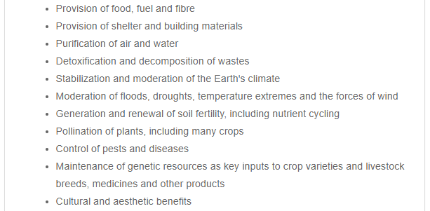
(UNDB, n.d.-a)

The threats of biodiversity loss

The loss of biodiversity
The concern for biodiversity starts with climate change, which would cause habitat change, then lead to biodiversity loss. Both biodiversity loss and climate change are partly affected by human activities, which leads to the pollution, habitat degradation and destruction (Jones, 2014a). Based on the Living Planet Report produced by McLellan et al. (2014), the global species population quantity has reduced 52% since 1970, the humanity now requires 1.5 planets’ worth of resources to satisfy their needs for future, and this pressure is multiplied due to the double effect of growing population and higher ecological footprints per capita. According to Steffen et al. (2015), the planetary boundaries are the safe space defined for life on earth, the Figure 2 shows that the genetic diversity is one of the three variables which at high risk. Scientists point out that the current rate of species extinction is one per hour, which is the fastest rate since the extinction of the dinosaurs. This rate is more than 1,000 times of natural extinction rate, and it is likely to rise dramatically. Under this speed, over one million of terrestrial species will disappear from the Earth in 50 years (Jiang et al., 2015). There is substantial evidence that we are entering a sixth period of mass extinction on Planet Earth (Atkins et al., 2014).

Figure 2: The current status of the control variables for seven of the nine planetary boundaries
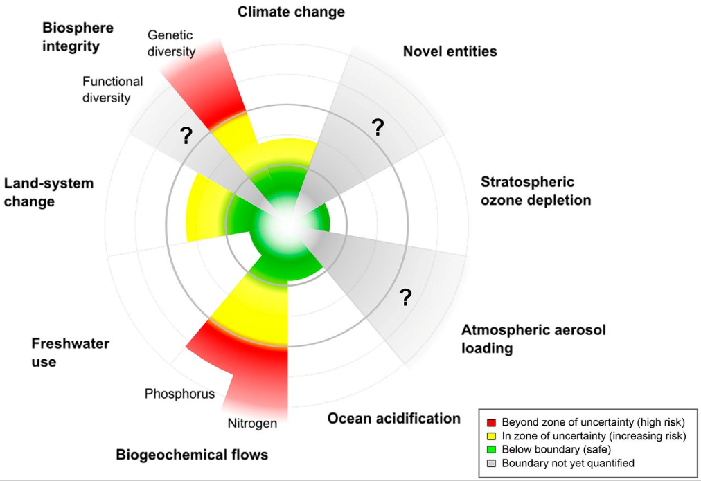
Steffen et al. (2015, p6)

The International Union for Conservation of Nature’s (IUCN) Red List is established in 1964, it is the most comprehensive information source on the global conservation status of animal, plant, and fungi species in the world. By providing the information like the distribution, population, and habitat of different species, and their threatened status and conservation actions for related decision makers, the IUCN Red List is a critical indicator of the health of the world’s biodiversity (IUCN Red List, n.d.). The IUCN Red List classified species into eight categories of extinction risk: Extinct, Extinct in the Wild, Critically Endangered, Endangered, Vulnerable, Near Threatened, Least Concern and Data Deficient. They are determined by modeling of population viability. The species listed in Critically Endangered (CR), Endangered (EN) or Vulnerable (VU) are considered as threatened species (Secretariat of the CBD, 2010). According to the recent report, the number of threatened species has almost tripled from 10,533 in 1996 to 26,840 in 2018 (IUCN Red List, 2018b). As shown in Figure 3, over 27% of assessed species are threatened with extinction in 2018 (IUCN Red List, 2018a).

Figure 3: The percentage of assessed species which are threatened with extinction
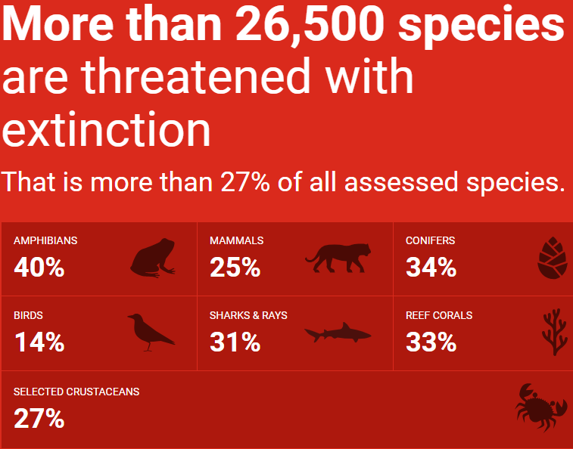
(IUCN Red List, 2018a)

The Red List Index shown below (see Figure 4, a value of 1.0 indicates the Least Concern status of all species in a group, a value of 0 indicates extinct status of all species in a group) indicates that the Corals group is experiencing a sharp decrease of its index value, which means the group is facing a greater extinction risk (Secretariat of the CBD, 2010). Coral reefs are the important barriers to against the storms, typhoons, and hurricanes, and they are the home to 25% of all marine life. They are directly influence our lives (WWF, n.d.-a). Until 2010, 70% of coral reefs are threatened or destroyed. As a result, over 500 million people worldwide will be affected as they are depending on coral reefs which provide food, storm protection, jobs and other income sources (World Conservation, 2010). In 2018, the Climiate Change Commttee of United Nations issues the warning that, with the goal of 1.5°C global warming under the Paris Agreement, further 70-90% of current coral reefs will be lost. If it gets to 2°C, virtually all (over 99%) coral reefs will be lost (Hoegh-Guldberg et al., 2018).

Figure 4: Red List Index
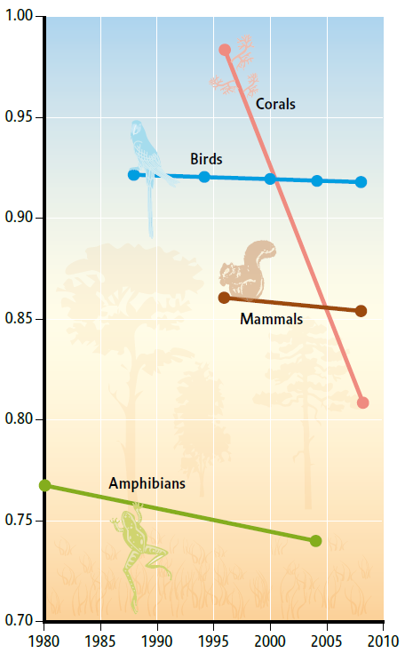
(Secretariat of the CBD, 2010, p29)

The drivers of biodiversity loss
Unfortunately, climate change is not the only factor should be considered for the loss of coral reefs, other factors like pollution, invasive alien species, destructive fishing, and ocean acidification also been identified as the cause of the coral reefs’ loss. This particular case indicates that the current biodiversity loss is the result of combinations of divers. The UNDB (n.d.-a) classified these drivers into direct and indirect divers (see Figure 5), most of them are related to human activities. The habitat loss, degradation and fragmentation are continuing to be the gravest threat to biodiversity, which mainly caused by human’s expansion and interference into natural ecosystems.

Figure 5: Direct and indirect drivers of biodiversity loss
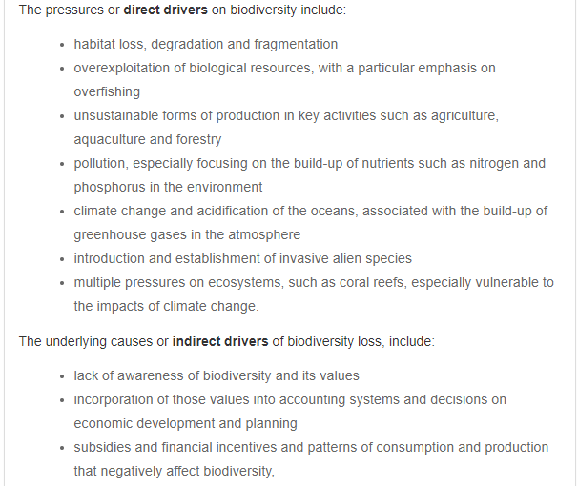
(UNDB, n.d.-a)

In 2018, the WWF Living Planet Report lists and compare the socio-economic trends and Earth system trends (see Figure 6) from 1750 to 2015, it clearly show the explosive growth of human activities since 1950s, and its significant impact on the Earth’s life support system (WWF, 2018a). It confirms that the agriculture expansion, infrastructure developments and unsustainable forest management are the factors that causing and accelerating the habitat loss, degradation and fragmentation (Secretariat of the CBD, 2010). These factors affect 86% of all threatened mammals, 86% of the threatened birds and 88% of the threatened amphibians (World Conservation, 2010).

Figure 6: Socio-economic trends and Earth system trends from 1750 to 2015
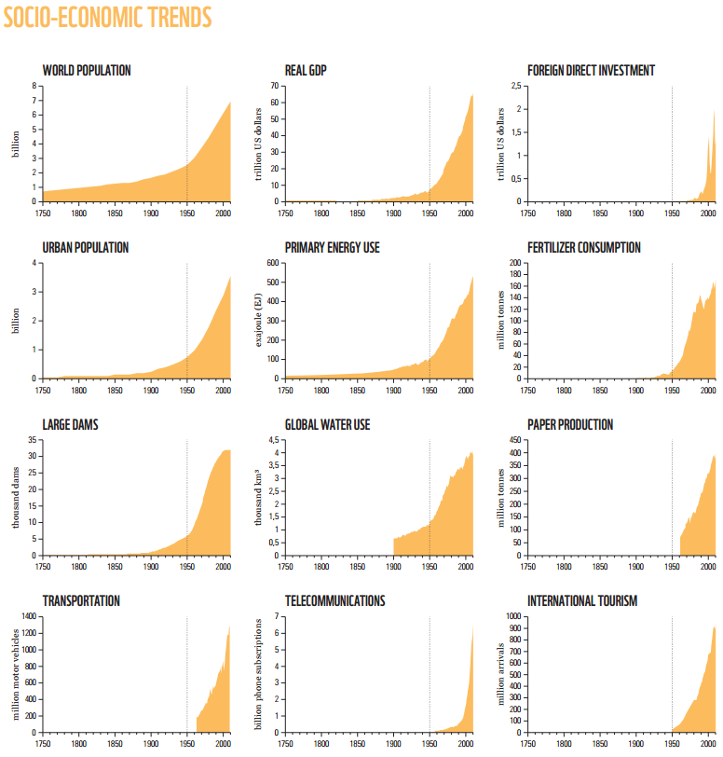
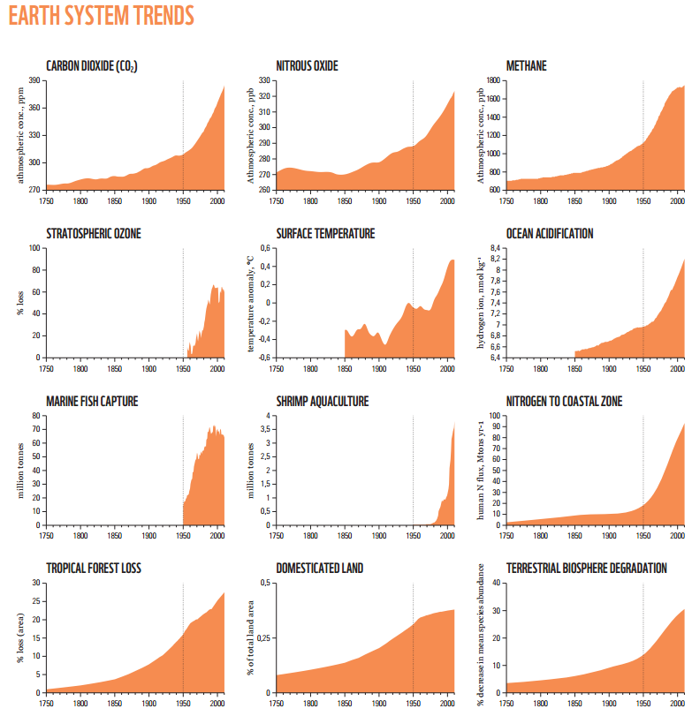
(WWF, 2018a)

Moreover, the over-exploitation of natural resources is considered as the heart of the threats that endanger the global biodiversity and ecosystems, reflected in activities like resource extraction, fishing and hunting for food, medicine and pet. The marine ecosystems are significantly affected by over-exploitation, the size of marine capture fisheries in the mid-1990s is four times bigger than it is in the early 1950s (Secretariat of the CBD, 2010). Currently about 30% of fish stocks are identified as overfished (UNDB, n.d.-a). Studies also discover that, on average, the species of birds, mammals and plants used for medicines are facing a higher extinction risk than the whole group. Especially in the developing regions, local people are depending on these species for living (Secretariat of the CBD, 2010). The unsustainable harvesting not only threatens the biodiversity, but also put peoples’ livelihoods which depended on biodiversity resources at risk (Secretariat of the CBD, 2014).

Pollution from nutrients and other sources are considered as a growing and continuing threat to biodiversity in coastal, terrestrial, and inland water ecosystems. Invasive alien species are continually threatening all kinds of species and ecosystems, and some indications show that it is getting worse. Based on a sample study of 57 countries, 542 alien species are identified. The study estimated that there are average over 50 invasive alien species per country, range from 9 to more than 220 (Secretariat of the CBD, 2010).

Climate change and biodiversity are closely related, climate change has a significant impact on biodiversity, the increasing temperature result in raising sea level, drought, changing patterns of rainfall and more extreme weather events. These changes could lead to significant impact on biodiversity, and this impact is predicted to increase progressively in the coming decades (Secretariat of the CBD, 2010). Moreover, Stork (2010) suggests that climate change is more likely to lead to high level of extinction as it creates global impacts and it could acting synergistically with other range of threats to biodiversity. However, according to World Conservation (2010), the healthy biodiversity could significantly ease the climate change. For example, the terrestrial and marine ecosystems like forests and wetlands, could contribute to storing carbon dioxide. Moreover, biodiversity helps people to adapt to climate change. For example, the coastal mangrove forests could provide coastal protection for people to reduce their vulnerability from flooding and coastal erosion, which caused by sea-level rise and stronger storms. In addition, over-population of human being is being argued as an ultimate threat of biodiversity loss (World Conservation, 2011).

Actions for biodiversity conservation

The Convention on Biological Diversity (CBD)
It is clear that this global scale loss of biodiversity would cause rapid and large shifts in ecosystem structure, thus, to ultimately create negative impact on all societies and economics, even destroy the human civilization. To prevent this foreseeable disaster, partnerships at all levels are urgently needed for effective biodiversity conservation. In respond, the first global agreement on the conservation and sustainable use of biodiversity is born, namely the Convention on Biological Diversity (CBD) (UNDB, n.d.-a). The CBD is an international convention that aims to protect the global biological resources, it is established by the United Nations, and entered into force in 1993. It has three main objectives: biodiversity conservation, sustainable use of biodiversity, and fairly share the benefits from biodiversity (CBD, 1993). The CBD regulates that the signatory countries need to make catalogues of their national flora and fauna species, and formulate protection plans for endangered species. Moreover, the developed countries should provide supplemental resources for developing countries in the form of donation or transfer to compensate their growing expenses on protection actions. Furthermore, the developed countries should provide a more affordable way to transfer technologies to developing countries to make the protection of global biological resources more convenient. What is more, the signatory countries need to share their research findings, profits and technologies with the countries which they acquire nature resources from (Wang, 2015). The Convention is comprehensive in its conservation goals to cover all species, ecosystems and genetic resources, and creates linkage with the economic goal of sustainable use of biological resources. It is vital to the future of humanity, thus, over 150 governments signed it when it is firstly established, at present, it has 196 Parties (UNDB, n.d.-a).

To actually implement the CBD, in 2010, at the 10th meeting of the Conference of the Parties (COP-10), the contracting parties have approved the ‘Strategic Plan for Biodiversity 2011-2020’, and identified the 2020 global biodiversity targets (see Table 1), which is also named as Aichi Biodiversity Targets (CBD, 2010a). The plan provides a comprehensive and flexible framework for contracting parties to engaged in the management of biodiversity conservation and development of related policies. In concerns of the drivers (see Figure 5) of biodiversity loss, the Aichi Targets integrate social and economic drivers into the heart of the targets to solve the problem from the source. It identifies the role of a wide range of stakeholders including governments, businesses, and individuals (UNDB, n.d.-b). The role of businesses is discussed in detailed in the later section.

Table 1: The Aichi Biodiversity Targets
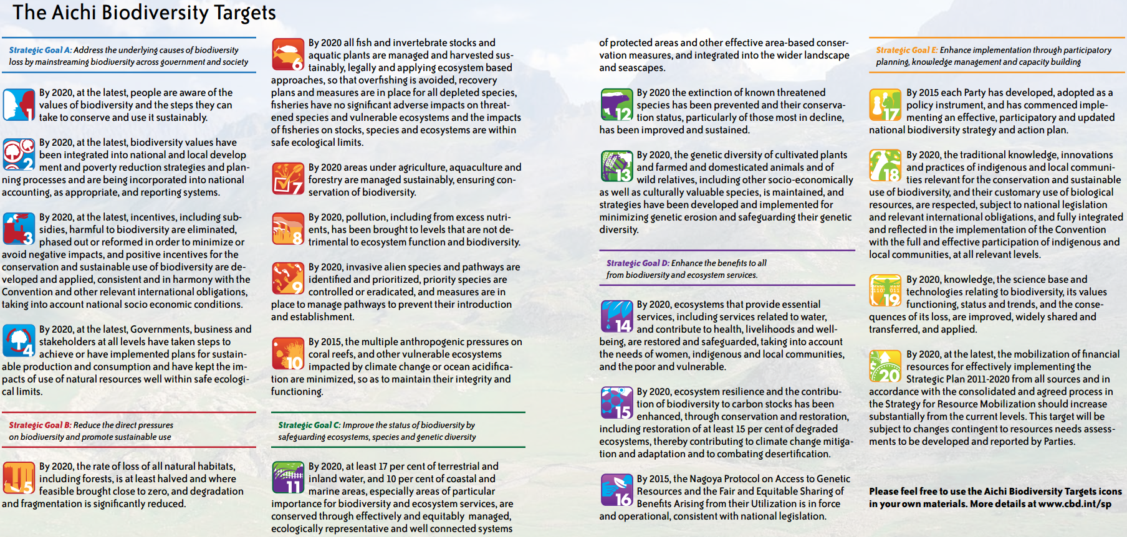
(CBD, 2010b)

The World Wide Fund for Nature (WWF)
The World Wide Fund for Nature (WWF) was established in 1961 as an international fundraising organisation, aims to protect the future of nature by providing financial support for the existing conservation groups (e.g. IUCN) worldwide (WWF, n.d.-e). With nearly 60 years of development, currently it is the leading conservation organisation in the world with operations in 100 countries and supported by nearly 5 million members worldwide (WWF, n.d.-b). WWF’s work used to mainly focus on the protection of species and landscapes, with the changing environment and threats, its work also evolves to challenge the larger global threats and forces (e.g. climate, forests, marine) that create significant impact on wildlife. It is actively engaging with wide range of stakeholders like government, business, community and academia to educate and influence people to make sustainable decisions, and in partnership with them to implement various innovative programs for conservation (WWF, n.d.-c). The WWF’s conservation works on wildlife are mainly focus on the flagship or/and umbrella species like tigers, rhinos, and giant panda. The protection of these species and their habitats would also benefit other species or the regional areas (WWF, n.d.-d). One of WWF’s flagship publication is the Living Planet Report, which is a comprehensive study shows the changing status of global biodiversity and the health of the planet, released every 2 years since 1998. Through various indicators like Living Planet Index (LPI), the report is able to provide us the scientific evidence of the current status of world biodiversity (WWF, 2018b).

Significant progress is urgently needed
With the first establishment of ‘Strategic Plan for Biodiversity’ by the CBD for the period 2011-2020, this period is identified as the ‘United Nations Decade on Biodiversity’ (UNDB, n.d.-b). As the end of this decade is approaching, the targets of this strategic plan are awaiting to complete. However, the recent WWF Living Planet Report (WWF, 2018a) indicates that despite various policy commitments (e.g. Aichi Targets) have been established to aim to slow down or alter the rate of species extinction, the trend of biodiversity decline is continued (see Figure 7). The dominant drivers of current biodiversity decline are still the same threats: overexploitation and agriculture. Besides that, the climate change is gradually creating significant impact on species, and even on genetic level. The current projections suggest that most of Aichi Targets in The Strategic Plan for the Convention on Biological Diversity (2010-2020) are unlikely to be achieved on time. The report emphasizes that, a dramatic move for a much more ambitious goal is urgently needed to stop the current severe decline of the biodiversity.

Figure 7: Biodiversity declines have continued despite repeated policy commitments aimed at slowing or halting the rate of loss
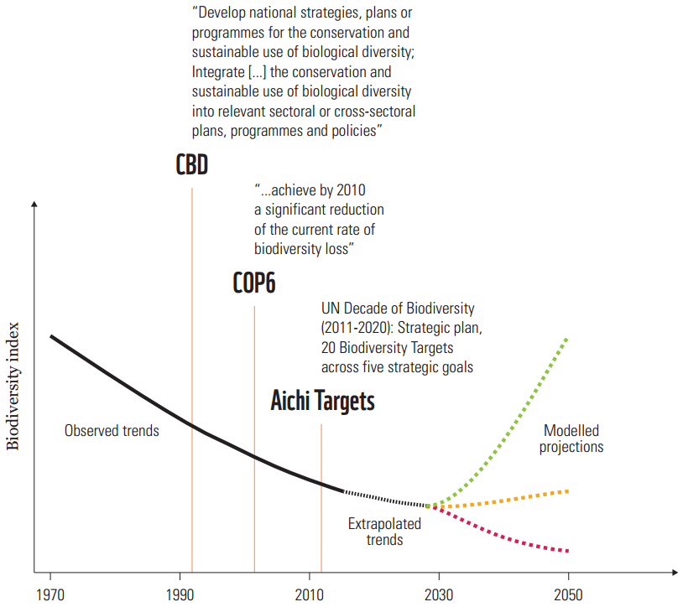
(WWF, 2018a)

The report also points out that the species extinction is not the only crisis that requires urgent transformation, the population of wildlife is also at stake. According to The Living Planet Index from 1970 to 2014 (see Figure 8), which shows the state of global biodiversity and the health of earth, the population of wildlife have declined by 60% in the last 40 years, habitat degradation and loss is the most reported threat (WWF, 2018a). This result clearly indicates the devastating impact that human activities have created on other species and nature environment.

Figure 8: The Global Living Planet Index, 1970 to 2014
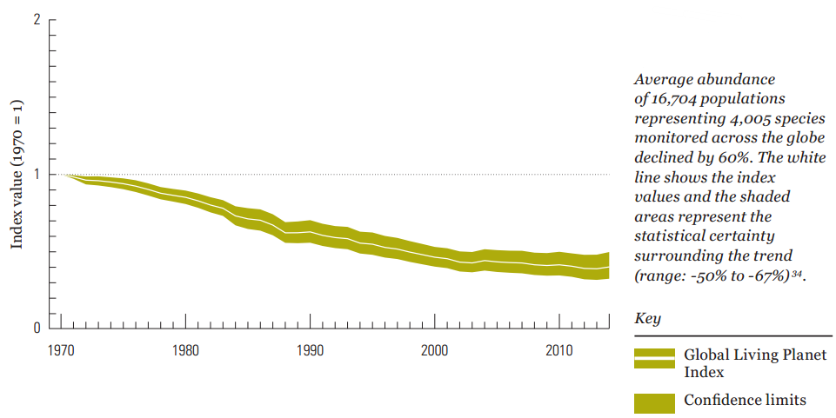
(WWF, 2018a)

Human’s unsustainable activities have pushed the Earth’s life support systems to the edge of collapse, at this historical point, a new global deal for people and nature is urgently needed (WWF, 2018b). To reverse the curve of biodiversity loss, the new global deal demands ambitious and well-defined goals, and a credible set of actions (WWF, 2018a).

Business and biodiversity

Complexity of biodiversity conservation and demands for multi-stakeholder participation
Biodiversity conservation is a complex issue that cuts across different regions, disciplines and departments. Firstly, biodiversity conservation is multidisciplinary including biology, ecology, meteorology, geography, sociology. These different disciplines all provide theories and technical support for conservation activities, and their theoretical bases are essential for conservation awareness raising and education. Secondly, biodiversity conservation is a challenge referring to multi fields including legislations, policies, environment, forestry, customs, culture, international communication and etc. Effective conservation requires the integration of knowledge and strengths of these fields. These two features of biodiversity protection mean it needs to be a coordinated process among many departments. It needs government departments to provide legislation, policy, strategic and macro planning support; local communities’ direct involvement; research institutions to responsible for technical development, theory exploration, education promotion and awareness raising; NGOs to introduce and promote international advanced concepts, experiences and methods; and companies to provide funding support and implement conservation in their development. Therefore, effective biodiversity conservation requires participation from a wide range of stakeholders; it has been recognised as one effective approach internationally. Among these stakeholders, private sector plays an important role as it is accounted for the most of negative impacts on biodiversity, while the current conservation on biodiversity is lack of sufficient participation from companies (Zhang and Liu, 2015).

The demand of corporate accountability for biodiversity

The concerns of corporate governance and social responsibility in early days
The earlier consciousness of corporate social responsibility could be traced back to the age of the Industrial Revolution in Britain, when the harm of workers and environment that caused by irresponsible corporate behavior was concerned (Solomon, 2013). With the continuous growth of this consciousness, in the 1950s, corporate social responsibility has been recognised as a discipline (Boatright, 2013). The corporate governance mechanisms were mainly driven by the finance-dominated agency theory, which solely aims to pursue profit maximization for shareholders without considerations of the interests of the environment, employees, local communities and other stakeholders. With the explosive development of industrialization and globalization, companies are increasingly expanding their operations worldwide, significantly contribute to the emergence of the global environmental and social issues like financial crisis, climate change and biodiversity loss. As these issues are increasingly threatening the world, the demands for corporate social responsibility and requests for companies to take account for their impact are never been so intense before. It indicates the urgency for companies to discharge their accountability for stakeholders, especially those non-shareholding stakeholders (Solomon, 2013).

Although it is clear that the neglection of social responsibilities is not going to support companies for the long-run, companies have concerns about the cost incurred by socially responsible behaviors as studies (e.g. Vance, 1975) point out a negative relationship between corporate social responsibility and financial performance. However, some studies (see Alexander and Buchholz, 1978, Graves and Waddock, 1994) argue that there is no significant linkage between social responsibility and stock market performance, while Alexander and Buchholz (1978) also believe that a company which behave in a socially responsible way is more tending to master the skills to operate the company well, which leads to improving financial performance. In line with this view, some studies (see Solomon and Solomon, 2003, Pensions Week, 2003) showed that the management of environmental and social issues is viewed as a crucial indicator to assess a company’s management quality. On the other hand, the socially irresponsible behavior could cause negative impact on financial performance in concerns of the case of Mexican Gulf oil spill in 2010, totally £46.2 billion penalty will be paid by BP for the worst environmental disaster in US history (BBC News, 2016). With increasing number of studies (e.g. Cochran and Wood, 1984, Johnson and Greening, 1994, Solomon, 2013) supporting the positive relationships between corporate social responsibility and financial performance, it is necessary to improve the internal control of environmental and social risk management.

The corporate accountability for environmental issues
The human’s survival is depending on the nature environment as it provides the living space for human activities, the nature resources for human to use as inputs of production, and the absorption services to absorb the residuals that generated by production and consumption activities (Wall et al., 2001). However, human’s unsustainable activities have been threatening the planet’s environment that affecting the interests of future generations and other species (Garner, 1996).

As a result, environment was one of the first areas that companies are encouraged to discharge their accountability (Solomon, 2013). Accountability is ‘an emancipatory concept that helping to expose, enhance and develop social relationships through a re-examination and expansion of established rights to information’ (Gray, 1992, p413). In short, Gray et al. (2014) defined accountability as ‘the duty to provide an account or reckoning of those actions for which one is held responsible’ (Gray et al., 2014, p50). It arises from the relationship between the accountor and accountee, in our case, a company and its stakeholders. This relationship is defined based on the current laws or ruling ethics, values and principles of the society, indicate the responsibilities that a company should be responsible for stakeholders. To maintain such relationship, the company needs to undertake certain actions, and provides an account of those actions. Account is the information that the companies use to explain or justify their actions to stakeholders. The corporate report is one of the forms for companies to provide such information. While, in concerns of the reality that the accountability is asking the companies to voluntarily provide required information for the society, there is a need to define and articulate the companies’ responsibility, thus, to pursue the demanded accountability from companies (Gray et al., 2014). The environmental reporting was the first non-financial area of reporting that concerned by the public. Numerous guiding principles (e.g. Coalition for Environmentally Responsible Economies, Global Reporting Initiative) for the corporate reporting of environmental issues are formulated for companies to measure and report their actions. Such initiatives help to form mandated and regulated accountability for companies to discharge (Solomon, 2013).

Apart from these initiatives, the stakeholder engagement is also considered as a key factor to drive the companies’ accountability for environmental issues. Here the stakeholders are not only including the traditional pool of shareholders, employees and customers, but also contain more importantly, the wider interest groups like local communities, regulators, NGOs, pressure groups, environment and future generations. Such stakeholder engagement helps to build a multi-disciplinary team, identifies broad range of views and opinions of environmental impacts, put the companies in the centre of the network of stakeholder relationship, thus, to improve companies’ awareness of environmental issues and their performance on environmental actions (Gray et al., 2014).

The demand for better accounting and accountability for biodiversity
These initiatives result in a growing number of environment reports from the companies all over the world, while the quality and quantity of corporate environmental reporting, especially from those industries which create significant impact on the environment, have not satisfied users’ needs generally (Solomon, 2013). Some studies (Harte and Owen, 1992, Adams et al., 1995, Deegan and Rankin, 1996) point out that these environmental reports are usually descriptive and self-congratulatory, rarely disclose any negative information, and express more on the intentions rather than actual practices. Moreover, in companies’ disclosures, they mainly focus on the certain issues and pollutants, rarely consider the systemic causes of these environmental issues (Whiteman et al., 2013). Moreover, companies tend to recognise the environmental issues in very limited ways by mainly consider the factors like powerful stakeholders, external pressures and costs. The environmental issues like biodiversity and habitat loss are only being recognised when they have impacts on companies’ costs or relationship with major stakeholders (Gray et al., 2014).

These issues are related to the disincentives of corporate environment reporting, firstly, without sufficient supervision from the society, and lack of legal requirements, companies are lack of awareness and motivation (Gray and Bebbington, 2001, Solomon, 2013). Moreover, companies might have concerns with the confidentiality issues of certain information that related to their environmental reporting (Wyburd, 1994). More importantly, in the views of companies, environmental reporting is usually perceived as a marketing tool to improve their reputation, thus, companies are unwilling to disclose any sensitive or negative information which are detrimental for their business (Benston, 1982, Solomon and Lewis, 2002). Therefore, it could be explained that companies are not actually responding to the environmental issues, they are responding to the changes of costs, stakeholders’ views, risks and other matters to fit business’s value and mission (Gray et al., 2014).

The discussions above indicates that companies have not integrated environmental reporting into the mainstream reporting, their management systems and stakeholder engagement on environmental issues are insufficient. The level of accountability that companies discharged in environmental reporting would not be tolerated in financial reporting (Gray et al., 2014). The suggestions for further improvement have been proposed in various studies (e.g. Jones, 2003, Solomon, 2000, Solomon et al., 2013, Gray et al., 2014), while the actual progress is little, and most of the issues have not been resolved. Jones (2003) argues that the studies of operationalizing environmental accounting is insufficient. He puts focus on the biodiversity, which is an identifiable and distinguishable environmental sub-system. As discussed earlier, the relationship between biodiversity and the wider environment is complex and interactive. Currently the world has growing concerns of the biodiversity loss, the companies’ responsibility in preserve even enhance biodiversity is increasingly appealed by the society (Jones, 2014a). It needs to be noticed that the accountability of companies is defined by the society rather than the companies themselves, the companies’ responsibility is constantly changing with the requirements of the society (Walters, 1977, Gray et al., 2014). Therefore, the corporate accountability for biodiversity would increasingly demand by the society. However, a lack of prior research into biodiversity might lead to a lack of understanding of biodiversity and how it could be considered as a material risk for business (Atkins et al., 2014). Companies need to pay urgent attention to this issue to discharge their accountability for biodiversity (Bebbington, 2010).

The role of companies in biodiversity conservation

’Business and biodiversity’ proposed by the CBD
Biodiversity is an unavoidable issue for modern companies, no matter from their corporate social responsibility perspective or their survival and development perspective (Zhang et al., 2014). Since the concept of ‘business’ (private sector) participation in biodiversity’ has been firstly proposed in the COP-3 to the CBD in 1996 (CBD), ‘Business and Biodiversity’ has gradually developed as an important issue in CBD negotiation. As a result, in 2010, the CBD decides to carry out global forum for business participation in biodiversity dialogue and launch the first forum for ‘Global Partnership for Business and Biodiversity’ (GPBB) in 2011. Since then, the forum is held every year to specifically discuss the issues about business participation in biodiversity (Wang et al., 2015).

The Aichi Biodiversity Targets that formulated at the COP-10 of CBD in 2010 is composed of 5 strategic goals with 20 specific targets (see Table 1), identifies the roadmap and schedule for global biodiversity conservation, provides a flexible framework for participated countries to formulate their national plans. In Aichi Biodiversity Targets, companies’ position and function in biodiversity conservation have been greatly valued in Strategic Goal A, which is: ‘address the underlying causes of biodiversity loss by mainstreaming biodiversity across government and society’ (CBD, 2010b, p2). Companies are involved in all the detailed targets. The second target suggests biodiversity values to be integrated into national accounting and reporting systems, and the fourth target points out the requirement for business participation (CBD, 2013).

The emergence of The Economics of Ecosystems and Biodiversity (TEEB)
Although World Conservation (2011) confirmed that we have failed to meet any of the 2010 biodiversity targets set by the CBD, there are significant achievements of awareness raising and study contribution. The respond initiative The Economics of Ecosystems and Biodiversity (TEEB) makes an outstanding contribution by points out the economic benefits of ecosystems and biodiversity, the costs of biodiversity loss, and the failure to take protective actions versus the costs of effective conservation. This global initiative is initiated by the environment ministers from the G8+5 counties meeting in 2007 and supported by the United Nations Environment Programme (UNEP) since 2008. TEEB points out that the economic invisibility of nature’s flows into the economy is the major contributor to the degradation of ecosystems and the loss of biodiversity, thus, its aim is to ‘making nature’s values visible’ by mainstreaming the values of biodiversity and ecosystem services into decision-making at all levels. The approach in analyzing and structuring the valuation is guided by three core principles: 1). Recognise the benefits provided by biodiversity and ecosystem services; 2). Demonstrate the value of biodiversity and ecosystem services in economic development; and 3). Capture the value of biodiversity in policy making and regional planning process (TEEB, n.d.). For example, as shown in Table 2, loss of biodiversity and ecosystem services could result in serious economic costs (Bishop et al., 2010a). In the Maldives, due to the coral reef degradation, the cost of construction for structures to replace the services provided by coral reefs is between $1.6 and $2.7 billion (World Conservation, 2010). Moreover, the planned marine protected areas are covering about of 20%-30% of the seas and oceans, the predicted cost of conservation is between $5 billion and $19 billion, while it would ensure $70 billion to US$80 billion profits for fishing industry, and $4.5 trillion to $6.7 trillion worth of marine ecosystem services annually (UNDB, n.d.-a).

Table 2: Relationship between biodiversity, ecosystems and ecosystem services
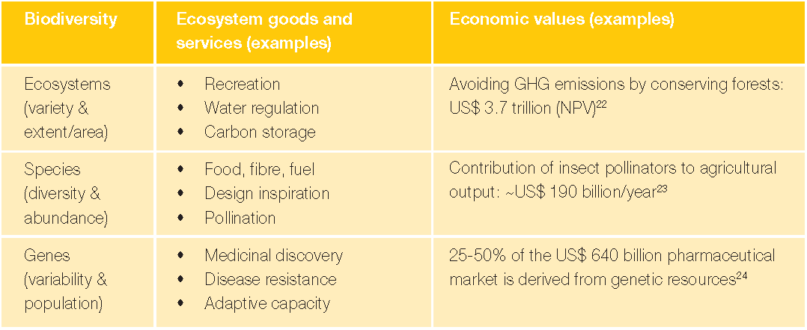
(Bishop et al., 2010a)

Except the value-in-use has been practiced in evaluating the economic value of the biodiversity, the non-use value of biodiversity is also been considered. It contains of heritage values and existence values, which are usually related to the attributes (e.g. morality, religion) that do not exist in trading market. This feature creates significant challenges for valuation, currently only the ‘declarative preference method’ can be used to evaluate the non-use value of biodiversity (Du et al., 2016). However, there are opposing voices about assigning monetary value to biodiversity as people should protect biodiversity whether it makes financial sense or not. Humans are the root cause of biodiversity crisis and we need to be responsible for further generations. Despite different views, one fact is certain: it is cheaper to act sooner rather than later (World Conservation, 2010).

As an emerging tool for biodiversity conservation, TEEB is supporting various global initiatives including CBD. The development of TEEB is moved to the phase of action and implementation since 2011. To widely improve decision makers’ perceptions on biodiversity, the current focus of TEEB is mainly on the global TEEB network construction. One of the issues is insufficient participation from stakeholders like companies (Du et al., 2016). Business have a significant role in TEEB, Bishop et al. (2010a) indicates that the biodiversity loss and ecosystem degradation are both risks and opportunities to business, there is a need to integrate the economics of biodiversity and ecosystem services in decision-making of the business. The Figure 9 shows the key points for business to manage these risks and opportunities.

Figure 9: Key action points for business
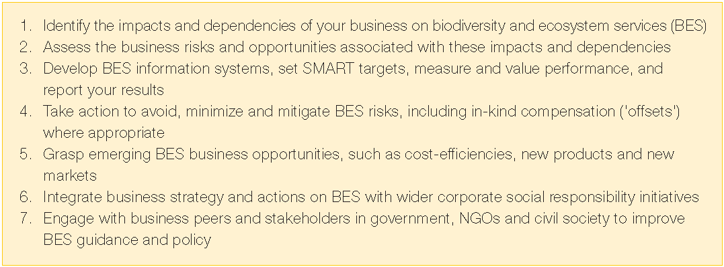
(Bishop et al., 2010a)

In response, over a quarter of global CEOs expressed concerns towards the impacts of biodiversity loss on their business growth prospects in PwC’s 2009 survey. Although business are responding, much more work is required to develop competitive business models, which can not only conserve biodiversity and ecosystem services, but also deliver better products and services to meet people’s needs (Bishop et al., 2010b). World Conservation (2010) discovers that the current global investment in biodiversity conservation cannot match with the growth of needs, and it is not being effectively managed. The estimation shows that the current funding gap to meet the CBD’s global objectives is between $10-50 billion per year. CBD is calling for ten times increase in financing and human resources by 2020 to fill the gap. Besides the funding, related policies are also needed to encourage companies to participate in biodiversity conservation.

The international standards and guidelines for biodiversity reporting

Global Reporting Initiative (GRI) and other sustainability standards
In the earlier discussions about the drivers (see Figure 5) of biodiversity loss, one of the indirect drivers is that people did not incorporate the values of biodiversity into accounting systems and decisions on economic development and planning (UNDB, n.d.-a). In association with the critical role of business in biodiversity conservation that discussed above, there is a need to improve companies’ accountability for biodiversity. It would represent the stakeholders’ acknowledgement about the seriousness of biodiversity issues, and their increasing demand for transparency and monitoring of companies’ performance and actions on biodiversity conservation. Therefore, it is essential to provide standards and guidance for companies to disclose reliable information on biodiversity issues through the current practice of sustainability reporting., thus, to improve corporate accountability for biodiversity (Boiral, 2016).

Global Reporting Initiative (GRI) is an independent international organisation that has been leading the sustainability reporting since 1997, it aims to empower decision that create social, environmental and economic benefits for everyone by helping global governments and businesses to understand and communicate their impact on important sustainability issues. The Sustainability Reporting Standards produced by GRI (GRI Standards) are the first global standards for sustainability reporting and widely adopted by organisations. In 2017, about 93% of the top 250 companies in the world disclosed their sustainability performance based on the GRI Standards (GRI, n.d.). GRI Standards are widely considered as the most reliable and detailed reporting framework, they are composed of a wide range of indicators on different aspects of sustainability, including biodiversity (Boiral, 2016).

Biodiversity has always been one of the environmental performance indicators in GRI Standards. As shown in Figure 10, the G3.1 of GRI’s Sustainability Reporting Guidelines has two core indicators (EN11 and EN12) and four additional indicators (EN13, EN14, EN15 and EN25) specifically deal with biodiversity disclosures, including reporting information on species and habitats which affected by organisation’s operations; the impact of organisation’s operations, products and services on biodiversity; and how the organisation managing these impacts (GRI, 2011b). These indicators have been widely used in academic studies to investigate companies’ reporting for biodiversity (see Rimmel and Jonäll, 2013, van Liempd and Busch, 2013), and to further develop the reporting and evaluation framework for biodiversity (see Samkin et al., 2014, Atkins et al., 2014).

Figure 10: biodiversity indicators in G3.1 Sustainability Reporting Guidelines
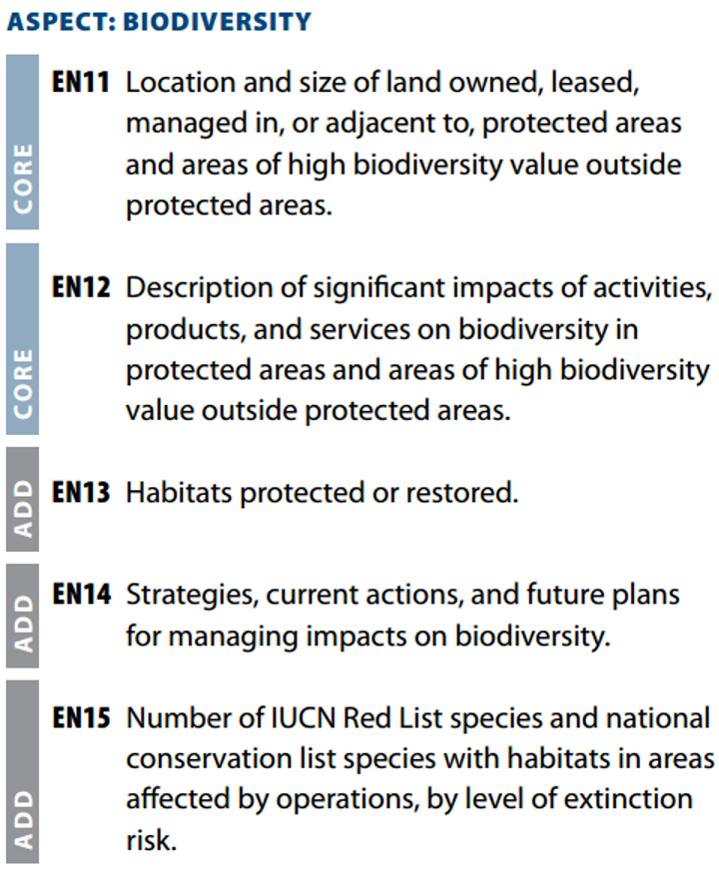

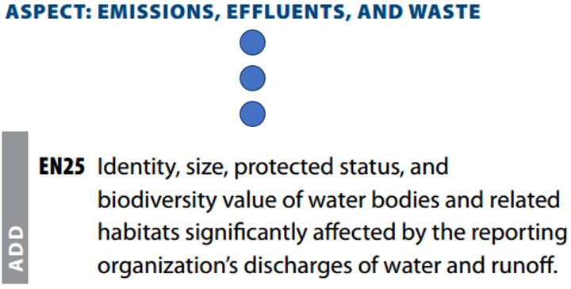
(GRI, 2011b)

The G4 of GRI Guidelines which released in 2013 put increased emphasis on the materiality of companies’ reports. More focus has been put on the critical matters which are material to companies’ operations and their key stakeholders. Therefore, the indicators of biodiversity are reevaluated and identified (see Figure 11), The G4-EN11, G4-EN12, G4-EN13 and G4-EN14 have shared importance as core indicators in the aspect of biodiversity (GRI, 2013). Besides that, the G4 Guidelines also provide more cleared requirements for companies to further analysis and understand their impact on the society and environment. Atkins et al. (2018) points out that compares to the G3.1-EN15, the G4-EN14 puts emphasis on the disclosures of ‘total’ number of endangered species which with habitats in areas affected by companies’ operations, by level of extinction risk. As a result, more information about threated species and companies’ actions to protect them are increasingly disclosed by multinational companies.

Figure 11: Biodiversity indicators in G4 Sustainability Reporting Guidelines
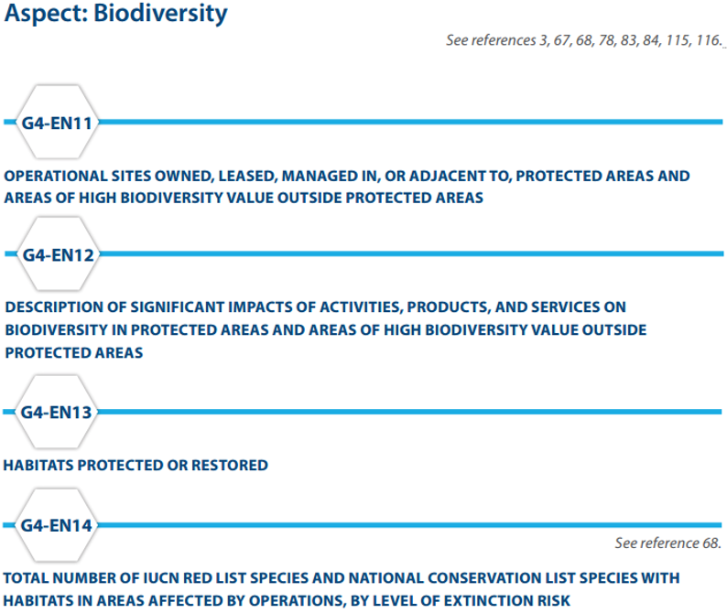
(GRI, 2013)

The GRI also has been actively work with other international standards like the International Organisation for Standardization (ISO) to further promote the sustainability reporting practice (GRI, 2011a). The ISO is the largest developer of voluntary international standards in the world with a membership of 162 national standards bodies. Its aim is to provide solutions to global challenges by developing international standards which are consensus based and market relevant (ISO, n.d.). To deal with the challenge of the sustainability, the ISO 26000 is formulated in 2010 as the guidance on social responsibility. It helps to define what are the social responsibilities for businesses and organisations, and how they could translate principles into socially responsible actions. Both of ISO 26000 and GRI Guidelines are striving to improve organisations’ sustainability performance, although they have significant overlap in concerns of covered topic, they have their own distinct functions. The ISO 26000 provides a comprehensive guidance for companies to planning their activities, while the GRI Guidance offers a framework for companies to measure and present their performance to stakeholders (GRI, 2014). For example, as shown in Table 3, biodiversity is one of the core clauses of the ISO 26000’s environment subject, the issue 4 (subclause 6.5.6) clearly state that the organisations are socially responsible to provide ‘protection of the environment, biodiversity and restoration of natural habitats’ (ISO, 2010). It could be practiced and demonstrated by following the according indicators of the GRI Guidelines (GRI, 2014).

Table 3: Linkage table between GRI G4 Guidelines and ISO 26000: 2010
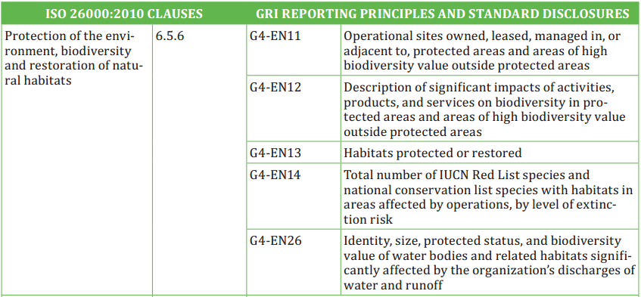
(GRI, 2014)

The partnership between GRI and ISO 26000, and any other initiatives for sustainability helps the world organisations to achieve a common consensus and get access to a practical set of tools to fulfil their responsibilities and report their performance. More importantly, the close communication and engagement among these initiatives help the world to further develop the standards and principles of the global sustainability issues, including biodiversity (GRI, 2014).

GRI 2018 is the most recent versions of the GRI Standards that available as of 28th June 2018. It contains three universal standards including Foundation (GRI101), General Disclosures (GRI102) and Management Approach (GRI103), that applicable for every organisation preparing a sustainability report. Apart from these, three topic-specific standards namely Economic (GRI200), Environmental (GRI300), and Social (GRI400) are also included for organisaitons to report their material impacts on related topics. Biodiversity is one of the specific topics in the Environmental Standards as GRI 304: Biodiversity (GRI, 2018b). As shown in Figure 12, it contains management approach disclosures in relevance with biodiversity, and biodiversity-specific disclosures. The management approach disclosures provide guidance for organisations to report management approach for biodiversity, which ensure the full disclosure of the organisation’s impact on biodiversity (GRI, 2018a).

Figure 12: GRI 304: Biodiversity 2016
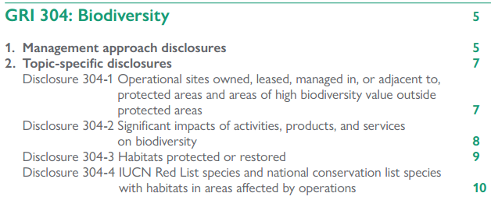
(GRI, 2018a, p2)

The biodiversity-specific disclosure items are in line with the G4 guidelines, while it further specifies the reporting requirements of each item. As shown in Figure 13, a list of specific requirements with suggestive examples are provided for organisations to follow and prepare. This would help organisations to improve their understanding of this disclosure item and get clear ideas of their reporting content. It also provides reporting recommendations for organisations to further improve their accountability for biodiversity (GRI, 2018a).

Figure 13: Disclosure 304-1 topic-specific disclosures
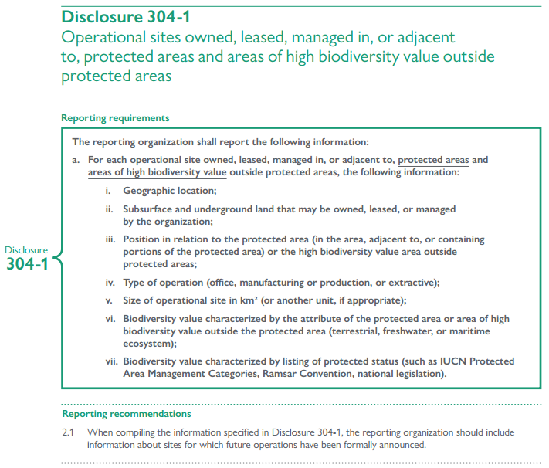
(GRI, 2018a, p7)

Integrated Reporting (IR) and thinking
The application of GRI Guidelines have result in significant growth of detailed disclosures on biodiversity. However, the desired results have not been met, the prior studies (e.g. Rimmel and Jonäll, 2013, van Liempd and Busch, 2013) that using GRI Guidelines to investigate companies’ biodiversity reporting discovered that, companies have failed to address a clear relationship between business risks and biodiversity losses. Moreover, the future planning of biodiversity management is also limited. The Guidelines are practiced by companies more like a disclosure checklist rather than a framework for biodiversity management (Maroun and Atkins, 2018). Studies (Milne et al., 2009, Milne and Gray, 2013) believe that the GRI Guidelines are failed to define the actual sustainability, rather, they reinforce the business-as-usual by providing an impression management tool to ease the social and political pressures. The Guidelines are formulated based on the assumption that there is a direct relationship between corporate reporting and actions. However, the measures that companies use to comply with the Guidelines are not necessarily indicate companies’ commitment to sustainability. The aim of the Guidelines is not just asking companies to simply record and disclose the species and habitats affected by companies’ operations, and companies’ conservation actions. Without genuine commitment to stop even reverse the trend of biodiversity loss, and proactive actions that driven by such commitment, these records are just ‘fossil records’, which inevitably incapable for companies to discharge their accountability (Atkins et al., 2018).

In addressing and aiming to solve the issues discussed above and other aspects of sustainability, a new form reporting guideline is emerged, named integrated reporting, which represents the recent sustainability development. It is proposed by the International Integrated Reporting Committee (IIRC), which is a global coalition of regulators, investors, standard setters, companies, the accounting profession and NGOs, aims to promoting the corporate practice of integrated reporting and thinking to lead the evolution of corporate behavior by focusing on value creation (IIRC, n.d.). Defined by the IIRC, the integrated reporting is:

“A process founded on integrated thinking that results in a periodic integrated report by an organisation about value creation over time and related communications regarding aspects of value creation” (IIRC, 2013, p34).

It seeks to remove the barriers between financial reporting and sustainability reporting, which usually separately provided by companies, by integrating material social and environmental information into the companies’ annual report. It is not just the combination of two kinds of reports, further, it incorporates material information from different sources to reflect the reality of companies’ operations and performances, thus, to enable stakeholders to make an informed assessment about companies’ ability to create and sustain value (Solomon, 2013). What embedded in the integrated reporting is integrated thinking, which is defined as:

“The active consideration by an organisation of the relationships between its various operating and functional units and the capitals that the organisation uses or affects. Integrated thinking leads to integrated decision-making and actions that consider the creation of value over the short, medium and long term” (IIRC, 2013, p34)

Such integrated thinking bringing about a mind-set change by letting companies to acknowledge that there is an interconnection between the resources used and the relationships with material stakeholders. It encourages companies to actively create values for stakeholders by addressing the changing challenges of society and environment, rather than passively comply with the requirements that demand by sustainability guidelines (King, 2016). The implementing of integrated thinking would help to shift the financially oriented reporting which still practices by global companies at present, to integrated reporting (IFAC, 2015).

In the integrated reporting framework, six different types of capital which companies are usually use or affect are proposed to describe the value creation process (see Figure 14). They are the inputs of the companies’ business model and will be allocated and incorporated based on the companies’ mission and vision to convert to outputs through business activities. The outcomes that based on the business activities and outputs indicate the companies’ impact on the capitals, which are the created values. To ensure the long-term viability, companies need to continuously monitor and evaluate the external environment to identify risks and opportunities relevant to this value creation process (IIRC, 2013).

Figure 14: The value creation process
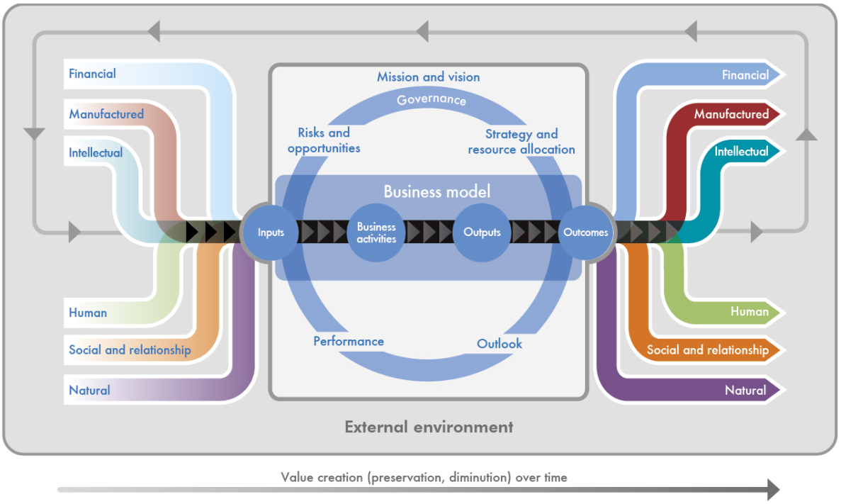
(IIRC, 2013)

This framework emphasizes the importance of the measurement and management of non-financial factors into the business strategies and the mainstream decision-making and reporting (IIRC, 2011). The nature capital here represents all kinds of environmental resources, species, and ecological services, the biodiversity loss would be considered as a material risk in this framework and would be addressed in company’s mainstream decision making and planning process. Such recognition and commitment would drive companies to mobilize different capitals required to support those decisions and plans (Maroun and Atkins, 2018).

As the significant outcome of the third King Report, the integrated reporting has been firstly adopted in South Africa as a compulsory practice for listed companies. In early practices, the quantity of biodiversity disclosures has showed significant improvement, while the quality of these disclosures has raised concerns, such as the significant repetition (Solomon, 2013), and the issues in line with the limitations of GRI guidelines (Maroun and Atkins, 2018). Solomon (2013) explains that it is due to reporters’ inadequate understanding of the guidance, the key is the materiality of disclosed information. Moreover, as pointed out by Maroun and Atkins (2018), the integrated reporting is principles-based rather than prescriptions-based. With companies integrate biodiversity into the heart of their practices, the intrinsic value of biodiversity has been recognised, the genuine commitment to conserving biodiversity and preventing extinction have been made. These progresses have transformed companies’ disclosures from passively responding to stakeholders’ demand for accountability, to actively recognizing, leading and discharging their accountability for stakeholders. Such transformation leads to the emergence of a new form of accounting with emancipatory potential to tackle biodiversity loss: extinction accounting, which is discussed in detail in later section.

The development of integrated reporting raised the discussions about the role of accounting in value creation process. Accounting plays an important role in providing sufficient and comprehensive information for the internal and external users to make decisions. By applying the integrated thinking, the financial information which produced by the conventional accounting is still critical, while not sufficient to meets the needs of internal decision makers and society. To support the company to discharges required accountability for value creation, accounting should look across the whole value creation process to take account of the interconnection and interrelationship between the inputs from different capitals into a company’s business model, and the connection between the outcomes to different capitals (King, 2016). With more functions and responsibilities of accounting given by the frameworks and guidelines that discussed above, there is a need to explore the development of the role of accounting, especially in biodiversity issues.

Chapter 3: The Theoretical Framework in Developing the Role of Accounting in Biodiversity Issues

The roots of accounting and its early definitions
Accounting as a profession is viewed differently by various people. A person’s contacts with the subject (e.g. education, work experience) influence his/her views of accounting (Bailey, 1970). Accounting is a discipline with a long history, the systems of accounting are discovered to have existed as early as 4500 B.C., in the ancient civilizations of Babylonia and Assyria (Newgarden, 1969). In ancient Egypt, the form of accounting could be discovered in the records of items and activities that used to coordinate and monitor the laborers’ efforts. This transactions-based record keeping is carried over into the double-entry bookkeeping, which is emerged in the fifteenth century (Atkins and Maroun, forthcoming).

Accountancy was growing as a mature and respected profession in England, Ireland and Scotland since seventeenth centuries, most of publications on bookkeeping and accounting were in English. After this profession emigrate to US along with the accountants from England, Ireland and Scotland, two major events in the early twentieth centuries did much to shape the evolution of accounting. The first was the US federal income tax law and its requirement of business record-keeping in a generally accepted form. The second was the 1929 Great Depression. A demand for examination of business practices result in the various federal securities acts of the 1930s and the resultant required disclosure of financial data (Newgarden, 1969). Various definitions of accounting have been proposed since then, the evolutionary trend of accounting in modern times could be outlined in these definitions. In 1928, defined by Brett:

“Accountancy is the science of classifying and recording business transactions and of analyzing their effects upon a business concern so as to reveal the true condition of the business, and also to indicate any changes of policy of the management that would improve these results and benefit the status of the business” (Brett, 1928, p3).

The time of 1950s witnesses the development of the managerial accounting approach, which is based on the premise that accounting techniques can provide information which is useful in management decision-making. It is a forward-looking approach as opposed to the historical approach of financial accounting (Bailey, 1970). The definition that has been made in 1955 puts emphases on accounting’s role of financial record keeping and reporting:

“Accounting may be defined as a body of principles and procedures designed to act as a guide in recording and reporting those affairs and activities of an economic unit that are capable of expression in monetary values” (Pyle, 1955, p1).

The American Institute of Certified Public Accountants’ (AICPA) definition emphasis such traditional view as:

“Accounting is the art of recording, classifying and summarizing in a significant manner and in terms of money, transactions and events, which are, in part at least, of a financial character and interpreting the result thereof” (American Institute of Certified Public Accountants, 1953, p9).

At this point, the system of accounting is characteristiced with control and accountability in monetary terms (Atkins and Maroun, forthcoming). With rapid social, economic, political and technological changes since 1960s, a significant pressure has been placed on accounting profession to cope with the demand s of society. People are appealing that businesses have social responsibilities to their consumers, employees, community and environment. The businesses’ responsibility is no longer limited by solely focus on making profit, but also to share other responsibilities (Carey, 1965). These changes undoubtedly affect businesses’ management of organisation and allocation of resources. As a tool for more effective decision making, accounting surely will be play an important role in this area (Bailey, 1970). In result, in 1966, the AICPA develops the definition with an expanded concept:

“Accounting is a discipline which provides financial and other information essential to the efficient conduct and evaluation of the activities of any organisation” (Cohen, 1966, p61).

This indicates that the data processed by accounting are not only expressed in monetary terms, but also might in other quantitative terms, or in symbolic or verbal forms (Cohen, 1966). In the same year, the American Accounting Association defines accounting as

‘the process of identifying, measuring, and communicating economic information to permit informed judgments and decisions by users of the information’ (American Accounting Association, 1966, p1).

This definition emphasized a broad scope for accounting by expanding the types of data that could meet the standards for accounting information. Under this definition, the accounting information is not only limited by transactional data but also various kinds of non-transactional data (American Accounting Association, 1966).

Such transformation of accounting could be explained and further developed in the notion of General System Theory (GST), which is discussed below.

General Systems Theory (GST) and accounting

The emergence of GST
The modern science is increasingly expanding and specialized into innumerable disciplines, and new sub-disciplines are continually generating due to the complexity of theoretical structures and techniques in each field. The specialists of each field are becoming more independent, result in the difficulties for them to connect with each other. However, the similar problems and conceptions are surprisingly emerged in these widely different fields (Von Bertalanffy, 1971). In order to explain such phenomenon, there is a need for concepts that would promote a macro view of science and human affairs and connect the communication gaps among specialized disciplines (Bailey, 1970).

In response to such a need, the notion of General Systems Theory (GST) was first introduced by Von Bertalanffy, aims to reduce or even eliminate the barriers between different scientific fields to avoid unnecessary duplication of labour (Von Bertalanffy, 1971), and prevent the reductionist reasoning of scientific thought (Feyerabend, 2011). It is an attempt to take a macro view of science and human affairs in opposition to the traditional micro view taken by individual disciplines (Bailey, 1970). It seeks to provide a set of general concepts common to many disciplines, rather than to establish a single, self-contained ‘general theory of everything’ which will replace special theories of particular disciplines (Boulding, 1956).

Von Bertalanffy was a biologist who believed that the proper study of biology should be in the order and organisation of parts and processes, rather than in the study of the parts alone. Based on this belief, he suggests that the physical and social world is one of organized complexity, rather than unorganized or lawless complexity (Von Bertalanffy, 1968). The conclusion made by Von Bertalanffy as ‘the principles of wholeness, of organisation, and of the dynamic conception of reality become apparent in all fields of science’ (Von Bertalanffy, 1952, p176) was the earlier content of GST.

The continues development of GST leads to the emergence of various new fields like cybernetics. The cybernetics is discovered from the mechanistic areas, firstly noted by Wiener (1948) as the science of systems control. Later on Beer (1960) defines it as:

‘the science of communication and control … The formal aspects of this science seek a general theory of control, abstracted from the applied fields, and appropriate to them all’ (Beer, 1960, p7)

The main contribution of cybernetics to GST is its emphases on the feedback, which allows for self-regulation of the system. As shown in Figure 15, with feedback, the output of the system will be compared with desired performance to identify the discrepancy information, which will become one of the inputs to make effective changes in the system. The feedback process underlies the control of the system (Bailey, 1970). Later on, although the cybernetics has been developed and divided into a diverse area of knowledge (Dechert, 1965), its significance is still consist in the communication and information flow in systems through the feedback process (Bailey, 1970).

Figure 15: A simple cybernetic system
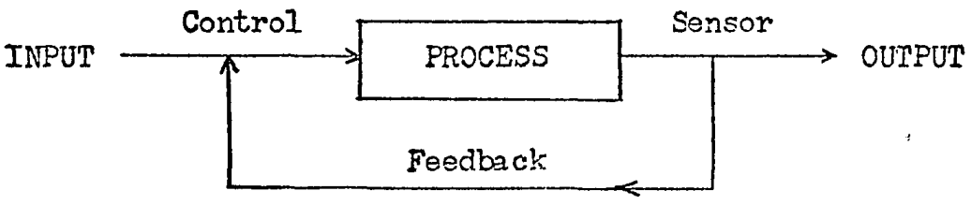
(Bailey, 1970)

GST as an open system
The most contribution that Von Bertalanffy has made to the field of GST is the recognition of living systems as open systems, which has been wider applied as an effective approach to understand social and ecological systems (Hammond, 2005). The notion of open systems helps to view and describe subjects of study, for example, organisations could be regard as organisms that process inputs from the environment bask as outputs, their behavior is the result of the interactions between the organisation, its internal sub-systems and the environment (Hopper and Powell, 1985).

The features of open system
To define ‘system’, various definitions have been provided:

“…a complex of elements in mutual interaction” (Von Bertalanffy, 1952, p11).

“…a set of parts coordinated to accomplish a set of goals” (Churchman, 1968, p29).

“…anything that consists of parts connected together” (Beer, 1960, p9).

Based on the definitions above, Bailey (1970) adopts a basic general definition of ‘system’ as:

“a system is any complex of elements in mutual interaction” (Bailey, 1970, p19).

GST could be considered as an overall term covering the conceptual approach to systems, most of the content of GST has developed based on the concept of open system (Bailey, 1970). Open systems are in contact with their environment, with input and output across the boundaries of the systems (Chin, 1967). Such interchange between the open system and its environment lay the foundation for the systems’ viability, its continuity, and its ability to change (Buckley, 1967). In contrast, the systems which are isolated from their environment are called closed systems. They have relatively self-contained structures (Katz and Kahn, 1978), and functioning within themselves (Von Bertalanffy, 1932). Such closed systems do not exist in reality (Chin, 1967).

Von Bertalanffy (1952) uses living systems as example to explain open systems:

“living forms are not in being, they are happening; they are the expression of a perpetual stream of matter and energy which passes the organism and at the same time constitutes it. We believe we remain the same being; in truth hardly anything is left of the material components of our body in a few years; new chemical compounds, new cells and tissues have replaced the present ones” (Von Bertalanffy, 1952, p124).

Therefore, like a human body, open systems should be viewed as processes that continually generate matter to the outer environment and take in matter from it. Further, Parsons (1956) points out that the system is a system of behavior or action, rather than a fixed structure or an object of perception. Bailey (1970) believes such concepts of open system form the GST, which viewing systems as processes and seeking to understand and describe the relationships both within the system and between the system and the environment. GST allowed wider application of systems concepts to the social science as it suggests various physical and social phenomena can be viewed as systems and that generalisations made about the nature of systems will lead to a better understanding of particular systems and of the relationships among systems.

One of the essential features of open system is its hierarchical order. According to Berrien (1968), the fundamental assumption of GST is that the universe could be considered as a nesting of systems, with smaller systems embedded in larger systems. Miller (1955) lists the hierarchy of system in nature that based on atomic particles through atoms, molecules, crystals, viruses, cells, organs, individuals, small groups, societies, planets, solar systems, and galaxies. Von Bertalanffy (1952) points out that this typical pattern is widely exist not only in the biological but also in the psychological and sociological fields. Based on the concept of hierarchical order, every system is a component or sub-system of a supra-system and is itself made up of sub-systems (Miller, 1955). Therefore, Bailey (1970) suggests that any system can be studied completely if we can examine all possible relationships within a system and between the system and its environment. In the other word:

‘the attempt to study a part (of anything) without understanding the whole from which the part comes (reductionism) was bound to lead to misunderstandings – the part can only be understood in its context’ (Gray et al., 2014, p17)

The structure of open system
The earlier definition of system as ‘a complex of elements in mutual interaction’ indicates that a system is consists of a structure (complex of elements) and a process (mutual interaction). In terms of the structure of a system, it formed by elements such as objectives, environment, boundary, inputs, outputs, components, management (Bailey, 1970).

According to Bailey (1970), systems are created with purpose to accomplish, such objective should be the central guiding force in the functioning of a system, thus, to maintain a system’s existence. The function of a system is to process input into output. There are two types of inputs: maintenance and signal. The former are those which energize the system, the latter are those which the systems accepts to produce outputs delivered to the supra-system (Berrien, 1968). Berrien (1968) classify outputs as products useful, or useless to the supra-system. The key for a system to survival is to ensure its deliver products are acceptable to its environment. It can be concluded that the objective of a system is to produce output of maximum usefulness to its supra-system.

Based on the definition provided by Churchman (1968), the environment of a system consists of all things outside the system’s control which affect the performance of the system. For a complex system, it is possible to identify those elements in the environment which could significantly affect the system’s performance (Bailey, 1970). In the real world, it is important to distinct a system with its environment, and between systems. It leads to the necessity of define boundaries. The boundary of a system could be physical like the skin of a person (Ruesch, 1967), it could also be abstract and less-than-exact, such as the boundary of a forest (Rapoport, 1956). Bailey (1970) concludes the boundary of a system as:

“that line or region which separates the components of a system from its environment” (Bailey, 1970, p51).

Berrien (1968) points out that the main functions of a system’s boundary are coding and decoding. The coding refers to inputs, which are the complexes of information/energy/matter introduced into a system. Decoding refers to the outputs, which are the transformation of information/energy/matter from system into a form useful to the supra-system.

The term ‘component’ refers to the sub-systems which compose a system. It directly related to the hierarchical structure of systems as each system consists of sub-systems (components) which themselves are also consist of sub-systems (components). Although components have overall system objective to achieve, they are identifiable respectively as having distinguishable objectives that contribute to the production of the system output. Similarly, each component is consisting of sub-components that interact to achieve the component objectives (Bailey, 1970).

Management (also named system control) is the element of a system that regulates the system and achieves the system objective. This concept is based on the idea of the cybernetic system with feedback (Bailey, 1970). The concept of feedback has been regarded as one of the central and most important concepts in GST (Berrien, 1968). It is a mechanism that provides for the control of purposive or goal-directed systems (Buckley, 1967). As the objective of a system is to produce output of maximum usefulness to its supra-system, feedback plays an essential role to compare actual output with the expected output and feeds information back to management component of the system. The management component will make adjustments accordingly (Bailey, 1970). Deutsch (1951) believes that

“feedback is meant a communications network which produces action in response to an input of information and includes the result of its own action in the new information by which it modifies its subsequent behavior” (Deutsch, 1951, p197).

Under this more sophisticated notion, the feedback control would

“include not only adjustments to maintain a given structure and process but also adjustments to change system structure, process, and objective, leading to growth and elaboration of the system” (Bailey, 1970, p67).

The process of open system
A system is identifiable not only by the elements discussed above, but also the relationships that exist among the elements. In a system, relationships are the things that tie the system together (Hall and Fagen, 1956), they are postulated among all system elements, systems and sub-systems, and sub-systems (Optner, 1965). In the modern complex systems which are the higher level systems, relationships are mainly consist of transmission of information (Buckley, 1967).

In higher level systems, as the structure becomes more fluid (e.g. living systems), the process (mutual interaction) becomes more significant. Berrien (1968) believes that the structure view of a system is more important than the process view as the function of a system is based on its structure, while Bailey (1970) argues that if we consider it as, a system’s structure limits the functional capabilities of its components, it could be conclude that the system’s functioning is limited by the structure of the components. As claimed by Parsons (1956):

“the system is not the physical organism nor the object of physical perception, but it is a system of behavior or action” (Parsons, 1956, p56).

The true nature of a system at a particular time must be determined by the particular interactions that are taking place among the elements of the system. A system’s potential might be determined by its structure, but an altered set of interactions among the elements would be necessary to achieve such potential. The interaction makes the structure a system. Therefore, to get a better understanding of a system, both structure and process need to be considered, but more emphasis should be given on the process rather than structure, especially for higher level systems (Bailey, 1970).

According to Berrien (1968), a system could exist in various states, each of them has a particular pattern of relationships existing among the components and a particular filtering condition of the boundary. Katz and Kahn (1978) claims that closed systems would tend to run down, which move toward states of equilibrium, whereas for open systems, they would become more elaborate rather than less differentiated as they are open and able to receive inputs from the environment. Contrast with the static state of closed systems’ equilibrium, the open systems are move to a dynamic equilibrium called steady state (Von Bertalanffy, 1952). The steady state refers to a self-regulated open system which maintains a balance but not at any particular fixed point or level (Chin, 1967). To maintain such steady state to ensure their survival, open systems need to reacts to disturbances (from environment) by adjusting inputs and outputs, and building up and breaking up of components (Coetzee and Van Niekerk, 2012). Adaptation and growth seem to be the typical mechanisms for an open system to response (Bailey, 1970). Adaptation is relating to those behavioral and structural modifications in a system that aims to extending survival time (Berrien, 1968). In this approach, the character of the system will remain unchanged, and more inputs will be imported from environment to maintain the steady state. As for the growth, it usually refers to increase in quantity. But it also could be qualitative, the qualitative change might occur when quantitative growth needs specialized sub-systems which not needed before. Sometimes in order to adapt their environment, systems will attempt to absorb their external forces, or take control over them to adapt their environment (Katz and Kahn, 1978).

The Figure 16 presents a model for a self-regulating system, which could be applied for the most of complex, high-level systems. It suggests that a system is usually composed of 3 groups of components, which are management, production, and information. Accounting could be one of sub-systems of an organisation’s information group, the sub-system itself would also consist of management, production and information sub-components, in continuation of the hierarchical structure. The interrelationship among these components is maintained through communications. The feedback process helps the system to maintain a steady state. By responding to the needs of adaptation and growth to meet the demands of changing environment, the system is able to achieve its foundational purpose: ensure the maximum usefulness of its output to its supra-system to keep survive (Bailey, 1970).

Figure 16: A self-regulating system
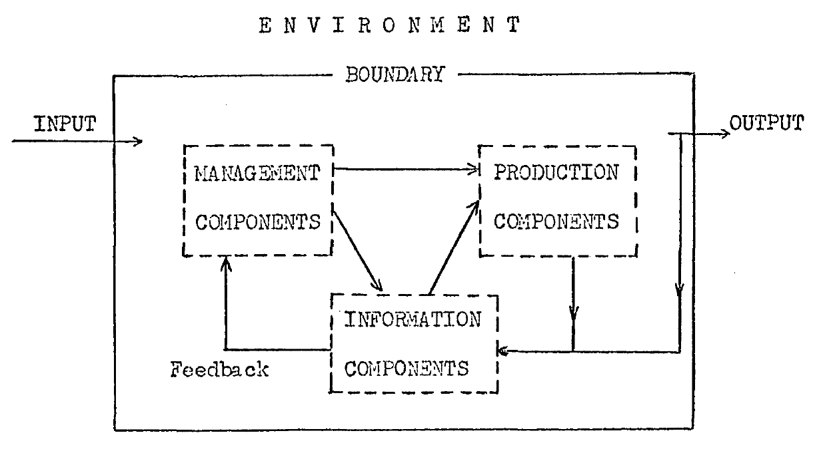
(Bailey, 1970)

The application of GST

The notion of GST in Gaia Theory
The essence of GST is about interconnectedness and wholeness, it has been applied by Atkins and Atkins (2016a) in the book ‘The Business of Bees’ to interpret the linkages between business and current declining of bee population. Along with GST, Atkins and Atkins also introduce other theoretical frameworks that concern with interrelationships between species, and the planet we all inhabit, Earth. These theories are more or less in keeping with the notion of GST. One of the most impressive and marvelous theories is the Gaia theory, which firstly hypothesized in 1970s.

Gaia theory is developed by James Lovelock, who hypothesis that there is a planet-sized, self-regulating entity controlling the Earth’s atmosphere to suit its needs. Such entity is Gaia, the name ‘Gaia’ is from the Greek Earth goddess who known as Ge. Gaia is a complex entity:

“involving the Earth’s biosphere, atmosphere, oceans, and soil; the totality constituting a feedback or cybernetic system which seeks an optimal physical and chemical environment for life on this planet” (Lovelock, 2000, p10).

If we assume Gaia is the largest living creature on Earth, like all living organisms, she is capable to operate, develop and maintain systems through the cybernetic process of trial and error.

Lovelock (2000) claims that the existence of Gaia could be demonstrated by the history of Earth’s climate and temperature. Since there is life existence on the Earth, the climate has never been unfavorable for life, the surface temperature is remained constant and favorable for life, while the composition of the early atmosphere has drastic change, and the output of energy from the sun has significant variations. It seems like the Gaia regulates the surface temperature to maintain most of her existence, as a human body regulates the body temperature to pursuit the maximum comfort. To perform such regulatory functions, Gaia needs associations of species to cooperate, micro-organisms are believed to play a major role in Gaia’s self-regulating activity. Lovelock assumes that the key regions for Earth to regulate planetary health, or say the vital organs of Gaia, are the wetlands, estuaries, and muds on the continental shelves. These places are essential for the adjustment of the rate of carbon burial, which regulate the concentration of oxygen, and the essential elements that returned to the atmosphere. Therefore, it is essential to keep these regions from human’s exploration.

Some people believe that human is like a cancer on Earth, it is indubitable that human’s unrestricted population explosion and industrial activities have threaten all the life on the Earth. Garrett Hardin, the American ecologist used to say that:

“there is only one pollution…people” (Lovelock, 2000, p114).

Human and all other living things are parts and partners of Gaia. Gaia has power to maintain Earth as a fit and comfortable habitat for life, at the same time, human species and all other species are act unconsciously in the process of planetary homoeostasis, or say, Gaia’s self-regulation. As a cybernetic system, Gaia would safely adjust the turbulence of the atmosphere and biosphere that created by human and its industrial pollution. However, we already caused 20% increase in carbon cycle, 50% in nitrogen cycle, and over 100% in Sulphur cycle. In consideration of our usage of fossil fuels, the situation is getting worse (Lovelock, 2000). Human’s activities are also the main cause for the current sixth period of extinction on Earth (Atkins and Atkins, 2016b). Lovelock (2000) points out that if such increase in the input significantly go beyond the output, which is Gaia’s response, it could lead to a serious of cybernetic disasters. People now already sense the dangers and start to take measures to deal with the global warming and claim to save the Earth, but the fact is that:

‘our planet looks after itself. All that we can try and do is try to save ourselves’ (Lovelock, 2009, p9).

For example:

‘Ice Age might be a disaster for us, but would be a relatively minor affair for Gaia’ (Lovelock, 2000, p139).

If human become extinct on the Earth, Gaia would continue self-regulating itself and Earth would quickly recover to its equilibrium state. Lovelock (2015) even points out that if the goal of Gaia is to keep the Earth habitable, the carbon-based organic life might not the only form allowed.

However, the survival of human is crucial for Gaia, even human might be one of the most important species on Earth. It because human’s intelligence could directly affect the chance of Gaia’s survival. For example, human would be the only species that could foresee and response to the potential planetesimal strike on Earth. Unlike the rest of species that transfer the energy of sunlight for the self-regulation of Gaia, human has more crucial capacity for information transfer, thus to strength the capabilities of Gaia’s self-regulation. Although currently humans are not capable to solve the planet-sized problem, our existence could contribute to better self-regulation of the Gaia to deal with the threats ahead (Lovelock, 2015).

Despite the hypothesis of Gaia theory sounds hard to believe, even terrifying, it does provide a new perspective to see the world, and a new approach to think the relationship between human and nature. The thought of this theory indicates that ecosystem, biodiversity, and all species including human are inextricably connected, their fates cannot be separated. Such thought is in line with the concept of GST (Atkins and Atkins, 2016a).

The application of GST to get a better understanding
The Gaia theory provides an extreme angle to perceive the systems ontology by considering the whole of life on our planet as the highest level of system. In line with such notion, the reality could be seen in terms of systems and the relationships among them, as well as their components. The GST constructs a worldview which puts emphasis on the interconnectedness and interdependence of systems. It forms a holistic approach to knowledge and practice, challenges the reductionism of the mechanistic worldview, which inherited from the Scientific Revolution of the 17th century. This systems ontology indicates the dynamic and critical nature of knowledge, which is embedded in and emerging out of continuous interactions among the complex web of relationships (Hammond, 2005). The systems view:

‘reinforces a constructivist orientation to knowledge as a dialectical, pluralistic, and participatory process that emphasizes the importance of mutual understanding, meaning, and values’ (Hammond, 2005, p23).

It provides an epistemological insight for the learning process of knowledge, which the understanding of the complex systems should be drawn from a wide variety of perspectives (Hammond, 2005). In result, GST is developed to support interdisciplinary communication and cooperation, facilitate the unity of knowledge and help to bridge the gap between the object-oriented and the subject-oriented disciplines, and promote scientific discoveries in disciplines that lack exact theories (Von Bertalanffy, 1972, Laszlo, 1974, Rapoport, 1976, Hammond, 2010, Rousseau, 2015).

GST forms the systems thinking, everything could be considered as a system. The philosophical position of GST grants an approach to study complex systems like climate, society, human body and organisms. It views these systems not just as an independent unit but also as a compilation of a multitude of parts and processes (Coetzee and Van Niekerk, 2012). In result, ignore the interactions between the system and other systems might lead to misunderstanding. It has been discovered that this systems conception was not only applicable in natural science, but also has been successfully applied to social science which involves human interacts. Moreover, the framework of thought that provided by GST could capture the interactions between natural and social sciences. This allows people to see things in a broader context, and understand connections between different systems (Gray et al., 2014).

The application of GST for a better world
Various researchers (Von Bertalanffy, 1964, Laszlo, 1972, Hofkirchner, 2005, Pouvreau, 2014, Rousseau, 2015, Atkins and Atkins, 2016a) believe that GST could be used as a strategy and action plan to avert the emerging social and environmental crisis for our civilization, and opening up a pathway towards a better world.

However, Rousseau (2015) points out that since 1950s, the various developments of system researchers have fragmented the systems community. The systemic innovation has slowed down as there are no new waves of systems science, thinking and practice since the 1990s. The lack of a well-developed GST could potentially affect our understandings of the world challenges that we are currently facing, and the development of responses. Therefore, to support the building of a better world, a conceptual framework (see Figure 17) has been developed. The GST* is used to represent the founding principles of GST as it:

‘represents principles underlying systemic structures and behaviors that recur isomorphically across different specialized disciplines’ (Rousseau, 2015, p523).

Figure 17: The relationship between GST* and the General Systems Worldview
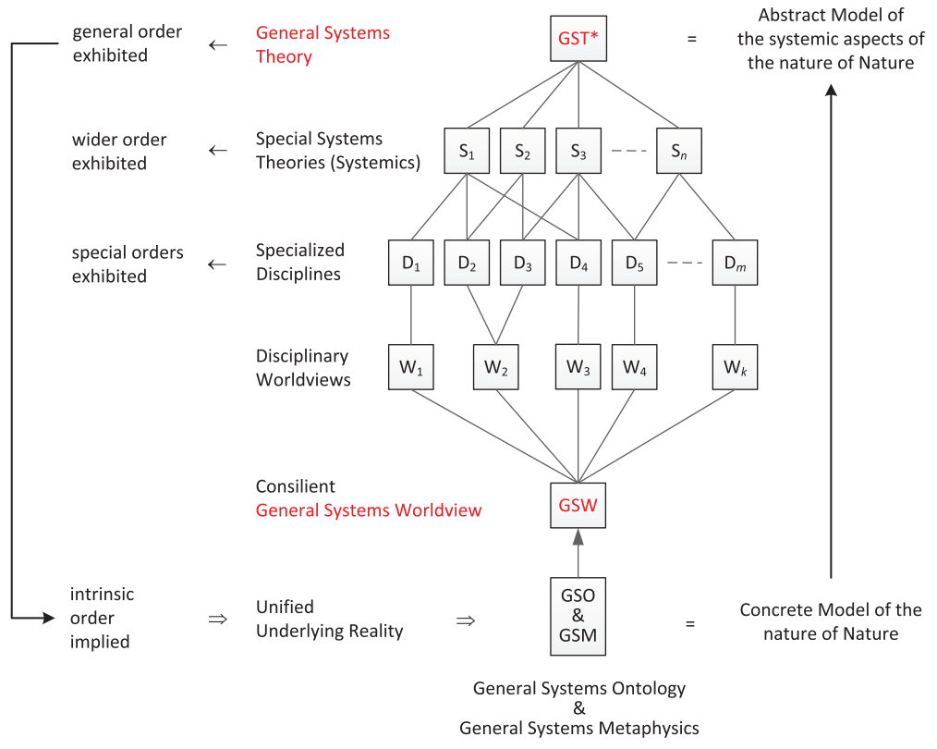(Rousseau, 2015)

The framework assumes that as there is a unified reality underlying nature (GSO), the content of GST* would provide an abstract model of the systemic nature of this concrete underlying reality (GSM) (Rousseau, 2015). Studies (Wilby et al., 2015, Rousseau, 2015) have demonstrate the possible existence of this GST in principle, the future development of this particular GST principles would inaugurate an era of systemic innovation, promote the new discoveries across the disciplines. It would significantly contribute to the competence and scope of science, which is crucial to build a better world (Rousseau, 2015).

The GST approach helps researchers to focus on the individual components as well as the relationship between the components that comprise a certain terminology/tool, thus, to understand those tools greatly. Various studies (Coetzee and Van Niekerk, 2012, Gray et al., 2014, Rousseau, 2015, Atkins and Atkins, 2016a) have emerged to try to use GST to explore the potential of their particular discipline for saving the planet, as well as building a better world. For example. Coetzee and Van Niekerk (2012) employ GST approach to address the origins of the disaster management cycle in disaster risk management, which is influenced by multi-disciplines. Moreover, Rousseau (2015) employs GST approach by expanding the Maslow’s ‘hierarchy of needs’ with the common goals for the progress of human civilization that expressed by various international organisations (e.g. United Nations), to develop a model (see Figure 18) for a better world. The Maslow’s ‘hierarchy of needs’ (Maslow, 1954) used to solely focus on the individual personal needs, while in this model, the boundary of ‘individual’ could be contextually transformed, such as family, community, organisation and country. The satisfaction criteria could be weighted differently for different ‘individuals’. Therefore, the world would become better if more ‘individuals’ have changes to move up their ‘individual needs’. These criteria could be considered as value scale to evaluate and support the developed approaches to build a better world (Rousseau, 2015).

Figure 18: A model of 'better world' criteria adapted from Maslow's hierarchy of needs and mapped to organisational value systems
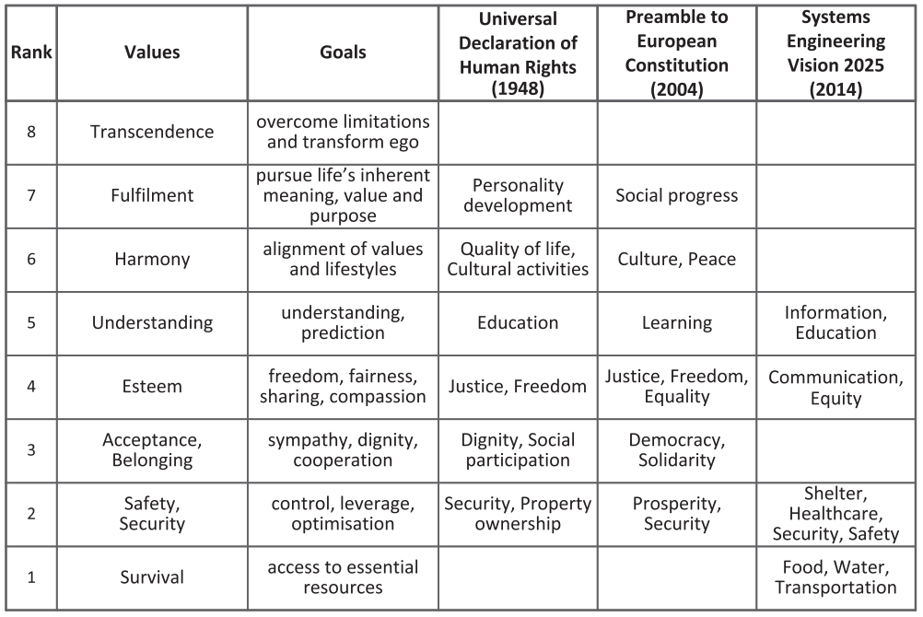
(Rousseau, 2015)

As discussed in 2.2.1, biodiversity conservation also involves multi-disciplines, and requires efforts from different ‘individuals’ (broadly construed). Tackle the trend of massive extinction is not only out of the needs to build a better world, but also, the most fundamental, to save our world by saving our planet. As human, at least we need to satisfy our needs of survival in the future. Therefore, the biodiversity loss should be concerned by every ‘individual’ which composed by humans. The disciplines which created by humans would take part of the solution based on their specialties to respond to this challenge. We have discussed the role of business (see 2.2.3) as one form of ‘individual’ in this situation. Now it is worth to explore the role of accounting as a discipline in the practices of biodiversity conservation.

Siting the accounting problematic
Gray et al. (2014) point out that GST is especially helpful as a way of thinking, which allows the issue to be considered in a broader context. But when comes to the specific problems, people are easily to ‘reduce’ the problem artificially to produce solution. It brings the risk of missing the point of GST, which excluding the complex and irreducible elements of the system from the problem. Such approach is referred to constrained system thinking approach. Business organisations are normally being considered as restrained systems, the reductionism is more typically characterizes thought in accounting. However, accounting is a complex system interacting with a complex series of natural and social systems. The conventional accounting is usually ignoring these interactions. Lowe and Tinker (1977) believe that in a theoretical and an empirical sense, the relation between accounting policy and human and social well-being is problematic. At that time, some social science subjects like economics would have national or global criteria for social and human welfare, while accounting as a discipline and in practice, is only operating at the micro-organisational level and concerns the welfare of those individual enterprises. Similarly, Hopper and Powell (1985) point out that accounting has been traditionally oriented towards stabilizing organisations rather than leading growth and adaptation. Therefore, accounting has failed to account for some of the missing elements, it should not be separated from human and non-human systems.

By compare the major subjects that studied at universities in different centuries, Lowe and Tinker (1977) discovered that the sustainability of disciplines and professions are depending on temporary needs, issues and problems. Accounting is one of the institutional activities that ‘created’ in response to particular social groups and needs. The survival of such artifacts is depending on their fulfillment of those social purposes.

Accounting as a social system
Social group is:

‘a set of two or more individuals interacting with each other in a manner different from their interactions with other individuals’ (Berrien, 1968, p90).

Here the ‘individuals’ could be further expanded to the broadly construed terms which discussed in 3.2.3.3 (Rousseau, 2015). Social groups exist in hierarchical structures as there are exchanges and interactions within groups and between groups and their surroundings (Berrien, 1968). As accounting is originally people to people measuring and communicating information to people who use the information, accounting could be considered as part of a social system and a social system itself (Bailey, 1970).

Social system could be considered as a concrete system, which is:

‘a nonrandom accumulation of matter-energy in a region in physical space-time, which is nonrandomly organized into co-acting, interrelated subsystems or components’ (Miller, 1965a, p202).

As for accounting, it could be considered as a concrete system made up of all those people who function in the profession of accounting in all organisations. In line with the elements of systems that discussed in 3.2.2, the human organisations are the immediate environment of accounting, which accounting functions as the information component to provide information output with maximum usefulness. If we think further, to ensure its long-term survival, accounting also need to aid the organisations to achieve the self-regulation, thus, to ensure the organisations meet their objective as producing output with maximum usefulness to its supra-system. Therefore, for accounting, its environment is also including the total environment which composed of social, economic, political and other systems which the organisations are sub-systems. The objective which accounting should aid the organisations to achieve, should be shaped by the organisations’ environment. Thereby, the usefulness of the information that accounting provided for the company should be determined by the fact that this information is related to the company’s objective of providing output to meet the needs of its stakeholders. Based on the discussions above, the boundary of accounting should be based on the state of the issues which concerned by the society or/and the world. The boundary defines the environment of the accounting which it selects and coding input for processing, and decoding output for. In relation to accounting’s functions for external users, it should provide information on the organisation’s performance and state in the forms which specially meet the needs of those in the environment who contribute inputs to the organisation and receive output from it (Bailey, 1970).

Social system also could be considered as an abstracted system, which is:

‘a set of formal relationships within or among concrete subsystems. Their relationships exist as concepts in the minds of scientific observers’ (Miller, 1965b, p109).

Accounting also could be regarded as an abstracted system made up by a set of relationships, roles or functions. The study of accounting as an abstracted system would allow us to explore the nature of accounting as an area of knowledge. Accounting could be defined as the system for:

‘the measurement and communication of feedback information on the state and process of human organisations’ (Bailey, 1970, p166).

Its objective should be based on the terms that the society is likely to accept and sustain it. That is, contribute to the satisfaction of needs and welfare at individual and social levels. The relationship between accounting, society’s needs, and the substantial environment is dynamic, as shown in the Figure 19, the society’s needs are influenced by the substantial environment and they are the inputs of the accounting system, the outputs are the services provided by the practitioners that aim to satisfy the society’s needs and to be further measured through the environment (Lowe and Tinker, 1977). The objective of accounting in society should be:

‘influencing the individual’s and society’s institutional decision making mechanisms to produce a desired level of welfare or well-being’ (Lowe and Tinker, 1977, p269).

Figure 19: 'Universe of discourse’ of system
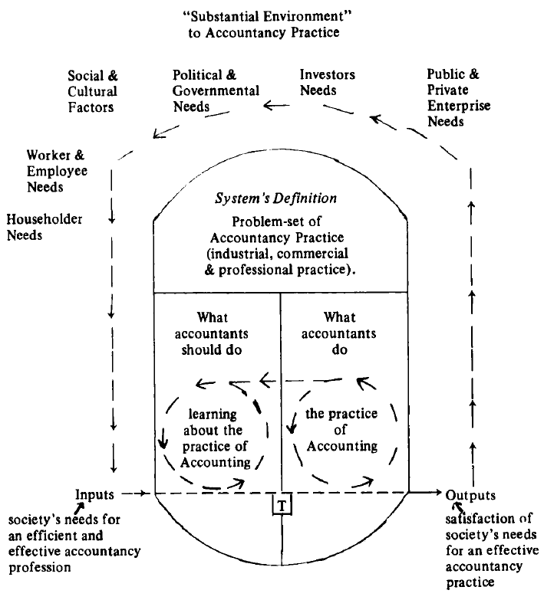
(Lowe and Tinker, 1977)

To achieve the steady state of accounting by meeting such objective, accounting should be designed as a flexible and adaptive system to allows for continuous growth and adaptation (Bailey, 1970). However, studies (see Lowe and Tinker, 1977) have indicated a substantial conflict exists between the society’s needs for accounting information (inputs) and the actual practices (outputs) by practioners. The society’s needs indicate what the accounting practices should be, the satisfaction of such needs is in relation with the interaction between ‘should’ and ‘do’, a constant interaction is essential in this matter.

In consideration of accounting’s survival and prosperity as a profession is mainly depend on its production of information, it is essential to recognise the accounting problematic as it might fail to address the conflicts in society. Lowe and Tinker (1977) point out that the source of such accounting problematic is the obstructed methodological development, there is a need for more explanatory and predictive accounting theories.

Role of accounting in environmental issues

Social accounting
As discussed earlier, accounting plays an important role in business as they provide purpose-oriented information to support management’s decision-making process and to fulfill accountability to stakeholders (Burritt et al., 2003). For business managers, apart from pursuing the financial profits for shareholders, they also obligated to satisfying other stakeholders’ requirements such as health and safety. In consideration of the uncertainty of future, managers require substantial relevant information to decide alternative approaches of actions to fulfil these obligations (Chambers, 1957). Thus, the purpose-oriented data provides important information for managers to achieve their desired future. If the desired future is to achieve sustainability, accounting has an essential role in it (Burritt et al., 2003).

The area of social accounting, which designed to provide information relative to organisation objectives other than profit-making has been recognised as a promising future in early 1970s, Bailey (1970) believes it could being a broad, extremely useful extension of accounting techniques. Currently, social accounting is showing its potential to reveal, examine and even ameliorate the negative aspects that the world is facing in 21st century. Gray et al. (2014) describe social accounting as simultaneously three things:

‘(1) a fairly straightforward manifestation of corporate efforts to legitimate, explain and justify their activities; (2) an ethically desirable component of any well-functioning democracy and, (3) just possibly, one of the few available mechanisms to address sustainability that does not involve fascism and / or extinction of the species’ (Gray et al., 2014, p3).

Social accounting is claimed to provide the prospect of a different view of the world, and the conventional accounting which solely focus on financial matters could be considered as one part of social accounting. It provides a way that we seek to address, redress and re-orientate our relationship with some negative consequences of human activities, such as climate change and species extinction. Thus, the social accounting can potentially expose the conflict between the pursuit of economic objectives and the pursuit of social and environmental ambitions (Gray et al., 2014) It provides a vehicle for different interest groups to support their ideological position (Arnold and Hammond, 1994), which could be in opposition to the interest of companies. It has potential to challenge the current business hegemony, thus, to develop a more democratic society for a better world (Gray and Bebbington, 2000). As a part of social accounting, and usually been put forward paralleled with it, the environmental accounting discussed below share the same potentials with social accounting.

Environmental accounting
The environmental reporting has a long history (Gray et al., 2014), Atkins and Maroun (forthcoming) have explored the roots of environmental reporting, the earlier form could be traced back to the 19th century from a scientific report produced by non-accountants. With centuries of development, the environment reporting only became widespread since 1980s. The demands of companies’ accountability for environment have led to the emergence of the concept and practices of environmental accounting, which allows companies to collect, use and report information that relevant to the environment (Burritt et al., 2003). Apart from the reporting guidelines we discussed in 2.2.4.1, there are numerous influential initiatives (see Figure 20) emerged since 1970s in concerns of environmental accounting and reporting. In result, with increasing practices from companies, new areas of discourse have been established. Moreover, innovative suggestions and practices are increasingly emerged, such as the notions of accounting for biodiversity (Gray et al., 2014). Along with the development of social accounting, the environmental accounting is starting to drive the debate between business and society, to renegotiate the boundaries of the business-society-environment. The environmental accounting has a counter-hegemonic potential to disrupt and change discourse in the public interest, thus, to move forward the companies’ sustainability by reducing their environmental impact. Even more, these new forms of accountings are believed with significant potential in developing a more democratic society (Gray and Bebbington, 2000).

Figure 20: Influential initiatives in environmental accounting and reporting
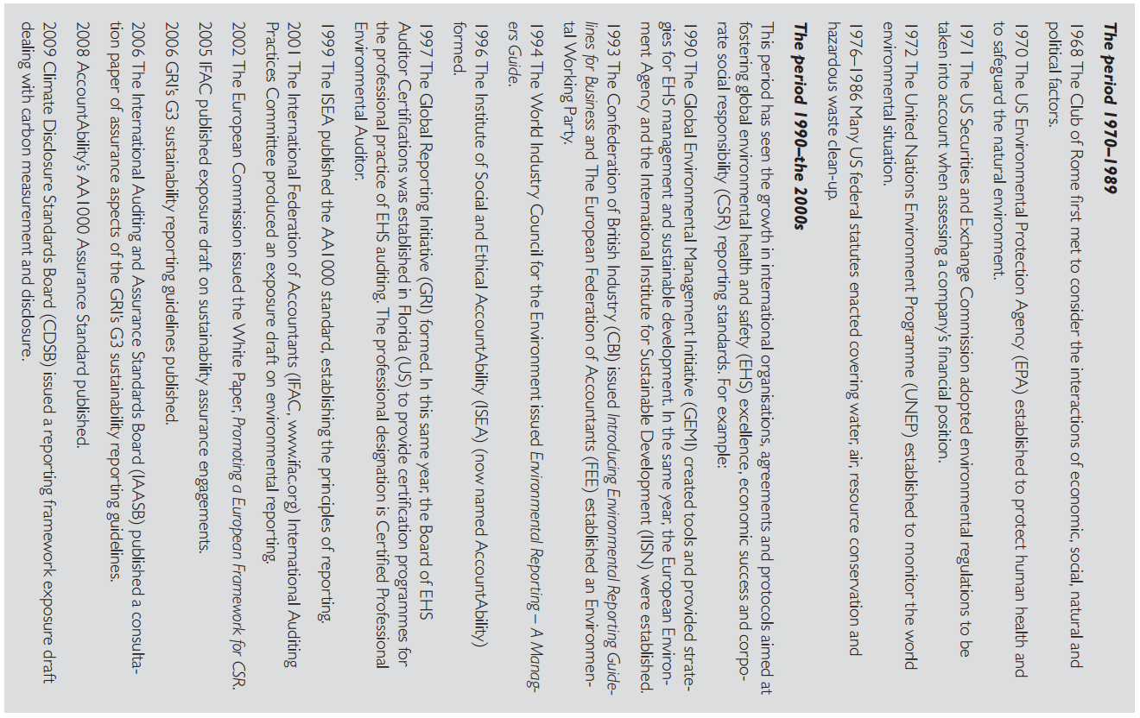
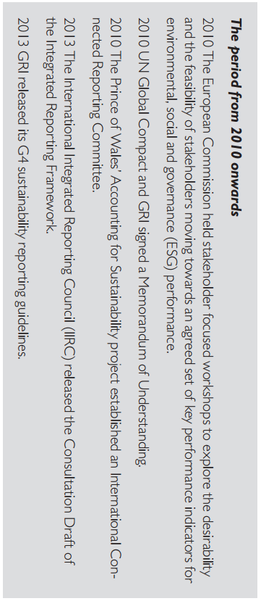
(Gray et al., 2014)

However, as concerned by Gray and Bebbington (2000), all these potentials would only be possible to realized when the environmental accounting is deployed and function as environment-centreed rather than business-centreed. If the environmental accounting is deployed as simply introduce the environmental concerns into the conventional accounting practices, it would easily fall into the situation that the environmental accounting is practiced in serving the business. In result, despite the significant improvement of the eco-efficiency, the businesses’ overall environmental impact would continuously grow due to the rising industrialisation and consumption. In this case, the environmental accounting is actually creating more harm than good.

The design of environmental accounting is not only intended to let accounting to be aware of the environmental issues, but also, more importantly, to play a significant role in tackling these issues (Gray and Bebbington, 2000). Disappointingly, currently accounting is one of the least developed areas of the companies’ response to the environmental issues, the accounting systems’ capability in incorporating the full effects of companies’ environmental impacts are widely recognised as inadequate (Gray et al., 2014). Even in the integrated reporting, which is one of the most recent developments of sustainability movement, the natural capital has not received sufficient attention despite it has been defined to share the equal importance with financial capital. It is undeniable that without nature, the modern capital system cannot exist (Atkins and Maroun, forthcoming). Some studies (e.g. Atkins et al., 2014, Maroun and Atkins, 2018) argue that we should not take an anthropocentric view of the nature, the real or intrinsic ecological value of the nature should be recognised. The details are discussed in the below sections around biodiversity issues.

Accounting for biodiversity

The emergence of biodiversity accounting
The emergence of biodiversity accounting and the substantive studies around it indicate the emancipatory potential of accounting in solving global challenges (Atkins and Maroun, forthcoming). Jones’ (1996) study was the first attempt in exploring accounting for biodiversity, which is inspired by the biodiversity treaty (as mentioned in 2.1.3.1) that signed in the Earth Summit in Rio de Janeiro in 1992. In supporting the conservation of the world’s nature resources to maintain the harmonious balance between human and nature, human organisations should take account for their stewardship of these stocks of natural assets, especially those critical natural capital, which is irreplaceable and increasingly affected by human’s organisational activities (Jones, 1996). Accounting is believed to play a unique and crucial role in this case as accountants are experts of data collection, organising and reporting, their skills and knowledge can be used to create links between humanity and nature (Jones and Solomon, 2013). The conventional accounting is evolved for financial calculations and been practiced as the establishment of profits and private ownership, the public goods like nature and biodiversity are excluded from accounting calculations. It does not concern the effect of an organisation’s activity toward natural environment (Jones, 2010). With the new form of accounting which is designed to be able to recording, measuring and disclosing biodiversity (Jones, 2010), it is possible for companies to collaborate and communicate with other stakeholders like NGOs and governments to provide integrated interdisciplinary solutions for biodiversity loss (Jones, 2014a).

Jones’ (1996, 2003) studies are trying to build a natural inventory model to account for flora and fauna, and their habitats. The model and its development are discussed in detail in following sections. Alongside Jones’ first attempt, the world’s increasing concerns on biodiversity crisis have encouraged academic accounting community to further explore the potential of accounting in contributing to the conservation of biodiversity. The significant development is evident in a special issue of Accounting, Auditing and Accountability Journal (AAAJ) entitled ‘Accounting for Biodiversity’ which released in 2013, and the book ‘Accounting for Biodiversity’ which edited by Jones (2014a). As a result, various initiatives and innovative models and frameworks are developed to improve accounting’s capacities in recording, valuing, and reporting biodiversity. Moreover, various case studies are carried out to assess and evaluate global organisations’ accounting and accountability for biodiversity. The details of these findings, alongside the related reflections and recommendations are discussed in following sections.

The accounting models for the recording and valuation of biodiversity
Recording and valuation of biodiversity are the challenges faced by the biodiversity accounting, Jones (2014a) has identified the obstacles that stop conventional accounting to adapt biodiversity accounting, which are: reliance on neo-classical economics; business focus; capitalist orientation; monetary dependence; numerical quantification; and technical accounting practices. In response, various accounting models and techniques are developed in aims to record and value biodiversity.

For example, the ecosystem approach, which includes three models: 1) the World Business Council’s (WBC) framework for Corporate Ecosystem Valuation is used to measure the valuation of ecosystem. It perceives biodiversity valuation as a win-win scenario as it could improve not only a company’s financial results, but also its environmental performance. 2) the European ecosystem approach is more concerned with the costs of biodiversity loss in areas of critical international importance. 3) the Houdet’s life cycle approach develops from an environmental management accounting perspective, designed for individual company to examine its interactions with biodiversity. These approaches are comprehensive by focusing on the overall services provide by biodiversity, while their scopes are limited as they are business-centreed (Jones, 2014b).

In contrast, a natural inventory approach (see Figure 21) developed by Jones (1996), (2003) provides a more focused model for biodiversity recording and valuation for a wide range of organisations. It is a bottom-up approach specifically focuses on flora and fauna, and their habitats. A multi-layered pyramid of hierarchical criticality is created, it starts with a simple classification of habitat type and natural capital status, develops to a general inventory of flora and fauna by population. This approach emphasizes the stewardship aspects of biodiversity, makes organisations aware of the ‘biodiversity assets’ which they own or responsible for (Atkins and Maroun, forthcoming).

Figure 21: Natural inventories: hierarchical criticality
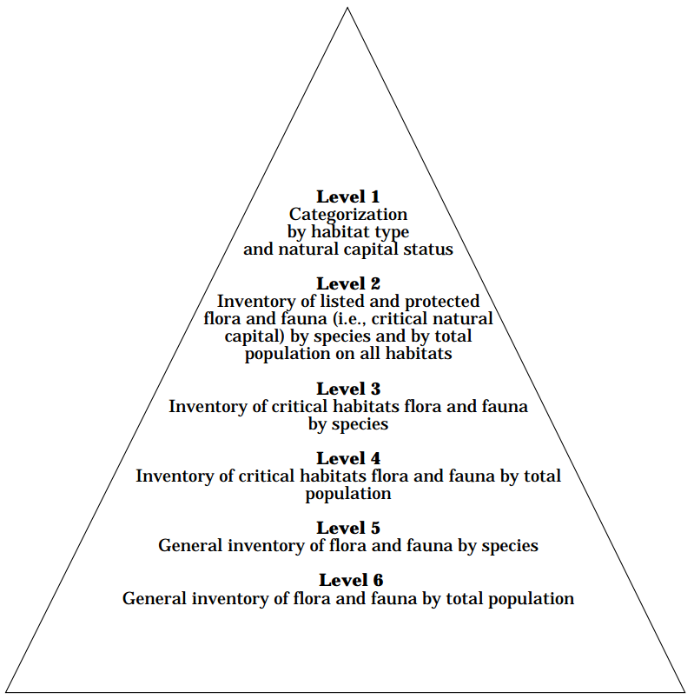
(Jones, 1996)

Moreover, Davies (2014) attempts to integrate biodiversity into full cost accounting (FCA), which has been widely used in the environmental accounting. The FCA tries to measure the full economics, environmental and social impact of an organisation’s activities into monetary terms. With the study of applying biodiversity accounting into the FCA model to the relocation of a university campus, Davies demonstrates that the biodiversity could be applied in FCA model to identify the direct and indirect costs and associate benefits. The study also raises concerns in relation to monetary reductionism and monetization of all the impacts identified.

In contrast, Christian (2014) views biodiversity through the deep ecology approach, which is deeply non-anthropocentric by places human in an equal position with all other biological species. Under this thought, biodiversity cannot be converted into monetary value as all species have their own intrinsic value. In support of this viewpoint, Jones (2014a) argues that some things are priceless and cannot be valued by the instrument which created by mankind. The valuation is just another form for human to control and dominate the world.

The discussions around anthropocentric and non-anthropocentric view of biodiversity accounting
Alongside with other approaches introduced in the book ‘Accounting for Biodiversity’ which edited by Jones (2014a), the models discussed above provide different perspectives about how the human organisations should take account for biodiversity. It raises the debate around anthropocentric and non-anthropocentric centric viewpoint in developing biodiversity accounting. From a non-anthropocentric viewpoint, as pointed out by Christian (2014), nature is valuable in its own right and biodiversity has its intrinsic value. The human species has no right to destroy other species, on the contrary, as the dominant species on the planet, the human species has responsibilities to care for the global biodiversity. From an anthropocentric viewpoint, accounting for biodiversity should consider human and human needs as the priority. Biodiversity is valuable to human as they are supplies of food, fresh water, medicine and amusement. Loss of biodiversity might lead to unknown and incalculable consequences (Atkins et al., 2014).

In the discussions of these two viewpoints, van Liempd and Busch (2013) believe that it is more effective to encourage companies to preserve biodiversity by identifying the instrumental value of biodiversity. The recognition of non-anthropocentric viewpoint might be especially controversial for business and accounting audiences as they have been traditionally educated within a neo-classical economies’ framework of utility and individual wealth maximization. However, Atkins et al. (2014) argue that from a deep ecology perspective, companies are reporting biodiversity for the ‘wrong’ reason, research evidence shows the currently biodiversity reporting disclosed by companies is dominated by an anthropocentric approach and impression management. These companies are considered fail to protect biodiversity according to its intrinsic value. However, it is still considered better than doing nothing at all. Although it is unrealistic to practice pure deep ecologists’ suggestion to eliminate all business activities which affecting the environment, Atkins et al. (2014) believe the future of biodiversity reporting should reject an anthropocentric approach and pursue a deep ecology perspective, thus to recognise the intrinsic value of biodiversity. While at present, Maroun and Atkins (2018) suggests that both anthropocentric and non-anthropocentric factors should be considered to ensure that:

‘biodiversity is not understood only in monetary terms while avoiding a situations where environmental concerns appear to be too far removed from current business practice by an investor community which may not understand deep ecology completely’ (Maroun and Atkins, 2018, p107).

This is believed as the necessary compromise in the short-term to pragmatically ensure the companies’ commitment in discharging their accountability for biodiversity. The considerations around this view are explained in the later sections.

Frameworks for biodiversity reporting and their limitations
As discussed in 2.2.3, the role of companies in biodiversity conservation has increasingly stressed by the world organisations, biodiversity related criteria have been integrated into various reporting guidelines (see 2.2.4), especially the GRI Guidelines, which have been widely adopted by the companies in the world. However, a low level of corporate disclosures on biodiversity has been discovered in several studies (e.g. Rimmel and Jonäll, 2013, van Liempd and Busch, 2013), indicated by the limited quantity and quality of information.

In Sweden, there is a content-repeating behavior in companies which disclose biodiversity information, repeat identical information exist in websites, annual reports or stand-alone reports. It shows that companies try to make the most from a small amount of information (Rimmel and Jonäll, 2013). In Denmark, although there are various guidelines, principles, handbooks and tools developed by governments and NGOs to help companies address biodiversity challenges, little information is disclosed about actual performance results or targets, costs or other quantitative data. Most of the disclosures are focus on mission statement, risk management, materiality and GRI, which account for 81.25% of total disclosures. It might indicate that companies are only starting aware and report biodiversity issues. The vague mission statements are easy to undertake and function as public relation, while no disclosures about performance and cost due to requirement of substantive inputs and projects. The study also noticed that none of investigated reports consider ethical grounds as one of reasons for taking account of biodiversity. Companies even did not state why they are required to disclose their impact on biodiversity. This means companies are unaware that they are under any form of ethical requirement to disclose biodiversity information (van Liempd and Busch, 2013). These findings show that although the quantity of disclosures is growing throughout the years, the motivation of companies’ disclosure on biodiversity is mostly defensive and reactive.

It can be seen that the biodiversity reporting studied above adopted essentially anthropocentric view of biodiversity. Atkins et al. (2014) believe that even the non-anthropocentric view is not adopted, in order to discharge accountability, companies should not only to protect biodiversity, but also to report their performance and stewardship to the public. Other than sustainability reporting standards like GRI Guidelines, a reporting and evaluation framework especially for biodiversity should be developed. Therefore, based on the natural inventory model (see Figure 21) which proposed by Jones (1996), Atkins et al. (2014) develop a biodiversity reporting framework (see Figure 22) and use it to investigate the biodiversity reporting from the listed companies in UK and Germany in 2008.

Figure 22: Biodiversity reporting framework (adapted from Jones, 1996)
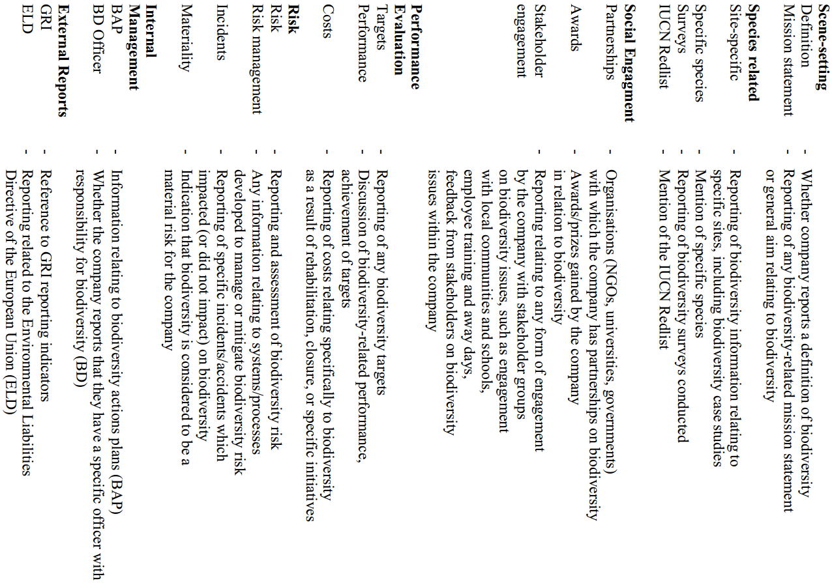
(Atkins et al., 2014)

The finding shows that UK companies have better performance in both quality and quantity of biodiversity disclosures. This might because UK has more international companies, which leads to higher standard of accountability and risk management. The performance of mining companies is significant, the mining industry plays a leading role in biodiversity reporting by providing detailed and specific disclosures about the companies’ potential impacts on biodiversity. However, this might relate to mining companies’ invasive nature of extractive processes. King (2016) points out that the most of significant quantity of biodiversity disclosures are provided by companies in high environmental impact industries including mining, oil and gas. Atkins et al. (2014) suggest the that companies’ major motivations for protecting and enhancing biodiversity is to manage biodiversity risk, believing it to be material.

Moreover, Atkins et al. (2014) also notice that there is lack of financial data in biodiversity reporting. Generally, biodiversity reporting is tending to be partial and biased. Majority of biodiversity reporting is focus on the positive performance of companies, with little information on the negative impact. The coverage of biodiversity is also disappointing with little consideration of habitats, unpopular species, or of any environmental or ecological valuation. The appearance of cherry picking and show-casing best practice case studies on biodiversity indicate the approach of impression management.

As suggested by King (2016), the current biodiversity reporting approaches are trend to be ‘anthropocentric’, companies mainly focus on the most ‘useful’ species for humans. This creates great neglect of other species which seems to be less useful to human. Moreover, corporate practices on biodiversity disclosures are trend to focus on risk management. However, it worth to be noticed that Atkins et al. (2014) also identify other range of motivations for corporate biodiversity reporting, including protection of natural heritage and our ecological inheritance, which indicates proactive incentives.

Problematisation of biodiversity accounting
The discussions above confirm the fact that currently there are various problems and limitations remain in the practices of accounting for biodiversity. As stressed by Jones and Solomon (2013), the research in biodiversity accounting is in its early stages, there is a need to push forward the boundaries to further explore the emancipatory potential of accounting in engendering changes in corporate attitudes and behaviors in preserving and enhancing biodiversity. The problematisation is defined as an approach to identifying and analyzing ‘problems’, the special issues of AAAJ on ‘Accounting for Biodiversity’ take such approach to address, analysis and provide potential solutions for the problems in accounting for biodiversity. As shown in Figure 23, a serious of problems have been discussed in carefully selected papers.

Figure 23: Problematising accounting for biodiversity
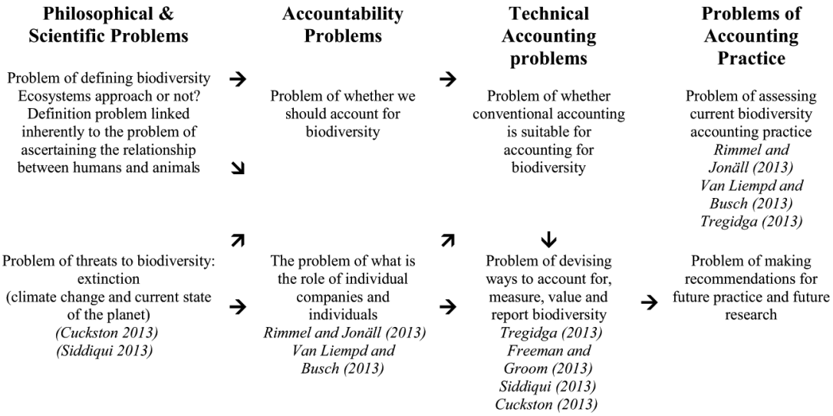
(Jones and Solomon, 2013)

Apart from the findings discovered by Rimmel and Jonäll (2013) and van Liempd and Busch (2013) which are discussed earlier. Siddiqui (2013) suggests that accounting for biodiversity is also applicable in public sector as it can help government agencies to demonstrate their environmental stewardship and accountability to concerned stakeholder groups. The world governments are encouraged to mainstream biodiversity accounting, thus, to form a legitimate basis for international issues like bilateral negotiations and disaster loss assessments. With the increasing concerns on biodiversity from academic accounting community, Freeman and Groom (2013) points out that the accountants’ current knowledge on biodiversity is extremely insufficient, especially on the aspect of valuation. Atkins et al. (2014) believe that there is a need to increase the scope of accountant’s knowledge and training to all the aspects of environmental reporting, including biodiversity reporting. The discusses around these problems indicate that accounting for biodiversity has great potential to shape companies’ attitudes and transform their behavior to mitigate their impact on biodiversity, even to encourage them to take further and more effective actions to preserve and enhance the variety of species on our planet (Jones and Solomon, 2013).

Inspired by Tregidga’s (2013) study which focus on specific species, Jones and Solomon (2013) suggests that the detailed reporting of specific species could effectively demonstrate organisations’ performance and in helping to establish a guiding framework for organisations to account for all species affected by their operations. Further, the concerns for the term ‘biodiversity’ have been raised, as it does not address the urgency of species extinction and sounds scientific with difficulties to acquire immediate understanding. Organisations would be more responsive and motivated when they are demanding to account for their ‘contribution to extinction of life on earth’, or to report how their conservation actions can help to prevent even reverse species extinction. In line with this thought, a collection of studies (see Atkins and Atkins, 2016b) on a specific species: bees, is emerged to investigate how the business world reacting to reverse the declining trends of bee population in the interests of long-term corporate sustainability.

In practice, one of the species that have been increasingly concerned and discussed by business is bees. From an anthropocentric view, it is a critical species within our ecosystem, providing an ecosystem service by pollination (Atkins and Atkins, 2016b). Insect pollination is a crucial ecosystem service for both natural and agricultural systems as approximately a third of the world’s crops depend on it to produce flower. Numerous businesses are involved in growing, transporting, transforming and selling pollination-dependent fruit and seed crop products. Other sectors such as tourism also depend on the service of wild pollinators (Houdet and Veldtman, 2016). The pollinator decline is not only the problem for government, but also for companies in terms of their social and economic responsibility (Romi and Longing, 2016). A massive financial risk is correlated with decline in bee populations. Thus, the significant bee population decline in recent years has caused considerable alarm. ‘Business of bees’ has been increasingly discussed in accounting community (Atkins and Atkins, 2016b).

By exploring the US S&P 100 companies’ disclosures in 2014 on pollinator decline issues, Romi and Longing (2016) disappointedly and surprisingly find out that in companies’ annual reports, there is no pollinator decline related disclosure in firm-specific risks. But few companies do have related disclosures in their sustainability reports, including the practices like employee participation, spreading the issue to other companies, research on bee-friendly products and companies’ impact on pollinator decline, and related education. Similar practices also been discovered in UK companies’ biodiversity disclosures. Interpretative content analysis is employed by Atkins et al. (2016) to uncover a series of themes in the bee related disclosures. Firstly, some companies adopt educational initiatives by providing bee-related knowledge for employees and stakeholders. Training for bee conservation even beekeeping were provided by some companies. Jonäll and Rimmel (2016) also discover similar educative initiatives that some companies build observable beehives around their buildings and sponsor activities for schools, thus, to educate people about how the bees live and work. Secondly, Atkins et al. (2016) find some companies demonstrate deep historical and cultural interest in bees through explaining similarities between corporate operations and bees’ activities.

With the growing emphasis on the companies’ accountability for specific endangered species, a new form of accounting named extinction accounting, is emerged and refined in a series of studies (Atkins et al., 2018, King, 2016, Maroun and Atkins, 2018, Atkins and Maroun, 2018). It could be perceived as a natural evolution from biodiversity accounting, with more emphasis on the urgency for a form of corporate reporting, which is more emancipatory in countering the current extinction trend (Atkins and Maroun, 2018). Compared with the previous biodiversity accounting studies, which result in the corporate reporting featured with descriptive, focused on compliance with external requirements, and seek for social acceptance, the extinction accounting attempts to take a further step to encourage companies recognise their unique ability and actively commit to the course in stopping even reversing the extinction trend (Atkins et al., 2018). The development of such reporting practices demands accounting to have an emancipatory potential, which is more transformative and progressive than the current reporting forms (Maroun and Atkins, 2018). The details of extinction accounting concepts and frameworks are discussed in later sections after the introduce of emancipatory accounting theory, which is essential for the development of extinction accounting.

The Emancipatory Accounting Theory

German critical theory and critical accounting
The German critical theory refers originally to the work of interdisciplinary research members of the Institute of Social Research founded in Frankfurt in 1923 (Laughlin, 1987), thus, it also known as the Frankfurt School of Critical Theory (Gallhofer and Haslam, 1991). It is a diverse set of thought primarily based on four key characters: Max Horkheimer, Theodor Adorno, Herbert Marcuse and Jurgen Habermas. Their thought reformulated the concerns of German idealist thought (e.g. concerns with the nature of reason, truth and beauty) with the new ways of understanding (Held, 1980):

‘They placed history at the centre of their approach to philosophy and society. Yet the issues they addressed went beyond a focus on the past and embraced future possibilities. Following Marx, they were preoccupied, especially in their early work, with the forces which moved (and might be guided to move) society towards rational institutions – institutions which would ensure a true, free and just life. But they were aware of the many obstacles to radical change and sought to analyse and expose these. They were thus concerned both with interpretation and transformation’ (Held, 1980, p15).

They are concerned with the approach to understand the reality through the interpretation of historically formed societies and institutions, and to achieve a desired transformation of societies and institutions to ensure a true, free and just life. Theory plays a significant role here for the change and development of societies and institutions (Laughlin, 1987):

‘Critical theory is a vehicle through which understanding about reality can be achieved and transformation of concrete institutions occur’ (Laughlin, 1987, p482).

Critical theory here is able to provide methodologies to improve the reality to a better state rather than the present, which is not satisfactory for critical theorists. The methodological tools are sourced from the historical analysis, which is able to reveal the insights from the points of progress in the past and the mechanisms behind them. These methodological tools are believed useful to be used again to promote societal development in the future (Laughlin, 1987).

As shown in Figure 24, critical theory is roots in the thought of Kant, Hegel and Marx, which emphasis the significance of human agency in the historical change, while it keeps certain distance from the classical Marxist historical materialist interpretation of history. For critical theory, the ‘development of society is neither an inevitable progression (as it was for Hegel) nor determined solely by structural matters’ (Laughlin, 1987, p482). It takes a balanced view of history with emphasis on both subjective human agents and objective structure, as:

‘The contradiction between the forces and relations of production does not give rise to a fixed crisis path. The course of the crisis, the nature of its resolution, depends on the practices of social agents, and on how they understand the situation they are part of. Critical theory does not downplay structure, but seeks to examine the interplay between structure and social practices, the mediation of the objective and subjective in and through particular social phenomena’ (Held, 1980, p362).

Figure 24: An overview of the Kant/Hegel line of theoretical and methodological thought
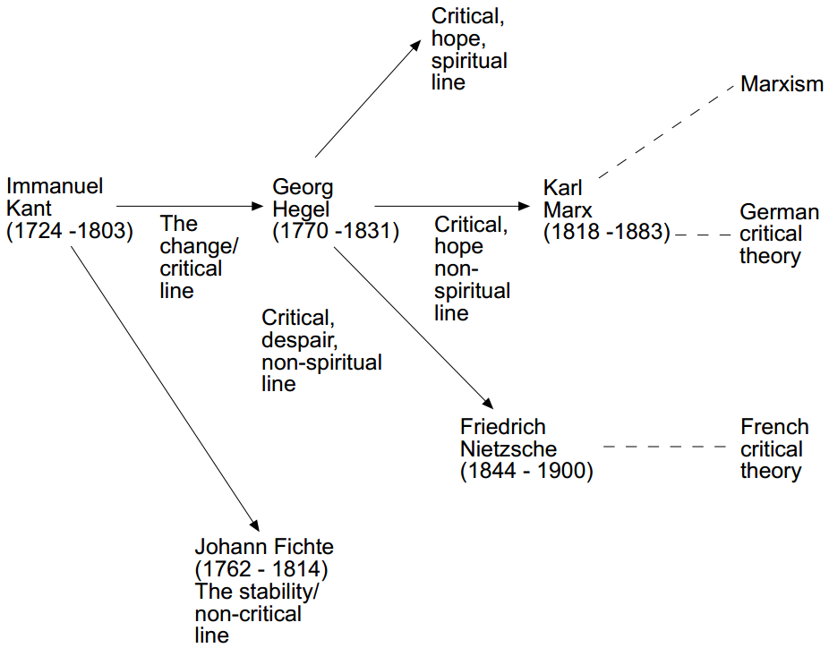
(Laughlin, 1995)

Such ‘balance’ in relation to critical theory grounds its strengths in the theoretical, methodological and change possibilities in Laughlin’s (1995) middle-range thinking, which is discussed in detail in the research methodology section. According to Laughlin (1987), the assumptions of critical theory are subject to debate and question as they are concerning the ability of conscious human action to change the social world:

‘… firstly, that society has the potential within itself to be what it is not; secondly, that conscious human action is capable of moulding the social world to be something different and ‘better’; and thirdly, that this can be promoted by utilizing the aids and props which critical theory can supply’ (Laughlin, 1987, p483)

Such characteristic grounds critical theory the reflexivity and openness of its concern to engage with different perspectives and learn from others. This strength in good communication ensures the German critical theoretical approach continues to be valued in research today, noting its own commitment to theory development, especially in the theoretical appreciation of accounting (Gallhofer and Haslam, 2003, Gallhofer et al., 2013). Besides that, Laughlin (1987) points out other three characteristics that the critical theory is in association with accounting research. Firstly, critical theory closely links the theory and practice, which fits with the design of accounting system. Secondly, critical theory’s central concern is the critique of the status quo and the need for transformation to achieve social betterment, which is the ethical dimension that has been absent in accounting research for a long time. It could drive the accounting to develop as a discipline and profession for the human welfare rather than just for the micro-level organisations (as discussed in 3.2.4). Thirdly, critical theory proposes the historical analysis of the social organisations to address the hidden factors under a contextual and holistic view, thus, to improve understanding to allow for change. This methodological framework could be addressed by accounting in promoting the change for betterment.

Among the four key characters of critical theory, Habermas believes that the ‘society has progressed due to the expanding and developing language skills of societal members’ (Laughlin, 1987, p485), as it is the basic rational skill which distinguish mankind from other species. His insights in the role of language in societal developmental processes provide the most promising methodological approach to understand and change the design of accounting. Firstly, his emphasis on the role of language and communication in promoting understanding and non-violent change could be addressed by accounting as it is perceived as the language of organisation. Secondly, Habermas suggests that the ideal state of the phenomena should be discovered during the investigation process rather than being defined prior the investigation. This stand would bring more pragmatic application of the methodology in accounting research. Thirdly, compare with other critical theorists, Habermas provides specific applications of his methodology, which could be clearly studied for the improvement of accounting (Laughlin, 1987).

Habermas’s insights suggest a less radical perspective, alongside other critical theorists, the critical theory has been widely applied and developed in accounting academics for a considerable period and generated various forms of accountings (e.g. social accounting, counter accounting, emancipatory accounting) which aiming to bring about social betterment. In 1999, to define the boundaries of critical accounting, Laughlin defines the critical accounting as:

‘a critical understanding of the role of accounting processes and practices and the accounting profession in the functioning of society and organisations with an intention to use that understanding to engage (where appropriate) in changing these processes, practices and the profession’ (Laughlin, 1999, p73).

This definition indicates the contextual feature of critical accounting by considering accounting as a phenomenon which has social, economic and political impact and needs to be understood and changed in this context. Moreover, it considers the functioning of the accounting processes and practices and the accounting profession at multiple levels (e.g. societal, institutional, organisational level). An implicit point also has been addressed from the definition, which is, in order to address such complex issues, critical accounting needs ‘intellectual borrowings’ from other disciplines to generate the suitable theoretical and methodological perspectives. Furthermore, critical accounting researchers’ understanding might vary due to above factors, thus lead to various form of evaluations, and engagement in changing that which is understood (Laughlin, 1999).

In line with this definition, Laughlin (1999) points out that currently the accounting community’s concern is either on the interpretation or transformation of the problems. The clarity on both of interpretation and transformation, as initially concerned by critical theory, is inadequate. There is a need to address this issue as the challenges pressing on mankind and our planet are accelerating. In relation to the theoretical and methodological perspectives for critical accounting, Laughlin specifically criticize the Tony Tinker’s project, which solely ‘borrowed’ Marxist thought into the critical accounting research. Tinker’s approach and his notion of emancipatory accounting and later refinements made by others are discussed in following sections.

The emergence of emancipatory accounting from Tinker’s early intervention
Emancipatory accounting also could be understood as the accounting that is seen as engendering emancipation. It was, as far as we know, firstly explicitly developed (i.e. in terms of the first usage of the construct) by Tinker (1984, 1985). The emphasis is on connecting actual and possible accountings based on critical thought, with the aim in Tinker (1984, 1985) being to bring revolutionary transformation of both the problematic conventional accounting and society in general. For Tinker (1984), conventional accounting is a tool designed to serve the established socio-political order of capitalism by solely focusing on the conflicts around the capitalistic micro organisations (in relation to ownership interests understood in capitalistic terms), which is narrow and restricted. This type of accounting practice is perceived as exploitative and repressive of society more generally (in particular the interest of labour) from a critical perspective as it directly and actively defaults or displaces from attention the conflicts that it omits from its content (Gallhofer and Haslam, 2017).

To address and counter the conflicts in general, emancipatory accounting is proposed by Tinker (1984, 1985) to provide an alternative to problematic conventional accounting. It aims to bring a Marx-inspired revolutionary transformation, to counter alienation emerging from the capitalist system, especially the capitalist relations of production. Tinker’s (1984, 1985) emancipatory accounting, instead of maintaining the status quo, create tension by stressing the problematic status quo, thus, to lead transformation. Its focus is on illuminating the exploitation and repression of labour. Gallhofer and Haslam (2017) point out that the notion of emancipatory accounting that sees conventional accounting and its context as problematic and needing radical transformation has significantly influenced the subsequent studies of social and environmental accounting, which tend to attack conventional accounting and provide what are seen as progressive alternatives. However, Tinker’s notion solely focuses on accounting’s content, and in line with Tinker’s (1984, 1985) formulation, an accounting practice is either emancipatory (directly or indirectly) or is a tool of the repressive status quo. Such a clear-cut dichotomy contributes to difficulties of implementation.

Shifts in the meaning of emancipatory accounting by recognizing accounting as a multi-dimensional phenomenon embedded in a dynamic context
By recognizing the narrow implication of emancipatory accounting defined by Tinker (1984, 1985), Gallhofer et al. (2015) further construct the notion of emancipatory accounting by broadening out its meanings. In their articulation, accounting is composed with a number of properties and dimensions (e.g. content, form, usage and aura) in interacting with each other and with a dynamic context to engender a complex social impact. Such articulation goes beyond Tinker’s (1984, 1985) sole focus on the content of accounting. Further, for Gallhofer et al. (2015), the shifts in the form (including the nature of media in which it is articulated), usage (who use it and how, including for what purposes), and aura (how accounting is perceived in society) of accounting also can bring about the emancipatory development. In supporting this, with a study on the case of accounting in Germany from the late nineteenth century up to the aftermath of the First World War, Gallhofer and Haslam (1991) elaborate how the transformation in accounting’s aura can engender a threat to the socio-political order which is conflict-enhancing rather than conflict-resolving. Alongside other studies (see Gallhofer et al., 2015) on the impact of the changes in accounting’s content, form, usage and aura, Gallhofer and Haslam (2017) suggest that the interactions of the elemental dimensions of accounting in relation to wider contextual dynamics could potentially lead to emancipatory change. In line with this suggestion, the accounting content perceived by Tinker (1984, 1985) as conventional and problematic could function in an emancipatory way by interacting with other elemental dimensions of accounting in a dynamic context. In this regard, in exploring more radical possibilities of conventional accounting, Gallhofer and Haslam (1995) adopts a historical analysis discover that the accounting publicity (making things visible to the public) which is considered as conventional today was perceived as a radical democratic revolutionary idea and practice in 1830s.

Consequently, a ‘continuum thinking’ has been applied to theorise accounting as more (or less) emancipatory on a continuum in a contextual dynamic (Haslam, 2016). This application is significantly influenced by the postmodern and feminist critique of dichotomous thinking, challenging the dichotomy of conventional accounting and emancipatory accounting. Therefore, any accounting is understood as invested with both emancipatory and repressive potential. And accounting can be perceived to have both (a mix of) emancipatory and repressive impacts at any instant of time (Gallhofer and Haslam, 2017).

With appreciation of accounting as a multi-dimensional phenomenon embedded in a dynamic context, the construct of emancipatory accounting could be understood in broader and looser terms. The grand transformation proposed by Tinker (1984,1985) is no longer considered as the key objective of emancipatory accounting. The objective is replaced by notions for social progress, which suggest accounting should be practiced to engender social betterment (Gallhofer and Haslam, 2017). However, as discussed earlier in critical theory, there are different views on the social betterment. So the new position is not aligned to any notion of betterment. Identities, interests, and projects that can be addressed as objectives and linked together have to be progressive. This poses a challenge for emancipatory accounting to follow through its commitment in the reality (Haslam, 2016).

Further constructions of emancipatory accounting by engaging with the theoretical developments in the humanities and social sciences
In response to the challenge of difference, Gallhofer et al. (2015) initiates critical theoretical engagement with the developments in the humanities and social sciences which have been elaborated as postmodern, post-structuralist and post-Marxist thought. The appreciation of reflexivity from postmodern and post-structuralist thought has engendered the new pragmatism, a more cautious and pragmatic approach to deal with the complexities and uncertainties posed by the significance of difference in the real-world context.

In the last decades, the development of globalisation, urbanisation and equal rights further enhances rather than eradicates difference, which is opposite to the assumptions of modernisation theory. This is perceived positively by Young (2011) in terms of social movements:

‘…the good society does not eliminate or transcend group difference. Rather, there is equality between socially and culturally differentiated groups, who mutually respect one another and affirm one another in their difference’ (Young, 2011, p163).

This reflects the increased sensitivity to difference, which acknowledges a plurality of interests, identities and projects on the basis that they are sharing the basic commitments to progress, democracy, freedom and justice that are integral to a notion of well-being. The very respect for the particular is a universal principle (Calhoun, 1995). By taking the plurality of interests seriously, the voices and interests of particulars are able to be listened to and understood. Based on this universal principle, diverse interests could be linked in ‘chains of equivalence’ to articulate the particular and universal. With interests of particulars articulated, a general equivalent is needed to present the chain as a whole. Such a general equivalent is contingent upon the existing particulars and their interactions. The emancipation(s) is(are) seen to emerge throughout the process. With the emphasis on the understanding and respect of the particular, a collective force is formed for emancipatory praxis based on the common sense of repression and injustice between the different interests, identities and projects. This gives recognition to plurality in emancipation, that emancipatory project can be formed by aligning diverse progressive interests, identities and projects (Gallhofer et al., 2015). This constructed differentiated universalism combines the strengths of both universalism and difference, provides a critical perspective to involve a pragmatic and discursive appeal to common values (Gallhofer and Haslam, 2017). As described by Laclau and Mouffe (1987) in relation to our times:

‘We are living … one of the most exhilarating moments … a moment in which new generations, without the prejudices of the past, without theories presenting themselves as ‘absolute truths’ of History, are constructing new emancipatory discourses, more human, diversified and democratic. The eschatological and epistemological ambitions are more modest, but the liberating aspirations are wider and deeper …’ (Laclau and Mouffe, 1987, p80).

The above discussion indicates possibilities for accounting and emancipatory praxis:

‘Today the construct emancipatory accounting needs to be seen in terms of the mobilising of accounting in relation to a range of legitimate identities, interests and projects and in terms of the aligning of these in a progressive movement’ (Haslam, 2016, p154)

This addresses the significance of accounting in the agonistic democratic processes. To further develop the possibilities of accounting in a new pragmatist emancipatory praxis, Gallhofer et al. (2015) articulate a delineation of accounting as a differentiated universal, recognising the possibilities of an expansive delineation of the accounting concept and notably the variety of particulars this encompasses – which can be legitimately worked on as ‘accounting’ and just need to be clarified for analysis. This contrasts with the broad delineation of Gray et al. (1996). Social accounting (as introduced in 3.3.1) as formulated by Gray et al. (1996) in one moment of their analysis is considered as accounting almost without constraints, even without boundaries. Such a broad delineation without reference to specifics makes it potentially too vague to address the specific, and offer little positive for emancipatory praxis and thus might lead actors to fall back on the narrower delineations in practice – indeed in another moment of their analysis, Gray et al. (1996) even appear to suggest that forms of counter or shadow accounting are not accounting (Gallhofer et al., 2015).

According to Gallhofer and Haslam (2017), the focus on accounting delineation is significantly influenced by the postmodern and post-structuralist thought on the dynamics of the concepts and constructs, which raise the questioning about what is accounting and its boundaries. The Gallhofer et al.’s (2015) study suggests that the emancipatory dimensions of accounting have been overly constrained in previous approaches to accounting delineation. The narrow delineations of accounting are usually reflected in professional practices, and the role of the profession that is historically perceived by accounting academics. This is greatly influenced by the profession itself, and the perceived interests of narrowly recognised users like shareholders and investors. Such narrow delineations of accounting have failed to better reflect the plurality of interests, thus, usually being negatively viewed by critical perspectives. However, as discussed earlier, any accounting has emancipatory potential, including the conventional accounting often depicted as mainstream, if the emancipatory dimensions of the latter are rarely studied. In contrast, the broader delineations of accounting are addressed to reflect a plurality of interests.

To solve the challenge of the articulation of accounting delineation with the new pragmatist emancipatory praxis, Gallhofer et al. (2015) suggest delineating accounting as a differentiated universal, which perceives the delineation of accounting as a political act, seeks to promote a variety of accountings to respond the calls of a new pragmatist emancipatory praxis. These particular accountings share the universal characteristics while are different with each other in terms of their own particular characteristics. This approach clearly addresses its potential to respect difference and plurality, provide more possibilities for new accountings and new imaginings of accounting, to make a variety of accountings that might be more emancipatory.

The greater centrality and general applicability of the new pragmatist emancipatory accounting construct
The above discussions introduce the significant refinements of emancipatory accounting from Tinker’s (1984, 1985) classical Marxism construct to Gallhofer et al.’s (2015) post-Marxist new pragmatist construct. The move beyond the grand revolutionary transformation objective which is the result of single act of a single agent, towards the multiple progressive objectives which are the result of agonistic communication and democratic practice, increases the possibilities for the emancipatory accounting in relation to a range of progressive interests, identities and projects. The emphasis of reflexivity, which draws from the theoretical developments in the humanities and social sciences, has improved the notions of emancipatory accounting with more cautious pragmatism and continuum thinking. In result, any accounting is perceived to contain both emancipatory and repressive dimensions, it can become more (or less) emancipatory in a dynamic context. Further, with a pragmatic, progressive and pluralistic perspective reflected in the notions of emancipatory accounting, and the delineation of accounting as a differentiated universal, various emancipatory accountings could be aligned to support progressive projects (Gallhofer and Haslam, 2017).

In result, with more space opened for accounting to be emancipatory, the accounting communities have more opportunities to get involved in the progressive engagement. It would provide more possibilities for the increased usage of the critical new pragmatist emancipatory accounting; thus, the greater centrality and more general applicability of the emancipatory accounting construct would be achieved. As a communicative practice, accounting can further help us to understand and engage with the projects addressing today’s pressing challenges, thus, move us toward a better world and society (Gallhofer and Haslam, 2017).

The emergence of extinction accounting with emancipatory potential
The emergence and construct of extinction accounting are significantly influenced by the emancipatory accounting theory discussed above. With the pressing threat of massive species extinction and increasing calls for the private sector to act, the need to encourage changes in mind-sets and bring about social change is ever pressing. To better address the urgency to transform companies’ attitude and behavior on the threats of species extinction, a new form of accounting is required as an ‘emancipatory project’ to effectively drive and present such transformation. The extinction accounting is designed for such purpose with considerations of pragmatism (Maroun and Atkins, 2018)

To develop its concepts and practical framework, Atkins et al. (2018) explore the integrated reports and other sources of disclosures released by top listed companies in South African, to investigate their disclosures relating to the conservation of rhinoceros, which is endangered and significant in cultural, heritage, eco-tourism and intrinsic value. Several factors are discovered in supporting the emerging of extinction reporting practiced by these companies. For example, the focus of companies’ disclosures is not constrained by the concerns of financial considerations, compliance with reporting standards, or direct relation with companies’ operations. Their disclosures include not only the descriptive accounts of poaching, but also the initiatives they have taken to combat poaching. Companies are providing direct financial and other forms of support to collaborating with other stakeholders like government agencies and NGOs, and even prepared to work with their competitors to promote anti-poaching measures. Such initiative is reflecting the concept of ‘differentiated universal’ (as discussed in 3.5.4), that a range of progressive interests, identities and projects are aligned here for a unified project, which is to prevent extinction of rhinoceros by combating poaching. Through companies’ accounting infrastructure, these practices could be communicated effectively with a broad range of stakeholders to improve awareness, as well as to provide them practical approaches to contributing to anti-poaching measures. It is important that the rhinoceros is not framed as part of a non-financial reporting compliance practice. Perceived by Atkins et al. (2018), the threat of rhinoceros extinction is being considered as a material issue by the investigated companies, their related reporting is no longer solely driven by the impression management, the findings also reveal their genuine commitment in preserving this biologically and culturally important species. Such commitment indicates that the organisational boundaries are shifting, possibly influenced by the societal shift in ecological consciousness as there are growing concerns raised by various international organisations toward the threats of biodiversity loss (as discussed in 2.1). As a result, the boundaries of accounting are shifting as well, and the role of the accounting infrastructure is changing. These interactions are in line with the application of GST by considering accounting as a social system, which is constantly interacting with its environment and strive to satisfy the needs and welfare at individual and social levels through continuous growth and adaptation (as discussed in 3.2.5). Such transforming movement indicates that the companies’ practices are moving away from a dominant anthropocentric perspective of species to a more balanced perspective with consideration of deep ecological views. It makes this new form of accounting distinct with previous forms of accountings which mobilized by companies in discharging their accountability for sustainability issues. The essential differences are summarized in the Table 4 shown below.

Table 4: Views of researchers on accounting for biodiversity, philanthropy and extinction
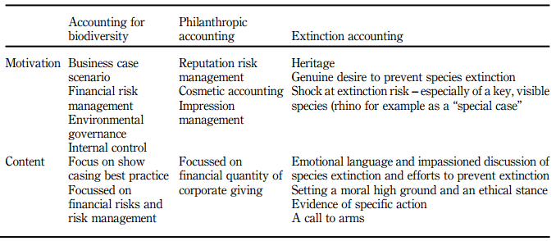
(Atkins et al., 2018)

According to Maroun and Atkins (2018), the intention of extinction accounting is to guide companies to address and report biodiversity related risks including extinction, thus, to encourage them to recognise and communicate how they could contribute to mitigate those risks. Here accounting is perceived as an emancipatory force to improve social well-being or welfare. However, as an emancipatory pragmatic approach inspired by the new pragmatist construct of emancipatory accounting (Gallhofer et al., 2015), extinction accounting is not aiming to bring a radical change of current practice, but to find a pragmatic approach to start an emancipatory development within the current system. To bring a progressive change, it is necessary for extinction accounting to solve the weaknesses of current reporting practices, which is the weak interconnection between the reporting content and the actual actions on identified biodiversity risks. Therefore, the reporting framework for extinction accounting should be developed to ensure that:

‘1) sufficient information on affected species is provided; 2) the reasons for being concerned with extinction are established and 3) the policies, plans and actions taken to respond to the possible extinction of species are consistently reviewed and reported on’ (Maroun and Atkins, 2018, p107)

As shown in Table 5, the extinction accounting framework proposed by Maroun and Atkins (2018) takes into account the principles from the GRI (see 2.2.4.1), integrated reporting (see 2.2.4.2) and emancipatory accounting theory (see 3.5), constructed for companies to comprehensively report the risks identified in relation with extinction of specific species, the evolving actions formed to combat extinction, the detailed performance with evaluation of any successes and failures, and the plan for further actions in the future. Six elements are outlined to guide companies to fulfil such expectation. The first element is mainly developed from the GRI indicators with requirements for descriptive information. Both anthropocentric and non-anthropocentric views should be considered in addressing the risks and explaining the motivations for preventing extinction, as mentioned in 3.4.3, this is to seek balanced pragmatism between the two paradigms to ensure the acknowledgement from companies and stakeholders. The second and third elements mainly concern with the actions taken by companies and partnerships involved in supporting companies’ extinction prevention projects. These two elements are important in establishing a clear connection between environmental policies and operational practices. The fourth and fifth elements are focusing on the review of companies’ actions and performance with their policies and pre-established objectives. This post-implementation review process helps to further reinforce the linkage between companies’ reporting content and actual actions. The regular review of the performance and objectives are also essential to maintain companies’ commitment to anti-extinction initiatives and encourage the continuous development of the approaches for extinction prevention. Finally, the sixth element is mainly based on the integrated thinking and practices of integrated reporting, emphasis on the necessity to incorporate the whole extinction prevision process into the companies’ primary report for stakeholders. Companies are expected to explain how the risks of species extinction affect their strategy, operational plans and assessment approaches. Their reported performance should include not only the success, more importantly, but also any failures in mitigating risks. As a forward-looking framework, it also requires companies to discuss their plan to response to the risks caused by biodiversity loss in the future.

Table 5: Elements in an extinction accounting framework
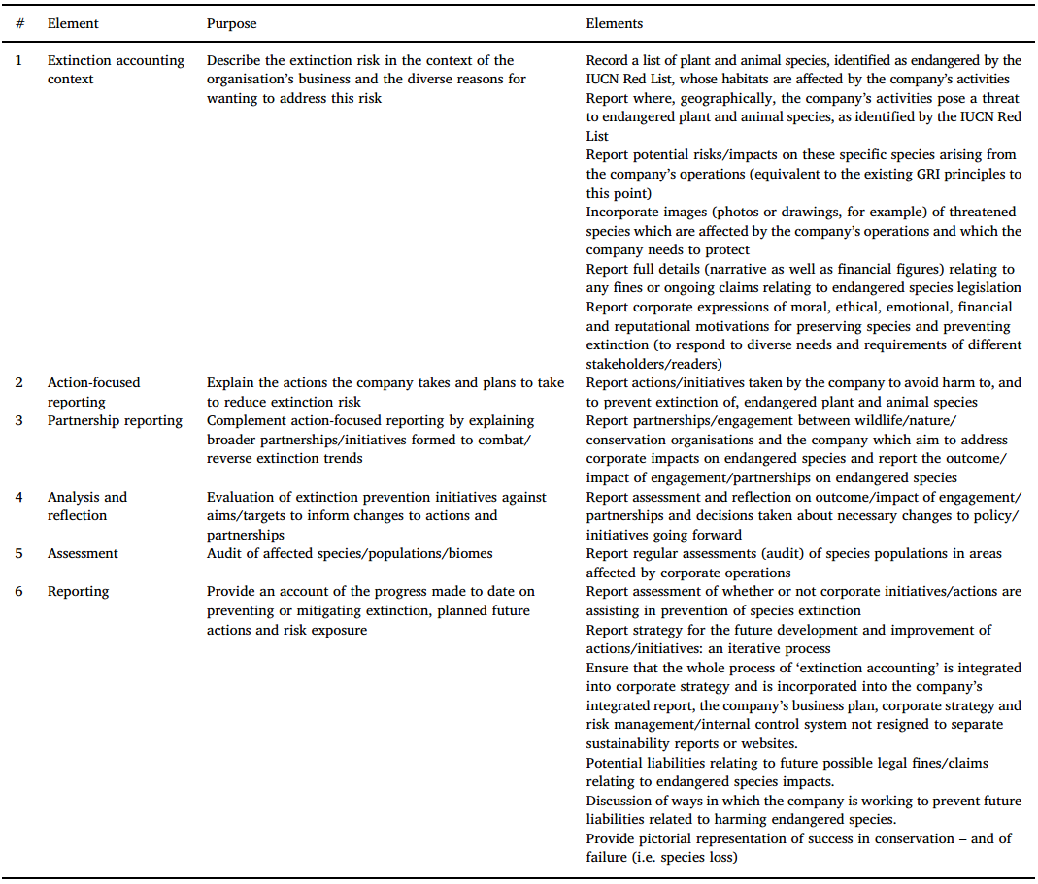
(Maroun and Atkins, 2018)

The framework reflects the essence of extinction accounting for driving organisational change, helps to develop accounting to be part of the value creation process refer to not only the financial capital, but also the nature capital and social welfare. Companies’ actions and disclosures on extinction prevention based on this framework would be more progressive and transformational than the current reporting frameworks like GRI, which have been criticized that practiced by companies as a disclosure checklist to provide ‘fossil record’ of species. The extinction accounting has revealed the accountancy’s emancipatory potential and practiced the emancipatory accounting in the new pragmatist perspective. It is true that a radical change is needed if we want to prevent massive extinction of species, while the pragmatism should be taken into consideration when formulate the extinction accounting framework. It is unlikely to convince modern companies with the non-anthropocentric perspective which represented by the deep ecology, currently the companies and investor communities are unable to consider the nature from a non-financial or non-economic perspective. On the other hand, the solely adoption of anthropocentric perspective is not only raising the technical and moral challenges by assigning monetary value to the nature, but also tending to be short-sighted by ignoring ecological or intrinsic value of species. Extinction accounting is not attempting to resolve the tension between these two perspectives, rather, as mentioned earlier, it seeks to formulate a framework to address both perspectives as a compromise to the pragmatism (Atkins and Maroun, 2018).

Chapter 4: The biodiversity issues in China

Biodiversity loss in China and its impact
China is one of twelve countries with the richest biodiversity on the planet, it has over 30,000 kinds of higher plant species (ranked 3rd in the world), over 28,000 marine species (11% of global marine species), and over 6,000 vertebrate species (13.7% of global vertebrate species). China also has rich genetic resources, it is one of four centres of genetic resources origin in the world (Li, 2015). Based on current records, China has 1,339 kinds of cultivated crop, with 1,930 kinds of relatives in the wild. China has the most varieties of fruit trees in the world, it also has 576 kinds of domesticated animal (The Ministry of Environmental Protection of China, 2011). Moreover, China has varieties of natural ecosystems (see Figure 25), mainly are the grassland, forest, agricultural and desert ecosystems, which occupied 82.7% of the total area of all the ecosystems in China (see Table 6).

Figure 25: Map of Distribution of China's Terrestrial Ecosystems in 2010 (Data of Taiwan Province of China was not included)
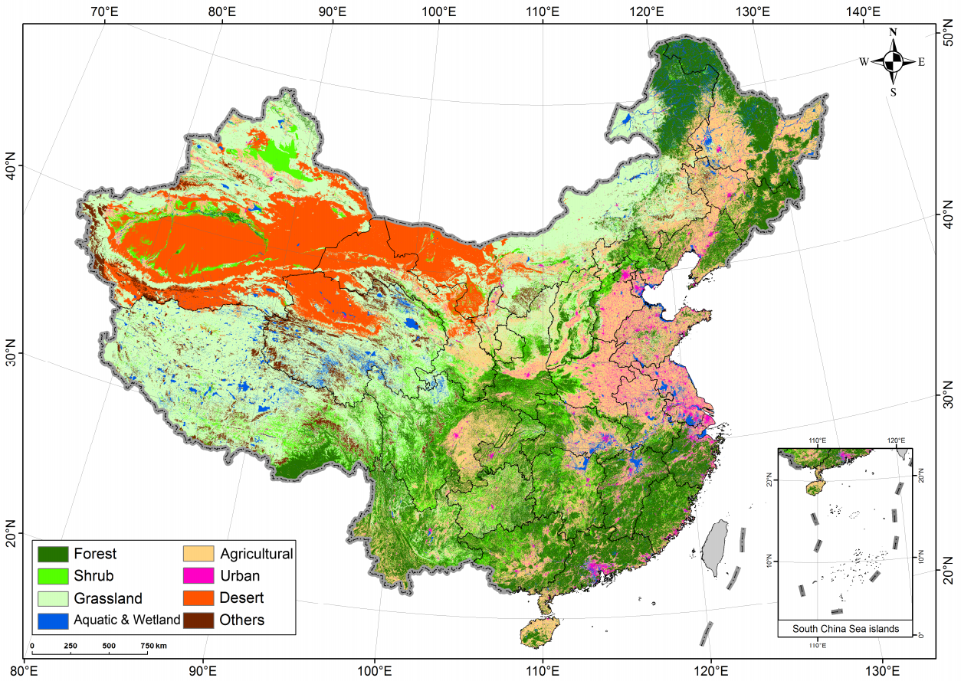
(The Ministry of Environmental Protection of China, 2014)

Table 6: Distribution of terrestrial ecosystems of China and percentage of areas of all ecosystems in 2010
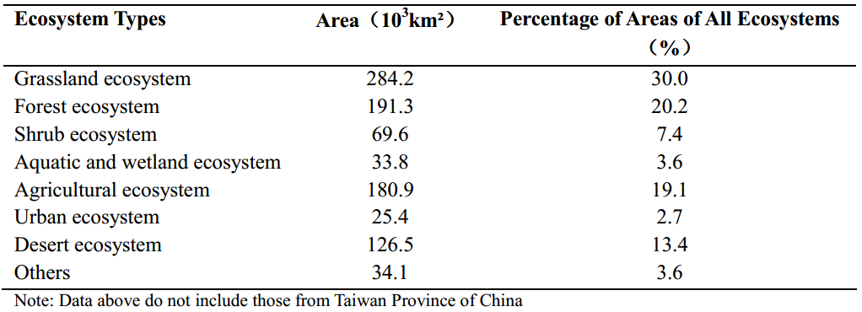
(The Ministry of Environmental Protection of China, 2014)

However, China needs to feed about 25% of the population in the world by using just 7% of the global arable land, which creates significant challenge for China to balance between economy development and environment protection (World Economic Forum, 2018). With the rapid growth of population and accelerated speed of the industrialisation and urbanisation process, the current production mode in China is placing great pressure on biodiversity and sustainable utilisation of renewable resources (WWF China, 2015). The main factors for biodiversity loss in China are: habitat degradation or loss, overexploitation of natural resources, environmental pollution, large-scale plantation of single species, invasion of alien species, and climate change (The Ministry of Environmental Protection of China, 2014).

Based on current record, in China, 34.7% of invertebrate species are endangered (including CR, EN and VU based on IUCN Red List, see Figure 26) (Wang and Xie, 2004); 932 (21.4%) of vertebrate species are endangered, 2,471 (56.7%) of vertebrate species require attention and protection (including CR, EN, VU, NT, and DD based on IUCN Red List, Figure 26) (Ministry of Environmental Protection & Chinese Academy of Sciences, 2015); 3,767 (10.9%) of higher plant species are endangered, 10,102 (29.3%) of higher plant species require attention and protection (Ministry of Environmental Protection & Chinese Academy of Sciences, 2013).

Figure 26: Structure of the categories used at the regional level
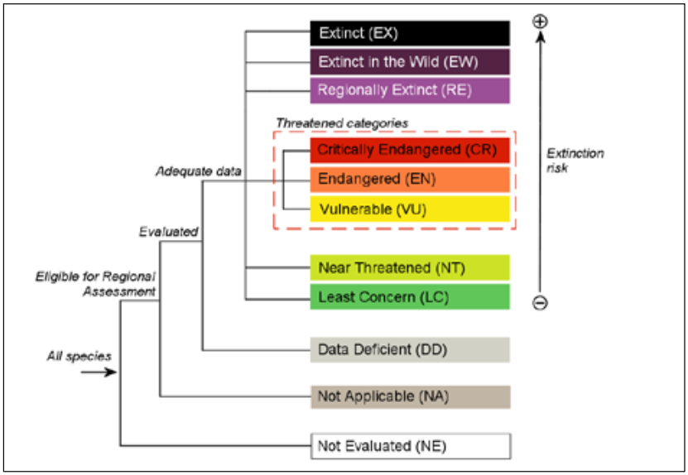
(IUCN, 2012)

Biodiversity has received growing attention from international community due to its vital function for the social and economic development of a country or a region. It becomes a hot topic next to climate change. In China, the biodiversity loss has created significant impact on the safety of personal and property, safety of food, pharmaceutical industry and tourist industry, and future development. For example, human’s overexploitation of forest usually results in water and soil erosion, which is one of the main causes of debris flow, create significant threats on infrastructures, residences, and people’s lives. Moreover, China has over 12,000 kinds of Chinese herbal medicines, some of the rare herbals have limited quantity in its growth cycle and have strict requirements for growing environment. The overexploitation of wild herbals has led to rapid decrease of rare herbals, even near extinction. It might cause serious consequence as there are lots of people in the world are still using herbal medicines for their treatment. Furthermore, the hybrid rice that created in 1970s by Yuan Longping, who is the Chinese expert on rice seed breeding, has made significant contribution to the food security. It is all based on the discovery of the wild rice sterile plants in Hainan province. However, currently the population of this kind of wild rice is rapidly declining, even on the edge of extinction in some distribution sites. The loss of this kind of wild crop species would cause significant threats on food security (The Ministry of Environmental Protection of China, 2014). What is more, currently in China, the decline of pollinators has reduced the stability of agricultural production system. In the Southwest part of China, lots of famers are using ‘human pollinators’ to pollinate apple and other fruit trees. In Maoxian County, Sichuan province, 100% of the apples were hand pollinated (Partap and Ya, 2012). The wild bees in that region were almost extinct due to the excessive use of pesticide, and lack of habitat. This might just possible for this kind of high-value crops, while for other crops the cost would be vast. The bees and other pollinators have provided us the sustainable and free pollination service for thousands of years, we only recognise their importance when we start to losing them (Goulson, 2012).

Features need to be considered in China

Political features

The position of the Communist Party of China (CPC) in China
China is currently lead by the Communist Party of China (CPC), which established in 1921, and found the People’s Republic of China in 1949 as the sole ruling party. The CPC sticks to democratic centralism, claims itself as the vanguard of the working class in China, the core leadership of the cause of socialism in China, and the representative of the interests of Chinese people of all nationalities (Xinhua, 2017a). The ultimate goal of CPC is to realize the communist social system. The Constitution of CPC regulates that the highest leading body of the party is the CPC National Congress and the resulting Central Committee. The CPC National Congress is usually held every five years, authorised to: hear and audit the reports from Central Committee, and Central Commission for Discipline Inspection; discuss and decide the major issues of the party; make amendments of the constitution of the party; and vote for Central Committee, and Central Commission for Discipline Inspection. (People.cn, 2012a).

Currently the 19th Central Committee of CPC is represented by Jinping Xi, who is the current leader of China. In 2017, at the 19th CPC National Congress, the Central Committee states the theme of the Congress as:

‘Remain true to our original aspiration and keep our mission firmly in mind, hold high the banner of socialism with Chinese characteristics, secure a decisive victory in building a moderately prosperous society in all respects, strive for the great success of socialism with Chinese characteristics for a new era, and work tirelessly to realize the Chinese Dream of national rejuvenation’ (Xinhua, 2017b).

Socialism with Chinese characteristics
The idea of construct ‘socialism with Chinese characteristics’ is firstly proposed in 1982 by Deng Xiaoping, who is the chief designer of China’s reform and opening-up policy. The idea contains ‘the socialist path with Chinese characteristics’ (the practical approaches), ‘the theoretical system of socialism with Chinese characteristics’ (the action guide), and ‘the socialist system with Chinese characteristics’ (the fundamental guarantee) (People.cn, 2007a).

To be specific, ‘the socialist path with Chinese characteristics’ is the path of modernisation of Chinese style that the CPC lead Chinese people to open up through the revolutionary praxis like economic construction, and reform and opening-up. The path is: under the leadership of the CPC, based on the Fundamental Realities of the Country (China is still in the primary/underdevelopment stage of socialism and will remain so for a long time), take economic construction as the central task, uphold the Four Cardinal Principles (adhere to the socialist path; adhere to the people’s democratic dictatorship; adhere to the leadership of the CPC; adhere to Marxism-Leninism and Mao Zedong Thought), stick to the reform and opening-up policy, liberate and develop the social productive forces, build socialist market economy with Chinese characteristics (the economy system that combines public ownership and market economy), build socialist democratic politics, build advanced socialist culture, build harmonious socialist society, build socialist ecological civilization, promote the comprehensive development of people, gradually realize common prosperity for all people, and build a modern socialist country that is prosperous, strong, democratic, culturally advanced, harmonious, and beautiful (People.cn, 2013).

‘The theoretical system of socialism with Chinese characteristics’ is the latest theoretical achievements of localisation of Marxism in China that realized by the CPC through the incorporation between Marxism and China’s reality (People.cn, 2007a). The combination of basic principles of scientific socialism and China’ reality is enabling China’s socialist theoretical system to equipped with characteristics of the times and Chinese characteristics (Xinhua, 2017e).

‘The socialist system with Chinese characteristics’ stands for the fundamental political system for the system of people’s congress; the basic political systems for the system of multi-party cooperation and political consultations, the system of regional national autonomy, and the system of community level self-governance that lead by the CPC; the basic economic system of keeping public ownership as the mainstay of the economy and allowing diverse forms of ownership to develop jointly; socialist legal system with Chinese characteristics; and all the specific systems that established based on the above systems (People.cn, 2013).

The current goal and the current principal contradiction of Chinese society
Under the thought on socialism with Chinese characteristics for a new era, the CPC has confirmed the overarching goal for the period from 2020 to the middle of the 21st century as achieving socialist modernisation and national rejuvenation. It will be based on the accomplish of the building of moderately prosperous society in all respects, to a Two-Stage Development Plan (see Xinhua, 2017c) to build China into a great modern socialist country that is prosperous, strong, democratic, culturally advanced, harmonious, and beautiful (Xinhua, 2017d).

In line with the thought for the new era, the 19th National Congress also confirms that the principal contradiction of Chinese society has transformed from the contradiction that between the people’s ever-growing material and cultural needs and the backwardness of social production, to the contradiction that between the people’s ever-growing needs for a better life and the unbalanced and inadequate development. The needs to be met for people to live a better life are increasingly broad, including the needs for democracy, rule of law, fairness and justice, security and a better environment (Xinhua, 2017c). This transformation indicates a historical achievement, for example, the demand for food and clothing, and for survival, has transformed to the demand for environmental protection; the policy of ‘let some people and regions prosper prior to others, thus they can bring along the behindhand regions’ has transformed to the policy of ‘co-construction and sharing’; and the transformation of China’s economy from a phase of rapid growth to a stage of high-quality development. These are the specific expression of the principal contradiction of the society, and the characteristics of the new era. However, the transformation of the principal contradiction of Chinese society does not affect the current Fundamental Realities of the China, which China is still in the primary/underdevelopment stage of socialism and will remain so for a long time. China’s international position as the largest developing country is also unchanged (Yan, 2018).

The ‘unbalanced and inadequate development’ stands for the appearance of the contradictions during the process of development, including inadequate development quality and performance, insufficient innovation capability, insufficient level of the real economy, insufficient conservation for ecological environment. Moreover, the task of overcome poverty is tough; people are facing problems in employment, education, medical treatment, housing, and provide for the elderly; the civilization level of the society still needs to be improved; the task of comprehensively implement the rule of law is still heavy; and the national governance system and governance capacity needs further improvement (Yan, 2018). Therefore, to solve these unbalanced and inadequate development problems on the basis of continually promote development, to significance improve development quality and performance, and to satisfy people’s growing demand for the aspects of economy, politics, culture, society, and environment, the Central Committee draws up the ‘Five in One’ overall plan, which is the economic construction, political construction, cultural construction, social construction, and ecological civilization construction. This overall plan is aims to comprehensively improve China’s material civilization, political civilization, spiritual civilization, social civilization, and ecological civilization, thus to transform from the building of partial modernization to comprehensive and coordinated modernization (Xinhua, 2017d).

Economic features

The economic reform and open up
In 1970s, China just experienced the 10 years ‘Cultural Revolution’, which created the most serious setback and damage to the country (Xinhua, 2009). The productivity growth was slow, the issue of people’s food and clothing has not been solved, the technology and education were fall behind. Moreover, the drawbacks of the planned economy were emerged: the law of value and the function of market regulation were ignored; the consumption was constrained by the merchandise ticket; the driver of the economy development was lost due to the compulsory public ownership. Under this condition, a revolutionary change is urgently need in China. Therefore, in 1978, at the 3rd Plenary Session of the 11th Central Committee of the CPC, the Central Committee represented by Deng Xiaoping initiates the ‘Economic Reform and Open up’ movement (Shao, 2015). This movement aims to change the management systems and policies that unsuitable to the development of productivity, result in the establishment of the Socialist Market Economy System, which integrates the market economy with the basic socialist social system. Under this system, the market has decisive effect on social resources allocation, while the planning economy is still one of the important means for the country to regulate the market and supply (Xinhua, 2018b). The ‘Open Up’ is mainly stands for the open up to the world, it is in line with the trend of the global development, and it has been considered as the inevitable choice to speed up the modernization construction of China (Shao, 2015).

The ‘Economic Reform and Open up’ policy is one of the two fundamental points for the CPC’s basic line for primary/underdevelopment stage of socialism, this policy is defined as one of the basic national policies that requires long-term adherence. With 40 years development since 1978, the modern market system has been gradually built and improved, the proportion of market-adjusted price has increased from 3% in 1978 to about 98% in 2018. With the liberation of productivity, in the last 40 years, the number of market entity has increased from 0.5 million to 100 million; the average annual GDP growth has achieved to approximately 9.5%, and the economic aggregate has increased by 200 times (Xinhua, 2018b). Currently China is ranked as the second biggest economies in the world after the United States (The Economist, 2018).

Problems from high-speed economic growth
Although the reform has benefited China with distinguished economic performance, it also has problems such as lack of top-level design, focus more on the partial planning rather than the comprehensive planning, and paid less attention to the improvement of the international development environment. For example, the reform was only put emphasis on the economic modernization, the development activities cost vast quantities of natural capital (Johnson et al., 1997), various other quality-of-life dimensions have been sacrificed for this so called ‘economic miracle’ (Johnson et al., 1997, McElroy et al., 1998, Edmonds, 2012). China’s natural environment is currently one of the most serious global concerns (Sims, 1999, Banque, 1997), especially the air pollution and natural disasters like species loss and desertification (Smil, 1993, Lotspeich and Chen, 1997). Fortunately, the serious of environmental issues have been noticed by Chinese government (Lo and Leung, 1998), and various new legislations and regulations have been formulated (Palmer, 1998). However, the limitations of these regulations have emerged due to various institutional and contextual obstacles (Sims, 1999). In respond to this kind of issues, China draws up the ‘Five in One’ overall plan which mentioned earlier, bring in the concept of ecological civilization, which is discussed in detail in the later section.

As discussed earlier, China’s economy has kept the growth rate around 10% in the last 40 years, resulting in a growing proportion in global economy. However, the continuous impact of the global financial crisis has result in the changes of the global development environment and conditions. For example, the continued depression of world economy has significantly weakened the external pull-force for China’s economy; the manufacturing industry is losing its cost advantage due to the decreasing working-age population, increasing pay level, and intensified competition from emerging economies. The rate of China’s economy growth has gradually reduced to around 6% in recent years since 2012. Moreover, the domestic supply side cannot satisfy the accelerated demand structure, which is consumer’s growing demand for higher quality products and services. These changes have significantly restricted the China’s original mode of economic development, which mainly rely on the inputs of production factors, external demand pull-force, and scale expansion (Xu, 2017).

Apart from the problems mentioned above, inefficiency of the governance system of the government and companies is also a problem faced by China in the last 40 years. It is mainly because the supervision body is usually part of the internal governance system, there is a need of supervision from external body to improve governance efficiency. To solve these problems, China needs to actively integrate into the global market to bring in external supervision body to create strong and efficient supervision (Huang, 2016).

The transform of China’s economy from a phase of rapid growth to a stage of high-quality development
To better solve the problems mentioned above and deepen the reform, in 2013, the president Xi proposed the initiative of ‘The Belt and Road’ (B&R), short for the Silk Road Economic Belt and the 21st-Century Maritime Silk Road. It is a national top-level cooperation initiative aims to establish and strengthen partnership with countries along the line of the B&R (see Figure 27), thus to connect the development strategies of each country, explore the potential of regional market, promote investment and consumption, create demand and employment, and promote cultural exchange among countries (Xinhua, 2015).

Figure 27: The Belt and Road
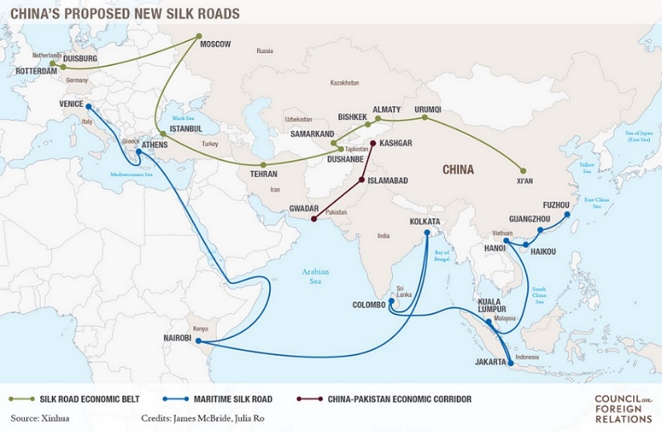
(People's Daily, 2015)

The B&R initiative helps China to expand and deepen the ‘Open Up’ policy to solve the existing problems, and bring in the external supervision body for the economic governance, social governance, and national governance (Huang, 2016). Moreover, it helps to promote the ongoing ‘Supply-side Reform’ and solve the emerging issues like excess production capacity and excess foreign exchange. Furthermore, it also responds to the opportunities like the increase of neighboring countries’ willing of strengthen cooperation with China, actively work with these countries to build a community of shared interests, destiny, and responsibility (Xinhua, 2015).

In 2017, the report of the 19th National Congress points out that China’s economy has transformed from a phase of rapid growth to a stage of high-quality development. At present, China’s economy is at the key point of the transformation of development mode, economic structure and motive force of growth. The report points out that, the way to succeed in this transformation is to ‘applying a new vision of development and developing a modernized economy’ (Xinhua, 2017g). The characteristics of a modernized economy are: continuously enhanced international competitiveness; continuously improved product and service quality; continuously optimized industrial structure; and transform to the industrial structure and production mode which have high scientific and technological content, low resources consumption, and less pollution on environment (Wang, 2017). To construct a modernized economy, China will focus more on the real economy, deepen the structural reform of the supply-side and strive to transform Chinese enterprises into world-class, globally competitive firms. Moreover, China will keep emphasis on the development of B&R initiative and be more open to the world. (Xinhua, 2017c).

The emergence and development of ecological civilization construction

The emergence of the ecological civilization concept
At present, one of the important goals of building moderately prosperous society in all respects is to construct ecological civilization. The ecological civilization is considered as the new stage of human civilization after the industrial civilization, it is the social formation under the basic tenet that the people and nature, people and people, people and society are be able to achieve harmonious coexistence, virtuous circle, all-around development, and continuous prosperity (Kang, 2008).

Since 1960s, the issue of ecological environment has become the hot topic concerned by the world. The industrial civilization which create significance impact on the present world is developed based on the sacrifice of the nature environment, caused alienation among people, society and nature. To solve this common issue of the human development, the United Nations firstly formally put forward the concept of sustainable development in 1972 at the World Environment Conference (Zhao, 2017). With rapid growth of economy, China has created devastating impact on the ecological environment, and become one of the countries that have major environmental issues (Kang, 2008). Therefore, in consideration of the fundamental interests of the country and Chinese people, and the responsibility for the global ecological environment, China starts to develop the concept of ecological civilization since the 14th CPC National Congress in 1992 (Zhao, 2017).

The mainstreaming process of ecological civilization construction
The construction of ecological civilization was firstly proposed in the 17th CPC National Congress in 2007 as one of the new requirements for the realizing of the building of a moderately prosperous society in all respects by 2020. It was mainly focus on the pollution control and emission reduction, and the establishment of the concept of ecological civilization in the society (People.cn, 2007b).

At the 18th CPC National Congress in 2012, the Central Committee makes a strategic decision to ‘give great impetus to the construction of ecological civilization’, defines the construction of ecological civilization as a long-term strategy related to the people’s wellbeing and the future of the nation, and integrate it into all aspects and the whole process of the economic construction, political construction, cultural construction and social construction, so called ‘Five in One’. The report puts emphasis on the protection effort on nature ecological system, and the construction of the ecological civilization system (People.cn, 2012b).

Although the construction of ecological civilization has received significant attention from the Central Committee and the State Council since the 18th CPC National Congress, the construction progress is still lagging behind the socio-economic development. Moreover, it becomes the major bottleneck that constraints the sustainable socio-economic development in terms of the severe environmental pollution, ecosystem degradation, and the growing contradiction between development and population, resources and environment. Therefore, to speed up the transformation of the mode of economic development, to promote social harmony, to realize the building of a moderately prosperous society in all respects, and to actively respond to climate change, in 2015, the Central Committee and the State Council release the ‘Opinions of Accelerating the Construction of Ecological Civilization’. It contains 35 specific objectives in 9 aspects, act as a programmatic document to form the long-term deployment and framework for the construction of ecological civilization. The aim of the document is to make significant progress on the building of resources-saving and environmental-friendly society, to promote ecological civilization as mainstream value of the society, and to match the level of the construction of ecological civilization with the goal of building a moderately prosperous society in all respects by 2020 (Gov.cn, 2015a).

The document emphasizes the importance of the coordination between the socio-economic development and the construction of ecological civilization, for example, it gives priorities for resources saving, environmental protection, and natural recovery, and integrates indicators like resources consumption, environmental damage and ecological benefits into the evaluation system of socio-economic development. Moreover, the document also trying to highlight the concept that everyone is the constructer of the ecological civilization, it indicates that no matter the government, enterprise, or individual, everyone should consciously fulfill the requirements of the ecological civilization during the daily life (Gov.cn, 2015b). For example, the Objective 29 is to improve people’s awareness for ecological civilization and make it the mainstream of social values, one of the actions is to take the ecological civilization education as an important content of quality-oriented education, and it is integrated into national education system and cadre education and training system. Besides that, the Objective 31 is to encourage active participation from the public, in supporting of this, perfecting the system of public participation, system of public supervision, and system of public interest litigation for environmental issues. Furthermore, the document puts significant emphasize on perfecting the system of ecological civilization, 10 objectives are set for this aspect including perfecting the political performance appraisal system, and accountability system (Gov.cn, 2015a). The significance of this document is that it mobilizes the whole party, the whole society to take positive action to deeply and continually promote the construction of the ecological civilization.

At the 19th CPC National Congress in 2017, the Central Committee reports that one of the historic changes over the last five years is the notable progress in the construction of ecological civilization: the people’s consciousness and proactivity for green development have significantly improved, the system of ecological civilization is gradually formed, the governance of ecological environment is notably strengthened, the environmental conditions get improved, and China is becoming the important participator, contributor and leader for the building of global ecological civilization. The next step is to ‘speed up the reform of the system for developing an ecological civilization and building a beautiful China’, aims to build the modernization that characterized by harmonious coexistence between human and nature, and able to satisfy people’s growing need for beautiful ecological environment (Xinhua, 2017g).

The development of ecological civilization construction has significantly promoted the legislative process of environment related legislations, such as the amendments of ‘Environmental Protection Law’, ‘Atmospheric Pollution Prevention Law’, and ‘Wildlife Conservation Law’ which have been made in recent years. Only the strictest rules will be able to provide reliable guarantee for the construction of ecological civilization. To further formulate the ecological regulations which are more meticulous and efficient, there is a need to further move ecological civilization towards the will of the nation by writing ecological civilization into the national constitution (People.cn, 2018b).

Therefore, in 2018, the first session of the 13th National People’s Congress has voted to pass the ‘Amendment to the Constitution of the People's Republic of China’, writing ‘Ecological Civilization’ into the constitution:

In the seventh paragraph of Preamble of Constitution, ‘promote the harmonious development of material civilization, political civilization, and spiritual civilization, build China into a socialist country that is prosperous, strong, democratic and culturally advanced’ is revised to ‘promote the harmonious development of material civilization, political civilization, spiritual civilization, social civilization, and ecological civilization, build China into a great modern socialist country that is prosperous, strong, democratic, culturally advanced, harmonious, and beautiful, to realize the great rejuvenation of the Chinese nation’ (Xinhua, 2018a).

In the Article 89 of the Constitution, the sixth item of ‘the function and power exercised by the State Council’ has been revised from ‘Leading and managing economic work and urban and rural construction’ to ‘Leading and managing economic work, urban and rural construction, and ecological civilization construction’(Xinhua, 2018a).

Biodiversity Conservation in China

National policies and plans on biodiversity conservation
In 1993, as one of the early signatory countries, China joins the ‘Convention on Biodiversity Diversity’ which established by the United Nations, starts to participate in international programs (Wang, 2015). As mentioned earlier, one of the regulations of CBD is to formulate national plans for biodiversity conservation. Therefore, in 1994, China’s ‘National Biodiversity Conservation Action Plan’ has been released. In the next 16 years, in consideration of the new issues emerged for global biodiversity conservation, and significant transformation of China’s economy and society, a new plan has been drafted (Xue, 2011). In 2010, the State Council approves and releases the China’s ‘National Biodiversity Strategy and Action Plan 2011-2030’ (NBSAP), which identifies the basic principles, strategic targets, priority fields and actions of biodiversity conservation for the next 20 years. This plan is basically in line with the global ‘Strategic Plan for Biodiversity 2011-2020’, which is released at the COP-10 in 2010 (The Ministry of Environmental Protection of China, 2014).

In details, the NBSAP identifies the four fundamental principles as: 1). prioritize the biodiversity conservation in social and economic development and environmental protection activities; 2). keep sustainable utilization of biological resources; 3). encourage public participation and establish partnership among stakeholders on biodiversity conservation; and 4). establish the benefit sharing mechanism to realize the balance of interests between the provider and user on genetic resources and related knowledge. The NBSAP sets the strategic objectives with three phases: short-term (by 2015, to effectively contain the trend of biodiversity loss in the key areas), medium-term (by 2020, to take basic control of biodiversity loss), and long-term (by 2030, to realize the substantial conservation of biodiversity). In line with the strategic objectives, the NBSAP also identifies the strategic tasks in eight specific aspects: 1). improve the policies, legislations and systems that related to biodiversity conservation; 2). encourage national and local departments to integrate biodiversity conservation into their planning; 3). strengthen the capacity building of biodiversity conservation; 4). strengthen the in-situ conservation of biodiversity, and rationally carry out ex-situ conservation; 5). promote the sustainable development and utilization of biological resources and encourage related intellectual property protection; 6). promote the benefit sharing of biological genetic resources and related traditional knowledge; 7). improve the capacity to respond to the new threats and new challenge of biodiversity, discover how the climate change, species invasion, harmful pathogen, and genetically modified organisms affect biodiversity and human health; 8). enhance public’s awareness for participation in biodiversity conservation and strengthen international exchange and cooperation on biodiversity conservation. Moreover, the NBSAP also firstly identified 35 priority regions of biodiversity conservation with clear boundaries (see Figure 27), and specifically propose 30 priority actions in 10 key fields, and 39 priority projects that need to be carried out urgently in the next 5-10 years. This plan clarifies the direction of China’s biodiversity conservation and sustainable utilization of biological resources in the next 20 years (Xue, 2011).

Figure 28: 35 priority regions for biodiversity conservation
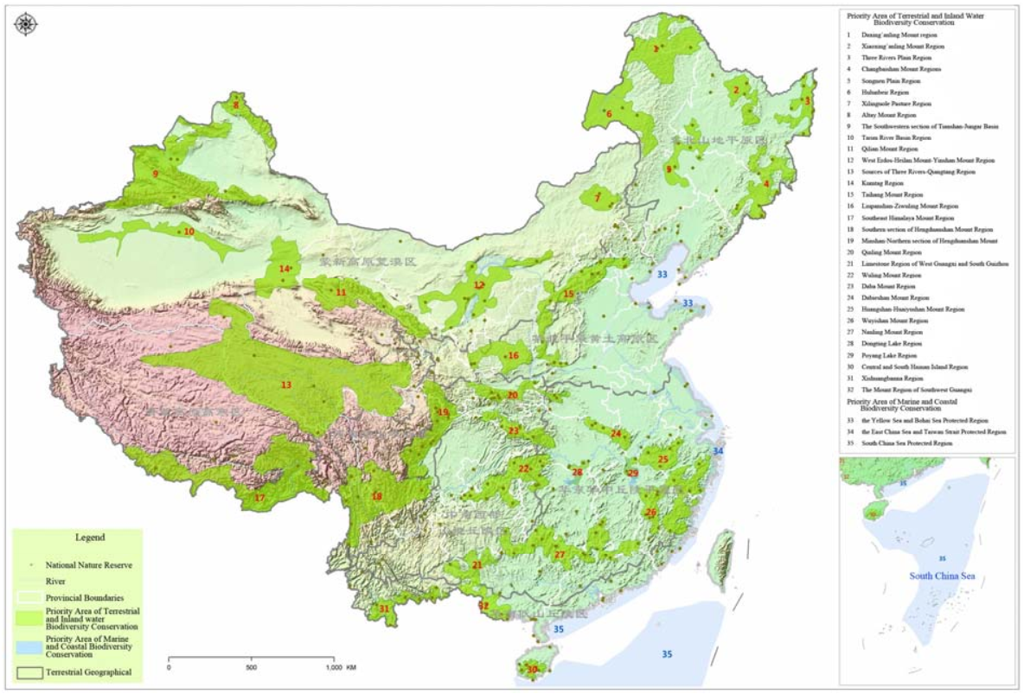
(The Ministry of Environmental Protection of China, 2014)

In supporting the fulfillment of the national plan and international convention, in 2011, the State Council approves to establish China National Committee for Biodiversity Conservation, which is composed by 25 ministries, and lead by the prime minister of the State Council (Li, 2015). In 2014, China launched the ‘China-TEEB national action plan’, aims to establish the TEEB systems that apply to China, thus, to promote the mainstreaming of the valuation of biodiversity and ecological services (Du et al., 2016).

Moreover, along with China’s current emphasis on the construction of the ecological civilization, the biodiversity issues also been increasingly discussed in the national policies. In 2012, at the 18th CPC National Congress, the ‘biodiversity conservation’ is firstly mentioned in the report (People.cn, 2012b). The ‘Opinions of Accelerating the Construction of Ecological Civilization’ which released in 2015 also contains requirements that specifically related to biodiversity. Firstly, in Objective 3, one of the main targets is to take basic control of the speed of biodiversity loss, and significantly enhance the stability of national ecological system. Moreover, in Objective 14, which focus on the protection and restoration of natural ecological system, includes requirements like: implements key projects for biodiversity conservation; establish monitoring, evaluation and early warning system; perfecting national biosafety inspection mechanism; effectively against the loss of species resources and the invasion of alien species; actively participated in the negotiation and implementation of the international convention on biological diversity; strength the construction and management of nature reserves; carry out mandatory protection of vital ecological systems and species resources; and effectively protect rare and endangered species, ancient and rare trees, and nature habitat. Furthermore, the Objective 17, which aims to perfecting laws and regulations, points out the need to research and formulate legislations for biodiversity conservation, and the need to revise related existing legislations like wildlife conservation law (Gov.cn, 2015a). In 2016, China is officially becoming one of the contracting parties of the ‘Nagoya Protocol on Access to Genetic Resources and the Fair and Equitable Sharing of Benefits Arising from Their Utilization to the Convention on Biological Diversity’. It indicates that China’s bioindustry is moving towards the era of benefit sharing of genetic resources, related legislations and systems will be established and standardized (China Environmental News, 2016). In 2017, at the 19th CPC National Congress, one of the objectives in the section of ‘reinforce the efforts for ecosystem conservation’ is to build ecological corridor and biodiversity conservation network, improve the quality and stability of the ecosystem (Xinhua, 2017g).

The actions and performance of biodiversity conservation

Biodiversity survey
In respond to the plans and policies on biodiversity conservation, various actions have been taken by the governmental departments, research institutions, and NGOs. Zang et al. (2016) point out that the lack of comprehensive understanding of threatened status of wild flora and fauna resources used to make the conservation works short of systemic, scientific and concentrated approaches, thus lead to inefficiency. Therefore, it is essential to carry out regular biodiversity survey and establish the most updated biodiversity red list to support further conservation works. According to The Ministry of Environmental Protection of China (2014), various of initiatives have been taken to carry out national biodiversity surveys in the last decades, including the surveys for different ecological systems (e.g. forest ecosystem, marine ecosystem, and wetland ecosystem), different categories (e.g. plant, animal, and microorganism) , and specific species (e.g. giant panda). Further, in 2014, the China National Committee for Biodiversity Conservation approves the ‘Biodiversity Conservation Major Projects Implementation Plan 2015-2020’, one of the basic tasks is to carry out national biodiversity survey and evaluation, thus to build national biodiversity database and information platform based on the unit as county territory (Wu et al., 2016).

The formulation of China’s species red list is started since the 1980s when the ‘IUCN Red List Standard’ is firstly introduced into China. The previous lists are limited by the evaluation range and evaluation subjects, thus unable to fully reflect the threaten status of species. To acquire a comprehensive picture of current threatens status of species in China, the China Environmental Protection Department and Chinese Academy of Sciences launched the formulation of ‘China Biodiversity Red List’ in 2008. As a result, the ‘China Biodiversity Red List – Higher Plant Assessment Report’ and ‘China Biodiversity Red List – Vertebrate Assessment Report’ are released in 2013 and 2015 respectively (Zang et al., 2016).

The ‘China Biodiversity Red List 2015’ completes the threatened status assessment for 34,450 advanced plant species and 4,357 kinds of vertebrate species (except marine fishes) in China. The result of the assessment show that the current trend of biodiversity loss in China has not been contained effectively (Jiang et al., 2015). The list also provides the reassessment of advanced plant species and vertebrates species which have been assessed in ‘China Biodiversity Red List 2004’. Within 11 years, over half of assessed advanced plant species’ threatened status are improved or been removed from the list; and there are less threatened vertebrate species. However, in consideration of the threatened status of listed vertebrates species, the number of species that getting worse is more than the number of improved (Zang et al., 2016). One positive sign is that the threatened mammals in China have reduced from 223 to 178, which suggests initial success of protection for threatened mammals. For example, the combination of on-site and off-site conservation has strengthened conservation for giant pandas (Jiang et al., 2015).

The ‘China Biodiversity Red List 2015’ identifies the threatened status of known advanced plants and vertebrates, as well as their distributional differences and threatened factors. It provides important scientific evidence for local government and related departments to formulate related policies and plans, and promote the reasonable utilization of resources. Moreover, it provides reference for environmental impact evaluation of construction projects. Furthermore, it could be used as essential material for biodiversity education and public awareness raising (Zang et al., 2016).

Biodiversity education and research
To further encourage public participation, the knowledge of biodiversity conservation has been integrated into the curriculum requirements for biology for primary, middle, and high schools since 2011 (The Ministry of Environmental Protection of China, 2014). For example, approved by the Ministry of Education, since 2013, the Eighth Grade Biology that published by People’s Education Press has a Chapter named ‘Biological Diversity and its Conservation’ (see Figure 29). The Chapter starts with the introduction of scientific way of classification and naming for biology; then focus on the understanding of biological diversity, including species diversity, genic diversity, and ecosystem diversity. The final part points out the cause of current threats of biodiversity and the current measures for conservation. It also teaches and encourage students take actions to participate in biodiversity conservation (Zhu and Zhao, 2013, p96-110).

Figure 29: The Eighth Grade Biology Chapter Six - Biological Diversity and its Conservation
(Zhu and Zhao, 2013)

The compulsory education text book introduces a World Extinct Wildlife Cemetery (see Figure 30) which is located in Nanhaizi Milu Park (also known as David’s Deer Reserve) in Beijing. This cemetery is made by 100 tombstones that arranged like fallen dominos along a road, each tombstone is represent a bird or mammal species that extinct in the last 300 years. At the end of the road, some tombstones are still standing represent some of the endangered species, including human. The founder of the cemetery believes the domino-style design shows the fact that extinction of individual species would endanger other related species. The aim of this cemetery is to promote public awareness for biodiversity conservation, it attracts students and animal protectors to visit and memory the extinct species during the Tomb-Sweeping holiday (Cao, 2014).

Figure 30: The Graveyard of Extinction
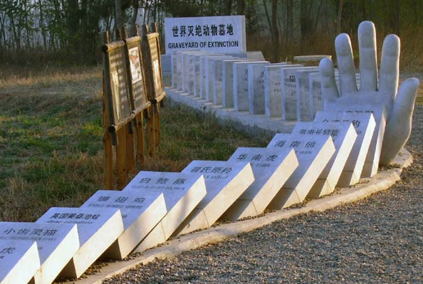
(Cao, 2014)

Except the above approaches, various departments and regions also organised various publicity activities through different communication channels like television, newspapers, radios and internet to improve social awareness and participating enthusiasm of biodiversity conservation, hundreds of millions of people have been affected (Li, 2015).

Moreover, the government is also promoting the researches about the conservation and sustainable utilization of biodiversity. There are 1,908 universities established majors on biology. For ecology, there are about 50 universities have undergraduate degree, 38 universities have master-degree, 22 universities have PhD degree. Until 2012, over 556,000 related professionals have been trained for biodiversity related research and conservation (The Ministry of Environmental Protection of China, 2014).

Establishment of nature reserves

In 2010, the State Council released the ‘National Planning for Major Functional Zones’, which classifies China’s land into four major function zones: priority development zones, key development zones, limited development zones, and prohibited for development zones. The plan regulates that the national level nature reserves, forest parks, geological parks, tourist attractions are included in the prohibited for development zones, any industrial and urbanization development activities are prohibited in these regions to protect natural resources and genetic resources or rare species (The Ministry of Environmental Protection of China, 2014). By the end of 2014, China had established 2,729 natural reserves, covering 1.47 million square kilometers land, which is 14.84% of Chinese land area. 85% of national key protected wild fauna and flora species are protected (Li, 2015).

Moreover, the ecosystem protection and restoration have made effective achievements, according to World Economic Forum (2018), China has put significant emphasis on planting forests to tackle the environmental issues. The government is planning to increase the forest coverage to 23% by the end of 2020. With 33.8 million hectares of forest planted over the last 5 years, the total forest area in China at present has achieved 208 million hectares. Along with the planted new forests, new habitats for endangered species are created, various animals are saved from extinction. For example, after massive reforestation in the northern Shaanxi province, the population of North-Chinese Leopards has significantly increased, as well as other rare species like roe deer, red fox, and golden pheasant.

Current progress of performing national and international plans for biodiversity conservation
With years development and work on biodiversity conservation, at ‘China’s Fifth National Report on the Implementation of the Convention on Biological Diversity’, the Ministry of Environmental Protection reports the current progress of the implantation of National Biodiversity Strategy and Action Plan 2011-2030 (NBSAP) and 2020 Aichi Targets. As shown in Table 7, the NBSAP is contains of 30 objectives, currently only the Objective 10 (enhance and coordinate information systems for genetic resources) has made ‘significant progress’, 15 objectives have made ‘considerable progress’, the rest of 14 objectives have made ‘some progress’ (The Ministry of Environmental Protection of China, 2014).

Table 7: Assessment of implementation of National Biodiversity Strategy and Action Plan 2011-2030 (NBSAP)
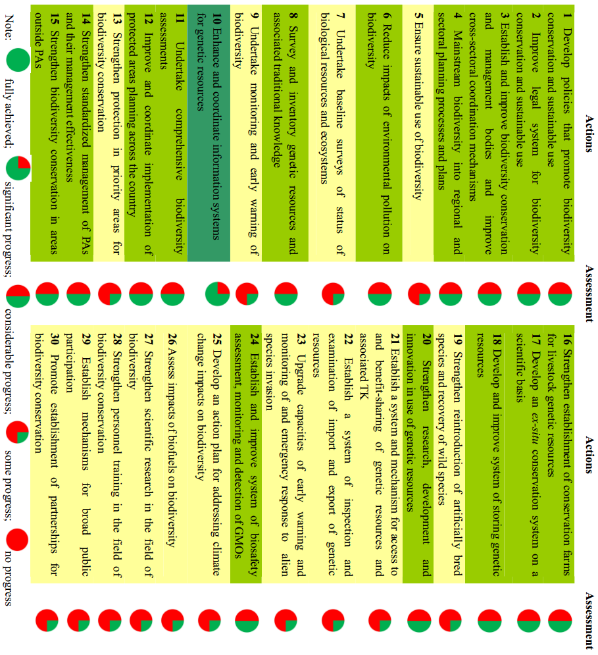
(The Ministry of Environmental Protection of China, 2014)

As for the 2020 Aichi Targets (see Table 8), except the Objective 2, 16, and 18 which are currently lack of indicators, there are 38 indicators in the rest of 17 objectives. Out of these 38 indicators, 7 of them are lack of sufficient data, 26 of them are improved in different levels, while 5 of them are getting worse and require more effective strategies and measures (The Ministry of Environmental Protection of China, 2014).

Table 8: Assessment of China's progress in achieving 2020 Aichi Targets
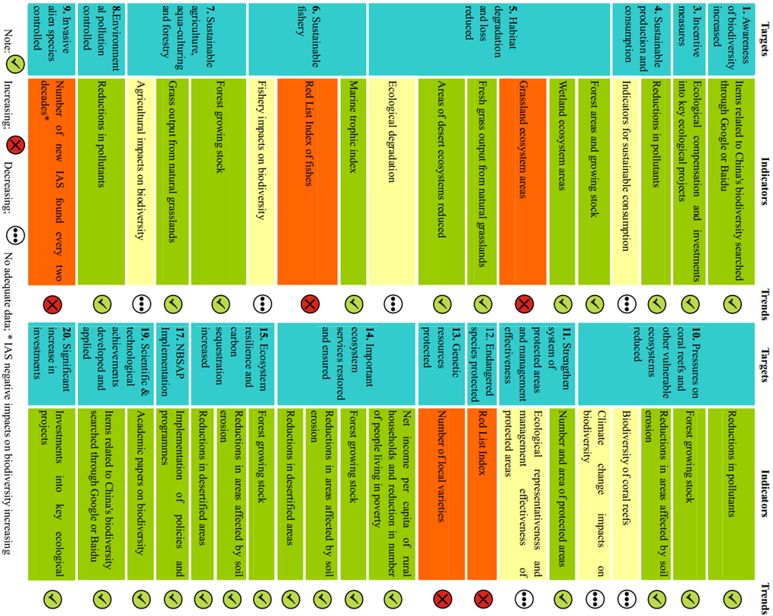
(The Ministry of Environmental Protection of China, 2014)

Although significant progress has been made for biodiversity conservation in China, the overall trend of biodiversity degradation has not been fundamentally contained, the issues of species habitat loss and fragmentation, and invasion of alien species are still the challenges of biodiversity conservation (Wei, 2015a). At present, 90% of the nationwide grasslands are degeneration and desertification in various levels, 40% of the key wetlands are facing the threat of degeneration. Some rare endangered species have not been protected, the phenomenon of genetic resources loss still exist (Li, 2015).

The key issues of current biodiversity conservation are: 1) the related legislations and systems require further improvement; 2) the conservation awareness requires further improvement; 3) the contradiction between conservation and development is still significant; 4) insufficient funding; and 5) insufficient scientific researches (The Ministry of Environmental Protection of China, 2014).

The demand and potential of ‘business and biodiversity’ in China

Lack of participation from companies in China
As discussed in 2.2 and above, the conservation of biodiversity requires cooperation from different stakeholders. However, the current biodiversity conservation process in China is characterized by a lack of participation from multi-stakeholders. It is necessary to establish a participation mechanism for biodiversity conservation that complies with China’s characteristics, and put China’s actual conditions, problems and demands into consideration. Currently, one of the key obstacles to such mechanism is the lack of corporate participation (Zhang and Liu, 2015). With companies’ support and effort, most of current issues for biodiversity conservation would be relieved even resolved.

According to Hou (2014), biodiversity protection is one of the important contents of social responsibility, but it has not been valued as well as other components like public welfare by companies. In China, companies are the main bodies that utilize the biodiversity, but they did not realize the seriousness of the issue. According to the GoldenBee CSR Index Report (2007-2013) which published by China WTO Tribune et al. in 2013, 15% of Chinese companies believe China does not need to worry about biodiversity issue, only 13% of companies develop technical research about biodiversity, and there are only 7% of companies use professional reports to spread and report biodiversity. This indicates that most companies are lack of relevant knowledge, technical research, publicity and guidance about biodiversity protection. The potential of companies’ participation in biodiversity conservation is significant in China.

The driving forces and opportunities for ‘Business and Biodiversity’ in China

GPBB and China
As one of the signatory countries of CBD, the Chinese government was invited to attend the forums of the Global Partnership for Business and Biodiversity (GPBB), and on the GPBB-4 in 2014, China firstly announced that it is ready to join GPBB. Correspondingly, the Ministry of Environmental Protection of China has already organized some activities like business and biodiversity case study collection, corporations’ awareness for biodiversity conservation survey, and biodiversity and green development international forum. It also organizes business representatives in different industries to sign the ‘initial written proposal for corporate participation in biodiversity conservation’, initially establish the communication and cooperation platform between government and companies. As a result, companies in China are starting to take actions to participate in biodiversity conservation. However, China does not have experience in organizing and guiding corporations to participate in biodiversity conservation, sustainable utilization and benefit sharing. In respond to such challenges, the government is suggested to actively participate in the global partnerships to improve the national capacity to develop ‘Business and Biodiversity’ in China. Moreover, based on the characteristics of China to establish a coordination mechanism that across departments to guide the specific work of companies’ participation in biodiversity (Wang et al., 2015).

In 2020, the COP15 will be taken place in China, focus on the assessment of the progress of ‘Biodiversity Strategic Plan 2011-2020’, and the formulation of ‘Biodiversity 2050 strategic objectives’ and ‘Biodiversity Strategic Plan 2021-2030’ (Xue, 2017). This indicates that the CBD is going to enter into a new era with new challenges and objectives. Moreover, 2020 is also the year that China planned to realize the building of moderately prosperous society in all respects, and to construct the ecological civilization system in all respects. It is the first time that China going to host a global conference with such significant meaning in the field of biodiversity conservation. Therefore, 2020 will be an important year for China to show its performance on biodiversity conservation to the world, and its determination to undertake broad responsibilities for international cooperation on biodiversity conservation (Zou et al., 2017). It would indicate the need for China to make significant progress on the development of ‘Business and Biodiversity’ by 2020.

The opportunities and problems faced by companies
In 2015, China host a national level high-end summit international forum solely focus on the theme of biodiversity conservation, it aims to carry out a deep discussion about the ways and methods to push green development and to build communication platform to integrate biodiversity conservation into economic social development (Wei, 2015a). The forum expressed the urgent demand for researches about ‘Business and Biodiversity’, especially the need for approaches to allow companies to measure and communicate biodiversity related information (Wei, 2015c, Wei, 2015b). The forum also emphasis that the conservation of nature is investment rather than cost, invest in the natural capital could not only bring the resource output of environmental ecosystem like water, soil and air, but also bring the industrial derived output such as ecotourism, ecological agriculture, and high-end biomedical. The forum suggests that, invest in natural capital could both create GEP (Gross Ecosystem Production) and GDP (Gross Domestic Product), which are the core and foundation of sustainable development (Wei, 2015a).

As discussed earlier, the China’s economy has transferred from high speed growth to high quality development, the economic structure is continuously optimizing and upgrading. These changes will reduce the economy’s dependence on environmental resources in certain extents, which helps to relieve the negative impact on ecological environment and biodiversity. This transformation also brings new features to the biodiversity conservation, which should be concerned and considered by business. Firstly, as one of the important contents of ecological civilization, biodiversity conservation has been integrated into governments’ planning at all levels. It will inevitably lead to policy impacts on business. Secondly, as the environmental bearing capacity has reached to the critical state, China should rely on the rich biodiversity resources to realize technological innovation and industrial upgrading, and to promote sustainable development. Thirdly, China’s economic development and environmental issues are various across different regions, the environmental differences between east and west regions are significant, the work on biodiversity conservation should gradually transform from total planning to specialized planning in each region. Fourthly, as China is currently improving legislations, with the amendment and establishment of legislations about biodiversity conservation, the supervision of biodiversity conservation will be stricter. Correspondingly, the companies which have significant impact on environment and biodiversity would face more challenges in future. Fifthly, the public’s appeal for the ‘green hills and clear waters’ is growing significantly, the biodiversity conservation is the important safeguards to provide ideal living environment for people (Li, 2015).

Chapter 5: Research Questions and Methodology

Research aim, questions, and objectives
The above discussions indicate the urgency of the need to promote ‘Business and Biodiversity’ in China, which is not only the need for Chinese companies to respond to the national and international concern on biodiversity loss, but also, the most importantly, the need for Chinese companies to recognise and discharge their accountability on biodiversity, thus, to strengthen the forces in preventing species extinction. As discussed in chapter 3, the theoretical framework developed in this thesis provides a systemic, holistic, and critical view of the essential role of accounting in this process to strive for a better world and society. From GST perspective, accounting need to grow and adapt itself to fit with the current context (here refers to the pressing threat of biodiversity loss) through its interactions with other social systems (here refer to the other disciplines, human organisations and institutions that concern on biodiversity loss) and the total environment (here refers to the conflicts in society), thus, to ensure the survival and prosperity not only for itself as a profession and body of knowledge, but also for its supra-systems, including companies and other forms of human organisations (Bailey, 1970), the civil society, mankind and our planet (Rousseau, 2015). From the new pragmatist emancipatory accounting perspective, as a communicative social practice (Gallhofer and Haslam, 2003), accounting could utilize its emancipatory potential by addressing the multiple progressive objectives from a diverse legitimate interests, identities and projects, and seeking to align these in a progressive movement (Gallhofer and Haslam, 2017), thus, lead to a potential emancipatory outcome: the extinction prevention (Atkins and Maroun, 2018).

The research topic of this thesis is significantly inspired by the studies (for instance, Jones and Solomon, 2013, Rimmel and Jonäll, 2013, van Liempd and Busch, 2013, Atkins et al., 2014, Atkins et al., 2016, King, 2016, Atkins et al., 2018, Maroun and Atkins, 2018, Atkins and Maroun, 2018) conducted in examining and developing the corporate accounting and accountability for biodiversity in terms of corporate reporting. The insights of these work and the theoretical perspectives discussed above significantly influence the objectives of this thesis, and the methodologies adopted for approaching these objectives. To be specific, this thesis is aiming to further promote and improve ‘Business and Biodiversity’ in China by exploring the potentials of biodiversity accounting and accountability from Chinese companies, thus, to address the pressing threat of biodiversity loss in the world. This leads to the research questions of this thesis as following:

- What is the current status of biodiversity reporting from Chinese listed extractive companies?

The ideal mechanism and framework for ‘Business and Biodiversity’ in China is likely to be identified through the understanding of the context, which is essential for desired transformation and should be based on carefully grounded interpretation (Laughlin, 1987, Laughlin, 1999). This critical consideration makes the assessment of biodiversity reporting currently practiced by Chinese companies (Atkins et al., 2018), and the elaboration of perceptions from concerned particulars/stakeholders (Gallhofer et al., 2015) as fundamental objectives of this thesis.

As discussed in 4.3.4, currently the Chinese companies are inactive in biodiversity conservations activities, even their environmental conservations are poorly practiced, and the initiatives for ‘Business and Biodiversity’ are just emerged in recent years. Therefore, the biodiversity disclosures from Chinese companies are expected to be inadequate and insufficient. To address this problem, this thesis attempts to identify the industry which under the most pressures from society for biodiversity conservation by providing the most negative impact on biodiversity, such industry is expected to provide the most detailed and substantial biodiversity reporting compare with other industries. According to Boiral (2016), mining companies are creating serious impacts on biodiversity as their activities lead to degradation of indigenous vegetation, fragmentation of habitats, and erosion and pollution of soils on which many species are relying for their survival. Moreover, the mining industry also being identified as the industry which providing the most disclosures on biodiversity (Rimmel and Jonäll, 2013, Atkins et al., 2014). In China, the extractive industry (including oil, gas and mining companies) has been identified in creating the greatest impact on biodiversity than other industries (Hou, 2014), and a research (China WTO Tribune et al., 2013) on CSR reporting in China indicate that the extractive industry discloses the most information on biodiversity conservation, and its reporting quality is higher than the industry average in all aspects. Therefore, the biodiversity reporting provided by Chinese listed extractive companies is adequate to represent the most progress of biodiversity reporting in China. At the same time, there is a need to elaborate the perceptions from different particulars/stakeholders toward the Chinese companies’ current and potential accountability for biodiversity, which leads to the second research question:

- What are the perceptions from different stakeholders on Chinese companies’ current and potential accountability for biodiversity?

As the aim of this thesis is to make progressive improvement of corporate biodiversity reporting for Chinese companies to better discharge their accountability for biodiversity, such accountability should be carefully defined. As emphasized by Walters (1977), the ‘social responsibility is not telling society what is good for society but responding to what society tells the firm the society wants and expects from it’ (p44), in the same way, the improvement of corporate accountability for biodiversity should be decided by the society. This is in line with the insights of the theoretical framework of this thesis, as a social system, accounting should produce information output with maximum usefulness to its supra-systems, such usefulness should not only determined by the survival and prosperity of accounting’s supra-systems and the total environment (Bailey, 1970), but also the level of different individuals’ (broadly construed, see 3.2.3.3) satisfaction criteria for a ‘better world’ (Rousseau, 2015). In terms of the views for a ‘better world’, the Frank School of Critical Theory which is discussed in 3.5.1 significantly influence the critical accounting research, which tends to explore the social role of accounting in a ‘could be’ view (Laughlin, 1987, Laughlin, 1999, Broadbent and Laughlin, 2013), to reflect the problem perceived by particulars and the changes they desired to address the problem (Laughlin, 1999). Critical research is significantly characterized by the emphasis on political economy (Tinker, 1980), especially the studies (Tinker et al., 1991) on critical social and environmental accounting, which focus on the claims that is politically pragmatic and acceptable. To pragmatically address the different ‘could be’ views at present world, studies (e.g. Gallhofer et al., 2015, Gallhofer and Haslam, 2017) are devoting to further refine and construct the notion of ‘emancipatory accounting’ by engaging with the insights from the recent theoretical developments in the humanities and social sciences. In result, as a communicative social practice with emancipatory potential, accounting should be mobilized in a more cautious and pragmatic approach to actively engage in the agonistic democratic processes which respect difference and plurality (Gallhofer and Haslam, 2017). Therefore, to ensure the proposed biodiversity reporting framework is systemic, progressive, and most importantly, pragmatic, the perspectives from different social actors that significantly relevant with biodiversity conservation should be interpreted and respected. Their diverse interest, identities, and projects are aligned to form a differentiated universalism to develop the desired biodiversity reporting framework to answer the third research question of this thesis:

- How to improve Chinese companies’ accountability for biodiversity in China context?

As this study is aiming to contribute to the social well-being or welfare by creating paths which allow an emancipatory development in line with the construct of the new pragmatist emancipatory accounting (Gallhofer and Haslam, 2017, Maroun and Atkins, 2018), the primary objective, and also the heart of this thesis is to develop a biodiversity reporting framework that especially fitted within China context to bring about attitude and behavior change, for Chinese companies, as well as the society. The recommendations will be based on the comparative analysis and discussions of empirical studies, and the leading development in biodiversity accounting and emancipatory accounting literature

Research methodology

Research philosophy
Research philosophy is an over-arching term associate with the development and the nature of knowledge. As shown in Figure 31 below, it is composed of assumptions about how a researcher views the world, which significantly influence the research strategy and associated methods. The two major ways of considering research philosophy are the ontology and epistemology (Saunders et al., 2009).

Figure 31: The research 'onion'
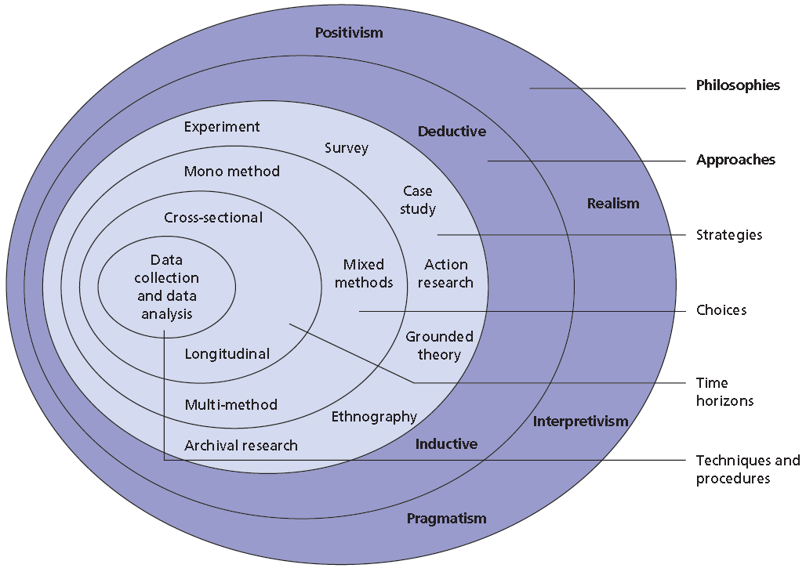
(Saunders et al., 2009)

Ontology concerns the nature of reality, there are two distinct positions in the studies of social sciences. On one side the social entities can and should be regarded as concrete social entities that are independent of social actors, which is usually referred as objectivism. On the other side, the social entities can and should be regarded as social constructions created based on the perceptions of social actors, which is usually referred as constructionism (Bryman and Bell, 2011).

Epistemology is concerned with the nature of knowledge, concern with its forms and how it could be acquired and transmitted. One side of the two distinct positions assumes that knowledge could be obtained through observation and built up piecemeal (Hopper and Powell, 1985), which is usually refer to the nature science epistemology: positivism (Bryman and Bell, 2011). On the other side, knowledge is attributed with a more subjective nature (Hopper and Powell, 1985), which is usually refer to interpretivism. The interpretivism has distinctive view of the subject matter (people and social entities) of the social science with natural sciences, it argues that social reality has a meaning for human beings, in result, human action is meaningful and should be interpreted from people’s view. It respects the differences between people, thus, it acknowledges the social scientists’ personal values (or bias) upon the objectivity of the findings (Bryman and Bell, 2011).

In assisting social researchers to clarify their assumptions about the nature of society and organisations, Burrell and Morgan (1979) construct four sociological paradigms of the organisational research (see Figure 32). The notion of ‘paradigm’ is borrowed from the Kuhn’s (1970) construct to analysis the revolutions in science. To be specific, a paradigm is ‘a cluster of beliefs and dictates which for scientists in a particular discipline influence what should be studied, how research should be done, and how results should be interpreted’ (Bryman, 1988, p4). This definition indicate that different paradigms are inconsistent with each other due to divergent assumptions and methods (Bryman and Bell, 2011). Burrell and Morgan’s (1979) construct of sociological paradigms is based on principal theoretical and philosophical assumptions (Hopper and Powell, 1985), suggest the nature of science are either subjective or objective, and the nature of society are either regulatory or radical. These two dimensions form the four paradigms which provide alternative views of social reality. Each paradigm has its methodological implications in generating different type of organisational analysis to identify specific organisational ‘problems’ in different ways (Bryman and Bell, 2011).

Figure 32:Adapted from Burrell and Morgan’s (1979) four sociological paradigms
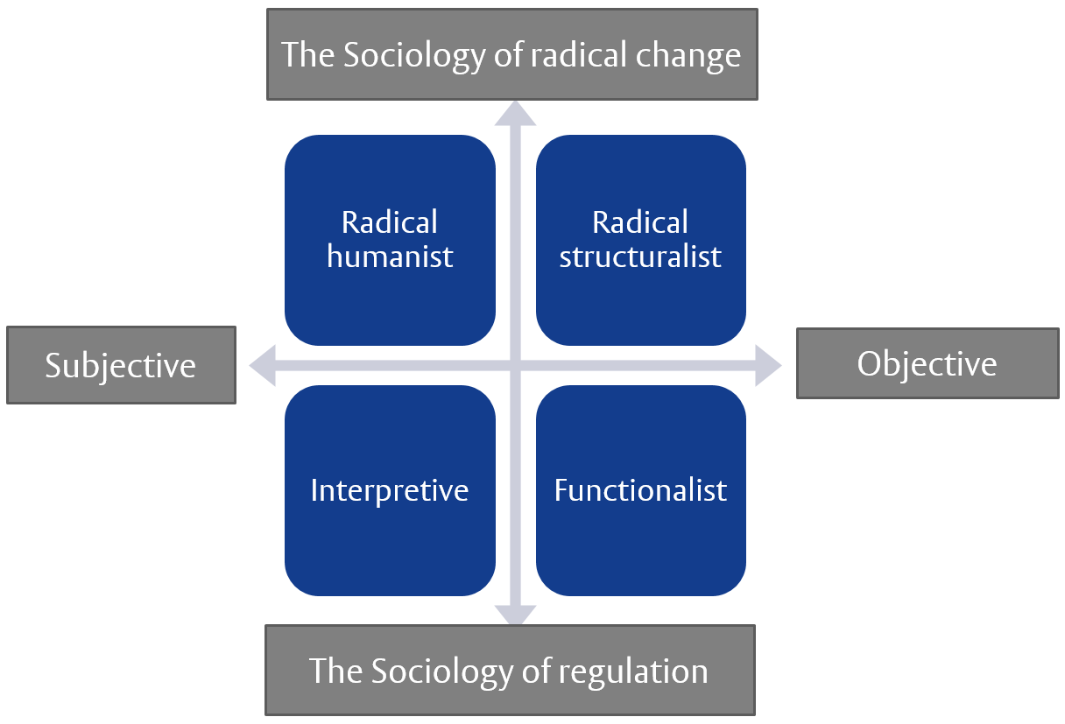
(Burrell and Morgan, 1979)

Burrell and Morgan’s (1979) model significantly influence the social researches by offering them a framework to understand and guide their research approaches (Bryman and Bell, 2011). Jackson and Carter (1991) highlight that the paradigm incommensurability protects the diversity of scientific thought by resisting the intellectual hegemony of functionalism. However, Reed (1985) argues that the differences between paradigms are overstated by Burrell and Morgan (1979), thus, result in isolationism that significantly reduces potential for creative theoretical development.

For Laughlin (1995), the significance of Burrell and Morgan’s (1979) work in designing classification schema for social researchers to understand wide range of social science approaches to empirical research is appreciated, while the simple bipolar dualism is considered too simplistic to limit methodological awareness. To enhance methodological awareness to encourage more different research focuses and new research questions, Laughlin (1995) further refines the Burrell and Morgan’s (1979) schema by adding new dimensions to the theoretical and methodological debate. It is being described as ‘middle-range’ thinking, which significantly influence later development of research into accounting and relevant practices (Gallhofer et al., 2013). As shown in Figure 33, the theoretical-methodological positions are presented in terms of three continua, refer to theory, methodology and change, ranging from high to low. The theory dimension relates to the levels of usage of prior theorizing before carrying out any empirical studies. The methodology dimension refers to the levels of theoretical closure on the methods of empirical studies. The change dimension deals with the levels of critique with regard to the status quo and the need for change in the phenomena that studied (Laughlin, 1995).

Figure 33: Dimensions on the choice process for empirical research
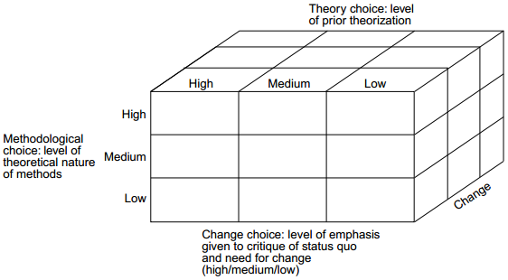
(Laughlin, 1995)

By reviewing different schools of thought on social sciences, Laughlin (1995) positions German critical theoretical orientation (as introduced in 3.5.1) as a ‘balanced’ position (see Figure 34). As elaborated by Gallhofer et al. (2013), it confirms and promotes the practices of German critical theoretical orientation, especially in accounting practices as it is ‘both rigorous and meaningful, being concerned to engender radical change, social progress and emancipation (Gallhofer et al., 2013, p192)’.

Figure 34: Characteristics of alternative schools of thought
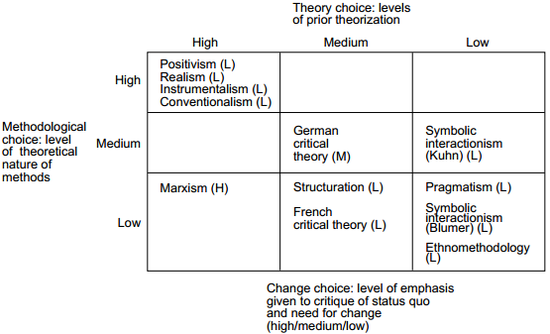
(Laughlin, 1995)

As discussed in the last section (5.1), this research is in line with the German critical theoretical orientation, that seeks to develop critical interpretive understandings of current biodiversity reporting practiced by companies, and variety of perceptions from relevant stakeholders on corporate accountability for biodiversity in Chinese context, thus, to come up with the envisioning of better practices to formulate mechanism and reporting framework to bring about betterment or positive transformation of relationship between human and nature. In terms of change, our study is attempting to transform corporate attitude and behaviour, and to bring about social change in relation to biodiversity conservation, while the pragmatic considerations are also addressed to approach a possibly aligned progressive movement. In terms of theory, the explanatory theories (e.g. GST, German critical theory) of the biodiversity accounting and extinction accounting are significantly influence our study by providing insights, the empirical findings are expected to be distinct in the Chinese context. In terms of methodology, the researcher’s subjectivity and variability are not either strictly constrained or freely encouraged to be involved in this study. The researcher’s influence on the study is significantly based on the understanding of the context as well as the theories.

Research Design
As discussed in 5.1, this study focusses on the Chinese companies’ accountability for biodiversity and how it could be further improved with emancipatory potential. It is important to gather and interpret useful data to answer the question of this thesis. Qualitative research is claimed to better address in-depth information in the data itself rather than quantification in the collection and analysis of data (Bryman and Bell, 2011). Therefore, the research question of this thesis has been addressed through a qualitative research of biodiversity accounting practices.

To answer the first sub-question, extractive industry has been identified as an ideal sector to gather the adequate information under the guidance of prior studies (Rimmel and Jonäll, 2013, Atkins et al., 2014) and prior investigations in China (Hou, 2014, China WTO Tribune et al., 2013). The proper data should be gathered from reliable data source. There are two stock exchanges in China mainland, which are Shanghai stock exchange (SSE) and Shenzhen stock exchange (SZSE). The sample for our study includes all the A-share-listed companies under the extractive industry category in both the SSE and SZSE. As mentioned in 4.2.3.2, the Chinese government starts to put significant emphases on the construction of ecological civilization since 2012, and then join the CBD’s Global Partnership for Business and Biodiversity (GPBB) in 2014 (Wang et al., 2015). In consideration of Chinese government’s political influence, corresponding actions from companies are expected. To examine the companies’ performance throughout this particular period, our study focuses on the companies’ narrative reporting on biodiversity from 2013 to 2015. There are 41 to 42 companies (number changes due to company transition and new listed companies) listed in SSE, and 29 companies listed in SZSE during the period. Take out the companies which transformed or newly listed during the period, it leaves 40 companies in SSE. Our final sample consisted of 69 listed extractive companies (see Table 11 in Appendix). Their annual report, sustainability report and website are reviewed to identify disclosures relating to biodiversity. Annual reports and CSR reports are downloadable from corporate website or the platforms of stock exchanges. The companies’ websites were examined during the time in December 2015 by using an online tool called way back machine (https://archive.org/web/), which allows us to browse a website at a specific time.

Among the identified companies, as shown in Table 12 to Table 18 in appendix, only 46.38% (32 out of 69) of them have CSR report (or equivalent reports) from 2013 to 2015, and around 50% of these 32 companies’ CSR reports are less than 20 pages. On the other hand, 53.62% (37 out of 69) of identified companies do not have CSR report from 2013 to 2015, while some of them do have CSR related section (usually within one page) in their annual report. Moreover, only 39.13% (27 out of 69) of identified companies have CSR section in their corporate website. In most of the case, these CSR sections just provide downloadable reports, or the same content as in the CSR report. Surprisingly, some of the companies just have the title of CSR section on their website with no content. Only few of companies do have different or detailed CSR disclosures on their website.

For those companies which provide CSR report, in 2013, 16.13% (5 out of 31) of them have no disclosures related to biodiversity, 41.94% (13 out of 31) of them have biodiversity related disclosures within half page, another 41.94% (13 out of 31) of them have more than half page disclosures related to biodiversity. This structure has slightly fluctuated throughout the years. In 2015, 20% (6 out of 30) of them have no biodiversity related disclosures, 36.67% (11 out of 30) of them have no more than half page biodiversity related disclosures, 43.33% (13 out of 30) of them have over half page biodiversity related disclosures. A slightly improvement could be noticed throughout the years.

For those companies which do not have CSR report but do have a CSR section in their Annual Report, in 2013, 71.05% (27 out of 38) of them do not have biodiversity related disclosures, 28.95% (11 out of 38) of them have biodiversity related disclosures, but none of these disclosures contain over half page. There is a significant improvement of this structure throughout the years. In 2015, the percentage of companies which do not have biodiversity related disclosures has reduced to 56.41% (22 out of 39), the percentage of companies which provide biodiversity related disclosures within half page has increased to 43.59% (17 out of 39).

The above information indicate that companies are starting to aware and disclose biodiversity related issues, especially the companies that provide CSR content in annual report. However, as most of the companies do not have their individual CSR report, the content of their disclosures is very limited, lead to limited disclosures on biodiversity related issues, usually less than half page. In consideration of the relevance of disclosed information with biodiversity, the narratives that use terms like biodiversity, ecosystem, habitats, ecosystem services, conservation, restoration and information on species (Rimmel and Jonäll, 2013, Atkins et al., 2014) are referred as direct biodiversity disclosures. The narratives that use terms like green mines, tree planting, ecological environment and ecological civilization that would significantly influence biodiversity are referred as indirect biodiversity disclosures. The narratives in both categories are analysed in this study, while it is worth to indicate that the number of companies provide direct disclosures is considerably less than those provide indirect disclosures (see Table 19 in appendix). The interpretive content analysis of these narrative disclosures has generated numerous themes as shown in following chapter, the performance of companies’ biodiversity reporting is generally disappointing with limited disclosures on specific species or concerns on extinction.

In seeking for more insights of current practices of ‘Business and Biodiversity’ in China, especially in preventing extinction, an additional study has been taken to investigate the corporate accounting and accountability of the most representative endangered species in China: giant panda. To explore the corporate participation in giant panda conservation, we sought to extract any examples of reporting for panda from the sustainability reports and annual reports of Chinese listed companies as well as from websites. Initially, we analysed the annual reports, CSR reports and corporate websites for Chinese listed extractive companies but found nothing relating to panda. Then, we analysed the websites and annual reports of the NGOs which involved in panda conservation and protection in China, namely WWF China and Shanshui to find evidence of these NGOs’ partnership with business and listed companies in panda conservation practices. This analysis provided rich illustrations from the NGO sector of panda accounting and accountability. As discussed in Atkins et al. (2018) in relation to rhinoceros conservation and protection, one of the leading ways in which companies are actively attempting to preserve species is to cooperate with NGOs, such as the WWF. Apart from the information gathered from articles and the media about how companies in China are engaging with NGOs to help save panda, we also analysed corporate reports and websites to find illustrations of panda accounting. We found panda reporting by two Chinese companies, as well as by seven international companies that are either based in China or are joint ventures with Chinese companies. We also carried out an extensive internet search for news and media articles and reports relating to corporate participation in panda conservation. In China this involves using the Baidu function which is the Chinese equivalent of Google. The findings are discussed in detail in Chapter 6.

To answer the second question, qualitative interview is used to investigate relevant stakeholders’ perceptions towards Chinese companies’ accountability for biodiversity as it can helps to explore people’s understanding, experiences and imaginings through their ways of expressing (Edwards and Holland, 2013). Totally 19 face to face semi-structured in-depth interviews (including two pilot interviews) have been carried out with 18 respondents (see Table 20 in appendix for participant profiles, including both personal and organisational information) from broad range of institutions or organisations representing different stakeholders, including companies, NGOs, CSR consulting companies, academies and government department. These respondents are directly or indirectly involved in the projects that relevant with ‘Business and Biodiversity’. They are approached based on the snowball basis (Gilbert, 2008) and the insights of the theoretical sampling approach which roots in grounded theory (Corbin and Strauss, 2012). Rather than develop concepts to form theory, the theoretical sampling approach is partly employed in this study in seeking to discover the ideas and issues that emerged in the interviews in depth, thus, to refine the ideas or improve understanding of issues by contacting the person which equipped with adequate experiences or/and knowledge. The pilot interviews are taken with two respondents (CC1 and CC2) from CSR consulting companies, they are identified based on their experiences in ‘Business and Biodiversity’ related reports. The design of pilot interview questions (see 11.2.1 in appendix) is significantly influenced by biodiversity accounting literatures and early findings in Chinese companies’ biodiversity reporting. The result of pilot interview is used to shape the following interview questions (see 11.2.2 to 11.2.7 in appendix) and the selection of potential participants. The respondent CC2 has been invited for another interview to investigate specific issues that closely relevant with CC2’s experiences. The rest of the respondents are identified based on the needs for further discovery or improvement of understanding along the interview process. They are approached by introduce of friends or recommendation of previous respondents. As participants are gathered from different stakeholder groups, apart from the unified interview questions, they are also provided with some additional questions based on their specific knowledge or experiences. Each interview lasted between 30 to 60 minutes, start with questions for general information (e.g. what is your position in your current organisation?) and prepared interview questions, then each interviewee was being encouraged to talk broadly about their perceptions and knowledge to the issue based on their professions. All interviews were recorded and transcribed, providing a substantial amount of data for later analysis.

Research Analysis
The interpretive nature of this thesis defines the need for tools for qualitative data analysis. In analysing the corporate disclosures on biodiversity, content analysis is a commonly used analytical tool to examine mass media items and documents including organisations’ annual reports (Bryman and Bell, 2011). It provides an important approach for the cultural study of organisations as it allows researchers to analysis organisational values though organisational documents. Thus, it has been mostly used to assess organisations’ social and environmental disclosures as it can making replicable and valid inferences from data base on their context (Milne and Adler, 1999). Researchers could recognise the importance of the values by measuring the frequency they occurred (Kabanoff et al., 1995). Moreover, it is a transparent research approach, which makes the replications and follow-up studies are feasible (Klaus, 1980). Furthermore, content analysis is highly flexible that can be applied to various unstructured information, and it can be widely applied in business and management researches (Bryman and Bell, 2011). However, the reliability of content analysis has been concerned in social and environmental accounting literatures (Milne and Adler, 1999), as the quality of content analysis is closely depending on the quality of the documents. Bryman and Bell (2011) explain that sometimes researchers have to rely on organisations’ documents in public domain as they have difficulty of gaining access to those organisations. But the public-domain documents might not be an accurate representation of how different organisation actors perceive the situations. Bell et al. (2002) point out that a significant gap could exist between understanding of what initially supposed to express and what it comes to represent. Atkinson and Coffey (2004) remind that documents have a distinct level of ‘reality’ in their own right, the content are written with distinctive purposes. They should not be simply viewed as reflecting organisational or social reality as they are produced for significant objectives and targeted audiences. Therefore, documents cannot be considered as representing objective point of view. They have to be compared and examined in the context of other sources of data (Bryman and Bell, 2011). According to Beardsworth (1981), the use of content analysis could focus on searching for certain ideas/ themes within the text. It is usually that a researcher wants to code text according to certain themes in content analysis. Barley et al. (1988) suggest that under this situation, a more interpretative approach is needed. It means the researcher is not only looking for manifest content, but also for latent content.

Tregidga et al. (2012) point out that the current methods for analyzing the quality, meaning and accountability of organisational reporting in accounting research almost dominate by approaches like quantitative content analysis, few studies investigate the ‘nature’ and ‘meaning’ of reporting and its ‘effects’. In social and environmental accounting field, some notions like impression management are considered as explanations for organisational communications, while they are usually superficially investigated in most of researches using relatively rough indicators such as volumes of disclosures. Qualitative content analysis is frequently used for the qualitative analysis of documents. It provides a strategy for searching themes in the contents being analysed (Bryman and Bell, 2011). Interpretive content analysis is one of the qualitative content analysis approaches that focus on the immediate context of text production and reception (Merkl-Davies et al., 2013). Its aim is to understand and describe how the corporate narratives are used for sense-making, identity construction and legitimation (Demers et al., 2003). Interpretive content analysis has been used in various studies focus on sustainable and environmental issues (Tregidga and Milne, 2006, Laine, 2005, 2009, 2010), discover how and why organisations develop and change their disclosures. It also been used in studies in relation to corporate disclosures on biodiversity (Atkins et al., 2018) to investigate organisations’ motivation and disclosed content. The researchers rely on ‘a process of subjective sense-making, which included numerous rounds of reading and various attempts to systematise the findings into a coherent interpretation’ (Laine, 2009, p1034). Through the interpretative analysis of the features and development of texts, researchers would be able to identify patterns, similarities, exceptions and possible omissions both over time and between organisations (Laine, 2010).

As the language used in corporate disclosures is seen as playing an important role in constructing a specific organisation identity, interpretative content analysis is employed in this study to investigate the identified companies’ disclosures that relevant with biodiversity. This study was conducted through numerous rounds of reading. In the initial stages, the researcher readthrough each corporate reports and website in detail identifying references to biodiversity related issues. A closer reading of the text was made once an initial reading was complete, a large number of extracts was identified from the reports to form themes. As shown in Chapter 6, all coded data was placed into two categories with four main themes: focus on the interests of company itself and focus on the interests of other stakeholders; and disclosures characterized with impression management and disclosures characterized with emancipatory potential. A significant subjective analysis is involved by using this interpretive approach. The draft result has been presented at different conferences and seminars to ensure that the findings resonated with a broad audience. With the comments from the conferences and seminars, the researcher took another round of reading of corporate reports and website for improvements and corrections.

For the additional study on giant panda, interpretive content analysis is applied as well for identified disclosures, while the focus is on the emancipatory potentials of corporate disclosures in preventing panda’s extinction (Atkins et al., 2018). The findings are analysed and developed in the context to propose an accounting framework (significantly influenced by Maroun and Atkins, 2018) specifically in preventing extinction of giant panda. The insights of this additional study significantly contribute to the recommendations in answering the question of this thesis.

Grounded theory is partly employed in this study in analysing the interviews to generate themes and categories. Grounded theory is a specific methodology developed by Barney Glaser and Anselm Strauss in The Discovery of Grounded Theory: Strategies for Qualitative Research (1967) for the purpose of building theory from data (Corbin and Strauss, 2012). It has been defined as ‘theory that was derived from data, systematically gathered and analysed through the research process. In this method, data collection, analysis, and eventual theory stand in close relationship to one another’ (Straus and Corbin, 1998, p12). Bryman and Bell (2011) point out two core characteristics of grounded theory: theory is developed out of data; and the approach is recursive.

Coding is the key process in grounded theory, it breaking down the qualitative data into component parts and giving names. Corbin and Strauss (2012, p159) defined it as ‘extracting concepts from raw data and developing them in terms of their properties (characteristics that define and describe concepts) and dimensions (variations within properties that give specificity and range to concepts)’. It is an essential first step to the generation of theory and it is in a constant state of potential revision and fluidity during the analysis process. In the coding process, data provide potential indicators (events/ behavioural actions) for concepts; these indicators are constantly compared to fit in the best matched concepts, the generated concepts will be grouped and turned into categories in later process. During the coding process, researchers should start coding as soon as possible along with the data collection. It helps them to sharpen their understanding of data and create strong foundation for later stages including theoretical sampling. Secondly, it is important for researches to keep go back to raw data or initial notes to find missing codes or connections, especially when researchers get struck during coding process. It is also important to review codes in relation to transcripts, make comparison and adjustment, and try to find connections between codes. Thirdly, researchers need to keep in mind that any data could be coded in more than one way; more general theoretical ideas should be generated from data, as well as potential connections between concepts and categories. Finally, it is normal for having too many codes in the early stages; the key is to be imaginative and inventive to consider all the possibilities. During the coding process, researchers need to be aware of the loss of context as significant emphasis has been given on interviewees’ words (Bryman and Bell, 2011).

As mentioned earlier, concepts are the outcomes of coding; they are ‘words that stand for groups or classes of objects, events, and actions that share some major common property/properties, though the property/properties can vary dimensionally’ (Corbin and Strauss, 2012, p45). Concepts are derived from data; they are varying in levels of abstraction. The basic level concepts point to, relate to and provide details for higher level concepts, which can be recognised as categories/themes. Thus, categories can represent what a group of basic level concepts are indicating or pointing to (Corbin and Strauss, 2012). Constant comparison is ‘the analytic process of comparing different pieces of data for similarities and differences’ (Corbin and Strauss, 2012, p65). It enables researchers to differentiate one category/theme from the other and identify its specific properties and dimensions (Corbin and Strauss, 2012). Constant comparison begins as soon as the provisional categories have been formed or data have been abstracted. This process challenges and further explains the properties of the original concepts or categories with more data (Locke, 1996). Bryman and Bell (2011) point out that this process reminds researchers to constantly compare phenomena being coded under a certain category/theme thus to generate a theoretical elaboration of that category/theme.

Grounded theory is perceived well fitted in organisational research (Locke, 2001), it is particularly helpful for research to predict and explain behavior (Goulding, 2002), could support theorizing of ‘new’ substantive areas that have not been explored or well investigated by others. As new features of technological or managerial change emerge and bring revolutionary effects in business world, grounded theory is an ideal open-ended research strategy for these ‘new’ substantive areas (Locke, 2001). Parker and Roffey (1997) suggest that grounded theory has provided a systematic framework for the studies of the management practices in their social and organisational context. Its potentials in connecting categories/themes are considered helpful for social and environmental aspects of accounting studies.

As mentioned in the last section, this study is not a pure grounded research that does not seeking to build theory from interviews, while the insights and significance of grounded theory has driven us partly employ it as primary interview data collection approach in research design and data analysis process. During the interview process, apart from the new themes raised from new interviews, the previous data are repeatedly reviewed to generate new understandings or discover potential connections. Data was considered to be saturated after the 19th interview with totally over 200 themes generated. With constant comparison, five general categories are classified as following (see Chapter 8 for details) with relevant themes: 1) current status of ‘Business and Biodiversity’ in China, 2) challenges to promoting ‘Business and Biodiversity’ in China, 3) current attempts to improve ‘Business and Biodiversity’ in China 4) recommendations for future improvement of ‘Business and Biodiversity’ in China, and 5) the significance of panda conservation.

In answering the main question of this thesis, all empirical analyses are compared and discussed in Chapter 9. With all themes (from Chapter 6 and Chapter 8) alongside the insights from additional study on panda (Chapter 7) were theoretically interpreted in terms of systemic and emancipatory analysis, recommendations (Chapter 10) are provided including proposed mechanism and accounting framework.

As a research in a non-Western context, the significance of language is essential to be considered. To minimize the misunderstanding and other negative consequences created by language barrier, all interviews were recorded and transcribed in Chinese, and these transcripts were analyzed and summarized prior to translating into English. Moreover, the translated quotes that cited in this study (in Chapter 6, 7, and 8) were reviewed and verified by the researcher’s supervisor, who is a native English speaker to further reduce the risk of language barrier.

Chapter 6: Interpretive Content Analysis
Through the interpretive content analysis of both direct and indirect biodiversity-related information disclosed by the companies selected, numerous themes were identified by carefully reading the data in relation to existing literature and classifying them into two general categories. One category includes different approaches to biodiversity-related conservation practices from the companies, another category represents various features of the companies’ disclosures for biodiversity conservation. The coding used in this analysis was checked and approved by the researcher’s supervisor.

Different approaches to biodiversity-related conservation practices
In relation to different approaches adopted by the companies towards biodiversity-related conservation practices, as shown in the list below, most of the companies appear to focus on their own interests. This theme can be classified into two groups. The first is to minimize risks by reducing their impact on biodiversity. Sub-themes identified under this grouping are: 1) prevent environmental incident; 2) compensate and recover the ecological environment; 3) minimize operational impact; and 4) integrate ecological environment conservation into the project cycle. Another group arising from the analysis involves maximizing interests by utilizing ecological services provided by biodiversity. Sub-themes identified within this group include: 1) seeking benefits from improved local ecosystem; and 2) creating biodiversity to gain required ecological services. We also find a few companies’ practices which focus more on the interests and needs of other stakeholders including society, species, and ecological environment. These themes are: 1) recognizing the importance and the value of biodiversity for society; and 2) being concerned for species and the ecological environment. The details of these themes are discussed in the following sections.

Focus on the interests of company itself

Minimize risks by reducing company’s impact on biodiversity

Prevent environmental incident
Currently in China, companies seem to focus primarily on pollution control and emission reduction in environmental issues as they are prioritized by the government. The pollution issue is of serious concern to the general public due to its higher visibility and significant impact on people’s everyday life and living environment. With limited awareness and concerns about biodiversity related issues, some companies aim to prevent environmental disaster or incident. For example, Company No.12 disclosed:

‘the company’s subsidiaries have already completed … registration work with the local environmental protection department for an emergent environmental incident action plan … to effectively prevent the emergent environmental incident’ (Annual Report, 2013, p24).

Company No.6 also disclosed similar content:

‘the company also focuses on geological disaster prevention and control’ (CSR Report, 2013, p17).

Although this could be taken to demonstrate company’s risk control of significant environmental incidents, more progressive and proactive practices should perhaps be considered.

Compensate and recover the ecological environment
Most of the companies analysed tended to perform conservation activities (e.g. soil reclamation, vegetation recovery, compensation) after their destructive operations. For example, Company No.21 discloses its reclamation project in collapsed mining site, and the specific amount of compensation fee. The company also spend money on the reinforcement project of local dam, sluice and road (CSR Report, 2013, 2014, 2015). The company’s operations might be the cause of these projects, as they damage the ecological services provided by local biodiversity, thus leading to water loss and soil erosion.

Company No.60 establishes its principle for mining site rehabilitation as:

‘Damage one place, recover one place, carry out soil reclamation of each refuse dump’ (CSR Report, 2013, p12).

The company admits it damages the local environment and only focus on recovery. To demonstrate its efforts, the company discloses its partnership with research institutions, and related performance:

‘combine the actual production and the features of local environment and climate, to cooperate with research institutions like Chinese Academy of Sciences Shenyang Institute of Ecological Application and Beijing Traffic Science Research Institute … achieve the quick succession process of the diversity of reclamation plants and the recovery of vegetation in refuse dump’ (CSR Report, 2013, p12).

Related capital input and quantitative information are also provided to demonstrate its performance. However, the report does not disclose information about specific plant species and other species that might need to be recovered. It might be difficult for people to believe the company can recover the local environment to its original state, which is the impression that the company trying to create, as they provide little information on the specifics of the recovery process.

Company No.47 does improve its recovery performance in 2015 by focusing on biodiversity and specific species. In its specific biodiversity section, it discloses that for some of its mining site, the selection for specific tree species (Jatropha curcas, Sisal hemp, Pigeonpea, Oleander, Bougainvillea speetabilis, and Acacia confusa) used for mining site recovery is based on the features (dry, barren) of the mining site. Specific planting patterns are used to ensure the recovery of the ecological environment. The company also provide cases of other mining sites, where different plant species are selected to fit the geographical conditions of different sites. In some sites, the company even points out some ecological services (dust control, noise reduction, and beautiful natural landscape) provided by recovered plant (CSR Report, 2015). These specific cases could indicate the company’s awareness and concerns about biodiversity. The reasonable selection and planting approaches for recovered species make the company’s performance more reliable and convincing.

However, apart from their efforts, their focus is still on the recovery and compensation after their operations. It raises concerns that, without accurate and comprehensive measurement and valuation, companies might not even know how much damage they have done to the local ecosystem and species. It is questionable whether they can recover local biodiversity back to its original (and native) state. Moreover, it is also questionable whether they will be able to deliver all the recovery projects after their operations.

Minimize operational impact
Some companies have taken more proactive conservation activities before or during the operations to minimize their impact on local ecological environment, especially in environmentally sensitive areas. Due to the nature of the extractive industry, sometimes companies have to gain access to environmentally sensitive areas to exploit and transport natural resources. Different measures have been taken to minimize the impact of such operations. For example, Company No.56 claims that it complies with the national ‘Regulations on Wetland Conservation’, actively reduce its mining range in order to conserve local national wetland park. The company also:

‘repeatedly send people to local government departments like Land Bureau and Development and Reform Commission to proceed the work on reducing mining range’ (CSR Report, 2015, p32),

This might indicate the company’s willingness to sacrifice part of its self-interests for wetlands conservation.

For those sensitive areas that companies are unable to avoid, Company No.35 firstly states the conditions of the vulnerable ecological environment around its operating site, then it discloses that:

‘230 million Yuan (China’s currency) has been invested for biological environmental construction’ (Company Website, 2013).

However, further details about this investment or program have not been provided. For another operating site which is located in desert, the company describes it as

‘not only short of water resource, also the ecological environment is very fragile’, ‘in order to conserve local ecology to the maximum’, ‘this project has set zero release of waste water as one of its main objectives since the beginning’ (CSR Report, 2014, p31).

Detailed process and acknowledgement from the local environmental protection agency are provided to support its performance. Although it has not specifically mentioned biodiversity or specific species, its ‘minimum impact’ on local environment could potentially benefit the local biodiversity.

Similarly, one of Company No.22’s oilfield is also located in desert, where

‘has the world’s largest populus euphratica forest, it has been honoured as the oldest, largest and best preserved original populus euphratica forest’ (CSR Report, 2013, p40).

By focus on this specific species, the company:

‘adopted protection procedures to each populus euphratica when it carries out the site selection and construction work of well site, well station and road’, thus to ‘actively practice the concept of ecological protection, guaranteed not to damage local plant’ (CSR Report, 2013, p40).

The company demonstrates its efforts by disclosing its practices regarding representative species in the operating site. However, the report does not provide further details, such as financial figures or quantitative information.

Company No.28 has a project which aims to:

‘restore the marine environment and fishery resources of the subsea pipeline project’, it releases two million black sea bream into the sea, ‘expected to add about 100 tons of black sea bream in surrounding waters of Dapeng Bay and Daya Bay’ (CSR Report, 2013, p31).

The company also has a transnational pipeline which crosses some nature reserves and other sensitive areas. In order to conserve the ‘ecological diversity of transnational waters’, the company has set up special funds to build fish breeding stations to:

‘conduct fish reproduction and releasing, carry out research on artificial reproduction of burbot, and monitor water quality and aquatic life’ (CSR Report, 2014, p32).

It can be noticed that company is investing in a long-term biodiversity conservation project; the funded station and research could improve and further measure future performance in order to minimize further the company’s operational impact on biodiversity around the pipeline. This great effort might be encouraged by the involvement of transnational waters, which could involve wider groups of stakeholders and international regulations.

As for operational projects in foreign seas, Company No.39 states that it strictly obeys foreign marine animal protection regulations. When employees see protected rare animals like sea turtles, whales and dolphins during offshore platform operations, they need to report to managers to decide whether to stop the operation. The company also mentioned in relation to its performance in foreign sea operations that it:

‘… has not received complaints relating to environment protection issues for seven years’ (CSR Report, 2013, p34).

In 2014, the company provides training and education for employees to become Marine Mammal Observers, the related training certificate, observation form and recorded behaviors are disclosed in company’s reports. These employees are required to:

‘perform effective observation and record the time and location of the appearance of marine mammals’ (CSR Report, 2014, p29),

This helps the company to reduce its impact on these species. A significant improvement of company’s conservation activities can be noticed from disclosures throughout years, it might indicate that its conservation motivations are no longer limited by complying with regional regulations. Active and long-term conservation activities are developed to minimize company’s impact on regional species.

Integrate ecological environmental conservation into project cycle
Some companies are trying to integrate conservation activities/projects within their industry chain. For example, Company No.28 discloses how they integrate environmental management into the full life cycle of their industry chain. Before operations begin, they state that they:

‘endeavour to reduce the occupation of arable land … environmental protection facilities are designed, built and commissioned together with the main project’ (CSR Report, 2015, p33).

Then, during operations they state they have:

‘comprehensively checked and rectified environmental pollution and ecological damages; and reduce the impact on the ecological environment through noise reduction, emission reduction and other means’ (CSR Report, 2015, p33).

And that they have:

‘put a lot of effort into the conservation of soil and water and into restoring the vegetation, working hard to restore the ecological environment and protect the biodiversity of our operation areas’ (CSR Report, 2015, p33).

It could be noticed that instead of more detailed information, the company uses the words like ‘endeavour’, ‘lots of effort’, ‘work hard’ to demonstrate its emphasis on the issue, but without demonstrating success. Although this does indicate a commitment it would perhaps be more convincing were the company to disclose more specific and detailed disclosures including what they have done, what has worked and where they have not been so successful.

In 2016, the same company classified ‘biodiversity destruction’ as one of ‘six major environmental risks’. As a result, green drilling was used to demonstrate the integration of habitat conservation into the whole well-drilling cycle. By focusing on the development of eco-friendly mud, and recycling of drilling waste, the company states that it is able to:

‘protect surface and underground water’ (CSR Report, 2016, p37).

This green drilling philosophy and technology has been widely applied in the company’s global operations. Moreover, with the company’s conservation of local wetland, the eco-balance of wetland at the company’s operating site in Iran has been guaranteed and the company has won the ‘environmental protection award’ from the host country. These initiatives indicate that the company has recognised the importance of biodiversity in its sustainable development. Progress could be noticed by the specificity and details of disclosed cases.

Maximize interests by utilizing ecological services provided by biodiversity

Seeking benefit from improved local ecosystem
Some companies’ practices are not limited to conservation, but they are also concerned with trying to improve the ecological environment around their operating site. For example, Company No.27 states that they:

‘pay attention to biological sand control … and strive to protect and significantly improve the ecological environment along the railway … 17 million Yuan has been invested to beautify the railway line and surrounding environment’ (CSR Report, 2013, p84).

It can be speculated that this project could benefit the company by providing biology sand control services, thus, reducing the company’s maintenance cost for the railway. However, it is notable that the company’s actions for improvement appear to be limited to ‘beautification’ which is suggestive more of impression management than genuine ecological improvement. The company also discusses another project in which they are working with local government to recover the local collapsed pits which were created by former small coal mines (mostly private illegal mining enterprises), and to further improve that area to become a sight-seeing green industrial demonstration park (CSR Report, 2013, p83). It could demonstrate company’s generous commitment for local ecological environmental conservation as they are also dealing with damages created by other organisations. Such commitment may be driven by the genuine concerns for the ecological environment around its operation site. Alternately it could be another public relations exercise.

Company No.56 discloses that its conservation activities are not only aimed at greening the mining site, but also intend to:

‘form a unique landscape, which improves employees’ working and living environment’ (CSR Report, 2014, p32).

Similarly, Company No.37 also points out that its conservation projects could create beautiful working and living environments for employees, thus providing better services for production and employees’ health. Moreover, the company also creates a plant community based on scientific selection and planting, to provide ecological services like air cleaning, sound insulation and dust filtration (CSR Report, 2013).

In these cases, companies’ ecological environment conservations are not only motivated by legislative requirements and responsibility, but also by a stated interest in themselves and their employees. They treat ecological environmental issues as opportunities to glean benefit from ecological services rather than focusing only on risks associated with biodiversity, suggesting a shift in companies’ perceptions.

Create biodiversity to gain required ecological services
By recognizing the value of biodiversity, some companies are trying to develop other industrial activities alongside their biodiversity related conservations to gain benefits. For example, Company No.11 stated that they are building an ecological garden to plant various vegetables for employee restaurant, which dose not only green the operating site and environment, but also reduces costs. The company’s treated waste water can be used for watering surrounding farmland, which provides greater livelihood opportunities for the surrounding community (Company Website, 2013). In a similar manner, Company No.37 is developing an eco-tourism industry alongside its green mine project. It is building an ecological farm, tea garden and other scenic spots in its mine park, which can attract 50,000 tourists every year (CSR Report, 2013). Company No.35 state that on the basis of ecological recovery, the company aims to build an ecological industry chain for its land rehabilitation project. Its ecological construction includes high level eco-agriculture facility base, and national mine park. This project provides employment for surrounding residents by establishing facilities for greenhouse planting and livestock breeding. In addition, the company has also built tourist facilities such as ‘ecological avenue’, an artificial lake, and an ecological restaurant. With continuous development, the company aims to further integrate ecological recovery, modern agriculture, and eco-tourism within its eco-park. The company’s practices have been acknowledged and they have been presented with an awarded from local and national government (CSR Report, 2013, 2014, 2015).

It can be noticed that by developing other industries alongside conservation projects, companies are tending to maximize the benefit that they can gain from the conservation activities. These benefits include welfare for employees, economic benefit for the company, and employment benefit for surrounding community, thus improving the company’s CSR performance and image. These approaches demonstrate that companies are devoting more effort to conservation activities, and that the surrounding environment is benefitting to some extent. However, such activities appear to be less concerned with preserving and improving biodiversity. Indeed, these initiatives may actually lead to the loss of the original, native biodiversity and may even damage the local ecological system.

It is clear from the content analysis that some companies do appreciate the ecosystem services provided by biodiversity, and thus are trying to reap these benefits. For example, in order to reduce the encroachment of sand onto the highway road which Company No.28 use to develop its operations in desert, the company:

‘planted more than 20 million trees such as Haloxylon and Calligonum around the highway to ensure sand fixation’ (CSR Report, 2014, p31).

The company uses photovoltaic technology to generate power to irrigate the ecological protected forests. This highway project was ranked among the Top 10 Most Beautiful Highways in China and was celebrated as a ‘National Environmentally Friendly Project’. This initiative not only helps the company to reduce costs associated with sand control, but also provides shelters for hares and birds (CSR Report, 2014). Similar approaches have been used by other companies, which have created ecological services aimed at sand/dust control, sound insulation and air cleaning.

Therefore, the analysis shows that companies are making efforts to develop biodiversity related conservations initiatives in a variety of ways. However, it seems that they still focus on the risks and interests for themselves. Their practices on biodiversity are mainly aimed to acquire the ecosystem services that they need. Their practices and initiatives seem to be benefitting general ecological environment instead of biodiversity specifically. This might be due to their limited awareness and motivation, and unwillingness to provide greater efforts.

Focus on the interests of other stakeholders

Recognise the importance and the value of biodiversity for the society
The analysis indicated that some companies are beginning to recognise the importance of biodiversity. For example, Company No.7 points out that its forest management has achieved:

‘zero forest fire, zero casualties, zero large scale outbreak of pests … take a good care for the natural air anion bar and green barrier of west Beijing’ (CSR Report, 2015, p13).

The company recognises that, by protecting the forest, it also protects the ecological services that the forest provides for the city.

Further, some companies are beginning to value the benefits provided by biodiversity. For example, Company No.28 states that:

‘a diversified environment is a valuable resource for humanity. Respecting nature, developing in harmony with nature and protecting nature are of great importance to our sustainable development’ (CSR Report, 2013, p31).

Issues that closely relate to biodiversity are also being discussed by some companies, for example, Company No.2 points out that:

‘climate change and resources shortage have already become the global environmental issues that perplex humans’ (CSR Report, 2013, p6).

In response, the company cooperates with NGOs aims to help raise awareness. Moreover, it also encourages its employees to take part in marathon activities, in order to:

‘let them experience the importance of air quality and the natural environment during the running process’ (CSR Report, 2014, p6).

The company also points out that their employees can consequently influence surrounding citizens/local residents and communities, further improving their awareness of sustainable development. It can be noticed that companies’ activities in this area arise from their recognition of important issues.

Concern for species and the ecological environment

Concern for species and the ecological environment within the habitats affected by companies’ operations
The content analysis revealed that some companies appear to have greater concerns for species living in habitats affected by their operations than other. Consequently, they seek to create and conserve habitats within their operating site. For example, Company No.22 discloses that one of its subsidiaries has a 2,200 square metres grove within its operating site, which people call ‘the egret garden’ as hundreds of egrets inhabit there. The company points out that the:

‘egret has higher requirements of the quality of its living environment; thus, it can be considered as the ecological indicator for the regional environment’ (CSR Report, 2014, p20).

The company sticks to green operations and makes an effort to provide superior habitat for egrets in its operating site. As egrets are inhabiting the company’s operating site, their higher standards for living requirement can be used to demonstrate company’s performance on habitat conservation and improvement.

Company No.39 discloses that sea birds are frequenters of the company’s off-shore platform. When they are homeless during the storm season, the drilling platform becomes their habitat. The company also provides a record that one of its employees attends to sea birds on the deck which had been injured in a storm. Employees feed them, bind up their wounds, and release them after they are cured (CSR Report, 2014). In this case, the company considers its operating platform as a temporary habitat for surrounding species, and encourage its employees further improve the services that the platform can provide for those species.

Moreover, as mentioned earlier, the company provides training for employees to observe marine species, as one of the training results, it discloses the employees’ perceptions from their observation, such as

‘on the way to the off-shore platform, come across three phoca largha (a kind of seal) lazily lie on the thick ice, leisurely enjoy the sunbath. As a national priority protected animal, phoca largha has a higher standard for its environment. As the Bohai Sea have set up a phoca largha conservation zone, they consider here as their home’ (CSR Report, 2015, p31).

These observation records could demonstrate employees’ awareness and knowledge about biodiversity around the company’s operating site. Moreover, a non-anthropocentric view could be discerned from the words that they used to describe these species as they are talking about the animals as though they have their own intrinsic value and not regarding their relationship with humans.

Company No.34 is carrying out a long-term ‘fish multiplication’ project, whereby the company releases highly protected fish species such as Silurus Lanzhouensis, White Silver Carp, Fancy Carp, and Bighead Carp in to the Yellow River, and aims to maintain the ecological balance of the Yellow River (CSR Report, 2013). The company is also settings up an individual sector to specifically operate this project for other water areas and is adopting a scientific approach by cooperating with ecological technology partner to significantly improve its performance. Before releasing them, specialists will check fish quality and size, make ‘right ear tag’ on samples (around one fifth of total released fish) in order to carry out performance assessment for following project. The company also carries out research on artificial reproduction to improve performance, such as achieving higher fertility rates, and expanding the number of species to maintain genetic balance, detailed quantitative information and list of species are provided to demonstrate its performance (CSR Report, 2014). For each fish releasing activity, the company will arrange specific release places, and number and size of different released fish species, thus, to ensure the successful supplement of endangered rare fish resources. This continuous project not only reduces the hydropower project construction’s negative impact on fish resources, but also actively improve the regional ecological environment and aquatic living resources (CSR Report, 2015). Working with local institutions and ecological technology organisation allows the company to adopt the most scientific way to implement its ‘fish multiplication’ project.

The project not only supplements endangered fish resources in various water areas, but also make breakthroughs on artificial reproduction for various fish species.

Concern for species and ecological environment beyond the range of companies’ operations
All the conservation practices discussed above are concentrated around companies’ operational sites. Some companies’ practices are far beyond and tend to actively engage with stakeholders to take the lead in practice. These companies’ disclosures are not only aiming to discharging accountability, but also tending to be educative and promotional. For example, Company No.28 comment that:

‘forests are important carbon sink of the nature, a climate stabilizer and a shelter for biodiversity’ (CSR Report, 2014, p35).

The company demonstrates its performance by engaging with stakeholders, stating that they are:

‘actively engaged in forestry carbon sequestration transactions, promoting full participation in afforestation efforts, and striving to cultivate forest resources’ (CSR Report, 2014, p35).

In detail, the company’s carbon sink forests demonstration project has been approved by the China Green Carbon Foundation, the company lists ten of its subsidiaries which were awarded ‘National Model Units for Afforestation’ by the National Afforestation Committee (CSR Report, 2013, 2014). The company also explains in the report what a carbon sequestration forest is, including the ecological services provided by the forest, how the project benefits the eco-system and biodiversity, and how it can bring economic benefits (CSR Report, 2014). A strong educational and persuasive motive can also be detected from the company’s disclosures, which might aim to enhance public awareness.

Company No.22 discloses that one of its subsidiaries implements an ‘enhancement and releasing to restore fishery resources’ event, aiming to conserve marine ecology. It plans to:

‘release 50 million fishery species annually to help restore fishery population resources, protect biodiversity, improve coastal ecological environment, and promote sustainable development of fishery’ (CSR Report, 2015, p31).

In this case, the company is trying to promote sustainable development for fishery industry and concerns for coastal ecological environment, which consider the interests beyond itself. However, the report does not provide further details.

Impression management versus emancipatory characteristics of conservation practice disclosures
The analysis revealed two groupings of characteristics among the conservation practice disclosures: those disclosures which were suggestive of impression management and those disclosures which seemed to have emancipatory potential. There were a number of themes drawn out by the analysis which fell into these two groups. The themes falling into the grouping of disclosures which were suggestive of impression management rather than a genuine commitment to conservation, including: 1) a focus on the compliance with laws and legislations, 2) a focus on good performance in overseas projects, 3) repeated content, 4) a focus on tree planting and greening, 5) Only disclosing on the website, not in the reports, 6) non-continuous project, and 7) limited attempts to demonstrate conservation performance. We believe, these are the features of the disclosures that companies provided to form a good impression of accountability for biodiversity. These disclosures focus more on compliance with certain demands, with less effort being placed on details relating to biodiversity issues. However, the analysis also identified themes within the disclosures which appeared to have emancipatory potential, including: 1) the company acknowledging impacts on the ecological environment, 2) recognizing the value of biodiversity, 3) running continuous projects for biodiversity conservation, 4) providing training for employees, 5) taking the lead in the artificial reproduction of specific species, 6). disclosures on specific species, and 7). innovative approaches to engaging with stakeholders on biodiversity related issues. These features of the companies seem to have emancipatory potential as they not only discharge companies’ accountability for biodiversity, but also further promote biodiversity conservation practices to solve the current global challenges of biodiversity loss. In other words, the disclosures in some cases seem to be transformational and eliciting and engendering change or at least progression towards change. The details of these themes are discussed in the sections below.

Disclosures characterized with impression management potential

A focus on the compliance with laws and legislations
Some companies’ disclosures on environmental conservation issues tended to focus on compliance with laws and legislations. For example, Company No.52 states that:

‘the company is strictly obeying the requirements from the regional environmental protection department, complying with local, national, industrial environmental protection legislations’ (CSR Report, 2013, p9).

However, the company did not provide any name or reference to these legislations. Similarly, Company No.38 discloses that:

‘the company is able to strictly comply with national legislations and standards for environment conservation’ (CSR Report, 2015b, p8).

The company does mention the term ‘New Environmental Law’ and related training actions, but no other detailed information (e.g. specific criteria) is provided. Its disclosures contain limited content and the content that is included is vague. The disclosures from Company No.45, No.4, No.8, and No.16 have similar features, they emphasis that they are complying with national or international legislations, while the disclosed information of these legislations is limited. Besides that, Company No.4 states that they:

‘improve investment in safety and environment conservation’ (Annual Report, 2015, p23).

Yet they provide no financial information or further details

Company No.8 discloses that they aim:

‘to establish an environmentally friendly corporation and build a green mine’ (Annual Report, 2013, p24).

However, they provide no specific planned objectives nor details on how they intend to do this.

Company No.16 disclose the following without any further details about the standards:

‘the effluent pollutants are complying with national and local standards’ (Annual Report, 2014, p20).

These cases suggest that some companies appear to participate in environmental conservations in a passive manner, merely complying with regional or national legislations rather than their impact on regional environment or species. Moreover, their focus on legislation is mainly on pollution and emission issues, with less concerns placed on ecological systems or species. This could indicate their limited awareness, or their preference of concerned issues. Without indication of specific criteria of legislations, companies’ disclosures are too vague to demonstrate their performance.

A focus on good performance in overseas projects
Some companies prefer to disclose their good performance on biodiversity conservation in overseas projects. For example, Company No.6 states its subsidiary in Australia follows the health, safety and environmental management system required by international standard ISO14001. The company:

‘plant around 10,000 native trees annually, thus, to create and recover ecological diversified wild environment around operating site’ (CSR Report, 2014, p17).

However, the company has no such project in China. This might indicate that the company’s awareness and activities in relation to biodiversity conservation are encouraged by foreign local requirements.

In contrast, as discussed earlier, Company No.39 demonstrate good performance on biodiversity conservation in its foreign operations. Its continuous and improved practices show that the company’s motivation is not solely dependent on foreign local requirements. For example, the company’s initiatives on training for employees to observe and record species activity data help it to further minimize its operational impact on local biodiversity. Moreover, similar projects and initiatives are applied in other operating sites, including those in China. The company’s motivation for biodiversity conservations might begin with foreign local requirements, but are then integrated into their values and strategy. This level of motivation could help to generate innovative initiatives and detailed measures.

One of Company No.22’s case studies disclose the biodiversity conservation initiatives implemented by its subsidiary in Columbia. Firstly, the company outlines the highly sensitive ecological environmental area and nature reserves, which forbid any kind of operations in those area. Secondly, it assigns specialist employees to cooperate with local government to implement specific protection on wildlife. Thirdly, it organizes a wildlife photography competition aimed to raise local residents’ awareness of wildlife conservation, especially for endangered species. Fourthly, in order to further improve residents’ conservation awareness and ability, the company carries out specific training for the community (CSR Report, 2015). It is notable that the company is actively engaging with stakeholders and focusing on awareness raising and education, aiming to create a sustainable conservation environment. Although the company does not conduct similar practices in China, it does have other biodiversity conservation projects.

Based on these cases, those companies which have operations in foreign countries usually have good awareness and practices in biodiversity conservation. This is mainly due to the needs to comply with international standards or the requirements of foreign governments. Therefore, companies tend to disclose these practices to demonstrate their performance on biodiversity conservation. Some of these companies do not have similar practices in China, which might indicate that these companies’ motivation for biodiversity conservation is solely based on the compulsory requirements from the local authority. Relatively, some companies do have similar practices for operations in China, where the requirements for biodiversity conservation are not as strict as some foreign countries. This could indicate that these companies are tending to further develop their practices and try to apply their improved awareness and practices in their national and other international operations. It could potentially promote social awareness and actions, thus, contribute to the biodiversity conservation.

Repeated content
Repeated content is one of the issues that usually exists in companies’ disclosures (Solomon, 2013). In our findings, different levels of repeated content also been identified.

Firstly, when a company discloses the same mission statement for environmental issues throughout years, this may suggest a lack of improvement and development in their level of awareness. For example, Company No.30 discloses the same mission statement for three years:

‘Perform clean production, protect ecological resources; perform cyclic utilization, realize low carbon development, achieve total involvement to create ecological civilization’ (CSR Report, 2013, 2014, 2015).

The detailed activities and performance are disclosed in a similar pattern with slight improvement over the years. The company’s focus is consistently on pollution control and emission reduction, no disclosures are specifically concern for biodiversity. A consistent mission statement might indicate that companies’ awareness is less likely to have improved.

Secondly, some companies repeatedly disclose same performance throughout years. For example, Company No.46 discloses:

‘Since December 2012, Yindu Mining (one of company’s subsidiaries) has been listed as second batch of national green mine experimental enterprise by Ministry of Land and Resources’ (CSR Report, 2013, 2014, 2015).

The performance in 2012 has been repeatedly disclosed over the following three years, with nearly unchanged mission statement and practices. This may indicate the company has made little effort in this area. Similarly, Company No.18 repeatedly lists three of its mining sites that have been awarded as national green mine experimental unit in its 2013 and 2014 CSR report, and add one more mining site in 2015 CSR report. For the same greening project, in 2013, the company discloses they were:

‘planting 65,469 trees and shrubs’ (CSR Report, 2013, p50).

While in 2014, it discloses that they had:

‘planted over 60,000 trees and shrubs’ (CSR Report, 2014, p43).

Except the slight rephrasing, the remaining content of the paragraph in these two CSR reports is exactly same.

As a further example, Company No.35 continuously discloses one of its ecological mine projects, which was to establish ‘300 solar greenhouses’, ‘16 thousand square meters of intelligent greenhouse’, and ‘other tourist facilities like ecological avenue, artificial lake, and ecological restaurant’ are repeatedly disclosed in the CSR report from 2013 to 2015. It also discloses same content about providing ‘80 employment opportunity’ and the award from the local government in 2013 and 2014 CSR reports. The company does update its performance, such as the new farm established in 2014, other facilities established in 2015, and a new national award awarded in 2015. For the unimproved practices and previous performance, the company tends to keep them in the report in following years.

These findings might indicate that companies are trying to make the most of their practices (which may be few and far between) to demonstrate their conservation performance. They repeatedly use earlier disclosed content to enrich disclosures which reveal limited efforts and achievements for the current year.

Thirdly, some companies provide updated performance with a template content, like filling in annual review forms. For example, Company No. 17 is using same template to disclose its practices and performance in greening and tree planting projects. In its 2013 and 2014 CSR reports, the company uses almost the same paragraphs to report its investment and performance of these projects. The difference between the 2013 and 2014 disclosures are the date, investment amount, greening area and number of trees planted. Moreover, in its 2014 and 2015 CSR report, the company also use nearly the same paragraphs to disclose its practices on environment protection training and publicity. The only difference is that the company updates the new ‘Environmental Protection Act’ which is established in 2015 in its 2015 CSR report. This kind of disclosure could indicate that the company is consistent with its conservation projects. However, it also could show that they do not pay much attention to changing environmental issues. This company appears passive rather than dynamic and transformational in its approach.

A focus on tree planting and greening
From the analysis, the majority of biodiversity related disclosures seem to focus on tree planting or greening. Companies disclose their tree planting activities at various levels and in different forms.

Some companies disclose their tree planting activities without detailed information, just generally describing their goals and performance. For example, Company No.15 discloses that it:

‘aims to create an ecological mine, organize tree planting activity every year, and through tree planting activity, practise green environmental protection concept, protect greenery, protect the environment, use actual actions to repay nature and society’ (Annual Report, 2014, p24).

The company does add new biodiversity related content in 2015:

‘consider the natural ecological balance as basics’ (Annual Report, 2015, p40).

However, the rest of the disclosures are almost the same as in the previous report. The company has demonstrated its improved awareness, but the improvement of its performance is limited.

Some companies do provide detailed information such as the amount of investment in the tree planting project, and the number and coverage of planted trees. For example, when Company No.45 discloses its continuous tree planting project in Inner Mongolia, it provides the specific amount of its annual investment, and detailed quantitative information about planted trees and greening area to demonstrate its efforts and performance. The company also sets greening coverage target as ‘7000 mu per year’ (CSR Report, 2014, 2015) to measure its performance. By providing these related financial figures and quantitative information, the company can clearly report its annual performance on tree planting project. However, the company does not provide further information about its planted trees, such as any information which proves the quality of its project.

In contrast, Company No.40 not only discloses the specific number of planted trees and greening area, but also provides the survival rate of the trees and actual ground recovery rate (CSR Report, 2015). It could help to measure the quality of company’s activities that make its performance more reliable. These data also could be used to measure company’s future performance, such as whether the company take any actions to improve the survival rate of planted trees.

In addition to similar information to that mentioned above, Company No.29 also disclose the specific species of planted trees:

‘planting over 80,000 trees including Platycladus orientalis, the Chinese scholartree, Chinar and other native trees’ (CSR Report, 2013, p30).

The company is perhaps demonstrating their concern for specific species and biodiversity by providing the specific names of native trees. This perhaps indicates that the company is not only planting trees for greening, but also for the conservation of native tree species. This could result in significant recovery or improvement of local ecological systems.

Some companies tend to consider the climatic features of the tree planting site to select suitable tree species. For example, when Company No.47 performs greening reclamation project, it selects the native tree species that have a strong ability to grow in a dry and barren environment and have a higher survival rate, including Jatropha curcas, Sisal hemp, and Pigeonpea (CSR Report, 2015). This is likely to significantly improve the survival rate of planted trees and improve the performance of its greening project for a long term. Moreover, the company also further takes advantage of biodiversity by creating the ecological services that it needs. For example, the company selects a combination of plants including Chamaemelum nobile, Photinia fraseri, Ficus microcarpa, and Bougainvillea speetabilis that could form a plant community to provide ecological services like dust reduction and noise reduction (CSR Report, 2015). Similarly, Company No.34 discloses its tree planting activity for its operations in the desert. In order to support its operations in desert, the company select a specific tree Ulmus elmite that has a higher tolerance of saline-alkaline, cold and dry environment. The higher survival rate of planted trees could ensure the dust reduction function (CSR Report, 2015). These cases indicate that companies are starting to recognise the value of ecological services provided by biodiversity and tend to acquire certain ecological services that they need, which is in line with the findings discussed in 5.1.2.2. In order to achieve this, they need to implement their tree planting activities more scientifically, including the improved understanding of regional climate and features of different tree species. This could significantly improve the survival rate of planted trees, thus, ensure the quality and sustainability of their conservation projects.

Based on the cases discussed above, is appears that most companies perform biodiversity related conservations by focusing on tree planting activities. This may be because planting trees is relatively easy for employees to implement, compared to more complex operations, and it is easier to demonstrate effect and demonstrate performance. However, companies’ approaches are varied. The companies which solely disclose tree planting activities might have limited awareness or less emphasis on biodiversity conservation. Therefore, their disclosures usually focus on the greening coverage and number of planted trees, sometimes just mentioned their actions or commitment on tree planting without any further detailed information. In contrast, the companies which also have other conservation projects tend to perform tree planting activity more scientifically and disclose more detailed information. They have more concerns for native tree species. Their conservation project also considers the features of regional climate and select the suitable native tree species to ensure the survival rate. Moreover, with improved awareness and knowledge, some companies also tend to selectively recover or create biodiversity to acquire the ecological services that they need. Although these approaches are anthropocentric, companies would significantly have motivated to recover or improve the biodiversity, ensure the survival rate of native species, thus, to improve their conservation performance.

Only disclosing on the website, not in the reports
Some companies tend to disclose biodiversity related information on their website instead of in their corporate reports. For example, Company No.58 discloses information about partnerships on its website. Regarding ecological conservation, the detailed introduction of nature reserves is provided, as well as the cooperated NGO partner. (Company Website, 2014). It seems that the company is trying to demonstrate their awareness by introducing protected species into their nature reserves and demonstrating their participation in biodiversity conservation by introducing their NGO partner. However, the website did not provide any specific actions or projects that the company participated in.

Company No.38 only provides its principles for environment and safety on its website:

‘completely eradicate accidents that cause ecological hazard’ (Company Website, 2015a).

Similarly, Company No.42 only discloses its CSR related information on its website, and the only information related to ecological conservation is:

‘promote the harmonious development between mineral economics and ecological environment’ (Company Website, 2013).

Although they have disclosures that related to ecological conservation on their website, these disclosures are too general without any actual activities and performance.

Non-continuous project
Some companies provide one time or non-continuous disclosures for their practices.

For example, Company No.60 provides detailed information regarding their ecological restoration project in its 2013 CSR report, including its project plan, partnerships, adopted techniques, and performance. However, in the following years, the company stopped publishing CSR Reports, as well as information related to biodiversity. There are no follow up disclosures about the previous project.

Similarly, some companies do have disclosures related to ecological conservation in 2013, while in the following years, there are no further disclosures. Moreover, these companies tend to just provide brief mission statement for ecological conservation (Company No.3, No.9, No.42, and No.53), or few sentences for their actions on ecological offsetting (Company No.3), ecological restoration (Company No.53) and ecological accident plan (Company No.9, and No,38).

The reasons for these non-continuous disclosures might vary. In consideration of their disclosed vehicle, some companies stop publishing CSR reports after 2013, some companies do not have CSR report at all, they just integrate some of the CSR issues into their Annual report, some companies disclosed on their website.

Limited attempts to demonstrate conservation performance
Based on companies’ disclosures, we notice that they have different ways of demonstrating their performance on ecological conservations, including no violation of legislation, no ecological accident, received awards, related financial investments and/or quantitative information of tree planting projects, and survival rate of planted trees. These performance indicators could indicate these companies’ insufficient awareness on biodiversity conservation. Moreover, it could also indicate their insufficient emphasis on more appropriate or scientific approaches to biodiversity conservation, such that the disclosed performance might be motivated by impression management.

We also identified some companies which have more concern for specific species and biodiversity, implement more scientific approaches, and disclose more detailed information to demonstrate their performance. These cases will be discussed in detail in the latter section.

Compliance with legislations or zero ecological accident
For example, Company No.6 discloses its national conservation performance as:

‘In 2015, no environmental pollution accident occurred, the company has not been criticized by the superior government environmental protection department’ (CSR Report, 2015, p15).

Similarly, Company No.52 states:

‘There is no significant environmental conservation accident occurred in 2013’ (CSR Report, 2013, p9).

These companies only attempt to comply with basic requirements, no further achievements have been provided. It could indicate their insufficient awareness or insufficient emphasis on conservation issues.

Received awards
Some companies also tend to disclose awards received in order to demonstrate their conservation performance. For example, Company No.49 shows its performance as one of its subsidiaries:

‘has been awarded by Ministry of Land and Resources as a national level green mine demonstration unit’ (Annual Report, 2014, p22).

However, this performance has been repetitively disclosed in company’s Annual reports for three years. As discussed earlier, the repeated disclosures might occur because it does not have any further achievements during that period. Company No.31 also has repeated disclosures which state that to:

‘further strengthen the construction of green mine … [they will] invest a certain amount of capital, strengthen the greening and beautification work of mining area. New progress of constructing green mine and civilization mine has been made’ (Annual Report, 2013, p22, 2014, p23).

From the content, we can see that the company has not even received the award, it is constructing the green mine. Without any indicators or criteria, it is difficult to measure the reliability of its performance. The company’s disclosures of its investment are vague as no specific financial figures have been provided.

In contrast, Company No.32 states that it is strictly complying with the ‘Environmental Conservation and Recovery Governance Program for the Mining Industry’ to achieve green mine construction in its 2013 CSR Report. Following this, in its 2014 CSR Report, the company discloses that three of its subsidiaries have been awarded the ‘national green mine experimental unit’.

Interestingly, we find out that none of these companies provide detailed information about the reward ‘green mine’ besides the name of award and awarded parties. Users of reports would not know what criteria have been assessed, how the company pass the assessments, and how long it would be valid.

Financial or/and quantitative information of tree planting projects
Besides the disclosures of conservation actions and received rewards, some companies also provide quantitative information of their conservation activities to show their performances. The quantitative information usually including the covered greening area, planted trees, and amount of investment. For example, Company No.18 discloses that its:

‘total greening area has achieved to 260,000 square meters, planted around 60,000 trees’ (CSR Report, 2014, p43).

The company is using quantitative information of planted trees to demonstrate its conservation performance. It also could indirectly support its claim of ‘green mine’ reward.

Moreover, some companies only provide the financial figures about their conservation project. For example, Company No.57 discloses that:

‘in 2014, the total cost of company’s environmental conservation investment is 44.8 million Yuan, 9.02 million Yuan of them are the cost for ecological environment conservation of mine … For 2015, the company arranges 22.91 million Yuan capitals specially for ecological environment conservation of mine’ (CSR Report, 2014, p10).

Similarly, Company No.14 discloses that the company has accumulatively invested 12.3 million Yuan for environmental governance (CSR Report, 2014, p22). In 2015, the accumulated investment increase to 16.8 million Yuan (CSR Report, 2015, p34). Ecological restoration is one part of its governance projects. These companies tend to place more emphasis on the disclosed financial investment to demonstrate their performance, with less concern placed on the actual outcome from the conservation project.

Furthermore, many companies provide both financial figures and quantitative information relating to conservation projects to demonstrate their performance. For example, Company No.36 discloses that:

‘the company has successively invested over 5 million Yuan for ecological restoration of terminated refuse dump and tailing pond, around 1,500 Mu of land is restored’ (CSR Report, 2015, p7).

Similarly, Company No.27 discloses that in order to establish ecological mining site, it successfully passes the national supported project:

‘Ecological Restoration Technology and Demonstration for Large Energy Base’ in 2015 … and invest 237 million Yuan for water and soil conservation and ecological construction, increase the greening area by 19,99 million square meters…’ (CSR Report, 2015, p74).

The company also provides case study of its subsidiaries to demonstrate performance:

‘Shendong Coal invest 140 Million Yuan in ecological construction project … covered 15 square kilometer, planted around 3.5 million trees and shrubs’ (CSR Report, 2015, p74).

Survival rate of planted trees
As seen above, some companies provide relatively detailed information. However, their disclosures did not demonstrate the sustainability of their conservation performance.

Some companies also provide the survival rate of planted trees. For example, Company No.40 discloses that until 2015, in Yili company (one of its subsidiaries), the total vegetation recovery area of the mining site has achieved 130,000 square meters, planted 20,500 trees, 18,500 survived (Annual Report, 2015, p25). Similarly, Company No.60 discloses that:

‘until the end of 2013, the company invests 52.12 million Yuan into mine ecological governance … implement 15,013 Mu of ecological environment governance, the reclamation rate has achieved over 95%, the survival rate of trees has achieved over 75%’ (CSR Report, 2013, p13).

By providing the survival rate of planted trees, these companies could be demonstrating their concern for and actions relating to sustainable conservation. Their performance is not only measured by financial investment, greening area and number of planted trees, but also by survival rate of planted trees, which should be considered as actual conservation performance.

Disclosures characterized with emancipatory potential

The company acknowledging impacts on the ecological environment
Some companies introduce their conservation activities by firstly acknowledging the negative impacts they have had on the ecological environment.

For example, Company No.22 admits that:

‘the operations like exploration and development of oil and gas, and the construction of oil and gas transformation pipeline will unavoidably affect the current ecological environment’ (CSR Report, 2013, p41).

In respond, the company’s actions for impact reduction are mainly in the form of ecological restoration and land rehabilitation.

Company No.52 states that the company is aims to:

‘gradually achieving the transformation of development and utilization of mineral resources from the traditional mode which consume mineral resources and damage the ecological environment, to the new mode which respect the natural ecology and comprehensive utilize the mineral resources’ (CSR Report, 2013, p9).

To implement such transformation, the company emphasises emissions reduction and recycling of production waste.

Although conservation activities such as these are limited, they do address their negative impact on the ecological environment, which the majority of companies analysed tend to neglect in their reports. This initiative might have emancipatory potential by reminding companies about their obligations to reduce or even alter the negative impacts that they have brought to the ecological environment.

Recognizing the value of biodiversity
Besides acknowledging the cause of negative impacts on the ecological environment, some companies also point out the value and benefit of ecological services provided by biodiversity.

As discussed in the previous section, Company No.34 points out that in the desert, the afforestation activities could ensure the working and living environment for employees in the mining operating site (CSR Report, 2015). Beyond the company level, Company No.7 addresses that its forest management reinforced the green barrier of West Beijing (CSR Report, 2015). Furthermore, Company No.28 discloses that ‘a diversified environment is a valuable resource for humanity’ (CSR Report, 2013, p31). Under this perception, the company tends to create biodiversity to acquire the ecological services (e.g. sand control, sound insulation) that they need (CSR Report, 2014). Such benefits from ecological services also been pointed out by other companies, including Company No.27, No.37, No.47, No.29, and No.56.

These emerging disclosures indicate that companies are beginning to value the benefits provided by ecological services, not only for themselves, but also for the society and even humanity. Although currently most of their practices are limited, they are starting to realize the differences between biodiversity conservation and general greening (or tree planting). This suggests transformation of their perceptions about conservation from merely pursuing a charitable cause to developing profitable/favorable activities, which will in turn stimulate more attentions to ecological stewardship. This at least represents a starting point, as companies are clearly becoming interested in biodiversity. Their perceptions and actions could be shaped by improved awareness and participation, and continuous engagement with other stakeholders. Therefore, recognizing the value of biodiversity has emancipatory potential as companies will then take further actions to respond the current urgency of biodiversity loss.

Running continuous projects for biodiversity conservation
Some companies disclose their continuous projects for biodiversity conservation, with continuous investment and involvement, and significant progress being made over the years.

Company No.22 established the ‘Clear Water and Blue Sky’ program in 2013, which aims to promote green and low carbon development in response to climate change. The company sets specific objectives and financial information:

‘Sinopec is going to invest 22.87 billion Yuan into the program between 2013 to 2015’ (CSR Report, 2013, p28).

This seems to be a financially material amount. In the following years, the company continued to disclose progress and performance of the program, including implemented projects, invested funds, and selected case study. Moreover, the program updates itself with additional projects and investments every year, to keep up with the updated policy and regulations (CSR Report, 2014, 2015). Based on this program, the company continuously discloses related case studies to highlight its performance. Some of its case studies also have been continuously disclosed to demonstrate the progress over the years, such as water recycling, and participation in the Climate China Summit (CSR Report, 2013, 2014, 2015). Ecological conservation is part of the ‘Clear Water and Blue Sky’ program. In 2014, the company sets up a ‘Biodiversity Conservation’ program that paralleled with ‘Clear Water and Blue Sky’ program, it specially focuses on biodiversity conservation around company’s operating site, both domestically and overseas. ‘Biodiversity Conservation’ is also a continuous program, the company discloses its procedures for biodiversity conservation in different stages of operation. For example, during the operation:

‘when discover protected animals … timely report to forestry bureau and perform protection procedures; when discover protected plants … carry out conservation procedures like transplantation, and timely report to forestry bureau’ (CSR Report, 2014, p19).

The company also provides various case studies which have been implemented in different subsidiaries, the cases including establishing and maintaining habitats for egret (CSR Report, 2014, p20), provide training for local community to raise conservation awareness, and carry out enhancement and releasing activities to help to restore fishery resource, thus to conserve biodiversity (CSR Report, 2015, p31).

Company No.28 continuously discloses its concerns for and actions relating to climate change, including developing technologies for emission reduction, and organizing tree planting activities (CSR Report, 2013, 2014, 2015). In addition, the company has continuous projects for ecological restoration, such as the restoration of marine environment and fishery resources. This project starts with the releasing of fish in to the specific water area (CSR Report, 2013), later on the company establishes fish breeding stations to carry out research on artificial reproduction of different fish species to maintain the ecological diversity of water area (CSR Report, 2014). Moreover, the company also has continuous projects to create biodiversity, thus, to get the benefit from the creation of ecological services. For example, the company has operations in desert, to conserve the ecological environment and gain ecological services like sand control, it establishes an artificial green space system which consist of three layers of green belt. The company’s case study provides further details and performance relating to the project (CSR Report, 2013). It also established a green belt along the highway in desert since 1993, with continuous maintenance and conservation, the highway has been rewarded as one of the ‘Top 10 Most Beautiful Highway’ in China in 2014 (CSR Report, 2014, p31). Furthermore, since 2014, the company established a full life cycle mechanism for environmental management. It considers environmental conservation and stakeholder engagement within the whole stages of its business projects: along with the design, construction, operation, and acceptance stage of each business project, the company performs ecological evaluation, conservation, monitoring, and restoration activities for environmental management (CSR Report, 2014). The company continuously develops this mechanism during a number of years and establishes a ‘conserve biodiversity and nature habitat’ section in its 2015 CSR Report.

Company No.34 has a specific ‘conserve biodiversity’ section in its CSR reports, continuously disclose its fish enhancement and releasing project. The project is aims to

‘conserve the native fish species of main stream of the Yellow River, supplement and recover the population and regeneration capacity of fishery resources, thus, to maintain the ecological balance of the Yellow River’ (CSR Report, 2013, p34).

The quantity and the specific species of released fish are provided in company’s 2013 CSR report. Based on that, in 2014 CSR report, the company also points out that it marks 100,000 released fish to

‘carry out the follow-up assessment of fish enhancement and releasing efficiency’ (CSR Report, 2014, p34).

The project also made progress by successfully achieving the artificial reproduction of more fish species and improving the general fertility rate of fish by 20% compared to 2013 (CSR Report, 2014). In 2015, the company expands the number of its releasing sites to five, the improved project allows it provides precise quantity and size of each kind of released fish species (CSR Report, 2015).

Company No.39 has a specific project named as ‘Conserve marine life’ and continuous disclose the progress of the project every year. In 2013, the company points out its action procedures when discover protected marine species in its operation site. In 2014, the company takes a further step by providing training for its employees to improve their awareness and abilities to conserve protected marine species. Certain employees need to be qualified as Marine Mammal Observer (MMO) to effectively observe and record the time and location of certain marine species. The qualification of MMO and observation form are also disclosed by the company (CSR Report, 2014, p29). In 2015, as the result of the training and actions for observation, the company discloses some of its photos and comments from employees.

These examples suggest significant progress among these companies in terms of continuous projects. The continuous development and refinement of their conservations allow them to provide more detailed and even more scientific disclosures. Moreover, with experienced practices and engagement with stakeholders, their disclosures are more tending to be educative. In this case, rather than reporting their performance, they also intending to take proactive actions to raise awareness, which would help to promote social change. Furthermore, by continuously investing in specific researches, working with ecological professionals, or participating in world leading events, some companies even made a scientific breakthrough (e.g. artificial reproduction of more fish species), or take a lead in the industry. These initiatives could demonstrate their growing concerns of the issue, as well as their emerging commitment for leading the conservation actions. Therefore, the companies’ consistent and continuously improved conservation projects would have emancipatory potential to contribute to biodiversity conservation.

Providing training for employees
Some companies disclose the training that they provided for their employees to better implement their conservation activities. For example, as mentioned above, the Company No.39 provide training for its employees to become qualified Marine Mammal Observers, to effectively observe and record the behavioral habits of certain species, thus, to avoid or reduce the operation impact on them (CSR Report, 2014). Further, the company also carries out training for environment conservation legislations for employees in different positions, thus, to comprehensively improve employees’ awareness and skills for environmental conservation (CSR Report, 2015).

Similarly, Company No.17, No.36, No.38, and No.47 disclose their specific training for employees to study new ‘environment conservation law’. However, they did not provide detailed information or case study for the training. In contrast, Company No.32 provides the details of the external environment conservation specialists that it invited for the training, as well as the details of employees who have been trained (CSR Report, 2013). Moreover, the company also lists the latest environmental conservation legislations that released by the government, and actively invite government officials to deliver the training in the company. Further, the company also organises related publicity events, knowledge tests and contests, and other forms of activities to further improve employees’ awareness and management skills for environmental conservation (CSR Report, 2015). Company No.37 carries out ‘environment safety month’ event every year by inviting government professionals to provide training to improve employees’ knowledge on environment conservation management. As a result, the company carried out ‘enhancement and releasing’ activity in Tingjiang River. It also organized an internal contest to select a set of enterprises that qualified as ‘superior environment, beautiful ecology’ within the Group (CSR Report, 2015).

These examples show that companies are taking actions to improve their employees’ awareness and skills for environment conservation as well as biodiversity conservation. Most of them actively engage with stakeholders who have professional knowledge to ensure the quality and relevance of the training. Such initiative could have emancipatory potential as companies are trying to spread the awareness and knowledge to their employees, thus, to improve the companies’ capacity for implementing conservation projects.

Taking the lead in the artificial reproduction of specific species
In earlier discussions, some companies’ sustainable conservation projects are tending to lead the scientific research for artificial reproduction of specific species.

For example, in order to maintain the biodiversity of the water area that affected by company’s operations, Company No.28 sets up fish breeding stations to take researches on artificial reproduction of related fish species (CSR Report, 2014). Similarly, Company No.34 establishes its fish breeding stations and cooperate with ecological technology company to carry out researches on artificial reproduction, and measurement of its fish enhancement and releasing project. It aims to maintain the ecological balance of the Yellow River by supplementing and recovering the population and regeneration capacity of native fish species. The company has made several scientific breakthroughs through the successful artificial reproduction of more native fish species (CSR Report, 2013, 2014, 2015).

Although these cases are mainly focus on the conservations for the species that originally affected by companies’ operations, these conservation approaches have emancipatory potential by setting scientific research stations for specific species. They have more concerns on regional biodiversity, working with professionals to scientifically measure and recover the ecological balance. Their continuous conservation project would effectively reduce the extinction risk of native species.

Disclosures on specific species
As discussed in previous sections, some companies do provide disclosures for their conservation activities for specific species, including native species, national protected species, and other species. Their conservation practices are motivated by various objectives, including reduce the impact from companies’ operations, compliance with regional legislations, demonstrate responsibilities. and gain benefit from ecological services. For example, the Company No.34 that discussed above is trying to reduce its operation impact on regional water area by carrying out artificial reproduction of native fish species, including Silurus Lanzhouensis, White Silver Carp, Fancy Carp, and Bighead Carp in Yellow River (CSR Report, 2013), Schizothorax wangchiachii, Schizothorax dolichonema, Schizothorax kozlovi Nikolsky, Schizothorax chongi, Procypris rabaudi, Leptobotia elongate, and Percocypris pingi in Yalong River (CSR Report, 2014, 2015).

Similarly, Company No.22 discloses its practice for biodiversity conservation within its operating site. In order to protect the egrets and their habitat, the company strictly implement green operations and maintain the superior conditions of egrets’ habitat (CSR Report, 2014). Moreover, as mentioned in earlier section, Company No.39 provides training for its employees to observe and record the life habit and behavior of marine species that around its operating site. It aims to reduce the negative impact from company’s operations by timely observe or predict the appearance of these species. As a result of training, the company discloses some of the records and photos of observed species, including whale, dolphin, sea gull, seven stars shark, and Phoca largha (CSR Report, 2015). Furthermore, Company No.28 provides its conservation practices for Populus euphratica forest, including detail information about this species, and company’s conservation procedures while operate around Populus euphratica forest (CSR Report, 2013).

As some companies try to create biodiversity to get the particular ecological services that they need, some of them disclose the name of specific species that they have been used. For example, Company No.47 discloses that, in order to implement land reclamation and form an enclosed shelterbelt to control the wind, the company select species like Sisal hemp and Pigeonpea to plant (CSR Report, 2014). In the following year, to improve the survival rate of planted trees, based on the climate features of the operation site, the company selects the tree species which have strong ability to resist drought and barren, including Jatropha curcas, Sisal hemp, Pigeonpea, Oleander, Bougainvillea speetabilis, and Acacia confuse (CSR Report, 2015). Similarly, Company No.29 provides the specific tree species that it has planted to strengthen the green natural barrier, including Platycladus orientalis, Chinese scholartree, Chinar and other native trees (CSR Report, 2013).

Some companies provide detailed information for their greening project by disclosing the name and number of planted species. For example, Company No.27 discloses that, to beautify the railway line and surrounding environment, the company expands 2,946 square meters greening area by planting Rose, Ulmus pumila, Cypress, and Clover, it also planted 640 trees including 92 Pinus sylvestris, 486 Populus bolleana LAUCHE, and 62 Syzygium aromaticum (CSR Report, 2014). Similarly, Company No.7 disclose the specific species that it used for greening, including Poplar, Pine tree, Locust tree, Platycladus orientalis, and Ulmus minor (CSR Report, 2014, 2015).

These cases indicate that companies are starting to focus on biodiversity and related ecological services, thus, to implement specific projects to conserve or utilize specific species. With increased attention and experience, they tend to further develop their projects in more scientific approach. As a result, these practices would reduce the extinction threats of the protected or rare species, even would have emancipation potential contribute to the improvement of population of these species.

Innovative approaches to engaging with stakeholders on biodiversity related issues
We noticed that some companies’ approaches of stakeholder engagement are innovative regard to the issues related to biodiversity.

For example, Company No.2 is active in various stakeholder engagement activities. It has cooperation with Xiamen WWF on ‘earth hour’ event, which aims to lead and spread the ‘green for all’ concept. Moreover, in order to improve teenagers’ environmental protection awareness, the company carries out activities in schools and select environmental protection ambassador from students. Furthermore, for the community, the company organizes activities like ‘low carbon green life’ knowledge contest, and invite citizens to visit company’s environmental protection facilities, thus, to appeal public to conserve environment (CSR Report, 2013). In 2014, the company organizes its employees to join outdoor activities, thus, to encourage them to participate in environmental protection works, and influence surrounding public’s awareness. What is more, the company is an active sponsor and participant of the tree planting activities which organized by local government (CSR Report, 2014). The company is not only improving the conservation awareness for its employees, but also for the regional communities. Various approaches are designed and implemented based on regional stakeholders and available activities. It can be noticed that the company is trying to create its leading role in environmental protection by disclosing these stakeholder engagement activities. However, it tends to put the company in a relatively dominate position, rarely concerns the communication with its stakeholders. The company does not have disclosures directly related to biodiversity, which might due to lack of attention or awareness.

In another example, one of the subsidiaries of Company No.28 is actively communicates the status of its construction of environmental protection facilities through news media and social networks, and invites representatives of regional community residents, environmental organisations, experts, scholars, entrepreneurs, college students and PLA soldiers to visit project plants before the official acceptance of the project. It aims to encourage public supervision and suggestions, and ensured the project meets residents’ expectation of a clean environment and considers the interests of local residents (CSR Report, 2013). The company is innovatively utilized new media platform to widely, publicity and timely engage with stakeholders. The active invitation for representatives of stakeholders demonstrates its concerns with public opinions. It indicates that, with significant development of communication technology, companies are under great pressure from public. One concern raised from the company’s disclosures is, the company does not clarify whether this subsidiary’s approach is widely applied in company or just limited in this subsidiary.

Although these cases did not directly indicate companies’ concerns for biodiversity, the result of stakeholder engagement for ecological conservation issues would indirectly benefit the regional biodiversity. Moreover, biodiversity issues could be raised by engaged stakeholders, the public’s awareness and demand for biodiversity related conservation could drive companies’ attention and practices. Therefore, these innovative approaches of stakeholder engagement have emancipatory potential to benefit the regional biodiversity. These cases indicate that companies need to create effective communication platform to engage with stakeholders. They also need to adjust communication and disclosures approaches to demonstrate their accountability to the public.

Chapter 7: Accounting and Accountability for Giant Panda
This chapter focuses on one specific species in China: giant panda, which is the most famous endangered species in the world, and one of the species under the highest level of protection in China. The findings from the last Chapter contain limited practices and disclosures on specific endangered species, and surprisingly, none of the investigated companies provide disclosures related to giant panda. In consideration of the significance of giant panda as the representative endangered species in the biodiversity conservations in the world and in China, it is worth to discover the current accounting and accountability for giant panda.

The chapter starts with the importance of giant panda and key factors that result in its endangered status, followed by the conservation measures which have been practiced by various stakeholders including national and international companies. With evaluation of these practices, a panda centric accounting and accountability framework is formulated to illustrate the current mechanisms for panda conservation. By considering the current achievements and concerns of panda conservation, and the potential of corporate participation, recommendations are provided along with a proposed reporting framework for panda conservation in future. Thus, to further promote the companies’ and other organisations’ accounting and accountability for giant panda, and hopefully for other endangered species as well.

The importance and status of the most famous species in China: giant panda

The importance of giant panda
The giant panda is one of the most loved and cherished species in the world. It has been adopted by the world’s leading wildlife NGO, the Worldwide Fund for Nature (WWF) as their ‘mascot’. The giant panda is one of the 13 flagship species which have global conservation priority. Well conservation of giant pandas and their habitats also benefit to all the species living in the same area, including other rare species such as golden monkey, lesser panda, and blood pheasant, as well as the ecosystems like forest and wet land (WWF China, n.d.-a). Giant panda has been established as an indicator species, performance of giant panda conservation represents the performance of nature reserves in the region (Green Homeland, 2003). Moreover, giant pandas play an important role in their habitats as they spreading seeds in their droppings all over the forest, thus to keep the forest thrive (WWF UK, 2015). Where the giant pandas live is been called the green heart of China, which is the Upper Reaches of the Yangtze River (WWF, 2009). The Yangtze River is the ‘mother river’ of China, it provides water to one-third of Chinese population, and over 500 million people live around it (WWF, 2010). Furthermore, the forest that giant panda lives in is also crucial for the livelihoods of local people, who depend it on food, medicine, and fuel.

What is more, giant pandas are culturally and economically valuable to China, they can generate income through tourism. They are the national symbol of China and are recognised as the ‘national treasure’. They have been rented to overseas as the Goodwill Ambassadors of China, promote and maintain friendship between China and other countries (China Conservation and Research Centre for the Giant Panda, n.d.). Some people have accused such diplomacy as ‘panda diplomacy’, that associate panda loans with China’s willingness to build trade relationships with other countries to gain access to valuable resources (John, 2014). Xinhua (2017f) explains that China used to implement ‘give-away’ policy to ship 23 giant pandas abroad, while most of them have died, and the population of giant panda has decreased to about 1,000 in the late 1970s. In order to prevent giant panda from extinction, in 1982, China replace the ‘give-away’ policy by ‘on-loan’ policy. Under this new policy, all the panda cubs born abroad have to be sent back to China for the breeding program to expand the gene pool. Moreover, the received panda rent money was used to fund the conservation projects for panda and other endangered species.

Extinction threats of giant panda
China implements the systemic survey of giant panda every decade since 1974. The geologic record shows that the current giant panda (Ailuropoda melanoleuca David) is the descendant of Ailuropoda melanoleuca baconi (Woodward), it was widely distributed in southern and eastern China, northern Burma and northern Vietnam. In the middle of the twentieth century, giant pandas’ habitats have shrunk to just 6 isolated mountain ranges, approximately 23 isolated habitats in Szechwan, Gansu and Shaanxi Provinces. 13 out of these isolated habitats have higher risk of extinction due to smaller giant panda population. (Conservation International and Shanshui Conservation Centre, 2009). Up to 2017, there are 33 isolated giant panda population groups, only 6 of these groups have over 100 giant pandas (WWF China, 2017). Climate change might contribute to the long-term trend of habitat reduction, but the main reason is the human activity in modern times. Chinese population explode from 0.47 billion in 1949 to 1.3 billion in 2000, with the rapid development of industry and agriculture, human activities and expansion significantly affect giant pandas’ habitats (Conservation International and Shanshui Conservation Centre, 2009).

There are various factors contribute to the degeneration, fragmentation and loss of giant panda’s habitats. The traditional threats like grazing, medicinal herbs collecting, and poaching have not been eliminated completely. Besides that, new threats are emerging: large-scale road construction, tourism, mining, and the dam construction. These factors intensify the isolation of giant panda groups and the extinction risk of isolated small group of giant pandas. Isolation among small groups of giant pandas is fatal for their long-term survival. Reduction of effective breeding individuals leads to inbreeding and failure of breeding, thus drop the population’s abilities to adapt environment and resist diseases. Ultimately, small groups’ survivability is reduced, even leading to extinction (Fan, 2016a).

Research by Wu et al. (2014) shows that the most suitable habitats for giant panda are gradually reducing, and some of these habitats have not covered in current giant pandas’ conservation network. The suitable habitats for giant pandas have lower tolerance of environment change due to their specialties; the future climate change could lead to the degradation of these habitats. Moreover, Wu et al. (2016) point out that based on various researches (Wu and Lv, 2009, Liu, 2012), giant pandas’ habitats will shrink, and some new suitable habitats will expand to west and higher altitude, with the trend of fragmentation. The future works of conservation and recovery of giant pandas’ habitats are facing great challenge. It is urgent to identify and complement the conservation gaps of the most suitable habitats (current and potential) for giant pandas and take actions to prevent the reduction of these habitats. The following monitoring and evaluation works are also required.

Bamboo is the main source of food for giant pandas, the distribution range of bamboo is one of the main factors that determine the distribution of giant pandas (Wu et al., 2016). Bamboo naturally dies off every 40-120 years, giant pandas normally move from die-offs bamboo area to healthy bamboo area (China Conservation and Research Centre for the Giant Panda, n.d.). However, bamboo have periodic phenomenon of flowering as it is one-time reproductive plant, it will extensive wither with the flowering. Currently the inner mechanism of this phenomenon remains unknown, that makes the periodic bloom of bamboo a main threat to giant pandas (Wu et al., 2016). The interference from human activities creates more threats. Due to human expansion and over harvesting of bamboo, 65% of giant panda’s habitats are declined between 1974 and 2001. Accordingly, the population of wild giant panda experienced sharp decrease from 2,459 to only 1,596 during the same period (Conservation International and Shanshui Conservation Centre, 2009). In response, the government banned logging activities in giant panda’s habitats since 1998 and focus on establishment and expansion of natural reserves and green corridors. The green corridor composed by bamboos and forests, like a bridge, to connect habitats to expand giant pandas’ range of activities, thus to help them find more foods and companions to breed (WWF Global, n.d.).

Current conservation on giant panda

Government’s actions

Establish legislations for giant panda conservation
The Chinese government consistently attach great importance to the conservation of giant pandas and their habitat. The State Council introduces ‘Instruction for Actively Conservation and Reasonably Utilization of Wild Animal Resources’ in 1962 and firstly identify giant panda as first class national protected animal. In 1987, the Supreme People’s Court announces the legal punishment of criminals who hunt, resell and smuggle giant pandas, the sentence including over 10 years imprisonment, life imprisonment, or death penalty (China Forestry, 2013). In order to fundamentally save giant panda from extinction. The Chinese government issues ‘Wildlife Conservation Law’ in 1988; over 50 legal documents related to giant panda conservation were released in the following two decades. They provide positive legal basis for giant panda conservation. After the implementation of ‘China giant panda and related habitat conservation project (1992)’, numerous giant panda nature reserves have been established, effectively contain the trend of habitat degradation (Wu et al., 2010). Until 2008, there are 63 giant panda reserves in China, covering 32,077.59 square kilometres. 16 out of them are national level nature reserves, which is higher than the national average. Currently, set up nature reserve is the main approach to conserve giant pandas and their habitats. However, lots of habitats, potential habitats and habitat corridors still have not covered by nature reserves. A few residents are living in these areas. It is important to ensure the local community conservation. Towards these issues, some people believe the investment that the central government provides for wild giant panda conservation is severely low, a fundamental change is required (Conservation International and Shanshui Conservation Centre, 2009).

For this situation, Wu et al. (2010) explain that although the current legislations are generally applicable to giant panda conservation, there are some issues exist. The fundamental reason is the lack of robust legislation. Without legal protection, the national investment in giant panda conservation cannot satisfy the actual needs. Similarly, the current wildlife conservation legislations and major conservation projects have lots of contradictions and inconsistencies with local economic development. For example, some local economic projects like highway and railway construction could segment giant pandas’ habitats result in isolation of population. The concomitant pollution like sound pollution and light pollution could also affect giant pandas and their habitats.

To be specific, Wu et al. (2010) point out the potential issues of ‘Wildlife Conservation Law’. When the ‘Wildlife Conservation Law’ was established, it guided by the thought of ‘crossing the river by feeling the stones’, ‘solve the problem when it occurs’, and ‘laws should be general rather than specific’. Thus, the legislations of ‘Wildlife Conservation Law’ was too simple and unclear. There is no specific institution for the management of wildlife conservation, instead, the wildlife conservation is managed by different administrative departments, which inevitably leads to mutually making excuses or fighting for authority among these departments. It could indicate that the government has not sufficiently recognise the significance of wildlife conservation, its conservation activities mainly at the stage of ‘conservation after accidents’.

China is also lack of specific legislations about international governments’ and organisations’ participation in China’s wildlife conservation and giant panda conservation. This not only affects the motivation of these parties, but also creates difficulties to manage and coordinate them. All these legislation issues are not favorable for the construction and management of giant panda nature reserves and conservation works (Wu et al., 2010).

Improvement of legislations and specific panda law
With increasing appeals for improvement of wildlife conservation legislations, the New ‘Wildlife Conservation Law’ has been approved in 2016 and started to implement since 2017. According to China Forestry (2016), compare with the previous one, the New ‘Wildlife Conservation Law’ adjusts various content and strengthen the legal liability of the regulation. Some of these improvements would provide significant benefits for giant pandas. Firstly, it strengthens the conservation of wildlife’s habitats, any construction (e.g. Railway, Bridge) or planning that might affect wildlife’s habitats need to evaluate their impact and adopt remedial measures. To support the evaluation process, the new legislation requires related departments to identify and publish the list of wildlife’s major habitats. Moreover, the new legislation also recognises the seriousness of habitat fragmentation, actively promote the integration of wildlife habitats. Secondly, the new legislation ensures the compensation for the damage that caused by wild animals, thus solve the conflicts between people and wild animals. In the previous legislation, only the local government is responsible for the compensation. With limited funds, the local government usually cannot provide sufficient compensation for the affected residents, thus intensify the conflicts between people and animal. To solve this issue, the new legislation allows local government to promote insurance companies to provide related insurance services. Furthermore, the new legislation also regulates that all the expenses that local government used for compensation and precautionary measures will be paid by the subsidy of central government. As the new legislation solves the insufficient compensation and fund issues, it is favorable to promote the harmony between people and wild animals. Thirdly, the new legislation introduces a mechanism that encourage related stakeholders to participate in wildlife conservation activities. For example, it encourages citizens, private companies and other organisations to participate in wildlife conservation in the form of donation, funding, and voluntary service. It also encourages each level of government to strengthen the publicity and education, and popularization of scientific knowledge for wildlife conservation. Education department and education institutions are also required to provide wildlife conservation education for students. The role of media also been emphasized in the new legislation, it should carry out the publicity of wildlife conservation legislations and knowledge; and supervise any illegal act. Fourthly, the new legislation also strengthens the severity of legal responsibility for law breakers and delinquent government officials, thus, to ensure the related departments to execute their obligations.

This New ‘Wildlife Conservation Law’ would help to solve some of the issues that discussed earlier. Giant panda is the species that the Chinese government pay the most attention and allocate the most significant investments in conservation compare with other species (Wu et al., 2016). In 2015, the State Forestry Administration of China hosts a National Giant Panda Conservation Working Conference, discuss the recent performance and problems, and point out the priorities of the next stage of giant panda conservation management. In order to improve the management level of giant panda conservation, the conference put the formulation of ‘Giant Panda Conservation Regulation’ on the agenda (China Forestry, 2015). This will be the first legal legislation for a specific species in China. The future conservation project is going to focus on the protection of giant panda’s habitats, improve the policy supporting mechanism and conservation capabilities, thus, to improve the overall conservation management for giant pandas. This ‘Giant Panda Conservation Regulation’ will ensure the institutional guarantee of the management of giant panda conservation (Zhang, 2015). Zhiyong Fan, who is the executive director of WWF China policy research Centre believes that the potential threats of giant panda conservation not only have not being eliminated, but also more serious than ever before. This proposed ‘Giant Panda Conservation Regulation’ has potential to help restrain the fragmentation trend of giant panda’s habitats. Moreover, this legislation will be a good example for the conservation of other species (Xue, 2015).

NGOs’ actions

WWF
The WWF (World Wide Fund for Nature) was the first international organisation invited by Chinese government in 1980, to help protect giant pandas. WWF was carrying out the first giant panda protection research program, cooperate with State Forestry Administration (SFA) to implement the national giant panda survey and formulate the ‘giant panda and habitats conservation project’. In the last 30 years, WWF’s giant panda strategy has developed from pure species protection expand to the ecosystem protection that focus on giant panda’s habitats. The main contributions of WWF are: promote the effective management of giant panda habitats; reduce the negative impact of infrastructure construction; promote sustainable development of community; demonstrate sustainable tourism; exploring response and adaptation strategy of climate change (WWF China, n.d.-a).

With the growing demand for corporate accountability of environment and biodiversity, WWF promotes partnerships with private sector. Companies could participate as project sponsors, which provide financial support for WWF to undertake certain conservation projects that fit company’s vision. Moreover, companies could join the corporate alliance membership, that members provide funds for WWF, in returns, WWF will provide environmental protection trainings for members’ employees, and create a platform for members to share their experiences. Related materials will also be provided for members to improve their corporate image (WWF China, n.d.-b). Currently, most of its partners are international companies, such as Walmart, Staples, and Coca-Cola (WWF China, 2018).

Shanshui
Shanshui Conservation Centre (hereafter Shanshui) is a non-governmental biodiversity protection organisation which supported by and cooperates with Conservation International (CI). Its programs are mainly based on the western China, carry out field protection to demonstrate the harmony between human and nature, thus to promote the mainstreaming of nature conservation in the nation, local policy and public awareness (Shanshui Conservation Center, 2014a).

Shanshui was founded by an academic team which has proficient experiences in nature conservation researches and practices; its academic background helps it to create wide cooperative relationships with communities, research institutions, government, corporations, media and other organisations. Shanshui’s strategy is mainly formed by three modules: ‘practice station’, ‘research institute’ and ‘value chain’ (Shanshui Conservation Center, 2014a).

Figure 35:Three modules that form Shanshui’s work
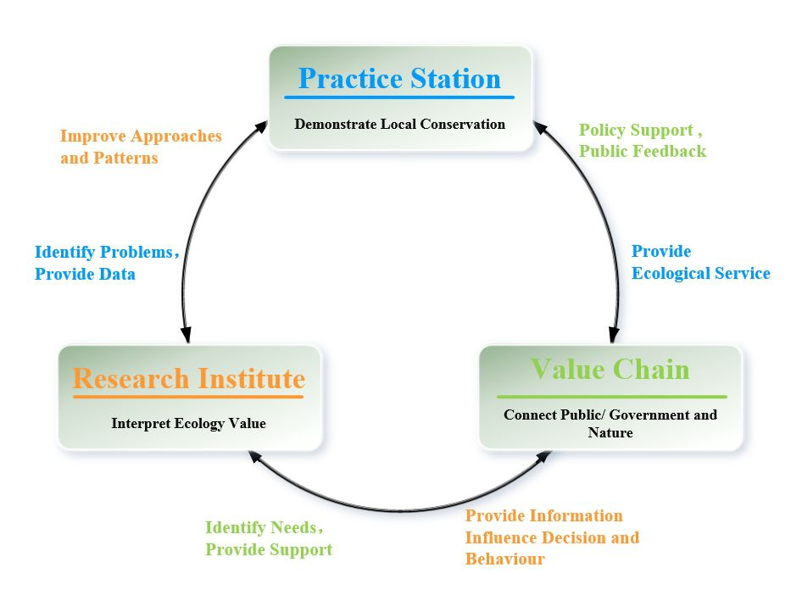
(Shanshui Conservation Center, 2014a)

‘Practice station’ is focus on implementing field protection works by training protectors and innovating new protection approaches (Shanshui Conservation Center, 2014a). Community protection is one of these new approaches, different with traditional approach, Shanshui is providing fund and technology to support the community residents to perform protection works. The residents who lived around giant panda nature reserves always been rely on nature resources to make a living, which would threaten the wildlife’s’ habitats and create intense human-animal conflicts. Shanshui believes that only the local residents can solve this issue as they create this threat to environment at the first place (Shanshui Conservation Center, 2015).

The outcomes of ‘practice station’ would provide beneficial ecological services to the public, thus promote the ‘value chain’. On the other hand, the generated experiences and emerged problems from ‘practice station’ will be send to ‘research institute’. The research team will analysis these data to develop new knowledge and approaches, which would further improve the performance of ‘practice station’, and provide suggestions and evidence for public and policy makers, to improve the ‘value chain’
(Shanshui Conservation Center, 2014a). Moreover, ‘research institute’ also use its academic resources to train the next generation students based on the country’s future environmental needs (Shanshui Conservation Center, 2015). Only society’s acknowledgement of ecological value could open the channel to fund nature. Therefore, ‘Value chain’ is aims to connect public, government and nature together by delivering the concept of ecological value and ecological justice products to society (Shanshui Conservation Center, 2014a).

Value chain project – China Nature Watch
China nature watch is one of the projects of ‘value chain’, it is an independent assessment of China’s ecological status that jointly issued by NGOs and university research institutions every year. Based on accumulated data from these organisations, the report is trying to picture and explain the changes of China’s natural ecology in the last decade, provide information for public and decision makers. The database website Nature Watch Map (http://www.hinature.cn) which has been introduced earlier in 3.2.2.2, is funded by HSBC and the CEPF (Critical Ecosystem Partnership Fund) (Shanshui Conservation Center, 2014c).

Value Chain product - Bee Panda
The ‘Bee Panda’ is one of the ecological justice products provided by Shanshui Partner. Shanshui Partner is a social enterprise that established by the support of Shanshui Conservation Centre, aims to explore commercial approaches to support ecological protection, focus on producing the most pure forest honey (Shanshui Partner, n.d.).

The ‘Bee Panda’ only can be produced in the giant pandas’ habitats, where have optimal ecological environment to satisfy the living requirements for Chinese bees. The bee keepers are the local villagers, who are also the watchman of forest, giant pandas and pure water (Shanshui Partner, 2013). These villagers live in communities that near the nature reserves. They used to rely on nature resources to make a living, mainly gather medical herbs, which highly threaten the giant pandas’ habitats. The ‘Bee Panda’ program provides an ideal alternative livelihood for these local villagers, the program funding the Chinese bee breeding industry and encourages local residents to participate in conservation activities in giant pandas’ habitats (Shanshui Partner, 2016). The honey is produced by the traditional method, only harvest once a year to ensure the highest quality (Shanshui Partner, 2013). The product design, market research including pricing were conducted by Shanshui’s academic research team (Zhang and Lv, 2014). 100% of profits from the sales of ‘Bee Panda’ will be given back to Shanshui’s and local communities’ ecological conservation activities. Currently, the ‘Bee Panda’ program is supporting 5 conservation area and 1,194 watchmen in the local community. The program has benefit 4,175 kinds of plant, 248 kinds of birds, and 92 kinds of beasts that living with giant pandas (Shanshui Conservation Center, 2014c).

Jie Feng, who is the program director of Shanshui points out that 40% of wild giant pandas are living in local communities instead of nature reserves. The protections of these giant pandas are dependent on community residents; they are supervising the forbidden activities like illegal hunting and deforestation. The ‘Bee Panda’ program not only solves the livelihood issue of local residents, but also returns the profits to community to support the protection works. It directly protects the ecological environment of giant pandas’ habitats. Zhi Lv, who is the founder of Shanshui, giant panda conservation expert and professor of conservation biology in Peking University highlight that the ‘Bee Panda’ demonstrate the concept of ecological justice, which is the balance between nature and market, villagers in conservation area and outside consumers, and people’s costs and income for natural conservation. The honey produced from pandas’ habitats could connect the city consumers with pandas’ habitats, and the profit could be used to fund local villagers for participating in conservation activities and develop alternative livelihood. The ‘Bee Panda’ could be a carrier and medium for public to recognise the value of nature resources and environment protection (CCTV News, 2014).

One of ‘Bee Panda’s marketing approach is corporations’ CSR cooperation. For example, the skin care brand Kiehl’s has continually collaborate with celebrities to design and promote limited edition product with ‘Bee Panda concept’ from 2012 to 2014, and donate part of selling profit to Shanshui to support panda conservation programs (L’oreal China, 2015). Moreover, the L’oreal China is also working with Shanshui to expand sales channels of ‘Bee Panda’.

The ‘Bee Panda’ provides an innovative approach for NGOs to cooperate with social enterprises; and connect urban public with conservation programs. People are more easily to get involved in ecological conservation, what they have purchased is not only just a bottle of honey, but also the conservation actions and ecological value behind it. The ‘Bee Panda’ also ensures the sustainable funding for community-based conservation, the feedback mechanism successfully balance the internal benefit.

In future, Shanshui will continually perform scientific researches on specific problems in conservation industry and seeking solutions along with media, government and other organisations. It is important for Shanshui to maintain good relationships with funders and local resource managers as the community protection usually takes long time to see the effects. Therefore, its projects are usually threatened by various factors, for example, any regional economy development could destroy a five years project within just one month. Moreover, Shanshui is going to actively publish reports and share information with other institutions which have various advantages to develop stacked data products (Shanshui Conservation Center, 2015).

Research institutes’ actions
Research institutions in China also made significant contributions for giant panda conservation. According to Gu et al. (2015), from 2000 to 2013, there are 9,338 published research papers investigate totally 746 endangered species, 1,058 (11.33%) of them are focus on giant pandas. Giant panda is the only species which has been studied by over 1,000 research papers, which makes it one of the most well protected species.

The China Conservation and Research Centre for Giant Panda was established by Wolong Nature Reserve and WWF in 1983. It is the largest base for giant panda research and nature conservation education. Its researches are mainly focus on the breeding and population increase of giant panda. Along with giant pandas’ habitats, the research centre was damaged by Wenchuan earthquake in 2008. After the reestablishment and improvement, the new research centre is currently integrating the academic resources of giant panda; and expanding or improving giant panda research institutions in other locations like Beijing, Shanghai and Guangdong. As a result, breakthrough of the three difficulties of giant panda breeding field has been made recently, which are hybridization, fertilization, and survival of cubs (State Forestry Administration of China, 2018).

Moreover, WWF produces a ‘WWF Giant Panda Conservation Research Report’ in 2016. It has two parts, including 11 research reports, which are part of the research works that WWF cooperate with its academic partners on giant pandas and giant pandas’ habitats from 2008 to 2016. Its academic partners including national research institutions (e.g. Chinese Research Academy of Environment Sciences) and universities (e.g. Tsinghua University). These reports looked at different areas of giant panda researches, such as, how the infrastructure construction, mineral resource exploration, climate change going to affect giant pandas’ survival and related recommendations; the legislations and policies for giant panda conservation; habitat fragmentation pattern; and formulation of ecological red line for key species (Fan, 2016a, 2016b). These scientific studies would significantly contribute to the current conservation projects and future conservation planning.

As mentioned earlier, Shanshui was founded by academic team in Peking University, it closely links its conservation projects and practices with its research institutions. It enables Shanshui to effectively solve the specific issues appeared in the conservation project. With the continuous improvement, Shanshui’s research could also help to influence related policies and legislations, thus to achieve broad application (Shanshui Conservation Center, 2014a).

The ‘China Biodiversity Red List 2015’ that discussed in earlier part is partly contributed by Chinese Academy of Sciences. Its Biodiversity Community start to research and establish the ‘Catalogue of Life China’ since 2007, and continuous to update every year. The Chinese Academy of Sciences also work with China Environmental Protection Department to initiate the ‘China Biodiversity Red List’ project in 2008, the Lists are completed and released since 2013 (Jiang et al., 2015). It would help to solve the issues that the IUCN Red List cannot comprehensively reflect the threatened status of species in China. The ‘China Biodiversity Red List’ would provide the most up to date data for species population and distribution, which are the scientific basis for related government decision making. It would also provide scientific basis for conservation actions and plans, and impact assessment (Zang et al., 2016). Furthermore, it creates the necessary conditions for public to participate in biodiversity conservation (Jiang et al., 2015). Shanshui’s Nature Watch project would considerably benefit from these lists.

Overall, the Chinese research institutions have made significant contributions for giant panda conservation in terms of scientific study (e.g. breeding), measurement, and policies. However, the researches for ‘business and biodiversity’ are very limited. Only few studies (Liu, 2013, Luo, 2014, Zhang et al., 2014, Wang et al., 2015) explore the emerging issues and approaches of ‘business and biodiversity’ in China. Currently there is no published studies investigate corporate precipitation in giant panda conservation.

Companies’ actions
As mentioned in 4.2.2, corporate actions are identified from two Chinese companies (HIK Vision, Panda Green Energy Group), and seven international companies (Shangri-La, L’Oreal, Mercedes-Benz, Seagate, HSBC, Carrefour, Canon) that are either based in China or are joint ventures with Chinese companies. Their practices are significantly collaborating with NGOs introduced above.

Carrefour China
Carrefour has participated in WWF’s Sichuan pepper project since 2002; the project aims to protect giant pandas by providing alternative livelihood for villagers living around giant panda nature reserves. The sale of pepper used to be villagers’ main income source, but most of profits were taken by middlemen. Thus, villagers have to collect medical herbs and firewood from the wild to make a living (Carrefour China, 2011). WWF helps villagers form a cooperative to grow sustainable Sichuan pepper and introduce to Carrefour. By making direct purchase from cooperative, Carrefour can provide fresh, traceable products to its customers. Villagers’ incomes are improved and secured by this long-term project; it ensures the long-term protection of giant panda’s habitat. This holistic approach provides a sustainable solution and benefits all the involved stakeholders (WWF, 2012).

CANON China
Canon Company was established in 1937 and entered China in 1997; ‘mutualism’ is its corporate philosophy. Since Canon China participate in China wild life photo training camp in 2004, it starts to participate in wild life conservation work. In 2008, the Wenchuan earthquake caused significant damage of wild giant pandas’ habitats. There is a need for researches of giant pandas’ habitat and giant pandas’ post-earthquake ecological habit, as well as the following conservation work (Foreign Economic Cooperation Office, 2013). To support the post-earthquake conservation, the Canon China:

‘donates 16 sets of office equipment and image documentation equipment for wild giant panda protection stations in Szechwan Minshan and Shaanxi Qinling to recover their daily conservation work and post-earthquake behaviour researches for wild giant pandas’ (Canon China, 2014, p76).

Moreover, Canon China is seeking to help reduce the difficulties and improve efficiency of nature reserves’ conservation work by providing the high-end field surveillance cameras to monitor wild giant pandas’ habitat and moving direction (Foreign Economic Cooperation Office, 2013). As it disclosed in its 2013 CSR report:

‘In 2012, Canon China launch the ‘Image·Tracker’ program in wild life reserves. It establishes giant panda conservation fund in Wolong Nature Reserve to support the researches about breeding and wild training of giant panda. Moreover, the program also provides a complete set of high-definition video field monitoring system to Fengtongzhai Natural Reserve to support the conservation and salvation of wild giant pandas and other wild animals’ (Canon China, 2013, p52).

The most advanced video monitor technology contributes the first hand video data for long term researches of giant pandas’ environment, habitat, breeding and etc. (Foreign Economic Cooperation Office, 2013). Canon China continually tracking the development and real effect of wild giant panda conservation programs, keep updating and debugging the monitoring equipment (Canon China, 2014). Currently Canon China also work with WWF on other programs to record image data of China’s biodiversity and raise public awareness by providing the high-end imaging technology. Meanwhile, it also considers expanding the program for conservation of other endangered wild species (Foreign Economic Cooperation Office, 2013).

L’Oreal China and Shanshui
The skin care company Kiehl is cooperates with NGO Shanshui to support the marketing of ‘Bee Panda’. It collaborates with celebrities to design and promote a limited-edition product that incorporating the ‘Bee Panda concept’ with the aim of donating some of the profits from sales to Shanshui to support panda conservation programs (L'oreal China, 2015, p11). Moreover, L’Oreal China is also working with Shanshui to expand sale channels for Bee Panda and has purchased Bee Panda honey as raw material for its own products since 2016, donating 10% of its income to the community for local ecological conservation (Sina Public Welfare, 2017).

HSBC China and Shanshui
One of HSBC China’s continuous green bank strategies is to significantly promote conservation projects. The projects that related to giant panda conservation are:

- ‘Preserve endangered species in biodiversity hotspots.
- Build a platform for the public to take part in nature conservation’ (HSBC China, 2015, p23).

In specific, HSBC China disclosed its Giant Panda National Park Demonstration project in its 2015 CSR report (p.27). The company believes that:

‘Currently, the main problem for giant panda conservation is lack of a unified management mechanism and model. As a result, it is difficult to manage the panda habitat in the most effective and sustainable way’ (HSBC China, 2015, p27)

Therefore, the HSBC China decided to support Conservation International (CI) which participates in nature reserve management as an NGO in Sichuan. CI has worked with local government departments to creates a pilot national park at Sichuan Anzihe Giant Panda Nature Reserve, to develop a more scientific, systematic and open management. This should allow more institutions, groups and individuals to participate in conservation activities (HSBC China, 2015).

As mentioned in previous section, Shanshui is funded by and cooperates with CI on the China Nature Watch project, as disclosed in Shanshui’s Annual Report (2014c, p42, 2015, p10) and the project is also partly funded by HSBC. HSBC China states that:

‘In 2015, HSBC funded Shanshui Conservation Centre to carry out the China Nature Watch programme, aiming to fully mobilize public resources to obtain information about endangered species and promote the public’s participation in biodiversity conservation’ (HSBC China, 2015).

Mercedes-Benz
Mercedes-Benz, one of the world’s most significant car makers, is also involved in panda conservation. There is information in the media which describes the efforts of Mercedes Benz to assist in panda protection. For example, the company has funded a panda kindergarten for rearing baby panda (Han, 2009, Campaign China, 2012). The launch of the Mercedes-Benz Panda Kindergarten was in response to the 2008 Sichuan Earthquake, which seriously damage giant pandas’ habitat, the automaker is reinforcing its commitment to panda conservation with the release of five P.A.N.D.A. tips to help preserve the species which include sharing information about panda on Facebook and other social media in order to raise public awareness of their plight (Campaign China, 2012). This project forms part of Mercedes-Benz's Green Legacy Program with United Nations Educational, Scientific and Cultural Organisation (UNESCO) in support of World Heritage Sites in China (Han, 2009). Until 2012, the Mercedes-Benz Kindergarten has housed almost 20 pandas, contributed to the research for pandas’ eventual survival in the wild and to raise public awareness (Campaign China, 2012).

Shangri-La
The hotel chain, Shangri-La, disclosed substantial panda related information in its report, for example:

“Shangri-La’s Care for Nature’ Project - In Shaanxi Province, two hotels participate and support the projects of Zhouzhi Nature Reserve. Zhouzhi Nature Reserve is the home of golden monkeys and panda. Xian Shangri-La Hotel and Xian Jinhua Hotel renew the patrol equipment for Reserve’s patrols, which improve patrols’ equipment and capacities. Moreover, they also support the alternative livelihood project, such as bee keeping and Chinese herbal planting projects thus replacing traditional field herbal collection. We hope our support on these projects can reduce the pressures of human activity on the Reserve’ (Shangri-La, 2012, p31).

‘Shangri-La’s Care for Panda’ Project - As part of ‘Shangri-La’s Care for Panda’ Project, we provide support to the planting of 1.6 hectares of bamboo forest in Sichuan Provence (a panda hometown) ... This bamboo forest is planted within the Dujiangyan Centre for Panda Care and Disease Control, located at the foot of Qingcheng Mountain. Shangri_La will plant 9,000 Phyllostachys violascens (a species of bamboo) and 90 trees. This bamboo forest will provide food for the giant pandas in the Dujiangyan Centre. The Dujiangyan Giant Panda Centre is currently under construction and is estimated to open to the public in 2013. The Centre will receive and cure ill or aged giant pandas, and carry out research for disease control’ (Shangri-La, 2012, p31).

The details of this continues project for giant panda conservation also have been disclosed, as the Shangri-La Hotel, Chengdu, stating that:

“…in 2014, Shangri-La Hotel, Chengdu further developed its Care for Panda project. … through the development of bamboo plantations and panda feeding facilities. The Group set up a panda kitchen to produce food for the endangered bears, as well as a system to allow guests to share their views on the Centre. As of the end of 2014, a total of 1.6 hectares of bamboo had been planted” (Shangri-La, 2015, p15)

This excerpt from their report provides some quantitative information as well as qualitative narrative. It also suggests evidence of stakeholder engagement:

“Hotels with Sanctuary projects also form partnerships with relevant external parties including accredited non-government organisations, academic bodies, and community groups to ensure local endorsement and professional input” (Shangri-La, 2016, p15).

Further the company explains that they carry out audits of biodiversity in order to inform further strategy, which does resemble an emancipatory element in this emergent extinction accounting:

“Biodiversity data is collected on a regular basis to measure results and inform decision makers on the next steps required for each project” (Shangri-La, 2016, p15).

These initiatives are reminiscent of the attempts to protect rhinoceros from poaching in South Africa, as disclosed by South African listed companies (Atkins et al., 2018). However, the text was almost identical to that disclosed in (Shangri-La, 2013), which is indicative of a rather boiler-plate approach to the panda accounting rather than a more dynamic, emancipatory form of reporting.

Panda Green Energy Group
Panda Green Energy Group provided information about their new mascot, a Giant Panda called Qiyi, adopted by the company in 2017. The article explains that the CEO of Panda Green Energy went to the Chengdu Research Base at the Giant Panda Breeding Centre and selected a panda for adoption. The articles stated that Qiyi would serve as the active mascot for the United Nations Development Program’s (UNDP), “Youth Leadership Summer Camp for Climate Action and Panda Green Energy’s World's First "Panda Power Plant" and will participate in the opening ceremony held in the United Nations headquarters in Beijing on 10 August (Panda Green Energy Group, 2017). As disclosed in Panda Green Energy Group’s 2016 Environmental, Social and Governance Report (p12-13), the Group plans to establish more Panda Solar Plant and Summer Camps along ‘One Belt, One Road’ to provide global youth a deep understanding of climate change and green energy, thus to encourage next generation to get involved in future innovate development (Panda Green Energy Group, 2016, p13).

HIK and Seagate
HIK Vision, a Chinese company, disclosed information about its cooperation with Seagate to support the WWF’s giant panda conservation project:

“HIK VISION and Seagate work together to support WWF’s giant panda conservation work in Sichuan province Yele Nature Reserve. Based on the environmental features of Yele Nature Reserve, HIK VISION provides design and implementation services for the development of hardware equipment for the cooperative project. The company needs to overcome the limitations of complicated terrain and atrocious weather, work with partner Seagate to support technical defence system of the Nature Reserve, to provide high stability and 24/7 safety protection. It aims to reduce the human activities’ interference for the ecological environment of Nature Reserve, improve the Nature Reserves’ monitoring capability and management efficiency, thus to guarantee the gradual recovery of rare population of giant pandas. In the future, the company will pay more attention on ecological conservation, strive for the conservation of more wild flora and fauna” (HIK VISION, 2017, p26).

Seagate also provide disclosures relating to panda preservation on their corporate website:

“In partnership with the World Wildlife Fund, Seagate donated surveillance and storage equipment to a giant panda habitat in Western China. The equipment is being used to monitor the pandas and their environment as part of conservation and preservation efforts” (Seagate, n.d.).

There has been media attention on the company for their wildlife protection efforts. Xi Zhinong is a famous wildlife photographer in China capturing pictures of panda and other threatened species. He states that he depends on Seagate storage products in his work to document China’s endangered species. Indeed, Xi explains that photography can be a “potent weapon” in educating people about the plight of these animals and in motivating them to take an active role in caring for the environment (Zhang, n.d.). This resonates with claims in the accounting literature that a botanical drawing, an etching or other form of pictorial ‘account’ is an important and emancipatory means of conveying the urgency of extinction prevention and the need to protect biodiversity. These elements are included in the extinction accounting framework presented in Atkins and Maroun (2018).

A panda centric accounting and accountability framework
An outcome from this research was to develop a panda-centric depiction of the accountability and accounting mechanisms currently in operation within China which aim to save panda. Figure 35 below brings together all the actors involved in saving panda.

Figure 36:Current mechanisms for giant panda conservation in China
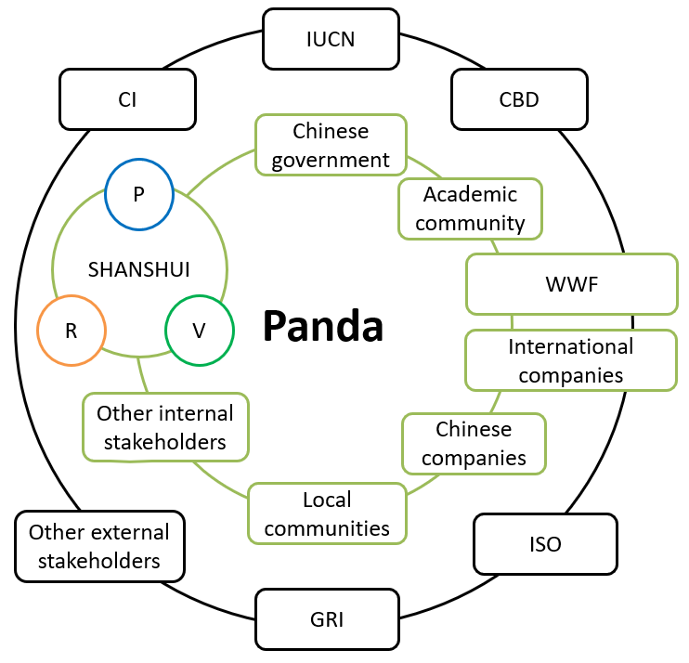

The diagram brings together the current mechanisms for giant panda conservation in China based on this study. With the giant panda in the centre, different stakeholders are placed in two different rings represent their relationship with and influence on giant panda conservation. Government, NGOs, local communities, academic community, international companies, Chinese companies and other internal stakeholders are placed in the inner ring as they directly involved in or contribute for giant panda programs or activities. In the outer ring, IUCN, CBD, CI, GRI, ISO, WWF, international companies and other external stakeholders representing as external parties to support or put pressures for stakeholders which within the ring in relation to giant panda conservation. It needs to be noticed that WWF and international companies are in both rings as they are creating connections between internal and external stakeholders; and Shanshui is specialized due to it has its own research institution and social enterprise.

Since giant panda experienced significant loss of habitat and population in the 1980s, Chinese government issued various legislations to constrain human interference, and established lots of nature reserves and conservation programs with the support of academic communities and international NGOs. With the forthcoming special regulation for giant panda, it is the most well protected species by government.

By living alongside giant panda’s habitat, local communities play an important role in conservation efforts. With the help of NGOs, the alternative livelihoods programs transform these local communities from representing a long-term threat to be a sustainable field conservation force.

NGOs are the main contributors of giant panda conservation, creating connections between different stakeholders and exploring new approaches for more sustainable and integrated practices. Two types of NGOs have been discussed within this study, one is WWF represents international nature NGOs, another is Shanshui represents national biodiversity focused NGOs. Both of them have initiatives with government, academic community, local communities, international corporations and other interested organisations and individuals.

The WWF works closely with local authorities as it was invited by Chinese government. It provides systemic and scientific conservation practices for giant panda based on its international working experiences. Most of WWF’s partners from private sector are international corporations, this might due to its international influence and connections, enable WWF finds businesses with shared value or believes to support its programs.

As a native NGO with academic background, Shanshui has better understanding of its stakeholders thus enable it to connect them by creating mutual interests. Its own research institute allows it to solve specific problems and provide specialized support based on its needs. In order to deliver its concept to the public and sustainably support its giant panda conservation program, Shanshui establishes its own social enterprise to produce ecological justice product ‘Bee Panda’. It is designed and developed by Shanshui’s research team. Compare with WWF’s pepper project, the ‘Bee Panda’ further expands the impacts and sustainability of giant panda’s conservation by involved in broader stakeholder dynamics. Generated profits will not only be used to fund the project, but also used to support Shanshui’s researches and other conservation projects. Moreover, Shanshui’s Nature Watch program creates a platform for general public, nature lovers and citizen scientists to participate and supervise conservation activities for giant panda and other species. Integration of these functions makes Shanshui a sustainable and innovative NGO. Although sometimes it has difficulties in working with local authorities, the involvement of general public, NGOs, scientists, media and corporations can significantly gain government’s attention and policy support. Ultimately, it could deliver the ecology value and concepts to society to expand the channel for human to feedback nature. Shanshui’s innovative approaches could be adjusted and developed in other organisation or for other species.

Currently in China, government, NGOs and academics are seems to be the main contributors at present, there are great potential spaces and opportunities for national and international corporations to expand and develop their conservation practices. Especially the national companies which rarely participate in biodiversity conservations compare to international companies. Except related legislations, the relationships between corporations and government are created through NGOs. There was no direct engagement between government and corporations in relation to conservation on giant panda or other species. Fortunately, with the appeal and invitation from CBD, government starts to initiate platform and mechanism for corporation to participate in biodiversity conservation practices. Corporations are also tending to pay more attention to this issue under the pressure from international standards like GRI and ISO. Moreover, there is also a lack of direct engagement between government and local communities in relation to alternative livelihoods. Government has great potentials for local communities to further expand and develop their alternative livelihoods to create more ‘ecology justice’ ways of life. Furthermore, currently there is no or little communication or cooperation among NGOs. Both Shanshui and WWF have similar giant panda conservation programs even sometimes in the same region, but they rarely communicate with each other. Shanshui’s future information sharing project might break these barriers.

The closer the collaboration between these parties, the more likely panda conservation will be to succeed.

Current achievements and concerns of giant panda conservation
In 2013, China has completed the fourth national giant panda survey, which shows there are 1,864 giant pandas alive in the wild, increased by 17% (268) compare to the survey in 2003. Moreover, there are 375 giant pandas in captivity in China and 42 giant pandas abroad in 12 countries. Furthermore, the habitat of giant panda also increased by 11.8% to 2.58 million hectares over the decade (The Guardian, 2015). These solid evidences prove that the population of giant panda is stabilized and begin to increase, as well as the suitable habitats. Therefore, the IUCN Red List decides to down-list the giant panda from Endangered to Vulnerable in 4th September 2016. This decision positively confirmed the effective conservation efforts from Chinese government in last decades (IUCN, 2016). With this inspiring achievement, not only the giant pandas are benefited, but also other species living in the same regions. It ensures the nature services that have been provided for tens of millions of people who live alongside rivers downstream of panda habitat. This successfully demonstrates the value of investment in the conservation of iconic species like giant panda (WWF Global, 2016).

However, as pointed out by Nicolov (2019), the down-listing of a species is not necessarily a positive sign for the species and can send an inappropriate signal. The State Forestry Administration of China (2016) responds that although giant panda is down-list from endangered, it is still an endangered species that require stronger conservation support. As the direct management department of giant panda conservation, the State Forestry Administration explains that IUCN’s report is just based on related data and technical index. If consider the actual performance and protection situation, it is too early to down-list the giant panda from endangered. Because the habitat fragmentation is still the main threat of giant panda populations, it obstructs the gene exchange between local populations, affects the genetic diversity of giant pandas. Gong et al. (2016) emphasize that the fragmentation pattern of habitats has not changed at all, as well as the human interference. Accelerated local infrastructure construction and resources development in giant pandas’ distribution area further the fragmentation degree of local habitats. This result in various fragmentation type, thus increase the uncertainty of integral fragmented habitats. Moreover, as IUCN (2016) points out, the wild giant pandas are still facing severe survival risk; more than 35% of panda’s bamboo habitat is predicted to be eliminated in the next 80 years due to climate change. Furthermore, Fan (2016a) mentions that much of panda’s habitat is threatened by poorly planned infrastructure projects.

Based on these factors, the endangered situation of giant panda has not improved; the decades of conservation work just maintain the existing status. More efforts are needed to achieve the long-term survival of giant panda. The key for future conservation work is to try not to lose any inch of giant pandas’ habitats, and to expand and connect the potential habitats. Meanwhile, the impacts of climate change also need to be considered. Moreover, the transformation and upgrade of conservation approaches are also needed to cope with new conservation requirements (Gong et al., 2016).

The State Forestry Administration concerns that this down-list might cause relaxed conservation work, thus lead to irreversible damage and loss (State Forestry Administration of China, 2016). Only the broader conservation policy and measures could ensure the survival of wild giant panda and their unique habitats in future. The public should have more extensive understanding about the importance of conservation of wild species and their habitats for human life. Lambertini, the general secretary of WWF global is appealing to establish and deepen the integrated cooperative relationships among government, local communities, NGOs, corporations and individuals to facing the greater conservation challenge (WWF China, 2016).

Moreover, currently in China, most of corporate participants are international companies, only a few of Chinese companies are involved, and their involvement is mostly limited to the form of donation. This might due to the low level of public awareness. In respond, numerous international and national NGOs and the Chinese government are making efforts to raise awareness and encourage companies to start or take further actions in panda and biodiversity conservations.

Recommendations and proposed reporting framework for giant panda conservation
In responding to the concerns and challenges discussed above, one recommendation is that it is necessary to speed up the establishment of specific ‘giant panda conservation regulation’ to fill gaps in legislation protecting giant panda and their habitat. It is essential to ensure future investment in nature reserves and other conservation projects and solve the conflicts with local economic development which have arisen from previous legislative loopholes. Secondly, a standard and set of guidelines for business and biodiversity are required as those currently in place are provided by international organisations. China needs to formulate a specific set of standard and guideline that fits the current Chinese context.

Our study has shown that although partnerships exist between NGOs and companies, and that Shanshui and the WWF are all involved in various initiatives, there seems to be little collaboration among these parties. Working more closely together and collaborating with each other would have a synergistic effect, increasing the impact of the initiatives. In relation to multi-stakeholder engagement, the Chinese government could improve mechanisms by which corporations can contact other stakeholders in order to participate in direct conservation practices, and integrate these practices into corporate operations or products, thus releasing the weighty potential conservation from the private sectors. Moreover, government could further introduce local communities, NGOs and other stakeholders into these mechanisms to multiply conservation dynamics. Furthermore, NGOs could create partnerships with each other, share information and integrate resources to achieve mutual goals. They could form a stronger force to create greater impacts on programme implementation, awareness raising, policy formulation, and supervision.

In order to support the formulation of proposed mechanisms, an equal dialog platform is required to solve the obstacles among stakeholders. The key is to let each stakeholder share equal right to express their opinions and concerns, thus, to create a fair context to combine interests, mediate conflicts, identify goals and assign responsibilities. Successful implementation of this dialog could integrate different stakeholders as a whole, speed up conservation progress, and create more conservation approaches and opportunities. Secondly, it is also important to create dialog platform with international conservation organisations, expand cooperative networks and exchange experiences to make further improvements. Meanwhile, there is also a great demand for academics’ research and investigation on effectiveness of corporate practice on giant panda conservation. Finally, further strengthen the involvement of stakeholders like media and public could help the society form a supervisory environment, thus, to force private sector pay more attention and take actions. These recommendations are not limited by focus on giant panda but for all other endangered species.

As discussed above, another outcome from this research has been to develop a panda-centric extinction accounting framework, which builds on the extinction accounting framework presented in Atkins et al. (2018) but adapts it for saving panda, incorporating the various agencies and bodies we have found to be involved in panda conservation (see Table 9).

Table 9: A panda-centric extinction accounting framework
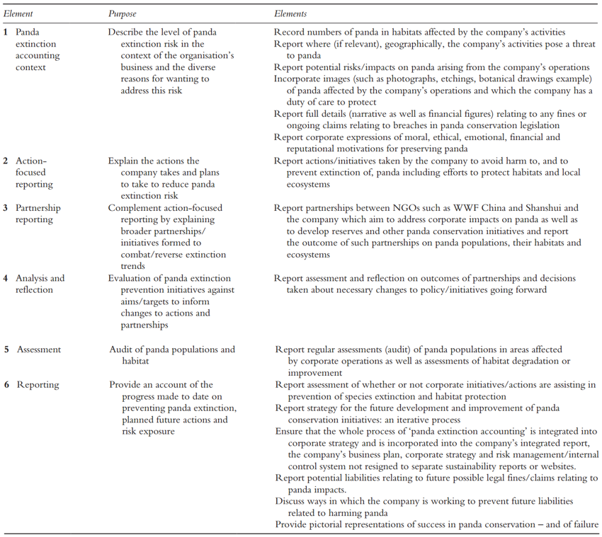

Chapter 8: Interview Analysis
The interview analysis identified numerous themes which fell into five categories, which are: 1) current status of ‘Business and Biodiversity’ in China, 2) challenges to promoting ‘Business and Biodiversity’ in China, 3) current attempts to improve ‘Business and Biodiversity’ in China 4) recommendations for future improvement of ‘Business and Biodiversity’ in China, and 5) the significance of panda conservation.

Current status of ‘Business and Biodiversity’ in China
The interviews indicate that currently in China, due to insufficient awareness, attention, and requirements on biodiversity issues, companies have limited understanding of ‘Business and Biodiversity’, such that most of their current practices are inadequate. However, as pressure from stakeholders continues to grow, and good examples and experiences are available from international practice, the potential for the future development of ‘Business and Biodiversity’ in China is significant.

Companies have insufficient understanding of ‘Business and Biodiversity’
From the interviews, it appeared that companies’ understanding of biodiversity conservation is inadequate, which is mainly due to their insufficient awareness and attention, and inadequate demand from society.

An interviewee from one company’s HSE (Health, Safety, and Environment) department stated that:

‘From my point of view, environmental protection, ecological protection, and biodiversity protection are the same in nature, they are environment protection’ (C6).

Another interviewee from the same department said:

‘Currently the research of environmental experts focuses more on environmental regulations, and pollution abatements, even I (former environmental expert of the company) am not familiar with biodiversity’ (C7)

As for interviewees from other departments, their understanding is far less:

‘Biodiversity? I did not hear of it in this company…We cover lots of things on the environment, and we also pay attention to ecology. But the word ‘biodiversity’ is new and unfamiliar to us’ (C3).

The interviewees from academic institutions explained that:

‘Apart from people who produce the CSR report, it is possible that no one may understand the concept of biodiversity in state-owned businesses’ (A1).

There are several CSR consulting companies in China providing consulting services for companies on CSR issues, and biodiversity is one of their topics. In the interviews, they pointed out that:

‘when we ask about specific elements of biodiversity conservation, they (the companies) do not really understand, with most remaining at the stage of protection of flora and fauna’ (CC1).

For the companies which do not have related disclosures, when CSR consultants propose biodiversity issues to them:

“The first reaction is their (companies) low awareness, they say something like ‘I don’t know anything about this’. If talk about environmental protection, they do pay attention. As for biodiversity, they perceive it is too detailed and figurative, they have no relationship with it” (CC1).

On the other hand, for those companies which do provide biodiversity-related disclosures:

‘although these companies list biodiversity separately, their awareness is still remaining at the level of conservation for rare flora and fauna’ (CC1).

When the consultants were asked whether there are companies which actively approach them for biodiversity related consulting services, they said:

‘the market and our clients do not have these kinds of needs’ (CC2B).

An interviewee from a company explained that:

‘It is not the case that companies are resisting protection of, and disclosure on biodiversity, they are simply not paying attention to (biodiversity). The awareness of public and companies needs to be raised’ (C3).

This quotation suggests that companies are simply not being asked to consider biodiversity, there is no societal awareness of stakeholder pressure.

Companies usually perceive biodiversity related issues as one part of ecological protection, while:

‘The majority of companies’ understanding of ecological protection remains at the level of: energy saving and emission reduction’ (A2).

An interviewee from a CSR consulting company explained that:

‘Although the differences of environmental protection, ecological protection, and biodiversity protection are obvious in strict academic terms, currently corporations believe there are no substantial differences between these concepts, they believe these are all about environmental protection’ (CC3).

Companies tend to neglect environmental conservation due to the pressure of competition
It seemed from the interview analysis that companies pay little attention even to the environmental issues more generally because of the need to save costs and compete in the market. This is especially the case for SMEs, as without concern for reputation, they are creating more negative impacts on the environment.

Companies usually put less emphasis on environmental conservation
The interviews analysis revealed that companies tend to put less emphasis on the Environmental part of the HSE department. For example, when companies bid for the orders, they usually like to compete by providing a lower price:

‘Thus, we need to cut down some budget, normally we reduce the budget for the HSE department. This creates an unfavourable situation for our future (HSE) work. Compared with foreign countries, China has a lack of standardization in this (bidding) process. In foreign countries, the owner (Party A) will identify the exact amount of HSE expense during the bidding process. However, in China, the owner (Party A) normally do not disclose this and tend to make it more of an invisible expense’ (C6).

When companies need to cut down the budget from HSE department, it is usually the Environmental part which is cut, mainly due to inadequate legislations:

‘China has laws and regulations for safety expenses (the Health and Safety parts of HSE), companies are required to allocate certain amounts of funds for these. However, there is no compulsory requirement to allocate expenditure to environmental protection’ (C6).

This situation limits the HSE department’s budget for Environment part, thus, limits companies’ environmental practices.

Companies are concerned about the cost of biodiversity conservation
Interviewees point out that one of the reasons that companies are discouraged from participation in biodiversity conservation is their concern for cost:

‘there are significant costs for companies if they want to perform biodiversity conservation’ (CC1).

‘they have not done (biodiversity) related research because of the costs of bringing in professionals and producing reports’ (CC3).

CSR consulting companies have tried to introduce biodiversity conservation for companies, and although companies agreed with the idea in principle, they unwilling to take action:

‘some companies agreed that this (biodiversity conservation) is a good thing, and that they should do it, but when they consider the costs and real actions, they become hesitant’ (CC1).

In consideration of this reaction, one interviewee from CSR consulting companies explains that this is mainly due to the pressure of competition:

‘Under the current situation in China, for companies, the key is to achieve minimum costs, it is important for them to get orders. If they turn on the pollution control equipment, they will make a loss. To survive or go bankrupt, I think everyone including employees will choose to survive. Thus, under this situation, as long as the government’s supervision weakens, companies will start to pollute.’ (CC3).

Similar arguments were also provided by a company interviewee:

‘It depends on companies’ profits, things like biodiversity conservation will require investment and will create additional expense … Companies certainly are not willing to spend money on these things … I think those companies which participate in biodiversity conservation are driven by the need to improve corporate reputational image or to expand corporate influence. But it depends on companies’ profits, companies are more like to do it when they have more profits. In fact, currently in China, the competition among companies is very intense, it is difficult for companies to perform biodiversity conservation when they cannot even survive competition’ (C6).

It seems like companies tend to consider biodiversity conservation as an optional approach to improve corporate reputation and public image, rather than as part of their obligations. Therefore, they tend to neglect biodiversity issues when they under pressure from competition.

Some interviewees even perceive biodiversity conservation negatively as it could also affect companies’ operations:

‘It will increase costs if doing biodiversity protection, not helping for subject but only delay the completion of subject’ (C8).

SMEs are creating more damage to environment
In terms of cost saving, some interviewees point out the particular role of SMEs (Small and Medium-sized Enterprises) in environmental pollution and biodiversity loss. They are more active in pursuing lower costs with no regard for reputation:

‘SMEs are still lacking in awareness (relating to biodiversity conservation), companies are pursuing profits and survival under the pressure of competition. Some of them do not have any awareness of biodiversity; some of them do have awareness, but they are not doing anything due the high cost … they compete with lower costs ... In order to save cost, SMEs might deliver jerry-built projects, and discharge pollution over standards’ (A3).

‘The most obvious difference between SMEs and larger listed companies is that SMEs do not care about reputation, their goal is to make profit’ (CC3).

An interviewee from a CSR consulting company also highlighted the devastating impact that small private enterprises had on the environment in earlier times:

‘The private mining industry has outdated production technology and limited capital; its scale looks small but its damage to environment is fatal. They do not have any kind of approaches or facilities for pollution control, all the pollutants will directly go into the natural environment’ (CC3)

‘they do not understand the concept of biodiversity at all. Whatever they do, they just want to achieve minimum cost. If they create pollution during their operations, they will give money to the local government to bribe officials. Currently there are lots of things like this happening in lots of places…I think lawlessness among smaller private enterprises might affect biodiversity the most.’ (CC3)

These insinuations relating to bribery are especially worrying as they suggest a deep-seated, endemic problem which also leaks into the political arena.

As SMEs face less regulatory constraints than listed companies, this also intensifies the competitive pressure on listed companies. The interviewee points out that the key to solving these problems is to ensure the role of local government:

‘SMEs are difficult to control, and they have the greatest destructive effect. The first constraint management for them is to set up an access permission mechanism, exploitation license is required for mining, the local government has the main responsibility as all set of procedures for nature resource extraction are examined and approved by it’ (CC3).

Companies pay limited attention to biodiversity related issues
The analysis of the interview data revealed that, as one of many CSR topics, ‘biodiversity’ received lower attention by companies, it was even one of the last issues companies considered among environment topics. Compared with other environmental issues which currently of significant concern to the government and society, and could potentially help companies to reduce costs, biodiversity seems to have lower importance to companies. Only those companies which have high dependence on biodiversity tend to pay more attention to it.

Companies produce limited biodiversity related disclosures
The interviewees indicated that it is rare to find biodiversity related information in companies’ disclosures:

‘Generally, it is rare to find a company considering biodiversity in their reporting as a specific topic, and it is also rare to find the word ‘biodiversity’ in relation to the subject of environmental protection’ (CC2A).

‘I have a former colleague working in Ernst & Young, and the firm did well in sustainable development. Currently, however, biodiversity is not included in their audit services, because there are very few biodiversity disclosures released by companies’ (G1).

‘Large domestic companies produce limited CSR disclosures, and biodiversity issues are reported far less’ (A2)

‘Biodiversity is not a major topic in the current CSR field, as far as I know there is no reporting focusing specifically on biodiversity’ (CC3)

The interviewees from companies explained that this lack of disclosure is mainly due to companies’ limited attention to the subject:

‘The current planning does not specially concern biodiversity, (companies) rarely involve in this issue’ (C4).

‘It is true that companies do not recognise the importance of biodiversity protection, they are doing it passively’ (C5).

Interviewees point out that companies’ priorities are mostly placed on pollution issues rather than biodiversity:

‘Companies usually disclose information about energy consumption and resource consumption, including water, electricity, air, natural gas and etc. As for biodiversity, there are very few companies which consider it as a special subject, and it is very rare to find the specific word ‘biodiversity’ in CSR reports’ (CC2A).

‘What the companies are afraid of is to be monitored due to their over standard pollution discharge, they did not pay much attention on biodiversity’ (C7).

‘There are very few cases of biodiversity disclosure in CSR reports. Their reports mainly focus on pollution, and do not include details relating to biodiversity’ (A3)

At our level, we have not considered future plans relating to biodiversity protection and disclosure, currently we only consider energy saving and emission reduction … Biodiversity is not considered among the company’s business risks, the current business risks include energy saving, emission reduction, trash recycling, wastewater treatment and etc., no biodiversity’ (C6).

Biodiversity has relatively lower importance in CSR issues
As mentioned above, interviewees believe biodiversity has lower importance than other environmental issues and it seems there is a lack of sufficient attention from companies. Government requirements and supervisions are not in place:

‘China now is paying attention to emissions reduction, which has strict policy and legislation, pollution control is the most important thing for environmental protection in China, biodiversity’s position is after that’ (C7).

‘In China, companies only care about the species that are listed on the national protection list. If there is no requirement from government, companies rarely do it (biodiversity conservation)’ (CC3).

‘For example, energy saving itself is for cost reduction, which companies are encouraged to do. Emissions reduction is required by government for large companies which has high energy consumption. These are environmental issues. However, ecological protection and biodiversity protection, they are the last options in environmental issues. Ahead of these issues are waste water, garbage etc., which have significant effects on the commercial community. Companies will invest in these things as they are mainly examined by the environmental protection agency’ (CC3).

‘Currently the legal supervision (for biodiversity) is insufficient… on the other hand, the national policy (for biodiversity) is also insufficient… In consideration of another aspect, the awareness of companies is insufficient… the promotion for corporate participation in biodiversity protection has only emerged in recent years’ (G1).

Some interviewees also believe this is the result of societal attention, as people are more concerned about pollution issues like air quality:

‘Currently pollution in China has intensified, people are more concerned about urgent issues and present issues and have not thought about the impacts on biodiversity’ (C7).

‘Moreover, things like dust and sulfur dioxide are observable by the public. Compared to these things, ecological issues and biodiversity attract less attention, nobody speaks up for them. There are very few famous rare species like giant panda; the public are not aware of the majority of rare species’ (CC3).

One interviewee from an academic institution believed the lack of interest related to the late development of CSR in China:

‘The development of CSR in China is relatively late, the current index system (environment protection) does not include the word ‘biodiversity’. It does have these items: resources recycling, waste water, water and electricity, green office, environmental education, clean energy, emission reduction etc.’ (A2).

Under these conditions, interviewees believe that currently biodiversity is likely to be the last thing that companies are going to consider among CSR practices:

‘I have not seen any company actively perform biodiversity conservation within their CSR programs …The biodiversity topic is at the very bottom of CSR issues…If a company has 100 things to do, biodiversity must be one of the last 10 things ... For them, there are more issues that have priority over biodiversity’ (A2).

‘There are too many things included in CSR, biodiversity is just a small part in one of the environmental topics… usually the biodiversity part is arranged at the very end when producing the report. It has limited materials to build up content’ (G1).

The companies which have more dependence on biodiversity tend to pay more attention to biodiversity
However, an interviewee from the governmental environmental conservation department argues that with the government’s appeal for ‘Business and Biodiversity’, some of the companies which have more dependence or impact on biodiversity start to put more emphasis on biodiversity related issues although their motivation is mainly driven by external pressures and potential economic benefits:

‘I know some industries in China currently do pay attention to biodiversity, including extractive industry, planting industry, breeding industry, organic agriculture, and traditional Chinese medicine industry. They have more dependence on biodiversity’ (G1).

‘Why do companies want to join [the Business and Biodiversity Partnership]? Firstly, the government promotes it. Secondly, the industry promotes it. Thirdly, I believe the most important thing is that it relates to the economic development of themselves...... Companies which have significant impact on biodiversity definitely want to join’ (G1).

Companies’ current biodiversity conservation activities are limited
The interview analysis revealed that, some companies’ current practices on biodiversity conservation remain at the basic level (e.g. funding support), and further, some practices are even inappropriate or incorrect. Companies have limited knowledge about biodiversity. The involvement of different departments in biodiversity issues is also insufficient. Currently, companies are mainly passively responding to the requirements of government. With the increasing concerns on biodiversity issues raised by government, companies are starting to make progress. There is a significant potential for ‘Business and Biodiversity’ in future.

Some conservation practices are inappropriate
Some interviewees point out that most of companies’ current biodiversity conservation activities are inappropriate. Some of them just participate in the form of donation, with different motives:

‘Mostly the companies just provide funds to support (biodiversity conservation), they do not have in-depth participation ... In consideration of the purpose of participated companies, firstly, they might aim to reduce the negative attention (from public) through work with international NGOs. Another reason is that they might treat it (biodiversity conservation) as a charitable and public service, mainly show on the donation’ (CC1).

Some companies even wrongly perform the conservation project. For example, the ecological remediation project should recover the local environment to the original state. While some companies just perform the recovery of the surface, without considerations of actual biodiversity or ecological system:

‘Before the implementation of project, we will do specific research and arrangement, through photograph and video records to recover the environment as it was before. The project only cause regional effect, will not affect the general environment, animals might leave the place, but the plant will not be damaged’ (C8).

‘in China, companies just perform ecological remediation on surface layer, and do not really achieve the remediation effect. They just use uncontaminated soil to cover (the pit) or use the relatively standard pollutant to fill the pit, and then cover with soil; they will plant some grass if the requirement is strict. Currently, China has not performed this kind of conservation in details’ (C7).

Some companies’ practices are remained at the basic level
Some interviewees believe that currently in China, ‘Business and Biodiversity’ is at a very early stage. Most of their attention is focused on other environmental issues as discussed earlier:

‘Currently in China, people who are paying attention to this (‘Business and Biodiversity’) are not professional enough. Currently China is focus more on pollution abatement, the attention on biodiversity is only at the management level’ (C7).

‘they did not pay attention to the connection between business and biodiversity protection unless they have special needs, or their leaders have preference of biodiversity protection. Currently the car industry has shown an interest in biodiversity protection, but this is mainly for branding promotion’ (N3).

Some companies are also aware of the limited nature of their biodiversity conservation efforts, while from their expressions, it is difficult to find their intentions for further improvement:

‘How do we take care biodiversity issues at present? We just ensure corporate self-discipline; we do not touch the things in natural reserves. In the regular environment, we try our best to perform ecological remediation. As for the detailed work of biodiversity, we might do some event every year, do something rational, do publicity, and then communicate with society’ (C7).

‘Currently we do not perform ecological compensation systematically, but what we are doing is part of ecological compensation’ (C7).

‘Companies are not allowed to drill in some wet lands, we are already making a great contribution by not consciously drilling’ (C5).

As a result, most companies’ biodiversity related disclosures also remain at a basic level:

‘At least in the mission statement, most companies mention the concept of ecological protection, but when it comes to specific case studies and specific species, there are very few disclosures’ (CC2A).

‘According to my experience, biodiversity related information provided by companies is very limited, normally just from some database – during their construction process, they assess the biodiversity in the region and then create a database. Otherwise, companies just invest money. They have not gone to a deeper level such as: sustainable utilization, harmonious coexistence, and benefit sharing with the local stakeholders’ (G1).

Within the company, very few departments are involved in biodiversity related issues, while other departments have limited knowledge and participation opportunities:

‘There are special departments to take care of environmental issues, our financial department has nothing to do with it … The only relationship between accounting department and biodiversity protection is providing fund’ (C3).

‘I have corporate with corporate financial staff on the issue of ecological restoration compensation, one favorable thing for environment protection that from the financial staff is, if you done well in ecological restoration work, you can get some tax reliefs for compensation, which encourage company to carry on. However, it is not on the issue of biodiversity, which is even further’ (C7).

Despite most of companies’ practices are remaining at basic level, some interviewees believe that companies have significant potential if they could improve their awareness:

‘The Chinese companies’ awareness for public benefits and CSR is insufficient, thus, there were less Chinese companies participate in biodiversity conservation. It (Business and Biodiversity) only gets improved in the recent three years, but they are mainly in the form of branding promotion’ (N3).

‘there are three main goals for biodiversity conservation: protection, sustainable utilization, and benefit sharing of genetic resources. Most of companies just carry out some of the approaches, including funding support. They might have participated in other activities like poverty relief, community development and etc., which might related to sustainable utilization and benefit sharing of genetic resources, but they have not realized that’ (G1).

Companies’ practices are mainly based on the requirements of government
Interviewees from the corporate sector state that the government’s requirements play a significant role in their participation in biodiversity related issues. In some cases, it seems like companies are ‘forced’ by government to participate:

‘What we do is also the things that are required by the government, as long as the government’s requirements are in place, companies will comply’ (C7).

‘There are obvious requests for operations in the desert, our constructions for large pipeline need to consider local living beings. Moreover, there are wet lands and swans in the range of the company’s oil field, the wet lands belong to local government, we have to pay local government for conservation works. It is not we want to do it voluntarily, we have to do it because the environment protection department requests it’ (C5).

One interviewee from CSR consulting firms points out that companies’ conservation targets are highly dependent on government requirements. They indicated that companies are reacting passively on biodiversity conservation:

‘Unless in the nature reserve, or there are national level protected species in the region. Under this condition, the government will inform companies before they enter the region. Except that, other species will not matter to companies. In Australia, it is totally different, it has a broad range of protection measures (for species)’ (CC3).

Companies are starting to make progress
Although the evidence presented thus far is quite negative in relation to corporate activities aimed at conserving and enhancing biodiversity, some interviewees believe that currently there is an improvement of companies’ practices. Although their awareness is still insufficient, they do start to use the terms like ecological restoration, ecological mine, and ecological reclamation:

‘Ecological restoration, ecological mine, and ecological reclamation actually have more relation with environmental protection. Although they did not mention the word ‘biodiversity’, their work is mostly related to biodiversity protection’ (G1).

Since China has joined the ‘Business and Biodiversity’ partnership, the environmental protection department organized a case study collection, aiming to dig out good practices from Chinese companies. Although the collection has not yet been published, it does demonstrate that some companies are participating in biodiversity conservation:

‘Biodiversity is a new topic; it is difficult to collect information about companies’ participation, but actually there are lots of practices. We prepare a case study collection; it is mainly focus on large companies. Our institution believes that the damage they created for biodiversity is more than the benefit they provided for biodiversity through conservation activities, thus, the case study collection did not get approved. However, the collection could help you to understand that it is true that some companies are doing these things (biodiversity conservation), maybe their approaches are not incorrect, but they are actually doing it’ (G1).

One interviewee from an NGO points out that some companies do approach them for consultancy advice on environmental assessment, in order to avoid negative impacts on protected species:

‘some companies come to us, ask us to make environmental assessment for their project, provide some information of environmental protection, and help them to do the regional planning and development plan, thus, they can aware which places are highly protected, they will not touch it’ (N2).

Apart from engagement with external stakeholders, companies are also improving their operations and equipment to reduce their impact on the environment, which would indirectly benefit biodiversity:

‘When we need to, we will do something, such as restore land, and change some equipment that we currently making. The new equipment can treat pollution with the well drilling process, not like the past that we pollute first and then manage’ (C7).

Companies do not have specific training for biodiversity
Currently, along with insufficient awareness, training on biodiversity issues is also inadequate in companies, with employees only being aware of biodiversity issues through their own exposure to various media channels. Training will only be provided by companies when it is deemed necessary.

Limited training or awareness raising activities for employees
Interviewees claim that there is no relevant training on biodiversity issues provided by companies, such that employees’ awareness is generally insufficient:

‘Actually, companies lack systemic publicity, and employees do not know what ecological protection is, what biodiversity protection is, and they do not understand the differences and connections between these things and environmental protection’ (CC3).

‘Companies do not have knowledge popularization or training on biodiversity issue’ (C7).

Some interviewees stated that the way they have found out about biodiversity is through their personal reading or study. Usually only those people whose work is more related to the HSE department will show any interest:

‘My approach to understanding biodiversity is self-awareness, there is no training in the company’ (C7).

‘Mostly through public information platform, and public information from media [I find out about biodiversity]. Sometimes through my own experiences in the field’ (C8).

‘Another issue is, at the basic level, people’s understanding and awareness [of biodiversity issues] are limited by their profession’ (CC3).

Interviewees from companies point out that companies do have strict training for safety issues and popular environmental issues like pollution control. While on biodiversity issues, there is no company-wide specific training:

‘With respect to employees’ training, all of us need to accept training from the government’s relevant department (e.g. state administration of work safety supervision) and get the qualification certificate… However, currently only the Safety part [of HSE] has this qualification certificate, which is the certificate for our employment. It is required by the government’ (C2).

‘There is no specific training on biodiversity protection, the company’s training is focus on pollution control and analysis of the new policy from the state environmental protection department. However, many people are simply not interested’ (C7).

Related training only provided for special project
Some interviewees mentioned that, for certain special projects such as foreign operations and operations close to nature reserves, companies do provide relevant training on biodiversity conservation. Therefore, it could be considered that, currently, companies only provide biodiversity training when it is necessary:

‘When we were in Kenya, we built a passage for wild animals every few metres. The training is necessary, such as how to protect species, prohibit fishing and hunting, avoid cutting plants that are beyond the operational range, and not discharging household waste and industrial refuse. Such training is carried out by senior leadership and post operation personnel’ (C2).

‘Only when we work around nature reserves, we try to find out how many species there are and how to protect them as these are required in the environmental assessment. Moreover, during the construction of the pipeline program, we consider the issue of vegetation protection’ (C7).

Companies react passively towards biodiversity related disclosures
The interview analysis revealed that some companies perceive biodiversity reporting negatively as they are aware that they have failed in discharging accountability for biodiversity. Their disclosures primarily aim to comply with the requirements or respond to the pressures from media exposure. As a result, impression management seems to be applied widely by companies.

Companies have negative perceptions about disclosures
One interviewee from the corporate sector expressed negative perceptions about biodiversity related disclosures. The interviewee believed his negative perceptions are due to the companies’ insufficient performance, which makes them unable to disclose with confidence:

‘Chinese companies dislike information disclosure very much, they believe that information disclosure is the same as recrimination. As we are not performing well in biodiversity conservation at present, that makes us feel the disclosure is the same as incrimination’ (C7).

The interviewee further explains that in addition to inadequate performance, companies are also under pressure from employees, who might consider companies are prioritizing biodiversity rather than employee benefits. Companies concern themselves with these interrelations when they are planning their disclosures:

‘The current regulations in China are difficult for all companies to meet. Chinese companies are not willing to do a publicity stunt as there is always something inadequate [in their performance]. For example, a listed company wants to promote corporate image, but it has not achieved the requirements that are strictly required by regulations. They might have some missing elements, or issues that have not done well. If the company advertises its CSR on environmental protection, while its performance on labour protection is inadequate, its employees will be very upset’ (C7).

Disclosures are mainly based on the relevant requirements
Companies disclosures on biodiversity primarily involve complying with external requirements:

‘Current companies’ disclosures on biodiversity constitute just one paragraph, because they have done nothing about it, but they still need to follow the requirements from the international standard (e.g. GRI)’ (CC3).

‘I believe the major motivation for Chinese companies to protect biodiversity and disclose related information is strict regulatory regime, and supervision, then there are [pressures from] NGOs’ (C7).

Some companies even have limited disclosures on other environmental or CSR issues. Currently only the central enterprises are mandatorarily required to provide CSR disclosures, other companies disclose voluntarily, they might just need to comply with industry requirements or requirements from stock exchanges; or select criteria that they would like to disclose from international standards. Usually only the top companies tend to disclose biodiversity related issues other than ‘popular’ environmental issues like pollution control:

‘Chinese companies disclose far less information on biodiversity, only some companies (central enterprises) are mandatorily required by government to disclose a CSR report, other companies disclose CSR information voluntarily. There are very few examples of biodiversity disclosure in companies’ CSR reports. Their CSR reports focus mainly on pollution, they do not go into details on biodiversity’ (A3).

‘The majority of companies’ disclosures on the environment constitute less than half a page, and they do not mention biodiversity protection, because they merely follow the requirement of the principles, only the top companies may produce [biodiversity related disclosures]’ (C7).

Interviewees from companies point out that companies’ disclosures on environmental issues are mainly based on the government’s priority, which are usually considered as highly urgent in relation to appeals from the society. In response, companies will not disclose other issues unless they have covered the issues which are prioritized by government:

‘As for disclosures, we mainly follow the requirements of regulation. If the government requires pollution control and soil protection, we will focus on those issues, and then extend to some representative things like environmental benefits, societal benefits, and ecological benefits. What you have mentioned [biodiversity issues] are not the key areas that are under the supervision of government. Thus, disclosures on these issues are simply additional disclosures. If I have not done the required things, it is inappropriate to do something else. The issues we currently disclosed are the highly urgent things that are required by society’ (C7).

‘It is not about motivation and resistance (to disclose), it is about obeying the law’ (C1).

Companies mainly focus on accident-related disclosures
According to the discussions above, it can be assumed that companies are reacting passively towards environmental disclosures. The findings would indicate that their performance on environmental issues is inadequate. Moreover, when we discuss disclosure issues with interviewees from companies, they tend to place more emphasis on environmental accident related disclosures. It is in line with the themes of 5.2.1.7.1 discussed in earlier section, that their concerns for environmental issues are limited to the negative impact created by corporate operations：

‘What we could disclose more are: firstly, we have got the approval from the government (for environmental impact assessment) … as long as we have the government’s permission and acceptance, it is fine (for us to cope with any environmental issues). If any environmental accidents or events occurred, we will disclose these to the public though the platform of government or media, it is a must-do thing’ (C2).

Companies’ disclosures on environmental issues are also influenced by the development of communication technology. Sometimes companies have to provide environmental disclosures as they cannot hide certain issues from the media. The pressure from external stakeholders could force companies to disclose:

‘Currently, at least we have succeeded in disclosing all information to the public, because it is impossible to hide, the internet is so well-developed. Some of our units want to do something, but we cannot hide [the truth]’ (C2).

This is slightly worrying as it suggested the company would behave secretively if it were not for the presence of the internet and social media.

Impression management in biodiversity related disclosures
As for ‘good practice’ in relation to biodiversity conservation that is disclosed by companies, some interviewees point out that those disclosures could be considered as impression management:

‘As a company, we are certainty not willing to spend money on biodiversity protection, the current biodiversity related disclosures in our CSR report merely intend to improve our corporate social image, or our social responsibility’ (C6).

This represents a blatant approach to impression management with no genuine commitment to environmental issues and biodiversity at all.

‘The biodiversity protection case studies and activities that are mentioned in corporate reports are just the publicity stunt, we only disclose the light spots of the company, they are not key to our operations. The disclosures in the report are for corporate image, to tell the public that we are considering this issue. However, the reality is, we do not have any commitment to those things. I believe it is a long way off for us to do this’ (C7).

One interviewee from a CSR consulting firm points out that currently there is a social responsibility paradox phenomenon, which is the contradiction between what companies claimd about their CSR performance and their actual actions. This again suggests impression management behavior by companies:

‘Currently there is a social responsibility paradox phenomenon, companies are announcing their ideas and the importance of sustainable development to them. However, if you go to their working site or talk to the grass-roots employees, people will not believe this at all because all they have seen and heard about these companies are the damages they have caused’ (CC3).

Good examples of ‘Business and Biodiversity’ practices among Chinese companies
The interview revealed that there were some good examples among Chinese companies in developing ‘Business and Biodiversity’. From international companies’ practices in China, and Chinese central enterprises’ practices in overseas operations, related knowledge, cases, experiences and conceptions could be studied for future development of ‘Business and Biodiversity’ in China.

International companies are more prepared to participate in ‘Business and Biodiversity’
Some interviewees from NGOs mentioned that in China, international companies have better performance in ‘Business and Biodiversity’ than Chinese companies. These international companies have long term cooperation with them (international NGOs). They have sophisticated practices and experiences in CSR, thus, they can apply their good ‘Business and Biodiversity’ practices in China as well.

However, other interviewees held different views, they believed that international companies’ participation in ‘Business and Biodiversity’ in China is mainly due to their needs to build their corporate image, thus, to secure their operations in China. That is why most of them tend to choose panda as one of their species for conservation, as it is one of the symbolic and famous species in China:

‘This is how international companies approach public relations, they chose some famous and highly recognised projects to participate in, in order to build their brand in China’ (CC1).

Chinese central enterprises have better ‘Business and Biodiversity’ practices in overseas operations
Apart from international companies operations in China, most of companies that perform ‘Business and Biodiversity’ practices are central enterprises, which are the state-owned enterprises that occupy the dominate position of the main industries and key fields that relate to national security and national economic lifeline (Shanghai Securities News, 2017). When they operate overseas, they need to comply with the regional countries’ requirements or international standards for biodiversity conservation:

‘Normally only large companies have disclosures on specific species. That might because they have broader operations and overseas operations, thus, they receive more supervision from stakeholders’ (CC2A).

‘Overseas, our operations have to comply strictly with regional approaches and legislations’ (C8).

Compared with China, the countries that these companies operate in have strict legislative requirements for biodiversity conservation. Therefore, these companies usually have better performance overseas on biodiversity practices:

‘In China, we have not seen any programme that focuses directly on biodiversity protection. However, when I visit some China-invested enterprises in Africa and Australia, they have done a very good job on biodiversity protection. They explore all kinds of plants in excavation areas and mark all the plants which need to be protected. In Australia, if a company’s operations could affect a marked plant, the companies need to transplant the plant. The local law is very strict, it is the most effective approach to force companies to protect biodiversity’ (CC3).

‘When we work in Brazil, as long as a company builds a factory, it definitely affects the environment and causes damage. So, when the company starts to make a profit, it invests money in local people to conduct biodiversity research … however, the main goal is still profit maximization. After all, social responsibility is not compulsory [in China] … Therefore, compared with Brazil, companies in China are performing more badly. They concern more about their profits and interests, the government regulation in this aspect is not very strict, under this condition, it is difficult to ask a company to act in a socially responsible manner’ (C6).

The potential for Chinese companies’ biodiversity practices in overseas operations
One interviewee believed that companies are just passively complying with regulations, and that their good performance overseas does not represent an improvement in their concern for biodiversity:

‘It is true that companies do not recognise the importance of biodiversity protection, they are doing it passively. I believe the companies in Brazil are also passively doing it, because the government has specific regulations about environment protection’ (C5).

However, it is true that these overseas operations do provide opportunities for company managers and employees to improve their awareness and abilities in relation to biodiversity conservation through necessary trainings (see 7.1.5.2). Moreover, with a significant amount of investment devoted to biodiversity practices in overseas operations, companies are able to engage with different stakeholders to improve their experiences in biodiversity conservation. Although these companies might not apply these conservation projects in China at that time, their experience do equip them with the required knowledge and abilities, which would benefit their potential participation in the future:

‘Our programmes in foreign countries have performed well in relation to biodiversity protection. When we work in Brazil, we put lots of investment to HSE, it almost constitutes 9-10% of the total contract amount. We also cooperate with the local university, investigate the factories’ impact on local biology, and they also continuously perform related surveys and research’ (C6).

‘When we are working in Brazil, I know that they have detailed projects for biodiversity protection. The business owner entrusts us with funds, we entrust the protection organisations which are recognised by the local government to carry out biodiversity measurement and reporting … we pay them every month to take regular measurements and produce a detailed report, including flora and fauna, and impacts on river, rain and air. In relation to fauna, this requires photos and the frequent appearance of each species. This report will cost over 10,000 dollars each month’ (C5).

This quotation suggests a financially material commitment to biodiversity protection within the Brazilian context.

Challenges to promoting ‘Business and Biodiversity’ in China
In order to effectively promote ‘Business and Biodiversity’, a robust foundation is required, is based on support and supervision from stakeholders. However, currently such a foundation is insufficient, resulting in limited engagement between companies and stakeholders. Moreover, companies believe that currently it is unnecessary or unrealistic for them to participate in biodiversity conservations. Apart from biodiversity issues, even on CSR practices, their knowledge and understanding are inadequate. Furthermore, the interviewees also raised concerns about the current dilemmas faced by human, which are significant for the ‘Business and Biodiversity’ practices.

The foundation to promote ‘Business and Biodiversity’ in China is insufficient
The promotion of ‘Business and Biodiversity’ requires support and supervision from stakeholders. However, we noticed that in China, even the stakeholders have inadequate awareness of ‘Business and Biodiversity, and insufficient measures to guide, support and supervise companies. Apart from the needs of legislations, a platform for companies to engage with stakeholders is also needed. The conflicts among stakeholders also need to be solved.

The public have a limited understanding of biodiversity
In discussing the challenges to promote ‘Business and Biodiversity’ in China, most interviewees stated a primary challenge to be the general public’s inadequate understanding of biodiversity:

‘The biggest barrier [to ‘Business and Biodiversity’] is that people are not aware of this issue’ (A2).

‘It is rare to hear this word (biodiversity), I do not know the definition, my understanding is about the diversity of species and biological information’ (A3).

One interviewee points out that issues such as biodiversity conservation have been overlooked when China developed its economy, thus, with limited interest among the public resulting in limited understanding:

‘Chinese economic development has been extensive, and people did not realise the value of these things (biodiversity). Currently there is no policy related [to biodiversity]. It will only value when it is raised to a higher level, at present it is not at that height. Until now, people do not understand those things’ (C7).

As discussed earlier, in China, legislation relating to biodiversity conservation is limited, some interviewees argue that even the government might not have enough people with sufficient understanding. This alone affects the formulation of related policies and legislations:

‘The government leaders’ awareness is closely related to this, if their awareness is insufficient, there will be less work put into [biodiversity]’ (CC3).

Lack of supported policies and mechanisms
Current legislation in China is inadequate to form robust requirements and guidance for companies to participate in biodiversity conservation:

‘policies and legislations for biodiversity protection are rarely found, it is even hardly to find the word ‘biodiversity’ mentioned in relevant legislation. Thus, companies do not have enough motivation, and there is a lack of punishment mechanisms [to make companies pay attention]’ (CC1).

‘When we are consulting and planning CSR reports for companies, environmental protection is an important part, especially for the companies which depend on natural resources, they will be concerned about ecological protection, biodiversity protection, and public welfare. However, this area is characterized by a lack of systemic measurement, which is policy’ (CC3).

Interviewees point out that there several problems exist in current legislations for environmental conservation, such as difficulties in coordinating different levels of environmental protection departments, and their relations with different levels of local government:

‘Currently the regulations for environmental protection are very complex. The environmental protection department at city level, provincial level, and country level have multilayer regulations’ (C7).

Moreover, some environmental protection legislations are too general without consideration for specific conditions and applications. Some legislations are too strict at present without considerations of companies’ actual abilities to comply. Therefore, companies lack incentives and support, to encourage them to participate in biodiversity conservation:

‘The features of Chinese law are: strict requirements that are difficult to implement. Moreover, lots of requirements are not detailed enough, such as bioremediation and soil remediation, our current regulations and practices have not reached this level, thus, biodiversity protection is far less of a concern’ (C7).

Interviewees also mentioned that it is not just about insufficient regulations, but also insufficient support from other stakeholders like research institutions. Companies cannot perform biodiversity conservation by themselves, and external support is necessary. Research institutions also require external support (e.g. financial support) to promote research into ‘Business and Biodiversity’. Therefore, what is insufficient is a mechanism to connect all the stakeholders to promote ‘Business and Biodiversity’:

‘That is why we need professionals like ecologists, and an interactive mechanism between companies and research institutions. This requires a platform … However, currently we are not in this position. Firstly, these institutions in China generally lack funding. Secondly, there are limited researchers specialized in this area. The work is time consuming and requires financial support. Companies cannot do (biodiversity conservation) by themselves without support from specialists. But at the initial stage, it is difficult to expect companies to provide money for research institutions. Companies are only willing to provide money to do it when they understand the issue and see the value in returns. Thus, an external force is needed to promote companies at an earlier stage. This external force could come from government, public, international organisation, or all of them’ (CC3).

Lack of law enforcement
Lack of law enforcement is one of the reasons why most companies fail to meet the strict requirements for environmental conservation. There is a lack of sufficient supervision from legislators, and lack of sound solutions for companies. What companies currently do is establish environmental conservation targets by themselves, which are in line with their current abilities and continuously improvement:

‘It is difficult to ask companies to perform environmental protection from voluntary to mandatory. When you want to mandatorily something you need to think about costs, and the law enforcement forces that you needed’ (CC3).

Potential conflict with the interests of local government
As mentioned earlier, sometimes the environmental protection department’s regulations and projects conflict with the interests of local government, which usually related to economic issues:

‘When local environmental protection departments identify the issues (related to ‘Business and Biodiversity’), they are facing the problems about whether they can put punitive measures into practice, and whether those actions will be affected by other factors like local governments’ need for local economic development’ (A3).

In order to attract companies to develop their local economy, in the early stages, some local governments are willing to sacrifice the environment, intentionally loosening requirement and supervision for companies:

‘In most places, local governments do not want to set up nature reserves, which means no company will be interested in developing this area’ (CC3).

‘Why do some local governments indulge companies that create damage to the environment even when they know what is happening? [It is because] the local governments depend on these companies to gain income’ (CC3).

These companies it seems used to pay or bribe local governments to gain the loosened requirement and supervision from local government for environmental issues. As for local governments, they tend to use the money for local development. It looks like a win-win situation for both companies and local governments, but significant damage has been exacted on the local environment:

‘Companies believe that after they provide money (to local government), they could get some sort of protection (from local government) that allows them to do whatever they want. After local government takes the money, they will leave companies alone, and use the money to build house or road’ (CC3).

Fortunately, this phenomenon is becoming more contained in recent years. Local governments’ awareness is improving, although it remains inadequate:

‘The current problem is that: local governments do not have this kind of awareness (for biodiversity conservation), and they tend to protect companies as they are paying tax and improving the economy of the region. For local governments, their aim is to ensure the normal operations of companies, they do not care about other things. A few years ago, many companies could get a ‘government protection unit’ license (from local governments), which means the Environmental Protection Agency and Tax Bureau cannot get involved. These things are reducing in recent years’ (CC3).

‘Generally, the general policy (established by central government for environmental issues) conflicts with the specific interests of local governments’ (C8).

Local governments also need to consider the interests of their people, which is at the heart of their priorities. If people have a strong desire to protect their living environment, their appeals could pressurise local governments to consider:

‘Although sometimes the public’s appeals and local government’s interests are conflict, government has to compromise when it is represented by the majority of the public. This could be used in reference to rare species protection’ (CC3).

Insufficient database for biodiversity
Interviewees point out that the current database for biodiversity in China is insufficient, some of the endangered species have not been recorded in the national protection list. This intensifies the challenges companies face in participating in biodiversity conservation:

‘Another issue relating to biodiversity in China is a lack of effective and comprehensive investigation and statistics’ (CC3).

‘In China, companies only care about the species that are listed in the national protection list. If there is no requirement from government for companies to investigate biodiversity, companies rarely do it’ (CC3).

One interviewee emphasised that there is a need to confirm the validity of the current biodiversity database, thus, to ensure the effective guidance and measures for biodiversity conservation projects:

‘In relation to the biodiversity database, there is one possibility: real analysis based on fake data. Because these data might not exist, or they are out of date. If apply the outdated data to the reality, it means we are using the fake data to perform real analysis’ (C7).

Lack of a platform for companies to engage with stakeholders
One interviewee from corporate sector points out that there is a lack of a platform for companies to gain support from stakeholders on biodiversity issues. It is difficult for companies to actively participate in biodiversity conservation without a supportive environment. The companies are expecting to work with reliable stakeholders on biodiversity related projects:

‘Currently the platform for (Business and) Biodiversity has not been built yet, I believe the CASS (Chinese Academy of Social Sciences) could do some researches about biodiversity issues’ (C7).

‘Currently China is also doing the ecological compensation fund, but it requires downstream institution to do the field work. The large companies are expecting their funds can be used well’ (C7).

Insufficient linkage between ‘Business’ and ‘Biodiversity’
Currently in the corporate sector, managers’ performance is linked to KPIs (Key Performance Indicators), which usually related to financial performance. Managers tend to place more emphasis on KPIs. If environmental conservation performance is not considered in KPIs, or negatively affect KPIs, managers might neglect it:

‘Currently business management mainly relies on KPIs, which is linked with managers’ performance. Therefore, managers normally pay more attention to KPI tasks rather than non-KPI tasks. If ecological protection is merely a managers’ management indicator but not a KPI, then managers will pay less attention to it. Moreover, at basic level, environmental protection implies costs, usually high costs. These costs may conflict with KPIs as a KPI requires high profits and low costs. In this conflictual situation, managers normally put environmental protection into adjustment’ (CC3).

Companies’ understanding and practices in CSR reporting are insufficient
The analysis showed that the traditional vehicle of biodiversity reporting, the CSR reports, is wrongly perceived and practiced by companies at present. CSR reports have been considered as an optional tool to improve companies’ corporate image rather than a vehicle to discharging their accountability to stakeholders. Some companies even outsource their CSR reports, leave less employees involved in CSR practices. There is a need to improve companies’ knowledge and understanding of CSR practices.

CSR reports have not been considered as a vehicle for discharging accountability by companies

Companies’ current attention on CSR report is inadequate
Some interviewees believe that most Chinese companies do not pay sufficient attention to CSR practices and disclosures. They still consider the CSR report as a tool to improve corporate image. Therefore, companies’ expenditure on CSR practices usually depends on their business performance:

‘Currently the market of social responsibility consulting is shrinking substantially, there are more companies talking about social responsibility but less of them spending money on it’ (CC3).

‘The number of published CSR reports is still increasing, but companies’ emphasis is reducing… It can be shown on the cost of the CSR report; the lower cost is due to lower budget. It mainly because the current Chinese economy is in downward phase, some companies decide to reduce the budget for CSR department…They might like to perform the CSR when the business is doing well. However, when the business is not doing well, CSR budget will be the first to cut down. The reason is that the companies do not have enough understanding of CSR, they still consider the CSR report as an external element. They have not link CSR to their management’ (CC2A).

Currently only few listed companies provide detailed CSR report that are separate from the annual report and comply with various CSR standards. Most companies simply provide CSR reports with limited content:

‘Some listed companies might publish a CSR report separately and follow the CSR standard. However, most companies might just write few pages of CSR issues in the annual report, one paragraph for each CSR element’ (CC1).

‘Listed companies which have high visibility and a healthy state of their operations are willing to perform CSR. The remaining companies do not even include CSR on their agenda’ (A2).

As some of the interviewees mentioned, currently CSR practice is still developing in China, with most companies being unaware of issues like biodiversity conservation. Some companies do not even have a sufficient understanding of CSR, for example, they tend to consider executives’ personal donations as part of CSR:

‘Lots of companies do not separate their charity donations from business owners and companies’ CSR’ (A2).

Companies’ current practices in CSR reports are inadequate
According to the interviewees, the current function of CSR report in China is limited. Companies usually only disclose examples of good practices. Moreover, only very few CSR reports are audited, which could result in a lower quality of disclosed information:

‘Firstly, and most obviously, CSR report is not well-balanced, with companies only reporting good performance … Secondly, only few of CSR reports are audited …Thirdly, the linkage between reporting and management is not strong. The ultimate aim of reporting is to improve management, this should be the original intention of reporting’ (CC2A).

‘I think it is related to the domestic environment and awareness, because the audit of the CSR report is not mandatory ... Most companies still remain passive on the formation of CSR report, they just do what they are asked by regulators. They do not consider the CSR report as seriously as the financial report. This is because they treat the CSR report more as a publicity instrument. From this perspective, the audit does not hold much meaning for them. Moreover, in current domestic companies’ CSR reports, the quality of disclosed quantitative information is low, and the data is incomplete, especially the environmental protection part’ (CC1).

Some companies outsource their CSR reports to consulting firms
One interviewee points out that currently some companies’ CSR reports are outsourced, and they provide required information to CSR consulting companies to produce CSR reports. The content analysis of listed extractive companies’ disclosures discussed in Chapter five, indicated that the structure and style of some companies’ CSR reports are similar. This may be because they outsourced their CSR reports to the same CSR consulting company. Although such outsourcing may help companies to improve their CSR reporting, the companies’ actual performance might not be in line with their CSR reports. Moreover, companies’ awareness and knowledge of CSR issues might be affected:

‘Currently most large companies’ CSR reports are outsourced, CSR reports from different companies might look similar. Under this condition, companies’ attention to actual practices could be completely different with what they have disclosed in CSR reports’ (A2).

‘Lots of CSR consulting companies are producing CSR reports for companies. That is why you feel that lots of CSR reports look similar. Those reports might be produce by the same CSR consulting company’ (A2).

Inadequate training in CSR issues
In companies, limited CSR practices might relate to management’s insufficient awareness and knowledge of CSR issues. As pointed out by interviewees, most companies do not have a special department to specifically deal with CSR issues. Only a limited number of employees are concerned with CSR issues:

‘At present, only few companies set up their own CSR department, for most companies, CSR issues are handled by the corporate culture department or other departments. Thus, the remainder of staff in the companies have less knowledge of CSR issues’ (G1).

While interviewees from companies argued that they do have mandatory training for CSR related issues, such training appears to be based on government requirements:

‘It is necessary to accept related training, including our annual training program. Whether at group level or company level, training for health and environment is mandatory. There are no special requirements for post qualification, mainly because government do not have these requirements. But the training is mandatory’ (C2).

One interviewee from an academic institution points out that CSR issues are usually neglected in corporate training, as people tend to be less interested in it, especially biodiversity related issues. All these factors indicate that current corporate training on CSR is inadequate:

‘In corporate training, the CSR part is at most only scheduled for one class, and it is the most uninteresting topic for managers…Currently, biodiversity is just one topic within social responsibility. The major problem is no one pushes it forward specifically, they even ignore it’ (A2).

Need to formulate a Chinese CSR standard
As mentioned earlier, the current policy in China only requires central enterprises to mandatorily provide CSR reports. The requirements are based on various international standards, which usually contain biodiversity issues. These companies usually provide disclosures related to biodiversity, while the content is limited. Their focus is mainly on pollution control and emissions reduction, which are emphasized by the government:

‘Chinese central enterprises have to publish a CSR report, and biodiversity has to be one of the elements disclosed … These requirements are based on ISO26000, the international social responsibility standard, and social responsibility disclosure standard of each industry’ (G1).

As the current CSR requirements are mainly based on international standards, there is a need to formulate a CSR standard that fits the Chinese context:

‘There is no governmental department formulating a CSR standard, just some industry associations (doing it). The current reporting standard refers to the international standard’ (A2).

Currently some research institutions are working on the formulation of such a CSR standard, while it is still considered as a recommendation. Moreover, interviewees from research institutions believe the current priority is awareness raising:

‘We focus on the formulation of standard, and companies’ acceptance and publicity of concepts. And how to combine the concept with companies’ development, let companies pay attention to this (CSR)’ (A2).

Companies believe it is unnecessary or unrealistic to participate in biodiversity conservation
The interviews indicated that the companies’ employees are aware of, and are concerned about, the loss of species, yet they believe it is unnecessary or unrealistic for companies to take action. They believe it is unnecessary because it is not entirely their obligation, and they are not equipped with sufficient abilities to do that. Some of them believe their practices in environmental protection are adequate to discharge their responsibility for biodiversity. They believe it is unrealistic because currently there are more unsolved issues with higher priority than biodiversity issues. Besides that, companies have concerns not only on the cost but also the progress of their projects, which considerably related to their profitability and competitiveness. Based on current context, biodiversity issues are not significant enough for companies to consider.

Companies do recognise the importance of biodiversity conservation
Some interviewees from companies do recognise the urgency of biodiversity loss in China, however, currently they feel powerless to deal with this issue:

‘Species in China are reducing, definitely reducing … The current issue for China is: we know clearly that it (biodiversity) requires protection, but we cannot protect it’ (C7).

Companies’ major concern is still about financial costs, but they do realize the non-financial benefits that their companies could arise from biodiversity protection:

‘you have to increase expenses if you want to protect, thus, profit will reduce. But on the other hand, if you think further, the effect includes economic benefit, social benefit and environment benefit. Although your economic benefit is reduced due to increased costs, the benefits of environment, sustainable development, local communities are increased. Therefore, comprehensively, increased investment in biodiversity protection and the environment will have positive effects’ (C1).

Companies believe that environmental conservation is synonymous with biodiversity conservation
In contrast, some interviewees believe it is unnecessary to promote specific biodiversity conservation as it already been covered in environmental conservation projects:

‘…some people believe that protect the ecological environment is the protection for biodiversity’ (A2).

‘I believe our company will not actively do this (biodiversity conservation). However, we ensure that HSE is the most basic and effective protection for biodiversity. HSE’s work has a significant impact on biodiversity. If our company performs well in actual environmental protection, 95% of their ecological protection duty will be achieved’ (C1).

According to an interviewee from an environmental protection department that specially dealing with China ‘Business and Biodiversity’ issues, biodiversity conservation should be distinguished from environmental or ecological conservations:

‘I believe biodiversity protection and ecological protection are totally different. Biodiversity is about the level of diversification of organism, including genes, species and ecological system. The ecological civilization is more complex, if just purely talk about ecology or ecosystem, it just one part of biodiversity. However, if talk about ecological environment or ecological civilization, it will be a totally different concept with biodiversity. The current standards put biodiversity under the environment’ (G1).

Biodiversity has lower priority in companies’ considerations

People believe there are other things more urgent than biodiversity
Some interviewees point out that in China, people prioritize other living quality issues than biodiversity:

‘The reality of China is, the issues like food quality, people’s livelihood, and pollution have not been solved yet…’ (CC3).

Compared with biodiversity issues, other environmental issues like pollution are easier to be observed by people, and easier to create direct impact on people. Thus, people usually consider other environmental issues more urgent than biodiversity:

‘Currently pollution in China has been intensified, people give more concerns to the urgent issues and the issues at present, they have not thought about the effects of biodiversity’ (C7).

Moreover, for companies, compare with biodiversity, the things like pollution discharge are easier to be monitored by regulators. As the biodiversity related legislations, database, and measurements are not robust at present, companies tend to pay less attention:

‘What the companies afraid is to be monitored due to their over standard discharge, they did not pay much attention on biodiversity’ (C7).

Companies believe biodiversity issues should not be considered at current stage
The interviewee believes that it takes time for companies to get in hand with biodiversity conservation, the environmental conservation is the foundation for biodiversity conservation. Biodiversity conservation will only be effective when environmental issues like pollutions are solved:

‘The trend is to solve the current issues, the pollution control is the foundation for biodiversity protection, only the gradual improvement of environment quality could provide the conditions for biodiversity protection’ (C7).

‘Relatively, the ecological compensation is the next step for China to do, currently we focus on pollution control, next stage is to get the general environment right, biodiversity is a further thing. It is the matter of one stage and another’ (C7).

Companies are not attaining basic environmental conservation standards
Currently, some companies’ operations in certain regions have not attained the national standard for environmental conservation, which some people consider as the foundation for biodiversity conservation. Some interviewees believe it is impossible to perform biodiversity conservation now as the conservation for basic environmental issues have not been achieved:

‘… like environmental protection, currently lots of places even do not reach the environmental protection standard. The biodiversity (conservation) might have higher requirements’ (CC1).

Some interviewees also agree that the current biodiversity related regulations are difficult to comply with:

‘If you go look at Chinese government’s regulations for biodiversity protection, it has requirements for every department, but they cannot achieve it now’ (C7).

‘Regulations for flora and fauna protection are strict, but the actual practice might not be able to meet (those regulations)’ (C1).

One interviewee points out that even the current environmental conservation requirements in China are too strict to comply, companies are already struggled to comply with the requirements for pollution control, they do not have any spare resources for biodiversity issues. Compare with large companies like central enterprises, SMEs and illegal private enterprises are under less pressures and supervisions from external stakeholders. Thus, SMEs and illegal private enterprises tend to neglect environmental conservation regulations to reduce cost:

‘The Chinese pollution standard is very strict, even higher than other countries. But only the large companies can achieve, the small township enterprises cannot achieve. The main task of companies’ environmental protection department is to meet the state pollution standard’ (C7).

Companies think they should not be involved too much in biodiversity conservation
Some interviewees from the corporate sector believe it is not the responsibility for companies to actively promote biodiversity conservation, companies just need to prevent their negative impacts on biodiversity:

‘Biodiversity is not in the scope of our business. How is our company going to protect biodiversity? Actually, to ensure the compliance with HSE standards is the protection for biodiversity … for our company, firstly, environmental protection itself is biodiversity protection. Secondly, for the specific cases like our operations that need to across nature reserves … our company definitely has protection measures for biodiversity … What our company could do … is to protect environment, to not affect biodiversity. Our company only could do it from this angle’ (C1).

While another interviewee points out that, currently most of companies still believe the biodiversity conservation is government’s responsibility:

‘Our company did not look for external agency for biodiversity related services, and it is meaningless even somebody provide that kind of services. Companies still believe it is local government’s responsibility’ (C7).

As for the companies which are participating in biodiversity conservation, the interviewee argues that only those companies with leading-edge technologies are equipped with adequate abilities to perform biodiversity conservation. Currently China is lack of sufficient professionals for biodiversity conservation. Without solid foundation and support, currently only the enthusiastic volunteers like NGOs are acting as pioneers to promote biodiversity conservation:

‘I believe the companies that participate in biodiversity protection is in leading edge... Currently in China, people who doing this (biodiversity conservation) is not professional enough, and only few people pay attention to it. Currently China puts more focus on pollution abatement, the attention on biodiversity is only at the management level. Currently there are no environmental experts do these things (biodiversity conservation), only the enthusiastic volunteers doing these things’ (C7).

Cost is not the only thing that companies concern for ‘Business and Biodiversity’
As discussed earlier, cost is the major concern for companies participating in biodiversity conservation. While another interviewee points out that except the cost, the companies’ operations or construction projects will also be affected by biodiversity conservation projects. It could raise other complex issues like unable to meet the deadline:

‘Costs will increase if we participate in biodiversity protection, it is not helping but only delay the completion of subject… Companies’ protection about biodiversity is not just the issue of money, also about the project progress, and human resource issues, it will delay and affect overall project’ (C8).

Moreover, the interviewee also indicates that, participation in biodiversity conservation is not a one-off project, companies need to ensure the sustainably of their biodiversity conservation projects. It would lead to other issues like continuous budget and continuous updating measurement:

‘…The most important thing is the follow-up impacts for biodiversity. It is more important to ensure the follow up protection than one-off protection. These are the issues that have to be solved gradually’ (C8).

Dilemmas faced by stakeholders
Some interviewees also discuss the origin of the issue and raise the concerns for the current dilemmas faced by authorities, societies, even human. The dilemmas including how to balance development and conservation, how to deal with natural resources, and whether conservation should be based on an anthropocentric approach or non-anthropocentric approach. These are difficult questions to answer, and are still being intensely discussed in the academic literature (e.g. Atkins et al., 2014, Maroun and Atkins, 2018, Atkins and Maroun, 2018, Christian, 2019, Gray and Milne, 2019). The continuous discussions around these questions would help to shape the development of ‘Business and Biodiversity’.

Government facing dilemma between economic development and environmental conservation
With increased awareness and appealing for environmental protection from public, government is putting more emphasis on environmental issues. However, as discussed earlier, sometimes the environmental protection projects or policies are conflicting with the interests of economic development:

‘Currently China is highly threatened by biodiversity loss, people’s living environment is also poor. China now has advanced industries, they do have some species protection projects ... Government is leading the environmental protection work, but it also needs to consider the economic development and employment. I believe there is lots of work to do’ (A3).

‘Companies, local governments and central government have some different interests; thus, they have different thoughts … Everyone knows about protection (for environment), but when they implement it, it will definitely affect their (economic) benefits, (development) speed, and other aspects … when local governments and companies involved in this issue, they will consider that based on their own interests. This is a complex thing that involves many relationships: the whole and individual, central and local, companies and government’ (C8).

When local governments facing this dilemma, they will be concern with people’s reaction. People usually are more sensitive to changes of livelihood rather than the changes of biodiversity and environment. Thus, without strict requirements or legislations for environmental issues, local government tends to prioritise local economic development:

‘Environmental protection department is always the main target that criticized by the society over the years, it has the greatest responsibility for China’s environmental problems. People blame it for not handle the issue by using its law enforcement power. But is the environmental protection department no good at all? No, environmental protection department (in local government) is under the control of county government, city government, and provincial government. All these governments need to consider not only the environmental issues, but also the economy issues and people’s livelihood. People’s livelihood and environment issues are different, if people go on strike due to livelihood issues, it will cause lots of trouble for government. In contrast, nobody will know about missing tree or species’ (CC3).

Human facing dilemma between exploiting nature and conserving nature
One interviewee points out that the original cause of biodiversity loss is from unlimited human desires, that humans are continuously expanding their range of activities, taking living spaces and resources from other species. Now humans are facing the dilemma between continuing to exploit nature and conserving nature:

‘This is a very conflicted matter, on the one hand, people need to survive, but in reality, people already solved this problem, but humans’ desires are limitless, always want more, animals’ habitats become worse and less. It is unlikely to limit human to develop and exploit. The national development is always the main theme, and it is conflicting with environmental protection’ (C6).

‘The key threat of biodiversity is people compete with animals and plants for living space. The current biodiversity protection is just the surface work, actually it cannot protect. For example, there are lots of dams on the Jinsha River and Yangtze River, even each dam has one migration channel for fish, fish still cannot swim back upstream. It is not realistic. Humans need to acquire resource and energy from nature to develop the economy … If the current space does not suffice, human will invade and occupy the space of animals and plants. Under these conditions, there are great pressures for biodiversity protection’ (CC3).

The dilemma between anthropocentric and non-anthropocentric approaches
One interviewee from CSR consulting sector raised the concerns about environmental conservation standards. The current standards are formulated based on the level of harm to humans. Even all the companies are complying with, and able to meet the standards, the animals and plants will still be harmed. Therefore, when we set up standards and legislations for environmental conservation and biodiversity conservation, should they be anthropocentric or non-anthropocentric? It is a dilemma faced by human:

‘Companies’ emissions might be able to meet the standard, but it still causes harm, the national standard cannot guarantee harmless emission, the difference between standard emission and harmless emission is huge. Moreover, sometimes the ‘harmless’ is defined for human not for animals and plants. Companies’ emission could change the PH of soil, and composition of air that lead to great impact on animals and plants. Currently we are lacking this kind of researches and approaches to let public, government and companies to be aware. In general, biodiversity protection is insufficient in all aspects’ (CC3).

‘… Even if everything follows the national standard, it still means pollution will be generated, as well as the damage to local vegetation and ecology’ (CC3).

A related concern is also raised for biodiversity conservation. Currently our focus is mostly on endangered species and species that critical for human (e.g. bees), while for other non-endangered species and species that considered as inessential for human at present, there is lack of emphasis:

‘In the future, a special legislation for biodiversity might be introduced, it will cover all the species, this is possible … However, for other non-famous or less endangered species, people’s protection awareness might be low’ (CC1).

Limited research on ‘Business and Biodiversity’
As mentioned earlier, currently there is lack of research on ‘Business and Biodiversity’, it has not been covered in the field of social science in China. Even in environment related fields, researchers’ attention is usually lay on the issues that mostly concerned by the government and public at present:

‘In social science field, I never heard people investigate in this topic (biodiversity accounting)’ (A2).

‘Currently environmental experts’ research is more focused on environmental regulations, and pollution abatements’ (C7).

Without demand and support from government, companies, and public; research institutions tend to be inactive on ‘Business and Biodiversity’ researches. For companies, without requirements from government and public, they tend to be inactive on biodiversity conservation activities. Besides that, without sufficient support from research institutions and consulting firms, companies are unable to participate in biodiversity conservation projects.

‘Professionals’ participation is important, because currently China is lack of professionals, volunteers, and research organisations in this area. At least the companies which I have contacted rarely mentioned their contact with biodiversity protection organisations’ (CC3).

The CASS (Chinese Academy of Social Sciences) does have research into corporate disclosures on biodiversity issues:

‘When we evaluate companies’ performance on biodiversity issues, we usually check whether they include related concepts about biodiversity. Secondly, whether they have linked biodiversity with their operations … Thirdly, whether they have their own planning (for biodiversity issues) … Fourthly, their actual performance based on regulations for biodiversity protection’ (A1).

However, only part of these studies is published in the form of reports or books or in news conferences. These studies have not been widely disseminated due to insufficient attention and insufficient resources:

‘CASS do not have enough people and resource to public all the released report, this kind of evaluation is just one of many works’ (A1).

‘Research report about corporate disclosures is published in the form of reports or books in news conference. Target groups of the conference are: companies, media, government institution, and specialists’ (A1).

Current attempts to improve ‘Business and Biodiversity’ in China
In improving ‘Business and Biodiversity’ in China, currently stakeholders are making efforts to create platforms to approach to companies, aims to improve their awareness and practices, and to supervise their performance. Such platforms require support and engagement from a wide range of stakeholders, which is one of the current challenges. Moreover, the accountability from these stakeholders should also be concerned and addressed.

The Chinese government is promoting ‘Business and Biodiversity’
Currently the Chinese government is leading the ‘Business and Biodiversity’ in China. It is focusing on the establishment of a platform to engage with companies and stakeholders. Moreover, it is implementing projects for awareness raising of different types of companies. As it is in the initial stage, to develop a ‘Business and Biodiversity’ mechanism that fits in China context, significant support from stakeholders, and respond from companies are urgently needed.

Chinese government starts to pay attention to ‘Business and Biodiversity’
As discussed in 3.3, Chinese government starts to pay attention to ‘Business and Biodiversity’ in recent years. Before now, related legislations have been updated, and related reporting standards for companies have been released:

‘The social responsibility national standard that released in 2015 has specifically point out the disclosure requirements for biodiversity index and guide for industries’ (G1).

‘Currently there are lots of performance evaluation systems for information disclosure, each industry would have their own industrial performance evaluation system. We also have national standard and reporting guidance. The three major standards that released in 2015 are: social responsibility guide, social responsibility reporting guide, and performance evaluation system. These are the quantitative measurements of biodiversity’ (G1).

In the government system, some biodiversity related issues are now being considered as one part of personal performance evaluation system. It would raise government officials’ emphasis on these issues, thus, to influence companies’ behaviors:

‘What I know about the plan of government is, the ecological civilization or ecological value has been bring into their examination and evaluation system’ (N3).

To conserve biodiversity in nature reserves, government is trying to reduce the human activities around the nature reserves:

‘Our country has ecology red-line that companies cannot enter, even the resident are encouraged to move out in order to protect original ecology’ (G1).

According to the government interviewee who is especially responsible for ‘Business and Biodiversity’, currently that government department only has 3 people, their efficiency is limited in consideration of the need of workload. The interviewee expresses that at this early stage, significant support from other stakeholders is need:

‘It was only government performing the biodiversity protection. Companies’ participation in biodiversity protection and the formulation of participation mechanism just started since 2014’ (G1).

‘Currently only our department (Foreign Economic Cooperation Office, FECO) which under the Ministry of Environmental Protection is especially responsible for companies’ participation (in biodiversity conservation)’ (G1).

The Chinese government is promoting research into ‘Business and Biodiversity’
The FECO (Foreign Economic Cooperation Office) is trying to establish a website platform to share all the resources related to ‘Business and Biodiversity’, and encouraging research institutions to share their studies to contribute to the formulation of effective policies and strategies:

‘We put biodiversity protection related resources in our own information website, including the latest national and international standards. At present, lots of research institutions are studying biodiversity, but they are insufficient to provide support for the formulation of related policy. Thus, we are setting up a platform for research institutions to support the policy formulation and strategy planning’ (G1).

The FECO is also actively working with research institutions to explore feasible approaches for ‘Business and Biodiversity’. This would significantly stimulate related researches from research institutions:

‘Currently we are doing the economic value assessment of biodiversity for each industry, various approaches are available, but there is no unified one, the outcomes from different specialists by using different approaches have significant differences. Moreover, it is impossible to assess the value of biodiversity itself as its value has significant potentials, people will not realize that until some point in the future, or people will only recognise that when they paid the price for the damage they created on biodiversity. Currently the TEEB is quite new to us, we cooperate with Chinese Research Academy of Environmental Sciences to promote TEEB work’ (G1).

The Chinese government is searching for good practice in ‘Business and Biodiversity’
As the development of ‘Business and Biodiversity’ in China is only at an early stage, the FECO’s current approach for corporate sector is to select good practice as examples to spread the awareness and knowledge. Therefore, the FECO decides to start with central enterprises, help them to identify practices that related to biodiversity conservation, then select good examples to show to others. Other types of companies will be gradually affected and involved:

The government encourage central enterprises to actively perform biodiversity practices, thus, to lead other state-owned companies to follow and produce reports, then the SMEs will also be encouraged’ (G1).

‘Currently, companies disclose less information about biodiversity, thus, we help them to emphasise their practices that are favourable to biodiversity. And then we will choose some representative companies and their practices as the good example’ (G1).

The Chinese government is implementing projects to improve companies’ awareness
As most of Chinese companies are lack of awareness of biodiversity conservation at present, the FECO’s current priority is to improve companies’ awareness and knowledge:

‘Currently companies still have lower recognition of biodiversity, lots of our programs are providing training for companies to improve their protection awareness, protection capacity, and strategic planning’ (G1).

To encourage companies to participate, the FECO provides related standards and guidance for companies to choose based on their capacities:

‘the current situation is that companies do not have enough awareness. We have a programme that provides a biodiversity evaluation index kit, which includes related content and standard of international convention, national strategic planning, and industrial standard guide. Companies could select index from the kit to use based on their own situation and development status’ (G1).

The FECO also has related program for SMEs:

‘The supervision for large companies is very strict, for the SMEs we also have a program: the awareness training and ability improvement for SMEs. This program is funded by global environment foundation, collaborates with government and SME association. During the training process, we also help SMEs to dig out case studies. SMEs are extremely important as they are the majority of Chinese companies’ (G1).

The Chinese government is establishing a mechanism for ‘Business and Biodiversity’ Partnerships
Currently the government is implementing several programs to establish a partnership mechanism:

‘As the (Business and Biodiversity) partnership mechanism is established, China has its own framework to promote companies’ participation in biodiversity conservation. Currently we have some programs … The future planning for this partnership mechanism is still in the research stage, currently we are doing the programs for mechanism formulation, implementation and establishment’ (G1).

The mechanism is aiming to bring different stakeholders together, start with establishing experiment site to create good practices:

‘The partnership mechanism is for all the stakeholders to join. When the mechanism is established, it will have experiment site and demonstration in each industry and field, including corporate sector, government agencies, research institutions, industry associations, communities, NGOs and nature reserves’ (G1).

The FECO encourages current members of this partnership to take the lead in their industries or fields to participate in ‘Business and Biodiversity’. This partnership is open to all stakeholders, but it does not mean everyone can join, the potential members have to be examined by FECO to ensure they are in line with the partnership’s conservation goal:

‘This partnership has member unit, some members will take the lead, other companies from each industry and field are expected to follow … It is not like everyone can join, we need to audit their case studies and corporate strategy to define whether they are in line with our biodiversity convention goal’ (G1).

NGOs are providing approaches for companies to participate in biodiversity conservation
Currently NGOs are providing various approaches to help companies to get involved in biodiversity conservation activities, they are expecting more in-depth involvement from companies rather than funding support. The current practices with social enterprises and international companies could be studied by the Chinese companies.

NGOs are seeking for cooperation with companies in various levels
NGOs are active in the promotion of ‘Business and Biodiversity’, their basic approach is to search for funding from companies to support their conservation projects:

‘Our cooperation with companies has several categories. First, companies provide fund to support our field protection program … but currently there are no extractive companies doing it … The last category … is mainly for Chinese foreign investment in Africa in extractive, mining, energy, financial and water and electricity industries. We only spread our views and opinions to companies through industry associations, we do not do this for individual companies’ (N2).

Moreover, NGOs are also trying to help companies to develop their CSR practices, and create more connections. For example, introducing community development projects to companies, which will provide sustainable livelihood for people living around the biodiversity hot spots, thus, to indirectly protect the biodiversity:

‘Our corporate engagement program is mainly focus on the contact work with companies. For example, to output our public welfare program to companies, or recommend the public welfare program to companies based on their needs’ (N3).

‘Our biodiversity protection related programs with companies are: migratory bird protection, giant panda protection, community co-construction. Basically, our programs are focus on the protection of some species and community economic development. For example, the companies provide fund for us to do protection work for species like manchurian tiger, panther pardus orientalis, giant panda, and migratory bird’ (N3).

Currently, NGOs tend to put more focus on the programs that could integrate conservation projects into companies’ operations:

‘The way we choose companies to cooperate is based on the key point of our programs, which is to make their industry chain or supply chain become environmentally friendly. Currently we focus on issues like water, carbon, and biodiversity’ (N3).

NGOs cooperating with social enterprises
Although NGOs provide this broad range of participation opportunities, currently only a few Chinese companies are involved. The participating companies are mostly international companies and Chinese social enterprises. According to the interviewee from NGO sector, social enterprises play an important role to implement filed conservation projects which the nature reserves are unable to perform:

‘These social enterprises do make profits, but what they are doing is for public welfare, which relates to biodiversity protection, assessment, and consulting. Most of projects that we cooperate with these social enterprises are biodiversity survey. We provide funding support, they offer survey data. They also cooperate with local nature reserves. The local nature reserves have obligations to know the biodiversity information within the region. But sometimes, they have limited ability, manpower and other problems. When these nature reserves do not have sufficient ability to do the survey, they will look for these social enterprises to do’ (N1).

NGOs cooperating with international companies
As discussed in previous chapters, currently NGOs have more cooperation with international companies, which could be studied as good practice. At a basic level, companies could fund NGOs’ project to improve their corporate image and branding. NGOs also provide opportunities for companies’ employees and customers to participate in some biodiversity conservation activities, which could improve people’s awareness and knowledge:

HSBC’s main purpose is for public benefit … they believe our projects are relatively good in consideration of both meaning and cost … as a financial enterprise, HSBC does not have direct dependence or impact on ecology, it (the reason that HSBC participate in these projects) is for CSR, its corporate image, and corporate branding’ (N1).

‘When we carry out field survey, they (HSBC) wish their employees could take part … Therefore, in the process of our field research, we might invite some of their employees to participate in the research, let them experience nature and research activities. Actually, for HSBC, it is a welfare for employees’ (N1).

‘The case of BMW is similar to that of HSBC, CSR is related to their corporate image and branding … Besides that, the company also wants to provide welfare for employees. BMW invites some of its customers to go to the fields with our scientists, to see the views, and perform scientific activities with scientists, which are good experiences’ (N1).

CSR consulting firms are improving companies’ awareness of ‘Business and Biodiversity’
CSR consulting firms usually equipped with the leading knowledge of CSR issues. One of their services is to improve companies’ awareness and share their knowledge with companies.

Some CSR consulting firms do not have specific biodiversity projects at present, but they confirm the inevitability of that project in future:

‘as a specialized research institution in social responsibility, our main emphasis is to promote CSR management. We are not only aiming to let companies know the importance of these things, but also letting them know how to do it … This (CSR management) is our current focus. Currently we do not have projects in biodiversity, but we will definitely have them in future’ (CC2B).

In contrast, some CSR consulting firms do have programs for biodiversity conservation, similar to the FECO, their programs are mainly focus on awareness raising:

‘Currently we are doing some biodiversity protection programs, first is awareness-raising, spread the awareness, start with government, industry association, NGOs, then media and companies’ (CC1).

Moreover, these CSR consulting firms are also searching for companies’ good practices in ‘Business and Biodiversity’ as case studies to improve companies’ awareness and perceptions:

‘Another thing what we are doing now is to dig out the case studies of companies’ participation of biodiversity, help them to find the values. Thus, to let them know this is not only about costs, but also the business opportunity and avoid the risks’ (CC1).

One interviewee from CSR consulting sector points out that currently only the companies which highly depend on the services of biodiversity, or able to create significant impact on biodiversity are starting to consult for biodiversity related issues:

‘In most cases, we provide them with the relevant knowledge (about biodiversity); we play the role of disseminator of awareness. Only few companies especially come to ask about biodiversity. Now we have several companies that actively come to ask for consulting as they concern about it. The pharmaceutical industry and traditional Chinese medicine industry also pay attention to this as their businesses are depending on the biodiversity ... Most of time is we reminding companies (about biodiversity issues), and most of companies have not realized their relationships with biodiversity’ (CC1).

The interviewee from the FECO was working in a CSR consulting firm, which could produce CSR reports for companies. Biodiversity is considered as one of the issues in those CSR reports:

‘We focus on biodiversity since 2014, when we are writing CSR report for companies, biodiversity part is just one paragraph. Now we gradually help them to dig out all kinds of index’ (G1).

When CSR consulting firms introduce biodiversity issues to companies, they notice that companies show interests when they aware the financial benefits of biodiversity. Therefore, CSR consulting firms tend to put more emphasis on TEEB (The Economics of Ecosystems and Biodiversity):

‘When we just talk about protection, companies are not interested, but when we say the biodiversity has commercial value, they start to pay attention … Thus, companies are more likely to pay attention to biodiversity when the opportunities are introduced. Before that, they tend to be contradictive when they are asked to protect biodiversity’ (CC1).

Approaches to monitoring ‘Business and Biodiversity’
Currently the government and NGOs are the main forces for the supervision of ‘Business and Biodiversity’. NGOs are trying to create platforms to let wider stakeholders to get involved in the supervision process. It would help to build the foundation for ‘Business and Biodiversity’. Moreover, the interviewees also raised the concerns for the need of supervision for stakeholders. Not only the companies, but also other stakeholders should discharge accountability for biodiversity.

NGOs providing approaches to monitor ‘Business and Biodiversity’
Apart from the role of partners, NGOs are also acting as supervisors to monitor companies’ activities. When they detect companies are violating the environmental legislations, they will use their own influence, and influence of other stakeholders to form pressures for these companies:

‘if we found they violate (the legislations) within our protection range, we will publish some announcements or news. If the issue cannot be solved in a long time, we might need the strength of media and government to give them pressures’ (N3).

‘When a company’s pollution discharge reaches a severe level that threatens a protected area, we might perform some measurement and related scientific research (about their negative impact) along with our protection program. After that, we will hand these data to local government to let the local government deal with this company’ (N3).

One of the effective approaches to monitor companies’ impact on biodiversity is to build a biodiversity database. The State Forestry Bureau has such biodiversity survey, while the survey is not entirely available for the public to access. It might due to the concerns for the inappropriate use of the data, or other governmental concerns:

‘The State Forestry Bureau organizes the national biodiversity survey every few years … the problem is that it is not willing to release the data to the public. Because some of the data are sensitive ... It leads to the issues that lots of protection institutions are lack of sufficient data to make decisions’ (N1).

‘Organisations can apply for the data access, but the process is usually time-consuming and complex … The State Forestry Bureau does provide open access to some part of the data’ (N1).

Moreover, as one of the participants, the interviewee has concerns regarding the quality of the biodiversity data that surveyed by local research institutions. The supervision is insufficient, the expertise of those local research institutions on biodiversity is also questionable:

‘I believe the quality of the data surveyed by State Forestry Bureau is very average. Usually the State Forestry Bureau lets the local university research institutions do the survey. I have joined in their survey and found there is lack of supervision … the State Forestry Bureau cannot ensure all the institutions complete the survey properly’ (N1).

Therefore, with the support of international companies, the NGO is trying to establish a China biodiversity database by itself to show the information and current status of biodiversity in China:

‘HSBC cooperate with us for a project named China Nature Watch, we mainly focus on three part. First, to establish a database for China biodiversity information … Second, to carry out species survey to fill in the database … Third, to establish a website and an APP to present the information in database … The public could upload the information they observed to fill in the database. Another project is China Nature Watch Report, which we are going to produce every year … to summaries the current status of biodiversity in China’ (N1).

The NGO is planning to continuously update the database to monitor the changes of biodiversity information, thus, to identify the impact and the source:

‘About the data update, we hope the biodiversity survey is a continuous process. For example, carry out survey every two years, then identify the differences of the data between two years. If the data show a decline of a bird species, we will look for the reasons behind it’ (N1).

As this database is open to the public, everyone can use it to monitor and accuse for inappropriate activities. If a company’s operations create negative impact on regional biodiversity, people could timely discover it and use the database as evidence to report it:

‘This database is open to the society; it is not just for us to supervise (corporate activities). The public, other conservation institutions, they can browse the database, when they find out negative impact on biodiversity, the society could appeal for actions’ (N1).

The interviewee points out that the NGO also hope this database could be used to support biodiversity related researches:

‘Currently some people are doing the quantification of the value of ecological system, we hope that when we complete the database, we could support them for more scientific measurement’ (N1).

Government program for the supervision of ‘Business and Biodiversity’
One interviewee from the CSR consulting sector believes that without government supervision, companies will not bring the environmental or biodiversity issues into actual practice:

‘I believe it is necessary to do the monitoring and evaluation of companies’ impact (on biodiversity) … If there is no supervision and assessment for companies’ impact on biodiversity, the pollution, and the harm on biodiversity that caused by companies are inevitable’ (CC3)

The environmental protection department establishes a monitoring mechanism to detect any activities that create negative impact on ecological environment by violating the laws and regulations:

‘The government environmental protection ecological division create a monitoring mechanism, it discloses things about malfeasance and destructive activities in a set period of time’ (G1).

Recommendations for future improvement of ‘Business and Biodiversity’ in China
To further improve ‘Business and Biodiversity’ in future, interviewees recommend that there is a need to build and strengthen the foundation of ‘Business and Biodiversity’ by improving the public’s awareness, and related legislations. Moreover, in promoting effective and sustainable engagement among stakeholders on ‘Business and Biodiversity’, an ‘aligned interest mechanism’ has been proposed and discussed, the mechanism on giant panda conservation which we discussed in 6.3 could be considered as an example or prototype for such mechanism. In line with this idea, the recommendations and expectations for Chinese government and companies are provided. Furthermore, the interviewees also point out the significant role of media in ‘Business and Biodiversity’, along with other stakeholders, media also need to be accountable for the society and companies. What is more, the global industry chain is suggested to be considered in developing ‘Business and Biodiversity’ in China.

The need to enhance the public’s awareness and participation in ‘Business and Biodiversity’
Some interviewees put emphasis on the need to improve the general public’s awareness and knowledge about ‘Business and Biodiversity’, thus, to form a social pressure for companies to comply. Especially the investors, their opinions would be significantly considered by companies. With the support and supervision of professionals, the mobilized public would help to shape the development of ‘Business and Biodiversity’.

Need to improve investors’ awareness and attention
The interviewee from CSR consulting sector points out that the investors’ demand could effectively force companies to take actions. If investors’ awareness and attention on biodiversity issues are improved, especially the related risk of their investments, companies will respond to it:

‘Now we should consider the risks from our own perspective, if the investors start to concern, most of companies will respond immediately’ (CC1).

Need to improve public’s education
Some interviewees also emphasis the importance of education for biodiversity, the public should at least take the basic education from school:

‘What is biodiversity? People do not understand, it relates to the issue of national education. Environmental department should take responsibility and take actions with other departments. For example, add courses in school, and let neighborhood committees do the publicity within the community’ (CC2B).

‘Basic education (about biodiversity) should start since primary school. Without basic education and understanding, even people’s attention cannot be raised, not to mention the actions’ (A2).

Fortunately, as mentioned in the 3.3.2.3, currently biodiversity is part of compulsory education in some regions of China. The Eighth Grade Biology that published by People’s Education Press has a Chapter about the introduction of biodiversity and its conservation. Generally, the public’s awareness for environmental protection has been improved gradually, the education for specific issues like biodiversity is also urgently needed:

‘It is obvious that the public’s awareness of environmental protection is increasing … they need to improve their understanding to a more professional level which related to biodiversity protection … This is related to the process of education and publicity … Environmental protection is a long-term process; the awareness is constantly needed. Education institutions should spread the most advanced and professional concepts, including things like biodiversity protection’ (CC2A).

Need to promote public’s participation
Interviewees point out the significant potential of public’s participation in biodiversity conservation. The public’s concerns could help to shape local governments’ interests. Moreover, the public’s attention could help to monitor companies’ performance on CSR issues. Such pressure could prevent companies from utilizing impression management:

‘the companies and public should take the responsibility together … Thus, if a company is doing the green wash, the public might be able to notice. Normally the contact details of the company can be found in the reports, if the public has the CSR awareness, people can communicate with the company to force them to perform CSR … public participation is an important factor, we encourage more people to look at companies’ CSR report’ (CC2A).

For ‘Business and Biodiversity’, the stakeholders which have professional knowledge could help to guide public’s participation in monitoring companies’ performance:

‘Another aspect is the society’s supervision, because government’s law enforcement is limited, society’s supervision is needed. Biodiversity is the thing that companies interact with nature. The external supervision, and involvement of professional institutions and professionals could provide information to draw attention from society’ (CC3).

Sometimes the government is not responding to certain issues timely and efficiently, or not willing to actively disclose and solve certain issues. For this situation, the society needs to form a monitoring mechanism, also called forcing mechanism, to appeal for related disclosures and resolution. Such pressure could help government to improve its performance:

‘Government’s transparency is not voluntary formed; government is not willing to actively disclose things. Thus, a mechanism is needed from the society, such as the media and the National People’s Congress, to questioning the government (on certain issues) ... through this external monitoring mechanism, people could force government to take action and make improvement. The purpose of disclosure is to let the public understand (the issues), people will promote (the issues) when they understand. Our government is a centralized government … If there are no requirements from the superior, government’s disclosures will be based on the public’s appeal, government will only respond when that appeal is strong. Companies are similar as government at this extent, they are not willing to actively disclose things. Therefore, it is necessary to have a mechanism to force them to disclose, and form a social atmosphere, through disclosures to raise public’s attention … This is a kind of forcing mechanism, it has to be established, no one will be willing to disclose without this mechanism’ (CC3).

Such mechanism is also needed to monitor companies’ performance. Interviewees point out that NGOs have important role in this mechanism due to their independence:

‘Moreover, the support from NGOs and industry committees is also important, their supervision is really helpful for the awareness raising of companies. Whether the companies like or not, when the external pressures from NGOs pressing them, they are forced to pay attention to these things (e.g. biodiversity)’ (CC1).

‘it is difficult for media to keep independence when disclose companies’ biodiversity information. In contrast, NGOs have better performance as they do not have direct interest relationships with companies’ (CC2B).

The need for sound legislation for ‘Business and Biodiversity’
Along with the need to formulate a specific and detailed legislation for ‘Business and Biodiversity’, the government should also take the feasibility of such legislation into account. Apart from the requirements and supervision, the government should also provide support and possible solutions for companies to practically comply with the legislation.

The need of formulation and execution of government’s legislations on ‘Business and Biodiversity’
Currently, as companies are not willing to actively participate in biodiversity conservation, it is necessary to formulate related legislations to not only promote ‘Business and Biodiversity’, but also prevent companies’ harm on biodiversity:

‘Biodiversity protection is not mainly depending on companies. It depends on the formulation and execution of government’s regulations. It is difficult to rely on companies to actively protect biodiversity, the pressures from government and other stakeholders are necessary’ (CC3).

‘there is no specific legislation for biodiversity. Thus, the law-executors do not have law to supervise, and the companies do not have strict obligations to comply with, especially the listed companies, they need to deliver profits to shareholders, they do not want to make a cost which is not required to’ (CC1).

‘The legislation can effectively promote companies to pay attention to the protection of biodiversity and rare species, especially the companies which perform the large-scale projects’ (CC2A).

The government’s legislations on CSR reporting has result in a significant improvement of CSR practices, it could be a promising example for ‘Business and Biodiversity’:

‘We found the government’s attention and announced policies and legislations have significant impact on CSR (practices), and then is the promotion from industry associations. These factors would have same effect on biodiversity issues’ (CC1).

Government also needs to provide realistic solutions for companies along with improved legislations
The interviewees from corporate sector expressed their concerns for the establishment of legislations for ‘Business and Biodiversity’. As discussed in 7.2.3.4, some of the current legislations for environmental protection are too strict to achieve, the large companies are already struggled to meet the standards, not to mention SMEs. They also claim that some of the requirements are not detailed enough for them to comply with. These issues would affect the usefulness of the legislations:

‘Regulations for flora and fauna protection are strict, but the actual practice might not achieve (those regulations)’ (C1).

‘The features of Chinese law are: requirements are strict, but difficult to achieve. Moreover, lots of requirements are not detailed enough, such as bioremediation, soil remediation … The current regulations in China are difficult for all the companies to achieve’ (C7).

One interviewee further argues that the proposed legislations for ‘Business and Biodiversity’ should consider the actual feasibility:

‘It is complex if you consider in long term … the government needs to establish lots of mandatory standards if it wants to make it (‘Business and Biodiversity’) compulsory. The government needs to consider the feasibility of the standards’ (C6).

Further, the interviewees from CSR consulting sector suggest that the government should also provide support and sound solutions along with the legislations for ‘Business and Biodiversity’:

‘From government perspective, it should provide more motivation and support’ (CC1).

‘But the companies themselves are operating based on slender profit; they need the minimum cost to obtain the international order. The supervision and measurement (for ‘Business and Biodiversity’) are necessary, but it is not that simple. When a company has been reported (for negative impact on biodiversity), government’s punishment cannot solve the problem. Why? Essentially, the company is not meant to damage the environment, it needs to survive. This is the current status for most of companies. Under this situation, the key issue is to have a reasonable mechanism to points out a way out for companies. When the government dealing with these companies, it needs to think about how to let them survive’ (CC3).

The need for a mechanism for ‘Business and Biodiversity’
Some of the interviewees emphasize the need for an ‘aligned interest mechanism’ for ‘Business and Biodiversity’. The idea is based on the needs to coordinate divergent interests among stakeholders to serve a unified purpose: biodiversity conservation. Thus, to create opportunities for effective engagement and dialogue for ‘Business and Biodiversity’. The study on giant panda (see Chapter 6) provides us a good example for such ‘aligned interest mechanism’. However, there are certain difficulties identified for such mechanism, including the unwillingness of NGOs to work with companies in certain industries, and lack of communication among stakeholders.

The need for a mechanism for ‘Business and Biodiversity’
‘Business and Biodiversity’ is not solely depending on companies, they cannot participate in biodiversity conservation activities just by themselves. To ensure the companies’ fundamental contributions for biodiversity conservation, a supportive external environment is needed, as well as pressures from external stakeholders:

‘Actually, companies are just one part of CSR. The corporate behavior is significantly related to the constraint and interests that driven by the external environment … if you expect companies to protect biodiversity on purpose, the guidance from an effective integrated environment is needed’ (CC3).

Currently, biodiversity reporting is considered as an approach for companies to participate in biodiversity conservations. However, as discussed in 7.1.6.4, companies’ actual performance might be inconsistent with their disclosures. It might due to the lack of supervision, or possible employment of impression management, which we have discovered in 5.2.1. Therefore, a mechanism is needing to ensure the conservation projects are put in place:

‘Disclosure itself is a way of protection (for biodiversity), because the disclosure should be based on the fact. Under the pressure of disclosure, companies will take actions. Disclosure could be used to promote protection. However, it is not enough; we need a mechanism to put the protection in place’ (CC3).

Moreover, companies might not prioritize biodiversity issues due to the lower demand from the public, instead, they could choose other hot CSR topics to effectively improve their corporate image. Thus, a mechanism is needed to encourage or force companies to pay attention to biodiversity issues:

‘a mechanism is very important, because there are lots of topics that companies can choose to improve their CSR, biodiversity protection is just one of the many options. Currently the society’s attention to biodiversity issues is not sufficient. Companies would prefer to choose other hot topics to effectively improve corporate image’ (A1).

A proposed mechanism that aims to create effective engagement and dialogue among stakeholders by aligning divergent interests
Interviewees point out that the key for such mechanism is to coordinate divergent interests among stakeholders. Although different stakeholder is pursuing different interests or values, such as profitability, employment rate, social stability and harmony, animal liberation, and deep ecology. These interests and values could be aligned for a unified purpose, such as biodiversity conservation. Thus, to create opportunities for effective engagement and dialogue:

‘The key is the coordination of interests (among different stakeholders), thus, to develop awareness’ (A3).

‘The key to let more companies participate in biodiversity protection is to create an integrated framework for the relationship among industry chain, companies, local government and local community. Firstly, you need to know the interests that pursued by each party, and then promote biodiversity conservations based on each parties’ interests. In fact, biodiversity conservations, economy development, corporate profitability, employment, and improvement of community facilities are closely connected. The key to bring them (stakeholders) together is their interests, not just the idea or concept of environment protection’ (CC3).

‘Protection (for biodiversity) needs to be supported by strong forces, these forces could come from economic aspect, ethical pursuit, or the dream of environmental protection. Value pursuit is also one of the interests for stakeholders. An atmosphere needs to be formed … we need to see things from multiple angles, based on the interests that pursued by stakeholders, to look for joint point with our protection objectives, thus, to form a social atmosphere for biodiversity conservation’ (CC3).

In earlier discussions, some local governments tend to be contradictive for biodiversity conservation. It is mainly due to the conflict they perceived between biodiversity conservation and economic development. They prioritize the economic development as it significantly affects their interests, such as the acceptance of the society and political performance. If there is a way to transform their perceptions or show them how they could gain social acceptance and political achievement through biodiversity conservation. They will be active on the promotion of ‘Business and Biodiversity’:

‘We cannot say that the local governments do not have conscience (for environmental issues); they prioritize the needs for local economy, their expenditure and official career … If these things could be benefited by protecting biodiversity, government will be very active … What are the needs of local governments? Political performance, acceptance of the society, and economic income’ (CC3).

In this mechanism, the interests of general public are usually the demand for higher quality of living environment, and their concerns for other lives and species. While for academics, especially the social scientists, their interests would be mostly on the self-value fulfillment through their contributions for a better world:

For academia, I believe academic itself has responsibilities and obligations to provide guidance, let companies to participate in biodiversity protection. To make own academic achievements to come into play, it is the realization of personal achievement … just like our research on social responsibility, we hope, at least people feel this (research achievement) is valuable, meaningful, and have positive impact on society. This self-value fulfillment would be the most interests of academics’ (A1)

Panda conservation as a successful case at present
The interviewee from CASS points out that, the key for this ‘aligned interest mechanism’ to work is to has robust legislations to clear the role of involved stakeholders. It not only protects the benefits of each stakeholder, but also forms a supervision mechanism to punish anyone who violate the agreement of the mechanism. However, all of these should be based on the sufficient awareness of the society. This indicates the current priority of awareness improvement:

‘Firstly, the legislations, which need to be clear about the involved stakeholders, the role they need to play, and what benefit they could gain by playing such role. Moreover, if they are failed to play such role, what kind of punishment mechanism should be implemented … above all, you need to let people have awareness (for biodiversity issues), it is the foundation for all the possibilities’ (A1).

If this ‘aligned interest mechanism’ could be successfully established, the significant potential of corporate sector will be unleashed for biodiversity conservation. Otherwise, the biodiversity will be continuously harmed by corporate operations:

‘Companies are the institutions that pursue profits, their advantage is that they control a lot of resources. Their behavior is depending on the orientation of their interests. If the orientation (for biodiversity protection) has been established, their performance will be more effective than NGOs. Thus, the question is whether such mechanism could be formed. If it could be formed, companies will actively expand it. They could do (biodiversity protection) better and more effective than NGOs. However, if there is no such mechanism, the harm (on biodiversity) created by companies will be significant’ (CC3).

In the eyes of the interviewee, currently, the conservation for giant panda could be considered as a successful case. As studied in Chapter 6, giant panda is famous in the world due to its uniqueness, loveliness, and endangered state. Thus, the Chinese government put significant emphasis on giant panda conservation, formulate strict legislations, establish nature reserves, and encourage researches for pandas. The society also pay close attention to giant pandas, contribute for conservation projects, and supervise any activities that create harm on pandas. As for the companies, the international companies tend to participate in giant panda conservation to demonstrate their CSR or improve their corporate image in China. NGOs play an important role in this process. For Chinese companies, although they are not active in giant panda conservation projects at present, they do comply with the laws and appeals from the society by not creating harms on pandas.

However, currently this mechanism could only be practiced on few animal stars like giant panda. Other endangered species do not have this ‘privilege’. Moreover, as discussed earlier, the current mechanism for giant panda conservation still has significant potential to improve:

‘The ideal mechanism for protection should be able to connect government’s interests, public demands, and the companies’ market together. The key is to make this mechanism like an eco-system. The giant panda protection is a successful case. Firstly, the government is focus on giant panda protection and has legislations to punish people who harm pandas and their habitats. Secondly, everyone loves panda due to its loveliness, although the existence of giant panda has no impact on our daily life, people want to protect it. For the companies, they spend money to protect giant panda by establishing Protection Park or adopt panda to promote their brand. Each party can achieve their value. From this case, we can see that, under the surface of protection, it is the pursuit of interests and values. Only to coordinate these interests and values to fit with protect objectives could make things happen. However, it also needs to base on different conditions’ (CC3).

The current difficulties for this ‘aligned interest mechanism’

NGOs are refusing to work with companies from certain industries
From the interviews, we noticed several issues that could be the difficulties for this proposed ‘aligned interest mechanism’. Firstly, the discussion with the interviewees from NGOs indicates that currently the extractive companies are in NGOs’ black lists. NGOs do have supervision on these companies, while they are refusing to work with them. It would intensify the conflicts, and create barriers for communication:

‘The extractive industry is in our black lists; we prefer to supervise these companies rather than collaborate with them’ (N3).

‘The extractive industry is sensitive in west part of China, our partners and us rarely work with them, basically we have contradictory relationship with them’ (N1).

The engagement and dialogue among stakeholders are insufficient
Moreover, it also could be noticed that there is lack of communication among stakeholders. For example, some interviewees from corporate sector are unaware of the biodiversity related projects that carried out by other stakeholders. They believe these issues should be taken care by others, while the fact is different with their assumptions. In fact, corporate participation is urgently needed for the development of ‘Business and Biodiversity:

‘I believe the Ministry of Environmental Protection must have their regulations and requirement about biodiversity … The institutions like the Ministry of Environmental Protection, animal welfare association, and CAS, they must have the highest level of research on (biodiversity issues)’ (C1).

‘(Business and Biodiversity) is quite new at present, it is difficult to gather resources about corporate participation in biodiversity conservation … the main problem is that we have less contact with companies … we hope those companies which have good practice in biodiversity conservation could actively come to us, or give us opportunity to communicate with them, or work with them’ (G1).

Similar issue is also existing in academic sector. The interviewee from CASS points out that currently, the social sciences department does not have projects for ‘Business and Biodiversity’, its focus is mainly on the issues like carbon emission. The communication between social sciences department and Ministry of Environmental Protection on biodiversity issues is insufficient:

‘CASS communicates a lot with the government, but have not get to the detailed level of biodiversity… Even with the Ministry of Environmental Protection, we have not talked about biodiversity. Our communication is usually focus on carbon emission from large companies’ (A1).

The government needs to improve itself to promote ‘Business and Biodiversity’
To discharge government’s accountability for ‘Business and Biodiversity’, the role of local government should be ensured, there should be a platform for stakeholders to effectively and equally engage with government in different levels. Moreover, the awareness of governmental officials should be improved and regularly reviewed.

The significant role of local government on ‘Business and Biodiversity’
When the corporate operations (especially extractive companies) create significant impact on regional environment, the local people will raise conflicts with them for environmental protection. Usually these conflicts cannot solve the issue unless the local government get involved:

‘The government is more powerful than extractive industry, the conflicts between local people and extractive companies cannot solve the issues’ (N1).

Currently, all the corporate projects need to be evaluated and approved by the government before implementation. It allows government to effectively control the corporate activities, and their impact on environment and biodiversity:

‘Companies are leading by the government, in most of the cases, our projects are approved by the local government. The environment protection department entrust qualified evaluation institution to evaluate the project, including assessments of projects’ environmental impact, and impact on local ecological environment and biodiversity’ (C2).

The local governments also have close relationships with environmental protection departments and universities, thus, usually it is easier for local governments to perform environmental protection projects. However, sometimes the local governments tend to prioritise the economic development or infrastructure construction. They take money from companies in the name of environmental protection, while use those money for other things:

‘local governments have specialized department for environmental protection, they also have more direct connection with universities, in some extent, local governments could do better than companies (on environmental protection), they could formulate local regulations to protect. On the other hand, if the motive of local governments is not pure, they could ask money (from companies for environmental protection) and then use the money for other purpose, this situation exists in lots of places’ (CC3).

The need to improve the awareness of government officials
Interviewees express their concerns about the awareness of local government officials. In consideration of the features of Chinese politics (see 3.2.1), in China, the local governments’ awareness on biodiversity issues could have significant impact on other stakeholders:

‘The government leaders’ awareness is closely related to this (biodiversity protection), if their awareness is insufficient, there will be less work put on this’ (CC3).

‘From the government level, the ecological value now is one of the evaluation criteria of government officials. If the ecological value exists in the government level, the companies will have the same criteria’ (N3).

As discussed earlier, one of the major issues about the development of ‘Business and Biodiversity’ is the conflict between the social appeal for biodiversity conservation and local governments’ need for economic development. To solve this conflict, the interviewee from CASS suggests that the key is to transform the awareness of local government officials. They need to be aware that the pursuit of economic development should not be based on the destruction of environment and biodiversity. To adjust the government officials’ performance appraisal seems like a feasible approach to achieve that awareness improvement:

This is the issue about the indicators for local governments’ performance appraisal. We should not only assess the economic indicators, but also the non-economic indicators. Moreover, in the assessment, we need to make sure that the economic development is not based on the destruction of the environment. Our government is currently working on this, but it always obstructed by some factors, which mainly related to local governments’ awareness. The current interests of local government officials might still base on the conventional awareness, which believe their personal political achievements are mostly rely on economic development. This awareness needs to be transformed… do not sacrifice environment to pursue economic development, this will affect the future’ (A3).

The need to establish an even dialogue platform among stakeholders
One interviewee from the NGO sector reveals a controversial phenomenon in China: in order to exploit the nature resources in nature reserves for certain governmental or corporate projects, sometimes the companies and local governments are requesting for boundary adjustment of nature reserves. This could allow them to get access to required nature sources without violating the laws:

Currently, any kind of industrial development is forbidden in national reserves. There is a ski resort has been built in Beijing Haituo reserve for The Olympic Winter Games. In order to avoid the violation of the law, they request to adjust the boundary of the reserve to make the ski run area out of the range of the reserve … it is not right from both scientific angle and protection angle. However, this is happened due to their needs to exploit resources’ (N1).

Some stakeholders including scientists, media and NGOs used to appeal to against it. However, there is lack of communication platform among stakeholders, and the government departments are not willing to change their decisions:

In the ecological protection field, the Chinese ecological protection scientists, some medias, and some NGOs including us, we were appeal to against it, while it is meaningless. The government does not want to lose the credibility. They are not willing to do the readjustment even there are opposite voices from the public’ (N1).

However, the interviewee expresses the concerns for the effectiveness of the even dialogue platform as the government’s voice has significant impact. The good thing is that currently the government has strict control of this kind of phenomenon:

Currently there is no dialogue platform, and I think it is difficult for equal dialogue even the dialogue platform exists. Furthermore, even the equal dialogue could be achieved, the result might not have significant impact … Generally, it is not that bad, the government has strict control in recent years, thus, there are less this kind of issues’ (N1).

Expectations for companies’ participation in ‘Business and Biodiversity’
For Chinese companies, interviewees expect more active and in-depth engagement between companies and stakeholders, especially on the biodiversity training for employees, senior and middle management. Only with sufficient knowledge and awareness, companies are able to integrate conservation practices into companies’ operations. Thus, to provide the foundation for companies to discharge their accountability.

The demand for more active engagement with stakeholders
Currently some companies start to engage with stakeholders on biodiversity issues, such as consulting from NGOs for biodiversity assessment. Moreover, the companies which have more dependence on biodiversity have more engagement activities. The interviewee from the FECO suggests that companies should get more involved in the conservation projects:

‘companies cannot do that (biodiversity conservation) by themselves, they need government to provide supports to do the work … Companies provide money for government to do the work, it is actually a kind of cooperation, although it might not in line with our expectations for companies’ practices ... Moreover, lots of companies are not only protecting the local ecology, but also helping to improve the local economy and living standard of residents. This also can be considered as a cooperation. Furthermore, companies also collaborate with NGOs to develop protection projects … they need to work with specialized research institutes or NGOs to do the work. For the industries like traditional Chinese medicine or organic agriculture which have close relationships with biodiversity, they might be more active to work with stakeholders’ (G1).

One interviewee from NGO sector points out that currently most of the companies that involved in biodiversity conservation are international companies. Chinese companies are rarely engaging with stakeholders for biodiversity conservation:

‘We have no contact with extractive industry, and there are no extractive companies come to us asking for help. We do have cooperation with HSBC, BMW, Bridgestone, and Kiehl’s’ (N1).

Interviewees from different sectors are appealing for more engagement from Chinese companies:

‘We have few connections with companies ... Currently we wish those companies which perform well in biodiversity protection could actively looking for us or give us change to communicate and cooperate with them’ (G1).

‘Currently, most of our partners are research institutions and universities, then the NGOs. There are some companies, but not many, they are social enterprises and public welfare enterprises. Currently there is no pure commercial enterprise’ (N1).

‘From social science perspective, they are four ways to promote companies’ participation in biodiversity conservation. Firstly, set up the concept of ecological environmental protection to improve companies’ understanding ... Secondly, as social scientists, we should create a set of systems through researches to show companies how they should participate in biodiversity protection ... Thirdly, we need to promote legislations … in actual, legislation is the most effectively way for companies to participate… Fourthly, as a research institution, we could work with companies on specific issues of biodiversity’ (A1).

The needs to improve training in the company
The previous discussions indicate the insufficient training in companies. Interviewees are appealing for biodiversity related training for employees. Some of them emphasis the importance to improve the awareness of senior leadership. The senior managements have significant influence if they could lead the training:

‘Who is responsible for the corporate awareness? The senior leadership. It (promotion of ‘Business and Biodiversity’) depends on whether the senior leadership pays attention to CSR and whether they have concepts on sustainability. If they do focus on these issues and personally promote it, the effect will be definitely different as now’ (CC2A).

‘To promote this (biodiversity protection), you need to improve the awareness of senior leadership of companies and government. Because in China, people tend to do the things that emphasized by the top level’ (A1).

To improve the corporate awareness of biodiversity, the interviewee from CASS suggests to firstly improve the public’s basic understanding of biodiversity. Moreover, highlight the biodiversity topic in corporate CSR training. Furthermore, provide more advanced training for the employees whose work is closely related to biodiversity issues:

‘From the angle of concept promotion, there are three important aspects. Firstly, popularize biodiversity concept to the entire society, employees are part of society. Secondly, from company level, we need to put emphasis on this topic (biodiversity) in CSR training … Thirdly, except the general training for the whole employees, we also need to provide intensive training for the employees who have close relationship with biodiversity issues’ (A1).

The interviewee also provides the approaches that the academic sector could help to support those training activities:

‘To achieve these three aspects, firstly, we could set up a special topic in companies’ internal training. Secondly, we could carry out public training for this kind of CSR topic. Thirdly, we could provide training for medias, they could help with the awareness spreading’ (A1).

The needs to improve executive capability in the company
One interviewee from corporate sector points out that currently the executive and supervision capabilities of Chinese companies are weak. The requirements from the top management usually cannot be correctly implemented in the basic level. The companies’ middle management plays a significant role as they need to transfer top management’s ideas into actual actions. Thus, it is essential to ensure managers’ fully understanding of top management’s ideas to improve companies’ executive and supervision capabilities:

‘During the executive process, the issues like disjoint or deformation of the original requirements might emerge among different levels. Thus, it is difficult to ensure the executive strength … Our country has some shortcomings in management. What is management? You need to make a company operates effectively, the executive strength needs to be strong. We have strict standard from top management to the basic level, but why we cannot achieve targets in basic level? The problems are in the middle level. The companies’ executive and supervision capabilities are insufficient’ (C6).

The needs to encourage companies to intergrade biodiversity conservation into their operations
As discussed earlier, currently most of Chinese companies have not involved in biodiversity conservation projects:

‘As you know in China, most of state-owned enterprises and private enterprises from Chinese extractive industry have not did things (biodiversity conservation) like this, neither the improvement of industry chain nor the funding support’ (N2).

As for the participated companies, their current projects on biodiversity conservation are usually in the form of donation. The interviewees expect companies to get more in-depth involvement:

‘What I know about corporate practices and disclosures, usually they only protect the species that living around their operating sites’ (G1).

‘The current companies’ practices are limited by just providing funds, the biodiversity research institutions expect companies to perform biodiversity protection by themselves rather than just providing funds’ (G1).

‘for the industries like organic farming, the nature of their operations and productions are related to biodiversity. If they have strong awareness, they might pay more attention before they do production research and development’ (G1).

Currently there are few good practices, some companies are managed to integrate biodiversity conservation within their operations. It not only effectively protects biodiversity, but also improves their technologies:

‘We also work with companies to help them improve their production process and supply chain, making their production line and supply chain more sustainable, green and environmentally friendly’ (N2).

‘I believe the large companies could have some technological innovations. Chinlco is a good example in extractive industry. The company opens up a copper mine in Yunnan, but it has not been approved during the opening process due to its destructive impact on biodiversity. In respond, the company builds a pipeline inside the mountain by using its improved technology. The pipeline is used to export mineral substance and import nutrient solution and water to maintain the organisms on the surface. After that, the company plant crops which favorable for the soil on the surface. When the soil gets fertile, the company plants more vegetation. I believe it is a scientific and responsible approach. Because of that, the company obtains the mine opening permit by its own technology innovation’ (G1).

The needs to improve corporate disclosures on biodiversity conservation
There is also a need for companies to improve their biodiversity disclosures. The current requirements from international standards could be used to guide companies’ disclosures. Moreover, a biodiversity disclosure mechanism should be developed to support corporate disclosures based on their different conditions. Furthermore, the external audit or evaluation for corporate disclosures on biodiversity is needed to ensure the quality of disclosures:

‘For corporate disclosure on biodiversity issues, firstly, external requirement is necessary, if biodiversity disclosure is currently required by various CSR standards, we need to ask the companies that listed in Shanghai Stock Exchange and Shenzhen Stock Exchange to specifically provide required disclosures. Secondly, biodiversity is one of the CSR topics, different way of disclosures should be based on different type of companies … we need to establish a disclosure mechanism for them, to combine with their current information disclosure system. Thirdly, we could do special evaluation for corporate disclosures on biodiversity. Usually it is performed by the third-party organisation, of course the government also could do this’ (A1).

Emphases on the role of media in ‘Business and Biodiversity’
Throughout the interviews, we noticed the interviewees’ emphasis on the role of media in developing ‘Business and Biodiversity’. Companies’ perceptions for media’s report on their CSR issues are tending to be precautionary and hostile. Some interviewees have concerns about media’s independence, objectivity, expertise, and accountability on ‘Business and Biodiversity’ related reports. They believe that media should be trained with sufficient knowledge to discharge their role as disseminator and promotor of ‘Business and Biodiversity’ issues, thus, to discharge their accountability to the society, and to companies as well. Currently the medias already starting to improve their social responsibility. To acquire further specialized training and support, the ‘aligned interest mechanism’ that we discussed earlier could be applied. That mechanism is not only for companies, but also for other stakeholders to engage with each other.

Media is the main approach for people to understand biodiversity
When we ask interviewees about how they get to know biodiversity issues especially those related to businesses, most of them answered the media. This raised our concerns about the role of media in ‘Business and Biodiversity’:

‘Mainly through the news, and the television channels which talk about species extinction and animal protection’ (A3).

‘Mostly through public information platform, and public information from media (to understand biodiversity). Sometimes through my self-experiences in the field’ (C8).

While only those interviewees whose work is closely related to CSR issues get to know ‘Business and Biodiversity’ related issues from multiple channels:

‘From three aspects, firstly, as we are doing the CSR researches, biodiversity is involved in various CSR standards, thus, we would pay attention to the related requirements for companies. Secondly, Chinese companies are rarely involved in the spreading of biodiversity protection. If you want to know a company’s performance on biodiversity protection, most of information are come from its CSR report. Thirdly, the media, sometimes the media will report some events related to biodiversity and companies’ (A1).

The current issues about the role of media
One interviewee from corporate sector views media negatively. The interviewee states that media tends to report negative news about company instead of good practices:

‘Medias in China are interesting, they like to disclose negative things of companies, ignore companies’ positive activities … Currently China’s media is lack of in-depth and constructive content’ (C7).

In respond to the negative impact of media’s report, companies start to find ways to control the risks:

‘Various kind of new medias are emerged … Currently every SME has a public opinion monitoring system, which is a risk prevention mechanism’ (A1).

Moreover, some companies even pay or threat media to control their report, which affects media’s independence. These activities lead to the appeals for media’s social responsibility:

‘Currently China also pay attention to media’s social responsibility, lots of media have rent-seeking activity’ (A1).

‘Medias usually have issues on independence when they are reporting companies’ CSR … It relates to the media environment … Sometimes companies might exert influence on media for the needs of publicity, media might make compromise in exchange of self-interests’ (CC2B).

‘it is difficult for media to keep independence when disclose companies’ biodiversity information. In contrast, NGOs have better performance as they do not have direct interest relationships with companies’ (CC2B).

The need of media’s social responsibility
One interviewee from corporate sector complains that Chinese media tend to expose negative things of companies without any useful recommendations:

‘The Chinese media like to expose the ‘scars’ of the companies, only talk about the negative things of companies, and the media’s disclosures are lack of constructive comments. I do not like these things, but there is nothing you can do’ (C7).

Moreover, some interviewees also concern about the professional integrity of media. These concerns lead to the discussions around media’s social responsibility:

‘There are lots of events emerged in recent years in relation to irresponsible behavior of media. In the last few years, some journalists from famous media have involved in the cases like code of conduct violation, and blackmail … be objective should be the most important professional integrity of media’ (CC2B).

The nature of media in China is public institution rather than company, while it is still one form of organisation that need to take social responsibility:

‘Media is also the participant (in ‘Business and Biodiversity’); thus, they also need to undertake social responsibilities during their disclosure process. The nature of media in China is public institution rather than company. Both of international standards and national standards are focus on the social responsibilities of organisations. Public institution is also one form of organisation. Therefore, media itself should also take social responsibility’ (CC2B).

Fortunately, currently in China, some media institutions start to produce their social responsibility report:

‘Currently, some media in China start to publish their social responsibility reports … in this May, led by People’s Daily Online, over 20 media institutions collectively release a media social responsibility report. It indicates media’s emphasis on this issue’ (CC2B).

Researches and evaluations about the media’s social responsibilities also emerged in the academic sector. Theses research activities would effectively promote the development of media’s social responsibility:

‘We are currently doing the media’s social responsibility … researches including the issues like: What topics are included in media’s social responsibility? What is the media’s core social responsibility? What are the boundaries of media’s social responsibility? What is the most important topic in media’s social responsibility’ (A1)?

‘Currently some media also have their own social responsibility research centre. They also have cooperation with us (CASS)’ (A1).

‘CASS has a blue book, new media’s social responsibility evaluation report. It aims to guide media to be responsible through evaluation. The evaluation has a set of indicators like the authenticity, and motivation of topic selection’ (A1).

The role of media in ‘Business and Biodiversity’
Interviewees also discuss the role of media in ‘Business and Biodiversity’. Firstly, media plays a role of disseminator that need to spread corporate practice and performance to the public. In the process, they need to keep objective and interpret corporate disclosures into the content that easier to be understand by the public. Moreover, media could further develop their report with the discussions around the impact of corporate disclosures:

‘Media plays a role of disseminator. When companies want to disclose any information, they need to deal with media. They used to choose public media at first. Now, lots of companies also use their owned media to spread social responsibility information’ (CC2B).

‘When the new policy has been released, media will interpret it to public in a more understandable way, it relates to the correctness of the interpretation. Media is the bridge between professionals and public that interpret terminology into something more understandable for pubic … Any media’s report is selective, the choice represents attitude, disclosed information needs to be objective and real’ (CC2B).

‘Media need to do proper interpretation of corporate disclosures to public. Normally companies only disclose what they have done, media should point out what impacts will bring to public. Thus, the public will have direct feelings’ (CC2B).

Secondly, media plays a role of promoter that need to actively encourage and guide companies to participate in ‘Business and Biodiversity’. At the same time, media also have obligations to supervise companies’ biodiversity practices, whether companies are disclosing the truth or hiding something from the public. The current development of internet forms a pressure for companies to pay attention to their disclosures:

‘Media also plays a role of promoter, but its influence is not obvious at present. Media has obligations to supervise (corporate behavior) through press release … sometimes corporate disclosures are aiming to respond to CSR relates issues like environmental accident. It is due to the pressures from media, which also are the pressures from social consensus. Media might know some things that the public is unaware, through their press release, companies have to respond or deal with related issues. This is media’s obligation of supervision, through disclose companies’ negative practices, to promote companies to provide CSR related disclosures’ (CC2B).

‘Currently the companies also pay attention to media … they have lower voice in front of media. Especially consider the development of internet … they do not want to have negative news’ (A1).

The need to improve media’s awareness for biodiversity conservation
One interviewee from CSR consulting sector raise a beetle case to discuss the media’s impact on biodiversity conservation, as well as the need to improve media’s awareness and knowledge for biodiversity conservation:

‘There was a newspaper talk about one beetle species which is rare in the world, it could be sold for hundred thousand dollars. This news is terrible, people will go looking for the beetle after they see the news and know how much the beetle worth. This kind of news will only speed up the extinction of species. Therefore, media has significant responsibility in this aspect’ (CC3).

Other interviewees agree that media have significant impact on biodiversity conservation and should take responsibilities. However, they argue that this case also indicates the need of a protection mechanism. The related departments should be able to actively respond, and the society should have awareness and basic understanding of biodiversity issues. The ‘aligned interest mechanism’ that discussed earlier could be developed to help with this issue:

‘This case sounds simple, but it is complicated. This new is not wrong, it spreads the value of the rare things. From the perspective of biodiversity conservation, I personally believe it is not media’s main responsibility. Why there are so many people try to catch the beetle after they see the news? It means our protection mechanism for rare species have not been established. Moreover, why the environment protection department did not take actions after they see the news? I personally believe that currently, lots of media could not refuse to disclose this kind of news just because they concern about biodiversity protection. Otherwise, maybe there are no clear boundaries about this kind of news’ (CC2B).

‘Of course, media should consider the social consequence of its published news, you could say its media’s responsibility. But the environment protection department and law enforcement agencies should have some measures about this kind of issues. Media is just performing the function of information disclosure. Of course, there might have extreme cases, lots of things could do around this topic’ (A2).

The interviewee from FECO points out the needs to improve media’s awareness for biodiversity conservation, as well as the needs to supervise media’s practice:

‘Media institutions have weak biodiversity awareness, they will not explore news from the views of protection. Currently all the information about biodiversity programs are released by media. It is important to improve the media’s awareness for biodiversity protection, and their influence on public awareness. But currently there is no restriction mechanism to supervise media’ (G1).

The need to provide support for media to participate in ‘Business and Biodiversity’
The most effective approach to encourage media institutions to participate in ‘Business and Biodiversity’ would be the formulation of governmental policies:

‘That must be the government’s job (to formulate policies about media’s disclosure), media’s publicity on biodiversity issues could improve public awareness … will have great impact … news supervision department and environmental protection department should take counsel together to formulate a related policy … encourage the media which related to environment topics to pay more attention to the news about biodiversity issues’ (CC2B).

To help media institutions equip with sufficient awareness and knowledge to participate in ‘Business and Biodiversity’, interviewees believe that the support from related government departments and NGOs is essential:

‘Firstly, the government could use policies to promote and encourage the news on public environmental issues and biodiversity issues. Secondly, for media, their specialized knowledge is not enough to report environmental news, they also need specialized knowledge of environment and biodiversity. The government departments should provide related support, like training. Currently some NGOs are doing this, provide training for the journalists who selected from related media, let them understand the environmental and biodiversity issues that China is currently facing, and what media should do. Thirdly, after the training mechanism has being established, the government should allow media to do related investigation. Local environment protection department could cooperate with organisations like NGOs, to invite media to do biodiversity investigation and report. But this requires the related departments to be open-minded’ (CC2B).

The need to improve the correctness and independence of media’s release
Interviewees also raise the concerns about the independence of media and the correctness of media’s disclosures:

‘Media should guide biodiversity issues to a correct direction through publicity. The media’s focus was not really on the real biodiversity news. For example, people might pay more attention to the news like a giant panda has quins rather than the news about panda protection’ (CC1).

‘The media should spread more knowledge about biodiversity protection … the validity of these knowledge needs to be ensured’ (CC1).

To ensure good practice of media in ‘Business and Biodiversity’, sufficient training is needed, as well as a well-developed standard for media’s social responsibility:

‘Firstly, media need to be trained to understand the concept (of biodiversity conservation). Secondly, an institutional constraint is required to prevent illegal activities … Thirdly, media need to keep independence … Fourthly, need to strengthen the development of media’s social responsibility’ (A1).

Currently in China, lots of social responsibility practices are problematic. There is a need to legitimate the social responsibility’ (A1).

‘to keep independence, at least you need to have a basic understanding of biodiversity … Thus, when companies provide biodiversity related data for media to release, media would have an objective view based on their professional judgment’ (CC2B).

Suggestions for media to further promote ‘Business and Biodiversity’
To further promote ‘Business and Biodiversity’, media institutions could spread related information and knowledge through their own platform and platforms in public places:

‘Media could spread the knowledge of biodiversity in their own platform … Moreover, media could cooperate with NGOs to perform some field work, such as face to face training and education in communities and schools, which would affect the major population. Furthermore, try to affect the public as much as possible through various ways, including the publicity in underground and universities’ (CC2B).

Moreover, as discussed earlier, when a company failed to fulfil its accountability for biodiversity, the media should not only expose the problem, but also provide potential suggestions or solutions for the company to improve:

‘As one of the supervision party, media could propose recommendations according to social consensus for companies to improve’ (CC2B).

‘we also emphasize the rationality and constructive nature of media’s report. Media should not only disclose negative things, but also provide constructive opinions, help companies to improve’ (CC2B).

Emphases on the global industry chain
One interviewee from CSR consulting sector points out the significance of global industry chain. With the development of globalization, the world is closely work together. The developed economics tend to remove low side productions in developing economics due to the factors like cost, environmental impact, and efficiency. This leads to the fact that the environmental destruction and impact on biodiversity also been transferred to developing economics along with low side productions. Compare with developed economics, the developing economics share more burdens on environmental issues, in addition with their limited abilities, it is difficult for developing economics to promote ‘Business and Biodiversity’ by themselves:

‘You cannot close all the mines. Countries like US, EU and Japan, they can say in order to protect environment they removed all the mines. They can purchase mineral products from international market, China is one of that market. This is a transfer of environmental destruction’ (CC3).

‘When we do this kind of things (‘Business and Biodiversity’) we have to link with the distribution of global industry chain. China is in the part of low side production, which has the most significant energy and resources consumption, as well as the most significant emission. In this chain, US and EU are on the high-end side, they can achieve the biodiversity protection, while China cannot. If China does not do the low side production, other countries like Vietnam, Burma and Cambodia will do, the demand for low side production is continuously exist’ (CC3).

Therefore, the interviewee suggests that the global industry chain need to be considered in the development of ‘Business and Biodiversity’. All the parties involved in the global industry chain should share the burden for environmental issues, which including biodiversity conservation:

‘Thus, we need to consider the relationships in the global industry chain when we talk about biodiversity protection ... The assessment of biodiversity also needs to be based on the view of global industry chain, thus, to identify the part which creates the most significant impact on biodiversity, and then think about how the other parts should provide subsidy’ (CC3).

The significance of panda conservation
As Chinese companies have limited experiences in ‘Business and Biodiversity’, the international companies’ participation in giant panda conservation provides a good example for Chinese companies to study. By focusing on the conservation of an umbrella or/and flagship species, a wide range of species would be conserved. With the liberation of Chinese companies’ potential, a wide range ‘Business and Biodiversity’ practices would be developed, leads to further development of biodiversity conservation.

Conservation on giant panda will also benefit other species
As discussed earlier, some interviewees claim that for ‘Business and Biodiversity’, there is a need to focus on other species which usually receive less attention from the public:

‘The protection status of giant panda is the best, everyone knows it is a rare species and have to be protected. However, as for other rare species that not famous like giant panda, nobody cares whether these species are been hurt or sold’ (CC3).

One interviewee from NGO sector argues that as the giant panda is one of the umbrella species, the protection of panda will also benefit other species. In consideration of the limited resources and insufficient public awareness for biodiversity conservation at present, focus on giant panda is easier to attract funding and support from the public:

‘Our protection is based on the thought of ecosystem, start from the umbrella species and flagship species. For example, to protect the giant panda, you need to protect their habitat first. By doing that, the rest of species that living in the same area will also be protected. The giant panda is easier for public to pay attention and willing to contribute for protection. It is the way to not only protect giant panda, but also other species. If the ecosystem can be protected, the endangered species and other species also can be protected’ (N1).

The participation from Chinese companies has great potential
One interviewee from NGO sector states that currently in China, only some of the international companies are providing funds for them to perform panda conservation projects:

‘We have a big panda protection team, … the only relationship between us and companies is the donator and implementer of the project. Moreover, there are few fund providers, Carrefour is one of them, along with other international companies, there are no Chinese domestic companies’ (N2).

As for Chinese companies, some interviewees explain that the giant panda is already been well protected by the government, not like internationals companies that need to find a famous species to build their corporate image in China, the Chinese companies usually do not have the needs to focus on panda.

‘for domestic companies, from our point of view, we do not need everyone to focus on the giant panda protection. Because giant panda is already a national protected animal … government has invested a large amount of special funds every year … If a mining company has not taken care the biodiversity around its working site, while to support the giant panda protection, people might think the company is making a publicity stunt’ (CC1).

Moreover, currently in China, as most of companies do not have awareness for biodiversity conservation, and lack of sufficient focus on CSR, their social responsibility is usually practiced in the form of donation or charity. The money they donate might contribute for the panda conservation, while the focus of their disclosure is mainly on the amount of money rather than the specific projects:

‘It just because the domestic companies did not disclose it appropriately. Such as the giant panda protection, some companies might spend several millions even tens of millions to support, but there are no disclosures in public. These companies might only consider it in the internal information report ... If they are going to disclose it, usually they just advertise how much money they have spent (for public benefit or charity), looks like people cares more about the amount of money, not what has been done’ (CC1).

Chapter 9: Comparative Analysis and Discussions
This chapter compared the findings from the last three chapters to gain insights and open the discussion about the key issues in relation to the research question of this thesis. The six key issues are identified as 1) biodiversity conservation as a marginalized or unrepresented topic in companies; 2) stakeholders should also be accountable for ‘Business and Biodiversity’; 3) the need to align and integrate forces and resources in promoting ‘Business and Biodiversity’; 4) the need to take a pragmatic consideration of non-anthropocentric approach of biodiversity conservation; and 5) the need to address the employment of impression management on biodiversity reporting. The elaboration of these issues leads to the recommendations and conclusion in the following chapter.

Biodiversity conservation as a marginalized or unpresented topic in companies
Most of the corporate biodiversity disclosures are disappointing, only few positive examples and practices are identified with emancipatory potential, while the interpretation from the interviews are far more depressing, accelerating the concern about the employment of impression management by companies in biodiversity reporting. Both of content analysis and interview analysis revealed the fact that currently biodiversity conservation is a marginalized or unpresented topic in the most of Chinese companies’ CSR practices. Inadequate awareness and understanding, and most importantly, inadequate resources and external pressures are identified as the key reasons.

Inadequate external pressures for biodiversity conservation and reporting
Biodiversity is identified as one of the topics in the corporate environmental reporting, while the majority of the environmental disclosures are in concern with emission reduction and pollution control, leave limited, even no place for biodiversity issues. This is significantly influenced by the inadequate regulatory pressures from the government and the inadequate supervision pressures from the society. Compare with biodiversity loss, the issues like pollution have higher visibility, more easily understandable concept, and more direct impact on people’s life. Therefore, these issues are generally perceived as more urgent problems prioritized by the society, and strictly addressed by the regulators.

In contrast, biodiversity is perceived in more scientific terms that requires specific knowledge and professionals to deal with, thus, most of responsibilities are assigned to government, research institutions and concerned NGOs. Without specific and robust legislative requirements, companies are rarely conduct biodiversity practices or merely perform in basic levels such as the tree planting and greening activities. The highlight of Chinese companies’ good performance in overseas operations further indicate the inadequate regulatory requirements and social demands for corporate biodiversity conservation and reporting in China.

The case on giant panda conservation provides a representative example to demonstrate how the regulatory requirements and social forces can contribute to the extinction prevention of specific species. Companies are widely supervised, and motivated to support panda conservation. The resources and support for companies’ participation are also widely provided by conservation actors like NGOs. The giant panda conservation also been perceived as an exceptional case in terms of its popularity and significance in China, which leaves the questionable possibilities for wide application of panda conservation mode to other species. However, the significance of the giant panda case is actually lying in the demonstration about how the social awareness and understanding could foster the genuine concern of the species, thus, lead to the conservation commitment and actions.

Inadequate resources for biodiversity conservation and reporting
As mentioned above, without sufficient external pressures, the resources for corporate biodiversity conservation are also inadequate, both internally and externally. The internal resources including financial resources and human resources. The concern of cost is significantly addressed in the interview analysis, under the context of the slowing of economic growth and economic transition, the market competition is significantly intensified, Chinese companies are struggling to survive by minimizing the costs. With limited and reducing budget for environmental department, most of financial resources are used for the pollution control and emission reduction projects which have higher priority. In this context, companies are unwilling to perform biodiversity conservation unless they can financially benefit from it. It explains the cases of the utilization and creation of certain ecological services (e.g. sand control) in corporate disclosures. Moreover, the concern on SMEs has been raised in terms of their reckless pursue of cost minimization and less pressure from supervision, which lead to devastating harm on environment and further intensify the competition pressures of listed companies.

For the human resources, it is rare to find the disclosures on staff training that specifically relevant to the biodiversity conservation. This has been revealed in interviews that most of corporate staffs in environmental department have inadequate understanding and knowledge on biodiversity. Companies’ environmental training is usually concentrating on the hot topics in China (e.g. emission reduction), the biodiversity training is only provided for the specific projects in overseas operations. There are limited corporate departments and staffs involved in the CSR reporting, some companies even outsource CSR reporting to external CSR consulting companies, result in inadequate human resources for biodiversity issues, and further increase the intents for impression management.

The concern with the inadequate external resources for corporate biodiversity conservation and reporting is discussed in detail in the later section alongside the concern with the unquestioned accountability of stakeholders for companies.

Theoretical reflection about the marginalized or unpresented voice of biodiversity conservation in companies
The discussions above reveal the current state of the biodiversity conservation as a marginalized or unpresented voice in Chinese companies. Such state leads to the inadequate awareness and understanding of biodiversity issues in companies, which is evidenced in disappointing findings from content analysis and interview analysis. To address this issue, this state needs to be understood through the lens of the theoretical framework of this thesis. Firstly, the new pragmatism’s position on identity and recognition lies on the openness in seeking to understand and respect difference. With interactions among different identity positions, the different positions are selected, arbitrated and prioritized based on their worth for an aligned progressive/emancipatory praxis (Gallhofer et al., 2015). Currently in China, in both corporate and society level, with inadequate engagement and interactions, the positions that concern for biodiversity have been rarely understood and respected, thus, the voice for biodiversity conservation has been rarely addressed and prioritized by the society and companies. Moreover, the attempt to align different social forces for biodiversity conservation should be based on the robust alliance of concerned forces. In other word, the different interests, identities and projects for biodiversity conservation should be aligned to form a collective force first, to be able to effectively promote ‘Business and Biodiversity’.

Secondly, in terms of the GST, as a social system in seeking for survival, a company needs to achieve its maximum usefulness to its supra-system(s). Currently, one of such usefulness defined by the society is the company’s accountability for environmental protection, while the most emphasis is on pollution control and emission reduction. In result, the specific accountability for biodiversity seems to be insignificant to secure the company’s survival. In the same sense, as the information component of a company, accounting need to produce the information with maximum usefulness to the company to secure its survival as a corporate department. Therefore, its focus on environmental relevant information is inevitably lies on the pollution and emission rather than biodiversity. This current status is problematic in terms of the limited boundaries of these systems. The biodiversity conservation might be perceived as unimportant factor in corporate level, while considered as critical in the broader levels. That sense of critical has not been addressed and appreciated by companies. As a body of discipline that developed for the needs of the society (Lowe and Tinker, 1977), the current accounting practice in Chinese context seems failed that objective by rarely considering the total environment. The constrained boundaries of these social systems need to be broke, allows for the process of growth and adaptation of these systems based on not only their immediate environment, but also the total environment, to secure their long-term survival and prosperity (Bailey, 1970). The interactions among components and systems at different levels are considered essential for this process. The need to address this issue alongside the issues identified above leads to the following discussions.

Stakeholders should also be accountable for ‘Business and Biodiversity’
The empirical analysis revealed the significance of the engagement and interactions between companies and stakeholders in ‘Business and Biodiversity’. In the content analysis and the panda case, the companies’ good practices are closely associate with the support from conservations stakeholders like NGOs and research institutions. The interview analysis further indicates the need to demand accountability from not only the conservation stakeholders, but also other stakeholders in promoting ‘Business and Biodiversity’.

Conservation stakeholders should be accountable for companies in biodiversity conservation and reporting
Based on the empirical analysis, the external resources for corporate biodiversity conservation and reporting refer to: favorable policies from regulators, available information and researches, and support from conservation actors like NGOs. These resources are emerging in China while still inadequate. Firstly, with China joins the GPBB, relevant requirements (e.g. specific panda law), participation mechanism (e.g. ‘Business and Biodiversity’ partnerships), online resources platform (e.g. international standards), and research initiatives (e.g. research on TEEB) are developing by Chinese government to promote ‘Business and Biodiversity’. However, most of interviewees from corporate sector are unaware of these initiatives, apart from these, they are expecting more ‘attractive’ policies such as tax relief on biodiversity conservation projects. As pointed out by one interviewee from CSR consulting sector, the regulators should focus more on the approaches in providing ‘way out’ for companies, rather than stricter regulations and supervisions.

Secondly, as concerned by corporate interviewees, there is lack of a comprehensive and most up to date biodiversity database or information platform available for companies and other conservation actors to use. As discussed in panda chapter, there are several conservation actors developing such database, while they have not effectively work with each other to incorporate their data. Moreover, as this thesis originated, the studies on ‘business and biodiversity’ in China is inadequate, the available guidance and knowledge for Chinese companies are extremely limited. Apart from the government programs shown above, only limited CSR consulting firms are providing biodiversity consulting service as part of their CSR consulting services.

Thirdly, the empirical analysis revealed that the most of good practices which have emancipatory potential do have close partnerships or engagement with conservation stakeholders such as NGOs, research institutions, local communities, and local government. Especially in the companies’ overseas operations and panda conservation. These stakeholders are providing conservation project, biodiversity survey, scientific report, conservation training, operation improvement service for companies to participate in biodiversity conservation. This indicates the importance of the partnership and engagement with conservation stakeholders as they are equipped with specialized resources. However, most of companies do not have contact with these stakeholders or merely engage with them on projects that indirectly relevant with biodiversity. More surprisingly, as discovered in interviews, some NGOs are refusing to work or contact with companies in certain industries. This leads to the concern about stakeholders’ accountability for companies.

The above discussions revealed inadequate external resources for corporate biodiversity conservation and reporting, which create more difficulties to promote ‘Business and Biodiversity’ in China. As these conservation stakeholders are equipped with adequate awareness, knowledge and projects in relation to biodiversity conservation, they should utilize these resources to guide and support ‘Business and Biodiversity’. Therefore, they should be accountable for companies, focus more on the approaches to provide a ‘way out’ and to ‘clear the path’ for companies, rather than merely monitor and accuse corporate practices. Although companies might not be interested in these initiatives at present, the available and prepared ‘way out’ is necessary for them to take a first step and could significantly accelerate that process. Fortunately, the interviews revealed that currently conservation stakeholders are planning or developing this kind of ‘way out’, aims to provide attractive conservation projects for companies, help them to improve corporate image, and even improve their industry chain and products. Especially in the case of panda conservation, various forms of corporate participation in panda conservation, directly or indirectly, are developed or lead by NGOs. However, the accountability of these conservation stakeholders for companies should be addressed to avoid situations such as, on the one side, refuse to contact with companies in certain industries by adding them into blacklist; on the other side, taking too much work from companies by providing outsourced services. Their responsibilities and boundaries should be outlined and supervised.

At the same time, the interviews with conservation stakeholders also revealed their expectations on more contact from companies. Therefore, companies are also suggested to actively approach to conservation stakeholders based on their needs of external resources for biodiversity conservation and reporting; or communicate their needs on their own communication platforms or vehicles, thus, to promote the process of engagement and partnership. It is evidenced in content analysis that the companies with more concern and progress on specific species and regional biodiversity, are more active in seeking to cooperate with specific conservation stakeholders.

The significant role of other stakeholders in promoting ‘Business and Biodiversity’
As emphasized in interviews, apart from the main conservation stakeholders, other stakeholders like media, developed economics, general public, and company staffs also have significant role in promoting ‘Business and Biodiversity’. Their accountability should also be addressed. Firstly, as revealed by interviewees from corporate sector, most of their awareness and knowledge of biodiversity issues are acquired through the mainstream media channels in terms of the absence of relevant training in companies. Moreover, the companies’ improving disclosures and transparency are significantly influenced by the development of new media. On the one hand, new media provides more channels and approaches for companies to discharge accountability; on the other, which is more significant, new media brings more supervision and exposure pressures for companies to comply. The media community is expected to play roles as disseminator, promoter and supervisor of ‘Business and Biodiversity’. However, currently the media community in China is concerned with their independence, inadequate knowledge on biodiversity issues, and sense of social responsibility. Suggestions are proposed in improving the accountability of media for ‘Business and Biodiversity’, such as active engagement with conservation bodies, providing educative information and knowledge, and providing constructive suggestions for companies alongside the release of corporate native practices.

Secondly, as pointed out by one interviewee from CSR consulting sector, the development of ‘Business and Biodiversity’ in China should also incorporate the considerations of global industry chain, which has significant impact on the environment and biodiversity in China. It is believed that the globalization and global trade have encouraged the transfer of environmental destructive productions and operations from developed economics to developing economics, thus, intensify the pressures and difficulties for corporate biodiversity conservation in developing economics like China. As a result, developed economics should sharing more burdens for the biodiversity conservation in China. This view is in line with the principles of CBD, that the developed countries should provide resources or support in different forms to compensate the developing countries’ growing expenses and inadequate technologies on conservation actions (Wang, 2015). The developed economics’ accountability for ‘Business and Biodiversity’ in China would significantly depends on the Chinese government’s negotiation with international forces.

Thirdly, as one part of the society and one of living beings on the planet, each individual also should be accountable for biodiversity conservation. As discussed in previous sections, the external pressures and resources for ‘Business and Biodiversity’ are sourced from the society, which is composed by individuals. The potential strength of general public in promoting and supervising ‘Business and Biodiversity’ has been stressed by some of the interviewees. In practice, the Bee Panda and China Nature Watch programs that introduced in panda chapter are significantly lie on the support of the general public. Everyone can choose to purchase ecological justice products to support biodiversity friendly companies and organisations, and to monitor and report companies’ impact on regional biodiversity. To foster individual’s sense of accountability for ‘Business and Biodiversity’, the interviewees’ emphasis has been given on the education, including the education for the next generations in school, for the media community which has growing significance in modern communication, and for the government officials and corporate senior managers who have significant influence. Fortunately, as discovered in content analysis, currently some companies are trying to be educative in conservations relevant to biodiversity, they are attempted to not only influence their employees, but also the local communities and citizens, thus, to improve the attitude and behavior of general public.

Theoretical reflection about the accountability of stakeholders for ‘Business and Biodiversity’
The discussions above put emphasis on the role of stakeholders in promoting ‘Business and Biodiversity’, argues that the ‘Business and Biodiversity’ cannot request the accountability solely from companies. The conservation stakeholders which equipped with adequate knowledge and resources, and other stakeholders which could significantly affect corporate attitude and behaviors, are also accountable for the promotion of ‘Business and Biodiversity’. They are expected to actively engage, support and supervise companies in biodiversity conservation and reporting. From the lens of the theoretical framework of this thesis, firstly, based on the common sense of the urgency of biodiversity loss and the need to promote ‘Business and Biodiversity’, the different interests, identities, and projects of different particulars should be aligned (despite their positions might be potentially conflictive) to form a collective force to address this challenge. Based on the understanding and respect of difference, the emancipatory or progressive project would be achieved in and through its interactions with different identity positions (Gallhofer et al., 2015). The active engagement and interaction among united particulars are the key to address this common challenge.

Secondly, one of the key features of GST is the dynamic interactions among systems and components (Gray et al., 2014). The growth and adaptation of a social system based on the context of its environment are achieved through the adjusting of its boundaries, inputs, outputs, and other components (Bailey, 1970). The inputs contain not only the signal in terms of the needs for growth and adaptation (as demanded by the supra-systems like society), but also other resources like knowledge, which are the outputs of other social systems such as the conservation stakeholders. All these systems are interacting with each other for the unified purpose, the better world, or say, the survival and prosperity of themselves and of the supra-system at the highest level, our planet (Gaia). The active engagement and interactions among systems and components are essential in promoting the process of such growth and adaptation. Therefore, the relevant stakeholders should be accountable for the growth and adaptation of companies in line with the proposition of ‘Business and Biodiversity’.

The above discussions address the significance of engagement and interactions between companies and other stakeholders in promoting ‘Business and Biodiversity’, especially the role of stakeholders. The further concern of engagement and interactions leads to the following section.

The need to align and integrate forces and resources in promoting ‘Business and Biodiversity’
As revealed in panda chapter, there is a need to align the resources from conservation stakeholders. The insights of the interview analysis further indicate the need to promote interdisciplinary and interdepartmental cooperation, as well as the need of a mechanism to involve a wide range of stakeholders and promote active engagement and interactions among them. The conservation and stakeholder engagement mode of Shanshui which introduced in panda chapter further lead to the consideration of social engagement and supervision. Both of content analysis and interview analysis revealed companies’ good practices in overseas operations, lead to the discussions about the need and possibilities to incorporate those experiences and practices into domestic practices.

The need to align the resources and projects of conservation stakeholders
Apart from the interactions between companies and stakeholders, the interactions among stakeholders are also emphasized in the empirical analysis. As discussed earlier and specifically addressed in panda chapter, the conservation information, resources, and projects from different NGOs could be incorporated to achieve the maximum efficiency towards the aligned objectives, which are the field conservation, and construction of biodiversity database for public to contribute and monitor the status of biodiversity in China. Besides that, the interdisciplinary and interdepartmental cooperation also have significant potential. As revealed in interviews, the government department which is responsible for ‘GPBB’ partnership is attempting to establish an engagement platform to gather all the stakeholders and resources. However, it has found difficulties to approach to companies. At the same time, companies, alongside other stakeholders are rarely aware of the programs of this government department. Moreover, the studies that in relevant with ‘Business and Biodiversity’ do emerging in some research institutions in China, while these studies have not been widely spread.

These factors suggest that there is a need to promote the engagement and interactions among these conservation stakeholders, to not only align their resources and projects, but also improve their knowledge and capabilities for more effective conservation actions. Furthermore, the group of conservation stakeholders could be further expanded by engaging and incorporating other stakeholders into the force of conservation, for example, as suggested by interviewees, provide relevant training for media community to liberate their potentials in promoting ‘Business and Biodiversity’.

The Shanshui’s conservation strategy (see 7.2.2.2) suggests an ideal mode (see Figure 35) of engagement among different stakeholders. Its field conservation involves the local communities, and social and private companies by providing them training and suitable conservation projects. Part of the outputs of the conservation projects are associated with Shanshui’s ‘Value Chain’ program, which aims to get the general public and government involved, not only helps to improve their awareness, knowledge, and behaviors, but also draws funding, policy, and participation support from them. At the meantime, the field conservation data and emerged problems and difficulties are feedback to Shanshui’s ‘Research Institute’, which is based in Peking University, supported by university researchers from different disciplines. Their research findings will be used to further improve the field conservation and the development of ‘Value Chain’ program. This mode of engagement has successfully involved and integrated different stakeholders and their resources into the Shanshui’s biodiversity conservation-centreed practices, provides us a constructive example to align the stakeholders and their resources in promoting ‘Business and Biodiversity’.

The need to form a social engagement and supervision
Further inspired by Shanshui’s ‘Value Chain’ program, there is a need to expand the force of conservation stakeholders by involving and incorporating more social actors, provide them with relevant information, knowledge, ecological products and services, participation opportunities and platforms. For the public participation, apart from the Shanshui’s Nature Watch Map (see 7.2.2.2.1) introduced earlier, there is a financial product named as ‘Ant Forest’ (provided by Ant Financial Services Group and installed in Alipay, which is the Chinese equivalent of Paypal) has recently become well-known and influential in China. It helps users to record their low carbon behavior, their low emission performance helps to foster a virtual tree in their phone. When this virtual tree is measure, the Ant Financial Services Group will cooperate with welfare foundations (e.g. China Green Foundation, Yili Public Welfare Foundation, and SEE Foundation) to plant a real tree, or guard an equivalent area of protected area on earth (People.cn, 2018a). Until May 2018, with the effort of over 350 million users, over 55.52 million real trees are planted, and over 39,000 mu of protected area are guarded. Users can monitor their real tree through the Ant Forest page in real-time on their phone, through satellite, they can see how their tree can bring changes to the planet (China Daily, 2018). These cases indicate the potentials of modern technologies and innovative mode of engagement help to connect people and environment, thus, to form social engagement, and even supervision.

The interview analysis also addresses the need to improve the awareness and abilities of government officials in terms of their significant influence and authority in China. In content analysis, most of companies’ conservation practices are based on the compliance with government policies and requirements. Besides that, the cooperation with local government or governmental agencies, and the awards or titles received from the government are commonly used to demonstrate their conservation performance. However, the interview analysis revealed the concern about the governance of local government, especially those located in the places with backward economic and abundant nature resources. Without sufficient awareness and external supervision, they tend to sacrifice the environment in exchange of economic development. This involves complex factors such as local’s livelihood, corruption, and loosened supervision. Apart from the suggestions about providing adequate training for governmental officials, integrating environmental and biodiversity conservation into their performance appraisal that proposed by interviewees, the social engagement and supervision could also be considered to further improve the governance of local government. In terms of the engagement with government, as one interviewee from NGOs emphasized, there is a need to establish an effective even dialogue platform between government and other conservation stakeholders to better supervise and improve the local government’s governance on environmental and biodiversity issues. With Chinese central government’s increasing attention and emphasis on the construction of ecological civilization in recent years, the local government’s awareness and governance on biodiversity issues are gradually improving (e.g. Luo, 2018), providing significant opportunities for further engagement and supervision among conservation stakeholders.

The need to incorporate oversea experiences and practices on biodiversity conservation and reporting
As one of the significant parts of both companies and society, the corporate staffs’ awareness and behaviors on biodiversity issues are also influential. In content analysis, most of corporate biodiversity disclosures which have emancipatory potentials do include the engagement with employees. Especially the overseas operations, which employees are trained to carry out conservation practices. These cases demonstrate that companies have integrated biodiversity conservations into their operations, systematically improved their capacity in conservations. However, as revealed in interview analysis, companies’ good practices in overseas operations are rarely reflected in domestic operations. The training that relevant with biodiversity conservations are rarely provided for employees. The main reasons are relevant with the voluntary nature of CSR reporting, lower awareness and external pressures, and the intensified competition in China that discussed earlier. One of the most efficient and promising approaches in promoting ‘Business and Biodiversity’ in China is to incorporate oversea experiences and practices.

However, even the employees who have experiences in overseas operations have negative perception about that. They are aware the urgency of biodiversity loss in China, while they believe the companies are unable to carry out biodiversity conservation practices in China at present. This issue leads to the discussions of following section.

The theoretical reflection about the aligned and integrated forces and resources in promoting ‘Business and Biodiversity’
The discussions above indicate the need to form a mechanism to promote engagement and interactions among all the stakeholders, thus, to effectively align and integrate the resources and projects in promoting ‘Business and Biodiversity’. From the lens of the theoretical framework of this thesis, firstly, the integration of different resources and projects would help to avoid unnecessary duplication of labour, promote interdisciplinary and interdepartmental cooperation among a verity of stakeholders to effectively develop ‘Business and Biodiversity’. Secondly, it reflects the very construct of the new pragmatic emancipatory praxis that a diverse of progressive interests, identities and projects could be aligned for a social betterment. Despite the potential of conflicts among actors, the agonistic communication and democratic practice would lead to a pragmatic project with understanding and respect to the differences (Gallhofer and Haslam, 2017). The following section further discuss the consideration of new pragmatism for our case.

The need to take a pragmatic consideration of non-anthropocentric approach of biodiversity conservation
The content analysis identified some good practices of corporate biodiversity conservation with emancipatory potential, which have more concerns with the intrinsic value of specific species. Similar concerns also been discovered in interview analysis, alongside the interviewees’ pragmatic consideration of ‘Business and Biodiversity’. Although the current practices are mainly anthropocentric, it is certain that the increasing involvement and understanding of biodiversity conservation would lead to more non-anthropocentric behaviors.

The need to make a compromise between ideal dreams and the reality
The interviews revealed that the corporate employees, especially those who have experiences in overseas operations do have awareness and concern about the biodiversity loss in China. As person living in society, they are yearning for higher quality of living environment and nature with abundant species, while as corporate employees, they are concerning more about the competition pressures, and other difficulties that keep companies away from participation in biodiversity conservations at present. Moreover, as mentioned earlier, compare with biodiversity issues, they concern more about the issues like pollution which have more direct impact on them. There perceptions could be perceived as anthropocentric.

However, they also expressed their pragmatic considerations. For example, they acknowledge the necessity to address the biodiversity issues, while they believe it should only be based on the good performance of basic environmental issues (e.g. pollution), which has higher priority and would provide foundation for biodiversity conservations. Moreover, they point out the concern for the feasibility of government’s current and potential legislations that relevant with biodiversity, argues that, as discussed earlier, government should be more supportive and suggestive alongside the strict legislations. Companies are lack of external resources and support to participate in biodiversity conservations. Furthermore, other interviewees also expressed their considerations for more possibilities to promote biodiversity conservation, such as the potential of people’s collective demand, and the problems of current regulatory power relations. These perceptions suggest their pragmatic considerations for promoting ‘Business and Biodiversity’ in China, which could be perceived as the compromise between the ideal dreams and the reality. It indicates the non- anthropocentric potential of people’s values.

The increasing involvement would foster non-anthropocentric behaviors
The content analysis revealed that some companies which have more involvement in conservation actions that relevant with biodiversity are showing increasing concerns for specific species. The cases of increasing involvement are including the long-term or continuous conservation projects, the increasing number of trained employees, and the increasing cooperation with conservation organisations. The increasing involvement result in increasing understanding and concerns; thus, more emphasis is put on the wellbeing of surrounding or native species. This transformation of concerns could be reflected in companies’ projects and disclosures, such as the increasing researches on the artificial reproduction of native species, aiming to not only maintain the ecological balance, but also the genetic balance. Moreover, the performance indicators are not only limited by the financial investments, received awards, and quantitative informative (e.g. number of planted trees and coverage), but also the post-implementation review (e.g. survival rate of planted trees, tag on released fish samples for future assessment) and case of employees’ practices (e.g. save and care species). More remarkable, some companies tend to provide narrative disclosures (e.g. employees’ records of observed species, the salvation cases of species) or tend to be educative in promoting biodiversity conservation in their disclosures to express their concerns. These cases revealed the non-anthropocentric potential of these companies’ behaviors as increasing concerns have been given on intrinsic value of species.

In content analysis, most of companies’ disclosures on specific species are mainly focusing on critical species or national protected species, non-critical species are rarely mentioned. As revealed in interviews, it might because the conservation of popularity and significance of critical or national protected species would maximize the corporate performance and image on biodiversity conservation. Furthermore, it also might relate to the limited resources of conservation stakeholders as the interviewees revealed that, the conservation of critical or national protected species would bring associate benefits for other species and their habitat in the region. Therefore, conservation stakeholders tend to prioritize the conservation for these species when they have limited resources. They also expressed that the conservation actions, as well as legislations for non-critical species will be addressed in the future. There is a process to develop non-anthropocentric behaviors. The increasing concerns and involvement are necessary to foster this process.

The interviews analysis revealed the need for more non-anthropocentric concerns. For example, one interviewee from CSR consulting sector indicates that the setting of current environmental standards and indicators are mainly based on the ‘harm level’ for humans rather than other species. Moreover, most of conservation projects are designed and implemented without genuine considerations of the actual impact on species. The conservation actions should be species or biodiversity centred.

Theoretical reflection about the pragmatic consideration of ‘Business and Biodiversity’
The discussions above indicate the necessity of pragmatic consideration of ‘Business and Biodiversity’. From the lens of theoretical framework of this thesis, firstly, people do have expectations for an ideal world without the threat of biodiversity loss, while they also acknowledge the pragmatic difficulties in the reality. They do concern for the possibilities to solve these difficulties, thus, to promote biodiversity conservations with more emancipatory (non- anthropocentric) potential. Moreover, it is demonstrated that the companies’ increasing involvement in biodiversity conservations would foster more genuine commitments on the conservation of specific species, which has emancipatory potential. It demonstrates the continuum thinking suggested by the new pragmatist construct (Gallhofer and Haslam, 2017), the companies’ practice in biodiversity conservation could be more non-anthropocentric by aligning diverse non-anthropocentric interest, identities, and projects. Secondly, in terms of the model of ‘better world’ criteria (see Figure 18) that developed by Rousseau (2015), with more ‘individuals’ (broadly construed) committing to higher values and seeking for opportunities to move up the hierarchy of needs, the world will become ‘better’.

The need to address the employment of impression management on biodiversity reporting
The content analysis revealed the companies’ employment of impression management, which is confirmed and further discussed in the interview analysis. To effectively address this practice, the insights from both content analysis and interview analysis suggest more active engagement and interactions among stakeholders. Specifically, suggest companies to carry out continuous/long-term conservation projects in cooperation with conservation stakeholders, and demonstrate their continuous improvement by putting more emphasis on the actual impact on species. Moreover, companies are encouraged to perceive biodiversity conservation as opportunities rather than risks. The ‘aligned interest mechanism’ is considered to ensure the general benefits for all stakeholders including other species. These approaches are believed with significant potential to address the employment of impression management.

The need to demonstrate continuous improvement of biodiversity conservation
As revealed in content analysis, the significant features that distinguish the corporate disclosures between impression management potential and emancipatory potential are the continuity of their conservation projects and the approaches they used to demonstrate their performance. Firstly, the continues projects are usually result in improving engagement and partnerships with conservation stakeholders, thus, allows for in-depth integration of conservation practices into corporate operations. Moreover, with consistent engagement and practices, corporate employees’ awareness, understanding and abilities for biodiversity conservation would be significantly improved, thus, as discussed earlier, lead to more genuine commitment. Furthermore, the continuous concern of biodiversity issues and engagement with leading conservation organisations allows the companies to flexibly adapt to the demand of the external context. What is more, by concentrating on a specific project, the accumulated resources and progresses are easily result in scientific or practical breakthrough, thus, to further promote the conservation researches or practices. Further indicated in interview analysis, the continuous project would hold companies accountable as their performance could be compared and monitored along the time.

In terms of the disclosed performance, apart from the mostly disclosed indicators like compliance with the legislations, financial investments, quantity information, received awards, the continuous project further provides more relevant indicators to demonstrate continuous improvement. For example, the survival rate of specific species, the improvement of ecological balance or generic balance, the maintained or improved ecological services, the breakthrough of researches of practices, and the specific case of employee participation. As pointed out in interviews, the meaningful performance should be based more on the long-term positive impact on species, rather than the conservation action itself or short-term achievements. Therefore, the demand for continuous/long-term project and the demonstration of meaningful performance would significantly prevent practices of impression management.

The possibilities for companies to perceive biodiversity conservation as opportunities other than risks
Another significant factor that could keep companies away from the employment of impression management is their perceptions about the biodiversity conservation. The content analysis revealed that the majority of companies still consider biodiversity issues as risks. Their disclosures are focus more on the compliance with legislations and minimization of the negative impacts, less emphases have been given on further progressive considerations. As some interviewees explained, companies have less interests in biodiversity conservation when they perceive it as risks. They tend to associate it with additional costs and labour. Therefore, they are more likely to employ impression management to merely meet the relevant legislative requirements.

In contrast, the content analysis also revealed that some companies tend to seek opportunities from biodiversity conservation, such as taking advantages of ecological services to save costs or provide benefits (e.g. living environment) for employees. This shift of perceptions does encourage more practices and improve companies’ performance. However, these practices are significantly driven by anthropocentric view, without genuine consideration of native species and guidance from professional conservation stakeholders, there is a danger that companies’ practices cannot improve but create harm on native species or ecosystems. Under this situation, companies’ claim of biodiversity conservation would be considered as impression management. To avoid such practice, as mentioned earlier, companies need to actively engage with conservation stakeholders, seeking guidance and supportive resources, thus, to improve their understanding and abilities in biodiversity conservation. In another word, it is not only about the opportunities for companies, but also for other stakeholders including regional environment and species, to benefit from ‘Business and Biodiversity’. This construct is reflected in certain good practices identified in content analysis, and further developed in the proposed ‘aligned interest mechanism’ from interview analysis. Interviewees are generally agreed that there is a need of a mechanism to align the diverse interests from different stakeholders to collectively promote biodiversity conservation. Only to perceive ‘Business and Biodiversity’ as an opportunity could lead to effective participation. No matter the pursued opportunity is anthropocentric or non-anthropocentric, the key is to get it started, the continuous development would progressively shape the mechanism for a better world. The government is considered to play an important role in this mechanism in terms of its significance in policy and funding support.

Form the lens of the theoretical framework of this thesis, the idea of ‘aligned interest mechanism’ is in line with the construct of differentiated universalism developed by Gallhofer et al. (2015), which is believed to combine the strengths of both universalism and difference, to collectively strive for progressive objectives.

Chapter 10: Recommendations and Conclusion
This chapter aims to provide recommendations in responding to the discussions above, as well as in answering the research questions of this thesis. The basis of proposed mechanism in promoting ‘Business and Biodiversity’ in China and proposed accounting framework in improving Chinese companies’ accountability for biodiversity is grounded in the following recommendations: 1) The possibilities of integrated reporting, 2) ensure the biodiversity conservation and reporting are species/biodiversity-centred, 3) ensure the accountability of stakeholders for companies on biodiversity conservation and reporting, 4) to address not only risks but also opportunities, and 5) Ensure the open and effective engagement among stakeholders.

The recommendations for biodiversity reporting framework in addressing the key issues

The possibilities of integrated reporting
In addressing the issues of biodiversity conservation as a marginalized or unpresented topic, and the significant employment of impression management for biodiversity reporting, the integrated reporting (see 2.2.4.2) is suggested to be considered for the proposed reporting framework in this thesis. As discussed earlier, the integrated thinking that embedded in the integrated reporting would help companies to acknowledge the value of all the resources (including natural capital) and their interconnections, by integrating them into the consideration of decision-making and operation processes, companies would be accountable for the value creation for short, medium and long term. The integrated reporting framework would help companies to communicate such value creation to stakeholders for them to make informed assessment of companies’ performance. The significance of integrated reporting lies in its emphasis on the measurement and management of non-financial factors into the business strategies and mainstream decision-making and reporting. This makes it a perfect vehicle for biodiversity reporting and further foster the emancipatory potential of biodiversity conservation which addressed by the construct of extinction accounting (Maroun and Atkins, 2018).

In consideration of the Chinese context, as discussed in Chapter 4, China’s economy has transformed from rapid growth to the ‘new normal’, which brings more focus on sustainable development and improvement of social welfare. The government’s increasing emphases on the environmental issues could be reflected in the address of ecological civilization, which foster the ‘Business and Biodiversity’ in China. Moreover, as China further expands and deepens the ‘Open Up’ policy, increasing engagement and interactions with international parties and organisations are expected.

Under this context, the Chinese business community, especially those state-owned enterprises, would share the equal responsivities with the government to improve their management of capitals in different forms and their ability to communicate effectively in an international context (Eccles and Lee, 2015). This brings possibilities of integrated reporting, which could encourage companies to not only address the biodiversity considerations into their strategy and mainstream decision-making and operation process, but also helps them to effectively communicate their value creation process, and even further demand for external resources (capitals) in both domestic and international context. As reveled in content analysis, due to the voluntary nature of sustainability reporting for most of the companies in China, currently the integrated reporting has not been practiced by Chinese companies, even the CSR reporting is inadequately practiced. The incorporation of integrated thinking and possible employment of integrated reporting by Chinese companies would bring significant improvement of ‘Business and Biodiversity’ and effectively prevent impression management practices.

Ensure the biodiversity conservation and reporting are species/biodiversity-centred
Another suggestion in addressing the impression management issues and further promoting the emancipatory potentials of corporate biodiversity practices is to ensure the corporate biodiversity conservation and reporting are species/biodiversity-centred. As Gray and Bebbington (2000) emphasized, the environmental accounting should be driven by the interest for the environment (environment-centred) rather than the interest to reflect environmental issues in conventional accounting practice (business-centred). Otherwise, it is likely that the environmental accounting ends up doing more harm than good. Similarly, the notion of extinction accounting also stresses the centrality of the species, that corporate extinction reporting should reflect the extinction risk of species and how the company act to address such risk and its performance, thus, to transform the company’ and also the society’s attitude and behavior, encourage changes in mind-set and bring about social change.

The current studies (e.g.Zhang and Liu, 2015) on the mechanism of stakeholder participation in biodiversity conservation in China have not put sufficient emphasis on the centrality of species/biodiversity. As discussed in the last chapter, there is a need to align different stakeholders and encourage engagement and interactions among them in promoting ‘Business and Biodiversity’ in China. Under the current urgency of biodiversity loss worldwide, make the mechanism of ‘Business and Biodiversity’ as species/biodiversity-centred could effectively generate common value to speed up the process of the formulation of collective force. Moreover, the address of common value on species/biodiversity conservation would also accelerate the interdisciplinary and interdepartmental cooperation among stakeholders.

However, as discussed in the last chapter, there is also a need to take a pragmatic consideration of ‘Business and Biodiversity’ at present, that the current external pressures and resources are inadequate for companies to carry out biodiversity conservations with more non-anthropocentric considerations. Only the increasing involvement and understanding would foster more non-anthropocentric behaviors. It is necessary to formulate the mechanism for ‘Business and Biodiversity’ as species/biodiversity-centred to ensure the genuine commitments in combating biodiversity loss, while the compromise to anthropocentric approaches is also necessary at present to pragmatically promote the biodiversity conservations with more emancipatory (non- anthropocentric) potential. In practice, as suggested in 9.5, the proposed reporting framework should address more on companies’ engagement and interactions with conservation stakeholders on continuous/long-term project, and the actual impact on regional species.

Ensure the accountability of stakeholders for companies on biodiversity conservation and reporting
To address the accountability of stakeholders for corporate biodiversity conservation practices, the Chinese government plays an essential role in terms of its significant political influence and its leading position in the ‘Business and Biodiversity’. Apart from the formulation of more detailed and strict legislations and supervision, more focus should be given on the approaches (e.g. attractive policies, relevant training) to motivate and support companies’ participation. Other conservation stakeholders should also be supportive apart from their supervision of corporate activities. It is important for them to be open and approachable for companies’ engagement.

The Chinese companies should actively seek support and resources from conservation stakeholders based on their needs for biodiversity conservation practice. Their biodiversity reporting should not only include their existing partnerships, projects and performance, but also the difficulties and potentials for further actions. To be specific, they could list their needs for external support or resources (e.g. information, measurement, professionals), or partnership opportunities in their report to attract conservation stakeholders. As for other stakeholders like local residents, companies could also seek for active engagement through various media channels (e.g. social media) to get their support and feedback, thus, to further improve and shape corporate biodiversity practices. Moreover, the companies should also clarify all kinds of support and resources they have get from different stakeholders, demonstrate not only their accountability, but also the accountability of other stakeholders on ‘Business and Biodiversity’. Furthermore, in consideration of the negative impacts on biodiversity that associate with global industry chain, companies could clarify or point out their role in the industry chain, and how they are currently addressing this issue and further plans, as well as their needs from governmental or social support. These disclosures would help to provide a systemic and critical perspective for stakeholders’ assessments and encourage for further engagement and interactions.

To address not only risks but also opportunities
As discussed in 9.5.2, companies should not only address the risks associate with biodiversity, but also the opportunities, for themselves and for other stakeholders. It would result in more active and engaged practices, open up more space for innovative and progressive conservation approaches. To be specific, in line with the idea of extinction reporting framework that introduced in 3.6, in corporate biodiversity report, firstly, companies should describe the benefits they have gained from biodiversity and ecological services (e.g. raw materials, sand control) in relevant with their operations, and how these benefits could be expressed in both monetary and non-monetary (e.g. how long it takes to form) terms. Secondly, companies should introduce and explain the actions and plans to maintain/protect or further expand/explore these benefits. The information about companies’ partnerships/initiatives with conservation stakeholders should also be provided if they have any, and the details of any other external support or resources. Thirdly, companies should also provide assessment and reflections about their practices, including regular assessment of their performance and associated reflections, and any changes have been made for future practices as a result of reflections. Fourthly, in providing an account of the above process, companies are encouraged to incorporate the process of above practices into its primary report to stakeholders. If they have not employed integrated reporting practice, they should at least demonstrate their integrated thinking by explaining how they incorporate such process into companies’ strategies and operations in their sustainability report to stakeholders. In terms of the reporting on performance, they should not only report the successes, but also failures and difficulties, which are more important in this case. It leads to the report for the demands from and opportunities for stakeholders to address these failures and difficulties.

In the meantime, in companies’ biodiversity report, companies should also indicate the opportunities that they have provided for external stakeholders, or the opportunities that external stakeholders could get from companies’ partnerships/initiatives for biodiversity conservation practices. These opportunities for stakeholders could be in both monetary (e.g. funding) and non-monetary (e.g. company products and services, human resource, access to information) forms. Moreover, companies could also point out the opportunities or benefits they have provided for other stakeholders from their practices, such as the improved nature environment, water quality, sand control services for regional residents. Furthermore, the opportunities or benefits for corporate employees should also be addressed, such as the relevant training, conservation activities and personal achievements. Finally, the most important and the core of the companies’ reporting, the companies should report the opportunities or benefits they have created for regional species and biodiversity, such as recovered or improved ecological balance, and generic balance, or improved habitat quality.

Ensure the open and effective engagement among stakeholders
To address the engagement and interactions among stakeholders, it is essential to establish an open and effective mechanism to connect them. The construct of open system (see 3.2.2), the Shanshui’s conservation mechanism (see 7.2.2.2), and the ‘aligned interest mechanism’ (see 8.4.3) which proposed from interview analysis provide us the basis for the ideal framework, alongside the discussions and recommendations above, the Figure 37 shown below is the proposed mechanism in further promoting ‘Business and Biodiversity’ in China. It is species/biodiversity-centred, composed by three major function components namely management, practice and research which are based in China, and six significant international forces namely international biodiversity conservation bodies, international research institutions, international reporting standards, international companies, overseas operations/practices and developed economics. The lines and circles that connect these components, forces, and diverse stakeholders represent the engagement and interactions between them through the communication approaches in various forms including accounting. The main engagement and interactions among the three major function components are labelled.

Figure 37: The proposed mechanism in promoting 'Business and Biodiversity' in China
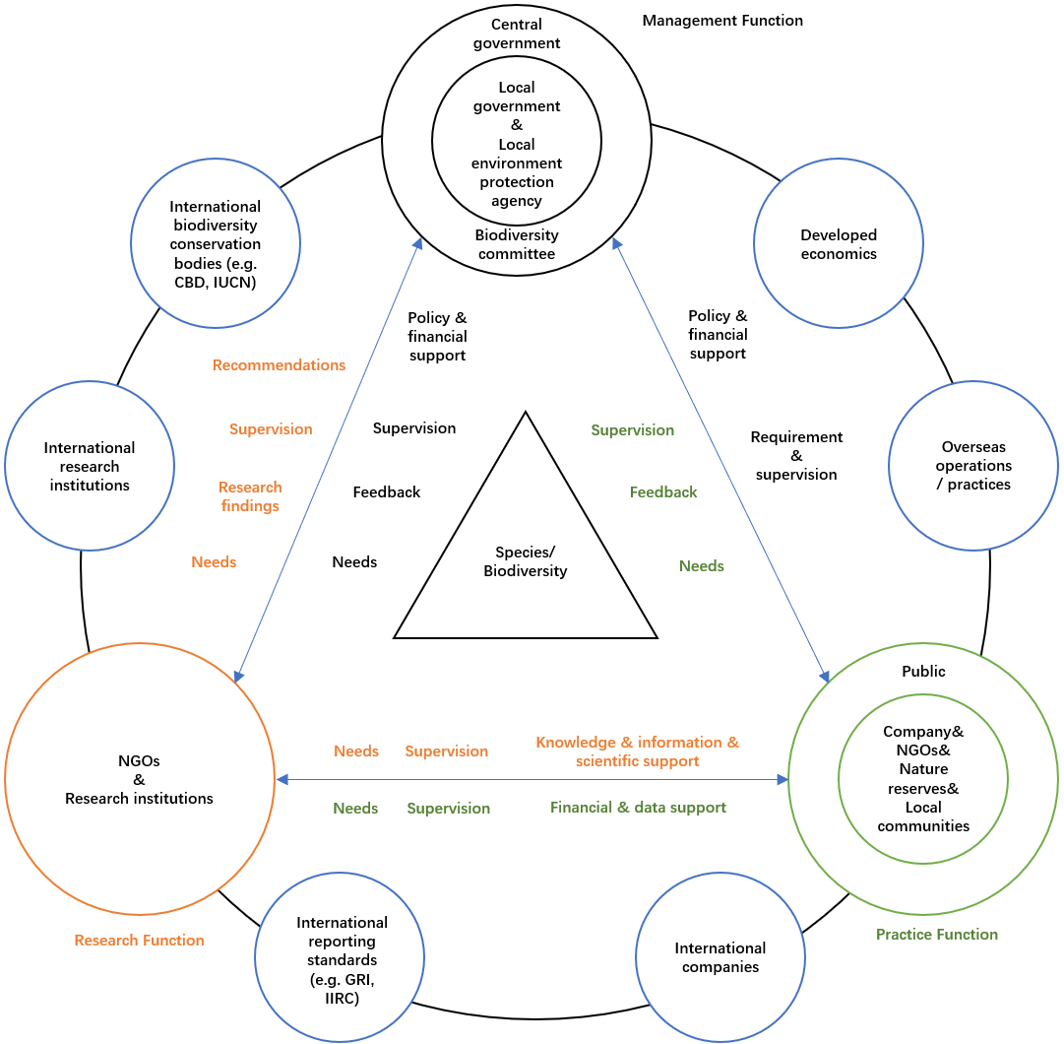

The management function is performed by Chinese government in terms of their significant influence, resources and authority in China. It contains two general levels; the central government and China National Committee for Biodiversity Conservation are the central management that mainly responsible for the significant decision-makings (e.g. national policies and projects), the organisation and coordination of conservation projects and actions, the negotiation and cooperation with international forces, and the supervision of local management and other functions. The local government and local environment protection agency are the local management that mainly responsible for the implementation of central management’s decisions, the organisation and coordination of specific conservation projects and actions, the engagement with local stakeholders and relevant supervision, and the feedback of performance and any issues to central management. In relation to the management component’s engagement with others, the government in general is expected to provide policy and financial support to both practice and research components and supervise their actions and performance. It also provides relevant requirements for the practice component (especially companies) to comply and provides feedback and further needs for the research component to carry out further researches. Moreover, in the international context, the Chinese government’s engagement with international biodiversity conservation bodies and developed economics are essential in terms of the obtain of international support and resources. At the same time, the Chinese government should also under the supervision of other stakeholders, especially the local government, to prevent any corruptions or wrongdoings.

The practice function is ideally to be performed by each individual in the society, while in the most of cases are mainly performed by the practice part of conservation NGOs, nature reserves, local communities, and what we are trying to address in this thesis, companies. These forces are expected to be supported, as well as supervised by the public, to carry out biodiversity conservation practices. As discussed earlier, without adequate conservation professionals and resources, companies should actively engage with other stakeholders within the practice component, as well as research component, management component, and international forces to seek for support and resources. As part of practice component, companies should communicate their needs with management and research components. Moreover, as conservation stakeholders should also be accountable for companies, both management and research components should also under the supervision from companies, as well as other practice forces and the society. Apart from that, companies and other practice forces should feedback the government in terms of relevant policies, requirements and support, for further improvement. Furthermore, companies and other practice forces should provide financial or/and data support for research component to carry out relevant researches in improving biodiversity conservation practices. In the international context, companies should incorporate their good biodiversity practices in overseas operations and good practices of international companies into their practices in China. Moreover, companies could also incorporate the global leading reporting standards in their reporting practices to further improve their accountability. As for other practice forces, they could also cooperate with international companies in promoting further conservation opportunities.

The research function is mainly performed by research institutions in different areas, and the research part of the conservation NGOs. Their major responsibility in this mechanism is to carry out researches based on the needs of government and practice forces for conservation practices, thus, to provide findings and recommendations to the management component, and to provide knowledge, information and scientific support to practice component. At the same time, the research component should also effectively communicate its needs to management and practice components to gain adequate support and resources for continuous researches. Moreover, its strength in scientific knowledge and researches could also be used to supervise the practices of government and practice forces for further improvement. In the international context, the research component has significant role in engaging with international research communities and conservation bodies to communicate the latest status and challenges of biodiversity loss, and the relevant plans and approaches in addressing those challenges, thus, to fulfil its function to provide adequate support and information for management component to make decisions and for practice component to carry out field conservation actions. Moreover, in this mechanism, the research component is also expected to engage with international reporting standards and international companies to further develop and shape corporate reporting practices in China.

Proposed biodiversity reporting framework based on Chinese context
The proposed mechanism above is constructed based on the insights of our theoretical framework and empirical analysis, expected to guide open and effective engagement among stakeholders in promoting the ‘Business and Biodiversity’ in China, thus, to address the research questions of this thesis, which is to improve Chinese companies’ accountability for biodiversity.

The Table 10 shown below is the proposed biodiversity accounting framework in promoting ‘Business and Biodiversity’ in China, including seven aspects with specific elements, which are constructed based on the recommendations of this thesis and the extinction accounting framework which is introduced in 3.6 and its further refines in later studies (Atkins and Maroun, 2018, Atkins et al., 2019, Zhao and Atkins, 2019). Significant emphasis has been put on this extinction accounting framework in terms of its progressive nature and emancipatory potential to address the urgency of biodiversity loss, the consideration of recommendations above further develops and shape it to fit in Chinese context. The significant adaptation is the notion of opportunity and benefit drivers of biodiversity conservation other than risk, which open more space for participation and engagement in interacting with the mechanism proposed above. It is important to highlight that this framework is also species/biodiversity-centred, the practices relevant with the notion of opportunity and benefit certainly should not be based on the harm on species/biodiversity as the opportunity and benefit of species/biodiversity are the priority and core of this framework. For the compliance of this proposed accounting framework, it is voluntary for companies to comply with the elements suggested below in consideration of the inadequate development and regulatory requirement of sustainability reporting in China at present. Moreover, the framework does not require companies to entirely comply with the elements identified below, the main purpose of the listed elements is to outline the concept of this framework, and for companies to consider all the aspects of the proposed biodiversity accounting. Companies may practice the elements differently, while they need to ensure the aspects that guided by the framework have not been overlooked. It could be assumed that, the more a company is complying in line with the proposed framework, the more that company is accountable for the biodiversity. The details of each aspect of the framework is explained in detail in following content.

Table 10: The proposed biodiversity accounting framework in promoting ‘Business and Biodiversity’ in China
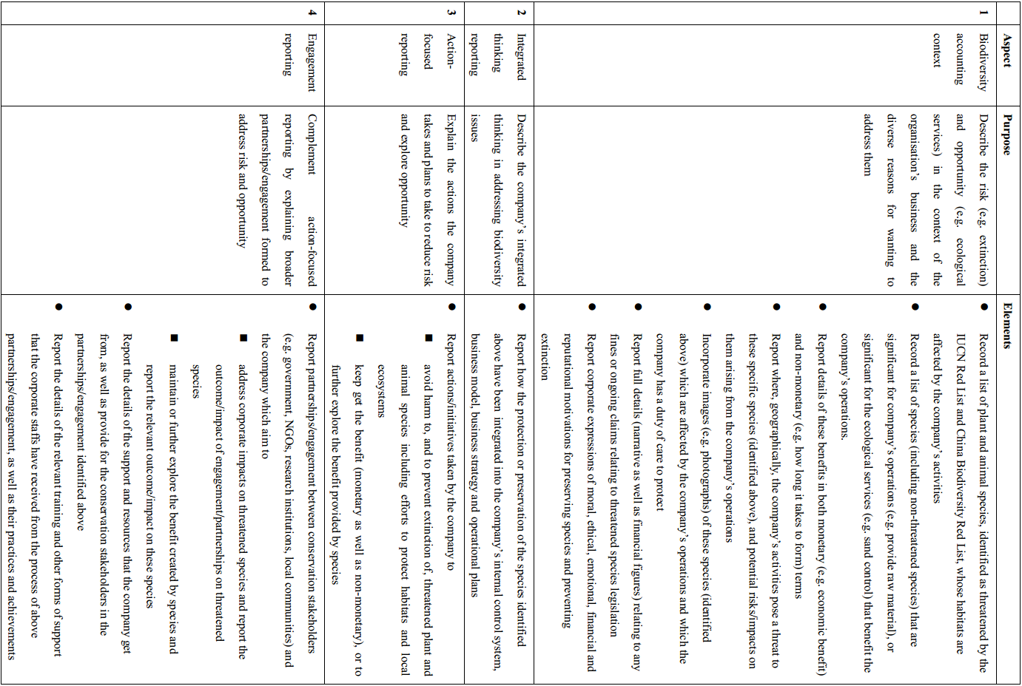
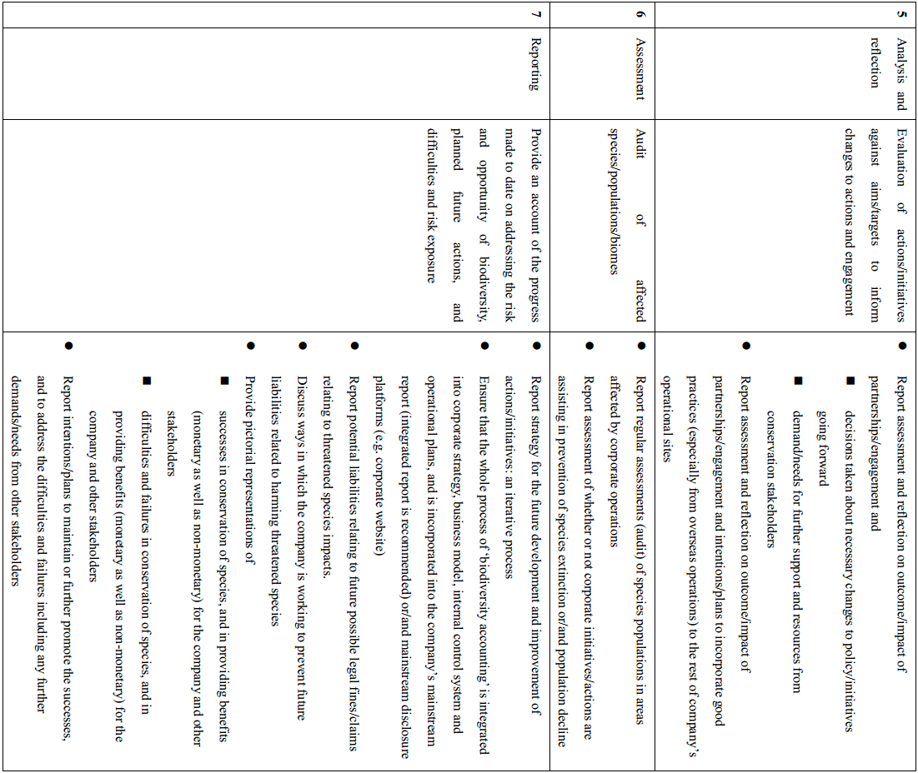

The first aspect of this framework is the biodiversity accounting context, which is for companies to describe the risks posed by biodiversity loss, as well as the opportunities in biodiversity conservation in relation with the companies’ operations. The risks are mainly referring to the extinction, population decline and habitat degradation of threatened species which are identified not only in the IUCN Red List, but also in the China Biodiversity Red List (see 4.3.2.1). The threatened species are referring to the species categorized in Critically Endangered (CR), Endangered (EN) or Vulnerable (VU) that classified by IUCN Red List (Secretariat of the CBD, 2010). The opportunities are mainly referring to the benefits that companies are currently getting from the products (e.g. honey) or services (e.g. dust control) of species/biodiversity, which also including non-threatened species. The benefits are expected to be expressed in both monetary and non-monetary terms to demonstrate species’ economic as well as intrinsic values. Companies are expected to clarify how these species are affected by their activities, and their diverse motivations in addressing these issues.

The second aspect is the integrated thinking reporting, which is for companies to demonstrate their integrated thinking by explaining how they integrate biodiversity conservation practices into their internal control system, business model, business strategy and operational plans. This is essential to examine companies’ commitment and potential employment of impression management.

The third and fourth aspects are referring to the companies’ actual projects and actions on biodiversity conservation, including partnerships and engagement with both internal and external stakeholders. On the one side, companies are required to report the practices and performance in reducing or reversing the risks of threatened species. On the other side, companies need to report the practices and performance in maintaining or further improving the conditions of the species which are beneficial to them, thus, to maintain or further explore the benefits. These species could be threatened or non-threatened species. As emphasized earlier, the exploration of benefits from biodiversity conservation should not create any form of harm on species. This is expected to be supervised mainly by external conservation stakeholders like government and NGOs. In consideration of the partnerships and engagement, companies are expected to report the details of the support and resources they have received from conservation stakeholders, as well as the support and resources that they have provided for these conservation stakeholders, thus, to demonstrate the companies’ as well as the conservation stakeholders’ accountability. Moreover, companies are also expected to report the training or other forms of support that their employees have get from above projects and actions, and their relevant practices and achievements. This would help companies to address the continuous improvement of the employees’ awareness and capacity on biodiversity conservation, thus, to foster their genuine commitment on conservation, or say, non-anthropocentric view of conservation.

The fifth and sixth aspects are referring to the post-implementation review, aiming to examine the actual performance of the conservation practices against the original aims and targets to generate reflective evaluation, thus, to inform changes to actions and engagement for further improvement. Companies are expected to incorporate good practices (especially and usually their practices in overseas operations) into their operations in other regions. As for the further improvement or address the difficulties and failures, companies are encouraged to disclose their demand and needs for further support and resources, thus, to attract and initiate further partnerships and engagements. Moreover, the regular review of the performance and targets helps to promote efficiencies, maintain commitment, and encourage development of new and innovative conservation approaches (Maroun and Atkins, 2018).

Finally, the last aspect of the framework is the reporting, which companies are expected to incorporate the whole ‘biodiversity accounting’ process into their corporate strategy, business model, internal control system and operational plans, and into their mainstream reporting (integrated report is recommended) or/and main disclosure platforms. Companies are expected to report successes in conservation of species and in providing benefits for themselves as well as for other stakeholders. Apart from successes, they are also expected to report relevant failures or difficulties. Based on that, companies need to provide their intentions or plans for future practices, in maintaining or further promoting the successes, as well as in addressing the difficulties and failures.

Concluding words

Conclusion and research contributions
The original intention of this thesis was to explore the potential of accounting as a body of knowledge and a communicative social practice to strive for a better world. In practice, this thesis has made a contribution at a number of levels in addressing the pressing challenge of biodiversity loss by focusing on the role and accountability potential of the corporate sector, specifically in Chinese context, which is rarely studied among academic accounting communities. By investigating the biodiversity relevant disclosures provided by listed extractive companies, which are creating the most impact on biodiversity and producing the highest quality sustainability report in China, the current status of corporate biodiversity reporting in China has been identified, including different approaches practiced and characteristics of disclosures. In consideration of the generally disappointing performance and lack of disclosures on specific endangered species from investigated companies, we further explore the current disclosures provided by Chinese companies as well as international companies based in China on a representative species which is endangered and well known in China: the giant panda. The findings contribute significantly to identifying the leading practices of ‘Business and Biodiversity’ in China, which contribute to developing the mechanism and accounting framework proposed in this thesis. In order to construct the mechanism and accounting framework with systemic and critical considerations, as well as to examine the accountability of companies’ current biodiversity reporting from different perspectives, interviews being carried out with people from diverse stakeholders’ groups. Their perceptions have been elaborated in detail in relation to the current status of ‘Business and Biodiversity’ in China, and the current challenges, approaches, and recommendations in further promoting ‘Business and Biodiversity’ in China. Finally, the recommendations which include the proposed mechanism and accounting framework in improving Chinese companies’ accountability for biodiversity are provided based on the comparative analysis and discussions of above empirical studies, and leading development in biodiversity accounting and emancipatory accounting literature.

In terms of practical contributions, firstly, this thesis addresses the current status, difficulties and potentials of ‘Business and Biodiversity’ in China, provide progressive and pragmatic recommendations with consideration of both anthropocentric and non-anthropocentric perceptions. The proposed mechanism and accounting framework are expected to specifically guide further development of ‘Business and Biodiversity’ in China, thus, responding to urgent calls in addressing the threats of biodiversity loss, as well as the new global deal for nature and people. Secondly, with systemic considerations throughout this thesis, the recommendations are not only for the improvement of companies’ accountability, but also other stakeholders’ including every individual’s accountability, for biodiversity. Therefore, the recommendations of this thesis have wider applications in not only the corporate sectors, but also other sectors including governmental departments, research institutions, NGOs and etc., to further improve their practices in addressing biodiversity loss. Thirdly, as the current academic studies in biodiversity accounting in China as well as in other eastern countries are extremely limited, this research is a good start to open more opportunities for further studies or initiatives around this topic. Fourthly, in the Chinese context, the insights of this thesis could contribute to the development of ecological civilization, which is currently emphasized by the Chinese government. With the continuous economic growth and ‘Open Up’ reforms, China’s role in the global arena is increasingly concerned by the world. The improved performance on environmental issues would help China to get increasing influence in the international context. Finally, as this thesis is also grounded in critical perspectives, the recommendations including proposed mechanism and accounting framework could be adapted to address other global challenges or sustainability topics. All these practical contributions indicated above would help to lead our world to a ‘better place’, enhancing societal welfare.

For the theoretical contributions, firstly, the critical new pragmatist construct of the emancipatory accounting that recently developed by Gallhofer and Haslam (2017) is incorporated in the theoretical framework of this thesis. The employment of this construct in the specific biodiversity accounting study in the Chinese context contributes to the empirical practice of the theory, such as the identification of different values and positions, the possibilities and obstacles to align them, the significance of the relevant accounting practice and etc. This study would help to provide insights for further refinement or development of the theory. Secondly, apart from the emancipatory accounting theory, the employment of GST as another part of the theoretical framework further ground the progressive nature of this study as both theories are claimed to have significant potentials for the social betterment, and to put emphasize on the holistic view. The insights of the GST provide a systemic thinking that encourage considerations for interdisciplinary and interdepartmental engagements. The theoretical framework that incorporate strengths of above two theories helps to further explore and perceive the potentials of accounting in contributing to a better world. It could be applied for further studies of biodiversity accounting, as well as for other topics with progressive intentions in diverse context. Thirdly, this thesis has attempted to understand the current issues and seek to address them for further improvement by perceiving accounting as a social system. As discussed in 9.1.3, from the lens of GST, biodiversity as a marginalized or unpresented topic in Chinese companies is explained in terms of the constrained boundaries and inadequate interactions with total environment. Biodiversity issues are considered as insignificant for survival in company level, while considered as critical in broader levels. This consideration further addresses the need to promote active engagement and interactions between companies and other stakeholders. Alongside the employment of the new pragmatist construct of emancipatory accounting theory, the practice of this thesis brings more insights for the considerations of the boundary and hierarchical order of GST. Finally, as indicated in 9.4, interviewees tend to have multi-identities (e.g. as a citizen in the society and as a staff in a company) that lead to different and sometimes even conflictive perceptions. Moreover, some of them do have recent transfers between different sectors (e.g. from new media to CSR consulting sector, from CSR consulting sector to governmental department), and the interviews revealed that their perceptions are becoming more or less progressive along with their changing positions. These phenomena suggest more complex considerations of particular and universal, contribute to the ideas for further theoretical and practical studies.

In consideration of literature contributions, firstly, this study has filled the gap of biodiversity accounting researches in China context, which provides more perspectives and insights for the further study of ‘Business and Biodiversity’. Secondly, this study has constructed the theoretical framework that composed the insights of GST (Von Bertalanffy, 1950, Bailey, 1970, Von Bertalanffy, 1971, Rousseau, 2015) and emancipatory accounting theory (Tinker, 1984, Gallhofer and Haslam, 2003, Gallhofer et al., 2015, Haslam, 2016, Gallhofer and Haslam, 2017), and applied it into the China context, which is different with the context they originated from. It contributes to the study of application and adaptation of western based theories into eastern world, which could bring more insights on practical practices and theoretical developments. Thirdly, as this study is significantly enlightened from the construction of extinction accounting (Atkins et al., 2018, Maroun and Atkins, 2018, Atkins and Maroun, 2018), the findings of this thesis contributes to the applicability of the construct. For example, the identification of the accounting and accountability for specific species with emancipatory potential in China context, and the need to make a compromise between anthropocentric and non-anthropocentric approaches (Atkins et al., 2014, Maroun and Atkins, 2018). The empirical data also provides insights for the further development of this construct, such as the emphasis on the opportunity other than risk, the accountability of stakeholders, and the potentials in fostering non-anthropocentric practices which could be reflected in the proposed mechanism and reporting framework of this thesis. Fourthly, the empirical data identifies that some of the current issues of Chinese companies’ practices on biodiversity are in line with the problems discovered by previous literatures, such as the practice of impression management and anthropocentric oriented practices (Jones and Solomon, 2013, Rimmel and Jonäll, 2013, van Liempd and Busch, 2013, Atkins et al., 2014). It indicates that these issues are widely appeared all over the world regardless of the context differences, opens more space for further studies.

Research limitations and further research possibilities
This thesis has several limitations, firstly, in relation to the data, except for the panda case, the samples for the evaluation of Chinese companies’ biodiversity reporting are solely sourced from the listed extractive companies, which are selected in terms of their significant impact and highest quality of disclosures on biodiversity. This might lead to the limitations of the representativeness and universality of Chinese companies’ accountability for biodiversity in this thesis as the non-listed companies and companies in other industries have not been considered. However, it is unrealistic in practice to cover all of them into this thesis. As the nature of this thesis is forward-looking in further improving Chinese companies’ accountability for biodiversity, the selection of the leading listed companies in biodiversity reporting would serve that purpose with maximum potential. Further studies could be carried out in applying the findings of this thesis to other industries or types of companies, or in exploring the performance of other industries or types of companies for further insights and refinements.

Secondly, the interviewees are mainly based in Beijing, which might suggest the limitations of the representativeness of interviewees’ perceptions in China. However, as Beijing is the capital city of China, it is where the most of the Chinese leading research institutions, consulting firms, NGOs, governmental departments and large listed companies’ headquarters are located. This creates more opportunities for the emergence of leading awareness and practices of ‘Business and Biodiversity’ as the initiative is just emerged in China in recent years. Therefore, most of the participated interviewees are based in Beijing, while most of them do have experiences and/or contacts in other regions of China even overseas. Further studies could be carried out to investigate perceptions from relevant stakeholders from wider regions, thus, to discover more insights in improving ‘Business and Biodiversity’ in China.

Thirdly, the application of the theoretical framework of this thesis in Chinese context could implicate limitation considerations. According to Kamla et al. (2012), the theories that trying to construct the social role of accounting are supposed to be the results of Western ‘colonialism’ with the considerations of local societies, histories, cultures and politics. It might be problematic to directly apply Western theories, here specifically the GST and new pragmatist construct of the emancipatory accounting theory, for biodiversity accounting in China, which has completely different social, historical, cultural and political background. In practice, the conflicts with the ideas that posed by the theoretical framework do arise in the process of interviews, and some interviewees do point out the obstacles to apply those ideas in Chinese context. However, as GST suggested, all systems are connected, similar patterns or theories could arise from different systems or disciplines, and the patterns or theories that arise from a specific system or discipline could be applied or may provide insights for other systems or disciplines (Rousseau, 2015). In practice, with the application of the theoretical framework, some of the findings of this thesis discovered similar even exact issues and ideas in Chinese companies’ biodiversity reporting compare with the findings from Western based studies. Moreover, with elaboration of the empirical analysis, progressive insights and pragmatic considerations have been added to the development of biodiversity accounting to fit in the Chinese context. Further studies could be carried out to specifically address this issue.

Apart from suggestions for further studies indicated above and in the conclusion section, there are more possibilities, such as follow up studies to capture the process of the possible change in mind-set or social change alongside the continuous development of ‘Business and Biodiversity’, and the influential factors and challenges. Moreover, studies could be carried out to investigate the biodiversity reporting provided by other stakeholders like NGOs and government, focusing on the issues like how their accountability could be addressed, and how they measure, record and communicate biodiversity information. Furthermore, future studies could also investigate specifically how companies integrate biodiversity considerations into management accounting rather than financial accounting. What is more, further studies could also focus on the non-anthropocentric considerations of sustainability development, such as the classification of pollution harm on humans and other species.

Appendix

Tables
Table 11: List of 69 identified extractive companies in China
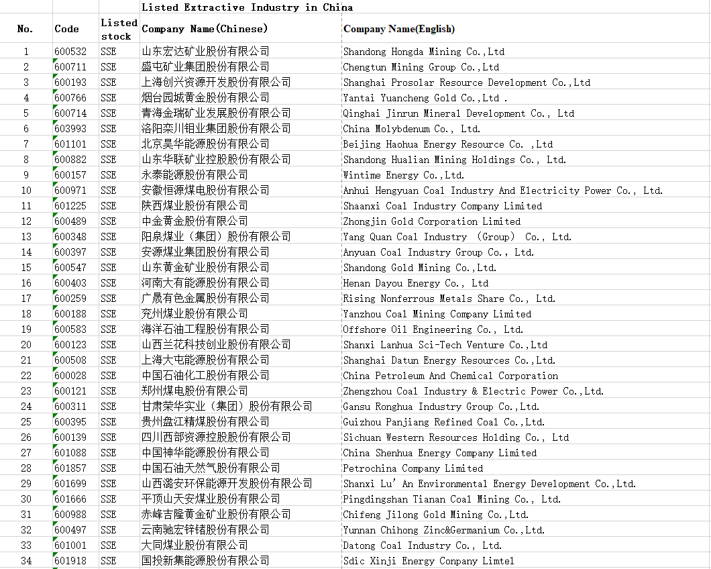
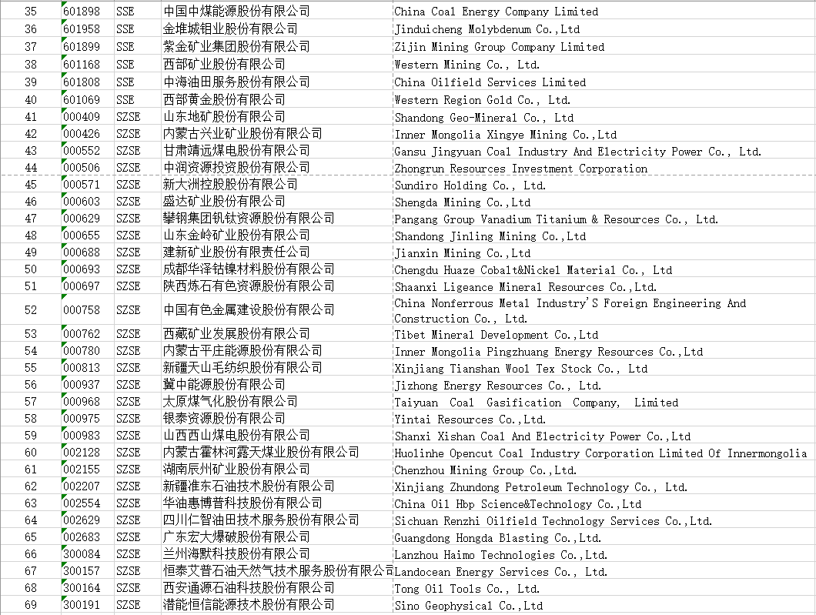

Table 12:Number of companies have/do not have CSR report/CSR section on their website
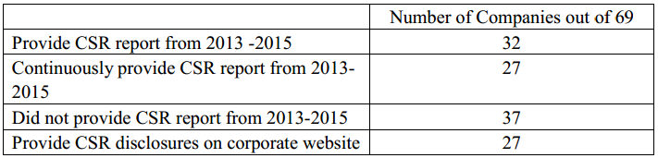

Table 13: Number of pages of CSR report
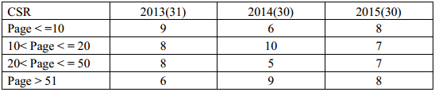

Table 14: Number of pages of Environment Section in CSR report
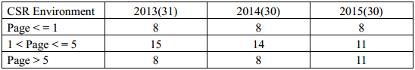
Table 15:Number of pages of biodiversity related disclosures in CSR report
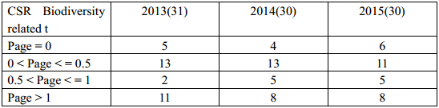

Table 16: Number of pages of CSR section in Annual report
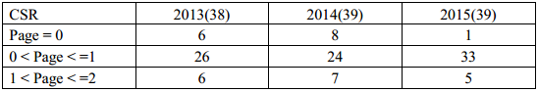

Table 17: Number of pages of Environment Section in Annual report
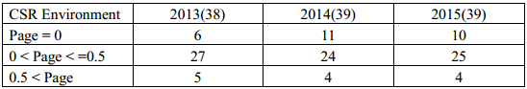

Table 18: Number of pages of biodiversity related disclosures in Annual report
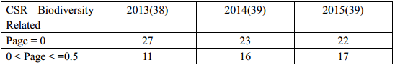

Table 19: Number of companies provide direct or indirect disclosures related to biodiversity
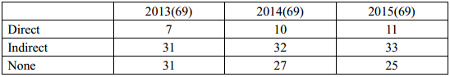
Table 20: Interview participant profile
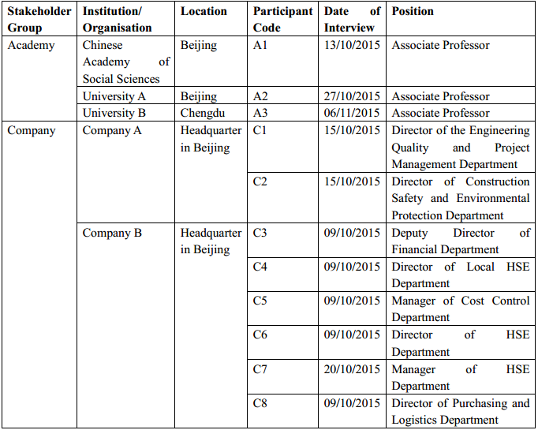
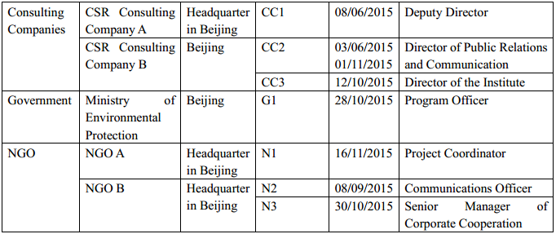

Interview questions

Pilot interview questions
- What drives you to work on biodiversity related issues?
- Currently, what are the main issues of CSR reporting of Chinese listed companies?
- Does the companies’ biodiversity conservation activities and disclosures have similar issues? Any differences?
- In your opinion, what is the current status of corporate participation in biodiversity conservation activities and disclosures?
- Compare with the environmental issues (e.g. air pollution) that received increasing concerns from the public and government, what are the companies’ concerns and actions on biodiversity issues?
- Why the most of companies tend to use the terms like ‘ecological protection’ instead of ‘biodiversity protection’?
- How are the Chinese companies’ disclosures on biodiversity related issues different with western countries?
- In China, which industry is more active (e.g. actions, disclosures) in biodiversity related issues?
- In your experience or opinion, when companies participate in biodiversity conservations, should they just focus on their working site?
- Currently, some of the international companies (operate in China) have better performance than Chinese companies in terms of biodiversity reporting, what are the reasons?
- What are the main barriers or difficulties for Chinese companies to participate in biodiversity conservation activities and disclosures?
- How to improve companies’ awareness and participation in biodiversity conservation?
- Are there any legislations (existing or preparing) related to ‘Business and Biodiversity’? What are the features in China context?
- In your opinion, is it necessary to set up specific law or legislations for individual species (e.g. endangered, famous)?
- How to verify the companies’ disclosures on biodiversity related issues?

Interview questions for all stakeholders
- What is your understanding about biodiversity?
- What is your opinion about the threat of biodiversity loss in China?
- What is your opinion about Chinese companies’ impact on biodiversity?
- How do you think about the potential impact on companies’ financial performance from companies’ participation in biodiversity conservation?
- Do you believe companies have obligations for biodiversity conservation?
- Do you believe the companies’ donations for biodiversity related foundations are effective?
- When you perform biodiversity related activities or researches, have you pay attention on IUCN or GRI?
- Do you think some species have priorities than others in terms of conservation?
- What are your opinions for companies’ reporting and disclosures for biodiversity conservation (e.g. current issues, status, key factors, future trend)?
- Based on your understanding of Corporate Social Responsibility, what are the relationships and difference among environment protection, ecological conservation, and biodiversity conservation?
- In your opinion, what are the major motivator and obstructer for Chinese companies to participate in biodiversity conservation and disclosures? How about Chinese companies’ major advantage and disadvantage?
- In your opinion, what are the reasons that currently only few companies provide biodiversity related disclosures?
- In your opinion, what are the major conservation and disclosure differences between the rare/endangered and general species?
- What is the major difference about biodiversity related information disclosures between Chinese national companies and foreign companies?

Additional interview questions for all stakeholders except extractive companies
- Currently, do you have any cooperation (e.g. project, consulting) with Chinese companies (mainly focus on extractive industry) about their participation (direct or indirect) in biodiversity conservation?
- What do you know about companies’ disclosures on biodiversity related conservations? Does your organisation have any related reports or researches for this?
- Do you have any monitoring and evaluation activities about companies’ impact on local biodiversity?
- In your opinion, in which area that your organisation could contribute to promote companies’ accountability and their participation for biodiversity conservation? And how your organisation could cooperate with other stakeholders?
- As one of the stakeholders, how is your organisation going to assess and regulate companies to let them discharge their accountability for local biodiversity?
- In your opinion, what are the most urgent needs of Chinese companies on biodiversity reporting?

Additional interview questions for extractive companies
- What are your approaches to understand biodiversity?
- How is your organisation discharge accountability and reporting for local biodiversity and specific species (endangered and normal)?
- Does your organisation have any current or future project/plan for biodiversity conservation and reporting?
- Does your organisation have any cooperation with other stakeholders (e.g. NGO, government, employees) on biodiversity conservation and reporting?
- In your opinion, how can make the cooperation among stakeholders more effective for biodiversity conservation and reporting?
- How you measure the biodiversity related disclosures? Any audit?

Additional interview questions for CSR consulting companies
- What is the role of media on biodiversity related issues?
- Is there any supervision institution or regulations for media’s reporting on biodiversity?

Additional interview questions for academics
- Currently there are only few companies have individual auditing for their biodiversity reporting or CSR reporting, any reasons?
- Are there any academic researches about companies’ participation in biodiversity conservation and reporting in China?
- What is your opinion about companies’ disclosures for biodiversity conservation (e.g. problems, current status, key factors, future trend)?

Additional interview questions for government
- What are the government’s current and future project/plan and requirements for ‘Business and Biodiversity’?
- Currently the government is preparing the ‘Giant Panda Conservation Law’, how about other endangered species and normal species?
- Is there any government report about ‘Business and Biodiversity’?

References

ADAMS, C. A., HILL, W. Y. & ROBERTS, C. B. 1995. Environmental, employee and ethical reporting in Europe, Certified Accountants Educational Trust London.
ALEXANDER, G. J. & BUCHHOLZ, R. A. 1978. Corporate social responsibility and stock market performance. Academy of Management journal, 21, 479-486.
AMERICAN ACCOUNTING ASSOCIATION 1966. A statement of basic accounting theory, American Accounting Association.
AMERICAN INSTITUTE OF CERTIFIED PUBLIC ACCOUNTANTS 1953. Accounting Terminology Bulletin No.1. New York: American Institute of Certified Public Accountants.
ANYUAN COAL INDUSTRY GROUP 2014. Anyuan Coal Industry Group CSR Report.
ANYUAN COAL INDUSTRY GROUP 2015. Anyuan Coal Industry Group CSR Report.
ARNOLD, P. & HAMMOND, T. 1994. The role of accounting in ideological conflict: Lessons from the South African divestment movement. Accounting, Organizations and Society, 19, 111-126.
ATKINS, J. & ATKINS, B. 2016a. Bee decline: An integrated approach. In: ATKINS, J. & ATKINS, B. (eds.) The Business of Bees: An Integrated Approach to Bee Decline and Corporate Responsibility. Greenlead Publishing.
ATKINS, J. & ATKINS, B. 2016b. The Business of Bees: An Integrated Approach to Bee Decline and Corporate Responsibility, Greenleaf Publishing.
ATKINS, J., BARONE, E., MAROUN, W. & ATKINS, B. 2016. Bee accounting and accountability in the UK. In: ATKINS, J. & ATKINS, B. (eds.) The Business of Bees: An Integrated Approach to Bee Decline and Corporate Responsibility. Greenleaf Publishing.
ATKINS, J., GRäBSCH, C. & JONES, M. 2014. Corporate biodiversity reporting: exploring its anthropocentric nature. In: JONES, M. (ed.) Accounting for Biodiversity. Routledge.
ATKINS, J. & MAROUN, W. 2018. Integrated extinction accounting and accountability: building an ark. Accounting, Auditing & Accountability Journal, 31, 750-786.
ATKINS, J. & MAROUN, W. forthcoming. The Naturalist’s Journals of Gilbert White: Exploring the roots of accounting for biodiversity and extinction accounting
ATKINS, J., MAROUN, W. & ATKINS, B. 2019. How can accounting, integrated reporting and engagement prevent extinction? Around the World in 80 Species: Exploring the Business of Extinction. Routledge.
ATKINS, J., MAROUN, W., ATKINS, B. C. & BARONE, E. 2018. From the Big Five to the Big Four? Exploring extinction accounting for the rhinoceros. Accounting, Auditing & Accountability Journal, 31, 674-702.
ATKINSON, P. & COFFEY, A. 2004. Analysing documentary realities. Qualitative research, 56.
BAILEY, R. E. 1970. An Application of General Systems Theory to the Determination of the Nature of Accounting.
BANQUE, M. 1997. World Development Report 1997: The State in a Changing World, World Bank.
BARLEY, S. R., MEYER, G. W. & GASH, D. C. 1988. Cultures of culture: Academics, practitioners and the pragmatics of normative control. Administrative science quarterly, 24-60.
BBC NEWS. 2016. BP says total Gulf spill bill $61.6bn [Online]. BBC News. Available: https://www.bbc.co.uk/news/36798842 [Accessed 7th January 2019].
BEARDSWORTH, A. 1981. Analysing press content: some technical & methodological issues. The Sociological Review, 29, 371-395.
BEBBINGTON, J. 2010. Accounting for biodiversity and reflecting on interdisciplinarity. Sydney.
BEER, S. 1960. Cybernetics and management.
BEIJING HAOHUA ENERGY RESOURCES LIMITED 2014. Beijing Haohua Energy Resources Limited CSR Report.
BEIJING HAOHUA ENERGY RESOURCES LIMITED 2015. Beijing Haohua Energy Resources Limited CSR Report.
BELL, E., TAYLOR, S. & THORPE, R. 2002. Organizational differentiation through badging: Investors in people and the value of the sign. Journal of Management Studies, 39, 1071-1085.
BENSTON, G. J. 1982. Accounting and corporate accountability. Accounting, organizations and Society, 7, 87-105.
BERRIEN, F. K. 1968. General and social systems, Rutgers Univ Pr.
BISHOP, J., BERTRAND, N., EVISON, W., GILBERT, S., GRIGG, A., HWANG, L., KALLESOE, M., VAKROU, A., VAN DER LUGT, C. & VORHIES, F. 2010a. TEEB–The Economics of Ecosystems and Biodiversity Report for Business. Executive Summary.
BISHOP, J., VAN DER LUGT, C., VORHIES, F., BSR, L. H., KALLESOE, M., BERTRAND, N., GRI, S. G. & EVISON, W. 2010b. The Economics of Ecosystems and Biodiversity: Report for Business. TEEB.
BOATRIGHT, J. R. 2013. Ethics in finance, John Wiley & Sons.
BOIRAL, O. 2016. Accounting for the unaccountable: Biodiversity reporting and impression management. Journal of Business Ethics, 135, 751-768.
BOULDING, K. E. 1956. General systems theory—the skeleton of science. Management science, 2, 197-208.
BRETT, G. M. 1928. Fundamental Accounting, New York, The College of the City of New York.
BROADBENT, J. & LAUGHLIN, R. 2013. Accounting control and controlling accounting: Interdisciplinary and critical perspectives, Emerald Group Publishing.
BRYMAN, A. 1988. Quantity and Quality in Social Research, London, Routledge.
BRYMAN, A. & BELL, E. 2011. Business research methods, Oxford University Press.
BUCKLEY, W. 1967. Sociology and modern systems theory.
BURRELL, G. & MORGAN, G. 1979. Sociological paradigms and organisational analysis. London: Heinmann.
BURRITT, R., PETERSEN, H., SCHALTEGGER, S., BURRITT, R. L. & PETERSEN, H. 2003. An Introduction to Corporate Environmental Management Striving for Sustainability.
CALHOUN, C. 1995. Critical social theory: Culture, history, and the challenge of difference, Wiley-Blackwell.
CAMPAIGN CHINA. 2012. Mercedes Benz reinforces commitment to panda conservation [Online]. Available: http://www.campaignasia.com/article/mercedes-benz-reinforces-commitment-to-panda-conservation/294190 [Accessed 5th Jan 2018].
CANON CHINA 2013. Canon China CSR Report 2013.
CANON CHINA 2014. Canon China CSR Report 2014.
CAO, Y. 2014. Animals honored in simulated cemetery [Online]. China Daily. Available: http://www.chinadaily.com.cn/china/2014-04/04/content_17405918.htm [Accessed 4th April 2018].
CAREY, J. L. 1965. The CPA Plans for the Future, New York, American Institute of Certified Public Accountants.
CARREFOUR CHINA. 2011. Multiple initiatives to ensure food security (多项举措保驾食品安全) [Online]. Available: http://www.carrefour.com.cn/News/CarrefourNewsDetail.aspx?NewsID=147 [Accessed 19th October 2017].
CBD. 1993. About the Convention [Online]. Convention on Biological Diversity. Available: https://www.cbd.int/intro/default.shtml [Accessed 19th October 2017].
CBD. 1996. COP 3 Decision III/6: Additional financial resources [Online]. Convention on Biological Diversity. Available: https://www.cbd.int/decision/cop/default.shtml?id=7097 [Accessed 19th October 2017].
CBD. 2010a. COP 10 Decision X/21:Business engagement [Online]. Convention on Biological Diversity. Available: https://www.cbd.int/decision/cop/default.shtml?id=12287 [Accessed 19th October 2017].
CBD 2010b. Strategic Plan for Biodiversity 2011-2020 and the Aichi Targets.
CBD 2013. Quick guides to the Aichi Biodiversity Targets.
CCTV NEWS. 2014. Taking and giving: panda honey shows ecological justice (索取与给予：熊猫蜂蜜体现生态公平——专访大熊猫保护专家吕植) [Online]. Available: http://news.cntv.cn/2014/09/11/ARTI1410411157349994.shtml [Accessed 19th October 2017].
CHAMBERS, R. 1957. Accounting and Action, Law Book Company of Australia PTY Limited.
CHIFENG JILONG GOLD MINING LIMITED 2013. Chifeng Jilong Gold Mining Limited Annual Report.
CHIFENG JILONG GOLD MINING LIMITED 2014. Chifeng Jilong Gold Mining Limited Annual Report.
CHIN, R. 1967. The Utility Of Systems Models And Developmental Models for Practitioners. In: SCHODERBEK, P. (ed.) Management Systems. New York: John Wiley & Sons.
CHINA COAL ENERGY COMPANY LIMITED 2013. China Coal Energy Company Limited CSR Report.
CHINA COAL ENERGY COMPANY LIMITED 2014. China Coal Energy Company Limited CSR Report.
CHINA COAL ENERGY COMPANY LIMITED 2015. China Coal Energy Company Limited CSR Report.
CHINA CONSERVATION AND RESEARCH CENTRE FOR THE GIANT PANDA. n.d. Giant Panda [Online]. Available: http://www.forestry.gov.cn/portal/dxm/ [Accessed 19th October 2017].
CHINA DAILY. 2018. The Ministry of Ecological Environment is working with Ant Forest to call hundreds of millions of users to construct a beautiful China [Online]. China Daily. Available: http://cnews.chinadaily.com.cn/2018-06/05/content_36331389.htm [Accessed 20th February 2019].
CHINA ENVIRONMENTAL NEWS. 2016. China Offically Joined 'Nagoya Protocol on Genetic Resources' [Online]. Information Exchange for Biological Genetic Resources Acquisition and Benefit Sharing. Available: http://www.absch.org.cn/dt/gjdt/201609/t20160906_84023.html [Accessed 15th December 2018].
CHINA FORESTRY. 2013. Giant Panda Conservation Legislations [Online]. China Giant Panda. Available: http://panda.forestry.gov.cn/zxdw/pub/cms/2/13681/13714/13716/13964.html [Accessed 25 June 2018].
CHINA FORESTRY. 2015. National Giant Panda Conservation Working Conference [Online]. Available: http://www.forestry.gov.cn/main/72/content-753135.html [Accessed 27th June 2018].
CHINA FORESTRY. 2016. Analysis the Highlights of New 'Wildlife Conservation Law' [Online]. Available: http://panda.forestry.gov.cn/zxdw/pub/cms/2/13681/13693/13694/88674.html [Accessed 27th June 2018].
CHINA MOLYBDENUM LIMITED 2013. China Molybdenum Limited CSR Report.
CHINA MOLYBDENUM LIMITED 2014. China Molybdenum Limited CSR Report.
CHINA MOLYBDENUM LIMITED 2015. China Molybdenum Limited CSR Report.
CHINA NONFERROUS METAL LIMITED 2013. China Nonferrous Metal Limited CSR Report.
CHINA OILFIELD SERVICES LIMITED 2013. China Oilfield Services Limited CSR Report.
CHINA OILFIELD SERVICES LIMITED 2014. China Oilfield Services Limited CSR Report.
CHINA OILFIELD SERVICES LIMITED 2015. China Oilfield Services Limited CSR Report.
CHINA SHENHUA ENERGY LIMITED 2013. China Shenhua Energy Limited CSR Report.
CHINA SHENHUA ENERGY LIMITED 2014. China Shenhua Energy Limited CSR Report.
CHINA SHENHUA ENERGY LIMITED 2015. China Shenhua Energy Limited CSR Report.
CHINA WTO TRIBUNE, CHINA ECONOMIC INFORMATION NETWORK, GOLDENBEE MANAGEMENT CONSULTING & INTERNATIONAL RESEARCH CENTER FOR SOCIAL RESPONSIBILITY & SUSTAINABLE DEVELOPMENT OF PEKING UNIVERSITY 2013. GoldenBee Research on Corporate Social Responsibility Reporting in China 2013. Beijing.
CHRISTIAN, J. 2014. Accounting for biodiversity–a Deep Ecology perspective. Accounting for Biodiversity. Routledge.
CHRISTIAN, J. 2019. A deep ecology perspective on extinction. In: ATKINS, J. & ATKINS, B. (eds.) Around the world in 80 species: exploring the business of extinction. Routledge.
CHURCHMAN, C. 1968. West. The systems approach. Delta, New York.
COCHRAN, P. L. & WOOD, R. A. 1984. Corporate social responsibility and financial performance. Academy of management Journal, 27, 42-56.
COETZEE, C. & VAN NIEKERK, D. 2012. Tracking the evolution of the disaster management cycle: A general system theory approach. Jàmbá: Journal of Disaster Risk Studies, 4, 1-9.
COHEN, M. F. 1966. A description of the professional practice of certified public accountants. Journal of Accountancy (pre-1986), 122, 61.
CONSERVATION INTERNATIONAL & SHANSHUI CONSERVATION CENTRE 2009. China wild giant panda survival and security evaluation (中国野生大熊猫生存安全评价).
CORBIN, J. & STRAUSS, A. 2012. Basics of qualitative research: Techniques and procedures for developing grounded theory, Thousand Oaks, AGE Publications.
DAVIES, J. 2014. Full cost accounting–integrating biodiversity. Accounting for Biodiversity. Routledge.
DECHERT, C. R. 1965. The development of cybernetics. American Behavioral Scientist, 8, 15-20.
DEEGAN, C. & RANKIN, M. 1996. Do Australian companies report environmental news objectively? An analysis of environmental disclosures by firms prosecuted successfully by the Environmental Protection Authority. Accounting, auditing & accountability journal, 9, 50-67.
DEMERS, C., GIROUX, N. & CHREIM, S. 2003. Merger and acquisition announcements as corporate wedding narratives. Journal of Organizational Change Management, 16, 223-242.
DEUTSCH, K. W. 1951. Mechanism, teleology, and mind. Philosophy and phenomenological research, 12, 185-223.
DU, L., LI, J., LIU, G., ZHANG, F., XU, J. & HU, L. 2016. Progress in the researches on the Economics of Ecosystems and Biodiversity (TEEB). Biodiversity Science, 24, 686-693.
ECCLES, G. R. & LEE, G. 2015. Integrated Reporting: Corporate Disclosure for China’s "New Normal" [Online]. MIT Sloan Management Review. Available: https://sloanreview.mit.edu/article/integrated-reporting-corporate-disclosure-for-chinas-new-normal/ [Accessed 23rd February 2019].
EDMONDS, R. L. 2012. Patterns of China's lost harmony: a survey of the country's environmental degradation and protection, Routledge.
EDWARDS, R. & HOLLAND, J. 2013. What is qualitative interviewing?, A&C Black.
FAN, Z. 2016a. WWF Gaint Panda Conservation Research Report Part 1 (WWF大熊猫保护研究报告上册).
FAN, Z. 2016b. WWF Gaint Panda Conservation Research Report Part 2 (WWF大熊猫保护研究报告下册).
FEYERABEND, P. 2011. Tyranny of science.
FOREIGN ECONOMIC COOPERATION OFFICE 2013. Chinese corporations' participation in biodiversity: case study collection (中国企业参与生物多样性案例汇编).
FREEMAN, M. C. & GROOM, B. 2013. Biodiversity valuation and the discount rate problem. Accounting, Auditing & Accountability Journal, 26, 715-745.
GALLHOFER, S. & HASLAM, J. 1991. The aura of accounting in the context of a crisis: Germany and the First World War. Accounting, Organizations and Society, 16, 487-520.
GALLHOFER, S. & HASLAM, J. 1995. Accounting and modernity. Advances in Public Interest Accounting, 6, 203-232.
GALLHOFER, S. & HASLAM, J. 2003. Accounting and emancipation: some critical interventions, Routledge.
GALLHOFER, S. & HASLAM, J. 2017. Some reflections on the construct of emancipatory accounting: Shifting meaning and the possibilities of a new pragmatism. Critical Perspectives on Accounting.
GALLHOFER, S., HASLAM, J. & YONEKURA, A. 2013. Further critical reflections on a contribution to the methodological issues debate in accounting. Critical Perspectives on Accounting, 24, 191-206.
GALLHOFER, S., HASLAM, J. & YONEKURA, A. 2015. Accounting as differentiated universal for emancipatory praxis: accounting delineation and mobilisation for emancipation (s) recognising democracy and difference. Accounting, Auditing & Accountability Journal, 28, 846-874.
GARNER, R. 1996. Environmental politics, Prentice Hall/Harvester Wheatsheaf.
GILBERT, N. 2008. Researching social life, Sage.
GLASER, B. G. & STRAUSS, A. L. 1967. The discovery of grounded theory; strategies for qualitative research, Chicago, Aldine.
GONG, M., CUI, L., FAN, Z., ZHU, Y., LIU, G., GUO, J. & LI, H. 2016. Habitat fragmentation's impact on giant panda's long term suvival (栖息地破碎化对大熊猫种群长期生存的影响). In: FAN, Z. (ed.) WWF Gaint Panda Conservation Research Report Part 2 (WWF大熊猫保护研究报告下册).
GOULDING, C. 2002. Grounded theory: A practical guide for management, business and market researchers, Sage.
GOULSON, D. 2012. Decline of bees forces China's apple farmers to pollinate by hand [Online]. China Dialogue. Available: https://www.chinadialogue.net/article/show/single/en/5193-Decline-of-bees-forces-China-s-apple-farmers-to-pollinate-by-hand [Accessed 11th December 2018].
GOV.CN. 2015a. The Central Committee and the State Council's Opinions of Accelerating the Construction of Ecological Civilization [Online]. The Central People's Government of the People's Republic of China. Available: http://www.gov.cn/xinwen/2015-05/05/content_2857363.htm [Accessed 3rd December 2018].
GOV.CN. 2015b. The Understanding of ‘Opinions of Accelerating the Construction of Ecological Civilization’ from the Director of the Development and Reform Commission [Online]. The Central People's Government of the People's Republic of China. Available: http://www.gov.cn/xinwen/2015-05/06/content_2857592.htm [Accessed 4th December 2018].
GRAVES, S. B. & WADDOCK, S. A. 1994. Institutional owners and corporate social performance. Academy of Management journal, 37, 1034-1046.
GRAY, R. 1992. Accounting and environmentalism: an exploration of the challenge of gently accounting for accountability, transparency and sustainability. Accounting, Organizations and Society, 17, 399-425.
GRAY, R., ADAMS, C. & OWEN, D. 2014. Accountability, social responsibility and sustainability: Accounting for society and the environment, Pearson Higher Ed.
GRAY, R. & BEBBINGTON, J. 2000. Environmental accounting, managerialism and sustainability: Is the planet safe in the hands of business and accounting? Advances in environmental accounting & management. Emerald Group Publishing Limited.
GRAY, R. & BEBBINGTON, J. 2001. Accounting for the Environment, Sage.
GRAY, R. & MILNE, M. J. 2019. Species extinction and closing the loop of argument: imagining accounting and finance as the potential cause of human extinction. In: ATKINS, J. & ATKINS, B. (eds.) Around the World in 80 Species: exploring the business of extinction. Routledge.
GRAY, R., OWEN, D. & ADAMS, C. 1996. Accounting & accountability: changes and challenges in corporate social and environmental reporting, Prentice Hall.
GREEN HOMELAND. 2003. Giant panda specialist: Lv Zhi: "My protection target is not just giant panda" (大熊猫专家吕植：“我的保护目标不仅仅是大熊猫”) [Online]. Available: http://www.people.com.cn/GB/huanbao/8220/30473/31759/32140/2351100.html [Accessed 19th October 2017].
GRI. 2011a. ISO and Global Reporting Initiative increase cooperation on sustainable development [Online]. Global Reporting Initiative. Available: https://www.globalreporting.org/information/news-and-press-center/Pages/ISO-and-Global-Reporting-Initiative-increase-cooperation-on-sustainable-development.aspx [Accessed 6th January 2019].
GRI 2011b. Sustainability reporting guidelines, Version 3.1. Amsterdam.
GRI 2013. Sustainability Reporting Guideline Version 4. Global Reporting Initiative.
GRI 2014. GRI G4 Guidelines and ISO 26000: 2010. How to use the GRI G4 Guidelines and ISO 26000 in conjunction. Geneva: International Organization for Standartization (ISO) and Stichting Global Reporting Initiative (GRI)[online]. Accessed January, 18, 2016.
GRI 2018a. GRI 304: Biodiversity 2016. Consolidated Set of GRI Sustainability Reporting Standards.
GRI. 2018b. GRI Standards Download Center [Online]. Available: https://www.globalreporting.org/standards/gri-standards-download-center/ [Accessed 17th July 2019].
GRI. n.d. About GRI [Online]. Global Reporting Initiative. Available: https://www.globalreporting.org/information/about-gri/Pages/default.aspx [Accessed 5th January 2019].
GU, L., WEN, C., LUO, M., WANG, H. & Lü, Z. 2015. A rapid approach for assessing the conservation effectiveness of the most concerned endangered species in China. Biodiversity Science, 23, 583-590.
HALL, A. D. & FAGEN, R. E. 1956. Definition of system. General systems, 1, 18-28.
HAMMOND, D. 2005. Philosophical and ethical foundations of systems thinking. tripleC: Communication, Capitalism & Critique. Open Access Journal for a Global Sustainable Information Society, 3, 20-27.
HAMMOND, D. 2010. The science of synthesis: Exploring the social implications of general systems theory, University Press of Colorado.
HAN, T. 2009. Mercedes-Benz sponsors giant panda kindergarten [Online]. China Daily. Available: http://www.chinadaily.com.cn/bw/2009-09/07/content_8660786.htm [Accessed 5th Jan 2018].
HARTE, G. & OWEN, D. 1992. Current trends in the reporting of green issues in the annual reports of United Kingdom companies. Green reporting: Accountancy and the challenge of the nineties, 8, 166-200.
HASLAM, J. 2016. Informings for Control and Emancipatory Interests in Accounting: New Reflections on the Intellectual Emancipation of Accounting and the Possibilities of Emancipatory Accountings. Pioneers of Critical Accounting. Springer.
HELD, D. 1980. Introduction to critical theory: Horkheimer to Habermas, Univ of California Press.
HENAN DAYOU ENERGY LIMITED 2014. Henan Dayou Energy Limited Annual Report.
HEYWOOD, V. H. & WATSON, R. T. 1995. Global biodiversity assessment, Cambridge University Press Cambridge.
HIK VISION 2017. HIK VISION 2016 CSR Rerpot (杭州海康威视数字技术股份有限公司2016年度社会责任报告).
HOEGH-GULDBERG, O., JACOB, D., TAYLOR, M., BINDI, M., BROWN, S., CAMILLONI, I., DIEDHIOU, A., DJALANTE, R., EBI, K. & ENGELBRECHT, F. 2018. Impacts of 1.5 ºC global warming on natural and human systems.
HOFKIRCHNER, W. Ludwig von Bertalanffy. Forerunner of evolutionary systems theory. The New Role of Systems Sciences For a Knowledge-based Society, Proceedings of the First World Congress of the International Federation for Systems Research, Kobe, Japan, CD-ROM (ISBN 4-903092-02-X), 2005.
HOPPER, T. & POWELL, A. 1985. Making sense of research into the organizational and social aspects of management accounting: A review of its underlying assumptions [1]. Journal of management Studies, 22, 429-465.
HOU, M. 2014. Three dimensions of biodiversity protection (生物多样性保护的三个维度) [Online]. CNEO.COM.CN. Available: http://www.csr-china.net/a/guandian/shouyeguandian/20141218/2459.html [Accessed 19th October 2017].
HOUDET, J. & VELDTMAN, R. 2016. How to account for bees and pollinators? In: ATKINS, J. & ATKINS, B. (eds.) The Business of Bees: An Integrated Approach to Bee Decline and Corporate Responsibility. Greenleave Publishing.
HSBC CHINA 2015. HSBC China corporate sustainability report.
HUANG, F. 2016. The Need to Strengthen the Basic Theory Research About 'One Belt and Road'. New West, 05.
HUOLINHE OPENCUT COAL LIMITED 2013. Huolinhe Opencut Coal Limited CSR Report.
IFAC 2015. Creating Value with Integrated Thinking: the Role of Professional Accountants.
IIRC 2011. Towards Integrated Reporting: Communicating value in the 21st century. The International Integrated Reporting Committee.
IIRC 2013. The International <IR> Framework.
IIRC. n.d. The IIRC [Online]. The International Integrated Reporting Council. Available: http://integratedreporting.org/the-iirc-2/ [Accessed 12th January 2019].
INNER MONGOLIA XINGYE MINING LIMITED. 2013. Social Responsibility [Online]. Available: http://www.nmxyky.com/index.php/lists/index/29 [Accessed 1st March 2019].
ISO. n.d. About ISO [Online]. International Organization for Standardization. Available: https://www.iso.org/about-us.html [Accessed 6th January 2019].
ISO, I. 2010. 26000: guidance on social responsibility. Ginebra: ISO.
IUCN 2012. Guidelines for Application of IUCN Red List Criteria at Regional and National Levels. Version 4.0 ed.
IUCN. 2016. The IUCN Red List of Threatened Species: Ailuropoda melanoleuca [Online]. International Union for Conservation of Nature and Natural Resources. Available: http://www.iucnredlist.org/details/712/0 [Accessed 19th October 2017].
IUCN RED LIST. 2018a. The IUCN Red List of Threatened Species [Online]. Available: https://www.iucnredlist.org/ [Accessed 30th December 2018].
IUCN RED LIST 2018b. Table 1: Numbers of Threatened Species by Major Groups of Organisms (1996-2018). IUCN Red List.
IUCN RED LIST. n.d. Background & History [Online]. The International Union for Conservation of Nature’s Red List. Available: https://www.iucnredlist.org/about/background-history [Accessed 30 December 2018].
JACKSON, N. & CARTER, P. 1991. In defence of paradigm incommensurability. Organization studies, 12, 109-127.
JIANG, Z., QIN, H., LIU, Y., JI, L. & MA, K. 2015. Protecting biodiversity and promoting sustainable development: in memory of the releasing of Catalogue of Life China 2015 and China Biodiversity Red List on the International Day for Biological Diversity 2015 (保护生物多样性, 促进可持续发展 ——纪念《中国生物物种名录》和《中国生物多样性红色名录》发布). Biodiversity Science, 23, 433-434.
JIANXIN MINING LIMITED 2014. Jianxin Mining Limited Annual Report.
JINDUICHENG MOLYBDENUM LIMITED 2015. Jinduicheng Molybdenum Limited CSR Report.
JIZHONG ENERGY RESOURCES LIMITED 2014. Jizhong Energy Resources Limited CSR Report.
JIZHONG ENERGY RESOURCES LIMITED 2015. Jizhong Energy Resources Limited CSR Report.
JOHN, V. 2014. Zoos weigh up the costs of China's 'pandanomics' [Online]. The Guardian. Available: https://www.theguardian.com/world/2014/sep/13/edinburgh-zoo-pandas-tian-tian-china-pandanomics-birth-cub [Accessed 13th June 2018].
JOHNSON, R. A. & GREENING, D. W. Relationships between corporate social performance, financial performance, and firm governance. Academy of Management Proceedings, 1994. Academy of Management, 314-318.
JOHNSON, T., LIU, F. & NEWFARMER, R. S. 1997. Clear water, blue skies: China's environment in the new century, World Bank Publications.
JONäLL, K. & RIMMEL, G. 2016. Corporate bee accountability among Swedish companies. In: ATKINS, J. & ATKINS, B. (eds.) The Business of Bees: An Integrated Approach to Bee Decline and Corporate Responsibility. Greenleaf Publishing.
JONES, M. 2014a. Accounting for biodiversity, Routledge.
JONES, M. 2014b. Ecosystem and natural inventory biodiversity frameworks. Accounting for Biodiversity. Routledge.
JONES, M. J. 1996. Accounting for biodiversity: a pilot study. The British Accounting Review, 28, 281-303.
JONES, M. J. 2003. Accounting for biodiversity: operationalising environmental accounting. Accounting, Auditing & Accountability Journal, 16, 762-789.
JONES, M. J. Accounting for the environment: Towards a theoretical perspective for environmental accounting and reporting. Accounting Forum, 2010. Elsevier, 123-138.
JONES, M. J. & SOLOMON, J. F. 2013. Problematising accounting for biodiversity. Accounting, Auditing & Accountability Journal, 26, 668-687.
KABANOFF, B., WALDERSEE, R. & COHEN, M. 1995. Espoused values and organizational change themes. Academy of Management Journal, 38, 1075-1104.
KAMLA, R., GALLHOFER, S. & HASLAM, J. 2012. Understanding Syrian accountants' perceptions of, and attitudes towards, social accounting. Accounting, Auditing & Accountability Journal, 25, 1170-1205.
KANG, R. 2008. Ecological Civilization: An Imporant and Urgent Development Topic [Online]. The News of Communist Party of China. Available: http://theory.people.com.cn/GB/49154/49156/6808795.html [Accessed 3rd December 2018].
KATZ, D. & KAHN, R. L. 1978. The social psychology of organizations, Wiley New York.
KING, M. 2016. The Chief Value Officer: Accountants Can Save the Planet, Greenleaf Publishing.
KLAUS, K. 1980. Content analysis: An introduction to its methodology. Sage Publications.
KUHN, T. S. 1970. The structure of scientific revolutions, University of Chicago press.
L'OREAL CHINA 2015. L'oreal China sustainable development result summary.
L’OREAL CHINA 2015. 2014-2015 Summary for L’oreal China Sustainable Development Result (2014-2015 欧莱雅中国可持续发展成果阶段汇总).
LACLAU, E. & MOUFFE, C. 1987. Post-Marxism without apologies. New left review, 166, 79-106.
LAINE, M. Meanings of the term ‘sustainable development’in Finnish corporate disclosures. Accounting Forum, 2005. Elsevier, 395-413.
LAINE, M. 2009. Ensuring legitimacy through rhetorical changes? A longitudinal interpretation of the environmental disclosures of a leading Finnish chemical company. Accounting, Auditing & Accountability Journal, 22, 1029-1054.
LAINE, M. 2010. Towards sustaining the status quo: Business talk of sustainability in Finnish corporate disclosures 1987–2005. European Accounting Review, 19, 247-274.
LASZLO, E. 1972. The relevance of general systems theory. New York: George Braziller.
LASZLO, E. 1974. A Strategy for the Future.
LAUGHLIN, R. 1995. Empirical research in accounting: alternative approaches and a case for “middle-range” thinking. Accounting, Auditing & Accountability Journal, 8, 63-87.
LAUGHLIN, R. 1999. Critical accounting: nature, progress and prognosis. Accounting, Auditing & Accountability Journal, 12, 73-78.
LAUGHLIN, R. C. 1987. Accounting systems in organisational contexts: a case for critical theory. Accounting, Organizations and Society, 12, 479-502.
LI, G. 2015. How to perform well the biodiveristy protection work in China under the new situation (新形势下如何做好我国生物多样性保护工作). World Environment, 8-9.
LIU, Y. 2012. Impact of climate change to Minshan's giant panda and habitat (气候变化对岷山大熊猫及栖息地的影响). Beijing: Beijing Forestry University.
LIU, Y. 2013. Biodiversity Conservation Path of Enterprise. China WTO Tribune, 12, 53-55.
LO, C. W.-H. & LEUNG, S.-W. 1998. Environmental protection and popular environmental consciousness in China. China review, 501-541.
LOCKE, K. 1996. Rewriting the discovery of grounded theory after 25 years? Journal of Management Inquiry, 5, 239-245.
LOCKE, K. 2001. Grounded theory in management research, Sage.
LOTSPEICH, R. & CHEN, A. 1997. Environmental protection in the People's Republic of China. Journal of Contemporary China, 6, 33-59.
LOVELOCK, J. 2000. Gaia: A new look at life on earth, Oxford Paperbacks.
LOVELOCK, J. 2009. A Final Warning: The Vanishing Face of Gaia. Penguin London.
LOVELOCK, J. 2015. A rough ride to the future, The Overlook Press.
LOWE, E. & TINKER, A. 1977. Siting the accounting problematic: towards an intellectual emancipation of accounting. Journal of Business Finance & Accounting, 4, 263-276.
LUO, S. 2014. Enterprises' Envolving in Biodiversity Protecting Become Mainstream. China WTO Tribune, 7, 42-42.
LUO, S. 2018. Our county is constructing biodiversity conservation network to strengthen the protection of ecological systems [Online]. People's Government of Nanhua County. Available: http://www.ynnh.gov.cn/file_read.aspx?id=17811 [Accessed 20th February 2019].
MAROUN, W. & ATKINS, J. The emancipatory potential of extinction accounting: Exploring current practice in integrated reports. Accounting Forum, 2018. Elsevier, 102-118.
MASLOW, A. H. 1954. Motivation and personality. New York: Harper & Row.
MCELROY, M. B., NIELSEN, C. P. & LYDON, P. 1998. Energizing China: Reconciling environmental protection and economic growth, Harvard University Press.
MCLELLAN, R., IYENGAR, L., JEFFRIES, B. & OERLEMANS, N. 2014. Living Planet Report 2014: species and spaces, people and places. World Wide Fund for Nature.
MERKL-DAVIES, D., BRENNAN, N. & VOURVACHIS, P. 2013. A taxonomy of text analysis approaches in corporate narrative reporting research. working paper, Centre for Impression Management in Accounting Communication, Bangor Business School, UK.
MILLER, J. G. 1955. Toward a general theory for the behavioral sciences. American Psychologist, 10, 513.
MILLER, J. G. 1965a. Living systems: Basic concepts. Systems Research and Behavioral Science, 10, 193-237.
MILLER, J. G. 1965b. The organization of life. Perspectives in biology and medicine, 9, 107-125.
MILNE, M. J. & ADLER, R. W. 1999. Exploring the reliability of social and environmental disclosures content analysis. Accounting, Auditing & Accountability Journal, 12, 237-256.
MILNE, M. J. & GRAY, R. 2013. W (h) ither ecology? The triple bottom line, the global reporting initiative, and corporate sustainability reporting. Journal of business ethics, 118, 13-29.
MILNE, M. J., TREGIDGA, H. & WALTON, S. 2009. Words not actions! The ideological role of sustainable development reporting. Accounting, Auditing & Accountability Journal, 22, 1211-1257.
MINISTRY OF ENVIRONMENTAL PROTECTION & CHINESE ACADEMY OF SCIENCES 2013. 'China Biodiversity Red List - Higher Plant Assessment Report
MINISTRY OF ENVIRONMENTAL PROTECTION & CHINESE ACADEMY OF SCIENCES 2015. 'China Biodiversity Red List - Vertebrate Assessment Report
NEWGARDEN, A. 1969. A Little Anthology of Words and Pictures about Accounting and Accountants: From Antiquity to the Present Day, Arthur Young.
NICOLOV, S. 2019. Recovered species? The eastern North Pacific grey whale unusual mortality event, 1999–2000. In: ATKINS, J. & ATKINS, B. (eds.) Around the World in 80 Species: Exploring the Business of Extinction. Routledge.
OPTNER, S. L. 1965. Systems analysis for business and industrial problem solving.
PALMER, M. 1998. Environmental regulation in the People's Republic of China: The face of domestic law. The China Quarterly, 156, 788-808.
PANDA GREEN ENERGY GROUP 2016. Panda Green Energy Group Limited 2016 Environmental Social and Governance Report: Committed to Providing Affordable Clean Energy.
PANDA GREEN ENERGY GROUP. 2017. Panda Green Energy welcomes new member to the family Giant Panda Qiyi adopted as the Company mascot [Online]. Available: http://unitedpvgroup.com/en/news-events/press-releases//article/panda-green-energy-welcomes-new-member-to-the-family-giant-panda-qiyi-adopted-as-the-company-mascot [Accessed 04 Jan 2018].
PANGANG GROUP VANADIUM TITANIUM & RESOURCES LIMITED 2014. Pangang Group Vanadium Titanium & Resources Limited CSR Report.
PANGANG GROUP VANADIUM TITANIUM & RESOURCES LIMITED 2015. Pangang Group Vanadium Titanium & Resources Limited CSR Report.
PARKER, L. D. & ROFFEY, B. H. 1997. Methodological themes: back to the drawing board: revisiting grounded theory and the everyday accountant’s and manager’s reality. Accounting, Auditing & Accountability Journal, 10, 212-247.
PARSONS, T. 1956. The Social System: A General Theory of Action. In: GRINKER, R. R. (ed.) Toward a unified theory of human behavior. Basic Books.
PARTAP, U. & YA, T. 2012. The human pollinators of fruit crops in Maoxian County, Sichuan, China: a case study of the failure of pollination services and farmers' adaptation strategies. Mountain Research and Development, 32, 176-186.
PENSIONS WEEK 2003. Green firms perform better than their peers. Financial Times.
PEOPLE'S DAILY. 2015. Belt and Road Initiative Opens to All Nations: Xi [Online]. People's Daily Online. Available: http://en.people.cn/n/2015/1022/c90000-8965767.html [Accessed 8th December 2018].
PEOPLE.CN. 2007a. Socialism with Chinese Characteristics [Online]. Available: http://dangshi.people.com.cn/GB/165617/166499/9981580.html [Accessed 2nd December 2018].
PEOPLE.CN. 2007b. Speech by Hu Jintao at the 17th National Congress of the CPC [Online]. News of the Communist Party of China. Available: http://cpc.people.com.cn/GB/64093/67507/6429846.html [Accessed 3rd December 2018].
PEOPLE.CN. 2012a. Constitution of the Communist Party of China [Online]. News of the Communist Party of China. Available: http://dangshi.people.com.cn/n/2012/1119/c234123-19618241.html [Accessed 1st December 2018].
PEOPLE.CN. 2012b. Speech by Hu Jintao at the 18th National Congress of the CPC [Online]. News of the Communist Party of China. Available: http://cpc.people.com.cn/n/2012/1118/c64094-19612151-8.html [Accessed 3rd December 2018].
PEOPLE.CN. 2013. Steadfasly Follow the Path of Socialism with Chinese Characteristics [Online]. News of Communist Party of China Available: http://theory.people.com.cn/GB/40557/359694/index.html [Accessed 2nd December 2018].
PEOPLE.CN. 2018a. 6 million mu of afforestation in the next five years, Ant Forest is exploring the 'Internet Plus' to implement ecological conseravtion [Online]. People.cn. Available: http://gongyi.people.com.cn/n1/2018/0313/c151132-29865014.html [Accessed 20 February 2019].
PEOPLE.CN. 2018b. The Suggestion from the Central Committee of the CPC on Amending Part of the Constitution: Writing Ecological Civilization into the Constitution [Online]. Ecological Civilization of China. Available: http://www.cecrpa.org.cn/sxyw/yw/201803/t20180301_636315.shtml [Accessed 9th December 2018].
PETRO CHINA LIMITED 2013. Petro China Limited CSR Report.
PETRO CHINA LIMITED 2014. Petro China Limited CSR Report.
PETRO CHINA LIMITED 2015. Petro China Limited CSR Report.
PETRO CHINA LIMITED 2016. Petro China Limited CSR Report.
PINGDINGSHAN TIANAN COAL MINING LIMITED 2013. Pingdingshan Tianan Coal Mining Limited CSR Report.
PINGDINGSHAN TIANAN COAL MINING LIMITED 2014. Pingdingshan Tianan Coal Mining Limited CSR Report.
PINGDINGSHAN TIANAN COAL MINING LIMITED 2015. Pingdingshan Tianan Coal Mining Limited CSR Report.
POUVREAU, D. 2014. On the history of Ludwig von Bertalanffy’s “general systemology”, and on its relationship to cybernetics-Part II: Contexts and developments of the systemological hermeneutics instigated by von Bertalanffy. International Journal of General Systems, 43, 172-245.
PYLE, W. W. 1955. Fundamental accounting principles, Homewood Illinois, R.D. Irwin.
RAPOPORT, A. 1956. Statistical Boundaries. In: GRINKER, R. R. (ed.) Toward a unified theory of human behavior. Basic Books.
RAPOPORT, A. 1976. General systems theory: A bridge between two cultures. Third annual Ludwig von Bertalanffy memorial lecture. Systems Research and Behavioral Science, 21, 228-239.
REED, M. I. 1985. Redirections in organizational analysis, Routledge.
RIMMEL, G. & JONäLL, K. 2013. Biodiversity reporting in Sweden: corporate disclosure and preparers' views. Accounting, Auditing & Accountability Journal, 26, 746-778.
ROMI, A. M. & LONGING, S. D. 2016. Accounting for bees: evidence from disclosures by US listed companies. In: ATKINS, J. & ATKINS, B. (eds.) The Business of Bees: An Integrated Approach to Bee Decline and Corporate Responsibility. Greenleaf Publishing.
ROUSSEAU, D. 2015. General Systems Theory: its present and potential. Systems Research and Behavioral Science, 32, 522-533.
RUESCH, J. 1967. Analysis of various types of boundaries. Toward a Unified Theory of Human Behavior, 340-361.
SAMKIN, G., SCHNEIDER, A. & TAPPIN, D. 2014. Developing a reporting and evaluation framework for biodiversity. Accounting, Auditing & Accountability Journal, 27, 527-562.
SAUNDERS, M., LEWIS, P. & THORNHILL, A. 2009. Research methods for business students, Pearson education.
SDIC XINJI ENERGY LIMITED 2013. SDIC Xinji Energy Limited CSR Report.
SDIC XINJI ENERGY LIMITED 2014. SDIC Xinji Energy Limited CSR Report.
SDIC XINJI ENERGY LIMITED 2015. SDIC Xinji Energy Limited CSR Report.
SEAGATE. n.d. Community Snapshots [Online]. Available: https://www.seagate.com/gb/en/global-citizenship/community-snapshots/ [Accessed 5th Jan 2018].
SECRETARIAT OF THE CBD. Global Biodiversity Outlook 3. 2010. Montréal: Secretariat of the Convention on Biological Diversity.
SECRETARIAT OF THE CBD 2014. Global Biodiversity Outlook 4.
SHAANXI COAL INDUSTRY LIMITED. 2013. Corporate Social Responsibility [Online]. Available: https://web.archive.org/web/20130122184227/http://www.shxcoal.com/index.php?action-viewnews-itemid-28 [Accessed 1st March 2019].
SHANDONG GOLD MINING LIMITED 2014. Shandong Gold Mining Limited Annual Report.
SHANDONG GOLD MINING LIMITED 2015. Shandong Gold Mining Limited Annual Report.
SHANDONG HUALIAN MINING HOLDINGS LIMITED 2013. Shandong Hualian Mining Holdings Limited Annual Report.
SHANGHAI DATUN ENERGY RESOURCES LIMITED 2013. Shanghai Datun Energy Resources Limited CSR Report.
SHANGHAI DATUN ENERGY RESOURCES LIMITED 2014. Shanghai Datun Energy Resources Limited CSR Report.
SHANGHAI DATUN ENERGY RESOURCES LIMITED 2015. Shanghai Datun Energy Resources Limited CSR Report.
SHANGHAI SECURITIES NEWS. 2017. Establish the central enterprise billing platform to support the development of real economy [Online]. Sina Finance. Available: http://finance.sina.com.cn/roll/2017-08-05/doc-ifyitayr9187626.shtml [Accessed 19th January 2019].
SHANGRI-LA 2012. Sustainability Report.
SHANGRI-LA 2013. Shangri-La Hotels and Resorts 2012 UN Global Compact Communication on Progress.
SHANGRI-LA 2015. Shangri-La Hotels and Resorts 2014 UN Global Compact Communication on Progress.
SHANGRI-LA 2016. Shangri-La Hotels and Resorts 2015 UN Global Compact Communication on Progress.
SHANSHUI CONSERVATION CENTER. 2014a. About Shanshui Conservation Center (关于山水自然保护中心) [Online]. Available: http://www.shanshui.org/ArticleShow.aspx?id=69 [Accessed 19th October 2017].
SHANSHUI CONSERVATION CENTER. 2014b. Nature Watch (自然观察) [Online]. Available: http://www.hinature.cn [Accessed 19th October 2017].
SHANSHUI CONSERVATION CENTER 2014c. Shanshui Conservation Center 2014 Annual Report.
SHANSHUI CONSERVATION CENTER 2015. Shanshui Conservation Center 2015 Annual Report.
SHANSHUI PARTNER. 2013. Public benefit honey: not just honey (公益蜂蜜：不仅仅是蜂蜜) [Online]. Available: http://www.beepanda.com/gyfm.html [Accessed 12th Feburary 2017].
SHANSHUI PARTNER. 2016. The meaning of panda honey towards Baishui River Jinxingou (保护故事： 熊猫蜂蜜对于白水江集信沟的意义) [Online]. Available: https://wap.koudaitong.com/v2/showcase/feature?alias=d4w6eh30 [Accessed 19th October 2017].
SHANSHUI PARTNER. n.d. Shanshui Partner: ecological justice product enterprise (山水伙伴： 生态产品公平企业.) [Online]. Available: https://wap.koudaitong.com/v2/showcase/feature?alias=1irkd1oc8 [Accessed 19th October 2017].
SHANXI LUAN ENVIRONMENTAL ENERGY DEVELOPMENT LIMITED 2013. Shanxi Luan Environmental Energy Development Limited CSR Report.
SHAO, W. 2015. Deng Xiaoping's Historical Contribution for China's Reform and Opening-up Cause [Online]. Deng Xiaoping Memorial Network. Available: http://cpc.people.com.cn/n/2015/0420/c69113-26874369.html [Accessed 6th December 2018].
SHENGDA MINING LIMITED 2013. Shengda Mining Limited CSR Report.
SHENGDA MINING LIMITED 2014. Shengda Mining Limited CSR Report.
SHENGDA MINING LIMITED 2015. Shengda Mining Limited CSR Report.
SHENGTUN MINING GROUP LIMITED 2013. Shengtun Mining Group Limited CSR Report.
SHENGTUN MINING GROUP LIMITED 2014. Shengtun Mining Group Limited CSR Report.
SIDDIQUI, J. 2013. Mainstreaming biodiversity accounting: potential implications for a developing economy. Accounting, Auditing & Accountability Journal, 26, 779-805.
SIMS, H. 1999. One-fifth of the sky: China's environmental stewardship. World Development, 27, 1227-1245.
SINA PUBLIC WELFARE. 2017. L’Oreal purchase the ‘Bee Panda Honey’ and propose for green consumption [Online]. Sina Public Welfare. Available: http://gongyi.sina.com.cn/actype/qy/2017-06-06/doc-ifyfuzny3452017.shtml [Accessed 15th June 2018].
SINOPEC 2013. Sinopec CSR Report.
SINOPEC 2014. Sinopec CSR Report.
SINOPEC 2015. Sinopec CSR Report.
SMIL, V. 1993. China's environmental crisis: an inquiry into the limits of national development, ME Sharpe.
SOLOMON, A. Could corporate environmental reporting shadow financial reporting? Accounting Forum, 2000. Elsevier Science Publishing Company, Inc., 30-56.
SOLOMON, A. & LEWIS, L. 2002. Incentives and disincentives for corporate environmental disclosure. Business Strategy and the Environment, 11, 154-169.
SOLOMON, A. & SOLOMON, J. 2003. The SRI dilemma for pension fund trustees: some perceptions of their evolving role, Centre for Business Relationships, Accountability, Sustainability and Society.
SOLOMON, J. 2013. Corporate governance and accountability, John Wiley & Sons.
SOLOMON, J. F., SOLOMON, A., JOSEPH, N. L. & NORTON, S. D. 2013. Impression management, myth creation and fabrication in private social and environmental reporting: Insights from Erving Goffman. Accounting, organizations and society, 38, 195-213.
SPICER, J. I. 2006. Biodiversity: A Beginner's Guide, Oxford: One World Publications.
STATE FORESTRY ADMINISTRATION OF CHINA. 2016. Giant panda is still a endangered species, still needs stronger conservation (大熊猫仍是濒危物种, 仍需加大保护力度) [Online]. Available: http://www.forestry.gov.cn/main/195/content-903457.html [Accessed 19th October 2017].
STATE FORESTRY ADMINISTRATION OF CHINA. 2018. China Conservation and Research Center for Giant Panda [Online]. Available: http://www.forestry.gov.cn/sites/dxm/dxm/ [Accessed 8 July 2018].
STEFFEN, W., RICHARDSON, K., ROCKSTRöM, J., CORNELL, S. E., FETZER, I., BENNETT, E. M., BIGGS, R., CARPENTER, S. R., DE VRIES, W. & DE WIT, C. A. 2015. Planetary boundaries: Guiding human development on a changing planet. Science, 347, 1259855.
STORK, N. E. 2010. Re-assessing current extinction rates. Biodiversity and Conservation, 19, 357-371.
STRAUS, A. & CORBIN, J. 1998. Basics of qualitative research: Techniques and procedures for developing grounded theory. Thousand Oaks, CA: Sage.
SUNDIRO HOLDING LIMITED 2014. Sundiro Holding Limited CSR Report.
SUNDIRO HOLDING LIMITED 2015. Sundiro Holding Limited CSR Report.
TAIYUAN COAL GASIFICATION LIMITED 2014. Taiyuan Coal Gasification Limited CSR Report.
TEEB. n.d. About TEEB [Online]. The Economics of Ecosystems & Biodiversity. Available: http://www.teebweb.org/about/the-initiative/#history [Accessed 29th December 2018].
THE ECONOMIST. 2018. World in Figures - World Economy Ranking [Online]. The Economist. Available: https://worldinfigures.com/rankings/index/38 [Accessed 7th December 2018].
THE GUARDIAN. 2015. Giant panda numbers up 17%, China reports [Online]. Available: https://www.theguardian.com/environment/2015/mar/02/giant-panda-numbers-up-17-china-reports [Accessed 19th October 2017].
THE MINISTRY OF ENVIRONMENTAL PROTECTION OF CHINA 2011. China's Updated National Biodiversity Strategy and Action Plan. Beijing.
THE MINISTRY OF ENVIRONMENTAL PROTECTION OF CHINA 2014. China's Fifth National Report on the Implementation of the Convention on Biological Diversity.
TINKER, A. M. 1980. Towards a political economy of accounting: an empirical illustration of the Cambridge controversies. Accounting, Organizations and Society, 5, 147-160.
TINKER, T. 1984. Social accounting for corporations: Private enterprise versus the public interest, New York, Markus Wiener.
TINKER, T., NEIMARK, M. & LEHMAN, C. 1991. Falling down the hole in the middle of the road: political quietism in corporate social reporting. Accounting, Auditing & Accountability Journal, 4.
TREGIDGA, H. 2013. Biodiversity offsetting: problematisation of an emerging governance regime. Accounting, Auditing & Accountability Journal, 26, 806-832.
TREGIDGA, H., MILNE, M. & LEHMAN, G. Analyzing the quality, meaning and accountability of organizational reporting and communication: Directions for future research. Accounting Forum, 2012. Elsevier, 223-230.
TREGIDGA, H. & MILNE, M. J. 2006. From sustainable management to sustainable development: a longitudinal analysis of a leading New Zealand environmental reporter. Business Strategy and the Environment, 15, 219-241.
UNDB. n.d.-a. Biodiversity [Online]. United Nations Decade on Biodiversity. Available: https://www.cbd.int/2011-2020/about/biodiversity [Accessed 30th December 2018].
UNDB. n.d.-b. Taking Action for Biodiversity [Online]. United Nations Decade on Biodiversity. Available: https://www.cbd.int/2011-2020/about/undb [Accessed 1st January 2019].
VAN LIEMPD, D. & BUSCH, J. 2013. Biodiversity reporting in Denmark. Accounting, Auditing & Accountability Journal, 26, 833-872.
VANCE, S. C. 1975. Are socially responsible corporations good investment risks. Management review, 64, 19-24.
VON BERTALANFFY, L. 1932. Theoretische biologie, Gebrüder Borntraeger.
VON BERTALANFFY, L. 1950. An outline of general system theory. The British Journal for the Philosophy of science, 1, 134.
VON BERTALANFFY, L. 1952. Problems of life.
VON BERTALANFFY, L. 1964. The world of science and the world of value. Teachers College Record, 65, 496-507.
VON BERTALANFFY, L. 1968. Organismic psychology and systems theory, Clark University Press Worchester.
VON BERTALANFFY, L. 1971. General systems theory: foundations, development, applications. London, Allan Lane. BertalanffyGeneral Systems Theory: Foundation Development Applications1971.
VON BERTALANFFY, L. 1972. The history and status of general systems theory. Academy of Management Journal, 15, 407-426.
WALL, S., BLACK, G. & REES, B. 2001. Introduction to international business, Financial Times.
WALTERS, K. D. 1977. Corporate social responsibility and political ideology. California Management Review, 19, 40-51.
WANG, A., WU, J. & LIU, J. 2015. Business and biodiversity: a review of the negotiation progress of a new issue under the Convention on Biological Diversity (企业与生物多样性:《 生物多样性公约》 新议题的产生与谈判进展). Biodiversity Science, 23, 689-694.
WANG, J. 2017. Modern Economic System: Strategic Target of Development [Online]. People.cn. Available: http://cpc.people.com.cn/19th/n1/2017/1024/c414305-29604653.html [Accessed 8th December 2018].
WANG, S. & XIE, Y. 2004. China Biodiversity Red List (Volume I), Beijing, Higher Education Press.
WANG, Z. 2015. 'Convention on Biological Diversity' Come into Force at 29th December 1993 [Online]. China Science Communication. Available: http://www.xinhuanet.com/science/2015-12/29/c_134957037.htm [Accessed 12th December 2018].
WAYBACK MACHINE. 1996. About the Internet Archive [Online]. Available: https://archive.org/about/ [Accessed 19th October 2017].
WEI, B. 2015a. Biodiveristy is the strategic resources to promote the green transformation (生物多样性是推动绿色转型的战略资源) [Online]. China.org.cn. Available: http://news.china.com.cn/txt/2015-06/29/content_35932305.htm [Accessed 19th October 2017].
WEI, B. 2015b. Ecological offsetting allance established in Guiyang, serve the ecological civilization construction (生态补偿联盟贵阳成立 服务生态文明建设) [Online]. China.org.cn. Available: http://www.china.com.cn/news/2015-06/28/content_35925879.htm [Accessed 19th October 2017].
WEI, B. 2015c. Shijin Liu: Accounting for ecological capital, improve the operability of green development (刘世锦：核算生态资本 增加绿色发展可操作性) [Online]. China.org.cn. Available: http://www.china.com.cn/news/txt/2015-06/29/content_35932260.htm [Accessed 19th October 2017].
WESTERN MINING LIMITED. 2015a. Security and Environmental Protection [Online]. Available: http://www.westmining.com/gf_Environmental/201706/t20170612_50261.html [Accessed 1st March 2019].
WESTERN MINING LIMITED 2015b. Western Mining Limited CSR Report.
WESTERN REGION GOLD LIMITED 2015. Western Region Gold Limited CSR Report.
WHITEMAN, G., WALKER, B. & PEREGO, P. 2013. Planetary boundaries: Ecological foundations for corporate sustainability. Journal of Management Studies, 50, 307-336.
WIENER, N. 1948. Cybernetics. Scientific American, 179, 14-19.
WILBY, J., ROUSSEAU, D., MIDGLEY, G., DRACK, M., BILLINGHAM, J. & ZIMMERMANN, R. 2015. Philosophical foundations for the modern systems movement. Systems Thinking: New Directions in Theory, Practice and Application’, Proceedings of the 17th Conversation of the International Federation for Systems Research, St. Magdalena, Linz, Austria, 27, 32-42.
WORLD CONSERVATION 2010. Saving biodiversity: An economic approach.
WORLD CONSERVATION 2011. The Big Plan.
WORLD ECONOMIC FORUM. 2018. China's new forests will be the size of Ireland [Online]. World Economic Forum. Available: https://www.weforum.org/agenda/2018/01/china-is-creating-new-forests-the-size-of-ireland?utm_source=Facebook%20Videos&utm_medium=Facebook%20Videos&utm_campaign=Facebook%20Video%20Blogs [Accessed 5th November 2018].
WU, J., LIU, Z. & TENG, L. 2010. Research and evaluation of China giant panda conservation policy (中国大熊猫保护政策的研究与分析). In: FAN, Z. (ed.) WWF Gaint Panda Conservation Research Report Part 1 (WWF大熊猫保护研究报告上册).
WU, J. & LV, J. 2009. Climate change's potential impact on giant panda's distribution (气候变化对大熊猫分布的潜在影响). Environmental Science & Technology, 32, 168-177.
WU, X., FAN, Z., GAO, J., ZHAO, Z., TIAN, Y., LI, J., LI, G., HU, L. & CHANG, Y. 2014. Research about climate change's potential impact on giant panda's habitats and population, and future conservation strategy (气候变化对大熊猫栖息地与种群的潜在影响与未来保护策略研究). In: FAN, Z. (ed.) WWF Gaint Panda Conservation Research Report Part 2 (WWF大熊猫保护研究报告下册).
WU, X., FAN, Z., ZHAO, Z., LI, J., GAO, J., TIAN, Y., LI, G., CHANG, Y. & LI, Y. 2016. Climate Change's potential impact of giant panda's habitat and population in Qinling and Minshan area, and research for future conservation strategy (气候变化对秦岭和岷山地区大熊猫栖息地与种群的潜在影响与未来保护策略研究). In: FAN, Z. (ed.) WWF Gaint Panda Conservation Research Report Part 2 (WWF大熊猫保护研究报告下册).
WWF 2009. Newsletter.
WWF 2010. WWF China Programme Annual Report 2010.
WWF. 2012. Peppers Help Pandas in China’s Sichuan Province [Online]. World Wide Fund for Nature. Available: http://www.worldwildlife.org/stories/peppers-help-pandas-in-china-s-sichuan-province [Accessed 19th October 2017].
WWF 2018a. Living Planet Report 2018.
WWF. 2018b. What is the Living Planet Report? [Online]. World Wild Fund for Nature. Available: https://wwf.panda.org/knowledge_hub/all_publications/living_planet_report_2018/ [Accessed 1st January 2019].
WWF. n.d.-a. Coral reefs: home to 25% of all marine life [Online]. World Wide Fund For Nature. Available: http://wwf.panda.org/our_work/oceans/coasts/coral_reefs/ [Accessed 31st December 2018].
WWF. n.d.-b. History [Online]. World Wide Fund for Nature. Available: https://www.worldwildlife.org/about/history [Accessed 1st January 2019].
WWF. n.d.-c. Our Work [Online]. World Wide Fund for Nature. Available: https://www.worldwildlife.org/initiatives [Accessed 1st January 2019].
WWF. n.d.-d. Protecting Wildlife for a Healthy Planet [Online]. World Wide Fund for Nature. Available: https://www.worldwildlife.org/species [Accessed 1st January 2019].
WWF. n.d.-e. Who We Are [Online]. World Wide Fund for Nature. Available: https://www.worldwildlife.org/about [Accessed 1st January 2019].
WWF CHINA. 2015. The fourth national giant panda survey (第四次全国大熊猫调查专题) [Online]. World Wide Fund for Nature China. Available: http://www.wwfchina.org/specialdetail.php?pid=205&page=1 [Accessed 19th October 2017].
WWF CHINA. 2016. Giant panda is not lised as endangered, but still facing serious survival risk (大熊猫不再列为 “濒危”，但仍面临严峻生存风险) [Online]. World Wide Fund for Nature China. Available: http://www.wwfchina.org/pressdetail.php?id=1711 [Accessed 19th October 2017].
WWF CHINA 2017. Giant Panda Climate Change Vulnerability Assessment Report.
WWF CHINA. 2018. Individual Brand [Online]. WWF China. Available: http://pdd.wwfchina.org/page/appIntro/duli [Accessed 14th June 2018].
WWF CHINA. n.d.-a. Giant Pandas (大熊猫保护) [Online]. World Wide Fund for Nature China. Available: http://www.wwfchina.org/programmedetail.php?id=8 [Accessed 19th October 2017].
WWF CHINA. n.d.-b. WWF China corporate partners (企业合作伙伴) [Online]. World Wide Fund for Nature China. Available: http://www.wwfchina.org/sponsor.php [Accessed 19th October 2017].
WWF GLOBAL. 2016. Giant panda no longer endangered, but iconic species still at risk [Online]. World Wide Fund for Nature. Available: http://wwfcn.panda.org/?5441/Giant-panda-no-longer-endangered-but-iconic-species-still-at-risk [Accessed 19th October 2017].
WWF GLOBAL. n.d. Giant Panda [Online]. World Wide Fund for Nature Available: http://wwf.panda.org/what_we_do/endangered_species/giant_panda/ [Accessed 19th October 2017].
WWF UK. 2015. Giant Pandas: Living Proof that Conservation Works [Online]. World Wide Fund for Nature UK. Available: http://www.wwf.org.uk/wildlife/giant-pandas [Accessed 19th October 2017].
WYBURD, G. 1994. Environmental reporting: A manager's guide. Business Strategy and the Environment, 3, 33-34.
XINHUA. 2009. The Footprint of the Republic - 1966: the Start of the 10 Years Civil Strife 'Cultural Revolution' [Online]. Central People's Government of the People's Republic of China. Available: http://www.gov.cn/guoqing/2009-08/24/content_2752407.htm [Accessed 6th December 2018].
XINHUA. 2015. The Release of 'Vision and Actions on Jointly Building Silk Road Economic Belt and 21st-Century Maritime Silk Road' [Online]. Ministry of Commerce of the People's Republic of China Comprehensive Department. Available: http://zhs.mofcom.gov.cn/article/xxfb/201503/20150300926644.shtml [Accessed 8th December 2018].
XINHUA. 2017a. About CPC [Online]. Available: http://www.xinhuanet.com/english/special/19cpcnc/index.htm [Accessed 1st December 2018].
XINHUA. 2017b. Infographic: 13 parts of Xi's report to 19th CPC National Congress [Online]. Available: http://www.xinhuanet.com/english/2017-10/19/c_136691759.htm [Accessed 1st December 2018].
XINHUA. 2017c. Infographic: Highlights of Xi's report to 19th CPC National Congress [Online]. Available: http://www.xinhuanet.com/english/2017-10/18/c_136689568.htm [Accessed 1st December 2018].
XINHUA. 2017d. Infographic: The Thought on Socialism with Chinese Characteristics for a New Era [Online]. Available: http://www.xinhuanet.com/english/2017-10/22/c_136696339.htm [Accessed 1st Decemober 2018].
XINHUA. 2017e. Socialism with Chinese characteristics enters new era: Xi [Online]. China Daily. Available: http://www.chinadaily.com.cn/china/19thcpcnationalcongress/2017-10/18/content_33398070.htm [Accessed 2nd December 2018].
XINHUA. 2017f. Why giant pandas around world have to return to China? [Online]. China Daily. Available: http://www.chinadaily.com.cn/world/2017-02/23/content_28321107.htm [Accessed 13th June 2018].
XINHUA. 2017g. Xi Jinping: Build a Moderately Prosperous Society in All Respects, Take the Great Victories for Socialism with Chinese Characteristics in the New Era - Report at the 19th National Congress of the CPC [Online]. Available: http://www.xinhuanet.com//politics/19cpcnc/2017-10/27/c_1121867529.htm [Accessed 4th December 2018].
XINHUA. 2018a. Ecological Civilization has been written into the Constitution [Online]. Ecological Civilization of China. Available: http://www.cecrpa.org.cn/stjj/stfy/201803/t20180313_636760.shtml [Accessed 9th December 2018].
XINHUA. 2018b. The Story Start with the Great Discussion - the Establish Process of the Socialist Market Economy System [Online]. People.cn. Available: http://politics.people.com.cn/n1/2018/1116/c1001-30405739.html?form=rect [Accessed 7th December 2018].
XU, L. 2017. New Characteristics of China's Economic Development and Transformation in the New Era [Online]. Economic Daily Available: http://www.ce.cn/xwzx/gnsz/gdxw/201711/10/t20171110_26817006.shtml [Accessed 6th December 2018].
XUE, D. 2011. The main content and implementation strategy for China Biodiversity Conservation Strategy and Action Plan. Biodiversity Science, 19, 387-388.
XUE, D. 2017. The latest development for implementation of the Convention on Biological Diversity. Biodiversity Science, 25, 1145-1146.
XUE, X. 2015. China going to formulate specialized protection legislation for giant panda, how about cowfish and Chinese sturgeon? (中国将为大熊猫制定专门保护条例，江豚、中华鲟怎么办？) [Online]. The Paper. Available: http://www.thepaper.cn/newsDetail_forward_1319306 [Accessed 19th October 2017].
YAN, X. 2018. The Significance of the Transformation of the Principal Contradiction of Chinese Society [Online]. The News of the Communist Party of China Available: http://theory.people.com.cn/n1/2018/0104/c40531-29744175.html [Accessed 5th Devember 2018].
YANTAI YUANCHENG GOLD LIMITED 2015. Yantai Yuancheng Gold Limited Annual Report.
YANZHOU COAL MINING LIMITED 2013. Yanzhou Coal Mining Limited CSR Report.
YANZHOU COAL MINING LIMITED 2014. Yanzhou Coal Mining Limited CSR Report.
YINTAI RESOURCES LIMITED. 2014. Yintai Public Welfare Foundation [Online]. Available: https://web.archive.org/web/20150812053824/http://china-yintai.com/page4t.php?1771?2 [Accessed 1st March 2019].
YOUNG, I. M. 2011. Justice and the Politics of Difference, Princeton University Press.
YUNNAN CHIHONG ZINC AND GERMANIUM LIMITED 2013. Yunnan Chihong Zinc and Germanium Limited CSR Report.
YUNNAN CHIHONG ZINC AND GERMANIUM LIMITED 2015. Yunnan Chihong Zinc and Germanium Limited CSR Report.
ZANG, C., CAI, L., LI, J., WU, X. & LI, J. 2016. Preparation of China Biodiversity Red List and its significance for biodi-versity conservation of China (《 中国生物多样性红色名录》 的制定及其对生物多样性保护的意义). Biodiversity Science, 24, 610-614.
ZHANG, F., FANG, J. & YIN, G. 2014. Problem, current status and approach of corporations' participation in biodiversity (企业参与生物多样性的问题, 现状与路径). China WTO Tridune, 71-75.
ZHANG, F. & LIU, W. 2015. Current status of stakeholder's participation in biodiversity conservation and research about mechanism construction (生物多样性保护多方利益相关者参与现状与机制构建研究). Environmental Protection, 5, 29-33.
ZHANG, K. n.d. Storage is a Potent Weapon for Protecting Endangered Species [Online]. Available: https://www.seagate.com/gb/en/do-more/storage-is-potent-weapon-protecting-endangered-species-master-dm/ [Accessed 5th Jan 2018].
ZHANG, X. 2015. The Summary of Director Xiwu Zhang's speeach at National Giant Panda Conservatgion Working Conference [Online]. Forestry Department of Gansu Province. Available: http://www.gsly.gov.cn/content/2015-04-14/26611.html [Accessed 29th June 2018].
ZHANG, X. & LV, Z. 2014. The Ecological Impact and Value of Chinese Honey Bee in Giant Panda Habitat, and its Contribution to Giant Panda Conservation (大熊猫栖息地中华蜜蜂的生态价值及其对大熊猫保护的作用). Peking: Peking University.
ZHAO, L. & ATKINS, J. 2019. Panda accounting and accountability: preventing giant panda extinction in China. Around the World in 80 Species: Exploring the Business of Extinction. Routledge.
ZHAO, M. 2017. The Historical Logic of the CPC's Thought on the Construction of Ecological Civilization [Online]. The News of Communist Party of China Available: http://theory.people.com.cn/n1/2017/0122/c40531-29040513.html [Accessed 3rd December 2018].
ZHONGJIN GOLD LIMITED 2013. Zhongjin Gold Limited Annual Report.
ZHU, Z. & ZHAO, Z. 2013. The Eighth Grade Biology Beijing, People's Education Press.
ZIJIN MINING GROUP LIMITED 2013. Zijin Mining Group Limited CSR Report.
ZIJIN MINING GROUP LIMITED 2015. Zijin Mining Group Limited CSR Report.
ZOU, Y., FU, Y., YANG, L., WAN, X., WANG, Y. & LIU, J. 2017. China and COP 15: a path for responsible environmental power. Biodiversity Science, 25, 1169-1175.

