‘Being free’: an ethnographic exploration of the passionate attachment of educational psychologists to their reports

C J Percival
Doctor of Educational and Child Psychology (DEdCPsy)

School of Education
2019

‘Being free’: an ethnographic exploration of the passionate attachment of educational psychologists to their reports

Catherine Jane Percival
Draft research thesis submitted in part requirement for the
Doctor of Educational and Child Psychology

University of Sheffield
School of Education
March 2019

“To become spring, means accepting the risk of winter. To become presence means accepting the risk of absence.”
(Antoine de Saint-Exupéry, Manon, Danseuse, 2007 published posthumously).

“Who am ‘I’ without you? When we lose some of these ties by which we are constituted we do not know who we are or what we do. On one level, I think I have lost ‘you’ only to discover that ‘I’ have gone missing as well”
(Butler, 2004a, p.22)

Abstract

Although considerable time is spent in the creation of reports by educational psychologists (EPs), there has been surprisingly little research in the field. Much of what is available is more concerned with the structure, content or utility of the report for different audiences than with meaning for the professional. In this research project, I explore how reports are spoken about by the Educational Psychology Service (EPS) - in which I am a trainee - and the implications that these reports may have for the subjectivity of the EPs. Being immersed in practice on placement provided the opportunity to adopt an ethnographic methodology within the EPS base. Here I collected the language used about reports from three sources: fieldnotes; recording and transcription of a journal club held by the EPS; and two further interviews in the form of extended conversations with two EPs. Using discourse analysis drawing on a critical framework, I proposed 7 discourses that were used when speaking of reports: ‘reports as just acts’; ‘reports as psychological’; ‘reports as helpful’; ‘reports as defining EPs’; ‘reports as difficult’; ‘reports as expert’; and ‘reports as a purchase’. I engaged with further analysis based on the work of the philosopher Judith Butler. I explored how reports appear to be implicated in what it is possible for EPs to be and how EPs may trouble these assumptions using Butler’s psychoanalytically informed ideas of passionate attachment, foreclosure and iterative performativity. I suggest that EPs remain agentic professionals with the potential to ‘re-cite’ what reports and report writing could be.

Key terms: educational psychologists, reports, ethnographic, discourse analysis, Judith Butler, subjectivity, subjectivation, passionate attachment, foreclosure, iterative performativity.

Table of Contents
 | Introduction and Rationale | 5
Chapter 1 | Critical Literature Review | 8
 | Overview | 8
 | Review of the literature | 8
 | The role of the educational psychologist | 8
 | The report as cultural artefact or object | 18
 | Creating the report | 23
 | Originality of the research | 31
 | Research questions (RQs) | 32
 | Summary | 32
Chapter 2 | Methodology | 34
 | Overview | 34
 | Critical psychology | 34
 | The subject- the ‘who’ of research | 35
 | Knowing the subject- the ‘what’ of research | 44
 | Research procedures- the ‘how’ of research | 46
 | Reflexivity | 55
 | Quality | 57
 | Ethics | 58
 | Summary | 59
 | Analysis and Discussion | 61
Chapter 3 | Exploring the available discourses: How are EP reports spoken about? | 61
 | Overview | 61
 | Reports as just acts | 62
 | Reports as psychological | 67
 | Reports as helpful | 70
 | Reports as defining EPs | 74
 | Reports as difficult | 78
 | Reports as expert | 82
 | Reports as a purchase | 87
 | Further discussion | 88
 | Summary | 90
Chapter 4 | Exploring the construction of EPs and their reports | 91
 | Overview | 91
 | Instances of the ‘I/we’ of the EP and the ‘it’ of reports | 91
 | Instances of passionate attachment or talking ambivalently | 97
 | Instances of abjection | 105
 | Instances of the unassimilable remainder | 115
 | Summary | 121
Chapter 5 | Exploring the troubling of this identity. | 122
 | Overview | 122
 | ‘Recitation’ of report writing that may undermine the norms | 122
 | ‘Failed’ performances of talking about report writing | 127
 | Voiced challenges to the norms and justification for those challenges | 131
 | Summary | 137
Chapter 6 | Conclusion | 139
 | Overview | 139
 | Further discussion | 139
 | Implications for practice | 144
 | Limitations | 150
 | Future research | 151
 | Summary | 152
 | Final reflections | 153
 | References | 154

List of Tables & Diagrams

Diagram 2.1 | Butlerian Subjection | 39
Diagram 3.1 | The possible discourses of reports and report writing from the Journal Club. | 62
Table 4.1 | Summary of who could be an EP or a ‘good’ EP. | 106
Diagram 6.1 | Butlerian Subjection | 139
Diagram 6.2 | Pictorial representation of an example of a re-citation of reports. | 145
Table 6.1 | Summary of who could be an EP or a ‘good’ EP. | 146
List of Appendices
Appendix 1 | Abbreviations/ acronyms used in this thesis. | 174
Appendix 2 | Searches entered for the Critical Literature Review. | 175
Appendix 3 | Example of an extract from my field notes. | 176
Appendix 4 | Annotated transcript of the Journal Club. | 177
Appendix 5 | Example of an extract from my reflective notes on coding the discourses. | 219
Appendix 6 | Georgaca & Avdi’s (2012) 5-stage critical discourse analysis. | 220
Appendix 7 | Coding of the discourses. | 222
Appendix 8 | Transcription code. | 225
Appendix 9 | Annotated transcript of interview 1 (Pat). | 226
Appendix 10 | Annotated transcript of interview 2 (Charlie). | 261
Appendix 11 | Example extract from my reflective diary. | 284
Appendix 12 | Ethics approval letter from my placement provider. | 285
Appendix 13 | Ethics approval letter from the University of Sheffield. | 287
Appendix 14 | Information sheets and consent forms. | 288
Appendix 15 | Full field note entries from extracts presented in the thesis. | 297
Appendix 16 | Rhetorical strategies in the analysis. | 300
Appendix 17 | Analytic strategy used for RQ2 based on Butler’s (1997) work. | 306
Appendix 18 | My analysis of who could be an EP or a ‘good’ EP. | 307
Appendix 19 | Analytic strategy for RQ3. | 312

Introduction and Rationale

Within this thesis I use acronyms which are commonly found in the language of educational psychology culture and also abbreviations I have used in this research. I have included them in full as they are introduced within the body of the text, but they can also be found in Appendix 1.

This thesis was conceived and carried out whilst a Trainee Educational Psychologist (TEP) on placement for Years 1, 2 and 3 in the same Local Authority (LA) Educational Psychology Service (EPS). The immersive experience of being a TEP on placement is in many ways akin to ethnographic research (Willig, 2013) as it affords the opportunity to learn through an insider perspective (Whitaker, 1996) of the everyday lives and culture of the world of the EPS. From listening to the conversations between members of the EPS with each other, teachers, parents and, particularly, the LA Special Educational Needs and Disabilities (SEND) team, I became curious about the meanings held by Educational Psychologists’ (EPs’) reports and the apparent impact that the practice of their creation had on the team around me and, as time went on, on my own practice and developing role. Considered in this ethnographic way the process of creating reports is a cultural practice and the report itself a cultural artefact or object; both of which are endowed with meaning. Ethnography is also a transparent way to consider the subject in terms of positionality as I am a member of the EP community and culture. I am not impartial; I too create reports and there is the probability of bringing my own experiences into interpretations of what I witness.

As my experience with reports grew, I became more aware of the difficult emotions often associated with their creation and what appeared to be resentment towards the time they demanded from EPs. I listened to the language used and thought that closer analysis of this may yield some insight into why they had remained such a visible cultural practice when they appeared so difficult. I became conscious too of my own emerging visibility as an ‘EP’ and how this was linked to my reports as they began to be approved in supervision and sent out to the SEND team, schools and parents. These musings on the identity of EPs led me to engage with the writing of Michel Foucault and Judith Butler to explore ideas of how reports may help the professional to be or become an ‘EP’. Exploration of this process, referred to as subjection or subjectivity, is the central ambition of this thesis.

In a meandering way, I finally arrived at the point of destination in the thesis as it is presented here. From my located vantage point, I explore the creation of EP reports as objects with significant meaning not only within their content but for those who author them. I consider this aspect of their meaning by engaging with ideas of complex subjectivity in relation to the powerful discourses available about EP reports and their creation.

I initially chose to use the term ‘report creation’ as opposed to ‘report writing’ to highlight that the activity is more than a secretarial aspect of the work. I wanted to move away from a purely scientific notion of written psychology to something that was perhaps suggestive of more liberated ideas of imagination and inspiration as having a role. ‘Creation’ also evokes the idea of an originator, in this case the EP, who brings the ideas into being. With that said, as I will discuss later in this research, this notion became more problematic when psychoanalytically conceptualised. I decided to follow my changing thoughts within the thesis by leaving ‘report creation’ and ‘report writing’ in place as they were originally written.

To begin my research journey, I initially discussed my interest in this area informally in team meetings from the end of Year 1. During my second year on placement, I was also involved in developing the Psychological Advice templates for the statutory work of the EPS from a more action research-oriented perspective. Although this small-scale research is not included within this thesis, its presence within the EPS service development plan gave additional relevance to my doctoral research. I initially planned to decide whether to research only statutory reports or all EPs’ reports. However, as I listened to EPs talk, I realised that there was a fluidity in when they themselves made this distinction. I have therefore remained focused on ‘reports’ as the broader category in the sense that they have used it.

Overview of this thesis:

- In Chapter 1, I critically review a wide range of literature on the subjects of the role of EPs and their reports, and present my research questions.
- In Chapter 2, I outline my theoretical position and present my methodology and research procedures.
- In Chapter 3, I explore the available discourses from the educational psychology service journal club.
- In Chapter 4, I present analysis of the interviews with two of the EPs using an analytic strategy based on the work of Judith Butler.
- In Chapter 5, I consider how these EPs trouble or resist their identities as report writers with further theoretical analysis based on Butler’s work.
- In Chapter 6, I reflect on the implications of my analyses for educational psychology practice and future research. I critically consider the limitations of my research and my final thoughts on the process of creating this thesis.

Chapter 1 Critical Literature Review

Overview

Within this chapter I aim to outline the role of the EP and how it has evolved in English culture so that the creation of reports can be clearly placed in context. I hope to provide some critical discussion of current available research on reports and their creation. I also aim to provide a rationale for my interest in the process of creating an EP report and how this is experienced by EPs as the creators within the existing research.

Review of the literature

My curiosity in report creation led to a review of the current literature available within relevant areas across the fields of psychology and sociology, and other applied professions such as social work. Sources and searches for this review can be found in Appendix 2.

The role of the Educational Psychologist

A Brief Historical Outline of the field of Educational Psychology

Compulsory schooling was introduced to England through the Elementary Education Act of 1870 to fit with the increasing industrialisation that was taking place at the time. As the predominant world-view was industrial in nature - with measurement and creation of standardised products privileged over the artisan, idiosyncratic past - it is perhaps unsurprising that universal standards of performance were expected in schools as they had been from children in the factories. Yet, as the population of schools increased it became apparent that some children were more suited to the education system available than others. In recognition of this, efforts were made to distinguish those children who would require different forms of education through the creation of psychometric tools, for example by Alfred Binet in France (see Hill, 2013). Around this time, psychology was becoming a distinct discipline in its own right and moving away from philosophy towards science (see Arnold, 2013) with epistemologically realist intentions of uncovering truths about behaviour. The political and scientific climates were ripe for the idea and pursuit of measurement and categorisation of school children, and psychological assessment became a tool within the sphere of education. Although no specific mention of reports was available for this period, these psychometric tools involved “recording…responses” (Arnold, 2013, p.15). This suggests some initial links between the assessment and the expectation of a visible record of the information about the child.

Over the next 30 years, the empiricist method as applied to children gathered momentum. Hence, it was well established by the introduction of the 1914 Elementary Education (Defective and Epileptic Children) Act, which gave Local Authorities (LAs) responsibility for providing education for children identified as “mentally defective” (p.103). LAs, therefore, required assistance in determining the needs of children and how education staff should respond to them. In 1913, Cyril Burt was appointed the first Educational Psychologist, employed to assist the LA in their decisions for children’s education. From his contract of employment with the London County Council, it would appear that the role was largely based on the assessment and categorisation of children, although also stated was “recording, statistical and administrative work” (Arnold, 2013, p.21) and mention of a “typist” (ibid, p.23) both of which are suggestive of an element of report writing. Burt was influenced by Binet’s work in psychometrics and introduced it into his work to identify children who would be more suitably placed in alternative educational provision. There were considerable differences between the understanding of psychometric testing between the two men, however; Cyril Burt considered the measurement to be of a fixed and innate ‘intelligence’, a view completely rejected by Binet himself as “brutal pessimism” (Binet, 1909 in Stobart, 2008, p.54) of a child’s capacity to learn. Even in these very early days of educational psychology, the role of the EP was being shaped by political and legislative contexts; with that said, it was also having a reciprocal impact on education direction and legislation. With regards to Cyril Burt, Hill (2013) claims that his understanding of ‘intelligence’ was highly influential on the Education Act of 1944 which introduced further screening (in the universal 11-plus test), categorisation and separation of children within the education system; often informed by psychometric measurement.

Early shaping of the profession was also influenced by others who looked beyond measurement of the child to the wider systems. For example, John Dewey (1902 in Alexander, 2018) talks of the need to ‘psychologize’ teaching:

Dewey’s push to look deep inside classrooms, teacher practices, and subject matter and to extract meaningful principles that could reshape the educational experience remains characteristic of today’s educational psychologists. (Alexander, 2018, p.148).

There was evidence of these more holistic understandings of children in the early part of the 20th century with pedagogical approaches being developed by, for example, Susan Isaacs’ work on play (see Campbell-Barr & Georgeson, 2015) and Maria Montessori’s child-centred practices (see Standing, 1998). Despite these individual shifts away from an emphasis on assessment, however, the role of the psychologist as Burt construed it appears to have been more influential in the conception of the Educational Psychologist than these more developmentally theoretical practitioners overall. Within the development of the education system, the continued importance of psychological testing of individual children was reflected in The Hadow Report: Psychological Tests of Educable Capacity and their possible use in the public system of education (HMSO, 1924). This report was positioned in a critical position (as suggested by the cautious use of ‘possible’ in its title) and signalled an important moment in the future direction of the EP professional role. Positively, it explicitly recommended the importance of gathering information from teachers; although this appeared more as corroboration of assessment findings than collaboration in reaching a shared understanding. Despite the recognition that there were more social or systemic factors influencing both psychological test scores and educational outcomes, there continued to be adherence to the notion of a more fixed underlying ability and positivist ideas. This may have been influenced by Burt’s contributions to the committee and the role of EPs continuing to be more inclined to individualised casework. Although no specific reference is made to EP reports, this document continued to position the EP as the ‘recognised expert’ with the power to define the ability of a child.

EPs were later positioned with other ‘recognised experts’ within what we would now call, a multi-agency team. The Underwood Report (Ministry of Education, 1955) recommended their presence in child guidance clinics with medical and social services workers, while also maintaining a presence in schools and providing a “link” between the clinics and schools. Here was another case of legislation securing the place for, and training of, EPs and defining their role. Now the role was partially of gatekeeper, with the EP having the power to refer to the child guidance clinics for further assessment. The emphasis appears to have been largely on assessment rather than intervention, perhaps due to the underlying assumptions of fixed ability over the possibility of change more prevalent in the work of Isaacs and Montessori.

From the 1870s until the early 1980s, children were measured and separated; being sent to appropriate special schools to meet their needs, or, it could be argued, the needs of others as, at this point, there was no requirement to educate a child with perceived difficulties in learning. Following the Warnock Report (1978) and Education Act of 1981, there was a drive towards the integration of children based on the idea of a continuum of special needs and a move away from the categorisation of ‘handicap’ (see Faupel & Hardy, 2013). However, this retained the realist perspective of being able to discover the truth of a child’s difficulty in a categorical way. Within the Education Act 1981, EPs were given precise legal responsibilities in the production of ‘Statements of Special Educational Need’ for individual children, thus protecting the educational needs of those children but also securing the EP role and a growth in the profession. Although this is classed as providing psychological “advice” (Schedule 1, Part 1, 1(2) of the Education Act, 1981) there is the assumption that this would be written to be included in the Statement. The report appears to be a more obvious cornerstone of EP practice by this point.

As the turn of the century approached, the more inclusive endeavour was continued with the introduction of the Education Act 1997 and the related Statutory Code of Practice (2001). Within this, there was a hope that expertise could be increased within mainstream schools through the requirement of the employment of a Special Educational Needs Coordinator (SENCo). Schools were expected to follow a graduated approach with increasingly needs-specific educational support, known as ‘school action’ and ‘school action plus’, prior to the issue of a Statement by the LA. To me, these ideas around cycles of action to support children hint at the beginnings of a paradigm shift in SEN to something more mutable, dynamic and linked to social processes than Burt’s categorical approach; perhaps a more constructivist (Willig, 2013) epistemology of education. There are suggestions that this growing expertise in schools was supported by EPs “giving away psychology” (e.g. Buck, 2015; Miller, 1969); although, through this legislation, EPs were once again securely positioned at the gateway to the extraordinary in terms of needs and resources with their assessment a requirement of the Statementing process. Yet, despite the focus on needs, Billington et al. (2016) argue that by this point Educational Psychology’s:

most notable achievement during the 20th century was its development of the technical means, systems and individual practices by which selected individuals could be positioned as defective, deviant or as a member of a transgressive category; for example, as a disability or in special need (p.3).

This was despite the changing tide within the EP profession from “within-child/deficit” models of conceptualisation to “what happens between an adult and a child” (Gillham, 1978, p.15, original italics) that had begun way before the turn of the century.

With the arrival of Every Child Matters (Department for Education and Skills, 2003), outcomes for all children were defined not only by achievement but also well-being and safety. Some EPs (e.g. Beaver, 2011) saw the opportunity to move the focus of the profession away from identification of SEN, with its emphasis on the location of the problem being within the child, and more towards systemic interventions to enable change for the child. This more holistic approach towards the child was also echoed in the second Warnock report (Warnock, 2005) which reconsidered ideas of inclusion as being around educational engagement rather than presence in a particular environment- a statement of the importance of belonging as part of support for learning. SEN and the inextricably linked role of the EP were under scrutiny again and a national debate ensued.

Within the profession, the concerns voiced within Gillham’s (1978) book had continued to grow against uncritical acceptance of more medicalised, expert accounts of children being produced by EPs and the focus being on individual work with children. Focus shifted from deficit and deviance to how to bring about change for children (e.g. Gillham, 1978) and a more critical perspective of how the profession worked with children (e.g. Bird, 1999). Most notably this involved a focus on working with the adults in the systems around the child rather than working directly with the child.

The importance of the role of adults perhaps reflected paradigm shifts towards systemic and interactionist models of psychology (e.g. Wagner, 2000). For some EP services this involved a commitment to consultation delivery models (Leadbetter, 2000; Booker, 2005; Wagner, 2000). More widely, EPs embraced theoretical ideas that had emerged from the Soviet Union. In particular, the socio-cultural understanding of learning in the work of Lev Vygotsky (e.g. 1978) became, and has remained, particularly influential (e.g. Edwards, 2017). This model was interested in the learning potential of a child when supported by an adult or more able peer (e.g. Cole & Cole, 2001) rather than assessment of the point of independent learning purported to be captured by most standardised psychological tests. Within the wider world of education and pedagogical research there was interest in these more socio-cultural views of psychology and development such as Engesrtöm’s ‘activity theory’(Engeström, 1987) that, like Vygotsky, emphasised the importance of the agency of the learner and both their personal history and the culture of “local practices” (Sannino et al., 2009, p.xiv) and “larger social systems” (ibid.). Such theoretical understandings demanded more flexible assessment, for example Feuerstein’s ‘dynamic assessment’ (e.g.Tzuriel, 2000).
These alternative ways of working (e.g. consultation and non-standarised assessment work) appear to have impacted on reports, for example, Gillham (1978) reflects:
Teachers, social workers, doctors, administrators know what a psychological report is, they’ve been seeing them for years – it is a test report with the results in a little box at the top: they must be rather bewildered by the psychologist’s change of attitude. (p.17)
Within her consultation-based service, Wagner (2000) suggested that reports were only written for statutory work and that typed “notes” (p.16) of main point and actions were provided for consultation work. Similarly, reports based on dynamic assessment would need to record ‘structural cognitive modifiability’ (Feuerstein et al., 2002) or the amenability to change or learning (e.g. Lauchlan & Carrigan, 2013) rather than the current fixed performance of the child. This suggests at least the intention of creating reports that were better able to reflect EP practice.

The current climate and the role of the EP.

Part 3 of the 2014 Children and Families Act and the associated Special Educational Needs and Disability Code of Practice: 0 to 25 years (SEND CoP) (DfE/ DoH, 2015) form the backbone of the current thinking and legislation around SEN. Although broadly similar to the previous legislation, it now encompasses the 0-25 age range rather than only school aged children, provides a ‘local offer’ for LAs to demonstrate and co-develop SEN provision with other stakeholders and produces Education, Health & Care Plans as opposed to Statements if required. It is regarded as more user-led (e.g. Norwich, 2014) in line with other legislation such as the United Nations Convention on the Rights of the Child (UNICEF, 1989) which advocates for the participation of children and young people and the Mental Capacity Act (The Stationery Office, TSO, 2005), which protects the voice and wishes of young people. To date, the research around the benefits of the new legislation has been fairly unclear as different stakeholders, such as SENCos (e.g. Curran et al., 2017) and parents (Betley, 2017) appear to have focused on different aspects of the wider agenda. Nevertheless, there is recognition that it is a system more in keeping with the current move towards ever increasing ‘marketisation’ within education (Norwich, 2014), with its emphasis on personal choice.

EPs are once again firmly positioned within the new legislation. Although Statements were replaced with EHC plans, the ‘Health’ and ‘Care’ aspects are only included when they relate to the young person’s special educational needs. Perhaps for this reason, EPs have remained central to the professional assessment of those needs within the statutory process. Their role within this has been protected by the following short paragraph within the lengthy SEND CoP document:

Psychological advice and information [must be sought] from an educational psychologist who should normally be employed or commissioned by the local authority. The educational psychologist should consult any other psychologists known to be involved with the child or young person. (DfE/ DoH, 2015, 9.49)

Although seemingly understated within the legislation, the EP thus remains statutory, crucial and once again positioned as ‘gatekeeper’ to both the assessment and understanding of a young person’s SEN and to resources. Again, there is an expectation that there will be a written record of the “outcomes” the young person would be expected to achieve and the “provision” they would require to achieve these.

At the same time, EPs are not solely engaged in statutory assessment work. They are also available to support young people and the educational system in other ways such as individual casework, consultation and training. In line with the increased marketisation in education, reflected in academisation (e.g. Shah, 2018), EP services have been able to develop their own service models and many, like the one at which I am on placement, have adopted ‘traded’ models where their services are purchased directly by educational settings. This has offered at least some EPs the chance to expand their role whilst still being viewed as offering psychological expertise (Lee & Woods, 2017). This has perhaps allowed some EPs to reassert themselves as ‘scientist-practitioners’ (e.g. Miller & Frederickson, 2005 in Buck, 2015). Even so, some EPs have also acknowledged that there has been a power shift around their role (Islam, 2013) towards academies who, by designation, are “free to disburse their funds as they wish” (Shah, 2018, p.217) and these EPs question the ethical position of working in this way (Islam, 2013).

At the end of most work by the EP, there is an expectation of a written report from those who commissioned the work. Anecdotally, much of the work commissioned appears to be linked to the governmental mantra of “progress” (Pratt, 2016) and why a particular young person has been unable to make it. Somewhat cynically, the report in this sense can be used to explain why school level progress targets are not being reached and retain the place of the school in the market. Within the EPS in which I am a TEP there is a requirement to produce a ‘Record of Psychological Involvement’ for all case work, but this may be different in other services. Across the profession, as previously mentioned, the statutory requirement to produce ‘Psychological Advice’ for the LA is almost exclusively expected to be supplied by the EP in written report form. Recent research by a working party of EPs (Crane, 2016) trialled replacing prose reports with a matrix style of report for statutory advice in response to the huge increase in requests for statutory assessment within their service. This format was adopted by the service; although there appeared to be a mixed response to it. There is, therefore, acknowledgement within the profession of the considerable part of the EP role that is devoted to the process of creating reports, whether those are commissioned by schools or LAs, paid for or ‘free’.

The EP report as a cultural artefact or object

The definition of a report.

The Oxford English dictionary (2017) defines a report as “An account given of a particular matter, especially in the form of an official document, after thorough investigation or consideration by an appointed person or body”. This makes clear that a report is more than just a written document, rather it is the material culmination of a process; in this case, a piece of EP work where the ‘particular matter’ pertains to the perceived difficulties of a child or young person. It also inextricably links it to the writer, in this case the EP, as “appointed person or body”.

The purpose of an EP report.

It is difficult to succinctly state the purpose of an EP report because they are available to a range of stakeholders (young people, schools, parents, LAs, etc.) for whom this purpose may be different. Perhaps the most obvious purpose of the report (as the above definition suggested) is to provide an “account” of what has been said, done and ‘discovered’. This can often become a long-term or lasting record in the case of EP reports, even if this was not the intention.

Nevertheless, a report needs to be more than descriptive, its purpose is to elucidate further understanding of the referral question (Mastoras et al., 2011), i.e., in the case of EP reports, the young person’s ‘problem’. There is an expectation that this understanding will recommend future action in the hope of bringing about change for the young person and the systems around them (e.g. Wiener & Costaris, 2012). For the recipients of psychological reports in general, the recommendations section is considered the most important (Brenner, 2003; Harvey, 2006). This would suggest that, for these recipients, at least one major purpose of a report is to gain expert advice on what to do about the ‘problem’. In this way, the report functions as a receptacle for expert knowledge and signposts action; its purpose lies “in getting from one mind to the mind of another desired understandings and consequent inclinations to action” (Appelbaum, 1970, p. 350).

Within the statutory process, the Psychological Advice report may serve an even more explicit purpose. Through making recommendations both in terms of outcomes and the provision needed to achieve them (SEND CoP, DfE/ DoH, 2015), the EP aims to secure both action and the resources to support it. EPs still, at times, view themselves as ‘gatekeepers to resources’ (e.g. Attard et al. 2016) or “resource definers” (Cameron & Monsen, 2005, p.285); which will require them to be mindful not simply of the needs of the young person, but the feasibility of their recommendations and the limits of the public purse. The information they provide needs to be useful to LAs and schools for making decisions (e.g. Walker, 1998 in Buck, 2000). Within the statutory advice there is also the requirement to describe the young person in terms of their ‘needs’ (BPS, 2015). Hennum (2011) talks of social work documents in the field of child protection in terms of Van Gennep’s (1960) theory of liminality; as part of a “social rite of passage” (Hennum, 2011, p.336) with the power to move young people from one category in society to another. I would argue that the same is true of EP statutory reports. Through defining needs, a report may ultimately move the young person into a category of SEN; positioning them as separate to the ‘normal’. In this way, Hennum argues, “reports often functioned as liminal bridges serving to prove the necessity for moving children from one category to another.” (Hennum, 2011, p.342). Through creating reports, we may be helping to create and sustain a particular social order.

This “proving of necessity” may be wider than just the categorising of young people. EPs themselves have been conferred a statutory necessity through the requirement of Psychological Advice in the statutory assessment process (SEND CoP, DfE/DoH, 2015). It may be that reports as artefacts or objects, however unintentionally, serve a purpose in sustaining the profession as the sole producers of those objects. In so doing they may also shape and define the profession in a particular way; giving the distinctive role so often sought by EPs (Cameron, 2006) and constructing us as, for example, ‘The Expert’. It may be that we are perhaps flattering ourselves into thinking that it is our role that is prized over the object. Attard et al. (2016) liken the report to a gift and suggest that this being asked to give something (i.e. the report) is the “established role” of an EP (p.963). Perhaps within the profession, reports are acting as our own ‘liminal bridges’ moving our role from here to elsewhere, however uncertain those two points are. To view reports in this way is to seriously question who they are for and to whom they belong.

Ownership of the report.

Questions of ownership do not appear to be straightforward. Ownership could be conferred by the voices contained within the report, perhaps of staff, the young person and parents; or it may be through the authorship of the report, thus giving ownership to the EP. More commercially, the report may belong to those who commissioned and perhaps paid for it. Alternatively, ownership may be transferred by being the potential primary benefactor of the report, i.e., one would hope, the young person themselves. In my albeit limited experience, it is unusual for a young person to request the attention of an EP. Generally, a referral will come from the school SENCo, perhaps initiated through a parental request, or it will be commissioned by the LA as part of the statutory process. With that said, the Lamb Inquiry (DCSF, 2009) did recommend that EPs be placed at “arm’s length” (p.87, recommendation 49; 6.10) from the LA so that their work could be considered more independent by parents. The report, as an object, is in this way ‘for’ the school, parent or LA i.e. it will be delivered to them as their entitled property rather than the young person’s. (The exception here would be a young person who has mental capacity and is over the age of 16 or at the end of year 11 when the EP should engage directly with them rather than their parent(s) (DfE/ DoH, 2015; MCA CoP, 2007). After all, what is contained within the report is surely ‘for’ the benefit of the young person i.e. to meet their needs or bring about change for them.

There may also be a sense of ownership from those whose voices are contained within the report. In research into TEP reports, Fox (2016) found the voice of the young person to be only a very small part of the report. Similarly, Buck (2000) found that children’s views appeared much less in statutory assessment reports than had been predicted by EPs. This is despite the views of both young people and their parents or carers being part of the requirement in the statutory process (Section 19, Children and Families Act, 2014) and generally regarded as good practice within the EP profession. For example: “the EP’s representation of the child’s voice needs to move from their assessment/consultation with the child through their Advice to manifestation in the EHC plan” (Fox, 2016, p.61). This might impact on young peoples’ sense of ownership of reports about them. Of note here is Fox’s use of the word “representation”. Both the voice and the identity of the young person become known through their representation by the EP within the report. It is the voice of the EP throughout the report, the young person’s voice and the voices of others are “mediated by the professional” (Hennum, 2011, p.340). The EP is the “authorized author” (ibid, p.340) who will decide how the voices of others are shared within the report.

This authorship may or may not be synonymous with ownership of the report. In her discussion of what she calls ‘workaday writers’ (employees who produce written output as part of their paid role), Brandt (2009) acknowledges these ambiguities saying, employees “compose in environments that are shot through with competing interests, rival owners, and contentious ideas about the value and status of their writing” (p.171). Perhaps ownership, in this authorial sense, is more akin to responsibility for the words and ideas contained within the report than possession of it as an object. In this way, as a document with psychological content, its ownership would surely remain with the EP.

However, in my practice, I have witnessed sections of my report cut and pasted into an EHC plan during a meeting without discussion of how this partial representation may misconstrue the whole. My ‘voice’ has become represented as “corporate voice” (Brandt, 2009, p.166). Once the report has been shared it appears to be independent of the EP, the responsibility of the EP but no longer their possession; rather the property of the LA, the parent or carer, or (for example, in traded work), the school. In creating a good report, the EP must acknowledge these tensions in meeting the “competing interests” of these “rival owners” (Brandt, 2009).

A ‘good’ report.

Within the literature there are researched examples of what is construed as good psychological (e.g. Groth-Marnat & Horvath, 2006) and educational psychology reports (e.g. Mastoras et al. 2011; Hull, 2010) in terms of their construction. From data gained from relevant stakeholders, this body of research recommends practice around aspects of: readability; length; the inclusion of strengths as well as deficits; whether to include test scores; the importance of answering the question and providing appropriate recommendations; the integration of the referral questions; presentation of assessment results and recommendations; and whether to provide feedback to the ‘client’. With regards to EP reports specifically, SENCos, parents/carers and the SEN panel have been found to value reports that helped them to make plans for action to help the young person (Hull, 2010), harking back to meeting the purpose of the report. Although enormously instructive, like Attard et al. (2016) I feel that much of this research is almost secretarial or formulaic in its intentions, focusing on the written aspects of the report. I question here whether it reflects the more complex difficulties EPs grapple with in the creation of reports that I have encountered in conversations and experienced in my own report creating. More instructive has been research by Buck (2000) which analysed how the language used by the EPs in their statutory advice reports affected the understanding of young people’s needs by LAs. In addition, Cameron and Monsen (2005) suggested a problem analysis framework that considered the “often-messy matrix of factors that surround human problem solving” (p.300) and sought to structure reports for statutory assessment to reflect this more systemic problem solving. Thus, good reports required critical reflection on more psychological aspects of the report.

Creating the report

Writing the child.

In creating a report, the EP may be creating a story or particular narrative about the young person; or perhaps in trying to weave their impressions of the young person with those of others, they are creating a synthesis of narratives. The idea that a young person can be ‘captured’ in this way can be problematic for EPs (e.g. Quicke, 2000; Attard et al., 2016; Mercieca, 2009). Once written, this narrative becomes a static representation of the EP’s encounter with the young person and yet within more relativist and social constructionist ways of thinking about knowledge (e.g. Burr, 2015), this is problematic. According to Fogg (2016, citing Bruner, 1986) “Meaning is never static or equivocal, but always up for negotiation and renegotiation” (p.37). These ideas of construction, deconstruction and reconstruction of the narratives around young people do not appear compatible with the indelibility of the report. While for many EPs the epistemological understanding of the nature of young people has shifted within their practice, their reports appear ensnared by the epistemology of their past: The more realist approaches that aim to espouse objective truths about those young people.

It would be hoped that in creating the report, EPs are aiming to tell more hopeful stories about young people; even so, perhaps in the retelling we are helping to create more than the report as an object but rather helping to create the young person’s identity. Within a narrative framework, Polkinghorne (1991) considers that “Self-concept is a storied concept, and our identity is the drama we are unfolding” (p.149). The stories we create within reports may form part of this narrative construction of the young person either through the stories told about them or the stories they then tell themselves. This would allow a positive purpose for reports through sharing more positive narratives that sow the seeds of change. As Billington (2006) reminds us we should carefully reflect on “[h]ow we write of children” (p.8). This poses the question of how to communicate to report readers that we are creating something that is forever in reconstruction, when reports themselves can appear constructed with finality or permanence.

Similar to these concerns of permanence, are concerns around identity by Attard et al. (2016) with regard to the assumption of completeness which may be applied to what is written about the young person. Citing Johnson (1993), they refer to this as ‘preformism’ that suggests that any partial description is in some way representative of everything about that young person. Quicke’s (2000) experience of wondering whether he has said enough about the young person demonstrates this well in EP practice. Yet, at the same time, he also worries that he has shared too much and broken the trust placed in him by the young person.

Some tensions between report writing and ethical practice.

This dilemma around trust highlights who has the most power within this supposed partnership working with the young person. Ultimately, the report will be created in its final form by the EP no matter how instrumental the young person and/ or other stakeholders have been within the creative process. The power here is in the professional role of the EP and its associated rituals. As applied psychologists, we hold a particular knowledge base (for example, around the power of narrative construction of the young person) and Sewell (2016) cautions that this may lead us to practice in epistemically oppressive ways. This idea of epistemic oppression (e.g. Dotson, 2012) considers who has the power of knowledge construction in society and how it could be used to oppress or marginalise others through the sharing of this knowledge. As EPs and authors, we have the power to decide what knowledge about the young person should be ‘measured’ in assessment, and what knowledge to privilege and share in creating the report. Bozic (2004) tried to acknowledge that meaning had been created in a shared and collaborative way within consultation (in this instance with teachers rather than the young people themselves) through providing a written record in the form of a consultative letter for teachers rather than a “unilateral interpretation” (p.295) within a more traditional report. These letters were generally viewed by the teachers in this small-scale research as positive reminders of what had been said. In inserting only further questions, rather than additional answers or interpretation, Bozic allows the letters to be grounded within relativist understandings of knowledge about the young person in question by recognising that he could only represent his own understanding without further spoken interaction.

There may be further ethical difficulty around this for some EPs, particularly if their epistemological beliefs sit more comfortably within the social constructionist realm. It may be important for them to share that the ‘truth’ within the created report is the truth as they construct it rather than an objective or empirical fact in the way it may be construed by others. Moore (2005) suggests:

if our practice is not simply ad hoc, but meaningful and intentional, then it must be based upon some theory... Furthermore, this theory must inevitably be an expression of our practitioner view of the world, our ontology, and include what we take to be true, real and of significance. (p.107)

Other practising EPs have also written about their difficulties with ontological mismatch. With the expectations for them to be the expert when they would prefer to claim uncertainty or ‘aporia’ (Mercieca, 2009) and, as Fogg (2016) describes it, the pressure from others to use “a quiet, Foucauldian fusion of power and knowledge” (p.37) to influence the future of young people.

For ethical practice, it seems necessary to share our view of the world; almost as a form of translation or a lens through which to read our report. Prilleltensky (1997) suggests that we should scrutinise and ‘annunciate’ (here he cites Freire, 1975) not only these ontological assumptions but also our views on other values such as self-determination, compassion, distributive justice and diversity, and how we prioritise these over each other when they are in competition. If these values are informing report creation, then there may be a need to make them explicit. These values may also be reflected as we try to meet the (often competing) needs of all the stakeholders in the report. Possible cultural, societal beliefs in self-determination or over interdependence, compassion for parents, or empathy for the stresses on teachers and SEND officers which may colour our written discourse require reflexivity (Prilleltensky, 1997).

Within the creation of reports, we may feel pressured to ignore our values to meet the competing needs of all stakeholders. For example, a study of US school psychologists (Boccio et al., 2016) found that almost a third had felt pressure to behave in a way they felt was unethical by administrative staff. In Britain too, the BPS (2015) cautions EPs that their decisions should not be “driven by financial or other constraints of the requesting local authority or parent” (p.5), although in practice it is hard to be immune to these discourses. Buck (2015) suggests that LA pressures could lead to ‘reverse-engineering’ (p.221) with statutory advice being written to form the EHC plan rather than starting with the needs of the young person.

The report as meaningful work

Recent surveys of EP services found that there are currently high levels of EP vacancies (AEP, 2017) and a greater demand for the services of EPs in post than can be met (NAPEP, 2015); thus, there is considerable pressure on EPs when coping with the workload; part of which is creating reports. The idea of time in relation to reports could be considered not only as the pressures of time constraints, but also time as a satisfactory proportion of the role. In research with School Psychologists in the United States, Brown et al. (2006) found that considerably more time was spent writing reports than was desirable; detracting from aspects of the role that the School Psychologists perceived as more satisfying. Contrastingly, in England, the reports are a fundamental part of the statutory assessment process and, therefore, are seen as a more central task of the role, perhaps allowing for less flexibility regarding the proportion of time they are afforded. Within my own service, the performance of the team was judged in a recent Ofsted inspection by the percentage of statutory reports that were submitted within the required six-week deadline. In this situation, the role of the EP was largely defined by the presence of their reports and the quality measured by their creation in a timely fashion. Thus, there are not inconsiderable pressures on EPs to also support the reputation of the team through their report creation.

Such pressures can also impact on the structure of the report. As previously mentioned, the most prized part of the EP report is the recommendations, often in an easily accessible list form. Even so, Quicke (2000) describes these lists as:

a technically-practical way of coming to terms with the complexities of everyday decision making, but more appropriate for shopping than practising psychology (p.261).

This offers an example of the dissatisfaction an EP can feel as a report creator. His quote suggests a sense of constraint that has been felt by other EPs. Within my own service I have witnessed the team struggle to create a suitable template that presented Psychological Advice in a way that met the requirements of statutory assessment but also offered some authorial autonomy. When talking to EPs in Malta about their report writing, Attard et al. (2016) heard support for standardised templates as they offered a way to simplify and contain the story of the young person, but also resistance to them as the content could feel too directed by the template structure. Within my own service, because of the time pressures described, the emphasis has been on efficiency with clear, standard expectations of content areas within the template. There was the hope that this would bring other pragmatic benefits, for example, making reports seem familiar and navigable by the SEND team to make decisions about the EHC plan. This questions once again who the reports are really for: Those questions of ownership or Buck’s ‘reverse engineering’.

There appears no less complexity with non-statutory reports. Anecdotally, EPs talk of feeling that they have to tread carefully with some schools who are looking for discourses that allow them to be able to claim that they cannot meet the needs of that young person. In likening EP reports to gifts, Attard et al. (2016) made me consider how difficult it would be to give an appropriate gift if you were unsure of the recipient, or if it was for multiple recipients. In a traded context, where a report is paid for, it is no longer a gift, yet the relationships are often with the same young people, parents or SENCos as for the statutory ‘gift’. This highlights the complexity of the meaning of reports and the relationships surrounding them. Attard et al. (2016) reflect on Martinez-Aleman’s (2007) idea that the gift also says something about the identity of the giver, in this case who, or perhaps what, the EP is or represents.

Quicke (2000) talks about the tension experienced as an EP between getting to know someone and describing them well, and the pragmatics of getting the job done. He talks about the return of “disquieting questions” within the process (p.259). For him, the process was defined by more than the writing; it was perhaps about deliberating on those ‘disquieting questions’. In Brandt’s (2009) research with ‘workaday writers’, many of them reported having transformative experiences: political, ethical, intellectual or aesthetic. Thus, the process is a reciprocal exchange - the report is created by the writer but, in so doing, it creates a new writer. Perhaps overlooking this is to deny the EP their part in the process, to sever the important link between the ritual and its meaning for them.

This idea of a reciprocal exchange suggests that creating reports has the potential to provide an aspect of meaningful work for EPs, and yet so much of what I have heard has been negative and framed by the discourse of struggle. Michaelson et al. (2014) suggest that:

Work is one way through which we affirm social fit, through market feedback and/or the sense that we serve social objectives bigger than our own aims, allowing us to make narrative sense of our lives. (p.82)

Again, there is the suggestion of identity construction through the creation of reports; but here it is about the identity of the EP through their work rather than the identity of the young person within the artefact. Tensions around external pressures from other stakeholders and time constraints, ethical dilemmas, ownership confusion and ontological mismatch within this ritual may be creating resistance from EPs as they try to protect their role identity.

Grant (2008a) suggests that employees found their work more meaningful when they had direct contact with the beneficiaries of the work, i.e. received direct feedback, and when it had perceived social impact and social worth (Grant, 2008b). By this he means that employees can see that their work is benefitting others and that it is valued by others. In my current service, workloads have meant that there is little opportunity to be involved in the ‘plan-do-review’ cycle (DfE/ DoH, 2015) and much of the work is statutory assessment. Therefore, the impact of the report is seldom known. Although EPs can reflect on their work in supervision, there is little evidence that positive reflection alone benefits job performance (e.g. Carador, 2014). With little feedback, I wonder if the EPs are questioning their role within the wider SEN culture.

EP reports may be prized for their psychological knowledge content but may hold meaning for other reasons. For example, Williams (2016) suggests:

The psychologist in the age of psychologisation becomes an authority figure who merely confirms to the client (and their parent or teacher) a fact already known by those psychologically minded.” (p.133).

Perhaps EPs feel more aware of this as a possibility and are therefore questioning the prioritising of this ritual within their work. Given the current shortage of EPs and the time pressures incumbent upon them it feels timely to explore their experiences of how a large part of their time is spent, particularly as this is often portrayed (at least anecdotally) as a less preferred aspect of the role.

Through this study, I hope to give voice to a profession around one aspect of their striving to give voice to the people they work with and support. I hope to offer some insight to what this practice means for them.

Originality of the research

Winsor (1993) suggests that people who write as part of their work are rarely asked about what they think of that work. Similarly, there is very little research that has asked EPs about their reports or the experience of creating them with the notable exception of Attard et al. (2016) who spoke to EPs in Malta. This research aims to explore what EPs in one English LA say about their reports and report creation and to use further theoretical insight from Judith Butler’s work to consider the implications of this cultural, professional object and practice for the professionals they are able to be or become.

Research questions (RQs)

RQ1: 'How are EP reports spoken about?'
RQ2: 'How does the Report shape the EP within the profession? (How reports are constructed by EPs but also how EPs are constructed through their reports)'.
RQ3: ‘How do EPs trouble or resist their constructed identity as writers of reports?’

Summary

- From its origins, the role of the EP has shaped and been shaped by political, legislative and epistemological climates.
- Both assessment and written records have traditionally been part of the EP role and currently remain so.
- Psychological Advice from EPs is a statutory requirement within current SEND legislation.
- EP reports appear to hold a variety of purposes for a range of different stakeholders but are, broadly speaking, written, expert accounts that signpost action and resources.
- EP reports may be helping to maintain both the social order of SEN and the role of the EP within it.
- Ethical dilemmas, ownership confusion, ontological incongruity and time pressures all appear to create tension around report writing for EPs.

Chapter 2 Methodology

Overview

In this chapter, I aim to describe the who, what and how of my research. I firstly address the ‘who’ through a description of my understandings of the ontology of the subject with particular reference to the theoretical work of Michel Foucault and Judith Butler. I ground this research in a critical realist epistemology as my basis for ‘what’ can be asked. I then outline ‘how’ I approached answering the research questions by describing how I collected the data and the analytic strategies I used to interpret that data. Finally, I consider the importance of reflexivity, research quality and the maintenance of an ethical position.

Critical psychology

From the beginning of my journey into the EP profession, I was interested in the felt point of tension between the ‘shoulds’, i.e. what I should be doing to meet the job role and what I should be doing from my own agentic, ethical perspective. Reports became prominent within this tension as I began to think more critically about what I was expected to do. This research offered the possibility to think critically about the power of psychology through its practice. This falls within the fields of critical psychology (e.g. Rose, 1979; Teo, 2015) and critical educational psychology (e.g. Williams et al., 2016). More specifically, my research allowed for critical thought about the power of psychology on its own professionals, and who or what it was possible for them to be. Critical approaches problematise the psychologist as ‘the one who knows’ (Lather, 2001, p.482). To be critical is in these terms is to be intentionally suspicious and disruptive (e.g. Fox et al., 2009) and I only felt able to engage with this research because of the critical nature of the EPS.

The subject - the ‘who’ of the research.

Within this research I asked questions about how reports become recognisable symbolic objects and how EPs become recognised as a particular type of person. I explored this through listening to the talk, unsolicited or in response to my questions in conversations, that others claimed as their ‘reality’. This required scrutiny of my understandings or assumptions of being or becoming. This is often referred to as subjectivity (Blackman et al., 2008) or subjection (Butler,1997), and these ‘selves’ as subjects. In this way I am asking, as Hollway and Jefferson (2013) suggest, not only about the ‘what’ and the ‘how’ of research but also the ‘who’.

The role of language and the ‘beyond of language’

Within this work, I wanted to avoid any reductionist theory that looked for processes of subjection being within the individual. This would suggest a consistent, enduring subject that could be ‘mined’ for or discovered (Brinkman & Kvale, 2015). Instead, I considered subjects to be constructed (and reconstructed) within the social world through their relationships, including through their relationship with me as researcher. This led me to explore theories of the subject as discursively formed through the social medium of language.

Rather than being a way of accurately representing reality, Potter and Wetherell (1987) regard language as a way of functioning in the world and, in so doing, actively constructing it. Therefore, the subject too comes into being, or is ‘socially constructed’, through language or other systems of meaning. Within this discursive psychological positioning, both meaning and ‘being’ are continually changing and reforming (e.g. Banister et al., 1994); the subject is positioned (Parker, 2015) within a particular space, time and social context.

I was interested in what Georgaca (1995) calls ‘the beyond of language’ (cited in Billington, 2002, p.34) that troubles the idea of shared meaning. For Georgaca and Avdi (2012) these ‘systems of meaning’ (p.147) that operate within a socio-cultural context are ‘discourses’ (see also Parker, 2015) which operate ‘beyond the intention’ of the speaker (Banister et al., 1994). For Foucault (1982/ 2013) exploring how “human beings are made subjects” (p.208) necessitates an exploration of this ‘beyond’ intention, as, for him, it is power forming the subject through the discourses available to them (e.g. Butler, 1997). As Willig (2013) states:

From a Foucauldian point of view, discourses, facilitate and limit, enable and constrain what can be said, by whom, where and when (p.130).

My understanding of this is that the power resident in the performance of language and other meaningful practices has both a formative and prohibitive aspect to who or what a person can say. However, Foucault’s position is more than subordination of the subject. He sees the power resident in discourses as constituting the subject (e.g. Butler, 1997) or bringing it into being. The subject relies on the power of discourse to ‘exist’ (for example, to become an EP) but is constrained to exist in a particular way by the same power that formed them (perhaps they are unable to be the EP they would like to be).

Beyond discourse: complex subjectivity

For me, a Foucauldian account of becoming a subject required grounding the exploration within the social and historical context of the professional world of EPs. It offered a theoretical space to consider the discourses that shaped the possibilities of a socially formed professional. (Perhaps these were the ‘shoulds’ of the role that I experienced). Nevertheless, such a discursively constructed subject has been variously critiqued as “blank or empty” (Stanley, 2013, p.12); “vacated” (Hollway & Jefferson, 2013); or merely a “by-product of forces” (Blackman et al., 2008, p.10). Perhaps because I was already familiar with the participants in this research or perhaps because I exist within the Western discourse of the psychoanalytic subject (Parker, 2015), I needed a theory that could also respect the experience of “for-me-ness, or mineness” (Zahavi, 2014, p.21). I was looking for explanations of how the “out there” of the social world gets “in here” to the psychological experience of being a subject (Frosh & Baraitser, 2008, p.347). Without some attention to this, I found it difficult to consider the emotional aspects or the felt sense of agency present within the language shared. This entailed theorising subjectivity in a more ‘complex’ way. For Parker (2015):

The figure of complex subjectivity is one that takes seriously both the intentions and desires of the individual and the operation of social structures and discourse (p.59).

This does not deny the role of the social world but, instead, recognises the ‘inner’ sense of being ‘inhabited’ by it (Frosh, 2010).

In order to theorise complex subjectivity, researchers within the psychosocial field have turned to psychoanalytic theorists such as Melanie Klein (e.g. Hollway & Jefferson, 2013) or Jacques Lacan (e.g. Brock, 2016). Similarly, the work of the philosopher Judith Butler (e.g. 1993) draws on psychoanalytic concepts (in addition to further theorising) and has been used to aid interpretation in studies of gender (e.g. Morison & MacLeod, 2013) and, perhaps more relevant to this research, workplace identity (Kenny, 2010). I too considered aspects of Butler’s work to be helpful in exploring my research questions.

The Butlerian subject
The complexity of Butler’s theory and writing leads me to have a tentative approach to my understanding of it, not least because she offers no procedural suggestions for how to apply her ideas (Borgerson, 2005). This has naturally enforced a position of uncertainty onto me. Though uncomfortable, it could be argued, this has been a positive research position as it in keeping with the critical realist perspective I discuss later. With that said, I have persevered, and this section hopes to elucidate the Butlerian subject through some brief description of the influential aspects within Butler’s (1997) theory of ‘subjection’: the Hegelian notion of ek-stasis; Althusser’s interpellation; Nietzsche’s ‘bad conscience’; Foucauldian discourse; and the psychoanalytic concepts of passionate attachment, performativity, iteration and foreclosure (see diagram 2.1). Whilst precariously perching on the shoulders of Butler, I felt an ethical imperative to acknowledge the shoulders of those who provided some of her theoretical vantage. Yet, this can only be a brief, appreciative gesture to this literature within a project of this scale.

Butler and the ‘external’ subject.

Butler’s theory is rooted in the Hegelian concept of ek-stasis (Butler, 2004b; Kenny 2010). Here, subjectivity is located externally with the ek-static subject requiring the ‘external’ ‘other’ to come into existence; “[t]he other…is both implicated in, and constitutive of, the self” (Kenny, 2010, p. 858). For Hegel, the subject “is what it incessantly encounters as outside of itself” (Butler, 2015, p.114). However, Butler questions who ‘itself’ can be to have these encounters, if the encounters are forming that ‘self’ or subject. Within this argument there is a paradoxical pre-existing subject who can recognise the subject who comes into being.

Butler’s position is also ‘Foucauldian-inspired’ (Morison & MacLeod, 2013) in that this ‘other’ can be thought of as the power of prevalent discourses. Like Foucault she regards power as not only controlling the subject, but also constituting it; “power is not simply what we oppose but also…what we depend on for our existence…” (Butler, 1997, p.2). This is what she means by ‘subjection’: being constituted rather than simply subordinated by power.

For Foucault, discourse provides a “grid of intelligibility” (Brady & Shirato, 2011) where subjects come to be recognised. Butler critiques Foucault’s position for failing to address “the psychic form that power takes” (Butler, 1997, p. 2). It is self-recognition within this “grid” that perhaps demands an explanation of the psyche (a capacity for self-reflection) within her theory.

Butler and the ‘tropological’ subject

Butler draws on the Nietzschean psychic phenomenon of ‘bad conscience’. Here, the subject comes into being through self-reflection on their submission to the power of the other, and further oppression directed back on themselves, in the form of guilt, for this submission (Brady & Shirato, 2011). Janaway (2007) summarises Nietzsche’s position here:

human beings subjected to the restrictions of civilized society, and so constrained to internalise their instincts, satisfy their instinctive drive by inflicting suffering on themselves (p.127).

As Butler (1997) writes, “the subject is the effect of power in recoil” (p.6). She describes this as “tropological inauguration” (Butler, 1997, p.3) of the subject; subjection through this figurative turning of power or ‘restrictions’. This idea of turning is further developed by Althusser (1969/ 2000) where power is ‘ideology’. For him, ideology ‘recruits’ individuals and ‘transforms’ them all into subjects through the operation of ‘interpellation’ or hailing them (Althusser, 1969/2000). By recognising themselves as the subject who is hailed by the powerful other, they are transformed into that subject. Althusser uses the example of becoming a ‘suspect’ by turning around to the hailing of a policeman. This presupposes the need for the hailing subject on whom this transformation is reliant. Again, for Althusser the ‘Other Subject’, seen as more remarkable or powerful, is necessarily implicated in becoming a subject. As Butler (1993) understands it:

I can only say ‘I’ to the extent that I have first been addressed [interpellated], and that address has mobilised my place in speech; paradoxically, the discursive condition of social recognition precedes and conditions the formation of the subject: recognition is not conferred on a subject, but forms that subject (p.223).

Butler makes clear that, for her, the subject is not ‘the individual’ but rather a “linguistic occasion for the individual to achieve” (Butler, 1997, p.11); in this research, the EP not, for example, Pat.

For Butler too, it is that moment of turning that forms the subject, but the problem remains of how to account for the role of a self-reflective psyche in subjection if it has not yet come into existence through subjection (Butler, 1997; Brady & Shirato, 2011). For example, she writes, “I cannot be present to a temporality that precedes my own capacity for self-reflection” (Butler, 2005, p.39). For her, these previous accounts are unable to give an adequate account of this ‘inward’ turn to the ‘psyche’ (Butler, 1997) which she develops in her theory through the use of psychoanalytic concepts.

Butler and the psychoanalytically informed subject

During my time as a TEP, I have experienced an ambivalent relationship with reports, seeing them as variably powerful, helpful, necessary or obstructive to what I consider to be more interesting or useful practice. At times this relationship has felt an emotionally painful one and has made me question what being an EP is all about. I had become aware of this almost ‘love to hate’ aspect in the language and behaviour of the team around me. This felt important to explore and yet somehow underprivileged by more discursive accounts. Butler recognises this ambivalence towards social power, which she tries to understand through the concept of ‘passionate attachment’ (Butler, 1997). She talks of having to embrace the power that both brought about, but also threatens, existence, in order to continue to exist:

Subjection exploits the desire for existence, where existence is always conferred from elsewhere; it marks a primary vulnerability to the Other in order to be. (Butler, 1997, p. 20-21)

It is within this vulnerability that ambivalence, arises when everything is at stake for the subject:

…no subject emerges without a passionate attachment to those on whom he or she is fundamentally dependent (even if that passion is “negative” in the psychoanalytic sense)…I would rather exist in subordination than not exist. (Butler, 1997, p.7)

Butler uses the concept of foreclosure to explain how passionate attachments structure the limits of this existence for subjects. Possible subjects are recognised as falling within the norms, discourses, or ‘constraints’ of intelligibility (Butler, 1993, xi; Borgerson, 2005). Those who fall outside these ‘constraints’ - in what is foreclosed - fail to be recognised, experience a sense of abjection, or otherness, and are relegated to the ‘zone of dreaded uninhabitability’ (Butler, 1993, p.3). These processes of identification (recognition and abjection) lead what was external to the subject to become experienced as an internal struggle for existence (Kelly, 2010); thus, offering Butler’s (1997) understanding of the ‘psychic life of power’.
These foreclosed subject positions have led the Butlerian subject to be criticised as too deterministic or lacking agency (e.g. Cadwallader, 2009). This would have been problematic for my research that hoped to be, in some small way, emancipatory for those who had taken part. It would seem though that Butler does not suggest that the constraints on possible subjects are in some way fixed. Instead she uses the ideas of performativity and iteration to explain how change can happen.

For Butler (1990), this illusionary fixed nature of norms as:

a set of repeated acts within a highly rigid regulatory frame that congeal over time to produce the appearance of substance, of a natural sort of being (p.43)

is both what maintains and allows for subversion of the norms (Morison & MacLeod, 2013). In order to be recognised by the ‘other’, subjects depend on performative iterations. For Butler this idea of performativity is not merely a subject repeatedly performing in a particular way - as that would suppose the pre-existing subject she refutes - rather, it is through performing that subjection happens (Morison & MacLeod, 2013). Performances are needed to maintain the illusion of the norm or discourse, however, as no performances are ideal, it is within:

reiteration that gaps and fissures are opened up as the constitutive instabilities in such constructions as that which escapes or exceeds the norm (Butler, 1993, p.10).

Either through resistance or unintended modification, the potential for agency is present within the iterative (but imperfect) performances of discourse (Morison & MacLeod, 2013). So, the power that forms the subject can also be ‘self-subverting’ (Butler, 1997, p.93) to that power.
Knowing the subject - the ‘what’ of the research.

Given these understandings of the Butlerian subject, I needed to consider how such a subject could be ‘known’. Butler (1997) makes clear that the ontology of the subject within her theory is “permanently uncertain” (p.3-4) at the moment of subjection. Yet her central role for the constitutive power of discourse suggested to me that the focus of study needed to be on discourse through exploration of language or other symbolically meaningful human ‘performances’ (Morison & MacLeod, 2013).

This approach to understanding often sits within the relativist paradigm of social constructionism (Burr, 2015). Within social constructionist understanding, there is no claim to some pre-existing knowledge that can be described in a shared way through language, but, rather, that knowledge is actively constructed through the language used (e.g. Gee, 2005). This fits within postmodernist or post structuralist thought in that “[t]he old certainties vanish, leaving us with the tentative, the provisional, the temporary, the contingent.” Crotty (1998, p.194). Research from this paradigm does not claim to uncover fixed facts or objective truths.

In order to explore how EP reports are spoken about I aligned to these theoretical assumptions about the opacity of language and the “determining power of discourse” (Alvesson & Karreman, 2000, p.1138) held within the texts I collated. These were words that constructed both what a report could be and the possible ‘subject positions’ (Parker, 1994, p.245) of an EP. I wanted to look not only at how language was used to convey meaning, but also how it was related to wider socio-historical aspects of discourse and ‘ways of being in the world’ (Gee, 2005, p.3). Furthermore, and perhaps most importantly, I wanted to explore how the power of these discourses constituted the EP.

Although my analysis was of language (or ‘texts’), I did not feel that a social constructionist position was most helpful in answering my research questions. I wanted to relate this language to contextual factors, such as institutional structures (e.g. local and national government) and to consider the use of physical space. Sims-Schouten et al. (2007) considered it helpful for their analysis to treat these factors as “having extra-discursive ontology” (p.101) which allows them to claim a reality that exists beyond socially constructed discourses. I felt this approach was respectful of participants’ experience because it, “positions their talk within the materiality that they also have to negotiate.” (Sims-Schouten et al., 2007, p.103) or acknowledges the barriers that they experience as existing for them. I also wanted to explore how discourses had been shaped by what had gone before which suggested to me a presupposition of a historical ‘reality’. As Archer (1995) writes:

Present day actors are not responsible for the genesis of social structures; however, their activities have a bearing on whether existing social structures get reproduced or transformed (p. 71–72 in De Souza, 2014, p.146).

Instead of assuming a social constructionist or strong relativist position, I considered there to be an ontological reality. Like, Sims-Schouten et al. (2007), I focused on “embodiment, institutions and materiality” (p.106) as non-discursive factors. For example, the material object of the report, the embodied EP’s and the Local Authority as ‘existing’ beyond the language used to construct them (Bhaskar, 1989; Parker, 1992). Despite this ontological reality, I still considered knowledge about this reality to be socially constructed; that I could only claim knowledge of the world of others through my own interpretation of their interpretation. This implies an acceptance of a relativist epistemology (e.g. Bhaskar, 2008 in De Souza, 2014). I considered this to fit within a critical realist perspective (Denzin & Lincoln, 2013) where there is a relationship between the material and social worlds through which people can understand themselves however limited this knowledge may be (e.g. Sims-Schouten et al., 2007).

Research procedures- the ‘how’ of the research.

Given the ontological and epistemological assumptions I had made, I needed a research design that would allow me to be immersed within the social and material ‘data’. For reasons I will outline below, I was drawn to ethnography.

Ethnography

I aimed to explore discourses within a particular professional culture and how it shaped possible professional identities. Privileged within the ethnographic design are the three tools of participation, observation and documentation (Campbell & Lassiter, 2015). These offered opportunities to ‘witness’ the performances that had the potential to speak to my research questions. Ethnography is characterised by “social exploration and protracted investigation” (Atkinson et al., 2001, p.5). Due to my existing commitments as a TEP on placement there was, importantly, a feasibility to this research design.

Broadly speaking, ethnography is the study of a culture (‘ethno-‘) through its texts (‘-graphy’) (Campbell & Lassiter, 2015). To engage with the critical realist perspective of my research, this needed to be a form of reflexive ethnography that was able to “de-centre ethnographic authority” (Geertz, 1973, p. 124) and construct shared meaning. The notion of ‘culture’ is an elusive and controversial one (e.g. Wolcott, 1999) even so it felt helpful to use it within this research to locate what would be included both physically (‘the field’) and experientially (‘the participants’). To fit with the notion of the Butlerian subject, “culture” needed to be continuously, relationally produced and situated within the social and historical discourses that constituted it (e.g. Clifford & Marcus,1986). I considered knowledge production as necessarily “reciprocal” (Geertz, 1973) between those taking up particular subject positions (Parker, 2015) and texts. I did not, therefore, aim to reduce EP report writing to an objectivist, explanatory, cultural model, but rather hoped to produce ‘thick descriptions’ (Geertz, 1973) of ‘cultural’ experience.

Two of the three research tools privileged within the ethnographic research design are observation and participation (Campbell & Lassiter, 2015) both of which imply action or performance. Action, or performance, are central to the theoretical assumptions I have made about subjection. For Foucault, “Power exists only when it is put into action…” (1982/ 2013, p.219). Therefore, to observe and participate in the everyday language and practices around the creation of reports offered a way to experience and explore formative power. Similarly, if it is through iterative performativity that subjects are formed and recognised (Butler, 1993; Morison and MacLeod, 2013) then observation of, participation in, and reflection on, the performance of practices could inform understanding of what it means to be a subject, or more specifically here, to be an EP. Ethnography appeared to offer a located and embodied research design that encompassed both the discursive and material assumed within the critical realist epistemology of my research.

Traditionally, ethnography focuses on observation of participants (the ‘other(s)’) within a culture, while auto-ethnography focuses on the observation as a participant within a particular culture and is written more as a ‘memoir’ about the ‘self’ (see Tedlock, 1991). I chose to describe my design as ethnographic (rather than autoethnographic) because I was exploring discourses which shaped both self and others. For Campbell and Lassiter (2015):

…ethnography develops out of an unambiguous consideration of one’s own experiences, positions, and subjectivities as they meet the experiences, positions and subjectivities of others (p.5).

Similarly, within this research, conversations were seen as co-constructed between me as researcher (but also cultural participant) and others as participants; or between co-participants and me as writer of field notes. As, in line with Butler, I tentatively held the idea of a blurring or interdependency between ‘self’ and ‘other’, I felt this left too ambiguous a meaning to ‘auto-’ for it to be useful. I would therefore describe myself as an ‘observant participant’ (Tedlock, 1991) as this ‘foregrounds’ how my experience is entwined with interpretation (Campbell & Lassiter, 2015).

The field

The field of study for this research was the office where members of both the EPS (including myself as a TEP) and the SEND team were based. The participants were members of these teams and included the PEP, qualified EPs, Assistant and Trainee EPs and administration staff as well as Case Coordinators who wrote the EHC plans, supporting administrative staff and management from the SEND team. Also included in the field were other physical spaces where EPs came together to discuss their work (e.g. for team meetings). This sadly precluded discussions with children and young people, parents and school staff due to the practicalities of gaining ethical consent to participate.

Importantly, within the epistemological considerations of my research, the field was not boundaried in the fixed, physical or social sense that I have described above, but rather, by my own ‘gaze’ (Emerson et al., 2001): with whom I choose to construct knowledge through my participation and transcription; and what I overlooked, intentionally or otherwise.

Data collection from the field

As described by Campbell and Lassiter (2015), the third ethnographic tool is documentation (the ‘-graphy’). It was through this performance of documentation that my subject position as researcher, rather than part of the EP community, was constituted, as this was not within my normal practice as a TEP and set me apart from those around me.

I compiled three sources of documentation within the field. Firstly, I collected descriptions of events (‘inscriptions’), things people said (‘transcriptions’) (Atkinson, 1992) and my own reflections on naturally arising conversations and practices surrounding EP reports. This was done by keeping quick, scratch notes and elaborating these into fuller fieldnotes as soon as time permitted.

Secondly, within the normal practice of this EPS, a regular journal club is held where a journal article of interest is read and discussed by the EPs. As report writing was part of the Service Development Plan for the year, I proposed sharing a paper by Attard et al. (2016) on the experience of EPs report creation. With consent from the team, the ensuing discussion was transcribed as a form of ethnographic data.

Finally, I interviewed two EPs from the field to expand on the conversations we had already been sharing. Due to the small nature of the EPS and issues of anonymity, I will sketch only a brief description of these EPs. Both had come from teaching backgrounds. ‘Pat’ had then trained as an EP through the Masters route and had many years of experience. ‘Charlie’ had trained more recently through the doctoral programme and had become an EP around the time of the new Code of Practice (DfE/ DoH, 2015) being adopted. Parker (2015) considers the importance of history in discursive research: “how a phenomenon has come into being and how it changes” (p.3). Within my theoretical stance, it felt important to consider the performative aspect of report writing for each of the EPs and how the ‘phenomenon’ of the report had come into being and changed within their professional life. Having entered the profession at different historical points it is likely that discourses around report writing would have been different at both local and wider levels (e.g. due to staffing, policy or political changes) and this was something I kept in mind during analysis.
Transcription of these conversations provided the third source of documentation. These collated texts formed the source for interpretation to answer my research questions.

To answer RQ1: 'How are EP reports spoken about?'

The data set

For this part of the research, the data set comprised the written texts of my field notes (example in Appendix 3) and the transcript from the EP journal club (Appendix 4). The fieldnotes were collected from Monday 11th of June 2018 until Thursday 2nd August 2018 with the participation of 24 SEND and EPS team members in total. The journal club was attended by 8 members of the EPS including qualified EPs, TEPs (including me) and an Assistant EP. There was therefore a substantial body of text for analysis. I listened to and re-read the transcript several times to gain an overall impression of the texts. During this stage I carried out some initial coding of themes that then helped me to select the most relevant sections of the texts that could answer my research question. I kept reflexive notes to aid robustness and transparency in this selection (example in Appendix 5).
Analytic strategy: discourse analysis

To explore how EPs and reports are constructed, and perhaps how the practice of report writing is maintained, I decided a critical discourse analytical approach was needed (Willig, 2008). Discourse analysis offered a critical tool of inquiry as it analyses the language as it is performed and views it as constructed within texts rather than as a reflection of reality (Georgaca & Avdi, 2012); it explores how objects are ‘talked into being’ (Willig, 2013, p. 125). I decided to use Georgaca and Avdi’s (2012) five stage approach as it aimed to explore both the performative aspects of language (e.g. justification of a particular viewpoint) and how discourses shape and constrain experience and subjectivity (e.g. Parker, 1992). It, therefore, moved beyond the immediate language use to socio-historical discourses. A detailed outline of this approach can be found in Appendix 6 I have tried to transparently show how this has been used within the annotated transcript in Appendix 7. As part of this particular approach is an analysis of ‘practices, institutions and power’, it fitted well with a systematic critical realist approach that considered the three ‘extra-discursive’ factors of “embodiment, institutions and materiality.” (Sims-Schouten, 2007, p.106).

To answer RQ2: 'How does the Report shape the EP within the profession? (How reports are constructed by EPs but also how EPs are constructed through their reports)'.

The data set

My initial plan was to conduct semi-structured interviews with the EPs. However, this proved to be difficult for me due to the nature of my existing relationships with the EPs. I wanted the ‘interviews’ to be more conversational and reflective of these subject positions as ‘EP/ TEP’, ‘more/less experienced in the EP profession’, ‘supervisor/ supervisee’ etc. I hoped to capture the types of naturalistic conversations already shared prior to the start of the research. In this style, my subject position as ‘novice researcher’ was perhaps more evident in the stumbling initial stages of the interviews. I found it helpful to think of these conversations as:

literally an inter-view, an inter-change of views between two persons conversing about a theme of mutual interest (Brinkman & Kvale, 2015, p.4).

I recorded and transcribed each conversation using some of the conventions suggested by Jefferson (2004) (see Appendix 8). I took care to protect participants’ confidentiality (BPS, 2010; HCPC, 2016) through transferring recordings from my mobile recording device to my password protected computer and assigning first codes and then pseudonyms to participants.

Following each interview, I returned to my fieldnotes to record reflexive comments on emotional responses I had during the interviews (Hollway & Jefferson, 2013; Ellis, 1991), relational factors, and any changes in my own thinking about reports that came into my awareness (see Appendix 11 for example).

Analytic strategy

This second research question asked how EPs and their reports come into being and, so, needed to be answered through consideration of subjectivity or subjection. Although she does not suggest analytical procedures, for Butler (1997), a critical analysis of subjection involves three aspects:

- an account of the way regulatory power maintains subjects in subordination by producing and exploiting the demand for continuity, visibility, and place;
- recognition that the subject produced as continuous, visible, and located is nevertheless haunted by an unassimilable remainder, a melancholia that marks the limits of subjectivation;
- an account of the iterability of the subject that shows how agency may well consist in opposing and transforming the social terms by which it is spawned (p.29).

Discourse analysis appeared to provide a strategy to address the first of these aspects and was helpful to answer research question 1. Yet, I considered the further aspects of Butler’s critical analysis to have utility in answering the remaining research questions. In particular, her theoretical concepts of passionate attachment and foreclosure to answer research question 2, and performativity, iteration and foreclosure to answer research question 3.

I listened to and read the interview transcripts repeatedly; listening particularly for possible:

- Instances of the ‘I/We’ of the EP and the ‘it’ of reports. How was this ‘it’ shaping the ‘I’ or the ‘We’? Where were the points of blurring or slippage between object and subject positions?

- Instances of passionate attachment or talking ambivalently about reports that could be suggestive of the idea of the report as constitutive ‘other’;

- Instances of abjection where talk suggested:
  - who could be an EP; or
  - be a ‘good EP’ as they related to the report or report writing;

- Instances of the unassimilable remainder that suggested what a good EP was or could be in an incremental way rather than a jump to the ‘idealised’.

For transparency, I have included the annotated transcripts in Appendices 9 and 10.

To answer RQ3: ‘How do EPs trouble or resist their constructed identity as writers of reports?’

Analytic strategy

Butler considers the possibility of being something (or someone) different to lie within the performances of what is expected to be an EP. These will be necessarily imperfect, either unintentionally or intentionally through a resistance to the norm. Through this “failure to accurately replicate the norm” (Morison & MacLeod, 2013, p.571) possibilities for change become apparent. For Butler, this is not to suggest that anything is possible, as “resistance must always be articulated from within existing discourses.” (Morison & MacLeod, 2013, p.569); or as, Butler, herself states, “[t]here is only the taking up of tools where they lie” (Butler, 1990, p.145). From looking for how EPs trouble the norms of their role and the place of report writing within that, they may be constructing ideas of new norms.

To answer research question 3, like Morison and MacLeod (2013, p.572), I am looking for possible instances (within transcripts of the interviews) of:

- “Re-citation” of report writing that may undermine norms;

- “Failed” performances of talking about report writing that result in norms taking a new direction;

- Voiced challenges to the norms by speakers;

- Instances of justification for these challenges.

Examples of how this has been used within the transcripts are included in Appendix 9 and 10.

Reflexivity

Throughout this research I was positioned as an ‘insider’ whose subject position was shared within the professional culture as a ‘writer of reports’. Although this was how I was primarily perceived by others within the shared space, I needed to consider how knowledge of my research activities may have affected what people said or did within my presence. I did feel I had more possibility for some reflexive distance or criticality as ‘researcher’ and ‘student’. These brought opportunities to reflect on the research from outside the field, with the support of others in supervision, where I was constructed in these alternative subject positions. I aimed to maintain awareness of this ‘oscillation’ of gaze (Hamilton, 2007).

Brannan et al. (2007) caution that, “what is perceived as 'normal' in the workplace to the insider can be difficult to render 'strange' for ethnographic practice.” (p.400). I tried to reflect on that ‘I had no idea it would be like this’ and my own emotional reactions from first starting on placement. Similarly, Campbell and Lassiter (2015) highlight the need to pay particular attention to agreement in ethnography. I worried that the EPs would not provide moments of ‘shock’ (Karp & Kendall, 1982 in Heyl, 2001) that would shake me from our shared assumptions; the possible echo chamber of professional practice. Nevertheless, perhaps this should not have been as unique a challenge as I first thought. Kenny (2010) suggests it may be important for all researchers to acknowledge the “embeddedness in the people and settings we research” (p.871) regardless of whether they are an insider.

If, as I am claiming, knowledge is constructed through the available discourses then this is true of my knowledge as the author; necessitating the maintenance of a “reflexive awareness of the problematic status of one’s own knowledge claims” (Willig, 2013, p.139). Adenaes (2005) talks of discourse that “bears such moral and rhetorical force that it functions as an unchallengeable discourse” (p.219) and I tried to remain cautious of being able to notice these as an insider.

It was important for me to be reflexive through all the stages of the work: observation, participation, documentation and analysis. My fieldnotes were not “innocent texts” (Campbell & Lassiter, 2015, p.72) but rather constructed in a particular way by me as the researcher. Likewise, as Parker (2015) reminds us, “[o]ur analysis is informed by our place in the text” (p.55). It was, therefore, important for me to keep a reflective diary throughout the research process (see example in Appendix 11).

Quality

Within qualitative research, there is “[t]he Heraclitean understanding that we cannot step in the same stream twice” (Fernandez, 1994, p.136 in Wolcott, 2005, p.159); that the context of the research is everchanging (Yardley, 2017). So, the usual quality criteria of reliability, validity and generalisability are not considered meaningful (e.g. Willig, 2013): Within this piece of ethnographic work, the aim was not to make things happen at all let alone to replicate them (e.g. Wolcott, 2005); thus, inherently failing the test of ‘reliability’. Similarly, the term ‘validity’ suggests an expectation of truth that would not sit comfortably within a critical research perspective. Finally, with regards to generalisability, there is no claim within this research that the experience written about is typical or representative. With that said, as Wolcott (2005) points out “the story must transcend its own modest origin” (p.166) in some way for it to have utility as a piece of research which I hope will be demonstrated within my later discussion section.

Instead, I considered Yardley’s (2000; 2017) four key dimensions of quality in qualitative research:

- Sensitivity to context: I hoped to address this criterion through adopting an ethnographic design whilst remaining vigilant and ‘critically reflective’ (Parker, 2015) of my own position within the culture and the effect of context on me;

- Commitment and rigor: I hoped to achieve this through immersion both in the field and through repeatedly re-visiting recordings, transcripts and fieldnotes. I tried to demonstrate commitment to theoretically-driven analysis;

- Transparency and coherence: I included transcripts and reflections from my research diary and fieldnotes to try and provide a visible thread for the reader from the data to my interpretation;

- Impact and importance: I aimed to outline the potential implications for development of the EP profession.

Ethics

Ethical consideration for this research was based on the principles of the British Psychological Society [BPS] (2009; 2010) and the Health and Care Professions Council [HCPC] (2016). Full ethical approval was obtained from both the Local Authority and the University of Sheffield prior to any data collection (Appendices 12 and 13).

In the interest of transparency and good relationships, as well as ethical considerations, I discussed the research at EP and SEND team meetings and gave all members hard copies and electronic versions of the applicable information sheets (Appendix 14). All members of both teams were offered the opportunity to discuss the research further with me and to opt out of consent to take part if they chose to do so. I was mindful that charges of invasion of privacy and deception can be aimed at ethnography (e.g. Wolcott, 2005) and did not want to jeopardise important working relationships or make team members feel uncomfortable in their working environment. As Lather (2001) writes, an “invasive stretch of surveillance” (p.483) may not necessarily be experienced as a way to “shared clarity” (p.484) in the way that either the researcher or the participants may initially have hoped. I also had to be mindful that there was likely to be inequitable benefit from this research for members of the SEND team. For this reason, I emphasised that consent could be withdrawn at any point in the research and any conversations already shared would not be included. Further information sheets and opt-in consent forms were given to EPs willing to participate in the journal club and interviews.

Lather (2001) reminds us of “the danger of research to the researched” (p.483) and for this reason throughout this thesis I have tried to convey my sense of uncertainty through the language I use in my interpretations. I try to explicitly acknowledge that even when trying to work reflexively, there are “limits of self-reflexivity” (Lather, 2001, p.484). As implied by my stated critical realist epistemology, misrepresentation of meaning is almost inevitable. Perhaps, from a Butlerian perspective, this thesis can be thought of as a non-ideal performance that offers an opportunity for ‘constitutive instability’ (Butler, 1993) that disrupts ideas about a natural way of being.

Summary

This research aimed to be critical of the power and practice of educational psychology. Within it, I subscribed to Foucauldian ideas of the power of discourse in forming and shaping subjects, while Judith Butler’s work allowed me to further postulate a more complex subject to account for the ‘inner’ sense of the subject (or psyche). Throughout, I aligned to a critical realist epistemology that allowed for realism of experience whilst acknowledging the limits to a shared understanding of this experience. Using an ethnographic research design as an observant participant within the EP ‘culture’, I collected data from three sources: fieldnotes, a journal club and two interviews in the form of extended conversations with EPs. I explored this data using critical discourse analysis and further analysis informed by Butler’s theoretical assumptions. While so doing, I considered the importance of reflexivity within my epistemological perspective and particularly with regards to my emic position. In aiming for quality research, I adhered to Yardley’s criteria of sensitivity to context, commitment and rigor, transparency and coherence, and impact and importance. With regards to personal and professional conduct, I carried out this research within the ethical expectations of the University, Local Authority and relevant professional bodies with full commitment to behaving in an ethical way towards those who engaged with it as participant or reader.

Analysis and Discussion

Chapter 3 Exploring the available discourses: How are EP reports spoken about?

Overview

In the following section, I present my analyses of the Journal Club. Guided by research question 1: ‘How are EP reports spoken about?’. I explore the available discourses of reports within the conversation in a critical way. I also consider the implications for how EPs become positioned.

Analysis of the Journal Club

I interpreted 7 possible discourses (see diagram 3.1) that constructed how reports or report writing were spoken about by EPs during the journal club and how these related to wider social and historical discourses. I have shown how the discourses were linked to some initial coding of the transcript in Appendix 7. In this section, key illustrative words or phrases for each discourse are included with further illustration through longer extracts from the transcript. Key quotes from my fieldnotes offer examples from beyond the journal club. The full entries from which these were taken are included in Appendix 15. I have also noted some of the rhetorical strategies used by the EPs and further description and examples of their usage are included in Appendix 16.

Diagram 3.1 The possible discourses of reports and report writing from the Journal Club.

Reports as just acts

“I wanted to tell his story” [Sam, line 403].

Historically, the right to education was introduced in England through the Elementary Education Act of 1870. Within this Act, children (“scholars”) were not described as having rights but rather “attendance” at school and there are stipulations as to how this attendance could be justly protected. In many ways, the birth of the EP profession helped to maintain the discourse of children being entitled to a suitable education through its endeavour to determine how to ‘fit’ children into the education system so that their attendance could be maintained (e.g. Hill, 2013). In this sense early reports of the types of assessments carried out by Cyril Burt would have provided the ‘evidence’ about this suitability.

Within current legislative discourses, the emphasis on the agency of children and their parents has shifted; children are explicitly talked of as having the ‘right’ to education (UNICEF, 1989). Within this discourse, EPs are positioned as listening to the voices of children (Norwich, 2014; UNICEF, 1989; TSO, 2005; DfE/DoH, 2015) and their parents (DfE/DoH, 2015). Within such wider discourses, their reports are talked of as just acts.

Within my analysis, I interpreted different aspects of report writing as being driven by an ethical stance. This discourse is discussed below with some key examples that I considered to be illustrative of its enactment during the journal club.

EPs were self-questioning of the ethical requirements of themselves as report writers (Don’t feel able to do that ethically, Charlie, lines 1286-1287). Some of them considered the report as a place to create a richer picture of a child for others (I wanted to tell his story, Sam, line 403) or to understand their needs and avoid pathologisation or labelling (A big push to describe need rather than a thing, Charlie, lines 56-57).

At times, the language used conveyed a sense of the child being held within the report or the report almost assuming the identity of the child (An actual capture of the kid, Pat, lines 899-900). This desire to represent the child conflicted with difficulties around workload and time constraints; there was a fear of somehow losing the individuality of the child:

Part of this storytelling involved refocusing the attention of others to the child within the administrative task. Children could not be understood in terms of number of pages, outcomes or general workload. For example, Pat asks, “It’s how you convey the child is more than the outcomes…?” [lines 1038-1039].

EPs wondered about their feelings of duty towards the children they wrote about. In line with wider legislative discourses, EPs tried to “[p]rivilege the child’s voice or the parent’s voice” [Charlie, lines 415-416], advocate for their needs, and create empathy in others.

Some talk appeared to suggest being protective of children within reports. Similar to Quicke (2000), this involved considering, on the one hand, “How much do you then share afterwards?” [Cathy, lines 344-345] while, on the other hand, acknowledging the role of the written word in offering transparency and visibility of things that had taken place in assessment or consultation: “So everyone can read it” [Charlie, line 1283]. In the following extract, Charlie uses the rhetorical device of rationalisation to justify this position:

These further extracts from the transcipt are provided as an example of a performance of this discourse within the journal club.

In this extract, Sam talks respectfully about a young person Jack (pseudonym). Sam appears to feel a sense of duty to convey a balanced picture of Jack’s strengths and needs to others. His use of repetition (“really, really”, line 385) highlights his effort in trying to emphasise Jack’s strengths even though he is talking to a sympathetic audience. Despite Jack’s clear eloquence in doing this for himself, Sam’s talk links to a wider discourse of the powerless or lack of voice for young people (e.g. Fox, 2016) and the need for Sam to act as his advocate. Perhaps his use of a rhetorical question is his way of reminding his colleagues of this perceived duty in a non-threatening way? Sam’s own frustrations in being heard are apparent in the following, later extract:

Here, Sam uses a rhetorical question (“So there’s a bit of a moral thing there, isn’t there?” lines 755-757) to try and engage the empathy of the other EPs for Jack and for his own difficulties in writing the report. There is a suggestion of the wider discourse around the need for pathologisation of a child’s difficulties within schools, perhaps to secure additional resources. This is echoed in the final excerpt about Jack:

Here Sam uses humour as a rhetorical strategy as a way of acknowledging the shared understanding of his difficult feelings. He uses repetition of the phrase to show that Jack is one example of a much larger problem about how children’s needs are considered. Through asking this rhetorical question he suggests an advocacy role as a report writer. As report writers, EPs are positioned as caring and ethical practitioners.

Reflection
There is an assumption that EPs are in a powerful position to be able to advocate for the needs of children. However, this analysis made me consider whether in having less time to build relationships with schools, families and children, EPs are having to rely more on their reports to make the differences they would like to see happening. If, after all, this power sits within a report, the voices of the child (as represented by the EP) and the EP both rely on the reading of the report in order to be heard.

Discussion.

This discourse positioned reports as having ethical potential through telling the story of the child, trying to create empathy and providing a balanced perspective. In describing and advocating for their needs, EPs aimed to protect their right to a suitable education. Report writing was primarily seen as a just act and a duty to the child and positioned the EP as advocate and just practitioner who reflects on how they “write of children” (Billington, 2006, p.8). Similarly, the EP became a storyteller; able to move the “representation” (Fox, 2016, p.61) of the child’s voice to a written form. In this way, the EP is positioned as Hennum’s (2011) “authorized author” (p.340). This discourse also hinted at reports as having the capacity to create change for children that linked to a wider discourse of needing to create empathy for children in a system on the “verge of crisis” (Weale & McIntyre, 2018).

Reports as psychological

“It was hard to formulate without writing for me” [Sam, lines 179-181].

A second discourse positioned reports as being a place where psychology was, could, or should be, present. It echoed Dewey’s (1902) call for the psychologisation of education while hinting at the role of the EP to provide this. This linked to the wider discourse within the EP profession around what “distinctive contribution” (Cameron, 2006) EPs could make within the interdisciplinary systems supporting children; defining this as being thinkers and purveyors of psychology. This discourse of reports as psychological also appeared linked to other wider discourses related to the general shortage of EPs (NAPEP, 2015) as well as specific difficulties with staff absence, recruitment and retirement locally. Furthermore, it related to local demands on EP time for statutory assessment, with the EPS area consistently having one of the highest percentage of children with EHCPs in the region (DfE, 2017a). These appeared to shape the EPs’ understanding of a reliance on their reports to spread psychology widely as they - as psychologists - were spread more thinly.

I interpreted this second discourse as a particular way of talking about reports within the journal club. For some EPs, this was expressed in terms of the suggestion of a report being a place to think psychologically or to formulate through writing. Writing a report appeared to be more than an administrative act but rather a psychological act where EPs were “thinking, reflecting” [Sam, line 749] while they created reports and “Not just sitting there like a robot churning it out” [Stevie, lines 545-546]. This involved “using…skills as a psychologist” [Stevie, lines 1105-1106] and being able to “go and investigate what you can’t, but I can?” [Pat, lines 1566-1567].

There was also a sense of the report being a substitute for the EP (“a replacement for me”, Alex, line 272) when they were no longer physically present to share psychology and “relying on the report to do the talking for you” [Cathy, lines 247-248]. This linked to the wider discourse of EPs being a scarce commodity (“cos I’ve got no follow up time”, Pat, lines 881-883) and a more local discourse around EPs having to work in a different way to manage the current statutory workload (“I don’t really put that anymore”, Val, lines 98-99). There was a tension present between this possibility of a report being effective psychology and the idea of the psychology being about what happened within the relationships at the time of the assessment or visit: “It’s about how we are in the moment” [Stevie, lines 522-523].

The following extract from Stevie highlights some of the possibilities and constraints she feels around reports as psychological:

This extract suggests a role for reports as being psychological, although there is a perceived gap between the using of psychological skills and the report as one of those skills. This linked to a wider discourse around professional constraint; that EPs are not currently able to practice, or write reports, in the way they would like, and this has become worse when compared to the past or to EPs working in other localities. Stevie’s long inhalation seemed to reflect a sense of realisation or regret around this. She also demonstrates this on returning to the office one day saying “Right. I need to get the reports out of the way” [Stevie, FN, 14.06.18] suggesting that they were a barrier to her ‘real’ work as a psychologist.

Discussion

This discourse positioned reports as a place to formulate and try to capture or ‘distil’ the psychological work. Reports were also explored for their relational potential by some EPs and positioned as a replacement for the EP in their absence. This physical ‘absence’ had extra-discursive (Sims-Schouten, 2017) resonance of a blurring between the materiality of the report and the visible embodiment of the EP in the physical environment of educational institutions. Through this discourse, EPs were positioned as psychologists, i.e. within the professional realm of psychology rather than education. As in research elsewhere, they were spending proportionally more time report writing than they wished (Crane, 2016; Brown et al., 2006) and so, paradoxically, looked to the report to be psychological to maintain their position as psychologists. The EPs often resisted this discourse, seeing reports as unable to be psychological in the way their practice ‘in the moment’ could be. If reports were psychological, perhaps this positioned EPs as ‘writers’ not ‘doers’ of psychology; or perhaps the current climate has damaged the equilibrium between these interdependent aspects of the role.
Reports as helpful

“The provision and the outcomes bit” [Sam, lines 198-199]

This discourse, both historically and currently, positioned reports as administrative documents that could be helpful in providing advice or guidance, for example to teachers and moderating panels, and in recommending resources or provision for children. From this, EPs were positioned as powerful professionals (i.e. the “gateway to resources”, e.g. Attard et al., 2016) but also as assessors and problem solvers. This discourse appeared secured by EPs being named as statutory assessors within the current legislation, whose psychological advice must be sought (DfE/ DoH, 2015).

This third discourse positioned reports as helpful in several different ways. Firstly, EPs hoped that the report would be in some way helpful for the child about whom it was written. This was often in terms of making recommendations around the help they should receive or the type of educational setting or provisions that they might need. Reports were positioned, more specifically, as providing access to resources but also, more generally, as “trying to make things different” [Sam, lines 231-232] for children. The helpfulness appeared to lie in the report because it had been written by an EP; perhaps because of their perceived power within the statutory process. For example, Charlies says, “If the EP says it then you don’t stand a chance not giving it to them” [lines 1198-1200]. This sometimes positioned EPs as assessors and problem solvers - able to provide answers - and advisors on teaching. For example, Alex talks of including quality first teaching (DCSF, 2008) recommendations in her reports “because you know they’re not happening” [lines 269-270].

Although EPs at times engaged with this aspect of power within their reports, they were also aware that the reports could be seen as helpful because they made the work of others easier (“People are mostly reading the EP reports”, Charlie, lines 630-631). However, there was also a sense that the report was devalued in terms of its psychological content or the work that had been put into creating it. The report became a product or tool for others to “cut and paste” [Stevie, line 1068] to suit their needs. EPs used the rhetorical device of dysphemism (e.g. “bung”, Alex, line 1160; “chunks”, Stevie, line 1068) and the more playful use of alliteration ("laundry lists”, Pat, line 1173) to show what little regard this ‘helpful’ aspect of reports was given.

The idea of the report as helpful “product” [Pat, line 624] became particularly apparent towards the end of the summer term when there was a drive for EHC plans to be completed. Below is a sample of the talk I heard from the SEND team while report writing in the office which privileges this “materiality” (Sims-Schouten, 2007, p.106) of the report:

In response to listening to this talk I wrote the following reflection in my fieldnotes:

Reports were also acknowledged by the EPs as being helpful with regards to fulfilling the EP duty “as part of the EHC process” [Alex, lines 299-300]. This linked to the wider discourse of EPs being the only professionals named within the Code of Practice (DfE/ DoH, 2015). It appeared that this may have resulted in the EPs feeling some “responsibility for other professionals” [Cathy, line 222] and in this way linked to the wider discourses around austerity and cuts to public service funding (e.g. The Guardian online, 2017). Even so, through the perception of reports as helpful products (“EP report is the most helpful piece…”, Charlie, lines 634-635), the reports also allowed EPs to be seen as or to feel helpful (“We want to be helpful”, Charlie, lines 577).
Discussion

Although recognising the discourse of reports as helpful through being documents that carry powerful advice, EPs also appeared to position them more negatively as ‘chunks’ of text; helpful in their utility for more bureaucratic purposes that appear to devalue them. This ability by others to claim ownership of the text links to the wider discourses of “competing interests” (Brandt, 2009, p.171) and “rival owners” (ibid.) of corporate texts more generally. Nevertheless, even when reports served these bureaucratic purposes, EPs were still positioned as helpful. They appeared to feel helpful as they recognised the pressures on the wider, overstretched systems in which they work while acknowledging being “stuck in the bureaucratic basement” (Cameron & Monsen, 2005, p.284).

Reports as defining EPs

“Do they still see us in the same way?” [Ashley, lines 427-428].

I proposed a fourth discourse of ‘reports as defining EPs’ which appeared to relate to how reports shaped EPs professionally either in terms of what they did or how they were viewed by others and themselves. It may reflect the historical link between the birth of the profession through the commissioning of Cyril Burt by the LA and the expectation of a written record of information (Arnold, 2013).

In the journal club I heard instances where EPs associated reports with perceptions of their professional identity. Through reports, EPs became visible and were judged by others. Reports of poor “quality” [Sam, line 189] could suggest that “as a psychologist, you’re remiss” [Stevie, line 1535]. This discourse also appeared to be about EPs themselves feeling professional through the report they had produced. In this sense, it suggested a more reflexive visibility: how EPs appeared to themselves. For example, Sam said you, “don’t want to feel like…you’re compromising yourself or your professional sort of effort” [lines 189-192]. In the following extract, Stevie uses the rhetorical strategy of anaphora; repeating the word “you” to emphasise the EP’s perceived responsibility for their own professional identity:

Reports appeared to have the power to make EPs both more or less visible. EPs spoke of this in an ambivalent way. On the one hand, they wanted to be recognised as “the psychologist behind it” [Ashley, line 951] but on the other hand, they did not want to become too visible.
This question of how visible to be as the psychologist ‘behind’ the report was reflected in the following extract:

This extract suggested that in gaining professional status as a report writer, EPs are also positioned as vulnerable to scrutiny. Providing the report as a finished product without revealing the professional toil allowed the EP to appear competent to report readers. Here Charlie used the rhetorical device of hyperbole (“three days”, line 985) and extreme case formulation (“head nor tail”, line 987) to humorous effect possibly to share the experience with the other EPs while continuing to protect her competence in front of them.

EPs talked of the “push-pull” [Ashley, line 430] from wider discourses around government policies and local difficulties (e.g. “The SEND reforms have transformed us”, Stevie, lines 859-860). They also talked of “internal pressure” [Charlie, line 1462] from themselves about what was expected in terms of reports. This appeared puzzling to them, for example, Charlie wonders, “It’s where that desire comes from for me” [lines 1453-1454]. At yet other times, EPs appeared confused as to where pressure was coming from. For example, Ashley appears to stumble here with her use of pronouns: “We, they perpetuate that role” [Ashley, lines 425-426].

Discussion

Reports appeared to be talked about primarily as making EPs visible but, paradoxically, also being a product that obscured them. Through creating and sharing this product, EPs were positioned as professionals with status but being too visible in reports had the potential to undermine this. Within this discourse, therefore, EPs were also positioned as vulnerable. This vulnerability is reflected within the wider discourses around protection of the role, for example, within statutory processes (AEP, 2014).

Within my analysis, the discourse of ‘reports as defining EPs’ was perhaps the most evocative of Foucault’s ideas of the constitutive nature of power (e.g. Butler, 1997). Here EPs were not merely subordinated by discourse, but rather recognised as EPs because of the reports they wrote. However, although reports seemed so formative to the identity of EPs, there was some resistance to this discourse. In saying “Till we don’t write reports…” [line 1357], Stevie suggested that EPs could still exist professionally without reports.

Reports as difficult

“The angst you went through” [Pat, lines 965-966].

The wider historical discourses that perhaps shaped this discourse of difficulty could be traced back to discourses about the nature of children’s ‘abilities’. Due to their written format, reports are static documents that require rewriting if they are to be changed. Although this had some epistemic alignment with Burt’s ideas about fixed intelligence and categorisation, it has been more problematic for EPs making less realist claims about their knowledge of children (e.g. Fogg, 2016).

Beyond these philosophical difficulties, this discourse again related to those wider discourses of practical difficulties, i.e. paucity of time due to staff shortages and austerity. Back in 2006, research by Farrell et al. found that lack of contact time was considered the main barrier to effective EP practice. Clearly there is a trade-off between contact and report writing time. Despite Farrell et al.’s research taking place prior to the SEND reforms of 2014, the EPs’ talk within the journal club suggested that this is an enduring problem.
During the journal club, EPs openly expressed finding reports difficult to write. This fell broadly into two aspects of difficulty: practical and emotional; which seemed interdependent. Some of the discourse about the practical difficulties in report writing were indeed about the availability of time due to lack of personnel (e.g. “Lack of us”, Val, line 116) but also the pressure EPs felt to write then in a “shorter time” [Sam, line 173]. Sam’s use of the rhetorical strategy of polysyndeton below, helps to justify the difficulty by emphasising how much is needed to be done within this short time:

This linked to the wider discourse of the scarcity of EPs and financial pressures in LAs but also a wider discourse about the increasing volume of statutory assessment. Broadly speaking this could be characterised as more reports to be written by fewer EPs. This was seen as particularly challenging within the local context as illustrated in the following extract:

Here there was a shared understanding of the topic without explicit explanation; Stevie simply said “as many” [line 171] and Charlie said “300” [line 1720] and the listeners understood that they were discussing statutory assessments. Implicit within this talk of statutory assessments was the understanding that a report would need to be written for each one. This suggested the well-worn nature of this topic of discussion within the team; there was a history of similar conversations. Stevie used the voice of the EP from a different area (“WHAT?!” line 1718) to show the empathy that is felt for the difficulty the team were experiencing from the wider profession; this was an extraordinary difficulty for this team within the general difficulty for the profession. Again, the wider discourse around the lack of time or scarcity of EPs was evoked by Pat’s use of the “way we’re working at the end” [lines 1723-1724]. Her use of “tidal wave” [line 1724] suggested both scale and force, and the possibility of the EPs being subsumed or ‘drowning’ in the workload. The phrase “not able to get in and break it up” [Pat, lines 1725-1726] suggested the powerlessness of the EPs. Finally, Alex’s use of humour [line 1729] at once acknowledged and provided relief for the difficulty felt. The team were reliant on each other to cope with the workload and humour was often used to create morale.

Part of the difficulty appeared to be around the quality of written advice. This was talked of as compromised by the EPs because of perceived time constraints. With that said, EPs also spoke of creating shorter reports as constraining in describing the individuality of children or “quite formulaic” [Sam, line 195] and “basically ticking boxes” [Sam, line196]. Perhaps reflecting the paradigms of practice of some of the EPs, reports were also spoken of as problematic for their static or enduring nature as a way of describing potentially dynamic needs. For example, Val was resistant to her report being understood as a “statement of how this child is going to be forever” [lines 94-95]. This appeared to link to the wider discourse around the scarcity of EPs that limited their ability to get to know the children who they may only see “for three hours max” [Pat, lines 820-821]. EPs conveyed their dissatisfaction with the quality of reports through the use of dysphemism or dismissive language (e.g. “Fairly meaningless”, Pat, line 627; “Waffling on”, Alex, line 333).

The confusion of ownership, audience or purpose was also talked about; Charlie questioned whether EPs were “Doing it for the child or the parent or SEN or us…?” [lines 701-702]. There was also an idea that reports were difficult because they were regarded as the only valuable work of EPs or they took up time that could be used for ‘doing’ rather than ‘writing’ psychology; Charlie wonders, “Is that [reports] all that’s useful and helpful in what we do?” [Charlie, lines 318-319]. This balance between ‘writing’ and ‘doing’ was not the only implication of this discourse for EP practice. As illustrated in the following extracts from my field note, report writing also impacted on the physical working environment:

Here was another way that reports enacted upon the visibility of EPs; this time visibility from each other.

The discourse of ‘reports as difficult’ appeared, beyond the more practical difficulties, to encompass emotional difficulty. The creation of reports seemed a difficult and painful process and EPs spoke of “struggle” [Stevie, lines 1135-1136], “uncomfortable” feelings [Stevie, line 1151] and “the angst and the upset” [Pat, lines 601-602].

Discussion

Within the discourse of ‘reports as difficult’, reports were negatively positioned as formulaic and un-psychological which perhaps explained the EPs’ resistance to some of the more structural recommendations from research (e.g. Mastoras et al., 2011). The static nature of reports was difficult for EPs whose talk also positioned reports as a narrative of the child. Being static was to deny opportunities for the construction and reconstruction of the child’s identity (Bruner, 1986; Fogg, 2016).

In line with Brown et al.’s (2006) research, reports were also seen as having negative implications for practice due to the time required to write them. The time spent on report writing often positioned EPs as isolated due to the solitary nature of this activity. Within this discourse, EPs were further positioned as struggling between the practical pull of increased workload and the emotional pull of providing quality, psychological written advice. This appeared to be a painful position in which to find themselves.

Reports as expert

“Why are you asking me? You’re the expert, you know”. [Stevie, 1245-1247].

It would appear that, historically, the report was a way to capture the advice of an EP in a written format (e.g. the Education Act, 1981). This discourse of EPs being advisors to LAs and schools remains today with current legislation requiring “Psychological Advice” (DfE/ DoH, 2015) to be provided. To provide this advice requires the writer to have gone through a lengthy and academically demanding process to qualify as an EP (AEP, 2019). For the more recently qualified this has also led to the title of ‘Dr’ which speaks to the wider discourse of the expert professional. These reports are not only used to make important statutory decisions within the LA but can also appear as evidence in tribunal cases brought against the LAs (HM Courts and Tribunals Service, 2013; DfE/ DoH, 2015; Yates & Hulusi, 2018). Within my analysis I proposed this sixth discourse, related to these wider discourses, which I have described as ‘reports as expert’. This discourse had several aspects to it but what drew them together was an expectation that the report held a record of an expert opinion on the child.

EPs spoke of the possibilities of reports as a place to contain ‘diagnostic’ labels for children. There was an expectation of these labels from, for example, tribunal judges (e.g. “Is it SLD [severe learning difficulties] or what is it?” Charlie, lines 83-84) and some parents (e.g. “So, has he got dyslexia?” Val, line 129). EPs talked of avoiding the pressure to “label children like that” [Val, lines 30-31] and saw reports as a place to describe needs instead. In the following extract, Val uses the rhetorical device of repetition (e.g. “I don’t”) to emphasise her anti-labelling position. Repetition of “so forth” also helps to minimise the importance of “dyslexic” and “autism”.

There appeared to be an expectation of certainty - a truth or an answer - within the report that also positioned EPs as this truth telling expert: “They want to know” [Charlie, line 82]. EPs’ discomfort with having to provide certainty, or a more realist perspective than these EPs were willing to adopt, is illustrated in the extract below:

Here Charlie was able to humorously demonstrate the tension through contrasting her more desirable tentative way of writing about a child with the most ‘expert’ of reports (i.e. for a tribunal). Other EPs talked about the language they used in reports to convey this more cautious understanding of children that suggested reflexivity around avoidance of epistemic oppression (Sewell, 2016; Dotson, 2012). By using the words “‘likely”, “probable”, “possible” [lines 1254-1255], Sam suggested reports contain a formulation based on interpretation or hypothesis rather than fact. EPs talk suggested an incompatibility with the demands for emphatic language of the Children and Family Act (2014). Pat showed her resistance to this by using the rhetorical device of extreme case formulation to say (ironically, somewhat emphatically), “I never definitely think anything” [line 1260] with regards to her reports. When Alex talked of how other psychologists felt able to write with certainty (“Well CAMHS can do it”, line 1276) this appeared to bring in the wider discourses of what may be helpful in the work of psychologists.
EPs’ tentative approach may also have been due their desire to protect valuable relationships. In the following extract Alex used the rhetorical device of understatement to be cautious about a teacher’s practice:

Within this discourse, there was the idea of the report as a legal document. EPs talked of their acceptance of being “charged…with writing a statutory assessment” [Stevie, lines 529-530]. With this duty, the report was also positioned as a piece of evidence, a source of accountability for EPs, and an adequate record. From this position, it was able to offer a source of protection to both the EP and the child.

For example, Stevie positioned reports as a lasting record or proof of what had taken place (e.g. “Can go back in a few years’ time”, line 1378; “How would you know what had happened”, lines 1370-1371; “Way of recording what we have done”, lines 1362-1363). Her claim to insufficiency of a “verbal report” [line 1368] suggested to me, once again, the importance of EPs’ work being visible. Repetition of the word “some” in her description of the report as “something, somewhere that someone can go back…” [lines 1377-1378] created an impression of ‘some’ unknown or invisible threat that was hard to defend against and emphasised the vulnerability of the author. This linked to wider discourses of the accountable professional who could “be taken to fitness to practice court” [Stevie, line 1384-1385], the need for regulation (“HCPC”, line 1384) and consumer vulnerability (“you’ve gotta be really mindful…”, lines 1365-1366). It positioned EPs (and other report stakeholders) as vulnerable and needing protection.
Alternatively, Charlie and Ashley were more hopeful by refuting the idea that this position for reports as expert evidence required EPs to work in their current manner. By recording the work on a flip chart and taking a photograph, it “summarised it in that moment” [Charlie, line 1451] and there was “no reason to write it down again” [Charlie, line 1452]. Here there is the hint of the acknowledgement of shared meaning being generated, similar to Bozic’s (2004) collaborative letter writing, although the emphasis appears to be more on efficiency of capturing what has been said.

Discussion.

This discourse positioned reports as legal documents that provided permanence or lasting proof of both the assessment and professional opinion. Reports were often positioned by others as a source of truth that led them to be seen as threatening by EPs who were aligned to a more uncertain position or ‘aporia’ (e.g. Mercieca, 2009). This appeared to result in EPs being positioned as reluctant experts who were conflicted in their willingness to express certainty while still wanting to remain helpful and to fulfil their statutory duties. Reports left them open to scrutiny and further positioned them as vulnerable and in need of protection. This discourse held the historical echoes of the role initially occupied by Burt (Arnold, 2013) positioning EPs as assessors and categorisers. At times this discourse appeared to be in conflict with the discourse of ‘reports as just’ with EPs struggling as they reflected on how they were expected to “write of children” (Billington, 2006). This may have been because of the epistemological differences between the more relativist positions of these EPs and the more realist ‘expert’ position. Their cautiousness may have reflected a resistance to epistemic oppression (Dotson, 2012; Sewell, 2016).

Reports as a purchase

“Buy the EP in or an EP” [Charlie, line 1755].

My final interpretative offering from analysis was the discourse of ‘reports as a purchase’. I considered this to be linked to the wider discourses around the marketisation of education and academisation of schools (e.g. Norwich, 2014; Shah, 2018; Pratt, 2016). It also appeared to relate to changes in EP service delivery with EPs being directly commissioned and paid for by schools (‘trading’) rather than provided through the LA.

This discourse evoked ideas of fair exchange (“Obviously for traded you get some money back”, Cathy, lines 156-157) but also an acknowledgement of attempts by schools to make use of the statutory system to gain an EP report without paying (“They wanted an EP for free”, Alex, line 299). This increased marketisation of education, with schools as consumers and professionals (and their reports) as commodities, was further emphasised by Charlie’s self-correction in the following phrase: “Buy the EP in or an EP” [line 1755]. There was no longer a shared consensus within schools about who “the EP” might be because “an EP” could be purchased from a range of private services as well as the LA.
Discussion

This discourse positioned reports as purchasable goods. This necessarily positioned EPs as producers or suppliers in competition with others in the market. Attard et al. (2016) considered the EP role to have always involved an exchange but here this exchange became explicitly commercial.

Further discussion

In this chapter, I explored how EPs spoke of their reports during the journal club. I interpreted the available discourses around reports and report writing within this talk using critical discourse analysis. I proposed seven available discourses that positioned reports within a Foucauldian “grid of intelligibility” (Brady & Shirato, 2011) as: just; psychological; helpful; defining EPs; difficult; expert; and a purchase. Through these discourses, reports were given diverse cultural roles that the EPs considered to be conflicting at times. These ranged from being an ethical document with the power to advocate for a child through to the antithesis of this helpful narrative as nothing more than ‘chunks of text’ to be copied and pasted for administrative purposes.

The available discourses often referenced or alluded to wider social and political discourse within the current educational and legislative systems. In particular, they spoke of the protected place for EP reports within the current legislation (DfE/ DoH, 2015) and alluded to the scarcity of both EPs and other professionals within an overstretched public sector. There were also links to the historical role of the EP as categoriser, assessor and recorder of measurement. Through these discourses, EPs were constituted as report writers and, in so being, the power of the discourse existed through how they spoke of reports and through putting this discourse into action in their performances of report writing. This positioned them on occasions in positive, powerful ways as just practitioners, professionals with expert status, and helpful to others. More negatively, through their reports they became vulnerable, struggling and isolated; open to scrutiny and exposed but yet obscured. More recently they have also been positioned as suppliers of purchasable goods.

EPs used a wide range of rhetorical devices which further positioned them as impassioned orators who, nevertheless, looked for cohesiveness and acceptance for their current positionings. This was offered through shared understanding and humour that created both empathy and solidarity, perhaps suggesting awareness of their vulnerability and their need to be a unified team and (possibly) profession.

“But are we telling you anything you don’t already, haven’t already thought of? My guess would be “NO”.” [Pat, interview 1, lines 969-970].

Perhaps, as Pat suggests in this extract, these cultural (societal, political, historical) norms were familiar. However, like Kenny (2010), I remained curious about how this power was enacted at the level of the ‘psyche’ (Butler, 1997). Why, when so much of the discourse around the creation of reports was experienced by the EPs as negative, was their identification of themselves as report writers maintained? My aim in the following chapter is to explore this guided by my second research question.

Summary

- I considered how EPs spoke of reports and interpreted the available discourses using critical discourse analysis.

- I proposed 7 discourses of reports as: just, psychological, helpful, defining EPs, difficult, expert, and a purchase.

- I related these to wider social, political and historical discourses, including the marketisation of education and continuing austerity in public services.

- I presented my interpretations of how this positioned EPs as report writers, for example, as just practitioners.

- I noticed how EPs used rhetorical devices such as extreme case formulation, repetition, and humour to be persuasive and convey meaning and emotion.

Chapter 4 Exploring the construction of EPs and their reports

Overview

In this chapter my analysis of the interviews with the EPs Pat and Charlie aims to answer research question 2: 'How does the Report shape the EP within the profession? (How reports are constructed by EPs but also how EPs are constructed through their reports)'. In this analysis, I further explore how reports and EPs come into ‘being’ (i.e. become recognisable as EP reports and EPs) guided by Butler’s theoretical concepts of passionate attachment and foreclosure as outlined in the four-stage analytic strategy in Appendix 17. The interview transcripts are available in Appendices 9 and 10 with extracts and quotes presented in this section to illustrate.

Instances of the ‘I/We’ of the EP and the ‘it’ of reports. How was this ‘it’ shaping the ‘I’ or the ‘We’? Where were the points of blurring or slippage between object and subject positions?

Both during and on re-listening to the conversations with Pat (P) and Charlie (Ch) there were times when it was unclear whether a speaker was referring to the report (positioned as the object) or the EP (positioned as the subject) which was suggestive of the interdependence of identity between them. This was sometimes seen in the interchange or muddling of pronouns as in the extract below:

Here it was the report that had “taken the place of an inter-[action?]” but there was slippage between the report and the EP in the use of the word “we’ve”. In listening to and reading this extract I experienced a sense of confusion between what was the EP and what was the report. While writing reports, the EP’s practice had been removed from the “face to face”; they had become faceless objects like the reports. In the following extract, this disappearance was invoked by the phrase “we’re wallpapering ourselves”:

This again suggested that EPs themselves were becoming covered or obscured by the paper of reports. This had a constitutive feel to it: the identity of the EP was blurred by the physical report.

In seeming contradiction, in interview 2, there was almost the opposite sense from Charlie (Ch); instead, the report could potentially be an advocate. Here Charlie appeared to be performing from within the available discourse of ‘reports as just’. The confusion in unpicking when we were referring to the report and when we were referring to the EP is illustrated well in the following extract:

There was a sense of the report becoming an embodiment of the EP in “being there all the time” [line 414]; able to talk and advocate in her place. This was an example of the rhetorical device of prosopopoeia as it animated the report suggesting that it had not only a physical presence but a voice. The slippage between the report and EP as advocate could be seen in the extract in lines 411-413 and reappeared in line 496: “That if I feel like it’s an advocacy, (.) if I’m in an advocacy role”. The emphasis on the word “it’s” and “I’m” with the pause between them suggested that blurring of positions for the EP as she was talking. This almost personification of reports was further illustrated in the following extract from interview 2 where reports were likened to a “team” or “family”:

The sense of confusion between the subject and object was also present within talk about perception or feelings of worth. For example, Charlie said:

Here the identity of the EP appeared to have been shaped by how the report was received. Below, Charlie had written herself into existence as a “good psychologist”. Through the reading of the report by others her identity as a psychologist was ‘validated’; she became a “(good) psychologist”:
The phrase of “She knows what’s she’s talking about” suggested a performance of the discourses of reports as ‘expert’ or ‘psychological’.

There was also a sense of blurring between what was internal and external to the EP. In some instances, the report was a way of externalising internal thoughts, feelings or frustrations as in the following extract:

For Charlie, reports appeared able to speak words (e.g. “I have said” not written) but were also imbued with strong emotions such as “brave” or “passionate”. In the final line, she appeared to suggest that the report was a place where the internal could become external. Even so, Charlie suggested some resistance to this apparent shared identity in her use of “individuality”:

However, perhaps, through the report’s constitution, the EP was no longer ‘individual’ but constitutively linked to it. The moment’s hesitation in line 915 suggested to me brief confusion over whether the report “is” separate or part of the “we”.

Discussion

There appeared to be a blurring between the physicality of EPs and their reports. On occasions, the report became an ‘embodied’ place marker for the absent EP who, somewhat ironically, was often physically separated from other work because of the time spent creating reports. At times within the conversations, the report was able to convey the words, feelings and volitions of the EP and, in so doing, to create a recognisable ‘psychologist’ to the reader. The linguistic slippage between the ‘I’ and the ‘it’ suggested the closeness of identification between these EPs and their reports. The EPs were not only recognisable to others outside the profession and mutually recognisable to each other through their bodies - as Hegel would suggest is the primary medium of recognition (Hancock & Tyler, 2001, p.575; Borgerson, 2005) - but also through their reports.

Instances of passionate attachment or talking ambivalently about reports that could be suggestive of the idea of the report as constitutive ‘other’.

In this section, the link between the report and EP is explored beyond a blurring to something more fundamentally dependent guided by the theoretical concept of passionate attachment (Butler, 1997). This is to propose that, despite their resistance, there is an attachment for the EP to the report for their existence; that the report allows them to become recognisable as an EP.

The use of ‘passionate’ emphasises the feeling of strong emotions, similar to those within the discourse of ‘report as difficult’ (e.g. Stevie’s “struggle” and Sam’s “cross” feelings). Within the conversations with both Pat (P) and Charlie (Ch) there were expressions of both emotional and physical pain in relation to reports. In this first illustrative extract from interview 1, Pat was referring to Sam’s difficulty in making reports shorter:

Her resistance to writing reports, particularly long ones, was present here but the use of “inflict” suggested that they were painful and the “cut it down” suggested a desire to wound the report in return. The possibility of making the report smaller might also have reduced the chance of it getting “in the way” (see extract below) and, in turn, reduced the uncomfortable feeling of “tension” for Pat. Her mixed negatives (“that’s to say that I don’t see we would have to write something”) perhaps suggested her ideal wish to avoid this pain by not writing:

Charlie (Ch) also talked of her “pain” [line 278] and “dread” [line 372] of writing reports. In the following extract, she initially characterised the report as nothing more than a “receipt” or “evidence”, which gave it some physicality:

Her use of “blood, sweat and tears” appeared to suggest a more human physicality and attribution of emotion. Her hesitation in “inta it being (.) really (.) I don’t know (.)” evoked the idea of confusion as to whether this “being” was the report or the EP. Writing the report may have brought the EP into “being” but, if so, the process was painful.

Despite this, the refusal by the EPs to reject the report completely suggested a position of ambivalence towards it. At several points in interview 1, Pat tried to discredit reports (e.g. as “pointless”, line 25) but then allowed them to remain relevant to EPs through recasting them or giving them a specific role (e.g. “to accurately describe the child”, line 26; alternatives to “traditional reports”, line 144; to “summarise”, line 139 or as simply “written records”, line 243). Her sense of ambivalence towards reports appeared in the following extracts:

In the second extract she used extreme case formulation (“all”) to emphasise the limiting effect of report writing on the role. However, she quickly reframed what reports could be as otherwise no EP role would have existed when the “all” of report writing was removed. She was able to remain passionately attached to reports by dismissing only “traditional reports”; although her musings of “that’s interesting” suggested she recognised that there was more to this resistance within the “we” of the profession.

Pat’s ambivalence towards reports was shown again in the next extract, where she was initially dismissive but then protective of them as a “written record”:

Pat’s use of “if anyone challenges you” suggested a dependency on the report to remain an EP. There was a sense of protection, perhaps as a challenge to identity or existence as an EP. In return, Pat suggested that EPs (the “we” in line 248) protected reports in an almost religious way in her use of “enshrined”. Within the conversation there were again hints at the constitutive nature to this exchange, for example, the hesitant “it-it’s the being” and the repeated “to make yourself”. The idea of the need for protection was elaborated by Pat later in the conversation in her use of the words “risky”, “flack” and “FEAR”:

It would seem that to “be different” - i.e. have the possibility of being recognised differently as an EP - carried a danger for EPs. By their attachment to reports, EPs’ role remained “safe”. For Pat, through the report writing, the EP became recognisable in a safe way. To try and become recognisable through being in the “nitty gritty” of more direct work risked becoming “dirty”, “shown up or exposed or whatever” [later in line 802, interview 1]. The extreme emphasis on the word “FEAR” suggested to me that “whatever” may be the possibility of abjection or not being recognisable as an EP at all. In the following extract, the risk of existence in the “long term future” was also questioned:

By having (in almost a military sense) “retreated” into report writing, EPs were constituted as attached to reports through protection but also defeat. Through our own enshrinement in the Code of Practice (DfE/ DoH, 2015) we may have gained “protection” for our “small profession” (AEP, 2014, p.3) but may also have become, as Pat later suggests, “architects of our own demise” [line 956].

In contrast to Pat, Charlie’s conversation appeared to centre more on personal practice. In the following extract she described an almost non-negotiable discourse of the EP role as “see one [child], write one [report]…”; to see a child had “implications” for writing:

This suggested the power of the discourse of EPs as report writers. There appeared to be an inextricable link between the ‘love’ (“see”) and ‘hate’ (“write”) parts of the role suggestive of passionate attachment. The “never ends” of this again evoked a preservation of existence for the EP. There was an almost unconscious feel to this in “you never get to stop and think”. Charlie noted this unconscious aspect while she was writing and recognised that her sense of identity “comes out” in the report:

The conversation continued around the idea of “flavours” of report (see Appendix 10); the idea that a report could be recognisable and give a sense of what was important to the EP as its writer (e.g. “…you sense that she is relational…”, lines 856-857). This sense of the EP becoming visible in the report was presented below in a humorous way by Charlie as “look at my incredible thoughts”. Here she was able to perform and be recognised as a psychologist through presenting her “formulation, on paper for others to see”:

Despite her protestations of having “agonised” [line 1007] over writing, Charlie described having “something in me that enjoys writing reports” and a “drive in me”. These conflicting emotions and compulsion to behave in a recognisable way were suggestive of passionate attachment, particularly as there was “no getting away from that”.

Discussion

The EPs associated strong and often painful emotions with report writing. Despite expressing this discomfort, they also appeared to show a deeply held or passionate attachment to them. Although at times resisting and rejecting the discourse of EPs as report writers, at other times reports were reframed in a less threatening way (e.g. as a “receipt” for work) to remain acceptable to them. Alternatively, there was a sense of capitulation to the compulsion to write them. Reluctance to reject reports entirely seemed bound with talk of safety, protection, and retreat. The report appeared to be preserved because of the reciprocal protection it offered EPs. This was suggestive of fear of occupying the “zone of uninhabitability” (Butler,1993, p.3) where EPs would not be recognisable to themselves or others without their reports.

In Butlerian terms, the powerful discourse of EPs as report writers could maintain this behaviour because the report exploited “the demand for continuity, visibility, and place” (Butler 1997, p.29) by EPs. Their reports allowed them to remain recognisable from the origins of the profession and visible to others when they were not physically present. Through passionate attachment to their reports, EPs remained recognisable to others.

Instances of abjection where talk suggested: who could be an EP or be a ‘good EP’ as they related to the report or report writing.

In this section, through using the ideas of abjection and foreclosure, I looked for instances of who could be an EP and a ‘good’ EP within the two interviews. Key words and phrases from the interviews that suggested who could be an EP and a good EP are included in Appendix 18 and are summarised in table 4.1 below:

Table 4.1 Summary of who could be an EP or a ‘good’ EP.

It appeared to me that the EPs were recognisable to themselves in a different way to how they saw themselves recognised by others and this created tension for them. Of particular difficulty for Pat was the tension between the EP as someone who interacted with others and the EP as report writer. Within interview 1, an EP was talked of by Pat (P) as someone who was expected to interact with other people as opposed to someone who wrote a report for people “to have (.)”:

As suggested in the following extract, the point of this interaction (as opposed to writing) was to make a difference for the child:

The phrase “The kid was still (.)” suggested to me the idea of non-movement and no change for this child. As, for Pat, an EP was someone who created change, this position was then foreclosed to someone who was positioned as a report writer. It was unclear whether the cry of “What’s the point?” was asking about the point of report writing or the “five EPs”. This created a sense of abjection, or unrecognisability as an EP for someone who was recognised as a report writer. This sense of abjection was less stark in Charlie’s (Ch) conversation:
This suggested that EPs were seen as reliable professionals because others “see” their reports. Like their CAMHS colleagues, their recognisability as a psychologist was unlikely to be foreclosed without the report, but the report was needed to be ‘good’ or create a “good feeling”. An EP without the report would inhabit a place of unreliability rather than unrecognisability as a psychologist. For Charlie the report was “evidence” of the interaction (or “doing”) rather than Pat’s idea of being “instead of” [interview 1, line 36] the interaction.

Pat remained committed to the importance of creating “change” for the child:

For Pat, there was an emphasis on an EP as someone who used psychology to make a change. The phrase “the job is not the report” suggested a further instance of subject (EP) and object (report) confusion. There was a sense of Pat’s fear of abjection for the EP to nothing more than a report writer or possibly to become recognisable only as their report. To avoid this, reports were returned to their object position through designation to very specific roles (for “exams” or “EHCs”).

Below, Pat considered the role of the report in being recognised as a good EP by others, referring to the report as “the outcome” of the work which is a recurring idea during the conversation:

The measurement of goodness suggested it was “almost impossible” to be a good EP without writing good reports. Pat showed keen awareness of how EPs came to be recognised through ‘good’ reports but her resistance to this could be seen in her physical reaction in banging the table and the mocking tone she used in lines 193-196 in the extract below. Her repeated use of the word “we” suggested her acknowledgement that this was a recognition of EPs by others within the EP profession:

The idea of being able “to prove” suggested that an EP became a visible being through the report. This embodiment allowed the EP to appear “good” and “clever” and was suggestive of abjection of an EP as being “good” if unable to produce a good report. Interestingly, the report was frequently described in very feminine physical terms: “absolutely elegant”; “lovely”, “elegant” and “beautiful”; and, elsewhere, “immaculate” [line 662]. This last word in particular had almost religious connotations of spotlessness or purity suggesting to me that a good EP was able to clean up the “messiness” of the work discussed in interview 2 [lines 804-810] through writing a good report. This sanitised work was in sharp contrast to the “nitty gritty get your hands dirty " [line 857] work that Pat saw as the EP role.

Perhaps unsurprisingly, an EP could also be recognised by their use of psychology. For Pat (see below), this was necessarily through being good at “applying psychology” so that they could make the “difference” [lines 490, 493 and 495] that someone simply skilled in report writing could not:

There was a sense, which is further illustrated in the next extract, that “incredibly time consuming” [line 482] reports were “becoming” the EP role; that psychology was something to “know” rather than apply or “use”.

Charlie also referred to the importance of the practical using of “psychology through relationships” [line 25]. In contrast to Pat, EPs were also recognisable to her when using psychology more theoretically to “look at everything through our own psychological lens” [lines 180-181]. Both Pat and Charlie engaged with the idea that EPs were using the report to try and remain recognised as an EP through writing psychology when there was no longer time for “using it” [line 914]. For example, Pat’s talk of being able to “think of fifty interventions” [line 453] for a report and Charlie’s recognition of an EP’s ability to show they “know lots of fancy stuff” [line 565-566].

Pat and Charlie’s ideas of the necessity of psychology to be recognised as an EP suggested foreclosure of this identity to other professionals (certainly those who were not psychologists). This position was also foreclosed to others by Charlie because of their perceived “vested interest” [line 182] where EPs were recognised through being able to give “independent advice” [line 175]. This perhaps harked back to the Lamb Inquiry (DCSF, 2009a) where they were placed at “arm’s length” from LAs:

This idea of independence to be an EP was also extended to how they could think about children or the “perspective” [Charlie, line 180] they could bring. Through this an EP could provide a “balanced view about the whole child” [Charlie, line 192] through:

The use of the term “nobody else” suggested abjection of other professionals from being possible EPs because of their inability to do this. For Charlie, this position could include a report writer as being an EP if they were trying to create a “good enough narrative of who they [children] are” [lines 47-48] to make a difference for them.

Discussion

There appeared to be a tension for EPs as to whether they were recognisable to themselves or others. Perhaps due to time pressures, scarcity within the profession or schools not choosing to purchase their services in traded models, they had become less visible in their physical presence in educational settings and the report was a way to be present and visible. It had become recognisable as evidence of the EP having once been there. However, in being unable to do what they considered to be the real work, i.e. bring about change through the use of psychology, EPs were fearful that in becoming only report writers they would face professional abjection, no longer recognisable to themselves or other EPs as EPs. Back in 2005, Cameron and Monsen stated, that “Educational Psychology appears to be passing through yet-another phase of uncertainty about its role, function, status and training” (p.284), a phase that appeared in this research to be in continuation.

Perhaps some of the fear that EPs felt was due to the changing discourse around other roles that may appear to erode the sense of exclusion to their professional identity. For example, SENCos are now legally required (DCSF, 2009b) to hold the Master’s-level National Award for SENCo which has increased their expertise. This has possibly increased the fear of disappearance for EPs as SENCos are able to perform aspects of the EP role (e.g. exam access arrangement, some assessments), write assessment reports, or to use aspects of EP reports in a more informed way. More widely, there is a recognition that psychologists have eroded their unique expertise through “giving psychology away” (e.g. Zimbardo, 2004; Buck, 2005) or the “psychologisation” of society (Williams, 2016). Nevertheless, the writing of statutory psychological advice reports remains exclusively the domain of EPs. As such, despite the changing discourses around the remits of SENCos and EPs, in this respect at least, the EP is recognisably distinct. The identity of other professionals was also foreclosed through their perceived agendas in contrast to the ‘independence’ of the EPs.

The EPs also claimed their identity through their use of psychology. To be a good EP meant using psychology to create change or make a difference. Despite this, there was again an ambivalence as to whether reports could exclude this position. On the one hand the time-consuming nature of report writing diminished time spent using psychology in practice, but at other times there was more harmony with this discourse with written psychology being valued. It was (reluctantly) accepted that a good EP could be recognised by others as a good report writer; able to write an ‘elegant’ report, even if that report may not bring about change.

Instances of the unassimilable remainder that suggested what a good EP was or could be in an incremental way rather than a jump to the ‘idealised’ EP.
This section considers how these EPs talked of their own or current professional subjectivity in relation to these ideas of the ‘good’ EP through exploration of the idea of the ‘unassimilable remainder’. The unassimilable remainder carries with it the idea of an ideal subject that is beyond the recognisable subject. Linked to it is a sense of longing or melancholia for what might be or for the (perhaps idealised) memory of how it used to be:

For Pat (P) this sense of longing appeared to be around bringing more psychology to being an EP, (e.g. “If we’re supposed to be applied psychologists…”, line 178). This suggested the discourse of EPs as “scientist-practitioners” (e.g. Miller and Frederickson, 2005). There was a further sense from her (see below) that the role was not as it should or could be in her use of “assumed” and “not convinced”. The intensity of her emotion could be seen in her banging of the table:

Pat did try to reconcile her position with the report being useful but returned to the idea that there was no room for the real work because the place had been subsumed by the report. Again, Pat’s emphasis on “don’t think it CAN TAKE THE PLACE OF” suggested how keenly she felt this. This was not about the ideal EP who would definitely be able to make a difference as Pat accepted a non-idealised position in suggesting that “somebody might decide to do something different” [her emphasis].
She suggested later in the conversation that there had been times when EPs in the service had been closer to this ideal with the good work they “started out with” [line 374]. Even so, the sense of loss returned as those practices “have gone” [lines 374-375]. The practicalities of staff shortages, schools choosing not to purchase EP services, and time spent writing reports were all likely to have foreclosed this position to the EPs. Time-saving ways of producing a “true record of what went on” [line 580] (e.g. by taking photos of consultation notes) were seen by Pat as offering hope to assimilate the possibility of working “in the moment” [line 578-579]. She also considered this to be a way to work more equitably and offer “parity” [line 619] to all voices. Pat aspired to the idea of working to “co-construct” [line 606] rather than remaining “separate” [line 605] (in the way writing a report is).

In the following extract, Pat suggested the difficulty in trying to change the role:

The attempts at “inventing” and “re-inventing” suggested a wish to be recognised in a different way. However, “nobody persists” which evoked the idea that EPs could not be recognised in these reinvented ways; they were trying to assimilate foreclosed identities, perhaps an unassimilable remainder. Pat’s use of “impotent” hinted at the power of the available discourses that were shaping what EPs could be. For Pat, this resulted in EPs needing to “retreat” to a place of recognisability as report writers. As Kenny (2010) suggests, this “discourse was maintained by processes of recognition and exclusion” (p. 858). Despite this, Pat clung to her sense of longing to work more collaboratively in her hopeful use of “is” in “that’s where the future is”.

It would seem to me, this lack of ‘space’ was sometimes expressed by EPs as a lack of time as suggested by Charlie in the following extract:

For Charlie there was also a sense of longing to be an EP who was able to do other “wonderful things”. Below, she appeared to address these difficult feelings through her use of humour:

Despite this, her conversation suggested that there was space for report writing for the ideal EP. This would not just be the “written record” Pat could tolerate [interview 1, line 242] but rather an effective report that could tell a “good enough story” [lines 472-473] that “does that young person some justice” [line 473]. Taking that into account, there seemed an incompatibility between an ideal EP as also being able to write this ideal report when reports took the time of other idealised work. Charlie hoped for resolution (below) through becoming more idealised in direct work that had given “enough” so there was no “need” for the report:

This would suggest the unassimilable remainder for Charlie (in a similar way to Pat) was for an EP to be recognisable by the work carried out within the “visit”. The emphasis was on the work being finished by others (“THEY”) rather than later by the EP in a report. But although Charlie longed for this role, the possible expectation of a report could have been foreclosing that position. Here, the report my have been creating distance from those with whom Charlie had engaged. This position may reflect a wish for more intimacy but remain unassimilable through of fear of that same intimacy.

Discussion

Both Pat and Charlie showed strong feelings towards a seemingly unattainable position for EPs. This appeared to be the idealised EP as someone who was able to create enough change when working directly with others so that a report became superfluous. Through settling for a non-idealised position, there was a need, not only for a report, but (for Charlie at least) for this report to become more idealised as able to create the change. This created difficulty in time allocation. More direct work created more, and possibly ‘better’, reports thus leaving less time for the idealised direct work. The position of someone who did not write reports was foreclosed through strong discourses and statutory requirements and the possibility of working effectively only ‘in the moment’ remained unassimilable.

Summary
This chapter explored how reports shaped the professional through consideration of the psychoanalytic concepts from Butler’s work. Within the EPs’ talk there was slippage between the ‘I’ of EPs and the ‘it’ of reports suggestive of confusion or blurring of identity. They appeared to experience strong and at times painful emotions about reports and report writing and yet also appeared unable to reject or relinquish them. I theoretically framed this ambivalence as passionate attachment in my analysis. I considered reports as powerful not just in subordinating EPs but in making them recognisable as EPs. The EPs appeared to long for recognisability through their doing rather than writing of psychology. However, in clinging to their ‘safe’, recognisable subjectivity as report writers they also longed to be able to write either shorter or more effective reports.

Chapter 5 Exploring the troubling of this identity.

Overview

In this chapter, I explore my third research question: ‘How do EPs trouble or resist their constructed identity as writers of reports?’. It was never the intention of Butler to theoretically propose a subject without agency (Butler, 1990; Morison & MacLeod, 2013), i.e. with a fixed and determined identity. Through suggesting that subjection requires iterations (or repeated, recognisable performances), Butler (1997) is also able to account for the site of agency to be within these performances. Despite the suggestion of EPs’ passionate attachment to reports within their talk and the difficulty in assimilating more ‘acceptable’ parts into their identity, the EPs did try to resist the identity of report writer as an “appearance of… a natural sort of being” (Butler, 1990, p,43). Within this chapter, I provide what I have interpreted as illustrative examples of this resistance using the analytic strategy outlined in Appendix 19. I also consider the possibilities for change it may offer these EPs.

“Re-citation” of report writing that may undermine norms

In this section, I consider EPs’ alternative performances of ‘reports’ and ‘report writing’ in both their talk and practice. In trying to trouble the norm of EPs as “traditional” [line 144] report writers, Pat implored two fundamental changes. The first of these was to create the narrative in a shared, collaborative way through “child-centred planning” [line 141] where it was “co-constructed between the people who participated” [line 611] rather than the EP creating a “separate report” [line 605]. This idea of joint working between professionals was viewed positively in research by Farrell et al. (2006) and have been incorporated into some consultation-based services (e.g. Wagner, 2000). Clearly this construction of the report could still be followed by the EP writing a traditional report, but Pat resisted this through the second of her suggested changes: the use of “modern technology” [line 142] to capture what has been created in the meeting. Through doing this, reports could be evidence of the work that had taken place, but for Pat this way of recording could be a “true record” [line 580] whereas in more traditional reports you (the EP) had a “choice about what you put in the report” [line 91] that was not available to others. In this way, her talk appeared to maintain the discourse of ‘reports as just’ over ‘reports as expert’. These ideas were returned to in several places during the conversation but are illustrated in the following extract:

Of particular emphasis was the brevity of the work (“let’s jot a few notes down”) and the opportunity for completion of the work (“that’s the end of it”). Her stress on the word “it” in the phrase “the end of it” created an ambiguity over whether ‘it’ was the end of that piece of work or perhaps a re-citation of the traditional report as able to be annihilated.

A similarly alternative way of creating a record had been used in a particular context by Charlie and Ashley and was discussed in the extract below. While Ashley appeared to have engaged with this resistance to traditional report writing, Charlie showed less resistance:

This re-citation may have captured enough of the norms of a report for Ashley; for example, it was still a paper record that was written by an EP as the consultation facilitator in this process (albeit that it was written in the presence of others at the time rather than on their own later). Unlike in Pat’s re-citation, there was still some sense of ownership of the paper by the EP as they photographed it and sent the photos to other participants after the consultation. However, perhaps this re-citation did not allow Charlie to feel recognised as an EP as someone who created a “coherent formulation” [line 398]. Elsewhere she had valued the report as being “after the moment” [line 291] as she was able to:

Pat and Ashley’s re-citation of reports as capturing the moment may have foreclosed this position as reflective EP for Charlie. Elsewhere she did re-cite her own version of reports as a collaborative process that would still allow her to have the opportunity to formulate and reflect. This involved sharing and discussing reports:

In a similar way to Pat’s “true record” this allowed reports to be just acts that accounted for the views of others and also their feelings. Charlie then questioned “why don’t I do that every time?” which made me wonder if this re-citation of reports still did not maintain a discourse of reports that allowed her to feel recognisable as an EP. Reports may no longer have been ‘expert’ if they were able to be negotiated. Alternatively, it may simply be that this fitted within the discourse of reports as difficult (i.e. time-consuming).

Later in the conversation, Charlie re-cited report writing as potentially collaborative in yet another sense. Here, through the sharing of thought processes or formulation with other EPs, it was no longer an isolating activity:

Yet, Charlie did remain fast to her independence when she engaged with the discourse of reports as a purchase:

Here she stated her position as “the EP” with its sense of ownership of the report and made it clear that her report was the purchase not “the report you’ve asked for” “just because you’re paying for it”. Even so, her use of the word “necessarily” returned her to this more collaborative position of negotiation or shared understanding of the child.

Discussion

EPs resisted an identity as the “lone ranger” working in isolation. Instead they tried to re-cite report writing as an activity that could happen collaboratively in the moment with others. This was facilitated through the use of technology, meetings with shared signed records, and the use of formulation through peer supervision. ‘Reports’ became part of the active, “nitty gritty” role and EPs were constructed as just and collaborative doers of psychology. This alternative performativity created an EP who was more visible through their own physical presence rather than the physical presence of their reports. However, the performativity of EP created as ‘working in the moment’, may have excluded the EP from being ‘reflective practitioner’ after that moment.

“Failed” performances of talking about report writing that result in norms taking a new direction.

In this section, I consider how unintentional or planned failures to create reports in the ‘natural’ or expected ways may have led to the possibility of different discourses around reports. During the conversation with Pat she intentionally (and vociferously) resisted the norm of reports as a record of the work; seeing performances of writing reports as now being the way EPs try to create change (i.e. “intervention”, line 647):

Her use of “no longer” suggested to me that over time these iterative performances of writing reports (rather than delivering more active intervention) have constituted the EP as offering only a report as intervention. Here ‘failed’ performances have taken reports in negative direction in practice for Pat. Despite this, Butler’s performativity could also help to see this possibility of change as hopeful - with iterative performances of a different nature slowly changing how the EP is recognised in the future.

Pat saw it as important that EPs recognised the report for “What it represents to us” [line 776]. In a time of increased statutory assessments (Department for Education, 2017) and SEND tribunals (Ministry of Justice, 2018), the report kept the EP “safe” [line 822] by saying “I did my job” [line 823]. This ‘failed performance’ (that EPs were report writing for themselves rather than others) may have troubled the identity of EPs as helpful to others. However, in recognising this, it may also encourage EPs to explore alternative ways to feel professionally “safe”.

Charlie often took a more positive position about reports but also explored the idea that EPs may write reports to help themselves. In the following extract there were the echoes of Pat’s ideas of safety for the EP:

Charlie’s use of the word “brave” suggested that to challenge the practice of others is dangerous. Her emphatic “NO” implies that this would have been more so in “the moment” than in the report. Through this failed performance of the report as a place to challenge practice, Charlie may have been taking ‘EP’ in a new direction for her; no longer as “people pleasers” [line 548] but rather something more challenging.

In this previous extract, Charlie suggested that reports offered a space for emotional processing for EPs; a place to “get it out onto the paper” [line 611]. She saw this as possible for feelings of frustration at not being able to challenge practice but also, less successfully in the following extract, as a way to “get this child out of my head”:

She appeared in this instance to engage with reports as a form of self-supervision prior to seeking supervision from another EP. This was more than the idea of reports being a place for formulation. This performance of talking about reports as almost having a therapeutic aspect troubled the idea of report writing as only a painful process for EPs and suggested again that report writing could be beneficial for them. This positioned EPs not only as trying to be helpful but also in need of help; a vulnerability that may have undermined the discourse of ‘expert’. The report may have been, as Pat suggested, a “retreat” [interview 1, line 737] in both the sense of avoiding confrontation but also in the sense of a place to contemplate or even recover from emotions.
In this final example of ‘failed performance’, Charlie’s focus returned to the helpfulness of reports for others. Here reports were recast as a piece of research about a child:

This performance still accepted report writing as part of the EP role through positioning EPs as researchers. Reports as dissemination of research may have had the potential to be ‘helpful’, ‘expert’ and ‘psychological’. With that said, without an expectation of more direct work from the EP they would have remained more of the ‘scientist’ than ‘practitioner’ from Miller and Frederickson’s (2005, in Buck, 2015) “scientist-practitioner”.

Discussion

In this section I have tried to show how the EPs “partially challenge established scripts” (Morison & MacLeod, 2013, p.574) of reports and report writing. Through re-citing the report as a piece of research about a child, they are able to privilege their positions as just advocates for children through their psychological scientist practitioner status, rather than ‘meaningless’ report writers. Alternatively, through challenging the script of ‘reports as helpful for others’ (which may maintain them as report writers because of their desire to help others), the conversations explore the possibility of reports as being to help EPs through keeping them ‘safe’. Claiming of ownership of reports in this way may be hopeful for EPs’ feelings of agency to re-cite what a report can be.

Voiced challenges to the norms and instances of justification for these challenges.

In this section, I explore parts of the conversations where EPs were perhaps more direct in their challenges to the available discourses. I also explore occasions where they may experience unease in this challenge and provide additional justification for their attempts to “resist, thwart, and alter these [power] relations” (Peterson & Langellier, 2007, p.211) within their performances.

Pat challenged some of the discourses around reports that positioned the identity of EPs as report writers. In this first extract, Pat and I engaged with the idea of an inversion of motivation to see the child. The EP (as report writer) may “see the kid” through the perspective of the “form” in order to “write something” rather than the other way around:

Through her cry of “that isn’t what it was ever meant to be”, Pat challenged the norm of reports as being helpful. Elsewhere she specifically challenged the idea that a ‘good’ report with it’s “laundry list” [line 452] of “fifty interventions” [line 453] was in the interest of the child; justifying this by saying:

Below, she further justified this using emotive language. The phrase “whipped out” suggested the EP causing pain to “struggling” “kids”; the antithesis of the discourse of being helpful:

This troubled the identity of EPs as helpful prescribers of interventions. She went further and questioned whether EPs were “the best people” [line 28] to make these recommendations at all rather than “the people doing them” [lines 28-29] (presumably school staff). She justified this idea because only they “know what the school has available” [line 34]. Here the EP was positioned as conveying “what needs to happen” [line 31] which did not foreclose a position as either ‘expert’ or ‘report writer’ (with the report as the vehicle of this conveyance). However, it did foreclose the identity of the EP as someone “doing” [line 28] interventions.

Pat also challenged the discourse of reports as helpful because others “won’t read” [line 51] it and because of its future redundancy (“what use will it be in twenty years’ time?”, line 166). She maintained that even to come “three weeks later” [line 241] was “too late to be of any use” [line 567]. She justified this challenge in the extract below:

This resisted the identity for the EP as a report writer and positioned them instead as someone who engendered “momentum or motivation”. Ultimately this norm of the ‘report as helpful’ was challenged by Pat below because it had not done that or, in fact, “done anything” [line 124]; things had not “got a lot better” [line 574] for the child:

Charlie also articulated a challenge to ‘reports as helpful’ if no “difference” [line 281] could be seen:

Here, in suggesting that report writing was “not difficult” [line 280] she also resisted the discourse of ‘report as expert’. This discourse was also troubled by Pat’s challenge to the idea of the report being a “true reflection of what went on” [lines 93-94] because it was written solely by the EP. In so doing, she also troubled the identity of the EP (as writer of traditional reports) as just; the views of others did not receive parity on paper:

As illustrated in this further extract, this injustice was particularly so for Pat if writing in an ‘expert’ way:

She justified this challenge by asking “Who’s it for then?” [line 156] suggesting perhaps that the report was not for children or parents “receiving” [line 152] it but perhaps to maintain the discourse of expert for the “technical” [line 156] EPs.

Pat articulated a further challenge to how “accessible” reports were from within the discourse of ‘reports as psychological’:

This challenge positioned reports as a way for “research psychology” to become “applicable” to others. As such, it resisted the identity of EP as report writer and allowed them to be the “conduit” of psychology or “applied psychologists” [line 178].

Discussion

The EPs voiced challenges to the norms of reports as helpful, expert, psychological and just. In so doing, they remained ‘active meaning-makers’ (Peterson & Langellier, 2006) who tried to create new possibilities for what their reports could be. As Morison and MacLeod (2013) suggest, resisting one discourse may not allow simultaneous resistance to another discourse. In challenging the idea that reports were helpful in suggesting ‘expert’ interventions, EPs may also have challenged their identity status as experts. Yet, through positioning themselves as having the potential to create the momentum for change rather than the interventions, they were positioned as psychological. Furthermore, in returning agency to “the people doing” the interventions, they would remain just practitioners. Ultimately, they become ‘good EPs’ through the performance of psychology, whether this was in practising psychology to bring about change or communicating psychology in an accessible way through their writing. The report could become ‘good’ through their skills as the psychologist.

In the 1970s, Gillham (1978) wrote that EPs:

have become increasingly intolerant of the burden of traditional expectations. Instead of allowing themselves to continue to be formed by established social expectancies (to whose formation they have in the past contributed), they are actively redefining their role. (p.11)

It would appear that this resistance to the prevailing norms still proved difficult for these EPs. Through their ‘imperfect’ performative iterations of the norms in both speaking of and ‘writing’ reports, these EPs may also have been slowly but “actively redefining their role” and, in so doing, ‘becoming’ the EPs of the future.

Summary

In this chapter, the EPs re-cited reports as a collaborative, ‘in the moment’ activity rather than a solitary activity to be completed later by the EP. However, this acknowledged the loss of the reflective element of report writing. ‘Failed’ performances of reports suggested that they may be not only for others but also for the EPs themselves as a source of protection. At other times, they were spoken of as a piece of research about a child. The EPs voiced challenges, and justification for those challenges, to the discourses of reports as helpful, expert, psychological and just.

Chapter 6 Conclusion
Overview

In this chapter, I propose a theoretical EP professional identity in relation to reports. I go on to consider what implications such a position may have for EP practice in line with Yardley’s (2000, 2017) criteria for ‘impact and importance’ in qualitative research. I critically reflect on the limitations of this current research and constructively look towards its potential in suggesting future research. The chapter and thesis conclude with some final reflections.

Further Discussion

In this section, I offer a conceptualised ‘Butlerian’ EP from my interpretations in this research through reflecting back on the theoretical basis for Butler’s subjectivity (see diagram 6.1). I suggest that reports are created by EPs and, through iterated performance of this cultural practice, they ‘become’ EPs.

This research looked at the professional identity of EPs situated within a particular culture that I proposed had been constituted by social and historical norms. To be consistent with the idea of a ‘Butlerian EP’, this culture was considered dynamic; being continuously relationally produced. Although the cultural practice of report writing seemed shaped and constrained by the norms or discourses, M^{c}Nay (1999) reminds us that:

The cultural necessity for a performative reiteration of these symbolic norms highlights the extent to which they are not natural or inevitable and are, therefore, potentially open to change (p.177).

Within this context, this opened up Stevie’s possibility of EPs not being report writers. Even so, although Pat and Charlie also troubled this report writing identity, I proposed that they remained passionately attached to their reports; fearful that to cease this practice would lead to a position of unrecognisability as EPs. Nevertheless, some of their performances of report writing, in both speech and practice, made alternatives visible from within the existing discourses. This suggested that what appeared ‘natural’ could and may change. This lack of ‘inevitability’ was the site of agency for the EPs through slowly changing discourses around reports.

Perhaps as a way of reducing their ‘struggle’ with reports, these EPs re-cited what reports could be. Although they felt constrained by the dominant discourses of reports, they showed critical engagement with them and a willingness to search for viable and alternative ways to practice. As Butler writes, “to operate within the matrix of power is not the same as to replicate uncritically relations of domination” (1990, p.42). The more critical replications of reports by these EPs (which I will discuss further in the following section) appeared to involve the act of report writing becoming recognisable as something else which, at times, resulted in the ensuing reports becoming recognisable in a different form. Nevertheless, reports did not realise Stevie’s idealised position of no longer being written but continued to exist and retain their constitutive position. Reports continued to keep EPs safe and visible. To acknowledge this was to acknowledge that reports may be seen as for others but also as for ourselves.

Implications for practice

Within this section, I aim to explore my hopes for the usefulness of this research to the EPs who participated and the wider EP culture. Engagement with this research, either as participant or reader, is an opportunity to meet the HCPC (2015) standard of proficiency 11.3 which states that practitioner psychologists “must” (p.3) “be able to reflect critically on their practice and consider alternative ways of working” (p.12). Charlie talked of the reflective potential of her interview in the extract below:

I hope that this research has offered the opportunity for more informed reflection. However, as Carador (2014) suggested, reflection alone has little effect on job performance (although that research had little to say on identity). To consider our professional identity more deeply, including as report writers, as “constituted” but not “determined” by discourse (Butler, 1990, p.195) may help us to consider our resistance to change while still providing a sense of agency and professional optimism. Despite their experience of oppression from the wider discourses (e.g. the current legislative context), these EPs engaged with alternative performances of ‘reports’ in both practice and speech acts. Reports were re-cited as research about a child, ‘true’ records of work that had taken place, a form of reflection or self-supervision, and a collaborative activity. In diagram 6.2 below, I have presented a pictorial representation of how one example of their re-citations could potentially be shaped and constrained by the available discourses proposed in this research.

To construct a pictorial representation in this way may help provide a position of reflexivity around the discourses that maintain report writing. Here I present table 6.1 again as a reminder of how I interpreted EPs and ‘good’ EPs as recognisable:

This suggests that EPs are recognisable as both doers and writers of psychology. If we accept this proposition, ‘reports’ remain a part of the professional identity of EPs. If the ‘good’ report is part of the identity of the ‘good’ EP then it could be considered to speak to the discourses of:

- ‘Reports as helpful’ in that they are able to “add value to interactions”;
- ‘Reports as just’ in that they are able to “make a difference for a child” and
- ‘Reports as psychological’ in that they “use psychology” and are written by “a ‘good’ psychologist”.

Wagner (2000) re-cited reports from her consulttion-based service as “consultation records” (p.16) and, similarly, suggested that schools found them “highly professional and very helpful” (p.17) thus meeting the first and third bullet points above. It may be that moving away from the word ‘report’ is helpful in privileging the performance of psychology in the moment (the ‘consultation’) over the performance of writing about it after (the ‘record’).
Similarly, EPs who ‘use psychology’ from the more socio-cultural fields (e.g. Vygotsky, 1978; Feuersteing et al., 2002; Engeström, 1987) may need to find ways of emphasising the non-static potential for learning and development. To be a ‘good’ psychologist they may need to write in a way that highlights the agency of the learner and the importance of interactions and cultural factors; to move away from ‘within-child’ descriptions. ‘Dynamic assessment’ (Feuerstein et al., 2002) would surely require more dynamic reports that focus on intervention and review (e.g. Lauchlan & Carrigan, 2013).

EPs may find it easier to trouble or resist other available discourses which feel less constituitve of their identity. For example, ‘reports as a purchase’ still allows EPs to be recognised in non-traded models of service delivery. Butler (2004b) speaks of the difficulty in maintaining a “critical and transformative relation” (p.3) to the norms or discourses that constitute who we can be:

This is not easy, because the “I” becomes, to a certain extent unknowable, threatened with unviability, with becoming undone altogether, when it no longer incorporates the norm in such a way that makes this “I” fully recognizable. (Butler, 2004b, p. 3).

Hopefully, this research will help EPs to reflect on which aspects of the ‘norm’ or discourse may threaten to ‘undo’ them and, more positively, where this ‘undoing’ may offer possibility for change. I also hope it offers an illuminative perspective to consider why change, with regards to report writing, may feel so threatening to their role while at the same time helping them to recognise that these currently available discourses need not be deterministic of their professional identities. Through critical exploration and alternative performative iterations, the discourses of reports and EPs as report writers may change.

Thus far, I have considered the site of change to be within the available discourses interpreted from these conversations. Be that as it may, throughout these conversations there were allusions to the wider discourses that helped shape these and were available within and beyond the wider EP community. Some of the ambivalence within the EPs’ talk reflected resistance to the wider discourses around, for example, current legislation. The field of critical educational psychology would suggest that EPs need to be involved at the political level (e.g. Fox, 2009). Based on the ideas within this thesis around professional identity, I consider it important for EPs to work across the profession so that those within different service models and localities remain mutually recognisable. To work in a critical, emancipatory way is to recognise rights but also responsibilities (Prilleltensky, 1997). I would suggest that for EPs to have the ‘right’ to be “free in their report writing” brings with it the responsibility of being just in their report writing. This may require them to be especially critical of their ‘reports as expert’. This may lead to, for example, scrutinising the power of epistemic oppression within this discourse or, alternatively, recognising and embracing the power of this discourse in bringing about change at systemic levels.

Limitations

Within this section, I consider how this research may have been limited in what it was able to explore and the meaning I was able to interpret.

I made epistemological assumptions that would not expect the interpretations described in this thesis to be replicable across people, places or time. On reflection, this was difficult for me because, like the EPs in the study, I wanted my work to be as helpful and meaningful to others as possible. My ontological assumptions about the existence of materiality and practices (such as laws, reports and institutions) would have made it interesting to include EPs who worked in other localities or service models; particularly those few who do not write reports as commonly defined. It may also have been interesting to converse with EPs who had retired prior to recent legislative changes to explore potentially changing discourses.

Perhaps more problematic for this particular research was the singularity of each conversation with Pat and Charlie as it neglected the iterative nature of performativity. As I have proposed that both repeated action and talk of report writing help to shape the EP identity, repetition could have provided a richer picture of this subjectivation. This may have been mitigated slightly by Pat and Charlie’s presence and talk in the journal club. Perhaps I was less aware of this limitation because of my insider position. My ‘embeddedness’ (Kelly, 2010) in this setting had allowed me to be privy to many prior and ongoing cultural conversations.

Through stating a critical realistic position for this research, I have presented it as my socially constructed interpretations and do not suggest that my ‘findings’ are in any way static or irrefutable. Although I have tried to engage reflexively with this research, I do acknowledge that my position as a member of the culture in ethnographic research may have further limitations. Through questioning and listening within the same “grid of intelligibility” (Brady & Shirato, 2011) that contains the talk, I may have been constrained by those cultural patterns of conversation. A researcher from outside this “grid” may have noticed or shaped moments of misunderstanding that led to different re-citations of what reports could be. Alternatively, being familiar with the norms may have allowed me to recognise “failure to accurately replicate” them (Morison & MacLeod, 2013, p.571) (however nuanced) that would have perhaps gone unnoticed by a researcher from outside the culture.

Future research

I hope through this research to have shown the usefulness of Judith Butler’s work in considering the professional identity of EPs. I have found this model of analysis helpful to explore our understanding of who ‘we’ are and what our report writing practice means to us. Considering the constitutive role of cultural performances has helped me to reflect on change processes in a different way. Reconsidering resistance to letting go of a difficult practice as passionate attachment may help cultivate a more compassionate understanding of an otherwise seeming lack of professional momentum.

This theoretical framing of research may be helpful in further research of both school-based and professional identity that aims to explore greater understanding of how power defines who we can possibly be. This could include further research into other aspects of the EP role where ambivalence is often felt; for example, the role of assessment (particularly cognitive assessment) or particular service models. It could also be applied to the wider systems in which EPs work, such as exploration of the prevailing discourses around the roles of school SENCos.
Butler’s own work is often associated with her exploration of gender and sexuality and offers a critical way to think about ‘natural’ categories. It could offer theoretical insight into the experience of children and young people categorised, for example, as ‘minority groups’, ‘high achievers’, ‘low attainers’, ‘autistic’ or otherwise labelled. This could be especially helpful during the teenage years when young people are often exploring their own identity.

Summary
- I proposed a professional identity for EPs based on the work of Judith Butler. Reports were seen as constitutive in the complex subjection of the EP.

- I suggested, in line with Butler’s theory, that the EP remained an agentic subject and, as such, was able to change what reports and report writing could be within the constraints of currently available discourses.

- I signposted possible areas of future research based on Butler’s theoretical concepts in settings where EPs practice where there is:

- a seemingly ‘natural’ identity that can be undone; or
- ambivalence towards a key part of professional identity

References

AEP (Association of Educational Psychologists), (2014). Thinking of a career in educational psychology? Available at: https://www.aep.org.uk/careers/ Accessed: 19.02.19.
AEP (Association of Educational Psychologists), (2014) Annual Report. [Viewed 06.01.19]. Available at: https://www.aep.org.uk/search/?q=annual+report+2014
AEP (Association of Educational Psychologists), (2017). A manifesto for all children and young people. [Viewed 03.11.17]. Available at:
http://www.aep.org.uk/EasySiteWeb/GatewayLink.aspx?alId=8888
Adenaes, A. (2005). Neutral claims- gendered meanings: parenthood and developmental psychology in a modern welfare state. Feminism & Psychology, 15(2), 209-226.
Alexander, P. (2018). Past as prologue: Educational psychology’s legacy and progeny. Journal of Educational Psychology, 110(2), 147–162.
Althusser, L. (1969/ 2000). Ideology interpellates individuals as subjects. In: P. Du Gay; J. Evans & P. Redman, eds. Identity: A reader. London: Sage pp. 31-38.
Alvesson, M. & Karreman, D. (2000). Varieties of discourse: on the study of organisations through discourse analysis. Human Relations, 53(9), 1125-1149.
Appelbaum, S. A. (1970). Science and persuasion in the psychological test report. Journal of Consulting and Clinical Psychology, 35, 349-355. doi:10.1037/h0030105
Archer, M. S. (1995). Realist Social Theory: The Morphogenetic Approach. Cambridge: Cambridge University Press.
Arnold, C. (2013). The rise of education in C. Arnold & J. Hardy, eds. British educational psychology: The first 100 years. Leicester: The British Psychological Society. pp. 12-23.
Attard,S., Mercieca, D. & Mercieca, D.P. (2016). Educational psychologists’ report-writing: acts of justice? International Journal of Inclusive Education, 20(9), 962-974.
Atkinson, L. (1992). Understanding ethnographic texts. Newbury Park, California: Sage.
Atkinson, P., Coffey, A., Delamont, S., Lofland, J. & Lofland, L., eds. (2001). Handbook of ethnography. London: Sage.
Attard,S., Mercieca, D. & Mercieca, D.P. (2016). Educational psychologists’ report-writing: acts of justice? International Journal of Inclusive Education, 20(9), 962-974.
Banister, P., Burman, E., Parker, I., Taylor, M. & Tindall, C. (1994). Qualitative methods in psychology: a research guide. Buckingham: Open University Press.
Beaver, R. (2011). Educational psychology casework: A practice guide. 2nd edition. London: Jessica Kingsley.
Benczes, R. (2013). The role of alliteration and rhyme in novel metaphorical and metonymical compounds. Metaphor & Symbol, 28(3), 167-184.
Betley, L. (2017). What do parents report of the Education, Health and Care needs assessment process? Unpublished Ph.D. thesis, University of East London.
Bhaskar, R, (1989). Reclaiming Reality: A Critical Introduction to Contemporary Philosophy. London: Verso.
Bhaskar, R. (2008). A Realist Theory of Science. London: Verso.
Billington, T. (2002) Children, psychologists and knowledge: A discourse-analytic narrative. Educational and Child Psychology,19(3), 32-41.
Billington, T. (2006). Working with children: Assessment, representation and intervention. London: Sage.
Billington, T., Williams, A., Goodley, D. & Corcoran, T. (2016). Introduction in Williams, A., Billington, T., Goodley, D. & Corcoran, T. eds. Critical educational psychology. Chichester: John Wiley & Sons pp. 2-11.
Binet, A. (1909). Les ideés modernes sur les enfants. Paris: Flammarion. In G. Stobart (2008). Testing times: The uses and abuses of assessment. London: Routledge.
Bird, L. (1999). ‘Towards a more critical educational psychology’, Annual Review of Critical Psychology, 1(1), 21-33.
Blackman, L., Cromby, J., Hook, D. Papadopoulos, D. & Walkerdine, V. (2008). Creating subjectivities. Subjectivity, 22(1), 1-27.
Boccio, D.E., Weisz, G & Lefkowitz, R. (2016). Administrative pressure to practice unethically and burnout within the profession of school psychology. Psychology in the Schools, 53(6).
Booker, R. (2005). Integrated children’s services – implications for the profession. Educational Psychology in Practice, 22(4), 127–142.
Borgerson, J. (2005). Judith Butler: On organizing subjectivities. Sociological Review, 53, 63-79.
Bozic, N. (2004). Using letters to support consultative work in schools. Educational Psychology in Practice, 20(4), 291-302.
Brady, A. & Shirato, T. (2011). Understanding Judith Butler. London: Sage.
Brandt, D. (2009). When people write for pay. Journal of Advanced Composition 29 (1), 165-197.
Brannan, M., Pearson, G. & Worth, F. (2007). Ethnographies of work and the work of ethnography. Ethnography, 8(4), 395-402.
Brenner, E. (2003). Consumer-focused psychological assessment. Professional Psychology: Research and Practice, 34, 240-247. doi:10.1037/0735-7028.34.3.240
Brinkman, S. & Kvale, S. (2015). InterViews: Learning the craft of qualitative research interviewing. 3rd ed. London: Sage.
British Psychological Society (2009). Code of Ethics and Conduct. Leicester: BPS.
British Psychological Society (2010). Code of Human Research Ethics. Leicester: BPS.
British Psychological Society (BPS) (2015). Guidance for Educational Psychologists (EPs) when preparing reports for children and young people following the implementation of The Children and Families Act 2014. Leicester: The British Psychological Society.
Brock, M. (2016). Reading formations of subjectivity: from discourse to psyche. Social & Personality Psychology Compass, 10(3), 125-135.
Brown, M.B., Holcombe, D.C., Bolen, L.M. & Scott Thomson, W. (2006). Role function and job satisfaction of school psychologists practicing in an expanded role model. Psychological Reports, 98,486-496.
Bruner, J. (1986). Actual minds, possible worlds. Cambridge, MA: Harvard University Press.
Bucholtz, M. (2007) Variation in transcription. Discourse Studies, 9(6), 784-808.
Buck, D. (2015) Reconstructing educational psychology reports: an historic opportunity to change educational psychologists’ advice? Educational Psychology in Practice, 31(3), 221-234, DOI: 10.1080/02667363.2015.1030724.
Buck, D. N. (2000). A ‘Code-A-Text’ analysis of educational psychologists’ reports submitted to statutory assessments procedures and the relationship with provision allocated to children with special educational needs. Educational and Child Psychology, 17(4), 29 –46.
Burr (2015). Social constructionism. 3rd ed. Hove, East Sussex: Routledge.
Butler, J. (1990). Gender trouble: Feminism and the subversion of identity. London, UK: Routledge.
Butler, J. (1993). Bodies that matter: The discursive limits of sex. London: Routledge.
Butler, J. (1997). Theories in subjection: The psychic life power. Stanford, CA: Stanford University Press.
Butler, J. (2004a). Precarious life: The powers of mourning and violence. London: Verso.
Butler, J. (2004b). Undoing gender. Abington: Routledge.
Butler, J. (2005). Giving an account of oneself. New York: Fordham University Press.
Butler, J. (2015). Senses of the subject. Fordham: Fordham University Press.
Cadwallader, J. (2009). How Judith Butler matters. Australian Feminist Studies, 24, 289-294.
Campbell-Barr, V. & Georgeson, J. (2015). International Perspectives on Early Years Workforce Development (Critical Approaches to the Early Years). Northwich: Critical Publishing Ltd.
Cameron, R.J.(S) (2006). Educational psychology: The distinctive contribution. Educational Psychology in Practice, 22(4), 289-304.
Cameron R. J. (S) & Monsen, J.J. (2005). Quality Psychological Advice for Teachers, Parents/Carers and LEA Decision‐makers with Respect to Children and Young People with Special Needs, Educational Psychology in Practice, 21(4), 283-306, DOI: 10.1080/02667360500344864.
Campbell, E. & Lassiter, L. E. (2015). Doing ethnography today: Theories, methods, exercises. Chichester: Wiley Blackwell.
Carador, M. T. (2014). The effects of positive versus negative impact reflection in change in job performance and work-life conflict. Frontiers in psychology: Personality & Social Psychology, 5, Article 1320, 1-8.
Children and Families Act 2014. London: The Stationery Office. [Viewed 18.11.17]. Available at http://www.legislation.gov.uk/ukpga/2014/6/pdfs/ukpga_20140006_en.pdf
Clifford, J. & Marcus, G.E. (1986). Writing culture: The poetics and politics of ethnography. London: University of California Press.
Cole, M. & Cole, S. (2001) The Development of Children. 4th ed. New York: Scientific American Books.
Colston, H.L. & O’Brien, J. (2000). Contrast and pragmatics in figurative language: Anything understatement can do, irony can do better. Journal of Pragmatics, 31(11), 1557-1583.
Crane, J. (2016). Rethinking statutory advice: A working party’s solution. Educational Psychology Research & Practice, 2(2), 39–45.
Crotty, M. (1998). The foundations of social research. London: Sage.
Curran, H., Mortimore, T. & Riddell, R. (2017). Special Educational Needs and Disabilities reforms 2014: SENCos’ perspectives of the first six months. British Journal of Special Education, 44(1), 46–64.
Cutcliffe, J. R. (2000). Methodological issues in grounded theory. Journal of Advanced Nursing, 31(6), 1476-1484.
Denzin, N. & Lincoln, S. (2013). The landscape of qualitative research. 4th edition. London: Sage.
Department for Children, Schools & Families (DCSF) (2008) Personalised learning – a practical guide. London: DCSF Publications. [Viewed 29.12.18]. Available at: https://webarchive.nationalarchives.gov.uk/20130322234708/https://www.education.gov.uk/publications/standard/publicationDetail/Page1/DCSF-00844-2008
Department for Children, Schools and Families (DCSF). (2009a). Lamb Inquiry – Special educational needs and parental conﬁdence – Brian Lamb OBE. London: DCSF Publications. [Viewed 28.01.19]. Available at: https://webarchive.nationalarchives.gov.uk/20100202101623/http://www.dcsf.gov.uk/lambinquiry/
Department for Children, Schools & Families (DCSF) (2009b). The Education (Special Educational Needs Co-ordinators) (England) (Amendment) Regulations 2009. London: DCSF Publications. [Viewed 02.02.19]. Available at: http://www.legislation.gov.uk/uksi/2009/1387/made?view=plain
Department for Education (DfE), 2011. Developing sustainable arrangements for the initial training of educational psychologists. [Viewed 02.03.19]. Available at: https://assets.publishing.service.gov.uk/government/uploads/system/uploads/attachment_data/file/182106/DFE-10035-2011_review_of_EP_training.pdf
Department for Education (DfE) (2017a). Special educational needs in England, January 2017: Local authority tables: SFR27. [Viewed 19.01.19]. London: DfE. Available at: https://www.gov.uk/government/uploads/system/uploads/attachment_data/file/633033/SFR37_2017_Local_authority_tables.xlsx
Department for Education (DfE) (2017b). Special educational needs in England, January 2017. London: DfE. [Viewed 12.01.19]. Available at: https://assets.publishing.service.gov.uk/government/uploads/system/uploads/attachment_data/file/633031/SFR37_2017_Main_Text.pdf
(DfE/ DoH) Department for Education/Department of Health. (2015). Special educational needs and disability code of practice: 0 to 25 years (revised). London: DfE. [Viewed 12.11.17]. Available at:
https://www.gov.uk/government/uploads/system/uploads/attachment_data/file/398815/SEND_Code_of_Practice_January_2015.pdf
Department for Education & Skills (DfES) (2003). Every child matters. London: DfES. [Viewed 12.11.17]. Available at: https://www.gov.uk/government/uploads/system/uploads/attachment_data/file/272064/5860.pdf
DeSantis, A.D. (2003). A couple of white guys sitting around talking: The collective rationalization of cigar smokers. Journal of Contemporary Ethnography, 32(4), 432-466.
De Souza, D. E. (2014). Culture, context and society – The underexplored potential of critical realism as a philosophical framework for theory and practice. Asian Journal of Social Psychology, 17, 141–151.
Dewey, J. (1902). The child and the curriculum. Chicago, IL: University of Chicago Press.
Dotson, K. (2012). A cautionary tale: On limiting epistemological oppression. Frontiers: A Journal of Women Studies, 33(1), 24–47.
Education Act 1944. London: HMSO. [Viewed 26.11.17]. Available at http://www.educationengland.org.uk/documents/acts/1944-education-act.pdf
Education Act 1981. London: The Stationery Office. [Viewed 26.11.17]. Available at http://www.legislation.gov.uk/ukpga/1981/60/pdfs/ukpga_19810060_en.pdf
Education Act 1997. London: The Stationery Office. [Viewed 26.11.17]. Available at https://www.legislation.gov.uk/ukpga/1997/44/pdfs/ukpga_19970044_en.pdf
Edwards, A. (2017). Cultural-historical theory and pedagogy: The influence of Vygotsky on the field in R. Maclean, ed. Life in school and classrooms: Past, present and future, pp. 153-166.
Elementary Education Act 1870. London: HMSO. [Viewed 26.11.17]. Available at http://www.educationengland.org.uk/documents/acts/1870-elementary-education-act.html
Elementary Education (Defective and Epileptic children) Act 1914. London: HMSO. [Viewed 26.11.17]. Available at http://www.educationengland.org.uk/documents/acts/1914-el-ed-defective-epileptic-children-act.pdf
Ellis, C. (1991). Sociological introspection and emotional experience. Symbolic interaction, 14, 23-50.
Emerson, R.M., Fretz, R.I. & Shaw, L.L. (2001). Participant observation and fieldnotes. In: P. Atkinson, A. Coffey, S. Delamont, J. Lofland & L. Lofland, eds. Handbook of ethnography. London: Sage, pp. 342-368.
Engrström, Y (1987). Learning by expanding: an activity-theoretical approach to developmental research. Helsinki: Orienta-Konsultit. [Viewed 09.08.19]. Available at http://www.lchc.ucsd.edu/mca/Paper/Engestrom/Learning-by-Expanding.pdf
Evans, S.P., Grahamslaw, L., Henson, L. & Prince, E. (2012). Is the restructured initial professional training in educational psychology fit for purpose? Educational Psychology in Practice, 28(4), 373-393.
Farrell, P., Woods, K., Lewis, S., Rooney, S., Squires, G., & O’Connor, M. (2006). A review of the functions and contributions of educational psychologists in the light of ‘Every Child Matters: Change for children, Department of Education and Skills: Research Report 792. Manchester: University of Manchester. [Viewed 28.01.19]. Available at: https://www.escholar.manchester.ac.uk/api/datastream?publicationPid=uk-ac-man-scw:93204&datastreamId=FULL-TEXT.PDF
Faupel, A. & Hardy, J. (2013). ‘Challenging behaviour’ and the challenges for educational psychologists in C. Arnold & J. Hardy, eds. British educational psychology: The first 100 years. Leicester: The British Psychological Society, pp. 38-48.
Fernandez, J. (1994). Time on our hands in D.D. Fowler & D.L. Hardesty, eds. Others knowing others. Washington DC: Smithsonian Institution Press, pp. 119-144.
Feuerstein, R., Feuerstein, R.E., Falik, L.H. and Rand, Y. (2002). The dynamic assessment of cognitive modifiability. The learning propensity assessment device: Theory, instruments and techniques. Jerusalem: ICELP Press.
Fogg, P. (2016). What use is a story? Narrative, in practice in Williams, A., Billington, T., Goodley, D. & Corcoran, T., eds. Critical educational psychology. Chichester: John Wiley & Sons, pp. 34-42.
Foucault, M. (1982/ 2013). The subject and power. In: H.L. Dreyfus & P. Rabinow. Michel Foucault: Beyond structuralism and hermeneutics. Abingdon: Routledge.
Fox, D., Prilleltensky, I. & Austin, S. (2009). Critical psychology for social justice: Concerns and dilemmas. In: D. Fox, I. Prilleltensky & S. Austin, eds., Critical psychology: an introduction. London: Sage, pp. 3-19.
Fox, M (2016). The Pyramid of participation: The representation of the child’s voice in psychological advice. Educational Psychology Research and Practice, 2(2), 58–66.
Frank, J. (1990). You call that a rhetorical question? Forms and functions of rhetorical questions in conversation. Journal of Pragmatics, 14, 732-738.
Freire, P. (1975). Cultural action for freedom. Harvard Educational Review Monograph, 1, 1-55.
Frosh, S. (2007) Disintegrating Qualitative Research. Theory & Psychology, 17(5), 635–653.
Frosh, S. (2010). Psychoanalysis outside the clinic: Interventions in psychosocial studies. Basingstoke: Palgrave Macmillan.
Frosh, S. & Baraitser, L. (2008). Psychoanalysis and psychosocial studies. Psychoanalysis, culture and society, 13, 346-365.
Gee, J.P. (2005). An Introduction to Discourse Analysis and Theory. New York, Routledge.
Geertz, C. (1973). The Interpretation of Cultures. New York: Basic Books.
Georgaca, E. (1995). Things beyond language? Lacan and Kristeva. Presentation at the Discourse Unit, Manchester Metropolitan University, 20 March 1995.
Georgaca, E. & Avdi, E. (2012) Discourse Analysis in D. Harper & A.R. Thompson, eds. Qualitative research methods in mental health and psychotherapy: A guide for students and practitioners. Oxford: Wiley Blackwell. [Viewed 26.02.18]. Available at: https://www.dawsonera.com/readonline/9781119973256
Gillham, W. (Ed.). (1978). Reconstructing educational psychology. London: Croom Helm.
Grant, A.M. (2008a). Employees without a cause: The motivational effects of prosocial impact in public service. International Public Management Journal, 11(1), 48-66. DOI: 10.1080/10967490801887905.
Grant, A. (2008b). The significance of task significance: Job performance effects, relational mechanisms, and boundary conditions. Journal of Applied Psychology, 93(1), 108 –124.
Gray, R.A. (1992). The art of speaking fair: A bibliographical study of euphemism and dysphemism. Reference Services Review, 20(3), 33-76.
Groth-Marnat, G., & Horvath, L. S. (2006). The psychological report: A review of current controversies. Journal of Clinical Psychology, 62(1), 73-81. doi:10.1002/jclp.20201.
Hamilton, L. (2007). Muck and magic Cultural transformations in the world of farm animal veterinary surgeons. Ethnography, 8(4), 485-501.
Hancock, P. & M. Tyler (2001). ‘Managing subjectivity and the dialectic of self-consciousness: Hegel and organization theory’. Organization, 9(4), 565–585.
Hannigan, S. (2014). Narrative Inquiry and Auto-Ethnography: Interpretive Approaches to Research. London: Sage Online. [Viewed 02.01.18]. Available at:
http://dx.doi.org/10.4135/978144627305013516589
Harper, D.J. (1996). Accounting for poverty: From attribution to discourse. Journal of Community & Applied Social Psychology, 6, 249-265.
Harvey, V. S. (2006). Variables affecting the clarity of psychological reports. Journal of Clinical Psychology, 62(1), 5-18. doi:10.1002/jclp.20196.
Health and Care Professions Council (HCPC) (2016). Guidance on Conduct and Ethics for Students. London: HCPC.
Health and Care Professions Council (HCPC) (2015). Standards of proficiency: Practitioner psychologists. London: HCPC.
Hennum, N. (2011) Controlling children’s lives: covert messages in child protection service reports, Child and Family Social Work, 16, 336–344.
Heyl, B.S. (2001). Ethnographic interviewing. In: P. Atkinson, A. Coffey, S. Delamont, J. Lofland & L. Lofland, eds. Handbook of ethnography. London: Sage, pp. 369-383.
Hill, V. (2013). An evolving discipline: Exploring the origins of educational psychology, educational selection and special education in C. Arnold & J. Hardy, eds. British educational psychology: The first 100 years. Leicester: The British Psychological Society, pp. 24-37.
HM Courts and Tribunals Service. (2013). Guidance for expert witnesses giving evidence in special educational needs appeals and disability discrimination claims hearings. London: Author.
Hollway, W., & Jefferson, T. (2013). Doing Qualitative Research Differently: A Psychosocial Approach. London: Sage.
Hull, A. (2010). The utility of educational psychologist’s reports within a local authority, according to its major stakeholders. DEdChPsych. thesis, University of East London uk.bl.ethos.536617.
Islam, S. & Bozic, N.M., (2013). An investigation into educational psychologists’ perceptions of traded service delivery, using soft systems methodology. Ap.Ed.&ChildPsy.D. thesis, University of Birmingham.
Janaway, C. (2007). Beyond selflessness: Reading Nietzsche’s Genealogy. Oxford: Oxford University Press.
Jefferson, G. (2004). Glossary of transcript symbols with an introduction. In G. H. Lerner, ed. Conversation Analysis: Studies from the First Generation. Amsterdam: John Benjamins, pp. 13-31.
Johnson, C. (1993). System and Writing in the Philosophy of Jacques Derrida. Cambridge: Cambridge University Press.
Karp, I. & Kendall, M.B. (1982). Reflexivity in fieldwork. In: P.F. Secord, ed. Explaining social behaviour: Consciousness, human action and social structure. Beverly Hills, CA: Sage, pp. 249-273.
Kenny, K. (2010). Beyond ourselves: Passion and the dark side of identification in an ethical organization. Human Relations, 63(6), 857-873.
Lather, P. (2001). Postmodernism, post-structuralism and post (critical) ethnography: Of ruins, aporias and angels. In: P. Atkinson, A. Coffey, S. Delamont, J. Lofland & L. Lofland, eds. Handbook of ethnography. London: Sage, pp. 477-492.
Laughlan, F. & Carrigan, D. (2013). Improving learning through dynamic assessment: A practical classroom resource. London: Jessica Kingsley Publishers.
Leadbetter, J. (2000). Patterns of service delivery in educational psychology services: Some implications for practice. Educational Psychology in Practice, 16(4), 449–460.
Lee, K. & Woods, K. (2017). Exploration of the developing role of the educational psychologist within the context of “traded” psychological services. Educational Psychology in Practice, 33(2), 111-125. DOI: 10.1080/02667363.2016.1258545.
Martinez-Aleman, A. (2007). The nature of the gift: accountability and the professor-student relationship. Educational Philosophy and Theory, 39(6), 574–591.
Mastoras, S.M., Climie, E.A., McCrimmon, A.W., & Schwean, V.L. (2011). A C.L.E.A.R. approach to report writing: A framework for improving the efficacy of psychoeducational reports. Canadian Journal of School Psychology, 26(2), 127 – 147.
McCarthy, M. & Carter, R. (2004). “There’s a million of them”: Hyperbole in everyday conversation. Journal of Pragmatics, 36(2), 149-184.
McNay, L. (1999). Subject, psyche & agency: The work of Judith Butler. Theory, Culture & Society, 16(2), 175-193.
Mental Capacity Act (2005): Code of Practice (MCA CoP). London: The Stationery Office. [Viewed 18.11.17]. Available at https://www.gov.uk/government/uploads/system/uploads/attachment_data/file/497253/Mental-capacity-act-code-of-practice.pdf
Mercieca, D. (2009.) Working with uncertainty: Reflections of an educational psychologist on working with children. Ethics and Social Welfare, 3(2), 170-18. DOI: 10.1080/17496530902951939.
Michaelson, C., Pratt, M.G., Grant, A.M. & Dunn, C.P. (2014). Meaningful work: Connecting business ethics and organization studies. Journal of Business Ethics, 121, 77–90.
Miller, A., & Frederickson, N. (2005). Generalisable ﬁndings and idiographic problems: Struggles and successes for educational psychologists as scientist-practitioners. In D. Lane & S. Corrie, eds., The modern scientist-practitioner: Practical approaches to guide professional psychologists’ thinking. London: Routledge, pp.47-82.
Miller, G. A. (1969). Psychology as a means of promoting human welfare. American Psychologist, 24, 1063 –1075.
Ministry of Education (1955) Underwood Report of the Committee on Maladjusted Children.
London: HMSO. [Viewed 26.11.17]. Available at http://www.educationengland.org.uk/documents/underwood/underwood1955.html
Ministry of Justice (2018). Tribunal and gender recognition certificate statistics quarterly, July to September 2018 (provisional), Ministry of Justice. [Viewed 12.01.19]. Available at: https://www.gov.uk/government/statistics/tribunals-and-gender-recognition-certificate-statistics-quarterly-july-to-september-2018
Moore, J. (2005). Recognising and questioning the epistemological basis of educational psychology practice. Educational Psychology in Practice, 21(2), 103-116. DOI: 10.1080/02667360500128721
Morison, T. & MacLeod, C. (2013). A performative-performance analytical approach: infusing Butlerian theory into the narrative-discursive method. Qualitative Inquiry, 19(8), 566-577.
National Association of Principal Educational Psychologists (NAPEP) (2015). Educational Psychology Workforce Survey 2015. [Viewed 03.11.17].
http://www.napep.org/Educational%20Psychology%20Workforce%20Survey%202015.pdf
Nietzsche, F. (1967). The genealogy of morals. Translated by Walter Kaufmann. New York: Random House.
Norwich, B. (2014). Changing policy and legislation and its effects on inclusive and special education: a perspective from England. British Journal of Special Education, 41(4), 403-425.
Oxford English Dictionary online (2017). Oxford: Oxford University Press. [Viewed 15.10.17]. Available at: http://oed.com
Parker, I. (1992). Discourse dynamics: critical analysis for social and individual psychology. London: Routledge.
Parker, I. (1994). Reflexive research and the grounding of analysis: social psychology and the psy-complex. Journal of Community and Applied Social Psychology, 4(4), 239-52.
Parker, I. (2015) Psychology after discourse analysis: concepts, methods, critique. Hove: Routledge.
Patrika, P. & Tseliou, E. (2015). Blame, responsibility and systemic neutrality: a discourse analysis methodology to the study of family therapy problem talk. Journal of Family Therapy, 38(4), 467-490.
Peterson, E. E., & Langellier, K. M. (2006). The performance turn in narrative studies. Narrative Inquiry, 6, 173-180.
Peterson, E.E. & Langellier, K.M. (2007) The performance turn in narrative studies in M. Bamberg (Ed.) Narrative – State of the Art. John Benjamins Publishing Company. [Viewed 27.01.19]. Available at: https://ebookcentral.proquest.com/lib/sheffield/detail.action?docID=622887#goto_toc
Polkinghorne, D.E. (1991). Narrative and self-concept. Journal of Narrative & Life History, 1(2&3), 135-153.
Pomerantz, A. (1986). Extreme case formulations: A way of legitimising claims. Human Studies, 9(2/3), 219-229.
Potter, J & Wetherall, M. (1987). Discourse and social psychology: Beyond attitudes and behaviour. London: Sage.
Pratt, N. (2016). Neoliberalism and the (internal) marketisation of primary school assessment in England. British Educational Research Journal, 42(5), 890-905.
Prilleltensky, I. (1997). Values, assumptions and practices: Assessing the moral implications of psychological discourse and action. American Psychologist, 52(5), 517-535.
Quicke, J. (2000). A phenomenology of educational psychological practice. Educational Psychology in Practice, 15(4), 256-262. DOI: 10.1080/0266736000150407
Riffaterre, M. (1985). Prosopopoeia. Yale French Studies, 69, 107-123.
Rose, N. (1979). The psychological complex: mental measurement and social administration [online]. London: LSE Research Online. [Viewed 28.09.18]. Available at: http://eprints.lse.ac.uk/archive/0000000622
Sannino, A.; Daniels, H. & Gutiérrez, K.D. (2009). Activity theory between historical engagement and future-making practice in A. Sannino; H. Daniels & K.D. Gutiérrez, eds. Learning and expanding with activity theory, pp 1-19.
Sewell, A. (2016). A theoretical application of epistemological oppression to the psychological assessment of special educational needs; concerns and practical implications for anti-oppressive practice. Educational Psychology in Practice, 32(1), 1-12. DOI: 10.1080/02667363.2015.1090404
Shah, Q. (2018). Academisation: Who now holds the key to the secret garden? Power & Education, 10(3), 215-232.
Sims-Schouten, W. Riley, S.C.E. & Willig, C. (2007). Critical realism in discourse analysis: A presentation of a systematic method of analysis using women’s talk of motherhood, childcare and female employment as an example. Theory & Psychology, 17(1), 101–124.
Special Educational Needs and Disabilities Act 2001. London: The Stationery Office. [Viewed 27.11.17]. Available at: https://www.legislation.gov.uk/ukpga/2001/10/pdfs/ukpga_20010010_en.pdf
Standing, E.M. (1998). Maria Montessori: Her life and work. London: Plume.
Stanley, S. (2013). From discourse to awareness: rhetoric, mindfulness and a psychology without foundations. Theory & Psychology, 23(1), 60-80.
Stashko, H. (2018). Phonetic and syntactic stylistic means in media space: manipulation or emotional commonplace? Communication Today, 9(2), 132-142.
Staske, S.A. (1998). The Normalization of problematic emotion in conversations between close relational partners: Interpersonal emotional work. Symbolic Interaction, 21(1), 59-86.
Stobart, G. (2008). The uses and abuses of assessment. London: Routledge.
Summerﬁeld Report. (1968). Psychologists in education services. London: Her Majesty’s Stationery Ofﬁce.
Tannen, D. (1990). You just don’t understand. New York: William Morrow.
Tedlock, B. (1991). From participant observation to the observation of participation: The emergence of narrative ethnography. Journal of Anthropological Research, 47(1), 69–94.
Teo, T (2015) Critical Psychology: A Geography of Intellectual Engagement and Resistance. American Psychologist, 70(3), 243–254.
The Hadow Report (1924). Psychological Tests of Educable Capacity and their possible use in the public system of education. London: HM Stationery Office. [Viewed 24.07.19]. Available at http://www.educationengland.org.uk/documents/hadow1924/hadow1924.html
The Guardian online editorial (2017). The Guardian view on public sector staff shortages: losing the numbers. The Guardian [online].13th June. [Viewed 15.01.19]. Available at: https://www.theguardian.com/society/commentisfree/2017/jun/13/the-guardian-view-on-public-sector-staff-shortages-losing-the-numbers
The Warnock Report 1978. Special Educational Needs: Report of the Committee of Enquiry into the Education of Handicapped Children and Young People. London: HMSO. [Viewed 26.11.17]. Available at: http://www.educationengland.org.uk/documents/warnock/warnock1978.html
Tzuriel, D. (2000). Dynamic Assessment of Young Children: Educational and Intervention Perspectives. Educational Psychology Review, 12(4).
UNICEF (1989). The United Nations convention on the rights of the child (UNICEF.). London. doi:10.1093/tropej/fmp024
van Gennep, A. (1960). The Rites of Passage. London: Routledge & Kegan Paul.
Vygotsky, L. S. (1978) Mind in Society: The Development of Higher Psychological Processes (M. Cole, V. John-Steiner, S. Scribner, & E. Souberman, transl.) Cambridge, MA: Harvard University Press.
Wagner, P. (2000) Consultation: Developing a comprehensive approach to service delivery, Educational Psychology in Practice, 16 (1), 9-18.
Walker, C. (1998). Assessment interview with Rob Stoker, Chair of Division of Educational and Child Psychology of The British Psychological Society. DECP Newsletter, 84.
Warnock, M. (2005). Special educational needs: A new look. London: Philosophy of Education Society of Great Britain.
Weale, S. & McIntyre, N. (2018). Special needs pupils being failed by system 'on verge of crisis'. The Guardian [online]. 22nd October. [Viewed 15.01.19]. Available at: https://www.theguardian.com/education/2018/oct/22/special-needs-pupils-being-failed-by-system-on-verge-crisis
Whitaker, M.P. (1996). Ethnography as learning: A Wittgensteinian approach to writing ethnographic accounts. Anthropological Quarterly, 69(1), 1-13.
Wiener, J. & Costaris, L. (2012). Teaching psychological report writing: content and process. Canadian Journal of School Psychology, 27(2), 119– 135.
Williams, A. (2016). Are we all psychologists now? in Williams, A., Billington, T., Goodley, D. & Corcoran, T., eds. Critical educational psychology. Chichester: John Wiley & Sons, pp.127-134.
Williams, A., Billington, T., Goodley, D. & Corcoran, T. (2016). Critical educational psychology. Chichester: Wiley Blackwell.
Willig, C. (2008). Introducing qualitative research in psychology: Adventures in theory and method, 2nd ed. Maidenhead: Open University Press.
Willig, C. (2013). Introducing qualitative research in psychology, 3rd ed. Maidenhead: Open University Press.
Winsor, D. (1993). Owning corporate texts. Journal of Business and Technical Communication, 7, 179-195.
Wolcott, H.F. (1999). Ethnography: A way of seeing. Walnut Creek, CA: Altamira Press.
Wolcott, H.F. (2005). The art of fieldwork, 2nd Ed. Walnut Creek, CA: Altamira Press.
Yardley, L. (2000). Dilemmas in qualitative health research. Psychology & Health, 15, 215–228.
Yardley, L. (2017). Demonstrating the validity of qualitative research. The Journal of Positive Psychology, 12(3), 295–296.
Yates, M & Hulusi, H.M. (2018) Missed Opportunities: What can be learnt from EPs’ experiences at SEN tribunals? Educational Psychology in Practice, 34(3), 300-314.
Zahavi, D. (2014). Self and other: Exploring subjectivity, empathy and shame. Oxford: Oxford University Press.
Zimbardo, P. G. (2004). Does psychology make a signiﬁcant difference in our lives? American Psychologist, 59, 339-351.

Appendices
Appendix 1 Abbreviations and Acronyms used within this thesis
AEP Association of Educational Psychologists
BPS British Psychological Society
CAMHS Children and Adolescent Mental Health Service
CoP Code of Practice
DCFS Department for Children, Families and Schools
DfE Department for Education
DfES Department for Education and Skills
DoH Department of Health
EHC plan/ EHCP Education, Health and Care Plan
EP Educational Psychologist
EPS Educational Psychology Service
FN field notes
HMSO Her Majesty’s Stationery Office
LA Local Authority
NAPEP National Association of Principal Educational Psychologists
PEP Principal Educational Psychologist
RQ research question
SEN Special Educational Need(s)
SENCo Special Educational Needs Co-ordinator
SEND Special Educational Need(s) and Disability/ies
SLD severe learning difficulties
TSO The Stationery Office
UNICEF United Nations International Children's Fund

Appendix 2 Searches entered for the Critical Literature review
This body of research was sourced from database searches using White Rose etheses; EBSCO Discovery (British Psychological Society website); Starplus (Sheffield University library); Google Scholar UK, ethos (British library); Association of Educational Psychologists; and Gov.uk websites. The following terms were entered as searches:
- Children’s views/ voice in psychological reports
- Educational psychology reports
- Writing reports about children
- Psychological advice (for the statutory assessment process).
- Report writing
- History of the educational psychology report - no returns
- Statutory assessment
- The role of the educational psychologist
- (Effects of) feedback/ no feedback
- Job/ role satisfaction and educational/ school psychologists

Appendix 3 - Example of an extract from my field notes.

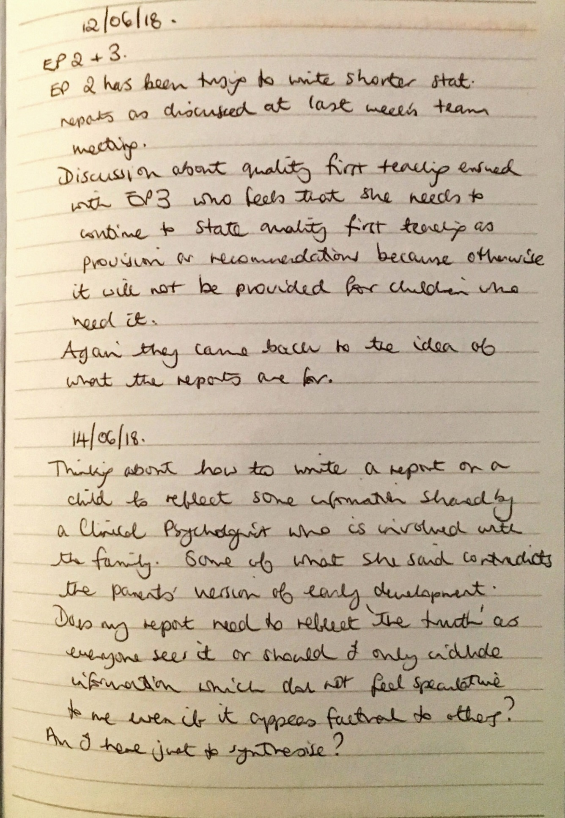
Appendix 4- Annotated transcript of the Journal Club.
Notes on Journal Club recording
Line | Speaker |  | Comments  D- Discourses  WD- wider discourses  RS- rhetorical strategies
1  2  3  4  5  6  7  8  9  10  11  12  13  14  15  16  17  18  19  20  21  22 | Stevie | It was interesting wasn’t it that I thought like you were saying that the person’s philosophy came through and if they hadn’t been someone who was I don’t know someone who was a researcher in philosophy or a (.) so for me it was a very different way of of so I think they took a very philosophical stance of quite a few things (.) particularly when they were talking about how you would view things like gifts, and giving. There’s two elements to a gift and it isn’t (.) I dunno ((inhales)) the way you write a report you know, it’s very philosophical but that’s interesting though because this person’s obviously thought quite a bit about things and about psychology and writing reports. I’d like to know how they got together thinking about this (.) were they just talking one day and “oh I can help you think about (.) report writing. I’ve come from this(.)”. It’s not the way I would have approached it. | D-EPs would need help- reports are difficult
23  24  25  26  27  28  29  30  31  32  33  34  35  36 | Val | No. It’s not what I expected either. The thing I found interesting was the talking about (.) labelling. And they were saying within their reports that they feel they’re always labelling (2) children um, which I don’t, I don’t’ feel that we do. They were actually talking terms like dyslexic and so forth and um (2) autism and so forth. I don’t feel that we really do label children like that (.) even, cos it was talking like they have to label for a purpose and you have to label a child so they can get an Education, Health and Care plan is what it seemed to be saying (2) but | D-diagnostic/ expert  resistance to this  RS- repetition ‘I don’t’
37  38  39  40  41  42  43 | Charlie | I highlighted quite a lot of those (.) bits (.) I don’t’ know, you recognise some of the tensions but not that, I don’t feel (.) like we have to say certain things for certain reasons. But that was really, like using a particular assessment for a particular purpose.. | D-resistance to being expert  D-tensions-internal force
44  45  46  47  48  49  50  51  52  53  54  55 | Val | We used to have but we don’t do exam ones any more, do we? Then you did have to, so I don’t think there’s anything around like that anymore so again I wondered whether it was historical or different where they were doing it. But then <in the same way>, although if you’re writing for an Education Health and Care Plan I’d be talking about sort of severity, and the frequency and the resources that are needed for the child not they’ve got this and therefore, so | RS- evidence of experience to give credibility to view.  D-providing judgement  RS- polysyndeton
56  57  58  59  60  61  62  63 | Charlie | It seemed, like, there was a big push to <describe need> rather than (2)a thing (.) and now people seem (.) seem quite on board with that. Although that, seems to be quite a push not to say that now a child can’t access Northcott outreach unless they’ve got a diagnosis of autism or they’re on the panel | D-child-centred, describing need  D-big push- external force
64 | Val | That’s true
65  66 | Charlie | so that does hark back to that. That resource thing. | WD- historical role of EP
67  68  69 | Cathy | Do you think there is that push around say an ‘SLD label’? Or around what’s this child’s primary category of need? | D-push- external force  expectation of expert
70  71  72  73  74  75  76  77  78  79  80 | Val | Don’t know that there even is necessarily. I think it does go, as you say, in terms of needs especially when I think of children who have gone >to certain provisions<. There have been times when children who say certainly haven’t got a (.) >I’m not sure I should say this< ((laughs)) an <SLD> (.) label (.) that have gone to a school that is for and provision <SLD children> so I don’t think that’s necessarily tied in, although, you know | D- key to resources  RS- recognising EP resistance to a shared wider language. Appealing to audience perspective  WD- medicalisation of learning difficulties, within child discourses
81  82  83  84 | Charlie | Yeah, some of the work I’ve done with the tribunal stuff (.) that is (.) they want to know (.) the judge will ask (.) “Is it (.) SLD or what is it?” | D-Expert judgement, evidence. Label.  RS- uses problematic language in judge’s voice. Uses experience to give credibility.
85  86  87  88  89  90  91 | Cathy | DO you have the same sort of worry broader than that though? So, they were worrying about (.) by using the labels that you were kind of limiting or closing down possibilities for children (.) by what you wrote in the report. Do we have that (.) do we share that kind of concern?
92  93  94  95  96  97  98  99 | Val | I’m side tracking (.) I agree with then that I don’t like the idea that this is it, and that is a statement of how this child is going to be forever sort of thing (2 um and I know that I used to put more often in reports that this child should be reviewed in whatever and it made me think that “I don’t really put that anymore” | D- Permanence  D-having to work differently now- change
100 | Pat | Cos we don’t review ‘em.
101  102  103  104  105  106  107  108  109 | Val | EXACTLY. Cos we’re not going int to see children very often so I don’t put this child should be reviewed cos you may never have another Ed Psych in the school. Yeah (.) so that made me think that in a way you’re making it more of a standalone (.) piece (.) and saying “This is set in stone” in a way just by inference because you’re not putting that. | WD- scarcity of EPs  D-Permanence is problematic
110  111 | Cathy | Something about a permanence? This is how this child will always be, or?
112  113  114  115  116  117 | Val | Well(.) you’re not saying that b-but not meaning to say that but yes I would have said review in a certain amount of time and now I’m not but that’s just because there’s a lack of us so know it’s not going to happen. | D- being made to say things by the way the report is written- constraining  WD- scarcity of EPs
118  119  120  121  122  123  124  125  126 | Charlie | I tend to use quite general terms like “this seems to suggest that or he’s likely to be this…”. But then (3) I don’t know is that (2) no-one’s ever said that’s not a good thing to do or schools have never questioned wanting a (.) judgement before but maybe that’s (.) It seem to me that maybe they’re seeking to make judgement statements all the time they wanna.. | RS- using tentative language in both speech and reports- suggests genuineness  D- expert judgement
127  128  129 | Val | I think parents sometimes want to. ((all laughing)). I’ve certainly had discussions with parents “So has he got dyslexia?” | D- parents need for diagnosis  WD- diagnosis for resources, need for parents not to be blamed for difficulties.  RS using parents voice to say diagnostic term.
130 | Charlie | “He’s got literacy difficulties” (laughs) | RS- uses EP shared language to create understanding. Laughs to show not correcting Val.
131  132  133  134 | Stevie | I liked the word, I did like we could have an economy of exchange, I did like it. I thought it was a good way of thinking about it. Circular in motion. So, you know
135  136 | Charlie | I’m not sure I understood fully ((others laughed)).
137  138 | Val | ((laughing)) I didn’t. It was too philosophical for me.
139  140  141  142  143  144  145  146  147  148  149  150 | Stevie | My understanding of it was it’s an economy, it’s not monetary, its’ about thinking about, it’s about when you’re writing a report, when you’re doing an assessment (.) there’s an exchange going on, it’s like you see a child, you talk to people, erm, you write, you know, you listen to them, you know there’s a consultation and then you (.) then write a report. That’s the economy and that’s the exchange. So exchange because of ideas, that’s my understanding of it | D- reports as an exchange, product. Part of a helpful process.  WD- report are expected to be written by EPs at the end of the process.  RS- Anaphora
151  152  153  154  155  156  157  158  159  160  161  162  163 | Cathy | So additional to that. So you’re giving, that’s what you’re giving in this report but then what do we get (.) as a profession for that. You know, we’re then being given (.) an identity. So (.) part of that is exchange is what you get back, so >obviously for traded you’re getting some money back< ((laughs)) but just generally for reports is that we get given (.) our status (.) we’re seen as the expert or the professional or the >font of all knowledge or whatever it  is< that there’s that exchange even though there might not be a monetary exchange. | D-reports provide status  D- purchase, monetary exchange  RS- polysyndeton. dragged out extra ‘or the’ suggests a weariness or resistance to those titles.
164  165  166  167  168  169  170  171  172  173  174  175  176  177  178  179  180  181  182  183  184  185  186  187  188  189  190  191  192  193  194  195  196  197  198  199  200  201  202  203  204  205  206  207  208  209  210  211  212  213  214 | Sam | Yeah, it’s funny actually it might be a good time to refer to, because I said I would have a go at trying to shorten reports. Might be easier to bring it all into here if that’s alright. So, I mean, I mean, I had a go at three or four advices since the last meeting, I was conscious of the, the issues of that. And you know like trying to (2) pressurise myself (.) a little bit to do them quickly or to do them in a shorter time. And I’ve just decided that it’s too difficult (.) it’s too stressful really. You know and I think that was Pat’s point um at the meeting and actually it’s quite good to have experimented on it, on myself and the point was the one you’ve just made (.) really it was hard to formulate without writing something for me. People might be different (.) people be able to think more abstractly and I needed to think in sequences, sentences so actually it was the reading and the analysing and the thinking time that’s tricky (.) but actually for me that’s all bound up with the writing. So and trying to do something that’s of reasonable quality so you don’t feel like you (.) you you (.) you’re compromising yourself or your professional (.) sort of effort really. So that was so that was so that I kind of came out of that (.) really. Shortening it was really, really hard unless the reports became quite formulaic (. ) and we were basically ticking boxes. Um, so, I think there is (.) um the other bit was was I’ve been trying to work on the (2) the the provision and the outcomes bit and I think there is some movement we could make on that and I’ve had a go at sort of em some sort of like blurb statements, you know, that we could put in in the current, current assessment, you know, you know a bit of blurb saying that our reports are NOT going to include these, these should be there already and then for each of the provision sections I put a little >“it is important to say that does not include what should be readily provided in schools, colleges or early years settings”<. So I’ve been trying really hard not to put in anything that would be element one or two, so it would be only element three. | D- reports are time-consuming  D- difficult, pressurise myself, stressful-internal or internalisation of external forces  D- formulation, thinking psychologically, enabling role  RS- polysyndeton- adding in ‘and the’ conveys the lengthiness of the process.  D- tricky, difficult  D- professionalism, role of presenting professional quality  D- formulaic, constrained professionally  D- reports as additional advice, over and above teaching  WD- unique contribution of educational psychology.  WD- standardised expectations of teachers best practice  D- educational expert  RS- shared educational language suggestive of credibility.
215  216  217  218  219  220  221  222  223  224 | Cathy | That kind of fits with what they touch on in the paper too about does that report takes the place of the psychologist? So if you put, so if you’re not there in the meeting (.) so this idea that perhaps you’ve got to put the totality of everything you know about that child and sometimes we seem to be taking responsibility for other professionals over that ((others saying ‘mmm’ and ‘yeah’). | D- taking responsibility for the work of others  WD- austerity, cuts in services, scarcity of all professionals.
225  226  227  228  229  230  231  232  234  235  236  237  238  239  240  241  242  243 | Sam | Yeah, yeah, yeah, absolutely. And the thing that got it for me there was just, just this I’m only putting things that are extra super special in that, in that provision section however (2) i-i-it’s also that the report has some sort of (2) purpose to it, isn’t it? It’s about trying to make things different, so (.) or you hope it is, >I mean it might not be true at all< but you hope that it’s making a difference. So it should be used to stress the importance of certain things, so if those certain things are element one or element two (2) right, well, as a psychologist you think but they are really, really important you want to put them in (.) you see what I mean? So it’s actually about so find (.) making that leap is actually quite difficult. | RS- hyperbole? Alliteration. additional words to stress importance.  D- providing something extra, making a difference.  WD- unique contribution-fear of only being useful for writing reports.  D- role of report in stressing importance, lasting authority  D- difficult
244  245  246  247  248 | Cathy | Is that more so because you can’t go back in, like say before when you were going back in more, do you think that’s more so because you are relying on the report to do the talking for you? | D- in place of the EP/ becomes the EP  RS- embedded assumption in the question
249 | Sam | Yeah (.) yeah
250  251  252 | Cathy | Rather than being able to go back in and say, “Well what about all those things you should be doing anyway?”
253  254  255  256  257  258  259  260  261  262  263 | Sam | Yeah. Unless unless we did it, unless we did allow ourselves the opportunity to put more ordinary things in but saying actually these are ordinary things but they are really, really important you’ve really got to do them otherwise there’s no point in doing the next bit. You know, so maybe that’s the way forward (.) but (.) it’s really hard just to do the element three things, that’s what I found, but I think it might be worth the effort | D- Reports as persuasive.  RS- repetition of really- showing persuasive role of reports  D- hard, difficult
264  265  266  267  268  269  270  271  272  273  274  275  276  277  278  279  280  281 | Alex | I tried to do one where I tried not to put Quality First Teaching in it (2) and I think for me, I’ve been in the environment and I saw that this that these things weren’t happening (others mmmm, yeah) you, you, I want to put them in because you know they’re not happening(.) and because I’m not going to be there that, that, that report is me in a way (.) it’s a replacement for me (2) then it’s quite, I do then think, you know if I only put short statements of only do this and this and this that (2) that that child’s never going to get what they need in that environment. Which then takes (.) then you start thinking about what’s this report for anyway? And is, is this a useful piece of work at the end of the day? ((lots of agreeing mumbles from others)) | D- being helpful to the child, advising teachers  RS- using shared educational language- gives credibility  D- report as replacement for EP  D- advocating for needs of the child.  RS- alliteration and repetition to emphasise how much is needed.  Use of absolute ‘never’ to be more persuasive (pathos).
282  283  284  285  286  287 | Charlie | But that’s why we’re doing it backwards, if you’d done that piece of work (.) much sooner, they would have had all that information about (.) all the stuff they should have been doing and a [really useful piece of work] | WD-scarcity of EPs  WD- powerless of EPs in traded context.
288  289  290  291  292  293  294  295  296  297  298  299  300  301  302 | Alex | [Yes and the traded reports you can really go to town on] and I’ve found I’ve had two or three recently where (.) the children have never, ever seen an EP, they’ve seen all sorts of other professionals, who’ve put all sorts of labels on them (.) never seen an EP and then had SENCos wanting to come in and talk about well (.) what did you see ? And making notes about Quality First Teaching and I did get the impression, certainly at XX school and XX school that they wanted an EP for free (.) as part of the EHC process. (2) which you’re n-, I wasn’t prepared for that because for me it’s (.) it’s a contribution to a plan | D- statutory reports as constrained  D- reports as a purchase  WD- marketisation of education, traded EP services.  D- contribution to the EHC process.
303 | Pat | But they saw it as something else
304  305 | Alex | Yeah, they did. Well they saw it as two things I think um (.) [they]
306  307 | Charlie | [Yeah because] that report isn’t useful for them (.)necessarily
308  309  310  311  312  313  314  315 | Alex | No. So the things that we discussed about things, some of the things that were happening in the classroom I thought hmm well >maybe that’s not the best way to go about it< they were jotting them all down. I’m not going to put that (.) so it’s like, that’s like an invisible piece of work that I’ve done | D- role of the report in making EP work visible.
316  317  318  319  320  321  322  323 | Charlie | Yeah, and that was the thing for me reading this and (.) my own thoughts was “Is that it? Is that all (.) that’s useful and helpful in what we do? Cos it isn’t, the psychology that we do in the moment, in the time we’re there is just as or even more important ((others- yeah)) than that. How do you distil that into a report? | D- reports as unable to capture psychology.  WD- unique contribution  RS- uses rhetorical questioning to create feeling of solidarity for the difficulty expressed.
324 | Alex | You can’t
325 | Charlie | You can’t for those purposes
326  327  328  329  330  331  332  333  334  335  336 | Alex | You can’t and for discussions with parents as well, especially when you have to start reframing things together, especially when you talk about ADHD and anxiety and and there’s a lot of work going on there actually which is psychology with parents, em, (2) can’t be captured in here ((holds up a piece of paper)). Could start waffling on about it in the background section (.) but is that not really the place for it? Cos that’s not really background is it? | D-psychology is more than the reports-can’t be ‘captured’ (see distil above)  RS- Dysphemism.word chosen to show devaluation of report.
337  338  339  340 | Charlie | And there’s things then that stay with that young person(.) potentially till they’re twenty five they might not want everyone to know about when they leave school | D- permanence  RS- creating sense of risk by using age. Rationalisation.  WD- changed concept of childhood for young people with SEND  D-Confidentiality, respect
341  342  343  344  345  346  347  348  349  350  351  352  353  354 | Cathy | That’s been a real dilemma before (.) that’s something we’ve spoken about before. Is how much, when you’ve gone and spoken to a young person, how much (.) do you then share afterwards? A-and likewise with parents when there’s been maybe >domestic violence or mental health issues at home< how much do they then appreciate is going to go into the report but a lot of what you’re writing ((inhales)) then makes sense because you know those things so if you don’t share those things then you can’t see why you’ve got to this (.) point in the report (2) [your thinking] | RS- shared experience, rapport  D- confidentiality, information sharing.  WD- systemic psychology  D- reports as formulation
355  356 | Charlie | [And you’ve used] those things to formulate your ideas (.) in the report
357  358  359  360  361 | Alex | But they don’t appear but that’s probably why you found it difficult Sam to shorten it because you’ve got all of those things, (.) the information and how to put it into a short form.
362  363  364 | Charlie | You could end up writing a novel about each child ((lots of uneasy laughter among the group)) | D- telling the child’s story  RS- Hyperbole.humour used to show understanding of difficulty
365  366  367  368  369  370  371  372  373  374  375  376  377  378  379  380  381  382  383  384  385  386  387  388  389  390  391  392  393  394  395  396  397  398  399  400  401  402  403  404  405  406  407  408 | Sam | It was, it was interesting cos I was able to reflect on this a bit more because I saw a young person who Charlie saw last year and emm he’s probably not going to get plan which is an interesting side of this one as well, I think the panel will say ‘no’ which is fine but emm Jack, he was really good and he was able to talk (.) eh you know really precisely and interestingly about all the different subjects and all the things he liked to do and what helps him and what doesn’t help him. And I felt, I thought well I have a duty to put that in, I can’t leave that out, why would you leave that out? But it takes me time to do all that, you know, you’ve got to write out haven’t you. You know but it’s not fair to him to leave that out, because actually that’s quite important in saying “Look he’s doing really well”, you know he’s got some needs but he’s doing really, really well. And then the other thing then was about the recommendations that Charlie made, you know so, so you made loads of really good recommendations, so actually what I’m going to do in the provision section, let me find an example, (2) so I did make some recommendations and afterwards I put >see EP report dated, for other useful recommendations blah, blah, blah and I put that in every section. Not SEMH because he doesn’t have any SEMH needs<. If they want anymore information they can just go to your report (.) it’s still relevant [Charlie emphatic ‘Yeah’]. So, I, so I got a bit hard line in the end with this in that sense (.) but then on the other hand I was soft line in the needs bit because I felt as though I wanted to describe, I wanted to tell his story a little bit. I don’t know whether it was the right or the wrong thing to do but i-i-it’s maybe every child is different and you can’t actually have a blanket policy for all, for every child, I don’t know | D- report as gaining resources, enabling others to make decisions  D- providing information, duty to child.  WD- children not having a direct voice or say over what they need- powerless, need for advocacy from adults  D- time-consuming  WD- EPS are limited resource  RS- rhetorical question  D- providing balanced view  D- telling the story of the child.  D-Being just.  D- formulaic  RS- blanket and all- unnecessary semantically but emphasises the point.
409  410  411  412  413  414  415  416  417  418  419 | Charlie | Maybe some of that comes back to our (.) unique contribution in terms of being able to make a professional judgement about (.) what is important to put in reports and (.) feeling that sometimes that duty, that may not be the right word, to reframe things and privilege the child’s voice or the parents voice and include things in reports that other professionals might not necessarily. To give that different perspective [others: mmmm] | D- providing balanced perspective, duty, professional judgement.  RS- repetition-uses Sam’s word to show acknowledgement but move on to new point.  D- reframing, psychological  WD- EP unique contribution
420  421  422  423  424  425  426  427  428  429  430  431  432  433 | Ashley | This is as well what it talks about here isn’t it? about being free (.) in your report writing which was quite interesting because then, em what you were saying before it actually, if we’re providing what the schools want, they see us as experts and therefore we, they perpetuate that role whereas if we do something they’re not then do they still see us in that same way? And are we ((inhales)) given that same kind of status, if you like and there’s that real (.) push-pull where if we were completely free and did what we liked, would it be seen in the same way? | D- constraining  D- reports as giving status, seen as expert  RS- push-pull to show force.  Repetition of free and completely free- emotive to create feeling of compassion for difficulty
434  435 | Cathy | It’s back to that economy of exchange again
436  437  438  439  440  441  442  443  444  445  446  447  448  449  450  451  452  453  454  455  456  457 | Ashley | Yeah, the economy of exchange (.) and also interestingly I had an email from, I did a piece of em looked after work, em, written a report so it’s not a statutory assessment but the foster carer was asking, em, when the report was going to be ready because the young person’s really eager to read it [lots of surprised thoughtful noises form the team]. Which made me suddenly think “Oh, I’d best go back and read it” because actually it them put a completely different ((laughing)) perspective on it because actually I was writing it because it had been commissioned by the virtual school for a particular reason (.) but obviously I still had to see the young child and write a report but yeah (.) it’s, it was at the point of going out but I was glad that I knew that because actually now I’ve gone back and thought, (.) read it ((inhales, exhales)) and thought “Do I need to change any of it?” | D- the child’s story but not their report.  D- written for different purposes, supporting the work of other services.  D- respectful
458  459 | Cathy | Do you get that idea that the report’s almost the child? Almost becomes like this
460  461  462  463  464  465  466  467  468  469  470  471  472 | Stevie | Yeah that’s what I picked up. All our identities are constructed (.) socially through report writing and (.) it’s not just the child but it’s also us as well and that’s when we become the expert. But I still (.) like the idea, all the, all the, my understanding is that all the ruminating that you’ve just done, would be what they would say at the end is about moving away from what they being very formulaic, >although I think statutory assessments are<, they use that CLEAR model which I think | D- report constructing identities  D- time-consuming, difficult  RS- emotive word
473 | Charlie | I don’t like it.
474  475  476  477  478  479  480  481  482  483  484  485  486  487  488  489  490  491  492  493  494  495  496  497  498 | Stevie | No, but I think if you want to be formulaic you would write a report using that structure and they’re saying if you start, even just start thinking about well what should I put in, what shouldn’t I put in in a report that’s’ where they are saying you are being just erm, and that was the philosophical bit that I was picking up at the end about your decision making, you’ve been just, and they use a distinction between law and just which I was ((laughing)) still trying to get my head around. But erm, I think, even if you have the same standard format i.e. it’s an EHC plan that we’re writing, the very fact that you thought ((inhales)) “Well shall I talk a lot about needs or I might leave” that that’s where you know I should put that in and all about referring to Charlie’s recommendations or not, you’ve then come at it, I-I-I would say in a just way and they would then say, it’s, you’ve had small openings in the economy of exchange. I would argue what you’ve done is a small opening | D- reports as just act, role of reports as a just document.  D- just  D-just, professional judgement  RS- questions self- shows being thoughtful. Showing recognition and empathy for Sam’s dilemma.
499  500 | Sam | What does that mean LS? I’m not quite sure what it means.
501  502  503  504  505  506  507  508  509  510  511  512  513  514  515  516 | Stevie | I think this is what, ((Quotes)) “the moment a psychologist is called to assess and support a child, a series of relations start to be established etc. etc. which cumulates in the production of a report. We want to think of this as an economy of exchange”. So that’s basically doing a visit, seeing everybody , writing a report. And then they’re saying, there’s some bits I don’t understand but that ((quotes)) “identities are established and enacted though the relationality impacted by the economy of exchange”. My understanding of that is (.) is it’s about relationships, yeah yeah in the moment [others agree]. So, then I thought, (.) could a report be relational too? | D- report as relational
517 | Pat | ((Laughs)). Possibly, possibly
518  519  520  521  522  523  524  525  526  527  528  529  530  531  532  533  534  535  536  537  538  539 | Stevie | How could you make a report? That’s easy to see, isn’t it? We all say (.) a good EP is someone who has good relationships with schools, it’s not necessarily (.) the end product is it, writing something, it’s about how (.) >we are in that moment, how we are with people, how we model all that< and I think then the report we’ve always seen as the end product, but but and it is I suppose, it’s the last bit of a process but in itself could it be relational? Em, I-I don’t know but I think we are charged aren’t we? with writing a statutory assessment and (.) I think the way you have gone about thinking (Sam) about that statutory assessment can it, you’ve said it’s hard it becomes formulaic if you just make it too short, you’ve thought, you’ve been just when you were thinking about writing that report and that is what they would say is a small opening in the economy of exchange. I, that’s my interpretation | D- report as relational  RS- anaphora- of how we- shows the doing of psychology.  D- statutory duty  D-hard, formulaic  D-just
540  541  542  543 | Cathy | So, it becomes more like a gift. They talk about the impossibility of a real gift cos there’s always an expectation even if it’s just a thank you or whatever
544 | Sam | So, the opening is a good thing
545  546 | Stevie | You’re not just sitting there like a robot churning it out, changing the name | D-more than writing, psychological  RS- devaluing language
547 | Sam | I get something back in return | D-exchange
548  549 | Ashley | That’s what we should be looking for when we write reports
550  551  552  553  554 | Cathy | Cos we could just go “Oh I’m the expert I’m going to say this” and that would be accepted (.) you get your status, they get their report. Done. But you’re looking for something more within that | D- exchange  D- just act
555 | Sam | Yup. I see.
556  557  558  559  560  561  562  563  564  565  566  567  568 | Stevie | But it was interesting about gifts and people who like to give gifts cos I thought about my sister, and she loves giving gifts but I was thinking what does she get out of it and it isn’t just giving a gift and there was that tribe or society where, three obligations about giving a gift, that’s it yeah, erm, not only do you give a gift but you’ve got to then receive a gift so you can’t go “Oh no no please”. There’s an obligation you’ve got to give gifts, then receive gifts don’t you know and then something about debt….
569  570 | Cathy | Then you’re in debt for a period of time so it’s something about social bonding
571  572  573 | Stevie | Yes yes. So could we see our report writing in that way? are we socially bonding with other people? | D- social bonding- relational
574  575  576 | Cathy | We do use the words ‘being helpful’ a lot. Is this helpful? ((laughing)) Don’t we? Whether we feel it | D- helpful
577 | Charlie | Yeah we do. We want to be helpful.
578  579  580  581  582  583  584  585 | Stevie | Making a difference, people say they want to make a difference yeah. So, we, I do think report writing is like that we, it is our gift but then ((inhales)) if you do take that analogy, the SEN team have got to want to accept our gift, haven’t they? You have to receive gifts, you can’t, it’s an obligation for them to receive them | D- making a difference  D- a gift
586  587  588 | Pat | They’re happy to receive them but what they want is a laundry list and that’s back to that PEP thing | D-devalued, not psychological
589  590 | Charlie | Yeah they’re not in debt, they’re not in debt to us | RS- anaphora?
591 | Pat | No exactly
592  593 | Cathy | But that’s legal isn’t it. It’s about that legal talk again rather than the just idea | D-legal document  WD- EP practice constrained by current policy
594  595 | Pat and Charlie | Yeah
596  597  598 | Cathy | It’s back to that, isn’t it, what do you need by the Code of Practice. What’s the legal requirement? That’s’ what we want | D-legal document  D-enabling the work of others
599  600  601  602  603  604 | Pat | They’re not interested in any of the other stuff that we might they just want a laundry list. The process we go through, the angst and the upset they’re not interested in are they? All they see is the list- was it on time and was it helpful? | D- difficult and meaningless work  RS- them and us creates solidarity- we want psychology, they want lists.  RS- emotive words  D-enabling the work of others. Part of a process.
605  606  607  608  609 | Ashley | It would be interesting to ask them, wouldn’t it? If they say, “Oh thanks for that report” we could say, “Did you get a real sense of that child?” Wouldn’t that be really interesting | D- giving a sense of the child
610 | Cathy | Yeah
611  612  613  614  615  616  617  618 | Charlie | But I don’t get..I think they remove themselves from the child in that process (Pat mmm). That’s not a child it’s a name on a list and they have to produce a plan and it’s irrelevant what they’re needs are what the provision is. And now they don’t have to do the meetings either they’re completely removed from the family. | D- connecting others to child  D- report as the child  RS- them and us- they are removed from child, we are not. Maybe more painful because earlier talked about not seeing children. Also feeling removed.  D-connecting others to the child  RS- repetition for emphasis.
619 | Ashley | Doesn’t matter does it?
620 | Charlie | …removed from the family
621 | Cathy | So does that report just become the child?
622 | Charlie | I think
623 | Cathy | Or just become us? Or…?
624  625  626  627 | Pat | Well it’s, the report is the product. That’s the problem it’s not about, i-i-it’s just it that enables them to produce something that’s (.) fairly meaningless but | D- report as product  D- meaningless, part of something meaningless  RS- devaluing language
628  629  630  631  632 | Charlie | Yeah! And I think doing moderating (.) regularly you see that, especially for the resource allocation bit, people are mostly reading the EP reports, they’re not even reading the plans | RS- Normalisation-using experience to give credibility to argument.  D- report as helpful for moderating decisions.
633 | Stevie | Are they not? Even professionals aren’t?
634  635  636 | Charlie | Hardly ever. The EP report is the most helpful piece of anything to do with that child in that em set of documents. | D-helpful
637  638  639  640 | Cathy | How does that make you feel about writing your reports knowing that? ((Everyone bursts out laughing)) Does that make you feel more (.) pressured? | D- pressured- force
641  642  643  644  645 | Charlie | Maybe, I think because, it’s that sense of the child, you get a sense of the child, most of the time through what we write and it’s because we take the time to consider it, like Sam described (2) The child’s voice. | D- sense of the child  D- considered, formulation  D- child’s voice
646 | Ashley | That’s why we’re doing the job | D- to give sense of child, child’s voice
647  648  649  650  651  652  653 | Charlie | So other professionals, maybe they are (.) other professionals round that table can read them and know what they’re thinking about. This is a (.) this type of child who has this type of needs and I can see them in the classroom, I can see what provision they’re going to need, erm, but.. | D- enable others to think.  D- give sense of the child  RS- repetition of ‘this type of’ suggest providing clarity, structure.
654  655  656 | Stevie | You see I don’t, I’d say our reports, cos I’d say our thinking is more balanced. Cos when I read some SENCos, you know, | D- place to think-confusion between reports and thinking
657 | Charlie | Yup
658  659  660  661  662  663  664  665  666  667 | Stevie | …submissions, it’s just like, it’s just like a rant, ((laughter)) it’s either a rant against the child or the person comes across as a bit unhinged, you know and go on, they seem to have taken quite personally, you know and why is this child doing it? You know, you get the sense that they’ve never come across it before and it’s all quite done in very emotive language, and you’re just like erm
668 | Charlie | And there’s never any strengths
669 | Stevie | No, Never
670 | Alex | It’s all very negative
671  672  673  674  675 | Charlie | They use that strengths box to write a narrative of difficulties ((wry laughter from group)) just jumbled up and then they separate them into the sections at the bottom
676  677 | Alex | They might start with “is a friendly child” and then
678 | Charlie | If you’re lucky
679 | Alex | If you’re lucky ((laughter)) BUT..
680  681  682  683 | Charlie | So, then you can see why we’re being asked to include more strengths because nobody else (.) seems capable of seeing them or(.) framing them in a <useful way>. | D- reports as providing strength or balance  D-reframing child.  RS- extreme case formulation-absolute word for emphasis. Them versus us.  D- useful
684  685  686  687  688  689  690  691  692  693  694  695  696 | Stevie | But yet at tribunal there’s no talk about strengths (.) ever. They, we only go to tribunal on needs, provision and naming of the school, not even outcomes, you can write rubbish outcomes and they don’t have to have met their outcomes (.) at tribunal, you won’t be taken to task for that it’s only about the provision, the naming of the school which is ‘i’ and the needs. So strengths, although our Ofsted inspector said you know they should be in plans, actually the judges and tribunals won’t say, “Where’s your strengths on this child?” | D-report as evidence, protection (taken to task)  RS- experience and specialist vocabulary used to demonstrate credibility for argument.  WD- power of Ofsted  WD- power of tribunals, makes much of what is in the report ‘rubbish’
697  698 | Alex | So, the expectations of a plan don’t all match up do they?
699  700  701  702 | Charlie | Well again it’s the why are we doing it? Are we doing it for the judge and the tribunal? Or are we doing it >for the child or the parent or SEN or us or..<? | D- reports for legal reasons  D- difficult to know who it is written for.  RS- polysyndeton-additional ‘or’ to show endless nature of the list
703  704 | Stevie | If we’re giving a gift then it’s not, it’s not, it’s not even for us
705  706  707  708 | Cathy | Well that would be really hard to know, wouldn’t it if you were just told to go and (.) buy a gift and you don’t even know who you are buying it for?
709  710  711 | Charlie | Oooh it would be difficult wouldn’t it… gift voucher, amazon voucher ((laughter from team))
712 | Pat | How formulaic ((Laughter))
713  714  715  716  717  718  719  720  721  722  723  724  725  726  727  728  729  730  731  732  733 | Stevie | Going back to my sister, she loves giving gifts because of how that person, she really goes to town, she really likes to make people happy, but it also makes her feel good about herself and I wonder, you know, I think we have something in that (.) if we’re going to see report writing as a gift, it’s not just about making the SEN team, the parents happy, the, you know, the child happy, it’s about making us, happy not in the ((Val and Pat start laughing at this word)) I would say our professional identity, obviously our skills and knowledge that’s that’s that’s when I would say ‘happy’, that’s how I would phrase it because ((inhales)) otherwise why would people spend, I go over and over a report, I read it quite a few times, I put new stuff in, I take stuff out, I want to make sure it reads well and it captures that child that’s what I mean by making us happy. | D- make EPs unhappy  D- professional satisfaction.
734 | Val | Yeah, ok
735  736  737 | Cathy | You want to feel like you’ve done a good job for that child ((mutterings of yeah from different people)) | D- advocate for the child
738  739  740  741  742  743  744  745  746  747  748  749  750  751  752  753  754  755  756  757  758  759  760  761  762 | Sam | There’s another thing I’ve just been thinking about while we’ve been talking about that is our own kind of (.) drive or purpose. So, with Jack there was an element there, just reflecting I was thinking the word that was coming to mind was ‘little bit cross’ or phrase actually that ‘I was a little bit cross’, like talking to Charlie about the situation and Charlie asked that question well why has it come to an assessment? And I was thinking, reflecting on that and what Jack was saying about his situation and I started to feel a bit cross (.) you know, actually he’s doing fine, he’s doing great, let’s just talk about how good he is, you know ((mmm, mutterings of agreement from others)) rather than talking about how rubbish he is which he isn’t. So, so there’s a bit of a moral thing there, isn’t there? School saying one thing is really bad, us saying it’s really good (2) so there’s a slightly different stuff (.) thing going on. Sorry I’m not speaking about it very academically, but anyway that’s how I felt when I was writing about it. | RS-using vocabulary of forces.  RS- understatement-tempered emotive language to remain professional, in control but repeated to emphasise.  D-place for reflection, thinking  D- makes EP unhappy  D- moral, balancing out other views.  RS- question seeking empathy.  WD- pathologisation of needs
763  764  765  766  767  768 | Cathy | There’s something about that from some of the EPs that respond, wasn’t there about erm that consistency. One EP in the study felt it was really important to iron out inconsistencies and another one said ((Val oh yes, yah, yah)) completely the opposite
769  770  771  772  773  774 | Sam | I mean you’d have to be the judge, if you read it to see whether my ‘little bit crossness’ came across ((laughter from all)) but I-I-I don’t think it did probably but that’s what I felt when I was writing it. Why did Jack, why do the Jacks need a plan? | D-should not show emotions- professionalism  WD-being emotional suggests lack of rational thought  D-protection of, advocacy for children  RS-understatement andrepetition of pattern of language to broaden argument, emphasise. Rhetorical question.  WD- pathologisation of needs
775  776  777  778  779  780  781  782  783  784  785  786  787  788  789  790  791  792  793  794  795 | Ashley | I took that kind of to mean two different things as well because the inconsistencies, that word ‘harmonise’ was really interesting, wasn’t it? Because I wondered whether it was about that if actually we feel like when we’ve got a load of negatives whether actually we need to present strengths as well to balance that out, but I also thought that it meant that actually if you’re an EP doing an assessment which came out with inconsistencies ((inhales)) that you felt a real responsibility to almost solve (2) what was happening and that actually by the end of the report you needed to have ironed out those inconsistencies and actually isn’t it ok to say that there are inconsistencies? ((Pat mumbling in agreement throughout this)) and this is how we leave it and this is how it is but actually when you’re writing a report it feels really hard to do that | D- providing balance  D- providing solutions  RS- rhetorical question to show compassion for shared difficulty  D- hard
796  797 | Pat | You want to gift wrap it ((lots of chatter in agreement))
798 | Ashley | That this is what it is
799  800  801  802  803  804  805  806  807  808  809  810 | Val | But then you’re saying it’s set in time and that’s it and it’s all sorted, which it isn’t, so that’s why, yah I didn’t get the idea of harmonising really, that sometimes there are inconsistencies and it’s interesting when sometimes you’ve seen a child, I think it said about that too, you’ve seen a child and then you see them again and how things evolve over time. So then you, “aah that would make sense given how it was before” but it needs time to see how things are totally going to play out | D- permanence
811  812 | Ashley to Cathy | Made me think of your case last week when I was reading that
813  814  815 | Cathy | ((Laughs)) yeah, what’s going on? Do I need to go back and do more or yeah this is it? That’s as far as I got | D- solution for others
816  817  818  819  820  821  822 | Pat | But the way we’re writing them now they can only ever be a small snapshot can’t they? ((others mmm)). They cannot encompass (3) to go cold to someone you’ve never met before for three hours max, pick up as much information as you can, it is a snapshot. | WD- difficult current policy. Better in the past.  RS-alliteration to emphasise lack of information, difficulty  RS- absolute to emphasise lack of relationship and time.  D- lack of time, not knowing children.
823 | Charlie | ((laughing)) Yeah it is. | RS- laughter to release tension of difficult point
824  825  826  827 | Cathy | Do you think that fits with the idea that you’re actually just doing that to write the report (.) for this type of work that we’re doing? For statutory (.) work | D- report as replacing psychology
828  829  830  831  832  833  834  835  836  837  838  839  840  841 | Pat | We shouldn’t be, it feels like we’ve bolted the door after the horse has gone because we haven’t had prior involvement ((knocks on table twice))((lots of ‘yeahs’ in the room)). If we’d had prior involvement you would see how it had evolved and this and what you would be writing then was the summation of everything that you’d gathered, but as it is you just, you know. (.) I don’t even know the outcome, of the, so I write reports but I don’t know whether they get an EHC plan it’s like chucking it down a blind alley, it’s, (.) you didn’t see them before (.) you won’t see them again. | D- not knowing children, lack of time  WD- scarcity of EPs  RS- metaphorical type language  RS-dysphemism- emotive, devaluing language.  RS- anaphora-repetitive pattern for emphasis of lack of relationship.
842 | Cathy | Hmm What happened?
843 | Pat | Yeah no idea
844 | Cathy | What was that report-
845 | Pat and Cathy | For?
846 | Pat | What did it achieve? Did it? Don’t know | RS-asyndeton
847  848  849  850  851  852 | Charlie | And if the point of a statutory assessment is (.) <the most complex (.) children with the most significant needs> you should be able to (.) have some quite detailed (.) good (.) assessment (.) information and it’s not- | RS- using quotation from legal documentation- suggests decision is elsewhere.  RS- anaphora- repetition of superlative to emphasise need.  D- providing good information  WD-EP work decided by SEND policy
853 | Pat | Sometimes it’s nothing
854 | Charlie | No
855  856  857  858 | Pat | You get ((gestures small amount between thumb and finger)) you print off what there is and there’s absolutely nothing ((lots of agreement))
859  860  861  862  863  864  865  866  867  868 | Stevie | I think you’re right, I think there’s, the SEND reforms have transformed (.) us as EPs through the amount of statutory assessments and the way that we are having to work i.e. we might never have seen the child before, we’re never going to see them again, we don’t know what happens and I think we are being transformed by that economy of exchange but <not in a good (.) way> | D- professional identity transformed by SEND policy  WD- pressure from the SEND system
869  870  871  872  873  874  875  876  877  878  879  880  881  882  883 | Pat | If you’ve never s-, actually today was a good example, I could have probed a lot more (.) about his feelings about all the men in his life who’ve disappeared but the one thing you don’t do is rip off someone’s façade if you can’t repair it and the fact ((Yeah, Yeah from others)) that I would go away (.) never see this boy again meant that I’m not going to ask those questions ((others muttering in agreement)) cos that’s just not, that’s not fair on that kid, not fair to me or anybody else (.) so I didn’t do it. Wasn’t that I didn’t think somebody needed to do it but I just thought well it’s not going to be me cos I’ve got no follow up time
884  885 | Cathy | Yeah, yeah confront him with all that and then go
886  887  888 | Pat | Yeah, Bye! ((lots of laughter, byes and nos from others)). Exactly. I do think I can’t ask those questions
889  890  891  892  893  894  895 | Cathy | But I suppose then what you’ve got there is enough to then put there in a report and say this now needs to be done, this is a piece of work that’s out there that sits there it’s not just a conversation you have with someone it’s (.) on a piece of paper that’s a record of that ((Pat mm)) | D- report replaces the psychology  D- record
896  897 | Charlie | The report then is more important than his psychological wellbeing | D- instead of psychological work
898  899  900  901 | Pat | And therein lies you problem. What is the priority? To get an actual capture, of the kid? Or to produce something that SEN can ((makes noise))? | D-capture child  D-enabling work of SEN team  RS-noise to suggest devalued.
902  903  904  905  906  907  908  909  910  911  912  913  914  915  916  917  918  919  920  921  922  923  924  925  926  927  928  929  930 | Stevie | This model allows for that though, that’s the nice thing about it I think because that other formulaic CLEAR thing was just talking about the report, the structure of the report writing whereas this is me is talking about the whole structure of (.) being an EP from the visit so the report just sits at the end, kind of thing, and erm you’ve got the assessment, you’ve got the economy of exchange and the report is part of that. So, if you had a box that said economy of exchange you’d have all the different elements in it and it er and all the judgements that you’ve come and thinking about which seems to be different every time you write a rep-, write a child’s, write a report. That’s the bit I liked about it, it was saying, you know, you’re constructed through (.) this assessment, through writing reports, but that’s ok and sometimes your judgement will lead you to do one kind of report in one kinda way and in another way, you know and that’s all (.) and sometimes I think we think “Am I going a bit mad?” you know, I’m not doing it the same as last week or I don’t wanna do that I just wanna do it like this. But actually, this way of thinking about it lets you approach it in that manner | D- report not the psychology, end product  D- giving EP identity  D- difficulty, resistance to constraints
931  932  933  934  935  936  937  938  939  940  941  942  943  944  945 | Pat | If you had the time. Most of us write them in a particular way because we know if they go to statutory they’re more useful to us ((Hmmm from others)). So yeah, in an ideal world you would create each report on the basis of your interaction and exchange, wouldn’t you? The report, the layout, everything would be different about it, but at the moment, it seems to me if I go out and do something traded and I think it will go to statutory I write it with those four headings because it’s easier [Val yep] it will save me time. I’m not saying, I understand this, but at the end of the day ((blows out heavily)) Wh-what? | D- time constraints  WD- scarcity of EPs, constrained by statutory system  D- reports based on the psychology  D- formulaic  WD- hope for change in the future, current system not working and will have to change.  D- time-consuming, administrative
946 | Val | I agree
947  948  949  950  951  952  953  954  955 | Ashley | But it says here as well that I’ve just noticed, about the (2) sometimes having that difficulty about making that judgement is in itself (3) a good thing [Pat of course] cos that’s the psychologist behind it, isn’t it? And says here about, actually couldn’t we find ways of including that in our reports? [Pat bursts out laughing, Val Hmmm] | D- psychologist behind the report
956  957 | Pat | Not if we want to make them shorter ((laughing)) ((lots of laughter from others))
958 | Charlie | Who cares though?
959  960  961 | Ashley | It says actually, about ways how to acknowledge the difficult decisions and judgements in the report itself [Cathy yeah] | D- unable to show/ share how difficult they are for EPs
962  963  964  965  969 | Pat | Well that would be fantastic, in an ideal world that is what you would do, the process that you went through, the three hours you sat and the angst that you went through for it | D- time and angst creating, painful process.  RS-repeated ‘bookends’ to emphasis personal experience/ sacrifice (‘for it’)
970 | Stevie | Yeah would be in you report
971  972  973 | Pat | Would be in your report but by the time it’s got to 25 pages ((loud laughter from all)) and, and | RS- hyperbole-humour used to create empathy and solidarity for the painful process.
974  975  976  977 | Sam | I don’t do them that long Pat, if I’m honest, I’ve never written a 25 page report [Pat No,no] ((laughing)) and I don’t think I ever will.
978  979  980 | Pat | But if you put in all your feelings about what you thought about if all that was written.. it could look massive [Sam yeah] | D- no time to be psychological
981  982 | Cathy | And would that uncertainty unnerve other people? | D- others need certainty  WD- in wider SEN team about EPs being reliable
983 | Pat | Oh probably
984  985  986  987 | Charlie | I don’t know if I want people to know that I sat for three days staring at a blank screen (laughter from others)). “I could not make head nor tail of this child” | D- resisting being an expert elsewhere but at the same wanting to be seen as an expert.
988 | Pat | Ah so you want them to think-
989 | Charlie | Maybe I want to look-
990 | Pat | I swanned in and I.. | D- hiding difficulty
991  992  993  994  995  996  997  998  999  1000  1001  1002  1003  1004  1005  1006  1007  1008  1009  1010  1011  1012  1013  1014  1015  1016  1017  1018  1019  1020  1021  1022  1023  1024  1025  1026 | Stevie | But you could say, “I didn’t put any of the child’s early development because…” and then you could say or “I spent a long time weighing this up but it’s it’s it’s so far, long ago and that child no longer has those same difficulties or faces the same adversities that erm I’ve left it out”. That’s what you could write you don’t even have to write about early development or, ((inhales)) I was thinking if you were making the report more relational you wouldn’t focus necessarily on the, the the needs in the same way. You might have four sections but say in cognition and learning you might talk about how that impacts on the relationship so if a child had severe learning difficulties you would talk about how that would then make, erm, you know family life more difficult, you know, is mum reli-, you know asking lots of questions and it would be about supervision and you’d say stuff like that. You know, they’re more concerned about his or her life long aspirations and you know and that he has to go to certain clubs or whatever, so you would, you would draw it more out into how it’s affecting the relationships and the way people, and the meanings they have about that. I think you would tackle it that way so you could still talk about the needs but you would focus on, on a, on a different way of presenting the information I think. [Sam yeah, yeah]. Rather than a very standardised way that this child has got severe learning difficulties | D- more psychological, relational.  D- using expert type shorthand label here despite resistance to this previously  D- relational, meanings shared through report.  RS- making the contrast by using rejected shared language.
1027  1028  1029  1030  1031  1032  1033  1034  1035  1036  1037 | Sam | Yeah definitely, there’s a difference there between a five year old, you write a report about a five year old and exactly what you’ve just said and Jack who’s 13, 14, whatever, you know thinking ahead, thinking about his transition to adulthood, you know and then the little five year old who’s trying to get it, the early development is more immediate so, I suppose isn’t it? So, it would vary wouldn’t it? yeah..
1038  1039  1040  1041  1042 | Pat | It’s how you convey the child is more than the outcomes? And more than the interventions? School life is not about (2) an outcome and 15 interventions. That’s not what it’s about | RS- anaphora-repetition to emphasise point.  D-to convey the sense of the child
1043  1044  1045 | Stevie | But then they have that dilemma didn’t they? If we don’t do it like that then they don’t get the resources | RS- contingency shows EPs feeling of responsibility.  D-gateway to resources.
1046  1047 | Pat | Exactly that’s the dilemma ((lots of agreeing noises from others))
1048  1049  1050  1051  1052  1053  1054  1055  1056  1057 | Stevie | You know, yeah it is a dilemma and I don’t think this paper answers it, er, and I still think, you know, we still feel, I think it’s a dilemma, you know I think should I talk about strengths because actually that’s really nice to read but, erm, takes up more of my time, um and it’s not what gets a plan so (.) and if they don’t get a plan is that, you know, a bad thing? So I tend not to …. | D- time-consuming  D- gateway to resources
1058  1059  1060 | Charlie | Yeah, or and then is it your fault that they didn’t get a plan? ((wry laughing in recognition of this from others))
1061 | Pat | Well that’s exactly it isn’t it?
1062 | Stevie | Well it is if they rely on our reports so much | D-relied upon
1063 | Pat | But is it your fault if they didn’t get a plan?
1064  1065  1066  1067  1068  1069  1070  1071  1072 | Stevie | Well it’s not a gift to them, I wouldn’t mind if they thought, you know, if they really appreciated our professionalism ((laughs)) or the hard work that goes into doing it. It’s not so they can cut and paste(.) big chunks and, you know, it’s done, makes their job easy. Which is ok, I’m not having a go but it’s not done as somebody who, like an equal thing. It doesn’t feel equal to me. | D- appreciated as a professional  D- making other people’s jobs easy- devalued.  RS- dysphemism  RS- showing some understanding for difficulty of others.  WD- whole SEND system stretched.
1073  1074  1075  1076  1077  1078  1079  1080  1081  1082  1083  1084  1085  1086  1087  1088 | Sam | I’m just wondering as well how um, erm, th-the discussion would go if we were talking instead of about advice reports if we were talking about consultation summaries so if we’re doing consultation with parents, whatever it was, you know, quite a positive kind of discussion, that was the main purpose and you’re writing it up as a summary and that would be, that could be, our kind of feelings about that thoughts about that might be different than, kind of, our thoughts and feelings about writing statutory advice reports or the traded work as well. You know, that we might actually be thinking different things about the purpose or the gift of that
1089  1090 | Cathy | And there is a real monetary economy there
1091  1092  1093  1094 | Sam | The consultation is a good example because you’re trying to you know, promote a good understanding of what can change, you know, so potentially
1095  1096  1097  1098  1099  1100  1101  1102  1103  1104  1105  1106  1107  1108  1109  1110  1111  1112  1113  1114 | Stevie | (to Cathy) Your xxx’s (Jamie) got an interesting thing about, the whole thing about Jamie about assessment and report writing because he will ((inhales)) he doesn’t write it for the, helping people write a plan, he’ll very much sit in the moment and talk about, you know, when he’s with a child or young person, it’s kind of very much led by, he feels very much in the present, and it he just goes with what’s presented with him and then obviously he’s using his skills as a psychologist but ((inhales)) then I could imagine his reports don’t have necessarily that structure that you could recognise in ours’. Because if they don’t talk about (.) cognition and learning, that won’t be in the report and the professionals that are writing a plan will have to look somewhere else, you know, for that | D-psychological, not constrained  D-not about being helpful, others doing their work/ part in process.
1115  1116  1117  1118  1119  1120 | Pat | But none of this would have occurred, would it, if we’d stuck with person-centred planning [others-yeah] we’d have written a report that captured the child and the outcomes should have come from the meeting which was always the intention | D- captures the child  D- part of the EHC process
1121  1122  1123  1124  1125  1126  1127  1128  1129  1130  1131  1132  1133  1134  1135  1136  1137  1138  1139  1140  1141  1142  1143  1144  1145  1146  1147  1148 | Stevie | And I’m not that sympathetic, cos what’s in front of him, at that moment is what’s important [Pat loudly-yes yes] and if that’s striking him as the most important thing [Pat exactly] that’s; the thing he focuses on and he privileges that, he pays a lot of attention to that, I don’t know if it’s obvious, cos he, you know, I haven’t seen him work, but it might not be as obvious to other people. That’s what he will write about [Pat hm,mm] and yet, erm, like you say, if you went with that to a meeting then you would perhaps have outcomes for that and that might be what, that’s what this was whole supposed to be about, wasn’t it? But I struggle, like the other day I’m writing a report on a child and there’s no cognition and learning apart from that he doesn’t engage with learning, there’s no cognitive issues, he’s just not working at the level he should be because he’s just not participating, but I was thinking well what shall I? That should be Quality First Teaching, there’s nothing in there that isn’t about, that should be an intervention, but I felt, I thought, I found it hard and bad not putting anything in, not putting something in | D-struggle, constrained by categories  D-hard, bad, constrained
1149 | Alex | Exactly
1150  1151  1152  1153  1154  1155  1156 | Stevie | And I thought ugh this is not right. It felt wrong, I felt uncomfortable, which is strange. You shouldn’t, I think we’ve got brainwashed into doing it, you know, you’ve got to put everything in just in case, and the kitchen sink. But actually, is that what we should be (.) or need to do? | D- not right, wrong, uncomfortable  WD- brainwashed-wider force  RS- absolute word and saying used to emphasise difficulty and devaluation  D-just-should
1157  1158  1159  1160 | Alex | But as you said before, I think it was at another meeting, might be wrong here, when we write everything in, like we have been, SEN bung all of that into a plan | D-enabling work of others  WD- EPs as administrators  RS-devaluing
1161 | Stevie and Charlie | They do yeah
1162  1163  1164  1165  1166  1167  1168 | Alex | So it looks extra so there’s going to be more plans. Whereas, if we do strip it down, and I’m for stripping it down, even though it’s really hard, that a lot of these kids we’re seeing, I mean I thought the plans were supposed to be kids that were really, really complex | D-hard to make shorter, resisting the work of others  WD- overstretched SEND system.  D-describing need
1169  1170  1171  1172  1173  1174  1175  1176  1177 | Pat | It should come out of a planning meeting, shouldn’t it [Alex-Yes] when we’re all there for those complex kids it should be generated there [Alex- yeah, yeah]. All we’re doing is all producing laundry lists, sending them in and as it happens, SEN cut and paste ours’ but they could cut and paste any of them couldn’t they? ((laughs)). | D- used to enable the work of other.  RS- devaluing language and absolutes  RS- laughter to soften what appears a harsh reality.
1178  1179  1180  1181  1182 | Charlie | The longer, you’re right, the longer our report looks, the more needy ((loud laughter and agreement)) the child appears, (.) just on the number of pages, and that’s not | D- describing child’s needs
1183  1184  1185  1186  1187  1188 | Alex | Yeah, “we’ve got 12 pages that’s a really bad one”. Then it’s hard, like with that one there was no Quality First Teaching in that school. The report might actually reflect the quality of teaching in the school not necessarily the child’s needs | D-report becoming the child  RS-using speech of others to emphasise previous point  D-substituting for low quality teaching
1189  1190  1191  1192 | Pat | But that’s not the problem that they should get an EHC ((hitting table)) EXACTLY. That’s the problem, we never see Quality First Teaching, well hardly ever | D- gateway to resources  WD- more plans being issued than expected.  RS-extreme case formulation-absolutes used to emphasise point, them tempered to seem more credible and fair.
1193  1194 | Alex | You get excited when you do, I do ((laughter))
1195  1196  1197  1198  1199  1200 | Charlie | Our provision is also seen as, is privileged above other professionals’ ideas around provision so if “Well if the EP says it then oh he needs it and if well the EP says it then you don’t stand a chance (.)not giving it to them or you know”, you think… | D-expert, privileged  D- key to resources  RS- anaphora-mocking tone used for quote, suggesting resistance to this expert position.
1201  1202  1203  1204  1205  1206  1207 | Stevie | If we were more tentative and and more (.) uncertain, I think (2) cos I’m happy with that because I think my identity (2) you know I’m quite happy having an identity where I’m more (2) wondering and more thoughtful, but I’ve do you think they want us to be like ((lots of loud laughter)) | D-tentative, uncertain, identity, wondering  D-being how/ what others want  RS-laughter- recognition of shared positioning
1208 | Pat | That’s not helpful, is it, to them.
1209 | Val | No!
1210 | Stevie | And that’s another dilemma for me you see
1211  1212 | Charlie | I’ve wondered in a tribunal report recently ((loud laughter from all)) | D- contrasting the expert position with more desirable tentative identity.  RS- humour, shared understanding, softening difficulty of this position. Selects role where need to be most expert.
1213 | Stevie | ((laughing)) have you wondered? | RS- shared humour
1214  1215  1216  1217  1218  1219 | Charlie | I have wondered in a tribunal report Stevie. Yeah Yeah. ((all laughing)). I can’t remember what I wondered about, but I did wonder. ((mutters to self)) Oh it was about that boy you saw, what would I have wondered about him?
1220  1221 | Ashley | The one at Hopewell School or the other one?
1222 | Charlie | The other one
12231224  1225  1226  1227  1228  1229  1230  1231  1232 | Stevie | Because I think you can be, we do this all the time, you know, we wonder a lot we co-construct, it’s like you (Pat) were saying it happens in the moment, the meaning and the identities are constructed collaboratively, all together and all points of view have equal (.) weight but this isn’t, this report, this economy of exchange isn’t talking like that, in that way, I don’t know whether it could (2) be.
1233  1234  1235  1236  1237  1238  1239  1240  1241  1242  1243 | Charlie | Do you think, >maybe not so much about statutory reports< but may be traded reports, once you’ve entered into that economy of exchange with somebody who (2) knows you and knows that you’re a wonderer then when you’re wondering in reports that’s (.) just accepted and (2) they know that, they’ve recognised your identity in that report so that’s ok. When it comes out of the blue (.) that might be more of an issue ((loud laughter from others))
1244 | Cathy | “They don’t know?” ((laughing)). | D-expert  RS- shared humour over expert role
1245  1246  1247 | Stevie | Yeah, yeah, they do they don’t like it. “Why are you asking me? You’re the expert, you know”.
1248  1249  1250 | Pat | I’ll always say, “Why do you think they do that?” I’ll have an idea but I’ll ask. You know, what’s that all about?
1251 | Charlie | You wonder
1252 | Pat | Yeah, I wonder
1253  1254  1255  1256  1257  1258  1259 | Sam | Does that relate to in the, cos in the again, talking about the choice of words ‘likely’, ‘probable’, ‘possible’ [lots of yeah/ yes from others] that’s all related to that. Which one do you use? So, you are wondering a bit, you’re saying ‘it’s likely that’ or ‘it’s possible that’ | D- resisting certainty, wondering
1260 | Pat | I never definitely think anything | RS-extreme case formulation-absolute used to resist absolutes
1261  1262  1263 | Charlie | No but then the IPSEA guidelines on specificity specifically says you can’t use those words | D-legal document  RS- bringing experience to the conversation to balance the argument.  WD-positivist agendas in SEND.
1264 | Pat | I know but it’s madness | D-madness
1265 | Sam | Oh right. Yeah but that’s that’s, OK, right
1266  1267 | Charlie | But I think, but we all still do, “benefit from…”, “likely to…” | D-resistance to certainty
1268  1269  1270  1271 | Sam | But how could you say with a child with emotional difficulties, how could you say this child definitely has X? [Charlie- Don’t know!] or emotional … | RS- normalisation?
1272  1273  1274  1275 | Pat | And will definitely benefit from 30 minutes of this, twice a week in this way ((while banging the table and others laughing loudly and jeering)) | RS-mimicking style of report writing of humorous effect to emphasise incongruity
1276  1277 | Alex | Well CAMHS can do it, why can’t we do it? Yes he has got ADHD. | WD- comparison to other psychologists  RS- Normalisaton
1278  1279  1280  1281 | Sam | Yeah but that’s based on, that’s based on a criteria based diagnosis, isn’t it? You know a clinical diagnosis. We’re not operating that way, we’re identifying | WD- medical model in psychology
1282 | Alex | ((Laughs)) I wonder?
1283  1284  1285  1286  1287  1288 | Charlie | Yeah I wonder if that’s why we have that dilemma, (.) >well I don’t know if it is a dilemma< with SEN about specificity, we professionally maybe don’t feel able <to do that> (.) ethically, yeah, I don’t know (2) but (.) legally that’s what’s expected | D- enabling work of SEN team.  D-ethical practice  D- legal expectation  RS- pattern of adverbs to show conflict/ contrast
1289  1290  1291  1292  1293 | Pat | You want to say “accept this child for who and what they are” that would be quality first and that would, that would make a huge difference. Never mind your laundry list, try accepting them. | D-creating empathy for the child  D-making a difference  D-resisting doing things for jobs of others.
1294  1295 | Alex | Yeah, there doesn’t have to be something wrong
1296 | Pat | No. He is or she is just what they are
1297  1298 | Alex | “I know there’s something wrong with them”
1299  1300  1301  1302  1303 | Charlie | Or even just the idea that things overlap, provision overlaps. This provision will be ok for all of these outcomes. They can’t handle that because it needs to go in the boxes ((lots of yeahs)) | D-reports to enable the work of others.  RS- attribution
1304  1305  1306  1307  1308  1309  1310 | Sam | I struggle with the four areas, since we moved to the four areas. I mean I can understand why they did it but I, you know, separating strategies for instance into four, is that only a cognition and learning strategy? [Alex-Yeah, Hmm]. No it isn’t, it’s everything. | D- struggle
1311  1312  1313  1314 | Pat | And that’s what you said about one of mine, I’d put something into social communication [Alex- yeah] that you thought and that’s what happens
1315 | Alex | I thought I’d have put it in the interaction
1316  1317 | Pat | They could be useful for all, virtually all of them
1318  1319  1320  1321  1322  1323  1324  1325  1326 | Charlie | So, it says clearly in the Code that the four areas will overlap and do overlap and a primary need isn’t the most important thing, it’s about all areas of need and assessment shouldn’t focus on a primary area of need but that’s exactly what we do do. ((laughing)) >I only know because I’ve read the Code again last night< ((all laughing)) Not all of it just.. | D-part of legislation, expert position  RS- showing knowledge of legislation- not claiming to be an  expert themself. Remain part of the group through humour and reducing appearance of expertise.
1327  1328 | Pat | But the Act seems to take precedence over the Code doesn’t it? | D- sharing expertise  RS- supporting Charlie to feel equal rather than expert again.
1329 | Charlie | Yep
1330  1331 | Pat | So that ‘may have’ has allowed everybody to get in.
1332  1333  1334  1335  1336 | Sam | Oh, so we’re allowed to use ‘may’ if it’s a may have, a question of special educational needs ((lots of laughter from others)) but not possible, likely, probable in reports | D- certainty  RS- repetition-using humour to highlight diffuse dilemma.  WD- double standards within expectations in the system. Disadvantage of EP position.
1337  1338  1339 | Pat | We can’t because that’s what triggers your assessment and then we have to investigate
1340 | Charlie | They ‘may have’ well do they? | D- establishing ‘existence’ of SEN
1341  1342 | Pat | Yes, and we will find out whether they do have | D- certainty of needs.
1343  13441345  1346  1347  1348  1349  1350 | Cathy | It’s back to that “the entire being of the child is equated to what is written following the ‘is’ thus not leaving space for the ‘other’” so it’s that isn’t it? If you’ve got to write in that really certain way then you have to write everything that could possibly be known (.) because otherwise you’re leaving bits out | D- giving a full picture/ story of the child.
1351  1352  1353  1354  1355  1356 | Charlie | Yeah, yeah. Something about the ‘supplement’, I liked that as well. This is just the supplement of our (.) work, this is it then, that’s all we’ve done is what’s written in there. I’ve not done that bit justice but I did like it. | D- psychology has gone before.  D- record
1357  1358  1359  1360  1361  1362  1363  1364  1365  1366  1367  1368  1369  1370  1371  1372  1373  1374  1375  1376  1377  1378  1379  1380  1381  1382  1383  1384  1385 | Stevie | Till we don’t write reports we’re just going to struggle aren’t we? We will fall foul of the HCPC who say, one of their standards is you’ve got to keep adequate records and (2) I don’t see how we ever will, will have some form of (.) way of recording what we have done. Whether call it a report or whatever, I don’t know, and in these days of data, you know, protection you’ve gotta be really mindful of how you, how we, do that. [Charlie- hmmm] I just, just doing a verbal report, I’m not sure would be enough anymore for, because if someone else came, followed on how would you know what had happened? And that is another kind of dilemma for me, really, is how, even in other aspects of, ways we work in other teams, someone is writing notes and then they type them up and they get put on a centralised data base so (.) so there’s something somewhere that someone can go back in a few years time and say well “yeah you were seen on this day by this person and I’ve read the notes and this what conclusions they came to or this is what was written” whether you use that language or not [Sam- yeah]. And if we didn’t, I don’t know, the HCPC, you’d be taken to (.) to fitness to practice court | D-possible identity for EPs who do not write reports  RS- alliteration  D- struggle  D- protection, adequate records, professional expectation  WD- litigious society, ‘consumer’ power, accountability  D- lasting record, proof of work  D-professionalism  WD- the accountable professional, being regulated
1386  1387  1388  1389  1390  1391  1392  1393  1394 | Sam | So where does things like family therapy or kind of family oriented consultations, where does that leave that really because a lot of that is about in the moment, it’s about helping people to change and do something, think about something differently and it’s not about what’s in a report, it’s about helping people to [LS- yeah] to accommodate to their lives | D- in the moment, real psychology, doing not writing
1395  1396  1397  1398  1399  1400  1401  1402  1403  1404  1405  1406  1407  1408  1409  1410  1411  1412  1413  1414  1415  1416  1417  1418  1419  1420  1421  1422  1423  1424  1425  1426 | Stevie | I think, we’re a lot more, working systemically, we’re a lot more up front about using ourself (.) as a tool and you’d be much more, that might be a dialogue you’d have with the family so, em and you’re much more tentative about judgements, and what you’re talking about and it’s very collaborative, so you would be saying things like, it wouldn’t be “l’ve got this statutory assessment to do and I’m going to do this IQ test and I’m going to do erm a parent questionnaire”. You’d be saying, “These are some of my ideas, I was thinking maybe I would perhaps assess so and so’s IQ but what do you think? Do you think that’s something that’s important to you?” “Right well I won’t do that then so out of this meeting today, my visit in this three hours, what do you think is the most important thing for you as a teacher or a family what would you like me to focus on?” “I’d like you to talk to them about X”, “Right OK”. So you would then negotiate that and then you might talk about…but you might not, you wouldn’t come up with any solutions necessarily but you’d go like well “How’s that impacting on you as a family, this bedwetting” Somebody would write notes, maybe, but they wouldn’t be like putting it into “we talked about bedwetting…”, it wouldn’t be written up like that either | D- self instead of the report is the tool  D- notes are sufficient when working systemically- report is not the work
1427 | Sam | Yeah yeah
1428  1429  1430  1431  1432  1433  1434  1435  1436 | Ashley | Me and Charlie were talking about how we report on our LAC consultation meetings, weren’t we? And that’s erm, more about the <process in itself> so what we decided to do was just give a brief overview of what it was and then because everything is visual and done on flip charts, the steps that we go through we just take photos of it and put it in the report | D- report is not the work, just need record of collaborative working.
1437  1438  1439 | Charlie | But that did make me want to write more. Oh Ashley can I just write this in? No that’s not the point of it.
1440  1441  1442  1443  1444  1445  1446 | Ashley | Cos actually it was capturing what everybody contributed to that meeting, and the plan was what everybody contributed so we take a photo of that [Charlie yeah] but we both felt like actually, you would even then after want to put recommendations from it ((laughs)) | D- capturing contribution more important than a report.
1447  1448 | Charlie | Or a summary. “Let’s just write a summary” NO.
1449  1450 | Ashley | We had to stop ourselves. This is it, this is it. | D- internal force  D- adequate record
1451  1452  1453  1454  1455 | Charlie | We summarised it in that moment. There’s no reason to (.) write it down again but then, (.) yeah but it’s where that desire comes from for me ‘Nah I want to write a summary down so everyone can read it’ | D- adequate record  D-internal pressure, EPs write reports  RS- emotive psychodynamic word suggests identity, unconscious.  D- being equitable, transparent or just
1456  1457 | Cathy | Was there an expectation from school that there would be anything more?
1458 | Charlie | I don’t think so
1459  1460  1461 | Ashley | No because we told them this is what you’re going to get ((Laughs loudly)) This is how its going to work
1462 | Charlie | It’s internal (.) pressure | D-internal pressure
1463  1464  1465 | Stevie | But does that come back to us thinking we’re good enough then? (2). As a profession
1466 | Charlie | I think it’s trying to be helpful | D- helpful
1467  1468  1469  1470  1471  1472  1473  1474  1475  1476  1477  1478  1479  1480  1481  1482  1483  1484  1485  1486  1487  1488  1489  1490  1491 | Stevie | Be helpful yeah, yeah I think we all, >I’m not saying all because you might think you don’t suffer from it< but I all, I feel a lot of psychologists suffer from that: (inhales) “are we good enough?” and I don’t know if that’s from because we compare ourselves to clinical psychologists ((somebody takes in breath ironically at this)) or other psychologists, I don’t know but I do have that that we doubt we doubt ourselves as professionals. Y’know every time I go to a conference it’s either the AEP or it’s the NAPEP one there’s a hell of a lot of people standing up there (.) talking about themselves in a way that they say, you know I’ve done all this work, look I’ve got a doctorate on it so it must be alright whereas in other professions they wouldn’t do that- this is what I’ve done, I’m showing it you cos it’s really good, you know and make of it what you want, but we seem to have this bit of an apology sometimes to our, yeah ((mutterings and joining in from others)), yeah, yeah you know ((laughter from others)) | RS- extreme case formulation corrected
1492  1493 | Charlie | Is this what you want me to say? ((laughter from others)). | D- helpful, pleasing others
1494 | Stevie | Is that helpful? ((ironically))
1495  1496  1497  1498  1499  1500  1501  1502 | Charlie | Well I started reading this [the paper] and it’s that first line about “EPs perhaps more so than any other kind of psychologists involve this..” and I thought, yeah we are pretty good aren’t we ?[yeah, yeah from others]. So why do we feel like that when EPs are the best ((laughter from others)) psychologists or so it says?
1503 | Alex | We need to start bigging ourselves up
1504  1505  1506  1507  1508  1509  1510  1511  1512  1513  1514 | Pat | We’d be better off, we ought to have one of those meetings before we do anything, shouldn’t we? To generate what is the problem and what can I then go away and look at? [yeah, yeah from others]. If we had the person-centred planning meeting before, ((tapping quickly on table)) sorry I’m back (.) and then you say, no, no but if you did it like that then we’d go away and investigate something that somebody wanted us to investigate
1515  1516 | Charlie | Which is the point of the c-, the whole Code
1517  1518  1519  1520  1521 | Pat | Exactly. Rather than doing a bloody IQ test because we can’t think of anything else and we don’t really know why we’re doing the assessment so we’d better knock out something | D- reports as record of poor assessment. Need for report driving assessment.  RS- dysphemism. devaluing language, removing the valuable careful thought from the process.  D- not knowing.
1522  1523 | Cathy | Yeah, that kind of safety, I don’t know, in procedures
1524 | Pat | Yeah we should know why
1525  1526 | Stevie | And that was my understanding that the child is at the centre
1527 | Pat | Absolutely
15281529  1530  1531  1532  1533  1534  1535  1536  1537  1538 | Stevie | It should be about them, what’s important to them, how it affects their lives, you know it should be enriching their lives. INSTEAD, we’ve got people from SENDIASS saying: right a statutory assessment’s going to be a full assessment of ALL their needs and if you haven’t got something in every section you’re >as a psychologist<, you’re remiss, you haven’t done a good job, she’s on your back all the time, you had it as well, didn’t you? | D- story of the child, helping the child  D- enabling the work of others  D-creating identity of EP
15391540 | Charlie | I was Jo-ed [SENDIASS officer] yesterday telling me about I’m not
1541 | Pat | Were you Jo-ed?
1542  1543 | Charlie | I was only mildly Jo-ed. She’d had a good telling off by the school
1544 | Pat | Oh excellent
1545  1546  1547  1548  1549  1550  1551  1552 | Charlie | Well indirectly, but she was on her best behaviour. She was saying to me, well this is why we need the EHC plan, this is why we need the EHC plan to assess all of this. Well no, that’s not the plan is it? That’s what we’re doing in this meeting talking about it (.) but it’s still this is why we need an EHC plan
1553 | Pat | The plan is not the assessment
1554  1555 | Charlie | To get all of this information together. No, no Jo.
1556  1557  1558  1559  1560  1561  1562 | Stevie | She wouldn’t allow, so then if she did it like you said, it’s an investigation, just did what we felt you, we’d agreed. I could see the SEN section “Well Pat’s only talked about cognition and learning or communication and interaction and what about, what are the? Where? I’ve got boxes that are empty” | D- enabling the work of others  RS- using voice of others, shared language to share experience, emphasise point.
1563  1564  1565  1566  1567  1568  1569  1570 | Pat | You would be multi-agency, wouldn’t you? What I’m saying is, if it worked properly the speech therapist would be, and we’d all say, so what would I go and investigate that you can’t but I can? What would you do that I can’t ((lots of noises of agreement)). And we’ll do it now. I won’t write a letter..exactly | D- multi-agency  WD- failing SEND system.  D-unique contribution.  RS- language patterning suggests complementary nature of the work  D- time-consuming
1571  1572  1573  1574 | Stevie | See that would be very, I think that would be systemic [Pat: hmmm] that’s collaborative and that is, I would say is in the moment
1575  1576  1577  1578  1579  1580  1581  1582 | Pat | Cos otherwise we write these silly letters and then it’s another thing, so I write something and then I can’t really assess the speech, you know what I mean and so then I say to the school and they have to write to the speech and language. By which time if we’d all sat down and done it we could have done it ((tapping table)). | D- time-consuming, not psychological  RS- repetition and brevity to suggest efficiency
1583  1584  1585  1586  1587  1588  1589  1590  1591  1592  1593 | Charlie | HS (Sensory team) was talking a bit this morning in the SENCo forum about, all about the way they’re going to change the paperwork this, hopefully from September, erm, and it sounds more like that they would have practically written a plan (.) before requesting and then once they request, everyone would get together, you look at the plan and see what more information is needed ((laughter in the room))
1594  1595 | Stevie | And what, how did that go, how did that go down?
1596  1597  1598  1599  1600  1601  1602  1603  1604  1605  1606  1607  1608  1609 | Charlie | Not terribly, it went alright. She unfortunately didn’t have the paperwork to show them but none of them were, em, shocked by the idea [some discussion of biscuits] but I can’t see that process working forever, because they were saying so you do your plan, do , review, so you start with your one page profile, then you do your cycles of plan, do , review then you write this ‘my plan’ and then if that’s still not working, you request statutory assessment. Then you all get together Blah, blah, people are just going to write the plan
1610 | Pat | Absolutely
1611 | Charlie | Without doing the background bit or
1612 | Val | Yah
1613  1614  1615  1616  1617  1618  1619  1620  1621  1622 | Stevie | Well except in Biggerham though, which was where we sort of borrowed it from, they moderate, and this is the bit we’d have to do, they moderate that plan, do, review, they aren’t just allowed to and they meet locality sort of moderating meetings where SENCos come. You’re not just allowed to put one in, if you want to put a statutory request in you have to have gone to this meeting before
1623 | Pat | Oh OK
1624  1625  1626 | Stevie | They have a grid when, they call it Biggerham grid and I just think of a cattle grid I don’t know why ((chuckles))
1627 | Cathy | Stop you getting in ((laughter from others))
1628  1629  1630  1631  1632  1633  1634  1635  1636  1637  1638  1639  1640  1641  1642 | Stevie | Yeah, it is, yeah you can’t go over it if you’ve got hooves ((loud laughter from others)) so it is, it’s like that. You have to have the right equipment on your feet cos they have like 1-5, and I think like 1-3 is supposed to be school support and so they have this grid in front of them and they go “Oh that’s a one or a two that’s not a four or a five which is when you go for statutory”, and then they say” So they would interrogate the person and if they haven’t done enough, either it’s not a child that, of enough need it’s turned back or if they haven’t done enough cycles, plan do review
1643  1644 | Pat | Please can we do that to Georgie (head teacher)? (laughter from others)
1645  1646  1647  1648  1649  1650  1651  1652  1653 | Stevie | And if you haven’t done all that they’re not allowed to submit or, you know, do a My Plan and all, it’s kind of moderated like we used to do in stages. And so what they do in Biggerham, everyone, and the EPs have been involved, I’ve got a flow chart upstairs, at a much more earlier stage they have to do an assessment and it’s all agreed in the meeting
1654 | Pat | They know what they’re doing
1655  165616571658  1659  1660  1661 | Stevie | Yeah, yeah they know what they’re doing and no, these children are not unknown, they’re not coming out of the woodwork, they are, (2) there’s a lot of information on them already, so I think you, as an EP, you might say well that’s really covered all that area by the speech and language therapist | D- telling the story of the child  RS- double negative used to highlight own difficulty of not knowing children  WD- overstretched SEND system.  D- covering gaps in other services
1662 | Pat | Yeah why would you
1663  1664  1665 | Stevie | Yeah why am I , I’m not even going to do anything on that. I’m going to do my stuff on this
1666  1667  1668 | Charlie | Yeah why am I going to write a report that says, “The speech and language therapist says…” ((lots of laughter from all)) | D- covering the gaps in other services
1669 | Stevie | Cos it’s all, the plan | D- contribution to an EHC plan.
1670 | Pat | Yeah they can say it themselves | D-contribution, covering other professionals
1671  1672  1673  1674 | Stevie | There’s no nasty surprises, so basically, an EHC plan looks slightly different, has a different the front page on it ((lots of the others- Hmmm))
1675  1676  1677  1678  16791680  1681  1682  1683  1684 | Charlie | But then that is what Michelle (SEND Case co) said was, “Oh the EP’s report are really helpful because they alert you to everything. So, I might not know there are speech and language problems but in the EP report”. So it’s almost like then they don’t need to read anything else because or they’ll look out for things if we tell them to ((muttering in the background in response to this)) | D- enabling the work of others, making things easy for others (while finding reports difficult- not equal- see Stevie’s comment).  D- expert, directive  RS- us and them used to highlight own difficulty.
1685  1686  1687  1688 | Stevie | Awwww, I find that not great. That does not sit well with me because I don’t always do that [Alex- No no] cos I think they’ll read what’s in the advice from the school | D- not great, does not sit well  RS- use of negatives to highlight difficult felt.  D- making other people’s jobs easier
1689  1690  1691  1692  1693  1694  1695 | Sam | I do occasionally do that where I actually say, where I think something’s really important I say the LA will need to make sure, I occasionally say will need to make sure they’ve got up to date medical advice or, you know, so I don’t know about that so you need to find it out. So.. | D- ensuring the important information is known about the child.  D- directive
1696 | Charlie | It’s obvious isn’t it?
1697 | Alex | Well it is to us
1698  1699 | Sam | I shouldn’t need to do that necessarily should I?
1700  1701 | Alex | Not really. No. Cos that’s not our job is it? to get up to date-
1702  1703  1704  1705  1706 | Sam | But I think in some cases, where I think it’s really important, hang on a minute. And also social care as, actually, well that’s the other thing, it’s really important to get the right advice from social care
1707 | Ashley | That’s that ‘just’ bit in here isn’t it?
1708 | Sam | Yeah
1709  1710  1711  1712  1713  1714  1715 | Pat | Well then when it doesn’t, when it gets turned down does Biggerham have the problem where they just, where the school say to the parent, “you write in then” and then they’ll do it? [some mutterings of “I don’t know” from others]. Cos that’s what happens here isn’t it?
1716  1717  1718  1719 | Stevie | They couldn’t believe it that we are doing as many as they are, >a year or a month or whatever it is.< She went, “WHAT?!” Because it’s a bigger, like, city. | D- time consuming, hard work  RS- normalisation  WD- overstretched system. Disproportionate assessment locally.
1720 | Charlie | I think we’ll exceed 300 this year | D- overstretched
1721 | Stevie | I think we will too
1722  1723  1724  1725  1726  1727  1728 | Pat | Well we’re creating the problem, aren’t we in fact. Because of the way we’re working at the end, the tidal wave is just going to keep coming, isn’t it? We’re not able to get in (.) to break it up like Biggerham. Do you know what I mean? ((mutterings of agreement from others)) | D- problem  RS- catastrophic, disaster, evocative language, powerlessness of EPs
1729 | Alex | Tsunami…it’s not a wave ((laughing)) | RS- humour used to diffuse pain
1730 | Pat | Sorry, tsunami ((others laugh))
1731  1732 | Stevie | Well people, if we stick to our guns it will help
1733  1734  1735 | Sam | The NAPEP report to the committee, I thought that was really good ((Others-mmmm)). Thought it was brilliant.
1736  1737  1738  1739  1740  1741  1742 | Pat | Except there was no mention of finance, no mention in that report about how would you persuade schools to spend their money to buy in anything, you know what I mean, because this city is one of the most heavily academised, you know, there was no mention of that. I thought, it’s great
1743  1744 | Sam | There has to be some sort of gatekeeping thing, wouldn’t there?
1745 | Pat | Exactly
1746  1747  1748  1749  1750  1751  1752  1753  1754  1755 | Charlie | I got my first inkling today from, there was quite a lot of SENCos at the secondary SENCo forum, and this was the first glimmer that they could (.) they could do that themselves with each other, they were able today to be quite critical of each other (.) and encourage them to do things, so I think if a few of them are doing it they would be happy to say, “No you need to buy the EP in or an EP” | D-Marketisation, existence of private EPs- implicit that will need report
1756 | Pat | Or do something
1757  1758  1759 | Charlie | Yeah, but yeah. But I don’t think the primaries (2) don’t seem to have that type of relationship
1760  1761  1762 | Stevie | I’m in charge of doing this workforce development…[conversation moves on to different topic]

Appendix 5- Example of an extract from my reflexive notes on coding the discourses in the Journal Club.

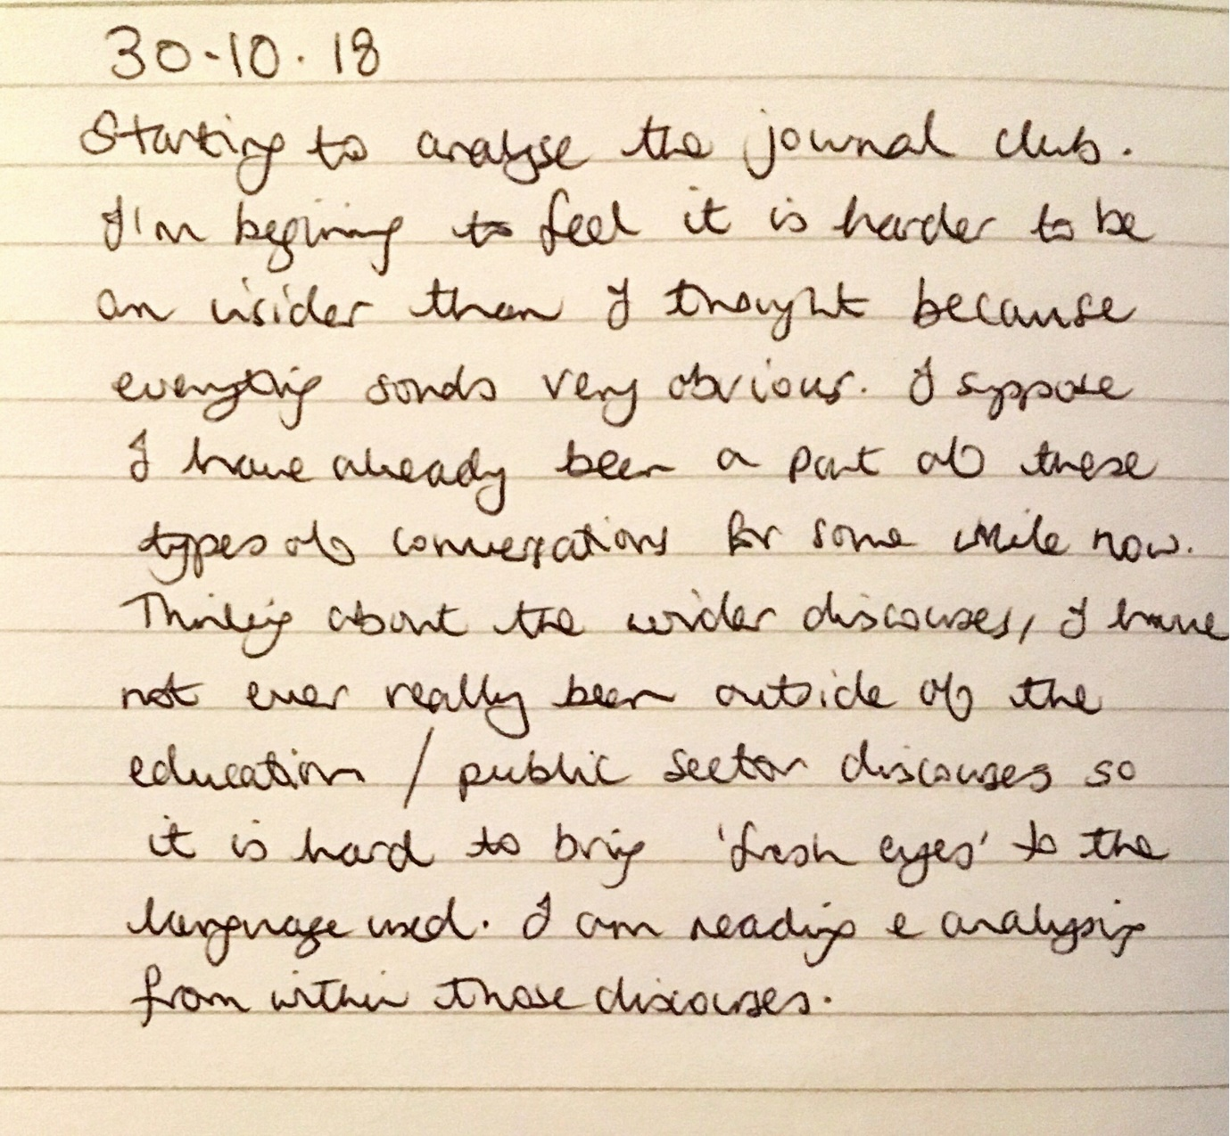

Appendix 6- Georgaca & Avdi’s (2012) 5-stage critical discourse analysis.
The five-stage form of discourse analysis described by Georgaca and Avdi (2012):
- Language as constructive: Discourses:
At this level, I highlighted the instances where the discursive objects of reports or report writing were talked about either explicitly using those words or implicitly through meaning. I explored the possible discourses this talk may suggest.
- Language as functional: Rhetorical strategies:
This level of analysis explored the interpersonal level; what were speakers trying to achieve through language (e.g. persuasion, creation of sympathy, solidarity)?
- Positioning: Implications for social and institutional practices:
Based on the work of Harré (1997) on ‘Positioning theory’, Hirvonen (2013) writes that “Positioning as action, or an act, refers to the determination and discursive construction of familiar “parts” and “roles” of the speakers, which make one’s actions and the social episodes intelligible and reasonable” (p.102). At this level of analysis, I looked for possible cultural roles for reports.
I performed these first three levels at the same time during repeated engagement with the texts.
- Practices, institutions, power:
This level of analysis moved the research from the close-range discourse level of local practice to a longer-range discourse level (Alvesson & Karreman, 2000). I looked for links to discourses in the social, political and historical spheres that currently shape the wider field of Educational Psychology.

- Subjectivity:
Willig (2013) suggests that discourses make available “certain ways-of-seeing the world and certain ways-of-being in the world” (p.133). This level of analysis looked for how the subject positions of report creators, readers or ‘needers’ were “taken up” (Willig, 2013) within the field.

Appendix 7 Coding of the discourses
Journal club: How the initial coding related to the discourses (see also annotated transcript Appendix 4)

Reports as just acts | Reports as describing needs, avoiding pathologisation
 | Reports as sharing information- about the child not for the child, summarise, provide information
 | Reports as the story or identity of the child- not static, EP as the storyteller, humanising, providing connection to or empathy for the child, totality
 | Reports as providing perspective, balance, a holistic picture- allowing/ privileging voices, bringing emotional balance to thinking about the child, removed from EP’s own emotions, capturing all contributions.
 | Reports as just acts- confidentiality, sharing, duty, respect
 | Reports as advocating for the child’s needs.
Reports as difficult | Reports as difficult
 | Reports as permanent
 | Reports as time-consuming
 | Reports as the end product and not the work
 | Reports as formulaic- constrained, laundry list
 | Reports as painful process for the EP
 | Reports as a snapshot, lack of knowledge of/ relationships with the children- devalued by EPs
 | Reports as replacing psychology- unable to capture psychology, devalued by EPs, instead of the psychological practice
 | Reports as meaningless, record of poor assessment
 | Reports as having unclear audience/ receiver
 | Reports as making EPs unhappy, madness
Reports as Identity Giving for EPs | Reports as giving status to EPs- make them appears knowledgeable
 | Reports as reflective of professionalism/ quality- to feel professional, to look/feel like a good EP
 | Reports as ‘visible’ EP work- evidence of work
 | Reports as identity constructing for EPs- a place to be an EP, an exchange
 | Reports as reflective of change in professional identity.
 | Psychological Advice reports as transforming EP work/ identity
Reports as Psychological | Reports as formulation or thinking- contemplative, enabling, providing coherence to thoughts, tentative, uncertain/ resisting certainty.
 | Reports as EP in situ/ replacement- authored, authoritative
 | Reports as ‘distilled’ psychology/ work.
 | Reports as relational
Reports as Expert | Reports as diagnostic, labelling
 | Reports as rooted in history
 | Reports as legal document, evidence, judgement, protection, a statutory duty, adequate record, accountability.
 | Reports as certain- truth, solution.
Reports as Helpful | Reports as gateway/ key to resources
 | Reports as exchange/ gift (premise of the journal article being discussed by the team).
 | Reports as expert advice, guidance, persuasion, advising on poor teaching
 | Reports as a way to make a difference- being helpful, communicating, prescribing advice
 | Reports as over and above/ extraordinary- providing expertise.
 | Reports as useful/ helpful work.
 | Reports as enabling the work of others (SEND team, teachers, moderators)- valued by others, used for decision-making..
 | Reports as a product or tool to be used by others
 | Reports as multi-purposed.
 | Reports as filling gaps in resources from scarcity of other professional
 | Reports as a contribution to the EHC process.
Reports as a purchase | Reports as a purchase

Appendix 8- Transcription code used based on the Jefferson transcription system (2004).

I decided to use the Jefferson Transcription System (Jefferson, 2004) as I wanted to include affective and interactional features within the interviews. This was to acknowledge the importance of my co-construction between or ‘obstruction’ (Bucholtz, 2007) by myself as the researcher and the participant. I selected notation from this system that I regarded as helpful for answering my research questions with minimal disruption to the flow of the conversation for the reader. I wished to be able to illuminate the reflexivity in my analysis and to allow alternative readings by others who may wish to engage with these texts. I hoped to open up the text (e.g. Billington, 2002) rather than find a truth but also afford others the opportunity to do the same through presentation of more than the content of the conversations.

Notation | Description
(.) | A micro pause of less than a second.
(4) | A pause with a measured length of seconds.
((laughs)) | Nonverbal communication or other contextual information.
[ ] | Overlapping speech
CAPITALS | Louder or shouted words
Underscore | Emphasis
(??) | Unclear/ inaudible speech
> < | Pace quickened
< > | Pace slowed

Appendix 9 Annotated transcript of interview 1 (Pat).

Key for RQ2
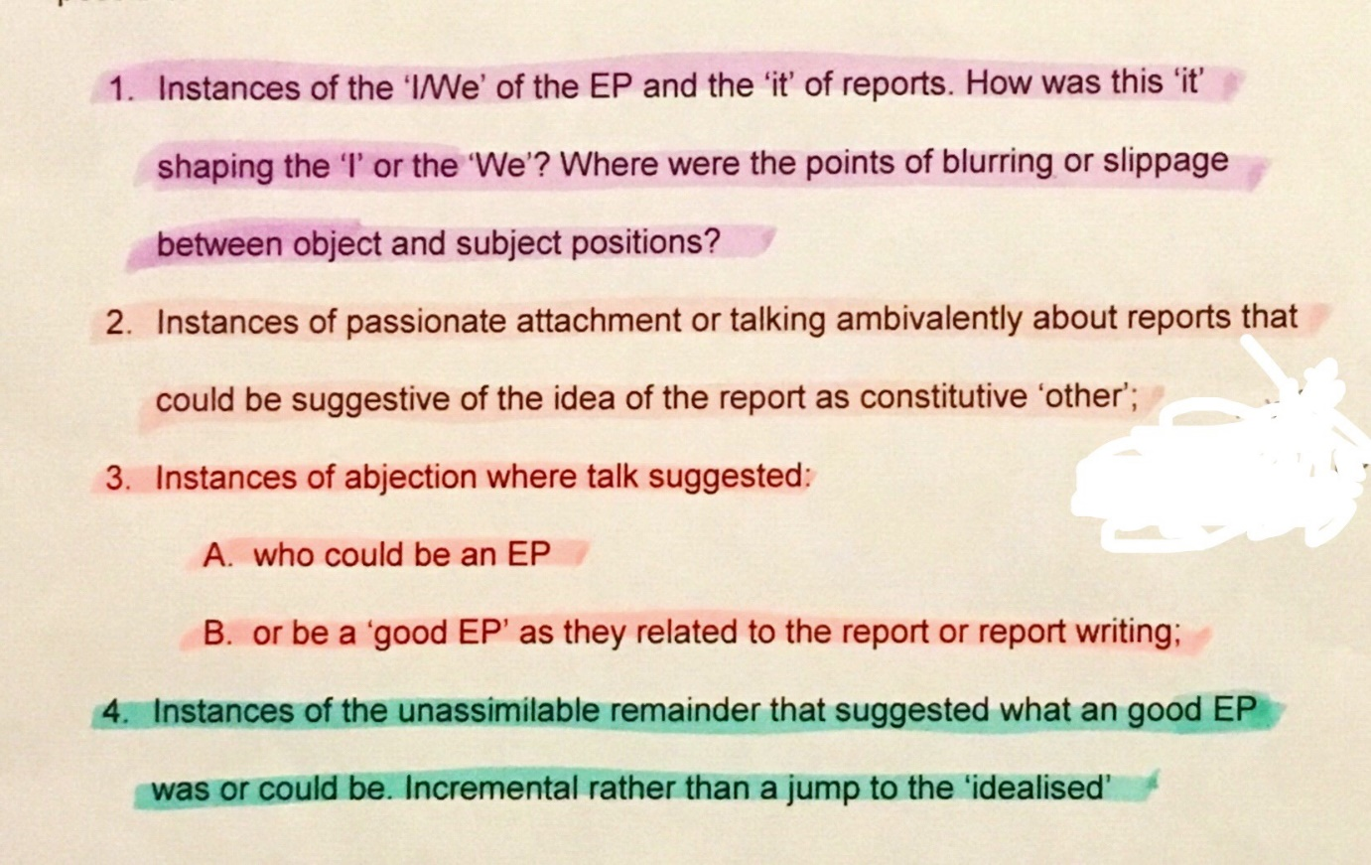
Key for RQ3

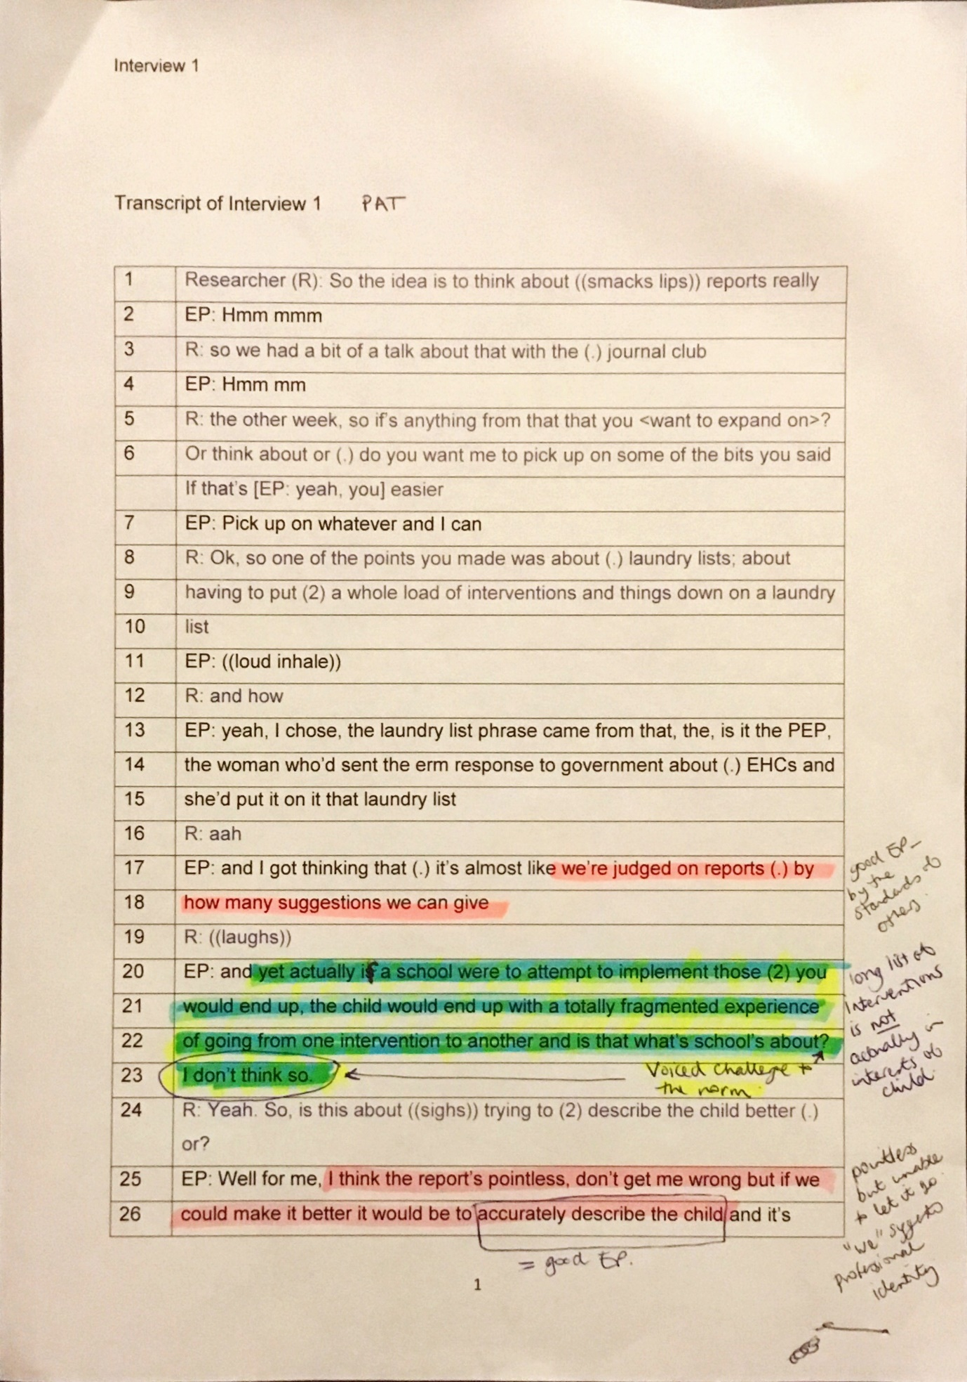

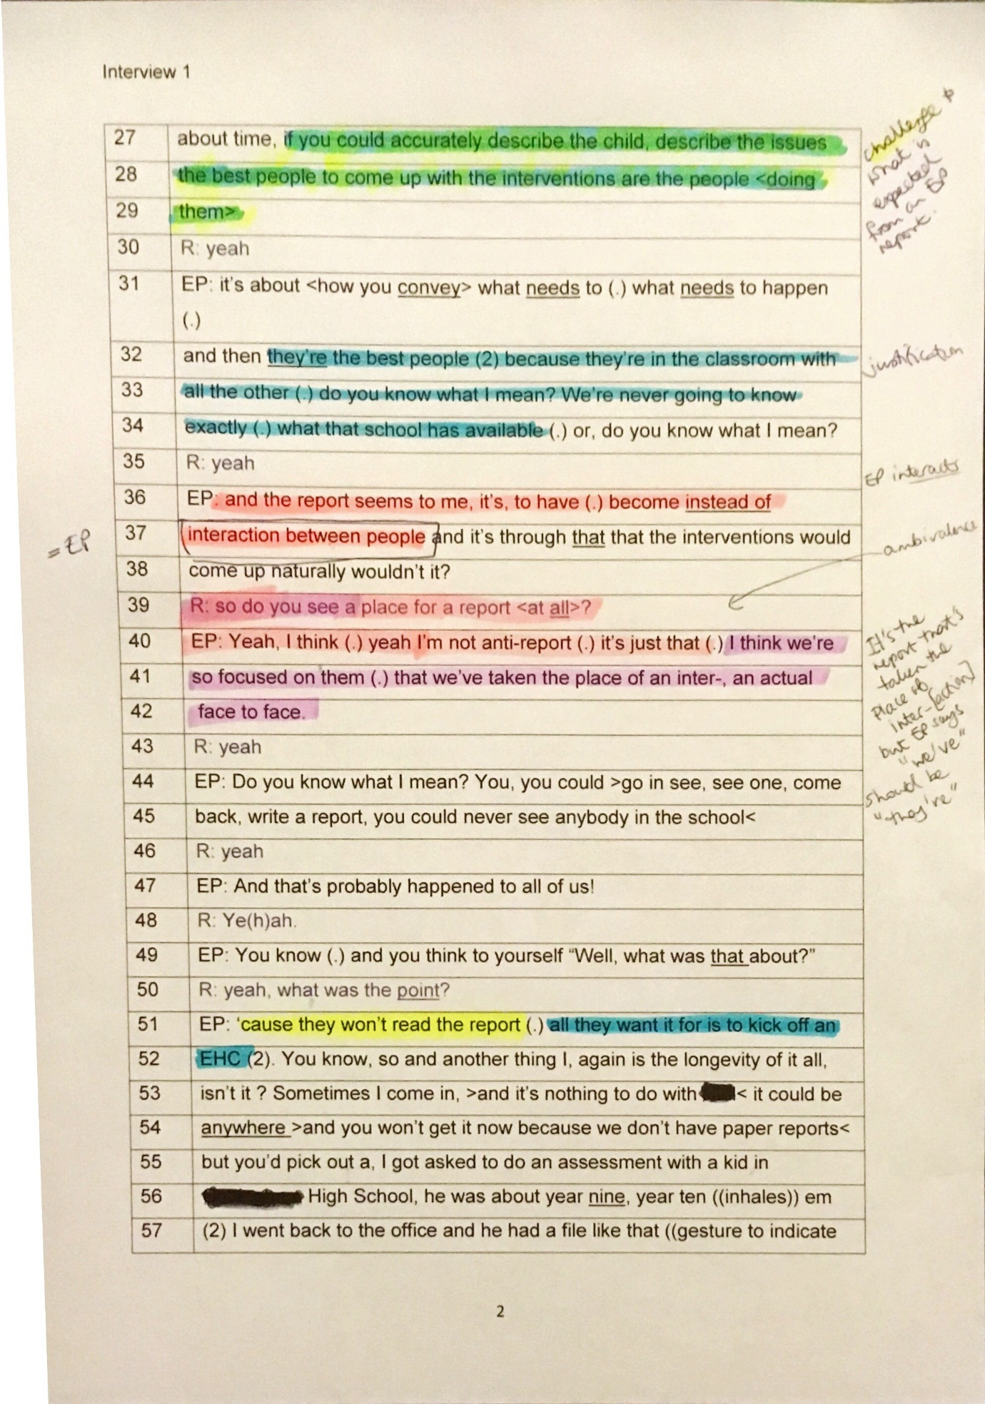
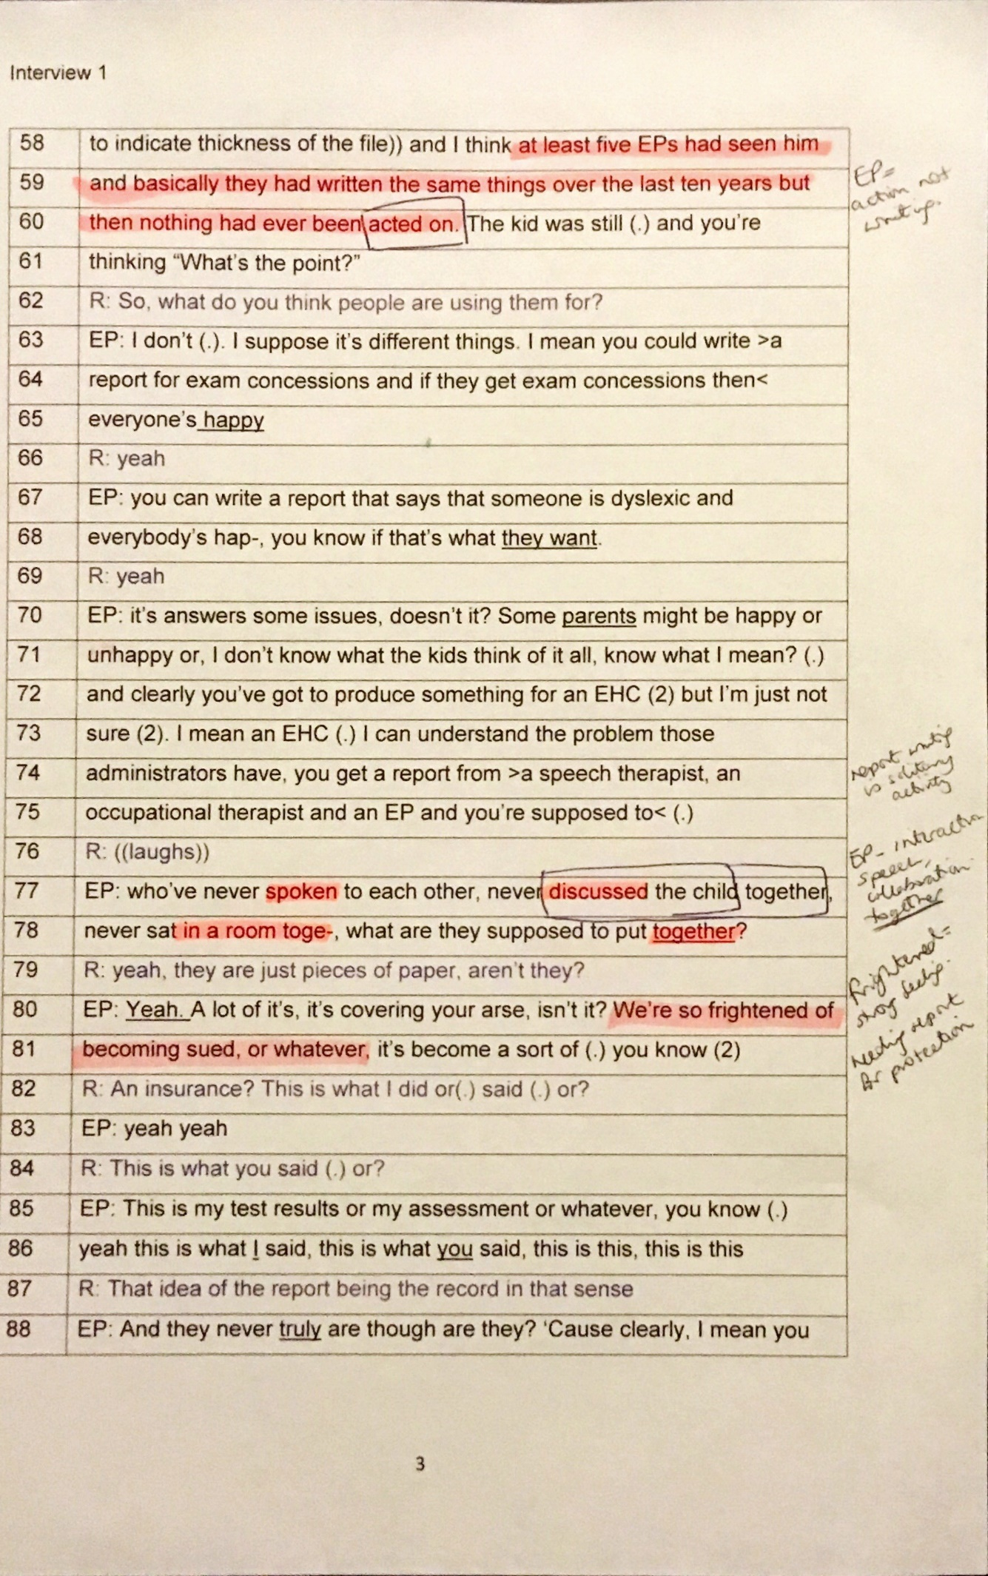
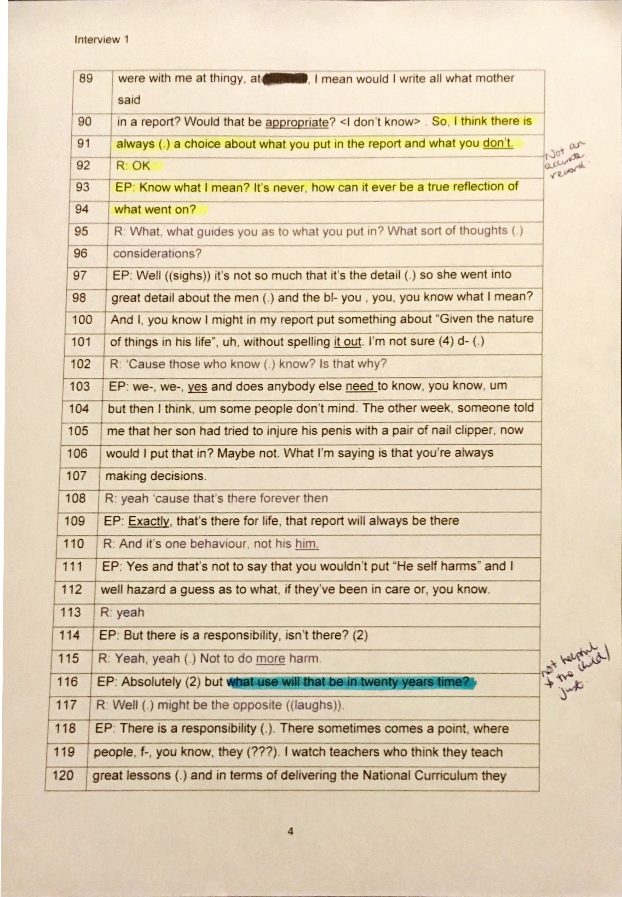

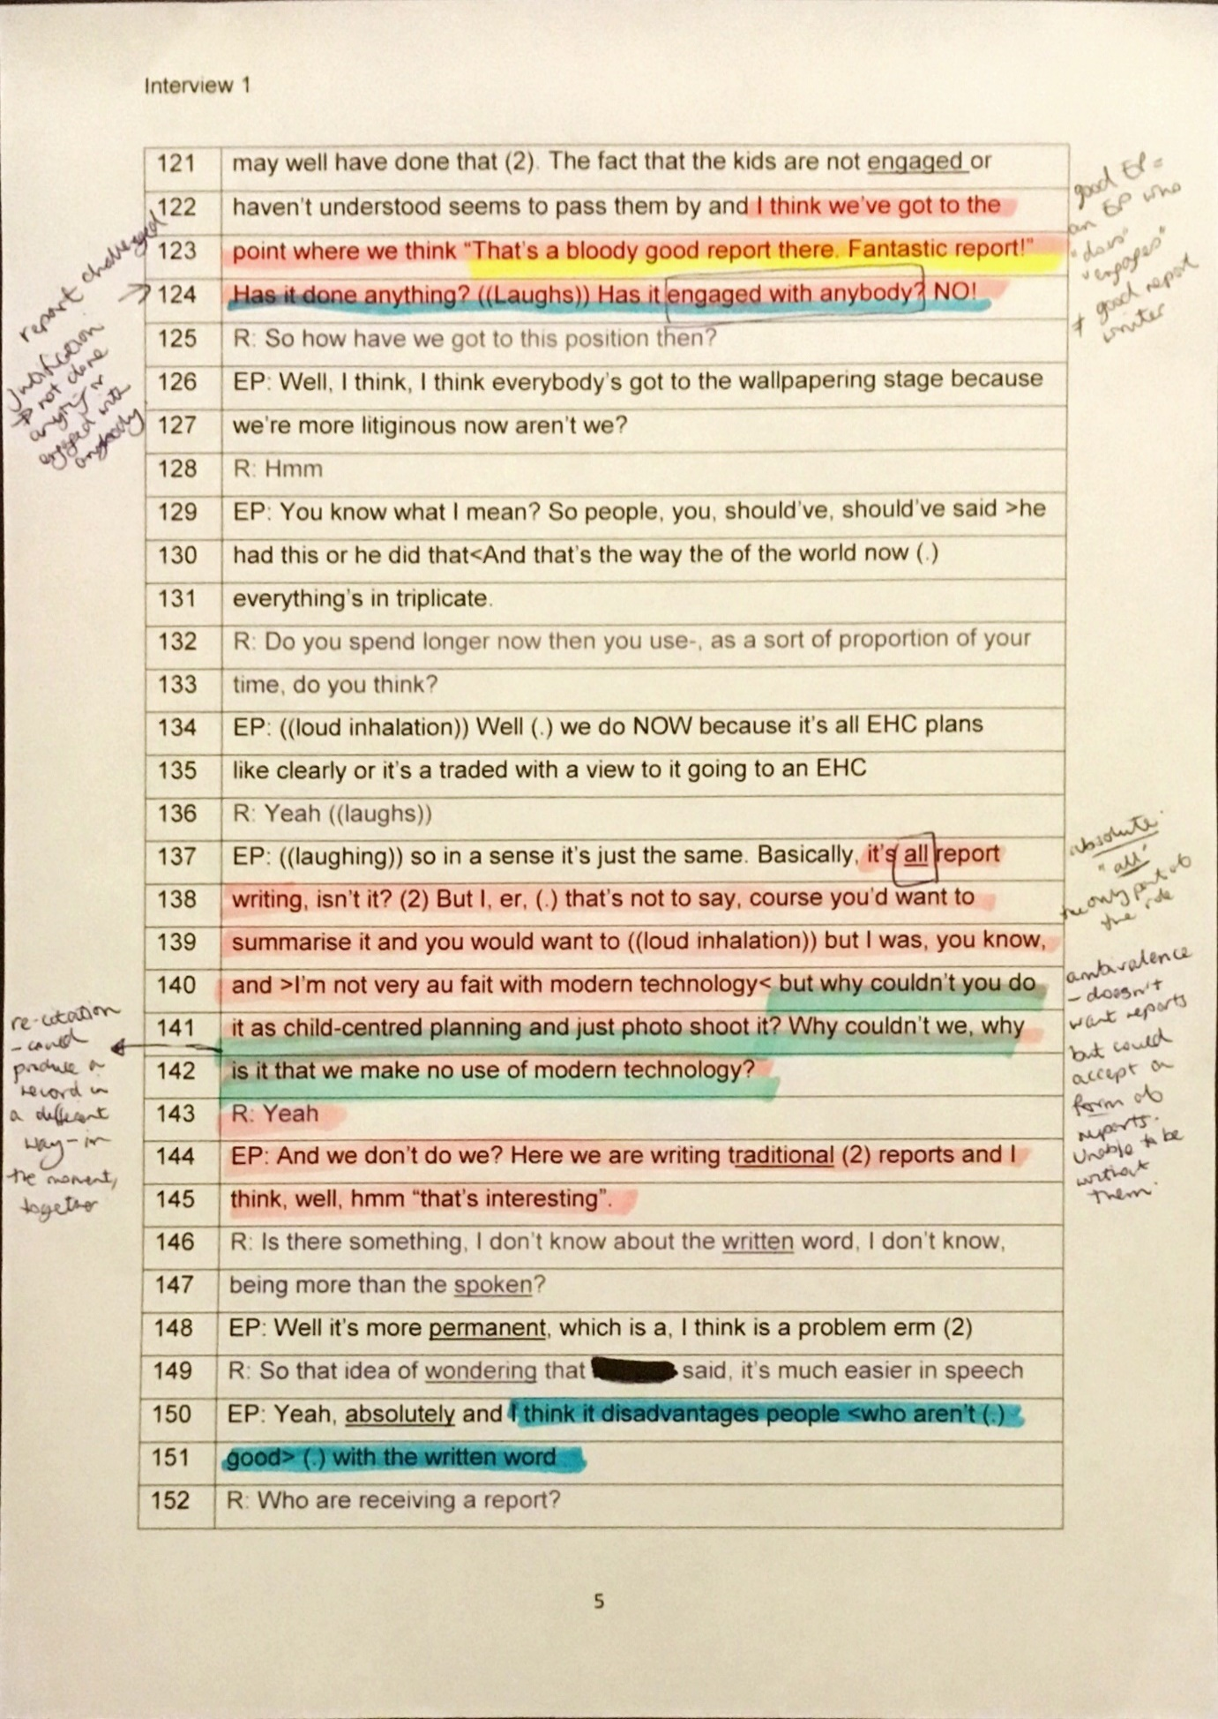

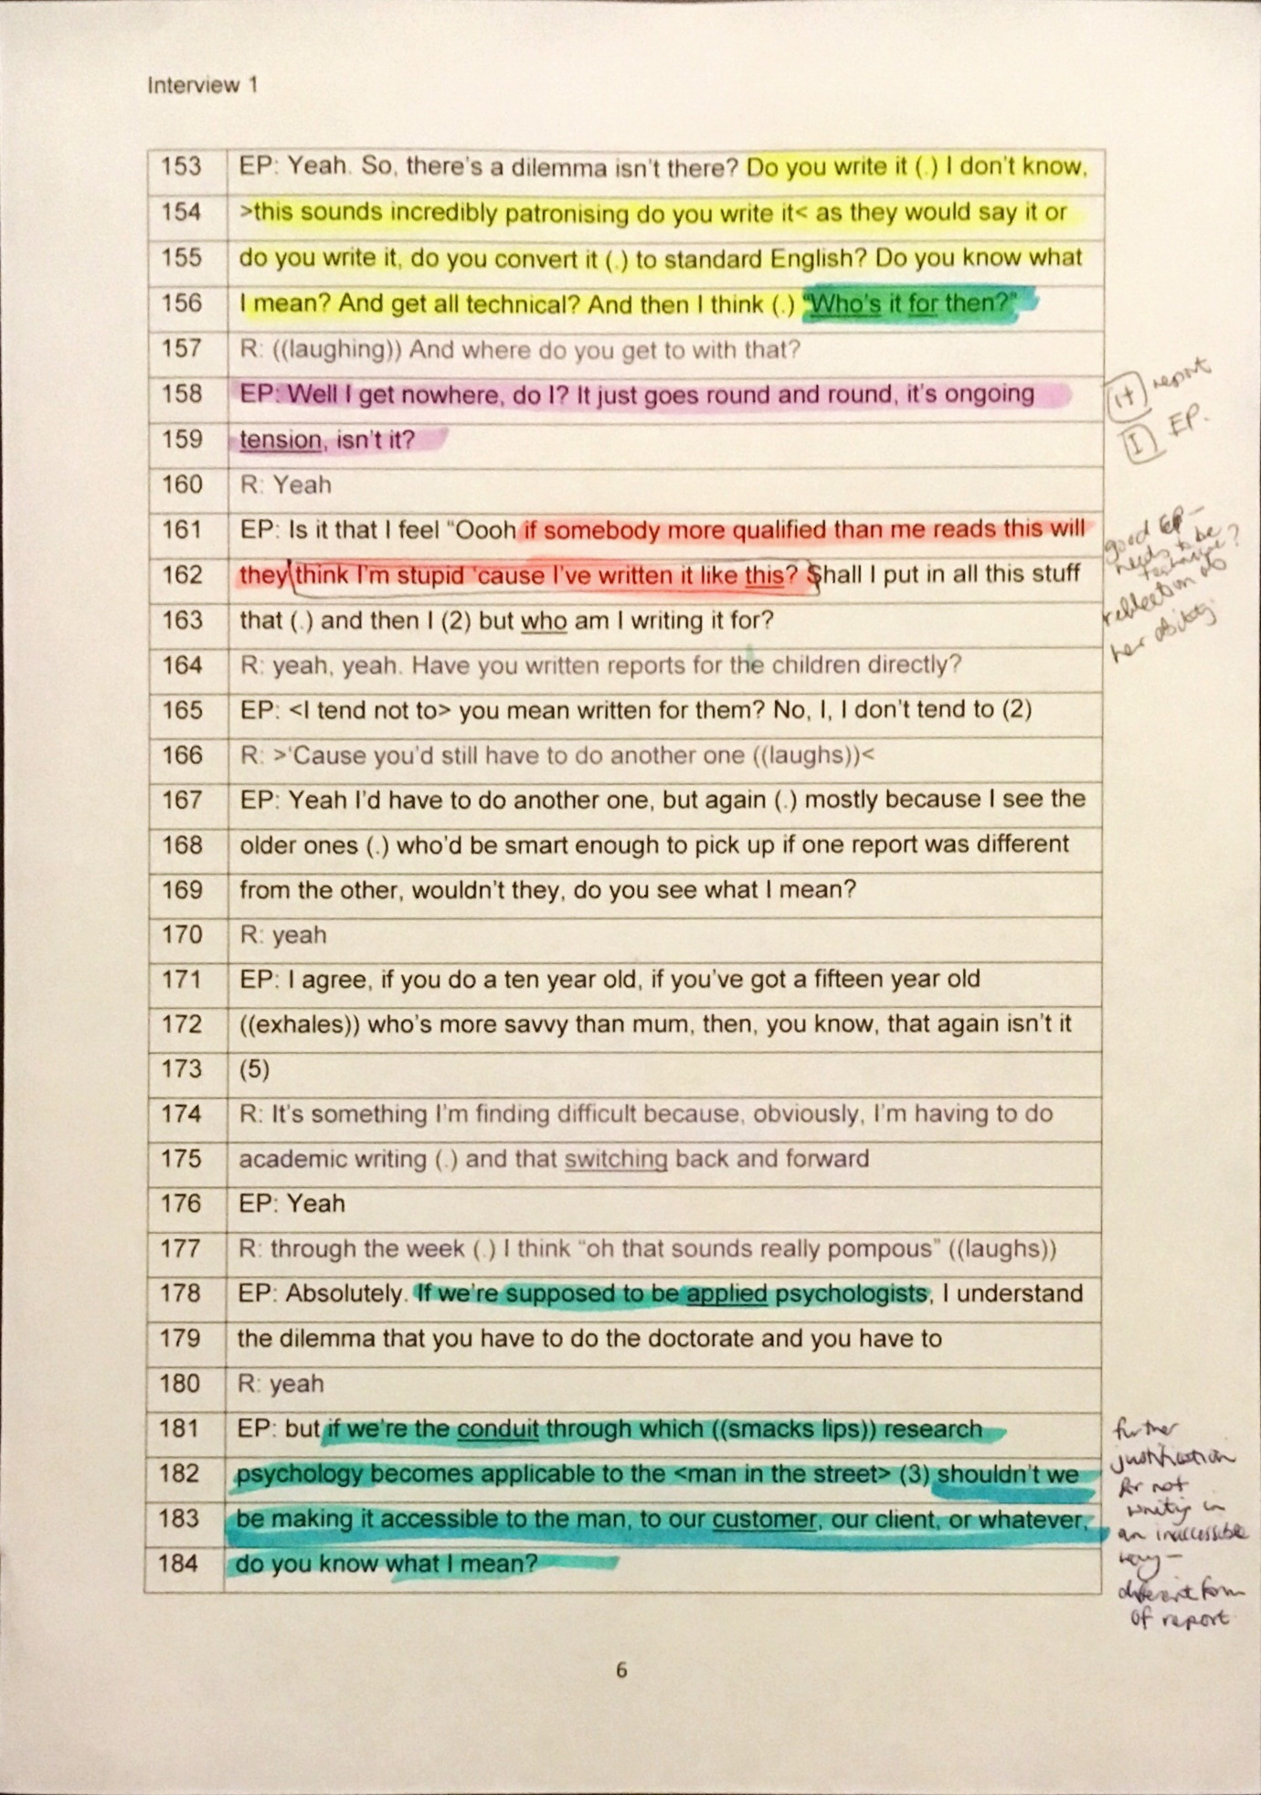

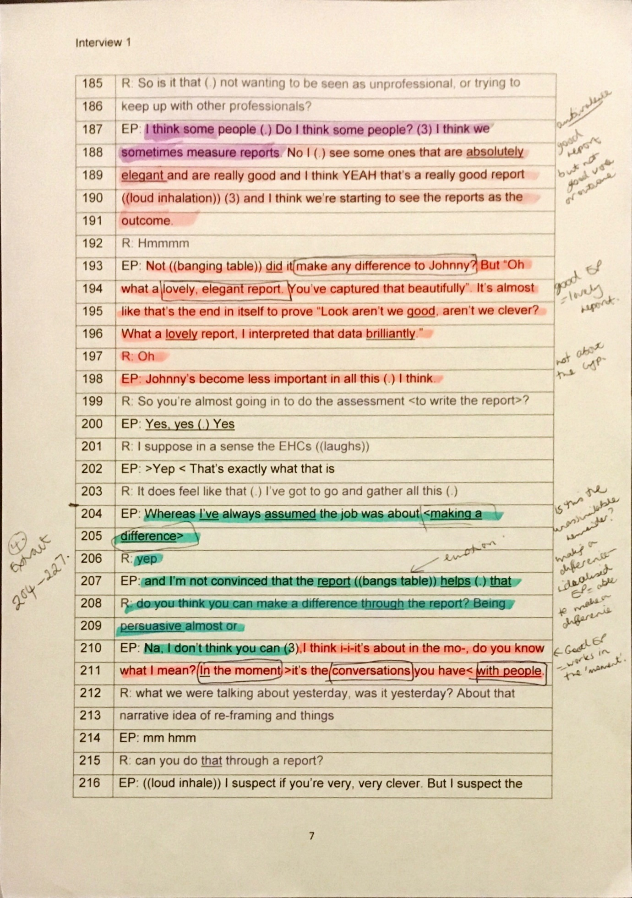

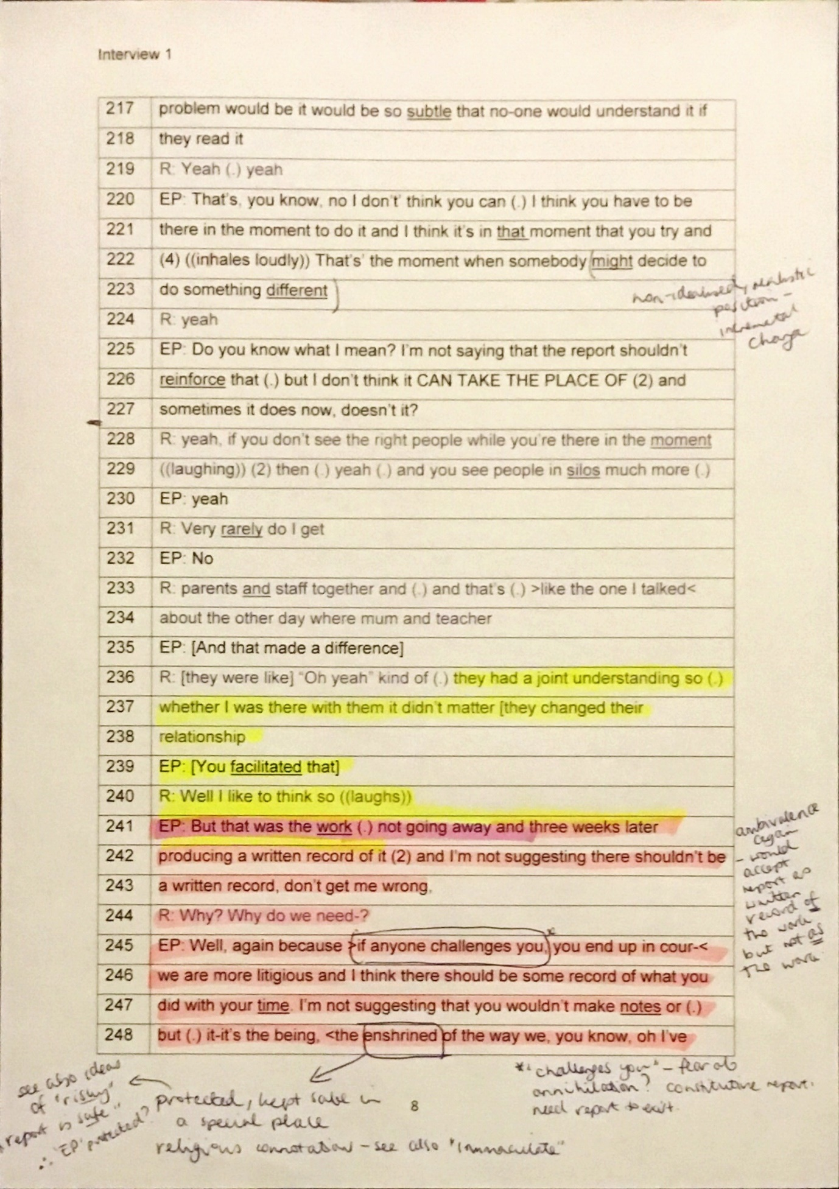

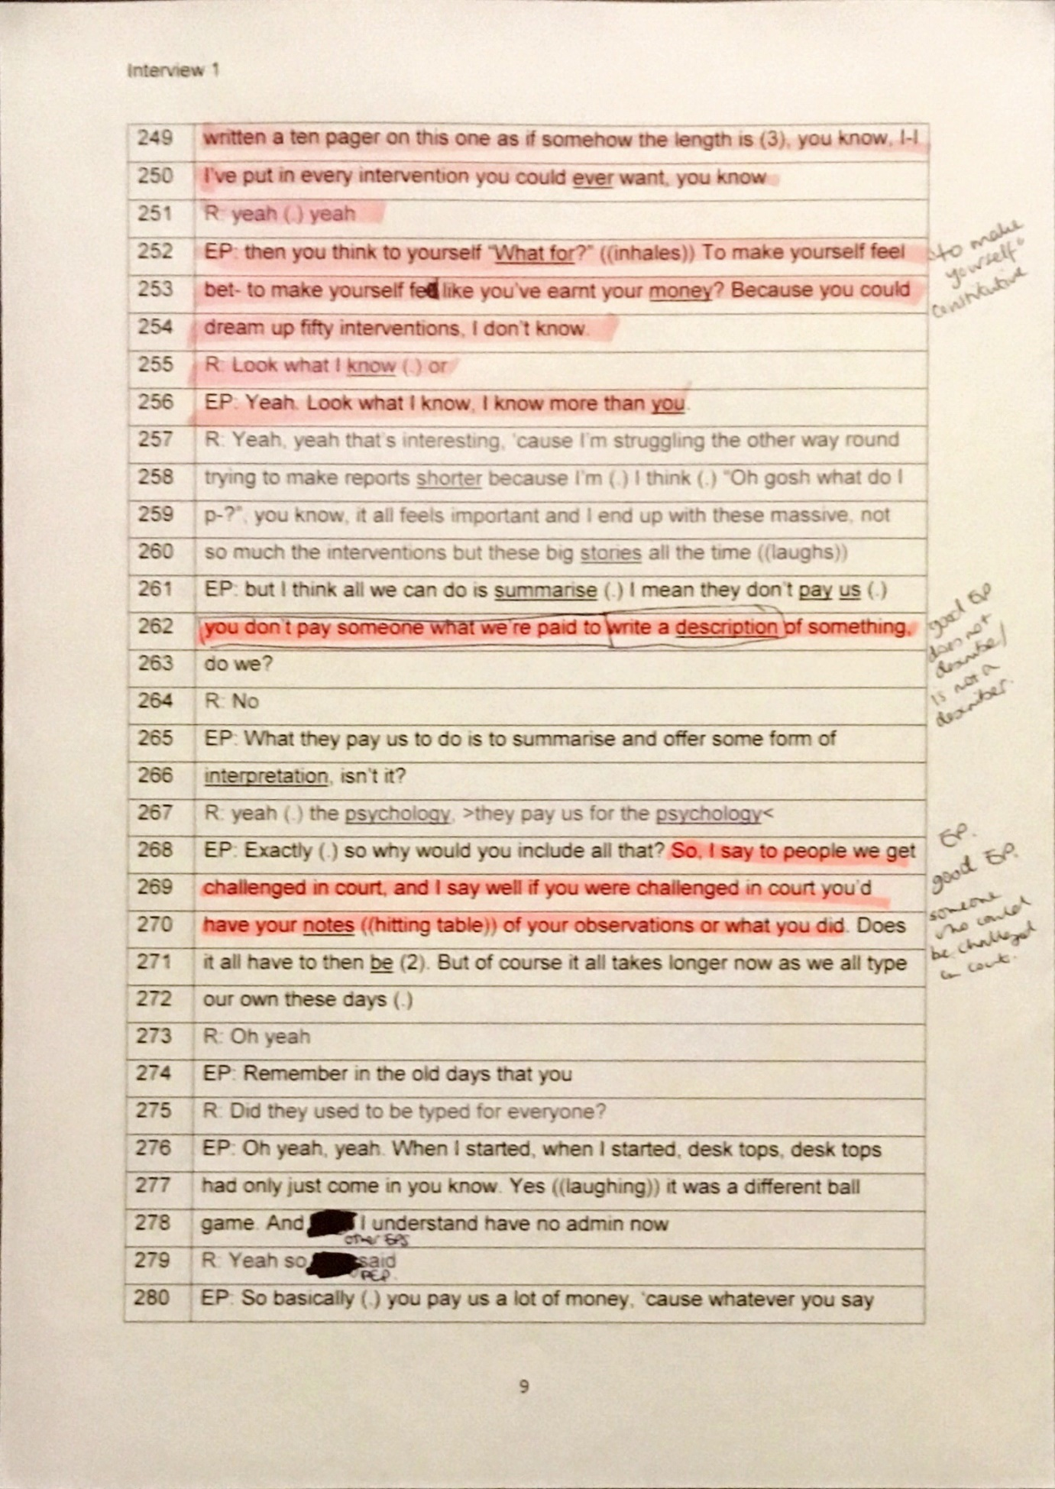

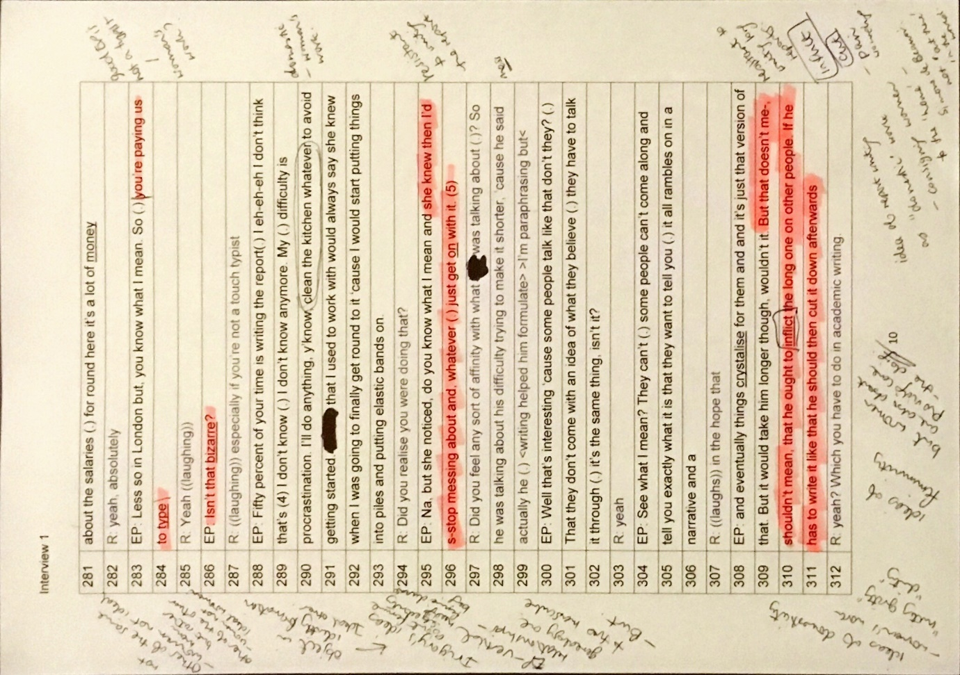

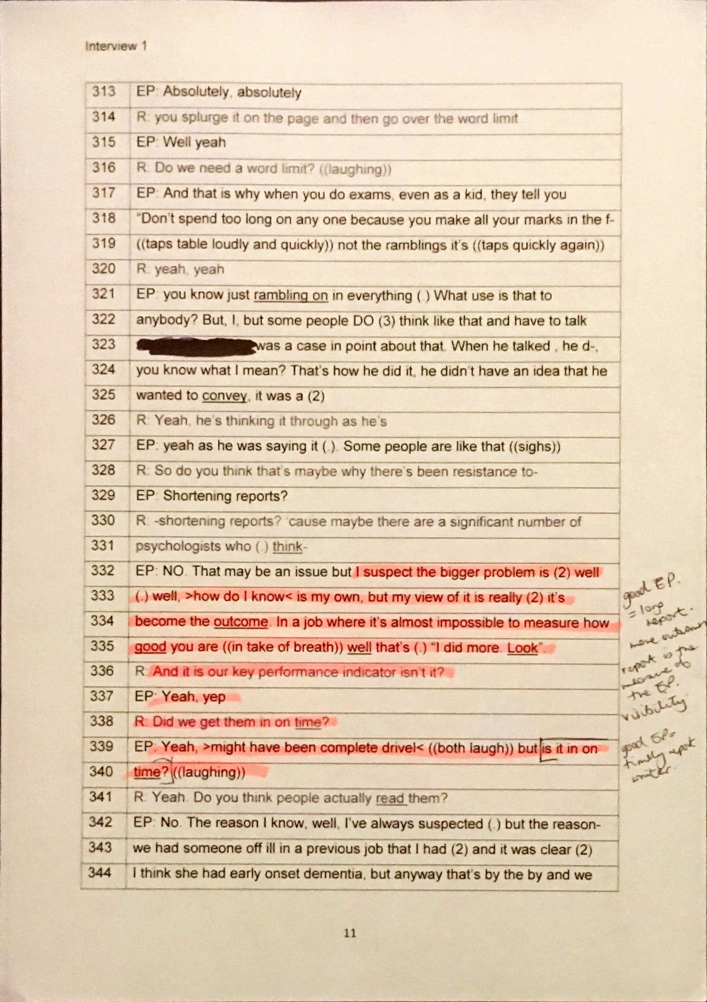

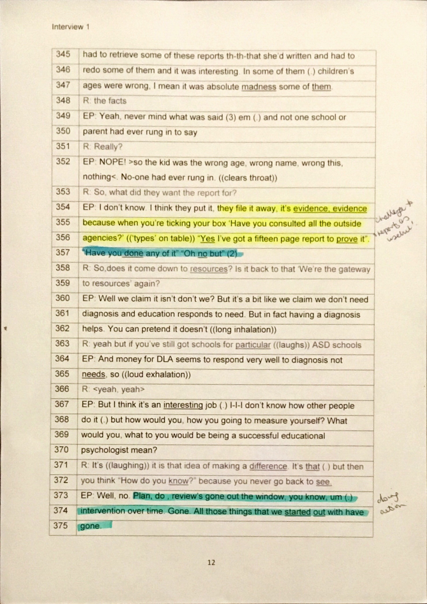

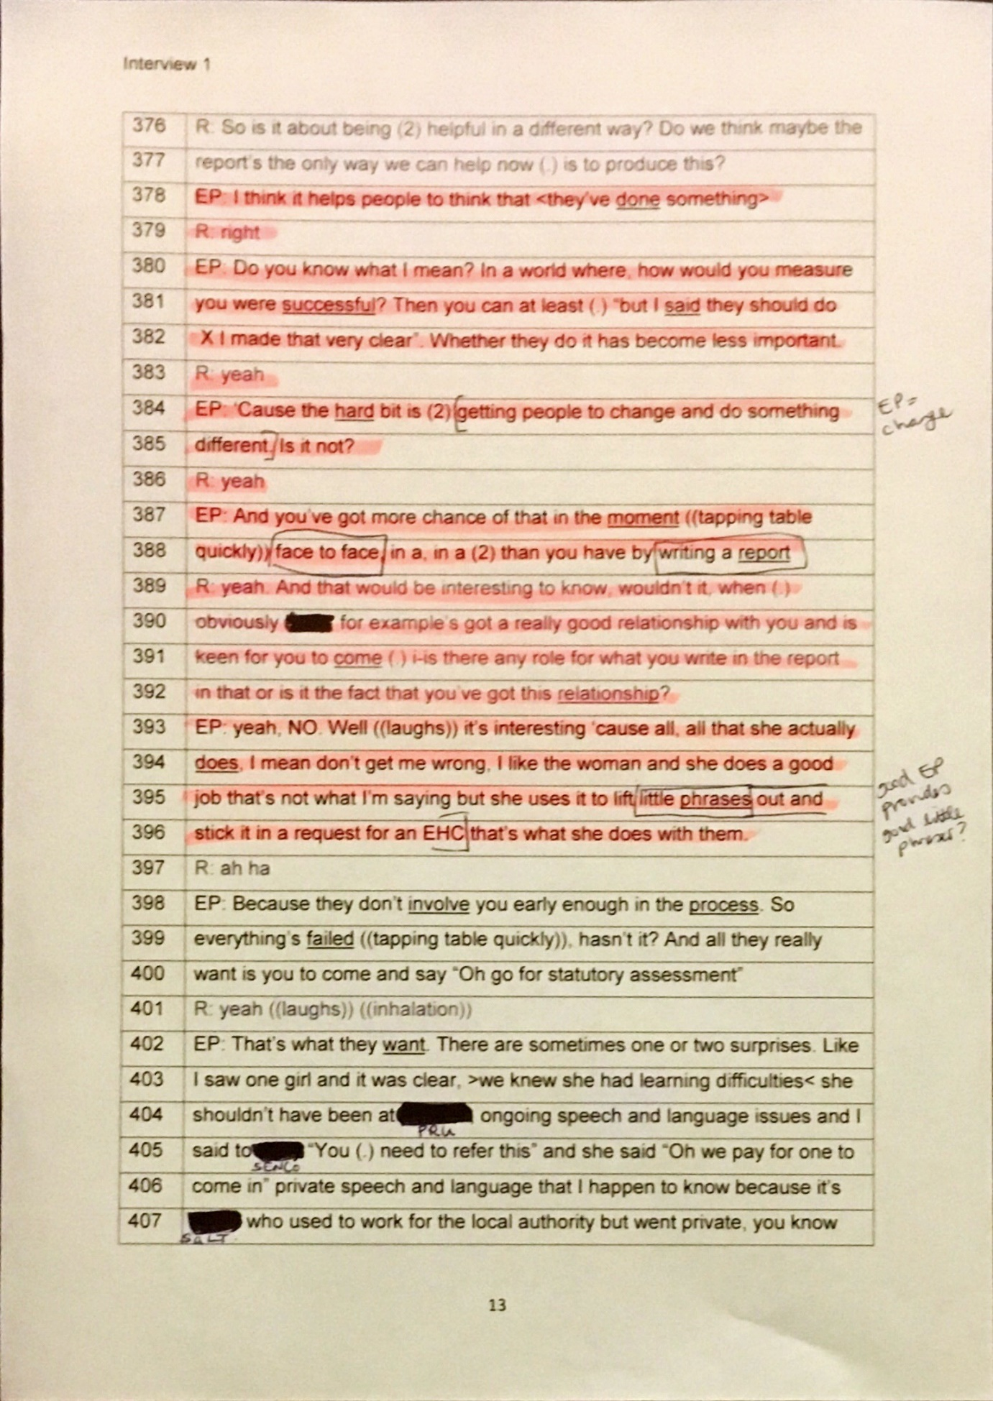

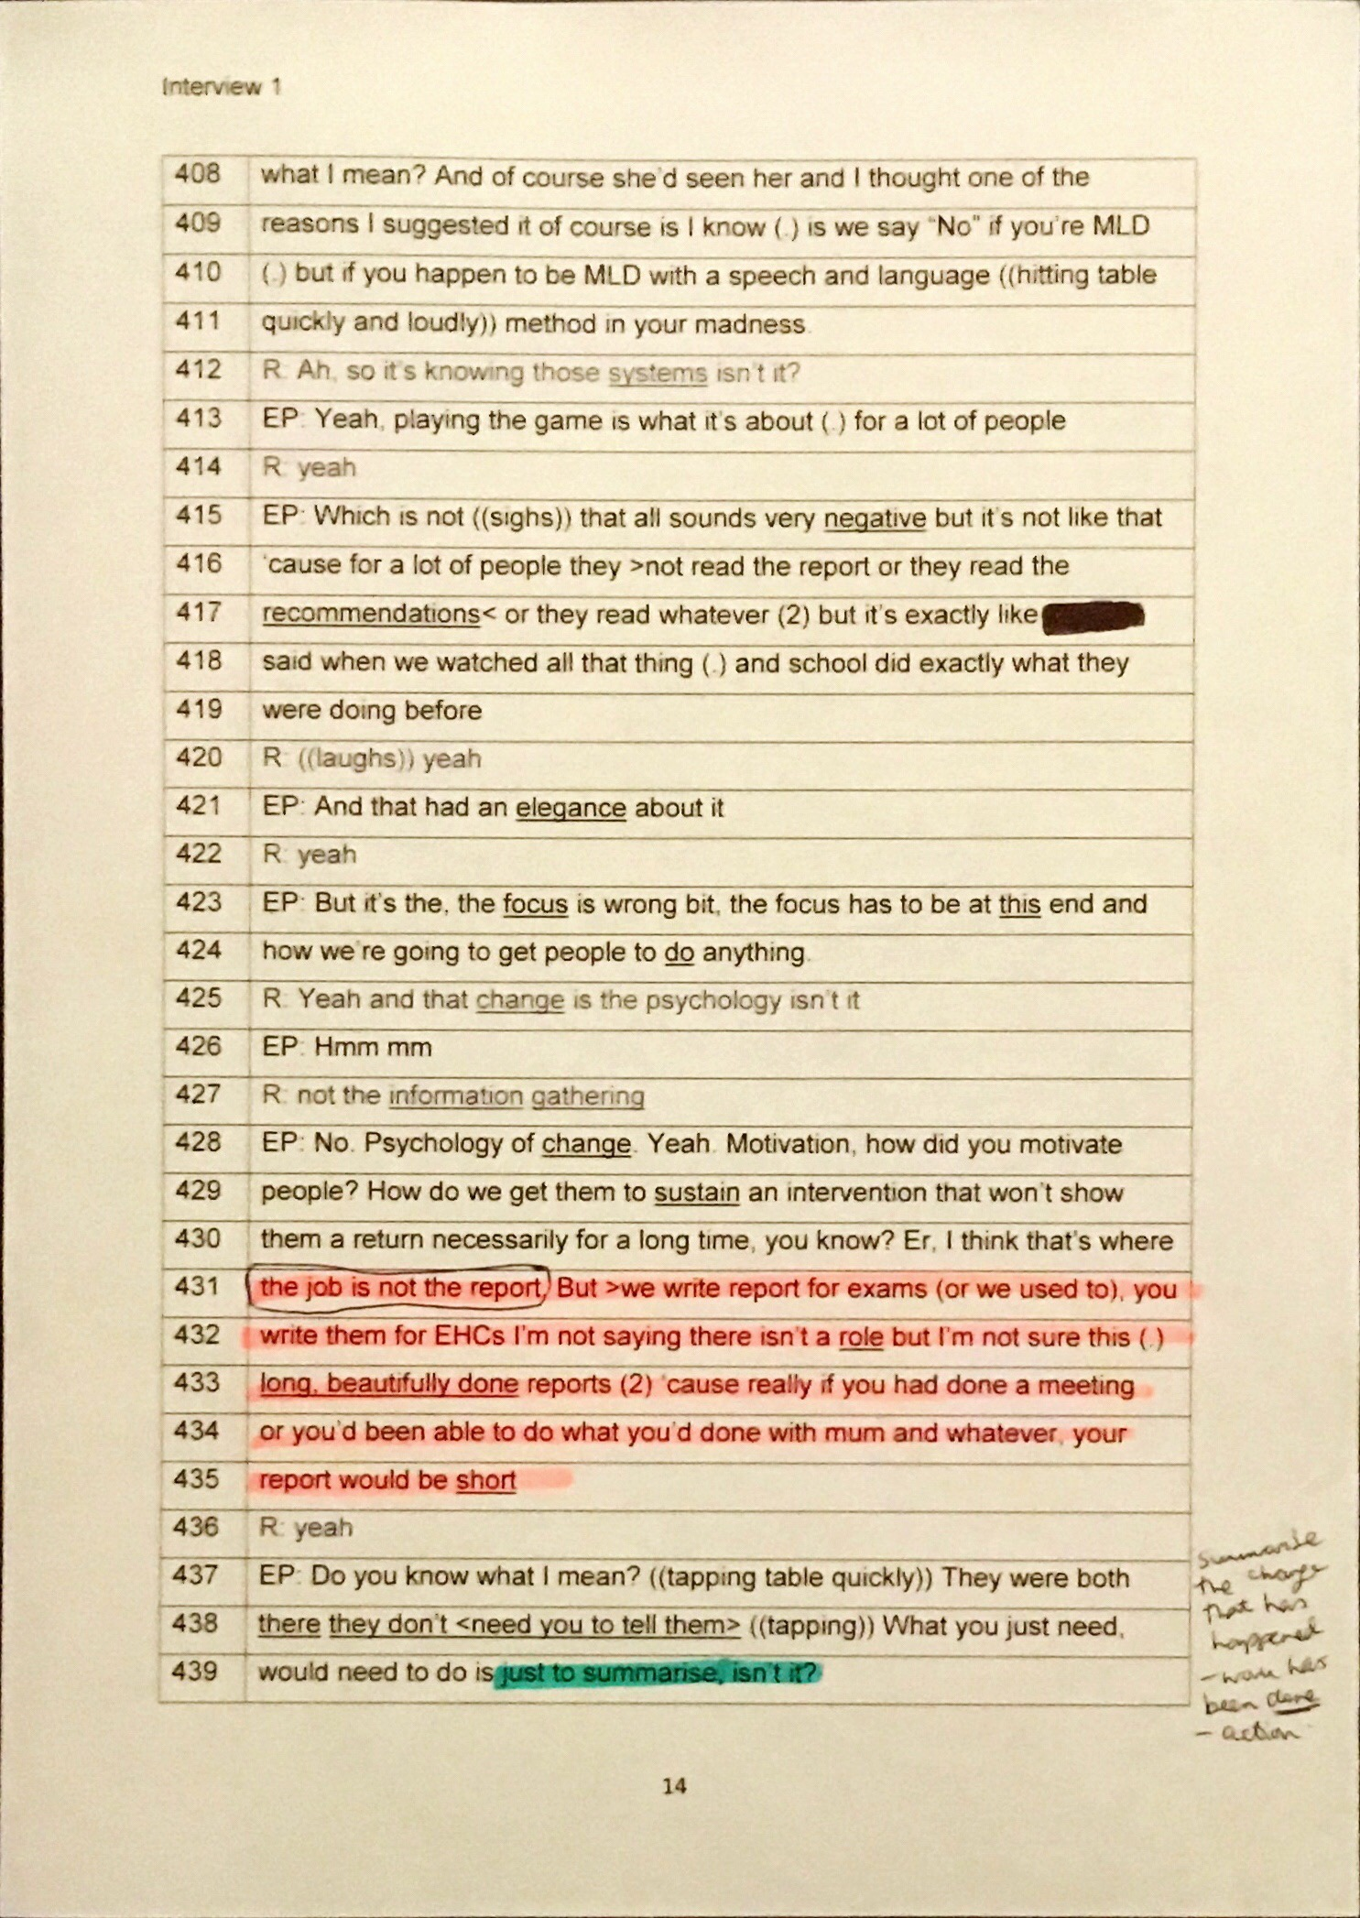

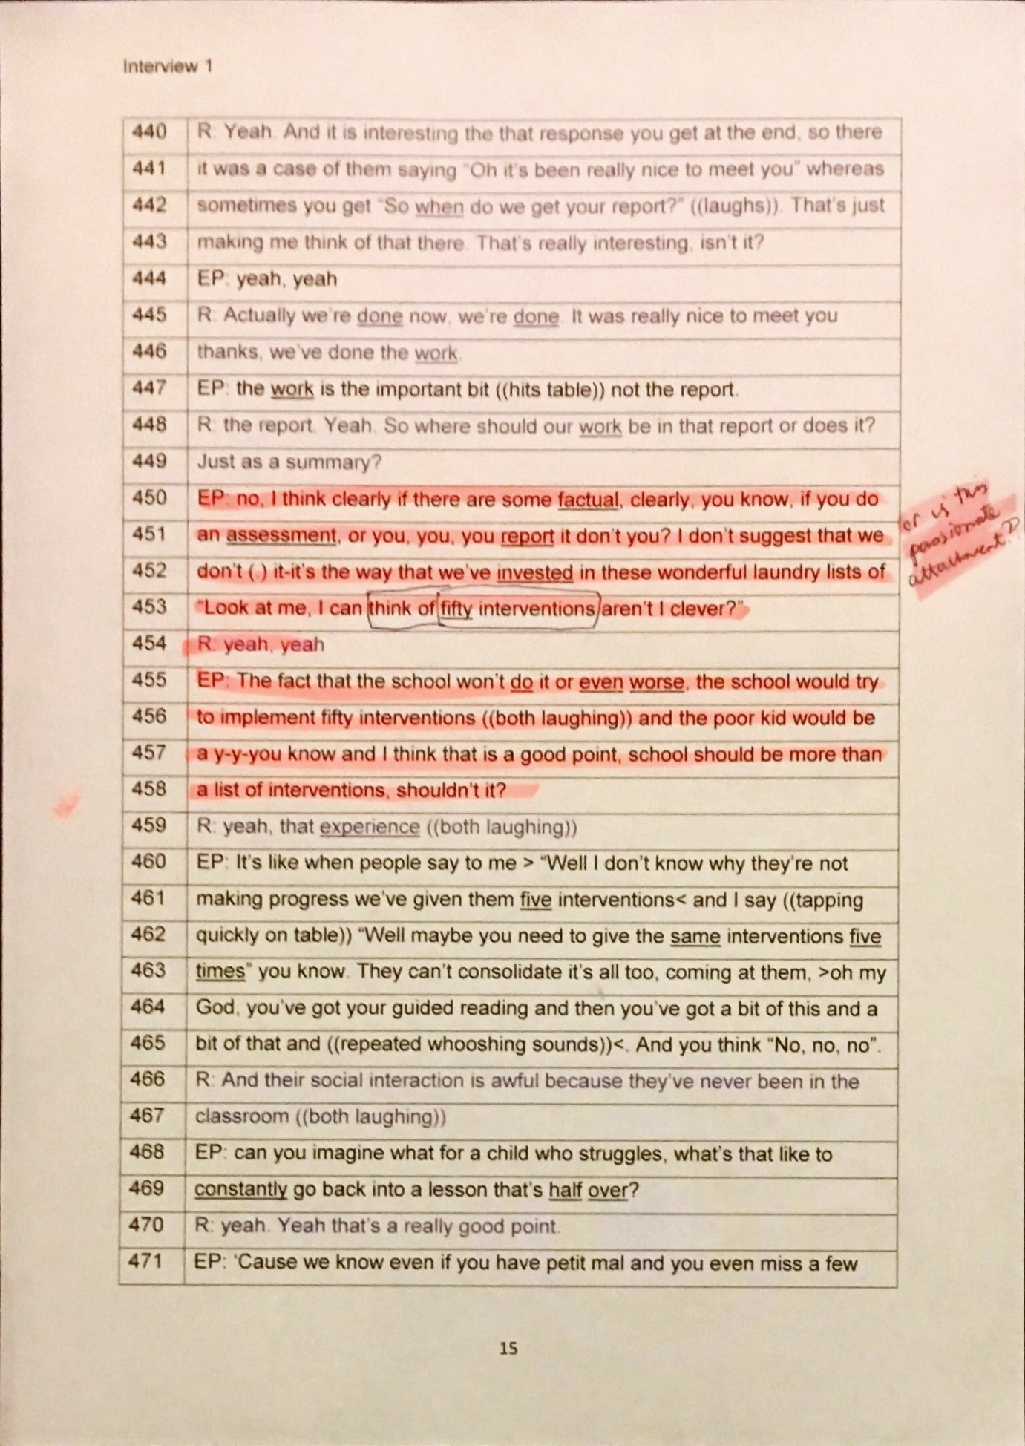

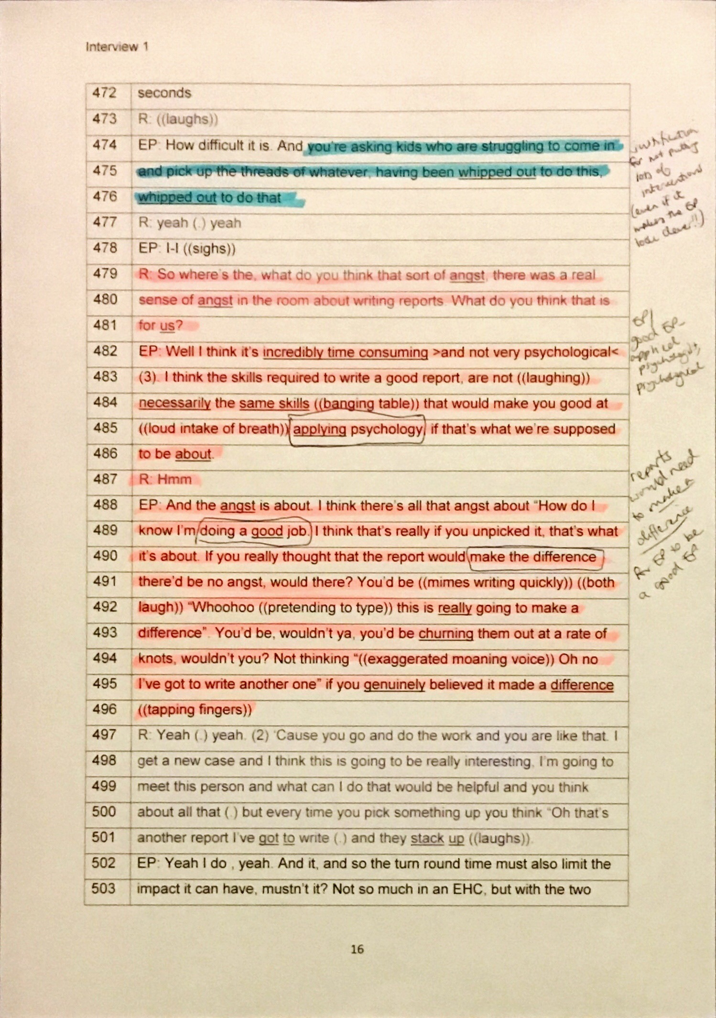

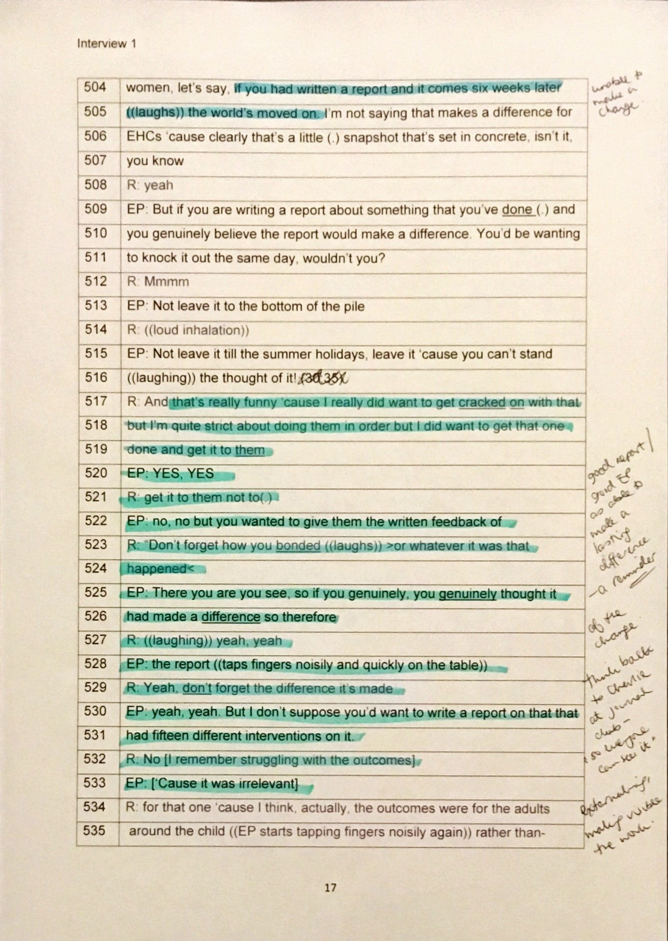

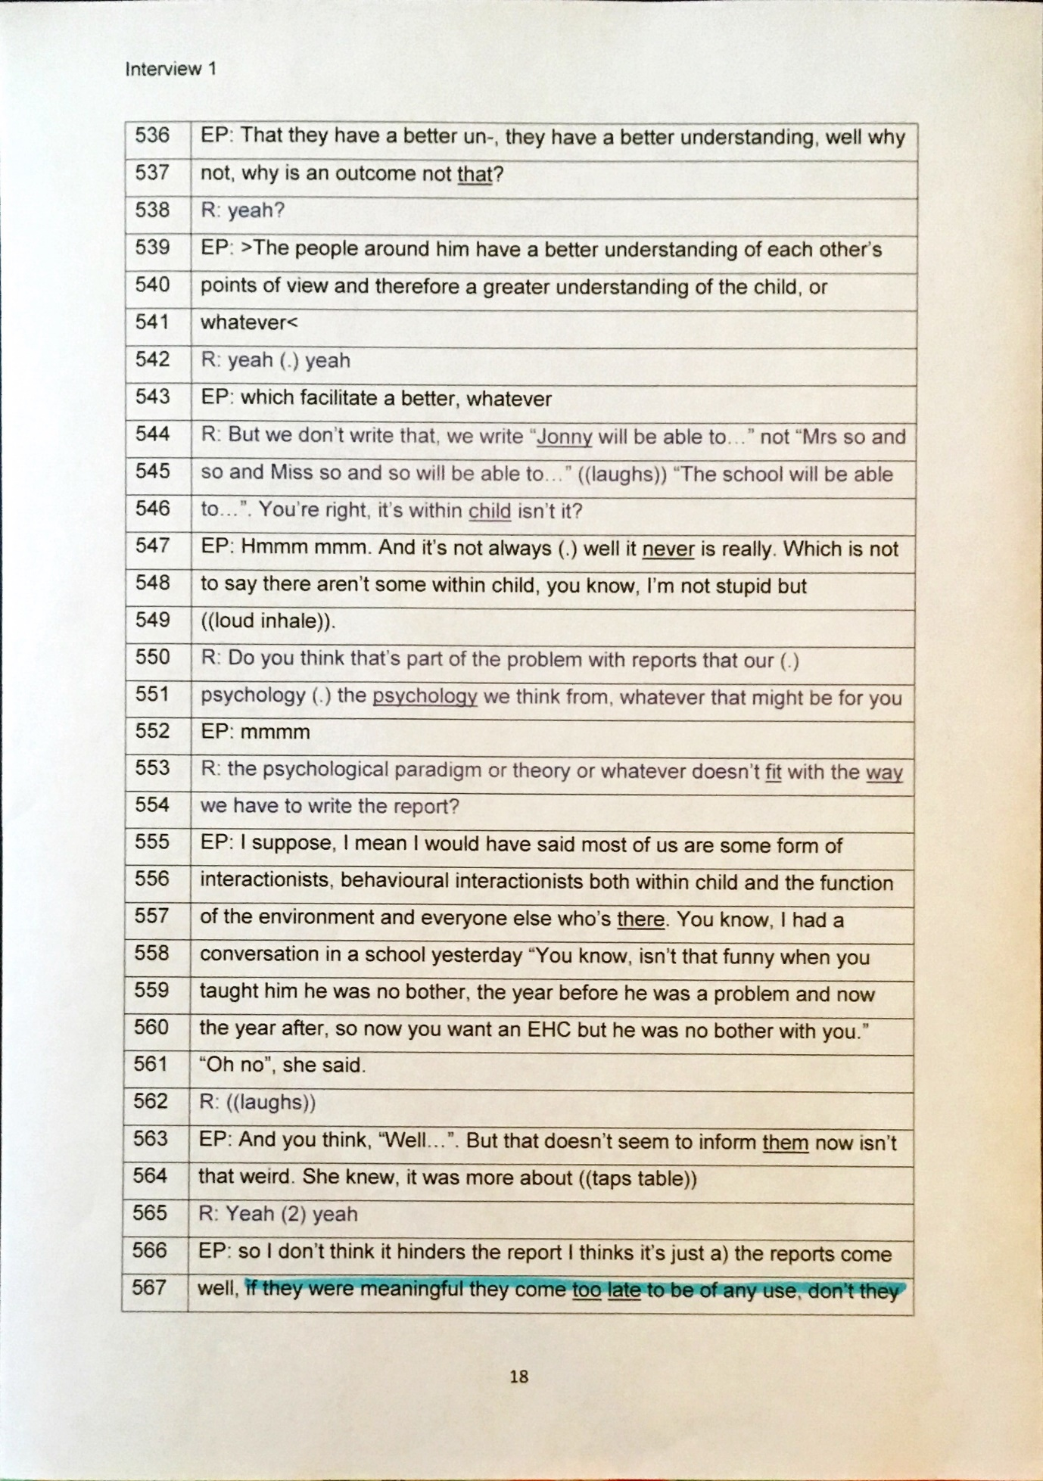

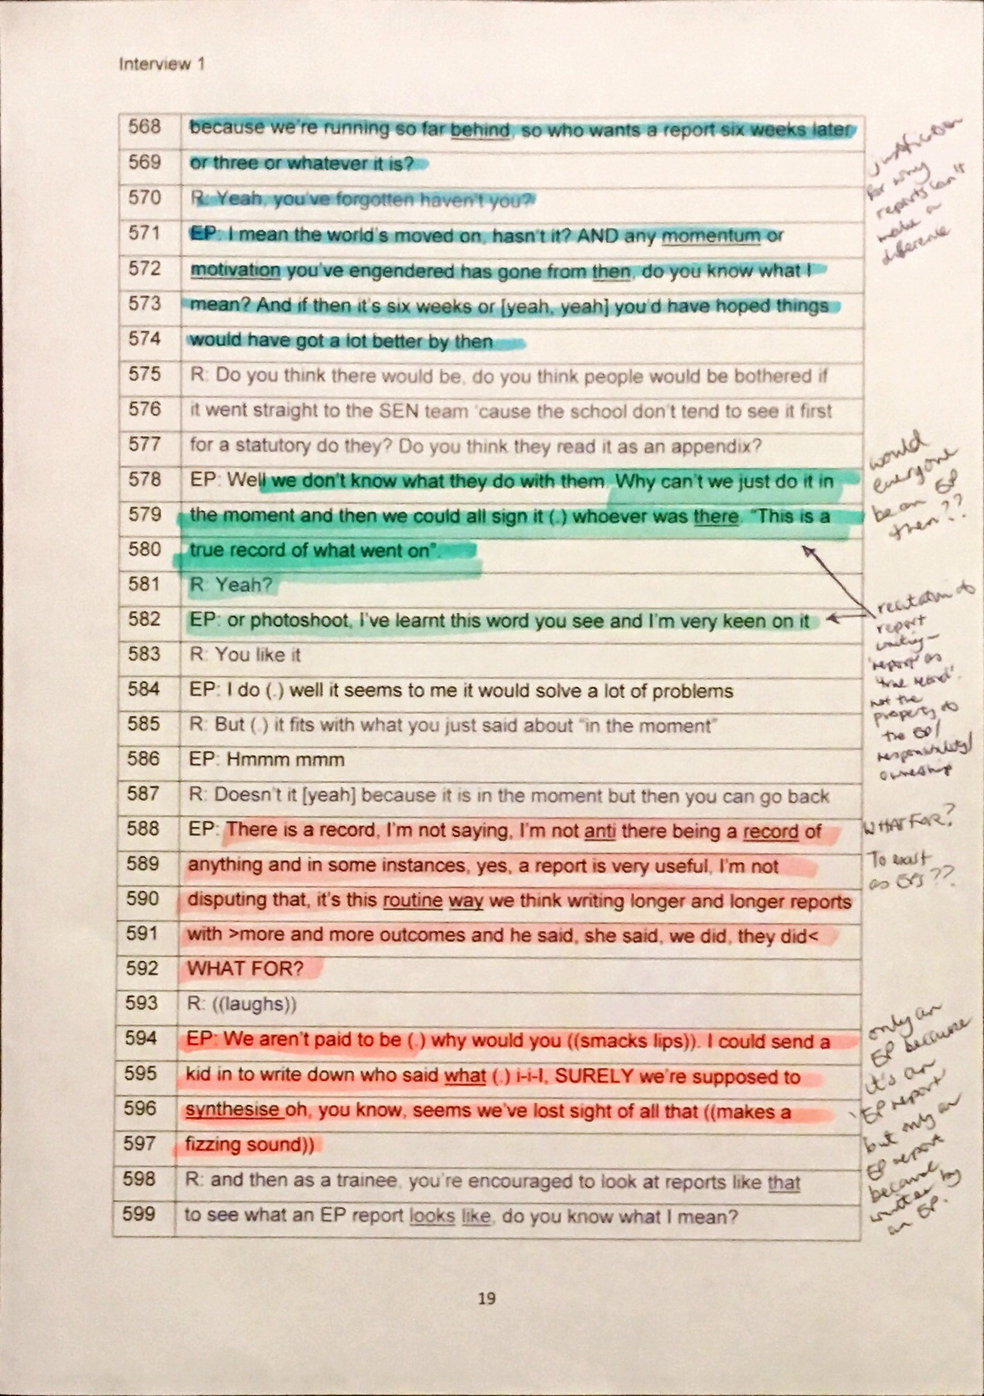

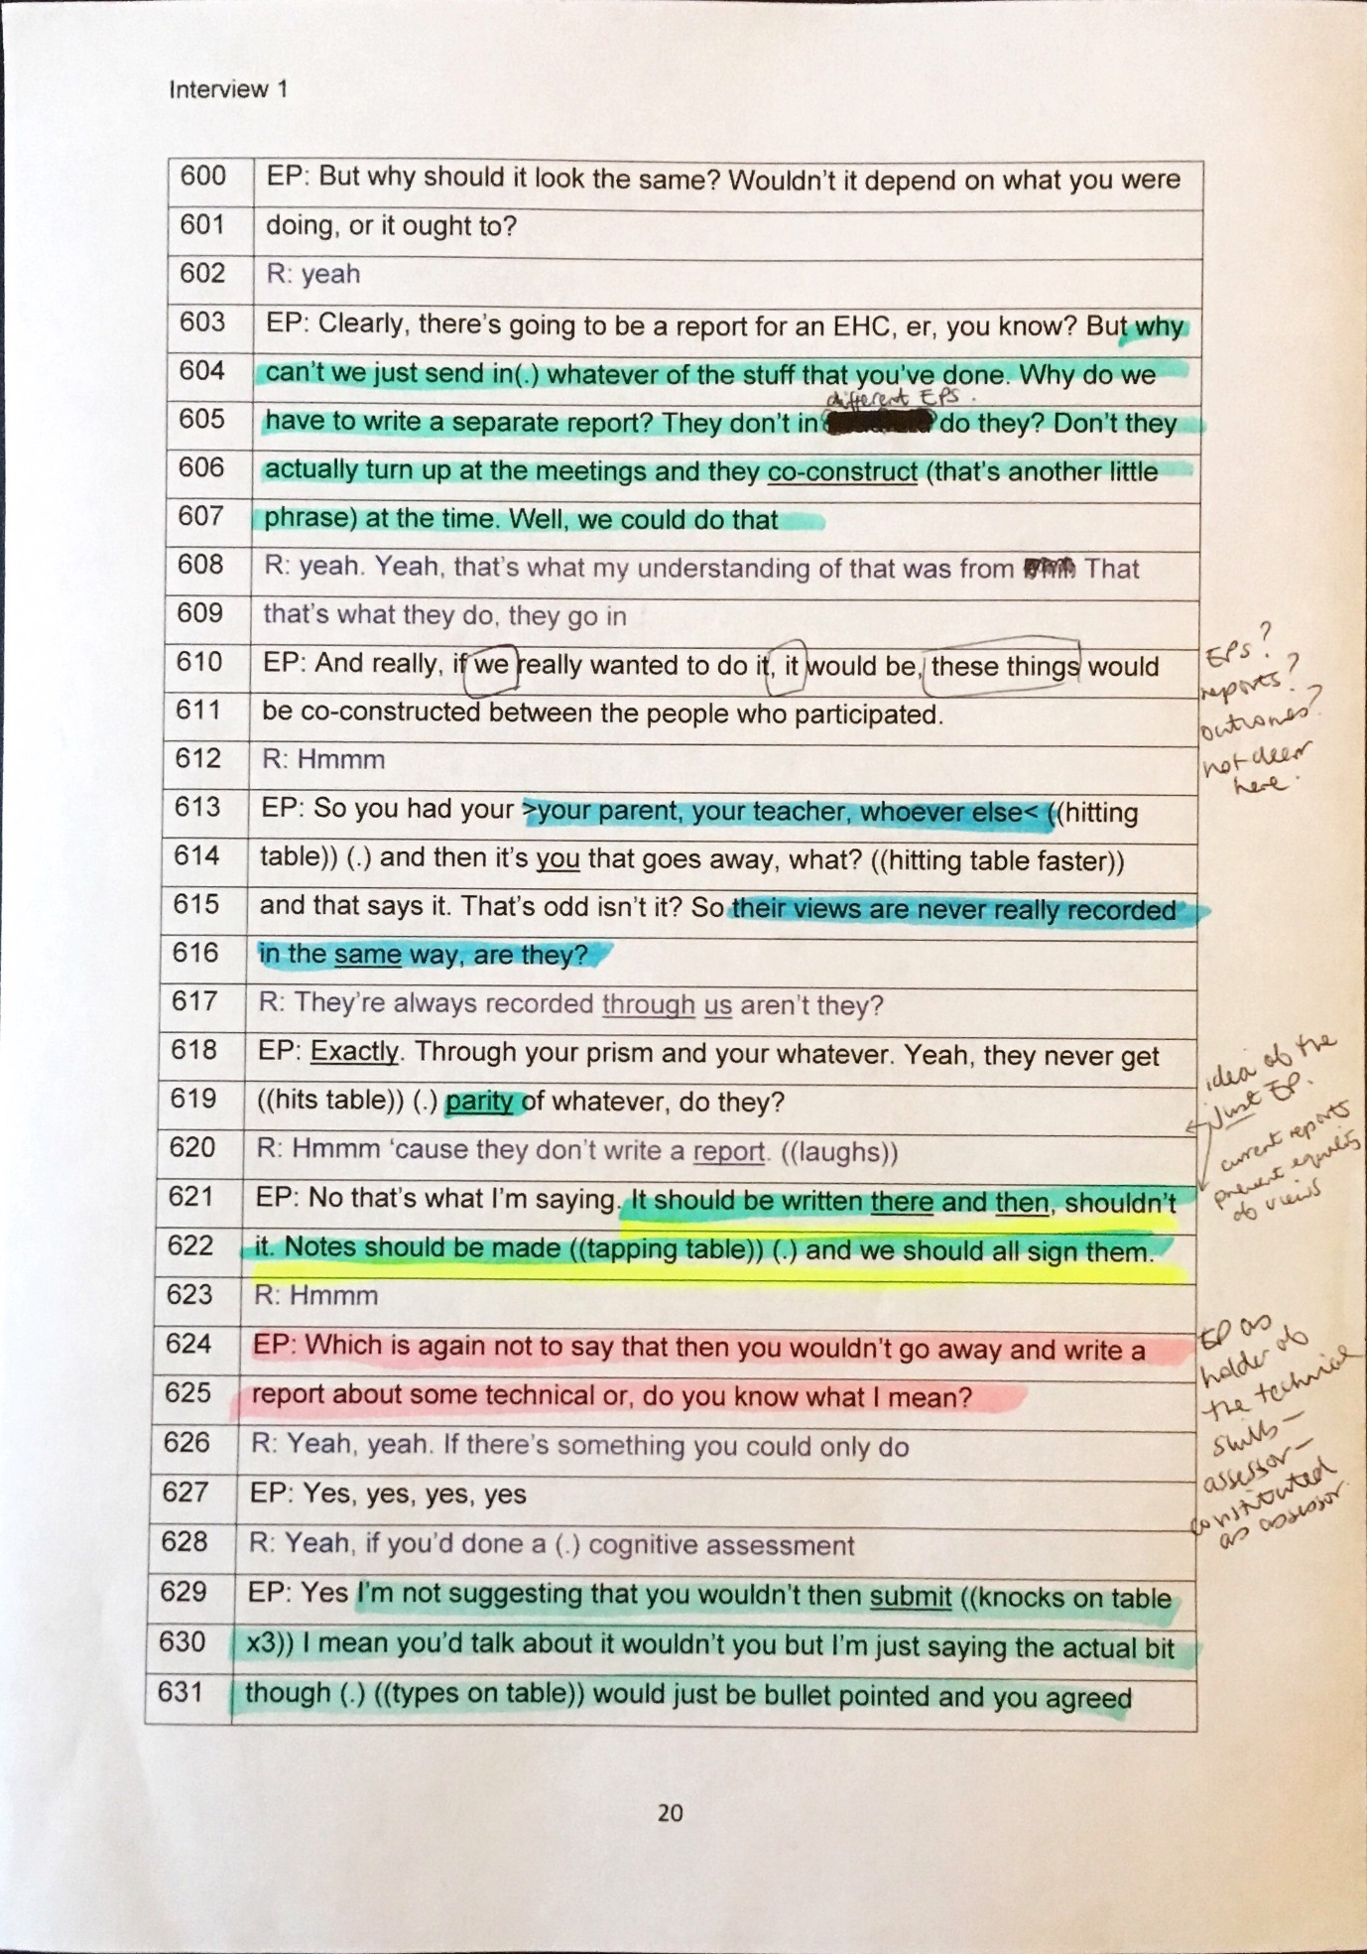

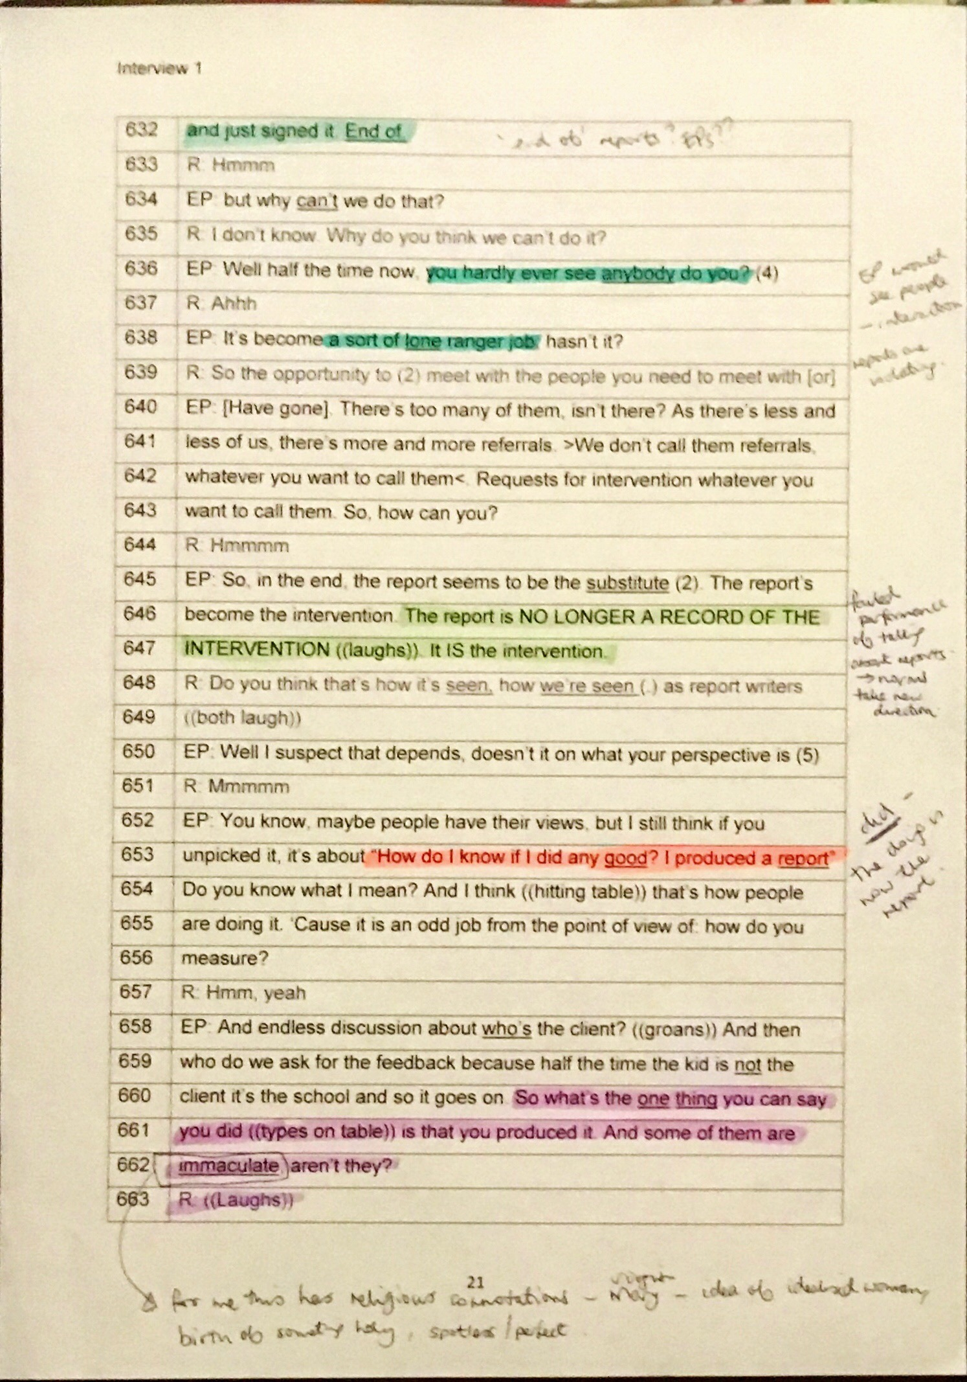

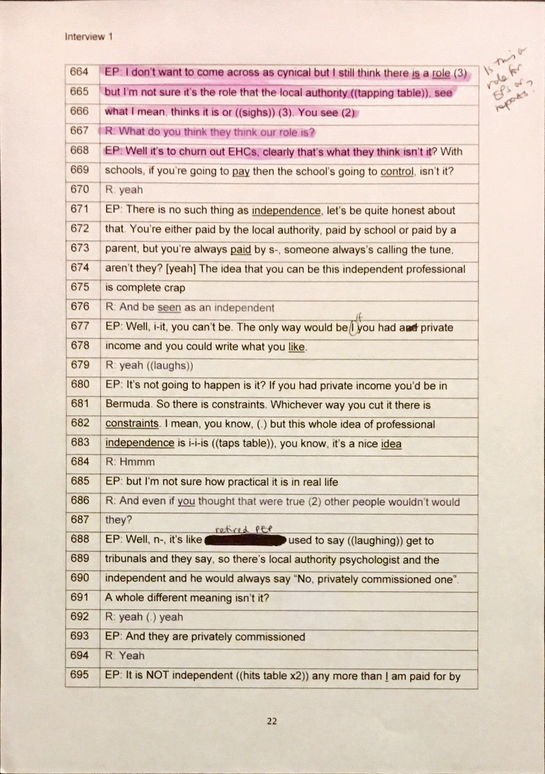

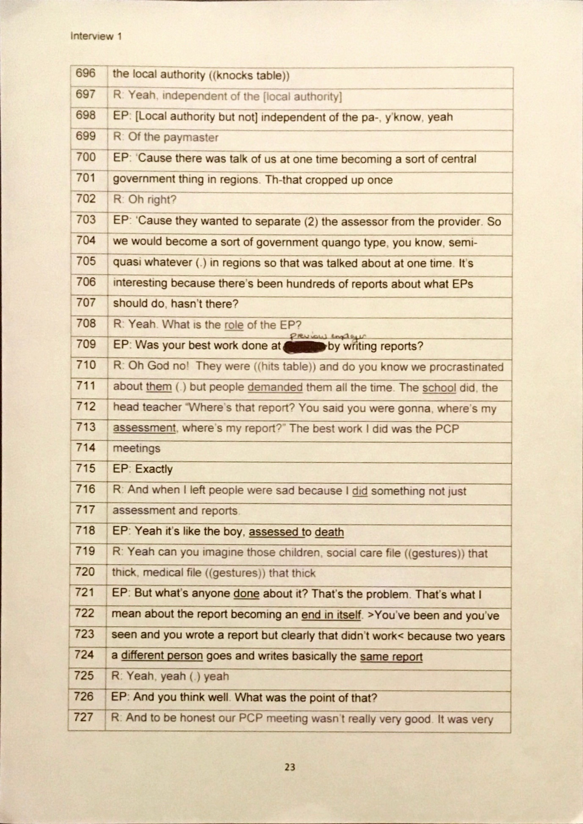

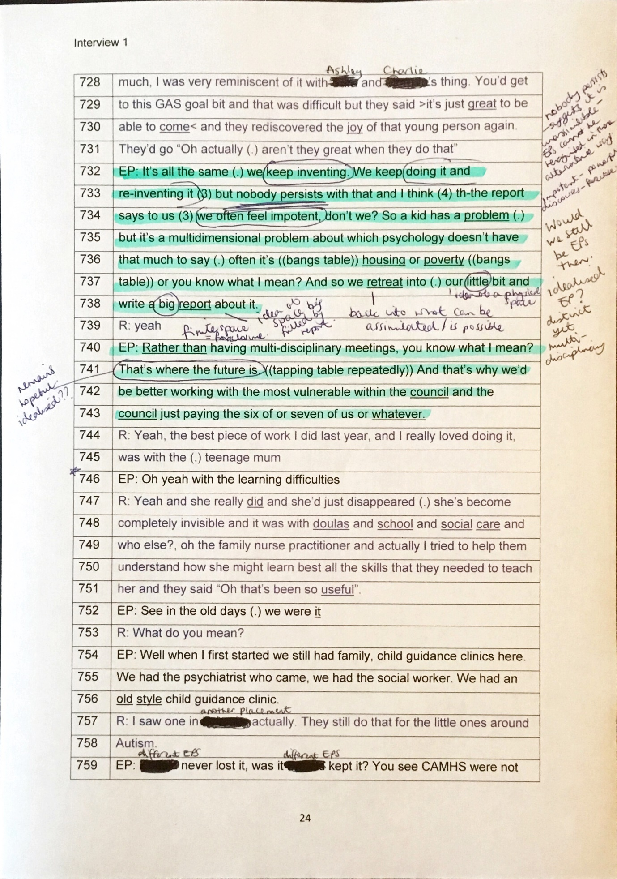

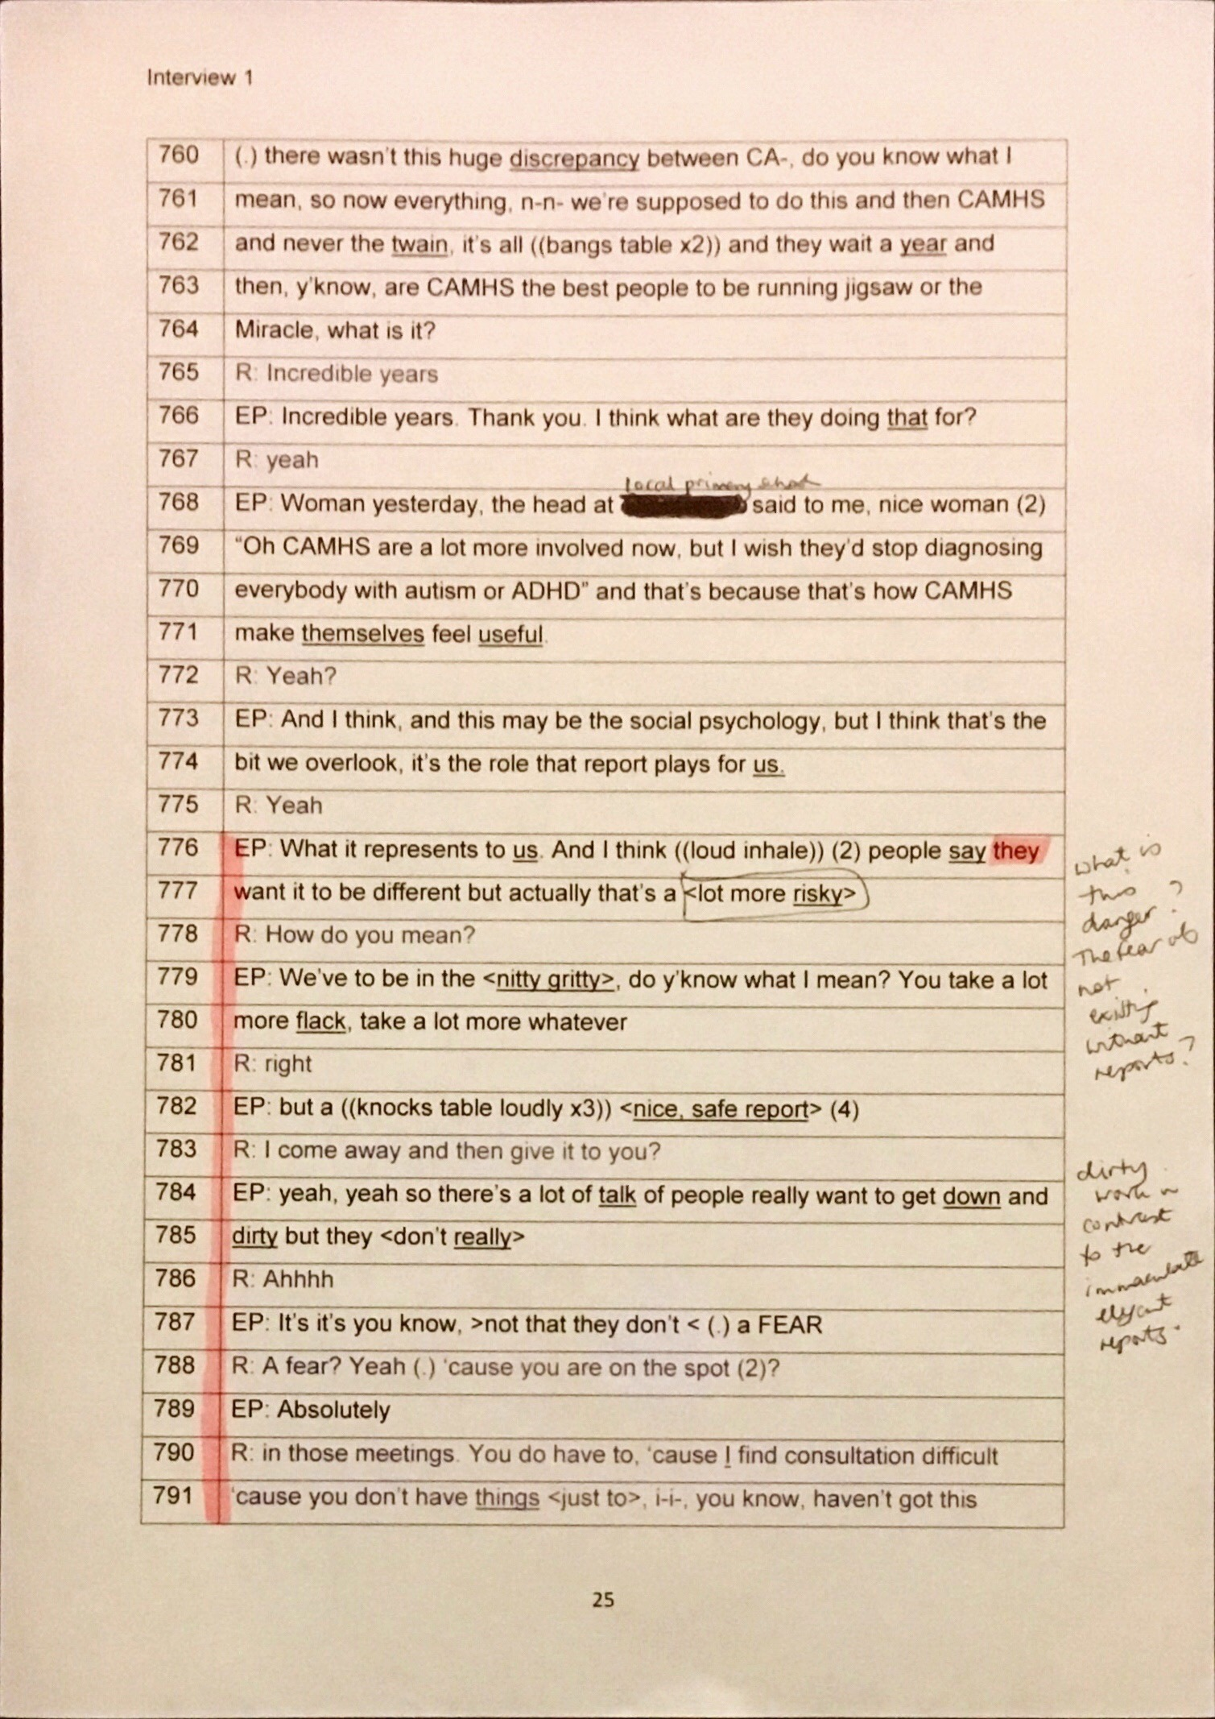

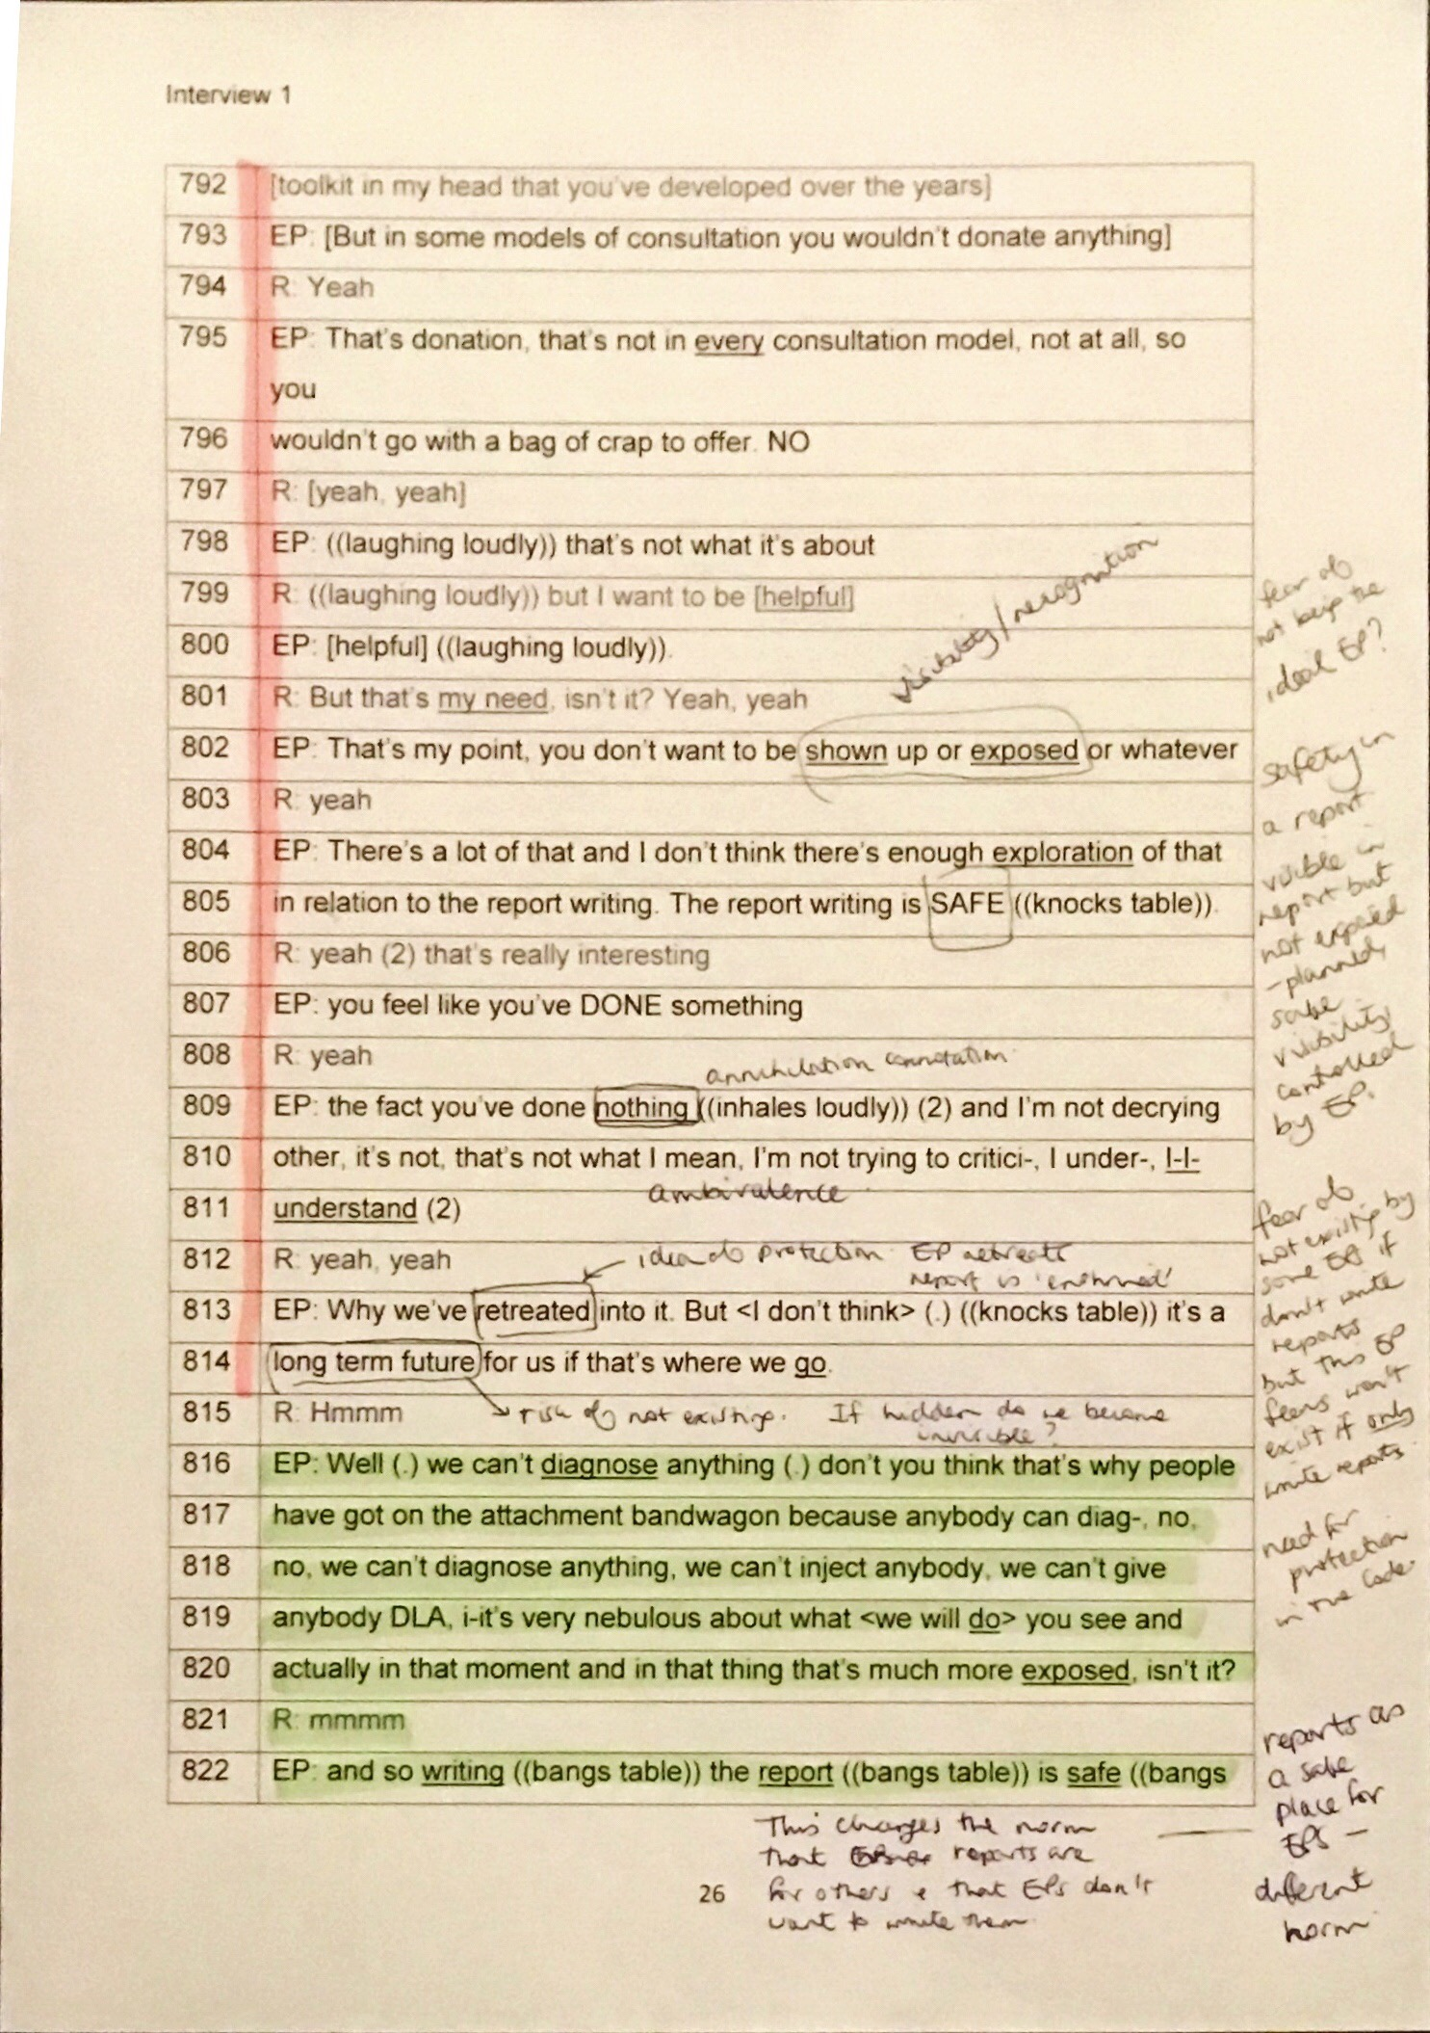

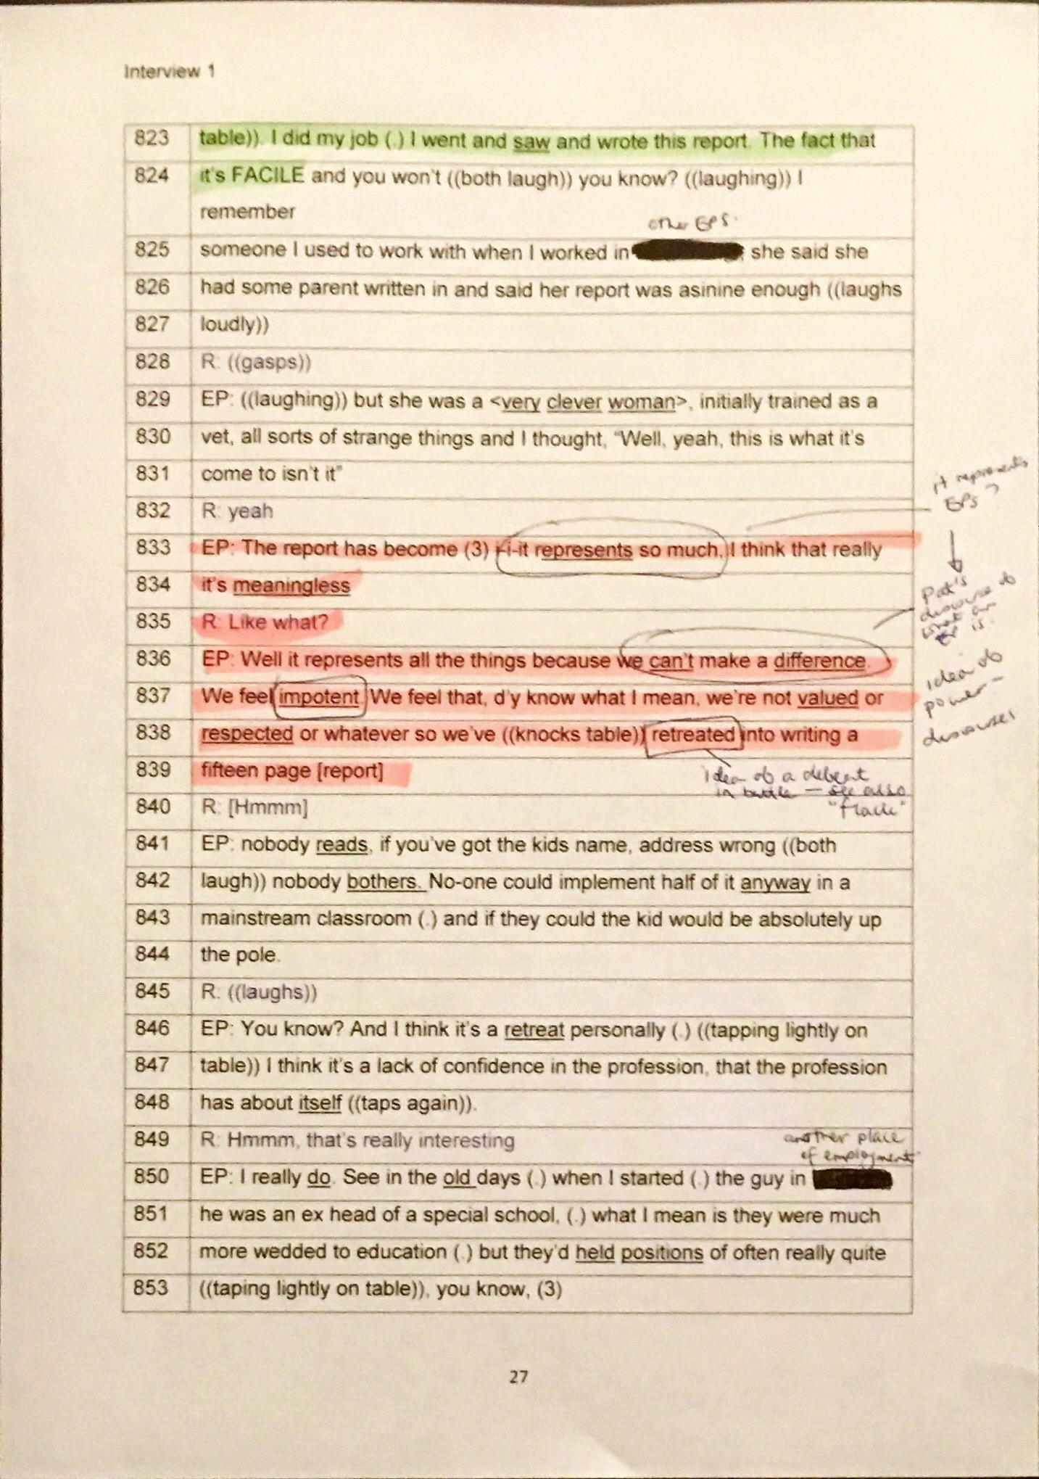

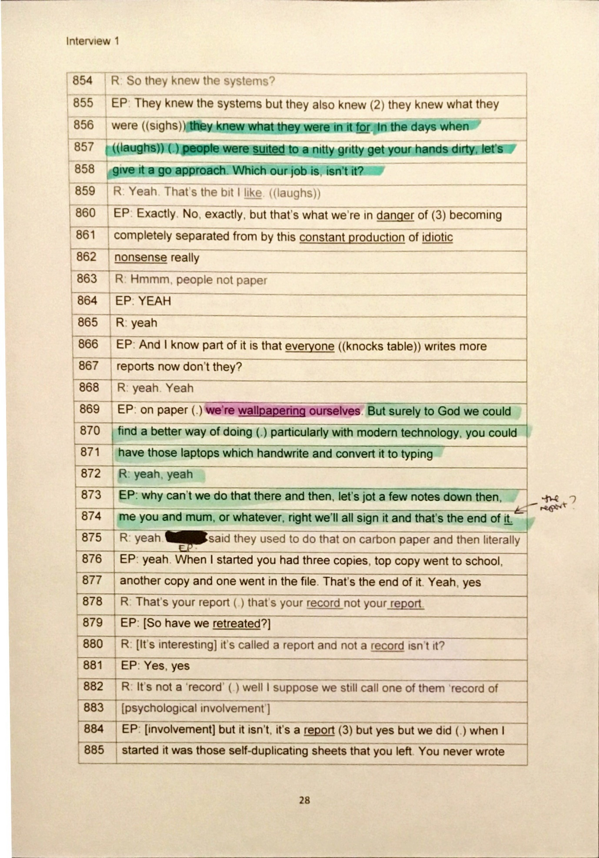

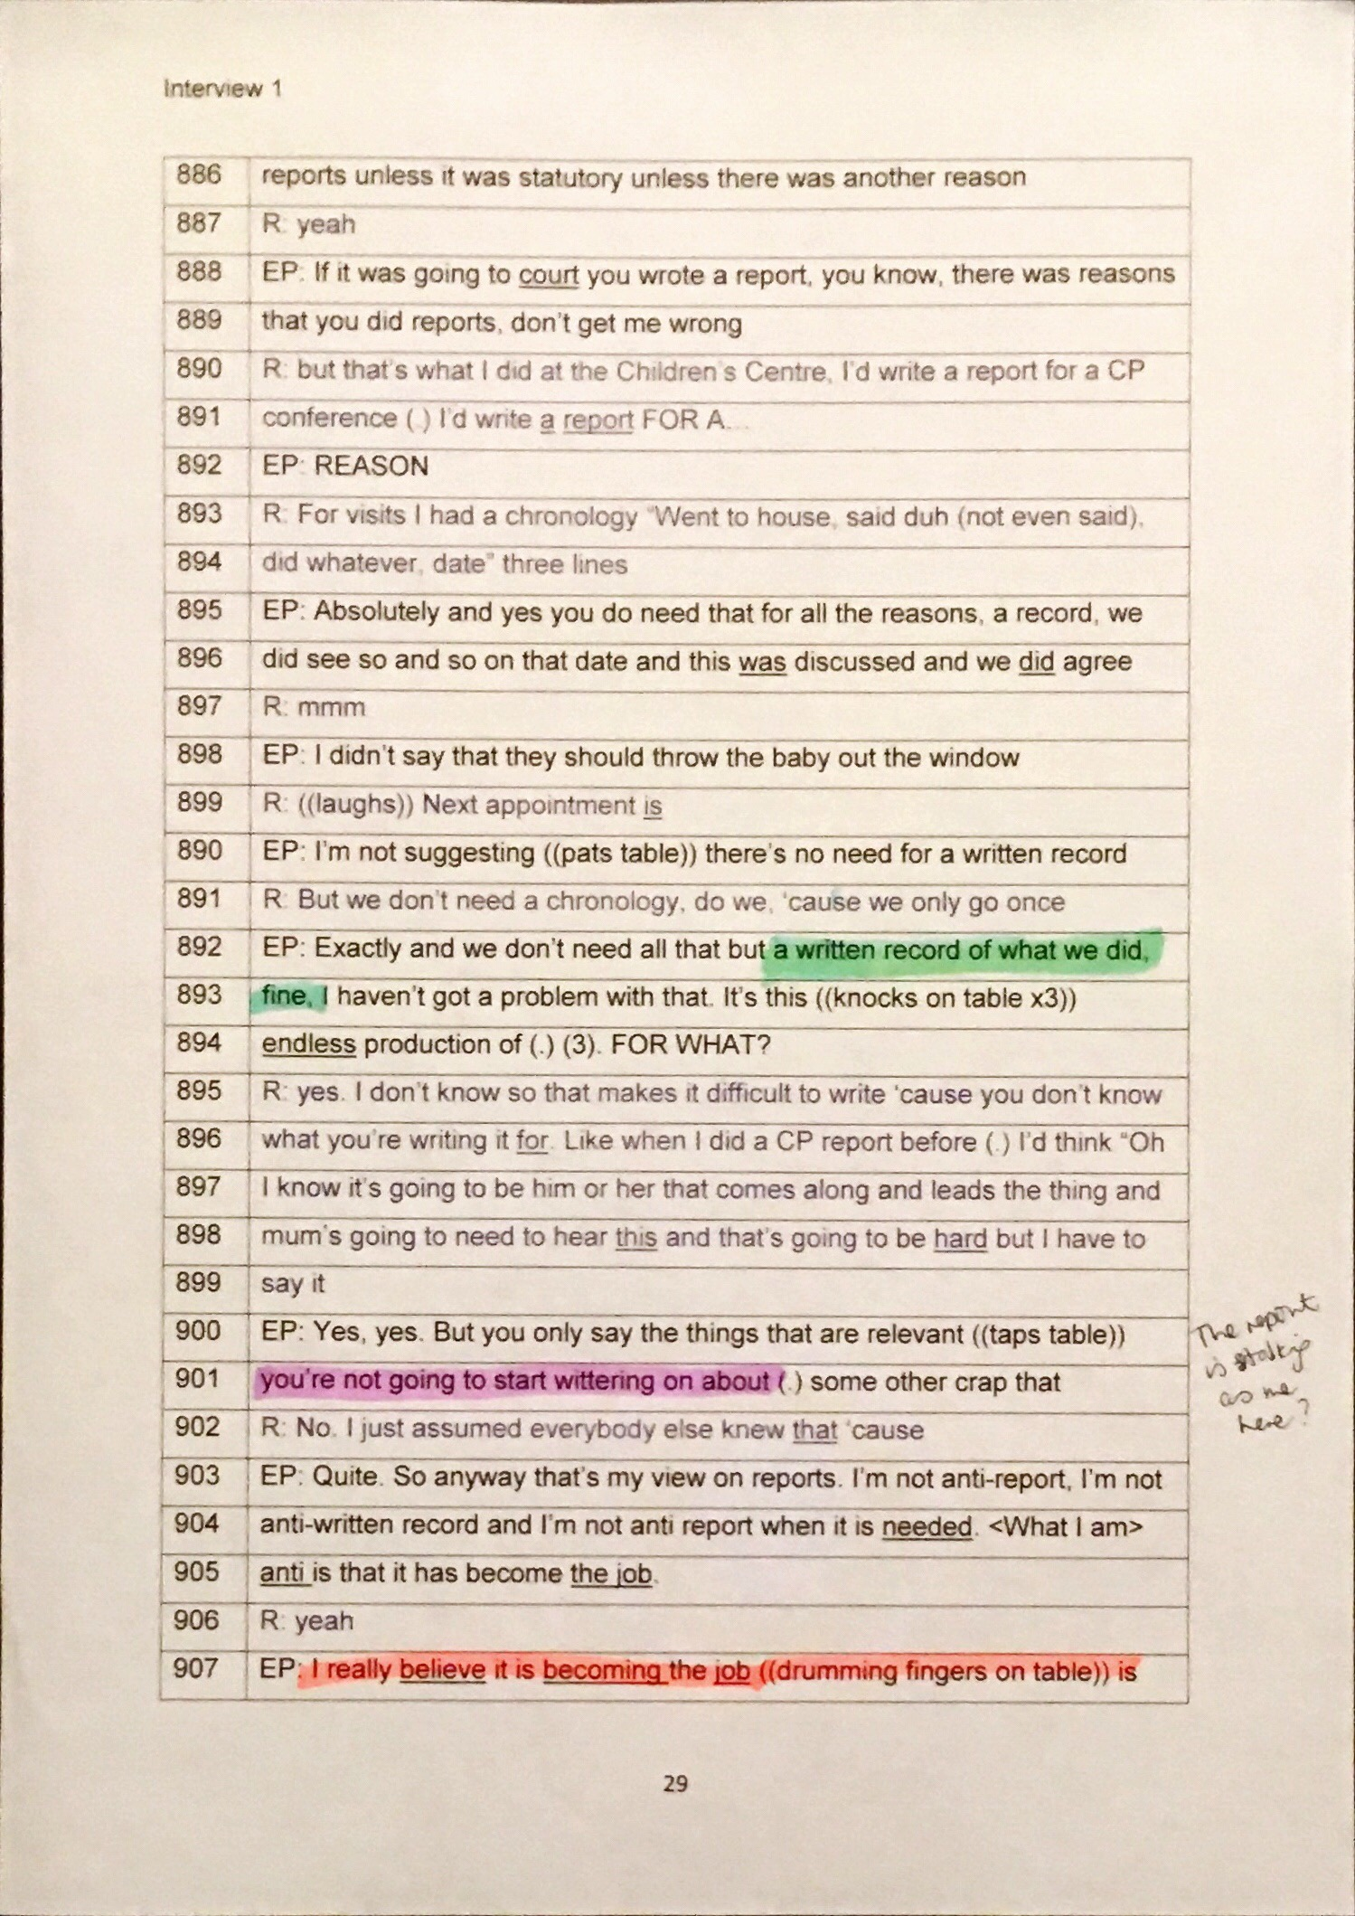

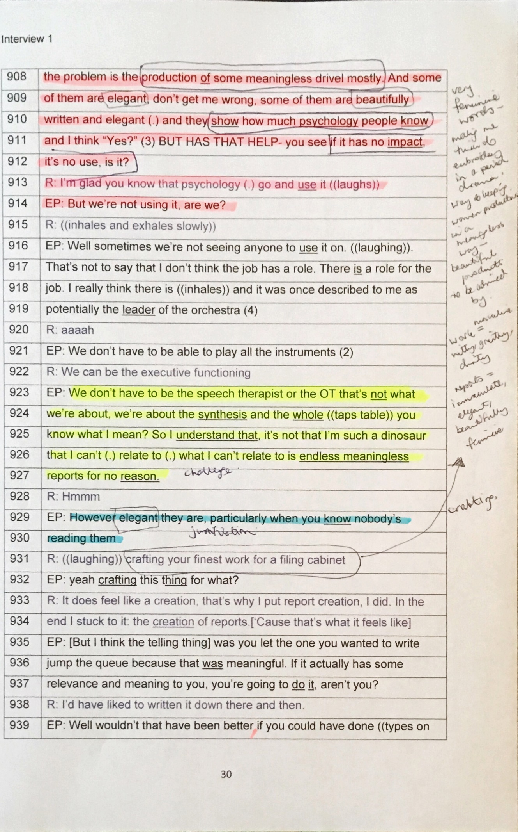

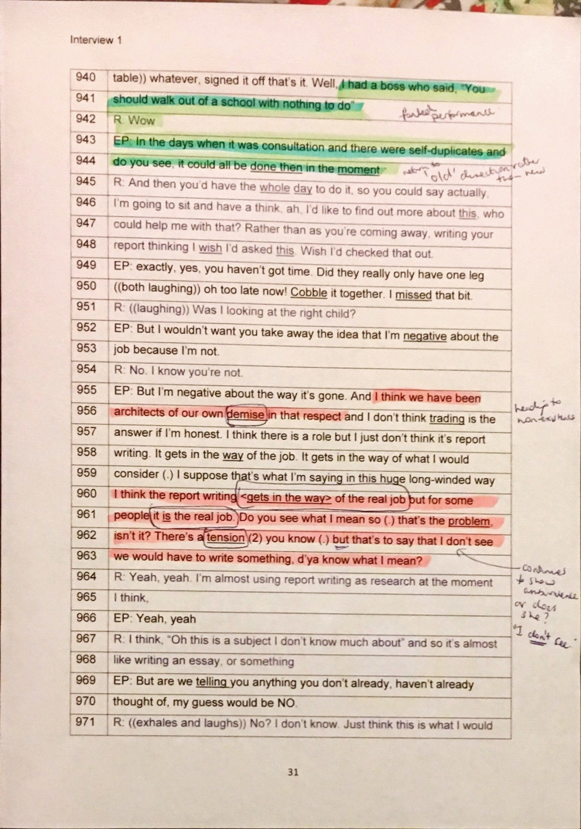

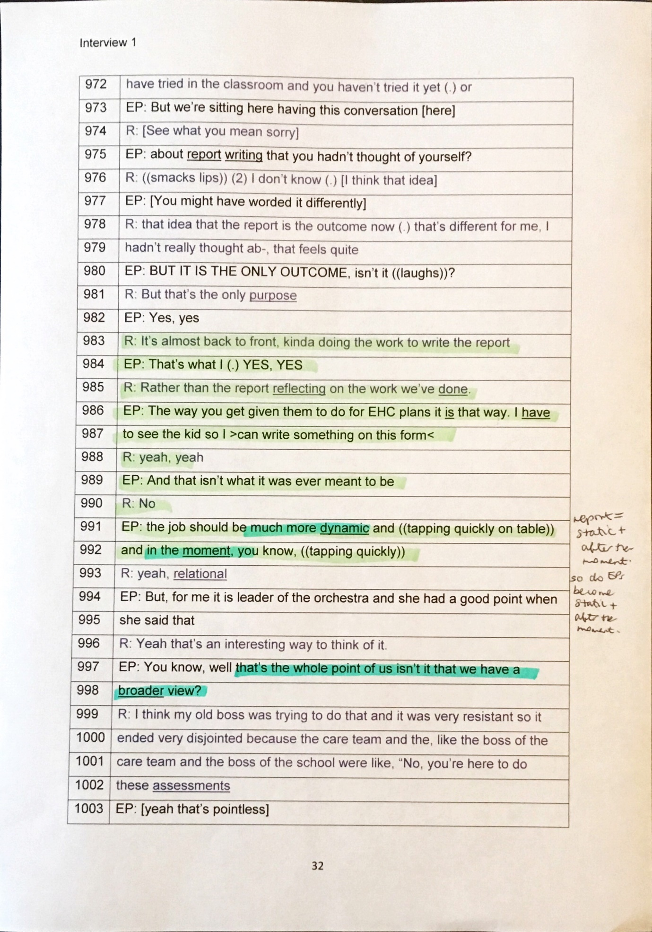

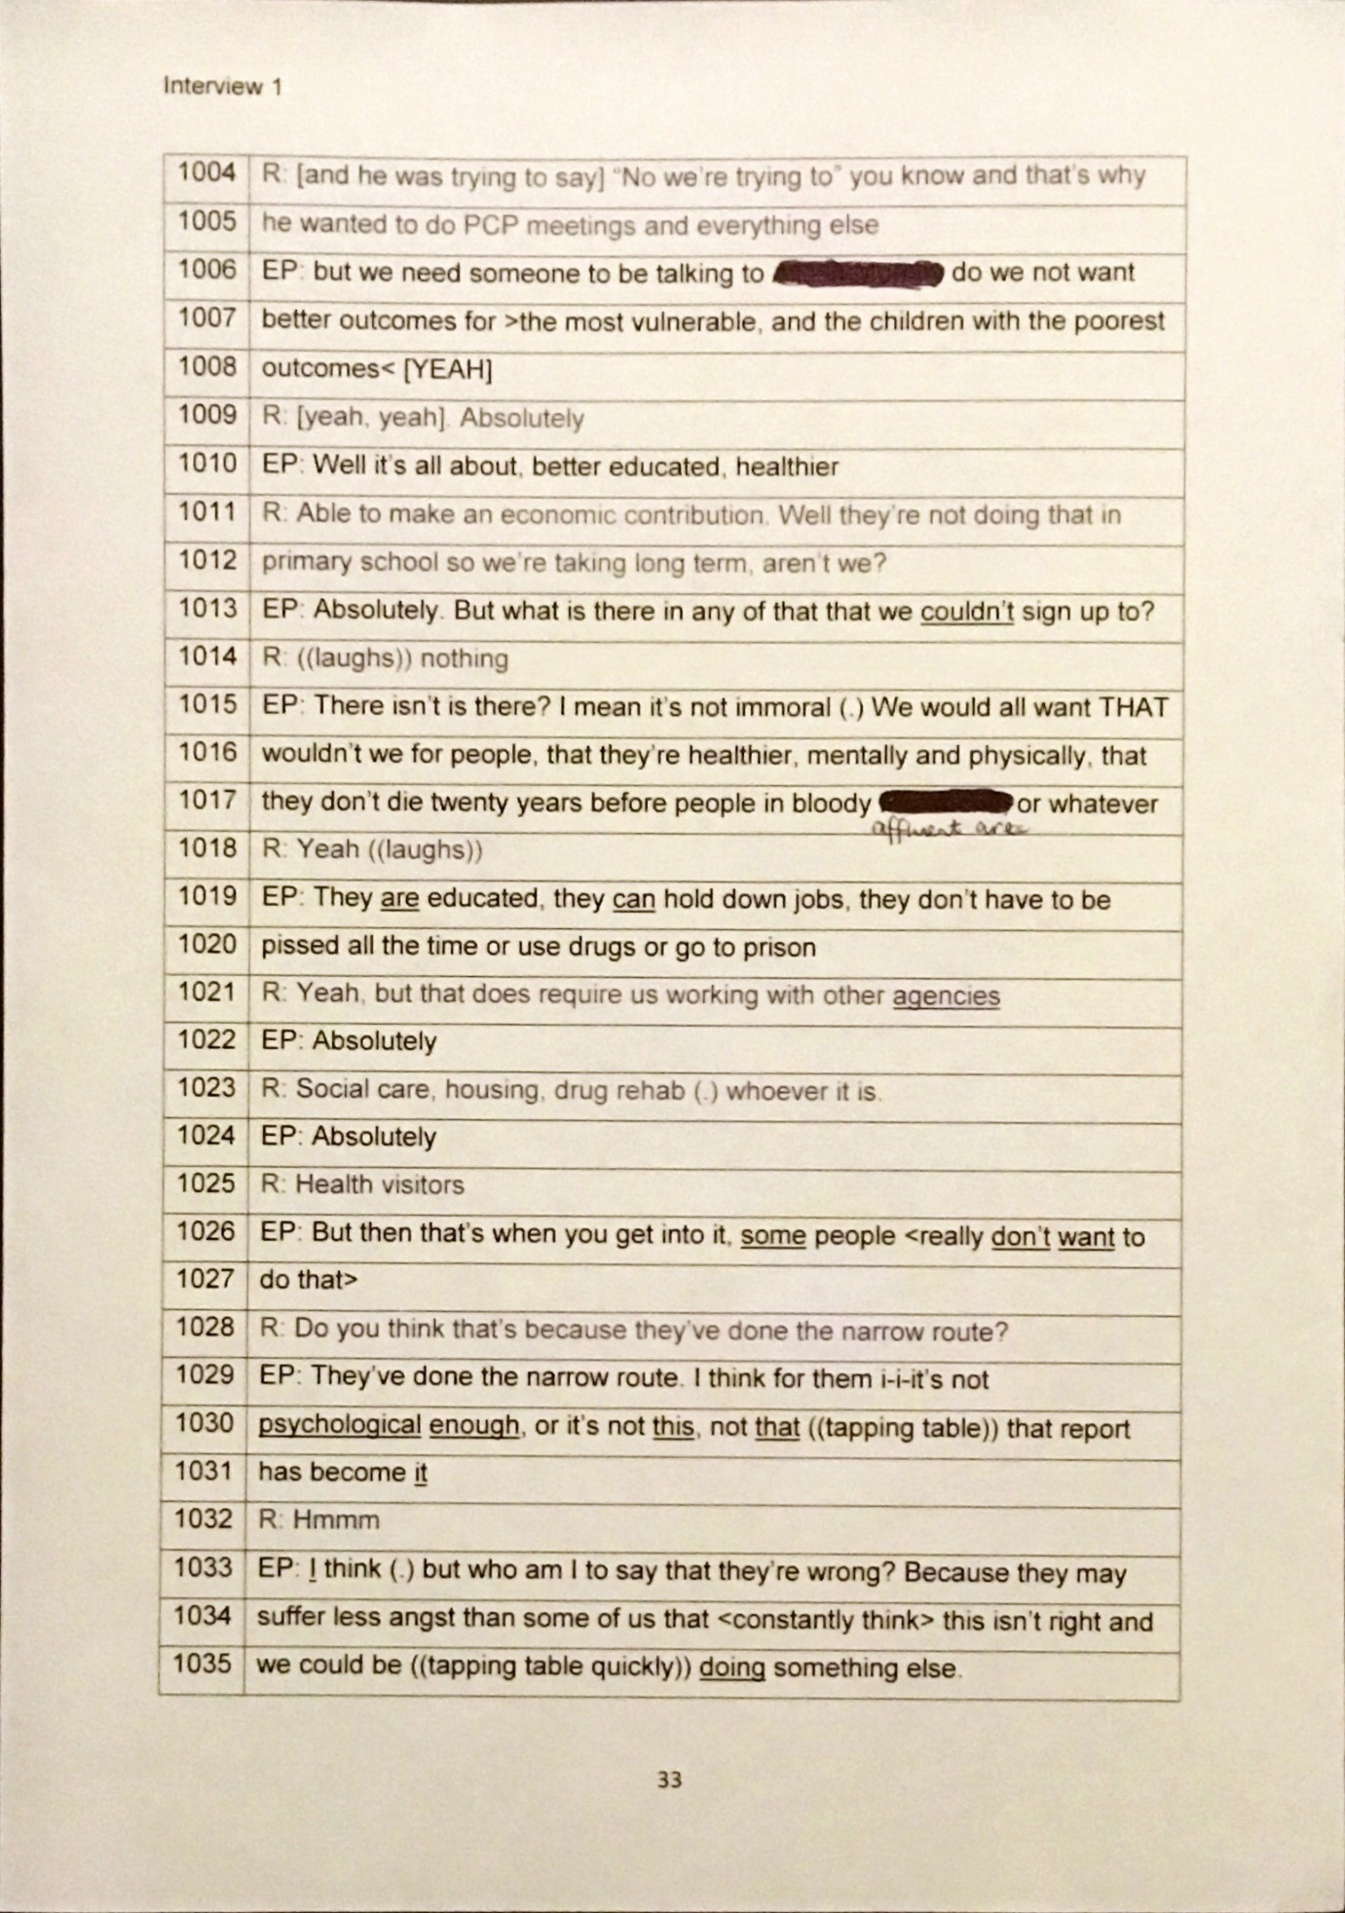

Appendix 10 Annotated transcript of interview 2 (Charlie).
Key for RQ2
Key for RQ3
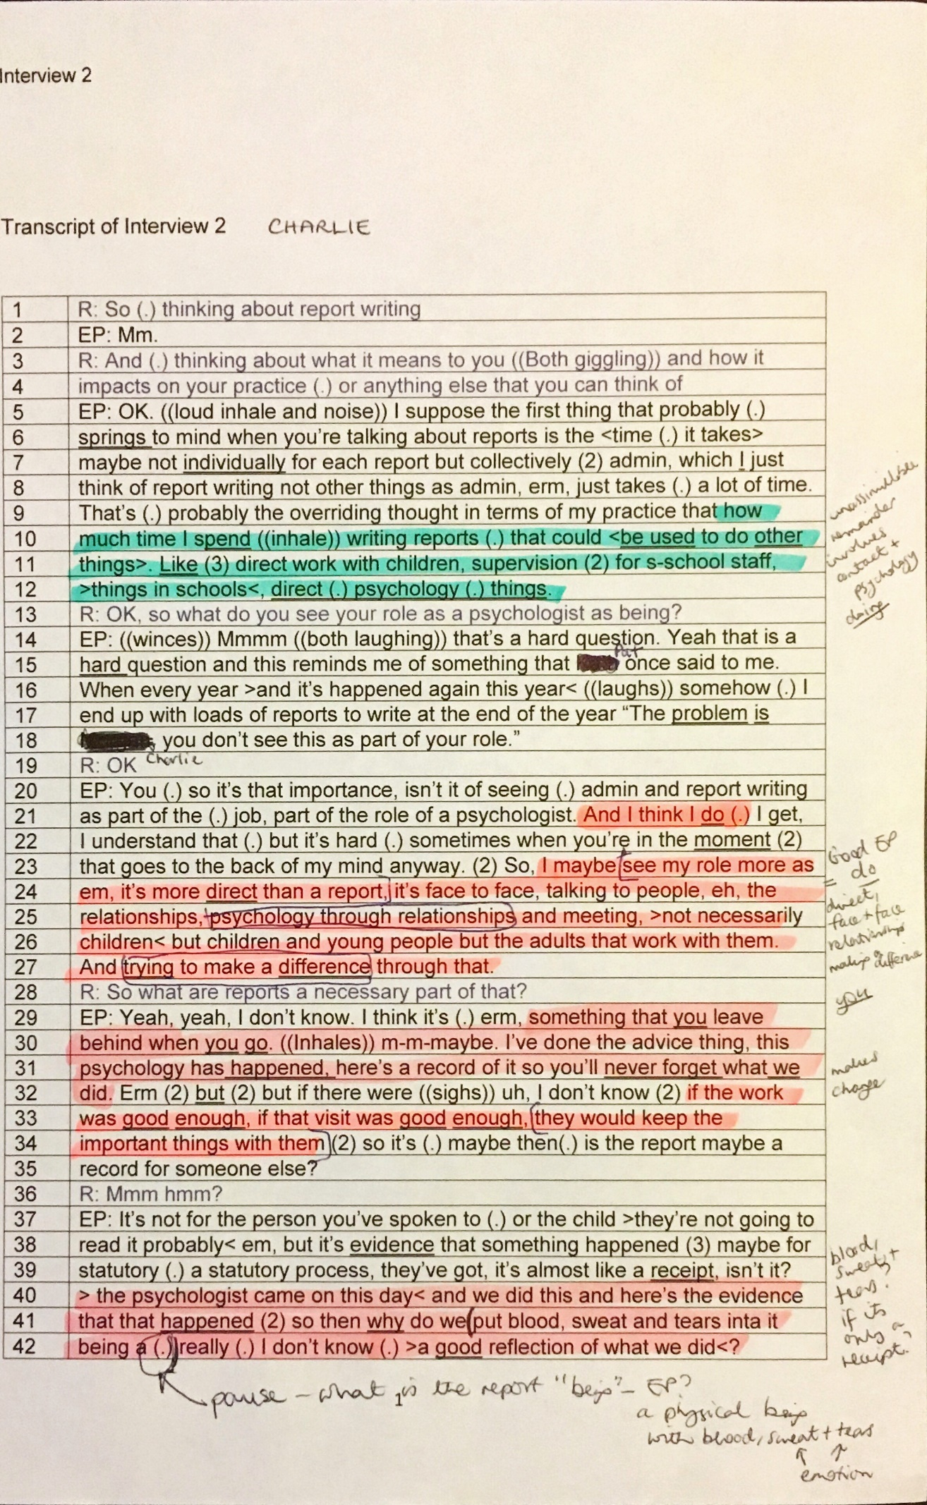
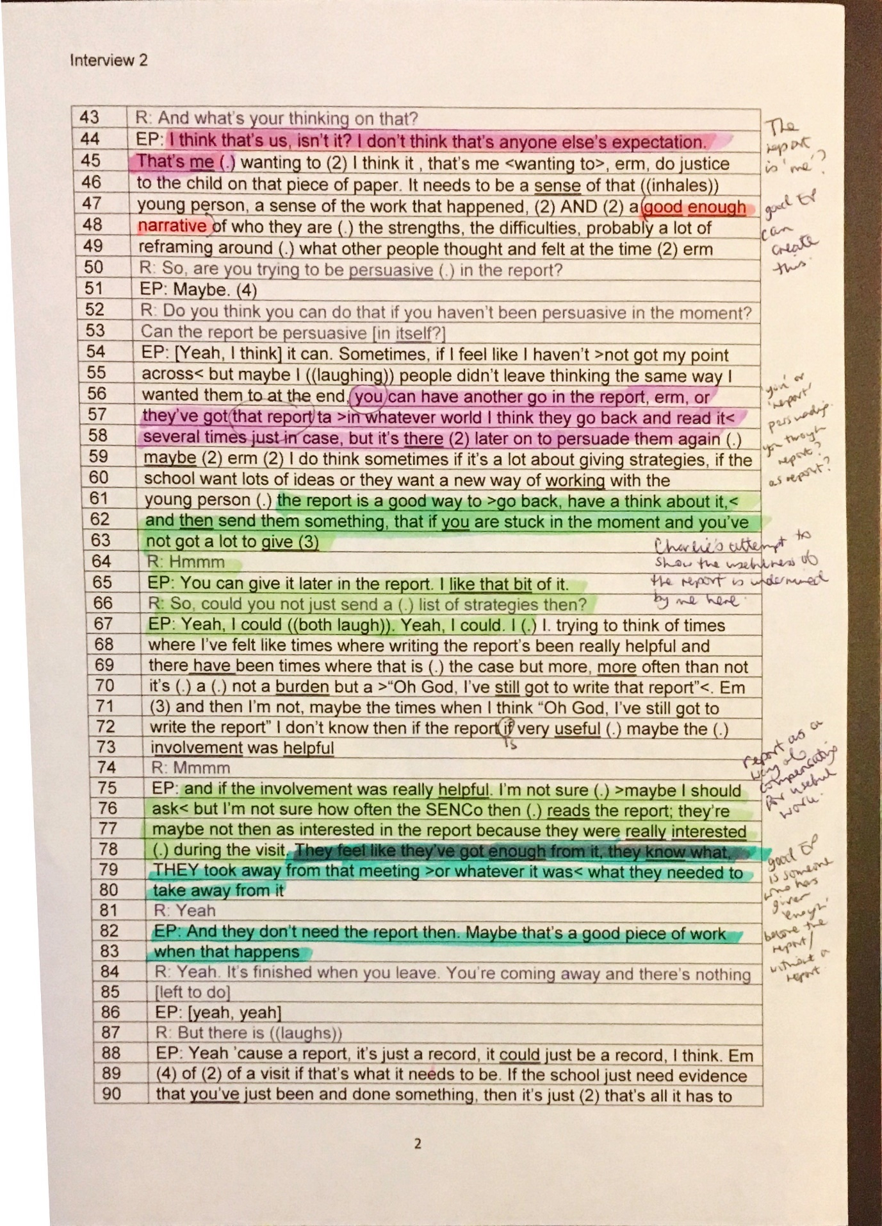

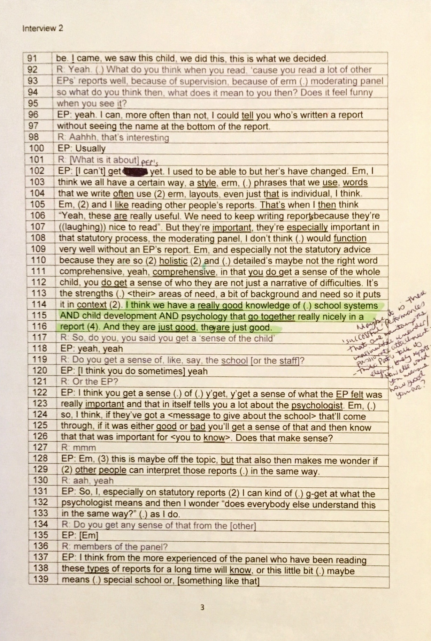

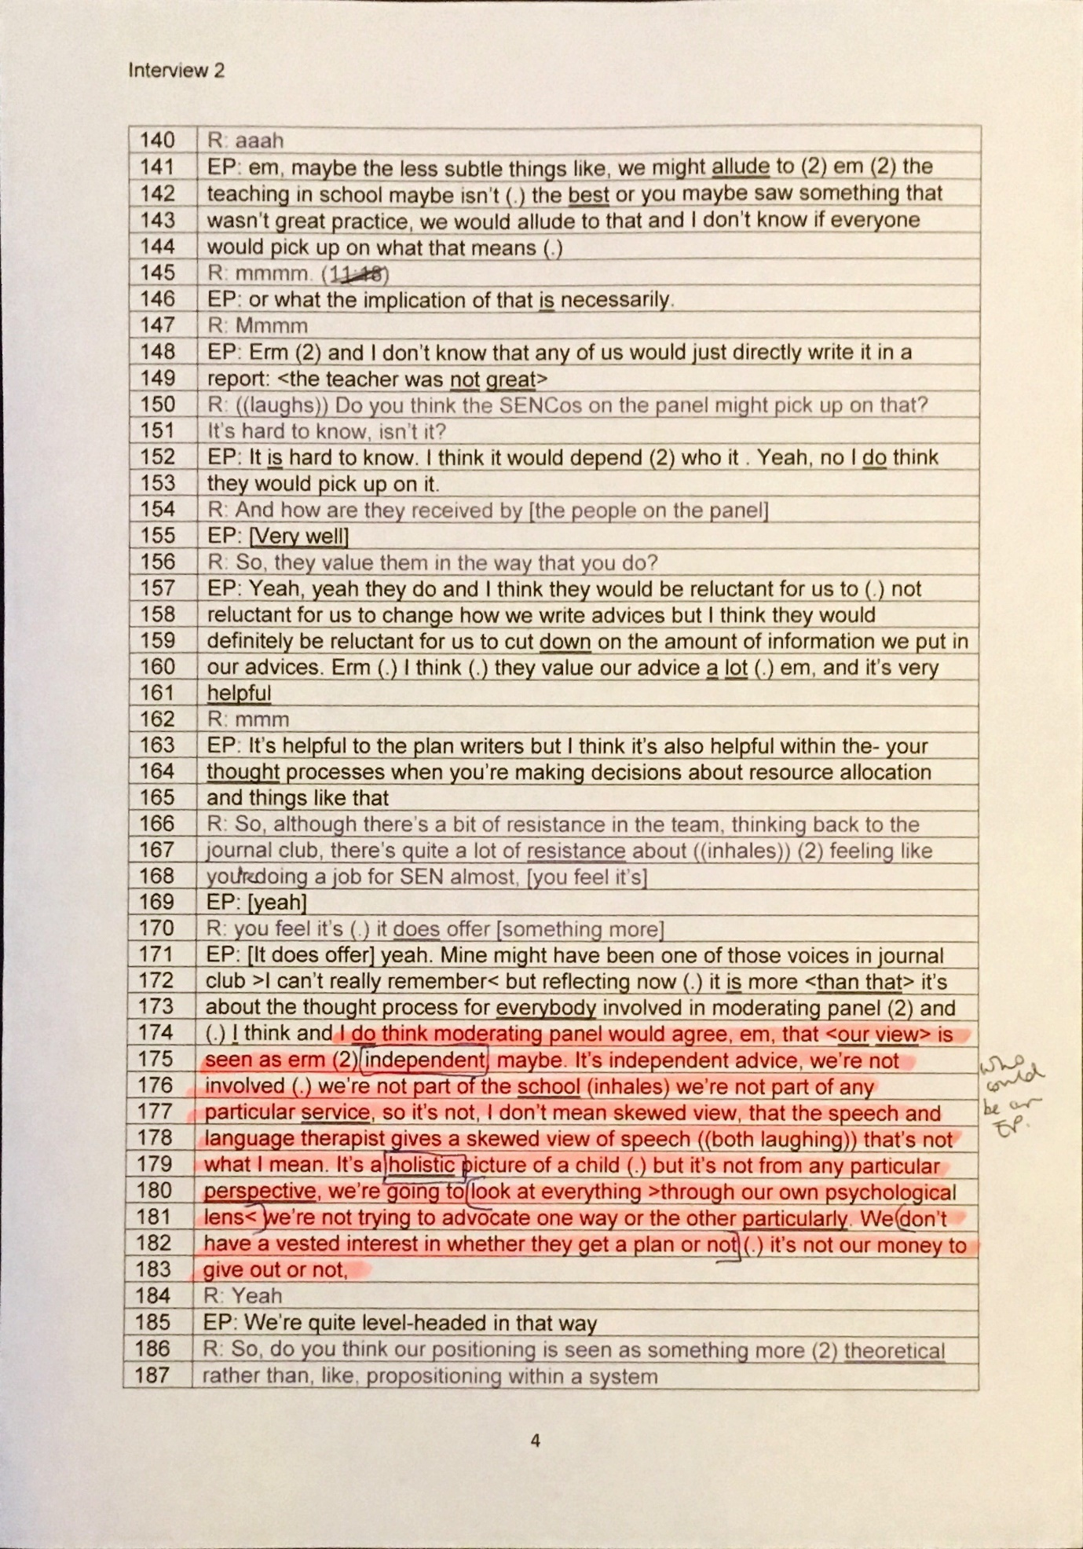

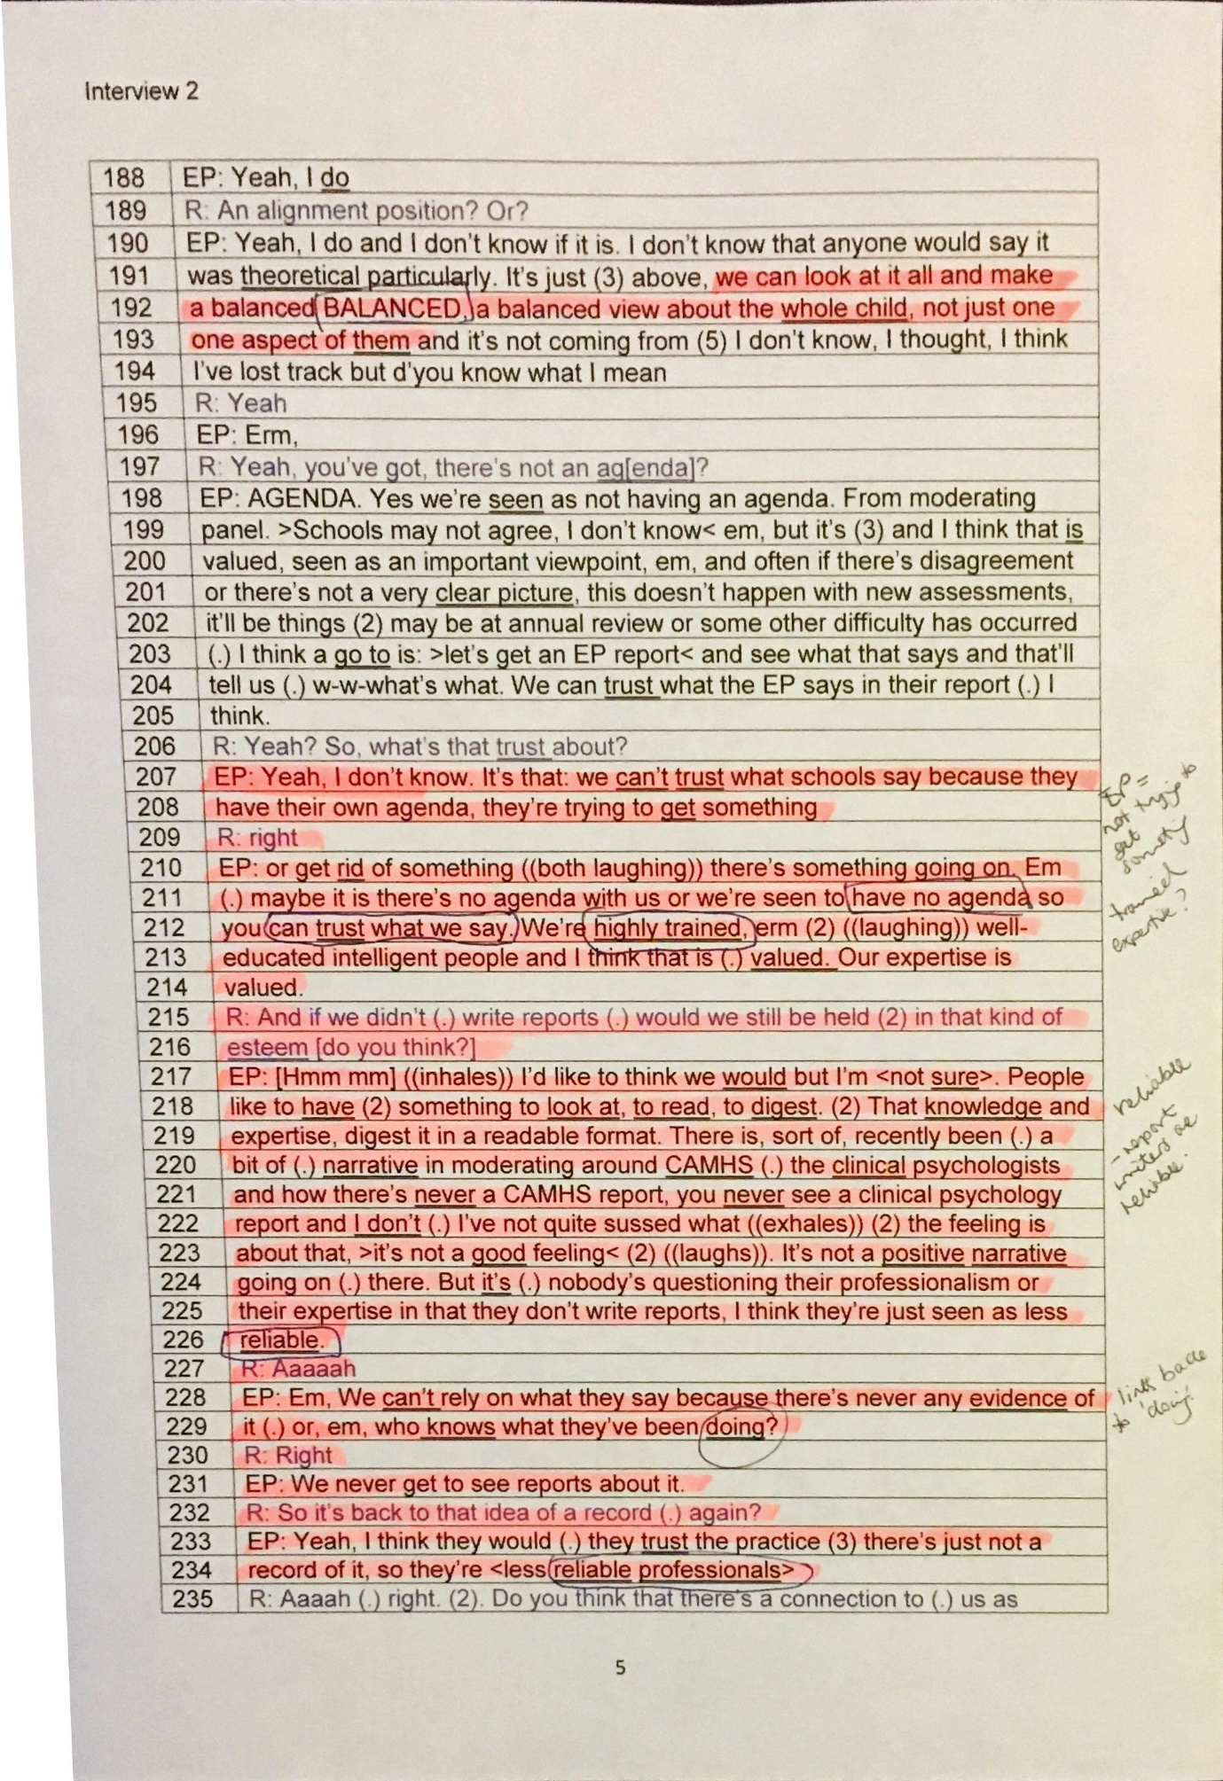

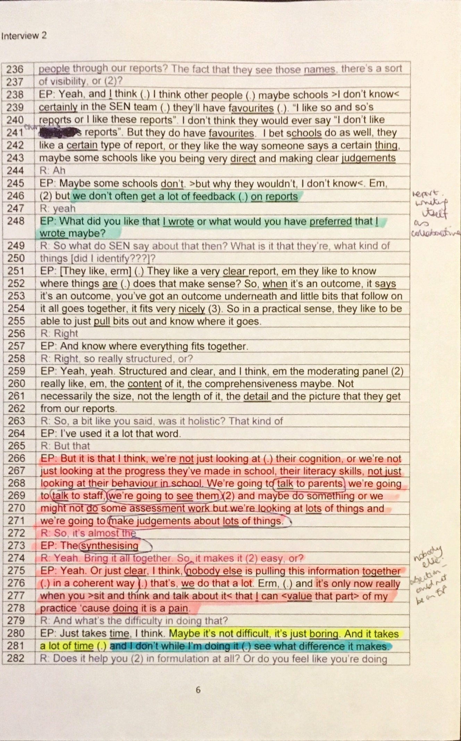
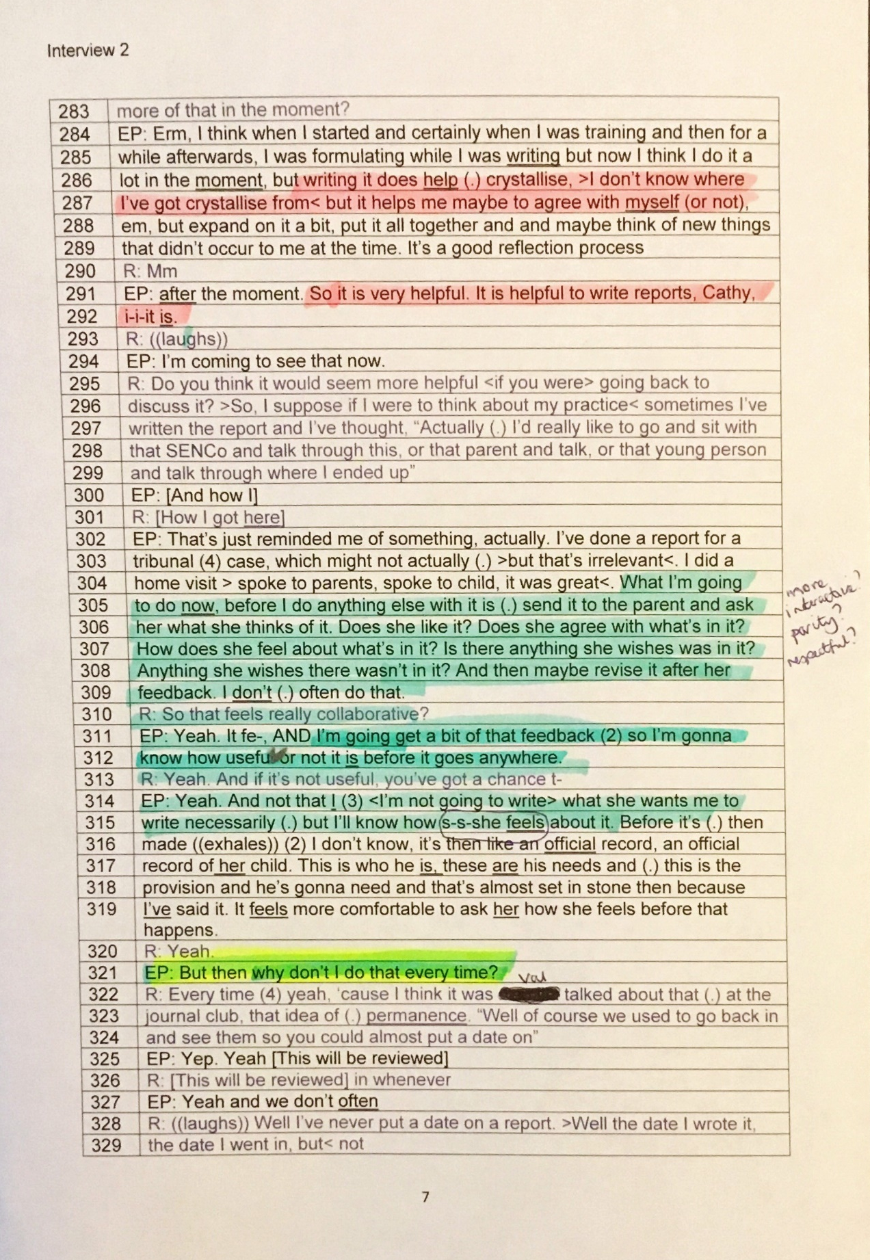

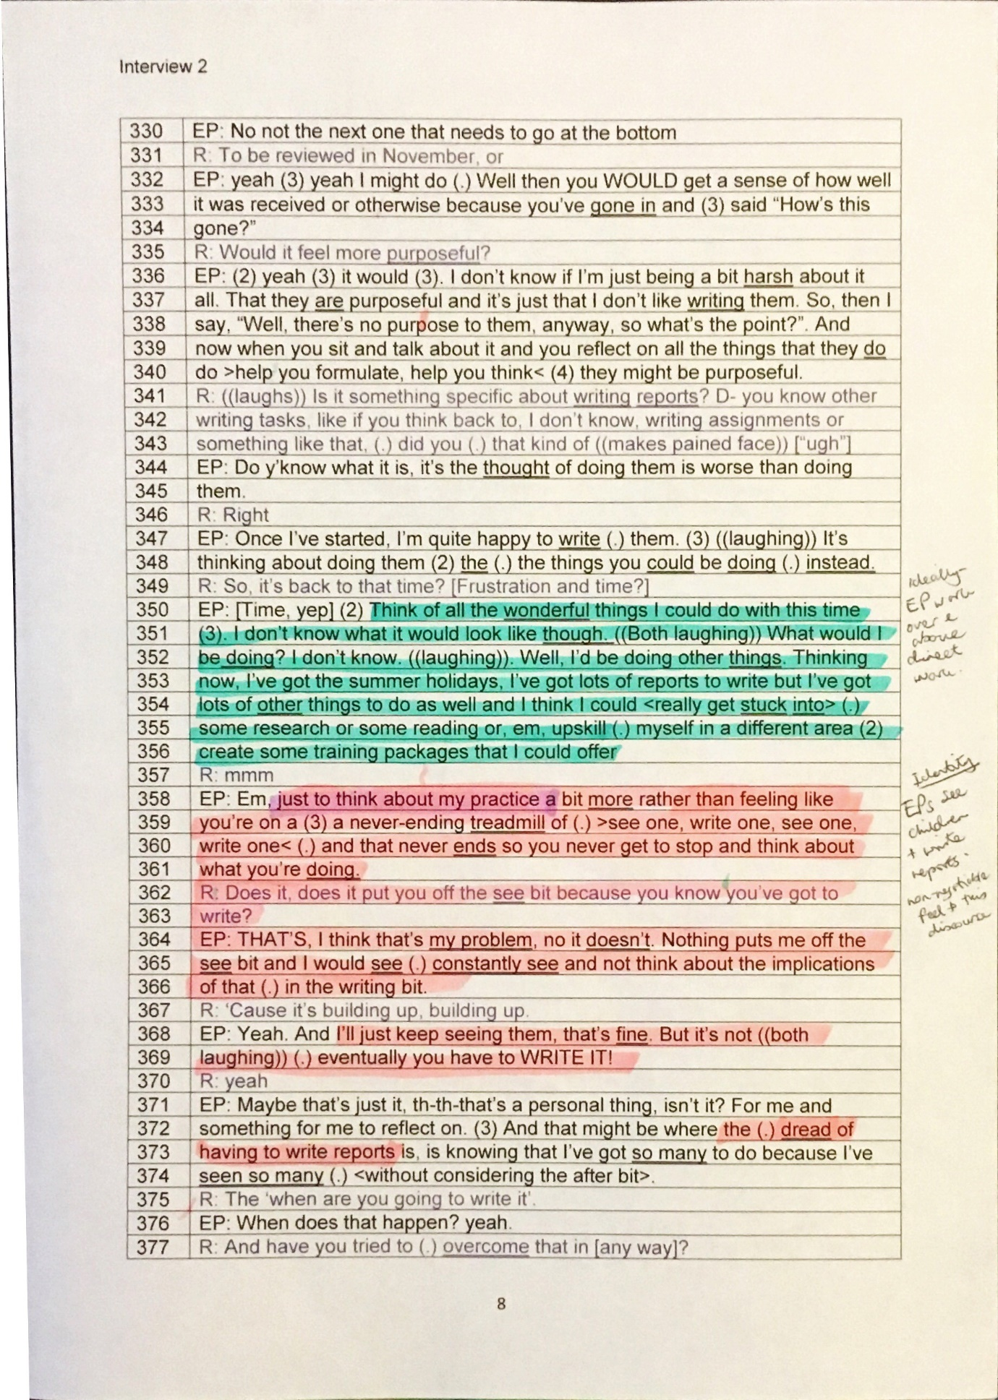

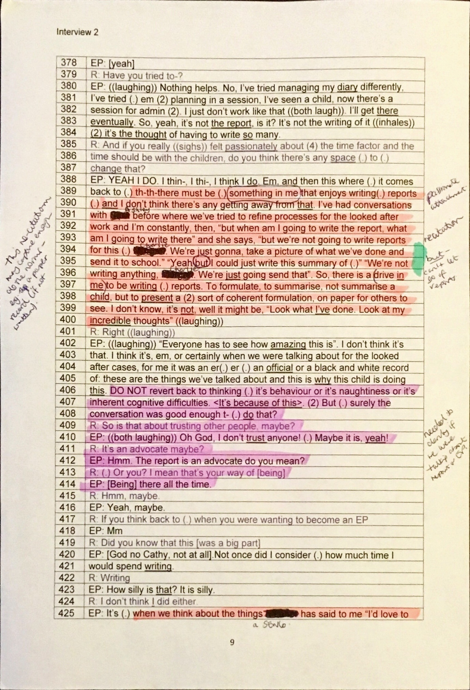

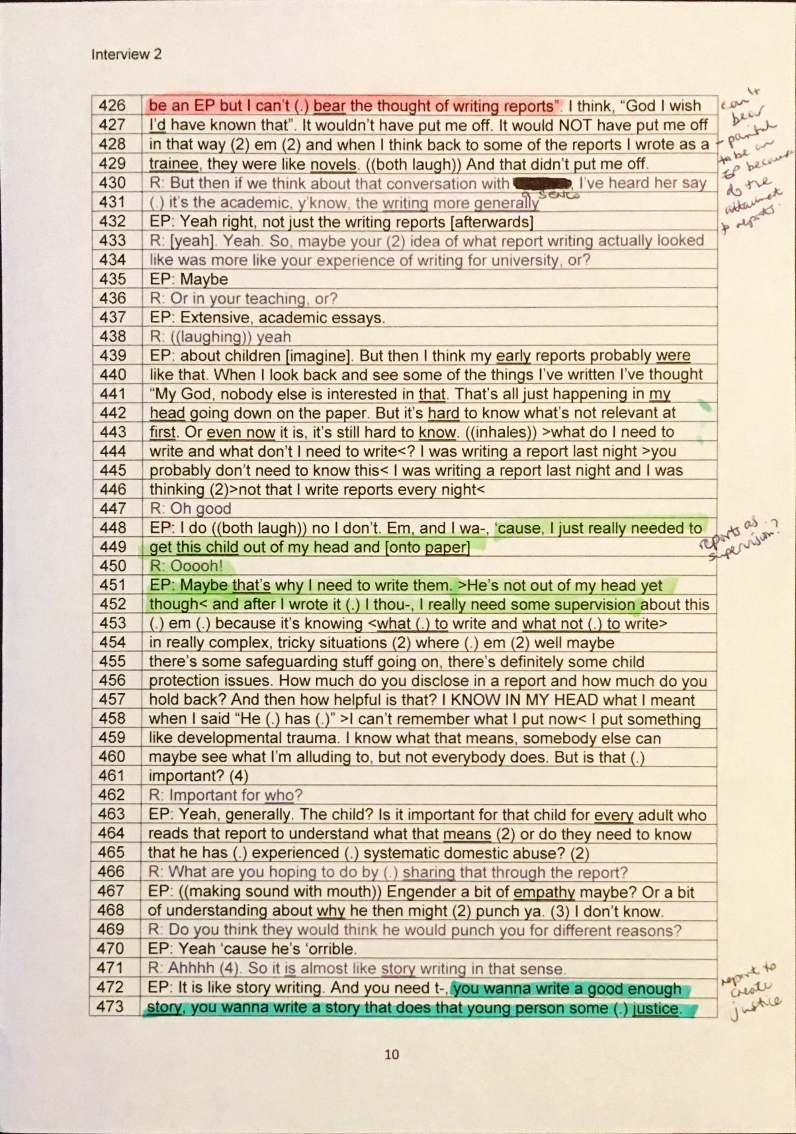

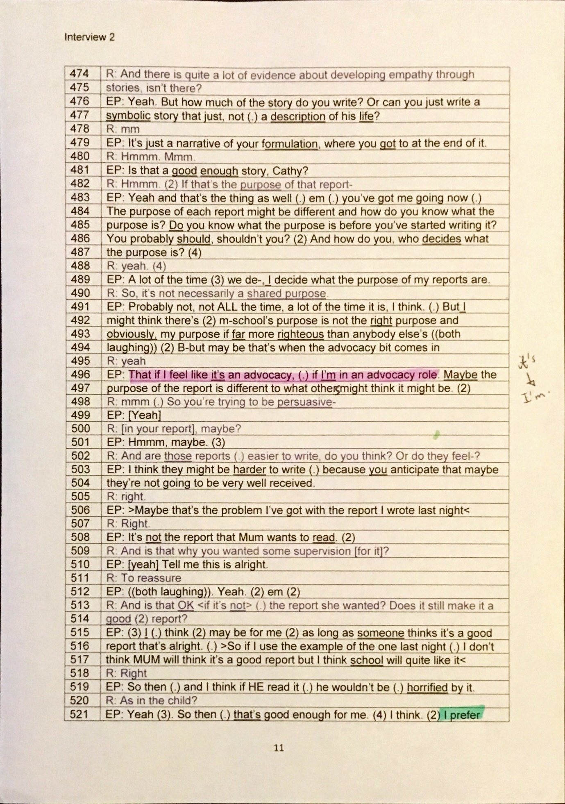

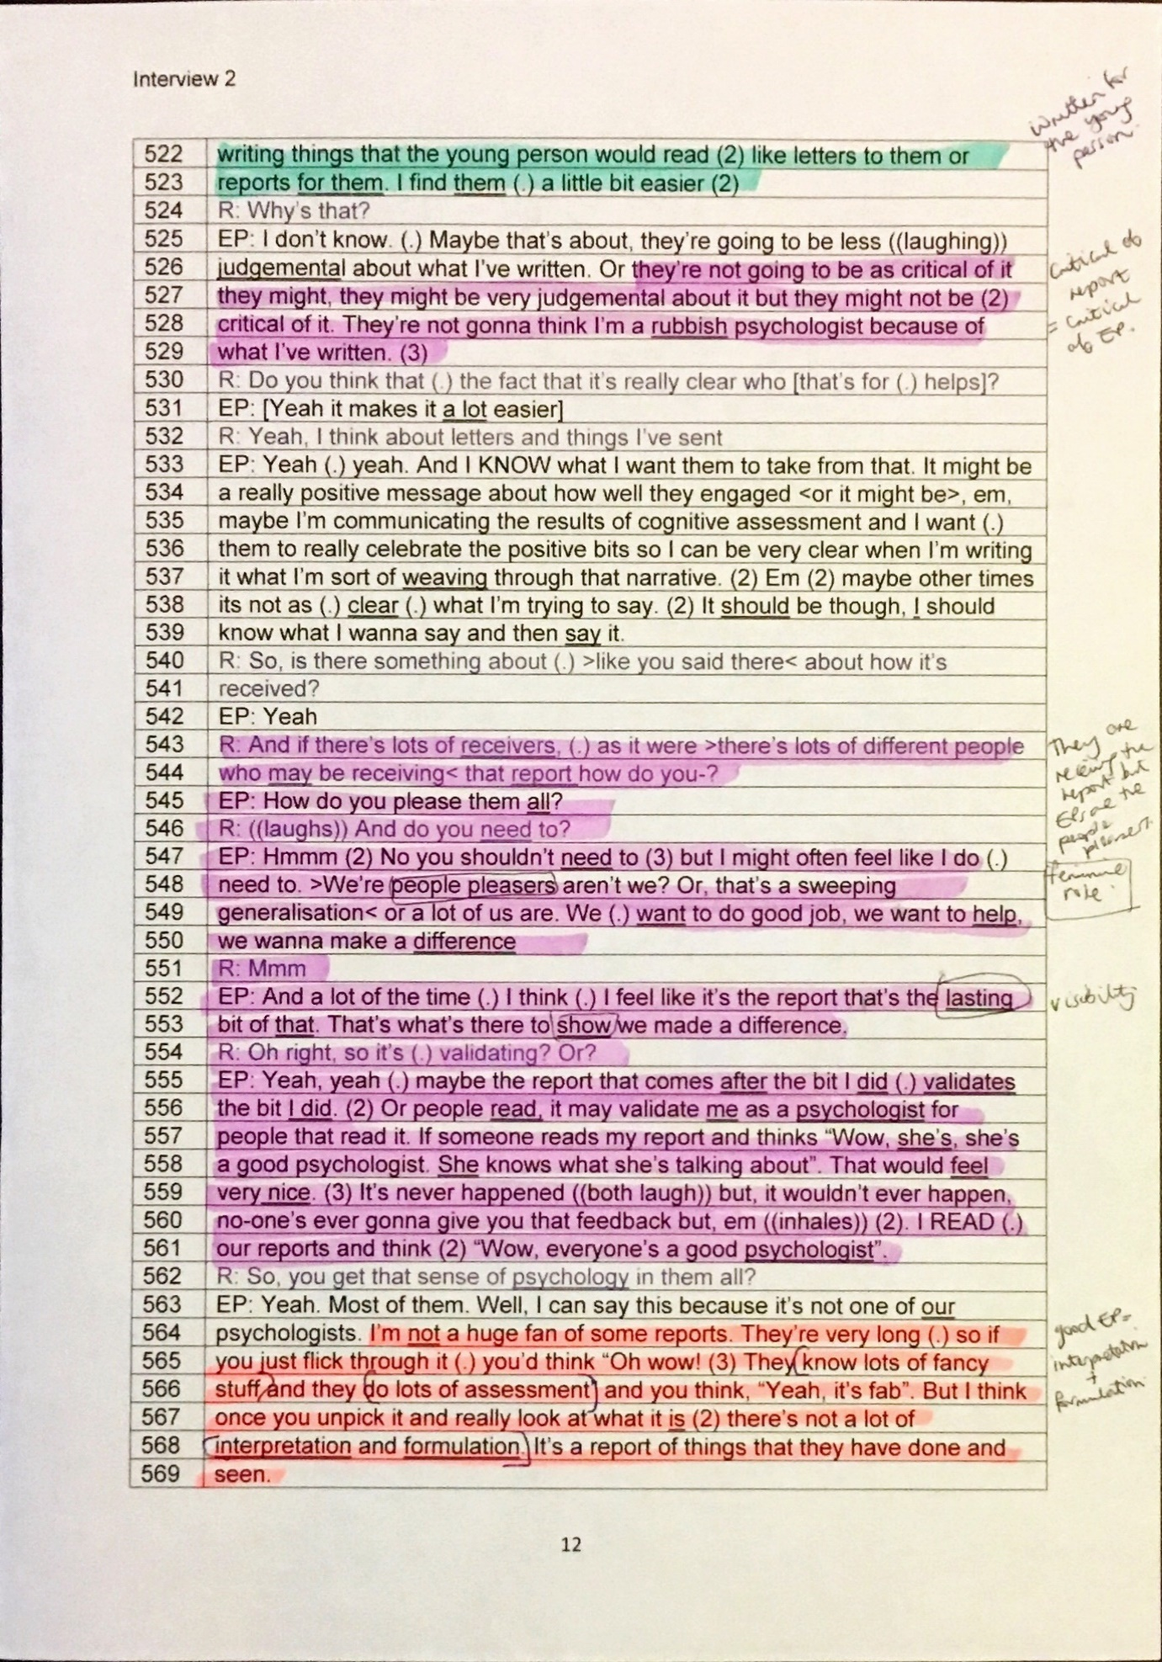

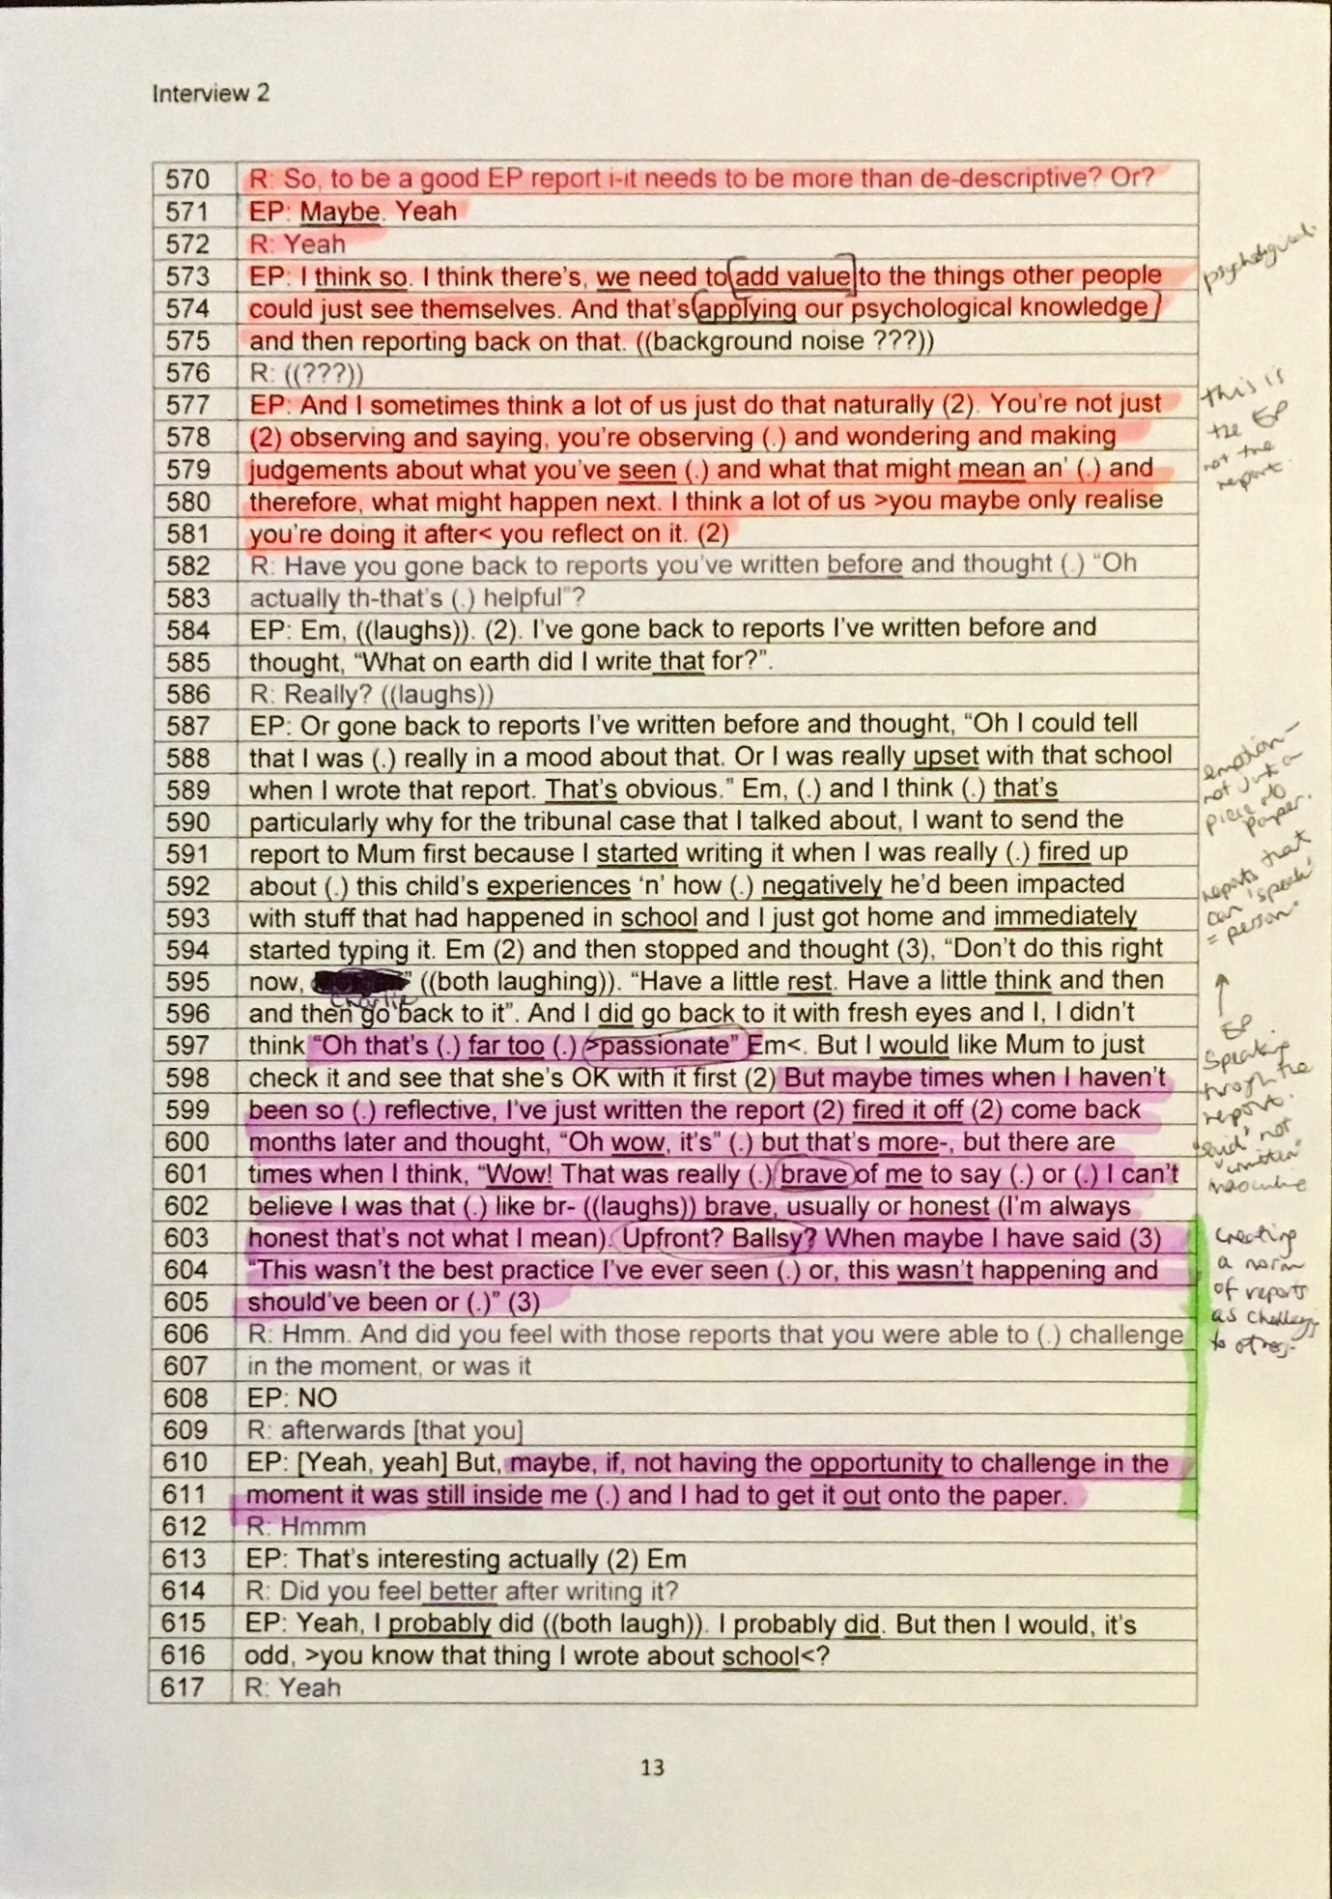

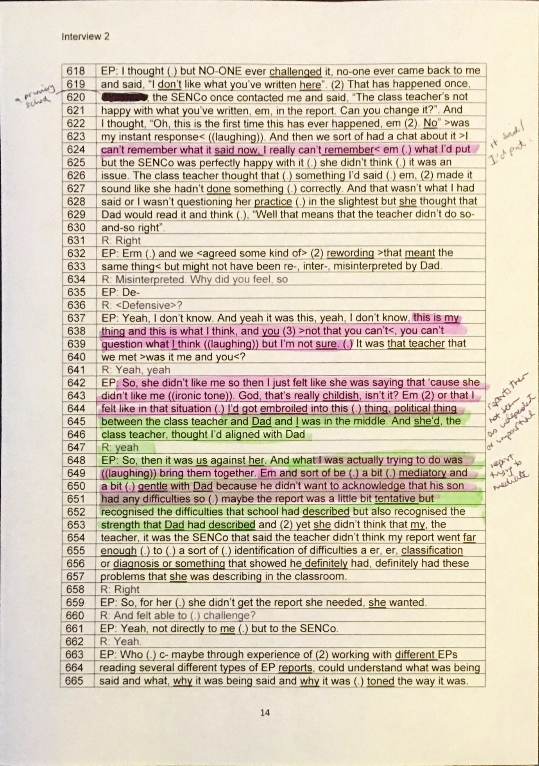

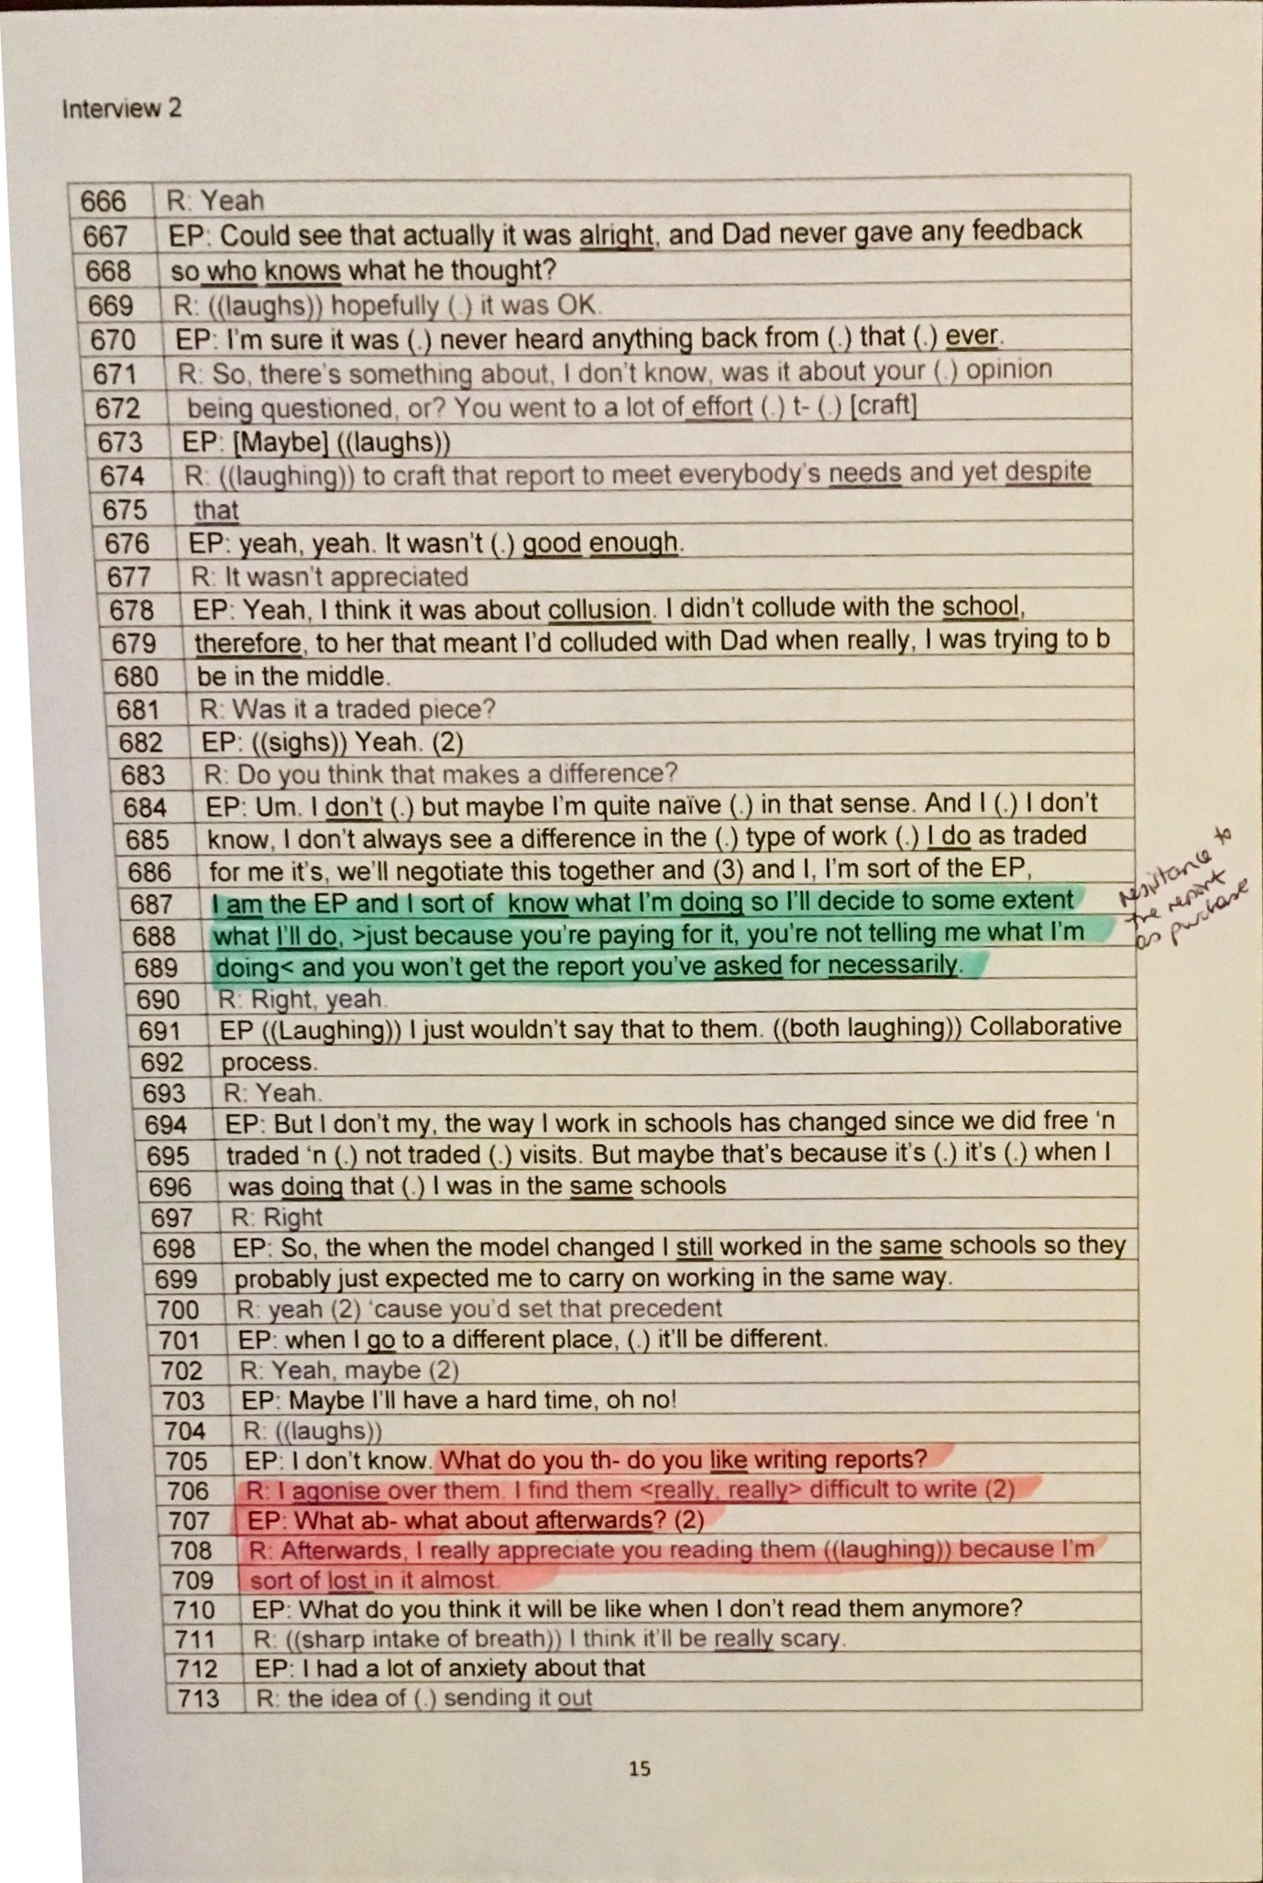

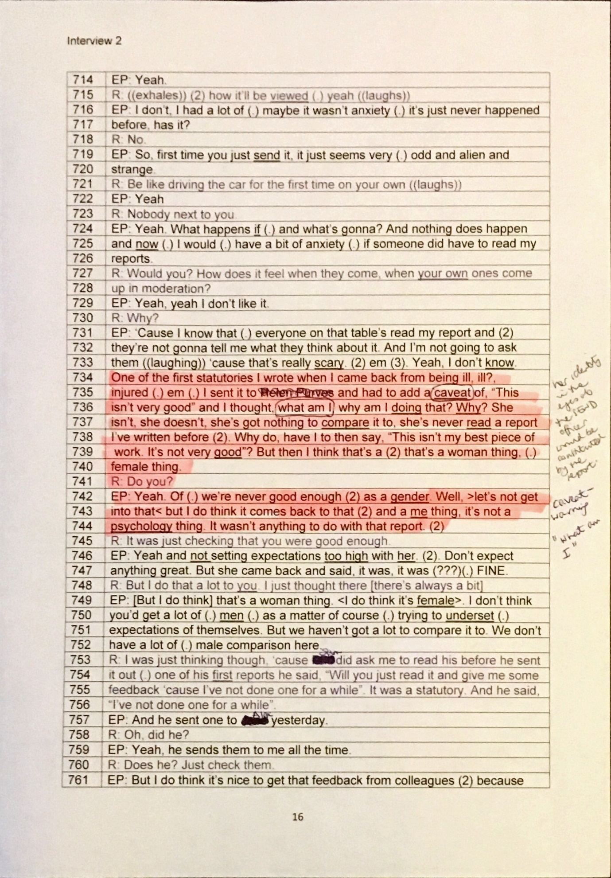
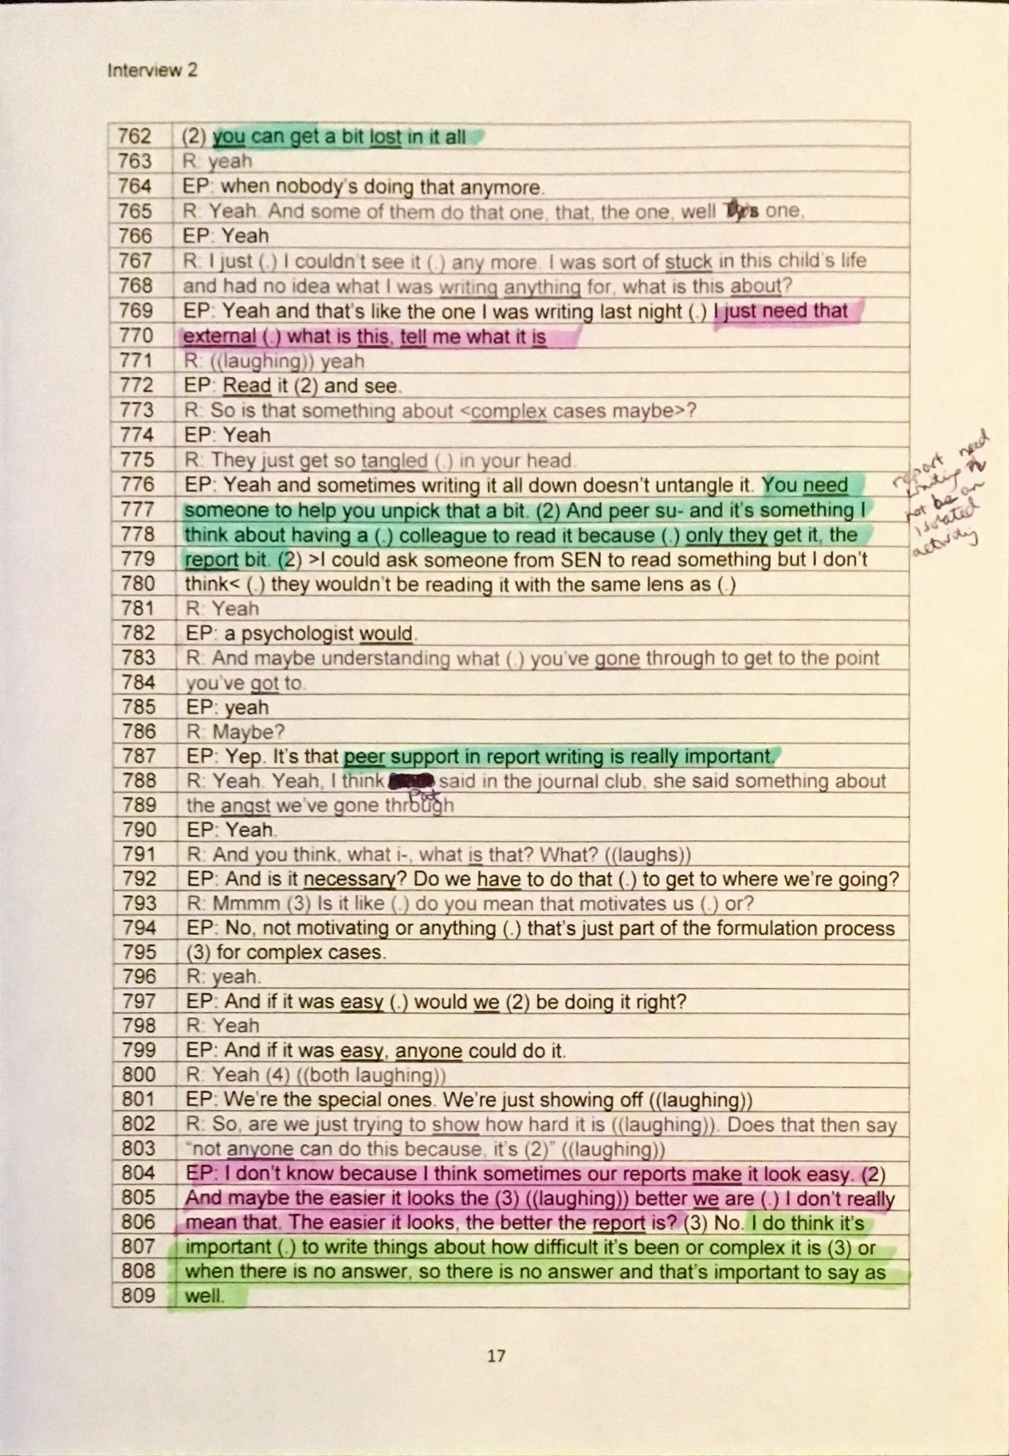

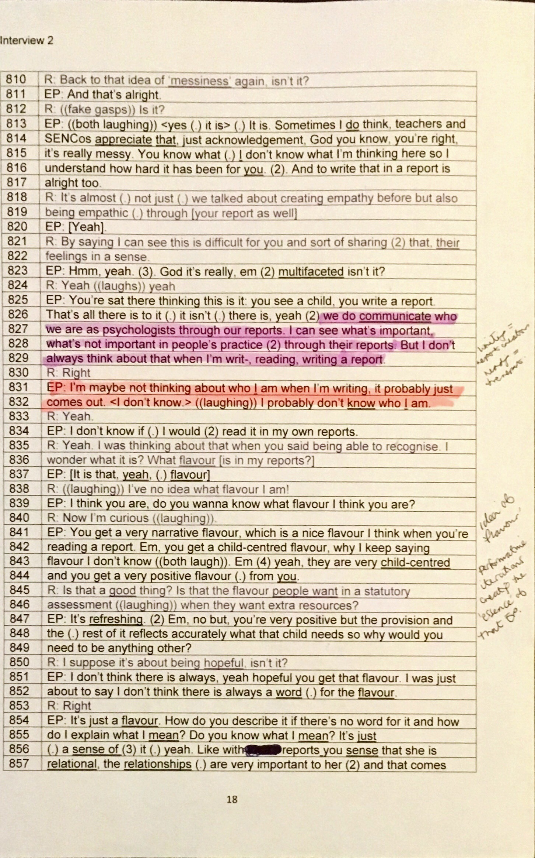
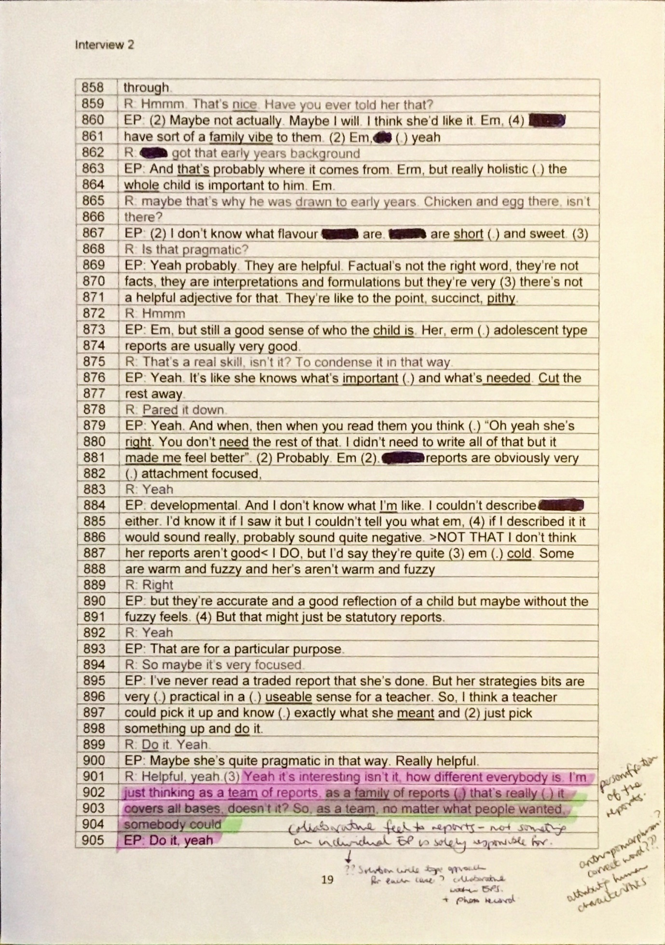

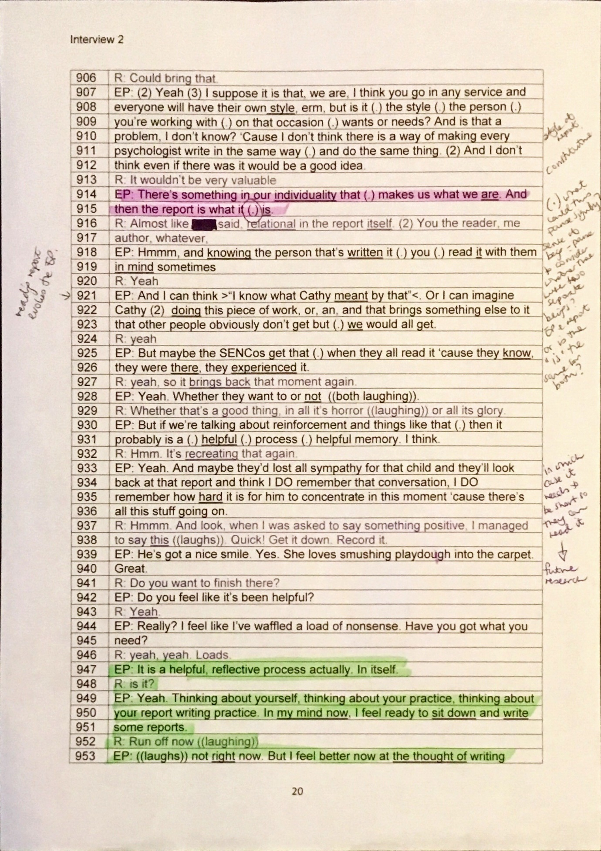

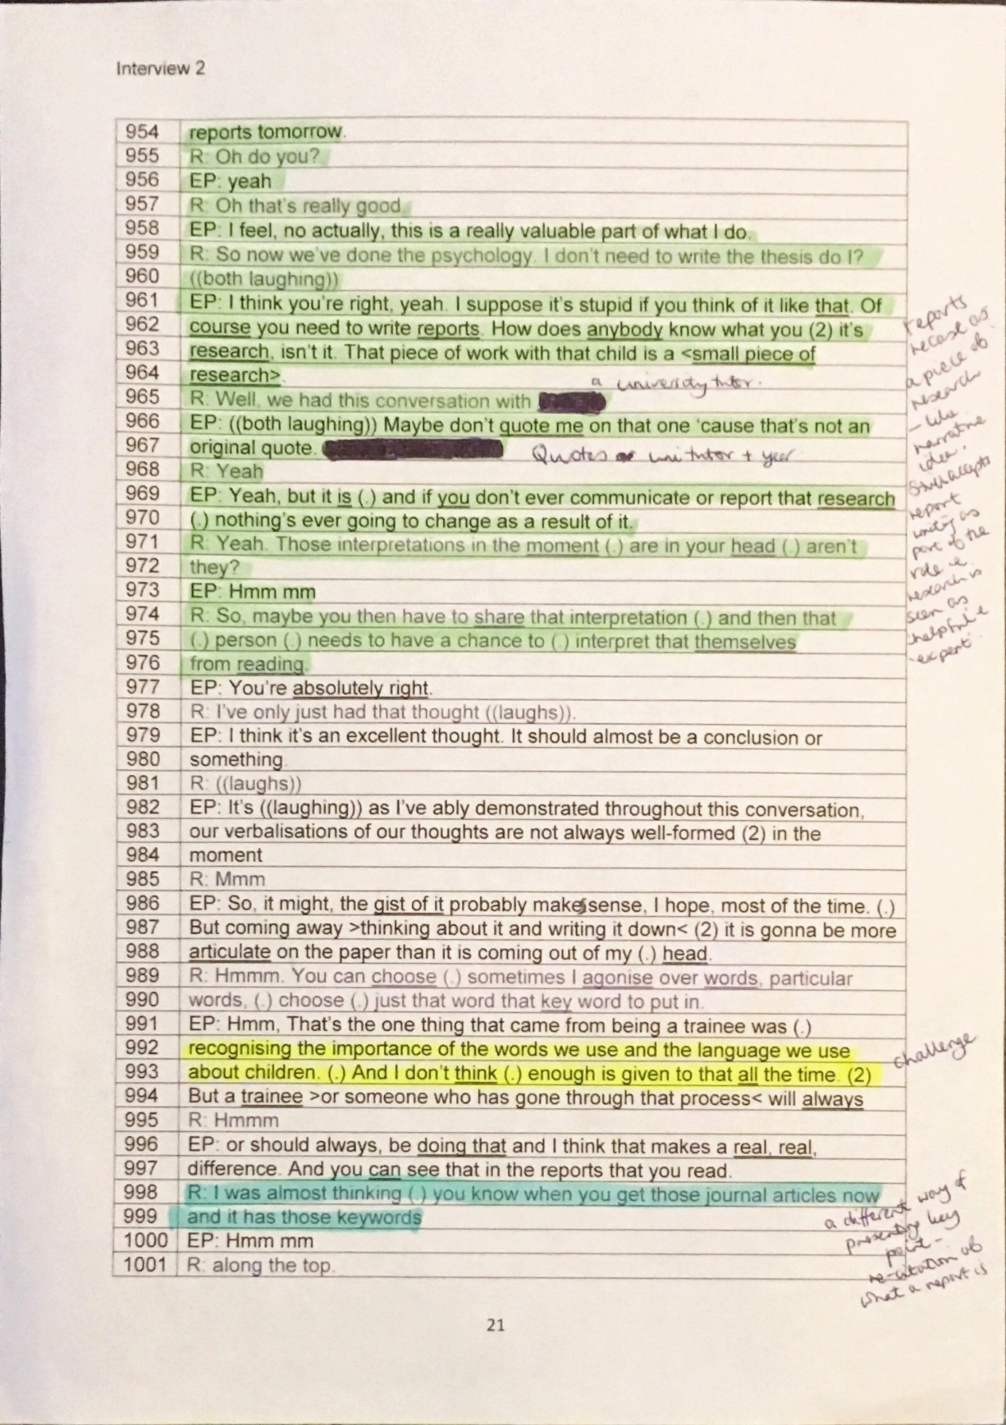

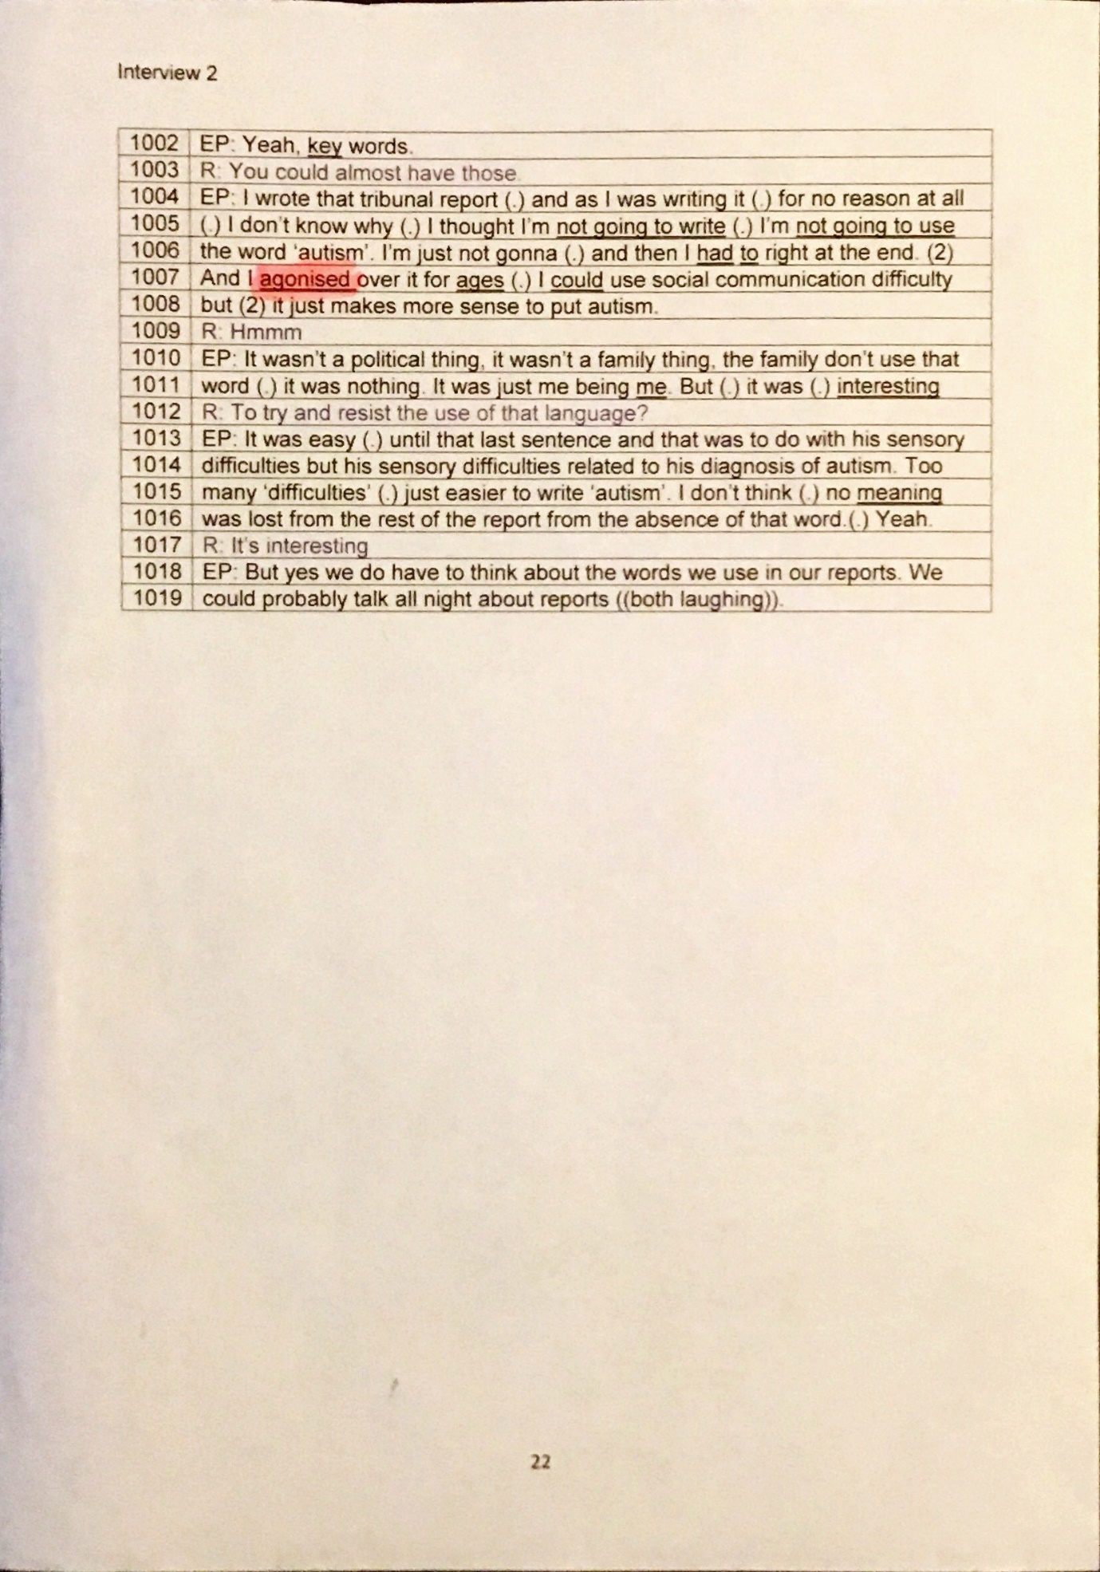

Appendix 11 Example extract from my reflective diary
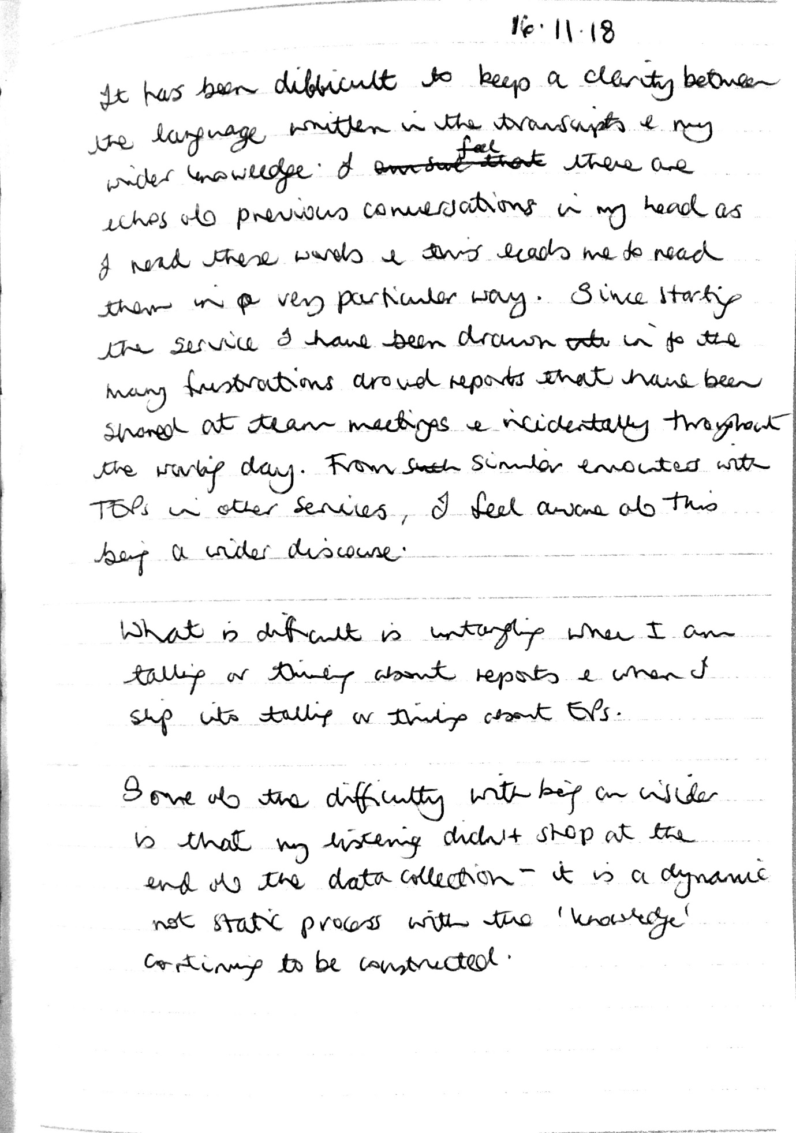

Appendix 12 Ethical approval letter from placement provider

 | Your Ref: CP/EP
 | My Ref: RS/RG
Catherine Percival  By email | Tel: 01482 616375
 | Fax:
Email: xxxxxxxxxxx
Date: 15th May 2018

Dear Catherine,

Research Governance application - The creation of educational psychology reports: an ethnographic exploration.

Thank you for submitting your research governance application. Your application has been considered by xxxxxx (AHoS & Caldicott Guardian) and me. I am pleased to inform you that your application has been approved, subject to you confirming that you will comply with the points that I have outlined below:

- You should confirm that you will comply with the terms of the Council’s Data Protection Policy, which can be accessed via the Council’s Intranet:

http://home.XXXX.gov.uk/policies-and-procedures/ict-and-information-governance/data-protection

- You should confirm that you will comply with the terms of the Council’s Information Security Policy, which can be accessed via the Council’s Intranet:

http://home.XXXX.gov.uk/policies-and-procedures/ict-and-information-governance/information-security

- Complaints – your application outlines the complaints process via the University of Sheffield. In addition to this we also expect to be informed if there are any complaints regarding your research, please therefore confirm that you will inform me directly should any complaints arise.

Please ensure that you confirm that you will comply with these requirements before your research commences.

I should also make it clear that it is not the role of the Research Governance process to make commitments on behalf of the Council regarding the allocation of any resources and levels of support that you require from Council service areas in order to progress with your research. This will be left to you to negotiate with the appropriate service manager.

I hope that your research progresses smoothly and would like to wish you all the best in your future studies.

If you would like any further information please do not hesitate to contact me.

XXXXX
Operations Officer
Children, Young People and Family Services

Appendix 13 Ethical approval letter from the University of Sheffield.

Appendix 14 Information sheets and consent forms

Field notes information sheet

Field notes consent form

Journal Club information sheet

Journal Club consent form

Interview information sheet

Interview consent form

Appendix 15 Full field note entries from extracts presented in the thesis.

14.06.18
What a frustrating day of report writing! I could not find my voice as a writer nor give a decent account from the people I had spoken to. I certainly have not felt that I have crafted a useful representation of this child! The result has been a synthesis of information that other people already know (i.e. they told me!) and guesswork. Where is the psychology in that?
Stevie came into the office. She started to talk about some supervision type work she would like to do with a special school if she had the time. She then dropped her bag on the floor and sat down on her desk chair saying “Right. I need to get the reports out of the way”. This suggested to me that all this report writing is getting in the way of the real work of EPs.
27.06.18
Discussion with Charlie.
She had written a report where she felt angry about the poor literacy teaching in the school for a girl who was thought to have dyslexia. She had used the BPS (British Psychological Society) definition of ‘dyslexia’ which highlights the difficulties with literacy persisting despite appropriate teaching.
She described the mocking tones a headteacher on the moderating panel had taken towards the certainty conveyed in her report. He read out what she had written in front of her and the rest of the [moderating] panel, emphasising her title of ‘Dr’.
05.07.18
We had talked about reports (again) at team meeting. There have been a huge amount of requests for statutory assessments lately and it was hard listening to the emotions of some of the team. In particular, Pat talked about how she had not anticipated the effect writing reports for all the statutory assessments would have on her:
“just wasn’t expecting it to make me feel like this”
“soul destroying”
“report after report”
“It’s ok at the moment because I know most of the kids, but can’t imagine what it will be like when I don’t”
We talked about what might happen to the profession if EP reports were not longer mandatory for statutory work. Pat’s view was that “we will disappear overnight”. There was a sense of frustration on the reliance on report writing to sustain the profession but at the same time undermining the ability to make it a worthy profession.
06.07.18
I was in the office with Sam on Wednesday. They advised me not to be like them and not to put off writing reports following visits: “Letting them build up is not good practice, Cathy”. The sense of this conversation was that reports are an onerous part of the process once the visit to the child is over. There was also a sense that unless reports are written quickly, children begin to fade or be lost over time and there is the potential for one child’s story to blur with another’s.
11.07.18
Observation- the desks in the EP part of the office are nearly all empty. Ashley and Sam are both in but behind their laptop screens writing reports. Sam has earphones on. Looked at the electronic calendars of two other EPs and it said ‘Report writing. Location: home’.
EPs clearly need to spend time out in settings and this changes their place of professional interaction from the EPS base to those locations. However, it seems that the practice of ‘writing up reports’ also physically separates EPs from their community of practice. EPs often work in absence from the team because they “get some peace” [Alex] or “get more done” [Ashley] or they work in the office but in isolation as Sam and Ashley are today.
16.07.18
Charlie had read one of Ashley’s reports and made the following comment: “it’s really empathetic and hopefully it will generate some empathy from others”
17.07.18
Quotes from member of the SEND team:
“Have we had the EP report yet?”
“Where’s the EP report?”
“Has the EP’s report been written?”
“Have you just used the outcomes form the EP report? I just tend to put those in.”
Reflection:
I could see how under pressure everyone was today in the office. It’s clear how important the EP reports are for the work of the SEND team but it all felt very depersonalised. Where has the EP gone? Reports are just a ‘thing’ to be collected that is disconnected from the person who wrote it and the person it is about.
It’s very noisy in the office today. Going home to write reports; it’s a lonely business.
18.07.18
Talking to one of the EPs today about making reports much shorter. Although this initially felt such a good idea, I suddenly felt really conflicted. If we moved to a cropped version of reports, how will we have space to enter into a young person’s world? Does this even matter?
26.07.18
Bizarre conversation with Louise from the SEND team at the end of the day who said, “I haven’t read the EP report” to me even though she had come to discuss the child with me because I was “the EP”. It was as if the report was something completely separate to me as the author. It made me feel slightly ambivalent about the report because it felt an irrelevant piece of paper when what she wanted was some face to face “psychological advice”. However, at the same time it was a really useful aide memoir to me as it is several months and assessments since I met the child.

Appendix 16 Rhetorical strategies in the analysis

Hyperbole
This is the use of overstatement or exaggeration by the speaker. The speaker aims to have a humorous effect which “depends on the listener entering a pact of acceptance of extreme formulations, the creation of impossible worlds or apparent counterfactuality” (McCarthy & Carter, 2004, p.149).
Example:
“You could end up writing a novel about each child” [Charlie, lines 362-363].
“Would be in your report but by the time it’s got to 25 pages” [Pat, lines 971-972].

Understatement
This suggests the use of a true but substantially subdued statement. Colston and O’Brien (2000, p.1557) suggest that it is “more protective of the speaker than literal remarks”.
Example:
“some of the things that were happening in the classroom I thought hmm well >maybe that’s not the best way to go about it<” [Alex, line 309-312]
“I mean you’d have to be the judge, if you read it to see whether my ‘little bit crossness’ came across,” [Sam, lines 779-771]. E.g. Sam’s “little bit crossness” suggests a shared understanding but perhaps also that Sam needs to protect his identity as an EP as someone who can control their emotions.
“yeah we are pretty good aren’t we ?” [Charlie, lines 1498-1499].

Rationalisation
This is a rhetorical device used to try and persuade others and perhaps the self. DeSantis (2003) suggest it can be used in groups to “weave their rationalizing arguments to form a common reality” (p.443) and helps protect the speaker and/ or listener from anxiety or cognitive dissonance. For example, here the EPs may try and rationalise why reports are important to write.

Examples:
“And there’s things then that stay with that young person(.) potentially till they’re twenty-five they might not want everyone to know about when they leave school” [Charlie, lines 337-340].
“people are mostly reading the EP reports, they’re not even reading the plans” [Charlie, lines 630-632].
“Wasn’t that I didn’t think somebody needed to do it but I just thought well it’s not going to be me cos I’ve got no follow up time” [Pat, lines 881-883].
“Well CAMHS can do it, why can’t we do it? Yes he has got ADHD.” [Alex, lines 1276-1277].

Normalisation
This rhetorical device is thought to make difficult emotions around a subject of conversation feel more neutral. Staske (1998) suggests that normalisation strategies fall into direct and indirect strategies. Direct strategies are where what is said is explicitly defined as being normal or natural. Indirect strategies are where commonality is created between the speakers through ‘matching’ (Tannen, 1990 in Staske, 1998) experiences.
Examples:
“Made me think of your case last week when I was reading that” [Ashley, lines 811-812].
“They couldn’t believe it that we are doing as many as they are, >a year or a month or whatever it is.< She went, “WHAT?!” Because it’s a bigger, like, city.” [Stevie, lines 1716-1719].

Extreme Case Formulation
Here examples are given in extreme form using very emphatic words (e.g. never, always) often to justify, accuse or defend; particularly when the speaker expects the listener to be non-sympathetic to their argument Pomerantz (1986).
Examples:
“The EP report is the most helpful piece of anything to do with that child in that em set of documents” [Charlie, lines 634-636].
“nobody else (.) seems capable of seeing them or(.) framing them in a <useful way>.” [Charlie, lines 682-683].
“I never definitely think anything” [Pat, line 1260].

Repetition
These devices are all largely used in “foregrounding an expression to achieve emphasis” (Benczes, 2013, p.178). Benczes (2013) also suggests that the more playful use of language can help with long-term retention of what is said and helps to create a “social bond” (p.167) between participants in the conversation.
- Repetition: Where words are phrases are said more than once, perhaps as the speaker loses their train of thought, hesitates or for emphasis.
Examples:
“they were saying within their reports that they feel they’re always labelling (2) children um, which I don’t, I don’t’ feel that we do. They were actually talking terms like dyslexic and so forth and um (2) autism and so forth. I don’t feel that we really do label children like that (.)” [Val, lines 25-32]
Stevie and Charlie repeating each other “wonder[ed]” in tribunal report [lines 1211-1219].

- Alliteration: a type of phonological analogy where the initial sound is the same in adjacent words.
Examples:
“laundry lists” [Pat, line 587].
“[extra] super special” [Sam., lines 227-228].
“they can only ever be a small snapshot” [Pat, lines 816-817].
“We will fall foul of the HCPC” [Stevie, lines 1358-1359].
“so there’s something somewhere that someone can go back” [Stevie, lines 1376-1378].
- Anaphora: a type of phonological analogy where words are repeated at the beginning of clauses.

Examples:
“you see a child, you talk to people, erm, you write, you know, you listen to them, you know there’s a consultation and then you (.) then write a report” [Stevie, lines 141-148].
“they’ve seen all sorts of other professionals, who’ve put all sorts of labels on them” [Alex, lines 291-293].
“it’s about how (.) >we are in that moment, how we are with people, how we model all that<” [Stevie, lines 522-524].
“you didn’t see them before (.) you won’t see them again” Pat [lines 840-841].

Asyndeton
This is a rhetorical device where conjunctions or phrases are removed which has the effect of energising or pushing the speech on (e.g. Stashko, 2018).
Example:
“What did it achieve? Did it? Don’t know” [Pat, line 846].

Polysyndeton
This is a rhetorical device where conjunctions or phrases are added to intentionally drag out the speech or emphasis the significance of the relationship between the speech objects (Stashko, 2018).
Examples:
“it was the reading and the analysing and the thinking time that’s tricky (.) but actually for me that’s all bound up with the writing” [Sam, lines 184-187]
“we’re seen as the expert or the professional or the >font of all knowledge or whatever it is<” [Cathy, lines 159-162].
“Or are we doing it >for the child or the parent or SEN or us or..<?” [Charlie, line 701-702].

Attribution (including blame)
Harper (1996) describes this as a way of talking to “make thing seem factual” (p.254). The speaker will attribute an explanation or blame (Patrika & Tseliou, 2015) for why something is as they find it. This may be to defend against uncomfortable emotions (Harper, 1996).
Examples:
“I think they remove themselves from the child in that process ((Pat mmm)). That’s not a child it’s a name on a list and they have to produce a plan and it’s irrelevant what they’re needs are what the provision is.” [Charlie, lines 611-616].
“They can’t handle that because it needs to go in the boxes” [Charlie, lines 1301-1303].

Rhetorical questions
This is a question that the speaker hopes will prompt thought in the speaker through its implication rather than what is actually said. The speaker is hoping to be persuasive rather than expecting a reply. Frank (1990) suggests it is a “good way to win an argument without jeopardising relationships” (p.737) so may be helpful in being controversial without being threatening.
Examples:
“I thought well I have a duty to put that in, I can’t leave that out, why would you leave that out?” [Sam, lines 376-378].
“Is that it? Is that all (.) that’s useful and helpful in what we do?” [Charlie, lines 318-319].
“actually, isn’t it ok to say that there are inconsistencies?” [Ashley, lines 790-791].

Prosopopoeia
Prosopopoeia literally means “to confer a mask or a face” (Riffaterre, 1985, p.108). It is a rhetorical device which allows an object that would not normally be able to speak to have a ‘voice’.

Dysphemism
Gray (1992, p.33) writes, “dysphemism is the practice of representing reality as worse than it is” or using negative words to make something sound less acceptable or valuable.
Examples:
“It’s not so they can cut and paste(.) big chunks…” [Stevie, lines 1067-1068].
“I don’t know whether they get an EHC plan it’s like chucking it down a blind alley,” [Pat, lines 839-840].
“Rather than doing a bloody IQ test because we can’t think of anything else and we don’t really know why we’re doing the assessment so we’d better knock out something” [Pat, line 1527-1521].

Appendix 17 Analytic strategy used for RQ2 based on Butler’s (1997) work.

- Instances of the ‘I/We’ of the EP and the ‘it’ of reports.
- Instances of passionate attachment or talking ambivalently about reports that could be suggestive of the idea of the report as constitutive ‘other’.
- Instances of abjection where talk suggested who could be
- an EP or
- be a ‘good EP’; as they related to the report or report writing.
- Instances of the unassimilable remainder that suggested what a good EP was or could be in an incremental way rather than a jump to the ‘idealised’.

Appendix 18 My analysis of who could be an EP or a good EP.
Summary
An EP… | A ‘good’ EP…
…interacts | …adds value to those interactions
…writes reports | …writes ‘good’ reports
…tries to make a difference for a child | …makes a difference for a child
…uses psychology | …is a ‘good’ psychologist
…is independent or impartial

Key words/ phrases | For EPs | For others
Who could be an EP…  An EP interacts | Pat (interview 1):  - interaction between people [line 37]  - discussed the child together [line 77]  - engaged with anybody [line 124]  - in the moment [line 211]  - conversations [line 211]  - with people [line 211]  - face to face [line 388] | Pat:
 | Charlie (interview 2):  - more direct than a report [line 24]  - face to face [line 24]  - psychology through relationships [line 25]  - balanced [line 192]  - talk to parents [line 268]  - talk to staff [line 269]  - we’re going to see them [line 269] | Charlie:
Who could be a ‘good EP’  A good EP adds value to those interactions. | Pat: | Pat:
 | Charlie:  - add value to the things other people could just see themselves [573-574] | Charlie:

Key words/ phrases | For EPs | For others
Who could be an EP…  An EP writes reports | Pat (interview 1):  - the job is not the report [line 431] | Pat:  - writing a report [line 388]  - “How do I know if I did any good? I produced a report” [line 653]  - production of some meaningless drivel mostly [line 908]  - little phrases [line 395]
 | Charlie (interview 2):  - more direct than a report [line 24]  - make judgements about lots of things [line 271]  - synthesising [line 273]  - nobody else is pulling this information together in a coherent way [lines 275-276] | Charlie:  - reliable professional [line 234]
Who could be a ‘good EP’…  A good EP writes a good report. | Pat:  - accurately describe the child [line 26]  - synthesise [line 596] | Pat:  - think I’m stupid ‘cause I’ve written it like this [line 162]  - clever [line 195]  - show how much psychology people know [line 910]  - fantastic/ bloody good report [line 123]  - lovely, elegant report [line 194]  - beautifully written [lines 909-910]  - is it in on time? [lines 339-340]  - you don’t pay someone what we’re paid to write a description [line 262]  - paying us to type [284]  - think of fifty interventions [line 453]
 | Charlie:  - if the work was good enough…they would keep important things with them [lines 33-34]  - good enough narrative [lines 47-48]  - interpretation and formulation [line 568]  - make judgements about lots of things [line 271]  - synthesising [line 273]  - nobody else is pulling this information together in a coherent way [lines 275-276]  - holistic picture [line 179] | Charlie:  - clear [line 275]  - know lots of fancy stuff [line 565-566]  - do lots of assessment [line 566]

Key words/ phrases | For EPs | For others
Who could be an EP  An EP tries to make a difference for a child | Pat (interview 1):  - acted on [line 60]  - make any difference to Johnny? [line 193]  - the job is not the report [line 431] | Pat:
 | Charlie (interview 2):  - trying to make a difference [line 27] | Charlie:
Who could be a ‘good EP’…  A good EP makes a difference for a child. | Pat:  - getting people to change and do something different [lines 384-385]  - make the difference [line 490]  - if it has no impact it’s no use is it? [line 912] | Pat:
 | Charlie:  - if the work was good enough…they would keep important things with them [lines 33-34] | Charlie:

Key words/ phrases | For EPs | For others
Who could be an EP…  An EP uses psychology. | Pat (interview 1):  - applying psychology [line 485] | Pat:
 | Charlie (interview 2):  - psychology through relationships [line 25]  - look at everything through our own psychological lens [lines 180-181] | Charlie:  - highly trained [line 212]  - Our expertise is valued [line 213-214]
Who could be a ‘good EP’…  A good EP is a good psychologist. | Pat: | Pat:  - show how much psychology people know [line 910]  - think of fifty interventions [line 453]
 | Charlie:  - interpretation and formulation [line 568]  - applying our psychological knowledge [line 574]  - observing and wondering and making judgements [lines 578-579] | Charlie:  - know lots of fancy stuff [line 565-566]  - do lots of assessment [line 566]

Key words/ phrases | For EPs | For others
Who could be an EP…  An EP is independent or impartial | Pat (interview 1): | Pat:
 | Charlie (interview 2):  - independent [line 175]  - don’t have a vested interest in whether they get a plan or not [line 181-182] | Charlie:  - have no agenda [line 211]  - you can trust what we say [line 212]  - reliable professional [line 234]
Who could be a ‘good EP’ | Pat: | Pat:
 | Charlie: | Charlie:

Appendix 19 Analytic strategy for RQ 3
Within interviews 1 and 2, I looked for examples of talk which suggested:
“Re-citation” of report writing that may undermine norms;
“Failed” performances of talking about report writing that result in norms taking a new direction;
Voiced challenges to the norms by speakers;
Instances of justification for these challenges.

To reflect the expanded age range and to be more succinct, I will from here on refer to children and young people collectively as ‘young people’ within this chapter of the thesis. However, I will then refer to them as ‘children’ for later chapters as this was the term used most frequently by research participants.

