“It would be easier if I didn’t care as much, but if I didn’t care I wouldn’t be able to do it…”

Enabling teachers to manage the personal and professional tensions when supporting pupils with challenging behaviour.

Olivia Blick

Submission Year
2019

A thesis submitted in partial fulfilment of the requirements for the degree of
Doctor of Educational and Child Psychology

“It would be easier if I didn’t care as much, but if I didn’t care I wouldn’t be able to do it…”
Enabling teachers to manage the personal and professional tensions when supporting pupils with challenging behaviour.

By:
Olivia Blick

A thesis submitted in partial fulfilment of the requirements for the degree of
Doctor of Educational and Child Psychology

The University of Sheffield
School of Education

Submission Date

Abstract
The nature of the relationships that teachers build with their pupils can be influenced by being; an educator, a friend, protector, mentor and disciplinarian. These roles can create opportunities for teachers to have range of emotional experiences within their roles (Chang, 2009). Studies have shown that pupil behaviour is one of the most detrimental factors to teacher wellbeing, yet other studies have shown that teachers’ emotional wellbeing is integral to the way in which they can relate to and interact with pupils and can determine their ability to develop positive teacher-pupil relationships (Hagenauer, Hascher, & Volet; 2015; Farouk, 2012).
This study aimed to understand the emotional experiences of teachers working with pupils with challenging behaviour. Five interviews were undertaken with primary school teachers and a grounded theory approach was used to collect and analyse the data.
Results from the study highlight the significant need for additional support for teachers when managing their emotional experiences of working with pupils with challenging behaviour.
This support highlights the need for systemic changes to the way in which support for teaching staff is incorporated within the school system by providing value and validation to their emotional experiences as well as a safe environment for teachers to share these experiences. However, the research also emphasises the need for teachers to develop a reflective practice to allow them to understand their personal and professional values and develop strategies to allow them to manage and work through tensions that may emerge between these values and their role.

Contents
- Statement of Positionality pg. 1

- Research Context and Rationale pg. 4
- 2.1 The Literature Review within Grounded Theory pg. 5
- 2.2 Childhood Adversity and a Rise in Exclusion Rates pg. 7
- 2.3 Promoting Protective Factors in the School Context-
The Teacher-Pupil Relationship pg. 9
- 2.4 Teacher Wellbeing pg. 12
- 2.5 The Importance of Teacher Wellbeing pg. 14
- 2.6 Protective Resources for Teacher wellbeing pg. 15
- 2.7 Challenges to Teacher wellbeing pg. 18
- 2.8 Supporting the teacher to support the pupil- pg. 22
Current support for teacher wellbeing
- 2.9 Summary pg. 25

- Methodology pg. 27
- 3.1 Background to the research pg. 27
- 3.2 My Approach pg. 31
- 3.3 Grounded Theory pg. 32
- 3.4 The Research Design pg. 41
- 3.5 Grounded Theory Analysis pg. 54

4. Findings pg. 70
- 4.1 External Value and Validation pg. 73
- 4.2 Personal and Professional Values pg. 82
- 4.3 Managing the Personal and Professional Clash pg. 90
- 4.4 A need for Empowerment pg. 95
- 4.5 Safe Space for Sharing pg. 101

5. Discussion pg. 109
  - 5.1 The Grand Grounded Theory pg. 109
  - 5.2 Developing a safe space for sharing: Systemic changes to better support teachers. pg. 112
  - 5.3 Understanding the personal and professional tension:
A space for reflective practice pg.115
  - 5.4 Sustaining one’s own resilience:
Teacher agency and Self-efficacy pg. 121
  - 5.5 Coaching as a model of support pg. 125
  - 5.6 Consultation as a model of support pg. 127
  - 5.7 Suggesting a model of supervision pg. 129

6. Conclusions pg. 136
  - 6.1 Applying the suggested model of supervision pg. 139

7. Reflections pg. 142
  - 7.1 Implications for educational professionals pg. 144
  - 7.2 Implications for Educational Psychology Practice pg. 147
  - 7.3 How it will affect my practice pg. 148
  - 7.4 How I found this research pg. 148
  - 7.5 The quality and rigor of my study: pg. 150
  - 7.6 Other Limitations pg. 153
  - 7.7 Future research pg. 155

References pg. 157

Appendix pg. 173
  - Appendix A: Ethical approval confirmation letter pg. 174
  - Appendix B: Memos pg. 175
  - Appendix C: Fishbone showing timescale of activities pg. 186
  - Appendix D: Participant Consent Form pg. 187
  - Appendix E: Participant Information Sheet pg. 188
  - Appendix F: Ecosystemic information about participants pg. 190
  - Appendix G: Transcript examples interviews 1, 4 and 5 pg. 192
  - Appendix H: Scanned in copy of hand-written line by line
coding example pg. 200
  - Appendix I: Bringing categories together pg. 211
  - Appendix J: Examples of Focused Codes pg. 212
  - Appendix K: Focused codes developing into categories. pg. 215
  - Appendix L: Examples of Developing Categories pg. 217
  - Appendix M: Additional quotes for the category External Value and
Validation pg. 222
  - Appendix N: Additional quotes for the category Safe Space
for Sharing pg. 227
  - Appendix O: Additional quotes for the category Personal and Professional Tension pg. 235
  - Appendix P: Additional quotes for the category
Empowerment pg. 241
  - Appendix Q: Concept map demonstrating the categories
linking together to form the model of supervision pg. 248

  - Appendix R: Concept map showing the
proposed model of supervision pg. 248

List of Figures
- Figure 1: Definition of wellbeing, modelling the ‘set point’ pg. 13
- Figure 2: The interplay between pupil-teacher relationships, teacher wellbeing and challenging pupil behaviour pg. 21
- Figure 3: Processes within Grounded Theory pg. 47
- Figure 4: Example of initial grouping of codes pg. 56
- Figure 5: an extract of the initial codes that were grouped together pg. 61
- Figure 6: Definition of wellbeing, modelling the ‘set point’ pg. 70
- Figure 7: An overall concept map showing the different categories of support required by teachers when managing their experiences. pg. 72
- Figure 8: Focused codes within the category External Value and Validation pg. 73
- Figure 9: Focused codes within the category Personal and Professional Tension. pg. 82
- Figure 10: Managing the personal and professional tension through the creation of boundaries around the role, sense of acceptance and emotional separation pg. 91
- Figure 11: Focused codes within the category
Empowerment pg. 95
- Figure 12: Focused codes within the category of
Safe Space for Sharing. pg. 102
- Figure 13: Model showing links between categories and proposed areas of support for teachers managing their emotional experiences. pg. 112
- Figure 14: Defining the five layers of organisational culture pg. 114
- Figure 15: The interplay of ecosystemic factors on the development of teacher agency pg. 123
- Figure 16: Showing a concept map of the proposed mode of supervision suggested within the present study. pg. 139

List of Tables
- Table 1: Initial coding example pg. 56
- Table 2: Functions of supervision alongside definitions pg. 131

Chapter 1
Statement of Positionality
This research explores the emotional experiences of teachers working with pupils who have challenging behaviour. It considers how teachers construct meaning from their experiences and uses this to develop a model of supervision that can be used within education systems to support teachers to manage these challenging emotional experiences.

Before beginning my training to become an Educational Psychologist I had been a teacher for 6 years in a number of primary school settings. My interest and passion had always been for working with pupils who had additional needs, predominantly pupils who had Social, Emotional, Mental Health difficulties (SEMH), then known as Behavioural, Emotional and Social Difficulties (BESD).

My time-spent teaching was extremely challenging. I had a passion and drive for inclusion and supporting the needs of all pupils in my class, however this was quickly swamped by the day to day challenges of dealing with a number of pupils who had behavioural difficulties often displaying violent, aggressive outbursts as I was trying to support them in my daily work as their teacher. Managing these situations was also coupled with having the professional roles and responsibilities of being a mainstream classroom teacher, planning, differentiating, teaching and facilitating the progress of the other children in the class often with no other adult support.

My days were exhausting, and I would often describe my role to others as being a ‘child-minder’ and ‘fire-fighting’ the numerous outbursts and problems in the day, with very little emphasis on my teaching responsibilities let alone my passions for inclusion, providing support and making a difference to these pupils’ lives. I had very little support, bottled up my difficulties through my own critique of not doing a good job, which resulted in me having a period of time off sick due to difficulties with my own mental health and wellbeing.

I then started working as a Trainee Educational Psychologist (TEP), receiving regular supervision to discuss my work and reflect on my practice. This made me aware of the significant lack of this type of support for teachers and other staff working under very challenging situations in schools. I also started providing consultation-based support within schools as a TEP and saw first-hand how valuable school staff and particularly teachers, found having that time to talk. As a TEP I provided a safe, empathetic environment and asked questions that facilitated discussions that opened up teachers’ thinking about particular pupils and resulted in often extremely emotional conversations. Many teachers opened up to me about difficulties that meant that they were on the brink of break-down or collapse and did not know where to go next, something which stirred up a number of feelings in myself from my own past.

I then knew that I wanted my research to enlighten professionals on the challenging and emotive experiences that teachers were having. However I was also very aware of wanting my research to create something that would also be useful in dealing with this difficult situation and therefore I wanted my research to focus on how professionals could provide support for teachers when managing these challenging experiences.
I used a constructivist grounded theory approach to the research, which has shaped the structure of this thesis. The thesis starts by exploring the current context of the research rather than a traditional literature review as this may have impacted on the interviews and data analysis. The grounded theory approach I chose to use is then discussed in more detail within the methodology section of the thesis, including the epistemological and ontological positioning of the research, the research design and process of data analysis. The thesis then outlines the results from the data analysis and the subsequent theory that has been developed along with a discussion linking it to relevant literature. It concludes by considering the implications for the research, limitations as well as opportunities for further research within the field.
Chapter 2
Research Context and Rationale
Teaching is an extremely emotive profession as the role of teacher now takes on responsibilities which fall far beyond that of being an ‘educator’. Teachers are now required to adapt their role to support a diverse and challenging range of pupils by also being a friend, protector, caregiver, mentor and disciplinarian (Chang, 2009). This varied range of roles presents a range of emotional experiences for the teacher, which can be negatively impacted when a teacher is attempting to provide support for a pupil with challenging behaviour (Hargreaves, 2000; Hagenauer, Hascher & Volet, 2015). Yet teachers’ wellbeing has also been shown to significantly correlate with the quality of teaching as well as their capacity to form secure and positive relationships with pupils (Hagenauer, Hascher & Volet, 2015).

In a climate of increasing adversity, with large numbers of children entering an education system with additional social, emotional and mental health (SEMH) needs there has never been a greater requirement for secure relationships to be built between student, teacher and the wider school community (Roffey, 2012). It is therefore crucial that we are providing support for teacher wellbeing so that they are better able to cope with the challenges of pupil behaviour and have the emotional capacity to form the positive relationships that these children require. This study considers the current support systems for teacher wellbeing and aims to develop a model of supervision that can be used to support teachers who are managing pupils with challenging behaviour.

2.1 The Literature Review within Grounded Theory
This section will explore the literature related to the context of the research and give a rationale for the present study. Within traditional grounded theory it is important for the researcher to pursue their research with a neutral stance that is not influenced by previous ideas surrounding the topic of study (Glaser & Strauss, 1967). Glaser (2001) suggests that if a researcher already has set opinions and beliefs about the area of study this may bias the collection and analysis of their data.

However, more recent researchers adopting a grounded theory methodology have argued that it is important to pragmatically consider the area of study so that the researcher can identify gaps and determine the parameters of their research (Lempert, 2011). This would suggest that when developing an innovative piece of research, lack of familiarity with the literature is unavoidable (Dunne, 2011). Nevertheless it is crucial to view this knowledge with an open- mind and reflect upon it throughout the research process (Lempert, 2011).

It would have been unavoidable and problematic for me to ignore my previous knowledge and experiences when conducting the present study as I have very close previous experience similar to that of my participant’s. This prior experience also allowed me to draw closer to my participants and develop a safer environment to more openly discuss issues within the interviews. As a constructivist approach to grounded theory was adopted in this study my previous experiences also allowed me to more effectively co-construct an understanding of the participant’s experiences. Nevertheless it was important for me to engage with previous experiences and knowledge of the subject area critically and comparatively and so, as suggested by Charmaz (2004), I have used memo writing as a tool throughout my research to help me to reflect on my approach throughout.

Within this chapter, Research Context and Rationale, I undertook my first engagement with the literature to help me to develop my understanding of the subject area and subsequently refine the present research. As Charmaz (2014) outlined it can then be useful to reengage with the literature to support the data analysis through Theoretical Sensitivity, to better consider the emerging theory within the present literature. Therefore a literature review was conducted prior to completing the study however, this literature will be expanded upon within the discussion in chapter five.

In the present chapter, I will begin by discussing childhood adversity and the significant rise in the current rates of exclusion throughout the education system. I will then go on to discuss factors that can be protective of pupils who are identified as ‘at risk’ within their education and argue that of these protective factors the teacher-pupil relationship is one of the most important. I will then discuss the impact of managing these challenging behaviours on teacher wellbeing and the subsequent damage that this can have on the teacher-pupil relationship. Finally, I will explore the current provision that is in place to help support teachers within these challenging situations and provide an argument to suggest that additional support needs to be given to teachers so that they have the capacity and emotional resilience to manage their relationships with challenging pupils.

2.2 Childhood Adversity and a Rise in Exclusion Rates
Most children have access to social and emotional resources that help to encourage their learning and development. However more recently, according to The Good Childhood Report (2017-2018), an increasing number of children and young people across the United Kingdom are living with ‘chronic adversity’ in terms of traumatic life experiences, acute stress and family breakdown. Roffey (2016) suggests that, ‘It is pupils most at risk of this adversity whose behaviour often gives most cause for concern, with defiance, disengagement and disruption problems that increasing numbers of schools are facing’ (Roffey, 2016, p30).

Recent Department for Education (DFE) statistics from the Exclusion Statistics Guide (2017) have shown that since 2012 there has been a dramatic rise in rates of exclusion across primary, secondary and specialist schools. These statistics have shown that 7,720 children were permanently excluded from all schools within the United Kingdom in 2016-2017. Of these 1185 were from primary schools, with 475 children who were aged 7 and under and 50 children who were aged four. This report suggests that on average 40.6 pupils are excluded from schools within the United Kingdom per day. It must also be considered that when collating their data, the DFE uses census data from schools and therefore it is highly likely that there are a considerable number of unofficial and internal exclusions taking place within schools on a daily basis. For example, a report by Gill (2017) for the Institute for Pupil Policy Research, reveals that rates of internal exclusions are over 50% higher than those recorded as permanent exclusions. This demonstrates that if these were accounted for the rates of reported exclusions would be far higher. Gill (2017) also documents that the top two causes of exclusions are persistent disruptive behaviour and physical violence with verbal abuse being the third most common cause of exclusion.

When reviewing these statistics further, research has shown that there are disproportionate rates of exclusion from particular groups of children (McCluskey, Riddell, Weedon & Fordyce, 2016). In their research McCluskey et al. (2016) found that of all excluded children across England and Wales, more than three times as many boys than girls were excluded from schools. Similarly more than half of all children excluded were considered to have special educational needs, most often SEMH needs. Exclusion rates have also shown to be higher in pupils who are working at lower than expected levels academically (Estyn, 2012) and also more likely in children from disadvantaged backgrounds (Manstead, 2014).

These findings demonstrate the crucial importance of providing the correct support for those children and young people identified as ‘at risk of exclusion’, particularly those who are dealing with traumatic and challenging experiences within their lives. Nevertheless in many school behavioural policies sanctions such as suspension and exclusion from school are commonly used, which some researchers suggest causes a further rejection by the school system, introducing what has become known as a ‘double whammy’ effect (Skiba, Reynolds, Graham, Sheras, Conely & Garcia-Vasquez, 2006).

Toothill and Spalding (2000) quote that, “The participation of children and young
people who experience emotional and behavioural difficulties in mainstream schooling is probably one of the most challenging tasks facing those committed to inclusion”, (p.111). Yet vast research has demonstrated the value of providing an inclusive practice within schools, that promotes protective factors, which in turn supports pupil development beyond their academic attainment (Werner, 2013). Some of these protective factors have been found to be individual factors such as having a ‘positive outlook’ and a ‘willingness to talk about issues’ however many are also from the child’s environment such as their adult relationships (Ungar, 2011).

2.3 Promoting Protective Factors in the School Context- The Teacher-Pupil Relationship
A number of these protective factors can be promoted in schools to help to make a difference to pupil wellbeing (Henderson & Milstein, 2003) however arguably these protective factors can only be cemented when there are positive relationships within the pupil’s school environment. Elements that Henderson and Milstein (2003) identified such as, ‘bonding with pro-social individuals, high expectations with clear and consistent boundaries, opportunities to contribute and participate, teaching of social and emotional skills and collaborative working with families’, (Henderson & Milstein, 2003, p.g. 156) all have to be cemented by a foundation of positive and proactive teacher-pupil relationships.

This argument also links back to attachment theory (Bowlby, 1979) which states the fundamental importance of a primary caregiver for an infant to thrive. This ‘attachment’ figure is crucial within school, particularly in the absence of such a relationship within their home or family environment. In a longitudinal study looking at the lives of 505 men and women from birth to adulthood, Werner and Smith (1992) found that outside of the family the person most often identified as a positive role model was a favourite teacher. Similarly Martin and Dowson (2009) suggest that ‘positive relationships with significant others are cornerstones of young people’s capacity to function effectively in social, affective and academic domains’ (p.351).

This relationship between pupil and teacher, has been shown to be crucial in not only the pupil’s academic progress but also in their social and emotional development (Pianta & Stuhlman, 2004). Reeve (2006) found an increase in the level of support from teachers has been shown to increase the comfort and engagement of pupils. There has also been shown to be positive links between improvements in classroom behaviour, social interactions, an enhanced sense of wellbeing and reductions in school exclusions when teachers are able to promote positive and supportive relationships with their pupils (Baker, Grant & Morlock, 2008; Hamre & Pianta, 2005).

Marzano, Marzano and Pickering (2003) place the teacher-pupil relationship at the centre of effective teaching and classroom management. They defined ‘high-quality’ teacher-student relationships as those which, were fair and respectful as well as motivating and engaging and found that in situations of high-quality relationships, teachers experienced thirty-one per cent fewer discipline and related problems. A more recent study by Martin (2017) considered pre-service teachers behaviour management training. Teachers discussed their personal experiences of managing what they felt to be challenging pupils who lacked motivation and engagement in classroom learning. Martin (2017) supported the behaviour management style of the teachers within the study and found that as teachers developed their relationships with pupils, pupil behaviour subsequently improved.

This is also well phrased in a quote from Marsh (2012); “Before motivation can take place, a strong foundation of mutual trust and respect must be laid. That foundation is possible only when based on personal relationships with every student”, (p. 98).

This need for positive relationships is also reflected in research that has examined pupil perspectives of the important elements in their education, particularly for pupils with SEMH needs that may display challenging behaviour (O’Connor, Hodkinson, Burton & Torsterisson; 2011). Within their study, O’Connor et al. (2011) interviewed pupils identified as having SEMH needs who were being supported within specialist provision due to the nature of their challenging behaviour. Pupils reported feeling a lack of trust and respect in their relationships with their teachers. O’Connor et al (2011) report that pupils were very weary of their teachers and held negative attitudes towards them. Cefai & Cooper (2010) interviewed secondary pupils within a mainstream school identified as having SEMH needs and found that pupils discussed not feeling listened to and that their views were not deemed as valid when they had challenging relationships with teachers. In contrast, when pupils identified positive relationships, they discussed elements such as, feeling that teachers were actively trying to build relationships with them, teachers having a good understanding of their needs and teachers being able to relate and empathise with pupils (O’Connor et al. 2011).

In summary, this research demonstrates the need for positive pupil-teacher relationships to cement protective factors that promote children’s wellbeing and in turn reduce the rates of disruptive behaviour and exclusion seen within education. However much research has shown that supporting children with challenging behaviour has significant negative affects on teacher wellbeing and subsequently causes problems between the teacher- pupil relationship. The next part of this chapter will go on to explore the challenges that impact on teacher wellbeing, particularly when managing pupil’s with challenging behaviour.

2.4 Teacher Wellbeing
Defining Wellbeing
Wellbeing is a relatively new term and one that has only recently become more prominent in research and policy (Seligman, 2011). It is also a term which has been incorporated into the World Health Organisation definition of Mental Health;
‘Mental health is defined as a state of wellbeing in which every individual realizes his or her own potential, can cope with the normal stresses of life, can work productively and fruitfully, and is able to make a contribution to her or his community’ (World Health Organisation, 2014).

As well as in their overarching definition of health;
‘Health is a state of complete physical, mental and social wellbeing and not merely the absence of disease or infirmity’ (World Health Organisation, 2014).

However there have been significant difficulties when attempting to define wellbeing, not only as there is an absence of theory to provide an understanding of the complex nature of the term but also because it is a ‘complex and multi-faceted construct’ (Pollard & Lee, 2003, p.60).

Many definitions have placed emphasis on the interplay between positive and negative elements such as the definition below:
‘subjective wellbeing consists of three interrelated components: life satisfaction, pleasant affect, and unpleasant affect. Affect refers to pleasant and unpleasant moods and emotions, whereas life satisfaction refers to a cognitive sense of satisfaction with life’. (Diener & Suh, 1997, p. 200).

However more recently attempts at defining wellbeing have moved towards describing the term as a balance of equilibrium. Dodge, Daly, Huyton & Sanders (2012) outline wellbeing as a ‘balance point between an individual’s resource pool and challenges that they face’ (p.230) (see figure 1 below). Although this has been critiqued for not considering wider ecological factors such as the family and community within the resource pool (La Placa, McNaught & Knight, 2013), it allows for the consideration of the multi-dimensional and individualised constructivist nature of the term.

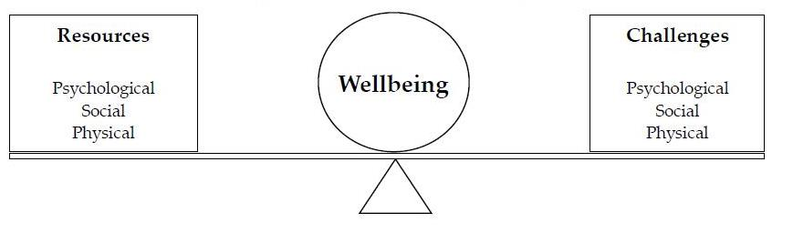

Figure 1: Definition of wellbeing, modelling the ‘set point’ (adapted from Dodge et al. 2012).

2.5 The Importance of Teacher Wellbeing
With the rise in understanding and importance of wellbeing within education there has also been an increase in evidence that suggests that teacher wellbeing is central to positive student outcomes (Roffey, 2012).

A study by Wellbeing Australia (2011) considered the links between increased teacher wellbeing, pupil wellbeing and better academic outcomes. This study found that teacher wellbeing has a significantly important impact not only on academic performance but also on improved student wellbeing. Although this is an international study and so must be considered with caution due to the differing contexts of the Australian and United Kingdom educational systems, the results of the study are replicated within other research.

Briner and Dewberry (2007) considered the direct links between teacher wellbeing and student academic outcomes, measuring over 24,000 teachers’ levels of wellbeing according to feelings of value, feeling overloaded and job stimulation and enjoyment. This was then compared with student outcomes on recent assessments and it was found that there was a significant link between lower levels of teacher wellbeing and lower pupil assessment scores. However in the study Briner and Dewberry (2007) do suggest that it would be difficult to separate the influence of pupil’s progress and improvements on the teachers scores of wellbeing through their self-efficacy scale and job satisfaction scale.

Teachers’ emotional wellbeing has been shown to be integral to the way in which they can relate to and interact with pupils as well as in their ability to develop positive teacher-pupil relationships (Hagenauer, Hascher, & Volet; 2015). Marzano (2003) found that teachers who have more job satisfaction also have improved relationships with their pupils and simultaneously also less difficulties with discipline. This is clearly a cyclical relationship, as research has also shown that positive interactions with pupils have been shown to make teachers feel good about their jobs and supports teacher wellbeing (Taris, Van Hornn Schaufeli & Schreurs, 2004).

In a recent discussion paper, Roffey (2016) suggests that teacher wellbeing is the corner stone for promoting whole school wellbeing initiatives and is fundamental when promoting protective factors for childhood adversity and supporting pupil behaviour. She concludes by stating that teachers who have difficulties with their own personal level of wellbeing and who feel under pressure, are simply less likely to have the time or patience to build and maintain positive relationships with challenging pupils, let alone be able to adopt solution focused and strengths based approaches to understanding these pupils needs and engaging with them effectively in the classroom.

When discussing teacher wellbeing it is therefore important to consider this balance of ‘resources’ and ‘challenges’, as well as taking into account the individual nature of the term. However it is also important to consider wider social, cultural and economic factors that are likely to cause variance between educational establishments and also between each individual’s understanding of their own wellbeing.

2.6 Protective Resources for Teacher wellbeing
Many studies have considered the emotional nature of teaching and examined factors that influence teacher wellbeing. Of these studies a multitude of factors have been identified both from within the individual’s immediate environment as well as from their wider societal and cultural context (Paterson & Grantham, 2016).

Many studies have found that workplace social support is an important protective resource for teacher wellbeing (Kinman, 2010). In a qualitative study that explored teacher wellbeing alongside pupil wellbeing, Roffey (2012), highlighted the importance of the ‘relational’ aspects within school environments. She suggests that it is the quality of contacts within schools that can ‘make or break’ teacher wellbeing and found that teachers identified respectful and supportive school communities, pro social values and a safe environment as having positive impacts on their own wellbeing.

In a more recent study, Paterson and Grantham (2016) considered an ecological view of teacher wellbeing. This study completed a focus group with five participants who were selected from a school identified from a group of other schools, with the most positive results from questionnaires relating to teacher wellbeing. Participants identified a number of elements across systems which promoted their wellbeing. Within the school microsystem participants felt that the collectivist culture within their school which promoted a positive and supportive environment where they felt respected and valued was important for their wellbeing. Similarly participants also discussed how this was also liked to macrosystems within society, whereby it was important that they also felt like they were supported and encouraged within these systems out in the community.

These studies suggest that the importance of workplace social support goes beyond having peers and colleagues to talk to about challenges or problems being faced. Instead also extending into the need for a safe and collective culture within schools so that staff felt respected and trusted in their roles and therefore able to share the problems they have.

In a review of the literature considering teacher resilience, Greenfield (2015) aimed to develop a model of teacher resilience. Greenfield (2015) identified a number of positive resources for teacher wellbeing including a number of support systems such as colleague, strong leadership, family and friends as well as positive pupil teacher relationships. However, at the heart of the model of resilience developed by Greenfield (2015), were teachers’ self-efficacy and beliefs surrounding their role. When teachers had high levels of self-efficacy and agency over their work, they were able to mange and cope with challenges and stressors as they continued to be confident over their practice.

In a discussion article by Jennifer Nias a Professor of Education, Nias (1996) suggests that teachers must consider their own identity, personally and professionally, so that they can work in a way that is congruent with their values. Although this article is outdated more recent studies have also shown that engaging with the emotional experiences of their work influences the way in which teachers shape their professional identities (Kelchtermans, 2016).

Nevertheless in many studies factors that support teacher wellbeing are often overcome by challenges that teachers face. It is therefore not surprising that much of existing literature focuses on a problem-based approach to understanding teaching experiences.

2.7 Challenges to Teacher wellbeing
Recent surveys have reported teaching as one of the most stressful professions, with recent studies suggesting that ‘over 41% of teachers report high levels of occupational stress within their roles’ (Paterson & Grantham, 2016, pg, 216 ). This pressure often leads to teacher ‘burnout’ which has been identified as ‘a feeling of physical, emotional and mental exhaustion, resulting from a chronic state and accumulation of pressure and stress at work’ (Golembiewski, Munzenrider, & Carter, 1983). This pressure and subsequent ‘burnout’ has led to the three year retention rate for teachers to be at its lowest rate, with over a third of all teachers leaving within their first five years in the role (Greenfield, 2015).

When considering the factors that influence the emotional pressure and stress within the role, many teachers highlight the problems of workload and the burden of increased pressure on academic expectations and progress for pupils (Gibbs, 2009). Gibbs (2009) suggests that this is linked to the lack of control that many teachers feel over their role, particularly elements that they feel are continually changing such as the curriculum and assessment procedures. This pressure has been widely addressed in recent government reports such as the DFE teacher recruitment and retention strategy (2019).

However this places very little emphasis on pupil behaviour which has been identified as the second reason that many teachers consider leaving the profession. In a recent National Union of Teachers (NUT) (2013) survey with 2,575 teachers across 13 different local authorities, two thirds of teachers reported considering quitting the profession due to difficulties managing challenging behaviour and the increase in the needs of pupils. Within this survey 90% of teachers reported dealing with a disruptive pupil in the last year, 77% report managing verbal abuse, 57% report managing physical abuse, bullying from a pupil 41% and damage of property by a pupil 23%. Although the NUT feel that the 2,575 respondents from the survey were representative of the general teaching population, it must be considered that it is likely that many teachers who do not experience behavioural challenges within their work may not have responded to the survey and similarly that those that do experience these difficulties may have also felt more empowered to voice this within the study, meaning that the results may not be a fully accurate picture of the challenges of behaviour across the full teaching population within the United Kingdom.

These statistics have also been supported by research which has shown that of all factors, classroom discipline and managing challenging pupil behaviour is one of the most significant detrimental factors on the wellbeing of teachers (Hargreaves, 2000; Sutton & Wheatley, 2003; Farouk, 2012).

In a study of 487 teachers, Galand, Lecocq & Philippot (2007) found that verbal victimisation from pupils, low-level continuous disruptive behaviour and aggressive attacks had strong negative impacts on teacher wellbeing causing increased levels of anxiety and depressive symptoms. Galand et al (2007) suggests that it is the continual daily disruptive behaviour that often causes the most psychological distress for teachers and is one of the most significant factors that contributes towards teacher ‘burnout’. This is reiterated in a more recent study which used questionnaires to gather an understanding of the influence of challenging behaviour on the wellbeing of 1,628 teachers. Moon and McClusky (2018) found that teachers who experienced challenge from pupils through either damage to property, physical assault, verbal assault or non-contact aggression reported lower levels of job performance, less student trust and lacked feelings of safety in school.

Nevertheless, it is also important to consider that there is significant individual variation in the impact of these factors on teacher wellbeing. This is likely to be accounted for by individual influences such as personal achievement, occupational commitment and teacher resilience, which have all been suggested to influence the balance of challenges and resources on teacher wellbeing (Galand et al. 2007; Jepson & Forrest, 2006). This also links back to the consideration of wellbeing from a constructivist positioning, understanding how and why some teachers find it easier to manage a challenging experience than others by considering their interpretations and constructions of their experiences.

With such striking statistics there is clearly a significant cyclical relationship between pupil behaviour, teacher wellbeing and the teacher-pupil relationship. As previously discussed, teacher wellbeing has a significant impact on not only a teacher’s ability to educate effectively but also on their capacity to provide emotional support and resilience to form positive and secure relationships with their pupils. As Roffey (2012) argues, ‘happy teachers produce happy pupils and vice versa’ (p. 97). Often the pupils who are most in need of these relationships are those that will display the most challenging behaviour and it is therefore crucial that teachers feel equipped and able to support them, regardless of the behaviour that they are coping with. Within this chapter I have developed a conceptual map to help to model this process (see figure 2).
The pupil-teacher
Relationship

Challenging Pupil Behaviour

Teacher wellbeing

Figure 2: The interplay between pupil-teacher relationships, teacher wellbeing and challenging pupil behaviour (developed by the researcher).

When reconsidering the quote above by Marsh (2012), it is important to consider whether the foundations of ‘mutual trust and respect’ and ‘personal relationships with every pupil’ could be possible when a teacher is attempting to cope with extremely challenging situations with particular pupils in their classroom on a daily basis. The pupils who are in need of the protective relationships with their teachers are often those who will show the most challenging behaviour and it is therefore important to consider whether a teacher can provide the security of that relationship when they are managing such challenging and emotional experiences.
With increasing numbers of pupils entering schools with challenging behaviour and a dramatic rise in exclusion rates (Roffey, 2012; Gill, 2017) it is crucial that more prominence needs to be placed on helping teachers to manage under these challenging situations so that their wellbeing and subsequent ability to form relationships with these pupils is not compromised.

However providing support for teacher wellbeing goes beyond managing the impact of physical outbursts and requires support of a social and emotional nature (Davison & Duffy, 2017). Greenhalgh (1994) suggests that working alongside pupils with challenging needs can be frightening for teaching staff and cause a range of associated negative emotions such as helplessness and anger. Hanko (2003) suggests that working with challenging pupils has an impact on teacher’s confidence and agency within their role and this can reduce teachers capacities for engaging and motivating their pupils. It is therefore crucial that professionals are working alongside teachers to not only support their sense of efficacy and confidence in their role but also to attempt to counter the negative effects of psychological distress caused by working with pupils with challenging behaviour.

2.8 Supporting the teacher to support the pupil- Current support for teacher wellbeing
Viewing education and wellbeing as embedded within each other has become a prominent topic of much research and policy, including promoting children and young people’s emotional health and wellbeing (2015) and mental health and behaviour in schools (2018). These policies are also followed by programs offering, whole school approaches to the support of mental health and wellbeing such as the Sandwell Charter Mark (2018). However much of the focus of these publications and approaches has been on supporting the wellbeing of children and young people, with less prominence placed on teacher wellbeing.

In recent government guidelines for mental health and behaviour in schools: advice for school staff, there is advice which details the clinical conditions that teachers may encounter within their roles but little information to promote the wellbeing of staff. Recent NICE guidelines (2015) draw attention to the need for a supportive base for all teachers to help to support and improve health and wellbeing within education. There is clearly an identified and significant need for support for teacher wellbeing, yet very little has been put in place within this area. The next part of this chapter will briefly discuss approaches which have been applied within research to support school staff in their work.

Support through consultation
When considering current support that could be applicable, providing consultation to support within education is a model primarily used within the Educational Psychology field. The use of consultation is common when helping practitioners working closely with a child or young people to develop their thinking around the needs of the child to help to facilitate and broaden the ideas and ways to support them (Hanko, 1995). A number of models of consultation have been developed to support staff in schools such as group process consultation, teacher led support groups and models such as the circle of adults (Hanko, 1995; Jones, Monsen & Franey, 2013; Wilson & Newton, 2006). These models have been found to be effective in supporting school staff to broaden their understanding about a child’s difficulties and provide opportunities for planning and preparation in how to support the child’s needs (Austin, 2012).

Although heavily based upon problem solving the difficulties a child or young person is facing, it has also been found that additionally for school staff being a part of a consultation meeting can also provide an opportunity which gives a safe space for them to share the challenging experiences that they are facing through the empathy and containment provided by the Educational Psychologist or practitioner facilitating the consultation (Miller, 1996). Nevertheless this is not an aim or outcome of when guiding a consultation meeting and models of consultation tend to focus heavily on proving a problem solving space rather than a space for emotional containment which can mean the feelings and emotional experiences of participants within the consultation could easily be overlooked.

Support through coaching
Coaching is another approach more frequently applied to education to support school staff through a ‘goal directed and solution focused approach’ (Adams, 2016). Although as with consultation as a form of support, coaching is predominantly developmental and aims to guide the coachee through support based around individual targets a goals within their practice (Adams, 2016) rather than in providing them with emotional support for challenging experiences that they may be facing.

Support through supervision
Supervision is a model of support developed within the ‘helping professions’ (Hawkins and Shohet, 2012). For professionals within fields such as social work and educational psychology supervision is a requirement of the roles and undertaken on a consistent and regular basis to support across a range of different elements of the work depending on the context within which it is applied.

Traditionally supervision was developed as ‘therapy for the therapist’ (Carroll, 2007) however it can also be applied to support with developmental, supportive and also managerial functions. As Hawkins (2011) discusses the functions of supervision are heavily dependent on the needs of the supervisee and the systems within which they are working.

Of the few examples where supervision has been considered for school staff and implemented within education, results have been positive. The ELSA (Emotional Literacy Support Assistant) program is unique in providing supervision as support for staff, as part of the essential requirements for the program is the provision of termly supervision for ELSA support assistants in schools (Weare & Gray, 2003). Evaluations of the supervision for ELSA staff members has shown, ‘higher levels of emotional resiliency, increased sense of accomplishment and lower levels of burnout and exhaustion related to the role’ (Davison & Duffy, 2017, p.g. 279 ). However, in current educational policy and practice there is very little in place with regard to the provision of supervision or support for school staff.

2.9 Summary
In a climate of increased adversity more children come into the education system reliant on the protective factors that schools provide for not only their academic progress but also their social and emotional development (Roffey, 2012). These protective factors are heavily influenced by the resources and systems in place within school, however at the foundation of these, is the need for strong and positive pupil-teacher relationships.

Nevertheless as this chapter has argued, if teacher wellbeing is overlooked and difficult emotional experiences when working with pupils with challenging behaviour not supported, then teachers will not have the capacity and resilience to create and maintain these crucial positive relationships with these pupils. The cyclical process is well described in the quote by Roffey (2012), ‘happy teachers produce happy pupils and vice versa’ (p.97). Yet, even with an increased prominence placed upon wellbeing within education, this chapter has also argued that there is still very little effective support for teacher wellbeing, particularly to support the emotional capacity for positive pupil relationships.

This study considers the impact that managing pupil’s with challenging behaviour has on teachers’ emotional experiences and aims to develop an understanding of how best to support teachers in managing their emotional experiences related to their work.

Chapter 3
Methodology
In this chapter I will aim to outline the design of my research. I will discuss my ontological and epistemological positioning within the research, justifying my choice of using Qualitative research methods as well as my decision to use a constructivist grounded theory approach to data analysis. This chapter will also outline the research process including; participant sampling, interview procedure, ethical considerations as well as show my reflections of the analytical process.
Appendix C demonstrates the timescale over which this research was developed, including the interview processes and analysis stages.

3.1 Background to the Research
Epistemological and Ontological Positioning
There are many elements to the role of a teacher, taking on the responsibilities of being such things as an educator, a friend, protector, mentor and disciplinarian (Chang, 2009). Each of these roles places a different emphasis on the teacher and can bring about a range of experiences for them, both positive and negative (Sutton & Wheatley, 2003).

This study aims to explore the experiences of teachers working with pupils with challenging behaviour, emphasising the understanding of not only what teachers experience during these challenges, but also how and why they interpret these experiences in a certain way. From this, the study will develop a model of supervision which can be used to guide professionals within education settings to support teachers in manging their emotional experiences.
Much postmodern research argues that the era of significant theories based around big narratives is over and that moving forward it is more significant to understand the specifics within a meaningful social, historical or geographical context (Flick, 2009). Therefore rather than ‘discovery’ it is more important to understand the ‘construction’ of knowledge, how it is ‘created’ by the person, rather than ‘what’ is found. Toulmin (1990) believes that it is more meaningful to address the ‘spoken word’, consider the particular rather than the universal and always understand this within the context in which it was formed. More recently Toulmin (2009) suggests that researchers within social fields can easily become ‘preoccupied’ with knowledge and instead should be aware of working without absolute certainty so that increased precedence can be placed on understanding the way in which individual’s understandings are influenced by the context within which they are experienced.

Qualitative research allows for this deeper level of understanding and this is why is it being used within the present study. Rather than simply understanding what the participants experience, it will allow for deeper exploration within their experiences, understanding their values, judgements and how this impacts on their interpretations and constructions of their experiences.

Approaching this research from a relativist, constructivist perspective allows for this deeper level of meaning, viewing understanding of not one reality, but instead a range of individual and constantly evolving realities (Charmaz, 2000). This perspective rejects the notion of an objective reality; ‘asserting instead that realities are social constructions of the mind, and that there exist as many such constructions as there are individuals,’ (Guba and Lincoln, 1989, p 43). This emphasises the need to understand how teachers construct their experiences and how their individual realities impact upon this.

CONSTRUCTIVISM and CONSTRUCTIONISM
Constructivist psychology investigates and theorises how human beings create ‘constructs’ which allow them to make meaningful understanding of their worlds and experiences (Raskin, 2002). However within constructivist psychology there are many terms such as “constructivism”, “constructionism” and “constructive” which are employed inconsistently and incoherently throughout many descriptions offering areas of divergence, but also many areas of similarity between them (Raskin, 2002).

Constructivism and social constructionism are two approaches which have been seen to share many binary oppositions such as, personal/social; individualist/relational; agency/structure; constructivist/constructionist, yet are discussed inconsistently throughout research (Raskin, 2002; Pavlovic, 2011). Social constructionists have argued that constructivists limit the acknowledgement of the social and discursive factors which shape our constructions. Constructivists have disputed that within a social constructionist approach the sense of ‘person’ and ‘agency’ becomes lost (Gergen, 1997; Pavlovic, 2011).

Radical constructivism (Von Glasersfeld, 1981) would state that ‘each person perceives the world differently and actively creates their own individual meanings for events’, (Von Glasersfeld, 1981, p.g. 107). However more recently constructivists have considered that more important within this is the extent to which the individual is seen as an agent who is in control of this construction process and the extent to which our constructions are the product of social forces (Burr, 2018). Previously the level of personal agency and social forces developing constructions have always been opposing within constructivism and constructionism. However more recent thinking has considered the interplay between both personal agency and social forces on the development of constructions. These suggestions instead propose that meaning making occurs within the individual but also reflects social forces such as power and ideology (Burr, 2018; Pavlovic, 2011).

A Constructivist Approach to Grounded Theory
These ideas have been considered within the approach to research for the present study where a constructivist grounded theory approach (Charmaz, 2000) has been used. Originally Charmaz (2000) rejected a social constructionist perspective, arguing that social constructionist researchers are, ‘treating their analyses as accurate renderings of the worlds they studied, rather than constructions of them’ (p.14). Similarly she felt that from a social constructionist perspective the subjectivity of the researcher and researched was not taken into account or reflected upon during analysis.

Charmaz (2014) outlines that she chose the term ‘constructivist’ grounded theory to acknowledge the subjectivity of the researcher’s involvement in the construction and interpretation of the data. However, she aligns herself closely with social constructionist researchers such as Lincoln (2013) who emphasise the impact of social life, contexts, interactions, discussions of viewpoints and our social interpretations within our acquisition of knowledge. More recently Charmaz (2014, p.14) writes that ‘subjectivity is inseparable from social existence’ suggesting that strong currents of social constructionism are apparent in her approach to constructivist grounded theory.

3.2 My Approach
My research questions along with my relativist, constructivist ontological and epistemological positioning then guided the methodology that I chose. It was important that as a researcher I allowed my participants to have a clear voice about their experiences, not only sharing what they experienced, but most importantly how they came to construct these experiences and what wider influences they felt impacted on their constructions. As a professional I felt that it was also important that my research would help other professionals recognise teacher’s experiences and perceive how teachers come to give meaning to their experiences so that they are able to understand how best to support them.

It was also important that the approach that I used allowed for the acknowledgement of the relationship between my participants and myself as a researcher. This was particularly prominent within my research as I had previously been a teacher who had similar experiences to those of my participants and therefore bought a high level of empathy and background experience into my research. Clarke (2005) states that it would not be possible for a researcher to be a ‘passive, neutral observer’ and that researchers are a part of the endeavour of research and their values must therefore be acknowledged by themselves, as well as their participants. I felt that it was important to share my experiences with my participants, not only to create a safe and empathetic environment but also to help to use my experiences to understand how they were constructing and making meaning of their own experiences. A constructivist perspective allows for the relationship between participant and researcher and encourages the co-construction of meaning within the research. Reflections became an important part of my research to acknowledge myself as a perspective within my research and reflect on my role within the co-construction of my data analysis.

I felt that a constructivist grounded theory approach (Charmaz, 2000) would allow for the collection of rich data, provide space for the co-construction of a deep and multi-layered understanding of the participant’s experiences as well as bring this data together to develop a theory strongly grounded within the data which considered how professionals would be able to support teachers in their experiences through a model of supervision.

3.3 Grounded Theory
Grounded theory has been shown to vary across different ontological and epistemological assumptions and it is suggested that as an approach it is malleable to fit across a broad range of research perspectives of both positivist and interpretative approaches (Giorgi, 1995). For this reason the techniques within grounded theory such as constant comparative analysis, coding and memo-writing can be used according to the positioning of the researcher (Bryant, 2002).

However from a constructivist perspective traditional grounded theory (Glaser & Strauss, 1967) has been heavily criticised. Charmaz (2006) states that traditional grounded theory provides an “objective external reality, a passive, neutral observer and a detached narrow empiricism”. It is also suggested that traditional grounded theory does not provide enough flexibility or space for reflection and subjectivity of the researcher or participants and presumes too much of an accurate rendering of truth within its analysis (Conrad, 1990).

The Emergence of Traditional Grounded Theory
Grounded theory emerged after heavy critique of qualitative research methods and epistemological assumptions to research. Many quantitative researchers saw qualitative methods as impressionistic, unsystematic and biased. Glaser and Strauss (1967) developed grounded theory to provide a qualitative approach that used systematic strategies and allowed for the movement away from descriptive methods, into a framework that allowed it to develop more conceptual understandings of studied phenomena.

Glaser and Strauss (1967) were interested in studying social processes within a particular setting as well as understanding more about particular social experiences. Their research using grounded theory has particularly focused on understanding the experiences of having a chronic illness. For Glaser and Strauss (1967) grounded theory allowed them to explain this studied process within new theoretical terms, understanding the properties, causes and conditions of the process and how it emerges and develops within theoretical boundaries rather than giving just a description of the process.

Engaging in any form of grounded theory requires the use of a set of common components that provide structure to the methodology used within data collection and analysis (Mills, Bonner & Francis, 2006).

The defining components of a grounded theory framework include;
- Simultaneous involvement in data collection and analysis
- Constructing analytical codes and categories from the data, not from preconceived logically deduced hypotheses
- Using a constant comparative method throughout the analysis
- Advancing theory development during each step of data collection and analysis
- Memo-writing to elaborate categories, specify their properties, define relationships between categories and identify gaps
- Theoretical sampling- sampling aimed toward theory construction rather than population representation
- Conducting the literature review after developing an independent analysis.
(Charmaz, 2014, p.6, 7).

Following this prescriptive criteria allows for the development of a completed theory that is useful, provides theoretical density, is durable over time, modifiable over time and gives explanatory power to the area of research (Glaser & Strauss, 1967). Glaser and Strauss (1967) believed that this provided qualitative research with a more powerful argument toward seeing it as credible and rigorous.

The Development of Grounded Theory- Glaser and Strauss (1967); Strauss and Corbin (1990, 1998)
Since its initial developments both Glaser and Strauss continued their development of grounded theory but in different directions (Charmaz, 2000) and from this several variations of grounded theory have evolved over time.

Glaser (1978) continued to understand grounded theory as he had previously used it whereas Strauss (1987) began work with Corbin (1990) and started to see grounded theory as a method of verification. Strauss and Corbin (1990) started to apply other technical procedures within their analysis. Glaser (1992) contends that Strauss and Corbin’s (1990) developments ignore the elements of emergence of categories from the data and instead start to force the data and analysis into preconceived ideas, in short he felt that their developments of grounded theory meant that the analysis was not grounded within the data, rather forced and therefore providing just a conceptual description.

A Constructivist Approach to Grounded Theory (Charmaz, 2000)
“Like any container into which different content can be poured, diverse researchers can use basic grounded theory strategies such as coding, memo writing and sampling for theory development with comparative methods because these strategies are in many ways transportable across epistemological and ontological gulfs although which assumptions researchers bring to these strategies and how they use them presuppose epistemological and ontological stances” (Charmaz, 2014, p.12).

This quote demonstrates the vast debates that have occurred over the use of grounded theory within research and the critiques which have occurred from traditional grounded theory due to its presupposed positivist assumptions. Critiques have viewed traditional grounded theory as ‘clinging to out-dated modernist epistemologies’ (Conrad, 1990, p.13). Conrad (1990) along with other researchers, suggests that grounded theory fragments the participants stories and places too much emphasis on the authoritative voice of the researcher and a narrow empiricism. Clark (2012) stresses that the research takes part within a situation and includes also what researchers and participants bring to this situation which must be considered within the analysis.

Constructivist grounded theory (Charmaz, 2000) uses the same systematic approaches of traditional grounded theory however it takes a relativist perspective and views research as a construction between participants and researcher, rather than simply an act of discovery by the researcher.

By working with a constructivist approach to grounded theory I was able to incorporate co-construction of meaning between myself and my participants. This enabled me to consider how participants interpreted and constructed their experiences and engage with forces arising within the situation and context of my research. This allowed me to incorporate reflexivity within my analysis, making it deeper, richer and more reliable through understanding and engaging with the process of construction (Hall & Callery, 2001). It also allowed for a closer analysis of the lived experience of the participants (Giorgi, 1995), which was very important in the present study to allow for a rich picture of their emotional experiences. It gave a description of participant’s situations, feelings, thoughts and actions and it was from this that I was able to analyse and understand how the participants construct these actions, intentions and feelings within their experiences (Charmaz, 2005).

The Theory within a Grounded Theory Approach
The aim of this study was to generate a substantive interpretive theory to help to understand how teachers interpret, react and build meaning within their emotional experiences working with pupils with challenging behaviour. A substantive theory is grounded in the research within one particular field and can be compared with other examples within a similar or the same field (Glaser & Strauss, 2017).

Unlike a theory formed from a positivist approach which is based on providing accurate, replicable, empirical measurement and separating fact and value (Abend, 2008), an interpretive theory gives understanding more emphasis than explanation and is gained through the theorist’s interpretation of the studied phenomenon. This type of theory also aligns well with a constructivist approach, assuming multiple emerging realities and locates theories within particular values, situations and contexts (Charmaz, 2014).
“Theories are thus deconstructions of the way in which we construct realities and social conditions and ourselves as subjects in those realities. They cannot compete with lay thinking, because their very objective is to make sense of it in its various forms and in different instances” (Alasuutari, 1996, p.382).

I initially considered using a phenomenological approach to closely explore the lived experiences of teachers managing their difficult experiences and relationships with pupils with challenging behaviour. However it was important for me to move beyond a descriptive account of the data. A grounded theory approach allowed me to address ‘why’ questions as well as considering ‘what’ and ‘how’ elements (Gubrium & Holstein, 2004). Through the co-construction of meaning within constructivist grounded theory a better understanding of the meaning teachers place on their experiences was gathered. Then subsequently by deconstructing these interpretations a theory of supervision could be developed which then helps other professionals to understand how to support teachers through their challenging experiences. Unlike phenomenology, grounded theory allowed for the movement beyond the descriptive data and into a theory-building level (Bryant & Charmaz, 2011) and through the use of a constructivist approach the personal value to the participant’s stories along with their own constructions and meanings was kept within the analysis.

Quality and Rigor in Grounded Theory Research
As discussed above grounded theory is concerned with the production of theory that is grounded within the data and therefore the issue of quality within Grounded Theory research is different from many other types of qualitative methodologies (Oktay, 2012). Within grounded theory the quality of a study is closely linked to the approach and assumptions taken through the researcher’s ontological and epistemological positioning. Some studies rely on a fixed notion of quality and rigor unlike a study based on relativist, constructionist and interpretive theory (Lazenbatt & Elliot, 2005).

Glaser and Strauss (1967) emphasise that the quality of a grounded theory study is heavily linked to the credibility of the theory generated within wider professional practice. Therefore findings need to be relevant and applicable for the practitioner so that they are able to make it generalisable and also transferable across a variety of situations.

Grounded theory provides structures and techniques which provide the researcher with rigorous and reliable methods for data analysis and support the production of a credible theory (Becker, 1993). Nevertheless it has been found that many studies that claim to use grounded Theory are not being true to all the critical components of the methodology which causes difficulties in demonstrating the quality of their analysis (Benoliel, 1996).

Charmaz (2014) states that there are significant distinctions within a constructivist grounded theory study which support its reliability and credibility such as; use of comparative methods, engagement in theoretical sampling, searching for variation in the studied categories and the development of inductive abstract analytical categories through systematic data analysis. Similarly Glaser and Strauss (2017) state that the quality of a theory, within grounded theory, cannot be separated from the process in which it is generated which is fundamental in constructing a theory of quality. Therefore it is the procedures within grounded theory that place value on its quality and vigour and for this reason they must be carefully considered and adhered to. Theoretical sampling is stated to be a critical component for successful grounded theory studies as this accounts for variations within the data and focuses on theory development (Hood, 2007). Similarly this enables the focus to be on the generalisability of concepts rather than samples, measured by the applicability of these concepts to other samples, contexts or situations (Conrad, 1990).

Alongside careful use of the procedures of grounded theory, Charmaz (2006) emphasised four criteria which also help to ensure the quality of the study; credibility, originality, resonance and usefulness. According to Charmaz’s (2006) criteria alongside close reflections within my research diary I have outlined below careful considerations for quality with the present study.

- Credibility: Ensuring that my study accurately fits and matches the procedures of a grounded theory Study, using memos within my research diary to bring awareness of my subjectivity as a researcher. Examples of these memos can be found throughout the research and in appendix B.

- Originality: Making sure that my emerging constructions and theory ‘challenges, extends, or refines current ideas, concepts and practices.’ (Charmaz, 2006, p182).

- Resonance: Ensuring that the developing categories provided a full and rich picture of my data and thoroughly examining the area of study as well as being open to new categories from emerging data.

- Usefulness: Provide a useable and practical application of theory offering constructions that can be interpreted into the practical nature of people’s lives and considering the multiple audiences that it needs to support. Ensure that I am thinking about the work of the Educational Psychologist and wider professionals when developing my research so that I am considering how it can be incorporated within this work.
Nevertheless Glaser and Strauss (1967) ascertain that researcher bias can be one of the most significant factors which impacts the credibility of a grounded theory study; risking the researcher placing their own values or perspectives onto the data analysis. Gerhardt (1990) also warns that the process of categorising and coding the data risks ‘shattering’ and devaluing the data, breaking it away from the individual experiences of the participant. Although within a constructivist grounded theory method there is an understanding of the connection and subjectivity that the researcher brings to the data analysis it is important to engage with this through my reflections and memos to be aware of any bias that I may bring. Thereby helping to avoid, “non-grounded ideas occurring from personal biases or personal experiences of an idiosyncratic nature” (Glaser, 1998, p.182) which would devalue the analysis and quality of the research.

Hall and Callery (2001) also emphasise the importance of the research diary and memo writing. By allowing for reflexivity and relationality between the researcher’s data and analysis enhances the rigor and thus the quality of the grounded theory methodology. Examples of memos can be found in appendix B and a research diary has been kept by the researcher.

3.4 The Research Design
The next section of the methodology explores the research design within the study and also discusses sample size and participant recruitment. It then goes on to discuss the structure of grounded theory and how these techniques were employed throughout the study. This section will also discuss the use of memos throughout the research project and examples of memos can be seen within the research showing the researchers reflections and development of the study.

The Research Question
As discussed, grounded theory allows the exploration of ‘how’ and ‘what’ questions during data analysis and throughout analysis provides space for ‘why’ questions and answers (Gubrium & Holstein, 2004). An initial research question must exist within a field of study however it is important that this research question does not make assumptions on the data. This was difficult in my present study as my previous experiences meant that I held assumptions that linked teachers’ challenging experiences with pupils, with negative emotional experiences and difficulties forming relationships with these pupils. Therefore it was very important that my initial research question did not place these assumptions on the research and that this was also reflected in the questions that I used to begin my interviews with participants.
Therefore my initial research questions were:
- What emotional experiences do teachers have when supporting pupils with challenging behaviour?
- How do teachers interpret these emotional experiences?
- What support can be provided to teachers managing pupils with challenging behaviour?

Ethical Considerations
When completing this research I adhered to the British Psychological Society code of ethics and conduct (2018). This code is broken down into four principles; Respect, Competence, Responsibility, Integrity, and outlined below is how this research considered these principles. A copy of the ethical approval confirmation letter can be seen in appendix A.

Respect:
I treated my participants with the upmost respect and dignity throughout the research process, being sensitive to the potential power dynamics of the researcher and participants. It was very important that participants felt safe and comfortable during the research process so that they felt trusting to share personal experiences and potentially emotive information with myself as the researcher. Therefore I gave participants clear information about the research process, aims and methodology. I ensured that they had background information about myself and understood my reasons both personally and professionally for undertaking the research. I made sure we had a comfortable room to complete the interviews and a space that allowed for confidentiality of information. Participants were also able to decide where they wanted to complete the interview, either at school or another identified location of their choice. Participants were also asked to complete a consent form (see appendix D) to agree to taking part in the research and also told that they were allowed to withdraw at any point along with any data they had shared as part of the research. Participants were also given an information sheet (see appendix E) which outlined that their sensitive information would be treated with care and be kept completely confidentially during the research process on a locked and secured pen drive and laptop and then securely destroyed at the end of the process.

This principle also outlines the importance of compassionate care, so it was important that I treated my participants with empathy and sensitivity during the interviews so that they felt supported in sharing information with me and understood the care and compassion that I had towards them and their experiences.

I was also aware that I had a duty of care to the pupils that teachers would be discussing during our interviews. Therefore, to ensure that my work did not impact on their present experiences with pupils, I asked teachers to reflect on an experience from the previous academic year or later in their teaching careers.

Competence
It was important to work within my skill set during the interviews and research process. I used the knowledge and experience of my research supervisor to ensure that I was completing the research process carefully and accurately and also throughout the interview process.

It may have been important to provide additional emotional support to my participants as they were discussing extremely emotive information with myself during the interviews. I used my skills and knowledge of supervision to support teachers and ensure that I was following the correct procedures for support. They were given my email address and phone number in case they felt the need to talk or share further experiences and if I did not feel professionally competent to manage this I would have signposted the participants to support through the education and support partnership counselling line.

Responsibility:
During the research process I was responsible for the wellbeing of my participants. I ensured that participants felt safe and supported during the interviews so that they were able to share information with me that they deemed appropriate and at no time did I use my authority or power differential to encourage my participants to share information that they did not feel comfortable with.
As discussed above I also made sure that my participants were supported after the interviews had taken place, through school support, support from myself or my supervisor or if required directing them to additional support such as the education and support partnership counselling line.

Integrity:
I was always honest, truthful and accurate about the research process, how the participants interview and data provided would be used and the nature of the research. Participants were provided with information about the research process before the interviews (see appendix E) and given an opportunity to ask any questions. The information sheet also had my contact details and the details of my research supervisor should participants have any further questions after the research.

Throughout the research process I also maintained personal and professional boundaries with my participants. My previous background history was shared with participants prior to the interview to support them to understand my sensitivity to the topic and this was done with professionalism. Equally the information that participants shared was often of a personal nature and again always treated with a professional nature.

Grounded Theory Methodology
Grounded theory methods allow for “systematic, yet flexible guidelines for collecting and analysing qualitative data to construct theories from the data themselves”, (Charmaz, 2014, p.1). The methods bring about iterative movements backwards and forward between data collection and analysis using a number of methods which compare and develop the emerging analysis of the data. Grounded theory is therefore not a linear sequential process and this is outlined in figure 3, showing how constant comparative methods move the researcher back and forth through data collection and analysis until categories have reached saturation point.

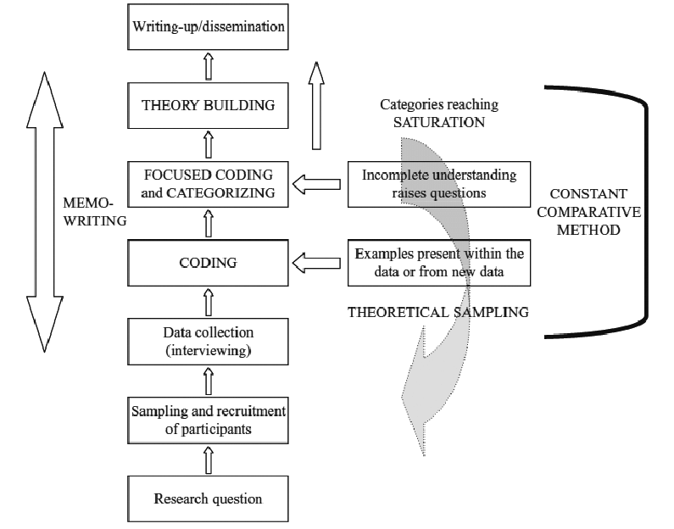

Figure 3: Processes within Grounded Theory (Charmaz, 2014, p.32)

Within this methodology data collection and analysis occur at the same time and through the use of reflections and memo writing analysis becomes deeper and more meaningful, feeding back to direct further data collection. This is known as constant comparative method and continues until categories reach theoretical saturation.
The next sections of this methodology look at how I moved between data collection, through the use of interviews, and analysis and how I used memo writing to guide the development of my data collection.

Sample- Theoretical Sampling
Due to using a grounded theory method to analyse the data it is difficult to give specific information about the sample size that will be used to collect data. Within grounded theory a technique known as theoretical sampling is used which means that the sample is adapted throughout the study to elaborate and refine categories that develop throughout analysis (Charmaz, 2014). ‘Theoretical sampling means seeking pertinent data to develop your emerging theory.’ (Charmaz, 2006, p.96). It starts with the initial data and then constructs and develops ideas about this data which are then examined through further data collection (Charmaz, 2014).

The sample within the present study focused specifically on teachers experiences and therefore I felt that there was no need to expand beyond this population. However the technique of theoretical sampling was used when developing the structure of each interview, meaning that ideas that emerged from one interview were subsequently explored in the following interview.

Memo 3 | Date 20.4.18 | Participant recruitment- defining challenge for teachers personal experiences
Discussion with research tutor over what ‘challenging’ means. How will I define this for my participants so that they know what is challenging. Must allow for their own subjectivity. If they feel that it was challenging to their own personal and professional values. It may not be the same level of challenging as another participant but that does not necessarily matter if it was still personally challenging to them.

Creation of a scale for the participants to consider the term challenging within.

When considering participant recruitment, it was important to use a set of criteria to make sure that the teachers that I would be working with had the relevant experiences to discuss with me (see memo 3).

The following sample was used to gather participants:
- Experience from the last academic year working with a pupil whose behaviour has been personally and professionally challenging.
- That the teacher has found that the pupil’s behaviour impacts on their emotional experiences when supporting this pupil.
- That these emotional experiences impact on the nature of the teacher’s relationship with the pupil.
- When considering the nature of the pupil’s ‘challenging’ behaviour this term is subjective to the personal nature of the experience. Therefore to provide a measure of the term challenging a scale will be used. On the scale, the pupil’s behaviour should reach at least seven points, with one being very compliant and easy to manage and ten being the opposite end of this spectrum.

When gathering my sample, I felt that it was initially important for me to work with teachers whom I had already supported through my work as a Trainee Educational Psychologist on placement so that I already had built a trusting and supportive rapport with staff. However due to practicalities it became apparent that I would have to extend my sample recruitment further out and therefore I emailed other lead SENCos in a range of localities across my placement area asking them to forward my details onto any schools or staff they felt would be suitable for my study.
Memo 5 | Date Feb 2018 | Participant recruitment
Discussion with research tutor over the use of particular schools for my sample. Need to think about the support systems that teachers may also have within a specific type of school. How much time is used from EPs already for this type of work. The Ofsted criteria requires improvement may also add additional job stressors. Any other professionals schools may use to support staff or any school policies that may support staff. How will I limit the impact of external factors within the interviews or are these factors of similar importance?

After a discussion with my Research Supervisor (see memo 5), I also felt that it would be important to think carefully about the types of schools that I was recruiting participants from so that their experiences were not biased by a particularly bad experience within their school, such as going through a ‘requires improvement’ category from Ofsted or having had multiple changes in leadership.

Therefore when participants initially contacted me about their interest I looked at their schools website and Ofsted reports and asked teachers about their experience and time working as a teacher to make sure that they would be a suitable participant. Gathering participants for the study was not a challenge, I had more teachers interested than I could manage to interview and I felt that this was an example of the lack of opportunities to talk with professionals about their challenging experiences.

As previously discussed, the definition of wellbeing within the present study considers the importance of a ‘set point’ between an individual’s challenges and resources (Dodge et al. 2012). However, this definition was critiqued for its lack of consideration for the role of wider ecosystemic factors on an individual’s wellbeing. Therefore, ecosystemic information was considered when interviewing participants within the present study. This information can be found in appendix F. It was also important within the constructivist nature of the research project, that wider ecosystemic influences on the participants constructions of their experiences were considered during the interviews. Participants often discussed their systems of support, such as school support and family support, however through co-construction with the researcher it was important to understand the nature of these systems and the way in which they influenced the participants constructions.

Interviews
Interviewing as a data collection method has a similar methodology irrespective of the methodological grounding of the study (Wimpenny & Gass, 2000). However interviews are commonly used within grounded theory analysis as they allow the researcher to taker a deeper level of questioning to explore a participant’s situation.

An open style of questioning was used to interview participants which allowed for questions to be used to direct and explore the discussion with participants and was suited to gathering data in a grounded theory study (Charmaz & Belgrave, 2012). This allowed me to respond to participants and to explore their experiences in a greater depth however it also enabled me to use questioning to help to facilitate their own interpretations and reflections on their experiences. Nevertheless even when directing my questioning I was always careful to ensure that my question style was predominantly open-ended to reduce possibilities of researcher bias.

The interviews all began with an introduction in which I spoke about my previous experience and my aims of the research. I also asked the participants to introduce themselves and gave an opportunity for any questions they may have had. I started all of the interviews with the open question, “Tell me about your experiences working with…”. The rest of the interview was then structured using key topics discussed in previous interviews at the same time as attempting to keep the interview as unstructured as possible to allow for an open dialogue and new topics to also be discussed.

As mentioned above within grounded theory the data collection is driven by the emergence of ideas through an initial analysis stage. Therefore as much as possible I would complete an interview, transcribe it and then complete an initial coding phase. I then used memo writing to reflect on the development of my early ideas and to link how this would be explored further in following interviews.

Day (1999) argues that through this process researchers can become so focused on reaching theoretical saturation that they become directed by the ideas they have currently found rather than leaving the interview space open. I was aware of this throughout my interviews and felt that it was important to guide the conversations that I had with participants but not be too directive and continued to focus on open questioning. I made sure that my participants had as much time as possible to answer the questions that I gave them and at the end of the interview I always asked if there was anything else that they would like to add as well as providing them with my email address should they wish to contact me to discuss anything further.

Transcriptions
In line with constructivist grounded theory I aimed to transcribe every interview using a line by line style after the interview and develop ideas for questioning for the next interview. I transcribed the entire interview rather than making notes or transcribing sections to allow me to get close to my data, preserve the detail from participants and also move with more ease back and forward through the interviews if required during deeper levels of analysis. Examples of the interview transcripts can be seen in appendix G.

Sample- Theoretical Saturation
Within a grounded theory study the sample size should also change over the course of the study (Glaser & Strauss, 1967). This allows for the exploration of negative cases which raise further questions about the data and occur in sharp contrast to previous emerging ideas (Charmaz, 2014). Sampling also continues until theoretical saturation occurs which causes ambiguity over the number of participants that may be required for a study. Theoretical saturation occurs when the categories are ‘saturated’ with data and no new categories or properties within categories are emerging (Glaser, 1978).

Theoretical saturation was reached in the present study after completing five interviews. Each interview was transcribed, and the transcription was then initially analysed, using a line by line approach. I then made brief notes of ideas which emerged from each interview which guided the questioning used within the interview.

During the interview process it became clear that my participants had both positive and negative journeys when supporting the pupils they were discussing and became a consideration within the saturation process. These contrasting journeys did not bring negative cases as they correlated with one another, providing more opportunities for discussion and co-construction of meaning by drawing upon similarities and differences between participant’s experiences whether positive or negative and allowed for a deeper level of saturation of the emerging theory.

3.5 Grounded Theory Analysis
This section will discuss myself within the research process and the reflections and developments throughout the analysis process. For this reason it will be discussed in terms of first person.

Coding
The process of coding in grounded theory allows the researcher to move beyond fixed statements based on the data to instead make analytical and meaningful sense of the stories and statements within the data. Charmaz (2014) suggests that coding is a minimum two-stage process; initial coding followed by focused coding. According to Charmaz (2006), coding entails naming segments of data ‘with a label that simultaneously categorises, summarises, and accounts for each piece of data’ (p 43).

Initial Coding
Charmaz (2014) states that during the first stages of coding a researcher should code everything to avoid focusing analysis too early. She recommends going through the transcription in a line-by-line process and naming each word or line of data

Each interview was transcribed after completion using the process of line by line coding (see table 1 for example). I then looked for emerging ideas within the interview and started to bring together some of the ideas that were evolving (see figure 4 for an example). Following the process of theoretical sampling, this allowed me to take these ideas to the subsequent interview and explore them in further depth.

Participant 1 Transcription Example | Coding
S: Well you’ve got a dread because you just don’t know what the day is going to bring. You’re worried for the other children. The child came in yesterday and he was literally bouncing off the walls. So you are just already apprehensive for the rest of the day wondering What sort of things are going to happen. | you’ve got a dread,  apprehension  worry other children  child uncontrollable ‘bouncing off the walls’  apprehensive  wondering what will happen  wondering

Table 1: Initial coding example
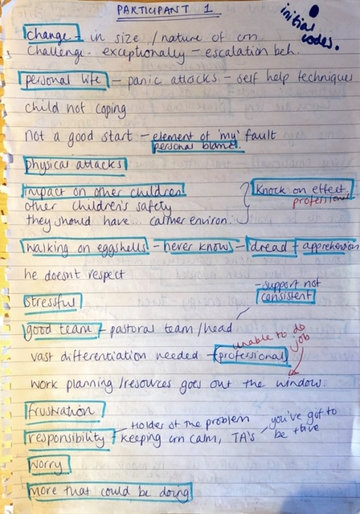

Figure 4: Example of initial grouping of codes that were used to feed into structure of the following interview.
These initial codes were heavily grounded within the data and I felt that it was important that when developing my codes, I kept close to the language that participants had used, particularly when these terms were linked closely to the language within the teaching field. This type of coding is called in vivo coding (Charmaz, 2014) and is seen to act as a method of preserving participants meanings within the coding, aiding to the co-constructive approach to the analysis. Examples of in vivo codes can be seen in Memo 21 below.
Memo 21 | Date 17.8.18 | In Vivo Coding
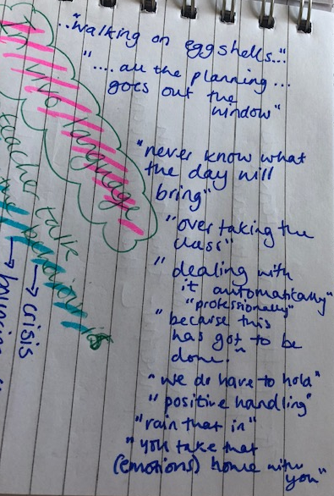
Significant amount of ‘teacher talk’ even within first interview. It will be interesting to compare this to the language that other participants use.

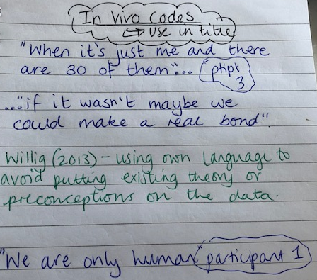
Using this language closely when coding. It would be good to use it within some of the focused codes/ categories and perhaps also within the title. Some of it is very emotive.

Using in vivo coding also helps the researcher to avoid putting existing theory or preconceptions onto the data and stick closely to the participants meaning and how they construct their own ideas and stories (Willig, 2013).

Similarly Charmaz (2014) outlines the importance of coding by actions, rather than topics or themes, helping to slow down the tendency to move too quickly into analytical thinking. I noted that when sticking closely to the data, in a line-by-line approach, I felt very close to the participant’s story. I immediately became aware of a distance that was growing between my thinking and the participants stories if I felt that I had moved too quickly into analytical thinking or drawing comparisons across interviews, as reflected in memos 14 and 15 below.
Memo 14 | Date 17.8.18 | Initial Coding
Thinking about the participant’s journey. Can almost feel their voice when reading back the transcripts; feeling very close to the data after listening and transcribing. I must be conscious of this feeling and try to maintain it throughout.

Memo 15 | Date 17.9.18 | Initial Coding
Noticing I'm moving away from the line by line coding already and starting to think about grouping and making comparisons. It is good that I am noticing comparisons however I don’t want to start to focus on this too quickly and miss other options. Keep moving back to line-by-line. Perhaps this is also because I am being directive in my questioning. Theoretical sampling important but don’t lose the uniqueness of each participants story.

There were emerging ideas forming from the initial coding stage (see memo 16) however it was important for me to note these down in a memo so that they were recorded and keep them to the back of my mind to allow me to continue analysing my data without it being influenced by my emerging ideas or constructions.

Memo 16 | Date 19.9.18 | Initial ideas emerging from data analysis.
- Professional vs. personal values
- automatic mode
- feeling stuck/ what next
- holding it together for the rest of the team
- frustrations over external agencies
- validation from others- if they could just be in my class for one day.

Focused Coding-
After going through an interview and completing the initial line-by-line coding I had over 200 codes from the five interviews I had completed. Similar ideas were coming across between the other interviews and they naturally started to allow for comparison and grouping, so it was then important to bring together similar codes and start to group them to form some of the focused codes.

Focused coding begins when codes start to appear more frequently among the initial codes or perhaps when some have more significance than others. “In focused coding you use these codes to shift, sort, synthesize and analyse large amounts of data” (Charmaz, 2014, p.138). Through this process decisions are made about which codes come together analytically to start to categorise and organise your data. Glaser (1978) states that these codes start to move the analysis towards a more theoretical direction and often become more conceptual.
When developing focused codes I wanted to continue to ensure that I was working directly with my data and so I referred back to direct quotations from the transcripts to ensure that I was not inferring meaning too quickly (See memo 22 below).

Memo 22 | Date 5.9.18 | Developing focused codes
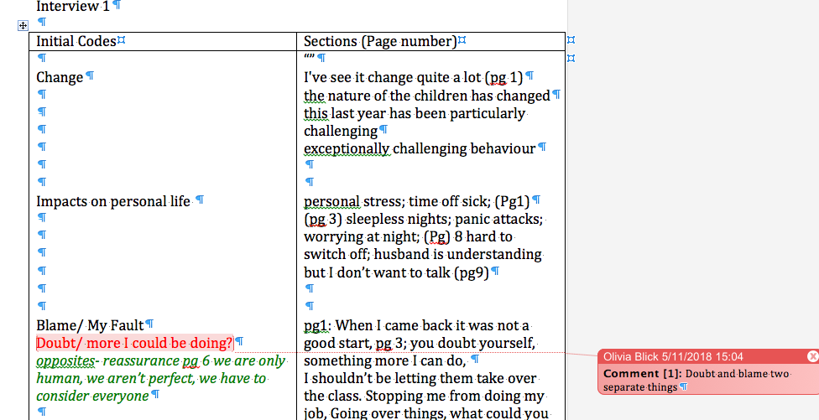
Making sure that even when I am grouping that I am staying closely to the data and making sure that I am not starting to be analytical too quickly which would move me away from the direct meaning of the data.

As you can see form the red and green commenting I have grouped ‘doubting myself’ and ‘shouldn’t be letting them take over and stopping me from doing my job’. However on reflection these are two separate ideas- doubt and blame.

So that it was easier to go back to the original transcripts to check back on meaning I decided to colour code the initial codes according to each interview. I then cut out all the initial codes and began physically grouping them to look for focused codes. During this process I asked colleagues on placement as well as colleagues within my training cohort about their thoughts and ideas surrounding the grouping of my initial codes and the development of my focused codes. I ensured that I was writing down all possible ideas for my focused codes (see figure 5 for an example of this).
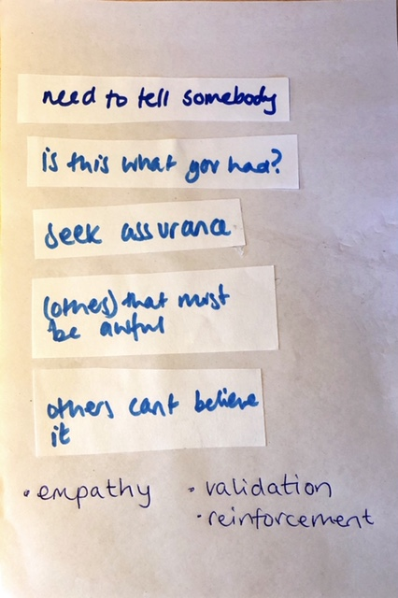
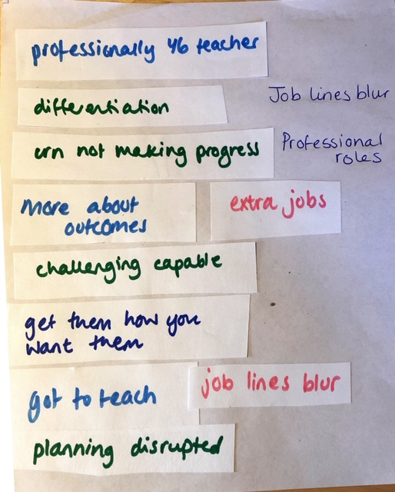
Figure 5 an extract of the initial codes that were grouped together: Ensuring that I was noting down all possible focused code options (empathy, validation and reinforcement).

Whilst developing some of the focused codes I also started to come up with additional questions from my data. To consider these questions I looked back to the original transcripts to help me to co-construct meaning alongside the participants data. Often many of these questions also lead me to think about my own experiences teaching and also to talk to other colleagues about their experiences supporting teachers. This aided a more analytical level of thinking when developing the focused codes, see Memo 26.

Memo 26 | Date 8.11.18 | Co-construction- questions emerging from focused code development
Questions also started to arise as I developed more focused codes and started to think about how these codes linked together.

Referring back to participant 1’s transcript this seemed focused around having to stay strong for her team. Other participants linked this to not wanting their families to see them upset. Many any said that they felt that once they started getting upset they just couldn’t stop.

I wondered why it appeared unprofessional to seem emotive about an experience, particularly one that was so challenging.

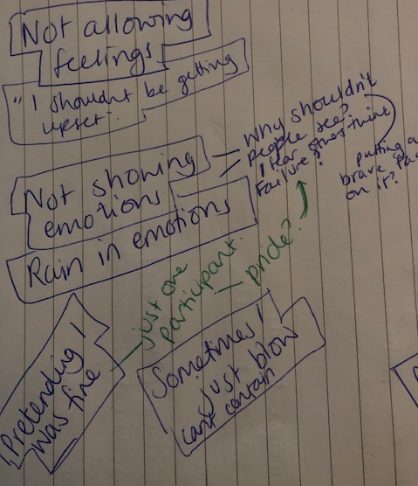
I discussed this with EP colleagues, and they said that it often surprised them at how emotional some teachers became during consultations. They felt that often the consultation provided the safe space to show emotions without judgement. Teachers seemed to feel that if they showed they were upset then they would be judged on both a professional and personal level- not being ‘strong enough’ for the job or not being able to ‘professionally distance themselves’ from their experiences so that they were able to get on with the professional elements of the job such as teaching, marking, behaviour management etc.

It felt natural to also begin developing initial thoughts as to how the focused codes may link together into possible theoretical ideas and also reasons for this. See Memo 16 below.

Memo 28 | Date 26.11.18 | Initial theory development
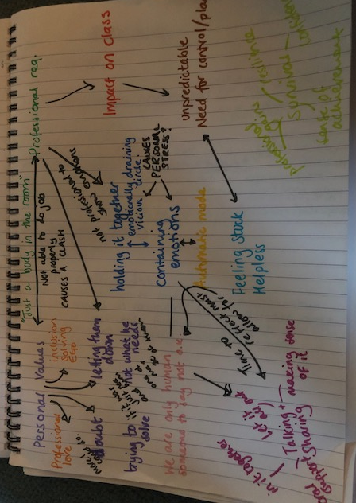
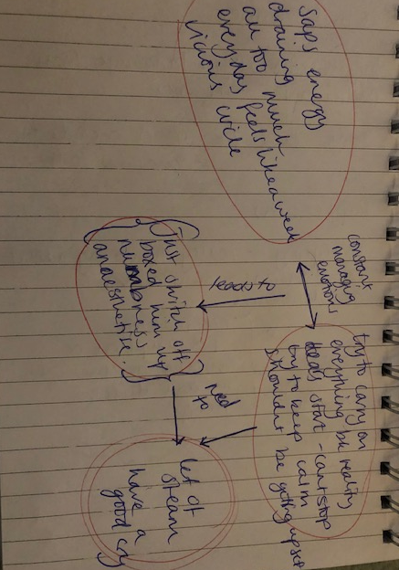
Theory based thinking to try to bring together some of the codes and think about how they linked- influencing factors on participants constructions such as management of emotions, provision of support in schools to reflect and provide containment of emotions etc.

Developing Categories
Following this process I had developed 43 focused codes. The process of developing focused codes had occurred over a long period of time and it felt that during this time I had started to move away from my interview transcripts (see memo 32). At this stage it was important for me to start to think about how I could refine my focused codes and start to develop categories which would help to feed into the theory development.

Memo 32 | Date 1.2.19 | Conversation about analysis with research supervisor
Today I updated my research supervisor on my analysis. I feel that it has been a very long drawn out process and that initially I felt very clear on the analysis and felt like I had my initial data very close to mind during the analysis. However more recently I feel like I am moving away from the data and feel less secure about the analysis process. I think this is because I still have a large number of focused codes and as of yet I am not clear about how they are going to come together into categories. I have decided to go back to my initial transcripts and look for quotes which support the focused codes.

Some grounded theorists would argue for using coding tools such as axial or theoretical coding to help sort and bring the data together. However these coding tools are not always appropriate to use within a constructivist approach as they can force a structure framework around the data analysis and risk forcing codes into categories (Charmaz, 2014). I felt that I wanted to allow my data to naturally come together into categories and because it was also very important for me to feel that my analysis was grounded within the data and reflected my participants voices, I decided to instead return to the original transcripts to help me to further refine my focused codes and start to identify categories. This also allowed me a level of flexibility as a researcher and enabled me to go back to my focused coding stages if appropriate and continually reengaging with the data, strongly encouraged within grounded theory.

I decided that it was important to go back to my original interview transcripts to look for quotes which would help to define the focused codes that I had developed. Therefore each time a focused code was used I copied the text and pasted it under the appropriate focused code headings and continuing with the original colour coding to allow me the ease of moving back and forth to the correct interview transcript. Once I had quotes under each of the focused code headings I was then immediately able to see where and how some of the focused codes grouped together or worked together to form categories.

Within the study some of the focused codes came together to form a category and others came together to form a system. Value and validation came together to form a category in its own right. Then empowerment became a category which encompassed a links between confidence, helplessness and self-doubt (see memo 35).

Memo 35 | Date 18.2.19 | Developing categories
Some categories have formed as a standalone and others have come together as a process. The theory, which in this case is a model of supervision, is really starting to take shape.
Value and Validation is a standalone category which overarches the model.
Confidence, Helplessness and self-doubt seem to come together as a process within the model and therefore have become the category empowerment.
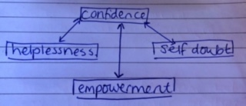
Not only was I able to form categories but I was also able to very naturally link the categories together to start to think about how these would form the model of supervision within the final theory and consequently also start to think about supporting psychological theory and literature.

Memo 33 | Date 15.2.19 | Developing categories
Going back to the original transcripts has immediately helped me to feel close to the original data again and also straight away refilled me with confidence over the direction of my analysis. I now no longer feel lost within the focused codes and instead feel secure in the way that I am constructing categories.
This has also helped me to see theories which can support my thinking… E.g. Personal Construct Psychology…
Quotes have been really helpful
I feel like I have got to the point now where I have memorized most of my interviews and could recall and recount specific details about my participant’s stories.

This led to the developed categories which are explored together within the findings section in Chapter Four of this research.

Theoretical Saturation
Theoretical saturation is one of the criteria that is required of the categories formed through grounded theory. Saturation means that a researcher continues to sample data until there are no new emerging theoretical insights or constructs developing from the data which would need further exploration.
However theoretical saturation is often a component of grounded theory research that is heavily critiqued. Charmaz (2008) states that often researchers consider theoretical saturation reached when the same ‘themes’ are repeatedly emerging from their data. Instead she argues that it is more important to consider saturation as the point when gathering more data would shed no further light on the properties of the theoretical categories.

Charmaz (2014) states that to assess whether your categories are saturated you need to ask the following questions:
- Which comparisons do you make between data within and between the categories?
- What sense do you make of these comparisons?
- Where do they lead you?
- How do your comparisons illuminate your theoretical categories?
- In what other new directions do they take you?
- What new conceptual relationships, if any, do you see? (p.214)
I always ensured that my initial coding would feed into the following interviews and that if I had any questions or emerging ideas I would explore them within the next interview. This helped me to refine the initial codes that I was developing and supported me to form focused codes and categories within my analysis.

Some grounded theory studies that have suggested that the saturation point has been reached after only working with a few participants have been criticised as reaching a saturation point too quickly. Although in the present study five participants were used I would not class this as a critique to the element of theoretical saturation within my study.

During each interview I felt very close to the experiences of my participants and having had similar first-hand experiences I was able to ask questions that probed them, facilitated them to reflect on their own experiences and construct their own meanings from their experiences, ultimately giving a much richer picture within my data. This meant that my interviews were long and that they also gave me a breadth of rich information. In addition the participants’ range of experiences both positive and negative helped to deepen my analysis and also helped to expand and illuminate the categories that emerged. The ideas which had emerged from a participant’s positive experiences collaborated with those which emerged from a participant’s negative experiences, helping to make category development more robust and consolidated. The process of category development also felt very natural and at no point did I feel that I was having to force inconsistent data into categories or that I was imparting my thinking onto my data to enable it to fit into categories.

Dey (1999) argues that the term saturation is not accurate as it would suggest that the data decides whether saturation has been reached. Instead Dey (1999) suggests the use of the term ‘sufficiency’ which places control of the saturation point in the hands of the researcher and considers more importantly whether the categories are ‘theoretically sufficient’ (p.257). This feels a more suited term to the present research. The categories that I developed were sufficient, detailed and expansive from the interviews that I have completed and should I have continued to interview I do not feel that I would have been able to generate such a depth of understanding to support my analysis nor would I have generated any new ideas which would have added to the construction of the categories.

The next chapter will look in more depth at each level of analysis and the concluding grounded theory.

Chapter 4
Findings
This section will explore the focused codes that have helped to construct each category and will consider how the categories are related to one another in developing the grounded theory. The categories developed will link back to the overall definition of wellbeing used within this research project, Dodge et al. (2012) (see figure 6) discussing wellbeing in terms of a balance of challenges to wellbeing and resources that support wellbeing. This is the case for all categories apart from one seen in section 4.2, which discusses a tension between factors rather than challenges and resources. These categories will then be used to develop an understanding of how best to support teachers in managing their emotional experiences when working with pupils with challenging behaviour which will form the theory within the present study.
Examples of quotes can also be seen to support the category development. Where it is important, these quotes also show the interview question to demonstrate the constructivist nature of the interviews.

Figure 6: Definition of wellbeing, modelling the ‘set point’ (adapted from Dodge et al. 2012).

Memo 34 | Date 16.2.19 | Positive supportive examples as well as negative challenging examples.
Need to make it clear within the findings sections when a code is supportive for teachers E.g. sense of achievement and having a plan. Also when they are challenging and have a negative implication on teachers experiences E.g. feeling stuck, doubting myself and unpredictable.

Memo 37 | Date 25.2.19 | Quote Selection
Attempting to pick out quotes to give meaningful examples of how the focused codes and categories have been developed within the findings section.
I found that there were so many powerful quotes from each participant and was conscious of how I was going to select the particular quotes for the findings section. I tried to ensure I had quotes from a range of participants for each code and category. There were also some quotes which were very useful as they very clearly outlined the ways in which the participants were constructing their experiences.
Put additional quotes into appendix section-

Figure 7 below demonstrates how the categories developed highlight the different areas of support which are required for teachers when managing their experiences with challenging pupils.
Personal
Professional
Tension
External Value and Validation
Safe space for sharing
Managing the personal and professional tension
Overarching need for
Empowerment
Sense of acceptance
Emotional separation
Boundaries around role
Overarching need for
4.1 External Value and Validation
External value and validation encompassed six focused codes which developed from the interviews (see figure 8). These areas demonstrate resources which teachers feel benefits their wellbeing and management of emotional experiences within their role such as, feeling supported, empathy towards difficulties and feeling appreciated. However it also demonstrates the challenges to teacher wellbeing such as lacking support, lacking validation of difficulties and feeling ‘let down’. These focused codes demonstrate the need for additional support for teachers when managing challenging emotional experiences within the classroom and feed into External Value and Validation. This is an overarching element of support which teachers require and something which must be encouraged within the ethos and climate of the culture by providing value and validation to all staff members through support, appreciation and empathy towards the challenges they may be experiencing.
External Value and Validation
Resources
Challenges

Feeling Supported
Lacking Support

Lacking validation of difficulties
Empathy towards difficulties

Feeling ‘let down’
Feeling appreciated

Figure 8: Focused codes within the category External Value and Validation
This section will now explore quotes which support the focused codes and creation of the category of External Value and Validation. Due to the practicalities of the word count, key quotes have been used as examples within the main body of the text however a full range of quotes for each category can be seen within appendix L.

Feeling Supported
Support and provision for staff wellbeing was something that was discussed by all teachers however this emerged to form two focused codes, feeling supported and lacking support. All teachers spoke about the support that they felt within their schools and participants 1 to 4 spoke about both being supported and also feeling a lack of support. Participant 5 spoke only about lacking support, however this could have linked to her significant feelings of being let down by other staff and professionals and also the fact that she felt that other people didn’t not understand how challenging her role was and the nature of the children that she was working with. Participant 5 talked about her husband and family and other adults in school, but she often said that she did not feel these people understood the challenging nature of her role and therefore although they were providing her with support she may not have actually felt that this was genuine.

“My husband would say “I don’t know why you are putting yourself through it all anyway, you don’t go to work just to get hit”… cause they don’t understand teaching anyway…” Participant 5

When discussing feeling supported, participants spoke about support from colleagues in school and also in some cases by senior leadership teams and systems in place within the school. This seemed to foster a sense of community for the teachers and help them to feel that they were not the only one managing a pupil’s behaviour.

“My head is really supportive and he will come and get him with the positive handling and the deputy head and so I feel we have got that support”. Participant 1

“I do feel like I’ve got more friends at work now which is great. Everyone here is great and really cares. Some of them are really proactive and take on things to help and have initiative”. Participant 2

“Its like a community thing…everyone comes in and says well done”. Participant 3

“We are a really good team and my colleagues are so supportive…you know you’re not the only one trying to deal with it” Participant 4

Lacking Support
However, teachers also spoke about the difficulties that they could still have within the support that they may be provided with. Often it seemed that teachers relied more heavily upon support from peers in school rather than senior leadership. In some cases this seemed to link to the consistency in support that was able to be provided by senior leadership. However there were also ecosystemic challenges which resulted in a lack of support for wellbeing, such as not having a ‘person’ who teachers can speak with, a lack of ethos for staff wellbeing and also a sense of senior leadership placing blame or a power differential stopping teachers from seeking support from senior leadership.

“He can go to pastoral and so something nice activity that works but that’s not always consistent so that would be nice to be able to do that everyday making sure pastoral are there for him” Participant 1

“There doesn’t seem to be any focus on staff wellbeing…. we can have a minefield of safeguarding issues and no one to talk to” Participant 2

“A lot of it does depend you know how people react …when people are a little bit more like ‘oh god that must have been awful’ not when there is an element of well that wasn’t very good…it makes you feel better”. Participant 3

“I just wanted to sit on my own in my classroom because others didn’t support me…” Participant 5

Lacking Validation of Difficulties
Teachers spoke about not feeling as though other professionals and adults both inside and outside of school understood the extent of the difficulties and emotional challenges that they were managing within their classrooms.

“People only see him when he is calm…You don’t know what he is really like in class” Participant 1

“No one is really taking account of my feelings” Participant 2

“There can be a real lack of gratitude and understanding…” Participant 3

“You can talk to other people but they don’t really get it properly” Participant 4

“I don’t think people outside of primary school realise and it was that I resented” Participant 5.

To counteract this some teachers spoke about wanting other adults to experience the difficulties that they were facing and that this gave them a sense of validation of the negative experiences that they were managing within their classrooms. This was about other people realising how hard their experiences were and feeling as though it is okay to be finding it difficult to manage their experiences and validating the difficulties they were feeling.

“I just wish that people could come in and spend a full day in class and just see what it is like and get a full picture of what it is like”. Participant 1

“I do think though it is really nice to have some validation, it does sound really needy and really lame, but it is good when someone is like wow that is really difficult and you have done really well”. Participant 3

“I think the perception of these needy children and what their needs are and how much work has to go into that I think the profile needs to be raised” Participant 5

Feeling “Let Down”
Teachers also spoke about a number of different systems within education and how many of them ultimately lead them to feeling let down. This focused code also had some links to feeling supported and appreciated within the school context.

“I understand that afterwards you should have time out you should to just chat through when you’ve been doing positive handling and be able to talk to people but that’s not always possible”. Participant 1

“All the external agencies are like no he's fine he's fine to be at home.. when I'm pretty sure he gets hit…you get really frustrated because you don’t know what anyone else is doing”. Participant 2

“…so many other adults involved… I don’t feel like I have the most involvement…it should all come from the teacher...they’ve not spent the most time with him…” Participant 3

“Its so heart-breaking and frustrating all the hard work that we do just goes out of the window, I find it so annoying” Participant 4

Participant 5 spoke in length about feeling let down by the systems in place within education, she called this the ‘teacher rant’ some extracts of this can be seen below and full details can be found in appendix G.

“I was resentful for the fact that I was so behind with my work and these are the current demands of teaching…it’s the people in high positions that say this is education, well it isn’t…I don’t think the people outside of education realise and it was that I resented… that’s when I felt let down… because L really should have had something separate…but there is no money…no funding” Participant 5.

Empathy towards difficulties
Participants also spoke about things which they felt supported their wellbeing and the way in which they were able to manage their emotional experiences working with challenging pupils. Empathy towards their difficulties appeared to allow the participants to feel supported and to show the challenges that they were facing.

“People who come in and cover for me they’ll just say I cant believe it, I don’t know how you do it day in and day out …It does make me feel a bit better because I think well obviously they understand what it is like you know…” Participant 1.

“Someone to say its ok to feel bad…Someone to say there is only so much you can do” Participant 2.

“When people are like ‘oh God that must have been awful’… it just makes you feel better” Participant 3.

Participant 4 also did not discuss this however this is likely to be because at the time she was in a very positive and confident place within her role and therefore was seeking less support and subsequently less in need of empathy from other members of staff or adults around her.

As previously discussed participant 5 didn’t feel that people truly understood her experiences and this meant that she didn’t not feel that people were able to empathise with her. She spoke about spending time on her own because of this and feeling the need for people to be able to genuinely provide her with empathy and support.

“I just wanted to sit in my classroom on my own with no body speaking to me” Participant 5.

She was also the only participant who asked me about my background and when I told her that I had previously been a teacher she said, “Right so you know exactly where I'm coming from…”. She was very much looking for someone to be able to genuinely empathise and understand the challenging nature of her experiences.

Feeling Appreciated
In positive situations participants talked about feeling appreciated in a range of ways. Often this was in other professionals or adults commenting on the work that they were doing, but the feeling of appreciation also seemed to come from feeling respected and cared for by other members of staff within the team.

“An Educational psychologist came in to see him and said how much we were doing to try to help” Participant 1.

“Parents really rely on my support and advice…we were working together and I started feeling appreciated”. Participant 2

“SLT felt he would benefit from having a fresh start in my class… I'm the lucky one… I have a reputation for dealing with the difficult kids… they all get sent to me”. Participant 4

“The principal would always come and make sure I was alright” Participant 5

For participant 3, where she did not feel as though her work was appreciated, she spoke about wanting and needing other staff members to show her a level of appreciation and let her know they felt that she was doing a good job.

“In teaching you just relish someone saying good job… you’re thinking god I am busting my balls everyday here and it’s so stressful and you’re like god I want some recompense…I want someone to say something”. Participant 3

4.2 Personal and professional values
This category is comprised of five focused codes and emphasises the tension that emerged for all participants between the way in which they constructed their personal values and professional roles (see figure 9). The ‘need for connection’ and ‘knock on effect’ were two focused codes which emerged and seemed to have the biggest influences on the way in which the participants constructed their personal and professional values, but also had the largest impact on the tension that emerged between these values.
Personal and Professional tension
Personal
Values
Professional
Values

Knock on effect
Need for connection

Figure 9: Focused codes within the category Personal and Professional Tension.

Personal Values:
All the participants discussed their personal values within their work and these predominantly focused around making a difference to the lives of pupils, supporting inclusion and an underlying interest in special educational needs. Some examples of these values can be seen below.

“I have been enjoying working with challenging behaviour for a long time”, “I want him to feel happy and safe”. Participant 1

“Personal interest”, “Doing it to help them”, “I believe in inclusion”, “behaviour has always inspired me”, “I remember how much my teacher used to mean to me”. Participant 2

“They spark more interest”, “I want to solve them”, “Trying to sort the difficult ones”. Participant 3

“Interest in psychology”, “always been what I wanted to do”, “enjoy working with challenging pupils”, “The children know I want to be there for them”. Participant 4

“Passionate about SEN”, “Good teachers care”. Participant 5

Need for Connection
One of the biggest personal challenges teachers faced was managing the connection that they made with the particular pupil. This links specifically in the need for teachers to have a strong relationship with the challenging pupil that they teach but also demonstrates the depth of these relationships that teachers and pupils form.

The need for connection was a focused code that was heavily placed within all participants’ personal values and also seemed to predominantly impact on the tension that arose between participant’s personal and professional values.
“I try to give him quality time on his own with me and I know that is what he likes, one to one attention on his own, but I cant always give him that and it does feel so frustrating”. Participant 1

“I think that if you think about a child’s life they have their mum, their dad, their grandparents and then there is you, their teacher and I remember how much my teacher meant to me…” Participant 2

“But when its your own class they are your babies and when they make a disclosure to you or something like that you’re like, you want to be like right I want to adopt this kid I’m going to adopt them right now.” Participant 3

“I think that he also, you know, doesn’t want to let me in so I guess maybe him resisting makes it a bit harder because I feel like he doesn’t [pause] I guess I feel like he doesn’t want to have that connection with me, yeh like he just doesn’t care”. Participant 4

“I needed to show her that after those incidents that I still, I tell her I love her, I mean its not going to harm, I think I do love my class…. they are like your family and then you hand them back…” Participant 5

Professional Values:
All of the participants spoke about the professional values that linked with their roles, some of these professional values linked positively with their personal values, but others stood apart from them. This emerged as creating a tension between the participant’s personal and professional values.

Some of the professional values teachers discussed were:

“I’ve got a vast range of needs in my class so there is vast differentiation”, “So many of our children really do need a lot of support”. Participant 1

“Having extra jobs to do”, “my other roles in school”, “time pressure”, “job lines blur”. Participant 2

“Professionally I am a year 6 teacher”, “I have got to teach”, “children making progress”. Participant 3

“At the start of the year you have got to get the classroom sorted, “got to get the children where you want them”. Participant 5

Participant 4 spoke very clearly about her values and how she taught, however there seemed to be very little distinction between personal and professional values, instead these tended to be amalgamated.

She said that she was “the one with a reputation for dealing with the difficult kids” and that “kids would get sent to me and crumble” so she felt very confident about her role and values. This also seemed to be supported by senior leadership within the school as she also spoke about going against the school behaviour policy because she didn’t feel it was right to send a pupil out, and not being reprimanded for this. I feel that it is for these reasons that, during our interview she spoke little about personal and professional values separately but instead discussed them in terms of one another and also spoke about them in a way that was very much related to the way in which she works in her role.

“Bang, bang, bang, firmness, let him know my rules and expectations and then be really consistent and firm with him but it was always about making that relationship and connection first, that’s the most important thing with these kids”. Participant 4

“… I always try to look beyond the actual behaviour…I wanted to give him as much as I could so I support it made me want to work for that relationship”. Participant 4

“Like I would never send him out, even though that was one of our school policies, but he is my little boy, in my class and if I sent him out he wouldn’t feel like that anymore”. Participant 4

“My motto is ‘kind hands, kind feet, kind words’ and then having trust with the children”. Participant 4
Knock on Effect
Participants also commented on the ‘knock on effect’ that the behaviour of one pupil had on the rest of the class. This was in terms of the amount of time that was spent with the particular pupil which took away from the time spent with the rest of the class. However it was also about the knock on effect for that particular pupils as some teachers also felt that they were aware of how isolated and unsupported the challenging pupil could be within their classroom.

This also demonstrates the clash between teacher’s personal and professional values as teachers wanted to spend time supporting the particular pupil, but also felt the need to support the rest of the class and did not like the thought that their education was being impacted.

“…And I’ve got all the other children and the other children are seeing that and sometimes they are scared and sometimes they say are you alright Miss S and that that well that upsets me because I think they shouldn’t be seeing that”. Participant 1

“His class are terrified of him, the parents hate him and I just don’t know what the best thing for him anymore would be”. Participant 2

“I think because I'm always scared for everyone else because he could do something. It’s almost like us against him. Its got to be like right well then you’re the protector of everyone else then and I think when you have to assume that once, then you kind of always go to that mode”. Participant 3
“He was just always naughty and really quite like nasty with the other children. Like deliberately being nasty to them or messing up their games”. Participant 4

“There were other needs in the class that were quite heavy timescale wise”. Participant 5

Personal and Professional Tension:
As demonstrated in figure 10, there was a tension between all the teacher’s personal and professional values which caused them a significant amount of emotional discomfort. This tension appeared to be primarily caused by managing a particularly challenging pupil alongside the needs of the rest of their class. This was in terms of maintaining their teaching role for the whole class, being inclusive to the needs of the challenging pupil and also providing support for them and their additional needs.

“I worry that he gets vibes from me, for that you know you try not to but like I say we are not perfect we are human and you are considering everybody in the class”. Participant 1

“I think my job lines blur because I've got to follow the rules and be professional but I’ve also got to be quite maternal and quite caring, not unprofessional but you get more involved”. Participant 2

“…You’re trying to teach demonstrative determinates and the children are looking at somebody who is throwing a chair at the window and you are like just carry on top watching and you feel like a clown…I should be addressing that problem but I’m not, I’ve got to teach… I’ve got to ignore this child that is in distress and very upset in crisis and we’ve all got to pretend its just not happening…” Participant 3

“…I have to put up with all of that and then I have to go and clean my classroom up wipe my bruises down and do a two page report accident report form, then do a cpoms to log it all, then speak to mum and then mark 90 books, so at first I was a little bit I don’t want to say resentful but it it was a little bit of a question like what is teaching these days because I literally cannot manage it I cant do it…” Participant 5

When asked about her personal and professional values and how she felt she managed these within her role participant 4 said;
“Oh mine matches completely. I would never be able to teach if I didn’t teach how I wanted to and so I’m really lucky…” Participant 4

Participant 4 seemed very sure that she did not have a tension between her personal or professional values and stated clearly that she ‘wouldn’t be able to teach if I didn’t teach how I wanted to’. However there were times within her interview where she did identify difficulties that she was having with tension between her values and she also talks about the emotional impact of this.

“… I also actually had to send him out in a P.E lesson once which I really didn’t want to do” Participant 4

“I’ve got the nurture, the consistency, the boundaries… but don’t get me wrong I find it really hard too… sometimes I just go to them and have a really big cry… I guess I always worry that there is more that I could do” Participant 4

Therefore although she felt that her personal and professional values ‘matched’ there were also times where there was a tension between them and these experiences caused upset and difficulties for her.

4.3: Managing the personal and professional tension
When considering how to support teachers in their work with challenging pupils and how to help teachers to construct and manage their emotional experiences it is crucial to consider this tension that emerges between their personal and professional values. The next category discussed is one which emerged to support the tension between teachers personal and professional values. Figure 10 below demonstrates how the personal and professional tension can be managed and supported through the creation of boundaries around the role, sense of acceptance and emotional separation.

Managing the personal and professional tension

Boundaries around role
Sense of acceptance
Emotional separation

Figure 10: Managing the personal and professional tension through the creation of boundaries around the role, sense of acceptance and emotional separation.

These focused codes and categories have emerged from the interviews. They focus on how to support teacher’s personal and professional tensions by supporting the ways in which they construct and interpret their experiences.

Boundaries around role
Within this category, this focused code demonstrates helping the teacher to understand their own personal and professional constructs of their role and also to understand their own limitations to their role. This was something which many teachers found challenging because often their personal and professional values lead them to have unrealistic expectations of the work they were doing. In some cases participants also spoke about how they were trying to create these boundaries around their role but all participants found this to be challenging.‘You’ve got all the responsibility so you take that home with you and then you are sat worrying…’ Participant 1

‘That is the hard part of teaching… you have only got a certain level of responsibility before you have to stop…but that is very hard to do…’ Participant 2

‘I think because I cant do my job to the best of my ability when its just me and there’s 30 of them…. and its just like ah… maybe if its just you and me maybe we could make like a big bond but its not. I don’t know I think its also a bit utilitarian greatest good for the rest of the class and that’s where that kind of numbness lies’. Participant 3

‘You can talk to other people but they don’t really get it properly so you have to be able to work through it in your own head and make sense of it yourself really. I think I’m starting to get there now…’ Participant 4

‘So you know there is a proper clash, this is what you’re supposed to be, this is what I feel, this is what I want to be, this is what I do…’ Participant 5

Sense of Acceptance
Part of what teachers appeared to find challenging about creating boundaries around their roles was being able to emotionally accept these boundaries. Many teachers spoke about knowing where to stop and trying to manage their roles, but it seemed that this still caused emotional conflict for many teachers.

‘Just trying to get everything back to reality in your head’. Participant 1

‘…but you have to go to another place and put all your stuff…’ Participant 2.

‘I think that upsets me that I have to do that for them. It makes me feel so sad that I have boxed him up…’ Participant 3

‘You cant be a robot about it… like it can sometimes just blow and all be too much’. Participant 4

Although participant 5 did not talk about developing a sense of acceptance over the boundaries around her role, her general story throughout her interview was one of challenge, overcoming adversity and being more accepting of the overall challenges within the teaching profession. She spoke about how she felt that the challenges to her role were predominantly from external systems such as political policies and funding and resource challenges. However even though she did not directly talk about trying to manage and accept boundaries around her role she did seem to have gained a better understanding of her role and spoke about more effectively managing her work life balance, developing more skills in her set and being more aware of the different elements to the teaching role.

Emotional Separation
Participants also seemed to find it very challenging to emotionally separate themselves from their role causing it to cloud the way in which they are able to reflect about the work that they do and the experiences that they are having.

‘Some days I've been in tears but you’ve got to try to rein that in, its so hard’. Participant 1

‘You’ve got the emotional attachment to your work, it can be separate, I think its quite a minefield’. Participant 2

‘You are like oh right they are in care, oh right their dad hits them…But then with your own class…they are your babies’. Participant 3

‘We are only human and we all have emotions and feelings…you cant be a robot… sometimes you just blow’. Participant 4

‘Then when you are in the car on the way home and you just think and you can feel the school umbilical chord slipping away’. Participant 5

Participants all spoke about their attempts to rationalise, reflect and emotionally separate from the work that they were doing but at the same time spoke about how difficult that this was to do. Therefore within this category, emotional separation, supports teachers to emotionally distance themselves from their role so that they could take a more reflective and reflexive stance to their work and also start to support them to more effectively manage the challenging situations that they come across.

4.4 Empowerment
The category of Empowerment is made up of five focused codes; feeling stuck, doubting myself and unpredictable which are challenges for participants emotional experiences and demonstrate a need for empowerment. Whereas sense of achievement and having a plan are positive codes identified which support and provide a resource to participants empowerment. The interaction of these focused codes within the category of Empowerment are shown below in figure 11.
Empowerment
Resources
Challenges

“Feeling stuck”
Sense of achievement
“Doubting myself”
“Having a plan”
“Uncertainty”

Figure 11: Focused codes within the category Empowerment

“Feeling Stuck”
Teachers commented on feeling ‘stuck’ and not knowing what to do or try next in a situation. There was also a sense that teachers did not feel equipped to manage such challenging situations, adding to their sense of helplessness.

‘You’re thinking is there more I could be doing…I’m not doing the things I should be doing’. Participant 1

‘Where do you go after a certain point.. I don’t know where to go or what to do with him’. Participant 2

“I always just want to pull him in but I can’t and there’s not really any way to that so its just kind of watching it play out and you just feel so helpless and futile…There’s nothing that you’re doing that is supportive so its just like well we are failing each other here aren’t we really not helpful”… Participant 3

‘I think I’m starting to get there now but I still haven’t got that proper relationship…He doesn’t want to let me in so it makes it a bit harder’. Participant 4

‘I was literally like I cant manage this…I cannot do this job’. Participant 5

“Doubting myself”
Teachers also started to report doubting the ways in which they acted and the support that they were providing for particular pupils. This linked to the level of confidence that teachers had and the security that they felt in the way they worked in their role, for example in knowing that they were providing the correct support and enough provision for the pupil. Two teachers felt that because they were ‘not specialist’, that there was a sense that they were not able to provide enough for a pupil which lead them to doubt their role and the way in which they were working.

“I worry for the child because I, you doubt yourself, you’re thinking there must be something more I can do, I’m not doing all the things I should be doing, I shouldn’t let a 7 year old child more or less be overtaking the class and stopping me doing what needs to be done”. Participant 1

“Then you have days and you think you are just not making any difference at all you are just so not sure whether you are making any difference”. Participant 2

“There’s nothing that you’re doing for them that is supportive so its just like well we are failing each other here we are really not helpful…”. Participant 3

“I guess I always worry that there is more I could do…”. Participant 4

“I’m just a primary school teacher- not a specialist teacher”. Participant 5

Uncertainty
Teachers all reported a level of uncertainty and unpredictability associated with the pupil’s behaviour. This seemed to correlate to their feelings of helplessness. This code also links with “Having a Plan” as teachers reported equipping themselves with additional subject knowledge and strategies which helped them to feel empowered to manage the situation and less impacted by the unpredictable nature of the pupils behaviour.

‘It is as if you are walking on eggshells because you just never know what to expect’. Participant 1

‘I am worried about next year and I always think of god when you are an adult what is your life going to be like?..’ Participant 2

‘But there is still a lot of I don’t know you see things as just like oh I need to solve that, I need to solve that and you make like lots of lists and plans and strategies and I think sometimes like the unpredictability of just children you can still be like blown away.’ Participant 3

‘But then I always worry that there is more that I could do…’ Participant 4

‘It was intriguing seeing what was going to unfold but it was also quite frightening’. Participant 5

“Having a plan”
Having a plan was identified as a resource to supporting teachers in managing the challenging experiences that they were attempting to cope with and reflects the way in which teachers had a need for control over the situation. The unpredictability, feeling of helplessness and doubt became consuming for many teachers and they all reported feeling a need for control through developing their knowledge, creating strategies and ‘having a plan’.

‘Could I have avoided it, what could I do next time…’. Participant 1

‘I am open to saying look I don’t know and I think you know more so if you do then please just tell me about it and help me I want to learn more’. Participant 2

‘I don’t know I think personally I like to feel in control of all these situations and like I can no matter what crisis will happen that I can be there for the other kids to sort of like minimise it but sometimes you just think am I minimising anything or am I just a body in the room’. Participant 3

“I have spent a lot of time researching attachment and learning about theories…”. Participant 4

“It was like a whirlwind but then after ’'d had the break at Christmas and we came back and then it was a really bad patch that was when all the exclusions were, but I felt more able to deal with it and I’d built up some strategies and id done some reading over Christmas”. Participant 5

Sense of achievement
Teachers that were able to celebrate successes appeared very confident in their own abilities and the ways in which they had worked, although for all participants this did not impact on their levels of self-doubt or uncertainty.

Through identifying areas of success and strength teachers often seemed more empowered and accepting of times in which they felt more helpless. Many of them commented on knowing that they had been able to ‘survive’ previous experiences with other challenging pupils and used this to help to bolster their current doubts and difficulties.

Participant 1 was the only teacher who didn’t appear to identify any areas of strength or achievement. She was the participant who I reflected as having the lowest levels of wellbeing and identified herself as having mental health needs such as anxiety and panic attacks. When she was discussing her experiences, she also said that the boy that she was talking about also left halfway through the year to go to a specialist provision so there may have also been less opportunities to make progress and feel the rewards and benefits.

‘I know that the way that I have my group works and it works well for the children. My strategies and things we use I know they are good’. Participant 2

‘I think the first time it’s like a bit… but then you are like right I’ve survived that, that’s another skill in my set, something I can pull out the next time. I don’t think its had a negative effect on me at all. Participant 3
‘I have a reputation for dealing with the difficult kids… I don’t take any messing, kids see me and then they just crumble’. Participant 4

‘Its been its been one of the successes I’d say I’ve had during my career because it was so so extreme it stands out form a lot of other things I’ve done so very rewarding very rewarding as teaching goes if you can see a difference like that that’s very rewarding’ Participant 5.

4.5 Safe Space for Sharing
This category demonstrates the overall need for additional support for teachers. All the participants that were identified shared a level of struggle with the emotional experiences that they were attempting to manage when working with challenging pupils.

Within this category focused codes that demonstrated challenges for participants were, ‘holding it together’, ‘automatic mode’, ‘unprofessional to express emotions’ and ‘wider impacts on wellbeing’. Whereas ‘offloading’ demonstrates the support that being able to share problems provided the participants. Figure 12 shows the interplay of these focused codes within the category of Safe Space for Sharing.

Challenges
Safe space for
sharing

Resources

Offloading
“Holding it together”
“I should be able to cope”

Automatic mode

Wider impacts on Wellbeing

Figure 12: Focused codes within the category of Safe Space for Sharing.

Holding it Together
Participants seemed to feel a sense of obligation to manage their own difficulties and keep their feelings contained. Often this was discussed in terms of keeping their ‘game face’ or ‘teacher face’ on.

‘I am quite emotional, so some days I have been in tears, but you’ve got to rein that in because you’ve got to carry on for the sake of the other children in class and keep the team going, you’ve got to be positive because you’ve got the responsibility’. Participant 1

‘Its probably the best and worst thing about being a teacher because you need to be able to show that and be human but that you also need to be able to be a robot and switch it off’. Participant 2

‘But I just try and keep it all contained and keep my game face on’. Participant 3

‘Well really you cant be a robot about it like it can sometimes just blow and all be too much’. Participant 4

‘But I don’t think people realise on the surface when you’ve got your teacher face on and everyone thinks you’re doing a great job and coping really well but inside you’re crumbing and you just want someone to come and say let me have your class for 10 minutes go and get a cup of coffee’. Participant 5

I should be able to cope.
This sense of ‘holding it together’ seemed very much grounded in the construction that many participants had that being overly emotional about their work was not professional and that they should be able to manage the challenging experiences that they were facing without support. Teachers seemed to feel that they would be negatively judged for showing these emotions or appearing upset about their work.

‘You think…I shouldn’t be getting upset like this you’ve got a job to do so I just try to carry on’. Participant 1

‘If I’m doing my job right then they don’t know that they have upset me and a lot of the time they don’t upset me. They should just see my teacher face and me managing it and letting them know that it is ok’. Participant 2

‘…that’s the thing I never cry at work, then maybe it will all bubble over at home. But I just try and keep it all contained and keep my game face on…’. Participant 3

‘Some days are harder than others… we are only human and we all have emotions and feelings and… it can sometimes just blow and all be too much’. Participant 4

‘I’d have to try to deal with it and then go back to the kids with my game face on’. Participant 5

Automatic Mode
Participants also reported that they felt that it was not professional to be emotional about their role and a need for containment of their emotions lead them to retreat into what they described as ‘automatic mode’, ‘robotic mode’ or ‘anesthetising themselves’ to manage difficult or challenging experiences.

‘When you are in school and an incident is happening and you do get attacked you find that you are very professional and its also as if like you are dealing with it automatically because this has got to be done…so you could be being spat at, hit, kicked and you sort of don’t realise what is happening to you…Then it is afterwards that you think…’. Participant 1

‘But its probably the best and worst thing about being a teacher because you need to be able to show that and be human but you also need to be able to be a robot and switch it off’. Participant 2

‘After a while actually you kind of anesthetise yourself to it, you think they have suffered a lot’. Participant 3

‘You can go into auto-mode dealing with it but then we are only human and we all have emotions and feelings and so well really you cant be a robot about it, like it can sometimes just blow and all be too much’. Participant 4

‘But obviously and then kids would start to realise and id have to try to deal with it and then go back to the kids with my teacher face and be like ‘right then’, ‘lets carry on with what we were doing’. Participant 5

Wider Impact on Wellbeing
There were a number of examples from all participants where the impact of containing their emotions had a detrimental effect on their wellbeing. These demonstrate the increasing need to provide additional support for teachers to promote and improve the way in which teachers are able to manage their emotional experiences so that teachers do not let the challenging nature of their roles detrimentally impact on their wellbeing.
‘I was having a little problem with my breathing so, not full panic attacks but anxiety attacks so I sound that they came back… I’m trying all the techniques of deep breathing and making time for myself exercising running and I find that is helping with some of the stress’. Participant 1

‘There doesn’t seem to be any form of staff wellbeing focus and even as a mainstream teacher in this school the class has a minefield of safeguarding issues’. Participant 2

‘But I think sometimes you like internalise it’. Participant 3

‘Don’t get me wrong I find it really hard too… I just go to them and have a really big cry’. Participant 4

‘I felt poorly, I felt stressed, I was going home with headaches couldn’t eat because I was too wound up, didn’t have lunch breaks, I just wanted to sit in my classroom on my own with no body speaking to me’. Participant 5

Offloading
Most teachers said that by ‘keeping their emotions contained’ meant that they often ‘bubbled over’ and caused them to become very upset rather than just being able to share the difficulties they were having as needed. For the participants a sense that they were able to share some of their difficult experiences with other members of staff who would be able to understand and support them was a very valuable opportunity. Not all participants were able to do this, but they all saw it as a very valuable opportunity and something they would greatly benefit from.

‘You’re talking it through it and saying I don’t think we could have done anything different, then that gives you some piece of mind that you did your very best’. Participant 1

‘You need to have someone to talk to about these things, like sending a child home with their parents who might do a horrible thing to that child because they have been naughty that day…’. Participant 2

‘I think it all becomes a bit more refreshing because its like a community thing where you know everyone comes in the next day and they are like ‘oh I heard that that happened well done’. Participant 3

‘Don’t get me wrong I find it really hard too. We are a really good team and my colleagues are so supportive sometimes I just go to them and have a really big cry’. Participant 4

‘I don’t think people realise on the surface when you’ve got your teacher face on and everyone thinks you’re doing a great job and coping really well but inside you’re crumbling and you just want someone to come and say let me have your class for 10 minutes and go and get a coffee’. Participant 5

This chapter has discussed the key categories which emerged from the data and started to form them into the theory which for the present study considers how best teachers can be supported to manage their experiences.

The next chapter will consider how the data from the present study argues for the additional support that teachers require when managing their emotional experiences with pupils with challenging behaviour. It will also relate the categories developed to current theory and literature and will develop a more detailed understanding of how this can be used to support teachers when managing their emotional experiences.

Chapter 5
Discussion
5.1 The Grand Grounded Theory
This research aimed to explore teacher’s emotional experiences when working with pupils with challenging behaviour to understand how best to support teachers in managing these experiences.

From analysis of the interviews a number of focused codes were developed, from which five categories were formed and used to develop a theory discussing how best to support teachers to manage their emotional experiences when working with challenging pupils.

Throughout this research the constructivist nature of teacher’s emotional experiences has been clearly apparent. As discussed previously, within constructivist psychology the individual is an agent who constructs their experiences within a context of ecological forces (Burr, 2018). In the present study, teachers identified with a range of beliefs and values which shaped their personal and professional identities and although a number of these values were shared, the ways in which they influenced the teacher’s experiences must be considered as an individual construct.

In addition to this, teachers were also working within a context of ecological systems, as identified in appendix L. These systems were commonly featured within the interviews and influenced the ways in which each individual teacher constructed and interpreted their experiences. Teachers identified a range of different systems of support, however the influence of these systems also has an individual nature, with some teachers perceiving support as positive and others seeing it as something that was not helpful for their practice. Therefore the ways in which the ecological factors influenced each teachers experiences was also individually constructed.

The constructivist theory developed from these categories, seen in figure 13, highlights the additional support which teachers require when managing the emotional experiences which arise from working with pupils with challenging behaviour. However, it also places emphasis on working with teachers as individuals and supporting the ways in which they interpret and construct their own individual experiences. Therefore the support that is provided to teachers must consider the individual nature of each teachers experience and also support each individual in the way that they construct these experiences

This theory has shown that overarching the support that teachers need, they must be supported within an environment which is encourages and allows for the emotional nature of their role, providing not only a safe space in which they feel able to share their experiences but also where they feel their emotions are given value and validation.

However this theory also highlights the personal and professional values which teachers bring to their roles and the tensions which can emerge within this values when working with pupils with challenging behaviour. Therefore as part of the support that teachers are provided with, opportunities to explore these values and emerging tensions need to be created so that teachers are better able to explore, understand and accept boundaries around their roles and be more able to accept any tensions that may emerge between their personal and professional values.

This theory also demonstrates the need for teachers to have opportunities to regain their confidence, self-efficacy and sense of agency in their roles when working with pupils with challenging behaviour through supporting them to regain a sense of empowerment within the roles.

This chapter will further discuss the theory developed from categories within the present study, making links to previous literature discussed in chapter 2.

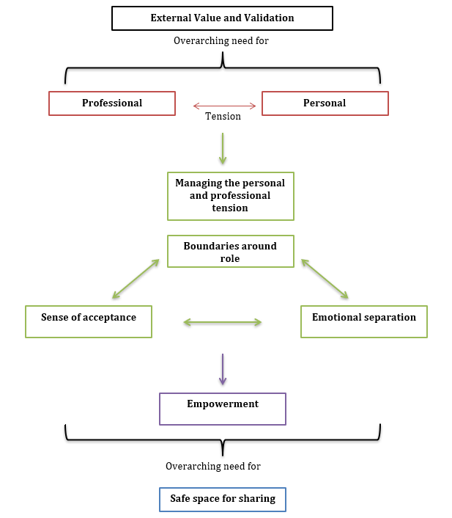
Figure 13: Model showing links between the categories which emerged within the present study.

5.2 Developing a safe space for sharing: Systemic changes to better support teachers
The present study identified a significant need to develop the provision in place to support teachers to manage the challenging emotional experiences they are facing within their roles. Much research has already identified this need for additional support for teacher wellbeing (Paterson & Grantham, 2016; Roffey, 2012) and the present study places prominence on the emotional nature of the teaching role and the significant challenge that this can bring both professionally and personally to teachers.

Categories developed within this research, suggest an overarching need for ‘external value and validation’ to the challenges teachers face and importantly also a ‘safe space’ for teachers to share their difficulties. However it is clear from participants within the present study, that teachers can feel extremely vulnerable about sharing their emotional experiences. Therefore it is crucial that, before providing support to teachers, they are enabled to feel ‘safe’ and able to share their challenging emotional experiences. This study has emphasised the need for systemic changes so that support for teachers is developed through schools as organisations as well as within the wider education system.

When considering support for the ‘helping professions’, Hawkin’s and Shohet (2012), describe the need for a culture of learning and development to be within the, “fabric of organisational processes”, as shown in the lily imagery (adapted from Hawkins and Shohet, 2012, figure 14 below). This Lily image shows the behaviours of the culture on the surface with the influencing systems below.

When applied within schools, on the top surface there needs to be changes within mission statements and policies to better promote support for the emotional nature of teachers experiences, which in some schools is starting to happen through school wide mental health and wellbeing initiative such as the Sandwell Charter Mark (2018). However, this must become embedded throughout the rest of the organisational culture and cemented in place by changes in behaviours, mindsets and motivations when encouraging teacher support in schools.
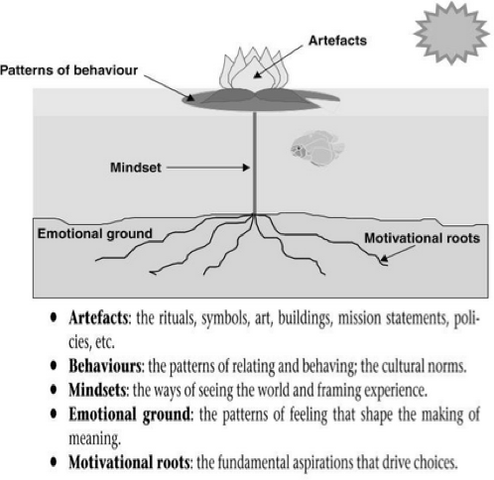

Figure 14: Defining the five layers of organisational culture (adapted from Hawkins and Shohet, 2012).

As mentioned in Chapter 2, Paterson and Gratham (2016) researched how wellbeing was supported in a school that was identified as having a high level of staff wellbeing. Their study highlighted implications across both school, local authority and government level to promote positive changes within school systems to promote teacher wellbeing. As discussed within their study, teachers reported feeling valued and respected both within their school as well as within the wider society and teachers also commented on the importance of a positive school ethos and collectivist culture in supporting and promoting their wellbeing. Teachers reported feeling able to openly discuss feelings and challenges, knowing that they were supported and advocated for as well as receiving feedback and praise for the work that they completed. However they also commented on the negative impact of the media within society and judgements that this can cause them to feel in doubts of ‘am I doing enough?’ (Paterson & Grantham, 2016, p95).

When developing models of supervision to support social workers, previous literature has also placed emphasis on the commitment of the whole organisation to make changes and engage with the process (Dugmore, 2014; Partridge, 2010). Although linked specifically to developing supervision practice, this research has specifically highlighted the need for in depth training to develop a shared language and understanding of supervision, effective and supportive leadership and increased opportunities for shared and collaborative working (Forrester, 2016). Although these studies discuss specifically the development of a practice of supervision within social work, they resonate with the present study, highlighting the need for a culture of support within schools which is promoted through increased training, shared language and improved communication that promotes a supportive environment for the emotional experiences of all staff both in schools and also across the education system.

5.3 Understanding the personal and professional tension: A space for reflective practice
As this study has already discussed, teachers’ experiences are based on the way each individual teacher constructs and interprets them. Within the present study a significant challenge for teachers was managing tensions which arose between constructions of their personal and professional values. For participants it was these tensions which impacted on the ways in which they interpreted situations and managed the challenging emotional nature of their experiences.

This study has supported previous literature which has discussed the personal nature of the teaching role and the personal commitments that teachers often bring to their work (Tašner, Žveglič, & Čeplak, 2017). As discussed previously, Nias (1996) suggests that teachers must have an understanding of their identities, professionally and personally so that they can understand the way they work and interact within their settings. Teachers’ beliefs about themselves and their role is crucial for their general wellbeing and resilience as it provides them with a sense of purpose and associated self-efficacy and hopefulness in the face of adversity (Dinham, Chalk, Beltman, Glass & Nguyen, 2017).

As discussed in chapter 2, Greenfield (2015) developed a model of teacher resilience, at the centre of which were the teachers’ beliefs, hopes, sense of purpose and self-efficacy. Within his study Greenfield (2015) writes that ‘teachers’ beliefs about themselves and their work is key to their resilience’ (p.59). Greenfield (2015) also suggests that stressors that teachers face both directly and indirectly challenge a teacher’s beliefs and it is this which has a detrimental impact on teacher resilience. This is also supported within the present study. In times of challenge, teachers felt unable to fully support particular pupils which created a tension with their personal values of inclusion as well as many of their hopes and aspirations for their work. However, through the process of the interviews, teachers were supported to reflect upon these experiences and were able to start to unpick the way in which their values influenced their constructions of their experiences. Subsequently after the interviews were completed, all teachers reported on what a helpful and valuable experience it was and how the time, space and discussion helped them to understand factors which had been influencing the ways in which they interpreted and constructed their experiences.

As discussed previously, Hawkins and Shohet (2012) suggest that to be able to fully understand our personal beliefs and values and how they influence our practice, we must engage with the reflective nature of supervision. However Hawkins and Shohet (2012) suggest that for reflective practice to be effective it must be a holistic process and they discuss four important elements to reflection:

- External reflection: reflecting on the needs and work with the client.

- Introspective reflection: the practitioner attends to their own feelings, thoughts and actions and uses these to support.

- Relational reflections: consideration is given to the relationships within the context. Client, supervisor and supervisee within supervision or within education this may be between child, teacher and other children or members of staff.

- Systemic reflections: reflecting on the practitioner’s relationship with the wider ecosystems for example their family, social networks, economic, cultural and organisational systems.

Although reflection needs to be holistic this study has emphasised the specific need for introspective elements to reflective practice, allowing teachers to understand their personal feelings, thoughts and actions and how these are shaped by the way in which they construct and interpret their experiences. Hawkins and Shohet (2012) believe that it is our core beliefs and motivations, which are at the foundation of how we make sense of our world and relate to ourselves within it.

Within the present study it is also clear that teachers were focused on ‘reflection on action’ (Schon, 1982), providing a critical commentary on many of their challenging emotional experiences with pupils. However as Schon (1983) discussed the purpose of reflective thinking is to support the practitioner to engage with a continuous cycle of learning so that they start to develop skills of ‘reflection in action’, thinking on their feet to be able to remain engaged in the process but also understand and manage the experiences that they are facing. This has also been described as developing an, ‘internal supervisor’, who is helping to support the practitioner to view their work from an external perspective in the moment and supporting them to work more effectively (Henderson & Bailey, 2018).

Throughout the interview process participants were able to share and discuss their experiences and through supported co-construction with the researcher they were able to openly reflect on their experiences. Many of the participants had values, which they themselves also identified as unrealistic and ‘magic wand’ type thinking. Therefore by engaging reflectively with their values teachers would be able to be supported to understand this tension between their personal and professional values and to construct aspirations that were still congruent with their values but that were more realistic to their practice.

Personal Construct Psychology (PCP) is an approach that would be very useful in supporting this reflective approach to understanding the influence of core values and beliefs on the ways in which teachers construct and interpret their experiences. Developed by George Kelly (1955), PCP suggests that we are all scientists who develop our own personal constructs about how our world works, enabling us to make sense of the observations and experiences that we have.

Within PCP, Kelly (1955) identifies core constructs which form an individual’s identity. Any subsequent confirmations or challenges to these core constructs from experiences of the world which then cause emotional reactions within the individual. Kelly (1955) describes each construct to be a bi-polar dimension of one entity and its opposite and that in many cases our constructs also work together to form our own personal theory of the world. This then influences the way an individual behaves so that they are consistent with the way in which their constructs make sense of their experience and subsequent behaviour.

When considering the emotional experiences of participants within the present study as well as within previous literature, guilt and anxiety were two of the most common negative emotional experiences often described by teachers (Hargreaves, 2000). Beaver (2011) suggests that these are emotional responses which occur when an experience has been incongruent with a person’s core constructs. Beaver (2011) described a guilt response as, “arising from experiences which provide evidence that the individual’s behaviour has been consistent with the native pole of a core construct, thus they have behaved in a way which presents as a challenge to the way they would wish to see themselves” (p.86). Similarly, Beaver (2011) suggests that anxiety is likely to be felt when an experience occurs which seems to have happened outside of the range of the construct system, meaning that an individual is not able to discriminate the experience and have an accurate understanding of it.

PCP has also been found to be useful to support the way a client constructs their experiences of the world (Beaver, 2011). Through techniques such as exploring and reframing which investigates a client’s constructs, identifying poles and links between them and then offering alternatives. As well as changing the range of constructs and the convenience of these constructs for a client, for example by applying a construct from one area of a client’s life to another area.

PCP has supported the development of a number of counselling and therapeutic approaches which have been found to be successful with many clients of a range of ages and difficulties (Holland & Neimeyer, 2009). The approaches have been successfully applied to school-based counselling support for children and young people (Truneckova & Vinney, 2012) as well as in studies which consider supporting the identities of people influenced by trauma, physical and mental illness (Moran, Pathak & Sharma, 2009; Lane & Viney, 2005). However these are few studies which have looked at PCP and its links to supporting the identities of teachers within education and therefore as a technique within teacher supervision it would need to be explored further.

One of the few studies which considers PCP alongside teacher identity is that of Bukor (2015). This study found that teacher’s personal beliefs, their histories and backgrounds significantly influence the ways in which they construct their practice and exploration of the ways in which teachers construct their identities has been shown to be successful in supporting teachers to reconstruct and manage their personal and professional selves within their roles. Although Bukor’s (2015) study focuses predominantly on language teachers it is likely to be able to be generalised to the rest of the teaching population.

However as discussed previously, for reflective practice to be effective it must be a holistic process and for this to be the case it is likely that it would also have to be supported by an external agent who an act as a facilitator and support the individuals reflective practice (Hawkins & Shohet, 2012). This also links to the need for systemic developments as discussed in section 5.2, as for teachers to become effective reflective practitioners they would need to be supported within as safe, secure environment and also supported to understand and develop their knowledge of reflective practice.

5.4 Sustaining one’s own resilience: Teacher Agency and Self Efficacy
Alongside providing space for reflection and a culture of support within schools, this study also highlights the importance of providing support that empowers teachers with an increased sense of agency as well as an improved sense of self-confidence over their work and their teaching roles. In the present study, teachers reported feelings of helplessness, self-doubt and feeling stuck which all impacted on their confidence in their practice.

As discussed previously, Greenfield (2015) places sense of purpose and self-efficacy, along with teacher’s beliefs, at the centre of his teacher resilience model. Greenfield (2015) suggests that developing a sense of efficacy and self-worth is an important aspect to forming a positive teacher identity and maintaining this is key to managing times of stress and continuing to have confidence and commitment throughout a teacher’s career. Along with previous literature, the findings from the present study suggest that is it therefore important to support teachers to regain a sense of agency in their work and then to start to build their confidence when working in this way through the development of plans and strategies as well as focusing on achievements and positive outcomes.

Theories of agency have evolved over recent years, initially supposing that a sense of agency was a highly individualised feeling linked to behaviour concepts of control and action (Wegner, 2002). However more recently, particularly when examining teacher agency, theories have suggested that it is instead related to a complex interplay of ecosystemic factors (Biesta, Priestly & Robinson, 2012). Ecosystemic models of agency suggest instead that, ‘…actors always act by means of their environment rather than simply in their environment [so that] the achievement of agency will always result from the interplay of individual efforts, available resources and contextual and structural factors as they come together in particular and, in a sense, always unique situations’, (Biesta & Tedder, 2007, p. 137).

Priestly, Biesta and Robinson (2015) also suggest that within ecosystemic models, teacher agency is influenced by; iterational factors such as past experiences, projective factors such as orientations towards the future and also practical-evaluative factors meaning how we engage with the present. This is shown within figure 15 below.
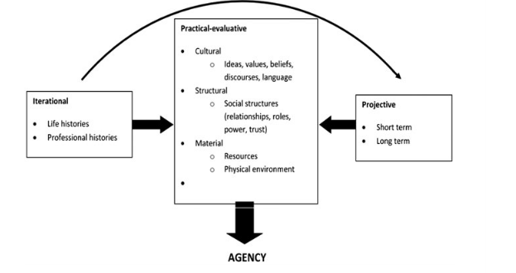
Figure 15: The interplay of ecosystemic factors on the development of teacher agency (Priestly et al. 2015, p5)

The present study would also suggest that it is the way in which an individual constructs their experiences that also impacts on their levels of agency, suggesting that feelings of doubt and helplessness come from the way in which the individual interprets their situation. As suggested by Priestly et al. (2015) in figure 16, participants in the present study discussed the influence of factors such as surviving past challenging experiences, relationships in schools, environmental factors and managing dynamics with other professionals, as factors which influenced their level of agency and confidence within their roles, however again these influences are linked to the way in which the individual interprets and constructs their experience.

Feelings of agency have been shown to be highly influential in the ways in which teachers engage with their work (Biesta, Priestly & Robinson, 2017) and yet ecosystemic theories suggest that there are also huge challenges which face teacher agency within ‘concrete settings’ that are influenced by externally imposed systems. Biesta et al (2015) found that teachers’ sense of agency was often challenged by a confusion over their roles particularly around elements of personalisation of learning, choice, curriculum and assessments. This is also highlighted within the frustrations that participants in the present study felt when managing the impact of external organisations, changes in school systems and reforms to curriculum and assessment policies on their levels of agency within their roles.

Alongside supporting teacher agency is it also important to enable teachers to regain confidence and improved self-efficacy surrounding their work. Bandura (1997; 2010) developed a theory of self-efficacy which suggested that it is linked to an individual’s belief in their own ability to succeed in a given situation or task. Bandura (1997) suggested that this significantly influences how well an individual would strive to achieve a task and their levels of perseverance and resilience should they come across challenges within the task itself. Therefore self-efficacy is also suggested to be ‘future-orientated’ and focused upon perceptions, rather than actual and current levels, of confidence (Hoy & Spero, 2005; Bandura, 1997).

Bandura (1997) outlined four sources of self-efficacy. Two of these sources are related to experiences; mastery experiences which are linked to direct experiences of success and overcoming challenge and vicarious experiences which are linked to seeing others succeed reinforcing our own beliefs. In addition, Bandura (1997) also identified verbal persuasion, the influence of others strengthening our beliefs in our own capabilities and finally our emotional and physiological state which also influenced how we judged our own self-efficacy.

As with a sense of agency, when supporting self-efficacy within the present study it is important to consider this from a constructivist perspective. Bandura (1989) suggests that an individual’s self-efficacy their judgements are significantly related to challenges and resources that may be perceived, particularly within their environment. Therefore it is important to support the way in which an individual constructs their own individual experiences and the individual challenges and resources that they perceive.

5.5 Coaching as a model for support
Within recent literature coaching psychology has been shown to be effective in supporting the development of teacher agency and self-efficacy due to its focus on supporting positive, goal-directed working (Adams, 2015; Armour, 2018). Therefore when considering building teachers resilience through supporting their self-efficacy and agency, coaching is likely to be a useful approach to use to support teachers in their practice and when managing their experiences.

Adams (2015) defines coaching as, “a collaborative, solution-focused, results-orientated and systematic process in which the coach facilitates the enhancement of work performance, life experience, self-directed learning and personal growth of the coachee” (p.232). Coaching considers how to support the coachee to grow and develop and move towards a future that they want to create. It emphasises supporting the resources that the coachee currently has within their work and uses this to strengthen them to work towards their goals and overcome self-limiting ways of thinking (Adams, 2015).

Research within the field of coaching has grown over recent years and there are still some gaps within the areas of research (Armour, 2018). However studies that have considered coaching within the education sector, have commonly shown overall improvements in wellbeing and interpersonal outcomes both at individual and systemic levels (O’Connor and Cavanagh, 2013), Studies that have applied coaching within education have shown particular improvements in resilience, leadership skills and collaborative working within schools (Grant, Green, & Rynsaardt, 2010; Lee, 2013).

Although coaching has been shown to have overall improvements in wellbeing and resilience it is important to be aware that coaching should be applied carefully when supporting school staff, particularly those that feel threatened by the potential of external views that they may not be coping with the challenging nature of their work, as discussed within the present study. Coaching tends to focus on an enhancement of skills set (Kretlow & Bartholomew, 2010) and this coupled with the dynamic of coach and coachee is also likely to create a power dynamic of ‘expert’ coach with a coachee who needs support and development. This dynamic may cause teachers to feel alienated and create a challenging environment to undertake the coaching process.

For this reason there needs to be careful consideration to the impact of this dynamic, particularly when working with teachers who may already have very self-limiting and doubting constructions of the work that they are doing, shown within the findings of the present study. As Nias (1989) highlighted in her early discussion, teachers are already likely to feel a loss of control and self-doubt surrounding the work that they are doing. It is therefore important that any support comes from a stance of empowerment for the teacher, supporting them to regain autonomy and control, as discussed within the empowerment category in the present study.

5.6 Consultation as a model of support
Consultation models, predominantly used within the practice of Educational Psychologists, have also been shown to be useful in supporting teaching staff to understand and manage challenging situations that they may be experiencing with particular pupils. There are a number of consultation models that have been developed such as group process consultation and teacher led support groups as well as staff sharing groups and facilitation techniques such as circle of adults (Hanko, 1995; Jones, Monsen & Franey, 2013, Wilson & Newton, 2006).

Austin (2012) used a consultancy supervision model to support teachers in a primary school and found positive results from all of the teaching staff involved in the sessions. However this was based on a small sample and suggested by Austin to lack generalizability. A larger study by Rae, Cowell and Field (2017) which evaluated supervision support to teachers in a specialist provision for pupils with SEMH needs, found that staff also reported the experience to be particularly valuable. Teachers commented on having a change in perspective about the pupil that they were working with, a sense of empowerment and a range of resources and strategies to try. Both studies by Austin (2012) and Rae et al. (2017) also found that teachers discussed the sense of community and collaborative ethos of the groups supportive and encouraging.

Rae et al. (2017) did however conclude that the results of supervision for staff was heavily dependent on how well the sessions were based around the factors which influenced their wellbeing. They felt that it was important to specifically consider the teacher’s own accounts and experiences of their role, what matters to them within their role and also what personal values they feel are important within their work. These results suggest that providing group sessions, such as some of the consultation models discussed earlier, may not provide as effective support for teachers as their personal experiences may not be taken into account.

Studies have also suggested that regardless of the problem-solving nature of the consultation models, an element of emotional support still occurs even as a side effect of the consultation. These studies have suggested that the professional or other staff members within the group provide an element of emotional and psychological containment for teachers (Vincent, 2018). In a study of pupil behaviour and teacher culture (Miller, 1996), the work of Educational Psychologists (EP) with identified pupils was evaluated and aspects most often associated with successful outcomes was discussed. Within his study Miller (1996) found that the EP consultations with teachers were regarded as a highly positive element of their work. Through the use of consultations teachers were not only supported to create a new understanding of the systems around that child and how to support them but teachers also commented on the importance of the EP providing a listening, encouraging and approving stance. Teachers discussed the importance of working alongside professionals with a strong knowledge base and range of skills, but teachers also felt personal qualities of the EP were most important within an effective consultation. Quotes from Miller’s (1996) study outline, “the psychologists encouraging approach” and “empathy with the emotional reactions that were produced during the work” (Miller, 1996, p.131).

Although providing support through consultation may allow for an element of empowerment through a problem solving model and also give the teacher a short period of time where they are able to share their experiences within a safe, empathetic environment, it is important to note that a consultation is often only offered as short term method to support a school with a challenging situation with a particular pupil. Therefore, it may provide temporary relief for a teacher however, as this study has shown, it is unlikely that as a method it would provide the consistent, holistic and support for a teacher managing challenging experiences with a pupil. Equally within a consultation session the emphasis is placed upon understanding the needs of the child rather than providing support for the teacher and therefore the needs of the teacher can be somewhat overlooked during the consultation, particularly in light of the findings of the present study which have shown that teachers need to have individualised support based around their own individual experiences and constructions for support to be effective.

5.7 Suggesting a model of teacher supervision
This study has shown that teachers are in considerable need for support when managing the emotional experiences that come from working with pupils with challenging behaviour. As discussed in chapter 2, teacher wellbeing has become an identified need for schools and has started to be considered within whole school approaches to supporting mental health and wellbeing as well as within NICE guidelines (2015). However findings from the present study have shown that for teacher support to be effective it must consider the individual personal and professional nature of the role, providing support to help teachers to manage the way in which they construct their roles as well as helping to support their sense of agency and self-efficacy through providing them with a sense of empowerment. However, as discussed above, approaches such as consultation and coaching, along with encouraging reflective practice, are not likely to be effective in providing the flexible and individualised support required for teachers when manging their emotional experiences working with challenging pupils.

As an approach supervision is a complex and variable process which is heavily dependent upon the context within which it is being used and therefore it is likely that this flexibility would allow it to be incorporated within education as an effective method of support for teachers.

Across different professions supervision has been defined in a number of ways. Traditionally within the social work profession, definitions have focused upon supporting each individual’s agency and their effective service delivery. In contrast to this, within counselling and therapeutic professions, from which supervision originally developed, it is focused upon wellbeing and described as, ‘therapy for the therapist’ as described by Carroll (2007). Within the Educational Psychology profession, Professional Supervision: Guidelines for practice for Educational Psychologists (Dunsmuir & Leadbetter, 2010) define professional supervision as; “a psychological process that enables a focus on personal and professional development and that offers a confidential and reflective space for the EP to consider their work and their responses to it” (p.5), considering its balance of support across the personal and professional Educational Psychology role. These functions demonstrate the flexibility that can be supported within a supervision model of support and resonate with the categories of support required for teachers developed within the present study.

Hawkins and Smith (2006) | Definitions related to Hawkins and Smith (2006) functions of supervision | Counselling Supervision:  Proctor (1988) | Social Work Supervision:  Kadushin (1976)
Developmental | Developing skills, understanding and capacities within the supervisee. | Formative | Educative
Resourcing | Responding to how supervisee is engaging with the emotional nature of their work. Ensuring they are not becoming ‘over-filled’ with the client’s emotion. | Restorative | Supportive
Qualitative | Responsibility of ensuring the supervisees work is of a standard and appropriate within ethical and professional boundaries. | Normative | Managerial
Table 2 below shows the links between the different functions within supervision and definitions discussed by Hawkins and Shohet (2012).

Table 2 Links between the different functions within supervision and definitions (Hawkins and Shohet; 2012)

Hawkins and Shohet (2012) outline five key capacities essential for supervision which when considered alongside the categories and findings from the present study demonstrate the capacity of a supervision model to provide effective support for teachers.

- Learning and Unlearning- This considers the importance of training and learning by experiences, but also acknowledges learning beyond that of direct experience and such as from the influence of coaching, mentoring and supervision. Supervision would allow teachers to address the work that they do in a constructive and supportive manner, drawing attention to areas of success and helping to empower teachers by encouraging them to develop plans and strategies to support their work with challenging pupils.

- Reflecting- Reflective practice is said to be at the foundation of the process of supervision. Schon (1983), one of the first writers to promote reflective thinking defines, ‘the capacity to reflect on action so as to engage in a process of continuous learning’. Hawkin’s and Shohet (2012) suggest that supervision should be a protected space for reflection and allow the practitioner to explore their thoughts and feelings about an experience to allow them to work in a responsive rather than a reactive manner. Findings from the present study along with previous research (Nias, 1995; Greenfield, 2015) have shown that supporting teachers to reflect on their personal beliefs, values and identities and how these impact on their practice, particularly when working with challenging pupils, is crucial for their general levels of wellbeing and resilience.

- Relating- This capacity within supervision has within it four stages; broadening relationships with others, staying engaged within those relationships even when they may become challenging, engaging with them in a manner which allows for depth and finally, attempting to connect that person with new possibilities and ideas changing their mind-set about a situation. As discussed within the present study, having a safe space for sharing and feeling supported and valued by colleagues is crucial for teacher wellbeing. Therefore providing space to develop safe and supportive relationships is crucial for overall teacher wellbeing.

- Collaborating- Supervision is a collaborative endeavour and aims to create a rich and diverse dialogue taking account of a range of elements that are involved within our experiences and work. By collaborating with others we are supported to share our own perspectives, values and the beliefs which influence our practice, at the same time as understanding and exploring the perspectives of others, again shown to be crucial within the present study for effective support for teachers. . Through this process we are building a richer and deeper understanding of the systems involved in our work beyond that of just our own core beliefs and values.

- Sustaining one’s own resilience- This is the final capacity discussed within supervision by Hawkin’s and Shohet (2012) and suggested to be one of the most fundamental. This considers the individual’s resource systems and how they can be used to support resilience. Collins (2008) suggests that resilience is linked to 3 key coping strategies; positive appraisal, goal directed working and gaining meaning and understanding of experiences. More recently Davys and Beddoe (2010) suggested that hope, optimism, sense of balance and future oriented working are all fundamental features for resilience. Supervision allows for the incorporation of these elements to support the resilience and wellbeing of supervisees. Within the present study teachers needed support to empower them, to reduce the levels of self-doubt and helplessness within the challenging situations and encourage them to develop plans and strategies to move forward within a problem situation.

Nevertheless although support through supervision would provide an extremely effective strategy to support teacher wellbeing there would be significant difficulties in implementing the practice, predominantly in resourcing the provision of support for teachers.

As discussed previously embedding the practice of supervision requires the commitment of the whole organisation to support the process (Dugmore, 2014) and therefore there would need to be a change within the fabric of the education system to incorporate and develop the practice of supervision. This change would need to be structured throughout the education system, within teacher training and also encouraged within individual schools to provide a supportive culture and ethos alongside the practice of supervision.

However within these systemic changes there would also need to be careful consideration as to how supportive supervision would sit alongside current managerial line management supervision, such as alongside professional development requirements and observations, which are already heavily embedded within education. This would need to be carefully addressed to avoid any power dynamics which would impact on the feelings of security and safety required for effective supervision.

Equally, within the current stretched education system, there is also very limited time and funding to provide resources to support supervision. For example, many schools would not see it as financially feasible for external professionals to come into school to provide supervision for school staff and in many schools this would also be unlikely to be seen as a priority. However for supervision to be effective, it must be consistent protected time (Hawkins & Shohet, 2012) and therefore it would be important to consider how to accommodate supervision within current practice in schools, such as through the development of peer supervision groups, or developing supervision skills within whole school staff training and identifying key staff members who can take on the supportive supervisory role.

Nevertheless, of the few examples where supervision has been implemented and researched within education, results have shown higher levels of emotional resiliency, increased personal accomplishment and lower levels of burnout and exhaustion (Davison & Duffy, 2017). The Emotional Literacy Support Assistant (ELSA) programme is unique as it is the only developed and longstanding system of supervision support for staff (Weare & Gray, 2003) and has shown similar positive results in improvements in emotional capacity and wellbeing amongst ELSA staff members (Osborne & Burton, 2014). Although there are very few studies which have considered the provision of supervision as support for teachers’ experiences, particularly their experiences when working with pupils with challenging behaviour.

Chapter 6
Conclusion
This study aimed to understand teachers’ emotional experiences when working with pupils with challenging behaviour with the purpose of developing a model of supervision that would provide support to teachers when managing these experiences. Key categories which emerged from the research included a need for; external value and validation, a safe space for sharing experiences, managing the personal and professional tensions within a teachers role and also providing empowerment and support for teachers within their work. These categories were then discussed and expanded upon in relation to previous literature and research and formed the model of supervision which is shown as a concept map in figure 16 below.

In a climate of increased adversity teachers are attempting to manage an increase in the number of children within the education system who have significant SEMH needs and are often at risk of exclusion because of the nature of their behaviour (Roffey, 2016). For all children the teacher pupil relationship is an important protective factor for social, emotional and academic progress (Pianta & Stuhlman, 2004; Martin, 2017). However for children with additional needs, particularly additional SEMH needs, this relationship is crucial to enable the pupils to feeling trusting, supported and respected by the teachers who care for them (O’Connor et al. 2011; Cefai & Cooper, 2010). Nevertheless, for teachers these relationships are extremely challenging to create and maintain because of the emotional nature of working with pupils with these needs (Hagenauer, Hascher, & Volet, 2015; Roffey, 2016).

This study has highlighted the challenging emotional experiences that teachers face in their work with pupils with challenging behaviour and demonstrated a significant need for the provision of support for teachers within these roles. However, it has also addressed the overall need for systemic changes within the education system to promote a supportive environment where teachers emotional experiences are valued and validated so that teachers feel more able and supported to share their emotional needs. Currently teachers feel threatened by external pressures to ensure that they are containing their emotions and managing their experiences so as to be seen as coping and maintaining the professional standards of their roles which has a broader impact on their emotional wellbeing and resilience within their role.

When considering the nature of this support more specifically, the present study has shown that one of the most significant areas of conflict for teachers were tensions that arose between their personal values and professional values when working. These tensions related to teachers beliefs and aspirations about their roles and the ways in which they would want to work to support pupils and the challenges that they faced in the reality of their work. Therefore within the support that they are provided with, teachers need to be supported to reflect and understand the role of their beliefs and values and how this influences the way in which they construct and manage their experiences. This support also needs to provide opportunities for teachers to rekindle their sense of agency and confidence within their role, providing opportunities to empower teachers through the celebration of their successes and the generation of future orientated and positive goals that encompass both their personal and professional values to aspire to within their work.

Although there are mechanisms of support for teachers when managing their experiences, such as consultation and coaching, which would incorporate some of the elements discussed above these approaches would not allow for the holistic and individualised support that this study has shown teachers require. As discussed in chapter 5, the type of individualised support teachers require would be most effectively facilitated through the incorporation of supportive reflective supervision. However, it is now crucially important that through policy, practice and further research a strong evidence base for the use of a model of supervision to support teachers is developed so that the support for teachers can be developed and put into place alongside continuing to develop the systemic changes required within education to support the development of supervision practice.

The next section outlines a suggested model of supervision which has been developed from the findings of the present study and discusses how this could be implemented in schools for further research.

6.1 Applying the suggested model of supervision
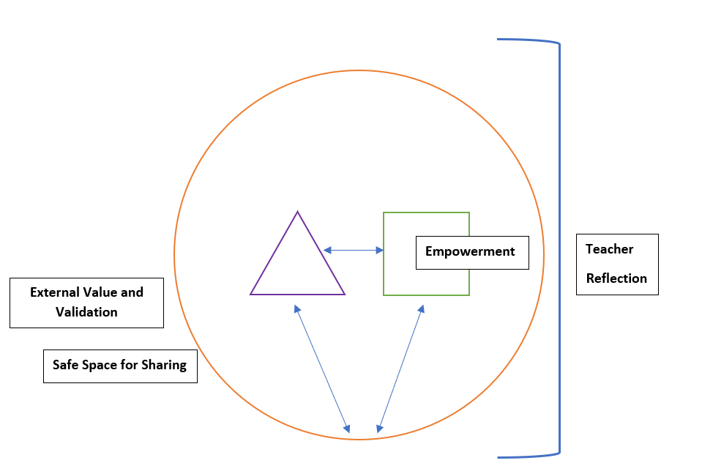
Figure 16 shows a concept map of the proposed constructivist model of supervision suggested within the present study.

The arrows within the concept map shows the complex interplay of relationships between the teacher (square), the pupil/s (triangle) and the wider school systems (circle). The map demonstrates the need for a school ethos that promotes a collaborative supportive environment within its systems and cultures including categories external value and validation and a safe space for sharing. It also shows the influence of empowerment on the individual teacher as well as placing reflection over the whole map to show the importance of the teacher reflecting on their own beliefs, values and constructs of their role and also the influence of the wider systems on these constructs.

The following is a description of how the constructivist model of supervision could be applied to a hypothetical example.

Stage 1: Supporting a culture of supervision
The first stages of the supervision process would be to support the school to consider the way in which supervision is incorporated within the school culture, developing systems in school to support a collaborative and positive ethos for all staff member. This should be through close workings with the senior leadership team and also through staff training. It is likely that during these sessions a staff supervision policy should be developed between the school staff and senior leadership team with the support of the supervision professional. As part of this supervision policy it is important to also set up a time for staff to come together within a safe environment for peer supervision sessions. The contracting process discussed below must be used within these sessions so that a safe and collaborative environment can also be created. The supervision professional should be available to support the first few peer supervision sessions in the school.

Stage 2: Developing a safe environment for supervision
After the systems and ethos for supervision has been develop it is then important for teachers to find space for their supervision sessions. It is important that teachers feel they are involved within the decision to begin supervision and that they have not been chosen to have supervision to limit possible threats and power differentials that this may cause.

Before entering into any process of supervision it is first important to develop a contract between the supervisor and the supervisee. This contract should include the practicalities of the supervision sessions, to support the supervisee to understand the process of supervision and also to develop a safe and trusting environment for the sessions to occur. It should also consider the aims of the supervision session and what both the supervisor and supervisee hope to occur as a result of the supervision.

Stage 3: Understanding the personal and professional values
Within the first session techniques from personal construct psychology could be used to explore the way in which the individual teacher perceives their role and their values within this role. A technique such as the ideal self (Moran, 2001) could be adapted and used as the idea teacher or the ideal school (Moran, 2001). During this stage it is important to understand how the teacher constructs their role, the factors which influence these constructions positively and negatively and how the teacher would work if they were not confined by the restraints of the education system.

Stage 4: Empowerment: Considering boundaries and reframing constructs; developing aspirational goals
It would then be important to start to support the teacher to reframe some of these constructions. Considering how realistic they are within the constraints of the education system and starting to realign them with goals and values that are more realistic and achievable. A coaching approach could be used to support this process. Considering developing positive and aspirational goals and developing an action plan to work towards them, including strategies for the teacher to start to apply to their practice.
Stage 5: Supporting ongoing reflective practice
Finally it is important to support the teacher to enter into a phase of reflection and reflexivity on their practice so that they start to develop their own internal supervisor who is coaching them through the work that they do. Throughout this reflective cycle it is important to support the teacher to notice times of success and how they are using strategies developed to work towards their goals.

The process of supervision is ongoing and this study suggests that teachers should have opportunities to reflect and engage with the challenging nature of the role on a regular basis. How often this occurs will influence the effectiveness of the supervision however it is important that supervision sessions are consistent and it is therefore down to individual schools to consider how often peer supervision sessions should occur. A shorter session could happen at the beginning of all staff meetings, or it may work better for groups to run at fortnightly intervals with smaller groups. It is important that teachers take ownership over these sessions and are supported to organise them with a time frame that suits their needs.

For the additional one to one supervision sessions to be effective it is likely that they will need to be completed over three to four sessions, depending on the needs of the individual teacher. These sessions are likely to be every two to three weeks so that the programme of supervision occurs within a school term.
It is now important that an evidence base for this model of supervision is developed through further research so that its effectiveness can be reviewed and the processes of the model adjusted accordingly.

Chapter 7
Reflections
7.1 Implications for educational professionals
Whilst writing this piece of research the climate of wellbeing within the school environment has begun to shift. There is now more emphasis placed upon whole-school approaches to wellbeing and more discussion within these approaches to supporting the wellbeing of school staff alongside that of the pupils.

This research has emphasised the need for this shift, highlighting the significant emotional experiences that teachers face in their work with pupils with challenging behaviour and the essential support that they should be receiving to help them with these experiences.

However this study has also shown that there needs to be considerable systemic changes within the culture of the education system, towards a more supportive and collaborative ethos where teachers feel valued and encouraged to share and reflect on difficulties they may be facing.

At the individual level, this research draws awareness for all educational professionals and staff within education settings, to elements that they could bring into their own discussions with teachers, even if this is simply providing emotional containment and understanding to a teacher’s challenging circumstances. However at a broader systemic level this research provides implications for the culture of all schools but also crucially for wider teacher education programmes.
If support for teachers is to be effective then it must be incorporated within the culture of the school, so that teachers feel safe and supported to share their experiences. However if, as this study has argued this support takes places through the introduction of a supervision approach, it is also fundamental for teachers to be trained in their understanding of supervision and reflective practice. With hope, this would encourage teachers to feel safe and supported to set up their own reflective supervision practice within their schools, with colleagues, so that it would become a regular opportunity to share challenges and discuss practice.

Educational professionals must therefore encourage and expand on the provision of support for teachers within schools and also support teachers to feel more able and safe to share their challenging experiences with other colleagues in school. A large part of this work should be aimed towards the school’s senior leadership team so that they make sure they are providing value and validation towards the challenges faced by their school staff and are also encouraging a safe and supportive environment for teachers to share challenges that they are facing.

7.2 Implications for Educational Psychology Practice
When considering the implications of this research for Educational Psychologists there is the space for significant opportunities. Educational Psychologists already work closely with teaching staff during consultations, although these consultations often take a problem-solving approach to managing a situation with a pupil. This model would allow for Educational Psychologists to work closely with teaching staff, to not only empower their problem solving and planning around the needs of a particular pupil but would also provide opportunity to encourage the teacher to reflect on their own practice and start to also provide support for the teacher’s emotional wellbeing.

During my practice as a Trainee Educational Psychologist (TEP), whilst writing my research project, I have been lucky to have had two consultations with a teacher in a local primary school. She has been working with two pupils both whom have challenging behaviour in her Year 1 class. My discussions with her during our consultations were very similar to the conversations that I had with the participants within my research with comments such as “having to focus on the rest of the class” and “if I could just work with him one to one all day long it would be so much better”. By using elements of my model of supervision I was able to help this teacher to understand how she was constructing her role and supported her to understand the boundaries within her practice and accept that she would not necessarily be able to ‘fix’ the problems of these children. We talked about her aspirations for her work with them and how I could support with these goals and through my work with the pupils we were able to check in with how she was managing her experiences. At the end of my work with the pupils we evaluated the work that I had done with the two children and the teacher spoke to me about how much more control she felt that she had over her practice and how useful it was to be able to step away from the work that she was doing to reflect on her role. She said that at times she felt overwhelmed by the level of need that these two children were having but that by stepping away she was able to understand that the responsibility for their needs was not all placed on her. She shaped their timetables so that they had some ‘special’ time with her, something which she felt was valuable and important to both the children and her personal values and was able to work towards this. She also spoke about how valuable it was to have time to share the emotional nature of her work and also to have someone to facilitate her to reflect on her practice. There have also been numerous other opportunities within my daily practice as a TEP that I have had conversations with teaching staff and school staff where I have used elements of the model of supervision that I have developed within this research.

Within my current EP service supervision is also now being used to support teaching staff within our local pupil referral units (PRUs). Teachers within these PRUs are managing children with significantly challenging behaviour on a daily basis and therefore supervision for these staff is extremely valuable. As a service this is a new and developing piece of work, however I have been involved with some of the evaluations of this work and have also started to share my model of supervision with the other EPs that have been supporting this work.

However, when many EPs work in traded services, often their only opportunities to work with teachers and school staff is through consultation and referrals of specific pupils for support and much of the school EP time can be taken up with statutory assessments leaving little time for individual work to support teachers. As discussed above there is an opportunity to incorporate this model within consultation with school staff however it is likely that to be effective, teachers would need to have a series of sessions of supervision, something that is unlikely to be practice for many EP services or school budgets.

Within the current climate of adversity, it would be challenging to encourage schools to purchase expensive EP time to provide supervision support for their school staff. However as many schools are now under increasing pressure to promote mental health and wellbeing and additionally with the impact of the ‘revolving door crisis’ on teacher retention in schools, there is a widening opportunity for EPs to work with schools to support the wellbeing of school staff. EPs are in an ideal position to have conversations with school leadership teams to discuss the need for support systems for school staff and if it is not possible for an EP to complete this work then these conversations would open up avenues for training for supervisory staff in schools and potential opportunities for assistant EPs to go into schools to complete work with teachers at significantly less cost.

7.3 How it will affect my practice
As a TEP who has previous experience of working as a teacher with challenging pupils I am very much aware of the emotional experiences that teachers have in the work that they do and the significant implications of these experiences on their teaching role as well as the wider impact on their health and wellbeing. Therefore within my practice I am always conscious of the support that we should be providing to teachers and school staff when they work with challenging pupils. As discussed above and where appropriate, I have already started to consider how the model of supervision I have used can shape some of the consultations that I have will school staff as part of the requests for support I receive for particular children.

However this study has also shown me how important it is that support for teachers, particularly reflective supervision, becomes ingrained within the teaching profession. Therefore it is my hope that in time, after further research to develop an evidence base for the model of supervision developed within the present study, I will be able to start to develop a training package that can be shared with schools to develop their knowledge of reflective supervision and hopefully encourage schools to start their own peer supervision groups. I also have high aspirations that I will be able to infiltrate into teacher training programmes to start to teach trainee teachers about the importance of reflective practice within their developing careers so that they will also continue and encourage reflective supervision within their schools.

Recently I have shared by research during a county wide training day at a local university and have started to develop links with other professionals working at the university and also within local academy chains to share my research and promote my work.

This is an area which I feel particularly passionate about and therefore I am also going to consider how I can continue to develop my knowledge in this area through further training and potentially further research if appropriate within my local authority.

7.4 How I found this research
The topic of this research is an area which I feel particularly passionate about, not only because of my previous experiences as a teacher but also because I think that the role of the teacher in supporting pupils with challenging behaviour is invaluable. For this reason I found completing this research extremely enjoyable and I am very proud of the outcomes of the research.

I knew that I wanted my research to provide something that would be useful and practical within the EP profession but as I started to develop my study and gather data I also felt that I wanted my research to provide a voice to the challenging, emotional experience that teachers were having with particular pupils and the personal efforts that teachers were putting into their work to try to support these pupils within their classrooms, often at the cost of their own mental health and wellbeing. This passion and drive fuelled my research and I feel proud that I have managed to achieve these outcomes.

I particularly enjoyed using a constructivist grounded theory approach within my research as I felt that it allowed me to achieve my aims to generate a practical model of supervision for school staff as well as remain close to the stories and data that I was collecting. However through the use of a constructivist positioning, I was also able to support the participants to understand and consider the way in which their constructions of their work and experiences influenced their practice. Through co-constructing the research, I was able to understand how and why participants constructed their experiences in certain ways, aiding the depth of the analysis and research. As discussed in my reflective memos throughout I also feel that my previous experience as a teacher was imperative to this research as it allowed me to truly co-construct and understand the experiences of my participants throughout the research and allowed me to focus my energy on empathising with their feelings and empowering their stories.

At times, the emotional nature of my interviews were very difficult for me as it brought back many of my own challenging and upsetting experiences as a teacher but reflecting on this, I feel that this further empowered me to produce a practical and useful resource to support teachers and draw attention to the support that they should be being provided with.

7.5 The quality and rigor of my study: How I met Charmaz’s criteria
According to Charmaz’ (2006) there is a number of important criteria that must be considered to ensure that a constructivist grounded theory study demonstrates quality and rigor. I will now consider how I feel my research project has accomplished these criteria.

Credibility:
At each stage of the analysis process I always ensured that I was following the range of methods used within a grounded theory study and took advice and guidance from my research supervision who is well researched in the field of grounded theory. I ensured that throughout the research process I was reflecting on my own previous experiences as a teacher and using these to support my co-construction of the data and to enhance my understanding of the data I was collecting. Throughout the process I also used reflective memos to ensure that I was continually striving for theoretical saturation of the data, feeding my understanding of one participants experiences into the subsequent interview to develop and deepen my thinking.

There are varying suggestions as to the amount of data to collect within a grounded theory study, however the goal within grounded theory is to aim for theoretical saturation of the categories being developed. As part of the research I undertook 5 interviews, some of which were almost 2 hours long. This gave me a significant amount of data and allowed me to have a depth to my understanding of the teacher’s experiences. I feel that at this point there would have been no changes to the categories I was constructing through further interviews. As Dey (1999) suggests the term theoretical sufficiency can be argued to be more appropriate than theoretical saturation and I feel that the theory that I developed within this research was saturated in credible and rigorous data collection.

The sample within the study also represents a diverse range of experiences, ages and school contexts and this also allowed for a deeper level of analysis within the data. Similarly some participants discussed very celebratory and positive experiences with challenging pupils whereas others had more negative experiences and this allowed for another perspective within the categories developed and even though the experiences were different in their nature, fitted well within the categories and allowed for an additional layer of depth to my understanding.

Originality:
I feel that my research ‘extends and refines current ideas, concepts and practices’ (Charmaz, 2006, p182) in the area of teacher supervision and support. There are a number of studies which have promoted the need for support for teachers however the present study focused more specifically at the nature of this support and the format that this support needs to take for it to be effective. This study offers an original example of support for teachers and promotes the use of a model of supervision which has been co-constructed and grounded within data collected specifically from teachers who are managing challenging experiences with pupils. Similarly of these current models of support few provide specific support that helps teachers to manage the personal and professional tensions when working with pupils with challenging behaviour, focusing specifically on scaffolding the pupil-teacher relationship.

Resonance:
Within the findings and analysis chapters of my research project I hope that there are logical links between how I used grounded theory methods to develop the initial codes, focused codes and categories and how these came together to form the model of supervision that is the theory within the present study. I feel that the use of reflective memos throughout the research project provides clarification of my thinking as I collected and analysed the data and that the quotations selected within the findings section of the project helps to elaborate on how the focused codes and categories were developed. I feel that the discussion chapter, whereby I made links to previous literature and theory, also helps to refine the model of supervision further and makes specific links to theories and approaches that could be used within the model to support teachers.

Usefulness:
To have a ‘useful’ grounded theory at least one of the following criteria should be achieved:
- Offer interpretations that people can use in their lives
- Suggest a generic process and what implications it may have
- Spark further research
- Contribute to knowledge
- Contribute to making a better world.
I feel that the present study has offered a useful and practical model of support, grounded within credible and rigorous data and supported by current literature and theory, that contributes to work of all educational professionals who work alongside teachers. It has contributed to the current field of knowledge as well as highlighted awareness to the need for proper teacher support and also sparked further interest and research for myself and my professional role as an EP.

7.6 Other Limitations
The limitations of the present study were heavily influenced by the practicalities of working alongside completing the research project. In the summer of year two I moved from the north of the country to the south which meant that I had a significant relocation and also changed my TEP placement. For this reason I felt that it would be best to collect my data in the north where I already had good links with schools and good relations with particular teachers that I had already identified as participants for my study. This however meant that I had a very limited amount of time to gather my data and also, as with grounded theory, analyse each interview so that the initial analysis could feed into subsequent interviews that I did. I achieved five interviews before reaching what I felt was theoretical saturation. I do think that if time and moving had not been a difficulty I would have liked, predominantly for peace of mind and interest, to have completed further interviews. There was the possibility of completing further interviews within my new placement once I had moved however by this point I had started to develop broader categories and started to form the final theory and so I did not think that it would be in line with grounded theory methodology to go back to initial coding and interview further participants. I had a long conversation with my research supervisor and also my fieldwork supervisor and discussed this which helped me to feel more confident in my decisions in reaching theoretical sufficiency. I do not feel that if I had interviewed more teachers my categories would have developed differently, however I do feel that I would be more confident in being able to evidence reaching theoretical sufficiency.

I think that should I complete further research in the future I would have more confidence to make decisions when developing my research project and that within the present study sometimes my decisions were held back by my lack of experience as a researcher. I feel I spent a lot of time going back and forth during the analysis stage, which did help me maintain grounded and close to the participants stories, however was very time consuming.

As with all research it is also important to consider the impact of the current situation and context on the interviewee’s responses. Again, due to time limitations all of my interviews were done at the end of the school year which meant that many of the teachers were tired and coming to the end of challenging years. No doubt this would have impacted on the stories that they told and how they reflected on their experiences. However it did mean that for many of the teachers, the experiences that they were talking about were fresh in their minds and so they were more accurate in their recollections of their experiences.

Within the sample of participants, I had managed to gain a wide range of ages and experiences as well as interview teachers from a range of different schools, local authority maintained as well as academies. However a limitation within my sample was the lack of gender diversity as no male teachers came forward to be interviewed as well as the lack of teachers from specialist or secondary provision. It would be very interesting in future research to consider how well the model would be applicable within both specialist provision and secondary schools and also whether secondary school teachers have the same personal and professional conflicts in their own roles when supporting pupils.

7.7 Future research
Teacher wellbeing is already becoming a heavily discussed area as there is a growing body of evidence to highlight the need for additional mental health and wellbeing support in schools. Recent initiatives such as the Sandwell Charter Mark (2018) have included the need to support teacher wellbeing and within my current local authority EPs are already being used to provide support to teaching staff within PRUs. Therefore the model of support developed within the present study is in prime position to now be developed and expanded with future research.

It would be very important within next steps to test the model of supervision suggested within the present study, with teaching staff, perhaps through a research method such as action research. So that it can be evaluated and adjusted and to start to develop an evidence-base to support the model in practice.

It would also be a major step if this research project could be encompassed within current whole-school initiatives for mental health and wellbeing. Within my current local authority we are supporting the Sandwell Charter Mark, a school wide initiative for mental health and wellbeing which has specific approaches to support teacher wellbeing. It would therefore be very valuable if this model could be incorporated and tested within a whole school model such as this, to help to demonstrate and promote its benefits to school staff. I value and will openly look for further research areas to explore and look forward to sharing my research project with other professionals to expand their knowledge and understanding of this area.

I am extremely passionate about supporting teachers and school staff in the challenging work that they face within their roles and I am very proud of the outcomes and findings of this piece of research. I hope that alongside publishing this research in a journal, I will also have opportunities to continue to research and expand on research in this field, particularly related to the model of supervision that I have developed within the present study.

References
Abend, G. (2008). The meaning of ‘theory’. Sociological Theory, 26(2), 173-199.

Adams, M. (2015). Coaching psychology in schools: Enhancing performance, development and wellbeing. Routledge.

Alasuutari, P. (1996). Theorizing in qualitative research: A cultural studies perspective. Qualitative Inquiry, 2(4), 371-384.

Armour, M. (2018). Supervision's' Three Amigos': Exploring the Evolving Functions of Supervision and its Application in the Field of Coaching.

Bandura, A (1997). "Self-efficacy: Toward a Unifying Theory of Behavioural Change". Psychological Review. 84 (2): 191–215.

Bandura, A. (2010). Self‐efficacy. The Corsini encyclopedia of psychology, 1-3.

Baumeister, R. F., Stillwell, A. M., Heatherton, T. F., & Parrott, W. G. (2001). Interpersonal aspects of guilt: Evidence from narrative studies. Emotions in social psychology: Essential readings, 295-305.

Beaver, R. (2011). Educational Psychology Casework: A Practice Guide Second Edition. Jessica Kingsley Publishers.

Becker, P. H. (1993). Common pitfalls in published grounded theory research. Qualitative Health Research, 3(2), 254-260.

Benoliel, J. Q. (1996). Grounded theory and nursing knowledge. Qualitative Health Research, 6(3), 406-428.

Biesta, G., & Tedder, M. (2006). How is agency possible? Towards an ecological understanding of agency-as-achievement. Learning lives: Learning, identity, and agency in the life course.

Biesta, G., Priestley, M., & Robinson, S. (2015). The role of beliefs in teacher agency. Teachers and Teaching, 21(6), 624-640.

Biesta, G., Priestley, M., & Robinson, S. (2017). Talking about education: Exploring the significance of teachers’ talk for teacher agency. Journal of Curriculum Studies, 49(1), 38-54.

Bishop, S. (2008). Running a nurture group. Sage.

Bowlby, J. (1979). The Bowlby-Ainsworth attachment theory. Behavioural and Brain Sciences, 2(4), 637-638.

British Psyhological Society (2018). BPS Publication (Internet) Leicester: BPS. Available at https://www.bps.org.uk/sites/bps.org.uk/files/Policy/Policy%20-%20Files/BPS%20Code%20of%20Ethics%20and%20Conduct%20%28Updated%20July%202018%29.pdf. Accessed 15.5.2018.

Bryant, A. (2002). Re-grounding grounded theory. Journal of Information Technology Theory and Application (JITTA), 4(1), 7.

Bryant, A., & Charmaz, K. (Eds.). (2011). The Sage handbook of grounded theory. Sage.

Buchanan, R. (2015). Teacher identity and agency in an era of accountability. Teachers and Teaching, 21(6), 700-719.

Bukor, E. (2015). Exploring teacher identity from a holistic perspective: Reconstructing and reconnecting personal and professional selves. Teachers and teaching, 21(3), 305-327.

Burr, V. (2018). Social constructionism. Handbook of Research Methods in Health Social Sciences, 1-16.

Carroll, M. (2007). One more time: What is supervision?. Psychotherapy in Australia, 13(3), 34.

Cefai, C., & Cooper, P. (2010). Students without voices: the unheard accounts of secondary school students with social, emotional and behaviour difficulties. European Journal of Special Needs Education, 25(2), 183-198.

Charmaz, K. (1996). The Search for Meanings- Grounded Theory. In Smith, J.A., Harre, R., van Langenhove, L. Rethinking Methods in Psychology (p27-49). London. Sage Publishers.

Charmaz, K. (2008). Grounded theory as an emergent method. Handbook of emergent methods, 155, 172.

Charmaz, K., & Belgrave, L. (2012). Qualitative interviewing and grounded theory analysis. The SAGE handbook of interview research: The complexity of the craft, 2, 347-365.

Charmaz, K. (2014). Constructing Grounded theory (2nd ed.). London: Sage.

Chang, M. L. (2009). An appraisal perspective of teacher burnout: Examining the emotional work of teachers. Educational psychology review, 21(3), 193-218.

Children’s Society (2018). The Good Childhood Report 201. Accessed 19 December 2018, from https://www.childrenssociety.org.uk/what-we-do/resources-and-publications/the-good-childhood-report-2018

Chin, J. H., & Mansori, S. (2018). Social Marketing and Public Health: A Literature Review. Journal of Marketing Management and Consumer Behaviour, 2(2).
Clarke, A.E. (2012). Feminism, Grounded Theory, and Situational Analysis Revisited, in S.N. Hess-Biber, The Handbook of Feminist Research (2nd ed.). Loss Angeles: Sage.

Collins, S. (2008). Statutory Social Workers: Stress, Job Satisfaction, Coping. Social Support and individual differences. British Journal of Social Work, 38, 1173-1193.

Conrad, P. (1990). Qualitative research on chronic illness: a commentary on method and conceptual development. Social Science & Medicine, 30(11), 1257-1263.

Cousins, J. B., & Walker, C. A. (2000). Predictors of educators’ valuing of systemic inquiry in schools. Canadian Journal of Program Evaluation(Special Issue), 25–53

Davison, P., & Duffy, J. (2017). A model for personal and professional support for nurture group staff: to what extent can group process consultation be used as a resource to meet the challenges of running a nurture group?. Educational Psychology in Practice, 33(4), 387-405.

Day, C., Kington, A., Stobart, G., & Sammons, P. (2006). The personal and professional selves of teachers: Stable and unstable identities. British educational research journal, 32(4), 601-616.

Davys, A., & Beddoe, L. (2010). Best practice in professional supervision: A guide for the helping professions. Jessica Kingsley Publishers.

Department for Education (2014) SEND Code of Practice: 0 to 25 years. London: Department for Education.

Department for Education (2015) Promoting children and young people’s emotional health and wellbeing. London: Department for Education.

Department For Education (2017). Exclusion Statistics Guide. London: Department for Education.

Department for Education (2018). Mental Health and Behaviour in Schools. London: Department for Education.

Dey, I.(1993).‘Qualitative Data Analysis: A User-Friendly Guide’.London. Routledge.

Deci, E.L. & Ryan, R.M. The “what” and “why” of goal pursuits: Human needs and the self-determination of behaviour. Psychological Inquiry, 11 (2000), pp. 227-268

Devos, C., Dupriez, V., & Paquay, L. (2012). Does the social working environment predict beginning teachers’ self-efficacy and feelings of depression?. Teaching and Teacher Education, 28(2), 206-217.

Diener, E., & Suh, E. (1997). Measuring quality of life: Economic, social, and subjective indicators. Social Indicators Research, 40 (1–2), 189–216. http://dx.doi.org/10.1023/A:1006859511756

Dinham, J., Chalk, B., Beltman, S., Glass, C., & Nguyen, B. (2017). Pathways to resilience: how drawings reveal pre-service teachers’ core narratives underpinning their future teacher-selves. Asia-Pacific Journal of Teacher Education, 45(2), 126-144.

Dodge, R., Daly, A. P., Huyton, J., & Sanders, L. D. (2012). The challenge of defining wellbeing. International journal of wellbeing, 2(3).

Dunne, C. (2011). The place of the literature review in grounded theory research. International Journal of Social Research Methodology, 14(2), 111-124.

Dunsmuir, S., & Leadbetter, J. (2010, November). Professional supervision: Guidelines for practice for educational psychologists. Leicester: British Psychological Society.
Erb, C. S. (2002, May). The emotional whirlpool of beginning teachers' work. Paper presented at the annual meeting of the Canadian Society of Studies in Education, Toronto, Canada.

Estyn. (2011). Joint Investigation into the handling and management of allegations of professional abuse and the arrangements for safeguarding and protecting children in education services in Pembrokeshire County Council. Cardiff: CSSIW.

Farouk, S. (2012). What can the self-conscious emotion of guilt tell us about primary school teachers’ moral purpose and the relationships they have with their pupils? Teachers and teaching, 18(4), 491-507.

Flick, U. (2009). An introduction to qualitative research. London: Sage.

Furrer, C. J., Skinner, E. A., & Pitzer, J. R. (2014). The influence of teacher and peer relationships on students’ classroom engagement and everyday motivational resilience. National Society for the Study of Education, 113(1), 101-123.

Galand, B., Lecocq, C., & Philippot, P. (2007). School violence and teacher professional disengagement. British Journal of Educational Psychology, 77(2), 465-477.

Gerhardt, U. (1990). Patient careers in end-stage renal failure. Social Science & Medicine, 30(11), 1211-1224.

Gergen, K. (1997). Realities and relationships: Soundings in social construction. Cambridge, MA: Harvard University Press.

Gibbs, C. (2009). Explaining effective teaching: self-efficacy and thought control of action. The Journal of Educational Enquiry, 4(2).

Gill K (2017) Making The Difference: Breaking the link between school exclusion and social exclusion,IPPR. http://www.ippr.org/publications/making-the-difference

Giorgi, A. (1995). ‘Phenomenological Psychology’, in J.A. Smith, R. Harre and L. Van Langenhove (eds), Rethinking Psychology. London: Sage.

Glaser, B. G. (1998). Doing grounded theory: Issues and discussions. Sociology Press.

Glaser, B., & Strauss, A. (1967). The discovery of Grounded Theory. Chicago, IL: Aldine Publishing Company.

Glaser, B. G., & Strauss, A. L. (2017). Discovery of grounded theory: Strategies for qualitative research. Routledge.

Golembiewski, R. T., Munzenrider, R. F., & Carter, D. (1983). Phases of progressive burnout and their worksite covariants. Journal of Applied Behavioural Science, 19, 461–481.

Greenfield, B. (2015). How can teacher resilience be protected and promoted. Educational & Child Psychology, 32(4), 52-68.

Greenhalgh, P. (2002). Emotional growth and learning. Routledge.

Guba, E. G., & Lincoln, Y. S. (1989). The countenances of fourth-generation evaluation: Description, judgment, and negotiation. The politics of program evaluation, 15, 202-234.

Gubrium, J.F. & Holstein, J. A. (2004). The active interview. Qualitative research: Theory, method and practice, 2, 140-161.

Hagenauer, G., Hascher, T., & Volet, S. E. (2015). Teacher emotions in the classroom: Associations with students’ engagement, classroom discipline and the interpersonal teacher-student relationship. European Journal of Psychology of Education, 30(4), 385-403.

Hall, W. A., & Callery, P. (2001). Enhancing the rigor of grounded theory: Incorporating reflexivity and relationality. Qualitative health research, 11(2), 257-272.

Halbesleben, J. R. (2006). Sources of social support and burnout: a meta-analytic test of the conservation of resources model. Journal of applied Psychology, 91(5), 1134.

Halbesleben, J. R., & Wheeler, A. R. (2015). To invest or not? The role of coworker support and trust in daily reciprocal gain spirals of helping behaviour. Journal of Management, 41(6), 1628-1650.

Hamre, B. K., & Pianta, R. C. (2001). Early teacher–child relationships and the trajectory of children's school outcomes through eighth grade. Child development, 72(2), 625-638.

Hanko, G. (2003). Towards an inclusive school culture—but what happened to Elton's ‘affective curriculum’?. British Journal of Special Education, 30(3), 125-131.

Hargreaves, A. (2000). Mixed emotions: Teachers’ perceptions of their interactions with students. Teaching and teacher education, 16(8), 811-826.

Hargreaves, A. (1998). The emotional practice of teaching. Teaching and Teacher Education, 14, 835–854.

Hargreaves, A. (2001). Emotional geographies of teaching. Teachers College Record, 103, 1056–1080.

Hawkins, P. (2011). Expanding emotional, ethical and cognitive capacity in supervision, in J. Passmore Supervision in coaching. London: Kogan Page

Hawkins, P., & Shohet, R. (2012). Supervision in the helping professions. McGraw-Hill Education (UK).

Hawkins, P. & Smith, N. (2006) Coaching, Mentoring and Organizational Consultancy: Supervision and Development. Maidenhead: Open University Pres

Henderson, P., & Bailey, C. (2018). The internal supervisor: developing the witness within. In Supervisor Training (pp. 93-105). Routledge.

Henderson, N., & Milstein, M. M. (2003). Resiliency in schools: Making it happen for students and educators. Corwin Press.

Hood, J. C. (2007). Orthodoxy vs. power: The defining traits of grounded theory. The Sage handbook of grounded theory, 151-164.

Holloway, E. (1995). Clinical supervision: A systems approach. Sage.

Jackson, P. (2008). Coaching, mentoring and organizational consultancy: Supervision and development. Coaching: An International Journal of Theory, Research and Practice, 1(1), 102-105.

Jepson, E., & Forrest, S. (2006). Individual contributory factors in teacher stress: The role of achievement striving and occupational commitment. British Journal of Educational Psychology, 76(1), 183-197.

Jones, D., Monsen, J., & Franey, J. (2013). Using the Staff Sharing Scheme to support school staff in managing challenging behaviour more effectively. Educational Psychology in Practice, 29(3), 258-277.

Kadushin, A. (1976). Supervision in social work. New York: Columbia University Press

Kelly, N., & Antonio, A. (2016). Teacher peer support in social network sites. Teaching and Teacher Education, 56, 138-149.

Kolb, D. A. (1984). The process of experiential learning. Experiential learning: Experience as the source of learning and development. In : (pp. 20-38). Prentice-Hall, Inc..

Lane, L. G., & Viney, L. L. (2005). The effects of personal construct group therapy on breast cancer survivors. Journal of Consulting and Clinical Psychology, 73(2), 284.

Lazenbatt, A., & Elliott, N. (2005). How to recognise a 'quality' grounded theory research study. Australian Journal of Advanced Nursing, The, 22(3), 48.

La Placa, V., McNaught, A., & Knight, A. (2013). Discourse on wellbeing in research and practice. International Journal of Wellbeing, 3(1).

Lempert, L.B. (2011). ‘Asking questions of the data: memo-writing in the Grounded Theory Tradition’. In Bryant, A. and Charmaz, K. (2011). “The Sage Handbook of Grounded Theory’. Sage Publications.

MacLure, M. (1993). Arguing for your self: Identity as an organising principle in teachers’ jobs and lives. British Educational Research Journal, 19(4), 311–322.

Manstead, A. (2014). Identity, socioeconomic status, and well-being: Does positively identifying with a group buffer the negative effect of low SES on well-being? ESRC End of Award Report (ES/K003534/1). Swindon: ESRC

Manticopoulos, P. (2005). Conflictual relationships between kindergarten children and their teachers: Associations with child and classroom context variables. Journal of School Psychology, 43(5), 425-442.

Marsh, H. (2012). Relationships for learning: using pupil voice to define teacher− pupil relationships that enhance pupil engagement. Management in Education, 26(3), 161-163.
Martin, A.J. & Dowson, M. (2009). Interpersonal relationships, motivation, engagement and achievement. Yields for theory, current issues and educational practice. Review of Educational Research, 79 (1), 327–365.

Martin, J. (2019). Building Relationships and Increasing Engagement in the Virtual Classroom: Practical Tools for the Online Instructor. Journal of Educators Online, 16(1), n1.

Marzano, R. J. (2003). What works in schools: Translating research into action. ASCD.

Marzano, R. J., Marzano, J. S., & Pickering, D. (2003). Classroom management that works: Research-based strategies for every teacher. ASCD.

McCluskey, G., Riddell, S., Weedon, E., & Fordyce, M. (2016). Exclusion from school and recognition of difference. Discourse: Studies in the Cultural Politics of Education, 37(4), 529-539.

M. Milyavskaya, M. Inzlicht, N. Hope, R. KoestnerSaying “no” to temptation: Want-to motivation improves self-regulation by reducing temptation rather than by increasing self-control Journal of Personality and Social Psychology, Advance online publication (2015),

Mills, J., Bonner, A., Francis, K. (2008). The development of constructivist
grounded theory. International journal of qualitative methods, 5(1), 25-35.

Miller, A. (1996). Pupil behaviour and teacher culture. Continuum Intl Pub Group.

Moon, B., & McCluskey, J. (2018). An Exploratory Study of Violence and Aggression Against Teachers in Middle and High Schools: Prevalence, Predictors, and Negative Consequences. Journal of School Violence, 1-16.

Moran, H., Pathak, N., & Sharma, N. (2009). The mystery of the well-attended group. A model of Personal Construct Therapy for adolescent self-harm and depression in a community CAMHS service. Counselling Psychology Quarterly, 22(4), 347-359.

Nias, J. (1996) Thinking about feeling: the emotions in teaching, Cambridge Journal of Education, 26(3), 293–306.

Schein, E. H. (2010). Organizational culture and leadership (Vol. 2). John Wiley & Sons.

Schon, D. (1983). The Reflective Practitioner. New York: Basic Books

Simon, D. J., Cruise, T. K., Huber, B. J., Swerdlik, M. E., & Newman, D. S. (2014). Supervision in school psychology: The developmental/ecological/problem‐solving model. Psychology in the Schools, 51(6), 636-646.

Stoltenberg, C. D., & McNeill, B. W. (2011). IDM supervision: An integrative developmental model for supervising counselors and therapists. Routledge.

Tašner, V., Žveglič, M., & Čeplak, M. M. (2017). Gender in the Teaching Profession: University Students’ Views of Teaching as a Career. Center for Educational Policy Studies Journal, 7(2), 47-69.

Teacher workload survey 2016 available at https://www.gov.uk/government/publications/teacher-workload-survey-2016

Tunariu, A. D., Tribe, R., Frings, D., & Albery, I. P. (2017). The iNEAR programme: an existential positive psychology intervention for resilience and emotional wellbeing. International Review of Psychiatry, 29(4), 362-372.

O'Connor, M., Hodkinson, A., Burton, D., & Torstensson, G. (2011). Pupil voice: listening to and hearing the educational experiences of young people with behavioural, emotional and social difficulties (BESD). Emotional and Behavioural Difficulties, 16(3), 289-302.

Oktay, J.S. (2012). Grounded Theory. Oxford University Press, 2012.

Osborne, C., & Burton, S. (2014). Emotional Literacy Support Assistants’ views on supervision provided by educational psychologists: what EPs can learn from group supervision. Educational Psychology in Practice, 30(2), 139-155.

Proctor, B. (1988). Supervision: A Working Alliance (videotape training manual). St Leonards-on-sea: Alexia Publications.

Pavlović, J. (2011). Personal construct psychology and social constructionism are not incompatible: Implications of a reframing. Theory & Psychology, 21(3), 396-411.

Pianta, R. C., & Stuhlman, M. W. (2004). Teacher-child relationships and children's success in the first years of school. School psychology review, 33(3), 444.

Pollard, E. L., & Lee, P. D. (2003). Child well-being: A systematic review of the literature. Social Indicators Research, 61(1), 59-78.

Raskin, Jonathan D. (Spring 2002). "Constructivism in psychology: personal
construct psychology, radical constructivism, and social constructionism" (PDF). American Communication Journal

Reeve, J. (2006). Teachers as facilitators: What autonomy-supportive teachers do and why their students benefit. The Elementary School Journal, 106(3), 225-236.

Roffey, S. (2012). Pupil wellbeing—Teacher wellbeing: Two sides of the same coin? Educational and Child Psychology, 29(4), 8.

Roffey, S. (2016). Building a case for whole-child, whole-school wellbeing in challenging contexts. Educational & Child Psychology, 33(2), 30-42.
Seligman, M.E. P. (2011). Flourish –A new understanding of happiness and well-being –and how to achieve them. London: Nicholas Brealey Publishing.

Seligman, M. E., & Csikszentmihalyi, M. (2000). Positive psychology: An introduction (Vol. 55, No. 1, p. 5). American Psychological Association.

Skiba, R., Reynolds, C.R., Graham, S., Sheras, P., Close Conely, J. & Garcia-Vasquez, E. (2006). Are zero tolerance policies effective in the schools? An evidentiary review and recommendations. Washington, DC: Zero Tolerance Task Force Report for the American Psychological Association.

Sutton, R. E. (2000, April). The emotional experiences of teachers. In Annual Meeting of the American Educational Research Association, New Orleans.

Sutton, R. E., & Wheatley, K. F. (2003). Teachers' emotions and teaching: A review of the literature and directions for future research. Educational psychology review, 15(4), 327-358.

Taris, T. W., Horn, J. E. V., Schaufeli, W. B., & Schreurs, P. J. (2004). Inequity, burnout and psychological withdrawal among teachers: A dynamic exchange model. Anxiety, Stress & Coping, 17(1), 103-122.

Teale, C. (2010). Emotional Intelligence and Social Perception.

Tootill, R., & Spalding, B. (2000). How effective can reintegration be for children with emotional and behavioural difficulties?. Support for Learning, 15(3), 111-117.

Toulmin, S. (1990). Cosmopolis: The Hidden Agenda of Modernity. New York: Free Press.

Ungar, M. (2011). The social ecology of resilience: addressing contextual and cultural ambiguity of a nascent construct. American Journal of Orthopsychiatry, 81(1), 1.

Vincent, C. (2018). Giving advice during consultations: unconscious enactment or thoughtful containment?. In Brief Encounters with Couples (pp. 85-97). Routledge.

Von Glaserfeld, E. (1995a). Radical constructivism: A way of knowing and learning . London: The Falmer Press.

Wellbeing Australia (2011). Survey: Factors affecting school wellbeing: First Analysis. Sydney: Wellbeing Australia Network.

Werner, K. M., Milyavskaya, M., Foxen-Craft, E., & Koestner, R. (2016). Some goals just feel easier: Self-concordance leads to goal progress through subjective ease, not effort. Personality and Individual Differences, 96, 237-242.

Werner, E. E., & Smith, R. S. (1992). Overcoming the odds: High risk children from birth to adulthood. Cornell University Press.

Werner, E. E. (2013). What can we learn about resilience from large-scale longitudinal studies?. In Handbook of resilience in children (pp. 87-102). Springer, Boston, MA.

Willig, C. (2013). Introducing qualitative research in psychology. McGraw-Hill International.

Wilson, D., & Newton, C. (2006). Circles of Adults: A team approach to problem solving around challenging behaviour and emotional needs. Inclusive Solutions UK Limited.

Wimpenny, P., & Gass, J. (2000). Interviewing in phenomenology and grounded theory: is there a difference?. Journal of advanced nursing, 31(6), 1485-1492.

World Health Organization. (2014). Measuring Quality of Life. Geneva: World Health Organisation

Appendices

Appendix A: Ethical approval confirmation letter
Appendix B Memos

Memo 1 | Date 7. 2.18 | Development of research questions
Making sure that the questions aren’t leading…
Open and not with bias e.g. how does this impact on relationships would suggest there is an impact? Is there? Research would suggest yes but this cannot impact on my initial questions as with GT….

Memo 2 | Date 19.4.18 | Constructionist GT
Level of concern over stating a ‘theory’ when really I want to be more flexible in the development of a ‘theory’. More so want to bring about an awareness of how to support, importance of containment.

Liked the concept of Coaching that we had during Sheffield training day. I think this would link nicely…. more of a constructionist approach- inline with my ontological and epistemological thinking.

Memo 3 | Date 20.4.18 | Participant recruitment- defining challenge for teachers personal experiences
Discussion with research tutor over what ‘challenging’ means. How will I define this for my participants so that they know what is challenging. Must allow for their own subjectivity. If they feel that it was challenging to their own personal and professional values. It may not be the same level of challenging as another participant but that does not necessarily matter if it was still personally challenging to them.

Creation of a scale for the participants to consider the term challenging within.

Memo 4 | Date 20.4.18 |  | Understanding Constructivist vs. Constructionist
Constructivist  Denies objective reality- RELATIVIST  Multiple realities- “as many constructions as there are individuals”  About the process of construction of meaning  “People make their worlds but do not make them as they please” Our world are constructed under conditions- these shape our views and actions.  Importance of the subjective relationship between researcher and participants- co construction of meaning. |  | Constructionist  One construction that is shared by others with often multiple viewpoints that are discovered in the space between individuals.

Memo 5 | Date Feb 2018 | Participant recruitment
Discussion with research tutor over the use of particular schools for my sample. Need to think about the support systems that teachers may also have within a specific type of school. How much time is used from EPs already for this type of work. The Ofsted criteria requires improvement may also add additional job stressors. Any other professionals schools may use to support staff or any school policies that may support staff. How will I limit the impact of external factors within the interviews or are these factors of similar importance?

Memo 6 | Date 10.5.18 | Sampling from my own schools
Would really like to collect the data in schools that I have already built a rapport with- important to have trust with teachers. However due to time constraints and difficulty with teachers interest in the study I will have to open this up to other schools. This will allow for a wider sample which is also important.
Importance of lots of information sharing before the interview to put participants at ease, opportunities for questions and answers, time for building rapport.

Memo 7 | Date 18.5.18 | Completing Interviews
Discussion with research supervision regarding the process of completing the interviews. I am changing placements between year 2 and year 3 and because of this want to get all of my data collected before the summer. Therefore there is significant time pressure.

Decided to complete the interviews, transcribe as well as possible (with the time pressure) and then complete initial line by line coding so that I can still maintain the GT analysis procedure and so that each interview can inform the next.

Memo 8 | Date 4.6.18 | Interview 1
Totally open question… “Tell me about your experiences”…

Themes identified for following interview questions…
Personal/ professional values?
Automatic mode?
Impact on individual as well as rest of the class? Knock on effect…
How do you feel that you influenced the challenge?
Do you feel you are an emotional person? How does this influence your work?
Reflection/ reflective practice?
Team teach?
Involvement of others?

Memo 9 | Date 3.7.18 | Interview 2
Themes identified for following interview questions…

Personal/ professional values?
Level of control?
External agencies?
Safeguarding concerns?
Ways of coping
Political/ systemic/ wider challenges
Conscious of children/ others seeing your emotions?

Memo 10 | Date 12th July | Interview 3
Themes identified for following interview questions…

How much are teachers able to see/ celebrate the successes?
Sense of confidence? Strategies and plans support this?
Children have/ haven’t bonded with?
Seeking assurance from others?

Memo 11 | Date 17.7.18 | Leading questions/ comments
Interview 4 asked a question linked to previous participants comments about going into ‘auto mode’ and ‘robotic mode’. This sparked the participant to talk about her own automatic mode and I felt concerned over the level of directedness made by myself in her answers.

Memo 12 | Date 17th July | Interview 4
Themes identified for following interview questions…

Conflict when children don’t reciprocate feelings?
Confidence/ celebrating successes links to resilience?

Memo 13 | Date 20th July | Theoretical Saturation
Theoretical Saturation

Varying suggestions as to the amounts of data to collect within GT studies.

Dey (1999) theoretical sufficiency
First interviews provided broad categories which were filtered down in future interviews beyond the 5 would not have altered the categories.
Overarching sense that conflict occurred when personal professional values clashed

5 long and detailed interviews. Mixed sample

Quickly created meaningful conversation allowed me to delve and develop a strong understanding of participants experiences.

Memo 14 | Date 17.8.18 | Initial Coding
Thinking about the participant’s journey. Can almost feel their voice when reading back the transcripts; feeling very close to the data after listening and transcribing. I must be conscious of this feeling and try to maintain it throughout.

Memo 15 | Date 17.9.18 | Initial Coding
Noticing I'm moving away from the line by line coding already and starting to think about grouping and making comparisons. It is good that I am noticing comparisons however I don’t want to start to focus on this too quickly and miss other options. Keep moving back to line-by-line. Perhaps this is also because I am being directive in my questioning. Theoretical sampling important but I also don’t loose the uniqueness of each participant’s story.

Memo 16 | Date 19.9.18 | Initial ideas emerging from data analysis.
- Professional vs. personal values
- automatic mode
- feeling stuck/ what next
- holding it together for the rest of the team
- frustrations over external agencies
- validation from others- if they could just be in my class for one day.

Memo 17 | Date  20.9.18 | Worry over the loss of participant’s voice… how can I show the power of their stories within the study
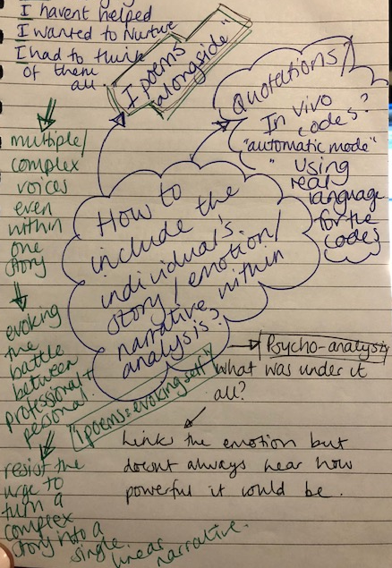
- Stick closely to language
- Ipoems? Complex voices within the stories, these would show the tension within the stories- resist the urge to turn a complex story into a single linear narrative…
- Within the title?
- DECP debate article?

Memo 18 | Date 25.9.18 | Feeling close to data and language
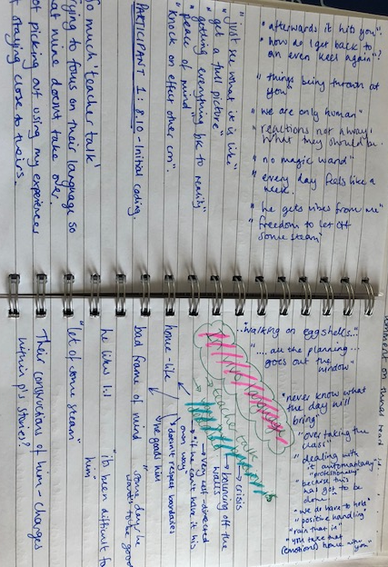
Keep going back to original transcripts. Reading and re-reading. Listening to the recordings in the car and feel like I can recall and remember the details of the participants interviews.

Lots of rich ideas coming from the interviews. Vast amounts of ‘teacher talk’ and in vivo language. Would be good to use this language when forming some of the focused codes/ categories.

Also looking at the way behaviours/ children are described and noting down questions that popped into my mind during coding or things that I would have liked to have elaborated on.

Memo 19 | Date 30.7.18 | Moving away from initial codes and language… too soon?
I noticed that compared to previous interviews I was paying less attention to the language that participants were using. Perhaps this was because coding was becoming quicker and I was allowing my analysis to become deeper and with more comparison rather than just surface level. However I really want to value to language used and don’t want to miss anything in the initial stages so I will go back to the interviews again with another highlighter colour to look closely line by line at language again.
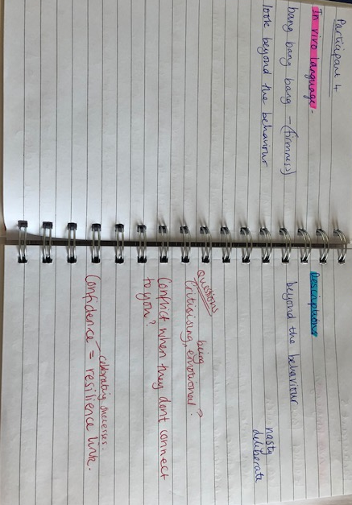

Memo 20 | Date 17.8.18 | Grouping codes
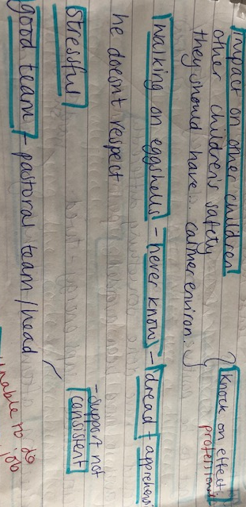
Lots of codes that are around the same concepts so I am going to bring them together on a sheet of paper to make them more observable together and perhaps more workable. This will help me to think about how to structure following interviews

Eg Grouping
- Impact on other children;
- worry about other children’s safety;
- they (children) should have a calmer environment.

Memo 21 | Date 17.8.18 | In Vivo Coding

Using this language closely when coding. It would be good to use it within some of the focused codes/ categories and perhaps also within the title. Some of it is very emotive.

Willig (2013) using own language to avoid putting existing theory or preconceptions onto data.

Memo 22 | Date 5.9.18 | Developing focused codes
Making sure that even when I am grouping that I am staying closely to the data and making sure that I am not starting to be analytical too quickly which would move me away from the direct meaning of the data.

As you can see form the red and green commenting I have grouped ‘doubting myself’ and ‘shouldn’t be letting them take over and stopping me from doing my job’. However on reflection these are two separate ideas- doubt and blame.

Taking the initial codes I have constructed and finding quotes to go alongside these to support me to start taking a more analytical stance during coding.

Memo 23 | Date 2.10 | Examples within EP practice
Consultation with a primary school teacher- comments very much related to personal/ professional tension.
“having to focus on the rest of the class”
“If I could just work with him 1:1 all day long it would be much better”

During consultation tried to help the teacher to reflect on this tension, make her aware of her successes with the pupil and set some goals for her to try to achieve in her work to make her feel like she was making gains in supporting him.

Memo 24 | Date 13.10 | Podcast about reflecting on emotions- mental health and wellbeing
Matt Haige Happy Place Podcast
Thoughts:
- Stopping obsessing about being the best and accepting just being better- ability to celebrate the successes
- Our thoughts are made of words, words can set you free- but this is also what we battle against.
- Developing an internal therapist
- Sharing the pain
- Taking ownership
- But must banish worrying about others judgements

Memo 25 | Date 5.11.18 | Taking an analytical stance to coding
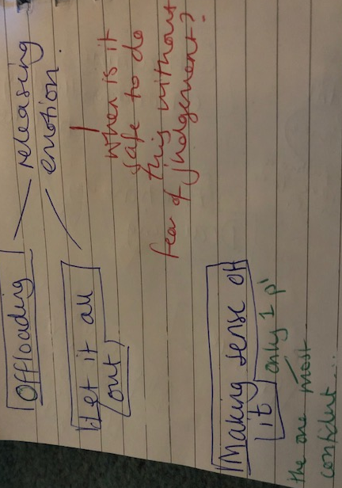
Developing analytical thinking to try to bring together some of the codes and think about how they linked- influencing factors on participants constructions such as management of emotions, provision of support in schools to reflect and provide containment of emotions etc.

Memo 26 | Date 8.11.18 | Co-construction- questions emerging from focused code development
Questions also started to arise as I developed more focused codes and started to think about how these codes linked together.

Referring back to participant 1’s transcript this seemed focused around having to stay strong for her team. Other participants linked this to not wanting family to see them upset. Many any said that they felt that once they started getting upset they just couldn’t stop.

I wondered why it appeared unprofessional to seem emotive about an experience, particularly one that was so challenging.

I discussed this with EP colleagues and they said that it often surprised them at how emotional some teachers became during consultations. They felt that often the consultation provided the safe space to show emotions without judgement. Teachers seemed to feel that if they showed they were upset then they would be judged on both a professional and personal level- not being ‘strong enough’ for the job or not being able to ‘professionally distance themselves’ from their experiences so that they were able to get on with the professional elements of the job such as teaching, marking, behaviour management etc.

Going back to initial interview transcripts to ensure that I am co-constructing meaning.

Memo 27 | Date 8.11.18 | Co-construction- questions emerging from focused code development
Questions also started to arise as I developed more focused codes and started to think about how these codes linked together.

Really trying to understand the participant’s experiences and group the codes accurately.

Going back to the original transcripts to start to identify quotes to support this process.

Feel that someone without my previous experience as a teacher may have just assumed certain analytical assumptions about the data Ie: moral support rather than external validation of difficulties.
My previous experience supported me to delve deeper into the meaning of what some of the participants spoke about.

If I hadn’t lived what my participants were describing I wouldn’t be able to even start to claim to be able to understand their feelings or experiences.

Memo 28 | Date 26.11.18 | Initial theory development
Theory based thinking to try to bring together some of the codes and think about how they linked- influencing factors on participants constructions such as management of emotions, provision of support in schools to reflect and provide containment of emotions etc.

Memo 29 | Date 26.11.18 | Developing Codes
I still have a large number of codes- I need to further refine them to make the data more manageable. Removed duplications and thinking about comparisons between codes- similarities and also more importantly differences. Always referring back to transcripts and quotes. Some have been an easier fit than others and I must be aware of this and reflect upon it so that I am not making analytical assumptions.

Memo 30 | Date 16.1.19 | Within practice examples
Similar themes emerging within ELSA supervision session:
- Uncertainty
- Need for continuity of support
- EP providing containment and supporting reflection
- Group supporting TAs to feel cared for rather than judged

Memo 31 | Date 2.1.19 | Splitting up focused code
- My teacher face/ game face
- Automatic mode/ dealing with it automatically
Initially these were grouped together under coping however when referring back to the original transcripts during grouping it became clear that the ‘teacher face/ game face’ constructs were linked to a need to be perceived as coping which added to the difficulties as it lead some teachers to feel overlooked or foolish or like their difficulties were not as significant. Whereas ‘going into automatic mode’ and ‘being a robot’ seemed to be a construct linked to dealing with the behaviour and the challenges in a more ‘professional way’. For example some teachers had scripts in their heads or systems in place for situations which seemed to remove the personal elements from the challenge and helped them to feel as though they were dealing with it in a more professional way.

Memo 32 | Date 1.2.19 | Conversation about analysis with research supervisor
Today I updated my research supervisor on my analysis. I feel that it has been a very long drawn out process and that initially I felt very clear on the analysis and felt like I had my initial data very close to mind during the analysis. However more recently I feel like I am moving away from the data and feel less secure about the analysis process. I think this is because I still have a large number of focused codes and as of yet I am not clear about how they are going to come together into categories. I have decided to go back to my initial transcripts and look for quotes which support the focused codes.

Memo 33 | Date 15.2.19 | Developing categories
Going back to the original transcripts has immediately helped me to feel close to the original data again and also straight away refilled me with confidence over the direction of my analysis. I now no longer feel lost within the focused codes and instead feel secure in the way that I am constructing categories.
This has also helped me to see theories which can support my thinking… eg Personal Construct Psychology…
Quotes have been really helpful
I feel like I have got to the point now where I have memorised most of my interviews and could recall and recount specific details about my participants stories.

Memo 34 | Date 16.2.19 | Positive supportive examples as well as negative challenging examples.
Need to make it clear within the results sections when a code is supportive to the model of supervision and supportive for teachers E.g. sense of achievement and having a plan. Also when they are challenging and have a negative implication on teacher’s experiences E.g. feeling stuck, doubting myself and unpredictable.

Memo 35 | Date 18.2.19 | Developing categories
Some categories have formed as a stand alone and others have come together as a process. The theory, which in this case is a model of supervision, is really starting to take shape.

Value and Validation is a stand alone category which overarches the model.
Confidence, Helplessness and self-doubt seem to come together as a process within the model and therefore have become the category empowerment.

Memo 36 | Date 19.2.19 | Naming categories
Need to think about names for categories- grouped them but an overall name is important.
Some of them would suit being in vivo codes so that I can stay close to the participants language but must make sure they make sense.
Eg: Impact on other children or “knock on effect”?

Memo 37 | Date 25.2.19 | Quote Selection
Attempting to pick out quotes to give meaningful examples of how the focused codes and categories have been developed within the results section.
I found that there were so many powerful quotes from each participant and was conscious of how I was going to select the particular quotes for the results section.

I tried to ensure I had quotes from a range of participants for each code and category.

There was also some quotes which were very useful as they very clearly outlined the ways in which the participants were constructing their experiences.

Memo 38 | Date 27.2.19 | Concept map for the model
Trying to develop a concept map to demonstrate the processes within the model.
Thinking about how to show the different systems within the model and how they interlink. Also need a name for the model.

SAGE- setting aspirational goals and empowerment
SER- support, empowerment, reflection
RES model- reflection, empowerment and support

Appendix C- Fishbone showing timescale of activities

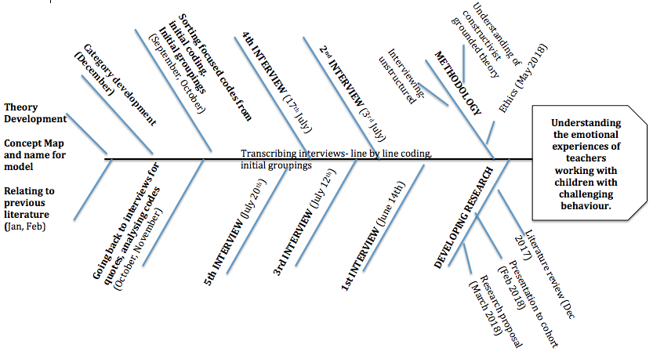

Appendix D- Consent Form

Participant Consent Form

Research Project Title

Understanding the emotional experiences of teachers who are supporting pupils with challenging behaviour. Considering how these experiences can impact on their relationships with these pupils: A grounded theory study.

Participant Consent Form

Before agreeing to take part in the study please make sure that you have read the attached participant information sheet and understand the requirements of the study. If you have any questions before signing please contact Olivia Blick, Trainee Educational Psychologist oblick1@sheffield.ac.uk. Or you may also contact the supervisor for the research Victoria Lewis v.lewis@sheffield.ac.uk.

I ____________________________ agree that by signing this consent form I agree to take part in the study.
I understand that all information will be kept anonymous
I understand that I can withdraw my participation in the study along with any information that I have shared at any point.
I understand that the information I have shared will be securely stored on a password protected device until completion of the project when it will be securely destroyed.
I understand that if at any point after the completion of my interview I feel that I need additional support to understand and reflect on my experiences I will contact the researcher Olivia Blick on the contact details outlined above.

Signed (participant) | Date
Name in block letters

Appendix E- Participant Information Sheet

Participant Information Sheet

Research Project Title
Understanding the emotional experiences of teachers who are supporting pupils with challenging behaviour. Considering how these experiences can impact on their relationships with these pupils: A grounded theory study.

Invitation
You are being invited to take part in this research project. Before you decide to do so, it is important you understand why the research is being done and what it will involve. Please take time to read the following information carefully and discuss it with others if you wish. Ask us if there is anything that is not clear or if you would like more information. Thank you for reading this.

What is the project’s purpose?
This project aims to understand more about the emotional experiences that teachers face when supporting a child with particularly challenging behaviour. It aims to consider the impact that these experiences have on the relationships that are formed between teacher and pupil and how as Educational Psychologists we can best support teachers in these relationships.
The research questions for this project are outlined below:
- How do teachers interpret their emotional experiences when supporting pupils with challenging behaviour?
- How and why do teachers feel that their emotional experiences impact on their relationships with pupils who display challenging behaviour?
- What support would teachers feel is beneficial in supporting their relationships with pupils with challenging behaviour?
Why have I been chosen?
You have been chosen as your school Educational Psychologist feels that you meet the criteria for the study outlined below:
- Experience from the last academic year working with a pupil whose behaviour has been personally and professionally challenging.
- When considering the nature of the pupils ‘challenging’ behaviour these pupils are likely to be at risk of permanent exclusion.
- As the pupil’s teacher you found that their behaviour impacted on your emotional experiences when supporting this pupil.
- That these emotional experiences impact on the nature of your relationship with the pupil.
Your experiences are very valuable and we feel that they would make an important contribution to the study.

What will the process involve?
Once you have agreed to take part in the study you will be contacted to arrange a date and time that suits you for an interview. This interview will comprise of a set of open ended questions for you to answer which will facilitate a discussion around your experiences. The sessions will be open for you to discuss your experiences within a safe environment. They may also cause some reflection on your experiences and there will be ongoing opportunities to be supported in these experiences if you feel you need this after the interview.

What will happen to the information that I share?
During the interviews all conversations will be recorded using a voice recording device. These conversations will then be transcribed and pseudonyms will be used within the transcriptions so that all information shared is kept completely anonymous. The recordings and transcriptions will be kept on a locked and secured device and will not be shared with any other participants or with anyone outside of the research project. After completion of the study all data and recordings will be securely disposed of. Within the write up of the research project all transcriptions will be kept completely anonymous.

Do I have to take part?
Your involvement in this project is completely voluntary and as part of the ethical considerations for the study you have the right to withdraw your consent to participate at any point, even after agreeing to consent to be involved or after completing your interview. If you choose to withdraw any information that you have shared will be securely destroyed and will therefore not be used within the study.

Contacts for further information
Olivia Blick (Researcher) Victoria Lewis (Research Supervisor)
Trainee Educational Psychologist Educational Psychologist and Lecturer
Sheffield University Sheffield University
oblick1@sheffield.ac.uk v.lewis@sheffield.ac.uk

Appendix F- Ecosystemic information about participants
Participant | Gender | School Location | Level of Experience | School Support | Wider Support
Participant 1  Y1 class | Female | Working as a class teacher in a mixed age class which has been formed as a type of nurture group/ provision for pupils with additional needs at the school.  Within the suburbs of city | High level of experience | Didn’t discuss positive support systems in school  Spoke about her close team of in class support although not in a positive way | Husband and close family members
Participant 2  Y5 class and Nurture teacher | Female | Very poor socio-economic area in city | 5 years experience. | Spoke about support from friends in school.  Felt lacking in wider school support specifically from SLT | Partner  Large friendship group
Participant 3  Y6 class | Female | Very poor socio-economic area in city | Recently qualified in 2nd year of teaching | Spoke about support from friends in school. | Partner  Family
Participant 4  Year 1 | Female | Very poor socio-economic area in city | Recently qualified in 2nd year of teaching | Spoke about support from friends in school but also challenges in these peer relationships | Partner  Family
Participant 5  Year 3 | Female | Very poor socio-economic area in city | Recently qualified in 2nd year of teaching | Spoke about relationships with colleagues but not the nature of whether this support was positive or negative. | Partner  Family

Appendix G: Transcript examples from interviews 1, 4 and 5.

Participant 1: Works in a key stage 1 Integrated Resource for children with complex physical and medical needs. Nearly 30 years teaching experience

O: So tell me a bit about how, how does it feel, so you mentioned coming in and walking on egg shells and that kind of feeling so tell me a bit more about that?

S: Well you’ve got a dread because you just don’t know what the day is going to bring. you’re worried for the other children. the child came in yesterday and he was literally bouncing off the walls. so you are just already apprehensive for the rest of the day wondering What sort of things are going to happen. you are trying to keep the children calm you’ve got a teaching assistant feeling the same way pause erm its affecting me that I do have sleepless nights because I’m not only worried for the other children in class, I’m worry for the child as well because I, you doubt yourself you’re thinking, there must be something more I can do, I’m not doing the things that I should be doing I shouldn’t let a 7 year old child more or less be [pause 4 sec] erm, overtaking the class and stopping me doing what needs to be done.

Erm, as I said I’ve gone through a Really stressful period in my personal life I was having a little problem with my breathing so erm, s, not full panic attacks but anxiety attacks so I found that they came back as well. Erm, so I’m trying all the techniques of deep breathing and making time for myself exercising running and I find that they help the stress. but when you are in school and an incident is happening and you do get attacked you find that you are very professional and it its almost as if like you are [pause] dealing with it automatically because this has got to be done. we do positive handling so often we have to we do have to hold to avoid himself getting hurt and older children and us getting hurt. [Big intake of breath and sigh] but after that you just feel you stutter there has been some days where I have found it very difficult, I am quite emotional, so some days I have been in tears but you’ve got to rain that in because you’ve got to carry on for the sake of the other children in class and keep the team [pause] going you’ve got to be positive and you’ve got the responsibility so you take that home with you and then you’re sat worrying at night going over things and reflecting on what you’ve done could that situation have been avoided and, erm, [pause 5 sec] it saps your energy and you’re tired and it seems like its a vicious circle.

O: I can very much empathise with all the things that you are saying because that is very much how I felt when I was teaching. I had not in an IR a similar situation in my class and a lot of the things you are saying were very similar to me and I can very much I know how you feel, I can almost feel it with you. It is a very very stressful experience that treading on egg shells is exactly how you feel. So you said you mentioned you feel like you go into an automatic mode when you are dealing with it, tell me about that.

S: That you just have to make sure all the other children are safe, that you just have to get them calm and it might be that you just realise the situation is getting dangerous so you just have to go in and do positive handling, get someone to call for help, erm make sure the other children are safe, get them out of class, ask the other teaching assistants to take them out of class you are just trying to think of the safety of the other children and during that while you are because the child is quite strong, so during that you could be being spat at you could be being kicked and you sort of that you don’t realise then what is happening to you, you, just sort of, I’ve got to try and you know look after the other children try and help this child to calm down get him out of class sometimes so he can, you know, have that time to calm down. Err and then its afterwards that you think, I’ve been kicked, I’ve been spat at and you know, you think [pause 5 sec], and I’ve got all the other children and the other children are seeing that and sometimes they are scared and sometimes they say are you alright Miss S and that that well that upsets me because I think they shouldn’t be seeing that and what is really upsetting is that because the children have got speech language and communication difficulties they can go home at night and say to their parents ‘oh this has happened today’ so they are probably keeping feelings inside them that. So you’re just dealing with the situation as it is, but it sort of hits you afterwards.

O: So what sort of things do you think when you’ve dealt with it and you are coming back down from the event?

S: Yeh youre thinking, could I have avoided that situation, what could I do next time, is everyone else ok because there could be other members of staff that have got hurt, erm are the other children ok, how do I get back to getting everything on an even keel again and get everyone back to what they should be doing. Erm, sometimes if I have been really upset I have broken down and then I think, you shouldn’t be getting upset like this you’ve got a job to do and if I do come out of class that makes it worse I think because you’ve sort of got time, you know, the head teacher says go and get a drink S, but you’re just sat there going it over it all so I just try to carry on because [pause 3 sec] if you know if I’m going over everything then the tears start and sometimes I just cant stop but erm [pause 3 sec] its difficult [pause 3 sec] its just…

O: So when you are reflecting and thinking about it what sort of things do you think you mentioned a few times could I have done something differently tell me a bit more about that.

S: I think because we are only human [pause 3 sec] erm and you’ve got a lot of other stressful er things happening in the classroom a lot of children that you are er constantly having to remind them of boundaries what they should be doing. Were only human and sometimes [pause] and sometimes you’re reaction to what’s happening if things are being thrown at you are not probably [pause] what they [pause] should be, you know. So, [ahh] I don’t know you’re just thinking, if I hadn’t have said that would that have happened. We’ve had lots of strategies in place we’ve tried lots of different things that work for a short time and then stop working pause erm and the educational psychologist that we have spoken to and that has been in to give us some support she said you are doing everything there is nothing really that she could suggest to do any different so you feel like I’ve just got to get on with this.

O: and is it easy to feel like you’ve just got to get on with it?

S: Its difficult

Participant 4: Recently qualified- year 1 teacher

O: So tell me a little about your experiences of working with the pupil that has challenging behaviour.

C: Okay so well, J is a little boy that I worked with for the last 2 years. [intake breath] He was a real challenge in my class but also a child who I got really close to and so i was really upset when he went to a different school just recently [pause]. I took him for transition work as I was the one that he was closest to, he’s in foster care.

So for him it was like build a good relationship and then bang bang bang firmness let him know my rules and expectations and then be really consistent and firm with him but it was always about making that relationship and connection first, you know, [pause] that’s the most important thing for me with these kids

O: So tell me a little about that relationship with this little boy.

C: It was easy, well it wasn’t always easy, sometimes I was in tears over it or pulling my hair out because [intake breath] like things I would try just wouldn’t work but it was easier I suppose erm because I always try to look beyond the actual behaviour [pause] like thinking about his background and the trouble he had from being so little I just wanted to give him as much as I could so I suppose it made me want to work hard for him to build that relationship.
Like I would never send him out, even though that was one of our school policies, but he is ~my~ little boy, in ~my~ class and if I sent him out he wouldn’t feel like that anymore.

But then I have this other little boy in my class who has been much harder to crack. He is from the other year 2 class and he came in January because the SLT felt that he would benefit from a bit of a fresh start and because {laughs} well erm I guess I am the lucky one that has a reputation in the school for dealing with the difficult kids. There are even kids in year 6 that still come to see me to talk about things or when they are upset, even though well I never taught them they want to speak to me. I guess I’ve just got something in me that connects me with these kids.

O: What about this little boy who was harder to crack then? Tell me about him, what did you see as harder?

C: He was just always naughty and really quite erm like [pause] nasty with the other children. Like deliberately being nasty to them or messing up their games. I also actually had to send him out in a PE lesson once which I really didn’t want to do. I think I’m starting to get there with him now but I still haven’t got that proper consistent relationship with him yet. I think that he also, you know, doesn’t want to let me in so I guess maybe him resisting makes it a bit harder because I feel like he doesn’t [pause] I guess I feel like he doesn’t want to have that connection with me, yeh like he just doesn’t care. He’s had a hard home life too, his mum is really difficult and I think his dad is very strict and hard on him at home so I think its trust with him.
Both these boys have attachment needs and I have spent a lot of time researching attachment and learning about theories. I’m really interested in the psychology behind it all and I guess I do quite like working with these challenging children the most because it is always just ~so~ rewarding. But then also like ~super~ frustrating when you know what they are going home to, [long pause] that’s the heartbreaking part.

O: So you mentioned that you are usually the person who children come to or are sent to when there is a problem. Why do you think that is?

C: I don’t know really. I think its just because I can build it that relationship with them. Well, I’ve got the nurture, the consistency, the boundaries. Children know I want to be there for them, but like I don’t take messing. I’ve started to spend more time in KS2 now helping. Children get sent to me and then they just crumble and cry and let it all out.

C: But don’t get me wrong, I find it really hard too. We are a really good team and my colleagues are so supportive sometimes I just go to them and have a really big cry.

O: What do you think it is that sometimes makes you seek that support?

C: [Sigh breath] I guess I always worry that there is more that I could do and if its been a hard day I always think is it me, have I messed up there.
Some days are always harder than others too. Like if one day you are just not up to it maybe you’ve not slept well or well, hormones. You can go into auto mode dealing with it but then we are only human and we all have emotions and feelings and so well [pause] really you cant be a robot about it like it can sometimes just [pause] blow and all be too much.

O: Interestingly a lot of people have mentioned going into automatic mode. What would your automatic mode be like?

C: Oh really! Erm so, I guess it would be like bang bang bang consistency and boundaries and being firm with them but then knowing when you need to also do the nurture side of things too. But you cant do any of that if you don’t have the relationship in the first place so I guess although maybe you sometimes go robotic when you are dealing with a challenging situation or a kick off you need to have the nurture and the human side too.

O: So you mentioned the difficulties knowing what the children are going home to and that being the heartbreaking part.

C: Oh Yes, its so heartbreaking and very frustrating all the work we do just goes out of the window, I find it so annoying. There are lots of parenting problems with these pupils and I always really worry that something might happen to them. Then its frustrating because you know when you’ve worked so hard being consistent and firm and then that’s all undone over a holiday. But then I always think you can be the person they need the most which is so rewarding.

O: What else do you think helps you to maintain and manage it all?

C: Oh definitely like by being a mum. Then treating all the children like they are mine and like I don’t want this to sound all wishey washey, but I think I am a very natural mum and a natural nurturer. Speaking to colleagues if I feel I need it. My school also had a school psychologist for a little while and I spoke to him but that didn’t really help much for me because I feel like I’ve got it all sorted in my own head and I know how to manage it all. I think you can talk to other people but they don’t really get it properly so you have to be able to work through it in your own head and make sense of it yourself really.
I have had problems with other colleagues in school which has actually been harder but then I know I can just close the classroom door and I well I know what I want my classroom to be like.

O: Other participants have mentioned to me that the way they have to work professionally clashes with the way they would like to work personally. What do you think about that?

C: Oh mine matches completely. I would never be able to teach if I didn’t teach how I wanted to and so I’m really lucky. My motto is ‘kind hands, kind feet, kind words’ and then having trust with the children. Like I said I’m a natural mum and then I treat all the children how I would my own children. That’s the most important thing for me being a natural nurturer. I don’t think you can fake it, you cant fake like being there for them and being that caregiver so if its not working then you just have to keep trying new things until you get there. I think that’s the thing for me this has always been what I wanted to do, so [pause] its frustrating when it doesn’t work out how you want it to but then you just have well you just have to keep trying and follow what you really believe. I guess that’s it really.

Participant 5: Year 3 Primary teacher, 7 years experience, small one form entry primary school

O: and so how does that feel for you for her to have that turbulent start and then to have made all that progress and to have had that celebration?

P: I’ve never really thought of it in terms of me I’ve only ever thought about it in terms of her and how well equipped she now is. For me how do I feel? I feel emotional the fact and I can see how a teacher can have an impact on not just your learning but your life really. I’d never never really considered it; it’s giving me goose pimples just talking about it. I’m very proud of her and I think its been very hard work, its attachment disorder she’s got, its quiet, there’s a lot gone off going off at home so there’s reasons behind where she is, I obviously cannot change any of that but I’ve worked closely with mum who previously wouldn’t have anything to do with school, I think she felt shed been let down but some services and had not trust so I think to close that gap as well. Its been its been one of the successes id say I’ve had during my career because it was so so extreme it stands out form a lot of other things I’ve done so very rewarding very rewarding as teaching goes if you can see a difference like that that’s very rewarding.

O: okay and what about when it was at the start of the year and it was really difficult for you and you mentioned that you would get to lunchtime and usually feel upset or agitated?

P: it was very hard to pause get a work life balance because it’s hard anyway what’s your background?
O: I used to be a teacher.

P: Right so you know exactly where I’m coming from you don’t really have a balance anyway do ya, but literally it took all of my time up because I was literally going home with bruises my husband was like you’re not going to work for this. I was planning in the evening because id not managed to get done what I needed to in that day and I needed to catch up with what the other class was doing and I was stressed with the classroom, stressed with the kids and trying not to show it, but obviously and then kids would start to realise and id have to try to deal with it and then go back to the kids with my teacher face and ‘right then’, ‘lets carry on with what we were doing’ and a couple of the kids would tune in and they would come and give me a hug and everything so it it was a bit of a mixture. In some instances it was quite intriguing to see what was going to unfold. In some instances it was quite frightening because genuinely I was hurt filling accident forms out and things like that and very very stressful very stressful. And there were other needs in the class that were quite heavy timescale needs so I just, before Christmas its tiring isn’t it that time before Christmas and you’ve got your new children so your in the stage where you need to start as you mean to go on but you also need them to like ya. And then id got to be super controlled of the class to deal with the situation so that no body got hurt. and obviously id done team teach training in case I had to restrain her erm so it was like, it was like a whirlwind but then after id had the break at Christmas and we came back erm and then it was a really bad patch that was when all the exclusions were, but I felt more able to deal with it and I’d built up some strategies and id done some reading over Christmas and so I picked up what I said to the kids were when L had been excluded I had to explain why and we created code classroom for them to stay in the room and move to their special seats and code corridor for them to pick up their learning and go straight into the corridor to erm carry on working well as best they could to keep them safe if she was throwing scissors and whiteboards erm twice she’s nearly got children in the face so that would be a code corridor and they were all trying to have nosey as you would but generally they would all manage that well and then once that was sort of done the crisis weren’t taking as long it was after Christmas that I realised I had started to build a very strong bond with her because although she didn’t like being told off or having to be made to do things I was quite, not strict but I was firm with what I wanted and eventually we found that we were receptive of each other and I remember her going into crisis and she punched and kicked and everything it it, I got gouges out of my arms and I was quite upset and a bit traumatised because it was so bad that it erm and then she was hitting her head and she was digging her nails in and I was like, ‘I don’t know what to do’, then eventually when she came round the thing that made her worse was that she thought shed ruined what wed got and she was worried that I wouldn’t like her anymore so then I realised that pause id sort of tapped into her and her psych and I needed to show her that after those incidents that I still, I tell her I love her, I mean its not going to harm, I think I do love my class.

O: do you feel that’s part of your teaching role that love?

P: exactly they are like your family and then you hand them back but erm I really needed to do something for her to be able to know that everything was always ok and I would just sit crossed legged on the floor and she sit face down eyes down and id realise she was coming out of the crisis and id eventually so id tap my lap and say I’m ready for my cuddle whenever you are and id say you’re fine your safe and everything is ok and eventually she crawl up and id hold her really tight until id feel her relax because she does like the firm hold and then the crisis used to finish quicker because she had a way out and giving her a way out meant she could come round quicker so once we’d had our hug and she realised we’d not fallen out or anything wed do a distraction walk or do a job or something come back and then attempt the learning again and it gradually got shorter and shorter until around February time when she’d just come for a hug instead and we avoided all of the first part. so it was just very intense and it was sort of a crash course into the world of SEN which I am quite passionate about anyway. But yeh we seem to be in a good place and it’s only over the past couple of weeks that we have started talking about new classes and new teachers and she’s been a bit clingy. She went to she was saying she didn’t want to do something and just like *hits table* as if she didn’t want to do it and I was just like no L we don’t do that anymore so she came out of it I just hope that the six weeks off are consistent for her so that she can come back and hit the ground running.

O: so you talked about afterwards showing her that your relationship was still there and that it was okay was that easy to do after she had been really attacking you?

P: This was after Christmas so at this point I was sad for her because, because id watched her so much and got to know her and spent time with her and after Christmas I felt like I knew her and I could read her so we did have that bond together. Before Christmas erm, how did I used to feel, I don’t think we got to the stage where id realised that it was as simple as just hugging her but I did have to be alright with her after and make sure she thought it was alright so I didn’t send her into crisis and it was a little bit if I’m honest as if I was just like ‘well this is great isn’t it’ sort of thing. I have to put up with all of that and then I have to go and clean my classroom up wipe my bruises down and do a two page report accident report form, then do a cpoms to log it all, then speak to mum and then mark 90 books, so at first I was a little bit I don’t want to say resentful but it it was a little bit of a question like what is teaching these days because I literally cannot manage it I cant do it I cannot do this job I’m not capable so yeh it made me feel very, not as confident as well because when we’ve got like shine assemblies and we have to perform to our stars this week and id literally go down after having put my hair back in place and put my shoes in the bin because they were all snapped, she’s ruined so many of my things and id literally have to stand at the front and go ‘hello everybody’ so I used to feel as though I was going mad like dual personality.

O: so it kind of felt a little false that flicking from one to the other?

P: yeh it did and then id go home and then id have normal family life I’ve got a daughter she’s 15, been married 18 years, so id go home to my husband who’d do them moans because he didn’t want pork chops for tea and then id be like I’ve had a rubbish day at work I cant get that right I cant get this right and he’d say ‘I don’t know why your putting yourself through it all anyway you don’t go to work to get hit’, cause they don’t understand teaching anyway he thinks I come to school to play with kids all day. so there was pressures both side and then obviously I went into teaching later because it was all I wanted to do but my life took a different course and I was just about to turn 30 and my husband persuaded me to go and do my teaching and I love it but that made me question what it was all about for that period of time. it really did but no, back to loving it yeh its tough but throw something like that into the mix people don’t realise quite how bad it is. like they don’t know that that child was a full time job but then your class is a full time job so it was like having two jobs at one time. but like you say at the end of it when you get through it you know you can manage because you managed that so you can mange this so erm but I don’t think people realise on the surface when you’ve got your teacher face on and everyone thinks you’re doing a great job and coping really well but inside you’re crumbing and you just want someone to come and say let me have your class for 10 minutes go and get a cup of coffee so yeh.

O: so you mentioned resentful before Christmas. What do you think that resentment was about? Do you think it was that clash because you wanted to provide the care and support for the class and that was your goal for teaching and that she wasn’t letting you do that?

P: No it wasn’t really it was pause more of a resentment to the system because I obviously didn’t resent L because I understood what was going off at home and I had hat empathy for her. So it wasn’t resentment towards her. I’d got all the support I needed when it was happening. The principle would always make sure I was alright. The first few times I was shook up and everything but eventually I got used to it so I suppose people weren’t seeing the signs as often, But then I was resentful for the fact that I was so behind with my work and these are the current demands of teaching so it’s the people in the high positions that say this is education well it isn’t, it isn’t. Come and speak to a teacher don’t walk around a classroom and think that is it because its not its just a performance. Its that side of it that nearly made me think I didn’t want to do this anymore not supported but the school but not supported by the system if you had 30 children that were all the same all age related erm all well mannered knew how to behave got on then, then you might probably not, because there would probably be a spider in the sink or something which would put everybody out, but possibly then you could run to timetable and say look we’ve had our literacy marvellous lets move into maths and because that’s what Ofsted see when they come in I think that’s why people are loosing good teachers because I think it’s the good teachers that care, they are the ones who care they care about the children and they care about the job they care about the outcomes, they care enough to want to do a good job. And then you’ve got other types of teachers who do it because of the lifestyle, the holidays, the money which is also fine because it is a career and all that. But then you’ve got the people sat running the system which don’t realise what a strain it can be on a good teacher. And how simple it can be for a teacher that’s just doing it for a different reason. I don’t want to cast aspersions though because none of our staff are like that and I’m sure I’m talking in general terms. But some people will say I wont mark those books today then because this has happened and I will just think I’ve been at work all these hours and its just not got done so I cant do that. But how are you going to teach a lesson the next day if you don’t know how they’ve done that day. So I, I, I, don’t think people outside of primary school realise and it was that I resented. The fact that I didn’t feel supported, I felt poorly, I felt stressed, I was going home with headaches couldn’t eat because I was too wound up, didn’t have lunch breaks, I just wanted to sit in my classroom on my own with no body speaking to me and that’s when I felt let down, that’s when I felt let down.

O: So do you think in a way that not L herself but actually the situation made your personal values and then the professional values

P: Clash!

O: Yes did they clash?

Yes an absolute clash because erm to be a good teacher you’ve got to want to teacher because to do it all I mean there’s all the admin you’re a social worker a doctor a wet towel issuer you’re so many different things aren’t you that you genuinely have to want to do it otherwise it would be awful an awful job so you know there was a proper lash there this is what you’re suppose to be, this is what I feel, this is what you want to be, this is what I do. Because really L should have had something separate for L but there is no money there is no funding so there’s not. I mean our funding at the minute we are struggling for support staff we could do with more support staff so there just isn’t the funds there because nobody realises what is needed in a school because they think you are just reading a story, doing a science lesson or painting a picture all day. So I think the perception of these needy children and what their needs are and how much work has to go into that I think the profile needs to be raised.

O: and especially because there are more and more children entering the system with those extra needs that need the staff there that they can be supported by and build those relationships with.

P: Exactly but then you get round it. I don’t think I have ever had that teacher rant before about the systems and things. But these children need to be recognised and the support they need needs to be recognised by the systems because what works for her is not going to work for the next person and the only think, its taken me a year to get to where I am with L, so its going to take the next teacher a year, I can pass on what I know, but its always going to be different. Really for L she needs to have a consistent teacher through school or a consistent adult.

Appendix H- Scanned in copy of hand written line by line coding example.

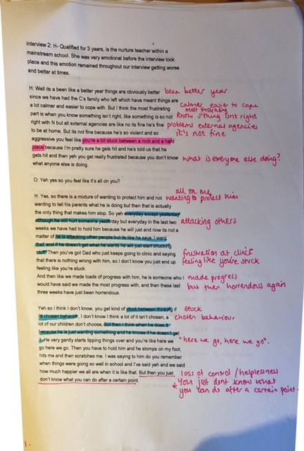

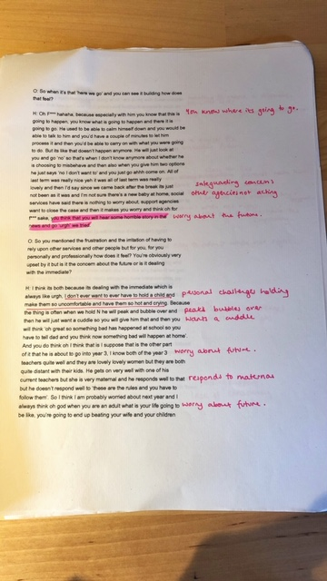

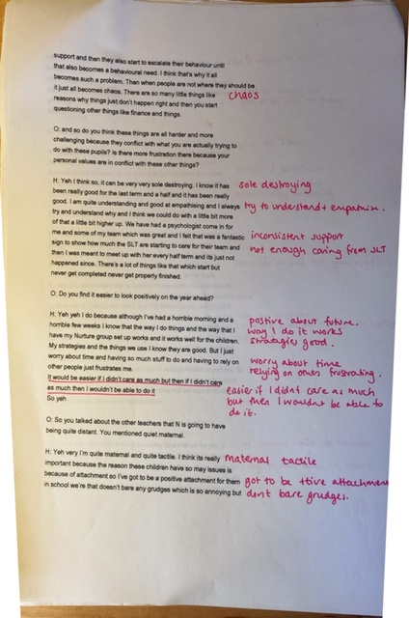

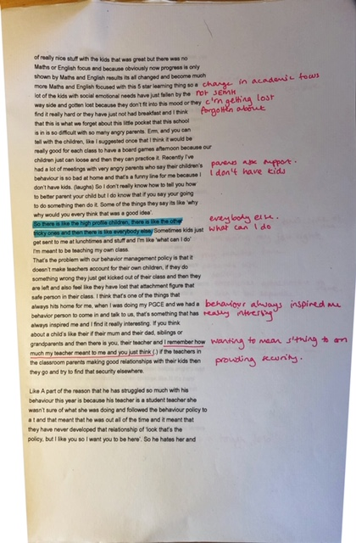

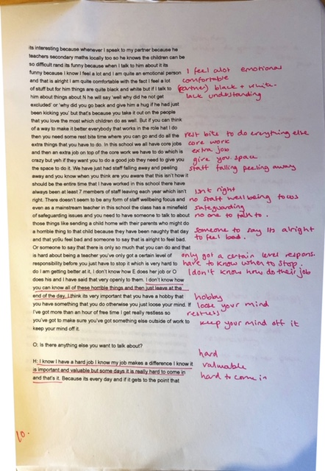
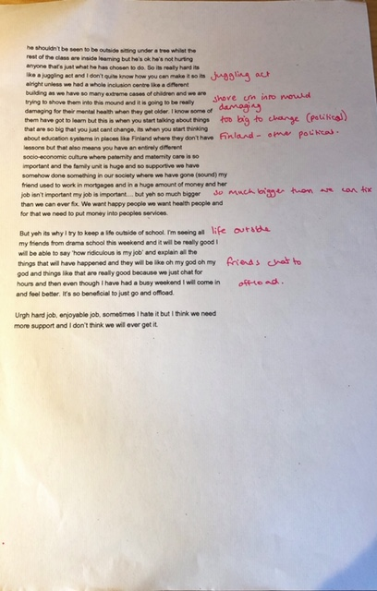

Appendix I- Bringing categories together
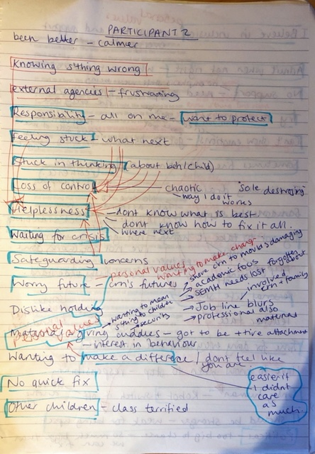
Appendix J- Examples of Focused Codes

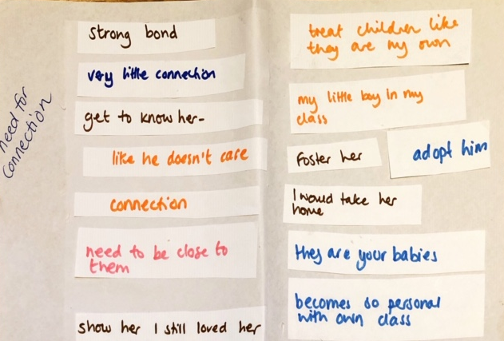

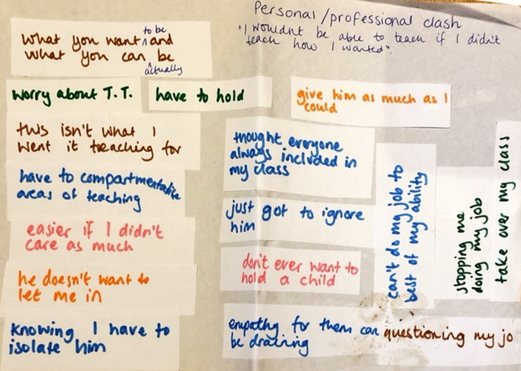

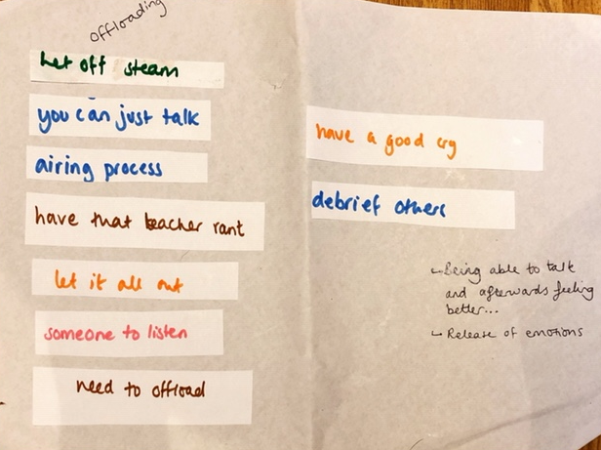

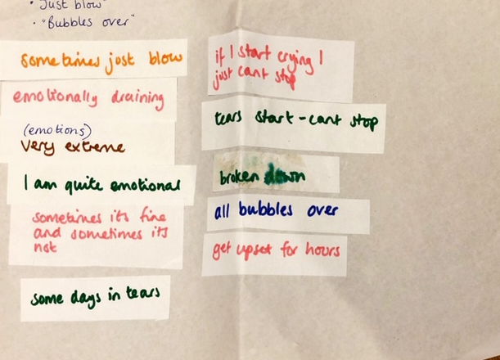

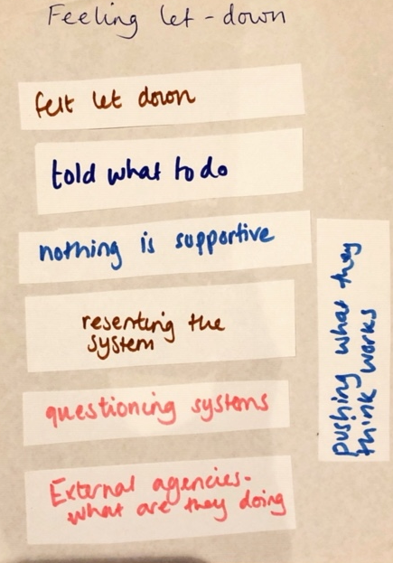
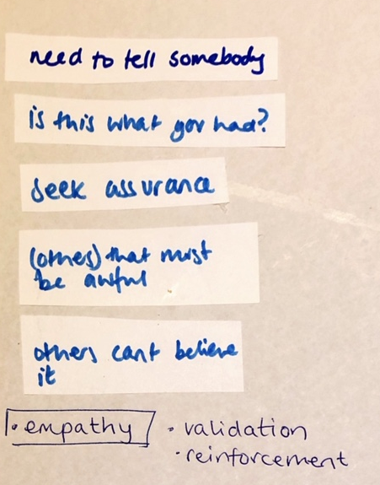
Appendix K: Focused codes developing into categories.
External Value and Validation

Feeling appreciated
Lacking validation of difficulties
Empathy towards difficulties
Feeling ‘let down’
Lacking Support
Feeling Supported
Challenges
Resources

Personal
Values
Professional
Values
Personal and Professional tension

Need for connection
Knock on effect

Managing the personal and professional tension

Boundaries around role

Emotional separation
Sense of acceptance

Resources
Challenges
Empowerment

Sense of achievement
“Feeling stuck”

“Having a plan”
“Doubting myself”

“Uncertainty”

Safe space for
sharing

Resources
Challenges

Offloading
“Holding it together”

“I should be able to cope”

Wider impacts on Wellbeing

Automatic mode

Appendix L: Examples of Developing Categories through sorting of quotes from the interviews with additional memo boxes to demonstrate deeper analysis and links to current theory or research.

Feeling Valued/ let down/ (under)-Appreciated/ Supported- Sense of value
Support from head teacher, good pastoral team
Lack of support from others in SEN team
More friends at work now… everyone is great and really cares
There doesn’t seem to be any focus on staff well-being
No-one is listening… no one is taking account of my feelings
in it together
No help from them (external agencies)
So many other people involved… but I don’t feel like I have had much involvement (not been invited to meetings etc- missed out)
Pushing what they (external professionals) think works
Its like a community… you come in the next day and people are like oh I heard that happened are you ok?
There can be a real lack of gratitude
Sometimes I think you can get more upset about the personal attacks towards you about dealing with them rather than their attacks towards you because you can kind of understand it.
We are a really good team any my colleagues are so supportive
you know you’re not the only one trying to deal with it
I didn’t feel supported
I just wanted to sit on my own in my classroom because others didn’t support me… That’s when I felt let down
Questioning systems
What were they (external agencies) doing
I, don’t think people outside of primary school realise and it was that I resented. The fact that I didn’t feel supported, I felt poorly, I felt stressed, I was going home with headaches couldn’t eat because I was too wound up, didn’t have lunch breaks, I just wanted to sit in my classroom on my own with no body speaking to me and that’s when I felt let down, that’s when I felt let down.
People in the high positions don’t realise the demands
No-body realises what is needed in school… I think the profile needs to be raised…

External validation of Difficulty
Educational psychologist said how much we were doing to try to help
People only see him when he is calm
You don’t know what he is really like in class
I just wish that people could come and spend a full day in class
I wish they could get a full picture
External validation
Other people realising how hard it must be- increases their sense of value and worth.
Someone to allow the teacher to understand that it is not all on them/ all their fault/ that it is ok that they cannot fix or support everyone.
You might not have fixed everything but for someone to tell you that you have helped in some ways.
They’d realise how difficult he is and how stressful it is
Everybody should have a chance to see what it is like
People who cover cannot believe it…. it makes you feel better because they understand what it is like
People say ‘I don’t know how you do that class everyday’
Someone to say its ok to feel bad
Someone to say there is only so much you can do
That is the hard part of teaching… you have only got a certain level of responsibility before you have to stop…but that is very hard to do…
I have said to O (safeguarding lead) “ I don’t know how you can know all these horrible things and then just leave at the end of the day”.
when you talk to people who aren’t teachers about it they just cant believe it and they are just kind of like of how do you deal with that and sometimes you feel like a bit of an idiot because you are like I really don’t know
when people are like ‘oh God that must have been awful’… it just makes you feel better
I think its just a matter of validation
…in teaching we all relish someone saying good job
I am busting my balls everyday here and its so stressful and youre like God I just want some recompense.
I want someone to say something… I want someone to say oh God that child is off the wall sometimes
You want everyone to know how hard it is
Some time, like, for us to talk and hear that it wasn’t acceptable
I do think it is really nice to have some validation
My husband was like ‘you’re not going to work for this’
My husband would say “I don’t know why you are putting yourself through it all anyway, you don’t go to work just to get hit”… cause they don’t understand teaching anyway…
People don’t realise quite how bad it is
I don’t think people realise on the surface…you just want someone to come and say let me have your class for 10 minutes go and get a coffee…
I don’t think people outside of primary school realise and it was that I resented
No-body realises what is needed in school… I think the profile needs to be raised…

I should be able to cope
Some days I have been in tears but you’ve just got to rain it in.
Containment- we are only human, we are not perfect- trying to give reasons for emotional strain…
You think…I shouldn’t be getting upset like this you’ve got a job to do
I just try to carry on
…we are only human…
We are not perfect
they (SLT) think why am I not managing.. I should be able to cope
Deal with it ‘professionally’- automatic mode
“When you are in school and an incident is happening and you do get attacked you find that you are very professional and its also as if like you are dealing with it automatically because this has got to be done”
I get upset for hours
If I am doing my job right then the don’t know that they have upset me
Stigmatism over coping- need for support to know that it is ok not to manage all of the time. Opportunities to offload to colleagues; need for a safe place for this?
“If I’m doing my job right then they don’t know that they have upset me and a lot of the time they don’t upset me. They should just see my teacher face and me managing it and letting them know that it is ok”…”I love my job most of the time when all the sh** doesn’t happen and that’s the version of someone they should see because I think they see a lot of anger and upset at home”.
They should just see my teacher face
I feel a lot
Someone to say that its alright to feel bad…
I know that I am only human and I know that I feel a lot and I like the fact that I do but its when you think that these kinds of days you just need a mental health day to just stop and relax
Its like now (gestures to the fact she has been crying) I know that I wont be in a good state to talk with anyone or deal with anything until the afternoon, I just need somewhere to escape.
Number of examples where level of attempt at containment has lead to mental health problems- traumatised, panic attacks, sleepless nights, time off work…
I feel like I should be stronger… I shouldn’t be getting upset like this… I am weak for getting upset…. but then I couldn’t show how much I care about the children.
Its probably the best and worst thing about being a teacher because you need to be able to show that and be human but that you also need to be able to be a robot and switch it off.
Somewhere to put all of your stuff
I never cry at work… then maybe it will all bubble over
I just try and keep it all contained and keep my game face on
Wider impact on well-being- ‘sole destroying’, ‘draining’, ‘saps energy’, ‘everyday feels like a week’, ‘need a mental health day’, ‘personal stress’, ‘worry’, panic attacks’, ‘going mad’
They should only see the other version- see my teacher face
I find it really hard too…sometimes I just go to them (colleagues) and have a really big cry
Some days are harder than others… we are only human and we all have emotions and feelings and so well you really cant be a robot about it… it can sometimes just blow and all be too much
…I've never really thought about it in terms of me, I’ve only ever thought about it in terms of her…
stressed with the classroom, stressed with the kids and trying not to show it..I’d have to try to deal with it and then go back to the kids with my game face on
I was quite upset and a bit traumatised
acting a clown
trying not to show it (stress)

“I was having a little problem with my breathing so, not full panic attacks but anxiety attacks so I sound that they came back… I’m trying all the techniques of deep breathing and making time for myself exercising running and I find that is helping with some of the stress”
Automatic mode- this is related to how teachers cope with the stress at the moment in time that it is happening… but entering into this also puts off entering into the emotions that they are feeling and also inhibits reflection…
When you are in school and an incident is happening and you do get attacked you find that you are very professional and its also as if like you are dealing with it automatically because this has got to be done”
“so you could be being spat at, hit, kicked and you sort of don’t realise what is happening to you”…”Then it is afterwards that you think… so you are just dealing with the situation as it is, but it sort of hits you afterwards”
“But its probably the best and worst thing about being a teacher because you need to be able to show that and be human but you also need to be able to be a robot and switch it off”
“You can go into auto-mode dealing with it but then we are only human and we all have emotions and feelings and so well really you cant be a robot about it, like it can sometimes just blow and all be too much” “Maybe sometimes you go into the robotic when you are dealing with a challenging situation or kick off, but you need to have the nurture and the human side too”
“After a while actually you kind of anesthetise yourself to it, you think they have suffered a lot” “I think I have just become numb to it… but then when it is your own class they are like your babies…”

Holding it together, but then it just bubbles over- on-going need for a safe-space for sharing and offloading troubles, peer supervision?
I should be dealing with it professionally
Holding it together for the team
You’ve got all the responsibility
“I am quite emotional, so some days I have been in tears, but you’ve got to rain that in because you’ve got to carry on for the sake of the other children in class and keep the team going, you’ve got to be positive because you’ve got the responsibility”
“Then you’re sat at home every night going over everything and reflecting on what you’ve done, could that situation have been avoided and, erm, it saps your energy and you’re tired and it seems like a vicious circle”.
“Sometimes if I have been really upset I have broken down and then I think, you shouldn’t be getting upset like this, you’ve got a job to do”
“If I’m going over everything sometimes the tears start and sometimes I just cant stop”
“and i think when you do team teach, I understand that afterwards you should have time out you should to just chat through when you’ve been doing positive handling and be able to talk to people but that’s not always possible because there is no one. Sometimes you have to because you are so upset thinking What you could have done differently and how are you feeling but i understand from team teach that time should be given because sometimes its really difficult to go back in there”
It’s all on me
keep it all contained… I never cry at work
I don’t think I have ever had that ‘teacher rant’ before
Everyone thinks you’re fine but inside you are crumbling
Pretending I was fine
‘game face’
‘teacher face’
“But I don’t think people realise on the surface when you’ve got your teacher face on and everyone thinks you’re doing a great job and coping really well but inside you’re crumbing and you just want someone to come and say let me have your class for 10 minutes go and get a cup of coffee so yeh”.

Appendix M: Additional quotes linking to codes and External Value and Validation category development

External Value and Validation | Participant 1 | Participant 2 | Participant 3 | Participant 4 | Participant 5
Lacking validation of difficulties | People only see him when he is calm  You don’t know what he is really like in class  I just wish that people could come and spend a full day in class  I wish they could get a full picture  They’d realise how difficult he is and how stressful it is | No one is taking account of my feelings | Some time, like, for us to talk and hear that it wasn’t acceptable  I do think it is really nice to have some validation | You can talk to other people but they don’t really get it properly | I, don’t think people outside of primary school realise and it was that I resented  My husband would say “I don’t know why you are putting yourself through it all anyway, you don’t go to work just to get hit”… cause they don’t understand teaching anyway…  People don’t realise quite how bad it is  I think the perception of these needy children and what their needs are and how much work has to go into that I think the profile needs to be raised.
Feeling let down | I understand that afterwards you should have time out you should to just chat through when you’ve been doing positive handling and be able to talk to people but that’s not always possible because there is no one | There doesn’t seem to be any focus on staff well-being  No-one is listening…  …all the external agencies are like no he's fine he's fine to be at home.. when I'm pretty sure he gets hit…  you get really frustrated because you don’t know what anyone else is doing | …so many other adults involved… I don’t feel like I have the most involvement…it should all come from the teacher...they’ve not spent the most time with him… | its so heartbreaking and frustrating all the hard work that we do just goes out of the window, I find it so annoying | Questioning systems  What were they (external agencies) doing  The fact that I didn’t feel supported, I felt poorly, I felt stressed, I was going home with headaches couldn’t eat because I was too wound up, didn’t have lunch breaks, I just wanted to sit in my classroom on my own with no body speaking to me and that’s when I felt let down, that’s when I felt let down.
Feeling appreciated | “Educational psychologist said how much we were doing to try to help” | “parents really rely on my support and advice”  “working together”  “feeling appreciated” | I think its just a matter of validation  …in teaching we all relish someone saying good job  I am busting my balls everyday here and its so stressful and youre like God I just want some recompense.  there can be a real lack of gratitude  I do think though it is really nice to have some validation, it does sound really needy and really lame, but it is good when someone is like wow that is really difficult and you have done really well. | SLT felt he would benefit from having a fresh start in my class… I'm the lucky one… I have a reputation for dealing with the difficult kids… they all get sent to me | The principle would always come and make sure I was alright
Feeling Supported | “I am really fortunate because I have a really good team”  “My head is really supportive and he will come and get him with the positive handling and the deputy head and so I feel we have got that support”  Support from head teacher, good pastoral team  **“not always consistent” | More friends at work now…  everyone is great and really cares  in it together  we had a psychologist come in for me and some of my team which was great… it was a fantastic sign that SLT were starting to care for their team… **but then its just not happened since  **it feels like everything is going to s*** and she (HT) is pretending everything is fine so we are the ones having to deal with it all  There doesn’t seem to be any focus on staff wellbeing  minefield of safeguarding issues and no one to talk to  I’ve spoken to HT about it before but then I was just left in an office and I felt like no one was taking account of any of my feelings or listening to me and it felt horrible.  I do feel like I’ve got more friends at work now which is great. Everyone here is great and really cares. Some of them are really proactive and take on things to help and have initiative. | Its like a community thing…everyone comes in and says well done  a lot of it does depend on how others react  sometimes they can be brought back in and you are just not ready…I think we needed more time to recover** | We are a really good team any my colleagues are so supportive  you know you’re not the only one trying to deal with it  my school had a school psychologist for a while | I just wanted to sit on my own in my classroom because others didn’t support me…  I don’t think people realise on the surface…you just want someone to come and say let me have your class for 10 minutes go and get a coffee…  not supported by the school, not supported by the systems
Empathy towards difficulties | People who come in and cover for me they’ll just say I cant believe it, I don’t know how you do it day in and day out  It does make me feel a bit better because i think well obviously they understand what it is like you know yeh | Someone to say its ok to feel bad  Someone to say there is only so much you can do  That is the hard part of teaching… you have only got a certain level of responsibility before you have to stop…but that is very hard to do…  I have said to O (safeguarding lead) “ I don’t know how you can know all these horrible things and then just leave at the end of the day”. | when you talk to people who aren’t teachers about it they just cant believe it… they are just kind of like of how do you deal with that … you are like I really don’t know  when people are like ‘oh God that must have been awful’… it just makes you feel better  I want someone to say something… I want someone to say oh God that child is off the wall sometimes  You want everyone to know how hard it is |  | I don’t think people realise the demands  I felt poorly, I felt stressed, I was going home with headaches couldn’t eat because I was too wound up, didn’t have lunch breaks, I just wanted to sit in my classroom on my own with no body speaking to me

Appendix N: Quotes linking to codes and safe space for sharing category development
Safe space for sharing | Participant 1 | Participant 2 | Participant 3 | Participant 4 | Participant 5
Holding it together | I should be dealing with it professionally  Holding it together for the team  You’ve got all the responsibility  “I am quite emotional, so some days I have been in tears, but you’ve got to rain that in because you’ve got to carry on for the sake of the other children in class and keep the team going, you’ve got to be positive because you’ve got the responsibility”  “Then you’re sat at home every night going over everything and reflecting on what you’ve done, could that situation have been avoided and, erm, it saps your energy and you’re tired and it seems like a vicious circle”.  “Sometimes if I have been really upset I have broken down and then I think, you shouldn’t be getting upset like this, you’ve got a job to do”  “If I’m going over everything sometimes the tears start and sometimes I just cant stop”  “and i think when you do team teach, I understand that afterwards you should have time out you should to just chat through when you’ve been doing positive handling and be able to talk to people but that’s not always possible because there is no one. Sometimes you have to because you are so upset thinking What you could have done differently and how are you feeling but i understand from team teach that time should be given because sometimes its really difficult to go back in there” | It’s all on me  Its probably the best and worst thing about being a teacher because you need to be able to show that and be human but that you also need to be able to be a robot and switch it off. | keep it all contained…  I never cry at work  But I just try and keep it all contained and keep my game face on  But I think sometimes you like internalise it | Some days are always harder than others too. Like if one day you are just not up to it maybe you’ve not slept well or well, hormones  well really you cant be a robot about it like it can sometimes just blow and all be too much | I don’t think I have ever had that ‘teacher rant’ before  Everyone thinks you’re fine but inside you are crumbling  Pretending I was fine  ‘game face’  ‘teacher face’  “But I don’t think people realise on the surface when you’ve got your teacher face on and everyone thinks you’re doing a great job and coping really well but inside you’re crumbing and you just want someone to come and say let me have your class for 10 minutes go and get a cup of coffee so yeh”.
I should be able to cope | Some days I have been in tears but you’ve just got to rain it in.  You think…I shouldn’t be getting upset like this you’ve got a job to do  I just try to carry on  …we are only human…  We are not perfect  they (SLT) think why am I not managing.. I should be able to cope  Deal with it ‘professionally’- automatic mode  “When you are in school and an incident is happening and you do get attacked you find that you are very professional and its also as if like you are dealing with it automatically because this has got to be done” | I get upset for hours  If I am doing my job right then the don’t know that they have upset me  “If I’m doing my job right then they don’t know that they have upset me and a lot of the time they don’t upset me. They should just see my teacher face and me managing it and letting them know that it is ok”…”I love my job most of the time when all the sh** doesn’t happen and that’s the version of someone they should see because I think they see a lot of anger and upset at home”.  They should just see my teacher face  I feel a lot  Someone to say that its alright to feel bad…  I know that I am only human and I know that I feel a lot and I like the fact that I do but its when you think that these kinds of days you just need a mental health day to just stop and relax  Its like now…I know that I wont be in a good state to talk with anyone or deal with anything until the afternoon, I just need somewhere to escape.  I feel like I should be stronger… I shouldn’t be getting upset like this… I am weak for getting upset…. but then I couldn’t show how much I care about the children.  Somewhere to put all of your stuff | I never cry at work… then maybe it will all bubble over  I just try and keep it all contained and keep my game face on  They should only see the other version- see my teacher face | I find it really hard too…sometimes I just go to them (colleagues) and have a really big cry  Some days are harder than others… we are only human and we all have emotions and feelings and… it can sometimes just blow and all be too much | …I've never really thought about it in terms of me, I’ve only ever thought about it in terms of her…  stressed with the classroom, stressed with the kids and trying not to show it..I’d have to try to deal with it and then go back to the kids with my game face on  I was quite upset and a bit traumatised  acting a clown  trying not to show it (stress)
Automatic mode | When you are in school and an incident is happening and you do get attacked you find that you are very professional and its also as if like you are dealing with it automatically because this has got to be done”  “so you could be being spat at, hit, kicked and you sort of don’t realise what is happening to you”…”Then it is afterwards that you think… so you are just dealing with the situation as it is, but it sort of hits you afterwards” | “But its probably the best and worst thing about being a teacher because you need to be able to show that and be human but you also need to be able to be a robot and switch it off” | “After a while actually you kind of anesthetise yourself to it, you think they have suffered a lot” “I think I have just become numb to it… but then when it is your own class they are like your babies…” | “You can go into auto-mode dealing with it but then we are only human and we all have emotions and feelings and so well really you cant be a robot about it, like it can sometimes just blow and all be too much” “Maybe sometimes you go into the robotic when you are dealing with a challenging situation or kick off, but you need to have the nurture and the human side too” | But obviously and then kids would start to realise and id have to try to deal with it and then go back to the kids with my teacher face and ‘right then’, ‘lets carry on with what we were doing’  I don’t think people realise on the surface when you’ve got your teacher face on and everyone thinks you’re doing a great job and coping really well
Wider impacts on mental health | I’ve had some personal stress  “I was having a little problem with my breathing so, not full panic attacks but anxiety attacks so I sound that they came back… I’m trying all the techniques of deep breathing and making time for myself exercising running and I find that is helping with some of the stress”  i really must calm down because if I don’t calm down when i first go home, if I don’t de stress, i am going to take it with me to bed and then have a sleepless night and its very hard to switch off  when every day then everyday feels like a week. | it can be very very sole destroying  There doesn’t seem to be any form of staff wellbeing focus and even as a mainstream teacher in this school the class has a minefield of safeguarding issues  Are when somebody needs a mental health day to just stop to not go into work to sleep to relax | You know when you are like, what, I cant comprehend this  I don’t know you feel like a piece of shit sometimes because you are like what have you helped him with  But I think sometimes you like internalise it | Don’t get me wrong I find it really hard too… I just go to them and have a really big cry | I felt poorly, I felt stressed, I was going home with headaches couldn’t eat because I was too wound up, didn’t have lunch breaks, I just wanted to sit in my classroom on my own with no body speaking to me
Offloading | I understand that afterwards you should have time out you should to just chat through when you’ve been doing positive handling and be able to talk to people…  Sometimes you have to because you are so upset thinking What you could have done differently and how are you feeling  even if its talking to some one from senior leadership about how you are feeling or a colleague that has been in there with you. You are just sort of getting everything back to reality on your head and just thinking…  You’re talking it through it and saying I don’t think we could have done anything different, then that gives you some piece of mind that you did your very best. | You need to have someone to talk to about these things, like sending a child home with their parents who might do a horrible thing to that child because they have been naughty that day…  I’ve spoken to the head teacher about it before but then I was just left in an office and I felt like no one was taking account of any of my feelings or listening to me and it felt horrible.  “I’m seeing all my friends from drama school this weekend and it will be really good I will be able to say ‘how ridiculous is my job’ and explain all the things that will have happened and they will be like ‘oh my god oh my god’ and things like that are really good because we just chat for hours and then even though I have had a busy weekend I will come in and feel better… It’s so beneficial to just go and offload” | I think it all becomes a bit more refreshing because its like a community thing where you know everyone comes in the next day and they are like ‘oh I heard that that happened well done’ (laughs) but at the time I felt like the most fumbling you know just idiot and you’re like oh what did I say. | “Don’t get me wrong I find it really hard too. We are a really good team and my colleagues are so supportive sometimes I just go to them and have a really big cry”. | “People don’t realise quite how bad it is…”  “I don’t think people realise on the surface when you’ve got your teacher face on and everyone thinks you’re doing a great job and coping really well but inside you’re crumbling and you just want someone to come and say let me have your class for 10 minutes and go and get a coffee”  “I don’t think I have ever had that teacher rant before about the systems and things”

Appendix O: Quotes linking to codes and personal professional tension category development

Personal and Professional Tension | Participant 1 | Participant 2 | Participant 3 | Participant 4 | Participant 5
Personal Values | “I have been enjoying working with challenging behaviour for a long time”, “I want him to feel happy and safe”. | “Personal interest”, “Doing it to help them”, “I believe in inclusion”, “how much my teachers used to mean to me”, “behaviour has always inspired me”, “I remember how much my teacher used to mean to me”. | “they spark more interest”, “I want to solve them”, “trying to sort the difficult ones”. | “interest in psychology”, “always been what I wanted to do”, “natural nurturer”, “enjoy working with challenging pupils”, “the children know I want to be there for them”. | “passionate about SEN”, “good teachers care”.
Need for Connection |  | “I think that if you think about a child’s life they have their mum, their dad, their grandparents and then there is you, their teacher and I remember how much my teacher meant to me…” | “With a lot of the challenging children you have a sense of pride in your relationships with them”  “I’d have so much love for him… I’d go home and I would be constantly thinking about him”  “And this year for my challenging ones when you hear stories like oh he had cancer you cant think too much about that and you know and I think when you know a bit more safeguarding history as well you know when its attached to a highly challenging child then you know they act this way because of this. But you know its really difficult…”- trying to distance her connection from the boy… this teacher said that this was something she found very difficult to do last year and this is something she is trying to work on more this year but still finding hard… she related this to also having to anesthetise herself to their problems….  “But when its your own class they are your babies and when they make a disclosure to you or something like that you’re like, you want to be like right I want to adopt this kid I’m going to adopt them right now. I don’t know you feel like there is a lot of investment in your class but you kind of have to keep drawing so may different lines in the sand” teacher making attempts at ‘drawing lines in the sand’ and creating boundaries but still finding it hard… “Like you cant think there’s this boy in year three that I really like and I’ve always said if he goes up for fostering then I’m taking him….you know but you kind of have to ignore them because they probably have loads of things going on with their class teacher…  I don’t know I feel like I always want to try to sort all the really difficult ones and I feel like its hard seeing them with other people. …I don’t know you just want to like cradle them all and look after them...I don’t know I was never a maternal person before I became a class teacher but I actually feel like they are the ones that actually spark a lot of interest in me”.  “I probably do love the ones who are so painfully heartbreaking more”  “I think its hard because you really want them to love you and you really want that relationship with tem but then you are also like raah I just messed with all my systems an it was all for my own need because I really wanted to just be extra nice with them today”.  I don’t know I was never a maternal person before I became a class teacher | I think that he also, you know, doesn’t want to let me in so I guess maybe him resisting makes it a bit harder because I feel like he doesn’t [pause] I guess I feel like he doesn’t want to have that connection with me, yeh like he just doesn’t care.  When talking about what make it easier to manage the challenging behaviour…”by being a mum. Then treating all the children like they are mine and like I don’t want this to sound all wishey washey, but I think I am a very natural mum and a natural nurturer”. | “We have built a very very strong close relationship and it is going to make it so hard for us both to move on”  “I realised that I had sort of tapped into her…and I needed to show her that after those incidents that I still, I tell her I love her, I mean its not going to harm, I think I do love my class”  Question- Do you feel that is part of your teaching role? “Exactly they are like your family and then you hand them back…”  I felt like I knew her and we did have that bond together  “I have said so many times I just wish I she could come home with me… I’d say all the time if she did get taken into care that I would have her straight away… but them when you are in the car o the way home and you can feel the school umbilical chord going away and you start to think about your own family in those moments…”
Professional Values | “Planning disrupted”, “so much differentiation”, “challenging the most capable”, “Children not making the progress”  “All the planning that I am doing goes out of the window, so I put a lot of work in a lot of work preparing resources and because all the learning is disrupted so much, its frustrating” | “Having extra jobs to do”, “my other roles in school”, “time pressure”, “job lines blur”. | “Professionally I am a year 6 teacher”, “I have got to teach”, “children making progress”. |  | “At the start of the year you have got to get the classroom sorted”, “got to get the children where you want them, “focus on the class routines and expectations and things”.
Knock on Effect | Worried about their safety  Keeping them calm  “Other children are scared”  “Other children to cope with”  “Usually one of the teaching assistants will take him but that’s a knock on effect because the other children need support as well and miss out and need the support.”  “…And I’ve got all the other children and the other children are seeing that and sometimes they are scared and sometimes they say are you alright Miss S and that that well that upsets me because I think they shouldn’t be seeing that”  “The worry has been for the other children in the class because I’ve got 9 children with very complex needs with physical and medical difficulties, as I have said, and the effect that it is having on those children is a big worry to me as well, because I’m worried for their safety, I’m worried that they are not making the progress that they should be making in a more calmer environment” | “His class are terrified of him, the parents hate him and I just don’t know what the best thing for him anymore would be”  “He just takes up all my time” | “You think that if that was you in that situation you’d feel so bad for the child but it can really emotionally drain like the whole class”.  “I think also because I know how much he has drained my class over the years. I think that also can kind of upset when for 5 minutes he trashed the classroom and they are all scared and they have to like, they are used to his volatile outbursts. I think they are on edge when you know they could do something because he has hurt a lot of them, he’s also kicked a lot of teachers”.  “You are the protector of everyone else”  “I think because I'm always scared for everyone else because he could do something. Its almost like us against him. Its got to be like right well then you’re the protector of everyone else then and I think when you have to assume that once, then you kind of always go to that mode”. | “Nasty to the other children” | “There were other needs in the class that were quite heavy time scale wise too”
Personal and Professional Tension | I worry about team teach  I never want to have to hold because I worry about the hurt I am causing  We are not perfect, we have to consider everyone  “I worry that he gets vibes from me, for that you know you try not to but like I say we are not perfect we are human and you are considering everybody in the class”.  “How do I get everything back to an even keel again and get everyone back to what they should be doing”  When talking about their relationship… “I try to be professional. I try to, you know, make sure that he is ok when he is engaging lots and lots of praise, I try to give him quality time on his own, with me or another member of staff and I know that is what he likes one to one attention on his own but we can always give that”- | “I don’t ever want to have to hold a child and make them so uncomfortable and have them so hot and crying”  “The main reason I am doing what I am doing with these children is so they don’t end up in prison and hurting someone in such an extreme way, but then you have days where you think you are just not sure whether you are making any difference”  “It would be easier if I didn’t care as much, but then if I didn’t care as much I wouldn’t be able to do it”  “I think my job lines blur because I've got to follow the rules and be professional but I’ve also got to be quite maternal and quite caring, not unprofessional but you get more involved”  …”I remember how much my teacher meant to me and you just think…”  “I believe in inclusion and I believe in that we should try and support as many people as possible here but part of me sometimes you’ve got to admit when what we are doing just isn’t right or you don’t feel like you have the capacity to deal with certain children” | You have to compartmentalise areas of teaching  I thought everyone would always be included in my class…knowing I have to isolate him  Feeling like I have just got to ignore him  Empathy for them can be draining  Stopping me from doing my job to the best of my ability- have to be utilitarian and think about the greatest good for the rest of the class. I never thought I would have to do that.  I feel like I want to sort all of the difficult ones… want to cradle them and look after them.  “It is so much more impactful when you know they used to throw tables and now they are actually sat passing a glue stick and saying thank you…its so rewarding…I would never want to leave here for that reason”  “It feels like such a personal battle because you think oh all the nine months I have put in with you, I sat with him, I sweated for him”  “But I also think its because I cant teach him because he’s so he should be in a special school and so I think because I cant do my job to the best of my ability when its just me and there’s 30 of them…. and its just like ah… maybe if its just you and me maybe we could make like a big bond but its not. I don’t know I think its also a bit utilitarian greatest good for the rest of the class and that’s where that kind of numbness lies”. | I’m really interested in the psychology behind it all and I guess I do like working with these challenging children the most because it is always just, so rewarding, but then also super frustrating when you know what they are going home to, that’s the most heart-breaking part.  I know I can just close the classroom door and I well, I know what I want my classroom to be like. Confidence coming from being able to teach the way she wants to. She spoke about closing the door on the challenges in the wider school.  When talking about the personal and professional clash… “Oh mine matches completely, I would never be able to teach if I didn’t teach how I wanted to and so I'm lucky really…. I think that’s the thing for me this has always been what I have wanted to do, so its frustrating when it doesn’t work out how you want it to but then you just have well you jus have to keep trying and follow what you really believe. I guess that’s it really”.  “… I also actually had to send him out in a P.E lesson once which I really didn’t want to do” Participant 4  “I’ve got the nurture, the consistency, the boundaries… but don’t get me wrong I find it really hard too… sometimes I just go to them and have a really big cry… I guess I always worry that there is more that I could do”  Then it’s so heartbreaking and very frustrating all the work we do just goes out of the window. | What you want to be and what you can actually be  This isn’t what I went into teaching for  “I feel emotional the fact and I can see how a teacher can have an impact on not just your learning but your life really. I’d never ever really considered it; it’s giving me goose pimples just talking about it”.  “So at first I was a little bit, I don’t want to say resentful, but it was a little bit of a question like what is teaching these days because I literally cannot do it, I cannot do this job, I’m not capable of this.”  I went into teaching later because it was all I wanted to do but my life took a different course and I was just about to turn 30 and my husband persuaded me to go and do my teaching and I love it but that made me question what it was all about for that period of time. it really did but no, back to loving it yeh its tough but throw something like that into the mix people don’t realise quite how bad it is.

Appendix P: Quotes linking to codes and empowerment category development

Empowerment | Participant 1 | Participant 2 | Participant 3 | Participant 4 | Participant 5
Feeling Stuck | You’re thinking is there more I could be doing  I’m not doing the things I should be doing  Don’t have the capacity to help  We are only human- (there is only so much we can do)  His home life is difficult  We’ve not got a magic wand have we | You end up feeling like you’re stuck  you’re a bit stuck between a rock and a hard place  stuck between thinking if its chosen behaviour  You don’t know what you can do after a certain point  Where do you go after a certain point.. I don’t know where to go or what to do with him  “Sometimes kids get sent to me at lunch and I am like ‘what am I supposed to do’?. | If only it was just me and him  But I also think its because I cant teach him because he’s so he should be in a special school and so I think because I cant do my job to the best of my ability when its just me and there’s 30 of them  I always want to pull him in but sometimes I just cant  “I always just want to pull him in but I can’t and there’s not really any way to that so its just kind of watching it play out and you just feel so helpless and futile…There’s nothing that you’re doing that is supportive so its just like well we are failing each other here aren’t we really not helpful”…  You feel like a clown watching it play out  You think personally am I healing anything  Am I minimising anything or am I just a body in the room  I don’t know what my impact can be  home-life difficult  he has got additional needs so he doesn’t understand  Not able to get to the root of why | I actually had to send him out in P.E once which I really didn’t want to do.  I think I’m starting to get there now but I still haven’t got that proper relationship.  He doesn’t want to let me in so it makes it a bit harder  Don’t get me wrong… I find it really hard to… | I was literally like I cant manage this  I cannot do this job  What next
Doubting myself | I was off for a while… that was not a good start  You doubt yourself  I shouldn’t let a 7 year old take over my class  You just doubt yourself  You’re thinking it through and saying I don’t think we could have done anything differently…. give you peace of mind that you did your very best  “I worry for the child because I, you doubt yourself, you’re thinking there must be something more I can do, I’m not doing all the things I should be doing, I shouldn’t let a 7 year old child more or less be overtaking the class and stopping me doing what needs to be done”. | Just not sure whether you are making any difference  I don’t know how to fix it  Sometimes I am just like ‘what can I do’?  You have days where you just think you are just not making any difference at all you are just so not sure whether you are making any difference. | Maybe they did that and my response was not right  Somebody else might have dealt with it better  You feel like a failure  We are failing each other | I guess I always worry that there is more I could do…  I always think is it me- have I messed up there | I was not as confident  I just had to put on a performance  I’m just a primary school teacher- not a specialist teacher
Uncertainty | “It is as if you are walking on eggshells because you just never know what to expect”  “You’ve got a dread you just never know what the day is going to bring”  “Apprehensive for the day wondering what is going to happen” | You think that you will hear some horrible story in the future in the news and go ‘urgh’ we tried.  I am worried about next year and I always think of god when you are an adult what is your life going to be like?.. | I think maybe its also because I’m used to them a bit older and I’m used to a bit more of a higher level of communication from them that I find it difficult maybe- additional information/ support/ don’t know how to manage  But there is still a lot of I don’t know you see things as just like oh I need to solve that, I need to solve that and you make like lots of lists and plans and strategies and I think sometimes like the unpredictability of just children you can still be like blown away.  You might still be right and still have done it how you would have always done it and they might still flip out…. sometimes you’re asked ‘oh what did you do differently with that child that made them erupt’ and you are like ‘nothing I followed every letter to the law and I did exactly what I always do and they were not responsive’ and I think that when there is like that element of blame you’re like its your reaction that made them erupt you’re the cause of this.  “I do feel like you are constantly walking a tightrope in terms of too much love or not enough, too much positivity or not enough, too much firmness or not enough. I don’t know. | “But then I always worry that there is more that I could do…” | It was intriguing seeing what was going to unfold but it was also quite frightening  It was like a whirlwind
Having a plan | “Could I have avoided it, what could I do next time…” (wanting a plan)  “We’ve had lots of strategies in place we’ve tried lots of different things that work for a short time and then stop working pause erm and the educational psychologist that we have spoken to and that has been in to give us some support she said you are doing everything there is nothing really that she could suggest to do any different so you feel like I’ve just got to get on with this.” | “I was an actor before and I just sort of fell up this ladder and so I am quite open to saying look I don’t know and I think you know more so if you do then please just tell me about it and help me and I want to learn more”  I am open to saying look I don’t know and I think you know more so if you do then please just tell me about it and help me I want to learn more. | “I don’t know I think personally I like to feel in control of all these situations and like I can no matter what crisis will happen that I can be there for the other kids to sort of like minimise it but sometimes you just think am I minimising anything or am I just a body in the room”.  But there is still a lot of I don’t know you see things as just like oh I need to solve that, I need to solve that and you make like lots of lists and plans and strategies | “So for him it was like build a good relationship and then bang bang bang firmness let him know my rules and expectations and then be really consistent and firm with him but it was always about making that relationship and connection first, you know, that’s the most important thing for me with these kids” Confident about her approach  “I have spent a lot of time researching attachment and learning about theories…”  “I can build that relationship with them. Well, I've got the nurture, the consistency, the boundaries… I don’t take messing…” | We’ve just developed all sorts of silly strategies over the year because I have not to know her.  “it was like a whirlwind but then after id had the break at Christmas and we came back erm and then it was a really bad patch that was when all the exclusions were, but I felt more able to deal with it and I’d built up some strategies and id done some reading over Christmas”  “It was a crash course in the world of SEN”  I’ve developed some of the strategies I have used. Its made me research the Boxall system and I’ve got other children that will benefit from that. I feel like I've been at Bootcamp.
Sense of achievement | Less of a sense of achievement in this situation perhaps because the teacher stressed a lot that wasn’t working, she felt very unable to cope and had the worst mental health of all the participants interviewed.  The boy she was talking about also left half way through the year to go o a specialist provision so there may have also been a sense of failure with him or just less opportunity to make progress and feel the rewards and benefits. | I know that the way that I have my group works and it works well for the children. My strategies and things we use I know they are good | You are like no, I’ve got it- I cracked that kid- Lots of confidence- no doubt  When you’ve got them where you want them  I survived it, that’s another skill in my set  “I think the first time it’s like a bit… but then you are like right I’ve survived that, that’s another skill in my set, something I can pull out the next time. I don’t think its had a negative effect on me at all”.  Its so much more impactful when you know they used to throw tables and now they are actually sat passing a glue stick and they say thank you and stuff, its so rewarding.  I used to be a lot more of a panicked person… But now I don’t get flustered. I think now my confidence in many ways of like has been better I’m just like ‘ok alright I’ve dealt with this its fine’  I don’t know I do feel like in general teaching can make you a lot more competent in many ways of dealing with lots of things and I think that’s kind of like why I do really really enjoy teaching because it makes your more life efficient | I guess I've just got something- confidence in own abilities  I have a reputation for dealing with the difficult kids  I don’t take any messing  Kids see me and then they just crumble  “I guess I've just got something in me that connects me with these kids” | Its been one of the biggest successes of my career- it will always stand out  I’d tapped into her  Its enhanced my practice  I have learnt so much, so many strategies  I am so much more resilient now  I’ve been bumped about and come out the other side more shiny  I felt like I could read her  Its definitely enhanced my practice because I’ve had to try so many things out and had to have so many thinks that haven’t worked so I have become more resilient.  it was a very very tough time we’ve gone full circle where I am literally gutted that I’ve got to leave her  yeah I’m really really pleased with her she’s done so well she really has-  Its been its been one of the successes id say I’ve had during my career because it was so so extreme it stands out form a lot of other things I’ve done so very rewarding very rewarding as teaching goes if you can see a difference like that that’s very rewarding.

Appendix Q: Concept map demonstrating the categories linking together to form the model of supervision.

External Value and Validation

Personal
Professional

Boundaries around role

Emotional separation
Sense of acceptance

Empowerment

Safe space for sharing

Appendix R: Concept map showing the proposed model of supervision

