DEVELOPMENT OF WORKPLACE-BASED ASSESSMENTS FOR SURGICAL AND ENDOVASCULAR PROCEDURES

By Dr Anup V Mathew MBBS MRCS FRCR
Being a thesis submitted for a Master of Philosophy (M Phil)
From the University of Sheffield

Submitted February 2019

Word Count: 13,095
(excluding References and Appendices)

Student:

Dr Anup V Mathew

3 Shearwater Drive

Preston

PR2 9AX

UK

Supervisors:

1. Prof Jonathan D Beard

Consultant Vascular Surgeon and Honorary Professor of Surgical Education, University of Sheffield

Sheffield Vascular Institute

Northern General Hospital

Sheffield

S5 7AU

2. Prof Malcolm W.R. Reed

Dean and Professor of Surgical Oncology

BSMS Teaching Building, University of Sussex

Falmer

Brighton

BN1 9PX

Table of contents

Abstract..................................................................................................... 5

Acknowledgements................................................................................... 7

Author's declaration................................................................................ 8

Dissemination of work............................................................................. 9

List of Tables and Illustrations............................................................. 10

List of Abbreviations................................................................................ 12

Chapter 1: Introduction, Background and Literature-review................ 13

Chapter 2: An evaluation of the use of Surgical DOPS in the Intercollegiate Surgical Curriculum Programme (ISCP).................. 27

Aims
Methodology
Results
Discussion
Chapter 3: Workplace-based assessments for endovascular procedures.............................................................................................. 38

Aims
Methodology
Statistical analysis
Participants
Project plan and management
Project progress till date/results

Chapter 4: IR-PBA workshop, Royal College of Radiologists.......... 57
Chapter 5: Analysis of Interventional Radiology PBAs in current practice................................................................................................... 62
Chapter 6: Future work and further development of IR-PBAs.............. 77

References.................................................................................................... 74

Appendices.................................................................................................... 80

Abstract:

Aims:
Workplace based assessments (WBAs) are methods used in medical training to assess those aspects of real day-to-day performance that a remote-controlled assessment of competence cannot assess.
The aims of the project were
- to develop the existing Surgical- Direct Observation of Procedural Skills (S-DOPS) tool.
- to develop WBAs for endovascular procedures from existing Procedure-based assessments (PBAs) for surgical procedures.

Methods:

1: Data on S-DOPS for one year (2007-08) were extracted and analysed. A new version based on existing PBAs was designed and trialled. Analysis of data on S-DOPS for 2010-11 was undertaken to assess if the changes made had resulted in better utilisation of the tool.

2: Endovascular procedures performed by consultants were observed and analysed by a group of vascular radiologists and surgeons to identify and agree the task-specific and global domains. Procedure-based assessments are WBAs which rate a combination of task-based and global competencies, together with a summary judgement about the competence of the trainees to perform that procedure. The PBAs were created and piloted by the consultants. Assessments of trainees performing endovascular procedures were undertaken.
Results:
1: There was increased uptake of the new version of S-DOPS (2010-11), with more number of trainees completing a higher number of S-DOPS. There was good correlation between the level of training and the S-DOPS score (higher level trainees achieved higher mean scores).
2: Limited sample numbers made it difficult to draw any statistically significant conclusions on validity and reliability. However, qualitative analysis suggests that endovascular PBAs appear to be acceptable and feasible, and trainers and trainees find them educationally useful.

Conclusions:
1: The absence of ratings below 4 and the low number per trainee (2007-08) suggest that DOPS was used only when trainees felt able to meet expectations and that assessors might be confused by the norm-based scale. The new S-DOPS form (2010-11) has criterion-based ratings and more space for recording feedback. Both assessors and trainees seem more satisfied with the new form. Criterion-based ratings seem more acceptable and confers improved construct validity to the S-DOPS tool.
2: Endovascular PBAs have been incorporated into the RCR e-portfolio and are used by IR trainees. Similar PBAs have been designed for non-vascular IR procedures, and together with endovascular PBAs are collectively called IR-PBAs.

Acknowledgments:

I would like to dedicate this thesis to my son Reuben (born in July 2012), my daughter Ivana (born in December 2018) and my wife Neena (who has let me pursue my professional and academic aspirations, and who has provided unrelenting support along the way).

I would like to thank Prof Beard (JB) for his constant encouragement, invaluable knowledge, and boundless patience. He has created many opportunities for me through this project including presentations, papers and conference-workshops (almost making me believe that I am an expert in the field!). I am grateful to him for introducing me to Interventional Radiology through this project, and for supporting my decision to pursue it as a career.

I would like to thank Prof Reed who has always been encouraging, and am grateful to him for standing by me during difficult personal circumstances in September 2010.

I acknowledge the help provided by Prof Jim Crossley with the statistical aspects of this thesis, in particular, with the complex world of generalisability theory.

I thank Joe Booth (Executive Director, Education, RCR) for the tremendous help with this project from the start, and with obtaining data from RCR.

Thanks also to Maria Bussey (Head of ISCP) for help with data on S-DOPS from the RCS England.

Last, but certainly not least, a very big Thank you to my parents whose prayers, blessings and good wishes have been, and will be, with me throughout, wherever I am, and will be. Thank you for pushing me to realise my potential.

Author's Declaration

I confirm that this work is original and that any passage(s) or diagram(s) copied from academic papers, books, the internet or any other sources have been identified by the use of quotation marks and the reference(s) cited. I also confirm that this is

my own work. I again acknowledge the significant help and contribution towards statistical analysis by Prof Jim Crossley (Consultant Paediatrician and Professor in Medical Education, the University of Sheffield).

No part of this thesis has been submitted for any award or degree at any other institute.

Dissemination of Work

Publication:
Mathew A, Beard JD, Bussey M. 'An evaluation of the use of Direct Observation of Procedural Skills in the UK Intercollegiate Surgical Curriculum Programme' Ann R Coll Surg Engl (Suppl) 2014; 96: e10–13

Presentations:
- Procedure-based Assessments for Endovascular Trainees- A Mathew, JD Beard: Oral presentation at British Society of Endovascular Therapy, Stratford-upon-Avon, June 2012

Poster at RSNA Conference, Chicago, November 2012 and BSIR Conference, Bournemouth, November 2012
- Assessing the Procedural Skills of Vascular Trainees- Jonathan Beard and Anup Mathew: Oral presentation by Prof Beard at the Annual Meeting of the Society for Vascular Surgery, Chicago, June 2011
- An Evaluation of the Use of S-DOPS in the Intercollegiate Surgical Curriculum Programme - A Mathew, J Beard, D Rowley, A Woodthorpe & J Foulkes : Oral presentation at the Academy of Medical Educators Conference, London, January 2010
- An Evaluation of the Use of Surgical DOPS in the Intercollegiate Surgical Curriculum Programme - A Mathew, J Beard, D Rowley, A Woodthorpe & J Foulkes: Poster at the AMEE Conference, Spain, September 2009, and the Ottawa Conference, Miami, USA, May 2010

List of Tables and Figures

Table 1: Assessor responses to the feedback questionnaire for the national pilot on endovascular PBAs

Table 2: Trainee responses to the feedback questionnaire for the national pilot on endovascular PBAs

Figure 1: Percentage breakdown of S-DOPS filled, by trainee level

Figure 2: Number of S-DOPS versus score (2007-08)

Figure 3: S-DOPS score by trainee level (2007-08)

Figure 4: Number of S-DOPS versus score (2010-11)

Figure 5: S-DOPS score by trainee level (2010-11)

Figure 6: Schematic diagram of Endovascular Aneurysm Repair (EVAR)

Figure 7: Duration of feedback (IR-PBA national pilot programme)

Figure 8: Assessor responses to the feedback questionnaire for the national pilot on endovascular PBAs (percentage representation)

Figure 9: Trainee responses to the feedback questionnaire for the national pilot on endovascular PBAs (percentage representation)

Figure 10: Breakdown of IR-PBAs by trainee level (IR-PBA analysis)

Figure 11: Breakdown of scores versus number of trainees (IR-PBA analysis)

Figure 12: Score versus trainee level (IR-PBA analysis)

Figure 13: Detailed breakdown of individual trainee levels versus PBA score (IR-PBA analysis)

Figure 14: PBA score (global) versus trainee level for nephrostomy insertion

Figure 15: PBA score (global) versus trainee level for uterine fibroid embolisation

Figure 16: PBA score (global) versus trainee level for upper GI stent insertion

Figure 17: PBA score (global) versus trainee level for tunnelled line placement

Figure 18: PBA score (global) versus trainee level for peripheral artery angioplasty/stent

Figure 19: PBA score (global) versus trainee level for percutaneous transhepatic cholangiogram (PTC)

Figure 20: PBA score (global) versus trainee level for endovascular aneurysm repair (EVAR)

Figure 21: PBA score (global) versus trainee level for ureteric stent placement

List of Abbreviations

ABR American Board of Radiology

ACR American College of Radiology

ARCP Annual Review of Competence Progression
CBA Competency-based Assessment
CBD Case Based Discussion

CCT Certificate of Completion of Training

CT Core Trainee

EVAR Endovascular Aneurysm Repair

GMC General Medical Council
GSS Global Summary Score
HTA Health Technology Assessment

IR Interventional Radiology
ISCP Intercollegiate Surgical Curriculum Programme
JCHST Joint Committee for Higher Surgical Training
Mini-CEX Mini Clinical Evaluation Exercise
Mini-IPX Mini Imaging Interpretation Exercise
Mini-PAT Mini Peer Assessment Tool
MMC Modernising Medical Careers
NOTSS Non Technical Skills for Surgeons
OSATS Objective Structured Assessment of Technical Skills
PBA Procedure-based Assessment
PMETB Postgraduate Medical Education and Training Board
PROSPECT PROficiency-Based StePwise Endovascular Curricular Training
Rad-DOPS Radiology Direct Observation of Procedural Skills

RCR Royal College of Radiologists

SLE Supervised Learning Environment

ST Specialty Trainee
STRESS Simulator for Testing and Rating Endovascular Skills
Surgical DOPS Direct Observation of Procedural Skills in Surgery
WBA Workplace-Based Assessments

UEMS European Union of Medical Specialists

Chapter 1

Introduction, Background and Literature-review

Educational assessment is the process of measuring and guiding progress. There are several methods of assessment. These include examinations, tests, discussions, portfolios and interviews. A good assessment method should have several qualities including reliability, validity, feasibility, educational impact and user-satisfaction¹.

Assessment in Medical training
Assessment in medical training is the process of measuring the knowledge, skills, judgment and/or professional behaviour of a trainee, against defined standards. The primary purpose of assessment within medical training is to verify that they have learnt enough to practise safely².Within the context of postgraduate medical education, an assessment system may assume a regulatory role, by ensuring the quality of training delivered and educational standards for the purposes of professional regulation, clinical governance and patient safety.

Purpose of assessment:
Assessments can be categorized into ‘formative’ and ‘summative’.
Formative assessment (low-stakes assessment’ or ‘Assessment for Learning’) is primarily aimed at aiding learning through constructive feedback that identifies areas for development. Lower reliability is acceptable for individual assessments as they can and should be repeated frequently. This increases their reliability and helps to document progress. Such assessments are ideally undertaken in the workplace.

Summative assessment (‘high-stakes assessment’ or ‘Assessment of Learning’) is primarily aimed at determining a level of competence to permit progression of training or certification. Such assessments are undertaken infrequently (e.g. examinations) and must have high reliability as they often form the basis of pass/fail decisions.

Assessments can be referenced in two ways³:
- Criterion-referenced assessment compares a trainee’s performance to an absolute standard. Such a benchmark might be the ability to perform a procedure competently and independently.
- Norm-referenced assessment compares a trainee’s performance with other trainees in the same cohort. Such a reference might include a below average, average or above average performance within a particular cohort.

Criterion-referencing rather than norm-referencing is used within WBA, i.e. a trainee’s performance is not compared with their peers but to a fixed standard. Criterion-referenced assessments assist assessors in making consistent judgments by setting absolute standards of performance and a clear description of the standard expected.

At best, norm-referenced assessments imply that the ‘average’ level will increase with time and experience. However, this is inherently more difficult for assessors to determine, as it depends on the performance of that particular cohort and relies on intuitive assessor judgments.
Regular assessment of practical skills or competence has been introduced into training programmes in the interests of public, political and professional accountability. In 2001, the Joint Committee for Higher Surgical Training (JCHST) initially encouraged the assessment of practical skills. The 2002 consultation paper ‘Unfinished Business’ highlighted the need for major reforms in postgraduate training, and supported the need for assessment of practical skills in training⁴. The authors concluded that ‘a new Postgraduate Medical Education and Training Board will be required to ensure that, throughout training, all assessments and examinations… are appropriate, valid and reliable.’

The Postgraduate Medical Education and Training Board (PMETB) assumed statutory responsibility in 2005, its remit being to establish and maintain standards for all postgraduate assessment programmes and curricula. All postgraduate specialties provide comprehensive curricula, in which the competencies defined in the syllabus are blueprinted to the assessment programme. All postgraduate assessment programmes required urgent reform to be able to assess those competencies that could not be assessed adequately by examinations, in particular technical skills and professional behaviours. For the craft specialties, the formalized assessment of technical skills demanded different methods of assessment. Workplace-Based Assessments (WBA) have been introduced to address this gap in assessment programmes. These assess what a trainee actually does in the workplace. The main aim of WBA is to assess those aspects of real day-to-day performance that a remote-controlled assessment of competence cannot assess.

The assessment of competencies is highly relevant to medical practice. Competencies define job-related tasks or roles, using applied and integrated aspects of knowledge, skills and attributes. CBA is concerned with the assessment of essential competencies, designed to ensure that health professionals perform their job to an acceptable standard of clinical competence.

Competency-based assessment was implemented within UK postgraduate training in 2005, through the revised system of training doctors, called ‘Modernising Medical Careers’ (MMC) ⁵. This started with the Foundation Programme, which marked the introduction of WBA into postgraduate medical training. MMC was launched in February 2003 by the four UK health departments after widespread consultation around the Chief Medical Officer's report Unfinished Business.

In 2007, new competency-based surgical curricula were launched by the surgical specialties participating in the Intercollegiate Surgical Curriculum Programme, together with Obstetrics and Gynaecology. These new curricula include the formal, structured assessments of surgical skill in the workplace, to provide an authentic assessment of day-to-day working practice and to maximise the educational impact of the experience.

WBAs offer a method of assessing job-related competencies that cannot be fully assessed by other assessment methods. WBAs have the potential to provide more individualised training, as they focus on competencies achieved rather than the time a trainee has been on a programme. There is also the opportunity to identify those trainees who may need additional support. WBAs assess what doctors actually do in practice (performance) as well as their ability to modify their performance under different clinical circumstances. Hence they are potentially highly valid tools of assessment.

Feedback forms an integral part of assessment. This could be provided using a scoring system, as free text or a combination of both. Scoring systems generally rate the trainee on a rating scale, e.g. 1 to 10. Free text can be used to provide more details or to highlight strengths and weaknesses. Written feedback on forms are useful to document the interaction as well as to form a permanent record in the trainee’s personal development portfolio. Verbal feedback provides the opportunity to expand on the points referred to in the written feedback. Feedback should be regarded as a two-way process with the trainee being given the opportunity to reflect on his or her practice and identify strengths and weaknesses.
Most of the assessment methods currently in use incorporate all the above concepts of feedback.

Workplace-based assessments currently in use
There are several WBAs in use across different medical specialties. The assessment methods currently recommended by the ISCP for trainees in surgical specialties include Surgical DOPS (Direct Observation of Procedural Skills in Surgery), CBD (Case Based Discussion), Mini-CEX (mini Clinical Evaluation Exercise), Mini-PAT (Peer Assessment Tool), and PBA (Procedure-based Assessment)⁶.

Surgical-DOPS (Appendix 1) is a method for assessing competence in performing basic diagnostic and interventional procedures during Core Surgical Training. Procedure Based Assessment (Appendix 3) is a method for assessing surgical skills during more advanced diagnostic and interventional procedures and is usually undertaken during Specialist Training level. The Royal College of Radiologists use WBAs including the Rad-DOPS and the Mini-Imaging Interpretation Exercise (Mini-IPX) ⁷.

Training in craft specialties (surgery and interventional specialties including cardiology and interventional radiology) has traditionally been based upon an apprenticeship and examination model. Log books provide a useful record of procedural experience⁸ but experience does not guarantee technical competence⁹. The opportunity to gain procedural experience is also decreasing. Studies have shown a reduction in the numbers of operations undertaken and the level of competence achieved by surgical trainees ¹⁰. The reasons for this reduction include the European Directive on Hours of Work ¹¹. Thus, the traditional apprenticeship model, where technical competence was usually achieved through many years and long hours, seems no longer appropriate. Workplace-based assessments of technical competence are being introduced as one solution to this problem.

Competence can be defined as how well a trainee can do in a controlled representation of professional practise, i.e. when supervised by a consultant in the operating room. Procedure Based Assessments (PBAs) have been developed by the Intercollegiate Surgical Curriculum Programme⁶ in the UK as the principle workplace-based assessment method for technical skills in surgery. PBAs rate a combination of task-based and global competencies together with a summary judgement about the competence of the trainees to perform that procedure¹².
The purposes of such assessments are:
(1) An aid to learning;
(2) To determine the level of competence a trainee has reached;
(3) To check progress is being made;
(4) To ensure patient safety before a trainee performs a procedure unsupervised;
(5) For certification of completion of training;
(6) For revalidation of existing consultants.
PBAs have been developed and validated for a number of surgical procedures.

Procedure-based assessments

At the start of my project, I was invited to get involved in an ongoing study, ‘Assessment of Surgical Skills of Trainees and Consultants in the Operating Theatre’, comparing the value of three workplace-based assessment methods: PBA, Non Technical Skills for Surgeons (NOTSS) ¹³ and Objective Structured Assessment of Technical Skills (OSATS) ¹⁴. This was a large, ethically approved, Health Technology Assessment (HTA)-funded prospective observational study ¹⁵. This was conducted within the operating theatres of three teaching hospitals in Sheffield, UK, from April 2007 to June 2009. My interest was to obtain information on the practicalities of using the PBA, including various settings where it took place, time taken for the form to be filled in and for feedback, and general feedback from users of the form (trainees and supervisors). This exposure would be very useful when it came to my main project of designing PBAs for endovascular procedures. I acted as an independent assessor observing the procedure and filling out the form at the end. This data was used to assess inter-observer reliability of the tool.
The PBA is a two-part form. It contains a checklist of competencies which has six domains: consent, preoperative planning, preoperative preparation, exposure and closure, intra-operative technique and postoperative management, and a global summary. Not all PBA domains require completion for a given assessment, but a trainee must demonstrate competence for the whole procedure over time. Checklist competencies are classified into generic items (steps common to all procedures), and task-specific items (steps specific to that particular procedure). Each item is assessed as’ satisfactory’ or ‘unsatisfactory/ development required’. Standards are set at the level required for the Certificate of Completion of Training (Consultant level).
Checklist competencies can be rated as ‘not applicable’, either because there is no intention for the trainee to perform this part of the procedure or because it is not relevant to the case. The global summary score (GSS) is an overall judgement of the trainee’s ability to perform the observed parts of the procedure on that occasion with or without supervision using a four-level rating scale (level 1, unable to perform the procedure under supervision; level 4, competent to perform the procedure unsupervised). PBA forms for all procedures and guidance notes can be found on the ISCP (Intercollegiate Surgical Curriculum Programme) website ⁶.

This study was concerned with evaluating PBA in the operating theatre, so only the domains of preoperative preparation, exposure and closure, and intra-operative technique were completed.

Trainees were observed directly and assessed using the PBA by their clinical supervisor and by one or more independent assessors from the research team. This was to ensure that all trainees performing each of their specialty-specific procedures were assessed on at least two occasions. Six surgical specialties were included in the study: cardiac, colorectal, gastrointestinal, orthopaedics, vascular, and obstetrics and gynaecology, with several index procedures in each specialty. The procedures were chosen to reflect the breadth of surgery in each specialty, for example open and laparoscopic procedures, a range of procedural complexity, and were performed regularly by trainees.

The results of this study ¹⁶ showed that PBAs are a reliable method to assess procedural skills of trainees in the operating theatre. PBAs require far fewer observations to achieve acceptable reliability, compared to other postgraduate workplace-based assessment methods. In addition, PBAs were also shown to possess good validity, which were demonstrated through multiple sources. All PBAs were completed after direct observation of surgical skills of trainees in the operating theatre, which holds high face validity as they related to actual surgical performance rather than simulated surgical performance. This study also showed that PBAs possess good construct validity and this concurs with previous research and ISCP national data. Most trainees and clinical supervisors found the method very acceptable. PBAs were valued positively by most of the participants across all specialties.

The above conclusions reinforced our belief that PBAs would be the ideal method of assessment for endovascular procedures. These procedures compare very well with laparoscopic procedures for which PBAs are in use.

Literature-review

The process of assessment in medical training has evolved through the years. In recent years, there has been a shift in focus from merely testing facts, to assessments based on testing the competencies of trainees². Different medical specialties in the UK have developed their own assessment methods. This literature review aims to outline the current evidence on various methods of workplace-based assessment in medical training, and endovascular training in particular.

A literature-search was performed in Pubmed using the following Boolean strings with no author, journal or publication-date filters:
- "endovascular training" OR "endovascular assessment" OR "endovascular skills"
- "Workplace-based assessment"
- "Procedure-based assessment"

The search performed using the terms "endovascular training" OR "endovascular assessment" OR "endovascular skills" generated 119 results. Searches performed using the terms "Workplace-based assessment" and "Procedure-based assessment” generated 48 and 16 results respectively.

Epstein et al ¹⁷ define professional competence as ‘‘the habitual and judicious use of communication, knowledge, technical skills, clinical reasoning, emotions, values, and reflection in daily practice for the benefit of the individual and the community being
served’’.

Ahmed et al ¹⁸ state that the multidimensional role of an interventional radiologist requires a number of the components of surgical, anaesthetic, and radiological skills. They categorize competences in IR broadly into two categories: non-technical skills and technical skills. They include knowledge, communication-skills, teamwork and cognitive skills (decision-making, mental readiness and ability to cope with stress) under non-technical skills. Technical skills include psychomotor skills and manipulation of tools. They propose that some form of structured ‘skills and task assessment’ needs to be included in the training programs, and could include an objective structured clinical examination- type exercise consisting of bench models and virtual reality simulations, using objective rating scales as measurement tools.

There have been several studies aimed at assessing the technical skills of endovascular trainees. Aggarwal et al ¹⁹ assessed the role of a virtual reality simulator (Vascular Interventional Surgical Trainer, Mentice Corporation, Gothenburg, Sweden) for interventional vascular procedures. They assessed the performance of twenty consultant surgeons with varying levels of experience in endovascular procedures, and concluded that surgeons with minimal endovascular experience can improve their performance during short-phase training on a virtual reality endovascular task, and that virtual reality simulation may be useful for the early part of the learning curve for surgeons who wish to expand their endovascular interests. They propose the simulator as a valid tool for both assessment and training in endovascular skills.

Willems et al²⁰ report that though computer simulators were demonstrated to have excellent face validity, they cannot differentiate between experienced and non-experienced candidates. In addition to the expenses associated with the acquisition and maintenance of these machines, there are several other factors like fluoroscopy time, procedure time, lesion coverage or residual stenosis measurements, which make it difficult to differentiate between an experienced and an inexperienced candidate. They designed the Simulator for Testing and Rating Endovascular Skills (STRESS) machine and conducted a study to define an optimal pass/fail cut-off value for the STRESS test score and demonstrated that it is possible to determine an optimal cut-off value for competence testing with the STRESS machine.

Hsu et al ²¹ studied the use of computer simulation for determining endovascular skill levels in carotid artery stenting. They concluded that there was strong correlation between previous endovascular experience and performance on the carotid stenting simulator. Both novice and advanced groups improved their time after a 30-minute to 60-minute proctored training session; however, improvement in the novice group was greater than that in the advanced group, which suggests that novices may benefit disproportionately from this type of training.

In a review published in the Journal of Vascular Surgery, Neequaye et al ²² have described several methods that are available to objectively assess endovascular skills. Time-action analysis relies on the time taken by an individual to perform each specific step in a procedure to draw conclusions on the performance of that individual. The disadvantage of this method is that it does not provide a measure of the quality of the procedure. Also, the technique is manpower intensive.
They note that procedure specific checklists used in conjunction with global rating scales have been shown to be effective and reliable assessment tools of surgical dexterity using synthetic and cadaveric models as well as in live operating. This system has been validated in other fields of minimally invasive surgery; however its feasibility in endovascular skills assessment is not proven. The authors indicate that this is a promising prospect for in vivo assessment of endovascular skill.

One of the main criticisms of assessments which use global rating scales is that they are weakened by a lack of reliability testing. Duran et al (JVS Dec 2015) developed and internally validated a global assessment tool, applicable to all endovascular procedures, for technical endovascular skill in a live operating room setting ²³. They then used this tool for assessment purposes utilising electromagnetic tool tip tracking to allow for motion analysis and, therefore, objective measurements of performance. These metrics characterize the quality of movement by smoothness and efficiency using validated algorithms that have successfully identified “expert movement” across a broad range of domains. They conclude that this " Fundamentals of Endovascular Surgery" model successfully differentiates competent and non-competent performance of fundamental endovascular skills based on a series of objective performance measures. They propose that this model could serve as a platform for skills testing for endovascular trainees.

Maertens et al have developed a PROficiency-Based StePwise Endovascular Curricular Training (PROSPECT) Program ²⁴, consisting of e-learning and hands-on simulation modules, focusing on iliac and superficial femoral artery atherosclerotic disease. Construct validity was investigated. They assessed performances using multiple-choice questionnaires, valid simulation parameters, global rating scorings, and examiner checklists. 29 medical students and 20 vascular surgeons participated. They conclude that the PROSPECT program is a feasible and construct validated surgical program to train cognitive, technical, and nontechnical endovascular skills, and that it is a structured, stepwise, proficiency-based valid endovascular program to train cognitive, technical, and human factor skills.

Another study by Tedesco et al looked at the utility of endovascular simulators to provide a standardized exercise and framework for objective skills assessment ²⁵. They propose that being able to repeatedly simulate the same task within the same environment will allow comparison of the same subject over time, a group of subjects
at the same level of training, or a group of subjects of different backgrounds or specialties. They envisage the optimal assessment of trainees in the future to be a combination of a structured global rating scale along with objective computerized measurements that will best reflect the subjects’ skill level.

Error analysis has been used in surgical procedures like laparoscopic cholecystectomy²⁶ and pyloromyotomy²⁷ to differentiate technical skill by examining both the frequency and type of error committed during the procedure. However, there are no reported studies to date examining error analysis in endovascular training and assessment.

Chapter 2

An evaluation of the use of Surgical DOPS in the Intercollegiate Surgical Curriculum Programme (ISCP)

The Intercollegiate Surgical Curriculum Programme (ISCP) is a UK-wide collaborative project involving all the surgical royal colleges and the specialty associations involved in surgical training. Workplace-based assessment (WBA) refers to the assessment of day-to-day working practice and is an integral part of the ISCP assessment framework. The main aim of WBA is to aid learning through constructive feedback. Several WBAs have been adopted by the ISCP including the mini-clinical evaluation exercise (mini-CEX), direct observation of procedural skills (DOPS), case-based discussion (CBD) and procedure-based assessment (PBA). A systematic review of WBAs concluded that there was no clear evidence to show that DOPS can lead to improvements in performance but identified studies that showed largely positive results in terms of learner satisfaction ²⁸.

DOPS assessment tool

Among these, DOPS (Appendix 1) was introduced to assess a trainee’s technical and professional skills over a range of basic diagnostic and interventional procedures. This was derived from the DOPS tool designed by the Joint Committee on Higher Medical Training of the three Royal Colleges of Physicians of the UK in 2005 ²⁹. Some authors have criticised the assessment of technical skills by observation, as currently occurs in the

operating room, for being subjective ³⁰. However, other studies have shown that DOPS has the advantage of a short time commitment for the procedural observation itself and a ready supply of practice opportunities for commonly performed procedures ³¹. The original tool included ten domains, from consent through to post-procedural instructions, which were rated using a norm-based Likert scale from 1 to 6 (where 1 is ‘below expectations’ for the trainee’s level of training, 4 ‘meets expectations’ and 6 is ‘above expectations’). Completed DOPS results are stored in each trainee’s web-based portfolio, together with his or her logbook of experience.
Previously the ability to undertake procedures had been documented through the use of log books and a record of complication rates. DOPS improves on logbooks by being designed to be a more objective assessment of competence than simply counting numbers of procedures, and by allowing supportive feedback. DOPS is a method that has been designed specifically for trainees to be assessed for competence in the day-to-day practical procedures that they undertake as part of their training. Strengths and areas for development are expected to be identified after each DOPS encounter.

DOPS is trainee-led. The procedure may involve a patient or laboratory technique. The trainee chooses the procedure and the observer to conduct the assessment. The assessor is expected to give their open and honest opinion of the trainee’s performance and should provide immediate feedback by high-lighting strengths and identifying areas for development. Documentation uses a standard proforma. The expected standard of performance is what would be expected of the trainee at the end of the current stage of their training.

In addition to a global rating the DOPS form includes ratings of a number of possible components of clinical competence including; consent, analgesia, aseptic technique, post procedure management and communication. The assessment of the less procedure specific skills such as communication, approach to the patient and analgesia are in many ways more important than the technical skill in performing the individual procedure. The duration of a DOPS assessment varies with the procedure observed, feedback may take an additional 20%-30% of the procedure time. Most specialties use one form of DOPS for trainee-assessment. The Royal College of Physicians, the Royal College of Anaesthetists and the Royal College of General Practitioners use a generic DOPS form, whereas the Surgical colleges use the S-DOPS and the Royal College of Radiologists use the RAD-DOPS form.

Following the successful HTA study in which PBAs were found to be very reliable, the ISCP decided to analyse the use of S-DOPS. I was involved in this project as it provided a useful background for when I started designing and analysing PBAs for endovascular procedures.

Aims:
The aims of our study were:
Phase 1: to evaluate uptake, scoring profile and user-satisfaction of S-DOPS as an assessment tool
Phase 2: to identify areas for improvement and design a new version, and
Phase 3: to evaluate the new version

Methodology:
Phase 1: Data on S-DOPS were extracted from the portfolios of all trainees for each three-month period during the first year of the introduction of ISCP in August 2007. This data was provided to me for further analysis. I analysed the data with regard to level of training, specialty, procedure (including complexity), scores achieved, time taken for observation and feedback, and satisfaction of trainees and assessors with the S-DOPS tool. All procedures in the syllabus were rated according to their perceived complexity as basic, intermediate and advanced (in relation to core surgical training).

Phase 2: During 2009–2010, a new version, called S-DOPS (Appendix 2), was designed, taking into account the results of the evaluation. This was done using an iterative Delphic email process by the members of the Curriculum Development and Assessment Committee of the ISCP. The design was based on the existing PBA tool, which uses criterion-based ratings. A binary rating is used for each domain (S = satisfactory for completion of core surgical training, D = development required). There is a summary four-level rating at the end of the form, which is based on the level of senior supervision required to perform the procedure:
Level 1: Unable to perform the procedure under supervision
Level 2: Able to perform the procedure under supervision
Level 3: Able to perform the procedure with minimum supervision (needed occasional help)
Level 4: Competent to perform the procedure unsupervised
The reason for adopting the new rating system was that the PBA tool had been shown to have good validity and reliability. The new S-DOPS tool was then piloted in the workplace by members of the Curriculum Development and Assessment Committee (and their respective trainees) and further modifications were made. A questionnaire, which included questions on overall satisfaction with the original DOPS and the new S-DOPS, was emailed to all core surgical trainees and their respective trainers in the South Yorkshire core surgical training scheme (Appendices 3 and 4).

Phase 3: Data were extracted from the portfolios of all UK trainees for 2010–2011 and analysed in the same way as before.

Results:
Phase 1: During the first year, 1,370 surgical trainees (level ST1–ST5) completed a total of 6,240 DOPS assessments. The mean number of completed assessments per trainee was 3.4, with a skewed range of 1 to 40. The majority of DOPS assessments were completed by ST1and ST2 trainees (Figure 1). The modal time for observation of the procedure was 10 minutes and it was 5 minutes for feedback. The mean score per DOPS was 4.8 (range: 3–6) for the whole group (Figure 2).

There was little difference in mean scores according to level of training except for the most senior trainees (i.e there was no evidence of construct validity) (Figure 3).

The proportion of DOPS forms completed for procedures rated as basic, intermediate and advanced were 26%, 62% and 12% respectively. Most domains were consistently rated 4 or 5, even if the procedure was more difficult than usual, again showing little evidence of construct validity.

Phase 2: Based on the results from phase 1, a new version of S-DOPS was designed. A total of 16 assessors and 15 trainees returned the questionnaire after using the new tool. For assessors, the modal level of satisfaction was 5 (mean: 5.4, range: 3–8) for the old form and 8 (mean: 7.5, range: 2–10) for the new form. For trainees, the modal level of satisfaction was 6 (mean: 4.8, range: 1–7) for the old form and 8 (mean: 6.9, range: 4–9) for the new form. Assessors gave the norm-based rating on the previous form a modal score of 5 (mean: 4.8, range: 2–8) on a ten-point Likert scale and the criterion-based rating on the new form a modal score of 8 (mean: 7.6, range: 2–10).
The respective scores for trainees were 5 (mean: 4.4, range: 1–7) and 5 (mean:
6.1, range: 3–8). Among the assessors, nine (56%) preferred the use of the wording ‘development required’ in the rating of domains while three (19%) preferred ‘unsatisfactory’. Four assessors expressed no preference. Almost all trainees
(14/15) supported the use of the wording ‘development required’. Thirteen assessors (81%) preferred using the new form, two (12%) preferred the old form and one expressed no preference. Nine trainees (60%) preferred the new form, four (27%) the old form and two had no preference. Following this evaluation, the ISCP replaced the old DOPS with the new S-DOPS. The new S-DOPS form was uploaded to the ISCP website in 2010. Trainees were encouraged to undertake S-DOPS at an earlier stage and more frequently. Revised guidelines were provided for assessors and trainees, with emphasis on the importance of constructive feedback.

Phase 3: During 2010–2011, 3,525 surgical trainees (level CT1–ST8) completed a total of 36,512 S-DOPS assessments. Around 8% of the forms (n=3,102) did not have information on performance level, were not validated or were filled in by non-training grade doctors. This left 33,410 for analysis. The mean number of completed S-DOPS assessments per trainee was 10.1, with a skewed range of 1 to >125. The majority of S-DOPS assessments were completed by ST1/CT1 and ST2/CT2 trainees.

The mean score per S-DOPS was 3.33 (range: 0–4) for the whole group (Figure 4). There was a good correlation between the level of training and the mean S-DOPS score, with higher level trainees achieving incrementally higher mean scores (r=0.93) (Figure 5).

The proportion of S-DOPS forms completed for procedures rated as basic, intermediate and advanced were 28%, 64% and 8% while the mean scores for these levels of complexity were 3.30, 2.94 and 2.90 respectively (i.e there was an inverse correlation between score and complexity; r=-0.91).

Discussion:

The absence of almost any ratings below 4 and the low number of DOPS assessments per trainee in the 2007– 2008 results suggest that trainees were submitting themselves for assessment only when they felt they could meet or exceed expectations (i.e. they were using DOPS as ‘mini-exams’ rather than as an aid to learning). Trainers may also have been unsure of what was meant by ‘satisfactory for level of training’ on the norm-based rating scale on the old DOPS form. This could mean they were more prepared to give trainees a generous score. These results prompted the redesign of the S-DOPS form. The new form incorporates simpler criterion-based ratings, which clearly define the standard required, thereby removing the ambiguity associated with the rating system in the previous version. Our results indicate that both assessors and trainees are more satisfied with the new form and support its use compared with the old form. Revised guidelines were provided for assessors and trainees, with emphasis on the importance of constructive feedback (i.e. the principal purpose of the tool is to provide objective evidence for the feedback provided). Trainees were encouraged to undertake S-DOPS at an earlier stage and more frequently to demonstrate progression of learning before achieving competence. Minimum numbers of WBAs including S DOPS have been introduced to reflect their formative nature throughout the attachment. WBAs also now form an integral part of the annual review of competence progression (ARCP).

The revised guidance seems to have been effective as there has been a significant increase in the uptake of S-DOPS by trainees. Compared with 2007–2008, there was a 470% increase in the number of S-DOPS completed during 2010–2011, a corresponding 157% increase in the number of trainees using S-DOPS and a 197% increase in the mean number of S-DOPS assessments per trainee. There has been some improvement in the overall profile of scoring but very few trainees were awarded a summary score of less than 2 (i.e. unable to complete the procedure). This is probably to be expected but the number of assessments with scores of 3 and 4 was fairly even, suggesting that trainees were more prepared to ask for an assessment at an earlier stage or that assessors found the criterion referenced summary rating scale easier to use. The improved construct validity of the S-DOPS tool (both with level of training and complexity of procedure) reinforces this impression. Scores have also been shown to improve with time, further confirming the construct validity of DOPS. Previous studies have also confirmed construct validity of DOPS by showing that scores improve with time ³². The pattern of seniority of trainees has not altered, with most S-DOPS assessments being completed by junior trainees. This is not surprising as DOPS and S-DOPS are both aimed at simpler/core procedures, with PBAs being used for more complex/specialty procedures.

Conclusions

The combination of revised guidance and a criterion referenced scoring system linked to clear performance anchors appears to have improved the uptake and appropriate use of this assessment of procedural competence (i.e. as an aid to learning). According to the ISCP, while the primary purpose of individual WBAs is to aid learning, the collection has an important role in informing the decision about the satisfactory progression of trainees at their ARCP. In this respect, WBAs have a summative role along with other indicators such as logbook numbers. The General Medical

Council (GMC) has produced guidance on the practical implementation of WBAs, including S-DOPS ³³. Refinements such as the use of the term ‘supervised learning event’ rather than ‘assessment’, as advocated by the GMC ³⁴, and the requirement for mandatory feedback may further improve the utility of S-DOPS.

Limitations:
During phase 2 of the study, there were limited numbers of participants providing feedback on the pilot version of the revised S-DOPS. However, the comments obtained were very relevant and these were taken into consideration before the final version of S-DOPS was introduced to the ISCP curriculum.
There was a big difference in the sample-sizes in the 2007-08 and 2010-11 series which makes direct comparison between the two difficult. This disparity was due to increased uptake of the new version of S-DOPS by the second cohort.

Although a significant increase in uptake of S-DOPS was seen in 2010-11, this cannot be wholly attributable to being due to the changes made in the form alone. The fact that there was increased recognition of the potential value and importance of workplace-based assessments in craft specialties could be an important factor. Also, these assessment methods were made increasingly mandatory for trainees; this was perhaps a significant contributory factor to the sharp increase in numbers.

This part of the thesis has been published in the Annals of the Royal College of Surgeons of England, in 2014 ³⁵.

Chapter 3

Workplace-based assessments for Endovascular Procedures

Endovascular procedures are minimally invasive procedures carried out by radiologists and/or vascular specialists, primarily to treat diseases affecting blood vessels. These procedures commonly use the following approach:
- an artery or vein (usually at the groin) is accessed
- under X-ray guidance, guidewires and catheters are manipulated through the blood vessel to the area/organ of interest where the necessary treatment is carried out
- all instruments are removed from the blood vessel and control of bleeding achieved
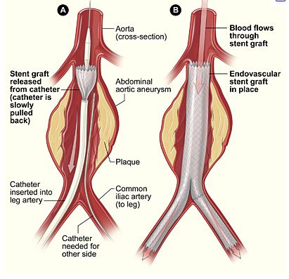
Fig.6 Schematic diagram of Endovascular Aneurysm Repair (EVAR)
©www.hearthealthywomen.org
Endovascular surgery is a relatively new specialty in medicine. The earliest endovascular treatments for narrowing or blockage of arteries of lower extremities were developed during the 1960’s. Advances in technology and medical research allowed the specialty to develop rapidly during the 1980’s. Endovascular treatment of aortic aneurysms was introduced as an alternative to open surgical repair, in the 1990’s (Fig.6). Initially, it was mainly used for patients who were too unwell to undergo a major operation due to significant co-morbidities. However, due to its minimally invasive nature, the physiological insult to patients is much less compared to open surgery. This in turn means fewer post-procedure complications and less time spent in the critical care ward and in the hospital in general. Therefore, the endovascular option is increasingly being offered to patients who would have had open surgery.

Other endovascular procedures include:
- treatment of peripheral arterial disease (including narrowing or stenosis, and blockage or occlusion) by balloon dilatation (angioplasty) with or without placement of stents to keep the arteries open
- carotid artery stenting to prevent cerebrovascular accidents including strokes
- blocking off arteries and veins by a process called embolisation, where particles or coils are injected into the target vessel, for the treatment of tumours, abnormal dilatation, active severe bleeding either spontaneous (gastro-intestinal) or due to trauma, cerebral aneurysms, acute gastro-intestinal bleeding, traumatic bleeding and certain types of tumours.
- Treatment of diseases or symptoms caused due to obstruction of veins
- Placement of filters in the inferior vena cava to prevent clots in the lower limbs from reaching the pulmonary circulation with the potential to cause pulmonary embolism

Endovascular surgery is a specialised branch of a wider sub-specialty in Radiology, known as Interventional Radiology (IR). IR can be defined as the performance of procedures using catheter or guide-wire combinations using image guidance ³⁶. In addition to the endovascular procedures mentioned above, these include drainage of abscesses and obstructed systems in the liver and kidneys and biopsy of various structures including lymph nodes and abdominal organs.

The American College of Radiology (ACR) granted IR official recognition as ‘‘a new component of the specialty of radiology’’ in 2001. The American Board of Radiology (ABR) ³⁷ and the Royal College of Radiologists, UK (RCR) recommended in 2010 that IR training needs to be separate from diagnostic radiology because of the additional need for a number of skills including manual dexterity ³⁸.

In 2009, the European Union of Medical Specialists (UEMS) recommended that IR be established as a division within the UEMS section of Radiology. In 2010 the Royal College of Radiologists gained recognition for IR as a sub-specialty of Clinical Radiology, and subsequently a curriculum was approved by the GMC ³⁹. Training in IR extends over six years- three years for core radiology training and three years for sub-specialty (IR) training.

Like most ‘craft-specialties’, training in endovascular surgery is mainly ‘on-the-job’. Trainees are exposed to procedures in stages depending on their experience. Initially, they observe procedures being performed by consultants and specialists. In the next stage, they assist in the procedure. When they have demonstrated the requisite familiarity, knowledge and skills, they are allowed to perform either certain steps of the procedure or the whole procedure, under strict supervision from the trainer. Formative assessment of trainees is imperative to provide appropriate feedback on performance. This is ideally delivered as soon as the training episode is completed. Workplace-based assessments form an appropriate tool to provide this feedback.
As with any other medical specialty, endovascular trainees need to undergo regular formative and summative assessments during their training, to assess and document their progress. At the moment, there are no formal assessment tools specifically for endovascular trainees.

The main focus of my research is on developing and testing workplace-based assessment tools for endovascular procedures.

Aims:
The primary aim of the project was to develop workplace-based assessments for endovascular procedures. The secondary aims were to evaluate their measurement characteristics against the qualities of a good assessment tool, namely, reliability, validity, educational impact, acceptability and feasibility.

Methodology:
The following steps were undertaken:
- Task analysis - Endovascular procedures performed by consultants were observed and analysed by a group of vascular radiologists and surgeons to identify and agree the task-specific and global domains. Patients scheduled to undergo endovascular procedures were approached prior to the procedure. The objectives of the study were explained to them, and they were given an information-sheet and contact details of a member of the research team for further clarification, if needed. Their consent was sought, for the procedure to be observed by investigators who might not be ordinarily involved in their care. After this, irrespective of the patient participating in this study or not, their management and treatment were continued as scheduled.
The assessment domains were developed by direct observation of endovascular procedures performed by consultants. The design of these was based on PBAs already developed for numerous surgical procedures which are now routinely used for assessment of surgical trainees and is the preferred method of assessment of the surgical Royal Colleges.

- PBA development - The PBAs were created at writing workshops. Consultants mapped the domains from existing surgical PBAs and adapted them for endovascular procedures. The domains included consent, pre-procedure planning, pre-procedural preparation, access and closure, intra-procedural technique (global and task-specific) and post-procedural management. It was noted that, as expected, there were several common themes between the surgical and endovascular PBAs, the more obvious differences being in the intra-procedural technique section. These PBAs were then piloted by the consultants themselves to ensure face and content validity and iterated as required.
- Measurement of reliability - Vascular trainees and consultants were assessed undertaking each endovascular procedure on at least two occasions, to help estimate variation due to case complexity. Assessments of trainees performing the procedure were undertaken by the consultant supervisor and an independent assessor.
- Validity, Educational Impact, Acceptability and Feasibility – Data recorded included the type of procedure and the global score. The consultant supervisor provided constructive feedback. Throughout the study, informal qualitative feedback about the PBAs were obtained from the assessors and trainees, but no modifications to the PBAs were performed at this stage.

Statistical analysis:
Reliability was analysed using the VARCOMP procedure in SPSS (version 14). Threats to reliability include the proceduralist’s case-to-case performance variation, the variable stringency of assessors, and the subjectivity of assessors. Variance component analysis estimates the relative contribution to score variance of each of these sources of score error and the relative contribution of proceduralist-to-proceduralist ability (true score variance).

Validity indicates how well the score reflects the intended construct of technical performance. If valid, the following hypotheses will be fulfilled
- Scores will increase with duration of training and number of procedures performed
- Higher-scoring procedures will result in fewer complications and a shorter length of stay.
Each of these hypotheses will be tested. Pearson’s method will be used for hypothesis independently. As this is not a hypothetical study, no power calculation can be made. Our aim was to sample sufficiently large numbers of trainees, assessors and cases to enable generalizability analysis. We estimated that 300 samples would provide enough data for statistical analysis.

This study was the continuation of a large HTA-funded 2-year study, ‘Assessment of Surgical Skills of Trainees and Consultants in the Operating Theatre’, which was given ethical approval by Trent MREC (Ref No. 07/MRE04/13, submission date 21/12/2006. I contributed to this study as one of the independent assessors, observing general and vascular surgical procedures performed by trainees and independently filling out PBAs for use in the study, prior to the formal commencement of my study on endovascular PBAs. I also attended team-meetings where I gained insight into the methodology of the study and potential difficulties in recruitment. We planned to employ the same statistical methods used in that study.

Participants:
All adult patients undergoing endovascular procedures, viz. endovascular aneurysm repair (EVAR) and endovascular peripheral artery stenting, were offered the opportunity to be included in the study. Patients less than 21 years of age and pregnant patients were excluded. Potential participants were identified when the decision to perform an endovascular procedure on them was made. The list of endovascular procedures was obtained from the Angiography department in advance. This was done by the co-investigator. The objectives of the study were explained to patients, and they were given an information-sheet and contact details of a member of the research team for further clarification, if needed. After this, irrespective of the patient participating in this study or not, their management and treatment continued as scheduled.

Trainees performing endovascular procedures and the trainers who supervise them were also participants in the study. Both these groups were approached prior to the study and were given information sheets and consent forms. Only those procedures where both the trainee and the trainer were informed and given consent were included in the study. Any procedure in which a trainee or trainer participated and subsequently withdrew consent was not included in the study. All members of staff in the angiography suite were given information sheets with contact details for the investigators.

It is unlikely that trainees experienced any additional distress as a result of the observation of the procedure, as they are regularly assessed by their trainers as part of their training. This study focussed on testing the assessment tool, namely the PBA, rather than the trainee. In the event that a trainee did feel that he/she were experiencing additional stress or distress, the procedure was not included in the study, and the observer/independent assessor made it clear to the participants that if requested, they will leave the angiography suite.

Project progress till date:
- I drafted the project protocol with the assistance of my supervisor Prof Beard, during May 2009.
- The project was registered with the STH Research & Development in June 2009.
- I submitted the online application for ethical approval of the study to the South Yorkshire Research Ethics Committee in July 2009. I attended the South Yorkshire Research Ethics Committee meeting on 30th July 2009. The study was given an unfavourable ethical opinion by the committee in August 2009, for the following reasons:
- Unclear methodology: This was addressed in a revised proposal. The assessment domains were developed by direct observation of endovascular procedures performed by consultants. The design of these were based on PBAs already developed for numerous surgical procedures which are now routinely used for assessment of surgical trainees and is the preferred method of assessment of the surgical Royal Colleges.
- Unclear recruitment methods: We had included patients on whom procedures were performed by trainees, as participants in the study. However, we had not considered or included trainers and trainees as participants in the study. The committee was of the view that trainers and trainees should also be included as participants, in view of this being an observational educational study. This was addressed and the protocol revised to include them as participants. Information sheets and consent forms were included. All trainees and trainers involved in endovascular procedures at participating centres were invited to participate in the study.
- Sample-size: The committee was not convinced about the calculation of sample-size or the use of generalizability analysis. The sample size of 300 episodes was based on the advice of our statistical expert Dr Jim Crossley, using generalizability theory, and based on our previous HTA funded study. Also, this study was a continuation of a large 2-year HTA-funded study which was given MREC approval (Trent MREC Ref No. 07/MRE04/13, submission date 21/12/2006), for which the same statistical principles were used. We have obtained confirmation from our statistical expert that the proposed sample size is adequate for generating valid conclusions for this study.
- Validity of the tool: Construct validity will be measured using data including information on the age, gender, country of qualification, duration of training, the total number of this procedure performed previously and in the last 6 months. Outcome validity will be measured using data on time taken to perform the procedure, intra and post-procedural complications and length of stay.
- We proposed to video-record procedures for task-analysis for designing the PBA. This generated ethical issues about confidentiality of patients, trainees, trainers and staff. Therefore it was decided to abandon recording and design the PBAs exclusively by independent assessors observing the procedures firsthand. Taking into consideration the above criticisms, the protocol was modified. In the development phase of procedure-based assessments, instead of videoing procedures, we decided that radiologists and vascular surgeons will observe and analyse the procedures, and create procedure-based assessments by listing the steps involved.

- I submitted the revised protocol to the Leicestershire, Northamptonshire and Rutland Research Ethics Committee 2 in September 2009. I attended the ethics meeting in October 2009. The ethics committee granted a favourable opinion subject to some changes:
- The trainer and trainee information sheets should be in the same standard format as the one for patients and should include standard headings: this was addressed as recommended.
- The information sheet for trainees should explain the potential risk of distress, for example if the student does not think that they performed well during the observations, and should include a mechanism to access support. This could be through normal routes including their mentor or educational supervisor: the trainee information sheet was modified to ensure that all this information was included.
- The trainee information sheet should explain if there are any potential implications for the participant if they do not complete all the steps. This could also confirm that performance in the study will not be counted towards their portfolio as discussed at the meeting: the trainee information sheet was modified to ensure that all this information was included.
- A separate consent form should be provided for each staff information sheet and should be in the standard format used in the consent form patients, including boxes to initial for each statement and permission for regulatory authority and Trust access to the research data in case of audit.
- The Committee recommend that once developed the tool should be presented to the GMC if possible, although this is not a condition of approval.
The necessary changes were made and submitted to the committee in November 2009. We received a favourable ethics approval for the study from the committee, in November 2009.
- The ethics approval was submitted to the Research & Development department at Sheffield Teaching Hospitals in December 2009. The study was given R&D approval at Sheffield in January 2010.
- R&D applications were made to the respective departments at Leeds Teaching Hospitals NHS trust, Hull and East Yorkshire Hospitals NHS Trust and Newcastle upon Tyne Hospitals NHS Foundation Trust, in December 2009.
- PBAs were developed in Sheffield by consultants, during January 2010.
- Recruitment of patients, trainees and supervisors began in February 2010.
- The study was granted R&D approval at Leeds Teaching Hospitals NHS trust in February 2010, Newcastle upon Tyne Hospitals NHS Foundation Trust in June 2010 and Hull and East Yorkshire Trust in December 2010.
- The first phase of the study was completed at Sheffield by October 2010.
- Unfortunately, due to work-pressures, recruitment did not take place at the participating centres.

Results:
Procedure-based assessments were developed for Endovascular Aneurysm Repair (EVAR) (Appendix 4) and iliac artery angioplasty and stenting, using methodology described above. Subsequently it was felt that with slight modifications, the PBA for iliac artery angioplasty/stenting could be used for other peripheral arteries including the superficial femoral artery, popliteal artery and arteries of the lower leg. The PBA was renamed as peripheral artery angioplasty/stenting to include the above (Appendix 5).

Endovascular PBAs:
The Endovascular PBA has three main sections. The first part consists of fields to record basic data including the names of the trainee and the assessor, and the date and duration of the procedure.

The second part is in the form of a checklist arranged under six separate domains. These domains are: consent, pre-procedural planning, pre-procedural preparation, access and closure, intra-procedural technique and post-procedural management. The domain of intra-procedural technique includes several global and task-specific items. The global items refer to certain attributes demonstrated during the procedure that are common to all endovascular procedures, e.g. appropriate communication skills, awareness of radiation protection issues and calm and effective responses to unexpected situations. Task-specific items refer to the steps that are specific to the type of endovascular procedure that is being performed, e.g. deployment of angioplasty balloons and stents.

Each checklist item is assessed using a binary scale. The standard required to be achieved is set at Certificate of Completion of Training (CCT) level. Depending on performance, each item is assessed as 'satisfactory' or 'development required'. A third choice is 'not observed or not appropriate', where the assessor has either not observed that aspect of the procedure or where it was decided that the trainee would not perform that part of the procedure.

The third part of the assessment is the Global summary score. This rates the trainee using a four-level rating scale, based on the trainee's overall ability to perform the procedure:
Level 1: Unable to perform the procedure or part observed, under supervision
Level 2: Able to perform the procedure or part observed, under supervision
Level 3: Able to perform the procedure with minimum supervision (needed occasional help)
Level 4: Competent to perform the procedure unsupervised (and could deal with any complications that arose)
The PBAs were trialled on two endovascular trainees in Sheffield. We obtained 52 PBAs for analysis. There were six assessors including trainers and independent assessors. The limited number of samples obtained meant that any meaningful or thorough analysis of the data was impossible. However, there was limited evidence on Variance component analysis that a trainee with a higher global score is almost certain to better than a trainee with a lower global score, and that the difference is not due to variation in the stringency of their assessors or the difficulty of their cases. Precision would be higher if they have some or all of the same assessors and lower if they have differing mixes of procedure type. Variance component analysis also indicated that as with most workplace-based assessments, the variance of PBAs decreased as more were done with more assessors on more procedures; in other words, the reliability of PBAs increased.

21 (40%) of the forms had written feedback in the free-text assessors' comments section. These comments ranged from those on specific technical details to more generic overall opinions.
Some examples of specific comments are:
"Failed to cannulate contralateral limb" (EVAR)
"Concern regarding tip of guidewire in tibials" (Peripheral angioplasty/stenting)
"Reflection on screening time and coning, and Heparin dosage" (Peripheral angioplasty/stenting)
"Faulty deployment of Angio-seal"(Peripheral angioplasty/stenting)
"Did not interpret post-stent angiogram satisfactorily"(Peripheral angioplasty/stenting)

Some examples of generic comments are:
"Technically good" (Peripheral angioplasty/stenting)
"Overall quick, clean, efficient procedure" (Peripheral angioplasty/stenting)
"Overall OK but need to focus on detail and be careful"
"Rather hesitant and poor preparation/team briefing" (Peripheral angioplasty/stenting)

17 (33%) of the forms had written feedback in the free-text trainees' comments section. 16 of these were from one single trainee, and the comment in all these cases was "Fair assessment". The only one from the other trainee included the comment "Made me slightly nervous with somebody standing behind me assessing me. I think this is a very good way of assessing trainees"

Informal verbal feedback about endovascular PBAs obtained from trainers and trainees indicated that the PBAs were seen to be educationally useful, acceptable and feasible.

Discussion:

As discussed above, a low number of samples were only obtained.
It was noted on the obtained forms that in the majority of instances, the free-text comments box was empty for both trainers and trainees. This observation is slightly discouraging in that the comments section is one of the most important areas of the PBA. This is where verbal feedback and discussion between trainer and trainee are expected to be documented. The usefulness of these comments is not only due to the specific steps of a procedure that a trainee can focus on for further improvement, but also to provide an overview of more generic skills not just endovascular but also situational awareness, communication-skills and administrative skills. Indeed, it was noted that for those forms which did have assessor's comments, these tended to be a combination for specific and generic skills.

The common trainee response "Fair assessment" needs to be interpreted in context. It is highly unlikely that a trainee who perceives a score as too low, or assessor comments as too critical, will find it easy to challenge his/her assessor by leaving comments in the trainee section in conflict with the assessor comments. This may be why trainees tend to agree most of the time, as they might feel that any opinion not in agreement with the assessor's comments might be perceived as "due to lack of insight". Also, they might fear that any disagreement might result in potential conflict in the trainer-trainee relationship, which in turn can have an undesirable effect on future training.

Limitations and difficulties:

There were significant difficulties in recruitment. Several factors needed to be fulfilled for a sample to be obtained. The following were a few issues that proved to have a detrimental effect on recruitment:

1. My availability: I was one of the independent assessors. The number of endovascular lists that I could attend were sometimes limited by my clinical work commitments.
2. Suitable cases: Endovascular lists include a variety of procedures other than EVAR and peripheral angioplasty. There were many instances when a list had only one or two cases of these two index procedures, but even they were considered unsuitable to be performed by trainees either due the complexity of procedure or time-limitation.
3. Cancellation: As with other specialties, endovascular lists also were not immune to on-the-day cancellations due to various factors including bed unavailability and unexpected emergency cases displacing non-emergency elective cases.

Not a single sample was obtained from satellite centres. Informal feedback suggests that this was due mostly to work-pressures and time-limitation. Although I cannot be sure, I feel there might be an element of (non-deliberate) lack of full commitment to the study as well, that might be responsible.

On reflection, this is possibly a theme that is observed not just in this study, but with WBAs in general which could potentially be perceived as time-consuming, especially in the current scenario of significantly increased pressures on the NHS, to deliver more care in limited time. This indicates a need to educate both trainers and trainees about the potential benefit of WBAs especially with verbal and free-text feedback.

By 2011, along the lines of the endovascular PBAs developed in Sheffield, The Royal College of Radiologists had developed PBAs for other endovascular procedures like tunnelled central venous catheter insertion and uterine fibroid embolisation, and also for non-vascular interventional radiology procedures, including upper gastro-intestinal stenting, percutaneous biliary drainage, percutaneous nephrostomy and antegrade ureteric stenting. Therefore, along with the two developed in Sheffield (EVAR and peripheral artery angioplasty/stent), there were eight PBAs together labelled Interventional Radiology PBAs (IR-PBAs), recommended by the RCR for use by IR trainees.

In October 2010, the PBAs were published on the website of the Vascular Society of Great Britain and Ireland.

Chapter 4

IR-PBA workshop, Royal College of Radiologists

In March 2012, I co-organised a workshop for Radiology consultants, on Interventional Radiology PBAs (IR-PBAs). Twenty consultants from across the UK attended the full-day workshop. The day was facilitated by Dr Ian Francis (Consultant Radiologist, Brighton), Mr Joe Booth (Executive Director, Specialty Training, RCR) and myself (Appendix). The objectives for the workshop were to:
- Clarify the position of Interventional Radiology as a sub-specialty
- Describe the IR curriculum and its relationship to diagnostic radiology
- Introduce the assessment system for IR and the role of workplace-based assessment (WPBA)
- Introduce PBAs and describe their use, and research, to date
- Practice using PBAs
- Discuss a planned pilot
- Discuss how to fit WPBAs in general and PBAs in particular into the working day
The workshop included talks on the structure of IR curriculum structure, overview of WPBA for Clinical Radiology and Interventional Radiology, the purpose of WPBA – (formative vs summative). We also focussed on the latest GMC guidance and the introduction of Supervised Learning Environments (SLEs) in Foundation training of doctors, the role of WpBAs including mini-IPX and Rad-DOPS and the need for summative assessment of procedural skills.

I talked about the background of PBAs, their use in surgical training, research and evidence from surgery and previous piloting in radiology. For the interactive session, I had produced two video-clips. The first one demonstrated a trainee performing a chest-drain insertion on a fictitious patient, under supervision by a trainer. This trainee needed additional prompts and help throughout the procedure. The second video demonstrated the trainee performing a chest-drain placement in a smooth fashion, with little or no prompting. These videos were shown during the workshop. The delegates were given PBA forms to assess the trainee, as they were watching the videos. This exercise gave the delegates an opportunity to practise using the PBAs in a simulated environment. The delegates gave the first trainee an overall grade of level 1 or level 2, and the second trainee a grade of level 3 or 4.
A national pilot was launched with the aim of trialling the PBAs in practice in various centres in the UK, followed by feedback questionnaires for the users involved in the pilot scheme. The feedback questionnaires (Appendix) asked the following questions:
The assessors answered the following:
1. As the assessor, how long did this process take, in addition to the time you would normally have spent observing the procedure?
The options were <10 minutes, 10-20 minutes, 20-30 minutes and >30 minutes.
2. It is important to assess and give feedback to trainees on their performance in carrying out interventional procedures
3. It was easy to use this assessment form
4. It was useful to have this assessment form to help structure feedback to the trainee
The responses to questions 2, 3 and 4were "strongly agree", "agree", "neutral", "disagree" and "strongly disagree".
The trainees answered the following:
1. It is important to be assessed and receive feedback on my performance
2. It was easy to understand the assessment form
3. It was useful to receive structured feedback from the assessor
The responses were "strongly agree", "agree", "neutral", "disagree" and "strongly disagree".

We obtained qualitative and quantitative information on the use of PBAs.
21 assessors and 11 trainees returned 32 feedback questionnaires.
The duration for completing the PBA was less than 10 minutes in 17 episodes, between 10-20 minutes in 12 episodes, and between 20-30 minutes in 1 episode.
No response was noted for this question in 2 episodes.

Figure 7: Duration of feedback

The following assessor responses were noted for the questions:
 | Important | Easy | Useful
strongly disagree | 3 | 0 | 0
disagree | 0 | 5 | 4
neutral | 0 | 1 | 1
agree | 5 | 23 | 16
strongly agree | 22 | 1 | 7
Table 1: Assessor responses
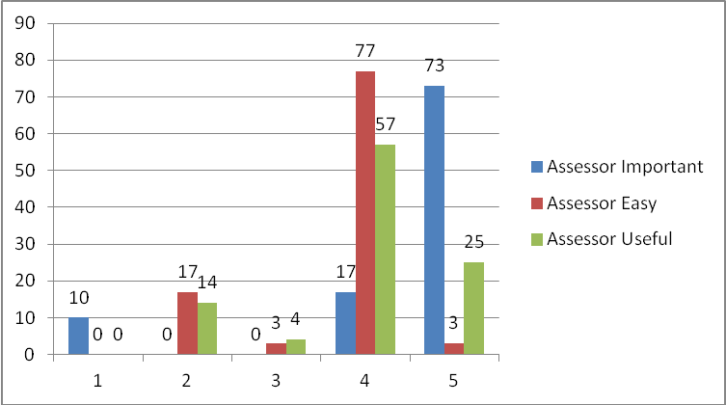
Figure 8: Assessor responses in percentages
The following trainee responses were noted for the questions:
 | Important | Easy | Useful
strongly disagree | 0 | 0 | 0
disagree | 0 | 0 | 0
neutral | 0 | 3 | 0
agree | 8 | 15 | 12
strongly agree | 22 | 12 | 18

Table 2: Trainee responses
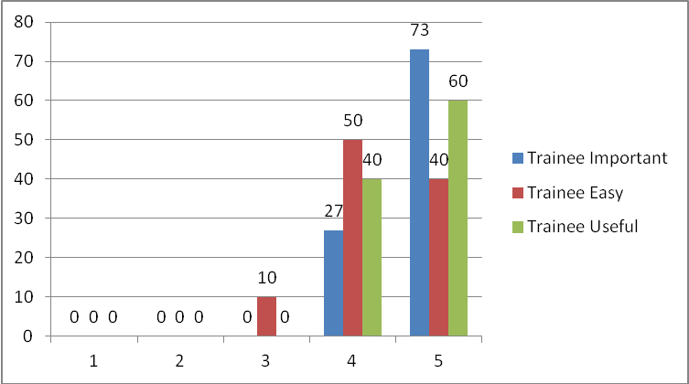
Fig.9: Trainee responses in percentages

14 assessors and 11 trainees provided free-text responses in the comments section. There were a few recurring themes in the free-text responses obtained for comments (Appendix). The most common theme was that the forms were "too detailed/lengthy/long-winded" or "labour-intensive".There were also comments usggesting more spac for free text comments nd observations. A few trainee responses indicated that the process of feedback through the form is very helpful.
The responses indicated that majority of the assessors and trainees felt that PBAs are important in training and feedback, are easy to use/understand and that they are useful in providing structured feedback.

In 2014, IR-PBAs were formally adopted as one of the methods of assessment of Radiology trainees and the forms have been incorporated into their e-portfolios.

Chapter 5

Analysis of Interventional Radiology PBAs in current practice

Background:
IR-PBAs (Vascular and Non-vascular procedures) have been incorporated in the e-portfolios of all Interventional Radiology trainees who follow the RCR Interventional Radiology curriculum. Trainees are encouraged to obtain regular feedback using this tool.

Aims:

To evaluate the use of IR-PBAs in current practice

Methodology:

Data on IR-PBAs recorded from 1st January 2014 to 1st September 2015 was

obtained from the RCR. Data collected included procedure name, the date of

procedure, seniority of trainee, level achieved and free text comments.

Results:
530 PBAs were available on 8 different procedures (Fig.13-20), which included endovascular aneurysm repair, peripheral artery stenting/angioplasty, tunnelled central venous catheter insertion, uterine fibroid embolisation, antegrade ureteric stenting, upper GI stent insertion, percutaneous biliary drainage and percutaneous nephrostomy. 13 PBAs submitted by non-ST grade doctors were excluded, leaving 517 suitable for analysis.
90% (463/517) of PBAs were completed by senior trainees (ST4-ST6) (Fig.9). This is an expected pattern of distribution as PBAs are designed for procedures primarily performed by more senior trainees whereas other assessment tools like RAD-DOPS are used to assess procedures performed by relatively junior trainees (ST1-ST3). 71% of PBAs were scored at level 3 or 4 (Fig.10). Disregarding PBAs completed by ST1 trainees (1% of total dataset), there was good correlation between the level of training and the mean global summary score, with higher level trainees achieving incrementally higher mean scores (Fig.11 and 12). 93% (481/517) of PBAs had free text comments in the box for verbal feedback.
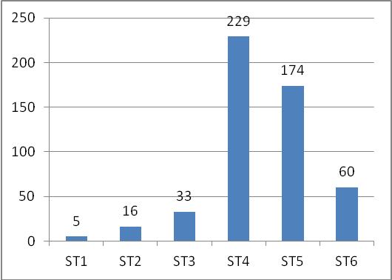
Fig.10: Breakdown of PBAs by trainee level
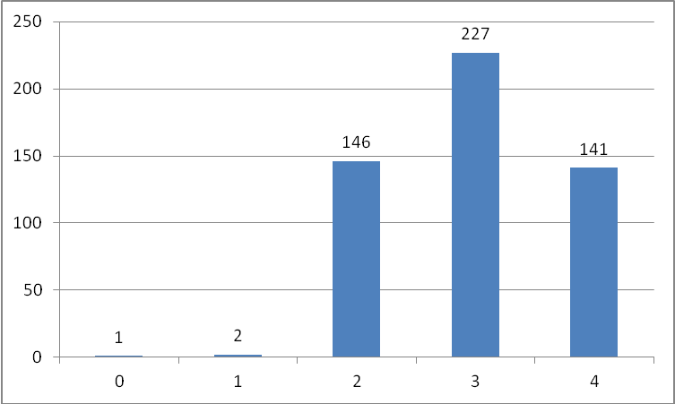
Fig.11: Breakdown of global summary scores versus number of trainees
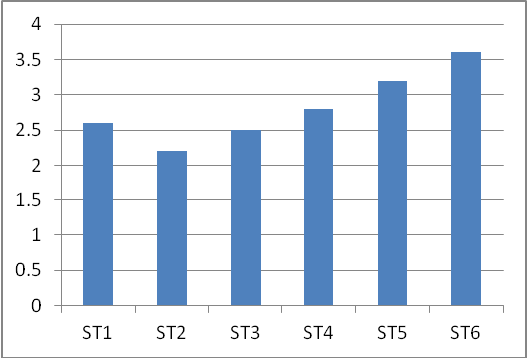
Fig.12: Global summary score versus trainee level
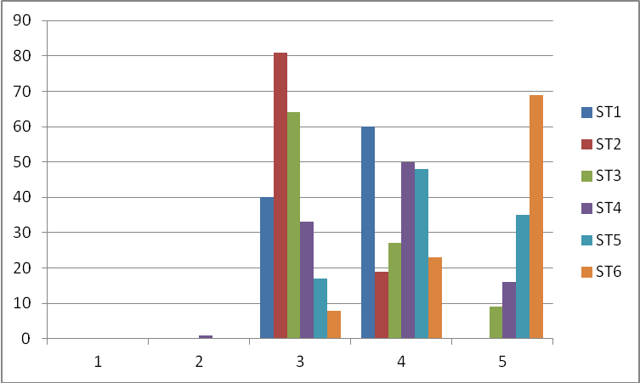
Fig.13: Detailed breakdown of individual trainee levels versus global summary score

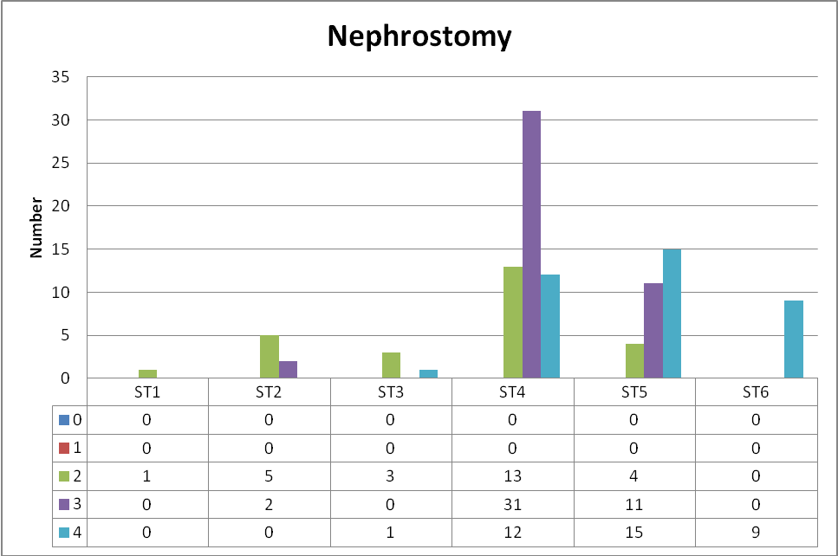

Fig.14 PBA score (global) versus trainee level for nephrostomy

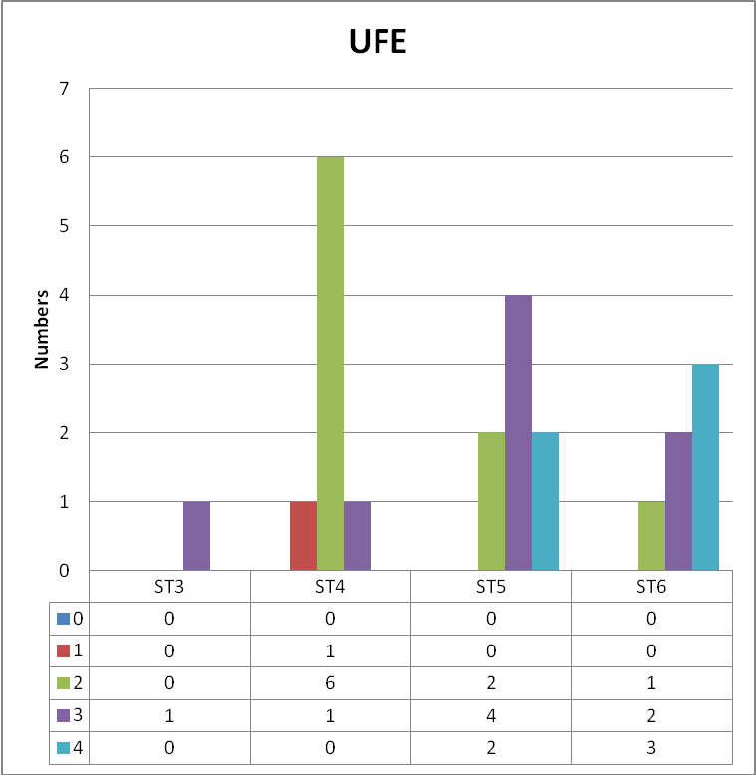

Fig.15 PBA score (global) versus trainee level for uterine fibroid embolisation

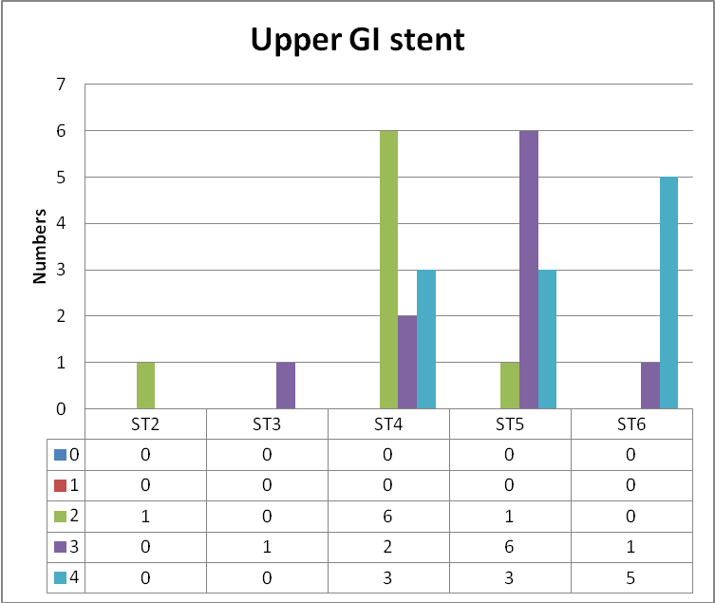

Fig.16 PBA score (global) versus trainee level for Upper GI stent

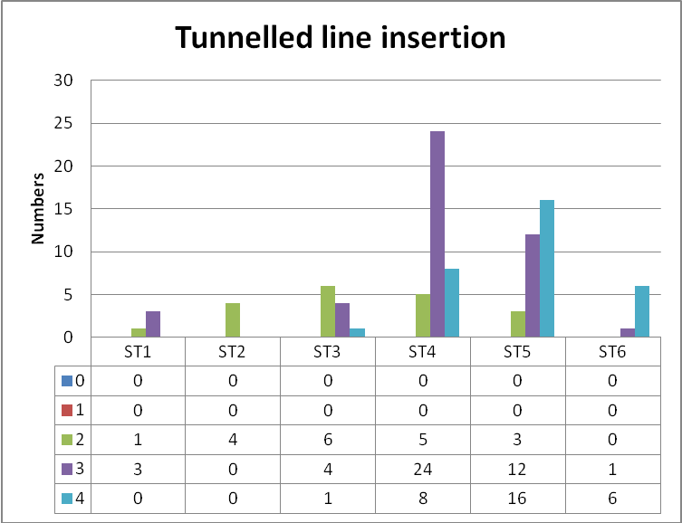

Fig.17 PBA score (global) versus trainee level for tunnelled line insertion

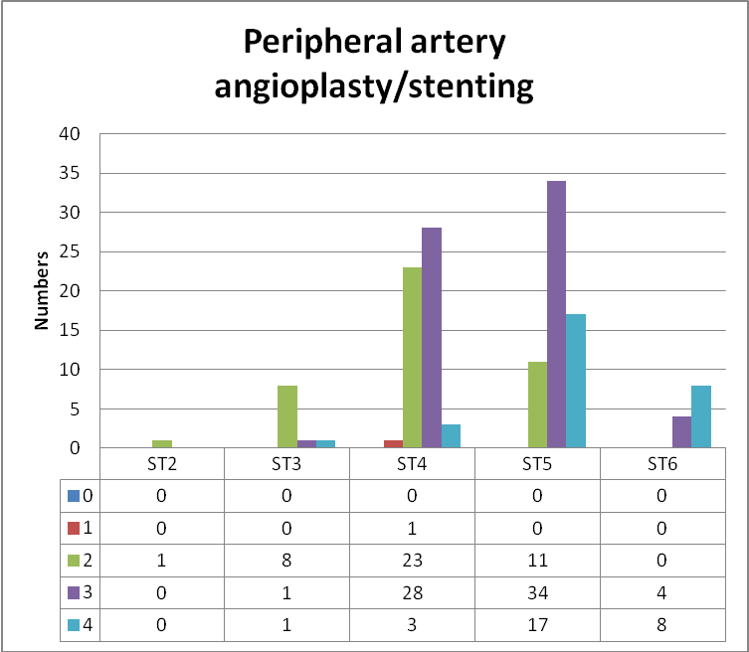

Fig.18 PBA score (global) versus trainee level for peripheral artery angioplasty/stent

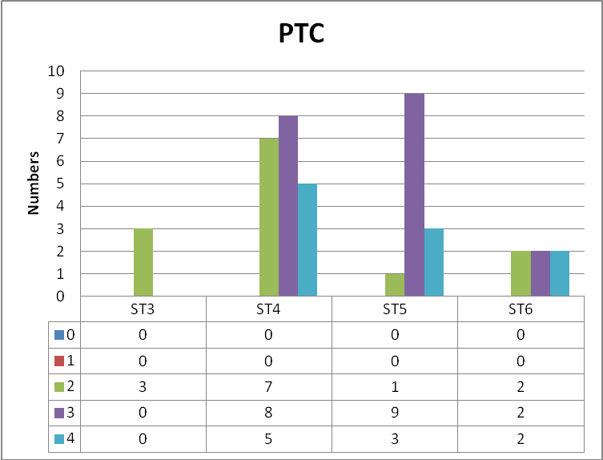

Fig.19 PBA score (global) versus trainee level for percutaenous transhepatic cholangiogram

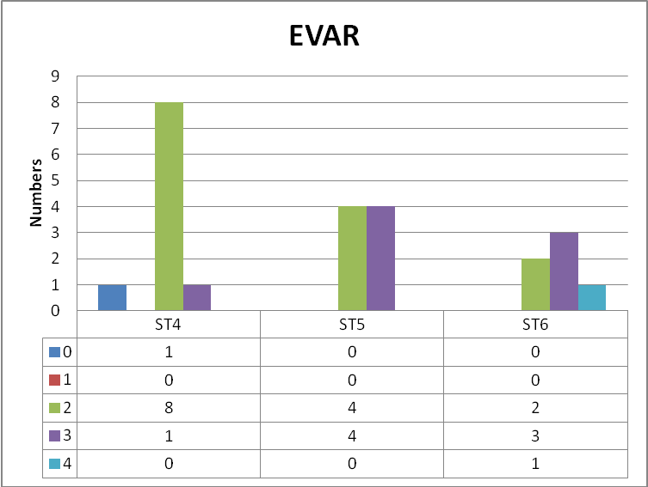

Fig.20 PBA score (global) versus trainee level for endovascular aneurysm repair

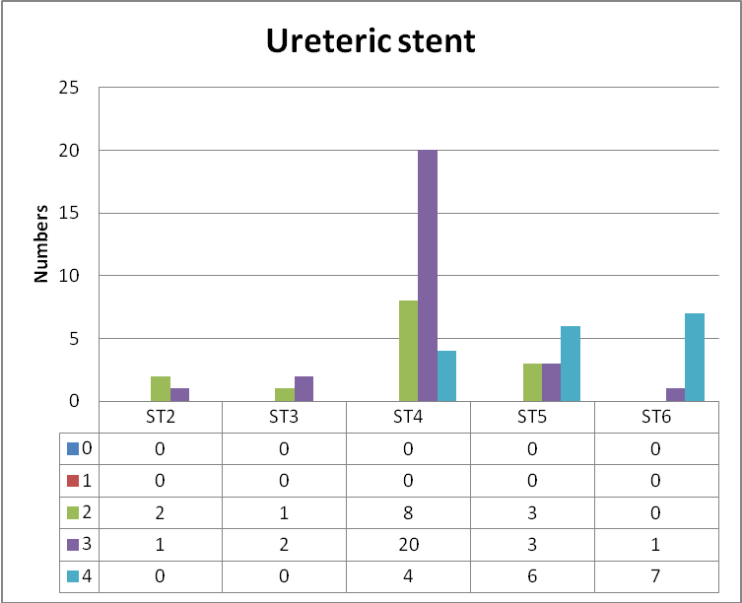

Fig.21 PBA score (global) versus trainee level for antegrade ureteric stent

Discussion:

A large proportion of PBAs were filled by senior trainees; this is an expected pattern of distribution as PBAs are designed for procedures primarily performed by more senior trainees whereas other assessment tools like RAD-DOPS are used to assess procedures performed by relatively junior trainees (ST1-ST3). The incrementally higher scores according to seniority level is an encouraging observation as this further re-iterates the construct validity of PBAs. Verbal feedback is a mandatory component of workplace based assessments including PBAs and hence, ideally 100% of samples should have this recorded. Many procedures showed decreasing numbers of PBAs performed for more senior trainees, for example, those at ST6 level. Such trainees usually operate independently, either unsupervised or under remote supervision. The trainer may have made it clear that they are available if required at any stage, to ensure patient safety is not compromised. However, this has the disadvantage that trainees no longer obtain one-to-one supervision and hence only obtain limited feedback on their performance. Having said that, they may only need such supervision or feedback in complex or difficult cases. Also, training in such circumstances provides a measure of self-confidence and independent decision-making skills among trainees. This re-iterates the importance of striking a balance between close supervision of trainees and giving them increasing independence in their practice.

Chapter 6

Future work and further development of IR-PBAs

As with all aspects of medical education, the development of assessment tools is also a dynamic process which responds to various factors like ongoing changes in the training structure and pathway, emerging new evidence on their use and the challenges of training in a busy environment, both for trainees and trainers. Thus, there is a need to constantly evaluate and appraise the assessment tools with a view to respond to these changes as necessary. This means that the tools themselves are subject to continuous evolution.
The "Shape of Training" review⁴⁰ led by Prof David Greenaway in 2013, notes that
"assessment and evaluation throughout postgraduate training is becoming increasingly
bureaucratic – ticking boxes – and is not necessarily demonstrating capabilities or
showing that a doctor is consistently working safely". In light of reduction in working
hours and stricter regulations, the report also recommends revised curricula that
deliver broader specialty training, more targeted supervision and a more personalised
outcome based approach to assessment and progression.
Recent years have also seen the publication of several documents on postgraduate
curricula and assessment programmes, by the General Medical Council (GMC),
supporting a move towards outcomes-based curricula. Outcomes-based curricula
focus on what kind of capabilities doctors will have upon completion of the
programme rather than the process by which these capabilities are achieved ⁴¹. Their
publication "Excellence by design: standards for postgraduate curricula" ⁴² indicates
that standards require curricula to describe fewer, high-level generic, shared and specialty-specific outcomes. The publication "Promoting excellence: standards for
medical education and training" sets out ten standards and requirements for the
delivery of all stages of medical education and training organised around five
themes⁴³, one of them being "Developing and implementing curricula and
assessments", and under this theme, sets out the standard that "Postgraduate curricula
and assessments are implemented so that doctors in training are able to demonstrate
what is expected in Good medical practice and to achieve the learning outcomes
required by their curriculum", and makes a specific recommendation that "assessments must be mapped to the requirements of the approved curriculum and appropriately sequenced to match doctors’ progression through their education and training."

More specifically on postgraduate assessments, the GMC publication "Designing and maintaining postgraduate assessment programmes"⁴⁴ appears to place a greater emphasis on validity. In addition, their guidance suggests placing a priority on ensuring feasibility and acceptability to assessors and doctors in training. WBAs including IR-PBAs may need to be further streamlined or refined, to make sure that users do not find it too complex or lengthy, as suggested by the comments on the IR-PBAs on our pilot samples.

Further development of IR-PBAs should incorporate changes based on not only national current guidance from bodies such as the GMC, but also on feedback from users, both trainees and trainers. Regular analyses and review of these assessment tools in a constantly evolving training environment is essential to assure all stakeholders that these continue to be one of many valuable tools in the formative and summative assessment of trainees, ultimately leading to safe, competent and confident doctors.

The development of endovascular PBAs could also help to inform the design of the metrics for endovascular simulators, which are being increasingly used for training ⁴⁵ . Vascular and Endovascular PBAs could also contribute to a European Curriculum for Vascular Training and European Board Examinations ⁴⁶ .

References:

- Schuwirth LWT. Assessing medical competence: finding the right answers. Clin Teacher 2004; 1: 14–8.
- Sam Leinster Assessment in Medical Training, The Lancet , Vol 362, 1770, November 22, 2003
- Beard J.D. Assessment of Surgical Skills of Trainees in the UK, (2008) Ann R Coll Surg Engl, 90, 282-285
- Department of Health (2002) Unfinished Business, Proposals for reform of the Senior House Officer grade. A report by Sir Liam Donaldson, Chief Medical Officer for England. A paper for consultation (http://www.dh.gov.uk/prod_consum_dh/groups/dh_digitalassets/@dh/@en/documents/digitalasset/dh_4018808.pdf)
- http://www.mmc.nhs.uk/medical_education/about_modernising_medical_care.aspx
- https://www.iscp.ac.uk/curriculum/surgical/assessment_wbas.aspx
- https://www.rcr.ac.uk/clinical-radiology/specialty-training/workplace-based-assessment
- Galasko C. Mackay C. (1997) Unsupervised surgical training: logbooks are essential for assessing progress. British Medical Journal, 315, 1306-1307
- Thornton M., Donlon M., Beard J.D. (2003) The operative skills of higher surgical trainees: measuring competence rather than experience undertaken. Ann R Coll Surg Engl, 85, 190-193
- Katory M., Singh S., Beard J.D. (2001) Twenty Trent trainees: a comparison of operative competence after BST. Ann R Coll Surg Engl (Suppl,), 83, 328-330
- Department of Health. (2003) European Working Time Directive www.doh.gov.uk/workingtime/index.htm
- Beard J, Rowley D, Bussey M, Pitts D (2009) Workplace-based assessment: assessing technical skill throughout the continuum of surgical training ANZ J Surg, Vol 79, Issue 3, 148–153
- Yule S, Flin R, Maran N, Rowley D, Youngson G, Paterson-Brown S. Surgeons’ non-technical skills in theoperating room: reliability testing of the NOTSS behaviour rating system. World J Surg 2008; 32: 548–556.
- Martin JA, Regehr G, Reznick R, MacRae H, Murnaghan J, Hutchison C et al. Objective structured assessment of technical skill (OSATS) for surgical residents. Br J Surg1997; 84: 273–278.
- Beard JB, Marriott J, Purdie H, Crossley J. Assessing the Surgical Skills of Trainees in the Operating Theatre. National Institute for Health Research Health Technology Assessment 2011; Vol. 15: No. 1 (available to download at https://www.journalslibrary.nihr.ac.uk/hta/hta15010#/abstract.)
- J. Marriott1, H. Purdie3, J. Crossley2 and J. D. Beard4Evaluation of procedure-based assessment for assessing trainees’ skills in the operating theatre Br J Surg. 2011 Mar;98(3):450-7
- Epstein RM, Hundert EM (2002) Defining and assessing professional competence. JAMA 287:226–235
- Ahmed K, Keeling A N, Khan R S, Ashrafian H, et al. What Does Competence Entail in Interventional Radiology? Cardiovasc Intervent Radiol (2010) 33:3–10
- R. Aggarwal, S.A. Black, J.R. Hance, A. Darzi1 and N.J.W. Cheshire.Virtual Reality Simulation Training can Improve Inexperienced Surgeons’ Endovascular Skills, Eur J Vasc Endovasc Surg 31, 588–593 (2006)
- Willems MC, van der Vliet JA, Williams V, Kool LJ, Bergqvist D, Blankensteijn JD.Assessing endovascular skills using the Simulator for Testing and Rating Endovascular Skills (STRESS) machine. Eur J Vasc Endovasc Surg. 2009 Apr; 37(4):431-6.
- Jeffrey H. Hsu, Duraid Younan, Sudha Pandalai, Bryce T. Gillespie, Raj A. Jain, David W. Schippert, et al . Use of computer simulation for determining
endovascular skill levels in a carotid stenting model, Journal of Vascular Surgery Volume 40, Number 6, 1118-1124
- Simon K. Neequaye, Rajesh Aggarwal, Isabelle Van Herzeele, Ara Darzi, Nicholas J. Cheshire. Endovascular skills training and assessment , Journal of Vascular Surgery Volume 46, Number 5 1055-1063
- Duran C, Estrada S, O'Malley M, Sheahan MG, Shames ML, Lee JT, Bismuth J. The model for Fundamentals of Endovascular Surgery (FEVS) successfully defines the competent endovascular surgeon. J Vasc Surg. 2015 Dec;62(6):1660-6.e3. doi:10.1016/j.jvs.2015.09.026. PubMed PMID: 26598123. (11/10/16 22:24)
- Maertens H, Aggarwal R, Desender L, Vermassen F, Van Herzeele I. Development of a PROficiency-Based StePwise Endovascular Curricular Training (PROSPECT) Program. J Surg Educ. 2016 Jan-Feb;73(1):51-60. doi: 10.1016/j.jsurg.2015.07.009. Epub 2015 Aug 11. PubMed PMID: 26276301.(11/10/16 22:42)
- Tedesco MM, Pak JJ, Harris EJ Jr, Krummel TM, Dalman RL, Lee JT.
Simulation-based endovascular skills assessment: the future of credentialing? J
Vasc Surg. 2008 May;47(5):1008-1; discussion 1014. doi:10.1016/j.jvs.2008.01.007. Epub 2008 Apr 18. PubMed PMID: 18372149
- S.K. Sarker, A. Chang, C. Vincent, A.W. Darzi Technical skills errors in laparoscopic cholecystectomy by expert surgeons. Surg Endosc Other Intervent Tech, 19 (2005), pp. 832-835
- B. Tang, G.B. Hanna, N.M.A. Bax, A. Cuschieri Analysis of technical surgical errors during initial experience of laparoscopic pyloromyotomy by a group of Dutch pediatric surgeons Surg Endosc Other Intervent Tech, 18 (2004), pp. 1716-1720
- Miller A, Archer J. Impact of workplace based assessment on doctors’ education and performance: a systematic review. BMJ 2010; 341: c5064
- JCHMT Assessment Tools Are Now Available. Royal College of Physicians. http://www.rcplondon.ac.uk/press-releases/jchmt-assessment-tools-are-now-available (cited August 2014)
- Moorthy K, Munz Y, Sarker SK, Darzi A. Objective assessment of technical skills in surgery. BMJ 2003; 327: 1,032–1,037
- Morris A, Hewitt J, Roberts CM. Practical experience of using directly observed procedures, mini clinical evaluation examinations, and peer observation in pre-registration house officer (FY1) trainees. Postgrad Med J 2006; 82: 285–288
- Davies H, Archer J, Southgate L, Norcini J. Initial evaluation of the first year of the Foundation Assessment Programme. Med Educ 2009; 43:74–81
- General Medical Council. Workplace Based Assessment: A Guide for Implementation. London: GMC; 2010
- General Medical Council. Learning and Assessment in the Clinical Environment: The Way Forward. London:GMC; 2011
- Mathew A, Beard JD, Bussey M. 'An evaluation of the use of Direct Observation of Procedural Skills in the UK Intercollegiate Surgical Curriculum Programme' Ann R Coll Surg Engl (Suppl) 2014; 96: e10–13
- https://www.bsir.org/patients/what-is-interventional-radiology/
- http://theabr.org/ic/ic_landing.html
- The Royal College of Radiologists and The British Society of Interventional Radiologists: Provision of Interventional Radiology Services. London: The RCR and BSIR 2014
- https://www.rcr.ac.uk/clinical-radiology/specialty-training/curriculum/ interventional-radiology-curriculum
- D Greenaway, Prof. "Securing the future of excellent patient care. Final report of the independent review Led by Professor David Greenaway"; published October2013 © 2013 Shape of Training available at www.shapeoftraining.co.uk
- Harden, RM , Crosby, JR, Davis, MH (1999) ‘An introduction to outcome-based education’ in ed Lilley, P, Outcome-based education AMEE Medical Education Guide No 14, Dundee, 1999
- "Excellence by design: standards for postgraduate curricula". Published May 2017. Available at www.gmc-uk.org/education/postgraduate/standards_for_curricula.asp
- General Medical Council. Promoting excellence: standards for medical education and training. London: GMC; 2015
- Designing and maintaining postgraduate assessment programmes Published May 2017, GMC Manchester
- Van Herzeele I., Aggarwal R., Neequaye S., Hamady M., Cleveland T., Darzi A., Cheshire N., Gaines P. (2008) Experienced endovascular interventionalists objectively improve their skills by attending carotid artery stent training courses. Eur J Vasc Endovasc Surg, 35, 541-550
- Pandey V.A., Wolfe J.H.N., Lindahl A.K., Rauwerda J.A., Bergqvist D. on Behalf of the European Board of Vascular Surgery (2004) Validity of an Exam Assessment in Surgical Skill: EBSQ-VASC Pilot Study. Eur J Vasc Endovasc Surg 27, 341–348

Appendices:
Appendix 1: S-DOPS form 2007
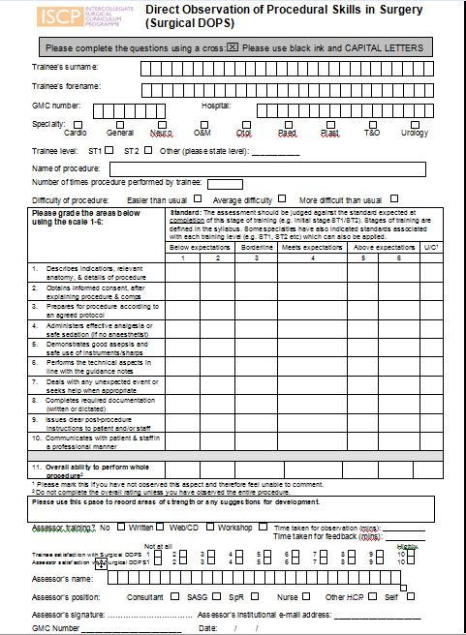
Appendix 2: S-DOPS form 2009 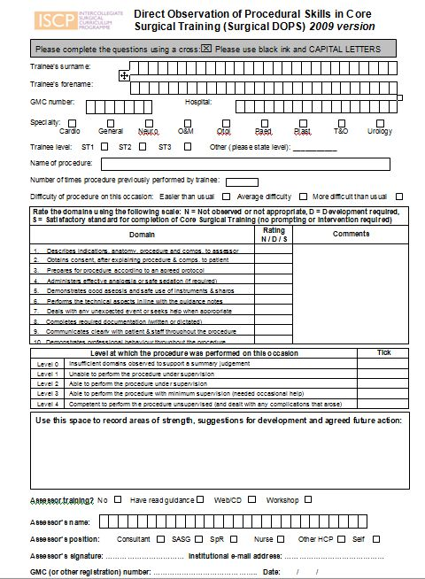

Appendix 3: Questionnaire for trainees on original and new DOPS forms
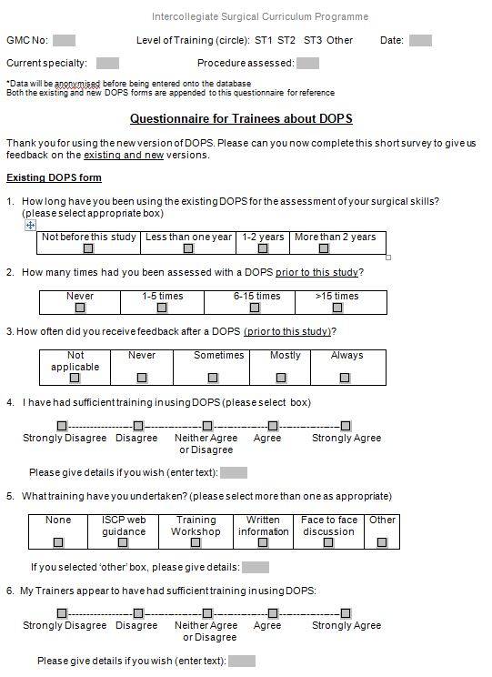

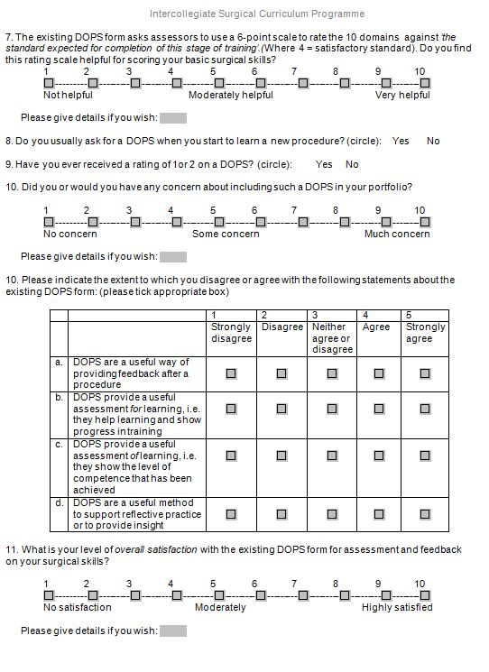

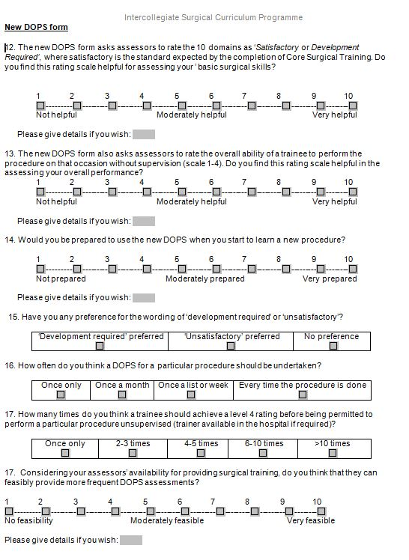

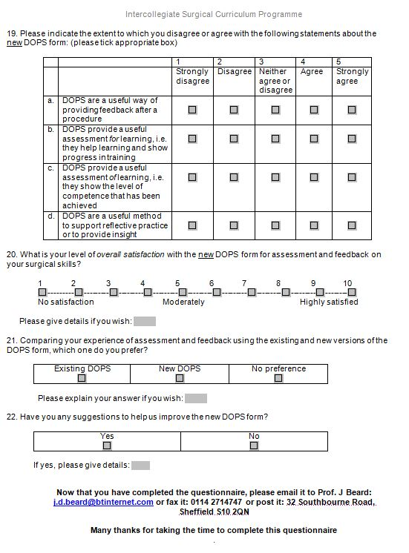

Appendix 4 Questionnaire for assessors on original and new DOPS forms
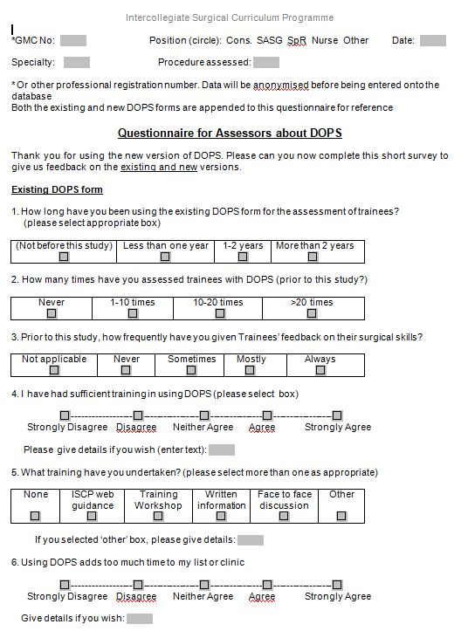

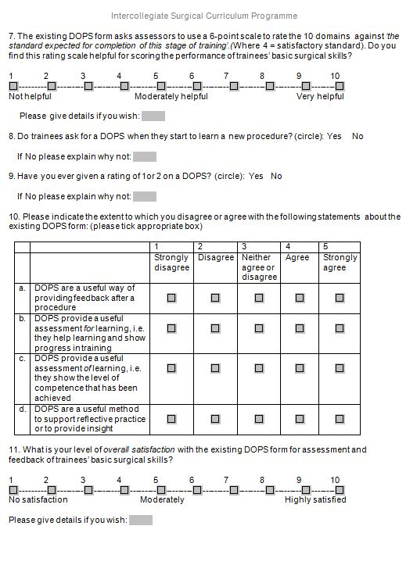

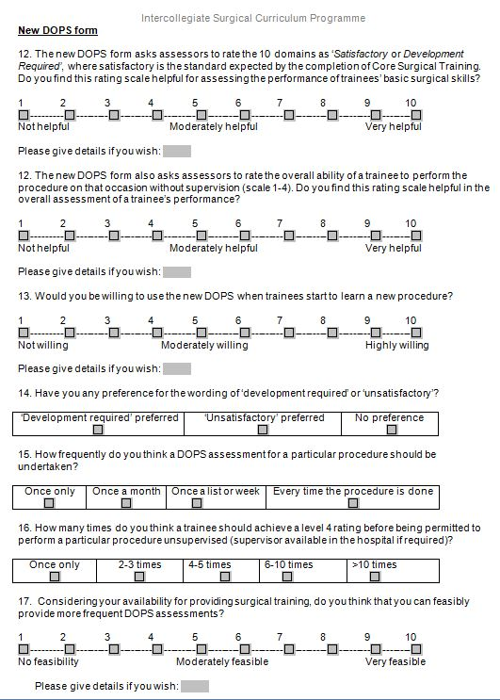

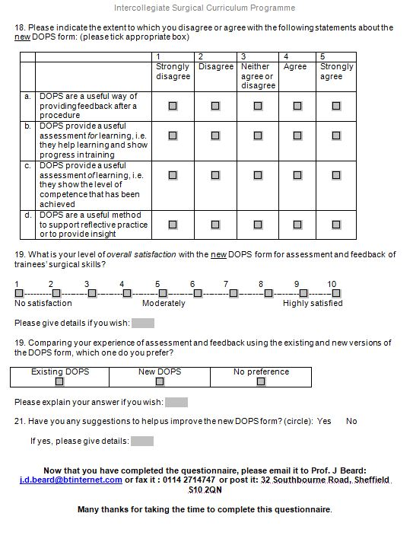

Appendix 5: PBA for Laparoscopic cholecystectomy (page 1)
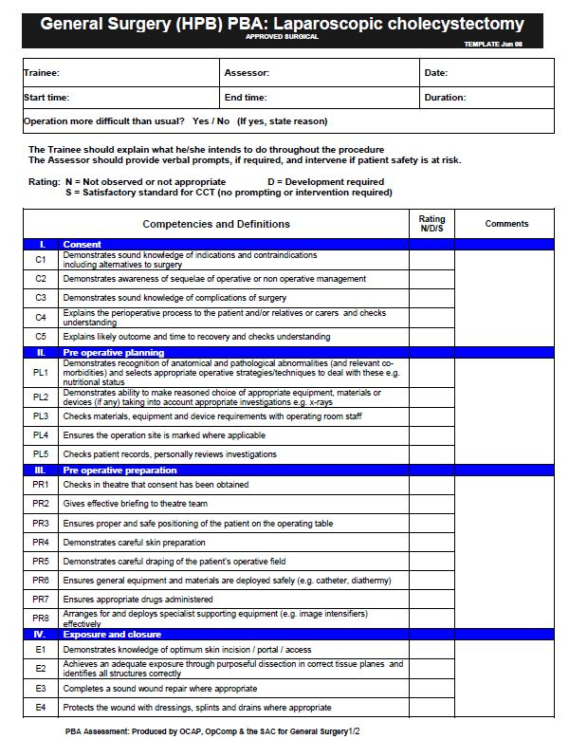

PBA for Laparoscopic cholecystectomy (page 2)
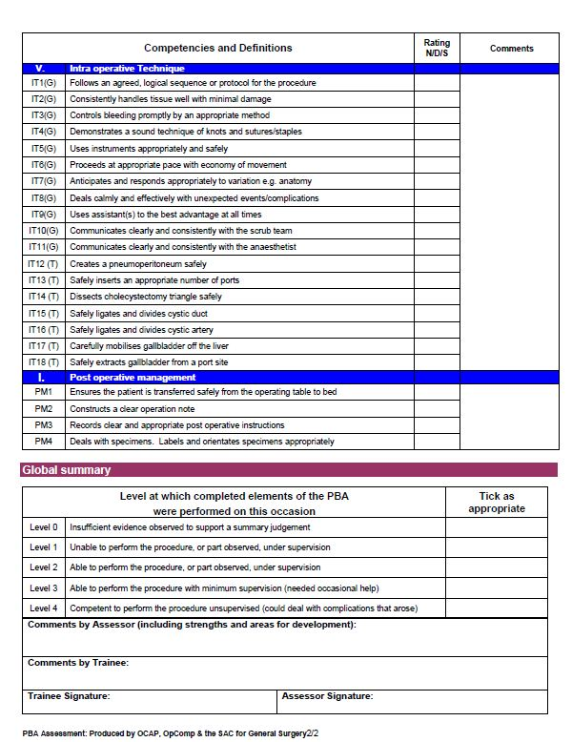

Appendix 6: PBA for EVAR (page 1)
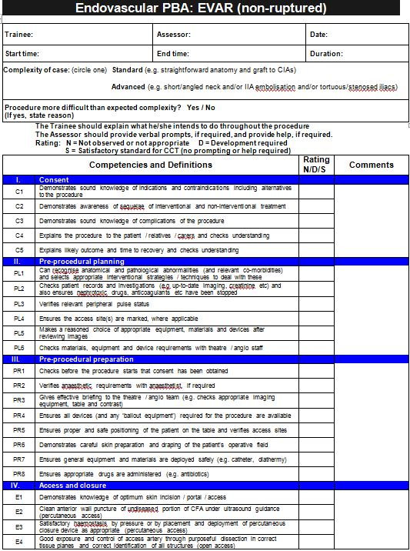

PBA for EVAR (page 2)
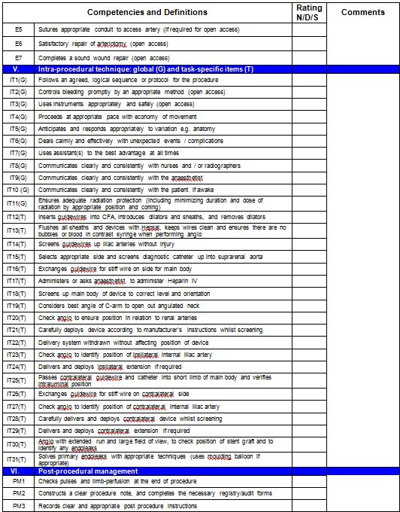

PBA for EVAR (page 3)
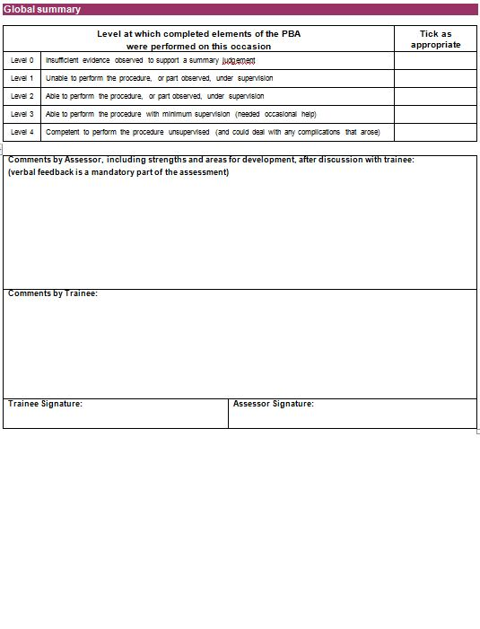

Appendix 7: PBA for peripheral artery angioplasty/stenting (page 1)
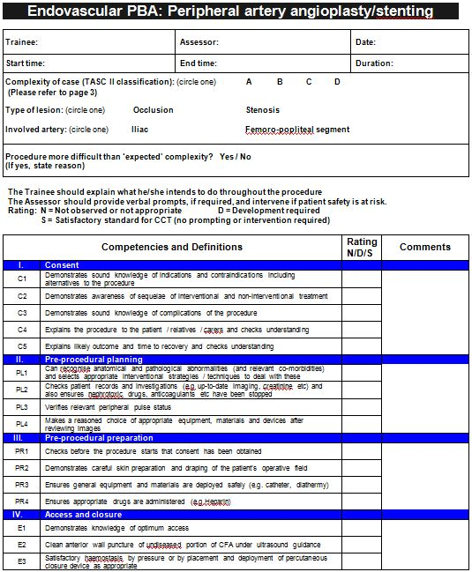

PBA for peripheral artery angioplasty/stenting (page 2) 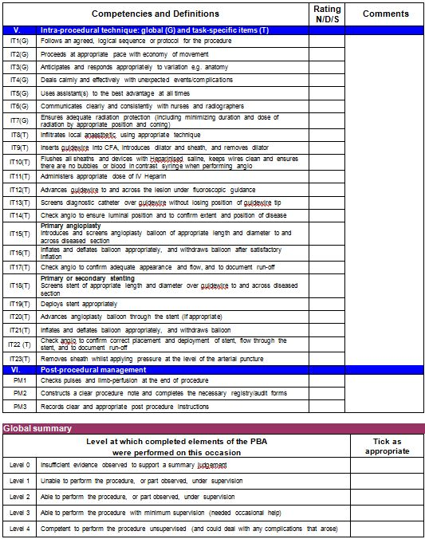

PBA for peripheral artery angioplasty/stenting (page 3)
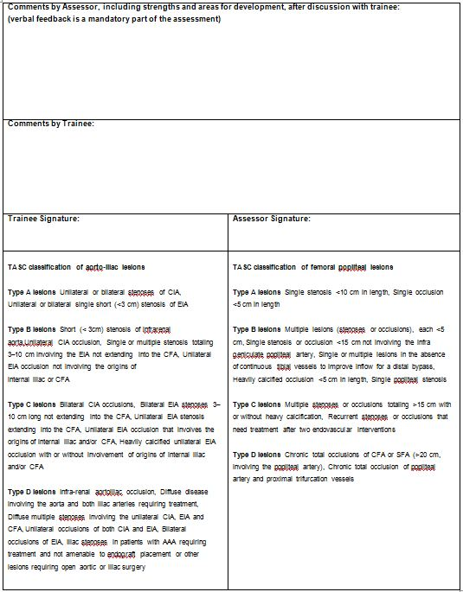

Appendix 8: Programme for Interventional Radiology PBA workshop March 2012

PBA Introduction 19 March 2012
Facilitators: IF=Ian Francis, AM=Anup Mathew, JB=Joe Booth
 | Time | Session | Activity | Lead | Materials/AV
 | 10.00 | Registration and coffee
 | 10.30 | Welcome and Introductions | Overview of the day | IF | PowerPoint
 | 10.45 | Interventional Radiology Curriculum | Slides / Discussion reviewing IR curriculum structure, sub-specialty status, | IF | PowerPoint
 | 11:15 | The Assessment System for IR | Overview of WPBA for CR & IR. Purpose of WPBA – formative vs summative. Mention recent GMC guidance, SLEs in Foundation. Role of mini-IPX and Rad-DOPS. Need for summative assessment of procedural skills. | JB/IF | PowerPoint
 | 11:35 | Morning refreshments
 | 11.55 | Introducing PBAs | Background of PBAs, use in surgery, research evidence from surgery, previous piloting etc in radiology. How to conduct PBAs in practice. Discussion. | AM | PowerPoint, paper copies of all PBA forms.
 | 12:30 | Practising PBAs | Show video and get delegates to complete the relevant PBA form. Compare scoring in some fields. Discuss. | AM/IF | Video clip, relevant PBA form.
 | 13:00 | Lunch
13.30 |  | The pilot | How we plan to run the pilot, what we want coordinators to do. Discussion about feasibility and timing. | JB | Powerpoint / documents
14:00 |  | Opportunities for assessment | How to fit WPBAs in general and PBA in particular into the working day | IF | Powerpoint / discussion
14:30
15:00 |  | Evaluation and close |  |  | Evaluation Forms

Appendix 9: Feedback form for National Pilot evaluation of IR-PBAs (2012)

Feedback for the Pilot Evaluation

To be completed by the assessor:

As the assessor, how long did this process take, in addition to the time you would normally have spent observing the procedure?
<10 mins 10-20 mins 20-30 mins >30 mins

It is important to assess and give feedback to trainees on their performance in carrying out interventional procedures
Strongly disagree Disagree Neutral Agree Strongly Agree

It was easy to use this assessment form
Strongly disagree Disagree Agree Strongly Agree

The supporting guidance notes were clear
Strongly disagree Disagree Agree Strongly Agree Did not read guidance

It was useful to have this assessment form to help structure feedback to the trainee.
Strongly disagree Disagree Agree Strongly Agree

Do you have any comments on the assessment or suggestions for improvement?

To be completed by the trainee:

It is important to be assessed and receive feedback on my performance
Strongly disagree Disagree Neutral Agree Strongly Agree

It was easy to understand the assessment form
Strongly disagree Disagree Neutral Agree Strongly Agree

It was useful to receive structured feedback from the assessor.
Strongly disagree Disagree Agree Strongly Agree

Do you have any comments on the assessment or suggestions for improvement?

Appendix 10: Assessor free text responses on feedback forms for National Pilot evaluation of IR-PBAs (2012)
Refining and reducing the questions as there is some repetition
Fit for purpose - very thorough assessment
It is too detailed and structured. It is useful for a trainee in the early stages of development as each step is detailed, but more broad statements need to be much easier to fill in.
Too labour intensive
Sorry I didn't read guidance immediately before, though I looked before, but it needs to be intuitive.
Rigid competencies in a particular procedure do not allow for deviation from that technique, whether it be due to operator preference or required due to anatomy/pathological findings - the candidate may be unfairly marked down because of this.
Too lengthy a form, lots of questions, difficult in busy set up to fill in the form. An informal feedback is more useful.
More space for free text comments and observations. There are too many individualised performance statements. Forms should be on global skill and performance as well as stepwise analysis of performance.
I think there are too many individualised steps in the analysis of the procedure. System process and confidence of trainee could be focussed on in further detail.
I nearly lost the will to live
Make more concise e.g. separate section surgical/anaesthetic aspects of the EVAR as some of these are irrelevant in our practice. Also maybe have a version for junior trainees and one for senior trainees as some of the questions are very basic for senior people.
24 - 26 are similar
Some parts of the form far too complicated and over engineered, particularly the pre-procedure.
The rating system is not helpful. The 'S' category could be replaced with 'satisfactory for stage/year of training'.

Appendix 11: Trainee free text responses on feedback forms for National Pilot evaluation of IR-PBAs (2012)

Perhaps too many sections, in particular assessments of puncture and access
Its very detailed and may distract the assessor from the case itself. This type of form may be more useful for more junior trainees.
Form is too detailed and time-consuming to use when the trainee is able to perform the procedure almost independently.
I didn’t need to understand the form, it was more important for my assessor to be familiar with it. The assessment case felt artificial in that there was very little dialogue. Usually there is lots of dialogue between trainer and trainee throughout the procedure.
Long winded assessment process. Good feedback ie performance.
Good to go through the events of procedure and discuss. Good supervision and guidance.
Good tool that can be made better.
Please make this form more concise. Most trainees would not be inclined to take this much time.
Please make this form more concise or group stages of the intervention into sections which can then be generally ticked off.
Form is too detailed but process of feedback is very helpful.
The process of feedback is very constructive. The form is too detailed and some sections are slightly repetitive. A grading scale e.g. 1-5 would be better as a rating system.

