Investigating Fibroblast Involvement in Vascular Inflammation Using Co-Culture Models

Kelly Wright

Department of Materials Science and Engineering
The University of Sheffield

A Thesis Submitted for the Degree of
Doctor of Philosophy
September 2018
ABSTRACT

BACKGROUND
Coronary heart disease is caused by the accumulation of fatty deposits within the vascular lining, which often goes undetected until a patient becomes symptomatic. Consequently, current treatments are primarily aimed at symptomatic relief. Nevertheless, it would be more beneficial to develop preventative treatments.
To do this it is necessary to understand the chronic inflammatory processes that underpin atherogenesis. Endothelial adhesion molecules (e.g. ICAM-1) are up-regulated during inflammation. ICAM-1 binds to LFA-1 on circulating leukocytes to enable extravasation into the vessel wall; numerous cell types including the endothelial cell, smooth muscle cell and fibroblast have been shown to express ICAM-1, though its expression patterns in the vessel wall have not been studied in detail.
Moreover, the involvement of the adventitial fibroblast has become increasingly popular owing to its ability to migrate towards a site of injury at the luminal surface. Therefore, it was hypothesised that inflammatory-activated endothelium directly activates the fibroblast, which then provides a positive feedback loop to enhance the inflammatory response in the endothelial cells.
ICAM-1 was used as a marker to study the augmentation of the inflammatory responses of endothelial cells, smooth muscle cells and fibroblasts in various co-culture arrangements. This would unravel the communication network that exists between these cell types and suggest how this can be augmented in an inflammatory response.

METHODS
The numbers of intimal and adventitial cells were counted in 5 µm paraffin-embedded histology sections of human coronary artery (LAD and RCA). Sections were also immunolabelled against α-SMA and THY-1.
HUVEC, HUASMC and NHDF were cultured in 2D monoculture and co-culture arrangements. The cells were stimulated with 25 U/mL human recombinant TNF-α for 0, 3, 6, 9 and 12 hours before fixing and immunolabelling for ICAM-1 expression. Games-Howell testing was used to determine any statistically significant differences in ICAM-1 expression, and the relationship between cell ratio and ICAM-1 expression was examined via Spearman’s Rho in co-cultures.
Significant results were examined further through conditioned medium experiments. This involved incubating monocultures of HUVEC, HUASMC and NHDF with or without 25 U/mL TNF-α for 12 hours prior to sterile filtering and transferring to fresh monocultures of HUVEC and NHDF. ICAM-1 expression was assessed and compared to monoculture and co-culture data.
Dot blots and western blots were also carried out on HUVEC and NHDF cell lysates on 10 % polyacrylamide gels. For dot blots, dots using 2 µg protein were created whilst for western blotting the wells were loaded with 10 µg total protein. The equipment set to 100 V for 110 and 75 minutes for SDS-PAGE and western blot, respectively. The nitrocellulose membrane was then blocked with 5 % BSA and immunolabelled against ICAM-1 using the chromogenic substrate DAB.

RESULTS/DISCUSSION
The proportion of adventitial cells changed in relation to the extent of plaque progression in the coronary artery sections, though opposing trends were seen in the RCA and LAD, where the cell ratio increased and decreased, respectively. This suggested that additional factors such as shear stress could affect adventitial cell proliferation and/or migration.
Co-labelled cells for α-SMA and THY-1 were present primarily within the tunica adventitia, indicating the likely phenotype conversion of the fibroblast into the myofibroblast.
ICAM-1 expression in HUVEC was significantly increased in co-culture with both HUASMC and NHDF after 12 hours of TNF-α stimulation, when compared to monoculture (p<0.001). The mechanisms of action were contrasting, where HUASMC constitutively expressed a pro-inflammatory molecule whilst TNF-α induced pro-inflammatory expression in NHDF that acted on HUVEC.
The opposite was found in NHDF, where the ICAM-1 expression was decreased after 12 hours in co-culture with HUVEC and HUASMC versus monoculture (p<0.001), highlighting the expression of anti-inflammatory mediators by both the endothelial and smooth muscle cells.
Conditioned medium experiments demonstrated that ICAM-1 was significantly up-regulated in HUVEC when HUVEC, HUASMC and NHDF were pre-incubated with TNF-α for 12 hours (p<0.001). Yet, TNF-α offered little alteration to the ICAM-1 up-regulation in NHDF, where significant up-regulation generally occurred when HUVEC, HUASMC and NHDF were pre-incubated without TNF-α. These results confirmed that prior to TNF-α stimulation, signalling pathways targeted fibroblast activation, whilst afterwards these switched to enhancing the inflammatory response within the endothelial cell.
Analysis of HUVEC and NHDF cell lysates through dot blot demonstrated that significant up-regulation of ICAM-1 abundance was evident in HUVEC in the presence of TNF-α (p=0.012). This could not be demonstrated in NHDF. ICAM-1 bands could not be detected in NHDF by western blotting, but HUVEC presented a similar pattern to that obtained through dot blot analysis.
Differences between the dot blot and confocal image analysis are likely because ICAM-1 is present within the cell and the soluble form of ICAM-1 is released. Confocal image analysis only studied the presence of ICAM-1 expression on the cell membrane. Moreover, the sensitivity threshold of western blotting may not be suitable for assessing ICAM-1 expression; ideally, the western blot experiments would be repeated using a method with enhanced sensitivity, such as using chemiluminescence detection.

CONCLUSION
Combining the results from monoculture, co-culture and conditioned medium experiments indicated the presence of autocrine, juxtacrine and paracrine signalling pathways.
Pro-inflammatory pathways were evident from the endothelial and smooth muscle cells to the fibroblast without the presence of TNF-α, yet when TNF-α was included these pathways became inhibitory and new pro-inflammatory pathways were activated from the smooth muscle and fibroblast cells towards the endothelial cell. Consequently, the endothelial pro-inflammatory response was exacerbated when the fibroblast was included.
Data obtained confirms that the fibroblast has the ability to augment the vascular inflammatory response and should therefore be included in in vitro models that study the signalling mechanisms that underpin atherogenesis. More specifically, the communication pathways between the endothelial cell and fibroblast need to be considered in more detail, which may highlight novel therapeutic targets to prevent vascular disease in the future.

ACKNOWLEDGEMENTS
Firstly, I would like to express my sincere gratitude towards my supervisors Prof. John Haycock and Prof. Sheila Francis for their continued motivation, guidance and invaluable advice throughout my PhD.
A big thank you to all of my friends and family for their support; a special appreciation to Josh Taylor for being my rock, a constant source of encouragement and for being there for me through all the ups and downs of my research. You have always been willing to listen to me even when you have no idea what I am talking about. Thank you.
I would also like to thank all the scientists within the Kroto Research Institute that have helped me during my project, especially Vanessa Singleton who has supported me endlessly, particularly with getting the western blotting equipment up and running.
Finally, thank you to EPSRC for funding my project and providing this opportunity. Without it, this would not have been possible.

STATEMENT OF ORIGINALITY
This is to certify that to the best of my knowledge the contents of this thesis are my own work and contains no material previously published or written by another person except where references are made.

TABLE OF CONTENTS
Pg.
LIST OF FIGURES 11
LIST OF TABLES 15
ABBREVIATIONS 16

CHAPTER 1 - INTRODUCTION AND OVERVIEW 18
1.1 AN INTRODUCTION TO CARDIOVASCULAR DISEASE 18
1.2 RESEARCH IN CVD 18
1.3 HYPOTHESIS 21
1.4 EXPERIMENTAL DESIGN 22
1.5 AIMS AND OBJECTIVES 23

CHAPTER 2 – LITERATURE REVIEW 25
2.1 CVD MORBIDITY AND MORTALITY 25
2.2 FACTORS AFFECTING CVD DEVELOPMENT 29
2.2.1 VASCULAR ANATOMY AND PHYSIOLOGY 29
2.2.2 GENETIC AND LIFESTYLE FACTORS FOR CVD 33
2.3 PATHOGENESIS OF ATHEROSCLEROSIS 34
2.3.1 STAGES OF ATHEROSCLEROSIS 34
2.3.2 ELASTIC LAMINA INTEGRITY 37
2.3.3 SMC PHENOTYPE CONVERSION 39
2.3.4 FIBROBLAST PHENOTYPE CONVERSION 41
2.3.5 NEOVASCULARISATION IN ATHEROSCLEROSIS 42
2.4 THE ROLE OF INFLAMMATION IN ATHEROSCLEROSIS 43
2.4.1 INNATE IMMUNITY 44
2.4.2 ADAPTIVE IMMUNITY 51
2.4.3 THE CONTRIBUTION OF LDL TO THE EXPRESSION OF ADHESION MOLECULES 53
Pg. 2.4.4 THE SIGNFICANCE OF ICAM-1 EXPRESSION 54
2.5 TREATMENTS FOR CVD 54
2.6 IN VITRO MODELS 58
2.7 SUMMARY 67

CHAPTER 3 - DETERMINING FIBROBLAST
PRESENCE IN HUMAN ATHEROSCLEROTIC
SPECIMENS BY IMMUNOHISTOCHEMISTRY AND HISTOLOGY 69
3.1 INTRODUCTION 69
3.2 METHODS 71
3.2.1 PREPARATION OF HUMAN CORONARY ARTERY
SECTIONS 71
3.2.2 CONFOCAL MICROSCOPY 72
3.2.3 LIGHT MICROSCOPY 72
3.3 RESULTS 75
3.3.1 IMMUNOHISTOCHEMISTRY SIGNIFYING
MYOFIBROBLAST PRESENCE 75
3.3.2 LIGHT MICROSCOPY ANALYSIS COMPARING
ADVENTITIAL TO ENDOTHELIAL CELL COUNTS 77
3.4 DISCUSSION 78
3.4.1 IMMUNOHISTOCHEMISTRY SIGNIFYING
MYOFIBROBLAST PRESENCE 78
3.4.2 LIGHT MICROSCOPY ANALYSIS COMPARING
ADVENTITIAL TO INTIMAL CELL COUNTS 80
3.5 CONCLUSION 82

Pg.
CHAPTER 4 – HUMAN UMBILICAL VEIN
ENDOTHELIAL CELL, HUMAN UMBILICAL ARTERY
SMOOTH MUSCLE CELL AND NORMAL HUMAN
DERMAL FIBROBLAST MONOCULTURE STUDIES 83
4.1 INTRODUCTION 83
4.2 METHODS 84
4.2.1 PREPARATION OF CELL CULTURE MEDIUM 85
4.2.2 HUVEC ISOLATION AND CULTURE 86
4.2.3 NHDF ISOLATION AND CULTURE 88
4.2.4 HUASMC CULTURE 90
4.2.5 RESURRECTION OF CRYOPRESERVED CELLS 90
4.2.6 EFFECTS OF CULTURE MEDIUM CONDITIONS ON CELL GROWTH 91
4.2.7 TNF-α STIMULATION OF MONOCULTURES 91
4.2.8 IMMUNOCYTOCHEMISTRY TO EXAMINE ICAM-1
UP-REGULATION 92
4.2.9 USING IMAGE ANALYSIS SOFTWARE TO ASSESS
ICAM-1 EXPRESSION IN MONOCULTURE 93
4.3 RESULTS 94
4.3.1 EFFECTS OF CULTURE MEDIUM CONDITIONS ON CELL GROWTH 94
4.3.2 ICAM-1 UPREGULATION DEPENDENCE OF
TNF-α CONCENTRATION 96
4.3.3 TIME DEPENDENCE OF ICAM-1 EXPRESSION 99
4.4 DISCUSSION 102
4.4.1 EFFECTS OF CULTURE MEDIUM CONDITIONS ON CELL GROWTH 102
4.4.2 ICAM-1 EXPRESSION 103
4.5 CONCLUSION 106

Pg.
CHAPTER 5 – HUMAN UMBILICAL VEIN
ENDOTHELIAL CELL, HUMAN UMBILICAL ARTERY
SMOOTH MUSCLE CELL AND NORMAL HUMAN
DERMAL FIBROBLAST CO-CULTURE STUDIES 107
5.1 INTRODUCTION 107
5.2 METHODS 108
5.2.1 CELL CULTURE 108
5.2.2 ANALYSIS OF CELL SEEDING RATIOS 109
5.2.3 TNF-α STIMULATION OF CO-CULTURES 110
5.2.4 IMMUNOCYTOCHEMISTRY TO EXAMINE ICAM-1
UP-REGULATION 111
5.2.5 USING IMAGE ANALYSIS SOFTWARE TO ASSESS
ICAM-1 EXPRESSION IN CO-CULTURE 112
5.3 RESULTS 113
5.3.1 ANALYSIS OF CELL SEEDING RATIOS 113
5.3.2 HUVEC AND NHDF CELLS IN CO-CULTURE 116
5.3.2 HUVEC AND HUASMC CELLS IN CO-CULTURE 119
5.3.3 HUASMC AND NHDF CELLS IN CO-CULTURE 124
5.3.4 HUVEC, HUASMC AND NHDF CELLS IN
TRI-CULTURE 127
5.4 DISCUSSION 130
5.4.1 ANALYSIS OF CELL SEEDING RATIOS 130
5.4.2 NHDF TO HUVEC CELL COMMUNICATION 131
5.4.3 HUASMC INFLUENCE OF ICAM-1 EXPRESSION 134
5.4.4 COMBINED EFFECTS IN TRI-CULTURE 136
5.4.5 LIMITATIONS 137
5.5 CONCLUSION 138

Pg.
CHAPTER 6 – TRANSFER OF PRE-CONDITIONED
CELL CULTURE MEDIUM TO ASSESS CELLULAR COMMUNICATION METHODS 140
6.1 INTRODUCTION 140
6.2 METHODS 141
6.2.1 CELL CULTURE 141
6.2.2 ICAM-1 UP-REGULATION USING PRE-
CONDITIONED MEDIUM 141
6.2.3 IMMUNOCYTOCHEMISTRY TO EXAMINE ICAM-1
UP-REGULATION 144
6.3.4 ANALYSIS OF IMAGES 144
6.3 RESULTS 145
6.3.1 HUVEC CONDITIONED MEDIUM TRANSFERRED TO
HUVEC 145
6.3.2 HUASMC CONDITIONED MEDIUM TRANSFERRRED TO
HUVEC 148
6.3.3 NHDF CONDITIONED MEDIUM TRANSFERRED TO
HUVEC 151
6.3.4 HUVEC CONDITIONED MEDIUM TRANSFERRED TO
NHDF 154
6.3.5 HUASMC CONDITIONED MEDIUM TRANSFERRED TO
NHDF 157
6.3.6 NHDF CONDITIONED MEDIUM TRANSFERRED TO
NHDF 169
6.4 DISCUSSION 163
6.4.1 AUTOCRINE CYTOKINE SIGNALLING 163
6.4.2 ICAM-1 EXPRESSION AFTER TRANSFER OF
CONDITIONED MEDIUM WITHOUT PRO-INFLAMMATORY STIMULATION 164
6.4.3 ICAM-1 EXPRESSION AFTER TRANSFER OF
CONDITIONED MEDIUM WITH PRO-INFLAMMATORY
STIMULATION 166

Pg.
6.4.4 DIFFERENCES BETWEEN CULTURE CONDITIONS
IN CO-CULTURE VERSUS THOSE INVOLVING THE
TRANSFER OF CONDITIONED CULTURE MEDIUM 167
6.5 CONCLUSION 168

CHAPTER 7 - CHANGES IN ICAM-1
CONCENTRATION VIA CELL LYSATE ANALYSIS 170
7.1 INTRODUCTION 170
7.2 METHODS 172
7.2.1 SAMPLE PREPARATION 172
7.2.2 DOT BLOT 174
7.2.3 SDS-PAGE 174
7.2.4 WESTERN BLOT 178
7.2.5 ANALYSIS OF ICAM-1 EXPRESSION 179
7.3 RESULTS 179
7.3.1 SAMPLE PREPARATION 179
7.3.2 SDS-PAGE 181
7.3.3 WESTERN BLOT 182
7.3.4 IMMUNOCHEMISTRY TO DETECT ICAM-1 183
7.4 DISCUSSION 187
7.4.1 USEFULNESS OF COOMASSIE BLUE AND PONCEAU
S STAINING 187
7.4.2 DOT BLOT VERSUS WESTERN BLOT 188
7.4.3 DOT BLOT VERSUS CONFOCAL IMAGE ANALYSIS 190
7.5 CONCLUSION 191

CHAPTER 8 - CONCLUSIONS AND FUTURE WORK 193
8.1 OVERALL CONCLUSIONS 193
8.2 FUTURE WORK 197
Pg.
BIBLIOGRAPHY 199

LIST OF FIGURES
Pg.
Figure 1.1 - The number of results from all databases in Web of Science under
the topic ‘atherosclerosis’ between 1988-2018. 20

Figure 2.1 - A scatterplot of CVD rate (age-standardised) and HDI for 171
countries. 26

Figure 2.2 – 2015 mortality statistics from CVD in the UK. 28

Figure 2.3 - Diagrammatic representation of vascular structure. 30
Figure 2.4 - Atheroprone areas within the coronary arteries and aorta. 32

Figure 2.5 - Comparison of the blood flow profile in the LCA and the RCA. 33

Figure 2.6 - Schematic representation of the histological changes that occur
within the atherosclerotic plaque development. 35

Figure 2.7 - Correlation between injury score and neointimal formation. 38

Figure 2.8 - Shear stress controls SMC phenotype. 40

Figure 2.9 - The fibroblast to smooth muscle cell continuum hypothesis and its contribution to neointimal formation. 42

Figure 2.10 - NF-κB is regulated by both TNF-α and IL-1 during the innate
immune response but via different mechanisms. 48

Figure 2.11 - The initial stages of inflammation in atherosclerosis. 52
Figure 2.12 - Differences in immunoglobulins IgM and IgG. 52
Figure 2.13 - The insertion procedure for a stent. 56

Figure 2.14 - Endothelial cell fate. 60
Figure 2.15 - Schematic of various co-culture arrangements. 61

Figure 3.1 - A light microscopy image of a van Gieson stained human coronary artery. 73

Figure 3.2 - Haematoxylin and eosin stained images of a RCA. 74

Figure 3.3 - Method of analysing the ratio of endothelial cells to adventitial cells
via microscopy. 74

Figure 3.4 - Immunostaining for α-SMA in a mouse coronary artery. 75

Pg.
Figure 3.5 - Immunohistochemistry for α-SMA and THY-1 in human coronary
artery sections. 76
Figure 3.6 - The ratio of adventitial cell to endothelial cell in relation to the completeness of the endothelial barrier. 77
Figure 4.1 - HUVEC isolation. 87

Figure 4.2 - Stages of NHDF isolation. 89

Figure 4.3 - Phase contrast images of HUVEC and NHDF phenotype. 94

Figure 4.4 - Representative confocal micrograph images of HUVEC and NHDF
at 6 and 24 hours stimulated under different concentrations of TNF-α 96

Figure 4.5 - Mean ICAM-1 upregulation in (a) HUVEC and (b) NHDF after incubation with different concentrations of TNF-α. 97

Figure 4.6 - Representative confocal micrographs of ICAM-1 expression at 3
hourly intervals up to 12 hours for HUVEC, HUASMC and NHDF after
incubation with 25 U/mL TNF-α. 99

Figure 4.7 - ICAM-1 upregulation in HUVEC, HUASMC and NHDF
monocultures stimulated with 25 U/mL TNF-α. 100

Figure 4.8 - Confocal images of ICAM-1 expression (red) on HUVEC and
NHDF after 12 hours of stimulation with 25 U/mL TNF-α. 101

Figure 5.1 - Epifluorescent micrograph images representing the different
HUVEC and NHDF co-culture ratios. 114

Figure 5.2 - The mean change in ratio of HUVEC and NHDF when cultured at
different seeding ratios. 114

Figure 5.3 - The mean change in cell count of HUVEC and NHDF over the 48-
hour study period in co-culture. 115

Figure 5.4 - Representative confocal micrograph images of HUVEC and NHDF
co-cultures when stimulated with 25 U/mL TNF-α for 0-12 hours. 117

Figure 5.5 - ICAM-1 upregulation in HUVEC and NHDF cells in co-culture when stimulated with 25 U/mL TNF-α. 118

Figure 5.6 - Relationship between the cell ratio (equation 5.1) and ICAM-1
levels in HUVEC and NHDF cells in co-culture when stimulated with 25 U/mL
TNF-α. 120

Figure 5.7 - Representative confocal micrograph images of ICAM-1 in HUVEC
and HUASMC co-cultures when stimulated with 25 U/mL TNF-α for 0-12 hours. 121

Pg.
Figure 5.8 - ICAM-1 upregulation in HUVEC and HUASMC cells in co-culture
when stimulated with 25 U/mL TNF-α. 122

Figure 5.9 - The relationship between HUVEC to HUASMC cell ratio and
ICAM-1 intensity in HUVEC cells. 123

Figure 5.10 - Confocal micrograph images representative of HUASMC and
NHDF cell co-cultures when stimulated with 25 U/mL TNF-α for 0-12 hours. 125

Figure 5.11 - ICAM-1 expression in HUASMC and NHDF cells in co-culture
when stimulated with 25 U/mL TNF-α. 126

Figure 5.12 - Confocal micrograph images of a HUVEC / HUASMC / NHDF cell
co-culture after stimulation with 25 U/mL TNF-α for 12 hours. 128

Figure 5.13 - A summary of the ICAM-1 intensities obtained after 12 hours of
TNF-α stimulation in HUVEC, HUASMC and NHDF cells under different culture conditions. 129

Figure 6.1 - Medium transfer experimental design. 142

Figure 6.2 - Representative confocal micrograph images of ICAM-1 expression
on HUVEC. 144

Figure 6.3 - Intensity of ICAM-1 on HUVEC after adding conditioned M199
medium from HUVEC for 12 hours. 147

Figure 6.4 - Representative confocal micrograph images of ICAM-1 expression
on HUVEC when incubated with conditioned M199 medium from HUASMC. 149

Figure 6.5 - ICAM-1 intensity values on HUVEC after incubation with
conditioned M199 medium from HUASMC. 150

Figure 6.6 - Confocal micrograph images representative of the ICAM-1
expression on HUVEC after incubation with conditioned M199 medium from
NHDF. 152

Figure 6.7 - ICAM-1 intensity on HUVEC after the transfer of NHDF conditioned
M199 medium, both with and without 25 U/mL TNF-α. 153

Figure 6.8 - Representative confocal micrograph images of ICAM-1 expression
on NHDF when incubated with conditioned M199 medium from HUVEC, with
and without TNF-α. 155

Figure 6.9 - ICAM-1 intensity on NHDF after the addition of M199 medium
conditioned on HUVEC. 156

Figure 6.10 - Confocal micrograph images representative of ICAM-1
expression on NHDF incubated with conditioned M199 from HUASMC. 158

Pg.
Figure 6.11 - ICAM-1 intensity in NHDF after the addition of conditioned M199
medium on HUASMC for 12 hours, either with or without 25 U/mL TNF-α 159

Figure 6.12 - Representative confocal micrograph images of ICAM-1
expression on NHDF incubated with conditioned M199 medium from NHDF. 161

Figure 6.13 - ICAM-1 expression on NHDF after the addition of conditioned
M199 medium from NHDF, either with or without TNF-α. 162

Figure 7.1 - BSA standard curve produced via BCA assay. 173
Figure 7.2 - SDS-PAGE equipment. 177

Figure 7.3 - Western Blot equipment. 178

Figure 7.4 - 10 % polyacrylamide gel with Coomassie Blue staining to
highlight the protein migration pattern on a variety of protein samples. 181

Figure 7.5 - Coomassie Blue staining of polyacrylamide gel and Ponceau S
staining of the respective nitrocellulose membrane. 182

Figure 7.6 - Ponceau S staining of nitrocellulose membrane with HUVEC and
NHDF samples after incubation with 25 U/mL TNF-α. 183

Figure 7.7 - 2 µg dot blots of HUVEC and NHDF cell lysates after incubation
with (A-E) 25 U/mL TNF-α for 0, 3, 6, 9 and 12 hours. 184

Figure 7.8 - Dot blot analysis of HUVEC and NHDF cell lysates after 25 U/mL
TNF-α addition for 0-12 hours. 185

Figure 7.9 - Comparison of ICAM-1 abundance in HUVEC and NHDF cell
Lysates. 185

Figure 7.10 - Immunolabelling for ICAM-1 after western blotting. 186

Figure 7.11 - Quantitation of ICAM-1 protein from western blot, where HUVEC
were incubated with TNF-α for 0-12 hours. 186

Figure 7.12 - Detection of ICAM-1 via western blotting in HUVEC after
incubation with 25 U/mL TNF-α for 12 hours. Each lane was loaded with 0, 2.5,
5, 7.5 and 10 µg of total protein (left to right). 188

Figure 8.1 - The hypothesised signalling network with candidates for the responsible signalling molecules. 196

LIST OF TABLES
Pg.
Table 2.1 - Genes targeted by NF-κB in large vessel cell types. 46

Table 2.2 - Features of a stent that can affect restenosis rate. 57

Table 2.3 - Comparison of 2D Co-culture arrangements from figure 2.17 (181). 62

Table 2.4 - In vitro co-culture methods to study atherosclerosis using human
cells. 63

Table 2.5 - Common experimental markers used for vascular cells either to
identify or characterise under different environmental conditions. 66

Table 4.1 - Constituents of the 1x intermediate M199 medium used for HUVEC
and HUASMC culture. 84

Table 6.1 - The combinations used for conditioned medium experiments.
Transfer between the same cell types were used as a control for comparative purposes. 143

Table 7.1 - Comparison of the advantages/disadvantages of western blot,
confocal microscopy and flow cytometry. 171

Table 7.2 - Constituents of the 2x non-reducing Laemmli buffer used for
western blot sample preparation. 173

Table 7.3 - The recipes of the polyacrylamide gels used. 176
Table 7.4 - The recipes of the running and transfer buffers used for SDS-
PAGE. 176

Table 7.5 - Protein concentration calculated for each sample, with
respective volumes required to carry out SDS-PAGE. 180

ABBREVIATIONS

α-SMA Alpha Smooth Muscle Actin
APS Ammonium Persulphate
BCA Bicinchoninic Acid
BMS Bare Metal Stent
BSA Bovine Serum Albumin
CABG Coronary Artery Bypass Graft
CD54 Cluster of Differentiation 54
CVD Cardiovascular Disease
DAB 3,3’-Diaminobenzidine
DALY Disability Adjusted Life Years
DES Drug-eluting Stent
DMEM Dulbecco’s Modified Eagle Medium
DMSO Dimethyl Sulfoxide
ECGS/H Endothelial Cell Growth Supplement with Heparin
EEL External Elastic Lamina
EndMT Endothelial to Mesenchymal Transition
eNOS Endothelial Nitric Oxide Synthase
FBS Foetal Bovine Serum
FGF Fibroblast Growth Factor
HCAEC Human Coronary Artery Endothelial Cell
HDI Human Development Index
HUASMC Human Umbilical Artery Smooth Muscle Cell
HUVEC Human Umbilical Vein Endothelial Cell
ICAM-1 Intercellular Adhesion Molecule 1
IEL Internal Elastic Lamina
IL-1 Interleukin-1
IL-6 Interleukin-6
IL-8 Interleukin-8
IMA Internal Mammary Artery
ITA Internal Thoracic Artery
JAK/STAT Janus Kinase/Signal Transducers and Activators of Transcription
LAD Left Anterior Descending
LCA Left Coronary Artery
LDL Low-density Lipoprotein
LFA-1 Lymphocyte Function-associated Antigen 1
LOX-1 Oxidised Low-density Lipoprotein Receptor 1
LPL Lipoprotein Lipase
MA-1 Macrophage antigen 1
MCP-1 Monocyte Chemotactic Protein 1
NF-κB Nuclear Factor Kappa B
NHDF Normal Human Dermal Fibroblast
NO Nitric Oxide
OSI Oscillatory Shear Index
oxLDL Oxidised Low-density Lipoprotein
PBS Phosphate Buffered Saline
PBST Phosphate Buffered Saline / Tween
PCSK9 Proprotein Covertase Subtilisin/Kexin
PDGF Platelet Derived Growth Factor
RA Radial Artery
RCA Right Coronary Artery
ROS Reactive Oxygen Species
RT Room Temperature
SDS-PAGE Sodium Dodecyl Sulfate Polyacrylamide Gel Electrophoresis
SVG Saphenous Vein Graft
TEMED Tetramethylethylenediamine
TGF-β Transforming Growth Factor Beta
THY-1 Thymocyte Antigen 1
TNF-α Tumour Necrosis Factor Alpha
TRADD TNFR1-associated Death Domain
UK United Kingdom
VCAM-1 Vascular Cell Adhesion Protein 1
VEGF Vascular Endothelial Growth Factor
vLDL Very Low-density Lipoprotein

CHAPTER 1
INTRODUCTION AND OVERVIEW
  - AN INTRODUCTION TO CARDIOVASCULAR DISEASE
Cardiovascular disease (CVD) is a general term to cover any disease or condition affecting the heart and/or circulation including coronary heart disease, myocardial infarction and stroke; it has been the leading cause of mortality worldwide for the past 15 years, responsible for 15 million deaths in 2015 alone. Although developing countries appear to have a higher proportion of deaths from CVD, middle to high income countries have a much higher prevalence, owing to the improved treatments available [1].
Typically, CVD is associated with atherosclerosis, which is characterised by the accumulation of fatty deposits inside the lining of the vessel wall to form plaques. These plaques increase in size over several decades, gradually decreasing vascular lumen size and consequently reducing the blood flow to downstream vessels. When the vessel becomes completely occluded, either via the growth of the plaque or by plaque rupture leading to thrombi formation, apoptosis of cells in downstream vessels is triggered. The different stages of plaque development and underlying mechanisms are described in chapter 2.3, indicating why acute cardiovascular events tend to happen in older age [2].
The underlying pathogenesis of atherosclerosis is not yet fully understood. The condition has been linked with both lipid accumulation and smooth muscle cell proliferation. There is also an underlying chronic inflammatory state, and the mechanisms that initiate this and its relationship to atherosclerosis have not been fully elucidated [3].

1.2 RESEARCH IN CVD
Thus far, research into the pathogenesis of atherosclerosis has primarily been undertaken using animal models, owing to the limitations with human studies. However, the UK National Centre for the Replacement, Refinement & Reduction of Animals in Research (NC3Rs) have been proactively developing and disseminating the principles of the 3 R’s [4] for over 50 years; these principles have been embedded in national and international legislation and regulations to make the use of animals in scientific procedures more humane, as well as in the policies of organisations that fund or conduct animal research [5]. Therefore, not only are the number of animals used in research limited, but techniques carried out must also be seen to minimise the pain, suffering or distress placed on the animal. Moreover, it is encouraged that the use of animals is avoided or replaced in the first place, where possible. All living vertebrates (except humans and cephalopods) are now defined as ‘protected’ under the Animals (Scientific Procedures) Act 1986. Consequently, the development of in vitro methodologies such as tissue engineering and in silico simulations have increasing research priority and importance.
Although there has been progress within the field of tissue engineering for vasculature, the main foci to date have been on the in vitro production of implantable vessels [6] and the cell-cell communication of the endothelial cell [7], smooth muscle cell [8] and inflammatory cells such as macrophages [9]. Implantable vessel production will reduce the need for autografts during surgeries akin to coronary artery bypass, where a donor vessel (typically thoracic, radial or saphenous) is usually obtained from the patient during surgery. Even though the surgery resolves the symptoms for the patient, it does not treat the underlying cause. Moreover, whilst the cell-cell interactions between the endothelial cells, smooth muscle cells and inflammatory cells are major contributors to plaque development, additional cell types can be found within the tunica adventitia (the outermost layer, see chapter 2.2.1) of vasculature that may also be involved in the inflammatory response, including but not limited to fibroblasts, endothelial progenitor cells and resident leukocytes [10].
The role of the tunica adventitia has been studied intermittently for the past few decades, yet current in vitro vascular models lack the complexity required to effectively study the intercellular interactions during certain processes, including the inflammatory response which underpins atherogenesis [11]. This became apparent when searching through journal articles to decipher how much each cell type within the vessel contributes to the progression of plaque formation. As discussed in chapter 2, there is well-documented evidence for the role of endothelial cells in atherosclerosis; nevertheless, as one progresses to the smooth muscle cell and subsequently the fibroblast, the research available and understanding of these latter cells begins to decline (figure 1.1).
Nevertheless, it is currently known that the dermal fibroblast plays a critical role in wound healing [12]; consequently, it is surprising that the fibroblast has not been studied further in relation to atherosclerosis. The healthy vessel wall wound healing process involves several stages: haemostasis, inflammation, proliferation, epithelialisation and remodelling [12]. Upon injury to the epidermis, pro-inflammatory cytokines activate the fibroblasts in the dermis via paracrine signalling, which in turn causes the fibroblast to secrete an abundant array of cytokines including Tumour Necrosis Factor Alpha (TNF-α) [13], Interleukin 1 (IL-1) [14], Transforming Growth Factor Beta (TGF-β) [15] (see chapter 2.4.1). The fibroblasts also then undergo phenotypic differentiation into myofibroblasts, which migrate into the wound site and contribute to the production of new extracellular matrix and closure of the wound [12]. This can be related to the pathogenesis of atherosclerosis, which has been theorised to be an aberrant, un-regulated form of wound healing, in response to the damage caused to endothelial cells by low shear stress and/or turbulent flow patterns [16].
Figure 1.1 - The number of results from all databases in Web of Science under the topic ‘atherosclerosis’ between 1988-2018. The results were refined using the key words ‘endothelial’, ‘smooth muscle’ and ‘fibroblast’, where the key foci have clearly been on endothelial and smooth muscle cell involvement.
Using this prior information, it is likely that damage caused to the vascular endothelium results in the expression of cytokines which diffuse through the vessel wall, where they can activate the fibroblasts that reside within the tunica adventitia. These fibroblasts then release an extensive range of cytokines from pro-inflammatory mediators such as IL-1 to the chemoattractant monocyte chemotactic protein 1 (MCP-1). some of which would affect the endothelial cells and smooth muscle cells, as well as undergoing a similar transformation to those in the dermis by differentiating into myofibroblasts and migrating towards the wound site.
However, the additional factor of low shear stress (which is not present in skin) may augment the healthy wound healing response by inducing an exaggerated response leading to plaque development. For example, Albuquerque et al demonstrate that a shear stress of 3 dyn/cm² induces faster wound closure compared to both a static control and physiological shear stress conditions (12 dyn/cm²) in in vitro cultures of endothelial cells [17].
Therefore, to completely understand the development of a disorder comparable to atherosclerosis, it is necessary to study all cell types present in the vessel, not only to enable each cell-cell interaction to be studied, but to also understand how a combination of cell types provides diverging results to single cell cultures.

  - HYPOTHESIS
Research has already demonstrated that endothelial cells release pro-inflammatory molecules under atherogenic conditions [18]. Combining this with the ability of inflammatory molecules to induce a phenotype conversion in smooth muscle cell, leading to their migration into the tunica intima [19], the main questions that need to be answered are:
- whether endothelial damage directly or indirectly activates the inflammatory response in the fibroblast, leading to subsequent myofibroblast formation.
- how the cytokines released from the fibroblast upon activation affects the inflammatory response of the endothelial and smooth muscle cells.
I hypothesise that inflammatory-activated endothelium directly activates the fibroblast which consequently provides a positive feedback loop to enhance the inflammatory response in endothelial cells. With the endothelium in atheroprone areas being associated with an inflammatory phenotype, this could provide evidence to suggest that low shear stress could result in an excessive and abnormal wound healing response.

  - EXPERIMENTAL DESIGN
Initially, it was necessary to design a variety of in vitro co-culture experiments using endothelial cells, smooth muscle cells and fibroblasts to study the expression of inflammatory markers typically present in an inflammatory response. Any augmentations to the expression profile under different culture set-ups would therefore indicate the presence of a signalling pathway, either pro- or anti-inflammatory.
This would provide data to conclude whether the fibroblast alters the expression profiles in the endothelial and/or smooth muscle cell or simply migrates to a wound site to aid in extracellular matrix production and wound closure.
To be able to investigate the role of the fibroblast and its contribution to the inflammatory response, it was necessary to first assess the inflammatory response in each cell type individually and then analyse how much the fibroblast augments this response when co-cultured with the endothelial cell and smooth muscle cell. Although in vitro experimental results would be more biomimetic if 3D cultures akin to the vascular structure were produced, a basic 2D co-culture design has been adopted (figure 2.17d), where glass coverslips were coated with gelatin to which the Human Umbilical Vein Endothelial Cells (HUVEC), Human Umbilical Artery Smooth Muscle Cells (HUASMC) or Normal Human Dermal Fibroblasts (NHDF) were then directly seeded. This design was simple, but also provided the ability to control and maintain an even level of pro-inflammatory molecule across the culture. If this level was not so accurately controlled, there would be variation in the response time and degree of up-regulation of inflammatory markers, which would make it harder to decipher exactly how the fibroblast was contributing to the inflammatory response.
To begin with, haematoxylin and eosin stained sections of human coronary artery (right coronary artery and left anterior descending) were analysed to calculate the total number of cells present in the tunica adventitia; this included fibroblasts, endothelial progenitor cells and resident leukocytes as these cannot be distinguished via histological staining alone. This value was then used to calculate the ratio of adventitial cells to the number of endothelial cells in areas with and without damage to the endothelium. Moreover, some sections were also immunolabelled, allowing the identification and location of the fibroblasts. Hence, from these data it could be postulated that the fibroblast may play a critical role in atherosclerosis development.
Successively, it was necessary to determine how quickly and to what extent the inflammatory response was up-regulated in each cell type. I decided to use intercellular adhesion molecule 1 (ICAM-1), also known as cluster of differentiation 54 (CD54), as the inflammatory marker of choice. This marker is known to be expressed on HUVEC [20], HUASMC [21] and NHDF [22] and binds to lymphocyte function-associated antigen-1 (LFA-1) and macrophage antigen-1 (MA-1) on leukocytes to promote trans-endothelial migration into the vascular wall [23], a crucial process for the development of atherosclerotic lesions.
Once these data had been assessed, different co-culture environments were considered: HUVEC & NHDF, HUVEC & HUASMC and HUASMC & NHDF. This enabled any alterations in ICAM-1 expression to be observed between co-culture and monoculture conditions and confirm which cell types induced this response. Thereafter, the HUVEC, HUASMC and NHDF were combined into a tri-culture; whether any modifications in ICAM-1 expression were compounded or neutralised after TNF-α addition would indicate whether additional signalling pathways were present and/or which cell signals were dominant.

  - AIMS AND OBJECTIVES
The aim of my PhD was to contribute further to the understanding of the cellular interactions that take place to initiate and progress atherosclerosis within the vascular wall; specifically, to determine whether the inflammatory response observed in endothelial cells and smooth muscle cells can be augmented by the addition of the fibroblast. If the fibroblast proves critical to the cellular interactions within a vessel, the data will enhance the design of current in vitro models to provide a more accurate representation of the inflammatory response that ensues in disorders such as atherosclerosis.
To achieve this aim, a series of main objectives were established:
- To provide evidence of fibroblast presence within human coronary artery through histological and immunohistochemical analysis.
- To establish the culture conditions required to effectively analyse the up-regulation of the inflammatory response in all cell types (medium type, concentration of inflammatory mediator, length of incubation).
- To identify and semi-quantitatively analyse confocal images of ICAM-1 up-regulation in endothelial cells, smooth muscle cells and fibroblasts (in both monoculture and co-culture conditions) and carry out statistical analysis to determine any significant differences in ICAM-1 expression.
- Design experiments to determine the type of signalling occurring between the different cell types and consequently which cytokines may be responsible for any significant differences in ICAM-1 expression observed in co-culture versus monoculture.
If these data conclude that the fibroblast plays a significant role in the vascular inflammatory response, future experiments could build on the current design to include the addition of shear stress and/or the conversion of the current 2D design into 3D to determine whether these have any effect on the up-regulation of ICAM-1.
Moreover, improved vascular co-culture models would enable the investigation into how current therapies affect the fibroblast response and novel targets to be discovered.

CHAPTER 2
LITERATURE REVIEW
  - CVD MORBIDITY AND MORTALITY
CVD is the leading cause of mortality in both developed and developing countries; the classification of countries is largely influenced its human development index (HDI), which is a statistical indicator of how well a country is performing based on life-expectancy, education and per capita income [24]. However, according to World Health Organisation data, more than 80 % of cardiovascular related deaths now occur in developing countries and account for 10 % of disability-adjusted life years (DALYs) with 14038 deaths versus 133462 DALYs in 2004. Meanwhile, in developed countries, cardiovascular related deaths accounted for 17% of DALYs with 3027 deaths versus 17853 DALYs [25].
One DALY is the equivalent to one year of healthy life lost, which is calculated from the total number of years of life lost owing to premature death, in addition to a weighted years of life lost owing to disability. Therefore, with CVD causing severe disability, particularly amongst people who survive acute coronary events such as myocardial infarction or stroke, it is important to not only consider mortality rates, but to also consider the prevalence of CVD and the resultant loss disability-adjusted life years [26, 25].
By looking at the relationship between HDI and the morbidity of CVD worldwide (figure 2.1), it can be observed that in developing countries (HDI ≲ 0.5) there is a positive correlation between disease rate and HDI until reaching a peak of approximately 460 cases per 100,000, at an HDI of 0.7. Developed countries with a higher HDI than 0.9, have a lower rate of CVD than developing countries with low HDI values, likely owing to the research data availability exposing how lifestyle choices such as diet and exercise link to disease risk [27, 26].

Figure 2.1 - A scatterplot of CVD rate (age-standardised) and HDI for 171 countries. The UK is highlighted in red with an HDI of 0.909 and CVD rate of 60.1 [25, 27].
The United Kingdom (UK) is fortunate enough to be one of the few countries with an HDI greater than 0.9 (figure 2.1). Between 1988 and 2010 the mortality rate from CVD within the UK decreased from approximately 800 to 286 per 100,000 (age-standardised), whilst the prevalence increased from 7.5% to 10.1% in the same period [28].
This highlights the situation where CVD is no longer the cause of death for so many people in more developed countries, but rather the relative proportion of people who are living with the disease has now increased. This can be confirmed by looking at cardiovascular-related disease statistics from the UK in 2015 (figure 2.2); stroke and coronary heart disease are not only the major causes of mortality, but also highlight how the number of inpatient episodes within the National Health Service is approximately 6 to 7 times larger than the mortality, respectively. Consequently, it is estimated that there are 7 million people currently living with CVD within the UK. Furthermore, it is evident that age is the biggest mortality risk factor, with about 2/3rds of cases occurring in individuals over 75 years [28].
Owing to a large percentage of people surviving acute coronary events, the cost of CVD to the National Health Service is continually increasing, with a current estimated cost of £9 billion a year, in addition to an economic cost of £19 billion owing to premature death and disability [2]. The only way to reduce this increasing burden is by improving prevention strategies rather than the treatments available. To date, the focus has been on enhancing life expectancy through the development of new and improved treatments. However, this has resulted in increasing numbers of people living with the side-effects of such events, including having to control dietary intake, and mental illness e.g. depression arising as consequence of an inability to work or perform physically demanding activities.
Figure 2.2 – (top) 2015 mortality statistics from CVD in the UK. (bottom) Morbidity of CVD via inpatient episodes within the NHS (latest) [28].
CVD Category
  - FACTORS AFFECTING CVD DEVELOPMENT
Lifestyle, genetics, anatomy and physiology all affect the rate at which CVD is likely to develop. The full extent to what each of these factors contributes to the progression of disease is not yet completely understood; although many lifestyle factors are known to enhance the progression of disease such as diet, smoking status and alcohol consumption [29], the absence of such factors does not mean disease cannot occur. Therefore, it is imperative that further research is undertaken to determine how each factor affects the relative risk of atherosclerotic plaque development.

    - VASCULAR ANATOMY AND PHYSIOLOGY
Although CVD covers a wide range of disorders of the heart and associated vascular system, coronary heart disease and stroke are the key diseases that affect the population. Atherosclerotic plaque formation is essential to the development of such diseases; these plaques are prone to form in specific locations within the vasculature, owing to both the relationship between physical structure of the vessels and the mechanical forces instigated by blood flow.
The vessel wall consists of three distinct layers (figure 2.3):
- Intima: the innermost layer of the vessel wall consisting of simple squamous epithelium (or endothelium) and a thin internal elastic lamina (IEL). The vascular endothelium is a central regulator of haemostasis, fibrinolysis and vascular tone; the cells provide not only a barrier function but also acting as a signal transducer and synthesise their own growth factors [30].

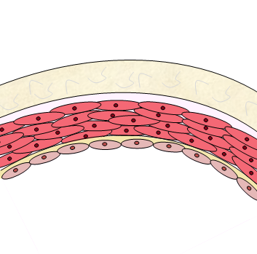
- Media: a thick, middle layer consisting of smooth muscle cells, collagen and elastic fibres. The concentration of elastin decreases towards the extremities and decreases with age. This layer is responsible for providing the vessel tone and responds to chemical signals received from the intima and to neuronal signals from the adventitia to increase/decrease the lumen size. Oxygen is received not only through diffusion but also via small vessels called vasa vasorum that infiltrate the outer wall in large arteries. An external elastic lamina (EEL) separates the media and the adventitia.
Figure 2.3 - Diagrammatic representation of vascular structure. All main vessels consist of 3 layers: tunica intima, tunica media and tunica adventitia.
Tunica Intima
Tunica Media
Tunica Adventitia
IEL
EEL
LUMEN
- Adventitia: the outermost layer of the vessel wall. It consists of a dense collagen and elastic network that provides the strength to the vessel. Autonomic nerves and vasa vasorum filter through this layer [31].
Blood flow and pressure are high in arteries to effectively transport oxygen away from the heart to the tissues that require it. To be able to cope with the demands of high pressure, arteries have a much thicker tunica media and tunica adventitia. On the other hand, as veins are under lower pressure, these vessels have thin walls but contain valves to ensure the blood flows in a continuous direction back to the heart.
Although atherosclerosis is associated with systemic factors such as hypertension and hyperlipidaemia, which tend to be more common in obesity, it has been determined that vessel structure plays a considerable role in influencing where plaques can develop. Blood flow imposes mechanical forces on the vessel wall and each vascular layer works synergistically to maintain a constant wall shear stress (τ) of approximately 15 dyn/cm² [32].
However, this cannot always be achievable, for example in areas of high curvature or vessel bifurcations [33]. These sites are routinely associated with abnormal stresses and strains, typically low-shear stress (<10 dyn/cm²), oscillatory shear stress, complex flow patterns and a high Reynolds (Re) number, a dimensionless number used as an indicator of flow patterns [34].
Pressure gradients are one of the major factors that influence fluid flow. For the majority of time the blood flow is laminar, producing a parabolic velocity profile with the blood constituents in the centre of the vessel travelling the fastest. Nevertheless, there are instances when the profile becomes turbulent and flow is uneven. Areas of low or even negative pressure are created, generating a pressure gradient. These pressure gradients quickly dissipate in areas adjacent to the vessel wall where velocity magnitude is considerably lower than in the main body of fluid. Shear stress becomes zero at the point where separation occurs; in some areas shear stress becomes negative as flow reverses and a region of recirculation develops [35]. These areas provide large residence times for particles such as low-density lipoproteins (LDL), allowing them to be integrated into the vessel wall and provoke an inflammatory response.
Understanding how blood flows within the coronary arteries is important. The ventricles of the heart have considerably different masses at 112 ± 27 vs 38 ± 8 grams, for the left and right ventricles, respectively [36]. This makes it is easy to understand how differences in velocity profiles in the left and right coronary arteries can be produced, owing to differences in the size of muscular contraction. The right coronary artery (RCA) provides branches into the posterior descending artery and the right marginal artery. Meanwhile, the left coronary artery (LCA) branches into the left anterior descending (LAD) and the circumflex artery (figure 2.4) [37].
With a large proportion of the heart mass comprised of the left ventricle, a stronger contraction is produced (compared to the right ventricle) to ensure blood supply to the rest of the body. Thus, a larger pressure gradient is produced (figure 2.5). The altering pressure gradient throughout the coronary tree causes variations in sensitivity to stenosis. Rafflenbeul et al (1980) studied patients with symptoms such as angina and concluded that the mean stenosis (%) in the RCA was lower than in the LAD (63.6 ± 4.4 vs 77.1 ± 3.2, p<0.05).
Additionally, Gradus-Pizlo et al (2003) used high-frequency epicardial echocardiography to determine the wall thickness of the LAD in normal versus diseased patients. The total wall thickness for healthy LAD was 1.0 ± 0.2 mm (combined thickness of tunica intima and tunica media was 0.34 ± 0.1 mm and tunica adventitia was 0.54 ± 0.2 mm) versus 1.8 ± 0.2 mm in patients with atherosclerosis (combined thickness of tunica intima and tunica media was 0.78 ± 0.3 mm and tunica adventitia was 0.92 ± 0.2 mm) [38].
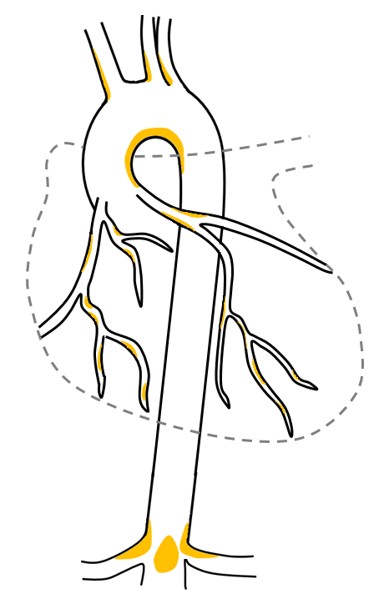
Descending Aorta
Ascending Aorta
RCA
Circumflex Coronary Artery
LAD
LCA
Right Marginal Artery

Figure 2.4 - Atheroprone areas within the coronary arteries and aorta (shown in yellow). Plaque build-up occurs primarily on the inside of curvatures or at branch sites. The coronary arteries are functionally end arteries so if an atheroma obstructs an artery, the heart tissue will die unless anastomoses have had chance to develop. Adapted from [298].

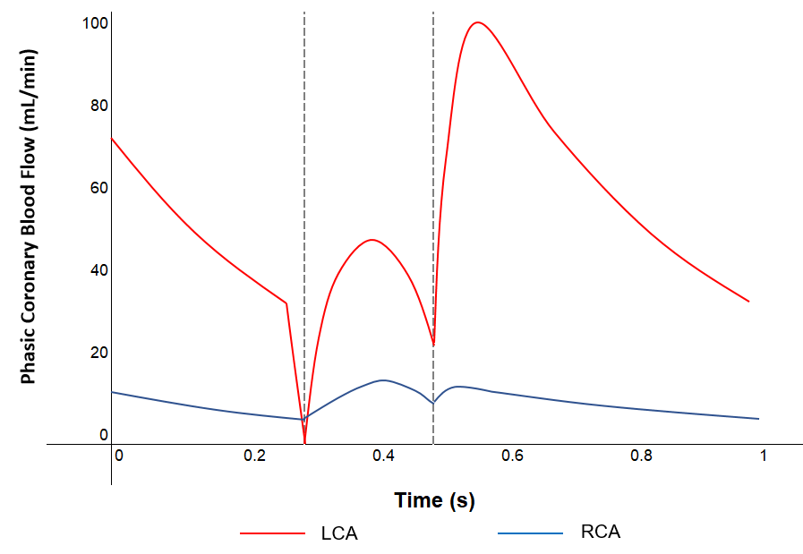
2.2.2 GENETIC AND LIFESTYLE FACTORS FOR CVD
Figure 2.5 - Comparison of the blood flow profile in the LCA and the RCA. At the beginning of systole, blood flow decreases in both arteries, especially the LCA where there is a sharp decline to almost 0 mL/min. Ventricular contraction allows blood to flow into both arteries, though diastole is the principal source for flow in the LCA. There is almost no change in the RCA owing to the decreased pressure in the right ventricle. Adapted from [299].
Risk factors can be separated into 2 categories: those that can be altered and those that cannot. Cardiovascular risk factors that cannot be changed include race [39], gender [40] and the inheritance of genetic conditions such as familial hypercholesterolaemia [41] or type-1 diabetes [42]. Gujral et al (2017) verified that the development of abnormal metabolic activities are less prevalent in white people than any other race or ethnicity [39], whilst women are likely to develop CVD approximately 7 to 10 years later than their male counterparts [40]. Moreover, high blood LDL levels are highly associated with the development of atherosclerotic plaques; familial hypercholesterolaemia is a common autosomal-dominant disorder in Europeans that results in a naturally high LDL level owing to a mutation in the LDL receptor which consequently produces an increased risk of heart disease [41]. Other conditions that can be controlled or prevented, include type-2 diabetes [42], high blood pressure and high cholesterol [43], via improvements in lifestyle choice - including healthy diet, decreasing alcohol and tobacco use, as well as increasing physical exercise [29].

  - PATHOGENESIS OF ATHEROSCLEROSIS
Ideally, the progression and understanding of diseases such as atherosclerosis would primarily involve the use on non-invasive in vivo imaging techniques such as ultrasound and computed tomography. Computed tomography is useful for the detection of luminal stenosis and plaque characterisation; however, when disease is extensive the vascular wall can become calcified and accurate visualisation of the lumen is hindered [44]. Moreover, with disease progression occurring over decades, the ability to follow the formation and development of plaques in vivo is limited.
Consequently, until now the best techniques to assess and analyse plaque formation and composition have been through the histological analysis of both human and mouse model (e.g. ApoE^{-/-}) vascular specimens. Whilst human specimens enable complex plaques to be analysed, mouse models allow relatively quick plaque progression where contribution of additional factors such as diet can be assessed [45].

    - STAGES OF ATHEROSCLEROSIS
The histology of lesions allows classification into degrees of severity, from class I (none to little disease) to VIII (advanced disease) using the conventional American Heart Association classification [46] (figure 2.6). Initial, fatty streak and intermediate lesions are divided into categories I, II and III, whilst more advanced lesions are divided into categories IV, V and VI and can present clinical symptoms such as myocardial infarction and stroke. Categories VII and VIII are reserved for calcified and fibrotic plaques without lipid cores.
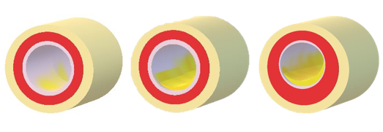
The proportion of advanced lesions increases with age, often with increasing complexity owing to plaque rupture or calcification. Defining the classification of lesions e.g. by magnetic resonance imaging, could potentially allow the indication of intervening treatment prior to plaque advanced stenosis.
Figure 2.6 – Schematic representation of the histological changes that occur within the atherosclerotic plaque development. Initially fatty streaks form, then smooth muscle cells migrate into the neointimal space to decrease lumen size. When the plaque becomes larger a necrotic core is formed. The plaque becomes complex when a surface defect leads to thrombus formation or plaque rupture. Adapted from [46].
Figure 2.6 demonstrates how atherosclerotic plaques can be categorised based upon their histology; detailed descriptions of the classifications are as follows [46]:
Class I: Initial lesion with foam cell formation
Only microscopic changes have taken place, meaning most lesions are not visible to the naked eye. Lesions consist of small, isolated groups of macrophage foam cells, preferentially in areas of intimal thickening. Lipid deposits are chemically detectable.
Class II: Multiple foam cell layers within fatty streaks
May have visible yellow coloured streaks, patches or spots, which can be identified via staining with Sudan III/IV. Macrophage foam cells are presented in higher concentration and in stratified adjacent layers. The turnover of macrophages, endothelial cells and smooth muscle cells are increased.
Class III: Pre-atheroma with extracellular lipid pools
Microscopically visible lipid droplets both extracellularly amongst the layers of smooth muscle cells and below the macrophage and foam cell layers, which replace the intercellular matrix proteoglycans and fibres, driving smooth muscle cells apart.

Class IV: Atheroma with confluent extracellular lipid core
Potentially symptom producing. Severe intimal disorganisation caused by the lipid core, which is generally large enough to be visible to the naked eye. The core develops from increased isolated extracellular lipid pools and organelles within some smooth muscle cells may become calcified. Macrophages/macrophage foam cells are more densely concentrated in lesion periphery.
Class V: Fibroatheroma
Formation of prominent new fibrous connective tissue. Arteries are narrowed, generally more so than in type IV. Smooth muscle cells in the media adjacent to the intima may be disordered, calcified and decreased in number, whilst an increase in macrophage and macrophage foam cells are found within the adventitia.
Class VI: Complex plaque with potential surface defect, haemorrhage or thrombus
Lesions with surface defect (fissures or ulceration), thrombus deposits, or calcified nodule. Thrombotic depositions can occur repeatedly over time and may be a key mechanism for vessel occlusion over a long period in medium sized vessels.
Class VII: Calcified plaque
Some plaques generate thick, fibrous caps which overlay sizeable accumulations of calcium within the neointima. The lipid-laden necrotic core, if present, is usually small and therefore this category of lesion is called fibro-calcific, as opposed to atheroma. These types of plaque may occur as an end-stage of atheromatous plaque rupture and/or erosion after healing and calcification.
Class VIII: Fibrotic plaque devoid of lipid core
When a plaque ruptures, the lipid contents are expelled, and a void is produced. This void must be filled by vessel wall constituents and healed. Healed plaques can be identified by the migration of smooth muscle cells into this void and the production of proteoglycans and newly synthesised collagen type III to produce a scar.
Lesions with previously healed ruptures may exhibit a multi-layering of lipid and necrotic core. Nevertheless, some healed lesions display no evidence of either rupture of the fibrous cap or necrotic core. It is assumed that these lesions are the result of healed erosions (a site lacking endothelium and display minimal inflammation), owing to their distinct layering of smooth muscle cells and proteoglycans, as well as frequently containing fibrin and/or platelets.

    - ELASTIC LAMINA INTEGRITY
Intimal hyperplasia is theorised to be an adaptive response to reduce the vessel lumen diameter in response to chronically reduced shear stress or endothelial injury. This is characterised by the accumulation of smooth muscle cells [47], proliferation of endothelial cells and changes to the extracellular matrix composition [48].
Owing to the non-uniform τ distribution around a vessel circumference, early physiological changes tend to involve only a portion of the vessel. Even though positive remodelling occurs, regional outward expansion of the vascular wall occurs to maintain lumen diameter. This will likely transpire until approximately 40% area stenosis; this is when the vessel has reached its expansion capacity. Only then will the hyperplasia begin to protrude into the lumen and begin to affect the flow of blood to downstream vessels [49, 50].
Evidence has suggested that the response magnitude has a positive correlation to the degree of injury to the vessel wall, as displayed in figure 2.7; this suggests neointimal thickening is an overactive healing reaction. It is hypothesised that maintaining the structural integrity of IEL is essential to preventing the formation and proliferation of the neointima and this prevents the direct contact between the endothelial and smooth muscle cells. This is underpinned by experimental studies on animals, which have demonstrated that either extensive damage or repeated damage to the endothelium will instigate smooth muscle cell migration [51]. Nevertheless, if loss of endothelial cells is limited and of singular occurrence, smooth muscle cell migration will not take place [52].
Previous studies have observed that lesion formation occurs primarily where the IEL has been broken down [51, 53]. Therefore, procedures to reduce vascular blockages where damage to the IEL may occur such as angioplasty or stent insertion often result in restenosis, typically within the first 6 months [54].
On a similar note, Masuoka et al (2010) suggests that a breakdown of the EEL may also correlate to plaque progression when comparing various portions of the internal carotid artery. The EEL was present in all specimens of the petrous portion but had dissipated in 31 out of 32 specimens of the cavernous portion, the most common site of stenosis within this vessel [55]. This indicates that direct contact between smooth muscle cells in the tunica media and cells from within the tuncia adventitia such as fibroblasts, is essential to plaque progression. However, this has not yet been studied in detail in vitro.
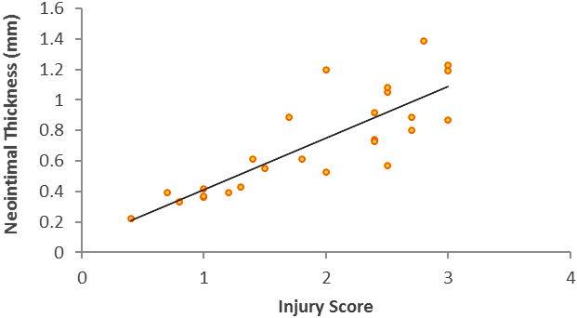
Likewise, when comparing alternative arteries affected by atherosclerosis, it has been recognised that the common hepatic artery has a thickened EEL in contrast to the absence of one within the splenic artery; the common hepatic artery is the least affected by atherosclerosis [56].
Figure 2.7 - Correlation between injury score and neointimal formation. Schwartz et al (1992) developed a porcine coronary restenosis model, in which histopathological injury was directed via a balloon expansion and coil injury method, as with stent insertion. There is a relatively strong positive correlation, with injury score being: 0 = no injury; 1 = break in the internal elastic membrane; 2 = perforation of the media; 3 = perforation of the external elastic membrane to the adventitia [51].
Echeverri et al (2003) confirmed that rupture to the EEL after vascular wall injury e.g. balloon angioplasty stimulates the angiogenic response in plaques, contributing to plaque formation. This may also be a factor that causes the tightly controlled angiogenic factors to become imbalanced to stimulate the production of blood vessels without the creation of lymphatics [57].

    - SMC PHENOTYPE CONVERSION
Changes in cellular environment and communication pathways from endothelial cells and fibroblasts during inflammation induces phenotypic conversion of smooth muscle cells from their normal contractile state to a synthetic phenotype; this synthetic phenotype is critical to atherogenesis [19].
Reactive oxygen species (ROS) mediate the physiological activity of smooth muscle cells. ROS can transfer from endothelial cells to smooth muscle cells via connexins, primarily cx43 and cx37. Connexins are involved in the formation of gap junctions; each gap junction consists of two hemi-channels, where the hemi-channel on the plasma membrane of one cells attaches to a hemi-channel on a nearby cell to allow the transfer of ions and small signalling molecules (figure 2.8) [58]. cx43 and cx37 are reciprocally expressed during times of low and high shear, respectively [18]. Although ROS production increases during endothelial injury, nitric oxide (NO) reacts with superoxide (O₂.) to form peroxynitrite (ONOO⁻), a reactive nitrogen species that promotes LDL oxidation [59].
After endothelial injury, contractile proteins such as α-smooth muscle actin (α-SMA) and SM-myosin are down regulated and protein synthesis is up-regulated promoting the synthetic phenotype. This is typically characterised by an increase in rough endoplasmic reticulum, Golgi and ribosomes that facilitate extracellular matrix production and secretion [60]. Moreover, platelet-derived growth factor (PDGF) is up-regulated in endothelial cells, promoting smooth muscle cell proliferation. These synthetic smooth muscle cells have a rhomboid morphology and typically have a higher proliferative and migration rate, resulting in smooth muscle cells being found within the tunica intima to produce the excessive healing response [19].
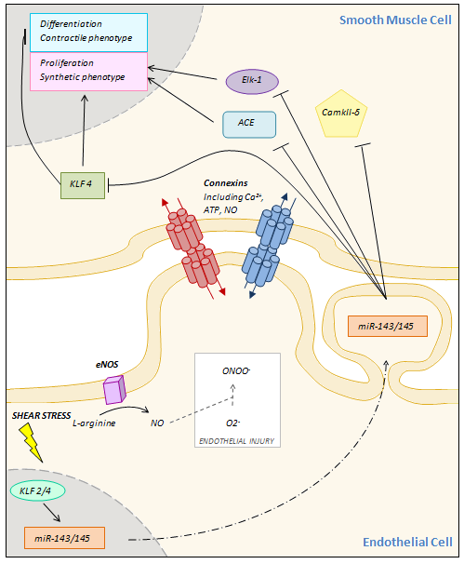
Zhang et al (1999) demonstrated that the synthetic phenotype of the smooth muscle cell can induce tissue factor expression in endothelial cells via a pathway independent of IL-1 and TNF-α [61]. This is significant, owing to the increased likelihood of thrombus formation on a plaque surface, leading to the onset of an acute coronary event.
Figure 2.8 – Shear stress controls SMC phenotype. Shear stress induces eNOS to synthesise NO; however, during endothelial injury this is scavenged by the superoxide radical reducing its protective effects. Moreover, miR-143 and miR-145 are up-regulated, controlling SMC phenotype. Unlike NO, these miRNAs must be transferred between cells by vesicle-mediated transport as they are too bulky to pass through the gap junctions. Adapted from [300, 301].

Immunostaining of the smooth muscle cells can be performed, by using markers to determine the phenotype of the cell. MYH11, which encodes the smooth muscle myosin heavy chain and vimentin, a major intermediate filament protein, can be used to identify the contractile and synthetic phenotypes, respectively [60].

    - FIBROBLAST PHENOTYPE CONVERSION
Adventitial fibroblasts are often the first cells to be activated in response to hormonal, inflammatory and mechanical stresses [62]. In response to vascular injury, fibroblasts can undergo marked changes in phenotype and convert into smooth muscle-like cells called myofibroblasts. They do this by upregulating α-SMA expression, in addition to proliferative and migration abilities, enabling the cells to contribute to neointima formation [63, 64].
It has been hypothesised that a ‘cell array’ may exist from fibroblast to myofibroblast to immature smooth muscle cell, as displayed in figure 2.9. However, fibroblasts are deficient of specific markers, and so whether smooth muscle cells and fibroblasts have a distinct or common progenitor cell has still not been determined [64, 65].
Li et al (2000) confirmed that adventitial fibroblasts translocate to the neointima after endoluminal injury; the group transduced the fibroblast cells with a retrovirus expressing B-galactosidase in the RCA of rats immediately after balloon injury and detecting its expression at various time points post-injury [66]. Other studies have also demonstrated that these fibroblasts contribute to smooth muscle cell phenotype conversion as well as their proliferation, migration and apoptotic properties, which are involved in vascular remodelling [67]. Myofibroblast differentiation can be inhibited by TGF-β, preventing vessel constriction and leading to collagen deposition in the tunica adventitia rather than the intima [68].
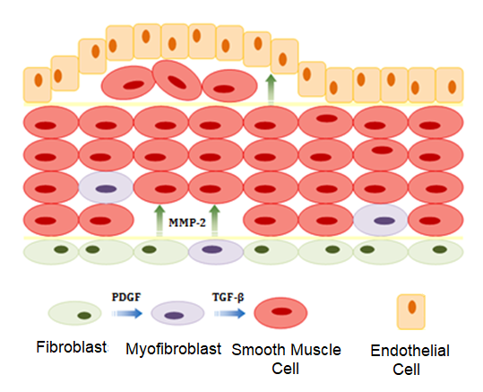
On the other hand, alternative evidence also suggests that endothelial-to-mesenchymal transition (EndMT) may also contribute to myofibroblast production and subsequent neointima formation. Chen et al (2015) demonstrated that EndMT increased overall plaque burden by 84%, along with providing a strong correlation between loss of fibroblast growth factor receptor 1, activation of endothelial TGF-β signalling and extent of EndMT [69].
Figure 2.9 – The fibroblast to smooth muscle cell continuum hypothesis and its contribution to neointimal formation. Blue arrows represent differentiation whilst green arrows depict migration properties. Adapted from [64].

    - NEOVASCULARISATION IN ATHEROSCLEROSIS
Neovascularisation comprises of 3 processes: angiogenesis, vasculogenesis and arteriogenesis, describing the growth of new capillaries (from pre-existing vessels and from a primitive vascular network) and increasing the diameter of existing vessels, respectively.
The extent of adventitial neovascularisation has been correlated with intima-media thickness, which also increases with advancing disease [70]. Heistad & Marcus demonstrated that whilst the tunica media is mostly avascular, the vasa vasorum infiltrating the tunica adventitia provide the nutrition required and if these vessels become occluded, medial necrosis occurs [71]. Consequently, the growth of the atherosclerotic plaque results in a hypoxic centre triggering inflammatory cell infiltration and promoting local neovascularisation. Moulton et al (2003) provides evidence of this, demonstrating that angiostatin reduces plaque angiogenesis and subsequently diminishes the recruitment of macrophages [72].
With the inflammatory response being key to inducing neovascularisation and promoting atherosclerotic disease, if it can be determined that endothelial cells are responsible for the activation of fibroblasts within the tunica adventitia, this would provide evidence to support my hypothesis (see section 1.3).
Along with blood capillaries, lymphatic vessels are found within the adventitial layer of large vessels where they may have an important role in removing lipids and inflammatory cells. Vascular endothelial growth factor C (VEGF-C) binds to vascular endothelial growth factor receptor 3 and is known to be over-expressed within advanced atherosclerotic plaques, leading to increased lymphangiogenesis, destabilisation of the plaque and eventual plaque rupture [73, 74]. Although VEGF-C promotes lymphangiogenesis, there appears to be a discrepancy between the formation of new lymphatic vessels and the formation of new blood capillaries during plaque growth, with the lymphatics being produced at a much slower rate. This imbalance of both angiogenesis and lymphangiogenesis could promote the chronic inflammatory state found during atherogenesis [75].

  - THE ROLE OF INFLAMMATION IN ATHEROSCLEROSIS
Chronic inflammation is induced and perturbed by apolipoprotein B-containing lipoprotein accumulation and arises at sites of pre-existing intimal hyperplasia. Foam cells and fatty streaks can begin to develop which leads to the progression of atherosclerotic lesions [46]. An increased expression of α4β7 integrin, which mediates lymphocyte homing, mucosal vascular addressin cell adhesion molecule and vascular cell adhesion molecule (VCAM-1) have been demonstrated in atherosclerotic plaques [76, 77]. Likewise, the cytokine IL-1 also appears to play a pivotal role; LDL appears to induce the expression of IL-1β in mononuclear cells in a dose-dependent manner, to which it is then cleaved by caspase-1 and secreted to cause endothelial cell dysfunction [78]. Interestingly, it has been demonstrated that the static co-culture of endothelial cells with smooth muscle cells enhances the sensitivity of the endothelial cell to TNF-α, up-regulating the production of inflammatory molecules [79, 80]. However, the production of these molecules is significantly reduced when the endothelial cells are exposed to flow [81, 80]. The expression of toll-like receptor 4 is up-regulated in a variety of cell types implicated in the pathogenesis of atherosclerosis. Oxidised LDL (oxLDL) but not native LDL has been demonstrated to increase this expression, specifically in macrophages [82, 77].
Macrophage apoptosis suppresses plaque progression in early stage lesions. However, in advanced lesions, macrophage apoptosis encourages the development of a necrotic core [83]. Oxidative stress, high concentrations of inflammatory cytokines such as TNF-α, oxLDL or activation of the fatty acid synthase – death receptor pathway are examples of pro-apoptotic processes that contribute to macrophage cell death. Likewise, endoplasmic reticulum stress via activation of an unfolded protein response is strongly correlated with apoptosis and plaque necrosis in advanced lesions of vulnerable human coronary artery plaques.
An alternative name for the necrotic core is the “lipid core”, owing to the dying lipid-filled macrophages, mostly with cholesterol, which become integrated as extracellular lipid into the areas of plaque necrosis. This necrotic debris is a source of pro-inflammatory stimuli and proteases and can therefore not only cause damage to nearby cells, but also elicit an inflammatory response [83].

    - INNATE IMMUNITY
The innate or humoral immune system is the first line of defence, which acts on the detection of pathogen-associated molecular patterns that elicit a toxic and inflammatory response as well as a parallel danger-associated molecular pattern pathway. A single signal transduction pathway involving the nuclear-factor kappa B (NF-κB) transcription factor is primarily responsible for the up-regulation of many gene products, such as those that control cell proliferation and cell survival, as well as those key to the inflammatory response [84].

NF-κB
NF-κB belongs to a group of proteins known as ‘rapid-acting’ primary transcription factors and is responsible for the up-regulation of several major pro-inflammatory and pro-thrombotic mediators such as TNF-α and various interleukins such as IL-1, interleukin-6 (IL-6), and interleukin-8 (IL-8) [85]; table 2.1 exhibits a selection of the target genes up-regulated within the cell types involved in the vascular wall. Although interactions between specific cell types cannot be accurately concluded, it can be inferred that when any cell type is stimulated to release IL-1β, TNF-α or interleukin-15, all cells within the vessel will respond to that signal. Ultimately, this suggests that an amplified inflammatory response will occur in a multi-cellular response compared to monoculture.
In most unstimulated cells, NF-κB is restricted to the cytosol by an inhibitory protein, IκB. Both IL-1 and TNF-α activate molecular pathways that result in the phosphorylation and subsequent ubiquitination and degradation of IκB proteins to release NF-κB. Only then can translocation into the nucleus occur, where it can control the transcription of its downstream target genes, as demonstrated in figure 2.10. However, in certain cell types such as macrophages and SMCs, NF-κB can be identified as constitutively active [86]. Although NF-κB affects a range of processes including the cell cycle, a significant finding is that the transcription factor binds to the promoter of the oxidised low-density lipoprotein receptor 1 (LOX-1) gene, ultimately increasing the uptake of oxLDL, promoting atherogenesis [87].

Reactive Oxygen Species
Although low concentrations of ROS are produced by all cell types, any imbalance in either the production of ROS or defence mechanisms such as antioxidant manufacture can lead to pathogenesis of disease, including
 | Target Gene | Description | Up-regulated in Atherosclerosis? |  |  | Complementary Receptor? |  |  | References
 |  |  | EC | SMC | Fib | EC | SMC | Fib
Cell Membrane Protein | ICAM1 | Intercellular adhesion molecule 1, a cell surface glycoprotein. Binds to integrins of type CD11a/CD18 or CD11b/CD18. |  |  |  |  |  |  | [88, 89, 90, 21]
 | SELE | E-selectin is an adhesion molecule that binds to sialylated carbohydrates present on the surface of certain leukocytes. |  |  |  |  |  |  | [91]
 | SELP | P-selectin, an adhesion molecule stored in Weibel-Palade bodies in unactivated ECs. |  |  |  |  |  |  | [92]
 | VCAM1 | Cell surface sialoglycoprotein expressed on both small and large blood vessels to mediate adhesion of certain leukocytes. Mediates leukocyte-endothelial signal transduction. |  |  |  |  |  |  | [88, 93, 94]
Cytokine/  Chemokine | IL1B | IL-1β is synthesised as a precursor protein. Only after stimulation will caspase-1 cleave the protein into its active state. |  |  |  |  |  |  | [95, 14]
 | IL1RN | IL-1ra is an antagonist to the IL-1 receptor. |  |  |  |  |  |  | [96]
 | IL6 | An interleukin that can act as both an anti- and pro- inflammatory signalling molecule. |  |  |  |  |  |  | [97, 98, 99]
 | IL8 | A protein that causes chemotaxis to neutrophils (but also other granulocytes) in target cells. |  |  |  |  |  |  | [98, 100]
 | IL15 | A cytokine constitutively expressed by many cell types. It induces proliferation of NK cells and down-regulates CX3CR1 (CX3CL1 receptor) |  |  |  |  |  |  | [101, 102]
 | TNF | TNF-α, a member of the TNF superfamily. It is expressed in most tissues and involved in systemic inflammation. |  |  |  |  |  |  | [103, 98, 13, 104]
 | VEGFC | Vascular endothelial growth factor C, a member of the platelet-derived growth factor/vascular endothelial growth factor family. Stimulates neovascularisation. |  |  |  |  |  |  | [105]
Table 2.1 - Genes targeted by NF-κB in large vessel cell types. The expression of most pro-inflammatory cytokine / chemokines are increased in atherosclerosis compared to basal levels in all vessel cell types. Meanwhile, there appears to be a decreasing number of cytokine receptors from the intima to adventitial layers. Green = positive, Red = negative, Amber = unknown.

atherosclerosis [106]. Chiu et al (2005) demonstrated that shear stress causes an increase in ROS in endothelial cells activating a cascade of downstream signalling, up-regulating the expression of inflammatory proteins such as intercellular adhesion molecule 1 (ICAM-1) via NF-κB gene expression [80].
Moreover, ROS react with polyunsaturated fatty acids in membranes and lipoprotein particles. This suggests that the formation of oxLDL is likely to occur when LDL is taken up into cells with excess ROS. Lysophosphatidic acid is derived from the enzymatic cleavage of lysophospholipids or phosphatidic acid by phospholipases such as autotaxin; this has been proven to cause phenotype switching in smooth muscle cells as well as increasing cytokine production in both smooth muscle cells [107] and endothelial cells [108].

TNF-α
Ridker et al (2000) has previously shown that plasma TNF-α is elevated in subjects with vascular complications [109]. TNF-α can be synthesised by most cell types and can bind to either cell surface receptor TNFR1 or TNFR2; TNFR1 is expressed in most tissues whilst TNFR2 is expressed predominantly on immune cells and ECs [110]. Upon activation of TNFR1, at least 3 distinct molecular pathways can be initiated [111]:
- Activation of NF-κB: TNFR1-associated death domain protein (TRADD), an adaptor protein that binds to the death domain of the cell receptor, recruits TNF-receptor-associated factor 2 and receptor-interacting protein 1 which subsequently recruit and phosphorylate IκB kinase (IKK) to activate it. IKK can then phosphorylate IκBα, releasing NF-κB.

- Activation of MAPK cascades: there are 3 classical pathways but TNF-α predominantly activates the JNK/AP-1 and secondly the p38-MAPK pathways. These pathways are activated in response to stress and are involved in cell differentiation, proliferation and are generally pro-apoptotic.

- Induction of apoptosis: although its death-inducing capability is weak compared to Fas/FasL, TRADD binds to the Fas-associated death domain which recruits an auto-proteolytic activating cysteine protease, caspase-8, leading to activation of downstream caspases involved directly in rapid cell death.
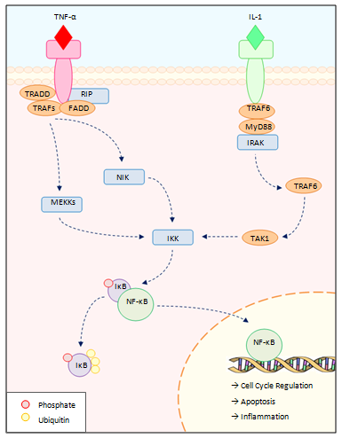
Figure 2.10 – NF-κB is regulated by both TNF-α and IL-1 during the innate immune response but via different mechanisms. When NF-κB can freely translocate into the nucleus, it can bind to the promoter region of its target genes, increasing their relative transcription rates. The transcription factor binds to many genes including cytokines involved in inflammation, cell surface receptors, stress response genes, acute phase proteins, growth factors and regulators of apoptosis. Adapted from [228].

IL-6
IL-6 is involved in a wide array of biological activities including immune regulation, haematopoiesis, inflammation and oncogenesis. The cytokine is highly inducible in vascular tissues through the actions of the angiotensin II peptide and produces a multitude of responses in cell types of cardiovascular importance including endothelial cells, monocytes and platelets [112]. This cytokine is an important acute phase protein, which can act as either a pro-inflammatory cytokine or anti-inflammatory myokine, released primarily by macrophages and T-cells. IL-6 is one of the factors linking the innate and adaptive immune response, with one of its pro-inflammatory mechanisms to activate B-cell differentiation. Its anti-inflammatory properties come from its inhibitory effects on TNF-α and IL-1 [113, 67].

IL-8
IL-8 is produced by various cell types and can alter the functional properties of vascular cells by acting as a chemoattractant for neutrophils and monocytes. It also induces angiogenesis [114]. Endothelial cells, specifically those that form the lining of blood vessels and the heart, store the cytokine within vesicles named Weibel–Palade bodies. Other molecules are also stored within these bodies such as Von Willebrand factor and P-selectin and therefore Weibel-Palade bodies play a dual role in inflammation and haemostasis [115].

IL-10
Also known as human cytokine synthesis inhibitory factor, this is an anti-inflammatory cytokine produced primarily by macrophages and Th2 lymphocytes. Huet et al (2013) demonstrated that IL-10 has anti-inflammatory properties on endothelial cells by reducing the pro-inflammatory effects that TNF-α induce, including ROS production and up-regulation of ICAM-1 expression [116]. IL-10 has also been shown to alter macrophage lipid metabolism, thus could underpin the formation of foam cells which is a key process in atherogenesis [117]. However, the underlying mechanism has yet to be determined.

VEGF
VEGF has been demonstrated to be up-regulated in neonatal cardiomyocytes [118] and various animal vascular smooth muscle cells in response to mechanical stretch [119, 120, 121]. It is an essential growth factor for endothelial cells and promotes neovascularisation. VEGF-mediated inflammation has been shown to increase vascular permeability, possibly allowing increasing uptake and retention of lipoproteins such as oxLDL [122].

Fibroblast Growth Factors (FGFs) / Platelet Derived Growth Factors (PDGFs)
FGFs are complex molecules involved in the regulation of many developmental processes such as patterning, morphogenesis, differentiation, migration and cell proliferation [123]. Known to be more potent stimulators of angiogenesis than VEGF [124], FGF1/2 are produced by various cells in human atherosclerotic plaques increasing angiogenesis and production of vasa vasorum via cellular proliferation and migration [125]. It has been demonstrated that the migration of SMCs follows the gradient of the PDGF when exposed to FGF-2. Produced by endothelial cells, smooth muscle cells and platelets during endothelial injury, PDGF is an additional growth factor involved in blood vessel formation; it is similarly a potent mitogen for mesenchymal cells [126].
The up-regulation of cytokines during the inflammatory response in wound healing within the dermis is very well described, unlike during atherosclerosis, however, there appear to be many similarities. Keratinocyte growth factor, also known as FGF7, is produced by mesenchymal cells such as fibroblasts within the dermis exclusively targeting the epithelial keratinocyte growth factor receptor. This enhances keratinocyte proliferation and migration [127]. Likewise, the concentration of PDGF is enhanced stimulating chemotaxis, matrix production and proliferation of cells to induce remodelling of the wound. During the wound repair response, fibroblasts differentiate into a specialised cell called the myofibroblast, enabling wound contraction; however, these cells disappear from the wound site within the dermis [128]. This is in contrast to atherosclerotic lesions and may be of significance.

    - ADAPTIVE IMMUNITY
The adaptive or cellular immune system is activated in response to changes in cell-surface receptor concentration and chemokine release within the initial atherosclerotic plaque formation. It is composed of highly specialised cells called T- and B-lymphocytes; along with monocytes, T-cells bind to VCAM-1 and ICAM-1 expressing cells, to which oxLDL up-regulates. Macrophages accumulate the lipids to produce foam cells. However, the T-cells become activated to oxLDL to secrete a range of cytokines including interferon gamma (IFN-γ), which further amplifies the inflammatory response (figure 2.11) [129].
Recent studies indicate that the T-cell driven B₂-cell response is atherogenic whilst the innate B₁-cell response appears to produce an atheroprotective response. This is owing to the differences in structure of the immunoglobulins (Ig) produced by these cell types (figure 2.12); B₁ cells synthesise a naturally occurring antibody, IgM, whilst the B₂ subtype manufacture IgG. IgG can bind to the oxLDL and promote its uptake into macrophages via Fc receptors, essentially enhancing the production of foam cells [84, 130].
Immunisation of mouse models with malondialdehyde-modified LDL emulsified with Freund's adjuvant (a chemical modification representative of oxLDL with inactivated mycobacterium to elicit the production of specific immunoglobulins) has been shown to reduce atherosclerosis via the activation of B₁ cells [131].

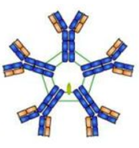
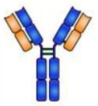
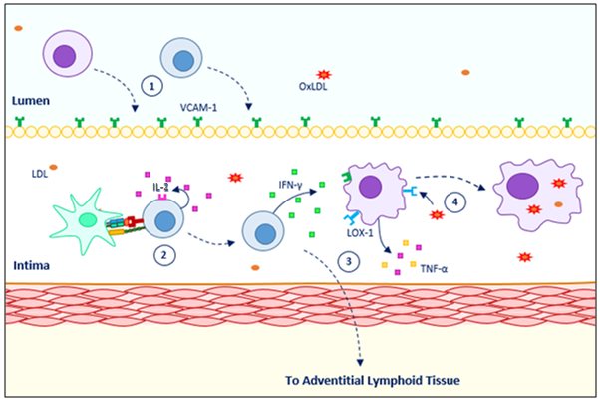
Figure 2.12 – Differences in immunoglobulins IgM (left) and IgG (right). IgG is a monomer whilst IgM is a pentamer; they make up 5-10% and 70-80 % of total serum immunoglobulins, respectively. Adapted from [302]
Figure 2.11 – The initial stages of inflammation in atherosclerosis. 1) Monocytes and immature CD4+ T-cells migrate into the intima via the up-regulation of cell surface proteins such as VCAM-1. 2) CD4+ T-cell receptor and CD28 interacts with MHC Class II receptor with oxLDL epitope and co-receptor B7 on an antigen-presenting cell, respectively. This allows the T-cell to release IL-2 and stimulate itself in an autocrine manner, maturing the cell and permitting subsequent release of IFN-γ. 3) IFN-γ released causes an increased inflammatory response from the macrophages by resulting in further release of IL-1 and TNF-α. The mature CD4+ T-cell likely migrates to the lymphoid tissue where it can activate a repertoire of other inflammatory cells. 4) Macrophages naturally express the LOX-1 receptor, enabling the uptake of oxLDL and convert into foamy macrophages. These cells begin to build up and indicate atherosclerosis will ensue.
    - THE CONTRIBUTION OF LDL TO THE EXPRESSION OF ADHESION MOLECULES
A combination of transmural pressure and leaky junctions caused by endothelial cell apoptosis and division enable the transport of LDL molecules into the tunica intima [132]. Sub-endothelial retention of LDL and oxLDL correspond to the initial event in atherogenesis.
Cell surface adhesion proteins (E/P-selectin, ICAM-1, and VCAM-1) become up-regulated under pro-atherogenic conditions via the binding of oxLDL to the scavenger receptor LOX-1, the major oxLDL receptor found in endothelial cells. Basal cellular expression of LOX-1 tends to be very low. Nevertheless, stimulation from elevated levels of IL-1, TNF-α, increased concentration of oxLDL or a low mean τ can also increase receptor expression [133].
However, it should be noted that other cell types such as smooth muscle cells, fibroblasts and macrophages also express LOX-1 along with other scavenger receptors. Altered expression of contractile proteins (α-actin, calponin) and an increased expression of collagen, along with increased proliferation and production of vasa vasorum via the release of FGF-2 within smooth muscle cells, can at least be partly attributed to oxLDL and the LOX-1 receptor [134].
Retention of oxLDL is predominantly found within the deeper layers of the intima during thickening. Therefore, there are 2 possible routes for LDL/oxLDL infiltration:
- the leaky gap junctions in the endothelium or
- the vasa vasorum that impregnates through the tunica adventitia.

Owing to the location of the vasa vasorum, research into the role of the adventitial fibroblast is becoming increasingly popular. Fibroblast cell number and function appears to correlate with dysfunction, restenosis and atherosclerosis of the vasculature, owing to their capacity to increase collagen synthesis and production of inflammatory cytokines [135].
Despite it being known that fibroblasts express LOX-1, the extent to which the adventitial fibroblast is involved within the development of inflammatory vascular diseases such as atherosclerosis is not yet completely understood. Research on various fibroblast types, primarily the dermal fibroblast, has provided insight on varying immunomodulatory functions dependent on HOX genes. It has been suggested that an aberrant ‘stromal address code’ can lead to chronic inflammation via retention of T-cells [136].

    - THE SIGNIFICANCE OF ICAM-1 EXPRESSION
ICAM-1, also known as CD54, is a cell-surface glycoprotein typically expressed on endothelium and cells of the immune system, though other cells including stromal cells have been demonstrated to express the protein [137].
ICAM-1 has a core protein of 55 kDa; however, where ICAM-1 has been extracted from tissues the molecular mass appeared in the range of 76-114 kDa, suggesting post-translational modification [138, 139]. It is the complementary receptor to integrins CD11 and CD18 and mediates leukocyte adhesion. During inflammation the expression of ICAM-1 is up-regulated, enhancing leukocyte trans-endothelial migration via binding to lymphocyte function-associated antigen-1 [140]. This is noteworthy owing to the development of foamy macrophages within the neointima, leading to plaque formation. Moreover, the Prospective Epidemiological Study of Myocardial Infarction study confirmed that the circulating form of the ICAM-1 protein (sICAM-1) correlates to the risk of myocardial infarction and angina pectoris [141]. Therefore, it has been suggested that ICAM-1 is a suitable marker to predict atherosclerotic disease progression and subsequent risk of acute coronary events.

  - TREATMENTS FOR CVD
Many people are unaware they have developed atherosclerotic disease. For many individuals, acute coronary syndrome or stroke occurs prior to the diagnosis of advanced disease. It may not be a surprise that available treatments are primarily aimed at therapeutic intervention e.g. increasing vascular lumen diameter opposed to taking preventative measures. Primarily, patients are advised to optimise their lifestyle to reduce CVD progression. This entails quitting smoking, losing weight if necessary and monitoring their diet and exercise regimes. Nevertheless, in many cases this is not enough to control blood cholesterol levels. In such cases, patients may be advised to take oral medications to reduce blood cholesterol levels, along with decreasing blood pressure and glucose levels, where required. In more severe cases, surgical procedures may be recommended [142].

Statins
Though various medications are available, the principal and most effective treatment used is a group of compounds named statins. These lower the blood LDL via inhibition of the enzyme HMG-CoA reductase, the rate-limiting step in the production of LDL cholesterol [143]. The compounds have been shown to have both anti-inflammatory and anti-coagulant properties, effectively reducing plaque progression and possibly contributing to plaque regression [144].

Angioplasty +/- Stent
Percutaneous transluminal balloon angioplasty can be performed with or without stent deployment and has become increasingly more practiced. During this procedure, the narrow or blocked area is expanded to allow sufficient blood supply to downstream tissues (figure 2.13). However, balloon expansion often causes damage to the vessel wall, leading to scarring and restenosis. Nevertheless, a stent can also be inserted to maintain this increased lumen diameter and prevent re-closure of the vessel.
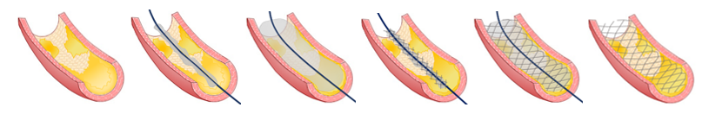
A variety of stent designs are available. Firstly, decisions must be made as to whether a bare metal stent (BMS) and drug-eluting stent (DES) will be opted for. BMS are made from a variety of alloys, whilst DES vary depending on drug content and polymer used for drug elution (table 2.2). Although DES are more expensive and delay the healing response of a vessel, they are largely favourable over BMS as they reduce restenosis rate and thus reduce the need for repeat procedures. On the other hand, this means anti-platelet therapy is necessary for a prolonged period (≥12 months) compared to the 30 days for a BMS to prevent late-stent thrombosis. Therefore, if the patient has a high risk of bleeding or is unable to tolerate or comply with the use of anti-platelet medication, the use of a BMS is preferential [145].
Figure 2.13 - The insertion procedure for a stent involves a catheter, guide wire and a balloon, which is attached to the stent. Once the balloon is deployed, the stent remains in place against the vessel wall, preventing the plaque from protruding in to the vessel lumen. Adapted from [303].
There are two main methods of stent insertion:
- balloon-expanded stent delivery
- self-expanding stent delivery.

In the balloon-expanded method, the stent is slipped over a balloon catheter, which is expanded when in the appropriate position. The advantage of this method is that the stent is expanded to the exact diameter. Meanwhile, in the self-expanding method, a sheath enclosing the stent is removed when the stent is in position and the stent expands to a pre-set diameter. This means that correct sizing is essential. If the diameter of the stent is too large, endothelial injury will occur and the vessel will be under a high degree of stress, or if too small then stent thrombosis is probable [146]. The salient properties of stents are reviews in table 2.2.

Table 2.2 - Features of a stent that can affect restenosis rate.
Stent Feature | Description
Strut Thickness | Rate of restenosis increases as thickness increases. The ISAR-STEREO trial demonstrated a statistically significant 5% decrease in clinical restenosis in the thin-strut group (95% CI, 0.39 to 0.99; p=0.03) [147].
Material | BMS – Stainless steel (nickel containing alloy 316L) and nitinol (an alloy of nickel and titanium) are commonly used. However, Ni²⁺ ions have demonstrated biotoxic, immunologic and carcinogenic effects [148, 149].  Biodegradable – Disappear within months to years without significant movement from deployment site. Materials used include poly-L-lactic acid, polyglycolic acids and poly-anhydrides [150].  Drug-eluting stents – Many polymeric materials are used including poly(ethylene-co-vinyl acetate), polyurethanes and poly(styrene-isobutylene-styrene) to control the release of drugs such as sirolimus or paclitaxel [151].
Geometry | In one systematic study, reducing strut-strut intersections reduced vascular injury, thrombosis and neointimal hyperplasia by 42%, 69% and 38%, respectively [152].  There appears to be no relationship between number of struts and restenosis, unless the stent is over-deployed. In this case, more struts are advantageous to more evenly distribute the forces [153].

Coronary Artery Bypass Graft (CABG)
Revascularisation via artery bypass grafting may be used to redirect collateral flow around the blockage and improve perfusion in cases that are unresponsive to medical therapy, or where disease is too extensive for alternative therapies.
In a meta-analysis with 24,268 patients with multi-vessel coronary artery disease, it was determined that although the incidence rates of mortality and MI were similar for both the coronary artery bypass graft procedure (CABG) and DES, revascularisation had to be performed 4 times more often after DES implantation [154]. Furthermore, it has become evident that major adverse clinical events, such as MI, stroke or death, was greater in percutaneous coronary intervention with DES than with CABG.
Research indicates that the vessel chosen to obtain the graft for surgery must be selected carefully. Previously, the saphenous vein graft (SVG) had been used for an extensive period. However, Loop et al (1986) demonstrated that the internal mammary artery (IMA) improved survival and reduced ensuing complications [155]. The IMA has an increased long term patency rate at 90-95% for 10-15 years compared to approximately 50% failure after 5-10 years for the SVG, with atheroma likely in the remaining viable grafts. A similar long term patency can be observed for the internal thoracic arterty (ITA) and the radial artery (RA), which are also becoming more frequently used. This is owing to a considerably enhanced rate of NO production in the IMA versus the SVG [156].

  - IN VITRO MODELS
With current treatments for CVD primarily targeting the surgical removal of stenosis in advanced disease, improvements in treatment options in the future are likely to be produced via preventing plaque formation. To develop such therapies, the signalling cascades involved between the different vascular and immune cell types need to be studied in more detail to uncover any novel targets.
Cellular or in vitro studies primarily investigate genetic and biochemical changes within disease. They provide a controlled and simplified environment, allowing isolated factors to be studied in detail. There are varieties of cellular technique that can be used to study atherosclerosis specifically; typical in vitro models use cultured endothelial cells exposed to various flow conditions, using devices such as cone-and-plate and parallel-plate chambers [157]. These allow the effect of the mechanical force and cellular interactions to be studied and experiments can be performed using either cell monolayers or co-cultures, which may or may not involve a membrane to separate the two or more cell types [158]. Intercellular communication, cell migration dynamics, stimulation and maintenance of cell function and differentiation can all be monitored using co-culture techniques [159]. The production and benefits of various approaches are discussed.
HUVEC are commonly used as a model for atherosclerosis as they are easy to obtain and have a high proliferative rate [160]. Although certain data, such as cobblestone morphology, doubling time and levels of expression of CD31 and VEGFR2 are reported as not too dissimilar between HUVECs and human coronary artery endothelial cells (HCAECs), evidence suggests HCAECs have a significantly increased response to cytokine stimulation than HUVECs [161]. This is because both genetic and environmental cues influence cell phenotype, which this ultimately influences experimental outcomes. For example, endothelial cells in veins demonstrate a higher vesiculo-vacuolar organelle density when compared to arterial endothelial cells [162]. Moreover, venous smooth muscle cells display a dedifferentiated state in comparison to arterial smooth muscle cells with increased cell proliferation, migration and synthetic capacity [163].
Genetic pre-patterning largely regulates arteriovenous differentiation prior to the introduction of blood flow (figure 2.14). Genes within the Notch signalling pathway are activated when VEGF concentration is high, leading to a pro-inflammatory response and promoting endothelial senescence. However, in venous cell development chicken ovalbumin upstream transcription II (COUP-TFII) suppresses Notch, along with the up-regulation of venous-specific genes including the Sox factors (Sox 7/18) [164]. Nonetheless, early stage endothelial cells are not committed to a specific cell fate at this stage and remain plastic for a short time during development [165, 166, 167, 168]. This change in cell fate is partially dependent upon the haemodynamics experienced within the formed vessels [168]. Liu et al (2012) also demonstrated that Notch expression is higher at plaque formation sites, where a pro-inflammatory state is known to be established, and thus may be related to coronary artery disease burden [164].
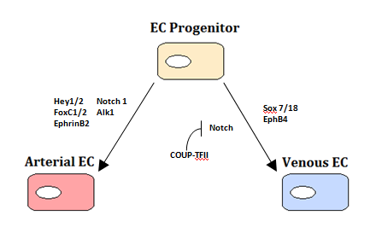
Figure 2.14 – Endothelial cell fate is determined by a variety of genetic factors, primarily the Notch signalling pathway (Hey1/2, Ephrin B2). This pathway is inhibited by COUP-TFII to produce the venous cell phenotype [164].
This indicates that the haemodynamic response cannot be investigated optimally when studying co-cultures in 2D. Therefore, whilst monocultures can easily incorporate flow into their study designs, co-culture studies often only deal with static flow. If flow was to be included, all cell types would be exposed to the same shear forces, increasing the complication of analysis owing to differing levels of cytokine production to those expected in vivo.
The transformation of vascular cell 2D co-cultures into simple 3D co-cultures is illustrated in figure 2.15. There are various methods in which a simple 3D structure can be constructed; table 2.3 summarises the advantages and disadvantages of using each technique. Although none of these structures provides the complete 3D physiological structure e.g. the lumen of a vessel, they do offer some spatial organisation closer to that found in vivo. With further research, the feasibility of producing a complete physiological construct in vitro via cellular co-culture methods may become a reality.
Co-culture research enables the interactions between two or more specific cell types to be studied in detail, without influences from external sources affecting outputs. Much of the previous co-culture research for atherosclerosis has involved primarily use of both endothelial cells and smooth muscle cells; the key findings from these studies involving predominantly human cells have been summarised in table 2.4.

SMC

EC
SMC in gel
EC
SMC
Membrane
EC
EC
Substrate
Substrate
SMC

A
D
C
B
Figure 2.15 - Schematic of various co-culture arrangements. (A) Cultures of endothelial cells and smooth muscle cells are on opposite sides of a porous membrane, facilitating separation but allowing cellular communication. (B) Endothelial cells on surface of gel to which the smooth muscle cells are embedded. The gel may be collagen, fibrin or synthetic. (C) Endothelial cells cultured directly on top of smooth muscle cells to simulate the geometry within the vessel. (D) Mixed culture of both endothelial and smooth muscle cells [158].

Co-culture | Advantages | Disadvantages
A | - Cells grow at different rates – prevent overgrowth | - Membrane stiffer than in vivo
B/C | - Reduction in diffusion distance | - No basement membrane (IEL)
D | - ECs form stable capillaries  - Suitable for high-throughput applications | - No vessel architecture
Table 2.3 - Comparison of 2D Co-culture arrangements from figure 2.17 [158].
Table 2.4 – In vitro co-culture methods to study atherosclerosis using human cells.

Cell Types | Flow profile | Focus | Key Findings | Reference
HUVEC, HSMEC, HASMC, HUASMC, HUVSMC | Static | SMC factors on EC tissue factor expression | Conditioned media from SMC demonstrating synthetic phenotype induced altered TF activity from established inducers of TF activity in EC. | [61]
HUVEC, HUSMC, PBL | Dynamic | Patterns of leukocyte recruitment | Adhesion of lymphocytes was negligible both with EC and EC-SMC co-cultures. TNF-α treated co-cultures demonstrated greater leukocyte recruitment than EC monocultures. | [79]
HCAEC, HCMSMC. Monocytes, CD4+ lymphocytes | Static | Leukocyte adhesion, chemotaxis and SMC proliferative response | TNF-α up-regulation of ICAM-1 on EC/SMC co-cultures studied. Adherence and chemotaxis by monocytes and lymphocytes reduced significantly with 5 mmol/L aspirin. Proliferative response of SMC after lymphocyte attack was also reduced significantly. | [169]
HUVEC, HUSMC | Dynamic  and Static | Effect of shear stress on EC and SMC interactions | In co-culture where only EC exposed to flow, SMC oriented perpendicularly to flow at higher shear rates and EC oriented themselves in the direction of flow. Without shear, EC gene expression of MCP-1 and oncogene-a brought about by co-culture with SMC was abated in the presence of shear stress. | [170]
HUVEC, HUASMC | Dynamic and Static | Inflammation related gene expression in EC due to co-culture with SMC | EC produce pro-inflammatory genes when cultured with SMC. This gene expression is inhibited when EC exposed to shear stress through inhibition of NF-κB activation brought about by SMC. Consequently, THP-1 adhesion was also curtailed. | [80]
HUVEC, HUASMC | Dynamic | Platelet adhesion to EC within EC-SMC co-culture | Use of TNF-α and TGF-β with EC with a EC-SMC coculture results in maximal levels of platelet adhesion due to the stimulation of vWF production in EC at low wall shear stress rates of 400 s⁻¹. | [171]
HUASMC, HUVEC, MonoMac-6 | Static | In vitro model of muscular artery to study early atherosclerotic events | In vitro model with multilayered SMC intima and endothelium with ECM was made. Addition of monocytes and LDL resulted in lipid insudation, monocyte transmigration and foam cell formation. IL-8 production was also demonstrated. | [172]
HAEC, HASMC | Dynamic  and Static | Quiescent SMC influence on TNF-α activated endothelial inflammatory response. | EC cultured directly with SMC express fewer surface adhesion proteins after exposure to flow and TNF-a activation than EC cultured alone, or indirectly with SMC. | [81]
HUVEC, HAVSMC, THP-1 | Static | Influence of AGES on vascular cells | SMC proliferation induced by glycol AGES. Significant increase in cytokine expression levels within co-culture. | [173]
HAEC or hCB-EC/  HASMC | Dynamic and Static | Quantification the elastic modulus of hCB-ECs co-cultured with SMCs | The modulus of hCB-ECs was ~25% lower than HAECs under monoculture and static conditions, as well as co-culture and static or flow conditions (p<0.05)  The modulus of hCB-ECs was ~10% lower than HAECs under monoculture and flow conditions (p<0.05) | [174]
HUVEC/  HUASMC | Static | Novel co-culture model possesses better EC coverage, factor release and anti-shedding functions | NO, PGI2, TM and TFPI release and/or expression is significant in EC co-culture (versus monoculture), inhibiting E-selectin expression and cell retention | [175]
HUVEC/  HUASMC | Static | Effect of EC on SMC spreading | The increase in cell adherence and spreading in EC/SMC was 148 ± 12.8 % and 292 ± 71.5 % in co-culture compared to their respective control groups | [98]

All studies demonstrate that the communication between the endothelial cell and smooth muscle cell is vital to controlling gene expression upon stimulus with a pro-inflammatory molecule such as TNF-α. Differences in results are generally statistically significant in co-culture when compared to those of cells cultured alone. An important observation from this table is that although approximately half include the induction of shear stress on endothelial cell via flow, these are all laminar flow studies, which induce a constant shear stress. It is imperative that more effort is placed into being able to stimulate the cells with a more accurate representation of the flow conditions found in vivo.
Imegwu & Nackman (2001) also demonstrated that bovine cells provide contrasting results to human cells, with respect to growth rates, which are essential to produce representative in vitro models for intimal hyperplasia and subsequent atherosclerosis development [176]. Nevertheless, there are other cell types involved in the pathogenesis of the disease, which have not yet had much attention. As previously described, adventitial fibroblasts have been indicated to contribute to neointimal formation; a principal function is to produce cytokines in response to injury, which are rarely considered in co-culture studies for atherosclerosis.
Therefore, it is necessary to investigate the impact of these components in more detail, potentially via the production of three-cell co-culture systems rather than the typical two-cell models. For a three-cell co-culture model, it would be necessary to ensure a system for easy identification of each cell type, and maintenance of cellular layers when transforming the model from 2D to 3D, owing to variations in cell growing times. Thus, cell trackers or cellular markers (summarised in table 2.4) play a key role in the identification of each cell type and determination of whether there has been either any active cellular migration between layers or transformation / differentiation of cell types during experimental procedure.
Cytokine production is essential to the initiation of the inflammatory response in atherosclerosis, and is not too dissimilar to that already
proven in other tissues such as cardiac tissue [177] and skin [178]. Considering this, it may be a suggestion to determine what influence both the smooth muscle cells and fibroblasts have on the synthesis of the inflammatory cytokines within the diseased vasculature.

Marker | Function | Advantages / Disadvantages | References
α-SMA | Key constituent of the contractile system within smooth muscle cells | Stains:  - myofibroblasts  - glomus cells  - myoepithelial cells | [179]
CD31/PECAM-1 | Cell adhesion molecule which is required for  leukocyte trans-endothelial migration under most inflammatory conditions. | Vascular endothelial marker; more specific than CD34. | [179]
Vimentin | A class-III intermediate filament involved with the stabilisation of type 1 collagen. | Mesenchymal marker; stains:  - endothelial cells  - fibroblastic cells  - macrophages  - melanocytes  - smooth muscle cells  - lymphocytes | [179]
Myosin-11 | Forms the heavy chain of a myosin protein complex found in smooth muscles | Smooth muscle specific | [180]
VCAM-1 | A type I membrane protein that mediates leukocyte-endothelial cell adhesion and signal transduction | Expressed on:  - activated endothelial cells  - smooth muscle cells  - fibroblasts | [181]
Connexin 37/40/43 | Endothelial gap junction proteins which expression levels change (increase in cx37/40, decrease in cx43) in response to shear stress | Expressed in a variety of mammalian tissues | [182]
TE-7 | Thymic microenvironment stromal cell indicator. | Specific for vascular fibroblasts | [183]
Table 2.5 - Common experimental markers used for vascular cells either to identify or characterise under different environmental conditions.

Table 2.4 - Common experimental markers used for vascular cells either to identify or characterise under different environmental conditions.
  - SUMMARY
CVD is the leading cause of mortality worldwide and unless further action is taken to develop new therapeutic strategies the morbidity of the disease will continue to increase. Research has uncovered that an underlying inflammatory response is responsible for instigating the pathogenesis of atherosclerosis and is key to the failure of current surgical treatments such as angioplasty and CABG. Nevertheless, the full cellular interactions have not yet been elucidated meaning drug therapy for prevention is still in its infancy. Therefore, if further work can be undertaken to delve into this area then new targets may be discovered enabling this lack of prevention to be overcome.
The primary way this inflammatory response can be studied in detail is via the production of more elegant and informative in vitro models. Studying the progression of plaque formation in vivo is almost impossible owing to ethics and invasiveness. Although animal models such as the ApoE^{-/-} mouse have been in use for some time, the genetic differences between humans and animal models mean that the translation of research to human studies does not always work effectively.
With a full understanding of atherosclerosis still absent, recent research has developed our awareness of the complexity of its pathogenesis. Models allow us to design and test novel approaches with the objective of finding a better therapeutic solution to those currently available. To study atherosclerosis, models need to be produced at each biological level to which the disease plays a role. This means producing models at the molecular, cellular, tissue and organ level as well as the human body to determine how they interact. This would allow the changes in the physiology to be studied to alterations to any of the biological inputs [184]
Moreover, with a growing understanding of the in vitro co-culture topic, it is necessary to determine whether the addition of fibroblasts into the current endothelial cell / smooth muscle cell co-culture model designs are indispensable. If significant deviations occur upon the fibroblasts’ inclusion, the approach to number of cell types included in in vitro model designs should be taken into consideration for future experimentation. A lack of specific markers currently makes it difficult to study fibroblasts, myofibroblasts and immature smooth muscle cells. However, if a marker was uncovered, the potential for future research into the cell continuum theory and respective progenitors’ role in relation to disease is extensive.
As the capability of in vitro models progresses towards the study of co-cultures in 3D matrices, experimental conditions achieved will get ever closer to those provided in vivo. This will allow not only continuing research into the pathogenesis of diseases and the mechanism of action of pharmaceuticals, but also the development and improvement of design of implants and mechanical devices. For example, with the ability to produce a complete blood vessel in vitro, exactly how stents alter blood flow can be studied in finer detail; thus, their physical design and biocompatibility can be optimised to attempt to continue reducing restenosis rates.

CHAPTER 3
DETERMINING FIBROBLAST PRESENCE IN HUMAN ATHEROSCLEROTIC SPECIMENS BY IMMUNOHISTOCHEMISTRY AND HISTOLOGY
  - INTRODUCTION
Prior to performing any analysis of the inflammatory response in in vitro cultured human endothelial cells, smooth muscle cells and fibroblast cells, histological sections of human coronary arteries (RCA and LAD) were studied. The aim of this work was to provide a solid foundation for all future studies by examining how the relative number of fibroblasts were altered in areas of increased neointimal thickness.
Ideally, the presence of fibroblasts would be studied in humans in vivo, to enable fibroblast presence, proliferation and migration to be studied in real-time and under the correct environmental conditions. Recent advancements in imaging techniques such as contrast-enhanced ultrasound with use of intravascular agents such as microbubbles can enable the pathology of atherosclerotic plaques to be assessed in greater detail than ever before (for more details see chapter 2.5.2) [185]. However, issues that arise when human participation is required in clinical trials include obtaining informed consent and maintaining high levels of attendance.
Consequently, the next best option was to analyse sections of human coronary artery tissue from deceased patients who had previously given consent for their tissue to be used in medical research. These sections provided a snap-shot image of fibroblast location and number, and were therefore useful in obtaining the required information to support future experimental studies.
It had been understood for some time that atherosclerosis results from an unresolved underlying chronic inflammatory response [46]; fibroblasts have been shown to play a key role within the inflammatory response to endothelial injury and subsequent wound repair in both in vitro and in vivo animal models [186, 12, 66, 51]. A complex combination of factors contribute to the relative risk of disease in an individual from genetic factors (gender [40], ethnicity [39]) to lifestyle factors such as diet and exercise (see chapter 2.2.2) [29]. An additional factor that affects disease progression is vessel architecture, whereby areas of low shear stress are produced at vessel bifurcations leading to increased residence times of lipids such as LDL [16, 187, 170]. Thus, two different coronary artery sections were obtained for analysis. The RCA and LAD are from opposite sides of the heart, with different flow and shear patterns. Consequently, the trends for each vascular section could be compared to determine whether shear stress may have influenced the abundance and location of fibroblasts throughout the vessel wall.
Additionally, Satore et al (2001) proposed a fibroblast to smooth muscle cell continuum. Combining previous knowledge suggested that increased neointimal thickness (which would correlate to the degree of atherosclerotic disease progression) may relate to the degree of fibroblast proliferation and migration; this was examined in the histological sections with relative ease through a combination of light microscopy (the ratio of cell within the tunica intima and tunica adventitia was compared through H&E stained sections) and confocal imaging techniques (immunofluorescence of α-SMA and THY-1 to detect the presence of fibroblasts, myofibroblast and smooth muscle cells). Whether the information obtained from in vivo animal experiments is directly translatable to disease progression in humans has not yet been fully elucidated, hence assessing human histological sections would provide further insight into the applicability of previous works.

3.2 METHODS
3.2.1 PREPARATION OF HUMAN CORONARY ARTERY SECTIONS
All human coronary artery samples (RCA and LAD) were ethically obtained from the Sheffield Tissue Bank under the ethics submission STH 16346 ‘Assessing Inflammatory Regulators of Vascular Disease in Arteries’, in accordance with the Human Tissue Act 2004. A minimal number of sections were used for research purposes and those that remained were returned for future research.
Paraffin-embedded 5 µm thick sections of diseased human coronary artery were de-waxed and rehydrated by placing in solutions of xylene (2x) and through graded alcohols (100 % - 50 % (v/v)) to water for 2-minute intervals at room temperature (RT). Antigen-retrieval was performed by incubating the sections in a sodium citrate buffer solution (pH 6) for 30 minutes at 95 °C. After cooling to RT and rinsing in phosphate-buffered saline (PBS) (3x), sections were incubated in 3 % (m/v) Bovine Serum Albumin (BSA) (Sigma-Aldrich; A17030) in PBS solution for 30 minutes at RT to block non-specific binding of secondary antibodies.
Primary antibodies of mouse monoclonal anti-human α-SMA (Dako; M0851) and sheep polyclonal anti-human thymocyte antigen 1 (THY-1) (R&D Systems; AF2067) were combined in PBS at a final concentration of 5 µg/mL each. Approximately 100 µL were required for each section, which were then placed in a humidity tray and incubated at 4 °C overnight. Following a series of PBS washes (3 x 5 mins), secondary antibodies of NL493 conjugated donkey anti-mouse (R&D Systems; NL009) and Dylight594 conjugated rabbit anti-sheep (Thermo Scientific; SA5-10056) were added at a final concentration of 5 µg/mL and 1 µg/mL in PBS for 2 hours at RT.
Once all antibodies had been added, the sections were rinsed in tap water and mounted using permanent aqueous mounting medium (Biolegend; 926102). The samples were left to dry overnight and maintained in dark conditions to prevent photobleaching.

3.2.2 CONFOCAL MICROSCOPY
Images were obtained using a Zeiss inverted LSM510 Meta confocal microscope, combined with a Zeiss EC Plan NEOFLUAR 40x/1.30 oil immersion objective. Argon/2 (λEx 488 nm, λEm 500-550) and HeNe1 (λEx 543 nm, λEm 600-700) lasers were used to excite the Alexa Fluor 488 and Dylight 550 conjugated secondary antibodies within the mouse aortic sections, and the NL493 and Dylight594 within the human coronary artery sections, respectively.
The gain and offset were adjusted for each image to ensure the highest dynamic range was obtained.

3.2.3 LIGHT MICROSCOPY
Haematoxylin and eosin stained diseased mouse aorta sections were imaged on an upright Motic light microscope using brightfield to provide comparative images to the fluorophore-labelled sections. Similarly, for the human coronary artery sections analogous van Gieson pre-stained sections were imaged (figure 3.1).
Haematoxylin and eosin stained sections of diseased RCA and LAD were obtained from the Cardiovascular Science Department, University of Sheffield. These were imaged using an upright Motic light microscope using brightfield and a 20x air objective (figure 3.2). Images of the entire endothelium and tunica adventitia were acquired for analysis, with an average of 3-fold more images required to cover the area of the tunica adventitia compared to the endothelium.
The total number of endothelial cells present were counted and the mean number of endothelial cells per mm estimated for each image taken.
Owing to an increased number of images obtained for the tunica adventitia, each image was assigned to its corresponding endothelium image; variations occurred in the number of adventitial images assigned per intimal image owing to the degree of curvature within regions of the histological sections as described in figure 3.3.
The number of adventitial cells were then counted, and the mean calculated. This enabled the adventitial cell to endothelial cell ratio to be predicted (equation 3.1).
$$Equation 3.1 Cell Ratio=Ln\left(\frac{Mean adventitial cell count per picture}{Mean endothelial cell count per mm}\right)$$
The expected cell ratio was also calculated using equation 3.2, allowing the observed cell ratio and expected cell ratio to be compared.
$$Equation 3.2 Expected Cell Ratio=Ln\left(\frac{{Endothelial cell}_{complete}}{\overline{{Endothelial cell}_{complete}}-n}\right)$$

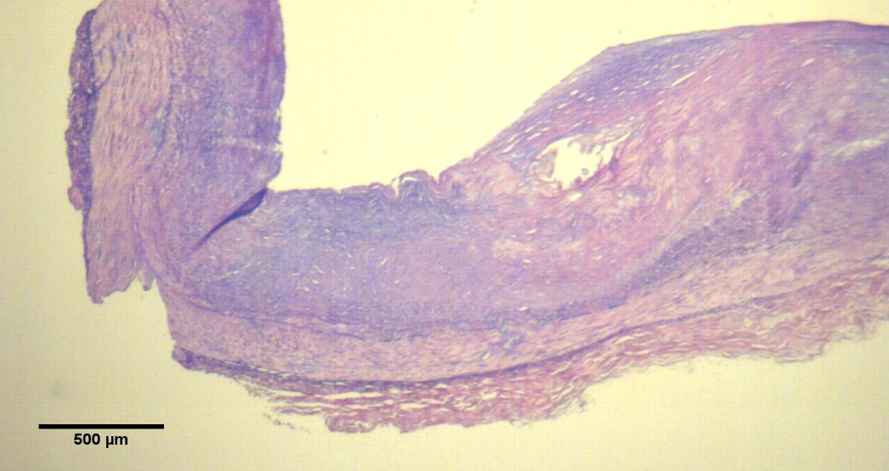

1
2
3
4

I

M
A
Figure 3.1 – A light microscopy image of a van Gieson stained diseased human coronary artery using a 4x objective. A series of images were taken on a 40x objective (dotted box, 1-4) and stitched together. The various layers of the vessel, the tunica intima (I), tunica media (M) and tunica adventitia (A) are clearly observable. Scale bar = 500 µm.

Figure 3.1 – A light microscopy image of a van Gieson stained human coronary artery using a 4x objective. A series of images were taken on a 40x objective (dotted box, 1-4) and stitched together. The various layers of the vessel, the tunica intima (I), tunica media (M) and tunica adventitia (A) are clearly observable. Scale bar = 500 µm.
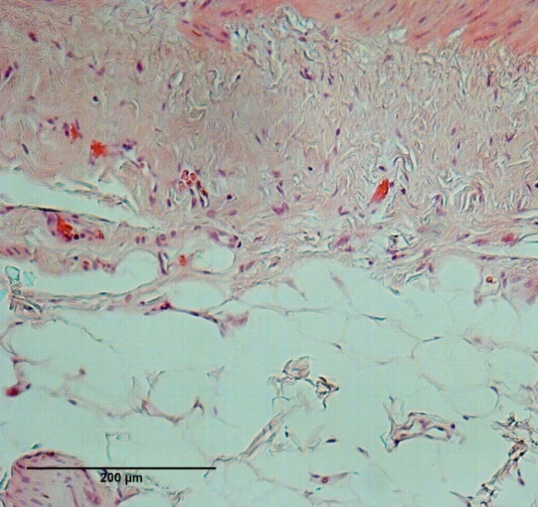
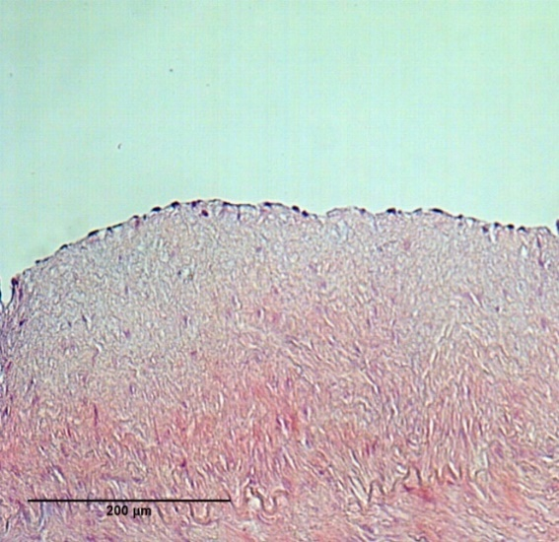
Figure 3.2 - Haematoxylin and eosin stained images of a RCA. A) The endothelium is markedly present. B) An abundance of cells were found within the tunica adventitia, with the erythrocytes (red) indicating the location of the vasa vasorum. Scale bar = 200 µm.

Figure 3.2 - Haematoxylin and eosin stained images of a RCA. A) The endothelium is markedly present. B) An abundance of cells were found within the tunica adventitia, with the erythrocytes (red) indicating the location of the vasa vasorum. Scale bar = 200 µm.
B

B
A

A

1

1
2

2
3

3
Figure 3.3 – Representative image to demonstrate the method of analysing the ratio of endothelial cells to adventitial cells via microscopy. In areas of curvature an increased number of images were required at the adventitia to cover the area inferior to the respective endothelium. Area 1 covers the endothelium whilst areas 2 and 3 cover the respective area of adventitia underneath. Scale bar = 500 µm.
3.3 RESULTS
3.3.1 IMMUNOHISTOCHEMISTRY SIGNIFYING MYOFIBROBLAST PRESENCE
With solely α-SMA labelling (figure 3.4), the tunica media can be observed as a relatively thin band with the production of a dense signal. Above this, a signal density gradient (high to low) can be observed from the tunica media-tunica intima interface towards the endothelium; this is indicative of migration of α-SMA⁺ cells from the tunica media into the tunica intima to produce a neointima. α-SMA⁺ labelling is also present within the tunica adventitia. Although it is apparent that some of the positively labelled cells profile the vasa vasorum, the presence of individual α-SMA⁺ cells can be observed.
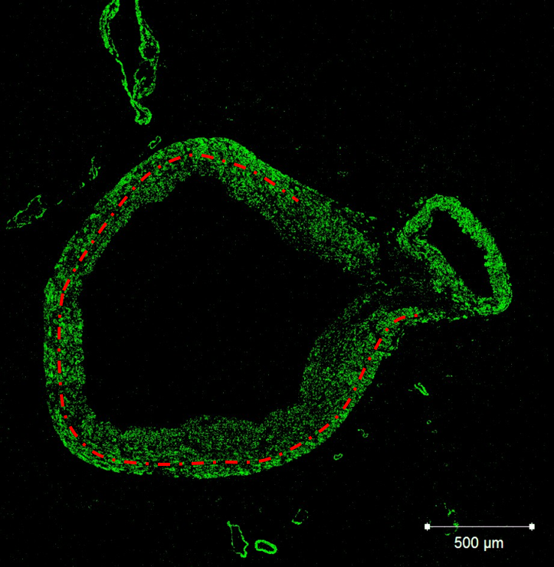
Meanwhile, THY-1 clearly highlighted the activated endothelium (figure 3.5); THY-1⁺ bundles were also found within the tunica adventitia and sporadic
Figure 3.4 – Immunostaining for α-SMA in a mouse coronary artery. The dotted line is approximately where the media-intima interface could be found. The neointima can be observed to be the thickest on the right portion of the vessel and can be distinguished from the tunica media by the decrease in intensity. Scale bar = 500 µm.

Figure 3.4 – Immunostaining for α-SMA in a human coronary artery. The dotted line is approximately where the media-intima interface could be found. The neointima can be observed to be the thickest on the right portion of the vessel and can be distinguished from the tunica media by the decrease in intensity. Scale bar = 500 µm.
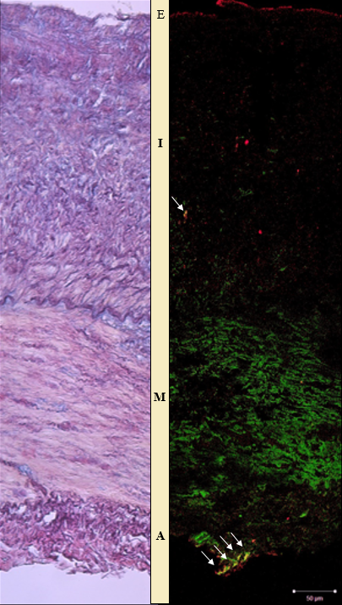
labelling was present throughout the entire vessel section. A proportion of the THY-1⁺ labelled cells, mostly those found within the tunica adventitia, were also α-SMA⁺ (figure 3.5).

Figure 3.5 – Immunohistochemistry for α-SMA and THY-1 in human coronary artery sections. A van Gieson stain had been used on the section on the left, with specific Immunolabelling for α-SMA (green) and THY-1 (red) on the right. The α-SMA signal not only clearly defined the tunica media (M) but also appeared to diffuse towards the endothelium (E). Meanwhile, the THY-1 signal was dotted throughout. The white arrows highlight co-stained areas, indicating possible myofibroblast formation. (A = adventitia, I = intima). Scale bar = 50 µm.

Figure 3.5 – Immunohistochemistry for α-SMA and THY-1 in human coronary artery sections. A van Gieson stain had been used on the section on the left, with specific Immunolabelling for α-SMA (green) and THY-1 (red) on the right. The α-SMA signal not only clearly defined the tunica media (M) but also appeared to diffuse towards the endothelium (E). Meanwhile, the THY-1 signal was dotted throughout. The white arrows highlight co-stained areas, indicating possible myofibroblast formation. (A = adventitia, I = intima). Scale bar = 50 µm.

3.3.2 LIGHT MICROSCOPY ANALYSIS COMPARING ADVENTITIAL TO ENDOTHELIAL CELL COUNTS
The number of endothelial and adventitial cells were counted in sections of diseased RCA and LAD. A cell ratio was then calculated using equation 3.1 and plotted against the number of endothelial cells present per mm (figure 3.6). Consequently, the number of endothelial cells per mm was related to the integrity of the barrier between the lumen and the adjacent tissue, with approximately 60 endothelial cells per mm (cell ratio of 0) constructing a complete.
Using equation 3.1, it was expected that the respective proportion of adventitial cells would increase with decreasing endothelial barrier integrity, owing to a constant number of adventitial cells but decreased number of endothelial cells. However, when comparing the values obtained for both vessels, large differences were observed in the number of adventitial cells present for the same number of endothelial cells. Consequently, when the data obtained was compared to the ‘expected cell ratio’ as calculated using equation 3.2, the RCA and LAD produced opposing trends, whereby the RCA produced larger adventitial cell numbers than expected, with a reduced count produced in the LAD.
Figure 3.6 – The ratio of adventitial cell to endothelial cell in relation to the completeness of the endothelial barrier. A complete barrier was produced at approximately 55-60 cells per mm. Solid lines = trendline of the histology data (equation 3.1), dashed lines = expected cell ratio (equation 3.2).

Figure 3.6 – The ratio of adventitial cell to endothelial cell in relation to the completeness of the endothelial barrier. A complete barrier was produced at approximately 55-60 cells per mm.. Solid lines = trendline of the histology data (equation 3.1), dashed lines = expected cell ratio (equation 3.2).

3.4 DISCUSSION
After consolidation of previous studies on the initiation and progression of atherosclerosis, it was determined that information gained from studies involving human participants was relatively limited owing to ethical considerations and the need for improved non-invasive imaging technology. Although experimental studies can be carried out on human tissue that had previously been consented for work in medical research, most research performed on such tissue in the past had mostly involved staining with standard histological stains to have a look at the gross anatomy/physiology of the vessels.
More in-depth analysis of fibroblast involvement in the initiation and progression of atherosclerosis had been carried out using either in vitro techniques or animal models to determine whether the fibroblast cells can differentiate and migrate towards the vascular lumen upon injury. However, whether the results from these experiments are directly translatable to humans had not yet been elucidated.
Therefore, the aim of the work in this chapter was to determine whether the results obtained from animal models were comparable to humans. To do this the objectives were to confirm fibroblast presence within the tunica adventitia of human coronary arteries and subsequently assess the relationship between the number of fibroblasts present within the tunica adventitia to the neointimal thickness for that section of vasculature.

3.4.1 IMMUNOHISTOCHEMISTRY SIGNIFYING MYOFIBROBLAST PRESENCE
The first objective was to confirm the presence of the fibroblast within the tunica adventitia through immunohistochemical techniques. The proteins of interest chosen were THY-1 and α-SMA; whilst α-SMA would identify any cell with smooth muscle cell-like properties e.g. smooth muscle cell and myofibroblast [63], the THY-1 would highlight any activated endothelium [188] as well as fibroblasts and myofibroblasts [189]. As a result, fibroblast presence within the tunica adventitia was completed through assessing mono- and/or dual-labelling.
Although the α-SMA label alone did not provide sufficient evidence for fibroblast involvement, combining this information with the data obtained through THY-1 labelling provided further insight. THY-1 has been shown to bind to receptors Mac-1 and CD97 on leukocytes, indicating its role in cell attachment to the endothelium during inflammation. Moreover, Koumas et al (2003) demonstrated that fibroblasts are heterogeneous for THY-1, and that only THY-1⁺ cells had the ability to differentiate into myofibroblasts upon stimulation with TGF-β [189]. It was ascertained that a few co-labelled SMA⁺/THY-1⁺ cells were present primarily within the tunica adventitia. This co-labelling suggests the presence of a cell type with both smooth muscle cell and fibroblast properties. Combining all this evidence suggests that the co-labelled cells are likely to be myofibroblasts.
Although myofibroblasts have the potential to originate from either endothelial cells [69] or fibroblasts [66], a large proportion of the co-labelled cells were found within the tunica adventitia. Even though the vessel sections suggest that there were little to no fibroblasts present within the tunica adventitia, it can be observed in figure 3.3 and figure 3.5 that there was little adventitia remaining on the section; the tunica adventitia is generally a thick layer to provide mechanical support to the vessel [31] and consequently is infiltrated with vasa vasorum (as seen in figure 3.4) to provide sufficient nutrient supply to the cells within. However, combining the fibroblast to smooth muscle cell continuum hypothesis [64], the likely activation and proliferation of the fibroblast prior to myofibroblast conversion and migration [190], and the relatively close positioning of the myofibroblasts observed within figure 3.5 to the tunica media, it can be proposed that these myofibroblasts originated from fibroblasts situated beyond the scope of the histology section.
Experiments on ApoE^{-/-} mice by Xu et al (2007) indicated that adventitial fibroblasts are activated before atherosclerotic lesion formation, thus indicate that adventitial inflammation is an early event in murine atherogenesis. Likewise, as discussed in chapter 2.3.4, Li et al (2000) confirmed that adventitial fibroblasts translocate to the neointima after endoluminal injury in rats. Both of these experiments suggest that whilst spontaneous plaque formation occurs in murine opposed to the slow disease progression in humans, the mechanisms that underpin plaque formation are likely to be comparable.
3.4.2 LIGHT MICROSCOPY ANALYSIS COMPARING ADVENTITIAL TO ENDOTHELIAL CELL COUNTS
With literature suggesting that endothelial injury activates fibroblast proliferation, migration and phenotype conversion [64], the ratio of adventitial cells to endothelial cells present within the coronary artery sections was examined. Consequently, it could be determined whether fibroblast proliferation occurred primarily in areas of stenosis. Whilst an approximate equal ratio of adventitial to endothelial cells was found in areas of complete endothelial integrity, the ratio was augmented in areas of disease with contrasting results obtained in the RCA versus the LAD.
Barrier integrity can be related to atherosclerosis progression whereby disruption to the endothelium is often found in areas of greater intimal thickness; the lack of protective barrier cannot protect the underlying tissue from a pro-inflammatory response. Zhang et al (2011) disclosed that sustained hypercholesterolemia in New Zealand White rabbits provoked barrier disruption only in older plaques [191]. Whilst the proportion of adventitial cells varied according to endothelial barrier integrity (figure 3.6), there was no additional specific labelling to determine what type of cells the tunica adventitia was composed of. Although fibroblasts can be found sporadically throughout the tunica adventitia, additional cell types can also be found including tissue macrophages and endothelial progenitor cells [10]. Consequently, it cannot be definitively determined at this stage that when the number of adventitial cells increases the number of fibroblasts also increase. Likewise, it cannot be determined that the decrease in adventitial cells in the LAD is through a lack of proliferation, whether the cells that were present had migrated towards the vascular lumen, or whether there was a lack of adventitial tissue present (i.e had been dissected away during preparation for embedding).
Mechanical stresses induced by the fluid flow through the vascular lumen will have little influence on the cells sat at a distance from a complete endothelial cell barrier, unless this occurs indirectly via the release of cytokines from the endothelial cells. Nevertheless, when the endothelial barrier becomes compromised, the underlying cells are then exposed to the fluid flow. These cells are then exposed to changes in mechanical stresses, which may activate morphogenesis on cells found within the tunica media and tunica adventitia e.g. conversion of the contractile smooth muscle cell into the synthetic phenotype.
Relevant to my findings, the variations in mechanical stressors between the LAD and RCA may have a large impact on the level of fibroblast proliferation within the tunica adventitia of the two vessels [37]. Although there are larger fluid flow gradients found within the LAD, wall stress is increased in the RCA [192], which could cause the increased number of adventitial cells in areas of disrupted endothelial cell barrier.
Stenmark et al (2013) demonstrated that adventitial fibroblast are first responders to changing vascular mechanical stressors [62]. Meanwhile, a window stress threshold in 3T3 fibroblast islands has been demonstrated, where the highest proliferation rates found in areas of higher mechanical stress and with stress values higher than the upper limit of the window producing no additional effect [193]. This would suggest that compromises in endothelial cell barrier integrity will initially affect the proliferation of fibroblasts rather than any other cell type.
Fibroblasts in ApoE^{-/-} mice have been shown to express more α-SMA, proliferated and migrated faster, and synthesised more TGF‐β₁, MCP‐1, and PDGF‐b than adventitial fibroblasts from C57BL/6 mice [194]. Moreover, Shi et al (2009) demonstrated that increased transmural interstitial flow enhanced rat aortic adventitial fibroblast motility via the production of MMPs in vitro [195].
Therefore, although little evidence can be found relating the number of fibroblasts present within the human tunica adventitia to either extent of stenosis or shear stress, murine experiments appear to be useful for obtaining information that is translatable to humans. The lack of human-specific studies are likely owed to the lack of specific fibroblast markers and availability and/or accessibility of human vascular tissue to study. To confirm how useful the information gained from murine studies are, a large-scale study comparing the histological findings relating to the number and location of fibroblasts in both murine and human arteries may be worthwhile.

3.5 CONCLUSION
The small-scale analysis of histological sections of coronary arteries studied suggests that the number of cells within the tunica adventitia changes in relation to barrier integrity and extent of disease. However, it cannot be said for certain whether the fibroblast contributes to the inflammatory process that underpins neointimal thickening and plaque production.
Nevertheless, the data suggests that the fibroblast population may have some involvement, both owing to the presence of THY-1⁺ cells in the tunica media and the diverging fibroblast population figures calculated between the RCA and LAD. The shear stress induced within these two vessels differ, owing to their positions within the cardiac tissue and may interplay with the integrity of the endothelial barrier to influence the proliferation of nearby fibroblasts and burden of disease.
These data suggest that the interaction between the endothelial cell and fibroblast warrants further inspection. In vitro studies concentrating on cell to cell interactions within the vessel tissue could ascertain whether the integrity of the endothelial barrier could influence the proliferation and subsequent contribution of fibroblasts to the inflammatory response that underpins atherosclerosis.

CHAPTER 4
HUMAN UMBILICAL VEIN ENDOTHELIAL CELL, HUMAN UMBILICAL ARTERY SMOOTH MUSCLE CELL AND NORMAL HUMAN DERMAL FIBROBLAST MONOCULTURE STUDIES
4.1 INTRODUCTION
Staining of human coronary arteries in chapter 3 provided an indication that fibroblasts may be involved in vascular inflammation and subsequent plaque formation. Therefore, the next stage in determining the level of contribution from the fibroblast was to elicit an inflammatory response in vitro on HUVEC, HUASMC and NHDF individually. The aim of these experiments was to provide an ICAM-1 up-regulatory response to TNF-α without any influences from additional cell types; these provided baseline results to which future studies assessing ICAM-1 up-regulation in co-culture could be compared.
As described in chapter 1, current in vitro vascular co-culture models primarily include only the endothelial cell and smooth muscle cell; moreover, there were no studies comparing the inflammatory response or ICAM-1 up-regulation within these cell types, either individually or in co-culture. Therefore, a staged process was required where the fibroblast was firstly studied alone, and then combined with the endothelial cell and smooth muscle cell once all baseline results were obtained.
The chosen method for analysing the up-regulation of the inflammatory response was via the amount of ICAM-1 expression on cell membranes, using TNF-α as the inflammatory inducer. TNF-α has two cognate receptors, TNFR1 And TNFR2; for the purposes of the following experiments the receptor of interest is TNFR1 which is the major signalling receptor for TNF-α. As described by figure 2.10, TNF-α activates the MEKK/NIK pathway, leading to NF-κB activation and the expression of inflammatory cytokines, cell surface receptors, stress response genes, growth factors and regulators of apoptosis [196]. One of the cell surface receptors that becomes up-regulated is ICAM-1. Research has demonstrated ICAM-1 is known to be expressed on HUVEC [20], HUASMC [21] and NHDF [22], making it an ideal protein of interest to study the inflammatory response in these cell types.

4.2 METHODS
4.2.1 PREPARATION OF CELL CULTURE MEDIUM
Medium 199 (10x) (Gibco; 21180-021) was stored at 4-8 °C until required. 50 mL of this stock medium was taken when required to make an intermediate solution containing serum, penicillin-streptomycin and amphotericin B (table 4.1).
Ingredient | Quantity (mL)
10x M199 stock medium | 50
dH₂0 | 383
FBS | 50
Penicillin-Streptomycin | 5
Amphotericin B | 2
NaHCO₃ | 10
Table 4.1 – Constituents of the intermediate Medium 199 used for HUVEC and HUASMC culture.

Table 4.1 – Constituents of the 1x conditioned Medium 199 used for HUVEC and HUASMC culture.

The intermediate medium was used for HUASMC culture and neutralisation of trypsin. For HUVEC cell culture and experimental set-ups, endothelial cell growth supplements combined with heparin (ECGS/H) (Promocell; C-30140) were added at a concentration of 0.4 % (v/v) to transform the intermediate medium into the complete M199 required. It was essential that complete medium was produced when necessary in 50 mL batches owing to the supplement only being stable for up to 1 week when stored at 4 °C.
Initial experiments were carried out using in-house isolated HUVEC, which were solely cultured in complete M199. For experiments studying the up-regulation of ICAM-1 up to 12 hours after TNF-α addition, purchased HUVEC (Promocell; C-12203) were used. These cells were initially cultured in endothelial cell basal medium (Promocell; C-22210) with supplement addition (minus hydrocortisone) (Promocell; C-39210). They were received at passage 2 and cultured until passage 4, where they were then cryopreserved. These HUVEC were thawed using this same medium before exchanging for complete M199 the following day.
Dulbecco’s modified eagle medium (DMEM) AQMedia (Sigma-Aldrich; D0819) with the same volumes of foetal bovine serum (FBS), antibiotics and antifungals was used for NHDF isolation culture prior to experimentation. For experiments, the NHDF were incubated in the complete M199 medium as described above.
As with HUVEC, purchased HUASMC were cultured in a different culture medium to begin with. Smooth muscle cell growth medium 2 (Promocell; C-22062) with supplement mix (Promocell; C-39267) was used to culture the cells until cryopreservation. Although the same medium was used to thaw the HUASMC, the following day the medium was exchanged for the intermediate M199 medium. This was changed again for experimentation to complete M199.

4.2.2 HUVEC ISOLATION AND CULTURE
For initial experiments, HUVECs were isolated from donated umbilical cords from the Jessop Wing, Sheffield NHS Teaching Hospitals, U.K. The ethics number was STH 15599 and approval named ‘Umbilical Cords for Vascular Cell Research’. Samples were stored at 4 °C in HEPES buffered DMEM combined with 1 % (v/v) penicillin-streptomycin and 0.4 % (v/v) amphotericin B. Isolation was ideally carried out within 24 hours.
Umbilical cord isolation of endothelial cells was carried out according to the method of Jaffe et al (1973) [197]. Cords were removed from the fridge and allowed to warm to room temperature for 30 minutes. During this time, the culture hood was prepared, and all materials acquired. The umbilical cord was carefully removed from the pot and the exterior cleansed with an ‘Azowipe’. Excess blood from within the vein was gently removed by massaging the cord. Any traumatised regions (e.g. areas accidentally torn during child birth or filled with irremovable blood clots) of the cord were removed before cannulating and clamping one end of the vein. The vein was then washed with 10-20 mL of serum free M199 to both flush the vein of any remaining clots and determine whether there were any holes in the tissue that must be removed, before securing the free end.
Type IV collagenase (Sigma-Aldrich; C5138) solution (0.1 % m/v) in serum free M199 was centrifuged for 1 minute at 3000 rpm and filtered through a sterile 0.2 µm filter to remove any large particles. The filtered solution was then taken up into a 20 mL syringe and attached to the cannula to inflate the vein. The cannulated, clamped and inflated cord can be observed in figure 4.1.
The cord containing the collagenase solution was then incubated for approximately 12-15 minutes at RT, ensuring the vein was occasionally massaged to encourage detachment of HUVEC. The clamp at the free end was then released to allow the removal of the collagenase solution into a 50 mL centrifuge tube. The remaining collagenase solution was then flushed through the vein, followed by 10 mL of the intermediate M199 medium. The cell suspension was then centrifuged at 220 g for 5 minutes at RT before discarding the supernatant and re-suspending the pellet using complete M199 medium. The cell suspension was transferred into a pre-gelatinised (0.1 % (m/v) gelatin (Sigma-Aldrich; G1890) in PBS) T75 flask and incubated at 37 °C, 5 % CO₂. After the isolation procedure was completed, all waste was placed into a pot and stored at -20 °C to be incinerated later, following an ethically approved procedure.
After cell isolation, complete M199 medium was changed 16-24 hours later, complete with PBS washes (2x), and subsequently every 2-3 days. Cells were grown until approximately 70-80 % confluency before passaging. To passage, the cells were rinsed with PBS (2x) before adding 5 mL of 0.25 % (m/v) trypsin. Cells were observed under a phase contrast light microscope and a small amount of mechanical force applied at intervals to assist in detachment. When about 80-90 % of cells detached, 10 mL of 10 % intermediate M199 medium was added to inhibit further trypsinisation. The cell suspension was then transferred to a 25 mL Universal tube and centrifuged at 220 g for 5 minutes.
Figure 4.1 – HUVEC isolation. The cord was cleaned, cannula inserted, and each end clamped. The collagenase solution was then injected into the vein until the cord became turgid and incubated at room temperature for 15-20 minutes.
Supernatant was then removed, and the cell pellet re-suspended in complete M199 medium. A haemocytometer was used to measure cell density and the cells were seeded into new T75 pre-gelatinised flasks (0.1 % (m/v) gelatin (Sigma-Aldrich; G1890) in PBS) at a density of 5,000-10,000 cells/cm² and incubated at 37 °C, 5 % CO₂. HUVECs were cultured to passage 2 before cryopreserving for later use. Cells were cryopreserved at 1 million cells per vial, with freezing solution comprising of 50 % (v/v) complete M199 medium, 40 % (v/v) FBS and 10% (v/v) dimethyl sulfoxide (DMSO). When the commercially obtained HUVEC were cryopreserved at passage 4, the freezing medium consisted of 50 % (v/v) endothelial cell basal medium with supplements (minus hydrocortisone) (Promocell; C-22210 / C-39210), 40 % (v/v) FBS and 10 % (v/v) DMSO. Vials were placed in a ‘Mr Frosty’ container at -80 °C overnight, before being transferred to liquid nitrogen (-196°C) Dewars for long-term storage.

4.2.3 NHDF ISOLATION AND CULTURE
Human skin samples were collected from consenting patients undergoing abdominoplasty, which involved the removal of excess tissue from the middle and lower abdomen. All tissue was banked and used on an anonymous basis under Human Tissue Authority Research Tissue Bank Licence Number 12179. The bulk tissue samples were stored in a standard physiological solution (e.g. PBS) with antimicrobial agents at 4 °C, for no longer than 12 hours before processing.
If isolation was unachievable within the same day, a segment of skin approximately 5 cm x 5 cm was removed from the processed bulk tissue and placed at 4 °C in prepared DMEM AQmedia (Sigma-Aldrich; D0819) for use in the following days. Using scalpel and forceps, a large skin segment was placed into a Petri dish and cut into smaller sections approximately 1 cm x 1 cm. Fragments were placed into a 0.2 % (m/v) Difco trypsin solution in a Universal 25 mL tube and stored at 4 °C overnight (figure 4.2). The trypsin solution was then removed, and the tissue placed into a Petri dish. This allowed the epidermis to be peeled off and discarded. The epidermal side of the dermis was then scraped using a scalpel blade to ensure removal of any remaining epidermal tissue before being minced into fragments smaller than 1 mm x 1 mm. 5 mL of collagenase A solution (Roche; 11088866001) was then added to the Petri dish before incubating the tissue at 37 °C and 5 % CO₂ for up to 24 hours. An overview of the procedure can be seen in figure 4.2.
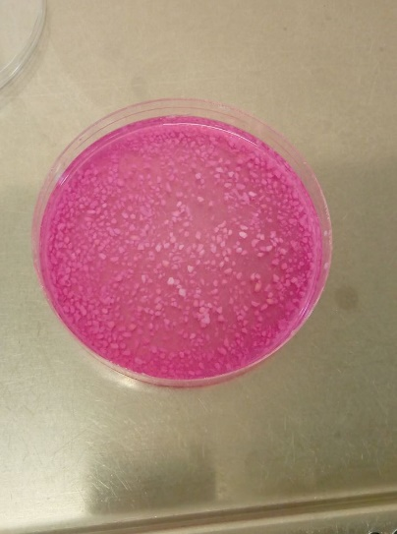
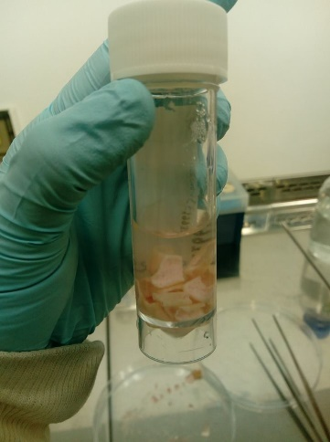

Figure 4.2 – Stages of NHDF isolation. (From left to right) skin was placed in Difco trypsin solution overnight. This enabled the epidermis to be peeled off and discarded, whilst the remaining tissue was minced for incubation in collagenase A solution overnight.

Figure 4.2 – Stages of NHDF isolation. (From left to right) skin was placed in Difco trypsin solution overnight. This enabled the epidermis to be peeled off and discarded, whilst the remaining tissue was minced for incubation in collagenase A solution overnight.

Once all the dermis had been digested, DMEM AQmedia was added to inhibit the collagenase and the solution was thoroughly mixed to separate any larger particles using a Pasteur pipette before placing the solution through a cell strainer. The cell suspension was centrifuged at 400 g for 10 minutes to form a cell pellet. The supernatant was discarded, and the pellet re-suspended in 5 mL prepared DMEM AQmedia before transferring to a T25 flask for incubation at 37 °C, 5 % CO₂. Culture medium was then changed after 24 hours, ensuring the cells were rinsed (2x) with PBS, and then every 2 to 3 days. All cells were grown until approximately 70-80 % confluency, before passaging.
To passage, cells were rinsed with PBS (2x) before adding 3 mL (T25) or 5 mL (T75) of 0.25 % trypsin. Cells were observed under a phase contrast light microscope and a small amount of mechanical force applied at intervals to assist in detachment. When about 80-90 % of cells detached, twice the trypsin volume of DMEM was added for neutralisation. The cell suspension was then transferred to a 25 mL Universal tube and centrifuged at 220 g for 5 minutes.
The supernatant was then removed, and the cell pellet re-suspended in DMEM AQmedia. A haemocytometer was used to calculate cell density and cells were seeded into new T75 flasks at a density of 5,000-10,000 cells/cm² and incubated at 37 °C, 5 % CO₂. NHDF were cultured to passage 3 before cryopreserving for later use. All cells were cryopreserved at 1 million cells per vial, with freezing solution comprising of 50 % (v/v) DMEM AQmedia, 40 % FBS (v/v) and 10 % (v/v) DMSO. Vials were placed in a ‘Mr Frosty’ container at -80 °C overnight before being transferred to liquid nitrogen Dewar flasks (-196 °C) for long-term storage.

4.2.4 HUASMC CULTURE
Cryopreserved HUASMC (Promocell; C-12500) were thawed in a 37 °C water bath for 2 minutes. The cell suspension was then transferred to pre-warmed complete smooth muscle cell medium (Promocell; C-22062) and incubated at 37 °C, 5 % CO₂. Culture medium was exchanged after 16-24 hours and subsequently every 2 to 3 days as standard, ensuring the cells were rinsed with PBS (2x) during medium changes. Cell cultures were grown until approximately 80-90 % confluency before passaging. 5 mL of 0.25 % trypsin solution was added to the freshly rinsed flask and detachment of the HUASMC observed under a phase contrast microscope. When the cells became rounded, a small amount of mechanical force was applied to remove the cells from the surface. When about 80-90 % of the cells has detached, 10 mL smooth muscle cell medium containing FBS was added for neutralisation.
The cell suspension was transferred to a 25 mL Universal tube and centrifuged at 220 g for 5 minutes. The supernatant was discarded, and fresh complete smooth muscle cell medium added. Cells were then counted using a haemocytometer and seeded into new T75 flasks at a density of 7,500-10,000 cells/cm². Cells were grown to passage 5 before freezing down in a freezing medium consisting of 50 % (v/v) complete smooth muscle cell medium, 40 % (v/v) FBS and 10% (v/v) DMSO at 1 million cells per vial. Vials were placed in a ‘Mr Frosty’ container at -80 °C overnight before being transferred to liquid nitrogen Dewars (-196°C) for long-term storage.

4.2.5 RESURRECTION OF CRYOPRESERVED CELLS
When defrosting cells from long-term storage including the commercially obtained HUVECs (Promocell; C-12203), the lower half of vials was placed in a 37 °C water bath for 90 seconds, or until only a small ice crystal was remaining. Pre-warmed cell culture medium was then added to the vial and the vial immediately transferred to a T75 flask, ensuring the seeding density remained between 5-10,000 cells/cm² for HUVEC and NHDF and 7.5-10,000 cells/cm² for HUASMC, as standard. The culture medium was then changed the following day and cultured as standard. For experimentation, cells were cultured up to 15 population doublings, where any remaining cells were then discarded.

4.2.6 EFFECTS OF CULTURE MEDIUM CONDITIONS ON CELL GROWTH
Prior to performing any extensive experimental set-up, the ideal working conditions for monocultures were studied to ensure both all cell types could be grown in the same medium type. The morphology of both HUVEC and NHDF was examined to determine whether the cells were undergoing apoptosis or proliferation when cultured in the different culture medium options (DMEM, intermediate M199 medium and complete M199 medium).
HUVEC and NHDF were seeded at 30,000 cells/mL into pre-gelatinised well plates to produce monocultures and incubated in DMEM, intermediate M199 medium or complete M199 medium. The medium was exchanged within 16-24 hours and images taken 48 hours post-seeding via phase-contrast on standard light microscope to observe morphology of the cells.

4.2.7 TNF-α STIMULATION OF MONOCULTURES
13 mm glass cover slips (Academy Science; NPC13/13) were placed into 24-well plates and incubated with 0.1 % (m/v) gelatin in PBS for at least 1 hour. Well plates were rinsed with PBS before the addition of HUASMC, HUVEC or NHDF at a seeding density of 7,500, 15,000 and 15,000 cells/cm², respectively. All cells were grown in their preferred culture medium until approximately 60-70 % confluency. Initially, HUVEC and NHDF were then rinsed with PBS and incubated in complete M199 medium containing between 0 and 100 U/mL of human recombinant TNF-α (Thermo Scientific; PHC3015) for 6 and 24 hours to determine the correct concentration of TNF-α to use.
Following this, HUVEC, HUASMC and NHDF were seeded as previously described but the culture medium was exchanged at 3-hourly intervals (up to 12 hours) for complete M199 medium supplemented with 25 U/mL of TNF-α. Upon completion of cell stimulation with TNF-α, the cells were rinsed with PBS (3x) and fixed using 3.7 % (v/v) formaldehyde at RT for 20 minutes. Following a triplicate series of 5-minute PBS washes, a 3 % (m/v) BSA in PBS solution was added to prevent non-specific binding of secondary antibodies, and the samples were incubated at 4 °C, before beginning the immunolabelling process within the following days.
All experiments were completed in triplicate with n indicating the number of independent repeats.

4.2.8 IMMUNOCYTOCHEMISTRY TO EXAMINE ICAM-1 UP-REGULATION
Mouse anti-human ICAM-1/CD54 primary antibody (eBioscience; BMS108) was diluted in PBS to produce a final concentration of 2.5 µg/mL, added to the formaldehyde-fixed cells and incubated at 4 °C overnight. The primary antibody was aspirated, and the coverslips were rinsed (3x) in PBS for 5 minutes each. The PBS was removed and was replaced with goat anti-mouse Alexa Fluor 633 (Life Technologies; A21052), which was diluted in PBS to produce a final concentration of 2 µg/mL. The coverslips were incubated for 2 hours at RT. The secondary antibody was discarded, and the coverslips rinsed (3x) in PBS (5 minutes each); this was followed by the addition of DAPI at a concentration of 1 ng/mL (also diluted in PBS), to which the coverslips were incubated for 10 minutes at RT. The samples were rinsed (3x) with PBS and the samples were stored in the dark at 4 °C until imaging could take place. Ideally, this would be within the same day, but if unable then imaging would take place the following day.
Immunolabelled glass coverslips were transferred from the well plate into a Petri dish containing PBS. Cells were observed using an upright Zeiss LSM510 Meta confocal microscope, combined with a Zeiss Achroplan 10x /0.30 W Ph1 water emersion objective lens. HeNe2 (λEx 633 nm, λEm 650-710 nm) and Ti-sapphire two-photon (λEx 780 nm, λEm 435-485 nm) lasers were used to stimulate the Alexa Fluor 633 (max λEx 632 nm, max λEm 647 nm) and DAPI (max λEx 358 nm, max λEm 461 nm), respectively. To minimise observation bias between images, an initial image was taken from a sample with expected high intensity values (12-hour sample from NHDF) with the pinhole size on maximum (approximately 9.7 Airy Units) to enable the entire cell to be observed. The microscope settings were then altered to produce a high-quality image at 512 x 512 pixels: for the Alexa Fluor 633 this consisted of a transmission (%) of 39.5 for the HeNe2 laser, detector gain of 850, amplifier offset of 0.1, amplifier gain at 1 and an average reading was taken from 4 scans. These settings were maintained throughout all remaining image acquisitions.
Close-up images of HUVEC and NHDF were obtained after stimulation with 25 U/mL TNF-α for 12 hours. For these, a Zeiss Achroplan 40x /0.80 W water emersion objective lens was used. The pinhole was changed to 1 Airy Unit and the detector gain/amplifier offset were adjusted accordingly.

4.2.9 USING IMAGE ANALYSIS SOFTWARE TO ASSESS
ICAM-1 EXPRESSION IN MONOCULTURE
ImageJ was the software of choice to calculate the mean intensity of ICAM-1 for each sample [198]. Each image had background fluorescence removed via ‘process -> subtract background’. The rolling ball radius was set to 12 pixels and the mean intensity of ICAM-1 was then obtained using the software. The data was then transferred to SPSS for statistical analysis. Games-Howell test was used to determine potential significant differences at the 5 % level.

4.3 RESULTS
4.3.1 EFFECTS OF CULTURE MEDIUM CONDITIONS ON CELL GROWTH
Figure 4.3 shows phase contrast light microscopy images obtained 48 hours after seeding in each culture condition. In DMEM, HUVEC have completely detached from the cell culture plate, likely owing to the lack of supplements which promote growth, leading to apoptosis. This is similar in the intermediate M199 medium, where although the HUVEC still appear attached to the surface, some of the cells are shrivelled and appear to be blebbing, indicating they are undergoing apoptosis.
Cell Type | Medium Type
 | DMEM | Int. M199 | Comp. M199
NHDF | 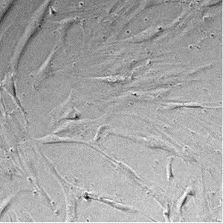 | 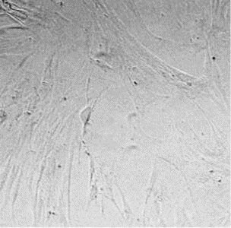 | 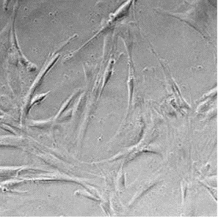
HUVEC | 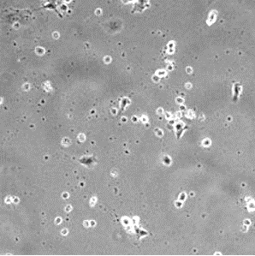 | 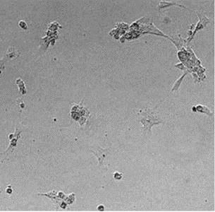 | 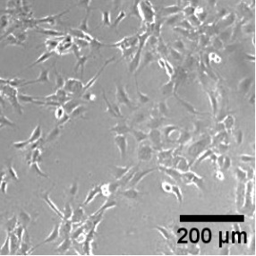
However, in complete M199 medium the HUVEC have the typical cobblestone morphology and have formed clusters, as expected. Meanwhile, NHDF demonstrated their typical spindle-shaped morphology in all culture medium types, suggesting that regardless of the culture environment they will be able to survive and proliferate.
Figure 4.3 – Phase contrast images of HUVEC and NHDF phenotype when cultured for 48 hours in either DMEM, intermediate M199 medium or complete M199 medium. The typical cobblestone morphology of HUVEC and spindle-shape of NHDF are only found together in complete M199 medium. Scale Bar = 200 µm.

Figure 4.3 – Phase contrast images of HUVEC and NHDF phenotype when cultured for 48 hours in either DMEM, ‘conditioned M199’ or ‘complete M199’. The typical cobblestone morphology of HUVEC and spindle-shape of NHDF are only found together in ‘complete M199’. Scale Bar = 200 µm.

4.3.2 ICAM-1 UPREGULATION DEPENDENCE OF TNF-α CONCENTRATION
A range of TNF-α concentrations up to 100 U/mL were tested on both HUVEC and NHDF cells. Examining the confocal images obtained (figure 4.4) and their analysis (figure 4.5), it can be concluded that even the lowest concentration studied (25 U/mL) stimulated a significant up-regulation of ICAM-1 in both cell types. The Games-Howell test confirmed this, indicating that all TNF-α concentrations caused a significant increase in intensity in HUVEC (p<0.001), whilst concentrations of 50 U/mL (p<0.01), 75 U/mL (p<0.05) and 100 U/mL (p<0.01) did so in NHDF after 6 hours of incubation. After 24 hours incubation with TNF-α, all concentrations significantly increased ICAM-1 upregulation in both cell types (p<0.001).
Beyond this, the only significant difference observed was between 25 U/mL and 100 U/mL at the 6-hour timepoint for HUVEC (p<0.01). Meanwhile, for NHDF cells a significant difference was observed between 25-75 U/mL (p<0.001), 25-100 U/mL (p<0.001), 50-75 U/mL (p<0.05), 50-100 U/mL (p<0.001) and 75-100 U/mL (p<0.01) after 24 hours incubation, but not 6 hours.

Time (Hours) | Cell Type | TNF-α Concentration (U/mL)
 |  | 0 | 25 | 50 | 75 | 100
6 | HUVEC | 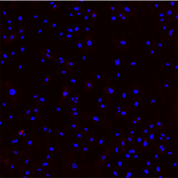 | 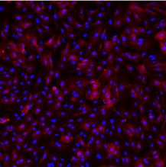 | 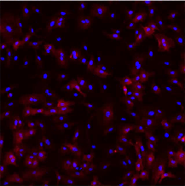 | 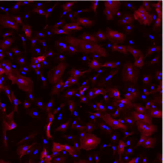 | 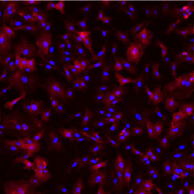
 | NHDF | 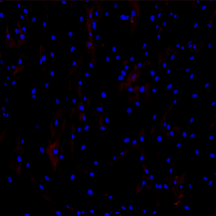 | 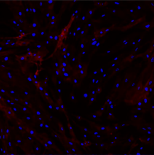 | 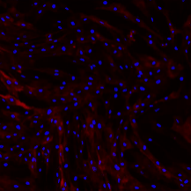 | 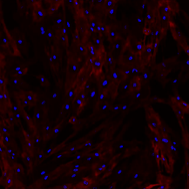 | 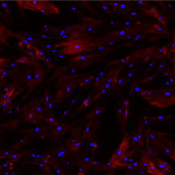
24 | HUVEC | 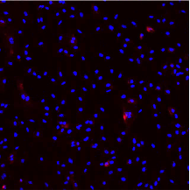 | 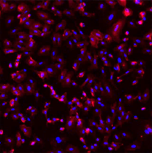 | 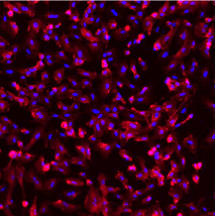 | 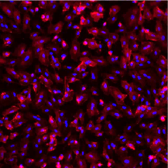 | 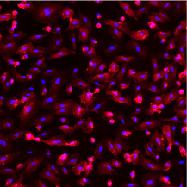
 | NHDF | 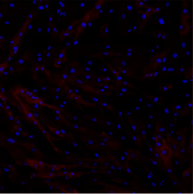 | 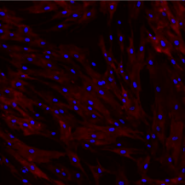 | 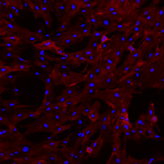 | 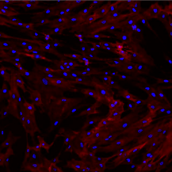 | 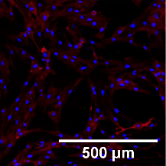
Figure 4.4 – Representative confocal micrograph images of HUVEC and NHDF at 6 and 24 hours stimulated under different concentrations of TNF-α. Nuclei are in blue with ICAM-1 upregulation in red. A significant increase in ICAM-1 expression can be observed after the addition of 25 U/mL TNF- α in both HUVEC and NHDF, particularly after 24 hours of incubation. There appears to be little difference in ICAM-1 expression with increasing concentrations of TNF-α versus the results using 25 U/mL. Scale bar = 500 µm.

Figure 4.4 – Representative confocal micrograph images of HUVEC and NHDF at 6 and 24 hours stimulated under different concentrations of TNF-α. Nuclei are in blue with ICAM-1 upregulation in red. A significant increase in ICAM-1 expression can be observed after the addition of 25 U/mL TNF- α in both HUVEC and NHDF, particularly after 24 hours of incubation. There appears to be little difference in ICAM-1 expression with increasing concentrations of TNF-α versus the results using 25 U/mL. Scale bar = 500 µm.

(b)

(a)

Figure 4.5 – Mean ICAM-1 upregulation in (a) HUVEC and (b) NHDF after incubation with different concentrations of TNF-α. A significant up-regulation of ICAM-1 was seen even at the lowest concentration of TNF-α (25 U/mL). (n=2).

4.3.3 TIME DEPENDENCE OF ICAM-1 EXPRESSION
Combining the fact that both HUVEC and NHDF produced significant up-regulation of ICAM-1 with only 25 U/mL TNF-α by 6 hours, and that whilst there is a large increase from 6 to 24 hours in HUVEC versus a smaller increase in NHDF, the time-course of ICAM-1 expression over 12 hours post TNF-α addition was examined in closer detail. Confocal micrograph images can be viewed in figure 4.6, where it is evident that ICAM-1 is gradually up-regulated in both HUVEC and NHDF over the experimental period, with an observably higher expression in HUVEC at 6 hours when compared to NHDF. Meanwhile, HUASMC appear to have a constitutively high ICAM-1 expression level.
Figure 4.7 shows a plot of relative intensity levels of ICAM-1 over 12 hours for HUVEC, NHDF and HUASMC cells. When examining the average intensity of ICAM-1 in HUVEC, a two-stage response was observed; an almost exponential increase in ICAM-1 upregulation between 0 and 6 hours, followed by a reduction in rate; the overall increase in ICAM-1 over the 12-hour period was approximately 3.9-fold. The different stages were confirmed by the significant differences (p<0.001) in ICAM-1 intensity between 0, 3 and 6 hours (p<0.001), as well as between 9 and 12 hours (p<0.01). During the 3-hour period between 6 and 9 hours, the difference was not significant (p=0.311).
In NHDF, there appeared to be no significant up-regulation of ICAM-1 expression between 0 and 3 hours (p=0.902). However, this was then followed by an approximate linear increase in ICAM-1; significant differences were calculated between the 3-, 6- and 9-hour intervals (p<0.001 and p<0.05). Although there appeared to be a further increase between 9 and 12 hours, the difference was not significant (p=0.069). Akin to HUVEC cells, the overall intensity increase was approximately 3.9-fold.

Cell Type | Time (Hours)
 | 0 | 3 | 6 | 9 | 12
HUVEC | 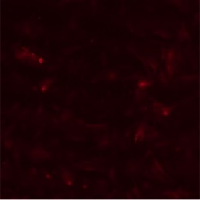 |  | 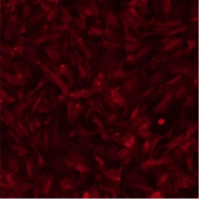 | 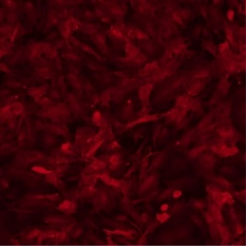 | 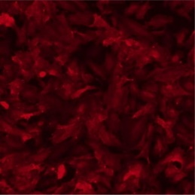
HUASMC | 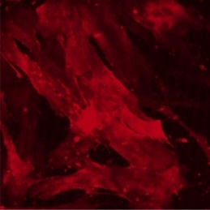 | 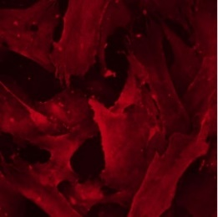 |  | 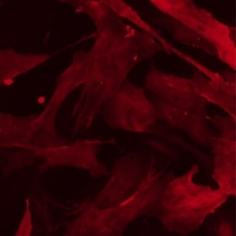 | 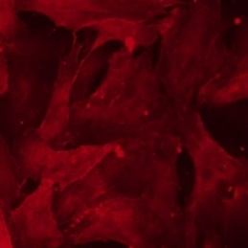
NHDF |  |  |  | 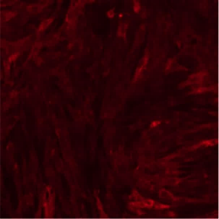 | 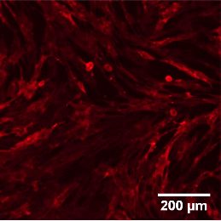
Figure 4.6 – Representative confocal micrographs of ICAM-1 expression at 3 hourly intervals up to 12 hours for HUVEC, HUASMC and NHDF after incubation with 25 U/mL TNF-α. A gradual increase in ICAM-1 upregulation was observed for HUVEC and NHDF cells, whilst HUASMC appeared to constitutively express ICAM-1 across all time points. Scale bar = 200 μm.

Figure 4.6 – Representative confocal micrographs of ICAM-1 expression at 3 hourly intervals up to 12 hours for HUVEC, HUASMC and NHDF after incubation with 25 U/mL TNF-α. A gradual increase in ICAM-1 upregulation was observed for HUVEC and NHDF cells, whilst HUASMC appeared to constitutively express ICAM-1 across all time points. Scale bar = 200 μm.
*

*
*

*
Figure 4.7 – ICAM-1 upregulation in HUVEC, HUASMC and NHDF monocultures stimulated with 25 U/mL TNF-α. In HUVEC, ICAM-1 appeared to increase in 2 stages; the first between 0 and 6 hours and the second beyond 9 hours. No change was observed in HUASMC. A linear increase in ICAM-1 was produced in NHDF after an initial delay of 3 hours. Mean ± SEM (n=3).

Figure 4.7 – ICAM-1 upregulation in HUVEC, HUASMC and NHDF monocultures stimulated with 25 U/mL TNF-α. In HUVEC, ICAM-1 appeared to increase in 2 stages; the first between 0 and 6 hours and the second beyond 9 hours. No change was observed in HUASMC. A linear increase in ICAM-1 was produced in NHDF after an initial delay of 3 hours. Mean ± SEM (n=3).

In contrast, baseline ICAM-1 expression in HUASMC was observably higher compared to HUVEC or NHDF cells (3.7-fold versus 1.3-fold, versus 1.2-fold), there appeared to be no significant change over the 12-hour period (p=1.000).
When comparing the localisation of ICAM-1 on the cell surface of HUVEC and NHDF (figure 4.8), it appears that whilst there is an almost uniform spread of ICAM-1 on the surface of NHDF, on HUVEC there appears to be an increased localised expression in areas of high cell-cell contact as well as on the leading edge.

HUVEC
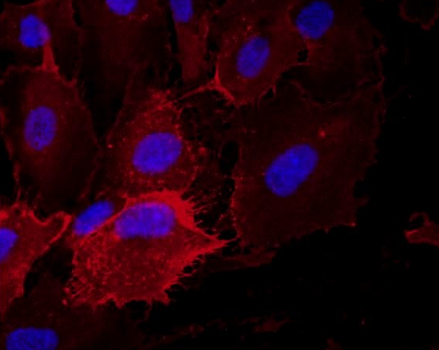
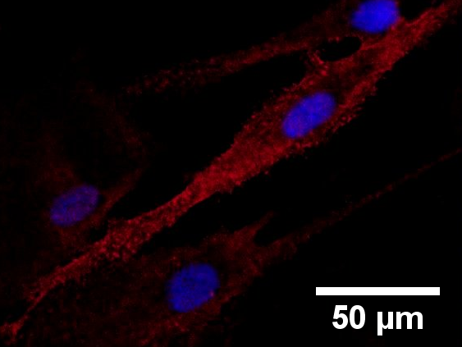
HUVEC

NHDF

Figure 4.8 – Confocal images of ICAM-1 expression (red) on HUVEC and NHDF after 12 hours of stimulation with 25 U/mL TNF-α. There appears to be high concentrations of ICAM-1 on the leading edge and in areas of HUVEC cell-cell contact, whilst in NHDF the ICAM-1 expression appears relatively consistent. Scale bar = 50μm.

Figure 4.8 – Confocal images of ICAM-1 expression (red) on HUVEC and NHDF after 12 hours of stimulation with 25 U/mL TNF-α. There appears to be high concentrations of ICAM-1 on the leading edge and in areas of HUVEC cell-cell contact, whilst in NHDF the ICAM-1 expression appears relatively consistent. Scale bar = 50μm.

4.4 DISCUSSION
The up-regulation of ICAM-1 was first examined in HUVEC, HUASMC and NHDF in monoculture conditions. This firstly enabled the ICAM-1 up-regulation to be examined for each cell type without any external influences, and secondly provided data which could later be compared to the ICAM-1 expression profile in the same cell types under different co-culture conditions. This was necessary to determine any significant differences in the expression profiles produced under altered culture conditions.
Although ICAM-1 expression was revealed on HUVEC, HUASMC and NHDF, the pattern of expression was different throughout. ICAM-1 was distinctly increased in areas of cell-cell contact and the leading edge in HUVEC upon TNF-α stimulation, HUASMC produced a constitutively high ICAM-1 expression and in NHDF the increase in ICAM-1 expression to TNF-α stimulation was uniform.

4.4.1 EFFECTS OF CULTURE MEDIUM CONDITIONS ON CELL GROWTH
Since HUVEC and NHDF are normally cultured in different medium, it was first necessary to determine what single medium type should be used for experiments, allowing the environmental conditions to be more tightly controlled. It was evident that the only culture medium that could be used was the complete M199 formulation and consequently was the medium chosen for all future experiments.
This was decided from the phase-contrast images of HUVEC (figure 4.3) after incubation in the different medium choices under consideration: DMEM, intermediate M199 medium and complete M199 medium. In both DMEM and the intermediate M199 medium, the HUVEC appear to be undergoing apoptosis, as suggested by the condensed and blebbing nature of the cells.
Although DMEM or the intermediate M199 medium may be suitable for the HUVEC when in co-culture with either HUASMC and/or NHDF, it would not be suitable to determine whether any differences in ICAM-1 expression levels were the result of the addition of a different cell type or change in culture medium type. Moreover, complete M199 medium would also be required if any differences between monoculture and co-culture were studied further via conditioned medium experiments, where the culture medium is incubated on one cell type prior to the addition to another e.g. NHDF monoculture stimulated for 12 hours prior to transferring the medium to HUVEC monoculture. Furthermore, it has also been previously demonstrated that umbilical smooth muscle cells can be grown in M199 [199]. Thus, it was decided that for continuity and control of factors within the culture medium, complete M199 medium would be the primary culture medium for future experimentation.
In addition, serum starvation has been routinely used when studying the effect of growth factors and cytokines in vitro. However, Pirkmajer & Chibalin (2011) concluded that although it is assumed that the basal activity of cells is reduced after serum starvation, available experimental data does not entirely support this and can even trigger various responses that could potentially interfere with experimental results [200]. Combining this with the knowledge that HUVEC cells are highly susceptible to undergoing apoptosis without the presence of growth factors, it was decided that serum starvation would not be required to study how the different cell types interact.

4.4.2 ICAM-1 EXPRESSION
For initial experiments on ICAM-1 expression, HUVEC cells were isolated ‘in-house’ whilst for later experiments these cells were commercially sourced (Promocell; C-12203). Therefore, for experiments involving the in-house isolated cells, ICAM-1 up-regulation represents only one donor, whilst the commercially bought HUVEC contained cells pooled from 3-4 umbilical cords. Consequently, the variation in data obtained for the first set of experiments was greater. Nevertheless, with the experiment being repeated in triplicate these results produced average values comparable to experiments conducted with pooled HUVEC.
Even though TNF-α caused an increase in ICAM-1 expression in both HUVEC and NHDF cells, the increase in ICAM-1 upregulation had a different profile over time. A maximum level of expression in NHDF at 6 hours was observed, suggesting that an alternative factor to TNF-α concentration was limiting the rate of production of ICAM-1. TNF-α induction of ICAM-1 gene expression has been shown to be dependent on NF-κB activation [80]. Thus, the accumulation of ICAM-1 on the cell surface is expected to be delayed, owing to the requirement of the transcription of new mRNA and subsequent protein synthesis.
Both transcription factors and the stability of the produced mRNA regulate how much overall protein is expressed. In unstimulated NHDF cells, the transcription unit including the ICAM-1 gene is normally found as a ‘closed complex’ and becomes ‘open’ when NF-κB is activated. However, the transcription unit in HUVEC is already in the ‘open complex’ format, likely owing to an additional factor regulating the activation of NF-κB [201]. This means that RNA polymerase II can readily bind to the transcription start site of ICAM-1 in HUVEC. Therefore, when TNF-α increases the production of NF-κB the rate of transcription is simply enhanced, explaining how ICAM-1 upregulation can be raised at 3 hours in HUVEC but not in NHDF cells.
Additionally, pro-inflammatory cytokines such as TNF-α have been shown to have a moderate stabilising effect on ICAM-1 mRNA in rat astrocytes [202]; if the basal levels of ICAM-1 mRNA are stabilised in such a manner, this could explain the initial exponential increase in ICAM-1 versus the linear relationship observed in NHDF and after 6 hours in HUVEC cells. Nevertheless, the knowledge that the fibroblast can express ICAM-1 is important to its involvement in plaque formation. Although the data thus far cannot conclude whether the initiation of the inflammatory response underlying atherogenesis is induced via the endothelium, it provides supporting evidence to the suggestion that leukocytes may migrate into the vessel wall via the vasa vasorum. These may then infiltrate the tunica adventitia of larger arteries, and not necessarily from the luminal side via transmigration through the tunica intima.
Moreover, the up-regulation of ICAM-1 indicates that at least the HUVEC and NHDF cells are responding to the stimulus and consequently may be able to induce different effects on the other cell types under consideration. For example, evidence exists that report on HUVEC cells releasing IL-1 [14], IL-6 [99], IL-8 [100], TNF-α [104] and VEGF [105]; these induce numerous signalling pathways including potentiating the inflammatory response in nearby cells as well as recruiting leukocytes to the site of inflammation. Fibroblasts are known to respond to some of these pro-inflammatory cytokines and in response produce and secrete cytokines including TGF-β1, IL-1β and IL-33 [203]. These interactions can be studied in more detail if the fibroblast is included in in vitro co-culture models.
Meanwhile, ICAM-1 expression in HUASMC has been demonstrated to be phenotype-dependent, whereby freshly isolated cells have a high-volume fraction of myofilaments and do not express ICAM-1, but over time in culture the cells decrease their volume fraction of myofilaments and concomitantly induce constitutive expression of ICAM-1 [21]. Consequently, the ICAM-1 expression was unaltered by the addition of TNF-α; this could simply indicate that the HUASMC cells are already maximally expressing ICAM-1. This suggests that SMCs are of the synthetic phenotype, comparable to those present in atherosclerotic plaques. The morphology of the HUASMC can also be anywhere from the typical contractile SMCs phenotype which are elongated and spindle-shaped to the synthetic phenotype, which are less elongated and have a cobblestone morphology; the HUASMC in figure 4.6 appear to be somewhere between the 2 states. Although it would also be useful to study how the expression of such adhesion molecules can be augmented in the contractile phenotype, this would require cells to be used for experimentation immediately after isolation. Nevertheless, the HUASMC were obtained commercially at passage 2, meaning that even if they were used immediately there is doubt as to ICAM-1 expression being low.
In terms of limitations, the method of image analysis and how this could affect the results also needs to be taken into consideration. Any background fluorescence was removed via ImageJ using a constant rolling ball radius; this would affect each cell type differently owing to size and shape. For example, with HUASMC being much larger than either HUVEC or NHDF, the background intensity removed from each cell would be larger, respectively. Therefore, no conclusions of a quantitative nature were made about the difference in ICAM-1 levels between cell types.
Additionally, whilst HUVEC and HUASMCs were used, which both come from the same in vivo environment and naturally cross-talk, NHDFs were also used which are from a considerably different in vivo environment. Not only are fibroblasts heterogeneous meaning that cells from different tissues may display slightly different characteristics [128], but HUVEC and HUASMC are from neonates whilst NHDFs are adult cells. Evidence suggests that healing is faster at an earlier neonatal age and scar production is less likely [204]; this could affect the development of the chronic inflammatory response underpinning atherogenesis in adults.

4.5 CONCLUSION
Significant up-regulation of ICAM-1 was observed in both HUVEC and NHDF after 12 hours of incubation with 25 U/mL TNF-α, with HUASMC constitutively expressing the cell adhesion molecule. Although this indicated that HUASMC were likely of a synthetic phenotype, this cell phenotype is often found in areas of atherosclerotic plaque formation and consequently the information gathered about how these cells can influence endothelial and fibroblast cells will still be valuable.
Moreover, considering that the three cell types are found from different layers of the vessel wall, that all can express ICAM-1, and that ICAM-1 binds to LFA-1 on leukocytes to allow transmigration, this raises questions as to whether leukocytes migrate into the vessel wall via the lumen or vasa vasorum. Consequently, results thus far demonstrate the importance of studying the interactions between all three cell types.
In vitro experiments are markedly different to in vivo conditions, with many cell types present together within the tissue as well as the cells being within in a 3D structure. However, it is important to simplify the design of the experiments to be able to make conclusions about specific cell-cell interactions. Therefore, the next stage in making the conditions more biomimetic was to introduce additional cell types into the culture conditions to determine whether any specific interactions influence the expression levels of ICAM-1.

CHAPTER 5
HUMAN UMBILICAL VEIN ENDOTHELIAL CELL, HUMAN UMBILICAL ARTERY SMOOTH MUSCLE CELL AND NORMAL HUMAN DERMAL FIBROBLAST CO-CULTURE STUDIES
5.1 INTRODUCTION
In chapter 4, the time course of ICAM-1 up-regulation when stimulated with 25 U/mL TNF-α was examined in HUVEC, HUASMC and NHDF monocultures. These experiments demonstrated that ICAM-1 expression can be up-regulated in HUVEC and NHDF cells over the 12-hour incubation period, whilst in HUASMC no significant difference in ICAM-1 intensity was observed. The results obtained from these experiments provided baseline ICAM-1 expression data to which future co-culture and medium transfer experiments could be compared to answer whether the expression of ICAM-1 was augmented through communication with additional cell types.
As previously mentioned, current in vitro vascular co-culture models primarily include only the endothelial cell and smooth muscle cell (chapter 1); although previous research has indicated that smooth muscle cells can enhance the inflammatory response of endothelial cells [79, 80], the role of the fibroblast cell with respect to the vascular inflammatory response has not been studied in detail. Moreover, even though previous research has indicated that ICAM-1 is expressed on HUVEC [20], HUASMC [21] and NHDF [22], there are no studies comparing the ICAM-1 up-regulation within these cell types, either individually or in co-culture.
Therefore, my next studies focussed on the co-culture of HUVEC, HUASMC and NHDF with the aim to determine whether the ICAM-1 up-regulation patterns observed in chapter 4 could be augmented in any way through the addition of alternative cell types to the culture. Initially, a co-culture of HUVEC and NHDF were studied. These were followed by co-culture experiments of HUVEC and HUASMC, and HUASMC and NHDF co-cultures. Finally, an experiment involving all three cell types (HUVEC, HUASMC and NHDF) was performed. These experiments allowed the presence of communication pathways between each cell type to be confirmed or discounted, as well as enabling the synthesis of hypotheses relating to the type of communication methods involved e.g. paracrine versus direct contact.
Cell biology in vivo is drastically different to that observed in vitro, with tissues presenting a 3D matrix with specific mechanical properties [205] and being made up of numerous different cell types (e.g. the tunica adventitia contains fibroblasts, tissue macrophages and endothelial progenitor cells [10]), all of which provide different biological functions to maintain a homeostatic environment. In vitro disease models provide a more simplistic approach, allowing changes in the physiology to be studied upon alterations to biological inputs [184]. Consequently, it is expected that the phenotype of a cell in vitro (e.g. endothelial cell) will become more biomimetic when the culture environment provides similar mechanical and chemical properties to those found in vivo. Thus, the introduction of additional cell types that are usually present (e.g. smooth muscle cell) can be incorporated into the culture, enabling the intercellular cross-talk that naturally occurs and enhancing the biomimetic properties of the cell culture [206].
If these co-culture experiments provide evidence to suggest NHDF can augment the ICAM-1 expression profile in HUASMC and/or HUVEC, this would provide further reasoning for the fibroblasts’ inclusion in future in vitro vascular models.

5.2 METHODS
5.2.1 CELL CULTURE
All cell types were initially grown in their preferred medium type; HUVEC and HUASMC were grown in M199 medium, with and without ECGS/H respectively, whilst NHDF were cultured in DMEM AQmedia. All cell types were cultured for up to 15 population doublings and complete M199 medium was used during experiments to maintain consistency throughout. For further details on culture methods, see chapters 4.2.1 - 4.2.4.
5.2.2 ANALYSIS OF CELL SEEDING RATIOS
To label one of the two cell types combined in co-culture, Celltracker™ Green CMFDA Dye (Thermo Scientific; C7025) was used. This was prepared by dissolving the powder in DMSO to produce a stock concentration of 10 mM, where it was then aliquoted and stored in the dark at -20 °C until required. The stock solution was then diluted in serum free M199 to produce a working concentration of 1 µM, covered with foil and pre-warmed to 37 °C before the addition of cells. Whilst the cell tracker solution was warming, the cell type to be labelled was passaged (described in chapter 4.2.3) to produce a cell pellet. The supernatant was discarded, and the cell pellet was re-suspended using the tracker-medium solution and incubated in the dark at 37 °C for 30 minutes, before re-centrifugation at 220 g for 5 minutes and re-suspension in complete M199 medium. The retention of the fluorescent signal from the cell tracker was greater than 72 hours and was passed on to daughter cells; this easily covered the time-period required to carry out the experiments described and highlighted all the NHDF during culture.
HUVECs were then also passaged (described in chapter 4.2.2) and combined with the NHDFs in ‘complete M199’ to produce cell suspensions with cell ratios of 2:1, 1:1 and 1:2 (HUVEC : NHDF), which equates to -0.7, 1 and 0.7 after implementing equation 5.1.
$$Equation 5.1 Cell Ratio= ln⁡\left(\frac{NHDF Count }{HUVEC Count}\right)$$
The combined HUVEC and NHDF cell suspensions were subsequently seeded at 15,000 cells/cm² on sterilised and gelatinised coverslips (0.1 % (m/v) gelatin (Sigma-Aldrich; G1890) in PBS) and incubated at 37 °C, 5 % CO₂. The following day the coverslips were rinsed (3x) in PBS and fresh complete M199 medium was added. After either 24 or 48 hours of incubation, the cells were rinsed (3x) with PBS and fixed with 3.7 % (v/v) formaldehyde for 20 minutes at RT. After additional (3x) PBS washes, the coverslips were also incubated with DAPI (1 ng/mL) for 10 minutes at RT, before rinsing (3x) and storing the coverslips in PBS. The samples were kept in the dark at 4 °C until imaged, which would preferentially be completed within the same day.
Images were obtained on an IX73 Olympus inverted microscope using a 10x/0.3 air objective; the system was combined with a wLS LED light source and DAPI/FITC/Texas Red triple filter system which possess spectra of λEx 390-420 nm λEm 435-475 nm, of λEx 480-505 nm λEm 510-555 nm and λEx 550-590 nm λEm 595-690 nm, respectively. This enabled the Celltracker™ Green CMFDA Dye (max λEx 492 nm, max λEm 517 nm) (Thermo Scientific; C7025) and DAPI (max λEx 358 nm, max λEm 461 nm) to be detected.
ImageJ was the software used to count the number of cells present in each labelled image [198]. The process entailed ‘image -> adjust -> colour threshold’, followed by ‘analyse -> analyse particles’; the total cell count and the number of NHDFs were then readily available and supported the calculation of the number of HUVECs (equation 5.2).
$Equation 5.2 No. of HUVECs= Total Cell Count \left(DAPI\right)-No. of NHDFs (FITC)$
The cell ratio obtained from the images was also compared to the initial seeding cell ratio using equation 5.1 to determine:
- whether there was a density dependence on how well each cell type grew in co-culture
- what initial seeding ratio was required to obtain an equal number after 48 hours (a 1:1 ratio was considered ‘healthy’, as discussed in Chapter 3.3.2)
T-tests to a 95% confidence interval were then carried out to compare HUVEC and NHDF cell counts between the different seeding cell ratios.

5.2.3 TNF-α STIMULATION OF CO-CULTURES
For co-cultures, one cell type was pre-labelled with Celltracker™ Green CMFDA Dye (Thermo Scientific; C7025) as described above, re-suspended in complete M199 medium and combined with the other cell type at the correct ratio. For 3-cell co-cultures, NHDF cells were pre-labelled with the tracker, whilst HUVEC and HUASMC could be distinguished via size differences. Co-cultures were combined to produce concentrations approximately half that used in the monoculture experiments and seeded onto gelatinised (0.1 % (m/v) gelatin (Sigma-Aldrich; G1890) in PBS) 13mm circular coverslips (Academy Science; NPC13/13) in 24-well plates and incubated at 37 °C, 5 % CO₂ overnight to allow cell adhesion.
The following day, the culture medium was exchanged for complete M199 medium containing 25 U/mL of human TNF-α (Thermo Fisher Scientific; PHC3015). The samples were incubated for 0, 3, 6, 9 and 12 hours. Where all three cell types were combined, the cells were seeded at 3,500, 5,000 and 6,000 cells/mL for HUASMC, HUVEC and NHDF, respectively. Owing to the limited availability of HUASMC, these co-cultures were only incubated with TNF-α for 12 hours. Thereafter, the cells were fixed using 3.7 % (v/v) formaldehyde for 20 minutes at RT before washing with PBS (3x). Prevention of non-specific binding of secondary antibodies was carried out by incubating samples for 1 hour with a 3 % (w/v) BSA (Sigma-Aldrich; A7030) in PBS solution. Samples were then stored at 4 °C.
With cell seeding occurring on Day 1, with the addition of TNF-α on either Day 2 or 3, immunolabelling was then carried out on Days 4 and/or 5, respectively. All experiments were completed in triplicate with n indicating the number of independent repeats.

5.2.4 IMMUNOCYTOCHEMISTRY TO EXAMINE ICAM-1 UP-REGULATION
As previously described in chapter 4.2.7, mouse anti-human ICAM-1/CD54 primary antibody (eBioscience; BMS108), goat anti-mouse Alexa Fluor 633 secondary antibody (Life Technologies; A21052) and DAPI were added to the fixed cells.
For imaging, the samples (coverslips) were transferred to a Petri dish containing PBS. Images were obtained using a Zeiss upright LSM510 Meta confocal microscope, combined with a Zeiss 10x/0.30 W Ph1 water immersion objective. Argon/2 (λex = 488 nm / λem = 500-550 nm), HeNe2 (λex = 633 nm / λem = 650-710 nm), Ti-Sapphire two-photon (λex = 780 nm / λem = 435-485 nm) lasers were used to stimulate the CMFDA (max λEx 492 nm, max λEm 517 nm), Alexa Fluor 633 (max λEx 632 nm, max λEm 647 nm) and DAPI (max λEx 358 nm, max λEm 461 nm) fluorophores, respectively.
All microscope and laser settings for Alexa Fluor 633 imaging were maintained from previous experiments: the resolution of the image was set to 512 x 512 pixels, the pinhole size was set to ~9.7 Airy Units, transmission (%) set to 39.5 for the HeNe2 laser with detector gain of 850, amplifier offset of 0.1, amplifier gain at 1 and an average reading was taken from 4 scans.

5.2.5 USING IMAGE ANALYSIS SOFTWARE TO ASSESS ICAM-1 EXPRESSION IN CO-CULTURE
ImageJ was the software of choice to calculate the mean intensity of ICAM-1 for each sample [198]. The total cell count was obtained via DAPI identifying all cells present, with the CMFDA labelling identifying the number of NHDF cells. The number of HUVEC was then calculated using equation 5.1 and the cell ratio obtained (equation 5.2). The cell ratio of the co-cultures involving HUASMC was calculated in a similar manner as demonstrated in equation 5.3.
$$Equation 5.3 Cell Ratio=Ln\left(\frac{HUVEC or NHDF Count}{HUASMC Count}\right)$$
Any images obtained that were clearly not representative of the population were removed from the image analysis; for example, if an image contained many HUVEC but few HUASMC cells. Each image had its background fluorescence removed via ‘process -> subtract background’, with the rolling ball radius set to 12 pixels. Areas were then selected of solely a single cell type and the mean intensity of ICAM-1 was then obtained using the software.
The data was then transferred to SPSS for statistical analysis. The Games-Howell test was used to calculate the p-value between the intensities obtained at different time-points; thus, highlighting any significant results at the 95% confidence interval. Where applicable, the cell ratio to intensity correlation was also assessed via the Spearman’s Rho test to determine R_{S} values.

5.3 RESULTS
5.3.1 ANALYSIS OF CELL SEEDING RATIOS
With the population doubling time being slightly different between all cell types under normal monoculture conditions, optimal seeding ratios needed to be calculated for the co-cultures, considering any influence on growth from the alternative cell type. This enabled co-culture experiments analysing the ICAM-1 expression to be carried out the day after seeding with an approximate equal cell ratio – this was calculated to be a healthy cell ratio as determined via the histological analysis of human coronary arteries in chapter 3.
Firstly, HUVEC and NHDF co-cultures were considered. The cells were seeded at three different seeding ratios, cultured for 48 hours and the new cell ratio calculated; images taken via epifluorescent microscopy can be seen in figure 5.1. The number of HUVEC appreciably increased between 24 and 48 hours. Moreover, although both cell types appear throughout the sample, the relative proportion changed in regions of interest owing to the formation of HUVEC islands. Figure 5.2 illustrates the change in cell ratio observed under different culture conditions. A decrease in cell ratio (equation 5.1), indicating a relative increase in HUVEC, occurred when HUVEC and NHDF were seeded at 2:1 and 1:2 (HUVEC : NHDF) ratios, whilst no differences were observed when cells were seeded equally.
It was essential that the cell ratio decreased when more NHDF were seeded to even out the ratio of HUVEC to NHDF by 48 hours; in this case the ratio changed from 0.7 to approximately 0.1, meaning that although there was twice the number of NHDF than HUVEC initially, the number of each cell type was relatively even after 48 hours. This suggests that a seeding ratio of both 0 and 0.7 were suitable for experiments. It was also essential that the exact cell numbers were analysed, to ensure that each cell type was growing well at the chosen seeding densities. Figure 5.3 displays the cell counts for HUVEC and NHDF. Observing the HUVEC data, whilst the numbers increased by approximately 150 % between 24 and 48 hours when seeded at ratio of -0.7 (2:1) and 0 (1:1), at 0.7 (1:2) the number of HUVEC appeared to increase by about 850 %. Although there appeared to be an increase of 100 % and 50 % in NHDF at 0 and 0.7 seeding ratios between 24 and 48 hours statistical tests were not performed and thus significant differences could not be established.
Time (Hours) | Seeding Cell Ratio (HUVEC : NHDF)
 | -0.7 (2:1) | 0 (1:1) | 0.7 (1:2)
24 | 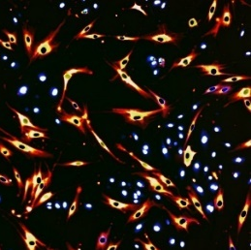 | 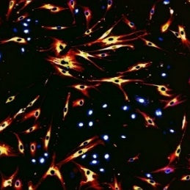 | 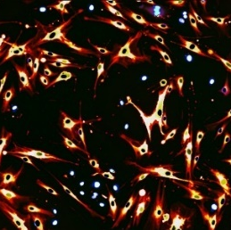
48 | 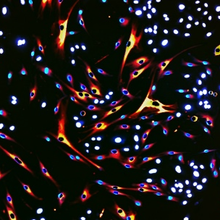 | 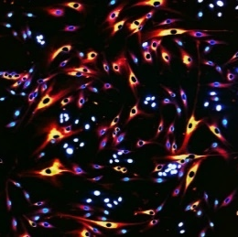 | 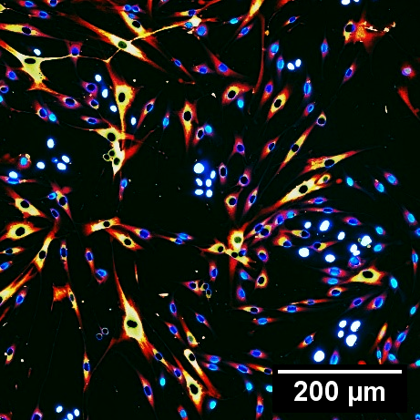
Figure 5.1 – Epifluorescent micrograph images representing the different HUVEC and NHDF co-culture ratios. DAPI (blue) identifies nuclei of both HUVEC and NHDF cells, whilst NHDF were identified by a CMFDA cell tracker (red-yellow). A significant increase in HUVEC count occurred between the two time-points for all seeding ratios, with the seeding ratios 1:1 and 1:2 appearing to have approximately equal quantities of both HUVEC and NHDF at 48 hours. Scale bar = 200 μm.
(1:2)

(1:1)

(2:1)

Figure 5.2 – The mean change in ratio of HUVEC and NHDF when cultured at different seeding ratios. Although there was no significant change in cell ratio when seeded in equal numbers, a significant decrease in cell ratio was observed when one cell type was predominant at seeding, indicating a relative increase in HUVEC count. (n=1).

Figure 5.3 - The mean change in cell count of HUVEC and NHDF over the 48-hour study period in co-culture. In HUVEC, the difference in cell count between 24 and 48 hours was only significant when HUVEC were not the major cell type present at seeding. There were also no significant differences in the HUVEC count between seeding ratios after 48 hours. In NHDF, there was no significant difference in number at 48 hours versus 24 hours for all seeding ratios. Moreover, the difference in cell count between the seeding ratios only became significant when comparing the results obtained at 48 hours for seeding ratios of -0.7 and 0.7. (n=1).
Nevertheless, owing to the higher initial seeding numbers with increasing ratio, the final NHDF count was significantly higher at 0.7 than -0.7 at 48 hours. Combining the data, it appeared that increasing the relative proportion of NHDF enhanced the growth of HUVEC, whilst an increasing proportion of HUVEC inhibited the growth of NHDF cells. Thus, a cell ratio somewhere between 0 and 0.7 was decided as optimum.

5.3.2 HUVEC AND NHDF CELLS IN CO-CULTURE
HUVEC and NHDF cells were seeded and stimulated with 25 U/mL TNF-α. Representative confocal images can be observed in figure 5.4. As with monoculture studies, there was a relative increase in expression of ICAM-1 over a 12-hour period. However, upon closer examination of respective cell response, it was evident that this increase in ICAM-1 was primarily from the HUVEC cells, with little expression observed in NHDF. The difference in ICAM-1 upregulation was more pronounced when analysing the relative ICAM-1 intensity of each cell type. Figure 5.5 displays the ICAM-1 intensity in HUVEC and NHDF under co-culture conditions, respectively.
HUVEC cells displayed a sigmoidal-shaped response; the differences between the mean intensities for each 3-hourly interval up to 9 hours were highly significant (p<0.01, p<0.001, p<0.001), followed by a difference that was not significant (p=0.451). This was different to HUVEC cells under monoculture condition, where the difference in ICAM-1 between 6 and 9 hours was not significant. Moreover, an increase in basal ICAM-1 expression in HUVEC cells when co-cultured with NHDF was observed (2.1 vs 1.3-fold; p<0.01), as well as a steeper gradient of ICAM-1 up-regulation. This resulted in the mean intensity at 12 hours being significantly greater than in monoculture (8.3- vs 5.2-fold; p<0.001).
On the other hand, NHDF cells did not display a significant change from basal ICAM-1 expression levels (0 hrs) after addition of TNF-α until a 12-hour time-point (p<0.05). Additionally, the mean intensity between the 3- and 9-hour intervals (p<0.01), and the 6- and 12-hour intervals (p<0.05) were significant. The basal ICAM-1 expression in co-culture was comparable to monoculture conditions (p=0.874). However, the relative intensity after 12 hours of incubation with TNF-α was only 1.7-fold in co-culture versus 5.1-fold

Label | Time (Hours)
 | 0 | 3 | 6 | 9 | 12
DAPI  HUVEC and NHDF | 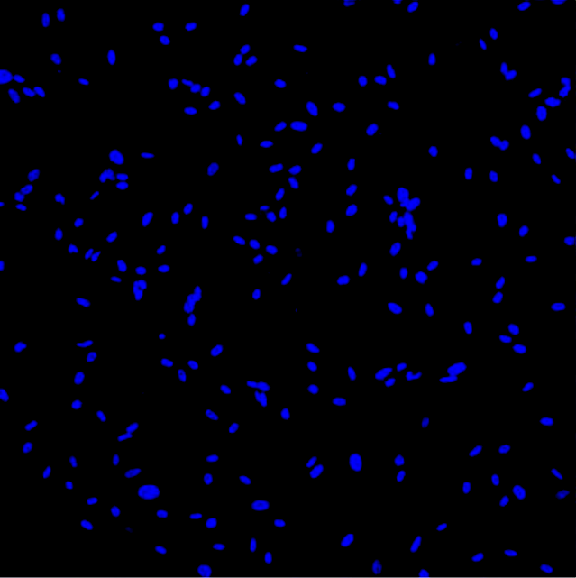 | 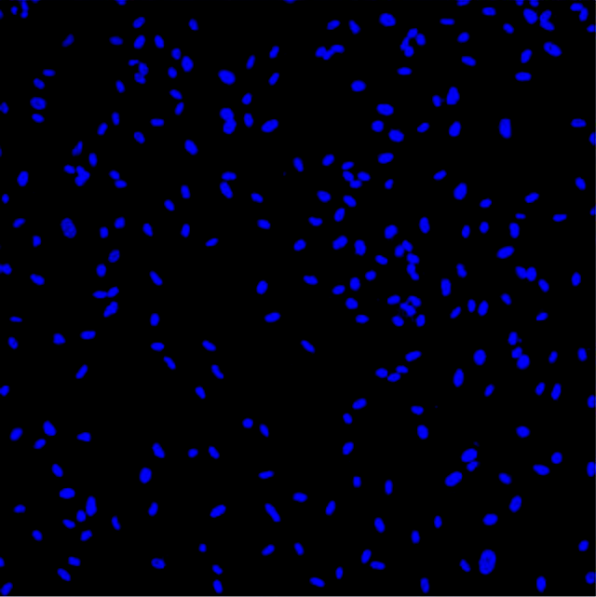 | 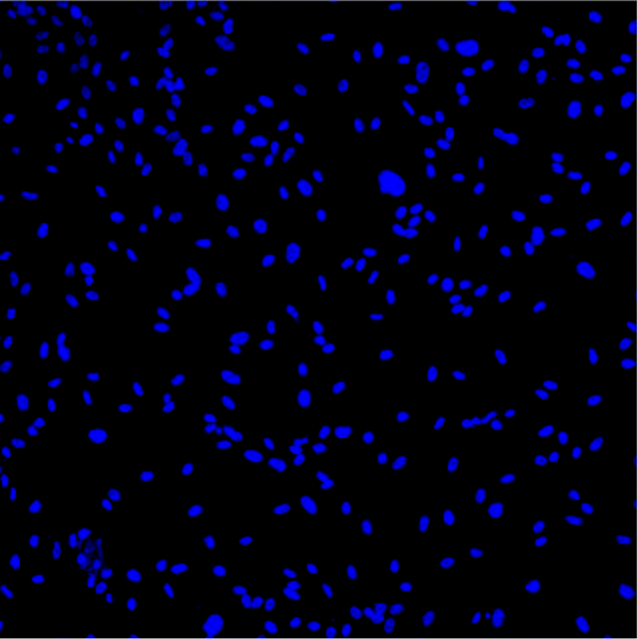 | 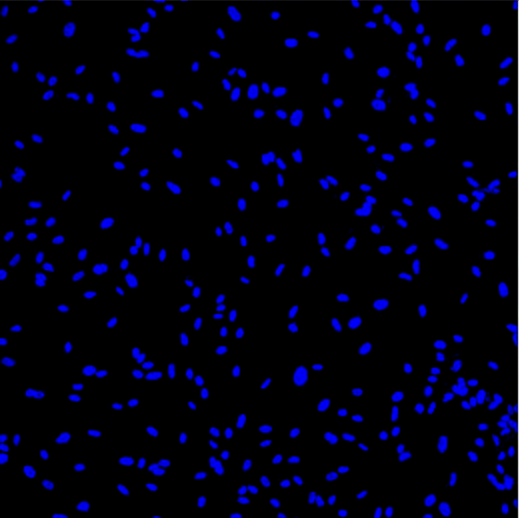 | 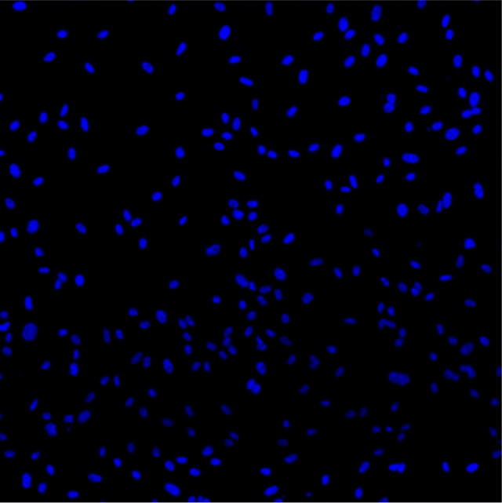
CMFDA  NHDF alone | 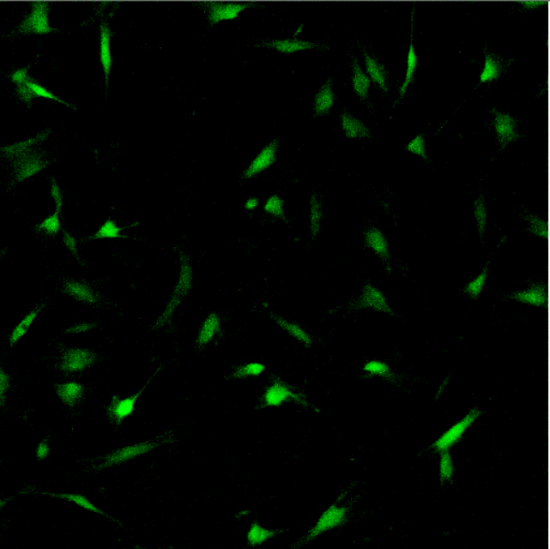 | 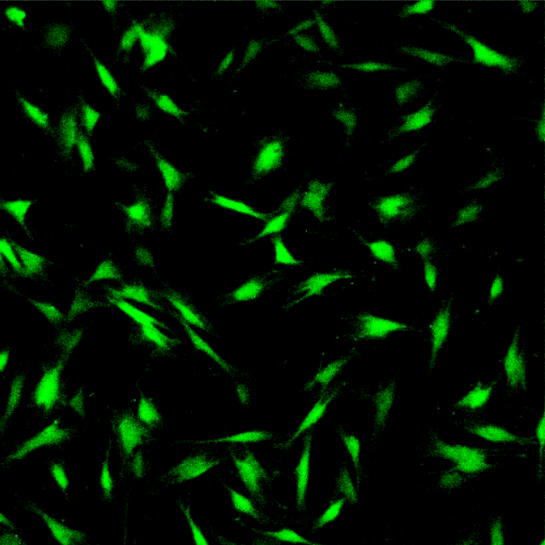 | 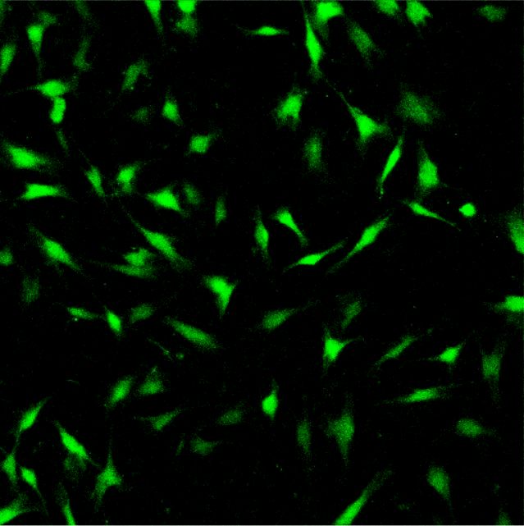 | 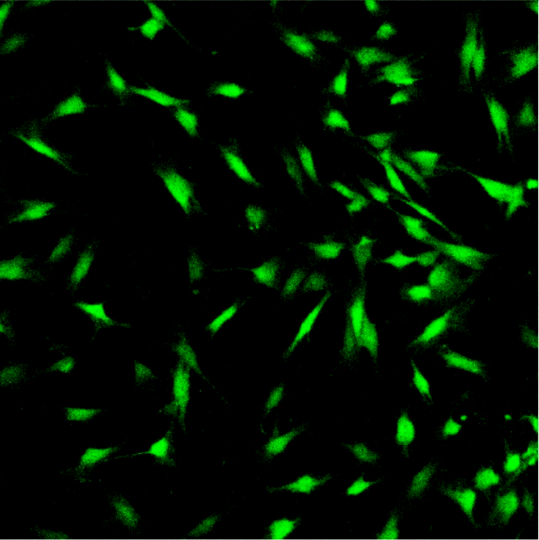 | 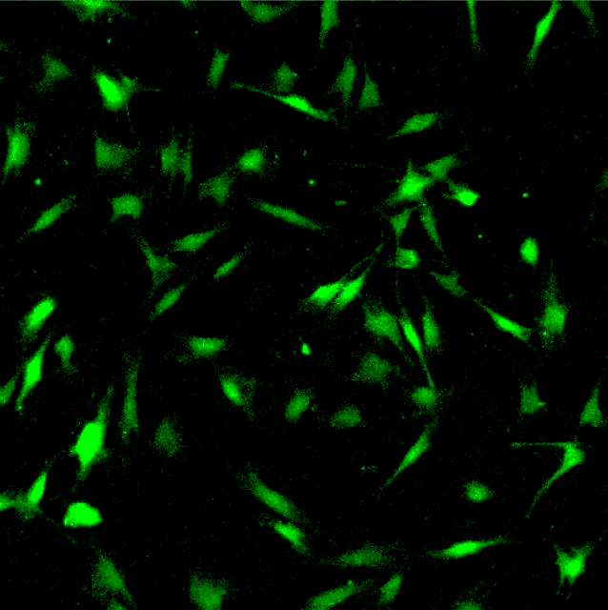
ICAM-1  HUVEC and NHDF | 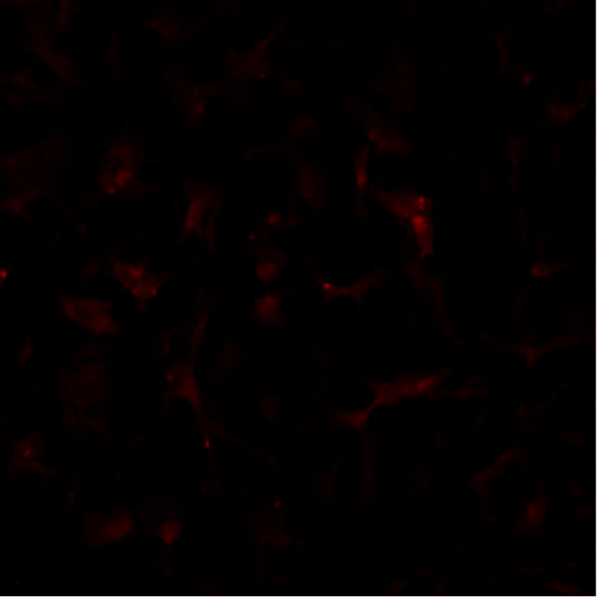 | 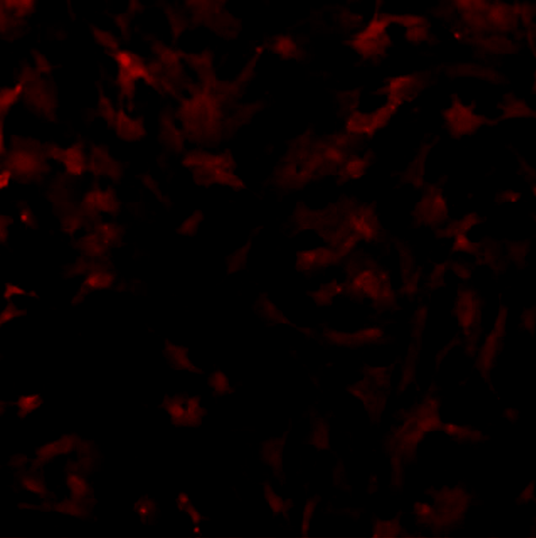 | 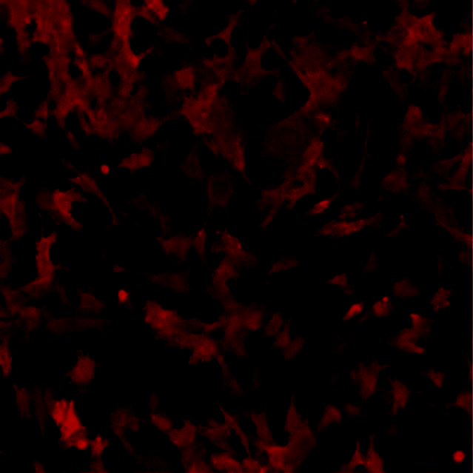 | 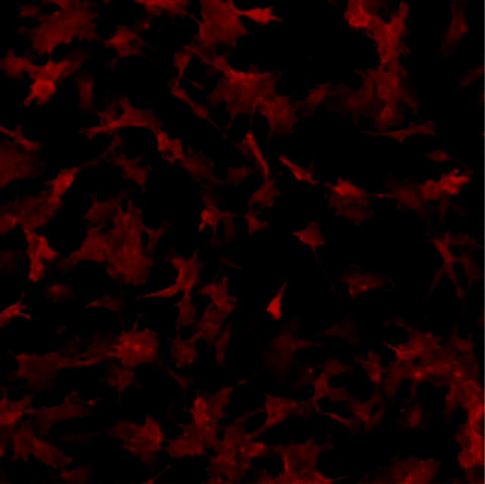 | 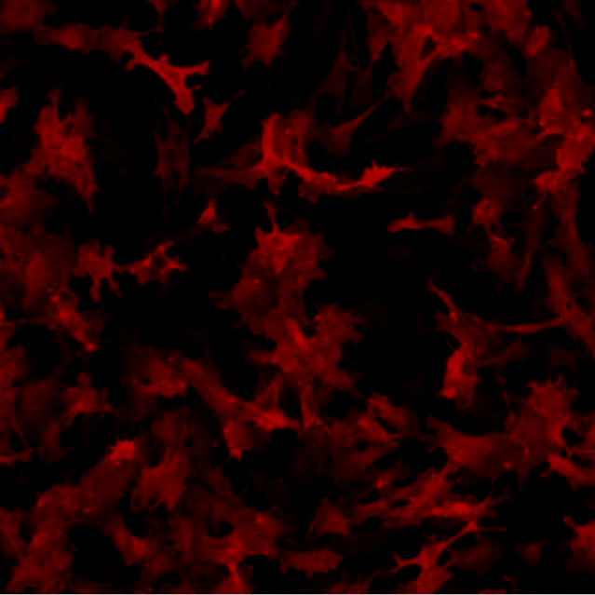
DAPI +  CMFDA | 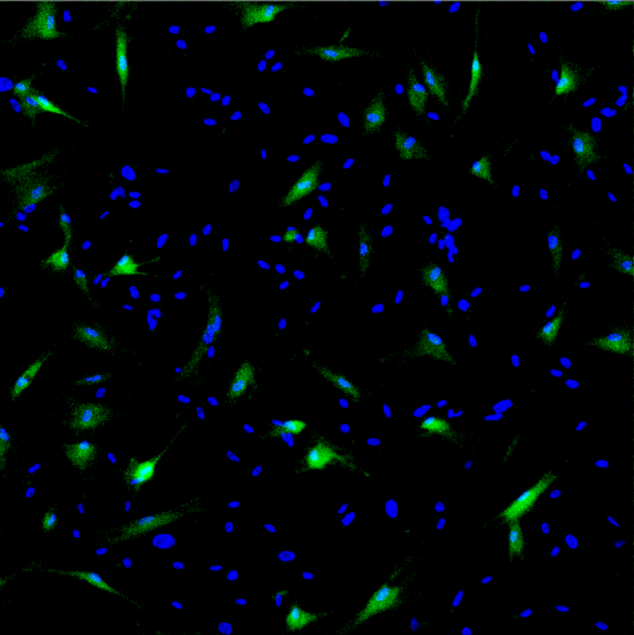 | 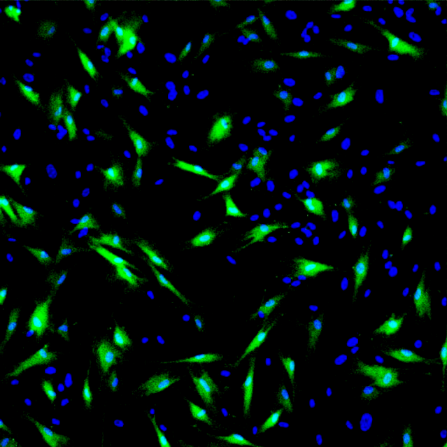 | 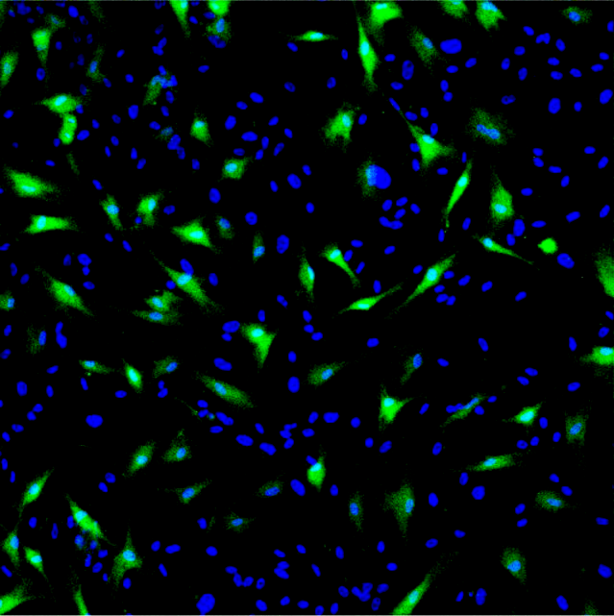 | 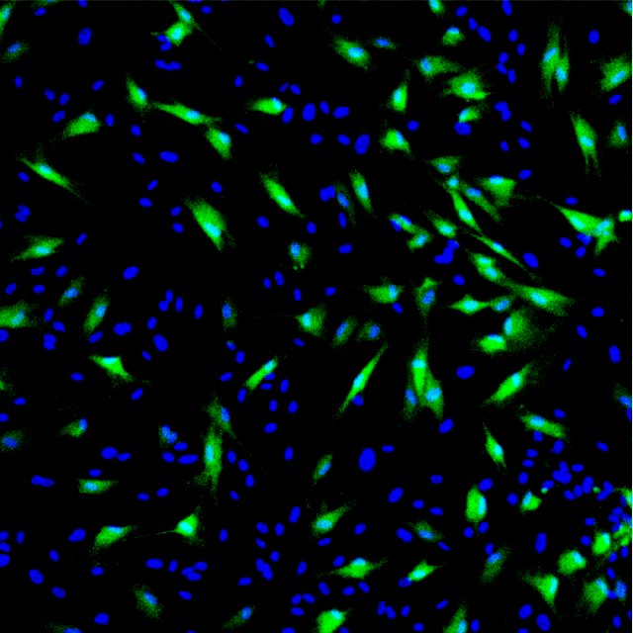 | 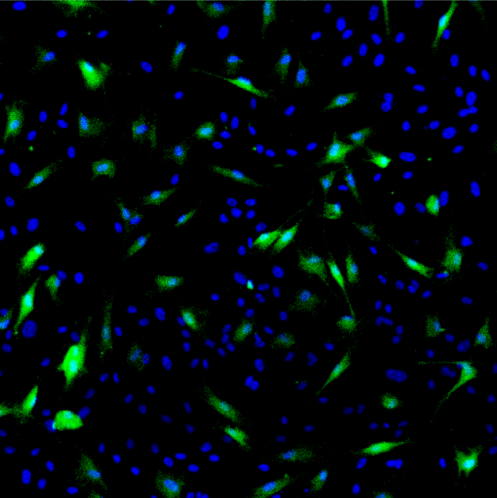
DAPI +  ICAM-1 | 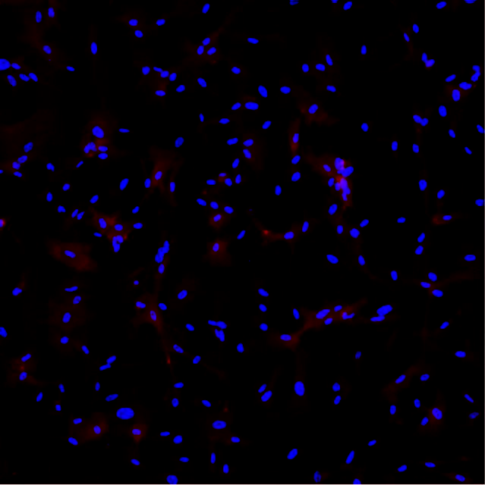 | 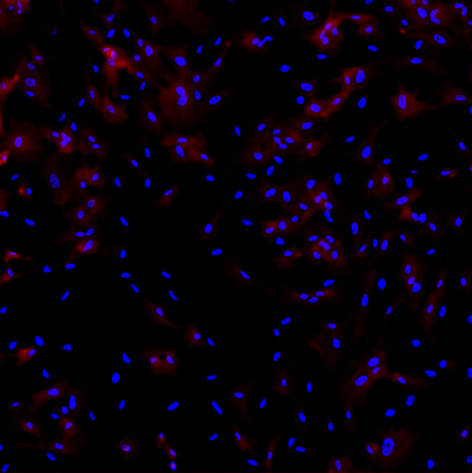 | 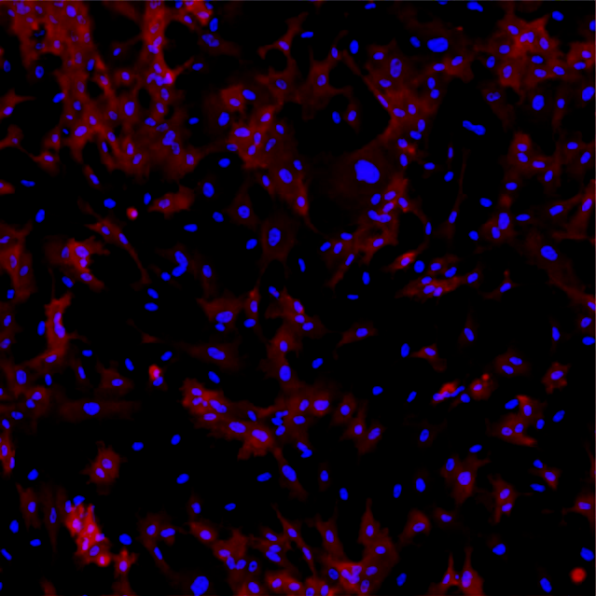 | 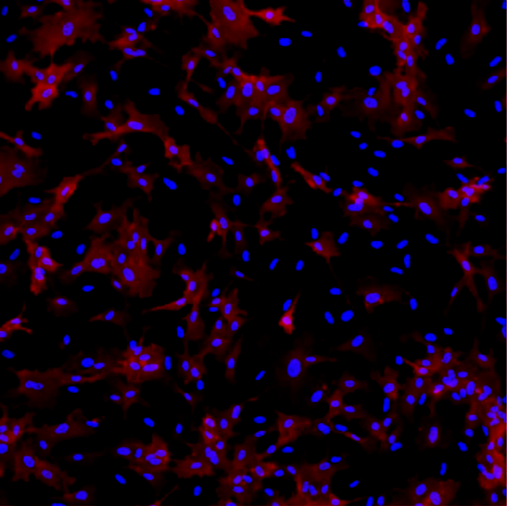 | 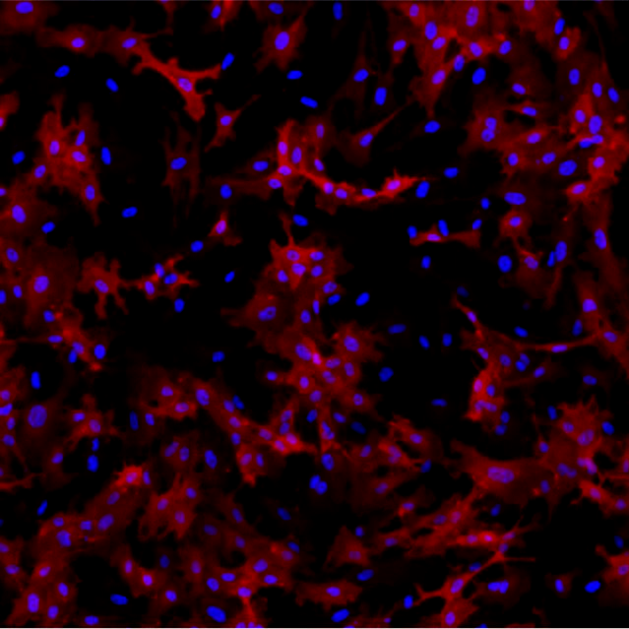
CMFDA +  ICAM-1 | 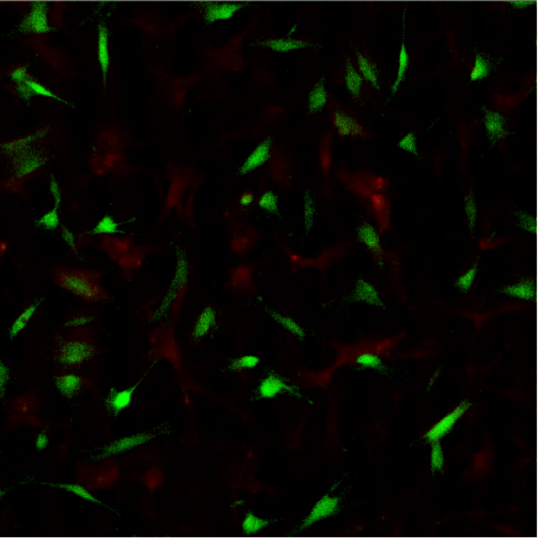 | 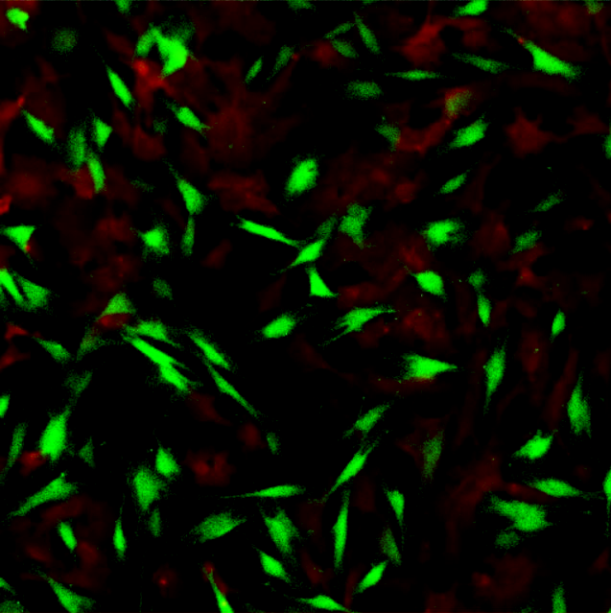 | 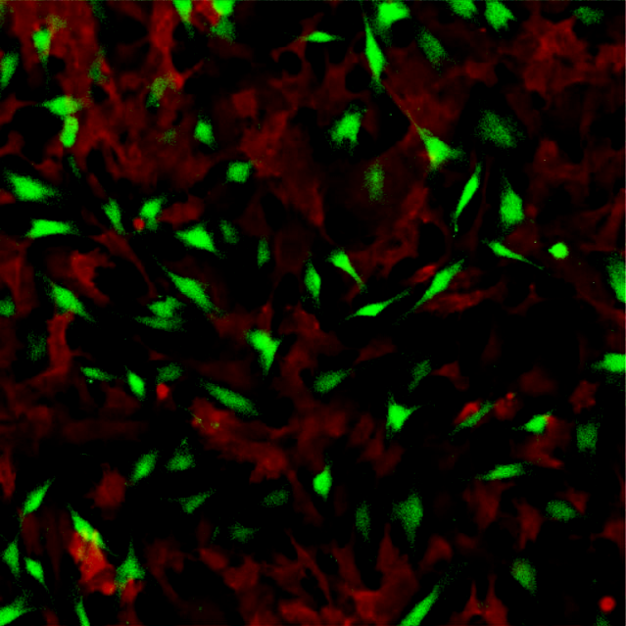 | 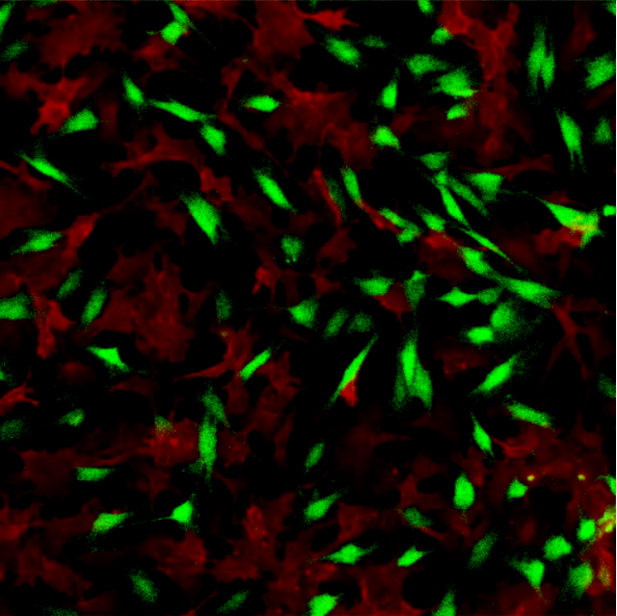 | 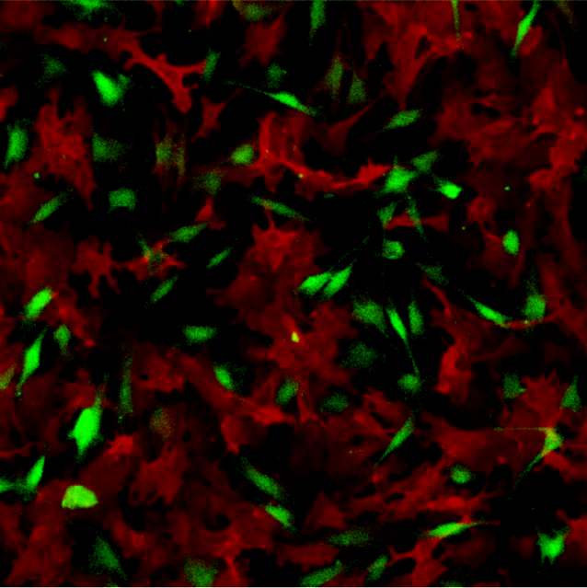
DAPI + CMFDA + ICAM-1 | 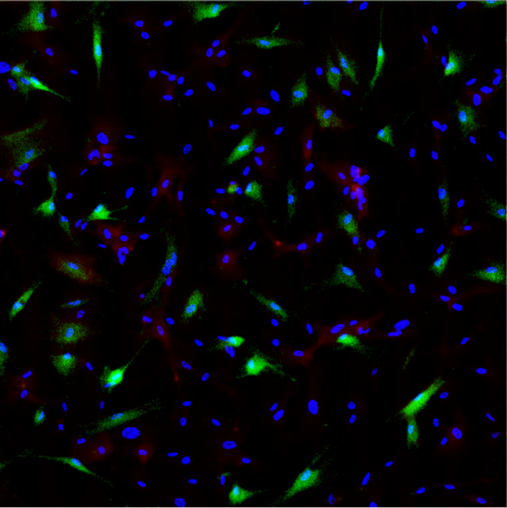 | 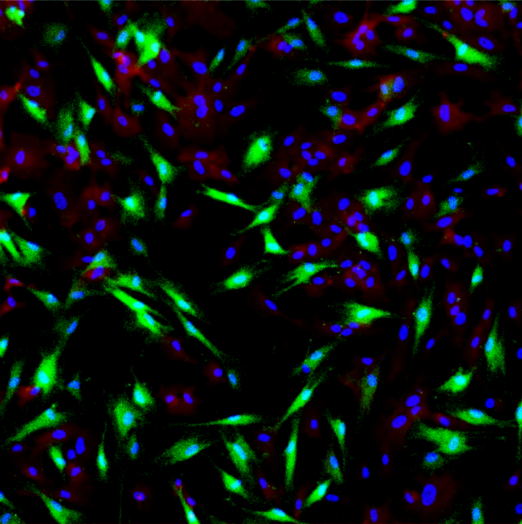 | 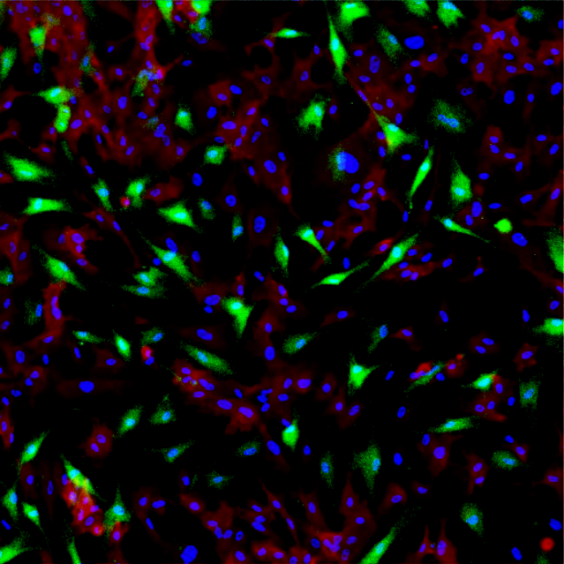 | 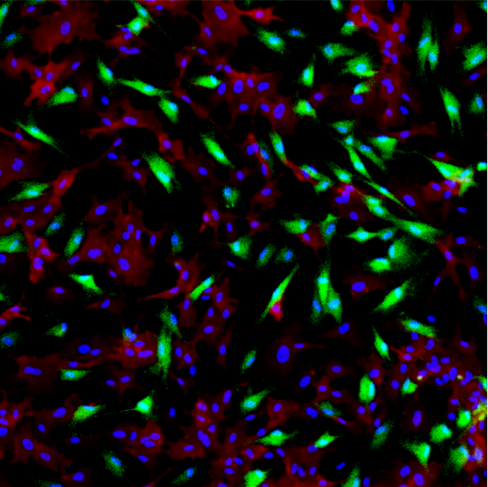 | 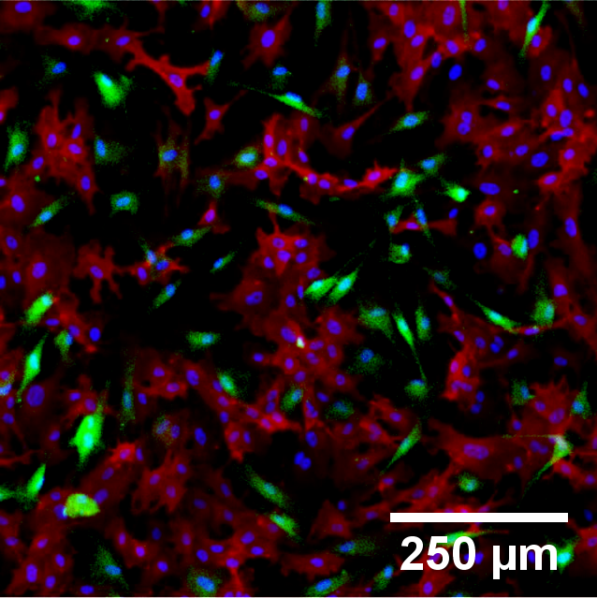
Figure 5.4 – Representative confocal micrograph images of HUVEC and NHDF co-cultures when stimulated with 25 U/mL TNF-α for 0-12 hours. DAPI (blue) identifies the nuclei of all cells, CMFDA (green) labels NHDF cells only. ICAM-1 (red) generally increased with increasing TNF-α exposure, though upon close examination this primarily arose in HUVEC cells. Scale bar = 250 μm.

*

*
*

*
TNF-α Added

Cells Seeded

Figure 5.5 – ICAM-1 upregulation in HUVEC and NHDF cells in co-culture when stimulated with 25 U/mL TNF-α. A small increase in basal ICAM-1 expression occurred after seeding, followed by a sigmoidal shaped response over 12-hours after stimulation in HUVEC presence. NHDF ICAM-1 expression was low for the first 6 hours, followed by a small increase over the following 6 hours. Mean ± SEM (n=3).

Figure 5.5 – ICAM-1 upregulation in HUVEC and NHDF cells in co-culture when stimulated with 25 U/mL TNF-α. A small increase in basal ICAM-1 expression occurred after seeding, followed by a sigmoidal shaped response over 12-hours after stimulation in HUVEC presence. NHDF ICAM-1 expression was low for the first 6 hours, followed by a small increase over the following 6 hours. Mean ± SEM (n=3).

in monoculture, indicating that the expression of ICAM-1 in monoculture was significantly greater than when in co-culture with HUVEC (p<0.001).
The influence of each cell type on the other is illustrated in figure 5.6, where the cell ratio can be related to the ICAM-1 upregulation in each cell type. A significant and positive relationship between the cell ratio and ICAM-1 level was observed in both HUVEC and NHDF. Cell ratio versus ICAM-1 intensity in HUVEC cells producing a gradient of 2.3 and R_{S} value of 0.541 (p<0.01), whilst in NHDF a gradient of 0.2 was produced with an R_{S} value of 0.652 (p<0.01).

5.3.3 HUVEC AND HUASMC CELLS IN CO-CULTURE
HUVEC and HUASMC were seeded and stimulated with 25 U/mL TNF-α the following day for up to 12 hours. Confocal micrograph images obtained at various time-points are illustrated in figure 5.7. ICAM-1 appears to be expressed in both cell types at the 0-hour time point. Moreover, an increasing intensity was observed over the experimental period within the HUVEC whilst for HUASMC there was little change, akin to monoculture conditions. Intensity values were obtained for each cell type and shown in figure 5.8. The ICAM-1 intensity for HUVEC cells was significantly higher in co-culture with HUASMC prior to TNF-α addition, than in co-culture with NHDF cells or under monoculture conditions (5.6- vs 1.9- vs 1.3-fold; p<0.001).
The overall increase of ICAM-1 level within the experimental period for HUVEC cells appeared to be approximately 3.9-fold, similar to monoculture conditions. This meant that the intensity values obtained from HUVEC cells in co-culture with HUASMC cells after 12 hours of TNF-α stimulation was significantly greater than for either in co-culture with NHDF cells or monoculture (9.6- vs 8.3-fold; p<0.05) versus 5.2-fold (p<0.001). Interestingly, it seems that in co-culture with HUASMC the only interval with a significant increase in intensity was between 3 and 6 hours after the addition of TNF-α (p<0.01), whereas in monoculture all intervals except the 6 to 9 hour period were significant.

Figure 5.6 – Relationship between the cell ratio (equation 5.1) and ICAM-1 levels in HUVEC and NHDF cells in co-culture when stimulated with 25 U/mL TNF-α. A positive cell ratio indicates more NHDF than HUVEC were present in a particular image. A positive correlation was present for both cell types, indicating that increasing NHDF proportion increases the ICAM-1 expression in both cell types. (n=3)

Figure 5.6 – Relationship between the cell ratio (equation 5.1) and ICAM-1 levels in HUVEC and NHDF cells in co-culture when stimulated with 25 U/mL TNF-α. A positive cell ratio indicates more NHDF than HUVEC were present in a particular image. A positive correlation was present for both cell types, indicating that increasing NHDF proportion increases the ICAM-1 expression in both cell types. (n=3)

Label | Time (Hours)
 | 0 | 3 | 6 | 9 | 12
DAPI  HUVEC and HUASMC | 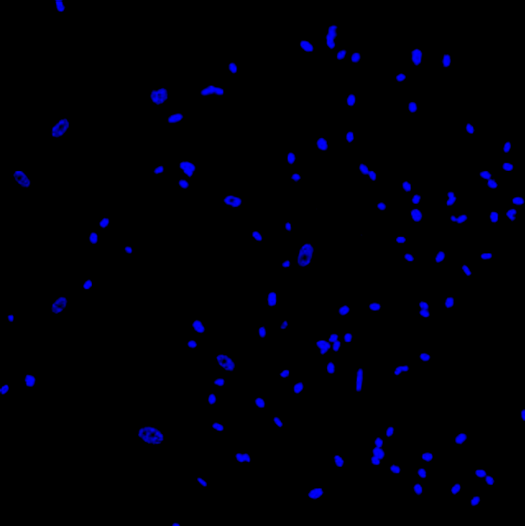 | 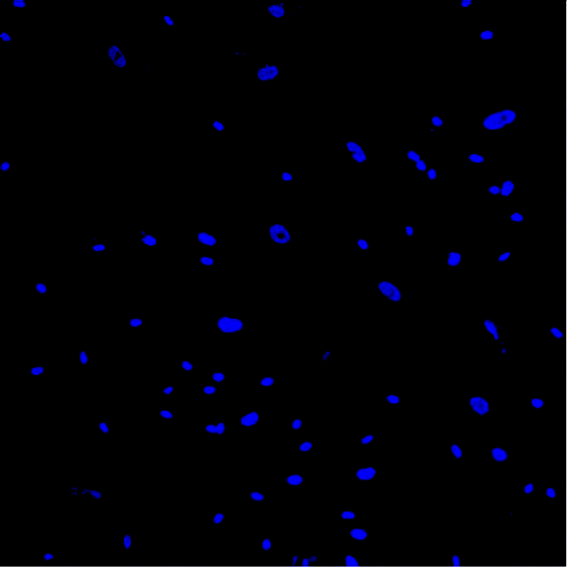 | 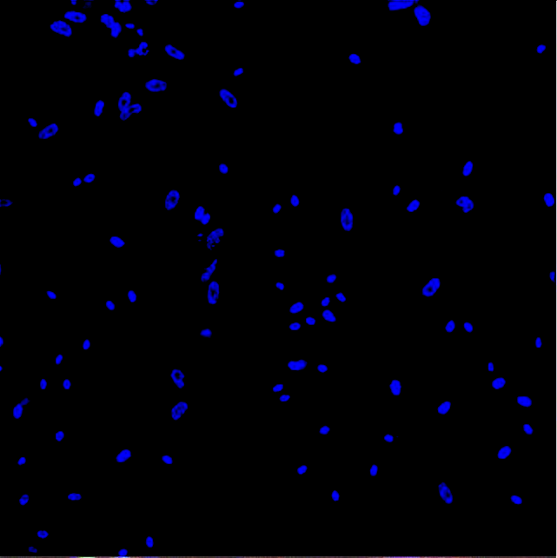 |  | 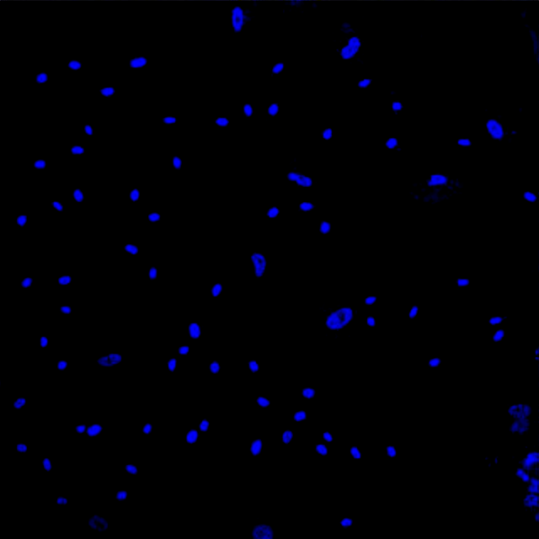
CMFDA  HUVEC alone | 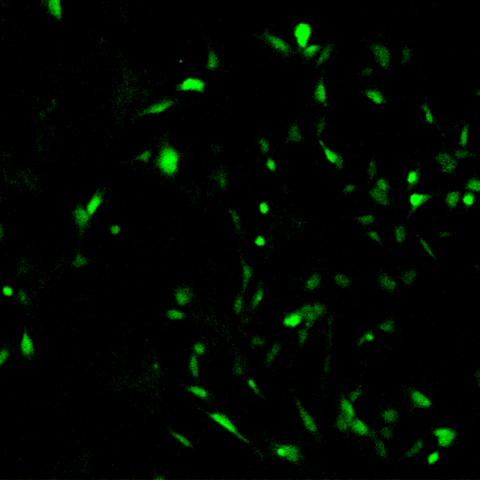 | 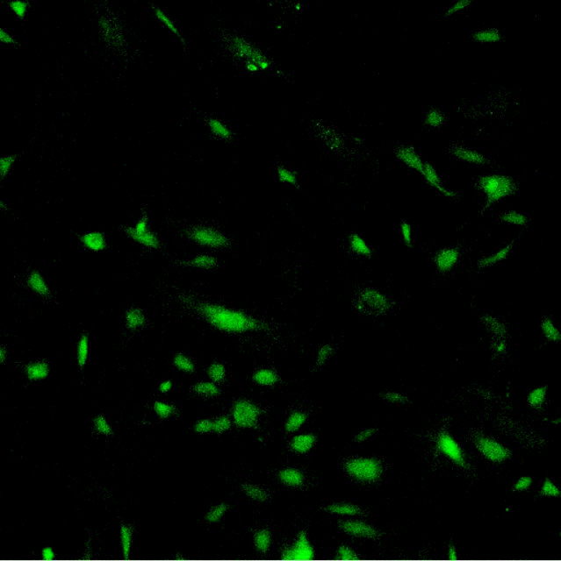 | 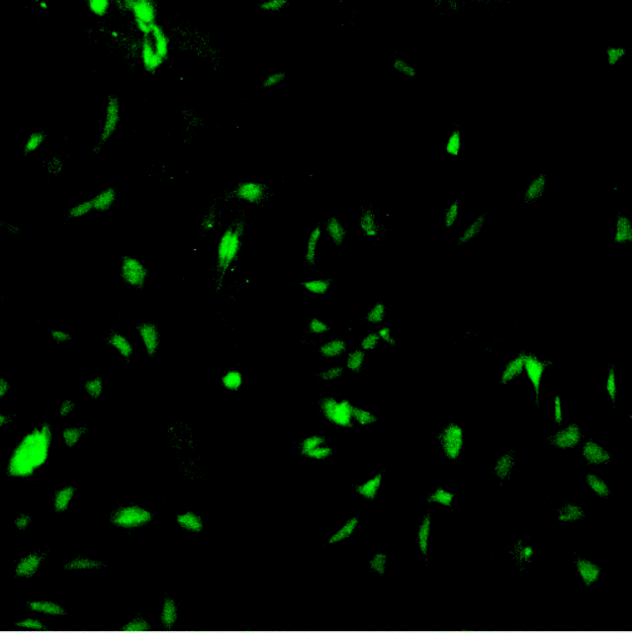 | 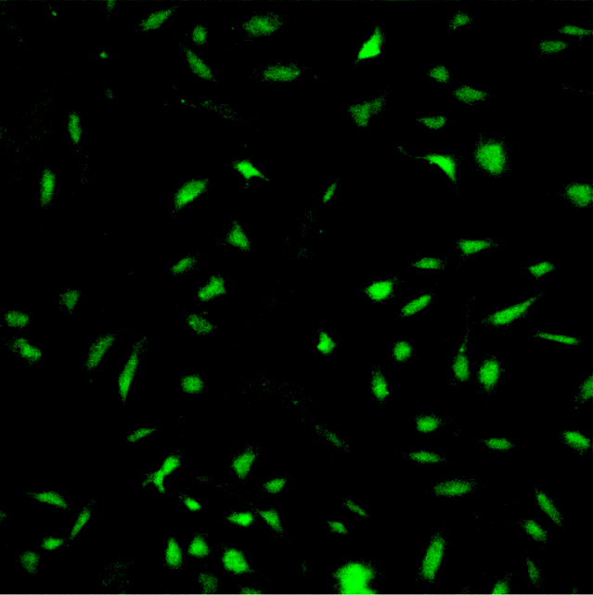 | 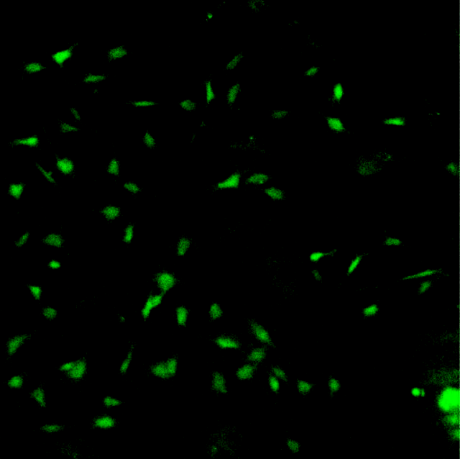
ICAM-1  HUVEC and HUASMC | 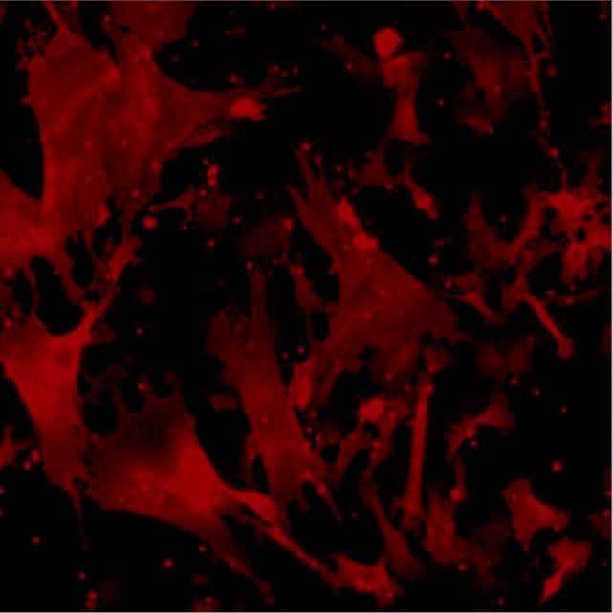 |  |  | 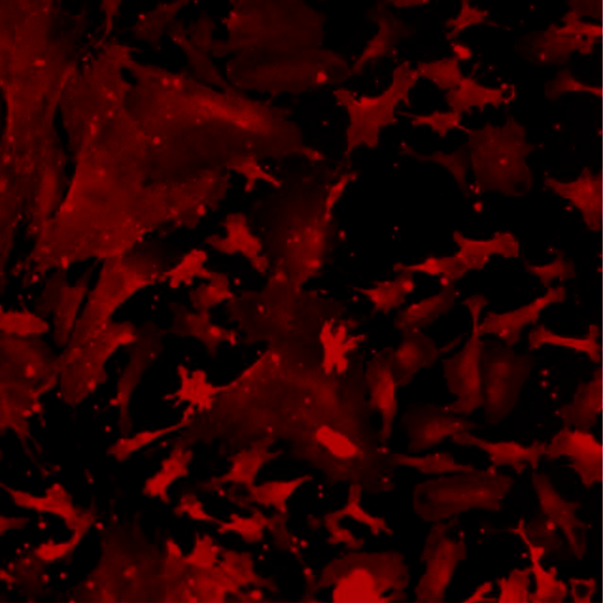
DAPI +  CMFDA | 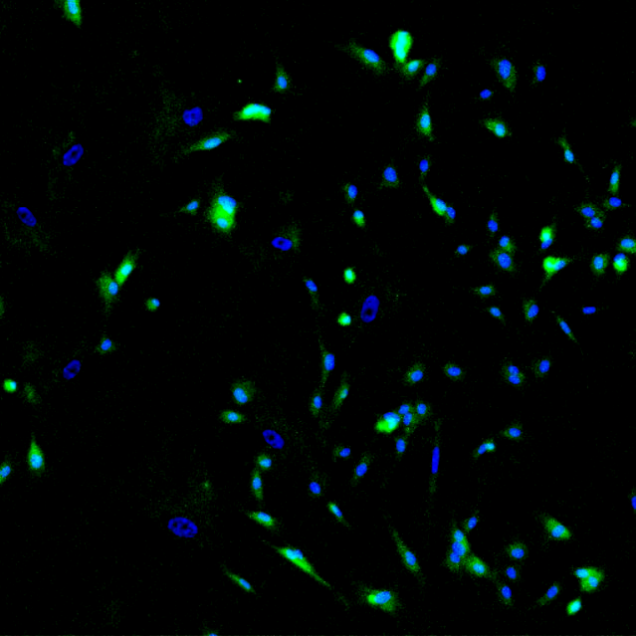 | 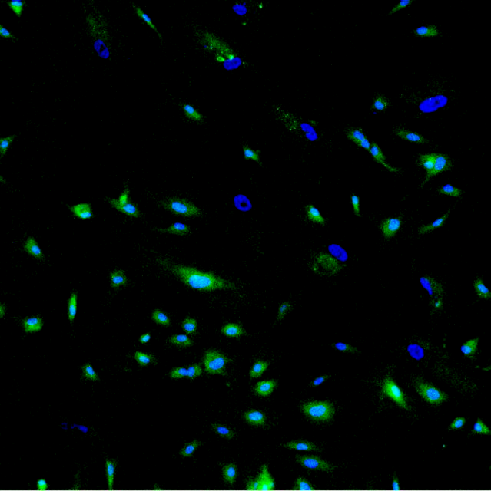 | 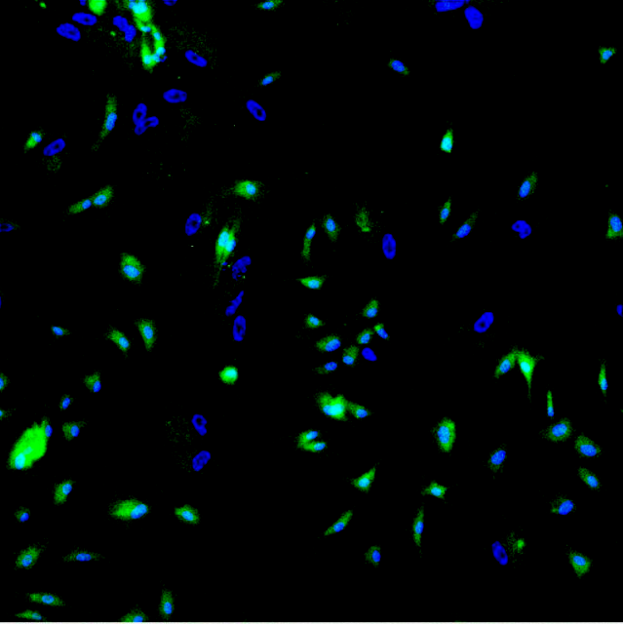 | 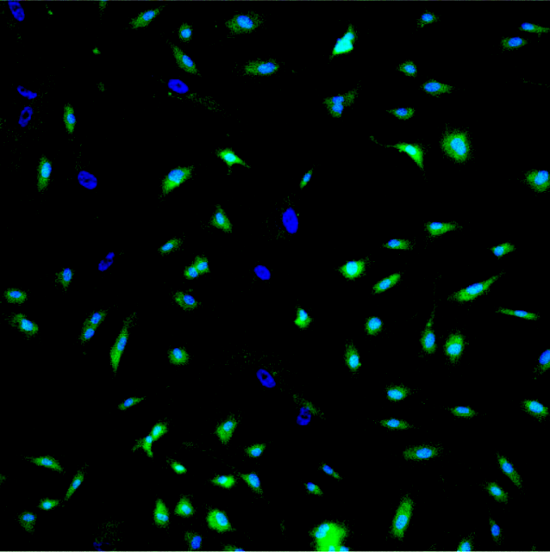 | 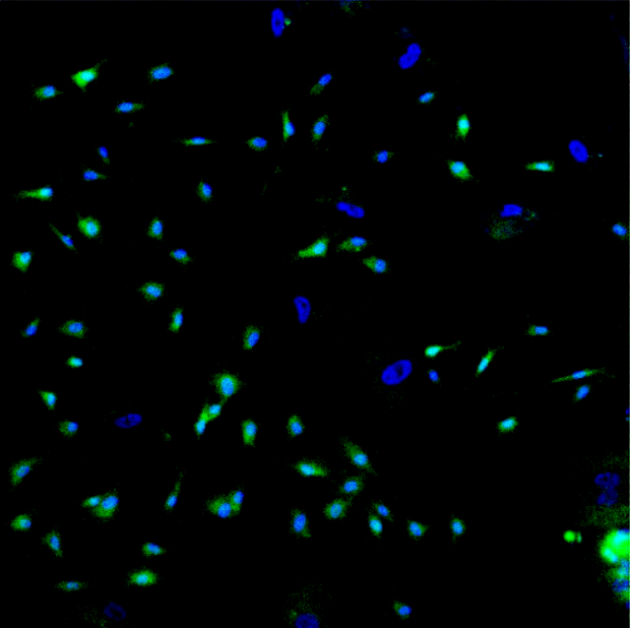
DAPI +  ICAM-1 | 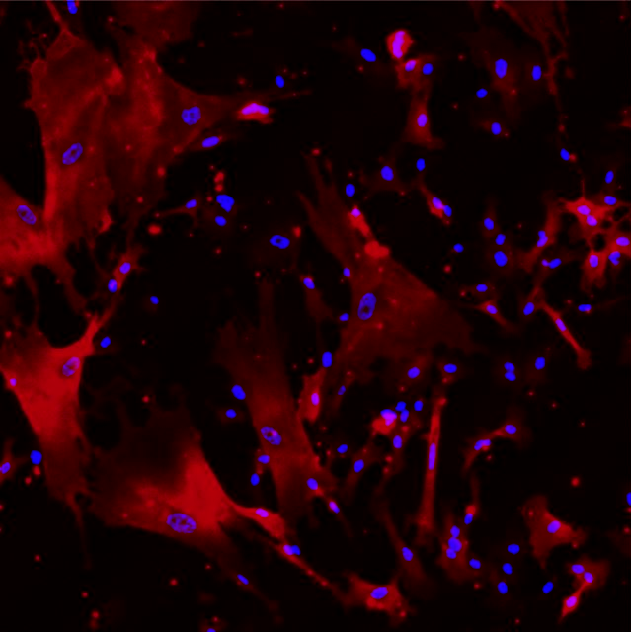 | 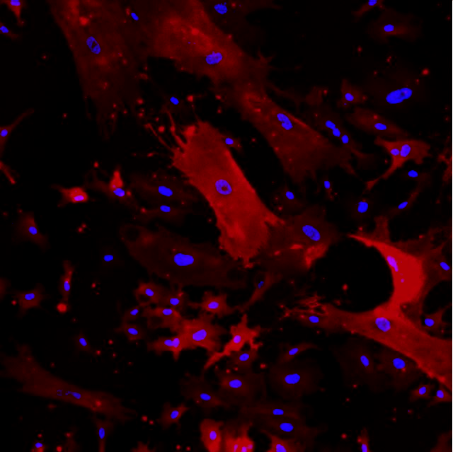 | 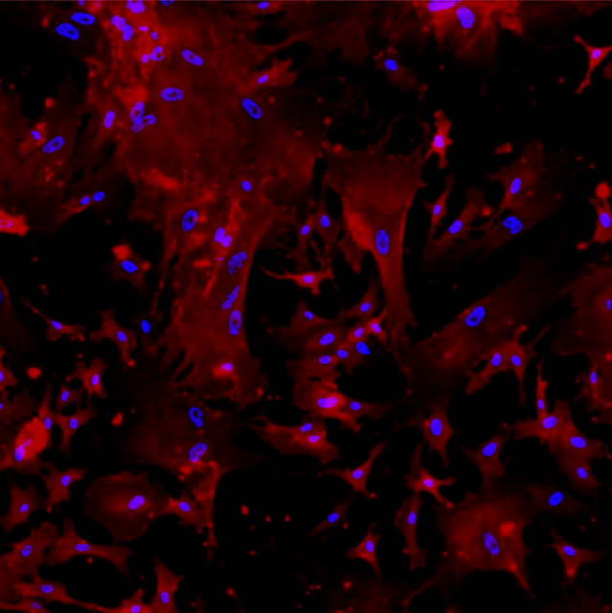 | 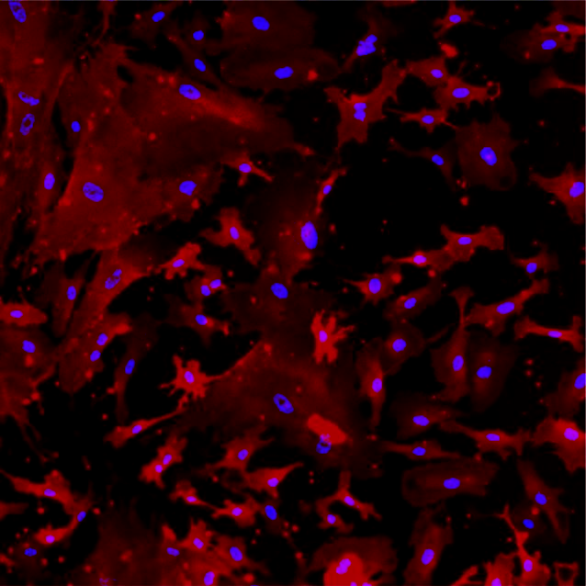 | 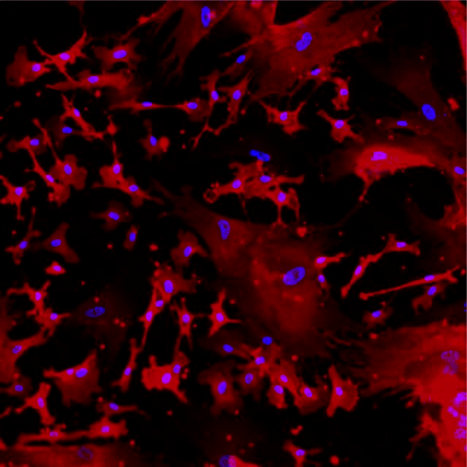
CMFDA + ICAM-1 | 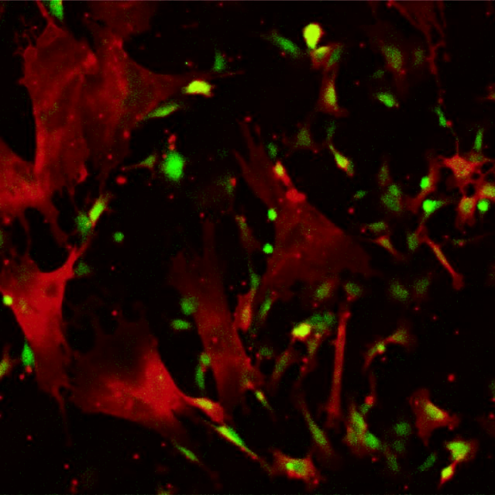 | 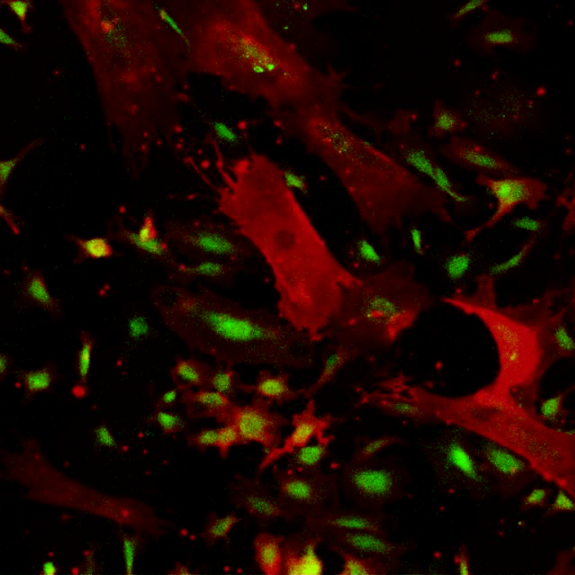 | 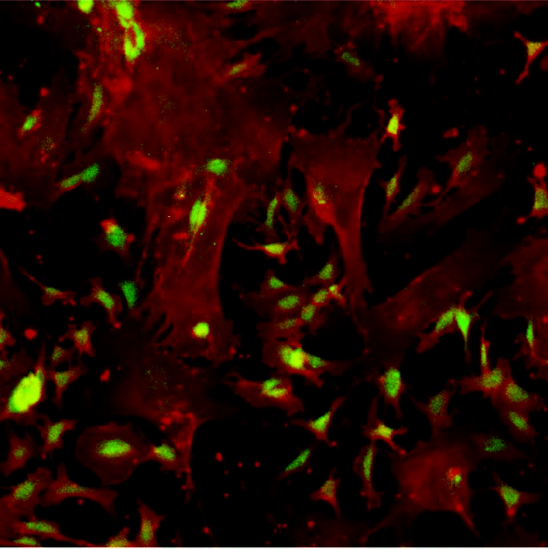 | 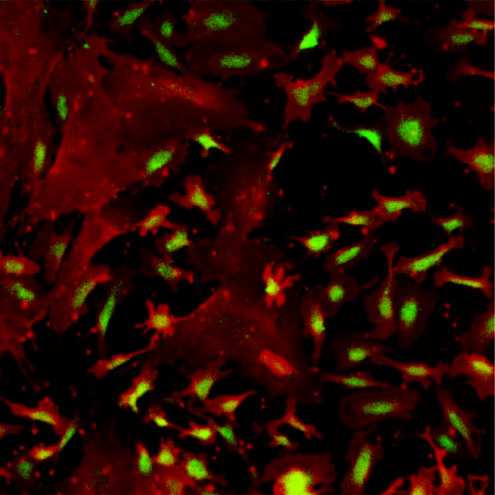 | 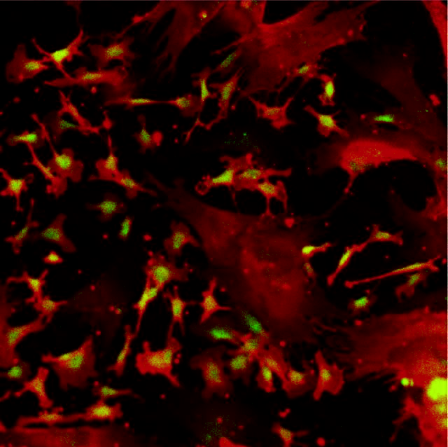
DAPI +  CMFDA + ICAM-1 |  | 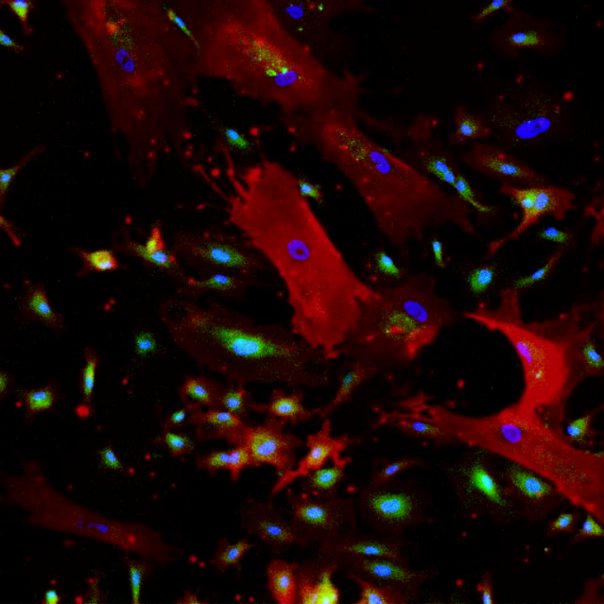 | 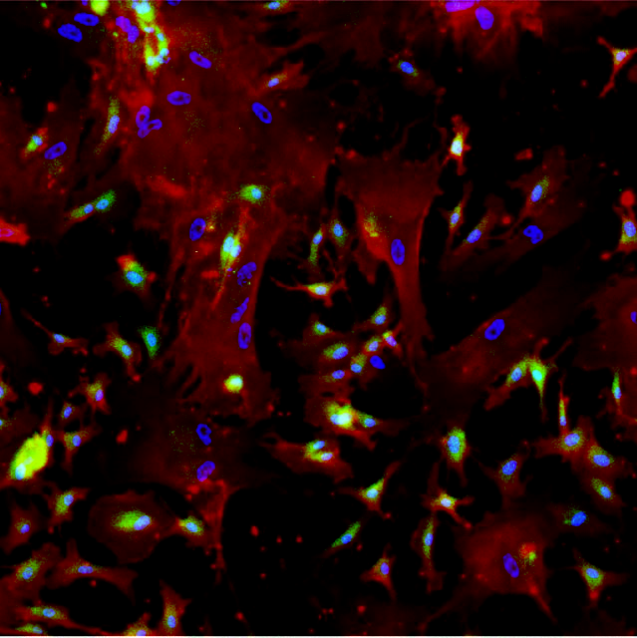 | 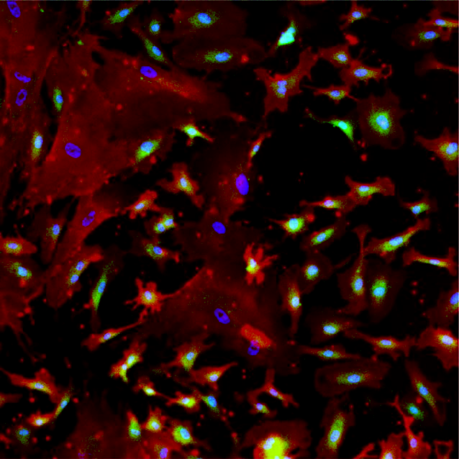 | 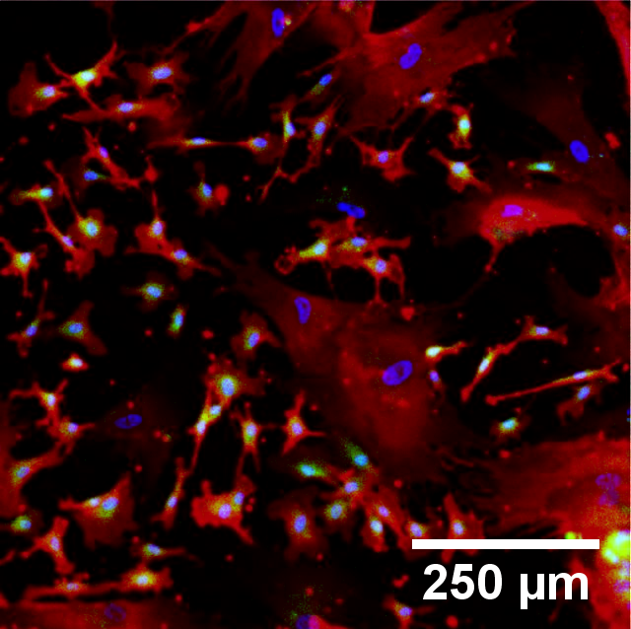
Figure 5.7 – Representative confocal micrograph images of ICAM-1 (red) in HUVEC and HUASMC co-cultures when stimulated with 25 U/mL TNF-α for 0-12 hours. DAPI (blue) identifies the nuclei of all cells, whilst CMFDA (green) identifies HUVEC cells. HUASMC cells appear to express constitutive levels of ICAM-1 throughout, whilst significant up-regulation occurs in HUVEC cells. Scale bar = 250 μm.

Figure 5.7 – Representative confocal micrograph images of ICAM-1 in HUVEC and HUASMC co-cultures when stimulated with 25 U/mL TNF-α for 0-12 hours. DAPI identifies the nuclei of all cells, whilst CMFDA identifies HUVEC cells. HUASMC cells appear to express constitutive levels of ICAM-1 throughout, whilst significant up-regulation occurs in HUVEC cells. Scale bar = 250 μm.

*

*
TNF-α Added

TNF-α Added
Cells Seeded

Figure 5.8 – ICAM-1 upregulation in HUVEC and HUASMC cells in co-culture when stimulated with 25 U/mL TNF-α. Basal ICAM-1 expression appeared to increase in HUVEC cells when cultured with HUASMC cell before the addition of TNF-α. Little change in ICAM-1 was observed in HUASMC throughout, whilst a significant increase in ICAM-1 was observed in HUVEC cells, specifically between 3 and 6 hours after TNF-α addition. Mean ± SEM (n=3).

Figure 5.8 – ICAM-1 upregulation in HUVEC and HUASMC cells in co-culture when stimulated with 25 U/mL TNF-α. Basal ICAM-1 expression appeared to increase in HUVEC cells when cultured with HUASMC cell before the addition of TNF-α. Little change in ICAM-1 was observed in HUASMC throughout, whilst a significant increase in ICAM-1 was observed in HUVEC cells, specifically between 3 and 6 hours after TNF-α addition. Mean ± SEM (n=3).

There was no significant difference in HUASMC ICAM-1 expression over the 12-hour period (p=0.546) and no significant difference observed between monoculture conditions, and the baseline intensity (p=0.498), or 12-hour intensity of ICAM-1 (p=0.419) when cells were co-cultured with HUVEC cells. The relationship between the HUVEC and HUASMC cell ratio (equation 5.3) and ICAM-1 level can be observed in figure 5.9, where it appears that an increasing proportion of HUASMC resulted in an increase in ICAM-1 levels in HUVEC cells. However, this correlation was not significant, producing an R_{S} statistic of -0.475 with p-value of 0.063. Owing to the intensity of ICAM-1 in HUASMC being relatively consistent, the relationship between the cell ratio and intensity of ICAM-1 in HUASMC was not considered.

Figure 5.9 – The relationship between HUVEC to HUASMC cell ratio and ICAM-1 intensity in HUVEC cells. Owing to the size difference between HUVEC and HUASMC, there was always a significantly larger number of HUVEC present. Though not quite significant, the negative correlation indicates that increasing the number of HUVEC decreases the ICAM-1 intensity within the HUVEC.

Figure 5.9 – The relationship between HUVEC to HUASMC cell ratio and ICAM-1 intensity in HUVEC cells. Owing to the size difference between HUVEC and HUASMC, there was always a significantly larger number of HUVEC present. Though not quite significant, the negative correlation indicates that increasing the number of HUVEC decreases the ICAM-1 intensity within the HUVEC.

5.3.4 HUASMC AND NHDF CELLS IN CO-CULTURE
To complete the different co-culture combinations using two cell types, HUASMC and NHDF cells were co-cultured and ICAM-1 levels calculated after addition of 25 U/mL TNF-α. Confocal micrograph images obtained are shown in figure 5.10. Whilst there appeared to be a relatively high level of ICAM-1 expression prior to addition of TNF-α, there was little to no observable change over the course of the experiment in either cell type. This was confirmed by the intensity values obtained, shown in figure 5.11. Games-Howell tests concluded that there were no significant differences for either HUASMC or NHDF cells. Whilst the baseline expression of ICAM-1 in HUASMC cells was comparable to both monoculture (p=0.659) and HUVEC co-culture conditions (p=0.356), for NHDF cells a significant increase in intensity was seen prior to TNF-α addition when compared to both monoculture and HUVEC co-culture conditions (2.8- vs 1.1-fold, p<0.001).
Owing to the lack of change in ICAM-1 intensity after the addition of TNF-α in either NHDF (p=0.991) or HUASMC (p=1.000), the relationship between cell ratio and intensity was not examined further.
This was distinctly different to the NHDF cell findings in both monoculture and co-culture with HUVEC cells, where baseline levels remained low and ICAM-1 increased over the experimental period. All intensity values for NHDF in the co-culture with HUASMC experiments were significantly greater than those observed in co-culture with HUVEC over a 12-hour period (p<0.001). Though the ICAM-1 intensity in NHDF at 12 hours was significantly greater in monoculture than in co-culture with HUASMC (p<0.001), the results obtained after 6 hours of incubation with 25 U/mL TNF-α were comparable (p=0.608). The relationship between the cell ratio of NHDF to HUASMC was not considered owing to a maximum level of ICAM-1 for both cell types, even in the presence of TNF-α.

Label | Time (Hours)
 | 0 | 3 | 6 | 9 | 12
DAPI  HUASMC and NHDF |  |  |  | 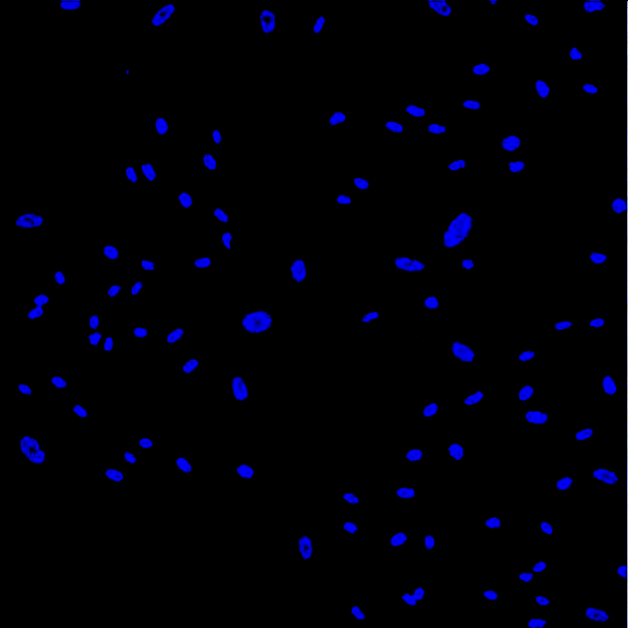
CMFDA  NHDF Alone | 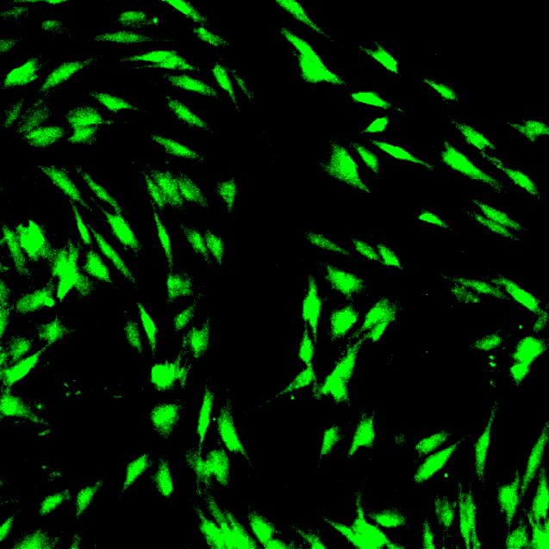 | 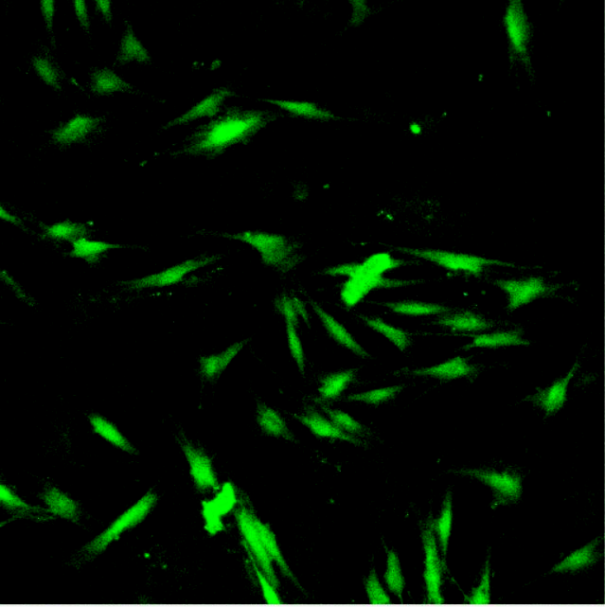 | 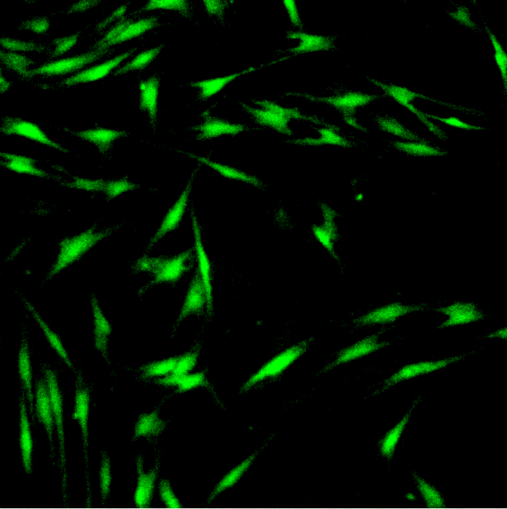 | 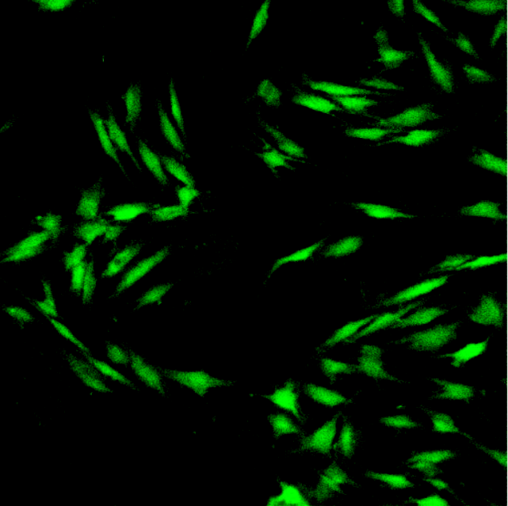 | 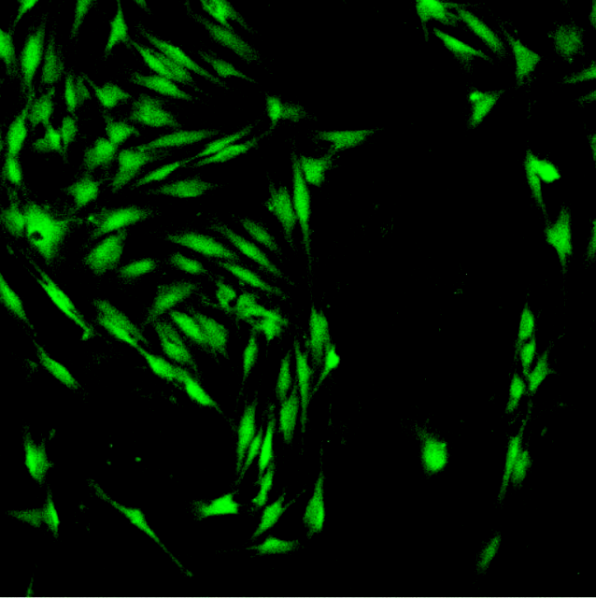
ICAM-1  HUASMC and NHDF | 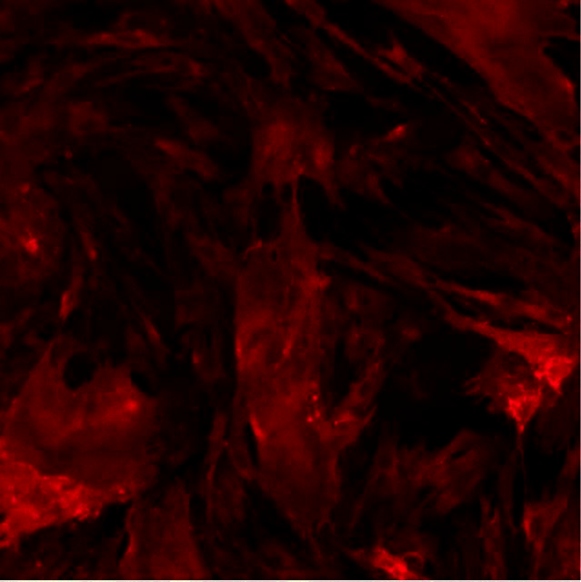 | 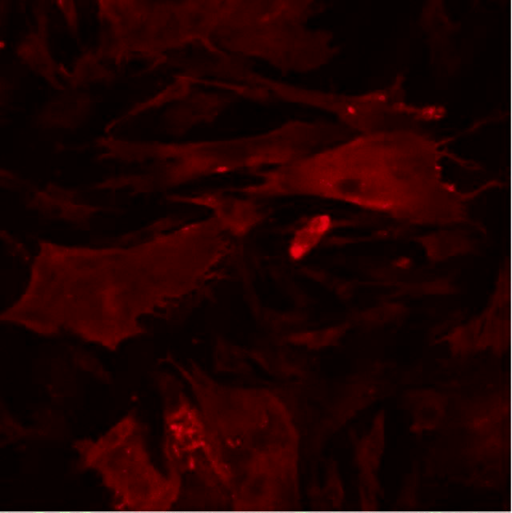 | 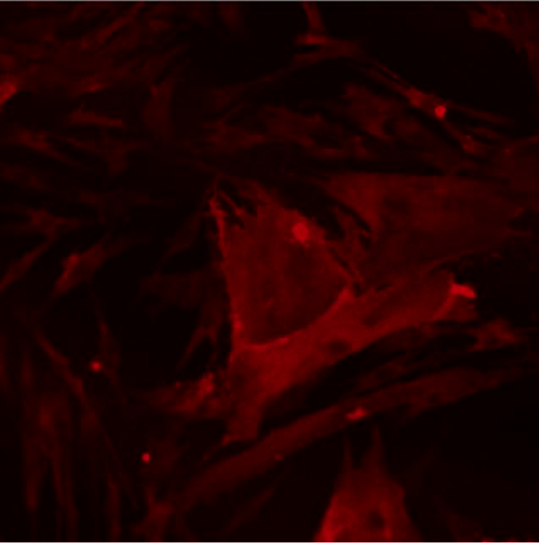 | 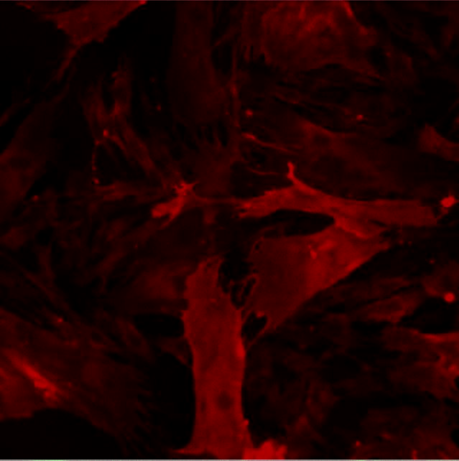 | 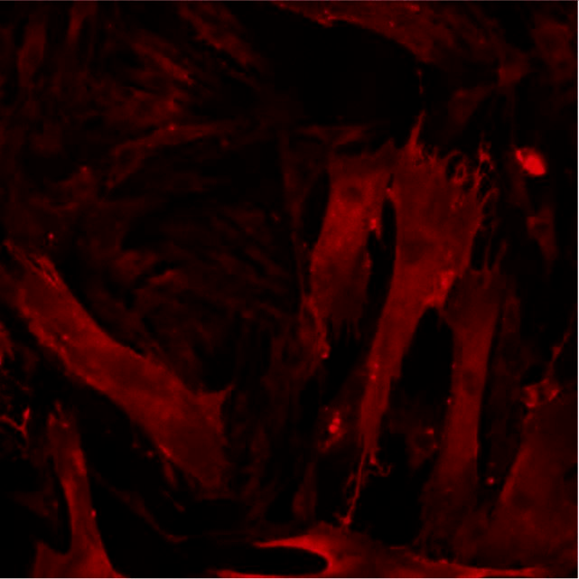
DAPI +  CMFDA | 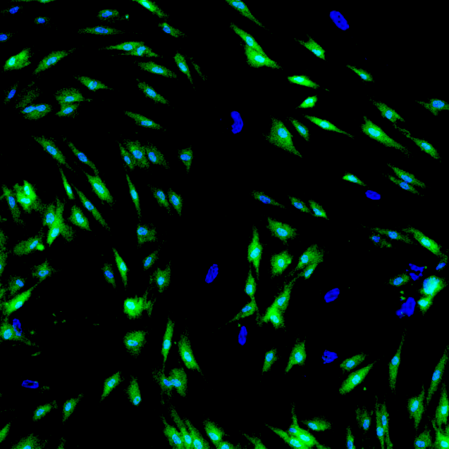 | 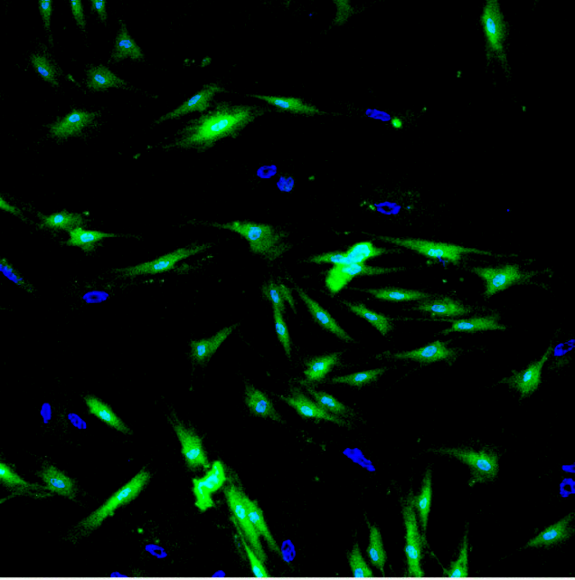 | 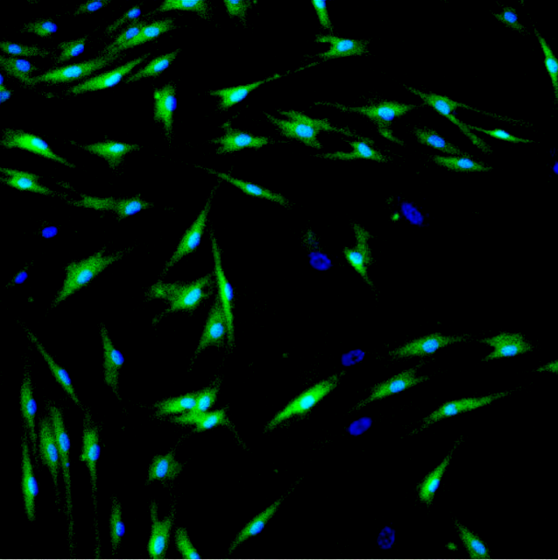 | 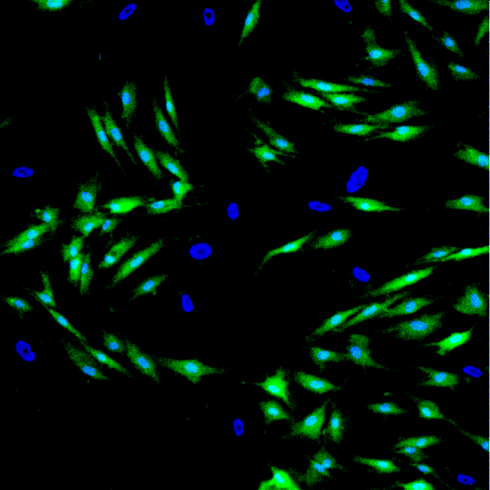 | 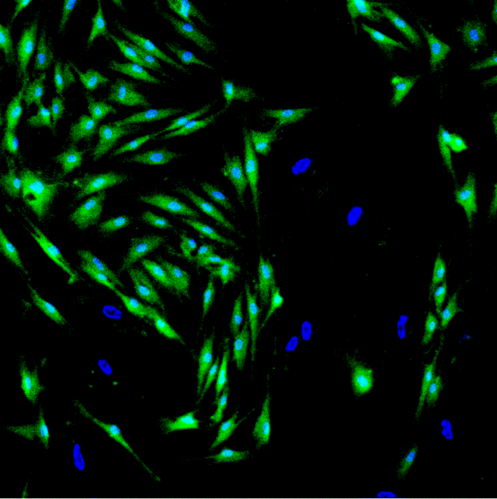
DAPI +  ICAM-1 | 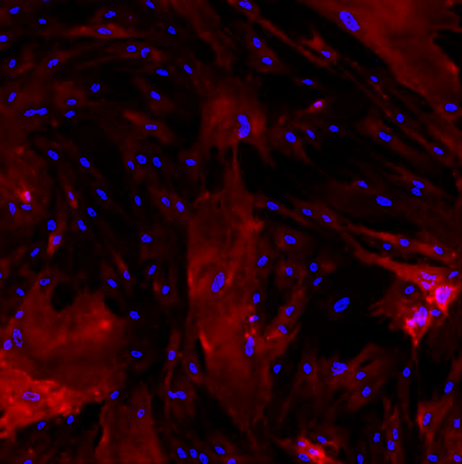 | 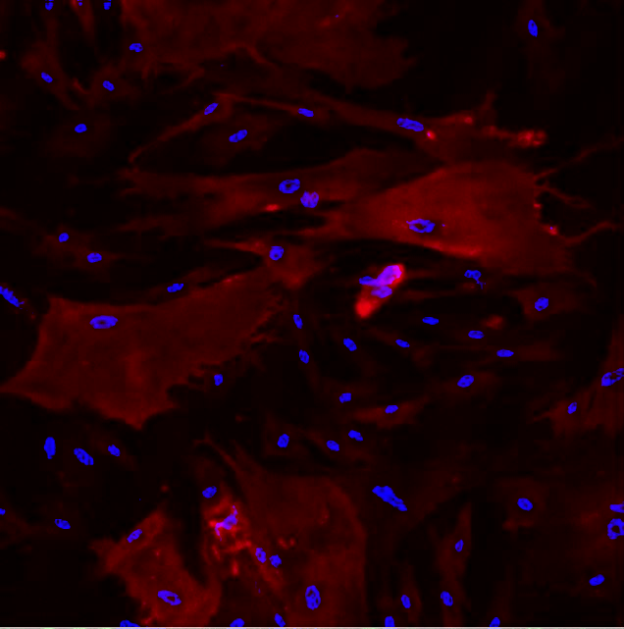 | 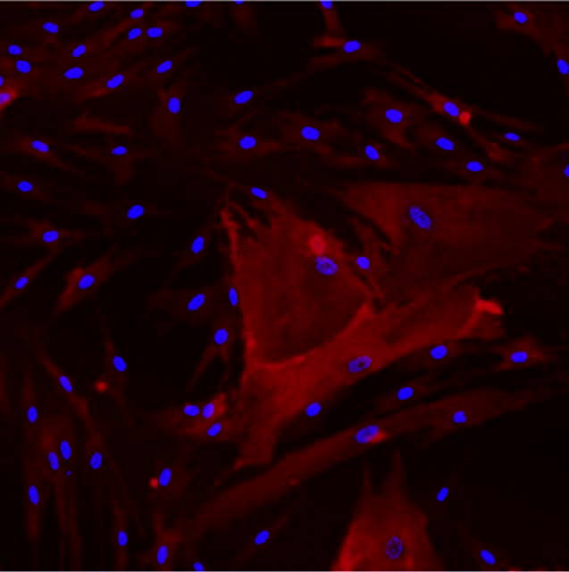 | 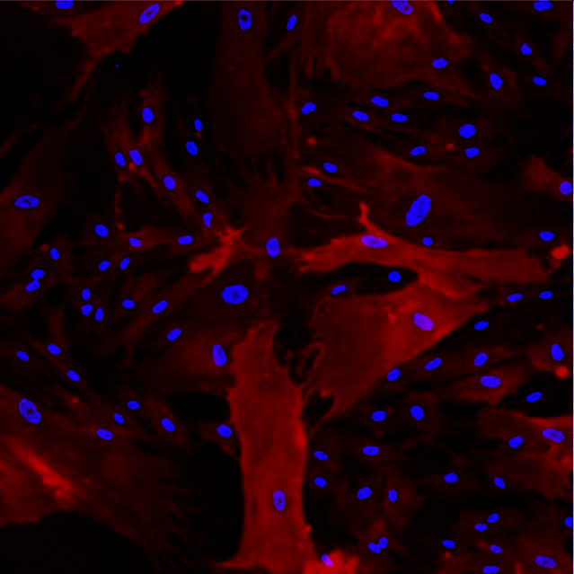 | 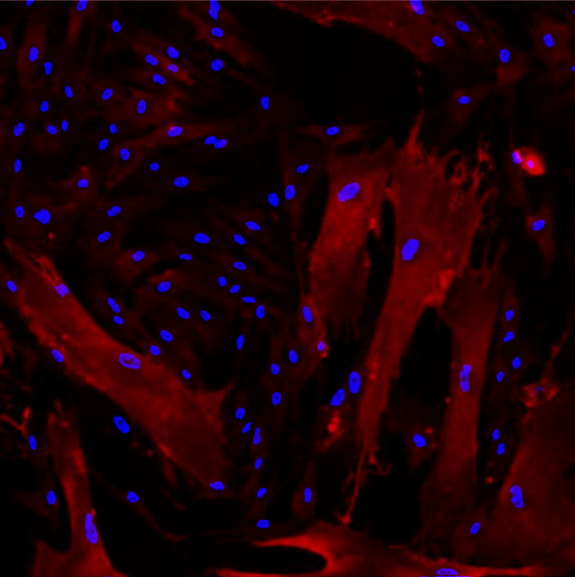
CMFDA + ICAM-1 | 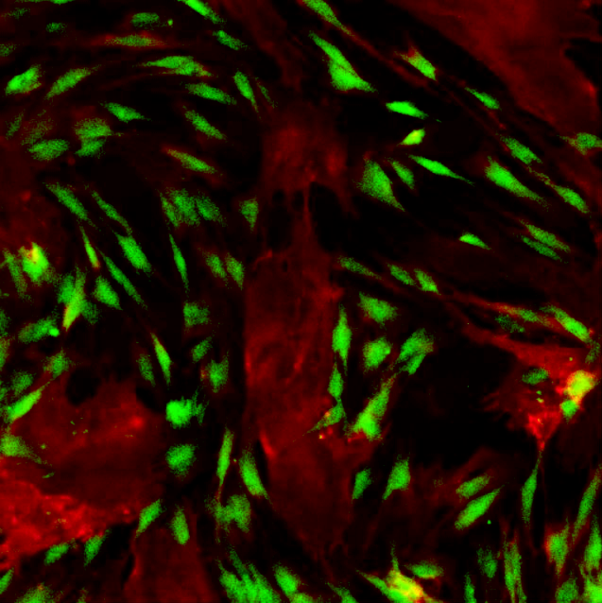 | 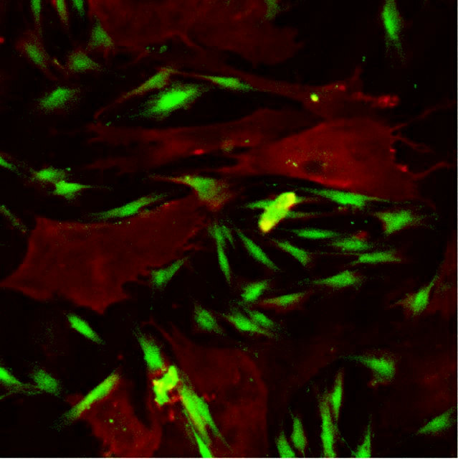 | 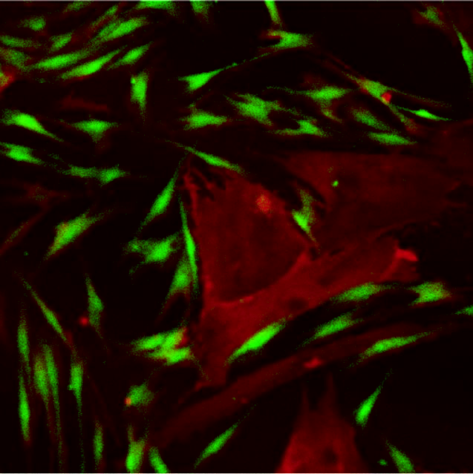 | 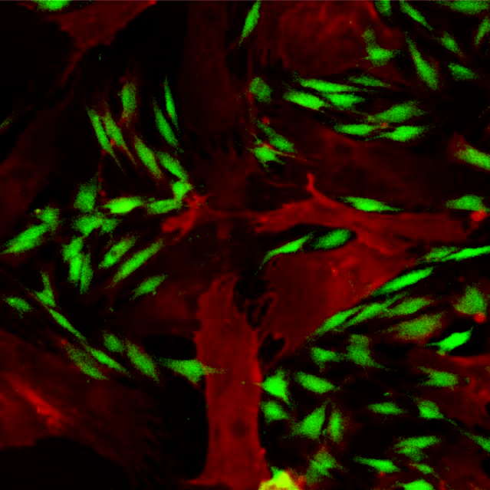 | 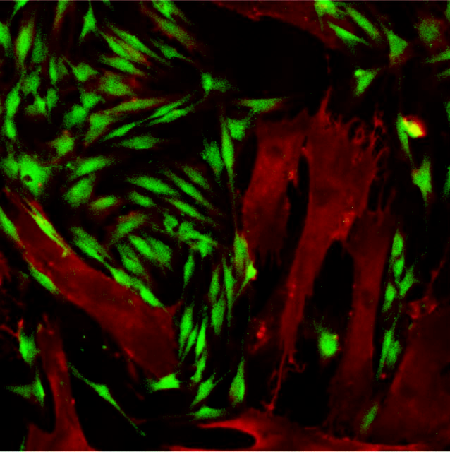
DAPI +  CMFDA + ICAM-1 |  | 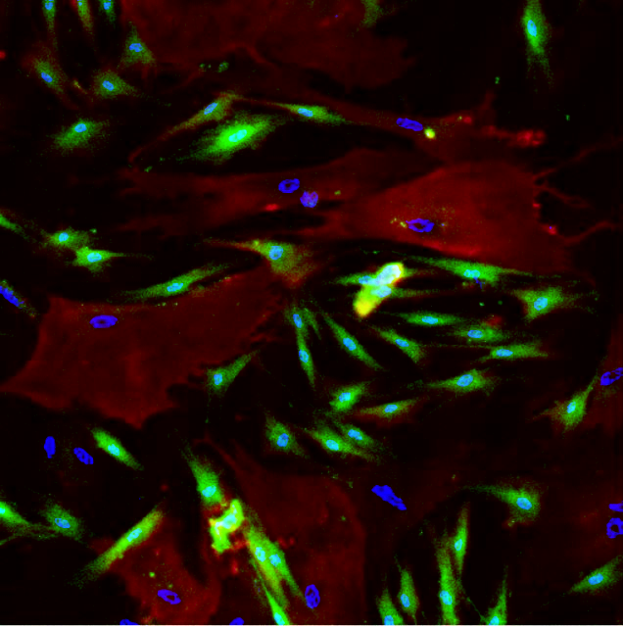 | 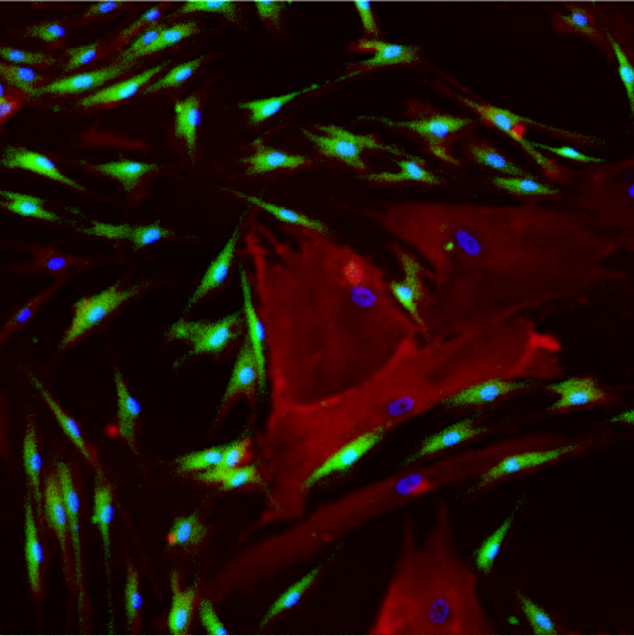 | 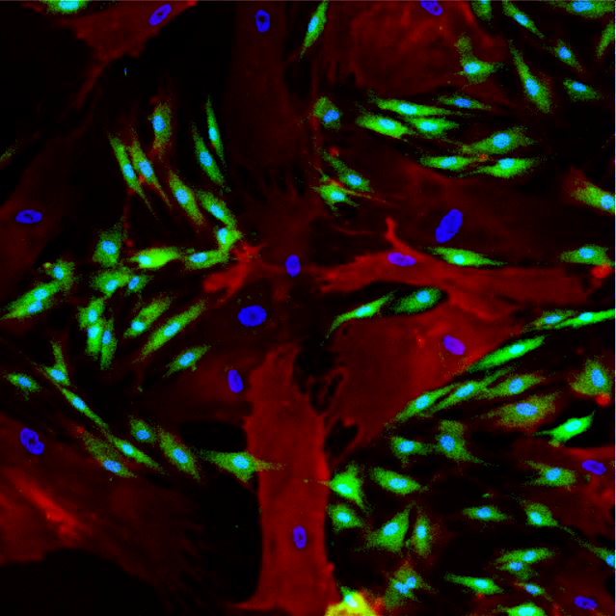 | 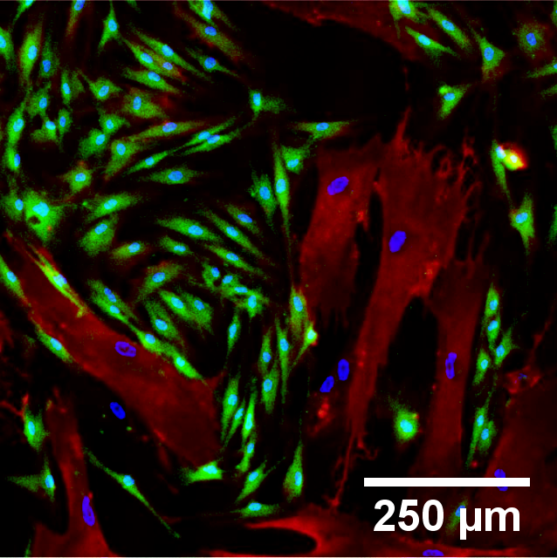
Figure 5.10 – Confocal micrograph images representative of HUASMC and NHDF cell co-cultures when stimulated with 25 U/mL TNF-α for 0-12 hours. DAPI (blue) identifies the nuclei of all cells, whilst CMFDA (green) identifies NHDF cells. No obvious change in expression of ICAM-1 (red) was observed throughout the experiment in either cell type. Scale bar = 250 μm.

TNF-α Added

Cells Seeded

Figure 5.11 – ICAM-1 expression in HUASMC and NHDF cells in co-culture when stimulated with 25 U/mL TNF-α. No significant changes in ICAM-1 expression was observed in either cell type throughout the experimental period. Mean ± SEM (n=3).

Figure 5.11 – ICAM-1 expression in HUASMC and NHDF cells in co-culture when stimulated with 25 U/mL TNF-α. No significant changes in ICAM-1 expression was observed in either cell type throughout the experimental period. Mean ± SEM (n=3).

5.3.5 HUVEC, HUASMC AND NHDF CELLS IN TRI-CULTURE
With evident cross-talk between HUVEC and NHDF (chapter 5.3.2), and at least unidirectional signalling from HUASMC to HUVEC (chapter 5.3.3) and NHDF (chapter 5.3.4), the concluding experiment was to produce a co-culture that investigated ICAM-1 up-regulation all 3 cell types: HUVEC, HUASMC and NHDF cells. This would allow the ICAM-1 expression profile to be compared to previous co-culture experiments and predict the roles of each cell type in augmenting the inflammatory response.
Figure 5.12 shows confocal micrograph images obtained from tri-cultures after stimulation with 25 U/mL TNF-α for 12 hours. The confocal images obtained from this experiment were akin to those obtained in previous co-culture experiments, with a high level of ICAM-1 expression in HUVEC cells and a low but still present level of ICAM-1 expression in NHDF cells. Figure 5.13 compares ICAM-1 intensity levels obtained in all cell types under the different culture condition after 12 hours of pro-inflammatory stimulation. However, owing to the absence of experimental repeats through the lack of both availability of materials and time, no statistical tests were carried out to compare these results to those in previous co-culture experiments; therefore, only general comparisons were made, and hypotheses formulated based on what these data suggests.
ICAM-1 expression in HUVEC cells was the lowest in monoculture, with the introduction of an additional cell type enhancing the up-regulation of the inflammatory marker; HUASMC caused a greater overall increase in ICAM-1 compared to NHDF cells. Moreover, when all three cell types were combined up-regulation was potentiated further. An opposing trend was seen in NHDF cells, where expression of ICAM-1 in monoculture was highest, with the addition of HUASMC or HUVEC cells decreasing expression. Although HUVEC cells appeared to decrease ICAM-1 more than HUASMC, in the tri-culture levels of ICAM-1 appeared to be comparable to when NHDF were cultured solely with HUASMC cells.
Although there was little difference in HUASMC expression in monoculture and co-culture conditions, when all three cell types were combined, ICAM-1 levels appeared to be slightly reduced.

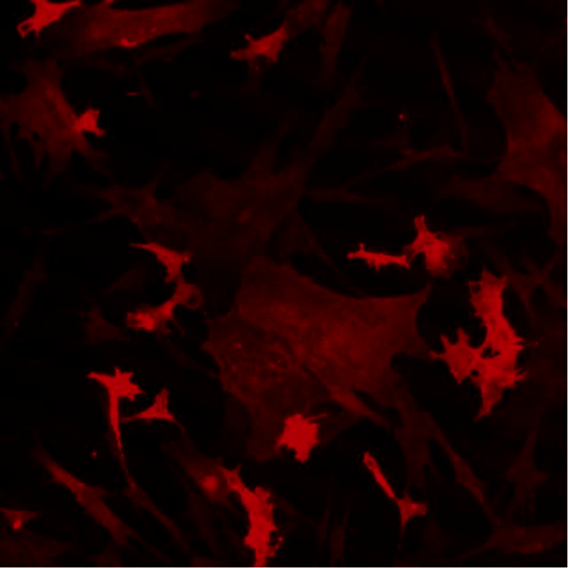  ICAM-1  HUVEC, HUASMC and NHDF | DAPI  HUVEC, HUASMC and NHDF | 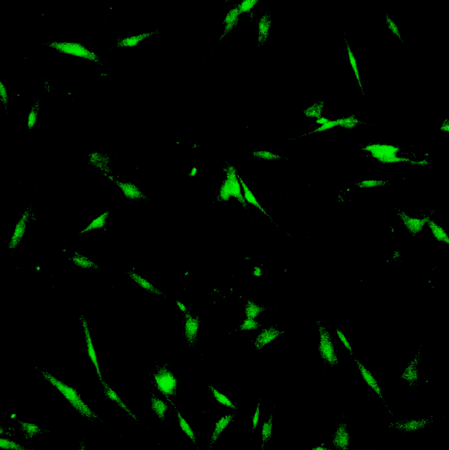  CMFDA  NHDF alone
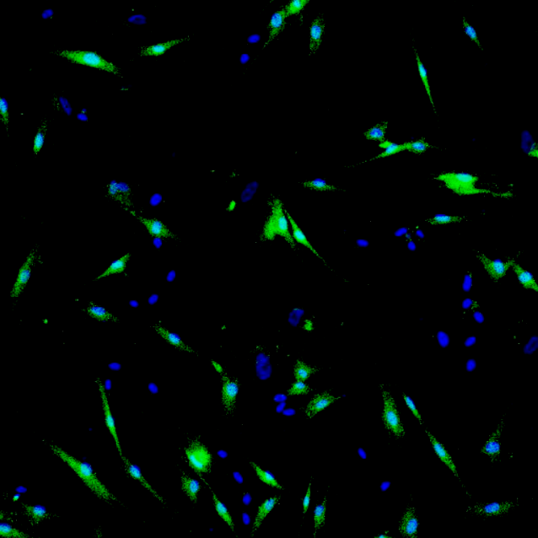  DAPI + CMFDA | 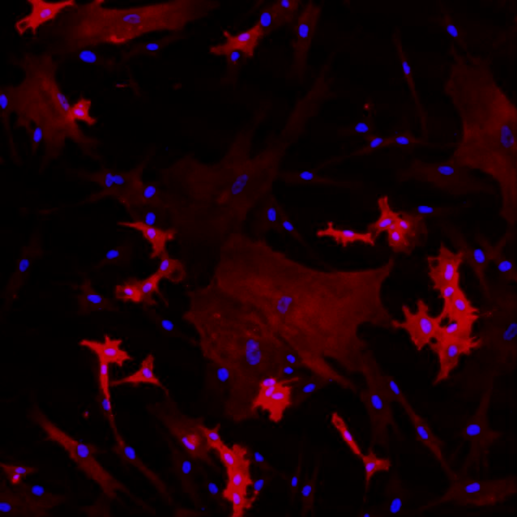  DAPI + ICAM-1 | 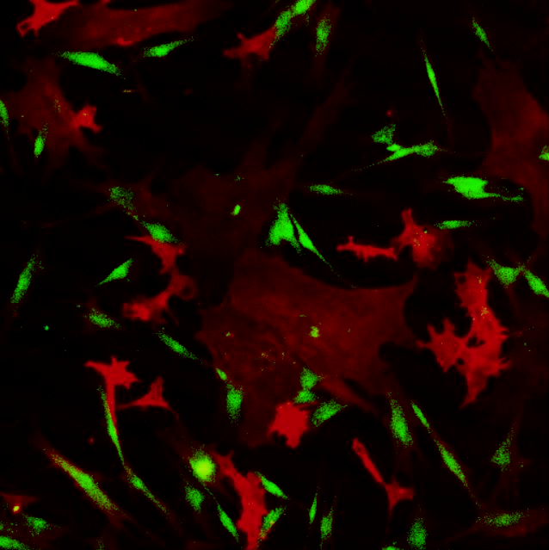  CMFDA + ICAM-1 | G  G
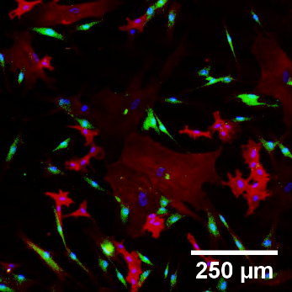
DAPI + CMFDA + ICAM-1

Figure 5.12 – Confocal micrograph images of a HUVEC / HUASMC / NHDF cell co-culture after stimulation with 25 U/mL TNF-α for 12 hours. Owing to the comparable size of HUVEC and NHDF, NHDF were tracked using CMFDA (green), whilst HUVEC were identifiable through the high ICAM-1 (red) expression alone. HUASMC were easily identified as they were greater in size and constitutively expressed ICAM-1, akin to monoculture and previous co-culture experiments. Although NHDF appear to express ICAM-1, the intensity appears lower than in monoculture conditions whereas the opposite occurred for HUVEC. DAPI (blue) highlights all cell nuclei. Scale bar = 250 μm.

Figure 5.13 – A summary of the ICAM-1 intensities obtained after 12 hours of TNF-α stimulation in HUVEC, HUASMC and NHDF cells under different culture conditions. HUVEC cells appeared to increase ICAM-1 levels upon introduction of additional cell types. In HUASMC cells the tri-culture ICAM-1 level appears lower than for monoculture or NHDF cell co-culture conditions. For NHDF cells the tri-culture ICAM-1 intensity is comparable to data obtained for the HUASMC cell co-culture. (for monocultures and co-cultures n=3, for tri-culture n=1)

Figure 5.13 – A summary of the ICAM-1 intensities obtained after 12 hours of TNF-α stimulation in HUVEC, HUASMC and NHDF cells under different culture conditions. HUVEC cells appeared to increase ICAM-1 levels upon introduction of additional cell types. In HUASMC cells the tri-culture ICAM-1 level appears lower than for monoculture or NHDF cell co-culture conditions. For NHDF cells the tri-culture ICAM-1 intensity is comparable to data obtained for the HUASMC cell co-culture. (n=1)

5.4 DISCUSSION
Co-culture experiments were carried out using different combinations of HUVEC, HUASMC and NHDF. The level of ICAM-1 intensity was obtained for each cell type in the various co-culture arrangements and were then compared to the previous monoculture experiments; consequently, where changes in ICAM-1 intensity were evident, the cause for this change had to be the result of intercellular signalling. For example, HUVEC appeared to express more ICAM-1 in co-culture with HUASMC than in monoculture, indicating that a signalling pathway must flow from HUASMC to HUVEC to elicit the response. Any significant findings were then examined later through the transfer of conditioned medium to confirm whether paracrine signals were responsible for the adjustment in ICAM-1 intensity.

5.4.1 ANALYSIS OF CELL SEEDING RATIOS
With all monoculture and co-culture experiments taking place over 2 days, the cell counts were only considered for up to 48 hours as the samples would then be fixed for immunolabelling. Although the results from the co-culture of HUVEC and NHDF indicate that a cell ratio between 0 and 0.7 was optimum, which indicates that there required to be a slightly higher percentage of NHDF than HUVEC at seeding, no further experimentation was carried out to determine exactly what the optimum seeding ratio was. There were two main reasons for this:
- cell counting provided only an estimate of the whole cell population and there was little discrepancy between the cell counts after 48 hours at either seeding ratio (figure 5.3)
- HUVEC are known to form islands (figure 4.3), which means that in all samples there would be areas with high and low densities of HUVEC.
Additionally, there was a distinct difference in both cell size and growth rate when comparing HUVEC and NHDF to HUASMC: the population doubling time in culture was approximately 1.5 – 2.0 days for HUVEC, 2.0 - 2.5 days for NHDF, and 10-12 days for HUASMC; likewise, HUASMC covered approximately 10x the surface area of both HUVEC and NHDF. Therefore, the seeding approach was adapted, whereby HUVEC, NHDF and HUASMC would be seeded at around a half or one third the normal seeding density (Chapters 4.2.2-4.2.4), for co-culture and tri-culture respectively, followed by calculating the ratio of different cell types in various areas of the culture. The cell ratio could then be compared to ICAM-1 expression within that area to determine whether any correlation was present.

5.4.2 NHDF TO HUVEC CELL COMMUNICATION
Clear differences in ICAM-1 expression levels were observed in both HUVEC and NHDF cells in co-culture, versus monoculture. Though opposing trends were produced, where the respective levels of ICAM-1 were increased in HUVEC and decreased in NHDF cells in co-culture, these results indicated that communication in both directions between HUVEC and NHDF was essential. Though the type of communication between HUVEC and NHDF cells cannot be completely determined by studying the co-culture data alone, analysis of the cell ratio versus ICAM-1 intensity in figure 5.6 provided an insight into the probable communication mechanisms.
The results in figure 5.6 suggested that the signalling method from NHDF to HUVEC involved either direct communication or the release of molecule(s) which had a very short effective communication distance [207], owing to the steep gradient between cell ratio and ICAM-1 intensity in HUVEC. Meanwhile, a small gradient relating ICAM-1 intensity in NHDF to the cell ratio suggested the responsible signalling molecule(s) released from HUVEC had a much larger effective communication distance, similar to what one would expect from a paracrine signal.
Francis & Palsson (1997) estimated that the maximum distance a single cell can successfully communicate via soluble cyto- and chemokine release is 250 µm, which is projected to take a period of 10 – 30 minutes to occur. This takes into account the speed of diffusion and intensity of signal required to effectively induce a response; their analysis indicated that whilst one would expect faster diffusion to result in a larger communication distance, in fact slower diffusion was better owing to the propagation of a more intense signal prior to dilution via random molecular motion [207]. Consequently, it is also expected that HUVEC express significantly larger quantities of the signalling molecule(s) compared to NHDF.
With the understanding that during injury to the endothelium, fibroblasts from within the tunica adventitia become activated and migrate towards the injury site, the communication methods observed between the endothelial and fibroblast cell may prove to be vital for a successful wound healing response.
Firstly, endothelial injury would promote the release of pro-inflammatory molecules from the endothelial cells into the interstitial fluid, where they can then diffuse through the surrounding tissue to activate fibroblasts laying within the tunica adventitia. For example, the expression of cytokines IL-1α, IL-6, IL-7, IL-8, IL-15, TNF-α and TGF-β are all increased in HUVEC in response to TNF-α stimulation [208], of which IL-1α [209], TNF-α [210] and TGF-β [211] have all been shown to act on NHDF.
Hannan et al (2009) confirmed the synthesis of TGF-β as well as bFGF by HUVEC [212]. Treatment of cultured rat atrial fibroblasts with TGF-β has been shown to induce a higher expression of hyaluronan, CD44, STAT3, and collagen (a marker of fibrosis), whereby antibody blocking of CD44 attenuated STAT activation and collagen production [213]. Acharya et al (2008) also confirmed that CD44-dependent TGF-β activation of fibroblasts was essential for fibroblast migration [214].
Furthermore, growth factors such as FGFs are essential for the regulation of proliferation, differentiation and metabolism of cells and have shown to be enhanced upon endothelial injury and in states of chronic inflammation. FGFs have a high affinity to heparan sulphate glycosaminoglycans, which not only enhances their half-life but also causes them to act in a localised manner near to their source of expression [215]. Therefore, a bFGF gradient is produced, with the highest concentration being found at the endothelium, leading to the recruitment of fibroblasts [216].
Secondly, the migrating fibroblasts would require a mechanism enabling them to know when they have reached their intended target and to subsequently change their phenotype from a pro-inflammatory phenotype which promotes the production of extracellular components such as collagen [217, 186] back to their original non-inflammatory state. This could be through the active induction of anti-inflammatory mediators expressed by either the endothelial or fibroblast cells, which are involved in the resolution of inflammation [218].
Young & Adamson (1993) demonstrated that epithelial cell secretions inhibited fibroblast growth in both control cultures and during acute bleomycin-induced pulmonary inflammation in rats [219]. However, a prolonged chronic pro-inflammatory stimulus may de-regulate the normal inflammatory processes to result in excess deposition of extracellular matrix [220]. Prolonged bleomycin-induced inflammation in rats confirmed this through the loss of inhibition of fibroblast growth by the epithelium which lead to fibrosis formation within the lung [219].
The origin of this fibroblast inhibition was likely through the growth factor FGF10, as it has since been revealed that its overexpression leads to reduced bleomycin-induced pulmonary fibrosis in mice [221]. The mechanism of action was possibly through the reduction of TGF-β and MMP-2 activity [222]. FGF10 appears to only be expressed by the mesenchyme, which develops into connective and skeletal tissues, including blood and lymph during embryo development [223]. Moreover, although FGF10 only produced a weak response in endothelial cells, it appeared to play a significant role in vasculogenesis and angiogenesis, as demonstrated via a chick chorioallantoic membrane model [224].
Even though FGF10 has been shown to have an important role in both vasculogenesis and angiogenesis [224], whether it may be involved in plaque angiogenesis during atherosclerosis disease development has not yet been studied and may be a potential direction for future studies.
Finally, fibroblasts are known to respond to pro-inflammatory cytokines such as TNF-α by synthesising and secreting cytokines including TGF-β1, IL-1β and IL-33 [203]. Whilst IL-1β and IL-33 are both part of the IL-1 superfamily [225], IL-1β in particular has been shown to increase ICAM-1 in endothelial cells [226]. Suzuki et al (1994) also established that TGF-β1 can induce ICAM-1 expression in HUVEC [227].
TNF-α, TGF-β and IL-1α/β all ultimately activate NF-κB to induce ICAM-1 expression, but act through slightly different signalling pathways to induce their effect [228, 229]. Hence, if more than one of these pro-inflammatory molecules are present, or their respective concentrations are boosted by alternative cell types, the ability to induce NF-κB translocation into the nucleus could coalesce to provoke an ICAM-1 expression beyond what would otherwise be observed, as indicated in HUVEC when in co-culture with NHDF (figure 5.5), where the respective increase in ICAM-1 intensity was 6.1-fold in co-culture versus 3.9-fold in monoculture (figure 4.7).

5.4.3 HUASMC INFLUENCE ON ICAM-1 EXPRESSION BY HUVEC AND NHDF
When both HUVEC and NHDF were cultured with HUASMC, the expression of ICAM-1 on the cell surface increased before TNF-α was added by 4.1-fold in HUVEC (figure 5.8) versus 1.8-fold in NHDF (figure 5.11). This indicated that either the HUASMC cells were expressing a pro-inflammatory stimulus (either constitutively or through HUVEC/NHDF induction), or that HUVEC/NHDF were releasing pro-inflammatory stimuli induced by HUASMC presence.
Likewise, the moderate negative correlation in figure 5.9 demonstrates that with increasing proportion of HUASMC, the ICAM-1 intensity in HUVEC increases. Though this relationship was not significant to the 95% confidence level (p=0.068), it does highlight HUASMC are likely required to be in close-contact to HUVEC to induce the increased ICAM-1 observed prior to TNF-α addition.
Chiu et al (2005) revealed that endothelial cells increase pro-inflammatory gene expression when co-cultured with smooth muscle cells under static conditions [80]; the direct contact of smooth muscle cells on endothelial cells results in Tyr142-phosphorylation of β-catenin in endothelial cells, leading to inflammation [230]. On the other hand, this was inhibited by exposing the endothelial cells to high shear stresses, highlighting the protective effect of shear stress in atherogenesis [80].
This was confirmed by Wallace & Truskey (2010), who also demonstrated direct contact between endothelial and smooth muscle cells was essential to produce the atheroprotective effects of high shear stress. Their results indicated that the expression of eNOS and Krüppel-like Family 2 genes were significantly up-regulated in the endothelial cell in co-culture with smooth muscle cells versus monoculture [81].
Considering that the relative ICAM-1 intensity increased by a significantly larger value in HUVEC than NHDF (4.1-fold vs 1.8-fold) in co-culture with HUASMC prior to TNF-α addition, this could highlight either:
- HUVEC are more sensitive to the pro-inflammatory paracrine signal released by HUASMC
or
- the activation of different pathways in HUVEC and NHDF are responsible for the increased ICAM-1 expression.
If the relative abundance of a receptor is different on the surface of the endothelial and fibroblast cells, the intensity of the cellular response could be different to the same concentration of pro-inflammatory stimulus. For example, IL-1 is known to initiate a number of different functions on vascular cells (see chapter 2.4.1); two subtypes of IL-1 receptor exist (IL-1R_{I} and IL-1R_{II}) to which IL-1R_{I} transduces a signal whilst IL-1R_{II} acts as a sink for IL-1β and has thus been termed a ‘decoy’ receptor [231].
Alternatively, different signalling pathways could be activated in the endothelial and fibroblast cells. Although NF-κB is the most common transcription factor to induce ICAM-1 gene expression, a number of alternative factors are also involved in transcription regulation including Janus kinase/signal transducers and activators of transcription (JAK/STAT) [232], palindromic interferon-γ-responsive element [232], Ets-1 [233], Ccaat-enhancer-binding proteins [234], Sphingosine-1-Phosphate [235], and retinoic acid response element [236].
Human airway smooth muscle cells have been shown to constitutively express the VEGF protein [237]. An imbalance of angiogenesis and lymphangiogenesis is found in atherosclerotic disease progression and has previously been discussed in chapter 2.3.5.
Additionally, prostaglandins are ubiquitously produced and act as autocrine and paracrine lipid mediators; they may be involved in both the promotion and resolution of the inflammatory response [238]. Vascular cells, including endothelial cells, smooth muscle cells and fibroblasts, are involved in the basal synthesis of Prostaglandin E₂ (PGE₂) [239]. However, during inflammation smooth muscle cells up-regulate PGE₂ synthesis [240].
Combining experimental results and previous research, it can be hypothesised that HUASMC express a paracrine signal to generate a pro-inflammatory phenotype in endothelial cells; however, this signal can be attenuated through a combination of direct contact and shear stress. This would support the previous hypotheses suggesting that a combination of paracrine and direct signalling is present between the endothelial and fibroblast cell types to produce a successful wound healing response. For example, after endothelial injury, it would be expected that the direct contact between the endothelium and underlying smooth muscle cells would be lost, promoting a pro-inflammatory phenotype in the surrounding tissue, contributing to the initiation and continuance of fibroblast activation and migration.

5.4.4. COMBINED EFFECTS IN TRI-CULTURE
There was only time to complete one tri-culture experiment, but the data indicated that the pathways present in the HUVEC/NHDF, HUVEC/HUASMC and HUASMC/NHDF co-cultures were interlinked.
For example, HUVEC ICAM-1 expression levels 12 hours after TNF-α addition were 5.2-, 8.3- and 9.5-fold in monoculture (figure 4.7), co-culture with NHDF (figure 5.5) and co-culture with HUASMC (figure 5.8), respectively. When all three cell types were combined, the ICAM-1 intensity appeared to increase further to approximately 11.4-fold (figure 5.13). Although the change in baseline ICAM-1 expression was not examined in tri-culture, the results indicate that the enhanced ICAM-1 expression prior to TNF-α addition in co-culture with HUASMC plus the enhanced expression between 0-12 hours post-TNF-α addition in co-culture with NHDF united.
Although TNF-α, IL-1 and VEGF have been shown to increase ICAM-1 in endothelial cells [74, 241, 77]; there is no research confirming whether simultaneous activation of these pathways can combine to enhance ICAM-1 expression beyond the expression after stimulation with each individual cytokine.
Similarly, the intensity of ICAM-1 in NHDF failed to change after the inclusion of TNF-α in co-culture with either HUVEC (figure 5.5) or HUASMC (figure 5.11). Upon combining all three cell types, the intensity of ICAM-1 12 hours after TNF-α addition was 2.8-fold, similar to the 2-7-fold observed in co-culture with HUASMC; this was an increase of approximately 1.7-fold in co-culture with HUASMC prior to TNF-α addition. Thus, it can be assumed that the ICAM-1 intensity of NHDF in tri-culture arose from a HUASMC signal, to which TNF-α had no influence.

5.4.5. LIMITATIONS
It is without doubt that there are factors within this co-culture model design that have not been taken in to consideration, such as the inclusion of leukocytes, extracellular matrix and/or the elastic lamina to separate the endothelial, smooth muscle and fibroblast cell types. However, these provide avenues to explore in future work.
As described in Chapter 2.4, macrophage apoptosis suppresses plaque progression in early stage lesions, whilst in advanced lesions, macrophage apoptosis encourages the development of a necrotic core [83]. Consequently, how the native vascular macrophage affects the expression of ICAM-1 upon the introduction of an inflammatory molecule such as TNF-α, would be a worthwhile avenue to proceed as this could influence the results obtained via the co-culture experiments and augment any subsequent leukocyte infiltration.
Likewise, the composition of the extracellular matrix, which typically includes a mixture of collagen, elastin, glycoproteins and proteoglycans, determines the tensile strength and elastic modulus of the arterial wall [242]. Whilst gelatin is denatured collagen and was used throughout experimentation, the inclusion of other components could influence the attachment, growth rate and cell signalling of the cultured cell types. Whilst advanced stable plaques exhibit a high matrix composition, plaque rupture risk is associated with increase matrix metalloproteinase production and increase matrix degradation. This includes the degradation of the internal and external elastic lamina, which increased the ability of fibroblasts and smooth muscle cells to migrate towards the vascular lumen, as discussed in Chapter 2.

5.5 CONCLUSION
Co-culture studies have demonstrated that complex communication networks exist between the HUVEC, HUASMC and NHDF, which control the extent to which the inflammatory response is induced upon TNF-α stimulation.
HUASMC appeared to constitutively release a pro-inflammatory stimulus that increased ICAM-1 expression in both HUVEC and NHDF under basal culture conditions. Moreover, HUASMC didn’t have any influence on how much the ICAM-1 intensity increased in HUVEC when TNF-α was added, suggesting that the responsible molecule activated an ICAM-1 signalling pathway independent to the NF-κB activation seen with TNF-α. With literature demonstrating constitutive VEGF expression in human airway smooth muscle cells and its ability to enhance ICAM-1 transcription via the JAK/STAT pathway, it could be speculated that VEGF could be responsible for the results observed.
Similarly, the rate of ICAM-1 expression on HUVEC was enhanced after TNF-α stimulation in co-culture with NHDF versus monoculture. Pro-inflammatory activation of fibroblasts is known to induce large quantities of pro-inflammatory cytokine expression such as TNF-α, IL-1 and IL-6, of which any or all could contribute to NF-κB activation and subsequent ICAM-1 expression.
On the contrary, both HUVEC and HUASMC appeared to inhibit the up-regulation of ICAM-1 in NHDF after TNF-α was added to the culture. Accountable molecules for this response could include the expression of prostaglandins or TNF-α antagonists that are only able to induce their effect on the fibroblast cell and may be critical to a successful wound healing response.
With NHDF enhancing the ICAM-1 expression in HUVEC, plus the ability of HUVEC and HUASMC to control ICAM-1 expression in NHDF, the fibroblast could play a larger role than expected in the vascular inflammatory response. Including the fibroblast into the endothelial and smooth muscle cell co-cultures already used has revealed communication pathways that would otherwise be omitted. The combinations of these cell-signalling pathways could be key to unlocking previously unknown signalling pathways between the endothelial cell, smooth muscle cell and fibroblast and thus enhancing the current understanding of the inflammatory process that underpins atherogenesis.
Although the results from these co-culture experiments provided notable results, they were not been able to provide any evidence on:
- any autocrine stimulation.
- whether the TNF-α supplement was degraded through the 12-hour experimental period.
It was anticipated that further experimentation through the production and transfer of conditioned culture medium between the endothelial, smooth muscle and fibroblast cells would provide an insight into these missing aspects and thus support or renounce current hypotheses.

CHAPTER 6
TRANSFER OF PRE-CONDITIONED CELL CULTURE MEDIUM TO ASSESS CELLULAR COMMUNICATION METHODS
6.1 INTRODUCTION
Monoculture (Chapter 4) and co-culture (Chapter 5) experiments provided some insights into the communication pathways that are present between HUVEC, HUASMC and NHDF. When compared to monoculture data, ICAM-1 expression on NHDF appeared to be significantly reduced in co-culture with either HUVEC and/or HUASMC. On the contrary, the opposite effect was seen in HUVEC, where co-culture with either HUASMC and/or NHDF appeared to enhance overall ICAM-1 expression versus monoculture.
ICAM-1 expression was also augmented in both HUVEC and NHDF by HUASMC prior to TNF-α addition under co-culture conditions. Moreover, when comparing the ratio of HUVEC, HUASMC and NHDF in co-culture to ICAM-1 intensity, it became apparent that the effective communication distance of the signalling molecules were unique, where the larger gradient between cell ratio and ICAM-1 intensity in HUVEC indicated a shorter effective communication distance [207]; this also highlights the high probability of different signalling molecules being expressed by HUVEC and NHDF in response to TNF-α. However, although the spacial range of cytokine communication is vital, it is currently insufficiently understood [243].
Therefore, the primary aim of the following experiments was to confirm whether paracrine signalling was solely responsible for the changes in ICAM-1 intensity previously observed. These experiments concentrated on exacerbating the communication distance between the HUVEC, HUASMC and NHDF (through the transfer of conditioned culture medium between independent monoculture samples), to confirm whether a stable soluble factor was being released.
Unlike previous monoculture and co-culture experiments, the following experimental set-up allowed any autocrine signalling to be identified. This enabled a second aim to be achieved involving the production of a comprehensive map of signalling pathways between the endothelial, smooth muscle and fibroblast cell types. The absence or presence of autocrine signals could indicate whether a primary or secondary cytokine was able to induce the changes in ICAM-1 expression observed,and were consequently required to confirm or disprove current hypotheses.

6.2 METHODS
6.2.1 CELL CULTURE
All cell types were initially grown in their preferred medium type; HUVEC and HUASMC were grown in M199 medium, with and without ECGS respectively, whilst NHDF were cultured in DMEM.
All cell types were cultured for up to 15 population doublings and complete M199 medium was used during experiments to maintain consistency throughout.
For further details on culture methods, see chapters 4.2.1 – 4.2.4.

6.2.2 ICAM-1 UP-REGULATION USING PRE-CONDITIONED MEDIUM
HUVEC, HUASMC and NHDF were passaged into Petri-dishes (pre-gelatinised for HUVEC) and incubated overnight in their preferred medium type to allow the cell adhesion. The cells were then incubated with complete M199 medium with or without the addition of 25 U/mL TNF-α (Thermo Scientific; PHC3015) for 12 hours (except for one case where HUVEC were incubated with TNF-α for 6 hours). After this incubation period was over, the medium was aspirated and stored at either 4 °C for use within the same day, or at -20 °C for future use. The culture medium was sterile filtered before using again.
Meanwhile, HUVEC and NHDF were also seeded onto pre-gelatinised glass coverslips at 15,000 cells/cm² and incubated overnight at 37 °C, 5 % CO₂ in their respective growth medium. The following day, the medium was discarded, the cells rinsed in PBS (2x) and pre-incubated medium was added to the cell culture at 3-hour time intervals, producing samples between 0 and 12 hours (figure 6.1). For example, 25 U/mL TNF-α was added to HUVEC cultured in a Petri dish for 12 hours, the medium was then removed, sterile filtered and added to NHDF cultured in a 24-well plate for between 0-12 hours.
As a control, the culture medium on HUVEC and NHDF was changed for complete M199 (no conditioning) at 3-hourly intervals for comparison. The different combinations used are displayed in table 6.1. All experiments were completed in triplicate with n indicating the number of independent repeats.
The HUVEC and/or NHDF samples were then fixed using 3.7 % formaldehyde for 20 minutes at RT before rinsing with PBS (3x). Blocking of non-specific binding of secondary antibodies was carried out via incubating the samples with a 3 % (m/v) BSA (Sigma-Aldrich; A7030) in PBS solution overnight at 4 °C.
With cell seeding occurring on Day 1, the addition of TNF-α to the petri dish occurred on Day 2 and ideally transferred to the well plate on Day 3. Immunolabelling was then carried out on Days 4 and/or 5, respectively.

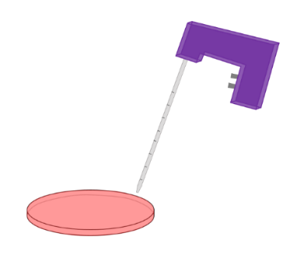
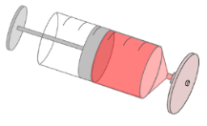
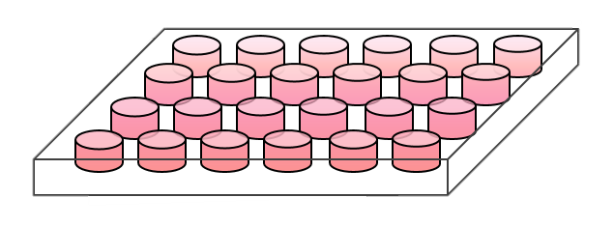
Conditioned Medium

Post-conditioned Cell Type

Pre-conditioned Cell Type

500 µL/well Conditioned M199

15 mL Complete M199 ± 25 U/mL TNF-α

Figure 6.1 – Medium transfer experimental design. Complete M199 medium was added to the pre-conditioned cell type for 12 hours before being aspirated, sterile filtered and added to the post-conditioned cell type for 0-12 hours.

Figure 6.1 – Medium transfer experimental design. Complete M199 medium was added to the pre-conditioned cell type for 12 hours before being aspirated, sterile filtered and added to the post-conditioned cell type for 0-12 hours.

Table 6.1 – The combinations used for conditioned medium experiments. Transfer between the same cell types were used as a control for comparative purposes.

Table 6.1 – The combinations used for conditioned medium experiments. Transfer between the same cell types were used as a control for comparative purposes.

Pre-conditioned  Cell Type | With 25 U/mL  TNF-α? | Post-conditioned Cell Type
HUVEC | + | HUVEC
 | -
HUASMC | +
 | -
NHDF | +
 | -
- | -
HUVEC | + | NHDF
 | -
HUASMC | +
 | -
NHDF | +
 | -
- | -

6.2.3 IMMUNOCYTOCHEMISTRY TO EXAMINE ICAM-1 UP-REGULATION
As previously described in chapter 4.2.7, mouse anti-human ICAM-1/CD54 primary antibody (eBioscience; BMS108) and goat anti-mouse Alexa Fluor 633 secondary antibody (Life Technologies; A21052) were added to the fixed cells.
Immunolabelled HUVEC/NHDF samples were transferred from the well plate into a Petri dish containing PBS in the dark room for imaging. Cells were observed using an upright Zeiss LSM510 Meta confocal microscope, combined with a Zeiss Achroplan 10x /0.30 W Ph1 water emersion objective lens. A HeNe2 (λEx 633 nm, λEm 650-710 nm) laser was used to stimulate the Alexa Fluor 633 (max λEx 632 nm, max λEm 647 nm). Microscope and laser settings were maintained from previous experiments: image size set to 512 x 512 pixels; pinhole size was set to maximum (approximately 9.7 Airy Units); transmission (%) of 39.5 for the HeNe2 laser, detector gain of 850, amplifier offset of 0.1, amplifier gain at 1 and an average reading was taken from 4 scans.

6.2.4 ANALYSIS OF IMAGES
ImageJ was the software of choice to calculate the mean intensity of ICAM-1 for each sample [198]. Each image had background fluorescence removed via ‘process -> subtract background’. The rolling ball radius was set to 12 pixels and the mean intensity of ICAM-1 was then obtained using the software. The data was then transferred to SPSS for statistical analysis. The Games-Howell test was used to determine significant results at the 5 % level.

6.3 RESULTS
With diverse results obtained in the different co-culture arrangements, conditioned medium experiments were carried out to determine what method of communication occurred between the different cell types. HUASMC were only used as a pre-conditioned cell type owing to the lack of diversity of ICAM-1 expression across the experimental conditions.

6.3.1 HUVEC CONDITIONED MEDIUM TRANSFERRED TO HUVEC
HUVEC were incubated with complete M199 medium for 12 hours, with and without 25 U/mL TNF-α. The medium was then transferred to a fresh sample of HUVEC; these would provide baseline results to which later experiments (where the same conditioned medium would be transferred to NHDF) could be compared. As a control, the medium was changed in the same format on HUVEC, but replaced with fresh complete M199 medium, to ensure the process of medium exchange did not influence the results.
The confocal images obtained can be viewed in figure 6.2, with the respective ICAM-1 intensity values displayed in figure 6.3. As expected, there were no significant changes in ICAM-1 expression over the 12-hour period in the control experiment (p=0.243). The results obtained when the conditioned medium did not contain TNF-α were comparable to this, where the ICAM-1 intensity at 12 hours was almost identical to 0 hours (p=0.999). On the contrary, when TNF-α was added to the conditioned medium, ICAM-1 intensity significantly increased over the experimental period (p<0.001).
The overall increase in intensity was 5.1-fold, approximately 30 % greater than the increase in standard monoculture conditions and when in co-culture with HUASMC (both 3.9-fold), but not as much as in co-culture with NHDF where the intensity increased by 6.3-fold. Consequently, when comparing the ICAM-1 intensities at 12 hours, the transfer of conditioned medium containing

Conditioned Medium | Time (Hours)
 | 0 | 3 | 6 | 9 | 12
Control | 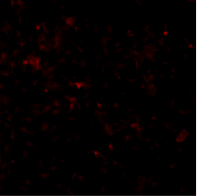 |  | 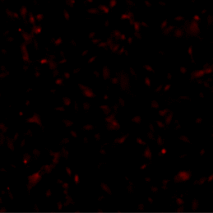 | 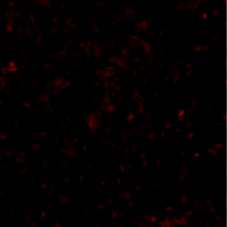 | 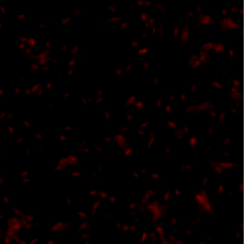
Without  TNF-α | 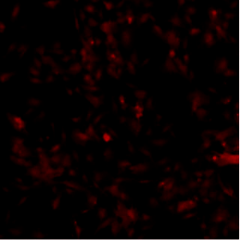 | 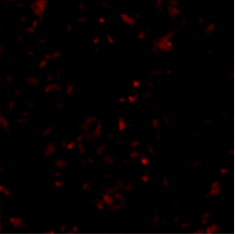 | 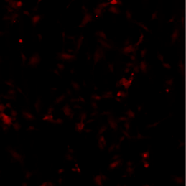 | 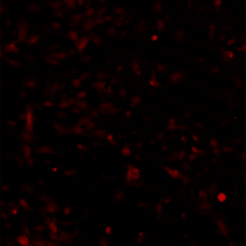 | 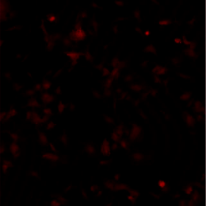
25 U/mL  TNF-α | 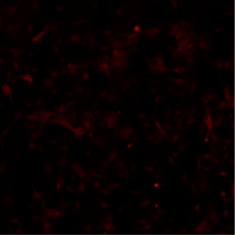 | 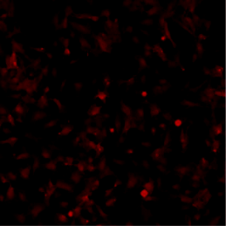 | 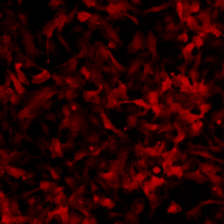 | 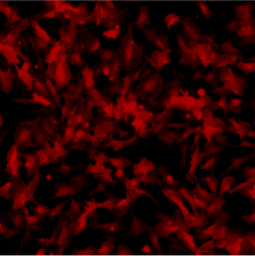 | 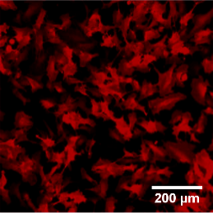

Figure 6.2 – Representative confocal micrograph images of ICAM-1 expression on HUVEC. The cells were incubated with conditioned medium from HUVEC with and without 25 U/mL TNF-α. No observable difference can be seen without TNF-α addition to the control, whilst its presence significantly up-regulated ICAM-1 expression. Scale bar = 200 µm.

Figure 6.2 – Representative confocal micrograph images of ICAM-1 expression on HUVEC. The cells were incubated with pre-conditioned medium from HUVEC with and without 25 U/mL TNF-α. No observable difference can be seen without TNF-α addition to the control, whilst its presence significantly up-regulated ICAM-1 expression. Scale bar = 200 µm.

*

*
Figure 6.3 – Intensity of ICAM-1 on HUVEC after adding conditioned medium from HUVEC for 12 hours. When TNF-α there were no significant differences in ICAM-1, whilst with TNF-α significant up-regulation occurred at every 3-hour interval up to 9 hours post-transfer. Mean ± SEM. (n=3)

TNF-α from HUVEC to HUVEC was significantly greater than in monoculture (6.9- vs 5.2-fold, p<0.001), but not as high as in co-culture with either NHDF (6.9- vs 8.3-fold, p<0.01) or HUASMC (6.9- vs 9.6-fold, p<0.001).
Moreover, whilst in monoculture there was no significant increase between 6 and 9 hours after TNF-α addition, in the conditioned medium experiment this occurred between 9 and 12 hours instead (p=0.299).

6.3.2 HUASMC CONDITIONED MEDIUM TRANSFERRED TO HUVEC
Culture medium was conditioned on HUASMC prior to the transfer to HUVEC for 0-12 hours. Figure 6.4 displays the confocal images obtained of HUVEC under the different conditions: control (no conditioning), conditioned without TNF-α and conditioned with 25 U/mL TNF-α, with intensity values obtained shown in figure 6.5.
The transfer of conditioned medium without TNF-α resulted in a 1.0-fold increase of ICAM-1 expression over the experiment. No significant increase in ICAM-1 intensity from baseline at either 3 (p=0.973) or 6 hours (p=0.061). The difference in ICAM-1 intensity between 6 and 9 hours was significant (p<0.05) meaning that by 9 hours the up-regulation from baseline was highly significant (p<0.001). There was no difference between the intensity values obtained at 9 and 12 hours (p=0.915). However, when the intensity values at 12 hours were compared to the control, this no longer became significant (2.3- vs 1.9-fold, p=0.345).
When the HUASMC were conditioned with TNF-α, all time-points were significantly higher than at 0 hours (p<0.001). As when TNF-α wasn’t present, there was no significant difference between the intensity values at 9 and 12 hours (p=0.309). Consequently, even at the 3-hour time point the intensity values were significantly higher than both the control (2.5- vs 1.5-fold, p=0.001) and conditioned medium without TNF-α (2.5- vs 1.3-fold, p<0.001).
The overall increase in ICAM-1 in HUVEC was approximately 4.9-fold for the experiment involving HUASMC conditioned medium with TNF-α, statistical

Conditioned Medium | Time (Hours)
 | 0 | 3 | 6 | 9 | 12
Control
Without  TNF-α | 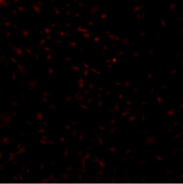 | 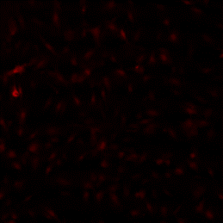 | 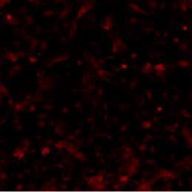 | 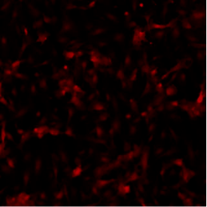 | 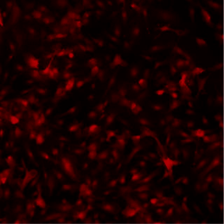
25 U/mL  TNF-α | 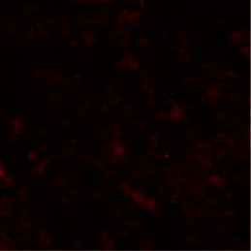 | 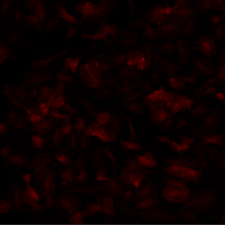 | 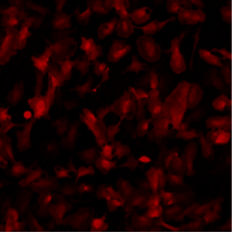 | 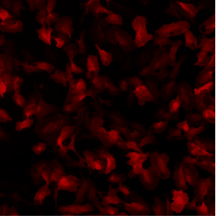 | 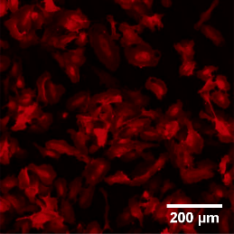
Figure 6.4 – Representative confocal micrograph images of ICAM-1 expression on HUVEC when incubated with conditioned medium from HUASMC. A small but observable increase in ICAM-1 occurred when medium was transferred from HUASMC to HUVEC without the presence of TNF-α; this was more significant when TNF-α was present. Scale bar = 200 µm.

Figure 6.4 – Representative confocal micrograph images of ICAM-1 expression on HUVEC when incubated with pre-conditioned medium from HUASMC. A small but observable increase in ICAM-1 occurred when medium was transferred from HUASMC to HUVEC without the presence of TNF-α; this was more significant when TNF-α was present. Scale bar = 200 µm.

Figure 6.5 – ICAM-1 intensity values on HUVEC after incubation with conditioned medium from HUASMC. There was no significant difference between the conditioned medium without TNF-α and the control. When 25 U/mL TNF-α was added to the conditioned medium, the medium produced a significant up-regulation after 3 hours incubation. Mean ± SEM. (n=3)

Figure 6.5 – ICAM-1 intensity values on HUVEC after incubation with pre-conditioned medium from HUASMC. There was no significant difference between the pre-conditioned medium without TNF-α and the control. When 25 U/mL TNF-α was added to the conditioned medium, the medium produced a significant up-regulation after 3 hours incubation. Mean ± SEM. (n=3)
*

*

analysis comparing the ICAM-1 intensity at 12 hours was not significantly different to either monoculture (6.1- vs 5.2-fold, p=0.119) or HUVEC conditioned medium with TNF-α (6.1- vs 6.9-fold, p=0.060). However, the intensities of HUVEC in co-culture with either NHDF or HUASMC were significantly higher (p<0.001).

6.3.3 NHDF CONDITIONED MEDIUM TRANSFERRED TO HUVEC
Figure 6.6 displays the confocal images obtained of HUVEC when incubated with conditioned medium from NHDF, both with and without the presence of TNF-α; figure 6.7 shows the ICAM-1 intensity values obtained.
When the NHDF were conditioned without TNF-α, there was no observable increase in ICAM-1 expression in HUVEC. This was confirmed when statistically comparing the intensity values at 0 and 12 hours (p=0.999). Moreover, there was no significant difference between the NHDF conditioned medium without TNF-α and the control at 12 hours (1.5- vs 1.9-fold, p=0.294).
Upon TNF-α addition to the conditioned culture medium, all time-points produced a significant increase in ICAM-1 intensity compared to the baseline (p<0.001). The intensity increase between each time-point was also significant (3 - 6 hrs, p<0.001; 6 - 9 hrs, p<0.05; 9 - 12 hrs, p<0.05). Therefore, the NHDF conditioned medium with TNF-α produced an intensity at 12 hours that was statistically significant when compared to NHDF conditioned medium without TNF-α and the control (5.2- vs 1.5-fold, p<0.001).
In addition, the overall increase in intensity was approximately 3.9-fold, analogous to the expression increase observed in HUVEC under monoculture conditions (p=0.993). Comparing the intensities at 12 hours, NHDF conditioned with TNF-α was not significantly different to HUAMSC conditioned with TNF-α (5.2- vs 6.1-fold, p=0.074) but were when the medium was conditioned either on HUVEC or when HUVEC were in co-culture with either HUASMC or NHDF (p<0.001).

Conditioned Medium | Time (Hours)
 | 0 | 3 | 6 | 9 | 12
Control
Without  TNF-α | 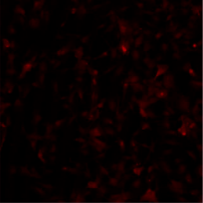 | 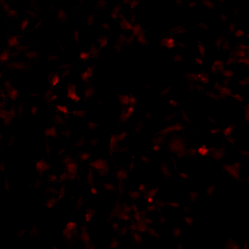 | 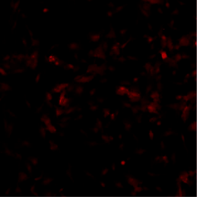 | 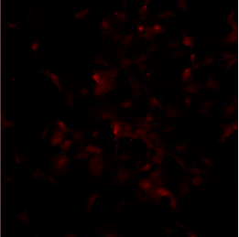 | 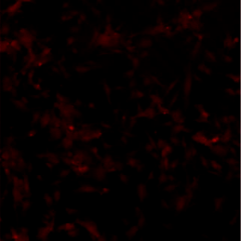
25 U/mL  TNF-α | 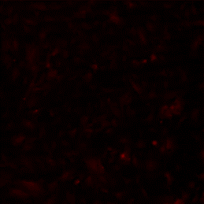 | 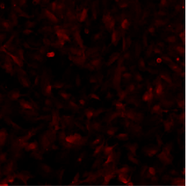 | 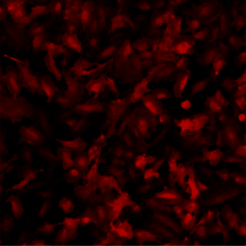 | 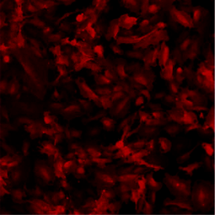 | 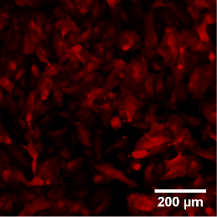

Figure 6.6 – Confocal micrograph images representative of the ICAM-1 expression on HUVEC after incubation with conditioned medium from NHDF. No clear difference is observed between the control and no TNF-α was added to the conditioned medium. When TNF-α was present in the conditioned medium, ICAM-1 was enhanced through each time-point. Scale bar = 200 µm.

Figure 6.6 – Confocal micrograph images representative of the ICAM-1 expression on HUVEC after incubation with pre-conditioned medium from NHDF. No clear difference is observed between the control and no TNF-α was added to the pre-conditioned medium. When TNF-α was present in the pre-conditioned medium, ICAM-1 was enhanced through each time-point. Scale bar = 200 µm.

*

*
Figure 6.7 – ICAM-1 intensity on HUVEC after the transfer of NHDF conditioned complete M199 medium, both with and without 25 U/mL TNF-α. No significant deviation from the control appeared without TNF-α present, whilst when it was added a significant increase in ICAM-1 arose, akin to in monoculture conditions. Mean ± SEM. (n=3)

6.3.4 HUVEC CONDITIONED MEDIUM TRANSFERRED TO NHDF
The confocal images obtained of NHDF incubated with conditioned medium from HUVEC can be seen in figure 6.8, with figure 6.9 displaying the respective intensity values.
It appeared that the ICAM-1 intensity was significantly higher than the control when NHDF were incubated with HUVEC conditioned medium, both when TNF-α was and was not present (p<0.001). Without TNF-α, the overall increase in intensity was 2.3-fold (p<0.001); the difference between 0 - 3 hours (p=0.996) and 9 - 12 hours were not statistically significant (p=0.077) whilst both intervals between 3 and 9 hours were extremely significant (p<0.001). The intensity value at 12 hours was approximately 67 % of that found in monoculture (3.4- vs 5.1-fold, p<0.001) and was significantly greater than in co-culture with either HUASMC (3.4- vs 2.7-fold, p<0.05) or HUVEC (3.4- vs 1.7-fold, p<0.001).
Meanwhile, the overall increase in ICAM-1 intensity was 1.4-fold when the conditioned medium included TNF-α (p<0.001). The only significant difference between 2 consecutive intervals was 3 - 6 hours post medium transfer (p<0.05). At 12 hours, the ICAM-1 intensity was 50 % of that in monoculture (2.6- vs 5.1-fold, p<0.001), which was comparable to the values obtained in co-culture with HUASMC (2.6- vs 2.7-fold, p=0.995) but significantly greater than when in co-culture with HUVEC (2.6- vs 1.7-fold, p<0.01).
Owing to the decrease in ICAM-1 in NHDF after HUVEC were conditioned with medium containing TNF-α for 12 hours, an intermediate experiment was carried out where HUVEC were conditioned with TNF-α for 6 hours. The results obtained from this experiment were comparable to when no TNF-α was present throughout the conditioning process (3.4- vs 3.6-fold, p=0.927).

Conditioned Medium | Time (Hours)
 | 0 | 3 | 6 | 9 | 12
Control | 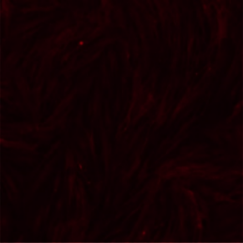 | 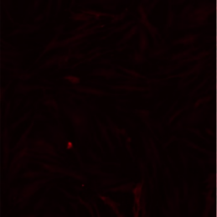
Without  TNF-α |  |  | 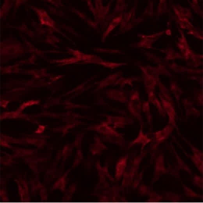 | 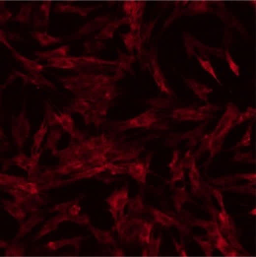 | 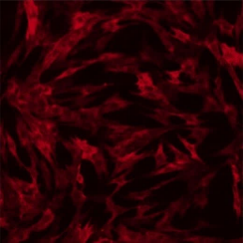
25 U/mL  TNF-α |  |  |  | 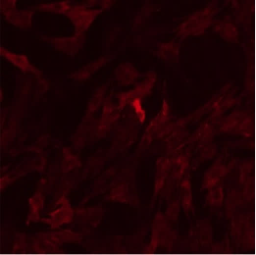 | 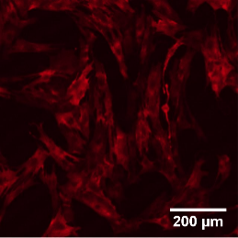

Figure 6.8 – Representative confocal micrograph images of ICAM-1 expression on NHDF when incubated with conditioned medium from HUVEC, with and without TNF-α. A similar trend is observed under both conditions, where ICAM-1 expression is up-regulated after 3 hours. Scale bar = 200 µm.

Figure 6.8 – Representative confocal micrograph images of ICAM-1 expression on NHDF when incubated with pre-conditioned medium from HUVEC, with and without TNF-α. A similar trend is observed under both conditions, where ICAM-1 expression is up-regulated after 3 hours. Scale bar = 200 µm.

*

*
*

*
Figure 6.9 – ICAM-1 intensity on NHDF after the addition of medium conditioned by HUVEC. Significant up-regulation of ICAM-1 was observed under all conditions (except control). However, after 12 hours HUVEC conditioning with TNF-α, the intensity 12 hours post transfer was comparatively decreased. Mean ± SEM. (n=3)

Figure 6.9 – ICAM-1 intensity on NHDF after the addition of medium pre-conditioned by HUVEC. Significant up-regulation of ICAM-1 was observed under all conditions (except control). However, after 12 hours HUVEC pre-conditioning with TNF-α, the intensity 12 hours post transfer was comparatively decreased. Mean ± SEM. (n=3)

6.3.5 HUASMC CONDITIONED MEDIUM TRANSFERRED TO NHDF
Complete M199 medium was conditioned on HUASMC for 12 hours prior to transfer to NHDF for up to 12 hours. Confocal images can be observed of the outcome in figure 6.10. There is evidently an increase in ICAM-1 expression and intensity upon the transfer of the pre-conditioned medium compared to the control, both with and without TNF-α where the relative increase in intensity was 2.5-fold and 1.9-fold, respectively (p<0.001). By comparing the intensity values at 12 hours (figure 6.11), although it appeared that TNF-α inclusion further enhanced the up-regulation of ICAM-1, this increase was not quite significant (3.8 vs 3.1, p=0.066).
When HUASMC were incubated without TNF-α, the conditioned medium significantly increased the ICAM-1 intensity from baseline by 6 hours (p<0.001). Moreover, this increase was mostly owed only to the significant difference between 3 and 6 hours (p<0.001), whilst the differences between 6-9 hours and 9-12 hours were not significant (p=0.333, p=0.633).
A similar trend is observed when TNF-α was included in the conditioned medium; the ICAM-1 intensity was increased from baseline from 6 hours onwards (p<0.001). On the other hand, the differences between both 3-6 hours and 6-9 hours were both highly significant (p<0.001). The difference between the values at 9 and 12 hours were again not significant (p=0.093).
Both conditions at 12 hours were significantly different to monoculture results: the intensity at 12 hours was approximately 60 % to that of monoculture when TNF-α was not present (3.1- vs 5.1-fold, p<0.001) and 75 % when TNF-α was included (3.8- vs 5.1-fold, p<0.01). This was similar when comparing the results to HUVEC co-culture conditions, though the intensity values at 12 hours were significantly greater than in co-culture (p<0.001). Meanwhile, HUASMC co-culture ICAM-1 results were comparable to when the conditioned medium did not include TNF-α (2.7- vs 3.1-fold, p=0.545), but not to when TNF-α was present (2.7- vs 3.8-fold, p<0.001).
The intensity results obtained at 12 hours when the HUASMC conditioned medium did not include TNF-α were also analogous to those in the HUVEC conditioned medium experiments, both with TNF-α (p=0.356) and without TNF-α (p=0.864). When TNF-α was added to the HUASMC conditioned
Conditioned Medium | Time (Hours)
 | 0 | 3 | 6 | 9 | 12
Control
Without  TNF-α | 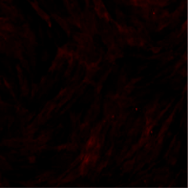 | 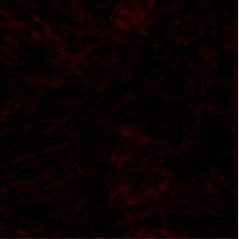 | 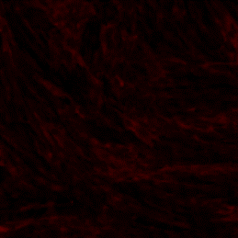 | 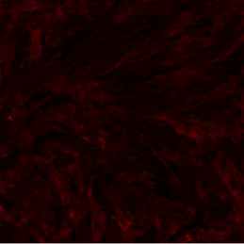 | 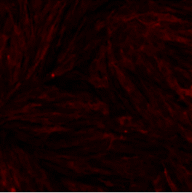
25 U/mL  TNF-α | 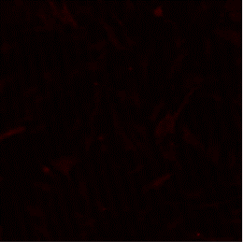 | 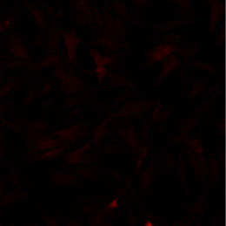 |  | 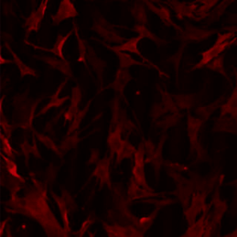 | 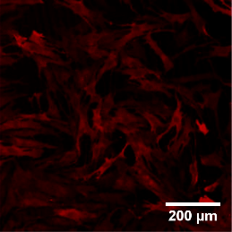

Figure 6.10 – Confocal micrograph images representative of ICAM-1 expression on NHDF incubated with conditioned medium from HUASMC. ICAM-1 appears increased in both conditions compared to the control, with a higher expression visible at 12 hours when TNF-α was present. Scale = 200 µm.

Figure 6.10 – Confocal micrograph images representative of ICAM-1 expression on NHDF incubated with pre-conditioned medium from HUASMC. ICAM-1 appears increased in both conditions compared to the control, with a higher expression visible at 12 hours when TNF-α was present. Scale = 200 µm.

*

*
*

*
Figure 6.11 – ICAM-1 intensity in NHDF after the addition of HUASMC conditioned complete M199 medium for 12 hours, either with or without 25 U/mL TNF-α. Though conditioned medium increased ICAM-1 throughout, there was no significant difference between the two conditioned medium types. Mean ± SEM. (n=3)

Figure 6.11 – ICAM-1 intensity in NHDF after the addition of ‘complete M199’ pre-conditioned on HUASMC for 12 hours, either with or without 25 U/mL TNF-α. Though pre-conditioned medium increased ICAM-1 throughout, there was no significant difference between the two conditioned medium types. Mean ± SEM. (n=3)

medium, the results were significantly different to the comparable experiment with HUVEC conditioning (3.8- vs 2.6-fold, p<0.001).

6.3.6 NHDF CONDITIONED MEDIUM TRANSFERRED TO NHDF
Medium was conditioned on NHDF with and without 25 U/mL TNF-α prior to transfer to fresh samples of NHDF; these results would serve as control comparisons to be able to determine what influence the HUVEC and HUASMC were having.
The transfer of conditioned medium caused a small but significant increase in ICAM-1 intensity from 6 hours post-transfer with both conditioned medium types (p<0.05) (figures 6.12-6.13). The relative increase in ICAM-1 intensity was 1.1-fold and 0.6-fold with and without TNF-α, respectively. At 12 hours post medium transfer, there was a significant difference between the 2 pre-conditioned medium types (p<0.05) and both were significantly higher than the control (p<0.001).
Consequently, the intensity values at 12 hours that were 40-50 % of those found in monoculture (2.0/2.5- vs 5.1-fold, p<0.001). NHDF conditioned medium values at 12 hours were also similar to HUASMC conditioned medium without TNF-α (p=0.265), HUASMC co-culture (p=0.992) and HUVEC conditioned medium with TNF-α (p=1.000). The results from NHDF conditioned medium with TNF-α were akin to this producing p-values of 0.838, 0.999 and 0.955, respectively.
Furthermore, the ICAM-1 intensity for both NHDF conditioned medium types were significantly reduced when compared to those obtained in HUVEC co-culture (with TNF-α, p<0.001; without TNF-α, p<0.05), HUVEC pre-conditioned medium without TNF-α (p<0.01) and HUASMC pre-conditioned medium with TNF-α (p<0.001).

Conditioned medium | Time (Hours)
 | 0 | 3 | 6 | 9 | 12
Control
Without TNF-α | 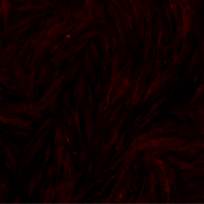 | 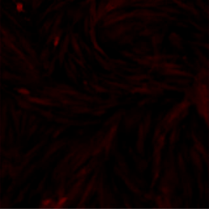 |  | 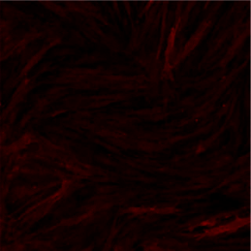
25 U/mL  TNF-α | 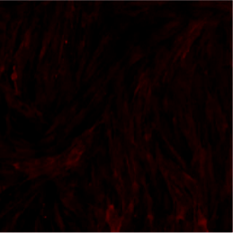 | 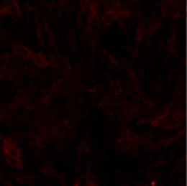 | 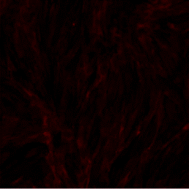 | 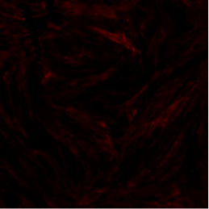 | 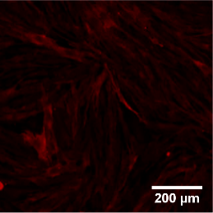
Figure 6.12 – Representative confocal micrograph images of ICAM-1 expression on NHDF incubated with conditioned medium from NHDF. There appears to be a small increase in ICAM-1 intensity in both conditioned medium experiments when compared to the control. Scale = 200 µm.

Figure 6.12 – Representative confocal micrograph images of ICAM-1 expression on NHDF incubated with pre-conditioned medium from NHDF. There appears to be a small increase in ICAM-1 intensity in both pre-conditioned medium experiments when compared to the control. Scale = 200 µm.
*

*
*

*
Figure 6.13 – ICAM-1 expression on NHDF after the addition of conditioned from NHDF, either with or without TNF-α. A small but significant increase occurred at each interval between 3 and 12 hours post conditioned medium transfer in the presence of TNF-α, whilst without a significant up-regulation only occurred between 3 and 6 hours. Mean ± SEM. (n=3)

Figure 6.13 – ICAM-1 expression on NHDF after the addition of pre-conditioned from NHDF, either with or without TNF-α. A small but significant increase occurred at each interval between 3 and 12 hours post conditioned medium transfer in the presence of TNF-α, whilst without a significant up-regulation only occurred between 3 and 6 hours. Mean ± SEM. (n=3)

6.4 DISCUSSION
When combining the results from the conditioned medium experiments, there are many signalling pathways present between HUVEC, HUASMC and NHDF which regulate the expression of ICAM-1. The way these pathways interact could be crucial to the inflammatory response that underpins atherogenesis and consequently may be important in providing evidence to suggest:
- why fibroblasts should be included in in vitro vascular models
- to discover any potential therapeutic targets.
The signalling pathways presented through the transfer of conditioned culture medium will also be compared to the signalling methods previously suggested via monoculture (chapter 4) and co-culture experiments (chapter 5). This will confirm or disprove the hypothesised mechanisms underlying the signalling pathways portrayed.

6.4.1 AUTOCRINE CYTOKINE SIGNALLING
In previous chapters, the monoculture and co-culture experiments were not able to provide any information as to whether autocrine signalling was present. Autocrine signalling involves the secretion of a cytokine from a cell, which then binds to its cognate receptor on the surface of the same cell. The only way to conclude whether this type of signalling was present was by stimulating one group of cells with TNF-α, collecting the medium and then transferring it to another group of the same cells to see whether a response was elicited.
Owing to the small increase in ICAM-1 compared to the control in NHDF when cultured with NHDF conditioned medium without TNF-α (figure 6.13), experimental results indicated that NHDF can self-induce the up-regulation of ICAM-1. Additionally, with a further increase in ICAM-1 intensity in the presence of TNF-α, this suggests the NHDF release pro-inflammatory molecules upon stimulation and/or that there is still TNF-α present in the medium from the conditioning process; even though the human recombinant TNF-α is stable for 1 year when stored at -20 °C [244], no studies have been completed to determine how long the protein is stable for at 37 °C. Either way, the final concentration of TNF-α must be significantly reduced compared to the 25 U/mL initially added owing to the intensity at 12 hours being approximately 50 % of that in monoculture.
Both IL-6 and TGF-β have been shown to produce autocrine responses in fibroblasts. IL-6 produces a positive-feedback loop that also initiates the expression of additional pro-inflammatory cytokines including IL-8, IL-33, IL-11 IL-1α and IL-1β [245]. Meanwhile, TGF-β is a profibrotic cytokine to which its autocrine production in fibroblasts has been shown to regulate cell growth [246], and induce the expression of ICAM-1 in human gingival fibroblasts [247].
Conversely, in HUVEC it was upon TNF-α addition to the HUVEC conditioned medium that the ICAM-1 intensity was increased (figure 6.3). If there is a significant reduction in TNF-α through the conditioning process, HUVEC should only increase ICAM-1 levels to no greater than 50 % of that found in monoculture. However, as the ICAM-1 intensity was greater than in monoculture TNF-α must induce the release of subsequent pro-inflammatory cytokines in the endothelial cell, which have an autocrine effect.
As discussed in chapter 2.4.1, TNF-α leads to the activation of NF-κB, which subsequently induces the up-regulation of several major pro-inflammatory and pro-thrombotic mediators such as TNF-α and various interleukins including IL-1, IL-6 and IL-8 [85]. One or a combination of these cytokines may act in an autocrine manner to produce the results observed.
Previous research has shown that TNF-α and IL-1 act in a similar manner, with a positive feedback loop existing with IL-1, which may act to enhance the effects of endothelial cell injury on ICAM-1 expression and ensuing leukocyte recruitment [248]. IL-8 also has an autocrine role by enhancing endothelial cell proliferation, survival and migration [249]. Moreover, Venkatesh et al (2013) demonstrated that TNF-α stimulation of endothelial cells induced a TNFR2-IRF1-IFN-β autocrine loop, which was essential to ICAM-1 expression and subsequent macrophage accumulation [250].

6.4.2 ICAM-1 EXPRESSION AFTER TRANSFER OF CONDITIONED MEDIUM WITHOUT PRO-INFLAMMATORY STIMULATION
The co-culture experiments demonstrated that ICAM-1 expression in HUVEC and NHDF could be augmented through the addition of alternative cell types, particularly with HUASMC which enhanced the ICAM-1 intensity in both cell types prior to the addition of TNF-α (figure 5.8 & figure 5.11). Therefore, culture medium was conditioned on HUASMC (without TNF-α) and transferred to both HUVEC and NHDF to determine whether this could have been via paracrine signalling. Interestingly, these experiments produced contrasting results, establishing that whilst HUASMC could enhance ICAM-1 expression in NHDF through the constitutive release of a paracrine signal (figure 6.11), this was not sufficient to induce the same effects in HUVEC (figure 6.5), where it appears that either direct contact or close proximity were required [80, 81].
This constitutive release by HUASMC induced a pro-inflammatory response comparable to the values obtained from NHDF in co-culture with HUASMC, suggesting that a maximal response had been obtained. Human airway smooth muscle cells have been shown to constitutively express the VEGF protein [237], which can induce activate the JAK/STAT pathway to induce ICAM-1 expression [241].
The results also provide support towards the Tyr142-phosphorylation of β-catenin in endothelial cells via the direct contact with smooth muscle cells, as suggested in chapter 5.4.3 [230].
Remarkably, HUVEC conditioned medium without TNF-α enhanced ICAM-1 expression in NHDF (figure 6.9). This was surprising considering there was no change in baseline ICAM-1 expression in NHDF when in co-culture with HUVEC (figure 5.5). Therefore, a possible explanation could be that whilst HUVEC constitutively secrete pro-inflammatory molecule(s) that have little autocrine effect when the NHDF and HUVEC are in close proximity the HUVEC may either:
- reduce or prevent the release of such cytokine(s)
or
- also express an inhibitory molecule resulting in the inability of the NHDF to respond to the pro-inflammatory stimulus.
For example, IL-15 is constitutively produced by endothelial cells [251], and has been demonstrated to attenuate TGF-β induced myofibroblast differentiation of foetal lung fibroblasts in a juxtacrine manner [15].

6.4.3 ICAM-1 EXPRESSION AFTER TRANSFER OF CONDITIONED MEDIUM WITH PRO-INFLAMMATORY STIMULATION
As previously described, it was expected that TNF-α stimulation would induce cytokine production and secretion via the activation of NF-κB, and then diffuse to influence nearby cells. Conditioned medium from both HUASMC (figure 6.5) and NHDF (figure 6.7) induced an up-regulation of ICAM-1 expression on HUVEC, analogous to when HUVEC were stimulated with 25 U/mL TNF-α in monoculture. Consequently, both HUASMC and NHDF must release pro-inflammatory molecule(s) after TNF-α stimulation that combine with any residual TNF-α to induce ICAM-1 up-regulation equivalent to monoculture conditions. This molecule(s) must have only a minor effect in NHDF to produce the results obtained. Both fibroblasts [252] and smooth muscle cells express IL-17 [253]; IL-17 promotes p38/MAPK activation in HUVEC, inducing cell adhesion molecule expression [254], whilst minimal ICAM-1 expression was observed in human gingival fibroblasts [255].
When HUVEC conditioned medium (with TNF-α for 12 hours) was transferred to NHDF (figure 6.9), the ICAM-1 intensity at 12 hours was significantly reduced compared to either when no TNF-α was added, or when HUVEC were pre-conditioned for 6 hours with TNF-α. Firstly, this indicates that HUVEC constitutively produce pro-inflammatory molecule(s) that only exert their effects on the NHDF. Secondly, owing to the decrease in ICAM-1 intensity with TNF-α addition, that:
- TNF-α reduces the expression of said constitutive pro-inflammatory molecule(s)
or
- TNF-α induces the production of an inhibitor from HUVEC.
When HUASMC were pre-conditioned with TNF-α, ICAM-1 expression in NHDF was not significantly different to when TNF-α was not present. This highlights not only that any release of pro-inflammatory molecule(s) via TNF-α activation did not affect NHDF, but also confirms that the majority of the TNF-α added initially might have been degraded/inhibited.

6.4.4 DIFFERENCES BETWEEN CULTURE CONDITIONS IN CO-CULTURE EXPERIMENTS VERSUS THOSE INVOLVING THE TRANSFER OF CONDITIONED CULTURE MEDIUM
Although the differences that occur in experiments involving conditioning the cell culture medium are expected to arise from the uptake or release of soluble factors such as cytokines, additional factors also have to take into account such as lack of direct cell-cell contact, changes in the concentration of vital media components and addition of cellular waste products.
Culture medium is traditionally tailored to each specific cell type, and thus contains different concentrations of amino acids and growth factors dependent on the requirements of the cell [256]. Optimum growth of HUVEC, HUASMC and NHDF would typically involve each cell being cultured under slightly different conditions e.g. NHDF would be grown in DMEM; complete M199 medium (see chapter 4.2.1) was the culture medium of choice to carry out all cell culture experiments, owing to HUVEC, HUASMC and NHDF all being able to successfully proliferate within the medium and to maintain consistency throughout.
Some of the vital components of the complete M199 cell culture medium used that may be altered include (but are not limited to) [256]:
- Glucose; M199 contains 1g/L which is approximately the same as normal blood glucose levels in vivo and is essential to the production of nucleotide phosphates such as ATP. A waste product of glycolysis is lactic acid.
- L-glutamine; an essential amino acid which easily breaks down at physiological pH in liquid medium to form ammonium and pyroglutamate.
- FCS; serum contains a variety of hormones, paracrine, endocrine and autocrine growth factors which support cell growth and prevent apoptosis.
- NaHCO₃; a buffer commonly used for maintaining the pH of cell culture medium in the presence of 4–10 % carbon dioxide.
- ECGS/H; ECGS constitutes primarily of FGF and has a mitogenic effect on endothelial cells, whilst heparin potentiates the stimulatory effect of ECGS.
Utilisation of essential components such as glucose and growth factors during the conditioning process reduces the concentration and availability of such molecules to the cells in the fresh culture. Ultimately, this could affect the viability of the cells and induce changes in protein transcription relating to the cells’ inflammatory status and cell survival e.g. apoptosis. In addition, the production of waste products such as lactic acid and ammonia can reduce the pH of the culture medium; although a buffer is contained within the culture medium, the buffer capacity of the medium will reduce with increased time in cell culture.
For primary cell culture, the culture medium is typically exchanged every 2 days to ensure the chemical composition is maintained within optimal conditions. Even though the process of conditioning the culture medium only lasted for 12 hours, followed by 12 hours for the experiment itself, during this time some alterations to the culture medium constituents would be expected. However, there were no significant differences observed in ICAM-1 expression in experiments involving the transfer of conditioned medium from HUVEC, HUASMC and NHDF to HUVEC without TNF-α (figure 6.3, figure 6.5 and figure 6.7) indicating that this cell type was still being cultured under optimal conditions. Moreover, as HUVEC require more specific culture conditions than HUASMC or NHDF e.g. the addition of ECGS/H, it can be anticipated that both HUASMC and NHDF were also cultured satisfactorily.

6.5 CONCLUSION
Conditioned medium experiments have emphasised how the signalling network that exists between the endothelial cell, smooth muscle cell and fibroblast is more extensive than initially suggested by co-culture experiments. It is evident that a combination of autocrine, juxtacrine and paracrine signals are present to regulate the inflammatory response.
When TNF-α was not present in the conditioned medium, pro-inflammatory pathways were present from HUVEC and HUASMC towards NHDF. What is more, a gradient of pro-inflammatory inducibility was present when compared to the respective location within the vessel wall, where HUVEC induced the maximal ICAM-1 up-regulation and the NHDF autocrine pathway inducing the least. This suggests that within the vessel wall, fibroblasts are maintained at a low-level inflammatory state within the adventitia, primed ready to be activated upon injury, where they can rapidly release an abundant array of pro-inflammatory cytokines and proliferate/migrate towards the site of injury.
The direction of the pathways were reversed when TNF-α was added to the situation, though the gradient still existed. The pro-inflammatory pathways were now directed towards the endothelial cell, where the HUVEC autocrine loop instigated the largest increase in ICAM-1 and NHDF producing the least. Nevertheless, the NHDF conditioned medium still induced a pro-inflammatory response akin to when TNF-α was added solely to the HUVEC monoculture. Consequently, the inflammatory response and expression of adhesion molecules induced in the endothelium to injury is considerably larger than it otherwise would be, improving leukocyte infiltration and the wound healing response.
Combining the results from co-culture and conditioned medium experiments, the significance of juxtracrine signalling between the different cell types has been highlighted. Activated fibroblasts migrate towards the site of injury, where they produce abundant extracellular proteins to provide a platform for vascular remodelling and wound closure. Once the fibroblast has arrived at the injury site, the pro-inflammatory response needs to be downregulated, ensuring that the wound is sufficiently closed but still not allowing an exaggerated healing response and scar formation. The juxtacrine anti-inflammatory response of the HUVEC and HUASMC to the NHDF may be the mechanism by which this is controlled.

CHAPTER 7
CHANGES IN ICAM-1 CONCENTRATION VIA CELL LYSATE ANALYSIS
7.1 INTRODUCTION
Previous monoculture (Chapter 4), co-culture (Chapter 5) and conditioned medium (Chapter 6) experiments semi-quantitatively assessed ICAM-1 expression profile changes in HUVEC, HUASMC and NHDF under different culture conditions via confocal imaging.
Traditionally, procedures such as western blots have been used to separate and identify target proteins. The technique enables semi-quantitative analysis of protein expression, where the amount of signal produced can be compared to a control. The process involves 3 distinct stages [257]:
- separation of proteins – the proteins within a sample are denatured and possess a negative charge, thus will travel through the SDS-PAGE gel towards the positive electrode at different speeds when a voltage is applied.
- transfer to a solid support – an electric current is applied perpendicularly to the surface of the gel, transferring the separated proteins onto a membrane (usually nitrocellulose or polyvinylidene difluoride)
- visualisation of target protein(s) – combinations of primary and secondary antibodies are incubated on the membrane. The secondary antibody usually contains an enzyme such as HRP, which can be used to produce a colorimetric or chemiluminescent method of detection.
In recent years, the development of flow cytometry has enabled fluorescence to be quantitatively assessed through the ability to correlate intensity to the number of proteins present on the cell surface [258]. This method involves cells in suspension, which are individually analysed as they flow within a fluid stream through a focussed laser interrogation point and provides output measurements for each cell rather than for the whole sample population [259].
However, there are advantages and disadvantages to these two methods (table 7.1); thus, the semi-quantitative analysis of protein expression via confocal images was chosen for the bulk of the experiments. This procedure positions itself somewhere between the semi-qualitative and quantitative natures of western blotting and flow cytometry, respectively, whilst also being significantly cheaper and quicker [259, 258, 257].
Nevertheless, it was still necessary to compare a range of results obtained through confocal image analysis with another commonly used technique to assess accuracy and reliability. Thus, having western blots been regularly used over the past few decades, the aim of the following experiments was to confirm the changes in ICAM-1 expression observed in previous experiments were factual by comparing the confocal image analysis results to those obtained through the western blot technique.
Table 7.1 – Comparison of the advantages/disadvantages of western blot, confocal microscopy and flow cytometry.

Table 7.1 – Comparison of the advantages/disadvantages of western blot, confocal microscopy and flow cytometry.
Procedure | Advantages | Disadvantages
Western Blot | - Sensitivity  - Specificity  - Semi-quantitative | - Prone to false / subjective results  - Expensive  - Technical and Slow  - Require larger sample sizes
Confocal Microscopy | - Specificity  - Lower cost  - Relatively quick  - Semi-quantitative | - Single focal plane  - Increased sensitivity to noise  - Technical
Flow Cytometry | - Subpopulation analysis  - Highlights non-uniformity  - Quantitative | - Expensive  - Slow

7.2 METHODS
7.2.1 SAMPLE PREPARATION
HUVEC and NHDF were cultured in Petri dishes as standard until approximately 80% confluency. 25 U/mL TNF-α (Thermo Scientific; PHC3015) was added to both cell types and incubated to produce samples at 0, 3, 6, 9 and 12 hours. 12-hour incubation samples were also produced post-transfer of conditioned medium (as described in chapter 6). When the incubation period was complete, the medium was aspirated, and the cells rinsed with PBS. Cold lysis buffer consisting of 0.1 % (v/v) Triton X-100, 0.1 % (m/v) SDS, 50 mM Tris-HCl pH 8 and 150 mM NaCl was immediately added, and a cell scraper used to remove the cells from the tissue culture plastic. The cell lysates were transferred into 1.5 mL Eppendorf tubes, where they were then agitated for 30 minutes, centrifuged at 10,000 rpm for 20 minutes and the supernatant collected.
A 10 µL sample of each cell lysate was removed to perform a bicinchoninic acid (BCA) protein assay (Thermo Scientific; 23227) enabling the total protein concentration of each cell lysate to be calculated; each sample was diluted 2-fold to ensure the results would be within the assay concentration range. The remaining of the lysate was stored at -20 °C until required.
To perform the BCA assay, 10 µL of the BSA standards, with the concentrations ranging from 0 to 2000 µg/mL, and the unknown samples were loaded into a 96-well plate. 150 µL of the working solution was then added to the plate and the plate agitated to ensure the solutions were well-mixed. The well plate was then incubated at 37°C for 30 minutes, left to cool to RT and absorbance readings at 562 nm taken via a plate reader. The absorbance values were then used to create a standard curve (figure 7.1), to which the samples of unknown concentration could be compared.
The calculated concentrations of the lysates were then used to determine the volume required for 2 µg of protein for dot blot analysis and for 10 µg of protein for sodium dodecyl sulphate polyacrylamide gel electrophoresis (SDS-PAGE). For SDS-PAGE, the required volume of cell lysate was added to an equal volume of 2 x non-reducing Laemmli buffer (table 7.2) and the samples made up to equal volume (approximately 25 µL) by the addition of 1 x Laemmli buffer (the 2x Laemmli buffer was diluted using dH₂0). The samples were then boiled for 10 minutes, releasing any pressure build up after 3-5 minutes. Once the lysates had cooled to RT, the samples were then loaded into the SDS-PAGE gels for electrophoresis.

Figure 7.1 – BSA standard curve produced via BCA assay to determine protein concentration of unknown samples, ready for western blotting.

Table 7.2 – Constituents of the 2x non-reducing buffer used for western blot sample preparation.

Table 7.2 – Constituents of the 2x non-reducing Laemmli buffer used for western blot sample preparation.

Ingredient | Quantity (mL)
10 % SDS | 4
Glycerol | 2
0.5 M Tris-HCl pH 6.8 | 2.4
dH₂O | 1.5
2 % Bromophenol Blue | 0.1

7.2.2 DOT BLOT
Prior to performing western blot analysis, cell lysate containing 2 µg of protein was dotted directly onto the nitrocellulose membrane and allowed to dry completely. Where volumes of cell lysate were greater than 1-2 µL, the volume was added 1 µL at a time and allowed to dry completely before addition of further lysate.
A blocking solution of 5 % (m/v) BSA in Phosphate-Buffered Saline/Tween (PBST) was added to the membrane, which was placed on a rocker for 1 hour before incubating with mouse anti-human ICAM-1/CD54 primary antibody at a concentration of 1 µg/mL (R&D Systems; MAB720-SP) in blocking buffer overnight at 4 °C. The membrane was then washed for 3 x 5-minutes in PBST before the addition of rabbit anti-mouse HRP-conjugated secondary antibody (Abcam; ab6728) at a concentration of 400 pg/mL in blocking buffer for 1 hour at RT.
During this incubation period, the 3,3-Diaminobenzidine (DAB)-peroxidase substrate was prepared. This involved making a 1 % (m/v) DAB solution in dH₂0, whereby a couple of drops of 5 M HCl was added to acidify the solution to enable DAB to dissolve. A 0.3 % (v/v) H₂O₂ in dH₂0 was also produced, and 500 µL of each solution was added to 5 mL PBS; this was followed by adjustment of the pH to approximately 7.2 via drop-wise addition of 0.1 M NaOH and further addition of PBS to make a total volume of 10 mL.
The membrane was once again washed 3 x 5 minutes in PBST before incubation with DAB-peroxidase substrate to visualise the ICAM-1 protein bands. Once the bands were clearly visible the nitrocellulose was rinsed with dH₂0 to prevent further reaction progression.

7.2.3 SDS-PAGE
Mini 1 mm polyacrylamide gels were prepared, using a 10 % (m/v) separating gel combined with 4 % (m/v) stacking gel (table 7.3). Glass plates were stacked and placed in a holder; water was pipetted into the well to ensure no leakage was present.
The constituents for the 10 % separating gel were combined in a universal tube, ensuring the ammonium persulphate (APS) and tetramethylethylenediamine (TEMED) were added immediately before pouring. The gel solution was poured in between the glass plate, leaving an approximately 3 cm gap at the top (for the stacking gel). A small volume of propan-2-ol was poured on top of the gel solution to remove air bubbles and ensure a perfectly flat surface was created. The solution was then left at RT for approximately 10-15 minutes until crosslinking had occurred (this was checked via the gelation of the leftover solution in the universal tube).
The propan-2-ol was then poured out and the remaining liquid removed using filter paper. A similar process to previous gel casting was then completed for the 4 % stacking gel, where the ingredients were combined in a universal tube, with the addition of APS and TEMED last before pouring. The gel was added almost to the up on the glass plates, leaving a space of approximately 1 mm. A 10-well comb was inserted carefully to ensure no air bubbles were present. Any overspill was immediately wiped. The gel was then left for a further 30-60 minutes to set.
The gelation of the stacking gel was assessed using the remaining solution in the universal tube. Once set, the comb was gently removed, ensuring the wells maintained their shape. The gel/plate set-up was then placed into the electrophoresis equipment, ensuring a buffer dam was also used in cases where only 1 gel was used, and running buffer (table 7.4) was loaded, ensuring the solution in the cassette was above the top of the short glass plate and the 2-gel marker had been reached.
5 µg of each protein sample were loaded into the wells of the gel ensuring any empty wells were loaded with 1 x Laemmli buffer of equal volume. The apparatus was run at 100 V for 110 minutes, or until the dye front was almost at the bottom of the gel.
Figure 7.2 displays the equipment used to produce and run the samples. To confirm adequate separation of the proteins, the gel was placed into a fixing solution (50 % MeOH (v/v), 10 % (v/v) HoAC in H₂O) for at least 30 minutes; this was exchanged for a Coomassie Blue solution (0.1 % (m/v) Coomassie Brilliant Blue in 50 % (v/v) MeOH, 10 % (v/v) HoAC in H₂O) for 2-4 hours, until the gel was no longer visible. The Coomassie Blue solution was swapped for a de-staining solution (5 % (v/v) MeOH, 7.5 % (v/v) HoAC in H₂O); the gel was incubated for between 4 and 24 hours, until the gel had become clear and any remaining protein bands were clearly visible.
Ingredient | Quantity (µL)
 | Separating Gel | Stacking Gel
H₂0 | 2375 | 893
1.5 M pH 8.8 Tris-HCl | 1500 | -
0.5 M pH 6.8 Tris-HCl | - | 469
30 % Acrylamide (37.5:1) | 2025 | 250
10 % SDS | 60 | 19
10 % APS | 60 | 19
TEMED | 6 | 2.5
Table 7.3 – The recipes of the polyacrylamide gels used.

Table 7.3 – The recipes of the polyacrylamide gels used.

Ingredient | Quantity
 | Running Buffer | Transfer Buffer
H₂0 | 1000 mL | 800 mL
Glycine | 14.4 g | 14.4 g
Tris | 3 g | 3 g
SDS | 1 g | -
Methanol | - | 200 mL

Table 7.4 – The recipes of the running and transfer buffers used for SDS-PAGE.

Table 7.4 – The recipes of the running and transfer buffers used for SDS-PAGE.

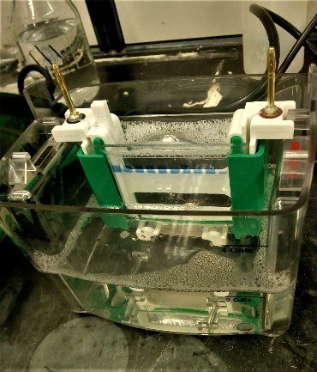
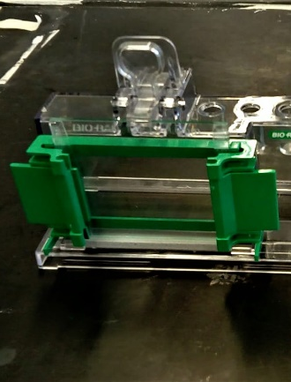

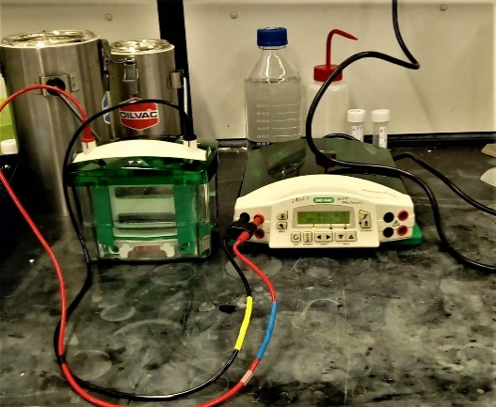

Figure 7.2 – SDS-PAGE equipment. (Top Left) The glass plates and holders for gel casting. (Top Right) The cast gel plus glass plates were loaded into the cassette, using a buffer dam if required. The cassette was then loaded into the tank and both buffer and samples were loaded. (Bottom) The electrodes were attached, and 100 V set on the power pack.

Figure 7.2 – SDS-PAGE equipment. (Top Left) The glass plates and holders for gel casting. (Top Right) The cast gel plus glass plates were loaded into the cassette, using a buffer dam if required. The cassette was then loaded into the tank and both buffer and samples were loaded. (Bottom) The electrodes were attached, and 100 V set on the power pack.

7.2.4 WESTERN BLOT
Whilst the SDS-PAGE was running, 0.45 µm nitrocellulose membrane (Bio-Rad; 162-0115) was cut to the approximate size of the separating gel. The membrane and 2 sheets of filter paper (Bio-Rad; 1703932) were soaked in transfer buffer.
Once electrophoresis was complete, the gel was removed from the electrophoresis set-up and placed into transfer buffer for at least 10 minutes to equilibrate. The running buffer was removed from the set-up and replaced with transfer buffer; the set-up was filled until the blotting line was met. A sandwich was created (filter paper – gel – nitrocellulose – filter paper) in the western blot cassette, ensuring any air bubbles were removed. The cassette was then placed into the same set-up as for the SDS-PAGE. It was vital that the transfer buffer was kept cold through the western blot, so prior to use the buffer was placed at -20 °C to cool and a small ice pack was placed into the set-up immediately before running (figure 7.3).
The apparatus was again set at 100 V and was left to run for 75 minutes. Once the transfer was complete, the apparatus was dismantled, the gel was placed into a fixing solution (50 % MeOH (v/v), 10 % (v/v) HoAC in H₂O) overnight and the membrane was placed into a Ponceau S staining solution (Sigma-Aldrich; P7170) for 5-10 minutes.
Figure 7.3 – Western Blot equipment. The polyacrylamide gel and nitrocellulose membrane were placed into the black and red cassette before being placed back into the tank. An ice pack was placed in the remaining space to keep the temperature of the buffer as low as possible.

Figure 7.3 – Western Blot equipment. The polyacrylamide gel and nitrocellulose membrane were placed into the black and red cassette before being placed back into the tank. An ice pack was placed in the remaining space to keep the temperature of the buffer as low as possible.
Once the gel was fixed, the fixing solution was exchanged for a Coomassie Blue and de-staining solution, as described in chapter 7.2.3, to enable visualisation of any remaining protein bands.
Meanwhile, once the membrane had incubated with Ponceau S, it was given 3 x 5-minute washes in dH₂0, enabling observation of the protein bands to ensure:
- an equal amount of protein was loaded
- there was sufficient protein transfer.
The membranes were then blocked and immunolabelled, as described in chapter 7.2.2.

7.2.5 ANALYSIS OF ICAM-1 EXPRESSION
Photographs were taken of the nitrocellulose membrane and analysed using ImageJ image analysis software [198]. The minimum and maximum brightness values were adjusted to optimise the dynamic range. The colour image was converted into grayscale and a lane was selected which contained numerous dots/bands of DAB staining. The process of ‘analyse -> gels -> plot lanes’, followed by selecting the sections of the curve which relate to the positive DAB labelling, enabled the area under the curve to be calculated.
The data was input into SPSS and the Games-Howell test used to identify any significant results to be determined to the 5 % level.

7.3 RESULTS
7.3.1 SAMPLE PREPARATION
The BSA standards provided enabled the standard curve relating protein concentration and absorbance to be produced (figure 7.1); consequently, the absorbance values from the cell lysates could then be compared to estimate the total protein concentration for each sample.
Table 7.5 displays the total protein concentration calculated for each sample, along
Sample | 25 U/mL TNF-α present? | Incubation Time (Hrs) | Volume per 10 µg protein (µL) | Volume of 1x Laemmli required (µL)
HUVEC | - | 0 | 7.5 | 10.0
 | + | 3 | 9.6 | 5.8
 | + | 6 | 7.2 | 10.6
 | + | 9 | 8.9 | 7.2
 | + | 12 | 8.5 | 8.0
NHDF | - | 0 | 3.9 | 17.2
 | + | 3 | 10.0 | 5.0
 | + | 6 | 9.4 | 6.2
 | + | 9 | 9.0 | 7.0
 | + | 12 | 10.4 | 4.2
HUVEC  (NHDF conditioned) | - | 12 | 8.3 | 8.4
 | + | 12 | 9.3 | 6.4
NHDF  (HUVEC conditioned) | - | 12 | 10.7 | 3.6
 | + | 12 | 10.5 | 4.0
HUVEC  (HUASMC conditioned) | - | 12 | 4.5 | 16.0
NHDF  (HUASMC conditioned) | - | 12 | 3.4 | 18.2
Table 7.5 – Protein concentration calculated for each sample, with respective volumes required to carry out SDS-PAGE.

Table 7.5 – Protein concentration calculated for each sample, with respective volumes required to carry out SDS-PAGE.

with the volume of cell lysate required for 10 µg of protein (to load to each well during SDS-PAGE) to which an equal volume of 2 x Laemmli was added followed by the addition of 1 x Laemmli to make all samples up to a total volume of 25 µL.

7.3.2 SDS-PAGE
Coomassie Blue staining of the acrylamide gel after SDS-PAGE enabled visualisation of all the protein bands prior to western blot. This would confirm that there was sufficient separation of the protein bands, as well as indicating that the amount of protein loaded should be sufficient to transfer onto the nitrocellulose for immunolabelling.
Figure 7.4 shows an example of a 10 % acrylamide gel with Coomassie Blue staining after SDS-PAGE on a range of samples. The middle to higher molecular weight protein bands are largely visible, with the lower weight bands still being observable but much less defined. There are also bands apparent at the bottom of the gel, which are likely formed from where the very small weighted proteins have not fully separated.

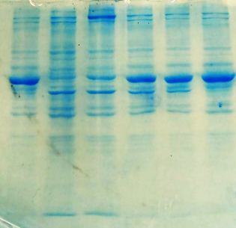

Figure 7.4 – 10 % polyacrylamide gel with Coomassie Blue staining to highlight the protein migration pattern on a variety of protein samples. The bands are distinct, with no smudging or ‘smile effect’ visible.

Figure 7.4 – 10 % polyacrylamide gel with Coomassie Blue staining to highlight the protein migration pattern on a variety of protein samples. The bands are distinct, with no smudging or ‘smile effect’ visible.

7.3.3 WESTERN BLOT
Once the proteins were transferred to the nitrocellulose membrane, Ponceau S stain was added to the membrane and Coomassie Blue stain added to the gel to ensure complete transfer of proteins. Figure 7.5 demonstrates that the conditions used for the western blot were adequate to transfer most of the proteins from the gel to the nitrocellulose membrane.
Moreover, as mentioned previously, the Ponceau S stained would provide evidence to determine whether the amount of protein loaded was equal throughout all of the samples tested. Figure 7.6 displays the amount of staining present throughout the samples were roughly the same, along with the presence of a band found at approximately 50 kDa which was present throughout all samples and appeared to be relatively consistent.

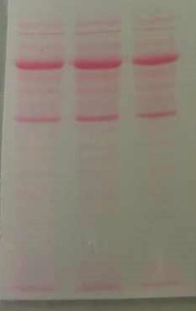
Figure 7.5 – (left) Coomassie Blue staining of polyacrylamide gel after western blot; there is faint staining of bands, but most of the protein has been extracted. (right) Ponceau S staining of the respective nitrocellulose membrane after western blot showing distinct banding and presence of large amounts of protein.

Figure 7.5 – (left) Coomassie Blue staining of polyacrylamide gel after western blot; there is faint staining of bands, but most of the protein has been extracted. (right) Ponceau S staining of the respective nitrocellulose membrane after western blot showing distinct banding and presence of large amounts of protein.

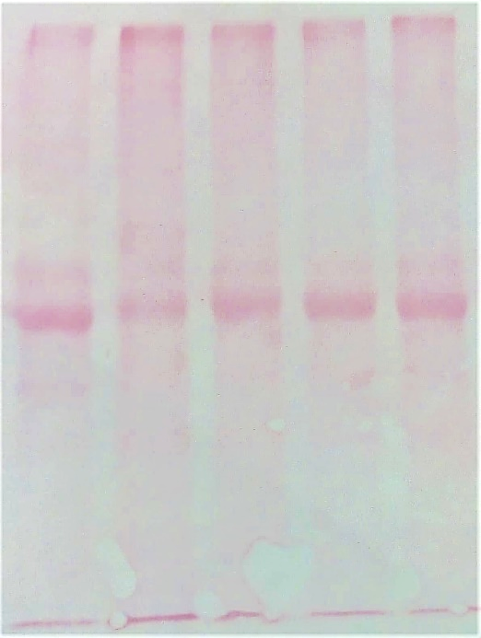
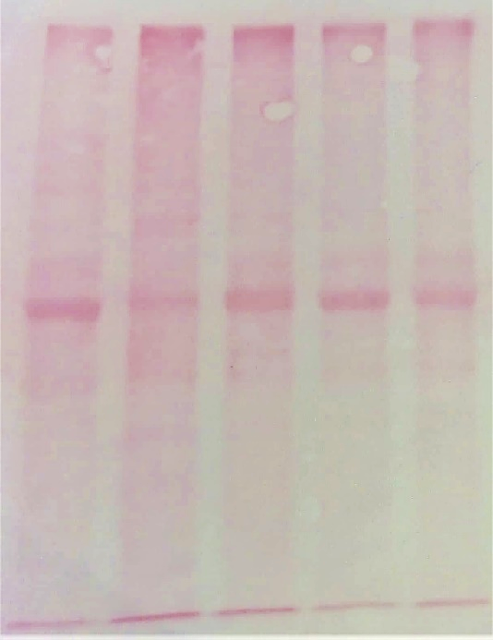
E

200

D

200

C

200

B

200
A

200

E

200

A

200
B

200
C

200

D

200

Molecular Weight (kDa)

Molecular Weight (kDa)
200

200
116

116
NHDF

NHDF
HUVEC

HUVEC
36

36
45

45
66

66
97

97
Figure 7.6 – Ponceau S staining of nitrocellulose membrane with HUVEC and NHDF samples after incubation with 25 U/mL TNF-α for (A) 0, (B) 3, (C) 6, (D) 9 and (E) 12 hours.

Figure 7.6 – Ponceau S staining of nitrocellulose membrane with HUVEC and NHDF samples after incubation with 25 U/mL TNF-α for 0, 3, 6, 9 and 12 hours (left to right).

7.3.4 IMMUNOCHEMISTRY TO DETECT ICAM-1
A combination of antibodies and DAB-peroxidase substrate, as described in chapter 7.2.3, enabled visualisation of ICAM-1 from HUVEC and NHDF cell lysates (figure 7.7 and figure 7.10). Initially, it appeared that when TNF-α was added directly to the cell cultures there was an increase in ICAM-1 abundance, which was significantly enhanced in HUVEC in comparison to NHDF. Moreover, in the pre-conditioned medium experiments there was only an increased ICAM-1 abundance when the pre-conditioning occurred on HUASMC, for both HUVEC and NHDF. Nevertheless, in HUVEC the abundance appeared less than that observed 3 hours post TNF-α addition, whilst in NHDF it was comparable to the results observed 6-12 hours after TNF-α addition in the dot blot.
Figure 7.8 demonstrates that through the analysis of the dot blot a significant up-regulation of DAB staining in HUVEC was present between 0 and 3 hours after TNF-α addition (3076 vs 577, p<0.05), which then plateaued to produce no significant change in area between 3 and 12 hours after TNF-α addition (p=0.619). On the contrary, although in NHDF there appeared to be an increase in area in the presence of TNF-α, there was no significant difference at any time point versus the control (0 hrs); the respective p-values for 3, 6, 9 and 12 hours versus the control were 0.581, 0.571, 0.053 and 0.237.
These expression patterns were different to those observed through confocal image analysis in chapter 4.3.3, where each time-point produced a significant increase in ICAM-1, along with the largest increase presenting between 3 and 6 hours (p<0.001).
The DAB staining for the HUVEC dot blots after incubation with NHDF conditioned medium without TNF-α for 12 hours was comparable to standard HUVEC monoculture without TNF-α (p=0.999). This result was also significantly different to HUVEC after incubation with 25 U/mL TNF-α for 3 hours (p=0.012). There were no other significant differences in area between HUVEC monoculture and any of the conditioned medium experiments (figure 7.9). This was similar in NHDF where, owing to the large variance, no significant results were present when comparing the conditioned medium and monoculture experiments.

A B C D E F G H

A B C D E F G H
NHDF

NHDF

Figure 7.7 – 2 µg dot blots of HUVEC and NHDF cell lysates after incubation with 25 U/mL TNF-α for (A) 0, (B) 3, (C) 6, (D) 9 and (E) 12 hours and (F-H) conditioned medium for 12 hours. (F) NHDF/HUVEC incubated with HUVEC/NHDF conditioned medium without TNF-α, (G) NHDF/HUVEC incubated with HUVEC/NHDF conditioned medium with 25 U/mL TNF-α, (H) NHDF/HUVEC incubated with HUASMC conditioned medium without TNF-α.

Figure 7.7 – 2 µg dot blots of HUVEC and NHDF cell lysates after incubation with 25 U/mL TNF-α for (A) 0, (B) 3, (C) 6, (D) 9 and (E) 12 hours and (F-H) pre-conditioned medium for 12 hours. (F) NHDF/HUVEC incubated with HUVEC/NHDF pre-conditioned medium without TNF-α, (G) NHDF/HUVEC incubated with HUVEC/NHDF pre-conditioned medium with 25 U/mL TNF-α, (H) NHDF/HUVEC incubated with HUASMC pre-conditioned medium without TNF-α.
HUVEC

HUVEC

*

*
Figure 7.8 – Dot blot analysis of HUVEC and NHDF cell lysates after 25 U/mL TNF-α addition for 0-12 hours. The only significant result for HUVEC appeared between 0 and 3 hours after TNF-α addition. In NHDF, although there appears to be an increase between 0 and 3 hours, there were no statistically significant results. Mean ± SEM. (n=3)

Figure 7.8 – Dot blot analysis of HUVEC and NHDF cell lysates after 25 U/mL TNF-α addition for 0-12 hours. The only significant result for HUVEC appeared between 0 and 3 hours after TNF-α addition. In NHDF, although there appears to be an increase between 0 and 3 hours, there were no statistically significant results. Mean ± SEM. (n=3)

Figure 7.9 – Comparison of ICAM-1 abundance in HUVEC and NHDF cell lysates (via dot blot) after the addition of conditioned medium types versus monoculture ± TNF-α for 12 hours. Although there appears to be an increase in area when TNF-α was included, none of the results displayed are statistically significant. Mean ± SEM. (n=3)

Figure 7.9 – Comparison of ICAM-1 abundance in HUVEC and NHDF cell lysates (via dot blot) after the addition of pre-conditioned medium types versus monoculture ± TNF-α for 12 hours. Although there appears to be an increase in area when TNF-α was included, none of the results displayed are statistically significant. Mean ± SEM. (n=3)
DAB staining only highlighted bands present at approximately 100 kDa on the HUVEC western blots. Meanwhile, no bands were observable on the NHDF samples (figure 7.10). There was a distinct increase in ICAM-1 expression at 0-3 hours and 3-6 hours after TNF-α addition. Though the area produced for each sample via western blot (figure 7.11) was considerably larger than the area produced via dot blot (figure 7.8), the trend appeared to be analogous.

E

12
D

9
C

6
B

3
A

0
HUVEC

HUVEC
NHDF

NHDF
Figure 7.10 – Immunolabelling for ICAM-1 after western blotting using 10 µg protein samples revealed bands only for the HUVEC samples; there appeared to be an increase between (A) 0, (B) 3 and (C) 6 hours, followed by little change in DAB staining at (D) 9 hours and (E) 12 hours. (n=1)

Figure 7.10 – Immunolabelling for ICAM-1 after western blotting using 10 µg protein samples revealed bands only for the HUVEC samples; there appeared to be an increase between 0, 3 and 6 hours, followed by little change in DAB staining. (n=1)

Figure 7.11 – Quantitation of ICAM-1 protein from western blot, where HUVEC were incubated with TNF-α for 0-12 hours. No value is presented at 0 hrs owing to the lack of visible band. An increase is DAB staining was observed between 3 and 6 hours after TNF-α addition, which was followed by a plateau. (n=1)

Figure 7.11 – Quantitation of ICAM-1 protein from western blot, where HUVEC were incubated with TNF-α for 0-12 hours. No value is presented at 0 hrs owing to the lack of visible band. An increase is DAB staining was observed between 3 and 6 hours after TNF-α addition, which was followed by a plateau. (n=1)

7.4 DISCUSSION
Dot blots and western blots were carried out on HUVEC and NHDF cell lysate samples after stimulation with TNF-α for 0, 3, 6, 9 and 12 hours to determine whether a similar trend was observed to that obtained through confocal image analysis. Whilst the dot blots revealed ICAM-1 expression in both HUVEC and NHDF, the only expression observable via western blot was in HUVEC samples.
As a result, the data obtained from western blotting could not strengthen nor weaken the conclusions made in previous chapters.

7.4.1 USEFULNESS OF COOMASSIE BLUE AND PONCEAU S STAINING
Coomassie Blue was used to confirm adequate separation of proteins within the polyacrylamide gels. The lower protein detection limit for this technique is approximately 100 ng [260]. Figure 7.4 demonstrates effective band separation, though little protein was detected for proteins with a lower molecular mass; nevertheless ICAM-1 had been estimated to have a molecular weight in the range of 76 - 114 kDa [138, 139] and should therefore present within the top proportion of the gel, where distinct bands were visible.
A limitation of this protein detection method was the requirement for gel fixation, meaning that the proteins could not be transferred to the nitrocellulose membrane for antibody detection thereafter [261]. Consequently, this meant that two gels containing the same protein samples had to be run at the same time: one to be stained with Coomassie Blue and one for electrophoretic transfer and antibody labelling. Owing to the limited sample volumes, Coomassie Blue was only used to confirm correct conditions for protein separation such as voltage and time required and could not be compared to antibody labelling.
Subsequently, Ponceau S stain was used to confirm adequate transfer of proteins from the gel onto the nitrocellulose membrane. Although the lower protein detection limit was higher than Coomassie Blue at approximately 250 ng, the stain was able to detect banding through each lane, confirming sufficient protein transfer (figure 7.5), and could easily be removed through the addition of 0.1 M NaOH [262].
Even though the Ponceau S didn’t provide a strong stain in the range where ICAM-1 was anticipated at the highest protein concentration (10 µg) (figure 7.6), the detection limit was expected to be significantly higher than that of antibody labelling meaning that the inability to observe bands through Ponceau S did not mean that there was not enough ICAM-1 protein present to be detected via antibody labelling.

7.4.2 DOT BLOT VERSUS WESTERN BLOT
After lysates of HUVEC and NHDF were created, the approximate protein concentration of the solution was estimated via BCA assay. The results from this assay indicated that the maximal load into a 10-well 1 mm polyacrylamide gel would be 10 µg, owing to the maximal load volume of 25 µL per well for this set-up. Western blots typically require approximately 20 – 30 µg of protein to be loaded, dependent on the relative abundance of the protein of interest. For the HUVEC lysates, ICAM-1 could be clearly detected when only 5 µg of protein was loaded (figure 7.12) but could not be seen in NHDF when the maximal load of 10 µg was used. Consequently, the relative concentration of ICAM-1 protein in the NHDF samples must have been significantly lower than HUVEC, and below the detection limit for chromogenic substrate detection method (500 pg for HRP/DAB) [263].
Figure 7.12 – Detection of ICAM-1 via western blotting in HUVEC after incubation with 25 U/mL TNF-α for 12 hours. Each lane was loaded with 0, 2.5, 5, 7.5 and 10 µg of total protein (left to right).

Figure 7.12 – Detection of ICAM-1 via western blotting in HUVEC after incubation with 25 U/mL TNF-α for 12 hours. Each lane was loaded with 0, 2.5, 5, 7.5 and 10 µg of total protein (left to right).
There are 3 different methods of protein detection on a membrane after western blot: colorimetric, chemiluminescent and fluorescent. Chemiluminescent detection is the most frequently method used as it allows [263]:
- multiple exposures
- re-probing via the ability to remove detection reagents
- detection and quantitation for a large range of protein concentrations
- greatest sensitivity versus alternative detection methods (can detect as low as femtograms of protein)
Although chemiluminescent detection for the western blots would have been ideal, specialised equipment are required for this method of detection; the light signal is captured on an x-ray film or by a charge-coupled device imager. Chemiluminescent detection also requires trial and error for determining the correct exposure time and thus can prove costly [263]. For that reason, colorimetric detection was chosen owing to its simplicity and cost-effectiveness.
The protein present within the cell lysates could be concentrated via precipitation [264], to which it was decided that acetone precipitation would be ideal. However, owing to the limited volume of lysates, in addition to the ability to obtain only an approximate 70 % yield [265], the concentration of the protein solution after the procedure was carried out was not sufficient to load significantly larger quantities of protein into the gels for SDS-PAGE.
Nevertheless, immunolabelling the lysate after direct application to the nitrocellulose membrane via the dot blot method enabled visualisation of ICAM-1 when the protein quantity was as low at 2 µg in both HUVEC and NHDF. The steps of this procedure are comparable to those during western blot after electrophoretic transfer of the proteins from the SDS-PAGE gel to the nitrocellulose membrane.
However, the dot blot method means that the ICAM-1 protein from within the lysate attaches to the membrane in a smaller surface area and the only way protein can be lost is through the washing and immunolabelling steps, as with the western blot procedure. When carrying out the western blot, protein can also be lost if the samples are not fully denatured (thus do not travel through the SDS-PAGE gel) and through the transfer of the proteins from the gel to the nitrocellulose if the correct conditions have not been used [266], meaning that less protein is attached to the membrane than initially loaded.
The dot blot experiments confirmed that the HUVEC samples contained a significantly higher proportion of ICAM-1 than the NHDF samples. Moreover, when comparing the HUVEC data between the dot blot (figure 7.8) and western blot (figure 7.11), it was apparent that a similar trend was observed when assessing the area under the curve produced via ImageJ analysis of DAB expression.
As previously mentioned in Chapter 2.4.4, ICAM-1 had been estimated to have a molecular weight in the range of 76 - 114 kDa [138, 139]. This was confirmed through the western blot analysis where a single band presented itself at approximately 100 kDa.
Consequently, although the western blotting process had the advantage that it confirmed that ICAM-1 was being specifically labelled, the dot blot process was sufficient to compare the relative abundance of ICAM-1 under the different experimental conditions.

7.4.2 DOT BLOT VERSUS CONFOCAL IMAGE ANALYSIS
With it being confirmed that the data obtained from dot blot was comparable to the western blot, the ICAM-1 expression profile of HUVEC and NHDF could be compared between dot blot and confocal image analysis. In HUVEC, there was a significant increase in DAB and thus ICAM-1 after 3 hours of TNF-α exposure, which then came to a plateau thereafter. This was similar in NHDF, though the increase in DAB was not quite significant. Additionally, there were no significant differences observed in the expression of ICAM-1 in the conditioned medium experiments for both HUVEC and NHDF via dot blot analysis.
Analysis of the western blot data was limited to the ability of observe the area of DAB precipitation on the nitrocellulose membrane. Thus, the range of ICAM-1 protein loaded onto the membrane could only be detected between a specific range. As previously discussed, the lower limit for DAB detection is approximately 500 pg [263], whilst the upper limit is dependent on the incubation time. If the blot was left to develop for too long, high background levels develop, and the bands presented become saturated. This is where strong signals don’t accurately reflect protein levels; they hide actual variation in protein levels and underestimate the amount of protein present. Similar apparent intensities of saturated bands are misleading as they indicate approximate equal levels of protein [267].
In contrast, laser scanning confocal microscopy allows the microscope settings to be adjusted to the fluorescence intensity, where the voltage, pinhole size, offset and gain are adjusted to produce the largest dynamic range [268]. However, care must be taken to ensure the results obtained have not been affected by quenching and/or photobleaching [269].
The trends obtained from western/dot blot analysis were distinctly different to those obtained via confocal image analysis - there was no significant change in ICAM-1 expression in NHDF and a small but significant increase in HUVEC 3 hours after TNF-α addition (figure 4.7); this was followed by a large up-regulation of ICAM-1 at 6 hours and beyond in both cell types. Likewise, with the confocal image analysis producing similar intensity results in HUVEC and NHDF under monoculture conditions, the relative abundance of ICAM-1 on the cell surface is expected to be similar in both cell types.
The reasons for this discrepancy can be owed to the methods of analysis, whereby confocal image analysis only assessed the amount of ICAM-1 present on the surface of the cell membrane, owing to the lack of detergent used during immunolabelling. Meanwhile, cell lysate production involved the destruction of the whole cell construct using strong detergents. Both Triton X-100 and SDS were used, which are non-ionic and anionic surfactants, respectively. These detergents allow the dispersion of hydrophobic compounds in aqueous media, including the extraction and solubilisation of membrane proteins [270].
This meant that antibodies were able to bind to both ICAM-1 that was already expressed on the cell membrane and ICAM-1 that had been synthesised but not yet expressed, such as those stored within intracellular vesicles [141, 271]. Consequently, the approximate 3-hour delay in up-regulation is likely the result of the time it takes from the synthesis and post-translational modification of ICAM-1 to its translocation to the cell membrane to enhance cell surface expression.
Moreover, with the confocal image analysis method producing statistically significant results for each experiment undertaken, this indicates that this method of analysis can detect:
- a larger window of ICAM-1 expression (it can detect a significant result at a lower relative abundance and/or produces a plateau at a higher relative abundance).
- smaller changes in membrane expression than either the dot blot or western blot methods.

7.5 CONCLUSION
The aim of this chapter was to compare the results obtained through both confocal image analysis and western blot, with the purpose of providing confirmatory evidence to the results obtained in previous chapters.
Although only 5 µg of total protein was enough to sufficiently detect ICAM-1 presence in HUVEC cell lysates, the relative abundance of ICAM-1 in NHDF was significantly lower resulting in no detectable bands when 10 µg of total protein was loaded for SDS-PAGE and western blot analysis.
Comparison of dot blot and western blot analysis confirmed this and indicated that the two methods could be interchanged provided the molecular weight of the protein of interest was either already known, or that the specificity of the antibody had already been tested. The only significant result obtained throughout both the dot blot and western blot experiments was the difference in ICAM-1 expression between the control and the HUVEC sample after a 3-hour exposure to 25 U/mL TNF-α in the dot blot (578 vs 3076, p=0.012).
Thus, whilst the data confirmed that a significant increase in ICAM-1 expression can be observed at 3 hours in HUVEC, there was a higher variation in the data obtained from other time-points and therefore there is no statistical significance to confirm the changes seen in ICAM-1 expression (as described in chapter 4 – chapter 6) beyond this.
There were several reasons why this could have occurred, from requiring a minimum of 500 pg of ICAM-1 present for DAB to sufficiently detect the protein, to the ability of adjusting the dynamic range when using confocal microscopy (making this method more sensitive to changes in the amount of ICAM-1 present).
If these studies were repeated, several modifications could have been made:
- Purified ICAM-1 could be used to produce a standard curve of protein present versus DAB intensity.
- Cell lysates with higher protein concentrations could be produced via protein precipitation enabling larger volumes of total protein to be loaded to the western blot system.
- Chemiluminescent detection methods could be used owing to the significantly lower detection limits.
In conclusion, although the western blots could not substantiate previous results, no refutable evidence was displayed signifying the requirement for further western blot experimentation.

CHAPTER 8
CONCLUSIONS AND FUTURE WORK
  - OVERALL CONCLUSIONS
The overall aim of this project was to determine whether the adventitial fibroblast could contribute to vascular inflammation and consequently assess the extent to which it may promote to the progression of diseases such as atherosclerosis. As discussed in chapter 1, a series of objectives were established and executed.
The list of objectives were as follows:
- To provide evidence of fibroblast presence and abundance within human coronary artery through histological and immunohistochemical analysis.
- To establish the culture conditions required to effectively analyse the up-regulation of the inflammatory response in all cell types (medium type, concentration of inflammatory mediator, length of incubation).
- To identify and semi-quantitatively analyse confocal images of ICAM-1 up-regulation in endothelial cells, smooth muscle cells and fibroblasts (in both monoculture and co-culture conditions) and carry out statistical analysis to determine any significant differences in ICAM-1 expression.
- Design experiments to determine the type of signalling occurring between the different cell types and consequently which cytokines may be responsible for any significant differences in ICAM-1 expression observed in co-culture versus monoculture.
Below summarises the work done to accomplish these objectives:
- Paraffin-embedded human coronary artery sections were immunolabelled for α-SMA / THY-1 and compared to comparative sections stained with van Gieson (Chapter 3). Sole labelling of α-SMA and THY-1 highlighted the tunica media and activated endothelium, respectively. Meanwhile, dual labelling was present primarily in the tunica adventitia, likely indicating the presence of myofibroblasts.

- The culture conditions were optimised to assess the up-regulation of ICAM-1 in response to the addition of TNF-α, a pro-inflammatory mediator (Chapter 4). Experiments determined that the lowest concentration of TNF-α examined (25 U/mL) was enough to:
- Induce the up-regulation of ICAM-1 12 hours after its addition to the culture medium.
- Enable any significant differences in the up-regulation of ICAM-1 to be observed.
Moreover, with HUVEC requiring ECGS/H supplementation for growth in monoculture, complete M199 medium was used throughout for continuity and to remove any influence of the supplement.

- ICAM-1 expression was assessed on monocultures (chapter 4) and co-cultures of HUVEC, HUASMC and NHDF (chapter 5). Statistical analysis confirmed that HUASMC increased the expression of ICAM-1 in both HUVEC and NHDF prior to TNF-α addition. After TNF-α supplementation, the up-regulation of ICAM-1 was enhanced in HUVEC in co-culture with NHDF, whilst the extent of ICAM-1 up-regulation was significantly decreased or absent in NHDF when in co-culture with HUVEC and HUASMC, respectively.

- The type of communication method between the different cell types was evaluated using conditioned medium experiments (chapter 6). These highlighted the presence of additional signalling pathways that were not perceivable in monoculture or co-culture studies, such as autocrine signalling. Results also indicated that juxtacrine signalling HUASMC → HUVEC and HUVEC → NHDF was likely, whilst HUVEC/HUASMC → NHDF and NHDF → HUVEC involved paracrine signalling. The overall hypothesised communication network is described in figure 8.1.

- Dot blots and western blots were carried out with the aim to provide confirmatory evidence to the data obtained in chapters 4, 5 and 6. Although the data confirmed that 25 U/mL can cause a significant increase in ICAM-1 expression in HUVEC, all other results were not significant and therefore could not provide confirmatory evidence to previous data attained.
Accordingly, if it was considered that fibroblasts, smooth muscle cells and endothelial cells are present within the tunica adventitia, tunica media and tunica intima, respectively, it can be hypothesised that the level of ICAM-1 expression in the fibroblast may be critical to its position within the vessel during the wound healing response where:
- Direct contact of smooth muscle cells and endothelial cells results in Tyr142-phosphorylation of β-catenin in endothelial cells and subsequent inflammation [230]. This is normally inhibited by endothelial exposure to high shear stresses [80]. However, after endothelial injury or exposure to low shear stresses this inhibition is prevented, inducing the production of pro-inflammatory molecules such as IL-1α, TNF-α and TGF-β, all of which have been shown to act on fibroblasts [209, 210, 211].

- The release of paracrine pro-inflammatory mediators from the endothelium and underlying smooth muscle cells activate the fibroblasts residing in the tunica adventitia. In response, activated fibroblasts synthesise an abundant array of pro-inflammatory cytokines including TGF-β1, IL-1β and IL-33 [203] and adhesion proteins (e.g. ICAM-1) to promote the recruitment of necessary cell types towards the injury site e.g. leukocytes [140]. The fibroblasts also proliferate and begin migration towards the site of injury to produce the required extracellular matrix for wound closure; Acharya et al (2008) confirmed that CD44-dependent TGF-β activation of fibroblasts was essential for fibroblast migration [214].

- After transitioning into the tunica media and then the tunica intima, direct contact with smooth muscle cells and endothelial cells begin to inhibit the TNF-α induced pro-inflammatory response in the fibroblast. This could be through the expression of either FGF10 [221, 223], PGE2 [240, 272] or IL-15 [251, 15] in the endothelial or smooth muscle cells, or through the induction of an inhibitory molecule within the fibroblast.

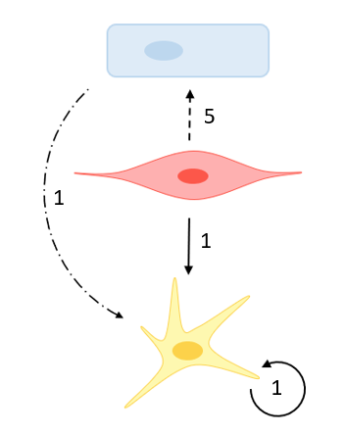
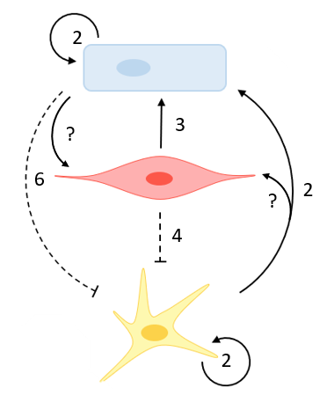
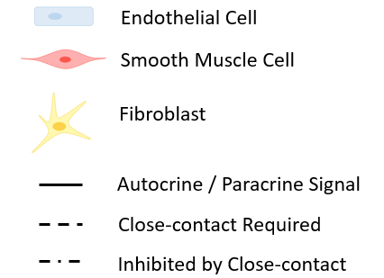
As a result, it can be concluded that the activation of the fibroblast is tightly regulated and is involved in a complex network with endothelial and smooth muscle cells to control the inflammatory response within the vessel. The fibroblast has the ability to enhance the pro-inflammatory response within at least the endothelial cells through paracrine factors. The inclusion of the fibroblast should therefore be considered in future in vitro studies where the underlying chronic vascular inflammatory response that underpins atherogenesis is to be assessed.
FGF10
IL-15

FGF10
IL-15
Phosphorylation of β-catenin

Phosphorylation of β-catenin
TNF-α
TGF-β

TNF-α
TGF-β
?

IL-6
TGF-β

IL-6
TGF-β
TGF-β
IL-1β
IL-33
IL-17

TGF-β
IL-1β
IL-33
IL-17
TGF-β
IL-1β
IL-33

TGF-β
IL-1β
IL-33
PGE₂

VEGF

TNF-α
IL-1α

TNF-α
IL-1α
Without TNF-α

Without TNF-α
With TNF-α

With TNF-α

Figure 8.1 – The hypothesised signalling network with candidates for the responsible signalling molecules. 1) Paracrine pro-inflammatory signals from the endothelial and smooth muscle cells target the fibroblast. The fibroblast also produces an autocrine loop. 2) TNF-α stimulation activates pro-inflammatory gene expression in at least the endothelial and fibroblast cells. The endothelial cell also produces an inhibitory molecule that specifically targets the fibroblast to slightly reduce the pro-inflammatory response observed prior to TNF-α addition. 3) The smooth muscle cells become activated and releases pro-inflammatory molecules that primarily target the endothelial cells. 4) Fibroblast migration to the tunica media leads to partial contact inhibition of TNF-α activation. 5) SMC migration into intima leads to direct contact with endothelial cells and further enhances inflammatory response (provided no high shear stress is present). 6) Migration of fibroblasts into the tunica intima leads to contact with endothelial cells and complete inhibition of inflammatory response.

Figure 8.1 – The hypothesised signalling network with candidates for the responsible signalling molecules. 1) Paracrine pro-inflammatory signals from the endothelial and smooth muscle cells target the fibroblast. The fibroblast also produces an autocrine loop. 2) TNF-α stimulation activates pro-inflammatory gene expression in at least the endothelial and fibroblast cells. The endothelial cell also produces an inhibitory molecule that specifically targets the fibroblast to slightly reduce the pro-inflammatory response observed prior to TNF-α addition. 3) The smooth muscle cells become activated and releases pro-inflammatory molecules that primarily target the endothelial cells. 4) Fibroblast migration to the tunica media leads to partial contact inhibition of TNF-α activation. 5) SMC migration into intima leads to direct contact with endothelial cells and further enhances inflammatory response (provided no high shear stress is present). 6) Migration of fibroblasts into the tunica intima leads to contact with endothelial cells and complete inhibition of inflammatory response.
  - FUTURE WORK
The primary limiting factor for scientific experimental work is the time it takes to carry out even a single experiment. Most procedures that have been run throughout my doctoral studies have been very time-consuming; an experimental period of 12 hours was used to assess ICAM-1 up-regulation, which does not consider cell culture, equipment set-up, sample fixation, immunolabelling or imaging.
Consequently, there are numerous directions in which the work presented can be taken forward:
- The communication mechanisms that underpin the changes in ICAM-1 expression observed in chapter 5 and 6 can be explored further. This would enable the exact protein or chemical species responsible to be pinpointed and could therefore highlight a possible novel mechanism by which the inflammatory response could be controlled.

- The western blot experiments could be repeated and refined to definitively confirm or contest the results obtained in chapters 4, 5 and 6.

- The cell types chosen for the experiments in this thesis could be changed for alternative cell types, such as exchanging HUVEC for HCAEC or NHDF for human aortic adventitial fibroblasts (HAoAF). Fibroblasts exhibit functional specialisation according to their site of origin [273], thus aortic fibroblasts may provide different results to those from the dermis.

- The culture arrangement for this thesis consisted of culturing cells on a 2D surface but could be transformed into a 3D set-up like those described in chapter 2.6. 3D structures provide a more biomimetic environment and enable both spacio-temporal distributions to be examined and the ability to stimulate only one cell type whilst maintaining a co-culture design.

- Endothelial cells are typically exposed to high shear stress in vivo, with low shear stress being linked to a pro-atherogenic condition. Therefore, the introduction of high shear stress would likely yield different ICAM-1 expression patterns to those observed in static culture.

The ideal model to study the inflammatory response in an in vitro vascular model would be one that simulates the in vivo environment, thus including both a 3D structure and shear stress induction on only the endothelial cells. Owing to the complexity of this environment, challenges remain related to the mechanical environment, distribution of nutrients and imaging. Nevertheless, simplified in vitro models can still provide useful evidence to provide backing or to discount possible therapeutic actions. With continued improvements in technology, the challenges currently faced will be overcome enabling the study of how different factors interweave to produce adverse outcomes, such as those seen in atherogenesis.

BIBLIOGRAPHY

[1] | WHO, "Top 10 Causes of Death Worldwide," 2 August 2015. [Online]. Available: http://www.who.int/mediacentre/factsheets/fs310/en/index1.html.
[2] | BHF, "Cardiovascular Disease," 2 August 2017. [Online]. Available: https://www.bhf.org.uk/heart-health/conditions/cardiovascular-disease.
[3] | R. J. Frink, Inflammatory Atherosclerosis: Characteristics of the Injurious Agent, Heart Research Foundation, 2002.
[4] | W. M. Russell and R. L. Burch, The Principles of Humane Experimental Technique, Wheathampstead (UK): Universities Federation for Animal Welfare., 1959.
[5] | NC3Rs, "The 3Rs," 2018. [Online]. Available: https://www.nc3rs.org.uk/the-3rs. [Accessed 02 August 2018].
[6] | L. Gui, B. C. Dash, J. Luo, L. Qin, L. Zhao and K. Yamamoto, "Implantable Tissue-engineered Blood Vessels from Human Induced Pluripotent Stem Cells," Biomaterials, vol. 102, pp. 120-129, 2016.
[7] | A. Pircher, L. Treps, N. Bodrug and P. Carmeliet, "Endothelial Cell Metabolism: A Novel Player in Atherosclerosis? Basic Principles and Therapeutic Opportunities," Atherosclerosis, vol. 253, pp. 247-257, 2016.
[8] | M. R. Bennett, S. Sinha and G. K. Owens, "Vascular Smooth Muscle Cells in Atherosclerosis," Circ Res, no. 118, pp. 692-702, 2016.
[9] | K. J. Moore and I. Tabas, "Macrophages in the Pathogenesis of Atherosclerosis," Cell, vol. 145, no. 3, pp. 341-355, 2011.
[10] | M. W. Majesky, "Adventitia and Perivascular Cells," Arterioscler Thromb Vasc Biol, no. 35, pp. e31-e35, 2015.
[11] | K. H. Benam, S. Dauth, B. Hassell, A. Herland, A. Jain, K. Jang, K. Karalis, H. J. Kim, L. MacQueen, R. Mahmoodian, S. Musah, Y. Torisawa, A. D. van der Meer, R. Villenave, M. Yadid, K. K. Parker and D. E. Ingber, "Engineered In Vitro Disease Models," Annu Rev Pathol Mech Dis, vol. 10, p. 195–262, 2015.
[12] | P. Bainbridge, "Wound Healing and the Role of Fibroblasts," J Wound Care, vol. 22, no. 8, pp. 407-412, 2013.
[13] | J. Vilcek, M. Tsujimoto, V. J. Palombella, M. Kohase and J. Le, "Tumor Necrosis Factor: Receptor Binding and Mitogenic Action in Fibroblasts.," J Cell Physiol Suppl, vol. Suppl 5, pp. 57-61, 1987.
[14] | J. L. Bankers-Fulbright, K. R. Kalli and D. J. McKean, "Interleukin-1 Signal Transduction," Life Sci, vol. 59, no. 2, pp. 61-83, 1996.
[15] | D. M. Wuttge, M. Wildt, A. Scheja and G. Westergren-Thorsson, "Interleukin-15 Attenuates Transforming Growth Factor-β1-induced Myofibroblast Differentiation in Human Fetal Lung Fibroblasts," Eur Cytokine Netw, vol. 21, no. 3, pp. 165-76, 2010.
[16] | A. J. Merched, K. Ko, K. H. Gotlinger, C. N. Serhan and L. Chan, "Atherosclerosis: Evidence for Impairment of Resolution of Vascular Inflammation Governed by Specific Lipid Mediators," FASEB J, vol. 22, no. 10, p. 3595–3606, 2008.
[17] | M. L. Albuquerque, C. M. Waters, U. Savla , H. W. Schnaper and A. S. Flozak, "Shear Stress Enhances Human Endothelial Cell Wound Closure In Vitro.," Am J Physiol Heart Circ Physiol, vol. 279, no. 1, pp. H293-302, 2000.
[18] | D. Shav, R. Gotlieb, U. Zaretsky, D. Elad and S. Einav, "Wall Shear Stress Effects on Endothelial-Endothelial and Endothelial-Smooth Muscle Cell Interactions in Tissue Engineered Models of the Vascular Wall," PLoS ONE, vol. 9, no. 2, p. e88304, 2014.
[19] | S. S. M. Rensen, P. A. F. M. Doevendans and G. J. J. M. van Eys, "Regulation and Characteristics of Vascular Smooth Muscle Cell Phenotypic Diversity," Neth Heart J, vol. 15, pp. 100-108, 2007.
[20] | C. Lawson and S. Wolf, "ICAM-1 Signaling in Endothelial Cells," Pharmacol Rep, vol. 61, no. 1, pp. 22-32, 2009.
[21] | B. E. Rolfe, J. D. Muddiman, N. J. Smith, G. R. Campbell and J. H. Campbell, "ICAM-1 Expression by Vascular Smooth Muscle Cells is Phenotype-dependent," Atherosclerosis, pp. 99-110, 2000.
[22] | T. Horikoshi, K. Ezoe, H. Nakagawa, H. Eguchi, N. Hanada and S. Hamaoka, "Up-regulation of ICAM-1 Expression on Human Dermal Fibroblasts by IFN β in the Presence of TNF-α," FEBS Letters, vol. 363, no. 1-2, pp. 141-144, 1995.
[23] | C. W. Smith, S. D. Marlin, R. Rothlein, C. Toman and D. C. Anderson, "Cooperative Interactions of LFA-1 and MAC-1 with Intercellular Adhesion Molecule-1 in Facilitating Adherence and Transendothelial Migration of Human Neutrophils In Vitro," J Clin Invest, vol. 83, no. 6, pp. 2008-2017, 1989.
[24] | The Nations Online Project, "The Human Development Index," Nations Online, 2016. [Online]. Available: www.nationsonline.org/oneworld/human_development.htm. [Accessed 7 April 2018].
[25] | WHO, "The Global Burden of Disease: 2004 Update," 2004.
[26] | WHO, "Noncommunicable Diseases Country Profiles 2014," 2014.
[27] | United Nations, "Human Development Report 2016: Human Development For Everyone," United Nations Development Programme, 2016.
[28] | BHF, "Cardiovascular Disease Statistics 2017," 2017.
[29] | M. F. Piepoli and G. Q. Villani, "Lifestyle Modification in Secondary Prevention," Eur J Prev Cardiol, vol. 24, no. 3, pp. 101-107, 2017.
[30] | A. Y. Chong, A. D. Blann and G. Y. H. Lip, "Assessment of Endothelial Damage and Dysfunction: Observations in Relation to Heart Failure," Q J Med, no. 96, p. 253–267, 2003.
[31] | J. A. Eurell, Veterinary Histology, Teton NewMedia, 2004.
[32] | D. P. Giddens, C. K. Zarins and S. Glagov, "The Role of Fluid Mechanics in the Localization and Detection of Atherosclerosis.," J Biomech Eng, vol. 115, no. 4B, pp. 588-594, 1993.
[33] | P. A. VanderLaan, C. A. Reardon and G. S. Getz, "Site Specificity of Atherosclerosis," Arterioscler Thromb Vasc Biol, vol. 24, pp. 12-22, 2004.
[34] | Y. S. Chatzizisis, A. U. Coskun, M. Jonas, E. R. Edelman, C. L. Feldman and P. H. Stone, "Role of Endothelial Shear Stress in the Natural History of Coronary Atherosclerosis and Vascular Remodeling," JACC, vol. 49, no. 25, pp. 2379-2393, 2007.
[35] | D. Rubenstein, W. Yin and M. D. Frame, Biofluid Mechanics: An Introduction to Fluid Mechanics, Macrocirculation, and Microcirculation, Academic Press, 2015.
[36] | L. E. Hudsmith, S. E. Petersen, J. M. Francis, M. D. Robson and S. Neubauer, "Normal Human Left and Right Ventricular and Left Atrial Dimensions Using Steady State Free Precession Magnetic Resonance Imaging," J Cardiovasc Magn Reson, vol. 7, no. 5, pp. 775-782, 2005.
[37] | R. S. Snell, Clinical Anatomy by Regions, Lippincott Williams & Wilkins, 2008.
[38] | I. Gradus-Pizlo, B. Bigelow, Y. Mahomed, S. G. Sawada, K. Rieger and H. Feigenbaum, "Left Anterior Descending Coronary Artery Wall Thickness Measured by High-Frequency Transthoracic and Epicardial Echocardiography Includes Adventitia," vol. 91, 2003.
[39] | U. P. Gujral, E. Vittinghoff, M. Mongraw-Chaffin, D. Vaidya, N. R. Kandula, M. Allison, J. Carr, K. Liu, V. Narayan and A. M. Kanaya, "Cardiometabolic Abnormalities Among Normal-Weight Persons From Five Racial/Ethnic Groups in the United States: A Cross-sectional Analysis of Two Cohort Studies," Ann Intern Med, vol. 166, no. 9, pp. 628-636, 2017.
[40] | A. H. E. M. Maas and Y. E. A. Appelman, "Gender Differences in Coronary Heart Disease," Neth Heart J, vol. 18, no. 12, pp. 598-602, 2010.
[41] | P. Rubba, M. Gentile, G. Marotta, A. Iannuzzi, M. Sodano, B. De Simone, F. Jossa, G. Iannuzzo, C. Giacobbe, M. D. Di Taranto and G. Fortunato, "Causative Mutations and Premature Cardiovascular Disease in Patients with Heterozygous Familial Hypercholesterolaemia," Eur J Prev Cardiol, vol. 24, no. 10, pp. 1051-1059, 2017.
[42] | M. Hernandez, C. Lopez, J. Real, J. Valls, E. O. M. de Victoria, F. Vazquez, E. Rubinat, M. Granado-Casas, N. Alonso and T. Moli, "Preclinical Carotid Atherosclerosis in Patients with Latent Autoimmune Diabetes in Adults (LADA), Type 2 Diabetes and Classical Type 1 Diabetes," Cardiovasc Diabetol, vol. 16, p. 94, 2017.
[43] | G. Albrektsen, I. Heuch, M. L. Lochen, D. S. Thelle, T. Wilsgaard, I. Njolstad and K. H. Bonaa, "Risk of Incident Myocardial Infarction by Gender: Interactions with Serum Lipids, Blood Pressure and Smoking. The Tromso Study 1979-2012," Atherosclerosis, vol. 261, pp. 52-59, 2017.
[44] | P. D. Bishop, L. E. Feiten, K. Ouriel, S. P. Nassoiy, M. L. Pavkov, D. G. Clair and V. S. Kashyap, "Arterial Calcification Increases in Distal Arteries in Patients with Peripheral Arterial Disease," Ann Vasc Surg, vol. 22, no. 6, pp. 799-805, 2008.
[45] | S. Zadelaar, R. Kleemann, L. Verschuren, J. Vries-Van der Weij, J. van der Hoorn, H. M. Princen and T. Kooistra, "Mouse Models for Atherosclerosis and Pharmaceutical Modifiers," Arteriscler Thromb Vasc Biol, vol. 27, pp. 1706-1721, 2007.
[46] | R. Virmani, F. D. Kolodgie, A. P. Burke, A. Farb and S. M. Schwartz, "Lessons From Sudden Coronary Death: A Comprehensive Morphological Classification Scheme for Atherosclerotic Lesions.," Arterioscler Thromb Vasc Biol, vol. 20, no. 5, pp. 1262-1275, 2000.
[47] | J. Steffel, T. F. Lüscher and F. C. Tanner, "Tissue Factor in Cardiovascular Diseases," Circulation, vol. 113, pp. 722-731, 2006.
[48] | S. S. Ahanchi, N. D. Tsihlis and M. R. Kibbe, "The Role of Nitric Oxide in the Pathophysiology of Intimal Hyperplasia," J Vasc Sci, vol. 45, no. 6, pp. A64-A73, 2007.
[49] | S. Glagov, E. Weisenberg, C. K. Zarins, R. Stankunavicius and G. J. Kolettis, "Compensatory Enlargement of Human Atherosclerotic Coronary Arteries," N Engl J Med, vol. 316, pp. 1371-1375, 1987.
[50] | H. Berglund, H. Luo, T. Nishioka, M. C. Fishbein, N. L. Eigler, S. W. Tabak and R. J. Siegel, "Highly Localized Arterial Remodeling in Patients With Coronary Atherosclerosis," Circulation, vol. 96, pp. 1470-1476, 1997.
[51] | R. S. Schwartz and D. R. Holmes, "Restenosis and the Proportional Neointimal Response to Coronary Artery Injury: Results in a Porcine Model," JACC, vol. 19, no. 2, pp. 267-274, 1992.
[52] | H. Robenek and N. J. Severs, Cell Interactions in Atherosclerosis, CRC Press, 1992.
[53] | J. J. Wentzel, Y. S. Chatzizisis, F. J. H. Gijsen, G. D. Giannoglou, C. L. Feldmen and P. H. Stone, "Endothelial Shear Stress in the Evolution of Coronary Atherosclerotic Plaque and Vascular Remodelling: Current Understanding and Remaining Questions," Cardiovasc Res, vol. 96, no. 2, pp. 234-243, 2012.
[54] | G. Dangas and F. Kuepper, "Restenosis: Repeat Narrowing of a Coronary Artery," Circulation, vol. 105, pp. 2586-2587, 2002.
[55] | T. Masuoka, N. Hayashi, E. Hori, N. Kuwayama, O. Ohtani and S. Endo, "Distribution of Internal Elastic Lamina and External Elastic Lamina in the Internal Carotid Artery: Possible Relationship with Atherosclerosis," Neurol Med Chir (Tokyo), vol. 50, no. 3, pp. 179-182, 2010.
[56] | S. M. Kimani, J. A. Ogeng'o, H. Saidi and B. Ndung'u, "Comparative Intimal-media Morphology of the Human Splenic and Common Hepatic Arteries," J Morphol Sci, vol. 28, no. 1, pp. 52-56, 2011.
[57] | D. Echeverri, G. Santamaria, V. Fuster, W. N. O'Connor and P. R. Moreno, "Rupture of the External Elastic Lamina Increases Plaque Neovascularization After Coronary Angioplasty in the Swine Model," J Am Coll Cardiol, vol. 41, no. 6s1, pp. 55-56, 2003.
[58] | H. A. Dbouk, R. M. Mroue, M. E. El-Sabban and R. S. Talhouk, "Connexins: a myriad of functions extending beyond assembly of gap junction channels," vol. 7, 2009.
[59] | C. A. Papaharalambus and K. K. Griendling, "Basic Mechanisms of Oxidative Stressand Reactive Oxygen Species in Cardiovascular Injury," Trends Cardiovasc Med, vol. 17, pp. 48-54, 2007.
[60] | C. Lin and B. Lilly, "Notch Signaling Governs Phenotypic Modulation of Smooth Muscle Cells," Vascul Pharmacol, vol. 63, no. 2, pp. 88-96, 2014.
[61] | J. C. Zhang, Q. Ruan, L. Paucz, A. Fabry, B. R. Binder and J. Wojta, "Stimulation of Tissue Factor Expression in Human Microvascular and Macrovascular Endothelial Cells by Cultured Vascular Smooth Muscle Cells In Vitro," J Vas Res, vol. 36, pp. 126-132, 1999.
[62] | K. R. Stenmark, M. E. Yeager, K. C. El Kasmi, E. Nozik-Grayck, E. V. Gerasimovskaya, M. Li, S. R. Riddle and M. G. Frid, "The Adventitia: Essential Regulator of Vascular Wall Structure and Function," Annu Rev Physiol, vol. 75, pp. 23-47, 2013.
[63] | Z. Shi and J. M. Tarbell, "Fluid Flow Mechanotransduction in Vascular Smooth Muscle Cells and Fibroblasts," Ann Biomed Eng, vol. 39, no. 6, pp. 1608-1619, 2011.
[64] | S. Sartore, A. Chiavegato, E. Faggin, R. Franch, M. Pauto, S. Ausoni and P. Pauletto, "Contribution of Adventitial Fibroblasts to Neointima Formation and Vascular Remodeling - From Innocent Bystander to Active Participant," Circ Res, vol. 89, no. 12, pp. 1111-1121, 2001.
[65] | L. F. Castella, L. Buscemi, C. Godbout, J. Meister and B. Hinz, "A New Lock-step Mechanism of Matrix Remodelling Based on Subcellular Contractile Events," J Cell Sci, vol. 123, pp. 1751-1780, 2010.
[66] | G. Li, S. Chen, S. Oparil, Y. Chen and J. A. Thompson, "Direct In Vivo Evidence Demonstrating Neointimal Migration of Adventitial Fibroblasts After Balloon Injury of Rat Carotid Arteries," Circulation, vol. 101, pp. 1362-1265, 2000.
[67] | J. Scheller, A. Chalaris, D. Schmidt-Arras and S. Rose-John, "The Pro- and Anti-inflammatory Properties of the Cytokine Interleukin 6," Biochemica et Biophysica Acta, vol. 1813, pp. 878-888, 2011.
[68] | P. A. Kingston, S. Sinha, A. David, M. G. Castro, P. R. Lowenstein and A. M. Heagerty, "Adenovirus-Mediated Gene Transfer of a Secreted Transforming Growth Factor-b Type II Receptor Inhibits Luminal Loss and Constrictive Remodeling After Coronary Angioplasty and Enhances Adventitial Collagen Deposition," Circulation, vol. 104, pp. 2595-2601, 2001.
[69] | P. Chen, L. Qin, N. Baeyens, G. Li, T. Afolabi, M. Budatha, G. Tellides, M. A. Schwartz and M. Simons, "Endothelial-to-mesenchymal Transition Drives Atherosclerosis Progression," J Clin Invest, vol. 125, no. 12, pp. 4514-4528, 2015.
[70] | M. Magnoni, S. Coli, M. M. Marrocco-Trischitta, G. Melisurgo, D. De Dominicis, D. Cianflone, R. Chiesa, S. B. Feinstein and A. Maseri, "Contrast-enhanced Ultrasound Imaging of Periadventitial Vasa Vasorum in Human Carotid Arteries," Eur J Echocardiogr, vol. 10, pp. 260-264, 2009.
[71] | D. D. Heistad and M. L. Marcus, "Role of Vasa Vasorum in Nourishment of the Aorta.," Blood Vessels, vol. 16, no. 5, pp. 225-38, 1979.
[72] | K. S. Moulton, K. Vakili, D. Zurakowski, M. Soliman, C. Butterfield, E. Sylvin, K. Lo, S. Gillies, K. Javaherian and J. Folkman, "Inhibition of Plaque Neovascularization Reduces Macrophage Accumulation and Progression of Advanced Atherosclerosis," PNAS, vol. 100, no. 8, pp. 4736-4741, 2003.
[73] | K. Drodz, D. Janczak, P. Dziegiel, M. Podhorska, A. Piotrowska, D. Patrzalek, R. Andrzejak and A. Szuba, "Adventitial Lymphatics and Atherosclerosis," Lymphology, vol. 45, no. 1, pp. 26-33, 2012.
[74] | M. Inoue, H. Itoh, M. Ueda, T. Naruko, A. Kojima, R. Komatsu, K. Doi, Y. Ogawa, N. Tamura, N. Takaya, T. Igaki, J. Yamashita, T. H. Chun, K. Masatsuga, A. E. Becker and K. Nakao, "Vascular Endothelial Growth Factor (VEGF) Expression in Human Coronary Atherosclerotic Lesions: Possible Pathophysiological Significance of VEGF in Progression of Atherosclerosis," Circulation, vol. 98, no. 20, pp. 2108-2116, 1998.
[75] | T. Nakano and K. Sueishi, "Angiogenesis and Lymphangiogenesis and Expression of Lymphangiogenic Factors in the Atherosclerotic Intima of Human Coronary Arteries," Hum Pathol, vol. 36, no. 4, pp. 330-340, 2005.
[76] | K. Zhi, M. Li, X. Zhang, Z. Gao, J. Bai, Y. Wu, S. Zhou, M. Li and L. Qu, "a4b7 Integrin (LPAM-1) is Upregulated at Atherosclerotic Lesions and is Involved in Atherosclerosis Progression," Cell Physiol Biochem, vol. 33, pp. 1867-1887, 2014.
[77] | Y. Feng, Z. R. Cai, Y. Tang, G. Hu, J. Lu, D. He and S. Wang, "TLR4/NF-κB Signaling Pathway-mediated and oxLDL-induced Up-regulation of LOX-1, MCP-1, and VCAM-1 Expressions in Human Umbilical Vein Endothelial Cells," Genet Mol Res, vol. 13, pp. 680-695, 2014.
[78] | S. Carta, R. Lavieri and A. Rubartelli, "Different Members of the IL-1 Family Come Out in Different Ways: DAMPs vs. Cytokines?," Front Immunol, vol. 4, p. 123, 2013.
[79] | G. E. Rainger, P. Stone, C. M. Morland and G. B. Nash, "A Novel System for Investigating the Ability of Smooth Muscle Cells and Fibroblasts to Regulate Adhesion of Flowing Leukocytes to Endothelial Cells," J Immunol Methods, vol. 255, pp. 73-82, 2001.
[80] | J. J. Chiu, L. J. Chen, S. F. Chang, P. L. Lee, C. I. Lee, M. C. Tsai, D. Y. Lee, H. P. Hseih, S. Usami and S. Chien, "Shear Stress Inhibits Smooth Muscle Cell-induced Inflammatory Gene Expression in Endothelial Cells: Role of NF-kappaB.," Arterioscler Thromb Vasc Biol, vol. 25, pp. 963-969, 2005.
[81] | C. S. Wallace and G. A. Truskey, "Direct-contact Co-culture Between Smooth Muscle and Endothelial Cells Inhibits TNF-alpha-mediated Endothelial Cell Activation.," Am J Physiol Heart Circ Physiol, vol. 299, pp. 338-346, 2010.
[82] | K. S. Michelsen, M. H. Wong, P. K. Shah, W. Zhang, J. Yano, T. M. Doherty, S. Akira, T. B. Rajavashisth and M. Arditi, "Lack of Toll-like Receptor 4 or Myeloid Differentiation Factor 88 Reduces Atherosclerosis and Alters Plaque Phenotype in Mice Deficient in Apolipoprotein E," Proc Natl Acad Sci U S A, vol. 101, no. 29, pp. 10679-10684, 2004.
[83] | T. Seimon and I. Tabas, "Mechanisms and Consequences of Macrophage Apoptosis in Atherosclerosis.," J Lipid Res, vol. 50, no. Suppl, pp. S382-387, 2009.
[84] | G. K. Hansson and A. Hermansson, "The Immune System in Atherosclerosis," Nat Immunol, vol. 12, pp. 204-212, 2011.
[85] | A. J. Dannenberg and N. A. Berger, Obesity, Inflammation and Cancer, Springer Science & Business Media, 2013.
[86] | A. Oeckinghaus and S. Ghosh, "The NF-kB Family of Transcription Factors and its Regulation," Cold Spring Harb Perspect Biol, vol. 1, p. a00003, 2009.
[87] | P. L. Hermonat, H. Zhu, M. Cao and J. Mehta, "LOX-1 Transcription," Cardiovasc Drugs Ther, vol. 25, pp. 393-400, 2011.
[88] | M. Braun, P. Pietsch, K. Schror, G. Baumann and S. B. Felix, "Cellular Adhesion Molecules on Vascular Smooth Muscle Cells," Cardiovasc Res, vol. 41, no. 2, pp. 395-401, 1999.
[89] | K. Chen, J. Chen, Y. Liu, J. Xie, D. Li, T. Sawamura, P. L. Hermonat and J. L. Mehta, "Adhesion Molecule Expression in Fibroblasts," Hypertension, vol. 46, pp. 622-627, 2005.
[90] | H. Lee, C. I. Lin, J. Liao, Y. Lee, H. Y. Yang, C. Lee, H. Hsu and H. L. Wu, "Lysophospholipids Increase ICAM-1 Expression in HUVEC Through a Gi- and NF-κB-dependent Mechanism," Am J Physiol Cell Physiol, vol. 287, no. 6, pp. C1657-C1666, 2004.
[91] | A. Rahman, J. Kefer, M. Bando, W. D. Niles and A. B. Malik, "E-selectin Expression in Human Endothelial Cells by TNF-alpha-induced Oxidant Generation and NF-kappaB Activation.," Am J Physiol, vol. 275, pp. L533-44, 1998.
[92] | G. Li, J. M. Sanders, E. T. Phan, K. Ley and I. J. Sarembock, "Arterial Macrophages and Regenerating Endothelial Cells Express P-Selectin in Atherosclerosis-Prone Apolipoprotein E-Deficient Mice," Am J Pathol, vol. 167, no. 6, pp. 1511-18, 2005.
[93] | J. M. Cook-Mills, M. E. Marchese and H. Abdala-Valencia, "Vascular Cell Adhesion Molecule-1 Expression and Signaling During Disease: Regulation by Reactive Oxygen Species and Antioxidants," Antioxid Redox Signal, vol. 15, no. 6, pp. 1607-1638, 2011.
[94] | K. Maiellaro and R. W. Taylor, "The Role of the Adventitia in Vascular Inflammation," Cardiovasc Res, vol. 75, no. 4, pp. 640-648, 2007.
[95] | C. Monaco, E. Andreakos, S. Kiriakidis, C. Mauri, C. Bicknell, B. Foxwell, N. Cheshire, E. Paleolog and M. Feldmann, "Canonical Pathway of Nuclear Factor κB Activation Selectively Regulates Proinflammatory and Prothrombotic Responses in Human Atherosclerosis," PNAS, vol. 101, no. 15, p. 5634–5639, 2004.
[96] | R. Dewberry, H. Holden, D. Crossman and S. Francis, "Interleukin-1 Receptor Antagonist Expression in Human Endothelial Cells and Atherosclerosis," Arterioscler Thromb Vasc Biol, vol. 20, no. 11, pp. 2394-400, 2000.
[97] | M. Mihara, M. Hashizume, H. Yoshida, M. Suzuki and M. Shiina, "IL-6/IL-6 Receptor System and its Role in Physiological and Pathological Conditions," Clin Sci, vol. 122, no. 4, pp. 143-159, 2012.
[98] | H. Wang, L. Bai, B. Shen, Z. Yan and Z. Jiang, "Coculture with Endothelial Cells Enhances Vascular Smooth Muscle Cell Adhesion and Spreading Via Activation of β1-integrin and Phosphatidylinositol 3-kinase/Akt," EJCB, vol. 86, no. 1, 2007.
[99] | A. R. Brasier, "The Nuclear Factor-κB–interleukin-6 Signalling Pathway Mediating Vascular Inflammation," Cardiovasc Res, vol. 86, no. 2, pp. 211-218, 2018.
[100] | X. H. Shen, S. J. Xu, C. Y. Jin, F. Ding, Y. C. Zhou and G. S. Fu, "Interleukin-8 Prevents Oxidative Stress-induced Human Endothelial Cell Senescence via Telomerase Activation," Int J Immunopharmacol, vol. 16, no. 2, pp. 261-267, 2013.
[101] | J. J. van der Meer, O. J. de Boer, P. Teeling, C. M. van der Loos, M. C. Dessing and A. C. van der Wal, "Smooth Muscle Homeostasis in Human Atherosclerotic Plaques Through Interleukin 15 Signalling," Int J Clin Exp Pathol, vol. 4, no. 3, pp. 287-294, 2011.
[102] | D. M. Wuttge, P. Eriksson, A. Sirsjo, G. K. Hansson and S. Stemme, "Expression of Interleukin-15 in Mouse and Human Atherosclerotic Lesions," Am J Pathol, vol. 159, no. 2, pp. 417-423, 2001.
[103] | S. Bertok, M. R. Wilson, A. D. Dorr, J. O. Dokpesi, K. P. O'Dea, N. Marczin and M. Takato, "Characterization of TNF Receptor Subtype Expression and Signaling on Pulmonary Endothelial Cells in Mice," Am J Physiol Lung Cell Mol Physiol, vol. 300, no. 5, pp. L781-L789, 2011.
[104] | K. Peppel, L. Zhang, E. S. Orman, P. Hagen, A. Amalfitano, L. Brian and N. J. Freedman, "Activation of Vascular Smooth Muscle Cells by TNF and PDGF: Overlapping and Complementary Signal Transduction Mechanisms," Cardiovasc Res, vol. 65, no. 3, pp. 674-682, 2005.
[105] | N. G. dela Paz, T. E. Walshe, L. L. Leach, M. Saint-Geniez and P. A. D'Amore, "Role of Shear-stress-induced VEGF Expression in Endothelial Cell Survival," J Cell Sci, vol. 125, no. 4, pp. 831-843, 2012.
[106] | M. J. Morgan and Z. Liu, "Crosstalk of Reactive Oxygen Species and NF-kB Signalling," Cell res, vol. 21, pp. 103-115, 2011.
[107] | F. Hao, M. Tan, D. D. Wu, X. Xu and M. Cui, "LPA Induces IL-6 Secretion from Aortic Smooth Muscle Cells via an LPA1-regulated, PKC-dependent, and p38α-mediated Pathway," Am J Physiol Heart Circ Physiol, vol. 298, no. 3, pp. H974-H983, 2010.
[108] | C. Gustin, M. Van Steenbrugge and M. Raes, "LPA Modulates Monocyte Migration Directly and via LPA-stimulated Endothelial Cells," Am J Physiol Cell Physiol, vol. 295, no. 4, pp. C905-C914, 2008.
[109] | P. M. Ridker, N. Rifai, M. Pfeffer, F. Sacks, S. Lepage and E. Braunwald, "Elevation of tumor necrosis factor-alpha and increased risk of recurrent coronary events after myocardial infarction.," vol. 101, no. 18, 2000.
[110] | E. Bremer, "Targeting of the Tumor Necrosis Factor Receptor Superfamily for Cancer Immunotherapy," ISRN Oncology, 2013.
[111] | V. Baud and M. Karin, "Signal Transduction by Tumor Necrosis Factor and its Relatives," Trends Cell Biol, vol. 11, no. 9, pp. 372-377, 2001.
[112] | T. Hou, B. C. Tieu, S. Ray, A. Recinos III, R. Cui, R. G. Tilton and A. R. Brasier, "Roles of IL-6-gp130 Signaling in Vascular Inflammation," vol. 4, no. 3, 2008.
[113] | T. Kishimoto, "IL-6: From its Discovery to Clinical Applications," Int Immunol, vol. 22, no. 5, pp. 347-352, 2010.
[114] | Y. D. Jung, F. Fan, D. J. McConkey, M. E. Jean, W. Liu, N. Reinmuth, O. Stoeltzing, S. A. Ahmad, A. A. Parikh, N. Mukaida and L. M. Ellis, "Role of P38 MAPK, AP-1, and NF-kB in Interleukin-1b-induced IL-8 Expression in Human Vascular Smooth Muscle Cells," Cytokine, vol. 18, no. 4, pp. 206-213, 2002.
[115] | D. J. Metcalf, T. D. Nightingale, H. L. Zenner, W. W. Lui-Roberts and D. F. Cutler, "Formation and Function of Weibel-Palade Bodies," J Cell Sci, vol. 121, pp. 19-27, 2007.
[116] | O. Huet, E. Laemmel, Y. Fu, L. Dupic, A. Aprico, K. L. Andrews, S. L. Moore, A. Harrois, P. L. Meikle, E. Vicaut, J. P. F. Chin-Dusting and J. Duranteau, "Interleukin 10 Antioxidant Effect Decreases Leukocytes/Endothelial Interaction Induced by Tumor Necrosis Factor α," Shock, vol. 39, no. 1, pp. 83-88, 2013.
[117] | X. Han and W. A. Boisvert, "Interleukin-10 protects against atherosclerosis by modulating multiple atherogenic macrophage function.," vol. 113, no. 3, 2015.
[118] | A. Leychenko, E. Konorev, M. Jijiwa and M. L. Matter, "Stretch-Induced Hypertrophy Activates NFkB-Mediated VEGF Secretion in Adult Cardiomyocytes," PLoS ONE, vol. 6, no. 12, p. e29055, 2011.
[119] | T. P. Quinn and M. Schlueter, "Mechanotransduction in the Lung Cyclic Mechanical Stretch Induces VEGF and FGF-2 Expression in Pulmonary Vascular Smooth Muscle Cells," Am J Physiol Lung Cell Mol Physiol, vol. 282, p. L897–L903, 2001.
[120] | K. G. Shyu, M. L. Chang, B. L. Wang, P. Kuan and H. Chang, "Cyclical Mechanical Stretching Increases the Expression of Vascular Endothelial Growth Factor in Rat Vascular Smooth Muscle Cells," J Formos Med Assoc, vol. 100, no. 11, pp. 741-747, 2001.
[121] | J. D. Smith, N. Davies, A. I. Willis, B. E. Sumpio and P. Zilla, "Cyclic Stretch Induces the Expression of Vascular Endothelial Growth Factor in Vascular Smooth Muscle Cells.," Endothelium, vol. 8, no. 1, pp. 41-48, 2001.
[122] | R. B. Singh, S. A. Mengi, Y. Xu, A. S. Arneja and N. S. Dhalla, "Pathogenesis of Atherosclerosis: A Multifactorial Process," Exp Clin Cardiol, vol. 7, no. 1, pp. 40-53, 2002.
[123] | B. Thisse and C. Thisse, "Functions and Regulations of Fibroblast Growth Factor Signaling During Embryonic Development," Dev Biol, vol. 287, pp. 390-402, 2005.
[124] | P. Parsons-Wingerter, K. E. Elliott, J. I. Clark and A. G. Farr, "Fibroblast Growth Factor-2 Selectively Stimulates Angiogenesis of Small Vessels in Arterial Tree.," Arterioscler Thromb Vasc Biol, vol. 20, no. 5, pp. 1250-1256, 2000.
[125] | J. Che, M. Okigaki, T. Takahashi, A. Katsume, Y. Adachi, S. Yamaguchi, S. Matsunaga, M. Takeda, A. Matsui, E. Kishita, K. Ikeda, H. Yamada and H. Matsubara, "Endothelial FGF Receptor Signaling Accelerates Atherosclerosis," Am J Physiol Heart Circ Physiol, vol. 300, no. 1, pp. H154-H161, 2011.
[126] | J. G. Pickering, S. Uniyal, C. M. Ford, T. Chau, M. A. Laurin, L. H. Chow, C. G. Ellis, J. Fish and B. M. C. Chan, "Fibroblast Growth Factor-2 Potentiates Vascular Smooth Muscle Cell Migration to Platelet-Derived Growth Factor," Circ Res, vol. 80, pp. 627-637, 1997.
[127] | R. P. Witte and W. J. Kao, "Keratinocyte-fibroblast Paracrine Interaction: The Effects of Substrate and Culture Condition," Biomaterials, vol. 26, pp. 3673-3682, 2005.
[128] | J. M. Sorrell and A. I. Caplan, "Fibroblast Heterogeneity: More Than Skin Deep," J Cell Sci, vol. 117, pp. 667-675, 2004.
[129] | J. Andersson, P. Libby and G. K. Hansson, "Adaptive Immunity and Atherosclerosis," Clin Immunol, vol. 134, no. 1, pp. 33-46, 2010.
[130] | P. Ponnuswamy, A. Schröttle, E. Ostermeier, S. Grüner, P. L. Huang, G. Ertl, U. Hoffmann, B. Nieswandt and P. J. Kuhlencordt, "eNOS Protects from Atherosclerosis Despite Relevant Superoxide Production by the Enzyme in apoE−/− Mice," PLoS ONE, vol. 7, no. 1, p. e30193, 2012.
[131] | H. M. Perry, T. P. Bender and C. A. McNamara, "B Cell Subsets in Atherosclerosis," Front Immunol, vol. 3, no. 373, 2012.
[132] | S. Weinbaum, G. Tzeghai, P. Ganatos, R. Pfeffer and S. Chien, "Effect of Cell Turnover and Leaky Junctions on Arterial Macromolecular Transport," Am J Physiol, vol. 248, no. 6 Pt 2, pp. H945-60, 1985.
[133] | A. Pirillo, G. D. Norata and A. L. Catapano, "LOX-1, OxLDL, and Atherosclerosis," Hindawi, vol. 152786, 2013.
[134] | T. Aoyama, M. Chen, H. Fujiwara, T. Masaki and T. Sawamura, "LOX-1 Mediates Lysophosphatidylcholine-induced Oxidized LDL Uptake in Smooth Muscle Cells," FEBS Letters, no. 467, pp. 217-220, 2000.
[135] | M. J. Mulligan-Kehoe and M. Simons, "Vasa Vasorum in Normal and Diseased Arteries," Circulation, vol. 129, pp. 2557-2566, 2014.
[136] | H. M. McGettrick, E. Smith, A. Filer, S. Kissane, M. Salmon, C. D. Buckley, G. E. Rainger and G. B. Nash, "Fibroblasts From Different Sites May Promote or Inhibit Recruitment of Flowing Lymphocytes by Endothelial Cells," Eur J Immunol, vol. 39, pp. 113-125, 2009.
[137] | The Human Protein Atlas, "ICAM-1," 2018. [Online]. Available: https://www.proteinatlas.org/ENSG00000090339-ICAM1/tissue#gene_information. [Accessed 2 August 2018].
[138] | R. Rothlein, M. L. Dustin, S. D. Marlin and T. A. Springer, "A Human Intercellular Adhesion Molecule (ICAM-1) Distinct from LFA-1," J Immunol, vol. 137, no. 4, pp. 1270-4, 1986.
[139] | M. L. Dustin, R. Rothlein, A. K. Bhan, C. A. Dinarello and T. A. Springer, "Induction by IL 1 and interferon-γ: tissue distribution, biochemistry, and function of a natural adherence molecule (ICAM-1). J. Immunol. 1986. 137: 245-254.," J Immunol, vol. 186, no. 9, pp. 5024-33, 2011.
[140] | S. D. Marlin and R. Rothlein, Intercellular Adhesion Molecules: ICAM-1, ICAM-2 And ICAM-3, 2nd ed., 1998, p. 1409–1412.
[141] | G. Luc, D. Arveiler, A. Evans, P. Amouyel, J. Ferrieres, J. Bard, L. Elkhalil, J. Fruchart and P. Ducimetiere, "Circulating Soluble Adhesion Molecules ICAM-1 and VCAM-1 and Incident Coronary Heart Disease: The PRIME Study," Atherosclerosis, vol. 170, pp. 169-176, 2003.
[142] | National Heart, Lung and Blood Institute, "What Are the Signs and Symptoms of Atherosclerosis?," 2015. [Online]. Available: https://www.nhlbi.nih.gov/health/health-topics/topics/atherosclerosis/signs. [Accessed 31 August 2017].
[143] | E. S. Istvan and J. Deisenhofer, "Structural Mechanism for Statin Inhibition of HMG-CoA Reductase," Science, vol. 292, no. 5519, pp. 1160-1164, 2001.
[144] | M. Singh and U. S. Bedi, "Is Atherosclerosis Regression a Realistic Goal of Statin Therapy and What Does That Mean?," Curr Atheroscler Rep, vol. 15, p. 294, 2013.
[145] | L. A. Pruitt and A. M. Chakravartula, Mechanics of Biomaterials: Fundamental Principles for Implant Design, Cambridge University Press, 2011.
[146] | R. van Geuns, C. Tamburino, J. Fajadet, M. Vrolix, B. Witzenbichler, E. Eeckhout, C. Spaulding, K. Reczuc, A. La Manna, R. Spaargaren, H. M. Garcı ́a-Garcı, E. Regar, D. Capodanno, G. van Langenhove and S. Verheye, "Self-Expanding Versus Balloon-Expandable Stents in Acute Myocardial Infarction: Results From the APPOSITION II Study," JACC Cardiovasc Interv, vol. 5, pp. 1209-1219, 2012.
[147] | A. Kastrati, J. Mehilli, J. Dirschinger, F. Dotzer, H. Schühlen, F. Neumann, M. Fleckenstein, C. Pfafferott, M. Seyfarth and A. Schömig, "Intracoronary Stenting and Angiographic Results," Circulation, vol. 103, pp. 2816-2821, 2001.
[148] | R. Köster and C. W. Hamm, "Nickel and Molybdenum Contact Allergies in Patients with Coronary In-stent Restenosis," Lancet, vol. 357, no. 9252, p. 316, 2001.
[149] | J. C. Wataha, P. E. Lockwood, M. Marek and M. Ghazi, "Ability of Ni-containing Biomedical Alloys to Activate Monocytes and Endothelial Cells," J Biomed Mater Res, vol. 45, pp. 251-257, 1999.
[150] | R. Waksman and R. Pakala, "Biodegradable and Bioabsorbable Stents," Curr Pharm Des, vol. 16, no. 36, pp. 4041-4051, 2010.
[151] | C. M. Mahoney, D. V. Patwardhan and M. K. McDermott, "Characterization of Drug-eluting Stent (DES) Materials with Cluster Secondary Ion Mass Spectrometry (SIMS)," Appl Surf Sci, vol. 252, pp. 6554-6557, 2006.
[152] | C. Rogers and E. R. Edelman, "Endovascular Stent Design Dictates Experimental Restenosis and Thrombosis," Circulation, vol. 91, pp. 2995-3001, 1995.
[153] | J. Gunn, N. Arnold, K. H. Chan, L. Shepherd, D. C. Cumberland and D. C. Crossman, "Coronary Artery Stretch Versus Deep Injury in the Development of In-stent Neointima," Heart, vol. 88, pp. 401-405, 2002.
[154] | G. N. Levine, E. R. Bates, J. C. Blankenship, S. R. Bailey, J. A. Bittl, B. Cercek, C. E. Chambers, S. G. Ellis, R. A. Guyton, S. M. Hollenberg, U. N. Khot, R. A. Lange, L. Mauri, R. Mehran, I. D. Moussa, D. Mukherjee, B. K. Nallamothu and H. H. Ting, "2011 ACCF/AHA/SCAI Guideline for Percutaneous Coronary Intervention," Circulation, vol. 124, pp. e574-e651, 2011.
[155] | F. D. Loop, B. W. Lytle, D. M. Cosgrove, R. W. Stewart, M. Goormastic, G. W. Williams, L. A. R. Golding, C. C. Gill, P. C. Taylor, W. C. Sheldon and W. L. Proudfit, "Influence of the Internal-Mammary-Artery Graft on 10-Year Survival and Other Cardiac Events," N Engl J Med, vol. 314, pp. 1-6, 1986.
[156] | D. P. Taggart, "Current Status of Arterial Grafts for Coronary Artery Bypass Grafting," Ann Cardiothorac Surg, vol. 2, no. 4, pp. 427-430, 2013.
[157] | A. Rezvan, C. Ni, N. Alberts-Grill and H. Jo, "Animal, In Vitro, and Ex Vivo Models of Flow-Dependent Atherosclerosis: Role of Oxidative Stress," Antioxid Redox Signal, vol. 15, no. 5, pp. 1433-1448, 2011.
[158] | G. A. Truskey, "Endothelial Cell Vascular Smooth Muscle Cell Co-Culture Assay For High Throughput Screening Assays For Discovery of Anti-Angiogenesis Agents and Other Therapeutic Molecules," Int J High Throughput Screen, vol. 1, pp. 171-181, 2010.
[159] | J. Qiu, Y. Zheng, J. Hu, D. Liao, H. Gregersen, X. Deng, Y. Fan and G. Wang, "Biomechanical Regulation of Vascular Smooth Muscle Cell Functions: From In Vitro to In Vivo Understanding," J R Soc Interface, vol. 11, p. 20130852, 2014.
[160] | H. Park, Y. Zhang, S. P. Georgescu, K. L. Johnson, D. Kong and J. B. Galper, "Human Umbilical Vein Endothelial Cells and Human Dermal Microvascular Endothelial Cells Offer New Insights into the Relationship Between Lipid Metabolism and Angiogenesis," Stem Cell Reviews, vol. 2, no. 2, pp. 93-101, 2006.
[161] | S. Gallogly, M. Brittan, O. Tura, E. Skinner and N. L. Mills, "Isolation and Characterisation of Coronary Artery Endothelial Cells from Patients with Acute Myocardial Infarction," Heart, vol. 99, p. A128, 2013.
[162] | W. C. Aird, "Endothelial Cell Heterogeneity," Cold Spring Harb Perspect Med, vol. 2, p. a006429, 2012.
[163] | A. P. Wong, N. Nili and B. H. Strauss, "In Vitro Differences Between Venous and Arterial-derived Smooth Muscle Cells: Potential Modulatory Role of Decorin," Cardiovasc Res, vol. 65, pp. 702-710, 2005.
[164] | Z. Liu, Y. Tan, G. W. Beecham, D. M. Seo, R. Tian, Y. Li, R. I. Vazquez-Padron, M. Pericak-Vance, J. M. Vance, P. J. Goldschmidt-Clermont, A. S. Livingstone and O. C. Velazquez, "Notch Activation Induces Endothelial Cell Senescence and Pro-inflammatory Response: Implication of Notch Signaling in Atherosclerosis," Atherosclerosis, vol. 225, no. 2, pp. 296-303, 2012.
[165] | T. Gridley, "Notch Signaling in Vascular Development and Physiology," Development, vol. 134, pp. 2709-2718, 2007.
[166] | J. Silvestre and Z. Mallat, "Arteries or Veins? VEGF Helps EPCs Choose Their cAMP," Arterioscler Thromb Vasc Biol, vol. 26, pp. 1934-1935, 2006.
[167] | X. Zhang, G. Zheng, L. Zou, H. Liu, L. Hou, P. Zhou, D. Yin, Q. Zheng, L. Liang, S. Zhang, L. Feng, L. Yao, A. Yang, H. Han and J. Chen, "Notch Activation Promotes Cell Proliferation and the Formation of Neural Stem Cell-like Colonies in Human Glioma Cells," Mol Cell Biochem, vol. 307, pp. 101-108, 2008.
[168] | D. C. Chong, Y. Koo, K. Xu, S. Fu and O. Cleaver, "Stepwise Arteriovenous Fate Acquisition During Mammalian Vasculogenesis," Dev Dyn, vol. 240, pp. 5153-2165, 2011.
[169] | R. Voisard, R. Fischer, M. Osswald, S. Voglic, R. Baur, M. Susa, W. Koenig and V. Hombach, "Aspirin (5 mmol/L) Inhibits Leukocyte Attack and Triggered Reactive Cell Proliferation in a 3D Human Coronary In Vitro Model.," Circulation, vol. 103, pp. 1688-1694, 2001.
[170] | J. J. Chiu, L. J. Chen, C. N. Chen, P. L. Lee and C. I. Lee, "A Model for Studying the Effect of Shear Stress on Interactions Between Vascular Endothelial Cells and Smooth Muscle Cells," J Biomech Eng, vol. 37, pp. 531-539, 2004.
[171] | S. P. Tull, S. I. Anderson, S. C. Hughan, S. P. Watson, G. B. Nash and G. E. Rainger, "Cellular Pathology of Atherosclerosis: Smooth Muscle Cells Promote Adhesion of Platelets to Cocultured Endothelial Cells," Circ Res, vol. 98, pp. 98-104, 2006.
[172] | B. Dorweiler, M. Torzewski, M. Dahm, V. Ochsenhirt, H. A. Lehr, K. J. Lackner and C. F. Vahl, "A Novel In Vitro Model for the Study of Plaque Development in Atherosclerosis," Thromb Haemost, vol. 95, no. 1, pp. 182-189, 2006.
[173] | M. H. Nam, H. S. Lee, Y. Seomun, Y. Lee and K. W. Lee, "Monocyte-Endothelium Smooth Muscle Cell Interaction in Co-culture: Proliferation and Cytokine Productions in Response to Advanced Glycation End Products," Biochim Biophys Acta, vol. 1810, pp. 907-912, 2011.
[174] | L. Cao, A. Wu and G. A. Truskey, "Biomechanical Effects of Flow and Coculture on Human Aortic and Cord Blood-derived Endothelial Cells," J Biomech, vol. 44, no. 11, pp. 2150-2157, 2012.
[175] | J. Li, K. Zhang, J. Wu, Y. Liao, P. Yang and N. Huang, "Co-culture of Endothelial Cells and Patterned Smooth Muscle Cells on Titanium: Construction with High Density of Endothelial Cells and Low Density of Smooth Muscle Cells," Biochem Biophys Res Comms, vol. 456, no. 2, pp. 555-561, 2014.
[176] | O. J. Imegwu and G. B. Nackman, "Heterotypic Smooth Muscle Cell/Endothelial Cell Interactions Differ between Species," J Surg Res, vol. 98, no. 2, pp. 85-88, 2001.
[177] | A. V. Shinde and N. G. Frangogiannis, "Fibroblasts in Myocardial Infarction: A Role in Inflammation and Repair," J Mol Cell Cardiol, vol. 70, pp. 74-82, 2014.
[178] | D. L. Stocum, Regenerative Biology and Medicine, Academic Press, 2012.
[179] | F. Lin and J. Prichard, Handbook of Practical Immunohistochemistry, Springer, 2015.
[180] | U.S. National Library of Medicine, "MYH11 gene," Genetics Home Reference, 29 August 2017. [Online]. Available: https://ghr.nlm.nih.gov/gene/MYH11. [Accessed 4 September 2017].
[181] | M. Umetani, C. Mataki, N. Minegishi, M. Yamamoto, T. Hamakubo and T. Kodama, "Function of GATA Transcription Factors in Induction of Endothelial Vascular Cell Adhesion Molecule-1 by Tumor Necrosis Factor-alpha," Arterioscler Thromb Vasc Biol, vol. 21, no. 6, pp. 917-922, 2001.
[182] | T. L. Johnson and R. M. Nerem, "Endothelial Connexin 37, Connexin 40, and Connexin 43 Respond Uniquely to Substrate and Shear Stress," Endothelium, vol. 14, no. 4-5, pp. 215-226, 2007.
[183] | T. Goodpaster, A. Legesse-Miller, M. R. Hameed, S. C. Aisner, J. Randolph-Habecker and H. A. Coller, "An Immunohistochemical Method for Identifying Fibroblasts in Formalin-fixed, Paraffin-embedded Tissue," J Histochem Cytochem, vol. 56, no. 4, pp. 347-358, 2008.
[184] | S. A. Ramsey, E. S. Gold and A. Aderem, "A Systems Biology Approach to Understanding Atherosclerosis," EMBO Mol Med, vol. 2, pp. 79-89, 2010.
[185] | D. C. Steinl and B. A. Kaufmann, "Ultrasound Imaging for Risk Assessment in Atherosclerosis," Int J Mol Sci, vol. 16, no. 5, p. 9749–9769, 2015.
[186] | E. J. Battegay, E. W. Raines, T. Colbert and R. Ross, "TNF-alpha Stimulation of Fibroblast Proliferation. Dependence on Platelet-derived Growth Factor (PDGF) Secretion and Alteration of PDGF Receptor Expression," J Immunol, vol. 154, no. 11, pp. 6040-7, 1995.
[187] | J. A. Berliner, N. Leitinger and S. Tsimikas, "The Role of Oxidized Phospholipids in Atherosclerosis," J Lipid Res, vol. 50, p. S207–S212, 2009.
[188] | E. Wandel, A. Saalbach, D. Sittig, C. Gebhardt and G. Aust, "Thy-1 (CD90) is an Interacting Partner for CD97 on Activated Endothelial Cells," J Immunol, vol. 188, no. 3, pp. 1442-50, 2012.
[189] | L. Koumas, T. J. Smith, S. Feldon, N. Blumberg and R. P. Phipps, "Thy-1 Expression in Human Fibroblast Subsets Defines Myofibroblastic or Lipofibroblastic Phenotypes," Am J Pathol, vol. 163, no. 4, pp. 1291-300, 2003.
[190] | F. Xu, J. Ji, L. Li, R. Chen and W. Hu, "Adventitial Fibroblasts are Activated in the Early Stages of Atherosclerosis in the Apolipoprotein E Knockout Mouse," Biochem Biophys Res Commun, vol. 352, no. 3, pp. 681-688, 2007.
[191] | H. Zhang, L. Zhang, J. Myerson, K. Bibee, M. Scott, J. Allen, G. Sicard, G. Lanza and S. Wickline, "Quantifying the Evolution of Vascular Barrier Disruption in Advanced Atherosclerosis with Semipermeant Nanoparticle Contrast Agents," PLoS ONE, vol. 6, no. 10, p. e26385, 2011.
[192] | S. A. Katranas, A. L. Kelekis, A. P. Antoniadis, A. G. Ziakas and G. D. Giannoglou, "Differences in Stress Forces and Geometry between Left and Right Coronary Artery: A Pathophysiological Aspect of Atherosclerosis Heterogeneity.," Hellenic J Cardiol, vol. 56, no. 3, pp. 217-223, 2015.
[193] | B. Li, F. Li, K. M. Puskar and J. H. C. Wang, "Spatial Patterning of Cell Proliferation and Differentiation Depends on Mechanical Stress Magnitude," J Biomech, vol. 42, no. 11, pp. 1622-1627, 2009.
[194] | F. Xu, Y. Liu and W. Hu, "Adventitial Fibroblasts from ApoE(−/−) Mice Exhibit the Characteristics of Transdifferentiation into Myofibroblasts," Cell Biol Int, vol. 37, no. 2, pp. 160-6, 2012.
[195] | Z. Shi, X. Ji, H. Qazi and J. M. Tarbell, "Interstitial Flow Promotes Vascular Fibroblast, Myofibroblast, and Smooth Muscle Cell Motility in 3-D Collagen I via Upregulation of MMP-1," Am J Physiol Heart Circ Physiol, vol. 297, no. 4, p. H1225–H1234, 2009.
[196] | D. Wallach, "TNF Receptors," in Encyclopaedia of Immunology (Second Edition), 1998.
[197] | E. A. Jaffe, R. L. Nachman, C. G. Becker and C. R. Minick, "Culture of Human Endothelial Cells Derived from Umbilical Veins. Identification by Morphologic and Immunologic Criteria," J Clin Invest, vol. 52, no. 11, pp. 2745-56, 1973.
[198] | C. A. Schneider, W. S. Rasband and K. W. Eliceiri, "NIH Image to ImageJ: 25 years of image analysis," Nature Methods, vol. 9, pp. 671-675, 2012.
[199] | K. Bohlin, L. Olsson and I. Cotgreave, "Isolation and Characterization of Human Smooth Muscle Cells from Umbilical Cord Vein and Their Reconstitution in a Vascular Co-culture Model with Underlying Endothelial Cells," Methods Cell Sci, vol. 18, no. 4, pp. 329-341, 1996.
[200] | S. Pirkmajer and A. V. Chibalin, "Serum Starvation: Caveat Emptor.," Am J Physiol Cell Physiol, vol. 301, no. 2, pp. C272-9, 2011.
[201] | R. M. McCarron, L. Wang, D. B. Stanimirovic and M. Spatz, "Differential Regulation of Adhesion Molecule Expression by Human Cerebrovascular and Umbilical Vein Endothelial Cells," Endothelium, vol. 2, no. 4, pp. 339-346, 1995.
[202] | P. Shrikant, I. Y. Chung, M. E. Ballestas and E. N. Benveniste, "Regulation of Intercellular Adhesion Molecule-1 Gene Expression by Tumor Necrosis Factor-alpha, Interleukin-1 Beta, and Interferon-gamma in Astrocytes," J Neuroimmunol, vol. 51, no. 2, pp. 209-220, 1994.
[203] | C. A. Feghali and T. M. Wright, "Cytokines in Acute and Chronic Inflammation," Front Biosci, vol. 2, pp. d12-26, 1997.
[204] | R. Mateu, V. Živicová, E. D. Krejčí, M. Grim, H. Strnad, Č. Vlček, M. Kolář, L. Lacina, P. Gál, J. Borský, K. Smetana Jr and B. Dvořánková, "Functional Differences Between Neonatal and Adult Fibroblasts and Keratinocytes: Donor Age Affects Epithelial-Mesenchymal Crosstalk In Vitro.," vol. 38, no. 4, 2016.
[205] | E. W. Raines, "The Extracellular Matrix can Regulate Vascular Cell Migration, Proliferation, and Survival: Relationships to Vascular Disease," Int J Exp Pathol, vol. 81, no. 3, p. 173–182, 2000.
[206] | G. Vert and J. Chory, "Crosstalk in Cellular Signaling: Background Noise or the Real Thing?," Dev Cell, vol. 21, no. 6, pp. 951-991, 2011.
[207] | K. Francis and B. O. Palsson, "Effective Intercellular Communication Distances are Determined by the Relative Time Constants for Cytoychemokine Secretion and Diffusion," Proc Natl Acad Sci USA, vol. 94, p. 12258–12262, 1997.
[208] | E. M. Nilsen, F. Johansen, F. L. Jahnsen, K. E. A. Lundin, T. Scholz, P. Brantzaeg and G. Haraldsen, "Cytokine Profiles of Cultured Microvascular Endothelial Cells from the Human Intestine," Gut, vol. 42, p. 635–642, 1998.
[209] | D. Kessler-Becker, T. Krieg and B. Eckes, "Expression of Pro-inflammatory Markers by Human Dermal Fibroblasts in a Three-dimensional Culture Model is Mediated by an Autocrine Interleukin-1 Loop.," Biochem J, vol. 379, no. Pt2, p. 351–358, 2004.
[210] | D. J. Kouba, H. Nakano, T. Nishiyama, J. Kang, J. Uitto and A. Mauviel, "Tumor Necrosis Factor-α Induces Distinctive NF-κB Signaling within Human Dermal Fibroblasts," J Biol Chem, vol. 276, pp. 6214-6224, 2001.
[211] | J. K. Jutley, E. J. Wood and W. J. Cunliffe, "Influence of Retinoic Acid and TGF-beta on Dermal Fibroblast Proliferation and Collagen Production in Monolayer Cultures and Dermal Equivalents.," Matrix, vol. 13, no. 3, pp. 235-41, 1993.
[212] | R. L. Hannan, S. Kourembanas, K. C. Flanders, S. J. Rogelj, A. B. Roberts, D. V. Faller and M. Klagsbrun, "Endothelial Cells Synthesize Basic Fibroblast Growth Factor and Transforming Growth Factor Beta," Growth Factors, vol. 1, no. 1, pp. 7-17, 2009.
[213] | S. H. Chang, Y. H. Yeh, J. L. Lee, Y. J. Hsu, C. T. Kuo and W. J. Chen, "Transforming Growth Factor-β-mediated CD44/STAT3 Signaling Contributes to the Development of Atrial Fibrosis and Fibrillation.," Basic Res Cardiol, vol. 112, no. 5, p. 58, 2017.
[214] | P. S. Acharya, S. Majumdar, M. Jacob, J. Hayden, P. Mrass , W. Weninger, R. K. Assoian and E. Pure, "Fibroblast Migration is Mediated by CD44-dependent TGF-beta Activation.," J Cell Sci, vol. 121, pp. 1393-402, 2008.
[215] | A. Beenken and M. Mohammadi, "The FGF Family: Biology, Pathophysiology and Therapy," Nat Rev Drug Discov, vol. 8, no. 3, pp. 235-253, 2009.
[216] | T. Schreier, E. Degen and W. Baschong, "Fibroblast Migration and Proliferation During In Vitro Wound Healing. A Quantitative Comparison Between Various Growth Factors and a Low Molecular Weight Blood Dialysate Used in the Clinic to Normalize Impaired Wound Healing," Res Exp Med (Berl)., vol. 193, no. 4, pp. 195-205, 1993.
[217] | T. Hendriks, K. M. L. C. Huyben and M. F. W. Martens, "Regulatory Aspects of Collagen Synthesis in Fibroblasts from Human Colon and Skin," in Wound Healing and Skin Physiology, 1995, pp. 245-254.
[218] | A. Filer, C. Pitzalis and C. D. Buckley, "Targeting the stromal microenvironment in chronic inflammation," Curr Opin Pharmacol, vol. 6, no. 4, p. 393–400, 2006.
[219] | L. Young and I. Y. Adamson, "Epithelial-fibroblast Interactions in Bleomycin-induced Lung Injury and Repair.," Environ Health Perspect, vol. 101, no. 1, pp. 56-61, 1993.
[220] | T. Kisseleva and D. A. Brenner, "Mechanisms of Fibrogenesis.," Exp Biol Med (Maywood), vol. 233, no. 2, pp. 109-22, 2008.
[221] | L. Tong, J. Zhou, L. Rong, E. J. Seeley, J. Pan, X. Zhu, J. Liu, Q. Wang, X. Tang, J. Qu, C. Bai and Y. Song, "Fibroblast Growth Factor-10 (FGF-10) Mobilizes Lung-resident Mesenchymal Stem Cells and Protects Against Acute Lung Injury," Scientific Reports, vol. 6, p. 21642, 2016.
[222] | V. V. Gupte, S. K. Ramasamy, R. Reddy, J. Lee, P. H. Weinreb, S. M. Violette, A. Guenther, D. Warburton, B. Driscoll, P. Minoo and S. Bellusci, "Overexpression of Fibroblast Growth Factor-10 During Both Inflammatory and Fibrotic Phases Attenuates Bleomycin-induced Pulmonary Fibrosis in Mice.," Am J Respir Crit Care Med, vol. 180, no. 5, pp. 424-36, 2009.
[223] | H. Ohuchi, T. Nakagawa, A. Yamamoto, A. Araga, T. Ohata, Y. Ishimaru, H. Yoshioka, T. Kuwana, T. Nohno, M. Yamasaki, N. Itok and S. Noji, "The Mesenchymal Factor, FGF10, Initiates and Maintains the Outgrowth of the Chick Limb Bud Through Interaction with FGF8, an Apical Ectodermal Factor.," Development, vol. 124, no. 11, pp. 2235-44, 1997.
[224] | F. Liu, G. Li, L. Deng, B. Kuang and X. Li, "The roles of FGF10 in Vasculogenesis and Angiogenesis.," Biomed Res, vol. 28, no. 3, pp. 1329-1332, 2017.
[225] | J. Schmitz, A. Owyang, E. Oldham, Y. Song, E. Murphy, T. K. McClanahan, G. Zurawski, M. Moshrefi, J. Qin, X. Li, D. M. Gorman, J. F. Bazan and R. A. Kastelein, "IL-33, an Interleukin-1-like Cytokine that Signals via the IL-1 Receptor-related Protein ST2 and Induces T Helper Type 2-associated Cytokines.," Immunity, vol. 23, no. 5, pp. 479-90, 2005.
[226] | C. L. Myers, S. J. Wertheimer, J. Schembri-King, T. Parks and R. W. Wallace, "Induction of ICAM-1 by TNF-alpha, IL-1 beta, and LPS in Human Endothelial Cells After Downregulation of PKC.," Am J Physiol, vol. 263, no. 4 pt 1, pp. C767-72, 1992.
[227] | Y. Suzuki, T. Tanigaki, D. Heimer, W. Wang, W. G. Ross, G. A. Murphy, A. Sakai, H. H. Sussman, T. H. Vu and T. A. Raffin, "TGF-beta 1 Causes Increased Endothelial ICAM-1 Expression and Lung Injury.," J Appl Physiol (1985), vol. 77, no. 3, pp. 1281-7, 1994.
[228] | Thomson Reuters, "Pathway Maps: Transcription NF-kB Signaling Pathway," 2018. [Online]. Available: http://pathwaymaps.com/maps/411. [Accessed 2 August 2018].
[229] | C. Freudlsperger, Y. Bian, S. Contag Wise, J. Burnett, J. Coupar, X. Yang, Z. Chen and C. Van Waes, "TGF-β and NF-κB Signal Pathway Cross-talk is Mediated Through TAK1 and SMAD7 in a Subset of Head and Neck Cancers.," Oncogene, vol. 32, no. 12, pp. 1549-59, 2013.
[230] | S. Chang, L. Chen, P. Lee, S. Chien and J. Chiu, "Different Modes of Endothelial–Smooth Muscle Cell Interaction Elicit Differential β-catenin Phosphorylations and Endothelial Functions," Proc Natl Acad Sci U S A., vol. 111, no. 5, p. 1855–1860, 2014.
[231] | F. Colotta, F. Re and M. Muzio, "Interleukin-1 Type II Receptor: A Decoy Target for IL-1 that is Regulated by IL-4," Science, vol. 261, pp. 472-475, 1993.
[232] | M. J. Walter, D. C. Look, R. M. Tidwell, W. T. Roswit and M. J. Holtzman, "Targeted Inhibition of Interferon-γ-dependent Intercellular Adhesion Molecule-1 (ICAM-1) Expression Using Dominant-Negative Stat1," J Biol Chem, vol. 272, pp. 28582-28589, 1997.
[233] | W. Feng, D. Xing, P. Hua, Y. Zhang, Y. Chen, S. Oparil and E. A. Jaimes, "The Transcription Factor ETS-1 Mediates Proinflammatory Responses and Neointima Formation in Carotid Artery Endoluminal Vascular Injury," Hypertension, vol. 55, no. 6, p. 1381–1388, 2010.
[234] | L. J. Manzel, C. L. Chin, M. A. Behlke and D. C. Look, "Regulation of Bacteria-induced Intercellular Adhesion Molecule-1 by CCAAT/enhancer Binding Proteins.," Am J Respir Cell Mol Biol, vol. 40, no. 2, pp. 200-10, 2009.
[235] | C. Lin, I. Lee, C. Hsu, C. Hsu, P. Chi, L. Hsaio and C. Yang, "Sphingosine-1-Phosphate Mediates ICAM-1-Dependent Monocyte Adhesion through p38 MAPK and p42/p44 MAPK-Dependent Akt Activation," PLoS ONE, vol. 10, no. 3, p. e0118473, 2015.
[236] | J. Gille, L. L. Paxton, T. J. Lawley, S. W. Caughman and R. A. Swerlick, "Retinoic Acid Inhibits the Regulated Expression of Vascular Cell Adhesion Molecule-1 by Cultured Dermal Microvascular Endothelial Cells.," J Clin Invest, vol. 99, no. 3, p. 492–500, 1997.
[237] | A. J. Knox, L. Corbett, J. Stocks, E. Holland, Y. M. Zhu and L. Pang, "Human Airway Smooth Muscle Cells Secrete Vascular Endothelial Growth Factor: Up-regulation by Bradykinin via a Protein Kinase C and Prostanoid-dependent Mechanism," FASEB J, vol. 15, no. 13, pp. 2480-8, 2001.
[238] | E. Ricciotti and G. A. FitzGerald, "Prostaglandins and Inflammation," Arterioscler Thromb Vasc Biol, vol. 31, no. 5, p. 986–1000, 2011.
[239] | I. Gomez, N. Foudi, D. Longrois and X. Norel, "The Role of Prostaglandin E2 in Human Vascular Inflammation.," Prostaglandins, Leukotrienes and Essential Fatty Acids, vol. 89, p. 55–63, 2013.
[240] | R. W. Alexander and M. A. Gimbrone Jr, "Stimulation of Prostaglandin E Synthesis in Cultured Human Umbilical Vein Smooth Muscle Cells.," Proc Nati Acad Sci USA, vol. 73, no. 5, pp. 1617-1620, 1976.
[241] | C. S. Abhinand, R. Raju, S. J. Soumya, P. S. Arya and P. R. Sudhakaran, "VEGF-A/VEGFR2 Signaling Network in Endothelial Cells Relevant to Angiogenesis.," J Cell Commun Signal, vol. 10, no. 4, p. 347–354, 2016.
[242] | S. Katsuda and T. Kaji, "Atherosclerosis and extracellular matrix.," J Atheroscler Thromb., vol. 10, no. 5, pp. 267-74, 2003.
[243] | K. Thurley, D. Gerecht, E. Friedmann and T. Höfer, "Three-Dimensional Gradients of Cytokine Signaling between T Cells," PLoS Comput Biol, vol. 11, no. 4, p. e1004206, 2015.
[244] | "Recombinant Human Tumor Necrosis Factor–α (TNF–α)," Thermo Fisher Scientific, 3 May 2011. [Online]. Available: https://www.thermofisher.com/order/catalog/product/PHC3015. [Accessed 11 September 2018].
[245] | H. N. Nguyen, E. H. Noss, F. Mizoguchi, C. Huppertz, K. S. Wei, G. F. M. Watts and M. B. Brenner, "Autocrine Loop Involving IL-6 Family Member LIF, LIF Receptor, and STAT4 Drives Sustained Fibroblast Production of Inflammatory Mediators.," Immunity, vol. 46, no. 2, pp. 220-232, 2017.
[246] | R. G. Wells, E. Kruglov and J. A. Dranoff, "Autocrine Release of TGF-beta by Portal Fibroblasts Regulates Cell Growth.," FEBS Lett, vol. 559, no. 1-3, pp. 107-10, 2004.
[247] | Y. Hosokawa, I. Hosokawa, K. Ozaki, H. Nakae and T. Matsuo, "Cytokines Differentially Regulate ICAM-1 and VCAM-1 Expression on Human Gingival Fibroblasts.," Clin Exp Immunol, vol. 144, no. 3, pp. 494-502, 2006.
[248] | N. A. Mortillaro and A. E. Taylor, "Endothelial Response to Cytokines," in The Pathophysiology of the Microcirculation, CRC Press, 1994.
[249] | A. Li, M. L. Varney, J. Valasek, M. Godfrey, B. J. Dave and R. K. Singh, "Autocrine Role of Interleukin-8 in Induction of Endothelial Cell Proliferation, Survival, Migration and MMP-2 Production and Angiogenesis," Angiogenesis, vol. 8, no. 1, pp. 63-71, 2005.
[250] | D. Venkatesh, T. Ernandez, F. Rosetti, I. Batal, X. Cullere, F. W. Luscinskas, Y. Zhang, G. Stavrakis, G. Garcia-Cardena, B. H. Horwitz and T. N. Mayadas, "Endothelial TNF Receptor 2 Induces IRF1 Transcription Factor-Dependent Interferon-b Autocrine Signaling to Promote Monocyte Recruitment," Immunity, vol. 38, pp. 1025-37, 2013.
[251] | N. Oppenheimer-Marks, R. I. Brezinschek, M. Mohamadzadeh, R. Vita and P. E. Lipsky, "Interleukin 15 Is Produced by Endothelial Cells and Increases the Transendothelial Migration of T Cells In Vitro and in the SCID Mouse–Human Rheumatoid Arthritis Model In Vivo," J Clin Invest, vol. 101, no. 6, pp. 1261-1272, 1998.
[252] | P. A. Lonati, N. C. Brembilla, E. Montanari, L. Fontao, A. Gabrielli, S. Vettori, G. Valentini, E. Laffitte, G. Kaya, P. Meroni and C. Chizzolini, "High IL-17E and Low IL-17C Dermal Expression Identifies a Fibrosis-Specific Motif Common to Morphea and Systemic Sclerosis," PLoS ONE, vol. 9, no. 8, p. e105008, 2014.
[253] | M. J. Butcher, T. C. Waseem and E. V. Galkina, "Smooth Muscle Cell-derived IL-17C Plays an Atherogenic Role via the Recruitment of Pro-inflammatory IL-17A+ T Cells to the Aorta," Arterioscler Thromb Vasc Biol, vol. 36, no. 8, pp. 1496-506, 2016.
[254] | L. Roussel, F. Houle, C. Chan, Y. Yao, J. Bérubé, R. Olivenstein, J. G. Martin, J. Huot, Q. Hamid, L. Ferri and S. Rousseau, "IL-17 Promotes p38 MAPK-Dependent Endothelial Activation Enhancing Neutrophil Recruitment to Sites of Inflammation," J Immunol, vol. 184, no. 8, pp. 4531-4537, 2010.
[255] | R. Mahanonda, P. Jitprasertwong, N. Sa-Ard-Iam, P. Rerkyen, O. Charatkulangkun, P. Jansisyanont, K. Nisapakultorn, K. Yongvanichit and S. Pichyangkul, "Effects of IL-17 on Human Gingival Fibroblasts.," J Dent Res, vol. 87, no. 3, pp. 267-72, 2008.
[256] | Sigma-Aldrich, "Cell Culture Manual 2011-2014," 2011. [Online]. Available: https://www.sigmaaldrich.com/content/dam/sigma-aldrich/docs/Sigma-Aldrich/Brochure/1/cell-culture-manual.pdf. [Accessed 12 August 2018].
[257] | T. Mahmood and P. Yang, "Western Blot: Technique. Theory and Trouble Shooting," N Am J Med Sci, vol. 4, no. 9, pp. 429-434, 2012.
[258] | K. Hogg, J. Thomas, D. Ashford, J. Cartwright, R. Coldwell, D. J. Weston, J. Pillmoor, D. Surry and P. O'Toole, "Quantification of Proteins by Flow Cytometry: Quantification of Human Hepatic Transporter P-gp and OATP1B1 Using Flow Cytometry and Mass Spectrometry.," Methods, vol. 82, pp. 38-46, 2015.
[259] | H. M. Shapiro, Practical Flow Cytometry, 3rd ed., Wiley-Liss, 1995.
[260] | G. Ren, C. K. Okerberg and S. T. Mathews, "Ultrasensitive Protein Detection and Imaging: Comparison of Lumitein™, ProteoSilver™, SYPRO® Ruby, and Coomassie® Brilliant Blue Gel Stains," in Protein Electrophoresis, B. T. Kurien and R. H. Scofield, Eds., Springer Protocols, 2012, pp. 621-32.
[261] | Protocols Online, "Coomassie," 2012. [Online]. Available: https://www.protocolsonline.com/protein-science/coomassie/. [Accessed 16 August 2018].
[262] | Sigma-Aldrich, "Ponceau S Staining Solution," 1998.
[263] | Bio-Rad, "Detection Methods," 2018. [Online]. Available: http://www.bio-rad.com/en-uk/applications-technologies/detection-methods?ID=LUSQ6KKG4. [Accessed 16 August 2018].
[264] | R. R. Burgess, "Protein Precipitation Techniques.," Methods Enzymol, vol. 463, pp. 331-42, 2009.
[265] | E. Fic, S. Kedracka-Krok, U. Jankowska, A. Pirog and M. Dziedzicka-Wasylewska, "Comparison of Protein Precipitation Methods for Various Rat Brain Structures Prior to Proteomic Analysis.," Electrophoresis, vol. 31, p. 3573–3579, 2010.
[266] | Bio-Rad, "Transfer Conditions," 2018. [Online]. Available: http://www.bio-rad.com/en-uk/applications-technologies/transfer-conditions?ID=LUSPTIMNI. [Accessed 17 August 2018].
[267] | R. Ghosh, J. E. Gilda and A. V. Gomes, "The Necessity of and Strategies for Improving Confidence in the Accuracy of Western Blots.," Expert Rev Proteomics, vol. 11, no. 5, p. 549–560, 2014.
[268] | N. S. Claxton, T. J. Fellers and M. W. Davidson, "Laser Scanning Confocal Microscopy," in Encyclopedia of Medical Devices and Instrumentation, John Wiley & Sons, Inc., 2006.
[269] | J. R. Lakowicz, "Quenching of Fluorescence," in Principles of Fluorescence Spectroscopy, Springer, 2007, pp. 277-324.
[270] | Thermo Scientific, "Detergents for Cell Lysis and Protein Extraction," 2018. [Online]. Available: https://www.thermofisher.com/uk/en/home/life-science/protein-biology/protein-biology-learning-center/protein-biology-resource-library/pierce-protein-methods/detergents-cell-lysis-protein-extraction.html. [Accessed 16 August 2018].
[271] | V. Videm and M. Albrigtsen, "Soluble ICAM-1 and VCAM-1 as Markers of Endothelial Activation," Scand J Immunol, vol. 67, no. 5, pp. 523-31, 2008.
[272] | P. F. Gomez, M. H. Pillinger, M. Attur, N. Marjanovic, M. Dave, J. Park, C. O. Bingham III, H. Al-Mussawir and S. B. Abramson, "Resolution of Inflammation: Prostaglandin E2 Dissociates Nuclear Trafficking of Individual NF-κB Subunits (p65, p50) in Stimulated Rheumatoid Synovial Fibroblasts," J Immunol, vol. 175, no. 10, pp. 6924-6930, 2005.
[273] | M. D. Lynch and F. M. Watt, "Fibroblast Heterogeneity: Implications for Human Disease.," J Clin Invest, vol. 128, no. 1, pp. 26-35, 2018.
[274] | E. Ammirati, F. Moroni, G. D. Norata, M. Magnoni and P. G. Camici, "Markers of Inflammation Associated with Plaque Progression," Hindawi, vol. 718329, 2015.
[275] | Y. Xu, K. Ravid and B. D. Smith, "Major Histocompatibility Class II Transactivator Expression in Smooth Muscle Cells from A2b Adenosine Receptor Knock-out Mice," J Biol Chem, vol. 283, no. 21, pp. 14213-14220, 2008.
[276] | E. Bittar, Caveolae and Lipid Rafts: Roles in Signal Transduction and the Pathogenesis of Human Disease, Elsevier, 2005.
[277] | I. Kurose, R. Wolf, M. B. Grisham, T. Y. Aw, R. D. Specian and D. N. Granger, "Microvascular Responses to Inhibition of Nitric Oxide Production," Circ Res, vol. 76, pp. 30-39, 1995.
[278] | R. Draijer, D. E. Atsma, A. van der Laarse and V. W. M. van Hinsbergh, "cGMP and Nitric Oxide Modulate Thrombin-Induced Endothelial Permeability," Circ Res, vol. 76, pp. 199-208, 1995.
[279] | R. Gulati, C. S. Rihal and B. J. Gersh, "The SYNTAX Trial," Circ Cardiovasc Intervent, vol. 2, pp. 463-467, 2009.
[280] | O. Tsoref, U. Amit, N. Landa, D. Kain, O. Rosenboim-Cohen, D. Tyomkin, A. David and J. Leor, "E-selectin-targeted Novel Nano Polymers Stabilize Atherosclerotic Plaque and Improve Cardiac Remodeling," Circulation, vol. 134, no. Suppl 1, p. A14013, 2016.
[281] | H. Wang and R. H. Eckel, "Lipoprotein Lipase: From Gene to Obesity.," Am J Physiol Endocrinol Metab, vol. 297, no. 2, pp. E271-288, 2009.
[282] | E. A. Stein, D. Gipe, J. Bergeron, D. Gaudet, R. Weiss, R. Dufour, R. Wu and R. Pordy, "Eﬀect of a Monoclonal Antibody to PCSK9, REGN727/ SAR236553, to Reduce Low-density Lipoprotein Cholesterol in Patients with Heterozygous Familial Hypercholesterolaemia on Stable Statin Dose With or Without Ezetimibe Therapy: A Phase 2 Randomised Control," Lancet, vol. 6736, no. 12, pp. 60771-60775, 2012.
[283] | S. B. Sharma and S. Garg, "Small Dense LDL: Risk Factor for Coronary Artery Disease (CAD) and its Therapeutic Modulation," Indian J Biochem Biophys, vol. 49, no. 2, pp. 77-85, 2012.
[284] | G. G. Schwartz, L. Bessac, L. G. Berdan, D. L. Bhatt, V. Bittner, R. Diaz, S. G. Goodman, C. Hanotin, R. A. Harrington, J. W. Jukema, K. W. Mahaffey, A. Moryusef, R. Pordy, M. T. Roe, T. Rorick, W. J. Sasiela, C. Shirodaria, M. Szarek, J. F. Tamby, P. Tricoci, H. White, A. Zeiher and P. G. Steg, "Effect of Alirocumab, a Monoclonal Antibody to PCSK9, on Long-term Cardiovascular Outcomes Following Acute Coronary Syndromes: Rationale and Design of the ODYSSEY Outcomes Trial," Am Heart J, vol. 168, no. 5, pp. 682-689, 2014.
[285] | L. L. Schierbeck, L. Rejnmark, C. L. Tofteng, L. Stilgren, P. Eiken, L. Mosekilde, L. Køber and J. B. Jensen, "Effect of Hormone Replacement Therapy on Cardiovascular Events in Recently Postmenopausal Women: Randomised Trial," BMJ, vol. 345, p. e6409, 2012.
[286] | M. S. Sabatine, R. P. Giugliano, A. Keech, N. Honarpour, H. Wang, T. Liu, S. M. Wasserman, R. Scott, P. S. Sever and T. R. Pedersen, "Rationale and Design of the Further Cardiovascular Outcomes Research with PCSK9 Inhibition in Subjects with Elevated Risk Trial," Am Heart J, vol. 173, pp. 94-101, 2016.
[287] | J. C. Obunike, S. Paka, S. Pillarisetti and I. J. Goldberg, "Lipoprotein Lipase Can Function as a Monocyte Adhesion Protein," Arterioscler Thromb Vasc Biol, vol. 17, no. 7, pp. 1414-1420, 1997.
[288] | F. W. Mohr, M. Morice, A. P. Kappetein, T. E. Feldman, E. Ståhle, A. Colombo, M. J. Mack, D. R. Holmes Jr, M. Morel, N. van Dyck, V. M. Houle, K. D. Dawkins and P. W. Serruys, "Coronary Artery Bypass Graft Surgery Versus Percutaneous Coronary Intervention in Patients with Three-vessel Disease and Left Main Coronary Disease: 5-year Follow-up of the Randomised, Clinical SYNTAX Trial," Lancet, vol. 381, pp. 629-638, 2013.
[289] | J. R. Mead, S. A. Irvine and D. P. Ramji, "Lipoprotein Lipase: Structure, Function, Regulation, and Role in Disease," J Mol Med, vol. 80, no. 12, pp. 753-769, 2002.
[290] | P. K. Ito, "Robustness of ANOVA and MANOVA Test Procedures," in Handbook of Statistics, vol. 1, 1980, pp. 199-236.
[291] | Y. Fukushima, S. Hirayama, T. Ueno, T. Dohi, T. Miyazaki, H. Ohmura, H. Mokuno, K. Miyauchi, T. Miida and H. Daida, "Small Sense LDL Cholesterol is a Robust Therapeutic Marker of Statin Treatment in Patients with Acute Coronary Syndrome and Metabolic Syndrome," Clinica Chimica Acta, vol. 412, pp. 1423-1427, 2011.
[292] | A. Fettelschoss, M. Kistowska, S. LeibundGut-Landmann, H. Beer, P. Johansen, G. Senti, E. Contassot, M. F. Bachmann, L. E. French, A. Oxenius and T. M. Kündig, "Inflammasome Activation and IL-1β Target IL-1α for Secretion as Opposed to Surface Expression," PNAS, vol. 108, no. 44, pp. 18055-18060, 2011.
[293] | B. A. Ference, J. G. Robinson, R. D. Brook, A. L. Catapano, J. Chapman, D. R. Neff, S. Voros, R. p. Giugliano, G. D. Smith, S. Fazio and M. S. Sabatine, "Variation in PCSK9 and HMGCR and Risk of Cardiovascular Disease and Diabetes," N Engl J Med, vol. 356, pp. 2144-2153, 2016.
[294] | S. M. Clee, N. Bissada, F. Miao, A. D. Marais, H. E. Henderson, P. Steures, J. McManus, B. McManus, R. C. LeBoeuf, J. J. P. Kastelein and M. R. Hayden, "Plasma and Vessel Wall Lipoprotein Lipase Have Different Roles in Atherosclerosis," J Lipid Res, vol. 41, pp. 521-531, 2000.
[295] | C. U. Choi, H. S. Seo, E. M. Lee, S. Y. Shin, U. J. Choi, J. O. Na, H. E. Lim, J. W. Kim, E. J. Kim, S. W. Rha, C. G. Park and D. J. Oh, "Statins Do Not Decrease Small, Dense Low-density Lipoprotein," Tex Heart Inst J, vol. 37, no. 4, pp. 421-428, 2010.
[296] | A. L. Armesilla, E. Lorenzo, P. Gómez del Arco, S. Martínez-Martínez, A. Alfranca and J. M. Redondo, "Vascular Endothelial Growth Factor Activates Nuclear Factor of Activated T cells in Human Endothelial Cells: A Role for Tissue Factor Gene Expression," Mol Cell Biol, vol. 19, no. 3, pp. 2032-43, 1999.
[297] | W. p. Arend, M. Malyak, C. J. Guthridge and C. Gabay, "Interleukin-1 Receptor Antagonist: Role in Biology," Ann Rev Immunol, vol. 16, pp. 27-55, 1998.
[298] | M. Beed, R. Khadaroo, G. Singh and P. G. Brindley, "Acute Care SINS: Surgical Insights for the Non-surgeon. Chapter 11:," Canadian Journal of General Internal Medicine, vol. 10, no. 2, p. 8, 2015.
[299] | P. G. Barash, B. F. Cullen, R. K. Stoelting, M. K. Calahan and C. M. Stock, Clinical Anesthesia, 6th ed., vol. 112, Philadelphia: Lippincott Williams & Wilkins, 2010, pp. 767-9.
[300] | D. Ramanujam and S. Engelhardt, "Intercellular miRNA Traffic," Circ Res, vol. 116, pp. 1726-28, 2015.
[301] | M. C. Staiculescu, C. Foote, G. A. Meininger and L. A. Martinez-Lemus, "The Role of Reactive Oxygen Species in Microvascular Remodeling," Int J Mol Sci, vol. 15, no. 12, pp. 23792-835, 2014.
[302] | Biology Exams 4 U, "Different Types of Immunoglobulins - IgG, IgA, IgM, IgD and IgE," 2018. [Online]. Available: https://www.biologyexams4u.com/2012/11/different-types-of-immunoglobulins-igg.html#.W2NEjtJKiUk. [Accessed 2 August 2018].
[303] | National Heart, Lung, and Blood Institute, "How Are Stents Placed?," 2018. [Online]. Available: https://www.nhlbi.nih.gov/node/3795. [Accessed 2 August 2018].
[304] | ABPI, "Guidelines for Phase 1 Clinical Trials," 2012.
[305] | NICE, "Myocardial infarction with ST-segment elevation: acute management," 2013.
[306] | L. T. Kishore and P. C. Gupta, "Vascular Imaging:Past, Present & Future.," JIMSA, vol. 26, no. 1, pp. 65-8, 2013.
[307] | D. C. Wymer, "Imaging - Angiography," in Comprehensive Clinical Nephrology - 4th Edition, 2010, pp. 56-74.
[308] | H. Yang, X. Xiong, L. Zhang, C. Wu and Y. Liu, "Adhesion of Bio-functionalized Ultrasound Microbubbles to Endothelial Cells by Targeting to Vascular Cell Adhesion Molecule-1 Under Shear Flow," Int J Nanomedicine, vol. 6, p. 2043–2051, 2011.
[309] | J. W. Pierce, M. A. Read, H. Ding, F. W. Luscinskas and T. Collins, "Salicylates Inhibit I Kappa B-alpha Phosphorylation, Endothelial-leukocyte Adhesion Molecule Expression, and Neutrophil Transmigration.," J Immunol, vol. 156, no. 10, pp. 3961-9, 1996.
[310] | T. Murase, N. Kume, T. Hase, Y. Shibuya, Y. Nishizawa, I. Tokimitsu and T. Kita, "Gallates Inhibit Cytokine-induced Nuclear Translocation of NF-kappaB and Expression of Leukocyte Adhesion Molecules in Vascular Endothelial Cells.," Arterioscler Thromb Vasc Biol, vol. 19, no. 6, pp. 1412-20, 1999.
[311] | A. Kumar, S. Dhawan and B. B. Agganwal, "Emodin (3-methyl-1,6,8-trihydroxyanthraquinone) Inhibits TNF-induced NF-κB Activation, IκB Degradation, and Expression of Cell Surface Adhesion Proteins in Human Vascular Endothelial Cells.," Oncogene, vol. 17, pp. 913-8, 1988.
[312] | A. Kumar, S. Dhawan, N. J. Hardegen and B. B. Aggarwal, "Curcumin (diferuloylmethane) Inhibition of TNF-mediated Adhesion of Monocytes to Endothelial Cells by Suppression of Cell Surface Expression of Adhesion Molecules and of Nuclear Factor-κB Activation.," Biochem Pharmacol, vol. 55, pp. 775-83, 1998.
[313] | M. E. Gerritsen, W. W. Carley, G. E. Ranges, C. P. Shen, S. A. Phan, G. F. Ligon and C. A. Perry, "Flavonoids Inhibit Cytokine-induced Endothelial-cell Adhesion Protein Gene-expression.," Am J Pathol, vol. 147, pp. 278-92, 1995.

