ACES TOO HIGH: AN IPA STUDY TO EXAMINE EDUCATIONAL EXCLUSION AND SOCIAL INEQUALITY

G. M. John

A thesis submitted in partial fulfilment of the requirements for the degree of
Doctor of Education
The University of Sheffield
January 2019
Abstract
Inclusion in schools is a highly complex and much debated topic (Edmonds, 2012; Hodge, 2016; Tutt, 2007; Webster and Blachford, 2015; Whitelock, 2012). However, the voice of the ‘excluded’ is rarely heard. This study has sought to listen to the voice of the excluded to hear ‘their truth’ about educational barriers and their consequences, along with innovative preventative measures. Since lack of educational attainment has been identified as the ‘biggest driver of future poverty’ (Rowntree, 2017) and school bullying/exclusion has been identified as a precursor to self-harm and suicide; suicide being the leading cause of death in almost all European countries (Hawton, Saunters and O’Connor, 2012), this thesis answers an urgent call to find preventative and restorative solutions. An interpretative phenomenological analysis approach (IPA) was implemented to further examine Edmonds’ stance that the education system unfairly discriminates against individuals ‘with’ difference (Edmonds, 2012). Since published data has highlighted many gaps between Wales and the rest of the UK, for example in educational attainment (Adult Basic Skills, 2004; PISA 2006; 2009; 2012; 2015 (cited in OECD 2006; 2009; 2012; 2015)), Adverse Childhood Experiences (ACEs) and health harming behaviour (Bellis, 2017), lack of economic regrowth (Rowntree Foundation, 2017) and rising suicide statistics compared to the rest of the UK (Samaritans, 2018); the research setting was purposely chosen because of the high rates of social poverty, inequality, opioid deaths (BBC, 2019) and self-harm compared to other localities. Semi-structured interviews were carried out with twelve participants (aged 14-35). Seven emerging superordinate themes were identified: ACEs and trauma, missed assessment, disabling learning environments, bullying, gaslighting and systematic abuse, damages to mental health, survival coping mechanisms and self-medication, revolving door of cycles of oppression and intergenerational poverty, and preventative measures and restorative solutions. The trans-disciplinary findings combine neuro-science, education, behavioural studies, ACEs, sleep studies, neuro-diversity and suicide prevention, to tackle international public health targets which, if implemented by policy makers, could lead a process of emancipatory social reform right across society to create a better future for our children.
Keywords: ableism, ACEs, educational inequality, misdiagnosis, suicide prevention

Dedications
This thesis is dedicated to my most influential teachers: my father who sowed the seeds for this restorative social justice study through demonstrating the powerful combination of neuroscience, education and user- led research many decades ago, when he strategically engineered a dramatic shift in my own educational attainment; to my mother for her incredible capacity to love the broken back to life; my daughter whose strength enables her to defy gravity and breakthrough concrete, and to Nick, my soul mate and best friend. This thesis is also dedicated to the countless unnamed individuals who have died prematurely; the faceless/voiceless people behind the social poverty statistics at local, national and international levels. It is hoped that this thesis will provide a key to help many unlock revolving doors of educational inequality, trauma, poverty and pain, to release many into freedom from their imposed prisons of fear, guilt, poverty and shame.
A new day is dawning…

Finally, I feel it appropriate to pay my respects to Charmain Speirs, Owain Davies, David Edwards and Assembly Member Carl Sargeant. You left us too soon. Gone, but not forgotten. I also feel it appropriate to pay my respects to 14-year-old Bradley John who died prematurely on 12th September, 2018 after experiencing bullying at school. I also wish to remember Swansea’s David Morris who has spent the last 18 years in prison for a crime it was impossible for him to commit, along with Joseph Fettah, another Welsh miscarriage of justice victim, who has just spent his 21st birthday in prison, having lost his freedom and much of his young adult life because of the injustice of systematic abuse.
This thesis is dedicated to you all.

Acknowledgements
Firstly, I also would like to express my deepest gratitude to The University of Sheffield for giving me an outstanding doctoral supervisor. Thank you, Doctor Antony Williams, for always being so patient, positive, empowering and always seeing the best in people.
I owe immense gratitude to all the courageous people who shared their stories and journeys with me. Thank you for allowing me into your lives and trusting me with the task of doing justice in conveying the realities of your ‘journey-lived’ experiences in a manner that does not ‘water-down’ or dismiss your pain. Without you, this research study would not have been possible. I would also like to thank all the countless individuals and families within multiple hard-to-reach communities who have openly shared their stories with me. I owe my thanks to too many people to mention, who engaged with me from the homeless, survivors of CSE (child sexual exploitation) and CSA (child sexual abuse), those trapped in the psychiatric and prison systems, ex-offenders, victims of miscarriages of justice, parents and the child victims of forced adoption and long-term fostering and the multitude of neuro-divergent individuals found across international physical and online platforms from the forced home-education communities. So many people have contributed that it is impossible to name everyone individually. However, I would like to extend personal thanks to the following people who have deeply impacted and encouraged me during this research journey:
Nikola Matulewicz Evans, Janet Willicott, Rachel Milgate, Lynne Wilkinson, Maria Ullyatt, Claire Wheeler, Miriam and George Bayliss, Steph Thielen and Kate Smith, your commitment to enforcing the rights of excluded children and removing barriers for forced home-educated communities is inspirational. Thank you also to Betsy de Thierry and Dr Renee Marks for the tireless work they do in training practitioners to use restorative methods to help children who have been impacted by ACEs.
I would also like to acknowledge thanks to Jayne Senior, Adele Gladstone, Jon Wedger and Teena Buckler for their tremendous courage and bravery in bringing CSE to the public’s attention. I would also like to acknowledge my sincere thanks to Michael O’Brien, Paddy Hill, Stephen Fettah, Joseph Fettah, John Morris and the family of David Morris, for engaging with me on a personal level to lead me to a deeper understanding of the cruelties of injustice from an insider perspective of wrongful conviction relating to the current prison system. Thanks to Huw and Cerys Davies for providing a refuge and friendship to those affected by homelessness, who need food, clothing and practical support to recover from addictions, prison, abuse and diminished mental health. Thanks to Ron Coleman, Jayne Whitney and Terry Davies for transforming the mental health system from the inside. Thanks also to Gillian Speke and Viv and Jason Baker, for taking the time to share their insight into some of the illegalities surrounding the long-term forced-fostering and adoptions system in existence within the UK. Thanks to David Malins, Georgina Robertson, Willow Holloway, Helen Owen, Alyssa Kelly, Carly Jones, Monique Craine, Victoria Morgan-Beattie, Delyth Jones, Adele Rose-Morgan and Julie King for advocating for the autism/differ-ability communities. Thank you to Judy who took the time to thoroughly read through this thesis. Thanks to Anna Richardson, Judith Stevens, Sarah Angelone and Rob Abraham for going above and beyond for countless young people in Swansea. Many thanks to politicians Mary Jones, Mark Isherwood, Darren Miller, Neil McEvoy, John Hemming, Leighton Andrews, David Jones and Peter Black for demonstrating care and concern for the people they represent. I would also like to acknowledge thanks to Mark Campion of ESTYN, Dr Leighton Andrews (Former Welsh Education Minister 2009-2013) and Neil McEvoy (Welsh AM) for modelling examples of integrity in doing the right thing at the right time and courageously speaking-up for victims of bullying and systematic abuse.
Together, our combined courage, strength and voice will turn the tide…

Table of Contents
Chapter | Section |  | Page
Glossary of terms |  |  | 14
Chapter One | 1.1 | Introduction | 20
 | 1.2 | Research Context and Aims of the Research | 21
 | 1.3 | Overview | 42
 | 1.4 | Conclusion | 45
Chapter Two |  | Literature Review | 46
 | 2.1 | Introduction | 46
 |  | Part One | 47
 | 2.2 | Inclusion | 47
 | 2.3 | The Background of Inclusion | 48
 | 2.4 | Exclusion and Educational Failure | 52
 | 2.5 | Digital Literacy Inclusion | 58
 | 2.6 | Student Voice | 62
 |  | Part Two | 66
 | 2.7 | ACEs/Trauma | 66
 | 2.8 | ‘Ableism’: Bullying and Gaslighting Towards Individuals with Vulnerabilities and/or Additional Learning Needs | 74
 | 2.9 | Misdiagnosis: When the Glass Slipper Doesn’t Fit | 81
 | 2.10 | The Importance of Locating Participants’ Experience within the Literature and Theoretical Frameworks | 91
 | 2.11 | Core Research Questions | 94
 | 2.12 | Conclusion | 94
Chapter Three |  | Methodology | 95
 | 3.1 | Introduction | 95
 | 3.2 | Justification and Rationale for the Most Appropriate Methodology for this Study | 95
 | 3.3 | Methods Considered | 98
 | 3.4 | Interpretative Phenomenological Analysis | 102
 | 3.5 | Research Context | 104
 | 3.6 | Ethical Considerations | 107
 | 3.7 | Research Design | 109
 | 3.8 | Recruitment | 109
 | 3.9 | Pilot | 110
 | 3.10 | Participants | 111
 | 3.11 | Procedure | 113
 | 3.12 | Interview Process | 113
 | 3.13 | Reflexive Boxes – Interview Reflections | 116
 | 3.14 | Conclusion | 121
Chapter Four |  | Analysis and Interpretation | 122
 | 4.1 | Introduction | 122
 | 4.2 | Stages of Analysis | 122
 | 4.3 | IPA Guidelines (Smith and Osborn, 2003, Smith et al, 2009, Smith, 1996) | 123
 | 4.4 | Emergent Themes | 124
 | 4.5 | Summary of Subordinate Themes | 126
 | 4.6 | Reflexive Box - Construction of Superordinate Themes | 129
 | 4.7 | Extract of Participants’ Quotations | 130
 | 4.8 | Framework of Superordinate Themes | 131
 | 4.9 | Conclusion | 132
Chapter Five |  | Data Presentation, Findings, Analysis and Discussion of Findings | 133
 | 5.1 | Introduction | 133
 | 5.2 | The Seven Superordinate Themes | 133
 | 5.3 | The Relationship Between the Seven Superordinate Themes | 134
 | 5.4 | Superordinate Theme One: ACEs and Trauma | 135
 | 5.4.1 | ACEs Too High | 136
 | 5.4.2 | Intergenerational Trauma | 150
 | 5.5 | Superordinate Theme Two: Missed Assessment | 158
 | 5.5.1 | Lack of Early Intervention for Neuro-Divergences | 159
 | 5.5.2 | Voice: Nothing About Us, Without Us | 167
 | 5.6 | Superordinate Theme Three: Disabling Learning Environments: The Gap Between Provision and Personal Learning Need | 175
 | 5.6.1 | Spot the Difference | 175
 | 5.6.2 | Discrimination against Children with Health Difficulties | 181
 | 5.6.3 | Subtractive Communication | 185
 | 5.7 | Superordinate Theme Four: Bullying, Gaslighting, and Systematic Abusive Practice. | 194
 | 5.7.1 | Bullying at School | 194
 | 5.7.2 | Systematic Abuse and Gaslighting | 205
 | 5.8 | Superordinate Theme Five: Damages to Mental Health: Survival Coping Mechanisms and Self-Medication | 212
 | 5.8.1 | Survival Coping Mechanisms: Withdrawal from Toxic Environments | 214
 | 5.8.2 | Self-Medication: Diminished Dopamine Leading to Addictive Behaviours | 218
 | 5.9 | Superordinate Theme Six: Revolving Door of Cycles of Oppression and Intergenerational Poverty | 229
 | 5.9.1 | Forced Poverty: Blocked Opportunities for Further Education, Employment and Economic Regrowth | 229
 | 5.9.2 | Developing Debilitating Physical Illnesses | 235
 | 5.9.3 | An Increased Risk of Re-Victimisation | 239
 | 5.9.4 | Intergenerational Trauma and Systems that Negatively Impact Upon the ACE Scores of the Future Generations: Prison, the Psychiatric System and Family Court | 245
 | 5.10 | Superordinate Theme Seven: Preventative Measures and Restorative Solutions: Neuroscience and Education, Knowing the Truth Will Set You Free | 263
 | 5.11 | Relating Findings to Initial Research Questions | 307
 | 5.12 | Conclusion | 310
Chapter Six | 6.1 | Introduction | 311
 | 6.2 | Strengths and Limitations of Study | 312
 | 6.3 | Key Findings | 317
 | 6.4 | Recommendations for Future Practice and Research | 332
 | 6.5 | Conclusion | 338
References |  | References | 342
Appendices | A1 | Ethics Application | 420
 | A2 | Information Sheets and Consent Forms | 422
 | A3 | Interview Schedule – Broad Interview Questions | 427
 | A4 | Extract of a Transcript | 428
 | A5 | Example of Identifiers with Instances of Direct Quotations | 431
 | A6 | ACE Scoring Sheet | 435
 | A7 | Intergenerational Trauma Histories | 436
 | A8 | The BLANK Language Assessment and the Communication Cycle | 439
 | A9 | Statistics Relating to Swansea (ABMU) and Wales | 441
 | A10 | Perspective of an ABMU Doctor - Self-harm in Swansea Compared with other Localities/Hospitals | 451
 | A11 | Public Domain Media Reports | 452
 | A12 | Reflexive Extracts | 468
 | A13 | Perspective of an ABMU Patient – Birth Trauma and Lack of Trauma Informed Practice | 470
 | A14 | Speke (2018) Insider Research | 471
 | A15 | A Nationwide Problem | 480
 | A16 | Reflexive Boxes – A Few Reflections - Engaging with the Locality, National Data and Local People | 483
 | A17 | The Trauma Informed Neuro-divergent Teaching Model | 489
 | A18 | Signposting and Helplines | 498

List of Figures
Chapter | Figure |  | Page
Chapter One | 1.1 | PISA Test Scores from 2015 | 22
 | 1.2 | National Survey of Adult Basic Skills (2004) | 23
 | 1.3 | Proportion of People Living in Relative Income Poverty | 25
 | 1.4 | Suicide rates in the UK | 25
 | 1.5 | Homelessness problem in Wales across the 22 local authorities | 27
 | 1.6 | Drug misuse related deaths in Wales by Health Board 2011 (Swansea/Abertawe ABMU) | 28
 | 1.7 | Admissions by Local Health Board and Independent Hospitals 2011-12 (Swansea/Abertawe – ABMU) | 28
 | 1.8 | Opioid Deaths (Office for National Statistics cited in BBC News, 2019b) | 29
 | 1.9 | LAC Rate Comparing Swansea to National average. | 30
 | 1.10 | Number of pupils aged 15 leaving full time education without a recognised qualification. | 35
 | 1.11 | Home-Education in the UK | 40
 | 1.12 | Wales: Highest Proportion of Home-Educated Children in the UK | 40
Chapter Four | 4.1 | Steps to IPA: Analysis of the Interview Data | 123
 | 4.2 | Emergent Themes | 124
 | 4.3 | Summary of Subordinate Themes | 126
 | 4.4 | Extracts of Participant Quotations | 130
Chapter Five | 5.1 | The Relationship Between the Seven Superordinate Themes | 134
 | 5.2 | A complex trauma history | 147
 | 5.3 | Breakdown of ACEs in this study | 148
 | 5.4 | Trauma history time-line documenting transgenerational trauma | 153
 | 5.5 | Graph to show participants’ missed assessments/later diagnosis | 162
 | 5.6 | Participants’ natural sleep rhythms | 182
 | 5.7 | Participants experiences of bullying | 204
 | 5.8 | The emergence of participants’ mental health difficulties in this study began before they were 25 years old. | 214
 | 5.9 | Diminished dopamine leading to addictive behaviours, poverty and depression | 221
 | 5.10 | An example of some of the participants’ symptoms of damaged mental health | 227
 | 5.11 | An increased risk of being re-abused and re-victimised | 240
 | 5.12 | An example of trauma history documenting re-victimisation and complex abuse. (ACE 7) | 243
 | 5.13 | The relationship between barriers and consequences of educational failure | 308
Chapter Six | 6.1 | Breakdown of ACEs in this study | 318
 | 6.2 | ACEs/Neuro-divergences | 319
 | 6.3 | Preferred Sleeping Patterns: Morning larks, night owls and those in-between | 322
 | 6.4 | Missed Assessments/Intervention for Neuro-divergences | 323
 | 6.5 | Bullying by teachers, pupils and other professionals at school | 326
 | 6.6 | Emergence of Mental Health Difficulties | 327
 | 6.7 | Symptoms of de-regulation experienced by participants (Groups 2-3) | 327
 | 6.8 | Health harming consequences (See figure 6.10 as only Group 4, those who had no support for ALN, truanted and left school before completing GCSEs, make up these statistics) | 328
 | 6.9 | Complex abuse and revictimisation experienced by ACEs 4+ (Figure 6.10 – only Groups 3 & 4 make up these statistics) | 328
 | 6.10 | ACEs and Educational Attainment | 329
 | 6.11 | Implications for future safegarding | 330
 | 6.12 | Breaking the revolving cycle of educational inequality and intergenerational poverty | 331

List of Tables
Chapter | Table |  | Page
Chapter One | 1.1 | An Extract from Bellis’ (2017) ACE Comparison | 24
 | 1.2 | Mortality from Suicide Hospitals 2006-10 (Swansea/Abertawe – ABMU) | 29
 | 1.3 | Pupils Leaving Education. Swansea compared to the other 21 LEAs. | 36
Chapter Two | 2.1. | Participant Demographics | 92
 | 2.2 | Participants Background Information | 93
Chapter Four | 4.1 | Framework of Superordinate Themes | 131

Glossary of Terms

The following terms and abbreviations have been used throughout this thesis:
Term | Definition
Ableism | Ableism is a belief or practices that devalues and discriminates against people with dis/abilities.
ABMU | Abertawe Bro Morgannwg University Health Board (Covers Swansea, Neath, Port Talbot and Bridgend)
ACEs | Adverse Childhood Experiences (ACEs) are traumatic events occurring during childhood.
ADHD | Attention deficit hyperactive disorder (ADHD) is classed as a neurodevelopment disorder which includes symptoms such as inattentiveness, hyperactivity and impulsiveness.
ASD | Autism spectrum disorder (ASD) is the name of a diagnosed condition which affects a person’s social interaction, communication, interests and behaviour.
ALN | Additional Learning Needs (ALN) is a term which refers to children with learning, communication, physical or sensory needs which may require additional support at school.
CAMHs | Child and Adolescent Mental Health Services are NHS services that assess and treat young people with emotional, behavioural or mental health difficulties.
C-PTSD | Complex Post-Traumatic Stress Disorder (C-PTSD) is a psychological condition that can develop in response to prolonged repeated trauma where the individual has had no chance of escape.
CSA | Child sexual abuse (CSA) is when an adult or older adolescent engages in sexual activity with a child for the purpose of sexual gratification.
CSE | Child sexual exploitation (CSE) is when a young person under the age of eighteen is groomed, ‘controlled’ and coerced into sexual activities which bring financial benefit to perpetrators who will often deceive their victims into believing that they are in a loving relationship with a ‘boyfriend’.
DfES | Department for Education and Skills
DSM | Diagnostic and statistical Manual of Mental Health Disorders (DSM)
Digital divide | The digital divide is the gap between those with digital literacy who are able to access computer technology easily and those who cannot.
EMDR | Eye Movement Desensitization and Processing
Forced home-education | Forced home-education is when home-education has been ‘forced’ upon the child/family, often as an Illegal exclusion at school due to not receiving adequate support for learning needs or emotional needs.
GAD | Generalised Anxiety Disorder (GAD) is characterised by excessive, uncontrollable and often irrational worrying about events.
Gaslighting | Gaslighting is a form of psychological manipulation that seeks to sow doubt in the minds of others to deceive and control both the targeted audience and the victim.
GCA | General Conceptual Ability assessments used in educational psychologist tests.
Gender Neutral names | Names which are applicable to both male and female genders.
IEPs | Individual Education Plans
Home-Education | Receiving education at home as an alternative to the mainstream schooling system.
Human trafficking/exploitation | Human trafficking is a crime against a person because the violation of the victim’s rights through being coerced into providing financial benefit to the trafficker.
Inclusion | The state of belonging, being valued and included within a group.
Inter-generational poverty | Poverty that is transmitted from one generation to another
Inter-generational trauma | Trauma that is transferred from the first generation of trauma survivors to the second and further generations.
IPA | Interpretative Phenomenological Analysis: A qualitative research methodology which relies upon a duel hermeneutic.
L2 | Second language
LAC | Looked After Child
Missed diagnosis | Failure to diagnose or delayed diagnosis as when a condition is not recognised.
Misdiagnosis | Misdiagnosis means that a doctor has diagnosed a person with the wrong medical condition often resulting in being given the wrong medication.
Neuro-divergence/neuro-divergent | Neuro-divergence /neuro-divergent means having a brain that diverges from the societal standards of ‘normal’. Some examples of neuro-divergences include dyslexia, autism, epilepsy, dyspraxia, ADHD, bipolar, schizophrenia, and effects of trauma brain injury.
Neuro-typical | Being neuro-typical means having a neurocognitive functioning that is considered to fall within the societal standards of ‘normal’.
NREM sleep | Non-rapid eye movement sleep (NREM) stages of sleep where the body repairs, regrows tissue, builds bone, strengthens the immune system and processes learning.
Mobbing | Mobbing means the intense bullying of a targeted individual by a group who work together to  cause their victim immense psychological stress through engaging in gaslighting tactics to distort their target’s sense of reality and to manipulate their victim into questioning their own sanity.
OECD | Organisation for Economic Co-operation and Development
PDA | Pathological Demand Avoidance (PDA
PISA | Programme for International Student Assessment
PTSD | Post-traumatic stress disorder (PTSD) is an anxiety disorder that can develop after a person experiences or witnesses a very frightening or distressful experience.
Re-victimisation | Re-victimisation is when a survivor of abuse is victimised again. This sometimes happens when a victim’s vulnerability attracts abusive personalities who are drawn to those they perceive as easy targets.
Scapegoating | Scapegoating is the practice of redirecting and projecting blame onto an innocent individual who becomes the ‘whipping boy’, taking the unmerited blame and consequent negative treatment to cover-up for the real criminal. Often scapegoating is used to distract attention away from the real perpetrator of crime, who will go out of their way to spread malicious gossip to destroy another innocent person’s reputation and credibility just to protect their own criminal act/s from being exposed.
SEN | Special Educational Needs (SEN) is a term that describes the needs of a child who has a differ-ability or disability which requires additional support.
Self-harm | Self-harm is when someone intentionally injures their body. It is usually a way of coping with or expressing overwhelming emotional stress.
SLC needs | Speech, language and communication (SLC) needs may describe difficulties with receptive, expressive or social language.
Subtractive Bilingualism | Subtractive bilingualism is when a second language is added, but it is added at the expense of the first language and the child experiences failure at both languages.
Systematic Abuse | Systematic abuse is a form of ‘official misconduct’ when an unlawful act is done and systems (usually public services) abuse their power, colluding together to lie or fabricate ‘evidence’ to protect the criminal/perpetrator in their organisation
WAG/WG | Welsh Assembly Government / Welsh Government

- Chapter One –

INTRODUCTION
True compassion is more than flinging a coin to a beggar; it comes to see that an edifice which produces beggars needs restructuring. (Martin Luther-King cited in Regan, 2007, p.17)
1.1 Introduction
This doctoral study has sought to explore the educational experiences, barriers to learning, consequences of educational exclusion and the restorative solutions offered by participants, using an interpretative phenomenological analysis (IPA) methodology to consider contemporary 21st century educational inclusion. This study aimed at exploring the educational experiences of twelve participants, who all perceive themselves to have been educationally failed and/or excluded whilst living in Swansea. The focus of this study has become increasingly significant since many gaps exist between Wales and the rest of the UK, along with evidence of social inequalities appearing to be more prevalent in Swansea compared to the rest of the nation.
This study has been motivated by my professional concerns for more than twenty years of being an educational practitioner and researcher living in Swansea, teaching as a Special Educational Needs Co-Ordinator (SENCO) with primary aged pupils in mainstream settings. I also enjoyed being a home-education facilitator trying to remove learning barriers to educationally excluded secondary aged-pupils within non-traditional online and off-line settings and engaging with some of the most excluded adults, who appeared to be trapped between many revolving doors, cycling between psychiatric hospital settings, homeless drop-in centres and prison.
My experience of teaching learners of all ages across contemporary international online platforms has also brought with it knowledge of alternative inclusive solutions which has also inevitably informed this research. This introductory chapter seeks to set out the background to the research context, the aims of the research and introduces the core research questions.
1.2 Research Context and Aims of the Research
Inclusion in schools is a highly complex and much debated topic (Ainscow, Booth and Dyson, 2004; Cheminais, 2002; Edmonds, 2012; Fredrickson and Cline, 2002; Hodge, 2016; Kutscher, 2005; Tutt, 2007; Webster and Blachford, 2015; Whitelock, 2012). However, the voice of the educationally ‘excluded’ is rarely heard. Since exclusion appears to typically operate as a structure with multiple forces designed to take away someone’s voice, power and control, this research aims to create an open space to explore exclusion and reasons for educational failure from a user-led solution-based perspective. Furthermore, since exclusion, like oppression, is often hidden from sight, with forces typically working together to marginalize, subordinate or devalue people, this research seeks to offer a platform for those without a voice to speak about their personal experiences.
Since a lack of educational attainment has been identified as the ‘biggest driver of future poverty’ (Rowntree, 2017) and school bullying/exclusion has been identified as a precursor to self-harm and suicide, suicide being the leading cause of death in almost all European countries (Hawton et al, 2012), this thesis hopes to answer an urgent call to find preventative measures. Since many gaps exist between Wales and the rest of the UK in education (Adult Basic Skills, 2004; PISA 2006; 2009; 2012; 2015 (cited in OECD 2006; 2009; 2012; 2015)), ACEs 4+ along with health harming behaviours (Bellis, 2017) and lack of economic regrowth (Rowntree Foundation, 2017), the research setting was purposely chosen because of the high rates of social poverty, inequality, opioid deaths and self-harm compared to other localities.
Between 2016-2017, the suicide rate in Wales increased by 11.9% with a 45% increase in female suicide, compared to decreasing suicide rates of 3.2% in England and a 6.1% decrease in the suicide rate of Scotland (Samaritans, 2018; Figure1.4). Therefore, an interpretative phenomenological analysis approach (IPA) was implemented to further examine educational exclusion from the point of view of some of the most excluded in society. As Passerini (1989) points out, “It is precisely because of their subjectivity – their rootedness in time, place and personal experience, and their perspective-ridden character – that we value them” (Passerini, 1989, p.263).
The Welsh Education system, education standards and related multi-disciplinary systems have been under immense public scrutiny due to the consistently low education results reported through PISA (cited in OECD 2006; 2009; 2012; 2015) and ESTYN (2014). evidences that the Welsh education standards have been consistently the lowest in Britain, reporting that Welsh education standards were well below average. (Figure 1.1)

Figure 1.1: PISA Test Scores from 2015
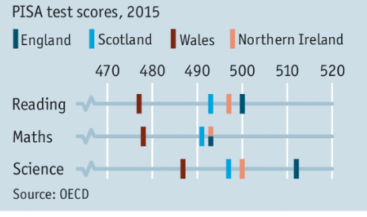
Source: The Economist: The struggle to improve the worst education system in Britain: Poverty is only one explanation for bad test results in Wales
In 2004, a national survey of adult basic skills revealed more discrepancies between England and Wales (Adult Basics Skills, 2004). The conclusions of this research study (Figure 1.2) showed Wales to have a higher adult population without basic literacy skills than any other English region, with also the second highest adult population without basic numeracy skills.
This research highlighted that over half of the working-age population in Wales lacked basic numeracy skills, while a quarter of Welsh adults of working-age lacked basic literacy compared to the average for England, which as a whole was 16%. This survey highlighted that individuals without Level 1 in basic skills were less likely to participate in adult learning, which reinforced their difficulty and disadvantage.

Figure 1.2: National Survey of Adult Basic Skills (2004)
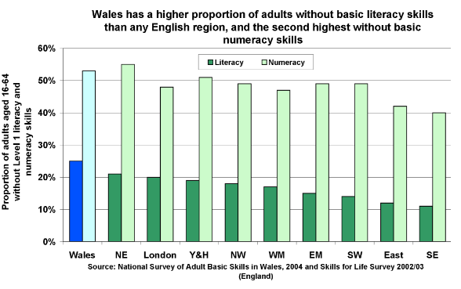
More recently, in 2017, Mark Bellis, director of Public Health Wales, an advisor to WHO and an expert in violence prevention, alcohol, drugs and sexual health, unearthed more damning statistics in his comparable ACE (adverse childhood experiences) study. (Table 1.1). Bellis’ comparable study found that nearly half of individuals living across both England and Wales had suffered at least one ACE and around 10% of the English and 14% of the Welsh population had been exposed to four or more ACEs (Bellis, 2017).
However, Bellis (2017) also found that ACE 4+ sufferers living in Wales were exposed to twice a greater ‘increased risk of developing health-harming behaviours’ such as being involved in violence and being a high-risk drinker compared to similar ACE 4+ score individuals living in England (Bellis, 2017).

Table 1.1: An Extract from Bellis’ (2017) ACE Comparison
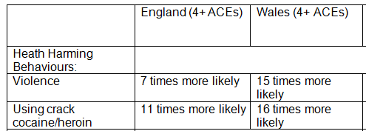
The Joseph Rowntree Foundation (2017) produced statistics to show that Wales has the highest rates of relative poverty compared to the rest of the UK. According to Rowntree (2017), “Across the four countries of the UK, Wales has consistently had the highest poverty” (Rowntree, 2017, p.29). Since 14 million people are living in poverty in the UK and 2.5 million are at risk of falling into poverty (World News, 2018), child poverty is a major concern (McCall, 2016).
Figure 1.3: Proportion of People Living in Relative Income Poverty
Figure 1.4 Suicide rates in the UK
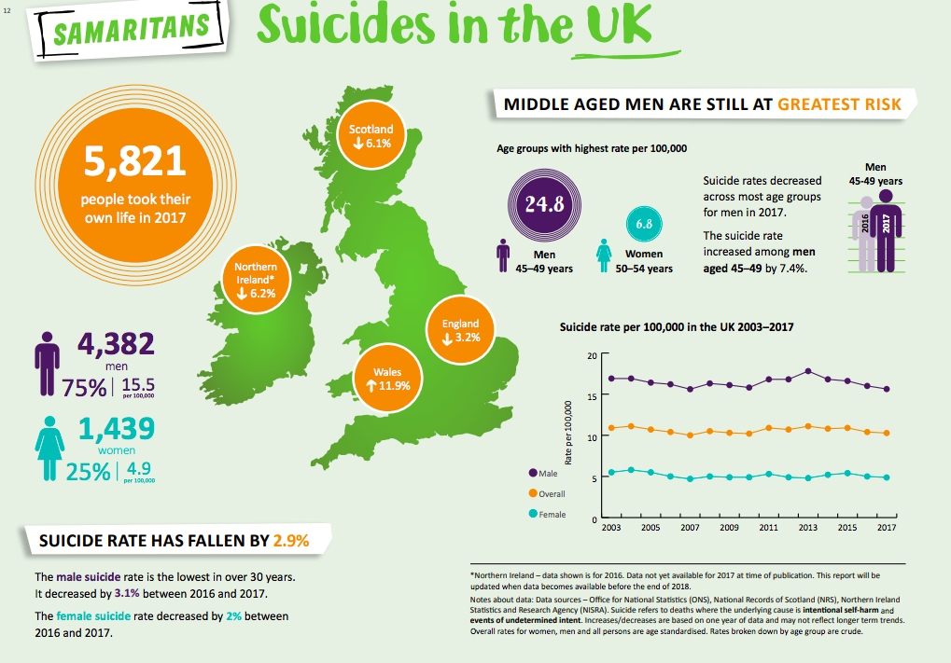
Since research evidence has exposed Wales to be a country that is not only underperforming educationally compared with the other UK countries (PISA 2006; 2009; 2012; 2015 cited in OECD 2006; 2009; 2012; 2015), but also has high figures for health harming behaviours (Bellis, 2017), poverty, economic under-development (Rowntree, 2017) and rising suicide rates (Samaritans, 2018). Furthermore, while England, Ireland and Scotland’s suicide rates are decreasing, Wales’ suicide rates continue to rise with 45% rise in female suicides (Samaritans, 2018). Therefore, qualitative research methods were used to conduct a deeper study to gain insight into the nature of these problems.
It should be noted at this point that the educational gap which exists between Wales and the rest of the UK cannot be attributed to academy schools since they do not exist in Wales (John; 2014b). However, another distinct difference in Wales is that the Education Reform Act (1988) allowed the statutory Welsh Language Board to make the Welsh language compulsory in all schools in Wales. However, despite Welsh being a compulsory subject, statistics reveal that only 14.6% of the population of Wales can speak, read and write Welsh and 73.3% of the Welsh population have no skills in Welsh at all (Office for National Statistics, 2011).
In 2001, the National Assembly of Wales released a statement which evidenced that approximately 780,000 children, young people and adults in Wales had literacy and numeracy problems which excluded them from realising their full potential in life (NAfW, 2001). In 2011, statistics showed that in Wales, only 26% of adults over the age of 16 had any form of recognisable qualifications (Office for National Statistics, 2011). This concurs with Gorard (1998) who previously had stated, “More people now leave education empty-handed in Wales than in the rest of the UK, and fewer gain the 2+ A levels” (Gorard, 1998, p.116).
Since my research aim was to develop a deeper understanding of the complexities of barriers to education and the consequences of educational exclusion/failure, I became further perplexed to discover more discrepancies existed between Swansea’s published social poverty data compared with the rest of Wales.
Swansea is the second largest city in Wales, having the second highest population out of the 22 Welsh local authorities, with an estimated population of 243,500 (Swansea Gov UK, 2018). Despite nearly a third of employed Swansea residents working within the public sector, statistics reveal that not many people in Swansea have achieved any form of higher qualifications (Swansea Gov UK, 2018). Statistics show that Swansea has high rates of homelessness (figure 1.5), drug misuse related deaths (figure 1.6), suicide (table 1.2), and removal of children into care (figure 1.9). Furthermore, Swansea has been called the ‘drug death capital of Wales’ (Griffiths, 2016). A recent report also has highlighted that ‘Swansea has the worst opioid death rate in England and Wales’ (BBC, 2019; figure 1.8).
Figure 1.5: Homelessness problem in Wales across the 22 local authorities
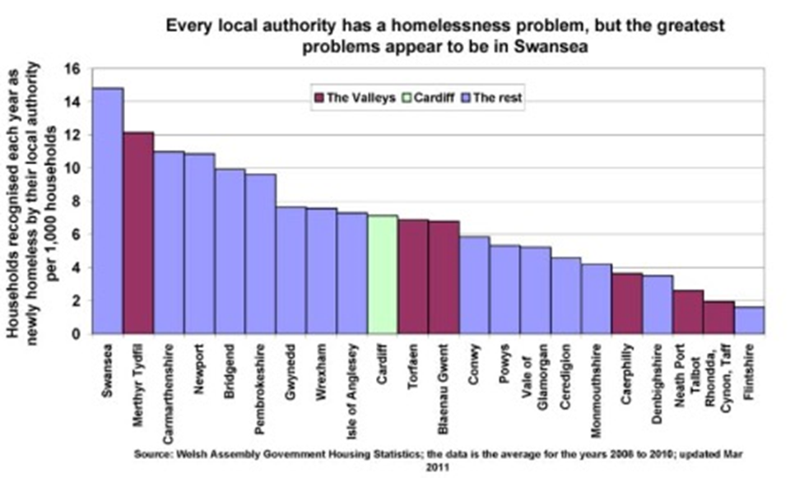
Figure 1.6: Drug misuse related deaths in Wales by Health Board 2011 (Swansea/Abertawe ABMU)
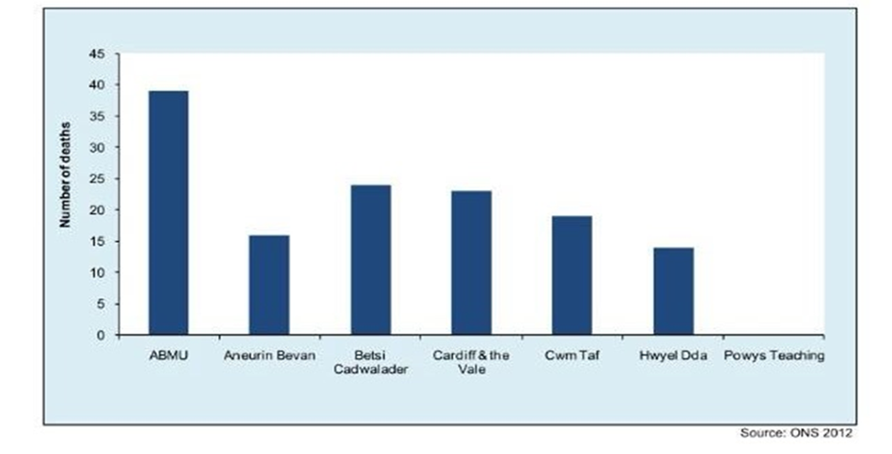
Figure 1.7: Admissions by Local Health Board and Independent Hospitals 2011-12 (Swansea/Abertawe – ABMU)
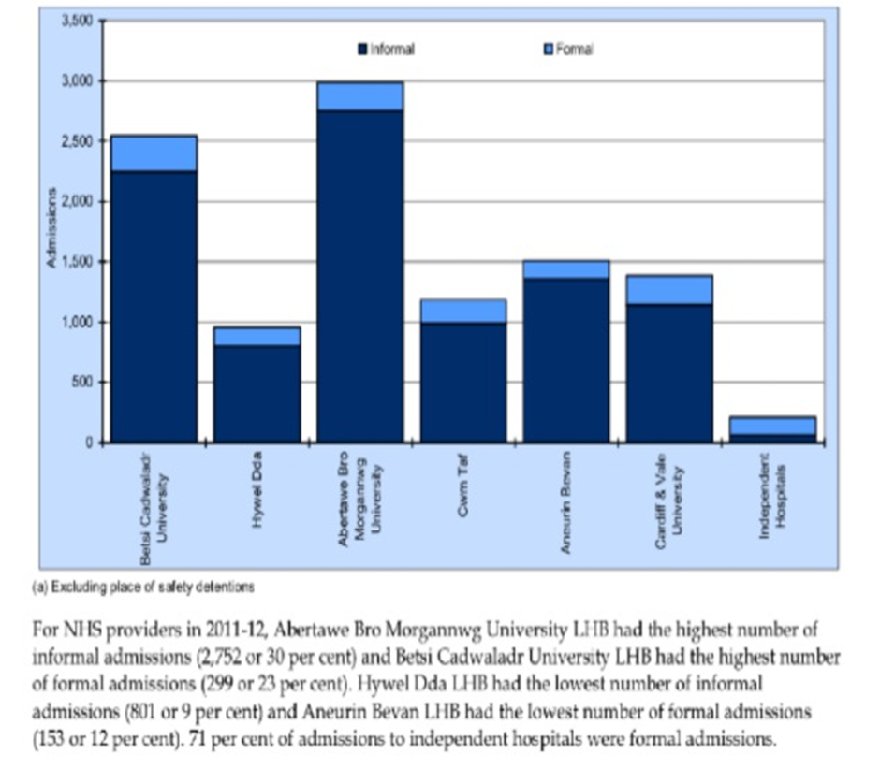

Table 1.2: Mortality from Suicide Hospitals 2006-10 (Swansea/Abertawe – ABMU)
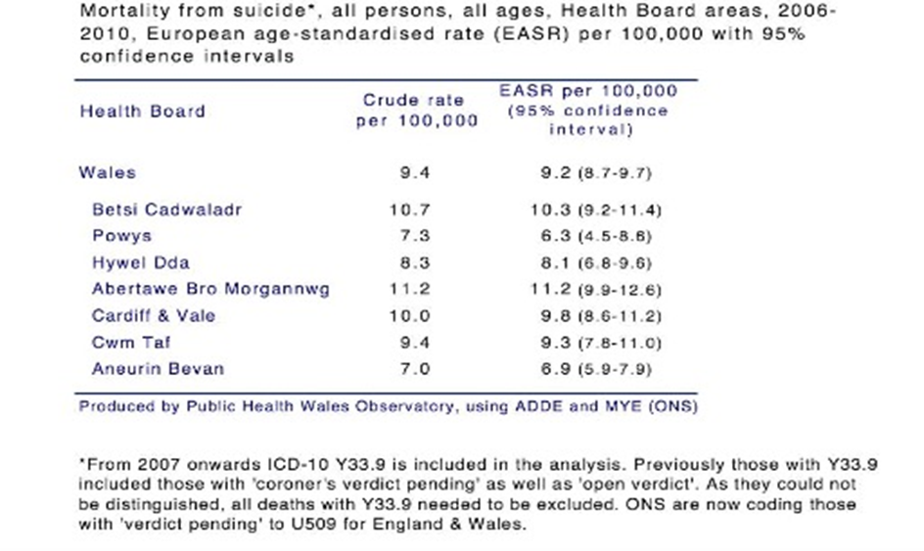
Figure 1.8: Opioid Deaths (Office for National Statistics cited in BBC News, 2019b)
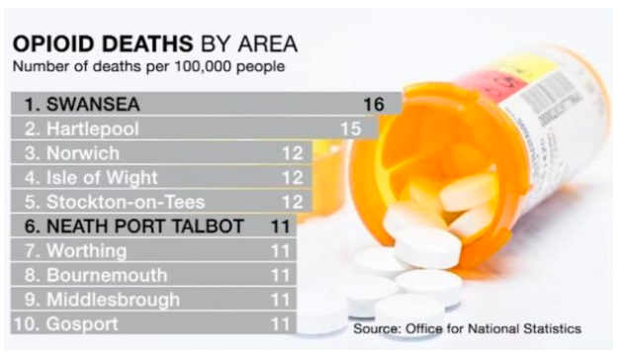
As well as the published government reports documenting the high rates of homelessness, suicide and drug and substance misuse, CSSIW (2016) also reported that Swansea’s LAC (looked after child) rate was significantly higher than the national average with 588 children being looked after in care during 2012-13.

Figure 1.9: LAC Rate Comparing Swansea to National average.
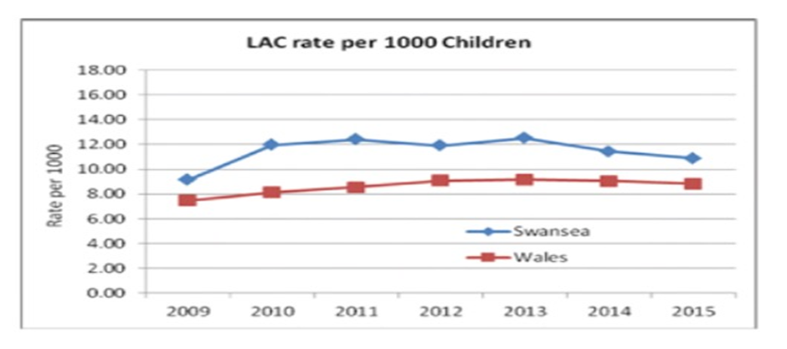

Source: CSSIW, 2016

Additionally, along with Swansea’s official social poverty statistics’ call for answers, more and more evidence of significant discrepancies emerged from different sources. Self-harm in Swansea was also highlighted as a significant problem compared to other regions, after a doctor in Plastic Surgery for the South Wales region (Anonymous, 2017) noted a marked ‘prevalence’ of self-harm injuries ‘in Swansea’ compared to the ‘the hospitals in Newport, Cardiff, Merthyr and Llantrisant’ (Appendix 10). Furthermore, Swansea also began to attract the attention of newspaper reporters who named Swansea the ‘drug death capital of Wales’ (South Wales Evening Post, 2016), while another newspaper reported that Swansea housed ‘Britain’s most overcrowded prison’ (Griffith, 2016 in Appendix 11).
A recent high-profile media case highlighted the poor practice of the Swansea family court system after a high court judge ordered that a child be returned to his family, after it emerged that he had been placed into foster-care with ‘utterly insubstantial’ evidence, as the ‘best example of neglect was not giving the boy an ice-cream’ (Telegraph, 2018). At the end of 2016, the chairman for Swansea’s health board (ABMU) revealed that Swansea’s health board had the second highest figures for the ‘over-medication’ of patients in the UK (Davies, 2016). This meant that more people were being medicated with prescription drugs under Swansea’s ABMU health board compared to other health authorities across Britain. Simultaneously, figures disclosed by Welsh government educational advisors (Welsh Assembly Government, 2017) highlighted that Swansea LA had the highest numbers of statemented children compared to the rest of the Welsh nation. Swansea’s psychiatric hospital also became under public scrutiny after a staff member’s sexual abuse towards a vulnerable patient became public knowledge (Appendix 11).
Therefore, in 2012, the Health Inspectorate of Wales inspected the facility reporting that there was, “Little evidence of individualised care planning.…a lack of patient centred culture, lack of engagement with patients…no attempt to capture user experience and to use this to inform the improvement of services.” (HIW, 2012, p.21) The report also noted that one acute ward was locked 80% of the time and there was ‘a lack of multi-disciplinary input to most wards’ (HIW, 2012, p.21).
Furthermore, an academic at Winchester University (Thornton, 2014) and an investigative writer (Rose, 2014) uncovered even more anomalies regarding the criminal justice practices at Swansea. Thornton (2014) found doctored police statements and omissions from original police documentation which were used to convict and wrongly imprison a vulnerable dyslexic person who received ‘four life-sentences’.
Before being convicted of ‘four life sentences’, Swansea’s David Morris had previously left school aged fourteen with no qualifications, having been described by his former Swansea school teachers as ‘remedial’ (Morris, 2017). Despite substantial evidence, including the absence of David Morris’ DNA on any of the victims, while the DNA of other suspects were found on these murder victims, David Morris remains in prison for a crime it was impossible for him to have committed (Morris, 2017). However, reporter Rose (2014) points out, “Morris is one of the few criminals in Britain who will almost certainly never be freed: Not because he was given a whole-life tariff, but because he still protests his innocence and so will not be considered for release” (Appendix 11).
Even more worrying revelations emerged about Swansea’s criminal justice system in 2017, when an ex-Swansea solicitor shed light on some of the police’s substandard practices:

Of all the police forces in Britain, South Wales Police has been responsible for some of the worst miscarriages of justice in the United Kingdom… nineteen people had been freed after being wrongly convicted of crimes they did not commit…evidence was routinely altered and fabricated. In some cases, detectives wrote statements themselves and then forced suspects or witnesses to sign them. In other cases, suspects were tortured, bullied or simply worn down by lengthy interviews into making untrue confessions. Vulnerable witnesses were ‘leaned on’ to make false statements implicating an innocent person in a crime; others were bribed, some intimidated. Prisoners serving time in jail were offered deals in return for signing false statements and some detectives planted incriminating evidence where it was certain to be found, to frame innocent suspects for crimes they had not committed. (Morris, 2017, p.19)
The Prison Reform Trust (Dobson, 2012) also drew attention to the large numbers of vulnerable individuals within prison having ‘serious learning disabilities with mental health problems, [and] with drug addiction’. Additionally, a spotlight was shone onto Swansea’s criminal justice system when non-standard police practices were brought to the public’s attention in a public court hearing in 1994. This highlighted how Paul and Wayne Darvell had been wrongfully convicted for murder and jailed for life (Independent, 1994). It emerged that South Wales police had fabricated interview notes used to wrongfully convict these two vulnerable, homeless and unemployed innocent individuals who also struggled with literacy and communication difficulties.
The psychologist who examined Wayne Darvell stated that Wayne was ‘suggestible and gullible’ (Kirby, 1992), and it was his lack of verbal and written skills which had led to the unsafe ‘confession’ for a crime he had not committed. This case provides a striking similarity to Steven Avery’s case (Harrington, 2017). Avery’s American case has been well-documented internationally through ‘The Making of a Murderer’ Netflix series which also highlighted inconsistencies and breaches of standard police practice towards a vulnerable person with learning difficulties and an IQ below average at 70 GCA (Harrington, 2017).
Yet another high-profile Swansea murder involving two ‘child killers’ with learning differences shocked the nation (Thomas, 2017 found in Appendix 11). In 1994, it was reported that these ‘child killers’ had violently murdered another young adolescent at roughly 4-5am on Swansea beach while they were all walking home from a nightclub. Swansea ‘child killer’, fifteen-year old Joshua Thomas had a diagnosis of ADHD and seventeen-year old Joel Taylor had attended a pupil referral unit (Appendix 11). Taylor had three previous convictions including burglary as a 14-year-old, criminal damage when he was 15 and unlawful wounding age 16. Thomas was reported to have an IQ of 87 and the mental age of a thirteen-year-old (Appendix 11).
It emerged that during the time of the murder, Thomas and Taylor, who would have benefitted from being at home and asleep at 4-5am, were instead walking home from a nightclub which they were too young to attend (Thomas, 2017). These ‘child killers’ share striking similarities to the ‘child killers’, Venables and Thompson, who had also been badly let down by societal and educational systems, left to struggle with unsupported needs and both described as ‘nigh-on-illiterate’ (Beckett, 2001). All four children were documented to have behavioural difficulties and problems with truancy. Moreover, all four-child victim/perpetrators were left without adult supervision to perpetrate a crime that involved controlling and manipulating another person who they perceived to be weaker and more vulnerable than themselves. The victim/perpetrators who carried out the unlawful acts not only destroyed two innocent children’s lives, but devastated all the families (Bulger, 2013; Fergus, 2018), friends and communities concerned, along with destroying their own lives. After these senseless acts of violence, nothing would ever be the same again.
At the time of the Swansea murder (2004/05), statistics showed that 1415 Welsh pupils were reported as not having achieved a recognised qualification and 833 left full-time education without qualifications (Figure 1.10). Liverpool also reported having high truancy compared to national averages, with multiple children being left unsupported with literacy and numeracy difficulties and thirteen schools in special measures at the time. Therefore, the statistics from both Liverpool and Swansea at the time of both child murders share similar characteristics of having high levels of social poverty and educational failure. Moreover, the National Assembly of Wales in 2001, released a statement which stated that around 780,000 children, young people and adults in Wales had literacy and numeracy problems which excluded them from realising their full potential in life (NAfW, 2001).

Unfortunately, the desperate need to feel accepted and to fit in can make youngsters vulnerable to being easily led or manipulated to carry out unlawful acts without considering the consequences (Baglivio, Epps, Swartz, Huo, Sheer and Hardt, 2014), placing themselves and others at a significant risk of harm.
Since low self-esteem often accompanies communication difficulties (Speake, 2003), vulnerable individuals often seek out acceptance and belonging in the ‘wrong crowd’. Both Thomas and Taylor were left unsupervised at 4-5am in the morning to commit a violent crime on another lone seventeen-year old, who they perceived as weaker and more vulnerable than themselves. Fourteen years on, Joshua Thomas and Joel Taylor still protest their innocence, insisting that the teenager was still alive when they left him, adamant that they cannot account for ‘how he ended up face down in the sea’ (Turner, 2017). However, the consequences of horrific murders still live on with the families, friends and close associates of the deceased (and the accused), their lives changed forever. As Wolynn (2016, p.52) points out, “Traumas do not sleep, even with death.”
Figure 1.10: Number of pupils aged 15 leaving full time education without a recognised qualification.
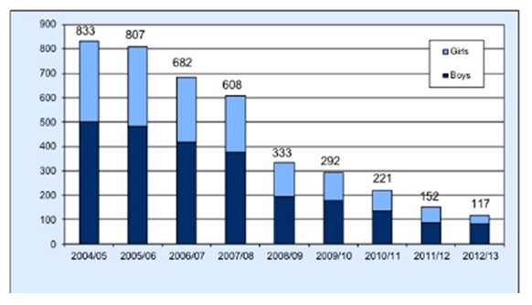
Table 1.3: Pupils Leaving Education. Swansea compared to the other 21 LEAs.
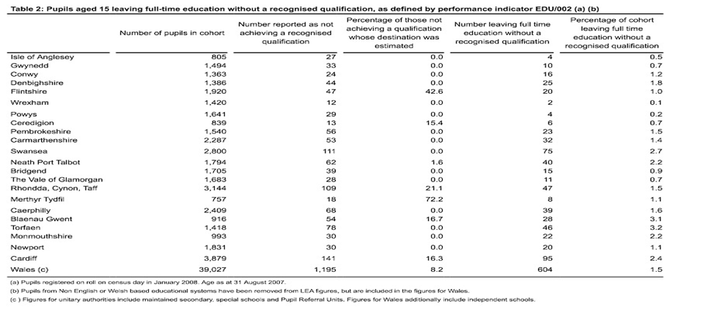
Swansea is no stranger to high-profile media stories which highlight failing safeguarding measures in schools towards vulnerable young people. Following the child sexual exploitation scandal at Rotherham (Gladman and Heal, 2017; Senior, 2016; Woodhouse, 2018), it is now recognised that the educationally failed, the excluded or those who truant from school are easy targets for perpetrators, as abusers specifically seek out the weak, easily manipulated and those who find it difficult to speak up for themselves.
At the end of 2016, a Swansea head teacher was jailed for inciting sexual activity and grooming ‘an exceptionally vulnerable’ pupil at a Swansea school for children with learning or mental health difficulties (Appendix 11).
Even though this head teacher had worked at this school for ten years, Swansea Crown Court was informed that police investigations had identified similar ‘other episodes in a school setting’ had previously taken place (Williams, 2016; Appendix 11).
In 2017, another Swansea teacher made national news when he admitted having sex with a sixteen-year old schoolgirl. The ECW (2018) committee found that all the girls who came forward ‘had varying levels of vulnerability’ (cited in Williams, 2016). However, after being sacked for gross misconduct, it transpired that Swansea local authority council gave this teacher an £8000 pay-out, along with a glowing reference which he wrote himself (BBC News, 2017, Appendix 11).
Many more high-profile media stories which document Swansea teachers abusing their positions of trust, using financial exploitation and other means to harm, can be found in Appendix 11. Alongside the abuse of power and trust are the painful stories of how young people in Swansea committed suicide and self-harmed because of alleged bullying and/or educational exclusion at Swansea educational settings (Appendix 11).
This introduction hopes to set the context for my research study, highlighting the multi-faceted reasons for wanting to listen to the voices of the most oppressed people within our communities, so that restorative solutions can be found. However, I am fully aware that as an insider-researcher, I bring to this research my own preconceived ideas, knowledge and experiences thus transparency is a necessity. My positionality as an educational researcher has always been to remove barriers to potential through seeking solutions to close attainment gaps and reverse educational failure for all learners (John, 1998; 2001; 2010; 2013). Thus, as a primary school teacher, I have always been engrossed in the topic of ‘inclusion’ with a focused passion to close gaps in attainment.
However, there are also some very significant factors that have influenced my values and have allowed me to bring a very personal dimension to the research.
During my BA(Ed) degree, my father helped me discover the powerful link between neuroscience and educational potential. At the time I was achieving B’s and C’s without putting much effort into my studies. It was at this point that my father set the challenge - for every A grade that I achieved he would give me £10. I accepted the challenge, consistently achieved straight A grades and made a fortune! However, what is more interesting was the change in my attitude, motivation and commitment towards my studies which consequently produced a significant shift in my performance data from averages of 50% to consistent grades over 70%. Unwittingly I learned how the power of reward can be used to positively affect quantitative scores. This experience profoundly affected my own teaching methods, as I have always have sought to use meaningful reward to increase motivation and academic performance with my own students. This in itself demonstrates a powerful link between neuroscience and education, as meaningful reward increases the dopamine levels which in turn cause people to want to repeat these positive experiences (Arias-Carrion, 2007; Mate, 2019a). As van der Kolk (2014) concurs, “The social environment interacts with brain chemistry” (van der Kolk, 2014, p.34).
Therefore, for over twenty-years, from my master’s degree onwards, I purposefully engaged in user-led research to develop more tailored inclusive systems throughout traditional mainstream settings (John 1998; 2001; 2010; 2013). Like Smith (2011), I believe that, “In research that purports to care about the marginalized, surely their voices and the voices of their children should be at the forefront” (Smith, 2011, p.839). Dhunpath (2000) also notes that student voices have been ‘long absent from educational research and policy” (Dhunpath, 2000, p.544).
Thus, alongside engaging in user-led educational research within the traditional mainstream educational settings in Swansea, to try to give a voice to the most alienated and marginalised in society, I also unwittingly found myself removing barriers to learning and ‘being’ across multi-disciplinary settings outside traditional systems. For example, I tried my best to help several home-educated young people and adults across the city. I felt in a privileged position to engage with the most excluded and marginalised individuals in society who were being ‘managed’ under mental health, education, criminal justice and/or social services institutions, as well as trying to help many older individuals who had been excluded from traditional systems. As Lee (1960) wrote, “You never really know a man until you stand in his shoes and walk around in them” (Lee, 1960, p.308). Therefore, I felt honoured to connect with those in hard to reach communities on a personal level, such as children who define themselves as ‘forced-home-educated’. Forced-home-educated children believe themselves to have no other option than to leave school, for reasons such as bullying or not having their educational needs met.
Davies (2019) points out:
In 2016, for the first time in 25 years, more children with SEND were educated outside the mainstream, some because they were subjected to informal exclusions... Over 9,000 children were off-rolled from our school system last year, many of whom had disabilities and special educational needs. (Davies, 2019, para. 1)
Since figures for home-education have risen 40% over three years in the UK (Figure 1:11; Adams, 2019; Issimdar, 2018), I counted myself highly privileged to hear some of their opinions about school experiences of exclusion, especially as Wales also has very high figures for home-education (figure 1.12).

Figure 1.11: Home-Education in the UK
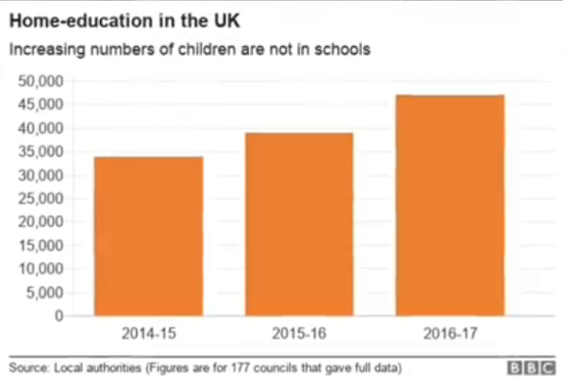
Figure 1.12: Wales: The Highest Proportion of Home-Educated Children in the UK
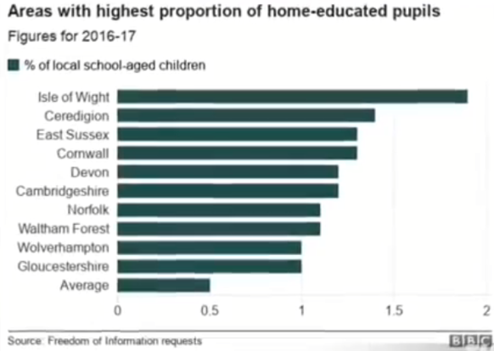
I heard countless painful accounts of lived experience which clearly illustrated the oppressive ‘social context of [their] individual lives’ (Griffiths and MacLeod, 2008, p.121).
I also began to read the multi-disciplinary literature which documented the high percentages of individuals with dyslexia, dyspraxia, ASD, ADHD and/or other language and communication needs who are amongst the most excluded communities; including the home-education communities, prison and psychiatric systems (Rogers, 2019), the foster-care system, the homeless and the drug and alcohol addict populations. Many of these individuals appeared to have either diagnosed or undiagnosed communication needs. They were quick to point out themselves, along with having little or no qualifications, they also ended up in further systems, including mental health and/or criminal justice institutions. I was also trusted by young mothers who believed that they had been ‘tricked’ into or forced to give up their children through the family court system.
Furthermore, many homeless people also shared their painful stories of battles with addiction to both illegal and prescribed drugs. Since Swansea’s social poverty statistics (Appendix 9) and the public domain media reports (Appendix 11) appear to reveal that an underlying problem exists, it is only right that the people who truly understand the full complexities surrounding the issues that most affect their lives are given the opportunity to speak. Even though I acknowledge that my own insider experiences could be viewed as subjective and thus a limiting factor of the research, I believe that it is precisely this position which led to the strong desire to remove societal barriers and to enforce fair justice for the marginalised (Appendix 16).
Therefore, I would like the reader to consider that for decades, no one believed the victims of Rotherham and Hillsborough or acknowledged their version of the truth. Instead these voices were disregarded, simply because ‘professionals’ had their own preferred account of ‘the truth’ which, it emerged later, only served to protect the wrongdoing of the organisations coming into the light.
As Scraton (2018), the researcher who exposed the truth behind the Hillsborough Disaster reminds us, ‘truth recovery’ is a vital requirement for challenging institutional injustices. Furthermore, Wolynn (2016) prompts us to consider, “No matter how skewed or one-sided the story, many of us rarely think to question what that story would look like if told by the other side” (Wolynn, 2016, p.90).
Since I know all the participants personally, I have accessed official documentation with dates and time-lines which refer to the many factual events spoken about during their interviews. Thus, I urge the reader to respectfully read the participants disclosures through the lens of fact or ‘the truth’ as opposed to just watering-it-down into their opinion or ‘their truth’. As this research study is ultimately a quest for solutions and preventive medicine- it is hoped that their combined voice will lead to the healing of a locality, the restoration of a country and lead a process of emancipatory social reform right across nations.
Therefore, the core research questions for this study are:
1) In what ways, if any, has your educational experience at school created barriers that have led to educational failure?
2) What have been the effects of educational failure upon your life?
3) What solutions would you suggest to policy makers to improve educational inclusion?
1.3 Overview
The first chapter sets out the background to the research context, the aims of the research and introduces the core research questions. The chapter also begins by exploring some of the statistics surrounding social poverty and educational inequality in Swansea.
Chapter Two examines the relevant literature for the present study. This literature chapter carefully considers inclusive education, neuro-diversity and exclusion, as well as the importance and reasons why young children and people need to master good speech, language and communication skills. There will also be an examination of how the social and medical models are utilised in education, along with Casey Edmonds’s stance that the education system is an unequal system that discriminates against those with ‘differ-ability’ (Edmonds, 2012). This chapter also will examine research which highlights how neuro-divergent related matters interconnect with other arms of oppression such as language, diagnosis, voice and victimisation of the ‘Other’. Additionally, the ‘forced home-education’ perspective, which is a completely different standpoint to ‘elective home-education’, will be briefly explored. As ‘forced home-educators’ believe that they were given no choice but to come out from mainstream traditional school education as the result of different reasons surrounding educational failure, bullying or unfair exclusion at school.
It is noted that this viewpoint does not in any way represent all ‘home-educators’ as no one person represents the home-education community, and each individual home-educator only represents themselves and their families. Home-educators are as varied as the different teaching styles, environments and mixed modalities which individuals choose to utilise for their individual children’s learning needs. However, for the purpose of this study, I will be focusing on examining literature surrounding the experiences of four ‘forced home-educated’ individuals.
This chapter will also embrace any relevant literature which has emerged from participants’ interviews, which is not traditionally found amongst traditional educational inclusion. For example, ACEs, trauma, intergenerational trauma, disabling learning environments, the abuse of power and systematic abusive bullying practices.
Literature surrounding some of the documented consequences of educational failure, SLC (speech, language and communication) difficulties and neuro-divergence, such as unemployment, drug and alcohol misuse, crime, CSE (child sexual exploitation), adult sexual exploitation, promiscuity, homelessness, mental health difficulties, mis/diagnosis and medication, self-harm, removal of children into the foster care system, and being subjected to further oppression leading to high risks of suicide. This chapter will conclude with a consideration of the shortage of literature regarding some of the emerging themes which further explains why it is a good reason to place such importance upon listening to the voice of the excluded as this perspective is rarely listened to or heard.
Chapter Three explains the rationale behind why my chosen methodology, IPA (interpretative phenomenological analysis). It discusses why IPA was employed to interview twelve very different individuals from Swansea aged from 14-35, using semi-structured interviews designed to illuminate the educational experiences of these people. This chapter also carefully considers other alternative methodologies, offering a critical response to demonstrate why each alternative method was not chosen to be implemented within this study. This methodology chapter also examines the ethical issues which needed to be addressed within this research inquiry, since the study was interested in identifying the challenges or barriers that led to educational failure and the effects of educational failure upon vulnerable young people’s life-choices. The chapter concludes with an in-depth consideration of the research design which was employed in this study, including recruitment, pilot, participants, procedure and the interview process.
Chapter Four presents the systematic processes and stages of IPA analysis and interpretation utilised within this study. The process of analysis, including participants’ emergent themes, summary of individual subordinate themes and the final construction of the seven superordinate themes are made visible to the reader in table form.
Chapter Five presents the findings of the study which emerged from an interpretative phenomenological analysis of the interview data. Seven superordinate themes were highlighted and further discussed within these chapters, offering an in-depth analysis of the lived experiences in relation to the literature and the initial research questions. I will also refer to literature which emerged as part of this research study, such as examining the effects of ACE (adverse childhood experiences) including fear, trauma, anxiety, panic attacks, PTSD (post-traumatic stress disorder), depression, self-harm and ‘hearing voices’ which are all serious mental health conditions. This leads on to explore the effects of unprocessed trauma and the negative impact upon physical health and cycles of poverty.
The final chapter concludes with the findings and presents an examination of the strengths and limitations of the study’s results for educationalists and policy makers. There will also be an examination of the cost implication upon the NHS and other public services, as well as the identification of recommendations for future practice and research.
1.4 Conclusion
This introductory chapter has set the scene for this study through exploring the background of the research context and examines the aims of the research study. It also highlights some of the motivations behind the research, presents a comprehensive overview to summarise the contribution of each chapter within the body of this thesis and introduces the core research questions to the reader. This introduction leads the way for the next chapter, the literature review which seeks to provide the reader with the theoretical context of this study. Since this study has responded to participants’ lived experience, much of the literature it is not commonly found within traditional texts about inclusion/exclusion.
As the poet, Theodore Roethke (1963) enlightens us; it is ‘in a dark time’ that ‘the eye begins to see’.
- Chapter Two –

LITERATURE REVIEW
Research practices are changing and developing as postmodern thinking has blurred the boundaries between disciplines. (Etherington, 2004, p.21)
2.1 Introduction
This literature review chapter provides a contextualising framework to locate this thesis within the field of contemporary inclusion. This review seeks to provide the theoretical context to explore how educational experiences, barriers to learning and consequences of school exclusion have affected individuals’ lives. This chapter has been deliberately divided into two parts and is consistent with the phenomenological and interpretative elements of IPA. Therefore, part one of the literature review examines the traditional literature around inclusion, exclusion and educational failure. It is important to note that the literature review had to be amended after the data collection, as participants’ lived experiences presented fresh insights into exclusion from a user-led perspective which are not commonly found in traditional texts about inclusion.
Part two of the literature review examines some of the significant themes which arose from participants’ voices and experiences which are not commonly found amongst the traditional educational literature about inclusion. Moreover, after the process of data-collection and analysis, the literature review had to be amended and re-written to reflect the actual content of the participants’ experiences and understanding of exclusion. In particular, there appears to be an absence of research about ableism in schools, specifically teacher bullying towards SEN (special educational needs) children or ‘Others’ who are perceived as being ‘different’ and/or children who display symptoms of trauma from ACEs or intergenerational trauma.
Since this IPA study invited respondents to ‘tell their story’ from their own perspective, their unique viewpoints about inclusion/exclusion brought forth a fresh understanding about the integral workings of inter-relationships, micro-political issues, co-productive systems and patterns of influence relating to educational failure, which are not commonly found within traditional educational research about inclusion.

Part One
2.2 Inclusion

Inclusion is an obligation to value others; accepting differences through the removal of barriers to maximise choices and learning opportunities (Cheminais, 2005; Zola, 1994). Moreover, “Inclusion is a process, not a fixed state.” (DfEE, 1998, p.23). Since inclusion is not a fixed position (DfEE, 1998), but rather an on-going, fluid process, which has ‘dignity’ and ‘value’ at its core, inclusion is about promoting equal access, freedom and opportunity, as well as removing discrimination, oppression and other barriers to being. Inclusion removes the barriers which create a ‘difference’, oppression or ‘exclusion’. Inclusion is a universal human right (Equality Act, 2010).
Inclusion is recognising the value of working with others, enjoying people for who they are, developing ways of being able to learn from one another and learning to take responsibility for own learning. True inclusion means everyone within a community is able to engage and develop strong working relationships based on mutual trust, regardless of any perceived differences of race, gender, disability or any other attributing factor which can be perceived as different. Inclusion is the determination of the acceptance of others. However, listening to the voice of the ‘excluded’ appears to remain quite an under-researched area and does not widely exist.
Previous research had focused primarily on cognition, neuro-development and the perceptions of professionals and/or parents (Edmonds, 2012). Nevertheless, there is much research about inclusion policy, neuro-diversity, critical disability studies, oppression, neuro-science, behavioural studies, digital learning, generational studies and exclusion. Since exclusions have risen 100% since 2011 (Rogers, 2019), true inclusion should inter-relate and interlink these studies to connect with the real stories of those who have been personally ‘failed’ by education. As Fanon (1952) points out, “A story that takes place in darkness – an internal darkness” needs the light to “shine into the smallest crannies” (Fanon, 1952, p.29).
2.3 The Background of Education
Until 1970, educational inclusion could never be a realistic goal…since it was not until the Education Act of that year that all children and young people finally had the right to attend school. Prior to this, some children were assessed as being ‘in-educable’ and so no state educational provision was made for them. (Black-Hawkins, Florian and Rouse, 2007, p.7 and 8)
The British education system began in 1870. The 1870 Education Act provided children with an entitlement to be educated in schools. However, ordinary schools found that they did not have the resources or methods to facilitate children presenting with SEN and so did not accommodate them (Black-Hawkins et al, 2007; Fredrickson and Cline, 2002). This dilemma appeared to be made worse by the Government’s incentive of paying teachers according to their pupils’ performance and their class results in reading, writing and arithmetic. This led to the exclusion of slow learners, pupils with emotional behavioural difficulties or any children with additional learning needs who did not appear to learn through traditional methods.

It was the social norm at the time for every child to experience the fundamental right to receive an education. Some elderly people who are still alive today remember that they did not go to school with the ‘normal’ children, but rather were sent to churches to be ‘looked after’. One person told of how he was sent away to the countryside by his mother and left there for thirteen years (Williams, 1970).
Fredrickson and Cline (2002) observed:
As more and more children were brought within the education system in the late nineteenth century, the schools of the day were faced with a wide range of learning and behaviour to which they were not accustomed and which they could not easily accommodate. Increasing numbers of children were excluded. (Fredrickson and Cline, 2002, p.67)
This highly oppressive approach was not challenged by the British Government until 1970, one hundred years after the education system first began, as it had been the norm in British society to devalue the ‘disabled other’ due to the traditional medical model that had developed over decades. During the eighteenth century, most doctors believed that all pains were diseases and would treat all patients in the same way (Engleharrdt, 1986). Leder (1990) points out that the development of science and the medical model to treat patients tried to find “a quantified measurement [as]… The patient’s own experience and subjective voice became inessential to the medical encounter” (Leder, 1990, p.146). Consequently, the ‘medical model’ became a tool of oppression and abuse towards the dis/abled ‘other’ (Goodley, 2011) .
History shows well documented evidence of this oppression through euthanasia in Nazi camps, forced sterilisation, forced abortions and assisted suicides towards those carrying labels of ‘dis/abled’ (Freedland, 1997; Gallager, 1990; Glover, 1977; Mailhot, 1995).
Watermeyer (2012) writes, “The idea of disabled people [and others] being exposed to perverse or demeaning representations of disablement is not at all new; but what has received virtually no attention is the psychological arena within which such meanings take root and are enacted” (Watermeyer, 2012, p.164). However, the actions of oppressors were driven by the motivation of social power and control (Grant, 2013) and this approach was not challenged by the Government until 1970.
In 1970, the Education (Handicapped Children) Act stated that all children, including those with dis/ability, were entitled to an education. Since the ‘dis/abled other’ was perceived as being uneducable, they were the responsibility of the ‘medical’ Health Service rather than the ‘social’ Education Service. However, it was not only the educational provision that needed challenging, as societies’ attitudes and the culture towards people of difference also needed to change. In 1970, the term ‘handicapped’ was used to describe SEN children, who previously could not access education at school (Fredrickson and Cline, 2002).
This accepted practice was challenged and instead different labels were given to define the ‘dis/abled other’. Moreover, definitions of dis/ability have continued to change frequently to suit the acceptable terms used in society. As Sinason (1992) points out, “No human group has been forced to change its name so frequently” (Sinason,1992, p.39).
Therefore, the social model of disability began to question unacceptable rights and boundaries, challenging developments like the Human Genome Project which focused on ‘impairment’ in prenatal testing and raised concerns about the lack of value that societies attach to lives of the disabled (Shakespeare, 1998). Additionally, the scientific method which is traditionally viewed as being objective and unbiased in its observation and measurement of discrete data, analysis and reporting methods began to be challenged.
Thus, the new social model theories challenged existing norms and established practice (Watermeyer and Swartz, 2008). The Education Act (1988) introduced the National Curriculum to Britain to establish consistency and raise standards throughout the country which included changes in curriculum, appraisal, finance, examining and the reporting of results (Wade and Moore, 1992). The National Curriculum (1999) began with an inclusive statement, listing three objectives to ensure all pupils’ needs were met through setting suitable learning challenges, responding to pupils’ diverse learning needs and overcoming potential barriers to learning and assessment for individuals and groups of pupils. The SEN Code of Practice (1994) was introduced to address inconsistencies and to bring accountability to SEN practice. The SEN Code of Practice outlined a graduated response to identify, assess and provide for children’s special educational needs through ensuring that Individual Education Plans (IEPs) were in place and all relevant information about children with SEN was recorded and updated on a Special Needs Register.
A revised Code of Practice (2002) and the Index for Inclusion (2002) were written to make provision more ‘workable’ in schools, advocating that teaching SEN children was the responsibility of everyone in their individual ‘setting’. DfES (2004) set out the Governments vision for SEN through ‘Strategy for SEN Removing Barriers to Achievement’ highlighting four key areas: Early intervention, removing barriers to learning, raising expectations and achievement and delivering improvements through partnership (Hayward, 2006). Thus, the arrival of the social model of ‘diff-ability’ (Edmonds, 2012) in education sought to remove all barriers to potential through adapting environments to eliminate discrimination.
However, Morris (1992) and Wendell (1996) argue against social model studies that ignore the personal experiences and the voices of people with differ-ability. Marks (1999) writes that, “Individual and social models of disability represent different sides of the same coin. Both are necessary for the survival of the other” (Marks, 1999, p.611).
Furthermore, Thomas (2007) suggests there is a need to break the boundaries between traditional disciplines of ‘medicalised’ views of disability and social models of the dis/abled other, along with listening to the personal experiences, insight and voice of people with differ-ability will produce better-rounded and balanced inclusion policies.
Currently in Wales, the new Additional Learning Needs Bill (ALN Bill) framework is being developed through a consultation which is responding to different stakeholder voices to be implemented from September 2020 and by 2023 the old SEN system of statements and IEPs will come to an end. The term special educational needs will be replaced with the term ‘additional learning needs’ and the old SEN system will be replaced by one multi-disciplinary system of support for all learners aged 0-25. (WAG, 2018).
2.4 Exclusion and Educational Failure
Practices that contribute, however minutely, to a learner’s sense of personal failure cannot be justified. All pupils are learners; their rights to learn, and to feel that their teachers trust and respect their learning, are paramount. (Drummond, 1993, p.186)
Educationalists, parents and politicians have always recognised that once a child falls behind at school and start to experience ‘school failure’, they are less likely to make progress, let alone catch-up (Equality Act, 2010; Every Child Matters, 2003; No Child Left Behind Act, 2002; Working Together, 2007). Therefore, ‘school failure’ often results in the widening of attainment gaps, leaving the child at risk of losing their confidence, doubting their own ability to succeed, feeling incapable and unable to access the school curriculum, which will result in a total disengagement or the failure to attend school altogether (Best, Manning, Gossop, Gross and Strang, 2006; Perez, Ariza, Sanchez-Marinez and Nebot, 2010; Zalsman, Tov, Tzuriel, Shoval, Barzilay, Fire, Shef and Mann, 2016).
The consequences of educational failure are widespread and can be observed throughout society. Forced-home-education as opposed to elective home-education, whereby parents have no choice but to remove their children from mainstream education, is on the increase and is one of the quickest growth markets (Green and Hoover-Dempsey, 2007).
DfE (2018) school exclusion figures show that children with SEN are six times more likely to be excluded from school (SEN Jungle, 2018). However, the stories behind the exclusions are often hidden from the view of society. Research highlights that dropping out of school is a long-term process of disengagement that occurs over many years, when the “wait to fail” teaching model (Elliott and Grigorenko, 2014) is embraced by many schools. The ‘wait to fail’ teaching model describes a ‘one-size’ model that treats all children the same, but does not recognise the need to differentiate, assess individual need or provide personalised intervention to close learning gaps. Over fifteen years ago, Every Child Matters (DfES, 2003) advocated that:
We need a greater focus on ensuring children at risk are identified earlier. We need to be able to share information to identify children who require additional support and provide a tailored service that safeguards them from abuse and neglect and enables them to fulfil their potential. (DfES, 2003, p.21)
Thus, assessment should be administered for appropriate intervention purposes, not purely for ‘labelling’ or diagnostic purposes (Elliott, 2003; Elliott and Grigorenko, 2014). Furthermore, the importance of early intervention to enable students to catch up with their peers cannot be over-stated (Gormley and McDermott, 2011; Snowling and Hulme, 2012). Elliott and Grigorenko (2014) also explain that a “precise balance of activities needs to be tailored to the particular strengths and weaknesses of the student” (Grigorenko, 2014, p.136).
Accurate assessment along with effective targeted intervention not only prevents educational failure but can enable students to catch-up and close learning gaps (Dore, 2008; John, 2013; Leaf, 2015). Therefore, ‘one-off categorical labelling’ or having a tight, constricting ‘label for life’ should be treated with caution (Snowling & Hulme, 2012), as no two dyslexic, autistic, dyspraxic, ADHD or neuro-typical persons are the same, nor will they present with the exact same needs. Kutscher (2005) points out that a child may be born with multiple issues that may exacerbate each other and it is good practice for children with unclear speech or any type of language difficulties to have their hearing checked (Daines, Fleming and Miller, 1996; McLachlan and Elks, 2012). Dawes & Bishop (2009), Lees and Urwin (1997) and Dore (2008) also recognise the co-occurrence of multiple diagnoses and advocate assessments in other related areas, such as reading, writing and focus/attention.
Dore (2008) states, “The auditory processing problem is quite common amongst people with learning difficulties” (Dore, 2008, p.88). Thus, keeping accurate ‘live’ working records of developmental changes is essential to track progress to foresee any potential future difficulties which might arise, as children with ‘corrected’ early speech and language difficulties sometimes later present with early reading difficulties in KS1 and then later comprehension and inference reading difficulties at KS2 or a much later age/stage (Snowling and Hulme, 2012).
Hull Learning Services (2004) note that ‘over one million children in the UK’ have difficulties with speech, language or communication (Hull Learning Services, 2004, p.1). Unidentified or untreated speech, language and communication difficulties often lead to low self-esteem, behavioural difficulties, poor educational attainment, school exclusion and difficulties finding future employment (Bercow, 2008; Elliott and Grigorenko, 2014; Lees and Urwin, 1997; Locke and Beech, 1991; McMinn, 2006).
Martin and Miller (2003) also highlight that there are also ‘strong links between language delay’ and poverty (Martin and Miller, 2003, p.76). Furthermore, there is not only a significant correlation between lack of educational achievement and poverty (Martin and Miller, 2003), but homelessness (Burt, Laudan, Lee and Valente, 2001; Shlay & Rossi, 1992), suicide rates, drug and alcohol problems (Snow and Anderson, 1993), self-harm (Hawton and Rodham, 2004; Marks, 2017), time in prison (Bryan, 2004; Cino, 2014) and psychiatric hospitals (Clegg, Hollis and Rutter, 1999); all of which are evidence of a failure within the current education and societal systems.
Moreover, the Prison Reform Trust (2013) provided statistics to show that 61% of young offenders have learning difficulties, with 23% having significant learning difficulties (IQs of below 70) and 36% have moderate learning difficulties (IQ 70-80). Cino (2014) also found that ‘vulnerable young people with learning disabilities’ often find themselves institutionalised and trapped in the criminal justice system.
Bryan (2004) has reported that over 65% of young offenders have speech, language and communication difficulties and most of these were unidentified, unmet needs. Gregory and Bryan (2010) note out of 65% of offenders with a language difficulty, 20% were shown as having a severe language delay and there are significant numbers of people with literacy difficulties and without any formal qualifications prisons. Written evidence from the Royal College of Speech and Language Therapists (2012) shows that approximately one third of offenders have speaking and listening skills below level 1 of the National Framework. Moreover, the Social Exclusion Unit report (2002), Reducing Reoffending by Ex-Offenders, stated that significant numbers of prisoners have been subjected to ‘a lifetime of social exclusion'. The report found that 80% of adult prisoners had a writing level below the level of an eleven-year old, they were 13 times more likely to have been in foster-care as a child and 10 times more likely to have been a regular truant at school.
Furthermore, the Social Exclusion Unit report (2002) also reported that there was 2.5 times more chance of prisoners having intergenerational links to the criminal justice system with a close family member also known to have a police record for committing at least one criminal offence. It is documented that homeless individuals also have severe complications including speech, language, communication and learning difficulties, mental illness, alcoholism, substance abuse, criminal histories and physical disabilities (Allgood and Warren, 2003; Burt et al., 2001; Goetz and Schmiege, 1996; Shlay and Rossi, 1992; Snow and Anderson, 1993). A recent study by University College London also found that 12.3% of homeless people had autistic ‘traits’, suggesting that autistic adults are over-represented amongst the homeless population (Churchyard, Ryder and Greenhill, 2018).
Clegg et al (1999) also estimate that one third of children with speech, language and communication difficulties will develop mental illness if untreated. Moreover, Meltzer, Gatward, Goodma and Ford (2000) also found that young people with learning difficulties were nearly “three times” more likely to get in trouble with the police than those without learning difficulties (44 per cent compared with 12 per cent) (Meltzer, Gatward, Goodma and Ford, 2000, p. 85). Hopkins (2014) also identified that young offenders in custody had low language, literacy and communication skills, performed well below the expected level on language assessments and logistical regression analysis independent of socio-economic status and educational attendance. Hepworth (2011) raises concerns about the mental capacity of young people with illiteracy in the criminal justice system. Cino (2015) also found that people with learning differences can be especially vulnerable during police questioning as they tend to lack a basic understanding of law procedures (Harrington, 2017; Morris, 2017; O’Brien, 2008; Thornton, 2018). Additionally, Mercier and Crocker (2010) found that police officers and lawyers have not been sufficiently trained to identify or support individuals with learning differences.
Furthermore, some police interviewers in the United Kingdom are still using the PEACE model (Gisli, Gudjonsson and Pearce, 2011). Gisli et al. (2011) believe that, along with the Reid technique, the PEACE model has been linked to unreliable and false confessions and are ‘typically associated with two main causes: manipulative/coercive interrogation techniques and suspects' vulnerabilities in interviews’ (Gisli et al, 2011, p.33). It is also known that those who are most at risk of being manipulated or coerced into giving false confessions are individuals with a ‘history of substance misuse and victimization’ (Gisli et al, 2011), along with educational failure, decreased mental health, suggestibility, agreeability and amenability (John, 2017a; John, 2017b; Kassin, Drizin, Grisso, Gudjonsson, Leo and Redlich, 2010; Yun and Lee, 2013).
As Cino (2015) points out:
It is unlikely that a child under the age of ten would be exposed to the youth justice system as the ‘doli incapax’ rule remains in place for those younger than the age of criminal responsibility.... However, it appears unclear as to what should happen to a young person if their chronological age is over the age of criminal responsibility, but their cognitive ability is lower? (Cino, 2015, p.69)
Bryan (2004) found that when offenders received targeted speech and language therapy, it significantly reduced the number of re-offences. Moseley (2006) reported that re-offences were reduced by up to 50% for offenders who had received targeted speech, language and communication intervention whilst in prison. However, speech therapy is not widely available in prison. Instead Adams (2016) found that, “Mental illness, including first diagnosis of mental illness, occurs at a higher rate in prison compared to non-incarcerated populations” (Adams, 2016, p.ii).
Moreover, rather than providing educational, restorative justice and rehabilitating offenders to become productive members of society, Adam (2016) points out there is a ‘significant correlation’ between the development of mental illness and the length of a prisoner’s prison sentence, ‘indicating that the longer a prisoner is incarcerated, the more likely s/he is to develop mental illness’ (Adam, 2016, p.iii). Therefore, for so many prisoners who have been educationally failed and develop mental illness at prison, who were mentally healthy before they were incarcerated, it appears that prison has become a ‘crazy-making’ place to send the educationally excluded (Adam, 2016).
2.5 Digital Literacy Inclusion
Today the challenge is to embrace diversity with differentiated, personalised pedagogical practices…The past was curriculum-centred; the future is learner-centred. (Schleicher, 2013, para 1)
The National Curriculum (1999) published three objectives to ensure all pupils’ needs are met through setting suitable learning challenges, responding to pupils’ diverse learning needs and overcoming potential barriers to learning and assessment for individuals and groups. As Marsh (2006) points out, “Childhoods are changing rapidly in the wake of innovations in digital technologies” (Marsh, 2006, p.9). Furthermore, the average digital birth or the time when a child is first introduced to new technologies, now tends to be at about six months old (Marsh, 2006). Therefore, seamlessness learning needs to cut across multiple physical, digital and language barriers. As Hernwell (1999) states, “Children in this postmodern age are the active users of media of the second media age, where they at the same time can be receivers, readers and producers of messages or information” (Hernwell, 1999, p.1).

Therefore, due to the growth of new technologies and a different generation of digital learners who are skilled at using the whole range of new technologies, what counted as excellent pedagogy ten years ago will now be out-of-date practice. Furthermore, researchers also argue that due to pupils’ interests in new technologies, today’s children do not need much teaching input to use them (Green and Hannon, 2007). Thus, digital technologies need to be used in classrooms as part of inclusion to remove barriers to children’s learning (John, 2013). However, there now appears to be a digital divide between the younger generation of learners who have embraced new technologies as part of their everyday life and an older generation of teachers who are still implementing traditional methods of teaching.

Marsh (2006) also points out, “Web 2.0 applications have the potential to transform classrooms into sites of active learning in which the students themselves become the experts” (Marsh, 2006, p.19). Moreover, online digital literacies are also ever increasing through social networking sites and collaborative social practices (Davies, 2007). As Hendricks (2004) highlights, “The internet surpasses the restrictions of fixed locations, such as schools, and opens up a new world of understanding and knowledge. Participants in cyberspace may come and go, but the web-sites remain” (Hendricks, 2004, p.3) Michael Gove (2012) stated at the BETT Conference:
The fundamental model of school education is still a teacher talking to a group of pupils. It has barely changed over the centuries…a Victorian school teacher could enter a 21st century classroom and feel completely at home. Whiteboards may have eliminated chalk dust, chairs may have migrated from rows to groups, but a teacher still stands in front of the class talking, testing and questioning. But that model won’t be the same in twenty years’ time. It may well be extinct in ten. (Michael Gove, 2012, BETT Conference, para 3)
Moreover, Rose Luckin (2012) argues in the Decoding Learning Report that, “Digital technologies in the classroom must go hand in hand with innovative and structured teaching to have a true impact on educational achievements” (Rose Luckin, 2012, p.12). The Report found that in the UK, more than £1 billion has been spent by schools on new digital technologies, but it was the way in which digital technologies were used that became the key to success. Furthermore, Strauss and Howe (1992) researched into the ways that the different generations behave and respond to society and have found that children today learn differently to previous generations, actually preferring to learn multiple things at the same time, connecting learning across settings, technologies and activities. This is known as ‘seamless’ learning.
Sharples, McAndrew, Weller, Ferguson, Fitzgerald, Hirst, Mor, Gavid and Whitelock (2012) point out, “Seamless learning is when a person experiences a continuity of learning across a combination of locations, times, technologies or social settings…it may form part of a wider learning journey that spans a person’s life transitions” (Sharples et al., 2012, p.24). Since Edmonds (2012) argues that the current education system actively discriminates against differ-ability learners, part of developing innovative digital pedagogies is for teachers or facilitators to listen to and respond to the pupil voice within their classes, since the digital generation of learners know how they prefer to learn better than anyone else.
Additionally, an awareness of one’s own cognitive processes and metacognition is also an important factor in accelerating learning outcomes (Sutton Trust, 1998). The Sutton Trust (1998) and Martin and Miller (2003) reiterate the need for effective pupil interaction and communication being built into learning opportunities for ALN students. Moreover, the Sutton Trust (1998) found that peer tutoring, along with digital literacy, was one of the most effective acceleration methods for closing the gaps in additional learning needs students (Gross and White, 2003).
John (2013) also found that ALN students who successfully combined digital learning with peer tutoring found learning gaps being successfully closed in value-added time. As digital technology allows learners to communicate on international platforms with other individuals from multiple cultures across the world using the most common shared languages, such as English which is perceived as being an international language by many countries across the world. Therefore, in terms of digital literacy and communicating internationally, English appears to be the most universal digital language for this level of communication.
Moreover, the EU (2013) states:
The digitally illiterate are missing out on social and economic opportunities’ as ‘easy access to online public services that can save time and money’, as well as being disadvantaged in the [international] employment market and having ‘less access to information to empower themselves as consumers or as citizens. (EU, 2013, para. 2).
Furthermore, since almost every type of employment depends upon digital technology, education policy needs to prioritise developing a digitally literate generation of young people and learners. Thus, education theorists need to rethink what learning in the twentieth century looks like, and drastically change their educational policies and practice to come in line with the challenges of this new digital world. As Professor Richard Noss (2012) reminds us:
The world is becoming increasingly digital… But they have not yet transformed our education system. Education needs to catch up. The system needs to be upgraded. If it isn't, our children and our country will fall seriously behind in the digital revolution. (Richard Noss, 2012, para. 1)
Therefore, the digital learner centred approach will not succeed without a cultural shift throughout the education system and new ‘fit for purpose’ policies in place.
Since it is estimated that ninety per cent of all jobs require e-skills (IDC), educators should be open to new ideas and innovative pedagogy, especially as neuro-diversity and preferred learning styles are rapidly changing, expanding and transforming into a ‘pedagogy of collegiality’ (Soep and Chavez, 2005). Moreover, Schleicher (2013), the author of the PISA study highlights:
Instead of considering social background and culture as obstacles to learning, the future is about capitalising on the diversity of learners, thus enhancing the potential of the knowledge-based society. Education systems have always talked about equity, now we measure their success by how well they deliver equity, in terms of moderating the impact which social background has on learning outcomes. (Schleicher, 2013, para. 2)
Furthermore, since digital education can be delivered anytime, anyplace, anywhere, using a choice of PC, TV, iPad or even a mobile phone, effective communication can be achieved anywhere at an incredible speed. Therefore, these new learning systems are enabling learning to be personalised in terms of both content (what is learned) and method (how and when it is learnt), enabling educators to come away from the ‘one size fits all’ pedagogy. Thus, today’s policy makers need to work co-operatively to create a ’new organizational structure’ that is ‘resilient, adaptive and supports the goals that we all share’ (Davis, 2013).
2.6 Student Voice
Ownership is the key to recovery. We must learn to own our experiences, whatever they are. Doctors cannot own our experiences, psychologists cannot own our experiences, nurses, social workers, support workers, occupational therapists, psychotherapists, carers and friends cannot own our experiences. (Coleman, 2011, p.23)

The voice of the child takes a leading role within the United Nations Conventions on the Rights of the Child (UNICEF, 1989), with Article 12 specifying the rights of the child to express an opinion on any matter concerning their welfare and to have that opinion taken seriously. The Children Act 2004 (DFES, 2004) established the role of the children’s commissioner to listen to and include young people’s voices to improve services that affect them. As Golding, Dent, Nisim and Tott (2006) point out, “There is increasing awareness of the principle of hearing the voice of the recipient of services. Having a principle, even one that is enshrined in law, however does not ensure good practice” (Golding et al, 2006, p.3).
Student voice and the voice of the excluded or educationally failed, has as Dhunpath (2000) says, been ‘long absent from educational research and policy’ (Dhunpath, 2000, p.544). However, McLeod (2007) describes the unwillingness to listen to excluded children as ‘power plays’. Spicer and Evans (2006) also found that professionals who impose their agenda onto service-users without listening to their needs create barriers both to the person who they are meant to help and to their own professional development. Evidently professionals who do not engage with their clients, miss golden opportunities to further develop their knowledge, insight and skills. Furthermore, qualifications and training that were sufficient for practice in the 1960s are now considered unfit-for-practice, since best practice has significantly moved on. Billington (2006) also points out, “Insider accounts may provide professionals with valuable sources of information when creating services and developing practices” (Billington, 2006, p.216). Therefore, as Holland and Kilpatrick (1993) point out people need “caring encouragement to resume their roles as authors of their own stories” (Holland and Kilpatrick, 1993, p.304).
Watermeyer and Swartz (2008) note that “all humans require validation and acknowledgement’, especially regarding their ‘painful and difficult experiences, in order to foster self-compassion and acceptance” (Watermeyer and Swartz, 2008, p.602). Thus, exploring exclusion and reasons for educational failure from the perspective of neuro-diverse learners is imperative, as listening to their ‘unheard’ voices and ‘life’s narratives’ (Connelly and Clandinian, 1990) can drive forward new research evidence to produce fresh, rich data. Listening and actively responding to unheard voices is important for humans to constantly revise, improve and adapt practice for the future generations (Arendt,1958). Billington (2006) highlights, “Children and young people as yet possess little political power that is free from adult sanction and they clearly share much in common with all those marginalised groups in society who can be subject to abuses of power” (Billington, 2006, p.3).
Shakespeare (1998) also believes that disabled people have the right to be “treated equally, should be included rather than excluded from society, and should have the right to be heard, regardless of physical or intellectual endowment” (Shakespeare, 1998, p.665). Therefore, it is even more important to listen to the voices of the vulnerable, since responding to the voice of ‘the other’ is essential to develop inclusion and to challenge the stigma attached to disability. Furthermore, Goodley and Lawthom (2011) imply that public services and layers of society need to transform their thinking to “promote forms of personhood and relationality that value disabled people as key contributors and participants” (Goodley and Lawthom, 2011, p113). Watermeyer and Swartz (2008) state:
We need to reclaim our personhood, our choice – own our ambivalence and examine our self-identities – if we are to move and cohere and find personal power…. being coerced into allowing others to define one’s experience and, hence, oneself. In denying our loss, where this obtains, we deny ourselves. (Watermeyer and Swartz, 2008, p.609)
Thus, through listening to the unheard stories, patterns and key themes will emerge that connect to established theory and this fresh data, evidence and truth could potentially lead to the development of new theory. Sikes (2004) suggests, “A good rule is never to think that anything is straightforward and 'obvious', never to take anything for granted and never to leave any assumptions unquestioned” (Sikes, 2004, p.15). Therefore, much can be gained through putting children, young people and marginalised groups at the forefront, by listening to their voice and story. Furthermore, the learner needs to be recognised as ‘the leading expert’ on themselves (Exley, 2001 cited in Billington, 2006b). For it is only when the student states in their own words what they need; this is the best information to inform practice. Since oppression is often experienced in hidden and invisible ways, it can become deeply internalised through the individuals unconsciously adopting the negative attitudes and beliefs of others towards themselves (Watermeyer, 2013; Goodley, 2011). Furthermore, Watermeyer and Swartz (2008) point out that actively listening to individual experience will give:
People back their alienated, colonised experience. Furthermore, understanding and integration of this experience will embody a fuller and more compassionate apprehension of self, incorporating a clearer emergence of the universality of human suffering, loss and hope. (Watermeyer and Swartz, 2008, p.609)
Thus, giving individuals a voice and ownership over their lives is needed to help individuals and society to make sense of their painful situations, as it is through the act of analysing, reflecting upon and listening to their stories that helps to validate their lives to make wider connections to be part of the development of better systems (Bruner, 1990; Koch, 1998). As Coleman (2011) teaches us, “Reclaiming ownership is itself a process of reflection, recognition, planning and action” (Coleman, 2011, p.23).

Part Two
2.7 ACEs/Trauma
Trauma was first classified in the diagnostic statistical manual, DSM-III (APA, 1980, p. 236) as an event existing “outside the range of usual human experience.” This diagnosis followed years of research into both combat and interpersonal violence responses led to the introduction of the PTSD diagnosis (DSM-III, APA, 1980). After many more decades of identifying known gaps in the research, the subsequent publications of the DSM-IV, DSM-IV-TR and DSM-V brought a more expanded and more inclusive definition of trauma (APA, 1994: 2000: 2013). Current trauma theorists acknowledge both trauma and traumatic responses occur on a continuum (Burke Harris, 2018; de Theirry, 2015; van de Kolk, 2014).
The ACE studies have been in existence for decades, with the initial ACE study (Felitti, 1985; Felitti, 1990) measured the existence of ten childhood traumatic experiences, five of which were personal to include emotional, physical, sexual, emotional neglect and physical neglect and five relate to household trauma such as witnessing domestic violence toward a parent, substance abuse, mental illness, parental separation/ divorce/death and living with a household member who has gone to prison. ACE research found that the higher the ACE score (Appendix 6), the more chance there is of developing multiple physical and mental health problems later in life (Meltzer, Merrick, Klevens, Ports and Ford, 2017; Nakazawa, 2015). The risk for depression (Anda, Whitfield, Felitti, Chapman, Edwards, Dube, Williamson, 2002) is four times higher in individuals who were exposed to four or more ACES, alcoholism is seven times higher and attempted suicide is 12 times higher.
Furthermore, negative health outcomes are up to 12 times greater than those of adults who have not had exposure to trauma (Felitti, Anda, Nordenberg, Williamson, Splitz, Edwards and Marks, 1998).
However, there is a distinct lack of literature regarding the impact of adverse childhood trauma (ACEs) and educational failure, even though it is inevitable that experiencing traumatic events will contribute to academic problems. Loeb, Stettler, Gavila, Stein and Chinitz (2011) state, “Exposure to trauma in early childhood can have disruptive and disorganizing effects on early physical, cognitive, social, and emotional development” (Chinitz, 2011, p.430). De Thierry (2015) points out that when a child’s brain is still developing, if they are repeatedly thrust into a state of fight or flight, their chronic stress state will deactivate the stress regulator genes which will prevent the brain from properly regulating response, possibly for the rest of their life. Additionally, Mate (2015) states that if a baby experiences trauma while in the womb, this will also impact upon their development.
Although not listed as part of the ACE score ten (Appendix 6), trauma experts suggest that some of the symptoms of birth trauma can be hypervigilance, sleep difficulties, difficulties with feeding, self-regulation difficulties, inability to focus, developmental delays, sensory regulation difficulties and speech and/or communication delays, which can present as, behavioural difficulties such as oppositional defiance, the inability to express verbal needs or exhibiting excessive meltdowns or ‘temper tantrums’ due to the child’s frustration and inability to fluently communicate their unmet needs (Burke Harris, 2018; de Theirry, 2016; Post, 2006; van der Kolk, 2014). A study by Kaiser Permanente (2017) found that children exposed to ‘perinatal complications’ were ‘more likely to be diagnosed with ASD’– due to being deprived of oxygen during the birthing process (Getahun, 2017). This study also found that abnormal foetal presentation and abnormal size or position were also associated with ASD. That is not to say that everyone who is ASD has had birth trauma, but instead children who have experienced complications both before and during the birth had a 44% greater risk of developing ASD than children who did not experience perinatal complications (Getahun, 2017).
Furthermore, as well as Gardener (2011) and Kaiser’s (2017) studies which connect perinatal and neonatal risk factors for autism, along with ADD/ADHD (Mate, 2019), links have also been made between at least 80% of children with developmental delays and cerebral dysfunction, including sensory processing disorder, ADHD and autism, central nervous system damage through birth trauma which requires ‘optimal anatomic physiologic integrity’ (Frymann, 2018).
ACE studies show that adverse childhood experiences are connected to negative physical health and mental health outcomes, such as depression (Felitti et al, 1998; Mate, 2019) and suicide (Dube, Anda, Felitti, Chapman, Williamson and Giles, 2001), heart disease (Dong, Giles, Felitti, Dube, Williams, Chapman and Anda, 2004), liver disease (Dong, Dube, Giles, Felitti and Anda, 2004), substance abuse (Dube, Felitti, Dong, Chapman, Giles, Anda, 2003; Mate, 2015; Mate, 2018; Mate, 2019). Higher ACE scores have also been shown to significantly increase the odds of developing some of the leading causes of death in adulthood, such as heart disease, cancer, chronic lung disease, skeletal fractures, liver disease and auto-immune diseases (Mate, 2019).
Van der Kolk (2014) also found that in a study of almost 10, 000 patients, those who reported significant adversity during childhood were 4 to 12 times more likely to experience depression, alcoholism, drug abuse and suicide attempts, with 2 to 4 times greater risk of becoming a smoker, having more than 50 sex partners, along with having a sexually transmitted disease. Additionally, trauma victims have a 1.4 to 1.6 times greater vulnerability towards physical inactivity and obesity, as well as 1.6 to 2.9 times likelihood of developing ischemic heart disease, cancer, chronic lung disease, skeletal fractures, hepatitis, stroke, diabetes, liver disease and premature death in adulthood (van der Kolk, 2014).
Higher ACE scores have been shown to increase the odds of smoking, heavy drinking, incarceration, and morbid obesity, along with increased risk for poor employment outcomes (Bellis, Lowey, Leckenby, Hughes and Harrison, 2013). Furthermore, experiences such as birth trauma or an unborn baby who feels their mother’s fear will be more exposed to being ‘born with higher cortisol levels before even taking their first breath’ (De Thierry, 2015, p.49).
Furthermore, Bellis (2017) believes that, “One way that ACEs spread is from one generation to the next. People exposed to ACEs such as violence are more likely to grow up to be violent themselves” (Bellis, 2017, p.45). Berger (2014) further explains that within psychoanalytic literature, the interrelationship between family dynamics and the individual is well documented and inescapable (Bion, 1961). However, intergenerational and secondary trauma is not acquired through a person having direct exposure to a specific traumatic event; rather it is passed down through the generations. Wolynn (2016) believes, “How our mother bonds with us in the womb is instrumental in the development of our neural circuitry… like a blueprint these patterns are transmitted more than learned” (Wolynn, 2016, p.40 and 41).
Wolynn (2016), notes that recent multi-disciplinary ‘cellular biology, neurobiology, epigenetics and developmental psychology’ suggest that ‘patterns of trauma and suffering’ are often repeated across ‘at least three generations’ (Wolynn, 2016, p. 17). Fresco (1984) explains that individuals who experience intergenerational trauma are similar to “people who have had a hand amputated that they never had. It is a phantom pain, in which amnesia takes the place of memory” (Fresco, 1984, p.421). Thus, intergenerational research puts forward evidence to show that it is possible for a person who has not directly experience trauma, for their body to still appear to be trapped, either in a place without time or in the time of the past trauma (Baum, 2000).
Conversely, secondary trauma can be induced through simply hearing about other people’s traumatic events, as it has been documented that 15–20 % of therapists who heard the stories and experiences of trauma survivors went on to develop PTSD symptoms themselves (Arvay & Uhlemann, 1996; Meldrum, King, and Spooner, 2002). Therefore, trauma can be passed down through the generations through survivors parenting their offspring from positions of unresolved trauma or as Baum (2013) notes, transference through having a close or extended contact with a person who has been traumatized.
Yehuda, Blair, Labinsky and Bierer (2007) also point out that PTSD in any parent will increase risk for depression and parental traumatization is associated with increased anxiety disorders in offspring. Williams-Keeler, McCarry, Baranowsky, Young and Johnson-Douglas (1998) also noted that many ‘second generation’ children of Holocaust survivors described how ‘their parents shrouded the past in silence’. However, unprocessed trauma comes with a price, as many of the survivors of the Holocaust who suffered after the war with years of silence and untreated trauma, parenting their children from places of torment and brokenness (van der Kolk, 2014). Consequently, many of the children of Holocaust survivors showed psychopathological wounds and scars (Epstein, 1979).
Moreover, research shows that trauma survivors who went on to develop posttraumatic stress disorder (PTSD) have greater rates of ‘familial psychopathology’ compared to similarly-exposed individuals who do not develop this disorder (Davidson, Swartz, Storck, Krishnan and Hammett, 1985, 1989, 1998; Dierker and Merikangas, 2001; Dijanic Plasc, Peraica, grubisic-Ilic, Rak, Jambrosic and Kozaric-Kovacic, 2007; Reich, Lyons and Cai, 1996; Wolynn, 2016). Kestenberg (1980, 1993) used the term “transposition” to describe how the traumatic impact of individuals’ parents were not simply limited to those directly involved.
Intergenerational research suggests that parental PTSD increases the risk of PTSD in the offspring by affecting their predisposition to transposition which in turn will affect their sensitivity and response to a traumatic event (Wolynn, 2016; Yehuda, Engel, Brand, Seckl, Marcus and Berkowitz, 2005; Yehuda et al., 2007). Williams-Keeler et al (1998) confirm that there is ‘a PTSD latency’ or ‘greater susceptibility to PTSD’ amongst the ‘second generation when confronted with major stressors’. There is also evidence to suggest that the long-term effects of trauma held in the body can carry a ‘psychological sequelae’ to the third generation (Rakoff, Sigal and Epstein, 1966; Rubenstein, Cutter and Templer, 1989; Sigal, DiNicola and Buonvino, 1988; Wolynn, 2016). Wolynn (2016) states, “Epigenetic tags can account for differences in how we regulate stress later in life” (Wolynn, 2016, p.30).
Therefore, it is possible for a child to be born with an increased sensitivity and a heightened trauma response which could have been established decades before they were even born (Wolynn, 2016). However, there is a ‘conspiracy of silence’ that shrouds trauma and it is this unwillingness to face painful truths that has contributed to a culture of denial, as even the survivors of the holocaust who spoke out about their horrendous atrocities were often avoided, isolated, silenced and denied validation (Huttman, 2003).
As Levine & Kline (2006) state, “Trauma is perhaps the most avoided, ignored, belittled, denied, misunderstood and untreated cause of human suffering” (Levine & Kline, 2006, p.3).
There are many positives and negatives of using psychologising models of ACEs. Since Felitti’s landmark ACE study was a foundational positive example of how professionals used critical insight and analysis to co-work alongside their service-users, constructing meaning through actively responding to their clients’ voice and perception of their past experience, this made room for phenomenological user-led insights to lead the way (Felitti, 1998).
The ACE model can offer empowering and meaningful explanations behind the symptoms of some unacceptable behaviours and responses which may have been misinterpreted in the past (Burke Harris, 2018; Perry and Szalavitz, 2006). Moreover, an understanding of ACEs can help professionals and victims of adversity to challenge any misplaced labels or inappropriate diagnoses which may have exposed ACE victims to further stigmatisation and harm (Coleman, 2011; Spring, 2016). Therefore, the ACE model appears to present a more compassionate approach to understanding symptoms connected to ‘unacceptable behaviours’ (Burke Harris, 2018; Mate, 2019), as opposed to using negative psychiatric labels or a life-long diagnosis as a means to gaslight and scapegoat victims (O’Hare, 2017; Senior, 2016; Survivor, 2018).
However, ACEs are not recognised within the DSM (van der Kolk, 2014). Thus, it is can be very difficult for ACE victims to access support and intervention (van der Kolk, 2014), whereas having a recognised DSM diagnosis like ADHD or autism can often lead to easier access of support and intervention. To tackle this discrepancy, van der Kolk (2014) has drafted proposed criteria for developmental trauma disorder (van der Kolk, 2014, p. 360). However, the DSM emphases symptoms and categories and is not concerned with understanding people’s pain (Siegal, 2011). Burke Harris (2018) points out that mis/diagnosis among ACE survivors can be highly probable because of the discrepancies in the DSM. However, the ACE model is not about treating a diagnosis or teaching labels, but what matters the most is the person and the level of support provided for that person (Burke Harris, 2018; Survivor, 2018). Although, Dr Gabor Mate (2017), who received his ‘appropriate’ diagnosis of ADD when he was 54 years old, believes that his diagnosis was a positive step that helped him to make sense of who he was. Mate (2017) believes his ADD diagnosis was ‘liberation not a limitation’.
Mate positions himself as a passionate advocate for the ACE movement, often speaking about his childhood experiences escaping the Jewish holocaust and believing that his ACEs produced symptoms of ADD, which negatively impacting upon adulthood (Mate, 2018, 2019a; 2019b). However, it is acknowledged that some individuals, who identify themselves as autistic because of genetic links, may find the assumption that their autism is connected to ACEs deeply insulting, especially if they have a low ACE score. Conversely, Mate (2019a) argues that a diagnosis is “better understood if we examine people’s lives, not only bits of DNA” (Mate, 2019a, p.25). Furthermore, with all the advances in intergenerational research evidence which interlinks the genetics of trauma to connect an individual’s unconscious behaviours and responses to their ancestors’ unresolved suffering, it is wise to remain open-minded to all the alternative possibilities (DiNicola and Buonvino, 1988; Mate, 2017; Mate, 2018, Mate, 2019; Rakoff, Sigal and Epstein, 1966; Rubenstein, Cutter, & Templer, 1989; Wolynn, 2016; Yehuda et al., 2005; Yehuda et al., 2007).
As Wolynn (2016) points out:
When your grandmother was five months pregnant with your mother, the precursor cell of the egg you developed from was already present in your mother’s ovaries. This means that before your mother was even born, your mother, your grandmother, and the earliest traces of you were all in the same body – three generations sharing the same biological environment. (Wolynn, 2016, p.25)
Therefore, the intergenerational trauma research appears to offer a more advanced step towards examining a broader, more compassionate and deeper understanding of the long-term effects of trauma which moves beyond the ‘ten’ ACE score criteria (Felitti, 1985; Felitti, 1990), the DSM diagnostic criteria (American Psychiatric Association, 2013) and the current ineffective trauma-informed approaches (Wiest-Stevenson and Lee, 2016).
Since the same traumatic event can be experienced differently by individuals within the same family unit, with one sibling self-soothing through developing unhealthy addictions, while another might become a people pleaser and deny self, it is interesting to note that both of these are unhealthy coping mechanisms linked to premature death (Mate, 2019). Subsequently, a change of culture is required to acknowledge the importance of the phenomenological journey-lived experiences which position and recognise the individual as the leading expert about themselves (Billingham, 2006). As Banks (2011) explains, “Trauma and tribulation, like beauty, are in the eye of the beholder. Not everyone experiences it with the same intensity or results” (Banks, 2011, p.19). Therefore, trauma informed practice can only be trauma informed practice if it has been informed by the traumatised. As Craig (2018) points out, “A top-down, or even a professional approach to ACEs, will not yield significant change” (Craig, 2018, p.184). Instead, Perry and Szalavitz (2006) recommend that the traumatised need “a healthy community to buffer the pain, distress and loss caused by their earlier trauma” (Szalavitz, 2006, p.232).
2.8 ‘Ableism’: Bullying and Gaslighting towards Individuals with Vulnerabilities and/or Additional Learning Needs
Bullying has been defined as repeated exposure to the negative actions of another/s over time, with a power imbalance between victim and bully (Olweus, 1993; Griffin and Gross, 2004). British statistics also suggest that a quarter of disabled people have reported being victimised (Roulstone and Balderston, 2009). However, Watermeyer (2013) observes that individuals who find themselves on the negative side of a ‘split’ are often manipulated to believe that they deserve to be abandoned, abused or punished by the ‘normals’ (Watermeyer (2013, p.71). Furthermore, there is research to suggest that individuals with additional learning needs are victimised at school more than their non-disabled peers (Luciano and Savage, 2007; Nabuzoka, 2003, Norwich and Kelly, 2004).
Moreover, studies centring on children with reading difficulties/dyslexia have shown that many of these children were bullied because of their reading/learning difficulties, ranging from a third (Hellendoorn and Ruijssenaars, 2000) up to 85% (Singer, 2005).
Fink, Deighton, Humphrey and Wolpert (2015) state, “Alarmingly, with respect to victimisation, the current findings show... SEN status predicts victimisation” (Fink et al., 2015, p.611). Allison, Roeger and Reinfeld-Kirkman (2009) point out that bullying not only has consequences in the short-term but increases chances of having chronic illnesses that lead to long-term health support and premature death (Sentenac, Gavin, Arnaud, Molcho, Godeau, Gabhainin, 2011). Thus, being the victim of bullying at school exposes children to anxiety, depression and lower academic performance (Bond, Carlin, Thomas, Rubin and Patton, 2001). Another consequence of the long-drawn-out stress of prolonged bullying, is an alteration in cortisol levels (Vaillancourt, Duku and Decatanzaro, 2008) and low levels of serotonin (van der Kolk, 2014) and dopamine (Mate, 2019a). However, van der Kolk (2014) found that higher levels of serotonin are needed to dampen the ‘fear system’ (Adolphs, 2013; van der Kolk, 2014, p.33). Hawton and Rodham (2006) and Leraya, insper, Heron, Lewis, Gunnell, Fisher, Wolfe (2013) found that adolescents tend to deeply internalise problems as a direct result of being bullied, further stating that being bullied in childhood is ‘predictive of self-harm’ (Hawton et al., 2013, p.608).
Research by Hawton and Rodham (2006) and Kim and Leventhal (2008), show that being a target of bullying at school increased the risk of attempting suicide. Since bullying often happens at school, it is extremely harmful for everyone involved (Kljakovic and Hunt, 2006). Additionally, Namie and Namie (2000) found that bullies search out the weakest in a group, while Turunen, Poskiparta and Salmivalli (2017) point out that students with reading difficulties are more ‘at risk for being victimised at school’ (Turunen et al., 2017, p132).
Tani, Greenman, Schneider and Fregosa (2003) emphasise that:
Bullies consistently harass and coerce others into joining them; reinforcers contribute to the maintenance of bullying by providing bullies with an audience and engaging in behaviours such as laughing and encouraging others to watch while peers are victimised. (Tani, et al, 2003, p.132)
Despite the wealth of literature regarding peer on peer bullying towards students with additional learning needs, there appears to be a notable gap in the literature regarding teachers who bully children. Twemlow, Fonagy, Sacco and Brethour (2006) found that nearly 50% of teachers admitted bullying a student at least once during their careers, while Aldrete-Phan (2002) reported that 51% of pupils with learning difficulties disclosed that teachers had caused their worst experiences at school (cited in Davies, 2011). Tani et al. (2003) believe that teacher bullies who deliberately cause harm to the most vulnerable in their class environments do so for the underlying motive which is ‘manipulation for personal gain’. Bandura’s theory of moral disengagement (1996) demonstrates that teachers who choose to bully children will need to justify their own unacceptable bullying behaviours through using ‘dehumanisation’ or scapegoating terms towards their victims. This includes calling these individuals ‘too sensitive’, ‘annoying’ or labelling them as having ‘behaviour problems’.
As Spring, 2016) points out, “To abuse a child, [abusers] need to distort the truth. Because the truth is hideous, and [their] actions are crimes… But if the truth is too forcefully imposed on their situation, then they move on to minimisation” (Spring, 2016, p.43 and 44). Thus, teachers who wittingly or unwittingly bully, use similar gaslighting techniques or psychological manipulation to sow doubt in the minds of others to deceive and control both the targeted audience and the victim. Teachers who bully or gaslight their victims will manipulate the behaviour of their target, their targets’ peers and the targets’ environment.
Consequently, the chosen target can be blamed for having difficulty regulating their emotions if they ever retaliate when they are further victimised by their peers or teacher-bully (Fink et al., 2015; Shields and Cicchetti, 2001). As pointed out by Goodley (2011), the ‘normals’ tend to have impossible ‘ableist’ criteria and lean towards an unreasonable position of resisting and oppressing 'the disabled Other'. Namie and Namie (2000) state that because of ‘unrelenting verbal assaults that cut to the core of the targets being’, over time the target will become powerless, helpless and silent, as their personality gets trampled and ‘bent out of recognition’ even to themselves (Namie and Namie, 2000, p.5). As Grant (2013) describes this as other outside influences making them ‘unfree by inducing’ in them ‘a false belief’ (Grant, 2013, p. 419). Watermeyer and Swartz (2008) concur:
Internal experience may be relegated to a shameful, unseen corner of the self, rejected and disowned not only publicly, but perhaps also in privately felt accounts of self-identity and history (Watermeyer and Swartz, 2008, p.600).
However, Goodley (2011) believes that these oppressive responses towards dis/abled people could be viewed as symptoms of a ‘cultural psychopathology of ableism’. Goodley (2010) also found that defences towards the ‘Other’ ‘include psychological investments of nondisabled professionals in constituting dependency’ in those they would like to define as ‘disabled’, making it ‘acceptable’ to ignore abuse towards the other through using the unconscious reasons why ‘individuals and communities often scapegoat disabled’ people (Goodley, 2010, p.80). Thus, teacher bullying offers an explanation why SEN pupils are more likely to also bully others (Fink et al., 2015), as ALN students have also been identified as being bully/victims; those who are bullied themselves in one environment and then bully others in a different setting (Kaukiainen, Salmivalli, Lagerspetz, Tamminen, Vauras and Maki, 2002).
Fink et al. (2015) also found, “Reactive bullying may be an adaptive response to being the target of frequent bullying behaviour” (Fink et al., 2015, p.611). Coppersmith (1967) found that the three most influential people who shape a child’s own perception of themselves are teachers, peers and parents. If there is a duel combination of both teachers and pupils bullying the same target, then this bullying will have two thirds negative impact upon damaging that child-self-image. Takizawa, Maughan and Arseneault (2014) also observe the psychological scars of bullying remain and continued to impact the target’s life, long after the bullying episode had passed. Statistics show that students with learning difficulties have been reported to bully up to three times more than those without learning difficulties (Estell, farmer, Irvin, Cowther, Akos and Boudah, 2008), while girls with additional needs are ten times more likely to bully other girls without learning difficulties (Kaukiainen, Salmivalli, Lagerspetz, Tamminen, Vauras and Maki, 2002).
Smith Singer, Hoel and Cooper (2003) have noted that males are ‘less willing to tell teachers about bullying at school than females’ (Smith et al., 2003, p.185) and as statistically male suicide is currently one of the leading causes of death in this country (Samaritans, 2018), eradicating bullying at school is crucial from a public health crisis standpoint.
Other studies have revealed that nearly one-third of school child bullies have ADHD, 12.5% suffer from depression, 12.5% have oppositional/conduct disorder and a disproportionately high number of bullies underachieve in school (Meltzer et al, 2017; Wolke & Lereya, 2017). Additionally, being the target of bullying increases states of anxiety and lowered self-esteem, as feelings of alienation and rejection from the peer group reduce pupils’ readiness to learn (Martin and Miller, 2003).
Moreover, Baiden, Stewart and Fallon (2017) also found that, “Bullying victimization is a signiﬁcant predictor of NSSI [non-suicidal self-injury]” (Baiden et al., 2017, p.231).
Self-harm has very recently been flagged up as a very serious global public health problem among adolescents (ABMU, 2016; 2017; Heath, Toste, Nedecheva and Charlebois, 2008; Marks, 2017; Muehlenkamp, 2014; Muehlenkamp, Claes, Havertape and Plener, 2012; Nock, 2010). While Cronholm, Forke, Wade, Bair-Merritt, Davis, Harkins-Schwarz, Pachter and Fein (2015) stress that bullying at school, isolation and rejection by peers are significant childhood traumas, which despite not being on the original ACE list, will push children further along the trauma continuum (de Theirry, 2015). As Nakazawa (2015) points out, the consequences of bullying can result in “deep, biophysical changes that lead to chronic health conditions in adulthood” (Nakazawa, 2015, p. 25).
However, despite the long-term health risks, students who are being bullied at school have a tendency not to report it, since they know that nothing will be done about it (Whitted and Dupper, 2005). Furthermore, a conspiracy of silence is magnified by teachers, as Blood, Boyle, Blood and Nalesnik (2010) found that nearly 50% of staff who knew about bullying incidents at school chose not to intervene as they had not personally ‘observed the events’ or believed that dealing with bullying incidents was not within their role or remit (Bauman, 2008). Consequently, students often perceive teachers as unable to protect them from the harm of bullying at school (Norvick and Isaacs, 2010).
Additionally, Smith, Singer, Hoel and Cooper (2003) found that children who experienced bullying are more prone to become re-abused as adults in the workplace, as narcissistic personalities are drawn to those who have ‘normalised abuse’ as they are easier to exploit, manipulate and control. De Boer (2010) states, “Discrimination against individuals and groups thrives when left unchecked and unchallenged” (De Boer, 2010, p.632). Therefore, if bullying is left unchallenged and if ‘abuse of power is successful, transgressions become repetitive’, as they become desensitised to their wrongdoing towards others (Greco, 2014). Moreover, bullying will thrive in organisations which lack accountability.
Therefore, it might appear that some of these professionals have been attracted to the caring professions by an unconscious ‘disavowed sadism’ to inflict pain and suffering on others (Freud cited in Watermeyer, 2013).
Since targets of bullying are usually passive, it is precisely their compliance which makes them vulnerable to potential perpetrators (Salmivalli, Veenstra, Lindenbreg, Huitsing and Sainion, 2014). However, when incompetence, inadequacy and abuse practice is ignored, there will always be disastrous consequences for these organisations. For example, health board ABMU’s failures to carry out background checks (Appendix 11) resulted patients with learning difficulties being put at risk when ABMU’s mental health and learning disabilities critical service director’s son and employee Kris Wade sexually abused vulnerable patients before murdering his neighbour. (BBC News, 2019a).
It is noteworthy that in 2017, a quarter of staff working for the NHS, the largest employer in Europe, reported that they had been bullied, harassed or abused by a colleague at work (Social Partnership Forum, 2018). Kline (2013) states that, “Bullying is held directly responsible, in part, for the largest ever UK healthcare scandal in which hundreds of patients died. But almost no one wants to talk about it” (Kline, 2013, para. 1).
However, Watermeyer (2013) notes that the destructive ‘chronicity of splitting, accusatory relationships with professionals not only misses the opportunity for improving methods, but also wastes personal capital through a needless alienation of workers with valuable skills” (Watermeyer, 2013, p.79). Furthermore, Shield (2006) warns, “In the frequent absence of benign leadership and knowledgeable management, neglect, perversion and compulsion could come to dominate” (Shield, 2006, p.33).

The DoH (1995) observed that significant numbers of children still ‘suffer in silence at the hands of adult bullies’. This has been echoed by Billington (2006) who noted that many young people have “suffered for years at the hands of inadequate local services or clumsy practitioners” Billington (2006, p.278). As Field (1996) teaches us, “Those who can, do, those who can't, bully” (Field, 1996, p.324).
2.9 Misdiagnosis: When the Glass Slipper Doesn’t Fit.
The UK’s Medical Research Council (MRC) has recognised the urgent need for ‘an innovative vision for a national mental health strategy’ (Sahakian, 2010), as suicide is the leading cause of death in almost all European countries (Hawton et al, 2012). Additionally, almost 10% of British children aged 5–16 years have a’ clinically diagnosable mental health problem’ which often continues into adult life, along with 16% of adults in Britain having a common mental disorder, such as anxiety or depression (Beddington, Cooper and Field, 2008; Green, McGinnity, Meltzer, Ford and Goodman, 2005). Therefore, along with the ensuing pressure on the NHS budget, improving the mental health of children and young people is currently considered to be a top priority in Great Britain.
Despite well-established research which demonstrates the link between childhood trauma and later developing mental health problems being known for decades, it appears that the DSM has not responded to this rich evidence base of knowledge.
Moreover, there is still a gap in their current listed diagnoses and a significant discrepancy in the DSM with regards to childhood trauma. Since the symptoms of trauma can mimic other illnesses, it is very common for individuals who are affected by childhood trauma to be wrongly diagnosed and medicated using the ‘best fit’ diagnosis criteria found within the DSM.
Additionally, Hodge (2016 cited in Runswick-Cole, Mallet and Timimi, 2016, p.187) suggests that “labels are… agents of ‘disablism’. Van der Kolk (2014, p.157) also found troubled children with histories of abuse will often ‘accumulate numerous diagnoses over time’ and found that ‘many patients have been given four, five, six or more of these impressive but meaningless labels’ before leaving their teenage years.
However, Billingham (2006) emphasises, “The diagnosis is a complex social intervention which, while imparted by the professional in a few seconds, can affect ...the [person’s] life for the rest of their days” (Billingham, 2006, p.116). Therefore, since a specific ‘childhood trauma’ diagnosis is not recognised within the DSM, this discrepancy has often resulted in a mismatch in the diagnosis, treatment, intervention strategy and provision prescribed for individuals, as childhood trauma presents itself differently in different individuals (Burke Harris, 2018). This is because symptoms are unique to the person dependent upon the age at the time of the trauma which will imprint upon the person’s developmental age/stage during the time of the trauma (Davidson 2015; de Thierry, 2015; van der Kolk, 2014).
Van der Kolk (2014) notes, the lasting impact of the trauma on the individual is also dependent upon the “relationship to the agent responsible for the trauma, social support received and the duration of the traumatic experience(s)” (van der Kolk, 2014, p.9).
Some children can be significantly affected by a single trauma, such as a dog bite or a car accident, and develop ‘basic PTSD symptoms’ even though they might live with loving parents in ‘safe and supportive homes’ (van der Kolk, 2014). However, as de Theirry (2015, p.18) writes, it is also known that when ‘trauma is processed in the context of a warm and genuine relationship, the impact is minimised’.

Nevertheless, due to the ‘childhood trauma’ gap in the DSM, many troubled young people have been left to cope with unprocessed trauma trapped inside their bodies for years because they have had no outlet to talk about their traumatic childhoods. Moreover, their presenting symptoms will often be judged through the lens of the published diagnoses listed in the DSM. The National Child Traumatic Stress Network has stated that 82% of the children seen do not meet the criteria for PTSD. As van der Kolk (2014, p.157) notes, the traumatised often display symptoms of being ‘shut down, suspicious or aggressive’.
Since childhood and adolescence are crucial periods of brain development that lead to increased self-regulation, damage to this developmental process can lead to impulsiveness and risky behaviours that result in impaired cognitive or emotional development and school failure. Van der Kolk (2014) found that 77% of childhood trauma victims suffered from impulsive behaviours, poor self-regulation and aggression towards others and self, 84% suffered from dissociation and depersonalization symptoms, 75% suffered with chronic feelings of shame, self-blame, and feeling ‘permanently damaged’ and 83% found difficulty in maintaining ‘satisfactory relationships with others’. Other symptoms of trauma are often described as poor self-regulation, aggression against self and others, amnesia and dissociation, somatization, depression, distrust, shame and self-hatred, hypervigilance, irritability, memory and concentration problems, sleep disturbances, and ‘an exaggerated startle response’.
Furthermore, Walker (2017), professor of neuroscience and psychology, reveals a significant link between sleep disturbances and later developing learning and attention deficits, along with eating problems, aggression, bullying and behavioural problems, becoming a substance misuser in later adolescence, suicidal thoughts, attempts and completion. Walker (2017) directly links sleep deprivation with “all major psychiatric conditions, including depression, anxiety and suicidality” (Walker, 2017, p.3).
Additionally, Walker (2017) believes that the connection between sleep and memory consolidation is so close that he believes that he can predict ‘with high accuracy’ how much a person can remember based on the amount of Non-rapid eye movement (NREM) sleep they had the night before (Walker, 2017, p.114).
Bellis (2017) also suggests:
ACEs in childhood can also compromise how individuals learn to regulate their emotions, control their impulses or manage their behaviour. Reduced self-control and difficulty with interacting socially increase their need for coping mechanisms - drinking, smoking and drug use. (Bellis, 2017, p.45)
Moreover, children, young people and adults who appear to be stuck in parts of their physical, emotional, intellectual, language and/or social development, often display regressive states or high-levels of distractibility, where the attention is held momentarily. These descriptions also correspond to the earlier developmental stages used to describe the first years of life (Cooper, Moodley and Reynell’s model, 1978). Therefore, the descriptive symptoms of shock, PTSD (Anisman, 2011) and trauma are almost identical to the symptoms of ADHD. While the diagnostic criteria for PTSD identifies a specific traumatic event which triggers the symptoms, assessment of ADHD is more likely to focus on behavioural problems.
However, providing treatment interventions that focus on ADHD will be inappropriate or even harmful if a PTSD diagnosis would be more appropriate given the sudden trauma which triggered the symptoms. Van der Kolk (2014) puts forward the argument for a discrete childhood trauma diagnosis (van der Kolk, 2014, p.360) since the symptoms between childhood trauma and PTSD, ADHD and other conditions overlap, increasing the potential for misdiagnosis, ineffective medication or other unsuitable treatments being prescribed.
ADHD has been linked to inhibition of the dopamine transporter, Methylphenidate, which increases dopamine available for ‘synaptic transmission’ (Volkow, Wang, Fowler, Logan, Gerasimon, Maynaud, Ding, Gately, Gifford and Franceschi, 1998). However, evidence shows drugs used to treat ADHD can cause chromosomal abnormalities (El-Zein, 2005). Dopamine levels reach their highest natural levels in late childhood to prepare the teenage brain for the changes at puberty (Benson, 2003; Spear, 2000). Nakazawa (2015, p.52) explains that when children enter adolescence, they ‘naturally undergo a period of developmental pruning of neurons’ as the ‘brain prepares for becoming more specialised’ at whatever they are ‘good at and interested in’ while discarding what is not needed. Thus, retaining high natural dopamine levels is crucial for maintaining focus of attention, interest levels and enjoyment of school; these are all contributors towards good educational attainment (Mate, 2019a).
Van der Kolk (2014) lists depression, depersonalization, dissociation, increased aggression towards self and others, compulsive behavioural responses including a repetition of traumatic events, a withdrawing away and decline in family and occupational functioning as common symptoms of trauma. However, if a person who has experienced past trauma is put in a stressful situation, such as a mental health assessment or test, they could easily be triggered to go into a dissociative state (de Thierry, 2015).
Furthermore, since the hearing of people who go into dissociative states can be affected and only half of speech is visible on the lips (McLaughlan and Elks, 2012), it cannot be assumed that dissociated individuals are able to hear or understand spoken words. Thus, physical trauma responses which affect hearing and the ability to speak can produce even more misconceptions about the individual’s intellectual capacity if the professional has limited knowledge.
De Thierry (2015) points out that one of the trauma responses ‘is concerned with a traumatised person’s ability to use words’ as the ‘broco’ area of the brain, which is responsible for speech and language, goes ‘off-line’ and ‘shuts down’ (De Thierry, 2015, p.34). Van der Kolk (2014) uses the word ‘alexithymia’ to describe a person who has no words for feelings. (Van der Kolk, 2014, p.98). Van der Kolk (2014) explains:
Many traumatised children and adults simply cannot describe what they are feeling because they cannot identify what their physical sensations mean... This failure to be in touch with their bodies contributes to their well-documented lack of self-protection and high rates of revictimisation. (Van der Kolk, 2014, p.98 and 99)
There evidence that connects trauma to speech, language and communication difficulties, Clegg et al (1999) estimate that one third of children with speech, language and communication difficulties will develop mental illness if left untreated. As McMinn (2006) evidences:
Children with receptive difficulties have problems understanding even common language, may have difficulty knowing when language is directed at, or pertinent to, them. They may avoid eye contact, avoid situations that they find difficult, or avoid speech – this may give the appearance of hearing loss, so deep is the level of ‘shutting off’ in some children. (McMinn, 2006, p.17)
Dore (2008) believes that the main cause of receptive, attention, auditory processing and other similar learning difficulties are “the result of the same neurological problem in the brain – caused by a delay in the development of the cerebellum” (Dore, 2008, p.30). Research carried out on groups of adults suffering with acute trauma, show that those with childhood trauma suffered much more than other groups from dissociation, amnesia, confusion and behavioural re-enactments, self-hatred and self-harm (de Thierry, 2015; van de Kolk, 2014).
Klonsky (2009) explains that self-harm is often used by adolescents as a ‘means of regulating negative affect’ and more knowledge and understanding is required by professionals to understand self-harm as an affect-regulation function, linked to internalised blame and depression from not being heard (Klonsky, 2009, p.261). Affinity Healthcare published that the proportion of young people who self-harm in the UK is now among the highest in Europe (Marks, 2017). Furthermore, Hawton et al (2012) describe self-harm as a highly addictive behaviour which is often linked to bullying, childhood trauma, neglect and abandonment.
Furthermore, O’Sullivan (2015) found that approximately 70% of patients referred for uncontrolled epilepsy did not have epilepsy at all but dissociative seizures linked to childhood trauma (Fisher Barry and Kanner, 2015). Additionally, O’Sullivan (2015) found that misdiagnosis is common amongst individuals who suffer from dissociative seizures or psychogenic non-epileptic attacks because of an overlap of the symptoms. However, Kaufman (2010) found that anti-epileptic drugs used to treat epilepsy, pain and psychiatric disorders can increase the risk of suicide. Moreover, Fisher (2009) has acknowledged that when patients have been misdiagnosed with epilepsy and prescribed with heavy powerful anti-epilepsy medications, in the absence of epileptic seizures, these medications will produce harmful side effects which make life even more difficult.
Furthermore, as Coleman (2011) points out:
It is common within psychiatry to describe someone who is not responding to medication as being ‘drug-resistant’ – even when they have an adverse response to the drug. Rather than say a drug is not working, they find it easier to blame the person’s own biology or physiology for the treatment’s ineffectiveness. (Coleman, 2011, p.37)
Epilepsy misdiagnosis usually occurs because of inadequate history taking, as non-epilepsy seizures are often trauma based, linked to a history of abuse and PTSD, along with a developmental delay, school records should be examined as part of the history taking process (O’Sullivan, 2015). Furthermore, Marks (2017) evidences that the shock of trauma can ‘freeze’ a child developmentally in several areas, causing a possible developmental delay. Additionally, comorbid psychiatric conditions in non-epilepsy seizures include 50% of individuals carrying a diagnosis of anxiety disorder, 25% have made a suicide attempt, nearly 30% have at least one psychiatric hospitalisation (D’Alessio, Giagante, Oddo, Silva, Solis and Consalvo, 2006), 22%-100% present with PTSD features and more than 90% reported having high numbers of childhood (sexual and physical) abuse compared to the general population (Reuber, 2008). Additionally, other comorbid psychiatric conditions in non-epilepsy include 73% report some form of trauma (47% sexual abuse, 43% physical abuse), 34.4% had suffered loss/death and 24.6% psychological abuse (Fiszman, Alves-Leon, Nunes, D’Andrea and Figuera, 2004; Myers et al, 2013, 2014, 2017).
Furthermore, GAD (Generalized Anxiety Disorder) is recognised as a chronic condition making it one of the most difficult anxiety disorders to treat (Gould, Safren, O'Neill Washington and Otto, 2004; Keller, 2002). However, cognitive avoidance in GAD reflects an automatic process of avoiding threatening situations, because of the fear of the possibility of uncontrollable future negative events (Heimberg, Turk and Mennin, 2004).
There is a substantial overlap between PTSD symptoms and other psychiatric disorders, like the hearing voices experience which has been commonly linked to the schizophrenia diagnosis (Coleman 2011; Longden, 2013a; Longden, 2013b). However, it is now recognised that voice hearing and hallucinations can often be triggered by a traumatic event such as an accident, illness, bullying, assault or as a symptom of childhood sexual abuse or significant childhood trauma (Coleman, 2011; Romme, Escher, Dillion, Corstens and Morris, 2009).
Conversely, Bendall (2004) points out that the diagnosis of “schizophrenia is an illness that consists of no particular symptoms, that has no particular outcome, and that responds to no particular treatment” (Bendall, 2004, p.87).
Since ‘29% of all forcible rapes occur before the age of eleven’ (van der Kolk, 2014, p.7), sexually abused children are more at risk of developing PTSD (McLeer et al., 1994) and hearing voices (Coleman, 2011). Moreover, McLeer, Callaghan, Henry and Wallen (1994) suggest that sexually abused children are more often diagnosed as ADHD than PTSD. Furthermore, because of difficulties in diagnosing accurately, Weinstein, Staffelbach and Biaggio (2000) suggest clinicians inquire about the ACE/traumatic experiences presenting with ADHD symptoms to increase the accuracy rate in diagnosing sexual abuse victims. McLeer et al (1994) also observe the significant overlap in the symptoms between PTSD and ADHD, finding that 54% of sexually abused children with PTSD also met diagnostic criteria for ADHD. A different study by Evren, Umet, Bozkurt, Evren and Agachanli (2016) found an overlap between the symptoms of ADHD and PTSD in male patients with alcohol-use disorder due to previous childhood emotional abuse. Weinstein et al (2000) concur after they found that comorbidity often exists as the behavioural and ‘emotional correlates of ADHD, PTSD, and sexual abuse are diagnostically complex’ because of the symptom overlap and comorbidity.
Moreover, van der Kolk (2014) points out that it is common for rape victims to develop long-term emotional reactions of ‘fear, anxiety, fatigue, sleep and eating disturbances, intense startle reactions and physical complaints.’ Females are twice as likely to develop PTSD following a traumatic event compared to men, with sexual molestation and rape being the most common cause of PTSD in women. Additionally, ADHD was the second most frequently diagnosed disorder among a population of sexually abused children who carried a primary diagnosis of PTSD (McLeer et al., 1994).
Victims with a previous history of sexual abuse are more likely to develop ‘PTSD three months following rape than rape victims who did not develop PTSD’ (van de Kolk, 2014). Moreover, Mate (2019a) found that 30% of ADD children were more likely to have parents who have suffered major depression, compared about compared with 6 percent of ADD children whose parents did not suffer from depression. Furthermore, Fisher, Barry, Kanner and Fana (2015) observe that some clinicians ‘diagnose and adios’.
The National Alliance on Mental Health (2015) acknowledged that more than 50% of individuals with a mental health diagnosis did not receive any help or support during the previous year. Coleman (2011) believes that psychiatric diagnosis and medication are used to ‘control individual behaviours’ of people who are considered as being ‘socially damaging’ and the ‘use of mind altering drugs’ is one such method of control. Watermeyer (2013) also believes that ‘medicalisation’ has been widely used to silence these voices, to stop them telling their stories. Winkler, Mlada, Csemy, Nechanska and Hoschi (2015) and Coleman (2011) have noted that suicides are more frequently committed in association with psychiatric hospitalisation, as Winkler et al. (2015) point out, males with a history of anxiety and multiple hospitalisations or incarcerations are ‘especially prone to commit suicide’.
Moreover, opioid deaths and drug poisoning from prescription drugs is a growing concern (BBC, 2019) which has been blamed on GPs ‘constant overprescribing’ of drugs.
Furthermore, it has emerged that 80% of heroin users first began with prescription painkillers (BBC, 2019). However, Patil, Mezey and White (2013) point out that the “Mental Health Act 1983 section 136 allows a non-medically trained professional to deprive individual liberty on mere suspicion of a mental disorder, based on ‘disorderly’ behaviour in the community’.
Therefore, there are a high number of homeless individuals who are often picked up by the police and sectioned under Mental Health Act 1983 section 136 (Mokhtar and Hogbin, 1993). Patil et al. (2013) observe that adolescents who are likely to be sectioned are “found with higher rates of institutionalisation, abuse, criminal histories and more likely to be brought in due to self-harm” (Patil et al., 2013, p.610). Thus, a ‘failure to pursue’ appropriate intervention, can inevitably ‘result in harm’ as the victimised are re-abused by the system time and time again.
2.10 Locating Participants’ Experience within Literature and Theoretical Frameworks

The aim of this thesis was to locate the participants’ experience within the research literature and theoretical frameworks. This study explores the stories of twelve individuals (six males and six females) who all perceive themselves to have been educationally failed or excluded through no fault of their own. Participants in this study vary in age from 14-35 years old and have experienced different settings throughout Swansea. The sample was an opportunity sample since most of the participants were already known to me:
- Four participants left school during their comprehensive years, defining themselves as being ‘forced’ home-educated.
- Four participants successfully completed their education and attained their GCSEs at school.
- Four participants attended comprehensive school, but for one reason or another, did not leave school with any GCSEs.

The participant demographic details are shown in Tables 2.1 and 2.2. The information is provided to add context and transparency for the reader. All participants were given gender-neutral names and referred to as either he or she throughout the thesis to further protect their identity. Further detail about the participants is provided in chapter three.

Table 2.1: Participant Demographics

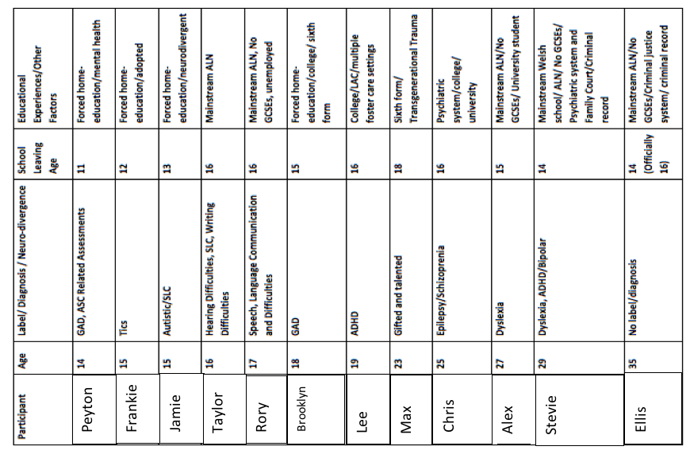
Table 2.2: Participants background information
Participant | 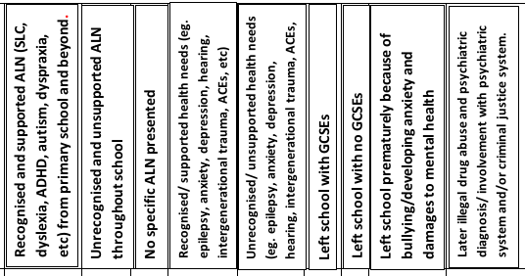
Peyton |  |  | x |  | x |  |  | x
Frankie |  | x |  |  | x |  |  | x
Jamie | x |  |  |  | x |  |  | x
Taylor | x |  |  | x |  | x
Rory |  | x |  |  | x |  | x |  | x
Brooklyn |  |  | x |  | x |  |  | x
Lee | x |  |  |  | x | x
Max |  |  | x |  | x | x
Chris | x |  |  | x |  | x
Alex | x |  |  |  | x |  |  | x
Stevie |  | x |  |  | x |  | x |  | x
Ellis |  | x |  |  | x |  | x |  | x
2.11 Core Research Questions
After extensive reading and reflection around the established inclusion/exclusion literature, gaps were identified, such as the deficit of user-led research and the following core research questions were developed:
1) In what ways, if any, has your educational experience at school created barriers that have led to educational failure?
2) What have been the effects of educational failure upon your life?
3) What solutions would you suggest to policy makers to improve educational inclusion?
2.12 Conclusion
This literature review chapter has provided a contextualising framework that positions the thesis with contemporary inclusion. While it is acknowledged that it is not possible to address the entire epistemology of inclusion in one chapter, it is hoped that what is presented will support the reader to locate the thesis within both the progressive multi-disciplinary theoretical texts. Since IPA is a data-driven, bottom-up approach which examines both individual and shared experiences, revising the literature to reflect participants’ individual and shared lived experiences was consistent with the IPA methodology (Smith, Flowers and Larkin, 2009). After conducting the interviews, I was surprised by the unexpected themes that arose which are not commonly found in traditional inclusion literature. It became apparent that little user-led research has been undertaken into ACEs, intergenerational trauma, ableism, teacher bullying and the consequences of missed assessment and misdiagnosis/one-off labelling of children. This literature chapter prepares the way for chapter three which justifies why IPA was chosen as the most appropriate methodology for this study.
- Chapter Three–

METHODOLOGY
To fully understand and appreciate action from the perspective of participants, one must get close to a participant in a wide cross-section of their everyday activities over an extended period of time. (Emmerson, Frets and Shaw, 1995, p.10)

3.1. Introduction
This methodology chapter provides the justification for the IPA approach which was considered to be the most appropriate methodology for this study. This chapter also explores the research process, the research context, the recruitment of participants, interview process and research design, along with an explanation of the ethical considerations. The twelve participants are presented in more detail with my interview reflections.

3.2 Justification and Rationale for the Most Appropriate Methodology for this Study
Ontology refers to a person’s mind set, view of the world or their social reality. Since our values directly impact our perception, behaviour, choices and ways of doing things, researchers need to be aware that their values may unavoidably influence their choice of research methodologies and methods which consequently can make any type of research problematic (Sikes, 2004). The researcher’s chosen methodologies and methods will usually correspond directly to the suitability and relevance of their own underlying theories relating to their own field of research (Clarke, 2005). Different fields of research already have an established set of approaches and methodologies, so researchers tend to choose methods which have been specifically designed to deal with their particular lines of enquiry within the existing methodology of that research field.

Sikes (2004) states that:
Usually, the most significant factor that influences choice and use of methodology and procedures is 'where the researcher is coming from' in terms of their philosophical position and their fundamental assumptions. (Sikes, 2004, p.5)
There are generally considered to be two approaches to the construction of knowledge: positivism and interpretivism. If a person holds a positivist stance, their social reality is often viewed as being objective, independent, fixed and ‘detached’ (Wellington, 2000). Positivists will study a scientific type of approach which focuses on controlled experiments resulting in quantitative data which can be easily measured and compared. Therefore, a positivist researcher will choose research methods that reflect their ontology, for example they might choose to use a fixed and closed-question large survey which will provide them with a specific set of numerical data which can be analysed quickly. In contrast, an interpretivist will tend to use experiences, perceptions and interpretations to increase their knowledge and understanding of the world (Sikes, 2004).
Moreover, adopting interpretivist approaches and a social constructivist approach requires the starting assumption that nothing is ‘set in stone’ as situations and individuals are always subject to change.
Harris and Bell (1994) explain:
In evaluating, the same problem can be approached from a variety of viewpoints using a variety of approaches…when collecting information from people one should remember that what is collected is unlikely to represent an objective reality. (Harris and Bell, 1994, p.48)
Therefore, qualitative methodology often succeeds in collecting the hidden information and concealed knowledge that more accurately examines the reasons and significant factors of influence behind the hard, quantitative data. As Ayers (2003) notes, social constructivism and qualitative inquiry helps researchers to illuminate and humanise the research process. Bruner (1986) also believes that listening to people’s stories are ‘the life stuff of those whose behaviour they study’ (Bruner, 1986, p.43) and for this reason qualitative inquiry methods have widely been used when conducting social research (Vygotsky, 1978). However, there is no such thing as totally value-free research, as a researcher’s values will considerably influence their perception, position, assumptions, methodology and the methods they adopt (Carr, 1995).
Strauss and Corbin (1998) point out that ‘insights do not happen haphazardly’ but instead they occur in the minds of those who ‘interplay with the data’. Thus, it is important for researchers to choose a robust research methodology to address issues to do with rigour and validity. As a researcher, I am all too aware, along with Strauss and Corbin (1998) that, “The theories that we carry in our heads inform our research in multiple ways, even if we use them quite unselfconsciously” (Strauss and Corbin, 1998, p.47).
Therefore, researchers should be aware of how their positionality might limit or affect their own research, as well as interfering with their interpretation of others’ research findings. Furthermore, the researcher needs to promote impartiality, sensitivity and an objective stance when interviewing participants who might already perceive themselves as misunderstood and marginalized by the very policies, professionals and services that were intended to help them. Since I am already known and trusted by respondents, an important consideration for the researcher to explicitly recognise is the power relationship involved in using techniques like qualitative interviewing and participant observation, since these can have power effects or carry an unconscious bias.
Consequently, it is important for researchers to select the most appropriate methodology for their study, which will be driven by both the research questions and their theoretical assumptions (Lyons and Coyle, 2016). Thus, the researcher will need to thoroughly evaluate a selection of methodology, giving careful thought towards producing a study which is both academically rigorous and sound, as well as firmly placing ethical practice right at the heart of the research process. As a researcher, I want to remain confident that my research will be received and welcomed as being in the public’s best interest by all stakeholders and acted upon by policy makers and practitioners at a global level. Therefore, this research process is critical.
3.3 Methods Considered
Qualitative research has a number of main methods, tools and approaches for collecting and analysing narratives. Each methodology comes with its own separate philosophy, advantages and disadvantages. Therefore, it is extremely important for the researcher to be informed of the main theories behind the methodologies in order to choose the most appropriate method their study. However, in order to explain why IPA is the most appropriate method and ‘best-fit’ methodology for my study, an evaluation of IPA’s positioning compared to other narrative approaches is required. The main methodologies for conducting narrative inquiry are grounded theory, discourse analysis, narrative analysis, thematic analysis and interpretative phenomenological analysis (Lyons and Coyle, 2016).
Grounded theory is a research method which was developed by Glaser and Strauss (1967). It is designed to test existing theory, with the aim of constructing or discovering new theory through the analysis of large volumes of data. The early foundations of grounded theory are of positivism, later developing into a more qualitative positioning (Corbin and Strauss, 2015; Lyons and Coyle, 2016).
Grounded theory is likely to begin with a research question or with the collection of large amounts of qualitative data as a starting point. Theory is constructed from the emerging data. Grounded theory is similar to IPA, in that it focuses on categorising lived experience and identifying meaning from it. However, unlike IPA, grounded theory does not seek to offer explanations about it (Willig, 2008). Moreover, Willig (2008) argues that it would be more appropriate for researchers who seek to explain lived experience to lean more towards implementing a phenomenological research methodology.
Discourse analysis is primarily focused in the power of communication and is described as being the ‘social constructionist approach to research’ (Lyons and Cole, 2016). There are many sub-types including discursive psychology, Foucauldian discourse analysis and critical discourse analysis. Discursive psychology focuses on the way people write and speak and analyse how individuals’ draw information from their culture and use of language in different contexts to make sense of reality (Potter 1996; Willig, 2013). Foucauldian discourse analysis focuses on how language shapes our understanding of power relationships, oppression and social change (Parker, 1992). The Foucauldian approach takes the view that discourses ‘facilitate and limit, enable and constrain what can be said, by whom, where and when’ (Willig, 2013, p.130).
Critical discourse analysis focuses on construction, rhetoric, ideology and action (Lyons and Coyle, 2016). Unlike IPA, discourse analysis methodologies believe that language facilitates social action and individuals formulate versions of reality through language (Willig, 2013). IPA does not prioritise language over experience, as discursive approaches do not tend to believe that experience precedes description (Willig, 2013). Thus, the main difference between IPA and discourse analysis is in their units of analysis; IPA researchers are interested in an interpretation of the meaning for individuals within their contexts, whereas discourse analysis focuses on discursive representations (Smith et al, 2009).
Even though previous studies in education (Potter, 1996) have shown how valuable discourse analysis can be, my research focus was aimed at gleaning an understanding of the meaning behind the lived experiences of twelve participants’ stories, rather than understanding how they used language within their different contexts.
Narrative analysis has its roots within social constructionism and overlaps with discursive and phenomenological methodologies (Smith et al, 2009). It examines how the structure of people’s stories influence human experience and places text before the researcher to analyse the stories, before transforming them into descriptions and theories of what they represent. Thus, narrative researchers are interested in the content of people’s stories and the structure of narrative. However, IPA does not solely focus upon the structure of a person’s story but seeks to interpret meaning, explanation and understanding from them.
Thematic analysis is a method for identifying and interpreting patterns or themes arising from qualitative data, including data familiarisation, coding, searching for themes, reviewing themes, defining and naming themes and writing up. It can be used to analyse large sets of data, such as comparing and contrasting themes found in data produced from qualitative surveys. Thematic analysis and IPA both seek a comprehensive analysis of what the themes and patterns are in the data. However, thematic analysis has often been criticised for not having a clear theoretical framework, whereas IPA is bound to a rigorous phenomenology epistemology (Smith et al, 2009) in which understanding participants lived experience of reality is given priority.
As an insider researcher, one of the key advantages of employing IPA is its robust framework. This rigid framework encourages both researcher and participants, to become integrally intertwined in the investigation, connecting them as unique individuals with different philosophies, but within a similar context to ask the critical questions.
As Lyons and Cole (2016) note, “IPA studies are usually concerned with big questions, questions of considerable importance to the participant either on an ongoing basis or at this critical juncture” (Lyons and Cole, 2016, p.53).
Moreover, IPA data provides the researcher with valuable ‘rough edges’ which is highly communicative and ‘dialogical’ as it explicitly talks back to the researcher. As an insider researcher with a range of experiences, including past acquired SENCO knowledge of underlying speech, language and communication difficulties, I was able to utilise these skills to facilitate highly effective and dynamic semi-structured interviews with neuro-divergent participants based upon my knowledge of the BLANK model and communication cycle (Appendix 8) and receptive language (John, 2013; McLaughlan and Elks, 2012).
Through conducting ‘speech, language and communication friendly’ interviews with all participants using appropriate language to suit their levels of understanding, this helped the participants to feel at ease and dialogue freely. Thus, the IPA methodology allowed some of the most silenced in society to have a platform to speak and voice their perspectives.
As Schwandt (1999) states:
Understanding requires an openness to experience, a willingness to engage in a dialogue with that which challenges our self-understanding. To be in a dialogue requires that we listen to the ‘Other’ and simultaneously risk confusion and uncertainty both about ourselves and the other person we seek to understand. (Schwandt, 1999, p.459)
Smith (1996, p.206) suggests that IPA provides insights into people’s lives whose experiences might be ignored and voices not otherwise heard.
Thus, IPA also allows the connection of commonalities between the individual experiences, along with the interweaving of another layer of analysis - the dual hermeneutic interpretation of the researcher. Moreover, as the researchers’ most crucial role is to guide a conversational interview, semi-structured interviews empowered the participants to lead, while allowing the researcher the opportunity to modify the questions and to probe more deeply. Therefore, the IPA methodology was deliberately chosen for its uniqueness in allowing each participant’s individual voice to be heard. Furthermore, the IPA methodology is in keeping with my original research study’s main goal which was to highlight some of the hidden underlying processes of oppression that currently exist throughout society.
IPA recognises that the participants are like co-authors of the research, as the researcher actively weaves in and out of their stories, becoming intertwined in the narratives in order to jointly make sense of their experiences. Moreover, IPA provides a clear theoretical framework to ensure consistency of both rigor and validity throughout the whole research process which is underpinned by a theoretical foundation and detailed procedural guidelines (Smith et al, 2009). Therefore, I decided to choose IPA methodology as it is perfectly suited to this study, as it allows the blending of both participant and researcher insights. Furthermore, through listening to unheard, oppressed and often silenced voices, the researcher will have the opportunity to step outside the conventions of traditional fields of education to examine the fresh expressions found within the data.

3.4 Interpretative Phenomenological Analysis
IPA has theoretical roots in phenomenology (Moran, 2000), hermeneutics (Palmer, 1969) and idiography (Smith et al, 2009). The philosopher and scientist, Husserl, first argued for the importance of phenomenological inquiry involving the careful consideration of a person’s experience.
Husserl (1927) points out:
Focusing our experiencing gaze on our own psychic life necessarily takes place as reflection, as a turning about of a glance which had previously been directed elsewhere...Through reflection… we grasp the corresponding subjective experiences in which we become conscious of them, in which they appear. (Husserl, 1927, para. 2)
Husserl argued that individuals should ‘go back to the things themselves’. Husserl believed that self-reflections should describe rather than explain experiences, as the experiences were analysed to reveal the construction of the experience. Husserl has contributed to the work of IPA by helping IPA researchers to ‘focus centrally on the process of reflection’ (Smith et al, 2009).
Husserl’s philosophical student, Heidegger (1927) argued against Husserl’s view, instead putting forward an idea that experience should be interpreted, as well as described (Langdridge, 2007). This change in philosophy led to the shift from Husserl’s descriptive-transcendental phenomenology to Heidegger’s hermeneutic (interpretative) -existential phenomenology, which emphasised the duality of describing lived experience and the interpretation of meaning. Heidegger (1962, p.59) noted that phenomenology is focused with examining ‘something that lies hidden’ which may be concealed or disguised, as it comes to light, along with that which is visibly manifest. Thus, Interpretative Phenomenological Analysis is rooted in Heidegger’s duel hermeneutic-existential phenomenology and inter-subjectivity in asserting to explore in-depth human lived experience which can enable individuals to reflect more successfully upon their own experiences and resolve conflict.
As Riessman (2008) states, “Telling stories about difficult times in our lives creates order and contains emotions, allowing a search for meaning and enabling connection with others” (Riessman, 2008, p.10).
Goodley (2011) also acknowledges that the power of listening to different voices can enable researchers to evaluate the ‘private troubles’ of people while at the same time uncovering ‘public issues’ within institutions and organisations.
Smith (1995) developed Interpretative Phenomenological Analysis as a sound theoretical framework, with robust guidelines for qualitative research (Smith et al, 2009). During the past decade, IPA has been conducted widely within the field of health psychology and nursing, as well as applied social and clinical psychology (Flowers, Marriott and Hart, 2000). Smith (2009) categorized IPA as having three key features: idiographic, inductive and interrogative. The idiographic quality is shown through the participants’ “lived experience” married with subjective interpretation. As Smith and Osbourne (2015) suggest, in IPA the respondents are ‘trying to make sense of their world’, while the researcher attempts to understand how the participants are ‘trying to make sense of their world’.
Therefore, this IPA study connects with theories of social constructivism which focuses on constructing knowledge and understanding of truth from human shared experiences. Consequently, IPA not only interconnects to the traditions of feminism, but combines education with other disciplines, such as psychology, sociology, history, neuroscience and critical disability studies.
3.5 Research Context
This study was carried out in Swansea, Wales, United Kingdom. I decided not to anonymise the research location because of the significant discrepancies in the official government data and the irregularities regarding the social poverty and inequality that exists there in comparison to the rest of the nation (see Appendix 11 and 13). Swansea is the second largest city in Wales, having the second highest population out of the 22 Welsh local authorities, with an estimated population of 242,400 (Swansea Gov UK, 2018).
Swansea has the highest figures for opioid deaths (Figure1.8), the highest rates of homelessness in Wales (Figure 1.5), with high rates of suicide, drug and substance misuse (Figure 1.6) and has higher figures than the Welsh average for children being placed within the care system (Figure 1.9). Swansea also has a very high number of statemented children (Welsh Assembly Government, 2017) and documented over-medicalised service-users (Davies, 2016), as well as gaining the title of having ‘the most overcrowded prison’ in England and Wales (Griffiths, 2016). Therefore, since substantial quantitative data evidenced major gaps and unsustainable pressure in psychiatric support, social services, criminal justice and education sectors, it was the presence of this official published quantitative data about Swansea which is one of the fundamental reasons behind my qualitative inquiry and forms the starting point to my IPA research.
As Stevenson (2014) puts it, “Proximity to the condemned, to people unfairly judged; that was what guided me back to something that felt like home” (Stevenson, 2014, p.14)
This IPA study examined the stories of twelve people (six males and six females) of ages varying from 14-35 and from a range of different settings throughout Swansea, who believed that they have experienced educational failure or exclusion through no fault of their own. I decided not to anonymise the research location as the participants were deliberately sought out because they live in Swansea and it was hoped that their voices would help to explain the significant discrepancies in Swansea’s data. I was mindful to protect the identity of organisations as far as possible. However, it should be also noted that some of the information disclosed by participants is already found in the public domain. Additionally, some of the participants in this study did not want to change their names, however great care was taken to protect participants’ identities. Therefore, many identifying details have been changed or removed and I decided to give all the participants gender-neutral pseudo-names as an extra-precautionary measure.
Therefore, throughout this thesis, participants may be referred to as male or female, or in some instances no reference to gender is given. However, it should be noted that in the rare instances where a participant has self-disclosed their own gender when describing their personal experiences of being a female such as giving birth, having an abortion or experiencing mother blame as a result of exclusion; all of which are highly relevant to this research study, this could not be avoided.
This study was approved by Sheffield University Research and Ethics Committee in July 2015 (Appendix 1). All participants were more than willing to openly share their stories and because of the interest in my study, I wrote to Sheffield University to obtain ethical authorisation to increase my participant numbers by 20% (Appendix 1). It is believed that the increased interest in my IPA research arose as participants were given the opportunity to strategically witness; a tactical device to speak when others remain silent and to give fresh vision when others can’t see.
Ali and Lees (2012) point out:
The oppressed not only stand to gain from social activism by being activists themselves and by benefiting from the resulting changes, but are also best situated to see, understand, and document the pressing need for bettering our society for the good of all. (Ali and Lees, 2012, p.162)
Therefore, it is the intention behind this research to strive to maintain purity in portraying justice and it is for these critical reasons above, that it was felt extremely important not to anonymise the broad research location. In accord with Fanon (1952), I believe that insightful treasures can often emerge from the darkest places.

3.6 Ethical Considerations
First, do no harm’ - The Hippocratic Oath
Ethical considerations, such as the issues of confidentiality, informed consent and ensuring that participants are not harmed in anyway were carefully implemented before carrying out research. Therefore, once my ethics application and been cleared by Sheffield University, I spoke to participants (and the parents of children under the age of eighteen) in more detail and provided them with an information sheet and a consent form (Appendix 2). Parents were encouraged to read through the information sheet with their children. Both participants and parents signed the consent forms prior to interviews.
In keeping with research guidelines, I gained informed consent from participants before the IPA study began and all participants were notified that they could withdraw at any time. Since IPA can be compared to a camera, in that it captures a snapshot of what has taken place in an individual’s life at a particular time and place, gender-neutral pseudo-names were used as a further protective measure to disguise individuals’ identity from anyone who might have known them during the time of the ‘snap-shot’. Respondents were well-informed about the aims and objectives of the study and all eager to take part. All participants gave consent to their interviews being audio-taped and transcribed. Participants were reassured that all names, information and organisations that could possibly identify them would be changed, disguised or removed to protect their identity as far as possible. Respondents were also informed that audio-tape recordings would be destroyed after the research was published.
The research focused upon participants’ individual experiences of educational failure. Thus, all interviews were held in quiet spaces to ensure private, confidential discussion. Participants were also informed that my research supervisor would also have access to the audio-taped transcripts, as their responses would contribute to my thesis.
All respondents were reminded that they could say as much or as little during the interview as they wished. All participants were informed of the relevant and appropriate support systems that were available to them if they felt they needed to talk to somebody about any of the issues or painful memories that might have surfaced due to the interview process.
The participants were contacted to arrange a date to be interviewed at their choice of venue. Due to the emotive nature of the research, a semi-structured open-ended questioning style used broad research questions to help the conversation flow freely (Appendix 3). Since the majority of the participants were known to me, I had a degree of assumed knowledge, which allowed fuller access to ask more in-depth, probing questions about difficult or hidden truth, which a more detached researcher would not have been relationally equipped to do. It is this ‘deep immersion’ and closeness that enables researchers to consider how the voices, experiences and narratives are situated within the socio-cultural contexts, as listening to individual experiences can very often address a shared social position within society (Emmerson et al, 1995; James, 2007).
Warwick (1982) warns:
Social research involving deception and manipulation ultimately helps produce a society of cynics, liars and manipulators, and undermines the trust which is essential to a just, social order. (Warwick, 1982, p.58)
To minimise researcher bias, I sought to use the rigorous IPA methodology to collect, record, document and analyse the direct voice of the participant. Thus, this research sought to enable the participants to freely present their perceptions of their own life situations in their own words.
Due to the participants speaking freely about their own experiences using semi-structured open-ended questions, interviews ranged from approximately 5 minutes to 90 minutes, depending on how much or how little the respondent wanted to say. All interviews were audio-taped and afterwards the interviewees’ words were transcribed verbatim (Appendix 4) to communicate the authentic voice (Goodley, 2011). Detailed field notes were also used to record observations of other relevant factors, such as notable behaviours or information gleaned from the encounter and these field notes acted to support and strengthen the interview evidence (Appendix 12). As part of the ethical considerations, participants were offered the opportunity to read their transcripts, but instead most requested the preference to read the whole thesis when complete.
3.7 Research Design
In order to allow free flowing dialogue, loose, broad research questions were used during the semi-structured interviews:
* In what ways if any, are the challenges or barriers that led to educational failure?
* What could have made an important difference at this time?
* What are the effects of educational failure in young people?
* How have these experiences impacted upon life-choices?
* What solutions do you suggest?
* What are the implications for educationalists and policy makers?

3.8 Recruitment
Being an insider researcher, I had the privilege of being involved in supporting a number of individuals throughout a plethora of settings in Swansea.
All participants perceived themselves as being the victim of some form of educational failure, oppression or exclusion. Many participants who choose to contribute to this research also identify themselves as having a neurological difference or diagnosis. Since individuals’ ideas and input should be at the heart of any research that involves them, this unique research opportunity gave participants a platform to use their voice to open-up new dialogues about how experiences of trans-disciplinary and interdisciplinary systems have affected their lives. Furthermore, because of some of them having involvement with multi-disciplinary teams, they naturally discussed these multi-disciplinary systems they had encountered.
3.9 Pilot
The research method was trialled on a teenage respondent who was being home-educated. This pilot served the purpose of testing the research process and design to highlight any loopholes, limitations or problems in the research design. This pilot provided vital information which was used to inform the later research. It also provided a useful opportunity for further improvements to be made to the research design, the semi-open interview questions and the interviewing technique. It highlighted that one of the weaknesses of this design was that if I solely conducted interviews with home-educated teenagers, then due to their age and limited life-experiences they would not be able to fully reflect upon the full consequences of educational failure upon their adult life-choices.
Therefore, this pilot highlighted the importance of engaging with a range of ages, including adult participants too. The adult participants would be able to draw upon adult life experiences which the younger participants were not old enough to do. The participant who took part in the pilot wanted their voice included in the main-body of the research. Since this research is all about inclusion and the research questions remained the same, it was deemed only right to include this person’s voice in the thesis.
Furthermore, to exclude and deny this person the opportunity to have a voice would have been contrary to the aims and principles set out in this research study.

3.10 Participants

The sample was an opportunity sample, as most participants were already known to me. It should be noted that the summaries do not form part of the analysis but are only intended to provide a context for the reader. Demographic details collected from each participant can be found in Tables 2.1 and 2.2.

A Brief Descriptive Summary

Peyton, Frankie, Jamie and Brooklyn identify themselves as ‘forced’ home-educated.
- Peyton is fourteen years old and has been educated at home since Year 7. Peyton has a diagnosis of general anxiety disorder and is currently waiting assessments for ADHD/ADD/ASD.
- Frankie is fifteen years of age and has been educated at home since Year 8. Frankie was bullied at school for being adopted.
- Jamie is fifteen years old. After attending a Welsh speaking school and being identified with communication difficulties, parents were advised to transfer Jamie to an English-speaking school where a later autism diagnosis was obtained. Jamie has been home-educated since Year 9.
- Brooklyn is eighteen and has attended both Welsh and English-speaking schools. Brooklyn became home-educated during Year 11 after experiencing panic attacks whilst sitting GCSEs.

Taylor, Lee, Max and Chris attended school all the way through to successfully sitting and attaining their GCSEs at the end of Year 11.
- Taylor’s sixteen years old. As a young child, Taylor suffered with glue ear and experienced hearing problems which were also accompanied by communication difficulties. Taylor is in Year 11.
- Lee is nineteen years old and has experienced life in multiple foster-care placements. Lee also has a diagnosis of ADHD.
- Max is twenty-three years old. At school Max, was identified as a ‘gifted’ and talented future ‘Oxbridge’ student.
- Chris is twenty-five years old. From a young age, Chris suffered with uncontrollable epilepsy, having been hospitalised a number of times through the school years. As an older teenager, Chris was sectioned at a psychiatric hospital where a diagnosis of paranoid schizophrenia was obtained.

Rory, Alex, Stevie and Ellis attended comprehensive school, but for one reason or another, did not attain any GCSEs.
- Rory is seventeen years old and despite attending school all the way through, did not manage to attain any GCSEs.
- Alex is twenty-seven and has been diagnosed with dyslexia, leaving school just prior to sitting her GCSEs because of bullying at school.
- Stevie is twenty-nine years old. Educated at a Welsh speaking school with undiagnosed and unsupported dyslexia, left school at fourteen years old. After being involved with psychiatric services, Stevie has a dual diagnosis of ADHD and bipolar disorder.
- Ellis is thirty-five years old and identifies as being a recovering heroin addict who has experienced homelessness. Ellis left school without any GCSEs after truanting regularly at fourteen. Ellis has also served time in prison.

3.11 Procedure
A letter and information sheets were given to participants (and parents if the participant was a child). This letter introduced and explained the rationale for the research and the procedure and the information sheet (see Appendix 2) contact details form was signed by the participant. All participants were enthusiastic to take part in the research. Arrangements were made between the researcher and the participants to meet at a convenient time at a quiet place of their choice. Semi-structured interviews were conducted with each of the participants and lasted between five minutes and an hour and a half, depending on how much or as little the participants wanted to say. Each of the interviews was recorded on an audio recorder and then transcribed verbatim by the interviewer. Individual taped interviews were transcribed word-for-word with specified line numbers complying with IPA guidelines (Smith et al, 2009).
Any significant dysfluencies were omitted from transcripts and Lieblich, Tuval-Mashiach and Zilber’s (1998) transcript symbols were used:
• Brackets [ - ] addition of missing words or phrases
• Parentheses ( - ) addition of a description or explaining phase
• Asterisk * signifies name change
• Ellipses … signifies deleted speech
• Quotation marks “ ” signifies the dialogue reported by the narrator

3.12 Interview Process
The individual interview aimed to provide participants with an introduction to the purposes of the research, encouraging them to provide a brief ‘life-history’ and their interpretation of events and relationships regarding their educational experience.
Interviews were semi-structured, allowing for a better structure for comparability than unstructured interviews, whilst allowing the interviewer more freedom ‘to probe beyond the answers’ (May, 2001, p.93). Since all the participants were all known to me, this gave me a distinct advantage in that they were all relaxed and I was already adept at changing my communication style to suit their individual communication need. Therefore, my positionality gave me a unique advantage to pre-plan for person-centred interviews to remove communication barriers for participants with speech, language and communication difficulties. Since some participants had ‘hidden’ communication needs, I was keenly aware that I did not want the interview process to be a negative experience for any of them. I sought to do my utmost to adhere to the principle behind the Hippocratic Oath, ‘First, do no harm’ and I used strategies to remove communication barriers which would have caused increased anxiety levels for some of the participants.
These carefully considered approaches to removing communication barriers enabled a smoother dialogue and aided my desire to use the interview experience as a positive therapeutic vehicle to empower participants to be affirmed in the knowledge that they had been actively listened to and clearly understood. As McLachlan and Elks (2012) point out through the ‘Communication Cycle’, hidden receptive language skills understandably come before expressive language skills and it is clear to see that weaknesses at any stage can lead to difficulties being understood (Appendix 8).
Difficulties with receptive language are often hidden from direct view but can be found with difficulties listening, following basic instructions, remembering and understanding language, while difficulties with expressive language can be heard through unclear speech, grammatical speech errors, illogical flowing speech or vocabulary (McMinn 2006). Speake (2003) also notes that another indicator of receptive language difficulties includes difficulty in answering questions.
Thus, I was mindful to reduce any frustration on the part of any participant who due to communication difficulties might be struggling or stammering to put their point across. Additionally, with participants with receptive language difficulties, there would be expected delays in the flow of a conversation, to allow the person to work out what was said to them and then convert their thoughts back into the words that they want to speak. Thus, I wanted to put preventative measures in place to avoid any participant feeling that their voice was still not being heard. Thus, I adapted my choice of language to ensure that all participants clearly understood the questions being asked of them, often rephrasing or simplifying questions to ensure that I fully understood what some were struggling to communicate.
In order to aid understanding, I also adapted my probing to ensure relevance to their unique contexts. I personally believe that these pre-planned steps were essential for my participants to feel that they were clearly being heard and understood. Researchers who do not recognise the need to develop an adequate relationship with their participants before interview are at risk of failing to adequately support a person with possible communication difficulties. Consequently, these researchers may find that the dynamics of their interviews might be greatly hampered. Additionally, their data collection might not be as rich in quality as the researchers who give careful thought to purposefully planning person-centred interviews to maximise effective communication.
Therefore, as an insider researcher, my prior knowledge of the participants and their individual language needs greatly assisted me in the interview process. Since the comfortable dialogue and person-centred approach had the desired effect of empowering participants to speak with boldness and clarity. Furthermore, I would never have gleaned as much in-depth information, knowledge and understanding, if I had failed to establish a trusting relationship with recipients.
Simultaneously, the pre-planning for the effective transition between expressive and receptive modes of communicative dialogue during the semi-structured interviews enabled the collection of a richer quality of data. This rich data was then thoroughly examined and evaluated using IPA.

3.13 Reflexive Boxes – Interview Reflections
Reflexive Box 1 – Interview Reflections with Peyton
The interview took place at the family home and after about five minutes of the tape recorder being on, Peyton was soon relaxed and chatted at length. I found at times, Peyton became very angry when referring to the professionals who had either done nothing to help, or those who used and abused their positions to lie and cause harm. At these times in the interview, Peyton expressed anger by swearing or repeating utter disbelief at professionals’ unscrupulous deceitful behaviour. Peyton spoke very intelligently and offered great insight into this situation. Peyton spoke with the vocabulary, comprehension and wisdom of someone much older than fourteen years old. Peyton was happy to offer a personal analysis of the situation with sharp insight which I found astonishing. Peyton was able to accurately pin-point gaps in the system and offered intelligent preventative solutions. At times, the pain was clearly visible in both voice and eyes, which was uncomfortable to see and hear, clearly illustrating the utter devastation that needless adult ‘professional’ bullying can have on a child’s life. Throughout the interview, Peyton referred to mum as being the biggest support and ‘rock’, so it was quite alarming to know that Peyton had to endure two social services investigations, both of which were staged and initiated to cover-up professional incompetence. To be honest this interview shocked me to the core.
Forced-Home Educated Age 14 Length of Interview – 1 hr 30

Reflexive Box 2 – Interview Reflections with Frankie
Despite being very confident, funny and having a lot to say, Frankie was quite serious at the beginning of the interview as very short precise answers were given. Frankie’s earliest recollections of school experiences appear blurred as it was repeated, ‘I can’t remember. I can’t remember’ (Line 8). Frankie’s mum recalls that this was a very painful and difficult time for Frankie, as a school move was made due to school bullying. Despite Frankie’s interview being relatively short, I was able to identify themes early on. Key points were repeated throughout the interview to emphasise importance, ‘I got bullied and bullied and bullied and bullied’ (lines 18-19). Frankie also used sarcasm and humour, along with using funny voices to illustrate feelings about school, for example, ‘You must copy this off the board and if you go wrong, we will beat you’ (lines 64-65). Right at the end of the interview, Frankie almost shouted in an exasperated tone of voice that schools need to protect children from being bullied, especially those who have been adopted and experienced trauma. Then Frankie made it clear that the interview needed to finish as there were more pressing engagements to attend.
Forced-Home Educated Age 15 Length of Interview – 5 minutes

Reflexive Box 3 – Interview Reflections with Jamie
During the interview, it was evident that Jamie found it extremely difficult talking about some areas of school experience. At certain points, there was silence as much processing was going on. At the beginning of the interview, some questions were met with either ‘yes’ or ‘no’ answers which required further prompts and questioning. At other times, Jamie became very vocal as questions evoked strong memories, feelings and emotions. At other times during the interview, Jamie spoke slowly and thoughtfully, giving careful consideration to what was being explained or described. Jamie spoke about attending four different Swansea schools, noting exclusion or bullying experiences at each one. Jamie’s mother noted that although Jamie was far too young to remember, Jamie was advised to leave the first Welsh speaking school because speech, language and communication difficulties were identified and the school did not have the resources to support this need. Therefore, instead the family were advised to take Jamie to a local English-speaking school. Jamie spoke about how becoming a target at three subsequent English-speaking schools has negatively affected every area of life. Jamie also did not mention about an autism diagnosis which was acquired at a later age. Jamie became even more vocal when the tape-recorder was turned off, openly exclaiming the self-belief that he/she must be the most hated person in the locality because of being the victim of relentless bullying. This comment clearly illustrated a deep internalisation of blame.
Forced-Home Educated Age 15 Length of Interview – 7 minutes

Reflexive Box 4 – Interview Reflections with Taylor
Taylor appeared visibly happy and confident throughout the interview, speaking at length about both good and bad experiences. Taylor seemed very eager to present a balanced viewpoint although strong opinions were also offered about what professionals could do to improve practice. Since Taylor’s mum had asked if I would offer support prior to GCSE exams, after reading a psychologist’s report which had revealed a very low General Conceptual Ability (GCA) score of 76, I saw the need to explicitly explain about exam specifications to help Taylor strategically tackle the GCSEs and self-advocate. Taylor was eager to offer these insights and experiences because of the help given. Additionally, since Taylor’s interview took place in the middle of the final GCSEs, this learner further benefitted as more knowledge about access arrangements was gleaned from me during this interview which positively impacted upon learning outcomes. This interview provided Taylor with the confidence to further self-advocate ensuring laptop provision was put in place for all remaining exams. Thus, this interview affected positive change as Taylor acquired the knowledge to remove personal learning barriers between educational need and exam provision which helped to produce very good GCSE results.
Mainstream ALN Age 16 Length of Interview – 28 minutes

Reflexive Box 5 – Interview Reflections with Rory
Rory, who felt ‘gutted’ about leaving school without attaining any GCSEs, was eager to talk about school experiences. Since Rory knew the interview was being recorded, words were chosen very carefully. However, after the first few questions, everyone relaxed and the interview was more like a conversation as Rory was happy to speak at length about most topics. When answering some of the questions, some painful memories about being deeply humiliated by other pupils and teachers laughing about ‘it’ at school, clearly evoked strong emotions and whilst speaking about this sensitive topic, a nod was used along with raised eyebrows and a direct look in the eye, as Rory stated, “You know what I mean.” Feeling the discomfort at this point, the interview was drawn to a close. However, afterwards Rory stated that he [or she] was grateful for the opportunity to speak about how school had failed him [or her] and wanted to take part in research to prevent others suffering in silence and to stop bullying in school.
No GCSEs / Unemployed Age 17 Length of Interview – 15 minutes

Reflexive Box 6 – Interview Reflections with Brooklyn
Brooklyn took part in the pilot and was eager for his [or her] voice to be included in the main research body. Relaxed throughout the interview, a range of topics were spoken about at length. Brooklyn demonstrated clear insight, referring to detailed examples of memories which included names and dates. Brooklyn proved to be a very pro-active participant who expanded past personal experiences to offer a prolific knowledge base of solutions which had been personally tried and tested, along with others researched via the internet. At the end of the interview, Brooklyn commented that the interview had been a cathartic experience as it allowed him [or her] to talk about experiences at length in a safe and non-judgemental environment.
Forced-Home Educated. Age 18 Length of Interview – 1 hr 20

Reflexive Box 7 – Interview Reflections with Lee
Lee is a naturally chatty person with deep insight and knowledge of the workings of multiagency systems due to experiences living at multiple foster-care settings. Before the interview, Lee expressed that this opportunity had been longed for as it was rare for foster-care children to have their voices heard, to tell their story and to express the situation from their own perspective. Lee spoke at length during the interview, and at times was so engrossed in what he [or she] was saying that the roles switched and it was Lee who began to ask the questions. At times, as an interviewer I found the contents of the deeply personal information deeply distressing to listen to and was surprised by Lee’s ‘matter-of-fact’ stance as he [or she] explained that there was a desperation to be listened to by someone.
Multiple Foster Care Settings Age 19 Length of Interview – 1 hr 10

Reflexive Box 8 – Interview Reflections with Max
Max had initially approached me to be considered to take part in this study and there was a real keenness to be interviewed. Max is a confident speaker and topics were covered at length. To be honest, his [or her] stance challenged my preconceptions as, since Max had obtained eleven excellent GCSEs and three (AAB) A’ Levels, I had not perceived this person to have been educationally failed by any stretch of the imagination. However, Max insisted on having an interview to expand my understanding of what it meant to be educationally failed. During this interview, I interjected occasionally to ask for further clarification or added further questions. Max gave detailed descriptions as information was recalled which was deeply sensitive, especially the hurtful memories of school. Max provided a unique analysis of owned experiences, as well as referring to the possible motives of others or their positioning within the power struggles at school. Max displayed a range of emotions, including anger about the immense sense of loss and regret for going to school and being exposed to harm. Max’s unique articulation of educational failure from the lens of an overachiever added a fresh perspective. It was felt that the interview had been an empowering experience, as the simple act of being heard, listening to and having his [or her] pain acknowledged, appeared to help the process of coming to terms with the past, as well as helping Max realise how the insidious internalised blame for situations that were outside the realm of his [or her] control had wrongly formed past thinking.
Gifted and Talented Age 23 Length of Interview – 1 hr

Reflexive Box 9 – Interview Reflections with Chris
Chris was happy to talk about his [or her] experiences about being educationally excluded across multiple education systems and the consequences of long-term struggles with out-dated-systems. Chris spoke openly about past experiences of being an ill-child who had been hospitalised several times during childhood. He [or she] explained how due to illness beyond his [or her] control, Chris sat GCSEs without much support. Chris also explained how it felt to be excluded from activities and school trips because of illness and also disclosed what it felt like as an adult to have life-changing decisions made without being asked to give consent. Chris was open about a range of sensitive issues, including self-harming and being sectioned at a psychiatric hospital. Having journeyed with Chris, I have personally witnessed Chris’ strength to survive against all the odds stacked against him [or her] and it is a miracle that Chris is still alive to tell the tale. Chris’ voice, along with other participants in this study, is highly valued.
Psychiatric System Age 25 Length of Interview – 18 minutes

Reflexive Box 10 – Interview Reflections with Alex
Alex was eager to be part of this study and after nagging me for an interview, I gladly responded to this request. Being one of the older participants, Alex had experienced multiple learning contexts, including primary, secondary, college and university settings. A very confident self-assured speaker who had strong opinions, the interview was conducted at length as there was so much that Alex wanted to discuss. Speaking with insight and clarity, Alex offered a balanced viewpoint giving both positive and negative examples of practice. Despite knowing Alex for a long time, I was quite shocked by the disclosures made during the interview and felt inspired by the sheer determination to turn his [or her] life around despite struggling with dyslexia and leaving school early before siting GCSEs.
Dyslexic/ University Setting Age 27 Length of Interview – 1hr 10

Reflexive Box 11 – Interview Reflections with Stevie
At the beginning of September 2013, having previously tried to support and help Stevie through a very difficult period in his [or her] life, I was so shocked by what I had seen that, that I took Stevie to Swansea LA after they requested that I provide them with evidence about the failure to diagnose across the authority (Appendix 16), but unfortunately no one wanted to listen to Stevie. Therefore, when the opportunity arose to be interviewed for this study, Stevie wanted to explain about the horrific consequences of educational failure on his [or her] young life. Stevie was comfortable answering questions in English despite being educated at a Welsh mainstream school. However, due to a mixture of trauma, unsupported dyslexia and subtractive bilingualism, some of Stevie’s speech can often be muddled, grammatically incorrect or words are used in the wrong context. Despite these barriers to being heard, I know and understand Stevie perfectly well and this interview has given Stevie’s silenced voice a platform to speak and share his [or her] insights in this powerful story.
Dyslexic/ ADHD/Bipolar/ Family Court Age 29 Length of Interview – 1 hr

Reflexive Box 12 – Interview Reflections with Ellis
I interviewed Ellis at the local homeless-drop-in-centre, where his [or her] educational journey was kindly shared with me. Ellis was pleasant throughout the interview and happy to be involved in this research. Ellis was able to draw upon vivid early memories of school, even though he [or she] shuffled and looked uncomfortable when talking about how he [or she] was publicly shamed for not ever finishing school work. Ellis was happy to examine several factors surrounding why he [or she] left school so early and why a destructive path had been ‘chosen’ involving drugs and addiction. Ellis was open and easy to interview, eager to share from his [or her] own experiences of educational failure, feeling ‘rubbish’, drug addiction, homelessness, criminal conviction and hopelessness. During the interview with Ellis, a male volunteer offered both Ellis and I a bacon sandwich and his voice can be heard clearly on the audio recording tape. However, this extra unexpected voice on the audio recording is important, as this person died before I had the chance to transcribe the interview. This situation highlights the absolute urgency driving this research study, as there have been many more untimely deaths and suicides within the homeless communities in Swansea since this interview which emphasises the pain and reality of hopelessness behind the local suicide statistics (Appendix 9).
Prison / Criminal Record Age 35 Length of Interview – 25 minutes

3.14 Conclusion
This methodology chapter offers validation for the selected approach of IPA (Smith et al, 2009), providing an examination of the research design, research process and offers more detail about the participants to the reader. The next chapter presents the stages of analytic process involved in the identification of the superordinate and subordinate themes that led to the formation of the findings. While the analysis for the most part focused on the ‘core’ of the participants’ experience, in keeping with the twofold nature of IPA, the researcher’s interpretation of the participants’ experience is presented simultaneously alongside the raw findings.

- Chapter Four –

ANALYSIS AND INTERPRETATION
A good rule is never to think that anything is straightforward and 'obvious', never to take anything for granted and never to leave any assumptions unquestioned. (Sikes, 2004, p.15)
4.1 Introduction
This section provides the reader with a transparent examination of the stages of analysis, as each participant’s interview was subjected to a systematic analysis using IPA techniques (Smith et al., 2009). The stages of systematic analysis allowed a logical movement (Figure 4.1) from the raw data to the identification of the overarching individual themes and from the emerging subordinate themes towards an identification of the common themes (Figure 4.5).
4.2 Stages of Analysis
The first stage of analysis involved transcribing the interviews. The analysis involved listening to the audio interview a number of times, in order to become immersed in the narrative while reading and re-reading over the transcript. Initial points of interest, ideas or emerging themes were noted in the right-side column next to the transcript, while key emerging themes were written in the left-hand column (Appendix 4). When this process was complete with one transcript, the same process was systematically conducted with the next transcript, and so on, until all participants’ transcripts had been subjected to this process. Figure 4.2 shows a sample of data during stage 1 and 2 of the analysis process. Once all the transcripts had been systematically analysed, the participants’ overarching themes were identified together. These were shown in a table of results which provided an overview of overarching themes across participants (Figure 4.3).
4.3 IPA Guidelines (Smith and Osborn, 2003, Smith et al, 2009, Smith, 1996)
Figure 4.1: Steps to IPA: Analysis of the Interview Data
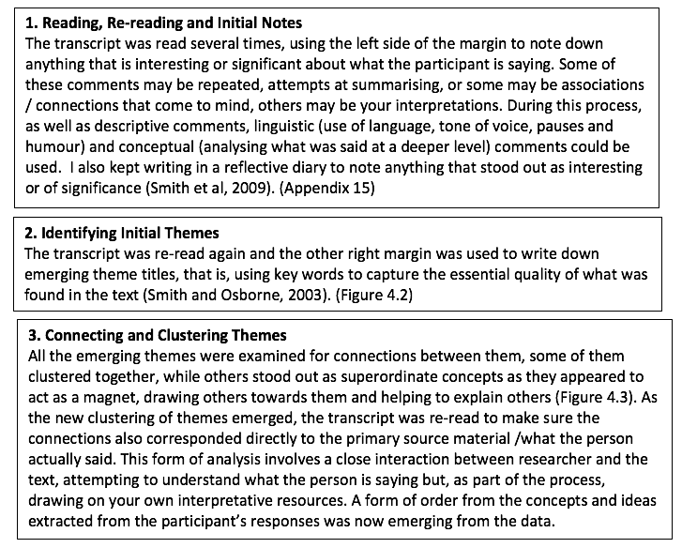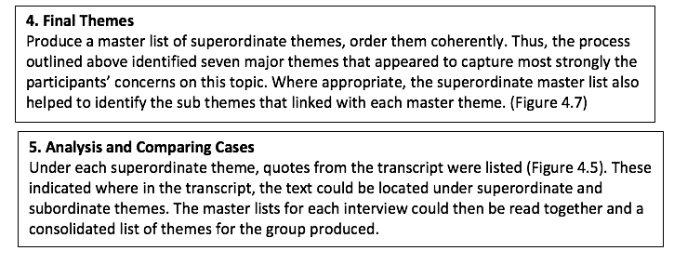
The next stage identified emerging common themes found within all the transcripts. In checking the validity of the method and interpretations, the listed themes were analysed with the reference to the original text and where there appeared to be a cluster of closely related themes, these were named under a super-ordinate theme.
4.4 Emergent Themes
Figure 4.2: Emergent Themes
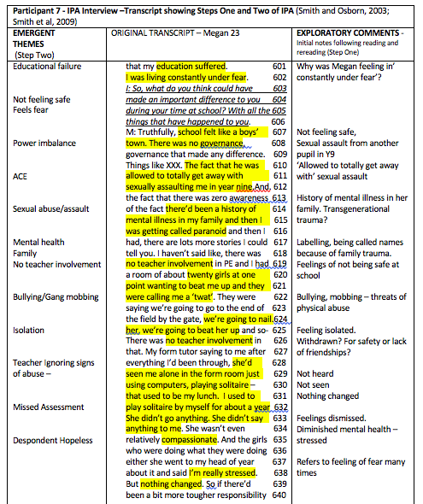

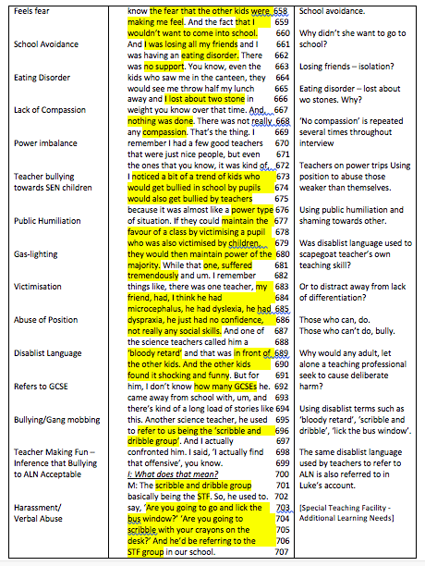
Participant 4’s account

4.5 Summary of Subordinate Themes
The superordinate themes were constructed during the IPA analytic process, through examining the patterns and connections between the participants’ emergent subordinate themes.
Figure 4.3: Summary of Subordinate Themes
The next stage in the process was to compare and contrast themes to develop a final table of super-ordinate and subordinate themes (Table 4.1). Through using examples of individual participant experience from the transcripts to capture the quality of the participants ‘collective’ experience, a rich picture of themes emerged during the analytic process of the analysis (Figure 4.4; Appendix 5). Key word searches were also carried out on the transcripts to probe further and deeper into participants’ feelings and experiences.

4.6 Reflexive Box: Construction of Superordinate Themes
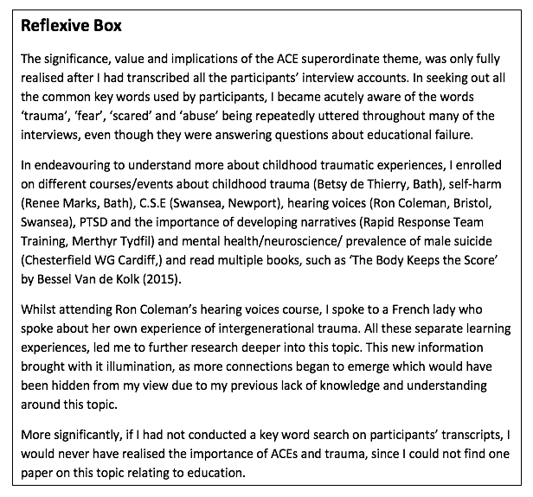

4.7 Extracts of Participant Quotations
Figure 4.4: Extracts of Participant Quotations
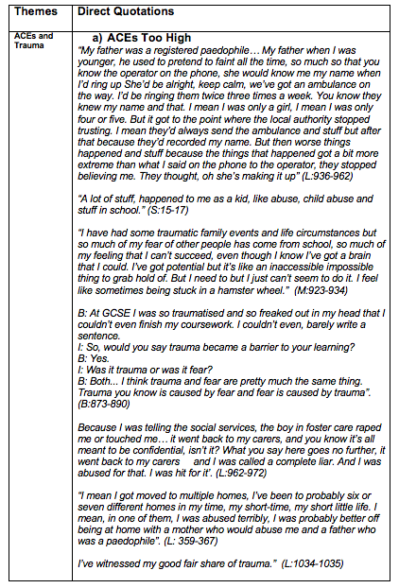
4.8 Framework of Superordinate Themes
The process of arriving at the final seven superordinate themes was quite straight forward, as several similar themes were presented throughout.
Table 4.1: Framework of Superordinate Themes
4.9 Conclusion

This chapter has contributed to the thesis by offering an in-depth examination of all the systematic stages of analysis, right from handling the vast amounts of raw data produced by the twelve interviews to the identification of the overarching individual themes and common shared experiences. This chapter also details how important the key word search was used as a useful tool for identifying experiences that appeared to matter the most to the participants. This chapter leads naturally onto the data presentation, findings and discussion chapter which present participants’ experiences through the lens of both their lived experience (phenomenological) and applying knowledge through interpretative analysis. In the next chapter, I have decided to combine both the findings and discussion into one section to avoid unnecessary repetition, to deepen and broaden the exploration of the final superordinate themes.

- Chapter Five –

DATA PRESENTATION, FINDINGS,
ANALYSIS AND DISCUSSION
Good IPA studies tend to tap into ‘hot cognition’, engaging with issues that are current, emotive and sometimes dilemmatic. (Lyons and Cole, 2016, p.53)
5.1 Introduction
This combined findings and discussion chapter (Smith & Osborn, 2003) presents each super-ordinate and subordinate theme in turn, using examples of direct participant voice from the transcripts, along with the researcher hermeneutic interpretation and the extant literature. Interpretative phenomenological analysis guidelines explain how studies are usually written as narrative form to help the reader to grasp the researcher’s interpretation of their own data (Smith et al, 2009). Thus, I have utilised Smith et al.’s (2009) philosophy in writing up this IPA study through presenting each of the seven superordinate themes as narrative accounts.

5.2 The Seven Superordinate Themes
1) ACEs and trauma
2) Missed assessments
3) Disabling learning environments
4) Bullying, gaslighting and systematic practice
5) Damages to mental health, survival coping mechanisms and self-medication
6) Revolving door of cycles of oppression and intergenerational poverty.
7) Preventative medicine and restorative practice
5.3 The Relationship between the Seven Superordinate Themes.
As seen in Figure 5.1, there is much movement and flow between all the superordinate themes, as they often overlap and are firmly interconnected.
Figure 5.1: The Relationship between the Seven Superordinate Themes
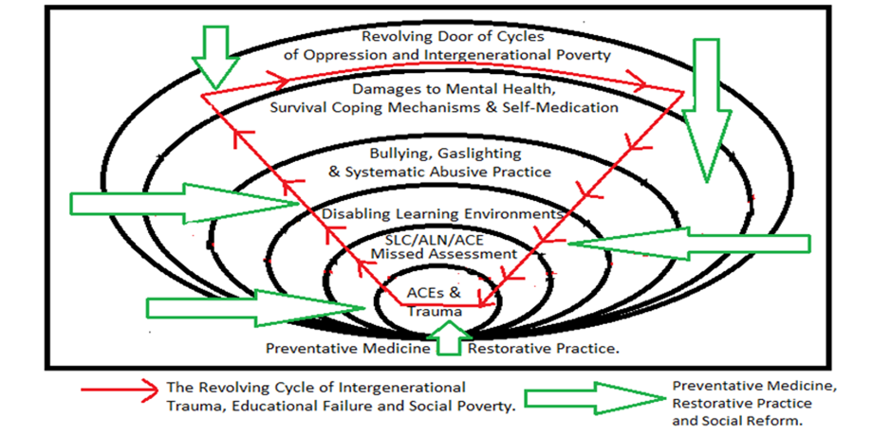
As Bell (1987) states, “A successful study will provide the reader with a three-dimensional picture and will illustrate relationships, micro-political issues and patterns of influences in a particular context” (Bell, 1987, p.7).
5.4 Superordinate Theme One: ACEs and Trauma
Throughout this research study, which focused upon gleaning knowledge about participants’ educational experiences, I was quite surprised that adverse childhood experiences (ACE) emerged as a superordinate theme. Moreover, during their interviews, a third of participants disclosed that they were sexually abused as children by people they knew, two-thirds stated that they had been physically abused, 100% disclosed emotional abuse and one-third of participants had social services involvement which resulted in half of these children either being removed from their birth mothers and placed in foster-care and/or adopted.
In both Lee and Stevie’s accounts, they reveal that they experienced multiple complex traumas during their childhood years, recounting they had experienced all five separate high impact ACEs as youngsters: child sexual abuse, physical abuse, emotional abuse, physical neglect and emotional neglect across their lifetime:
“I’ve witnessed my good fair share of trauma.” (L:1034-1035)
“A lot of stuff, happened to me as a kid, like abuse, child abuse and stuff in school.” (S:15-17)
However, Stevie and Max’s interviews reveal that they suffered from abuse both at home and school:
“I have had some traumatic family events and life circumstances but so much of my fear of other people has come from school, so much of my feeling that I can’t succeed, even though I know I’ve got a brain that I could. I’ve got potential but it’s like an inaccessible impossible thing to grab hold of. But I need to but I just can’t seem to do it. I feel like sometimes being stuck in a hamster wheel.” (M:923-934)
For so many interviewees, it appears that ACE and/or intergenerational trauma negatively impacted their lives, which in turn hampered their education and academic success at school. Upon closer inspection, Max’s comment appears to highlight many of the participants’ experiences and references to intergenerational trauma. Participants’ accounts about trauma are echoed by contemporary trauma theorists who acknowledge that both trauma and traumatic responses occur along a continuum. (Breslau & Kessler, 2001; de Theirry, 2015; van de Kolk, 2014). Thus, the two subordinate themes ‘ACEs too high’ and ‘Inter-generational trauma’ are discussed below and although presented independently, there is much overlap between these subthemes.

5.4.1 ACEs Too High

ACEs, while experienced by other participants, are most consistently spoken about in the narratives of Lee, Stevie, Max and Frankie. As Lee recalls earliest memories of being groomed by a paedophile father, it is clear to see how childhood trauma can negatively impact upon every aspect of a child’s life, including their learning outcomes:
“My father was a registered paedophile… My father when I was younger, he used to pretend to faint all the time, so much so that you know the operator on the phone, she would know me, my name when I’d ring up… I’d be ringing them twice three times a week... they knew my name… I was only four or five. But it got to the point where the local authority stopped trusting... But then worse things happened and stuff because the things that happened got a bit more extreme...they stopped believing me. They thought, oh [he/she’s] making it up” (L:936-962)
Lee’s account reveals the insidious tactic of ‘gaslighting’, which is a strategy commonly used by abusers to prevent their harmful actions coming to light, so they can continue their abuse without any repercussions.
Spring (2016) explains, with gaslighting or “grooming, the abuser prepares the victim to be abused. Resistance is eroded. Blame and responsibility creep onto the victim” (Spring, 2016, p.45). Moreover, Lee’s account highlights how professionals became unwittingly ‘groomed’ to becoming inactive towards the child victim, while the abuser and those in safeguarding positions continued to project blame onto the innocent child. Unfortunately, as Lee’s experience shows, victim blaming and shaming makes child abuse victims more susceptible to further abuse from others.
Abramson’s (2014) description of gaslighting echoes Lee’s experience, “Almost always involves multiple incidents that take place over long stretches of time; it frequently involves multiple parties playing the role of gaslighter or cooperating with a gaslighter; it frequently involves isolating the target in various ways” (Abramson, 2014, p.2). Thus, by making his son [or daughter] ring up emergency services ‘twice, three times a week’, Lee, as a young child became unsuspectingly voiceless against abuse, as the gas-lighting process had rendered him [or her] silent, while those in safeguarding positions ignored his [or her] cries for help.
Sussman’s (2005) description of torture appears to align with Lee’s experience of being gaslighted, “Torture forces a victim into the position of colluding against himself through his own affects and emotions, so that he experiences himself as simultaneously powerless and yet actively complicit in his own violation” (Sussman, 2005, p.4).
There is a real sense of helplessness as Lee recalls the hopelessness and the horror of not being believed. Instead, Lee was left to cope with multiple unprocessed traumas alone. Moreover, Lee’s account reveals the tactical and systematic undermining of a young person’s character and integrity as a little child, not only silencing this voice, but also made him [or her] an easy target for subsequent abuse.
It is evident that many of the key professionals involved in Lee’s life, ‘even the teachers’, continued to use the ‘a compulsive liar’ label and victim-blame him [or her] when Lee was further sexually abused whilst under the state ‘protection’:
“When you are nine/ten and someone’s hurting, raping you…I tried telling social services that things were happening at the [foster] house and they called me a liar. They told me I was a compulsive liar.” (L:425-432)
‘‘Social services… decided to call me a compulsive liar and stuff like that, when I brought up my issues like the rape… they decided to call me a compulsive liar… even the teachers done it. They were, ‘oh you’re just making it up now, tall tales’ (L:649-660)
“I was completely emotional. I was crying all the time. I couldn’t focus. And when I was telling people about - then they were calling me liar and stuff like that, teachers, social services, local authority” (L:928-934)
Lee’s account is echoed by Spring (2016) who explains that the “perpetrator grooms not just the victim but the family and society too” (Spring, 2016, p.45). In Stevie’s interview, there is also a disclosure of child-abuse at home by the grandfather. Stevie describes how the sexual abuse was re-enacted in the infant school toilets with other children:
“I was being abused at home by my grandad and none of the school picked up on any of that, and um, and things happened with other girls. Well, two other girls that were in my class. We used to do things in the toilet because it was being done to us at home and we used to act out then, what was being done to us at home”. (S:22-30)

Stevie’s account demonstrates that children who are sexually abused often become deeply traumatised, and often their only communication of what has happened is through re-enactment:
“If a child has been sexually abused as a kid because there are symptoms and there are ways that a child that’s been touched will act out differently to a child that hasn’t been touched and you’ve got to be aware of these kind of actions, because you know people don’t just act like that unless maybe something has happened or they’ve been opened-up or they’ve seen something…it does lead a child onto a different path” (S:202-214)
Perry and Szalavitz (2006) explain, ‘oversexualised interactions’ are ‘modelling’ what they know about behaviour. Re-enactment is often the only way of remembering or telling, since complex deep shock often results in the person literally becoming unable to talk about or use words to talk about or process the trauma (Spring, 2016, 18). Furthermore, the ‘broco’ area of the brain which is responsible for speech and language can go ‘off-line’ and shuts down (de Thierry, 2015). Zola (1994, p.85) echoes the effects of trauma when she reports that, “Oppression does not only involve the loss of voice but also the tools to find it.”
However, it appears that Stevie’s non-verbal communication was desperately crying out to be heard, but despite the ‘symptoms’ being there, as Stevie recalls, ‘none of the school picked up on any of that. Instead, since sex is one of the strongest dopamine rewarders which floods the body with ‘feel good’ endorphins (McIlaney and McKissic Bush, 2008), it is little wonder that these sexualised behaviours were repeated at primary school with other children. Additionally, high ACE scores have also been linked to sexually risky behaviours (Hills, Anda, Felitti and Marchbanks, 2001).
Clearly, Stevie’s school and home left him [or her] to struggle alone with multiple unprocessed traumas, including undiagnosed dyslexia, as there was no ‘help at home’ as ‘home wasn’t very good’ (S:191):
‘My family, my mum I didn’t get any help at home at all with anything at all’ (S: 80-82)
Stevie refers to another high-impact adverse childhood experience; the loss of a biological father through divorce or abandonment (Felitti et al., 1998). Moreover, at least 70% of participants within this study experienced either separation or divorce of parents or abandonment.
Max’s voice is filled with pain when discussing his [or her] mother and father’s separation. Describing this as ‘quite traumatic’, it is noted that the school staff were totally unaware of these ‘traumatic’ experiences:
“I missed so much time in school and it was in my GCSE year, I moved out of my father’s house with my mother and brother. And so home life was quite traumatic as well, and there was nobody I could talk to about it. There was no real support given. The school didn’t really know.” (M:558-565)
Max further reflects on how it felt that survival was the only way to cope in quite a stressful home-environment, while living with parents who were also dealing with their own relationship difficulties and pain. Max further reflects on how the lack of any sort of intervention for unprocessed trauma impacted upon his [or her] grades and left him [or her] extremely vulnerable to become a target for further abuse:
“I had traumatic family events going on and there was no counselling offered or support. On top of it, I was getting bullied”’ (M:405-408)
Regrettably, Lee also discloses even more abuse when he [or she] discloses some more reasons for removal from the biological mother to be placed into foster-care, revealing more depths of childhood adversity:
‘I’d been put through the foster care system because I had to be taken off my mother and quite often before I was taken into foster care, my clothes were quite smelly because my mother wasn’t washing them.’ (L:29-34)
Wolynn (2016) explains that the ‘stress of maternal separation’ causes negative ‘gene expression changes that can be traced for three generations’ (Wolynn, 2016, p.35), therefore one would have expected Lee to have been taken to a place of safety. However, instead of recovering from the adversity of being removed from the natural mother, Lee further discloses being moved to ‘six or seven different [foster] homes’ where he [or she] was ‘abused terribly’:
“I mean I got moved to multiple homes, I’ve been to probably six or seven different homes in my time, my short-time, my short little life. I mean, in one of them, I was abused terribly, I was probably better off being at home with a mother who would abuse me and a father who was a paedophile”. (L:359-367)
Recurrent humiliation from a parent has also been classified as a high shock ACE which causes a ‘slightly more detrimental impact than some other ACEs and has been marginally correlated to a greater likelihood of adult illness and depression’ (Nakazawa, 2015). However, it is interesting how Lee reflects that he [or she] would have been ‘probably better’ ‘being at home with a mother who would abuse me and a father who was a paedophile’ than at foster-care. Lee further discloses how after being removed from his [or her] biological family, more traumatic experiences followed, as well as being raped by another child whilst at foster care, he [or she] was also emotionally and physically abused by foster-parents:
‘Because I was telling the social services, the boy in foster care raped me or touched me… it went back to my carers, and you know it’s all meant to be confidential, isn’t it? What you say here goes no further, it went back to my carers and I was called a complete liar. And I was abused for that. I was hit for it’. (L:962-972)
As Lee continued to disclose more abusive experiences, the anger was tangible, as vivid recollections were made about how it felt to have the manufactured label of ‘liar’ which had originally been created to control him [or her]. It is evident that the label of ‘liar’ was used as a tool to oppress Lee once again, this time by the professionals who should have been helping not harming. As Spring (2016) states, “To abuse a child, you need to distort the truth. Because the truth is hideous, and your actions are crimes, so abusers employ ‘the triad of cognitive distortion’” (Spring, 2016, 43 and 44).
Therefore, it is clear that systematic abusers know that to maintain absolute control, they also need to systematically influence and undermine others’ perception of their ‘target’ through creating a false reality to gaslight the victim and onlookers. Lee disclosed that the foster-carers created a false reality and did the ‘unbelievable’ alongside their physical abuse:
“I was raped, they used to beat me and they made me eat my own vomit.” (L:408-410)
It is evident that the abusers deliberately combined bizarre and unbelievable cruelty, such as ‘force’ feeding Lee his [or her] ‘own vomit’ (L:384) and hitting Lee ‘across the back of knee caps’ with [butter] ‘knives’ (L:373-376), to ensure that no one would ever believe that Lee was telling the truth about the other physical abuse. As Spring (2016) puts it, “Grooming deeply distorts truth and inverts responsibility” (Spring, 2016, p.45).
Lee’s account shows how multiple dismissive responses towards him [or her] not only distorted the victim’s sense of reality but appeared to be designed to protect the abusers from getting caught. Coleman (2011) also echoes this experience, “No one would believe me if I disclosed what had happened [so]…I was trapped for a while within this cycle of abuse; after all, who would believe me?” (Coleman, 2011, p.3)
Lee’s experience teaches us that systematic abusers expertly manipulate situations and environments to deceive people with distortions, which not only erode the victim’s sense of reality, but also cause others to doubt their credibility or reliability as witnesses of the truth. Thus, gaslighting not only removes a victim’s ability to speak, but also renders hearers unresponsive to their cries for help.
Morgan (2007) supports Lee’s account by explaining how the lasting imprint of ‘gaslighting’ classically involves a sequence of ‘crazy-making’ manipulative moves over an extended time-period and is usually the early beginnings of abuse. Furthermore, Abraham (2014) and Johnson (2000) both highlight the unbelievable deceptive lengths that gaslighters and abusers will go to when engaging in illicit ‘crazy making’ power games to manipulate targets, other people, situations and the physical environment to protect their wrongdoing coming to light.
Abraham (2014) perfectly describes the process behind the ‘paedophile’ father who deliberately and strategically manufacturing a set-up to deliberately manipulate those in safeguarding positions so that this young child would not be believed to be reliable, trusted or emotionally stable. As Watermeyer (2012) notes, “It is in the nature of ideology to ‘cover its tracks’; that is, to interpolate its subjects into beliefs and practices that obscure injustice” (Watermeyer, 2012, p.163)
Rebbe, Nurius, Ahrens and Courtney (2017) found that children who were placed in foster care or adopted from foster care had some of the highest ACE scores, compared to their counterparts due to already being in a vulnerable population. Therefore, fostered or adopted children are more likely to be exposed to multiple ACEs. Porter (1997) concurs, “The powerless are all too easily further victimized by labels that carry a lasting stigma” (Porter, 1997, p.806).
Frankie who also experienced removal from birth parents, reflects upon experiences of being relentlessly bullied for being adopted and acknowledged the vulnerabilities of ‘people who are adopted’ noting that schools need to ‘protect them’:
“Make policies against bullying, and especially against people who are adopted, because they have things against them and they should protect them”. (F:136-140)
Since attachment begins within the womb (de Thierry, 2015; Wolynn, 2016), trauma can also be experienced by the developing baby in the womb, especially as by the 24th week in the womb the baby can hear their mother’s voice.
Children who are removed from their family homes and taken into foster care are disproportionally higher in Swansea than the national average (Figure 1.9), and given the risk factors between ACEs and future poor mental and physical health (Anda, Croft, Felitti, Nordenberg, Giles and Williamson, 1999; Chapman, Wall and Barth, 2004; Corso, Edwards, Fang and Mercy, 2008; Felitti, 2009; Felitti et al., 1998; Gilbert, Breiding, Merrick, Thompson, Ford and Dhingra, 2015; Klassen, Chirico, O’Leary, Cairney, & Wade, 2016; Wade, Cronholm, Fein, Forke, Davis and Harkins-Scwarz, 2016), more emotional safeguards and interventions should be made available to protect these children the future harm from abusive professionals and foster-care environments.
Frankie, Lee, Max and Stevie’s accounts reveal a unique insight into how heinous gaslighting techniques, along with exposure to multiple ACEs often reoccur across more than one setting. Moreover, the ‘crazy making’ of victims found amongst the foster-care populations, as evidenced by both Lee and Frankie’s accounts, demonstrate that children who have been placed into the foster-care system are, as Rebbe et al., (2017) and Turney and Wildeman (2017) suggest, more vulnerable and at risk to experience further ACE exposure. This research also supports Frankie’s account of experiencing further adversity and gaslighting after leaving foster-care, which consisted of bullying, ‘name calling’ and ‘mental mind-games’ at school:
I: So what sorts of things happened to you?
R: You know, name calling, mental mind- games. (R:45-48)
Lee also experienced rape after going into foster-care, along with being physically and emotionally abused by foster-carers. Frankie’s experience of name-calling and mental mind-games concurs with Lee, as this is what professionals did when they purposely used the father’s previous silencing label to cover-up their own professional failings, namely child rape and sexual abuse whilst under their care:
“They were calling me liar and stuff like that, teachers, social services, local authority”. (L:931-934).
Participants’ interviews reveal, many experienced adversities from more than one setting. These included sexual abuse whilst at school (25%), physical abuse while at school (50%), physical abuse from caregivers/foster care (25%), multiple changes in caregivers/foster care (25%), attachment changes due to being fostered, adopted or given to another family member (25%), neglect, and loss of parent because of divorce, death, abandonment (67%).
Participants were also exposed to birth trauma (25% known cases), the suicide of a family/household member (8%), lived with a family member with addiction (33%), lived with a family member who was depressed or mentally ill (50%), disclosed sexual abuse outside school (25%), bullying from different sources at school (100%), bullying from peers (83%) and public humiliation from teachers (83%). Participants also revealed systematic abuse involving social worker, police, psychologist or other professional (75%), domestic violence (33%) and transgenerational trauma (91% known cases). Additionally, there was missed assessment, including undiagnosed or late diagnosis of SEN, speech, language and communication difficulties, trauma/mental health (100%).
De Thierry (2015) points out that when multiple trauma occurs in more than one setting, the damaging effects of the trauma deepens, and they can find themselves stuck or frozen further along the trauma continuum, especially as any further exposure to trauma that produces extreme fear and horror will leave a lasting imprint. Participants’ trauma histories were documented as part of the analysis process of this study, revealing multiple traumas being experienced through multiple settings (figures 5.2, 5.4 and 5.12).
It is interesting to note that both Lee and Stevie received later ADHD diagnosis after disclosing rape, while Frankie who suffered birth trauma, recognised that some of the symptoms and descriptors of ADHD presented as an accurate picture of many of his [or her] personal struggles with concentration and hyperactivity. However, as Mate (2019) points out, the ‘adoption itself’ and birth trauma are powerful environmental factor[s] that can contribute towards the development of ADD (Mate, 2019a, p.51) and adopted individuals have a higher chance of having ADD (Mate, 2019a, p.52). Lee and Stevie, who were both separated from their birth mothers received a later diagnosis of ADHD. A participant’s parent also believes that their own birth trauma caused symptoms similar to ADHD (Appendix 7).
Loeb et al (2011) point out that, “Exposure to trauma in early childhood can have disruptive and disorganizing effects on early physical, cognitive, social, and emotional development” (Loeb et al., 2011, p.430). Furthermore, Nakazawa (2015) notes that during the time when a child’s brain is still developing, if they are ‘repeatedly thrust into a state of fight or flight’, the chronic stress state disables the stress regulator genes to prevent the brain from properly regulating response for the rest of their life (Nakazawa, 2015, p.36).
Figure 5.2 – A complex trauma history
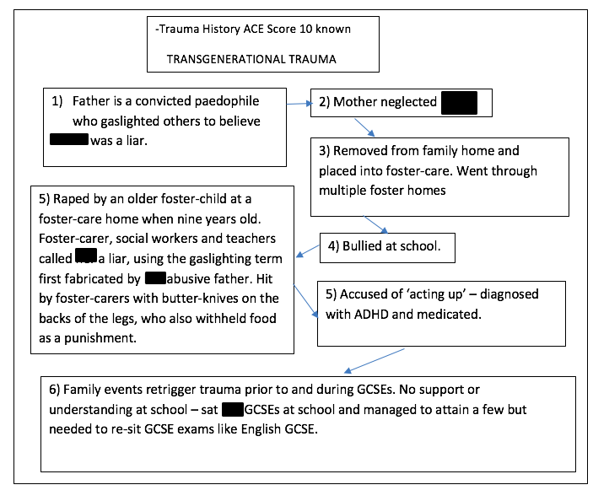
Since the use of an ACE score (Appendix 6) is a measurement of the collective effect of traumatic stress-exposure during childhood and corresponds directly with the latest understanding of the effects of trauma on neurodevelopment (Anda, Brown, Felitti, Bremner, Dube and Giles, 2007), the ACE statistics in this study are particularly alarming. The ‘Breakdown of ACEs’ in this study indicates that 58% of the participants had been exposed to 4+ ACEs, which is significantly higher than the national average which Bellis (2017) has reported as being at 14% in Wales. Bellis, who pioneered the first national ACE studies in England (2013) and Wales (2015), found that ‘almost half the general population reported at least one ACE and around 10% reported four or more’ (Bellis, 2017, p.44). However, Bellis (2017) also reported a higher figure in Wales, as 14% of the population have 4+ ACEs.
Figure 5.3 – Breakdown of ACEs in this study.
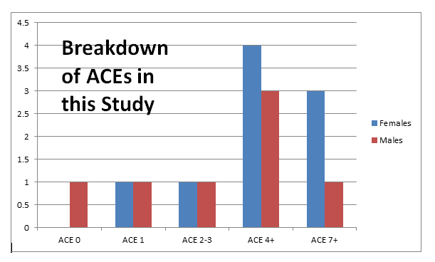
Thus, when examining the ACE scores and trauma histories of participants in this study who perceived themselves to have been educationally failed, additional information was provided by several of the participants’ parents revealing that a few of the interviewees also experienced trauma before or during their births.
The additional information provided by some of the participants’ mothers reveal additional birth/pre-birth traumas which, even though the participants would not have been able to remember, their body still kept the score (van der Kolk, 2014). Therefore, participants’ traumatic birth experiences, although not part of the ACE Score ten (Appendix 6), are still relevant to them and this research, as these ‘unconscious’ traumas would still have impacted upon their development. Some examples of pre-birth/birth traumas experienced by participants include one participant experiencing an unplanned emergency C section delivery, another was already a drug dependent baby at birth, one had birth complications, feeding difficulties and only managed to sleep right through the night when he [or she] started full-time school at four years old, while another participant experienced a relatively easy birth, but was exposed to domestic violence whilst in the womb during the pregnancy.
Thus, a few of these unborn participants would have experienced the same feelings of fear that their mothers would have felt along with the flood of stress chemicals which would have flooded the unborn baby. It is notable that two participants who experienced significant trauma at birth had difficulty with sucking reflex, had difficulties with sleeping and had language difficulties as toddlers. This is relevant to the study since it is known that participants who experience complicated, problematic births would have been left with a physical and emotional imprint, which would have left them with a heightened sensitivity towards their environment (de Thierry, 2015).
Consequently, babies who enter the world having already experienced feelings of fear will have higher cortisol levels, which will affect their regulation of emotion even before they are born. (de Thierry, 2015, p.49; Karr-Morse et al, 1997). Furthermore, these participants would already have a weakness or vulnerability towards having and feeling unprocessed pain which could be potentially re-triggered in any perceived threatening situations compared to their peers. This leads onto the next subordinate theme, intergenerational trauma.

5.4.2 Intergenerational Trauma
Despite separating into sub-themes for this analysis, there is often an inseparable overlap between ACEs at home, transgenerational trauma and traumatic experiences at school, as Max’s account reveals ‘a history of mental illness’ in the family:
‘There’s been a history of mental illness in my family and my grandfather committed suicide because he had paranoia because he had paranoid schizophrenia and so I was aware of this growing up. I would walk through school and this boy used to encourage other children to skip around me and shout ‘paranoid’ at me. Wherever I’d go down corridors, other kids would trip me up and this hatred started around the start of year seven’. (M:148-156)
“I wouldn’t go down certain corridors because doors would be slammed in my face or kids would try to trip me up or so there was a lot of fear there”. (M:200-204)
As Max and Frankie’s account shows, their peers at school were continually using their traumatic family history as a tool to relentlessly re-traumatise, bully and torment them:
“There was zero awareness of the fact there’d been a history of mental illness in my family and then I was getting called paranoid.” (M:613-616)
“Comprehensive school, that was terrible. Comprehensive school was terrible. I got bullied and bullied and bullied and bullied.” (F:16-20)
The anger in Frankie’s voice can be clearly heard as words are repeated often to reemphasise how ‘terrible’ the ‘bullying’ at school was. Frankie notes that being adopted became the sole focus of ‘name calling’ (F: 45-48) and bullying, as this trauma was used as a tool to inflict further pain. Often deliberate teasing or winding-up are used to evoke an explosive response, as Max self-reflects:
“I think they perceived me as an over reactor but then they did not know the fear that the other kids were making me feel.” (M:656-659)
Moreover, living life from the position of fear, predisposes a person to experience more trauma, as over-reactions, crying outbursts or hypersensitivities will attract further trauma from bullies who will only need to say a trigger word or phrase to get the desired effect through activating the fear response and re-traumatising their victim (de Thierry, 2015), it appears that Max’s trauma sensitivities were what made Max the perfect target for bullies. Thus, as Max’s account demonstrates, life can become incredibly difficult for the person who is perpetually hyper-aroused at school, as when living in a state of fear (Allen and Oliver, 1982), the logical and language part of the brain goes off-line, making the acquisition of learning new skills extremely difficult:
“I really felt that my education suffered. I was living constantly under fear”. (M:600-602)
Furthermore, young people who have indirectly or directly acquired trauma in their bodies can often be seen as ‘ticking time bombs’ who only need the slightest touch in their window of tolerance (Spring, 2016) to cause an eruption.This is because unprocessed trauma will often lie dormant just below the surface, waiting to be set off by carefully selected trigger word which bullies can skilfully use to evoke a retriggering response to re-traumatise the individual at any time.
Max describes how it felt to experience learning in a ‘constantly’ a hyper-aroused ‘fear’ state which was not conducive to effective learning taking place:
“I was just really fearful and stressed pretty much all the time and I had nobody I could really talk to about it.” (M:264-267)
Max’s account shows, that not only was the school unaware that there was a history of mental illness in the family, but they failed to realise the full implications of the deliberate re-traumatisation through the perpetual bullying at school which was retriggering past trauma. Thus, for the analytical purpose of this research, I created trauma timeline histories using existing knowledge of the participants which demonstrated that many were already significantly predisposed to being hypervigilant, making them more vulnerable to feeling trauma more intensely than others without this predisposition, as illustrated in Figure 5.4.
Max’s trauma history shows a predisposition to trauma from both sides of the family, as well as the grandfather being in the navy during World War Two and committing suicide, there appears to be links to the Holocaust. Max’s grandfather’s ships were sunk three times during the war and it is of interest to know that because of the shock and horror experienced in combat, it is common for war veterans to suffer from PTSD (van der Kolk, 2014) and their offspring are three times more likely to experience symptoms of PTSD (Wolynn, 2016) and can also be born with PTSD, thus making them more susceptible to feel trauma more deeply. Tragically, it was disclosed that two of the offspring have also committed suicide.
Yehuda et al (2007) point out that parental PTSD increases the risk of depression and parental traumatization is associated with increased anxiety disorders in offspring. There is also evidence to suggest that the long-term effects of trauma held in the body can carry a ‘psychological sequelae’ to the third generation (Rakoff, Sigal and Epstein, 1966; Rubenstein, Cutter and Templer, 1989; Sigal, DiNicola and Buonvino, 1988).
Fresco (1984) compares the effects of intergenerational trauma to, “People who have had a hand amputated that they never had. It is a phantom pain, in which amnesia takes the place of memory” (Fresco, 1984, p.421).

Figure 5.4 – Trauma history time-line documenting transgenerational trauma
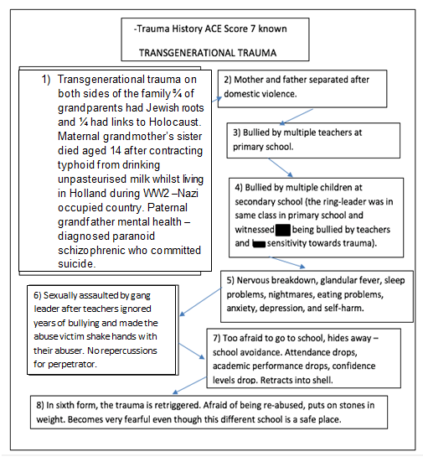
Thus, even though a person her/himself might not have directly experienced the trauma, their body can still appear to be trapped, either in a place without time or in the time of trauma (Baum, 2000). Additionally, the maternal grandmother was living in Nazi occupied Holland during World War Two and lost her sister at a young age. She was also forced to work on a farm at the age of fourteen. As Wolynn (2016) explains, “The biological residue of traumas your grandmother experienced can be passed down, with far reaching consequences” (Wolynn, 2016, p.26). Thus, it cannot be a coincidence that throughout Max’s interview, the word ‘fear’ is used nine times and ‘traumatic’ is spoken seven times when talking about personal experiences. Wolynn (2016) concurs, “Emotions can be biologically communicated [as]… three generations share the same biological environment of the womb” (Wolynn, 2016, p.28).
Moreover, research shows that trauma survivors who develop posttraumatic stress disorder (PTSD) have greater rates of ‘familial psychopathology’ compared to similarly-exposed individuals who do not develop this disorder (Davidson et al., 1985, 1989, 1998; Dierker and Merikangas, 2001; Dijanic Plasc et al., 2007; Reich et al., 1996). Through examining Max’s trauma history, it is clear to see how the genetic and environmental transmission of trauma appears to co-occur and co-exist together.
Thus, Max’s account appears to provide a clear example of how trauma can be passed down through the generations. As Bellis (2017) states, “One way that ACEs spread is from one generation to the next” (Bellis, 2017, p.45). Further exploration of intergenerational trauma revealed that at least 50% of participants within this study have a parent who suffers from anxiety, depression or a more complex mental health diagnosis. It is also known that 20% of participants were exposed to the suicide of a family/household member which is another high impact childhood trauma.
Additionally, it is known that at least 60% of participants’ parents had exposure to some quite significant impact childhood traumas themselves, with less than 20% of participant parents’ historical information not known. The combined collective intergenerational traumas of participants’ past generations include the suicide of a parent, child sexual abuse, being groomed and sexually abused as a young child by a paedophile ring, being a persecuted Jew and war survivor, being abandoned, parented by an alcoholic and substance misuser, being kidnapped and raped, being fostered and adopted, severe bullying at school by teachers, having a diagnosis of schizophrenia, experiencing domestic violence and experiencing active combat as a soldier.
I believe this information is relevant, since the parenting of a person struggling to cope with unprocessed complex trauma and possible PTSD, would be very different to a parent who was raised in a relatively happy, safe and worry-free happy childhood environment. Some of the participants’ parents were happy to provide their trauma time-lines (Appendix 7) which include links which suggest even further intergenerational trauma (see also account from miscarriages of justice victim found in Appendix 16). Thus, it is clear that transgenerational trauma involves both environmental and genetic factors, since any significant trauma imprints upon physiology, often affecting physical growth, sleep and brain development (Mate, 2019; Perry and Szalavitz, 2006; van der Kolk, 2014).
Furthermore, parents who have experienced childhood trauma or PTSD will inevitably parent their children differently, since a person whose unconscious automatic response has been set in the emotional flight/flight/freeze mode, will inevitably respond out of fear every time a perceived threat is detected. Therefore, trauma can be passed down through the generations through survivors parenting their offspring from positions of unresolved trauma or as Baum (2013) notes, transference through having a close or extended contact with a person who has been traumatized.
Moreover, statistics echo this experience of secondary trauma which can be induced through simply hearing about other people’s traumatic events, as 15–20 % of therapists who heard the stories and experiences of trauma survivors have been found to develop PTSD symptoms themselves (Arvay and Uhlemann, 1996; Meldrum, King and Spooner, 2002).
“’Home wasn’t very good and you know my mum was a single mum and she was ill… I had no father” (S:191-194)

“Home life was quite traumatic as well.” (M:558-565)

Neither of Stevie or Max describe their experiences at home as pleasant, instead they disclose that ‘home wasn’t good’ and home-life was quite traumatic’. However, parents who have their own untreated trauma are more likely to parent their children from places of brokenness and torment (van de Kolk, 2014), with the result that many of their children will also show psychopathological wounds and scars (Wolynn, 2016; Yehuda et al, 2005).

Through their own admission, Max, Brooklyn and Chris are extremely sensitive to feeling other people’s pain and can feel trauma more deeply than others who might not be experience the same event in the same way. Additionally, they are still prone to suffer with high anxiety due to becoming overwhelmed during times of personal confrontation with stressors in life:

“I was really anxious and really nervous.” (M:540- 541)
“I’m diagnosed with anxiety.” (B:133-134)

Additionally, I do not believe it is a coincidence that Brooklyn’s great-grandfather and Max’s grandfather both showed evidence of experiencing severe emotional breakdown which neither of them fully recovered from, as one committed suicide, while the other was incarcerated for life and never saw his family again. Max’s grandfather and Chris’ father both worked in high risk jobs in the armed forces and navy. Kestenberg (1980, 1993) used the term “transposition” to describe how the traumatic impact of individuals’ parents were not simply limited to those directly involved as intergenerational research suggests that parental PTSD increases the risk of PTSD in the offspring by affecting their predisposition to transposition. This in turn will affect their sensitivity and response to a traumatic event (Wolynn, 2016; Yehuda et al., 2005; Yehuda et al., 2007). Williams-Keeler et al (1998) also concur that there is ‘a PTSD latency’ or ‘greater susceptibility to PTSD’ amongst the ‘second generation when confronted with major stressors’.

As Max’s trauma time-line reveals (figure 5.4), information about relatives’ past trauma can offer important keys, clues or enlightenments to explain why a person might be experiencing inexplicable emotional pain which has no obvious cause, as traumas experienced by their forefathers/mothers are remembered and stored in their own genetics (Wolynn, 2016).

Unfortunately, a lack of understanding of intergenerational trauma at school appears to have pushed Max further along the trauma continuum, as he [or she] was perceived as an over-reactive sensitive person which made this learner an easy target for bullies. Max repeats how nothing was done to help him [or her] process the feelings of internal trauma, as this phrase is repeated throughout the entire interview:

‘Nothing had been done’ (M:487)
‘Nothing was done’ (M:491)
‘Nothing was done’ (M:515-516)
‘‘Nothing changed’ (M:639)
‘Nothing was done’. (M:655-656)
‘Nothing was done’ (M:668)
‘Nothing was done’ (M:1128)
‘And nothing happened and I was so vulnerable’. (M:804-805)
‘Then nothing else was done and so I was totally afraid.’ (M:372-373)
As Max’s further reflections appear to illustrate, individuals who endure multiple traumas without any intervention will internalise blame. Thus, traumatised individuals with unprocessed trauma can be continually re-traumatised at school, as Max’s account illustrates. They are often left to believe that they do not have a ‘voice’ and this negatively impacts upon and can warp their identity of self:
“‘My self-worth is nothing.” (M:731-732)
“I know that I’m not going to be heard if I do speak out about stuff. And what happens to me, even if it’s wrong, it doesn’t matter because it’s me”. (M:905-908)
5.5 Superordinate Theme Two: Missed Assessment
This super-ordinate theme emerged as the participants reflected on their learning experiences at school:
‘‘They need to get it right in school otherwise they’re going to be fed to the dogs, you know. And I think the teachers need to really take it seriously. They are playing with fire there. It is people’s lives here”. (S:835-841)
“Get to the root of things… give them the right help”. (S:987-988)

5.5.1 Lack of Early Intervention for Neuro-Divergences
As Rory reflects on experience at school, there is a real sense of disappointment as the ‘struggle’ to be heard and understood emerges:
“My mum thinks I had problems like dyslexia. I er, I can’t speak, I need speech therapy. I struggle to say certain words, read certain words. Like in exams, like I’d read over the question a couple of times just to get it in my head, like trying to figure it out. It was a struggle”. (R:47-54)
Rory appears to make the link between his [or her] lack of early intervention for unsupported speech difficulties and subsequent failure to establish effective spoken and reading skills, which impacted upon the struggle when sitting exams. Rory, one of the teenage participants, left school without attaining any GCSEs.
Rory notes that although his [or her] mum had actively pursued help from an educational psychologist throughout school, since there was already evidence of intergenerational neuro-divergences in the family, as the sister had a dyslexia diagnosis, nothing was done:
“My mum tried but I don’t know what happened. They didn’t do nothing anyway”. (R:58–60)

Often individuals who have expressive language difficulties, find conversations and exams problematic, as there is a ‘struggle’ to understand what is being said, as well as converting thoughts back into the words that they would like to speak or write. Lees and Urwin (1997) echo these findings, noting that children with communication difficulties rarely present without additional needs in other areas. Stevie, who dropped out of school at fourteen with undiagnosed dyslexia, also echoes a similar ‘struggle to read’ and notes that there was no intervention at school:
“Primary school…I just felt like it was getting a bit of a struggle to read, and that, because I couldn’t really read that well. I felt like - and but nothing got detected or anything”. (S:85-89)
“My reading difficulties were picked up... nothing to do with school, but after when I went to college”. (S:244-246)
It is evident that Stevie did not even realise that there were reading problems until adulthood. As well as a later diagnosis of dyslexia, Stevie also received a later diagnosis of ‘adult ADHD’.
Like Rory, Stevie reflects that it was mum who referred to CAMHs (Child and Adolescent Mental Health Services) as a younger teenager, but nothing came of it:
“I think my mum might have referred me but they said it wasn’t bad enough or something because I think they were trying to get me diagnosed with ADHD or something… But the system said I wasn’t bad enough at that time. I got diagnosed with ADHD when I was an adult like – adult ADHD”. (S:424- 427)
Along with Rory, there is a real sense of regret and anger as Stevie also links the lack of early intervention at school to consequent lack of qualifications, since the point is made that no ‘education’ or ‘any GCSEs or nothing’ were acquired whilst at school:
“I think if anything was picked up in school, I might have come out of school with an education or with any sort of grades because I have no education when it comes to like anything to do with school, I haven’t got any GCSEs or nothing”. (S:266-272)
The participants’ interviews reveal how the traditional “wait to fail” teaching model (Elliott and Grigorenko, 2014), not only became a barrier to participants’ learning potential, but contributed significantly to their educational failure. It is evident that 91% of the participants either ‘dropped-out’ of school, truanted or were absent home ‘ill’ a lot from school. However, Henry, Knight and Thornberry (2012), along with Rumberger (2011) evidence that ‘dropping out of school’ is a long-term progression of ‘disengagement’ that develops over many years.
In this study, several types of neuro-divergences and speech, language and communication needs went unnoticed (Figure 5.5): as 83% attended school with undiagnosed speech, language and communication difficulties, 25% of participants attended school with undiagnosed ADHD, 75% had undiagnosed writing difficulties, 8% hearing difficulties, 16% epilepsy, 8% ASD, 41% had unrecognised child sexual abuse related symptoms, 83% undiagnosed mental health difficulties such as anxiety and depression, 41% eating disorders, 58% sleeping disorders, 41% dyspraxia tendencies and 75% dyslexia.
Moreover, 100% of participants exhibited trauma related symptoms which impacted upon communication difficulties and confidence, along with evidence of difficulties with auditory processing and symptoms of pathological demand avoidance (PDA). Evidently, participants in this study displayed a mixture of neuro-divergences (sometimes termed comorbidity).
Figure 5.5: Graph to show participants’ missed assessments/later diagnosis
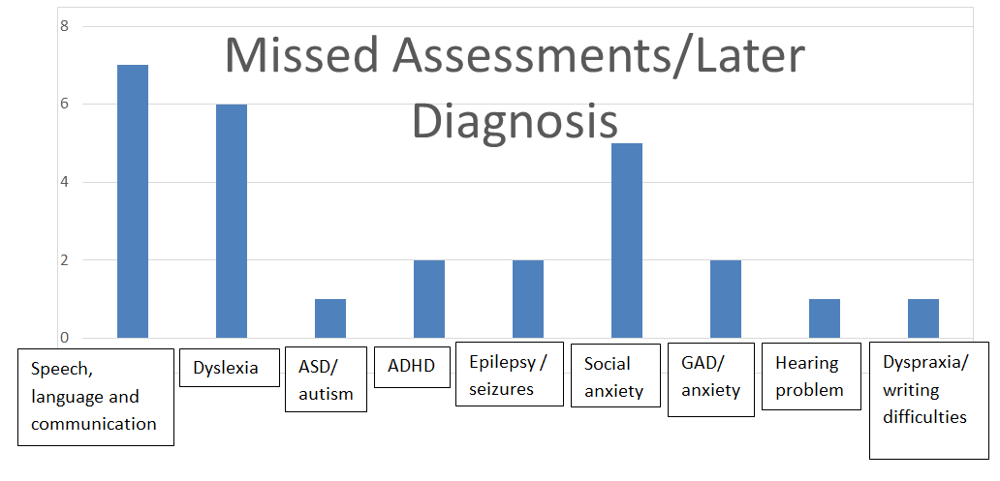
Additionally, the importance of learning problems being identified early with intervention being put in place has been long recognised by teachers, researchers and policy makers internationally (The No Child Left Behind Act, 2002, Every Child Matters, 2003, Working Together, 2007, Equality Act, 2010).
Early intervention is recognised within the pages of the policy document, ‘Every Child Matters’ (2003) stating that:
We need a greater focus on ensuring children at risk are identified earlier. We need to be able to share information to identify children who require additional support and provide a tailored service that safeguards them from abuse and neglect and enables them to fulfil their potential. (Every Child Matters, 2003, p.21)
Stevie describes the moment of realisation when it dawned on him [or her] that there were learning difficulties at twenty years old, which was six years after dropping out of school aged fourteen:
“I did college in Swansea and I must have been twenty and we had to do a test and that’s when I realised I had problems. I couldn’t. I couldn’t read. My mind- I couldn’t because it was really difficult and that’s when they did a dyslexia test on me in college and that’s when they found out I had dyslexia”. (S:254-262)
Fourteen-year-old Peyton, who was given a late diagnosis of anxiety by a psychiatrist after deregistering from school because of not coping in mainstream classes, reflects upon experiences with sheer frustration, mixed with anger:
“Well there was one psychiatrist near the end who did diagnose me with anxiety but we did know and realise I had gained generalised anxiety. Then cos I was just in my room all the time, I spent a lot of my time online, so I did an online depression test which I’m sure aren’t particularly medically accurate but I came up as severely depressed.” (P:265-274)
“No one ever brought up the possibility that I just had depression. I don’t think they thought that I was like old enough…For the reasons for me to be shut in my room and not being able to do anything to be like an actual mental illness.” (P:404-411)
Peyton reflects that it was hoped that practitioners had looked beyond the symptoms to find out exactly what the underlying difficulties were, so these weaknesses could have been investigated and addressed. However, anxiety at school had not even been acknowledged and so investigations into the underlying difficulties never took place.
Peyton, who was forced to deregister from school, angrily shares strong feelings of being let down by a system that was supposed to help all pupils reach their fullest potential:
“I haven’t got a diagnosis or anything for this but I’ve probably got ADHD or just ADD and no one had ever said anything about that and we are going to try to get a diagnosis, um at some point but no one’s ever said anything about that or like or any of the mainly the anxiety, no one’s ever-.” (P:302-309)
Like Peyton and other participants, Taylor also had a co-occurrence of unrecognised multiple diagnosis’ (Dawes & Bishop, 2009; Dore, 2008; Lees and Urwin, 1997). Taylor had already been diagnosed with hearing difficulties, however these difficulties were accompanied by other significant needs which exasperated the symptoms and went unnoticed by the school until the final sitting of GCSEs:
“We came away from the Geography [GCSE] exam with a U and my mum questioned the school if I could have a dyslexia test… I didn’t pass it but I was like borderline so they ended up giving me and extra 25%.” (T:137-144)
Elliott and Grigorenko (2014) also found evidence to show there are ‘similarities in the symptoms’ between auditory processing disorder (APD) and other disorders, including dyslexia, ADHD, ASD and specific language impairment. As noted by Dore (2008), “The auditory processing problem is quite common amongst people with learning difficulties” (Dore, 2008, p.88), Moreover, Lees and Urwin (1997) also found that neuro-divergent individuals often present symptoms of an underlying communication difficulty, which is evident within this research as some participants noted finding interaction and communication with others problematic, as well as developing relationships difficult. In Taylor’s account, a genetic problem of deafness running in the family is specifically referenced:
“I had glue ear most of my childhood…As well as it’s genetic in the family. My brother has hearing problems. My sister has glue ear as well”. (T:269-275)
Taylor’s account demonstrates that children with communication, visual and/or hearing difficulties are often unaware that there is anything wrong with them, as their difficulties are a part of their normal every day experience of life.
I: Has that [glue ear/hearing difficulties] affected your learning in school?
T: I would say, yes.
I: In which way?
T: Well… one of my grommets came out. I felt I could hear a lot more and ever since I’ve become a lot more independent.
I: How old were you then?
T: Oh sixteen. (T: 276-286)
As Taylor’s experience of missed assessments regarding hearing loss demonstrates, the need for multi-agencies to be working together in sharing information for the best learning outcomes for the child are required. Children with unclear speech or any type of language difficulties should always have their hearing checked (Daines et al, 1996; McLachlan and Elks, 2012). As Kutscher (2005) points out, sometimes not only can a child be ‘born with multiple issues’, but these difficulties can often exacerbate each other. Therefore, if a child has a difficulty in one area, such as hearing problems, then assessments in other areas, such as speech, language and communication, reading, writing and focus/attention, should follow. Moreover, keeping accurate ‘live’ working records of developmental changes is essential to track progress and to foresee any potential future difficulties which might arise.
Correlations between ‘corrected’ early speech and language difficulties’ and/or ‘corrected’ early reading difficulties in a child, might present with future comprehension and inference reading difficulties at a much later age/stage, as observed in Rory, Jamie and Taylor’s cases. Kutscher (2005) echoes:
If a child has any one of the problems out of the syndrome mix, then there is a very significant chance of one or more of the other problems occurring. (Kutscher, 2005, p.16)
This research supports accounts given, especially Taylor, whose comorbid conditions of dyslexia, hearing and speech and language difficulties, were also reflected in writing difficulties, but not acknowledged or supported. Instead Taylor was left to struggle writing with a pen which produced needless suffering every day with a ‘hand cramp, a pain in the back of neck and stomach’ (T:130). As Mate (2019a) points out, “Abdominal cramps in sensitive children are often clues to unresolved tensions” (Mate, 2019a, p.61).
Lee also vented frustration, when reflecting about receiving a very late diagnosis of ADHD. It is interesting to note that many of the ‘multiple different specialists’ involved with him [or her] before the ADHD diagnosis had called Lee a liar and victim blamed Lee for ‘being emotionally, behaviourally erratic’. These professionals passed judgement on the outward behaviours describing Lee as ‘just acting out’. No one took into account the complex trauma that Lee had been exposed to which put Lee well above the ACE 4+ category:
“I wasn’t diagnosed until very late on. I was, I went to CAMHs, I saw multiple different specialists who all told me that there was nothing wrong with me, I was just acting out and being emotionally, behaviourally erratic or whatever they said. Until I walked into one specialist and they said within five, six minutes of me entering the room – that child has ADHD”. (L:279-290)
Lee’s account demonstrates that ‘one-off categorical labelling’ or having a tight, constricting ‘label for life’ should be treated with caution (Snowling and Hulme, 2012). It is a known that no two dyslexic, autistic, dyspraxic, ADHD, PDA, ASD or neuro-typical persons are the same, nor will present with the exact same needs. Rather the person should be able to access the most suitable provision that relates to their own personal needs, instead of forced to conform to a set of criteria that may, or may not, be applicable to help their unique situation, learning style or potential. As noted by Peyton:
“I was looking for the criteria for social anxiety and I was like ‘ah ha’… I don’t think I had depression so much when I was in school, maybe as it was kind of developing as I was staying off but no one ever picked up on social anxiety or anything.” (P:288-298)

Peyton told how he [or she] used online research tools to gain knowledge and seek answers in developing a better understanding of his [or her] personal symptoms and needs. This highlights the need for professionals to allow for two-way-conversations to regularly take place between the student and the facilitator. It is only through having these ‘active listening’ and engagement conversations, where the student can state in their own words what they need, this is what places them in the appropriate position of being ‘the leading expert’ about themselves (John, 2013). However, Johnson (2004) notes that it is very rare for the ‘Other’ to be asked for their opinions and views, even though the person’s own voice and experience are the best foundations needed to inform practice.

5.5.2 Voice: Nothing About Us, Without Us
In light of Lee’s experience, there is a deep understanding, more than most, about the importance of listening to the voice of the child regarding any assessments carried out on them:
“I reckon it’s all about the voice of the child. It really is. I reckon that a child’s voice is the most important thing but who’s there to listen? Like I said earlier because I know when I was in school earlier no one was there to listen to me… Put yourself in those child’s shoes. What would you as a child want? What would you as a child feel safe with?” (L:857-872)
Peyton and Lee make the point about the need for professionals to establish good relationships with their clients based on mutual trust, respect and active listening:
“If they don’t know the child’s name, right? How do they expect the child to open-up to them? … Something had happened and you needed to tell someone, would you feel safe opening up to a teacher who didn’t know your name, didn’t know anything about you and wouldn’t take the time to listen to you?” (L:603-615)
“No one really properly, you know listened or asked or took any notice of anything… There was no reasoning” (P:1009-1013)
Since Lee’s voice was silenced through being falsely accused as a compulsive liar by multiple services after being raped under their care, we can clearly see how distant, unequal or judgemental professional relationships, and a lack of established trust, will limit professionals’ ability to access crucial information about a child or service-user’s most pressing needs. Often a lack of active listening will result in a mismatch between personalised needs and prescribed provision (Billington, 2006). The deliberate silencing of a person will make them more vulnerable to attracting future abuse and harm (Mate, 2019a; Spring, 2015).

The voice of the child plays a prominent role within the United Nations Conventions on the Rights of the Child (UNICEF, 1989), with Article 12 specifying the rights of the child to express an opinion on any matter concerning their welfare and to have that opinion taken seriously; Children Act 2004 (DFES, 2004) which established the role of the children’s commissioner to listen to and include young people’s voices to improve services that affect them; Children and Families Act 2014, the Local Authority is required to appoint at least one person to promote the educational achievement of its looked after children; Social Services and Well-being (Wales) Act 2014 and Well-being of Future Generations (Wales) Act 2015 also promote awareness of the views and interests of children in Wales.
Participants’ accounts still highlight major gaps between the legislative policies to safeguard children through listening to their voice and actual practice:
“Having never met me before, he just was sat down and said, ‘Right I have looked at your file and see that you are stuck in your room and can’t go out. You need to do this, otherwise, this is going to happen and you don’t want that-, otherwise eventually you’re going to end up, having to - we’re going to end up having to call the police or something and you don’t want that, do you?’ I said no words during then and just angrily nodded slightly and he said right can you get your mum? And he hadn’t spoken to her at this point. And then he told her that if I didn’t agree and didn’t agree to get better, which is kind of really stupid, that she was to take away my possessions and leave me in my room to have nothing and just do nothing all day and slowly go insane and then he told her to physically drag me into a car kicking and screaming”. (P:873-896)

“He was very obviously unfit to be a child psychiatrist… obviously he thought, we small people had a hive-mind and if this was wrong with them then obviously, this was the way forward. And if they don’t agree, then you force them. He’s so unfit to be working with mentally unstable people and children”. (P:909-917)
According to Peyton, his [or her] opinion was not sought as ‘no words’ were spoken by Peyton during this one-sided monologue-assessment. Instead a ‘prescription’ was given for the mother to ‘physically drag’ Peyton to school. Billington (2006: p.278) appears to describe fourteen-year-old Peyton’s experience accurately, when he too discloses observations of those who have “suffered for years at the hands of inadequate local services or clumsy practitioners.” However, when Peyton’s mother would not comply to his wishes instead stating that this ‘clumsy’ practice’ was like ‘child abuse’ (P:729-730), this practitioner then threatened to call the police to frighten the family into submission. The DoH (1995) also appears to concur with Peyton’s account noting that significant numbers of children ‘suffer in silence at the hands of’ professional adult bullies.
Furthermore, when this practitioner left this family home, he did not call the police but instead he reported Peyton’s family to social services:
“He sends a letter to social services who investigate us for months because I couldn’t go to school.” (P:730-733)
Fisher et al (2015) also found that some clinicians ‘diagnose and adios’, leaving the patient abandoned with a diagnosis but without any follow-up. However, as participants’ experiences show, an ineffective assessment or wrong diagnosis will result in a mismatch between intervention and needs. At a school level, an incorrect assessment will mean a mismatch between provision and learning needs, as Max describes:
‘I wish that I’d actually been considered in the decision-making process whereas I had to make my decisions around the decisions that were being made for me. If I had more of a chance to yeah tailor it, I know I would have done better and I wouldn’t have been so pressurized”. (M:1412-1420)
Additionally, Taylor explains about the dangers of one-off-assessments that determine life-long academic ability or differ-ability:
“I think they should question us before exams or before we come to comp that if we are struggling or stuff like that before we come to comp they should question us, before exams they should question us again, just in case anything has changed”. (T:254-260)
Since a person’s academic, language, emotional, physical and social development depends on a number of factors, Taylor suggests that regular informal user-led ‘conversations’ should be required as part of assessments and adjustments put in place where needed.
A diagnosis or results from a test is often seen as static or immovable, even though this should be subject to change as knowledge increases and barriers are removed due to better interventions being put in place. As participants’ experiences show, professionals who do not engage with their clients, miss opportunities to further develop their knowledge, insight and skills. Furthermore, qualifications and training that were sufficient for practice in the 1960s, are now not considered fit-for-practice, since best practice has significantly moved on to embrace the voice of the service-user. Moreover, Billington (2006) emphasises, “Insider accounts may provide professionals with valuable sources of information when creating services and developing practices” (Billington, 2006, p.216).
Golding et al (2006) wrote that:
There is increasing awareness of the principle of hearing the voice of the recipient of services. Having a principle, even one that is enshrined in law, however does not ensure good practice. (Golding et al., 2006, p.3)
Chris who was given a diagnosis of paranoid schizophrenia in his [or her] late teens talks about a combined failure across education and mental health services:
“I did A’ levels, but when I went to do a university course, I became very ill [after a traumatic event] and that stopped me because I was mentally ill. But if they kept- I think if they realised something, then they should have let me go back on it [the course] but they didn’t”. (C:189-196)
Instead of seeking answers through listening to Chris’ experience and opinion, Chris was diagnosed as a paranoid schizophrenic and further medicated. At one point, Chris was taking about seven different medications; some of these were prescribed to counteract the unpleasant side-effects of the other drugs. Chris explains:
I: Was there a link between your epilepsy and your mental health, in your opinion?
C: Yes.
I: Right. Did the professionals see that there was a link?
C: No. They don’t listen. (C:202-208)
Since service-users are the only ones who have lived their lives, it is imperative that professionals who have the power to change their lives through giving them a diagnosis, listen to the service-user and get them to list their lived experiences.
Billingham (2016) also emphasises these dangers, “The diagnosis is a complex social intervention which, while imparted by the professional in a few seconds, can affect ...the [person’s] life for the rest of their days” (Billingham, 2016, p.116).
Stevie and Lee also offer great insight into some of their feelings and reservations surrounding their ADHD diagnosis:
“They think its ADHD, it’s not. There could be an underlying problem.” (L:768-770).
“They think any child who’s spaced out for a minute might have ADHD. You can’t label all children who are a little bit spaced out all ADHD. There’s much more in depth things than that…You cannot get to the bottom or the depth of it unless you know the child personally and emotionally.” (L:239-250)
“I have not got ADHD. I just believe that its labels that people put on people and put them into a box.” (S:985-987)
Despite acquiring a late diagnosis of ADHD, a thorough examination of Lee and Stevie’s trauma history (ACE score 7+) would have uncovered many unrecognised and unacknowledged reasons to explain much of their ‘acting out behaviours’.
Any child who has survived their combined traumas would display symptoms of these traumas, which would have made permanent imprints upon their body, mind and central nervous system. Often children who are on the receiving end of multiple traumas are pushed into complex deeper trauma where the body might ‘dissociate’ or ‘space-out’ to protect the individual’s mind (Spring, 2015). In trying to make sense of these experiences and in the light of presented symptoms, another explanation is offered as to why individuals can often appear ‘stuck’ in their developmental stages and processes; displaying immaturity in attention and receptive language difficulties (de Thierry, 2015).
Since trauma impacts every part of the body, it is inevitable that rape victims might appear hypervigilant and fearful. Moreover, trauma can cause a child to ‘freeze developmentally’ (Mate,1999); this can affect the age-related brain development of every growth stage of when each trauma took place. This is why it is so important to ask the child/service user about their symptoms or difficulties, such as if there are certain situations, places, times, memories, people or triggers that make their symptoms/difficulties worse. This key information might illuminate where the real root cause of their difficulties lie. Moreover, a medical misdiagnosis can often result in the person being prescribed the wrong medication which can potentially cause them even greater harm.
McLeod (2007) defines unwillingness to listen as ‘power plays’, while Spicer and Evans (2006) also found that professionals who impose their agenda onto service-users without listening to their needs create barriers both to the person who they are meant to help as well as limiting their own professional effectiveness. Since misdiagnosis can frequently happen as key symptoms can easily be missed, or misinterpreted (Burke Harris, 2018; Mate, 2019; Perry and Szalavitz, 2006; van der Kolk, 2014), the service-user’s voice is imperative to the process, as implied by the principles of ‘people first’ (Goodley, 2017) and ‘nothing about us, without us’ (Charlton, 2000; Silberman, 2015).
Lee’s experience concurs with Max when pointing out how devastating it is for young people when there is no one there to listen to them, especially when they need to make sensitive, painful disclosures:
‘Voice of the child? Let me ask you something, what voice of the child?’ (L:451-452)
“There was no one I could really go to with it. Nobody knew how I was actually feeling”. (M:274-276)
‘Who is there to hear that child’s voice? Name me? Name someone who is there to listen to that child’s voice? (L:523-526)
As Lee concludes this section, it is evident that much work still needs to be done regarding closing the gaps between the policies that advocate listening to the voice of the child and actual practice:
‘My voice hasn’t been heard. No one, still to this day, don’t believe me… Still to this day”. (L:983-990)
5.6 Superordinate Theme Three: Disabling Learning Environments: The Gap Between Provision and Personal Learning Need
5.6.1 Spot the Difference
“Some people are more visual thinkers. This isn’t necessarily people who have some sort of difficulty or difference…Everyone has a different way of learning. I’m sure writing on a chalk board and copying it down is great for some people but for others are visual thinkers, some people prefer doing stuff online, some people prefer tactile medium. Some people really use their senses like people with autism and stuff and their sense of touch is a really big part of how they learn. So everyone learns differently and at the moment we just cater to one specific type of person and it’s not, it doesn’t work for so many types of people and so there should be so much more available.” … There’s so many people who don’t do the, who don’t fit into the one size fits all.” (P:1338-1358)
“Not every child is a computer and are not all wired the same”. (A:1110-1111)

“If you group everyone together, everyone who has autism and ODD and dyslexia and ADD and anxiety, and everyone who is not completely neuro-typical, then you probably have much more than the people who are ‘normal’. So, everyone learns differently. At the moment, we just cater to one specific type of person and it’s not-, it doesn’t work for so many types of people and so… There are so many people who don’t fit into the one size fits all”. (P:1328-1366)
Peyton and Alex point out everyone is different and all have different learning needs which often fluctuate and change. Peyton goes on to voice annoyance at the schools who exclude children, simply by trying to get everyone to conform to the same style of teaching and the ‘one size fits all’ learning mode. Peyton appears to challenge and question the notion of ‘normal’, putting forward the argument that each person’s ‘normal’ is going to look different, depending on their genetic make-up, family background, learning environment, personal strengths and limitations. Schleicher (2013), the author of the PISA study, also re-emphasises Peyton’s point that teachers need to ‘embrace diversity with differentiated, personalised pedagogical practices… the future is about capitalising on the diversity of learners’. (Schleicher, 2013, para. 2)
Frankie and Ellis describe the restrictions placed upon them as learners:
“I didn’t like the teaching style. The teaching style didn’t help me… You must copy this off the board and if you go wrong, we will beat you, kind of thing”. (F:61-66)
“Somethings have to change, you know. The way kids are taught...More encouragement from teachers and like I’ve already said, focusing on things you’re good at and not focusing so intently on what you’re not quite good at”. (E:456-469)
“All we had was the teacher telling us what to do”. (E:94-95)
‘‘It would always be right come in, sit down, listen to me, do exactly what I say. OK. You can go now’. (P:1393-1395)
Gove (2012) resonates with these accounts observing:
“The fundamental model of school education is still a teacher talking to a group of pupils. It has barely changed over the centuries…a Victorian school teacher could enter a 21st century classroom and feel completely at home… a teacher still stands in front of the class talking, testing and questioning.” (Gove, 2012, BETT Conference, para 3)
However, the National Curriculum (1999) published an inclusive statement that states three objectives to ensure an inclusive curriculum so that all pupils’ needs are met; through setting suitable learning challenges, responding to pupils’ diverse learning needs and overcoming potential barriers to learning and assessment for individuals and groups of pupils. In contrast to this inclusive statement, all the participants in this study note that their learning needs were not met and the mismatch between the provision and their needs became a barrier to their learning potential. It is interesting to note that the youngest participants (aged 14, 15, 15 and 16) who were born as part of the ‘digital generation’ with technology at their fingertips, while surrounded by technology, speak about the gap between the actual provision at school and their own preferred learning style.
This is explained by fourteen-year-old Peyton and Taylor:
“I prefer using a laptop because when I’m writing I get sort of a hand cramp, a pain in the back of my neck and my stomach”. (T:130-133)
“There are some people who find it difficult to write on paper, but are brilliant with computers, and there’s so much technology now. iPads and stuff that can be used very well in schools, can be connected with other things… But again, it doesn’t work for everyone. There are a lot of people who would be better off doing that”. (P:1375-1389)
Sixteen-year-old Taylor, who struggles with hearing, has language difficulties and finds writing tasks problematic, clearly expresses his [or her] preferred learning style which is needed to optimise the best outcomes. Taylor is digitally fluent and recognises that using a laptop, instead of traditional paper and pen, is his [or her] writing preference, even verbalising that traditional pen and paper method gives him [or her] ‘hand cramp’, ‘a pain in the back of my neck’ and stomach. However, school did not recognise Taylor’s learning need:
I: Would you prefer to use a laptop in exams?
T: Yes.
I: So, have you been offered the chance to use a laptop in exams?
T: No. (T:152-157)
After observing Taylor writing, I could see that the hand cramp might have been explained by poor pencil-grip and a disfluent writing style, which most certainly would have caused anxiety. These writing barriers would make it extremely difficult for any learner to keep up with their peers in class. Since anxiety is often felt in the stomach area, sometimes described as a gut-wrenching feeling (Mate, 2019), along with approximately 50% of a person’s dopamine being located within the gut, these physical symptoms should have been investigated further.
Since exams are a stressful experience for all students, having the added stress of struggling to use a pen and paper which causes hand-cramp and stomach pain is not helpful, as it would disempower that child. By denying Taylor the opportunity to perform at his [or her] best during exams, the school not only disadvantaged Taylor, but they also disadvantaged themselves by not giving their pupils the best opportunity to achieve the optimum GCSE results which would have positively reflected in their performance data.
Jamie, who identifies as autistic and digitally literate, makes a similar point:
I: Did you get to use computers in lessons?
J: No unless it was in an ICT lesson. (J:63-65)
My own observations of Jamie are that this learner presented differently when given two different options of using a laptop or a pen. With a pen, Jamie wrote in a small neat rigid perfect style, but due to the sustained concentration levels needed to perfect each letter, this prevented Jamie keeping up with peers. When at school, Jamie was often perceived by teachers as slow and non-attentive in lessons. However, whenever I observed Jamie having access to a laptop, a completely different learner was presented; one who is fast, confident and can complete all written tasks with ease. However, according to Jamie’s account, most teachers never got to see Jamie’s full potential, as in lessons, apart from ICT, there was never the opportunity to access digital learning tools. Jamie and Taylor were both left to struggle with their hand-writing, as their difficulties with fine-motor control and pencil grip became a barrier to both of them developing ‘automaticity’ in writing (Dore, 2008).
However, if the schools had engaged these pupils’ learning using digital technologies, this would have removed barriers.
As Marsh (2006) points out “Web 2.0 applications have the potential to transform’ schools or any environments into ‘sites of active learning’ whereby the ‘students themselves become the experts” (Marsh, 2006, p.19). Additionally, due to pupils’ interests in technologies, minimum teaching input is now required (Hannon and Green, 2007).
As Hendricks (2004) notes:
The internet surpasses the restrictions of fixed locations, such as schools, and opens up a new world of understanding and knowledge. Participants in cyberspace may come and go, but the web-sites remain. (Hendricks, 2004, p.3
This facilitator style of ‘active learning’ which encourages the student to take the lead relates to Frankie’s learning style, which was also not supported at school:
I: So, what is your learning style?
F: Fast, thinking outside the box. Letting me do, letting me lead, basically kind of thing...Letting me think and also the smaller the class, the better. I was in a class of thirty. That didn’t help at all. (F:78-88)

5.6.2 Discrimination against Children with Health Difficulties
Peyton appears to believe that if professionals listened to learners’ needs, this would have helped them to plan effective tailored provision, rather than prioritising the professionals’ perceived learning needs of children. This philosophy would have helped many participants who, because of physical illness or trauma, were unable to physically attend school.

“They [the school] didn’t help me when I was in hospital. They didn’t send work home... when I was in hospital they didn’t ask how he’s doing in hospital, they didn’t send a teacher to me. Nothing like that…The longest I was in hospital for at one time was about a month”. (C:42-51)
“They wouldn’t even send books home… they didn’t really do anything…Something online would be helpful but mainly just protocols or whatever for people with mental illnesses, as they don’t have anything to help anyone in any sort of way with that” (P:188-203)
Peyton and Chris both experienced discrimination as children who had health difficulties and were not well-enough to physically attend school. Peyton further explains:
“If your sleep is weird then it’s not possible [to go in] so if they had online 24/7, it would have been brilliant, it really would. They [school] wouldn’t even send books home because it was too much hassle… One of the symptoms of ADD is difficulty waking up and difficulty going to sleep… you just don’t wake up and don’t go to sleep…the period of time that you’re awake, shifts forward and so on and so on”. (P:1235-1256)
Peyton puts forward a strong argument for seamless learning, explaining how some children might not be able to attend regular 8.50am-3.20pm times and believes that the only accessible learning environment for some learners’ needs would be 24/7 digital online learning. Walker (2017) reveals significant links between sleep disturbances and “all major psychiatric conditions, including depression, anxiety and suicidality” (Walker, 2017, p.3).

Additionally, Walker (2017) also believes that children who fail to acquire a full nights’ sleep are at risk of developing learning and attention deficits, along with eating problems, aggression, bullying and behavioural problems, becoming a substance misuser in later adolescence and ‘suicidal thoughts, attempts and completion’ (Walker, 2017, p148).
Figure 5.6 demonstrates that 83% of participants in this study are considered to be ‘night owls’ which means that waking early for school might have been problematic resulting in disturbances in sleep.
Figure 5.6: Participants’ natural sleep rhythms
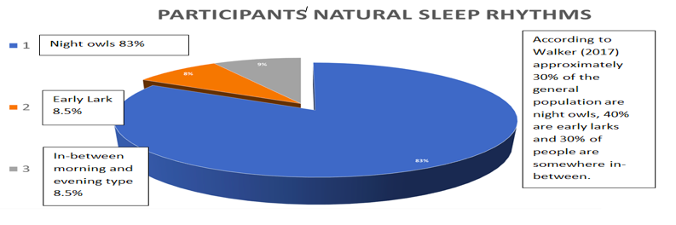
Unfortunately, seamless provision, which cuts across multiple physical, digital and language barriers is important to achieve success as learners, did not take place for any of the participants.
Sharples et al (2012) state that:
Seamless learning is when a person experiences a continuity of learning across a combination of locations, times, technologies or social settings…it may form part of a wider learning journey that spans a person’s life transitions. (Sharples et al., 2012, p.24)
Hendricks (2004) echoes this point that the internet is a vital resource which could be utilised to surpass ‘restrictions of fixed locations, such as schools’ (Hendricks, 2004, p.3), and has the potential to ‘open up a new world’ of inclusive seamless learning opportunities’. As pointed out by Peyton, if those who cannot access traditional teaching methods had been given access to an online learning environment, this would have been a ‘lifeline’ to them and would have prevented them experiencing educational exclusion. The author of the PISA study, Schleicher (2013) echoes Peyton’s frustration about the need for a shift in education whereby the ‘past was curriculum-centred’ but ‘the future [of education] is learner-centred’ (Schleicher, 2013, para 1)
As well as not having books sent home or having any access to online resources while he [or she] was hospitalised, Chris, who suffers with epilepsy, describes how it was not a good feeling being treated differently and excluded from activities just because of epilepsy:
“What I didn’t enjoy was how teachers would treat me different… And they wouldn’t let me go on school trips…So if they were going to the museum, I wouldn’t go because of my epilepsy”. (C:60-74)
“I didn’t have PE in school, but out of school, I did a gymnastics club… It wasn’t through the school - the PE teacher wouldn’t let me do a lot of PE… I wasn’t allowed to do PE in school. They wouldn’t let me”. (C:106-124)
“I felt that they treated me different.” (C:102)
Chris interprets these experiences as producing negative emotions of feeling ‘a bit odd’ and ‘a bit down’ (C: 247-272), because peers noticed that Chris was not fully taking part in school activities. Research by Benson, O’Toole, Lambert, Gallagher, Shahwan and Austin (2016) echo these experiences, finding that many individuals with epilepsy have felt like the “odd one out” amongst peer groups as they were often excluded from social activities with their peers, having ‘unnecessary restrictions’ imposed on them from teachers due to their epilepsy, which conflicted with their autonomy. Baker, Jacoby, Buck, Stalgis and Monnet (1997) reported 52% of individuals in their study experienced stigma because of their epilepsy.
De Boer (2010) emphasises that:
It has been shown that people with epilepsy themselves often internalise societal devaluations of them and as a consequence, they do not feel empowered to change the situation. (De Boer, 2010, p.633)
A closer look at Chris’ experience shows that teachers appeared to see Chris through the lens of disability first, instead of seeing Chris as a person (Goodley, 2017). Unfortunately, when looking at a person through the lens of their disability, in Chris’ case – a diagnosis of epilepsy, this diagnosis stopped teachers from appreciating strengths in the areas of gymnastics and catering, which were the two activities which Chris was excluded from. Chris compared this treatment at school to the way that clubs outside of school allowed fully engagement in these activities. Thus, it appears that school did not get to know strengths and abilities because they were solely focusing on diagnosis.
While it is recognised that risk assessments need to be carried out, limiting a person’s opportunities and stopping them participating in activities which celebrate their talents and strengths will have a negative impact on their sense of self. Interestingly, Chris uses the word ‘freedom’ when mentioning that there was more ‘freedom to cook’ at college, suggesting that this freedom had been stifled at school (C: 247-272). Clearly, teachers need to know their pupils’ preferred learning styles, strengths, gifts and talents and encourage all of them to enjoy participating in fair, non-discriminatory learning environments.

5.6.3 Subtractive Communication
“I mean sometimes you’re made to feel just because you have dyslexia you don’t warrant help.... surely this day and age, we live in a society where everybody should be entitled to an education and a decent one”. (A:343-351)
Alex and Taylor explain how discrimination negatively impacts upon differ-ability learners who are not in receipt of ‘the same effort’ from teachers. Taylor’s account of experiencing unequal treatment at school also illustrates an example of subtractive communication towards differ-ability students, as one would have thought that the ‘BTEC people’ would have required twice as much teaching input as the ‘higher’ pupils.
“They think that everybody like in lower classes are bad or naughty and noisy and stuff like that. When you talk to them, they are actually nicer than probably people in higher… People in lower they aren’t what people actually think. They want to learn, but they don’t feel they have the chance to’. (T:463-475)

“I have two teachers in BTEC science. You are meant to have parents evening with both of them to get a point of view from both of them… my physics teachers said he didn’t have time for us because he had too many people in higher GCSEs. He had too many GCSE people to view… He was prioritising people doing higher instead of the BTEC people… we had to see my biology teacher instead, and then when my dad questioned “Is there any way that we can help to get a merit or anything higher than just a normal pass?” And she said, she didn’t have time to do it… She just didn’t have time to teach us… I just looked at my parents’ faces and they were annoyed… we didn’t get the same effort”. (T:565-625)
However, instead of putting in more effort to close attainment gaps in their ALN students, the accounts show that the teachers made their priorities known when they told pupils that they were ‘prioritising people doing higher’ GCSEs and they didn’t have time to teach the ALN students; they did not have time to see their parents during parents’ evening or help them attain a better mark. Rory gives another example of how subtractive communication can result in unnecessary exclusions for students who take their teachers’ instructions literally:
‘One of the boys got suspended for literally- he was told to get out - so he walked out’. (R:174-176)
Exclusions can be a common problem for neuro-divergent pupils with receptive language difficulties or those with poor frontal lobe functioning, as they might find it difficult to infer the implied meaning behind unclear or ambivalent speech (McLaughlan and Elks, 2012). Thus, both teachers and pupils need to be taught how to communicate with clarity to eliminate any misunderstandings before learning situations become untenable for all.
As Rory’s account shows, suspending a child for taking a teacher literally and acting on instructions is a preventable problem. De Boer (2010) makes the observation that, “Discrimination against individuals and groups thrives when left unchecked and unchallenged” (De Boer, 2010, p.632). Douglas (2010) also found that ALN students are often subjected to punishment and control when ‘caught’ displaying characteristics of their differences. Ripley (2001) adds that,“Teachers may not always be aware that a student in their class has speech and language impairment and the students’ response may easily give rise to misconceptions” (Ripley, 2001, p.91).
Moreover, Temple Grandin (2008) affirms, “Behaviour never occurs in a vacuum; it is the end result of the interaction between the child and his or her environment” (Temple Grandin, 2008, p.110). Therefore, teachers need to ensure that their spoken teaching delivery content and tone can be easily understood by all pupils, as unclear communication or messages with two much information can be confusing for pupils with speech, language or communication difficulties. If a students’ level of receptive language is at a lower level to what their teacher is communicating with them, this will result in misunderstandings and frustration for both the teacher and student. As the BLANK receptive language assessment tool (McLaughlan and Elks, 2012) shows, if a student is developmentally delayed and performing at a level one receptive understanding, it follows that this student would not be able to understand negative language or more reasoning type of complex spoken questions (Appendix 8).
As noted by Alex and Jamie:
“The teachers started getting fed up of me… Cos in maths I kept not answering the answers right and then she got really pissed off… And then she put me down the bottom set.’ (J:69-77)
“I used to hate maths... I can do algebra equations; I understand them because I see the relation rather than just do the maths… those tests when you are asked a question out loud, mental arithmetic? I used to be in a state before I used to do those. I literally used to be a state... I don’t think they should do those. Seriously! I don’t think they should do those as they are not fair on kids who have dyslexia or dyspraxia or anything like that... it just makes you feel really stupid really. But also, I didn’t get any extra time or anything. I used to get nought sometimes because I just couldn’t keep up with it”. (A:166-208)
Since maths often has its own terminology and vocabulary, mental maths can be particularly stressful for learners with slower processing or receptive language difficulties. Additionally, as well as being difficult for pupils with speech, language and communication difficulties, those exposed to traumatic situations will often have difficulty acquiring ‘automatised’ skills, due to receptive, attention and auditory processing in the cerebellum (Dore, 2008).
Therefore, forcing children to practise skills which are physically unachievable for them equates to cruelty, especially as there are other more accessible options available. Elliott and Grigorenko (2014) echo this point by stating that intervention need to be ‘tailored’ to flow with any alterations in student performance. Since subtractive communication can be found throughout all forms of written, spoken and non-verbal communication, it is no surprise that many of the participants with speech, language and communication difficulties noted their difficulties with learning a second language (L2). Any second language teacher who wants their students to learn an unfamiliar language will need to ensure that their learning experience is meaningful and takes place within a realistic context.
However, Taylor, who has hearing, speech, language and communication difficulties, described second language lessons:
I: Tell me about your Welsh lessons.
T: Well, it’s a short course class and you don’t really do much. I sit at the front, at the front of the class, but all he does is put stuff on the board, and we just copy from it… It’s basically just quiet and copying off the board. (T:394-399)
In trying to extend learners’ knowledge, experience and vocabulary of a second language through silent ‘chalk and talk’ methods, this will not accelerate successful learning outcomes as not much productive learning will take place (Tschichold, 2012). Taylor also notes that the ‘copying off the board in silence method’ appears to be provoking an increased dislike for Welsh, the national language of Wales.
Since the Welsh language is rightfully part of the identity and culture of Wales, and the learning of Welsh is compulsory for all Welsh learners, surely the most effective teaching methods for ALN should be implemented to get the best results. Regardless of ability, one would expect learners of a second language to practise new vocabulary through rich conversational opportunities of speaking and listening to make up a high percentage of the curriculum for any type of second language learning. Since it is estimated that around 25% of all learners in Wales will have an additional learning need during their education (ALN Bill proposal, WAG 2018), it is important for all of these learners to access the most accelerated learning methods, such as peer tutoring (Sutton Trust, 2010). Furthermore, if children do not hear or use the language studied outside the four walls of the classroom, this will limit the opportunities for learners to extend their Welsh language in a real context.
Schmitt (2008) points out that in a second language classroom ‘learners cannot be expected to just pick up necessary vocabulary incidentally they need to put conscious effort into building their vocabularies’ (Schmitt (2008) cited in Tschichold, 2012, p. 7). Additionally, if a learner’s first language is not continually developed, strengthened and used alongside learning a new language at school, the expected outcome for the learner will negatively impact upon the language attainment of not just one, but both languages.
I: Did you do Welsh?
R: Yes. I failed Welsh, I failed English, I failed science, I failed maths.
I: Did you have the choice to drop Welsh so you could concentrate on English?
R: No, they didn’t give me a choice… I could have dropped that and had less subjects, concentrated on certain subjects, different subjects and done better. (R:148-160)
Rory’s account is supported by research about bilingualism, as Cummins (1989, 2005) believes that in order for bilingualism to have a positive effect on cognitive and academic development, a certain minimum threshold of the first language needs to be attained. This first language needs to be developed alongside the second language, or the individual will be at risk of developing low levels of proficiency in both languages. As most people living in Wales do not speak Welsh, this limits the opportunities for people who want to extend their Welsh language outside the classroom.
Cummins (1989) states, “Children who lack… educational support for literacy development in L1 frequently develop a subtractive form of bilingualism in which L1 skills are replaced by L2” (Cummins, 1989, p.21).
This appears to have been the case for Stevie
I: What was your first language speaking and listening?
S: It was Welsh in school but English in the house.
I: So, when you started to learn to speak - when you were two or three, the first language that you heard was English?
S: Yes.
I: And then, when you went to school for reading and writing, what would have been your first language for reading and writing?
S: It would have been Welsh… Cos we had Welsh books in the Welsh comp and the Welsh primary... We had English lessons then in comp right, so we only did Welsh stuff, we didn’t do any English stuff.’ (S:120-141)
Upon closer inspection, it has emerged that not one of the participants in this study were truly bilingual. It is clear that neither Stevie’s English or Welsh reading and writing skills were further developed within primary school as dyslexia went completely undetected until adulthood. Additionally, according to Stevie’s account, there was the absence of one pure first language as a solid foundation, along with evidence of a failure at both English and Welsh languages. Stevie, who only ever attended Welsh medium schools, was impacted by subtractive bilingualism. Participants’ examples of disabling language environments are echoed by Cummins (1989, 2005), who suggests that if beginner L2 learners do not continue to develop both languages, then any progression is likely to be frustrated by the ‘negative consequences of subtractive bilingualism’.
Max’s example also appears to strengthen the viewpoint put forward by Stevie:
“A trained nurse, she had a full degree in adult nursing, general nursing and um she wanted to do a post-graduate study, to not retrain but to function as a midwife and she had gone to an all Welsh school and had done all her exams in Welsh, up to being a school leaver at eighteen and done her basic nursing training… she’d done the full eighteen months of study but when it came to the final exams for that postgraduate study, she actually failed simply because she did not have the technical English language… which the degree itself is taught in English…It’s just making something so unnecessarily stressful.” (M:1292-1340)
Max’s example of the negative impact of subtractive bilingualism which affected a first language Welsh speaker, who failed at postgraduate study as midwifery because the course could only be studied in English, suggests along with Edwards, Tanner and Carlin (2011) that Wales is ‘a nation divided by language’ (Edwards et al., 2011, p.11).
As learners with speech and language difficulties, Rory and Taylor appear to understand better than most about the importance of developing complete competency in one language, rather than being left to fail and struggling in both the English and Welsh language, since both are compulsory subjects at school:
T: If you’re good at it [Welsh] then you’re going to take it. But if you feel that you’re getting no use out of it then I think you should be able to step out of it.
I: To have an option of whether you study Welsh or not?
T: Yep.
I: Are you going to use Welsh in the future?
T: No. (T:423-437)
Since both Taylor and Rory appear to believe that learning compulsory Welsh in school became a barrier to achieving better outcomes in GCSEs which were sat in English, one needs to ask if the way the compulsory teaching of the Welsh language (L2) is taught is a contributory factor to the consistently low Welsh education results (PISA, 2006; 2009; 2012; 2009 cited in OECD 2006; 2009; 2012; 2015); BBC 2013). As Gorard (2008) has echoed, “More people now leave education empty-handed in Wales than in the rest of the UK, and fewer gain the 2+ A levels” (Gorard, 2008, p.116).
Moreover, in 2011, statistics showed that in Wales, only 26% of adults over the age of 16 had any form of recognisable qualifications (Office for National Statistics, 2011). Furthermore, the Sutton Trust (2010) and Martin and Miller (2003) reiterate participants’ need for effective pupil interaction and communication being built into learning opportunities. The Sutton Trust advocates along with Taylor, that peer tutoring is one of the most effective acceleration methods for closing the learning gaps in ALN students (Gross and White, 2003). Thus, ALN students who have successfully combined digital learning with peer tutoring, found learning gaps were successfully closed with value-added outcomes when being taught in a speech, language and communication friendly environment which is also a restorative environment for ACE sufferers (John, 2013).
As Peyton and Lee sum up:
“The government’s always talking about this optimum learning potential or whatever it’s called, but I don’t see them putting things in place to get the children to their optimum learning potential.” (L:1064-1070)
“You didn’t have any choice to opt out of anything. This was the syllabus, this is what you do, this is what you learn.” (P:1437-1440)
The UN Rights of a Child Article 12 states that young people have the right to give an opinion about issues that affect them and their opinions should matter within their school setting. If an adult with a disability was in a workplace there would be laws to protect them to ensure that they have equality of access or the employer would be held to account. However, it appears that the same equality of access of provision and laws are not being taken as seriously by schools, as young people are not afforded the same rights within their school work environments. As participants’ accounts show, even though they were quite able to articulate their preferred learning style and knew what provision they needed, neither their ideas, input or voice was ever sought by those with the responsibility for arranging or facilitating their learning experiences. Therefore, given the governments drive to reverse child poverty (Rowntree, 2017) and reduce the future health harming statistics in Wales (Bellis, 2017); user-led insights are invaluable. As Billingham (2006) teaches us, when the oppressed are “allowed a ‘voice’ [they] may access insightful truths which are [far] in advance of professional knowledge” (Billingham, 2006, p.122).
5.7 Superordinate Theme Four: Bullying, Gaslighting, and Systematic Abusive Practice

5.7.1 Bullying at School
Max recalls how some children, already being targeted by the peer group, became ‘bullied by teachers’ who appeared to be on ‘power’ trips:
“My friend had, I think he had microcephalus, he had dyslexia, he had dyspraxia, he just had no confidence, not really any social skills. And one of the science teachers called him a ‘bloody retard’ and that was in front of the other kids. And the other kids found it shocking and funny. But for him, I don’t know how many GCSEs he came away from school with.’ (M:683-693)
‘I noticed a bit of a trend of kids who would get bullied in school by pupils would also get bullied by teachers because it was almost like a power type of situation. If they could maintain the favour of a class by victimising a pupil who was also victimised by children, they would then maintain power of the majority, while that one suffered tremendously.” (M:673-682)
It appears that Max interprets teacher disablism towards SEN/ALN children as teachers using a ‘power type’ of classroom management technique used to maintain control. However, it also appears from Max’s account is that these teachers also targeted the most vulnerable children in their classes, those who were already being bullied. Max noted that due to combined teacher and peer mobbing, these bullied children ‘suffered tremendously’. It is interesting how Max made the connection of the bullying of ALN children to the negative impact on both self-esteem and potential educational achievement. Moreover, there is much research to support Max’s assertion that students with additional learning needs are victimised in school more than non-disabled peers (Luciano and Savage, 2007; Nabuzoka, 2003; Norwich and Kelly, 2004).
Furthermore, studies centring on children with reading difficulties have shown that many of these children were bullied precisely because of their reading difficulties; ranging from a third (Hellendoorn and Ruijssenaars, 2000) up to 85% (Singer, 2005). Additionally, it is known that a quarter of disabled people have reported being victimised in the UK (Roulstone and Balderston, 2009).
As Fink et al (2015) argue, “Alarmingly, with respect to victimisation, the current findings show... SEN status predicts victimisation” (Fink et al., 2015, p.611).
Taylor shares a strikingly similar experience at a different school:
“Yeah, she [the teacher] was giving out revision exam time-tables for exams for science but she forgot the [SEN] people with extra time and when she remembered she said ‘I forgot the dribbles. And I think, I felt that was pretty harsh, but everyone was laughing, so I just went along with it… Everybody was laughing. I don’t know if the other dyslexic or the 25% people were thinking the same as me”. (T:216-231)
Taylor’s repetition of the phrase ‘everyone was laughing’ implies that ‘everyone’ was enjoying the public humiliation of SEN children under the guise of ‘humour’ or ‘banter’. However, by Taylor’s own acknowledgement it was felt this was ‘pretty harsh’ coming from a teacher, as he [or she] was aware that this comment was directed at the ALN children.
Max provides a similar account where the disablist term ‘dribble’ was used by a different teacher to describe additional learning students:
M: He used to refer to us being the ‘scribble and dribble group’.
I: What does that mean?
M: The scribble and dribble group basically being the STF. So he used to say, ‘Are you going to go and lick the bus window?’ ‘Are you going to scribble with your crayons on the desk?’ And he’d be referring to the STF [special teaching facility] group in our school.” (M:695-707)
Both Taylor and Max’s experiences of disablist language-based bullying used by teachers, demonstrate how this public abuse and humiliation could make an additional learning needs child a future target of abuse by the rest of their class. Ellis describes:
‘I was told in front of the class and as a punishment for not handing in work... I was sometimes made to stand on a chair, in front of the whole class for the entire lesson.’ (E:21-25)
Moreover, ten out of twelve participants in this study reported experiencing both teacher and peer bullying simultaneously, which would have made their learning environment a very hostile, toxic unsafe place. Aldrete-Phan (2001)) evidenced that being bullied by teachers at school is much more damaging than peer bullying, finding that 51% of students with learning difficulties disclosed that their teachers caused them their worst experiences whilst they were at school.
Max compares teacher bully behaviour to that of being in ‘a youth group’, implying that it was childish and inappropriate behaviour:
“It was kind of a bit of almost like a youth group, even with the teachers like them kind of joining in and getting power and control of the class by victimisation of people who were marginalised anyway’. (M:713-719)
However, constant bullying renders the victim powerless, and their personality gets bent out of recognition even to themselves. Rory went through school struggling with unsupported speech and undiagnosed dyslexia, experiencing such severe violent bullying from gangs that Rory became utterly terrified:
“In year seven to nine, I just didn’t want to go to school. I kept coming home with bruises all over me from boys hitting me. It like hurt, it really hurt… I kept being punched, bruised and it really hurt... The worst thing was that when I was walking home, they used to chase me home. I used to run home. The boys used to chase me all the way home”. (R:201-216)
Rory explains that the terror of ‘them’ made him [or her] more vulnerable as the gangs manipulated this fear and vulnerability to get Rory to do humiliating things to himself [or herself] which ‘some of the teachers’ found funny:
“Some of the teachers used to see me get bullied but they wouldn’t take nothing action, I heard there’d be rumours spread about me round school and the teachers be talking about it and laughing about it in the… the room they go into?... Staff room, yeah. They’d go in and laugh about ‘it’, ‘Oh my gosh, did you hear about --’… they used to talk about me all the time… They’d start gossip you know, like everyone else”. (R:255 -280)
It is no surprise that Rory never told anyone about what exactly was being forced upon him [or her] at school. Olweus (1993) believes that it is the right of a child to feel safe at school. Since Rory knew that his teachers were all ‘laughing’ and mocking him [or her] and this would have reinforced this silence around ‘telling’. My interpretation of Rory’s experience is that the bullies would have most probably manipulated this situation to deliberately render Rory speechless, since bullies will go to incredible lengths to carry on with their abuse hidden from plain sight.
Since male suicide is statistically one of the leading causes of death in this country (Samaritans, 2018), those in safe-guarding positions, need to be aware that males have a tendency to remain silent (Atkinson, 2017) when bullied. As Smith et al (2003) point out; males are ‘less willing to tell teachers about bullying at school than females’ (Smith et al., 2003, p.185). Since bullies specifically choose their targets as their victims are perceived as being too weak to speak up for themselves, it appears that teacher bullies are no different. However, their teaching positions and positions of power allow them to bully children without being punished. Alex also describes what it felt like when teachers ignored the bullying and the personal targeting at school, despite the fact it was causing him [or her] physical illness:
“They [bullies] cornered me in a small room. I used to hide from them. I was hiding from them at the time eating my lunch in a music closet… about nine girls came in there and all started on me.... accusing me of things I hadn’t done… I was too scared to say anything at all …. school didn’t do anything to support me.” (A:242-269)
Duarte, Pinto-Gouveia and Stubbs (2007) found that adolescents have a strong tendency to deeply internalise the pain of being bullied as a child. Brooklyn discloses how deeply internalisation of the pain of teacher and peer bullying goes into a child, explaining the ongoing affects as an adult:
“I remember being slapped across the face with a shoe... by a child. But there was nothing done about it… There was nothing said, there was no, you know – discipline... It was just brushed off, which looking back is quite unprofessional… When I was in year five, my teacher turned around to the entire class and asked them to put their hand up if they thought I was annoying, and she put her hand up too, and so did everyone else… It was public humiliation at the age of nine and affected me, well even now, it still affects me”. (B:98-127)
The negative impact upon Brooklyn’s later life is echoed in the research by Takizawa et al. (2014) who found that the psychological scars of bullying remained and continued to impact the target’s life long after the bullying episode had passed. Jamie also explains how constant bullying at school, alongside dealing with communication difficulties and a late diagnosis of autism, has left a feeling of needing to be ‘restricted’ to safe places. Jamie experienced regular public humiliation from a primary school head-teacher during school assemblies. It appears that Jaimie’s primary head-teacher is responsible for making Jamie a target of bullying at school. However, by the time Jamie went to comprehensive school the peer and gang bullying had escalated out of control:
‘Bullied since… year three to, up to year four… got bullied there… I got bullied from year five all the way to year six. Then went to a comprehensive, got bullied from year seven, all the way to year nine… I got slapped across the head with a metre ruler. I got punched across the dinner table. I got followed in the bathroom. I got strangled’
I: In school?
J: YES! (J:25-49)
“Think of it like this, if you are getting bullied all your life until you’re fifteen- You’d be restricted, to where you can go- And how long you can be there.” (J:109-117)
If ALN individuals are experiencing relentless public humiliation, hidden shame, fear and exclusion regularly in schools by teachers and peers, then these children will begin to experience the same effects of gaslighting and internalisation of deep blame, as already discussed in superordinate one and seen below:
“They’ll fight in gangs, so they all take it in turns…I’ve been told repeatedly to tell them [teachers] but it’s no point. They don’t do nothing”. (J:154-160)
“Either be popular, if you don’t be popular, get bullied. That’s how it works”. (J:146-148).
Jamie’s comment demonstrates an internalisation of blame as he [or she] interpreted the reason for being bullied was because he [or she] was not ‘popular’ enough. This interpretation concurs with Max’s account at how ‘popular’ groups appear to target differ-ability children. However, frequent bullying and humiliation can affect self-identify, leading a person to have a false perception of self. However, a damaged self-identity makes it incredibly difficult for a person to mentally defend themselves from the torrent of abuse (Attwood and Garrett, 2016).
Since trauma disables the language area of the brain (de Thierry, 2015), children with speech and language difficulties and/or who have been traumatised, are most at risk of imploding or exploding. Their difficulties with expressive language and the shock to their system can leave them unable to, or reluctant to speak out about the bullying, as noted by Rory and Alex who were ‘too scared to say anything’. Alex offers another reason why children do not speak out about abuse:
“I think it takes a lot of guts to go to a lecturer, teacher, anyone and say, you’re being bullied because the consequences of that could be worse anyway.” (A:897-900)
Thus, teacher bullying offers an explanation as to why SEN pupils are more likely to also bully others, as students with learning difficulties have been reported to bully up to three times more than those without learning difficulties (Estell et al, 2008). Moreover, girls with additional needs are ten times more likely to bully other girls without learning differences (Kaukianinen et al., 2002). This research supports the accounts of two of the dyslexic females in this study, who both disclosed being both victims/bullies. Moreover, students with additional learning have been identified as being bully/victims, those who are bullied themselves in one environment and then bully others in a different setting (Kaukiainen et al, 2002).
Alex explains that being bullied reproduced feelings of rage which in turn produced a very angry, aggressive teenager:
“It has affected everything to do with my life. It also made me very aggressive as well, I was the angry teenager and I got into trouble a few times... not in comp. When I was in comp, I was the quietest child in comp... I left, and I just thought, screw it, I’m not going to care anymore about what people think. I had this mentality. I’ll say what I want to people whether I hurt them or not either. I didn’t care”. (A:1009-1022)
“I was bullied a lot in school in comp. so I left a year early so I didn’t do my GCSEs.” (A:217-219)
As Fink et al. (2015) explain, “Reactive bullying may be an adaptive response to being the target of frequent bullying behaviour” (Fink et al., 2015, p.611).
In the words of Alex
‘I’m never going to take any shit again’. (A:862-863).
Researchers found that many teachers believed that dealing with bullying incidents was not within their role or remit (Bauman, 2008). However, evidence shows that bullying increases states of anxiety and lowers self-esteem, as feelings of alienation and rejection from the peer group will reduce pupils’ readiness to learn’ (Martin and Miller, 2003). Participants’ accounts show being the victim of bullying at school exposes children to anxiety, depression and lower academic performance (Hawton et al, 2012). This is also supported by Bond, Carlin, Thomas, Rubin & Patton (2001) who found that another consequence of the long-drawn-out stress of prolonged bullying is an alteration in cortisol levels (Vaillancourt et al., 2008).
Other studies have revealed that nearly one-third of school child bullies have ADHD, 12.5% suffer from depression, 12.5% have oppositional/conduct disorder and a disproportionately high number of bullies underachieve in school (Edwards et al, 2008). Stevie’s account uncovers bullying from this unpopular perspective, as a connection is made to the experience of fighting others at school to ‘peer pressure’ and ‘people pushing you’ to perform violent acts on others to fit in with the ‘popular’ pupils’:
‘Every year, I had a fight in school… like I found it quite hard like to be honest… it was difficult because there was peer pressure and then people pushing you.’ (S:149- 163)
Frankie who left school at twelve disclosed to a teacher about being relentlessly bullied, however instead of safeguarding this child, this teacher said that he did not ‘give a monkey’s’. Blood et al. (2010) also note that nearly 50% of staff who knew about bullying incidents at school chose not to intervene as they stated they had not personally ‘observed the events’. This supports participants’ accounts which state that bullying was ignored and nothing was done. Since the three most influential people shaping a child’s own perception of themselves are teachers, peers and parents (Coppersmith, 1967), these influences should develop healthy self-esteem. Children who experience a combination of bullying from teachers, family and pupils will experience the same effects of gaslighting, since their entire existence will be negatively affected. When children experience trauma in more than one setting, the damaging effects of the trauma will deepen (de Thierry, 2015) as they find themselves pushed further along the trauma continuum as every trauma leaves a lasting imprint.
Max experienced childhood adversity in all three of these environments:
‘I remember I couldn’t get my times-tables at one point… she [teacher] got me to stand up and do them in front of the whole class knowing I was one of the only ones who hadn’t practised or had any help with it… she got about a foot away from my face and screamed in my face… She humiliated me… she said, ‘he [or she] hasn’t done (her/his) work, (he/she) hasn’t studied and (he/she’s) a lazy (boy/girl)’... I started crying, she came over to me and that’s when she was a foot away from my face and she screamed in my face, ‘crocodile tears, you just be quiet’’. (M:25-46)
Instead of using intervention strategies to support Max, who was struggling with maths multiplication times-tables, this teacher used the opportunity to publicly humiliate Max:
‘I remember I got bullied and victimised by the year four teacher... There were a few events where she would shout at me in front of the whole class to the point of bringing me to tears. And I ran out of the classroom which was totally uncharacteristic of me.’ (M:14-23)
Additionally, I do not believe it is a coincidence that the boy from Max’s peer group, who bullied Max right through comprehensive school and eventually conducted a sexual assault, was in this particular class while this primary school teacher was bullying Max. This is where the child bully learned how easy it was to trigger Max’s fear response to provoke emotional meltdowns:
“I still had continuing trouble from this boy who came up through school with me and it was like pretty much as far as I can remember, targeting me.” (M:242-246)
Figure 5.7 – Participants experiences of bullying
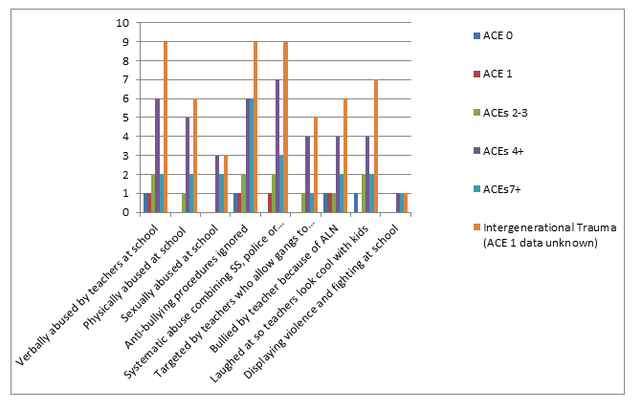
Despite the wealth of literature regarding peer bullying towards students with additional learning needs, there appears to be a notable gap in the literature regarding teachers who enjoy bullying the vulnerable. Since statistically a person with an ACE score of 4 or more is 1,220% more likely to attempt suicide than someone with an ACE score of 0 (Nakazawa, 2015, p.48), the results from this study demonstrates the importance of safeguarding children from all forms of bullying. Furthermore, since self-harm has been flagged up as a very serious local NHS concern in Swansea, along with high over-medication rates and opioid deaths compared to the rest of the UK (ABMU, 2016; 2017; BBC, 2019), it is important to be aware that as Baidena et al. (2017) points out, “Bullying victimization is a signiﬁcant predictor of NSSI [non-suicidal self-injury]” (Baidena et al., 2017, p.231). Consequently, since self-harm is a very serious global public health problem among adolescents (Hawton et al, 2012; Heath et al., 2008; Marks, 2017; Muehlenkamp, 2014; Muehlenkamp et al., 2012; Nock, 2010) and school bullying/exclusion has been identified as a precursor to self-harm and suicide completion which is the leading cause of death in almost all European countries (Hawton et al, 2012), participants’ accounts highlight the urgent need for systematic change.
5.7.2 Systematic Abuse and Gaslighting
Participants disclosed multi-professional bullying or systematic abuse, involving collusion amongst multiple professionals, including police officers, social workers, teachers and health care professionals.
‘Do you expect, do you really expect me [putting self in friend’s place] to come to university with a boy who sexually assaulted me, is right down the hall and he’s got away from it scott-free. He’s had no repercussions from this... The police were involved and everything and the police got [name omitted] to sign a document to say that she couldn’t press further charges in the future.’ (A:1251-1267)
I: So, there have been no repercussions for a sexual predator?
A: No and it’s all been hushed.
I: Did [name omitted] have a medical?
A: Yeah and there were witnesses (A:1349-1354)
Alex discloses even more non-standard professional police practice after a serious sexual assault was reported:
“The damage has been done to [name omitted] just cos she opened her mouth… he should have been suspended from university pending inquiry, it should have been taken to proper court.” (A:1339-1354)
Cortina (2008) also found that victims are often held at fault for their own mistreatment and those who practise this are found at multiple organisational levels, allowing a toxic culture to flourish. Furthermore, Peyton and Brooklyn believe they became victims of systematic abusive practice as professionals did not follow correct procedures, but commonly used fabricated, exaggerated or created evidence to target them, directly after both sets of parents raised concerns about professional abusive practice:
“We were trying to like complain because he [child psychiatrist] then lied about us in the letter. He said that I was in danger of going blind… And that mum had threatened to call the police if any professionals were involved which was completely untrue – she’s never threatened to call the police in her life… and we were, she was seeking help from lots of different people at, at the time… She was trying her absolute best and he lied about us in the letter to the social services and we couldn’t really complain… because he has a lot of power. He’s quite a powerful person in his line of work.” (P:798- 818)
“One of the social workers… she wanted to talk to my parents about me but when she came over, it had nothing to do with me, it was to do with something else completely… the head-teacher had an affair… [the social worker] wanted to know how my mother knew this information, how, where did she get it from, which made no sense cos that has absolutely nothing to do with me.” (B:493-510)
These experiences appear to mirror Lee’s description of gas-lighting whereby the perpetrators misused their positions and public money to cover their tracks, instead providing ‘valuable’ [mis] information to discredit the victim to others in influential positions. Ryan (2018) echoes this point, describing how gaslighting tactics were used against her when she pursued justice for her son. Ryan (2018) explains how ‘farcical’, ‘deeply biased’ and ‘inaccurate’ reports were written about her, along with damaging personal statements which suddenly changed and were later denied by the same people when they were questioned under cross-examination (Ryan, 2018, p.184-185).
Using tactics such as deliberately withholding key information to ‘keep the victim in the dark’, whilst fabricating false information and spreading lies to publicly shame and/or mother blame (Ryan, 2018) are also evident in some of the participants’ accounts. As Ryan (2018) highlights, “If we (mothers) dare to speak up on behalf of our children, we’re labelled as hostile or toxic” (Ryan, 2018, p.101). These silencing tactics described by Ryan (2018) are evident in many of the participants’ accounts that describe how their mothers were silenced and discredited when their mothers disclosed abusive practice towards the vulnerable. Coleman (2011) observes:
Time has taught me that this is the pattern with abusers; that they are often in positions of trust in the community, and that they use this position to ply their evil trade in misery and pain. (Coleman, 2011, p.4)

I: Why do you think the social services and the police targeted your family?
B: The only real thing that could be said or questioned is that maybe they were in cahoots with the school... it said that it [the anonymous letter] was written to protect the school [that was itself under investigation for child abusive practice towards primary aged SEN children] so it’s not very anonymous’. (B:646-655)
Research from Milgram (1963) supports participants’ accounts, since 65% of people will not question the actions of a person in authority, even if they believe those actions are wrong. However, if unethical practice remains ‘unchallenged’, then organisations will become desensitised to professionals who systematically abuse human rights and ethics (Greco, 2014). As Greco (2014) notes there has to be accountability, as the main problem with “abuse of power is successful transgressions become repetitive” (Greco, 2014, p.275).
Moreover, participants’ accounts reveal that professionals chose to cause deliberate harm to vulnerable young service users through actions of ‘hostile intent’ (Sentenac et al, 2010), as the singular purpose of bullying is to hide inadequacy and incompetence:
“Police officers went to my parents’ friend’s house… her son was also mentioned in the letter as also saying he was ‘demonised’ even though that’s quite discriminatory and offensive because he’s autistic, so I don’t know what they were implying”. (B:461-467)
As Shield (2006) observes, “In the frequent absence of benign leadership and knowledgeable management, neglect, perversion and compulsion could come to dominate” (Shield, 2006, p.33).
Scraton (2017) explains that there are two types of corruption; when a person is corrupt for themselves and they make a personal gain or when a person is ‘bent for the job’ where they protect their own interests and the institution, to cover their tracks so that the institution will also not be held responsible for wrongdoing.
Participants’ accounts show that the falsification of administrative documents does exist and are the result of unfair harassment to scapegoat and silence their targets. After Lee was raped whilst under the care of social services and silenced through victim shaming techniques, a personal explanation is given about what happened when justice was sought:
“I was taking social services to court and it had to be dropped because social services are just corrupt and tried to stop, trying every way to stop it.... There are millions of other cases out there where children have been abused, beaten or mistreated or neglected in their placements… There’s cases documented every day, but there’s never, their voices are hardly ever heard.” (L:987-1002)
Lee’s account illuminates that much abuse occurs within foster-care under social services’ provision. Clearly, abusive personalities will seek out jobs that give them a respectable ‘cover’ to increase their chances of repeatedly getting away with abuse and the legal power of the job position will give them access to the vulnerable (Freud cited in Watermeyer, 2013).
However, when abusive practice is ignored, it has disastrous consequences. This is because people who abuse and manipulate the vulnerable tend to seek positions of power (DoH, 1995) in jobs, such as the police, social work, teaching, medical profession, politics and religious organisations. Furthermore, Peyton’s family felt that they could not complain about the misuse of power, for fear that their only source of income might be targeted:
“We couldn’t really complain because mum… Her job was then on the line because he has a lot of power. He’s quite a powerful person in his line of work, so she had to be very careful not to [report the abuse] then lose her job.” (P:813-820)
Brooklyn explains what it felt like from a child’s perspective knowing that close family were being targeted by professions as a silencing strategy:
“I knew that social services’ role was supposed to be there to protect me, and the police were supposed to be there to protect me. And I suppose that’s one of the major reasons why I felt unsafe because there was somebody in a position of authority over me who was taking advantage of their position to target me personally”. (B:674-681)
“A situation of complete and utter fear and terror because honestly, it felt like I was being hunted...and it was traumatic...That’s all that was playing on my mind was you’re going to lose the house, you’re going to become homeless. You are going to be taken off your parents, so after my exam was finished, I called my mum to pick me up and I never went back.” (B:822-846)
Therefore, it is evident that both Brooklyn and Peyton’s GAD anxiety disorders were not brought on by irrational fear especially as 25% of the employees working for the same employer as their parents had reported workplace bullying (Social Partnership Forum, 2018) and this workplace bullying (see Appendix 7, 12 and 16) has previously been recognised as an unaddressed silent epidemic (Kline, 2013). Instead these organisations have won platinum and gold awards for promoting healthy work environments and wellbeing, even though there is much evidence to show that their employees engage in health harming behaviours towards the vulnerable (Appendix 11).
As Shield (2006) explains:
Breaking the immediate physical and emotional boundaries of the child, the perpetrator relied on the collusion and denial of the wider institution to enable the continuance of his perverse compulsion for action, manipulating children as puppets. In an environment where to exhibit distress or complain brought the risk of further punishment. (Shield, 2006, p.32).
Scraton (2017) concurs:
We have to keep an open mind on how those in authority act when they are culpable of serious deficiencies…. I think when those in authority find themselves actually accused of very serious crimes, they might describe as misdemeanours… there is always the possibility that they will cover their tracks, that they will attempt to place the blame elsewhere.
Max and Alex’s accounts describe the attitude of female professionals whose role it was to deal with sexual assault victims:
“This boy, who’d targeted me right through school… [and] sexually assaulted me. And he basically tried to penetrate me with his finger outside school. I was fourteen... the official line of what we were told was shake hands and they physically made us shake hands and he said sorry. And then nothing else was done. I was totally afraid of him.” (M:307-373)
However, Alex explains how safeguarding officers somehow shifted blame onto the victim of abuse. Spring (2015) explains, “In many settings of abuse, ‘choice’ has been manipulated in order to blame shift onto the victim, leaving them feeling responsible” (Spring (2015, p.10)
“Because [name omitted] was sexually assaulted right, because obviously that’s quite traumatic for a young person to go through…. They held that person back in uni. for that...I’m sorry he should have been chucked out of uni. That to me is putting other people at risk… they’re having this meeting the other week ok and then the lecturer turns around, not supportive at all by the way totally unsympathetic, horrible and she turns around she says [to the victim], “Oh you need to come and get all your stuff or I’ll chuck it in the bin.” (A:1197-1328)
5.8 Superordinate Theme Five: Damages to Mental Health: Survival Coping Mechanisms and Self-Medication
Participants disclosed significant damages to their mental health, as a result of adversity:
“In year nine my attendance dropped by about 50% and I had what I would class as a nervous breakdown because I was having targeting [sexual harassment/assault] from this boy. I lost all my friends, I developed an eating disorder… I became bulimic and I was self-harming. My sleep was totally disturbed, I was having nightmares. I missed about half of my school year and I developed glandular fever during this time. And I just remember my body was packing up and it was just one thing after another and I was just really, fearful and stressed pretty much all the time and I had nobody I could really talk to about it…My mum knew I was ill, my parents knew I was vomiting a lot and they knew I was losing weight, but there was no one I could really go to with it. Nobody knew how I was actually feeling. My mum knew that I hated school and I didn’t want to go anymore and I was home all the time or trying to be home all the time. If I did go to school, I was late. I was late for everything. I’d be late for assembly and I’d hide in school so I didn’t have to get called in.’ (M:250-283)
“Anxiety, depression...I would say its 100% common in teenagers under the age of eighteen and above. We live in quite a harsh society, so all teenage girls and teenage boys, they suffer with depression. School they all talk about bullying or drugs. Yes ok, there is bullying and drugs but there’s also mental health and that’s very, very important because your mental state affects everything”. (B:980-991)
Adolescents who have been exposed to trauma during their childhoods are at higher risk of experiencing damages to their mental health. As previously noted, childhood traumatic events leave their mark on children through stunting physical, language and emotional development, as well as resulting in diminishing dopamine levels and poor self-regulation. Since dopamine levels should be at their highest at the end of primary school to prepare them for the challenges of adolescence (Nakazawa, 2015), continued trauma can result in increasing prolonged states of uncontrolled anxiety, produce unwanted psychological changes and poor self-regulation in children (de Thierry, 2015; Marks, 2017; van de Kolk, 2014).
Figure 5.8: The emergence of participants’ mental health difficulties in this study began before they were 25 years old.
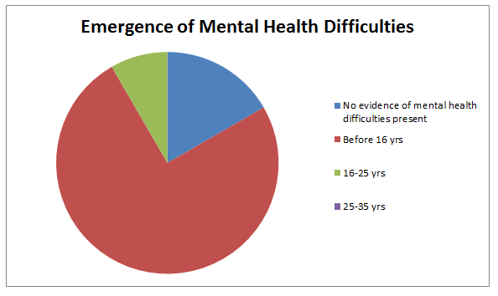
Furthermore, an altered biology might result in increased aggression and heightened sensitivity to the environment or social withdrawal and isolation as reactions to new stimuli have become dampened. The majority of participants who disclosed mental health difficulties recalled that their struggles began before they were sixteen years old (figure 5.8).

5.8.1 Survival Coping Mechanisms: Withdrawal from Toxic Environments
The majority of participants took measures to withdraw from toxic environments. Moreover, 40% of participants in this study mentioned that they stayed at home ‘ill’ from school:
“During my GCSE years which as you know are from year eight upwards. I was a little bit withdrawn and I had to do most of my studying at home where – it [reminders of the trauma] was following me around everywhere. I was completely emotional. I was crying all the time. I couldn’t focus. And when I was telling people about it, I, then, they were calling me liar.” (L:922-932)
However, as Max and Brooklyn point out, withdrawal from school and friends was not their preferred choice:
“The fact that I wouldn’t want to come into school and I was losing all my friends and I was having an eating disorder, there was no support. You know, even the kids who saw me in the canteen, they would see me throw half my lunch away and I lost about two stone in weight you know over that time. And nothing was done.” (M:659-668)
“I couldn’t commit to anything. I couldn’t commit emotionally, physically, mentally. I got to the point just after I left, I was crying 24/7 in bed. I wouldn’t leave, wouldn’t get out of my house, wouldn’t see anybody. I piled on a ton of weight.” (B:1010-1017)
It is clear from the accounts that many of the participants withdrew from school situations which were retriggering and reinforcing the coexistence of intrusive memories connected to adversity. Since part of an avoidance and defence response would be to avoid people or places that might trigger past trauma, it appears that many of the participants in this study sort to utilise strategies to avoid the pain of being in school.
Max’s account shows that ‘measures’ were taken to personally remove him [or her] self from the source of the trauma whilst at school:
“Playing solitaire – that used to be my lunch. I used to play solitaire by myself for about a year”. (M:630-632)
As this account appears to indicate, the avoidance of people and places in the aftermath of trauma can also involve emotional withdrawal from friends, previous habits or social activities that used to be a source of enjoyment and comfort, as broken trust can manifest itself through all established relationships.
Moreover, Stevie discloses:
“I couldn’t concentrate on any classes or anything really. I think I always used to go off into a daze and just day dream”. (S:219-222)
Complex traumatic experiences can cause a person to internally withdraw from being present (Spring, 2016), explaining why Stevie and Lee would go ‘off into a daze’, ‘space out’ and ‘day dream’, as these are dissociative states. Van der Kolk, (2014) notes, that the more prolonged the traumatic experience, the greater the risk that the victim’s body is likely to react with dissociation. Van der Kolk (2014) echoes these experiences, noting that the ‘price for shutting down’ is diminished participation in everyday life.
However, for many of our participants, who experienced trauma during adolescence, ‘decreased involvement in ordinary, everyday life’ can present itself as truanting, avoiding school/homework at home or avoiding school altogether, as damages to self-regulation will be evident in all relationships (Davidson, Grigoenko, Boivin, Rapa and Stein, 2015). Ellis describes how ‘mitching off school’ and not handing in ‘coursework’ took place as a way to protect self as feeling ‘inadequate’ and ‘not getting the grade’ felt ‘deflating’:
“I was mitching off school quite a lot and I would especially do that if I didn’t have the coursework to hand in… Mitching off school’s not a good thing, you know... The lack of encouragement and knowledge or education that they actually give you to lead you in a direction, it wasn’t there… Because I mitched off school quite a lot, some people would come with me occasionally and then they’d go to school. I’d only go to school, if I wasn’t going to get into any kind of trouble that day... if there was no coursework to hand in or if there were no tests to sit…it kind of pushed me away... feeling inadequate because I’d been moved down classes.” (E:238-265)
“To be honest with you, not getting the grade I wanted…it’s kind of a bit deflating, so I started to not go to school by the age of about fourteen”. (E:203-211)
“I don’t think I learned anything in school. I don’t think there was anyone… who I can remember helped me at all… Because of truancy, then I went to a centre…because otherwise my mother would have got fined and that because I was always mitching.” (S:296-306)
It is clear to see from the participants’ accounts how many of them acted out of the survival instinct. Since individuals who have suffered trauma will often make self-protective decisions to avoid the stressful situations or form coping mechanisms to help them get through life the best they can, thus trying to protect them from future damage.
However, social isolation has been found to be linked to suicidal behaviour (Maris, 1992) and can be a result of being bullied at school (Brunstein, Sourander and Gould, 2010; Hawton et al, 2012).
Moreover, negative school experiences and poor academic performance often precedes truancy (Zalsman et al, 2016), leaving school early and health-harming behaviours. As well as staying home ‘sick’ from school or going into dissociative states while in school, other participants mentioned how their parents permanently removed them from their school trauma through home-education:
J: I am restricted to places I can now go now in public. I’m restricted to a couple of stuff... Because of everywhere I go...Cos of bullying. Think of it like this, if you are getting bullied all your life until you’re fifteen- You’d be restricted...To where you can go- And how long you can be there.
I: So, have you restricted yourself?
J: No, my parents have. (J:89-119)
A third of participants in this study used home-education as a coping strategy to help them to recover from the negative experiences whilst at school. Morton (2010) echoes these findings, describing how forced home-education had been used as a safe ‘escape route’ for many young people protecting them ‘from what had become for them untenable situations’ at school (Morton, 2010, p.52). Hurlbutt (2011) found that 3.6% of home-educating parents have additional needs children and a further 2.1% indicated their children had physical or mental health difficulties which had not been sufficiently supported at school.

Morton (2010) also notes that there are significant numbers of adolescents who have been withdrawn from school to be home-educated after coming ‘close to emotional breakdown prior to being removed from school, (Morton (2010, p.52) including reporting links between ‘bullying and/or linked to a child having Special Educational Needs (SEN)’ and ‘escaping pressure from the school and the Local Authority’ to return back to a damaging learning environment.
Peyton believes that his [or her] family had no choice but to permanently withdraw him [or her] from school as mental health needs were not being supported:
“They literally said you have to start coming back to school or else we’ll have to take you to court, so we had to get de-registered… that was literally the only option”. (P:325-331)
“They (the LA) were quite eager for me to deregister, so they didn’t have to pay anything”. (P:461-463)
It appears that Peyton believes it is cheaper for councils to use threats of court action and fines for parents than using money from their budgets to bridge the gaps in provision or eradicate bullying out of schools which are causing significant mental health difficulties in young people (Hawton et al, 2012). Moreover, home-education is increasingly being used by parents as a mental health safeguarding measure to protect their children from further emotional damage (Holland, 2005; Hulbutt, 2011; Morton, 2010).
5.8.2 Self-Medication: Diminished Dopamine Leading to Addictive Behaviours
It is interesting to note that all of the four youngest participants (aged 14-16), including the three home-educated participants did not disclose that they engaged in any addictive health harming behaviours during their interviews.
However, the four oldest participants (aged 25-35) all explained how they engaged in addictive behaviours as a form of self-medication because of school exclusion. Moreover, two out of four of the oldest participants disclosed that they regularly truanted from school and it appears that truanting led to exposure to health harming addictive behaviours:
“I’d just mitch off... We used to get drunk and stuff around the school area.” (S:311-313)
‘You fall into the cycle of using, using drugs and being just a waste of time. You think you are a waste of time anyway and it’s really easy when you are in that frame of mind to sink even lower’. (N:348-352)
‘I’d be that bored that you’d start taking new things, trying drugs. Trying to enjoy yourself’. (R:119-122)
Since dopamine is the main brain chemical responsible for making people feel motivated and ‘alive’ (McIlaney and McKissic Bush, 2008), a person with depleted levels of dopamine might appear to look apathetic, tired and unable to concentrate long enough to complete tasks. As school did not offer any of these youngsters any motivation or reward, it appears that they looked elsewhere for comfort in health harming behaviours, including drinking alcohol, smoking and taking drugs whilst truanting from school. Mate (2019a) states:
In biological terms, any addictive substance or behaviour is self-medication, self-administered emotional relief. But the [undiagnosed] ADD person is also treating herself for a condition she is not even aware of having [as] … People with ADD seem to be short on dopamine the reward chemical. (Mate, 2019a, p.301-302).

Vaughn, Maynaud, Salas-Wright, Perron and Abdon (2013) found that regular adolescent truants were three times more likely to report depression and two and a half times more likely to report anxiety, suggesting that truanting is also connected to unsupported mental health needs at school. As Ellis explains:
‘It’s an easy route, isn’t it? It’s not a conscious decision you make…You feel that, you haven’t done very well and you kind of give up… It numbs any kind of emotions, doesn’t it? Drink and drug use when it’s excessive… It’s an escape, isn’t it? An escape from the reality that you are in.’ (E:356-366)
Rory and Ellis’ accounts suggest, they were both not in a good frame of mind before taking the drugs. Ellis states feeling like a ‘waste of time’ and Rory said he was ‘bored’ and ‘trying to enjoy’ life. However, truancy has been linked to other negative outcomes, such as smoking, drinking alcohol and substance misuse, crime, poor academic outcomes, school exclusion (Best et al, 2006; Perez et al, 2010; Zalsman et al, 2016) and self-harm (Marks, 2017). At the same time as truanting, Stevie and Alex describe how they started drinking alcohol ‘and stuff’ from age fifteen onwards:
‘From the ages of say like fifteen to seventeen… I was going to town every night taking drugs’. (S:471-474)
“I started drinking a lot, smoking, going out a lot, I mean I was fifteen going to town...Sneaking into a nightclub”. (A:1026-1031)
I: So, did you participate in dangerous behaviours?
A: Yeah at that age, yes. (A:1039-1041)

Figure 5.9: Diminished dopamine leading to addictive behaviours, poverty and depression
Figure 5.9 shows that five participants (aged from 17-35 years old) had engaged in substance misuse at an early age. Since almost all addictive drugs, including nicotine, alcohol, amphetamines and cocaine increase dopamine reward signals (De Bellis, 2000), it is no surprise that half of the adult participants engaged in these activities when younger.
“When I went to college I was dating anything with legs... I went with people for the wrong reasons really, so it has affected everything to do with my life”. (A:1005-1010)
Alcohol use during adolescence has been shown to inhibit neuronal development, along with impacting on executive brain functioning, which in adolescents increases their vulnerability towards experimenting with other risky behaviour (Ehlers & Criado, 2010; Matthews, 2010). Additionally, van der Kolk (2014) found that ‘emotion-focused coping’ makes trauma victims ‘vulnerable to engage in alcohol and substance abuse’, as he observed that between 25% and 50% of ‘all patients who seek substance abuse treatment suffer from a comorbid posttraumatic stress diagnosis’.
Van der Kolk (2014) also notes that the association between PTSD and substance abuse is ‘reciprocal’ as ‘drug abuse leads to assault, and reciprocally assault leads to substance use. Additionally, along with links to substance misuse, truanting has been highlighted as a common shared experience with child sexual exploitation victims (Senior, 2015). Stevie discloses:
‘Men took advantage of my vulnerability. Men. You know, as a young child/person, older men were having sex with me – as a kid like... Fourteen’. (S:846-851)
As a fourteen-year old with undiagnosed learning difficulties, Stevie was also extremely vulnerable to being manipulated by older men, who took advantage of his [or her] vulnerability at this young age, whilst he [or she] was living under council care. Additionally, as a young person who had experienced perpetual failure at school through not being able to access the curriculum, as he [or she] was unable to read, Stevie engaged in multiple unhealthy dopamine rewarding behaviours, including self-harm and risky under-age sex. Unfortunately, despite substance misuse, self-harm, sex and risky behaviours producing an instant high dopamine reward, they are also highly addictive. Since it is recognised that sex is one of the ‘strongest generators of dopamine reward’ (McIlaney and McKissic Bush, 2008, p.35), it is no surprise to learn that Stevie left school at fourteen engaging in regular underage-sex with much older men. McIlaney and McKissic Bush (2008) echo Stevie’s account, pointing out that young people who have been educationally failed are especially at risk of engaging in underage sex, substance misuse, criminal behaviour and self-harm to increase their low dopamine levels:
‘In year nine my attendance dropped by about 50% …I was self-harming’. (M:250-257)
‘I used to cut my arms. I used to take overdoses as a kid. It was when I was in school, thirteen. I used to cut my arms... My mum knew. No one in school noticed’. (S:866-875)
Chris also mentions about self-harming:
“If I was [distracted]… then I wouldn’t be thinking about self-harming or thinking about what happened.” (C:304-309)
Since self-harm is highly addictive (Hawton et al, 2012), as it gives the individual an instant flood of endorphins and because dopamine is a “reward chemical” it creates a craving within the person to repeat this pleasurable experience again and again (Mate, 2019a, p81). As dopamine is considered one of the “feel good” neurotransmitters (McIlaney and McKissic Bush, 2008), individuals with low self-esteem or those who have experienced failure at school, are at risk of feeling the need to do something to make themselves feel better.
Furthermore, it appears that self-harm in some participants’ cases is linked to depression and internalised blame from not being heard. Klonsky (2009) explains that self-harm is often used by adolescents as a ‘means of regulating negative affect’ and more knowledge and understanding is required by professionals to understand self-harm, not as attention seeking behaviour but as an affect-regulation function (Klonsky, 2009, p.261). Max observes:
“I’ve worked with youth since leaving school and the number of them that have self-harmed or the number of people who have self-harmed and there’s no access to anything for them and they don’t look like children with special needs. A lot of them don’t have dyslexia or any kind of problems keeping up educationally but they’ve self-harmed or they are going through an awful divorce at home... it will affect their grades”. (M:1048-1060)
As Max points out, young people who have been exposed to childhood trauma might be more prone to engage in self-destructive behaviours. Furthermore, many of the participants have referenced that they began to develop eating problems after experiencing traumatic events, either through over-eating, starving themselves or developing eating disorders:
“I did actually stop eating for a bit. I lost a lot of weight in college. I think I went down to like eight and a half at one point. I was eating like an apple. I used to get an apple, cutting it into four and that would be my four meals in a day.” (A:1050-1055)
“It was borderline eating disorder.” (A:813-814)
Max describes how after being sexually assaulted at fourteen, even after he [or she] attended a different school at sixth form with different people, unprocessed trauma from previous sexual abuse retriggered negative outward and internal unconscious responses:
‘There were a group of boys who were quite interested in me… I ended up taking loads of time off school. I put on about four stone in weight. I was really anxious and really nervous and I used to stay home all the time. As I could see was there [had been] no action taken about this ‘boy’ [abuser at previous school]. Therefore, there was no guarantee of safety for me, especially from other boys…. it really affected my grades, really affected my confidence and I didn’t socialise’. (M:533-550)
Max describes a common coping strategy used by bullied or sexual abuse victims where they will deliberately put on ‘stones in weight’, in order, to try to create protective armour to keep themselves safe in perceived unsafe environments. Felitti (2009) and Van der Kolk (2014) recognise that weight gain and obesity is sometimes used as an unconscious self-protection measure to stop any reoccurring abuse.
It appears that as uncontrollable anxiety builds up, individuals might unconsciously use defensive reactions which might include taking deliberate actions to avoid the mental or physical symptoms of de-regulation through over-eating or not eating (Max, Brooklyn and Alex), over-sleeping or not being able to sleep (Peyton, Max and Brooklyn), along with engaging in self-medication such as substance misuse, self-harm or other forms of risky addictive behaviours (Ellis, Stevie and Rory).
However, weight gain as a result of underlying trauma and anxiety (Felitti, 1985; Felitti, 1990) is still being missed as a symptom of trauma by doctors:
“The first time I went to the doctors to talk about my anxiety, this woman just asked if I’d ever thought or tried to lose weight because that would make a great deal of difference… I never mentioned that I was anxious because of my weight...It made me feel disappointed… I thought why bother, why did I do this. Why did I do this to myself cos I’ve made a massive effort to talk about my feelings and now they’ve just been disregarded and I’ve just been told that, ‘Oh just lose weight.’ (B:1383-1408)
Another example of how symptoms of trauma were missed by doctors is provided by Stevie, who explains how ‘this voice in my head’ started directly after being in a nasty fight:
“The last day I went in, I had a massive fight with this girl and it was really nasty. I was full of bruises. It was a really bad fight. I was always having fights and that all the time with girls and that. Nobody really picked up on that I was singled out… I went to CAMHs once or something because I started to hear like this voice in my head.”.” (S:408-422)
‘I was getting bullied outside of school and I think I was being bullied a little inside school as well. Like every year, I had a fight in school... you’d get into trouble after but there wasn’t anyone, people to pick up on what was actually happening.’ (S:146-169)
It is known that voice hearing and hallucinations are often be triggered by a traumatic event such as an accident, illness, bullying, assault or abuse (Longden, 2013). However, there are strong links between voice hearing and experiencing sexual, emotional and/or physical abuse at a formative stage of life (Coleman, 2011; Longden, 2013). The fact that Stevie recalls the voice hearing experience immediately after being involved in a ‘really, nasty’ ‘massive fight’ on the very last day of school before leaving at age fourteen, suggests that this voice hearing experience was triggered by the fight. As stated by Kim & Leventhal (2008), being a target of bullying at school increases the risk of attempting suicide. During the interview, Stevie also spoke about multiple suicide attempts as a child:
‘I used to take overdoses as a kid’. (S:866-867)
Therefore, despite being referred to CAMHs, Stevie was dismissed from the service, even though he (or she) was self-harming, taking regular overdoses and displaying the outward behaviours of a victim of child sexual abuse (CSA) and child sexual exploitation (CSE). Thapar, Collishaw, Pine and Thapar (2012) echo Stevie’s account, demonstrating that depression can be overlooked if there are ‘unexplained physical symptoms’, such as eating disorders, anxiety, refusal to attend school, decline in academic performance, substance misuse, or behavioural problems.
Figure 5.10 shows’ damages to participants’ mental health.

Figure 5.10: An example of some of the participants’ symptoms of damaged mental health
Thapar et al. (2012) also found that depression in adolescents has a prevalence of 4–5% and is one of the primary risk factors for suicide, which is one of the main causes of death in adolescents (Costello et al, 2005; Costello et al, 2006). Van der Kolk (2014) echoes these findings as he found that in a study of almost 10, 000 patients, those who reported significant adversity during childhood were 4 to 12 times more likely to experience depression, alcoholism, drug abuse and suicide attempts, with 2 to 4 times greater risk of becoming a smoker, having more than 50 sex partners, along with sexually transmitted disease. However, it is interesting to note the stark contrast between the females and males in this study, as the females were much more vocal about a full range of mental health conditions compared to the males in this study who also experienced depression, anxiety, self-harm, rape, suicide attempts, and mental health diagnoses. However, the males in this study had relatively little to say on these matters.
The reluctance of the males to talk as openly about their struggles, feelings of shame and mental health difficulties, compared with the females in this study, may provide a possible explanation why male suicide is the leading cause of death in the UK (Samaritans, 2018), compared to the female figures which are much lower. The Samaritans (2018) report, “In the UK, men remain three times as likely to take their own lives as women” (Samaritans, 2018, p.6). Therefore, this study might be a reflection of how males traditionally find it more difficult to share their deepest feelings about their pain (Atkinson, 2017; Grayburn, 2018) because of an ingrained belief system that real ‘boys don’t cry’ (Grayburn, 2018).
However, Hawton and Rodham (2006) report that ‘deliberate self-harm was nearly four times as common’ in females than males. Therefore, health and educational professionals need to be aware of these connections and further investigations carried out (Hawton and Rodham, 2006, p.65).
The UK’s Medical Research Council (MRC) echoes the urgent need for ‘an innovative vision’ for a ‘national mental health strategy’ (Sahakian et al, 2010), as suicide is reported as being the leading cause of death in almost all European countries (Hawton et al, 2012), almost 10% of British children aged 5–16 years have a’ clinically diagnosable mental health problem’ which often continues into adult life and 16% of adults in Britain have a common mental disorder, such as anxiety or depression (Beddington et al, 2008; Green et al, 2005). As van der Kolk (2014) states, trauma not only affects ‘psychological functioning’ but the impact of adverse experiences in childhood is ‘one of the most important public health problems in the world’.

5.9 Superordinate Theme Six: Revolving Door of Cycles of Oppression and Intergenerational Poverty
The ‘Revolving Door of Oppression’ was coined as a term to recognise the repeating cycles of social poverty that impacted participants lives:
“To me, it’s normal. It’s just my life. You know, but it’s not normal. It’s not right. And there needs to be something done about it because people are living growing up thinking that this is the way it should be and it’s not the way it should be.” (S:885-891)

5.9.1 Forced Poverty: Blocked Opportunities for Further Education, Employment and Economic Regrowth
Peyton and Brooklyn describe the socio-economic disadvantage faced by forced-home-educated children:
“My mum had to search the entire internet to find provision for me... She eventually came across an exam centre [outside Wales] which provided IGCSEs... But obviously we had to pay for them and I think they were £150 per GCSE.” (B:1042-1052)
“I tried to get some [GCSEs] from the local college, they said it was going to be hundreds [of pounds] … for one GCSE… Mum works part-time because obviously I’m at home all the time and she doesn’t earn a whole lot… We can’t afford to pay hundreds for GCSEs, which is something that everyone else gets paid for them, just because they have good mental health and physical health and are able to go to school which doesn’t seem very fair”. (P:489-503)

As these accounts illustrate, the high cost of exams at £150 per GCSE exam (without teaching materials or resources) would have impacted upon parents’ financial budgets after the children left school, as finding other suitable educational provision proved problematic. Peyton also talks about the financial worries regarding parental employment:
‘My mum… she probably would have been working full-time by now if I was still in school… if that horrible doctor had succeeded in getting her losing her job... when we went to complain about him making up lies because we wouldn’t obey his every command, we were worried about mum losing her job, and then, we wouldn’t have been able to survive, let alone possibly scrape money together to get me an education, like qualifications or GCSEs, which should be paid for anyway’. (P:1067-1087)
Peyton’s account appears to illustrate that some forced-home-educated children with mental health difficulties face further discrimination. Their unsecure predicament appears causes further worry about not being ‘able to survive’ financially as their parent, usually the mother, has to stay at home to ‘home-educate’ the child. Therefore, working full-time is no longer a viable option, resulting in a decreased family income. Davidson (2015) acknowledges the need for adolescents and young adults who live with disability to have continued access to appropriate education and employment to become ‘productive members of society’. However, Peyton describes how mental health difficulties became a further barrier to accessing education:
‘I can’t go out and when I tried to do a GCSE, a few months ago, we tried to get an invigilator in the house… And they said no. They said it was possible, but it was going to cost a lot and for the specific one I was doing, it wasn’t possible anyway, but generally it’s possible but it’s going to cost a load. Even if you are going to a place, it’s still going to cost, which it wouldn’t if you were still in school’. (P:441-453)
“[Having an exam invigilator to the house] was “too expensive… they wouldn’t come because there was something about, needing loads of people in a van with a secure box and the paper inside and blah, blah, blah and they would not do it. They just refused.” (P:631-637)
Rory, who failed all GCSEs at school, noted how this impacted upon the ability to access further suitable educational provision at college:
I: So, what did you need to get on to do the courses that you want to get on to? Why didn’t they let you on to the level two?
R: I didn’t have the qualifications.
I: What qualifications did you need?
R: Maths, English. That’s it. Just maths and English really. (R:85-92)
Chris also shows how the lack of effective communication or ‘joined-up’ thinking between different organisations became a barrier to him [or her] accessing higher university education, despite the fact that he [or she] had all the relevant qualifications needed to study a degree:
I: So, not just education at primary school, or even comprehensive school, improvements which could be made then-
C: Further on yes.
I: At college level and university?
C: And at university level, yes. (C:326-332)
Alex analyses the situation exceptionally well:
“It’s meant to be a system, is there any communication between these systems? No there’s not. Every time you go into a different education level you’ve got to go right back to the start again. It’s ridiculous”. (A:502-507)
Since education is meant to be a tool to get people out of poverty, participants’ accounts appear to indicate that the current education system is responsible for creating unsustainable circumstances of poverty.
Teather and Hillman (2017) also identify education as:
The principal tool for achieving the elimination of poverty; the means of equality for productive human rights, including a decent job, particularly for those young members of society with disabilities; and to enable them to contribute to their full potential. (Teather and Hillman, 2017, p.551)
However, the opposite is the case for participants in this study and Connell (1993) suggests that when the ‘educational needs of the disadvantaged’ are ignored, the overall ‘quality of education [will] be degraded for all, as a miscarriage of social justice’ (Connell, 1993, p.50). Furthermore, Teather and Hillman (2017) have observed that students with disabilities are often exploited by educational institutes and punish them ‘as victims of education in restricted access’ (Teather and Hillman, 2017, p.552). Moreover, lack of qualifications also significantly reduced participants’ chances of finding suitable employment:
I: Are there any options available to you?
R: What, right now?... Not really, because I’ve got no qualifications - just think about going in the army, getting it done there. I need money. When I left school, I wanted a job I didn’t have nothing just sat bored like I used to be walking round all day. I’d be that bored that you start taking new things, trying drugs.” (R:109-121)
At just seventeen years old, Rory stated, ‘I didn’t have nothing’ and then disclosed that this led to trying ‘drugs’. However, Ellis and Stevie both explain how drug addiction led them into further poverty and homelessness:
“You fall into the cycle of using, using drugs and being a waste of time… You feel that you haven’t done very well and you kind of give up…I was a heroin addict for seventeen years. It caused me to lose my driving license, which in turn caused me to lose my job. So, I even lost my home. I got caught in possession of Class A and sent to jail.” (E:348- 393)
“I was seventeen then, I got kicked out of the [children's residential home] because of drugs because it was zero drugs tolerance and then I was homeless for a few weeks… Because I had to have help because I was finding it really difficult with the work… I was taking speed (street drugs) to help me do the work’.” (S:481-565)
The trappings of substance misuse and homelessness leave individuals with little hope of getting out of poverty (Mate, 2016), leaving them stuck in their situations as the landlord’s bond and first month’s rent upfront is often unaffordable, which means people are forced into homelessness. However, as both Stevie and Ellis found, street crime is then often the only option out of poverty for the homeless to gain some sort of an ‘income’.
“I think there has to be a link between [lack of] education and crime because when people feel there’s no job prospects for them, how else are they going to support themselves?” (E:475-479)
Reid (2010) observes that there are usually disproportionately high levels of trauma, abuse and neglect which often precede homelessness.
Davies (2008) reports that “Around one third of homeless people in cities in the UK suffer from ‘schizophrenia’… [and] 1,200 ‘schizophrenics’ commit suicide annually in the UK” (Davies, 2008, p.9).
Wong, Clark and Marlotte (2016) also found that homeless people ‘may be unlikely to access services that can help them recover and exit homelessness’ as they are ‘often isolated from reliable sources of support from family and friends’ (Wong, Clark and Marlotte, 2016, p.831). Therefore, the homeless believe they have no other option but to engage in crime just to eat and survive. However, a homeless person with an addiction and/or a psychiatric diagnosis and/or a criminal record would find it incredibly difficult to gain future employment, as pointed out by Ellis:
‘You’re certainly limited, aren’t you? It’s difficult you know, once you’ve got a criminal record, there are so many companies that won’t be interested in you’. (E:543-547)
As Naramore (2015) points out:
Throwaway and runaway children, homeless children, and youth aging out of foster care may find themselves living on the streets in locales where the adult prostitution market suggests a way for youth to secure their own shelter, food, and clothing. (Naramore, 2015, p.2)
However, most human trafficked victims and those who are exploited do not see these types of dangers (Senior, 2016), as they tend to be targeted because of their vulnerabilities with no family support network, background of poverty and a lack of education. Mokhtar & Hogbin (1993) also discovered that there are a high number of homeless individuals who are often picked up by the police and sectioned under Mental Health Act 1983 section 136.
As Bourdieu (1986) states, if a nation’s education is inadequate, then this failure will negatively impact their economy, leading to gaps in available skillsets, inequality and the deskilling of workers, which will result in eventual societal collapse. Moreover, Shield’s (2006) equation appears to sum up many of the participants’ experiences of forced poverty as he calculates, “Victim + Perpetrator + Circumstances = Claustrum” (Shield, 2006, p.32).
5.9.2 Developing Debilitating Physical Illnesses
Participants’ time-lines and accounts show that many of them developed physical symptoms and illnesses concurrently with trauma. Max, Peyton and Brooklyn all disclosed separately that they experienced illnesses such as glandular fever, sciatica and chronic fatigue:
“My sleep was totally disturbed, I was having nightmares… I developed glandular fever during this time. And I just remember my body was packing up”. (M:257-262)
‘‘We thought it was chronic fatigue so we were always sort of going around to loads of doctors and everything, which probably didn’t help my anxiety and everything… I actually had depression. Depression was the reason and that I had developed serious stuff... I was too anxious to come downstairs… My sleep started going weird and I couldn’t come down. I was just too anxious to come downstairs;” (P:140-157)
“I was dealing with sciatica so I was in bed. I could hardly walk. I was in an awful amount of pain… I couldn’t walk”. (B:511- 531)
Moreover, all these participants describe how their sleep became so badly disturbed. Van der Kolk (2014) explains how being traumatised can affect self-regulation, listing sleep disturbances among other symptoms of trauma such as ‘hypervigilance, irritability, memory and concentration problems… and an exaggerated startle response’.
Walker (2017) notes that ‘sleep dispenses a multitude of [free] health-ensuring benefits, yours to pick up in repeat prescription every twenty-four hours” (Walker, 2017, p. 7). However, Walker (2017) also warns that anything that ‘bankrupts’ the sleep of a teenager could be the ‘tipping point between psychological wellness and lifelong psychiatric illness’ (Walker, 2017, p.309).
Breathing and sleeping irregularities have also been linked to heart disease and cardiovascular failure which often emerge decades later, increasing the chances that the person is met with an untimely death (Walker, 2017). Since trauma and fear-based experiences can shock the entire system, an individual’s breathing and sleeping can become disturbed:
“I started having panic attacks. I struggled to breathe. I was crying. No one even noticed”. (B:836-838)
“I had gained generalised anxiety.” (P:267- 268)

“I have social anxiety and generalised anxiety.” (B:1419-1420)

Furthermore, GAD (Generalized Anxiety Disorder) is recognised as a chronic condition making it one of the most difficult anxiety disorders to treat (Gould, Safren, O'Neill Washington, & Otto, 2004; Keller, 2002). Additionally, as evidenced by both Brooklyn and Peyton’s accounts, further academic avoidance revealed an ‘automatic process of avoiding threatening situations’, because of the fear of the possibility of uncontrollable future negative events (Heimberg et al, 2004).

Brooklyn’s account shows how trauma affects sleep, speaking, learning and physical illness, as anxiety co-occurs with other symptoms:
I: So physically, all of your emotional mental health in terms of fear, anxiety, trauma, it then had an impact upon your physical –
B: Everything really- my mental and emotional wellbeing had an effect on my physical well-being that had an effect on you know, everything else… concentration, trust, er, even the ability to sleep at night. It affected every part of my life, my eating, my sleeping, my motivation. I lost everything. Some days I would go to school on three hours sleep. And you know, I still wasn’t talking to my friends about it.” (B:907-922)
Walker (2017) supports the participants’ accounts and provides further consequences of sleep deprivation, which are problems with memory and learning retention, anxiety, attention deficit, dyslexia, depression, weight gain, ‘early onset of drug and alcohol use’, aggression, impaired immune system, impaired breathing, cardiovascular disease and all major psychiatric conditions, including suicidality, along with Alzheimer’s disease, cancer, diabetes, premature death and road traffic accidents. A lived example of how trauma is carried at a cellular level to the next generation is appears to be evident in the account of miscarriages of justice victim found in Appendix 16. Additionally, it is interesting to note that several participants’ parents reported that their children had childhood allergies, eczema and/or asthma (Appendix 7).
Furthermore, Mate (2019a) reports:
The flare up of allergies can certainly aggravate ADD symptoms, the one does not cause the other. They both are expressions of the same underlying inborn trait: sensitivity. (Mate, 2019a, p.59)
Since the participants in this study are aged 14-35 years old, the true extent of the damage to their immune systems is yet to become manifest (Nakazawa, 2015; Mate, 2019; van der Kolk, 2014). As Nakazawa (2015) states, “It can take thirty years or longer for the immune damage caused by that chronic adversity to progress to a clinically recognisable disease” (Nakazawa, 2015, p.102). Furthermore, many of the participants’ parents’ longer life-experiences clearly demonstrate the connection between ACEs, being bullied at school by a teacher/peers, later reoccurring workplace bullying as an adult and later onset of autoimmune and other illness emerging in their late forties (Appendix 7). Nakazawa (2015) reports:
One in three adults who had faced adversity prior to the age of eighteen was admitted into hospital for an autoimmune condition some thirty years later – and this was especially true for rheumatic autoimmune diseases such as lupus, rheumatoid arthritis and Sjorgren’s syndrome. (Nakazawa, 2015, p.99)
Subsequently negative health outcomes are up to 12 times greater for ACE 4+ adults who have been exposed to childhood trauma than those with an ACE score of zero (Felitti et al., 1998) and are 2.3 times more likely to have liver or digestive disease (Survivor, 2018), childhood trauma and health harming behaviours are clearly putting an unsustainable financial strain on the NHS. Moreover, those with an ACE score of six or above have a 15 percent or greater chance than those with an ACE score of zero of currently suffering from any of the ten leading causes of death in the United States, including chronic obstructive pulmonary disease (COPD), ischemic heart disease, and liver disease. They were twice as likely to suffer from cancer and four times as likely to have emphysema (Van der Kolk, 2014). All of these diseases not only put an extra strain on NHS resources but are an additional cost to the taxpayer. Therefore, preventative measures are urgently required to address this public health crisis.
5.9.3 An Increased Risk of Re-Victimisation
All three participants who reported child abuse to the authorities also disclosed that they were further abused at later stages in their lives by multiple abusive personalities in different settings. Figure 5.11 demonstrates that the participants who experienced re-abuse and re-victimisation as adults had ACE scores of 4+. Furthermore, the three participants with ACE score of 7+ experienced the most re-victimisation during their lives. Victims of recurrent abuse internalise blame and this can make them extremely vulnerable to attract further abuse/abusers, as their vulnerabilities and abuse history make them an ideal ‘easy target’ for potential abusers. Furthermore, abuse victims/survivors may have experienced so much mistreatment that abuse becomes ‘normalised’ and they will not easily notice abusive behaviour because to them abuse is normal (Perry and Szalavitz, 2006).
Smith et al. (2003) found that those who have been bullied as children are more prone to become re-abused and bullied as adults in work, this can be observed in Appendix 7. Therefore, perpetrators usually take advantage of victims who are ‘invisible’, have no voice or who are isolated from their families. These vulnerabilities make these people easier to groom as trust can be gained through the appearance of offering them emotional security to exploit them for financial, sexual or personal gratification.
As Samnani and Singh (2012) found, targets of bullying are usually passive and it is their damaged identity which makes them ‘vulnerable to potential perpetrators’.
“I know that I’m not going to be heard if I do speak out about stuff. And what happens to me, even if it’s wrong, doesn’t matter because it’s me”. (M:905- 908)
‘My self-worth is nothing.’ (M:731-732)

Figure 5.11 – An increased risk of being re-abused and re-victimised
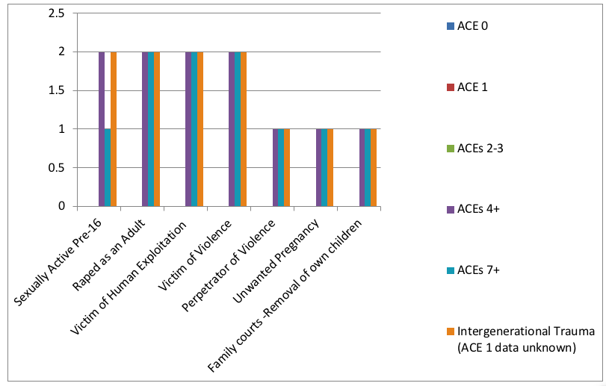
It is noteworthy to mention that the participants who conformed silently to their situations of abuse through resiliently staying at school and completing their GCSEs, despite enduring regular bullying, upon first appearance may appear to be demonstrating great resilience (Masten, Best and Garmezy, 1990). However, this study shows that participants’ ‘resilience’ put them at a greater risk of being exploited, as perpetrators of abuse are drawn to easy-going, passive and agreeable personalities because they are unlikely to retaliate. Bullies usually choose to gaslight easy-going victims as they know that they are more likely to internalise projected blame and will not disclose abuse because they blame themselves for the abuse (Coleman, 2011). It appears that Max’s abuser groomed him [or her] by befriending and gaining trust at an early age, then broke Max’s spirit through perpetual acts of public humiliation involving others who also bullied Max before he carried out a sexual assault on fourteen-year-old Max.
Then two years after this sexual assault, which was disregarded by teachers, this male abuser blatantly publicly rubbed his ‘privates’ against Max in full view of the teachers:
‘Nothing was done or said and then come prom in year eleven... he [male abuser] came over to me and I don’t know if it would classify as sexual assault, it felt that way, he started basically dancing really inappropriately. He started basically rubbing his privates against me.”’ (M:491-507)
As demonstrated by Max’s account, when sexual abuse or abuse of any kind is ignored, it will most likely be repeated as the perpetrator has got away with the crime. It is also known that the adult participants in this study were raped by someone they knew and saw on a regular basis. Abusers can then feel more empowered to repeat bolder, more public acts of abuse towards his victim. Moreover, it is estimated that 12,000 men are raped in the UK every year and 70,000 are abused or assaulted (Survivors UK, 2019). Max disclosed that self-harming was used to deal with the intense, repressed emotional pain as a coping strategy which Coleman (2011) describes as a form of communication. Max’s statement, ‘I don’t know if it would classify as sexual assault’ indicates a reduced sense of reality, which often happens when a person is subjected to perpetual abusive situations, with others as bystanders colluding with the abuse. This is the same way as a groomed victim who will not be aware of the strategic psychological manipulation behind their strategic de-humanisation, emotional breaking process. Abuse and pain then become ‘normalised’.
“To me, it’s normal. It’s just my life… people are living growing up thinking that this is the way it should be... So there needs to be something in place to stop this, for people to know that it’s not right... This isn’t the way your life should be”. (S:895-907)
One coping strategy is to become compliant and ‘please people’:
‘I was always very determined to please people. I always wanted to please people and I think that’s where the determination came from’. (L:418-422)
Unfortunately, many victims/survivors of abuse have a longing for acceptance and belonging, and it is precisely this determination to please people which is often perceived as a weakness by abusive personalities who look for targets to exploit. Mate (2016) believes that ‘nice’ people pleasers often self-suppress their own authenticity and deny their own ‘gut feelings’ as a coping mechanism, no longer pay attention to their own needs but compulsively serve the needs of others and are more prone to developing disease, addictions and being targeted for further abuse. Stevie became a re-victimised target of sexual exploitation and raped again as an adult, by other drug addicts who Stevie thought were his [or her] ‘friends’:
‘I got [drugged and gang] raped.’ (S:545)
As a victim of childhood abuse, educational failure and undiagnosed learning difficulties, with ‘no father’ figure, a substance misuser and under the care of the council as a ‘runaway’, all of these factors made Stevie high risk as a target to be groomed, human trafficked and exposed to child sexual exploitation (CSE):
“I became very promiscuous as a young child because of sexual abuse.” (S:45- 47)
“I was going to town every night taking drugs and I was on drugs every night and that- …. I’d go to sleep and do it again… that was my life for nearly three years… from fifteen to seventeen.” (S:473-479)
“I had a [older] boyfriend and then they’d like you know [makes a sexual gesture] … – I was just being led.” (S:195-197)
“It does lead a child onto a different path.” (S:214)
Figure 5.12: An example of trauma history documenting re-victimisation and complex abuse. (ACE 7)
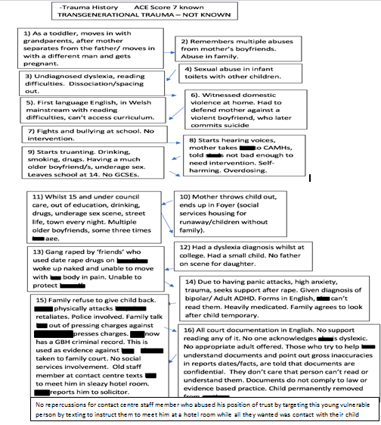
Figure 5.12 evidences how multiple systematic failures exposed one of the participants to an increased risk of exploitation and victimisation. This account and trauma time-line reveals an ACE score of 7, which according to Reid, Baglivio, Piquero, Grenwald and Epps (2017), puts this participant at a higher risk of being human trafficked, along with other victims who also had ACE scores higher than 6, as sexual abuse is ‘the strongest predictor of human trafficking’.
Stevie’s account discloses a long history of abuse, CSA and CSE (S: 856-872). One example given of being sexual exploited happened to Stevie when he [or she] was just fourteen years old and living under residential social care. It was at this age that Stevie became addicted to ‘going to town every night taking drugs’ and ‘street life’ where Stevie admits to having under-age risky sex with much older men, some of whom were three times his [or her] age which ‘led’ ‘onto a different path’ (S:473). Naramore, Bright, Epps and Hardt (2015) point out that young people who are caught in these types of cycles of abuses are ‘not committing crimes’ but are instead being ‘repeatedly victimized’. Moreover, Senior (2016, p.37) challenges the term ‘child prostitution’, as many young adolescents are groomed into street life by older ‘boyfriends’ who unbeknown to them act more like pimps.
David Cameron (Cameron cited in Booker, 2015) also reveals statistics highlight that 70% of prostitutes have been in care and care-leavers represent more than a quarter of the prison population. This account demonstrates that CSA (child sexual abuse) increases the risk of engaging in adolescence risky sex (Homma, Wang, Saewyc and Kishor, 2012), alcohol use and mental health disorders, including suicide (Hillis et al, 2001). However, another risk of drug addiction and having risky unprotected sex is having multiple unplanned and/or unwanted pregnancies:
‘I was on drugs… Seventeen, eighteen… pregnant at eighteen and I had a miscarriage… when I was nineteen, I got pregnant with my child. I was still taking drugs… I had my daughter… I got pregnant again… I had an abortion’ (S:534-545)
Estes and Weiner (2001) support these findings describing the risk factors for being sexual exploited are being a runaway, throwaway, substance misuser and/or victim of abuse. Senior (2016), who exposed the ‘Rotherham abuse scandal’ where 1,400 children were abused, notes, “For many years their stories were ignored or dismissed because the truth of what was happening didn’t suit those in authority” (Senior, 2016, p.369).
Instead, Senior (2016) notes that “children were getting criminal records as prostitutes’ and ‘forced back onto the street to pay their fines, yet nothing ever seemed to happen to those who bought them” (Senior, 2016, p38)
As Spring (2016) points out,
Grooming is about trickery and deceit, and recovery from its effects involves re-uniting with truth. But often that process is hampered because the wider network-... have also been groomed…’She makes things up’...’Doctors and teachers and police officers don’t abuse’… Abusers groom everyone around them, inviting the belief that they are pillars of the community, the people whose version of events is right, [and] the arbiters of truth... Abuse doesn’t happen in a vacuum. It happens in manufactured reality that abusers sometimes spend years creating. (Spring, 2016, p.45)
5.9.4 Intergenerational Trauma and Systems that Negatively Impact Upon the ACE Scores of the Future Generations: Prison, the Psychiatric System and Family Court
In this study, participants’ spoke about the negative effects of having involvement with all three systems; criminal justice, the psychiatric system and social services family court.
Participants’ accounts appear to reveal a ‘sequences of events’ which by design suppressed and made them submit to an imposed ‘disablist’ regime through the ‘force (of) the hand’ (Johnson, 2000). Stevie, who had dyslexia has had dealings with the criminal justice system, psychiatric services and family court, describes how life has been ‘robbed’ by these systems:
“I’ve been robbed… I’ve been robbed my dignity, I’ve been robbed – everything- a life. My whole life was robbed.” (S:954-960)
Furthermore, according to the ACE study (Felitti, 1985; Felitti, 1990) and intergenerational trauma research (Mate, 2019; Wolynn, 2016; Yehuda et al, 2007), the revolving door of poverty, oppression and inequality will continue to be outworked in lives of the next generation of children, who will automatically obtain ACE indicators if their parents have been to prison, have mental health problems or are adult victims of abuse themselves (witnessed by the child). Additionally, children who are separated or permanently removed from their parents through the family court system will also obtain at least another one significant ACE indicator due to this experience of separation from their natural caregivers.
Criminal Justice System and Prison
“They ended up taking me to court and I fought a four-year court battle and I lost. I couldn’t understand any of the court stuff. The letters, the reading, everything… I found it really difficult to understand.” (S:583-588)
After disclosing the childhood abuse as an adult, Stevie believes that family deliberately manipulated circumstances to discredit Stevie’s character when another much older family member displayed extremely violent behaviour towards Stevie.
Stevie explains that when acting in self-defence and when the police were called, Stevie was persuaded by the family not to press charges against the family member who had assaulted Stevie. Rosseger, Wtli, urbaniok, Elbert, Cortoni and Endrass (2009) found that 46.7% of female offenders had reported experiencing violence within their own families, were less likely to complete their education at school and are more likely to have experienced multiple forms of trauma at home. Rosseger et al (2009) also reported that both female and male offenders of violence often have histories of adverse childhood experiences including neglect, absent parents and/or criminal parents, lower levels of education, psychiatric admissions, as well as being unemployed at the time of the offence. Stevie fits into all five categories.
Both Stevie and Ellis’ accounts evidence how vulnerable young people with learning differences might find themselves unwittingly ‘trapped” in the criminal justice system’ (Cino, 2014). Stevie explained how their own family brought charges of GBH (grievous bodily harm), even though a fight had been started by a much older family member. This recorded involvement with the police was then used as evidence against Stevie in official reports to permanently remove Stevie’s child from being under parental care.
Ellis explains his [or her] experience of prison:
“I was a heroin addict for seventeen years. It caused me to lose my driving license, which in turn caused me to lose my job…. I even lost my home. I got caught in possession of Class A and sent to jail as well.” (E:387-393)
Ellis previously described how educational failure made him [or her] want to ‘give up’. He also disclosed how he [or she] took drugs and became a heroin addict to ‘escape from reality’ (E:364-366). Therefore, Ellis who experienced educational failure at school turned to drugs as ‘self-medication’ for his [or her] pain.
Ellis was sent to prison for being in possession of his [or her] own drugs and jail did not appear to help process the loss of an education or past pain. Instead Ellis described more multiple losses: ‘my driving license’, ‘my job’ and ’my home’. Since it has been reported that 80% people who try heroin began with prescription painkillers (BBC, 2018) and Swansea has the worst opioid death rate in England and Wales, Ellis’ experience appears to highlight a larger societal problem.
Ellis also makes transparent the link between educational failure and being incarcerated at Swansea prison:
‘Certainly, more than 50% [of prisoners could not read or write] ... They struggled, some people were better than others. Some couldn’t write their own names, spelling it correctly. And for the most part, some would struggle putting some sentences together’. (E:491- 499)
Ellis’ observation that very high numbers of illiterate individuals are found within the criminal justice system is supported by the Prison Reform Trust (2013) who found that 61% of young offenders have learning difficulties, with 23% having significant learning difficulties (IQs of below 70) and 36% have moderate learning difficulties (IQ 70-80). The Social Exclusion Unit report (2002), Reducing Reoffending by Ex-Offenders, also stated that significant numbers of prisoners have been subjected to ‘a lifetime of social exclusion'. The report found that 80% of adult prisoners had a writing level below the level of an eleven-year old, they were 13 times more likely to have been in foster-care as a child, 10 times more likely to have been a regular truant at school, and 2.5 times more chance of already having intergenerational links to the criminal justice system with a close family member also known to have committed at least one criminal offence, with a police record.
Hopkins (2014) also identified that young offenders in custody had low language, literacy and communication skills, performed well below the expected level on language assessments and logistical regression analysis independent of socio-economic status and educational attendance. Ellis offers a personal analysis to explain why there are so many illiterate individuals in prison:
‘The education system, if that fails you to begin with; you’re discouraged by teachers to do anything. Then that leads you into a place where you can’t do what you want to do, so your options are then limited, and you end up doing nothing at all, and that could lead to life on the streets, that could lead to drugs, that leads to too much time on your hands which to some people making a living is crime. So yeah, education system failure could lead to crime and drugs and jail’. (E:528-540)
Ellis is able to base his [or her] analysis on personal experience of school failure, truanting and leaving school without any qualifications and diminished self-esteem (E: 362-366), consequently developing an addiction to heroin which led to being caught with a Class A drug and incarcerated (E: 387-397). Thus, it appears that Ellis compares prison to some sort of ‘holding place’ for the illiterate as he [or she] observes that ‘people who aren’t very well educated can be easily manipulated and bullied into saying things they don’t really mean’ or being scapegoated to take blame, as seen in Stevie’s account.
‘I think there’s quite a high possibility in some cases where maybe the police struggle to solve these cases, people who aren’t very well educated can be easily manipulated and bullied basically into saying things they don’t really mean… There could be some people in jail for things that they haven’t done just because they’re easy targets or victims’. (E:511-521)
Ellis’ account appears to question the ethics and safeguarding processes behind the criminal justice system, as ‘people who aren’t very well educated’ might not be able to understand police questions [receptive language], write their own personal statements using their own words or be able to read these statements back to themselves before signing their police statements. Meltzer et al. (2000) found that young people with a learning difficulty were nearly “three times” more likely to get in trouble with the police than those without a learning difficulty (Meltzer et al., 2000, p. 85). Hepworth (2011) also raises concerns about how the mental capacity of young people with learning disabilities are assessed and supported within the criminal justice system. Furthermore, Gisli et al (2011) provide evidence to support Ellis’ belief that ‘some people in jail for things that they haven’t done’.
As Gisli et al (2011) state, “False confessions are more common than previously thought and are typically associated with two main causes: manipulative/coercive interrogation techniques and suspects' vulnerabilities in interviews” (Gisli et al, 2011, p.33). Furthermore, those most at risk of being manipulated into giving a false confession are substance misusers and those who have a history of victimization (Gisli et al, 2011). This highlights the important role of having appropriate adults present to ensure fairness (King, 2018).
As Cino (2015) highlights:
It is unlikely that a child under the age of ten would be exposed to the youth justice system as the doli incapax rule remains in place for those younger than the age of criminal responsibility. However, it appears unclear as to what should happen to a young person if their chronological age is over the age of criminal responsibility, but their cognitive ability is lower. (Cino, 2015, p.69)
Moreover, there is a ‘significant correlation’ between the development of mental illness and prison sentences.
As Adam (2016) points out, “The longer a prisoner is incarcerated, the more likely s/he is to develop mental illness” (Adam, 2016, p.iii). Adam (2016) also found that some prisoners who were mentally healthy before going into prison developed mental illnesses whilst at prison, indicating that prison can be a ‘crazy-making’ place for the educationally failed.
Psychiatric System
Stevie’s account appears to indicate a link between disclosing rape and then later involvement with the psychiatric services, being diagnosed and heavily medicated:
‘After the rape, I went to the doctors and they said that I was bipolar and ADHD and put me on medication and stuff like that. And you know they – because of the rape, I was actually suffering with post trauma stress and trauma.’ (S:612-618)
Stevie and another two participants in this study also received mental diagnoses and were heavily medicated directly after they reported rape. Stevie’s account describes how a wrong diagnosis and medication were given to Stevie which caused harmful adverse side effects. However, the side-effects of the drugs were misunderstood by professionals and were used against Stevie in official psychiatric/psychologist reports:
‘I was on medication and the medication that they put me on was like the bipolar medication and it made me really bad, mad like. It made me like, didn’t know what I was saying, most of the time. I was talking a load of -without thinking because my mind was like blablablabla and through that medication. And she just picked up whatever she wanted to and just used it into a nasty twisted thing.’ (S:757-765)
Spring (2016), another rape victim also uses the same adjectives ‘mad’ and ‘bad’ to explain, “Not mad, not bad -just traumatised” (Spring, 2016, p.11).
However, the psychologist did not recognise that Stevie was traumatised nor did this psychologist understand that Stevie’s disclosure about what he [or she] did to other children as an infant was modelled behaviour from child sexual abuse:
“I told them some of my experiences that I had in [infant] school with some abuse, stuff with the girl in the toilets. They just took that and they made it into something so disgusting and vulgar… They made me out that I enjoyed it and they made it out into something sick and vulgar… she twisted it into something so horrible and nasty about me as a kid … none of it was true.” (S:725-746)
Thoumi (2009) believes that psychiatric diagnosis and medication are often given to ‘control individual behaviours that are considered as socially damaging’ and the ‘use of mind altering drugs’ is one such method of control (Thoumi, 2009, p.75).
Coleman (2011) points out:
It is common within psychiatry to describe someone who is not responding to medication as being ‘drug-resistant’ – even when they have an adverse response to the drug. Rather than say a drug is not working, they find it easier to blame the person’s own biology or physiology for the treatment’s ineffectiveness. (Coleman, 2011, p.37)
Bloch and Reddaway (1977) support these accounts observing:
The mentally ill are often used as scapegoats for society’s fears... the psychiatrist commonly faces a duel loyalty, both to the patient he is treating and to the institutions to which he is responsible. (Bloch and Reddaway, 1977, p.23)
The failure to conduct any adequate history timeline (examining the educational records, hospital admissions including accident and emergency) is also evident in Chris’ experience of being sectioned and diagnosed with schizophrenia at a psychiatric hospital.
Moreover, Chris’ history of uncontrolled ‘epilepsy’ alongside symptoms of anxiety, depression, panic attacks, suicidal tendencies, self-harm, trauma, voice hearing and disturbed sleeping patterns were not thoroughly examined with the other health specialists involved with Chris:
I: You’ve got lots of different agencies involved. Were they communicating with each other?
C: No. (C:320-323)
Therefore, the lack of multi-agency communication left Chris exposed to the risk of being misdiagnosed with a very serious potentially life-long diagnosis. Longden (2013b) suggests, instead of asking someone ‘What’s wrong with you’, we should be asking ‘what’s happened to you?’ (Longden, 2013b, p.369). Therefore, extreme care is needed before giving someone a diagnosis such as schizophrenia. As Bendall (2004) states, the diagnosis of “schizophrenia is an illness that consists of no particular symptoms, that has no particular outcome, and that responds to no particular treatment” (Bendall, 2004, p.87). Furthermore, if a person begins to hear voices or experience hallucinations and suicidal tendencies, investigations are needed to find out the reason for the voice/s in the first place, especially as voice hearing has been connected to child abuse and trauma (Longden, 2013).
Presently, there is no specific diagnosis for childhood trauma in the DSM (van der Kolk, 2014) and so it should be noted that hearing voices can be a serious side-effect of some anti-psychotic or anti-epilepsy medication (Kaufman, 2010). However, since no further investigations were made, Chris was informed by a doctor that he [or she] would never come out of psychiatric hospital and would be locked up 24/7.
Being informed that you are going to be incarcerated or ‘caged’ for life inside a psychiatric hospital is not conducive to anyone’s mental health recovery and suicides are frequently committed in association with psychiatric hospitalisation (Coleman, 2011; Goldacre, Seagroatt and Hawton, 1993; Reutfors, Brandt, Ekbom, Isacson, Sparen and Osby, 2010; Winkler et al., 2015). As Chris explains:
‘Before I went to [psychiatric] hospital I think I only self-harmed like once. In hospital, I self-harmed about thirty/forty times... And some of them were serious and some of them weren’t, but before I went into hospital, I wasn’t doing none of this. It was because I was in an institution’. (C:353-361)
Furthermore, professionals did not listen to Chris’ voice or opinion:
I: Was there a link between your epilepsy and your mental health? In your opinion?
C: Yes
I: Right. Did the professionals see that there was a link?
C: No. They don’t listen. (C:202-208)
Van der Kolk (2014) suggests that the patient is the only ‘real textbook’ (Van der Kolk, 2014, p.11). Moreover, O’Sullivan (2015) found that approximately 70% of patients referred for uncontrolled epilepsy did not have epilepsy at all but their similar presenting symptoms had been previously misdiagnosed as epilepsy, even by epilepsy specialists. Furthermore, comorbid psychiatric conditions in non-epilepsy seizures include 50% of individuals carrying a diagnosis of anxiety disorder, 25% have made a suicide attempt, nearly 30% have at least one psychiatric hospitalisation (D’Alessio et al, 2006), present with PTSD features and more than 90% reported having high numbers of childhood (sexual and physical) abuse compared to the general population (Reuber, 2008).
Additionally, some other psychiatric conditions in non-epilepsy seizures include, 73% report some form of trauma (47% sexual abuse, 43% physical abuse), 34.4% had suffered loss/death and 24.6% psychological abuse (Fiszman et al, 2004; Myers, Perrine, Lancman, Fleming and Lancman, 2013). Moreover, some anti-psychotic medications also have the side-effects of hallucinations and suicidal tendencies (Kaufman, 2010). Coleman (2011, p.12) also points out that voice hearing and self-harm are often interrelated as ‘symbolic representations of intense emotional pain.’
Stevie believes that he [or she] was treated unfairly in the mental health system:
I: The Mental Health Act 2010 in Wales, it states that reports should be balanced and there should be both positive and negative –
S: None of that.

I: And also, as well it should be comprehensive and accurate-
S: No. It wasn’t. Nothing.
I: Did they include about your dyslexia and your reading difficulties?
S: No. No. (S:715-725)
It appears that a mental health ‘misdiagnosis’, an unjust charge of GBH, along with ‘expert opinions’ in psychiatric reports which were not trauma-informed and did not comply to The Mental Health Act 2010 in Wales policy, were all used as a combined tool to remove and separate Stevie’s daughter away from a loving parent. The Mental Health Measure (2010) Wales advocates the use of balanced, accurate and comprehensive evidence-based assessment reports.
However, all these ‘expert’ reports failed to meet this standard instead they appeared to present a one-sided biased, skewed viewpoint which displayed a lack of professional knowledge and understanding about ACEs, along with the damaging consequences of childhood abuse and trauma.
Stevie explains how educational failure contributed his [or her] misdiagnosis:
I: When you went to school for reading and writing, what was your first language for reading and writing?
S: It would have been Welsh. (S:128-132)
S: I had a doctor who was a (English speaking] psychiatric doctor and he’s the one who gave me the diagnosis after I ticked a few boxes which I don’t even know what I was ticking because I just used to tick the boxes.
I: So, you had to read the [English] and tick?
S: Yes.
I: Well did this doctor pick up that you couldn’t read?
S: No.
I: So, you had an assessment by a psychiatrist doctor who gave you things to read?
S: And I didn’t understand.
I: And he did not know that you couldn’t read?
S: I couldn’t read. (S:676-692)
Furthermore, Stevie points out that educational failure rendered him [or her] voiceless to challenge this mis/diagnosis:
‘I would like to get a misdiagnosis but I don’t even know how about doing that and because I can’t understand a lot of stuff anyway, with the reading and all of – and I’d like to go back to court to get my daughter back but then I don’t know how to do that because I don’t understand how to do it because I don’t have the right kind of reading and right kind of education to understand all this stuff’. (S:656-666)
“When someone gives you a diagnosis then it’s really difficult to get that lifted off you…I don’t take drugs. I haven’t taken medication for four years and I’m out of the mental health system. I still have money, ESA for bipolar and ADHD but I’ve been for a medical and I even told the medical people that I’m not bad (ill) anymore and… they gave me a rise in my money… They are obviously going off my history and not what I am saying now.” (S:640-655)
Stevie’s account shows that after attending a medical and stating that he [or she] no longer took drugs, medication and had been discharged from the mental health system, Stevie received ‘a rise in [benefit] money’. After reporting rape and other abuse, three participants in this study were diagnosed with life-long mental health diagnoses and medicated. Furthermore, one participant reported receiving several diagnoses and being prescribed seven to nine different medications, some treated the drug side-effects of other drugs. Van der Kolk (2014) explains that the psychiatric system can make considerable revenue from prescribing drugs to vulnerable people.
Mulitize (2005) clarifies that a psychiatrist can earn about ‘$300,000 USD per year’ for diagnosing and prescribing psychiatric medication based on symptoms, but if the same psychiatrist spent more time listening and understanding patients’ pain, they would only earn about $100,000 USD per year (Mulitize, 2005, p.192).
Van der Kolk (2014) points out that foster-care children are 11% more likely to be prescribed antipsychotics than other children in general, as these drugs “are used to make abused and neglected children more tractable” (Van der Kolk, 2014, p.37). Johnson and Johnson paid $2.2 billion in criminal damages to ‘settle accusations’ that they had unethically promoted an anti-psychotic drug to people with developmental disabilities (van der Kolk, 2014). Van der Kolk (2014) points out, “No one is holding the doctors who prescribed them accountable” (Van der Kolk, 2014, p.37). Ryan (2018) also pleads with urgency, “We all have a responsibility to drag the UK out of learning disability ‘care’ space that seems to remain aligned closer to the eugenic practices of the last century” (Ryan, 2018, p.247).
Stevie sums up personal experiences of the psychiatric system:
“I’ve been robbed – everything- a life because of some doctor putting a diagnosis on me. My whole life was robbed.” (S:957-960)
Foster-Care System and Family Court
The implications of educational failure can have even more far-reaching effects beyond having a criminal record with trumped-up criminal charges and a misdiagnosis. Furthermore, the combination of reading, writing and receptive language difficulties, trauma, anxiety, symptoms of PTSD and unprocessed trauma from CSA/CSE, along with educational failure made it impossible for Stevie to access key knowledge and information needed to challenge misdiagnosis, along with the significant breaches of law, which had resulted in losing access to see the daughter:
“I haven’t got my daughter because of the psychiatric and psychologist report.” (S:940-942)
Furthermore, it appears that the professionals who had been paid to write the expert opinions in the family court lacked the knowledge and insight that Stevie had dyslexia, receptive language difficulties, and the fact that an education through the medium of Welsh, not English had been embraced. None of these important factors had been considered by the ‘experts’ who were paid by the court to write in-depth, accurate, evidence-based reports about Stevie but instead appeared to resemble an unethical strategy whereby a court will pay out a lot of money (Jones, 2018) to a psychiatrist for an ‘expert opinion’ that labels ‘the sane’ ‘as mentally ill’ to control and dominate them (Bloch and Reddaway, 1977). Moreover, as well as key information being omitted from court reports, Stevie’s account documents how illiteracy and reading difficulties and subtractive bilingualism added to difficulties, as Stevie was left alone to struggle to read:
‘These two massive reports were for me to have my child… they were absolutely, completely- They just destroyed – (shakes head) really bad, just made everything a billion times worse’. (S:701-706)
Explaining how not one professional picked up on the fact that Stevie was unable to read any of the court documentation which was written in English, this prohibited equal access to all the family court documents and processes. The European Convention of Human Rights Article 6 states that ‘in the determination’ of ‘civil rights and obligations or of any criminal charge against’ someone, everyone is entitled to a fair trial.’ However, it appears that the existing criminal justice and psychiatric systems do not afford everyone with the same fairness and equality, when the odds of social inequality, discrimination and poverty are stacked against those who are trapped in a revolving door of oppression between systems.

Moreover, it appears that Stevie’s experience of being failed by the education system made Stevie more susceptible to being controlled and manipulated by abusive others who had more knowledge, and therefore power, to manipulate the criminal justice and psychiatric systems in their favour, and against Stevie, as a tool of oppression.
“A destroyer of lives”. (S:775-776)
Recent media report coverage echoes Stevie’s objectionable experience as substandard processes were also used to remove other children from their parents at this same family court (Appendix 11). Insider research by Speke (2018) supports Stevie’s account, as one of Speke’s participants (Appendix 14) wrote about their personal experiences of the family court, “Left feeling worthless, lost my income, my child, my self-worth... destroyed my life with false allegations and untruths” (Speke, 2018, p.10).
Furthermore, Speke’s research (2018) about the family courts revealed that 73% felt suicidal after being involved with social services, 93% believed that they were intentionally traumatised and deliberately labelled as mentally unfit as a fabricated reason for social services to remove their child. Moreover, 96% believed that family court/social services used their position of authority to bully them, 96% stated they were destructive and caused damage to their family, 86% stated that social services lied, exaggerated or ‘created’ falsified evidence against their family, with 84% acting on malicious, unproven allegations, gossip and hearsay. Additionally, 91% wrote that they were discriminated against by social services because of low income, age, literacy difficulties, status, physical/mental health and childhood adversity. (Appendix 14).

Johnson (2000) demonstrates exactly that:
The concept of oppression points to social forces that tend to press upon people and hold then down, to hem them in and block their pursuits of a good life. Just as privilege tends to open doors of opportunity, oppression tends to slam them shut. (Johnson, 2000, p.39)
Patil et al. (2013) also observed that the homeless, the educationally failed, abuse victims and institutionalised individuals living in poverty are being socially controlled by oppressive systems. Moreover, the more money or power an organisation has over a community or vulnerable individuals, the greater their control through an unequal distribution of power (Parsons, 1963). Jones (2018) has pointed out that during 2015, eight private fostering companies made profits of over 40 million pounds and some managers were being paid £250,000 each. Since forced adoption and fostering (through family courts) are fast growing multi-billion industries that bring in huge profits for the stakeholders (Jones, 2019; Speke, 2018), and social services tend to specifically target mothers who have already been failed by multiple systems without offering any support (Speke, 2018), something needs to be done to redress this balance.
McEvoy (2019) reads the lived heartache and pain of a father who experienced false allegations and child removal through the family court:
I had my children taken from me then 42 allegations were made against me. Suicide seemed the best option. Twice I tried to hang myself and once I stood on a railway track and the Samaritans talked me off the track.

McEvoy (2019) explains the predicament of men who are criticised for not talking about their emotions, since in the family courts any form of emotional pain is used against parents to prevent them from seeing their children. McEvoy (2019a) states, “I look forward to the day when criminal justice is dealt with in Wales in a completely different way.” McEvoy (2019b) points out, “Severing a relationship between a parent and a child is nothing short of taking someone’s life… The culture of false allegations in the family court arena is also a killer.”
As the cycle of oppression turns another full-circle to impact the next generation, surely this unfit-for-purpose system and those perpetuating this cycle of poverty onto the next generation, should be held to account? As it appears from the participants’ accounts that no one is policing the police, psychiatrists or social services, as manipulation and fabrication of evidence appear to be used as scapegoating strategies to deflect and ‘cover-up’ abuse, fraud or wrongdoing (Loveday, 2012; McEvoy, 2019).
The current system leaves no winners except those who are making huge profits from the vulnerable (van der Kolk, 2014). In the light of the foster-care statistics which are linked to low levels of education, high psychiatric admission and diagnosis (Bloch and Reddaway, 1977; Speke, 2018), homelessness (Patil et al., 2013), substance misuse, criminal justice system and prison (Cino, 2014; Rogers, 2019), CSE, prostitution and human trafficking (Reynolds, 2016; Senior, 2016), along with evidence showing how the family courts put mothers, fathers and children at risk of committing suicide (McEvoy, 2019), urgent reform is needed. Given Swansea’s high numbers of looked after children compared to the ‘National Average’, surely someone needs to question what evidence the CSSIW (2015) has used in its report which states that, “Children’s services are providing children and families with a sustainable, focused service which is improving outcomes for children”; since participants’ accounts in this study tell a different truth:
“There are millions of other cases out there where [foster] children have been abused, beaten or mistreated or neglected in their placements where they are better off being at their homes than they are at foster care...There’s cases documented every day, but their voices are hardly ever heard.” (L:993-1001)
Furthermore, unless urgent preventative measures and restorative solutions are sought at systematic level, the cycle of trauma, poverty and oppression will continue to be outworked in the future generations.
5.10 Superordinate Theme Seven: Preventative Measures and Restorative Solutions: Neuroscience and Education - Knowing the Truth Will Set You Free
This super-ordinate theme emerged as participants reflected upon what solutions they would suggest to policy makers to help them to improve inclusion to prevent the ensuing social inequality, inescapable feelings of failure and intergenerational poverty. Since I was involved in helping many of the participants remove barriers in finding their own solutions, this section has been written in a different style to previous sections.
Implementing prevention measures to be more forward thinking and look at the bigger picture
‘I think it really needs someone who is going to look at the bigger picture, because you can’t just think of these kids as kids that are in there for a lesson... You’ve got to think of the bigger picture- their future. Because you are there to teach them for their future… what can you do to make sure this child isn’t going to end up like I ended up? And I think first of all, really reading and to get that kind of education. You need to put time into kids and just show them that. You’ve got to go out of the way for them, to show them you’re not going to give up on them’ (S:795-812)
Bellis (2017) who is currently ‘developing a national ACE hub’ to raise awareness of this public crisis issue echoes, 'Prevention is key - and building a safer environment for every kid… Do we mend broken adults, with all the costs to society that implies, or avoid those problems by building strong, happy children?' (Bellis, 2017, p.45).
Davidson, Grigorenko, Boivin, Rapa and Stein (2015) also emphasise:
Globally, there is a crucial need to prioritize research directed at reducing neurological, mental health and substance-use disorders in adolescence, which is a pivotal age for the development of self-control and regulation. (Davidson et al., 2015, p.527)
Moreover, NICE Guidelines (2012) recognise that social and emotional behaviour can be influenced and changed through healthy environments and relationships and since children spend most of their time at home with their families and at school, it makes sense that participants’ ideas for preventative policies and action plans targeted both these environments. Furthermore, the participants’ solutions cost nothing to implement, so they would not put any strain on tax payers’ money. Instead, implementing their strategies could potentially save billions across services both in the immediate short-term and long-term future.
Since figures show that in England alone last year councils spent £816 million more on social care than they had budgeted for (Savage, 2018) and the NHS crisis is putting a strain on general practitioners who are on average doing 370 million consultations each year, which is 60 million more than five years ago (Doetter and Gotze, 2011), urgent reform is required across all public services. Participants’ accounts demonstrate that every person and their situation are unique, as none of them fitted into the ‘one-size-fits-all’ provision that has been on offer.
“There isn’t enough range. It [the system] just caters for the neuro-typicals.” (P:1308- 1309)
As participants point out, if individuals were offered choices, along with knowledge and given ownership over decision making about them, then they would be more likely to engage with their own learning and recovery process (Coleman, 2011). It is important to note that participants acknowledge that inclusive education policies need to embrace all those who have been previously exposed to trauma, including adults, considering the whole person, past, present and future. Survivor (2018) echoes this point, “We should also be considering AAEs (Adverse Adult Experiences) too, after all, we did not stop being human at age 18” (Survivor, 2018, p.12).
Therefore, participants’ solutions appear to focus on cost effective educational outcomes which are achieved through empowering and educating excluded ‘others’, including adults who might find themselves ‘bruised and broken’ outside systems, such as in locked psychiatric hospitals, prisons and homeless drop-ins. These solutions urge inclusive educational policy makers to consider all of a person’s education barriers, which might include a backlog of unprocessed trauma (Burke Harris, 2018), different sleeping patterns and/or sleeping difficulties (Walker, 2017), neuro-divergences (Kutscher, 2005), a distrust of multiple educational professionals and possibly not feeling safe enough to engage in learning in physical places with other people. All of these interrelated factors need to be considered to produce more cost-effect, far reaching educational inclusion policies which people might choose to use to remove barriers to poverty and accessing digital learning provision that can break through walls.

Early Intervention/Awareness of Speech Difficulties, Trauma, Sleep difficulties, Neuro-divergence and Mental Health
“They [professionals] need to be aware of all these things and not only well-educated on all these subjects but actually have procedures in place, to help people... I do know that everyone should be well-educated. Everyone who has any sort of power should know about this sort of thing and there should be things in place to help people like me and to not make things get that much worse and not inflict everyone with serious anxiety”. (P:966-985)
“I er, I can’t speak, I need speech therapy. I struggle to say certain words, read certain words. Like in exams, like I’d read over the question a couple of times just to get it in my head, like trying to figure it out. It was a struggle.” (R:48 54)
“There’s a lack of education in regards to trauma and mental health. There are certain aspects to mental health that people don’t talk about”. (B:1355-1358)
The participants suggest that well-educated professionals are needed across multi-agencies to properly assess, address and provide effective early intervention for children and young people, regardless of neuro-divergence differences. Furthermore, since the most important years of brain development is from birth to 6 years of age (Perry and Szalavitz, 2006), although the brain does not fully finish growing until about age 25, public servants who come into contact with people, especially the under-twenty-five-year olds should be trained in trauma reduction or basic communication strategies for hidden disabilities, such as BLANK and the communication cycle (Appendix 8).
As Senior (2016) points out, “If people don’t have the knowledge they can hardly be expected to have the empathy required to understand and deal with those who have been subjected to CSE [or any other trauma]” (Senior, 2016, p.358). All types of adverse childhood experiences, speech and language difficulties, sleep deprivation and low dopamine levels are connected to a wide array of negative consequences later in life, such as chronic disease, educational failure, unemployment, chronic offending and substance misuse (Burke Harris, 2018). Therefore, all practitioners have a duty of care and need to be informed.
Early identification screening tools need to be implemented to safeguard these individuals’ education, wellbeing and future outcomes (Craig, Baglivo, Wolff, Piquro and Epps, 2016). Since trauma disables the language area of the brain, I do not believe it is any coincidence that some of the participants with dyslexia and other specific learning difficulties noted intergenerational trauma in their families, as some of their parents/grandparents were exposed to some of the most horrific traumatic experiences in childhood imaginable (Appendix 7). A few of the participants’ parents have stated they have an anxiety diagnosis, or undiagnosed ADD symptoms yet upon a closer inspection, many of their symptoms appear very similar to PTSD.
Given that intergenerational PTSD and trauma is carried in the genes (Wolynn, 2016), it is significant that Rory believes that he [or she] needs speech therapy, especially as his [or her] mother has an ACE 4+ score and as an adult was told she is dyslexic. Evidence from the Royal College of Speech and Language Therapists (2012) supports Rory’s account demonstrating that approximately one third of offenders have speaking and listening skills below level 1 of the National Framework.

Moreover, since significant numbers of homeless individuals also have severe complications including speech, language, communication and learning difficulties, mental illness, alcoholism, substance abuse, criminal histories and physical disabilities (Burt et al., 2001; Shlay and Rossi, 1992; Allgood & Warren, 2003; Snow and Anderson, 1993), these excluded and often educationally failed communities could benefit from receiving speech therapy.
Additionally, since educational research demonstrates that unidentified or untreated speech, language and communication difficulties can lead to low self-esteem, behavioural difficulties, low levels of literacy, poor educational attainment, school exclusion and difficulties finding future employment (McMinn, 2006, Bercow, 2008, Locke and Beech, 1991), cost effective restorative measures need to be implemented at local and national strategic levels.
The Sutton Trust (2010) and Martin and Miller (2003) reiterate ALN participants’ need for effective pupil interaction and communication being built into learning opportunities. Thus, ALN students who have successfully combined digital learning with peer tutoring, have found learning gaps being successfully closed and provided value-added outcomes when being taught in a speech, language and communication friendly environment which is also a restorative environment for ACE sufferers (John, 2013; John, 2014a; John 2016; Appendix 17).
Martin and Miller (2003) also point out:
The importance of appreciating the social and emotional effects of speech difficulties on children cannot be overestimated…For example, increased anxiety, low self-esteem, feelings of alienation and rejection from the peer group will all reduce pupils’ readiness to learn. (Martin and Miller, 2003, p.36)
Additionally, both Taylor and Rory’s accounts suggest that ALN learners should be able to opt out of forced daily second language lessons when, after years of being in school, they still do not understand what is being said to them in Welsh. It is evident that this is especially the case when Welsh language lessons are conducted in silence and badly taught, as subtractive bilingualism can contribute to academic failure in two languages (Cummins, 1989; 2005).
Primary School: Raising Children’s Dopamine Levels Naturally as a Priority Preventative Measure – Trauma Informed Teaching Model
Ellis, whose negative experience of school led to truancy and eventually dropping-out of school into a lifestyle of drugs, crime and prison, presents a preventative solution which links directly to the work of neuroscience:
“Encouraging people more as in focusing on the things you are good at, spending more time in that direction and not condemning kids for not being quite good enough at other subjects.” (E:288-292)
Ellis’ account which emphasises that children need to know what they are good at connects to the research which found that children need to be achieving regularly at a specialism by the end of primary school to flood their bodies naturally with dopamine (Benson et al, 2003; Spear, 2000) and safeguard their future mental health. Moreover, researchers Vaughn et al. (2013), Nakazawa (2015), van der Kolk (2014) and de Theirry (2015) support Ellis’ suggestion, as achieving regular rewards is essential for increasing and maximising dopamine levels which need to be at their highest levels by the end of primary school, to support them through the turbulent developmental changes of adolescence.
Therefore, since diminished dopamine levels in the teenage years have been linked to substance misuse and other health harming behaviours (Mate, 2018) it is essential for children to know what they are good at and experience regular reward during these primary years. Research by John (2005, 2013) supports these findings demonstrating that teachers can use clever strategies to naturally increase students’ dopamine levels through providing choices, reward and differentiated communication (Appendix 17). This research illustrates how an all-inclusive, ADHD, ASD, trauma and neuro-divergent friendly teaching model, which embraced outdoor learning, pre-tutoring, peer-tutoring, multi-sensory ICT, teaching small numbers of similar learning types, reduced emotional distress and raised academic attainment.
This combined education and trauma-informed neuro-science learning model not only focused on reward and enjoyment to increase dopamine and feel good endorphins but managed to close significant learning gaps as 100% of learners achieved the expected outcomes and 46% achieved value-added. Sutton Trust (2010) found that one year with a very effective teacher adds 25-45% of an average school year to a pupil’s maths score performance. It was also designed as a neuro-divergent, trauma friendly classroom, which embraced a speech, language and communication friendly setting. Pre-tutoring, one of the trauma-friendly strategies, enabled children who had been previously terrified of maths to overcome their fear, lead the learning and achieve over and above expected outcomes (Appendix 17).
Additionally, Lee, who has a diagnosis of ADHD and suffered multiple childhood traumas, advocates that children should be encouraged to use their strengths to lead the learning:
“What better way than have a child teach the children... let the child lead a lesson. The child needs to feel special. Children want to feel special. They want to feel needed. And if they don’t feel special and needed they’re going to withdraw”. (L:897-907)
In my own experience, students with ‘ADHD’ tendencies and those who have suffered from trauma tend to be very caring, kind and empathetic to the needs of others. Thus, providing opportunities for children with ADHD tendencies to lead the learning plays to their strengths of the easily distracted as the extra stimulation of multi-tasking and constant movement helps to keep them focused on the task at hand (John, 2013; Appendix 17).
Therefore, through listening, responding and planning motivational rewards for the students in their classes, this not only keeps them on task but will produce optimum educational outcomes. ADHD has been linked to lower levels of the dopamine transporter, and consequently amphetamines are prescribed to increase dopamine available for ‘synaptic transmission’ (Volkow et al, 1998). However, teachers can also naturally increase dopamine levels without the harmful side effects (John, 2005; 2013).
John (2013) found that by pairing a hyperactive child with a child with an attention deficit, the extra distraction and ‘twice the responsibility’ enabled the hyperactive learner to expel excess energy in a positive direction, while the constant attention enabled the other learner with attention deficit to stay on task. Sutton Trust concurs that peer tutoring is one of the most effective acceleration methods for closing the gaps in additional learning needs students (Gross and White, 2003).

Creating More Equal, Tailored 24/7 Online/Offline Blended Learning Environments
“If at the start I could have done stuff online, it would have been brilliant especially if it was 24/7 and you could do it whenever you liked... difficulty waking up and difficulty going to sleep which, when you don’t have to you just don’t wake up and don’t go to sleep... most people who are in school maybe do have some difficulties but don’t realise that there is any other option.” (P:1228-1263)
‘I think it would have been good but it’s a really idealistic situation but if studies could be catered towards students and not towards an agenda of a school... I wish that I’d actually been considered in the decision-making process whereas I had to make my decisions around the decisions that were being made for me and if I had more of a chance to tailor it. I know I would have done better.” (M:1394-1419)
“Each child is different...Children need to be asked what they need.” (T:1104-1106)
According to Walker (2017), Peyton’s solution would prevent an array of future problems for approximately 30% of the population whose natural circadian rhythm and timing does not allow them to wake and function optimally at traditional 8.50am-3.20pm school times. Furthermore, as Mate (2019a) states, “The ADD adult is often a night owl” (Mate, 2019a, p. 286).
Walker (2017) states, “When the night owl is forced to wake up too early, their pre-frontal cortex remains in a disabled ‘offline’... night owls are not night owls by choice. They are bound to a delayed schedule by unavoidable DNA hardwiring” (Walker, 2017, p.21). Thus, despite looking ‘awake’, their brain remains in a ‘sleep-like state’ throughout early morning.
Thus, Peyton’s online preventative solution would allow for approximately 30% of the population to have the opportunity to sleep fully to optimise their learning potential and gain all the health benefits linked to a goodnight sleep, which would impact and reverse the current untenable financial burdens placed on the NHS and other systems.
Walker (2017) points out:
Routinely sleeping less than six or seven hours a night demolishes your immune system, more than doubling your risk of cancer… Alzheimer’s disease, cardiovascular disease, stroke and congestive heart failure… sleep disruption further contributes to all major psychiatric conditions, including depression, anxiety and suicidality (Walker, 2017, p.3)
Sleep research also links sleep deprivation to weight gain and memory loss (Walker, 2017) and it is associated with later addictive substance misuse, ‘associated with reward cravings’ stemming from the ‘brain’s prefrontal cortex’ and psychiatric illnesses (Mate, 2019a; Mate, 2019b; Volkow et al, 2009; Walker, 2017).
Walker (2017) also points out that, “Insufficient sleep during childhood significantly predicts early onset of drug and alcohol use in that same child during their later adolescent years” (Walker, 2017, p.149). Therefore, Peyton’s solution, although free to implement in schools, would save the NHS and tax payer billions of pounds in future healthcare costs. As Coleman (2011) notes, “It is evident that the NHS and Social Services by themselves cannot deliver the required recovery outcomes in mental health services” (Coleman, 2011, p.116).
One cost effective solution would be for schools to simply video/audio record their teachers’ live lessons and make them available for pupils to access online at home, hospital, another part of the school building or any other setting which has Wi-Fi.
As Brooklyn and Peyton point out, 24/7 online provisions offer ‘night owls’ or those with circadian rhythm differences the chance to access provisions during ‘anti-social’ hours or outside regular 9-5 work hours. Since online recovery solutions offer traumatised individuals the chance to safely experience 24/7 provisions whilst being present in their own homes, this can be a much safer solution for individuals who have been bullied by teachers and/or other local professionals. Since online solutions can be accessed anytime, anyplace, anywhere, they can make the ideal recovery for the traumatised who would be able to access them from the safety of their home. As van der Kolk (2014) points out, “Safety and terror are incompatible” (van der Kolk, 2014, p.210)
Online learning which is available 24/7 would not only allow students to choose their preferred style of learning setting but would also allow them to access higher levels of acceleration in the subject areas that they like best. Recorded lessons can also be used to give traumatised children the opportunity to access pre-learning materials, while the recorded lessons can also be used for overlearning purposes in the subject areas where they might struggle. Recorded lessons would enable children who need more overlearning exposure to replay the lessons at home to reinforce their understanding of topics.
Additionally, a bank of these pre-recorded lessons would also act as a ‘good coping mechanism’ for learners who struggle in different topics, and so will require pre-learning strategies before having the confidence to engage in lessons:
“[Having] really good coping mechanisms to work through in class…. [take] the time to help me with basic spelling and maths. Helping and you know stuff that I would find really difficult. That really stood out, [take] the time to help me develop my skills and cope with the way I understand those subjects.” (A:33-41)
Moreover, John (2013) found that as well as removing the fear of the unknown maths content which switched learners off even before the lesson began, the learners who had been exposed to pre-learning strategies became engaged as soon as in the lesson began, even putting their hand-up to explain their knowledge of concepts. John (2013) found that one learner who had previously been petrified of maths made over two year’s value-added progress in end-of-year assessment tests, successfully closing the learning gap.
John (2013) incorporated pre-tutoring into her inclusive mainstream learning model as an inbuilt preventative measure to remove anxiety within those pupils who had developed/acquired a crippling fear of maths. Instead she found that pre-tutoring, whereby struggling learners were given lesson content before the lesson, inspired confidence and well-equipped these learners before lessons began. Therefore, by combining neuro-science and educational strategies through simply offering more flexible curriculums that breathe, these are flexible enough to move and change with the student. This would also provide policy makers with effective preventative long-term strategies to safeguard children’s futures and reduce health harming behaviours that are putting an untenable strain on the NHS.
In accordance with the Human Rights Article 12, young people should be empowered with knowledge and information to make their own informed choices about their learning and things that affect them. Additionally, audio or video recording all lessons would also act as an accountability measure to prevent teacher bullying which has also emerged as a significant barrier to pupils’ learning.
Fast Track Neuro-Divergent Trauma Friendly GCSEs as an Option
“I sat the exam… after not going to school for four years, I got a B it turns out… so their reason for not funding me is a bit you know mute now.” (P:619-651)
“I got a B... I cried. Not because I was sad, but it was because I was relieved. I was happy. I was shocked because after everything I’d been through, I still managed to get a GCSE… I gained one and it made me cry because it was an achievement that I didn’t think I would get... I didn’t get sleep, I barely revised because I just didn’t have the motivation for it. And I know I could have got an A star in it because I left [the exam] an hour early and all the circumstances – it was a flipping miracle that I got a B”. (B:1114-1131)
One of the home-educated participants gained eight GCSEs, six of these GCSEs were obtained independently outside the school system against all the odds, as I managed to develop a user-led trauma friendly/neuro-divergent friendly GCSE model (John, 2014). This model was successfully used to remove barriers to others in similar circumstances who also had also experienced educational exclusion and/or experiences of being bullied.
This personalised one-to-one system produced the same successful results with a fifteen-year-old who had struggled with mathematics all through school. This young person had been advised by his primary school head-teacher to become home-educated as she believed he was never going to pass any exams. The neuro-divergent trauma friendly GCSE model enabled this young man to obtain enough GCSEs to gain a much sought-after place at a prestigious music college, as personalised GCSEs were tailored to his preferred learning style. These neuro-divergent friendly fast track GCSEs were designed to keep stress levels down to a minimum while trying to manage high anxiety and panic attack triggers prior to exams. Both Brooklyn and Peyton, as fourteen and sixteen-year olds outside traditional systems, still managed to attain excellent B GCSE grades, against all the odds while battling generalised anxiety disorder, social anxiety and/or depression.
This fast-track method (a GCSE in five/six weeks) was piloted in a group with other neuro-divergent home-educated learners, who were given the opportunity to have equal access in exams to allow dyslexic and autistic learners 25% extra time in exams and giving struggling or slower writers the opportunity to use laptops (although some parents did not want their child to use a laptop preferring the traditional method of using a pen). The group pilot lasted for just four and a half months and focused on a few GCSEs from the September to January, to allow parents to make their own arrangements for the later main May/June GCSE exams. Both online and physical platforms were created, with Facebook pages as an extra 24/7 learning platform for these learners to see posted online tasks and videos. The learners were also encouraged to engage across digital and physical platforms using periscope, google drive to write essays together, Facebook and also met in physical environments to create films to help learn key vocabulary. The participant who achieved the most GCSEs while battling anxiety and processing trauma, used distraction techniques to distract the mind from going into overdrive which successfully bypassed the stress/meltdown trigger (John, 2016).
Each exam was treated as a mock and the first result was always treated as a baseline. Exams were taken November, January and June, focusing on one subject area or two similar subject areas at a time, such as English language and English literature. However, it should be noted that the learners who were most emotionally injured because of being bullied at school, found it very difficult to learn as their trust and belief in themselves was so badly broken. Therefore, a shattered self-belief had to be restored before any chance of academic success could be secured. Therefore, I found that the first six weeks focused on addressing some of the damage of internalised blame and negative internalised scripts learned at school, such as ‘I am thick’, ‘I am the most hated person in the locality’, ‘I need to hide away or I will get bullied’.
With some participants, I found that I answered questions like, ‘Do you really believe in me?” multiple times, as experiences and questions were asked which directly related to their past traumatic experiences at school. I found that apologising for the way that they had been treated at school offered some comfort as someone was finally acknowledging their pain. This simple act appeared to ‘lift the needle’ past the ‘sticking point’ or ‘groove’ that some of their passed trauma had caused in them (Baum, 2013).
Academically, the fast-track method worked better at a personalised individual level as participants chose their own personal-centred GCSEs through doing their own research (with help) about which exam board provided them with the best GCSE to match their preferred style; whether an essay type or multiple choice, or a one-off three-hour paper compared to sitting two hour-and-a-half papers. This method allowed learners to choose their favourite GCSE subjects first, which would raise dopamine levels when that child achieved a good result (de Theirry, 2015; John, 2013; Nakazawa, 2015; van der Kolk, 2014; Vaughn et al., 2013).
The group pilot was not conducted in the same way as the previous personalised designed method which had given individuals the opportunity to choose their own personalised GCSEs, achieving outstanding results (John, 2014; John, 2016). Instead I found that the group pilot’s delivery in a physical setting became problematic because of the different youngsters and parents’ priorities and needs, as some wanted to learn solely on a physical platform while others only wanted to learn individually and via digital technology. The rich diversity of learning needs impacted upon the group dynamics and so the group pilot journeyed from being in a mainly physical setting to being completely delivered on a digital platform with one-to-one teaching, which enabled some of these neuro-divergent learners to focus and achieve their GCSEs in just under six weeks.
Ensuring availability of digital technology and equal access arrangements for GCSE exams
Taylor suggests that having equality of access in school by having 25% extra time in exams made a difference, after his [or her] mum questioned the school about dyslexia during the final GCSE year when Taylor was sixteen. However, a later educational psychologist report, which arrived during the time of this interview and while Taylor was in the middle of sitting GCSEs, revealed even more undiagnosed needs. During this interview, Taylor revealed when asked about exam writing preference that a laptop would be preferred as opposed to using a pen which caused physical pain.
I: Do you prefer using a pen or laptop or –
T: I prefer using a laptop because when I’m writing I get sort of a hand cramp, a pain in the back of my neck and my stomach.
I: Have you had access to using a laptop in exams?
T: Er no
I: Would you prefer to use a laptop in exams?
T: Yes.
I: OK. So, have you been offered the chance to use a laptop in exams?
T: No. (T:127—157)
It was during this time that I compared Taylor’s writing with a pen and using a laptop, observing that the writing speed and fluency was a lot faster when he [or she] used a laptop compared to using a pen.
Taylor’s account demonstrates the importance of professionals prioritising listening to the voice of the child/service-user, as every child is different and professionals have limited knowledge about individual children.
Following this interview, I showed both Taylor and mum the exam board equality of access exams policy and in the middle of GCSEs, Taylor asked to use a laptop for the remainder of the GCSE exams, which the school initially refused. However, due to a psychologist report documented at GCA score of 76, I advised mum to ring the exam board direct and they confirmed that Taylor was entitled to use a laptop during GCSE exams, along with other access arrangements. The psychologist’s report also entitled Taylor to have more reasonable adjustments. After this interview Taylor sat the remainder of GCSE exams using a laptop and successfully gained at least six GCSEs. Taylor is the only participant in this study to have had learning barriers removed whilst still studying at school and was able to pursue any choices of further education. As Silberman (2015, p.472) concurs, “Digital technology has opened up new horizons in education for adapting teaching materials to suit learners with a diverse range of learning styles.”
Eradicating Teacher Bullying out of Schools
“I think [teachers] not personally embarrassing and humiliating them [children] in front of peers. I’ve seen quite a few teachers from the area I live in and the school where I went to where teachers have humiliated their students in front of the class. I think it’s really bad practice… there is a rise in teenage suicide. There is a question mark from me on the education system and the teachers employed by the local education authorities”. (B:230-243)

“They should make policies against bullying, and especially against people who are adopted [have suffered losses connected to intergenerational trauma], because they have things against them [are predisposed/have a greater susceptibility to develop PTSD when confronted with major stressors] and they should protect them.” (R:136-140).
Participants talk about the importance of feeling emotionally safe at school, emphasising the importance of children needing to be educated in safe environments which reduce and minimise fear, as opposed to places which induce feelings of fear which retrigger dormant trauma in children creating either explosion or implosions. Thus, participants’ accounts emphasise that schools need to be safe places for children to grow emotionally and academically. Thus, schools need to be fully aware of their role in reducing childhood trauma, safeguarding children’s ‘maximum’ dopamine levels (Benson, 2003; Spear, 2000) and acting as a cushioning preventative and restorative environment for all learners. Given participants’ accounts of the long-term damage to their physical and mental health from combined teacher and peer bullying at school, another preventative measure is to eradicate bullying from schools. One way to do this is to make it a criminal offence for professionals within schools and other caring institutions to deliberately harm children in this manner.
Policy makers need to have policies in place to ensure that teachers and classrooms are safe environments which are free from bullying. Bandura (1996) concurs, “People do not usually engage in reprehensible conduct unless they have justified to themselves the rightness of their actions” (Bandura, 1996, p.365). Therefore, if cameras and the recording of all lessons and interactions within school environments were a legal requirement, along with a policy to remove any teaching professionals who engage in bullying behaviour from professional registers, this would act as a deterrent to others.
Internal Read/Write Recovery Systems: The importance of neuroscience behind children learning to read, write and journaling as a built-in recovery system to prevent self-harm
“I’d write things down... I wrote journals, I wrote journal entries. I think one of the big things is finding out how you feel and if you can’t think and process your own thoughts, trying to figure it out, maybe write it down, write down your thought process, like that way at least you can investigate into it.” (B:1210-1219)
“When you write something down, and keep it away from everyone, it’s still private, even though you’ve expelled and expressed all the crap, it’s out there on a physical format but it’s not going to be spread around like a disease... It can’t be used as ammo... I keep my journal with me. I put stuff down whenever I get stressed or I feel a bit overwhelmed”. (B:1220-1229)
Private journaling becomes a safe, trusted place to write and process information. Journaling, as a therapeutic restorative writing solution is documented by Gabel (2000, p.1), who found personal journaling helped to develop ‘the relationship with self, expressing strong emotion, and allowing opportunity for creativity’. This literature supports Brooklyn who found journaling helped him [or her] through a traumatic time as it was a personal and a private restorative solution.
Longden (2013) wrote about the power of her comfort book, which was a way for her to process her feelings in a safe way to prevent self-harming. Thus, private journaling can help a person during a time when there are trust issues with professionals, as journaling bypasses speaking to or involving other people in the process. The process of journaling does not put a vulnerable person in an unsafe position of being forced to make an involuntary disclosure to someone who is not trustworthy or does not have any understanding of trauma.
It also offers more success than trying to send those with social anxiety to talk to a group of strangers who they have never met, which unsurprisingly results in non-attendance as seen in Brooklyn’s account:
‘I was supposed to go to a massive meeting in a hall…. it’s kind of pointless for me to go to a meeting about my anxiety and get anxiety from the meeting.” (B:1412-1425).
Conversely, it is clear how journaling can be used as a private person-centred tool, where the author takes ownership of the content, as well as keeping thoughts and feelings private:
“I can look back on my entries back then and see how far I’ve come. I can see the difference in myself, even to the point of mental state or how I feel in myself or towards situations... I guess it becomes a bit more mathematical... When you write it down on paper... things like how you feel, all your emotions, situations and stuff, you can kind of interlink it. You can see why this happened, what caused it to happen and it’s a bit like a problem-solving puzzle”. (B:1256-1270)
Since trauma disables the speech and communication area of the brain which is also connected to the emotional side of the brain (van der Kolk, 2014), journaling enables the individual to access the logical part of the brain and bypass emotional triggers. Additionally, since trauma disables the communication area of the brain, this can make it virtually impossible for individuals to talk about what happened, as much of it can be so overwhelming and confusing. Brooklyn describes the journaling process as ‘mathematical’ ‘like a problem-solving puzzle’ whereby ‘you can kind of interlink it’. Brooklyn also notes that journaling helped to him [or her] to understand what had happened before being able to safely process trauma. Using private safe techniques to process trauma, journaling gives a person a narrative or to help them make sense of it and it aids resolution within themselves.
Gabel (2000) also found that the process of rereading journals was of ‘healing benefit’ to help individuals find ‘perspective’, ‘forgiveness’ and ‘positive action’.
“Another coping mechanism that I used was reading. When I say reading, I mean, reading 400 pages of any book per day and I would mostly read fiction, fictional stories about things that didn’t apply to my life simply because it helped me to escape from my reality. It helped me escape from what I had gone through and what I was feeling.... It wasn’t in the real world. It helped me to focus on something else. I’d spent a lot of my time focusing and dwelling on the stuff that happened, and it would stress me out to the point where I thought of doing things to hurting myself but no… reading took the focus away from all that bad stuff and it helped me focus on what I was reading on the page, again like a mathematical sort of thing. It was as if my brain was just feeding off this book, instead of my own thoughts, so I could take on this new data I guess”. (B:1281-1305)
Reading is another restorative solution which completely by-passes human intervention and can be used by individuals who would not trust another person enough to disclose anything verbally face-to-face. Moreover, Pearson (2017) provides evidence of research taken from 700,000 children across five generations which shows that parents who read daily to children when they are five years old and showing an interest in their education at ten years old significantly lessens the risk of them being in poverty at age thirty than children who were not exposed to those experiences. Billington (2011) also documents the benefits of reading noting that reading enables individuals to own and reconnect with themselves and the world, she has also witnessed some individuals recovering from depression and self-harm.

Moreover, "bibliotherapy" is a recovery scheme from the Reader Organisation (Billington, 2011) recommended by the National Institute of Clinical Excellence (NICE) as a way of reducing prescriptions of anti-depressants, since using literature has been proved to improve the mental health of ‘recovering drug abusers, elderly people in day centres, young homeless men, isolated young mothers and people with mental health issues or chronic illnesses’ (Billington, 2011; Hodge, 2007; Longden, Davis and Carroll, 2016).
Hodge (2007) tells of JS Mill who accounts of being "cured" of debilitating suicidal depression just by reading Wordsworth. As well as benefiting cognition, the left-to-right eye tracking which is involved in the process of reading has a soothing effect upon emotional pain and trauma, as evidenced by Eye Movement Desensitization and Processing (EMDR) which is currently one of the leading trauma recovery methods (Shapiro, 2013). EMDR has an almost 100% recovery rate for one-off traumas (van der Kolk, 2014). Thus, individuals who cannot read, or who lack the ability to fluently eye track back and forth will not be able to access the benefits of reading as moving the eyes back and forth is the body’s natural way of processing learning experiences, memory and soothes trauma (Shapiro, 2013; Walker, 2018).
Moreover, it is notable that the participants who provided the most self-discovered personal recovery solutions were the most fluent, avid readers, who by their own admission had used reading as a tool to search the internet for their own solutions. Often speaking about traumatic events forces the person to relive the trauma because speaking is associated with the emotional response in the brain (van der Kolk, 2014), whereas reading and writing helps the individual to problem-solve as it bypasses the emotional state but connects to the logical part of the brain.

Enjoyment of art, music, drama, sport, creativity and play as a mental health preventative safeguards and recovery solutions in schools, prisons, psychiatric and foster-care settings.
- The power of art
“I think art is one of those – I know it sounds corny, a beautiful subject where you are able to see who people really are and even in kids and it can be a tool to help kids”. (A: 1113-1125)
“I did like art…I did like DT ‘dileinod tecnolog’. I think that the design and wood work of making things sort of thing. I did like that.” (S: 236-240)
“I was on every art enrichment from year seven to year nine…I always knew I wanted to do art.” (M:190-1194)
“My art teachers, they’re very aware of what dyslexia is. I think a lot of kids end up being into art who are dyslexic. And they are very aware of how different teaching styles suit different kids.” (A: 442-447)
Many of the participants mentioned art as an enjoyable activity and Alex believes that art is another type of powerful healing tool for people who have difficulties (John, 2005). Skeffington and Browne (2014) support this account, believing that creativity and art can allow traumatised individuals who might find difficulty in verbalising ‘unspeakable trauma’ ‘access to hidden parts of self quickly, where talk therapy cannot’ (Skeffington and Browne, 2014, p.116). De Thierry (2015) also acknowledges that the arts can be a non-threatening vehicle for individuals to process their painful memories, thoughts and feelings without having to relive the negative emotions attached to the traumatic memory which become retriggered through retelling on a verbal level (van der Kolk, 2014).
Despite some dyslexic people displaying learning difficulties in reading, writing, spelling and phonological processing, Chakravarty (2009) observed that dyslexics tend to have ‘a natural flair for one or more of the arts such as music, dance, drawing or acting’ (Chakravarty, 2009, p.570). This strongly supports the dyslexic participants’ accounts in this study, along with their creative strengths in design technology, problem solving, photography, film making, engineering, catering, the outdoors and sport. The creative arts are often experienced as tactile, giving sensory feedback to the person which reinforces to the person that they are in the present, in a safer, more accepting of any differences kind of place, as creativity allows free subjectivity expression often experienced as play, with no right or wrong answers. Brooklyn explains how music helped:
“The things that helped me get by. There were a few things such as music, I played guitar, piano and write songs.” (B: 1207-2010)
Even though Brooklyn is not dyslexic and is a fluent reader, the creative arts appear to soothe in a similar way to how Alex experiences art. Since trauma and fear disable the language area in the brain making it extremely difficult for individuals to verbalise their residual horror, creativity appears to bring a release to unspoken feelings. Since many of the other neuro-divergent participants have described how much pleasure they gained from the creative arts and practical activities, like design technology, art, music and sport, (figure 5.13), I believe that all these activities create an environment whereby a person can flourish expressing something of themselves, while bypassing the need to use or decipher spoken or written words.
It is my belief that different creative arts should be made available in schools, prisons and psychiatric services, for traumatised young people or adults who are stuck in their situations, such as this would be of immense emotional benefit (John, 2005).
Moreover, Ellis’ account also shows how important it is for art teachers to praise children for their effort and creativity because art is such a powerful and personal subject, not like maths where there is either a right or wrong answer.
“I enjoyed art… But I was told not to pursue that because in all honesty, I wasn’t any good… there’s no encouragement there at all, just destroying what good thoughts you have of that subject.” (E: 134-177)
Ellis disclosed being told not to pursue art by the art teacher led to a disengagement in school. Therefore, since art is a ‘healing tool’; art should be accessible for all.
b) Sport and Physical Exercise
I: You’re a bit of a champion with a certain sport.
T: Yeah, athletics. (T: 24-26)
I: So outside of school, you were doing gymnastics?
C: Yes.
I: And you were achieving quite well in gymnastics?
C: Yes. (C: 115-120).
Taylor and Chris provide accounts of how achieving in a sport acted as a powerful preventative measure. Despite both Taylor and Chris having learning differences at school, both were members of sport-clubs outside school and excelled to quite high-levels within their chosen fields; ‘athletics’ and ‘gymnastics’. Both Taylor and Chris completed school and attained several GCSEs, despite facing adversity and educational exclusion at school.
My interpretation is that since they had opportunity to regularly experience success at a high competitive level in sport, it acted as a powerful distraction and increased their dopamine levels in a safe and healthy way. Bellis (2017) also recognises the benefit of sport as an ACE prevention strategy to channel excess stress or the negative emotional pent up energy from adversity into dedication and ‘excellence in sport’. Therefore, all young people need to be empowered to understand how they can manage and self-regulate their own dopamine levels and physiology (Shelton, 2000) using sport to raise diminished teenage dopamine levels, rather than being left to develop unhealthy addictions to substance misuse, underage sex and self-harm.
Challenging Negative Labelling to Make New Pathways
“You are given this label and no one takes the time to actually get to know, what is actually the matter because they see you through the label’s eyes … it’s really difficult to get that lifted off.” (S:631-634)
“I would say my outlook changed... I spent a lot of time on social media and I made friends with people worldwide, so that gave me an outlet because I could talk to people who were going through similar things to me who understood... It did help… in regards to getting used to telling people and getting my feelings out. Because I know a lot of people block and holding those feelings for years and it’s just not helpful”. (B:1538-1557)
Many participants turned their situations around by changing their outlook or through rejecting the labels. Stevie, Max and Brooklyn recognise, if spoken about negatively, especially by teachers or adults in authority, people will reflect those things back onto themselves, internalising blame which produces negative behaviour.
Siegal (2011) supports this account, demonstrating that children will internalise how the caregivers speak, behave or respond to them. Pierson (2013) concurs, evidencing the dynamic transformative power of positive words and actions to change people’s lives, emphasising the importance of ‘every child’ needing ‘a champion’. Brooklyn explains how his [or her] outcome changed only when there was a changed outlook and a different mind-set which emerged from spending time with kinder people. Cozolino (2006) echoes this account evidencing that the brain of an adult can change its wiring as the brain is not ‘a fully formed structure’ but is ‘a dynamic process undergoing constant development and reconstruction across the lifespan’ (Cozolino, 2006, p. 50).
Begley (2007) notes the adult brain “retains much of the plasticity of the developing brain, including the power to repair damaged regions, to grow new neurons, to rezone regions that performed one task and have them assume a new task, to change the circuitry that weaves neurons into the networks that allow us to remember, feel, suffer, think, imagine, and dream” (Begley, 2007, p.31). There is hope for everyone to change their life circumstances given the right support.
Leaf’s work (2015) about the mind-brain connection and neuroplasticity supports Stevie’s viewpoint about the power of rejecting negative labels and redefining yourself. Participants in this study have voiced that they had been laughed at by professionals or negatively labelled as a ‘compulsive liar’ (Lee), ‘stupid’ (Alex), ‘annoying’ (Brooklyn), a ‘dribble’ (Taylor), ‘crocodile tears’ (Max), ‘rubbish’ (Ellis), ‘bound to fail’ (Peyton) and ‘erratic’ (Lee), as well as receiving many official diagnoses such as schizophrenic, bipolar, ADHD, GAD, dyslexic, hearing impaired, SLC, epileptic and ASD. Brooklyn explains that engaging with other people on an international platform and hearing a wide-variety of different perspectives to the professionals empowered a change of mind-set which in turn changed internal thoughts and led to a change in situation.
Researcher Leaf’s comprehensive work with people suffering with traumatic brain injury and individuals classified as being learning disabled and who were ‘written off’ by society evidences that when people change their thought patterns they can rewire their brains, change their behaviour and increase their intelligence through simply changing the way they think and define themselves. Leaf (2015) believes that regardless of what type of baseline or negative thinking patterns a person has about him/herself, through directly changing to positive speaking and thinking on a daily basis to build memory, this can cause a dynamic shift in cognitive ability, language and emotional outcomes citing that she saw up to a 220% increase in one student’s abilities. Leaf explains about the ‘plastic paradox’, whereby what a person thinks will drive their brain, either negatively or positively. The plasticity of the brain enables new experiences to develop, leading to positive changes in wellbeing and changes the way a person relates to the world, others and themselves.
Rapid Response Person in Physical Learning Environments/24/7 online.
L: There was no support in place. There was no help. Nothing I had to do it all... I was offered a counsellor eventually and I did go and see them once a week, but I didn’t find it too helpful or nothing. But it was after, you know [seven years after the rape] I was offered that in year eleven…
I: So, was that too late in some ways?
L: Yes, in some ways. (L:1074-1088)
Lee’s account demonstrates how counselling was offered at school six or seven years after being raped. Trauma survivors and those suffering with symptoms of PTSD may find it extremely difficult to verbally communicate their experiences.
Nevertheless, ‘for healing to occur’ ‘individuals often need to externalise their stories if their traumatic memories are to be reconstructed and positively transformed’ (Green, 2011, p.14). Skeffington and Browne (2014) state that over 80% of individuals have suffered from at least one traumatic event. Moreover, the Rapid Response Team (Graham, 2016) evidenced that when responding to individuals caught up in natural disasters or crisis, 70% of individuals would already have been through previous traumatic events, environments need to be trauma friendly. Thus, an effective restorative solution to protect traumatised individuals from developing complex PTSD and getting stuck in the groove (Baum, 2013), is having someone to actively listen to their stories, to obtaining a narrative to make sense and meaning out of an unexplainable horrific situation as soon as possible after the event has occurred. This simple act of empathy has been evidenced to reduce the likelihood of a traumatised individual developing long-term mental health problems, such as the symptoms of disabling complex PTSD (C-PTSD).
Van der Kolk (2014) supports this viewpoint:
You have to find someone you trust enough to accompany you, someone who can safely hold your feelings and help you listen to the painful messages from your emotional brain. You need a guide who is not afraid of your terror and who can contain your darkest rage, someone who can safeguard the wholeness of you while you explore the fragmented experiences that you had to keep secret from yourself for so long. (Van der Kolk, 2014, p.211)
As Lee’s account suggests the symptoms of attention deficit and hyperactivity could have been minimised if immediate support had been implemented straight after he [or she] had been severely traumatised.
Stevie’s account demonstrates a similar story of being diagnosed with ADHD after being raped yet he [or she] did not receive any counselling to help process the shock and trauma, instead both were medicated and had their trauma stories silenced. As Burke Harris (2018) concurs, there is a danger with the ADHD label as it is often given by practitioners who ignore the part on the diagnostic manual that states that the label should only be given if the practitioner can be sure that the presenting symptoms are not brought on by another cause. Many participants found a sense of relief in talking about their experiences as part of this interview and through unburdening themselves about their injustices and misdiagnosis appeared to lift many of them out of their sticking point or groove (Baum, 2013) which had previously prevented them moving forward in their lives.
Thus, the trauma-timelines which were created as part of this study also became dynamic tools to assist a deeper understanding of participants collective trauma, including intergenerational transmission. Max was especially interested in my findings and after reading the personal trauma-timeline, contributed more valuable information and insight adding more detail to the trauma time-line as more connections were made.
Service Users having more Financial Control and Choice over Provision
“Schools have budgets and I think when it comes down to it, it comes down to money and I think that it’s easier to ignore that problem that they could deal with because it’s going to cost them too much money to get them assessed to find out what they need exactly”. (A:280-287)
“My mum had to search the entire internet to find provision for me… But obviously we had to pay for them and I think they were £150 per GCSE.” (B:1042-1044)
‘Having them (GCSEs) paid for like every other child my age would not be unhelpful… I don’t want it to cost thousands for getting my education because other people have it for free. And it should be free... have sort of the same sort of opportunities as ‘normal people’, who you know go to school and have it paid for and study it for two years and can go into school and can sit the exams’. (P:676-709)
Participants’ experiences highlight failures and mismanagement of public funds. Through giving service-users more agency and financial control over their own learning provision to suit their personal needs, this will serve two purposes. Firstly, it will act as an effective incentive for current Local Authority providers to improve their services and secondly, it will act as an effective preventative measure to protect young people from harm, as they have a back-up exit plan. Thus, participants argue a good point for publicly allocated government money to be returned back to the service-user if their school is unable to meet their educational needs, so they can find alternative learning provision. Therefore, if any learner needs to execute their fight or flight trauma response, rather than going into the freeze trauma response mode, they know that they have alternative choices rather than having to endure compulsory abusive learning environments. As participants' accounts demonstrate, home-education should also be recognised as a preventative/restorative measure for children who have been mistreated in school and not demonised by professionals who seek to scapegoat their own failures onto those who been forced out of the system.
“I got bullied and bullied and bullied and bullied and eventually halfway through Year eight, I left [school]. I was doing home-school for about, I don’t know, about three years and now I should be in year eleven. And I’m now doing home-school... which is awesome.” (R:18- 25)
When school is not a safe place and is exposing children to harm, participants suggest an alternative preventative/restorative solution, which a third of participants used as a place of safety during their comprehensive years. Home-education was perceived as an ideal safer alternative for learners to recover from school bullying or from schools where missed assessments and disabling environments were having a negative effect on their mental health. Van de Kolk (2014) supports this view noting that ‘it is critical that the victim re-establishes contact with his or her natural social support system’ after being traumatised. Morton (2010) also acknowledges, when children have experienced bullying or adversity at school, home-education can often be ‘a period for recovery’ for these youngsters to avoid the trauma and pain experienced at school. Additionally, the dynamic restorative power of home-education can empower the learner with more choice, freedom and autonomy.
This view is supported by Devine (2015) and Anthony and Burroughs (2012) who found that home-education can be operated in the same way ‘as a person in a restaurant would choose food from a menu’ (Anthony and Burroughs, 2012, p.3). Home-educated participants are able to access a variety of choices available to them including courses taught through home-education community groups, online courses, video instruction and individual study.
Since truanting has been linked to substance misuse and permanent school drop-out and involvement with other public services, such as the criminal justice system and/or the psychiatric services (Perez et al., 2010; Senior, 2016; Vaughn et al., 2013), home-education needs to be widely recognised as an effective preventative measure to protect vulnerable young people from the harm of being exposed to future school bullying and educational failure.

The Power of One: Recruitment, having higher standards of character and compassion - employing staff to empower others.
“I didn’t have any learning support, but Mary took the time. I’d stay late in the evening and she’d do my work with me. She didn’t have to do that, but she did it because she knew if I didn’t have a little bit of extra help. I wouldn’t get what I needed to get into my degree course.” (A: 469-475)
As an adult who was struggling with confidence and specific learning difficulties, Alex’s account reveals the important difference one person can make. Alex was bullied in school whilst struggling with dyslexia and dropped out of school before doing GCSEs and later as a teenager went completely off the rails (A: 1028-1059). Alex also suffered with self-regulation problems which included poor eating and sleeping, disclosed that Mary was the one person who enabled him [or her] to successfully turn life around and achieve a first-class honours degree in art. It appears that it only takes one person who is prepared to go the ‘extra mile’, who can make a difference (Bellis, 2017).
Thus, school teachers, college tutors and university lecturers are in a prime position to turn things around for struggling learners, restoring confidence where there is none or showing belief in their abilities so they can achieve when they do not have any self-belief in themselves. One person who acts in the opposite way to the people who caused the abuse in the first place, has the power to break negative mind-sets and damaging internalisation of failure, to empowering them to take back power, ownership and rebuilt confidence to steer their lives in a more positive direction. However, from Alex’s description, Mary had to go above and beyond to help as Alex was not yet positioned to help him [or her] self. Thus, it is my viewpoint that her college tutor went the extra mile by putting in extra ‘unpaid’ time to support her, unlike her previous comprehensive teachers.
While Alex had been relentlessly bullied during comprehensive school, Mary restored faith and trust in educationalists. Literature from Loveland (2012) points out the tremendous power that one compassionate, kind person can make in someone’s life, through listening to them, believing in them and being there for them in their hour of need. Bellis (2017) emphasises that his research has also demonstrated that not all children exposed to ACEs will go on to have mental and physical health issues, as “a child, having just one trusted adult around can make a difference to that individual's health across their life course…with a trusted adult around, the child can relax, and avoid the long-term toxic stress that causes so much damage” (Bellis, 2017, p.45).

More menu types of choice for private trauma therapies as suicide prevention, such as film therapy, pet therapy, journaling, the power of distraction, self-forgiveness, trauma-timelines, online/offline 24/7 counselling, EMDR, breathing exercises, sport.
- Pets
Brooklyn’s account illustrates that animals provide ‘unconditional positive regard’ which supports therapeutic healing because the dog was always there to listen to repeated stories without judgement and can’t tell your secrets to anyone.
“I guess having her [the dog] around and having someone to talk to that didn’t talk just listened, even though she doesn’t understand a word I’m saying, it just helped to get it out and even though she’s cheeky and silly, it was nice to have company. Someone that was always there and innocent, and had no expectations of me, who wasn’t out to get me, didn’t have an agenda, didn’t have a vendetta, was just a simple pup.” (B: 1565-1585)
Research by Hunt and Chizkov (2014) echo this account stating, “Dogs can lower acute distress without compromising emotional processing or therapeutic mechanisms.” (Hunt and Chizkov, 2014, p.457).
Morever, Kruger, Trachtenberg and Serpell (2004), Hunt and Chizkov (2014), Fine and Beiler (2008) also found evidence to support Brooklyn’s account that dogs can support individuals with diminished mental health as it focused her attention onto looking after the dog. Since dogs offer an ‘unconditional positive regard’, schools, psychiatric hospitals and prisons should consider adopting one as part of their wellness provision.
- Self-Forgiveness
“Believe [you] are forgiven and actually get healing. I believe that sets you free and it changes you’. (S:1001-1004)
Stevie suggests a very powerful strategy for anyone who has ever been groomed, gaslighted, scapegoated or systematically abused. Since perpetrators orchestrate circumstances to deliberately make their victims feel the unbearable weight of guilt, shame and internalise blame, self-forgiveness is essential for these victims to move on. Since even though they are not responsible for what has been done to them, they very often have been made to feel very guilty. Therefore, self-forgiveness is a way of letting themselves off-the-hook. Forgiveness does not mean forcing reconciliation with an abuser. In this study, the opposite is suggested. Moreover, abuse victims need to acknowledge what was done to them and put boundaries up to protect themselves from further abuse from this person/people/organisation, often having no contact with the person/people/organisation. Sesan (2009) found self-forgiveness to be an effective tool to help those suffering from self-harming eating disorders.
As Ha, Bae and Hyum (2017) state, “Unresolved traumatic experiences encompass unresolved thoughts and emotions. When people cannot forgive, they ruminate about the accident and resent the offenders while blaming themselves” (Ha, Bae and Hyum, 2017, p.9)
Therefore, Stevie’s definition of forgiveness does not ignore what happened, but rather acknowledges that it did happen, along with the pain, resentment and anger towards others and themselves. However, instead of becoming consumed with revengeful thoughts towards themselves and others, the person makes the conscious choice to make peace with themselves through dealing with these toxic feelings which can consume them or often make them ill. Spiers (2004) echoes that forgiveness acts as a preventative measure to protect people from developing mental illnesses, such as depression. Ha et al (2017) found the therapeutic effects of ‘forgiveness writing therapy’ in victims of sexual abuse helped to reduce their feelings of shame, blame, humiliation, depression and decreased self-worth.
The traditional stance on forgiveness is emphasised towards the perpetrator. Forgiveness therapy, however, is a strategy to ‘soothe the unresolved remorse’ through enabling the person to focus on the ‘therapeutic effects of forgiveness towards themselves and their situation. Examples might include processing activities such as confronting the event through writing, penning a letter to the offender (unsent) or writing a ‘warm’ kind letter of hope to themselves and the world.
By focusing on self-forgiveness and situational forgiveness through writing about the ‘meaning of the event’, self-forgiveness offers the victim the opportunity to remove all the feelings of false guilt and shame, including real feelings of guilt and shame for the things that they did to themselves [and others] as a result of their trauma. Gunnestada and Thwal (2011) supports this as they noted that spiritual belief can offer protective factors that produce resilience for people in crisis situations.
Gunnestad (2003) also found that spirituality can often help people in crisis to develop a more positive self-image and open up new opportunities and social activities to break negative cycles. At the end of her interview, Stevie added that faith in God helped and strengthened him [or her] (S:1001). As someone who had been let down by many systems and people, it is clear that faith made a difference, even though the situation had not changed.
Pargament (1997) who conducted a national study in USA with 21,000 participants supports Stevie’s view. He found that individuals who went to church regularly had a life expectancy which was 7.5 years longer, compared to those who never went to church. For someone who had been through so much abuse and exploitation at the hands of humans, I believe that Stevie’s closing comment offers insight to show that how believing in something bigger than yourself offers hope to keep believing for a better outcome.
- The Power of Distraction
“I think when you come out of hospital then, mental illness anyway, if you were doing education, it would probably help because it would distract you and making your mind more occupied… I wouldn’t be thinking about self-harming or thinking about what happened in the past… It would be used as a distraction.” (C: 297-312)
Chris suggests education and distraction techniques can occupy the minds of individuals who self-harm. Quennell and Allison (2007) support Chris’ suggestion pointing out, “teaching distraction techniques does work, offering alternatives does work, teaching emotional literacy and anxiety management do work, teaching harm reduction techniques helps young people to feel more in control” (Quennell and Allison, 2007, p.231).

Moreover, if individuals are given a diagnosis and locked up with nothing to do, their thoughts might soon be turned inward which will not be helpful if they are dealing with unprocessed trauma on their own. Instead distraction, as Chris suggests, keeping the minds active and is another positive preventative tool.
- Film Therapy
Brooklyn also suggests using film or audio-diaries as a way of processing trauma,
“People can make videos of themselves, audio-diaries and they don’t have to go public, they don’t have to share them, they can be private. You can share them with people you want to be able to understand what you are going through...There’s no writing, there’s no reading involved. That’s all they have to do is do is press play and record. Once it’s done you can listen to it back and that’s another way for you to process it. I mean when it’s in your head, I think a lot of the time it tends to get all jumbled up, with all the stuff so it becomes a bit of a mess, like an un-sortable mess. However, when it’s out, you can actually I guess break It down into pieces. It’s easier to process and easier too.” (B: 1309-1337)
Brooklyn’s suggests using film or ‘platforms like Youtube” (B:1309) as these can offer potential powerful recovery tools for individuals who might struggle to write their thoughts or experiences, or who do not want to interact in social group therapy. Solomon (1995, 2001) who has used movie therapy in prisons, also advocates that this approach helps individuals to self-reflect about their own life situations privately, as an alternative therapy which bypasses professional or social group interaction.

Moreover, movie or film therapy which uses films to improve mental health has been cited to help change the negative way a person thinks or feels (Strong and Lotter, 2015), filling them with hope or helping them reflect on their negative behaviours through watching other people talking about similar experiences to gain a better understanding of what happened to themselves.

Teaching the difference between resilience and normalised abuse: Educating ‘resilient’ young people about the dangers of normalising abuse as it comes with a high risk of being re-victimised and early death.
“I was always very determined to please people. I always wanted to please people and I think that’s where the determination came from.” (L: 418-422)
Taylor, Max, Lee and Chris are the only participants who stayed and completed their GCSEs at school. However, on a surface level, these participants appeared to have developed incredible resilience as they persevered through their hardships and pain to complete their qualifications at school regardless of how they were feeling. However, it appears that many of these participants also developed an unhealthy coping mechanism. Since resilience is commonly perceived as being a good measurement of character, if ‘resilience’ masks a mind-set which has ‘normalised’ abuse, then this is no strength at all, rather it is a vulnerability. Moreover, if the desire to please others involves having to shut off emotions, this makes an individual extremely attractive to abusive personalities who are drawn to ‘easy targets’. Therefore, young people need to be taught the subtle differences between true resilience and normalising abuse.
Furthermore, Mate (2019b) evidences that the ‘personality type’ that spends a life-time denying self to please others is more at risk of premature death due to having poor boundaries and an inability to say no to people.
As Mate (2019b) states, “When we have been prevented from learning to say no, our bodies may end up saying it for us” (Mate, 2019b, p.3). Therefore, it appears that normalised abuse and normalised pain will prevent people from seeking out medical help for physical pain, as to them it feels normal (Mate, 2019b). Max, Chris and Jamie have suggested that self-defence classes are a good way to develop knowledge about boundaries.
Furthermore, despite leaving school with GCSEs and having enough qualifications to access further education, 75% of this group suffered further re-abuse and re-victimisation from more than one perpetrator who took advantage of them during their life-time. It appears that their good nature, kindness, desire to please others and inability to say no, made them an easy target for abusers. Additionally, half of this group suffered marked psychological injury from being a continual target of controlling personalities. Therefore, a preventative measure for those who have adopted the unhealthy coping mechanism of pleasing others is for them to be educated about the unhealthy long-term effects of denying self and becoming a ‘doormat’ for others, such as developing auto-immune disease and early death.
These personality types need to recover a more balanced self-identity and develop boundaries which allow them the ability to say no without internalising feelings of false guilt or shame. Despite being the only participants in this study to leave school with their GCSEs, while ignoring painful experiences at school, this unwittingly taught them how to normalise abuse which in my opinion made them even more vulnerable to become further targets of abuse.

Creating better systems with more effective multi-agency communication
I: You’ve got lots of different agencies involved. Were they communicating with each other?
C: No.
I: So that could be a way forward?
C: That could be a way forward yes. (C:320-325)
Participants suggested that having better systems of communication and record keeping would prevent many problems of educational failure and minimise consequences of being misdiagnosed, as well as saving vast amounts of public money on additional paperwork. As Alex points out miscommunication costs money, as there had to be repeat dyslexia tests every-time there was a change from one educational establishment into another. Lee pointed out that records were not passed on from school to college, which left him/her having to ‘fight’ to get proper support.
Chris also found that lack of communication between services lead to more serious problems including being diagnosed with schizophrenia in the absence of multi-agency communication, trauma time-line histories documented and records being passed on. Moreover, young people should also be given a choice to use their preferred method of written communication, such as email or google docs which would make joint shared records easy to write, save time and include the different voices in one place, evidence of real multi-agency ‘joint working’. As Stevie’s account demonstrates, honest joint working between professional and service-user is a priority with family court documentation.

Therefore, a vital overlapping of multi-disciplinary research and training is required, underpinned by the in-depth knowledge gleaned from the most excluded insider voices and marginalised service-users to develop effective preventative medicine. Consequently, a ‘failure to pursue’ appropriate assessment procedures along with a failure to provide effective intervention will inevitably ‘result in harm’.
Allocate Money in First Instance to Families at Risk of Foster-Care to Break Cycle of Intergenerational Trauma
“I got moved to multiple homes, I’ve been to probably six or seven different homes in my time, my short time, my short little life. I mean, in one of them, I was abused terribly. I was probably better off being at home... I was raped in my foster home by a person who was actually in foster care himself. I was, beaten by my own foster carers… Social services don’t give a shit about anyone basically.” (L: 359-396)
Since children who have been through the care system are especially at risk of educational failure, Lee offers real insight. As Lee notes, he [or she] would have been ‘better off being at home’ than in foster-care. Therefore, services and governments need to consider redirecting their public funding into prevention measures to break and reverse poverty cycles. Thus, the same allocated foster-care government money could be used to target vulnerable families as a first prevention measure to help break cycles of intergenerational poverty, well before any point of crisis management is reached. I believe this strategy could save the tax payer billions in the long term too, as the expected outcomes for foster-care, children highlight that the current system is unfit for purpose. Therefore, it is better to prevent harm in the first place through trying to break the ingrained cycles of intergenerational trauma and oppression that damage families.
The overwhelming statistics show that foster-children make-up a high proportion of the populations found in the criminal justice system (Cino, 2014; Rogers, 2019), the educationally failed, homeless (Patil et al., 2013), street crime, including prostitution and drug dealing (Reynolds, 2016; Senior, 2016), along with evidence showing how mothers, fathers and their children are put at risk of committing suicide (McEvoy, 2019).
Given the overwhelming potential risk of harm towards foster-care children, any professional who is caught financially exploiting children, such as receiving financial bonuses or being a shareholder in a private fostering company which bring in high amounts of annual revenue for shareholders (Speke, 2018; Appendix 14), should serve a prison sentence. Similarly, there should be penalties if anyone in health, education, local authorities and police are caught misusing the position or receiving financial reward to cause children harm. Therefore, more agency and control need to be given back to the families who need the most support, for them to prioritise what is needed to aid their own intergenerational healing.
By investing the public tax payers’ money directly back into the family, this has the potential for whole generations of families to recover together from the damaging effects of unprocessed trauma. Trauma may have caused reduced mental health or psychological injury, poverty, substance misuse, violence or re-enacting their own childhood abuse and this strategy has the potential to help generations of families to find freedom and recovery for themselves and could save the government millions of pounds.
Since this thesis is all about listening to the voice of the excluded, it is believed that individuals will know more about what they need to recover and often speak from a depth of knowledge which can only be gleaned from ‘journey lived’ places of pain.

5.11 Relating Findings to Research Questions
Research questions one (barriers to education) and two (effects of educational failure) are answered within superordinate themes 1 -6: ACEs and trauma, missed assessments, disabling learning environments, bullying, gaslighting and systematic practice, damages to mental health, survival coping mechanisms, self-medication and revolving door of cycles of oppression and intergenerational poverty. However, due to their emerging interconnectedness, each of these factors not only reinforce each other, but also appear to have the dual role of being both a barrier to learning and a direct consequence of educational failure. Moreover, upon initiating an in-depth analysis of the findings in relation to the research questions, one is left pondering which came first, which is a bit like the situation with the ‘chicken and the egg’. Exploration of these themes has illustrated the multi-faceted interactions between interrelated factors (as illustrated in Figure 5.13) to demonstrate how educational failure has affected the participants and answered my initial research questions which were:
1) In what ways, if any, has your educational experience at school created barriers that have led to educational failure?
2) What have been the effects of educational failure upon your life?
3) What solutions would you suggest to policy makers to improve educational inclusion?
Figure 5.13 shows the intertwined relationship between all the barriers and consequences of educational failure that were gleaned from this study. As this study shows, misunderstandings about ACEs can lead to missed assessment, which can create a mismatch between learning need and provision, which can cause frustration which cause ‘behavioural problems’ and attract bullying.
Additionally, since trauma can impact upon language development, an inability to communicate effectively can attract further trauma, bullying and re-victimisation as an adult.
Figure 5.13 - The relationship between barriers and consequences of educational failure
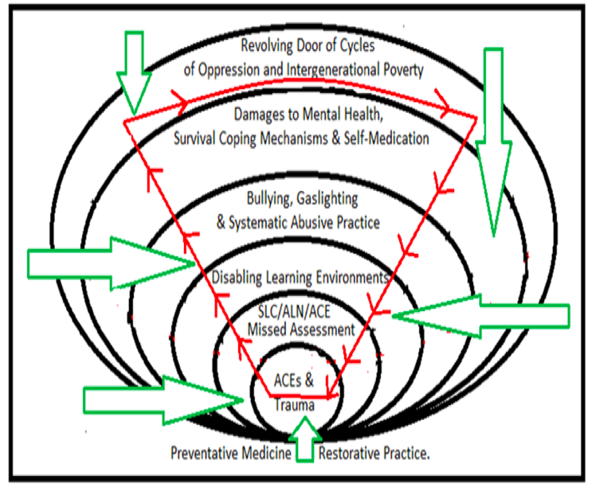
Furthermore, disabling environments, such as traditional school start times for night owls or those with circadian rhythm differences, will impact upon every area of a night owl’s life, including learning potential, attention, concentration, ability to retain information and impairing their health and functioning. These in turn, can lead to further exposure to trauma, missed assessments, bullying, damages to mental health and survival coping mechanisms including self-medication and the revolving door of cycles of oppression and intergenerational poverty. These disabling learning environments also contribute to reading and writing difficulties.
Since individuals who do not acquire a full ‘nights’ sleep, regularly miss out of the NREM stages which occur right at the end of a sleep cycle before naturally waking, this will mean that they are also missing the regular opportunity to exercise their left to right/right-left eye tracking muscles (Dore, 2008), which will impact upon their ability to learn to read and write quickly and fluently. Moreover, the ability to read and write fluently is essential as they are the body’s inbuilt trauma soothers which engage moving the eyes L-R back and fore. The continuous L-R movement is an effective trauma processing strategy, and so someone who cannot read or write fluently would be more dis/abled to help themselves utilise these trauma recovery strategies.
Furthermore, many participants spoke about the later financial harm and poverty which was a direct consequence of educational failure, leading some of them to homelessness, life on the streets, substance misuse, crime or their parents having a reduced income. Other young people were trapped in poverty cycles, who due to not being able to read could not become empowered and educated financially on how to get out of debt or their oppressive situation. This study also showed how this impacted inter-generationally onto the next generation before they were even born.
Research question three addressed preventative medicine and restorative solutions which embraced the voice of the oppressed to illuminate emancipatory educational solutions in combination with other multi-disciplinary resolutions. The user-led solutions are believed to be a dynamic strategic tool, not only to improve inclusive practice, but to act as a safeguard to protect others against poverty, oppression and education inequality. Furthermore, since suicide is the leading cause of death in almost all European countries (Hawton et al., 2012) and Wales has recently seen 45% increase in female suicides (Samaritans, 2018), question three proposes powerful, cost effective suicide preventative measures, along with restorative recovery solutions to tackle one of the most pressing public health crises.
As Coleman (2011) points out:
Society is trying to understand why so many people kill themselves. The failure to relate the way we [systems] treat people to any type of negative outcome is perhaps is most damning indictment of our current system. (Coleman, 2011, p.8)
5.12 Conclusion
In this chapter, I have discussed and analysed the seven superordinate themes which emerged from interviews with twelve participants who perceived themselves to have been educationally failed. Exploration of these themes have illustrated the multi-faceted interactions between interrelated factors (as illustrated in Figure 5.13) to demonstrate how educational failure has affected the participants across their life-span and answered my initial research questions. It is clear from the data that educational failure, exclusion and/or unsupported ACEs, can not only impact upon an individual’s own life, but also can negatively impact future generations. Children whose parents have been to prison and have mental health difficulties will automatically gain two ACEs due to their parents’ experiences according to Felitta’s ACE Score criteria ((Felitti, 1985; Felitti, 1990; Appendix 6). As Wiest-Stevenson and Lee (2016) state, “Students who are impacted by trauma face a variety of challenges and needs… [but] a review of literature reveals there is limited research on outcomes for trauma-informed schools” (Wiest-Stevenson and Lee, 2016, p.501). Therefore, social reform across systems is urgently needed.
In the next chapter, the key findings are discussed, with an examination of the study’s strengths and limitations, considering areas for further research and highlighting the overarching implications of the findings for educational practice, multidisciplinary policy development and social reform.
- Chapter Six –

CONCLUSION
Justice will not be served until those who are unaffected are as outraged as those who are. Benjamin Franklin (Good Reads, 2018, para. 1)

6.1 Introduction
This conclusion chapter summarises the findings and presents an examination of the strengths and limitations of the study for educationalists, educational practice and policy makers. There will also be an examination of the cost implications upon the NHS and other public services, as well as the identification of implications and recommendations for future practice and research. This study has sought to examine the factors that influence educational failure and/or exclusion and the consequences of that educational exclusion, as well as exploring preventative measures and restorative solutions for policy makers and practitioners. To achieve this aim, I used an IPA approach as a way of trying to make sense of personal educational failure and exclusion. This approach did not focus on the content analysis of policy documents, clinical evaluations or third person professional perspectives, but focused on conducting twelve in-depth semi-structured interviews with individuals from within hard to reach communities.
The study recruited twelve participants who perceived themselves to be educationally failed within the context of Swansea, with an opportunity sample of six females and six males. As noted by Smith (1999), “From an idiographic perspective, it is important to find levels of analysis which enable us to see patterns across case studies while recognising the particularities of the individual lives from which these patterns emerge” (Smith, 1999, p.424).
My primary focus was to listen to these voices from the perspective of their own experience, as well as bringing in the analytic lens of my own experience of an insider researcher. Analysis of interviews identified common superordinate themes which were presented and discussed in relation to the research questions and literature. This conclusion section will summarise the study’s strengths and limitations, evaluate the key findings and illuminate recommendations for future practice.
6.2 Strengths and Limitations of Study
One of the greatest strengths of this study is that it has provided a platform for unheard voices to ‘tell their story’. Additionally, what makes this study unique is that I have journeyed alongside these participants, often being there with some of them while they were experiencing the exclusion, the bullying or the systematic abuse. I witnessed first-hand some of what has been disclosed in these accounts and I can vouch that none of these accounts are fabricated versions of the truth. Moreover, I believe another strength of this study is the extensive time spent on deep researching, re-visiting and cross-checking research evidence across multidisciplinary and international research boundaries.
I believe because of the in-depth nature of this research which initially was not limited to a word count to allow freedom to ‘leave no stone unturned’, participants’ voices led this research down uncommon paths. Thus, another strength of this study is the ‘deep immersion’ with the data, as the closeness to participants over an extended period, gave myself as the researcher an incredible insight into how their voices, experiences and insights situate within the larger socio-cultural context. Since it is user-led, the emerging data naturally overlapped into many multi-disciplinary ideas, theories and systems which are not traditionally found within one piece of educational research.
Traditional research is usually driven by the subject specialism of the researcher or by narrowly restricted research question, which does not commonly allow for the combining of multidisciplinary fields outside of the researcher’s specialism, which rarely bring new insight into the ‘bigger picture’. I believe that journeying with participants during their struggles and trying my best to remove barriers to their learning, is another strength of this study.
I journeyed with many of the adult participants while they were at drop-in homeless shelters, psychiatric locked wards and under social services residential settings, whilst some of them were being abused, mistreated, threatened and silenced. I also attended GP appointments with three adult participants, psychiatric assessments, solicitor appointments, family contact centres, court and regularly drove two adult participants to access therapeutic services on a weekly basis which included mindfulness and support for hearing voices which were not available for them within the locality. I helped another dyslexic university learner to plan an essay as the 1:1 support had been unavailable for some-time and the deadline was imminent, I also tried my best to remove the educational barriers to all child participants, facilitating the learning of the forced home-educated child participants at my own home/online platforms.
I also made films with the children to deepen their understanding of some of the more complex sociological terminology and concepts which were used as ‘live’ learning tools to assist them with their essay writing (John, 2016). I also helped the only child participant who was still at school during the time of this study to secure exam access arrangements through highlighting the urgent need for a laptop whilst he [or she] was doing GCSEs. I booked exams for all the home-educated participants, secured exam access arrangements obtaining extra time and laptops and I even drove many of these participants to the different exam centres, varying from a weekly 80 miles trip to a one-off 180 mile-trip, as there were no other options available for participants in Swansea at this time.
I even wrote a script and directed a cartoon which was created by one of the home-educated young people in my group which was used by other organisations to raise awareness of the importance of taking part in the ALN consultations (Cymru ALN, 2015).
I am aware that as an insider researcher, my close connection to the participants could be viewed as a potential limitation of this study. However, with all research, the researcher’s own experience can influence the findings. Therefore, to make this research as pure as possible, great care and attention was taken through making summary notes immediately after each interview. I also kept self-reflective notes throughout the whole research study, as I found these informed and deepened my understanding. To ensure extensive checks and balances, after transcribing all of the interviews, I carried out a key word search on each of the interviewees’ transcripts and sought to educate myself about what they raised as important issues.
I had previous limited understanding of some of the emerging themes, such as ACEs, the voice hearing experience, sleep deprivation, CSE, miscarriages of justice and the practice of forcibly removing children from ‘labelled’ mothers. Therefore, it is evident that without doing a key word search analysis, I most certainly would have missed the significance of trauma. Trauma has emerged as being foundational and underpinning this study, as evidenced by the participants’ accounts and the trauma time-lines which were created as a dynamic tool for this study.
A potential limitation of the study could be participants’ varying ages and neuro-divergences, particularly as many have diagnosed or self-diagnosed difficulties in the area of language, understanding and processing. At the other end of the spectrum, another participant who believed him [or herself] to have been educationally failed had been defined as a gifted and talented potential ‘Oxbridge’ student by the school.
Since the aim of this study was to seek solutions for educational inclusion and I did not wish to discriminate or exclude anyone, all were welcome to take part in my study and share their stories regardless of any differences. I had a good grasp of participants’ receptive and spoken language abilities, so I sought to simplify or rephrase my questions to aid a better understanding for those with language difficulties. I also had developed trusting relationships with all participants and they were all reasonably relaxed and open during the interviews. Even during the questions which took participants ‘back to school’ and traumatic memories, participants remained relaxed and no one asked to stop their interviews. I personally view this as a strength of the study. Information was gleaned which detached researchers might not have been able to freely access.
Participants verbalised that the interview had a positive cleansing affect, as having someone listening for a sustained period not only validated them but also brought internal revelation that produced in many a shift in mind-set and ‘quantum change’ (Miller, 2001). It appears that motivational interviews have changed prisoners’ mind-sets, with 84% of offenders not re-offending within one year of release (Kainos, 2018). One ‘stuck’ participant in this study has since passed the UK Clinical Aptitude Test to study medicine, another two have achieved outstanding results in their chosen degrees, while others have also experienced shifts in their mind-sets and circumstances.
I fully credit these achievements to the participants who themselves found the strength to overcome against all the odds. However, I know that others, whose fragile lives were hanging by a thread, like the participant who was told by a psychiatrist that he [or she] would never leave a locked psychiatric ward, are no longer captive without hope but have found their freedom. Thus, it appears that the interviews could have been a catalyst for positive life change.
Another potential limitation could be the small sample used as the study recruited twelve participants from Swansea, Wales. However, Swansea was specifically chosen as a setting for this research because of the many discrepancies in Swansea’s data compared to national statistics (see Appendix 9 and 10); as one can see, these statistics demand urgent answers.
Therefore, the smaller sample of this study allowed more in-depth user-led research to be conducted. Furthermore, although a study with only twelve participants suggests a lack of representation in terms of population or probability, as Brocki and Wearden (2006) point out, the aim of IPA studies is not to achieve a representative sample but seeks to produce an in-depth examination. Knowledge can be greatly accelerated through a series of small-scale, detailed research studies (Touroni and Coyle, 2002). It should be noted however, that with all small sample research, generalised research conclusions should be approached with care and caution (Flowers, Smith, Sheeran and Beail,1997). Because of my engagement and connection with multiple others (Appendices 13, 14, 15) in similar circumstances right across the UK (England, Ireland, Scotland and Wales), it is my viewpoint that these participants represent ‘the tip of an iceberg’ as they are a small part of a wider societal problem. This is evidenced in the nationwide data collection of Special Needs Jungle (2019), Speke (2018) and KWADE (2017), along with individual accounts from others across the UK (Aspire Mum, 2019; Evans, 2019; Read, 2018).
IPA is a powerful research tool and was suitable for the purposes of this study. As a research method, IPA allows the researcher to engage with continual questioning, analytical thought and the persistent digging of user-led experiences, to uncover insight and knowledge, that cannot be found within the pages of traditional research literature. The participants were considered to be co-researchers in the research process, as it was their insight and unheard views that covered new ground, connecting user led experience with multidisciplinary specialisms.
As Soto and Swadener (2005) point out:
The potential to locate experiences within complex contexts to make sense of the daily lived world reality… coupled with a critical/advocacy component thrives on the passionate involvement and commitment of the researchers/co-researchers helping to cultivate hope and possibility! (Soto and Swadener, 2005, p.10)
It is my opinion that the ultimate strength of this research is the combined voice for harm-reduction which has the potential to impact individual, organisational, national and international strategic levels.

6.3 Key Findings
The key findings and recommendations from this study are set against a background of the urgent national public health, education and NHS priorities. In this study which examined perceived educational exclusion and failure, the ACE statistics were particularly alarming, as this study found that 58% of the participants had an ACE score of 4+. This is significantly higher than the national average which Bellis (2017) reported as being 14% of the general UK population (Bellis et al., 2015). Even more concerning are the statistics which reveal that a third of participants in this study had dangerously high ACE scores of 7+ (Figure 6.1).
Participants’ interviews and trauma histories reveal adversity was experienced from more than one setting which impacted upon their educational experience. These included sexual abuse whilst at school (25%), physical abuse while at school (50%), physical abuse from caregivers/foster care (25%), multiple changes in caregivers/foster care (25%), attachment changes due to being fostered, adopted or given to another family member (25%), neglect, loss of parent because of divorce, death, abandonment (67%), exposed to the suicide of a family/household member (8%) and living with a family member with addiction (33%).
Participants also disclosed sexual abuse outside school (25%), bullying from different sources at school (100%), bullying from peers (83%), public humiliation from teachers (83%) and systematic abusive practice involving social worker, police, psychologist or other professional (75%), domestic violence (33%), living with a family member who was depressed or mentally ill (50%), birth trauma (25% known cases) and transgenerational trauma (91% known cases). Additionally, missed assessment, misdiagnosis or late diagnosis of one or more of the following was 100%: SEN, speech, language and communication difficulties, trauma and/or mental health.
Figure 6.1: Breakdown of ACEs in this study
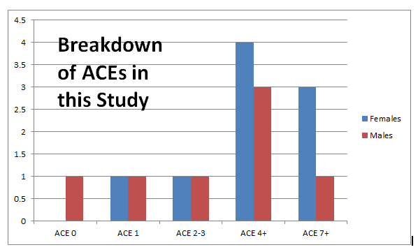
Along with the participants’ own trauma, the findings also revealed that intergenerational trauma was prevalent among participants’ accounts and trauma histories. Some participants explained how their parents and grandparents’ adversity had deeply affected their responses despite not directly experiencing their trauma themselves.
Furthermore, since at least 50% of participants within this study had a parent who suffered from anxiety, depression or a more complex mental health diagnosis, this would have impacted upon their own responses to trauma. It is also known that 20% of participants were exposed to the suicide of a family/household member which is another high impact childhood trauma.
Figure 6.2: ACEs/Neuro-divergences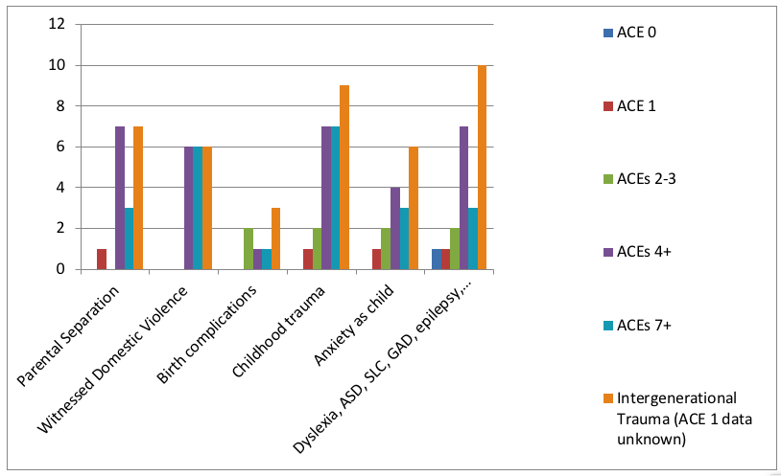
It is known that at least 60% of participants’ parents had exposure to some quite significant high impact childhood traumas themselves, with less than 20% of participant parents’ historical information not known. The combined collective intergenerational traumas of participants’ past generations included the suicide of a parent, child sexual abuse, being groomed and sexually abused as a young child by an organised paedophile ring, being a Jew during the Holocaust and war survivor, being abandoned by parents, being parented by an alcoholic and substance misuser, being kidnapped and raped, being fostered and adopted, severe bullying at school by teachers, having a diagnosis of schizophrenia, experiencing domestic violence and experiencing active combat as a soldier.
Thus, the findings from this study suggest that the long-term effects of trauma can be held in the body carrying a ‘psychological sequelae’ to the third generation. It is known that parental traumatization or any parent with PTSD carries an increased risk of depression in offspring, along with the close association with an increased risk of anxiety disorders in offspring (Yehuda et al, 2007), as was observed in this study. Clearly, this study recognised parents who have experienced childhood trauma or PTSD (without effective intervention or processing) will have a tendency towards parenting their children through an unconscious automatic response which has been set in the emotional fight/flight/freeze mode, as the fear emotional response will be re-triggered every time a perceived threat is detected. Furthermore, this study’s findings appear to indicate that the trauma/fear response, whether birth trauma, intergenerational trauma or personally experienced ACEs is significantly linked to educational failure or exclusion.
It became evident that most of the participants in this study experienced multiple traumas as children, which not only pushed them along the trauma continuum, but the feelings of extreme fear and horror would have left a permanent imprint upon every part of their body, mind and central nervous system (de Thierry, 2015), thus damaging learning capacity. Furthermore, due to being exposed to significant adversities at very tender ages, this could explain why many of the participants were exhibiting the symptoms of PTSD/C-PTSD whilst at school and beyond. Additionally, the trauma histories became an important part of the analysis process for this study, becoming a useful tool to uncover why participants might have had a tendency to ‘over-feel’ compared to their peers in class, when nothing in their own past (that they can remember) or the present (the learning environment) would give them any reason for an ‘over-reactive’ emotional response.
For example, one participant had a fear of drowning, yet nothing in their own experience had predisposed them to this fear; yet unbeknown to them their paternal grandfather had been shipwrecked three times in world war two.
The study also appears to indicate that the trauma/fear response might be directly linked to speech, language and communication difficulties, including receptive language difficulties and other additional learning needs. In this study, several types of neuro-divergences and speech, language and communication needs went unnoticed: as 83% attended school with undiagnosed speech, language and communication difficulties, 25% of participants attended school with undiagnosed ADHD, 75% had undiagnosed writing difficulties, 8% hearing difficulties, 16% epilepsy and 8% ASD. The study also revealed that 41% had unrecognised child sexual abuse related symptoms, 83% undiagnosed mental health difficulties such as anxiety and depression, 41% eating disorders, 58% sleeping disorders, 41% dyspraxia tendencies, 75% dyslexia and 100% of participants exhibited trauma related symptoms which impacted upon communication difficulties and confidence, along with evidence of difficulties with auditory processing and symptoms of pathological demand avoidance (PDA). Evidently, participants in this study displayed a mixture of neuro-divergences (sometimes termed comorbidity or combined developmental disorders).
Participants accounts show how sleep deprivation because of a lack of sleep on a regular basis appears to be connected to negative educational consequences as the ability to perform well became impaired, along with health difficulties that spiralled across the life-span. This study also found how night owls (approximately 83% of participants in this study compared with 30% of the general population) were often misjudged as being lazy or sluggish. However, many were physically unable to perform at their optimum learning capacity in the unequal traditional school system which has fixed early start-times leaving them sleep deprived on a daily basis and setting them up to fail (Walker, 2017).
The preferred sleep rhythms of participants in this study is found in figure 6.3. Furthermore, a closer examination reveals that a lack of consistently deep NREM sleep which takes place right at the end of a full sleep cycle, would impact upon the child’s eye muscle development, as their left to right/right to left eye tracking ability which is one of the essential skills required when learning to read will almost certainly be impaired, as automatic left to right eye tracking is used consistently by fluent readers. Additionally, a lack of NREM sleep also impairs the natural restorative process, as rapid eye movement which takes place at the end of sleep is also an effective natural restorative soother for trauma (Shapiro, 2013).
Figure 6.3: Preferred Sleeping pattern: Morning larks, night owls and those in-between.
Therefore, as findings show, the participants who were sleep deprived, would have missed out on nature’s way to soothe the body to cope with traumatic events and would also find it almost impossible to retain any new information, as NREM sleep takes place right at the end of a full sleep cycle. Furthermore, because retention of information is required to build upon skill development and reading and writing are needed across nearly all subject areas, those who lack a well-developed eye tracking internal system would inevitably find reading and writing very difficult.
Consequently, without correct assessment and early intervention to close gaps between their learning need and actual provision, the learning gap between themselves and their peers would steadily continue to increase. Thus, the findings of this study indicate a lack of multi-disciplinary knowledge and understanding in the combined areas of neuro-science and education, missed assessment of trauma, speech and language difficulties, neuro-divergences or misdiagnoses. As evidenced in this thesis, this lack of trauma informed practice appears to be widespread right through Swansea’s public services, from those who work with children who work with birth trauma (Appendix 13), right through schools, colleges, universities, prisons, psychiatric services and family court.
Figure 6.4: Missed Assessments/Intervention for Neuro-divergences
Findings in this study show that along with misdiagnosis, the traditional “wait to fail” and fail to assess with appropriate intervention teaching model (Elliott and Grigorenko, 2014), not only became a barrier to participants’ learning potential but contributed significantly to their educational failure.
Conversely, findings also show that the participants who received a diagnosis found that they were viewed through the lens of their disability or diagnosis, which also became a barrier to their learning potential as any strengths and abilities were ignored. Moreover, in some cases, opportunities to develop specialist skills became denied and discouraged. Thus, findings suggest that individuals should be able to access the most suitable educational provision for their own personal needs, instead of forced to conform to a set of criteria that may, or may not, be suitable for them.
Findings demonstrated how missed assessments have serious implications, especially as diagnosis often comes with intervention and medication which can cause even more harm if the diagnosis is incorrect. Thus, this study revealed how trauma histories might be a useful tool in helping individuals and practitioners uncover missing key information to aid assessment. The findings demonstrate how a ‘one-off categorical labelling’ or having one ‘label for life’ should be treated with extreme caution, especially as no two dyslexic, autistic, dyspraxic, ADHD, PDA, GAD or neuro-typical person is the same, nor will they present with the exact same needs.
Therefore, it is important for practitioners to ask the child/service user about their symptoms or difficulties, such as if there are certain situations, places, times, memories, people or triggers that make their symptoms/difficulties worse. This will provide key information to help illuminate where the real root cause of their difficulties lie and point them towards the most effective interventions at school and beyond. The study also revealed the ‘similarities in the symptoms between auditory processing disorder (APD) and other disorders, including dyslexia, ADHD, ASD and specific language impairment, and similarities in symptoms between PTSD and ADHD, bipolar disorder and GAD (general anxiety disorder) and epilepsy and non-epileptic seizures or dissociative seizures which are often missed by specialists themselves.
Symptoms of childhood trauma may often be missed due to a failure to take a thorough history review. Moreover, the findings show that exclusions appear to be a common problem for neuro-divergent pupils with receptive language difficulties or those with poor frontal lobe functioning who might find it difficult to infer the implied meaning behind unclear or ambivalent speech.
Findings also indicate that ALN differ-ability students are often subjected to punishment when they exhibit characteristics of their differences, as due to a failure to adequately assess and close gaps. Teachers lack of awareness of student difficulties often gave rise to misconceptions and negative reactions. All the participants in this study noted that their learning needs were not being met, as there was a mismatch and clear discrepancy between provision and their needs, which also became a barrier to their learning potential.
Consequently, another finding from this study revealed these missed assessments in turn created disabling learning environments which led to participants becoming targets of bullying, gaslighting and systematic abusive practice. Findings from this study (figure 6.5) show that public humiliation and bullying from teachers towards those with unmet educational needs is common, attracting further bullying from pupils. Furthermore, findings show that teachers who participate in public bullying send a clear message to all pupils that bullying towards these children is ‘acceptable’.
Given the findings relating to the gaps between educational need and provision, it appears that teacher bullying towards children had one purpose, which was to hide professional inadequacy and incompetence. The findings from this study also found that much of the bullying was directed towards children who already had heightened trauma responses or communication difficulties, so were unable to defend themselves against their teacher adult bullies and peer tormentors.
The effect of continuous bullying at school, being in an unescapable unsafe environment, being unable to speak up, escape or initiate their fight or fight response, will push them towards experiencing symptoms of PTSD.
Figure 6.5: Bullying by teachers, pupils and other professionals at school

Since statistically a person with an ACE score of 4 or more is 1,220% more likely to attempt suicide than someone with an ACE score of 0 (Nakazawa, 2015, p.48), the results from this study demonstrates the importance of safeguarding children from all forms of bullying at school and beyond. Findings also show a lack of professional awareness or knowledge about current trauma research and current evidence based mental health interventions.
Instead it is evident that some of the qualified mental health professionals who were supporting participants lacked understanding about GAD (Generalized Anxiety Disorder), self-harm, voice hearing, physical symptoms of de-regulation such as over-eating/not eating, over-sleeping, being awake through the night, or engaging in self-medication such as substance misuse, self-harm or engaging in other forms of risky addictive behaviour.
Figure 6.6: Emergence of Mental Health Difficulties

.
Figure 6.7: Symptoms of de-regulation experienced by participants (Groups 2-3)

However, the findings showed that multiple symptoms of underlying trauma and anxiety were still being missed by doctors. Furthermore, even the professionals who should have been helping them, ended up further harming them which led them directly into revolving doors of cycles of oppression and intergenerational poverty.

Figure 6.8: Health harming consequences (See figure 6.10 as only Group 4, those who had no support for ALN, truanted and left school before completing GCSEs, make up these statistics)

Figure 6.9: Complex abuse and revictimisation experienced by ACEs 4+ (Figure 6.10 – only Groups 3 & 4 make up these statistics)

Figure 6.10: ACEs and Educational Attainment

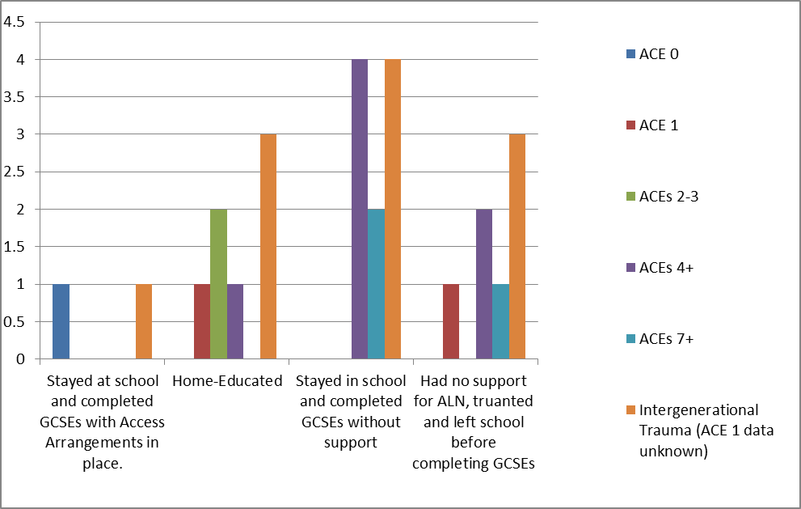
- Group 1: Stayed at school and completed GCSEs with access arrangements in place, achieved over 6 GCSEs and could access any further education course.
- Group 2 : Became forced-home-educated during comprehensive years due to struggles with bullying/decreased mental health.
- Group 3: Stayed in school and despite huge adversity completed GCSEs without support. However, it appears that since this group did not activate their fight or flight response, they appear to have gone into a state of freeze and numbing of pain and through ‘normalising their abuse’. This made this group particularly vulnerable to experiencing further reoccurring revictimisation.
- Group 4: Had no support for ALN, activated their flight response by truanting and left school before completing GCSEs/with no GCSEs. This group of participants are the only ones to make up the health harming statistics in figure 6.8).

Figure 6.11: Implications for future safegarding
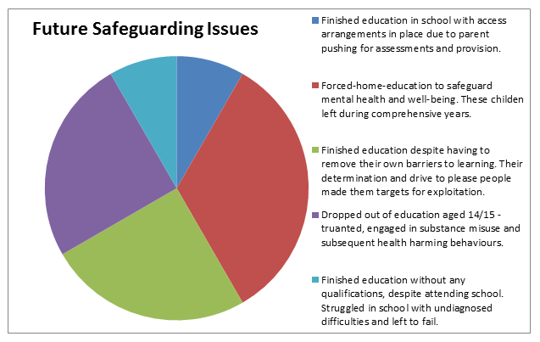
Therefore, the key findings of this study show that there is a strong inseparable link between the effects of trauma (ACEs and intergenerational trauma), sleep deprivation, missed assessments, disabling learning environments, bullying, damages to mental health and educational failure, along with far-reaching consequences of the revolving door of intergenerational poverty (figure 6.6, figure 6.7, figure 6.8, figure 6.9, 6.10, 6.11, 6.12), as well as the effect of trauma on the next generation (Appendix16 - Interview with a Miscarriages of Justice Victim).
These findings concur with Rowntree (2017), who identified the lack of educational attainment as the ‘biggest driver of future poverty’, along with Hawton et al. (2012) and Hawton and Rodham (2006), who identified school bullying/exclusion as a precursor to self-harm and suicide.
Since suicide has been identified as being the leading cause of death in almost all European countries (Hawton et al., 2012) and Wales has seen a recent 45% increase in their female suicide rate (Samaritans, 2018), the findings from this study demonstrate that urgent societal reform is required across multiple systems and institutions. Additionally, the findings from this study also provide fiscal preventative and restorative solutions. Furthermore, if these cost-effective preventative and restorative solutions are implemented, they have the potential to impact future generations through creating more user-friendly systems of equality, to reverse poverty and break ingrained intergenerational cycles of oppression.
Figure 6.12: Breaking the revolving cycle of educational inequality and intergenerational poverty
6.4 Recommendations for Future Practice and Research
The findings of this study have massive implications for professionals and policy makers across local, national and international strategic levels. As Bellis (2017) states:
Prolonged exposure to childhood stressors can result in children becoming 'locked' into a higher state of alert to threat… in that state of alert, bodies wear out more quickly. They are physiologically adapted to short term survival as they become permanently prepared to respond to further trauma… - never 'switching off' - also increases tissue inflammation, which we know is a trigger for many diseases. (Bellis, 2017, p.45)
The proposed recommendations are underpinned by the ACEs, trauma and sleep research which provide a rich evidence base to inform strategists and decision makers about how the significant cost-effective ‘game changing’ solutions would reduce harm, as well as saving governments millions of pounds. It is believed that the rich evidence offered within the body of this research contributes to the development and extension within the discipline of education and beyond. This research has the potential to impact upon multi-disciplinary fields, such as a national anti-poverty prevention strategy to reduce the untenable strain on public money being wasted across services.
Therefore, the recommendations in this study are for the attention of multi-policy makers and decision-makers across the public sector, not just within the subject specialism of education, as throughout this study neuro-science and education are inseparable. Thus, recommendations weave in and out throughout the different multi-systems to illustrate this inseparable bond. The recommendations from this study are:
- Early intervention from cradle to grave, intergenerational ACE screening.
- Implementing preventive measures to be more forward thinking and look at the bigger picture

- Primary School: Raising Children’s Dopamine Levels Naturally as a Priority Preventative Measure - Trauma Informed Teaching Model.

- Creating More Equal and Tailored 24/7 Online/Offline Blended Learning Environments: 24/7 Online/Offline Education/Learning that Breaks Through Walls: Sleep friendly, PTSD, Home, Prison, Hospital, Residential Care and Homeless Friendly Provision.

- Fast track trauma/neuro-divergent friendly GCSEs as an option alongside traditional methods.

- Ensuring availability of digital technology and equal access arrangements for GCSE exams

- Eradicating Teacher Bullying out of Schools

- Internal Read/Write Recovery Systems: The importance of neuroscience behind children learning to read, write and journaling as a built-in recovery system to prevent self-harm

- Enjoyment of art, music, drama, sport, creativity and play as a mental health preventative safeguards and recovery solutions in schools, prisons, psychiatric and foster-care settings.

- Challenging Negative Labelling Using Neuroscience to Make New Pathways

- Rapid Response Person in Physical Learning Environments/24/7 online

- Service Users having more financial control and choice over provision

- The power of one: Recruitment, having higher standards of character and compassion - employing staff to empower others.

- More menu types of choice for private trauma therapies as suicide prevention, such as film therapy, pet therapy, journaling, the power of distraction, Self-Forgiveness, trauma-timelines, online/offline 24/7 counselling, EMDR, sport.

- Teaching the difference between resilience and normalised abuse: Educating ‘resilient’ young people about the dangers of normalising abuse as it comes with a high risk of being re-victimised and early death.

- Creating better systems with more effective multi-agency communication

- Recognising home-education as an appropriate safeguard from the effects of disabling environment, enabling young people to access their fight/ flight response.

- ACE/Trauma/Intergenerational awareness, along with speech, language and communication training across systems, including using BLANK and the communication cycle across services (see Appendix 8).

- Trauma centred time-lines as vital jigsaw pieces to form a fuller picture of need and the voice of the service-user to lead and inform ‘diagnosis’ and intervention

- Introducing an ACE diagnosis into the DSM to reduce the high rates of [mis]diagnosis, to acknowledge the dangerous gap in the DSM as other [mis]diagnoses are causing significant harm. Simultaneously, changing the way diagnoses are given to ensure more checks and balances are in place.

- Trauma Time-lines to be used as safeguarding tools for knowledge and understanding. Using a recovery model perspective which views diagnoses as fluid to change with the person’s needs rather than a life-long label.

- Make professional systematic abuse of children/vulnerable adults a criminal offence, including all form of financial exploitation (for example, polypharmacy/over prescribing opioids for profit/shareholders of private fostering companies involved in the decisions to remove children)

- The voice of the service-user to lead and inform ‘diagnosis’/intervention

- Service users having more choice and financial control over educational provision/therapies

- Video recording all lessons/assemblies/head-teachers’ offices to safeguard pupils from the harm of bullying ‘behind closed doors’ (as is already the practise in some organisations).

- Eradicating workplace bullying out of public services (NHS, social services, police, education system) and ensuring that highly paid managers are suitably qualified and screened for their jobs, not having their positions because of nepotism and cronyism (see Appendix 11, Kris Wade (BBC News 2019a).
- Video record police/social services/NHS disciplinary interviews to ensure transparency and accountability. Use assistant technology to help those with speech difficulties or illiteracy write out transcripts/statements which cannot be edited. Protecting public from systematic abusive practice.

- Targeted interventions in prison and psychiatric hospitals: Review individuals background, reason for their ‘stay’, speech, language assessment, dyslexia assessment, sleep assessment, review how they were interviewed/ how their police statement was taken/diagnosis was given/what evidence/documentation was used.

- Provide empowering solutions, including helping them to break the intergeneration cycle of poverty. Using time-lines to uncover possible miscarriages of justice/misdiagnoses.

- Removal of children should always have direct evidence of harm based on fact not hearsay or as retaliation by public services towards those who make a complaint or raise issues of abuse concerning friends working in other sectors.

- Allocate (Foster-Care) money in first instance to families at risk of separation as restorative measure to break cycle of intergenerational trauma before breaking the family apart. Social services using more preventative measures to protect whole families and help them to break patterns of abuse, trauma, addiction and suffering. Giving money (that would be given to foster-carers in first instance of crisis) to help family to rise out of poverty to reverse harm.

- Having better communication policies in place which include understanding about receptive difficulties (Appendix 8); at individual, organisational and multi-disciplinary strategic levels.
6.5 Conclusion
In conclusion, this original research study has covered new ground in examining how ACEs/trauma, missed assessment/misdiagnosis, ableism and disabling school environments, bullying and damages to mental health are all contributory factors to educational failure. Additionally, this thesis has also found how these factors contribute towards the revolving door of cycles of poverty and premature death. Due to the relative absence of this type of educational research which is illustrated in Chapter Two (Part Two) of the literature review, this present study has made an original contribution through combining neuro-science, education, behavioural studies, ACEs, sleep studies, neuro-diversity and suicide prevention.
Along with ACE prevention, sleep deprivation is also perceived to be ‘the greatest public health challenge we face’ along with the ‘premature death it inflicts’ (Walker, 2017, p.340). Therefore, since ‘sleep dispenses’ a free ‘repeat prescription’ full of health benefits, it makes sense for the education system to stop inflicting harm on approximately 30% of night owls found within the general population (83% in this study) who are forced into sleep deprivation everyday by the fixed traditional school/work early starting times. Walker (2017, p.8) states, “Sleep is the single most effective thing we can do to reset our brain and body health each day.” Since Mate (2019a, p.314) points out the close connection ‘between sleep deficiency and the epidemic of ADHD’ along with the long-term effects of intergenerational trauma (Wolynn, 2016), this thesis presents solutions to tackle public health targets, such as combining education and neuroscience in the primary school to promote good sleep hygiene and raise children’s dopamine levels naturally ready for the teenage years and beyond (John, 2013).
Since Wales is the only country in the UK that has rising suicide statistics compared to all other countries within Britain, with female statistics rising by 45% (Samaritians, 2018) and suicide is the leading cause of death in almost all European countries (Hawton et al, 2012), this thesis answers an urgent call to action. Additionally, as a lack of educational attainment has been identified as the ‘biggest driver of future poverty’ (Rowntree, 2017), along with school bullying/exclusion identified as a precursor to self-harm and suicide, ‘power exists only in action’ (Foucault, 1980, p.89) and a ‘radical shift in our personal, cultural, professional and societal’ stance is required (Walker, 2017, p.340). As adverse childhood experiences are pushing up “already high health care costs an important component of our health care system and national strategy [should be] to reduce ACEs” (Srivastav, 2017, S136). Therefore, as Coleman (2011) states, it is high time “for professionals to get their act together. They should not be agents of the state, they should be the enablers of their local communities” (Coleman, 2011, p.154).
Currently, the Scottish government is using the Welsh poverty statistics (Bellis, 2017) as a negative example of social policy failures and poverty to promote their ambition to be world leaders in trauma informed care to improve all Scottish public services. Therefore, this original Welsh ACE study makes a significant and unique contribution to existing knowledge as it has not only been birthed in pain and has its roots in Wales but has been authentically informed by powerful Welsh voices who have sung in unison about their personal experiences of oppression, pain and trauma. Thus, providing a birds-eye-view of many reasons behind the negative statistics. Since trauma informed practice can only be truthfully trauma informed if it has emerged from the traumatised, the philosophy of this study is from the ‘nothing about us, without us’ (Charlton, 2000; Silberman, 2015) and ‘people first’ (Goodley, 2017) standpoint.

As Mate (2019a) warns us:
Without change, we will simply perpetuate a vicious cycle wherein each generation of our children are stumbling through the education in a half-comatose state, chronically sleep deprived [and] …stunted in [their] mental and physical growth as a consequence and failing to maximise their true success potential. (Mate, 2019a, p.314)
Furthermore, the findings of this study demonstrate the implications of the current educational policy which is causing widespread irreparable damage to our children’s lives due to its static position which is similar to Orwell’s (1945, p.97), ‘All animals are equal, but some animals are more equal than others’ stance.
Therefore, this thesis answers an urgent call for systematic reform and presents a good case for future financial and public investment. The long-term benefits will not only be felt across systems, but governments stand to save multi-millions of the public money in the process. Furthermore, the findings from this study form a secure base-tool to increase accountability across systems. If the recommendations from this study are executed, countries like Wales with past histories of failed educational policies, could find themselves re-positioned as the new world leaders, not just in education but pioneering socio-economic multi-disciplinary research across international borders.
If these cost-effective preventative and restorative solutions were implemented by policy makers, these simple solutions would inevitably spearhead a transformative process of emancipatory social and education reform to create better lives for all children and future generations. As Herman (2001) states, “When the truth is finally recognised, survivors can begin their recovery. But far too often secrecy prevails and the story of the traumatic event surfaces not as a verbal narrative but as a symptom” (Herman, 2001, p.1).
Therefore, it is time to rise up to William Temple’s challenge:
Are you going to treat a man as he is or as he might be? Morality requires that you should treat him as he might be, as he has it in him to become…Rising what he is to what he might be is the work of education. (William Temple cited in John, 2014c)

REFERENCES
Adams, M.L. (2016). Prison is a Crazy Making Place: Does Social Support Help? Phd
Thesis Fielding Graduate University.

Adolphs R. (2013). The biology of fear. Curr. Biol. 23 R79–R93. 10.1016/j.cub.11.055

Adult Basic Skills. (2004). National Survey of Adult Basic Skills. Adult Basic

Skills Agency.
Ainscow, M, Booth, T and Dyson, A. (2004). Understanding and Developing
Inclusive Practices in Schools: A Collaborative Action Research Network.
International Journal of Inclusive Education, 8, 2, 125-139.
Aldrete-Phan, C.N., (2001). A comparison of stress responses of children with and
without learning disabilities. Temple University.
Ali, A and Lees, KE (2012). The Therapist as Advocate: Anti-Oppression Advocacy
in Psychological Practice New York University
Allen, R.E. & Oliver, J.M. (1982). The effects of child Maltreatment on language
development. Child Abuse and Neglect, Vol 6, p.299-305
Allgood, S., & Warren, R.S. (2003). The duration of homelessness: Evidence from a
national survey. Journal of Housing Economics, 12 273-290.
Allison, S., Roeger, L., Reinfeld-Kirkman, N. (2009). Does school bullying affect
adult health? Population survey related quality of life and past
victimisation. Aust NZ J Psychiatry: 43: 1163:70

American Counselling Association. (2014). 2014 ACA code of ethics. Alexandria,

VA: Author.
American Psychiatric Association. (1980). Diagnostic and statistical manual of
mental disorders (3rd ed.). Washington, DC: Author.
American Psychiatric Association. (1994). Diagnostic and statistical manual of
mental disorders (4th ed.). Washington, DC: Author.
American Psychiatric Association. (2000). Diagnostic and statistical manual of
mental disorders (4th ed., text rev.). Washington, DC: Author.
American Psychiatric Association. (2013). Diagnostic and statistical manual of
mental disorders (5th ed.). Arlington, VA: Author.
Anda R.F, Croft J.BFelitti, ., V.J. Nordenberg, D Giles, W.H., Williamson D.F (1999).
Adverse childhood experiences and smoking during adolescence and
adulthood JAMA, 282 (17) (1999), pp. 1652-1658
Anda, R.F., Whitfield, C.L., Felitti, V.J., Chapman, D., Edwards, V.J., Dube, S.R. &
Williamson, D.F. (2002). Adverse childhood experiences, alcoholic parents,
and later risk of alcoholoism and depression. Psychiatric Services, 53(8),
1001-1009,
Anda RF, Brown DW, Felitti VJ, Bremner JD, Dube SR, Giles WH. (2007). Adverse
childhood experiences and prescribed psychotropic medications in adults.
Am J Prev Med. 32:389–94.
Anisman, H. (2011). Sensitization in Relation to Posttraumatic Stress Disorder
BIOL PSYCHIATRY 2011;70:404 – 405 doi:10.1016/j.biopsych.2011.07.006 ©

2011 Society of Biological Psychiatry

Anonymous. (2017). Perspectives of a Plastics Doctor
Anthony, K.V. and Burroughs, S. (2012). Day to Day Operations of Home School
Families: Selecting from a Menu of Educational Choices to Meet Students’
Individual Instructional needs . International Studies Volume 5, Number 1,
February 2012.

Arendt, H (1958). The Human Condition University of Chicago Press: Chicago
Arias-Carrion, E.P. (2007). Dopamine, Learning and Reward-Seeking Behaviour.
Acta Neurobiologiae Experimentalis 481-488
Arvay, M. J., & Uhlemann, M. R. (1996). Counsellor stress in the field of trauma: A
preliminary study. Canadian Journal of Counselling and Psychotherapy,
30, 193–210.
Ashby, C. (2012). Disability Studies and Inclusive teacher preparation: A socially
just path for teacher education. Research and Practice for Persons with
Severe Disabilities, 37(2), 89-99
Atkinson, N. (2017). Odd Man Out: Breaking the Vow of Male Silence. Elloa and
Nig Atkinson Self Published Book.
Attwood, T and Garnett, M. (2016). Exploring Depression and Beating the Blues
Jessica Kingsley Publishers

Ayres, W. (2003). The Art of Narrative Inquiry American Educational Research

Association; Chicago
Baglivio, M. T., Epps, N., Swartz, K., Huq, M. S., Sheer, A., & Hardt, N. S. (2014). The
prevalence of Adverse Childhood Experiences (ACE) in the lives of juvenile
offenders. OJJDP Journal of Juvenile Justice, 3(2), 1-23.
Baiden, P., Stewart, S.L, Fallon, B. (2017). The mediating effect of depressive
symptoms on the relationship between bullying victimisation and non-
suicidal self-injury among adolescents: Findings from community and
inpatient mental health settings in Ontario, Canada. Psychiatry Research
255 (2017) 238-247
Baker, G. A, Jacoby, A, Buck, D, Stalgis, C, Monnet, D. (1997). Quality of Life of
People with Epilepsy: A European Study. Epilepsy 38:353-62
Banks, J. (2011). The Effects of Trauma And How To Deal With It. House of
Healing: Asheville.

Barnes, C. (1990). Cabbage Syndrome: The social construction of dependence.

Falmer Press; London
Barnes, C. (1991). Disabled people in Britain and discrimination: A case for anti-
discrimination legislation. London: Hurst
Baum, R. (2013). Transgenerational trauma and repetition in the body: The groove
of the wound, Body, Movement and Dance in Psychotherapy, 8:1, 34-42,
DOI: 10.1080/17432979.2013.748976
Baum, R. (2000). Forgetting women: The half li(f)e of fascist memory. Utah Foreign
Language Review, X(1), 27–43.
Bauman, S. (2008). The role of elementary school counsellors in reducing school
bullying. The Elementary School Journal, 108 (5), 362-375
Basic Skills (2001). The Extent of the Problem. Basic Skills Agency.

BBC News. (2014). Prison Inspector Accuses ministers of prisons ‘failure’. June 14th

2014.

BBC News. (2017). Swansea teacher given payout despite under-age sex claims. 24th

January, 2017.

BBC News. (2019a). Kris Wade: Abertawe Bro Morgannwg Background Check

Failings. 29th January, 2019.

BBC News (2019b). Swansea has worst opioid death rate in England and Wales. 24th

February, 2019. https://www.bbc.co.uk/news/uk-wales-47350817

Beckett, F. (2001). A Fresh Start: Amid the Anger on Merseyside at the Release of

James Bulger’s Killers, One Complaint Echoed: They Got a Good

Education.The Guardian. Monday 9th July, 2001.

Beddington, J., Cooper, C.L Field, J, (2008). The mental wealth of nations. Nature,

455: 1057-1060
Begley, S. (2007). Train Your Brain, Change Your Mind.

Bell, J (1987). Doing Your Research Project Open University; Milton Keynes
Bellis, M (2017). Adverse Reactions Community Practitioner, London, Vol 9, Iss7
(July 2017) 44-45
Bellis, M, Lowey, H, Leckenby, N, Hughes, K, Harrison, D. (2013). Adverse
childhood experiences: retrospective study to determine their impact on
adult health behaviours and health outcomes in a UK population. Journal
of Public Health | Vol. 36, No. 1, pp. 81–91 | doi:10.1093/pubmed/fdt038 |
Advance Access Publication 14 April 2013
Bellis, M, Ashton, K, Hughes, K, Ford, K, Bishop, J. and Paranjothy, S. (2015).
Adverse Childhood Experiences and their Impact on health-harming
behaviours in the Welsh Adult Population.CPH, Centre for Public Health,
Liverpool John Moores University.

Bendall, R. P (2004). Madness explained; Psychosis and Human Nature Penguin,

London
Benson, A., o’Toole, S., Lambert, V., Gallagher, P., Shahwan, A, Austin, J.K. (2016).
The stigma, experiences and perceptions, of families living with epilepsy:
Implications for Epilepsy-Related Communication within and External to
the family unit – Patient Education and Counselling 99 1473-1481
Benson, P.L (2003). Hardwired to Connect; The New Scientific Case Children at
Risk Institute for American Values

Bercow Review (2008). www.dcsf.gov.uk (accessed 7/9/17)
Berger S. S. (2014). Whose Trauma Is It Anyway? Furthering Our Understanding of
Its Intergenerational Transmission, Journal of Infant, Child, and
Adolescent Psychotherapy, 13:3, 169-181, DOI:
10.1080/15289168.2014.937975
Best, D., Manning, V., Gossop, M., Gross, S. & Strang, J. (2006). Excessive drinking
and other problem behaviors among 14-16 year old school children.
Addictive behaviours, 31, 1424-1435/,

Biko, S. (1978). I write what I like. London: The Bowerdean Press.
Billington, J. (2011). Reading for Life: Prison Reading Groups in Practice and
Theory. Critical Volume 23, Number 3, 67-85.
Billington, T (2006). Working with Children, Assessment, Representation and
Intervention. Sage Publications; UK
Billingham, T. (2006b). Autism: Speculation, knowledge or understanding?
Discourse: Studies in the Cultural Politics of Education, 27:;2, 275-285,
DOI: 10.1080/01596300600676292

Bion, W. R. (1961). Experience in groups. New York, NY: Basic Books
Blachman, B. A., Schatschneider, C., Fletcher, J. M., Francis, D., Clonan, S. M.,
Shaywitz, B. A., (2004). Effects of intensive reading remediation for second
and third graders and a 1-year follow-up. Journal of Educational
Psychology, 96, 444–461
Black-Hawkins, K, Florian, L and Rouse, M (2007). Achievement and Inclusion in
Schools. Oxen: Routledge

Bloch, S. and Reddaway, P. (1977). Russia’s Political Hospitals. Futura

Publications limited, London.
Blood, G.W., Boyle, M.P, Blood, I.M., Nalesnik, G.R. (2010). Bullying in children
who stutter: Speech-language pathologists’ perceptions and intervention
strategies. Journal of Fluency Disorders 35 (2010) 92-109
Bond, I, Carlin, J, Rubin, K & Patton, G. (2001). Does bullying cause emotional
problems? A prospective study of young teenagers. British Medical
Journal, 323, 480-484
Booth, T and Ainscow, M. (2002). Index for Inclusion – Developing Learning and
Participation in Schools CSIE; Bristol
Bourdieu, P. (1986). “The forms of capital”, in Richardson, J. (Ed.), Handbook of
Theory and Research for the Sociology of Education, Greenwood, New
York, NY, pp. 241-258, available at: www.marxists.
org/reference/subject/philosophy/works/fr/bourdieu-forms-capital.htm
Breslau. N. & Kessler, R.C. (2001). The Stressor Criterion in DSMiv Post traumatic
studies disorder. An empirical Investigation. Biological Psychiatry 50,
699-704

Bruner, J. (1986). Actual Minds, Possible Worlds Havard University Press;

Cambridge

Bruner, J. (1990). Acts of meaning. Cambridge: Harvard University Press
Brunstein, K. A.Sourander, A., gould, M, (2010). The Association of Suicide and
bullying in childhood to young adulthood: a review of cross-sectional
and Longitudinal Research findings. Can J Psychiarty 55:282-8
Bryan, K (2004). Prevalence of speech and language difficulties in young
offenders. International Journal of Language and Communication
Disorders; 39, 391–400.
Bulger, R. (2013). My James: The Heart Rendering Story of James Bulger by his
Father.London: Pan Books.
Burke Harris. N. (2015). How Childhood Trauma Affects Health Across a Lifetime.
Published 17th February, 2015. https://youtu.be/85ovlJ3dsNk
Burke Harris, N. (2018). The Deepest Well: Healing the Long Term Effects of
Childhood Adversity. USA: Bluebird.
Burt, M., Laudan, Y.A., Lee, E., & Valente, J. (2001). Helping America’s homeless:
Emergency shelter or affordable housing, The Urban Institute Press;
Washington
Byers, Brown, B and Edwards, M (1989). Developmental Disorders of Language
Whurr Publishers; London
Cacace, A. T., McFarland, D. J. (2008). Controversies in central auditory
processing disorder. San Diego, CA Plural
Carr, W. (1995). For Education - Towards Critical Educational Inquiry
Buckingham, Open University Press
Change.org (2018). Petition: Penyrheol Comprehensive School Uniform policy
needs changing https://www.change.org/p/alan-tootill-penyrheol-comprehensive-school-uniform-policy-needs-changing-6a5e6059-6a66-4aca-9ee5-0267e7e36067
Chapman, M.V. Wall A., Barth R.P (2004). Children’s voices: the perceptions of
children in foster care American Journal of Orthopsychiatry, 74 (3) (2004),
pp. 293-304

Charlton, J. (2000). Nothing About Us Without Us: Disability Oppression and

Empowerment. University of California Press: USA.

Cheminais, R (2002). ‘Inclusion and school Improvement’ David Fulton Publishers;

London

Cheminais, R (2005). ‘Every Child Matters’ David Fulton Publishers; London
Chiao J. Y., Iidaka T., Gordon H. L., Nogawa J., Bar M., Aminoff E., (2008). Cultural
specificity in amygdala response to fear faces. J. Cogn. Neurosci. 20 2167–
2174. 10.1162/jocn.2008.20151
Churchyard, Alasdair, Ryder, M, Greenhill, A. (2018). The Prevalence of Autistic
Traits in a Homeless Population. Autism Journal, April 10th 2018.
http://doi.org/10.1177/1362361318768484
Cino, G. (2014). A Crime to be punished or a problem to be solved? Anti-social
behaviour orders and young people with mild learning disabilities. Journal
of Intellectual Disabilities and offending behaviour. Vol.5 No.2
Clegg, J., Hollis, C. & Rutter, M. (1999). Life sentence: what happens to children
with developmental language disorders in later life? Bulletin of the Royal
College of Speech Language Therapists, 571, 16-18.

Cohen, L and Manion, L (1994). Research Methods in Education Harper and Row;

London

Coleman, R (2011). Recovery: An Alien Concept? P&P Press; Fife
Collom, E. (2005). The ins and outs of home-schooling. The determinants of
parental motivation and student achievement. Education and Urban
Society, 37 (3), 307-335.

Connell, R.W. (1993). Schools and Social Justice, Pluto Press, Leichhardt
Connelly, M and Clandinin, D. (1990). Stories of Experience and Narrative Inquiry.
Educational Researcher, Vol 19 (5) 2-14
Copeland, W.E,.Wolke, D, Angold,A,. Costello, E. (2013). Adult psychiatric
outcomes of bullying and being bullied by peers in childhood and
adolescence

Copper, Moodley and Reynell’s Model (1978). Developmental Stages.

Coppersmith, S. (1967). Antecedants of Self-Esteem. San Fransico; W.H. Freeman

and co.
Corbett. J. (2001). Supporting Inclusive Education. A Connective Pedagogy.
Routledge Falmer; London
Corbin, J. & Stauss, A. (2015). Basics of Qualitative Research: Techniques and
Procedures for Developing Grounded Theory. 4th Edition CA:SAGE.
Corso P.S, Edwards, V.J, Fang, X, Mercy, J.A (2008). Health-related quality of life
among adults who experienced maltreatment during childhood American
Journal of Public Health, 98 (6) (2008), pp. 1094-1100
Cortina, L.M. (2008). Unseen Justice: Incivility as Modern Discrimination in
Organisations. Academy of Management. Review 33, 55-75
Costello EJ, Egger H, Angold A. (2005). 10-year research update review: the
epidemiology of child and adolescent psychiatric disorders: I. Methods and
public health burden. J Am Acad Child Adolesc Psychiatry; 44: 972–86.
Costello EJ, Erkanli A, Angold A. (2006). Is there an epidemic of child or
adolescent depression? J Child Psychol Psychiatry; 47: 1263–71.

Coupland, D. (1991). Generation X: Tales for an Accelerated Culture.
Cowne, E. (2003). ‘Developing Inclusive Practice: The SENCOs Role in Managing
Change’ David Fulton Publishers; London
Cozolino, L. (2006; 2014). The Neuroscience of Human Relationships; Attachment
and the Social Brain. London; Norton and Company.
Craig, C. (2018). Hiding in Plain Sight. CCWB Press; Glasgow.
Craig, J.M, Baglivo, M.T, Wolff, K, T., Piquero, A. R., Epps, N. (2016). Do Social
Bonds Buffer the Impact of Adverse Childhood Experiences on
Reoffending. Youth Violence and juvenile Justice Vol 15, (10, 2-20.
Cronholm P. F., Forke, C M, Wade R,. Bair-Merritt, M H Davis M, Harkins-Schwarz
M,. Pachter L M, Fein, J. A . (2015). Adverse Childhood Experiences:
Expanding the Concept of Adversity, In American Journal of Preventive
Medicine, Volume 49, Issue 3, 2015, Pages 354-361, ISSN 0749-3797,
https://doi.org/10.1016/j.amepre.2015.02.001.

CSIE (2002). ‘The Inclusion Charter and Explanatory Paper ’CSIE; Bristol

CSSIW (2016). Inspection Report about Swansea
Cummins, J. (1989). Language and literacy acquisition in bilingual contexts.
Journal of Multilingual and Multicultural development, 10, 1, 17-31.
Cummins (2005). Teaching for cross -language transfer in duel language
education: possibilities and pitfalls. TESOL symposium on duel language
education. Wake Ed Org.
Cymru ALN (2015). Wales ALN Bill. Https://youtu.be/di9iA8G9_Cpk
D’Alessio, L., Giagante, B., Oddo, S., Silva, W.W., Solis, P., Consalvo, D. (2006).
Psychiatric disorders in patients with psychogenic non-epileptic seizures
with and without cormodid epilepsy. Seizure. July 2006:15:333-339

Daines, B, Fleming, P and Miller, C (1996). ‘Speech and Language Difficulties’

Tamworth: NASEN House
Davidson J, Swartz M, Storck M, Krishnan RR, Hammett E. A (1985). diagnostic and
family study of posttraumatic stress disorder. The American Journal of
Psychiatry 1985;142:90–3.
Davidson AC, Mellor DJ. (2001). The adjustment of children of Australian
Vietnam veterans: is there evidence for the transgenerational
transmission of the effects of war-related trauma? The Australian and
New Zealand Journal of Psychiatry 2001;35:345–51.
Davidson J, Swartz M, Storck M, Krishnan RR, Hammett E. A (1985). diagnostic and
family study of posttraumatic stress disorder. The American Journal of
Psychiatry 1985;142:90–3.
Davidson J, Smith R, Kudler H. (1989). Familial psychiatric illness in chronic
posttraumatic stress disorder. Comprehensive Psychiatry 1989;30: 339–
45.
Davidson JR, Tupler LA, Wilson WH, Connor KM. (1998). A family study of chronic
post-traumatic stress disorder following rape trauma. Journal of
Psychiatric Research 1998;32:301–9.
Davidson, L.L., Grigorenko, E.L., Boivin, M., Rapa, E., Stein, A. (2015). A Focus on
adolescence to Reduce Neurological Mental Health and Substance-Use
Disability. Adolescent Mental Health Nature 527: S161-S166
Davies, D. (2008). Mental Health Factfile: Pembrokeshire Hearing Voices Group.
Third Edition March 2008.
Davies, A. (2016). Chairman of ABMU key speaker addressing Art students at
Swansea University Professor Andrew Davies ‘ARTS and Culture play a
vital role in underpinning our health’ 7th October, 2016.
Davies, G. (2019). Special Educational Needs. Part of the debate in Westminster
Hall. https://theyworkforyou.com.

Davis, M (2013) The Outlook on the Global Agenda; Thriving in a Hyperconnected

World
Dawes, P., Bishop, D. V. M., Sirimanna, T., Bamiou, D. E. (2008). Profile and aetiology
of children diagnosed with auditory processing disorder (APD).
International Journal of Pediatric Otorhinolaryngology. 72 483–489
[Article] [PubMed]
Dawes, P., Bishop, D. V. M. (2009). Auditory processing disorder in relation to
developmental disorders of language, communication and attention: A
review and critique. International Journal of Language and
Communication Disorders. 44 440–465 [Article] [PubMed]

De Bellis, M (2000). Adolescent onset Alcohol use Disorders American Journal of

Psychiatry 737-744
De Boer, H. M. (2010). Epilepsy stigma: Moving from a global problem to global
solutions. Seizure - European Journal of Epilepsy , Volume 19 , Issue 10 , 630
– 636
Denton, C. A., Nimon, K., Mathes, P. G., Swanson, E. A., Kethley, C., Kurz, T. B., &
Shih, M. (2010). Effectiveness of a supplemental early reading intervention
scaled up in multiple schools. Exceptional Children, 76, 394–416.
Department for Education and Skills (1978). Warnock Report. London; HMSO.
DfES. (2003). The Green Paper: Every Child Matters: Change for Children
Nottingham: DfES publications

DfES. (2004). The Children’s Act. London: HMSO
DfES. (2007). Working Together London: HMSO:
DfES. (2004). ‘Special Educational Needs: Code of Practice’ DfES Publications:
Nottinghamshire

DfES. (2004). Strategy for SEN Removing Barriers to Achievement

DfES. (1998). ‘The National Curriculum’ London; HMSO
DfES. (2018). School Exclusion Figures London: HMSO.

Department of Health (1991). The Children’s Act 1989 London: HMSO.

De Thierry, B. (2015). Teaching the Child on the Trauma Continuum. Surrey:

Grosvenor House.
Dhunpath, R. (2000). Life History Methodology: ‘Narradigm’ Regained.
Qualitative Studies in Education Vol. 13 (5) p.543-551
Dierker LC, Merikangas KR. (2001). Familial psychiatric illness and posttraumatic
stress disorder: findings from a family study of substance abuse and
anxiety disorders. The Journal of Clinical Psychiatry 2001;62:715–20
Dijanic Plasc I, Peraica T, Grubisic-Ilic M, Rak D, Jambrosic Sakoman, A, Kozaric-
Kovacic D. (2007). Psychiatric heredity and posttraumatic stress disorder:
survey study of war veterans. Croatian Medical Journal 2007;48:146–56.

Dobson, G. (2012). Prison the facts. Disability. London: Prison Reform Trust
Doetter, L. F. and Gotze, R. (2011). Health Care Policy for better or worse?
Examining NHS Reforms during times of economic crisis versus relative
stability. Social Policy and Administration 45 (4), 488-505
Dolphin, L. and Hennessy, E. (2017). Labelling Effects and Adolescent Responses to
Peers with Depression: an experimental investigation. BMC
Psychiatry17;228
Dong, M,. Dube S.R,. Giles, W.H Felitti V., Anda R.F. (2004a). Adverse childhood
experiences and self-reported liver disease: New insights into the causal
pathway Archives of Internal Medicine, 164 (4) (2004), pp. 460-461
Dong, M, Giles, W.H., Felitti, V.J. Dube, S.RWilliams., J.E.,. Chapman D.PAnda, R.F.
(2004). Insights into causal pathways for ischemic heart disease: Adverse
childhood experiences study Circulation, 110 (13) (2004), pp. 1761-1766,
10.1161/01.cir.0000143074.54995.7f

Dore, W (2008). ‘Dyslexia and ADHD – The Miracle Cure’ John Blake Publishing

Ltd; London
douglas, P. (2010). Problematising Inclusion: education and the question of autism.
Pedagogy, culture and society Vol, 18, No.2, 105-121
Drummond, M.J (1993). Assessing Children’s Learning David Fulton Publishers;
London
Duarte,C., Pinto-Gouveia, J., Stubbs, R.J. (2017). The prospective associations
between bullying experience, body image, shame and disordered eating in a
sample of adolescence girls. Personality and Individual Differences 116
(2017) 319-325. .
Dube, S.R.. Anda R.F, Felitti, V.J. Chapman, D.P. Williamson, D.F. Giles W.H (2001).
Childhood abuse, household dysfunction, and the risk of attempted suicide
throughout the life span: Findings from the Adverse Childhood
Experiences Study JAMA, 286 (24) (2001), pp. 3089-3096
Dube S.R, Felitti V,. Dong, M. Chapman, D.P. Giles W.H,. Anda R.F (2003). Childhood
abuse, neglect and household dysfunction and the risk of illicit drug use:
The Adverse Childhood Experience Study
Edmonds, C (2012). Diff-ability’ not ‘disability’: right-brained thinkers in a left-
brained education system in ‘Support for Learning’ Blackwell Publishing:
Oxford
Education Reform Act (1988).
Edwards, R., Smokowski, P., Sowers, K, Dulmus., Theriot, M., (2008). Abuse of
Power. Journal of Evidence-Based Social Work. 1:2-2, 111-129,
DOI:1300/J394v01n02 08
Edwards, A, Tanner, D, Carlin, P., (2011). The Conservative Governments and the
development of Welsh Language Policy in the 1980s and 1990s. The
Historical Journal, 54, pp.529-551
Ehlers, C.L. & Criado, J.R. (2010). Adolescent Ethanol Exposure: Does it Produce
Long-lasting electrophysiological effects? Alcohol 44, 27-37.
Elliott, J. G. (2003). Dynamic Assessment in educational settings: Realising
potential, Educational Review, 55, 15–32.
Elliott, J. G., Gathercole, S. E., Alloway, T. P., Kirkwood, H., & Holmes, J. (2010).
An evaluation of a classroom-based intervention to help overcome
working memory difficulties. Journal of Cognitive Education and
Psychology, 9, 227–250.

Elliott, J. G., & Gibbs, S. (2008). Does dyslexia exist? Journal of Philosophy of

Education, 42, 475–491.
Elliott, J. G., & Place, M. (2012). Children in difficulty: A guide to understanding
and helping (3rd ed.). London: Routledge.
Elliott, J., & Grigorenko, E. (2014). The Dyslexia Debate (Cambridge Studies in
Cognitive and Perceptual Development). Cambridge: Cambridge
University Press. doi:10.1017/CBO9781139017824
El-Zein, R.A. (2005). Cytogenetic Effects in Children Treated with
Methylphenidate. 10th January 2005, Cancer Lett. 2005;230:284–291.
[PubMed]
Emmerson, R., Fretz, R. and Shaw, L (1995). Writing Ethnographic Field-notes. The
University of Chicago Press; London:

Engleharrdt, HT (1986). The Foundations of Bioethics, Oxford University Press;

UK
Epstein, H. (1979). Children of the Holocaust. Bantam Books: New York.
Estell, D.B, Farmer, T.W, Irvin, M.J., Cowther, A., Akos, P & Boudah, D.J. (2008).
Students with exceptionalities and the peer group context of bullying
and victimisation in late elementary school. Journal of Child and
Family Studies, 18(2), 136-150. https://doi.org/10.1007/s10826-008-9214-1
Estes, R. J., & Weiner, N. A. (2001). The commercial sexual exploitation of children
in the U.S., Canada and Mexico. Philadelphia: School of Social Work,
Center for the Study of Youth Policy, University of Pennsylvania.
ESTYN (2014). Annual Report 2014-2015. ESTYN.
Etherington, K, (2004). Becoming a Reflexive Researcher – Using Ourselves in
Research Kingsley Publisher; London

EU (2013). Digital Agenda http://ec.europa.eu/digital-agenda

European Disability Forum (2010). Annual Report United Nations
Equality Act (2010). https://www.gov.uk
Evren, C., Umet, G, Bozkurt, M, Evren, B., Agachanli, R. (2016) Mediating role of
childhood emotional abuse on the relationship between severity of
ADHD and PTSD symptoms in a sample of male inpatients with alcohol
use disorder. Psychiatric Research 239: 320-324
Falth, L. Gustafson, S., Tjus, T., Heimann, M., & Svensson, I. (2013). Computer-
assisted interventions targeting reading skills of children with reading
disabilities –A longitudinal study. Dyslexia, 19, 37–53.

Fanon, F. (1952). Black skin, white masks London; Pluto Press.
Felitti, V.J. Anda, R.F. Nordenberg, D Williamson, D.F.. Spitz, A.M Edwards, V..
Marks J.S (1998). Relationship of childhood abuse and household
dysfunction to many of the leading causes of death in adults: The Adverse
Childhood Experiences (ACE) Study American Journal of Preventative
Medicine, 14 (4) (1998), pp. 245-258
Felitti V.J (2009). Adverse childhood experiences and adult health Academic
Pediatrics, 9 (3) (2009), pp. 131-132
Fenton, A, and Krahn, T. (2007). Autism, Neurodiversity and Equality Beyond the
Normal. Journal of Ethics in Mental Health
Fenton, B. D.C. (2018). The Old Wound: Destructive Plasticity and Intergeneration
Trauma. Philosophy Department University York Toronto M3J iP3, Canada.
Fergus, D. (2018). I Let Him Go: A Mother’s Heartbreaking True Story of the
Murder that Shocked the World. London: Blink Publishing.
Ferguson, M.A., Hall,R.L, Riley,A. and David R. Moore (2011). Communication,
Listening, Cognitive and Speech Perception Skills in Children With
Auditory Processing Disorder (APD) or Specific Language Impairment (SLI)
Journal of Speech, Language, and Hearing Research, February 2011, Vol.
54, 211-227. doi:10.1044/1092-4388(2010/09-0167)
Field, T. (1996). Bully in sight: How to predict, resist and combat workplace
bullying – overcoming the silence and denial by which abuse thrives. London:
UK

Fine, J (2006). Language in Psychiatry A handbook of Clinical Practice
Fink, E., Deighton, J., Humphrey, N,. Wolpert, M. (2015). Assessing the bullying and
victimisation of children with special educational needs in mainstream
schools: Development and validation of the Bullying Behaviour and
Experience Scale. Research in Developmental Disabilities 36 (2015) 611–
619612
Finkelhor, D, Shattuck, A, Turner, H, Hamby, S (2015). A revised inventory of
Adverse Childhood Experiences, In Child Abuse & Neglect, Volume 48, 2015,
Pages 13-21, ISSN 0145-2134,
https://doi.org/10.1016/j.chiabu.2015.07.011.
http://www.sciencedirect.com/science/article/pii/S0145213415002409
Finkelhor D,. Hamby S.L, Ormrod, R.K.. H.A Turner (2005). The JVQ: Reliability,
validity, and national norms Child Abuse & Neglect, 29 (4) (2005), pp. 383-412
Finkelhor D., Shattuck, A, Turner, H.A, Hamby. S.L (2012). Improving the adverse
childhood experiences study scale. Archives of Pediatrics & Adolescent
Medicine, 167 (1) (2012), pp. 70-75, 10.1001/jamapediatrics.2013.420
Finkelhor, D, Turner, H, A, Shattuck, Hamby., S. (2015). Estimates of childhood,
youth exposure to violence, crime and abuse JAMA Pediatrics, 169 (8) (2015),
pp. 746-754, 10.1001/jamapediatrics.2015.0676

Finkelstein, V (1996) The Disability Movement Has Run Out of Steam: Disability

Now.
Fisher, R, MD, PhD; Barry, J. MD; Kanner, A MD, FANA (2015). Psychogenic Seizures
— What are They, How Can They be Diagnosed and Treated? Stanford
Health Care
Fisher, R. (2009). Non-Epileptic Seizures and Misdiagnosis -Treating Psychogenic
Non-Epileptic Seizures) Youtube
Fiszman, A., Alves-Leon, S.V., Nunes, R.G, D’Andrea, I and Figuera, I (2004).
Traumatic events and posttraumatic stress disorder in patients with
psychogenic non-epileptic seizures a critical review. Epilepsy Behaviour,
December 2004, 5:818-825
Fitzpatrick, J. (2015). The Continuing Stigma of Mental Illness. Archives of
Psychiatric nursing. 29 133/
Fletcher, J. M., Stuebing, K. K., Barth, A. E., Denton, C. A., Cirino, P. T., Francis, D. J.
(2011). Cognitive correlates of inadequate response to reading
intervention. School Psychology Review, 40, 3–22.
Flowers, P., Marriott, C., & Hart, G. (2000). ‘The bars, the bogs and the bushes’: The
impact of locale on sexual cultures. Culture, Health and Sexuality, 2, 69-
86.
Ford J. D., Hartman K., Hawke J., Chapman J. F. (2008). Traumatic victimization,
posttraumatic stress disorder, suicidal ideation, and substance abuse risk
among juvenile justice-involved youth. Journal of Child & Adolescent
Trauma, 1, 75–92. doi:10.1080/19361520801934456
Foucault, M (1972). The Archaeology of Knowledge and the Discourse on
Language Pantheon; New York
Foucault, M (1980). Two lectures. In Power/knowledge: Selected interviews and
essays 1972–1977, Colin Gordon. New York: Pantheon.
Fredrickson, N. and Cline, N. (2002). Special Educational Needs, Inclusion and
Diversity Open University Press; Buckingham

Freedland, J (1997). Master Race of the Left. The Guardian August 30th 1997
Freire, P. (1970). Pedagogy of the oppressed. New York: Continuum.

French, S. (1993). Can you see the rainbow? The roots of denial.
French, S. (1993). Disability, impairment or something inbetween? In Swain, J,
Finklestein, V, French, S and Oliver, M Disabling barriers – enabling
environments London; Sage
Freud, S (1914). The Standard Edition of the Complete Psychological Works of
Sigmund Freud London: Hogarth Press
Fresco (1984). Remembering the Unknown. International Review of Psycho-
Analysis 11, 417-427.
Frymann, V. (2018). Birth Trauma: A Common cause of developmental delays.
Epidemic answers.
Fuchs, L. S., Fuchs, D., & Compton, D. L. (2010). Commentary: Rethinking response to
intervention at middle and high school. School Psychology Review, 39, 22–
28.
Gabbard, G, Litowitz, B and Williams, P (2011). Textbook of Psychoanalysis
American Psychiatric Publishers
Gabel, S.L. (2000). Restorative Writing. Universitty of victoria publishingi,
Proquest dissertations MQ48212

Gallager, HG (1990). By Trust Betrayed: Patient and Physician in the Third Reich

Henry Hold, London

Getahun, D. (2017). Children Exposed to complications at birth at risk of autism.

Kaiser Permanente study findings. American Journal of Perinatology.
Gibbons, S. and Silva, O. (2008). School Quality, Child Wellbeing and Parents’
Satisfaction. CEE Discussion Papers, London School of Economics and
Political Science, London, UK
Gilbert L.K. Breiding, , M.J. Merrick M.T,. Thompson W.W,. Ford D.C, Dhingra S.S.,.
(2015). Childhood adversity and adult chronic disease: an update from ten
states and the District of Columbia, 2010 American Journal of Preventive
Medicine, 48 (3) (2015), pp. 345-349
Gisili, H., Gudjonsson, and Pearce, J. (2011). Suspect Interviews and False
Confessions. Current Directions in Psychological Science, Vol.20, No.1,
Special Issue on Psychology and Law, pp. 33-37
Gladman, A and Heal, A. (2017). Child Sexual Exploitation After Rotherham
Jessica Kingsley Publishers: London.
Glaser, B. (1963). The use of secondary analysis by the independent researcher.
The American Behavioural Scientist 6: 11–14.
Glaser, B. & Strauss, A. (1967). The Dictionary of Grounded Theory: Strategies
for Qualitative Reseach. New York: Aldine.

Glover, J (1977). Causing Death and Saving Lives Penguin, London
Goetz, K.W., & Schmiege, C.J. (1996). From marginalized to mainstreamed: The
heart project that empowers the homeless. Family Relations, 45, 375-379.
Goldacre, M, Seagroatt, V., Hawton, K. (1993). Suicide after Discharge from
Psychiatric Inpatient Care. Lancet 342, 283-286.
Golding, H. S., Dent, H.R, Nisim, R.S, Tott, L. (2006). Thinking psychologically
about children who are looked after and adopted. Space for reflection,
England: John Wiley and sons Ltd.

Goodley (2011). Social psychoanalytic disability studies, Disability & Society,

26:6, 715-728,
Goodley, D & Lawthom, R (2011). Disability, community and empire: indigenous
psychologies and social psychoanalytic possibilities, International
Journal of Inclusive Education, 15:1, 101-115
Goodley, D and Runswick-Cole, K (2011). The violence of disablism Sociology of
Health & Illness Vol. 33 No. 4 2011 ISSN 0141–9889, pp. 602–617
Goodley, D and Tregaskis, C (2006). Storying Disability and Impairment:
Retrospective Accounts of Disabled Family Life Qualitative Health
Research Sage Publishers, UK
Goodley, D. (2011). Narrative Inquiry. In P. Bannister et al. Qualitative methods
in psychology: A research guide, 2nd Edition. Berkshire: McGraw-Hill
International

Goodley, D. (2013). Dis/entangling critical disability studies, Disability & Society,

28:5, 631-644
Goodley, D. (2011). Social psychoanalytic disability studies, Disability & Society,
26:6, 715-728,
Goodley, D. (2017). Disability Studies. An interdisciplinary introduction.
SAGE: London.
Good Reads. (2018). https://www.goodreads.com/quotes/49575-justice-will-not-be-served-until-those-who-are-unaffected
Gorard, S. (1998). Cited in John, G.M. (2014b). What can the welsh Education System
Learn from the Academies Act 2010? Unpublished, Part of EdD Sheffield
University
Gorard, S (2008). ‘Schooled to fail'? Revisiting the Welsh School‐Effect Journal
of Education Policy, 13:1, 115-124
Gormley, K. A., & McDermott, P. (2011). Traditions of diagnosis: Learning from the
past, moving past traditions. In R. Allington & A. McGill-Franzen (Eds.),
Handbook of research on reading disabilities (pp. 162–172). New York:
Routledge
Gould, RA. Safren, S.A.. O'Neill D, Washington, M.W. Otto (2004). Cognitive-
behavioral treatments: a meta-analytic review.

Gove, M. (2012). Keynote speech at BETT Conference on 11th January 2012

Graham, B. (2016). Rapid Response Team https://www.billygraham.org
Grandin, T (2008) The Way I See It – A Personal Look at Autism and Asperger’s
Future Horizons Publishers; Arlington

Grandin, T. (2012). at www.templegrandin.com/templegrandinart.html

Grant, C. (2013). Freedom and Oppression Politics Philosophy Economics 2013 12:

413
Grayburn, T. (2018). Boys Don’t Cry: Why I Hid My Depression and why Men Need
To talk About their Mental Health. Hodder and Stoughton: UK.
Greco. (2014). Abuse of power. Ethics in Orthodontics 146-275 0889-5406. American
Association of orthodontists.
Green, A. (2011). Art and Music Therapy for Trauma Survivors. Canadian Art
Therapy Association Journal 24:2 14-19.
Green, H., McGinnity, A, Meltzer, H, Ford, T, Goodman, R (2005). Mental health of
Children in Great Britain. UK:Palgrave MacMillian.
Green, C.L. and Hoover-Dempsey, K. V (2007). Why do parents homeschool?
Education and urban Society, 39 (2), 264-285

Green, H and Hannon, C. (2007) Their Space: Education for a Digital Generation.

London: Demos.
Greenbank, P. (2002). The Role of Values in Educational Research: the case for
reflexivity British Educational Research Journal 29 (6) 791-801
Gregory, J. and Bryan, K. (2009). Evaluation of the Leeds Speech and Language
Therapy Service Provision within the Intensive Supervision and
Surveillance Programme provided by the Leeds Youth Offending Team.
Unpublished report cited in www.publications.parliament.uk
Gregory, J. and Bryan, K. (2011). Speech and language therapy intervention with a
group of persistent and prolific young offenders in a non-custodial
setting with previously undiagnosed speech, language and
communication difficulties. International Journal of Language and
communication Disorders, 46 (2), 202-215.
Griffin, R.S and Gross, A.M. (2004). Childhood bullying: current empirical findings
and future directions for research. Aggression and Violent Behavior, 9,
379-400. http;//dx.doi.org/10.1016/S1359-1789(03)00033-g.

Griffiths, N. (2016) Shambles at Swansea Prison, Nia Griffiths’ Website/blog 2016.
Griffiths, M. and MacLeod, G. (2008). Personal Narratives and Policy: Never the
Twain? Journal of Philosophy of Education, 42: 121-143
Gross, J. and White, A. (2003). Special Educational Needs and School Improvement
David Fulton Publishers: London
  - Ha, N, Bae, S-M, Hyun, M-H, (2017). The Effect of Forgiveness writing
  - therapy on post-traumatic Growth in survivors of Sexual Abuse.
  - Sexual and Relationship Therapy

Harris, D. and Bell, C (1994). Evaluating and Assessing for Learning Kogan Page:

London

Harrington, R. (2017). The Making of a Murderer? The Steven Avery Story

Amazon: UK
Hawton, K. and Rodham, K. (2004). By their Own Hand. Deliberate Self-Harm and
Suicidal Ideas in Adolescents. London: Jessica Kingsley Publishing.
Hawton, K., Saunders, KEA, O’Connor, R.C. (2012). Self-harm and suicide in
adolescents. Lancet, 379: 2383-82

Hayward, A (2006). ‘Making Inclusion Happen’ Paul Chapman Publishing; London
Heath, N.I, Toste, J.R, Nedecheva, T, Charlebois, A. (2008). An examination of non-
suicidal self-injury among college students. J. Ment. Health. Couns. 30,
137-156

Heidegger, M. (1962). Being and Time. Oxford: Blackwell.
Heimberg, R.G, Turk C.L,. Mennin D.S (Eds.), (2004). Generalized anxiety disorder:
Advances in research and practice, Guilford Press, New York (2004), pp.
248-264
Hellendoorn, J. & Ruijssenaars, W (2000). Personal experiences and adjustment of
Dutch adults with dyslexia. Remedial and Special Education, 21(40, 227-
239. https://doi.org/10.1177/074193250002100405
Henricks, J. (2004). The Netgeneration: the Internet as Classroom and Community.
In ‘Current Issues in Education’. 7 (1) p35-39
Henry, K.L, Knight, K.E, Thornberry, T.P. (2012). School Disengagement as a
predictor of dropout, delinquency and problem substance use during
adolescence and early adulthood. Journal of Youth Adolescence (2)
156-66.
Hernwell, P. (1999). Children, Cyborgs and Cyberspace – Computer Communication
in the World of Children. CSSC: Hull University
  - Hershkowitz, I, Lamb, ME and Horowitz D (2007) Victimisation of children with
  - disabilities American Journal of Orthopscychiatry 77(4) 629-635)
Hepworth, K. (2011). Young people within the criminal justice system: making sense
of fitness to plead and mental capacity in practice. Journal of Learning
Disabilities and Offending Behaviour, Vol 2, No.4, pp.170-177
Hills, S.D, Anda, R.F, Felitti, V.J, Marchbanks, P.A. (2001). Adverse Childhood
Experiences and Sexual Risk Behaviours in Women: A retrospective
cohort study. Fam Plann Perpective 2001; 33(5) 206-211
HIW (2012). Review of the Care and Safety of Patients Card for at Cefn Coed
Hospital, Driving Improvements through independent and objective
review (April, 2012)
HM Inspectorate of Prisons (2011). The Care of Looked After Children in Custody,
a short thematic review: London: Stationary office.
Hodge, N. (2016). in Runswick-Cole, Mallet, R. and Timimi, S. (2016). Re-Thinking
Autism Diagnosis, Identity and Equality. London: Jessica Kingsley
Publishers.
Hodge, S. (2007). Reading between the Lines: The Experiences of taking part in a
Community Reading Project. Medical Humanities, London Vol 33, Issue
2:100.
Hoggett, P. (1992). Partisans in an uncertain world: The psychoanalysis of
engagement. Free Association Books; London
Holland, T. P. & Kilpatrick, A. C (1993). Using narrative techniques to enhance
multicultural practice. Journal of Social Work Education. Pp 302-308
Holland, O. (2005). Teaching at home: A new approach to tutoring children with
autism and Asperger syndrome. London, England: Jessica Kingsley.
Homma, Y, Wang, N., Saewyc, E, Kishor, N. (2012). The Relationship between sexual
behaviour among adolescent boys: a meta-analysis. J. Adolesc. Health 2012,
51(1): 18-24

Hook, D (2004). Critical psychology. Lansdowne, South Africa: Juta Academic

Publishing, , pp. 114-137
Hopkins, T. (2014). The Language, literacy and communication skills of young
offenders and non-offenders: A mixed method study. PhD thesis, University
of Sheffield.
Hoyle, L, Pooley, J, Halton, L, Armstrong, W and Huffington, C. (2004). Working
Below the Surface. The Emotional Life of Contemporary Organisations,
Karnac: London
Hull Learning Services (2004). ’Supporting Children With Speech and Language
Difficulties’ David Fulton Publishers; London.
Hurlbutt, K.S. (2011). Experiences of Parents who home-school their children with
autism spectrum disorders. Focus on Autism and other developmental
disabilities 26 (4) 239-249.
Husseri, E. (1927). Phenomenology found in Encycolaedia Britannica.
http://www.hfu.ed.tw/-huangkm/phenom/husseri-britannica.htm

Independent. (1994). Brothers jailed over false evidence: Darvell brothers. 15th

July, 1992.
Isohookana, R, Riala, K, Hakko, H, Rasanen, P. (2013). Adverse Childhood
Experiences and Suicidal Behaviour of Adolescent Psychiatric Inpatients.
Eur Child Psychiatry 22:13-22
Issimdar, (2018). Home-schooling in the UK increases 40% over three years. BBC
News 25th April, 2018.
James, A. (2007). Giving Voice to Children's Voices: Practices and Problems,
Pitfalls and Potentials, American Anthropologist. 109: 261–272.
John, G.M. (1996). A Triangulation Case Study on the Effectiveness of Strategies
used to ‘manage’ Unacceptable Behaviour. M.Ed Dissertation unpublished
Swansea Metropolitan University.

John, G.M. (1998). Dyslexia: A Family of Differences. M.ED Dissertation

unpublished. Swansea Metropolitan University

John, G.M. (2001) Accelerating learning. Post Graduate Leadership Diploma in

Education Dissertation unpublished Swansea Metropolitan University.

John, G.M. (2005). Using Design Technology Celebration Weeks to Promote An

Equal Neuro-Divergent Learning Accelerated Learning Environment

unpublished.

John, G.M. (2010). Developing a Speech, Language and Communication

Neurodivergent Friendly Classroom. Postgraduate SEN/ALN Diploma

Dissertation. unpublished Swansea Metropolitan University
John, G. M. (2013). Developing an innovative and highly inclusive learning
environment through effective interaction. The North of England
Education Conference, Mind, brain, community: inspiring learners,
strengthening resilience. 16-18th January, 2013
John, G.M. (2014a). Neuro-divergent Trauma Friendly GCSEs. Research Pilot as
Part of EdD Sheffield University
John, G.M. (2014b). What can the welsh Education System Learn from the
Academies Act 2010? Unpublished, Part of EdD Sheffield University
John, G.M. (2014c). Differences in How Researchers See their Function will almost
invariably affect the ways in which they conduct their work. Unpublished,
Part of EdD Sheffield University

John, G.M. (2016). Neuro-divergent Trauma Friendly GCSEs. Group Pilot as Part

of EdD Sheffield University.
John, G.M. (2017a). Interview with John Morris, Author of the Best Seller True
crime. ‘The Clydach Murders. Miscarriage of Justice’. Youtube Video
https://youtu.be/FSYxgUo0G Published 20th October, 2017.
John, G.M. (2017b). Interview with Michael O’Brien, Author of The Death Of
Justice, The True about the Cardiff three. A Victim of a Miscarriage of
Justice. Youtube Video. https://youtu.be/cCNSfElPzJw. Published on 27th
October, 2017.

John, G.M. (2018). Perspectives of an ABMU Patient – Birth Trauma and Lack of

Trauma Informed Practice 2018 Unpublished

Johnson, A. G. (2000) Privilege, power and difference. Boston; McGraw-Hill
Johnson, M (2004). Dyslexia-friendly schools: policy and practice. In G. Reid and A.
Fawcett (eds), Dyslexia in Context, pp. 237–256. London: Whurr.
Jones, R. (2018). Private Firms are making big money out of children’s social
services. 5th December, 2018. The Guardian.
  - Jones (2012) Prevalence and risk of violence against children with disabilities: a
  - systematic review and meta-analysis of observational studies The Lancet
  - July 2012

Kainos (2018). htps://kainoscommunity.org/access-our-services/pathways-to-

change/

Karr-Morse, R and M. S, Wiley (1997). Ghosts from the Nursery Atlantic Press;

London
Kassin, S.M., Drizin, S.A., Grisso, T. Gudjonsson, G.H., Leo, .A. Redlich, A.D. (2010).
Police Induced Confessions, Risk Factors and Recommendations. Looking
Ahead. Law and Human Behaviour, Vol 34, No.1, (February 2010), p. 49-52
Kaufman, K R. (2010) Psychogenic nonepileptic seizures and suicidal behavior on a
video/EEG telemetry unit: The need for psychiatric assessment and
screening for suicide risk Epilepsy & Behavior , Volume 19 , Issue 4 , 656 - 659
Kaukiainen, A, Salmivalli, C., Lagerspetz, K., Tamminen, M., Vauras, M., Maki, H.
(2002). Learning difficulties, social intelligence and self-concept:
Connections to bully-victim problems. Scandinavian Journal of
psychology; 4393), 269-278. https//doi.org/10.1111/1467-9450.00295.
Keller, M.B. (2002). The long-term clinical course of generalized anxiety disorder
Journal of Clinical Psychiatry, 63 (2002), pp. 11-16
Kestenberg, J.S. (1980). Psychoanalyses of children of survivors from the
Holocaust: Case presentations and assessment. Journal of the American
Psychoanalytic Association, 28, 775–804.
Kestenberg, J. S. (1993). What a psychoanalyst learned from the Holocaust and
genocide. International Journal of Psychoanalysis, 74, 1117–1129.
Kim, Y.S. & Leventhal, B. (2008). Bullying and suicide: a review. International
Journal of Adolescent Mental Health, 20, pp.133-154
King, J. (2018). The Important Role of the Appropriate Adult in Criminal Justice System, Swansea University Unpublished.
Kirby, T. (1992). Brothers freed over false evidence: darvell brothers. 15th July,
1992. Independent.
Klassen S.A.. Chirico D. O’Leary, D.D. Cairney J,. Wade T.J (2016). Linking systemic
arterial stiffness among adolescents to adverse childhood experiences
Child Abuse & Neglect, 56 (2016), pp. 1-10
Kline, R. (2013). Bullying the Silent Epidemic in the NHS. May 13th 2013.
https;//www.publicworld.org/blog/bullying_in_the_silent_epidemic_in_the_nhs
Kljakovic, M, Hunt,C., (2006). A meta-analysis of predictors of bullying and
victimisation in adolescence. Journal of Adolescence, Volume 49, Pages
134-145.
Klonsky, D. (2009). The functions of self-injury in young adults who cut
themselves: Clarifying the evidence for affect-regulation. Psychiatric
Research 166, 260-268

Koch, T. (1998). Story telling: Is it really research? Journal of Advanced Nursing,

28(6), 1182-1190.

Kramer, M.H (2003). The Quality of Freedom. Oxford: Oxford University Press
Krueger, R. A. and Casey, M. A. (2000). Focus Groups: A Practical Guide for Applied
Research. Sage Publications; UK

Kutscher, M.L (2005). Kids in the Syndrome Mix Jessica Kingsley Publishers;

London.

Kwade (2017). Kwade Elections 2017. Https://youtu.be/YgxZF2mvC_Y
Langdridge, D. (2007). Phenomenological Psychology: Theory, Research and
Method. Pearson Prentice Hall: England

Leaf, C. (2015). Science of Thought TED Talks (Published 16 March 2015)

Leder, M (1990). The Absent Body Chicago University Press; USA.

Lee, H. (1960). To Kill A Mockingbird. Penguin: UK.

Lees, J and Urwin, S (1997). Children with Language Disorders Whurr Publishers;

London
Lereya, S.T., Winsper, C., Heron, J., Lewis, G., Gunnell, D., Fisher, H., Wolfe, D.
(2013). Being bullied during childhood and the prospective pathways to
self-harm in late-adolescence. Journal of the American Academy of
Child & Adolescence Psychiatry, Volume 52, Number 6, June 2013.

Levine, P. and Kline, M. (2006). Trauma Through a Child’s Eyes. California; North

Atlantic Books.
Lieblich, A, Tuval-Mashiach, R, and Zilber, T. (eds) (1998). Narrative Research:
Reading, Analysis, and Interpretation, Volume 47, U.S: Sage

Locke, A and Beech, M. (1991) Teaching Talking NFER; Windsor
Loeb, J., Stettler, E.M, Gavila, T, Stein, A, Chinitz, S (2011). The Child Behavior
Checklist Scale: Screening for PTSD in Young Children with High
Exposure of Trauma. Journal of Traumatic Stress, Vol. 24, No. 4, August
2011, pp. 430–434

Longden, E. (2013a). The Voices in my Head. Published by TED Conferences

February, 2013
Longden, E. (2013b). Learning from the Voices in my Head. (TEB Books 39), TED
Conferences.
Longden, E, Davis, P., Carroll, J. (2016). An evaluation of shared reading groups
for adults living with dementia: Preliminary Findings. Journal of Public
Mental Health: Brighton, volume 15, issue 2 75-82
Loucks, N. (2007), No One Knows: Offenders with Learning Difficulties and
Learning Disabilities. Review of Prevalence and Associated Needs, Prison
Reform Trust, London

Loveday, B. (2012). Editors’ Commentary. Police Journal, Volume 85,
Loveland, E. (2012). The Power of One. International Educator; 21:4, 4: Social
Science Premium Collection

Luciano, S., & Savage, R.S. (2007). Bullying risk in children with learning
difficulties in inclusive educational settings. Canadian Journal of School
Psychology, 22(1). 14-31. https://doi.org/10.1177/0829573507301039

Luckin, R (2012). The Decoding Learning Report, (https://www.nesta.org.uk)
Lunt, I. and Norwich, B. (1999). ‘Can Effective Schools be Inclusive Schools?’
Institute of Education University of London; London

Lyons, E. and Coyle, A. (2016). Analysing Qualitative Data in Psychology.

London:SAGE.
McCall, B. (2016). Child Poverty Continues to Rise in the UK. The Lancet Volume
388 August 20th.
McEvoy, N. (2019a). Children Services Scandal Press Conference at the National
Conference at the National Assembly for wales. 18th February, 2019.
McEvoy, N. (2019b). Call on Welsh Government to Address lack of male abuse
support for men. Suicide prevention Published 24th February,
2019.https://youtu.be/KTNgrvXgivw
Macfarlane, K. and Woolfson, L.M. (2013). Teacher attitudes and behaviour
towards the inclusion of children with social, emotional and behavioural
difficulties in mainstream schools: An application of the theory of planned
behaviour. Teaching and Teacher Education, 29, 46-52
McIlhaney, M.D. and McKissic Bush, M.D. (2008). Hooked; New Science on how
casual sex is affecting our children Northfield; Chicago
McLaughlan, H. and Elks, L. (2012). ‘Language Builders; Advice and Activities to
Encourage Children’s Communication Skills’ ELKLAN; Cornwall.
McLeod, A (2007). Whose agenda? Issues of power and relationships when listening
to looked after young people, Child and Family Social Work, 12, 278-286
McLeer, S., Callaghan, M., Henry, D., & Wallen, J. (1994). Psychiatric disorders in
sexually abused children. Journal of the American Academy of Child and
Adolescent Psychiatry, 33, 313–319.
McLeskey, J., & Waldron, N. L. (2011). Educational programs for elementary
students with learning disabilities: Can they be both effective and
inclusive? Learning Disabilities Research & Practice, 26(1), 48–57.
McMinn, J (2006). Supporting Children with Speech and Language Impairment and
Associated Difficulties Continuum Publishing; London

Mailhot, A (1995). Any Choice you want; as long as it’s death The Disability Rag

and Resource
Maris, R. (1992) Overview of the study of suicide assessment and prediction. in
Maris, r.w, berman, a.l., maltsberger, jt, yufit, ri, Assessment and
prediction of suicide. new york: Guilford Press, p.3-22.
Marks, D. (1999a). Dimensions of oppression: Theorising the embodied subject
Disability & Society; Sep 1999; 14, 5; ProQuest Education Journals pg. 611

Marks, D. (1999b). Disability: Controversial debates and psychosocial

perspectives. London: Routledge.
Marks, R. (2017). Self-harm trauma training day at Betsi de Theirry. Bath Freedom
Trauma Centre. February 2017
Martin, D and Miller, C (2003). Speech and language Difficulties in the Classroom
David Fulton Publishers; London

Martin-Baro, I. (1994) Writings for a liberation psychology. Cambridge, MA:

Harvard University Press.

Marsh, J. (2006). Web 2.0: What are the Implications for Teaching and Learning.

Sheffield University
Mason, M (1992). Internalised Oppression Disability Equality in the classroom; A
Human Rights Issue Disability in Education, London
Masten, A.S., Best, K.M. & Garmezy, N. (1990). Resilience and development:
Contributions from the study of children who overcome adversity.
Development and Psychopathology, 2, 425-444.
Mate, G. (2015). Trauma, healing and the brain; community learning event. 27th
November, 2015. https://youtu.be/13w2Mpjkrs
Mate, G. (2016). Dr. Gabor Mate on the misunderstanding of trauma by society and
the medical. 24th November, 2016. industry. http:// youtu.be/Q-
K2JTTdcmY
Mate, G. (2017). Authenticity. 9th April, 2017. htpps://youtu.be/G57xfseSUTU
Mate, G. (2018). In the Realm of Hungry Ghosts: Close Encounters with Addiction.
Vermillion: London.
Mate, G. (2019a). Scattered Minds. the Origins and Healing of Attention Deficit
Disorder. Vermillion: London.,
Mate, G. (2019b). When the body says no: the cost of hidden stress. Vermillion:
london.
Matthews, D.B, (2010). Adolescence and alcohol: Recent advances in
understanding the impact of alcohol use during a critical development
window. Alcohol 44, 1-2.
Matthews, H (2003). Children and regeneration: setting an agenda for community
participation and integration. Children and society, 17 (4): 264-76

May, T. (2001) Social Research: Issues, Methods and Process Maidenhead: Open

University Press
Medawar, P. (1996). Is the Scientific Paper a Fraud? The Strange Case of Spotted
Mice and other Classic Essays on Science. Oxford University Press: Oxford
Meldrum, L., King, R., & Spooner, D. (2002). Secondary traumatic stress in case
managers working in community mental health services. In C. R. Figley
(Ed.), Treating compassion fatigue (pp. 85–106). New York, NY: Brunner-
Routledge.
Meltzer, H., Gatward, R, Goodma, R. and Ford, T. (2000). Mental Health of
Children and Adolescents in Great Britain. The Stationary Office: London.
Meltzer, M., Merrick, M., Klevens, J., Ports, K., Ford, D. C. (2017). Adverse
Childhood Experiences and Life opportunities: Shifting the narrative.
Children and Youth service Review 72 141-149.
Mercier, C. and Crocker, A. (2010) The first critical steps through the criminal
justice system for persons with intellectual disabilities, British Journal of
Learning Disabilities, Vol 39, No.2, 130-138.

Milgrim, S. (1963) YALE UNVERSITY

Millen, S.I (1968). None of these Diseases, UK: Reming H Revell

Miller, W.R. (2001). Quantum Change. London; The Guilford Press.
Mokhar, A. and Hogbin, P. (1993). Police may underuse Section 136. Medicine,
Science and the law, 33, 188-189
Mollica, R. & Caspi-Yavin, Y. (1991). Measuring torture and torture-related
symptoms. Psychological Assessment 3, 1–6.
Moody, S., Vaughn, S., Hughes, M., & Fischer, M. (2000). Reading instruction in the
resource room: Set up for failure. Exceptional Children, 53, 391–316.

Moran, D. (2000) Introduction to Phenomenology. London: Routledge.

Morgan, D. L. (1997) Focus Groups as Qualitative Research, Sage: London
Morgan, R (2007) The Gaslight Effect (New York: Random House, 2007)

Morris, J. (2017). The Clydach Murders: A Miscarriage of Justice. Seren Books;

Bridgend.
Morris, J. (1992). Personal and political: A feminist perspective on researching
physical disability. Disability, Handicap and Society 7: 157–66.
Morrison Van Voorhis, R (1998). Culturally relevant practice: A framework for
teaching the psychosocial dynamics of oppression Journal of Social Work
Education; Winter 1998; 34, 1; ProQuest Education Journals pg. 121
Morton, R. (2010). Home Education: Constructions of Choice. International
electronic journal of elementary education vol.3, issue 1,
Moseley, D. (2006). Developing oral communication and productive thinking skills
in HM Prisons Learning and Skills Research Centre, UK
Muehlenkamp, J.J., (2014). Distinguishing between suicidal and non-suicidal injury.
In Nock, M.K, The Oxford Handbook of Suicide and Self-injury. Oxford
University Press, New York. Pp.23-46.
Muehlenkamp, J.J., Claes, I., Havertape, I., Plener, P.I. (2012). International
prevalence of adolescence non-suicidal self-injury and deliberate self-
harm. Child Adolesc. Psychiatry Mental Health 6, 1-9

Mulitze, D. K. (2005). Pills for the Soul? Sovereign World: UK.

Murphy, R and Torrace, H (1987). Evaluating Education; Issues and Methods

Harper and Row: London
Murphy, R. (1995). Encounters: The body silent in America. In Watermeyer, B.
(2013) Towards a Contextual Psychology of Disablism Routledge publishers,
Oxon; England
Murray, R.M (2002). What do we need to treat in schizophrenia? Progress in
Neurology and Psychiatry, 6, 20-23
Myers, L.,Perrine, K., Lancman, M, Fleming, M., Lancman, M (2013). Psychological
trauma in patients with psychogenic non-epileptic seizures: Trauma
chaacteristics and those who develop PTSD. Epilepsy Behaviour Voil 28.
Issue 1, July 2013. 121-126.
Nabuzoka, D (2003). Teacher ratings and peer nominations of bullying and other
behaviour of children with and without learning difficulties. Educational
Psychology 23(3), 307-321. https://doi.org/10.1080/0144341032000060147

NAfW (2001). Statement about 780, 000 children, young people and adults having

literacy problems.
Nakazawa, D.J. (2015). Childhood Disrupted. How Your Biology Becomes Your
Biology, and how you can heal. New York: Atria.
Namie, G., & Namie, R., (2000). The Bully at Work: What you can do to stop the
hurt and rejection and reclaim your dignity on the job. Illinois;
Sourcebooks, inc.
Naramore, R., Bright, Ma, Epps, N, Hardt, NS (2015). Youth Arrested for Trading
Sex have the highest rates of childhood adversity: A statewide study of
juvenile Offenders, Sex Abuse 29(4)396-410.
NICE (2012). Attention Deficit Hyperactivity Disorder; The Guidance on Diagnosis
and Management of ADHD in Children, Young People and Adults

Nock, M. K. (2010). Self-injury. Annual review Clinical Psychology 6, 339-363
Norvick, R.M. & Isaac, J. (2010). Telling in compelling: The impact of student
reports of bullying on teacher intervention. Educational Psychology: 30,
283-296. Doi;10.1080/01443410903573123
Norwich, B. & Kelly, N. (2004). Pupils’ views on inclusion: Moderate learning
difficulties and behaviour in mainstream and special schools British
Educational Reseach Journal, 30, 43-65

Noss, R (2013). (http://www.tel.ac.uk)
OECD (2006). PISA; Assessment Frameworks – Key Comparisons in Reading, Maths
and Science OECD; Paris
OECD (2009). PISA; Assessment Frameworks – Key Comparisons in Reading, Maths
and Science OECD; Paris
OECD (2012). PISA; Assessment Frameworks – Key Comparisons in Reading, Maths
and Science OECD; Paris
OECD (2015). PISA; Assessment Frameworks – Key Comparisons in Reading, Maths
and Science OECD; Paris
Office for National Statistics (2011). 2011 Census Population Estimates for the
United Kingdom London

O’Brien, M (2008). The Death of Justice Y Lofa; Welsh Books Council.
O’Sullivan, S. (2015). It’s All in Your Head—True Stories of Imaginary Illness
National Hospital for Neurology and Neurosurgery, London, Chatto &
Windus, 2015).
Olweus, D. (1993). Bullying at school: What we know and what we can do. Oxford,
UK: Blackwell Publishers.

Orwell, G (1945). Animal Farm: A Fairy Story Secker and Warburg: London

Oxford online dictionary (2014).
Pargament, K. I. (2007). The Psychology of religion and coping: Theory, research,
practice. New York, London: Guildford Press.
Parker, I. (1992). Discourse Dynamics: Critical Analysis for Social and Individual
Psychology. London: Routledge.
Parsons, T. (1963). On Concept of political Power. Proceedings of the American
Philosophical Society 39: 232-62.
Passerini, L (1989). Truths in the Personal Narratives Group Interpreting Women’s
Lives. Indiana University Press p.261-264
Patil, P. Mezey, G.C. &White, S. (2013). Characteristics of adolescents placed
under section 136 Mental Health Act 1983. Journal of Forensic
Psychiatry and Psychology 24:5, 610-620
Pearse, J. and Gudjonsson, G.H. (1999). Measuring Influential police interviewing
tactics: A factor analytic approach. Legal and Criminology Psychology,
4, 221-238.
Pearson, H. (2017). Lessons From the Longest Study on Human Development.
October, 2017, Published by TED Talks.
Pellegrini, D.W (2010). Splitting and Projection: Drawing on psychodynamics in
educational psychology practice. Educational Psychology in Practice:
theory, research and practice in educational psychology, 26:3, 251-260,
Perez, A, Ariza, C, Sanchez-Marinez, F. & Nebot, M. (2010). Cannabis consumption
initiation among adolescents: a Longitudinal study. Addictive Behaviour,
35, 129-134

Perry, B. D. & Szalavitz, M. (2006). The Boy Who Was Raised By a Dog and other

stories from a child psychiatrist’s notebook. What traumatised children

can teach us about loss, love and healing. Basic books; New York.

Pharr, S. (1988). Homophobia; A weapon of sexism Inverness CA; Charden

Pierson, R. (2013). Every Child Needs a Champion. 3rd May,2013. TED Talks .

https://bit.ly/2c08yBO.

Porter, R. (1997). Bringing Order. to mental disorders. Nature vol 389

Post, B. (2006). Beyond Consequences, Logic and Control. Effects of trauma on the

body-mind and how trauma alters children’s behavioural responses. USA

publication.
Potter, J. (1996). Representing Disability: Discourse, Rhetoric and Social
Construction. London: SAGE.
Powell, R, smith, R, Reakes, A, (2003). NFER: Basic Skills and Key Skills: A Review
of International Literature

Prison Reform Trust (2012). Prison the facts. Disability. London: Prison Reform

Trust

Prison Reform Trust (2013). Prison the facts. Social Exclusion. London: Prison

Reform Trust
Quigley, S., Paul, P. (1984). Language and Deafness. San diego, College-Hill.
Rakoff, V., Sigal, J.J., &Epstein, N.B. (1966). Children and families of concentration
camp survivors. Canada Mental Health, 14, 24-26.
Ramjhun, A. F (2002). ‘Implementing the Code of Practice for Children with Special
Educational Needs: A Practical Guide’ David Fulton Publishers; London
Rebbe, R., Nurius, P.S., Ahrens, K. R., Courtney, M.E. (2017). Adverse Childhood
Experiences Among Youth Aging Out of Foster-care: A Latent Class
Analysis. Children and Youth Services Review 74 108-116.
Read, M. (2018). Joe Fettah: The Anatomy of Police Corruption.
Https://youtu,be/v7D2BfLchJo
Regan, P. (2007). Conspiracy of the Insignificant. Kingsway Publications: UK.
Reich J, Lyons M, Cai B (1996). Familial vulnerability factors to post-traumatic
stress disorder in male military veterans. Acta Psychiatrica Scandinavica
1996;93:105–12
Reid, D.B. (2010). Mental Health and Emerging Adulthood among homeless people.
Journal of Child Family Studies 19:536-537
Reid, J.A, Baglivio, M.T., Piquero, A.R, Grenwald, M.A and Epps, N. (2017). Human
Trafficking of Minors and Childhood Adversity in Florida. American
Journal of Public Health.

Riessman, C.K. (2008) Narrative Methods for the Human Sciences, London: Sage.
Reuber, M. (2008) Psychogenic nonepileptic seizures answers and questions.
Epilepsy Behaviour. May 2008:12:622-635
Reutfors, J, Brandt, L., Ekbom, A. Isacson, G., Sparen, P., Osby, U.(2010). Suicide and
Hospitalisation for Mental Disorders in Sweden: A Population Based case-
Control study. J. Psychiatric Research44, 741-747.
Reynolds, L. (2016). UK Orphans sold to paedophiles as sex slaves by traffickers
snatching children from care. Monday 15th February, 2016. Daily Express.
Richardson, L. (1990) Writing strategies: Reaching diverse audiences. Qualitative
Research Methods Series, 21, London: Sage.
Ripley, K, Barrett, J. and Flemming, P. (2001). Inclusion for children for children
with speech and language impairments. London:David Fulton Publishers.
Roethke, T. (1963). In a Dark Time. From Collected Poems of Theodore Roethke.
Doubleday publishing; USA.
Rogers, C. (2019). Too many children with autism are let down by schools and end
up in prison. University of bradford. 24th January 2019.https://
www.conversation.com
Romme, M, Escher, S, Dillion, J, Corstens, D, Morris, M (2009) Living with Voices. 50
Stories of recovery. Herefordshire;PCCs books.
Rose, D. (2014) Who Really murdered married wpc’s lesbian lover? the disturbing
question 12 years after man was given four life sentences amid shocking
police cover-up. 22nd november, 2014. Daily Mail
Rose, S.L., and Garske, J. (1987). Family environment, adjustment, and coping
among children of Holocaust survivors: A comparative investigation.
American Journal of Orthopsychiatry, 57, 332-344
Rose, J. (2009). Identifying and teaching children and young people with dyslexia
and literacy difficulties. (The Rose Report). Nottingham, UK: DCSF
Publications.
Rose, L. T., & Rouhani, P. (2012). Influence of verbal working memory depends on
vocabulary: oral reading fluency in adolescents with dyslexia. Mind, Brain,
and Education, 6, 1–9.
Rosen, S. (2003). Auditory processing in dyslexia and specific language impairment:
Is there a deficit? What is its nature? Does it explain anything? Journal of
Phonetics. 31 509–527
Rosen, S., Manganari, E. (2001). Is there a relationship between speech and
nonspeech auditory processing in children with dyslexia?. Journal of
Speech, Language, and Hearing Research. 44 720–736 [Article]
Rossegger, A., Wetli, N., Urbaniok, F., Elbert, T. Cortoni, F and Endrass, J. (2009).
Women convicted for violent offenses: Adverse childhood experiences,
low level of education and poor mental health. BMC Psychiatry 2009,
9.81 doi:10.186/1471-244X-9-81
Roulstone, A. and Balderston, S. (2009) Is violence, murder and harassment
against disabled people really hate crime? Disability Issues Evidence Day,
London, 19 November 2009.
Rouse, M and McLaughlin, M.J (2007). ‘Changing perspectives of special
educational needs in the Evolving Context of Educational Reform’ Sage
Publications; London

Rowntree, j. (2017). UK Poverty 2017. UK: Joseph rowntree foundation
Royal College of Speech and Language Therapists (2012). Justice Committee
Written evidence from the Royal College of Speech and Language
Therapists cited from www.publications.parliament.uk accessed 5th
September 2014
Rubenstein, I., Cutter, F., &Templer, D.I. (1989). Multigenerational Occurrence of
survivor syndrome symptoms in families of Holocaust survivors. Omega,
20, 239-244.
Rumberger, R.W. (2011). Dropping Out: Why students drop out of high school and
what can be done about it. Havard University Press, USA.
Runswick-Cole, Mallet, R. and Timimi, S. (2016). Re-Thinking Autism Diagnosis,
Identity and Equality. London: Jessica Kingsley Publishers.
Ryan, S. (2018). Justice For Laughing Boy. Connor Sparrowhawk – a death by
indifference. Jessica Kingsley Publishers: London.
Ryder, J. F., Tunmer, W. E., & Greaney, K. T. (2008). Explicit instruction in phonemic
awareness and phonemically based decoding skills as an intervention
strategy for struggling readers in whole language classrooms. Reading
and Writing, 21, 299–316.
Saine, N. L., Lerkkanen, M. K., Ahonen, T., Tolvanen, A., & Lyytinen, H. (2011).
Computer assisted remedial reading intervention for school beginners at
risk for reading disability. Child Development, 82(3), 1013–1028.
Sahakian (2010). Call for Urgent Mental Health Strategy UK’ UK Medical
Research Council (www.mrc.ac.uk/about/strategy/strategic plan 2009)
Salmivalli, C., Veenstra, R., Lindenberg, S., Huitsing, G., Sainion, M (2014). The role
of teachers in bullying: The relation between antibullying attitudes,
efficacy and efforts to reduce bullying. Journal of Educational
Psychology, Vol 106, No. 4, 1135-1143.
Samanani, A-K, Singh, P. (2012). Twenty Years of Workplace Bullying Research: A
Review of the antecedents and consequences of bullying in the workplace.
Aggression and violent behaviour 17 (2012) 581-589
Samaritans (2018). Suicide Statistics Report: Latest Statistics for the UK and
Republic of Ireland. December, 2018. Https://www.Samaritans.org
Savage, M. (2018). Revealed: Cash crisis pushing children’s services to tipping
Point. The Observer, 1st September, 2018.
Schatschneider, C., Wagner, R. K., & Crawford, E. (2008). The importance of
measuring growth in response to intervention models: Testing a core
assumption. Learning and Individual Differences, 18, 310–315.

Schleicher, A (2013). PISA Futures Magazine Issue 9
Schwandt, T.A. (1999). On understanding Qualitative Inquiry, 5(4), 451-464.

Scraton, P. (2009). Hillsborough The Truth Mainstream Publishing; London.

Scraton, P. (2017). Phil Scraton on Hillsborough and Turning Down an OBE. The

Update January 12th 2017.

Scraton, P. (2018). The Hillsborough Independent Panel Research and Report; A

unique Process in ‘Truth Recovery’. Queen’s university, Belfast.
Senior, J (2016). Broken and Betrayed: The True Story of the Rotherham Abuse
Scandal Pan Books: London
Sentenac, M. Gavin, A., Arnaud, C, Molcho, M., Godeau, E., Gabhainn, S.N (2011).
Victims of bullying among students with disability or chronic illness and
their peers: A cross-national study between Ireland and France. Journal
of Adolescent Health 48, 461-466.
Sesan, R. (2009). Forgiveness: The final frontier in recovery from an eating
disorder. In M. Maine, W. N.
Shakespeare, T. (1994). Cultural representation of disabled people: Dustbins for
disavowal? Disability and Society 9: 283–99.
Shakespeare, T (1998) Choices and rights: Eugenics, genetics and disability
equality Disability & Society; 13, 5; ProQuest Education Journals pg. 665

Shakespeare, T. (2006). Disability rights and wrongs. London: Routledge
Sharma, M., Purdy, S. C., Kelly, A. S. (2009). Comorbidity of auditory processing,
language and reading disorders. Journal of Speech, Language, and Hearing
Research. 52 706–722 [Article]

Shapiro, F. (2013) Getting Past Your Past. Take control of your life with EMDR

Therapy. Penguin: UK.
Sharples, M, McAndrew, P, Weller, M, Ferguson, R, Fitzgerald, E, Hirst, T, Mor, Y,
Gaved, M and Whitelock, D (2012). Innovative Pedagogy 2012 Open
University Press
Shield, P. (2006). Forty-Seven Today You are Nine: Systematic Abuse in Irish
Childcare Institutions. The Group Analytic Society (London), Vol 39 (1):25-
35, DOI:10.1177/0533316406055389
Shields, A. & Cicchetti, D. (2001). Parental Maltreatment and Emotion
Dysregulation as risk factors for bullying and victimisation in middle
childhood. Journal of Clinical Child Psychology 30: 349-63.
Shlay, A.B., & Rossi, P.H. (1992). Social science research and contemporary studies
of homelessness. Annual Review of Sociology, 18, 129-160.
Siegal, D. (2011). Mindsight; Transform Your Brain with the new science of
kindness. Oneworld Publishers: London.
Sigal, J.J., DiNicola, V.F., &Buonvino, M. (1988). Grandchildren of survivors: Can
negative effects of prolonged exposure to excessive stress be observed two
generations later? Canadian Journal of Psychiatry, 33, 207-212.
Sikes, P. (2004). Methodology, Procedures and Ethical Concerns from Opie, Clive
(ed.), Doing Educational Research: a guide for first-time researchers pp.15-
33, London: Sage Publications Ltd
Silberman, S. (2015). neurotribes.: The legacy of Autism and How to think smarter
about people who think differently. Allen & Unwin: london.
Silva, D. Colvin, I. Hagemann, E. Stanley, F. Bower, C (2014). Children Diagnosed
with attention deficit disorder and their hospitalisations: population data
linkage study: Europe Child Adolescent Psychiatry 23(11): 1043-1050

Sinason, V. (1992). Mental Handicap and the Human Condition Free Association

Books, London
Singer, E. (2005). The strategies adopted by Dutch children to maintain their self-
esteem when teased at school. Journal of Learning Disabilities, 38, 411-423.
https://doi.org/10.1177/00222194050380050401.
Skeffington, P.M.,and Browne, M. (2014). Art Therapy, trauma and Substance
Misuse: Using Imagery to explore a difficult past with a complex client.
International Journal of Art Therapy vol 19, no. 3, 114-121,
Smith, P. K., Singer, M., Hoel, H., & Cooper, C. L. (2003). Victimization in the school
and the workplace: Are there any links?. British Journal Of Psychology,
94(2), 175.

Smith, E (2011). Schools and disadvantage, British Journal of Sociology of

Education, 32:5, 831-839
Smith, J.A. & Osbourne, M. (2013). Interpretative phenomenological analysis in
J.A. Smith. Qualitative psychology; A practical Guide to Research methods.
London: SAGE.
Smith, J.A. (1996). Beyond the divide between cognition and discourse: using
interpretative phenomenological analysis in health psychology. Psychology
and Health, 11, 261-271
Smith, J.A. and Osborn, M. (2015). Interpretative phenomenological analysis, in J.A.
Smith. Qualitative psychology; A practical Guide to Research methods.
London: SAGE.
Smith, J., Flowers, P. & Larkin, M. (2009). Interpretative Phenomenological
Analysis: Theory, Method and Research. London: SAGE.
Snow, D., & Anderson, (1993). Down on their luck: A story of homeless street
people. University of California Press, Berkley.
Snow, P., C & Powell, M. (2004) Developmental language disorders and adolescent
risk: A public health advocacy role for speech pathologists? International
Journal of Speech-Language Pathology, 6(4), 221-229
Snowling, M. J., & Hulme, C. (2011). Evidence-based interventions for reading and
language difficulties: Creating a virtuous circle. British Journal of
Educational Psychology, 81, 1–23.
Snowling, M. J., Duff, F., Petrou, A., Schiffeldrin, J., & Bailey, A. M. (2011).
Identification of children at risk of dyslexia: The validity of teacher
judgements using ‘Phonic Phases’. Journal of Research in Reading, 34, 157–170.
Snowling, M. J., & Hulme, C. (1994). The development of phonological skills in
children. Philosophical Transactions of the Royal Society B, 346, 21–26.
Snowling, M. J., & Hulme, C. (2003). A critique of claims from Reynolds, Nicolson &
Hambly (2003) that DDAT is an effective treatment for reading problems:
“Lies, damned lies and (inappropriate) statistics.” Dyslexia, 9, 1–7.
Snowling, M. J., & Hulme, C. (2011). Evidence-based interventions for reading and
language difficulties: Creating a virtuous circle. British Journal of
Educational Psychology, 81, 1–23.
Snowling, M. J., & Hulme, C. (2012). Annual research review: The nature and
classification of reading disorders – commentary on proposals for DSM-5.
Journal of Child Psychology and Psychiatry, 53, 593–607.
Social Exclusion Unit (2002) Reducing Reoffending by Ex-Offenders . Social
Exclusion Unit: London cabinet.
Social Partnership Forum (2018). Creating Positive Workplace Cultures and
Tackling Bullying in the NHS – a Collective Call to Action.
Https://www.socialpartnershipforum.org/priority-areas/creating-positive-
workplace-cultures-and-tackling-bullying-in-the-nhs-a-collective-call-to-
action
Soep, E, & Chavez, V. (2005) Youth Radio and the Pedagogy of Collegiality.
Harvard Educational Review, 75(4), 409-434

Solomon, G. (2001). Reel Therapy: How Movies Inspire You to overcome Life’s

Problems. USA
Solomon, G. (1995). The Motion Picture Prescription: Watch this movie and call me
in the morning: 200 Movies to help you Heal Life Problems. USA

Soto, L.D & Swadener, B.B (2005). Power and Voice in Research Peter Lang: New

York
South Wales Evening Post (2016) Swansea drug capital of wales, June 2016.
Speake, J (2003) ‘How to identify and support children with speech and language
difficulties’ LDA publishing; Cambridge
Spear, L (2000) The Adolescent Brain and Age Related Behavioural
Manifestations Neuroscience and Behavioural Reviews 24 424-425
Special Needs Jungle (2019) https://www.speialneedsjungle.com

Speke, G. (2018). Social Services and Family Court Service-User Questionnaire.

Self-Published
Spicer, N.and Evans, R. (2006). Developing children and young people’s
participation in strategic processes. The experiences of the children’s fund
initiative. Social policy and Society, 5, 177-188.
Spring, C. (2015). Trauma, Dissociation and Recovery: Working with DID and
Complex PTSD. PODS (Positive Outcomes for Dissociative Survivors)
Publishing.
Spring, C. (2016). Recovery is my best revenge. Collected essays volumes 1 &2; my
experiences of trauma, abuse and dissociative identity disorder. CSP
Publishing; Huntingdon.
Srivastav, A. (2017). Addressing Adverse Childhood Experiences through
Affordable Care Act: Promising Advances and Missed Opportunities.
Academic Pediatrics 2017:17:S136-143
Stein, J. (2012b).Visual contributions to reading difficulties: The magnocellular
theory. In J. Stein & Z. Kapoula (Eds.), Visual aspects of dyslexia (pp. 171–
197). Oxford: Oxford University Press.
Stevenson, B. (2014). Just Mercy: A story of justice and Redemption. London:
Scribe.
Strauss, A.L. and Corbin, J. (1998) Basics of Qualitative Research: Techniques and
Procedures for Developing Grounded Theory Sage; London
Strauss, W and Howe, N (2000) Generations; The History of American’s Future,
1584 to 2069 Perennial; USA
Survivor, A. (2018). ACEs in the Shadows. Clickaread
Survivor UK. (2019). Https://www.survivor.Uk.org. Accessed January 12Th 2019.

Sussman, D. (2005). “What’s Wrong with Torture?” Philosophy and Public Affairs

33.1
Sussman T. J., Szekely A., Hajcak G., Mohanty A. (2015). It’s all in the anticipation:
how perception of threat is enhanced in anxiety. Emotion 16 320–327.
10.1037/emo0000098 [PubMed] [Cross Ref]

Sutton Trust (2010) http//:www.suttontrust.com
Swain, V, Finkelstein, S, French, S and Oliver, M (1993) In Disabling barriers –
enabling environments, London: Sage.

Swansea Gov Uk (2018) http//:www. Swansea.gov.uk

Swansea LA (2016) Corporate Plan 2016/17 Swansea Council

Swansea Lovestory (2009)
Tani, F., Greenman, P.S., Schneider, B.H. Fregoso, (2003). Bullying and the big five:
A study of childhood personality and participant roles in bullying incidents.
School Psychology International (2003), Vol, 24(2)
Takzawa, R., Maughan, B. Arseneault, L.(2014). Adult health outcomes of
childhood bullying victimisation: evidence from a five year decade
longitudinal British birth cohert. Am J Psychiatry. 2014;171:777-84
  - Teather, S., Hillman, W. (2017). The invisible students with disabilities in
  - the Australian education system, Equality, Diversity and
  - Inclusion: An International Journal, Vol. 36 Issue: 6, pp.551-565,
  - https://doi.org/10.1108/EDI-02-2017-0029
Telegraph (2018). Social worker criticised as child taken away from mother
because she refused to give him an ice-cream, 13th June, 2018.

Thapar, A, Collishaw, S, Pine, D.S, Thapar, A. (2012). Depression in adolescence.

Lancet 379:1056-67
Thomas, C. (2007) Sociologies of disability, ‘impairment’, and chronic illness: Ideas
in disability studies and medical sociology. London: Palgrave.
Thomas, J. (2017). This is the Story of How a Teenage Boy was Brutally Murdered
on his Walk Home. 27th January, 2017.Walesonline.
Thornton, B (2014). The Justice Gap. Clydach murders: five years working on a
hopeless case. Winchester university
Thoumi, F. E. (2010) The Inrernational Drug Control Regime’s Straight Jacket: Are
there any policy options? Trends Organised Crime13:75-86.
Torgerson, C. J., Brooks, G., & Hall, G. (2006). A systematic review of the research
literature on the use of systematic phonics in the teaching of reading and
spelling. London: Department for Education and Skills.
Torgesen, J. K. (2000). Individual differences in response to early interventions in
reading: The lingering problem of treatment resisters. Learning
Disabilities Research and Practice, 15, 55–64.

Torgesen, J. K. (2002). The prevention of reading difficulties. Journal of School

Psychology, 40, 7–26.
Torgesen, J. K. (2004). Lessons learned from research on interventions for
students who have difficulty learning to read. In P. McCardle & V. Chhabra
(Eds.), The voice of evidence in reading research (pp. 355–382). Baltimore, MD:
Brookes.
Torgesen, J. K. (2005). Recent discoveries on remedial interventions for children
with dyslexia. In M. J. Snowling & C. Hulme (Eds.), The science of reading: A
handbook (pp. 521–537). Oxford: Blackwell.
Torgesen, J. K. (2007). Using an RTI model to guide early reading instruction:
Effects on identification rates for students with learning disabilities.
Retrieved February 26, 2017 from http://www.fcrr.org/TechnicalReports/Response_to_ intervention_Florida .pdf.
Torgesen, J. K., Wagner, R.K., Rashotte, C.A., Herron, J., & Lindamood, P. (2010).
Computer-assisted instruction to prevent early reading difficulties in
students at risk for dyslexia: Outcomes from two instructional approaches.
Annals of Dyslexia, 60(1), 40–56.
Torgesen, J. K., Wagner, R. K., Rashotte, C. A., Rose, E., Lindamood, P., Conway
(1999). Preventing reading failure in young children with phonological
processing disabilities: Group and individual responses to instruction.
Journal of Educational Psychology, 91, 579–593.
Tschichold, C. (2012). French vocabulary in encore tricolore: do pupils have a
chance? The Language learning journal

TTA (1998) ‘SEN National Teaching Standards’ TTA www.education.gov.uk
Turney K, Wildeman, C (2017) Adverse childhood experiences among children
placed in and adopted from foster care: Evidence from a nationally
representative survey, In Child Abuse & Neglect, Volume 64, 2017, Pages 117-
129, ISSN 0145-2134, https://doi.org/10.1016/j.chiabu.2016.12.009.
Turunen, T., Poskiparta, E., Salmivalli, C. (2017) Are reading difficulties
associated with bullying involvement? Learning and Instruction 52 (2017)
130-138

Tutt, R (2007) ‘Beyond the Inclusion Debate’ Special Children Monthly

(March/April 2007 Edition)
United Nations (1989) The United Nations Convention on the Rights of the Child,
United Nations: New York.
Vadasy, P. F., Sanders, E. A., & Abbott, R. D. (2008). Effects of supplemental early
reading intervention at 2-year follow-up: Reading skill growth patterns
and predictors. Scientific Studies of Reading, 12, 51–89
Vaillancourt, T., Duku, E., Decatanzaro, D. (2008). Variation in hypothalamic-
pituitary-adrenal axis activity among bullied and non-bullied children.
Aggress.Behav. 2008;34:294-305.
Van der Kolk, B. (2014) The Body Keeps the Score. Mind, Brain and Body in the
Transformation of Trauma.UK: Penguin.
Vaughn, M.G., Maynard, B.R, Salas-Wright, P, Perron, B.E, Abdon, A. (2013).
Prevalence and correlates of truancy in the US: Results from a national
sample. Journal of Adolescence 36 767-776`

Vellutino, F. R. (1979). Dyslexia: Theory and research. Cambridge, MA: MIT Press.

Vellutino, F. R. (1987). Dyslexia. Scientific American, 256, 34–41.
Vellutino, F. R., & Fletcher, J. M. (2007). Developmental dyslexia. In M. J. Snowling
& C. Hulme (Eds.), The science of reading: A handbook (pp. 362–378). Malden,
MA: Blackwell.
Vellutino, F. R., Fletcher, J. M., Snowling, M. J., & Scanlon, D. M. (2004). Specific
reading disability (dyslexia): What have we learned in the past four
decades? Journal of Child Psychology & Psychiatry, 45, 2–40.
Vellutino, F. R., Scanlon, D. M., & Jaccard, J. (2003). Toward distinguishing
between cognitive and experiential deficits as primary sources of difficulty
in learning to read: A two year follow-up of difficult to remediate, readily
remediated poor readers. In B. R. Foorman (Ed.), Preventing and remediating
reading difficulties: Bringing science to scale (pp. 73–120). Baltimore, MD:
York Press.
Vellutino, F. R., Scanlon, D. M., & Lyon, G. R. (2000). Differentiating between
difficult to-remediate and readily remediated poor readers: More evidence
against the IQ achievement discrepancy definition for reading disability.
Journal of Learning Disabilities,33, 223–238.
Vellutino, F. R., Scanlon, D. M., Sipay, E. R., Small, S. G., Pratt, A., Chen, R.,. (1996).
Cognitive profiles of difficult-to-remediate and readily remediated poor
readers: Early intervention as a vehicle for distinguishing between
cognitive and experiential deficits as basic causes of specific reading
disability. Journal of Educational Psychology, 88, 601–638.
Vellutino, F. R., Scanlon, D. M., Small, S., & Fanuele, D. P. (2006). Response to
intervention as a vehicle for distinguishing between children with and
without reading disabilities: Evidence for the role of kindergarten and
first grade interventions. Journal of Learning Disabilities, 39, 157–169.
Vellutino, F. R., Scanlon, D. M., & Spearing, D. (1995). Semantic and phonological
coding in poor and normal readers. Journal of Experimental Child
Psychology, 59, 76–123.
Vellutino, F. R., Scanlon, D. M., & Tanzman, M. S. (1998). The case for early
intervention in diagnosing specific reading disability. Journal of School
Psychology, 36, 367–397.
Vellutino, F. R., Scanlon, D. M., Zhang, H., & Schatschneider, C. (2008). Using
response to kindergarten and first grade intervention to identify children
at-risk for long-term reading difficulties. Reading and Writing, 21, 437–480.
Volkow, N.D, Wang, G-J, Fowler, J.S, Logan, J, Gerasimov,M, Maynard, L, Ding, Y,
Gatley, S, Gifford, A and Franceschi1, D. (1998). Therapeutic Doses of Oral
Methylphenidate Significantly Increase. The Journal of Neuroscience, 2001,
Vol. 21 RC121 Extracellular Dopamine in the Human Brain

Vygotsky, L.S. (1978). Mind in Society Havard University Press: London
Wade R, Cronholm P.F., Fein J.A.,. Forke C.M, Davis M.B., Harkins-Schwarz M.,
(2016). Household and community-level adverse childhood experiences and
adult health outcomes in a diverse urban population Child Abuse & Neglect,
52 (2016), pp. 135-145

Wade,B. and Moore, M (1992). ‘Patterns of Educational Integration’Triangle

Books; Oxford
Walker, M. (2017). Why We Sleep: The New Science of Sleep and Dreams. UK;
Penguin.
Warwick, D. (1982) Tearoom Trade: Means and Ends in Social Research. In Bulmer,
M Social Research Ethics: An Examination of the Merits of Covert
Participation Observation MacMillian: London
Washbrook, E (2010) A Cross-Cohort Comparison of Childhood Behaviour
Problems Summary of Preliminary Findings. Sutton Trust Research; Durham
University
Watermeyer, B. (2012) Is it possible to create a politically engaged, contextual
psychology of disability?, Disability & Society, 27:2, 161-174
Watermeyer, B (2013) Towards a Contextual Psychology of Disablism Routledge
publishers, Oxon; England
Watermeyer, B & Swartz, L (2008) Conceptualising the psycho‐emotional aspects
of disability and impairment: the distortion of personal and psychic
boundaries, Disability & Society, 23:6, 599-610

Watermeyer, B. (2009) Claiming loss in disability, Disability & Society, 24:1,91-102
Watermeyer, B. (2002) Blindness, attachment and self: Psychoanalysis and
ideology. Free Associations 49: 335–52.
Webster, R. and blachford, P. (2015). Worlds apart? The Nature and Quality of
the Educational Experiences of Pupils with a Statement for Special
Educational Needs in Mainstream Primary Schools.British Educational
Research Journal 21st April, 2014. https://doi.org/10.1002/berj.3144
Weinstein, D, Staffelbach,D, Biaggio, M (2000) Attention-deficit hyperactivity
disorder and posttraumatic stress disorder: Differential diagnosis in
childhood sexual abuse, In Clinical Psychology Review, Volume 20, Issue 3,
2000, Pages 359-378, ISSN 0272-7358, https://doi.org/10.1016/S0272-
7358(98)00107-X.
Wellington, J. (2000) Educational Research: Contemporary Issues and Practical
Approaches, London: Continuum
Welsh Assembly Government (2017) Welsh Assembly Government Parent
Consultation about Swansea ALN High Figures

Welsh Assembly Government (2018) Additional Learning Needs Bill

Wendall, S (1996) The Rejected Body Routledge, London
Whitelock, D (2012) Innovative Pedagogy 2012 Open University Press
Whitted, K.and , Dupper, D. (2005). Best Practices for preventing or reducing
bullying in schools. Schools. 2005:27:167-75
Wiest-Stevenson, C. and Lee, C. (2016). Trauma Informed Schools. Journal of
Evidence-informed Social Work. 13:5, 498-503,

Williams, Elma (1970) ‘The Story of Pant Glas’ Hodder and Stoughton; London
Williams-Keeler, Lyn; McCarrey, Michael; Baranowsky, Anna B; Young, Marta;
Johnson-Douglas, Sue . (1998) PTSD transmission: a review of secondary
traumatization in Holocaust survivor Canadian Psychology ; Ottawa Vol.
39, Iss. 4, (Nov 1998): 247.families
Willig, C.& Stainton-Rogers, W. (2008) The SAGE Handbook of Qualitative
Research in Psychology. London: SAGE.

Willig, C. (2013) introducing Qualitative Research in Psychology.Maidenhead:

Open University Press.
Winkler, P., Mlada, K., Csemy, L., Nechanska, B, Hoschi, C. (2015). Suicides
following inpatient psychiatric hospitalisation: A nationwide case control
study. Journal of Affective Disorders 184 (2015) 164-169

Wolff, U. Lundberg, I. (2002). The Prevalence of Dyslexia Among Art Students.

Dyslexia8: 34-42.

Wolke, D. & Lereya, T. (2017) Long term effects of bullying, Arch Dis Child,

100:879-885 BMJ
Wolraich, M. L., Lambert, E. W., Bickman, L., (2004) Assessing the impact of parent
and teacher agreement on diagnosing attention-deficit hyperactivity
disorder. Journal of Developmental and Behavioural Pediatrics.
Wolynn, M. (2016). It didn’t start with you; How inherited family trauma shapes
who we are and how to end the cycle. Viking Publishers; New York.
Wong, C. F., Clark, L. F, Marlotte, L. (2016). The Impact of Specific and Complex
Trauma on the Mental Health of Homeless Youth. Journal of
Interpersonal violence. volume 31(5) 831-854. SAGE.
Woodhouse, S. (2018). Just a Child. The Rotherham Whistle-blower tells her
shocking story Blink Publishing: London.
World News. (2018). There are 14 million people living in poverty in the UK.
Youtube 17th September 2018.
Wright, B. A., Zecker, S. G. (2004). Learning problems, delayed development, and
puberty. Proceedings of the National Academy of Sciences of the United
States of America. 101 9942–9946
Yehuda, R, Bell, Linda, A, Bierer, M , Schmeidler, J (2008). Maternal, not
paternal, PTSD is related to increased risk for PTSD in offspring of
Holocaust survivors Journal of Psychiatric Research 42 (2008) 1104–1111
Yehuda R, Blair W, Labinsky E, Bierer LM.(2007). Effects of parental PTSD on the
cortisol response to dexamethasone administration in their adult
offspring. The American Journal of Psychiatry 2007a;164:163–6.
Yehuda, R (2011). Are Different Biological Mechanisms Involved in the
Transmission of Maternal Versus Paternal Stress-Induced Vulnerability
to Offspring? Biological Psychiatry Volume 70, Issue 5, 1 September 2011,
Pages 402-403
Yehuda R, Engel SM, Brand SR, Seckl J, Marcus SM, Berkowitz GS. (2005).
Transgenerational effects of posttraumatic stress disorder in babies of
mothers exposed to the World Trade Center attacks during pregnancy.
The Journal of Clinical Endocrinology and Metabolism 2005;90: 4115–8.
Yun, I. and Lee, J. (2013). I.Q and Deliquency: The Differential Detection
Hypothesis Revisited. Youth Vioence and Juvenile Justice, 11 (3), 196-211.
Zalsman, G, Tov, Y.S, Tzuriel, D., Shoval, G., Barzilay, R., Fire, N.T, Sherf, M,
Mann, J. (2016). Psychological Autopsy of seventy high school suicides:
Combined qualitative/quantitative approach. European Psychology.
Zerbo, O, Leong, A, Barcellos, L, Bernal, P, Fireman, B, Croen, LA (2015). Immune
medicated conditions in autism spectrum disorders. Brain Behav Immum 46:
232-236 doi:10.1016/j.bbi.2015.02.001

Zizek, S. (2008). Violence. Profile books; London.
Zola, I (1994). Towards Inclusion. The role of people with disabilities in policy and
research. Disability is not measles, new paradigms in disability pp49-60. New
York, Ontana

Appendices

Appendix 1: Ethical Approval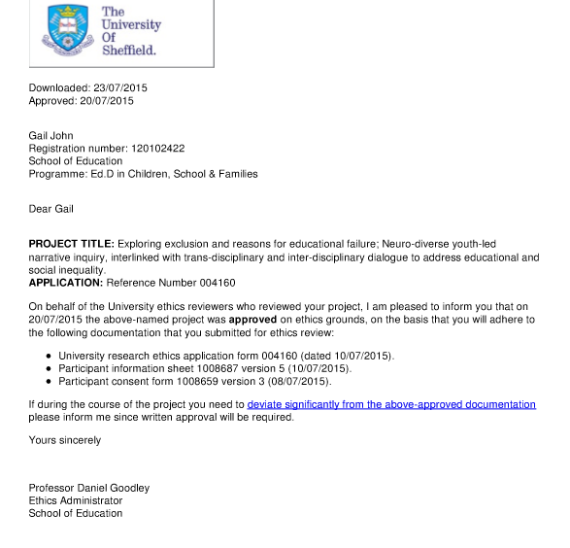

Appendix 2: Information Sheets and Consent Forms

Child Friendly Participant Information letters
Child Friendly Participant Information Sheet (Aged 10+)
1. Research Project Title:
Exploring exclusion and reasons for educational failure; Neuro-diverse youth-led narrative inquiry, interlinked with trans-disciplinary and inter-disciplinary dialogue to address educational and social inequality.
Listening to your thoughts, ideas and solutions about how the education system has failed or excludes children, based on your own experiences.

2. Invitation paragraph
You are being invited to take part in a research project.
Before you decide it is important for you to understand why the research is being done and what it will involve. Please take time to read the following information carefully and discuss it with your parents/guardians. Ask us if there is anything that is not clear or if you would like more information. Take time to decide, whether or not you wish to take part.
Thank you for reading this.
3. What is the project’s purpose?
The background of the project is to give you an opportunity to give your opinion based upon your own experiences. The aim of the project is to create a new space to listen to you, to listen to your opinions, thoughts and ideas about what it means to be educationally excluded or failed. Also, another purpose is to listen to your ideas and solutions to help improve current practice, educate the educators and influence inclusion policy.
The interview process will be about three months.
4. Why have I been chosen?
I am looking for participants who have been let down, excluded or educationally failed in one way or another. You are very important because it is your insights, observations and perceptions that are required for this research.
5. Do I have to take part?
It is up to you to decide whether-or-not, to take part. If you do decide to take part, you will be given this information sheet to keep (and be asked to sign a consent form) and you can still withdraw at any time. You will not have to give a reason.
6. What will happen to me if I take part?
You will be involved in the research by being interviewed about your experiences, opinion and insights about educational failure and the effects of exclusion. The interviews will be recorded, written down and analysed along with other participant interviews. Common themes will be analysed and drawn out. The interview will be quite relaxed, and you will be able to speak freely about your experiences and insights.
The research method that I intend to use is a Narrative Inquiry (IPA).
7. What are the possible disadvantages and risks of taking part?
There are no disadvantages, only that I have to interview you. If speaking about your experiences causes you distress, then it is OK if you do not want to take part. If you do not want to take part, you do not have to be involved in this research. You are free to say as much or as little as you wish. You can withdraw at any point during the research
8. What are the possible benefits of taking part?
You will have a chance to speak about your ideas and have your voice heard. It is hoped that this research will help to develop more inclusive educational practice and improve educational policy.
9. Will my taking part in this project be kept safe and confidential?
Yes. Everything that is said is confidential and your identity will be protected.
All participants will be asked to fill out a consent form and permission to allow restricted access to information collected about them, in the course of the project. All information collected about them will be kept strictly confidential and explain how information will be kept confidential. You will not be able to be identified in any reports or publications.
10. What will happen to the results of the research project?
You will be informed when the results of the research are likely to be published and where you can obtain a copy of the published results. You will not be identified in any report or publication.
11. Who is organising and funding the research?
I am self-funding this research.
12. Who has ethically reviewed the project?
This project has been ethically approved via the University of Sheffield’s education department’s ethics review procedure.

13. Contact for further information
The contact details of researcher and Head of School are found below:-

Lead researcher – Gail John edp12gmj@sheffield.ac.uk
Supervisor of the research – Dr Antony Williams, School of Education, The University of Sheffield, 388 Glossop Road, Sheffield S10 2JA, Tel: 0114 222 2000

14. Participant Information
All participants will be given a copy of the information sheet and a signed consent form to keep.

15. Other information
The research involves producing recorded media which will strictly only be used in this research. This will need your permission. I will not publish or broadcast the recording, show it in public, or deposit it in an archive without first requesting permission. Storage (and eventual disposal) of interview recordings which contain sensitive material will be stored in a locked cupboard at my house.
The audio and/or video recordings of your activities made during this research will be used only for analysis and for illustration in conference presentations and lectures. No other use will be made of them without your written permission, and no one outside the project will be allowed access to the original recordings.

Thank you for reading this information sheet
If you have any further questions, please do not hesitate to get in touch

G.M. John

Consent Form
Child Friendly Participant Consent Form 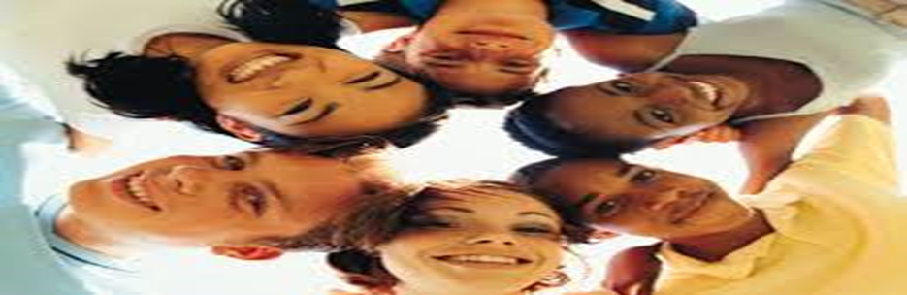
Title of Research Project:
Listening to your thoughts, ideas and solutions about how the education system currently fails or excludes children, based on your own experiences.
Exploring exclusion and reasons for educational failure; Neuro-diverse youth-led narrative inquiry, interlinked with trans-disciplinary and inter-disciplinary dialogue to address educational and social inequality.

Name of Researcher: Gail John

Participant Identification Number for this project: Please initial box
- I have read and understand the information sheet and I have had the opportunity to ask questions about the project.

- I understand that I am free to withdraw at any time without giving any reason. I am free to decline.

- I understand that my responses will be kept strictly confidential.
I give permission for members of the research team to access my
anonymised responses. I understand that my name will not be linked with the research materials, and I will not be identified in any reports that result from the research.
4. I agree for the data collected from me to be used in future research
I agree to take part in the above research project.
_______________________ ________________ ____________________
Name of Participant Date Signature
(or legal representative)
_________________________ ________________ ____________________
Name of person taking consent Date Signature
(if different from lead researcher)
To be signed and dated in presence of the participant
_________________________ ________________
Lead Researcher Date Signature
To be signed and dated in presence of the participant
Copies:
Once this has been signed by all parties the participant should receive a copy of the signed and dated participant consent form, the letter/pre-written script/information sheet and any other written information provided to the participants. A copy of the signed and dated consent form should be placed in the project’s main record (e.g. a site file), which must be kept in a secure location.

Appendix 3: Interview Schedule -Broad Interview Questions
To allow free flowing dialogue, loose, broad research questions were used during the semi-structured interviews around the core research questions:

- In what ways, if any, has your educational experience at school created barriers that have led to educational failure?
2) What have been the effects of educational failure upon your life?
3) What solutions would you suggest to policy makers to improve
their educational inclusion?

A series of open-ended questions were used to aid dynamic expansion, these included:

- Tell me about your educational experiences?

Probes- how were things at school?
What was it like for you?
What did you enjoy and what did you find difficult?
What helped? What didn’t help you?

- What were the challenges or barriers that led to educational failure?

Probes- Why was it a barrier? Any feelings?
Was there anything outside of school which impacted your learning?
What made school easier for you?
What made school more difficult?

- What could have made an important difference at this time?

Probes-were there any significant adults that helped?
What could have been put in place at this time?
Friendships? What interventions were put in place?
Was your voice heard? Were you included in decision making?

- How have these experiences impacted upon life-choices and what are the effects of educational failure upon your life?

Probes- examples of consequences. Explore their feelings,
Probe by questioning them more about what they have said.

- What solutions do you suggest and what are the implications for educationalists and policy makers?

Probe-discuss their ideas, perceptions and reasoning behind answers given.
What are the implications for professionals.

- Anything else that you think that I should know or that you would like to say but didn’t get the chance?
Appendix 4 Extract of a Transcript  Participant 1 - IPA Interview Transcript showing Steps One and Two of IPA (Smith and Osborn, 2003; Smith et al, 2009)  EMERGENT THEMES (Step 2)  Missed Assessment Opportunities  Physical illness masking emotional problems  Depression  Ineffective Learning Environment  Systematic Multi-Agency Abuse  Threats of court instead removing barriers  Identity  Forced Home-Educated  Inability to Access Education  Describes mum battling for support  Social anxiety and depression  Recognises that social anxiety was present at primary school age  Secondary school was difficult  No choice but to home-educate  Speaks about preventative solutions for children with mental illnesses or disabilities  Digital solutions, education online, different solutions for different learners,  Listening to the voice of the child. Every child matters  No solutions offered for neurodivergence  Barriers – including financial barriers which stopped access to education  Nocturnal sleeping patterns – participant connects this to chronic fatigue and symptoms of ADD | ORIGINAL TRANSCRIPT – age 14 -9843 words  I: Hello. So how old are you please? 1  P: Fourteen, at the moment. 2  I: Ok. Please could you tell me about your 3 educational and school experiences year 4 by year please? 5  P: I don’t- there’s nothing really 6 interesting, it’s all pretty normal. 7  I: OK, so how old were you when you 8 came out of school? 9  P: Eleven 10  I: OK, and what ways if any are the 11 challenges and barriers that led you to 12 coming out of school? 13  P: Um, well. I had depression. We didn’t 14 know that at first so we thought it was a 15 physical illness. but either way, I started 16 staying off a bit and um, Yeah, they 17 wouldn’t send any work home or 18 anything. Then eventually, um, I can’t 19 remember who contacted us. I think it 20 was the EWO, that they sent a letter to 21 my mum and said, if you’re not in school22 due, to all the absences or something or 23 other, something about courts and so 24 we were forced to um, what-you-call-it 25  I: Home-educate? 26  P: De-register. 27  I: Right. 28  P: So, because otherwise, if we were still 29 registered and all the absences, they 30 were threatening to take us to court or 31 whatever, so yeah we just de-registered.32  I: So, did the school at any point try to 33 help you? 34  P: Well it was kind of, just sort of come 35 back to school please, that was, we, 36 mum had to battle to try to get them to 37 send books home for me to study and 38 they wouldn’t because it was too much 39 hassle and at some point I was to talk to 40 the educational psychologist. And they 41 said, ‘yeah, yeah we will’ and then 42 nothing happened with that. They might43 have thought that I had anxiety and 44 depression or whatever, but no that 45 didn’t really happen and yeah they 46 weren’t very helpful. 47  I: Right, so when you were at school, 48 what did you enjoy and what did you 49 find difficult? 50  P: Um, I always liked English, um, maths.51 I don’t know. I don’t really know. I 52 didn’t like socialising with people kind of53 thing. I didn’t really realise then, but in 54 hindsight I realise that I had like social 55 anxiety and yeah. I didn’t really, it was 56 very stressful to try to be around people.57  I: In primary school, did you have anxiety58 at all in primary school? 59  P: I, um, in hindsight I always had social 60 anxiety, for sure. Um but I didn’t really 61 realise it. I just thought that was kind of 62 how people felt. 63  I: So how many years were you in school64 for? 65  P: Oh. 66  I: Did you come out? 67  P: I came out in year seven. At the 68 beginning of year seven. I spent like two 69 months in um, secondary quite difficult. 70  I: Did you find the transition from 71 primary to secondary quite difficult? 72  P: Not really. I quite liked it actually. 73  I: Right OK. So what do you think could 74 have made an important difference to 75 you at this time? 76  P: Um, I don’t know. No sort of 77 organisations or mainly schools have a 78 lot of like procedures in place for people79 who have mental illnesses or disabilities 80 or whatever. So I mean, even though 81 then I didn’t really realise it, they 82 weren’t, there was no - ‘maybe you 83 could do this at home.’ There was no 84 online, which would have been really 85 good for me, I think. 86  I: OK. 87  P: Cos later we tried a um, there was this88 thing called Red Balloon and its like an 89 online school and we tried to get that 90 funded later on because we thought it 91 was going to help but the council 92 wouldn’t do it, even though it would be 93 less than if I was actually going to school 94 But they said, no because it was too 95 much hassle. 96  I: So did you try that at all? 97  P: Yeah. Yeah. They were really nice 98 actually. They gave me, they gave me a 99 scholarship.They basically did it for free100 and I did that for a few months but 101 because my, my sleep pattern is weird 102 and sometimes I’m nocturnal and you 103 just can’t guarantee when I’m going to 104 be awake. So yeah. Then I had to, they 105 said they couldn’t do it anymore 106 because half the time, there were 107 teachers there doing nothing. 108 | EXPLORATORY COMMENTS- Initial notes following reading and rereading (Step 1)  Age at interview – fourteen  Fourteen, at the moment. I don’t- there’s nothing really interesting, it’s all pretty normal.  Eleven (leaving school)  Missed early interventions / assessment opportunities, no regard for child’s needs, child not listened to, lack of professional knowledge & limited expertise, unwillingness to help or learn.  I had depression. We didn’t know that at first so we thought it was a physical illness. but either way, I started staying off a bit and um,  Illness, anxiety, GAD, depression, mental health. First thing that is mentioned is depression, connects it to physical illness.  Yeah, they wouldn’t send any work home or anything. Then eventually, um, I can’t remember who contacted us. I think it was the EWO, that they sent a letter to my mum and said, if you’re not in school, um, due, to all the absences or something or other, something about courts and um,  Limited educational provision, not meeting personalised learning need, lack of provision, no digital resource. Systematic abuse, court and legal threats,  so we were forced to um, what-you-call-it.. De-register…So because otherwise, if we were still registered and all the absences, they were threatening to take us to court or whatever, so yeah we just de-registered.  Later fabricated social services allegations used to silence/control and as a scapegoat tactic not to provide effective educational provision.  The ‘word’ battle is used. Participant 5 also uses the word ‘battle’ to also describe how ‘mum’ had also tried and failed to get educational assessments in place.  Professional bullying and control resulting in fear, child internalising fear, anger, powerlessness and anger,  Well it was kind of, just sort of come back to school please, that was, we, mum had to battle to try to get them to send books home for me to study and they wouldn’t because it was too much hassle and at some point I was to talk to the educational psychologist. And they said, ‘yeah, yeah we will’ and then nothing happened with that.  Not listening to child or their primary need. Having no regard for codes of conduct/ policies.  They might have thought that I had anxiety and depression or whatever, but no that didn’t really happen and yeah they weren’t very helpful…I didn’t like socialising with people kind of thing. I didn’t really realise then, but in hindsight I realise that I had like social anxiety and yeah. I didn’t really, it was very stressful to try to be around people.  This participant did not realise that other people did not feel anxious all the time. It was this respondent’s ‘normal’ experience.  In hindsight I always had social anxiety, for sure. Um but I didn’t really realise it. I just thought that was kind of how people felt…I came out in year seven. At the beginning of year seven. I spent like two months in um, secondary quite difficult.  No choice but to home-educate, recovery from trauma, socially isolated, supportive parent, financial implication  No sort of organisations or mainly schools have a lot of like procedures in place for people who have mental illnesses or disabilities or whatever. So I mean, even though then I didn’t really realise it, they weren’t, there was no - ‘maybe you could do this at home.’ There was no online, which would have been really good for me, I think.  Missed assessments, anxiety went unnoticed by those at school. Infers that anxiety was interpreted as with-drawl and moodiness. Later we tried… an online school and we tried to get that funded later on because we thought it was going to help but the council wouldn’t do it, even though it would be less than if I was actually going to school. But they said, no because it was too much hassle.  This participant mentions about sleeping patterns not being in ‘normal’ range -mentions that sometimes is nocturnal.  I did that for a few months but because my, my sleep pattern is weird and sometimes I’m nocturnal and you just can’t guarantee when I’m going to be awake. So yeah. Then I had to, they said they couldn’t do it anymore because half the time, there were teachers there doing nothing. When questioned about alternatives, states there were not effective alternatives to suit needs. Makes the connection of sleep differences to chronic fatigue. Describes ‘lightbulb’ moment regarding social anxiety symptoms and connects these to ADHD/ADD symptoms. Much evidence of missed opportunities to assess child’s need.

Appendix 5: Example of Identifiers with Instances of Direct Quotations
Superordinate Themes | Direct Quotations
ACEs and Trauma | - ACEs High  “I’ve witnessed my good fair share of trauma.” (L6: 1034-1035)  “My father was a registered paedophile… My father when I was younger, he used to pretend to faint all the time, so much so that you know the operator on the phone, she would know me my name when I’d ring up She’d be alright, keep calm, we’ve got an ambulance on the way. I’d be ringing them twice three times a week. You know they knew my name and that. I mean I was only a +++, I mean I was only four or five. But it got to the point where the local authority stopped trusting. I mean they’d always send the ambulance and stuff but after that because they’d recorded my name. But then worse things happened and stuff because the things that happened got a bit more extreme than what I said on the phone to the operator, they stopped believing me. They thought, oh ++++ making it up” (L: 936-962)  “A lot of stuff, happened to me as a kid, like abuse, child abuse and stuff in school.” (S: 15-17)  B: At GCSE I was so traumatised and so freaked out in my head that I couldn’t even finish my coursework. I couldn’t even, barely write a sentence.  I: So, would you say trauma became a barrier to your learning?  B: Yes.  I: Was it trauma or was it fear?  B: Both... I think trauma and fear are pretty much the same thing. Trauma you know is caused by fear and fear is caused by trauma”. (B: 873-890)  “I was just really fearful and stressed pretty much all the time and I had nobody I could really talk to about it.” (M: 264-267)  “I think they perceived me as an over reactor but then they did not know the fear that the other kids were making me feel.” (M: 656-659)  “I really felt that my education suffered. I was living constantly under fear”. (M: 600-602)  ‘Because I was telling the social services, the boy in foster care raped me or touched me… it went back to my carers, and you know it’s all meant to be confidential, isn’t it? What you say here goes no further, it went back to my carers and I was called a complete liar. And I was abused for that. I was hit for it’. (L: 962-972)  ‘When you are nine/ten and someone’s hurting, raping you – you don’t know there’s anything wrong with it or if, you know, I tried telling social services that things were happening at the house and they called me a liar. They told me I was a compulsive liar.’ (L: 425-432)  ‘‘Social services… decided to call me a compulsive liar and stuff like that, when I brought up my issues like the rape… they decided to call me a compulsive liar… even the teachers done it. They were, oh you’re just making it up now, tall tales’ (L: 649-660)  “I was completely emotional. I was crying all the time. I couldn’t focus. And when I was telling people about -, then they were calling me liar and stuff like that, teachers, social services, local authority”’. (L: 928-934)  I’d been put through the foster care system because I had to be taken off my mother and quite often before I was taken into foster care, my clothes were quite smelly because my mother wasn’t washing them.’ (L: 29-34)  “I have had some traumatic family events and life circumstances but so much of my fear of other people has come from school, so much of my feeling that I can’t succeed, even though I know I’ve got a brain that I could. I’ve got potential but it’s like an inaccessible impossible thing to grab hold of. But I need to but I just can’t seem to do it. I feel like sometimes being stuck in a hamster wheel.” (M: 923-934)  “I had traumatic family events going on and there was no counselling offered or support. On top of it, I was getting bullied”’ (M: 401- 408)  “I mean I got moved to multiple homes, I’ve been to probably six or seven different homes in my time, my short-time, my short little life. I mean, in one of them, I was abused terribly, I was probably better off being at home with a mother who would abuse me and a father who was a paedophile”. (L;359-367)  “I missed so much time in school and it was in my GCSE year, I moved out of my father’s house with my mother and brother. And so home life was quite traumatic as well, and there was nobody I could talk to about it. There was no real support given. The school didn’t really know.” (M: 558-565)  - Intergenerational Trauma  “I was being abused at home by my grandad and none of the school picked up on any of that, and um, and things happened with other girls. Well, two other girls that were in my class. We used to do things in the toilet because it was being done to us at home and we used to act out then, what was being done to us at home”. (S: 22-30)  “If a child has been sexually abused as a kid because there are symptoms. And there are ways that a child that’s been touched will act out differently to a child that hasn’t been touched and you’ve got to be aware of these kind of actions, because you know people don’t just act like that unless maybe something has happened or they’ve been opened-up or they’ve seen something…it does lead a child onto a different path” (S: 191-214)  ‘Home wasn’t very good’. (S: 191)  ‘I had no father’. (S: 194)  ‘I was being abused at home, by my grandad.” (S:22-23)  “I became very promiscuous as a young child because of sexual abuse.” (S:45- 47)  “There was zero awareness of the fact there’d been a history of mental illness in my family and then I was getting called paranoid.” (M: 613-616)  ‘There’s been a history of mental illness in my family and my grandfather committed suicide because he had paranoia because he had paranoid schizophrenia and so I was aware of this growing up. I would walk through school and this boy used to encourage other children to skip around me and shout ‘paranoid’ at me. Wherever I’d go down corridors, other kids would trip me up and this hatred started around the start of year seven’. (M: 148-156)  “I was basically walking home, and totally out of the blue, this boy [same boy who led a bullying campaign against her regarding her traumatic family history] came up behind me and sexually assaulted me. And he basically tried to penetrate me with his finger outside school and I was absolutely freaked out, totally frightened, trying to get away from him and his friend who had been put on an offenders’ register.’ (M: 311- 319)  “This boy was with the boy who bullied me for years and he was shouting, ‘oh he wants to shag you, he wants to shag you… I was fourteen. I’m pretty sure I was fourteen. And so, I went home and I was totally besides myself... because that’s a really embarrassing shameful thing to happen. It didn’t happen because he liked me, it was victimisation and it was so humiliating. And I went home and I was sick. I was vomiting, totally frightened.” (M: 336-350)  “They should make policies against bullying, and especially against people who are adopted [have suffered losses connected to intergenerational trauma], because they have things against them [are predisposed/have a greater susceptibility to develop PTSD when confronted with major stressors] and they should protect them.” (R: 136-140).  “There are millions of other cases out there where [foster] children have been abused, beaten or mistreated or neglected in their placements where they are better off being at their homes than they are at foster care...There’s cases documented every day, but their voices are hardly ever heard.” (L:993-1001)

Appendix 6: ACE Scoring Sheet

- Before your 18th birthday, did a parent or other adult in the household often or very often…swear at you, insult you, put you down, or humiliate you? Or act in a way that made you afraid that you might be physically hurt?

- Before your 18th birthday, did a parent or other adult in the household often or very often…push, grab, slap, or throw something at you? Or ever hit you so hard that you had marks or were injured?

- Before your 18th birthday, did an adult or person at least five years older than you ever…touch or fondle you or have you touch their body in a sexual way? Or attempt or have oral, anal, or vaginal intercourse with you?

- Before your eighteenth birthday, did you often or very often feel that…no one in your family loved you or thought you were important or special? Or your family didn’t look out for each other, feel close to each other, or support each other?

- Before your 18th birthday, did you often or very often feel that…you didn’t have enough to eat, had to wear dirty clothes, and had no one to protect you? Or your parents were too drunk or high to take care of you or take you to the doctor if you needed it?

- Before your 18th birthday, was a biological parent ever lost to you through divorce, abandonment, or other reason?

- Before your 18th birthday, was your mother or stepmother: often or very often pushed, grabbed, slapped, or had something thrown at her? Or sometimes, often, or very often kicked, bitten, hit with a fist, or hit with something hard? Or ever repeatedly hit over at least a few minutes or threatened with a gun or knife?

- Before your 18th birthday, did you live with anyone who was a problem drinker or alcoholic, or who used street drugs?

- Before your 18th birthday, was a household member depressed or mentally ill, or did a household member attempt suicide?

- Before your 18th birthday, did a household member go to prison?

Appendix 7: Intergenerational Trauma Histories

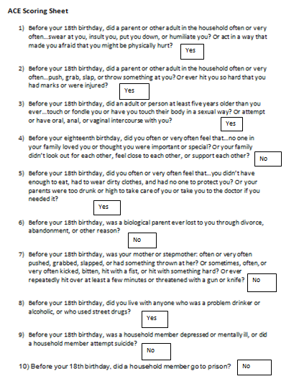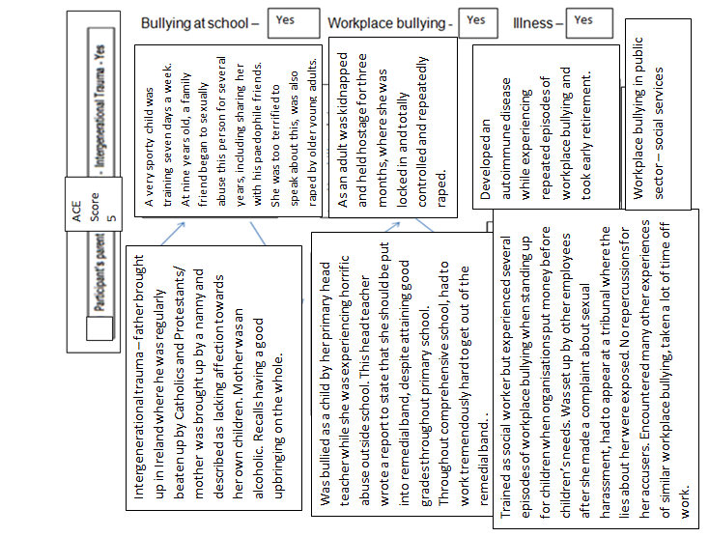

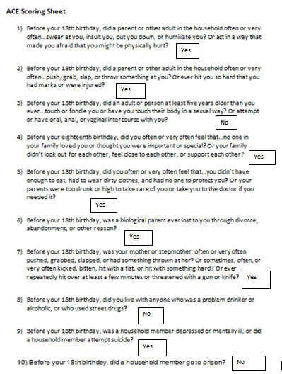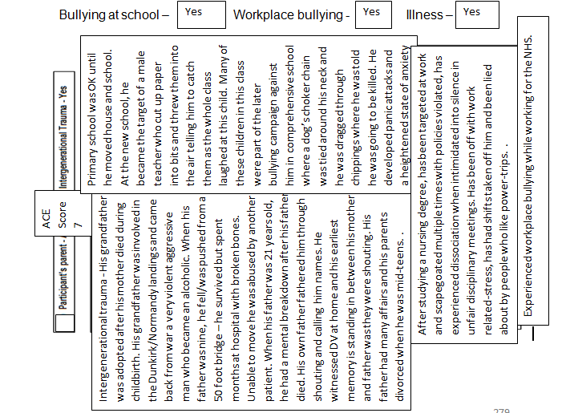

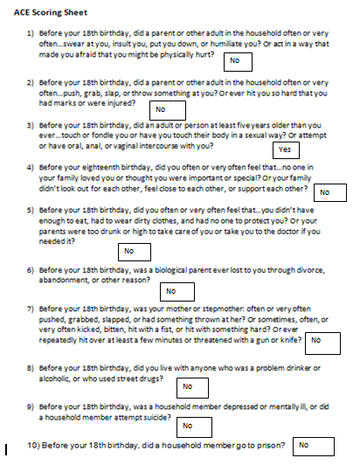
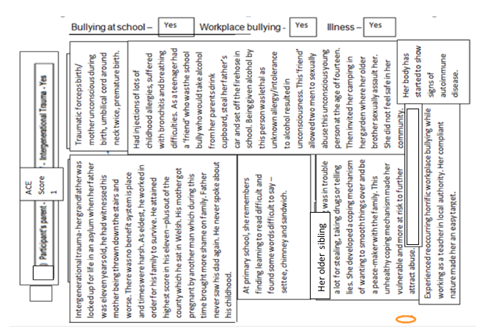
Symptoms similar to ADHD

Appendix 8: The Blank Language Assessment and the Communication Cycle

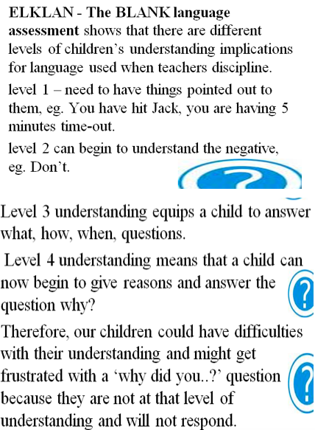

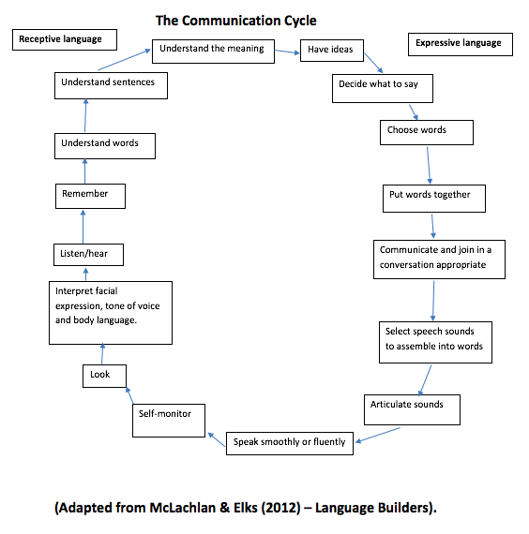

Appendix 9: Statistics Relating to Swansea (ABMU) and Wales

Research evidence from Bellis’ ACE comparable study (2013, 2015, 2017)
 | England (4+ ACEs)10% | Wales (4+ ACEs) 14% | My IPA study  (5 children/ 7 adults)
Heath Harming Behaviours:
Violence | 7 times more likely | 15 times more likely | 1 adult out of 7
Using crack cocaine/heroin | 11 times more likely | 16 times more likely | 2 adults out of 7
Develop  a chronic disease, such as type 2 diabetes,  heart and respiratory disease, and cancer, | Twice as likely as those with no ACEs  40% of developing these conditions by age 59. |  | Not known as none of the participants had reached 59.
Exposure to ACEs in childhood
Exposure to childhood verbal abuse | 18% | 23% | 100%  (school/systems)
Parental separation | 24% | 20% | 8 out of 12
Physical abuse | 15% | 17% | 7 out of 12  (at school)
Domestic violence | 13% | 16% | 3 out of 12
Mental illness | 12% | 14% | 7 out of 12
Alcohol abuse | 10% | 14% | 0 out of 12
Sexual abuse | 6% | 10% | 6 out of 12
 |  |  | 3 out of 12 (at school)
 |  |  | 2 out of 12 (at home)
 |  |  | 1 out of 12 (community)
Health Service Usage
Frequently visit GP | Twice as likely |  | No data (researcher was asked to attend GP appointments with three of participants due to them having confidence issues)
Attended A&E or  stayed overnight in hospital | Three times more likely |  | No data

The Basic Skills Agency undertook a survey of the literacy and numeracy standards of adults living in Wales.
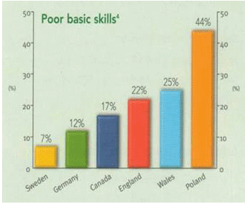
Source: International Adult Literacy Survey ONS 1997 in Basic Skills Agency The extent of the problem (2001)

Basic skills
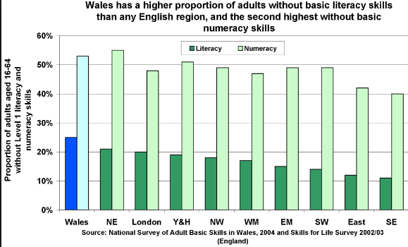

Source: Baseline data for CCET statement of need 2002 CESI/ELW

PISA Test Scores 2015
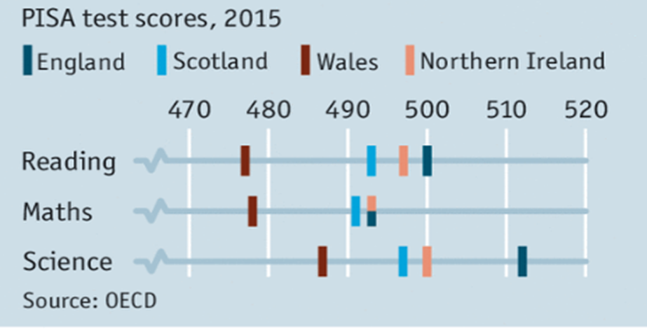
Economist: The struggle to improve the worst education system in Britain; Poverty is only one explanation for bad test results in Wales

Swansea homelessness data (2011) revealed that Swansea had the highest numbers for homelessness across the 22 Welsh local authorities. Swansea (AMBU) also has the highest figures for problematic drug use suicide, drug related deaths and informal admissions to psychiatric hospitals in Wales.
• Abertawe is the Welsh name for Swansea
• ABMU stands for (Abertawe Bro Morgannwg University)

Homelessness problem in Wales across the 22 local authorities

Drug misuse related deaths in Wales by Health Board 2011
Independent statistics in Swansea reported that in 2009, Swansea drug agencies reported 180% rise in heroin use and addiction in Swansea, documenting that the drug increase was ‘visible on the city’s streets’. (Swansea Love Story, 2009).
Estimated rates of problematic drug use per 1,000 (aged 15-64) by Health board area of residence in Wales 2009-2010..
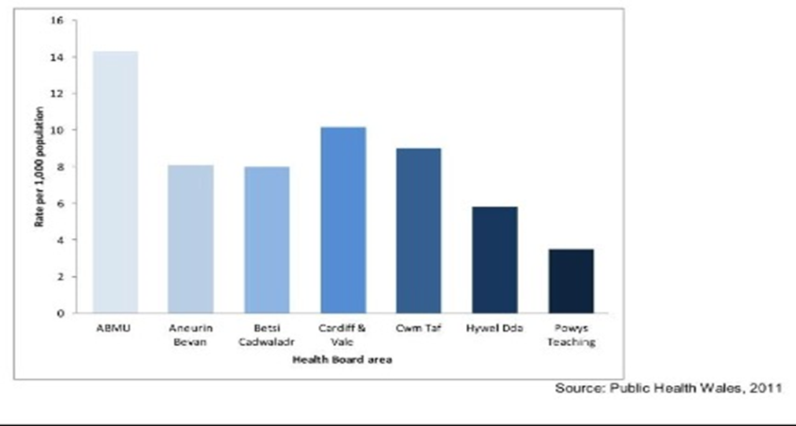

Mortality from suicide*, all persons, all ages, Health Board areas 2006-2010. European age-standardised rate (EASR) per 100,00 with 95% confidence intervals.
ABMU (Swansea Health Board) also has the highest numbers for informal admissions to psychiatrist hospitals in 2011-12. It is important to note that ‘Informal’ admissions are patients who voluntary agree to seek help from psychiatric hospitals due to experiencing severe symptoms of mental health difficulties or psychosis.

Admissions by Local Health Board and Independent Hospitals 2011-12

Swansea Prison Population Summary 2014.
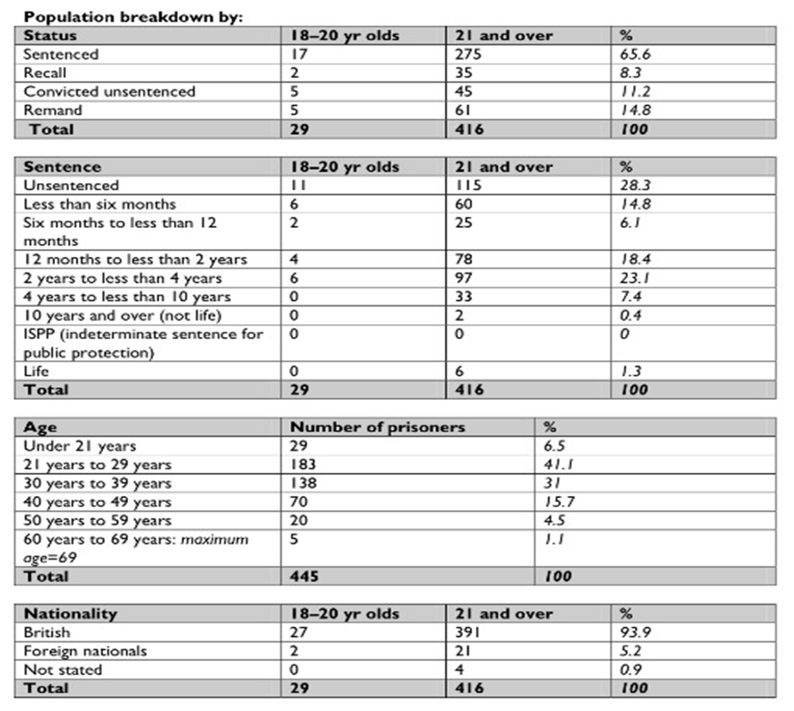

Looked After Children in Swansea Compared to the National Average
Number of pupils aged 15 leaving full time education without a recognised qualification.
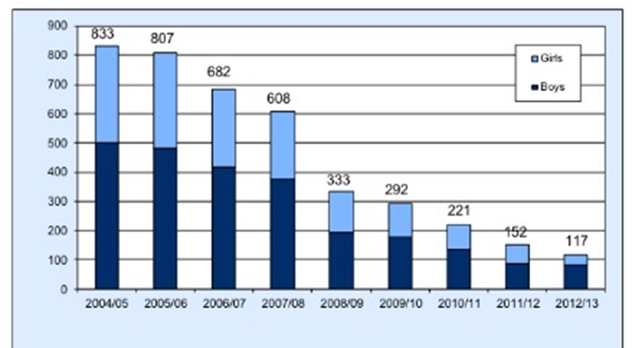

Pupils aged 15 leaving full-time education without a recognised qualification 2007/08

Pupils aged 15 leaving full-time education without a recognised qualification 2008/09
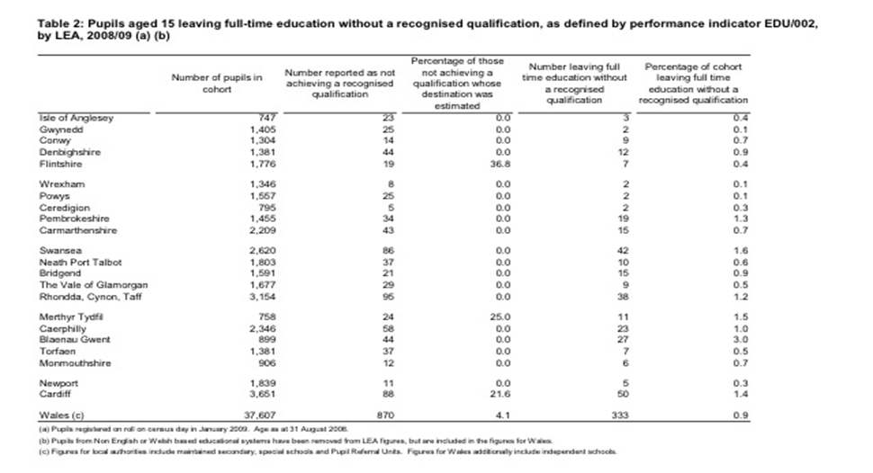
Percentage of working adults in Wales with basic skills difficulties
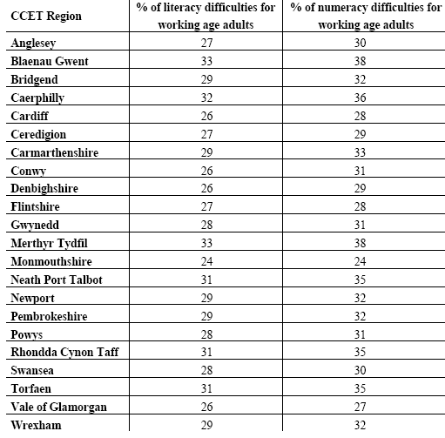
Thus, this official quantitative data provides a crucial backdrop to my qualitative narrative research and is one of the primary reasons for my choice of using IPA. Since phenomenological analysis will enable the researcher to gain insight into the lived experiences of individuals, so it is fitting for a study of social issues such as exclusion because it will allow a gathering of rich data about individual experiences.

Home-Education in the UK
:Wales: The Highest Proportion of Home-Educated Children in the UK
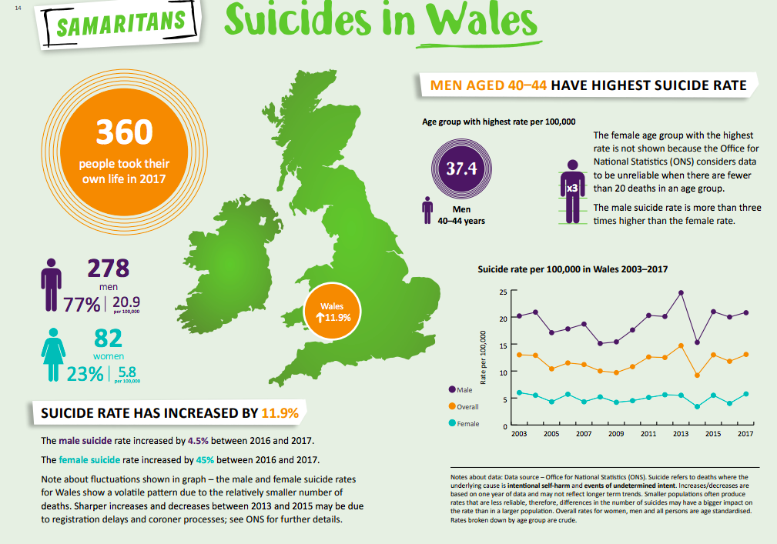

Appendix 10: Perspective of a Plastics Doctor - Self-Harm in Swansea compared with other Local Hospitals in South Wales Region
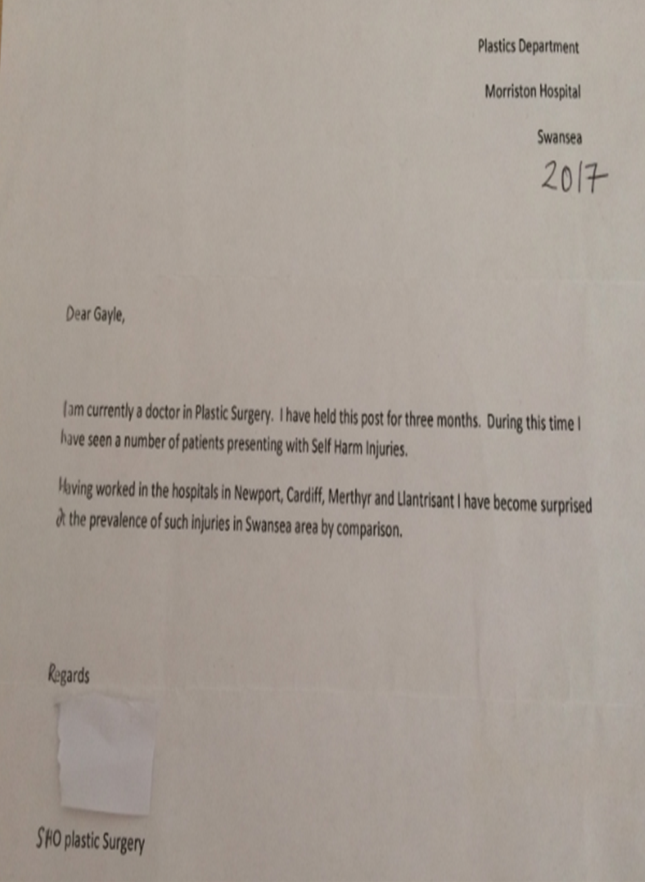

Appendix 11: Public Domain Media Reports
Criminal Justice
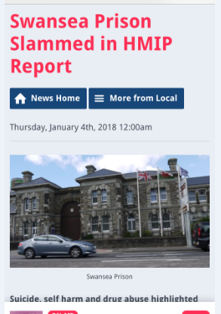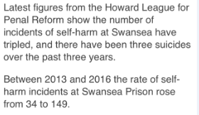
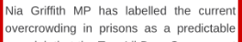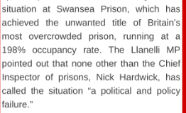
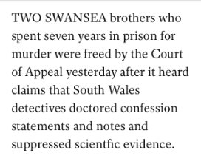
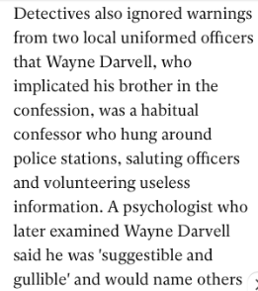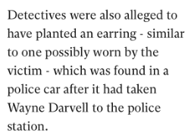

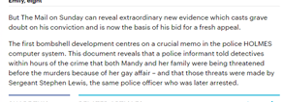
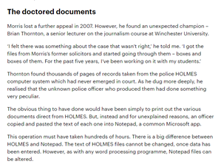aa
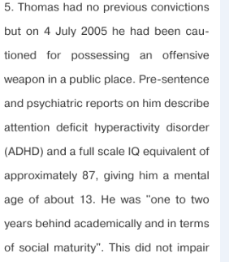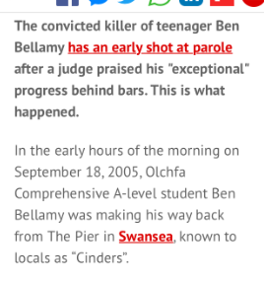
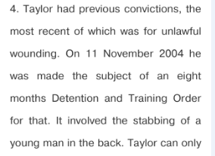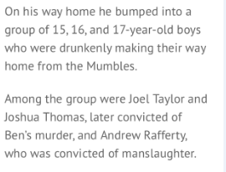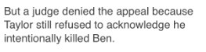

Substance Misuse

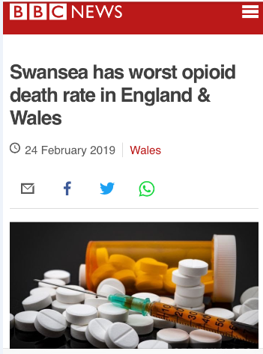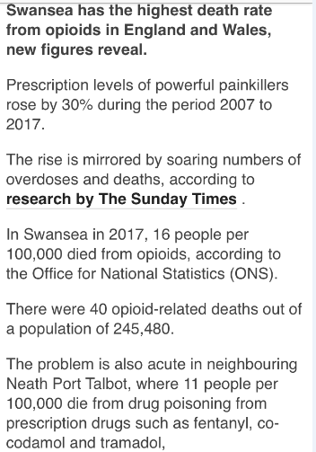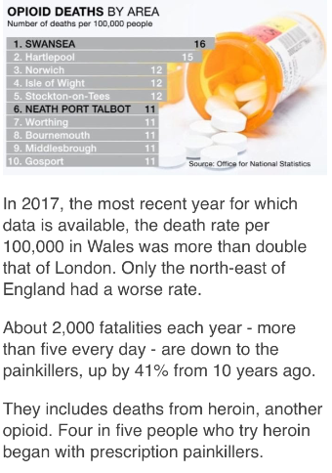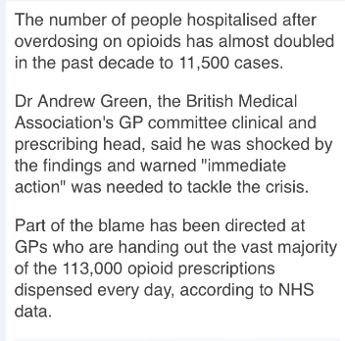

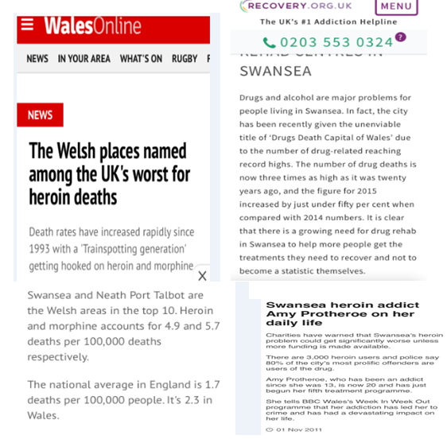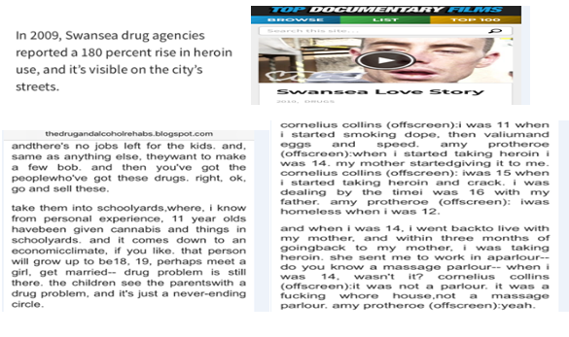

Public Servants’ Abuse (ABMU/Swansea LA controlled Schools/Family Court) Allegations of Sexual Abuse, Financial Abuse and/or Inappropriate Behaviour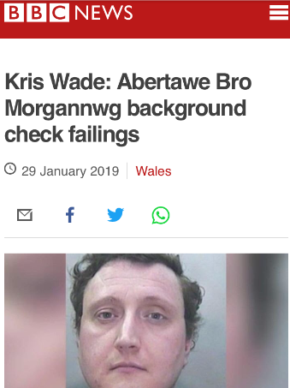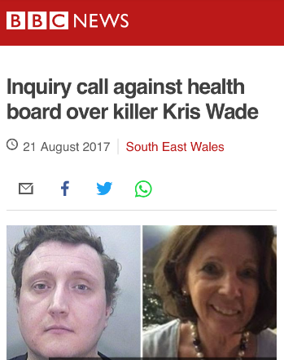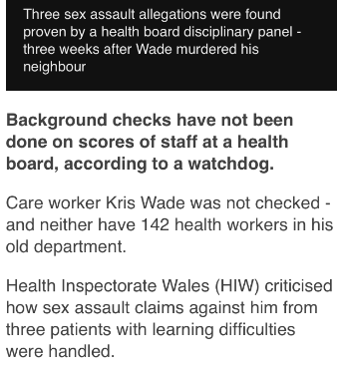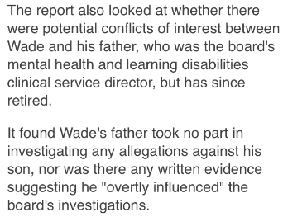

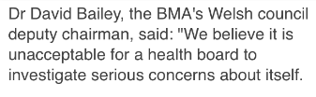

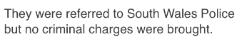

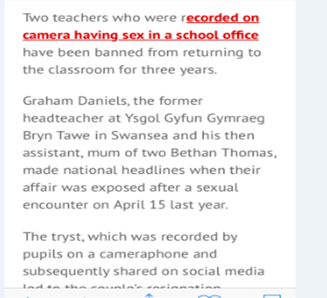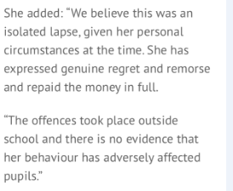
Evidence of LACK OF ACCOUNTABILITY: This teacher was caught in 2007, yet it took over seven years before she appeared before GTCW IN DECEMBER 2014, OVER FIVE YEARS AFTER she APPEARING IN COURT & admitted three counts of fraud
GTCW decided to give a three-year ban from teaching
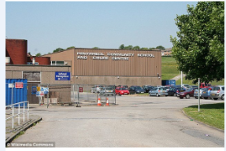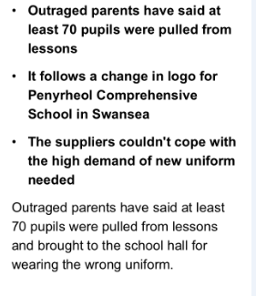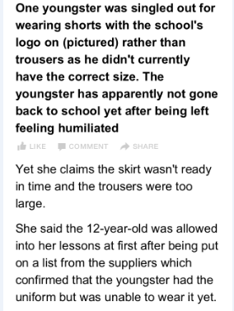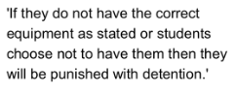
This recent financial exploitation scandal over overly priced expensive school uniforms being made compulsory for children to buy made national news, as the school only gave their logo to only two shops, one which is run by one of the teachers’ family business. This business is located outside Swansea in Carmarthenshire, so it is not a local business to the school. While local business UK Leisure, only 1.2 miles away from the school was not given equal opportunity to use the school logo and was denied equal opportunity to sell these uniforms to the local children. Incidentally, two of the key gatekeepers at this school were also part of another governing body that previously withheld valuable evidence surrounding financial exploitation and fraud, as this governing body wilfully covered up a teacher’s fraud and crime which was committed 2005-2007 from coming to the attention of regulatory bodies. Shameful behaviour! (Change.org, 2018)

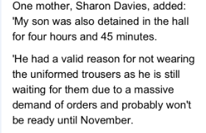
Clearly, as Shield (2006) warns, “In the frequent absence of benign leadership and knowledgeable management, neglect, perversion and compulsion could come to dominate.” (Shield, 2006, p.33)

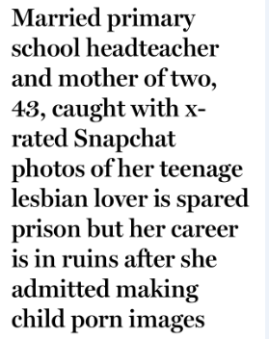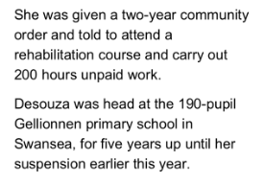
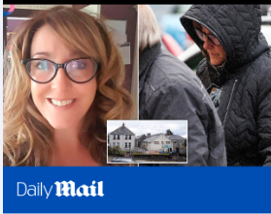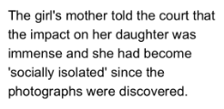
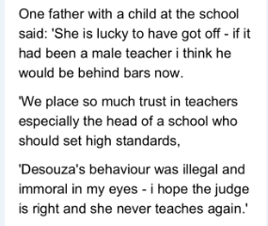
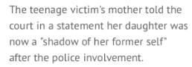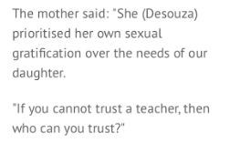
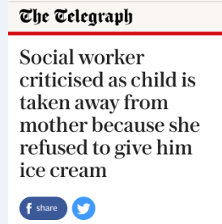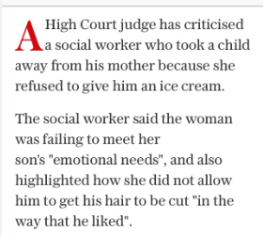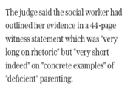

Premature Deaths/Suicides
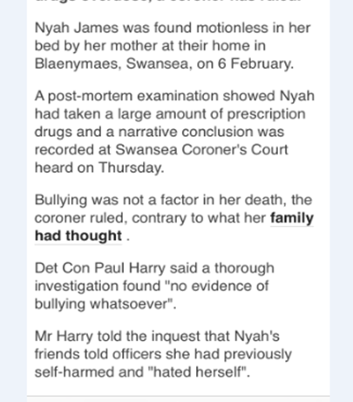

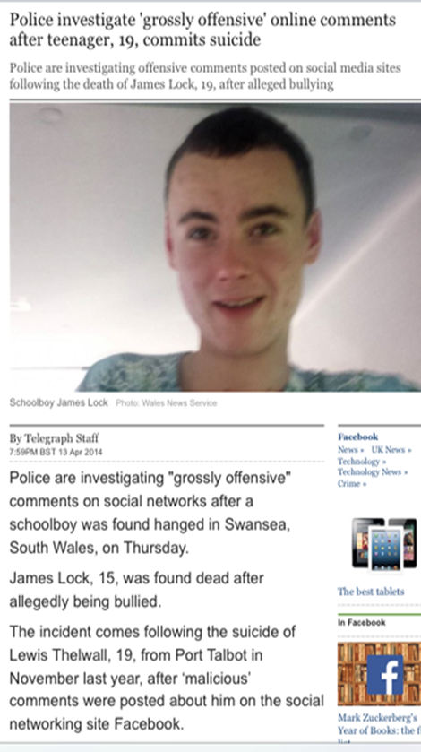

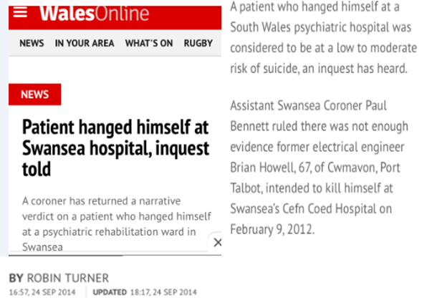

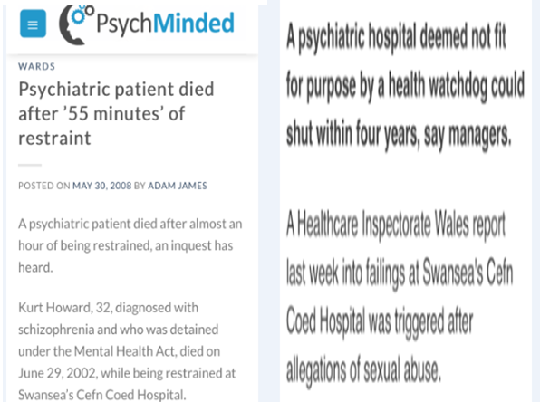

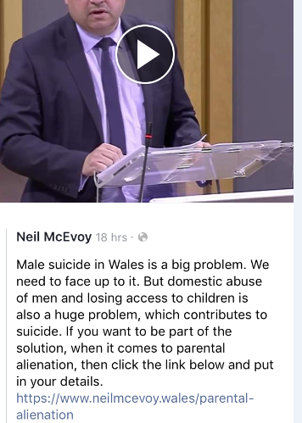

Appendix 12: Reflexive Extracts

Intergenerational trauma
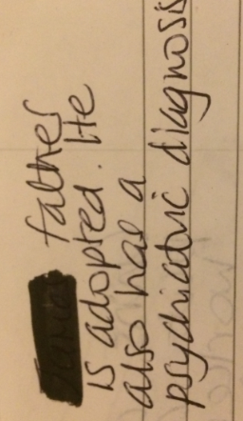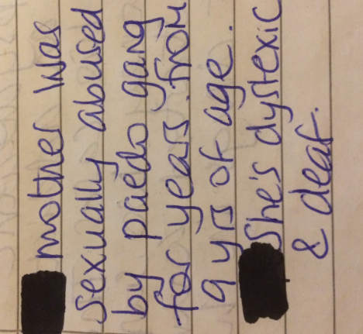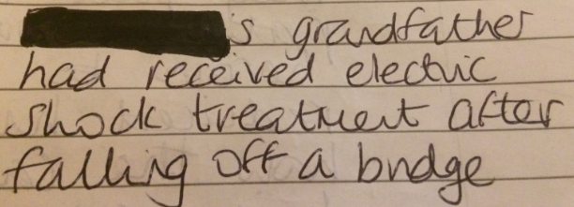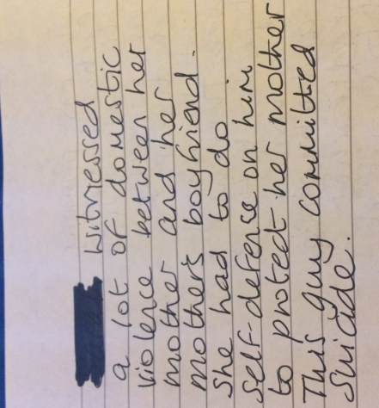
Teacher bullying
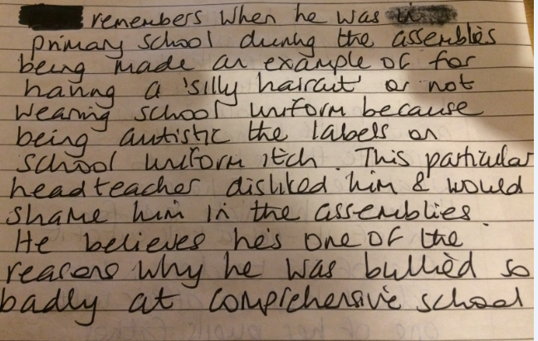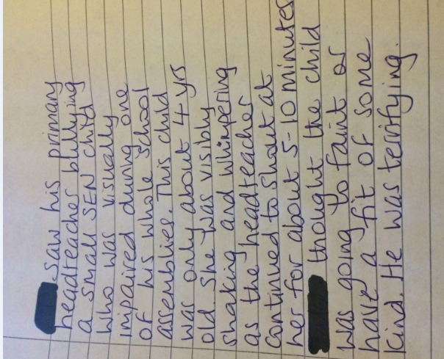
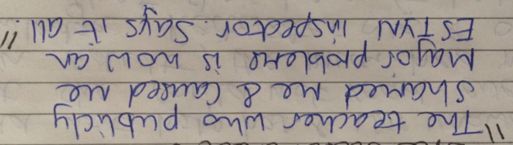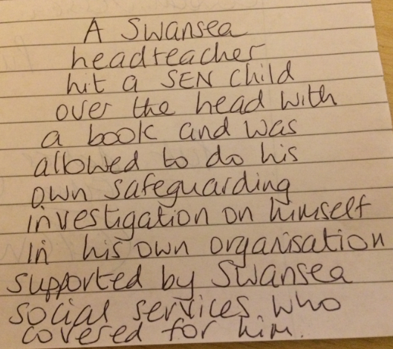

Harmful Mental Health Practice

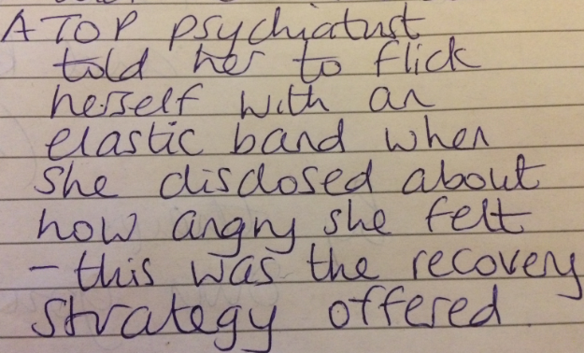

Systematic Abuse

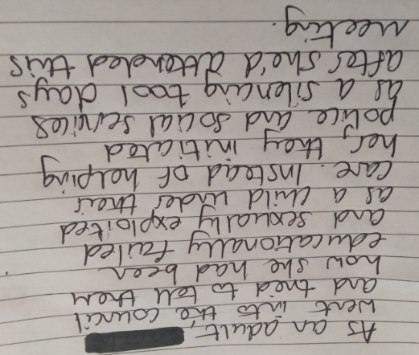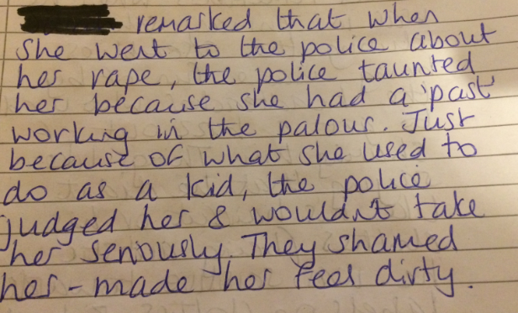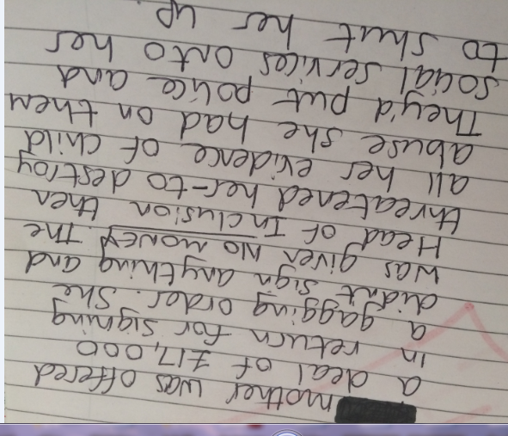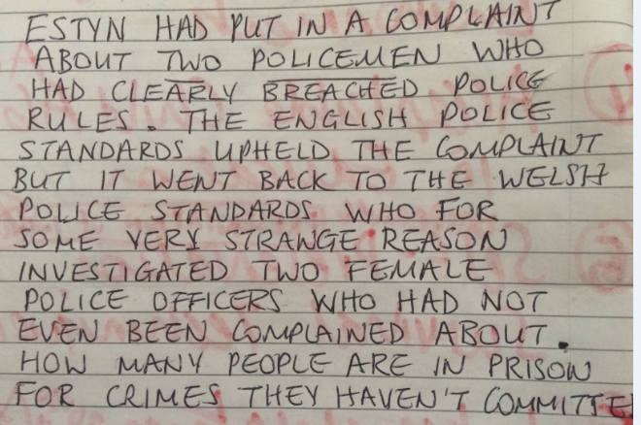

Appendix 13: Perspective of an ABMU Patient – Birth Trauma and Lack of Trauma Informed Practice. (John, 2018)

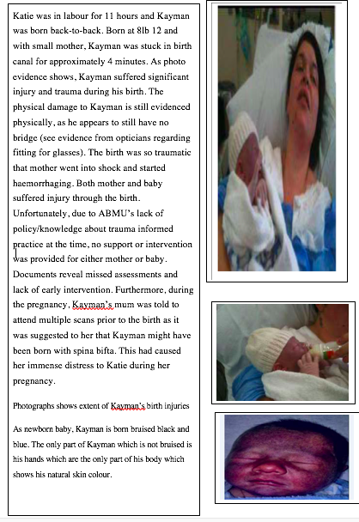
Mother and baby were discharged just 6 hours after this distressing birth where both mother and baby experienced shock.
Social services later misinterpreted baby’s birth trauma symptoms as evidence of child abuse and this child was removed from mum. Unfortunately, the lack of trauma informed practise across all Welsh public sectors (NHS, social services and education) continues to dominate, causing irreparable harm to both children and their families.

Appendix 14: Speke (2018) Insider Research 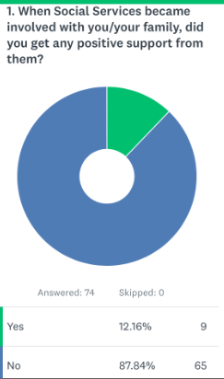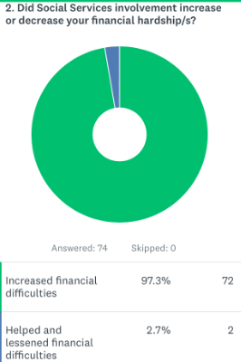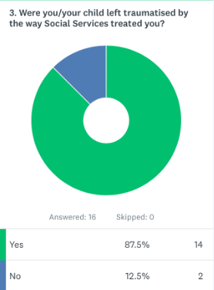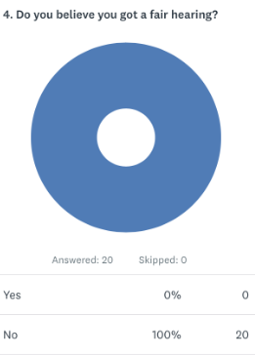
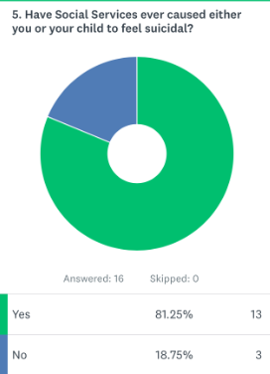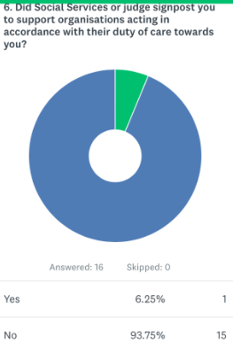

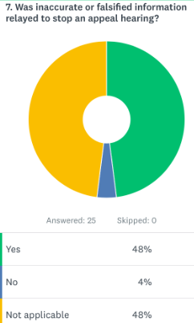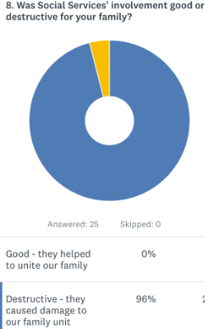

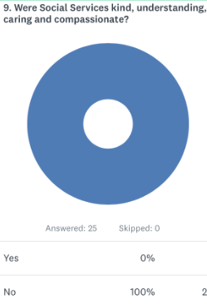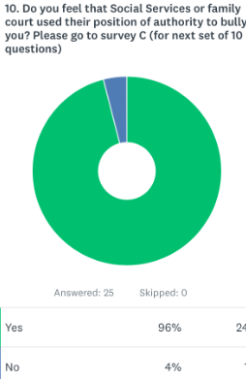

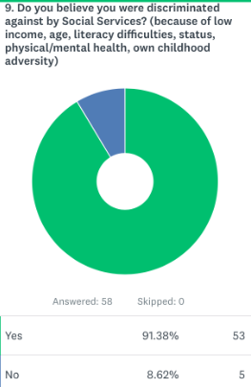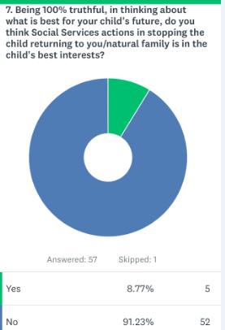

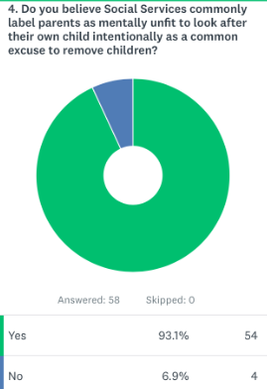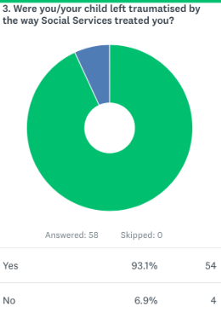

Written responses

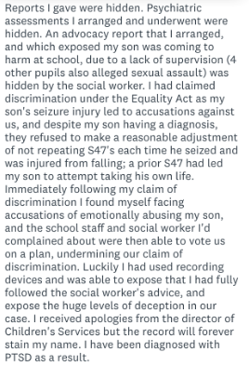

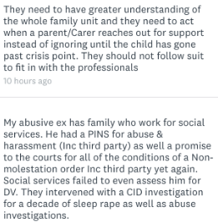

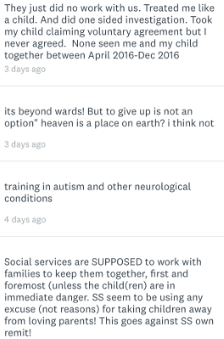

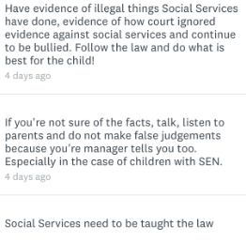

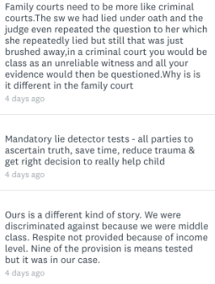

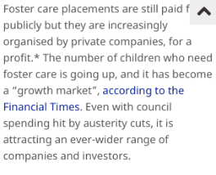

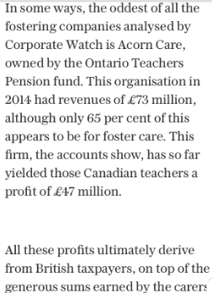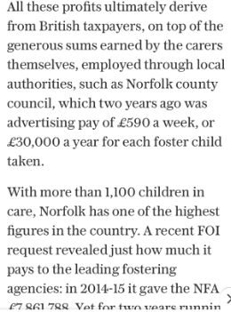

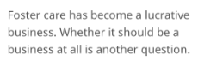

Appendix 15: Evidence of a Nationwide Problem

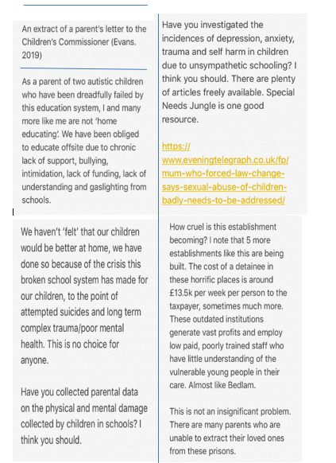

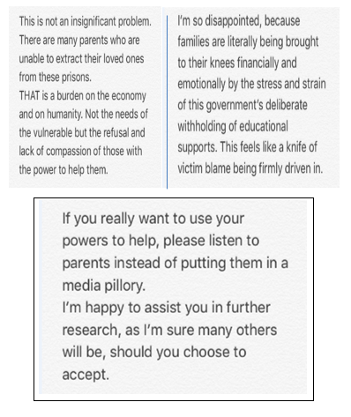

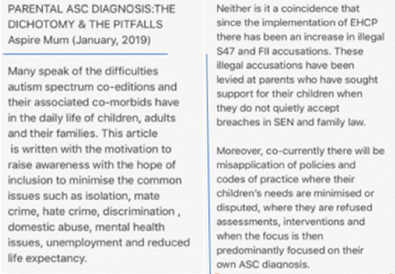

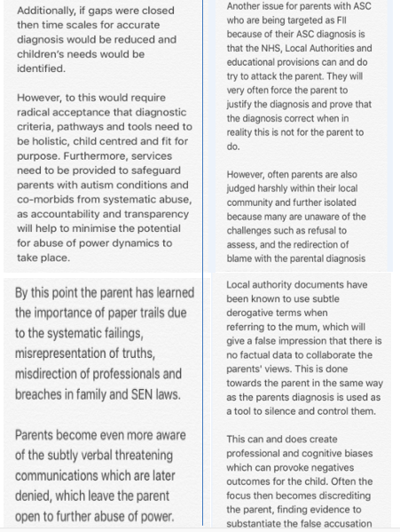

Appendix 16: Reflexive Boxes – A Few Reflections - Engaging with the Locality, National Data and Local People

Reflexive Box – Life Inside a Psychiatric Hospital – Worse coming out, than going In
Just prior to starting this doctorate, I was privileged to visit a friend’s son at a psychiatric hospital in 2012 and whilst there built good relationships with many of the other people in there. As my family and I took in cakes, boxes of crisps, KFC, pick and mix sweets, put on a twenty-first and twenty-second birthday parties, played cards and other games and generally spent time with these people. As a school SENCO at this time, what struck me was the similarity between them and the behaviours exhibited by some of the additional learning needs children within my classes, including speech, language and communication difficulties, social anxieties and meltdowns when these needs were not recognised or accommodated by psychiatric staff. One day I witnessed, one patient having a meltdown because a van had parked on a double yellow line and it was against the rules. Instead of communicating with this patient, the staff nurse brushed off his concern as unimportant. However, within a very short time-period, that patient became uncontrollable and received an injection to calm him down. This patient presented as typical ASD, having specific knowledge about a specialist topic, yet difficulty with conversation and rigidity of thought about certain topics. I told him I worked with ASD children and he self-reflected that the characteristics of ASD sounded like him, yet he had never heard of it before. Lobregt (2016, p.S669) has found that due to ‘diagnostic overshadowing’ symptoms between ASD and PTSD, clinicians can sometimes misinterpret symptoms attributed to ASD, when they are ‘manifestations of stress reactions related to perceived traumatic events’. Many of the patients disclosed they were bullied when they were in school, one recalled being publicly humiliated in front of the class when he was in infant school. However, I also witnessed that not many of these patients engaged with the day-time therapies because they wanted to make sure they slept during the day to ensure they were awake during the night as there was less safe about and they felt more vulnerable and unsafe. When a quite a few of the patients were discharged into the community, I drove several of them to access therapies such as Hearing Voices, Mindfulness and Talk Therapies. I also suggested setting up a shared reading group with their care managers, but no one was interested or wanted to engage. Additionally, I think I got more out of the mindfulness activities than those I took there as some of them did not fully engage. I wondered why this was so and believe it was because a few of them had unresolved, unprocessed trauma which made them extremely hypervigilant and stopped them wanting to even look at it. This excess energy acted like a coping, avoidance mechanism. Additionally, because of trust issues, individuals with trauma will not disclose their trauma and root issues without firstly knowing if the care professional or respondent can be trusted with the information, will listen to them, reject them, believe them, understand their pain, empathise, criticise or if they will use their pain against them at a much later date. Therefore, after walking alongside several individuals with severe mental health diagnosis and being allowed into their ‘circle of trust’ for seven years, observing current therapies, side-effects of multiple drugs and the way they have been spoken to by care professionals, I personally believe there should be more widespread knowledge of how individuals can access private, personal safe methods to process their trauma themselves and bypass professionals who may be perceived as a threat, due to past lack of empathy or demonstrating that they cannot be trusted with a self-disclosure (Ha et al, 2017). This is why it is so important to empower others with personal private recovery methods which instead of subtracting from them, empower them to ‘own’ their own recovery.

Reflexive Box –An Initial Look at Data -Left with more questions than answers
A Swansea homeless teenager at a psychiatric hospital painted a rather thought-provoking picture. This youngster just happened to mention that he finished school early before sitting his GCSEs. He elaborated by explaining that instead of sitting his GCSEs in 2009, he and his ‘high needs’ friends were informed by the authorities that they could just leave school months earlier before sitting their GCSEs, without getting into ‘any trouble’ or suffering any repercussions. Therefore, when this person was just fifteen, he left school along with his ‘high needs’ group of friends, without any qualifications. This homeless youngster, like many, had many overlapping problems. He had a drug problem and had admitted himself into the psychiatric hospital. He explained how he had suffered with mental health difficulties and struggled with reading and writing tendencies at school, though he didn’t have a diagnosis. He was also known to the police. Stories like these ‘stayed with me’ and profoundly challenged my thinking. It also extended my short-term vision for the children who I taught. I vowed that I would do all I could to ensure that I would carefully consider the long-term impact of any decisions regarding the children in my care, to consider that misjudgements had the potential to damage not only the children’s current lives, but their future as adults.
In 2013, I was so concerned by my initial observations of social poverty across systems that I raised these concerns with Swansea Council and WAG.
Reply from Swansea Council – 30th July, 2013.
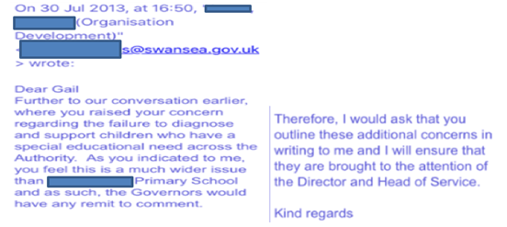
When I initially highlighted the issues regarding ‘a failure to diagnose and support children across the authority’ of Swansea to Swansea Council in 2013, I had no knowledge of ACEs. I began to search out the official statistics connected to these painful stories and these statistics then formed the springboard for my IPA narrative research. I found that in 2009, Welsh Government educational statistics showed the number of pupils leaving schools without a recognisable qualification successfully plummeted from 603 to 333. Welsh Assembly Government data showed the notable sharp decline in the numbers of youngsters leaving schools without any recognisable qualifications between end of school year 2008 (2007/08) and 2009 (2008/09).

As I delved more deeply into data gathering, I found that in 2009, drug agencies in the city had reported a dramatic increase in drug usage by 180% (Swansea Drug Agencies, 2009). Swansea’s individual data also showed a similar marked plunging downward shift from between the numbers of their pupils leaving without a recognisable qualification. Swansea figures illustrated that in 2007/08 out of 2800 children, 111 pupils were reported as not achieving a recognised qualification, whereas the actual number leaving full-time education without a recognised qualification was 75.
It was reported that 2.7% of the cohort left school without a recognised qualification. A year later, in 2008/09 out of 2620 children, 86 pupils were reported as not achieving a recognised qualification, whereas the actual Moreover, substantial quantitative data began to show other major gaps and unsustainable pressure across the need for psychiatric support, criminal justice, social services and education number leaving full-time education without a recognised qualification was 42. It was reported that 1.6% of the cohort left school without a recognised qualification. The question remained, what happened to the discrepancy of the 36 Swansea children identified in 2007/08 data who were not considered in the 2.7% of the cohort who left school without a recognised qualification. Additionally, what happened to the 44 pupils identified in 2008/09 Swansea data who were also not all considered among 1.6% of that cohort leaving school without a recognised qualification? Surely, this could not be right? Why wasn’t anyone examining the reasons behind the statistics? Surely, the reasons for these discrepancies was not school exclusion which had been indicated by the homeless youngster’s account or was there more to be discovered behind the stories representing those statistics? Instead from 2013-2014, I began examining the data and statistics about Swansea and wrote my doctoral research proposal in 2014. I found that The Prison Reform Trust drew attention to the large numbers of vulnerable individuals within Swansea prison have ‘serious learning disabilities, with mental health problems, with drug addiction’ (Dobson, 2012). User-led research within the prison highlighted that 51% had a drug problem before coming to the prison, 39% had a problem with alcohol and 40% recognised that they had mental health problems. Additionally, 27% of prisoners had housing problems and 20% felt depressed or suicidal. 73% of prisoners lived locally to Swansea before being locked-up (HMI, 2014). Swansea prison is described as ‘Britain’s most overcrowded prison’ since it runs at 198% occupancy rate and is a ‘predictable scandal. (Griffith, 2015) Referring to Swansea prison, Geoff Dobson of the Prison Reform Trust (2012) stated, “There are many people in there who shouldn’t be…if we tackled the whole issue of people on drug dependency properly then I think we could safely take out 25-30% of people in prison. (BBC, 2012) Official statistics show that ‘almost six out of ten short term prisoners are going to reoffend within a year’ as Swansea prison has a ‘revolving door process operating’. (Dobson, 2012). In 2014, 79% of those in Swansea prison had stated that it wasn’t their first time inside. The age bracket with the highest figures was the 21-29 year-old group, followed by the 30-39 year old group (Hardwick, 2014). It costs the tax payer £40,000 a year to keep someone in Swansea prison, MP Nia Griffith (2015) has pinpointed that education is a key factor in Swansea, as prisoners need to learn ‘basic literacy and life skills that many of them need, to have any hope of staying clear of trouble on their release.’

Chief Inspector of Prisons Nick Hardwick (Stone, 2014) stated in his report about Swansea prison, “This is political and policy failure. The demands on the system have now completely outstripped the resources available to meet them...the public are at risk because of it.” Moreover, following a notification from South Wales police about sexual abuse of a staff member towards a vulnerable patient at Swansea’s psychiatric hospital, the Health Inspectorate of Wales inspected the hospital in 2012. A recent report (HIW, 2012, p.21) stated that in the month of June 2011, one acute ward was locked for 80% of the time and there was ‘a lack of multi-disciplinary input to most wards’. Additionally, Swansea LAC figures were also significantly higher the Welsh average and Cardiff (the capital city), reveal problems in the city. Despite Swansea LA having high LAC figures compared to the national average Swansea “council’s children’s services are providing children and families with a sustainable, focused service which is improving outcomes for children.” (CSSIW, 2015) An examination of the education statistics regarding school aged children, revealed that 85% of all pupils involved in EOTAS in Swansea have additional learning needs or SEN. (EOTAS, 2015). There has also been a 14% increase in home-education in Wales (2014-2015), with many of these youngsters being removed from school due to their neuro-divergent needs such as dyslexia, dyspraxia, ADHD and ASC, not being met at school. (SHED, 2018; SCC, 2018; Join the Dots, 2018). In October 2016, I attended a talk at a Swansea University and heard the Chairman of ABMU, Professor Andrew Davies addressing Swansea university students stating that ABMU were the second highest health board in the UK for prescribing drugs/medication to service users.
After I obtained my ethical clearance in 2015 (Appendix 1), I began to engage with some of the most excluded individuals in Swansea using deep phenomenological analysis to gain insight into their lived experiences of exclusion. It was purely through conducting this powerful psycho-dynamic user-led research, while doing keyword searches on participants’ transcripts which revealed child trauma, this led to this thesis developing into ‘ACEs Too High: An IPA Study to Examine Educational Exclusion and Social Inequality’. Consequently, this thesis not only answers the question asked by Swansea Council, but provides a recovery and preventative manual which gives a voice to the voiceless, acknowledges their pain and presents the call for social reform, educational equality and restorative justice.

.

Reflexive Box – Home-Education – A Refuge for Many
As part of my own learning development as a new home-educator, I joined multiple online home-education sites on Facebook to learn from those more experienced at home-education than I. Despite teaching nearly twenty-years and having experience of teaching different age groups throughout primary, having engaged in an array of continued professional development and gaining postgraduate teaching qualifications, I was amazed by the sheer depth of up-to-date specialist knowledge held by many of these home-educators on these sites which are too many to mention). Before home-educating out of necessity not choice, I had negative pre-conceived ideas about home-educators, as I presumed that they were all anti-social with ‘problems’ with the establishment. However, I found that the home-education communities extended a warm welcome (even though I was a teacher) and empowered me with new specialist knowledge from their point of view and alternative ways to facilitate this new way to learn with my own child. I made lots of international friends and discovered multitudes of parents whose children had been failed by school systems, through many experiencing bullying, unmet ALN, unsuitable provision or other issues which resulted in damages to mental health. I also found that many of these parents who had fought and struggling to get support for their children, had been targeted by social services after seeking additional help or funding for their children’s educational provision. Some had even been threatened with the police. I soon realised that the accounts from the home-educated participants in this study are not uncommon to Swansea but are widespread across the UK. I am grateful to many home-educating parents, one of them in particular, since this lady especially went out of her way to demonstrate exceptional kindness and removed barriers to my daughter’s inability to access GCSEs in Wales, at a time when the support from the local authority was non-existent. This home-educator’s help and support came at a time after we had previously spent over £1000 at an exam centre in England, as we could not find any access in Wales. This lady, like many within the home-education community was, as Bellis (2017) describes, an individual whose positive input made the difference and can still be felt years later. This lady wasn’t a qualified teacher, but she showed more care and concern for my daughter’s educational achievement and wellbeing than any of the professionals working within the local education authority at that time, who chose to do nothing and only offered ‘token’ letter of support’ after the GCSE exams were over. This experience taught me many things, as it challenged my wrong pre-conceived ideas about home-education being a group of isolated people. It also made me realise that home-education can offer children who’ve been failed by school, a safe haven and a second chance to redeem their education and wellbeing. I also wondered about what happened to all the other children who had been forced out of school through no fault of their own, what if their parents could not afford to pay for their GCSEs or what if they didn’t have a supportive person to help them with new trauma friendly, restorative practice which were not available through the local authorities?

Reflexive Box – The Suffering Homeless Communities
For several years my husband led a large local volunteer group who regularly fed the homeless through doing weekly soup runs and Saturday breakfasts at one of the local churches. When he attended an independent, volunteer homeless drop-in centre which offered a range of choices of hot food, friendship, social activities, counselling for substance misuse and long-term rehabilitation, I went along to volunteer too. The homeless people told stories of systematic failures which sadly were not uncommon, but rather the norm among this community. Within this safe place, the strong bonds of friendship, support and kindness flourished, impacting everyone as soon as they walked through the door. The clients from the street were always polite and grateful to be served with food and it was evident just by talking with many of them that they struggled to communicate, along with having confidence and trust issues. The nameless faceless individuals behind Swansea’s social poverty statistics, especially the homelessness data, substance misuse, criminal justice revolving door of reoffending, psychiatric admissions, foster-care backgrounds, educational failure, death by drugs and male suicide figures were to be found amongst this community. Moreover, the harsh realities of this pain can be evidenced within this doctorate, not as an academic exercise, but as the fragility of someone’s life and death. I was very privileged to be trusted enough to conduct one of my interviews at this homeless drop-in centre. Whilst doing the taped interview, I was kindly asked if I wanted a bacon sandwich by another person who had struggled with addiction at this centre. Before I had the chance to transcribe my interview, the person who had been recorded on the tape offering me a bacon sandwich was dead. A few months later another volunteer at this centre committed suicide. Someone has to do something to help reverse the poverty and suicide statistics as this is the harsh reality of real lives and real pain.

Reflexive Box –Interview with a Miscarriages of Justice Victim
During the course of the thesis journey, I have been fortunate to engage with many people across different spheres of society. One of the people who has had a profound effect on me, went to prison for over eleven years for a crime he did not commit. He left prison vindicated but also left with PTSD and sleep apnoea from witnessing a murder, violence and experiencing rape. He later went on to have two children. Since trauma travels at a cellular level, it appears that both his sons have been affected by their father’s trauma and PTSD. One son had undiagnosed sleep apnoea and died at a tender age, because of this condition, while another son has been given a diagnosis of ADHD. Even though this gentleman is now free from prison, his trauma still affects his life and he is unable to work due to having flashbacks of what he went through. Thus, trauma can leave a person in an emotional prison long after the traumatic event/s have passed. This is another friend that I have made along the way and have had the privilege to get to know.

Reflexive Box –My Final Reflections
This thesis has been a journey of self-discovery. I am label-free, instead I self-identify as a neuro-divergent type of person who is not defined by any set of criteria. I believe that when trauma meets toxic, harmful or disabling environments and people, in some cases ADHD/PTSD symptoms tend to follow. However, when trauma is embraced in enriching environments with kind, compassionate people, it is possible for full sensory integration, healing and recovery from trauma to take place. This thesis celebrates neuro-divergent people and embraces the neuro-divergent perspective.

Appendix 17: The Trauma Informed Neuro-divergent Teaching Model (John, 2013)
Abstract
- This research has responded pro-actively by developing effective links between neuro-science, education and the release of potential.
- Additionally, this research has focused upon trying to increase the dopamine levels of children through meaningful reward to raise attainment. (McIlaney and McKissic Bush, 2008
- This research also seeks to understand the unique way this generation of children learn, since Generation Z have been born with technology at their fingertips and consequently learn differently to previous generations. (Strauss, W & Howe, 2000)

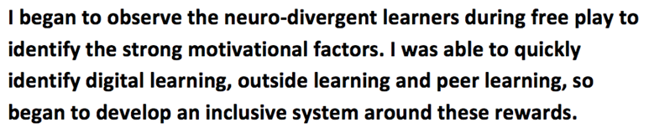
- I engaged with my Year Two mainstream class and allowed them to lead the research
- Together we created a Speech, Language and Communication Friendly Environment. 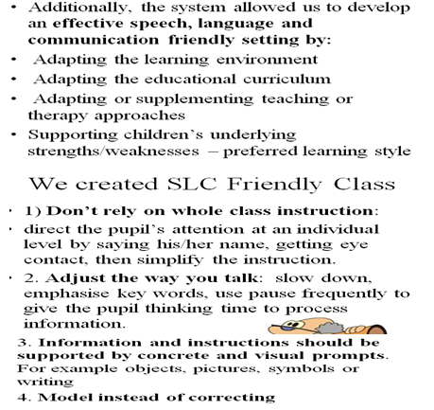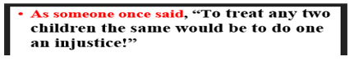

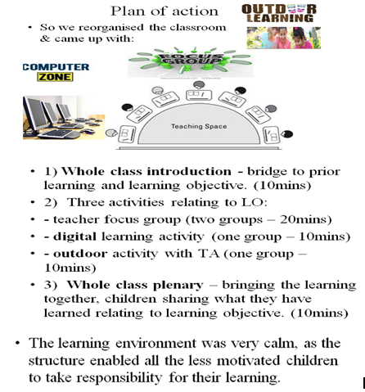

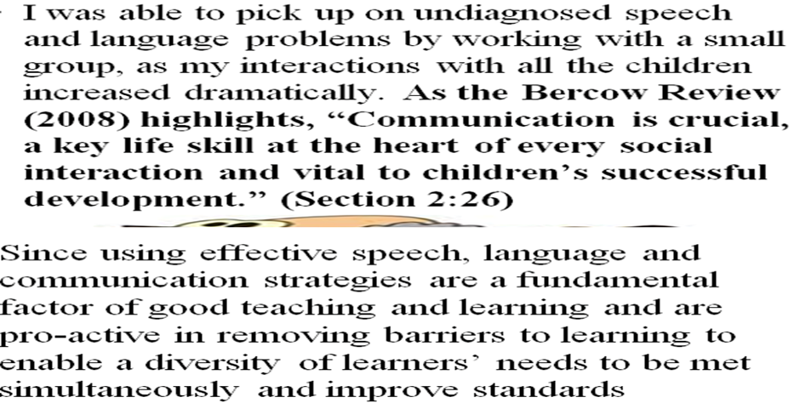

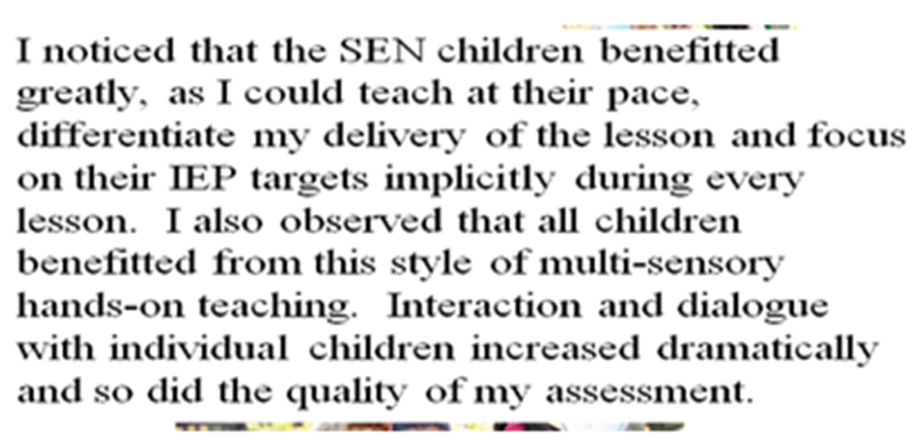

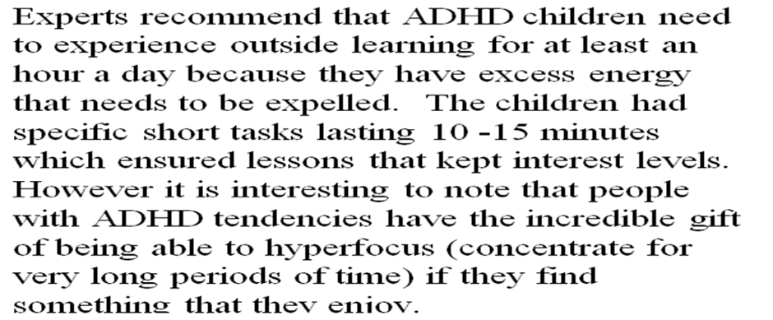

The most powerful strategies came from talking with the children and letting them lead.
I paired a child with ADHD tendencies with a child with ADD tendencies. The ADHD type child was given the responsibility to lead.
It gave the child with ADHD tendencies enough distraction to keep him/her fully on task, while the other child, who had someone constantly talking in their ear, keeping them alert and constantly on task.
Win, win situation!
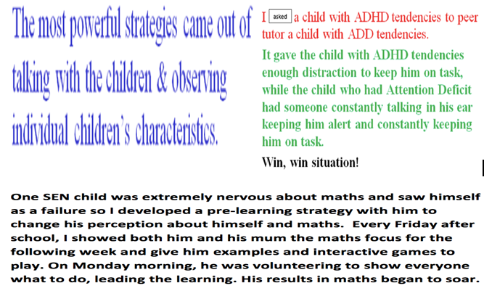

An autistic/ADHD child was the brain behind the learning system as it responded to his key reward /motivators – outdoor learning, digital learning and a variety of different multi-sensory learning activities.

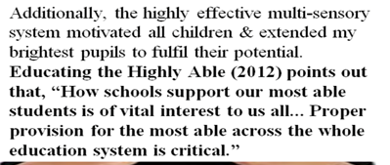

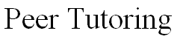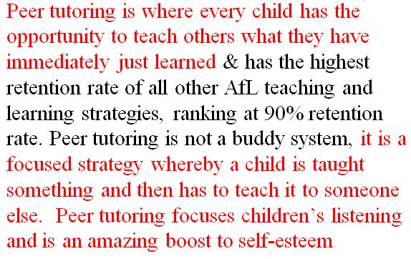
Peer tutoring is where a child is given the opportunity to teach others what they have immediately learned or a skill they know. It has the highest retention rate out of all the other Accelerated teaching and learning strategies – ranking at 90% retention rate. Peer tutoring is not a buddy system, it is a focused strategy whereby a child is taught something and then has to teach it to someone else. Peer tutoring focuses children’s listening and is an amazing boost to self-esteem.

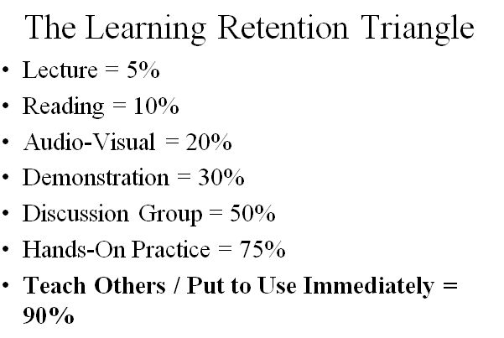

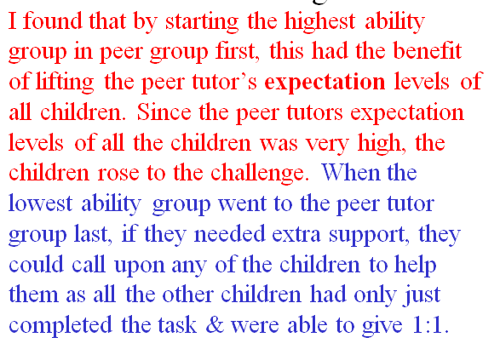
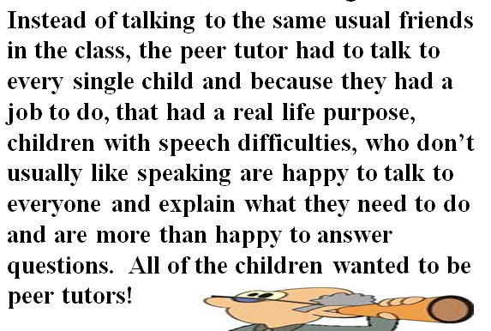

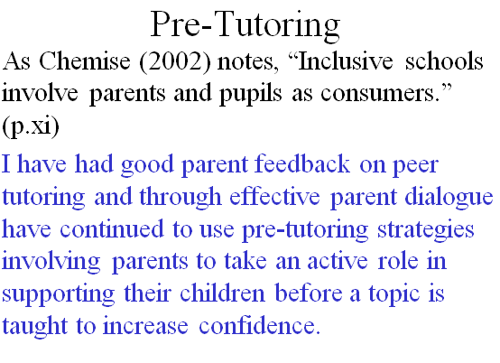

I had good parent feedback as I engaged with both parents and the children who were struggling with maths topics. Through inviting parents into my classroom on a Friday afternoon and sharing the forthcoming week’s maths focus with both parent and child, taking time to show both basic strategies and websites, this increased children’s confidence so by Monday morning pre-tutoring had prepared them for new concepts. I developed this concept by responded to the child’s needs. I found that pre-tutoring strategies not only empowered the children but also empowered the parents to take an active role in supporting their children before a topic is taught to increase their confidence. This strategy was so powerful it automatically led to these children leading learning in class.

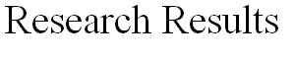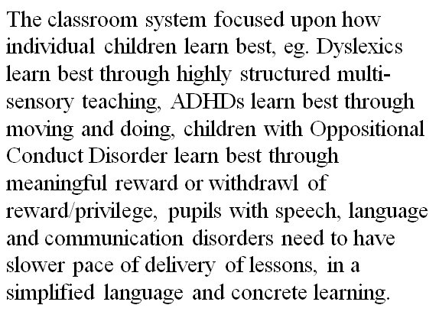

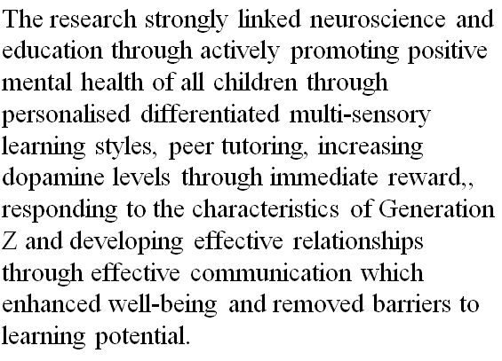

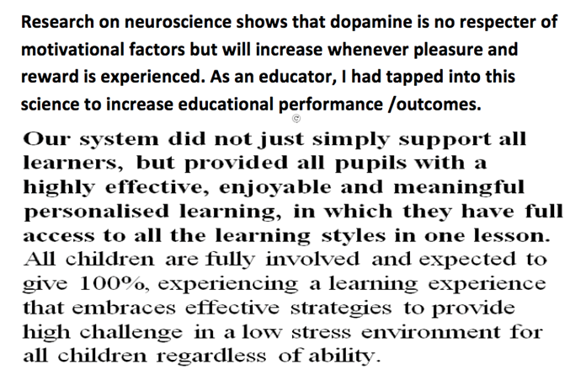
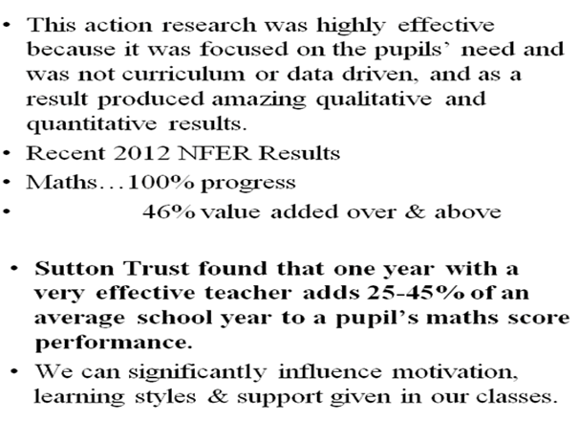

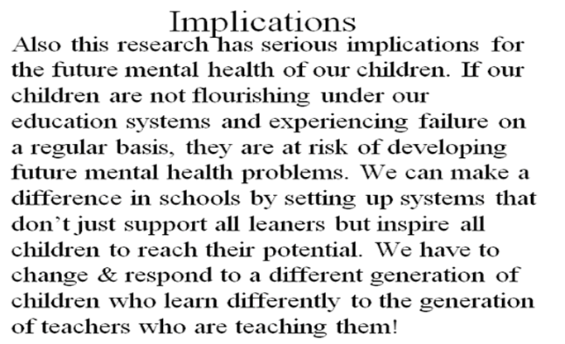

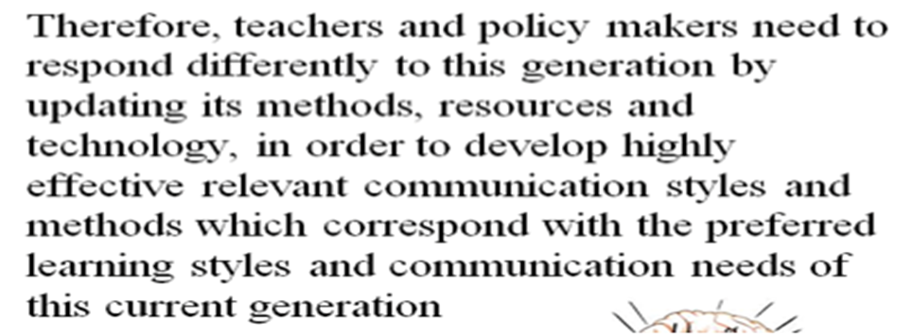
and develop ACE Friendly Classes
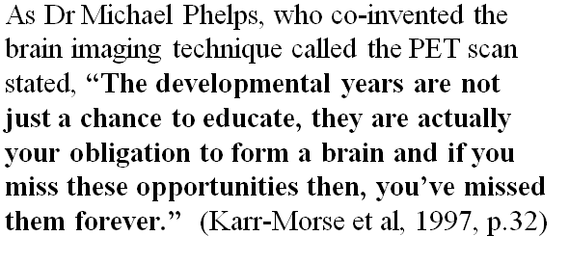

Appendix 18: Signposting and Helplines

Alcoholics Anonymous (Anyone who seeks help to stop drinking alcohol)

Telephone: 0800 917 7650

www.alcoholics-anonymous.org.uk

Childline (Support for Children)

Telephone: 0800 1111
www.childline.org.uk

Child Exploitation and Online Protection
www.ceop.police.uk to make a confidential report

Mental Health Foundation

Telephone: 02075357439
www.mentalhealth.org.uk

MIND (support and counselling for a wide range of mental health issues)

Telephone: 0300 123 3393 or text 86463
www.mind.org.uk

NAPAC (Support for adult survivors of child abuse)
0808 801 0331
www.napac.org.uk

NSPCC (Support for children and their families)

Telephone: 0808 800 5000
www.nspcc.org.uk

Samaritans (24-hour helpline to support people in crisis)

Telephone: 0116123 (free phone)
www.samaritans.org.uk

Survivors UK (Support for men who have been sexually abused)

www.survivorsuk.org

The Children’s Society

Telephone: 03003037000
www.childrenssociety.org.uk

Victim Support (Provides help and support to anyone affected by crime).

Telephone: 08081689111
www.victimsupport.org.uk

Woman’s Aid (Female survivors of domestic abuse)

Telephone: 0808 2000 247

www.womansaid.org.uk

