

**Type 2 Diabetes Mellitus and**

**Cognitive Impairment:**

**Assessment of Brain and Cardiac Function using Magnetic Resonance Imaging**

**By:**

**Dr Leanne Hunt**

A thesis submitted in partial fulfilment of the requirements for the degree of Doctor of Medicine

The University of Sheffield

Faculty of Medicine, Densitry and Health

Academic Unit of Radiology

Department of Infection, Immunity and Cardiovascular Disease

**November 2018**



**Type 2 Diabetes Mellitus and**

**Cognitive Impairment:**

**Assessment of Brain and Cardiac Function using Magnetic Resonance Imaging**

**By:**

**Dr Leanne Hunt**

A thesis submitted in partial fulfilment of the requirements for the degree of Doctor of Medicine

The University of Sheffield

Faculty of Medicine, Densitry and Health

Academic Unit of Radiology

Department of Infection, Immunity and Cardiovascular Disease

**November 2018**

**Acknowledgements**

I would like to thank my supervisors, Professor Iain Wilkinson and Dr Dinesh Selvarajah for the opportunity they have given me to complete this MD project and for all the supervision and guidance along the way. They have enabled me to complete this project successfully and developed my passion for research. I would also like to thank the support of the Sheffield Teaching Hospitals diabetes research department, particularly Professor Solomon Tesfaye and Dr Sharon Caunt. Professor Tesfaye helped to provide guidance in the planning and execution of the study and Dr Caunt helped significantly with my ethics application. Without her help and guidance I am sure I would still be trying to submit my ethics application! I would also like to thank the University of Sheffield’s academic radiology department, in particular Julia Bigley, Professor Nigel Hoggard and Dr Andy Swift. Julia, in particular, kindly provided her expertise in ensuring that the MRI protocol was as efficient as it could be; and during the MRI visit, ensured that the visit went as smoothly as possible. For this I am eternally grateful. I would also like to thank the participants of this study, as without them this study would not have been possible. Finally I would like to thank my husband, Martin, for having patience with me whilst I have been writing up my MD and my dog, Branston, for sacrificing some of his dog walks.

**Authors Declaration**

The study was undertaken in the University of Sheffield in collaboration with the Department of Infection, Immunity and Cardiovascular disease, the Academic unit of Radiology and the Academic unit of Diabetes. My contributions were the following:

* The primary role in the conception and design of the study, write up of the protocol, and research ethics application
* Recruitment, clinical and neuropsychological assessments of the subjects
* MR imaging: Professor I.D Wilkinson designed the MR protocols and the scanning was performed by the departmental radiographers and clinically assessed by neuroradiologists, particularly Professor N Hoggard and Dr A Swift. Prior to the imaging, I had consented all the subjects and arranged the appointments. I was present for all the scans.
* Collation of the data, image analysis and subsequent statistical analysis for the study was undertaken by myself. Professor I.D Wilkinson and Dr D Selvarajah supervised me. Mr S Palmer, Dr G Sloan and Mrs J Bigley completed inter-rater assessment of various image analyses.
* Write up of thesis, abstract submission, presentations and posters (first author).

**Dr Leanne Hunt**

List of Contents

List of Figures 6

List of Tables 10

List of Abbreviations 11

Abstract 14

Introduction 16

1. T2DM and Cognitive Impairment 18

2. Current Theories and Mechanisms of Cognitive Impairment in T2DM: Metabolic Risk Factors and Mechanisms 19

2.1 Metabolic Risk Factors 19

2.1.1 Glycaemic control 19

2.2 Metabolic Mechanisms 21

2.2.1 Glucose, Insulin and Insulin Resistance 21

2.2.2 HPA axis 24

2.2.3 Inflammatory Processes 24

3. Current Theories and Mechanisms of Cognitive Impairment in T2DM: Vascular Risk Factors 25

4. Current Theories and Mechanisms of Cognitive Impairment in T2DM: Genetic Predisposition 27

5. Current Theories and Mechanisms of Cognitive Impairment in T2DM: Depression 27

6. Mixed Pathology of Cognitive Impairment in T2DM 30

7. Magnetic Resonance Imaging in T2DM and Cognitive Impairment 31

8. Diabetic Cardiomyopathy and Cognition 39

Literature Review Summary 43

Aims of the Research Study and Hypotheses 45

Methods 48

1. Participants 48

2. Intervention 52

Visit 1 52

Visit 2 56

3. Outcome 61

3.1 Statistical Analysis Plan 61

3.2 MR Brain Image analysis 61

3.3 MR Cardiac Image analysis 77

Results 80

1. Baseline Data (Demographic/Laboratory and Clinical) 80

1.1 Demographic/Laboratory and Clinical Data Results for All Groups 80

1.2 Demographic and Baseline Data for the Diabetes Groups 89

2. Cerebral Blood Flow Results 91

3. Cerebral Anatomical Results 103

3.1 Visual Atrophy Assessment 104

3.2 Volumetric Results 114

4. Cardiac Results 151

4.1 Aortic Output Results 151

4.2 Left Ventricle Volumetry Results 153

4.3 Left Ventricle Ejection and Filling Dynamic Results 158

Discussion and Limitations 161

Discussion 161

1. Baseline Data 161

2. Primary Aim of the Study 164

3. Secondary Aims of the Study 166

Limitations 174

Conclusion 177

Further Work 178

References 179

# 

# List of Figures

Figure 1: Estimated prevalence of T2DM globally using IDF global estimates 16

Figure 2: Estimated prevalence of dementia globally and estimated projections 17

Figure 3: The potential role of insulin in the pathogenesis of dementia 23

Figure 4**:** Proposed pathophysiological mechanisms linking diabetes to changes in the brain and dementia 30

Figure 5: Probability map of location of grey matter atrophy attributable to T2DM**.** 33

Figure 6: Axial image acquired using p-CASL MR perfusion scan in a healthy volunteer displaying the Medial Temporal Lobes.. 63

Figure 7: Example Axial, Sagittal and Coronal FLAIR MR images in a T2DM subject showing WMH 66

Figure 8: Axial images of the different Fazekas Scores using FLAIR MR imaging 67

Figure 9: Scheltens Scale as depicted by Dr Antonie Micheau 68

Figure 10: Radiological examples of the different Scheltens scale on Coronal MR images, compared to the Scheltens Scale 69

Figure 11: SIENAX FLIRT standard space registration 71

Figure 12: SIENAX BET (Brain Extraction Tool) 71

Figure 13: SIENAX Field of View and Standard Space Marking 72

Figure 14: SIENAX Peripheral cortex mask segmentation 72

Figure 15: SIENAX Ventricle mask segmentation 72

Figure 16: SIENAX Whole brain segmentation 73

Figure 17: Freesurfer Processing Stream Overview 75

Figure 18: Cardiac MR image of an end-diastolic frame identified in the short axis view 78

Figure 19: Cardiac MR image of the Aortic Flow measurement 79

Figure 20: Box and Whisker Plot demonstrating the median and interquartile ages of the three groups 82

Figure 21: Pie chart demonstrating the gender of the participants 83

Figure 22: Box and Whisker plot showing the BMI data of the groups, 84

Figure 23: Box and Whisker plot showing the median and interquartile age of last education of the groups 85

Figure 24: Chart showing group mean Addenbrooke’s scores between groups 86

Figure 25: Box and Whisker plot showing the HbA1c levels in each group 87

Figure 26: Box and Whisker plot of participant’s cholesterol levels, 88

Figure 27: Chart showing group mean CBF in the medial temporal lobe 95

Figure 28: Chart showing group mean CBF in the thalamus. 96

Figure 29: Chart showing group mean CBF in the insula 97

Figure 30: Chart showing group mean CBF in the frontal lobe 98

Figure 31: Scatter graph showing the positive correlation between the medial temporal lobe CBF results and the Addenbrooke’s score. 99

Figure 32: Scatter graph showing the positive correlation between the thalamus CBF results and the Addenbrooke's score 100

Figure 33: Scatter graph showing the positive correlation between the insula CBF results and the Addenbrooke's score 101

Figure 35: Bar chart showing the distribution of the different Fazekas scale scores allocated to each participant within the periventricular region 105

Figure 36: Bar chart showing the distribution of the different Fazekas scale scores allocated to each participant at the white matter region 106

Figure 37: Bar chart showing the distribution of the Pasquier score at the level of the ventricle allocated within each group 109

Figure 38: Box and Whisker plot of WMH in each group 111

Figure 39: Bar chart showing the mean number of WMH between each group with the mean Addenbrooke's score of each group 112

Figure 40: Chart showing group mean grey matter volumes. 115

Figure 41: Scatter graph showing the positive relationship between grey matter volume and Addenbrooke's scores 116

Figure 42: Chart showing group mean peripheral grey matter volumes 117

Figure 43: Chart showing group mean total grey and white matter volumes 119

Figure 44: Chart showing group mean white matter volumes 121

Figure 45: Chart showing group mean ventricular CSF volumes …………..122

Figure 46: Chart showing group mean left hippocampus volumes 129

Figure 47: Chart showing group mean right hippocampus volumes 130

Figure 48: Scatter graph showing the positive correlation between the Left Hemisphere (LH) cortical grey matter volume results and the Addenbrooke's score 131

Figure 49: Scatter graph showing the positive correlation between the Right Hemisphere (RH) cortical grey matter volume results and the Addenbrooke's score 132

Figure 50: Scatter graph showing the positive relationship between the total cortical grey matter volume results and the Addenbrooke's score 133

Figure 51: Scatter graph showing the positive relationship between the total grey matter volume results and the Addenbrooke's score 134

Figure 52: Scatter graph showing the positive relationship between the left hippocampal volume results and the Addenbrooke's score 135

Figure 53: Scatter graph showing the positive relationship between the right hippocampal volume results and the Addenbrooke's score 136

Figure 54: Chart showing group mean middle temporal region volumes 139

Figure 55: Scatter graph showing the positive correlation between the middle temporal lobe grey matter volume results and the Addenbrooke's score 140

Figure 56: Voxel Based Morphometry demonstrating statistical significance in the a) Left Putamen b) Left Caudate c) Left Hippocampus d) Left amygdala e) Right hippocampus when the T2DM/MCI group volume mean was compared to the HV group 144

Figure 57: Scatter graph showing the positive trend between the medial temporal lobe CBF and volume results 149

Figure 58: Chart showing group mean SV/BSA results 155

Figure 59: Chart showing group mean ED/BSA results 156

Figure 60: Chart showing group mean CO/BSA results 157

# 

# List of Tables

Table 1: Summary of the main CBF papers and their key findings.………….37

Table 2: Baseline demographic and characteristics of all the groups. 81

Table 3: Baseline demographic characteristics of the two diabetic groups. 89

Table 4: CBF brain region of interest results 93

Table 5: Parenchymal Brain Atrophy results. 104

Table 6: Scheltens scale results. 107

Table 7: Pasquier score results.. 108

Table 8: Total number of WMH in each group. 110

Table 9: Brain volume data obtained using tissue voxel value histogram segmentation (SIENAX) for all groups…………………………………………114

Table 10: ASEG output from Freesurfer ……………………...……………….126

Table 11: LHPARC output from Freesurfer 138

Table 12: RHPARC output from Freesurfer 142

Table 13: Pearson's correlation outcomes comparing specific region of interest CBF and volume results in HV. 146

Table 14: Pearson's correlation outcomes comparing specific region of interest CBF and volume results in T2DM. 147

Table 15: Pearson's correlation outcomes comparing specific region of interest CBF and volume results in T2DM/MCI. 148

Table 16: Aortic output data for all the groups. 152

Table 17: Left Ventricle volumetry data for all the groups 154

Table 18: LV ejection and filling dynamic data for all the groups 158

Table 19: Left atrial end diastolic area 159

# 

# List of Abbreviations

3T 3 Tesla

Aβ Amyloid Beta

ACE-R Addenbrooke’s Cognitive Assessment

ACR Albumin Creatinine Ratio

ACTH Adrenocorticotrophic Hormone

AD Alzheimer's Disease

AGE Age Glycation End-products

AP Anterior Posterior

APOE-e4 Apolipoprotein E allele

ASEG Subcortical SEGmentation statistical output

ASL Arterial Spin Labelling

BBB Blood Brain Barrier

BLSA Baltimore Longitudinal Study of Aging

BMI Body Mass Index

BSA Body Surface Area

CBF Cerebral Blood Flow

CIMT Carotid Intima-media Thickness

CNS Central Nervous System

CO Cardiac Output

CRP C Reactive Protein

CVD Cerebrovascular Disease

CVR Cerebrovascular Reactivity

D-KEES Delis-Kaplan Executive Functioning Scale

ECG Electrocardiogram

ED End Diastolic

EDV End Diastolic Volume

EF Ejection Fraction

ES End Systolic

ESV End Systolic Volume

ET2DS Edinburgh Type 2 Diabetes Study

FBC Full Blood Count

FGRE Fast-Gradient Echo

FH Foot Head

GP General Practitioner

HF Heart Failure

HPA Hypothalamic-Pituitary-Axis

HRA Health Regulation Authority

HV Healthy Volunteers

IDE Insulin Degrading Enzyme

IL-6 Interleukin-6

L Left

LA Left Atrium

LFT Liver Function Test

LH Left Hemisphere

LHPARC Left Hemisphere cortical PARCellation statistical output

LV Left Ventricle

MCI Mild Cognitive Impairment

MR Magnetic Resonance

MRI Magnetic Resonance Imaging

NT-proBNP N-Terminal pro-Brain Natriuretic Peptide

PAI-1 Plasminogen Activator Inhibitor-1

PER Peak Ejection Rate

PER/EDV Peak Ejection Rate/End Diastolic Volume

PFR Peak Filling Rate

PFR/EDV Peak Filling Rate/End Diastolic Volume

PC-MRA Phase-Contrast Magnetic Resonance Angiography

R Right

RH Right Hemisphere

RHPARC Right Hemisphere cortical PARCellation statistical output

SA Short Axis

SD Standard Deviation

SPECT Single-Photon Emission Computed Technology

SSFP Steady State Free Precession

SV Stroke Volume

T2DM Type 2 Diabetes Mellitus

TCD Transcranial Doppler

TE Echo Time

TOPF Test Of Pre-morbid Functioning

TFTs Thyroid Function Tests

TNF Tumour Necrosis Factor

TPER systolic Time from EDV to PER

TPFR diastolic Time from ESV to PFR

TR Repetition Time

U&E Urea & Electrolytes

VBM Voxel Based Morphometry

WMH White Matter Hyperintensities

WMS-IV Wechsler Memory Scale

# Abstract

**Aims**

The risk of developing mild cognitive impairment (MCI) increases with Type 2 diabetes (T2DM). Brain morphometric alterations such as cerebral atrophy and Cerebral Blood Flow (CBF) changes have been associated with T2DM but not with people with T2DM and MCI. It is also known that T2DM patients develop cardiac systolic and diastolic dysfunction. The main aim of this study is not only to relate T2DM cerebral brain status on imaging to cognition but also to investigate them in relation to T2DM patients with MCI. The secondary aim of the study is to investigate whether cardiac output has any relation to any demonstrated cerebral findings.

**Methods**

Seventy-six age and gender matched subjects [30, T2DM+normal cognition (T2DM); 17, T2DM+MCI (T2DM/MCI) and 29, healthy volunteers (HV)] were recruited. All subjects underwent clinical and questionnaire (Addenbrooke’s Cognitive Assessment [ACE-R]) assessments and high-resolution, cardiac and cerebral Magnetic Resonance Imaging (MRI) at 3T. Cerebral and Cardiac images were analysed visually and quantitatively (VBM, FSL, Oxford; SIENAX FSL, Oxford; Freesurfer MGH, Harvard; Nordic Ice, Nordic Neuro Lab, Bergen, Norway; MEDIS suite, Medis medical imaging systems, Leiden, The Netherlands).

**Results**

Demographic data revealed aged-matched participants between all three groups (mean age 69.3-71.5 years, ANOVA, p = 0.164). T2DM/MCI ACE-R score (mean+SD; 83±4) was significantly lower compared to other groups (HV=96±2, T2DM=94±3; ANOVA, p<0.001). T2DM/MCI group had significantly lower regional cross-sectional grey matter volumes compared to HV in the left (p<0.0005) and right hippocampi (p<0.05), left putamen (p<0.05), caudate (p<0.05) and amygdala (p<0.05). There was significantly lower CBF in T2DM/MCI compared to T2DM and HV in the medial temporal lobes (CBF 76.8 ml/100g/min, ANOVA p<0.05), insula (CBF 67.5 ml/100g/min ANOVA p<0.005), and frontal lobes (CBF 71.8 ml/100g/min, ANOVA p<0.005)**.** Pearson’s correlation revealed significant correlations between ACE-R score and regional CBF measurements in the medial temporal lobes, (p<0.05, r=0.25) thalamus (p<0.05, r=0.23) and the insula (p<0.05, r=0.29). The cardiac data revealed significant reductions in SV/BSA (ANOVA, p<0.05) and ED/BSA (ANOVA, p<0.05) in the T2DM/MCI group compared to the HV and T2DM Groups.

**Conclusion**

This study demonstrates significantly lower cortical volumes and CBF in areas that have been associated with cognition in patients with T2DM and cognitive impairment. The cardiac data revealed mild abnormalities in diastolic dysfunction but this was not statistically relatable to the cerebral changes or cognitive changes seen. This may be essential to help our understanding of the pathological mechanisms that occur behind the increased risk of developing cognitive impairment in people with T2DM. Further investigation of both anatomical and functional cerebral involvement is required to examine the pathological mechanisms underlying the increased cognitive impairment risk associated with T2DM.

# Introduction

Diabetes is a metabolic disorder that is growing in prevalence worldwide every year. It was estimated that in 2013 there were 382 million adults in 219 countries with diabetes which is projected to increase to 592 million by 2035 (Guariguata et al., 2014) (Figure 1). The cohort with the largest projected increase is in the 60-79 year age group.

Of all patients with diabetes, 90% have Type 2 diabetes mellitus (T2DM) (Stumvoll et al., 2005) which causes multi-system micro and macrovascular complications. In recent years, there has been particular interest in the relationship between T2DM and cognitive impairment and dementia. With the largest projected increase in prevalence of diabetes in the older age groups, and the life expectancy of patients with diabetes also increasing; we can expect a significant rise in the prevalence of cognitive impairment and dementia (Strachan et al., 2011).

Figure 1: Estimated prevalence of T2DM globally using IDF global estimates, IDF atlas 2003; IDF atlas 2006; IDF atlas 2009; (Guariguata et al., 2014)

The most common type of dementia currently is Alzheimer’s Disease (AD), followed by vascular dementia (Ott et al., 1995). It is not uncommon, especially in patients with diabetes to present with a mixed form of dementia. The range of cognitive impairment can vary between mild deficits to the most severe clinical form, dementia (Luchsinger, 2012).

Figure 2: Estimated prevalence of dementia globally and estimated projections (Alzheimer’s Disease International, 2013)

Over the last few decades, there have been many studies that have examined the increased risk of cognitive impairment and dementia in patients with T2DM. These studies show a 1.5-2.5 fold increased risk of developing dementia in T2DM (Biessels et al., 2006; Cheng et al 2012). However, despite numerous studies examining the possible causative pathophysiological mechanisms of the underlying dementia (metabolic, vascular and Alzheimer’s type processes), there is no clear consensus on the type of dementia patients with T2DM will develop (Umegaki., 2014). It is likely, therefore, that the aetiology of cognitive impairment in patients with T2DM is multifactorial. Given the detrimental effect that this condition has on a patient’s daily life and the repercussions that this has on their families, further investigations into the causes and management of the condition are urgently required.

## 1. T2DM and Cognitive Impairment

People with T2DM are known to have subtle changes in cognitive performance, which can be evident from adolescence (Koekkoek et al., 2015). Even patients that are identified as having T2DM by routine screening, impaired fasting glucose or metabolic syndrome show similar changes in cognitive function as those with T2DM (Koekkoek et al., 2015). This suggests that the processes underlying cognitive dysfunction start at the pre-diabetes status and progress over time. Subsequently the deficits of cognitive dysfunction noticed in these patients, have been divided into three stages: diabetes-associated cognitive decrements, MCI and dementia (Biessels et al., 2018). Diabetes-associated cognitive decrements are associated with worsening performance on cognitive tasks when compared to HV, particularly with regards to tasks related to memory, executive function and processing speed (Biessels et al., 2018). However, it must be remembered that these can be subtle effects that may not qualify as abnormal on formal cognitive testing.

As a patient with T2DM develops mild cognitive impairment and dementia they continue to develop certain neuropsychological deficits, which impacts on their functional status. A meta-analysis reviewed 24 studies; totalling 26,137 patients (3351 with diabetes), examined six domains of cognitive function (motor function, executive function, processing speed, verbal memory, visual memory and attention/concentration). They found that patients with diabetes had deficits in both motor function as well as attention and concentration (Palta et al., 2014). It was also noted in the analysis of motor function that 20% of individuals with diabetes performed worse than any of the control group (Zakzanis, 2001). This was similar to findings by Larrabee et al (2008). Other studies and reviews have also highlighted other areas in the cognitive domains where deficits occur. A review by Kodl and Seaquist (2008) documented that psychomotor speed as well as memory and executive function are negatively affected by diabetes.

When we relate these patterns of cognitive deficits to specific brain regions (also taking into account whether the patient has developed non-amnesic [memory-preserved] or amnesic [memory-impaired] MCI), the main regions that are involved include the hippocampus, basal ganglia and frontal lobes. The medial temporal lobe contains both the hippocampus and amygdala, which are essential for memory function (both short and long term) as well as spatial memory and behaviour. The basal ganglia system is also important in memory, particularly the retrieval and formation of new memories, whilst the frontal lobe is involved in higher functional processes such as decision-making. These regions therefore need to be examined when doing detailed neuroimaging studies.

## 2. Current Theories and Mechanisms of Cognitive Impairment in T2DM: Metabolic Risk Factors and Mechanisms

### 2.1 Metabolic Risk Factors

#### 2.1.1 Glycaemic control

A clear relationship between HbA1c and cognitive function has not been established and is still debated. Some studies have shown that a high HbA1c (glycosylated haemoglobin) is associated with a higher risk of cognitive decline (Yaffe et al., 2006), whilst others have not (Geijselaers et al., 2015). A comprehensive study by Ravona-Springer et al., (2014) examined this relationship. Twelve years of consecutive HbA1c results from a diabetes register containing over 800 subjects with an average age of 72.8 years was reviewed. The subjects underwent full neuropsychological testing to examine their cognitive function over five domains. They found that long term poor glycaemic control significantly correlated to greater cognitive decline in later life independent of the regime used to treat blood glucose. If glycaemic control was adapted onto a more intensive regime, the correlation was still the same. The study was felt to be comprehensive as the study looked at glycaemic control trajectories, which reflect the chronicity of T2DM better, rather than a single HbA1c measurement. Their findings also reflected previous evidence highlighted by Feinkohl et al., (2015) that the irreversible damaging effect of mid-life diabetes increases the risk of cognitive impairment. The largest studies (Reynolds et al., 2010; Cukierman-Yaffe et al., 2009)

agree with the findings of the study by Ravona-Springer, in that only very high HbA1c concentrations were associated with an increased risk of developing cognitive impairment and dementia.

The main issue highlighted with all the studies that have researched the relationship between HbA1c and cognition is, firstly different neuropsychological testing techniques have been used in different studies, from a full battery of neuropsychological testing to quicker screening tools such as the Montreal Cognitive Assessment. This can make interpretation of the results difficult, as what may appear to be cognitive impairment on a screening tool, may not be identified as such on a full battery of neuropsychological testing. Secondly, some studies use a single HbA1c measurement as a reflection of glycaemic control, whereas others use glycaemic control over several years. This again may give differing results when interpreting the relationship between glycaemic control and cognition.

It is well known that acute hypoglycaemia causes transient cognitive impairment, which reverses upon correction of the blood glucose, but prolonged severe hypoglycaemia can cause permanent brain damage or death. Post-mortem studies have shown that this process results in damage to the frontal and temporal lobes (Warren and Frier, 2005). It is hypothesized that recurrent, severe hypoglycaemia, may cause cerebral damage leading to cognitive decline overtime.

Despite these findings, this has not been confirmed in some prospective studies. The Diabetes Control and Complications Trial (Diabet Control Complications Trial Res, 1996) and the Stockholm Diabetes Intervention Study (Reichard and Pihl, 1994) failed to show any long-term effects of recurrent severe hypoglycaemia on cognitive decline. The main limitation with these studies was the relatively short (7 and 5 year respectively) follow up period, the younger study population (13-40 years) and the inclusion of T1DM subjects.

In T2DM specific studies, Feinkohl et al., (2014) (part of the Edinburgh Type 2 Diabetes Study) found a relationship of severe hypoglycaemia and cognitive decline that mimics the post-mortem study. They reviewed 831 participants with T2DM (mean age 60-75 years at baseline) over 4 years with cognitive testing at baseline and at 4 years along with documentation of previous and current severe hypoglycaemic events. They found that both a previous history of severe hypoglycaemia and severe hypoglycaemic episodes that occurred during the follow-up period were associated with cognitive decline, even once vascular risk factors were added into the analysis models. Further more, the Action to Control Cardiovascular Risk in Diabetes (ACCORD) study has identified an underlying complex relationship that cognitive decline and hypoglycaemia can have. 2,956 adults aged over 55 years with T2DM underwent cognitive testing at baseline and at 20 months with incident confirmed severe hypoglycaemia documented. After the 3.25-year follow-up, the study found that poor cognitive function increases the risk of severe hypoglycaemic events (Punthakee et al., 2012). This highlights the complex relationship between cognitive decline and hypoglycaemia in that the relationship and nature of association can be bidirectional, i.e. recurrent severe hypoglycaemic events may lead to cognitive decline, but cognitive decline may lead to more hypoglycaemic events. This can cause challenges when trying to therapeutically manage this cohort of patients.

### 2.2 Metabolic Mechanisms

#### 2.2.1 Glucose, Insulin and Insulin Resistance

Insulin crosses the blood brain barrier (Banks, 2004) and interacts with insulin receptors found throughout the brain particularly in the hypothalamus and hippocampus (Banks et al., 2012). The action of cerebral nervous system insulin (CNS) is different to the action of peripheral insulin in that it increases blood glucose and decreases feeding, body weight and blood levels of insulin (Bruening et al., 2000). Impairment in the CNS insulin signalling pathway has been linked to the development of Alzheimer’s Disease (AD) and cognitive impairment in patients with T2DM (Whitmer, 2007).

AD is a known condition characterised by the accumulation of amyloid plaques (caused by amyloid beta (Aβ) protein aggregation) and the presence of intracellular neurofibrillary tangles (caused by hyperphosphorylated tau protein aggregation) (Amiri et al., 2013). Changes in the insulin pathway and the role of insulin in cognitive impairment are hypothesized to affect amyloid metabolism and deposition (Figure 3).

Insulin degrading enzyme (IDE) has a role in the brain to regulate the deposition of insulin and Aβ (Whitmer, 2007). In insulin resistance, desensitization of insulin receptors occurs causing the synthesis of several proteins, including IDE to be reduced (Umegaki, 2014). As mentioned, IDE regulates both insulin and Aβ and if IDE is reduced due to insulin resistance, this could lead to greater deposition of Aβ causing amyloidogenesis (Umegaki, 2014) leading to cognitive dysfunction. This theory has been shown in animal models, where the deletion of the homozygous IDE gene has caused greater deposition of Aβ (Farris et al., 2005).

.

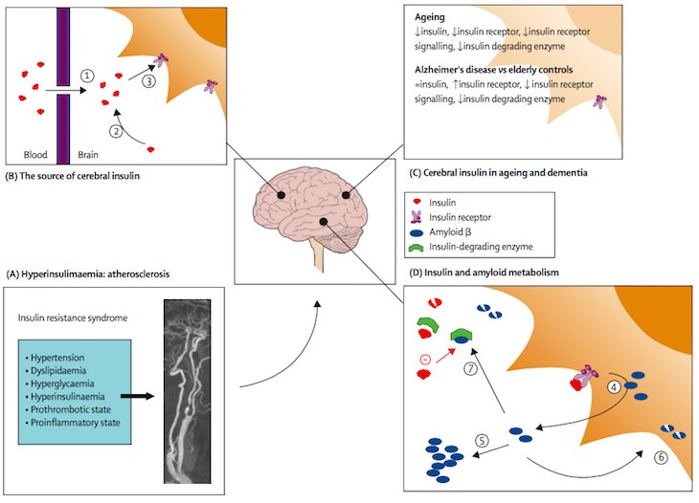

Figure 3: The potential role of insulin in the pathogenesis of dementia

(Hyperinsulinaemia has been identified as a risk factor for accelerated cognitive decline and dementia, which may be mediated through vascular effects and direct effects of insulin on the brain. Hyperinsulinaemia, in the context of the insulin resistance syndrome, is a risk factor for atherosclerosis (A). Insulin is transported actively across the blood–brain barrier (1), may be produced locally in the brain (2), and—acting through cerebral insulin receptors (3)—modulates food-intake and energy homoeostasis (B) Ageing is associated with changes in insulin and its receptor in the brain, and these changes may be even more pronounced in individuals with Alzheimer's Disease(C). Insulin also affects amyloid metabolism (D). Insulin stimulates the secretion of amyloid β (4) into the extracellular space where it can aggregate with other proteins to form senile plaques (5). Alternatively, excessive amyloid β can be cleared through endocytosis (6), or through direct extracellular proteolytic degradation by insulin-degrading enzyme (7). Reprinted from The Lancet, Vol 5, Biessels et al, Risk of dementia in diabetes mellitus: a systematic review, page 65, 2006 with permission from Elsevier.)

The formation of advanced glycation end-products (AGE) have also been implicated in the development of cognitive impairments in patients with T2DM (Spauwen et al., 2015). AGE occurs as part of the natural aging process, however AGE accumulation is accelerated in patients with T2DM (Spauwen et al., 2015). This results in oxidative stress and neuronal apoptosis. (Whitmer, 2007).

#### 2.2.2 HPA axis

Another potential mechanism, in which T2DM could result in cognitive impairment, is dysfunction of the hypothalamic-pituitary-adrenal (HPA) axis. T2DM is thought to inappropriately activate the HPA axis leading to an elevated serum cortisol and increased adrenocorticotrophic hormone (ACTH) levels (Strachan et al., 2011). This has been found in both animal (Tojo et al., 1996) and human studies (Lee et al., 1999). Chronic exposure to raised glucocorticoid levels is thought to cause damage to the hippocampal neurons (McEwen, 1999) which has an important role in long-term memory. This theory is supported by studies in patients with Cushing’s disease who have poorer memory and attention when compared to controls (Forget et al., 2000). Elderly people with poor cognitive performance have also been found to have higher cortisol levels (Lupien et al., 1994). The Edinburgh Type 2 Diabetes Study (ET2DS) found that higher basal cortisol levels were associated with quicker cognitive decline in T2DM patients (Reynolds et al., 2010).

#### 2.2.3 Inflammatory Processes

Chronic neuroinflammation is a well recognised pathophysiological mechanism in AD (Simen et al., 2011; Eikelenboom et al., 2006). Moreover, inflammatory markers such as C-Reactive Protein (CRP), fibrinogen, Interleukin-6 (IL-6), Tumour Necrosis Factor (TNF) and Plasminogen Activator Inhibitor-1 (PAI-1) are known to be elevated in T2DM patients (Whitmer 2007). However, only a handful of studies have examined the role of chronic inflammation in T2DM and cognitive decline and these have reported a possible link (Marioni et al., 2010; Yaffe et al., 2004). Further studies are required to confirm this and to examine if this is an epi-phenomenon i.e. chronic inflammation results in cognitive decline by accelerating microvascular disease or whether this process has a direct effect on cerebral neurons.

2.3 Summary

In summary, when reviewing the potential underlying metabolic causes of cognitive impairment, there does not seem at present to be enough evidence to show that HbA1c has a huge impact into whether a person develops cognitive impairment or not. What needs to be taken into consideration is the potential effect of ‘mid-life’ diabetes and metabolic memory with episodes of severe hypoglycaemia and how this can affect cognition. There appears to be growing substantial evidence to show that activation of the HPA axis may be involved in cognitive impairment and if future studies continue to show this, targeted therapy at reducing cortisol levels may become a treatment option. Finally emerging data regarding AGE and its association with AD and T2DM has shown some encouraging results and is most likely involved in the development of cognitive impairment. What is still unclear is how and what affect this has on T2DM patients.

## 3. Current Theories and Mechanisms of Cognitive Impairment in T2DM: Vascular Risk Factors

T2DM is associated with numerous vascular risk factors such as hypertension, dyslipidaemia and obesity resulting in significant micro- and macrovascular complications. How this relates to cognitive impairment is still being examined.

Several studies have examined the role of vascular risk factors in cognitive decline. A number of clinical observational studies have reported that high triglyceride levels are associated with poorer cognitive function (Perlmuter et al.,1988). However, these observations have not been confirmed in clinical intervention randomised control trials. Furthermore, some studies have reported a protective effect of dyslipidaemia on cognitive decline (Bruce et al., 2008b); whilst others have reported that there is no change in rate in cognitive decline between groups of patients taking more intensive cholesterol-lowering regimes, compared to those who are not (Williamson et al., 2014). At present the relationship between dyslipidaemia and the development of cognitive impairment remains inconclusive.

Hypertension, particularly during midlife is associated with a higher risk of cognitive impairment and dementia (Kloppenborg et al., 2008). A recent review by Feinkohl et al (2015) showed variable associations between hypertension and cognitive impairment. The Fremantle Diabetes Study found that a higher baseline diastolic blood pressure was associated with an increased risk of AD after 8 years (Bruce et al., 2008) whereas the ACCORD-MIND study did not demonstrate any relationship (Williamson et al., 2014). However it must be noted that the follow up period for both these studies were relatively small at eight and four years respectively. Nevertheless, hypertension is a known risk factor for cerebrovascular disease which also may increase the risk of dementia by causing cerebral small vessel disease and hypoperfusion, leading to increased cognitive decline (Kalaria et al., 2012).

Cerebrovascular disease (CVD) is a recognised risk factor for impaired cognitive function in both the general population and in T2DM. CVD increases the risk of cognitive impairment by causing damage to the neurovascular unit which regulates cerebral blood flow and ensures adequate cerebral perfusion during changes in mean arterial blood pressure (Ladecola, 2004). It is theorized that the structural and functional changes that occur within cerebrovascular disease, diabetes and natural aging leads to a reduction in cerebral blood flow and loss of autoregulation, leading to hypoperfusion. Changes in CBF can also lead to disruption in the integrity of the BBB (Umegaki, 2014). This process may lead to cognitive impairment by causing amyloid deposition and neuronal dysfunction (Snyder et al., 2015).

## 4. Current Theories and Mechanisms of Cognitive Impairment in T2DM: Genetic Predisposition

Genetic predisposition to cognitive impairment and dementia in the T2DM subject may also have a role and is currently under investigation. So far only the Apolipoprotein E (APOE) allele genotype has been examined. The APOE ε4 allele is found in 13% of the general population and is the predominant risk factor for late-onset Alzheimer’s disease. Of the limited studies available that have assessed this in T2DM subjects, they have shown that T2DM subjects who were carrying the APOE ε4 allele had double the relative risk of developing dementia compared to patients with either of these risk factors in isolation (Peila at al., 2002). Obviously, given the limited data available, this area of research will need to be continued and further developed to enable stronger conclusions to be drawn.

## 5. Current Theories and Mechanisms of Cognitive Impairment in T2DM: Depression

Diabetes and depression are two of the most common chronic conditions in the elderly population. It is estimated that up to 20% of adult patients with T2DM meet the criteria for comorbid major depression (Ali et al., 2006). The link between these two conditions also appears to be bidirectional. If a subject has a depressive episode earlier in life, this increases the risk of developing diabetes. This may be due to depression leading to poor diet, lack of exercise, which may increase social isolation and exacerbate the cycle. In reversal if a subject develops adult-onset diabetes, this increases the risk of developing depression (Katon et al., 2012). Does T2DM and depression increase your risk of cognitive impairment and dementia? Are they independent risk factors or are they synergistic?

In a systematic review undertaken by Lu et al., (2009) subjects with diabetes and depression when compared to those with depression alone had a 47% increased risk of all-cause dementia, a 39% increased risk of AD and more than a 2-fold increased risk of vascular dementia. The Cardiovascular Health Study also found that the association between depression and mild cognitive impairment was independent of underlying vascular disease (Barnes et al., 2006).

The ACCORD-MIND study found that patients with T2DM were associated with greater cognitive decline in all domains assessed: psychomotor speed, verbal learning and executive function. The study was also able to demonstrate that the effect of depression on cognitive decline was unaffected by previous CVD; baseline cognition or age; intensive versus standard glucose-lowering treatment; blood pressure treatment and dyslipidaemia; depression related health risk behaviours (body mass index, smoking and alcohol use), or intensive versus standard insulin treatment (Sullivan et al., 2013).

Again there have been conflicting results. A small cross-sectional study of T2DM reported a statistically non-significant trend for negative correlations between scores on a cognitive screening tool and scores on a self-administered screening instrument for depression (Trento et al., 2012). Sample size needs to be taken into consideration when interpreting this finding.

The general impression is that depression does have a role in diabetes related cognitive impairment. Several studies, such as Katon et al., (2012) have been able to reproduce the 2-fold increased risk of dementia in patients with comorbid depression and T2DM in their prospective study. There have been several theories as to why this occurs in this cohort of patients.

Depression severity has been associated with a higher risk of biological abnormalities, including the HPA axis. As mentioned earlier HPA axis dysregulation causes higher glucocorticoid levels and hippocampal atrophy and this has been found in patients with chronic or recurrent depression (Butters et al., 2008). Depression has also been associated with an increase in proinflammatory factors such as IL-6, TNF (Duarte et al., 2015) and increased platelet aggregation (von Kanel, 2004). Together these suggest a link between increased insulin resistance and AD development. As these pathways are being identified in the T2DM cohort as well, there may be an additive effect providing a mechanistic reason for a 2-fold risk of cognitive impairment in patients with both T2DM and depression.

## 6. Mixed Pathology of Cognitive Impairment in T2DM

By reviewing both the metabolic and vascular aspects of cognitive impairment, the cause appears to be of a multifactorial pathology that occurs along with normal brain aging (Figure 4).

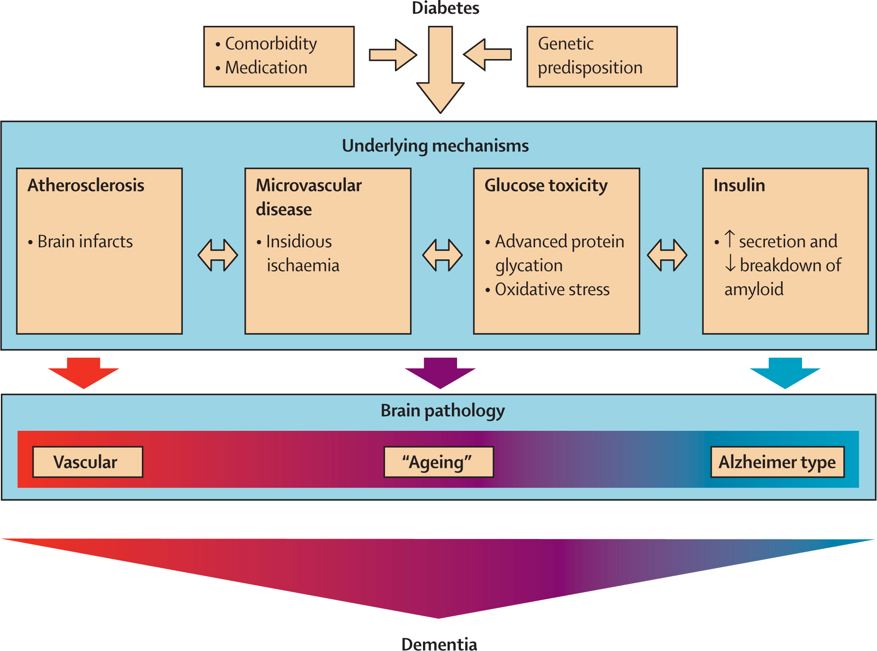

Figure 4**:** Proposed pathophysiological mechanisms linking diabetes to changes in the brain and dementia. Reprinted from The Lancet, Vol 5, Biessels et al, Risk of dementia in diabetes mellitus: a systematic review, page 65, 2006 with permission from Elsevier.

## 

## 7. Magnetic Resonance Imaging in T2DM and Cognitive Impairment

MRI is an imaging modality that does not use ionising radiation. This makes it particularly applicable for human experimental studies. The body comprises of various types of molecules, with water being the most abundant molecule. Water contains both hydrogen and oxygen atoms, with the nucleus of a hydrogen atom containing one positively charged proton. Protons also possess the property of spin. Combining spin and this charged distribution enables the hydrogen atoms to act like a ‘spinning top’. Normally this ‘spinning top’ has directional randomization. However, when the body is put into a static homogenous magnetic field, the hydrogen nuclei line up either parallel or anti-parallel to this applied magnetic field. The relative proportion that line up parallel to the field depends on temperature as well as the strength of the magnetic field. This difference can be termed the ‘net magnetisation of the spinning tops’.

When energy is applied (in the form of radio waves) at a specific resonance frequency, the net magnetisation flips as the nuclei absorb energy and become more ‘excited’. Once the application of radio waves stops, the spins try to revert back to their original equilibrium position. As they do so, they release radio waves at the same resonance frequency. This is the signal that we detect in magnetic resonance.

The production of images relies on the resonance frequency depending on the applied magnetic field. If this is altered by a ‘magnetic field gradient’, then knowledge of the resonant frequency can be used to tell us where the signal is located. Hence an anatomical image can be constructed (Wilkinson et al., 2014).

Different sequences can be built, where the timing and method of all the signal generation can be changed, to tell us about various parameters. These parameters include, proton density, T1, T2, vascular flow and iron deposition.

7.1 Structural Brain Changes

A series of MR neuroimaging studies have demonstrated structural and volumetric abnormalities in patients with T2DM, patients with normal cognition and healthy controls. The common abnormalities reported are increased brain atrophy, white matter hyperintensities (WMH) and cerebral infarcts. T2DM duration and higher fasting blood glucose levels were associated with greater loss of grey matter (Bryan et al., 2014).

Zhang et al., (2014) compared T2DM patients with and without mild cognitive impairment and healthy controls. Both T2DM groups showed a reduction in their grey matter volume compared to healthy controls. The degree of grey matter volume reduction was greater in the group with cognitive impairment. This suggests that progression from normal cognition to cognitive impairment may be linked with more extensive grey matter volume loss (Zhang et al., 2014). This has also been reported in other studies (Brundel et al., 2010; Moran et al., 2013) (Figure 5). Furthermore, atrophy of the middle temporal lobe and the middle temporal gyrus was reported present in only the T2DM group with cognitive impairment. Brain volumes in these regions correlated with the Montreal cognitive assessment score.

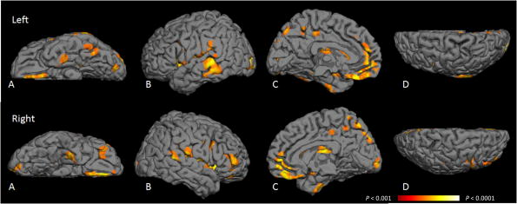

Figure 5: Probability map of location of grey matter atrophy attributable to T2DM**.** VBM was used to create a probability map of areas of grey matter atrophy attributable to T2DM when adjusted for age, sex, education, and total intracranial volume. Voxels highlighted are those areas most likely to have grey matter atrophy attributable to T2DM, with a false discovery rate p < 0.001 (orange) to p < 0.0001 (yellow). A: Inferior region. B: Temporal region. C: Medial region. D: Superior region. Moran et al., 2013, American Diabetes Association, Diabetes Care, American Diabetes Association. Copyright and all rights reserved. Material from this publication has been used with the permission of American Diabetes Association.

White matter hyperintensities (WMH), a marker of small vessel disease, is a common finding in the general population. It is related to the presence of cerebrovascular disease and thought to be caused by a combination of vascular and inflammatory factors. The presence of WMH is usually associated with cognitive disturbances, particularly when located in the periventricular region (van Bussel et al., 2017). However, the relationship between WMH, T2DM and cognition is less well established (Brundel et al., 2014). Some case control and clinical studies have reported a relationship between T2DM and the presence of WMH, whilst larger longitudinal population-based studies have been inconclusive. Some population-based studies have found an increase in the progression rate of WMH in T2DM, whilst others, such as De Bresser et al., (2010) and van Elderen et al., (2010) did not report a change. Overall, WMH particularly in the periventricular region is thought to affect cognition especially in the domains of processing speed, memory, executive functioning and motor speed (van Bussel et al., 2017).

7.2 Cerebral Blood Flow and Cerebrovascular Reactivity

Recent developments in advanced MR neuroimaging have provided a better understanding of the role of cerebral perfusion in cognitive decline. MR based contrast and non-contrast perfusion techniques allow us to examine alterations in cerebral haemodynamics due to macro and microvascular disease in greater detail (Brundel et al., 2014).

Only a handful of studies have been completed using these newer techniques and the studies have reported mixed findings (Table1). Cerebral hypoperfusion has been found in some T2DM studies (Wakisaka et al., 1990; Nagamachi et al., 1994; Sabri et al., 2000; Novak et al., 2006, Last et al., 2007; Brundel et al., 2012) whilst others do not (Fulesdi et al., 1999; Kario et al., 2005; Tiehuis et al., 2008). Tiehuis et al., (2008) and Brundel et al., (2012) have been trying to relate these findings to cognition and found that total CBF was associated with cognitive decline, but not necessarily T2DM (Tiehuis et al., 2008). Brundel et al., (2012) showed that CBF was associated with impaired cognition and a reduction in total brain volume in cross-sectional analyses. However they also found that neither the CBF nor the cerebrovascular reactivity (CVR) predicted the rate of cognitive decline or the change of brain volumes over time (Brundel et al., 2012).

|  |  |  |  |
| --- | --- | --- | --- |
| Study | Key Features | Key Findings | Limitations |
| Wakisaka et al., 1990 | CBF measured by Single-Photon Emission computed tomography (SPECT) in 16 non insulin-dependent DM (NIDDM) subjects (average age 72.8 years) versus 12 non-diabetic subjects (71.6years). | Areas of hypoperfusion were more frequent in NIDDM subjects, in the temporal, frontal and parietooccipital lobe (p<0.005). | Small study, only patients with stroke or dementia excluded, no cognitive testing. |
| Nagamachi et al., 1994 | CBF measured by SPECT in 27 T2DM patients (average age 64.1 years) and 12 non-diabetic patients (64.6 years). | Reduced regional CBF in each region of the cerebrum and cerebellum in T2DM (p<0.01). | Small study, no cognitive testing. |
| Fulesdi et al., 1999 | Resting CBF velocity and reactivity measured using transcranial Doppler, pre- and post-acetazolamide in 28 T2DM subjects (mean age 57.1 years) | Reduced CBF and cerebrovascular reserve in T2DM with long duration of diabetes (>10 years), p = 0.014. | Imaging modality of transcranial Doppler used, no cognitive testing, hypertensive subjects excluded. |
| Sabri et al., 2000 | T2DM subjects were matched to 19-aged matched controls underwent SPECT and positron emission tomography (PET) to measure regional CBF and regional cerebral glucose metabolism blood flow. | Reduction in CBF was seen in the T2DM group but the regional cerebral glucose metabolism blood flow values were due to concomitant atrophy (p <0.005). There was no relationship between the findings and the venous blood glucose level at the time of the PET scan. | Subjects were known to have cerebral microangiopathy already, which may have interfered with the results when trying to explore the relationship between T2DM and CBF. |
| Kario et al., 2005 | CBF and CVR measured by MR angiography in 20 subjects with and without T2DM (mean ages of all groups 69 years). All subjects had a history of hypertension. | Reduction in CVR was seen in the diabetic group (p = 0.06 in middle carotid artery) but not CBF. | Patients with a history of cerebrovascular disease or heart failure were not excluded. |
| Novak et al., 2006 | CBF velocities measure via transcranial Doppler in 28 T2DM and 22 non-diabetic subjects during baseline, hyperventilation and CO2 breathing. WMH were also measured using a 3T MRI. | Reduced CBF was found in the T2DM group with increased vascular resistance during baseline, hypo- and hypercapnia (p < 0.0001). WMH volume was negatively associated with CBF (p < 0.0001). | Alcohol intake is not quantified and no mention of exclusion if a subject has high intake. This may have interfered with the results received. T2DM patients with advanced complications were included. |
| Last et al., 2007 | CBF measured by continuous arterial spin labelling (CASL) imaging during baseline, hyperventilation and CO2 breathing in 26 T2DM (mean age 61.6 years) and 25 controls (mean age 60.4 years). WMH and brain volumes were also measured. | The T2DM group had smaller white (p = 0.001) and grey matter (p <0.001), baseline regional CBF (p = 0.006) and CO2 reactivity (p = 0.005) were also reduced compared to controls. | The CASL label has a short decay time; therefore CBF measurements may be affected. No cognitive testing and psychiatric conditions not excluded. |
| Tiehuis et al., 2008 | CBF (measured by two-dimensional phase-contrast MR angiography) and detailed neuropsychological testing completed in 98 T2DM patients and 47 controls. | Total CBF was associated with cognitive functioning (i.e. a lower CBF related to lower cognitive functioning scores) but this was not necessarily related to T2DM. | A 1.5T MR scanner was used, which has reduced resolution compared to a 3T. Known heart failure patients not excluded. |
| Brundel et al., 2012 | CBF (measured by two-dimensional phase-contrast MR) and CVR (measure by transcranial Doppler) were measured in 114 T2DM subjects at baseline and at 4 years. All underwent detailed neuropsychological testing. | CBF was associated with cognitive functioning and total brain volume in analyses in T2DM, however cerebral haemodynamics at baseline appeared not to have any predictive value in the rate of change in cognition or volumes overtime. | A 1.5T MR scanner was used, patients with a history of transient ischaemic attack, non-disabling stroke and heart failure were allowed to participate. |

Table 1: Summary of the main CBF papers and their key findings

The main issue with the CBF analysis that has been undertaken in these studies is that a global CBF analysis has been completed rather than a regional analysis. The methods done to measure this include either averaging over a volume to summarize a region of interest or using voxel-based parametric mapping techniques (Ryan et al., 2014). The issue with these methods is that the subtle effect of T2DM on CBF may not be recognised or the effect that is noticed is lost when corrected for partial volume effect (PVE).

Other limitations of the studies that have been done previously include: the lack of a cognitive impairment group for comparison of findings to cognitive status; the use of lower resolution MRI machines; using a younger population where the condition may not be present; using a small sample size; including subjects with other conditions that we know can effect CBF (e.g. stroke, heart failure) and in some studies, using a cohort of T2DM subjects with advanced complications (Novak et al., 2006). They also appear to lack the robust techniques required to reliably assess the associations that are found.

Along with CBF, CVR measures the ability of the cerebral microvasculature to vasodilate and hence cause an increase in cerebral blood flow. This has been addressed by several studies using hypercapnic conditions (by the use of a carbon dioxide mixture) and monitoring the response to blood flow. The results have shown a relationship between T2DM and reduced global and regional cerebral vasoreactivity (Chung et al., 2015; Novak et al., 2014; Fulsedi et al., 1999; Novak et al., 2006 and Last el al., 2007).

Duarte et al., (2015) expanded this research by showing impaired hemodynamic response in a tasked-based functional MRI scan in T2DM when compared to HV.

Overall, the literature appears to show that there is a potential reduction in CBF and CVR in patients with T2DM. However as with all studies in this research area, no definitive conclusions can be drawn due to limited data. The studies also lack the inclusion of cognitively impaired people and use relatively young subject cohorts. This needs to be addressed in future studies. Whether or not there is substantial decline in CBF and CVR and how this is related to cognitive decline remains to be conclusively investigated.

## 8. Diabetic Cardiomyopathy and Cognition

We know that cerebral perfusion is a mixture of cardiac output, arterial stiffness, patency of cerebropetal arteries, cerebral autoregulation and vessel patency (van Buchem et al., 2014). Any defect in these areas predisposes the patient to cognitive impairment.

Diabetes and the effect of the disease on the heart was first recognised by Rubler et al., (1972) over 40 years ago. This post mortem study of 27 patients with diabetic glomerulosclerosis were examined and reviewed for evidence of primary myocardial disease. It was noticed that the subjects (who did not have any history of conditions such as hypertension, coronary artery disease or valvular disease), had evidence of cardiomegaly and congestive cardiac failure. This condition was deemed a diabetic cardiomyopathy and the term is still used in clinical practice today.

Since then, further investigation into cardiac dysfunction and T2DM has revealed that diabetes can cause myocardial injury independent of coronary artery disease, hypertension and valvular disease (Boudina and Abel, 2007). This myocardial injury has been found subsequently to increase the risk of congestive cardiac failure and mortality (particularly in women) in T2DM subjects (Kannel and McGee, 1979).

The main defects that can be found in diabetic cardiomyopathy include an increase in LV mass, LV hypertrophy, reduced arterial stiffness and reduced diastolic and systolic function (Chen et al., 2016). It is worth noting that the diastolic dysfunction may be asymptomatic and can precede systolic dysfunction (Liu et al., 2001).

As diabetic cardiomyopathy has not yet been fully defined, several hypotheses and mechanisms to try and understand the underlying condition have been suggested. Chronic hyperglycaemia has been attributed to the following changes in the metabolic and molecular alterations, which include:

a) Impaired calcium homeostasis of the cardiomyocyte by increased glucose metabolism in the hexosamine pathway, resulting in reduced cardiac function and impaired diastolic relaxation (Cesario et al., 2006).

b) Activation of the Renin-Angiotensin system causing an increase in oxidative damage. This process also causes cardiomyocyte and endothelial cell apoptosis and necrosis (Frustaci et al., 2000), which contribute to increased interstitial fibrosis (Boudina and Abel, 2007).

c) Oxidative stress causing an increase in ROS production. This contributes to the development of cardiomyopathy by ROS-mediated cell death promoting abnormal cardiac remodelling (Boudina and Abel, 2007). Oxidative stress can also lead to DNA damage causing an alteration in glucose metabolism leading to hyperglycaemia induced cellular injury (Pappachan et al., 2013).

d) Increase in fatty acid metabolism leading to accumulation of lipids in the myocardium. This can cause lipotoxicity (McGavock et al., 2006). Further hypotheses suggest that lipid intermediates (ceramide) might instigate cardiomyocyte apoptosis (Zhou et al., 2000).

e) Mitochondrial dysfunction reducing mitochondrial respiration and protein expression of the oxidative phosphorylation components has been shown in T2DM obese mice (Boudina et al., 2005). Boudina et al., (2005) also suggest that by reducing adenosine triphosphate (ATP) production and myocardial high-energy phosphate reserves, this will contribute to impaired myocardial contractility.

f) Increased inflammatory cytokines such as IL-6 and TNF-α have been theorised in animal studies to cause diastolic dysfunction by decreasing calcium reuptake in the cardiomyocyte during the diastolic phase of the cardiac cycle (Zhang et al., 2011).

g) Hyperinsulinaemia and insulin resistance resulting in dysregulation of multiple transcription factors that modulate cellular and extracellular protein expression, causing cardiomyocyte hypertrophy (Pappachan et al., 2013).

As mentioned by Liu et al., (2001) patients with T2DM who have early diabetic cardiomyopathy often have evidence of global diastolic dysfunction with preserved systolic function. This can be reflected with a normal left ventricular ejection fraction result (CM et al., 2002). Diastolic dysfunction is characterised by impaired relaxation of the ventricular musculature during diastole of the cardiac cycle (Pappachan et al., 2013). This results in an increase in ventricular filling pressure and diastolic dysfunction. Early signs of diabetic cardiomyopathy can be difficult to clinically assess, as the patient may not have any signs of dysfunction. Ventricular hypertrophy and diastolic dysfunction are the only abnormalities seen at this stage.

Originally the subtle changes associated with diabetic cardiomyopathy were difficult to determine due to the lack of adequate imaging. As imaging technologies have developed, the subtle features of diastolic dysfunction can be seen on echocardiogram and cardiac magnetic resonance imaging (MRI).

Cardiac MRI in particular can quantify diastolic function (both globally and regionally) with excellent accuracy and reproducibility (Paelinck et al., 2002) and subsequently has become the reference standard. The main disadvantage of cardiac MRI is the known exclusion criteria of having certain magnetic medical devices in situ (such as pacemakers, defibrillators), which means the scan cannot be used, any surgical stents or clips that the subject may have can distort the images obtained, the technology itself is expensive to use and subjects may suffer from claustrophobia. However, the advantages of using cardiac MRI over other imaging techniques such as echocardiogram include a standardised technique that is reproducible and accurate, greater detail regarding left ventricle volume and functional assessments (which may be missed on echocardiogram) and tissue characterisation (Pontone et al., 2016).

To assess systolic and diastolic cardiac function via cardiac MRI, two types of assessment are usually used: Global Indexes (which include measurements of ejection fraction, cavity volume and myocardial mass) and Regional Indexes (which include information on myocardial strain and strain rate) (Chen et al., 2016). As mentioned previously, typical findings on cardiac MRI of diastolic dysfunction include: an increase in LV mass, LA area >25 cm2, normal ejection fraction >50%, a transmitral peak velocity E/A ratio <1, a reduced stroke volume (SV), reduced peak filling rate (PFR) and a reduced time to peak filling rate (TPFR) in the left ventricle (Boyer et al., 2004; Kawaji et al., 2009; Rodriguez-Granillo et al., 2012).

We know that cerebral perfusion is a mixture of cardiac output, arterial stiffness, patency of cerebropetal arteries, cerebral autoregulation and vessel patency (van Buchem et al., 2014). Any defect in these areas predisposes the patient to cognitive impairment.

Heart failure patients are known to be at risk of cognitive impairment and it is suggested that this is due to a reduction in CBF and ischaemic damage. We also know that cerebral hypoperfusion is observed in different types of dementia (Gorelick et al., 2011). Given that the initial asymptomatic changes of diabetic cardiomyopathy are reduction in LV diastolic and systolic function is this one of the processes behind the predisposition of developing cognitive impairment in T2DM by reducing CBF? Currently this question is unanswered.

Heart failure (HF) has had more definitive results, particularly in the general population. There have been many studies reporting cognitive impairment in HF, with a current prevalence of up to 80% (Nordlund et al., 2015). Patients with HF (and ultimately a reduced cardiac output), have been found to have reduced CBF despite the cerebral autoregulation process (Kim and Kim, 2015). As discussed previously, a reduction in CBF would cause damage to the neurovascular unit and increase cognitive dysfunction due to amyloid deposition.

With regards to T2DM, HF and cognitive impairment, there are limited studies. Current investigations have been assessing N-terminal pro-brain natriuretic peptide (NT-proBNP) and its relationship to cognitive decline. The main study addressing this is the ET2DS. Here they found higher circulating levels of NT-proBNP in T2DM subjects with cognitive impairment (Feinkohl et al., 2013).

Given the known link between heart failure patients (in the general population) and the high risk of developing cognitive impairment, one would expect this to correlate to the T2DM cohort as well; particularly as we know of the increased risk of developing ischaemic and non-ischaemic cardiomyopathy and heart failure in the T2DM cohort.

# Literature Review Summary

It is clear that T2DM, cognitive impairment and dementia have a very complex relationship. Both metabolic and vascular factors on the background of normal aging play an important role in the development of cognitive impairment and dementia in T2DM based on observational cohort studies. Ideally this needs confirming in well-designed interventional prospective studies, although we recognise the ethical difficulties that occur with this type of study. Further mechanistic studies are needed to determine how metabolic and vascular risk factors lead to cognitive decline and if and at what stage this can be reversed. Until this happens we will not have a pathogenic treatment for cognitive impairment or dementia and all we can do is manage the risk factors. To this end it is likely that several treatment modalities are required. This MD project focuses on the vascular pathology of cognitive impairment in T2DM.

From the literature review, there are still outstanding areas of research with regards to micro- and macrovascular effects of T2DM and the relationship with cognition. There is also a lack of definitive evidence surrounding changes in CBF, why this occurs and the effect that this has on cognition. I will address this by providing a study that has both a T2DM group and T2DM group with cognitive impairment, which is well age matched (and age appropriate). I will also provide a robust analysis technique to try and provide more definitive results.

We know there is strong evidence of vascular pathology in T2DM, combined with the lack of neuritic plaques in autopsy studies (Beeri et al., 2005) suggests that vascular pathology may play a role in the diagnosis of cognitive impairment. We also know that recent observations have suggested that brain cell function can be affected by haemodynamic changes before the development of structural changes (Duarte et al., 2015). What effect these changes have on CBF in T2DM patients and how this effects cognition currently remains inconclusive and these will try to be addressed in our study.

Finally this thesis will examine whether haemodynamic function can be explained by subtle changes in cardiac output that ultimately reduce cerebral blood flow and lead to the development of structural brain changes overtime. Can these changes then be related to cognitive decline? If we can investigate the cause of these haemodynamic changes, then this may alter our approach to investigating and treating cognitive impairment and dementia in T2DM.

# 

# Aims of the Research Study and Hypotheses

**1. Primary Aims**

**Aim 1:** To measure the anatomical areas associated with cognitive function (medial temporal lobe, frontal lobe, basal ganglia and insula) and assess the CBF in subjects with T2DM and mild cognitive impairment (MCI).

Hypothesis

There is a reduction in cerebral blood flow (CBF) in T2DM patients with MCI in areas of the brain known to be involved in memory function (medial temporal lobe, frontal lobe, basal ganglia and insula).

Rationale

CBF appears to be reduced in T2DM. In the T2DM with cognitive impairment cohort, we attribute further reduction in CBF causing haemodynamical and structural damage to the cognitive areas in the brain causing cognitive decline.

Approach

Carefully phenotyped patients with T2DM and MCI will undergo Arterial Spin Labelling (ASL-) MR neuroimaging to measure CBF (ml/100g/min) in cognitive areas. In addition, control groups of HV and T2DM without MCI will also be examined.

**Aim 2:** To examine the relationship between CBF and cognition in brain regions involved with cognitive function along with clinical measures of cognitive impairment.

Hypothesis

A lower CBF in brain regions associated with cognition will be associated with a lower cognitive testing score.

Rationale

In subjects with T2DM and MCI we assume that the CBF will be further reduced (see above), contributing to lower cognitive scores found on cognitive testing.

Approach

All participants will undergo cognitive testing. The results from the cognitive testing will be analysed against the results from the CBF analysis to determine the strength of the relationship.

**2. Secondary Aims**

**Aim 3:** To determine the characteristics of brain structural and volumetric differences between healthy volunteers (HV), T2DM participants and T2DM participants with cognitive impairment.

Hypothesis

A reduction in brain grey matter volume will be seen in the T2DM and exacerbated in the T2DM cognitive impairment group, when compared to Healthy Volunteers.

Rationale

Research regarding T2DM and structural brain changes has already identified some volumetric changes in the brain. Therefore we are expecting such changes to be exacerbated in the T2DM with MCI cohort.

Approach

Brain MRI (T1-weighted volumetric and T2-weighted) will be undertaken and analysis will be performed via visual and computer programme interpretation analysis. Visual analysis will include a manual count of white matter hyperintensities, Fazekas; Scheltens and Pasquier scales. Whole brain volume analysis will be completed via the use of SIENAX and Freesurfer computer analysis techniques. Regional brain volumes will be analysed by Freesurfer and Voxel Based Morphology. All results will then undergo group comparisons.

**Aim 4:** To explore the characteristics of LV cardiac function in T2DM participants with cognitive impairment.

Hypothesis

There is a reduction in LV cardiac function (i.e. systolic and diastolic impairment) in T2DM with cognitive impairment.

Rationale

T2DM is associated with a reduction in both LV systolic and diastolic dysfunction. We therefore hypothesize that this will be exacerbated in the T2DM with cognitive impairment group.

Approach

Carefully phenotyped patients with T2DM and MCI will undergo quantitative Cardiac-MR imaging, during the same MR brain assessment protocol, to measure LV systolic and diastolic function.

**Aim 5:** To relate LV cardiac output to CBF with cognition

Hypothesis

A reduction in LV systolic and diastolic function will cause a reduction in CBF in the T2DM cognitive impairment group.

Rationale

It is documented in heart failure patients that a reduction in LV output is attributed to cognitive impairment by causing a reduction in CBF and ischaemic changes. We therefore hypothesise that a reduction in LV output in non heart failure patients will have a similar effect.

Approach

The results received from the cardiac MRI quantitative analysis and CBF analysis will be reviewed to assess for statistical correlation and relationships.

# Methods

## **1. Participants**

This was a case control cross-sectional study. The study compromised of three groups:

A: 29 participants as Healthy Volunteers (HV)

B: 30 participants with T2DM without a diagnosis of MCI (T2DM)

C: 17 participants with T2DM who are diagnosed with MCI (T2DM/MCI)

Any subject with diagnosed T2DM (HbA1c >48mmol/mol) that had mild cognitive impairment defined the T2DM/MCI group. The mild cognitive impairment had previously been diagnosed via the local Sheffield psychiatric team via the Addenbrooke’s cognitive screening questionnaire. A score of 82-88 was used to define cognitive impairment.

The two control groups, T2DM and HV, were defined by the following. The T2DM group was defined as a subject with a known diagnosis of T2DM (as above) but normal cognitive scores on the Addenbrooke’s cognitive questionnaire. The HV’s were defined as subjects that had no diagnosis of diabetes and normal cognition as per the Addenbrooke’s cognitive questionnaire.

All participants were assessed against the exclusion criteria to ensure they did not have any conditions, which excluded them from the study, prior to the first visit. The exclusion criteria was as follows:

- Age outside of 50 to 80 years age group

- Psychiatric or neurological disorder diagnosis

- Visual impairment to the degree where the participant cannot complete

the required questionnaires

- History of substance abuse

- History of excess alcohol intake (greater than 14 units per week)

- Dementia diagnosis

- Claustrophobia or any other MRI contraindications

- Metallic or Magnetic objects in the body such as Pacemakers

- Inability to lie flat in the scanner

- Cardiomyopathy

- Left handed

- Heart failure – severe left ventricular dysfunction or where the participant cannot lie flat or move without becoming short of breath

- Atrial fibrillation/flutter

- Pregnancy, planning pregnancy or breast-feeding during the study period

- Clinically diagnosed COPD/chronic lung disease requiring long-term oxygen

therapy

- Clinically diagnosed obstructive sleep apnoea requiring non-invasive

ventilation

All participants were matched for age, sex, Body Mass Index (BMI) and diabetes duration (where appropriate). The Sheffield and the Humber research ethics committee granted ethical approval, 16-YH-0123 FIFO, for this study.

(The demographic detail is described in full in the results section.)

Participant Recruitment

Participants were recruited from a variety of sources. These included:

A: Sheffield Teaching Hospitals (STH) diabetes research database and diabetes clinics

B: Local General Practitioner (GP) surgeries

C: Local psychiatric memory clinics and database

Recruitment was undertaken by a variety of mechanisms. In clinics, the participant’s usual medical practitioner would approach the subject with regards to potential participation. If the subject was willing to be contacted by the research team or want further information, this was provided. Information was provided in forms of posters and the participant information sheet.

Publicity emails highlighting the study were sent via the University of Sheffield and Sheffield Teaching Hospitals NHS Foundation Trust internal email account to aid recruitment to the study.

## 

Flow Chart of Recruitment and Analysis Process

2760 subjects screened for eligibility

2500 psychiatric patients screened for either T2DM/MCI or MCI via the Sheffield psychiatry database

160 subjects as T2DM via STH diabetes research database

100 subjects as HV via Sheffield’s GP database

27 MCI eligible subjects identified

41 T2DM/MCI eligible subjects identified

122 T2DM eligible subjects identified

60 HV eligible subjects identified

4 MCI participants responded

17 T2DM/MCI participants responded

38 T2DM participants responded

37 HV participants responded

Visit 1 and Visit 2 Completed

Exclusions after Visits 1 and 2:

- 8 HV excluded due to MRI findings:

- 2 participants identified with evidence of cerebrovascular disease

- 6 unable to complete MRI scan due to claustrophobia

- 8 T2DM excluded due to MRI findings:

- 2 participants had meningioma’s found on MRI

- 6 unable to complete MRI scan due to claustrophobia/breath

holds too long

MCI data excluded due to low participant numbers

17 T2DM/MCI participants’ data analysed

30 T2DM participants’ data analysed

29 HV participants’ data analysed

## **2. Intervention**

### Visit 1

The purpose of this visit was to provide a screening visit and ensure eligibility into the study, along with clinical history, examination and completion of questionnaires.

Initial Screen

The potential participant was assessed for their suitability to undergo the protocol. The participant was asked specifically about any MRI contraindications and completed a questionnaire assessing their suitability to undertake MRI. If the participant wished, they were taken to the MRI scanner to familiarize themselves. The participant was also re-examined against the exclusion criteria.

Clinical Assessment

A focussed medical, social and educational history was completed. Medication history was also documented as well as ethnicity. The participant was also clinically examined.

Questionnaires

* PHQ-9 Depression Questionnaire

The participant was screened for depression by completing the PHQ-9 questionnaire. If a participant received a score of 5 or above they were excluded from the study and their GP informed of the result. This questionnaire was chosen as it was used routinely in both research and clinical practice and our local psychiatric team also uses it routinely.

* Addenbrooke’s Questionnaire (Assessment of Cognitive Function)

The participant underwent neuropsychological testing to assess if there was any degree (and if evident, measure) of cognitive impairment. To rule out confounding variables such as the result of extreme blood glucose levels in T2DM participants, each T2DM participant had their blood sugar checked by a Freestyle Optium Neo blood glucose monitor (Abbott, Berkshire, UK). If the blood sugar was below 3.5 mmol/L or above 20 mmol/L, testing was postponed and rearranged. The Addenbrooke’s questionnaire was used as this enabled us to test a subject’s cognition within 30minutes with relative accuracy of testing. (The sensitivity and specificity for MCI is 0.70 and 0.73 respectively and dementia is 0.68 and 0.91 respectively.) We compromised on using this test rather than completing full neuropsychological testing, as we would of needed another study visit to complete the full neuropsychological testing as this can take between two-four hours and we would of needed a neuropsychologist to undertake these tests. This questionnaire was chosen as our local psychiatric team used the Addenbrooke’s questionnaire as part of their clinic review.

The participants who were in the MCI group already had undergone a battery of standard neuropsychological testing at the Memory Clinic (when they were initially diagnosed with MCI). (The memory clinic currently uses the Addenbrooke’s questionnaire to diagnose cognitive impairment.) When the participant with MCI was rescreened at this initial study visit, the Addenbrooke’s questionnaire was repeated to ensure there was no further deterioration of cognition, which may indicate an underlying dementia diagnosis.

The other groups without MCI also undertook this questionnaire to ensure that there was no underlying cognitive dysfunction. If any participant was found to have a diagnosis of dementia or undiagnosed cognitive impairment they were excluded from the study and their GP informed. A diagnosis of dementia is found by scoring 82 or less on the Addenbrooke’s questionnaire, as per the Memory Clinic’s guidelines.

Electrocardiogram (ECG)

The participant had an ECG carried out to ensure that there was no evidence of atrial fibrillation or atrial flutter. The ECG was performed using the Marquette ECG machine (GE Healthcare, USA).

Physical Measurements

The participant had their height and weight measured. The height was measured using an electronic height-measuring instrument (Seca, Germany). The weight was measured by using weighing scales to the nearest 0.5kg (Seca, Germany).

The participant also had their blood pressure (BP) and heart rate measured using an automated BP cuff (Omron M4-1, Hoofderp, The Netherlands). The BP cuff was placed on the left anticubital fossa and the BP and heart rate was measured after the participant had been lying supine on the bed for three minutes.

Diabetes Complication Screening and Autonomic Function Tests

To assess for signs of diabetic complications a variety of tests were done. To assess for diabetic neuropathy, each subject underwent testing with clinical examination of their foot, including palpation of foot pulses and sensory testing with a 128-Hz tuning fork and 10g monofilament. STH’s retinal screening database was reviewed for annual retinal screening results and a urine sample to assess for microalbuminuria was sent. To assess for any autonomic dysfunction, autonomic function tests were performed. Cardiac autonomic function tests monitor heart rate variability and response to certain stressors. The following autonomic function tests were performed:

A: Heart rate variability over an eight-minute period whilst supine

B: Heart rate variability over timed breathing – 6 breathes per minute

C: Heart rate variability during the valsalva manoeuver

D: Heart rate variability during the lying to standing manoeuver

Recorded ratios of peak and trough R-R interval were measured during all tests. The standard deviation of the heart rate was measured for test A, whilst the BP for test A and C was measured. A three lead ECG was used to measure the ECG and heart rate during these tests. The ECG leads were connected to the Impulse device (Marques JLB, Institute of Biochemical Engineering, Federal University of Santa Catarina, Brazil), which was connected to a laptop (Dell Latitude E6430). This digitalised the heart rate data via the Autonomic Function Tests computer programme (Marques JLB, Institute of Biochemical Engineering, Federal University of Santa Catarina, Brazil).

Laboratory Examination

Blood tests were taken to exclude other variables of cognitive impairment and to enable a comment on the participant’s blood glucose control status. The blood tests that were taken included:

- HbA1c (glycosylated haemoglobin)

- Lipid profile

- Full blood count (FBC)

- Urea & Electrolytes (U&E)

- Liver Function Test’s (LFTs)

- Thyroid Function Test’s (TFT’s)

- Vitamin B12

- Adjusted Calcium

- Folate level

- Ferritin level

A urine sample was provided for assessment of nephropathy (Albumin:Creatinine Ratio [ACR]).

### 

### Visit 2

Visit 2 occurred within three months after visit 1.

MRI screening

MRI screening was repeated and the MRI safety forms completed. The participants with T2DM had their blood glucose checked to rule out extreme of blood glucose levels as a confounding variable. If the blood sugar was below 3.5 mmol/L or above 20 mmol/L, testing was postponed and rearranged. All participants were asked about any caffeine consumption. If any participant had caffeine, their MRI was postponed and rearranged.

MRI protocol

All images were acquired on a 3T (3 Tesla) MR system (Ingenia, Philips Healthcare, Best, NL). For each subject, both cardiac and brain imaging were performed during a single MR-table-occupancy with a total scan time of approximately 1 hour. Dedicated radiofrequency multi-channel array receiver coils were used for obtaining MR data from each anatomical location, so as to maximise the available resultant image signal-to-noise ratios. For the cardiac imaging, a dedicated thoracic coil was used whilst for brain imaging; a dedicated 32-channel coil was employed.

Brain MRI protocol

Each participant was placed supine, head first in the MRI machine. The following sequences were acquired following the initial survey and calibration images:

|  |  |  |
| --- | --- | --- |
| Sequence | Use | Parameters |
| 3D Sagittal T2 FLAIR (Fluid Attenuated Inversion Recovery) | Used to demonstrate small vessel disease and further white matter pathology | Field of View: (mm)  - FH: 140, AP: 140, RL: 170.  Reconstructed voxel size (for analysis) = 0.94 x 0.94 x 1.00 mm3  TR: 4800ms, TE (effective) = 125ms, TI (inversion pulse) = 1650ms, Flip angle (refocusing) = 40 degrees  Averages = 2 |
| pCASL (pseudo-Continuous Arterial Spin Labelling):  Single-shot Echo Planar Imaging | Used to model arterial perfusion and quantify arterial CBF | Slice thickness = 7 mm  Field of View: (mm)  - FH: 135, AP: 240, RL: 240  Reconstructed voxel size (for analysis) = 0.94 x 0.94 x 0.94 mm3  TR = 4000ms, TE = 15ms, Flip angle = 40 degrees  Averages = 73 dynamics |
| M0 estimation:  Single-shot Echo Planar Imaging | Yields spatial information of proton density to improve quantification in CBF model | Slice thickness: 7 mm  Field of View: (mm)  - FH: 135, AP: 240, RL: 240  Reconstructed voxel size (for analysis) = 0.94 x 0.94 x 0.94 mm3  TR = 10000ms, TE = 12ms, Flip angle: 40 degrees  Averages = 1 |

Cardiac MRI protocol

|  |  |  |
| --- | --- | --- |
| Sequence | Use | Parameter |
| T1-weighted 3D sequence: Magnetisation Prepared Rapid Acquisition Gradient Echo (MPRAGE)! | Used for depicting anatomy and volumetrics. | Field of View: (mm)  - FH: 240, AP: 240, RL: 170  Reconstructed voxel size (for analysis) = 0.94 x 0.94 x 1.00 mm3  TR = 8.2ms, TE = 3.8ms, TI (pre-pulse inversion) = 1000ms, Flip angle = 8 degrees  Averages = 1 |

The majority of cardiac image acquisitions were prospectively triggered by the R-wave of the electrocardiogram to enable consistent sampling of heart anatomy. Quantitative flow assessment through the ascending aorta used a retrospective gating approach. The participant was supine, head first in the MRI machine and instructed to hold their breath in expiration during most of the image acquisitions. The following sequences were acquired following the initial survey and calibration images:

|  |  |  |
| --- | --- | --- |
| Sequence | Use | Parameters |
| Multislice SA stack with breath hold on each slice | SA images | Slice thickness = 5mm  Number of slices = 12  Field of View: (mm)  - FH: 350, AP: 115, RL: 350  Reconstructed voxel size (for analysis) = 1.4 x 1.4 x 5.0 mm3  TR = R-R interval,TE = 1.78ms Flip angle = 60 degrees |

|  |  |  |
| --- | --- | --- |
| Sequence | Use | Parameters |
| Single slice multiphase balanced field turbo echo with breath hold | Left ventricle inflow and outflow image acquisition | Slice thickness = 5mm  Field of View: (mm)  - FH: 400, AP: 400, RL: 5  Reconstructed voxel size (for analysis) = 1.4 x 1.4 x 5.0 mm3  TR = R-R interval,TE = 1.67ms, Flip angle: 60 degrees |
| QFlow (quantitative phase-contrast angiography) with breath hold | Ascending aorta QFlow measurement just above aortic valve | Slice thickness = 8mm  Field of View: (mm)  - AP: 300, RL: 350  Reconstructed voxel size (for analysis) = 1.2 x 1.2 x 8.0 mm3  TR = 4.1ms, TE = 2.5ms Flip angle: 60 degrees |
| Aortic valve cross section cut with breath hold, single slice | Aortic valve image assessment | Slice thickness = 8mm  Field of View: (mm)  - FH: 24, AP: 280, RL: 280  Reconstructed voxel size (for analysis) = 1.2 x 1.2 x 8.0 mm3  TR = R-R interval,TE = 2.5ms, Flip angle = 45 degrees |
| Mitral valve cross section cut with breath hold, single slice | Mitral valve image assessment | Slice thickness = 8mm  Field of View: (mm)  - FH: 280, AP: 24, RL: 280  Reconstructed voxel size (for analysis) = 1.0 x 1.0 x 8.0 mm3  TR = R-R interval,TE = 1.41ms, Flip angle = 45 degrees |

|  |  |  |
| --- | --- | --- |
| Sequence | Use | Parameters |
| Multi turbo field echo with breath hold | Black-blood Myocardium imaging | Slice thickness = 8mm  Field of View: (mm)  - FH: 350, AP: 350, RL: 8  Reconstructed voxel size (for analysis) = 1.0 x 1.0 x 8.0 mm3  TR = R-R interval,TE = 1.1ms, Flip angle = 25 degrees |
| Multi gradient and spin echo (GRASE) with breath hold | Additional version for black-blood Myocardium assessment | Slice thickness: 8 mm  Field of View: (mm)  - FH: 350, AP: 350, RL: 8  Reconstructed voxel size (for analysis) = 1.0 x 1.0 x 8.0 mm3  TR = R-R interval, TE = 9.3ms, Flip angle = 90 degrees |

## **3. Outcome**

### 3.1 Statistical Analysis Plan

Statistical analysis was carried out with SPSS (Version 21, IBM Corp, Armonk, USA). Group differences on demographic characteristics and psychophysical experiments were compared. If the data was normally distributed, a one-way analysis of variance (ANOVA) was used. Post hoc analysis was completed using the Bonferroni test. If the data was not normally distributed a Kruskal-Wallis test was used. Post hoc analysis was completed using a Mann-Whitney U test. Inter- and intrarater variability was assessed using the either the Intra Class Correlation (ICC) statistic or the Kappa statistic depending on the data type. The VBM statistics were automatically done via the FSL-VBM automated programme, which used an independent Student’s t-test with Bonferroni correction. For correlations, a Pearson Product Correlation was completed.

### 3.2 MR Brain Image analysis

Analysis of all the MR brain data was done blinded. Only the subjects MRI number was known and this was not matched with the participant’s identifiable group number until all the analysis had been completed.

Cerebral Vascular Perfusion (ASL) Analysis

**Aim 1:** To measure the anatomical areas associated with cognitive function (medial temporal lobe, frontal lobe, basal ganglia and insula) and assess the CBF in subjects with T2DM and mild cognitive impairment (MCI).

**Aim 2:** To examine the relationship between CBF and cognition in brain regions involved with cognitive function along with clinical measures of cognitive impairment.

Approach:

Carefully phenotyped patients with T2DM and MCI underwent ASL-MR neuroimaging to measure CBF (ml/100g/min) in cognitive areas. In addition control groups of HV and T2DM without MCI were also examined.

Arterial Spin Labelling (ASL) is a MRI technique that is used for measuring tissue perfusion (using an intrinsic tracer) and allows the measurement of CBF (in specific regions of interest) to be obtained using commercially available analysis software (ICE, Nordic NeuroLab, Bergen, Norway). ASL works by using water in arterial blood as an ‘endogenous tracer’. This is made possible by inverting the magnetisation of the arterial blood by using radiofrequency (RF) pulses (Alsop et al., 2015). A time-delay is allowed so that the ‘tagged’ blood can flow into the brain tissues and the ‘tagged’ images are then acquired. These ‘tagged’ images contain both tagged and static tissue water. The process is repeated without magnetising the arterial blood so that a ‘control’ image is acquired. The signal difference between the ‘control’ and the ‘tagged’ images provides a measure of the ‘tagged’ blood from arteries delivered to the tissue by perfusion (Alsop et al., 2015).

Analysis Plan:

To analyse the CBF data a commercial processing package was used (Nordic Ice, Nordic Neuro Lab, Bergen, Norway). Nordic NeuroLab was used for the analysis of CBF as an image post-processing tool. This was chosen as the department is used to this processing tool for the analysis of CBF and it is highly regarded in the research literature. Regions of interest were chosen on anatomical areas associated with cognition and memory.

To analyse the CBF, the pCASL image was co-registered with the M0 estimation images. Perfusion maps were produced giving CBF estimates in ml/100g/min. As part of the Nordic NeuroLab analysis software, there is an ability to correct for any movement artefact that occurs secondary to patient movement during image acquisition.

The region of interests (ROI) that were used include: Left (L) and Right (R) medial temporal lobe, the frontal lobe (incorporating both hemispheres), R and L Insula, R and L caudate, R and L thalamus; and the R and L Putamen (Figure 6). The occipital lobe was used as a control area. To identify the R and L medial temporal lobe, the slice below the lateral horns of the ventricles was selected. The caudate, basal ganglia and thalamus were identified by their characteristic appearances. The frontal lobe was localised as using the slice above the last slice to contain the ventricles.

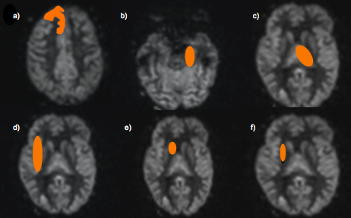

Figure 6: Axial image acquired using p-CASL MR perfusion scan in a healthy volunteer displaying the Medial Temporal Lobes. Region of interest (orange) has been drawn over the right frontal lobe (a), left MTL (b), left thalamus (c), right insula (d), right caudate nucleus (e) and right putamen (f).

In our study we did not need to correct for the partial volume effect (PVE) that is mentioned in research literature due to our analysis technique. It is known that CBF reduces naturally with brain aging and atrophy. To account for the atrophy, PVE correction normally occurs to ensure that the reduction in CBF is due to the underlying disease process itself, rather than the underlying atrophy. This is particularly relevant when using parametric mapping techniques for statistical analysis. To account for this we did localised regional specific areas of interest, where only the grey matter was measured.

To statistically analyse the data, the data was firstly assessed for normal distribution by the use of a histogram. As the data was normally distributed, an analysis of variance (ANOVA) was completed to obtain statistical significance. Subsequent sub-group comparisons were performed using post-hoc analysis. As all the confounding variables had been accounted for, an analysis of covariance (ANCOVA) was not required. To relate the CBF outcomes to the Addenbrooke’s cognitive testing scores, a Pearson’s product-moment correlation was completed. To assess the reliability of the technique used for the CBF measurements both inter and intrarater reliability was completed via the Intraclass correlation coefficient (ICC) statistic. For both inter and intra-rater reliability, 12 random subjects had their WMH count repeated to assess for reliability.

* Primary Outcome measurement: CBF (ml/100g/min)

Visual Assessment of Atrophy, SIENAX, Freesurfer and VBM

**Aim 3:** To determine the characteristics of brain structural and volumetric differences between healthy volunteers (HV), T2DM participants and T2DM participants with cognitive impairment.

Approach and Analysis Plan:

Brain MRI was undertaken and analysis performed via visual and computer programme interpretation analysis. Visual analysis included a manual count of white matter hyperintensities, Fazekas; Scheltens and Pasquier scales. Whole brain volume analysis was completed via the use of SIENAX and Freesurfer computer analysis. Regional brain volumes were analysed by Freesurfer and Voxel Based Morphology. The results then underwent a group comparison. The above analysis techniques are discussed in detail below.

a) Visual Assessment of WMH and Atrophy

For the visual assessment of WMH and atrophy, four different techniques were used. To assess the WMH, a manual count was done and the Fazekas scale was used. For a visual atrophy assessment, Scheltens and Pasquier scale was used. These scales were used as post-processing tools as they are highly regarded in the research literature, particularly when investigating cognition and dementia. This enables us to address our study aim during the analysis and discussion.

The visual atrophy scales that were used included the Fazekas Scale, Scheltens Scale and the Pasquier Score. With the Pasquier score the full method of analysis was deemed to be unsuitable due to not having had suitable training on how to reliably and consistently use the scale. Therefore the atrophy of the brain as a whole was assessed at two points and interpretation of the result needs to be mindful of this.

To undertake the WMH and visual atrophy assessments, a FLAIR (fluid-attenuated inversion recovery) MR image was used. It is recognised that MRI is sensitive at detecting changes in cerebral white matter. When the cerebral white matter is damaged, a prolonged T2 relaxation time occurs firstly due to the increase in tissue water content and secondly, due to degradation of myelin (Caligiuri et al., 2015). This is visualised well with conventional T2-weighted spin echo but these changes are even more obvious on FLAIR images (Caligiuri et al., 2015) and subsequently this is why a FLAIR image for identification and evaluation of any WMH was utilised. To ensure we had optimal views for our assessments, the WMH were counted in the axial view. For the Scheltens scoring system of atrophy, a sagittal image was used as this enables the best view of the atrophy markers; the width of the choroid fissure, hippocampus and temporal horn width. For the limited Pasquier score, the axial view was used as this enabled views of the ventricle that could be easily reproduced between subjects.

i) WMH Count

A FLAIR image was used in three different plans of view: Axial, Sagittal and Coronal. WMH were manually marked and calculated.

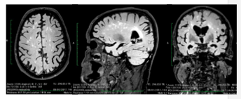

Figure 7: Example Axial, Sagittal and Coronal FLAIR MR images in a T2DM subject showing WMH

To statistically analyse the data, the data was firstly assessed for normal distribution by the use of a histogram. As the data was not normally distributed, a Kruskal-Wallis analysis was completed to identify the presence of statistical significance. Subsequent sub-group comparisons were performed using post-hoc analysis. To relate the WMH outcomes to the Addenbrooke’s cognitive testing scores, a Spearman-Rho was completed. To assess the reliability of the technique used for the WMH measurements both inter- and intrarater reliability were completed via the Intraclass correlation coefficient (ICC) statistic. For both inter and intra-rater reliability, 38 random subjects had their WMH count repeated to assess for reliability.

ii) Fazekas Scale

The Fazekas Scale provides an overall visual assessment of the WMH in the brain and the amount that are present. There are four grades; 0, where no WMH are evident or a single WMH is evident, to 3, where there are large areas of WMH.

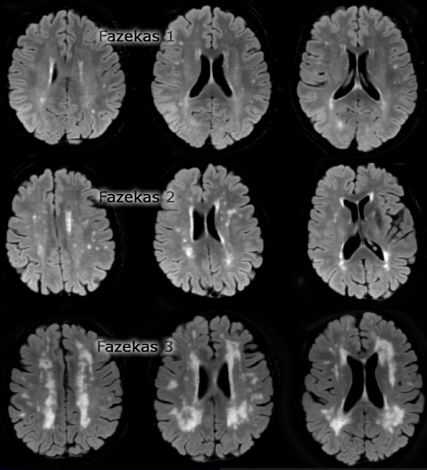

Figure 8: Axial images of the different Fazekas Scores using FLAIR MR imaging

To statistically analyse the data, the data was firstly assessed for normal distribution by the use of a histogram. As the data was not normally distributed, a Kruskal-Wallis test was completed to identify any statistical significance. To assess the reliability of the technique used for the Fazekas scale both inter- and intrarater reliability were completed via the Kappa statistic. For both inter and intra-rater reliability, 38 random subjects had their WMH count repeated to assess for reliability.

To analyse the cerebral atrophy, two scales were used – the Scheltens scale and a limited Pasquier scale.

iii) Scheltens Scale

For the Scheltens scale, a sagittal image was used to position the coronal image level with the anterior pons. The anatomical areas of interest within the Scheltens scale included; the width choroid fissure, height of the hippocampal formation and the width of the temporal horn. The scale has a score between 0-4. A score of 0 indicates that the anatomical areas of interest are within normal measurements and no atrophy is evident. A score of 4 however means that the temporal horn and choroid fissure’s width were greatly increased and the hippocampal height was reduced, suggesting severe atrophy.

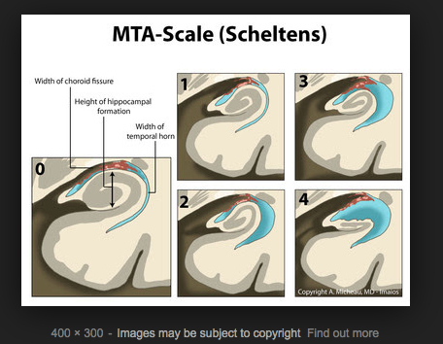

Figure 9: Scheltens Scale as depicted by Dr Antonie Micheau (copyright A.Michaeu, MD, Imaios)

Below are radiological examples of the different MTA scales:

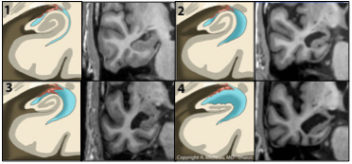

Figure 10: Radiological examples of the different Scheltens scale on Coronal MR images in T2DM subjects, compared to the Scheltens Scale as depicted by Dr Antonie Micheau.

To statistically analyse the data, the data was firstly assessed for normal distribution by the use of a histogram. As the data was not normally distributed, a Kruskal-Wallis test was completed to identify any statistical significance. To assess the reliability of the technique used for the Scheltens scale both inter- and intrarater reliability were completed via the Kappa statistic. For both inter and intra-rater reliability, 38 random subjects had their WMH count repeated to assess for reliability.

iv) Pasquier Scale

As mentioned, the Pasquier scale evaluates cerebral atrophy. The scale does this by assessing the sulcal dilatation and ventricular dilatation in 13 separate regions of the brain. The final score is the sum of the scores in all the regions (Pasquier et al., 1996). A FLAIR axial view was used to perform the scale at two levels, the level just above the lateral ventricles and the level of the ventricles.

To statistically analyse the data, the data was firstly assessed for normal distribution by the use of a histogram. As the data was not normally distributed, a Kruskal-Wallis test was completed to obtain statistical significance. To assess the reliability of the technique used for the Pasquier scale both inter- and intrarater reliability were completed via the Kappa statistic. For both inter and intra-rater reliability, 38 random subjects had their WMH count repeated to assess for reliability.

b) SIENAX Analysis

Following on from the visual assessment of atrophy, brain volume was computationally assessed. SIENAX is an automated computer programme that allows for the estimated measurement of whole brain volume, grey, peripheral grey and white matter volumes and ventricular CSF volume. SIENAX estimates the total brain tissue volume, using an image which is normalised for skull size (Smith et al., 2001; Smith et al., 2002). It does this by using a series of FSL programs (https://fsl.fmrib.ox.ac.uk/fsl/fslwiki/SIENA) (Smith et al., 2004). SIENAX starts by removing non-brain tissue from the single 3D, whole-head input dataset (Smith, 2002). The brain and skull image are then used to estimate the scaling between the subjects image and standard space (MNI152 space) (Jenkinson and Smith, 2001; Jenkinson et al., 2002) (Figure 11). This is done primarily to obtain the volumetric scaling factor, which is used as a normalisation for head size (Figure 13). The programme then runs tissue-type segmentation to estimate the brain tissue volume (Zhang et al., 2001) (Figure 12). This result is multiplied by the estimated scaling factor, which reduces head-size-related variability between subjects. Estimates of grey, peripheral grey (Figure 14) and white matter volumes and ventricular CSF volumes (Figure 15) and brain tissue volume (Figure 16) can be calculated.

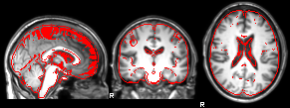

Figure 11: SIENAX FLIRT standard space registration

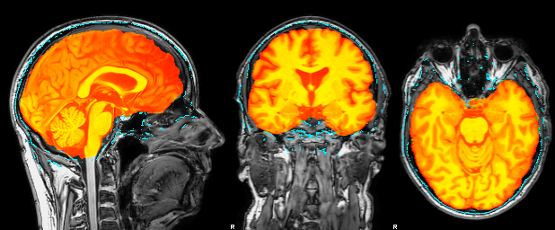(FLIRT (FMRIB's Linear Image Registration Tool) is a fully automated robust and accurate tool for linear intra- and inter-modal brain image registration (Jenkinson and Smith, 2001; Jenkinson et al., 2002). The image data is made up of several image slices to account for movement of the patient during scanning. FLIRT is therefore necessary to integrate and use all the images obtained together in later stages of SIENAX analysis.)

Figure 12: SIENAX BET (Brain Extraction Tool)

(BET allows for the calculation of the upper and lower intensity values for the

image, with the higher intensity value correlating to a higher tissue density. The orange area is what SIENAX has labelled as brain tissue (Smith, 2002).)

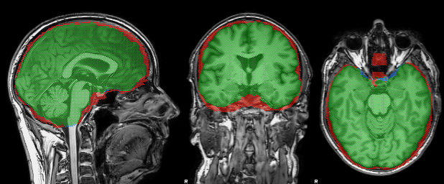Figure 13: SIENAX Field of View and Standard Space Marking

(The green area represents the intersection of the two masks. The blue line represents the original BET derived brain mask. The red line shows the standard space based mask combines with the field of view mask.)

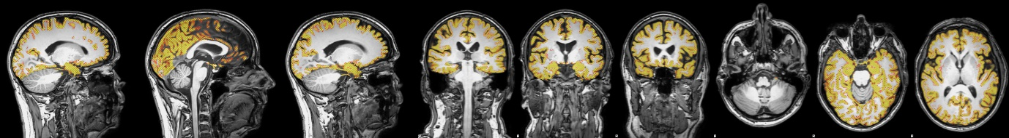

Figure 14: SIENAX Peripheral cortex mask segmentation

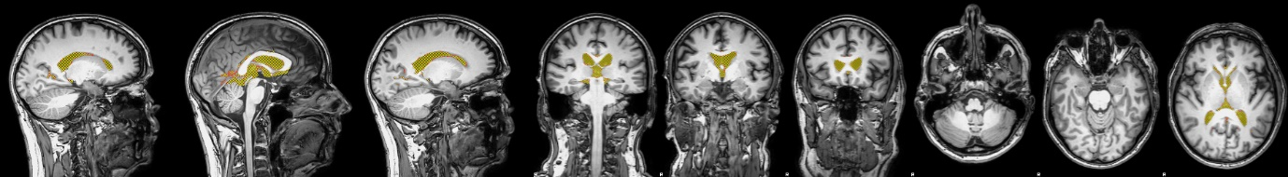(This mask allows for grey, peripheral grey and white matter volumes to be estimated.)

Figure 15: SIENAX Ventricle mask segmentation

(This mask allows for the ventricular CSF volumes to be estimated.)

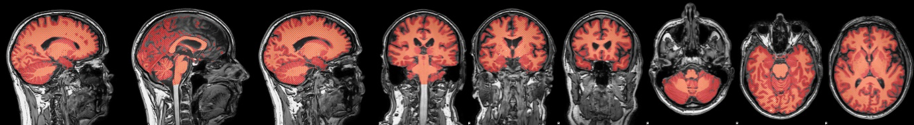

Figure 16: SIENAX Whole brain segmentation

(This mask allows for the total brain volume to be estimated.)

SIENAX was chosen as a post image-processing tool as it is widely used in research for the assessment of atrophy. It is regarded as an accurate tool for measurement of grey matter volumes (Storelli et al., 2017). The only disadvantage of SIENAX is that it only does overall volumes e.g. grey matter, white matter volumes. To enable us to achieve our aims we also needed an image-processing tool that enables more specific regional volume analysis. Hence Freesurfer was then used for more detailed volume regional analysis.

To statistically analyse the data, as the data was normally distributed, an ANOVA was completed to obtain statistical significance. Subsequent sub-group comparisons were performed using post-hoc analysis. As all the confounding variables had been accounted for, an ANCOVA was not required. To relate the SIENAX outcomes to the Addenbrooke’s cognitive testing scores, a Pearson’s product-moment correlation was completed.

c) Freesurfer Analysis

To assess specific anatomical volume estimations, which have complex tissue-type border architecture (e.g. the hippocampus), a further post-acquisition volumetric analysis methodology was used (Freesurfer, https://surfer.nmr.mgh.harvard.edu),

The Freesurfer process starts by using multiple volumetric T1 weighted MR images, where motion correction and averaging occurs (Reuter et al., 2010). Non-brain tissue is removed, using a hybrid watershed/surface deformation procedure (Segonne et al., 2004). An automated Talairach transformation occurs, along with segmentation of the subcortical white matter and deep grey matter volumetric structures (Fischl et al., 2002; Fischl et al., 2004a), intensity normalisation (Sled et al., 1998), tessellation of the grey and white matter boundary, automated topology correction (Segonne et al., 2007; Fischl et al., 2001) and surface deformation following intensity gradients, to optimally place the grey/white and grey/CSF borders (Dale et al., 1999; Dale and Sereno, 1993; Fischl and Dale, 2000).

Once the cortical models are completed, further procedures can be performed for further data processing and analysis including surface inflation (Fischl et al., 1999a), registration to a spherical atlas (Fischl et al., 1999b), parcellation of the cerebral cortex into units with respect to gyral and sulcal structure (Desikan et al., 2006; Fischl et al., 2004b), and creation of a variety of surface based data including maps of curvature and sulcal depth. This method uses both intensity and continuity information from the entire three dimensional MR volume in segmentation and deformation procedures to produce representations of cortical thickness, calculated as the closest distance from the grey/white boundary to the grey/CSF boundary at each vertex on the tessellated surface (Fischl and Dale, 2000).

The maps are created using spatial intensity gradients across tissue classes and are therefore not reliant on absolute signal intensity. The maps produced are capable of detecting sub-millimetre differences between groups. Procedures for the measurement of cortical thickness have been validated against a histological analysis (Rosas et al., 2002) and manual measurements (Kuperberg et al., 2003; Salat et al., 2004).

There are several outputs from Freesurfer, which contain different structural measurements. These include: ASEG, LHPARC and RHPARC.

As mentioned previously, as well as being highly regarded in research literature for accuracy (Storelli et al., 2017), Freesurfer was chosen as an image post-processing tool, so that regional volumes of areas associated with cognition could be measured and compared. This enabled us to meet our study’s secondary aims. Regions of interest were chosen based on known anatomical areas associated with cognition and memory.

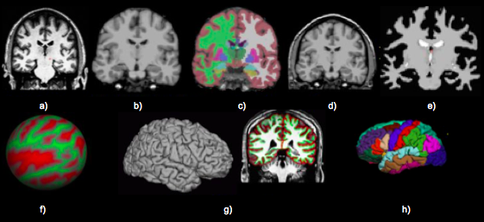

Figure 17: Freesurfer Processing Stream Overview

a) T1 weighted input, b) Skull stripping, c) Volumetric labelling, d) Intensity normalisation, e) White matter segmentation, f) Surface atlas registration, g) Surface extraction, h) Gyral labelling

(Freesurfer: https://surfer.nmr.mgh.harvard.edu)

To statistically analyse the data, as the data was normally distributed, an ANOVA was completed to investigate statistical significance. Subsequent sub-group comparisons were performed using post-hoc analysis. As all the confounding variables had been accounted for, an ANCOVA was not required. To relate the Freesurfer outcomes to the Addenbrooke’s cognitive testing scores, a Pearson’s product-moment correlation was completed.

d) Voxel Based Morphometry (VBM) Analysis

VBM is another neuroimaging analysis technique that allows the volume measurement of different anatomical areas within the brain. The structural data was analysed by using the FSL-VBM (Douaud et al., 2007) (<http://fsl.fmrib.ox.ac.uk/fsl/fslwiki/FSLVBM>) protocol. This is carried out using FSL tools (Smith et al., 2004). Initially, as per the above application of SIENAX, structural images of the brain were extracted along with grey matter segmentation. These images were then registered to standard space (MNI152), using a non-linear registration (www.fmrib.ox.ac.uk/analysis/techrep). The resulting images are then averaged and flipped along the x-axis to create a left – right symmetric, study-specific grey matter template. Next, all the ‘native’ grey matter images are non-linearly registered to the study specific template and modulated to correct for either local expansion or contraction. (This occurs due to the non-linear component of the spatial transformation process.) The modulated grey matter images are then smoothed with an isotropic Gaussian kernel. The last step in the process is statistical analysis using the voxel wise general linear model, with non-parametric testing. This allows for corrections for multiple comparisons across space. The atlas used to identify regional co-ordinates was the Talairach space co-ordinate.

VBM was used as a post image-processing tool as VBM uses voxel-by-voxel analysis, which is sensitive to differences in grey matter at a voxel-level accuracy (Testa et al., 2004), particularly the hippocampus. Comparisons are made based on statistical differences between groups and will show any differences that occur. Regions of interest were again chosen based on known anatomical areas associated with cognition and memory. To statistically analyse the data, a Students t-test was completed between each of the groups.

* Primary Outcome Measurements: The primary outcomes obtained from the above analysis include markers of brain volume and atrophy.

### 3.3 MR Cardiac Image analysis

Again all the analysis of all the MR cardiac data was done blinded. Only the subjects MRI number was known and this was not matched with the participant’s identifiable group number until all the analysis had been completed.

**Aim 4:** To explore the characteristics of LV cardiac function in T2DM participants with cognitive impairment.

**Aim 5:** To relate LV cardiac output to CBF with cognition

Approach:

Carefully phenotyped patients with T2DM and MCI underwent quantitative Cardiac-MR imaging to measure LV systolic and diastolic function.

Analysis Plan:

To analyse the data the MEDIS Suite version 2.0.16.0 (Medis medical imaging systems, Leiden, The Netherlands) MR software program was used. This method was used as a post-processing tool as it is widely used in the research literature. It enables us to measure end-systolic and end-diastolic measurements, which we will be using in our analysis to assess for any abnormalities. The software also automatically generates essential measurements such as ejection fraction, which again, is required for the assessment of left ventricular function.

End-systolic and end-diastolic frames were identified in the short axis view (Figure 18). To trace epicardial and endocardial contours, measurements were initially undertaken with the aid of automated image analysis software (QMASS) then altered manually if correction was needed. The papillary muscles were excluded for end-diastolic mass assessment.

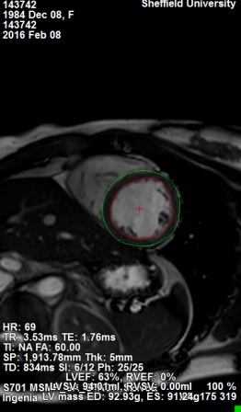

Figure 18: Cardiac MR image of an end-diastolic frame identified in the short axis view

Automatic calculations of end-diastolic volume (EDV), end-systolic volume (ESV), stroke volume (SV), ejection fraction (EF) and cardiac output (CO) and LV myocardial mass are provided by the MEDIS Suite analysis program.

Aortic flow was measured with the aid of an automated image analysis software program (QFLOW) then altered manually if correction was needed. The net flow volume, forward flow volume, backward flow volume and regurgitant percentage were calculated in both ml/min and ml/beat.

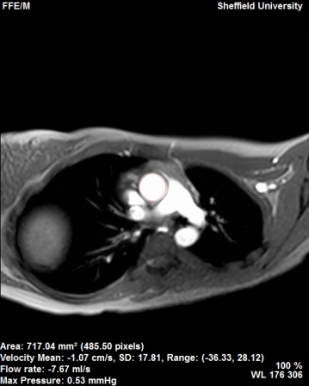

Figure 19: Cardiac MR image of the Aortic Flow measurement

To statistically analyse the data, as the data was normally distributed an ANOVA was completed. Both inter-rater and intrarater reliability were also calculated by using the intraclass correlation coefficient (ICC). For both inter and intra-rater reliability, 10 random subjects had their WMH count repeated to assess for reliability.

* Primary Outcome Measurements: The primary outcome measurements include data on left ventricle volumes, output and filling data along with aortic flow volumes.

# Results

## **1. Baseline Data (Demographic/Laboratory and Clinical)**

### 1.1 Demographic/Laboratory and Clinical Data Results for All Groups

The demographic and baseline characteristic data for all the groups can be seen in Table 1. The mean values and standard deviations have been calculated. To assess for statistical significance either an ANOVA for continuous data or Kruskal-Wallis analysis for categorical data were used. When comparing the T2DM groups an independent Students t-test was completed.

The majority of the participants were White British in ethnicity. All of the T2DM/MCI group was white British in ethnicity. For the other groups all apart from one Asian British participant in the HV group and two Asian British in the T2DM group, were White British.

A confusion screen was completed on all participants, which included blood level measurements of adjusted calcium, liver function, thyroid function, renal function, vitamin B12, folate and haemoglobin. These were all in normal range. To ensure that depression was not a cause for cognitive impairment a PHQ-9 depression questionnaire was completed. A score of 5 or more is indicative of underlying depression. None of the participants reached this score and hence no one was excluded from the study with regards to non-diagnosed depression.

All participants who had T2DM had a pre-questionnaire blood glucose check to ensure hypo-/hyperglycaemia did not interfere with the Addenbrooke’s cognitive assessment and depression questionnaires.

|  |  |  |  |  |
| --- | --- | --- | --- | --- |
|  | HV  n = 29 | T2DM  n = 30 | T2DM/MCI  n = 17 | p Value |
| Age (years) | 69.3  (4.6) | 71.0  (4.6) | 71.5  (3.2) | p = 0.164* |
| Gender  Male (%) | 15  (52) | 22  (73) | 12  (71) | p = 0.276* |
| Body Mass Index (kg/m2) | 26.3  (3.4) | 28.6≠  (3.8) | 30.1#  (2.8) | **p = 0.001\*** |
| Smoker (%)  Ex-Smoker (%)  Non-Smoker (%) | 0 (0)  17 (59)  12 (41) | 2 (7)  18 (60)  10 (33) | 2 (12)  8 (47)  7 (41) | p = 0.599* |
| Median (IQR) Age of Last Education | 17.5  (15-22) | 15.9≠  (15-18) | 15.0#  (15-15) | **p = 0.003\*\*** |
| Alcohol units consumed | 10.4  (10.7) | 10.3  (10.1) | 8.0  (17.7) | p = 0.786* |
| Addenbrooke’s Score (0-100) | 95.6  (2.4) | 94.1  (3.1) | 84.4#  (2.2) | **p = 0.000\*** |
| Median (IQR)  PHQ-9 Score (0-5) | 0  (0-1) | 1≠  (0-4) | 1#  (0-4) | **p = 0.022\*\*** |
| Systolic BP (mmHg) | 141.0  (13.9) | 142.7  (14.9) | 145.2  (13.8) | p = 0.612* |
| HbA1c  (mmol/L) | 36.4  (3.1) | 52.0≠  (9.8) | 55.9#  (12.8) | **p = 0.000\*** |
| Cholesterol  (mmol/L) | 5.7  (1.1) | 4.0≠  (1.0) | 4.3#  (1.4) | **p = 0.000\*** |
| Median (IQR) eGFR (ml/min) | 81  (71-90) | 82  (69-88) | 70  (59.5-88.5) | p = 0.467** |

Table 2: Baseline demographic and characteristics of all the groups.

Values are mean plus standard deviation (SD) unless stated; where ANOVA was completed a * is next to the p value; where a Kruskal-Wallis test was completed a ** is placed next to the p value; where a # is placed next to the value, this indicates statistical significance exists between the HV and T2DM/MCI group; where a ≠ is placed next to the value, this indicates statistical significance exists between the HV and T2DM group.

When reviewing the non-significant results, each group was well age-matched and this can be reflected in a p value of 0.164 (ANOVA).

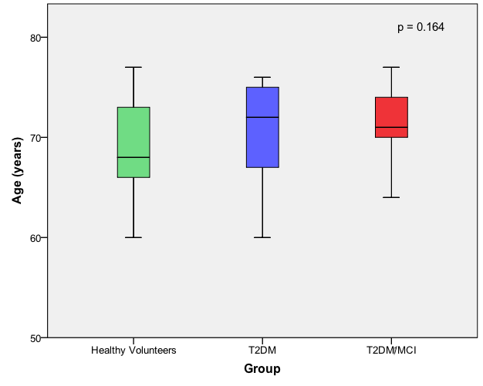

Figure 20: Box and Whisker Plot demonstrating the median and interquartile ages of the three groups, p = 0.164 (ANOVA).

Other group-mean statistical comparisons that did not reach a significant value of p<0.05 include: gender (p = 0.276), smoking status

(p = 0.599), alcohol unit consumption (p = 0.786), mean systolic blood pressure (p = 0.612) and eGFR (p = 0.467).

When reviewing the gender, the higher prevalence of males compared to female participants in both the T2DM and T2DM/MCI groups did not reach statistical significance (p>0.05).

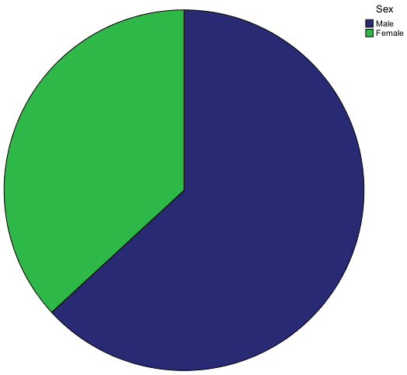

Figure 21: Pie chart demonstrating the gender of the participants, p = 0.276 (ANOVA).

The main significant results between group means noted in the data include: Body Mass Index (BMI) (p = 0.001), age of last education (p = 0.003), Addenbrooke’s score (p = 0.000), PHQ-9 score (p = 0.022), HbA1c

(p = 0.000) and cholesterol levels (p = 0.000). BMI was found to have statistically significant level between all three groups of F (2, 73) = 7.2,

p = 0.001 (ANOVA). There was a large effect size (0.16 eta squared). Post-hoc comparisons using the Bonferroni test indicated that the mean score for HV (M = 26.30, SD = 3.42) was significantly different (p<0.05) from that of the T2DM group (M = 28.63, SD = 3.79) and the T2DM/MCI group (M = 30.14,

SD = 2.83). The T2DM did not differ significantly from the T2DM/MCI group.

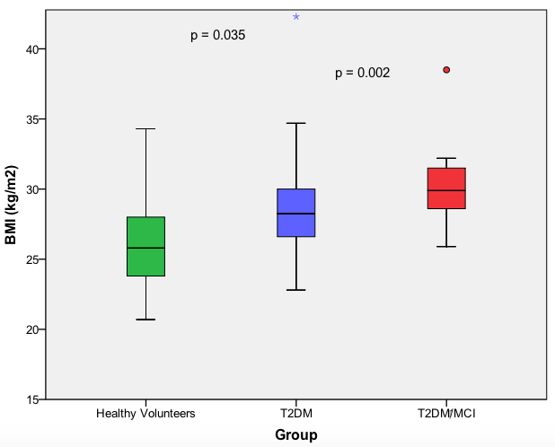

Figure 22: Box and Whisker plot showing the BMI data of the groups, p = 0.001 (ANOVA).

The data collected for age of last education was positively skewed on histogram therefore a Kruskal-Wallis completed to assess for significance. This was statistically significant between the groups χ2 (2, n = 76) = 16.18,

p = 0.003. The HV group had a higher median score (Md = 17.5yrs) than the other two groups (T2DM Md = 15.9yrs, T2DM/MCI Md = 15.0yrs). Post-hoc comparisons’ using a Mann-Whitney U test was completed to identify which groups were statistically significantly different. The Mann-Whitney U test revealed a significant difference in age of last education between HV and the T2DM/MCI group, *U* = 87, z = -3.80, p = 0.000, r = 0.56; as well as between the T2DM and the T2DM/MCI groups, *U* = 127, z = -3.01, p = 0.003, r = 0.44. Using Cohen (1988) criteria this indicated a large effect. There was no significance between the HV and T2DM groups, *U* = 59, z = -1.63, p = 0.102.

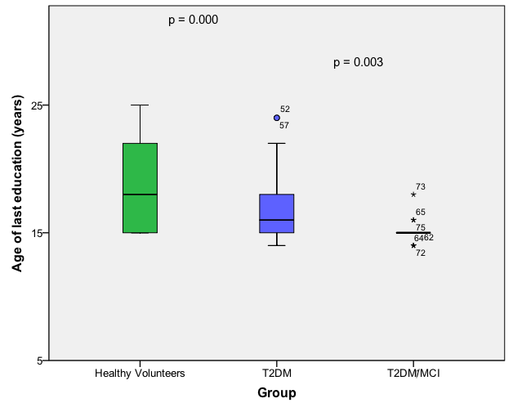

Figure 23: Box and Whisker plot showing the median and interquartile age of last education of the groups, p = 0.003 (Kruskal-Wallis).

An ANOVA was conducted to explore the relationship between the groups and the Addenbrooke’s score the participants recorded. There was statistical significance at the p<0.05 level between the means of the three groups: F (2, 75) = 99.3, p = 0.000. There was a large effect size (0.73 eta squared). Post-hoc comparisons using the Bonferroni test indicated that the mean score for HV (M = 95.59, SD = 2.38) was significantly different from that of the T2DM/MCI group (M = 83.00, SD = 3.94). The T2DM group

(M= 94.13, SD = 3.14) was also significantly different from the T2DM/MCI group. There was no significance between the HV and T2DM groups.

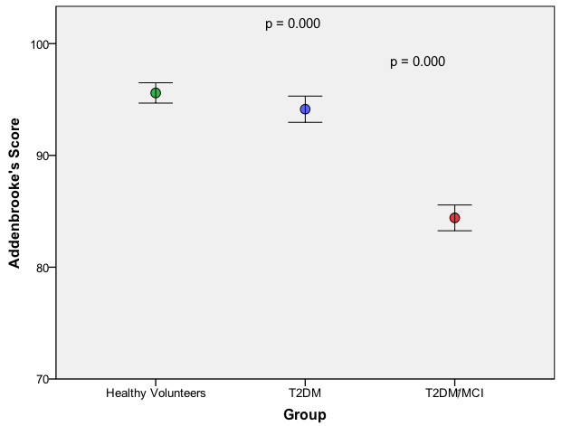

Figure 24: Chart showing group mean Addenbrooke’s scores between groups (error bars represent 95% confidence intervals from the means), p = 0.000 (ANOVA).

The PHQ9 depression questionnaire was completed on all participants. All participants had a score of less than 5. Despite this, the analysis has shown that the HV group has a lower PHQ9 score when compared to the other groups. The initial Kruskal-Wallis test revealed significance between the groups χ2 (2, n = 76) = 7.65, p = 0.022. For post hoc analysis, Mann-Whitney U test indicated significance between the HV (Md 0.00) and T2DM (Md 1.00) groups *U* = 272.000, z = -2.606, p = 0.010, r = 0.33. Significance was also found between the HV and T2DM/MCI groups (MD 1.00), *U* = 163.000,

z = -2.038, p = 0.042, r = 0.30. There was no significant difference between the T2DM and T2DM/MCI group, p = 0.96. Given such a low median score between the groups, the clinical significance of this result insignificant.

The HbA1c data was positively skewed and on completion of a Kruskal-Wallis test significance was demonstrated between the groups;

χ2 (1, n = 76) = 40.709, p = 0.000). The significance after post-hoc analysis by a Mann Whitney U test revealed that this significance occurs between the HV (Md 36.55) and T2DM groups (Md 50) *U* = 15.000, z = -6.380, p = 0.00,

r = 0.83; and the HV group and T2DM/MCI groups (Md 52) *U* = 5.000,

z = -5.514, p = 0.000, r = 0.81. There was no significance between the T2DM and T2DM/MCI groups (p = 0.240).

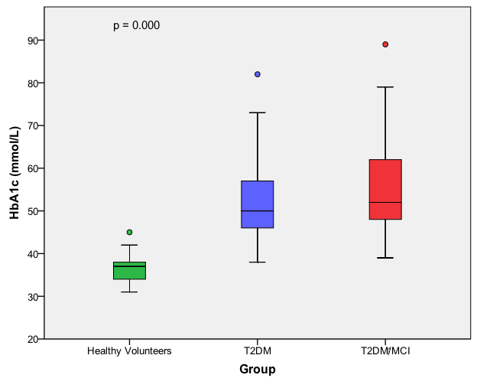

Figure 25: Box and Whisker plot showing the HbA1c levels in each group, p = 0.000 (Kruskal-Wallis).

When analysing the cholesterol results, the HV group had higher overall total cholesterol levels when compared to both the T2DM and T2DM/MCI groups. An ANOVA was completed showing statistical significance between the three groups: F (2, 73) = 18.64, p = 0.000. The effect size calculated via eta squared was 0.38. Post-hoc comparisons using the Bonferroni test indicated the mean score for HV (M = 5.72, SD = 1.15) was significantly different (p<0.05) from the T2DM (M = 4.02, SD = 1.00) and the T2DM/MCI group

(M = 4.26, SD = 1.30). There was no significance in cholesterol levels when comparing the T2DM and T2DM/MCI group.



Figure 26: Box and Whisker plot of participant’s cholesterol levels, p = 0.000 (ANOVA).

When reviewing the participants medication, in particular to cardiac medication, it can be seen that one participant in the HV group was on a beta-blocker (propranolol). In the T2DM group, 5 participants were on Angiotensin-Converting-Enzyme (ACE) inhibitor medications, 2 participants were taking Angiotensin-11-Receptor Blockers (ARB) medication and 1 participant was taking a beta-blocker. In the T2DM/MCI group 6 participants were taking an ACE-inhibitor medication and 2 were taking an ARB medication. This needs to be considered when reviewing the cardiac results.

### 1.2 Demographic and Baseline Data for the Diabetes Groups

The following table explores the baseline diabetes-related data of the two groups that contained participants with diabetes (T2DM and T2DM/MCI groups).

|  |  |  |  |
| --- | --- | --- | --- |
|  | T2DM  n = 30 | T2DM/MCI  n = 17 | p Value |
| Mean (SD) Duration of Diabetes (years) | 9.6 (5.3) | 13.8 (13.3) | p = 0.227 |
| Retinopathy  Present  Absent | 6 (21)  23 (79) | 5 (29)  12 (71) | p = 0.475 |
| Peripheral Neuropathy  Present  Absent | 0 (0)  29 (100) | 0 (0)  17 (100) | p = 0.437 |
| Nephropathy  Present  Absent | 1 (3)  28 (97) | 2 (12)  15 (88) | p = 0.344 |
| Autonomic Neuropathy  Present  Absent | 0 (0)  30 (100) | 0 (0)  17 (100) | p = 1.000 |

Table 3: Baseline demographic characteristics of the two diabetic groups. Values are numbers (percentages) unless stated otherwise, p values relate to group comparisons, analysed by a Students t-test.

Within the T2DM group 6 participants were diet controlled, 10 were on Metformin only and the rest were on a combination of either:

a) Gliclazide alone

b) Metformin and Gliclazide

c) Metformin, Gliclazide and Pioglitazone

d) Metformin, Gliclazide and Dapagliflozin

e) Metformin and Sitagliptin

In the T2DM/MCI group, 1 participant was diet controlled and 1 participant was on insulin and metformin therapy. The rest of the group were on a combination of:

a) Metformin

b) Gliclazide

c) Linagliptin

d) Metformin and Gliclazide

e) Metformin, Gliclazide and Pioglitazone

f) Metformin, Gliclazide and Linagliptin

g) Metformin and Pioglitazone

## **2. Cerebral Blood Flow Results**

As mentioned in the introduction, development in MR based contrast and non-contrast perfusion techniques have allowed us to examine alterations in cerebral haemodynamics in greater detail. From the literature, we identified that robust testing of CBF was needed, in particular when relating the findings to cognition. To recap the aims of the CBF measurements in the study were:

**Aim 1:** To measure the anatomical areas associated with cognitive function (medial temporal lobe, frontal lobe, basal ganglia and insula) and assess the CBF in subjects with T2DM and mild cognitive impairment (MCI).

**Aim 2:** To examine the relationship between CBF and cognition in brain regions involved with cognitive function along with clinical measures of cognitive impairment.

The results for the CBF are as follows.

2.1 Mean Motion Correction

Before the CBF analysis was completed, the images were corrected for movement. An ANOVA was conducted to see if there was any statistical significance between the degrees of movement artefact corrected between each groups. There was no statistical significance found, with a p value of 0.077.

2.2.CBF Analysis

The following table shows the results obtained for the CBF analysis.

|  |  |  |  |  |  |  |  |  |  |  |
| --- | --- | --- | --- | --- | --- | --- | --- | --- | --- | --- |
| CBF Region  of Interest | HV  n = 29 | | | T2DM  n = 28 | | | T2DM/MCI  n = 17 | | | p Value |
| R | L | C | R | L | C | R | L | C |
| Anterior Cingulate  Cortex  (ml/min/100g) | - | - | 42.1  (8.3) | - | - | 42.3  (8.7) | - | - | 32.9^  (6.6) | **p = 0.000** |
| Posterior  Cingulate Cortex  (ml/min/100g) | - | - | 40.9  (7.5) | - | - | 43.7  (9.2) | - | - | 35.0^#  (6.9) | **p = 0.009** |
| Occipital Lobe  (ml/min/100g) | - | - | 47.1  (10.7) | - | - | 46.3  (8.9) | - | - | 45.5  (6.4) | p = 0.844 |
| Medial Temporal Lobe  (ml/min/100g) | 46.3  (11.2) | 47.3  (9.8) | 93.6  (19.4) | 48.4  (15.2) | 49.1  (14.0) | 97.5  (27.7) | 36.5  (11.2) | 40.3  (12.0) | 76.8^  (20.2) | **p = 0.014** |
| Caudate  (ml/min/100g) | 38.0  (8.7) | 38.5  (8.4) | 76.5  (15.8) | 37.5  (7.9) | 38.9  (8.4) | 76.4  (15.4) | 32.8  (6.8) | 35.3  (8.4) | 68.2  (13.3) | p = 0.149 |
| Putamen  (ml/min/100g) | 35.3  (6.9) | 36.6  (7.1) | 71.9  (13.5) | 37.3  (8.3) | 39.7  (9.3) | 77.0  (16.7) | 32.5  (4.8) | 36.6  (12.0) | 69.0  (15.8) | p = 0.211 |

|  |  |  |  |  |  |  |  |  |  |  |
| --- | --- | --- | --- | --- | --- | --- | --- | --- | --- | --- |
| CBF Region  of Interest | HV  n = 29 | | | T2DM  n = 28 | | | T2DM/MCI  n = 17 | | | p Value |
| R | L | C | R | L | C | R | L | C |
| Thalamus  (ml/min/100g) | 43.8  (9.2) | 44.6  (8.9) | 88.4  (16.9) | 46.5  (9.5) | 46.0  (10.2) | 92.5  (18.5) | 38.3  (10.5) | 37.6  (12.4) | 75.9^  (22.3) | **p = 0.018** |
| Insula  (ml/min/100g) | 43.3  (9.7) | 43.1  (7.6) | 86.4  (16.9) | 43.3  (8.6) | 42.4  (8.0) | 85.7  (15.3) | 34.4  (6.0) | 33.1  (5.6) | 67.5^#  (10.1) | **p = 0.000** |
| Frontal Lobe  (ml/min/100g) | 44.5  (8.0) | 44.6  (8.2) | 44.6  (8.2) | 44.5  (8.5) | 44.2  (9.8) | 44.2  (9.8) | 35.8  (7.2) | 36.0  (6.0) | 36.0^#  (6.0) | **p = 0.003** |
| White Matter  (ml/min/100g) | 4.5  (4.4) | 3.8  (3.8) | - | 2.9  (1.3) | 2.2  (1.3) | - | 5.2  (3.8) | 4.0  (2.8) | - | p >0.05 |

Table 4: CBF brain region of interest results, where the right- and left-sided, with combined regions are presented. Values are Mean plus standard deviation (SD) unless stated, p values relate to combined brain region results where group comparisons are analysed by an ANOVA. Where a ^ is placed next to the value, this indicates statistical significance exists between the T2DM and T2DM/MCI group, where a # is placed next to the value, this indicates statistical significance exists between the HV and T2DM/MCI group; where a ≠ is placed next to the value, this indicates statistical significance exists between the HV and T2DM group.

The occipital lobe was selected as a control area. There was no statistical significance demonstrated in this area between the 3 groups.

As the previous table highlights, the regions of interest that have statistically significant results include the posterior and anterior cingulate cortex, medial temporal lobe, thalamus, insula and frontal lobe.

The posterior cingulate cortex was statistically analysed using an ANOVA to explore the results of the CBF between the groups. There was statistical significance at the p<0.05 level in the CBF for the three groups:

F (2, 73) = 5.030, p = 0.009. There was a medium difference in mean scores between some groups and the effect size, calculated using eta squared, was 0.13. Post-hoc comparisons using the Bonferroni test indicated that the mean score for T2DM (M = 43.7, SD = 9.2) was significantly different from the T2DM/MCI group (M = 35.9, SD = 6.9). There was no significance between the HV (M = 40.9, SD = 7.5) and T2DM/MCI group or between the HV and T2DM groups.

For the anterior cingulate cortex, an ANOVA was conducted to explore the results of the CBF between the groups. There was statistical significance at the p<0.05 level in the CBF for the three groups: F (2, 73) = 567.4, p = 0.000. There was a large difference in mean scores between some groups and the effect size, calculated using eta squared, was 0.19. Post-hoc comparisons using the Bonferroni test indicated that the mean score for T2DM (M = 42.3, SD = 8.7) was significantly different from the T2DM/MCI group (M = 32.9,

SD = 6.6). There was also significance between the HV (M = 42.1, SD = 8.3) and T2DM/MCI group. There was no statistical significance between the HV and T2DM groups.

For the medial temporal lobe, an ANOVA was conducted to explore the results of the CBF between the groups. There was statistical significance at the p<0.05 level in the CBF for the three groups: F (2, 73) = 4.521, p = 0.014. There was a medium difference in mean scores between some groups and the effect size, calculated using eta squared, was 0.11. Post-hoc comparisons using the Bonferroni test indicated that the mean score for T2DM (M = 97.5, SD = 27.7) was significantly different from the T2DM/MCI group (M = 76.8,

SD = 20.2). There was no significance between the HV (M = 93.6, SD =19.4) and T2DM/MCI group or HV and the T2DM groups.

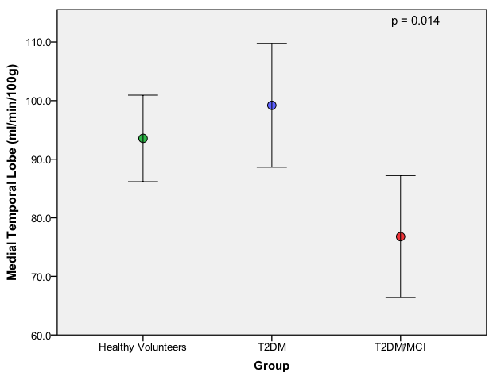

Figure 27: Chart showing group mean CBF in the medial temporal lobe (error bars represent 95% confidence intervals from the means), p = 0.014 (ANOVA).

For the thalamus, an ANOVA was conducted to explore the results of the CBF between the groups. There was statistical significance at the p<0.05 level in the CBF for the three groups: F (2, 73) = 4.237, p = 0.018. There was a medium difference in mean scores between some groups and the effect size, calculated using eta squared, was 0.11. Post-hoc comparisons using the Bonferroni test indicated that the mean score for T2DM (M = 92.5, SD = 18.5) was significantly different from the T2DM/MCI group (M = 75.9, SD = 22.3). There was no significance between the HV (M = 88.4, SD =16.9) and T2DM/MCI group or HV and the T2DM groups.

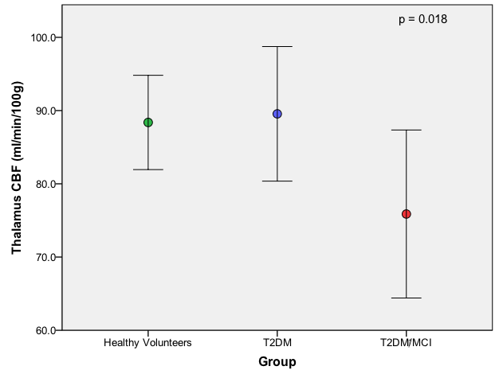

Figure 28: Chart showing group mean CBF in the thalamus (error bars represent 95% confidence intervals from the means), p = 0.018 (ANOVA).

For the insula, an ANOVA was conducted to explore the results of the CBF between the groups. There was statistical significance at the p<0.05 level in the CBF for the three groups: F (2, 73) = 9.961, p = 0.000. There was a large difference in mean scores between some groups and the effect size, calculated using eta squared, was 0.22. Post-hoc comparisons using the Bonferroni test indicated that the mean score for T2DM (M = 85.7, SD = 15.3) was significantly different from the T2DM/MCI group (M = 67.5, SD = 10.1). There was also statistical significance between the HV (M = 86.4, SD =16.9) and the T2DM/MCI group. There was no statistical significance between the HV and the T2DM groups.

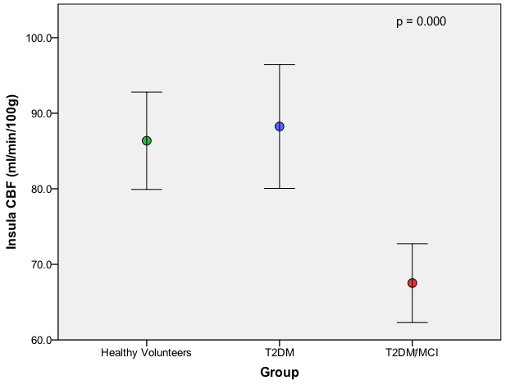

Figure 29: Chart showing group mean CBF in the insula (error bars represent 95% confidence intervals from the means), p = 0.000 (ANOVA).

Again, for the frontal lobe, an ANOVA was conducted to explore the results of the CBF between the groups. There was statistical significance at the p<0.05 level in the CBF for the three groups: F (2, 73) = 7.616, p = 0.001. There was a large difference in mean scores between some groups and the effect size, calculated using eta squared, was 0.18. Post-hoc comparisons using the Bonferroni test indicated that the mean score for T2DM (M = 88.6, SD = 15.4) was significantly different from the T2DM/MCI group (M = 71.8, SD = 17.8). There was also statistical significance between the HV (M = 89.1, SD =15.4) and T2DM/MCI group. There was no statistical significance between the HV and the T2DM groups.

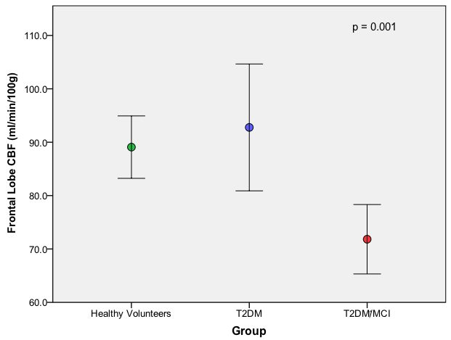

Figure 30: Chart showing group mean CBF in the frontal lobe (error bars represent 95% confidence intervals from the means), p = 0.001 (ANOVA).

2.3 Relationship between CBF and Addenbrooke’s Testing

To assess the relationship between the Addenbrooke’s questionnaire score results and combined ASL results, a Pearson’s product-moment correlation coefficient was completed for each region.

For the medial temporal lobe, there was a small, positive correlation between the two variables, r = .260, n = 74, p = 0.024, with higher Addenbrooke’s scores associated with higher grey matter volumes.

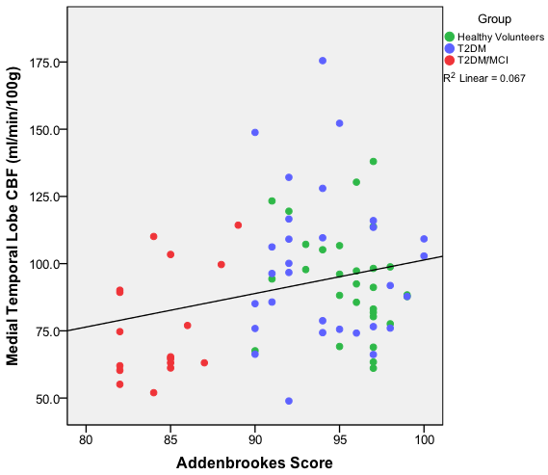

Figure 31: Scatter graph showing the positive correlation between the medial temporal lobe CBF results and the Addenbrooke’s score, p = 0.024.

For the thalamus, again there was a small, positive correlation between the two variables, r = .252, n = 74, p = 0.028, with higher Addenbrooke’s scores associated with higher grey matter volumes.

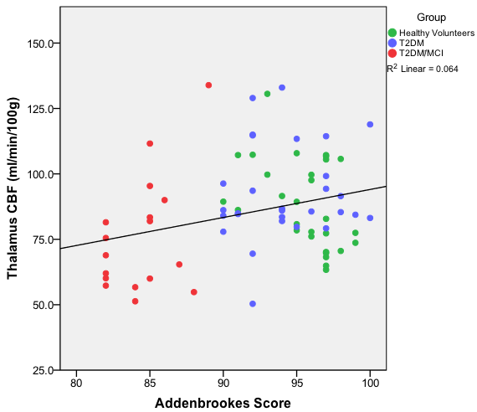

Figure 32: Scatter graph showing the positive correlation between the thalamus CBF results and the Addenbrooke's score, p = 0.028.

For the insula, there was a small, positive correlation between the two variables, r = .274, n = 74, p = 0.017, with higher Addenbrooke’s scores associated with higher grey matter volumes.

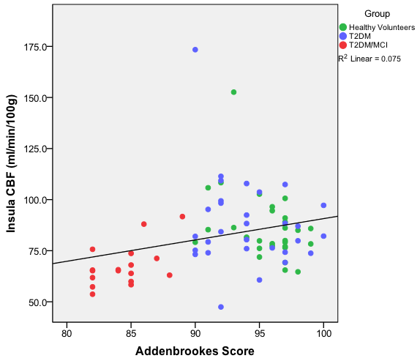

Figure 33: Scatter graph showing the positive correlation between the insula CBF results and the Addenbrooke's score, p = 0.017.

For the frontal lobes, no correlation was seen between the Frontal lobe CBF and the Addenbrooke’s score, r = .205, n = 74, p = 0.076.

2.4 Inter and Intra-Rater Reliability

To assess the reliability of the technique used for the ASL measurements both inter- and intra rater reliability were completed. To assess the inter-rater and intrarater reliability the Intraclass correlation coefficient (ICC) statistic was used. The results are as follows:

- Inter-rater:

a) Right MTL: using a single-measurement, absolute-agreement, 2 –way mixed-effects model, ICC = 0.965 (95% CI 0.882-0.990).

b) Left MTL: using a single-measurement, absolute-agreement, 2 –way mixed-effects model, ICC = 0.965 (95% CI 0.884-0.990).

- Intrarater right MTL:

a) Using a single-measurement, absolute-agreement, 2 –way mixed-effects model, ICC = 0.962 (95% CI 0.844-0.995).

2.5 CBF Summary

## The results obtained for the CBF analysis have shown that there is a reduction in CBF in subjects with T2DM and cognitive impairment in the medial temporal lobe, insula, thalamus and frontal lobe. These areas, apart from the frontal lobe, correlate positively to the Addenbrooke’s score, i.e. as the CBF increases the Addenbrooke’s score increases.

## **3. Cerebral Anatomical Results**

In the literature there is evidence of cerebral atrophy and white matter hyperintensities in the T2DM cohort. The data that we have obtained explores these findings further by relating the changes to a T2DM cohort with cognitive impairment and relating the findings to cognitive screening results. To recap the aim of the cerebral anatomical results was:

**Aim 3:** To determine the characteristics of brain structural and volumetric differences between healthy volunteers (HV), T2DM participants and T2DM participants with cognitive impairment.

#### The results of the cerebral anatomical findings are as below.

#### 3.1 Visual Atrophy Assessment

As given in the methods section, three visual atrophy-rating scales were used to assess any cerebral atrophy in all the participants. These consisted of the Fazekas scale, Scheltens scale and a limited Pasqueir score and they were interpreted from inspection of the 3D T1-weighted dataset acquired in each subject.

3.1.1 Fazekas Scale

The Fazekas score is observed in two regions – periventricular and white matter – with a graded scale between 0-3 recorded for each region.

|  |  |  |  |  |
| --- | --- | --- | --- | --- |
| Fazekas  Region | HV  n = 29 | T2DM  n = 30 | T2DM/MCI  n = 17 | p Value |
| Periventricular | 1 (1) | 1 (1) | 2 (2)#^ | **p = 0.021** |
| White Matter | 1 (0.5) | 2 (1)≠ | 3 (2)# | **p = 0.011** |

Table 5: Parenchymal Brain Atrophy results. Median and Interquartile range (IQR) presented, p value represents group comparisons using a Kruskal-Wallis test. Where a ^ is placed next to the value, this indicates statistical significance exists between the T2DM and T2DM/MCI group, where a # is placed next to the value, this indicates statistical significance exists between the HV and T2DM/MCI group; where a ≠ is placed next to the value, this indicates statistical significance exists between the HV and T2DM group.

* Fazekas Scale – Periventricular

For statistical analysis a Kruskal-Wallis test was completed which revealed a statistically significant difference in the periventricular Fazekas scale readings between the three groups (HV, n = 29, T2DM, n = 30, T2DM/MCI, n = 17),

χ2 (2, n = 76) = 7.73, p = 0.021. The T2DM/MCI had a higher recorded median score (Md = 2) than the other two groups, which recorded median values of 1. Post hoc analysis was completed using a Mann-Whitney U test. Statistical significance was found between the HV (Md = 1) and the T2DM/MCI groups (Md = 2) *U* = 140.500, z = -2.653, p = 0.008, r = 0.39. Statistical significance was also found between the T2DM (Md = 1) and T2DM/MCI groups *U* = 171.000, z = -1.995, p = 0.046, r = 0.29. There was no significance between the HV and T2DM groups, p = 0.251.

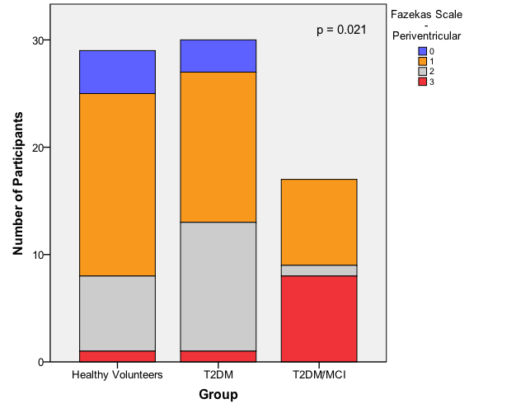

Figure 34: Bar chart showing the distribution of the different Fazekas scale scores allocated to each participant within the periventricular region, p = 0.021 (Kruskal-Wallis).

* Fazekas Scale - White Matter

For statistical analysis a Kruskal-Wallis test was completed which revealed a statistically significant difference in the white matter Fazekas scale readings

between the three groups, χ2 (2, n = 76) = 9.008, p = 0.011. The T2DM/MCI had the highest recorded median score (Md = 3), the T2DM group having a median score of 2 with the lowest median score being in the HV group (Md = 1). Post hoc analysis was completed using a Mann-Whitney U test. Statistical significance was found between the HV (Md = 1) and the T2DM/MCI groups (Md = 3) *U* = 139.000, z = -2.617, p = 0.009, r = 0.39. Statistical significance was also found between the HV and T2DM groups. (Md = 2) *U* = 309.500, z = -2.041, p = 0.041, r = 0.27. There was no statistical significance between the T2DM and T2DM/MCI groups, p = 0.07.

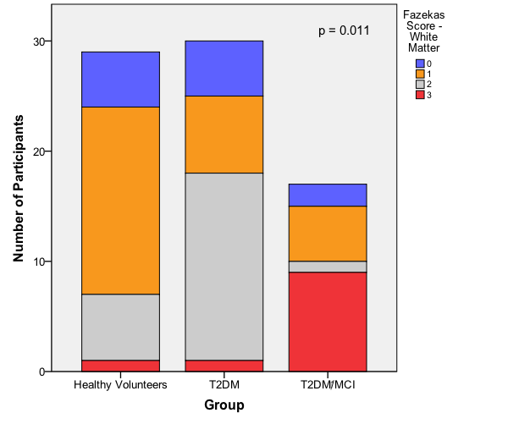Figure 35: Bar chart showing the distribution of the different Fazekas scale scores allocated to each participant at the white matter region, p = 0.011 (Kruskal-Wallis).

3.1.2 Scheltens Scale

The Scheltens scale is applied to the hippocampal region. A score of 0 to 4 can be awarded depending on the degree of hippocampal volume loss.

A Kruskal-Wallis test was completed which revealed a statistically significant difference in the Scheltens scale readings between the three groups (HV,

n = 29, T2DM, n = 30, T2DM/MCI, n = 17), χ2 (2, n = 76) = 29.162, p = 0.000.

The T2DM/MCI had the highest recorded median score (Md = 2), with the lowest median scores being in the T2DM group (Md = 1) and HV group

(Md = 1). Post hoc analysis was completed using a Mann-Whitney U test. Statistical significance was found between the HV (Md = 1) and the T2DM groups (Md = 1) *U* = 251.000, z = -3.281, p = 0.001, r = 0.43. Statistical significance was also found between the HV and T2DM/MCI groups (Md = 2) *U* = 44.500, z = -4.958, p = 0.000, r = 0.73. Finally there was statistical significance between the T2DM and T2DM/MCI groups

*U* = 127.500, z = -3.140, p = 0.002, r = 0.46.

|  |  |  |  |  |
| --- | --- | --- | --- | --- |
|  | HV  n = 29 | T2DM  n = 30 | T2DM/MCI  n = 17 | p Value |
| Scheltens Score | 1 (0.5) | 1 (1)≠ | 2 (2)^# | **p = 0.000** |

Table 6: Scheltens scale results. Median and Interquartile range (IQR) presented, p value represents group comparisons using a Kruskal-Wallis test. Where a ^ is placed next to the value, this indicates statistical significance exists between the T2DM and T2DM/MCI group, where a # is placed next to the value, this indicates statistical significance exists between the HV and T2DM/MCI group; where a ≠ is placed next to the value, this indicates statistical significance exists between the HV and T2DM group.

3.1.3 Pasquier Score

For the Pasquier score results, a modified version was completed assessing atrophy at two points – level with the lateral ventricle and level above the lateral ventricle.

|  |  |  |  |  |
| --- | --- | --- | --- | --- |
| Pasquier Score | HV  n = 29 | T2DM  n= 30 | T2DM/MCI  n = 17 | p Value |
| Level at the ventricle | 2 (1) | 2 (1) | 3 (1)^# | **p = 0.000** |
| Level above the ventricle | 1 (1) | 1 (1) | 2 (0)^# | **p = 0.002** |

Table 7: Pasquier score results. Median and Interquartile range (IQR) presented, p value represents group comparisons using a Kruskal-Wallis test. Where a ^ is placed next to the value, this indicates statistical significance exists between the T2DM and T2DM/MCI group, where a # is placed next to the value, this indicates statistical significance exists between the HV and T2DM/MCI group; where a ≠ is placed next to the value, this indicates statistical significance exists between the HV and T2DM group.

* Pasquier Score – Level at the Ventricles

A Kruskal-Wallis test was completed which revealed a statistically significant difference in the Pasquier Score between the three groups (HV, n = 29, T2DM, n = 30, T2DM/MCI, n = 17), χ2 (2, n = 76) = 27.314, p = 0.000. The T2DM/MCI had the highest recorded median score (Md = 3), with the lowest median scores being in the T2DM group (Md = 2) and HV group (Md = 2).

Post hoc analysis was completed using a Mann-Whitney U test. Statistical significance was found between the HV (Md = 2) and the T2DM/MCI groups (Md = 3) *U* = 50.500, z = -4.717, p = 0.000, r = 0.70. Statistical significance was also found between the T2DM/MCI group and the T2DM groups (Md = 2)

*U* = 70.000, z = -4.407, p = 0.000, r = 0.64. There was no statistical significance between the HV and T2DM (p = 0.246).

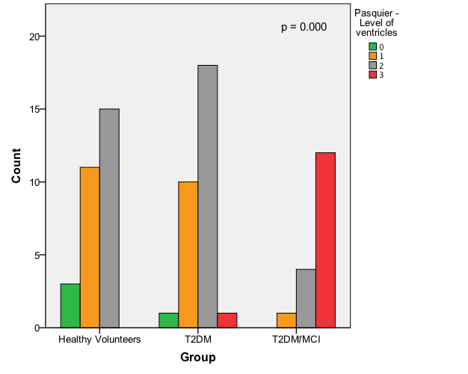

Figure 36: Bar chart showing the distribution of the Pasquier score at the level of the ventricle allocated within each group, p = 0.002 (Kruskal-Wallis).

* Pasquier Score – Level above the Ventricles

Again a Kruskal-Wallis test was completed which revealed a statistically significant difference in the Pasquier Score between the three groups (HV,

n = 29, T2DM, n = 30, T2DM/MCI, n = 17), χ2 (2, n = 76) = 12.371, p = 0.002. The T2DM/MCI had the highest recorded median score (Md = 2), with the lowest median scores being in the T2DM group (Md = 1) and HV group

(Md = 1). Post hoc analysis was completed using a Mann-Whitney U test. Statistical significance was found between the HV (Md = 1) and the T2DM/MCI groups (Md = 2) *U* = 123.000, z = -3.104, p = 0.002, r = 0.46. Statistical significance was also found between the T2DM/MCI and T2DM groups (Md = 1) *U* = 122.000, z = -3.270, p = 0.001, r = 0.48. Again there was no statistical significance found between the HV and T2DM groups

(p = 0.788).

3.1.4 White Matter Hyperintensities

White matter hyperintensities in the 3D FLAIR dataset were manually counted throughout all cerebral regions.

|  |  |  |  |  |
| --- | --- | --- | --- | --- |
| WMH | HV  n = 29 | T2DM  n = 30 | T2DM/MCI  n = 17 | p Value |
| Number of WMH | 821 | 1460≠ | 1376^# | **p = 0.001** |

Table 8: Total number of WMH in each group, p value represents group comparisons using a Kruskal-Wallis. Where a ^ is placed next to the value, this indicates statistical significance exists between the T2DM and T2DM/MCI group, where a # is placed next to the value, this indicates statistical significance exists between the HV and T2DM/MCI group; where a ≠ is placed next to the value, this indicates statistical significance exists between the HV and T2DM group.

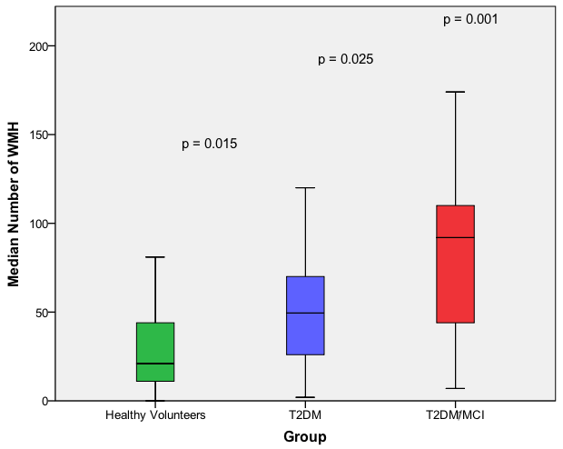Figure 37: Box and Whisker plot of WMH in each group, p = 0.001 (Kruskal-Wallis)

As the data was skewed (non-normal distribution), statistical analysis was completed using a Kruskal-Wallis test. This revealed a statistically significant difference in the total number of WMH between the three groups (HV, n = 29, T2DM, n = 30, T2DM/MCI, n = 17), χ2 (2, n = 76)= 14.231, p = 0.001. The T2DM/MCI had the highest median score (Md = 92), the T2DM had a median score of 49.50, and the HV had the lowest median score (Md = 21). Post hoc analysis was completed using a Mann-Whitney U test. Statistical significance was found between the HV (Md = 21) and the T2DM/MCI groups (Md = 92)

*U* = 101.000, z = -3.312, p = 0.001, r = 0.49. Statistical significance was also found between the T2DM/MCI and T2DM groups (Md = 49.5) *U* = 154.000,

z = -2.238, p = 0.025, r = 0.33. There was also statistical significance between the HV and the T2DM groups, *U* = 274.000, z = -2.442, p = 0.015, r = 0.32.

To assess any correlations between the descriptive imaging variables obtained from each of the groups, a Spearman Rho analysis was completed. There is a relatively strong negative relationship between the number of WMH and the Addenbrooke’s score, rho = -.405, n = 76, p = 0.000, indicating as the number of WMH increase, the Addenbrooke’s score decreases (Figure 39). By calculating the coefficient of determination, 24% of the variance can be associated with this relationship.

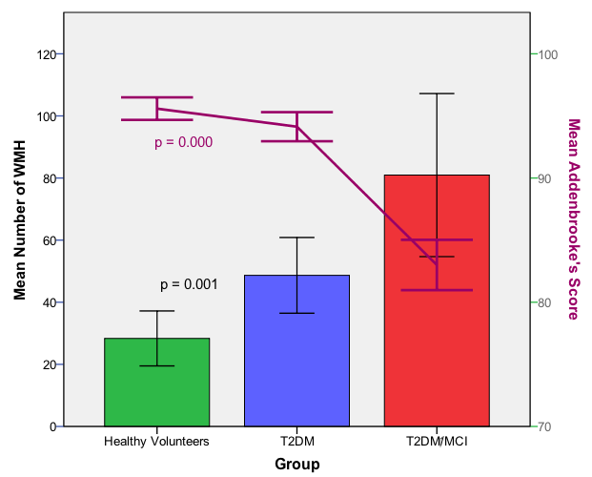

Figure 38: Bar chart showing the mean number of WMH between each group with the mean Addenbrooke's score of each group (95% CI error bars).

3.1.5 Inter- and Intra-rater Reliability for Pasqueir scale, Scheltens scale, Fazekas scale and WMH count

To assess the reliability of the technique used for the WMH measurements both inter and intrarater reliability were completed. To assess the inter-rater and intra-rater reliability the ICC statistic was used. The results are as follows:

- Inter-rater: using a single-measurement, absolute-agreement, 2 –way mixed-effects model, ICC = 0.992 (95% CI 0.882-0.990) and

- Intra-rater: using a single-measurement, absolute-agreement, 2 –way mixed-effects model, ICC = 0.984 (95% CI 0.938-0.996).

To assess the inter-rater reliability of the Pasqueir scale and Scheltens scale, a kappa statistic was used. The results are as follows:

- Pasqueir level above the ventricle: K = 0.642, indicating moderate reliability;

- Pasqueir level of the ventricle: K = 0.396, indicating, fair reliability and

- Scheltens scale: K = 0.668, indicating moderate reliability

To assess intrarater reliability of the Fazekas scale, the kappa statistic was used. The results are as follows:

- Fazekas periventricular: K = 0.800, indicating good reliability and

- Fazekas white matter: K = 0.800, indicating good reliability

#### 3.2 Volumetric Results

#### 3.2.1 Quantitative Volumetry of Tissue Types by SIENAX

SIENAX obtains brain volume data using tissue voxel value histogram segmentations for each group. The results obtained for the SIENAX programme includes the volumes of grey matter, peripheral grey matter, white matter, total brain matter and cerebral spinal fluid (CSF) (Table 9).

|  |  |  |  |  |
| --- | --- | --- | --- | --- |
|  | HV  n = 29 | T2DM  n = 30 | T2DM/MCI  n = 17 | p Value |
| Grey Matter Volume (mls) | 711467.6  (46834.3) | 685012.8  (39023.4) | 669872.3#  (37357.1) | **p = 0.004** |
| Peripheral Grey Matter Volume (mls) | 564038.5  (35019.9) | 545349.7  (29610.5) | 534384.0#  (34563.2) | **p = 0.011** |
| Total Brain Volume (mls) | 1407011.2  (68188.2) | 1374787.4  (66093.0) | 1355063.0#  (67467.6) | **p = 0.028** |
| White Matter Volume (mls) | 695543.7  (30153.4) | 689774.6  (34868.5) | 685190.7  (31060.0) | p = 0.625 |
| CSF Volume (mls) | 57313.2  (13822.3) | 61908.6  (20044.1) | 69629.6  (19472.6) | p = 0.117 |

Table 9: Brain volume data obtained using tissue voxel value histogram segmentation (SIENAX) for all groups. Values are mean plus standard deviation (SD) unless stated; p values represent group comparisons using ANOVA. Where a ^ is placed next to the value, this indicates statistical significance exists between the T2DM and T2DM/MCI group, where a # is placed next to the value, this indicates statistical significance exists between the HV and T2DM/MCI group; where a ≠ is placed next to the value, this indicates statistical significance exists between the HV and T2DM group.

3.2.1.1 SIENAX Grey Matter Volume

An ANOVA was conducted to explore the results of the grey matter volumes between the groups. There was statistical significance at the p<0.05 level in the grey matter volumes between the three groups: F (2, 73) = 5.928,

p = 0.004. A large difference (0.14 eta squared) in mean calculated volumes was seen. Post-hoc comparisons using the Bonferroni test indicated that the mean score for HV (M = 711467.6, SD = 46834.3) was significantly (p<0.05) different from the T2DM/MCI groups (M = 669872.3, SD = 37357.1). There was minimal significance (p= 0.053) between the HV and T2DM

(M = 685012.8, SD = 39023.4) groups and no significance between the T2DM and T2DM/MCI groups.

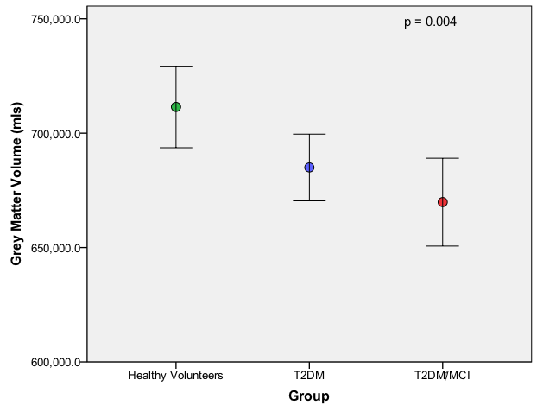

Figure 39: Chart showing group mean grey matter volumes (error bars represent 95% confidence intervals from the means), p = 0.004 (ANOVA).

To assess the relationship between the Addenbrooke’s questionnaire score results and grey matter volume, a Pearson’s product-moment correlation coefficient was determined. There was a medium, positive correlation between the two variables, r = .309, n = 76, p = 0.007, with higher Addenbrooke’s scores associated with higher grey matter volumes.

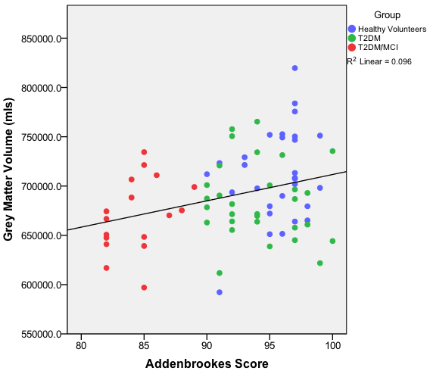

Figure 40: Scatter graph showing the positive relationship between grey matter volume and Addenbrooke's scores, p = 0.007.

3.2.1.2 SIENAX Peripheral Grey Matter Volume

An ANOVA was conducted to explore the results of the grey matter volumes between the groups. There was statistical significance at the p<0.05 level in the peripheral grey matter volumes between the three groups:

F (2, 73) = 4.850, p = 0.011 (Figure 46). A large effect size was seen (0.11 eta squared). Post-hoc comparisons using the Bonferroni test indicated that the mean score for HV (M = 564038.5, SD = 35019.9) was significantly (p<0.05) different from the T2DM/MCI groups (M = 534383.0, SD = 34749.8). There was no significance between the HV and T2DM (M = 545349.7,

SD = 29610.5) groups and no significance between the T2DM and T2DM/MCI groups.

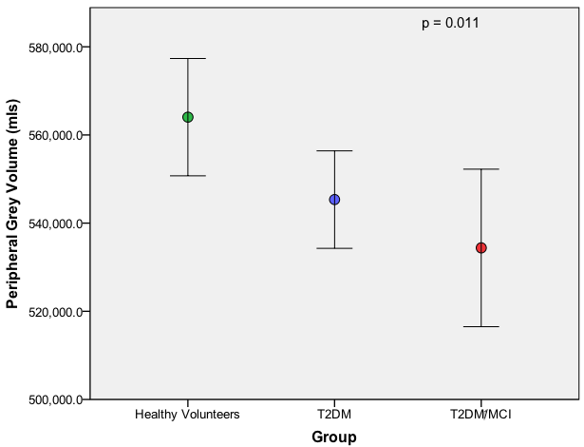

Figure 41: Chart showing group mean peripheral grey matter volumes (error bars represent 95% confidence intervals from the means), p = 0.011 (ANOVA).

A Pearson’s product-moment correlation analysis showed a small, positive correlation between the two variables, r = .290, n = 76, p = 0.011, with a higher Addenbrooke’s score associated with higher peripheral grey matter volumes.

3.2.1.3 SIENAX Total Brain Volume (grey and white matter only)

An ANOVA demonstrated statistical significance at the p<0.05 level in the total brain volumes for the three groups: F (2, 73) = 3.776, p = 0.028. There was a medium difference in mean scores between some groups and the effect size, calculated using eta squared, was 0.09. Post-hoc comparisons using the Bonferroni test indicated that the mean score for HV

(M = 1407011.2, SD = 68188.2) was significantly different from the T2DM/MCI groups (M = 1355063.0, SD = 57292.0). There was no significance between the HV and T2DM (M = 1374787.4, SD = 68188.2) groups or between the T2DM and T2DM/MCI groups.

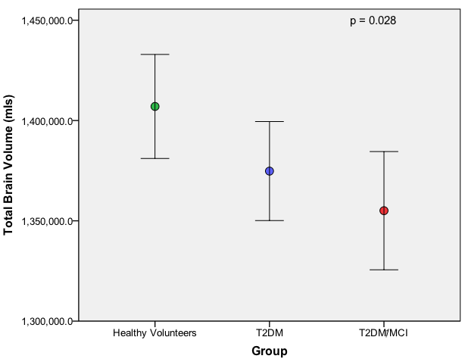

Figure 42: Chart showing group mean total grey and white matter volumes (error bars represent 95% confidence intervals from the means), p = 0.028 (ANOVA).

A Pearson’s product-moment correlation coefficient was completed, with a small positive correlation between the two variables, r = .258, n = 76,

p = 0.024, with a higher Addenbrooke’s score associated with a higher total brain volume reading.

3.2.1.4 SIENAX White Matter Volume

When analysing the white matter volumes via an ANOVA there was no statistical significance found, p = 0.538.

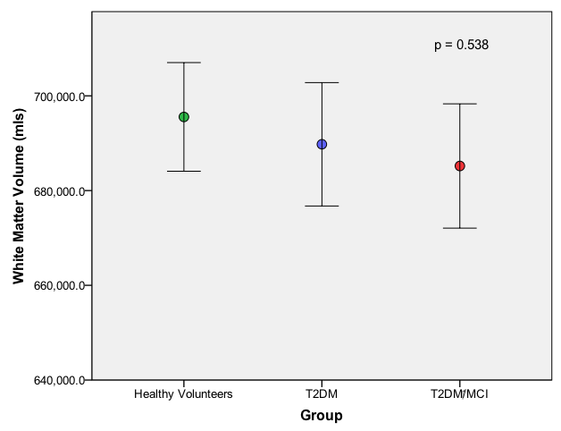

Figure 43: Chart showing group mean white matter volumes (error bars represent 95% confidence intervals from the means), p = 0.538 (ANOVA).

3.2.1.5 SIENAX CSF Volume

The CSF volume results between the groups using a one-way between-groups analysis of variance, did not show any statistical significance,

p = 0.117, however there does appear to be an upward trend between the groups (Figure 45).

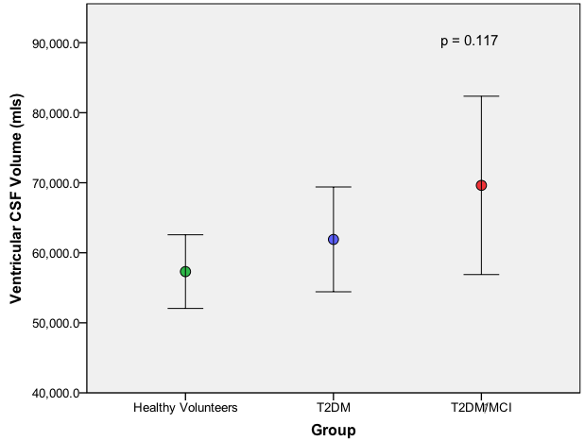

Figure 44: Chart showing group mean ventricular CSF volumes (error bars represent 95% confidence intervals from the means), p = 0.117 (ANOVA).

#### 3.2.2 Quantitative Anatomical Measurements of Tissue Types by Freesurfer

Freesurfer is a software package that enables the visualisation and analysis of structural and functional neuroimaging data. There are several outputs obtained.

3.2.2.1 ASEG

The ASEG output from Freesurfer identifies the volume of 8 bilateral structures and the white and grey matter volume in each of the three groups (Table 10).

|  |  |  |  |  |  |  |  |  |
| --- | --- | --- | --- | --- | --- | --- | --- | --- |
| Regional  Volume | HV  n = 29 | | T2DM  n = 30 | | T2DM/MCI  n = 17 | | p Value | |
| Brain segmentation volume (mm^3) | 1055588.0  (117867.7) | | 1047649.2  (105271.8) | | 989713.3  (106206.6) | | p = 0.129 | |
| Total cortical white matter (mm^3) | 452621.2  (60541.3) | | 448636.8  (57788.4) | | 416409.7  (58154.5) | | p = 0.112 | |
| Total cortical grey matter (mm^3) | 394992.9  (46181.6) | | 386727.5  (34969.9) | | 362932.5#  (33032.7) | | **p = 0.031** | |
| Subcortical grey matter (mm^3) | 52017.8  (4543.6) | | 52026.5  (4963.5) | | 49044.4#  (4179.5) | | p = 0.073 | |
| Total grey matter (mm^3) | 538922.1  (57079.8) | | 529962.8  (48337.3) | | 499287.8  (43387.3) | | **p = 0.040** | |
|  | **R** | **L** | **R** | **L** | **R** | **L** | **R** | **L** |
| Hemisphere cortical grey matter (mm^3) | 198008.8  (23539.9) | 196984.1  (22739.4) | 193988.1  (17954.7) | 192739.4  (17122.7) | 182838.6#  (16793.9) | 180093.9#  (16450) | **p = 0.050** | **p = 0.019** |
| Hemisphere cortical white matter (mm^3) | 226988.1  (30247.8) | 225633.1  (30359.9) | 225073  (29158.4) | 223563.8  (28838.3) | 209594.3  (27860.8) | 206815.4  (30565.8) | p = 0.129 | p = 0.100 |

|  |  |  |  |  |  |  |  |  |
| --- | --- | --- | --- | --- | --- | --- | --- | --- |
| **Regional**  **Volume** | **HV**  **n = 29** | | **T2DM**  **n = 30** | | **T2DM/MCI**  **n = 17** | | **p Value** | |
|  | **R** | **L** | **R** | **L** | **R** | **L** | **R** | **L** |
| **Thalamus (mm^3)** | 5953.0  (726.1) | 6640.4  (959.2) | 5941.6  (707.5) | 6684.7  (913.5) | 5607.5  (754.0) | 6453.6  (950.7) | p = 0.241 | p = 0.710 |
| **Caudate (mm^3)** | 3282.2  (407.4) | 3300.4  (402.5) | 3441.9  (373.5) | 3406.3  (368.5) | 3208.4  (439.3) | 3168.2  (376.9) | p = 0.124 | p = 0.128 |
| **Putamen (mm^3)** | 4761.4  (501.0) | 5009.2  (572.7) | 4899.3  (758.5) | 5006.7  (784.2) | 4452.7  (593.0) | 4872.3  (590.9) | p = 0.074 | p = 0.763 |
| **Pallidium (mm^3)** | 1347.0  (220.7) | 1313.1  (195.3) | 1325.2  (169.8) | 1375.4  (244.1) | 1360.6  (164.5) | 1285.1  (241.5) | p = 0.812 | p = 0.366 |
| **Hippocampus (mm^3)** | 4050.3  (563.4) | 3960.3  (445.1) | 3826.0  (454.5) | 3756.3  (495.3) | 3476.7#  (472.3) | 3517.7#  (382.0) | **p = 0.002** | **p = 0.008** |
| **Amygdala (mm^3)** | 1575.8  (221.4) | 1413.6  (173.5) | 1589.1  (173.9) | 1389.2  (146.8) | 1435.9  (285.6) | 1323.3  (191.8) | p = 0.059 | p = 0.214 |
| **Accumbens (mm^3)** | 537.7  (106.2) | 451.7  (141.1) | 532.0  (82.2) | 421.2  (115.3) | 483.1  (127.4) | 436.5  (130.8) | p = 0.192 | p = 0.665 |

Table 10: ASEG outputs from Freesurfer showing the volume results of 8 bilateral structures and the white/grey matter volume results. Values are mean plus standard deviation (SD) unless stated. L = Left, R = Right, p values represent group comparisons via ANOVA. Where a ^ is placed next to the value, this indicates statistical significance exists between the T2DM and T2DM/MCI group, where a # is placed next to the value, this indicates statistical significance exists between the HV and T2DM/MCI group; where a ≠ is placed next to the value, this indicates statistical significance exists between the HV and T2DM group.

When reviewing the ASEG output data, the following areas have highly significant differences between group mean volumes; the LH cortical grey matter, RH cortical grey matter, total cortical grey matter, total grey matter volume, left hippocampus and right hippocampus volume. All the comparisons were calculated via an ANOVA.

The left hemisphere (LH) cortical grey matter volume results showed statistical significance at the p<0.05 level in the grey volume result for the three groups: F (2, 75) = 4.183, p = 0.019. There was a medium effect size (0.10 eta squared). Post-hoc comparisons using the Bonferroni test indicated that the mean score for HV (M = 196984.1, SD = 22739.4) was significantly different from the T2DM/MCI group (M = 180093.9, SD = 16450). There was no statistical significance between the HV (M = 9010.1, SD = 1162.7) and T2DM or between the T2DM and T2DM/MCI groups.

Results for the right hemisphere (RH) cortical grey matter volume revealed statistical significance at the p<0.05 level in the grey volume result for the three groups: F (2, 75) = 3.121, p = 0.050. There was a medium effect size (0.08 eta squared). Post-hoc comparisons using the Bonferroni test indicated that the mean score for HV (M = 198008.8, SD = 23529.9) was significantly different from the T2DM/MCI group (M = 182838.6, SD = 16793.9). There was no statistical significance between the T2DM (M = 193988.1, SD = 17954.7) and T2DM/MCI or between the HV and T2DM groups.

The total cortical grey matter volume results were statistically significant at the p<0.05 level in the grey matter volume result for the three groups:

F (2, 73) = 6.704, p = 0.002. There was a medium effect size (0.09 eta squared). Post-hoc comparisons using the Bonferroni test indicated that the mean score for HV (M = 394992.9, SD = 46181.6) was significantly different from the T2DM/MCI group (M = 362932.5, SD = 33032.7). There was no statistical significance between the T2DM (M = 386727.5, SD = 34969.9) and T2DM/MCI or between the HV and T2DM groups.

Results for the total grey matter volume results were statistically significant at the p<0.05 level in the grey volume result for the three groups:

F (2, 75) = 3.363, p = 0.040. There was a medium effect size (0.08). Post-hoc comparisons using the Bonferroni test indicated that the mean score for HV (M = 538922.1, SD = 57079.8) was significantly different from the T2DM/MCI group (M = 499287.8, SD = 43387.2). There was no statistical significance between the T2DM (M = 529962.8, SD = 48337.3) and T2DM/MCI or between the HV and T2DM groups.

The left hippocampus grey matter volume results were statistically significant at the p<0.05 level in the grey volume result for the three groups:

F (2, 75) = 5.182, p = 0.008. A large effect size, calculated using eta squared, was 0.12. Post-hoc comparisons using the Bonferroni test indicated that the mean score for HV (M = 3960.3, SD = 445.1) was significantly different from the T2DM/MCI group (M = 3517.7, SD = 382.0). There was no statistical significance between the T2DM (M = 3756.3, SD = 495.3) and T2DM/MCI or between the HV and T2DM groups.

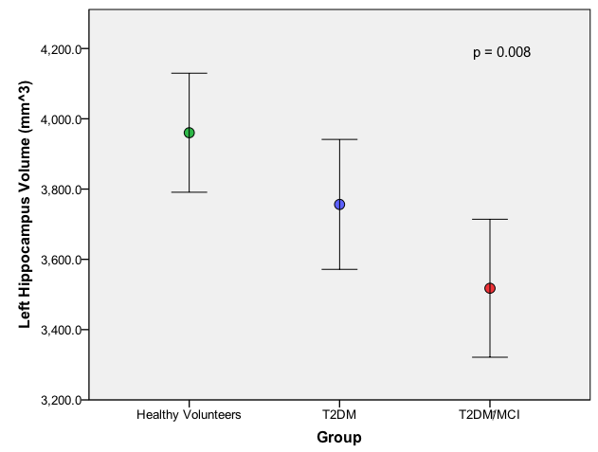

Figure 45: Chart showing group mean left hippocampus volumes (error bars represent 95% confidence intervals from the means), p = 0.008 (ANOVA).

Finally the right hippocampus revealed statistical significance at the p<0.05 level in the grey volume result for the three groups: F (2, 75) = 6.983,

p = 0.002. A large effect size was seen (0.16 eta squared). The mean score for HV (M = 4050.3, SD =563.4) was significantly different from the T2DM/MCI group (M = 3476.7, SD = 472.3). There was no statistical significance between the T2DM (M = 3826.0, SD = 454.5) and T2DM/MCI or between the HV and T2DM groups.

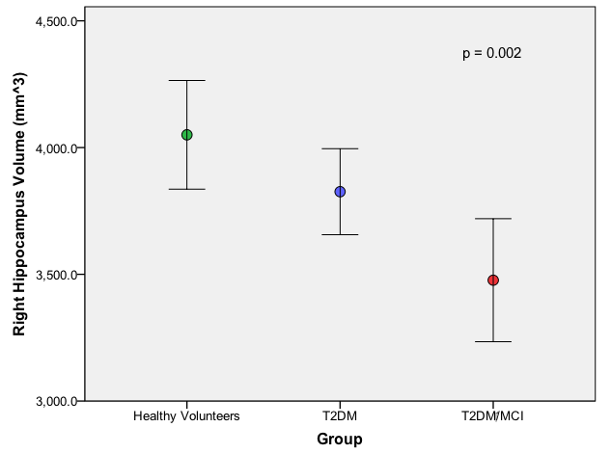

Figure 46: Chart showing group mean right hippocampus volumes (error bars represent 95% confidence intervals from the means), p = 0.002 (ANOVA).

Relationship between ASEG results and Addenbrooke’s Testing

To assess the potential relationship between the Addenbrooke’s questionnaire score results and the significant ASEG results obtained, a Pearson’s product-moment correlation coefficient was calculated for each aspect.

For the LH cortical grey matter volume, a small, positive correlation between the volume and Addenbrooke’s score is seen, r = .27, n = 76, p = 0.016.

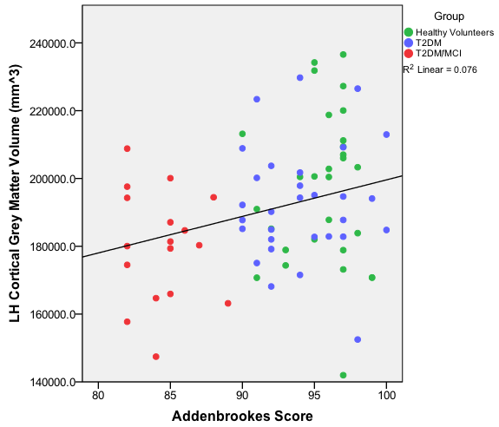

Figure 47: Scatter graph showing the positive correlation between the Left Hemisphere (LH) cortical grey matter volume results and the Addenbrooke's score, p = 0.016.

For the RH cortical grey matter volume, a small, positive correlation between the volume and Addenbrooke’s score is seen, r = .260, n = 76, p = 0.023.

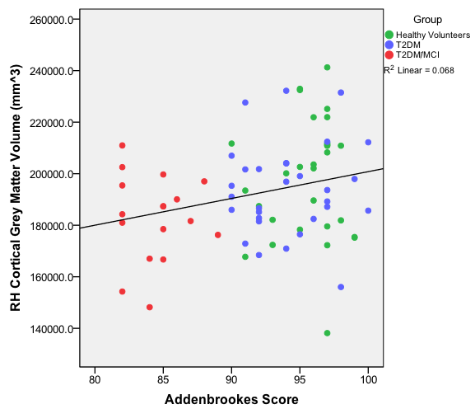

Figure 48: Scatter graph showing the positive correlation between the Right Hemisphere (RH) cortical grey matter volume results and the Addenbrooke's score, p = 0.023.

For the total cortical grey matter volume, a small, positive correlation between the volume and Addenbrooke’s score is seen, r = .269, n = 76, p = 0.019.

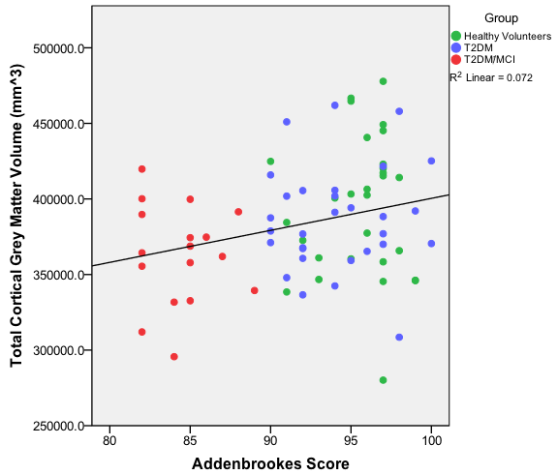

Figure 49: Scatter graph showing the positive relationship between the total cortical grey matter volume results and the Addenbrooke's score, p = 0.019.

For the total grey matter volume, a small, positive correlation between the volume and Addenbrooke’s score is seen, r = .271, n = 76, p = 0.018.

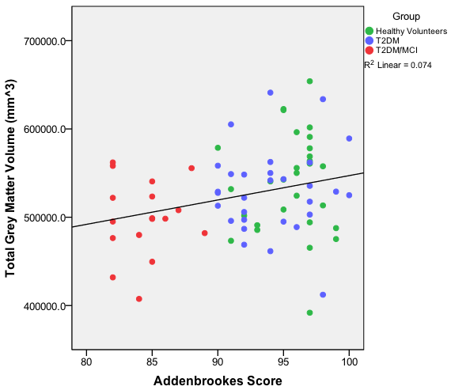

Figure 50: Scatter graph showing the positive relationship between the total grey matter volume results and the Addenbrooke's score, p = 0.018.

For the left hippocampal volume, a medium, positive correlation between the volume and Addenbrooke’s score is seen, r = .405, n = 76, p = 0.000.

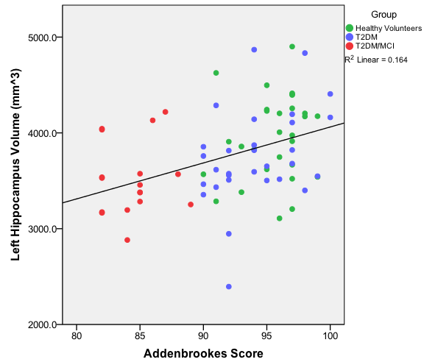

Figure 51: Scatter graph showing the positive relationship between the left hippocampal volume results and the Addenbrooke's score, p = 0.000.

For the right hippocampal volume, a medium, positive correlation between the volume and Addenbrooke’s score is seen, r = .433, n = 76, p = 0.000.

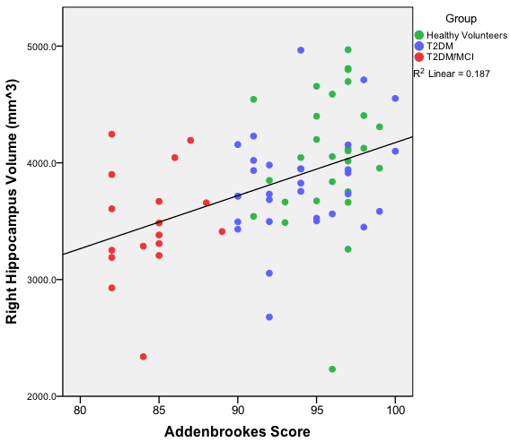

Figure 52: Scatter graph showing the positive relationship between the right hippocampal volume results and the Addenbrooke's score, p = 0.000.

3.2.2.2 LHPARC

The LHPARC output from Freesurfer identifies the volume of specific structures in the left hemisphere. The results obtained can be seen in the table below.

|  |  |  |  |  |
| --- | --- | --- | --- | --- |
| Region | HV  n = 29 | T2DM  n = 30 | T2DM/MCI  n = 17 | p Value |
| Caudal Anterior Cingulate (mm^3) | 1533.9  (418.2) | 1605.1  (381.4) | 1498.9  (590.3) | p = 0.704 |
| Caudal Middle Frontal (mm^3) | 5120.5  (1021.3) | 5171.6  (765.2) | 4807.8  (643.8) | p = 0.348 |
| Inferior Temporal  (mm^3) | 9103.0  (1344.0) | 8748.0  (1487.8) | 8229.1  (1105.1) | p = 0.115 |
| Middle Temporal  (mm^3) | 9010.1  (1162.7) | 9000.9  (967.6) | 7962.9^#  (904.7) | **p = 0.002** |
| Parahippocampal  (mm^3) | 2163.1  (336.5) | 2040.9  (338.3) | 1965.6  (284.5) | p = 0.122 |
| Posterior Cingulate  (mm^3) | 2676.1  (443.8) | 2719.7  (377.6) | 2476.5  (454.5) | p = 0.156 |
| Superior Frontal  (mm^3) | 18106.2  (2523.6) | 18150.8  (1805.7) | 16740.0  (1953.9) | p = 0.068 |
| Superior Temporal  (mm^3) | 9970.3  (1204.2) | 10003.3  (1399.8) | 9129.4  (924.0) | **p = 0.047** |
| Frontal Pole  (mm^3) | 685.0  (140.0) | 676.0  (123.1) | 680.2  (129.3) | p = 0.966 |
| Temporal Pole  (mm^3) | 2562.6  (386.2) | 2473.0  (269.2) | 2361.2  (505.0) | p = 0.220 |

|  |  |  |  |  |
| --- | --- | --- | --- | --- |
| Region | HV  n = 29 | T2DM  n = 30 | T2DM/MCI  n = 17 | p Value |
| Transverse Temporal (mm^3) | 999.7  (182.3) | 943.9  (182.2) | 875.4  (230.6) | p = 0.115 |
| Insula (mm^3) | 5868.1  (663.2) | 5774.8  (668.5) | 5550.6  (579.9) | p = 0.279 |

Table 11: LHPARC output from Freesurfer showing mean group volumes of selected regions of interest. Values are mean plus standard deviation (SD) unless stated; p values result from group comparisons using an ANOVA. Where a ^ is placed next to the value, this indicates statistical significance exists between the T2DM and T2DM/MCI group, where a # is placed next to the value, this indicates statistical significance exists between the HV and T2DM/MCI group; where a ≠ is placed next to the value, this indicates statistical significance exists between the HV and T2DM group.

Statistically significant group mean LHPARC output differences include the superior temporal and middle temporal regions (grey matter volume outputs). For the superior temporal region grey matter volume result, statistical significance at the p<0.05 level in the grey volume result is seen for the three groups: F (2, 75) = 3.195, p = 0.04. A small effect size (0.08 eta squared) is seen. Post-hoc comparisons using the Bonferroni test indicated that there was no significance found when comparing the mean score for T2DM

(M = 10003.30, SD = 1399.8) and the T2DM/MCI groups (M = 9129.4,

SD = 924.0) or between the HV groups (M = 9970.3, SD = 1204.2). There was no statistical significance between the HV and the T2DM/MCI group means.

The middle temporal region in the grey matter volume results was statistically significant at the p<0.05 level for the three groups: F (2, 73) = 6.704,

p = 0.002. A large effect size (0.16 eta squared) is seen. Post-hoc comparisons using the Bonferroni test indicated that the mean score for T2DM (M = 9000.9, SD = 967.6) was significantly different from the T2DM/MCI groups (M = 7962.9, SD = 904.7). There was also statistical significance between the HV (M = 9010.1, SD = 1162.7) and T2DM/MCI groups. There was no significant mean difference between the HV and T2DM groups.

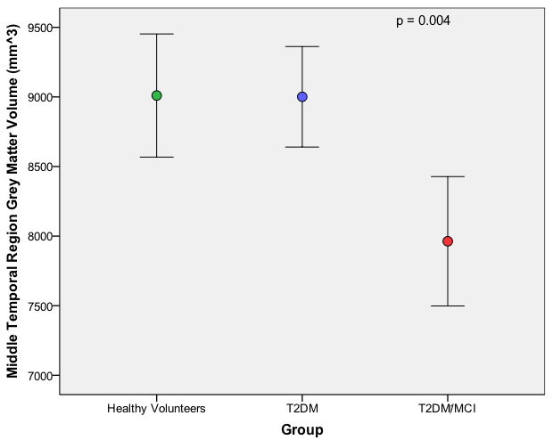

Figure 53: Chart showing group mean middle temporal region volumes (error bars represent 95% confidence intervals from the means), p = 0.002 (ANOVA).

Relationship between LHPARC results and Addenbrooke’s Testing

To assess the potential relationship between the Addenbrooke’s questionnaire score results and the significant LHPARC results obtained, a Pearson’s product-moment correlation coefficient was calculated for each aspect. For the grey matter volume of the middle temporal region, a medium, positive correlation between the volume and Addenbrooke’s score is seen,

r = .369, n = 76, p = 0.001.

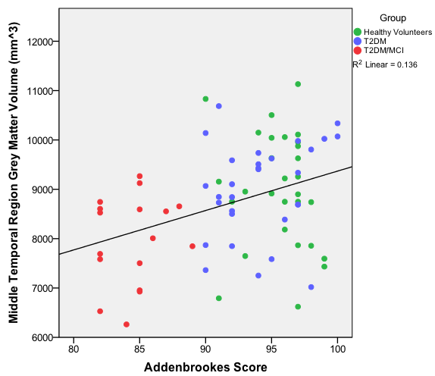

Figure 54: Scatter graph showing the positive correlation between the middle temporal lobe grey matter volume results and the Addenbrooke's score, p = 0.001.

The superior temporal grey matter volume region, showed a small positive significant correlation between grey matter volume and Addenbrooke’s scores (r = 0.227, n = 76, p = 0.049).

3.2.2.3 RHPARC

The RHPARC output from Freesurfer identifies the volume of specific structures in the right hemisphere. The results obtained can be seen in the table below.

|  |  |  |  |  |
| --- | --- | --- | --- | --- |
| Region | HV  n = 29 | T2DM  n = 30 | T2DM/MCI  n = 17 | p Value |
| Caudal Anterior Cingulate (mm^3) | 2050.3  (440.6) | 2012.1  (396.7) | 1888.2  (570.5) | p = 0.502 |
| Caudal Middle Frontal (mm^3) | 4937.4  (948.5) | 4765.0  (770.7) | 4764.3  (839.7) | p = 0.697 |
| Inferior Temporal  (mm^3) | 8698.8  (1533.3) | 8576.6  (1364.9) | 8031.5  (1091.1) | p = 0.271 |
| Middle Temporal  (mm^3) | 10027.6  (1245.3) | 10063.4  (1391.5) | 9336.8  (898.2) | p = 0.123 |
| Parahippocampal  (mm^3) | 2048.5  (367.7) | 1928.9  (338.5) | 1787.8#  (299.5) | **p = 0.049** |
| Posterior Cingulate  (mm^3) | 2789.1  (495.0) | 2763.2  (469.6) | 2608.5  (493.0) | p = 0.449 |
| Superior Frontal  (mm^3) | 17311.9  (2557.5) | 17361.6  (1802.6) | 16384.6  (1941.6) | p = 0.279 |
| Superior Temporal  (mm^3) | 9844.6  (1523.6) | 9531.6  (1078.0) | 8988.3  (1248.5) | p = 0.105 |
| Frontal Pole  (mm^3) | 963.7  (174.6) | 936.1  (169.8) | 1000.8  (212.2) | p = 0.503 |
| Temporal Pole  (mm^3) | 2329.4  (270.9) | 2144.9  (252.6) | 2206.2#  (356.9) | **p = 0.049** |

|  |  |  |  |  |
| --- | --- | --- | --- | --- |
| Region | HV  n = 29 | T2DM  n = 30 | T2DM/MCI  n = 17 | p Value |
| Transverse Temporal (mm^3) | 736.9  (120.8) | 739.4  (145.0) | 706.9  (140.0) | p = 0.701 |
| Insula  (mm^3) | 5995.0  (668.1) | 5856.7  (754.2) | 5773.7  (768.6) | p = 0.577 |

Table 12: RHPARC output from Freesurfer showing volume results in selected regions of interest. Values are mean plus standard deviation (SD) unless stated; p values represent group comparisons using an ANOVA. Where a ^ is placed next to the value, this indicates statistical significance exists between the T2DM and T2DM/MCI group, where a # is placed next to the value, this indicates statistical significance exists between the HV and T2DM/MCI group; where a ≠ is placed next to the value, this indicates statistical significance exists between the HV and T2DM group.

The significant results from the RHPARC outputs include the parahippocampal and the temporal pole using an ANOVA.

The parahippocampal region revealed statistical significance at the p<0.05 level in the grey matter volume result for the three groups: F (2,75) = 3.153,

p = 0.049. A medium effect size calculated using eta squared, was 0.08. Post-hoc comparisons using the Bonferroni test indicated that the mean score for HV (M = 2048.5, SD = 367.7) was significantly different from the T2DM/MCI group (M = 1787.8, SD = 299.5). There was no statistical significance between the T2DM (M = 1928.9, SD = 338.5) and T2DM/MCI or between the HV and T2DM groups.

For the temporal pole, statistical significance at the p<0.05 level in the grey matter volume result for the three groups: F (2,75) = 3.152, p = 0.049 was seen. A medium effect size (0.08 eta squared) was noted. Post-hoc comparisons using the Bonferroni test indicated that the mean score for HV (M = 2329.4, SD = 270.9) was significantly different from the T2DM group

(M = 2144.9, SD = 252.6). There was no statistical significance between the T2DM/MCI (M = 2206.2, SD = 356.9) and the T2DM or between the HV and T2DM/MCI groups.

Relationship between RHPARC results and Addenbrooke’s Testing

To assess the potential relationship between the Addenbrooke’s questionnaire score results and the significant RHPARC results obtained, a Pearson’s product-moment correlation coefficient was calculated for each aspect. The only significant correlation that was found was for the grey matter volume of the parahippocampal region, where a small, positive correlation between the volume and Addenbrooke’s score is present, r = .280, n = 76,

p = 0.014.

#### 3.2.3 Quantitative Volumetry of Tissue Types by Voxel Based Morphometry

Voxel Based Morphometry (VBM) is an automated technique that produces a voxel-wise comparison of the local grey matter concentration in certain regions of interest between two groups. The three groups are compared in turn with each other to assess for any statistical differences in grey matter concentration by using a Student’s t-test. The statistical comparisons between the T2DM/MCI and HV groups demonstrated statistical significance in grey matter regions associated with cognition. The significant areas (p<0.05) are overlaid in yellow in the following crosshair visual representations.

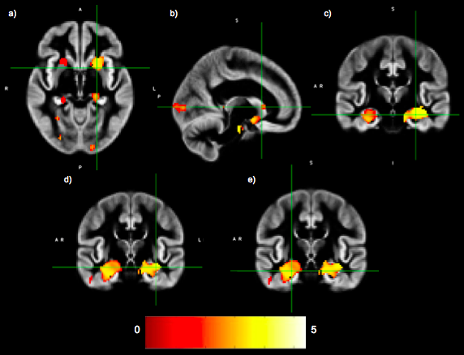

Figure 55: Voxel Based Morphometry demonstrating statistical significance in the a) Left Putamen (p = 0.01) b) Left Caudate (p = 0.03), c) Left Hippocampus (p = 0.00) d) Left amygdala (p = 0.02) e) Right hippocampus (p = 0.01) when the T2DM/MCI group volume mean was compared to the HV group; p values are family wise error corrected at voxel level.

When the T2DM group was analysed against the HV group, there were no statistically significant areas identified and all p values were >0.05 on the Student’s t-test. This was also the case for the group comparison between the T2DM group and the T2DM/MCI group.

## 3.2.4. Relationship between CBF data and Brain Volume Data

To see if there was any relationship between the CBF data obtained and the Freesurfer volume results, a Pearson’s correlation was done between specific regions of interest (of which were related to initial study aims and also where the data outputs matched). The results are as seen below.

a) HV Pearson’s correlations

|  |  |  |  |
| --- | --- | --- | --- |
|  | Insula Volume (mm^3) | Frontal Lobe Volume  (mm^3) | Medial Temporal Lobe  (mm^3) |
| Insula CBF  (ml/min/100g)  Pearson Correlation  Sig (2-tailed)  N | - .119  .539  29 | x | x |
| Frontal Lobe CBF  (ml/min/100g)  Pearson Correlation  Sig (2-tailed)  N | x | .152  .430  29 | x |
| Medial Temporal Lobe CBF  (ml/min/100g)  Pearson Correlation  Sig (2-tailed)  N | x | X | .249  .193  29 |

Table 13: Pearson's correlation outcomes comparing specific region of interest CBF and volume results in HV.

b) T2DM Pearson’s correlations

|  |  |  |  |
| --- | --- | --- | --- |
|  | Insula Volume (mm^3) | Frontal Lobe Volume  (mm^3) | Medial Temporal Lobe  (mm^3) |
| Insula CBF  (ml/min/100g)  Pearson Correlation  Sig (2-tailed)  N | - .095  .629  28 | x | x |
| Frontal Lobe CBF  (ml/min/100g)  Pearson Correlation  Sig (2-tailed)  N | x | .0.43  .830  28 | x |
| Medial Temporal Lobe CBF  (ml/min/100g)  Pearson Correlation  Sig (2-tailed)  N | x | X | - .143  .469  28 |

Table 14: Pearson's correlation outcomes comparing specific region of interest CBF and volume results in T2DM.

c) T2DM/MCI Pearson’s Correlations

|  |  |  |  |
| --- | --- | --- | --- |
|  | Insula Volume (mm^3) | Frontal Lobe Volume  (mm^3) | Medial Temporal Lobe  (mm^3) |
| Insula CBF  (ml/min/100g)  Pearson Correlation  Sig (2-tailed)  N | - .129  .620  17 | x | x |
| Frontal Lobe CBF  (ml/min/100g)  Pearson Correlation  Sig (2-tailed)  N | x | .331  .194  17 | x |
| Medial Temporal Lobe CBF  (ml/min/100g)  Pearson Correlation  Sig (2-tailed)  N | x | X | - .002  .993  17 |

Table 15: Pearson's correlation outcomes comparing specific region of interest CBF and volume results in T2DM/MCI.

Although the results above are demonstrated as each group, there was no statistical significance noted as a whole cohort between the CBF and the volume results. Despite the non-significance in the statistical analysis, an overall cohort trend can be observed in the scatter graph (figure 73). The T2DM/MCI group is mostly located in the lower part of the chart, indicating a trend towards lower CBF result with a lower medial temporal lobe volume.

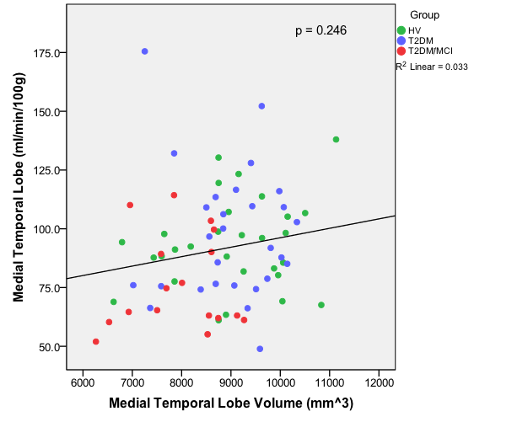

Figure 56: Scatter graph showing the positive trend between the medial temporal lobe CBF and volume results, p = 0.25.

3.2.5 Cerebral Anatomical Results Summary

The anatomical results have shown some interesting results. The visual atrophy assessments have shown a significant increase in atrophy and white matter hyperintensities within the grey and white matter as the groups progress from the HV’s, to the T2DM to the T2DM with cognitive impairment. The volumetric screening has also shown a significant reduction in grey matter volume again as the groups change from HV to T2DM to T2DM/MCI. This reduction in volume is seen globally and in specific regions of interest, such as the medial temporal lobe, hippocampus and frontal lobes.

### **4. Cardiac Results**

Subjects with T2DM are known to have subtle changes in cardiac output without a history of ischaemic heart disease, termed diabetic cardiomyopathy. This can be from subtle diastolic disturbance to florid systolic dysfunction. It is known in heart failure subjects that this reduction in cardiac output can lead to a reduction in cerebral blood flow; which may increase cognitive impairment. We wanted to explore this in subjects with T2DM and cognitive impairment to see if there was any relationship between cardiac function and CBF. To recap the aims of our cardiac data collection were:

**Aim 4:** To explore the characteristics of LV cardiac function in T2DM participants with cognitive impairment.

**Aim 5:** To relate LV cardiac output to CBF with cognition

The cardiac data was analysed in three main areas: aortic output, LV volumetry and LV dynamics. Due to severe movement artefact, one participant was excluded in the cardiac analysis, reducing the T2DM participant number to 29. The results are below.

#### 4.1 Aortic Output Results

On ANOVA statistical analysis of all the aortic output measurements automatically calculated via commercial software (MEDIS suite), there was no statistical significance between any of the group means. The following table shows the aortic measurements that were calculated and the p values.

|  |  |  |  |  |
| --- | --- | --- | --- | --- |
|  | HV  n = 29 | T2DM  n = 29 | T2DM/MCI  n = 17 | p Value |
| Flow Velocity (cm/s) | 11.6 (2.4) | 11.0 (2.7) | 11.1 (1.9) | p = 0.636 |
| Net Flow Volume (ml/beat) | 71.4 (12.3) | 70.2 (17.8) | 68.2 (16.8) | p = 0.811 |
| Forward Flow Volume (ml/beat) | 73.1 (12.8) | 72.8 (17.7) | 69.7 (17.1) | p = 0.794 |
| Backward Flow Volume (ml/beat) | 1.7 (1.5) | 2.4 (1.7) | 1.7 (1.5) | p = 0.165 |
| Regurgitant Fraction (%) | 2.3 (1.8) | 3.6 (2.8) | 2.4 (1.9) | p = 0.073 |
| Peak Flow Velocity (cm/s) | 110.3 (27.1) | 115.8 (22.1) | 119.6 (27.4) | p = 0.473 |
| Peak Pressure Gradient (mmHg) | 5.2 (2.8) | 5.6 (2.2) | 6.0 (2.6) | p = 0.566 |

Table 16: Aortic output data for all the groups. Values are mean plus standard deviation (SD) unless stated; p value relates to group comparisons using ANOVA.

#### 4.2 Left Ventricle Volumetry Results

All the LV Volumetry results are presented both with and without BSA (Body Surface Area) indexing. The LV mass is presented without papillary muscle inclusion. All statistical analyses were carried out by ANOVA.

|  |  |  |  |  |
| --- | --- | --- | --- | --- |
|  | HV  n = 29 | T2DM  n = 29 | T2DM/MCI  n = 17 | p Value |
| EDV (ml) | 90.6 (20.5) | 82.8 (23.8) | 78.3 (24.2) | p = 0.186 |
| EDV/BSA  (ml/min2) | 49.0 (9.1) | 42.8 (11.6) | 39.4(11.6)# | **p = 0.012** |
| ESV (ml) | 23.9 (7.6) | 22.4 (9.4) | 21.7 (10.3) | p = 0.701 |
| ESV/BSA  (ml/min2) | 12.9 (3.8) | 11.5 (4.7) | 10.9 (5.2) | p = 0.295 |
| CO (l/min) | 4.5 (1.5) | 4.0 (1.0) | 4.2 (1.2) | p = 0.320 |
| CO/BSA  (l/min*m2) | 2.44 (0.7) | 2.1 (0.5) | 2.1 (0.6) | p = 0.056 |
| SV (ml) | 66.7 (16.8) | 60.3 (19.2) | 56.6 (15.3) | p = 0.151 |
| SV/BSA  (ml/min2) | 36.0 (7.7) | 31.2 (9.5) | 28.5 (7.2)# | **p = 0.012** |
| EF (%) | 73.3 (6.8) | 72.9 (9.4) | 73.3 (7.3) | p = 0.979 |
| ED Mass (grams) | 108.1 (23.1) | 118.5 (22.2) | 112.1 (27.7) | p = 0.259 |
| ED Trab Mass  (grams) | 30.2 (7.7) | 30.0 (7.4) | 31.5 (7.3) | p = 0.812 |

|  |  |  |  |  |
| --- | --- | --- | --- | --- |
|  | HV  n=29 | T2DM  n=29 | T2DM/MCI  n=17 | p Value |
| ES Trab Mass  (grams) | 12.9 (5.3) | 11.1 (4.0) | 11.6 (4.5) | p = 0.330 |
| LV Mass/BSA  (g/m2) | 58.3 (8.8) | 61.1 (10.3) | 56.5 (12.7) | p = 0.325 |

Table 17: Left Ventricle volumetry data for all the groups. Values are mean plus standard deviation (SD) unless stated, p value relates to group comparisons using ANOVA. EDV = End-Diastolic Volume, ESV = End-Systolic Volume, CO = Cardiac Output, SV = Stroke Volume, EF = Ejection Fraction, ED = End Diastolic, ES = End Systolic. Where a ^ is placed next to the value, this indicates statistical significance exists between the T2DM and T2DM/MCI group, where a # is placed next to the value, this indicates statistical significance exists between the HV and T2DM/MCI group; where a ≠ is placed next to the value, this indicates statistical significance exists between the HV and T2DM group.

For the SV/BSA a one-way between groups analysis of variance has shown statistical significance between the three groups: F (2, 71) = 4.73,

p = 0.012. A large effect size is seen (0.12 eta squared). Post-hoc comparisons using the Bonferroni test indicated the mean score for HV

(M = 36.03, SD = 7.73) was significantly (p<0.05) different from the T2DM/MCI group (M = 28.51, SD = 7.16). There was no significance between HV and the T2DM group (M = 31.23, SD = 9.52) or the T2DM and T2DM/MCI group.

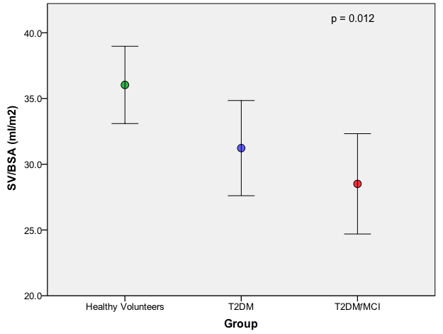

Figure 57: Chart showing group mean SV/BSA results (error bars represent 95% confidence intervals from the means), p = 0.012 (ANOVA).

Again for the EDV/BSA readings, an ANOVA showed statistical significance between the three groups: F (2, 71) = 4.70, p = 0.012. The effect size was calculated as 0.11. Post-hoc comparisons using the Bonferroni test indicated that the mean score for HV (M = 48.97, SD = 9.15) was significantly (p<0.05) different from the T2DM/MCI group (M = 39.43, SD = 11.65). There was no significance between the HV group and the T2DM group (M = 42.76,

SD = 11.61) or the T2DM and T2DM/MCI group.

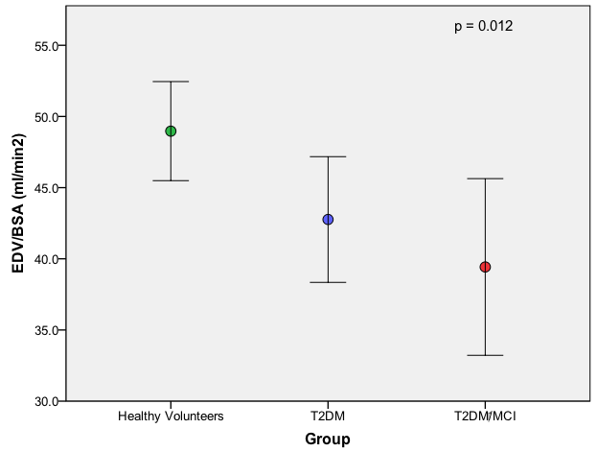

Figure 58: Chart showing group mean ED/BSA results (error bars represent 95% confidence intervals from the means), p = 0.012 (ANOVA).

For both the SV/BSA and EDV/BSA analysis, no other significant covariants were determined during correlation analysis; therefore an ANCOVA was not performed.

Despite not being statistically significant (p = 0.056) the CO/BSA analysis does appear to show a downward trend between the groups.

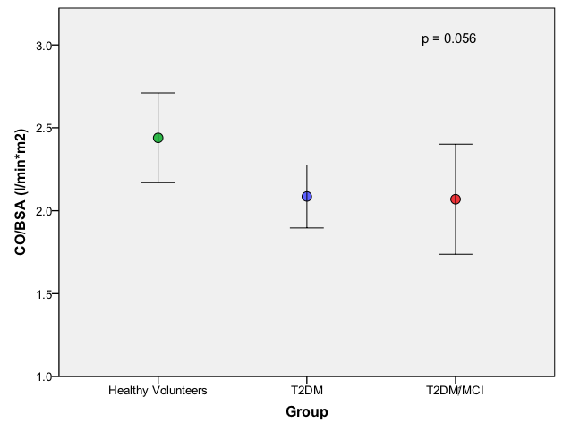

Figure 59: Chart showing group mean CO/BSA results (error bars represent 95% confidence intervals from the means), p value = 0.056 (ANOVA).

#### 4.3 Left Ventricle Ejection and Filling Dynamic Results

The following table shows the LV ejection and filling dynamic with statistical analysis of the groups with associated p value. The statistical tests were completed using an ANOVA, which did not reveal any statistical significances between the group means.

|  |  |  |  |  |
| --- | --- | --- | --- | --- |
|  | HV  n = 29 | T2DM  n = 29 | T2DM/MCI  n = 17 | p Value |
| PER (ml/s) | 652.2 (250.6) | 578.2 (203.2) | 598.8 (242.0) | p = 0.465 |
| PER/EDV  (EDV/s) | 7.0 (1.7) | 6.7 (1.8) | 7.6 (1.9) | p = 0.335 |
| TPER  (ms) | 40.9 (24.3) | 35.1 (5.3) | 33.1 (5.2) | p = 0.217 |
| PFR (ml/s) | 697.3 (256.8) | 613.1 (181.7) | 647.0 (212.0) | p = 0.349 |
| PFR/EDV  (EDV/s) | 7.44 (2.0) | 7.4 (1.2) | 8.3 (1.3) | p = 0.198 |
| TPFR (ms) | 40.9 (24.3) | 35.1 (5.3) | 33.1 (5.2) | p = 0.217 |

Table 18: LV ejection and filling dynamic data. Values are mean plus standard deviation (SD) unless stated. PER = Peak Ejection Rate, PER/EDV = Peak Ejection Rate/End Diastolic Volume, TPER = systolic Time from EDV to PER, PFR = Peak early Filling Rate, PFR/EDV = Peak early Filling Rate/End Diastolic Volume, TPFR = diastolic Time from ESV to PFR.

Left Atrial (LA) volume was also calculated to see if there was any evidence of LA dilatation as a reflection of diastolic dysfunction, particularly in the diabetic groups. This was a basic area measurement, due to limited MRI views of the atrium, with criteria of LA area measurement >25mm2 indicating end diastolic dysfunction. In this participant cohort there was no evidence of mean group LA dilatation.

|  |  |  |  |
| --- | --- | --- | --- |
|  | HV  n = 27 | T2DM  n = 30 | T2DM/MCI  n = 17 |
| LA ED area (cm2) | 12.7 (3.3) | 12.7 (4.5) | 13.8 (3.6) |

Table 19: Left atrial end diastolic area. Values are mean plus standard deviation (SD).

4.4 Inter- and Intrarater Reliability

To assess the reliability of the technique used for the cardiac measurements both inter- and intrarater reliability were undertaken. Two areas were randomly chosen to assess the technique – EDV measurement and ED mass measurement of the LV. To assess the inter-rater reliability the ICC statistic was used:

- EDV mass: using a single-measurement, absolute-agreement, 2 –way mixed-effects model, ICC = 0.995 (95% CI 0.983-0.999) and

- EDV: using a single-measurement, absolute-agreement, 2 –way mixed-effects model, ICC = 0.999 (95% CI 0.998-1.0).

The ICC was also used to assess the intrarater reliability:

- EDV mass: using a single-measurement, absolute-agreement, 2 –way mixed-effects model, ICC = 1.000 (95% CI 0.992-1.0).

- EDV: using a single-measurement, absolute-agreement, 2 –way mixed-effects model, ICC = 0.996 (95% CI 0.852-1.0).

## 4.5 Cardiac Results Summary

The results obtained from the cardiac data have been interesting. The only abnormalities that were found were a reduction in the EDV and SV in the T2DM/MCI cohort when compared to HV. This is interesting as it suggests that a reduction in cardiac output in this cohort of subjects is not related to a reduction in cognition.

# Discussion and Limitations

## 

## **Discussion**

As most research studies find, the recruitment process was very challenging at times. There was difficulty in identifying subjects and participants who had MCI. Despite screening the local psychiatric database of over 2000 patients, only 41 subjects with T2DM and MCI and 27 subjects with MCI were found. We believe one of the main reasons for this is a lack of subjects being identified as having mild cognitive impairment due to the ability of a subject with MCI to carry out most activities of daily living by using minor adjustments (e.g. to help with memory, subjects may write lists to help them remember planned activities). This means that the subject may not present to the GP or Psychiatric team for diagnosis or only present when the condition develops into dementia. Despite this, we were able to recruit enough T2DM/MCI subjects to enable group comparisons with HV and T2DM.

### 1. Baseline Data

The study cohort was well case controlled. There was no statistical significance between the three groups within the demographic data. As with most research studies, it was difficult to get a diverse range of ethnicity in our study cohorts. The majority of subjects were White British and the results need to take into consideration of this, particularly when comparing results to other studies, which may have a different ethnicity cohort.

There were, however, notable statistically significant differences in BMI and HbA1c in the T2DM and T2DM/MCI groups compared to the HV. Not surprisingly subjects with diabetes had a higher BMI and HbA1c. Again, unsurprisingly when comparing the Addenbrooke’s scores, the scores were significantly lower in the T2DM/MCI group.

The Addenbrooke’s cognitive assessment (ACE-R) is a recognised test for cognitive impairment and dementia (Berankova et al., 2015). The sensitivity and specificity for MCI is 0.70 and 0.73 respectively and dementia is 0.68 and 0.91 respectively. The advantage of the Addenbrooke’s screening tool is that it takes 30minutes to complete compared to other neuropsychological testing (which can take between two to four hours to complete) and it correlates well with other neuropsychological tests on attention, language and verbal memory. The main limitation with the Addenbrooke’s testing is that it is highly weighted towards the verbal and language tests. It also does not examine fluid intelligence and the cognitive domains of the test covered have not been validated against standard neuropsychological tests (Noone, 2015). For this reason, we have not related our findings to specific cognitive domains but instead used it to provide us with an overview of a subject’s cognition.

In this study we felt that an appropriate compromise was taken by using the Addenbrooke’s questionnaire. We were able to get an adequate overview of a subjects cognition and easily able to use the data to relate the scoring to the MR imaging findings. For future studies, it would be ideal to include the full battery of neuropsychological testing along with the ACE-R so that MRI findings can potentially be linked to specific regional areas in cognition.

Previous prospective studies have demonstrated that diabetes is associated with a faster rate of cognitive decline. It is unclear from our data what the rate of cognitive decline in our cohort was. Mottus et al., (2013) analysed the Lothian Birth Cohort data (cohort of people that were born in 1936 who have diabetes). It was noted that the associations between age and rate of cognitive decline was dependent on the cognitive ability at age 11 years (Mottus et al., 2013). Due to the nature of our research study we were not able to address this. However, given that the prevalence of T2DM is increasing, particularly within the adolescent and young adult population, this question could be addressed with a future longitudinal study.

The T2DM/MCI group was also noted to have a statistically significantly lower mean age of last education when compared to the HV and T2DM groups. Age of last education is a recognised as a risk factor for developing dementia (Exalto et al., 2013). This was based on data from two large longitudinal cohorts with 10 years of follow-up. This enable the group to produce a risk score calculator for developing dementia at ten years. Mean age of education was part of the scoring system, with education up to and including 12 years of age receiving 0 points, and education greater than twelve years of age receiving minus 1 point. In the baseline data collection, our results are consistent with the review of the longitudinal data showing that age of education appears to be a risk factor for developing cognitive impairment. This is important as even though our study cohort is smaller, the findings correlate to a much larger study.

Total cholesterol levels were significantly lower in the T2DM groups compared to the HV. Mean cholesterol levels in patients with diabetes were within the NICE recommended targets of cholesterol (<4 mmol/L). Although HV subjects had significant higher cholesterol levels, their mean QRISK2 score was lower than 10%, indicating that the cohorts ten year percentage risk of developing cerebrovascular and coronary heart disease was below the treatment threshold. Hence, none of the HV cohort reached the level required for medical intervention.

HbA1c, diabetes duration and prevalence of complications were similar between the groups with diabetes. This is both one of the major strengths of our study and a limitation. As our cohort of diabetes subjects were well matched, any findings that we have can potentially be related to diabetes as a disease process rather than the severity of the disease. However, this is also a limitation in our study cohort. As mentioned previously the majority of our study cohorts were White British in ethnicity and the results indicate that the cohort had very limited complications from diabetes. This may not reflect the overall general population of T2DM subjects, but, as mentioned, does enable us to review our results in terms of an underlying disease process rather than due to the severity of the condition.

When reviewing the HbA1c results, our results reflect the overall findings in literature that overall HbA1c is not associated with cognitive decline (see introduction). The burden of diabetes complications (neuropathy and retinopathy) were similar in both diabetes cohorts which may suggest that a different underlying mechanism is contributing to the development of cognitive impairment and is different to the pathological processes that cause neuropathy and retinopathy, for example.

### 2. Primary Aim of the Study

2.1 Cerebral Blood Flow Data

The primary aim of the study was to investigate the CBF in brain regions responsible for cognitive functioning (Alexopoulos et al., 2012). CBF in a control area was also measured (the occipital lobe).

There was significant reduction in the CBF in the T2DM/MCI group compared to the other study cohorts. The regions of greatest reduction in the CBF were the MTL, frontal lobe and insula. When correlating these findings to the Addenbrooke’s scores, there is a significant positive correlation found with the thalamic, frontal lobe, insula and MTL CBF. This indicates that a lower CBF is associated with lower Addenbrooke’s scores, indicating greater cognitive impairment within these brain regions. There have only been a few studies examining CBF in patients with T2DM and T2DM and cognitive impairment. These studies demonstrate a global reduction in CBF measurements and in areas associated with cognition such as the MTL, insula and frontal pole (Novak et al., 2006; Alexopoulos et al., 2012; Last et al., 2007; Chen at al., 2010; Jansen et al., 2016) independent of atrophy. On the other hand a few studies have reported no reduction in CBF in T2DM (Tiehuis et al., 2008; Rusinek et al., 2015; Chung et al., 2015). The discrepancy with the latter studies appears to be the methodology in which brain atrophy is corrected for. Nethertheless, the inconsistencies in the reported findings are most likely due to the overall small sample size in most of these studies.

Despite these limitations, there are several important findings that are consistent with our study. Our data showed a significant drop in CBF in subjects with T2DM/MCI in key brain regions associated with cognition. This is an important finding, as many other studies have not compared these brain perfusion changes with appropriate controls. Furthermore, we did not find a statistically significant difference in regional CBF between T2DM and HV. This may reflect the relatively small sample size. We estimate that a sample size of at least 284 subjects will be required to demonstrate a significant difference with 90% power and a margin of error of 5%. On the other hand, the brain perfusion may have an important role in the development of MCI in T2DM.

Interestingly our CBF T2DM results did show an increasing trend in CBF readings when compared to the HV group. This could reflect arterial vasodilation prior to a reduction in cerebrovascular reactivity (CVR) and CBF reduction (Tiehuis et al., 2008). This has been identified by several studies using hypercapnic conditions in T2DM with MCI (by the use of a carbon dioxide mixture) and monitoring the response to the blood flow. The results have showed a relationship between T2DM and reduced global and regional cerebral vasoreactivity (Chung et al., 2015, Novak et al., 2014). Duarte et al., (2015) expanded this research by showing impaired hemodynamic response in a tasked-based functional MRI scan in T2DM when compared to HV.

Even though the literature can be varied, our results have some consistencies with the studies available but also some differences. Our results do not show any statistical significance with the occipital lobe. Alexopoulos et al., (2012) showed a statically significant reduction in this area. The reason this discrepancy may have arisen is that this study did include AD subjects. As AD is currently thought to be a different underlying mechanism and will have different regional and structural changes, this may be the underlying reason why this occurred. Another reason for why our results did not show any occipital changes maybe due to the lack of participants with retinopathy changes. We know retinopathy is associated with vascular and neuropathic changes and given the lack of this diagnosis in our cohort, this may explain the differences. Areas that we did not measure that may account for the reduction in CBF in these areas are markers of metabolic activity and amyloid deposition. As mentioned in the introduction, the pathology behind T2DM and cognitive impairment is complex and may represent multiple aetiologies. Our results show that despite having controlled macrovascular risk factors between the diabetes groups, CBF reduction is still evident. Whether this reduction in CBF causes a change in neural activity by amyloid deposition is an area to be investigated.

### 3. Secondary Aims of the Study

Next we examined differences in global and regional brain volumes and WMH between study cohorts. In particular we examined brain atrophy as defined by a low brain volume that is not related to a specific macroscopic focal injury (e.g. trauma or infection) (Geijselaers et al., 2015). A number of different, validated methods were used (Yueniwati et al., 2018; Liu et al., 2018). Overall T2DM/MCI subjects had the lowest brain volume and greatest WMH load compared to the other study groups.

3.1 Atrophy and WMH

The WMH’s were significantly higher in the T2DM/MCI group when compared to the HV and T2DM groups. In addition, when the WMH’s were manually counted, subjects with T2DM/MCI also had the greatest WMH load. The WMH’s were found throughout the brain but the greatest amounts were seen in the watershed areas, where you would expect to see more ischaemic change. Interestingly, the T2DM group had a statistically significantly higher WMH count, compared to HV. This suggests the presence of early disease burden in asymptomatic subjects. There was a significant negative relationship between WMH and the Addenbrooke’s scores, indicating greater

neuroischaemic change was associated with the presence of greater cognitive impairment. Our findings reflect the current literature, which has demonstrated that greater brain atrophy and increased WMH load (Bryan et al., 2014, Tiehuis et al., 2009) is related to reduced cognitive function (Biessels et al., 2014) in T2DM subjects of similar age.

However there does appear to be some discrepancy in the literature regarding the importance of WMH load and how this relates to cognition. Our findings would suggest that WMH load might have an important role in the pathogenesis of cognitive impairment in T2DM. However this contradicts findings from other studies.

The ACCORD (Action to Control Cardiovascular Risk in Diabetes) study was a randomised control trial of 10,251 subjects with T2DM, an HbA1c ≥7.5% and either a prior cardiovascular event or cardiovascular risk factors. The subjects were randomly assigned to either an intensive glycaemic strategy targeting an HbA1c level <6.0% or a standard glycaemic strategy targeting an HbA1c level of 7.0–7.9% (Buse and Grp, 2007). A sub study of the ACCORD cohort, ACCORD-MIND (Memory IN Diabetes) was formed to investigate the relationship between diabetes and cognition with MR findings (Bryan et al., 2014). The results indicated that brain atrophy was associated strongly with diabetes longevity and fasting plasma glucose, rather than WMH. Furthermore this study suggested that for every ten years of diabetes duration, the brain of an individual with diabetes looked two years older (Bryan et al., 2014). This was consistent with other studies (Resnick et al., 2003) and leans more to the theory that grey matter atrophy, not WMH load, is associated with diabetes and cognitive change. The main weakness of this study is the lack of a control group to compare their findings to those of a non-diabetic population.

One factor that is recurrently highlighted in the literature is the association between duration of diabetes and degree of brain atrophy and cognitive decline; and the potential association between the glycaemic control and brain changes. In our study although there was no significant difference in diabetes duration, subjects with T2DM/MCI had a mean duration of diabetes of 4.2 years longer compared to the T2DM subjects. The glycaemic control was also non significant with HbA1c readings of 52 mmol/mol and 55.9 mmol/mol respectively. One factor that may need to be taken into account, which we and other studies have not investigated, is the association of ‘mid-life’ diabetes and the increase in risk of cognitive impairment (Feinkohl et al, 2015). It is known, particularly in T2DM, that a person may have not been diagnosed with diabetes and therefore may have uncontrolled diabetes several years before diagnosis. This would fit with the majority of other studies suggesting that longer diabetes duration is associated with an elevated dementia risk (Bruce et al., 2008a; Bruce et al., 2008b; Bryan et al., 2014).

Whether this ‘metabolic memory’ of a high HbA1c influences long-term outcome on cognition needs to be considered. This may be part of the reason as to why the follow-up study of ACCORD-MIND, ACCORDION MIND, did not see any improvement in the prevention of cognitive decline in the intensive study group (glycaemic, BP and lipid control) at eighty months follow up compared to the other study group (Murray et al., 2017).

3.2 Quantified Brain Volumes

To further examine brain volumes in greater detail than qualitative assessment, SIENAX was used. We found significant reduction in grey matter, peripheral grey matter and total brain volumes in T2DM and T2DM/MCI groups when compared to HV, implying atrophy. When we related these findings to the Addenbrooke’s cognitive testing, a positive correlation was seen between all the volume measurements and the Addenbrooke’s scores.

Next we examined the alterations in brain volumes in specific regions involved with cognition and memory. Using Freesurfer, we found significant reductions in the volumes of the L and R hippocampus in both the T2DM and T2DM/MCI groups. There were additional reductions in the L middle and superior temporal lobes in the T2DM/MCI group. In addition there was a significant positive correlation between regional brain volume measurements and the Addenbrooke’s score, which is in keeping with the global brain volume measurements.

The current literature which has examined regional brain volumes in T2DM shows reduction in grey matter volume, peripheral grey matter volume and total brain volumes, which are consistent with our results (de Bresser et al., 2010). Our findings add to the current literature by showing clear progression of brain atrophy from T2DM to subjects with T2DM and MCI. We have also demonstrated a significant reduction in brain volume and cortical thickness in areas associated with cognition, particularly the hippocampus and temporal lobe. Although atrophy of these regions has been previously reported (Brundel et al., 2010; Bruehl et al., 2009) these have mainly been in subjects with T2DM. Our study on the other hand shows the progression from HV, to T2DM patients onto T2DM/MCI patients in a variety of analysis techniques, which is unique to this study. Furthermore studies, which have examined the cortical thickness of cognitive areas, are limited. A study by Brundel et al., (2010) researched cortical thickness in T2DM patients. This showed that the effects of T2DM were more pronounced in the temporal lobe, which is reflected in our results. However our study adds uniqueness to these results by showing a further decline in cortical thickness in the T2DM/MCI group.

In summary, it can be clearly seen that there is a stepwise progression in volume loss from HV subjects to T2DM subjects to T2DM with cognitive impairment. This is seen both globally and regionally, particularly in areas related to cognition. However the above results only provide information on brain volume in specific regions. To explore this further we examined Voxel Based Morphometry (VBM).

3.3 Voxel Based Morphometry Data

One of the major benefits of analysis using VBM is that it yields anatomical detail of where grey matter volume differences between subjects and groups occur. The transformation of volumetric data into a defined atlas space enables standard definition of neuro-anatomical labels.

The main findings from VBM were significant atrophy in the left putamen, caudate, amygdala and the right and left hippocampus in subjects with T2DM/MCI compared to the HV group, corroborating the Freesurfer results. In particular, VBM analyses confirmed the presence of MTL atrophy.

There have been very limited studies in the context of diabetes, researching brain volume using VBM. Of the studies available, our data correlates by showing a reduction in volume in the MTL regions in the T2DM group (Moran et al., 2013; Wu et al., 2017; Kamiyama et al., 2010; Fang et al., 2018). There is one study by Wang et al., (2014) that does not fit with our results. They found differences in the right temporal and left cerebellar region, with no differences in the MTL region. One reason for this may be partly due to the age of the participants that were recruited into this study. Participants were aged at 53.1 years, whereas our participants were aged at 69-71 years (which matches the other studies). When comparing our study to the previous studies, our study, again goes on to show the continued reduction in VBM results in the T2DM/MCI cohort. There has only been one other study that also suggests these results (Zhang et al., 2014), however a limitation of this study is that neither a depression screen nor a biochemical confusion screen has been undertaken. This may introduce other confounding variables that we know can affect cognition. These variables have been taken into account in our study and add strength to our findings.

Interestingly there was no statistical difference found in the VBM analyses when comparing the T2DM with HV subjects or between the T2DM with T2DM/MCI subjects. This suggests that subjects with T2DM have intermediate brain volumes between HV and T2DM/MCI subjects and shows continued progression in brain changes from HV to T2DM to T2DM with cognitive impairment. This is similar to our Freesurfer/SIENAX findings.

Although this is a cross-sectional cohort study, our findings suggest a progression of brain volume loss as cognitive function declines. This is supported by relationships between measures of cognitive function and regional brain volumes.

In summary of the cerebral volume results, atrophy can be seen in both the T2DM and T2DM/MCI groups with more progressive changes in the T2DM/MCI group. Atrophy appears to be strongly related to cognitive change and this is reflected in the correlation results between atrophied brain areas and the cognitive testing scores. It would be interesting to repeat this study in a few years time, with the same patient cohort to see how the changes in the MRI and cognitive testing develop over time and whether the imaging techniques can be used as a predictive marker to the development of cognitive decline.

Next we examined the relationship between regional CBF and brain volumes in the MTL. This brain region is not only important in cognition but in our study volume/structure measurements in this brain region were consistently lower in the T2DM/MCI group. By examining the relationship between CBF and MTL volume we sought to determine a possible mechanistic understanding of the pathogenesis of cognitive impairment in T2DM.

3.4 Relationship of CBF to Cerebral Volumes

The anatomical areas where we could do a correlation between the CBF and volume results included the insula, frontal lobe and MTL regions. Although no significant correlations were identified between the insula and frontal lobe, we found a moderate trend albeit not significant positive correlation between the MTL and brain volume results i.e. as the CBF was higher, the volumes increased. In the correlation graph, a trend is apparent where the T2DM/MCI group is clustered towards the lower readings (i.e. lower CBF with lower brain volume) and the HV towards the higher readings. To explore this relationship further a larger sample size would be beneficial, along with refinement of the ASL technique used. However, this result is an interesting finding as it allows the development of hypothesis generation.

There are two possible explanations as to why these results may occur. Firstly, does the reduction in CBF occur due to brain atrophy or secondly is the reduction in CBF part of the mechanism that instigates brain atrophy? We believe it may be the latter. When analysing our Freesurfer results, the volumes of the right and left amygdala are not reduced between the groups, but in the CBF results, the medial temporal lobe has a reduction in flow. Although this is a gross comparison as the MTL contains the hippocampus as well, this may be starting to indicate that a reduction in CBF occurs before the development of atrophy and may be one of the pathological reasons behind why brain atrophy occurs. This is of course, a hypothesis that requires further investigation.

3.5 Cardiac Data

The outputs from the cardiac data that were acquired were examined. As highlighted in the results chapter there were only a few participants that were taking cardiovascular medications such as ACE-inhibitors, ARB’s and beta-blockers. Although this was a relatively low number (one participant in the HV cohort, 8 in the T2DM group and 8 in the T2DM/MCI group) this needs to be recognised when interpreting the results. It is well known that beta-blockers can slow the progression of cardiac systolic dysfunction and that ACE-inhibitors cause natruiresis and diuresis, which reduces cardiac output and lowers arterial pressure.

Another factor that needs to be taken into consideration when reviewing the cardiac data is the lack of co-morbidities in our groups. This can be seen as both a strength and limitation and mimics the statement made regarding the diabetes groups earlier. By having a well-matched cohort of subjects, this enables us to ensure that the results we obtained were due to the diabetes rather than any other condition (subjects with known heart failure were excluded from our study). However, as a limitation, given the majority of the subjects were White British and had limited complications from diabetes, this may not reflect the general type 2 diabetic population or the findings that we may of found in that population.

Reassuringly, there were no significant findings in the aortic output between the groups. The only significant results that were found in the LV volumetry data were lower values for the SV/BSA and the EDV/BSA in the T2DM/MCI group. There was no relationship in the LV mass outcomes and all the groups had a normal mean EF reading.

When we reflect our findings of the cardiac data to the literature, (despite the cardiac scan being a limited albeit quantitative indication of left ventricular function) we have some encouraging but limited results. The hypothesis we were investigating was whether there were any initial changes of diabetic cardiomyopathy and how this potentially could lead to a reduction in CBF. Markers of diastolic dysfunction include a reduction in SV and EDV. The SV/BSA and EDV/BSA results show significant reduction in outputs in the T2DM and the T2DM/MCI groups, when compared to the HV group. This is consistent and adds to the current literature (Kawaji et al., 2009) with the T2DM/MCI group. Other markers of diastolic dysfunction include a normal EF. Again, the EF was normal within all groups, which suggests no evidence of systolic dysfunction, which also reflects current literature (Boyer et al., 2004). Interestingly not all the characteristic markers of diastolic dysfunction were evident in our T2DM and T2DM/MCI groups. LV mass and left atrial sizes were similar throughout each group. This is uncharacteristic of the usual diabetic cardiomyopathy findings (Boyer et al., 2004; Kawaji et al., 2009; Rodriguez-Granillo et al., 2012). When we relate this finding to other studies such as the Strong Heart Study (Devereux et al., 2000) and the Framingham Heart study (Mahmood et al., 2014), our result differs. This may have occurred due to having such a small study population, or that our cohort was relatively ‘well’ and a different study ethnicity. Blood pressure was controlled and easily within the NICE targets, along with cholesterol results. This may suggest that these treatments are helping to prevent the onset of diastolic dysfunction by controlling the ‘additive’ effect of hypertension and hyperlipidaemia on structural changes to the heart.

When we relate the cardiac data to the cerebral data, the negative results we have achieved within our cohort appear to support the hypothesis that cardiac output does not increase the risk of developing cognitive impairment. This forms an important implication. To confirm these findings, a larger study would be required with two MRI study visits to enable a full cardiac quantitative evaluation to be undertaken.

A final point to note with the cardiac data is the use of the cardiac imaging on the 3T MR system. The majority of studies have undertaken cardiac imaging at 1.5T. We used the 3T MRI machine as our primary objectives were based around brain imaging and we wanted to develop a ‘one table sitting’ technique to obtain both the cerebral and cardiac imaging. By using the 3T MRI system and obtaining data that can be used and potentially compared to that obtained at 1.5T, whilst achieving a one table sitting for both cardiac and intracranial image acquisitions; we believe that this is the first study to use and achieve this MR technique.

## **Limitations**

This study has a number of interesting findings that add to the body of literature of brain volume and perfusion changes in patients with T2DM and mild cognitive impairment. However there are a few limitations that need to be considered.

The main limitation from the baseline data collection and recruitment process was the lack of a MCI without T2DM group. We intended and attempted to recruit a MCI without T2DM group so that we could ensure that the findings we achieved were down to an underlying diabetes process. However despite considerable efforts made to recruit this cohort (searching the local psychiatric database of over a two thousand subjects and GP surgeries) we were only able to identify 27 non-diabetic subjects with MCI and only four agreed to participate. Given the small sample size, data from this cohort was excluded from further analysis. Future studies may need to recruit people with an early dementia diagnosis rather than MCI, as these subjects tend to present to the GP and psychiatric teams. This would be likely to address this recruitment issue. Despite this limitation, a clean cohort was selected and patients were carefully phenotyped to ensure minimal cofounding variables were present.

Other minor limitations include:

* Known radiological limitations that can occur with image processing in ASL and the known sensitivity of the image acquisition. Given that this is a subtraction technique, the images are very sensitive to movement. (Ahlgren et al., 2017). To try and reduce this affecting the results, the images were reviewed after acquisition. If they were deemed inappropriate due to movement artefact, the sequence was repeated.
* Known limitations with the visual atrophy assessments, for example, as mentioned in the methods, a limited Pasquier test was applied due to time constraints / training and that WMH counting can be a subjective process. Hence, different researchers repeated these assessments to ensure the results obtained were reproducible.
* Known limitations of other automated computer image processing programmes such as SIENAX/Freesurfer and VBM. SIENAX can identify non-brain volumes such as optic nerves and eyes. To ensure non-brain tissue was not used, the images were manually checked prior to the SIENAX analysis. VBM analysis can be affected by the acquired image quality, such as the presence of artefact or by the image resolution and sequence acquisition parameters that are used. To reduce this effect, the 3T MR scanner was used, which has been reported as producing more localised and reliable results (Scarpazza et al., 2015).
* The cardiac data collection was from a limited left sided cardiac anatomy image. Due to time restraints of the subject being in the MRI machine for one hour, only a left sided quantitative cardiac MR assessment was performed. This helped ensure that the most relevant MR brain imaging was completed. However, even though this made complete evaluation of the diastolic dysfunction difficult, the quantitative LV data acquired indicates that no major group differences in cardiac function were present, even in the context of MCI.
* Due to time constraints not all the subjects scans were repeated for inter and intra rater reliability. For the visual atrophy assessments, 20 subjects scans were repeated with assessor’s blind to the subject identification. The subjects that were reassessed were mostly in the HV and T2DM groups. This is a limitation for the T2DM/MCI group as only a few were reassessed. For the ASL and cardiac imaging, 12 subjects images (a mix of subjects from all groups) were repeated again with assessor’s blind to the subject identification. Ideally all of the cohorts imaging would have been reassessed but as one participants imaging took approximately 8-9hours to assess, due to time constraints this was not feasible and this compromise was felt to be appropriate.

# 

# Conclusion

In conclusion, the study has provided some unique data and made some important findings, particularly in the context of the non-invasive acquisition of cerebral data and the MRI technique for cardiac and brain imaging in one table sitting. Having a well case controlled study cohort has enabled suitable correlations and potential relationships to be shown between the groups. CBF is reduced in areas known to be associated with cognition in subjects with T2DM and MCI, which are not related to brain atrophy. The CBF data also provided us with some interesting insights in the T2DM subjects. As mentioned in the discussion, the CBF results increased when compared to the HV group and may reflect arterial vasodilation. In both the T2DM and T2DM/MCI groups, there is evidence of global and regional brain atrophy with a reduction in cortical thickness in cognitive areas. The results also show that as the atrophy progresses, cognitive impairment deteriorates, and this can notably be seen in correlations with the Addenbrooke’s testing scores. The cardiac data provided unique results by showing that there were no significant differences between the groups, implying that left ventricular function does not appear to have a direct, temporally linked effect on CBF and brain volume implied changes. Therefore in subjects who do not have evidence of clinical heart failure, the reduction in CBF is likely to be caused by a different mechanism.

Overall, this study has provided some interesting and unique results that add to and further the current literature. Like all studies, there is further work that needs to be done to expand on the results obtained to continue to try and identify the underlying mechanisms and pathology in T2DM and MCI.

# Further Work

To further expand on the research undertaken, a few areas of further work are suggested. Ideally the study would be repeated as a prospective study with a larger cohort. For recruitment, firstly, the inclusion of a MCI or early dementia group without diabetes would enable us to ensure that the results we have seen are definitely due to diabetes as a disease process. However we would have to take into consideration the impact of dementia treatment that is currently used in these patients on potential radiological findings. Secondly, it would be useful to try and obtain greater ethnic diversity within our study groups to try and reflect the general population in better detail.

The study itself should be expanded. Ideally there should be four participant visits in total:

* Visit 1 to include the baseline clinical, medical and demographical data.
* Visit 2 to include full neuropsychological testing via a neuropsychologist.
* Visit 3 and 4 as two MRI visits – one for brain imaging and one for cardiac imaging.

By having two separate MRI study visits this would enable a more detailed LV cardiac scan and would collect all the relevant data that is required to investigate potential subtleties of diastolic dysfunction. A longer MRI timeframe would also allow us to include the assessment of carotid intima thickness to provide further insights into where the disruption of CBF begins.

With regards to the second visit, a neuropsychologist should undertake the full battery of neuropsychological testing with the participant so that specific regions of cognitive decline can be related to the anatomical MRI findings, rather than cognition as a whole.

Ideally it would be useful to revisit and repeat the above visits and investigations overtime to see changes and progression in imaging and cognitive testing and relate this to the clinical picture of the subject.

Overall, the future aims for the further work should be to continue to try and identify the underlying pathophysiological mechanisms behind why T2DM is associated with such a high development and risk of cognitive impairment, to see whether a biochemical or MR based marker can identify those at high risk and how we can ultimately medically optimise these subjects to reduce the risk of developing this highly important and costly condition.

# References

AHLGREN, A., WIRESTAM, R., LIND, E., STAHLBERG, F. & KNUTSSON, L. 2017. A Linear Mixed Perfusion Model for Tissue Partial Volume Correction of Perfusion Estimates in Dynamic Susceptibility Contrast MRI: Impact on Absolute Quantification, Repeatability, and Agreement With Pseudo-Continuous Arterial Spin Labeling. *Magnetic Resonance in Medicine,* 77**,** 2203-2214.

ALEXOPOULOS, P., SORG, C., FOERSCHLER, A., GRIMMER, T., SKOKOU, M., WOHLSCHLAEGER, A., PERNECZKY, R., ZIMMER, C., KURZ, A. & PREIBISCH, C. 2012. Perfusion abnormalities in mild cognitive impairment and mild dementia in Alzheimer's disease measured by pulsed arterial spin labeling MRI. *European Archives of Psychiatry and Clinical Neuroscience,* 262**,** 69-77.

ALI, S., STONE, M. A., PETERS, J. L., DAVIES, M. J. & KHUNTI, K. 2006. The prevalence of co-morbid depression in adults with Type 2 diabetes: a systematic review and meta-analysis. *Diabetic Medicine,* 23**,** 1165-1173.

ALSOP, 2015, Recommended Implementation of Arterial Spin-Labeled Perfusion MRI for Clinical Applications: A Consensus of the ISMRM Perfusion Study Group and the European Consortium for ASL in Dementia

AMIRI, H., SAEIDI, K., BORHANI, P., MANAFIRAD, A., GHAVAMI, M. & ZERBI, V. 2013. Alzheimer's Disease: Pathophysiology and Applications of Magnetic Nanoparticles as MRI Theranostic Agents. *Acs Chemical Neuroscience,* 4**,** 1417-1429.

ARVANITAKIS, Z., SCHNEIDER, J. A., WILSON, R. S., LI, Y., ARNOLD, S. E., WANG, Z. & BENNETT, D. A. 2006. Diabetes is related to cerebral infarction but not to AD pathology in older persons. *Neurology,* 67**,** 1960-1965.

BANKS, W. A. 2004. The source of cerebral insulin. *European Journal of Pharmacology,* 490**,** 5-12.

BANKS, W. A., OWEN, J. B. & ERICKSON, M. A. 2012. Insulin in the brain: There and back again. *Pharmacology & Therapeutics,* 136**,** 82-93.

BARNES, D. E., ALEXOPOULOS, G. S., LOPEZ, O. L., WILLIAMSON, J. D. & YAFFE, K. 2006. Depressive symptoms, vascular disease, and mild cognitive impairment - Findings from the cardiovascular health study. *Archives of General Psychiatry,* 63**,** 273-280.

BEERI, M. S., SILVERMAN, J. M., DAVIS, K. L., MARIN, D., GROSSMAN, H. Z., SCHMEIDLER, J., PUROHIT, D. P., PERL, D. P., DAVIDSON, M., MOHS, R. C. & HAROUTUNIAN, V. 2005. Type 2 diabetes is negatively associated with Alzheimer's disease neuropathology. *Journals of Gerontology Series a-Biological Sciences and Medical Sciences,* 60**,** 471-475.

BERANKOVA, D., JANOUSOVA, E., MRACKOVA, M., ELIASOVA, I., KOSTALOVA, M., SKUTILOVA, S. & REKTOROVA, I. 2015. Addenbrooke's Cognitive Examination and Individual Domain Cut-Off Scores for Discriminating between Different Cognitive Subtypes of Parkinson's Disease. *Parkinsons Disease*.

BIESSELS, G. J., STAEKENBORG, S., BRUNNER, E., BRAYNE, C. & SCHELTENS, P. 2006. Risk of dementia in diabetes mellitus: a systematic review (vol 5, pg 65, 2005). *Lancet Neurology,* 5**,** 113-113.

BIESSELS, G.J., DESPA, F. 2018, Cognitive decline and dementia in diabetes mellitus: mechanisms and clinical implications. *Nature Reviews*. 14, 591-604.

BOUDINA, S., SENA, S., O'NEILL, B. T., TATHIREDDY, P., YOUNG, M. E. & ABEL, E. D. 2005. Reduced mitochondrial oxidative capacity and increased mitochondrial uncoupling impair myocardial energetics in obesity. *Circulation,* 112**,** 2686-2695.

BOYER, J. K., THANIGARAJ, S., SCHECHTMAN, K. B. & PEREZ, J. E. 2004. Prevalence of ventricular diastolic dysfunction in asymptomatic, normotensive patients with diabetes mellitus. *American Journal of Cardiology,* 93**,** 870-875.

BRUCE, D. G., DAVIS, W. A., CASEY, G. P., STARKSTEIN, S. E., CLARNETTE, R. M., ALMEIDA, O. P. & DAVIS, T. M. E. 2008a. Predictors of Cognitive Decline in Older Individuals With Diabetes. *Diabetes Care,* 31**,** 2103-2107.

BRUCE, D. G., DAVIS, W. A., CASEY, G. P., STARKSTEIN, S. E., CLARNETTE, R. M., FOSTER, J. K., ALMEIDA, O. P. & DAVIS, T. M. E. 2008b. Predictors of cognitive impairment and dementia in older people with diabetes. *Diabetologia,* 51**,** 241-248.

BRUEHL, H., WOLF, O. T., SWEAT, V., TIRSI, A., RICHARDSON, S. & CONVIT, A. 2009. Modifiers of cognitive function and brain structure in middle-aged and elderly individuals with type 2 diabetes mellitus. *Brain Research,* 1280**,** 186-194.

BRUENING, J. C., GAUTAM, D., BURKS, D. J., GILLETTE, J., SCHUBERT, M., ORBAN, P. C., KLEIN, R., KRONE, W., MUELLER-WIELAND, D. & KAHN, C. R. 2000. Role of brain insulin receptor in control of body weight and reproduction. *Science (Washington D C),* 289**,** 2122-2125.

BRUNDEL, M., KAPPELLE, L. J. & BIESSELS, G. J. 2014. Brain imaging in type 2 diabetes. *European Neuropsychopharmacology,* 24**,** 1967-1981.

BRUNDEL, M., VAN DEN BERG, E., REIJMER, Y. D., DE BRESSER, J., KAPPELLE, L. J., BIESSELS, G. J. & UTRECHT DIABETIC ENCEPHALOPATHY, S. 2012. Cerebral haemodynamics, cognition and brain volumes in patients with type 2 diabetes. *Journal of Diabetes and Its Complications,* 26**,** 205-209.

BRUNDEL, M., VAN DEN HEUVEL, M., DE BRESSER, J., KAPPELLE, L. J.,

BIESSELS, G. J. & UTRECHT DIABETIC, E. 2010. Cerebral cortical thickness in patients with type 2 diabetes. *Journal of the Neurological Sciences,* 299**,** 126-130.

BRYAN, R. N., BILELLO, M., DAVATZIKOS, C., LAZAR, R. M., MURRAY, A., HOROWITZ, K., LOVATO, J., MILLER, M. E., WILLIAMSON, J. & LAUNER, L. J. 2014. Effect of Diabetes on Brain Structure: The Action to Control Cardiovascular Risk in Diabetes MR Imaging Baseline Data. *Radiology,* 272**,** 210-216.

BUSE, J. B. & GRP, A. S. 2007. Action to control cardiovascular risk in diabetes (ACCORD) trial: Design and methods. *American Journal of Cardiology,* 99**,** 21I-33I.

BUTTERS, M. A., YOUNG, J. B., LOPEZ, O., AIZENSTEIN, H. J., MULSANT, B. H., REYNOLDS, C. F., 3RD, DEKOSKY, S. T. & BECKER, J. T. 2008. Pathways linking late-life depression to persistent cognitive impairment and dementia. *Dialogues in clinical neuroscience,* 10**,** 345-57.

CALIGIURI, M. E., PERROTTA, P., AUGIMERI, A., ROCCA, F., QUATTRONE, A. & CHERUBINI, A. 2015. Automatic Detection of White Matter Hyperintensities in Healthy Aging and Pathology Using Magnetic Resonance Imaging: A Review. *Neuroinformatics,* 13**,** 261-276.

CAMPBELL, I. L., ABRAHAM, C. R., MASLIAH, E., KEMPER, P., INGLIS, J. D., OLDSTONE, M. B. A. & MUCKE, L. 1993. NEUROLOGIC DISEASE INDUCED IN TRANSGENIC MICE BY CEREBRAL OVEREXPRESSION OF INTERLEUKIN-6. *Proceedings of the National Academy of Sciences of the United States of America,* 90**,** 10061-10065.

CESARIO, D. A., BRAR, R. & SHIVKUMAR, K. 2006. Alterations in ion channel physiology in diabetic cardiomyopathy. *Endocrinology and Metabolism Clinics of North America,* 35**,** 601-+.

CHEN, Q., GAN, Y. & LI, Z.-Y. 2016. Left ventricular diastolic dysfunction in type 2 diabetes patients: a novel 2D strain analysis based on cardiac magnetic resonance imaging. *Computer methods in biomechanics and biomedical engineering,* 19**,** 1330-8.

CHENG, G., HUANG, C., DENG, H. & WANG, H. 2012. Diabetes as a risk factor for dementia and mild cognitive impairment: a meta-analysis of longitudinal studies. *Internal Medicine Journal,* 42**,** 484-491.

CHUNG, C.-C., PIMENTEL, D., JOR'DAN, A. J., HAO, Y., MILBERG, W. & NOVAK, V. 2015. Inflammation-associated declines in cerebral vasoreactivity and cognition in type 2 diabetes. *Neurology,* 85**,** 450-458.

CM, S., M, S., S, P., G, P. & BE, S. 2002. Left ventricular diastolic dysfunction as an early manifestation of diabetic cardiomyopathy. Cardiology.

CUI, R., ISO, H., YAMAGISHI, K., SAITO, I., KOKUBO, Y., INOUE, M. & TSUGANE, S. 2011. Diabetes Mellitus and Risk of Stroke and Its Subtypes Among Japanese The Japan Public Health Center Study. *Stroke,* 42**,** 2611-2614.

CUKIERMAN-YAFFE, T., GERSTEIN, HC., WILLIAMSON, JD. 2009, Relationship Between Baseline Glycemic Control and Cognitive Function in Individuals With Type 2 Diabetes and Other Cardiovascular Risk Factors The Action to Control Cardiovascular Risk in Diabetes-Memory in Diabetes (ACCORD-MIND) trial. *Diabetes care* 2009; 32: 221-26.

DALE, A. M., FISCHL, B. & SERENO, M. I. 1999. Cortical surface-based analysis - I. Segmentation and surface reconstruction. *Neuroimage,* 9**,** 179-194.

DALE, A. M. & SERENO, M. I. 1993. IMPROVED LOCALIZATION OF CORTICAL ACTIVITY BY COMBINING EEG AND MEG WITH MRI CORTICAL SURFACE RECONSTRUCTION - A LINEAR-APPROACH. *Journal of Cognitive Neuroscience,* 5**,** 162-176.

DE BRESSER, J., TIEHUIS, A. M., VAN DEN BERG, E., REIJMER, Y. D., JONGEN, C., KAPPELLE, L. J., MALI, W. P., VIERGEVER, M. A., BIESSELS, G. J. & UTRECHT DIABETIC, E. 2010. Progression of Cerebral Atrophy and White Matter Hyperintensities in Patients With Type 2 Diabetes. *Diabetes Care,* 33**,** 1309-1314.

DE GALAN, B. E., ZOUNGAS, S., CHALMERS, J., ANDERSON, C., DUFOUIL, C., PILLAI, A., COOPER, M., GROBBEE, D. E., HACKETT, M., HAMET, P., HELLER, S. R., LISHENG, L., MACMAHON, S., MANCIA, G., NEAL, B., PAN, C. Y., PATEL, A., POULTER, N., TRAVERT, F., WOODWARD, M. & GRP, A. C. 2009. Cognitive function and risks of cardiovascular disease and hypoglycaemia in patients with type 2 diabetes: the Action in Diabetes and Vascular Disease: Preterax and Diamicron Modified Release Controlled Evaluation (ADVANCE) trial. *Diabetologia,* 52**,** 2328-2336.

DESAI, C. S., MARTIN, S. S. & BLUMENTHAL, R. S. 2014. Non-cardiovascular effects associated with statins. *Bmj-British Medical Journal,* 349.

DESIKAN, R. S., SEGONNE, F., FISCHL, B., QUINN, B. T., DICKERSON, B. C., BLACKER, D., BUCKNER, R. L., DALE, A. M., MAGUIRE, R. P., HYMAN, B. T., ALBERT, M. S. & KILLIANY, R. J. 2006. An automated labeling system for subdividing the human cerebral cortex on MRI scans into gyral based regions of interest. *Neuroimage,* 31**,** 968-980.

DEVEREUX, R. B., ROMAN, M. J., PARANICAS, M., O'GRADY, M. J., LEE, E. T., WELTY, T. K., FABSITZ, R. R., ROBBINS, D., RHOADES, E. R. & HOWARD, B. V. 2000. Impact of diabetes on cardiac structure and function - The strong heart study. *Circulation,* 101**,** 2271-2276.

DIABET CONTROL COMPLICATIONS TRIAL RES, G. 1996. Effects of intensive diabetes therapy on neuropsychological function in adults in the diabetes control and complications trial. *Annals of Internal Medicine,* 124**,** 379-+.

DOUAUD, G., SMITH, S., JENKINSON, M., BEHRENS, T., JOHANSEN-BERG, H., VICKERS, J., JAMES, S., VOETS, N., WATKINS, K., MATTHEWS, P. M. & JAMES, A. 2007. Anatomically related grey and white matter abnormalities in adolescent-onset schizophrenia. *Brain,* 130**,** 2375-2386.

DUARTE, J. V., PEREIRA, J. M. S., QUENDERA, B., RAIMUNDO, M., MORENO, C., GOMES, L., CARRILHO, F. & CASTELO-BRANCO, M. 2015. Early disrupted neurovascular coupling and changed event level hemodynamic response function in type 2 diabetes: an fMRI study. *Journal of Cerebral Blood Flow and Metabolism,* 35**,** 1671-1680.

EIKELENBOOM, P., VEERHUIS, R., SCHEPER, W., ROZEMULLER, A. J. M., VAN GOOL, W. A. & HOOZEMANS, J. J. M. 2006. The significance of neuroinflammation in understanding Alzheimer's disease. *Journal of Neural Transmission,* 113**,** 1685-1695.

EXALTO, L. G., BIESSELS, G. J., KARTER, A. J., HUANG, E. S., KATON, W. J., MINKOFF, J. R. & WHITMER, R. A. 2013. Risk score for prediction of 10 year dementia risk in individuals with type 2 diabetes: a cohort study. *Lancet Diabetes & Endocrinology,* 1**,** 183-190.

FANG, F., ZHAN, Y.-F., ZHUO, Y.-Y., YIN, D.-Z., LI, K.-A. & WANG, Y.-F. 2018. Brain atrophy in middle-aged subjects with Type 2 diabetes mellitus, with and without microvascular complications. *Journal of diabetes*.

FARRIS, W., LEISSRING, M. A., HEMMING, M. L., CHANG, A. Y. & SELKOE, D. J. 2005. Alternative splicing of human insulin-degrading enzyme yields a novel isoform with a decreased ability to degrade insulin and amyloid beta-protein. *Biochemistry,* 44**,** 6513-6525.

FEINKOHL, I., KELLER, M., ROBERTSON, C. M., MORLING, J. R., WILLIAMSON, R. M., NEE, L. D., MCLACHLAN, S., SATTAR, N., WELSH, P., REYNOLDS, R. M., RUSS, T. C., DEARY, I. J., STRACHAN, M. W. J., PRICE, J. F. & EDINBURGH TYPE 2 DIABET STUDY, E. D. 2013. Clinical and Subclinical Macrovascular Disease as Predictors of Cognitive Decline in Older Patients With Type 2 Diabetes: The Edinburgh Type 2 Diabetes Study. *Diabetes Care,* 36**,** 2779-2786.

FEINKOHL, I., AUNG, P.P., KELLER, M., ROBERTSON, C.M., MORLING, J.R., MCLACHLAN, S., DEARY, I.J., FRIER, B.M., STRACHAN, M.W.J., PRICE, J.F. 2014, Severe Hypoglycemia and Cognitive Decline in Older People With Type 2 Diabetes: The Edinburgh Type 2 Diabetes Study. *Diabetes Care,* 37(2), 507-515.

FEINKOHL, I., PRICE, J. F., STRACHAN, M. W. J. & FRIER, B. M. 2015. The impact of diabetes on cognitive decline: potential vascular, metabolic, and psychosocial risk factors. *Alzheimers Research & Therapy,* 7.

FISCHL, B. & DALE, A. M. 2000. Measuring the thickness of the human cerebral cortex from magnetic resonance images. *Proceedings of the National Academy of Sciences of the United States of America,* 97**,** 11050-11055.

FISCHL, B., LIU, A. & DALE, A. M. 2001. Automated manifold surgery: Constructing geometrically accurate and topologically correct models of the human cerebral cortex. *Ieee Transactions on Medical Imaging,* 20**,** 70-80.

FISCHL, B., SALAT, D. H., BUSA, E., ALBERT, M., DIETERICH, M., HASELGROVE, C., VAN DER KOUWE, A., KILLIANY, R., KENNEDY, D., KLAVENESS, S., MONTILLO, A., MAKRIS, N., ROSEN, B. & DALE, A. M. 2002. Whole brain segmentation: Automated labeling of neuroanatomical structures in the human brain. *Neuron,* 33**,** 341-355.

FISCHL, B., SALAT, D. H., VAN DER KOUWE, A. J. W., MAKRIS, N., SEGONNE, F., QUINN, B. T. & DALE, A. M. 2004a. Sequence-independent segmentation of magnetic resonance images. *Neuroimage,* 23**,** S69-S84.

FISCHL, B., SERENO, M. I. & DALE, A. M. 1999a. Cortical surface-based analysis - II: Inflation, flattening, and a surface-based coordinate system. *Neuroimage,* 9**,** 195-207.

FISCHL, B., SERENO, M. I., TOOTELL, R. B. H. & DALE, A. M. 1999b. High-resolution intersubject averaging and a coordinate system for the cortical surface. *Human Brain Mapping,* 8**,** 272-284.

FISCHL, B., VAN DER KOUWE, A., DESTRIEUX, C., HALGREN, E., SEGONNE, F., SALAT, D. H., BUSA, E., SEIDMAN, L. J., GOLDSTEIN, J., KENNEDY, D., CAVINESS, V., MAKRIS, N., ROSEN, B. & DALE, A. M. 2004b. Automatically parcellating the human cerebral cortex. *Cerebral Cortex,* 14**,** 11-22.

FORGET, H., LACROIX, A., SOMMA, M. & COHEN, H. 2000. Cognitive decline in patients with Cushing's syndrome. *Journal of the International Neuropsychological Society,* 6**,** 20-29.

FRUSTACI, A., KAJSTURA, J., CHIMENTI, C., JAKONIUK, I., LERI, A., MASERI, A., NADAL-GINARD, B. & ANVERSA, P. 2000. Myocardial cell death in human diabetes. *Circulation Research,* 87**,** 1123-1132

FULESDI, B., LIMBURG, M., BERECZKI, D., KAPLAR, M., MOLNAR, C., KAPPELMAYER, J., NEUWIRTH, G. & CSIBA, L. 1999. Cerebrovascular reactivity and reserve capacity in type II diabetes mellitus. *Journal of Diabetes and Its Complications,* 13**,** 191-199.

GEIJSELAERS, S. L., SEP, S. J., STEHOUWER, C. D. & BISSELS, G. J. 2015. Glucose Regulation, cognition, and brain MRI in type 2 diabetes: a systematic review. *Lancet Diabetes Endocrin,* 3**,** 75-89.

GORELICK, P. B., SCUTERI, A., BLACK, S. E., DECARLI, C., GREENBERG, S. M., IADECOLA, C., LAUNER, L. J., LAURENT, S., LOPEZ, O. L., NYENHUIS, D., PETERSEN, R. C., SCHNEIDER, J. A., TZOURIO, C., ARNETT, D. K., BENNETT, D. A., CHUI, H. C., HIGASHIDA, R. T., LINDQUIST, R., NILSSON, P. M., ROMAN, G. C., SELLKE, F. W., SESHADRI, S., AMER HEART ASSOC STROKE, C., COUNCIL EPIDEMIOLOGY, P., COUNCIL CARDIOVASC, N., COUNCIL CARDIOVASC RADIOLOGY, I. & COUNCIL CARDIOVASC SURG, A. 2011. Vascular Contributions to Cognitive Impairment and Dementia A Statement for Healthcare Professionals From the American Heart Association/American Stroke Association. *Stroke,* 42**,** 2672-2713.

GUARIGUATA, L., WHITING, D. R., HAMBLETON, I., BEAGLEY, J., LINNENKAMP, U. & SHAW, J. E. 2014. Global estimates of diabetes prevalence for 2013 and projections for 2035. *Diabetes Research and Clinical Practice,* 103**,** 137-149.

IADECOLA, C. 2004. Neurovascular regulation in the normal brain and in Alzheimer's disease. *Nature Reviews Neuroscience,* 5**,** 347-360.

JANSEN, J.F.A, van Bussel, F.C.G, van de Haar, H.J, van Boxtel M.P.J, van Oostenruggn, R.J, Schram, M.T, Stehuwer, C.D.A, Wildberger, J.E, Backes, W.H. 2016. Cerebral blood flow`, blood supply`, and cognition in Type 2 Diabetes Mellitus. *Scientific Reports,* 6(1), 1

JENKINSON, M., BANNISTER, P., BRADY, M. & SMITH, S. 2002. Improved optimization for the robust and accurate linear registration and motion correction of brain images. *Neuroimage,* 17**,** 825-841.

JENKINSON, M. & SMITH, S. 2001. A global optimisation method for robust affine registration of brain images. *Medical Image Analysis,* 5**,** 143-156.

KALARIA, R. N., AKINYEMI, R. & IHARA, M. 2012. Does vascular pathology contribute to Alzheimer changes? *Journal of the Neurological Sciences,* 322**,** 141-147.

KAMIYAMA, K., WADA, A., SUGIHARA, M., KURIOKA, S., HAYASHI, K., HAYASHI, T., YOSHISAKO, T., YAMAMOTO, N., TSUCHIE, Y., YAMAGUCHI, S., SUGIMOTO, T. & KITAGAKI, H. 2010. Potential hippocampal region atrophy in diabetes mellitus type 2: a voxel-based morphometry VSRAD study. *Japanese Journal of Radiology,* 28**,** 266-272.

KANNEL, W. B. & MCGEE, D. L. 1979. DIABETES AND CARDIOVASCULAR-DISEASE - FRAMINGHAM-STUDY. *Jama-Journal of the American Medical Association,* 241**,** 2035-2038.

KARIO, K., ISHIKAWA, J., HOSHIDE, S., MATSUI, Y., MORINARI, M., EGUCHI, K., ISHIKAWA, S. & SHIMADA, K. 2005. Diabetic brain damage in hypertension - Role of renin-angiotensin system. *Hypertension,* 45**,** 887-893.

KATON, W., LYLES, C. R., PARKER, M. M., KARTER, A. J., HUANG, E. S. & WHITMER, R. A. 2012. Association of Depression With Increased Risk of Dementia in Patients With Type 2 Diabetes The Diabetes and Aging Study. *Archives of General Psychiatry,* 69**,** 410-417.

KAWAJI, K., CODELLA, N. C. F., PRINCE, M. R., CHU, C. W., SHAKOOR, A., LABOUNTY, T. M., MIN, J. K., SWAMINATHAN, R. V., DEVEREUX, R. B., WANG, Y. & WEINSAFT, J. W. 2009. Automated Segmentation of Routine Clinical Cardiac Magnetic Resonance Imaging for Assessment of Left Ventricular Diastolic Dysfunction. *Circulation-Cardiovascular Imaging,* 2**,** 476-484.

KIM, M.-S. & KIM, J.-J. 2015. Heart and Brain Interconnection - Clinical Implications of Changes in Brain Function During Heart Failure. *Circulation Journal,* 79**,** 942-947.

KLOPPENBORG, R. P., VAN DEN BERG, E., KAPPELLE, L. J. & BIESSELS, G. J. 2008. Diabetes and other vascular risk factors for dementia: Which factor matters most? A systematic review. *European Journal of Pharmacology,* 585**,** 97-108.

KOEKKOEK, P.S., KAPPELLE, L.J., VAN DEN BERG, E., RUTTEN, G.E.H.M., BIESSELS, G.J. 2015, Cognitive function in patients with diabetes mellitus: guidance for daily care. *The Lancet,* 14, 329-340.

KODL, C. T. & SEAQUIST, E. R. 2008. Cognitive dysfunction and diabetes mellitus. *Endocrine Reviews,* 29**,** 494-511.

KUPERBERG, G. R., BROOME, M. R., MCGUIRE, P. K., DAVID, A. S., EDDY, M., OZAWA, F., GOFF, D., WEST, W. C., WILLIAMS, S. C. R., VAN DER KOUWE, A. J. W., SALAT, D. H., DALE, A. M. & FISCHL, B. 2003. Regionally localized thinning of the cerebral cortex in schizophrenia. *Archives of General Psychiatry,* 60**,** 878-888.

LARRABEE, G. J., MILLIS, S. R. & MEYERS, J. E. 2008. Sensitivity to brain dysfunction of the Halstead-Reitan vs an ability-focused neuropsychological battery. *Clinical Neuropsychologist,* 22**,** 813-825.

LAST, D., ALSOP, D. C., ABDULJALIL, A. M., MARQUIS, R. P., DE BAZELAIRE, C., HU, K., CAVALLERANO, J. & NOVAK, V. 2007. Global and regional effects of type 2 diabetes on brain tissue volumes and cerebral vasoreactivity. *Diabetes Care,* 30**,** 1193-1199.

LEE, Z. S. K., CHAN, J. C. N., YEUNG, V. T. F., CHOW, C. C., LAU, M. S. W., KO, G. T. C., LI, J. K. Y., COCKRAM, C. S. & CRITCHLEY, J. 1999. Plasma insulin, growth hormone, cortisol, and central obesity among young Chinese type 2 diabetic patients. *Diabetes Care,* 22**,** 1450-1457.

LIU, J. E., PALMIERI, V., ROMAN, N. J., BELLA, J. N., FABSITZ, R., HOWARD, B. V., WELTY, T. K., LEE, E. T. & DEVEREUX, R. B. 2001. The impact of diabetes on left ventricular filling pattern in normotensive and hypertensive adults: The strong heart study. *Journal of the American College of Cardiology,* 37**,** 1943-1949.

LIU, M., NIE, Z. Y., LI, R. R., ZHANG, W., WANG, H., HE, Y. S., ZHAO, L. J. & LI, Y. X. 2018. Correlation of Brain Perfusion with White Matter Hyperintensity, Brain Atrophy, and Cognition in Patients with Posterior Cerebral Artery Stenosis and Subjective Cognitive Decline. *Medical Science Monitor,* 24**,** 5729-5738.

LU, F.-P., LIN, K.-P. & KUO, H.-K. 2009. Diabetes and the Risk of Multi-System Aging Phenotypes: A Systematic Review and Meta-Analysis. *Plos One,* 4.

LUCHSINGER, J. A. 2012. Type 2 Diabetes and Cognitive Impairment: Linking Mechanisms. *Journal of Alzheimers Disease,* 30**,** S185-S198.

LUPIEN, S., LECOURS, A. R., LUSSIER, I., SCHWARTZ, G., NAIR, N. P. V. & MEANEY, M. J. 1994. BASAL CORTISOL-LEVELS AND COGNITIVE DEFICITS IN HUMAN AGING. *Journal of Neuroscience,* 14**,** 2893-2903.

MAHMOOD, S. S., LEVY, D., VASAN, R. S. & WANG, T. J. 2014. The Framingham Heart Study and the epidemiology of cardiovascular disease: a historical perspective. *Lancet,* 383**,** 999-1008.

MARIONI, R. E., STRACHAN, M. W. J., REYNOLDS, R. M., LOWE, G. D. O., MITCHELL, R. J., FOWKES, F. G. R., FRIER, B. M., LEE, A. J., BUTCHER, I., RUMLEY, A., MURRAY, G. D., DEARY, I. J. & PRICE, J. F. 2010. Association Between Raised Inflammatory Markers and Cognitive Decline in Elderly People With Type 2 Diabetes The Edinburgh Type 2 Diabetes Study. *Diabetes,* 59**,** 710-713.

MCEWEN, B. S. 1999. Stress and the aging hippocampus. *Frontiers in Neuroendocrinology,* 20**,** 49-70.

MCGAVOCK, J. M., VICTOR, R. G., UNGER, R. H. & SZCZEPANIAK, L. S. 2006. Adiposity of the heart*, revisited. *Annals of Internal Medicine,* 144**,** 517-524.

MOON, J. H., LIM, S., HAN, J. W., KIM, K. M., CHOI, S. H., PARK, K. S., KIM, K. W. & JANG, H. C. 2015. Carotid Intima-Media Thickness Is Associated With the Progression of Cognitive Impairment in Older Adults. *Stroke,* 46**,** 1024-+.

MORAN, C., PHAN, T. G., CHEN, J., BLIZZARD, L., BEARE, R., VENN, A., MUENCH, G., WOOD, A. G., FORBES, J., GREENAWAY, T. M., PEARSON, S. & SRIKANTH, V. 2013. Brain Atrophy in Type 2 Diabetes Regional distribution and influence on cognition. *Diabetes Care,* 36**,** 4036-4042.

MOTTUS, R., LUCIANO, M., STARR, J. M. & DEARY, I. J. 2013. Diabetes and life-long cognitive ability. *Journal of Psychosomatic Research,* 75**,** 275-278.

MURRAY, A. M., HSU, F.-C., WILLIAMSON, J. D., BRYAN, R. N., GERSTEIN, H. C., SULLIVAN, M. D., MILLER, M. E., LENG, I., LOVATO, L. L., LAUNER, L. J. & ACTION CONTROL CARDIOVASC, R. 2017. ACCORDION MIND: results of the observational extension of the ACCORD MIND randomised trial. *Diabetologia,* 60**,** 69-80.

NAGAMACHI, S., NISHIKAWA, T., ONO, S., AGETA, M., MATSUO, T., JINNOUCHI, S., HOSHI, H., OHNISHI, T., FUTAMI, S. & WATANABE, K. 1994. REGIONAL CEREBRAL BLOOD-FLOW IN DIABETIC-PATIENTS - EVALUATION BY N-ISOPROPYL-I-123-IMP WITH SPECT. *Nuclear Medicine Communications,* 15**,** 455-460.

NOONE, P. 2015. Addenbrooke's Cognitive Examination-III. *Occupational Medicine-Oxford,* 65**,** 418-420.

NORDLUND, A., BERGGREN, J., HOLMSTROM, A., FU, M. & WALLIN, A. 2015. Frequent Mild Cognitive Deficits in Several Functional Domains in Elderly Patients With Heart Failure Without Known Cognitive Disorders. *Journal of Cardiac Failure,* 21**,** 702-707.

NOVAK, V., LAST, D., ALSOP, D. C., ABDULJALIL, A. M., HU, K., LEPICOVSKY, L., CAVALLERANO, J. & LIPSITZ, L. A. 2006. Cerebral blood flow velocity and periventricular white matter hyperintensities in type 2 diabetes. *Diabetes Care,* 29**,** 1529-1534.

NOVAK, V., MILBERG, W., HAO, Y., MUNSHI, M., NOVAK, P., GALICA, A., MANOR, B., ROBERSON, P., CRAFT, S. & ABDULJALIL, A. 2014. Enhancement of Vasoreactivity and Cognition by Intranasal Insulin in Type 2 Diabetes. *Diabetes Care,* 37**,** 751-759.

OTT, A., BRETELER, M. M. B., VANHARSKAMP, F., CLAUS, J. J., VANDERCAMMEN, T. J. M., GROBBEE, D. E. & HOFMAN, A. 1995. PREVALENCE OF ALZHEIMERS-DISEASE AND VASCULAR DEMENTIA - ASSOCIATION WITH EDUCATION - THE ROTTERDAM STUDY. *British Medical Journal,* 310**,** 970-973.

PAELINCK, B. P., LAMB, H. J., BAX, J. J., VAN DER WALL, E. E. & DE ROOS, A. 2002. Assessment of diastolic function by cardiovascular magnetic resonance. *American Heart Journal,* 144**,** 198-205.

PALTA, P., SCHNEIDER, A. L. C., BIESSELS, G. J., TOURADJI, P. & HILL-BRIGGS, F. 2014. Magnitude of Cognitive Dysfunction in Adults with Type 2 Diabetes: A Meta-analysis of Six Cognitive Domains and the Most Frequently Reported Neuropsychological Tests Within Domains. *Journal of the International Neuropsychological Society,* 20**,** 278-291.

PAPPACHAN, J. M., VARUGHESE, G. I., SRIRAMAN, R. & ARUNAGIRINATHAN, G. 2013. Diabetic cardiomyopathy: Pathophysiology, diagnostic evaluation and management. *World journal of diabetes,* 4**,** 177-89.

PASQUIER, F., LEYS, D., WEERTS, J., MOUNIER-VEHIER, F., BARKHOF, F. & SCHELTENS, P. 1996. Inter- and Intraobserver Reproducibility of Cerebral Atrophy Assessments on MRI scans with Hemispheric Infarcts. European Neurology.

PEILA, R., RODRIGUEZ, B. L. & LAUNER, L. J. 2002. Type 2 diabetes, APOE gene, and the risk for dementia and related pathologies - The Honolulu-Asia Aging Study. *Diabetes,* 51**,** 1256-1262.

PERLMUTER, L. C., NATHAN, D. M., GOLDFINGER, S. H., RUSSO, P. A., YATES, J. & LARKIN, M. 1988. Triglyceride levels affect cognitive function in noninsulin-dependent diabetics. *The Journal of diabetic complications,* 2**,** 210-3.

PONTONE, G., GUARICCI, A.I, ANDREINI, D., SOLBIATI, A.,

GUGLIELMO, M., MUSTAQ, S., BAGGIANO, A., BELTRAMA, V., FUSINI, L., ROTA, C., SEGURINI, C., CONTE, E., GRIPARI, P., RUSSO, A.D., MOLTRASIO, M., TUNDO, F., LOMBARDI, F., MUSCOGIURI, G., LORENZONI, V., TONDO, C., AGOSTONI, P., BARTORELLI, A.L., & PEPI, M. 2016, Prognostic Benefit of Cardiac Magnetic Resonance Over Transthoracic Echocardiography for the Assessment of Ischemic and Nonischemic Dilated Cardiomyopathy Patients Referred for the Evaluation of Primary Prevention Implantable Cardioverter-Defibrillator Therapy. *Circulation:cardiovascular imaging*, 9.

PUNTHAKEE, Z., MILLER, M.E., LAUNER, L.J., WILLIAMSON, J.D.,

LAZAR, R.M., CUKIERMAN-YAFFE, T., SEAQUIST, E.R., ISMAIL-BEIGI, F., SULLIVAN, M.D., LOVATO, L.C., BERGENSTAL, R.M., GERSTEIN, H.C. 2012, Poor Cognitive Function and Risk of Severe Hypoglycemia in Type 2 Diabetes Post hoc epidemiologic analysis of the ACCORD trial. *Diabetes Care*. 35(4):787-793.

RAA-SPRINGER, R., HEYMANN, A., SCHMEIDLER, J., MOSHIER, E., GODBOLD, J., SANO, M., LEROITH, D., JOHNSON, S., PREISS, R., KOIFMAN, K., HOFFMAN, H., SILVERMAN, J. M. & BEERI, M. S. 2014. Trajectories in Glycemic Control over Time Are Associated with Cognitive Performance in Elderly Subjects with Type 2 Diabetes. *Plos One,* 9.

REICHARD, P. & PIHL, M. 1994. Mortality and treatment side effects during long-term intensified conventional insulin treatment in the Stockholm Diabetes Intervention Study. Diabetes.

RESNICK, S. M., PHAM, D. L., KRAUT, M. A., ZONDERMAN, A. B. & DAVATZIKOS, C. 2003. Longitudinal magnetic resonance imaging studies of older adults: A shrinking brain. *Journal of Neuroscience,* 23**,** 3295-3301.

REUTER, M., ROSAS, H. D. & FISCHL, B. 2010. Highly accurate inverse consistent registration: A robust approach. *Neuroimage,* 53**,** 1181-1196.

REYNOLDS, R. M., STRACHAN, M. W. J., LABAD, J., LEE, A. J., FRIER, B. M., FOWKES, F. G., MITCHELL, R., SECKL, J. R., DEARY, I. J., WALKER, B. R., PRICE, J. F. & EDINBURGH TYPE 2 DIABET, S. 2010. Morning Cortisol Levels and Cognitive Abilities in People With Type 2 Diabetes The Edinburgh Type 2 Diabetes Study. *Diabetes Care,* 33**,** 714-720.

RODRIGUEZ-GRANILLO, G. A., MEJIA-CAMPILLO, M., ROSALES, M. A., BOLZAN, G., INGINO, C., LOPEZ, F., DEGROSSI, E. & LYLYK, P. 2012. Left ventricular filling patterns in patients with previous myocardial infarction measured by conventional cine cardiac magnetic resonance. *International Journal of Cardiovascular Imaging,* 28**,** 795-801.

ROSAS, H. D., LIU, A. K., HERSCH, S., GLESSNER, M., FERRANTE, R. J., SALAT, D. H., VAN DER KOUWE, A., JENKINS, B. G., DALE, A. M. & FISCHL, B. 2002. Regional and progressive thinning of the cortical ribbon in Huntington's disease. *Neurology,* 58**,** 695-701.

RUBLER, S., YUCEOGLU, Y. Z., KUMRAL, T., GRISHMAN, A., BRANWOOD, A. W. & DLUGASH, J. 1972. NEW TYPE OF CARDIOMYOPATHY ASSOCIATED WITH DIABETIC GLOMERULOSCLEROSIS. *American Journal of Cardiology,* 30**,** 595

SABRI, O., HELLWIG, D., SCHRECKENBERGER, M., SCHNEIDER, R., KAISER, H. J., WAGENKNECHT, G., MULL, M. & BUELL, U. 2000. Influence of diabetes mellitus on regional cerebral glucose metabolism and regional cerebral blood flow. *Nuclear Medicine Communications,* 21**,** 19-29.

SALAT, D. H., BUCKNER, R. L., SNYDER, A. Z., GREVE, D. N., DESIKAN, R. S. R., BUSA, E., MORRIS, J. C., DALE, A. M. & FISCHL, B. 2004. Thinning of the cerebral cortex in aging. *Cerebral Cortex,* 14**,** 721-730.

SCARPAZZA, C., TOGNIN, S., FRISCIATA, S., SARTORI, G. & MECHELLI, A. 2015. False positive rates in Voxel-based Morphometry studies of the human brain: Should we be worried? *Neuroscience and Biobehavioral Reviews,* 52**,** 49-55.

SEGONNE, F., DALE, A. M., BUSA, E., GLESSNER, M., SALAT, D., HAHN, H. K. & FISCHL, B. 2004. A hybrid approach to the skull stripping problem in MRI. *Neuroimage,* 22**,** 1060-1075.

SEGONNE, F., PACHECO, J. & FISCHL, B. 2007. Geometrically accurate topology-correction of cortical surfaces using nonseparating loops. *Ieee Transactions on Medical Imaging,* 26**,** 518-529.

SIMEN, A. A., BORDNER, K. A., MARTIN, M. P., MOY, L. A. & BARRY, L. C. 2011. Cognitive dysfunction with aging and the role of inflammation. *Therapeutic advances in chronic disease,* 2**,** 175-95.

SLED, J. G., ZIJDENBOS, A. P. & EVANS, A. C. 1998. A nonparametric method for automatic correction of intensity nonuniformity in MRI data. *Ieee Transactions on Medical Imaging,* 17**,** 87-97.

SMITH, S. M. 2002. Fast robust automated brain extraction. *Human Brain Mapping,* 17**,** 143-155.

SMITH, S. M., DE STEFANO, N., JENKINSON, M. & MATTHEWS, P. M. 2001. Normalized accurate measurement of longitudinal brain change. *Journal of Computer Assisted Tomography,* 25**,** 466-475.

SMITH, S. M., JENKINSON, M., WOOLRICH, M. W., BECKMANN, C. F., BEHRENS, T. E. J., JOHANSEN-BERG, H., BANNISTER, P. R., DE LUCA, M., DROBNJAK, I., FLITNEY, D. E., NIAZY, R. K., SAUNDERS, J., VICKERS, J., ZHANG, Y. Y., DE STEFANO, N., BRADY, J. M. & MATTHEWS, P. M. 2004. Advances in functional and structural MR image analysis and implementation as FSL. *Neuroimage,* 23**,** S208-S219.

SMITH, S. M., ZHANG, Y. Y., JENKINSON, M., CHEN, J., MATTHEWS, P. M., FEDERICO, A. & DE STEFANO, N. 2002. Accurate, robust, and automated longitudinal and cross-sectional brain change analysis. *Neuroimage,* 17**,** 479-489.

SNYDER, H. M., CORRIVEAU, R. A., CRAFT, S., FABER, J. E., GREENBERG, S. M., KNOPMAN, D., LAMB, B. T., MONTINE, T. J., NEDERGAARD, M., SCHAFFER, C. B., SCHNEIDER, J. A., WELLINGTON, C., WILCOCK, D. M., ZIPFEL, G. J., ZLOKOVIC, B., BAIN, L. J., BOSETTI, F., GALIS, Z. S., KOROSHETZ, W. & CARRILLO, M. C. 2015. Vascular contributions to cognitive impairment and dementia including Alzheimer's disease. *Alzheimers & Dementia,* 11**,** 710-717.

SPAUWEN, P. J. J., VAN EUPEN, M. G. A., KOHLER, S., STEHOUWER, C. D. A., VERHEY, F. R. J., VAN DER KALLEN, C. J. H., SEP, S. J. S., KOSTER, A., SCHAPER, N. C., DAGNELIE, P. C., SCHALKWIJK, C. G., SCHRAM, M. T. & VAN BOXTEL, M. P. J. 2015. Associations of Advanced Glycation End-Products With Cognitive Functions in Individuals With and Without Type 2 Diabetes: The Maastricht Study. *Journal of Clinical Endocrinology & Metabolism,* 100**,** 951-960.

STORELLI, L., ROCCA, M. A., PAGANI, E., VAN HECKE, W., DE STEFANO, N., ROVIRA, A., SASTRE-GARRIGA, J., PALACE, J. & FILIPPI, M. 2017. Comparison of methods for brain atrophy assessment in multiple sclerosis. *Multiple Sclerosis Journal,* 23**,** 799-800.

STRACHAN, M. W. J., REYNOLDS, R. M., MARIONI, R. E. & PRICE, J. F. 2011. Cognitive function, dementia and type 2 diabetes mellitus in the elderly. *Nature Reviews Endocrinology,* 7**,** 108-114.

STUMVOLL, M., GOLDSTEIN, B. J. & VAN HAEFTEN, T. W. 2005. Type 2 diabetes: principles of pathogenesis and therapy. *Lancet,* 365**,** 1333-1346.

SULLIVAN, M. D., KATON, W. J., LOVATO, L. C., MILLER, M. E., MURRAY, A. M., HOROWITZ, K. R., BRYAN, R. N., GERSTEIN, H. C., MARCOVINA, S., AKPUNONU, B. E., JOHNSON, J., YALE, J. F., WILLIAMSON, J. & LAUNER, L. J. 2013. Association of Depression With Accelerated Cognitive Decline Among Patients With Type 2 Diabetes in the ACCORD-MIND Trial. *Jama Psychiatry,* 70**,** 1041-1047.

TESTA, C., LAAKSO, M. P., SABATTOLI, F., ROSSI, R., BELTRAMELLO, A., SOININEN, H. & FRISONI, G. B. 2004. Comparison between the accuracy of voxel-based morphometry and hippocampal volumetry in Alzheimer's disease. *Journal of Magnetic Resonance Imaging,* 19**,** 274-282.

THAMBISETTY, M., METTER, J., YANG, A., DOLAN, H., MARANO, C., ZONDERMAN, A. B., TRONCOSO, J. C., ZHOU, Y., WONG, D. F., FERRUCCI, L., EGAN, J., RESNICK, S. M. & O'BRIEN, R. J. 2013. Glucose Intolerance, Insulin Resistance, and Pathological Features of Alzheimer Disease in the Baltimore Longitudinal Study of Aging. *Jama Neurology,* 70**,** 1167-1172.

TIEHUIS, A. M., VINCKEN, K. L., VAN DEN BERG, E., HENDRIKSE, J., MANSCHOT, S. M., MALI, W. P. T. M., KAPPELLE, L. J. & BIESSELS, G. J. 2008. Cerebral perfusion in relation to cognitive function and type 2 diabetes. *Diabetologia,* 51**,** 1321-1326.

TOJO, C., TAKAO, T., NISHIOKA, T., NUMATA, Y., SUEMARU, S. & HASHIMOTO, K. 1996. Hypothalamic-pituitary-adrenal axis in WBN/Kob rats with non-insulin dependent diabetes mellitus. *Endocrine Journal,* 43**,** 233-239.

TRENTO, M., RABALLO, M., TREVISAN, M., SICURO, J., PASSERA, P., CIRIO, L., CHARRIER, L., CAVALLO, F. & PORTA, M. 2012. A cross-sectional survey of depression, anxiety, and cognitive function in patients with type 2 diabetes. *Acta Diabetologica,* 49**,** 199-203.

UMEGAKI, H. 2014. Type 2 diabetes as a risk factor for cognitive impairment: current insights. *Clinical interventions in aging,* 9**,** 1011-9.

VAN BUCHEM, M. A., BIESSELS, G. J., LA ROCCA, H. P. B., DE CRAEN, A. J. M., VAN DER FLIER, W. M., IKRAM, M. A., KAPPELLE, L. J., KOUDSTAAL, P. J., MOOIJAART, S. P., NIESSEN, W., VAN OOSTENBRUGGE, R., DE ROOS, A., VAN ROSSUM, A. C. & DAEMEN, M. J. A. P. 2014. The Heart-Brain Connection: A Multidisciplinary Approach Targeting a Missing Link in the Pathophysiology of Vascular Cognitive Impairment. *Journal of Alzheimers Disease,* 42**,** S443-S451.

VAN BUSSEL, F. C. G., BACKES, W. H., HOFMAN, P. A. M., VAN OOSTENBRUGGE, R. J., VAN BOXTEL, M. P. J., VERHEY, F. R. J., STEINBUSCH, H. W. M., SCHRAM, M. T., STEHOUWER, C. D. A., WILDBERGER, J. E. & JANSEN, J. F. A. 2017. Cerebral Pathology and Cognition in Diabetes: The Merits of Multiparametric Neuroimaging. *Frontiers in Neuroscience,* 11.

VAN ELDEREN, S. G. C., DE ROOS, A., DE CRAEN, A. J. M., WESTENDORP, R. G. J., BLAUW, G. J., JUKEMA, J. W., BOLLEN, E. L. E. M., MIDDELKOOP, H. A. M., VAN BUCHEM, M. A. & VAN DER GROND, J. 2010. Progression of brain atrophy and cognitive decline in diabetes mellitus. *Neurology,* 75**,** 997-1002.

VAN HARTEN, B., DE LEEUW, F.-E., WEINSTEIN, H. C., SCHELTENS, P. & BIESSELS, G. J. 2006. Brain imaging in patients with diabetes - A systematic review. *Diabetes Care,* 29**,** 2539-2548.

VON KANEL, R. 2004. Platelet hyperactivity in clinical depression and the beneficial effect of antidepressant drug treatment: how strong is the evidence? *Acta Psychiatrica Scandinavica,* 110**,** 163-177.

WAKISAKA, M., NAGAMACHI, S., INOUE, K., MOROTOMI, Y., NUNOI, K. & FUJISHIMA, M. 1990. REDUCED REGIONAL CEREBRAL BLOOD FLOW IN AGED NON-INSULIN-DEPENDENT DIABETIC PATIENTS WITH NO HISTORY OF CEREBROVASCULAR DISEASE EVALUATION BY N ISOPROPYL-IODINE-123-P-IODOAMPHETAMINE WITH SINGLE-PHOTON EMISSION COMPUTED TOMOGRAPHY. *Journal of Diabetic Complications,* 4**,** 170-174.

WANG, C. X., FU, K. L., LIU, H. J., XING, F. & ZHANG, S. Y. 2014. Brain structural changes and their correlation with vascular disease in type 2 diabetes mellitus patients: a voxel-based morphometric study. *Neural Regeneration Research,* 9**,** 1548-1556.

WARREN, R. E. & FRIER, B. M. 2005. Hypoglycaemia and cognitive function. *Diabetes Obesity & Metabolism,* 7**,** 493-503.

WHITMER, R. A. 2007. Type 2 diabetes and risk of cognitive impairment and dementia. *Current Neurology and Neuroscience Reports,* 7**,** 373-380.

WILLIAMSON, J. D., LAUNER, L. J., BRYAN, R. N., COKER, L. H., LAZAR, R. M., GERSTEIN, H. C., MURRAY, A. M., SULLIVAN, M. D., HOROWITZ, K. R., DING, J., MARCOVINA, S., LOVATO, L., LOVATO, J., MARGOLIS, K. L., DAVATZIKOS, C., BARZILAY, J., GINSBERG, H. N., LINZ, P. E., MILLER, M. E. & ACTION TO CONTROL CARDIOVASC, R. 2014. Cognitive Function and Brain Structure in Persons With Type 2 Diabetes Mellitus After Intensive Lowering of Blood Pressure and Lipid Levels A Randomized Clinical Trial. *Jama Internal Medicine,* 174**,** 324-333.

WILKINSON ID., GRAVES 2014. Magnetic Resonance Imaging: Basic

principles, Chapter 5,  Grainger & Allison’s Diagnostic Radiology: a textbook of medical imaging Sixth Edition, Adam A, Dixon AK, Gillard JH, Schaefer-Prokop CM (Eds), Churchill Livingstone

WU, G. Y., LIN, L., ZHANG, Q. & WU, J. L. 2017. Brain grey matter changes in type 2 diabetes mellitus: A meta-analysis of whole-brain voxel-based morphometry study. *Journal of Diabetes and Its Complications,* 31**,** 1698-1703.

YAFFE, K., BLACKWELL, T., WHITMER, R. A., KRUEGER, K. & BARRETT-CONNOR, E. 2006. Glycosylated hemoglobin level and development of mild cognitive impairment or dementia in older women. *Journal of Nutrition Health & Aging,* 10**,** 292-295.

YAFFE, K., KANAYA, A., LINDQUIST, K., SIMONSICK, E. M., HARRIS, T., SHORR, R. I., TYLAVSKY, F. A. & NEWMAN, A. B. 2004. The metabolic syndrome, inflammation, and risk of cognitive decline. *Jama-Journal of the American Medical Association,* 292**,** 2237-2242.

YUENIWATI, Y., WANGSADJAJA, C., YULIDANI, I. G., RIANAWATI, B. & AL RASYID, H. 2018. The Role of Brain Magnetic Resonance Imaging (MRI) as an Early Detector of Cognitive Impairment. *Journal of Neurosciences in Rural Practice,* 9**,** 350-353.

ZAKZANIS, K. K. 2001. Statistics to tell the truth, the whole truth, and nothing but the truth: formulae, illustrative numerical examples, and heuristic interpretation of effect size analyses for neuropsychological researchers. *Archives of Clinical Neuropsychology,* 16**,** 653-667.

ZHANG, W. L., CHANCEY, A. L., TZENG, H. P., ZHOU, Z. Q., LAVINE, K. J., GAO, F., SIVASUBRAMANIAN, N., BARGER, P. M. & MANN, D. L. 2011. The Development of Myocardial Fibrosis in Transgenic Mice With Targeted Overexpression of Tumor Necrosis Factor Requires Mast Cell-Fibroblast Interactions. *Circulation,* 124**,** 2106-U174.

ZHANG, Y., ZHANG, X., ZHANG, J., LIU, C., YUAN, Q., YIN, X., WEI, L., CUI, J., TAO, R., WEI, P. & WANG, J. 2014. Grey matter volume abnormalities in type 2 diabetes mellitus with and without mild cognitive impairment. *Neuroscience Letters,* 562**,** 1-6.

ZHANG, Y. Y., BRADY, M. & SMITH, S. 2001. Segmentation of brain MR images through a hidden Markov random field model and the expectation-maximization algorithm. *Ieee Transactions on Medical Imaging,* 20**,** 45-57.

ZHOU, Y. T., GRAYBURN, P., KARIM, A., SHIMABUKURO, M., HIGA, M., BAETENS, D., ORCI, L. & UNGER, R. H. 2000. Lipotoxic heart disease in obese rats: Implications for human obesity. *Proceedings of the National Academy of Sciences of the United States of America,* 97**,** 1784-1789.