An Investigation Into E-therapies for Older Adults

Matthew Russell Bennion

A thesis submitted in partial fulfilment of the requirements for the degree of
Doctor of Philosophy

The University of Sheffield
Faculty of Social Sciences
Department of Psychology

Submission Date
25/11/2018

Abstract
This thesis concerns the use of e-therapies, that is, the delivery via a digital platform of a psychotherapeutic intervention. More specifically, it concerns the use of e-therapies for mild to moderate stress, anxiety and depression by older adults, a sector of the population hitherto neglected both in the design of e-therapies and in research of this nature. The primary aim of the work was to explore ways in which the user interface of an e-therapy could be enhanced to improve usability for and promote acceptability by older adults, and hence improve access to this mode of therapy for this particular service user group. Secondary aims were to examine whether perceived usability is associated with other factors that influence the delivery of therapy such as credibility, pre-expectancy and the therapeutic relationship. Phase one, comprising two surveys and a meta-analysis, mapped the landscape of contemporary e-therapy use within NHS England in order to determine: what e-therapies are used; what evidence exists for them; and whether they are suitable for older adults. Findings indicated that e-therapies used in the NHS are broadly effective, but they are less effective with age, and there is a dearth of research on their use in older adults. Following on from this, phase two, comprising three empirical studies, investigated: the relationship between usability and expectancies and acceptability of e-therapies, in older adults. Findings indicated that the perceived therapeutic relationship older adults formed with the e-therapy was related to the e-therapy’s usability, suggesting that usability is an important factor in e-therapy design that requires further research attention.

Contents
An Investigation Into E-therapies for Older Adults 1
Abstract 2
Contents 3
List of Tables 10
List of Figures 11
Acknowledgements 13
1 General Introduction 14
1.1 Introduction 14
1.1.1 Mental Health 14
1.1.2 Older Adult Mental Health 14
1.1.3 NHS Treatments for Mental Health Issues in Older Adults 15
1.1.4 Barriers to NHS Treatments for Mental Health Issues in Older Adults 15
1.1.5 E-therapy 16
1.1.6 Studies of E-therapy with Older Adults 16
1.1.7 Barriers to E-therapy for Older Adults 17
1.2 The Usability of E-therapy 19
1.3 Overview of This Body of Work 19
2 NHS Service Provision Panorama Part 1 (NHS E-therapies Survey) 23
2.1 Introduction 23
2.2 Policy History 24
2.2.1 Recent Technological Developments 25
2.3 Access to Digital Mental Healthcare in the NHS in England 25
2.3.1 Referral 25
2.3.2 Self-Help 26
2.3.3 The Current Study 26
2.4 Methods 27
2.4.1 Design 27
2.4.2 Procedure 27
2.5 Results 29
2.5.1 Improving Access to Psychological Therapies Services 35
2.5.2 NHS Mental Health Trusts 35
2.5.3 Apps Libraries 36
2.6 Discussion 36
2.6.1 Data Accessibility and Quality 37
2.6.2 NICE guidelines on E-therapies 37
2.6.3 Ways of Evaluating E-therapies 38
2.6.4 E-therapy Tailored to Specific Demographics 38
2.6.5 Older Adults and E-therapies 39
2.7 Conclusions 39
3 NHS Service Provision Panorama Part 2 (E-therapy Developers Survey) 40
3.1 Introduction 40
3.1.1 The Current Study 41
3.1.2 Important Indicators of Quality 42
3.1.3 Using Indicators of Quality to Evaluate Apps 43
3.2 Methods 43
3.2.1 Design 43
3.2.2 Participants 44
3.2.3 Procedure 44
3.2.4 Statistical Analysis 44
3.3 Results 45
3.3.1 Clinical Involvement 49
3.3.2 Academic Involvement 49
3.3.3 Publications Published or Forthcoming 50
3.3.4 Other Evidence 51
3.3.5 Psychological Approach or Theory 52
3.4 Discussion 53
3.5 Conclusions 55
4 NHS Service Provision Panorama Part 3 (Meta-Analysis of NHS e-therapies) 56
4.1 Introduction 56
4.2 Methods 58
4.2.1 Search Strategy 59
4.2.2 Eligibility Criteria 59
4.2.3 Outcome Measures 59
4.2.4 Data Extraction 59
4.2.5 Within-Study Quality and Risk of Bias 60
4.2.6 Between-Group Effect Sizes 62
4.2.7 Meta-Analysis 62
4.2.8 Analysis of Heterogeneity 63
4.2.9 Publication Bias 63
4.3 Results 63
4.3.1 Study Selection 63
4.3.2 Characteristics of Included Studies 69
4.3.3 Dropout Analysis 69
4.4 Meta-Analyses 69
4.4.1 Passive Controls - End of Treatment 70
4.4.2 Active Controls - End of Treatment 70
4.4.3 Passive Controls - Follow-Up 71
4.4.4 Active Controls - Follow-Up 71
4.5 Meta-Regression Analysis 72
4.6 Sub-group Analysis 74
4.7 Reporting Bias 76
4.8 Discussion 78
4.8.1 Main Findings 78
4.8.2 Methodological Lessons 81
4.8.3 Limitations 82
4.8.4 Clinical and Service Implications 82
4.8.5 Overall Conclusions 83
5 Usability, Feasibility, and Acceptability of MYLO 85
5.1 Introduction 85
5.1.1 E-therapy, Usability Testing and Engagement 86
5.2 Measuring Usability 86
5.2.1 Measuring Effectiveness and Efficiency 88
5.2.2 Measuring Satisfaction 88
5.3 Self-Help Conversational Agents 88
5.3.1 Manage Your Life Online (MYLO) 89
5.4 Aims 91
5.5 Hypotheses 92
5.6 Method 93
5.6.1 Participants 93
5.6.2 Materials 95
5.7 Procedure 96
5.8 Computer Programs 97
5.8.1 ELIZA 97
5.8.2 Manage Your Life Online (MYLO) 98
5.9 Sample Size Calculation 98
5.10 Data Analysis 99
5.11 Results 99
5.11.1 Descriptive Statistics 99
5.11.2 Are Both MYLO and ELIZA Effective with Older Adults? 100
5.11.3 Is MYLO a More Acceptable Conversational Agent for Problem Solving to Older Adults Than ELIZA? 104
5.11.4 Are Both MYLO and ELIZA of Equal System Usability? 106
5.11.5 What Effect Does System Usability Have upon the Acceptability of a Conversational Agent for Problem-Solving? 106
5.12 Discussion 110
5.12.1 Strengths and Limitations 111
5.12.2 Directions for Future Research 111
5.12.3 Summary and Conclusion 112
6 Acceptability and Usability of Enhanced MYLO(s) 113
6.1 Introduction 113
6.1.1 E-therapy Engagement 113
6.1.2 User Expectations 114
6.1.3 Style and Interactivity 115
6.1.4 The Therapeutic Relationship 115
6.2 Aims 116
6.3 Pilot Survey 116
6.3.1 Pilot Survey Participants 117
6.3.2 Pilot Survey Procedure 117
6.3.3 Pilot Survey Results 117
6.3.4 Pilot Survey Conclusion 118
6.4 Hypotheses 118
6.4.1 Main Study 119
6.5 Method 119
6.5.1 Participants 119
6.5.2 Computer Programs 120
6.5.3 Materials 124
6.6 Procedure 127
6.7 Sample Size Calculation 128
6.8 Data Analysis 128
6.9 Results 130
6.9.1 Descriptive Statistics 130
6.9.2 Do Enhanced Interface Features Make MYLO a More Effective Conversational Agent for Problem-Solving? 131
6.9.3 Do Enhanced User Interface Features Make MYLO a More the Acceptability Conversational Agent for Problem-Solving? 136
6.9.4 Do Enhanced Interface Features Improve Mylo’s System Usability? 139
6.9.5 Does Adding Introductory Guidance Regarding Mylo and What It Can and Cannot Do Increase Mylo’s Pre-Treatment Expectancy and Credibility? 143
6.9.6 Does System Usability Account for Differences in a Participants’ Working Alliance and Agreement on the Tasks of Therapy with a Conversational Agent for Problem-Solving? 144
6.9.7 Does System Usability Account for Differences in a Participants' Perceived Treatment Credibility of a Conversational Agent for Problem-Solving? 146
6.10 Discussion 147
6.10.1 Strengths and Limitations 149
6.10.2 Directions for Future Research 150
6.10.3 Summary and Conclusion 150
7 Discussion and Future Work, Conclusion 151
7.1 Research Summary 151
7.2 General Discussion 153
7.2.1 NHS England Records on E-therapy Use 153
7.2.2 Disparity Between Web and Phone Apps 153
7.2.3 Neglect of Older Adults in E-therapy Research 154
7.2.4 Importance of Usability 155
7.3 Conclusions 156
Bibliography 157
Appendices 181
Appendix A1. Study II Ethics Approval Letter 181
Appendix A2. Developer Contact Email 182
Appendix A3. Study II Participant Information Sheet and Consent Form 183
Appendix A4. Study II Participant Debrief 184
Appendix B1. Letter From NICE Regarding Publication 185
Appendix B2. Full Search Strategy for PubInfo 186
Appendix C1. Problem Distress Rating Scale (PDRS) used in Studies IV and VI 187
Appendix C2. Depression Anxiety Stress Scales 21 (DASS-21) 188
Appendix C3. Rating of Resolution Scale (RoR) 189
Appendix C4. System Usability Scale (SUS) used in Studies IV, V and VI 191
Appendix C5. Study IV Ethics Approval Letter 192
Appendix C6. Study IV Recruitment Poster 193
Appendix C7. Study IV Participant Information Sheet and Consent Form 194
Appendix C8. ELIZA Tips 197
Appendix C9. MYLO Tips 198
Appendix C10. Study IV Participant Debrief 199
Appendix D1. MYLO Introduction Screenshots 202
Appendix D2. MYLO Instructions Screenshots 206
Appendix D3. MYLO Guided with Speech Screenshot 207
Appendix D4. MYLO Speech Generation Process 208
Appendix D5. Health Questionnaire 9 (PHQ-9) 209
Appendix D6. General Anxiety Disorder 7 (GAD-7) 210
Appendix D7. Credibility and Expectancy Scale (CEQ) 211
Appendix D8. Credibility Scale (CS) 213
Appendix D9. Rating of Resolution v2 (Post-intervention and Follow-Up) 214
Appendix D10. System Feedback including Net Promoter Score (NPS) 215
Appendix D11. Working Alliance Inventory – Short Revised (WAI-SR) 216
Appendix D12. Study VI Ethics Approval Letter 218
Appendix D13. Study VI Recruitment Poster 219
Appendix D14. Study VI Online Registration Screenshots 220
Appendix D15. Backend Study Management System Process 221
Appendix D16. Study VI Participant Information Sheet and Consent Form 222
Appendix D17. MYLO Sound Test Screenshots 225
Appendix D18. Study VI Participant Debrief 226

List of Tables
Table 2.1 Freedom of Information Request Questions asked of IAPT Service Providers 28
Table 2.2 Freedom of Information Request Questions asked of NHS Trusts 28
Table 2.3 All web and smartphone apps reported to be used or recommended by the NHS for common mental health problems 30
Table 3.1 Questions asked of NHS e-therapy app developers 44
Table 3.2 All NHS e-therapy app survey responses by app 46
Table 3.3 Summary of key findings by number (N) and percentage (%) where yes was the response given 49
Table 4.1 Cochrane risk of bias assessment of included studies 61
Table 4.2 Characteristics of included studies 65
Table 4.3 E-therapies with studies 69
Table 4.4 Meta-regression analysis 73
Table 4.5 Subgroup analysis 75
Table 5.1 Measures of effectiveness, efficiency and satisfaction (ISO, 2016) 87
Table 5.2. Means and standard deviations for baseline, post-intervention and follow-up measures 99
Table 5.3 Correlation matrix of System usability and post intervention Ratings of Resolution, Helpfulness and Use Again, in the MYLO group 108
Table 6.1 SUS adjective rating scale adapted from Bangor, Kortum and Miller (2009) 125
Table 6.2. Means and standard deviations for baseline, post-intervention and follow-up measures 128
Table 6.3 Category examples 138
Table 6.4 System feedback improvement suggestions by improvement category by group 138
Table 6.5 Correlations between System Usability Score and Working Alliance Inventory and subscales 143

List of Figures
Figure 1.1 Thesis Structure 22
Figure 2.1 PRISMA Flow Diagram of app data collection 37
Figure 3.1 Clustered bar chart of clinical involvement by app type 50
Figure 3.2 Clustered bar chart of academic involvement by app type 51
Figure 3.3 Clustered bar chart of research evidence by app type 52
Figure 3.4 Clustered bar chart of other evidence by app type 53
Figure 3.5 Pie chart of psychological approaches and theories used by web and smartphone apps 54
Figure 4.1 Risk of bias graph 63
Figure 4.2 PRISMA flow chart of study section 65
Figure 4.3 Forest plot of e therapy compared with passive control at end of the treatment 71
Figure 4.4 Forest plot of e-therapy compared with active control at end of the treatment 72
Figure 4.5 Forest plot of e-therapy compared with passive control at follow-up 72
Figure 4.6 Forest plot of e-therapy compared with active control at follow-up 73
Figure 4.7 Funnel Plot for e-therapy compared with passive control at end of treatment 78
Figure 4.8 Funnel Plot for e-therapy compared with passive control at follow-up 79
Figure 5.1 Usability framework defined in ISO 9241–11. 88
Figure 5.2 User Centred Design Process 92
Figure 5.3 Study flow mapped to UCD 92
Figure 5.4 Study flow diagram 94
Figure 5.5 Screenshots of study ELIZA UI 97
Figure 5.6 Screenshots of MYLO 98
Figure 5.7 System usability (post) and rating of resolution (post) scatterplot 107
Figure 5.8 System usability (post) and helpfulness (post) scatterplot 108
Figure 5.9 System usability (post) and use again (post) scatterplot 109
Figure 6.1 Four P's model of engagement with cCBT (Cavanagh and Millings, 2013) 113
Figure 6.2 The 2 P Model for this study based on the 4 P’s model by Cavanagh and Millings (2013) 114
Figure 6.3 Study flow diagram 119
Figure 6.4 Baseline problem-related distress boxplot 130
Figure 6.5 Post-intervention problem-related distress boxplot 131
Figure 6.6 Follow-up problem-related distress boxplot 131
Figure 6.7 Baseline depression boxplot 132
Figure 6.8 Follow-up depression boxplot 133
Figure 6.9 Baseline anxiety boxplot 134
Figure 6.10 Follow-up anxiety boxplot 134
Figure 6.11 Post-intervention rating of resolution boxplot 135
Figure 6.12 Follow-up rating of resolution boxplot 136
Figure 6.13 Post-intervention net promoter score boxplot 137
Figure 6.14 Follow-up net promoter score boxplot 137
Figure 6.15 Net promoter score analysis 137
Figure 6.16 Post-intervention system usability score boxplot 139
Figure 6.17 Post-intervention problematic ratings boxplot 140
Figure 6.18 Post-intervention okay ratings boxplot 141
Figure 6.19 Post-intervention helpful ratings boxplot 141
Figure 6.20 Baseline pre-credibility boxplot 142
Figure 6.21 Baseline pre-expectancy boxplot 142
Figure 6.22 System usability (post) and working alliance scatterplot 143
Figure 6.23 System usability (post) and working alliance bond (bond) scatterplot 143
Figure 6.24 System usability (post) and working alliance task (task) scatterplot 144
Figure 6.25 System usability (post) and treatment credibility (post) scatterplot 145

Acknowledgements
Firstly, I would like to express my sincere gratitude to my supervision team: Dr Abi Millings, Dr Stephen Kellet, Prof Gillian Hardy and Prof Roger Moore for their continuous support throughout my PhD, for their patience, motivation, and immense knowledge. I’d also like to express my sincere gratitude to Dr Warren Mansell for allowing me to use his software MYLO.
I want to thank with all my heart my other half and cheerleader, Vicky Hackley, to whom I owe this entire PhD, who has supported me and been a voice of reason when things have got tough.
I am grateful to my mother Liz Bennion, my sister Dr Amy Burton, my brother-in-law Matt Burton and my nan Margaret Pirie, who have all supported me throughout this process. I now understand how tough a PhD is and have even more respect for my sister and her achievements. I want to thank my father Lindsay Bennion and his wife, Esther. I also want to express how grateful I am to have had the support of my family: The Allards, The Sadelaars, The Betts and The Bennions. A special thank you to my cousin Stuart Betts who checked in on me from time to time with words of encouragement.
I want to thank my close friends for their support: Andrew Morris, Ashley Horne, Cameron Isaacs, Damien Honeyford, Dan Beresford, David Mottershead, Gemma & Paul Salmon, John Owen, Leanne Beresford, Nathan Rhodes, Nick Martin, Paul Fullard, Ross Spencer and Rob Evans (Thank you for creating all those logos Rob!). I’d also like to thank these charitable souls: April Corum, Carolyn Fletcher, Gemma Downward, Gokhan Yavuz, Nicole Phillips.
My appreciation goes to Sheffield University, the Psychology department and CATCH for providing the funding and facilities for carrying out my research. I’d also like to give special mention to my university colleagues: Dr Jake Andrews, David Clayton, Jodie Stevenson, Elaine Clarke, James Brookes, Justina Mischewski, Mel Simmonds-Buckley, Rhiânan Ellis and Dr Emma Broglia. I am also grateful to the following staff: Dr Stephen Potter, Dr Katherine Easton and Dr Michael Batashvili for their unfailing support and assistance.
There have been times when I have doubted my capabilities as a dyslexic. I owe a great deal of gratitude to the following: Dr Harriet Cameron, Daniel Tudhope and Trevor Owen.
Finally, I’d like to dedicate this thesis in memory of three people: my grandfather’s John Pirie, and Owen Bennion who were both inspirational to me, and my old NHS manager Martin Bell whom helped fund my MSc and supported the proposal for my initial suggestion of a cross organisation-based PhD.
Thanks for all your encouragement!

General Introduction

Introduction
This thesis presents a program of work designed to explore ways in which e-therapy interfaces can be designed and enhanced to increase usability and acceptability in older adults. This introductory chapter summarises the current state of play regarding NHS mental health services for older adults with common mental health problems.

Mental Health
It is estimated that one in four people in the UK experiences a mental health problem (McManus et al., 2009) and that one in six reports experiencing a common mental health problem such as anxiety or depression in any given week (McManus et al., 2016). However, there are still wide inequalities in accessing mental health care across England. Reports show that approximately only 1 in 8 adults with a mental health problem currently receives treatment and that medication is the most common type of treatment for a mental health problem (McManus et al., 2016).

Older Adult Mental Health
A survey measuring the wellbeing of those aged over 16 conducted in 2010-11 in the UK found that 19% felt anxious or depressed (Beaumont and Lofts, 2013). Depression and anxiety were found to be highest among those aged between 50 and 59 and those aged 80 years or older (Beaumont and Lofts, 2013). It is clear from these figures that mental ill-health does not only affect the young and middle-aged, but the old too. Older adults are defined by the NHS as being someone over the age of 65, but note that the strict definition is not easily applied to everyone as people both psychologically and biologically age at different rates (NHS England, 2018). Studies have shown that depression and anxiety are common psychological difficulties experienced by older adults (Djernes, 2006; Steffens et al., 2009). Statistics indicate that between 8% and 10% of those aged over 60 experience clinically significant symptoms of depression (Pirkis et al., 2009) and around 8% of older adults meet the formal diagnostic criteria for an anxiety disorder (Byers et al., 2010). In older adults these disorders have also been associated with poorer physical health (Brenes et al., 2008), increased risk of suicide (Grek, 2007) and reduced quality of life (Andreescu et al., 2007). Unfortunately for those older adults who do experience them, mental health issues commonly go undiagnosed (Gum, King-Kallimanis and Kohn, 2009; Byers et al., 2010) and less than 30% of those with a mental health problem go in search of treatment (Trollor et al., 2007). The reasons as to why this is the case are still not fully understood. One investigation that looked at the barriers to treatment for older adults found that the most significant barrier to seeking therapy was that older adults did not recognise their problems as being sufficient to warrant help, nor did they consider their symptoms to be abnormal for their age and health conditions (Wuthrich and Frei, 2015). Increasing awareness and the provision of diagnostic tools may enable older adults to seek help. However, even if this were the case, are present NHS England mental health services adequately provisioned to deal with older adult mental health issues?

NHS Treatments for Mental Health Issues in Older Adults
A great deal of face-to-face therapy in NHS mental health services is done using cognitive behavioural therapy (CBT) which has a considerable evidence base supporting its effectiveness (Butler et al., 2006) and has been shown to be effective with older adults (Laidlaw, Thompson and Gallagher-Thompson, 2004; Ayers et al., 2007). However, CBT is not without its limitations when being used with older adults. The cognitive aspects of CBT are less effective and behaviour techniques, particularly relaxation therapy, are seen as being the more effective components of CBT in later life (Oude Voshaar, 2013).
Improving Access to Psychological Therapies (IAPT) is a programme which began in 2008 with the objective to improve access to evidence-based psychological therapies for people with mental health problems (Clark et al., 2009). IAPT saw 953,522 enter treatment in 2015/2016 (HSCIC, 2016) but despite the service being open to all adults, the older adult population is underrepresented with a national group average of only 7% in 2015/16. A study by Chaplin et al. (2015) distributed a service user questionnaire to 220 IAPT services across 97 organisations and found similar results to the national dataset with older adults representing 6.4% of those treated. This percentage is 5.6% less than the target for older adults set by the Department of Health in 2011 (Department of Health, 2011). HSCIC (2016) report the recovery rate for those aged 65 or over as being 60.4%, noticeably higher than the 45.4% recover rate of those of working age (18 to 64) (HSCIC, 2016).

Barriers to NHS Treatments for Mental Health Issues in Older Adults
With such a high recovery rate, older adults are a potentially ‘low-hanging fruit’ for services to improve recovery rates. However, four main barriers potentially stop more significant numbers of older adults from accessing IAPT services (Department of Health, 2013). Firstly, due to IAPT being initially established with a focus on working-age adults, the needs of older people are not actively considered, nor are sufficient efforts made to encourage increased access. GPs are particularly resistant in referring their older patients to IAPT due to their concerns that the assessment process may be particularly distressing for this demographic (Collins and Corna, 2018). Secondly, many older adults do not believe that they require psychological therapies and consider them to be not relevant or helpful in addressing their problems. This view may also be supported by health and social care professionals who work alongside them. Wuthrich and Frei (2015) found that the most significant barrier to seeking therapy was that older adults did not recognise their problems as being sufficient to warrant help, nor did they consider their symptoms to be abnormal for their age and health conditions. Thirdly, mobility and sensory problems are more common in older adults and may require special consideration by IAPT services in relation to the venue, timing and format of service delivery (Department of Health, 2013). Fourthly, IAPT staff are sometimes less sure about working with older people and feel they are not adequately trained to help older demographics (Department of Health, 2013).
The general consensus from IAPT services in England is that older adults are not accessing IAPT in the numbers that would be expected and that this must improve in the future (Chellingsworth, Davies and Laidlaw, 2016). Steps are being taken to try and deal with these issues at multiple levels. NHS England and NHS Improvement have published a practice primer to help GPs to identify when a mental health diagnosis and follow-up are appropriate for older adults (Mueller et al., 2017). This should enable GPs to make more knowledgeable decisions when referring older adults to IAPT. In addition to this the Department of Health (2013) has listed a number of recommendations to help IAPT services remove the barriers to access encountered by older adults, such as the tailored promotion of services through the distribution of leaflets and posters detailing common symptoms of mental health problems specific to older adults, along with ways older adults can access local services for help. The Department of Health (2013) has also recommended the adaptation of existing self-help materials to make them more user-friendly and relevant to older people. Psychological wellbeing practitioners (PWPs) report that these materials can be useful in their work with older people (Department of Health, 2013). One self-help material that may benefit from improved accessibility for this age group is e-therapy.

E-therapy
E-therapy is an umbrella term used to describe information and communication technology (ICT) used to support and improve mental health (Newman et al., 2011b). As such, the term covers information and psychoeducation websites, Internet-based interventions and smartphone applications. It is one of the most rapidly expanding areas of mental health research (Schmidt and Wykes, 2012) and research has suggested that it could be one way of reducing the barrier to therapy by providing help through a non-stigmatising method of treatment (Robinson and Serfaty, 2003; Proudfoot, 2004; Titov, 2007; Spurgeon and Wright, 2010). Recent systematic reviews and meta-analyses have suggested that e-therapy can be acceptable and effective in the treatment of anxiety and depression (Cuijpers et al., 2009; Griffiths, Calear and Banfield, 2009; Andrews et al., 2010) and it has also been proven effective when prescribed in primary care environments (Williams and Andrews, 2013; Williams et al., 2014). Other research has suggested that e-therapy could potentially reduce waiting lists, make treatment more cost-effective, reduce the time and expense of travel, stimulate self-management (Marks et al., 2003; Pim Cuijpers and Riper, 2014) and also decrease the workload of mental health professionals (Titov, 2007; Spurgeon and Wright, 2010).

Studies of E-therapy with Older Adults
A large number of clinical trials involving e-therapy have only focused on those aged between 20 and 60 years old (Crabb et al., 2012). A systematic review carried out by Crabb et al. (2012) indicated a low rate of participation by older adults in published clinical trials of e-mental health therapy. It also showed that although people over the age of 65 were not excluded, the median proportion of older adult participants only accounted for approximately 3%, a substantial under-representation. Randomised controlled trials that have focused on older adults have shown e-therapy to be an efficient and cost-effective choice of treatment for older adults with symptoms of depression and anxiety (Spek, Nyklíček, et al., 2007a; V. Spek et al., 2008; Dear et al., 2015; Titov et al., 2015). In addition to this, feasibility and pilot studies have indicated that older adults may find the use of e-therapies a satisfying experience (Botella et al., 2009; Zou et al., 2012; Dear et al., 2013).
The National Institute of Clinical Excellence (NICE), which among other roles develops recommendations for NHS mental health services, referred to one piece of e-therapy software in early iterations of their guidelines for e-therapies for depression: Beating the Blues (BTB) (NICE, 2006). BTB has had very few studies to evaluate its use in clinical practice with older adults specifically (Mcmurchie, Macleod, Power, Laidlaw, and Prentice, 2013). A pilot study with older adults (65+ years) by McMurchie et al. (2013) found that older adults opting to use BTB tended to be more confident and experienced with computers and that the use of BTB in addition to face-to-face therapy gave significantly greater statistical and clinical improvements in psychopathology compared with those who did not. A small pilot survey carried out by Elsegood and Powell (2008) into the opinions of NHS mental health older adult service users aged 65+ suggested a willingness to use e-therapy with 45% indicating an interest compared with 34% who stated they would not be interested. A small number of uncontrolled studies that have focused on older adults have shown that when offered e-therapy, uptake rates can be over 50% but the profile associated with those willing to try e-mental health therapies tend to be those with more confidence and experience in using computers (Mcmurchie et al., 2013). These findings match well with those of Crabb et al. (2012), who suggest older participants were more or at least as likely to complete an e-therapy programme as working-aged adults, but that they may have more technical challenges to overcome along the way. All of these findings give motivation for further work into the development of therapies specifically aimed at older adults, while also highlighting that there are some barriers older adults face in order to access and use e-therapies successfully.

Barriers to E-therapy for Older Adults
There are a number of barriers and challenges older adults face when using e-therapy. Age-related issues such as physical health problems create difficulties for older adults in accessing technology, while the characteristics of existing technology fail to consider these age-related issues in their design. Combined, these barriers contribute to older adult attitudinal issues in which older adults’ express antipathy towards technology.

Age-Related Barriers to E-therapy Uptake
E-therapy, like other technology, has a level of complexity that requires a user’s cognitive ability to learn how to operate it. However, many older adults suffer from physical conditions or health problems that make the use of new technology more difficult (Hanson, 2009). Around two in five older adults indicate that they have a health condition that makes reading difficult or challenging to them, or that they have a disability, handicap or chronic condition that makes it unfeasible for them to participate in many general daily activities, which could include using an e-therapy on a computer (Smith, 2014). Older adults can suffer from many different issues: auditory problems make it difficult to pick out and distinguish high-pitched sounds and much harder to focus due to a higher level of interference from background noise; visual issues such as image clarity, colour perception and increased vulnerability to glare that make it more difficult for older adults to view displays; and motor difficulties such as a decrease in motor control efficiency that makes carrying out precise movement and coordination more difficult. The onset of diseases like arthritis means that older adults are sometimes required to change the way they physically interact with some types of technology to use them effectively such as mouse-driven screen cursors that require accurate movements.

Characteristics of Existing Technology
One prominent barrier to the use of e-mental health technology by older adults is technology that is poorly suited to their capabilities (Hanson, 2009). An increasing number of human factors and ergonomics specialists argue that there is a need for more attention on the age-related changes in primary human abilities to ensure that the demands of the technology fit with the capabilities of the users. To overcome this issue technology can be redesigned and users trained to result in a more tailored fit between technology and an individual’s needs and requirements. A study carried out by Rogers et al. (1998) noted that around half of the difficulties older adults face when carrying out daily activities could be improved through a combination of better design and guidance.

Attitudinal Issues
Although computers are consistently used in all areas of life, older adults still express antipathy towards them; they believe their workings are a mystery and suspect, that they promise to make things easier but make them more complicated, and that they lack in social presence (Young et al., 2014). Older adults are sceptical of the safety of computers, particularly the safety of information such as electronic health-care records. Older adults have multiple privacy and security concerns regarding the use of computers for something as personal as medical records. Physician computers within health-care providers are seen as being more secure and trustworthy retainers of sensitive information than personal computers (Young et al., 2014). Participants in the Young et al. (2014) study were also concerned that the health data stored on health-care record systems could be used against them either as evidence of pre-existing conditions or by profit-making private insurance companies. When it comes to the concept of digital storage, a large number of older adults fail to see the benefit. Most are satisfied with storing records in a paper-based system and believe paper copies represent security. Storing information on a computer is not seen as useful but complicated mainly due to users not having faith in a computer to do its job correctly (Young et al., 2014).

Cognitive Issues
There are also a number of cognitive issues that older adults face that may impact on their use of computers. In particular, research has shown that some aspects of memory can decline with age such as the ability to hold and manipulate information in working memory. Aging is also associated with the slowing cognitive processing, a decrease in memory size, reduced attentional control, and difficulty in goal maintenance (Boot, 2009). A reduction in these abilities may affect an older adults ability to use some technologies (Wagner, Hassanein and Head, 2010). Problem solving and short-term memory have been found to be predictors of web use (Czaja et al., 2006) and lower cognitive functioning has been associated with not using the Internet at all (Berner et al., 2013).

The Usability of E-therapy
There are two quality attributes that determine whether e-therapy is useful: “utility” and “usability”. Utility is concerned with whether the program provides the user with the required functionality, while usability is focused on how well that functionality can be accessed by the user. Both are required equally, as a program can be easy to use, but lack functionality and on the flipside have functionality but be difficult to use. Nielsen (2012) defines five quality components that make up usability:
- Learnability: How easily the user can accomplish basic tasks when they encounter the program for the first time?
- Efficiency: After a user has learnt the program, how quickly can they perform tasks?
- Memorability: When a user returns to the program after an extended period of not using it, how quickly they can re-establish proficiency?
- Errors: How many errors does the user make, how severe are those errors and can the user recover from those errors?
- Satisfaction: How pleasing the design of the program is to the user?
There are a number of the barriers older adults face when using e-therapy that tie directly to usability as it is, in essence, the ability to get things done efficiently and in a way that ensures user satisfaction with the process. So, when designing e-therapy for older adults, increased emphasis needs to be placed on the perceived utility along with each of the five usability attributes. Older adults may have difficulty in learning to use an e-therapy, especially if the instructions overload the user’s working memory and make it harder for them to integrate the information effectively (Fisk et al., 2009). It is also not uncommon for older adults to struggle with memory-related problems which makes it essential that carrying out interactions with an e-therapy are easy to remember after periods of non-use. Otherwise, the frustration brought about by continually having to relearn elements of the program are likely to reduce the e-therapy’s adoption (Fisk et al., 2009). A clinical risk is also created when older adults with anxiety and depression accessing an e-therapy are unable to use it due to poor usability and as a result disengage from services. From all these examples it is clear that usability may play a significant role in how e-therapies are developed. In this body of work, the author attempts to explore how usability intrinsically ties with e-therapy and how usability affects other dimensions of e-therapy such as acceptability and effectiveness.

Overview of This Body of Work
This brief introduction has highlighted that there are key challenges to the development, research and service implementation of e-therapies for older adults. There has been little focus on the suitability of e-therapies for older adults and, as a consequence, little evidence of this (Crabb et al., 2012). The evidence that does exist indicate the untapped clinical potential that e-therapies hold with older adults (Spek, Nyklíček, et al., 2007a; V. Spek et al., 2008; Dear et al., 2015; Titov et al., 2015).
The primary aim of this work is to explore ways in which the user interface (UI) of an e-therapy could be enhanced to improve usability and promote acceptability in older adults. Secondary aims are to examine whether usability is associated with other therapeutic factors such as credibility, pre-expectancy and the therapeutic relationship.
Phase 1 of this work is described over the course of the following three chapters, in which the author sketches a picture of real-world e-therapy use within the NHS in order to determine: what e-therapies are used; what (if any) evidence exists for them, and whether they are suitable for older adults. Chapter two (Study I) explores the question of what e-therapies are currently being used within NHS mental health services. This is important for the issue of developing e-therapies that are acceptable to older adults because it tells us what is presently in use within the NHS and in turn enables us to examine what evidence of effectiveness these e-therapies have with older adults. Using Freedom of Information (FOI) requests and systematic web searches we collected information on NHS use and recommendation of e-therapies. We complied the first ever list of all the e-therapies being used and recommended in the NHS in England (Bennion et al., 2017). This list enables us to examine the effectiveness of NHS e-therapies, and specifically, whether age moderate’s effectiveness.
Chapter three investigates the development and research background of each of these apps, in order to begin to evaluate the evidence base supporting their use. The issues associated with evaluating apps are discussed, as are the different forms that ‘evidence’ might take. The study described (Study II) used a survey to examine 6 elements of app development: what clinical and academic involvement the apps had, whether the apps had any research evidence published or forthcoming, other evidence to prove effectiveness, whether the app applied a psychological approach or theory. Findings were that 68% of NHS e-therapies had clinical involvement, but that elements were present in less than 50% of e-therapies. This could indicate that little research is done into the effectiveness of apps, and that fewer than half of the e-therapies used by the NHS use any psychological approach or theory.
Chapter four follows on from these findings by examining the state of the published evidence for these apps via a systematic review and meta-analysis (Study III). The meta-analysis identifies the extent to which these apps are effective, and, if possible, with the publications available, the extent to which they are effective with older adults specifically. This knowledge is an important starting point for developing e-therapies that are acceptable to older adults. Systematic searches were carried out on Web of Science, PsychInfo, Pubmed for each e-therapies identified in Chapter two. These results were supplemented by papers identified in Chapter three. After the removal of duplicates and applying inclusion/exclusion criteria, 17 papers were left. These papers were evaluated for risk of bias and data were extracted and meta-analysed. Findings were that e-therapies are less effective for older adults. Because so little research has been done regarding the effectiveness of NHS e-therapies with older adults, the remainder of this thesis examines the acceptability/usability of e-therapy for this group. Three studies are described in Chapters five and six combined. These studies use an e-therapy called MYLO, which is based on Method of Levels therapy (explained in Chapter five).
Figure 1.1 Thesis Structure
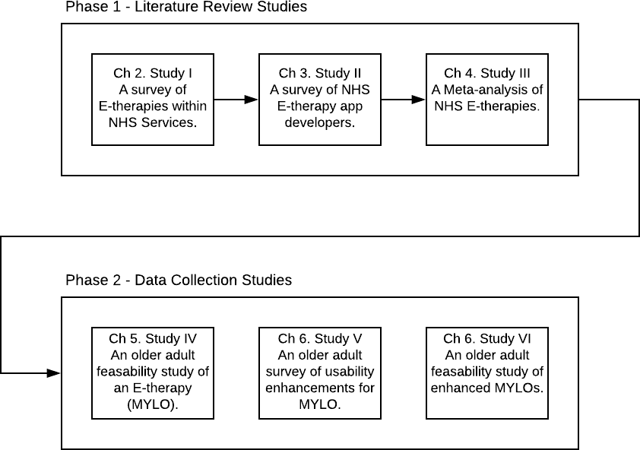
Chapter five explores whether usability and expectancies of e-therapies are related to older adult acceptability of e-therapy. This is important for the issue of developing e-therapies that are acceptable to older adults as we can establish if system usability and expectancies need more consideration during development. The study described in Chapter five (Study IV) replicated the method of an earlier study (Gaffney et al., 2013), but with an older sample. The acceptability of MYLO was compared with that of ELIZA a computer program users converse with via typed input that simulates the behaviour of a psychotherapist (Weizenbaum, 1976), among older adults unlike Gaffney et al., which used undergraduate volunteers. Measures were taken at pre and post a single session of either MYLO or ELIZA, and at 2-week follow-up, for problem-related distress, problem resolution, depression, anxiety and stress. A single point measure was taken for System Usability (SUS) at post. Ninety-four participants, recruited via the University of the Third Age, completed the study.
Findings were that both systems were effective over time and that in the MYLO group there was a relationship between system usability and their likelihood to continue using MYLO. The next chapter follows on from these findings by examining which enhancements older adults believe could potentially help improve MYLOs system usability.
Chapter six describes two studies. It firstly explores older adult opinions of new technology and views on the application of different possible enhancements to MYLO (Study V). This is important for developing MYLO further as it establishes which enhancements may be most appealing and beneficial to older adult users of MYLO. Using mixed methods, participants were asked to pretend they had an issue and then use MYLO to deal with it. They were then shown a series of video clips of possible technological enhancements that could be applied to MYLO, before being given a final survey containing a system usability scale and a set of questions to indicate how much they agreed/disagreed that adding each technology to MYLO would make it more acceptable to older adults.
Study VI follows on from these findings by examining whether implementing speech technology helps to improve MYLO’s acceptability among older adults. This is important for developing e-therapies as it establishes whether applying enhancements preferred by a particular demographic actually improves acceptability.
Study VI randomly allocated participants to one of 3 interventions: a standard MYLO, a guided MYLO and a guided MYLO with speech. Measures of expectancy/credibility, therapeutic alliance, system usability, depression, anxiety, distress, problem resolution, and loyalty were used. Sixty-three participants, recruited through the University of the Third Age, completed the study. While no between group differences were found, findings highlighted the potentially important role of system usability in both therapeutic alliance and perceptions of credibility.
These findings are interesting as emphasis is generally placed on the role of therapist support since reviews have indicated that guided self-help leads to better outcomes than unguided e-therapy (Spek, Cuijpers, et al., 2007; Andersson and Cuijpers, 2009; Richards and Richardson, 2012) and that the therapeutic alliance has been highlighted as one of the mechanisms for this (Barazzone, Cavanagh and Richards, 2012). Future research is needed to establish whether increasing usability has the effect of also increasing the strength of the alliance.
Chapter seven, the final chapter, provides a general discussion regarding how the work presented in this thesis has highlighted that this field is still in its infancy, and how there remains much work to be done in order to fully understand how the potential offered by the internet, the web and connected devices can be harnessed to improve the mental health of older adults. The main discussion points in the final chapter concern how NHS England records e-therapy use, how it is not presently possible to track which e-therapies are in use, where and by whom, and how by making minor modifications to the existing method of recording this information could be recorded. The chapter also discusses the differences between web and phone apps, and how these might have come about; the neglect of older adults in e-therapy research, with few studies focused purely on older adults and limited efforts to recruit them into general studies; and finally, the importance of usability for problem resolution and the likelihood of future use, as well as working alliance and credibility. It is hoped that this body of work can serve as a springboard for future research into usability, how usability affects the use of e-therapies and whether the relationships reported within this thesis are corroborated across other therapies and populations.

NHS Service Provision Panorama Part 1 (NHS E-therapies Survey)

Introduction
The combination of increased demand and financial pressures has forced health services to explore new and innovative methods of delivery at minimum cost. The internet and connected devices offer one potential solution to this challenge, which governments have begun to recognise, encouraging the use of digital services (see Australia’s digital hospital, Dutton, 2014, and internet mental health services in Norway and Sweden, Andersen and Svensson, 2013). However, it is unclear to what extent these initial steps are exploiting the digital potential in some countries. In the UK, according to a survey published in 2014, only 2% of the population reported any digitally enabled transaction with the National Health Service (NHS) despite an estimated 59% of UK citizens possessing a smartphone and 84% of adults using the internet (National Information Board, 2014). Older adult internet users aged 65 and over are most likely to agree that the benefits of being online outweighed any disadvantages and an estimated 86% of older adults aged 75 and over have access to a mobile phone (Ofcom, 2016). In England, the under-use of digital platforms in the NHS has been recognised by the publication of a five-year plan to reshape care delivery and utilise technology in the delivery of all kinds of healthcare (NHS England, 2014). Older adults warrant particular attention, however, as around two in five indicate having a health condition that makes reading difficult or challenging to them or that they have a disability, handicap or chronic condition that makes it unfeasible for them to participate in many general daily activities which could include using technology (Smith, 2014).
The current chapter focuses on the delivery of e-therapy in England, where the landscape of digital mental health service provision is not well delineated. This can be attributed to several factors: inadequate reporting; changing service recommendations; nationwide reorganisations of service provision infrastructure; and the rapid development and growth of the digital sphere itself. What is clear, though, is the increasing need for such services: a 2014 survey suggested that one in ten people in England wait more than a year for mental health assessment (We Need to Talk coalition, 2013), and in the UK as a whole it is estimated that by 2030 there will be 2 million more adults with mental health problems (Mental Health Network, 2014). Statistics indicate that between 8% and 10% of those aged over 60 experience clinically significant symptoms of a mental health issue (Pirkis et al., 2009). E-therapy has the potential to reduce waiting lists, make treatment more cost-effective, reduce the time and expense of travel, stimulate self-management (Marks et al., 2003; P. Cuijpers and Riper, 2014) and decrease the workload of mental health professionals (Titov, 2007; Spurgeon and Wright, 2010), but this potential can only be realised if the e-therapies cater for all demographics with which they are used. In this chapter, we examine identify which e-therapies are used and recommended across the NHS in England, in order that we can subsequently identify the suitability of these e-therapies for the over 65s.
The current study is based on requests made under the provisions of the UK Freedom of Information Act (2000) in 2015, and systematic enquiries on NHS websites. Under the Freedom of Information (FOI) Act, publicly funded bodies are obliged to respond to requests for specific information from members of the public. The resultant data documents the current state of digital mental health service provision in England.
There are multiple ways in which e-therapies have been defined and categorised in the literature. Riper et al. 2010 describe e-mental health as ‘‘the use of information and communication technology (ICT)—in particular, the many technologies related to the Internet— when these technologies are used to support and improve mental health conditions and mental health care’’. Other researchers have categorised e-therapies according to the amount of therapist support in them (Newman et al., 2011b), or the exact manner in which the web is used to aid delivery (Barak, Klein and Proudfoot, 2009).
Modes of delivery have also changed, with technological advances. Early e-therapy was sometimes packaged on CD-ROM and operated in a ‘stand-alone’ fashion on a PC, whereas practically all such tools are now accessed in one of two forms: as a web-based application (‘web app’), accessed via a conventional web browser, or else as a smartphone/tablet app, installed on (typically) the service user’s mobile device. The distinction is somewhat arbitrary, but since smartphone apps represent a relatively more recent development in the digital domain, and a significant one too, regarding popular uptake, it is convenient for this chapter to consider e-therapy as divided into two main categories: web apps and smartphone apps.

Policy History
The National Institute for Health and Care Excellence (NICE) is a non-departmental public body, responsible to but operationally independent of the UK Department of Health. Its function is to provide guidance to the NHS in England (although its advice often extends to the other constituent nations of the UK) for clinical practice, including what treatments should be offered for diseases, on the basis of published evidence. This remit includes the use of health technologies for mental ill-health. NICE recommendations stand until they are revised or replaced. In 2006, NICE issued its first specific guidelines for e-therapy, recommending two computerised cognitive behaviour therapy (cCBT) web apps for the treatment of mild to moderate depression and for panic/phobia, for which it was deemed there was sufficient evidence of clinical effectiveness. In 2009 these specific recommendations were withdrawn by NICE. At the time of writing (August 2016), NICE guidance for mental health practitioners is that cCBT can be offered for persistent subthreshold, or mild to moderate depression (National Institute for Health and Care Excellence, 2009); however, reference to specific tools (with published evidence) has been replaced by general guidelines for cCBT (National Institute for Health and Care Excellence, 2009; NICE, 2009). CCBT is recommended for research purposes only for generalised anxiety disorder (GAD) (National Institute for Health and Care Excellence, 2011) and is not recommended at all for adult phobias (National Institute for Health and Care Excellence, 2013).

Recent Technological Developments
Since the first NICE recommendations for e-therapies (National Institute for Health and Care Excellence, 2009), the use of smartphone and tablet computer has fundamentally altered the way that people interact with technology. On these devices, a plethora of health- and mental health-related apps are available at very little or no cost to the user. However, the quality and effectiveness of these apps are often questionable, with no general requirement to demonstrate beneficial outcomes through clinical trials or other means. While recent policy changes mean that currently, some stand-alone software including smartphone apps installed onto a device for a medical purpose are now considered a “medical device” (European Commission, 2016; MHRA, 2016) and must be registered with the MHRA, registration is not in itself an indication of efficacy (McCartney, 2013).
Meanwhile, the next generation of web apps includes features such as social networking which can lead to complex and dynamic interactions among users and technology. Unfortunately, the pace of change in smartphone and web health app development frequently renders the research community unable to evaluate programs fast enough to endorse or reject new interventions based on evidence as potentially effective components in routine care. This problem is not only effects researchers but also older adults who struggle to keep up with technology and as a result feel left behind (Vaportzis, Clausen and Gow, 2017). This shifting policy and technological landscape means that consulting NICE guidelines is no longer an effective way to find out which e-therapies are being routinely used and recommended across the NHS in England.

Access to Digital Mental Healthcare in the NHS in England
Understanding the digital mental health service landscape requires consideration of the methods of access to NHS recommended digital healthcare in England. There are several points of access including both referral and self-help routes.

Referral

Improving Access to Psychological Therapies
Much of the primary mental health care provision in the NHS in England currently comes through Improving Access to Psychological Therapies (IAPT) programme. IAPT was launched in 2007 to improve access to NICE-recommended psychological therapies for depression and anxiety disorders (Clark, 2011). IAPT services are provided on a local basis, sometimes alongside other health services, and offer direct routes to assessment and treatment by specialist mental health professionals without the need for GP referral.
Due to current NICE guidelines making general, rather than specific recommendations regarding e-therapies, practitioners in IAPT services are free to judge which apps are appropriate to use. Consequently, it is unclear which e-therapies are currently being recommended to and used by clients. Because mental health services in England are no longer exclusively provided by the NHS - charities, social enterprises, non-profit and limited companies can also provide IAPT services variation compounds this lack of clarity. In 2015-16 those aged 65 or over-represented 6% (88,519) of referrals to IAPT and 75% (65,919) of those entered IAPT treatment (NHS Digital, 2017b).

NHS Mental Health Trusts
In addition, IAPT services can also be provided by Mental Health Trusts, which cater for severe mental health problems (NHS Choices, 2015a). In the same period in which rapid technical developments have fundamentally changed the way that people expect to access services in general, the NHS in England has undergone profound infrastructural changes in mental healthcare provision. Collectively, these factors make for a very unclear picture of what e-therapies are used and recommended by the NHS across England.

Self-Help
In addition to accessing digital mental services via traditional face to face services (IAPTs or NHS Mental Health Trusts), there are also two avenues through which the NHS has sought to guide people’s use of digital self-help for mental health concerns.

NHS Health Apps Library
In keeping with the NHS goals of becoming “more digitised”, and with providing service users with access to tools to support their own well-being, The NHS Commissioning Board launched the NHS Health Apps Library in March 2013 (NHS England, 2013). The library was a subsection of the NHS Choices website and provided a portal through which the public could access a selection of smartphone and tablet apps reviewed by the NHS. However, the library was shut down on the 16th of October 2015 after the publication of two papers that questioned the methods of evaluation of the apps recommended by the library. Specifically, the evaluation of apps’ data security (Huckvale et al., 2015) and clinical effectiveness (Leigh and Flatt, 2015) were criticised.

NHS Online Mental Health Apps Library
In March 2015, NHS Choices published a webpage entitled Online Mental Health Services (NHS Choices, 2015b). This page existed separately from the now-defunct NHS Health Apps Library, and, at the time of writing (August 2016), provides a list of six apps, all web apps, that have “been approved for use by the NHS”, although by whom and upon what basis is unclear, and in fact seems to run counter to current NICE advice. While it is not known how many older adults use the internet to seek mental health support, a recent survey of older adult health app usage in Germany found that only 16.5% (95/576) of the those questioned used health apps, and the type of apps used were predominantly exercise related (Rasche et al., 2018). Research in the United States by Levine, Lipsitz and Linder (2016) indicated in 2014 that only 25% of the older population used digital health technologies such as obtaining health information, contacting clinicians and filling prescriptions. The paper goes on to advise that future innovations should focus on usability, adherence and scalability to improve the reach and effectiveness of digital health for older adults.

The Current Study
Digital mental health care provision within the NHS in England is diverse. Ever-evolving services provide different means of accessing digital healthcare products that are themselves the products of a highly dynamic marketplace, and with which official recommendations and advice struggle to keep pace. The key objective of this chapter is to illuminate the current state of digital mental health care in England by documenting what e-therapies are used and recommended by the NHS, thus providing a starting point for the evaluation of current practice with particular reference to older adults.

Methods

Design
We documented web and smartphone apps used and recommended in the NHS for stress, anxiety, and depression. Our data sources were fourfold. Using FOI Requests, we requested a list of which web apps were being used and recommended, and how many older adults were cared for, in (i) NHS IAPT services and (ii) NHS Mental Health Trusts. We also reviewed (iii) the NHS health apps library and (iv) the NHS mental health apps library to identify apps (and web apps) that were currently (or recently) being endorsed by the NHS. In our FOIs to NHS IAPTs and Trusts, we also asked for information about involvement in research, piloting, or development of e-therapies, to capture not only the current practice, but insight into the slightly larger temporal window of very recent past, current, and likely future developments. All e-therapies were appraised against the inclusion criterion of being targeted to alleviate the symptoms of depression, anxiety, or stress. To meet this criterion, the developer of the app had to be locatable via a Google search when entering the app name as the search term, and the app had to reference the targeted conditions in its marketing literature or be based on a therapeutic tool known to benefit the targeted conditions.

Procedure

Improving Access to Psychological Therapies
On the 10th of February 2015, a list of IAPT services within England was requested through an FOI email to NHS Choices, asking for the contact details of all IAPT services within the country. This yielded a list of 295 IAPT services, of which only 116 were sufficiently detailed to identify their overarching IAPT service provider. Each service’s provider was located via an internet search, and overall, 111 IAPT service providers were identified.
On the 13th of February 2015, an FOI email request was sent to each of the 111 IAPT service providers. The questions asked are reported in Table 2.1. According to the FOI Act, requests must be answered within 20 working days of receipt. No responses were received after this time.

Table 2.1 Freedom of Information Request Questions asked of IAPT Service Providers
Question | Wording
1. | According to the dataset I have obtained from NHS Choices, you host the following services [service names]. Please can you confirm whether this list is complete and add any additional services that are not listed? (Including address and postcode).
3. | If these services are not run directly by the NHS please state who runs them and what they are (e.g. Social Enterprise, Limited Company, third sector group).
4. | If you provide an IAPT a service on behalf of another organisation (such as a care commissioning group, foundation trust or other) please state the organisation’s name.
5. | Please state the types of referral used by your organisation / IAPT i.e. GP, Self-Referral, Other.
6. | If you offer a self-referral service do you have an online self-referral method such as a contact email address or a form on your website?
7. | Please state any e-therapies, computerised therapies, Internet-delivered therapies, online therapies, or advice/guidance websites for mental health issues that your organisation / IAPT service use or recommend to service users. For example, these might include, but are not limited to internet-delivered cognitive behaviour therapy with or without therapist support, internet-delivered therapy based on an approach other than cognitive behaviour therapy, online or email therapy/counselling, online social support networks, or informational websites.
8. | Please state any smart phone apps your organisation / IAPT service use or recommend to service users. For example, these might include specific apps from the NHS Choices Health Apps Library, or others that professionals in your service recommend.
9. | In 2013/14 could you give the total number of people your service saw under IAPT and also give a figure as to how many of those were aged 50 or over.

NHS Mental Health Trusts
Many IAPT services are hosted by NHS Mental Health Trusts. It is possible that the answers given by IAPT services may be missing elements that are only answerable at an NHS Trust level. For example, an IAPT service hosted by a Trust may not be aware of its host’s activities around research and development. Therefore, FOI emails were also sent to each Trust, using a list of 51 NHS Mental Health Trusts compiled from the NHS Choices mental health trust listing page on the 3rd of March 2015. The questions asked are reported in see Table 2.2. No responses were received after the mandated response window.
Table 2.2 Freedom of Information Request Questions asked of NHS Trusts
Question | Wording
1. | Please state any e-therapies, computerised therapies, Internet-delivered therapies, online therapies, or advice/guidance websites for mental health issues that your trust use or recommend to service users. For example, these might include, but are not limited to internet-delivered cognitive behaviour therapy with or without therapist support, internet-delivered therapy based on an approach other than cognitive behaviour therapy, online or email therapy/counselling, online social support networks, or informational websites. Format this as a list indicating which are recommended and which are used by the trust.
2. | Please state any smart phone apps your trust use or recommend to service users. For example, these might include specific apps from the NHS Choices Health Apps Library, or others that professionals in your service recommend. Format this as a list indicating which are recommended and which are used by the trust.
3. | For the period 2013/14 could you state the total number of people your trust treated for depression / anxiety and also give a figure as to how many of those were aged 65 or over.

NHS Apps Libraries
On the 26th of March 2015 web and smartphone apps were identified by carrying out four searches on the NHS Health Apps Library under the search terms “Mental Health”, “Depression”, “Anxiety”, “Stress”. Additionally, the apps listed when clicking on the navigation menu category “Mental Health” were also collected. The apps listed on the NHS Mental Health Apps Library (on the 2nd of November 2015) were also collected.

Results
We present the data from each of the sources separately in the following sections. For IAPTs and Trusts, we present data pertaining to i) response rates; ii) use of web and smartphone apps; iii) reports of being involved in research, piloting, or development of apps; and iv) whether they support online self-referral (IAPTs only). For apps libraries, we report the apps which met our inclusion criterion. The final list of e-therapies reported as being used or recommended by IAPTs or Trusts in England, or listed on the NHS Apps libraries for common mental health problems, is summarised in Table 2.3.
Table 2.3 All web and smartphone apps reported to be used or recommended by the NHS for common mental health problems
App | Format | Payment Model | Web or phone based (w/p) | N of IAPTs using/ recommending (% of 191 IAPT services) | N of Trusts using/ recommending (% of 51 Trusts) | Listed in NHS Health Apps Library (y/n) | Listed in Mental Health Apps Library (y/n)
Living Life to the Full | Online modular self-help | Free to access | W | 94 (49.2%) | 24 (47.1%) | n | n
MoodGym | Online modular self-help | Free to access | W | 46 (24.1%) | 10 (19.6%) | n | n
Big White Wall | Online forum with tools, courses and one to one messenger-based chat with a professional. | Paid for by provider (but only available in some areas) or end user | W | 39 (20.4%) | 12 (23.5%) | y | y
Beating the Bluesª | Online modular self help | Paid for by provider (but only available in some areas) or end user | w | 34 (17.8%) | 13 (25.5%) | n | n
SilverCloud Health | Online modular self-help with therapist support | Paid for by provider (but only available in some areas) | w | 27 (14.1%) | 5 (9.8%) | n | y
Ieso Digital Health Ltd | Online one to one messenger-based chat with a professional | Paid for by provider (but only available in some areas) | w | 22 (11.5%) | 5 (9.8%) | y | y
Fear Fighter | Online modular self-help | Paid for by provider (but only available in some areas) or end user | w | 20 (10.5%) | 5 (9.8%) | n | y
HeadSpace | Meditation via app or online | Paid for by end user | p | 11 (5.8%) | 3 (5.9%) | n | n
Buddy App^{b} | Tool to support face-to-face therapy | Paid for by provider | w | 6 (3.1%) | 2 (3.9%) | y | y
Don’t Panic! | Self-help resources | Free to access | p | 5 (2.6%) | 1 (2.0%) | n | n
MyMoodTracker | Mood tracker | Paid for by end user | p | 2 (1.0%) | 1 (2.0%) | n | n
Mindfulness Bell | Meditation | Paid for by end user | p | 2 (1.0%) | 0 (0%) | n | n
Moodkit – Mood Improvement Tools | Tools to improve mood | Paid for by end user | p | 2 (1.0%) | 0 (0%) | y | n
Thought Diary Pro | Thought diary | Paid for by end user | p | 2 (1.0%) | 0 (0%) | n | n
WellMind | Tools to help with depression, stress, anxiety | Free to access | p | 2 (1.0%) | 1 (2.0%) | n | n
Moodometer | Tool to support face-to-face therapy | Free to access | p | 2 (1.0%) | 0 (0%) | n | n
Kooth | Online one to one messenger-based chat with a professional for children and young adults aged 11 to 19 | Free to access (but only available in some areas) | w | 2 (1.0%) | 2 (3.9%) | n | y
CBTReferee | Journal to assist face-to-face CBT | Paid for by end user | p | 1 (0.5%) | 1 (2.0%) | n | n
iCBT | Tool for self-help using CBT | Paid for by end user | p | 1 (0.5%) | 0 (0%) | n | n
Thought Diary | Thought diary | Paid for by end user | p | 1 (0.5%) | 0 (0%) | n | n
Stay Alive | Tools to prevent suicide | Free to access | p | 1 (0.5%) | 1 (2.0%) | n | n
Take a break! | Meditation app | Free to access | p | 1 (0.5%) | 1 (2.0%) | n | n
Mindshift | Tools to help with anxiety | Free to access | p | 1 (0.5%) | 0 (0%) | n | n
Moodscope | Tool to monitor mood | Free to access, stepped payment | w | 1 (0.5%) | 1 (2.0%) | y | n
DigitalMeds | Binaural Beat technology for meditation | Paid for by end user | p | 0 (0%) | 0 (0%) | y | n
How Are You App | Mood tracker | Paid for by end user | p | 0 (0%) | 0 (0%) | y | n
Mindfulness by Digipill | Meditation | Paid for by end user | p | 0 (0%) | 0 (0%) | y | n
Mindlogr | Video journal | Paid for by end user | p | 0 (0%) | 0 (0%) | y | n
Panic Attack Aid | Tools to help with panic attacks | Paid for by end user | p | 0 (0%) | 0 (0%) | y | n
Phobia Free | Augmented Reality (AR) for exposure treatment | Paid for by end user | p | 0 (0%) | 0 (0%) | y | n
Stress Management App | Tools to help with stress | Paid for by end user | p | 0 (0%) | 0 (0%) | y | n
WorkGuru | Tools to help with stress at work | Paid for by end user | w | 0 (0%) | 0 (0%) | y | n
Worry Watch | Journal for anxiety | Paid for by end user | p | 0 (0%) | 0 (0%) | y | n
MindEd | Online advice and support | Free to access | w | 0 (0%) | 1 (2.0%) | n | n
Puffell | Online advice and support | Free to access | w | 0 (0%) | 1 (2.0%) | n | n
Virtual Hope Box | Tools to compliment face-to-face | Free to access | p | 0 (0%) | 1 (2.0%) | n | n
Aventurine Mood Improver | Tool for self-help using CBT | Free to access | p | 0 (0%) | 0 (0%) | y | n
Black Rainbow | Advice and audio for relaxation | Free to access | p | 0 (0%) | 0 (0%) | y | n
Depression Calculator | PHQ-9 screening tool | Free to access | p | 0 (0%) | 0 (0%) | y | n
Five Ways to Wellbeing | Tools for wellbeing | Free to access | p | 0 (0%) | 0 (0%) | y | n
Ginsberg | Activity and mood diary | Free to access | p | 0 (0%) | 0 (0%) | y | n
Happy Healthy App | Tools for wellbeing | Free to access | p | 0 (0%) | 0 (0%) | y | n
HealthStored | Health tracker | Free to access | p | 0 (0%) | 0 (0%) | y | n
Healthy Living | Guide to healthy living | Free to access | p | 0 (0%) | 0 (0%) | y | n
Hello Brain Health | Brain exercises for better health | Free to access | p | 0 (0%) | 0 (0%) | y | n
Moodbug | Mood tracker | Free to access | p | 0 (0%) | 0 (0%) | y | n
SAM: Self-help for Anxiety | Tools to help with anxiety | Free to access | p | 0 (0%) | 0 (0%) | y | n
Stress & Anxiety Companion | Tools to help with anxiety | Free to access | p | 0 (0%) | 0 (0%) | y | n
Notes
ª Beating the Blues developer Ultrasis went into administration in October 2015. The program is now linked with 365 Health and Wellbeing Ltd who have been unreachable for comment.
^{b} Buddy Enterprises has ceased operations and as a result of this Buddy App has been discontinued.

Improving Access to Psychological Therapies Services
The FOI responses from IAPT services were inconsistent. Some providers answered at an overarching provider level while others gave granular detail regarding each of their service locations. In our results, we assumed that when a provider responded at the top level that they referred to all their IAPT service locations. A total of 61 out of 111 IAPT service providers responded, accounting for 191 IAPT services. Two providers, one a charity and the other a Community Interest Company (CIC - a UK limited company whose objective is to benefit the community it serves, using any profits and assets for that purpose), refused to respond to the FOI on the grounds that the act did not apply to them; a further two acknowledged receiving the FOI request but did not follow up with a response to the questions asked, and 13 indicated that their services had been discontinued, merged with, or passed to another IAPT provider. A total of 33 IAPT providers did not respond at all to the FOI request. These comprised public sector organisations: n=8 (24.2%); third sector organisations: n=13 (39.4%); and private sector organisations: n=12 (36.4%). The majority of the non-responders were non-public sector organisations (n=25; 75.8%).
One hundred and sixty-nine of the 191 (88.5%) IAPT services for which responses were obtained recommend or used web apps and of those, 41 (24.3%) use at least one of the NICE (National Institute for Health and Care Excellence, 2006) recommended cCBT programs. IAPT services, in addition, highlighted 16 different web apps. Six were excluded for not meeting the inclusion criterion (Figure 2.1 PRISMA Flow Diagram of app data collection (Figure 2.1) leaving ten included web apps (Table 2.3). Fifty (26.2%) of the IAPT services recommend or use smartphone apps, and 21 smartphone apps were specifically named. Seven did not meet the inclusion criteria (Figure 2.1), leaving 14 included smartphone apps.
Twelve IAPT services indicated they were carrying out research into web apps, ten stated they were piloting web apps, and two said that they were in the process of developing their own. Regarding smartphone apps, 15 IAPT services indicated they were carrying out research into smartphone apps; two stated they were piloting smartphone apps, and ten said that they were in the process of developing their own. Two IAPTs indicated using patient webinars but did not disclose details of their content. Regarding online self-referral, 138 (72.3%) of the 191 IAPT services support this, either via email or online form.

NHS Mental Health Trusts
All 51 Mental health trusts responded to the FOI request. Thirty-nine of the 51 (76.5%) Trusts recommend web apps and of these 14 (35.9%) use NICE recommended cCBT (National Institute for Health and Care Excellence, 2008). Seventeen web apps were highlighted by Trusts, 5 of which did not meet the inclusion criterion (Figure 2.1). This left 12 included web apps (Table 2.3). Fifteen (29.4%) of the 51 Trusts recommend or use smartphone apps. Trusts named 14 specific smartphone apps, 6 of which did not meet the inclusion criterion (Figure 2.1), leaving 8 included smartphone apps (Table 2.3).
One Trust indicated it was carrying out research into web apps; two stated they were piloting web apps, and one said that it was in the process of developing its own. Regarding smartphone apps, 2 Trusts indicated they were carrying out research into smartphone apps; two indicated they were piloting smartphone apps, and seven said they were in the process of developing their own.

Apps Libraries
In the NHS Health Apps Library, a list of 44 web/smartphone apps was identified, 18 of these did not meet the inclusion criterion (Figure 2.1) leaving 26 included apps. Out of the seven web apps listed in the NHS Mental Health Apps Library on the 2nd of November 2015, 6 met the inclusion criterion, and one did not (Figure 2.1). Only three apps were present in both libraries (Table 2.3).
Figure 2.1 PRISMA Flow Diagram of app data collection
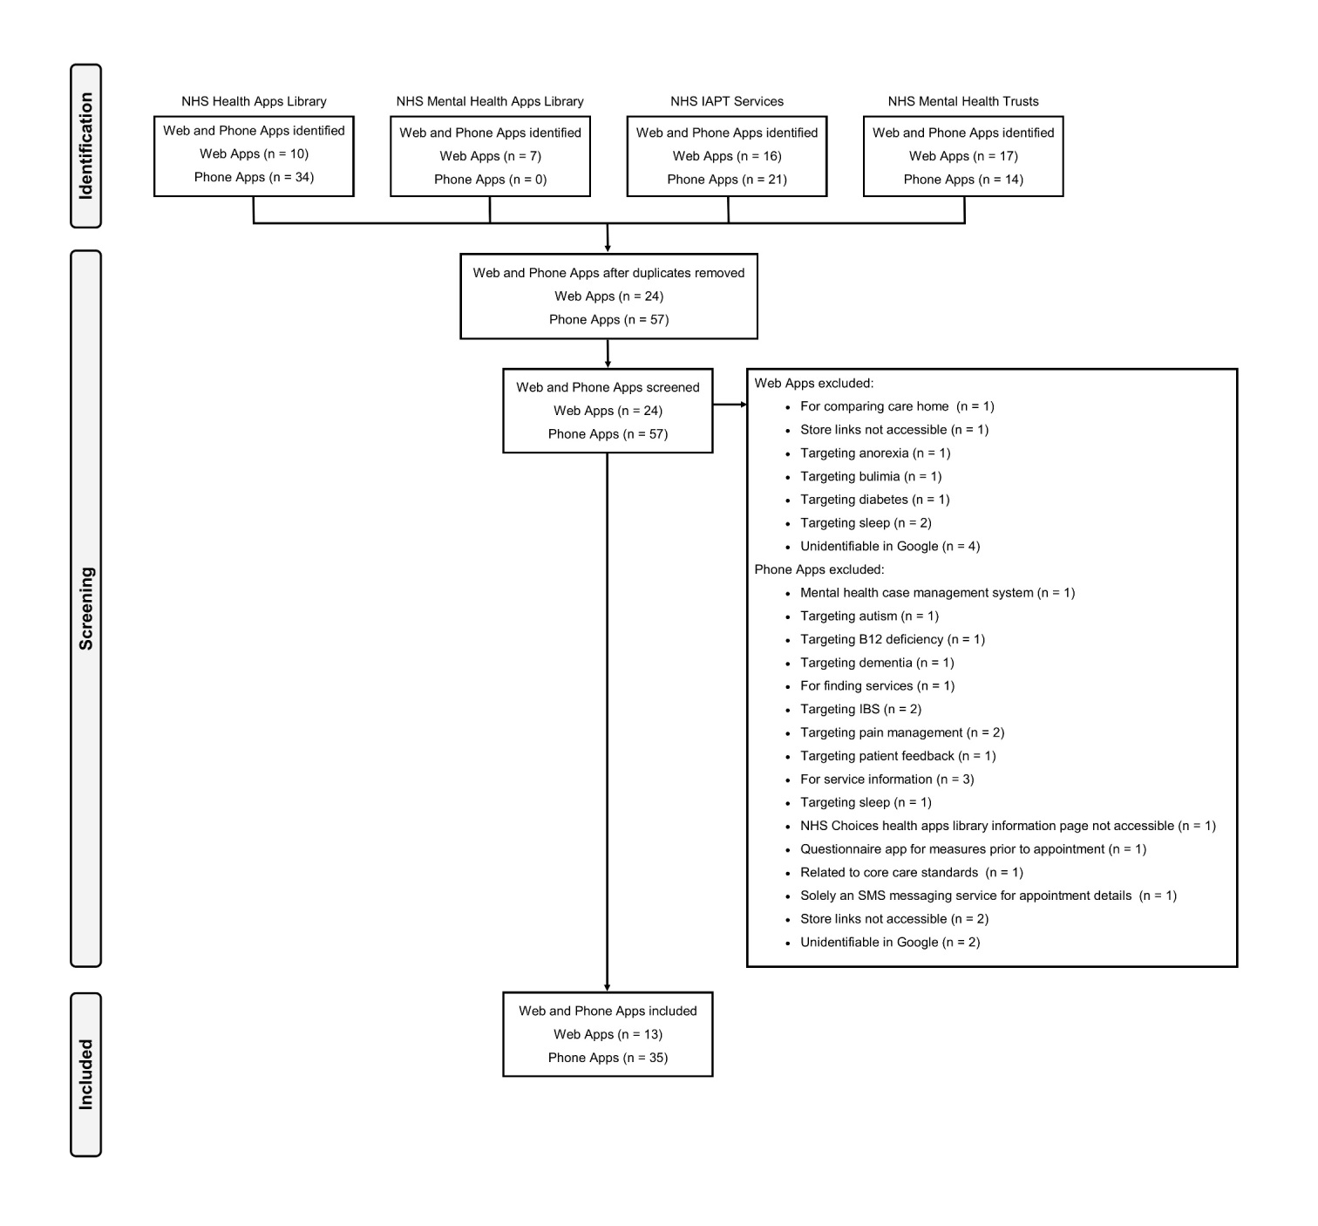

Discussion
The present chapter is the first attempt to document all the e-therapies used and recommended by the NHS in England at a particular window in time. The purpose of doing this was to provide a list of e-therapies to examine in relation to their suitability for older adults. While the list of e-therapies used and recommended by the NHS in England is changeable over time, the present chapter provides future researchers, commissioners, and policymakers with a baseline of information from which to build. The data presented raise several interesting issues relating to the accessibility of service information, NICE guidelines on e-therapies, and ways of evaluating e-therapies. These are discussed in turn, followed by the relevance of the main findings for older adults specifically.

Data Accessibility and Quality
This study relied heavily on the provisions of the UK FOI Act (2000) for the collection of data. Approximately 54% of service providers responded to their FOI request. Although this represents a large sample of service providers, it is difficult to ascertain the extent to which they are representative of all NHS IAPT services. The reorganisation of the provision of mental health services in England has led to the increased participation of private and third sector provider organisations. Unlike public bodies, these organisations are not obliged to respond to FOI requests. Indeed, over half of the organisations that did not respond to the FOI request were limited companies or charities. As more areas of the NHS are outsourced to external providers, inaccessibility of service information is likely to increase. There is, therefore, a need for the FOI Act to apply to all NHS services, be they publicly or privately run, to ensure a level of transparency that allows both positive and negative aspects of services to be made visible to the public and researchers alike.
Regarding the quality of the data collected, in some instances, the FOI requests were answered with datasets that contained missing or inaccurate data. For instance, in the IAPT dataset supplied by NHS choices, which is searched by service users of the NHS Choices website, only 46.4% of services had provided a contact email, and only 52.5% had a website link detailing more information about the service location. There is a clear need for the NHS to improve its data curation procedures to meet the aspiration of becoming truly digitally enabled.

NICE guidelines on E-therapies
NICE (2006) recommended two cCBT programs for use within NHS services. The publication of subsequent NICE recommendations (2009b) resulted in the withdrawal of endorsement of any specific app, shifting responsibility for choosing e-therapies to service providers. Because of this, there are now 13 different web apps, and 35 smartphone apps, for depression, anxiety or stress, available either through referral services or the NHS Mental Health Apps Library. These e-therapies are not consistently used or recommended across the country representing variability in service provision by geographical location. There are also notable differences between the four most used apps by IAPTs and Trusts, and the apps currently listed in the Mental Health Apps Library and previously listed in the Health Apps Library, with 3 of the four most used by IAPTs and Trusts not appearing in either library. Most notably, the top two apps used by IAPTs and Trusts are free to access and yet are not listed in the current (or previous) NHS library. Perhaps this indicates different decision processes being used by IAPTs and Trusts compared to NHS library curators.
Additionally, the current Mental Health Apps library features many apps that are only free in some areas of England, requiring user payment in others. This has implications for patient choice and service equality. Furthermore, 11.5% of IAPT services and 23.5% of Trusts do not use or recommend web apps at all. It is not clear whether this reflects the absence of specific NICE guidelines or a general lack of digitally enabled service provision.

Ways of Evaluating E-therapies
To help address the gap in NICE guidelines, it is crucial to investigate whether the apps currently being used are effective. While the pace of large-scale evaluative research (e.g., RCTs) lags behind that of advancing technology, there are other, more practical options for collecting and synthesising useful data. We make two specific recommendations. Firstly, the minimal dataset collected by IAPT (NHS Digital, 2016) which is used to build a picture of the current activity within IAPT services such as assessments, sessions, scales, should be revised. It currently requires data on whether a client is using an e-therapy, but it does not indicate which one (Health and Social Care Information Centre, 2015). A more fine-grained approach, where not only e-therapy use but also which one, was recorded, would provide the ability to isolate the impact of individual apps on end users. This relatively small change to routine data collection practices would provide an instant evidence base against which all the e-therapies listed in the present chapter could be evaluated. Secondly, for each e-therapy listed in the present chapter, a systematic literature review should be conducted, to synthesise any existing effectiveness data.
There are also alternative methods of evaluating e-therapies, which, while they do not address effectiveness specifically, can provide useful insight into the integrity of the content, data security measures, and the acceptability to end users. Researchers have begun to discuss and propose methods of evaluating e-therapies. MindTech’s Framework for Mental Health Digital Products (MindTech, 2014) aids users in the process of evaluating, comparing and contrasting programs by providing a list of all possible and relevant issues. The Mobile Application Rating Scale (MARS) (Stoyanov et al., 2015) enables expert raters to review apps for engagement, functionality, visual aesthetics, information quality and subject quality of health apps and has been tested on Mindfulness apps (Mani et al., 2015). Other methods of analysis and evaluation might include syphoning review data from the app stores. While it cannot speak to effectiveness, rating scores and download numbers may give indications about acceptability.
Presently the NHS does not have a process in place to endorse apps. However, The National Information Board is working to develop a Health App Assessment process (National Information Board, 2015). This process will eventually enable the NHS to endorse apps. However, the consequences of endorsement are currently unknown. Endorsement may result in market dominance by those gaining NHS approval, stunting the market and truncating innovation.

E-therapy Tailored to Specific Demographics
The majority of the web/phone applications included in this review were not tailored to a specific demographic. One e-therapy, Kooth, was designed for young people aged 11 to 19. There were no e-therapies found for older adults aged over 65. It may be possible that some of the modular based e-therapies listed have the potential to support these groups through customised modules. It would be useful for future research to collect data on specific provision for different demographics, both in terms of e-therapies available, and those employed by NHS services for specific demographics (e.g. Child and Adolescent Mental Health Services).

Older Adults and E-therapies
As we have found, a large number of web and smartphone apps have been developed as the medium for delivery of e-therapies. Alongside this, a recent survey (Ofcom, 2016) found that 65% of those aged 65 to 74 in the UK have access to the internet, with 72% users of smartphones, and nothing suggests that these figures will do anything other than increase over the next few years. Taken together, these figures suggest that older adults are among the users of e-therapies. However, it does not follow from this that the available apps are either acceptable or effective for this age group. While learning more about the development of e-therapies, the therapeutic models they use, and their theoretical underpinnings, may help to strengthen the case for particular apps, a meta-analysis of the published studies should paint a more robust picture of the evidence for e-therapies, as well as revealing any gaps in current knowledge surrounding their effectiveness for older adults.

Conclusions
As e-therapies are continually evolving, their place within NHS services will also continue to change. However, there is a pressing need for proper evaluation of the effectiveness of the e-therapies used and recommended by the NHS, to support evidence-based practice, and help to overcome the gaps remaining in the NICE guidelines on apps for common mental health problems. This chapter has provided a starting point for this work, by documenting all the web- and smartphone-based apps currently being used or recommended by the NHS in England. Future research should seek to examine the e-therapies identified within this chapter and systematically review and meta analyse the evidence for them to establish their clinical effectiveness. It is also important that changes are made to i) enable better reporting of digital mental health service provisions within IAPT services, and ii) build an evidence base with which to evaluate the effectiveness of different e-therapies.

NHS Service Provision Panorama Part 2 (E-therapy Developers Survey)

Introduction
While apps can have the potential to give great benefits, they also have the potential to cause physical, mental, reputational or financial harm to patients, healthcare professionals and their organisations if they are not evaluated for clinical safety. For example, an app may miscalculate a drug dose or give incorrect medical advice to a consumer or patient. NHS Digital (2017) highlights that apps to be used by the NHS cannot be endorsed unless they have been evaluated for potential harm, while Public Health England’s (PHE) health app assessment process requires developers to outline plans and policies to limit and mitigate potential risks associated with their apps.
Regulatory approval provides patients and healthcare professionals with the assurance that an app is of high quality, safe and ethical (NHS Digital, 2017). There are two types of regulation presently available in the UK: The Medicines & Healthcare products Regulatory Agency Medical Device Registration and Care Quality Commission Registration.
The Medicines & Healthcare products Regulatory Agency (MHRA) provides a ‘device determination’ flowchart that enables developers to check whether their app is defined as a medical device. The two main questions in determining this are whether the app has a medical purpose and whether it works directly with data obtained in vivo. At the time of writing, developers of apps that meet these criteria and who want to market them to the public are required by the UK government to register the app with the MHRA and to obtain for it CE marking, indicating conformity with health, safety and environmental protection standards for products sold within the European Economic Area (Department for Business, Energy & Industrial Strategy, 2012).
The Care Quality Commission (CQC) set out 14 regulated activities: personal care; accommodation for people who require nursing or personal care; accommodation for people who require treatment for substance misuse; treatment of disease, disorder or injury; assessment or medical treatment for persons detained under the Mental Health Act 1983; surgical procedures; diagnostic and screening procedures; management of supply of blood and blood-derived products; transport services; triage and medical advice provided remotely; maternity and midwifery services; termination of pregnancies; services in slimming clinics; and nursing care and family planning services. If an app provides a health or social care service that fits one of these activities the developers are required by the PHE to register with the CQC before the app can be assessed via the PHE app assessment process.
It is essential for the public to know whether a digital mental health app is effective. Some have argued that many apps have no evidence to support their effectiveness (Leigh and Flatt, 2015), but deciding what constitutes ‘evidence’ for apps is not straightforward. Within healthcare research, there is a hierarchical structure depicting the strength of evidence (Joanna Briggs Institute, 2014). The higher the level, the greater the internal validity and hence the more persuasive and trustworthy the evidence is. The randomised controlled trial (RCT) is currently the gold standard for providing evidence of clinical efficacy (Joanna Briggs Institute, 2014). However, RCTs take time to design, implement and publish and thus may be poorly matched to the pace at which technologies and tools are evolving. This means that there is presently no clear consensus on how best to evaluate apps, although policymaker and researcher efforts are being directed to the issue, as outlined below.
An EU Working Group was set up in February 2016 to create mHealth assessment guidelines but unfortunately failed to reach a conclusion (European Commission, 2017). A report by the group highlighted that building the guidelines had been found to be a much more complex exercise than initially expected at the beginning of the process, and the work required went far beyond the original mandate of the group (Working Group on mHealth Assessment Guidelines, 2017)
Separately to this, a toolkit for appraising digital mental health products was developed and released by MindTech in October 2017. The toolkit offers a standard set of criteria for evaluating existing digital mental health tools (apps and mobile websites) and a final report discussing the framework was published by Betton et al., (2017). Other examples of app assessment methods that have been developed in recent years include the Mobile App Rating Scale (MARS), developed by an Australian research team in 2015 (Stoyanov et al., 2015). MARS is a scale that aims to provide researchers, clinicians and developers with a way to score digital tools based on a list of evaluation criteria (Stoyanov et al., 2015). Similarly, the British Standards Institution in conjunction with Innovate UK has developed the PAS 277:20159 code of practice. As well as helping to design new tools, the code can be used to evaluate existing ones (BSI, 2015).
In October 2017, Public Health England (PHE) released a health app assessment process developed to encourage the creation of effective health apps and to enable health professionals to consider health apps for use in General Practice (Public Health England, 2017). The process covered eight different areas: evidence of effectiveness; regulatory approval; clinical safety; privacy and confidentiality; security; usability and accessibility; interoperability; and finally, technical stability.

The Current Study
It is apparent that the landscape for assessing apps is complex and ever-changing. The aim of the present chapter is to examine the quality of apps in use by the NHS by examining the manner in which they have been developed. The majority of existing app review methods focus on the technical rules and regulations of app design, and neglect or ignore entirely the question of whether the actual app does what it says and meets the claims its developers make for it. This is clearly a problem when dealing with apps that promise to improve the physical or mental health of their users. In an ideal world, before being released for general use, every app would have undergone rigorous user trials that demonstrated its effectiveness. However, rigorous trials are a costly and challenging business, and current models of app development and publishing seem to encourage ‘less rigorous’ approaches. Here, in an attempt to gauge the quality of existing apps as providers of therapy without performing user trials on each and every one, we have adopted the approach of probing more deeply into the processes employed in their development. More specifically, we are interested in the psychological model, theories, or therapies used, the extent of clinical and academic involvement, and any published (or otherwise) evidence in support of each app. The developers of each of the apps identified in Chapter two were contacted and asked to provide the relevant details. Note that this work predates the publication of the assessment tools described above. Were this study to be repeated now, it is likely that the work would have been informed by those tools.

Important Indicators of Quality
The purpose of this chapter is to evaluate the apps that were in use or recommended by the NHS at the time of writing. We were specifically interested in the following four indicators of quality, for the reasons that are outlined below.

Clinician Involvement
Healthcare staff routinely use apps to perform their roles (O’Connor et al., 2014). This makes it essential that the information given in these apps be grounded in the best and most up-to-date knowledge, derived from research, clinical experience and patient preference (NHS Digital, 2017). Unfortunately, many app stores do not carry out rigorous reviews regarding the accuracy of app content before publication, meaning some apps potentially have inaccurate information (Barton, 2012). Hamilton and Brady (2012) and O’Neill and Brady (2012) highlight that when assessing digital mental health apps, it is important to assess whether clinicians have been involved in the development process. This is because clinician involvement can help to ensure that any established modes of treatment are appropriately deployed within the app. For instance, an app based on CBT but made by someone who is not qualified to deliver CBT may fail to give an accurate implementation, involving a clinician who specialises in CBT would improve the accountability of app content.

Academic Involvement
Academic involvement in the process of developing an app can help to ensure the implementation of empirically supported interventions and principles, providing a foundation for an app’s use in clinical practice. Responsible academics strive to bring neutrality and remove bias, to expose the app to peer review and publish evidence of an app’s feasibility, acceptability and clinical effectiveness.
As mentioned previously it is essential that an app can show evidence of its effectiveness. In PHE’s app assessment process, developers must provide evidence that their app improves outcomes for patients and users; provides value for money; meets user needs and is stable and simple to use, and that people use it. Independent research is weighted highly in the assessment criteria, and apps that have a high level of clinical evidence are considered by NICE for “NICE evaluated” status. This status is considered to represent the gold standard for NHS health apps. In addition to this, all apps are required to show that they meet the criterion set out by NHS Digital (2017) covering: clarity of purpose and intended use; their evidence basis; the data that forms the basis their evidence and findings; any published academic studies. The involvement of academics in the development of an app can be helpful in ensuring that data are collected in a manner that makes it possible to evaluate effectiveness, although it is also important that evaluation is conducted by researchers independent of the app, without a personal interest in the results.

Research Evidence / Other Evidence
While RCTs are the gold standard, it is not expected that all apps will have published research evidence at the time of writing in part due to the rapid pace of change and the unwieldy nature of conducting RCTs. However, there might be other forms of evidence that can indicate whether an app may be beneficial to a patient. This evidence may take different forms such as practice-based evidence methodologies (e.g. detailed case series) that assess the acceptability, feasibility and initial effectiveness of an app and may also include early pilot trials.

Specific Psychological Approach or Theory / Set of Techniques / Therapy
Apps claiming to help with mental health problems such as depression, anxiety or stress would be expected to use established approaches to treatment that have been found to be effective in the real world. The psychological therapies that are designated by NICE regardless of disorder are all underpinned by a clinical theory. The risk of not having an organising theoretical framework for an app is that the change techniques that are used may be cherry-picked by developers on the basis of inappropriate criteria (e.g. selecting techniques that can be gamified easily rather than those that are most effective) and so lack theoretical coherence and consistency.

Using Indicators of Quality to Evaluate Apps
If we accept the premise that effective psychotherapeutic interventions only come about as the result of rigorous theoretical and empirical work by experienced clinicians and academics, it follows that apps need clinician and academic involvement, psychological theory and research/other data to support their effectiveness. The NHS e-therapies identified in the previous chapter have not been examined for compliance with any of these indicators of quality.
The current study used a survey sent to the developers of all the apps identified in Chapter two to explore how the apps fared against the indicators of quality described, and whether there were any differences between web and phone apps.

Methods

Design
We documented development information surrounding each of the web and smartphone apps used and recommended by the NHS for stress, anxiety and depression identified in Study I. Our data source was a survey sent to developers. In the survey, we asked for information about clinical involvement, academic involvement, publications published or forthcoming, other evidence of effectiveness and whether the app was based on a psychological approach or theory.

Participants
Participants were the developers of the 47 NHS e-therapies identified in Study I.

Procedure
Ethical approval was gained from the University of Sheffield Psychology Ethics Committee (see Appendix A1). During October 2015, each e-therapy developer was initially contacted by telephone before being sent an email invitation to be involved in a study (see Appendix A2). Those who expressed interest were sent an information sheet and consent form (see Appendix A3). Those who consented were sent a link to the online survey covering the five key areas of evidence for the quality of an app, namely: the extent of clinical involvement in its development; the existence of published evidence; the extent of academic involvement; any studies or trials which have been undertaken; and any psychological approach or theory on which the app is based (see Table 3.1). Each initial question had a further open-ended sub-question asking for more details when a participant confirmed the existence of that particular evidence. Participants were then debriefed (see Appendix A4)
Table 3.1 Questions asked of NHS e-therapy app developers
Question | Wording
1 | Did the development of the content for your e-therapy or smartphone app have clinical involvement?
1.1 | Please state how there was clinical involvement in the development of your app - e.g. the people involved and the process by which they were involved.
2 | Does your e-therapy or smartphone app have any publications of research evidence either published or forthcoming?
2.1 | Please list details of the publications of research evidence either published or forthcoming
3 | Did your app have any academic involvement in its development?
3.1 | Please list details of those academics
4 | Has your app gone through any pilot studies, feasibility studies, efficacy studies, effectiveness studies, Randomised Control Trials (RCT) or any other evidence to prove your app is effective?
4.1 | Please list details of those studies / sources of evidence
5 | Is your app based on a specific psychological approach or theory / set of techniques / therapy? (example: CBT)
5.1 | Please detail the specific psychological approach or theory / set of techniques / therapy? (example: CBT)

Statistical Analysis
In order to establish whether the answers to these questions differed as a function of app type (web or phone), tests of association were use. A series of chi-square tests were conducted for questions 2, 3, 4 and 5. Data from question 1 did not meet all assumptions for a Chi square, so a Fisher's Exact test was conducted instead.

Results
Thirty-six (76.6%) of app developers responded to the survey. Data for the missing 11 was determined by using information on each developer’s website relating to their web/smartphone app. Table 3.2 details, for each of the apps, the extent and nature of their indicators of quality, as derived from the responses of the developers to the survey or else from the interpretation of the apps’ websites, and Table 3.3 shows a summary of key findings relating to the questions asked.
Table 3.2 All NHS e-therapy app survey responses by app
App | Web or phone based (w/p) | Clinical involvement | Academic involvement | Publications published or forthcoming | Other evidence | Psychological approach or theory
Aventurine Mood Improver | P | N | N | Yª | Y^{b} | Y
Beating the Blues | W | Y | Y | Y | Y | Y
Big White Wall | W | Y | N | Y^{c} | Y^{c} | Y
Black Rainbow | P | N | N | N | N | N
Buddy App | W | Y | N | Y | Y^{d} | N^{e}
Depression Calculator^{f} | P | Y | N | N | N | N
DigitalMeds | P | N | N | Yª | N | Y
Don't Panic!^{f} | P | Y | N | N | N | Y
Fear Fighter | W | Y | Y | Y | Y | Y
Five Ways to Wellbeing | P | Y | N | N | Y^{g} | Y
Ginsberg App | P | Y | Y | N | N | Y
Happy Healthy App | P | Y | Y | Y | Y | N
Headspace | P | N | N | Y | Y | Y
Healthstored | P | N | N | N | N | N
Healthy Living^{f} | P | Y | N | N | N | N
Hello Brain Health | P | Y | Y | Y^{h} | Y | Y
How Are You App | P | N | Y^{i} | N | N | Y
iCBT^{f} | P | Y | N | N | N | Y
Ieso Digital Health Ltd | W | Y | Y | Y | Y | Y
Kooth | W | Y | Y | Yª | Y | Nj
Living Life to the Full | W | Y | N | Y | N | Y
Mind Ed | W | Y | Y | Y^{k} | N | N
Mindfulness Bell^{f} | P | N | N | N | N | N
Mindfulness by Digipill^{f} | P | Y | N | N | N | Y
Mindlogr | P | N | N | N | N | Y
Mindshift | P | Y | N | N | Y | Y
Moodbug | P | N | N | N | N | Y
MoodGym | W | Y | Y | Y | Y | Y
Moodkit – Mood Improvement Tools | P | Y | Y | Y^{l} | Y^{l} | Y
Moodometer | P | Y | N | N | N | Y
Moodscope | W | Y^{m} | Y | Y | Y | Y
MyMoodTracker | P | N | N | N | N | N
Panic Attack Aid^{f} | P | N | N | N | N | N
Phobia Free | P | Y | Y | Y^{n} | Yº | Y
Puffellf | W | N | N | N | N | N
SAM: Self-help for Anxiety | P | Y | Y | Y | N | N
SilverCloud Health | W | Y | Y | Y | Y | Y
Stay Alive | P | Y | N | N | N | N
Stress & Anxiety Companion | P | Y | N | N | N | Y
Stress Management App | P | Y | Y | N | Y^{p} | Y
Take a break! | P | Y | N | N | N | N
Thought Diary^{f} | P | N | N | N | N | N
Thought Diary Pro^{f} | P | N | N | N | N | N
Virtual Hope Box | P | Y | Y | Y | Y | Y
WellMind | P | Y | N | N | N | N
WorkGuru | W | Y | Y | Y^{q} | Y^{r} | Y
Worry Watch^{f} | P | N | N | N | N | N
ª References studies related to the therapy on which the app was based, rather than the app itself.
^{b} The developer assessed CBT apps in a non-scientific way.
^{c} Studies were not published at the time of the survey but were in preparation.
^{d} Piloted within 12 NHS Trusts across a range of services and teams.
^{e} Designed to work with a behavioural activation framework
^{f} Failed to respond to survey. Answered by the researcher based on publicly available information.
^{g} Had a testing/pilot phase mainly to see if the elements worked and what people thought about the app.
^{h} No publications but at very early stages of two projects that will produce independent research evidence.
^{i} PhD student rather than experienced research academic.
^{j} Declared no approach, but on inspection of the developer's website, it was found that the service offers one-to-one CBT over a messenger.
^{k} Comprehensive systematic review of e-therapies.
^{l} Currently being evaluated in a large controlled efficacy trial.
^{m} Adaption of the PANAS test.
^{n} Research carried out independently by Roehampton University and being prepared for submission.
º Feasibility study to test acceptability, presented at Royal College Psychiatry 2013 International Congress.
^{p} Piloted to ensure the UX was appealing / useful etc. but no formal studies.
^{q} PhD researcher is planning research looking at how to increase engagement with online workplace therapies.
^{r} 2 Non-academic studies without a control group. The developer is currently planning an RCT.
UX, User Experience; CBT, Cognitive Behaviour Therapy;
Table 3.3 Summary of key findings by number (N) and percentage (%) where yes was the response given
 | Web | Smartphone | Overall
Clinical involvement | 12 (92%) | 20 (59%) | 32 (68%)
Academic involvement | 9 (69%) | 9 (27%) | 18 (38%)
Research evidence | 12 (92%) | 9 (27%) | 21 (45%)
Other evidence | 10 (77%) | 10 (29%) | 20 (43%)
Psychological approach or theory | 9 (69%) | 19 (56%) | 28 (60%)

Clinical Involvement
According to a Fisher’s Exact test, there was a statistically significant association between app type and clinical involvement, p = .037. The result suggests that web apps may have more clinical involvement than phone apps (see Figure 3.1).
Figure 3.1 Clustered bar chart of clinical involvement by app type
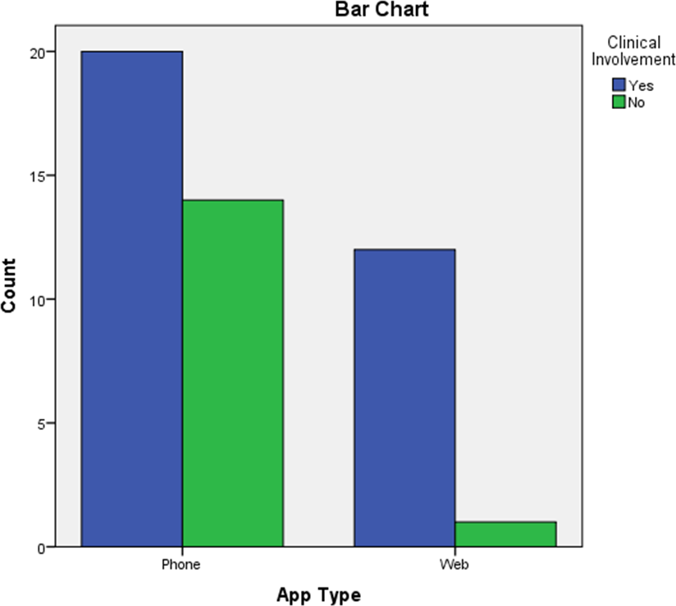

Academic Involvement
There was a statistically significant association between app type and academic involvement,
χ²(1) = 7.277, p = .007. There was a moderately strong negative association between app type and academic involvement, φ = -.393, p = .007. The result suggests that web apps may have more academic involvement than phone apps (see Figure 3.2).
Figure 3.2 Clustered bar chart of academic involvement by app type
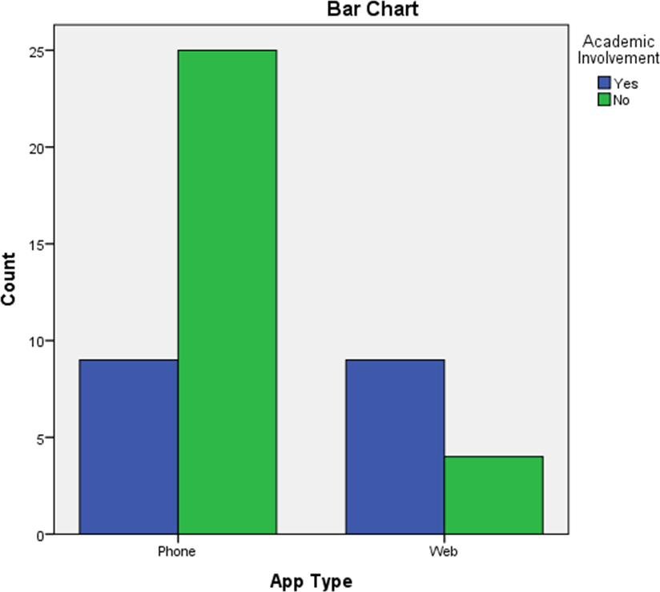

Publications Published or Forthcoming
There was a statistically significant association between app type and whether there were any scientific articles published or forthcoming, χ²(1) = 16.492, p < .000. There was a strong negative association between app type and articles published or forthcoming, φ = -.592, p < .000. The result suggests that web apps may have more papers published or forthcoming than phone apps (see Figure 3.3).

Figure 3.3 Clustered bar chart of research evidence by app type
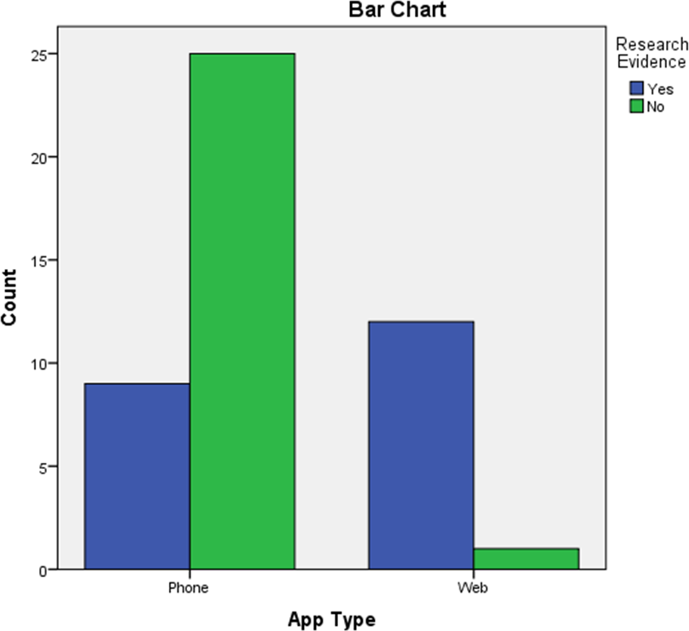

Other Evidence
There was a statistically significant association between app type and other evidence,
χ²(1) = 8.684, p = .003. There was a strong negative association between app type and other evidence, φ = -.430, p = .003. The result suggests that web apps may have more other evidence than mobile apps (see Figure 3.4).

Figure 3.4 Clustered bar chart of other evidence by app type
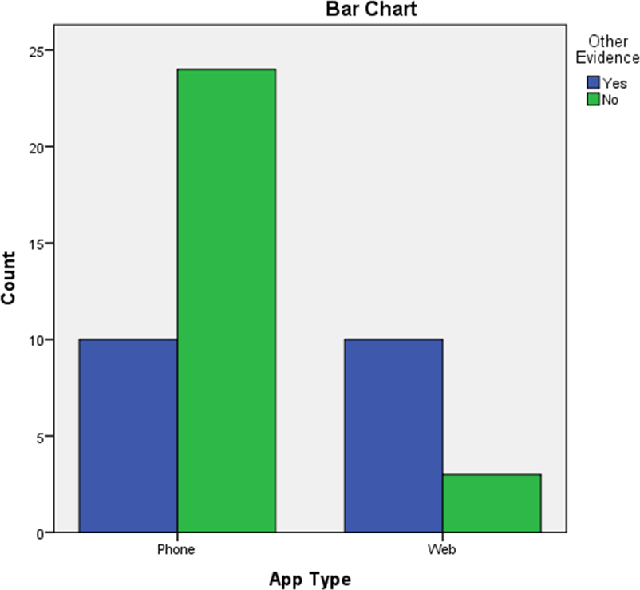

Psychological Approach or Theory
There was a non-significant association between app type and psychological approach or theory, χ² (1) = .696, p = .404. The result suggests that no difference in the use of psychological approaches or theories between web and phone apps (see Figure 3.4).
The psychological approaches of the 25 apps that declared using them are illustrated in Figure 3.5 below.

Figure 3.5 Pie chart of psychological approaches and theories used by web and smartphone apps

Discussion
The present chapter attempted to document development information surrounding each of the web and smartphone apps used and recommended by the NHS for stress, anxiety and depression identified in Study I. Our data source was a survey sent to developers requesting information about clinical involvement, academic involvement, publications published or forthcoming, other evidence of effectiveness and whether the app was based on a psychological approach or theory. The purpose of doing this was to attempt to gauge the quality of the existing apps as providers of therapy without performing user trials on every one. The approach adopted has enabled a deeper probing of the processes that are employed in each app’s development.
The data presented indicates a significant disparity between web and phone-based applications. Web applications are indicated as being significantly higher in all areas of quality except for psychological approach. This gap in quality measures may stem historically from how the two technologies have evolved. Web applications for mental health such as Beating the Blues (J. Proudfoot et al., 2003) originated in academia in the 2000s before being brought to market. Mobile apps began to appear in 2008 when app stores began to open (Cuadrado and Dueñas, 2012). However, the process of developing mobile apps for mental health took a drastically different route to market that had more in common with the early 1980s personal microcomputer boom (Lean, 2013) whereby anyone with access to a personal microcomputer and a programming book could publish their own software. Poor regulation of mental health app quality and privacy (Chandrashekar, 2018) has meant mobile apps have taken a similar path with home coders being able to create and publish mental health apps with minimal questioning of their quality.
The varying quality between the two app types is supportive of the issues and solutions discussed in the introduction to this chapter. However, even with the slow introduction of regulation, there still seems to be a limited amount of action to regulate mental health apps coming from the app stores themselves. A lingering responsibility is being placed on app developers to get regulated, for users to check apps are regulated and for governments and health organisations such as the NHS to flag up apps that are regulated. A number of studies have examined the potential dangers and safety issues associated with apps aimed at the public and whether these apps should be assessed or controlled by various regulatory agencies, such as the Medicines and Healthcare Products Regulatory Agency (MHRA) in England (Cummings, Borycki and Roehrer, 2013).
A study by Donker et al., (2013) carried out a systematic review of research evidence supporting the efficacy of mental health apps across all ages. The study revealed a complete lack of published evidence for many of the hundreds of e-therapy smartphone apps that are available. The results of the current survey have revealed a very similar trend to Donker’s findings, with only 27% of smartphone apps surveyed having any evidence of effectiveness published or forthcoming. The survey results indicate web apps fared much better with 92% of app designers saying that their app had evidence of effectiveness. However, overall 44.7% of apps had published or forthcoming evidence of effectiveness. The lack of a consistent evidence base makes the process of finding an effective NHS e-therapy haphazard. During 2018 the NHS plans to roll out a digital apps library designed to showcase a selected number of apps that have been through assessment and are safe to use (Bauer & Murphy, 2017).
It is vital that the NHS ensure this library contains apps that are supported by evidence, so service users are presented with effective apps. At the time of writing (February 2018), NICE guidance for mental health practitioners is that cCBT can be offered for persistent subthreshold, or mild to moderate depression. A strong emphasis is placed on the use of CBT within mental health services. The results of the survey indicated that at that time 60% of apps used a known psychological approach or theory. On further analysis, 71% of the 60% used CBT, meaning 14% of those that declared using a psychological approach/theory were using an approach that was not NICE-approved, and 40% had no theory behind them at all.
Importantly, we have seen from this study that different criteria can be applied to evaluating apps. Regarding research evidence, developers have different interpretations of this. Some felt that findings from third-party studies of the conventional, face-to-face delivery of the therapeutic theory used within the app would translate into an indication of the app’s effectiveness, while others considered internal studies, evaluations and testing of elements such as the User Interface (UI) to be a sufficient indication of app effectiveness. There are other areas that during the time of development were overlooked. Questions querying service user and computer scientist involvement could have provided further indicators of quality and opened further avenues of investigation. Assessment criteria’s that were released after this study was carried out, such as NHS Digital’s assessment questionnaire V2.1 (NHS Digital, 2018), have investigated service user involvement by asking questions around the use of user centred design (UCD).

Conclusions
As an increasing number of developers are looking to produce e-therapies for the NHS it is essential they apply clinical and academic best practices to ensure the creation of safe and effective apps. The present chapter has provided a snapshot of the commercial e-therapy development landscape and the areas that need the most refinement to improve their suitability for NHS mental health services. These are as follows:
- the building of better working relationships with clinicians to ensure e-therapy content is both beneficial and credible;
- creation of commercial app development projects with academics to enable increased innovation and to feed lessons learnt back to the research knowledge base;
- generation of published evidence through studies in areas such as piloting, feasibility, acceptability, effectiveness and efficacy to help enable easy distinction of the effectiveness of an e-therapy;
- collection, analysis and publication other evidence to back up claims of effectiveness;
- ensuring that a psychological approach or theory that is known to be empirically sound is applied within an app to help build credibility.
It should be noted that while the alternative methods of evaluation discussed in this chapter are relevant and timely, RCTs remain the pinnacle of quality evidence of effectiveness. The best way to synthesise such evidence is through meta-analysis. As such, the next chapter will extend the current investigation beyond this initial developer survey, to synthesise the published evidence available for all e-therapies used and recommended by the NHS in England, thus establishing NHS delivered e-therapy effectiveness. Furthermore, by treating age as a moderator, we will see the extent to which NHS delivered e-therapy is effective for older adults.

NHS Service Provision Panorama Part 3 (Meta-Analysis of NHS e-therapies)

Introduction
Mental health problems are one of the main causes of overall disease burden worldwide (Vos, 2013). It is estimated that 1 in 6 people currently in the United Kingdom (UK) are experiencing the symptoms of a common mental health problem such as anxiety or depression (McManus et al., 2016). Depression and anxiety have been found in the UK to be highest among those aged between 50- 59 and those aged 80 years or older (Beaumont and Lofts, 2013). Due to attitudes towards the existence and treatment of mental health problems shifting in a positive direction, people are far more likely to seek a psychological solution to their problems (Schumm et al., 2015). Indeed, there is meta-analytic evidence that people consistently prefer psychological interventions to medication (McHugh et al., 2013). Therefore, if point prevalence rates continue to remain stable, the older adult population continues to grow and attitudes to psychological treatment have shifted, this will result in increased demand for psychological treatment for mental health issues (Laidlaw and Pachana, 2009).
Due to this increased demand, mental health services have tried to ensure safety, satisfaction and rapid access to evidence-based interventions through changing their organisational processes, personnel and styles of intervention (Firth, Barkham and Kellett, 2015). This has resulted often in the application of stepped-care service delivery models in which accessible, brief, effective and low intensity (LI) interventions are offered as the first line of intervention (Bower and Gilbody, 2005). LI interventions offer efficiency savings to clinical services due to being brief (i.e. a low number of short sessions), low-cost (i.e. either pure self-help or self-help facilitated by non-professionals), flexible (i.e. a variety of delivery methods including the internet and telephone) and accessible (i.e. low wait times). There is now evidence from over 50 controlled trials showing that LI interventions are efficacious in relieving the acute-phase symptoms of depression and anxiety disorders and in preventing (or at least postponing) onset (Delgadillo, 2018). The interventions delivered across all these LI trials have been ubiquitously grounded in cognitive behavioural theory, as that is seen the most readily adaptable model for LI adaptation due to its ‘here and now’ focus (Turpin, 2010).
Valid criticisms of the LI treatment evidence base include the over employment of certain types of control groups (e.g. waitlist), high dropout, inadequate concealment of random allocation and recruitment of participants from the wider community via social media (Delgadillo, 2018). These factors combined appear likely to inflate effect estimates for LI interventions. Thus, when trials of LI interventions have been based in clinical samples, they have tended to yield more modest effects (Coull and Morris, 2011). Furthermore, both poor patient acceptability of internet delivered LI treatment and then then poor subsequent adherence to treatment are both recognised as obstacles to delivery (Karyotaki et al., 2017). Telephone support and guidance has been added in to LI interventions to increase acceptability and adherence, as meta analytic evidence highlights that guided self-help (i.e. telephone or in person supported LI treatment) outperforms pure self-help in the treatment of depression (Gellatly et al., 2007). Titov et al. (2015) in an older adult sample illustrated that guided self-help was efficacious compared to a passive control in an adult sample and that the LI intervention was rated as acceptable. However, the type and intensity of support required to attain clinical improvement does vary across diagnoses (Farrand and Woodford, 2013). Patients with specific combinations of symptoms and/or context factors (e.g. severe depression, in the context of personality disorder traits and high socioeconomic deprivation) have a high probability of drop-out and poor outcomes from an LI intervention, whereas such patients tend to respond favourably to more intensive psychological therapy (Delgadillo et al., 2017).
In terms of pure self-help, e-therapies (as part of the suite of LI interventions) have been championed as potentially making a key contribution in managing the throughput-quality challenge faced by clinical services. Tablets and smartphones are among the most rapidly adopted technological innovations by the public in recent history; adult smartphone ownership in the United Kingdom (UK) is presently at 80% and expected to reach 90% by 2020 (Deloitte, 2017). Those aged 65-74 living in the UK are increasingly connected, with four in ten (39%) using a smartphone and 47% using tablets (Ofcom, 2016). This breadth of ownership has been critiqued however in terms of excluding the poorest in society (Armstrong, 2018). Tablets and smartphones enable users to download and run apps from online app libraries. When the content is guided by clinical theory and techniques, they are transformed into clinical tools possessing the potential to provide cost effective, high volume and easy to access LI psychological interventions.
The therapeutic and organisational potential of e-therapies triggered an initial wave of interest and investment into digital health initiatives. The NHS Commissioning Board launched the NHS Health Apps Library in March 2013 and NHS Mental Health Apps Library in March 2015 (from here on referred to as the NHS Apps Libraries) signalling clear intent to realise the health and health economic potential of apps. However, the libraries were removed in 2015 after the publication of two papers questioning the validity of the evaluations of the apps. Specifically, the robust governance of data security (Huckvale et al., 2015) and clinical effectiveness (Leigh and Flatt, 2015) were questioned and criticised. This process specifically highlighted that the NHS had struggled to effectively separate the evidence base for the effectiveness of apps from the overly ambitious claims of their developers (Delgadillo, 2018). As a result, NICE and NHS England subsequently established independent initiatives. In November 2016, NICE revealed its plan to pilot an evaluation process for digital apps, and stated that from March 2017 it would publish “Health App Briefings” on mobile technology health apps as a proof-of-concept activity (NICE, 2016). These briefings set out the evidence for an app, but do not provide a recommendation on their use, leaving judgement to remain subject to the clinician. NHS England launched two new digital platforms in April 2017: a new beta of the NHS Digital Apps Library and a Mobile Health space. These platforms specify the quality standards expected for from all digital health and care products covering clinical effectiveness, regulatory approval, clinical safety, privacy/confidentiality, security, usability/accessibility, interoperability, technical stability and change management (Bauer and Murphy, 2017). Finally in October 2017, Public Health England (PHE) released guidance for app developers, assessors and commissioners (Public Health England, 2017). Just prior to the removal of the NHS App Libraries, Bennion et al. (2017) systematically surveyed app content, and together with strategic deployment of Freedom of Information requests, compiled a list of NHS used and recommended e-therapies (presented in Chapter two). This evidence was subsequently used by both NHS England and NICE in the development of NICE’s process for assessing digitally-enabled psychological therapies for use in Improving Access to Psychological Therapies (IAPT) services (see Appendix B1).
Clearly, there is tension (and often a pronounced time lag) between the speed at which an e-therapy can be developed and disseminated and the evidence base regarding its safety, feasibility, acceptability, effectiveness and efficacy. There are Medical Research Council guidelines (Craig et al., 2008) for the development and evaluation of complex health interventions (i.e. such as apps), but these appear to have been largely ignored by most app developers, possibly through ignorance rather than intent. Therefore, unlike other mental health treatments delivered in the NHS, some e-therapies seem to have leapfrogged the process of rigorous evaluation specified in the ‘hourglass’ model (Salkovskis, 1995). In the hourglass model, new therapies are first examined in studies with high external validity (stage 1), before progressing onto randomised and controlled research trials with high internal validity (stage 2) prior to dissemination (i.e. evidence-based practice) and service-wide audit and evaluation at stage 3. Randomised controlled trials (RCTs) are viewed as ‘gold standard’ in terms of therapeutic evaluation because of their high levels of internal validity (Bothwell et al., 2016). This study therefore chose to focus solely on RCTs of mental health apps in common use or recommended by the NHS. The central purpose of this review is to therefore summarise the evidence base for the efficacy of e-therapy with adults and older adults in order to better inform the commissioning and use of e-therapies in clinical services. No previous meta analyses of the effectiveness of NHS recommended e-therapies for anxiety and depression has been attempted and studies with older adult samples have been included to ensure breadth of application. LI interventions typically treat common mental health problems (i.e. anxiety disorders and depression; Turpin, 2010) and therefore this review is focal to the evaluation of clinical outcomes for apps for the management of anxiety and depression. Thus, the primary aim of this study was to quantify and synthesise the clinical trial evidence base for NHS recommended e-therapies, via calculating effect sizes and associated numbers need to treat. Given the acknowledged issues concerning the non-adoption and drop-out of providing e-therapies (Waller and Gilbody, 2009; Postel et al., 2010; Richardson, Stallard and Velleman, 2010), a secondary aim of the current review was to summarise dropout rates from e-therapies. Finally, this research sought to investigate the impact of potential moderating factors (such as e-therapy duration) via subgroup and meta-regression analyses.

Methods
The systematic review and meta-analysis followed the PRISMA statement (Moher et al., 2009) for transparent and comprehensive reporting of methodology and results. The systematic review was focal to the clinical trial evidence base of e-therapies offered by the NHS and is there considered a ‘targeted literature review’ due to being based on a clearly formulated question and then using explicit methods to identify, select, critically appraise, qualitatively analyse and interpret key relevant research.

Search Strategy
Each of the 51 NHS e-therapies identified by Bennion et al. (2017) were used as part of a search term comprised of the e-therapy name and its type (Website/App) for example “Beating the Blues” AND “Website” (see Appendix B2). Electronic searches by the primary reviewer were conducted on the following databases: PsycINFO, Web of Science, PubMed on the 25th of November 2016. The articles collected from these searches were combined with those collected via the app developer survey carried out in Chapter three by the primary reviewer to ensure grey literature disclosed by developers was included. Any queries concerning study eligibility were resolved through meetings with research supervisors.

Eligibility Criteria
Only English-language articles were included. Studies were included if and only if they were a randomized controlled trial (RCT) examining the efficacy of an e-therapy to adults with depression, anxiety or stress, and published in a peer reviewed journal. Comparator conditions that were eligible for inclusion included waitlists/TAU and other active therapies. Classifications of passive controls were based upon Higgins (2011) in which 'standard care (TAU) and waiting list controls' are defined as inactive. No restrictions were placed on diagnosis or any validated clinical outcome measure. RCTs of interventions delivered solely or in part via an NHS e-therapy matched this definition. Unpublished studies were excluded. The grey literature from the previous chapter was not included in the review as it did not add provide any additional findings.

Outcome Measures
The primary outcome measured were patient-reported outcomes (PROs) of depression/anxiety/stress taken at post-treatment and follow-up where available. Under circumstances where multiple measures were used the most widely used and well validated were prioritised. Drop-out rates from e-therapies were the secondary outcome measure.

Data Extraction
A priority data extraction tool was designed for the purposes of the study. Data was extracted according to the following criteria: a) study information (sample size, mean age of participants, diagnostic information or relevant inclusion criteria, study length and trial quality); b) intervention features (regularity of instructed use, e-therapy program summary, any additional intervention component details of the control condition); c) outcomes for depression, anxiety and stress symptoms (changes in total depression, anxiety and stress symptoms between baseline, termination of treatment and follow-up) with control comparisons; d) primary outcome measure (i.e. for studies which used more than one measure of depression/anxiety/stress, the most well validated and widely implemented measure in other e-therapy trials were selected). Studies were coded for both trial and practice factors including type of passive control (waitlist, treatment-as-usual; TAU) and active control (active treatment). Follow-up data were extracted to assess the durability of any therapeutic impact. E-therapies were also coded based on Newman et al. (2011) self-help typology: minimal-contact therapy, predominantly self-help, predominantly therapist administered treatment or self-administered therapy. The percentage of treatment responders was calculated using an intention-to-treat analysis. Drop-out rate was defined as the percentage of participants that did not finish the intervention, control or other therapy conditions. Non-completers were identified based on definition within each study.

Within-Study Quality and Risk of Bias
Bias was assessed in two separate ways. Firstly, the Cochrane risk of bias tool (Higgins et al., 2011) was used to assess study quality (see Table 4.1 and Figure 4.1), and from that, determine risk of within-study bias. Secondly, funnel plots were used to assess risk of publication bias (described below), with associated statistical analysis (e.g. Egger’s regression test and Begg’s rank correlation method).

Study Quality Assessment
Quality scores for each paper were calculated by the author (rater 1). Nine papers were then randomly allocated to two additional raters (rater 2; PhD student and rater 3; research supervisor). Cohen's kappa coefficient (κ) was used to measure the inter-rater agreement on risk of bias overall scores between rater 1 and rater 2 and rater 1 and rater 3. Kappa results were interpreted using the Landis and Koch (1977) categories; kappa values < 0 as indicating no agreement, 0–0.20 as slight, 0.21–0.40 as fair, 0.41–0.60 as moderate, 0.61–0.80 as substantial and 0.81–1 as almost perfect agreement. There was moderate agreement between rate 1 and rater 2, κ = .501, p < .001 and fair agreement between rater 1 and rater 3, κ = .388, p < .001.

Table 4.1 Cochrane risk of bias assessment of included studies
Study | 1 | 2 | 3 | 4 | 5 | 6 | 7
Donker et al. (2013)
Farrer, Christensen, Griffiths, & Mackinnon (2011)
Gilbody et al. (2015)
Grime (2004)
Howells, Ivtzan and Eiroa-Orosa (2014)
Høifødt et al. (2013)
Kessler et al. (2009)
Lintvedt et al. (2013)
Mackinnon, Griffiths, & Christensen (2008)
Marks, Kenwright, McDonough, Whittaker, & Mataix-Cols (2004)
Powell et al. (2013)
Proudfoot et al. (2003)
Proudfoot et al. (2004)
Richards et al. (2015)
Schneider, Mataix-Cols, Marks, & Bachofen (2005)
Sethi (2013)
Twomey et al. (2014)
Note: 1 – Random sequence generation (selection bias), 2 – Allocation concealment (selection bias), 3 – Blinding of participants and personnel (performance bias), 4 – Blinding of outcome assessment (performance bias), 5 – Incomplete outcome data (attrition bias), 6 – selective outcome reporting, 7 – other potential threats to validity

Figure 4.1 Risk of bias graph
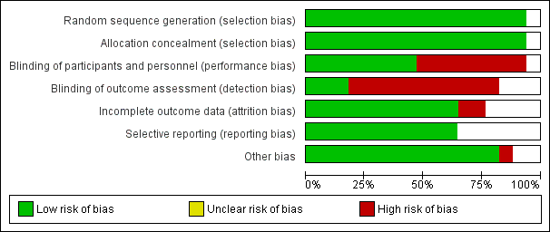

Between-Group Effect Sizes
The effect sizes are the calculated standardised difference found between e-therapy and active or passive controls (Borenstein et al., 2009). In order to calculate the between group end of treatment effect sizes, the e-therapy group end of treatment score was deducted from the control group end of treatment score (active or passive) and then divided by the pooled SD (Borenstein et al., 2009). Only completer’s data was used as intention-to-treat (ITT) outcome data was not available for all of the studies. Due to many of the trials having small sample sizes the effect sizes were revised using an adjustment, J, to convert effect sizes to Hedge’s g (Hedges, 1984). When studies had multiple treatment arms involving the same e-therapy with different component combinations (e.g. reminders and telephone support) the data was collapsed into a single group where treatment was comparable. For studies that were comprised of multiple comparison groups that did not receive e-therapy. Data was extracted from the most active comparison condition enabling a modest estimate of the population effect size, studies with passive controls are frequently found to have larger effect sizes than active controls (Cuijpers, van Straten, et al., 2010). The mean effect sizes were obtained and reversed and a positive effect of e-therapy was represented by a positive effect size and vice-versa.

Meta-Analysis
A random-effects meta-analysis was conducted using the Meta-Essentials Workbook (Suurmond, van Rhee and Hak, 2017). This was carried out to enable a more realistic estimate of the pooled mean effect sizes and as a result provide increased generalisability of the overall findings as between study heterogeneity was anticipated. The threshold for statistical significance was an alpha value of 0.05. Effect sizes were classified as follows: 0.20-0.49 = small, 0.50-0.79 = medium, and 0.80 and higher = large (Cohen, 1988, 1992). Subgroup meta-analyses were pre-planned based on anticipated heterogeneity between active and passive control groups. The pooled effect sizes were translated into numbers needed to treat (NNT; Kraemer and Kupfer, 2006). The NNT is an approximation of how many patients would need treatment in order to generate an additional outcome of benefit when in comparison with another condition. Pre-planned moderator analyses were performed to evaluate between-study heterogeneity. Meta-regression was completed at both end of treatment and follow-up for comparisons against both active and passive control groups using the continuous variables (mean participant age, number of sessions, duration in days, publication date) and gender. Sub group analysis was carried out at both end of treatment and follow-up for both comparisons against both active and passive control groups using categorical variables (recruitment setting, e-therapy and support typology). A Kruskall-Wallis test assessed whether there were any differences between dropout rates for e-therapy versus passive and active controls.

Analysis of Heterogeneity
Due to there being a small number of trials (k < 10) in the end of treatment, follow-up and subgroup analyses, a lower more conservative p value of 0.1 was adopted (Higgins, 2011). The I² statistic was used as an indicator of between study heterogeneity where 0%-40% may not be relevant, 30%-60% represents moderate heterogeneity, 50%-90% represents substantial heterogeneity, and 75%-100% represents considerable heterogeneity (Higgins et al., 2003). The magnitude and direction of the effect size was used to interpret the I² values (Higgins, 2011).

Publication Bias
In cases where there were sufficient numbers of studies (k > 10), visual inspection of the asymmetry of a funnel plot showing SEs against effect sizes was carried out to assessed publication bias. Egger’s regression and Begg’s rank correlation tests were used to statistically test for reporting bias.

Results

Study Selection
The search returned a total of 622 records. This was combined with the 152 records collected by surveying the app developers (as presented in Chapter 3), to ensure that any papers known to the developers that were not picked up by searches were included, giving a combined total of 774 records. After duplicates were excluded this left a total of 602. After excluding records that did not meet the inclusion criteria based on abstracts, 123 full version articles were retrieved. Nineteen trials were considered for review; two were excluded due to containing duplicate data from the same trial. Thus, a total of N=17 unique RCTs which had tested the efficacy of six different NHS recommended e-therapies were included in the meta-analysis. The PRISMA diagram is provided in Figure 4.2, and details of the included studies can be found in Table 4.2 Characteristics of included studies.

Figure 4.2 PRISMA flow chart of study section
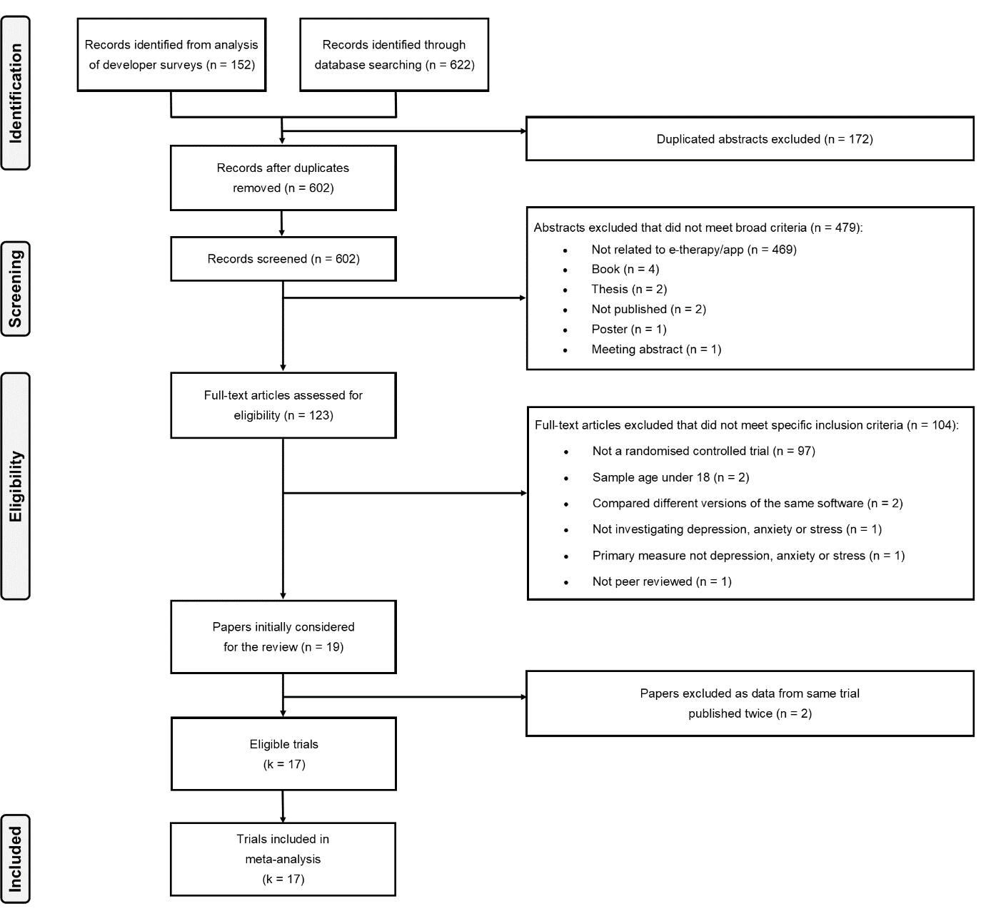
Table 4.2 Characteristics of included studies
 | Author  (Year) | Context, sample and presenting problem | N | Mean age (SD) | Gender  (% of Males) | Research independence,  trial design and analytic approach | e-therapy format  and duration | Control condition(s) | Outcome measure | Attrition % (n) | Follow-up  duration
Beating the Blues | Gilbody et al. (2015) | Primary Care  Clinical Sample  Depression | 691 | 39.87 (12.65) | 33.14%  (229) | No COI.  Pragmatic, multicentre, 3 arm, parallel.  ITT | Self-administered therapy.  8 x 50 min Sessions.  1 x 15 min intro video.  Weekly | 1. TAU  2. MoodGYM | PHQ-9 | e-therapy - 21% (45)  1. 25% (60)  2. 25% (60) | 6 months
 | Proudfoot et al. (2004) | Primary Care  Clinical Sample  Anxiety/Depression | 274 | 43.51 (13.909) | 26.28%  (72) | No COI.  Efficacy, 2 arm, parallel.  ITT | Predominantly self-help.  8 x 50 min Sessions.  1 x 15 min intro video.  Weekly | 1. TAU | BDI | e-therapy - 37% (54)  1. 34% (43) | 6 months
 | Grime (2004) | Public sector employees  Clinical sample Stress/Anxiety/Depression | 48 | 39  (9.74) | 41.66%  (20) | No COI.  Open, 2 arm, parallel.  ITT | Predominantly self-help.  8 Sessions.  Weekly. | 1. TAU | HADS-D | e-therapy - 21% (5)  1. 0% (0) | 6 months
 | Proudfoot et al. (2003) | Primary Care  Clinical Sample  Anxiety/Depression | 167 | 44.63 (14.41) | 26.35%  (44) | No COI.  Phase I, parallel  ITT | Predominantly self-help.  8 x 50 min Sessions.  1 x 15 min intro video. | 1. TAU | BDI | e-therapy - 46% (41)  1. 45% (35) | 6 months
FearFighter | Schneider, Mataix-Cols, Marks, & Bachofen (2005) | Psychiatric out-patients Clinical sample  Panic/phobia | 68 | 39  (11) | 26.47%  (16) | No COI.  ITT | Minimal-contact therapy.  9 Sessions.  10 weeks. | 1. Managing Anxiety | FQ | e-therapy - 28% (12)  1. 38% (8) | 1 month
 | Marks, Kenwright, McDonough, Whittaker, & Mataix-Cols (2004) | Psychiatric out-patients  Clinical sample  Panic/phobia | 90 (93) | 38.13 (12.42) | 59%  (28) | No COI.  ITT | Minimal-contact therapy,  9 Sessions.  10 weeks. | 1. TAU  2. de-STRESS | FQ | e-therapy - 49% (16)  1. 31% (12)  2. 18% (3) | 1 month
Headspace | Howells, Ivtzan, & Eiroa-Orosa (2016) | Internet  Community sample  No criteria | 194 | 40.3 (10.54) | 11.86%  (23) | No COI declaration.  2 arm, parallel.  ITT | Self-administered therapy.  10 x 10 min Sessions.  10 days. | 1. Catch notes (neutral task) | CES-D | e-therapy - 41% (40)  1. 34% (33) | None
IESO | Kessler et al. (2009) | Primary Care  Clinical sample  Depression | 297 | 34.95 (11.60) | 31.99%  (95) | No COI.  Multicentre, parallel, 2 arm.  ITT | Predominantly therapist administered treatment.  10 x 55 min Sessions.  16 weeks. | 1. Waiting list | BDI | e-therapy - 24% (36)  1. 34% (51) | 4 months
MoodGYM | Twomey et al. (2014) | Primary Care  Clinical Sample  Depression/anxiety/stress. | 66 (201) | 33.75 (10.01) | 22.73%  (15) | No COI declaration.  Parallel, 2 arm.  Completers | Self-administered therapy.  6 x 20-40 min Sessions.  1 x brief introduction. | 1. Waiting list | DASS-21 | e-therapy - 83% (84)  1. 69% (69) | 3 months
 | Powell et al. (2013) | Internet.  Community sample.  No criteria. | 3070 | 41.14 (13.01) | 22.12%  (679) | No COI.  Parallel, 2 arm.  ITT | Self-administered therapy.  5 Sessions.  5 weeks. | 1. Waiting list | WEMWBS | e-therapy - 74% (1128)  1. 27% (413) | 3 months
 | Lintvedt et al. (2013) | University, Adults, Community sample, Psychological Distress. | 163 | 28.15 (7.36) | 23.31%  (38) | No COI.  ITT / Completer / Compiler | Self-administered therapy.  5 Sessions.  5 weeks. | 1. Waiting list | CES-D | e-therapy - 48% (39)  1. 28% (23) | 2 months
 | Donker et al. (2013) | Internet, Adults, Community sample, Depression. | 1929 | ND | 27.62%  (509) | No COI.  Parallel, 3 arm, noninferiority.  ITT / Completer. | Self-administered therapy,  4 x 20-40 min Sessions.  4 weeks. | 1. e-couch IPT  2. e-couch CBT | CES-D | e-therapy - 80% (514)  1. 82% (528)  2. 86% (551) | 6 months
 | Høifødt et al. (2013) | Primary Care, Adults, Clinical sample,  Mild/Moderate Depression | 106 | 37.18 (11.09) | 27.36% (29) | No COI.  Delayed, 2 arm.  ITT / Completer. | Minimal-contact therapy,  1 x brief intro.  5 x 45-60 min Sessions.  7 weeks. | 1. Waiting list | BDI | e-therapy - 22% (12)  1. 37% (20) | 6 months
 | Sethi (2013) | Youth Centres  Community sample  Depression/Anxiety | 89 | 20.19 (1.39) | 41.57%  (29) | No COI declaration.  3 arm.  Completers (no drop outs) | Predominantly self-help,  3 x 1 hr Sessions.  2 x 1 hr Sessions + 30 mins for measures.  5 weeks. | 1. No treatment  2. face-to-face CBT | DASS-21 | e-therapy - 0% (0)  1. 0% (0) | None
 | Farrer, Christensen, Griffiths, & Mackinnon (2011) | Telephone counselling service  Clinical sample  A mental disorder. | 155 | 41.53 (12.36) | 18.06%  (28) | No COI.  4 arm, parallel, factorial  ITT | Predominantly self-help.  5 Sessions.  6 weeks. | 1. Tracking + TAU | CES-D | e-therapy - 48% (40)  1. 32% (23) | 6 months
 | Mackinnon, Griffiths, & Christensen (2008) | Canberra electoral roll  Community sample  Depression. | 525 | 36.8  (9.3) | 27.54%  (114) | No COI.  3 arm  MMRM | Predominantly self-help.  5 Sessions.  6 weeks. | 1. Blue Pages  2. Attention placebo | CES-D | e-therapy - 42% (76)  1. 30% (50)  2. 26% (47) | 6 months
SilverCloud Health | Richards et al. (2015) | Users of the Aware charity  Community sample  Mild/Moderate depression. | 188  (262) | 39.86 (10.94) | 27.13%  (51) | No COI.  ITT | Minimal-contact therapy,  8 modules.  No time limit. | 1. Waiting list | BDI | e-therapy - 55% (73)  1. 29% (37) | 6 months

s

Characteristics of Included Studies
Out of the 51 NHS e-therapies identified in Bennion et al. (2017, presented in Chapter 2) a total of 6 were found to have studies of their efficacy that fitted the inclusion criterion for the meta-analysis and comprised of 5 e-therapies and 1 phone-based e-therapy. The survey taken by developers of these e-therapies in Chapter 3 found that the 5 web-based e-therapies had both clinical and academic involvement in their development. The single phone-based e-therapy had neither clinical nor academic involvement in its development.
Table 4.3 E-therapies with studies
App | Web or phone-based delivery (W/P) | Clinical involvement in development and testing | Academic involvement in development and testing | Psychological theory used and associated clinical approach
Beating the Blues | Web-based | Y | Y | CBT
Fear Fighter | Web-based | Y | Y | CBT
Headspace | Phone-based | N | N | Mindfulness
Ieso Digital Health Ltd | Web-based | Y | Y | CBT
MoodGym | Web-based | Y | Y | CBT
SilverCloud Health | Web-based | Y | Y | CBT

Trials were either conducted in clinical (n = 10) or community settings (n = 7). All but one e-therapy had a basis in cognitive-behavioural theory. None of the studies declared a conflict of interest. The control conditions employed in the studies were TAU (n = 5), tracking plus TAU (n = 1), waiting list (n = 6), e-couch IPT (n = 1), e-couch CBT (n = 1), no treatment (n = 1), face-to-face treatment (n = 1), MoodGYM (n = 1), managing anxiety (n = 1), de-stress (n = 1), catch notes software (n = 1), blue pages (n = 1) and an attention placebo (n = 1). Trial analyses were mainly intention to treat (ITT; n = 11), ITT and completers (n = 2); ITT, completers and compiler (n = 1) and mixed effect model repeat measurement (MMRM; n = 1). The active control conditions employed in the studies were Managing Anxiety (n = 1), MoodGYM (n = 1), de-STRESS (n = 1), e-couch CBT (n = 1), e-couch IPT (n = 1), face-to-face CBT (n = 1), and Blue Pages (n = 1). Two of the trials did not require participants to have any symptoms of mental ill health. In terms of measuring depression outcomes, the Beck Depression Inventory-II (Beck, Steer & Brown, 1996), Center for Epidemiological Studies Depression scale (Radloff, 1977) and the Hospital Anxiety and Depression Scale were used in five studies each. Mean ages across the samples ranged from 20-44 years. Just one study of Beating the Blues included older adult participants. E-therapy treatment lasted between 10 -70 days, with sessions lasting 10-55 minutes.

Dropout Analysis
Dropout rates for e-therapies ranged from 21-83%, with a mean dropout rate of 37.15%. There was no significant difference between e-therapy (42.29%), control (30.07%) and active control (39.86%) in terms of dropout rates (χ²(2) = 2.013, p = .366).

Meta-Analyses
Between-group random effects meta-analyses were conducted for end of treatment and 6-month follow up outcomes for e-therapy compared to controls.

Passive Controls - End of Treatment
For all 15 trials (completer n = 2,944), the end of treatment population effect size for e-therapy compared with passive control was small 0.34 (95% CI: 0.05-0.64), but significant (z = 2.51, p = 0.012). Figure 4.3 shows the forest plot for this analysis. The NNT for e-therapy was 5.263; approximately one in every 5 patients experienced benefit from e-therapy when compared to passive controls at end of treatment. Significant and high levels of heterogeneity were apparent between the studies (Q₍₁₅₎ = 207.51, p < 0.001, I² = 93%).
Meta-regression analysis results for e-therapy versus passive are displayed in Table 4.4. Gender, number of sessions, treatment duration and publication date were all non-significant. The regression illustrates that younger participants experienced larger effect sizes when engaged in e-therapies.
Figure 4.3 Forest plot of e therapy compared with passive control at end of the treatment
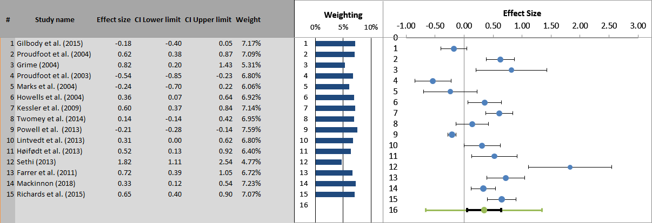

Active Controls - End of Treatment
The effect size for e-therapy compared with active treatment (k = 7, N = 1,172) was small 0.02 (95% CI: -0.45–0.48) and non-significant (z = 0.08, p = 0.932). Thus, e-therapy was found to be superior to passive controls at the end of treatment but was matched in terms of effectiveness when compared to other active treatments at this time point. Figure 4.4 shows the forest plot for this analysis. The NNT for e-therapy was 88.623; approximately one out of every 89 patients experienced additional benefit from e-therapy, when compared to another active treatment at end of treatment. Significant heterogeneity was apparent between studies (Q₍₇₎ = 33.58, p < 0.001, I² = 82%).
Meta-Regression analysis results for e-therapy versus active are displayed in Table 4.4. Gender and number of sessions were non-significant. Again, younger participants had a larger effect size. Treatment duration, age and publication date were all significant.
Figure 4.4 Forest plot of e-therapy compared with active control at end of the treatment
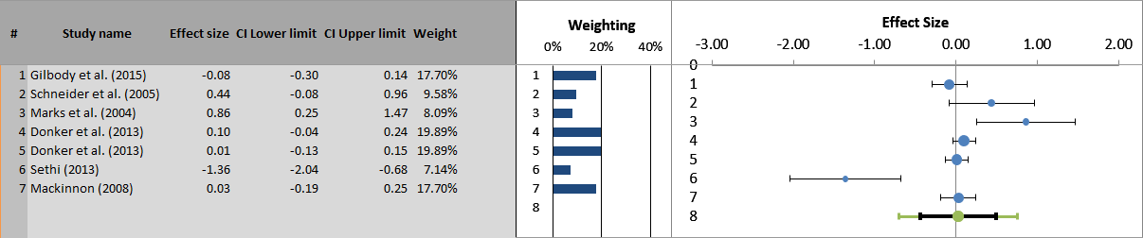

Passive Controls - Follow-Up
The effect size for e-therapy (d=0.30) compared with passive controls at 6-month follow-up (k = 9; N = 2,478), was small and significant in favour of e-therapy (95% CI: 0.04-0.57; z = 2.62, p = 0.009). Figure 4.5 shows the forest plot for this analysis. The NNT for e-therapy at follow-up was 5.953; approximately one out of every 6 patients experienced additional benefit from e-therapy when compared to passive controls at follow up. Significant statistical heterogeneity was again evident between the studies (Q₍₉₎ = 116.12, p < 0.001, I² = 93%).
Meta-Regression analysis results for e-therapy versus passive are displayed in Table 4.4. Gender, number of sessions, treatment duration, age and publication date were all significant.
Figure 4.5 Forest plot of e-therapy compared with passive control at follow-up

Active Controls - Follow-Up
The effect size for e-therapy compared with active controls at follow-up (k = 5, N = 1,112) was small 0.12 (95% CI: -0.23–0.47) and non-significant (z = 0.92, p = 0.356). Thus, at follow-up, e-therapy was found to be superior to passive controls, but again no significant difference was found when e-therapy was compared to an active treatment. Figure 4.6 shows the forest plot for this analysis. The NNT for e-therapy was 14.788; approximately one out of every 15 patients experienced additional benefit from e-therapy when compared to other active treatments at follow-up. Significant between study heterogeneity was found (Q₍₅₎ = 14.91, p = 0.005, I² = 73%).
Meta-Regression analysis results for e-therapy versus active are displayed in Table 4.4. Gender, number of sessions, treatment duration and publication date were all significant.
Figure 4.6 Forest plot of e-therapy compared with active control at follow-up
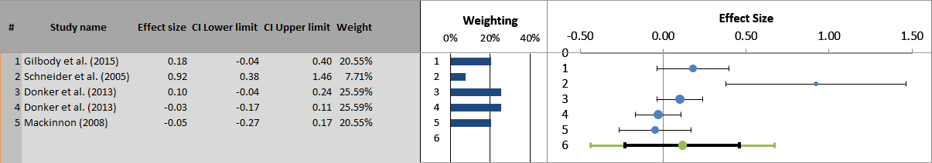

Meta-Regression Analysis
Table 4.4 for contains the results for the meta regression analyses for both end of treatment and at follow-up.
Table 4.4 Meta-regression analysis
Time Point | Control | Variable |  | N | B-coefficient | 95% CI | SE | P
End of Treatment | Passive | Age | (20.08 to 39.87) | 15 | -0.05 | -0.09 to 0.01 | 0.02 | 0.02*
 |  | Gender | (% of males) | 9 | 0.18 | -2.40 to 2.77 | 1.20 | 0.88
 |  | Number of sessions | (2-12 sessions) | 9 | -0.04 | -0.19 to 0.11 | 0.07 | 0.59
 |  | Duration in days | (1.5-16 days) | 7 | 0.02 | -0.06 to 0.11 | 0.04 | 0.57
 |  | Publication date | 2003 – 2015 | 9 | 0.02 | -0.04 to 0.08 | 0.03 | 0.54
 | Active | Age | (20.08 to 39.87) | 5 | 0.08 | 0.01 to 0.16 | 0.03 | 0.00***
 |  | Gender | (% of males) | 7 | 0.73 | -2.29 to 3.75 | 1.24 | 0.55
 |  | Number of sessions | (2-12 sessions) | 7 | 0.10 | -0.05 to 0.24 | 0.06 | 0.10
 |  | Duration in days | (1.5-16 days) | 7 | 0.10 | -0.03 to 0.22 | 0.05 | 0.06
 |  | Publication date | 2008 – 2015 | 7 | -0.07 | -0.14 to 0.00 | 0.03 | 0.02*
Follow-Up | Passive | Age | (20.08 to 39.87) | 9 | -0.03 | -0.06 to 0.00 | 0.01 | 0.03*
 |  | Gender | (% of males) | 9 | 3.24 | 1.61 to 4.88 | 0.71 | 0.00***
 |  | Number of sessions | (2-12 sessions) | 9 | 0.15 | 0.10 to 0.19 | 0.02 | 0.00***
 |  | Duration in days | (1.5-16 days) | 9 | 0.08 | 0.05 to 0.10 | 0.01 | 0.00***
 |  | Publication date | 2004 – 2015 | 9 | -0.07 | -0.09 to -0.05 | 0.01 | 0.00***
 | Active | Age | (20.08 to 39.87) | 3 | 0.14 | -1.03 to 1.31 | 0.27 | 0.61
 |  | Gender | (% of males) | 5 | -0.04 | -0.12 to 0.05 | 0.03 | 0.24
 |  | Number of sessions | (2-12 sessions) | 9 | 0.67 | -0.03 to 0.21 | 0.04 | 0.03*
 |  | Duration in days | (1.5-16 days) | 5 | 0.08 | -0.03 to 0.20 | 0.04 | 0.04*
 |  | Publication date | 2005 – 2015 | 5 | -0.04 | -0.12 to 0.05 | 0.03 | 0.24
Note: *significant at p < .05 threshold; **significant at Bonferroni adjusted p < .01 threshold; ***significant at p < .0001. Abbreviations: N: Number of studies; CI: Confidence Interval; SE: Standard Error; P: Calculated probability.

Sub-group Analysis
Table 4.5 contains the subgroup analyses that were conducted to examine the findings within different recruitment settings, e-therapies, and treatment typologies. The only significant effect was for treatment typology in studies examining end of treatment effects against an active control (Table 4.5). The result indicated that minimal-contact therapy may tend to generate better outcomes than self-administered therapy (0.03) and predominantly self-help (-0.63).
Table 4.5 Subgroup analysis
Time point | Control | Variable | Group | N | SMD (g) | 95% CI | I²(%) | P (between subgroups) | NNT
End of Treatment | Passive | Recruitment setting | Clinical | 9 | 0.27 | -0.05 to 0.58 | 89.48 | 0.50 | 6.605
 |  |  | Community | 6 | 0.47 | -0.03 to 0.97 | 95.28 |  | 3.841
 |  | E-therapy | Beating the Blues | 4 | 0.16 | -0.47 to 0.78 | 93.48 | 0.74 | 11.101
 |  |  | MoodGYM | 7 | 0.45 | 0.01 to 0.89 | 93.98 |  | 4.005
 |  |  | Other | 4 | 0.39 | 0.02 to 0.76 | 77.84 |  | 4.602
 |  | Typology | Predominantly therapist administered treatment (1) | 1 | 0.60 | - | - | - | 3.043
 |  |  | Minimal-contact therapy (2) | 3 | 0.34 | -0.20 to 0.87 | 82.91 |  | 5.263
 |  |  | Predominantly self-help (3) | 6 | 0.57 | -0.02 to 1.17 | 91.93 |  | 3.194
 |  |  | Self-administered therapy (4) | 5 | 0.06 | -0.18 to 0.30 | 85.74 |  | 29.549
 | Active | Recruitment setting | Clinical | 4 | 0.21 | -0.18 to 0.60 | 72.58 | 0.35 | 5.116
 |  |  | Community | 3 | -0.20 | -0.96 to 0.56 | 89.37 |  | 8.471
 |  | E-therapy | Beating the Blues | 1 | -0.08 | - | - | - | 22.167
 |  |  | MoodGYM | 4 | -0.10 | -0.60 to 0.39 | 84.05 |  | 17.739
 |  |  | Other | 2 | 0.62 | 0.21 to 1.04 | 10.66 |  | 2.951
 |  | Typology | Minimal-contact therapy (2) | 2 | 0.62 | 0.21 to 1.04 | 10.66 | 0.01** | 2.951
 |  |  | Predominantly self-help (3) | 2 | -0.63 | -2.00 to 0.74 | 93.74 |  | -2.907
 |  |  | Self-administered therapy (4) | 3 | 0.03 | -0.06 to 0.12 | 3.80 |  | 59.085
Follow-Up | Passive | Recruitment setting | Clinical | 7 | 0.40 | 0.17 to 0.63 | 76.44 | 0.08 | 4.49
 |  |  | Community | 2 | -0.02 | -0.43 to 0.39 | 92.23 |  | 88.623
 |  | E-therapy | Beating the Blues | 4 | 0.32 | 0.09 to 0.55 | 65.87 | - | 5.586
 |  |  | MoodGYM | 4 | 0.22 | -0.25 to 0.69 | 94.24 |  | 8.089
 |  |  | Other | 1 | 0.55 | - | - |  | 3.304
 |  | Typology | Predominantly therapist administered treatment (1) | 1 | 0.55 | - | - | - | 3.304
 |  |  | Minimal-contact therapy (2) | 1 | 0.04 | - | - |  | 44.316
 |  |  | Predominantly self-help (3) | 5 | 0.47 | 0.22 to 0.72 | 70.05 |  | 3.841
 |  |  | Self-administered therapy (4) | 2 | -0.10 | -0.37 to 0.16 | 81.21 |  | 17.739
 | Active | Recruitment setting | Clinical | 3 | 0.27 | -0.26 to 0.80 | 82.53 | 0.39 | 6.605
 |  |  | Community | 2 | 0.04 | -0.09 to 0.16 | 42.01 |  | 44.316
 |  | E-therapy | Beating the Blues | 1 | 0.18 | - | - | - | 9.874
 |  |  | MoodGYM | 3 | 0.02 | -0.07 to 0.11 | 9.95 |  | 88.623
 |  |  | Other | 1 | 0.92 | - | - |  | 2.063
 |  | Typology | Minimal-contact therapy (2) | 1 | 0.92 | - | - | - | 2.063
 |  |  | Predominantly self-help (3) | 1 | -0.05 | - | - |  | 35.456
 |  |  | Self-administered therapy (4) | 3 | 0.07 | -0.05 to 0.18 | 36.90 |  | 25.331
Note: *significant at p < .05 threshold; **significant at Bonferroni adjusted p < .01 threshold; ***significant at p < .0001. Abbreviations: SMD: Standardized Mean Difference; CI: Confidence Interval; I²: percentage of variation across studies due to heterogeneity; NNT: Number Needed to Treat.

Reporting Bias
The funnel plot for e-therapy compared with passive controls at end of treatment is reported in Figure 4.7. Inspection suggests reporting bias, as the study distribution did not have a symmetrical distribution around the pooled mean effect size. The Egger regression test (Intercept 10.98, 95% CI 1.97 to 19.98, p=0.021) indicated significant reporting bias, but Begg’s rank correlation method based on (Tau = 0.142857, p = 0.229), did not indicate significant reporting bias.
Figure 4.7 Funnel Plot for e-therapy compared with passive control at end of treatment

Inspection of the funnel plot for e-therapy compared with passive controls at follow-up (Figure 4.8) suggested reporting bias, as the study distribution was not consistently symmetrical around the pooled mean effect size. However, Egger’s regression test (Intercept 3.12, 95% CI -8.69 to 14.92, p=0.562) and Begg’s rank correlation method based on (Tau = 0.22, p = 0.83), did not indicate significant reporting bias. Therefore, the overall population effect size estimate was likely to be relatively robust.
Figure 4.8 Funnel Plot for e-therapy compared with passive control at follow-up

There were insufficient number of studies (k >10) to enable inspection the funnel plot for e-therapy compared with active treatment at end of treatment and at follow-up

Discussion

Main Findings
This review has quantified the efficacy of the NHS recommended e-therapies for adults and older adults presenting with stress, anxiety or depression. This has been the first attempt to review and quantify the efficacy of the apps recommended by, and in common usage, in the NHS through meta analysing the clinical trials evidence base. Overall, e-therapy has emerged as an LI intervention that is clinical effective when compared to passive controls (both at end of treatment and at follow-up), but when compared to another active intervention, e-therapies tend do not differ in terms of their clinical effectiveness. The acceptability analysis also illustrated an average dropout rate of 37% and also a broad range of dropout rates, with a worrying maximum dropout rate of 83% for the MoodGYM e-therapy. Melville, Casey and Kavanagh (2010) reported an average 31% (range, 2-83%) dropout rate from e-therapies. The clinical utility of any health intervention needs to consider the overall matrix of cost, acceptability, feasibility and efficacy evidence (Smart, 2006). The reasons why a patient refuses treatment with an app and drops out from an NHS recommended e-therapy (and what then happens to them) have yet to be investigated. Due to the limited number of studies testing specific e-therapies, it would be unfair to clinically champion any single e-therapy as being the most effective at this point in time. This meta-analysis does indicate that those e-therapies that have a greater amount of therapist input, tend to generate better outcomes, and this matches the results of previous meta-analysis (Palmqvist, Carlbring and Andersson, 2007; Spek, Nyklíček, et al., 2007a; Cuijpers et al., 2009).
The review also highlighted high variability via the I² statistic between e-therapies, suggesting that ‘e-therapy’ should not be considered a single and specific treatment approach. The most frequent forms of e-therapy were defined as ‘predominantly self-help’ or ‘self-administered therapy.’ The comparisons of study characteristics highlighted interesting commonalities and differences across and between e-therapies. Five out of the six e-therapies were based in cognitive-behavioural theory. This mirrors that LI interventions as a whole tend to be based and focussed on variants of CBT (The National Collaborating Centre for Mental Health, 2018). It is worth noting the LI versions of CBT have poor face validity and acceptability for some (Hind et al., 2010) and so the high dropout rates noted may be due to a combination of theoretical approach and/or technical factors related to e-therapy use. Clearly, there needs the be greater theoretical plurality in terms of e-therapy design that might then enable greater patient choice and also the potential for conducting patient preference trials (Knowles et al., 2015). NICE’s current assessment programme requires an e-therapy to abide to a strict method of delivery, which mirroring the NICE recommended psychological therapy for the disorder(s) being treated (NICE, 2017). Beating the Blues, Fear Fighter, Headspace, Ieso Digital Health Ltd and MoodGYM would all not be suitable for NICE assessment as all fail to meet one or more of NICE’s assessment criterion.
The standardisation of e-therapy recommendation by NICE is potentially clinically limiting, as all e-therapies that qualify for assessment must follow a set therapeutic style and approach. This potentially limits innovation in terms of the clinical e-therapy method, through disabling the incentives/possibilities of developing apps based in other theoretical schools. There may be a dilemma in the e-therapy field therefore between fidelity/conformity and innovation/development. A number of other approaches have been applied to e-therapy more recently such as acceptance and commitment therapy (Buhrman et al., 2013), interpersonal psychotherapy (Dagöö et al., 2014), mindfulness (Boettcher et al., 2014), psychodynamic psychotherapy (Andersson, Paxling, Roch-Norlund, et al., 2012) and cognitive analytic therapy (Easton et al., 2018). There are also new examples of LI interventions being designed for delivery in IAPT services based on an integrative theoretical framework (e.g. Meadows and Kellett, 2017). Five out of the six e-therapies in question were web-based. This bias towards web-based technology might be attributed to the differing maturity of web and mobile technology. In general, web-based applications predate mobile applications by some years, so that extant web-based e-therapies may have survived because of their previous accrual of clinical efficacy evidence.
At the end of treatment, the NHS-approved e-therapies were found to have a small effect size on common mental health problems. In comparison with passive controls, this represents a significantly greater clinical effect. At the same time point, when the e-therapies were compared to active treatments they were found to be similar in terms of their efficacy. At 6-month follow-up, small effects in favour of e-therapies were observed in comparison with passive controls, with equivalent effects to those of active treatment. Combined, these findings suggest that when compared with passive controls, NHS-approved e-therapies are efficacious for adults with stress, anxiety or depression, but are only equivalent to active treatment. It is interesting that no trials of e-therapies were set up as equivalence or non-inferiority trials (Lesaffre, 2008), with the current evidence suggesting that this should be the case in the future. Other meta-analyses of active psychological treatments have found a similar pattern of new treatments outperforming passive controls, but being equivalent to other credible active treatments (e.g. Hall et al., 2016).
While there have been a number of trials of ICBT, there have been relatively few in which the e-therapy was directly compared with face-to-face delivered CBT. One meta-analysis that assessed 13 controlled trials (N=1053) of guided ICBT versus face-to-face in which participants were randomised to either treatment arm (Andersson et al., 2014). Studies included were for a number of disorders and the results suggested that ICBT and face-to-face produced similar overall effects (Hedges g = -0.01; 95% confidence interval -0.13 to 0.12). This result is in line with an earlier meta-analysis that compared guided self-help (including ICBT studies) and face-to-face psychotherapy (McClay et al., 2013). The findings of the study conducted here would concur with the conclusions of these meta-analyses. Moreover, the current study findings would appear to mirror the “Dodo Bird Verdict” concerning psychotherapies delivered in routine practice, that there is often no differences in the outcomes achieved by different therapies in routine practice (Budd and Hughes, 2009).
In terms of health economics, the trials completed on e-therapy tend to lack associated sound health economic evaluation. Given the clinical equivalence identified with other active LI treatments in this meta-analysis, results suggest that the NHS e-therapies can be assumed to be cost effective, as they enable therapy to be provided with less therapist training, involvement and supervision (and therefore associated treatment on-costs). Other LI interventions such as behavioural activation have been shown to be cost effective due to low ongoing training, salary and supervision costs (Richards et al., 2016). Indeed, the practitioners that support LI interventions have been likened to coaches as opposed to therapists (Turpin, 2010) and the competencies to deliver LI interventions have been compartmentalised from traditional psychotherapeutic skills (Hague, Kellett and Simmonds-Buckely, 2017). Clearly, future research needs to evaluate the health economics of e-therapies alongside their clinical utility.
When comparing e-therapies with clinician support with passive controls at end of treatment, there was an increase in effectiveness based on level of clinician support. When comparing ‘pure self-help’ e-therapies with active control at end of treatment, a significant sub-group effect was found, with the increase in effectiveness being based upon increased clinician support. However, this gradual increase in effectiveness between typologies was distorted by a study within the “predominantly self-help” typology having face-to-face therapy as its active control. This placed “predominantly self-help” below “self-administered therapy” rather than above it. When comparing the self-help typology with passive controls at follow-up, a significant sub-group effect was not found and a sub analysis comparing e-therapies based on self-help typology with active controls at follow-up could not be conducted due to the limited number of studies. These findings fit with other evidence in which unsupported cCBT seems to have a smaller effect on depression (Cuijpers et al., 2011), as opposed to supported cCBT whose effect seems comparable to face-to-face therapy (Cuijpers, Donker, et al., 2010). Another meta-analysis has found iCBT to be four times more effective with online therapist support, than without any therapist contact (Spek, Cuijpers, et al., 2007). A review has also found that supported computerised interventions for depression yielded better outcomes than unsupported ones (Reger and Gahm, 2009). It is worth noting that e-therapy typologies in this meta-analysis emphasised some therapist contact, but that the contact time was low, with 70% (12 studies of three apps) having less than an hour and half of real time person to person support. Clearly, an established piece of knowledge now is that low intensity therapies appear to be ‘better enabled’ when supported by human contact and that this should be acknowledged in any future health economic evaluations.
Across passive and active post and follow-up comparisons gender was only found to be a significant moderator in the active treatment comparison at follow-up, suggesting that gender does not play a significant role in moderating the effectiveness of NHS recommended e-therapy. This is an interesting finding given other studies have found that being a female participant was a moderator of better outcomes. A study by Spek et al. (2008) that investigated predictors of group versus internet-based CBT for depression found that higher baseline depression scores, being female and low neuroticism scores predicted better outcome for both groups. In both passive and active comparisons at post treatment, the number of sessions delivered were not found to be a significant moderator, thus indicating that the number of sessions may not have a direct effect on post treatment benefit. It is worth noting that all the interventions studied were brief in nature and had a range of 5 to 10 sessions. Therefore, examining the effect of duration of treatment was limited. However, follow-up comparisons for both passive and active were significant suggesting that an increased number of e-therapy sessions may result in better long-term outcomes. The e-therapy outcome literature has not yet progressed to studying the dose-effect relationship for this form of LI intervention (Banerjee et al., 2017). Firth, Barkham and Kellett (2015) found that when LI therapists went beyond the treatment protocol of 6-8 sessions, then outcomes tended to atrophy, supporting dose-effect relationship. Examining duration in days as a moderator over passive and active comparisons found only the passive comparison at post to be non-significant. This may indicate that the longer the period over which e-therapy was accessed, the more effective the long-term outcome.
Age as a moderator in passive and active comparisons was significant in all comparisons (bar active follow-up). The positive significance effect of age in the active comparison at end of treatment should be taken precaution. There were only a few studies included in this analysis making the interpretation unreliable. The range of ages in the studies were relatively narrow (20-39.87), with very little variability (4/5 studies had a mean age within 3 years of each other). Finally, the study with the largest variability had participants with a mean age of (20) and a very large effect size in the opposite direction to the other 4 studies. Therefore, the study is having a large impact on the overall analysis. Upon removing the study, the whole direction of effect is reversed and the slope changes to a negative relation that is no longer significant. Overall the results suggest that in studies where the average age of participants was younger, digital therapies appear more effective. This outcome may be due to the fact that most studies surrounding NHS e-therapies have predominantly involved working age adults. Previous studies with non-NHS recommended e-therapy for depression have been shown to be effective with older adults. An RCT by Spek et al. (2007) involving older adults from the Netherlands with subclinical depression found a research developed e-therapy to be effective and a study in routine practice in New Zealand again found e-therapy to be effective with older adults (Dear et al., 2013). The current findings need to be explored through further studies designed to test whether age is a moderator. This could be further developed by assessing such potential moderators as fluid intelligence (abstract problem-solving ability), crystallized intelligence (cultural knowledge), computer anxiety, computer efficacy (beliefs about ability to use computers), education and ethnicity (Czaja et al., 2006).

Methodological Lessons
Finding studies relating to a specific e-therapy by searching for its name in academic databases was difficult. This seems to be due to the fact that, prior to commercialisation, many e-therapy platforms are known by their initial project name and not their eventual product name. For example, the commercial “IESO” platform was initially called “online CBT” (Kessler et al. 2009). This evolution presents a problem when attempting to collect a portfolio of evidence for a specific e-therapy from a publication database. This is because the search has to try to reconstruct the academic and product history of a particular e-therapy regardless of the changes to its name and format. This leaves a heavy reliance on either the company developing the software, or the researchers involved in developing the e-therapy to store their research collectively and make accessing this information an easy task. There is a risk that developers can resurrect a discredited e-therapy simply by ‘christening’ and relaunching it under a new name. One solution to this problem may be to make e-therapy researchers register their software on a public database with a unique identifier and to reference that identifier within publications. However, this would require that appropriate mechanisms be put in place, along with incentives for adherence or penalties for non-compliance (such as precluding the NHS from adopting any non-registered e-therapy).

Limitations
The present review had several limitations, which usefully highlight how the evidence base could be further developed. The number of trials conducted underpinning the apps recommended by the NHS were small and therefore some aspects of the meta-analysis were not possible to examine (e.g. there were an insufficient number of studies (k >10) to enable inspection the funnel plot inspecting for the presence of publication bias for e-therapy compared with active treatment at end of treatment and at follow-up). Using the risk of bias tool on the trials demonstrated a common methodological flaw pertaining to blinding of outcome assessments and so an inflated chance of bias due to performance bias. Across the studies, the diagnostic status of participants was unclear, outcomes were limited by the use of self-report measures and there was a lack of long-term follow-up. There is much discussion about the appropriateness and categorisation of control groups (Karlsson & Bergmark, 2015) and this is particularly relevant to mental health where no placebo control is possible. The use of passive control conditions in trials is also fraught with clinical limitations and reduces the external validity of any study. For example, waitlist controls have shown to inflate treatment effect sizes in comparisons, and TAU conditions are often heterogeneous, reducing the generalizability of findings (Furukawa et al., 2014). The manner in which adherence to e-therapy (and active control) was not routinely assessed in the studies or there was use of unvalidated adherence measures. There was not a commonly agreed definition of dropout across the studies. All studies had a mean age below older adult age of 65+ and therefore the efficacy of e-therapies with older adults is still largely under researched. The RCTs conducted have also neglected to report adverse incident rates. Therefore, the rate of people patients being harmed (e.g. hospitalised, attempting or committing suicide) whilst accessing an e-therapy is still unknown. Therefore, the safety of e-therapies in the utility matrix (Smart, 2006) is still under examined. The low kappa for the quality assessments should be taken into consideration when reflecting on the study quality findings.

Clinical and Service Implications
Several e-therapies included in this study have been developed not to need clinical support and guidance (e.g. MoodGYM and Headspace). Some of these therapies are free to use but do not offer or require guidance. The e-therapies in this study were seen to outperform passive controls, so it may be of benefit to explore offering e-therapies as a waiting list intervention. Therefore, rather than sitting passively on a waiting list, a patient could use an app to bridge across the wait-time period. Whilst there is evidence that wait-list interventions can influence eventual therapy take-up, the methods used tend to be inefficient in terms of time (e.g. offering monthly attendance at seminars (Delgadillo and Groom, 2017). E-therapies have real clinical potential as a support for patients on wait-lists and need to be investigated as to the rate of patients that no longer need treatment as a result of accessing e-therapy. Alternatively, it may be of useful to offer and evaluate e-therapies more as an accompaniment to current NHS IAPT services and this could be investigated via a component clinical trial (Bell, Marcus and Goodlad, 2013).
Whilst these unguided treatments maybe beneficial to patients waiting for treatment, it is clear from the results of this study and other studies (Palmqvist, Carlbring and Andersson, 2007; Cuijpers et al., 2009) that some clinician involvement is vital to ensuring good outcomes. Offering helper support via phone, e-mail, or face-to-face contact has also have been associated with higher adherence and completion rates (Palmqvist, Carlbring and Andersson, 2007; Cuijpers et al., 2009). However, the optimal level and type of support is still unknown and studies such as Titov et al. (2009, 2010) have shown that the involvement provided does not need to be therapy specific and can be technical or practical. It is clear that some human contact seems to mobilise the effectiveness of an e-therapy and therefore designers and services need to bear this in mind in terms of e-therapy development and also e-therapy support to patients.
E-therapies offer an easily accessible pathway to care with less emphasis on face-to-face contact. Even with this difference, the same ethical considerations should be applied with additional considerations surrounding anonymity and patient data security because the NHS stored files on clients and their treatment. One solution to this may be to separate health records from e-therapy treatment enabling personal details and NHS numbers to be excluded from the e-therapy platform. Patients have reported in studies that e-therapy has helped them to understand their issues and enabled them to build an familiarity with therapeutic principles (Bendelin et al., 2011; Gega, Smith and Reynolds, 2013). Better adherence has been attributed to patients having positive expectations of the potential usefulness of the e-therapy at the start of therapy (Murray et al., 2007; Kaltenthaler et al., 2008).

Overall Conclusions
In this meta-analysis of 'gold-standard' clinical trials, e-therapies have been found to be an efficacious as an acute-phase intervention for adults with common mental health problems, but does not out-perform other active treatments and performs best when supported by a clinician. The results of e-therapies in comparison to passive controls particularly raises the possibility of e-therapies being used as wait-list initiative. Nevertheless, results do not provide evidence that e-therapy is as durable as or more efficacious than active treatments. There is, therefore, a real need for further sufficiently powered “head-to-head” RCTs (with longer follow-up periods) to be conducted, to enable the comparative efficacy and durability of e-therapy treatment to be firmly established. The large sample size demands of equivalence or non-inferiority trials need to be taken into account when planning studies. Preliminary findings regarding attrition from treatment, and of a relationship between effects for symptoms of depression following e-therapy, are also important avenues for further research. It has been reported that uptake and engagement with e-therapies in trials may vary to that of data collected in practice (Fleming et al., 2018). This review has been limited to the treatment of common mental health problems with e-therapies and the role and potential of such technologies in supporting and treating patients with chronic and severe mental health problems is yet to be realised (Barnes et al., 2015). In keeping with the third stage of the hourglass model, it would now make sense for the NHS to invest in large scale dissemination and data collection regarding the effectiveness of e-therapies in routine practice, and particularly emphasise their utility as wait-list management device.

Usability, Feasibility, and Acceptability of MYLO

Introduction
With access to digital technology and use of the internet rapidly growing, a number of psychological interventions have been developed harnessing the internet (Kessler et al., 2009; Richards et al., 2014) and there is a growing evidence indicating that e-therapy can be effective as an alternative to face-to-face therapy for mild or moderate anxiety and depression (Proudfoot, 2004). There have been a small number of RCTs that have focused on older adults and their results support the potential use of e-therapy as an efficient and cost-effective intervention for older adults with symptoms of depression and anxiety (Spek, Nyklíček, et al., 2007a; Spek et al., 2008; Dear et al., 2015; Titov et al., 2015). Feasibility and pilot studies, while not concrete proof of efficacy, do indicate that older adults may find the use of e-therapies a satisfying experience (Botella et al., 2009; Zou et al., 2012; Dear et al., 2013). A small pilot survey carried out by Elsegood and Powell (2008) into the opinions of NHS mental health service users aged 65+ suggested a willingness to use e-therapy with 45% indicating an interest compared with 34% who stated they would not be interested. However, e-therapy is not without its limitations, one particularly prominent issue being that these tools typically require clients to access web-based resources without therapist supervision, meaning the software needs to be designed to be both accessible and straightforward for its users. One notable finding of the systematic review of e-therapy trials carried out by Crabb et al. (2012) was that, while people over the age of 65 were rarely if ever excluded from the reviewed trials, they accounted for a median proportion of only around 3% of participants. This suggests that the needs of older adults have not been the focus of these studies and are unlikely to be reflected in their findings.
There are a number of unique barriers and challenges older adults face when using technology that make them a population worthy of separate study. Around two in five older adults indicate that they have a health condition that makes reading difficult or challenging to them or that they have a disability, handicap or chronic condition. These health conditions make it unfeasible for older adults to participate in many general daily activities (Smith, 2014): these health problems can also make the use of new technologies more difficult. Another aspect concerns the design of the interface to these technologies. A study carried out by Rogers et al. (1998) noted that around half of the difficulties older adults face when carrying out daily activities could be improved through a combination of better design of artefacts in general and greater guidance in their use. There is nothing to suggest that similar difficulties would not be encountered when interacting with e-therapies. It is reasonable to propose that that better design and greater guidance would improve matters. This naturally leads us to a consideration of User Experience (UX) design, a key contemporary concept in the design of computer interfaces.

E-therapy, Usability Testing and Engagement
The concept of UX is largely understood as context-dependent, subjective and dynamic (Law et al., 2009) and formally defined by the International Organization for Standardization (ISO) as a “person's perceptions and responses resulting from the use and/or anticipated use of a product, system or service” (ISO, p2.15, 2018). The User Experience (UX) is something that should play a large role in the development of e-therapy particularly in the case of older adults.
Usability is a subset of UX, intersecting at the point at which UX is affected by a person’s ability to use a system or application. It is defined as “The extent to which a product can be used by specified users to achieve specified goals with effectiveness, efficiency and satisfaction in a specified context of use” (ISO, p1.1, 2018). Usability and other technological factors have an impact on the maintenance of engagement (Eysenbach, 2005). E-therapies for mental health are generally tested for engagement through feasibility and pilot studies measuring for treatment satisfaction. It is rare to see e-therapy studies using the full array of International standards and validated instruments for usability that are readily available and regularly used within the discipline of human-computer interaction (HCI). However, recently, large international trials have started to include some usability scales in their measurement batteries (Vis et al., 2015; Kleiboer et al., 2016) and it has been highlighted that there is a need to establish and optimise potential reach and uptake of these e-therapies through the use of methods used in engineering and computer science (Murray et al., 2016).
Widespread use of International Organisation for Standardization (ISO) guidelines and techniques to guide usability evaluations in e-therapies for mental health would enable the usability of e-therapies for mental health to become more methodical and complete, enabling a science to be built around e-therapy usability. A more regimented approach would also enable comparisons between e-therapies to be made. Some researchers have assessed participant ratings of interactive elements and core design choices through custom post-feedback questionnaires such as Cavanagh et al. (2009) in which a Posttreatment Feedback Question for Computerised Cognitive Behaviour Therapy (PFQ-CCBT) was implemented to collect feedback data regarding the features, satisfaction, helpfulness of the program. Out of those who gave feedback, 89% rated the program as very or quite helpful, and women were more positive in their feedback and reported the program as more helpful than men (Cavanagh et al., 2009). E-therapy researchers should consider assessing goal achievement through long standing HCI usability metrics to obtain a more detailed depiction of the usability of e-therapies for mental health. These HCI usability metrics can then be compared with other factors of e-therapy via psychological based metrics of therapeutic credibility, therapeutic expectancy and the therapeutic relationship bridging together the fields of computer science and psychology.

Measuring Usability
There are a number of different methods to measure usability.
The ISO/IEC 25022 (ISO, 2016) recommends that usability metrics should include:
- Effectiveness: The accuracy and completeness with which users achieve specified goals.
- Efficiency: The resources expended in relation to the accuracy and completeness with which users achieve goals.
- Satisfaction: The comfort and acceptability of use.
ISO/IEC 25022 also details the measures associated with each of the components of usability (see Table 5.1).
Table 5.1 Measures of effectiveness, efficiency and satisfaction (ISO, 2016)
Effectiveness | Efficiency | Satisfaction
- Tasks completed  - Objectives achieved  - Errors in a task  - Tasks with errors  - Task error intensity | - Task time  - Time efficiency  - Cost-effectiveness  - Productive time ratio  - Unnecessary actions  - Fatigue | - Overall satisfaction  - Satisfaction with features Discretionary usage  - Feature utilisation  - Proportion of users complaining  - Proportion of user complaints about a particular feature  - User trust  - User pleasure  - Physical comfort
A quantitative method for determining usability is outlined in ISO 9241-11 and consists of specific metrics regarding how well a user fulfils specific goals (Figure 5.1; ISO, 2018). The method incorporates users early on and often throughout all steps of the design and development process.
Figure 5.1 Usability framework defined in ISO 9241–11.
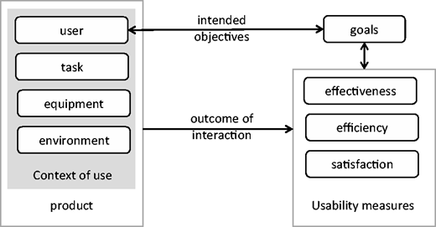
ISO 9241-11 details in depth how users should interact with a product and applies hands-on methods to indicate a products overall usability (ISO, 2018). A common technique that is used in this process is to record users as they perform representative tasks during interactions (ISO, 2018). When measures of effectiveness, efficiency, and satisfaction are adequately fulfilled the product can then be deemed to have reached an acceptable level of usability (ISO, 2018).
Standards such as ISO 9241-11 could be adapted and applied to e-therapies for mental health. This notion is further reinforced by Bevan (2009), who concludes that these standards should be used more frequently in usability work as they define good practice, are objective, can ensure consistency and provide target benchmarks for intervention designers.

Measuring Effectiveness and Efficiency
Effectiveness is generally measured by the successful completion of a task in addition to the sum of errors recorded while performing an interaction. Efficiency encapsulates the level of effort and the resource used by a user to achieve usability goal(s). This is typically measured by timing each task and averaging times across users and/or tasks.

Measuring Satisfaction
User satisfaction can be measured subjectively through standardised satisfaction questionnaires. These questionnaires can be administered before each task or after a usability test session (Mifsud, 2015).

Task Level Satisfaction
After users attempt a task and irrespective of if they achieve its goal or not, they should immediately be given a questionnaire to measure how difficult they found the task to carry out. This type of measure is generally comprised of no more than 5 questions and often takes the form of Likert scale ratings. The goal of the questionnaire is to provide insight into the task difficulty as seen from participants’ perspective. There are multiple post-test questionnaires available such as the After Scenario Questionnaire (ASQ; Lewis, 1991) and the Subjective Mental Effort Questionnaire (SMEQ; Sauro & Dumas, 2009).

Test Level Satisfaction
Test level satisfaction is measured by giving participants a standardised questionnaire at the end of the test session. The measure serves as a method of capturing a participant’s overall ease of use of the system being tested. A popular example of a test level satisfaction questionnaire is the System Usability Scale (SUS; Brooke, 1996). The SUS scale is an industry standard metric of perceived usability that has been used in over 1,200 publications (Brooke, 2013).

Self-Help Conversational Agents
A limitation of fully automated e-therapy is that despite its proven benefits, adherence can be low (Christensen, Griffiths & Farrer, 2009; Schueller, 2010; Cavanagh, 2015). While involving some degree of therapist support in some instances overcomes this issue (Andersson, 2016), increasing adherence to fully automated self-help interventions remains a research priority. Another possible method to increase adherence is the use of conversational agents, software programs which interpret and reply to lines of everyday normal language that are made by users.
The earliest recorded attempt to develop a self-help conversational agent was by Joseph Weizenbaum in 1966. His program, known as ‘ELIZA’, was designed to parody a conversation with a Rogerian psychologist. Rogers developed a person-centred approach to psychotherapy based on humanistic principles (Rogers, 1995). His conversation approach was based on three the ‘core conditions’ of congruence, unconditional positive regard and empathy (McMillan, 2004). How well ELIZA was programmed to conform to these ‘core conditions’ (if at all) is relatively unknown.
ELIZA uses natural language processing (NLP). NLP is a division of artificial intelligence (AI) that concerns the analysis and generation by computers of natural language (that is, the sort of language used by humans). In the case of ELIZA, relatively simple NLP rules are applied to analyse the user's typed inputs and then, based on that analysis, to generate text responses in the form of subsequent questions.
Helgadóttir et al. (2009) note that despite the initial optimism for ELIZA little progress has been made to evolve the concept into a fully automatic technique for treating mental health disorders. Small pockets of research exist in this area such as Woebot (Fitzpatrick et al., 2017) and a conversational agent by Ly, Ly and Andersson (2017) but the majority are commercially developed programs with no academic publications. Some examples are Tess (X2 AI, 2018), Abi (Abi Global Health Limited, 2018), Ada (Ada Health Gmbh, 2018), and Joy (hellojoy, 2018). Those that have attempted to develop e-therapy both guided and unguided have predominately used cognitive behaviour therapy (CBT) treatment (Helgadóttir et al., 2009). One reason for this may be the manualised and procedural way CBT is generally disseminated can be operationalised, making it a good fit for automation. Conversely, conversational therapies are by nature less rigid and thus their automation presents greater computational challenges.

Manage Your Life Online (MYLO)
Developing a self-help conversational agent from scratch would be a large undertaking, and beyond the scope of a PhD. So, for this body of research a self-help conversational agent developed and piloted by the University of Manchester called Manage Your Life Online (MYLO; Bird et al., 2018) is being used with the permission of its intellectual owner Dr Warren Mansell. The intervention is based on Method of Levels therapy (MOL; Carey, 2006), which in turn is based on the main beliefs of perceptual control theory (PCT; Powers, 1973). PCT emerged from an amalgamation of concepts and methods taken from engineered control system and applied to biological control systems. It provides an amalgamated model of human functionality that includes an integrated explanation of how psychological distress manifests and is maintained (Mansell, 2005; Carey, 2006; Higginson, Mansell and Wood, 2011). Central to PCT is the principle of control, the idea that humans act to control their perceptions which are susceptible to disturbances from aspects of the environment (Powers, Clark and McFarland, 1960; Powers, 1973). The PCT viewpoint on this is that problems within functioning are assumed to be problems in the process of control. Control is established through three key components: perception, comparison and action, which together form a negative feedback loop considered to be the most important element in the process of control (Carey, 2008). Each negative feedback loop is responsible for the control of one perception, an input function serves to perceive moment to moment representations of the controlled perception, and this is then compared with an internal preselected value of how we want that perception to be (Carey, 2008). If a discrepancy is detected between the desired perception and the current perception the output function will alter in order to reduce the detected discrepancy, therefore causing the input to match the internal reference value, at which point the particular perception is said to be under control of the individual (Carey, 2008).
Method of Levels therapy (MOL; Carey, 2006) is transdiagnostic and uses open questioning techniques to focus on the process of thinking as opposed to the content of what the client says. MOL also does not depend on a client carrying out homework or using written designs and tools. In a series of pragmatic trials, MOL has been evaluated in treating a range of difficulties in primary mental health care (Carey and Mullan, 2007, 2008; Carey et al., 2009). Patients who received MOL in these studies reported improvements in depression, anxiety and stress. MOL aims to get the most out of client control, by allowing them to determine the number and length of therapy sessions they receive. Unlike other conversational therapies, due to the simplicity of techniques and client centred nature of MOL it is well suited to automation and application within a computer-based self-help program. Furthermore, it can provide a treatment that is independent of any particular clinical diagnosis and potentially effective for any problem a client is struggling with.
The Manage Your Life Online (MYLO) program is designed on the fundamental principles of MOL therapy and simulates an MOL-style conversation through an automated, “instant messenger” interface. MYLO aims to aid individuals in solving a problem they are current experiencing by scanning user’s input of text for key themes and phrases which it utilises to produce questions aimed at encouraging the user to talk about a problem that is significant to them and asking questions aimed at shifting awareness to higher levels in their control system hierarchy.
A web-based randomized controlled trial of MYLO carried out by Gaffney et al. (2014) recruited healthy university students (n = 213) who completed baseline measures before being randomized to either MYLO or an active control condition program ELIZA. Participants completed a single session with their program in a lab environment before completing post-study and 2-week follow-up measures. The results found that both programs were associated with improvements in problem-related distress, anxiety and depression post-intervention, and again at 2-week follow-up; however, MYLO was reported to be no more effective than ELIZA. MYLO was rated significantly more helpful than ELIZA but not found to give significantly higher ratings of problem resolution. The findings provided support for the acceptability and effectiveness of MYLO when delivered over the internet and used by a non-clinical sample. The lack of a no-treatment control condition meant that the effect of spontaneous improvement could not be ruled out.
A conversational agent therapy such as MYLO may suit older adults due to its minimal learning curve and limited technical complexity. MYLO is also a non-commercial piece of software which enables the author to make enhancements to the software without legal complexities thanks to having permission from Dr Warren Mansell. The program has never been tested with older adults, this study therefore aims to evaluate the acceptability of MYLO with this group. Initially the study by Gaffney et al. (2014) will be replicated, but with an older aged sample to establish comparative feasibility and if, as found by Gaffney et al., that both MYLO and ELIZA lead to significant decreases in psychological distress immediately after use.

Aims
This study is phase one of a three-phase process based around several stages of user-centred design (UCD). UCD is an approach to software that is focused on user needs, wants and abilities that are considered central to the design process (Schleyer, Thyvalikakath and Hong, 2007).
The UCD approach involves four distinct phases (ISO, 2010): Phase 1: understand the context in which users may use the system; Phase 2: identify and specify the users’ requirements; Phase 3: Develop the solutions; Phase 4: Assess the outcomes of the evaluation against users’ context and requirements to check how well the design is performing (see Figure 5.2).
Figure 5.2 User Centred Design Process
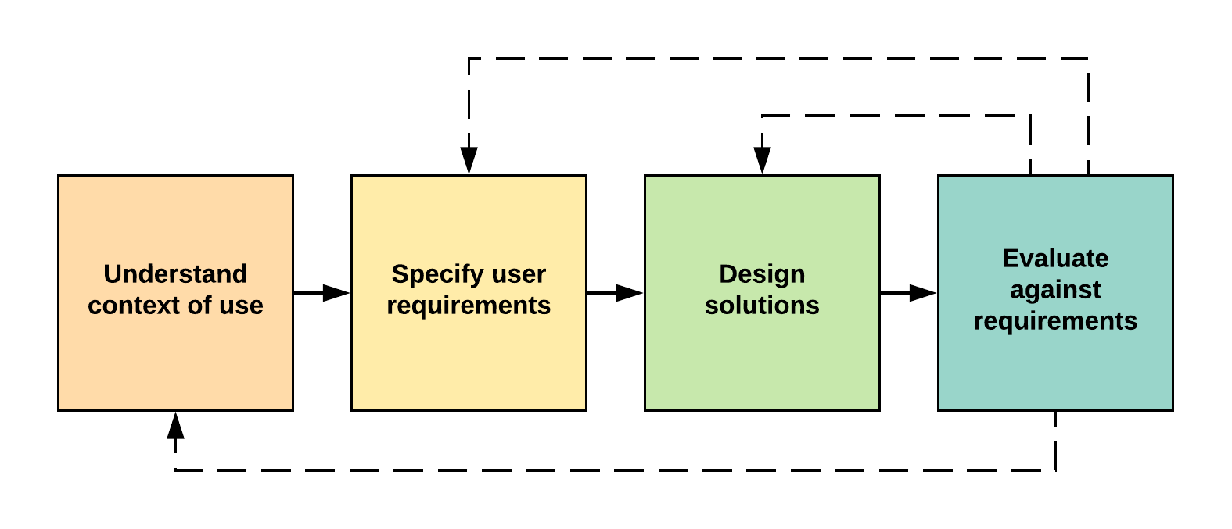
Under normal circumstances UCD would be used to build a system from the ground up for a specified persona (user archetype). Unfortunately, MYLO was not built in this way and has never had a persona defined; luckily, its interface is simplistic enough to enable the application of elements of UCD retrospectively.
The following phases (studies) are proposed for a retrospective implementation using phases of the UCD process: Study 1: Evaluate the current MYLO system; Study 2: Collect user requirements via a survey to decide upon UI enhancements and apply these enhancements to MYLO; Study 3: Evaluate enhanced MYLO system (see Figure 5.3).
Figure 5.3 Study flow mapped to UCD
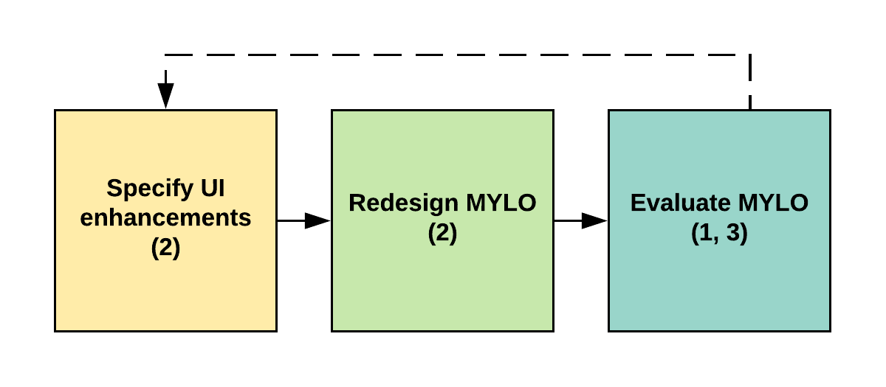
The primary aim of this study is to examine the acceptability and feasibility of using a conversational agent for problem solving with older adults. The study will replicate methodological elements of an earlier study carried out by Gaffney et al. (2013), in which the goal was to establish the effectiveness and acceptability of MYLO through a comparison with ELIZA. The second aim of the study will be to attempt to establish if MYLO and ELIZA have near equal mean system usability scores when using satisfaction metrics. The nature of the programs and the online setting of the study make measuring for effectiveness and efficiency via ISO 9241-11 difficult. Effectiveness is measured by the successful completion of a task in addition to the sum of errors recorded while performing an interaction. This method requires the researcher to be present during sessions, and this cannot be done easily during an online study and may not be appropriate when a user is engaging in a therapeutic process with the program. Gauging efficiency involves measuring the time taken to complete each task and averaging times across users and/or tasks. Two issues prevent this from being implemented in the current study. Firstly, it is not possible to time task completion without a researcher being present to do so. Secondly, the time taken for a participant to talk to a computer may differ from person to person based on the complexity of the problem being discussed. This makes the measurement of time potentially unreliable as an indicator of task efficiency. Because of these issues the study will implement a test level satisfaction questionnaire based on the satisfaction metrics of usability. Finally, the study will aim to investigate whether system usability effects the acceptability of MYLO in an older adult sample.

Hypotheses
- Based on Gaffney et al.’s (2014) findings that MYLO and ELIZA are effective conversational agents for problem solving, it is hypothesised that:
  - There will be significant reductions in problem-related distress following the use of both MYLO and ELIZA.
- It is expected that MYLO will be more acceptable conversational agent for problem solving than ELIZA with older adults. It is therefore hypothesised that:
  - MYLO use will be used for a significantly longer duration of time than ELIZA.
  - MYLO will be rated significantly more helpful than ELIZA.
  - Participants will significantly more likely to want to use MYLO again over ELIZA.
- Because MYLO and ELIZA have near identical user interfaces, it is hypothesised that:
  - There will no significant differences in ratings of system usability.
- ISO (2018) defines usability as the extent to which a product can be used by specified users to achieve specific goals with effectiveness, efficiency and satisfaction. Therefore, it is hypothesised that:
  - Older adults who rate a conversational agent with higher system usability will also have greater problem resolution and higher ratings of helpfulness and interest in using the program again.

Method

Participants
One hundred and twenty-six participants were recruited from The University of the Third Age (U3A) across the UK. The University of the Third Age is a movement that aims to educate and stimulate its members (U3A, 2018). The membership is mainly comprised of retired members of the community in the third 'age' of their life aged over 50. The inclusion criteria required participants to be aged 50 years or above and to be able to read and hear clearly (with glasses or hearing aids if needed) and to have a problem that was currently causing them distress that they were willing to disclose to a computer program. The exclusion criteria required that participants should not have professionally diagnosed mental health issues. At randomisation 124 participants were recruited and randomised (see Figure 5.4). The randomisation groups were relatively even at baseline with 59 allocated to MYLO, 53 to ELIZA. At post intervention seven, had been lost in the MYLO group, three in the ELIZA group. At 2-week follow-up three were lost in the MYLO group and zero in the ELIZA group.
Figure 5.4 Study flow diagram
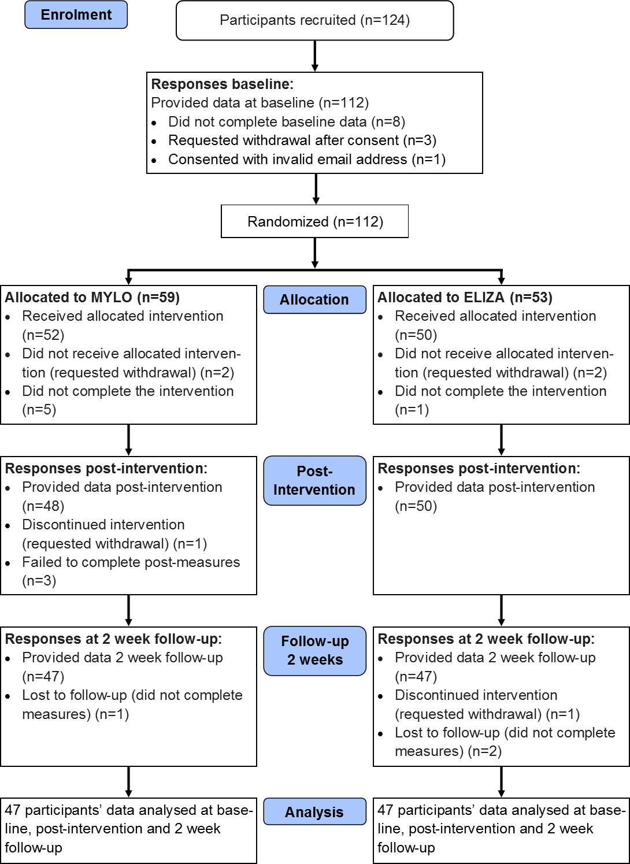

Materials

Demographics
Age and gender data were collected.

Measures of Effectiveness

Problem Description Ratings Scale (PDRS)
Similar to Gaffney et al. (2013), participants were asked to provide a qualitative description of a problem (e.g. with finances, relationships, family), a qualitative description of the time period it has been experienced, and to respond to two 11-point scales measuring the degree of distress caused by the problem ranging from 0 (not distressing at all) and 10 (highly distressing) and the problem’s solvability ranging from 0 (cannot be resolved) to 10 (easily resolved). (See Appendix C1)

Depression, Anxiety and Stress Scale (DASS-21)
The Depression, Anxiety and Stress Scale (DASS-21; Lovibond, & Lovibond, 1995) is a 21-item scale that measures levels of depression, anxiety and stress over the previous week on a 4-point scale (0 – 3). Scores can range from 0 to 42 in each domain of the scale (Depression, Anxiety, and Stress) and are calculated by summing the scores of the seven items. In previous research the scale has shown high internal consistency with Cronbach’s alpha values of Depression 0.91, Anxiety 0.84 and Stress 0.90 (Lovibond, & Lovibond, 1995). (See Appendix C2)

Measures of Acceptability

Time
The time difference in minutes between the first and last timestamp of each conversation log was used to measure the length of time participants spent using their assigned program.

Rating of Resolution (RoR)
To measure the extent to which the problem was resolved, following Gaffney et al. (2013), participants were asked to what extent they feel their problem has been resolved, 0 (Not resolved at all) to 10 (completely resolved). (See Appendix C3)

Helpfulness
Following Gaffney et al. (2013), participants were asked to rate how helpful they found their assigned computer program on an 11-point scale, 0 (not helpful at all) to 10 (extremely helpful). Space is also provided for qualitative responses. (See Appendix C3)

Use Again
Following Gaffney et al. (2013), participants were asked to rate the degree to which they would potentially use their assigned program again for a different problem, on an 11-point scale, 0 (most definitely not) and 10 (most definitely yes). Space is also provided for qualitative responses. (See Appendix C3)

Program Feedback
To glean further feedback, a series of questions used by Gaffney et al. (2013) were included. These explored the benefits and problems users experienced with their program, along with any improvements that could be made. Each question provided a space for qualitative responses. Participants were also asked whether they would recommend the program to others and whether they thought the computer helped in resolving their problem both with using yes–no questions. Space was also provided for qualitative responses. (See Appendix C3)

ISO Standard Usability Measures

System Usability Scale
The System Usability Scale (SUS; Brooke ,1996) is a 10-item scale of statements with a 5-point scoring scale on the strength of agreement from 0 to 4. Half the statements are worded positively, and half are worded negatively. The SUS score is calculated by firstly summing the selected scores from each item. For odd numbered items, the score contribution is the scale position (sp) – 1 and for even numbered items the contribution is sp - 5. Brooke (1996) specifies the total score must be calculated and multiplied by 2.5. The final score can range from 0 to 100, with the higher the score the better the level of usability. A score above 68 is considered above average usability and anything below is considered below average usability (Brooke, 2013). The internal-consistency of the SUS has been found to be at least .90 in large datasets (Bangor, Kortum and Miller, 2008; Sauro and Dumas, 2009) and the internal reliability compares favourably with other usability questionnaires (Bangor, Kortum and Miller, 2008). SUS was chosen for this study because its single measure output enables correlational analysis to be ran with other psychology-based scales being used in the study. (See Appendix C4)

Procedure
The study was approved by The University of Sheffield Psychology Department Ethics Committee (see Appendix C5). Participants either emailed or phoned the researcher after seeing the recruitment poster (see Appendix C6). The researcher inputted the potential participant’s email into the backend study management system (BSMS) and an email was automatically sent containing a link to an online participant information sheet and consent form (see Appendix C7). Upon consenting, participants were sent an email containing a further set of instructions about each stage of the study and a link to allow them to begin. Upon clicking the link, participants were taken to a set of baseline measures comprising the PRDS and DASS-21 measures. When completed, the BSMS randomly allocated the participant to either the MYLO or ELIZA experimental group and generated an accompanying username, password and program link for participants to access their allocated program. The BSMS then emailed these details to the participants along with a link to a guide video and tips web page (see Appendix C8 and C9). The participants were given 24 hours in which to click the link in the email and log in to converse with their selected computer program for up to 20 minutes. Because the study was running online the ability to control maximum talk time was not possible. Conversation length was recorded at the end of the session by the BMSM through calculating the timestamp difference between the first and last entries in the conversation log. After ending the conversation with the program participants were taken to a set of post-measures comprising of the PRDS, SUS, DASS-21 and RoR measures. Two weeks following this session, the BSMS sent participants an email asking them to complete a set of follow-up measures to complete their involvement in the study. These measures were the PRDS, DASS-21 and RoR. Participants were then debriefed (Appendix C10).

Computer Programs

ELIZA
ELIZA was one of the first computers to attempt to simulate the behaviour of a psychotherapist (Weizenbaum, 1976). The ELIZA used in this study was based on the version used in Gaffney et al.’s study, which can be accessed online at http://www.cyberpsych.org/eliza. A copy of the program’s JavaScript (JS) code was taken, re-written to the PHP Hypertext Pre-processor (PHP) programming language and then hosted by the researcher to ensure control of the program’s functionality was maintained throughout the study. Figure 5.5 shows the study ELIZA UI.
Figure 5.5 Screenshots of study ELIZA UI
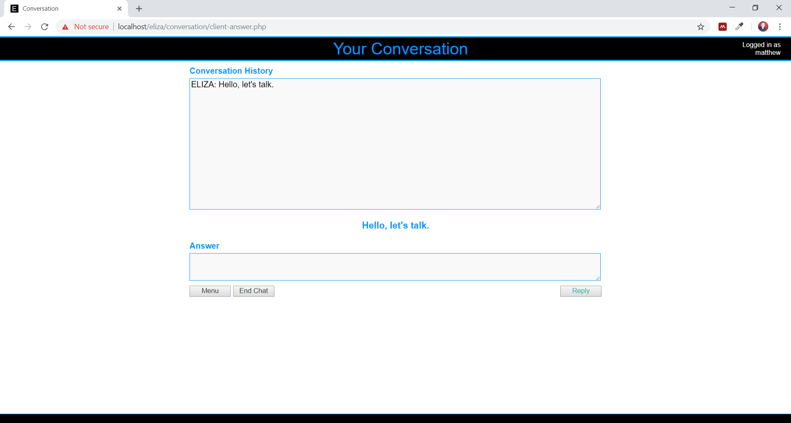

To ensure that both systems were judged on the conversation they generated and not their user interface (UI) the layout and input of ELIZA was altered to mirror the MYLO program.
The software firstly asks the participant “Hello, let’s talk.” The participant progresses the conversation by typing their problem into a text input box and pressing the return key. ELIZA then responds with a question that is aimed at encouraging conversation regarding the participant’s problem.

Manage Your Life Online (MYLO)
Manage Your Life Online (MYLO) is an automated self-help computer program that emulates the type of conversation that could be expected between a client and a therapist
Figure 5.6). MYLO’s aim is to aid the participant in solving their problem by applying the principles of Method of Levels (MOL) therapy (Carey, 2006). The software firstly asks the participant “Please tell me what’s on your mind.” The participant progresses the conversation by typing their problem into a text input box and then clicking one of the response rating buttons. MYLO analyses textual responses from client input for key terms and themes and responds with questions about the participant’s problem aimed at “encouraging conflict awareness and facilitating higher level awareness” (Gaffney et al. 2013). The HTML code for the MYLO program was cleaned to ensure it worked in modern web browsers and on mobile, tablet and PC.
Figure 5.6 Screenshots of MYLO

Sample Size Calculation
To determine the minimum number of subjects for adequate study power the ClinCalc Sample Size Calculator was used, as based on Rosner (2011). The calculation was carried out based on the study by Gaffney et al. (2014), where a Cohen’s d of 0.79 was found for the baseline and post-intervention comparison of distress scores of those in the MYLO group. A power analysis indicated that the minimum group size required was 19 with adequate power (0.8). However Gaffney et al. (2014) reported improvements in distress between MYLO and ELIZA groups as not having a significant effect (p = 0.13). As a result of this a further power analysis was carried out based upon the post-intervention distress scores of both MYLO and ELIZA where a Cohen’s d of 0.53 was found. This indicated that the minimum group size required was 67 with adequate power of (0.8).

Data Analysis
All analyses were conducted using SPSS for Windows (Version 23). The primary outcome measure for the study was problem-related distress. DASS-21, problem resolution, and helpfulness, use again and system usability were secondary outcome measures. While ANOVA analyses were intended, the assumptions of parametric tests were violated (data was not normally distributed). Therefore, non-parametric analysis was used throughout.
To investigate hypothesis one as to whether MYLO and ELIZA would both be associated with significant reductions in problem-related distress and psychopathology, fifteen Mann-Whitney U tests were performed on groups (MYLO and ELIZA) and time (baseline, post-intervention and 2-week follow-up) for problem-related distress, depression, anxiety, stress and total DASS-21 score. Ten Friedman tests were carried out on time (baseline, post-intervention and 2-week follow-up) for scores of problem-related distress, depression, anxiety, stress and total DASS-21 for both MYLO and ELIZA groups.
To investigate hypothesis two as to whether MYLO was a more acceptable conversational agent for problem solving to older adults than ELIZA, one Mann-Whitney U test was carried out to compare groups (MYLO and ELIZA) for time spent using the intervention. Six Mann-Whitney U tests were carried out to compare groups (MYLO and ELIZA) at post-intervention and follow-up for ratings of problem resolution, helpfulness and use again. Two Sign tests were carried out on time (post-intervention and follow-up) for ratings of problem resolution on MYLO and ELIZA groups.
To investigate hypothesis three as to whether both MYLO and ELIZA had equal system usability, a Mann-Whitney U test was carried out to compare groups (MYLO and ELIZA) at post-intervention for system usability.
To investigate hypothesis four, as to whether higher system usability was associated with higher ratings of problem resolution, helpfulness and interest in using MYLO again. Spearman's rank-order correlations were performed. The analyses used data from the MYLO condition only as ELIZA was not written with the purpose of being used for problem solving.

Results

Descriptive Statistics
A total of 112 participants completed a baseline questionnaire, of whom 112 completed the randomisation process and took part in the intervention phase, with 98 providing immediate post-study data. Out of those who completed the study, 94 (47 MYLO and 47 ELIZA) provided data at all three time-points (baseline, post-intervention and 2-week follow-up). A participant flow diagram is provided (see Figure 5.4). At baseline the age of participants ranged from 51 to 90 years, with a mean of 69.21 (SD 6.76). This group was comprised of 82 (73.2%) females. For those that provided data at all time points the average age was 68.4 (SD 6.49) and 69 (73.4%) were female. The average length of time spent using MYLO was 24.17 minutes (SD = 16.46) and 15.17 minutes (SD = 8.77) with ELIZA. Descriptive statistics for distress, resolution, DASS-21 and post intervention and follow-up are presented in Table 5.2.
Table 5.2. Means and standard deviations for baseline, post-intervention and follow-up measures
 | MYLO Mean (SD) |  |  | ELIZA Mean (SD)
Measure | Baseline | Post | Follow-up | Baseline | Post | Follow-up
Distress | 6.17  (1.55) | 3.68  (2.14) | 3.21  (2.27) | 6.02  (1.81) | 4.45  (2.51) | 4.23  (2.67)
Problem Resolvability | 4.09  (2.35) | // | // | 3.55  (2.25) | // | //
Problem Resolution | // | 2.17  (2.62) | 3.77  (3.29) | // | 1.43  (1.86) | 1.91  (2.21)
Depression | 9.66  (6.14) | 6.51  (5.36) | 4.98  (5.00) | 9.88  (8.29) | 7.79  (7.45) | 5.91  (6.80)
Anxiety | 4.21  (5.52) | 2.77  (4.06) | 2.64  (4.11) | 4.34  (4.83) | 2.64  (3.91) | 2.38  (3.22)
Stress | 13.19  (9.23) | 10.72  (8.51) | 8.51  (7.52) | 14.30  (9.03) | 10.21  (8.35) | 8.89  (7.60)
DASS total | 27.06  (16.18) | 20.00  (14.59) | 16.13  (13.91) | 28.51  (19.17) | 20.64  (15.04) | 17.19  (14.71)
Helpfulness | // | 2.94  (2.89) | 3.23  (2.81) | // | 1.43  (1.86) | 1.91  (2.21)
Use Again | // | 4.21  (3.14) | 4.43  (3.48) | // | 2.45  (2.79) | 2.70  (3.04)
System Usability | // | 63.56  (17.90) | // | // | 56.97  (19.46) | //
Note: DASS = Depression, Anxiety & Stress Scale;

Are Both MYLO and ELIZA Effective with Older Adults?

Problem-related distress
A Mann-Whitney U test was run to determine if there were differences in baseline problem-related distress between MYLO and ELIZA. Distributions of the baseline problem-related distress for MYLO and ELIZA were not similar, as assessed by visual inspection. Baseline problem-related distress for MYLO (mean rank = 46.07) and ELIZA (mean rank = 48.93) were not statistically significantly different, U = 1,038, z = -.516, p = .606. The result indicates that there were no between-group differences in problem-related distress at baseline.
A Mann-Whitney U test was run to determine if there were differences in post-intervention problem-related distress between MYLO and ELIZA. Distributions of the post-intervention problem-related distress for MYLO and ELIZA were not similar, as assessed by visual inspection. However, post-intervention problem-related distress for MYLO (mean rank = 43.45) and ELIZA (mean rank = 51.55) were not statistically significantly different, U = 1,295, z = 1.463, p = .143. The result indicates that there were no between-group differences in problem-related distress at post-intervention.
A Mann-Whitney U test was run to determine if there were differences in follow-up problem-related distress between MYLO and ELIZA. Distributions of the follow-up problem-related distress for MYLO and ELIZA were not similar, as assessed by visual inspection. Follow-up problem-related distress for MYLO (mean rank = 42.46) and ELIZA (mean rank = 52.54) were not statistically significantly different, U = 1,341, z = -1.808, p = .071. The result indicates that there were no between-group differences in problem-related distress at follow-up.
A Friedman test was run to determine if there were differences in problem-related distress between baseline, post-intervention and follow-up for MYLO. Pairwise comparisons were performed (SPSS Statistics, 2012) with a Bonferroni correction for multiple comparisons. Problem-related distress was significantly different at the different time points during the MYLO intervention, χ²(2) = 38.392, p < .001. Post hoc analysis revealed statistically significant differences in problem-related distress from baseline (Mdn = 6.00) to follow-up (Mdn = 3.00) (p < .001) and post-intervention (Mdn = 3.00) (p < .001) but not post-intervention to follow-up.
A Friedman test was run to determine if there were differences in problem-related distress between baseline, post-intervention and follow-up for ELIZA. Pairwise comparisons were performed (SPSS Statistics, 2012) with a Bonferroni correction for multiple comparisons. Problem-related distress was statistically significantly different at the different time points during the ELIZA intervention, χ²(2) = 25.000, p < .001. Post hoc analysis revealed statistically significant differences in problem-related distress from baseline (Mdn = 6.00) to follow-up (Mdn = 4.00) (p < .001) and post-intervention (Mdn = 5.00) (p < .001) but not post-intervention to follow-up.

Depression
A Mann-Whitney U test was run to determine if there were differences in baseline depression between MYLO and ELIZA. Distributions of the depression for MYLO and ELIZA were not similar, as assessed by visual inspection. Baseline depression for MYLO (mean rank = 48.56) and ELIZA (mean rank = 46.44) were not statistically significantly different, U = 1,054, z = -.380, p = .704. The result indicates that there were no between-group differences in depression at baseline.
A Mann-Whitney U test was run to determine if there were differences in post-intervention depression between MYLO and ELIZA. Distributions of the post-intervention depression for MYLO and ELIZA were not similar, as assessed by visual inspection. Post-intervention depression for MYLO (mean rank = 46.41) and ELIZA (mean rank = 48.59) were not statistically significantly different, U = 1,155, z = .390, p = .697. The result indicates that there were no between-group differences in depression at post intervention.
A Mann-Whitney U test was run to determine if there were differences in follow-up depression between MYLO and ELIZA. Distributions of the follow-up depression for MYLO and ELIZA were not similar, as assessed by visual inspection. Follow-up depression for MYLO (mean rank = 47.12) and ELIZA (mean rank = 47.88) were not statistically significantly different, U = 1,123, z = .138, p = .890. The result indicates that there were no between-group differences in depression at follow-up.
A Friedman test was run to determine if there were differences in depression between baseline, post-intervention and follow-up for MYLO. Pairwise comparisons were performed (SPSS Statistics, 2012) with a Bonferroni correction for multiple comparisons. Depression was statistically significantly different at the different time points during the MYLO intervention, χ²(2) = 38.392, p < .001. Post hoc analysis revealed statistically significant differences in depression from baseline (Mdn = 6.00) to follow-up (Mdn = 3.00) (p < .001) and to post-intervention (Mdn = 3.00) (p < .001), but not post-intervention to follow-up.
A Friedman test was run to determine if there were differences in depression between baseline, post-intervention and follow-up for ELIZA. Pairwise comparisons were performed (SPSS Statistics, 2012) with a Bonferroni correction for multiple comparisons. Depression was statistically significantly different at the different time points during the ELIZA intervention, χ²(2) = 25.000, p < .001. Post hoc analysis revealed statistically significant differences in depression from baseline (Mdn = 6.00) to follow-up (Mdn = 4.00) (p < .001) and to post-intervention (Mdn = 5.00) (p < .001), but not post-intervention to follow-up.

Anxiety
A Mann-Whitney U test was run to determine if there were differences in baseline anxiety between MYLO and ELIZA. Distributions of the anxiety for MYLO and ELIZA were not similar, as assessed by visual inspection. Baseline anxiety for MYLO (mean rank = 46.69) and ELIZA (mean rank = 48.31) were not statistically significantly different, U = 1,142, z = .295, p = .768. The result indicates that there were no between-group differences in anxiety at baseline.
A Mann-Whitney U test was run to determine if there were differences in post-intervention anxiety between MYLO and ELIZA. Distributions of the post-intervention anxiety for MYLO and ELIZA were not similar, as assessed by visual inspection. Post-intervention anxiety for MYLO (mean rank = 48.03) and ELIZA (mean rank = 46.97) were not statistically significantly different, U = 1,079, z = -.202, p = .840. The result indicates that there were no between-group differences in anxiety at post-intervention.
A Mann-Whitney U test was run to determine if there were differences in follow-up anxiety between MYLO and ELIZA. Distributions of the follow-up anxiety for MYLO and ELIZA were not similar, as assessed by visual inspection. Follow-up anxiety for MYLO (mean rank = 48.26) and ELIZA (mean rank = 46.74) were not statistically significantly different, U = 1,140, z = .289, p = .773. The result indicates that there were no between-group differences in anxiety at follow-up.
A Friedman test was run to determine if there were differences in anxiety between baseline, post-intervention and follow-up for MYLO. Pairwise comparisons were performed (SPSS Statistics, 2012) with a Bonferroni correction for multiple comparisons. Anxiety was statistically significantly different at the different time points during the MYLO intervention, χ²(2) = 9.125, p = .010. Post hoc analysis revealed no statistically significant differences in anxiety from baseline to follow-up or post-intervention, or post-intervention to follow-up.
A Friedman test was run to determine if there were differences in anxiety between baseline, post-intervention and follow-up for ELIZA. Pairwise comparisons were performed (SPSS Statistics, 2012) with a Bonferroni correction for multiple comparisons. Anxiety was statistically significantly different at the different time points during the ELIZA intervention, χ²(2) = 11.400, p = .003. Post hoc analysis revealed statistically significant differences in anxiety from baseline (Mdn = 2.00) (p < .001) to post-intervention (Mdn = 4.00), but not baseline to follow-up or post-intervention to follow-up.

Stress
A Mann-Whitney U test was run to determine if there were differences in baseline stress between MYLO and ELIZA. Distributions of the stress for MYLO and ELIZA were not similar, as assessed by visual inspection. Baseline stress for MYLO (mean rank = 45.21) and ELIZA (mean rank = 49.79) were not statistically significantly different, U = 1,212, z = .815, p = .415. The result indicates that there were no between-group differences in stress at baseline.
A Mann-Whitney U test was run to determine if there were differences in post-intervention stress between MYLO and ELIZA. Distributions of the post-intervention stress for MYLO and ELIZA were not similar, as assessed by visual inspection. Post-intervention stress for MYLO (mean rank = 48.03) and ELIZA (mean rank = 46.97) were not statistically significantly different, U = 1,059, z = -.342, p = .732. The result indicates that there were no between-group differences in stress at post-intervention.
A Mann-Whitney U test was run to determine if there were differences in follow-up stress between MYLO and ELIZA. Distributions of the follow-up stress for MYLO and ELIZA were not similar, as assessed by visual inspection. Follow-up stress for MYLO (mean rank = 46.66) and ELIZA (mean rank = 48.34) were not statistically significantly different, U = 1,144, z = .301, p = .764. The result indicates that there were no between-group differences in stress at follow-up.
A Friedman test was run to determine if there were differences in stress between baseline, post-intervention and follow-up for MYLO. Pairwise comparisons were performed (SPSS Statistics, 2012) with a Bonferroni correction for multiple comparisons. Stress was statistically significantly different at the different time points during the MYLO intervention, χ²(2) = 22.248, p = < .001. Post hoc analysis revealed statistically significant differences in stress from baseline (Mdn = 12.00) to follow-up (Mdn = 8.00) (p < .001) and baseline (Mdn = 10.00) (p = .026) to post-intervention but not post-intervention to follow-up.
A Friedman test was run to determine if there were differences in stress between baseline, post-intervention and follow-up for ELIZA. Pairwise comparisons were performed (SPSS Statistics, 2012) with a Bonferroni correction for multiple comparisons. Stress was statistically significantly different at the different time points during the ELIZA intervention, χ²(2) = 23.697, p = < .001. Post hoc analysis revealed statistically significant differences in stress from baseline (Mdn = 14.00) to follow-up (Mdn = 8.00) (p < .001) and baseline (Mdn = 10.00) (p = .001) to post-intervention, but not post-intervention and follow-up.

Total DASS-21
A Mann-Whitney U test was run to determine if there were differences in baseline DASS-21 between MYLO and ELIZA. Distributions of the DASS-21 for MYLO and ELIZA were not similar, as assessed by visual inspection. Baseline DASS-21 for MYLO (mean rank = 46.63) and ELIZA (mean rank = 48.37) were not statistically significantly different, U = 1,145, z = .310, p = .756. The result indicates that there were no between-group differences in DASS-21 at baseline.
A Mann-Whitney U test was run to determine if there were differences in post-intervention DASS-21 between MYLO and ELIZA. Distributions of the post-intervention DASS-21 for MYLO and ELIZA were not similar, as assessed by visual inspection. Post-intervention DASS-21 for MYLO (mean rank = 47.14) and ELIZA (mean rank = 47.86) were not statistically significantly different, U = 1,121, z = .129, p = .898. The result indicates that there were no between-group differences in DASS-21 at post-intervention.
A Mann-Whitney U test was run to determine if there were differences in follow-up DASS-21 between MYLO and ELIZA. Distributions of the follow-up DASS-21 for MYLO and ELIZA were not similar, as assessed by visual inspection. Follow-up DASS-21 for MYLO (mean rank = 46.86) and ELIZA (mean rank = 48.14) were not statistically significantly different, U = 1,134, z = .227, p = .820. The result indicates that there were no between-group differences in DASS-21 at follow-up.
A Friedman test was run to determine if there were differences in DASS-21 between baseline, post-intervention and follow-up for MYLO. Pairwise comparisons were performed (SPSS Statistics, 2012) with a Bonferroni correction for multiple comparisons. DASS-21 was statistically significantly different at the different time points during the MYLO intervention, χ²(2) = 44.433, p = < .001. Post hoc analysis revealed statistically significant differences in DASS-21 from baseline (Mdn = 24.00) to follow-up (Mdn = 16.00) (p < .001) and baseline (Mdn = 20.00) (p < .001) to post-intervention, but not post-intervention to follow-up.
A Friedman test was run to determine if there were differences in DASS-21 between baseline, post-intervention and follow-up for ELIZA. Pairwise comparisons were performed (SPSS Statistics, 2012) with a Bonferroni correction for multiple comparisons. DASS-21 was statistically significantly different at the different time points during the ELIZA intervention, χ²(2) = 28.433, p = < .001. Post hoc analysis revealed statistically significant differences in DASS-21 from baseline (Mdn = 28.00) to follow-up (Mdn = 14.00) (p < .001) and baseline (Mdn = 20.00) (p < .001) to post-intervention, but not post-intervention to follow-up.

Is MYLO a More Acceptable Conversational Agent for Problem Solving to Older Adults Than ELIZA?

Intervention time
A Mann-Whitney U test was run to determine if there were differences in intervention time between MYLO and ELIZA. Distributions of the intervention time for MYLO and ELIZA were not similar, as assessed by visual inspection. Time spent using MYLO (mean rank = 54.35) was significantly higher than time spent using ELIZA (mean rank = 40.65), U = 782, z = -2.437, p = .015. The result indicates that there was a between-group difference in intervention time.

Rating of resolution
A Mann-Whitney U test was run to determine if there were differences in post-intervention rating of resolution between MYLO and ELIZA. Distributions of the post-intervention rating of resolution for MYLO and ELIZA were not similar, as assessed by visual inspection. Post-intervention rating of resolution for MYLO (mean rank = 51.21) and ELIZA (mean rank = 43.79) were not statistically significantly different, U = 930, z = -1.412, p = .137. The result indicates that there were no between-group differences in rating of resolution at post-intervention.
A Mann-Whitney U test was run to determine if there were differences in follow-up rating of resolution between MYLO and ELIZA. Distributions of the follow-up rating of resolution for MYLO and ELIZA were not similar, as assessed by visual inspection. Follow-up rating of resolution for MYLO (mean rank = 50.34) and ELIZA (mean rank = 44.66) were not statistically significantly different, U = 971, z = -1.021, p = .307. The result indicates that there were no between-group differences in rating of resolution at follow-up.
Forty-seven participants were recruited to MYLO. Data are medians unless otherwise stated. A sign test with continuity correction was used to compare the differences in rating of resolution between post-intervention and follow-up. Of the 47 participants recruited to MYLO, the rating of resolution increased from post-intervention to follow-up in 26 participants, whereas nine participants saw no improvement and 12 participants rating of resolution decreased. Overall the median participant rating of resolution post-intervention (1.00) to follow-up (3.00) increased z = 2.109, p = .035.
Forty-seven participants were recruited to ELIZA. Data are medians unless otherwise stated. A sign test with continuity correction was used to compare the differences in rating of resolution between post-intervention and follow-up. Of the 47 participants recruited to ELIZA, the rating of resolution increased from post-intervention to follow-up in 26 participants, whereas 14 participants saw no improvement and 7 participants rating of resolution decreased. Overall, participant rating of resolution from post-intervention (0.00) to follow-up (2.00), increased, z = 3.133, p = .002.

Helpfulness
A Mann-Whitney U test was run to determine if there were differences in post-intervention helpfulness between MYLO and ELIZA. Distributions of the post-intervention helpfulness for MYLO and ELIZA were not similar, as assessed by visual inspection. Post-intervention helpfulness for MYLO (mean rank = 54.07) were statistically significantly higher than for ELIZA (mean rank = 40.93), U = 795, z = -2.412, p = .016. The result indicates that there were between-group differences in helpfulness at post-intervention.
A Mann-Whitney U test was run to determine if there were differences in follow-up helpfulness between MYLO and ELIZA. Distributions of the follow-up helpfulness for MYLO and ELIZA were not similar, as assessed by visual inspection. Follow-up helpfulness for MYLO (mean rank = 54.07) were statistically significantly higher than for ELIZA (mean rank = 40.93), U = 795, z = -2.412, p = .016. The result indicates that there were between-group differences in helpfulness at follow-up.

Use again
A Mann-Whitney U test was run to determine if there were differences in post-intervention use again between MYLO and ELIZA. Distributions of the post-intervention use again for MYLO and ELIZA were not similar, as assessed by visual inspection. Post-intervention use again for MYLO (mean rank = 54.81) were statistically significantly higher than for ELIZA (mean rank = 40.19), U = 761, z = -2.640, p = .008. The result indicates that there were between-group differences in use again at post-intervention.
A Mann-Whitney U test was run to determine if there were differences in follow-up use again between MYLO and ELIZA. Distributions of the follow-up use again for MYLO and ELIZA were not similar, as assessed by visual inspection. Follow-up use again for MYLO (mean rank = 53.87) were statistically significantly higher than for ELIZA (mean rank = 41.13), U = 805, z = -2.329, p = .020. The result indicates that there were between-group differences in use again at follow-up.

Are Both MYLO and ELIZA of Equal System Usability?
A Mann-Whitney U test was run to determine if there were differences in post-intervention system usability between MYLO and ELIZA. Distributions of the post-intervention system usability for MYLO and ELIZA were not similar, as assessed by visual inspection. Post-intervention system usability for MYLO (mean rank = 52.23) and ELIZA (mean rank = 42.77) were not statistically significantly different, U = 882, z = -1.684, p = .092. The result indicates that there were no between-group differences in system usability at post-intervention. MYLO had a marginally higher overall mean system usability (see Table 5.2) but neither scored above 68 which is deemed above average usability (Brooke, 2013).

What Effect Does System Usability Have upon the Acceptability of a Conversational Agent for Problem-Solving?
A Spearman's rank-order correlation was run to assess the relationship between post-intervention system usability and post-intervention ratings of problem resolution within the MYLO group (n=47). Preliminary analysis showed the relationship to be monotonic, as assessed by visual inspection of a scatterplot (see Figure 5.7). There was a statistically significant, moderate positive correlation between system usability and post-intervention ratings of problem resolution, r_{s}(45) = .438, p < .001. The result suggests that participants who scored MYLO’s system usability highly felt their problem had been more resolved.
Figure 5.7 System usability (post) and rating of resolution (post) scatterplot
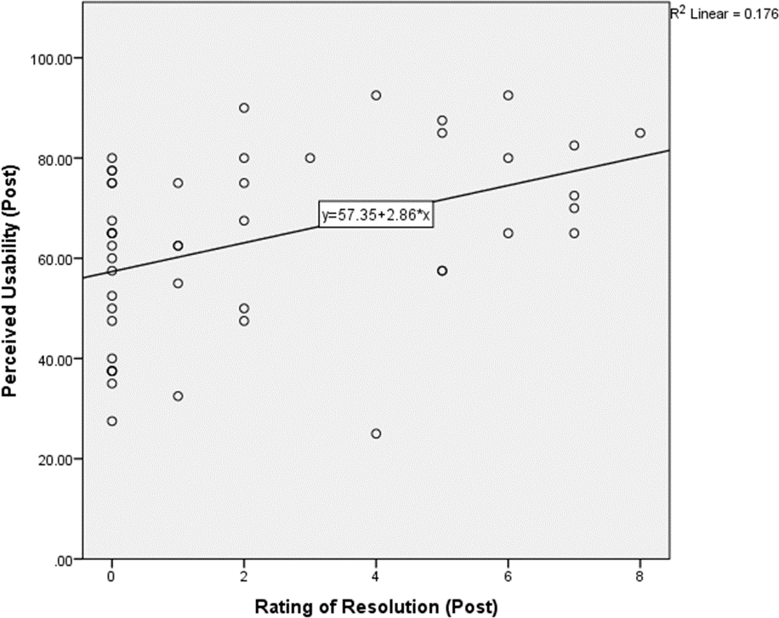
A Spearman's rank-order correlation was run to assess the relationship between post-intervention system usability and post-intervention ratings of helpfulness within the MYLO group. Preliminary analysis showed the relationship to be monotonic, as assessed by visual inspection of a scatterplot (see Figure 5.8). There was a statistically significant, moderate positive correlation between system usability and post-intervention ratings of helpfulness, r_{s}(45) = .514, p < .001. The result suggests that participants who scored MYLO’s system usability highly found MYLO more helpful.
Figure 5.8 System usability (post) and helpfulness (post) scatterplot
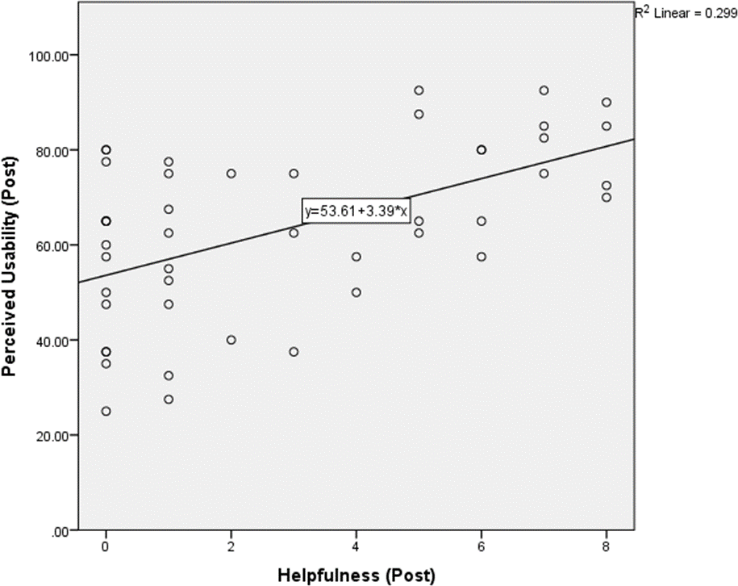
A Spearman's rank-order correlation was run to assess the relationship between post-intervention system usability and post-intervention ratings of interest in using MYLO again Preliminary analysis showed the relationship to be monotonic, as assessed by visual inspection of a scatterplot (see Figure 5.9). There was a statistically significant, moderate positive correlation between system usability and post-intervention ratings of interest in using MYLO again, r_{s}(45) = .514, p < .001. The result suggests that participants who scored MYLO’s system usability highly found MYLO more helpful. The result suggests that participants who scored MYLO’s system usability highly were more interested in using MYLO again.
Figure 5.9 System usability (post) and use again (post) scatterplot
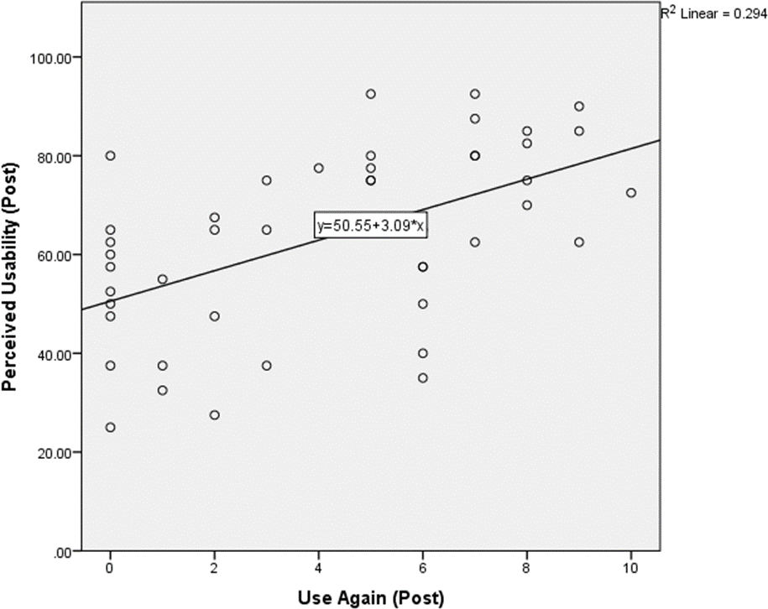
Table 5.3 Correlation matrix of System usability and post intervention Ratings of Resolution, Helpfulness and Use Again, in the MYLO group
 |  | 1 | 2 | 3 | 4
1 | System Usability | - | .44** | .51** | .54**
2 | Ratings of Resolution |  | - | .75** | .56**
3 | Helpfulness Ratings |  |  | - | .77**
4 | Use Again Ratings |  |  |  | -
*Correlation is significant at the 0.05 level (two-tailed).
**Correlation is significant at the 0.01 level (two-tailed).

Discussion
The present study had three aims, the first of which was to investigate the acceptability and feasibility of a conversational agent for problem solving with an older adult sample. The study used methodological elements of a previous investigation by Gaffney et al. (2013) that compared the efficacy of MYLO with another conversational agent ELIZA. Secondly, the study aimed to investigate if MYLO and ELIZA had near equal mean system usability based on their need identical user interfaces. Finally, the study investigated whether system usability affected the acceptability of MYLO when used by older adults.
It was hypothesised that both MYLO and ELIZA would be effective conversational agents for problem solving. All respondents, irrespective of group experienced significant reductions in distress, depression, anxiety, stress, and total DASS-21 scores between baselines and follow up. No significant results were found when comparing ratings at any of the time-points. The findings in this study are fairly consistent with the laboratory based pilot trial by Gaffney et al. (2014) and an online based Randomised Controlled Trial by Bird et al. (2018).
It was hypothesised that MYLO would be a more acceptable conversational agent for problem solving to older adults than ELIZA. We found that participant problem resolution increased over time after using either program. However, participants spent significantly more time using MYLO and it was rated significantly more helpful and significantly more likely to be used again when compared with ELIZA. These combined findings are again comparable with previous MYLO studies (Gaffney et al., 2014; Bird et al., 2018) and help to provide support of the acceptability of MYLO in helping older adults.
It was hypothesised that older adults would score both MYLO and ELIZA near equal on system usability. We found no significant difference between programs for system usability and neither program scored equal to or above the average system usability score of 68. The findings suggest that both programs were perceived by older adults as being below average usability. The MYLO group did however receive a marginally higher overall mean score of 63.5 (see Table 5.2) indicating it narrowly missed the average usability threshold of 68. It may be possible through enhancement of MYLO’s user interface that system usability may also improve. The next chapter of this body of work will explore the modification and testing of MYLO with enhanced users’ interfaces to examine if MYLO’s system usability can be improved.
It was hypothesised that the system usability of MYLO would be positively associated with higher ratings of problem resolution, helpfulness and likelihood of using again. The findings supported this hypothesis and indicated that higher system usability was related to perceiving MYLO as more helpful, gaining greater problem resolution from using MYLO, and likelihood of using MYLO again. These findings may indicate that system usability has an impact upon how participants receive and rate their experience of using MYLO. Alternatively, the direction of effect may be the opposite. That is to say, it might be that helpfulness, problem resolution, and likelihood of use lead to greater perceptions of usability. However, this would be counter to accepted models of usability (e.g. ISO 2018). While some studies have implemented the SUS scale as a measure of usability in e-therapies (Wit et al. 2015; Etzelmueller et al. 2018), there are not, to the author’s knowledge, any published studies that investigate at how the SUS scale interacts with other dimensions of e-therapy such as treatment credibility and the therapeutic relationship. Further studies are required to examine this is more depth. For example, it may be possible to manipulate usability, and compare problem resolution, helpfulness, and likelihood of using again, in an e-therapy with deliberately low versus high usability. This would enable researchers to be more confident about the causal direction of the relationship found here.
The results overall provide evidence that a conversational agent can help with resolving problems and reducing associated distress.

Strengths and Limitations
There has been little research examining the medium of conversation agents for problem solving with older adults. This study aimed to address that gap. There are however some limitations with the design of the study that should be taken into consideration.
The participants in the sample were predominantly from the U3A community. This demographic represents a specific group with a distinct set of dimensions many of which have not been measured in this study. Recruitment was difficult and failed to reach the targeted 67 participants per group which may have impacted on the power of the analyses and overall outcomes of this study. In turn, this may have resulted in a different depiction of older adult’s experiences with MYLO. The sample was predominantly female, White British. The study advertisement asked volunteers if they would be interested in talking to a computer and testing out a computerised problem-solving program. The type of problem was never specified, and participants were never screened or assessed prior to taking part, raising the possibility that individuals participated who did not feel as distressed about their problem as others.
Thirdly, although the study requested that participants have a problem they wished to solve, many participants chose to discuss medical problems and symptoms that MYLO is not built to deal with. MYLO’s user instructions need refinement in order for participants to better understand what MYLO can and cannot help them with through discussion.

Directions for Future Research
The present study has built upon the previous research around the acceptability of MYLO and provides support that older adults may find MYLO an acceptable conversational agent for problem-solving. The study has also investigated the impact of system usability and on the acceptability of MYLO. As a result of this, two avenues for further research have been proposed. Firstly, research needs to be done to examine whether enhancements to the user interface of a conversational agent improves its acceptability and usability with older adults. Secondly, further investigation needs to look at whether system usability affects other factors associated with e-therapy such as credibility and the therapeutic relationship.

Summary and Conclusion
The present study has sought to expand on the research of a conversational agent for problem-solving known as MYLO by testing its acceptability with a non-clinical older adult sample. In doing so, the study has provided evidence that MYLO may be acceptable to this demographic group, and that system usability may impact the experience as a result of doing so. Furthermore, system usability affected how helpful MYLO was to participants, how likely they were to use MYLO again and the extent to which they rated their problem as resolved.

Acceptability and Usability of Enhanced MYLO(s)

Introduction
The previous chapter investigated the acceptability of a conversational agent for problem-solving called MYLO when compared to a control conversational agent called ELIZA. The study also examined whether system usability contributed to the acceptability of a conversational agent for problem-solving with older adults. The findings indicated that both MYLO and ELIZA may be effective conversational agents but that MYLO was perceived to be more helpful and more likely to be used again by participants and strong positive correlations were found between system usability, helpfulness, use again and resolution ratings. Both agents scored below the average usability score of 68 indicating both agents were below average system usability. In this chapter, we take MYLO and implement enhanced interface features in an attempt to increase its overall system usability score. We also explore how system usability affects user expectations of e-therapy and the therapeutic relationship. In a pilot survey, we first identify which types of enhanced interface features would be appealing to the target user group. Subsequently, in the main study described in this chapter, we develop and user-test these enhancements.

E-therapy Engagement
While using e-therapies for the prevention and treatment of mental health issues has some significant benefits there are a substantial number of patients unwilling to engage in their use. Cavanagh and Millings (2013) created a quadripartite model called the Four P’s that describes the four core factors associated with engagement and disengagement of cCBT:
- Programme factors: content, structure, length, style, and interactivity of the cCBT.
- Problem factors: dimensions of clinical problems: the severity, comorbidity, and complexity.
- Person factors: demographic variables and user expectations.
- Provider factors: treatment location, provider attitudes, the amount of support, who offers support and the type of support offered.
Figure 6.1 Four P's model of engagement with cCBT (Cavanagh and Millings, 2013)
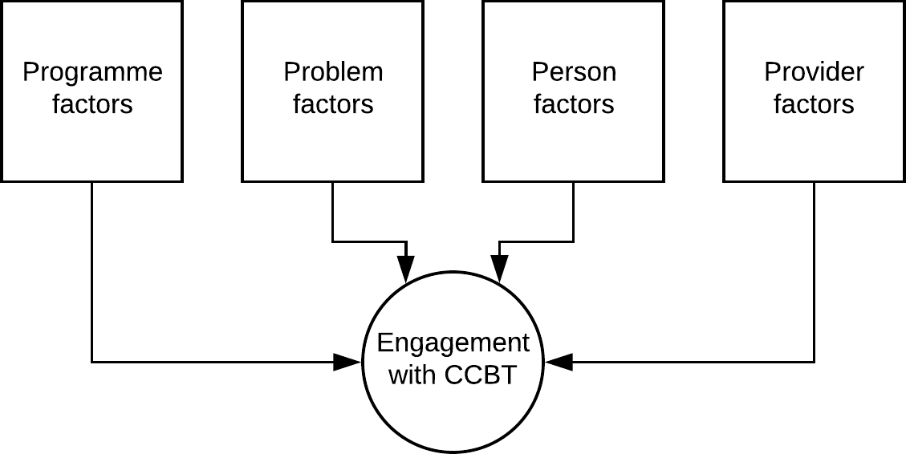
Within this body of work, it would not be feasible to explore all four P’s and their effect on engagement with MYLO. To implement Provider factors would require the involvement of external providers creating an array of additional ethical considerations. Similarly, Problem factors would involve clinical factors such as diagnosis creating further ethical considerations. It would also be unethical from a clinical viewpoint to use an experimental program on patients. This study, therefore, chooses to focus on the Programme and Person factors of the model and how their subfactors interact with one another (see Figure 6.2). The model proposed here firstly takes one element of programme factors, namely, style and interactivity, and measures it through system usability. Secondly, one element of person factors, namely, user expectation, is examined. Perceptions of MYLO’s system usability may determine a user’s belief in MYLO’s treatment credibility. Upon using MYLO, a user’s perceptions of system usability may also shape their pre-therapy expectations. All of these things may influence the strength of the therapeutic relationship formed with MYLO and all of these factors should contribute to the engagement people have with MYLO.
Figure 6.2 The 2 P Model for this study based on the 4 P’s model by Cavanagh and Millings (2013)
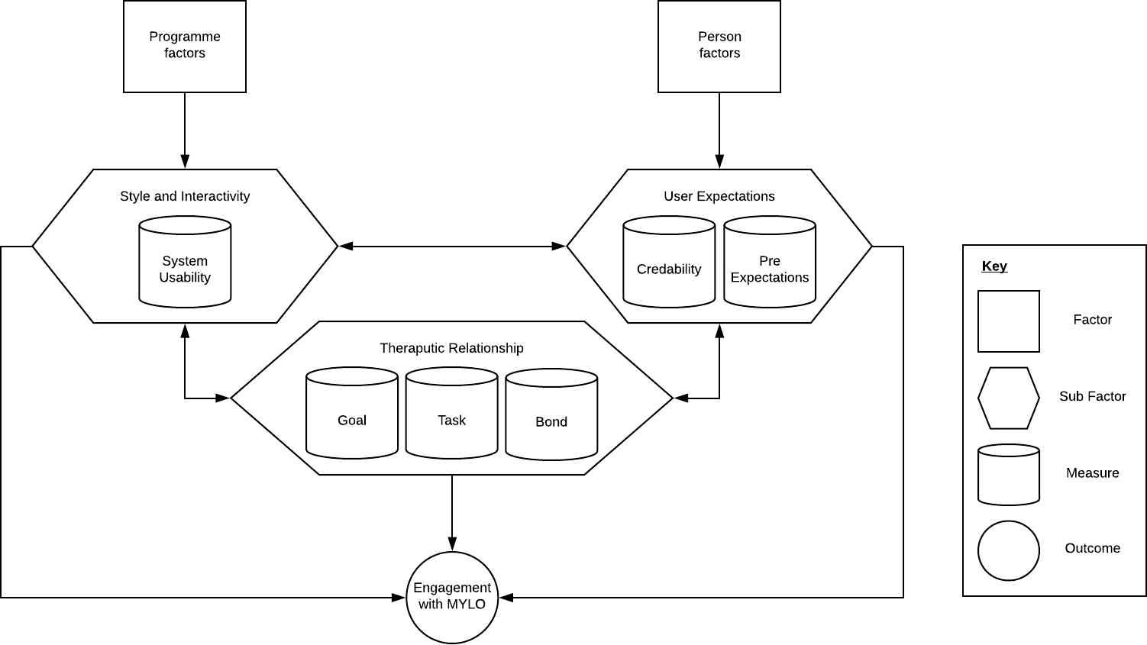

User Expectations

Pre-therapy Expectations
The pre-therapy expectations a user may have regarding e-therapy and its likely benefits may affect a user’s willingness to engage with the therapy and their hopefulness regarding the outcomes of using it (Cavanagh, 2010). Studies have found that having higher expectations of e-therapy may improve the uptake of treatment (Ritterband et al., 2015), result in better adherence (Murray et al., 2007; Kaltenthaler et al., 2008), and have a positive impact upon treatment completion (Cavanagh et al., 2009). All of these findings fit into the proposed model (Figure 6.2) where pre-therapy expectations maybe associated with greater engagement with MYLO. One suggested method of increasing treatment expectations may be to provide useful information about an e-therapy such as booklet, video, or taster session which may help users to engage with treatment (Cavanagh, 2010). This method was explored in a study by Mitchell and Gordon (2007) in which pre-credibility and preference for e-therapy were found to be initially poor among their sample. After being shown a short demonstration of e-therapy, the proportion of those expressing a preference for e-therapy increased from below 10 to 30%.

Credibility
Treatment credibility is how believable and convincing an intervention is perceived to be by a patient (Ritterband et al., 2015). Treatment credibility ratings for e-therapy tend to range from intermediate (Carlbring, Ekselius and Andersson, 2003) to high (Carlbring et al., 2001). This lack of consistency may point to there being problems in the way treatment credibility is assessed and a need for ‘gold standard’ (Ritterband et al., 2015). Regarding treatment credibility’s relationship with treatment outcome, consistent correlations have not been forthcoming, and in some cases, studies have found little connection between the two (Carlbring, Ekselius and Andersson, 2003; Kenardy, McCafferty and Rosa, 2003; Kaldo et al., 2008). Ritterband et al. (2015) have suggested that the look and feel of the e-therapy may play a significant role in how patients rate its credibility. This suggestion fits with the proposed model in Figure 6.2 where by system usability may influence MYLO’s treatment credibility.

Style and Interactivity
The style (aesthetic) of an app, which falls under the umbrella of ‘programme factors’ in the proposed model (Figure 6.2), encompasses the aesthetic experience which is suggested to be intrinsically motivating and requiring focused attention, which stimulates curiosity, interest and pleasure (Jennings and Morgan, 2000). The interactivity of an app enables a user to feel more involved in the process of what they are undertaking. The style (aesthetic) and interactivity of apps have both been associated with user engagement (Chapman, Selvarajah and Webster, 1999). O’Brien and Toms (2010) proposes six dimensions of the user engagement: Aesthetics, Endurability, Felt Involvement, Focussed Attention, Novelty and Perceived Usability. In the proposed model (Figure 6.2), style and interactivity are fundamental to usability.

The Therapeutic Relationship
In face-to-face therapy, the therapeutic relationship or working alliance is conceptualised by Bordin (1979) as being comprised of three aspects: the emotional bond between patient and therapist, the agreement between patient and therapist on the tasks of therapy, and the agreement between patient and therapist on the goals of treatment. The Working Alliance Inventory (WAI, Horvath and Greenberg, 1989) is a measure based on Bordin's work and widely used in psychotherapy research. The scale captures the three key alliance aspects: ‘Task’ - agreement on the tasks of therapy, ‘Goal’ - agreement on the goals of therapy and ‘Bond’ – the development of an affective bond.
Both Richardson and Richards (2006) and Peck (2010) have highlighted the importance of developing e-therapies that integrate ‘common factors’ and features of the therapeutic relationship. It has been stressed that e-therapies may fail to incorporate these factors, particularly those that are core to the therapeutic relationship (Helgadóttir et al., 2009).
The therapeutic relationship in e-therapy is the relationship between the service user and the therapist and their individual and shared expectations and beliefs about each other, and the programme. There is a need to understand further the nature of this relationship and how it may go beyond the traditional dyad (therapist-client) and triad (user-program-supporter) models (Cavanagh and Millings, 2013). Cavanagh (2010) refers to the triad model as a ‘triangle of alliance’ between the user, the software used and the programme supporter. In the proposed model (Figure 6.2), usability, credibility, and pre-expectations all feed in to therapeutic alliance, which in turn affects engagement. Conversational agents such as MYLO communicate via written or spoken dialogue, and the paradigm has more in common with face-to-face therapy than guided self-help. Limited research has been done to test for the presence of a therapeutic relationship between user and program within this dyad (user-agent) but some research has looked at how simulating human interaction through the use of technologies such as Avatars may increase the therapeutic alliance (Heim et al., 2018).

Aims
The primary aim of the current study is to examine whether enhanced user interface (UI) features improve the effectiveness, acceptability and usability of MYLO with older adults. Secondly, the study will investigate whether giving introductory information about MYLO and the underlying MOL therapy affects older adults’ initial treatment expectancy and credibility. Thirdly, the study will investigate whether system usability affects the working alliance and treatment credibility of a conversational agent for problem-solving. In the previous chapter, we investigated how system usability related to factors of acceptability and found that it may play a small but essential role in problem resolution, helpfulness and the likelihood of using a conversational agent again. Here, we will look to see if system usability affects the therapeutic relationship and its sub-scales of Task, Goal and Bond. Unlike general software, therapeutic software usability is focused on goal achievement (Mifsud, 2011). It is suggested that 10% to 15% of a task's success or failure is loosely linked to system usability (Sauro, 2012). Drawing from this principle, the current study will examine whether the usability of a conversational agent for problem-solving is associated with the task sub-scale of working alliance.
In order to address these aims, it is first necessary to identify which, of many possible enhancements to the user interface, it would be most fruitful to examine. To this end, a pilot survey was conducted to canvass opinion on possible enhancements and to guide decision-making regarding the technical work to be undertaken.

Pilot Survey
An online survey was created with the aim of establishing how older adults felt about a set of proposed technological enhancements that might improve the acceptability of MYLO. The technologies that were rated positively were implemented and tested with older adults in this study.

Pilot Survey Participants
A flyer advertising for participation in the study was sent via email to Universities of the Third Age (U3A) countrywide. Fifty-one participants responded to the flyer and were recruited to the pre-study survey. The University of the Third Age is a movement that aims to educate and stimulate its members (U3A, 2018). The membership is mainly comprised of retired members of the community in the third 'age' of their lives. The inclusion criteria required participants to be aged 50 years or above and to be able to read and hear clearly (with glasses or hearing aids if needed).

Pilot Survey Procedure
The study was approved by The University of Sheffield Psychology Department Ethics Committee.
Participants were asked to explore MYLO for up to 20 minutes and then complete the survey. The survey comprised 3 sections each covering a different area of enhancement: Speech Recognition – the identification of spoken language through the analysis of waveforms; Speech Synthesis – the generation of spoken language by a computer based on the textual input; Computer Avatars - the graphical representation of a user or computer as a character. In the survey, participants were presented with a video detailing the enhancement followed by questions relating to their thoughts on its potential application to MYLO.

Pilot Survey Results
A total of 32 participants completed the pilot survey. In response to the question “Having watched the video do you think adding speech recognition to MYLO would make it more acceptable to older adults?” the 32 participants recruited answered as follows: 4 strongly agree, 17 Somewhat agree, 6 Neither agree nor disagree and 5 Somewhat disagree. A chi-square goodness-of-fit test was conducted to determine whether an equal number of participants from each of the four agreement types were recruited to the study. The minimum expected frequency was 8.0. The chi-square goodness-of-fit test indicated that the number of strongly agree, somewhat agree, neither agree nor disagree and somewhat disagree participants recruited to the study was statistically significantly different (χ2(3) = 13.750, p = .003). This result indicates that just over half of the participants agreed to some degree that speech recognition would make MYLO more acceptable to older adults.
In response to the question “Having watched the video do you think adding speech synthesis to MYLO would make it more acceptable to older adults”. The 32 participants recruited answered as follows: 3 strongly agreed, 17 Somewhat agreed, 9 Neither agreed nor disagreed and 3 Somewhat disagreed. A chi-square goodness-of-fit test was conducted to determine whether an equal number of participants from each of the four agreement types were recruited to the study. The minimum expected frequency was 8.0. The chi-square goodness-of-fit test indicated that the number of strongly agree, somewhat agree, neither agree nor disagree and somewhat disagree participants recruited to the study was statistically significantly different (χ2(3) = 16.500, p = .001). This result suggests that just over half of the participants agreed to some degree that speech synthesis would make MYLO more acceptable to older adults.
In response to the question “Having watched the video do you think giving MYLO an avatar would make it more acceptable to older adults:” the 32 participants recruited answered: 2 strongly agreed, 6 Somewhat agreed, 7 Neither agreed nor disagreed, 11 Somewhat disagree, 8 Strongly disagreed. A chi-square goodness-of-fit test was conducted to determine whether an equal number of participants from each of the four agreement types were recruited to the study. The minimum expected frequency was 6.4. The chi-square goodness-of-fit test indicated that all responses were equally represented by the participants recruited to the study (χ2(4) = 5.500, p = .240).

Pilot Survey Conclusion
The results suggested that older adults may agree to some extent that both speech recognition and synthesis could improve the acceptability of MYLO with older adults. There was no clear agreement about whether an avatar may or may not improve the acceptability of MYLO with older adults. Based on these results the decision was made to implement only speech synthesis. Speech recognition was excluded due to a lack of control over multiple variables such as room acoustics, sound setup and microphone quality and avatars were excluded due to there being no clear-cut opinion of their potential benefit.

Hypotheses
- It is expected that the enhanced interface features will make MYLO a more effective conversational agent for problem-solving. It is therefore hypothesised that:
  - MYLO Guided with Speech will have significantly greater decrease in problem distress scores than the other two MYLO groups.
  - MYLO Guided with Speech will have significantly greater decreased in depression scores than the other two MYLO groups.
  - MYLO Guided with Speech will have significantly greater decreased in anxiety scores than the other two MYLO groups.
- Given that it is expected that the enhanced interface features will make MYLO a more acceptable conversational agent for problem-solving with older adults, it is further hypothesised that:
  - MYLO Guided with Speech will have significantly higher ratings of resolution than the other two MYLO groups.
  - MYLO Guided with Speech will have a significantly higher Net Promoter Score than the other two MYLO groups.
- It is expected that the enhanced interface features will result in MYLO having higher system usability. It is therefore hypothesised that:
  - MYLO Guided with Speech will have significantly higher system usability scores than the other two MYLO groups.
- Adding introductory guidance to MYLO regarding what it can and cannot do, along with details regarding and the underlying MOL therapy is expected to result in participants having higher treatment expectancy and credibility. It is therefore hypothesised that:
  - MYLO Guided with Speech will have significantly greater pre-intervention expectancy scores than the other two MYLO groups.
  - MYLO Guided with Speech will have significantly greater pre-intervention credibility scores than the other two MYLO groups.
- It is expected that usability will only be largely positively related only to agreement on the tasks of therapy on the Working Alliance Inventory. Based on the data of all 3 groups it is hypothesised that:
  - The overall Work Alliance Inventory will have a positive correlation with SUS scores.
  - The task element of the Work Alliance Inventory will have a positive correlation with SUS scores.
  - The goal element of the Work Alliance Inventory will have a positive correlation with SUS scores.
  - The bond element of the Work Alliance Inventory will have a positive correlation with SUS scores.
- It is further expected that usability will be positively associated with higher ratings of treatment credibility. Based on the data of all 3 groups it is hypothesised that:
  - The System Usability Scale (SUS) will have a positive correlation with perceived treatment credibility.

Main Study
In this study, the following interventions are compared: i) the MYLO software previously used in Chapter five, from herein referred to as ‘M’; ii) MYLO Guided, an enhanced version of the MYLO software from Chapter five, with the addition of introductory guidance and instructions about MYLO and the underlying MOL therapy, herein referred to as M+G; and iii) MYLO Guided with Speech, an enhanced version of M+G, with the addition of synthesised speech that reads the onscreen text aloud to the participant during the introduction, instructions and conversation, herein referred to as M+G+S.

Method

Participants
Ninety-four participants responded to the flyer and were recruited into the study. Participants were requested to have a problem that was currently causing them distress and that they were willing to disclose to a computer program. Further inclusion criteria required participants to be aged 50 years or above and to be able to read and hear clearly (with glasses or hearing aids if needed) and have access to a suitable computer, with headphones or speakers. At the randomisation stage of the study, 94 participants were randomised. The randomisation groups were relatively even at baseline with 33 allocated to the M group, 30 to the M+G group and 31 to the M+G+S group. At post-intervention 4 had dropped out from the M group, 4 in the M+G group and 1 in the M+G+S group. At 2-week follow-up two were lost to follow-up in the M+G group and 3 in the M+G+S group. A study flow diagram is provided below in Figure 6.3.
Figure 6.3 Study flow diagram
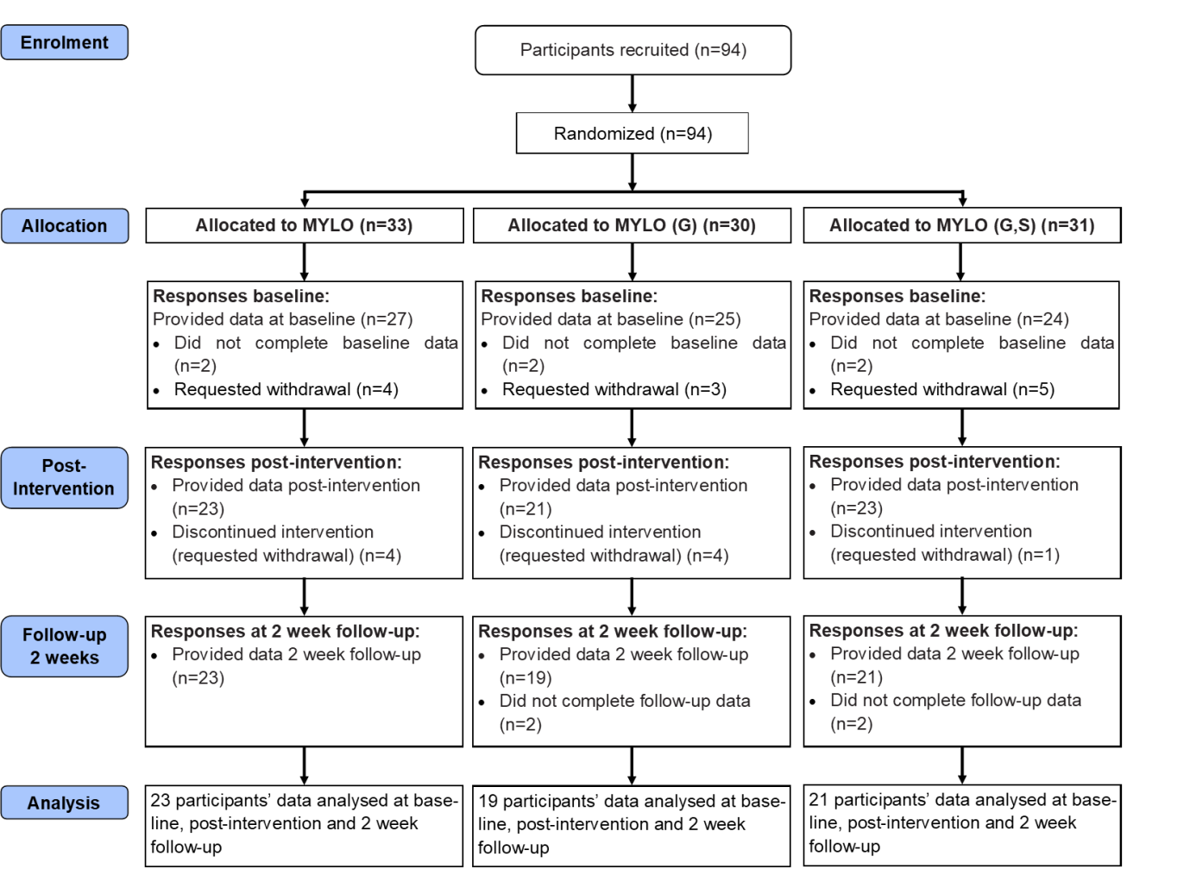

Computer Programs
The three programs used are described below.

Manage Your Life Online (MYLO)
M is an automated self-help-based computer program that emulates the type of conversation that could be expected between a client and a therapist. MYLO aims to aid the participant in solving their problem by applying the principles of Method of Levels (MOL) therapy (Carey, 2006). MYLO analyses textual responses from client input for key terms and themes, and responds with questions about the participant’s problem aimed at encouraging conflict awareness and facilitating higher level awareness (Gaffney et al. 2013). The version of MYLO used was the same as that developed and used in Chapter 5.

Manage Your Life Online (MYLO) Guided
M+G is an enhanced version of the system with an introduction and instructions. The introduction is comprised of a series of presentational web pages that the user must navigate through before being redirected to the baseline measures (see Appendix D1). The pages were adapted from the “Method of Levels: common questions about therapy” information sheet found within Mansell et al. (2012). The information sheet gives questions and answers to the most commonly asked patient questions regarding MOL therapy. Questions and answers considered irrelevant to MYLO and more applicable to face-to-face therapy were removed. While questions and answers that referred to Method of Levels (MOL) or a therapist were modified to read from the perspective of MYLO. These changes were made increase particpants pre credibiiltiy and expectancy of MYLO and help the particpant to form theraptic alliance with MYLO.
Original Question | Author Adaption
Deciding to seek help with your problem can be a big step to take. Once you have started Method of Levels (MOL), you might find that you have some questions about the therapy. Below are a few common questions that MOL clients have had, and some answers to these questions. Where relevant, we have also included anonymised quotes from people who have had MOL. If you have a question that is not covered below, please ask your therapist who will be happy to talk through any queries with you. | Hello, my name is Mylo,  Deciding to seek help with your problem can be a big step to take. Before we start the session, I shall go through a few common questions that my users have had in the past. If you have a question that I do not cover, please contact Matthew or one of his supervisors who will be happy to help you.
“What can I expect from MOL therapy?” You can expect a therapy which will allow you the time and space to talk through your difficulties. At each session you can choose whatever aspect of your difficulties you want to talk about, and your therapist will ask you questions about the thoughts and feelings you are experiencing. | What can you expect from me? You can expect to use an interactive computer system, which will allow you the time and space to talk through and reflect on your current difficulties. During the session, you can choose whatever aspect of your difficulties you want to talk about, and I will ask you questions about your thoughts and feelings. I will not suggest solutions to you, but will provide you with questions and prompts to help you make up your own mind about the best way forward for you.
“Can I bring a friend/partner/relative into the sessions with me?” MOL is all about helping people explore their own thoughts and feelings. This is most helpful for people when they can talk about their thoughts and feelings without being concerned that what they say might upset or worry somebody that they are close to. Therefore we would recommend that if you bring someone along, they stay in the waiting room while you actually have your therapy. | Can I have a friend, partner or relative present during our session? This is up to you, but I am here to help you explore your own thoughts  and feelings. It is most helpful for people when they don’t have to worry about saying something that could upset someone. Therefore, I would recommend that if you do have someone with you, they stay in another room while you are in the session with me.
“How long might I need therapy for?” The amount of therapy somebody needs varies widely from person to person. For some clients, one or two sessions is enough, for other people, more sessions are required. With MOL, it is you, the client who decides when to start and stop therapy, your therapist will not tell you how many sessions you have to attend, although different services may have certain limits on the numbers of sessions available. | How long might our session last for? The amount of time somebody needs varies widely from person to person. For some people, 10 to 15 minutes is enough, for others, more time is required. Take as much time as you feel you need. It is you who decides when to start and stop the session.
“Will my therapist give me advice on how to solve my problem?” While solutions to problems are very much the focus of MOL, your therapist will not offer you advice or otherwise try to suggest what the solution might be. MOL is based on the assumption that you are the best person to bring about positive change in your own life and you are the only person who will be able to tell when the right solution to your problem is found. During the session, you will be given the opportunity to talk things through and the therapist will ask questions to help you consider your problem in a different way. Through this questioning you will be able to develop new perspectives and understandings which will contain solutions to your problems.  One client said: “I think what I find useful is that you aren’t telling me what to do, so I feel as though I’m actually making myself better. I’m changing the way I think about things but I’m able to do this myself. I’m not doing it because you’ve told me how to. It makes me feel stronger because I know that I’m straightening my head out myself.” | Will you give me advice on how to solve my problem? I cannot tell you what the solution to your problem is, or offer you advice. I’m designed based on the assumption that you are the best person to bring about positive change in your life. You are the expert on your problem, and you are the only person who will be able to tell when you have found the right solution. During the session, you will be given the opportunity to talk things through. I will ask questions to help you consider your problem in a different way. Sometimes the same question needs to be asked a number of times to help people really reflect and think about how to answer. Through answering my questions, I hope to help you describe your problem more clearly, while enabling you to think about it from different points of view.
“How might I feel at different stages of the therapy?” Some clients report having different feelings about the therapy at different stages. During the first few sessions, some people felt that they struggled with the fact that they weren’t given any advice on their problem, and found it difficult to talk about upsetting things. However, as therapy continued, they came to feel as though they were making progress despite not being given advice, and began to feel more positive.  One client said: “It took me a while to understand the MOL, after I’d had a few sessions I started to question what the therapy was all about because I felt that I wasn’t getting any answers, but now I’ve come to understand that it’s about me being able to talk in whatever way I want to, and although you don’t give me any answers, you’ve sat there and said the right things to me and I’ve been able to learn the answers for myself”. | How might I feel at different stages of the session? Some people report having different feelings at different stages. Some people have struggled with the fact they were not given any advice. Others have found it difficult to talk about upsetting things. However, as the session continued, they came to feel as though they were making progress, and began to feel more positive. So give it a chance to work.
“What kinds of questions will I be asked and why?” You will be asked questions about your thoughts and feelings as you experience them in the session. The purpose of these questions is to provide you with an opportunity to talk and think about your problem in ways that you may not have considered before.  One client said:“The therapy has been brilliant. It’s helped me a lot and it’s really made me think differently about things which is something I’ve never done before. It’s great to be able to actually think through my thoughts.” | What kinds of question will I be asked and why? You will be asked questions about your thoughts and feelings as you experience them in the session. The purpose of these questions is to provide you with an opportunity to talk and think about your problems in ways that you may not have considered before.
“I am embarrassed/ashamed/guilty/worried about telling the therapist about my problem. Do I have to tell them everything to benefit from the therapy?” You do not have to talk about anything that you don’t want to. However, you may wish to talk about something without giving the therapist any details. This is absolutely fine. You don’t even have to name the problem, you could give it a code name, like ‘green apples’ and just talk about your thoughts and feelings regarding the ‘green apples’. The therapy focuses much more on the thoughts and feelings that you are currently experiencing rather than the story behind them. | I am ashamed, guilty or worried about my problem. Do I have to tell you everything to benefit from the session? You do not have to talk about anything you do not want to. Or you could talk about it without giving me all the details. This is absolutely fine. You do not even have to name the problem, you could give it a code name, like ”green apples” and then just talk about your thoughts and feelings regarding ”green apples”. The session will focus much more on the thoughts and feelings that you are currently experiencing rather than the story behind them.
“Do I have to answer the therapist’s questions?” You don’t have to answer the therapist’s questions if you don’t want to or if you feel as though you don’t have an answer to give. If this is the case, the therapist might explore with you how it feels to not know the answer or to not want to answer the question, but you will never be forced to answer anything that you can’t or don’t want to. | This question was removed as MYLO needs the user to answer as many of the questions asked as possible in order to better understand the participants problem.
“Why is the therapist asking me questions about things like my tone of voice, my facial expressions, or my body language?” MOL is interested not just in what you are saying, but also in the little background thoughts that you might be having as you are talking. Sometimes these thoughts might be really important in terms of how you view your problem. Usually when we have these little background thoughts our faces or bodies give us away. We might pause, look away, smile, change our tone of voice etc. So if your therapist asks you about any of these things they are just trying to check out if you are having any thoughts at that moment, and if so, what they might be. | This question was removed as MYLO presently has no ability to analyses tone of voice, facial expressions or body language.
“How will I feel when I leave a therapy session?” You may have a mixture of emotions following a session. Some clients report feeling good because they have been able to talk through important things, and have perhaps come to see them in a more helpful manner. However, for other clients, talking through their difficulties can be upsetting. It is normal to feel a bit emotional after a therapy session, as dealing with your problem can be a challenging thing to do. Some clients feel a bit confused about things and some clients report being in a thoughtful, reflective frame of mind.  One client said: “I get a lot out of the therapy; I usually leave the sessions feeling so much better than I did when I arrived. However, a few times it’s had the opposite effect on me when I’ve left feeling worse than I did when I got here!” | How will I feel when I finish the session? You may have a mixture of emotions following the session. Some people report feeling good because they have been able to talk through important things, and have perhaps come to see them in a different light. However, for others, talking through their problems can be mildly upsetting. It is normal to feel a bit emotional after a session, as dealing with your problems can be a challenging thing to do. As I mentioned at the start these are just a few of the questions that have been asked previously. I hope this information has given you an idea of what to expect from me. If you do have any further queries that have not been covered here or would like any of the points mentioned explaining in more detail, please contact Matthew or one of his supervisors who will be happy to talk things through with you. Thank you for listening and I really hope our session will be useful.
“How long will the sessions last and how often will I have to come?” Your first session will usually last about an hour although some of this time will be spent filling out questionnaires. Your subsequent sessions will last about 45 minutes, although they can be shorter than this if you wish. You can come to therapy as frequently as you want, as long as there is a free appointment slot. You can choose to come weekly, fortnightly, monthly, or more than once a week - whatever suits you best. | This question was removed as the experiment is only comprised of a single session.
“Why do I have to fill out questionnaires when I come for therapy?” Some of the questionnaires allow your therapist to monitor how you are feeling. For example, they might ask about your feelings of anxiety or depression over the past couple of weeks. The other questionnaires are needed as the MOL therapy is being offered as part of some research, and the questionnaires form an important part of this research. | This question was removed as it did not seem relevant to MYLO.
“Why does my therapist interrupt me when I am talking?” Your therapist may interrupt you when you are talking because they are interested in something that you have just said, and want to know more about it. Your therapist might also want to know about the background thoughts that were mentioned above and, often, the best time to find out about the background thoughts is while they’re actually there in your mind. If your therapist waits until you have finished what you are saying, you might not be able to remember the background thoughts that you were having a few minutes before. | This question was removed as MYLO does not interrupt participants.

For incorpation into MYLO the sheet has been written as though MYLO is directly speaking to the participant, some items have been removed for not being relevant to the automated context, and others adapted for the context. The instructions form a series of presentational web pages that the user must navigate through before being redirected to MYLO. The instructions was written as though MYLO is directly speaking to the participant and detail how to operate and use the program (see Appendix D2).

Manage Your Life Online (MYLO) Guided with Speech
M+G+S is a further enhanced version of MYLO Guided but with the addition of synthesised speech (see Appendix D3). The program reads aloud to the participant during the introduction, instructions and responds aloud during the session to try to provide a naturalistic and person-centric interface. To implement the speech generation, this version of MYLO passes its next utterance as a text string to a secure web server. The secure server then generates an MP3 file containing the spoken text. The location of the file is then sent to the participant’s web browser where MYLO picks up the web address and downloads the file before playing it to the participant. Further details on how this is implemented can be found in Appendix D4.

Materials

Demographics
Age and gender data were collected.

Measures of Effectiveness

Problem Description Ratings Scale (PDRS)
Similar to Gaffney et al. (2013) and the study carried out in Chapter 5, participants were asked to provide a qualitative description of a problem (e.g. with finances, relationships, family), a new 6-point scale to measure the time the person has had their problem for ranging from 0 (less than a month) and 5 (3 years or more). Two 11-point scales measuring the degree of distress caused by the problem ranging from 0 (not distressing at all) and 10 (highly distressing) and the problem’s solvability ranging from 0 (cannot be resolved) to 10 (easily resolved) (see Appendix C1).

Patient Health Questionnaire (PHQ-9)
The Patient Health Questionnaire (PHQ) is a 9-item self-administered version of the PRIME-MD diagnostic instrument for common mental disorders (Kroenke, Spitzer & Williams, 2001). The PHQ-9 scale is designed for use with adults in assessing and monitoring depression severity based on the 9 DSM-IV criteria, each rated as “0” (not at all) to “3” (nearly every day) (see Appendix D5).

Generalized Anxiety Disorder 7 (GAD-7)
General Anxiety Disorder (GAD-7; Spitzer et al., 2006) comprises seven items measuring symptoms and severity of anxiety based on the DSM-IV diagnostic criteria. The GAD-7 has good internal consistency (0.89) and good convergent validity with other anxiety scales (Kroenke et al., 2010) (see Appendix D6).

Measures of Pre-Treatment Credibility and Expectancy

Credibility and Expectancy Questionnaire (CEQ)
The credibility/expectancy questionnaire (CEQ; Devilly & Borkovec, 2000) is a 6-item scale over two sections, one related to thinking and one related to feeling. The scale measures treatment expectancy and rationale credibility and is intended for use in clinical outcome studies. Credibility (a cognitive factor) is derived from the first three ‘thinking’ questions and expectancy (a mainly affective factor) from the fourth ‘thinking’ question and the two ‘feeling’ questions. The scale has been found to be stable across different populations and to demonstrate high internal consistency within each factor (Devilly & Borkovec, 2000). Between 0.79 and 0.90 for expectancy, 0.82 and 0.86 for credibility and 0.84 and 0.85 for the whole scale (Devilly & Borkovec, 2000) (see Appendix D7).

Measures of Perceived Treatment Credibility

Credibility Scale (CS)
The Credibility Scale (CS; Sochting, Tsai & Ogrodniczuk, 2016) is a 6-item self-report questionnaire that was developed for a study assessing patients’ perceptions of the credibility of the treatment they were being provided. Participants respond to each item by rating the extent to which the treatment makes sense and is logical to them on a 5-point Likert-type scale. When the measure was developed parallel sets of items were created for “this therapy” and “the therapist” to allow for the possibility that patients may perceive these entities as distinct. However, principal components analysis of the scale revealed a single factor that accounted for 65.18% of the variance in item ratings. Therefore, the six questions are commonly expressed regarding a single credibility score. The internal consistency of CS was shown to be high (α = 0.89) (Sochting, Tsai & Ogrodniczuk, 2016) (see Appendix D8).

Measures of Acceptability

Rating of Resolution (RoR) v2
To measure the extent to which the problem was resolved, following Gaffney et al., (2013) participants were asked to what extent they feel their problem has been resolved, 0 (Not resolved at all) to 10 (completely resolved). System feedback questions have been version (see Appendix D9).

Net Promoter Score (NPS)
The Net Promoter Score (NPS; Reichheld, 2003) is a single metric that quantifies customer loyalty to a service through a single direct survey question: How likely are you to recommend this service? Three categories of responder are identified and classified from the scale as ‘promoters’ (those who would definitely recommend and use the service again), ‘passives’ (who are broadly happy but would not actively promote the service) and ‘detractors’ (who actively discourage others from experiencing the service). The overall score is calculated by taking the percentage of promoters and deducting it by the percentage of detractors (not including the passives). Scores can range from -100 (all detractors) to +100 (all promoters). Within industry a positive score is well considered, while scores over 50 are thought to highlight good performance (Department of Health and Social Care, 2012). The original description used a ten-point response scale, though subsequently a five-point response scale has been promoted (Reichheld, 2006; Keiningham et al., 2007). Most institutions use the shorter response scale, and this is the format the NHS ‘friends and family test’ has adopted to assess the likelihood of a patient recommending the healthcare received to another, and it is seen as a discriminator of healthcare performance (Hamilton et al., 2014). (see Appendix D10).

Measures of Usability

System Usability Scale (SUS)
The System Usability Scale (SUS; Brooke, 1996) is a 10-item scale of statements with a 5-point scoring scale on the strength of agreement from 1 to 5. To compute the scores into an overall SUS score: odd-numbered items, subtract one from the user response and even numbered items, subtracted the user responses from 5. This process leaves scale values from 0 to 4 with four being the most positive response. These scores are summed together and multiplied by 2.5 to create a final score. The final score can range from 0 to 100, with the higher the score, the better the level of usability. To interpret the SUS score into something meaningful the overall mean scores in this study will be converted into a grade/adjective based on the work of Bangor, Kortum and Miller (2009). (see Appendix C4).
Table 6.1 SUS adjective rating scale adapted from Bangor, Kortum and Miller (2009)
Raw SUS Score | Grade Scale | Acceptability Range | Adjective
90-100 | A | Acceptable | Best Imaginable
80-90 | B |  | Excellent
70-80 | C |  | Good
60-70 | D | Marginal | Ok
50-60 | F
40-50 |  | Not Acceptable | Poor
30-40
20-30 |  |  | Worst Imaginable
10-20
0-10

System Feedback
Three qualitative questions collecting feedback regarding MYLO comprised of the following: a description of 3 things the user found beneficial about MYLO, a description of 3 things that would improve MYLO, and any other comments or suggestions the user had regarding MYLO. (see Appendix D10).

MYLO question ratings
Every conversation with MYLO is recorded in a log file. The log file details the questions asked by MYLO; the answers given by the participant; the ratings given by the participant for each question asked by MYLO as problematic coded as 1, ok coded as 2 and helpful coded as 3. A log analyser written by the author sums each rating by occurrence for each conversation.

Measures of the Therapeutic Relationship

Working Alliance Inventory-Short Revised (WAI-SR)
The Working Alliance Inventory-Short Revised (WAI-SR; Hatcher & Gillaspy, 2006) is a 12-item measure for the assessment of the therapeutic alliance. The WAI-SR captures three key alliance aspects: (a) agreement on the tasks of therapy, (b) agreement on the goals of therapy and (c) development of an affective bond. The scale has been used to assess working alliance in ICBT (Andersson, Paxling, Wiwe, et al., 2012), with mean scores between 1.00–2.44 interpreted as a low alliance, 2.45–3.44 moderate alliance and 3.45–5.00 high alliance (Jasper et al., 2014). Cronbach's α on the total score and subscales ranged from 0.87 to 0.94. (see Appendix D11).

Procedure
Ethical approval was gained from the University of Sheffield Psychology Ethics Committee (see Appendix D12). A flyer advertising for participation in the core study was sent via email to Universities of the Third Age (U3A) countrywide (see Appendix D13). Each participant was requested to register their email address on a secure website (see Appendix D14). They were then sent an email by the BSMS (see Appendix D11 for the BSMS process) containing a link to an online Qualtrics based participant information sheet and consent form (see Appendix D15). Upon completion of the form, Qualtrics randomly allocated the participant to one of three intervention arms: M, M+G, or M+G+S.
After allocation, a further email was sent by the BSMS detailing further instructions about each stage of the study along with a link to allow the participant to begin. Upon clicking the link participants were directed to a specific location depending on their allocated group. M group were directed to a set of baseline measures comprising of PDRS, RoR, PHQ-9, GAD-7, CEQ and CS measures; M+G group were taken to an introduction to MYLO (see Appendix D1) before being redirected to the same baseline measures as M group; and M+G+S group were taken to an audio test to confirm their loudspeaker/headphones were working (see Appendix D17) before being taken to the same introduction as M+G group (see Appendix D1). However, unlike the M+G group, the voice of MYLO would read aloud the introduction before redirecting the participant to the same baseline measures as the M group.
Upon arriving at the MYLO system participants were required to login before conversing with the computer program. Because the study ran online, it was not possible to control maximum talk time: participants were directed to use the program until they had reached the end of their conversation or 20 minutes had passed. The duration of use was recorded. The average length of time spent using MYLO was 35.61 minutes (SD = 27.68), MYLO guided 32.89 (SD = 25.69) and MYLO guided with speech 25.19 (SD = 21.30). After ending the conversation with the program, participants were taken to a set of post-measures comprised of the RoR, SUS, NPS, CS and WAI measures.
Two weeks following the session, participants were sent an email asking them to complete a set of follow-up measures to complete their involvement in the study. These measures were comprised of RoR, PHQ-9, GAD-7, CS and NPS. Participants were then debriefed (see Appendix D18)

Sample Size Calculation
To determine the minimum number of participants for adequate study power, the ClinCalc Sample Size Calculator was used, based on Rosner (2011). The calculation was carried out based on the previous study where a Cohen’s d of 1.33 was found for the baseline and post-intervention comparison of distress scores in the MYLO group. A power analysis indicated that the minimum group size required was 6 with adequate power (0.8). However, the previous study also reported improvements in distress between MYLO and ELIZA groups was not significant. As a result of this a further power analysis was carried out based upon the post-intervention distress scores of both MYLO and ELIZA groups where a Cohen’s d of 0.33 was found. This indicated that the minimum group size required was 121 with adequate power of (0.8), resulting in a target sample size of 363.

Data Analysis
All analyses were conducted using SPSS for Windows (Version 23). The primary outcome measure for the study was problem-related distress. DASS-21, problem resolution, and helpfulness, use again and system usability were secondary outcome measures. While ANOVA analyses were in intended, the assumptions of parametric tests were violated (data was not normally distributed). Therefore, non-parametric analysis was used throughout.
To investigate hypothesis one, that enhanced interface features will make MYLO a more effective conversational agent for problem-solving, Kruskal-Wallis tests were performed on groups (MYLO, MYLO Guided and MYLO Guided with Speech) and time points (baseline, post-intervention and 2-week follow-up) for problem-related distress. Three Friedman tests were carried out for each group (MYLO, MYLO Guided and MYLO Guided with speech) across all three time points (baseline, post-intervention and 2-week follow-up) for problem-related distress. Kruskal-Wallis tests were performed on groups (MYLO, MYLO Guided and MYLO Guided with Speech) and time points (baseline and 2-week follow-up) for PhQ-9 and GAD-7. Signed tests were carried out for each group (MYLO, MYLO Guided and MYLO Guided with Speech) across time points (baseline and 2-week follow-up) for PhQ-9 and GAD-7.
To investigate hypothesis two, that enhanced interface features will make MYLO a more acceptable conversational agent for problem-solving with older adults, Kruskal-Wallis tests were performed on groups (MYLO, MYLO Guided and MYLO Guided with Speech) and time points (baseline and 2-week follow-up) for ratings of resolution and net promoter score. Wilcoxon Signed Rank tests were carried out for each group (MYLO, MYLO Guided and MYLO Guided with Speech) across time points (baseline and 2-week follow-up) for Ratings of Resolution.
To investigate hypothesis three, that adding enhanced interface features to MYLO would result in higher system usability, several analyses were undertaken. Firstly, Kruskal-Wallis tests were performed comparing system usability between groups (MYLO, MYLO Guided and MYLO Guided with Speech) and time points (post-intervention).
Secondly, to evaluate MYLO’s AI by examining its ability to respond to a participant’s answers effectively. Participant question rating totals for each participant’s conversation were calculated for problematic, okay and helpful and Kruskal-Wallis tests were performed on groups (MYLO, MYLO Guided and MYLO Guided with Speech) and time points (post-intervention) for participant question rating totals for problematic, okay and helpful.
Finally, the qualitative system feedback data regarding suggested system improvements was appraised and coded according to one of four improvement categories:
- AI – The conversational functionality of MYLO such as the responses MYLO gives and their appropriateness to a user’s input (that is, the quality of its ‘artificial intelligence’, AI). E.g. “MYLO needs to understand my problem”.
- UI – The user interface design and functionality of MYLO such as the controls (buttons, drop-down lists, etc.), visual style (colours, graphics, text, etc.), ‘missing’ user-triggered functionality such as the ability to enlarge text via a button. E.g. “The text needs to be bigger”.
- Therapy – Suggestions regarding the underlying therapy such as giving advice or involving a human. E.g. “MYLO needs to give me answers to my problems”.
- Other – Anything that was not related to the AI, UI, Therapy of MYLO. E.g. “Scrap it!”
Coding was validated by a second Computer Scientist (Dr Stephen Potter) to attempt to remove any bias. Cohen's kappa (κ) was run to determine if there was an agreement between the two evaluators on whether the improvement suggestions were related to AI, UI, Therapy or Other. The totals for each category were then calculated along with the overall percentage of the total improvements for each MYLO group.
To investigate hypothesis four regarding whether adding introductory guidance regarding MYLO increased MYLO’s baseline pre-treatment credibility and expectancy, Kruskal-Wallis tests were performed on groups (MYLO, MYLO Guided and MYLO Guided with Speech) and time points (baseline) for pre-credibility and pre-expectancy.
To investigate hypothesis five regarding the relationship between usability and working alliance and agreement on the tasks of therapy, for completeness, four Spearman’s rank-order correlations were conducted to investigate whether system usability was associated with working alliance score and its sub-scores goal, task, and bond.
To investigate hypothesis six regarding the relationship between usability and treatment credibility, a Spearman's rank-order correlation was performed.

Results

Descriptive Statistics
A total of 63 participants (18 males) aged 52-85 (M = 65.9) were included in the analysis. There were 23 participants in the MYLO condition (7 Male), 19 in the MYLO Guided condition (5 male) and 21 in the MYLO Guided with Speech condition (6 Male). All analyses were conducted using SPSS for Windows (Version 24). Descriptive statistics for distress, resolution, PHQ-9, GAD-7, CEQ, CS, RoC baseline and post-intervention and follow-up are presented in Table 6.3.
Table 6.3. Means and standard deviations for baseline, post-intervention and follow-up measures
Measure | M Group (n=23) |  | M+G Group (n=19) |  | M+G+S Group (n=21)
 | Mean | SD | Mean | SD | Mean | SD
Problem-related Distress
Baseline | 6.52 | 2.04 | 5.95 | 3.15 | 5.86 | 2.37
Post-Intervention | 5.26 | 2.47 | 4.53 | 3.20 | 4.81 | 2.62
Follow-up | 4.43 | 2.47 | 3.42 | 1.95 | 3.86 | 2.58
Problem Resolvability
Baseline | 5.87 | 3.15 | 6.47 | 3.12 | 5.57 | 3.17
Problem Resolution
Post-Intervention | 1.78 | 2.68 | 2.84 | 3.35 | 2.10 | 3.16
Follow-up | 4.13 | 3.07 | 4.53 | 3.20 | 3.33 | 3.06
PHQ-9
Baseline | 7.65 | 5.55 | 6.53 | 4.23 | 6.67 | 7.23
Follow-up | 6.74 | 7.03 | 4.37 | 5.40 | 4.67 | 6.01
GAD-7
Baseline | 6.00 | 5.03 | 4.37 | 3.95 | 4.57 | 5.88
Follow-up | 5.09 | 5.00 | 3.79 | 4.74 | 3.43 | 4.93
CEQ Pre-Expectancy
Baseline | 9.87 | 6.08 | 6.89 | 4.81 | 11.05 | 7.21
CEQ Pre-Credibility
Baseline | 13.00 | 4.35 | 11.57 | 4.06 | 13.24 | 4.45
CS Credibility
Baseline | 17.57 | 3.46 | 16.68 | 3.43 | 19.14 | 3.41
Post-Intervention | 12.57 | 5.58 | 14.05 | 5.29 | 13.52 | 6.51
WAI Goal
Post-Intervention | 1.46 | .74 | 1.36 | .56 | 1.52 | .69
WAI Task
Post-Intervention | 1.65 | .94 | 1.74 | .05 | 1.62 | .85
WAI Bond
Post-Intervention | 1.75 | .98 | 1.91 | 1.07 | 1.81 | 1.11
WAI Overall
Post-Intervention | 1.62 | .80 | 1.67 | .61 | 1.65 | .82
NPS
Post-Intervention | 1.87 | 2.63 | 2.42 | 2.91 | 2.14 | 3.02
Follow-up | 3.65 | 2.92 | 3.47 | 3.24 | 3.52 | 2.94
SUS
Post-Intervention | 64.46 | 18.23 | 64.61 | 19.95 | 60.24 | 17.99

Do Enhanced Interface Features Make MYLO a More Effective Conversational Agent for Problem-Solving?

Problem-Related Distress
A Kruskal-Wallis H test was conducted to determine if there were differences in problem-related distress between groups at baseline between the three groups: M (n = 23), M+G (n = 19), and M+G+S (n = 21). Distributions of problem-related distress at baseline were not similar for all groups, as assessed by visual inspection of a boxplot (see Figure 6.4). The mean rank of baseline problem-related distress scores was not statistically significantly different between groups, χ²(2) = 1.301, p = .522.
Figure 6.4 Baseline problem-related distress boxplot
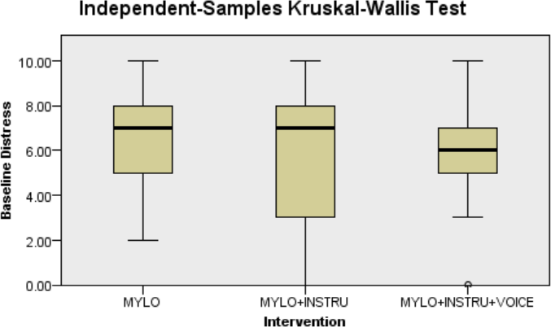
A Kruskal-Wallis H test was conducted to determine if there were differences in problem-related distress between groups at post-intervention between the three groups: M (n = 23), M+G (n = 19), and M+G+S (n = 21). Distributions of problem-related distress at post-intervention were not similar for all groups, as assessed by visual inspection of a boxplot (see Figure 6.5). The mean rank of post-intervention problem-related distress scores was not statistically significantly different between groups, χ²(2) = .915, p = .633.
Figure 6.5 Post-intervention problem-related distress boxplot
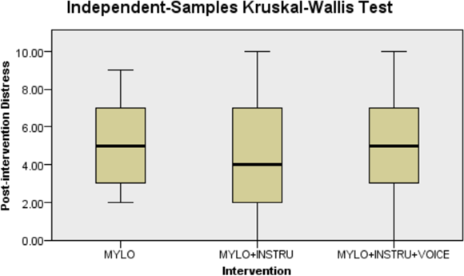
A Kruskal-Wallis H test was conducted to determine if there were differences in problem-related distress between groups at follow-up between the three groups: M (n = 23), M+G (n = 19), and M+G+S (n = 21). Distributions of problem-related distress at follow-up were not similar for all groups, as assessed by visual inspection of a boxplot (see Figure 6.6). The mean rank of follow-up problem-related distress scores was not statistically significantly different between groups, χ²(2) = 1.548, p = .461.
Figure 6.6 Follow-up problem-related distress boxplot
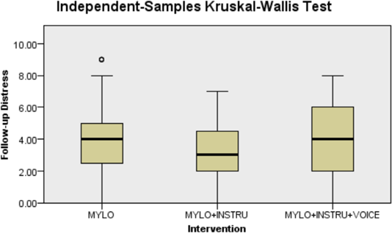
A Friedman test was run to determine if there were differences in problem-related distress between baseline, post-intervention and follow-up for M group. Pairwise comparisons were performed (SPSS Statistics, 2012) with a Bonferroni correction for multiple comparisons. Problem-related distress was statistically significantly different at the different time points during the M group, χ²(2) = 13.053, p < .001. Post hoc analysis revealed statistically significant differences in problem-related distress from baseline (Mdn = 7.00) to follow-up (Mdn = 4.00) (p < .001), but not for baseline to post-intervention and post-intervention to follow-up.
A Friedman test was run to determine if there were differences in problem-related distress between baseline, post-intervention and follow-up for M+G group. Problem-related distress was statistically significantly different at the different time points during the M+G group, χ²(2) = 9.806, p < .001. Post hoc analysis revealed statistically significant differences in problem-related distress from baseline (Mdn = 7.00) to post-intervention (Mdn = 4.00) (p < .001), but not for baseline to follow-up and post-intervention to follow-up.
A Friedman test was run to determine if there were differences in problem-related distress between baseline, post-intervention and follow-up for the M+G+S group. Problem-related distress was statistically significantly different at the different time points during the M+G+S group, χ²(2) = 9.029, p < .001. Post hoc analysis revealed statistically significant differences in problem-related distress from baseline (Mdn = 6.00) to follow-up (Mdn = 4.00) (p < .001), but not for post-intervention to baseline and follow-up to post-intervention.

Depression
A Kruskal-Wallis H test was conducted to determine if there were differences in depression between groups at baseline between the three groups: MYLO (n = 23), MYLO Guided (n = 19), and MYLO Guided with Speech (n = 21). Values are mean ranks unless otherwise stated. Distributions of depression score at baseline were not similar for all groups, as assessed by visual inspection of a boxplot (see Figure 6.7). MYLO Guided with Speech (28.69) recorded lower depression score at baseline than MYLO Guided (32.66) and MYLO (34.85) groups, but the differences were not statistically significant, χ²(2) = 1.450, p = .484.
Figure 6.7 Baseline depression boxplot
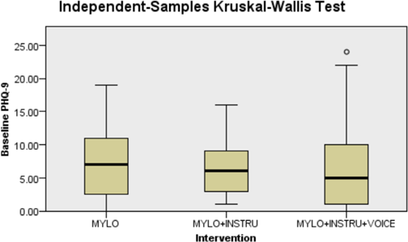
A Kruskal-Wallis H test was conducted to determine if there were differences in depression score between groups at follow-up between the three groups: MYLO (n = 23), MYLO Guided (n = 19), and MYLO Guided with Speech (n = 21). Values are mean ranks unless otherwise stated. Distributions of depression score at follow-up were not similar for all groups, as assessed by visual inspection of a boxplot (see Figure 6.8). MYLO Guided with Speech (29.60) recorded lower depression score at follow-up than MYLO Guided (30.00) and MYLO (35.85) groups, but the differences were not statistically significant, χ²(2) = 1.633, p = .442.
Figure 6.8 Follow-up depression boxplot
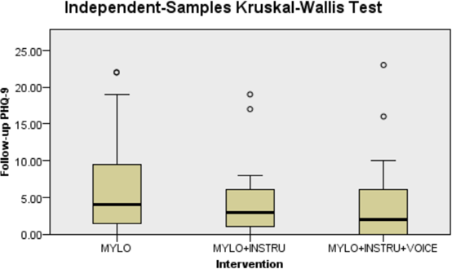
A series of sign tests were conducted to determine if there were differences in depression scores between baseline, post-intervention and follow-up time points for each of the three groups.
A sign test with continuity correction was used to compare the differences in depression between baseline and follow-up for the M group. Of the 23 participants recruited, 13 decreased in depression score, six increased in depression score and four participants had no change. Overall, participants decreased in depression from baseline (Mdn = 7.00) to follow-up (Mdn = 4.00), a non-significant decrease in the median of the differences of -1.00, z = -1.273, p = .203.
A sign test with continuity correction was used to compare the differences in depression between baseline and follow-up for the M+G group. Of the 19 participants recruited, 14 decreased in depression score, two increased in depression and three had no change. Overall, participants decreased in depression from baseline (Mdn = 6.00) to follow-up (Mdn = 3.00), a statistically significant decrease in the median of the differences of -2.00, z = -2.731, p = .006.
A sign test with continuity correction was used to compare the differences in depression between baseline and follow-up for the M+G+S group. Of the 21 participants recruited, 14 decreased in depression, two increased in depression and three had no change at all. Overall, participants decreased in depression from baseline (Mdn = 5.00) to follow-up (Mdn = 2.00), a statistically significant decrease in the median of the differences of -1.00, z = -2.168, p = .030.

Anxiety
A Kruskal-Wallis H test was conducted to determine if there were differences in anxiety between groups at baseline between the three groups: M (n = 23), M+G (n = 19), and M+G+S (n = 21). Values are mean ranks unless otherwise stated. Distributions of anxiety score at baseline were not similar for all groups, as assessed by visual inspection of a boxplot (see Figure 6.9). The M+G+S group (28.31) recorded lower anxiety at baseline than M+G (30.39) and M (36.70) groups, but the differences were not statistically significant, χ²(2) = 2.536, p = .281.
Figure 6.9 Baseline anxiety boxplot
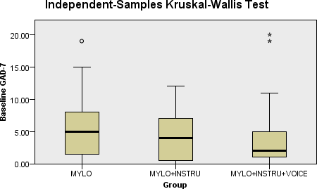
A Kruskal-Wallis H test was conducted to determine if there were differences in anxiety between groups at follow-up between the three groups: M (n = 23), M+G (n = 19), and M+G+S (n = 21). Values are mean ranks unless otherwise stated. Distributions of anxiety score at follow-up were not similar for all groups, as assessed by visual inspection of a boxplot (see Figure 6.10). The M+G+S group (27.90) recorded lower anxiety at follow-up than M+G (31.18) and M (36.41) groups, but the differences were not statistically significant, χ²(2) = 2.491, p = .288.
Figure 6.10 Follow-up anxiety boxplot
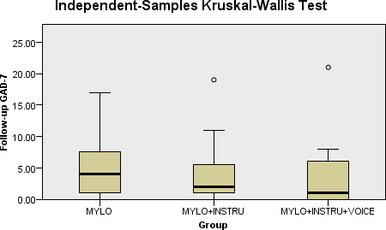
A series of sign tests were conducted to determine if there were differences in anxiety scores between baseline, post-intervention and follow-up time points for each of the three groups.
A sign test with continuity correction was used to compare the differences in anxiety between baseline and follow-up for the M group. Of the 23 participants recruited, 13 decreased in anxiety score, seven increased in anxiety score and three participants had no change. Overall, participants decreased in anxiety from baseline (Mdn = 5.00) to follow-up (Mdn = 4.00), a statistically non-significant decrease in the median of the differences of -1.00, z = -1.118, p = .264.
A sign test with continuity correction was used to compare the differences in anxiety between baseline and follow-up for the M+G group. Of the 19 participants recruited, nine decreased in anxiety score, five increased in anxiety score and five had no change. Overall, participants decreased in anxiety from baseline (Mdn = 4.00) to follow-up (Mdn = 2.00), a statistically non-significant decrease in the median of the differences of .00, z = -.802, p = .424.
A sign test with continuity correction was used to compare the differences in anxiety between baseline and follow-up for the M+G+S group. Of the 21 participants recruited, 11 decreased in anxiety, seven increased in anxiety and three had no change at all. Overall, participants decreased in anxiety from baseline (Mdn = 2.00) to follow-up (Mdn = 1.00), a statistically non-significant decrease in the median of the differences of -1.00, z = -.707, p = .481.

Do Enhanced User Interface Features Make MYLO a More the Acceptability Conversational Agent for Problem-Solving?

Ratings of Resolution
A Kruskal-Wallis H test was conducted to determine if there were differences in rating of resolution between groups at baseline between the three groups: M (n = 23), M+G (n = 19), and M+G+S (n = 21). Distributions of rating of resolution at post-intervention were not similar for all groups, as assessed by visual inspection of a boxplot (see Figure 6.11). The mean rank of baseline rating of resolution scores was not statistically significantly different between groups, χ²(2) = 1.387, p = .500.
Figure 6.11 Post-intervention rating of resolution boxplot
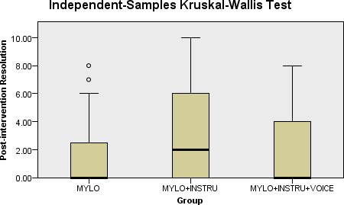
A Kruskal-Wallis H test was conducted to determine if there were differences in rating of resolution between groups at follow-up between the three groups: MYLO (n = 23), MYLO Guided (n = 19), and MYLO Guided with Speech (n = 21). Distributions of rating of resolution at follow-up were not similar for all groups, as assessed by visual inspection of a boxplot (see Figure 6.12). The mean rank of follow-up rating of resolution scores was not statistically significantly different between groups, χ²(2) = 1.611, p = .447.
Figure 6.12 Follow-up rating of resolution boxplot
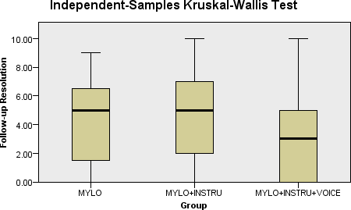
A series of sign tests were conducted to determine if there were differences in rating of resolution scores between baseline, post-intervention and follow-up time points for each of the three groups.
A sign test with continuity correction was used to compare the differences in rating of resolution between baseline and follow-up for the M group. Of the 23 participants recruited, 14 increased in rating of resolution score, one decreased in rating of resolution score, and eight participants had no change. Overall, participants decreased in rating of resolution from baseline (.00) to follow-up (5.00), a significant decrease in the median of the differences of 2.00, z = 3.098, p = .002.
A sign test with continuity correction was used to compare the differences in rating of resolution between baseline and follow-up for the M+G group. Of the 19 participants recruited, 11 increased in rating of resolution score, three decreased in rating of resolution score, and five had no change. Overall, participants decreased in rating of resolution from baseline (2.00) to follow-up (5.00), a non-statistically significant decrease in the median of the differences of 1.00, z = 1.871, p = 061.
A sign test with continuity correction was used to compare the differences in rating of resolution between baseline and follow-up for the M+G+S group. Of the 21 participants recruited, 10 increased in rating of resolution, five decreased in rating of resolution, and six had no change at all. Overall, participants decreased in rating of resolution from baseline (.00) to follow-up (3.00), a statistically non-significant decrease in the median of the differences of .00, z = 1.033, p = .302.

Net Promoter Score
A Kruskal-Wallis H test was conducted to determine if there were differences in net promoter score between groups at post-intervention between the three groups: M (n = 23), M+G (n = 19), and M+G+S (n = 21). Distributions of net promoter score at baseline were not similar for all groups, as assessed by visual inspection of a boxplot (see Figure 6.13). The mean rank of post-intervention net promoter scores was not statistically significantly different between groups, χ²(2) = .689, p = .709.
Figure 6.13 Post-intervention net promoter score boxplot
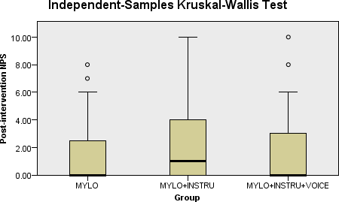
A Kruskal-Wallis H test was conducted to determine if there were differences in net promoter score between groups at follow-up between the three groups: M (n = 23), M+G (n = 19), and M+G+S (n = 21). Distributions of net promoter score at follow-up were not similar for all groups, as assessed by visual inspection of a boxplot (see Figure 6.14). The mean rank of follow-up net promoter scores was not statistically significantly different between groups, χ²(2) = .098, p = .952.
Figure 6.14 Follow-up net promoter score boxplot
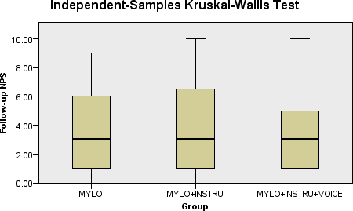
To investigate further NPS scores were grouped by detractors (0 to 6), passives (7 to 8) and promoters (9 to 10) and an overall NPS calculated by deducting the percentage of promoters from the percentage of detractors (excluding passives). The charts in Figure 6.15 show the distribution percentages of detractors (red), passives (yellow) and promoters (green) and the central number represents the overall NPS score. All three groups failed to reach a score of 50 or above which is the score considered by the UK Department of Health and Social Care (2012) to show good performance.

Figure 6.15 Net promoter score analysis
Intervention | Post Intervention | Follow-up
MYLO | 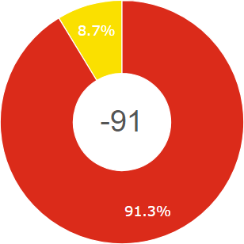 | 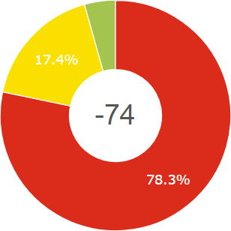
MYLO Guided | 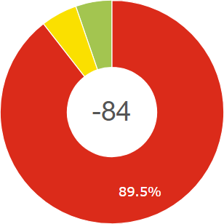 | 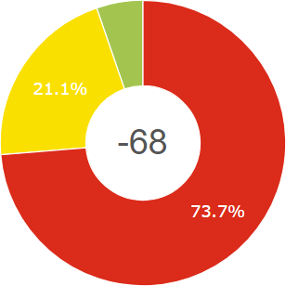
MYLO Guided with Voice | 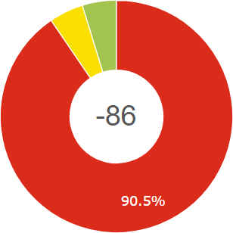 | 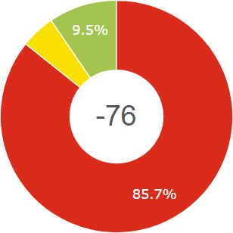

Do Enhanced Interface Features Improve Mylo’s System Usability?

System Usability
A Kruskal-Wallis H test was conducted to determine if there were differences in system usability between groups at post-intervention between the three groups: M (n = 23), M+G (n = 19), and M+G+S (n = 21). Distributions of system usability score at post-intervention were not similar for all groups, as assessed by visual inspection of a boxplot (see Figure 6.16). The mean rank of follow-up system usability scores was not statistically significantly different between groups, χ²(2) = 1.551, p = .460.
Figure 6.16 Post-intervention system usability score boxplot
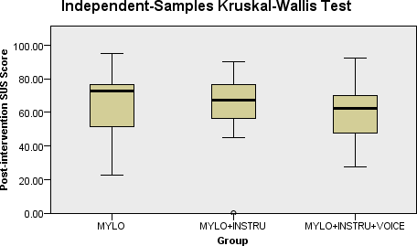
None of the MYLO versions scored within the acceptable range for usability, instead all fell within “Marginal” with an “Ok” score (see Table 6.1). Overall the interface enhancements did not improve MYLO’s system usability with older adults.

System Feedback
A total of 135 improvement suggestions were made over the three MYLO groups: M (n = 51), M+G (n = 39), M+G+S (n = 45). There was a very good agreement between the two evaluators judgements, κ = .840, p < .0005. The two evaluators agreed that 61 of the responses were AI, 35 were UI, 18 were Therapy, and seven were Other. However, evaluator 1 rated nine improvements as AI when evaluator 2 rated two as UI and seven as Therapy, and evaluator 1 rated two improvements as Other when evaluator 2 rated them as Therapy, final evaluator 1 rated three improvements as Therapy where evaluator 2 rated them as AI.
Table 6.4 Category examples
Category | Examples
AI | “no repetitions of questions”
UI | “design it softer colour etc”
Therapy | “Stop asking me what I thought of my answer”
Other | “abandon it”

The results indicated that the area requiring most improvement was MYLO’s AI receiving the highest percentage of suggestions in all groups (see Table 6.5). M group received the highest number of suggestions relating to the underlying MOL therapy. The M+G+S group at the lowest number of suggestions relating to the UI.

Table 6.5 System feedback improvement suggestions by improvement category by group
Group | Category | Total (Percent)
MYLO | AI | 17 (33.3)
 | UI | 17 (33.3)
 | Therapy | 15 (29.4)
 | Other | 2 (3.9)
MYLO Guided | AI | 25 (64.1)
 | UI | 8 (20.5)
 | Therapy | 3 (7.7)
 | Other | 3 (7.7)
MYLO Guided with Speech | AI | 28 (62.2)
 | UI | 10 (22.2)
 | Therapy | 3 (6.7)
 | Other | 4 (8.9)

MYLO Question Ratings

Problematic Ratings
A Kruskal-Wallis H test was conducted to determine if there were differences in problematic ratings between groups at post-intervention between the three groups: MYLO (n = 23), MYLO Guided (n = 19), and MYLO Guided with Speech (n = 21). Values are mean ranks unless otherwise stated. Distributions of problematic ratings at post-intervention were not similar for all groups, as assessed by visual inspection of a boxplot (see Figure 6.17). MYLO Guided (31.55) recorded lower problematic ratings at post-intervention than MYLO (31.80) and Guided MYLO with Speech (32.62) groups, but the differences were not statistically significant, χ²(2) = .038, p = .981.
Figure 6.17 Post-intervention problematic ratings boxplot
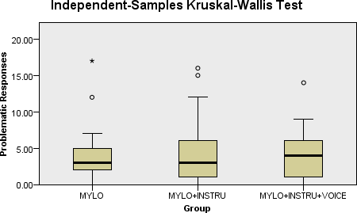

Okay Ratings
A Kruskal-Wallis H test was conducted to determine if there were differences in okay ratings between groups at post-intervention between the three groups: MYLO (n = 23), MYLO Guided (n = 19), and MYLO Guided with Speech (n = 21). Values are mean ranks unless otherwise stated. Distributions of okay ratings at post-intervention were not similar for all groups, as assessed by visual inspection of a boxplot (see Figure 6.18). MYLO (33.09) recorded higher okay ratings at post-intervention than MYLO Guided (32.82) and MYLO Guided with Speech (30.07) groups, but the differences were not statistically significant, χ²(2) = .351, p = .839.
Figure 6.18 Post-intervention okay ratings boxplot
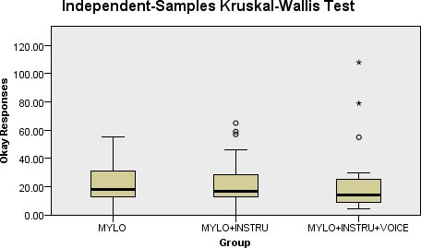

Helpful Ratings
A Kruskal-Wallis H test was conducted to determine if there were differences in helpful ratings between groups at post-intervention between the three groups: MYLO (n = 23), MYLO Guided (n = 19), and MYLO Guided with Speech (n = 21). Values are mean ranks unless otherwise stated. Distributions of helpful ratings at post-intervention were not similar for all groups, as assessed by visual inspection of a boxplot (see Figure 6.19). MYLO Guided (34.39) recorded higher helpful ratings at post-intervention than MYLO (32.35) and MYLO Guided with Speech (29.45) groups, but the differences were not statistically significant, χ²(2) = 1.084, p = .582.
Figure 6.19 Post-intervention helpful ratings boxplot
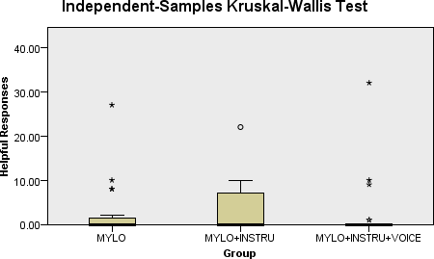

Does Adding Introductory Guidance Regarding Mylo and What It Can and Cannot Do Increase Mylo’s Pre-Treatment Expectancy and Credibility?

Pre-credibility
A Kruskal-Wallis H test was conducted to determine if there were differences in pre-credibility ratings between groups at baseline between the three groups: MYLO (n = 23), MYLO Guided (n = 19), and MYLO Guided with Speech (n = 21). Values are mean ranks unless otherwise stated. Distributions of pre-credibility score at baseline were not similar for all groups, as assessed by visual inspection of a boxplot (see Figure 6.20). MYLO Guided with Speech (33.98) recorded higher pre-credibility at baseline than MYLO (33.17) and MYLO Guided (28.39) groups, but the differences were not statistically significant, χ²(2) = 1.080, p = .582.
Figure 6.20 Baseline pre-credibility boxplot
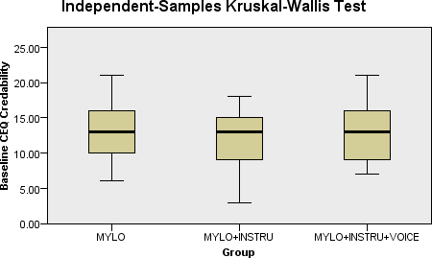

Pre-expectancy
A Kruskal-Wallis H test was conducted to determine if there were differences in pre-expectancy ratings between groups at baseline between the three groups: MYLO (n = 23), MYLO Guided (n = 19), and MYLO Guided with Speech (n = 21). Values are mean ranks unless otherwise stated. Distributions of pre-expectancy score at baseline were not similar for all groups, as assessed by visual inspection of a boxplot (see Figure 6.21). MYLO Guided with Speech (35.98) recorded higher pre-expectancy at baseline than MYLO (34.22) and MYLO Guided (24.92) groups, but the differences were not statistically significant, χ²(2) = 4.191, p = .123.
Figure 6.21 Baseline pre-expectancy boxplot
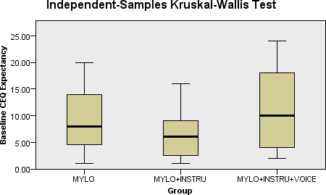

Does System Usability Account for Differences in a Participants’ Working Alliance and Agreement on the Tasks of Therapy with a Conversational Agent for Problem-Solving?

System Usability and Working Alliance Inventory
A Spearman's rank-order correlation was run to assess the relationship between post-intervention system usability (SUS Score) and working alliance (WAI-SR Overall). 64 participants were included. Preliminary analysis showed the relationship to be monotonic, as assessed by visual inspection of a scatterplot. There was a statistically significant, medium positive correlation between system usability score and work alliance task rating, r(61) = .449, p < .001. The result suggests that the higher participants scored system usability, the higher they would score the working alliance with a conversational agent for problem-solving.
Figure 6.22 System usability (post) and working alliance scatterplot
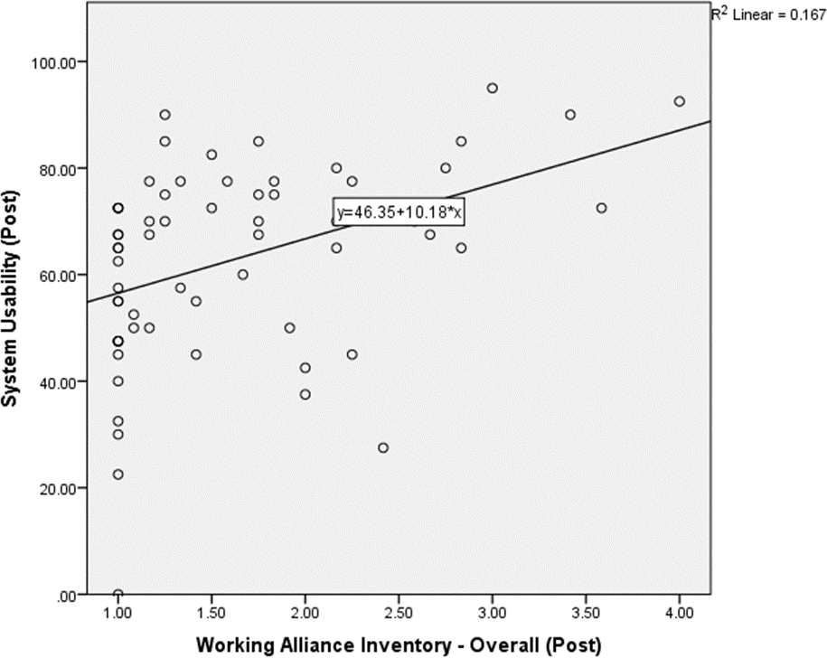

System Usability and Working Alliance Inventory Bond
A Spearman's rank-order correlation was run to assess the relationship between post-intervention system usability (SUS Score) and working alliance bond (WAI-SR Bond). 64 participants were included. Preliminary analysis showed the relationship to be monotonic, as assessed by visual inspection of a scatterplot. There was a statistically significant, small positive correlation between system usability score and work alliance task rating, r(61) = .282, p = .025.
Figure 6.23 System usability (post) and working alliance bond (bond) scatterplot
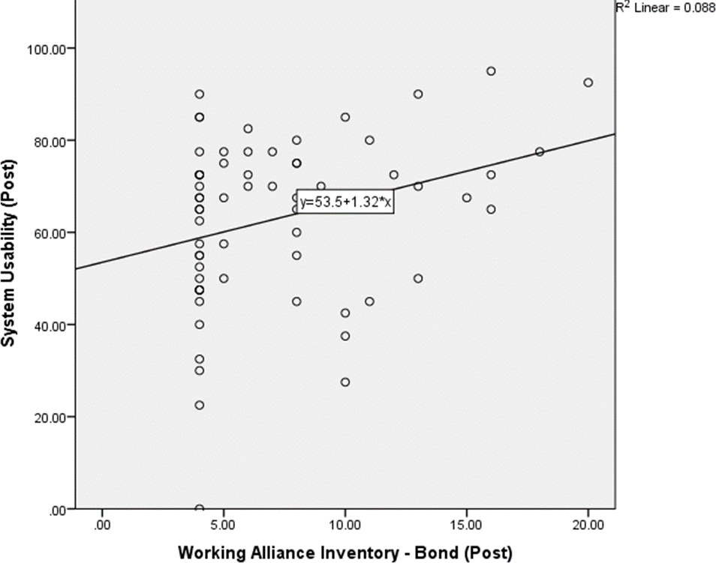

System Usability and Working Alliance Inventory Goal
A Spearman's rank-order correlation was run to assess the relationship between post-intervention system usability (SUS Score) and working alliance task (WAI-SR Task). 64 participants were included. Preliminary analysis showed the relationship to be monotonic, as assessed by visual inspection of a scatterplot. There was a statistically significant, small positive correlation between system usability score and work alliance task rating, r(61) = .272, p = .031.

System Usability and Working Alliance Inventory Task
A Spearman's rank-order correlation was run to assess the relationship between post-intervention system usability (SUS Score) and working alliance task (WAI-SR Task). 64 participants were included. Preliminary analysis showed the relationship to be monotonic, as assessed by visual inspection of a scatterplot. There was a statistically significant, large positive correlation between system usability score and work alliance task rating, r(61) = .582, p < .001.
Figure 6.24 System usability (post) and working alliance task (task) scatterplot
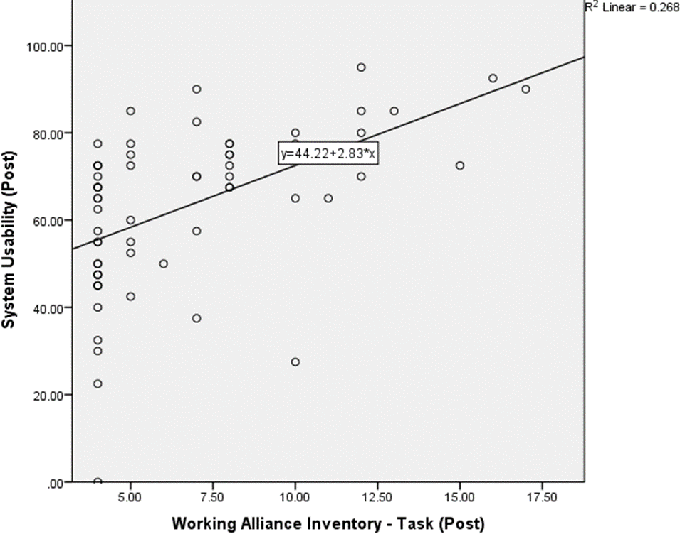
These findings suggest that those who rate higher system usability may experience a stronger work alliance with a self-help conversation agent. When examining the sub-scores of goal, task and bond, it becomes apparent that usability may predominantly affect the task sub-score of the work alliance, thus aligning well with the purpose of usability (see Table 6.5).
Table 6.5 Correlations between System Usability Score and Working Alliance Inventory and subscales
 |  | 1 | 2 | 3 | 4 | 5
1 | System Usability Score | - | .449** | .282* | .272* | .582**
2 | Work Alliance Inventory – Overall |  | - | .915** | .851** | .841**
3 | Work Alliance Inventory – Bond |  |  | - | .800** | .611**
4 | Work Alliance Inventory – Goal |  |  |  | - | .639**
5 | Work Alliance Inventory – Task |  |  |  |  | -
*Correlation is significant at the 0.05 level (two-tailed).
**Correlation is significant at the 0.01 level (two-tailed).

Does System Usability Account for Differences in a Participants' Perceived Treatment Credibility of a Conversational Agent for Problem-Solving?
A Spearman's rank-order correlation was run to assess the relationship between post-intervention system usability (SUS Score) and treatment credibility score (CS). 64 participants were included. Preliminary analysis showed the relationship to be monotonic, as assessed by visual inspection of a scatterplot. There was a statistically significant, large positive correlation between system usability score and treatment credibility score, r(61) = .563, p < .001. The result suggests that participants who score system usability highly may also be those who attribute greater treatment credibility to conversational agents for problem-solving.
Figure 6.25 System usability (post) and treatment credibility (post) scatterplot
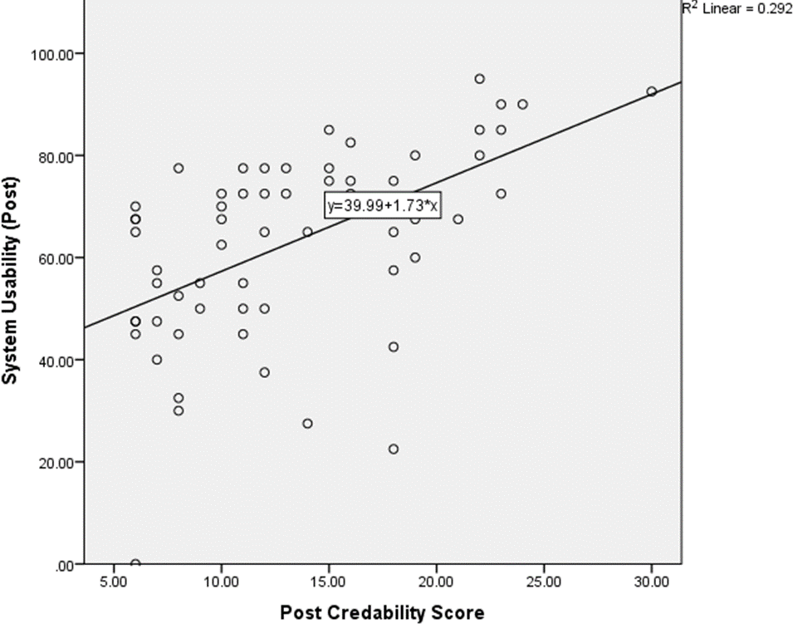

Discussion
The present study had three aims. Firstly, to investigate whether enhanced interface features improve the effectiveness, acceptability and usability of a computer-based problem-solving program with an older adult sample. Secondly, the study aimed to investigate whether giving introductory information regarding MYLO’s therapeutic methodology affects older adults’ initial treatment expectancy and credibility. Thirdly, the study investigated whether system usability affects the working alliance and treatment credibility of a conversational agent for problem-solving.
It was hypothesised that enhanced interface features would make MYLO a more effective conversational agent for problem-solving. Irrespective of which version was used, all groups had significant reductions in distress from baseline to follow-up. When comparing groups at each time point, no significant differences were found suggesting that all programs were effective as an aid to lowering problem related distress. However, only M+G and M+G+S groups showed a significant change in depression from baseline and follow-up. When comparing groups at each time point for depression, no significant differences were found. This may suggest that the enhancements may have helped participants understand the underlying MOL therapy and as a result had some effect on lowering depression levels over time. In contrast, there were no differences in changes in anxiety between participants in all three conditions suggesting that the enhanced versions of MYLO were no more effective to older adults than the standard version of MYLO when dealing with anxiety. Overall these findings may indicate that the addition of speech and a guide to therapy may have helped to improve MYLO’s ability to reduce depression over time. The reason for this may be due to the shift in issue focus. The M group was shown to have more issues with UI and therapy than the M+G and M+G+S groups. The enhanced UI and inclusion of a guide may have enabled participants to become more informed regarding what to expect from MYLO and as a result their perceptions of MYLOs issues may have changed and become more focused upon issues directly related to the AI rather than expectations of the therapy. This is reflective of Cavanagh (2015) in which it is suggested that guides may increase treatment expectations and help users to engage with treatment.
It was also hypothesised that enhanced interface features would make MYLO a more acceptable conversational agent for problem-solving with older adults. Only M group showed a significant change in rating of resolution from baseline and follow-up. None of the groups showed a statistically significant change in problem resolution between post-intervention and follow-up. It is hard to determine what this result is showing particularly when contrasted with the significant decreases in depression found only in the M+G and M+G+S groups. It may be that a more robust scale that is not based on a single Likert is needed in order to measure resolution more accurately. Net promoter score (NPS) was shown to be non-significantly different between groups. The enhanced interface features such as speech may have had a reverse effect on MYLO highlighting the flaws in its AI when generating responses.
It was hypothesised that enhanced interface features would result in MYLO having higher system usability; again, this was found not to be significant between groups. There were marginal differences in system usability but nothing to indicate that interface enhancements had any significant effect. Overall there were no significant group effects found in relation to measures of effectiveness, acceptability and usability. An explanation for this finding may stem from MYLO’s UI not being the root cause of the issues older adults experienced with MYLO. Categorised feedback of recommended improvements from participants in each MYLO group showed AI improvements across groups to be the most highlighted area of improvement when compared to UI (see Table 6.4). These percentages indicated the issues older adults faced when using MYLO might predominantly be due to MYLO’s AI and not UI. Future MYLO enhancements should focus on improving MYLO’s AI so that it is capable of generating responses appropriate to a user’s input.
It was hypothesised that adding introductory guidance regarding MYLO and what it can and cannot do would increase MYLO’s treatment expectancy and credibility. Ritterband et al. (2015) have suggested that the look and feel of the e-therapy may play a significant role in how patients rate its credibility. No significant differences were found between groups regarding pre-expectancy and credibility. Giving users an idea of what to expect and different levels of interface features did not affect how participants felt about the potential of using MYLO at a surface level. However, examination of the suggestions for improvement in the system feedback indicated that the standard MYLO group received more suggested improvements regarding the therapeutic content of MYLO.
It was hypothesised that older adults who rate a conversational agent with higher system usability would be associated with a stronger overall working alliance and task sub-score. Findings indicated that system usability was significantly positively related to working alliance and also its sub-scale task. However, the causal direction of these relationships is unknown. Widley used models of usability (ISO 2018) would suggest that usability feeds into user expectations and the user’s ‘relationship’ with a product, but it is also possible that this relationship is bidirectional. Future research could examine e-therapies of low and high usability in order to draw inferences about the causal pathways at work between the variables. If, however system usability impacts a client’s therapeutic alliance with a conversational agent for problem-solving such as MYLO, this finding chimes with the approximation that 10% to 15% of a (non-therapeutic) task's success or failure is loosely linked to system usability (Sauro, 2012).
Cavanagh (2015) proposes the idea of a triadic relationship between program user, e-therapy and human support. This study has explored one side of the triadic relationship between program user and conversational agent (e-therapy) and how usability interacts with it. Exploring the dynamic between a program user, conversational agent and supportive practitioner in relation to usability may be worthy of investigation. There may be two therapeutic alliances (a dual alliance) working in tandem within this context - an alliance with the e-therapy and an alliance with the human support, both of which could affect the overall therapeutic alliance, for good or for ill.
It was hypothesised that older adults who perceived the conversational agent as having higher usability would be those who also assigned it higher ratings of treatment credibility. Findings indicated that system usability was significantly positively related to treatment credibility. This may indicate that usability impacts a client’s rating of treatment credibility for conversation agents for problem-solving or vice versa. Future research could examine the impact of low and high usability in an e-therapy on credibility specifically. However, one way in which usability might exert an influence on credibility is via confidence. The usability of an agent instils confidence within the person using it. A number of studies have suggested that users find confidence in systems based on both their visual design and information structure (Robins, Holmes and Stansbury, 2010; Kim, 2016). So, when a user finds MYLO or one of its variants usable, they are likely to give the system more credibility. Other studies have also found associations between usability and user loyalty and satisfaction (Flavián, Guinalíu and Gurrea, 2006; David and Glore, 2013).

Strengths and Limitations
There has been little research examining the medium of conversation agents for problem solving with older adults. This study aimed to address that gap. However, as with the previous chapter, there are some limitations with the sampling and the design of the study that should be taken into consideration.
Regarding the sampling, as with Chapter 5, the participants were predominantly from the U3A community, representing a specific sub-group of older adults, likely to have higher SES. Due to sampling being predominantly from this group recruitment fatigue (whereby a large number of those interested in conversational agents were recruited for the study in Chapter 5, leaving far fewer available for involvement in this study) resulted in a failure to reach the targeted 121 participants per group which may have impacted on the power of the analyses and on the overall outcomes of this study. This, in turn, may have resulted in a different depiction of older adult’s experiences of MYLO’s with enhanced features. As with the last study, the sample was predominantly female, White British, and the study advertisement asked volunteers if they would be interested in talking to a computer and testing out a computerised problem-solving program. The type of problem was never specified, and participants were never screened or assessed prior to taking part, raising the possibility that individuals who participated who did not feel as distressed about their given problem as those who did not.
Regarding the design, there are two issues that warrant consideration. Firstly, enabling two of the groups to view the therapy guide prior to taking their baseline measures was an oversight in the study’s design and while the groups did not show a significant difference in the measures taken it cannot be ruled out that an effect took place during this time. Secondly, it is possible that the voice used for speech synthesis in the M+G+S group was not appealing to participants. Some of the feedback given indicated that participants may have felt the voice was not appropriate to their taste e.g. (‘Less mechanical voice’, ‘Need choice between male or female voice’). It is also difficult to tell if the M+G and M+G+S groups were sufficiently different. The M+G group had a guide, whereas the M+G+S group had a guide and speech, so these two groups differed only on the speech component. This alone might not have been sufficient to produce different effects between the groups. It may be that incorporating an avatar into the speech group may have given more varied results between groups, however, the results from the pilot survey did not indicate avatars as a preferred enhancement for the target group.

Directions for Future Research
The present study has built upon the previous research around the acceptability of MYLO and provides support for the notion that enhanced interface features may improve older adults’ acceptability of a problem-solving program. The study also investigated the impact of system usability on both treatment credibility and the therapeutic relationship of a problem-solving program. As a result of this, the following new avenues of further research are proposed. Firstly, further investigation needs to focus upon usability, and its effects on the treatment credibility and the therapeutic relationship of computer-based therapy as this is a fairly new avenue of research. Secondly, more should be done to explore how conversational agents can be used as a hybrid part of self-guided therapy within the ‘triangle of alliance’ model set out by Cavanagh (2010).

Summary and Conclusion
The present study has sought to expand on the research of a computer-based problem-solving program known as MYLO by testing its acceptability, effectiveness and usability with enhanced interface elements in a non-clinical older adult sample. The results indicated that enhanced interface features might not improve the acceptability, effectiveness, and usability of MYLO. System feedback indicated that the AI was the element that received the most suggestions for improvement, possibly implying that interface features alone cannot make a difference to MYLOs acceptability, effectiveness or usability. The study has also discovered that usability may play a small role in the development of the agreement of tasks within the therapeutic relationship and usability may also play a role in treatment credibility.

Discussion and Future Work, Conclusion

Research Summary
This thesis has aimed to determine whether e-therapy interfaces can be enhanced to increase usability and acceptability in older adults. Specifically, we have examined whether the usability and acceptability of an automated conversational agent for problem solving could be improved for older adults’ use, by adding interface features. The starting point for this research programme (which began in 2015) was to survey the existing e-therapy landscape within the real-world setting of the NHS, with a focus on provision for older adults. The data used to address this topic were, in the most part, acquired from NHS services via Freedom of Information (FOI) Act 2000 requests on the 13th of February 2015. Findings highlighted a high level of variation in e-therapy offerings in services across England, and a distinct lack of any real older adult-tailored e-therapy provision. This initial study also generated a list of e-therapies used within NHS services in 2015, something which at that time the NHS did not have. As such, the publication of these findings (Bennion et al., 2017) was welcomed by NHS officials (see Appendix B1).
Having established what e-therapies were being used within the NHS, the overarching aim of the next two chapters was to evaluate the quality of the e-therapies offered by NHS services. This was achieved in two ways.
Firstly, indicators of quality were identified, and the e-therapies were appraised against those indicators (Chapter three). This was achieved by surveying the developers of each of the identified e-therapies asking about academic and clinical involvement, clinical theory, published studies, and any other evidence of effectiveness. The data collected from the survey highlighted the divide in quality between web and mobile app types. Web apps were found to be significantly stronger in all but one area, namely the use of clinical theory. It is suggested that this difference might be attributed to the half-decade age gap and evolutionary differences between the two technologies.
Secondly, clinical effectiveness of the e-therapies was evaluated via meta-analysis, and by treating age as a moderator, a focus on older adults was attempted (Chapter 4). A series of database searches was carried out to collect papers relevant to the e-therapies identified in Chapter two. The papers were then merged with the publications reported by the developers in Chapter three. Studies employing a Randomised Controlled Trial (RCTs) design were selected, study quality was evaluated, and the required data extracted. The data indicated that the studies predominately did not target those over 65 for involvement. On the other hand, few studies excluded older adults. Meta-analyses results showed that the older the participant was, the less effective the e-therapy became. However, the major caveat of this work is the extremely low numbers of older adults represented in the studies included. So, while the findings may indicate that e-therapies within the NHS may be of benefit to younger adults, they are less suitable for older generations, more research is needed targeting older demographics to fully address this issue.
Given the lack of support for an existing NHS-used e-therapy for older adults, and the potential difficulty in working with a proprietary/commercial e-therapy for academic research and development, in Chapters 5 and 6, a researcher-developed, conversational agent e-therapy called MYLO was used.
In Chapter five, the aim was to see if a conversational agent for problem-solving called Manage Your Life Online (MYLO) was acceptable to older adults and to investigate whether system usability correlated with measurements of acceptability. For this study, MYLO was compared to a control conversational agent called ELIZA. All respondents, irrespective of group experienced significant reductions in distress, depression, anxiety, stress, and total DASS-21 scores between baselines and follow up but unlike previous studies, MYLO was not found to be better at resolving problems. The study went on to investigate the possibility of a relationship between system usability and measures of acceptability. It was found that system usability correlated significantly positively with problem resolution, helpfulness and the likelihood of using the conversational agent again. These correlations helped to pave the direction of investigation for the final two studies of this body of work.
In Chapter six the aims were to: i) establish which of three UI enhancements (speech synthesis, speech recognition and avatars) older adults felt would make MYLO more acceptable, and ii) see if adding speech synthesis to a conversational agent for problem-solving improved acceptability with older adults. Secondary aims looked at whether adding a guide to the agent prior to use improved participant pre-credibility and expectations and whether system usability correlated with measures of the working alliance and treatment credibility. For this study, the MYLO software previously used in Chapter five was compared to two variants. MYLO Guided, an enhanced version of the MYLO software from Chapter five with the addition of introductory guidance and instructions about MYLO and the underlying MOL therapy, and MYLO Guided with Speech, an enhanced version of the MYLO Guided software with the addition of synthesised speech that reads the onscreen text aloud to the participant during the introduction, instructions and conversation.
Findings were that all respondents, irrespective of group experienced significant reductions in distress between baselines and follow up. MYLO Guided and MYLO Guided with Speech were found to reduce depression between baselines and follow up, while MYLO was found to increase problem resolution between post-intervention and follow up. The study went on to investigate the possibility of a relationship between system usability and measures of acceptability. It was found that system usability correlated a strong positive with work alliance inventory and its sub type task, along with treatment credibility. Small positive correlations were also found between working alliance bond and goal. These correlations may help to pave the direction of investigation for future work.

General Discussion
The noteworthy findings from the above body of work are: i) NHS England lacks appropriate record-keeping regarding e-therapies being recommended and used; ii) there is disparity between the quality of web apps and that of phone-based apps; iii) older adults have been neglected in e-therapy research; and iv) usability is a key but under-researched aspect of e-therapies. We will discuss each in turn.

NHS England Records on E-therapy Use
The amount of effort and time required to establish what e-therapies were in use in the NHS in 2015 was surprising. Apparently, this was something neither the NHS nor other researchers had previously attempted, rendering comparison of e-therapy performance in NHS settings very difficult. Reflecting on the process of collecting this data, a set of key recommendations for policymakers was made in Bennion et al. (2017). The first recommendation concerns the FOI Act itself. Because it only applies to public bodies, while of great utility in getting information from many NHS service providers, the FOI Act does not support transparency in cases where NHS serviced are outsourced to third sector or private companies. The inability of researchers to access data from such third-party providers of NHS services is concerning, not least because it means that it is not possible to achieve comprehensive snapshot of current practice across the whole of the NHS, hampering potential evaluative research efforts. Bennion et al. (2017) therefore recommended that the FOI Act should apply to all NHS services, be they publicly or privately run, to ensure a level of transparency that allows both positive and negative aspects of services to be made visible to the public and researchers alike.
The second recommendation concerns the IAPT minimal dataset. The current minimal data collected by IAPT services contains data on referrals, waiting times, appointments, types of therapy and is therefore useful for reporting with transparency the outcomes of mental health services (Clark et al., 2018). However, the omission of which (if any) e-therapy is used renders the dataset of little utility for anyone interested in comparing effectiveness of different e-therapies or seeing whether different e-therapies might suit different client profiles better. Adding this to the minimal dataset would represent a relatively small change to routine data collection practices but would provide an instant research resource which could answer multiple important and timely research questions on e-therapies. In the larger picture there is a necessity for the NHS to improve its data curation and collection procedures in order to meet the aspiration of becoming truly digitally enabled.

Disparity Between Web and Phone Apps
Web apps were found to be significantly stronger against all of the quality indicators identified in Chapter three except one, namely, the use of clinical theory. It is suggested that this difference might be attributed to the half-decade age gap and evolutionary differences between the two technologies. In appraising the e-therapies, it was found that web apps fared better than phone apps. One likely explanation for this difference lies in their distinct ‘evolutionary paths’. Web applications for mental health such as Beating the Blues (Judith Proudfoot, Goldberg, Mann, Everitt, Marks, Gray, et al., 2003) originated in academia in the 2000s before being brought to market. As such they tend to be the result of a more considered (and perhaps more rigorous) development process. Smart phones, and the mobile apps that they run began to take off in 2008 when apps stores began to open (Cuadrado and Dueñas, 2012). However, unlike the earlier web apps, the rapid growth in popularity of smart phones fostered a process of developing mobile apps – and in all areas, not only for mental health – that had more in common with the early 1980s personal microcomputer boom (Lean, 2013) whereby anyone with access to a personal microcomputer and a programming book could create their own software. In contrast to the 1980s, however, the availability of app stores and the web meant that this software could easily be published and shared with huge numbers of potential users. Unfortunately, this has taken place under a regime of poor regulation of mental health app quality and of security and privacy standards (Chandrashekar, 2018), with even home coders being able to create and publish mental health apps with little, if any, quality assurance.
The current body of work has revealed that it is vital that the NHS ensure the NHS apps library contains apps that are supported by evidence, so that service users are presented with effective apps and that app developers are compelled to consider how to ensure their e-therapy content is safe, beneficial and credible. Ways to achieve this might include developing apps with input from clinicians. Developers working with academics to enable increased knowledge transfer and to conduct well-designed and fair trials, and then to feed the lessons learnt back to the research knowledge base. Developers and researchers should publish all evidence acquired through pilot, feasibility, acceptability, effectiveness and efficacy studies to facilitate appraisal of the effectiveness of an e-therapy. In the absence of publications developers should collect, analyse and publish summaries of other evidence to back up claims of effectiveness and ensure that a psychological approach or theory that is known to be empirically sound is applied within the apps they develop to help build credibility.

Neglect of Older Adults in E-therapy Research
The current research has shown that while e-therapies used within the NHS may be of benefit to younger adults, they might less suitable for older generations. But more research is needed targeting older demographics to adequately address this issue. The goal of the panorama work described in Chapters 2-4 was to establish what e-therapies are in use, and their effectiveness for older adults specifically. It turned out that there simply has not been enough research involving older adults. At a top level within NHS services it appears there are no e-therapies presently available to cater to older adults and those NHS e-therapies that were included in study III (Chapter four), the meta-analysis, were found to be more effective for younger adults than for old. A solution to this problem may be to use a modular platform of e-therapy such as SilverCloud to develop and roll-out modules specifically tailored to older adults. Why this has not already been attempted is unknown. It may be assumed that standard modules are suitable for both young and old; however, there is nothing in the SilverCloud literature, academic or otherwise, to confirm this. When it comes to older adult e-therapy, what little research there is that does include older adults is not representative. Lack of representation may be a deeper issue requiring further investigation, particularly considering the difficulties experienced recruiting older adults into the current studies (Chapters 5 and 6). More effort is needed to (a) carry out research with older adults and (b) attempt representative sampling of older adults within such research.

Importance of Usability
In the experimental work, a key finding was that usability was related to problem resolution, the helpfulness of the program and the likelihood of future use, as well as working alliance and credibility. The usability of e-therapies is under-researched. The extent to which it could account for some of the shortcomings of e-therapy is therefore unknown. Developers of e-therapies (be they researchers, clinicians, or software engineers) should give greater consideration to the usability of their e-therapy since the current research has found an association between whether users are able to achieve their therapeutic goals within the context of the therapeutic alliance and how easily a user can learn the interface and return to it. The direction of effect of this relationship is unknown and further research must be carried out to attain this information. It may be that by carrying out studies with e-therapies of low and high usability a better inference of the type of relationship can be made. No matter how good the underlying therapy and its implementation, users will derive no benefit if a poor interface renders the system unusable. When designing e-therapy, developers should consider who their target audience is, what its expectations, needs and abilities are, how it will interact with the e-therapy (Morrison and Doherty, 2014; Yardley and Bradbury, 2018) and, as a consequence, how the design choices of the system will affect its usability. Features such as layout, colours, content formatting, navigation and flow can all affect how a user feels about a system and how they interact with its content (Morrison et al., 2018). For instance, colours have been shown to affect how users interact with a system, to influence behaviours and to effect cognitive process such as memorising information presented to them (Bonnardel, Piolat and Le Bigot, 2011). More specifically in this context, the question of the possible effects of usability on aspects of engagement, adherence, attrition, the therapeutic alliance and other aspects of e-therapy is crucial and worthy of extensive further study. Since this body of work began, a number of large, international, multi-site trials have included usability scales in their measures (Vis et al., 2015; Kleiboer et al., 2016). While this is undoubtedly a step in the right direction, it is also imperative that smaller and less ambitious studies also consider the role of usability, how it relates to other variables and as to whether it is a cause or consequence.

Conclusions
In conclusion, this thesis has discussed the provision of e-therapy by NHS England in 2015: how developers go about developing e-therapy applications, who is involved in their development, and what evidence they offer as to their effectiveness. One of the apparent weaknesses in current provision is the lack of offerings that have been tested for effectiveness with older adults. Consequently, this thesis investigated whether a conversational agent for problem solving would represent an intervention that is acceptable to older adults, while also examining whether interface enhancements can improve acceptability, effectiveness and usability. The results of this work, also presented in this thesis, suggest that the enhancements added may not have altered the treatment credibility or therapeutic relationship of the agent but may have improved participants understanding of the underlying therapy delivered by the agent. It was also found that both the enhanced versions of the agent showed significant decreases in depression over time. Also reported here are the findings of a study which found associations between usability and other important factors related to the acceptability of e-therapies such as treatment credibility and the therapeutic alliance. It was found that higher usability was related to perceiving MYLO as more helpful, gaining greater problem resolution from using MYLO, higher likelihood of using MYLO again, higher treatment credibility of MYLO, a better therapeutic alliance with MYLO and a higher therapeutic alliance regarding the tasks of therapy.
It is clear that this is a field that is still in its infancy, and there remains much work to do to understand how the potential offered by the internet, the web and connected devices can be harnessed to improve the mental health of the population at large.
It is hoped that this body of work can serve as a springboard for future research into usability, how it affects the use of e-therapies and whether the relationships reported within this thesis are corroborated across other therapies and populations.

Bibliography
Abi Global Health Limited (2018) Abi — Fast Help From Friendly Doctors. Available at: https://abi.ai/ (Accessed: 6 April 2018).
Ada Health Gmbh (2018) Ada - Personal Health Companion App. Available at: https://ada.com/ (Accessed: 6 April 2018).
Andersen, A. J. W. and Svensson, T. (2013) ‘Internet-based mental health services in Norway and Sweden: Characteristics and consequences’, Administration and Policy in Mental Health and Mental Health Services Research, 40, pp. 145–153. doi: 10.1007/s10488-011-0388-2.
Andersson, G., Paxling, B., Roch-Norlund, P., et al. (2012) ‘Internet-based psychodynamic versus cognitive behavioral guided self-help for generalized anxiety disorder: a randomized controlled trial.’, Psychotherapy and psychosomatics. Karger Publishers, 81(6), pp. 344–55. doi: 10.1159/000339371.
Andersson, G., Paxling, B., Wiwe, M., et al. (2012) ‘Therapeutic alliance in guided internet-delivered cognitive behavioural treatment of depression, generalized anxiety disorder and social anxiety disorder’, Behaviour Research and Therapy, 50, pp. 544–550. doi: 10.1016/j.brat.2012.05.003.
Andersson, G. et al. (2014) ‘Guided Internet-based vs. face-to-face cognitive behavior therapy for psychiatric and somatic disorders: a systematic review and meta-analysis’, World Psychiatry, 13(3), pp. 288–295. doi: 10.1002/wps.20151.
Andersson, G. (2016) ‘Internet-Delivered Psychological Treatments’, Annual Review of Clinical Psychology, 12(1), pp. 157–179. doi: 10.1146/annurev-clinpsy-021815-093006.
Andersson, G. and Cuijpers, P. (2009) ‘Internet-Based and Other Computerized Psychological Treatments for Adult Depression: A Meta-Analysis’, Cognitive Behaviour Therapy. Taylor & Francis Group , 38(4), pp. 196–205. doi: 10.1080/16506070903318960.
Andreescu, C. et al. (2007) ‘Effect of comorbid anxiety on treatment response and relapse risk in late-life depression: Controlled study’, British Journal of Psychiatry, 190(APR.), pp. 344–349. doi: 10.1192/bjp.bp.106.027169.
Andrews, G. et al. (2010) ‘Computer Therapy for the Anxiety and Depressive Disorders Is Effective, Acceptable and Practical Health Care: A Meta-Analysis’, PLoS ONE. Edited by B. T. Baune. Public Library of Science, 5(10), p. e13196. doi: 10.1371/journal.pone.0013196.
Armstrong, S. (2018) The New Poverty. Verso Books. Available at: https://books.google.co.uk/books?hl=en&lr=&id=H595DwAAQBAJ&oi=fnd&pg=PR9&dq=Armstrong,+S.+(2017).+The+New+Poverty.+London:+Verso+Publishing.&ots=zjlaaiSHUc&sig=5q8eO-sAV2gJpGRuBEYfeagXoZk#v=onepage&q=Armstrong%2C S. (2017). The New Poverty. London%3A Vers (Accessed: 22 November 2018).
Ayers, C. R. et al. (2007) ‘Evidence-based psychological treatments for late-life anxiety.’, Psychology and Aging, 22(1), pp. 8–17. doi: 10.1037/0882-7974.22.1.8.
Banerjee, S. K. et al. (2017) ‘Evaluating the relative effectiveness of high-intensity and low-intensity models of behaviour change communication interventions for abortion care-seeking in Bihar and Jharkhand, India: A cross-sectional study’, BMJ Open, 7(2). doi: 10.1136/bmjopen-2016-012198.
Bangor, A., Kortum, P. and Miller, J. (2009) ‘Determining what individual SUS scores mean: Adding an adjective rating scale’, Journal of usability studies, 4(3), pp. 114–123. doi: 66.39.39.113.
Bangor, A., Kortum, P. T. and Miller, J. T. (2008) ‘An empirical evaluation of the system usability scale’, International Journal of Human-Computer Interaction, 24(6), pp. 574–594. doi: 10.1080/10447310802205776.
Barak, A., Klein, B. and Proudfoot, J. G. (2009) ‘Defining internet-supported therapeutic interventions’, Annals of Behavioral Medicine, 38(1), pp. 4–17. doi: 10.1007/s12160-009-9130-7.
Barazzone, N., Cavanagh, K. and Richards, D. A. (2012) ‘Computerized cognitive behavioural therapy and the therapeutic alliance: A qualitative enquiry’, British Journal of Clinical Psychology. Wiley/Blackwell (10.1111), 51(4), pp. 396–417. doi: 10.1111/j.2044-8260.2012.02035.x.
Barnes, C. W. et al. (2015) ‘A web-based preventive intervention program for bipolar disorder: Outcome of a 12-months randomized controlled trial’, Journal of Affective Disorders, 174, pp. 485–492. doi: 10.1016/j.jad.2014.11.038.
Barton, A. J. (2012) ‘The regulation of mobile health applications.’, BMC medicine. BioMed Central, 10, p. 46. doi: 10.1186/1741-7015-10-46.
Bauer, J. and Murphy, R. (2017) Apps library is advance for a digital NHS, NHS England. Available at: https://www.england.nhs.uk/blog/apps-library-is-advance-for-a-digital-nhs/ (Accessed: 10 February 2018).
Beaumont, J. and Lofts, H. (2013) Measuring National Well-being - Health, 2013. Available at: http://webarchive.nationalarchives.gov.uk/20160105160709/http://www.ons.gov.uk/ons/dcp171766_310300.pdf (Accessed: 5 May 2017).
Beck, A. T., Steer, R. A., & Brown, G. K. (1996) Beck depression inventory-II.
Bell, E. C., Marcus, D. K. and Goodlad, J. K. (2013) ‘Are the parts as good as the whole? A meta-analysis of component treatment studies.’, Journal of Consulting and Clinical Psychology, 81(4), pp. 722–736. doi: 10.1037/a0033004.
Bendelin, N. et al. (2011) ‘Experiences of guided Internet-based cognitive-behavioural treatment for depression: A qualitative study’, BMC Psychiatry. BioMed Central, 11(1), p. 107. doi: 10.1186/1471-244X-11-107.
Bennion, M. R. et al. (2017) ‘E-therapies in England for stress, anxiety or depression: what is being used in the NHS? A survey of mental health services’, BMJ Open, 7(1), p. e014844. doi: 10.1136/bmjopen-2016-014844.
Berner, J. S. et al. (2013) ‘Factors associated with change in Internet usage of Swedish older adults (2004–2010)’, Health Informatics Journal, 19(2), pp. 152–162. doi: 10.1177/1460458212462151.
Betton, V. et al. (2017) Framework for the effectiveness evaluation of mobile (mental) health tools. Available at: https://s3-eu-west-1.amazonaws.com/assets.wearemhabitat.com/Framework-for-the-effectiveness-evaluation-of-mobile-mental-health-tools.pdf (Accessed: 7 April 2018).
Bevan, N. (2009) ‘International Standards for Usability Should Be More Widely Used’, Journal of Usability Studies, 4(3), pp. 106–113. Available at: http://www.usabilityprofessionals.org. (Accessed: 11 July 2018).
Bird, T. et al. (2018) ‘Manage Your Life Online: A Web-Based Randomized Controlled Trial Evaluating the Effectiveness of a Problem-Solving Intervention in a Student Sample’, Behavioural and Cognitive Psychotherapy, pp. 1–13. doi: 10.1017/S1352465817000820.
Boettcher, J. et al. (2014) ‘Internet-Based Mindfulness Treatment for Anxiety Disorders: A Randomized Controlled Trial’, Behavior Therapy, 45(2), pp. 241–253. doi: 10.1016/j.beth.2013.11.003.
Bonnardel, N., Piolat, A. and Le Bigot, L. (2011) ‘The impact of colour on Website appeal and users’ cognitive processes’, Displays. Elsevier, 32(2), pp. 69–80. doi: 10.1016/J.DISPLA.2010.12.002.
Boot, N. C. and W. R. (2009) ‘Aging and Information Technology Use: Potential and Barriers’, Current Directions in Psychological Science, 18(253), pp. 253–258.
Bordin, E. S. (1979) ‘The generalizability of the psychoanalytic concept of the working alliance.’, Psychotherapy: Theory, Research & Practice, 16(3), pp. 252–260. doi: 10.1037/h0085885.
Borenstein, M. et al. (2009) Introduction to meta-analysis. Chichester, UK: John Wiley & Sons. doi: 10.1002/9780470743386.
Botella, C. et al. (2009) ‘An e-health system for the elderly (Butler Project): a pilot study on acceptance and satisfaction’, Cyberpsychology & behavior : the impact of the Internet, multimedia and virtual reality on behavior and society, 12(3), pp. 255–262. doi: 10.1089/cpb.2008.0325.
Bothwell, L. E. et al. (2016) ‘Assessing the Gold Standard — Lessons from the History of RCTs’, New England Journal of Medicine. Edited by D. Malina. Massachusetts Medical Society, 374(22), pp. 2175–2181. doi: 10.1056/NEJMms1604593.
Bower, P. and Gilbody, S. (2005) ‘Stepped care in psychological therapies: access, effectiveness and efficiency’, British Journal of Psychiatry, 186(01), pp. 11–17. doi: 10.1192/bjp.186.1.11.
Brenes, G. A. et al. (2008) ‘Anxiety, depression and disability across the lifespan’, Aging and Mental Health, 12(1), pp. 158–163. doi: 10.1080/13607860601124115.
Brooke, J. (1996) SUS: A ‘Quick and Dirty’ Usability Scale, Usability evaluation in industry. Edited by P. W. Jordan et al. CRC Press. Available at: http://scholar.google.com/scholar?hl=en&btnG=Search&q=intitle:SUS-A+quick+and+dirty+usability+scale#0 (Accessed: 9 February 2016).
Brooke, J. (2013) ‘SUS: A Retrospective’, 8(2), pp. 29–40. Available at: http://www.usabilityprofessionals.org. (Accessed: 14 June 2018).
BSI (2015) ‘Health and wellness apps - Quality criteria across the life cycle - Code of practice (PAS 277:2015)’, p. 36. doi: PAS 277:2015.
Budd, R. and Hughes, I. (2009) ‘The Dodo Bird Verdict-controversial, inevitable and important: a commentary on 30 years of meta-analyses’, Clinical Psychology & Psychotherapy, 16(6), pp. 510–522. doi: 10.1002/cpp.648.
Buhrman, M. et al. (2013) ‘Guided internet-delivered acceptance and commitment therapy for chronic pain patients: A randomized controlled trial’, Behaviour Research and Therapy, 51(6), pp. 307–315. doi: 10.1016/j.brat.2013.02.010.
Butler, A. C. et al. (2006) ‘The empirical status of cognitive-behavioral therapy: A review of meta-analyses’, Clinical Psychology Review, 26(1), pp. 17–31. doi: 10.1016/j.cpr.2005.07.003.
Byers, A. L. et al. (2010) ‘High Occurrence of Mood and Anxiety Disorders Among Older Adults’, Archives of General Psychiatry, 67(5), p. 489. doi: 10.1001/archgenpsychiatry.2010.35.
Carey, T. A. (2006) ‘The method of levels: how to do psychotherapy without getting in the way’. Hayward, CA: Living Control Systems Publishing., p. 178.
Carey, T. A. et al. (2009) ‘Assessing the Statistical and Personal Significance of the Method of Levels’, Behavioural and Cognitive Psychotherapy, 37(03), p. 311. doi: 10.1017/S1352465809005232.
Carey, T. A. and Mullan, R. J. (2007) ‘Patients taking the lead. A naturalistic investigation of a patient led approach to treatment in primary care’, Counselling Psychology Quarterly. Routledge , 20(1), pp. 27–40. doi: 10.1080/09515070701211304.
Carey, T. A. and Mullan, R. J. (2008) ‘Evaluating the method of levels’, Counselling Psychology Quarterly. Routledge , 21(3), pp. 247–256. doi: 10.1080/09515070802396012.
Carlbring, P. et al. (2001) ‘Treatment of panic disorder via the internet: A randomized trial of a self-help program’, Behavior Therapy. Elsevier, 32(4), pp. 751–764. doi: 10.1016/S0005-7894(01)80019-8.
Carlbring, P., Ekselius, L. and Andersson, G. (2003) ‘Treatment of panic disorder via the Internet: a randomized trial of CBT vs. applied relaxation.’, Journal of behavior therapy and experimental psychiatry, 34(2), pp. 129–40. Available at: http://www.ncbi.nlm.nih.gov/pubmed/12899896 (Accessed: 6 September 2018).
Cavanagh, K. et al. (2009a) ‘The Acceptability of Computer-Aided Cognitive Behavioural Therapy: A Pragmatic Study’, Cognitive Behaviour Therapy. Taylor & Francis Group , 38(4), pp. 235–246. doi: 10.1080/16506070802561256.
Cavanagh, K. et al. (2009b) ‘The Acceptability of Computer-Aided Cognitive Behavioural Therapy: A Pragmatic Study’, Cognitive Behaviour Therapy. Taylor & Francis Group , 38(4), pp. 235–246. doi: 10.1080/16506070802561256.
Cavanagh, K. (2010) Turn on, tune in and (don’t) drop out - engagement, adherence, attrition, and alliance with internet-based interventions, Oxford guide to low intensity CBT interventions. Oxford University Press. doi: http://dx.doi.org/10.1093/med:psych/9780199590117.003.0021.
Cavanagh, K. and Millings, a. (2013) ‘Increasing engagement with computerised cognitive behavioural therapies’, ICST Transactions on Ambient Systems, 13(2), p. e3. doi: 10.4108/trans.amsys.01-06.2013.e3.
Cavanagh, K. and Millings, A. (2013) ‘(Inter)personal computing: The role of the therapeutic relationship in E-mental health’, Journal of Contemporary Psychotherapy, 43(4), pp. 197–206. doi: 10.1007/s10879-013-9242-z.
Chandrashekar, P. (2018) ‘Do mental health mobile apps work: evidence and recommendations for designing high-efficacy mental health mobile apps’, mHealth. AME Publications, 4, pp. 6–6. doi: 10.21037/mhealth.2018.03.02.
Chaplin, R. et al. (2015) ‘Comparison of access, outcomes and experiences of older adults and working age adults in psychological therapy’, International Journal of Geriatric Psychiatry. Wiley-Blackwell, 30(2), pp. 178–184. doi: 10.1002/gps.4122.
Chapman, P., Selvarajah, S. and Webster, J. (1999) Engagement in Multimedia Training Systems. Available at: https://www.computer.org/csdl/proceedings/hicss/1999/0001/01/00011084.pdf (Accessed: 15 September 2018).
Chellingsworth, M., Davies, S. and Laidlaw, K. (2016) Improving Access to Psychological Therapies National Curriculum for CBT with Older People, National Curriculum for CBT with Older People. 2nd Edition. Available at: https://www.uea.ac.uk/documents/246046/11919343/2016+national-curriculum-for-cbt-with-older-people-revised-february-2016.pdf/4772951f-a051-4270-9e4d-3440c0d358a3 (Accessed: 5 October 2018).
Christensen, H., Griffiths, K. M. and Farrer, L. (2009) ‘Adherence in internet interventions for anxiety and depression.’, Journal of medical Internet research, 11(2), p. e13. doi: 10.2196/jmir.1194.
Clark, D. M. et al. (2009) ‘Improving access to psychological therapy: Initial evaluation of two UK demonstration sites.’, Behaviour research and therapy. Elsevier, 47(11), pp. 910–20. doi: 10.1016/j.brat.2009.07.010.
Clark, D. M. (2011) ‘Implementing NICE guidelines for the psychological treatment of depression and anxiety disorders: The IAPT experience’, International Review of Psychiatry, 23(4), pp. 318–327. doi: 10.3109/09540261.2011.606803.
Clark, D. M. et al. (2018) ‘Transparency about the outcomes of mental health services (IAPT approach): an analysis of public data’, The Lancet. Elsevier, 391(10121), pp. 679–686. doi: 10.1016/S0140-6736(17)32133-5.
Cohen, J. (1992) ‘A power primer.’, Psychological bulletin, 112(1), pp. 155–9. Available at: http://www.ncbi.nlm.nih.gov/pubmed/19565683 (Accessed: 18 June 2018).
Cohen, J. W. (1988) Statistical power analysis for the behavioral sciences (2nd edition), Hillsdale, NJ: Lawrence Erlbaum Associates. Available at: https://wwwnxjdrm01.storage.googleapis.com/MDgwNTgwMjgzNQ==01.pdf (Accessed: 17 June 2018).
Collins, N. and Corna, L. (2018) ‘General practitioner referral of older patients to Improving Access to Psychological Therapies (IAPT): an exploratory qualitative study’, BJPsych Bulletin. Royal College of Psychiatrists, 42(3), p. 115. doi: 10.1192/BJB.2018.10.
Coull, G. and Morris, P. G. (2011) ‘The clinical effectiveness of CBT-based guided self-help interventions for anxiety and depressive disorders: a systematic review’, Psychological Medicine, 41(11), pp. 2239–2252. doi: 10.1017/S0033291711000900.
Crabb, R. M. et al. (2012) ‘Is computerized cognitive-behavioural therapy a treatment option for depression in late-life? A systematic review’, British Journal of Clinical Psychology, 51(4), pp. 459–464. doi: 10.1111/j.2044-8260.2012.02038.x.
Craig, P. et al. (2008) ‘Developing and evaluating complex interventions: the new Medical Research Council guidance.’, BMJ (Clinical research ed.). BMJ Publishing Group, 337, p. a1655. doi: 10.1136/bmj.a1655.
Cuadrado, F. and Dueñas, J. (2012) ‘Mobile application stores: Success factors, existing approaches, and future developments’, IEEE Communications Magazine, 50(11), pp. 160–167. doi: 10.1109/MCOM.2012.6353696.
Cuijpers, P. et al. (2009) ‘Computer-aided psychotherapy for anxiety disorders: A meta-analytic review’, Cognitive Behaviour Therapy, 38(2), pp. 66–82. doi: 10.1080/16506070802694776.
Cuijpers, P., Donker, T., et al. (2010) ‘Is guided self-help as effective as face-to-face psychotherapy for depression and anxiety disorders? A systematic review and meta-analysis of comparative outcome studies’, Psychological Medicine, 40(12), pp. 1943–1957. doi: 10.1017/S0033291710000772.
Cuijpers, P., van Straten, A., et al. (2010) ‘The effects of psychotherapy for adult depression are overestimated: a meta-analysis of study quality and effect size’, Psychological Medicine. Cambridge University Press, 40(02), p. 211. doi: 10.1017/S0033291709006114.
Cuijpers, P. et al. (2011) ‘Self-guided psychological treatment for depressive symptoms: A meta-analysis’, PLoS ONE, 6(6), pp. 1–7. doi: 10.1371/journal.pone.0021274.
Cuijpers, P. and Riper, H. (2014) ‘Internet intervantions for depressive disorders: an overview’, Revista de psicopatología y psicología clínica, 19(3), pp. 209–216. doi: http://dx.doi.org/10.5944/rppc.
Cuijpers, P. and Riper, H. (2014) ‘Internet interventions for depressive disorders : An overview’, Revista de Psicopatología y Psicología Clínica, 19, pp. 209–216. doi: http://dx.doi.org/10.5944/rppc.vol.19.num.3.2014.13902.
Cummings, E., Borycki, E. M. and Roehrer, E. (2013) ‘Issues and considerations for healthcare consumers using mobile applications’, Studies in Health Technology and Informatics, 183, pp. 227–231. doi: 10.3233/978-1-61499-203-5-227.
Czaja, S. J. et al. (2006) ‘Factors predicting the use of technology: findings from the Center for Research and Education on Aging and Technology Enhancement (CREATE).’, Psychology and aging. NIH Public Access, 21(2), pp. 333–52. doi: 10.1037/0882-7974.21.2.333.
Dagöö, J. et al. (2014) ‘Cognitive behavior therapy versus interpersonal psychotherapy for social anxiety disorder delivered via smartphone and computer: A randomized controlled trial’, Journal of Anxiety Disorders, 28(4), pp. 410–417. doi: 10.1016/j.janxdis.2014.02.003.
David, A. and Glore, P. (2013) ‘The impact of design and aesthetics on usability, credibility, and learning in an online environment’, Online Journal of Distance Learning Administration, 13(4), pp. 1–8. doi: 10.1016/j.midw.2009.05.005.
Dear, B. F. et al. (2013) ‘Internet-delivered cognitive behavioural therapy for depression: A feasibility open trial for older adults’, Australian & New Zealand Journal of Psychiatry, 47(2), pp. 169–176. doi: 10.1177/0004867412466154.
Dear, B. F. et al. (2015) ‘Clinical and Cost-Effectiveness of Therapist-Guided Internet-Delivered Cognitive Behavior Therapy for Older Adults With Symptoms of Anxiety: A Randomized Controlled Trial’, Behavior Therapy. Elsevier B.V., 46(2), pp. 206–217. doi: 10.1016/j.beth.2014.09.007.
Delgadillo, J. et al. (2017) ‘Case complexity as a guide for psychological treatment selection.’, Journal of Consulting and Clinical Psychology, 85(9), pp. 835–853. doi: 10.1037/ccp0000231.
Delgadillo, J. (2018) ‘Guided self-help in a brave new world’, The British Journal of Psychiatry, 212(02), pp. 65–66. doi: 10.1192/bjp.2017.17.
Delgadillo, J. and Groom, M. (2017) ‘Using Psychoeducation and Role Induction to Improve Completion Rates in Cognitive Behavioural Therapy’, Behavioural and Cognitive Psychotherapy, 45(02), pp. 170–184. doi: 10.1017/S1352465816000643.
Deloitte (2017) ‘State of the smart Consumer and business usage patterns’, pp. 3–52. Available at: https://www.deloitte.co.uk/mobileuk/assets/img/download/global-mobile-consumer-survey-2017_uk-cut.pdf#page=16.
Department for Business Energy & Industrial Strategy (2012) CE marking, gov.uk. Available at: https://www.gov.uk/guidance/ce-marking (Accessed: 24 February 2018).
Department of Health (2011) ‘Talking therapies: A four-year plan of action. A supporting document to No health without mental health: A cross- government mental health outcomes strategy for people of all ages’, pp. 1–28. Available at: http://www.dh.gov.uk/en/Publicationsandstatistics/Publications/PublicationsPolicyAndGuidance/DH_123759 (Accessed: 15 May 2017).
Department of Health (2013) ‘How to make IAPT more accessible to Older People’, (March).
Department of Health and Social Care (2012) Friends and Family Test: what it means for NHS - GOV.UK, gov.uk. Available at: https://www.gov.uk/government/news/friends-and-family-test-what-it-means-for-nhs (Accessed: 5 March 2018).
Devilly, G. J. and Borkovec, T. D. (2000) ‘Psychometric properties of the credibility/expectancy questionnaire’, Journal of Behavior Therapy and Experimental Psychiatry, 31(2), pp. 73–86. doi: 10.1016/S0005-7916(00)00012-4.
Djernes, J. K. (2006) ‘Prevalence and predictors of depression in populations of elderly: A review’, Acta Psychiatrica Scandinavica, 113(5), pp. 372–387. doi: 10.1111/j.1600-0447.2006.00770.x.
Donker, T., Bennett, K., et al. (2013) ‘Internet-delivered interpersonal psychotherapy versus internet-delivered cognitive behavioral therapy for adults with depressive symptoms: Randomized controlled noninferiority trial’, Journal of Medical Internet Research, 15(5), pp. 1–16. doi: 10.2196/jmir.2307.
Donker, T., Petrie, K., et al. (2013) ‘Smartphones for smarter delivery of mental health programs: a systematic review.’, Journal of medical Internet research. Journal of Medical Internet Research, 15(11), p. e247. doi: 10.2196/jmir.2791.
Dutton, P. (2014) Australia’s First Digital Hospital. Australian Government Department of Health. Available at: http://www.health.gov.au/internet/ministers/publishing.nsf/Content/health-mediarel-yr2014-dutton109.htm (Accessed: 9 September 2016).
Easton, K. et al. (2018) ‘Technology supported delivery of Cognitive Analytic Therapy: Co-design, development and user-testing.’, in.
Elsegood, K. and Powell, D. (2008) ‘Computerised cognitive-behaviour therapy (cCBT) and older people: A pilot study to determine factors that influence willingness to engage with cCBT’, Counselling and Psychotherapy Research, 8(3), pp. 189–192. doi: 10.1080/14733140802163914.
Etzelmueller, A. et al. (2018) ‘Patient’s experience with blended video- and internet based cognitive behavioural therapy service in routine care’, Internet Interventions. Elsevier, 12, pp. 165–175. doi: 10.1016/J.INVENT.2018.01.003.
European Commission (2016) Guidance document Medical Devices - Scope, field of application, definition - Qualification and Classification of stand alone software - MEDDEV 2.1/6. Available at: http://ec.europa.eu/DocsRoom/documents/17921/attachments/1/translations/en/renditions/pdf.
European Commission (2017) Report of the Working Group on mHealth assessment guidelines | Digital Single Market. Available at: https://ec.europa.eu/digital-single-market/en/news/report-working-group-mhealth-assessment-guidelines (Accessed: 7 April 2018).
Eysenbach, G. (2005) ‘The law of attrition.’, Journal of medical Internet research. Journal of Medical Internet Research, 7(1), p. e11. doi: 10.2196/jmir.7.1.e11.
Farrand, P. and Woodford, J. (2013) ‘Impact of support on the effectiveness of written cognitive behavioural self-help: A systematic review and meta-analysis of randomised controlled trials’, Clinical Psychology Review, 33(1), pp. 182–195. doi: 10.1016/j.cpr.2012.11.001.
Farrer, L. et al. (2011) ‘Internet-based CBT for depression with and without telephone tracking in a national helpline: Randomised controlled trial’, PLoS ONE, 6(11), p. e28099. doi: 10.1371/journal.pone.0028099.
Firth, N., Barkham, M. and Kellett, S. (2015) ‘The clinical effectiveness of stepped care systems for depression in working age adults: A systematic review’, Journal of Affective Disorders. Elsevier, 170, pp. 119–130. doi: 10.1016/J.JAD.2014.08.030.
Fisk, A. et al. (2009) Designing for Older Adults. CRC Press (Human Factors and Aging Series). doi: 10.1201/9781420080681.
Fitzpatrick, K. K., Darcy, A. and Vierhile, M. (2017) ‘Delivering Cognitive Behavior Therapy to Young Adults With Symptoms of Depression and Anxiety Using a Fully Automated Conversational Agent (Woebot): A Randomized Controlled Trial’, JMIR Mental Health, 4(2), p. e19. doi: 10.2196/mental.7785.
Flavián, C., Guinalíu, M. and Gurrea, R. (2006) ‘The role played by perceived usability, satisfaction and consumer trust on website loyalty’, Information & Management. North-Holland, 43(1), pp. 1–14. doi: 10.1016/J.IM.2005.01.002.
Fleming, T. et al. (2018) ‘Beyond the Trial: Systematic Review of Real-World Uptake and Engagement With Digital Self-Help Interventions for Depression, Low Mood, or Anxiety.’, Journal of medical Internet research. Journal of Medical Internet Research, 20(6), p. e199. doi: 10.2196/jmir.9275.
Furukawa, T. A. et al. (2014) ‘Waiting list may be a nocebo condition in psychotherapy trials: a contribution from network meta-analysis’, Acta Psychiatrica Scandinavica, 130(3), pp. 181–192. doi: 10.1111/acps.12275.
Gaffney, H. et al. (2014) ‘Manage Your Life Online (MYLO): A pilot trial of a conversational computer-based intervention for problem solving in a student sample’, Behavioural and Cognitive Psychotherapy, 42(6), pp. 731–746. doi: 10.1017/S135246581300060X.
Gega, L., Smith, J. and Reynolds, S. (2013) ‘Cognitive behaviour therapy (CBT) for depression by computer vs. therapist: Patient experiences and therapeutic processes’, Psychotherapy Research. Taylor & Francis Group , 23(2), pp. 218–231. doi: 10.1080/10503307.2013.766941.
Gellatly, J. et al. (2007) ‘What makes self-help interventions effective in the management of depressive symptoms? Meta-analysis and meta-regression’, Psychological Medicine, 37(9), pp. 1217–1228. doi: 10.1017/S0033291707000062.
Gilbody, S. et al. (2015) ‘Computerised cognitive behaviour therapy (cCBT) as treatment for depression in primary care (REEACT trial): large scale pragmatic randomised controlled trial’, Bmj, 351, p. h5627. doi: 10.1136/bmj.h5627.
Grek, A. (2007) ‘Clinical management of suicidality in the elderly: an opportunity for involvement in the lives of older patients.’, Canadian journal of psychiatry. Revue canadienne de psychiatrie, 52(6 Suppl 1), p. 47S–57S. Available at: http://www.ncbi.nlm.nih.gov/pubmed/17824352 (Accessed: 20 July 2015).
Griffiths, K. M., Calear, A. L. and Banfield, M. (2009) ‘Systematic review on Internet Support Groups (ISGs) and depression (1): Do ISGs reduce depressive symptoms?’, Journal of medical Internet research, 11(3), p. e40. doi: 10.2196/jmir.1270.
Grime, P. R. (2004) ‘Computerized cognitive behavioural therapy at work: A randomized controlled trial in employees with recent stress-related absenteeism’, Occupational Medicine, 54(5), pp. 353–359. doi: 10.1093/occmed/kqh077.
Gum, A. M., King-Kallimanis, B. and Kohn, R. (2009) ‘Prevalence of Mood, Anxiety, and Substance-Abuse Disorders for Older Americans in the National Comorbidity Survey-Replication’, The American Journal of Geriatric Psychiatry, 17(9), pp. 769–781. doi: 10.1097/JGP.0b013e3181ad4f5a.
Hague, J., Kellett, S. and Simmonds-Buckely, M. (2017) ‘Low intensity assessment and treatment competency scales’, University of Sheffield.
Hall, J. et al. (2016) ‘Efficacy of Cognitive Behavioral Therapy for Generalized Anxiety Disorder in Older Adults: Systematic Review, Meta-Analysis, and Meta-Regression’, American Journal of Geriatric Psychiatry. Elsevier Inc., 24(11), pp. 1063–1073. doi: 10.1016/j.jagp.2016.06.006.
Hamilton, A. D. and Brady, R. R. W. (2012) ‘Medical professional involvement in smartphone “apps” in dermatology’, British Journal of Dermatology. Blackwell Publishing Ltd, 167(1), pp. 220–221. doi: 10.1111/j.1365-2133.2012.10844.x.
Hamilton, D. F. et al. (2014) ‘Assessing treatment outcomes using a single question: The Net Promoter Score’, Bone and Joint Journal, 96 B(5), pp. 622–628. doi: 10.1302/0301-620X.96B5.32434.
Hanson, V. L. (2009) ‘Age and web access’, in Proceedings of the 2009 International Cross-Disciplinary Conference on Web Accessibililty (W4A) - W4A ’09. New York, New York, USA: ACM Press, p. 7. doi: 10.1145/1535654.1535658.
Hatcher, R. L. and Gillaspy, J. A. (2006) ‘Development and validation of a revised short version of the working alliance inventory’, Psychotherapy Research, 16(1), pp. 12–25. doi: 10.1080/10503300500352500.
Health and Social Care Information Centre (2015) Psychological Therapies: Annual Report on the use of IAPT services England, 2014/15. Available at: http://www.hscic.gov.uk/catalogue/PUB14899/psyc-ther-ann-rep-2013-14.pdf.
Hedges, L. V. (1984) ‘Advances in statistical methods for meta-analysis’, New Directions for Program Evaluation. Wiley-Blackwell, 1984(24), pp. 25–42. doi: 10.1002/ev.1376.
Heim, E. et al. (2018) ‘Working alliance with an avatar: How far can we go with internet interventions?’, Internet Interventions. Elsevier, 11(January), pp. 41–46. doi: 10.1016/j.invent.2018.01.005.
Helgadóttir, F. D. et al. (2009) ‘Online CBT I: Bridging the gap between Eliza and modern online CBT treatment packages’, Behaviour Change, 26(4), pp. 245–253. doi: 10.1375/bech.26.4.245.
hellojoy (2018) Joy. Available at: http://www.hellojoy.ai/ (Accessed: 6 April 2018).
Higgins, J. (2011) Cochrane Handbook for systematic reviews of interventions version, The Cochrane Collaboration. doi: 10.1002/9780470712184.ch5.
Higgins, J. P. T. et al. (2003) ‘Measuring inconsistency in meta-analyses.’, BMJ (Clinical research ed.). British Medical Journal Publishing Group, 327(7414), pp. 557–60. doi: 10.1136/bmj.327.7414.557.
Higgins, J. P. T. et al. (2011) ‘The Cochrane Collaboration’s tool for assessing risk of bias in randomised trials.’, BMJ (Clinical research ed.). British Medical Journal Publishing Group, 343, p. d5928. doi: 10.1136/BMJ.D5928.
Higginson, S., Mansell, W. and Wood, A. M. (2011) ‘An integrative mechanistic account of psychological distress, therapeutic change and recovery: The Perceptual Control Theory approach’, Clinical Psychology Review, 31(2), pp. 249–259. doi: 10.1016/j.cpr.2010.01.005.
Hind, D. et al. (2010) ‘The acceptability of computerised cognitive behavioural therapy for the treatment of depression in people with chronic physical disease: a qualitative study of people with multiple sclerosis.’, Psychology & Health, 25(6), pp. 699–712. doi: 10.1080/08870440902842739.
Høifødt, R. S. et al. (2013) ‘The clinical effectiveness of web-based cognitive behavioral therapy with face-to-face therapist support for depressed primary care patients: Randomized controlled trial’, Journal of Medical Internet Research, 15(8), p. e153. doi: 10.2196/jmir.2714.
Howells, A., Ivtzan, I. and Eiroa-Orosa, F. J. (2014) ‘Putting the “app” in Happiness: A Randomised Controlled Trial of a Smartphone-Based Mindfulness Intervention to Enhance Wellbeing’, Journal of Happiness Studies, 17(1), pp. 163–185. doi: 10.1007/s10902-014-9589-1.
HSCIC (2016) Psychological Therapies: Annual report on the use of IAPT services. Available at: http://content.digital.nhs.uk/catalogue/PUB22110/psych-ther-ann-rep-2015-16.pdf (Accessed: 15 May 2017).
Huckvale, K. et al. (2015) ‘Unaddressed privacy risks in accredited health and wellness apps: A cross-sectional systematic assessment’, BMC Medicine. BioMed Central Ltd., 13(1), p. 214. doi: 10.1186/s12916-015-0444-y.
ISO (2010) Iso 9241-210:2010.
ISO (2016) ‘Systems and software engineering - Systems and software Quality Requirements and Evaluation ( SQuaRE ) – Measurement of quality in use’, pp. 31–32.
ISO (2018) ISO 9241-11:2018(en), Ergonomics of human-system interaction — Part 11: Usability: Definitions and concepts. Available at: https://www.iso.org/obp/ui/fr/#iso:std:iso:9241:-11:ed-2:v1:en (Accessed: 10 April 2018).
Jasper, K. et al. (2014) ‘The working alliance in a randomized controlled trial comparing Internet-based self-help and face-to-face cognitive behavior therapy for chronic tinnitus’, Internet Interventions, 1(2), pp. 49–57. doi: 10.1016/j.invent.2014.04.002.
Jennings, M. and Morgan (2000) ‘Theory and models for creating engaging and immersive ecommerce Websites’, in Proceedings of the 2000 ACM SIGCPR conference on Computer personnel research - SIGCPR ’00. New York, New York, USA: ACM Press, pp. 77–85. doi: 10.1145/333334.333358.
Joanna Briggs Institute (2014) The JBI Approach, The Joanna Briggs Institute. Available at: http://joannabriggs.org/jbi-approach.html#tabbed-nav=Levels-of-Evidence%0Ahttp://joannabriggs.org/jbi-approach.html%7B%23%7Dtabbed-nav=JBI-approach%5Cnhttp://joannabriggs.org/jbi-approach.html%23tabbed-nav=JBI-approach%5Cnhttp://joannabriggs.org/jbi-approach. (Accessed: 24 October 2018).
Kaldo, V. et al. (2008) ‘Internet Versus Group Cognitive-Behavioral Treatment of Distress Associated With Tinnitus: A Randomized Controlled Trial’, Behavior Therapy, 39(4), pp. 348–359. doi: 10.1016/j.beth.2007.10.003.
Kaltenthaler, E. et al. (2008) ‘The acceptability to patients of computerized cognitive behaviour therapy for depression: a systematic review’, Psychological Medicine, 38(11), p. 1521. doi: 10.1017/S0033291707002607.
Karlsson, P. and Bergmark, A. (2015) ‘Compared with what? An analysis of control-group types in Cochrane and Campbell reviews of psychosocial treatment efficacy with substance use disorders’, Addiction, 110(3), pp. 420–428. doi: 10.1111/add.12799.
Karyotaki, E. et al. (2017) ‘Efficacy of Self-guided Internet-Based Cognitive Behavioral Therapy in the Treatment of Depressive Symptoms’, JAMA Psychiatry, 74(4), p. 351. doi: 10.1001/jamapsychiatry.2017.0044.
Keiningham, T. L. et al. (2007) ‘A Longitudinal Examination of Net Promoter and Firm Revenue Growth’, Journal of Marketing. American Marketing Association , 71(3), pp. 39–51. doi: 10.1509/jmkg.71.3.39.
Kenardy, J., McCafferty, K. and Rosa, V. (2003) ‘Internet-Delivered Indicated Prevention For Anxiety Disorders: A Randomized Controlled Trial’, Behavioural and Cognitive Psychotherapy. Cambridge University Press, 31(3), p. S1352465803003047. doi: 10.1017/S1352465803003047.
Kessler, D. et al. (2009) ‘Therapist-delivered Internet psychotherapy for depression in primary care: a randomised controlled trial.’, Lancet. Elsevier Ltd, 374(9690), pp. 628–34. doi: 10.1016/S0140-6736(09)61257-5.
Kim, K. (2016) ‘The Relationship of UX and Perceptions of Credibility’, International Journal of Affective Engineering. Japan Society of Kansei Engineering, 15(2), pp. 109–114. doi: 10.5057/ijae.IJAE-D-15-00042.
Kleiboer, A. et al. (2016) ‘European COMPARative Effectiveness research on blended Depression treatment versus treatment-as-usual (E-COMPARED): study protocol for a randomized controlled, non-inferiority trial in eight European countries’, Trials. BioMed Central, 17(1), p. 387. doi: 10.1186/s13063-016-1511-1.
Knowles, S. E. et al. (2015) ‘Patient experience of computerised therapy for depression in primary care.’, BMJ open. British Medical Journal Publishing Group, 5(11), p. e008581. doi: 10.1136/bmjopen-2015-008581.
Kraemer, H. C. and Kupfer, D. J. (2006) ‘Size of Treatment Effects and Their Importance to Clinical Research and Practice’, Biological Psychiatry. Elsevier, 59(11), pp. 990–996. doi: 10.1016/J.BIOPSYCH.2005.09.014.
Kroenke, K. et al. (2010) ‘The Patient Health Questionnaire Somatic, Anxiety, and Depressive Symptom Scales: a systematic review’, General Hospital Psychiatry. Elsevier, 32(4), pp. 345–359. doi: 10.1016/J.GENHOSPPSYCH.2010.03.006.
Kroenke, K., Spitzer, R. L. and Williams, J. B. (2001) ‘The PHQ-9: validity of a brief depression severity measure.’, Journal of general internal medicine. Springer, 16(9), pp. 606–13. doi: 10.1046/J.1525-1497.2001.016009606.X.
Laidlaw, K. and Pachana, N. A. (2009) ‘Aging, mental health, and demographic change: Challenges for psychotherapists.’, Professional Psychology: Research and Practice, 40(6), pp. 601–608. doi: 10.1037/a0017215.
Laidlaw, K., Thompson, L. W. and Gallagher-Thompson, D. (2004) ‘Comprehensive Conceptualization of Cognitive Behaviour Therapy for Late Life Depression’, Behavioural and Cognitive Psychotherapy, 32(4), pp. 389–399. doi: 10.1017/S1352465804001584.
Law, E. L.-C. et al. (2009) ‘Understanding, scoping and defining user experience’, in Proceedings of the 27th international conference on Human factors in computing systems - CHI 09. New York, New York, USA: ACM Press, p. 719. doi: 10.1145/1518701.1518813.
Lean, T. (2013) ‘Mediating the microcomputer: The educational character of the 1980s British popular computing boom’, Public Understanding of Science. SAGE PublicationsSage UK: London, England, 22(5), pp. 546–558. doi: 10.1177/0963662512457904.
Leigh, S. and Flatt, S. (2015) ‘App-based psychological interventions: friend or foe?: Table 1’, Evidence-Based Mental Health, 18(4), pp. 97–99. doi: 10.1136/eb-2015-102203.
Lesaffre, E. (2008) ‘Superiority, equivalence, and non-inferiority trials’, Bulletin of the NYU Hospital for Joint Diseases, 66(2), pp. 150–154. doi: 10.1067/mhj.2000.104184.
Levine, D. M., Lipsitz, S. R. and Linder, J. A. (2016) ‘Trends in Seniors’ Use of Digital Health Technology in the United States, 2011-2014’, JAMA. American Medical Association, 316(5), p. 538. doi: 10.1001/jama.2016.9124.
Lewis, J. R. (1991) ‘Psychometric Evaluation of an After-Scenario Questionnaire for ComputerR Usability Studies: the ASQ’, SIGCHI Bulletin, 23(I), pp. 78–81. doi: 10.1145/122672.122692.
Lintvedt, O. K. et al. (2013) ‘Evaluating the effectiveness and efficacy of unguided internet-based self-help intervention for the prevention of depression: A randomized controlled trial’, Clinical Psychology and Psychotherapy, 20(1), pp. 10–27. doi: 10.1002/cpp.770.
Lovibond, S. H. and Lovibond, P. F. (1995) Manual for the Depression Anxiety Stress Scales. (2nd. Ed.). Sydney: Psychology Foundation.
Ly, K. H., Ly, A. M. and Andersson, G. (2017) ‘A fully automated conversational agent for promoting mental well-being: A pilot RCT using mixed methods’, Internet Interventions. Elsevier, 10(August), pp. 39–46. doi: 10.1016/j.invent.2017.10.002.
Mackinnon, A., Griffiths, K. M. and Christensen, H. (2008) ‘Comparative randomised trial of online cognitive-behavioural therapy and an information website for depression: 12-Month outcomes’, British Journal of Psychiatry, 192(2), pp. 130–134. doi: 10.1192/bjp.bp.106.032078.
Mani, M. et al. (2015) ‘Review and Evaluation of Mindfulness-Based iPhone Apps’, JMIR mHealth and uHealth, 3(3), p. e82. doi: 10.2196/mhealth.4328.
Mansell, W. (2005) ‘Control theory and psychopathology: An integrative approach’, Psychology and Psychotherapy: Theory, Research and Practice, 78(2), pp. 141–178. doi: 10.1348/147608304X21400.
Mansell, W. et al. (2012) A Transdiagnostic Approach to CBT using Method of Levels Therapy. doi: 10.4324/9780203081334.
Marks, I. M. et al. (2003) ‘Pragmatic evaluation of computer-aided self-help for anxiety and depression’, British Journal of Psychiatry, 183(JULY), pp. 57–65. doi: 10.1192/bjp.183.1.57.
Marks, I. M. et al. (2004) ‘Saving clinicians’ time by delegating routine aspects of therapy to a computer: A randomized controlled trial in phobia/panic disorder’, Psychological Medicine, 34(1), pp. 9–17. doi: 10.1017/S003329170300878X.
McCartney, M. (2013) ‘How do we know whether medical apps work?’, BMJ, 346, p. f1811. doi: 10.1136/bmj.f1811.
McClay, C.-A. et al. (2013) ‘A community-based group-guided self-help intervention for low mood and stress: study protocol for a randomized controlled trial.’, Trials, 14, p. 392. doi: 10.1186/1745-6215-14-392.
McHugh, R. K. et al. (2013) ‘Patient Preference for Psychological vs Pharmacologic Treatment of Psychiatric Disorders’, The Journal of Clinical Psychiatry, 74(06), pp. 595–602. doi: 10.4088/JCP.12r07757.
McManus, S. et al. (2009) Adult psychiatric morbidity in England, 2007 Results of a household survey, The Health and Social Care Information Centre, Social Care Statistics. doi: 10.13140/2.1.1563.5205.
McManus, S. et al. (2016) Mental health and wellbeing in England: Adult Psychiatric Morbidity Survey 2014. Available at: http://content.digital.nhs.uk/catalogue/PUB21748 (Accessed: 15 May 2017).
McMillan, M. (2004) The person-centred approach to therapeutic change. SAGE Publications. Available at: https://books.google.co.uk/books?id=5MTP1u3oV1QC&printsec=frontcover&dq=carl+rogers+core+conditions&hl=en&sa=X&ved=0ahUKEwjy_pn6gqbaAhWaF8AKHRlEDtgQ6AEILjAB#v=onepage&q=core conditions&f=false (Accessed: 6 April 2018).
Mcmurchie, W. et al. (2013) ‘Computerised cognitive behavioural therapy for depression and anxiety with older people: A pilot study to examine patient acceptability and treatment outcome’, International Journal of Geriatric Psychiatry, pp. 1147–1156. doi: 10.1002/gps.3935.
Meadows, J. and Kellett, S. (2017) ‘Development and Evaluation of Cognitive Analytic Guided Self-Help (CAT-SH) for Use in IAPT Services’, Behavioural and Cognitive Psychotherapy, 45, pp. 266–284. doi: 10.1017/S1352465816000485.
Melville, K. M., Casey, L. M. and Kavanagh, D. J. (2010) ‘Dropout from Internet-based treatment for psychological disorders’, British Journal of Clinical Psychology, 49(4), pp. 455–471. doi: 10.1348/014466509X472138.
Mental Health Network (2014) The future’s digital Mental health and technology. Available at: http://www.nhsconfed.org/~/media/Confederation/Files/Publications/Documents/the-futures-digital.pdf.
MHRA (2016) Guidance: Medical device stand-alone software including apps (including IVDMDs) All, Mhra. Available at: http://ec.europa.eu/growth/sectors/medical-devices/ (Accessed: 9 September 2016).
Mifsud, J. (2011) The Difference (and Relationship) Between Usability And User Experience, UsabilityGeek. Available at: https://usabilitygeek.com/the-difference-between-usability-and-user-experience/ (Accessed: 12 June 2018).
Mifsud, J. (2015) Usability Metrics - A Guide To Quantify The Usability Of Any System - Usability Geek, UsabilityGeek. Available at: https://usabilitygeek.com/usability-metrics-a-guide-to-quantify-system-usability/ (Accessed: 26 October 2018).
MindTech (2014) Digital mental health toolkit - MindTech. Available at: http://www.mindtech.org.uk/digital-mental-health-toolkit.html (Accessed: 20 October 2015).
Mitchell, N. and Gordon, P. K. (2007) ‘Attitudes Towards Computerized CBT for Depression Amongst a Student Population’, Behavioural and Cognitive Psychotherapy, 35(04), p. 421. doi: 10.1017/S1352465807003700.
Moher, D. et al. (2009) ‘Preferred reporting items for systematic reviews and meta-analyses: the PRISMA statement.’, BMJ (Clinical research ed.). British Medical Journal Publishing Group, 339, p. b2535. doi: 10.1136/BMJ.B2535.
Morrison, C. and Doherty, G. (2014) ‘Analyzing Engagement in a Web-Based Intervention Platform Through Visualizing Log-Data.’, Journal of medical Internet research, 16(11), pp. 1–16. doi: 10.2196/jmir.3575.
Morrison, L. G. et al. (2018) ‘Comparing usage of a web and app stress management intervention: An observational study’, Internet Interventions. Elsevier, 12, pp. 74–82. doi: 10.1016/J.INVENT.2018.03.006.
Mueller, C. et al. (2017) A Practice Primer on Mental Health in Older People, NHS England and NHS Improvement. Available at: https://www.england.nhs.uk/publication/a-practice-primer-on-mental-health-in-older-people/ (Accessed: 5 October 2018).
Murray, E. et al. (2016) ‘Evaluating Digital Health Interventions: Key Questions and Approaches’, American Journal of Preventive Medicine. Elsevier, 51(5), pp. 843–851. doi: 10.1016/J.AMEPRE.2016.06.008.
Murray, K. et al. (2007) ‘Does therapist guidance improve uptake, adherence and outcome from a CD-ROM based cognitive-behavioral intervention for the treatment of bulimia nervosa?’, Computers in Human Behavior. Pergamon, 23(1), pp. 850–859. doi: 10.1016/J.CHB.2004.11.014.
National Information Board (2014) Personalised Health and Care 2020, Using Data and Technology to Transform Outcomes for Patients and Citizens, A Framework for Action. Available at: https://www.gov.uk/government/uploads/system/uploads/attachment_data/file/384650/NIB_Report.pdf.
National Information Board (2015) WORK STREAM 1.2 ROADMAP. Enable me to make the right health and care choices. Providing citizens with access to an assessed set of NHS and social care ‘apps’ Work. Available at: https://www.gov.uk/government/uploads/system/uploads/attachment_data/file/442830/Work_Stream_3.pdf (Accessed: 24 November 2016).
National Institute for Health and Care Excellence (2006) Computerised cognitive behaviour therapy for depression and anxiety. TA97. Available at: https://www.nice.org.uk/guidance/ta97/ (Accessed: 9 September 2016).
National Institute for Health and Care Excellence (2008) Computerised cognitive behaviour therapy for depression and anxiety: Review of Technology Appraisal 51. Available at: http://www.nice.org.uk/guidance/ta97 (Accessed: 10 December 2014).
National Institute for Health and Care Excellence (2009) Depression in adults: recognition and management. CG90. Available at: https://www.nice.org.uk/guidance/cg90/ (Accessed: 9 September 2016).
National Institute for Health and Care Excellence (2011) Generalised anxiety disorder and panic disorder in adults: management. CG113. Available at: https://www.nice.org.uk/guidance/cg113/ (Accessed: 9 September 2016).
National Institute for Health and Care Excellence (2013) Social anxiety disorder: Recognition, assessment and treatment. CG159. Available at: https://www.nice.org.uk/guidance/cg159/ (Accessed: 9 September 2016).
Newman, M. G. et al. (2011a) ‘A review of technology-assisted self-help and minimal contact therapies for anxiety and depression: Is human contact necessary for therapeutic efficacy?’, Clinical Psychology Review, 31(1), pp. 89–103. doi: 10.1016/j.cpr.2010.09.008.
Newman, M. G. et al. (2011b) ‘A review of technology-assisted self-help and minimal contact therapies for drug and alcohol abuse and smoking addiction: Is human contact necessary for therapeutic efficacy?’, Clinical Psychology Review. Elsevier Ltd, 31, pp. 178–186. doi: 10.1016/j.cpr.2010.10.002.
NHS Choices (2015a) Authorities and trusts - The NHS in England - NHS Choices. Department of Health. Available at: http://www.nhs.uk/NHSEngland/thenhs/about/Pages/authoritiesandtrusts.aspx (Accessed: 9 September 2016).
NHS Choices (2015b) Online mental health services. Department of Health. Available at: http://www.nhs.uk/Conditions/online-mental-health-services/Pages/introduction.aspx (Accessed: 9 September 2016).
NHS Digital (2016) Improving Access to Psychological Therapies Data Set. NHS Digital. Available at: http://content.digital.nhs.uk/iapt (Accessed: 9 September 2016).
NHS Digital (2017a) Digital Assessment Questions - Beta. Available at: https://developer.nhs.uk/digital-tools/daq/ (Accessed: 19 February 2018).
NHS Digital (2017b) Psychological Therapies: Annual report on the use of IAPT services England, 2015-16. Available at: https://files.digital.nhs.uk/pdf/1/0/psyc-ther-ann-rep-2015-16_v2.pdf (Accessed: 9 October 2018).
NHS Digital (2018) Digital Assessment Questionnaire V2.1. Available at: https://www.england.nhs.uk/nhside (Accessed: 6 February 2019).
NHS England (2013) NHS Commissioning Board launches library of NHS-reviewed phone apps to help keep people healthy. Available at: http://www.england.nhs.uk/2013/03/12/nhs-apps/ (Accessed: 9 September 2016).
NHS England (2014) Five year forward view. Available at: https://www.england.nhs.uk/wp-content/uploads/2014/10/5yfv-web.pdf (Accessed: 9 September 2016).
NHS England (2018) Improving care for older people, NHS England. Available at: https://www.england.nhs.uk/ourwork/ltc-op-eolc/older-people/improving-care-for-older-people/%0Ahttps://www.england.nhs.uk/ourwork/ltc-op-eolc/older-people/ (Accessed: 4 October 2018).
NICE (2009) Depression in adults with chronic physical health problem: recognition and management. CG91.
NICE (2016) ‘NATIONAL INSTITUTE FOR HEALTH AND CARE EXCELLENCE PUBLIC BOARD MEETING’. Available at: https://www.nice.org.uk/Media/Default/Get-involved/Meetings-In-Public/Public-board-meetings/agenda-and-papers-nov-16.pdf (Accessed: 10 February 2018).
NICE (2017) ‘NICE IAPT assessment programme: Eligibility requirements of digitally enabled therapy technologies’. Available at: https://www.nice.org.uk/Media/Default/About/what-we-do/NICE-advice/IAPT/eligibility-and-prioritisation-criteria.pdf (Accessed: 13 July 2018).
Nielsen, J. (2012) Usability 101: Introduction to Usability, Nielsen Norman Group. Available at: https://www.nngroup.com/articles/usability-101-introduction-to-usability/ (Accessed: 3 October 2018).
O’Brien, H. L. and Toms, E. G. (2010) ‘The development and evaluation of a survey to measure user engagement’, Journal of the American Society for Information Science and Technology. Wiley-Blackwell, 61(1), pp. 50–69. doi: 10.1002/asi.21229.
O’Connor, P. et al. (2014) ‘Interns and their smartphones: use for clinical practice’, Postgraduate Medical Journal, 90(1060), pp. 75–79. doi: 10.1136/postgradmedj-2013-131930.
O’Neill, S. and Brady, R. R. W. (2012) ‘Colorectal smartphone apps: opportunities and risks’, Colorectal Disease. Blackwell Publishing Ltd, 14(9), pp. e530–e534. doi: 10.1111/j.1463-1318.2012.03088.x.
Ofcom (2016) ‘Adults’ media use and attitudes report’, (April), p. 182. doi: 10.1016/j.csi.2015.08.004.
Oude Voshaar, R. C. (2013) ‘Lack of interventions for anxiety in older people’, British Journal of Psychiatry, 203(1), pp. 8–9. doi: 10.1192/bjp.bp.113.127639.
Palmqvist, B., Carlbring, P. and Andersson, G. (2007) ‘Internet-delivered treatments with or without therapist input: Does the therapist factor have implications for efficacy and cost?’, Expert Review of Pharmacoeconomics and Outcomes Research, 7(3), pp. 291–297. doi: 10.1586/14737167.7.3.291.
Peck, D. F. (2010) ‘The therapist-client relationship, computerized self-help and active therapy ingredients’, Clinical Psychology and Psychotherapy, 17(2), pp. 147–153. doi: 10.1002/cpp.669.
Pirkis, J. et al. (2009) ‘The community prevalence of depression in older Australians’, Journal of Affective Disorders, 115(1–2), pp. 54–61. doi: 10.1016/j.jad.2008.08.014.
Postel, M. G. et al. (2010) ‘Effectiveness of a Web-based Intervention for Problem Drinkers and Reasons for Dropout: Randomized Controlled Trial’, Journal of Medical Internet Research, 12(4), p. e68. doi: 10.2196/jmir.1642.
Powell, J. et al. (2013) ‘Effectiveness of a web-based cognitive-behavioral tool to improve mental well-being in the general population: Randomized controlled trial’, Journal of Medical Internet Research, 15(1), pp. 1–17. doi: 10.2196/jmir.2240.
Powers, W. T. (1973) Behavior: The control of perception.
Powers, W. T., Clark, R. K. and McFarland, R. L. (1960) ‘A General Feedback Theory of Human Behaviour: Part II’, Perceptual and Motor Skills, 11(7), pp. 309–323. doi: 10.2466/PMS.11.7.309-323.
Proudfoot, J., Goldberg, D., Mann, A., Everitt, B., Marks, I. and Gray, J. A. (2003) ‘Computerized, interactive, multimedia cognitive-behavioural program for anxiety and depression in general practice’, Psychological Medicine. Cambridge University Press, 33(2), pp. 217–227. doi: 10.1017/S0033291702007225.
Proudfoot, J., Goldberg, D., Mann, A., Everitt, B., Marks, I., Gray, J. A., et al. (2003) ‘Computerized, interactive, multimedia cognitive-behavioural program for anxiety and depression in general practice’, Psychological medicine. Cambridge University Press, 33(2), pp. 217–227. doi: 10.1017/S0033291702007225.
Proudfoot, J. et al. (2003) ‘The development and beta-test of a computer-therapy program for anxiety and depression: Hurdles and lessons’, Computers in Human Behavior. Elsevier Science, 19(3), pp. 277–289. doi: 10.1016/S0747-5632(02)00062-6.
Proudfoot, J. et al. (2004) ‘Clinical efficacy of computerised cognitive-behavioural therapy for anxiety and depression in primary care: randomised controlled trial’, The British Journal of Psychiatry, 185(1), pp. 46–54. doi: 10.1192/bjp.185.1.46.
Proudfoot, J. G. (2004) ‘Computer-based treatment for anxiety and depression: Is it feasible? Is it effective?’, Neuroscience and Biobehavioral Reviews, 28(3), pp. 353–363. doi: 10.1016/j.neubiorev.2004.03.008.
Public Health England (2017) Health app development: the app assessment process, gov.uk. Available at: https://www.gov.uk/government/collections/health-app-development-creating-apps-for-health-professionals (Accessed: 10 February 2018).
Radloff, L. S. (1977) ‘The CES-D Scale’, Applied Psychological Measurement. Sage PublicationsSage CA: Thousand Oaks, CA, 1(3), pp. 385–401. doi: 10.1177/014662167700100306.
Rasche, P. et al. (2018) ‘Prevalence of Health App Use Among Older Adults in Germany: National Survey.’, JMIR mHealth and uHealth. JMIR Publications Inc., 6(1), p. e26. doi: 10.2196/mhealth.8619.
Reger, M. A. and Gahm, G. A. (2009) ‘A meta-analysis of the effects of Internet-and computer-based cognitive-behavioral treatments for anxiety’, Journal of Clinical Psychology, 65(1), pp. 53–75. doi: 10.1002/jclp.20536.
Reichheld, F. (2006) The Microeconomics of Customer Relationships, MITSLoan Management Review. Available at: https://sloanreview.mit.edu/article/the-microeconomics-of-customer-relationships/ (Accessed: 5 March 2018).
Reichheld, F. F. (2003) ‘The One Number You Need to Grow The One Number You Need to Grow The Idea in Brief The Idea in Practice’, Harvard Business Review. Available at: www.hbr.org (Accessed: 4 April 2018).
Richards, D. et al. (2014) ‘Internet-delivered treatment: its potential as a low-intensity community intervention for adults with symptoms of depression: protocol for a randomized controlled trial.’, BMC psychiatry, 14, p. 147. doi: 10.1186/1471-244X-14-147.
Richards, D. et al. (2015) ‘A randomized controlled trial of an internet-delivered treatment: Its potential as a low-intensity community intervention for adults with symptoms of depression’, Behaviour Research and Therapy. Elsevier Ltd, 75, pp. 20–31. doi: 10.1016/j.brat.2015.10.005.
Richards, D. A. et al. (2016) ‘Cost and Outcome of Behavioural Activation versus Cognitive Behavioural Therapy for Depression (COBRA): a randomised, controlled, non-inferiority trial.’, Lancet (London, England). Elsevier, 388(10047), pp. 871–80. doi: 10.1016/S0140-6736(16)31140-0.
Richards, D. and Richardson, T. (2012) ‘Computer-based psychological treatments for depression: a systematic review and meta-analysis.’, Clinical psychology review. Elsevier Ltd, 32(4), pp. 329–42. doi: 10.1016/j.cpr.2012.02.004.
Richardson, R. and Richards, D. A. (2006) ‘Self-help: Towards the next generation’, Behavioural and Cognitive Psychotherapy. Cambridge University Press, 34(1), pp. 13–23. doi: 10.1017/S1352465805002481.
Richardson, T., Stallard, P. and Velleman, S. (2010) ‘Computerised Cognitive Behavioural Therapy for the Prevention and Treatment of Depression and Anxiety in Children and Adolescents: A Systematic Review’, Clinical Child and Family Psychology Review. Springer US, 13(3), pp. 275–290. doi: 10.1007/s10567-010-0069-9.
Riper, H. et al. (2010) ‘Theme issue on e-mental health: a growing field in internet research.’, Journal of medical Internet research. JMIR Publications Inc., 12, p. e74. doi: 10.2196/jmir.1713.
Ritterband, L. et al. (2015) Treatment credibility and satisfaction with internet interventions. Oxford University Press. doi: 10.1093/med:psych/9780199590117.003.0022.
Robins, D., Holmes, J. and Stansbury, M. (2010) ‘Consumer health information on the Web: The relationship of visual design and perceptions of credibility’, Journal of the American Society for Information Science and Technology. Wiley-Blackwell, 61(1), pp. 13–29. doi: 10.1002/asi.21224.
Robinson, P. and Serfaty, M. (2003) ‘Computers, e-mail and therapy in eating disorders’, European Eating Disorders Review, 11(3), pp. 210–221. doi: 10.1002/erv.516.
Rogers, C. R. (Carl R. (1995) A way of being. Houghton Mifflin Co.
Rogers, W. a et al. (1998) ‘Functional limitations to daily living tasks in the aged: a focus group analysis.’, Human factors, 40(1), pp. 111–125. doi: 10.1518/001872098779480613.
Rosner B. Fundamentals of Biostatistics. 7th ed. Boston, MA: Brooks/Cole; 2011.
Salkovskis, P. (1995) ‘Demonstrating specific effects in cognitive and behavioural therapy’, in Research foundations for psychotherapy practice, pp. 191–228. doi: 10.1002/jclp.21909.
Sauro, J. (2012) Predicting Task Completion with the System Usability Scale, MeasuringU. Available at: https://measuringu.com/task-comp-sus/ (Accessed: 12 June 2018).
Sauro, J. and Dumas, J. S. (2009) ‘Comparison of three one-question, post-task usability questionnaires’, Proceedings of the 27th international conference on Human factors in computing systems - CHI 09, p. 1599. doi: 10.1145/1518701.1518946.
Schleyer, T. K. L., Thyvalikakath, T. P. and Hong, J. (2007) ‘What is user-centered design?’, Journal of the American Dental Association (1939). Elsevier, 138(8), pp. 1081–2. doi: 10.14219/JADA.ARCHIVE.2007.0319.
Schmidt, U. and Wykes, T. (2012) ‘E-mental health – a land of unlimited possibilities’, Journal of Mental Health, 21(4), pp. 327–331. doi: 10.3109/09638237.2012.705930.
Schneider, A. J. et al. (2005) ‘Internet-guided self-help with or without exposure therapy for phobic and panic disorders: A randomised controlled trial’, Psychotherapy and Psychosomatics, 74(3), pp. 154–164. doi: 10.1159/000084000.
Schueller, S. M. (2010) ‘Preferences for positive psychology exercises’, The Journal of Positive Psychology. Routledge , 5(3), pp. 192–203. doi: 10.1080/17439761003790948.
Schumm, J. A. et al. (2015) ‘Veteran satisfaction and treatment preferences in response to a posttraumatic stress disorder specialty clinic orientation group’, Behaviour Research and Therapy, 69, pp. 75–82. doi: 10.1016/j.brat.2015.04.006.
Sethi, S. (2013) ‘Treating youth depression and anxiety: A randomised controlled trial examining the efficacy of computerised versus face-to-face cognitive behaviour therapy’, Australian Psychologist, 48(4), pp. 249–257. doi: 10.1111/ap.12006.
Smart, A. (2006) ‘A multi-dimensional model of clinical utility’, International Journal for Quality in Health Care. Oxford University Press, 18(5), pp. 377–382. doi: 10.1093/intqhc/mzl034.
Smith, A. (2014) ‘Older Adults and Technology Use’, Pew Research Center, (April), pp. 1–26. doi: 202.419.4500.
Sochting, I., Tsai, M. and Ogrodniczuk, J. (2016) ‘Patients’ perceptions of treatment credibility and their relation to the outcome of group CBT for depression’, Archives of Psychiatry and Psychotherapy, 18(4), pp. 7–15. doi: 10.12740/APP/66485.
Spek, V., Cuijpers, P., et al. (2007) ‘Internet-based cognitive behaviour therapy for symptoms of depression and anxiety: A meta-analysis’, Psychological Medicine. Cambridge University Press, 37(3), pp. 319–328. doi: 10.1017/S0033291706008944.
Spek, V., Nyklíček, I., et al. (2007a) ‘Internet-based cognitive behavioural therapy for subthreshold depression in people over 50 years old: A randomized controlled clinical trial’, Psychological Medicine, 37(12), pp. 1797–1806. doi: 10.1017/S0033291707000542.
Spek, V., Nyklíček, I., et al. (2007b) ‘Internet-based cognitive behavioural therapy for subthreshold depression in people over 50 years old: A randomized controlled clinical trial’, Psychological Medicine, 37(12), pp. 1797–1806. doi: 10.1017/S0033291707000542.
Spek, V. et al. (2008) ‘One-year follow-up results of a randomized controlled clinical trial on internet-based cognitive behavioural therapy for subthreshold depression in people over 50 years’, Psychological Medicine, 38(05), pp. 635–639. doi: 10.1017/S0033291707002590.
Spek, V. et al. (2008) ‘Predictors of outcome of group and internet-based cognitive behavior therapy’, Journal of Affective Disorders, 105(1–3), pp. 137–145. doi: 10.1016/j.jad.2007.05.001.
Spitzer, R. L. et al. (2006) ‘A brief measure for assessing generalized anxiety disorder: The GAD-7’, Archives of Internal Medicine. American Medical Association, 166(10), pp. 1092–1097. doi: 10.1001/archinte.166.10.1092.
Spurgeon, J. A. and Wright, J. H. (2010) ‘Computer-assisted cognitive-behavioral therapy’, Current Psychiatry Reports, 12(6), pp. 547–552. doi: 10.1007/s11920-010-0152-4.
Stallings, W. (1974) ‘William T. Powers. Behavior: The control of perception. Chicago: Aldine publishing co., 1973, 296 pp’, Behavioral Science. John Wiley & Sons, Ltd., 19(6), pp. 415–417. doi: 10.1002/bs.3830190609.
Steffens, D. C. et al. (2009) ‘Prevalence of depression among older Americans: the Aging, Demographics and Memory Study.’, International psychogeriatrics / IPA, 21(5), pp. 879–888. doi: 10.1017/S1041610209990044.
Stoyanov, S. R. et al. (2015) ‘Mobile App Rating Scale: A New Tool for Assessing the Quality of Health Mobile Apps’, JMIR mHealth and uHealth, 3(1), p. e27. doi: 10.2196/mhealth.3422.
Suurmond, R., van Rhee, H. and Hak, T. (2017) ‘Introduction, comparison, and validation of Meta-Essentials: A free and simple tool for meta-analysis’, Research Synthesis Methods, 8(4), pp. 537–553. doi: 10.1002/jrsm.1260.
The National Collaborating Centre for Mental Health (2018) ‘The Improving Access to Psychological Therapies Manual’. Available at: https://www.england.nhs.uk/wp-content/uploads/2018/06/the-iapt-manual.pdf (Accessed: 13 July 2018).
Titov, N. (2007) ‘Status of computerized cognitive behavioural therapy for adults’, Australian and New Zealand Journal of Psychiatry, 41(2), pp. 95–114. doi: 10.1080/00048670601109873.
Titov, N. et al. (2009) ‘An RCT Comparing Effect of Two Types of Support on Severity of Symptoms for People Completing Internet-Based Cognitive Behaviour Therapy for Social Phobia’, Australian & New Zealand Journal of Psychiatry. SAGE PublicationsSage UK: London, England, 43(10), pp. 920–926. doi: 10.1080/00048670903179228.
Titov, N. et al. (2010) ‘Internet Treatment for Depression: A Randomized Controlled Trial Comparing Clinician vs. Technician Assistance’, PLoS ONE. Edited by A. V. García. Public Library of Science, 5(6), p. e10939. doi: 10.1371/journal.pone.0010939.
Titov, N. et al. (2015) ‘Clinical and Cost-Effectiveness of Therapist-Guided Internet-Delivered Cognitive Behavior Therapy for Older Adults With Symptoms of Depression: A Randomized Controlled Trial’, Behavior Therapy. Elsevier B.V., 46(2), pp. 193–205. doi: 10.1016/j.beth.2014.09.008.
Trollor, J. N. et al. (2007) ‘Prevalence of Mental Disorders in the Elderly: The Australian National Mental Health and Well-Being Survey’, The American Journal of Geriatric Psychiatry, 15(6), pp. 455–466. doi: 10.1097/JGP.0b013e3180590ba9.
Turpin, G. (2010) ‘Good practice guidance on the use of self-help materials within IAPT services’, March(March), pp. 1–39. doi: 10.1111/etap.12067.
Twomey, C. et al. (2014) ‘A randomized controlled trial of the computerized CBT programme, MoodGYM, for public mental health service users waiting for interventions’, British Journal of Clinical Psychology, 53(4), pp. 433–450. doi: 10.1111/bjc.12055.
U3A (2018) U3A - About, U3A. Available at: https://u3a.org.uk/about (Accessed: 26 October 2018).
Vaportzis, E., Clausen, M. G. and Gow, A. J. (2017) ‘Older Adults Perceptions of Technology and Barriers to Interacting with Tablet Computers: A Focus Group Study.’, Frontiers in psychology. Frontiers Media SA, 8, p. 1687. doi: 10.3389/fpsyg.2017.01687.
Virzi, R. A. (1990) ‘Streamlining the Design Process: Running Fewer Subjects’, Proceedings of the Human Factors and Ergonomics Society Annual Meeting. SAGE Publications, 34(4), pp. 291–294. doi: 10.1177/154193129003400411.
Virzi, R. A. (1992) ‘Refining the test phase of usability evaluation: how many subjects is enough?’, Human Factors. Human Factors & Ergonomics Society, Inc., 34(4), pp. 457–468. Available at: http://dl.acm.org/citation.cfm?id=141691.141700 (Accessed: 5 February 2016).
Vis, C. et al. (2015) ‘Implementing and up-scaling evidence-based eMental health in Europe: The study protocol for the MasterMind project’, Internet Interventions. Elsevier, 2(4), pp. 399–409. doi: 10.1016/J.INVENT.2015.10.002.
Vos, T., et al. (2013) ‘Global, regional, and national incidence, prevalence, and years lived with disability for 301 acute and chronic diseases and injuries in 188 countries, 1990-2013: a systematic analysis for the Global Burden of Disease Study 2013.’, Lancet (London, England). Elsevier, 386(9995), pp. 743–800. doi: 10.1016/S0140-6736(15)60692-4.
Wagner, N., Hassanein, K. and Head, M. (2010) ‘Computer use by older adults: A multi-disciplinary review’, Computers in Human Behavior. Pergamon, 26(5), pp. 870–882. doi: 10.1016/J.CHB.2010.03.029.
Waller, R. and Gilbody, S. (2009) ‘Barriers to the uptake of computerized cognitive behavioural therapy: a systematic review of the quantitative and qualitative evidence’, Psychological Medicine. Cambridge University Press, 39(05), p. 705. doi: 10.1017/S0033291708004224.
We Need to Talk coalition (2013) We still need to talk: a report on access to talking therapies.
Weizenbaum, J. (1976) ‘Computer Power and Human Reason: From Judgment to Calculation’. W. H. Freeman & Co. Available at: http://dl.acm.org/citation.cfm?id=540249 (Accessed: 11 August 2015).
Williams, A. D. et al. (2014) ‘The effectiveness of internet cognitive behaviour therapy (iCBT) for social anxiety disorder across two routine practice pathways’, Internet Interventions. Elsevier B.V., 1(4), pp. 225–229. doi: 10.1016/j.invent.2014.11.001.
Williams, A. D. and Andrews, G. (2013) ‘The Effectiveness of Internet Cognitive Behavioural Therapy (iCBT) for Depression in Primary Care: A Quality Assurance Study’, PLoS ONE, 8(2). doi: 10.1371/journal.pone.0057447.
de Wit, J. et al. (2015) ‘Web-based support for daily functioning of people with mild intellectual disabilities or chronic psychiatric disorders: A feasibility study in routine practice’, Internet Interventions. Elsevier, 2(2), pp. 161–168. doi: 10.1016/J.INVENT.2015.02.007.
Working Group on mHealth Assessment Guidelines (2017) ‘Report of the Working Group on mHealth Assessment Guidelines’, pp. 1–10. Available at: https://ec.europa.eu/digital-single-market/en/news/report-working-group-mhealth-assessment-guidelines.
Wuthrich, V. M. and Frei, J. (2015) ‘Barriers to treatment for older adults seeking psychological therapy’, International Psychogeriatrics, 27(07), pp. 1227–1236. doi: 10.1017/S1041610215000241.
X2 AI (2018) X2 AI – Mental Health Chatbot. Available at: http://x2ai.com/# (Accessed: 6 April 2018).
Yardley, P. L. and Bradbury, K. (2018) ‘The Person-Based Approach to planning , optimising , evaluating and implementing behavioural health interventions’, pp. 464–469.
Young, R. et al. (2014) ‘“Willing but Unwilling”: Attitudinal barriers to adoption of home-based health information technology among older adults’, Health Informatics Journal, 20(2), pp. 127–135. doi: 10.1177/1460458213486906.
Zou, J. B. et al. (2012) ‘Brief internet-delivered cognitive behavioral therapy for anxiety in older adults: A feasibility trial’, Journal of Anxiety Disorders. Elsevier Ltd, 26(6), pp. 650–655. doi: 10.1016/j.janxdis.2012.04.002.

Appendices
- Study II Ethics Approval Letter
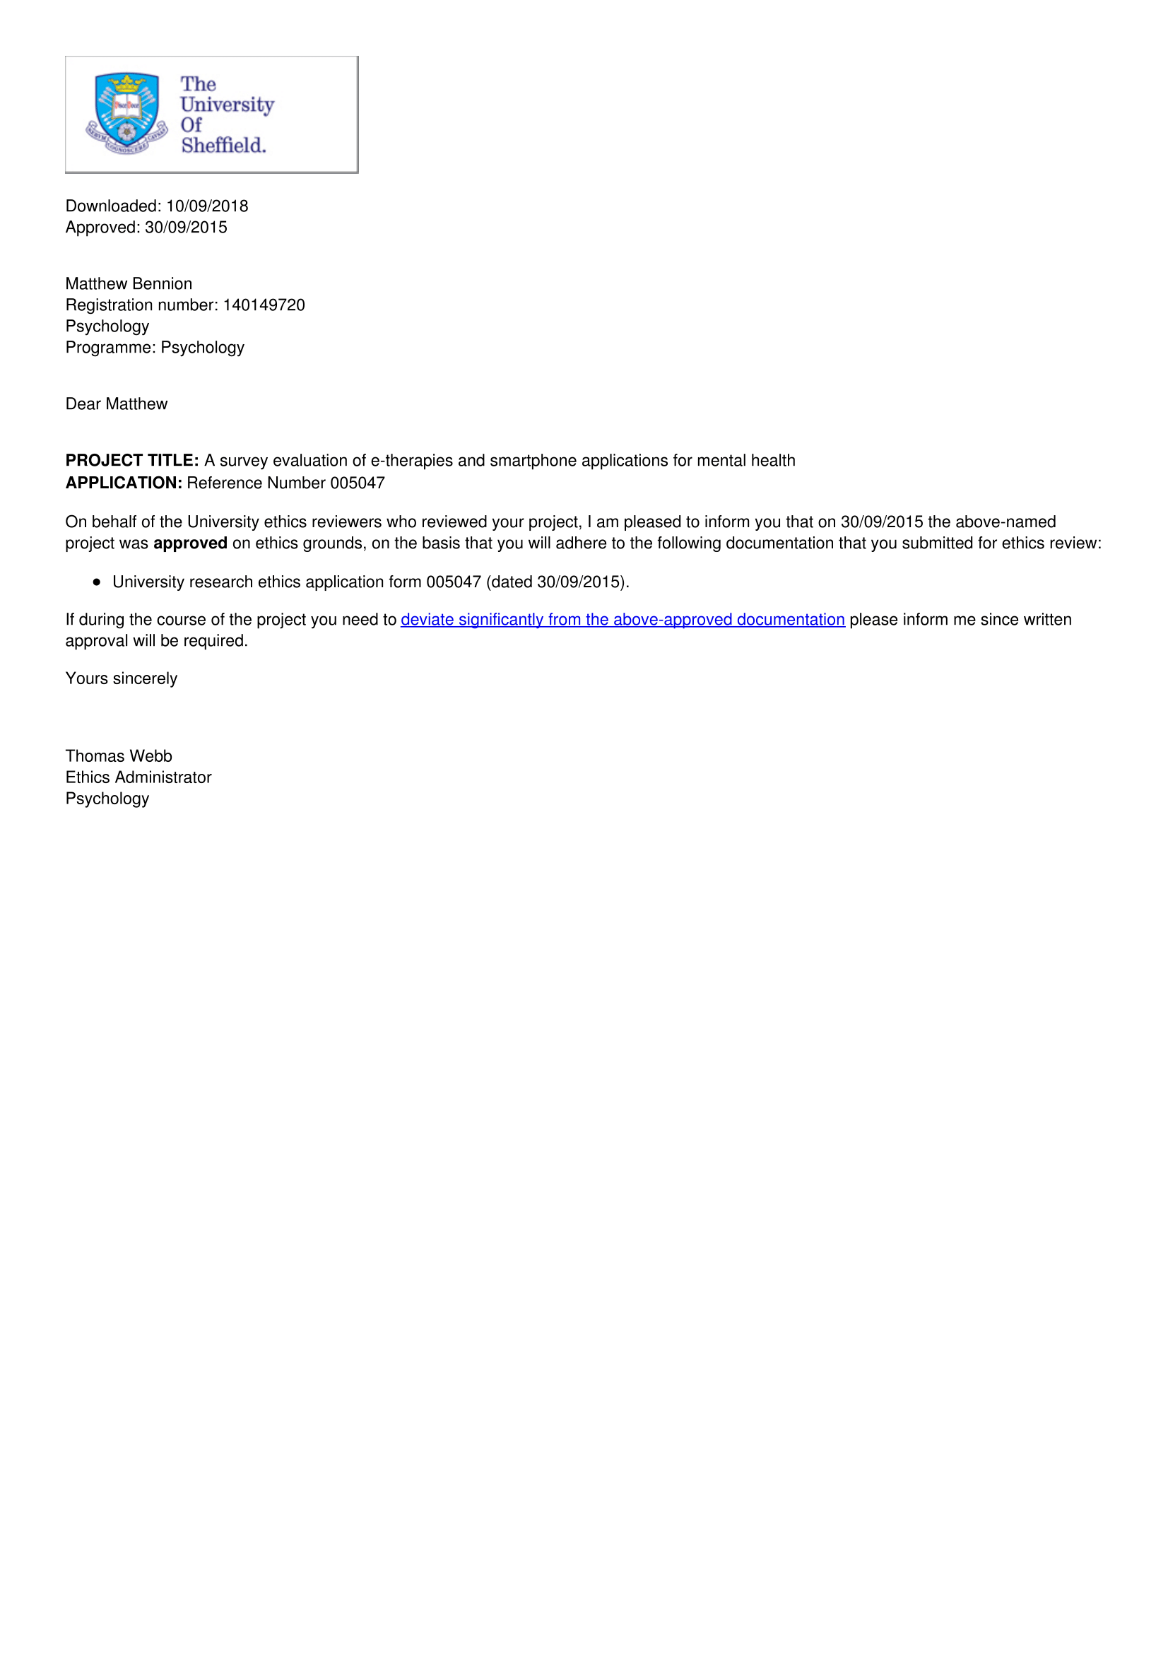
- Developer Contact Email
Dear Sir/Madam,
My name is Matthew Bennion a PhD student from The University of Sheffield. I’m conducting a study that aims to ascertain how many e-therapies and smartphone apps used by NHS mental health services or recommended by the NHS have clinical / academic involvement and research evidence. Your app has either been referenced by a NHS IAPT service or recommended on the Apps library and I was wondering if your company would be willing to fill in a questionnaire?
Yours Faithfully,
Matthew Bennion

- Study II Participant Information Sheet and Consent Form
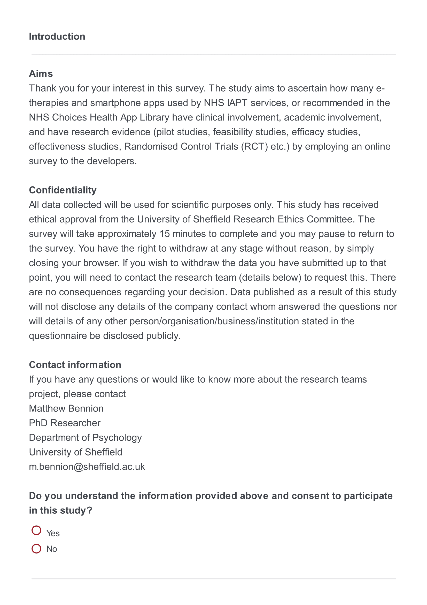
- Study II Participant Debrief
Thank you for taking the time to complete our survey.
Acknowledgements
This survey has received collective support by project supervisors Dr Abigail Millings and Dr Daniela Romano at the University of Sheffield.
Contact information
If you have any questions or would like to know more about the research teams project, please contact
Matthew Bennion
Phd Researcher
Department of Psychology
University of Sheffield
m.bennion@sheffield.ac.uk

- Letter From NICE Regarding Publication
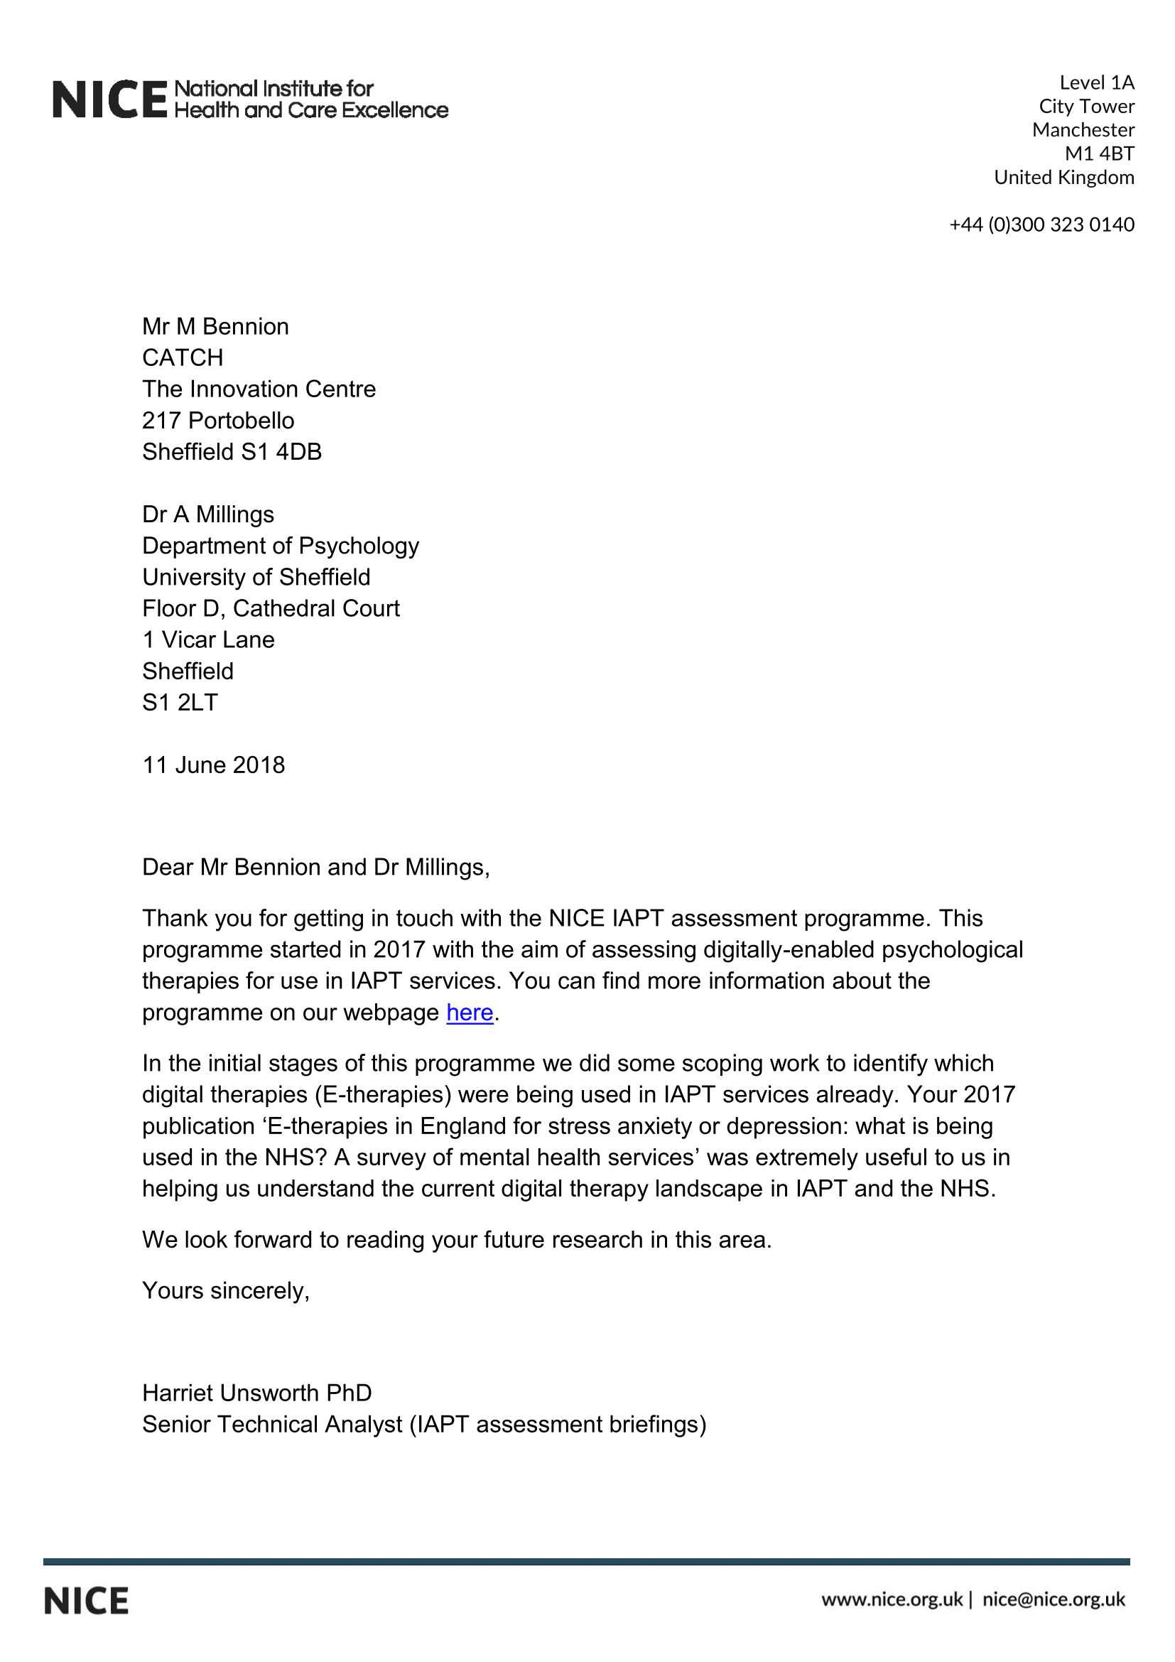

- Full Search Strategy for PubInfo
(Living Life to the Full) AND Website
(MoodGym) AND Website
(Big White Wall) AND Website
(Beating the Blues) AND Website
(SilverCloud Health) AND Website
(Ieso Digital Health Ltd) AND Website
(Fear Fighter) AND Website
(HeadSpace) AND App
(Buddy App) AND Website
(Don’t Panic!) AND App
(MyMoodTracker) AND App
(Mindfulness Bell) AND App
(Moodkit – Mood Improvement Tools) AND App
(Thought Diary Pro) AND App
(WellMind) AND App
(Moodometer) AND App
(Kooth) AND Website
(CBTReferee) AND App
(iCBT) AND App
(Thought Diary) AND App
(Stay Alive) AND App
(Take a break!) AND App
(Mindshift) AND App
(Moodscope) AND Website
(DigitalMeds) AND App
(How Are You App) AND App
(Mindfulness by Digipill) AND App
(Mindlogr) AND App
(Panic Attack Aid) AND App
(Phobia Free) AND App
(Stress Management App) AND App
(WorkGuru) AND Website
(Worry Watch) AND App
(MindEd) AND App
(Puffell) AND Website
(Virtual Hope Box) AND App
(Aventurine Mood Improver) AND App
(Black Rainbow) AND App
(Depression Calculator) AND App
(Five Ways to Wellbeing) AND App
(Ginsberg) AND App
(Happy Healthy App) AND App
(HealthStored) AND App
(Healthy Living) AND App
(Hello Brain Health) AND App
(Moodbug) AND App
(SAM: Self-help for Anxiety) AND App
(Stress & Anxiety Companion) AND App

- Problem Distress Rating Scale (PDRS) used in Studies IV and VI
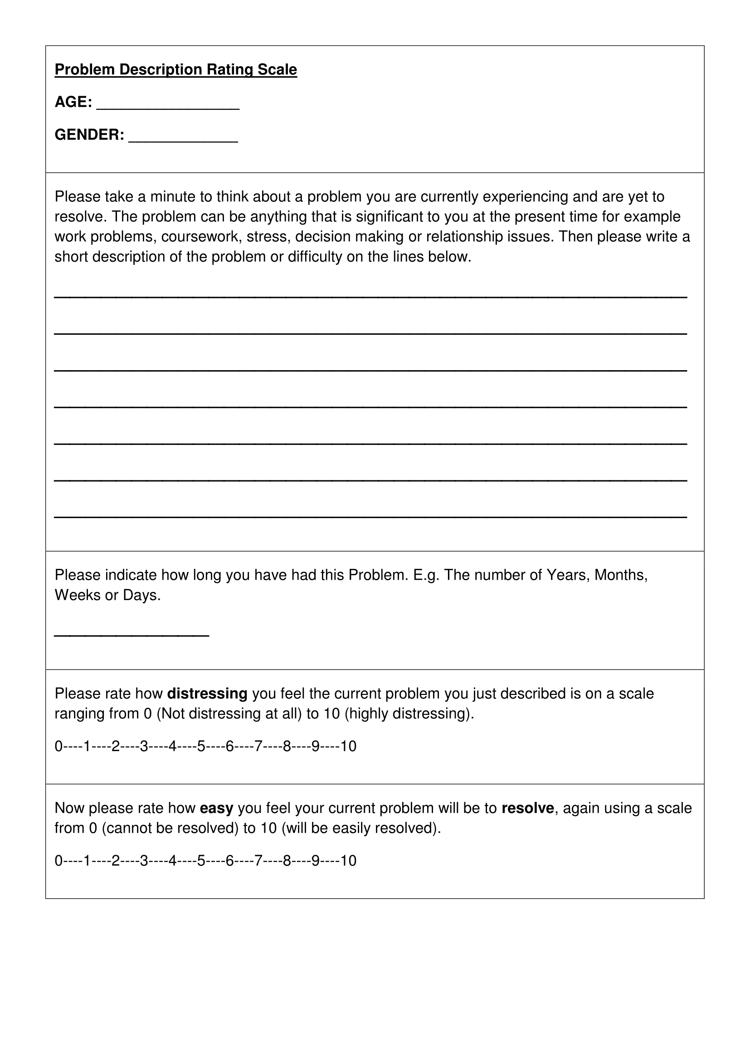
- Depression Anxiety Stress Scales 21 (DASS-21)
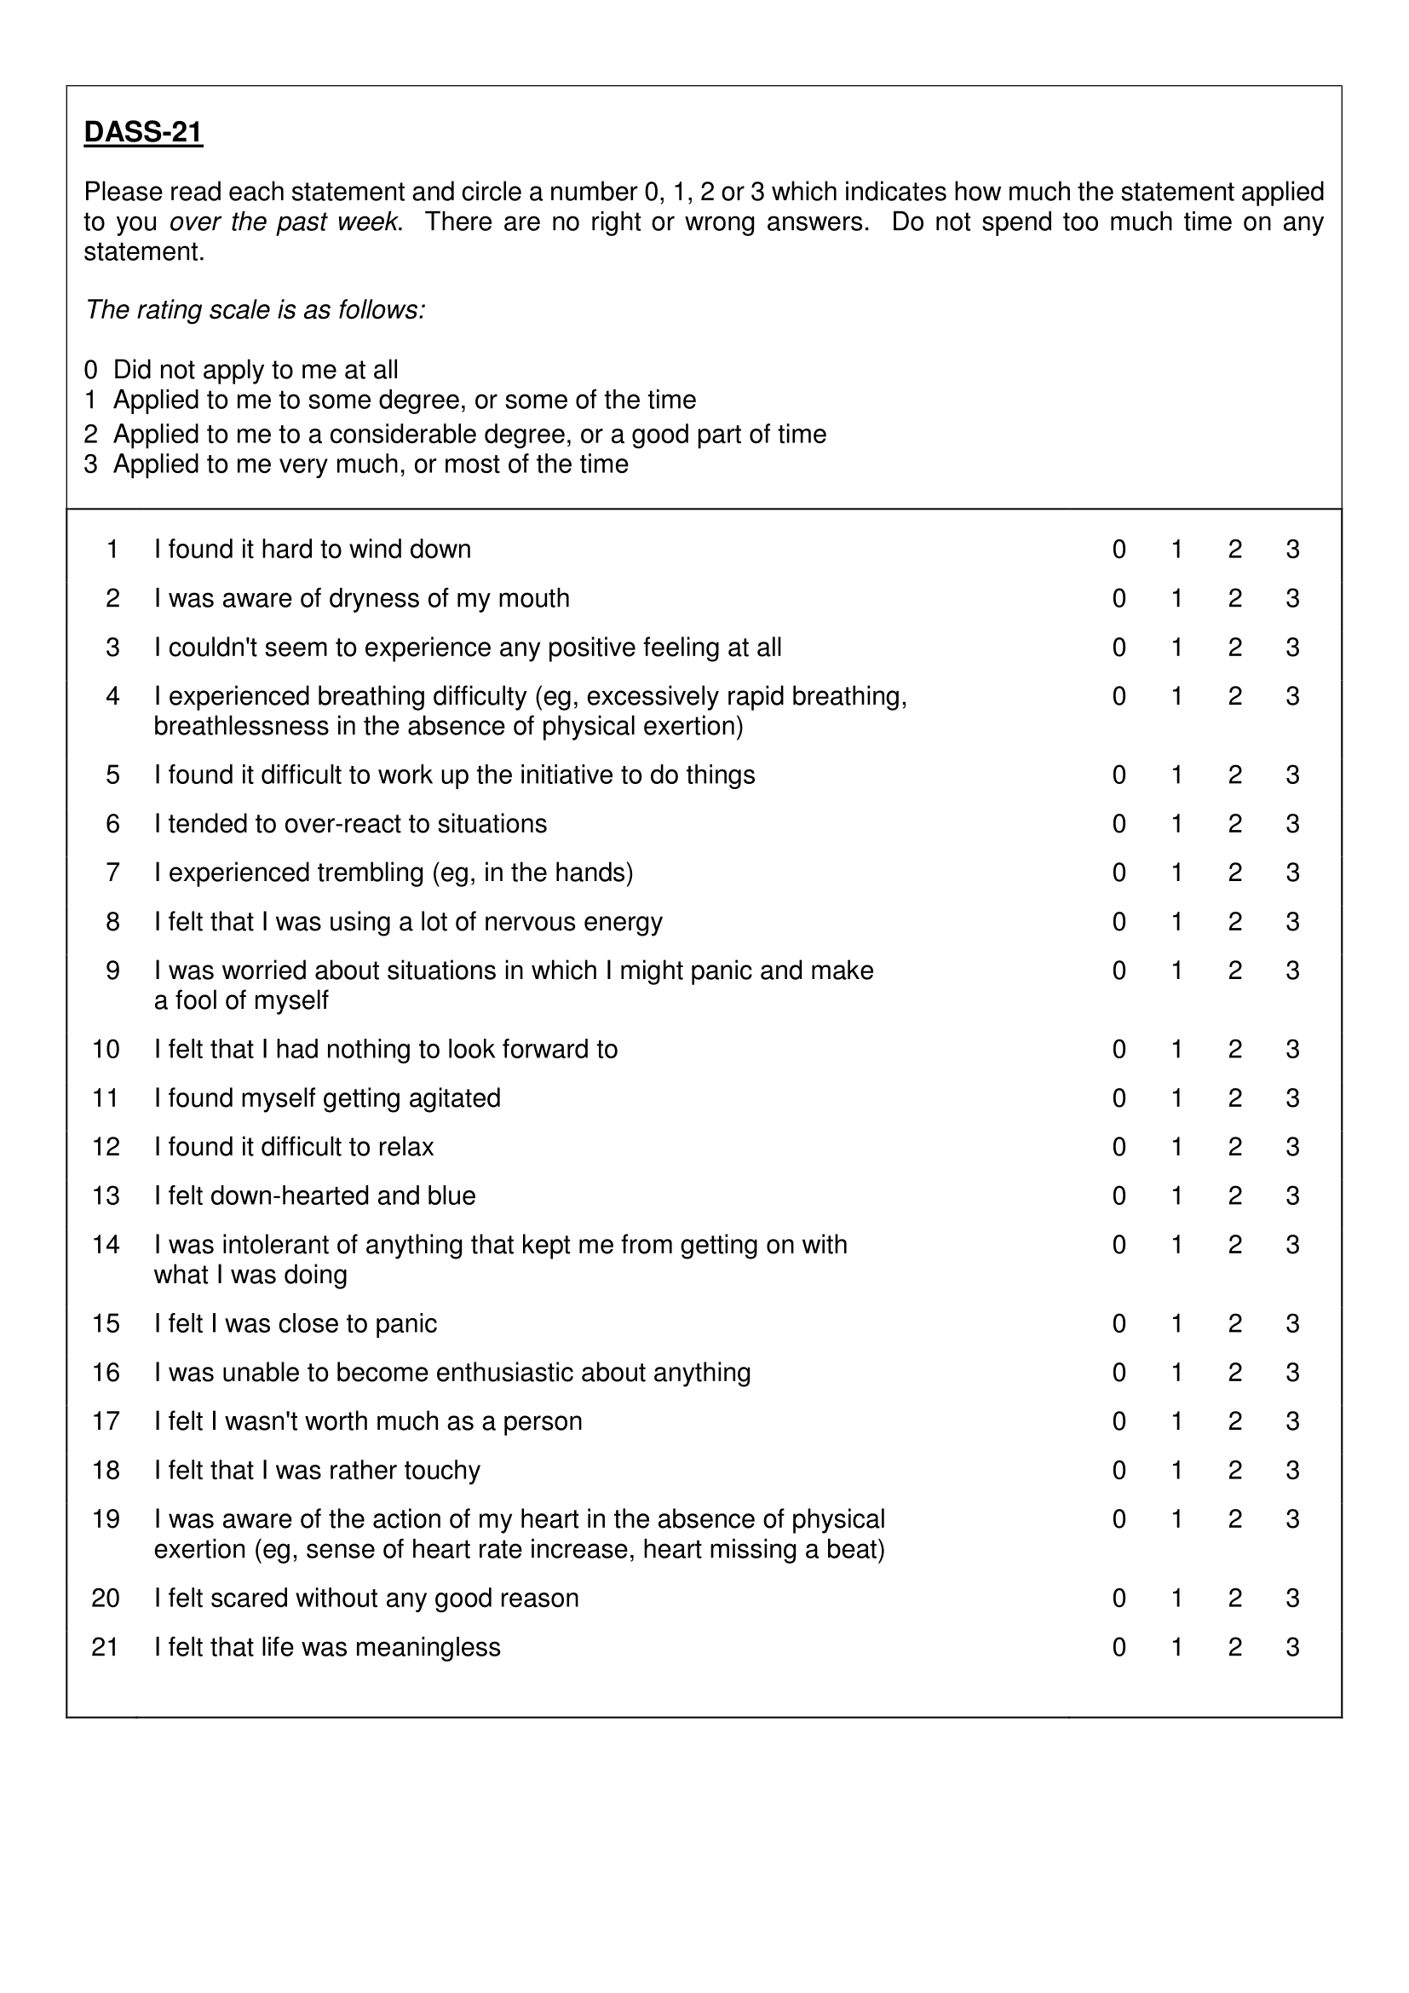
- Rating of Resolution Scale (RoR)
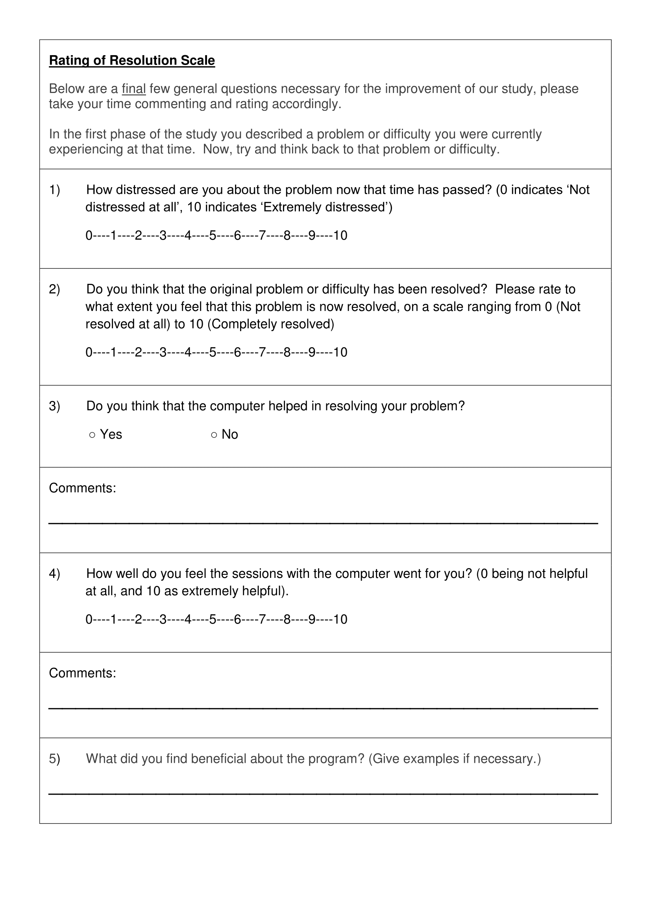
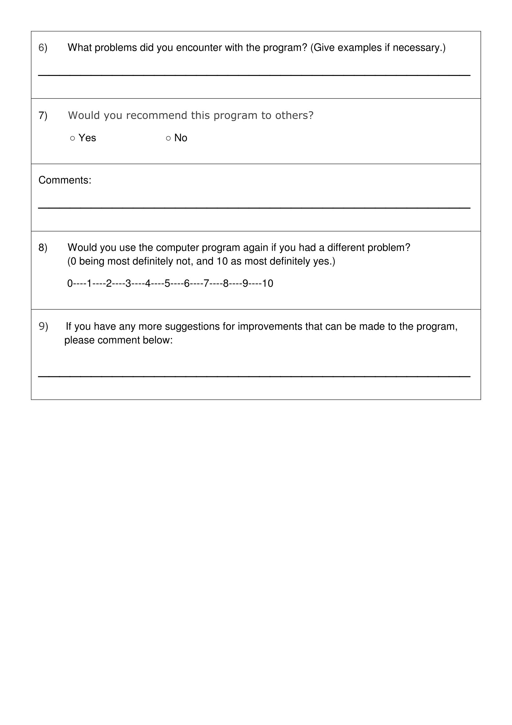
- System Usability Scale (SUS) used in Studies IV, V and VI
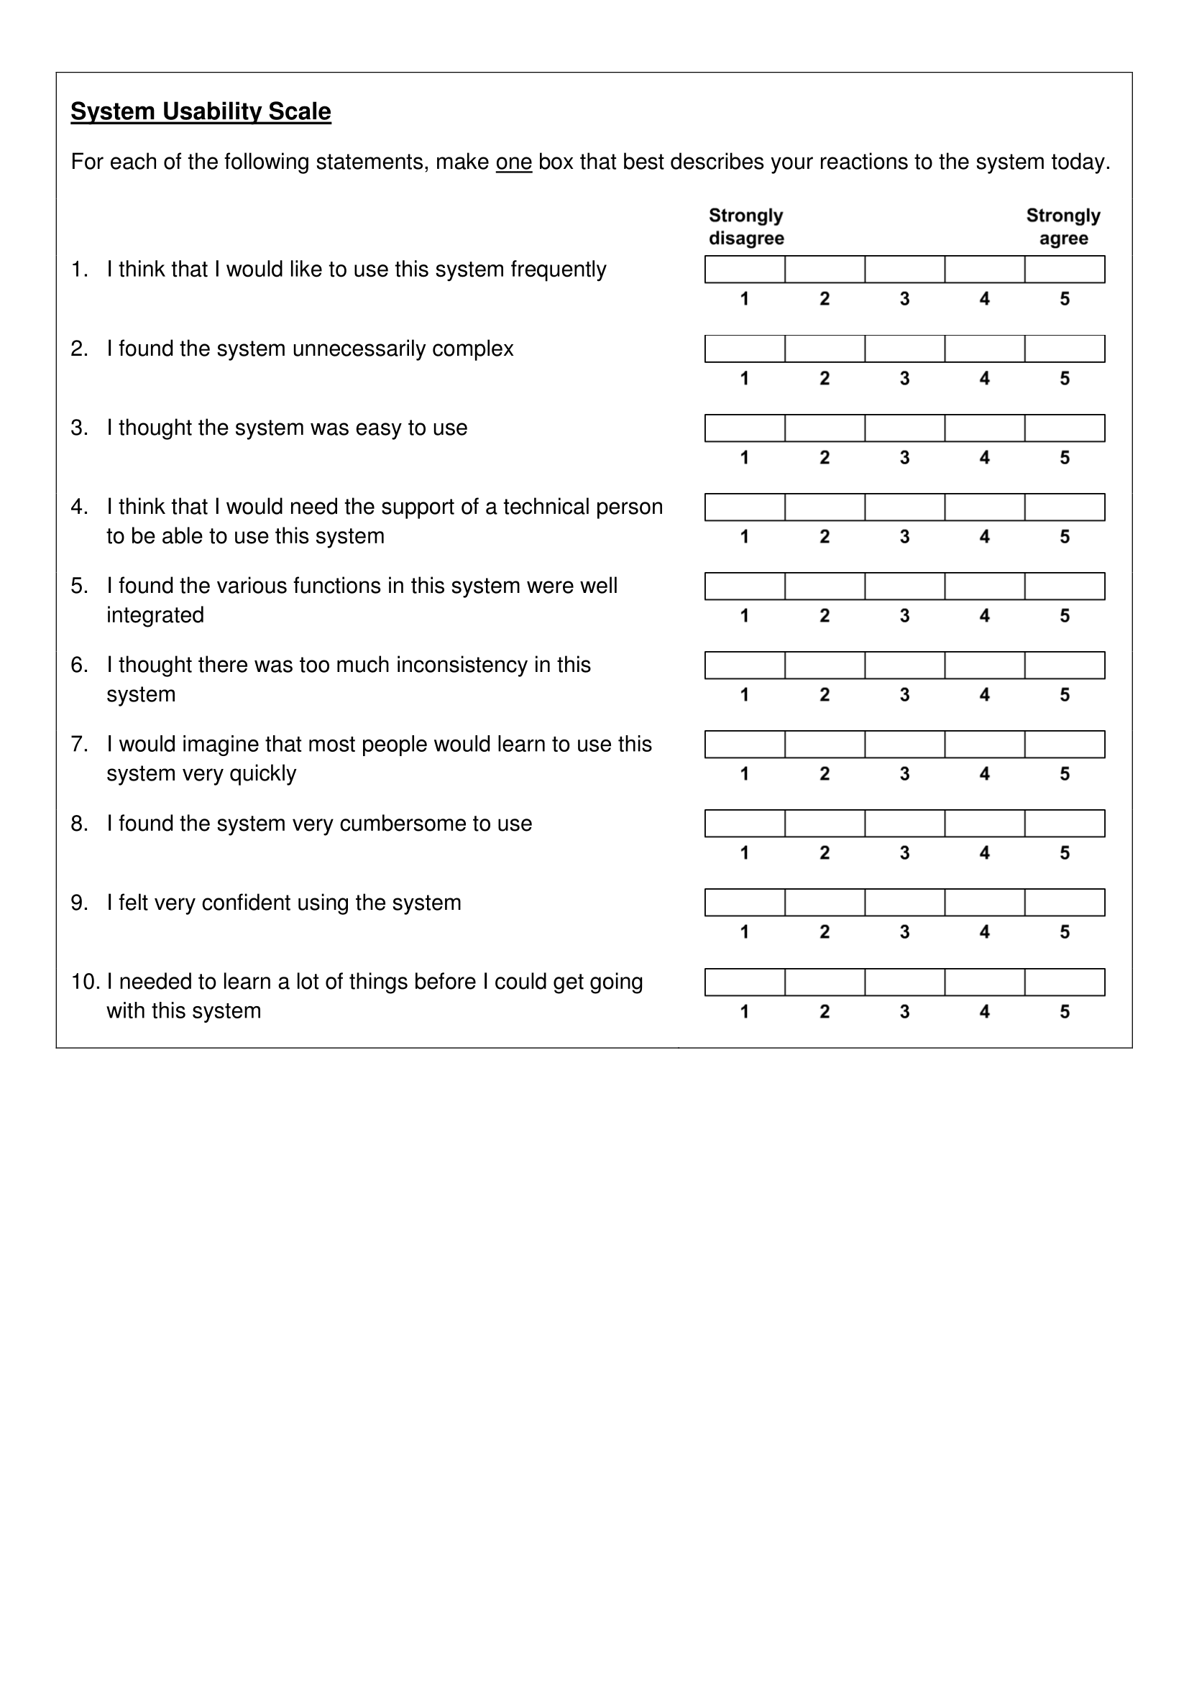

- Study IV Ethics Approval Letter
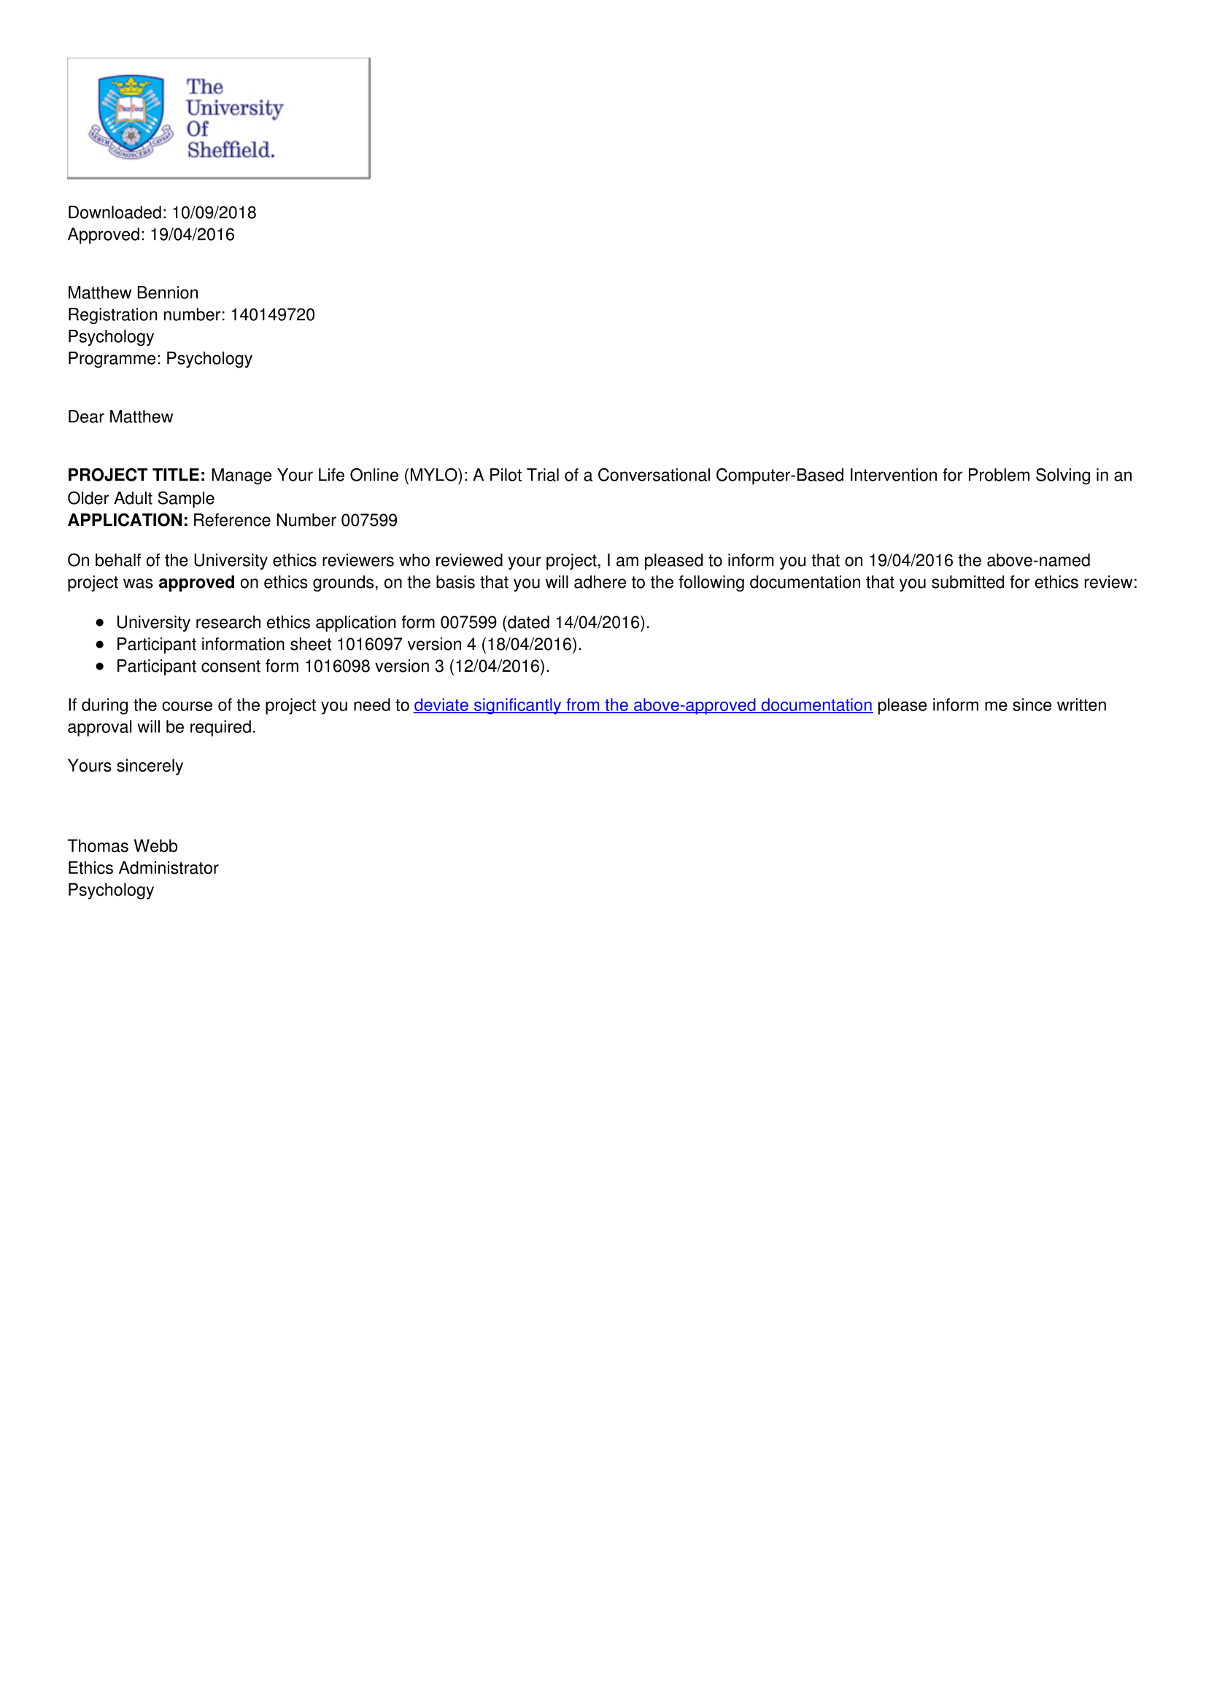
- Study IV Recruitment Poster
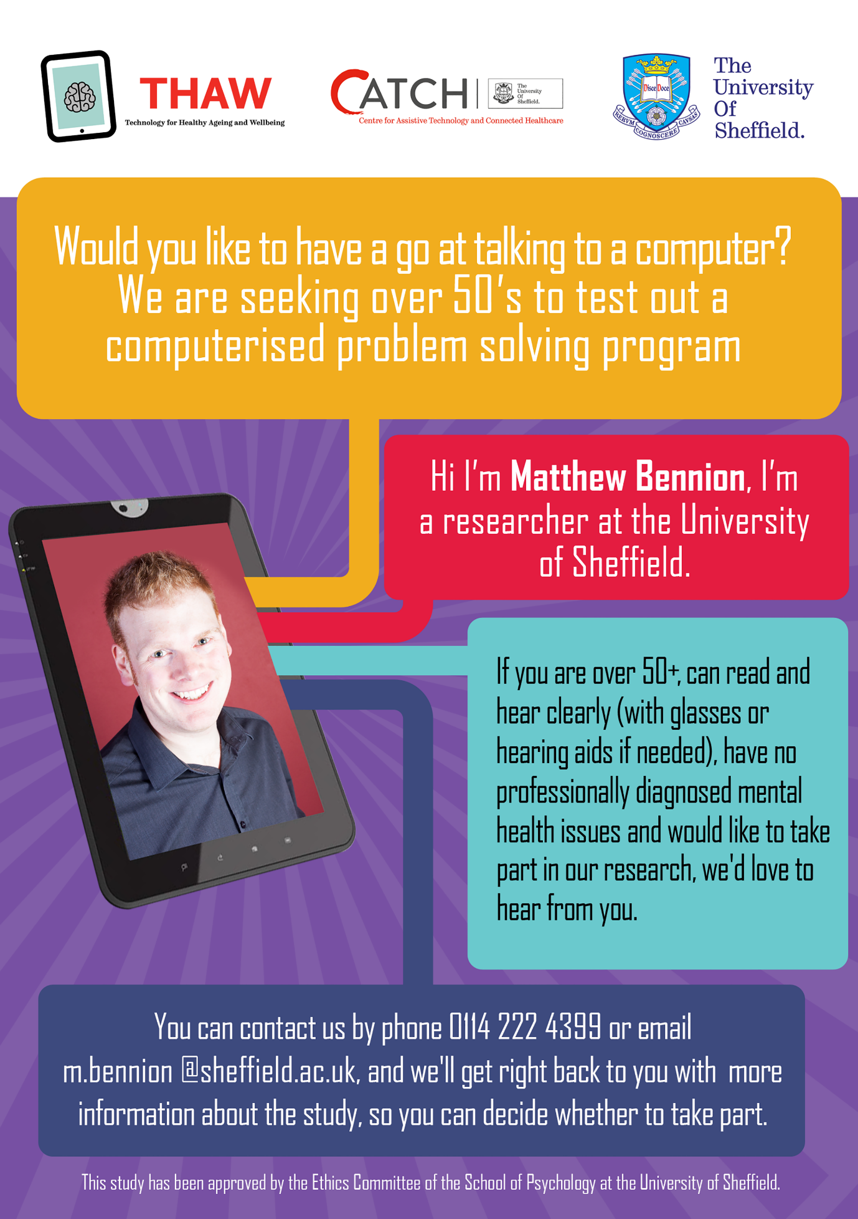

- Study IV Participant Information Sheet and Consent Form
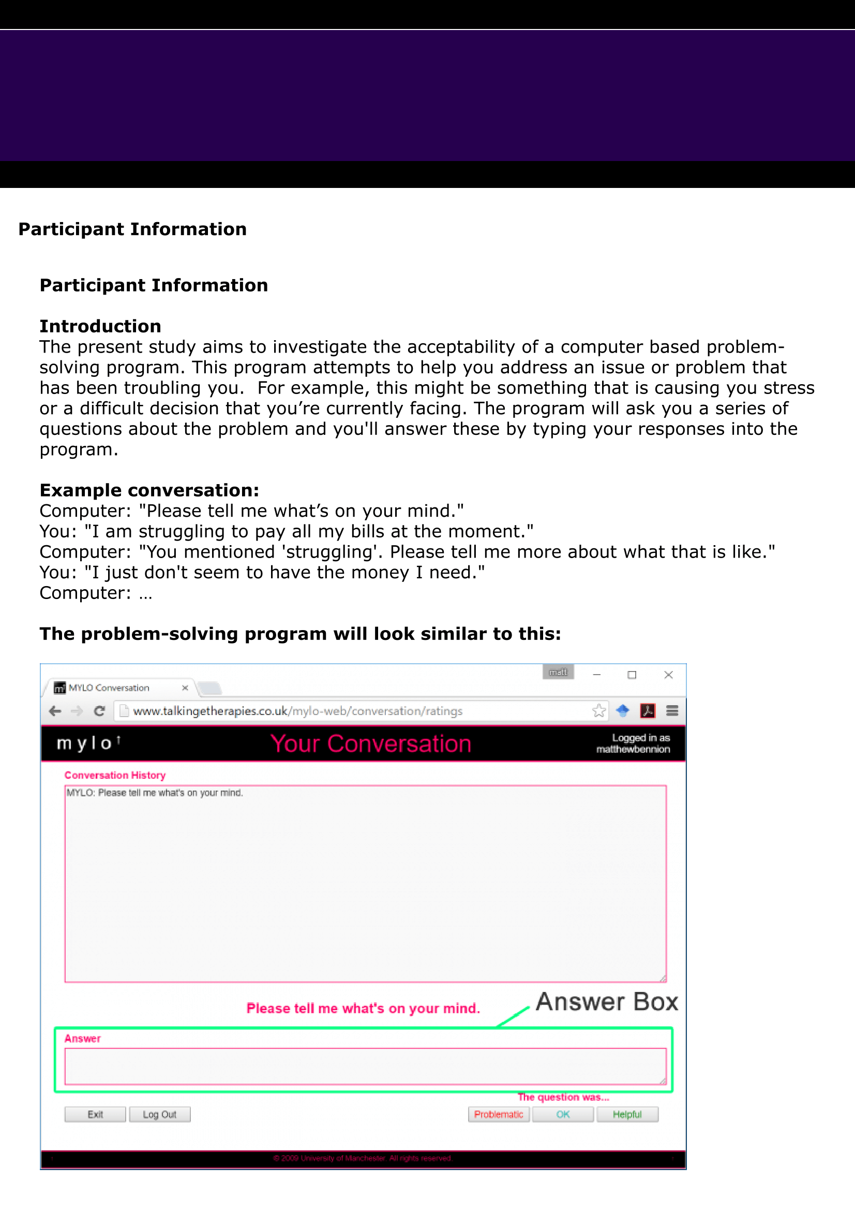
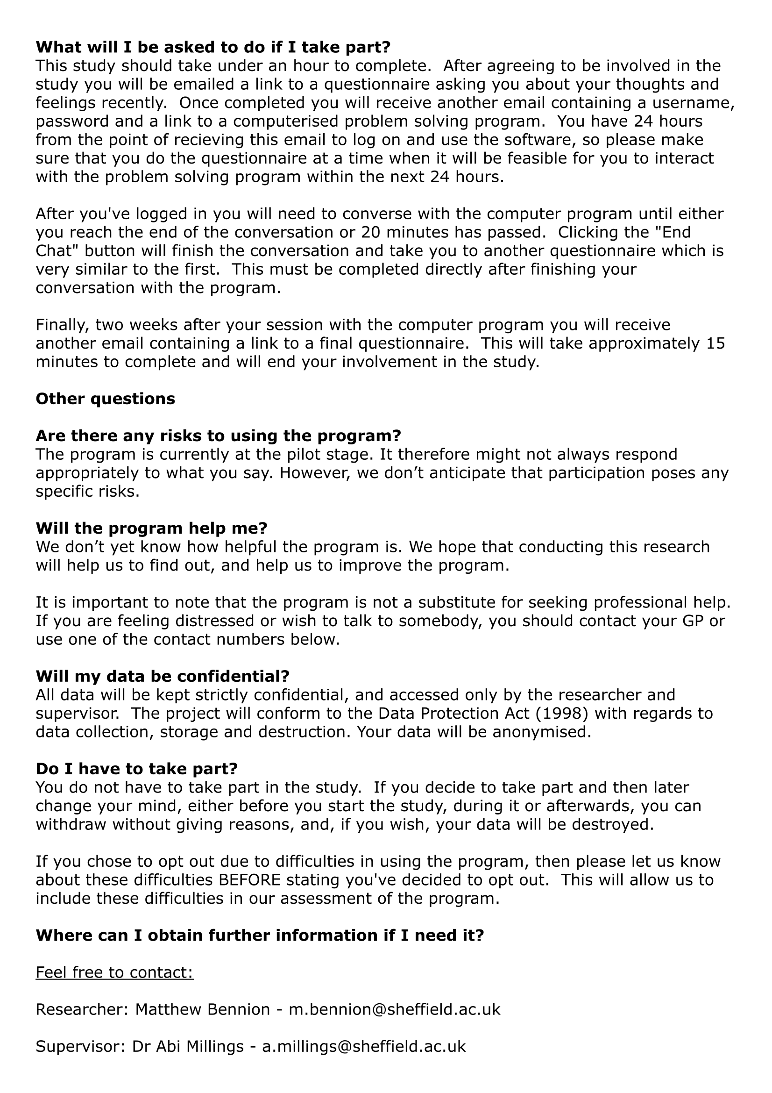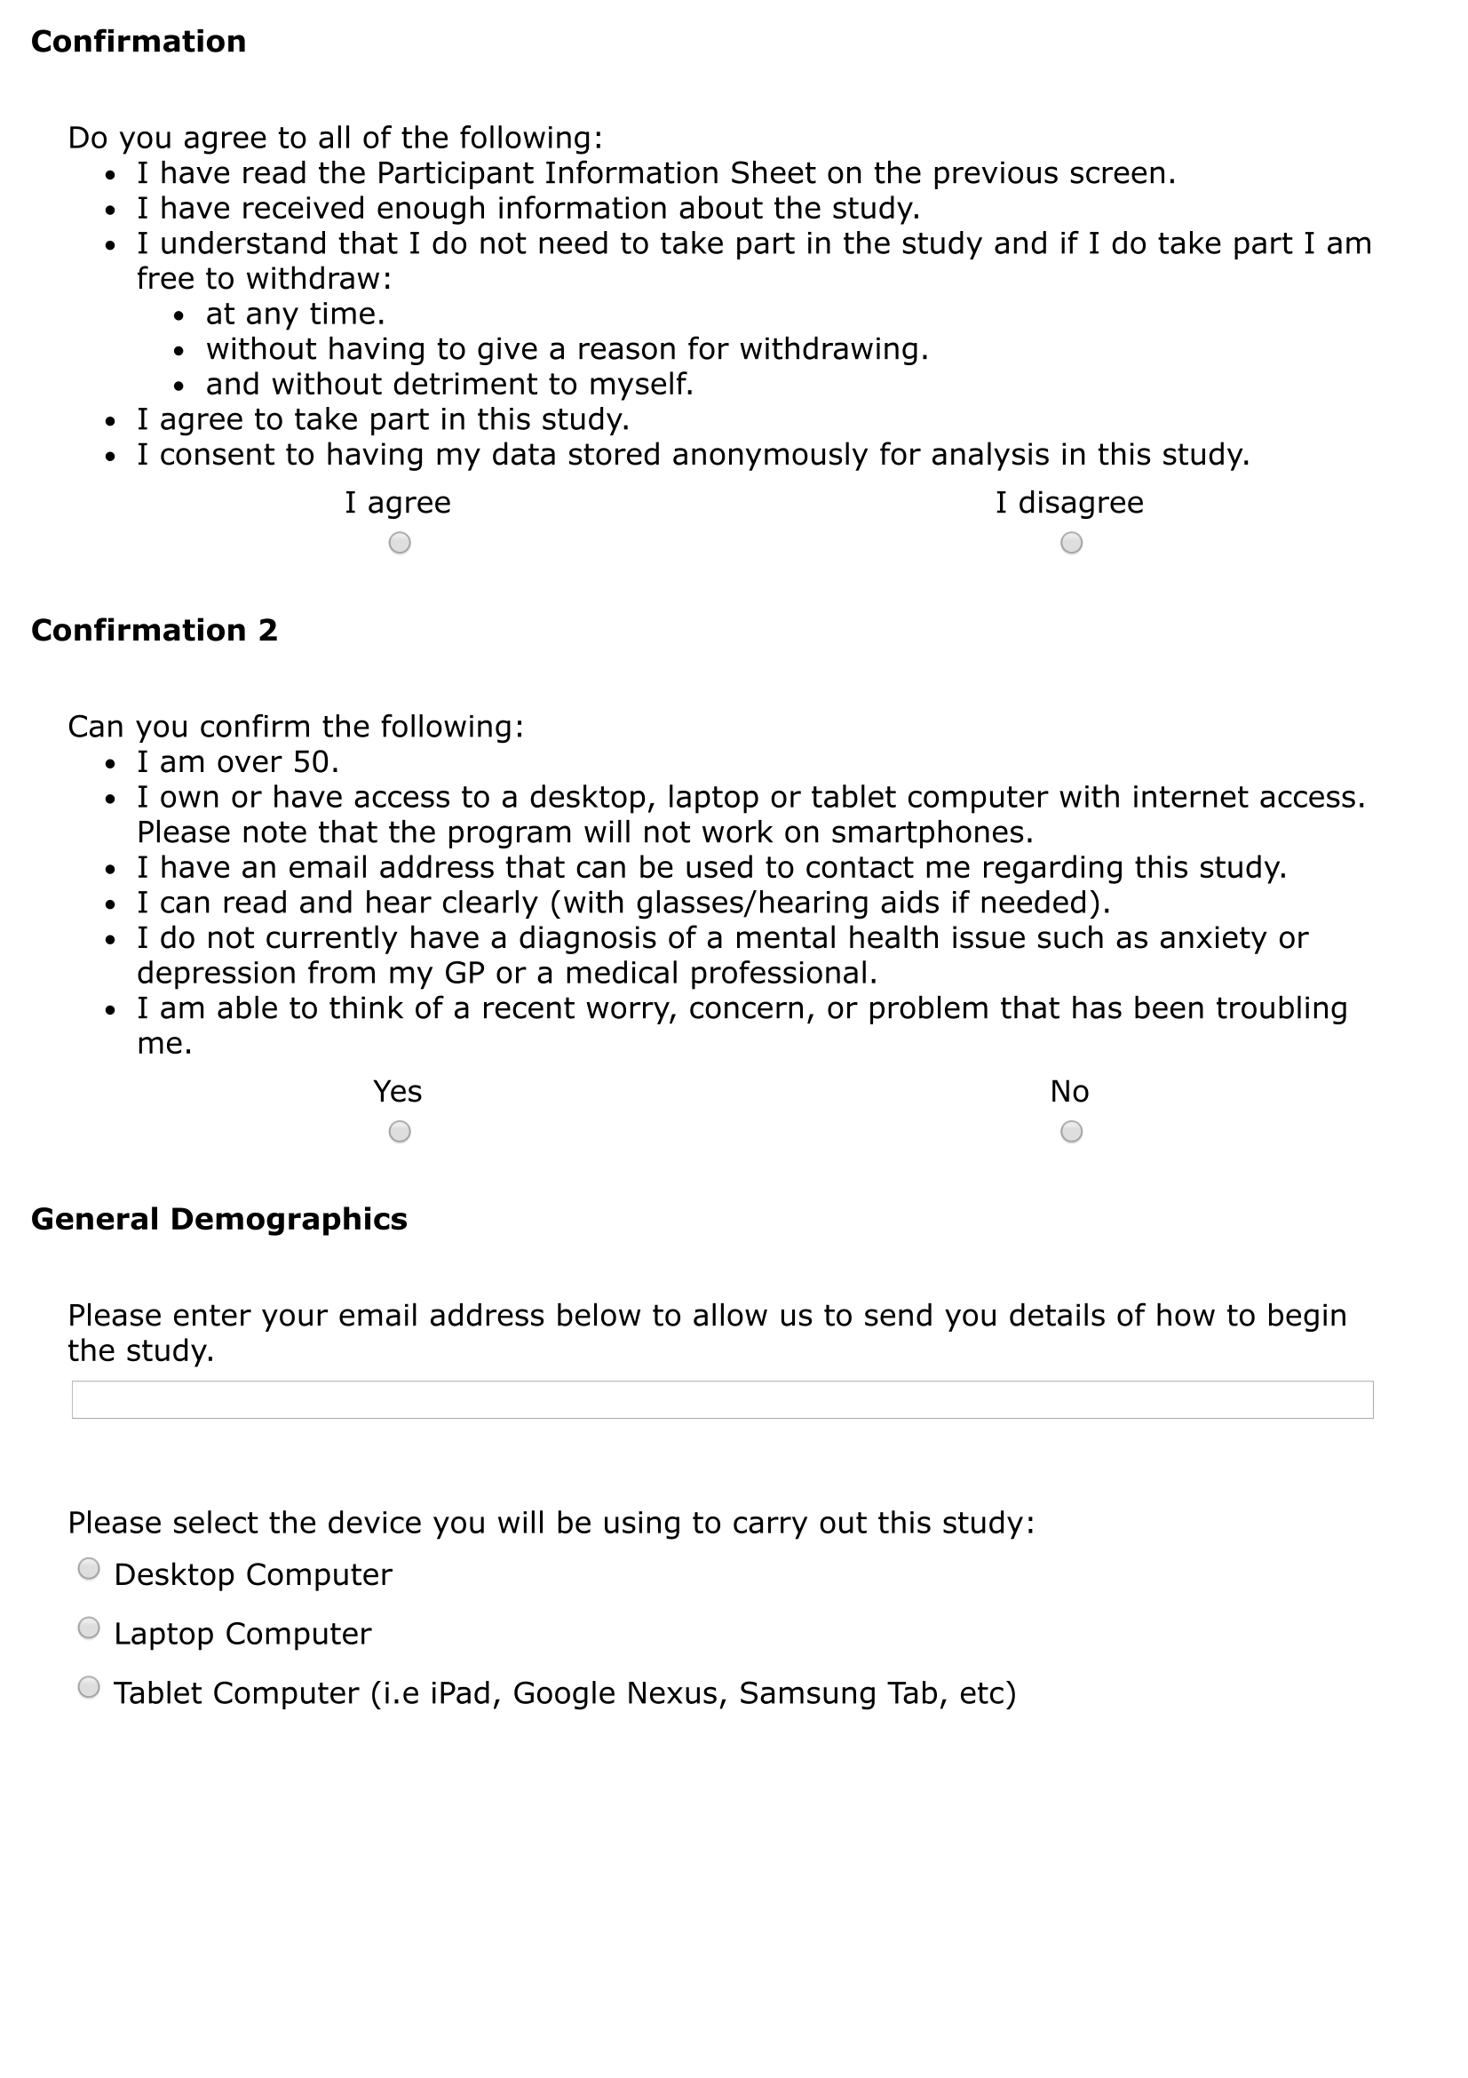
- ELIZA Tips
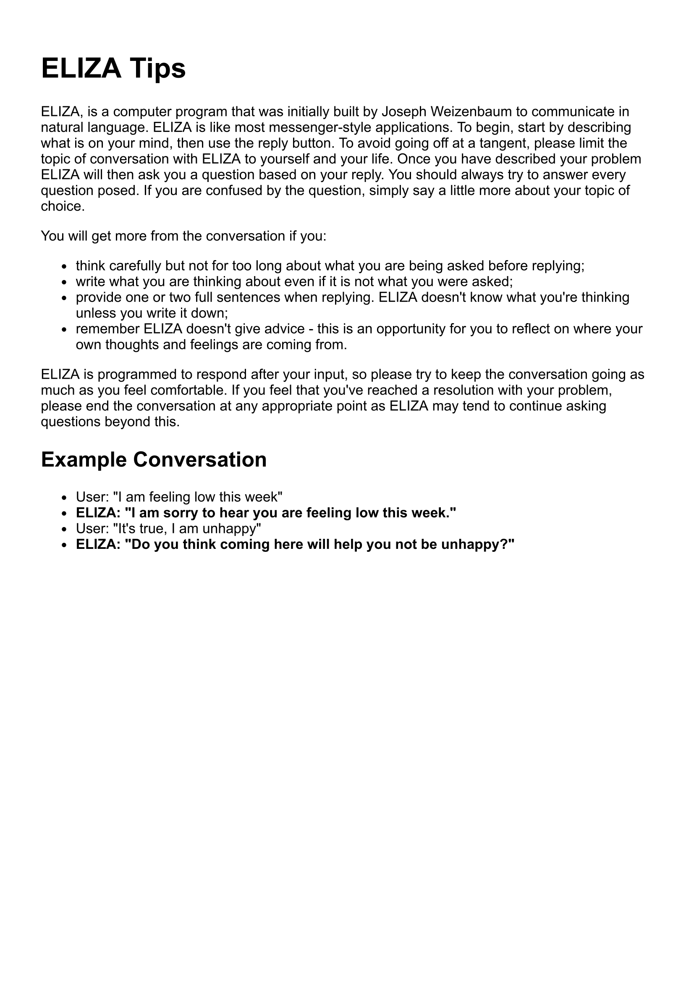
- MYLO Tips
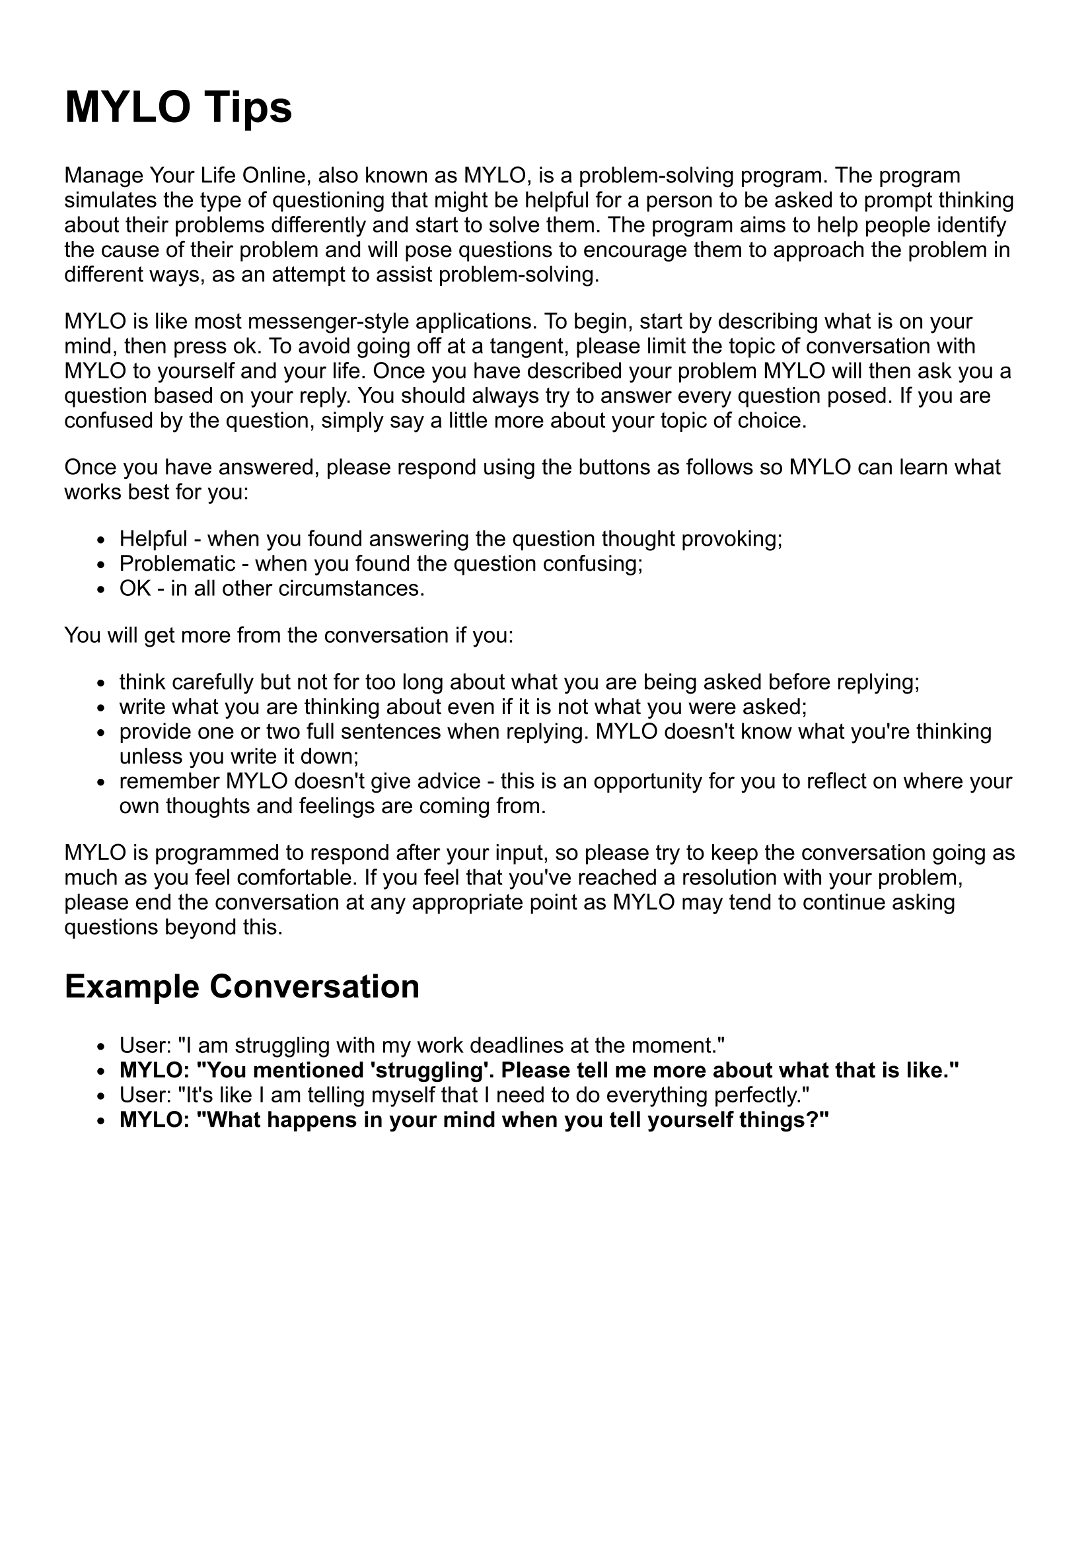

- Study IV Participant Debrief
Thank you for participating in this study.
You interacted with one of two programs. This is because we wanted to compare a program called Manage Your Life Online (MYLO) with a program called ELIZA and see which was best at helping older adults solve problems.
Previous research has shown MYLO to be an acceptable problem-solving aid for young adults. This study is important because its results will assist in the further development of MYLO. In this study we randomly assigned participants to talk with either MYLO or ELIZA. We expect to find MYLO to be the more acceptable problem-solving aid for older adults as MYLO was specially designed to aid in problem-solving, while ELIZA is a simulation of conversation with another person.
In the next phase of research, we will be looking at how we can improve MYLO's acceptability. This will be done by evaluating a series of possible enhancements via older adult feedback. If you're interested in being part of this work, then please feel free to contact me.
Thank you for your participation in our research. If you have any questions, please contact me using the details below.
Please remember, the program(s) involved in this study are not a substitute for seeking professional help. If you are feeling distressed, you should contact your GP
If completing this study has made you feel worried or stressed:You should contact your GP, who will be able to advise you on the support services available in your local area.
If you need urgent support, you can call
Samaritans on 08457 90 90 90 or www.samaritans.org
MIND on 0300 123 3393 or www.mind.org.uk
You can also contact your GP.
If you'd like further information
For an overview of this project, please watch the following video: https://youtu.be/djTNx0-z8QI
Contact information
If you have any questions or would like to know more about the research team's project, please contact
Matthew Bennion
PhD Researcher
Department of Psychology
University of Sheffield
m.bennion@sheffield.ac.uk
You can also contact Matthew’s supervisory team, Dr Abigail Millings, Prof Roger Moore and Prof Gillian Hardy at the University of Sheffield, by emailing a.millings@sheffield.ac.uk

- MYLO Introduction Screenshots
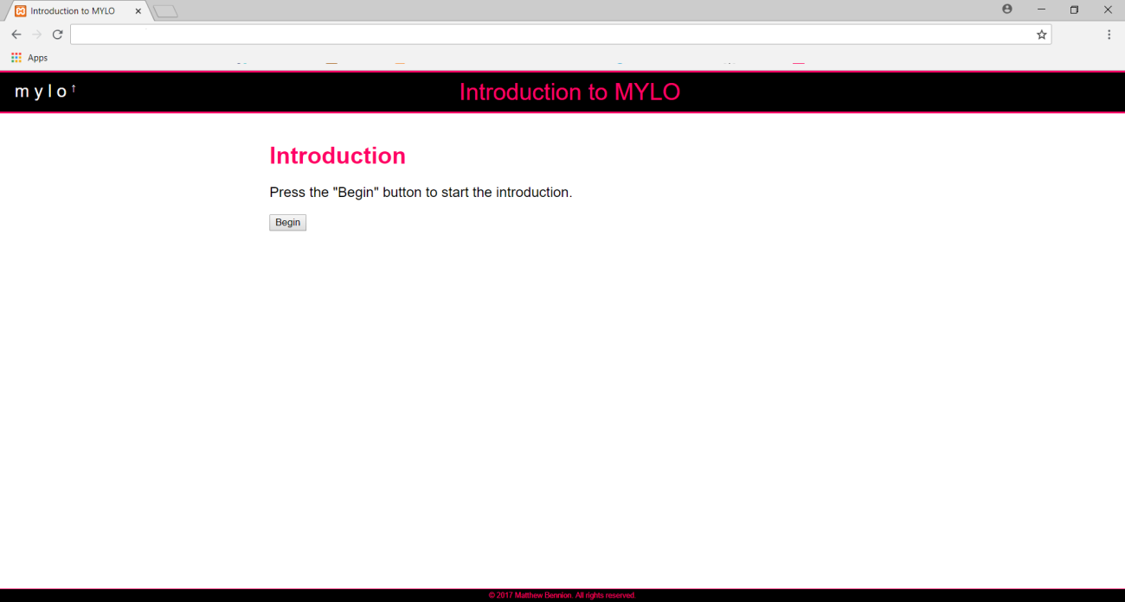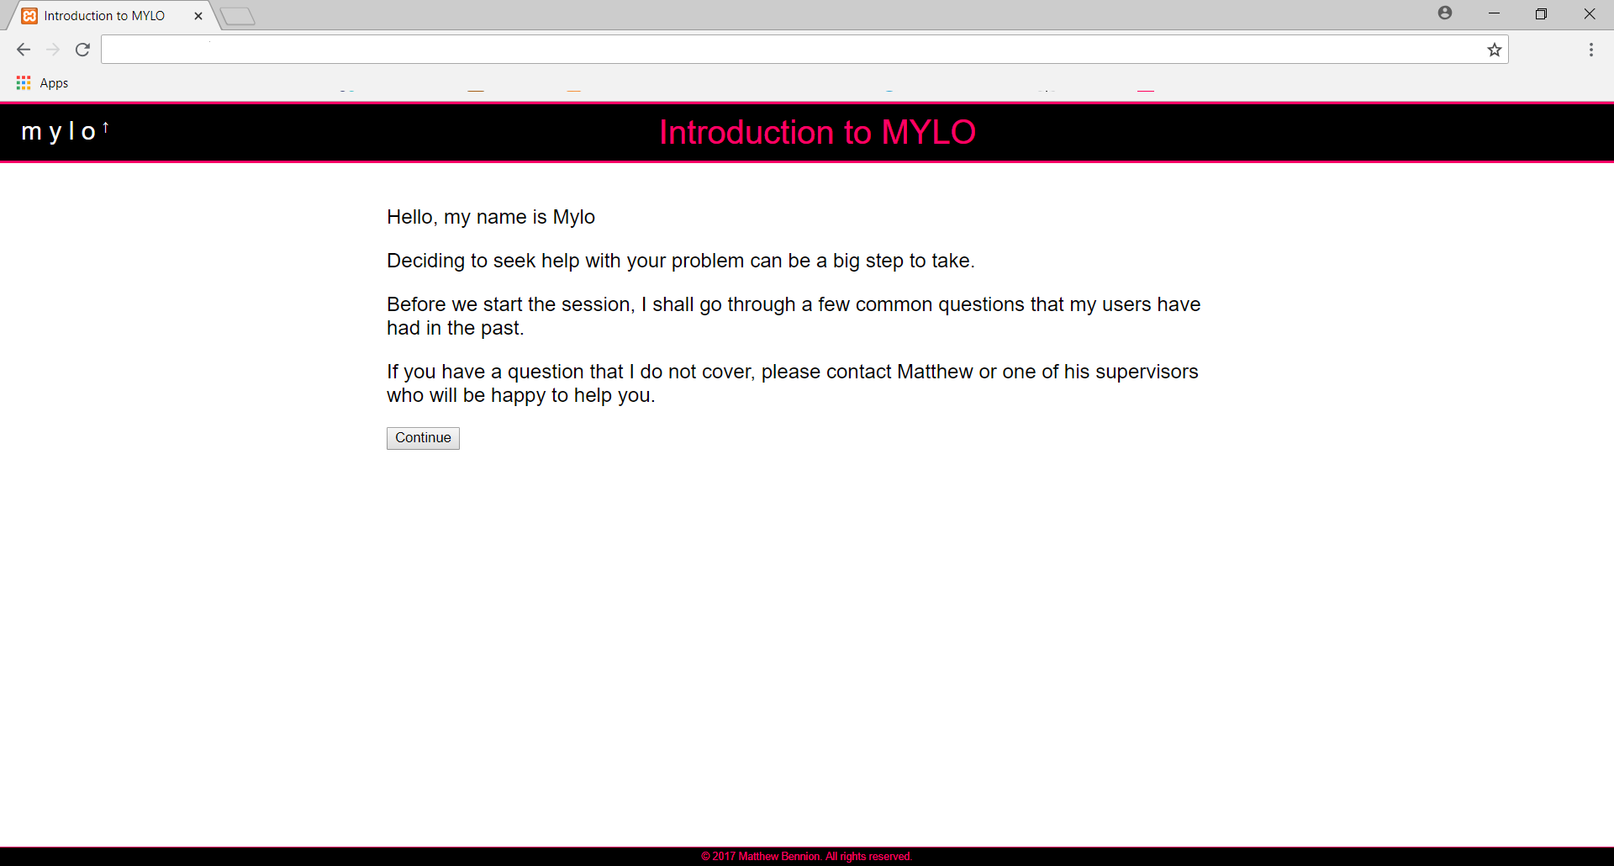
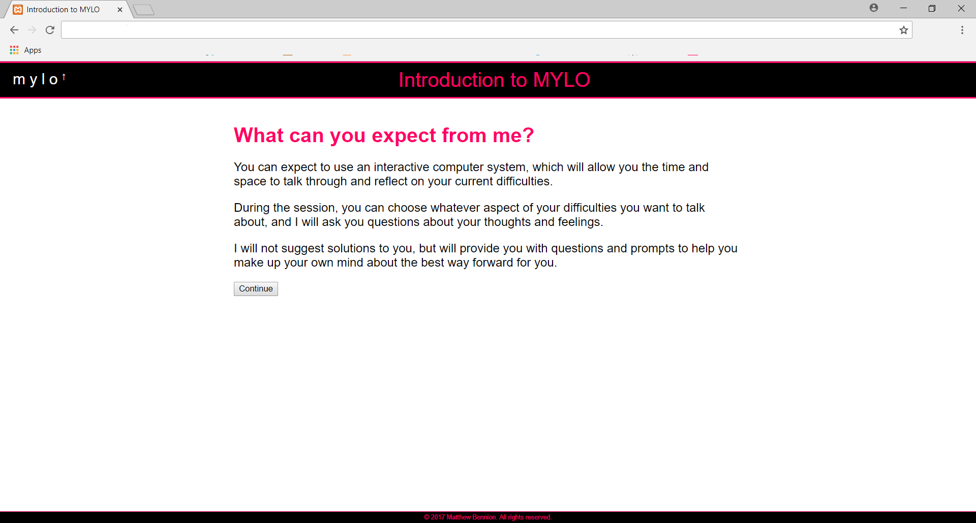
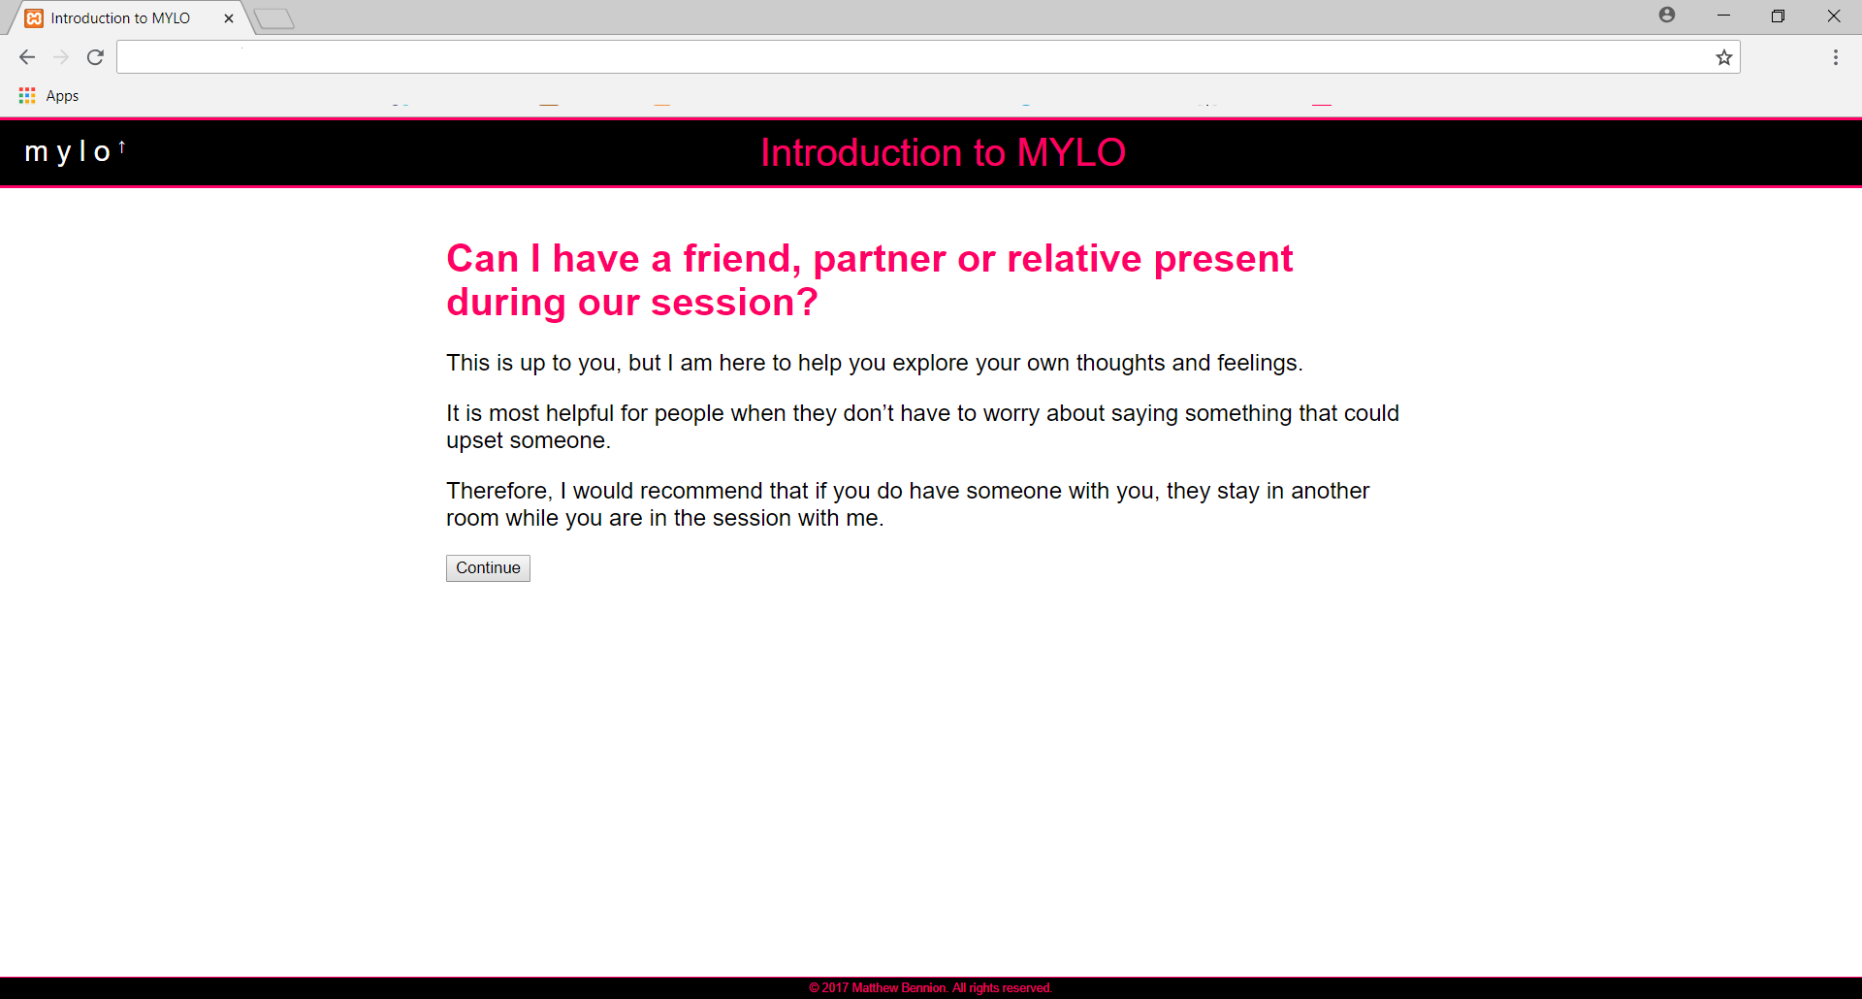
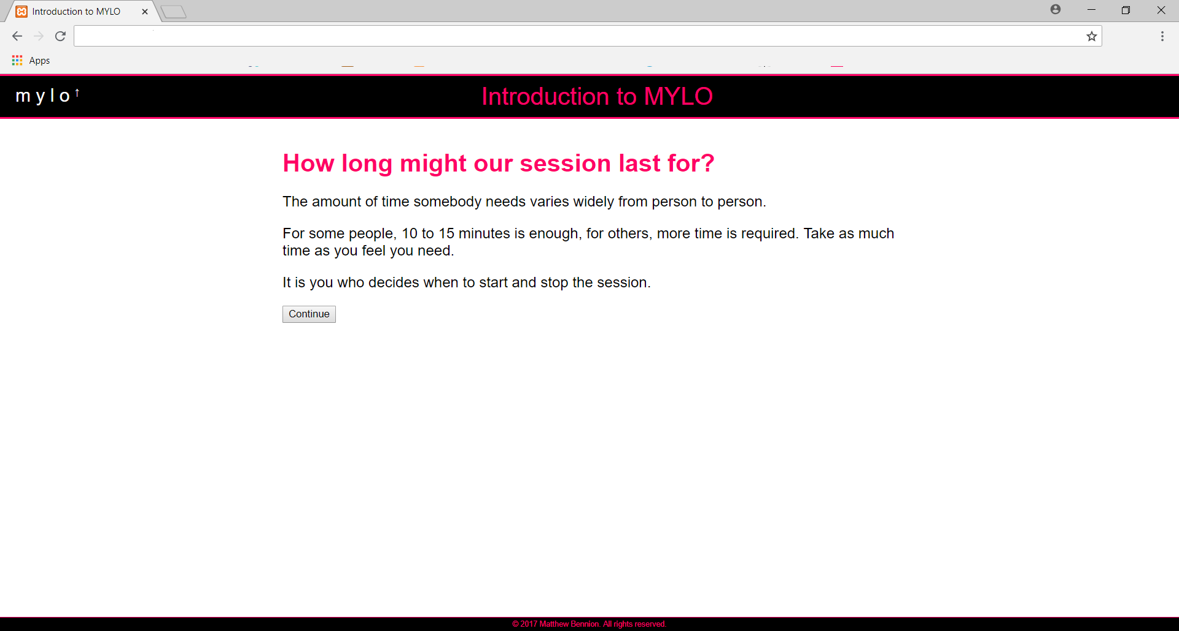
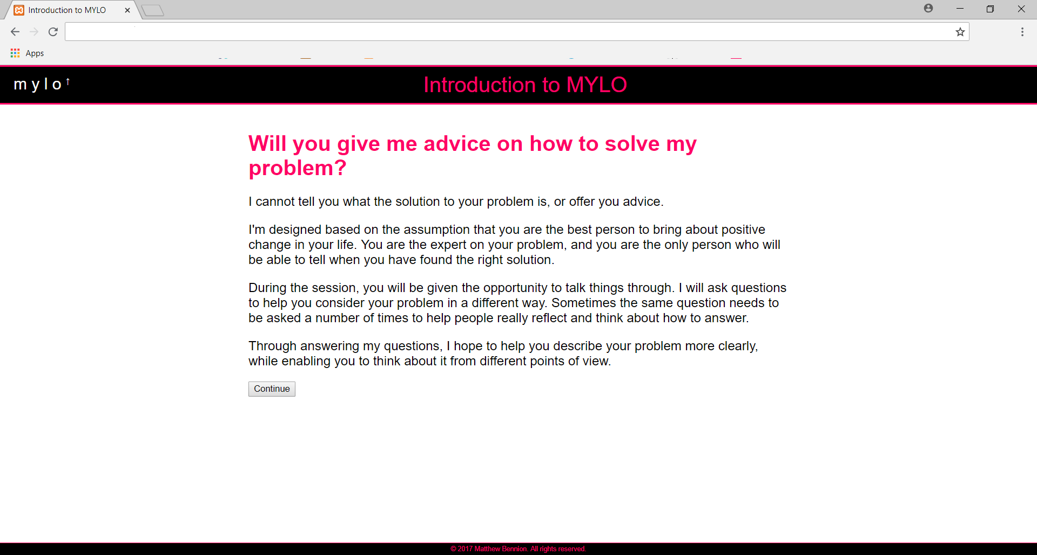
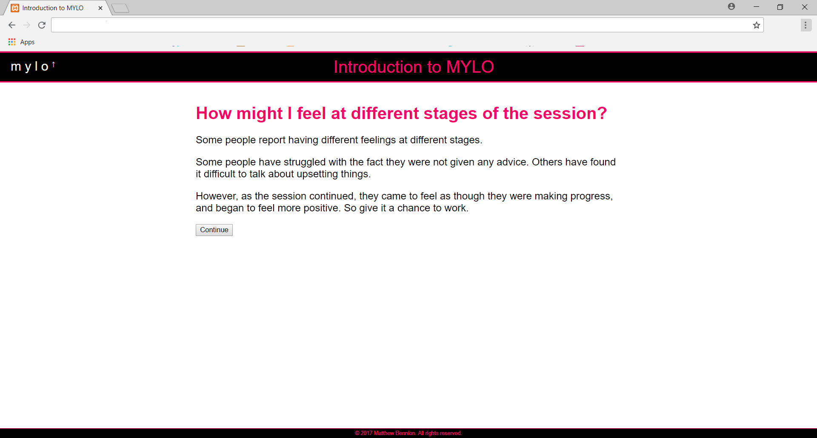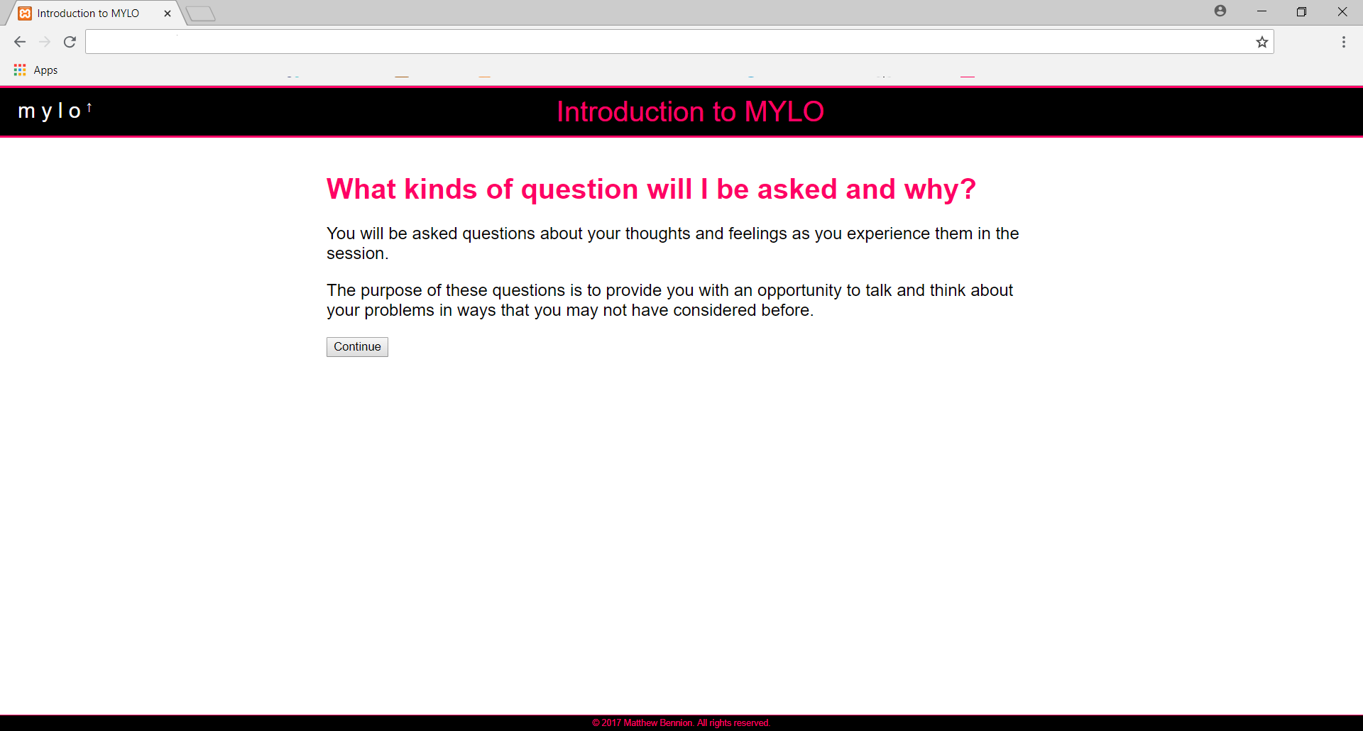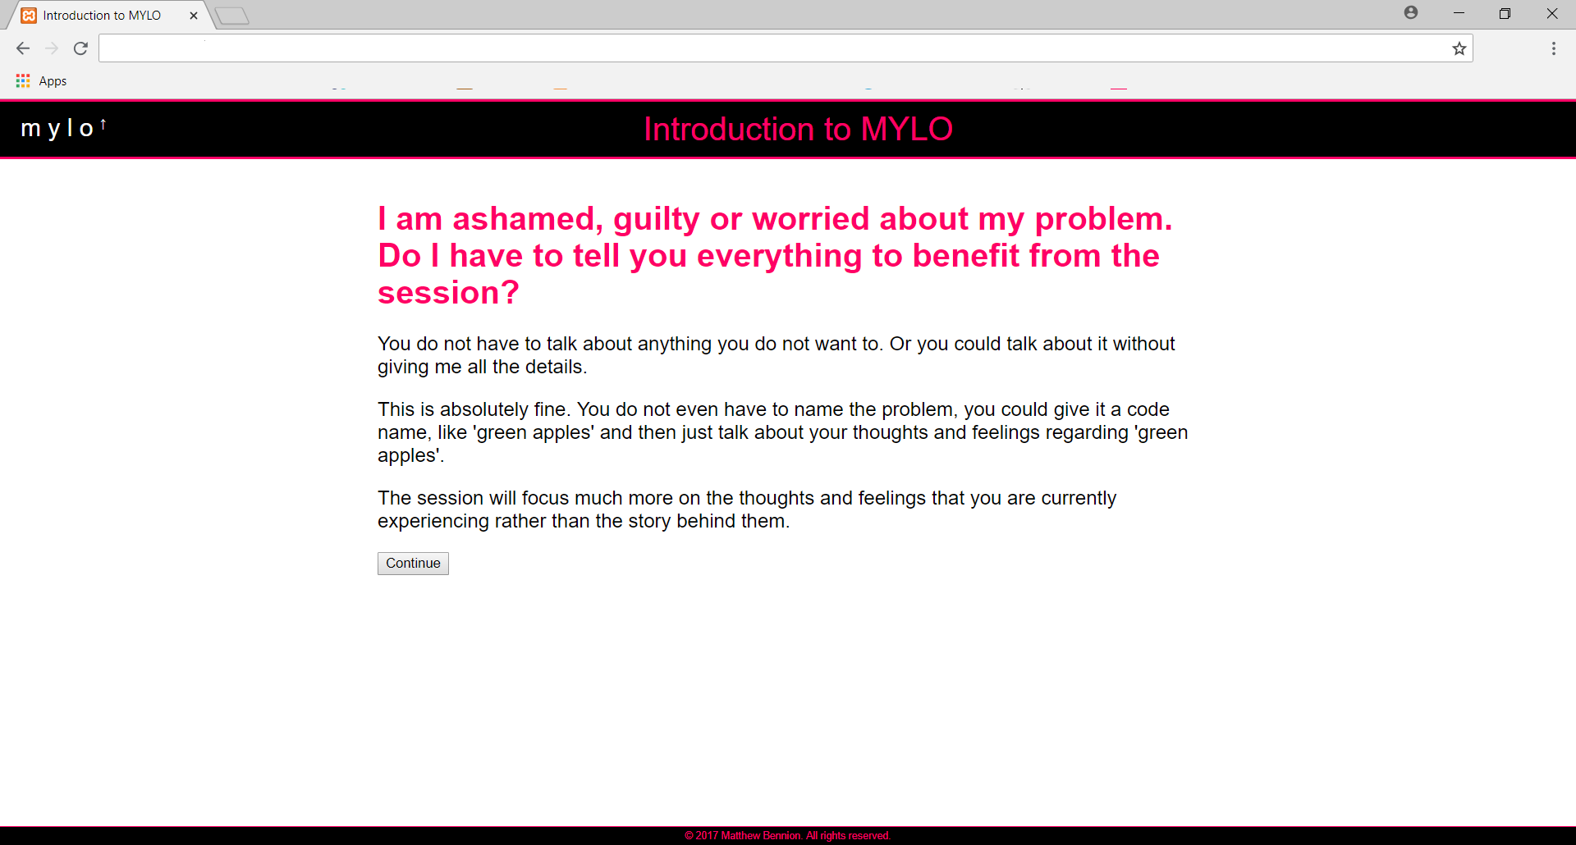
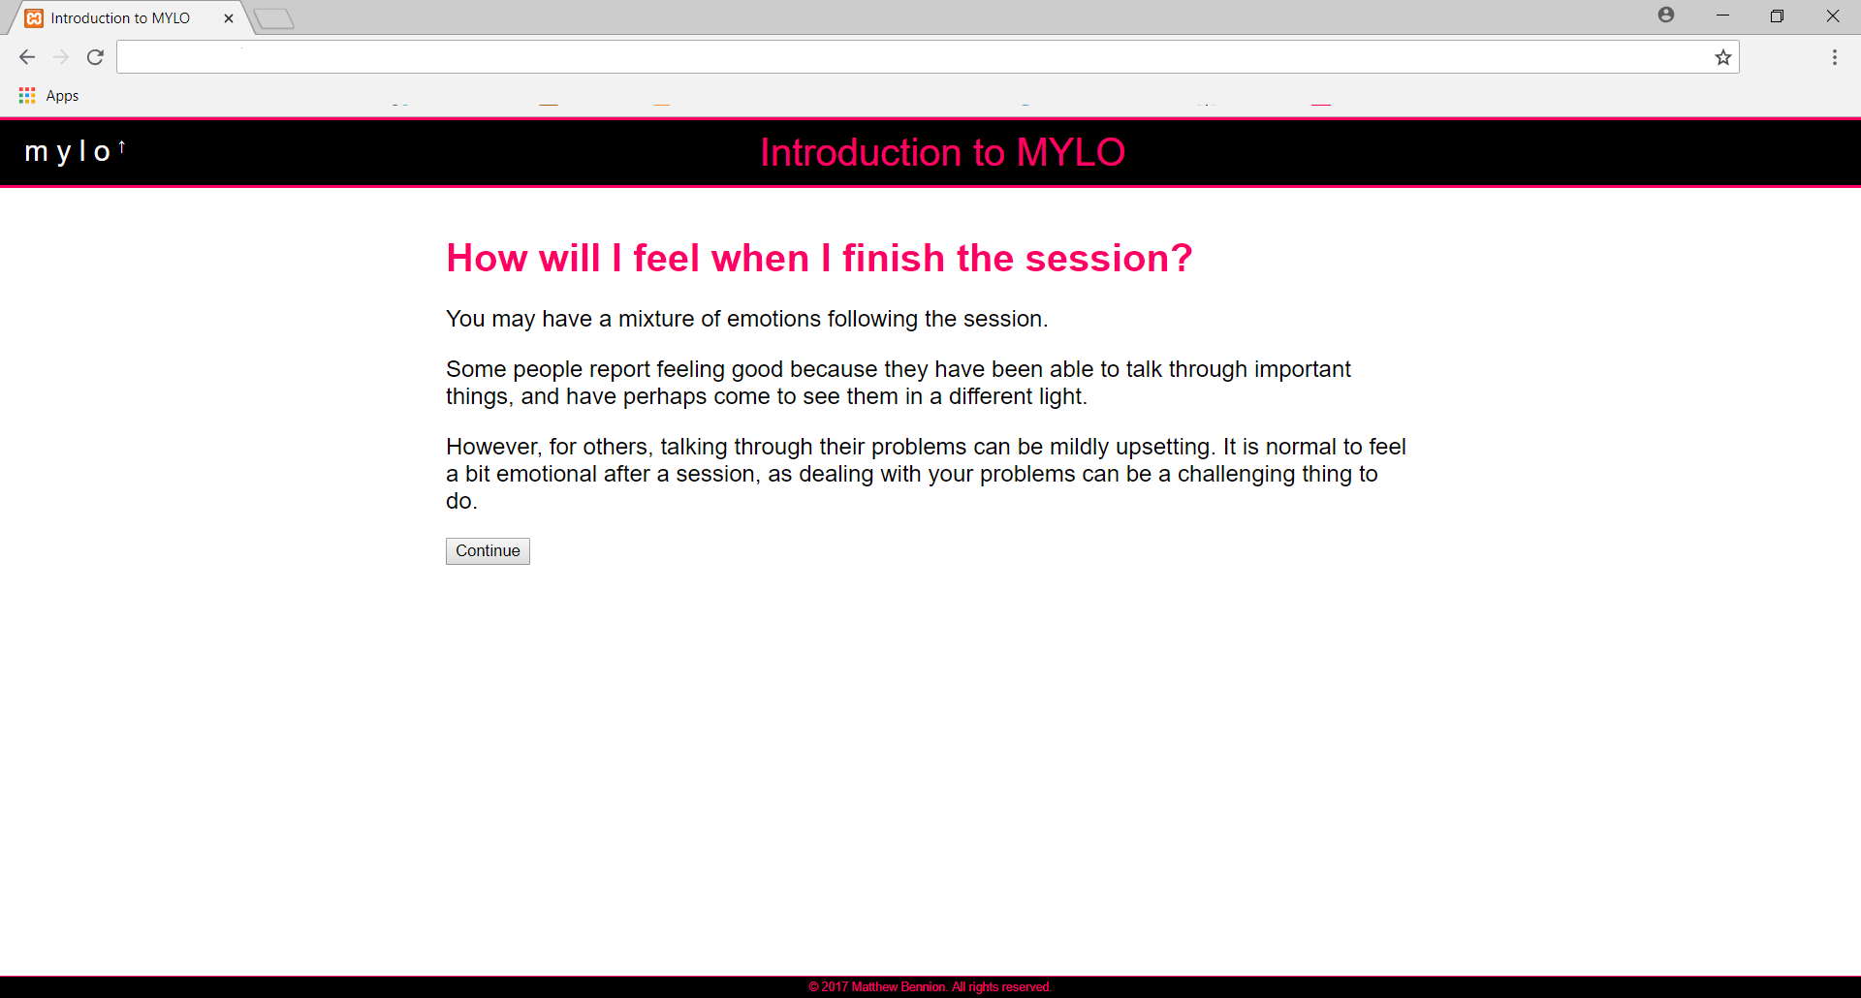
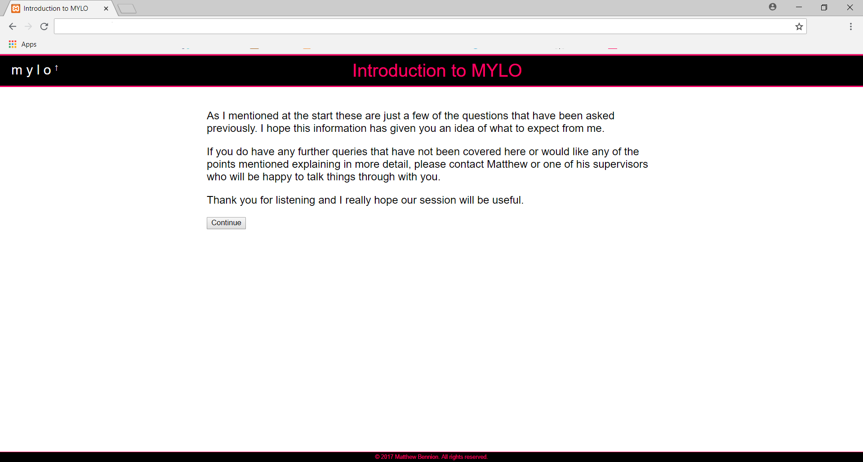
- MYLO Instructions Screenshots
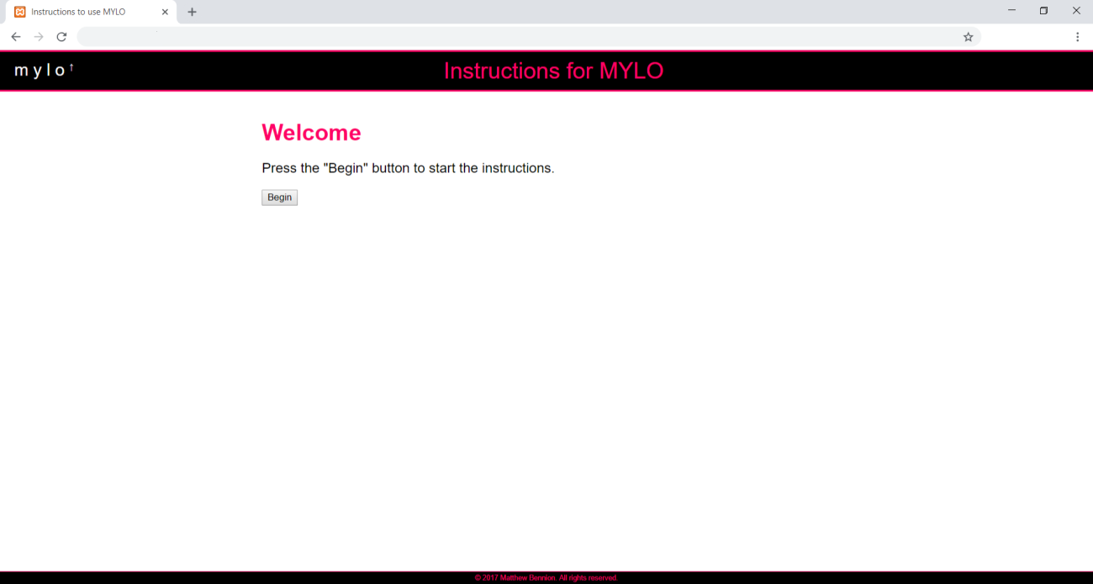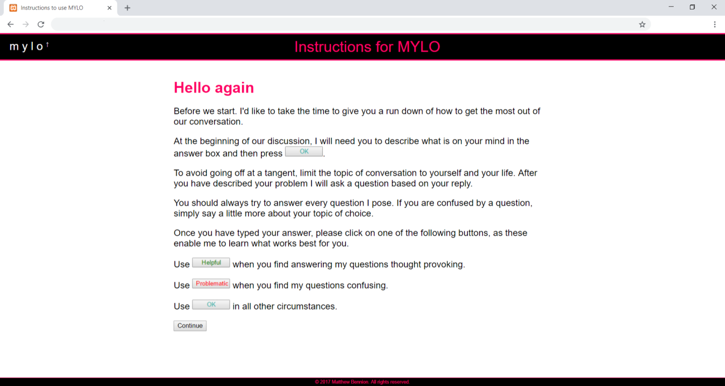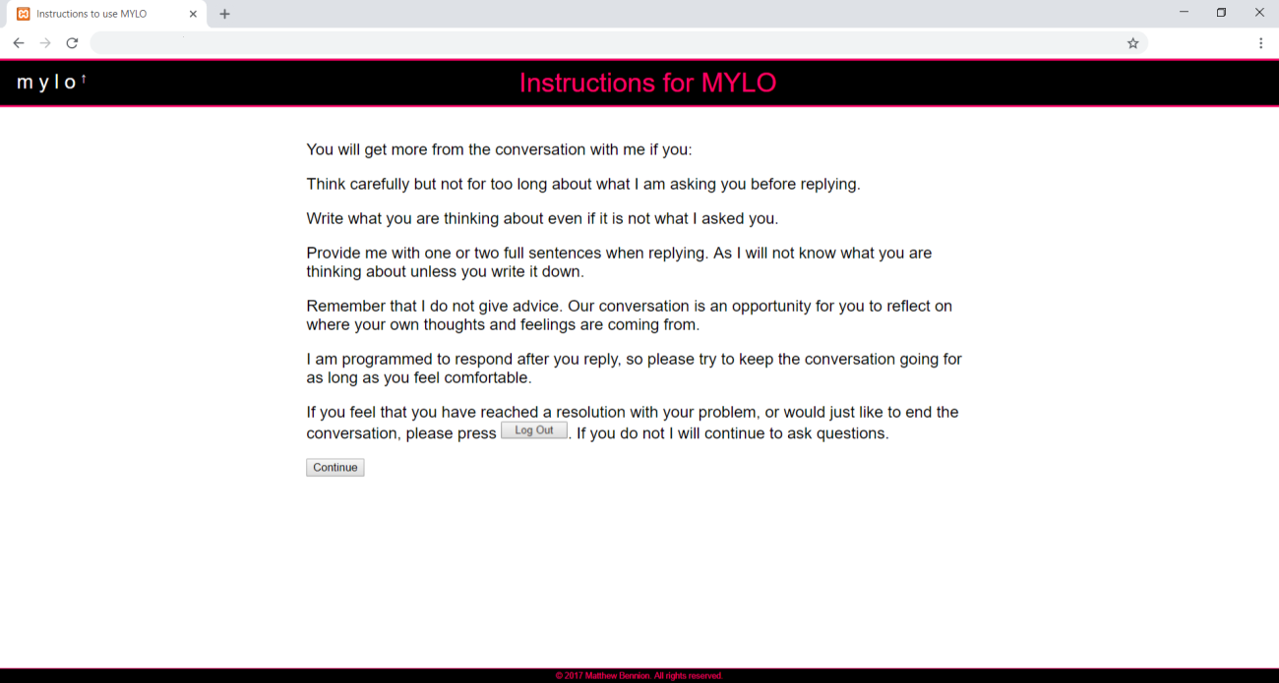
- MYLO Guided with Speech Screenshot
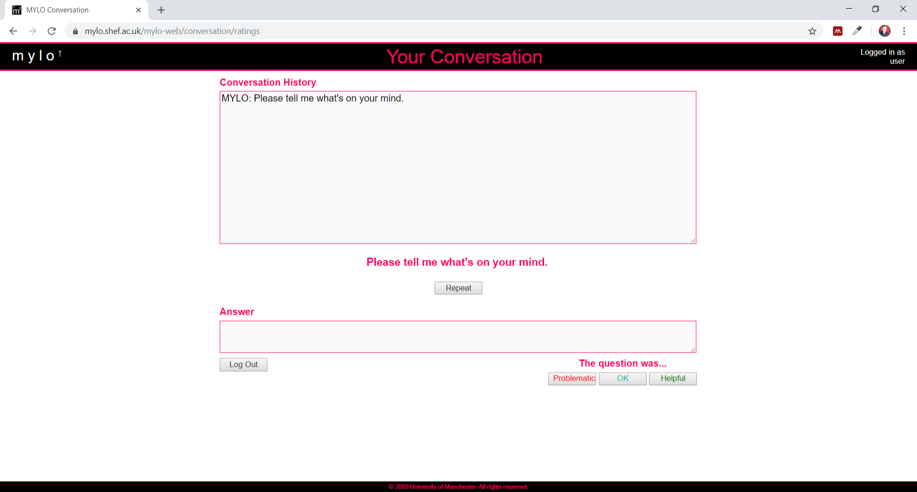
- MYLO Speech Generation Process
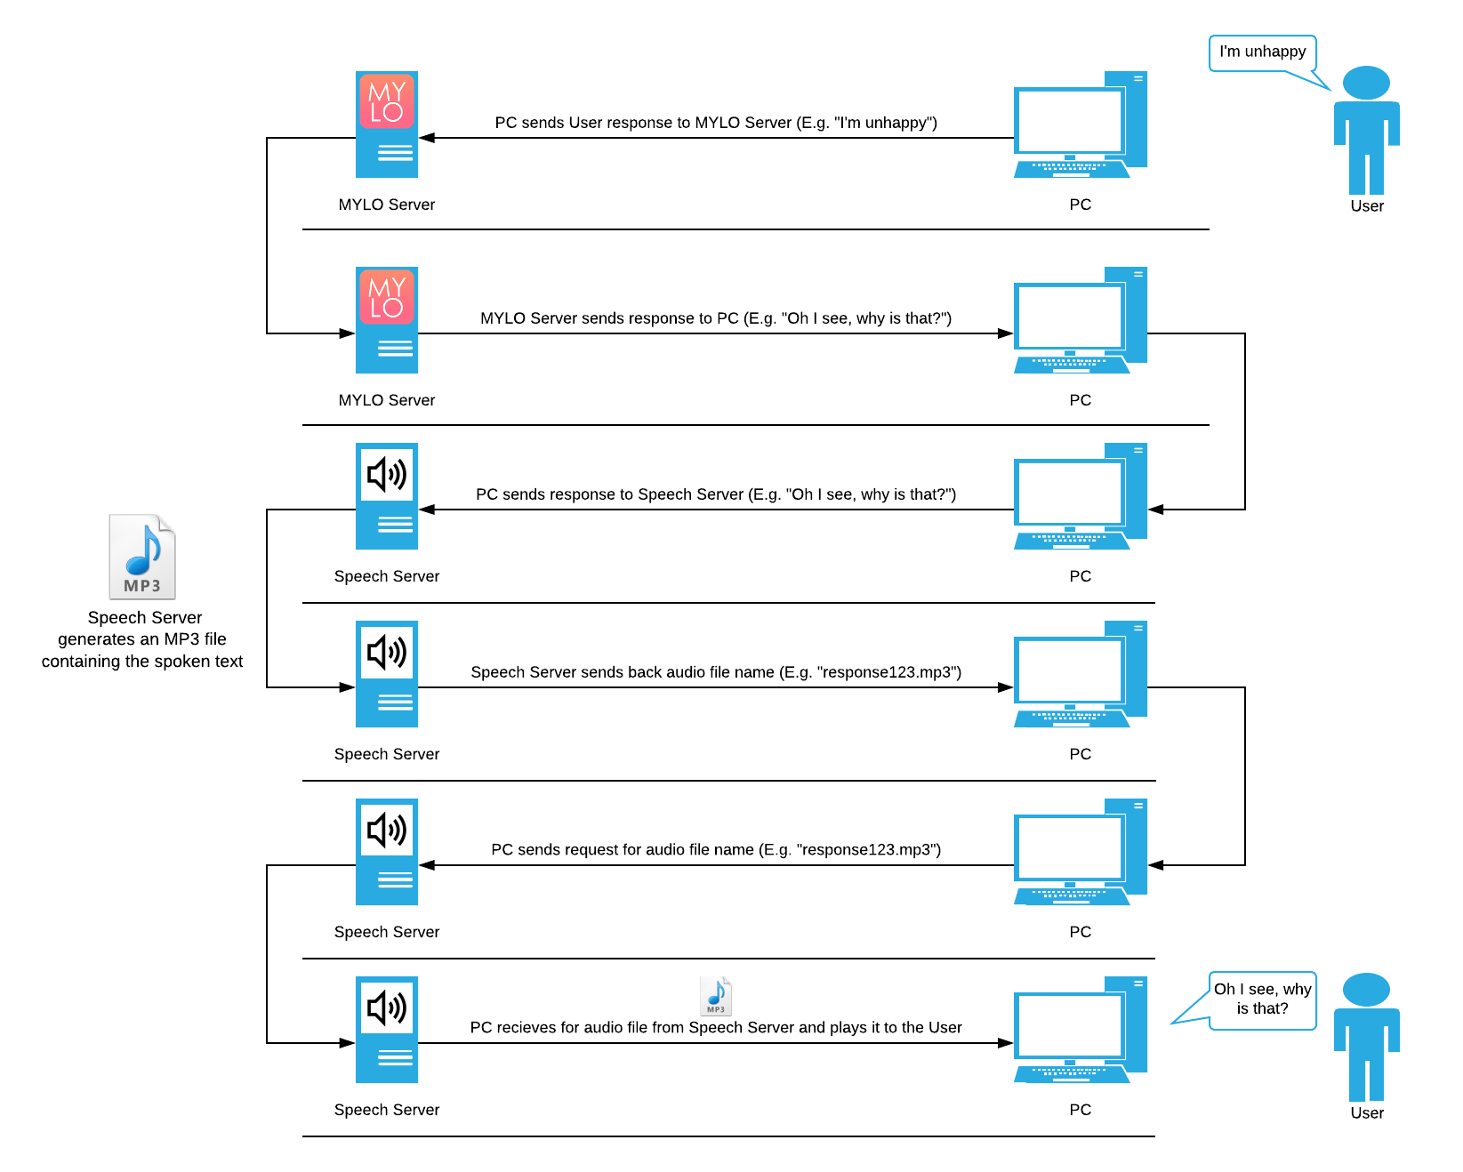
- Health Questionnaire 9 (PHQ-9)
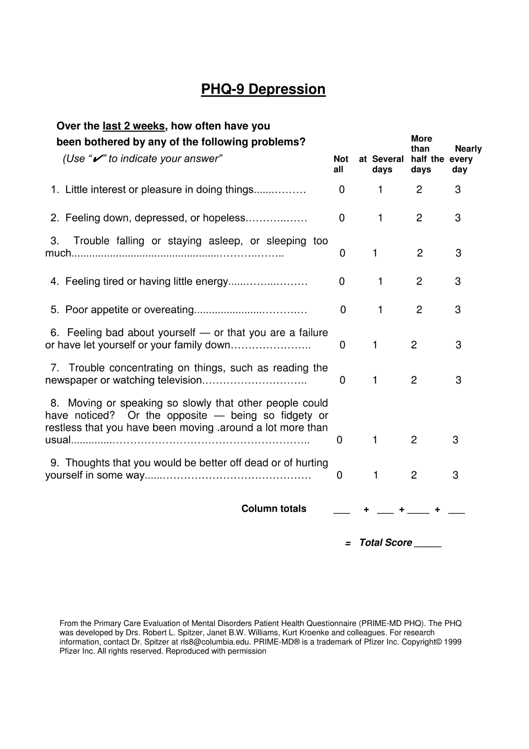
- General Anxiety Disorder 7 (GAD-7)
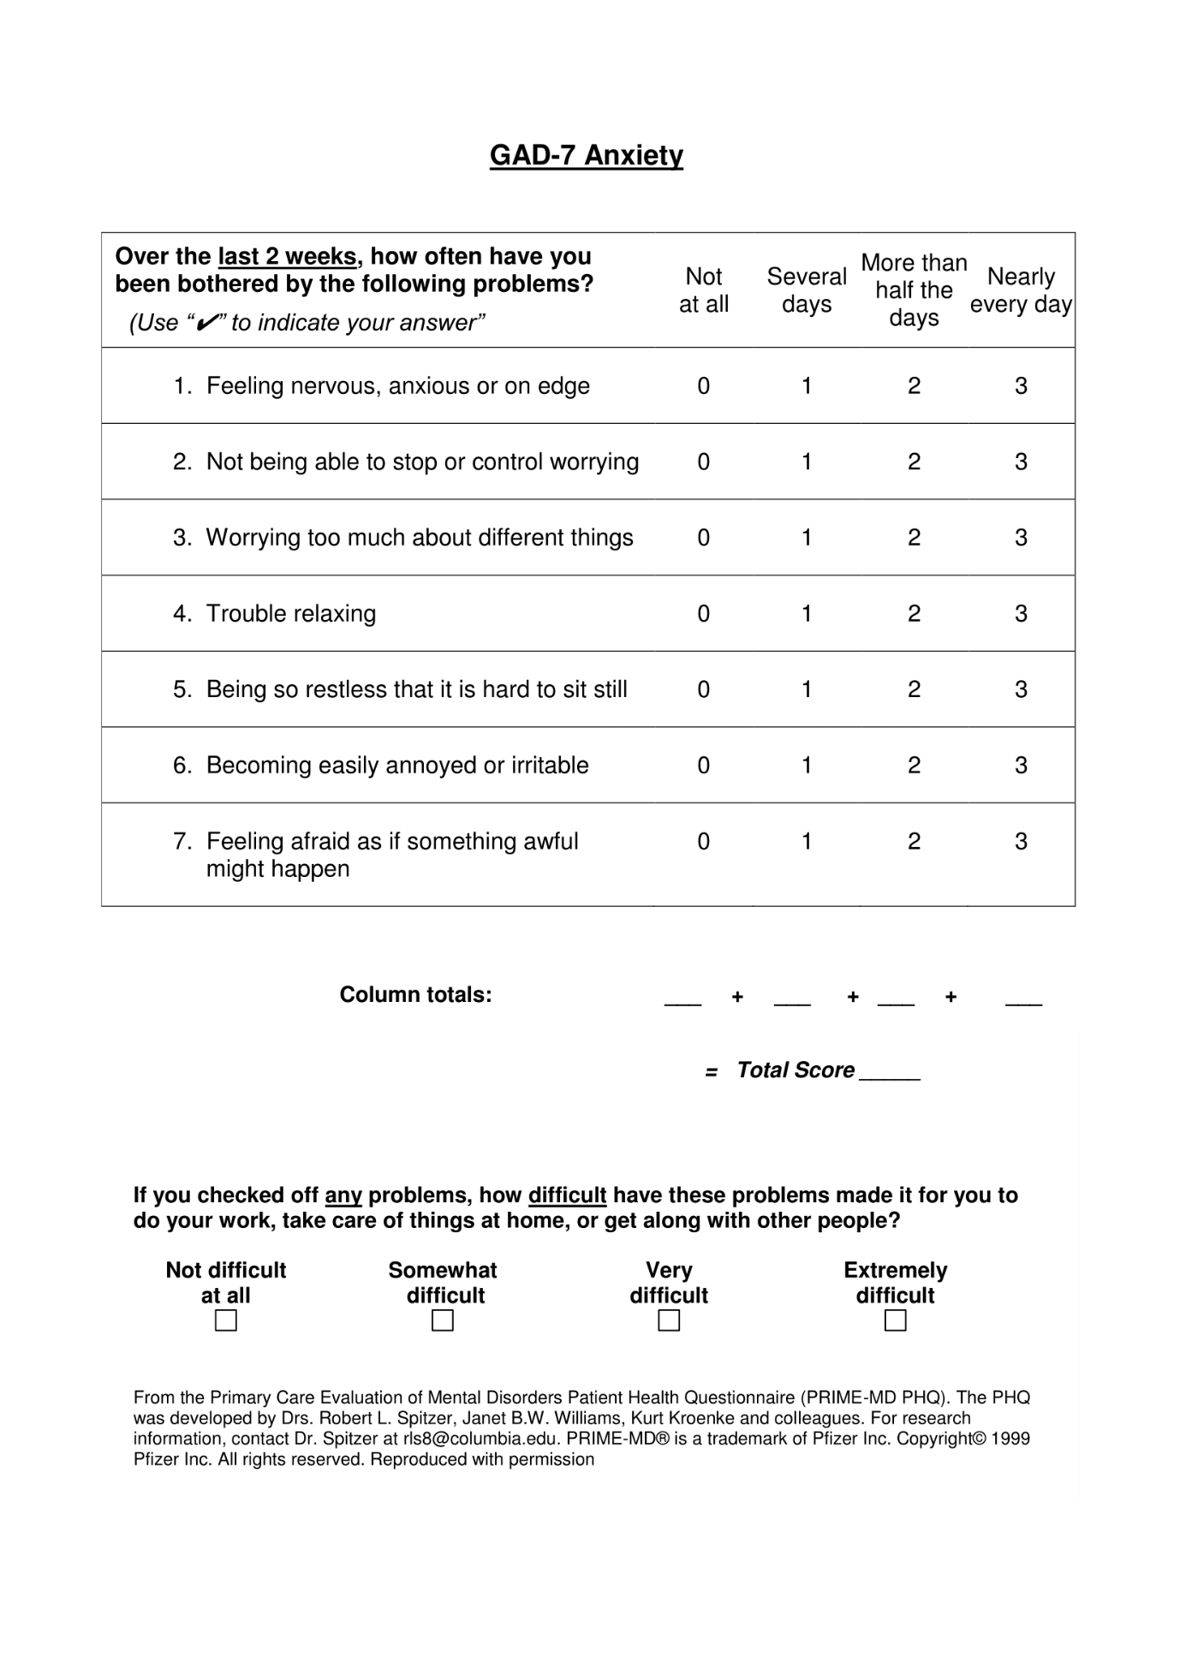
- Credibility and Expectancy Scale (CEQ)
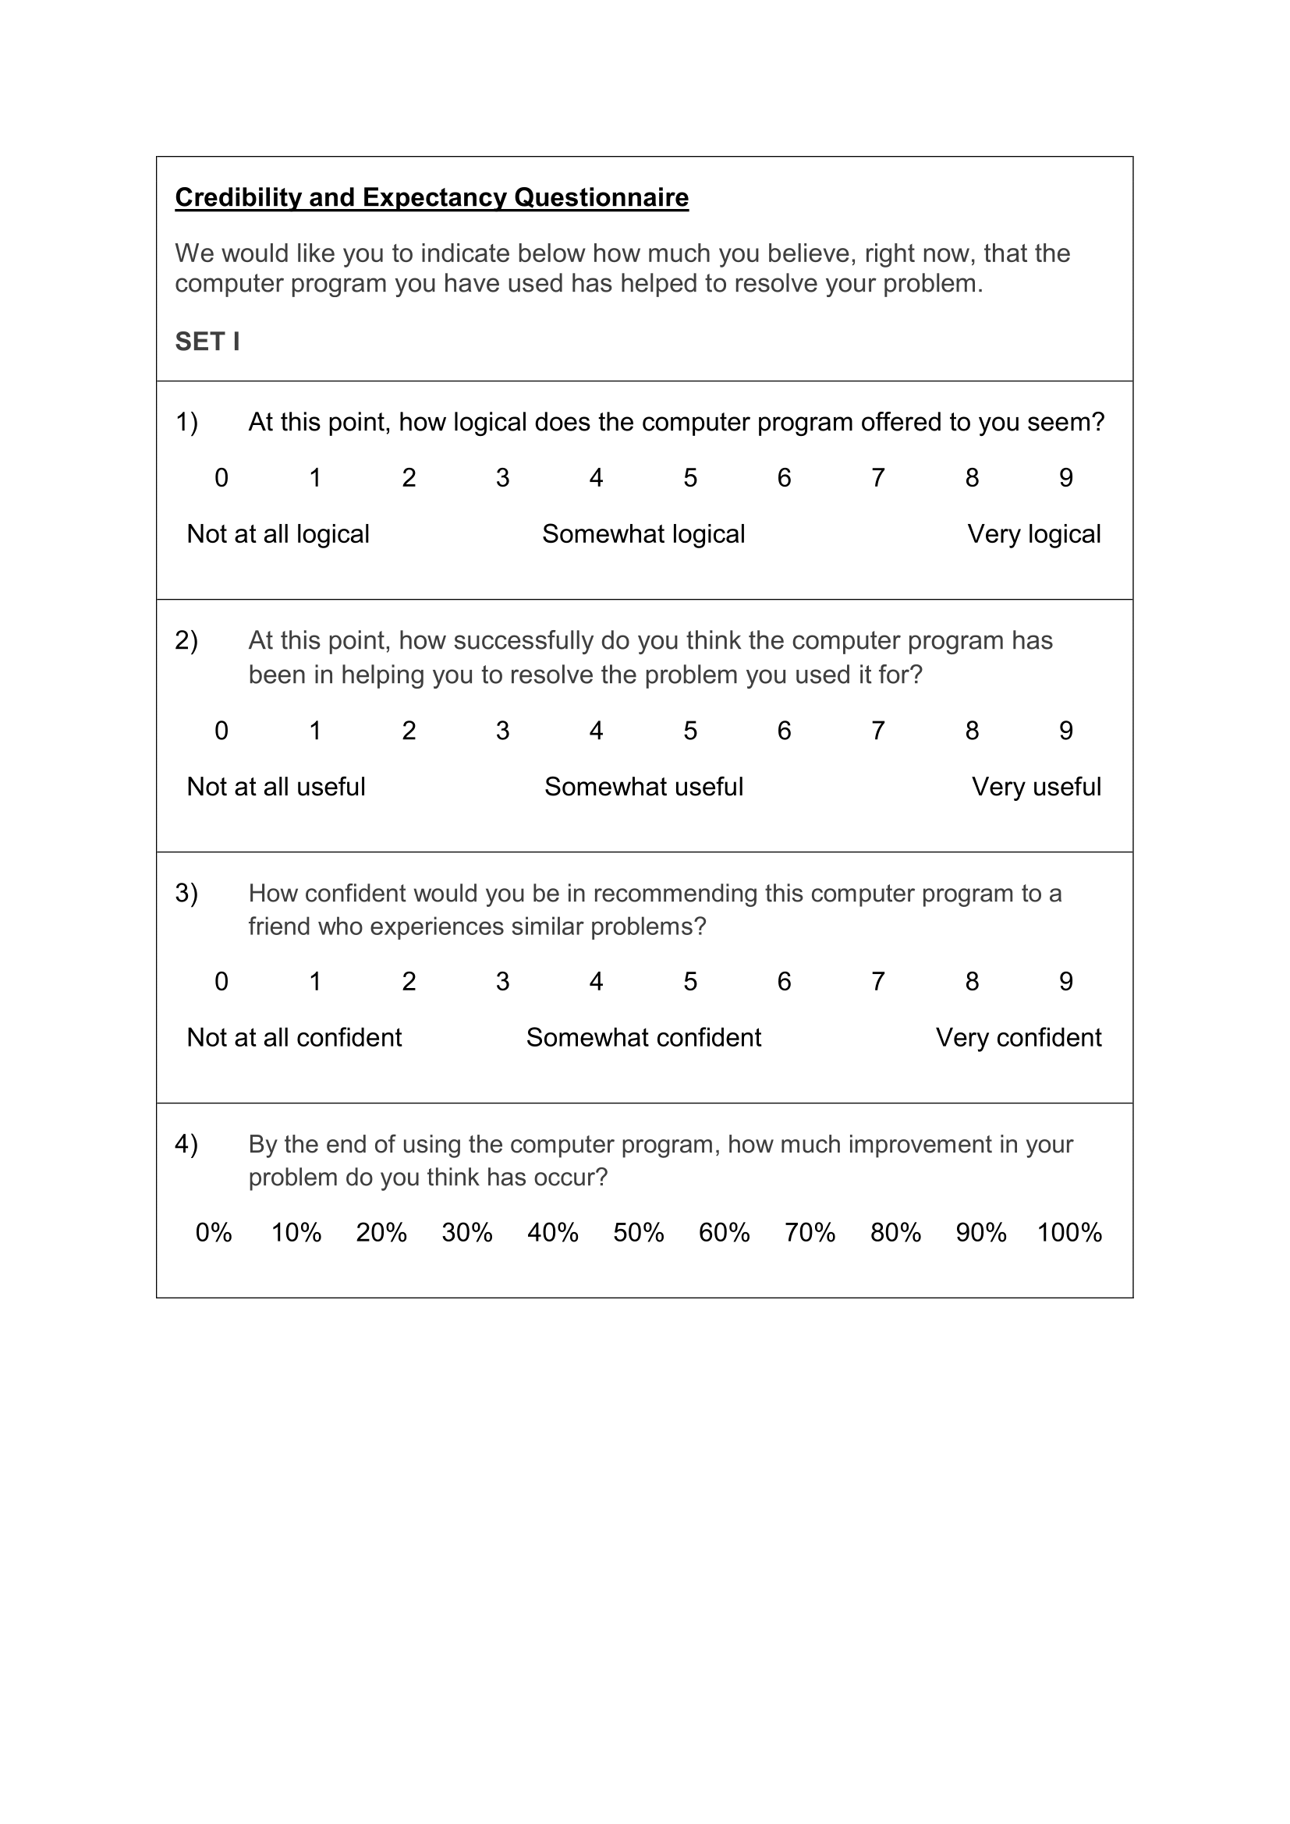
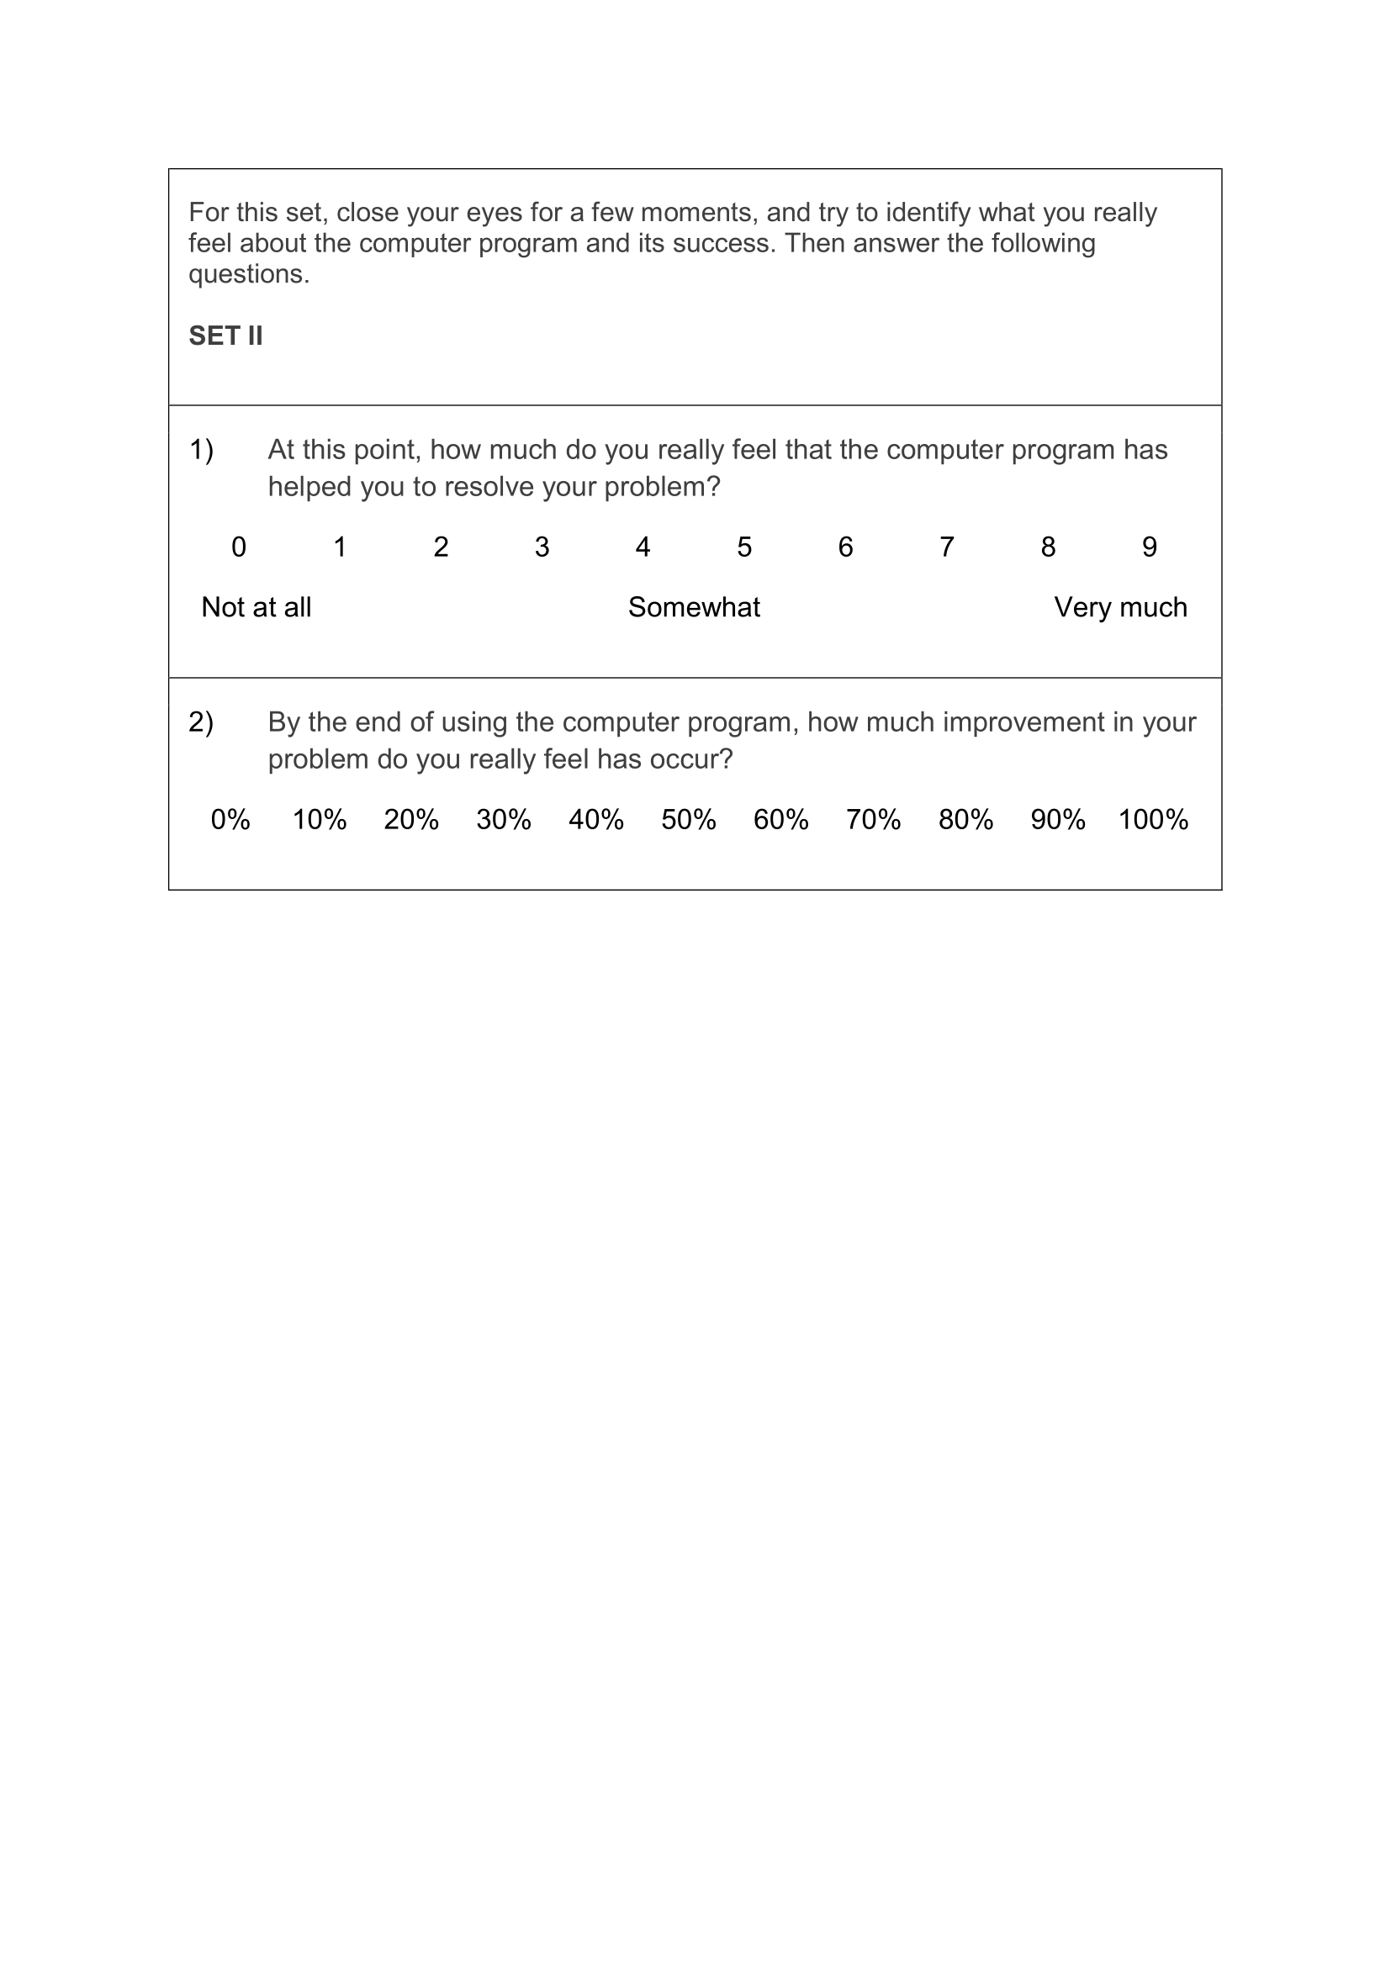
- Credibility Scale (CS)
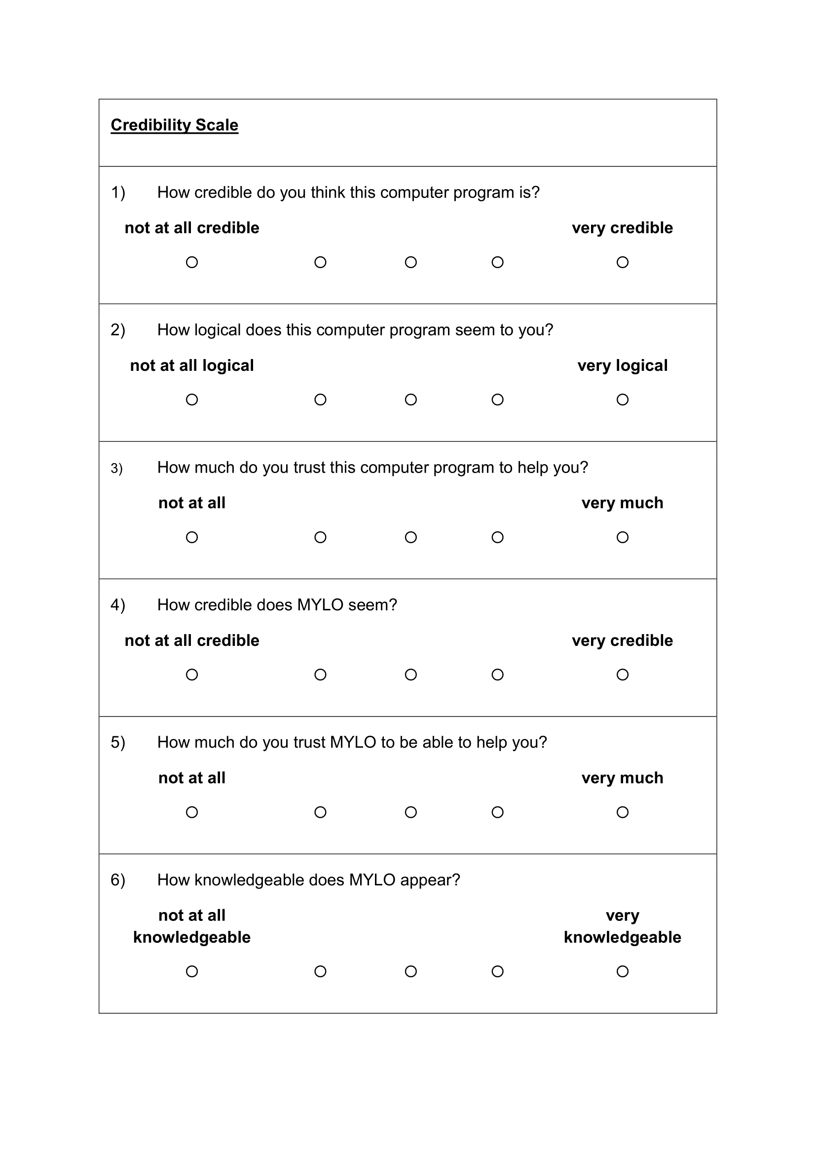
- Rating of Resolution v2 (Post-intervention and Follow-Up)
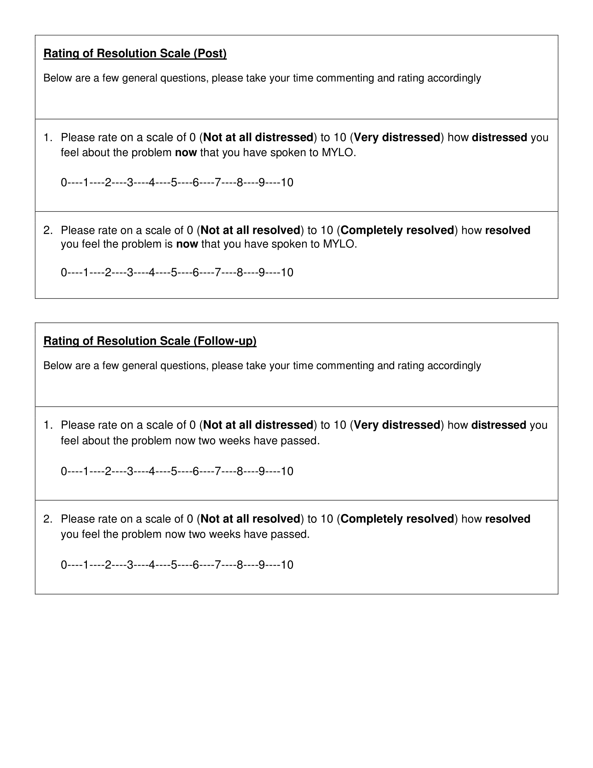
- System Feedback including Net Promoter Score (NPS)
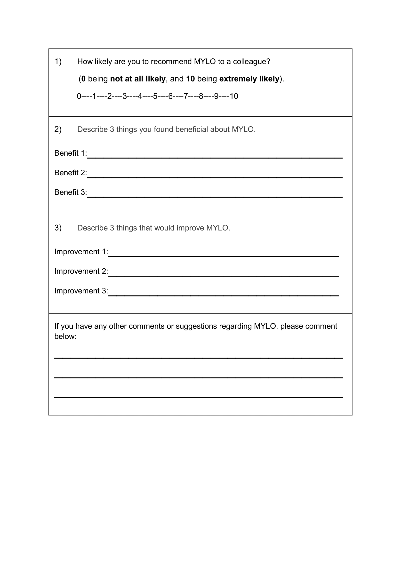
- Working Alliance Inventory – Short Revised (WAI-SR)
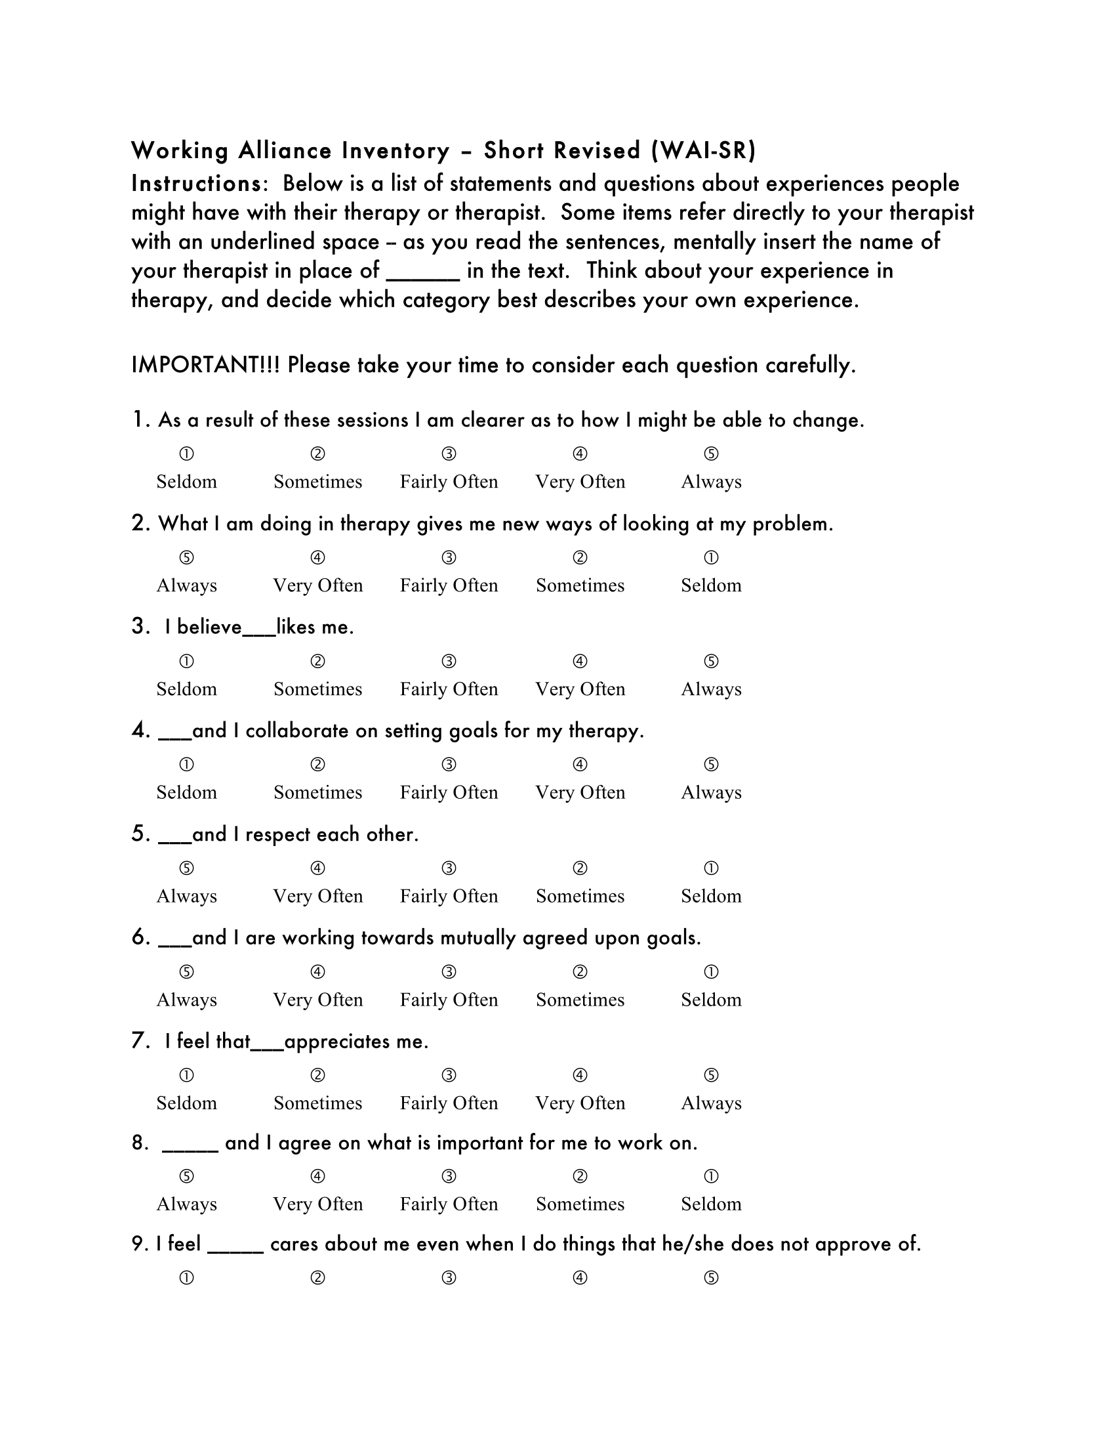
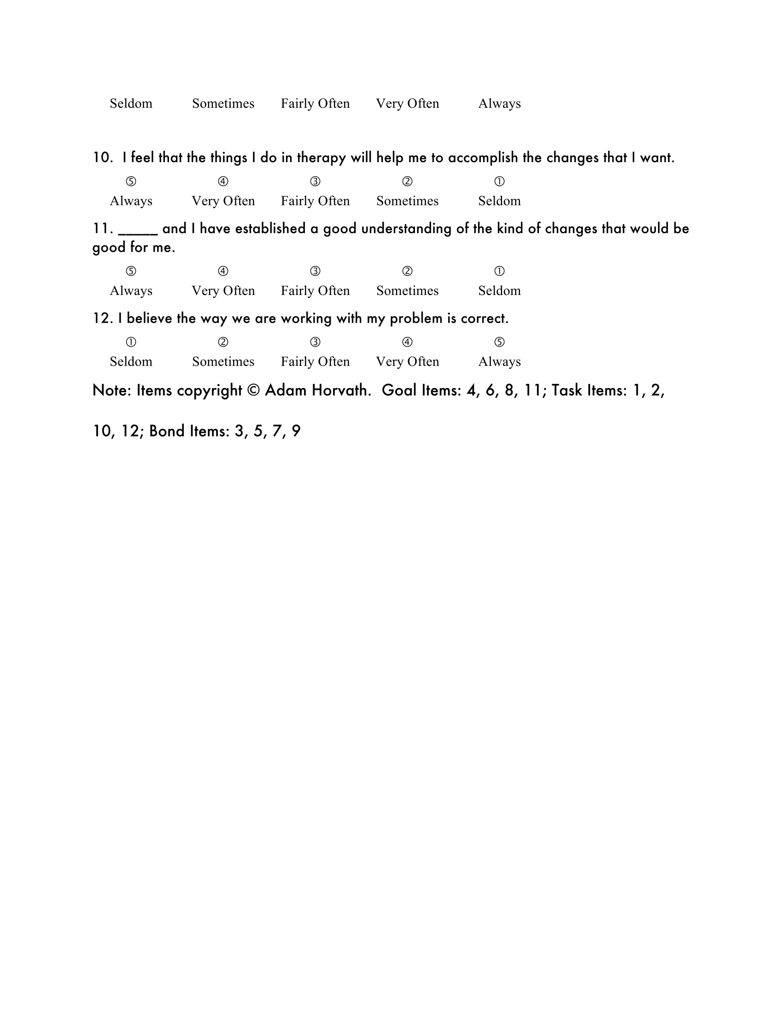
- Study VI Ethics Approval Letter
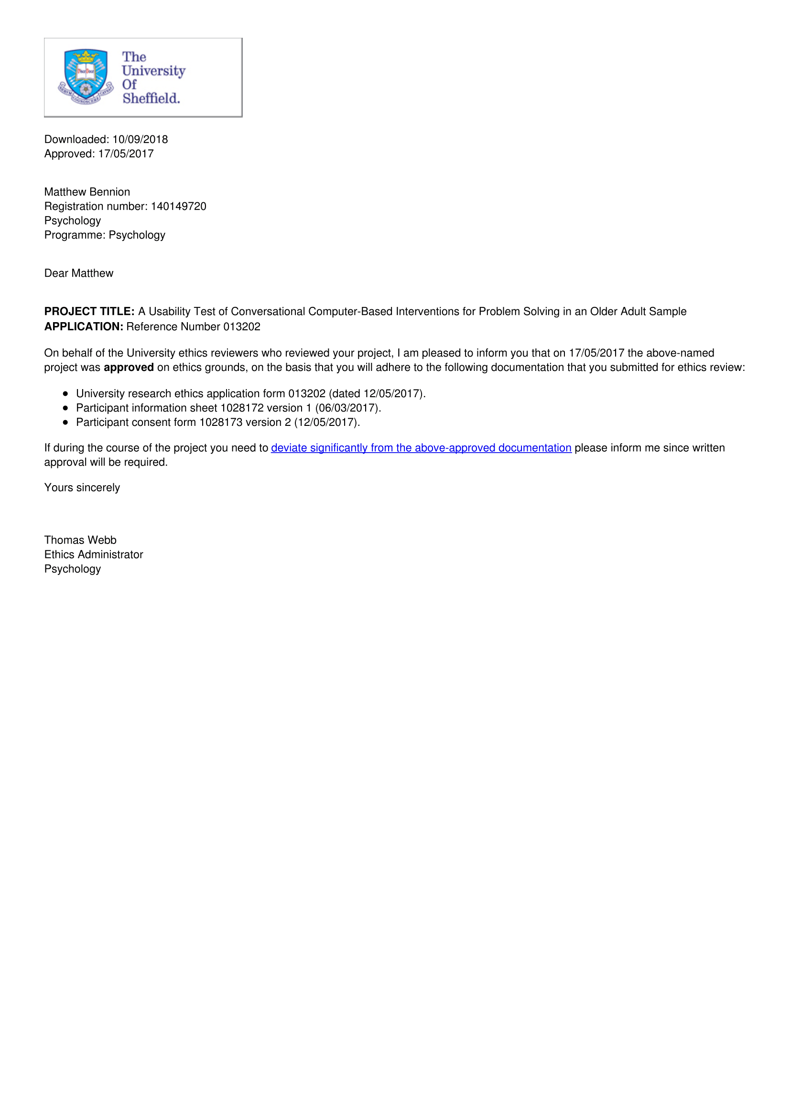
- Study VI Recruitment Poster
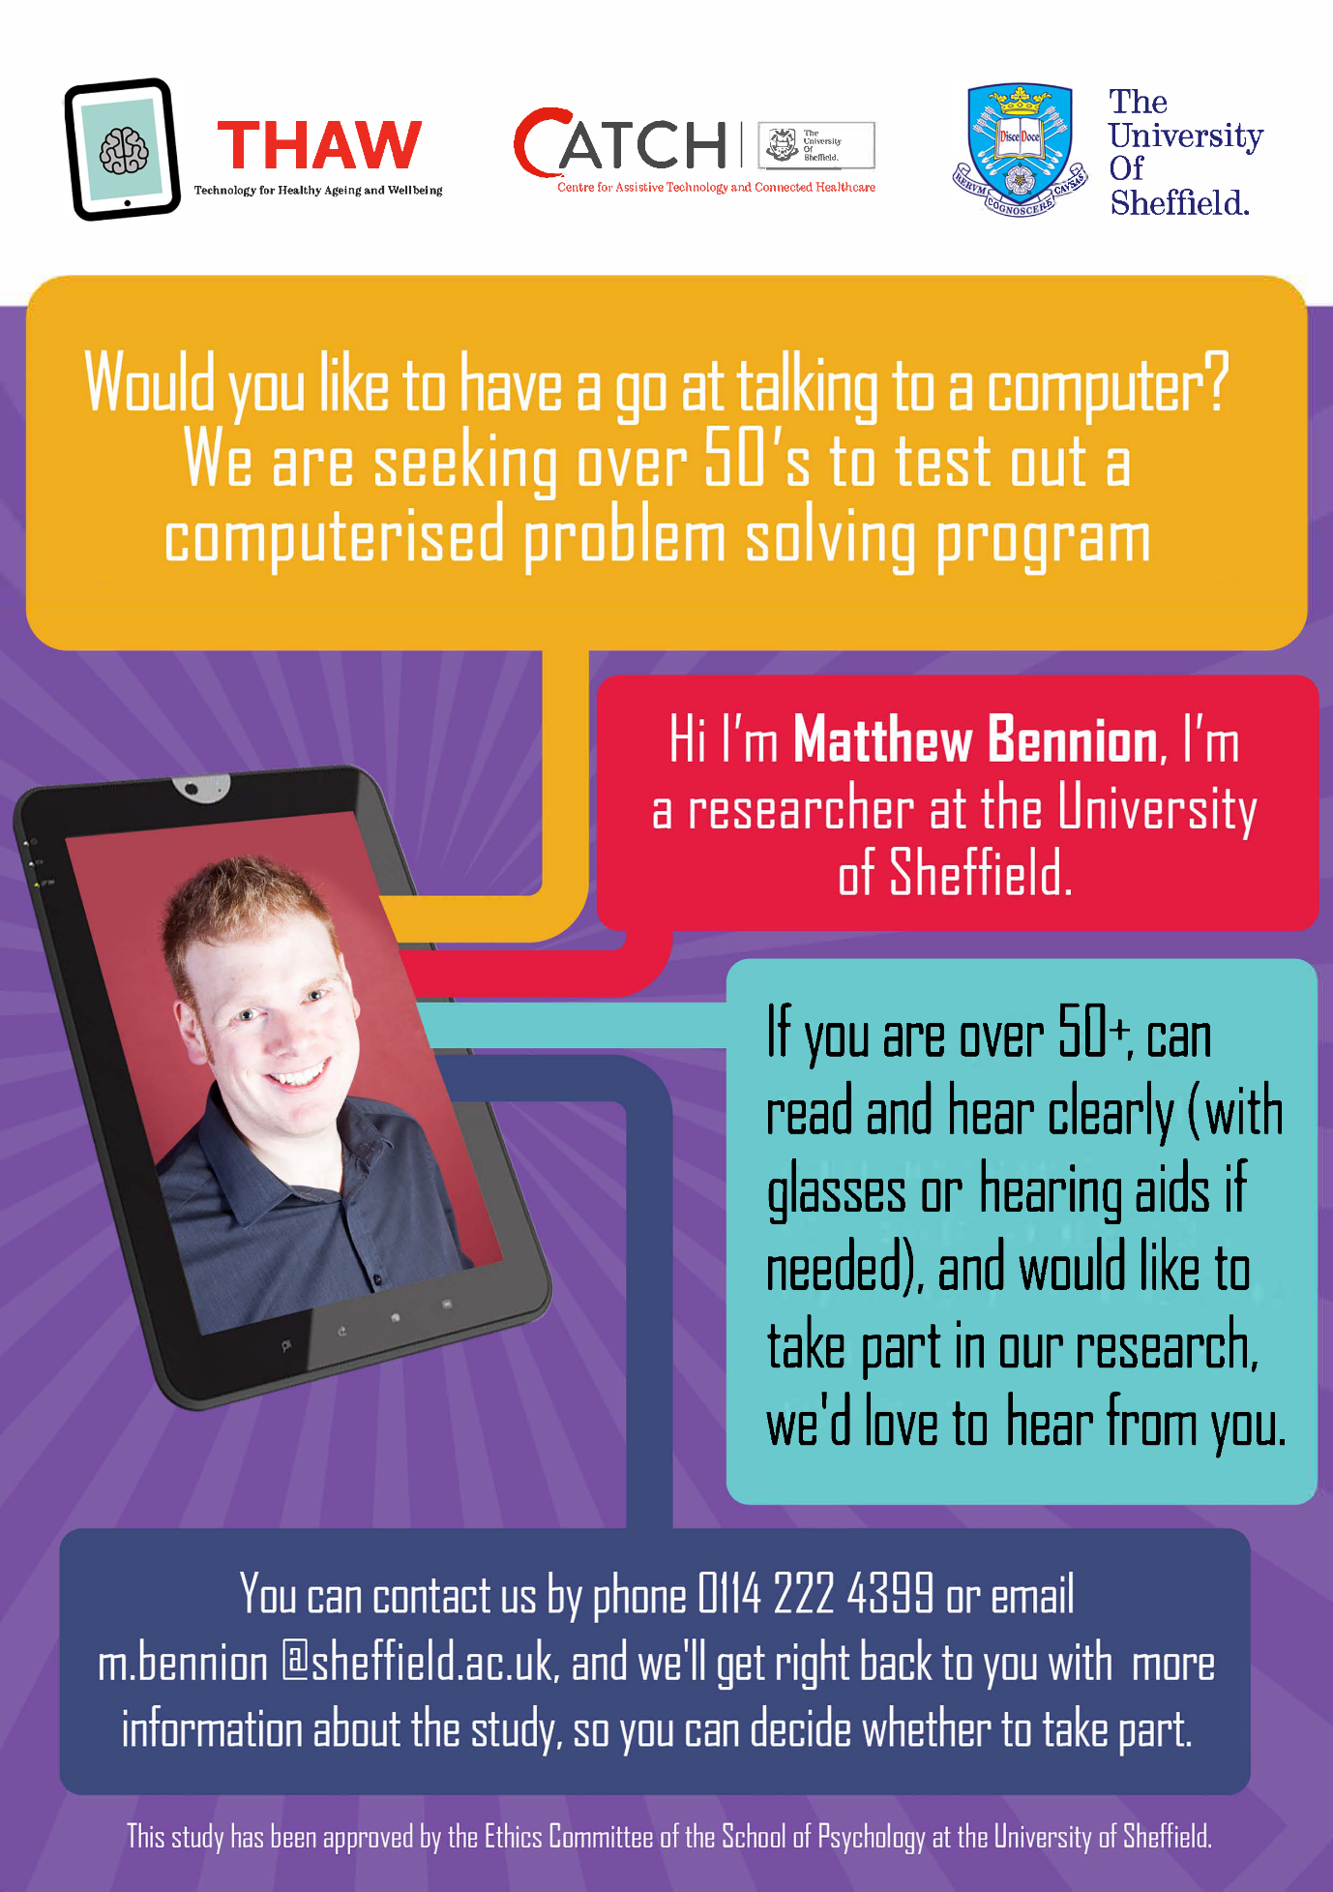
- Study VI Online Registration Screenshots
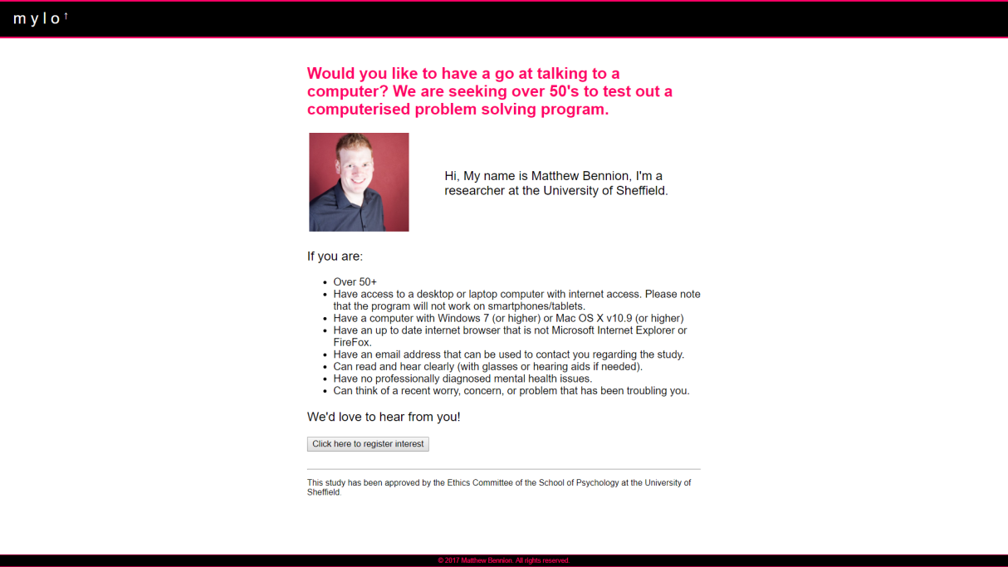
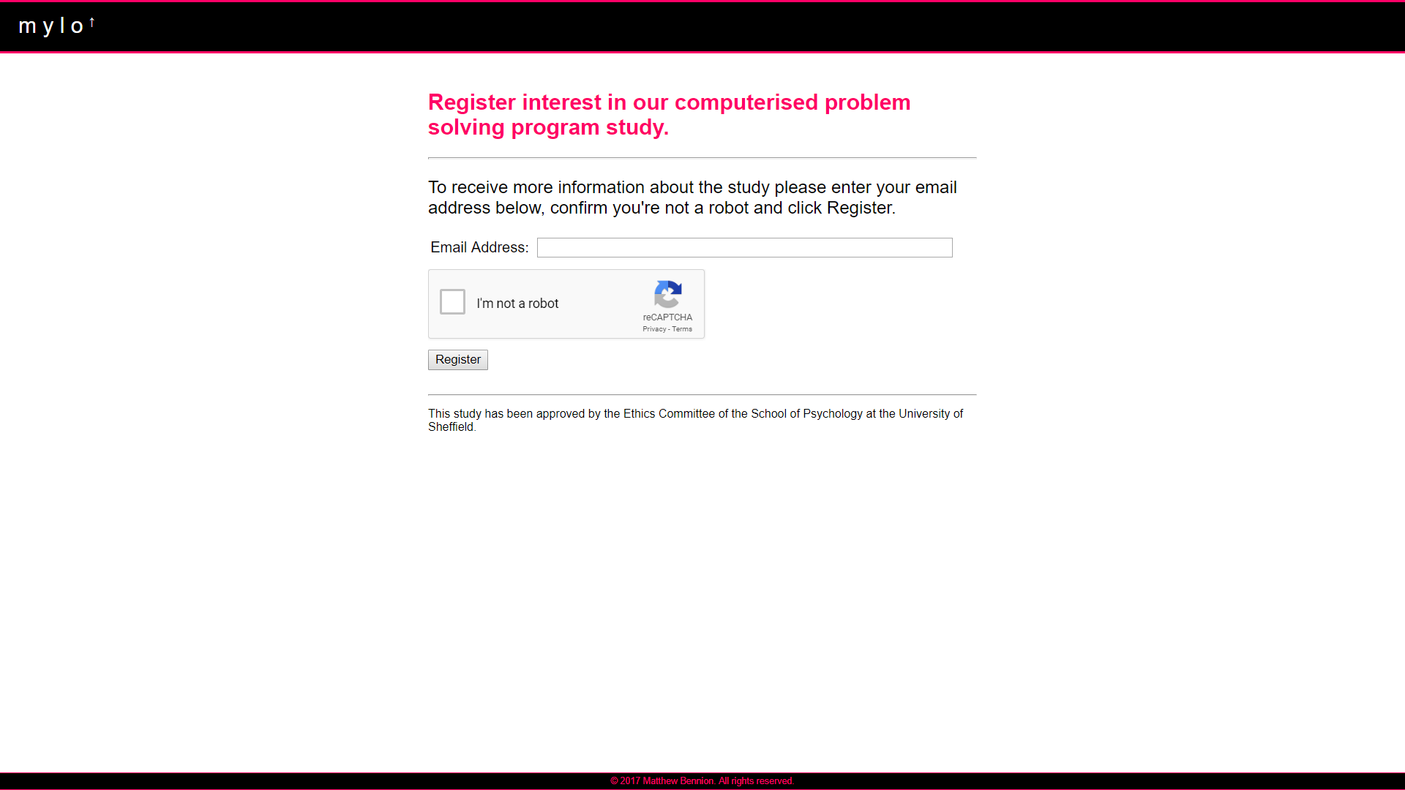
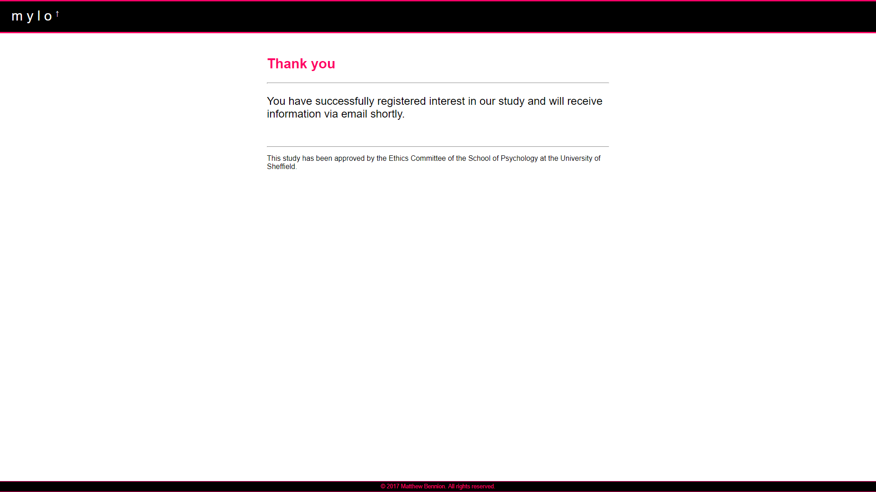
- Backend Study Management System Process
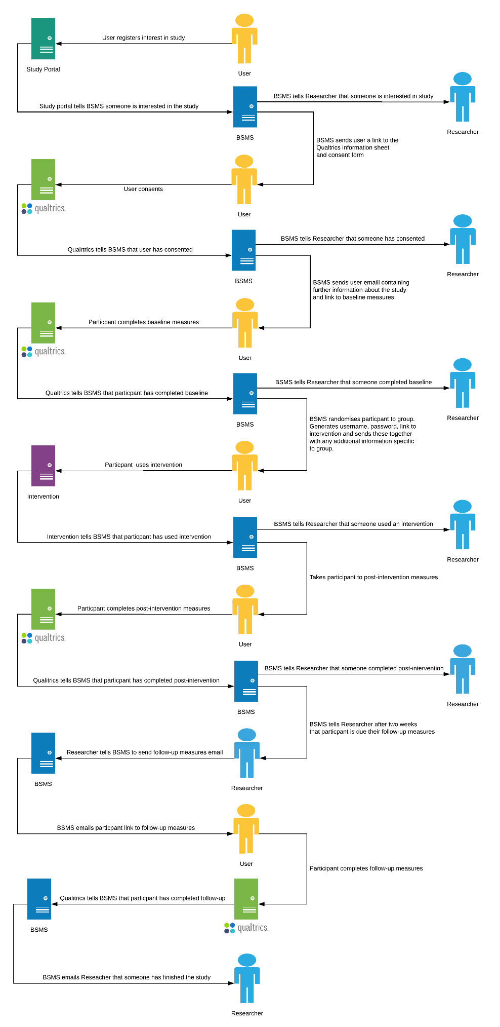

- Study VI Participant Information Sheet and Consent Form
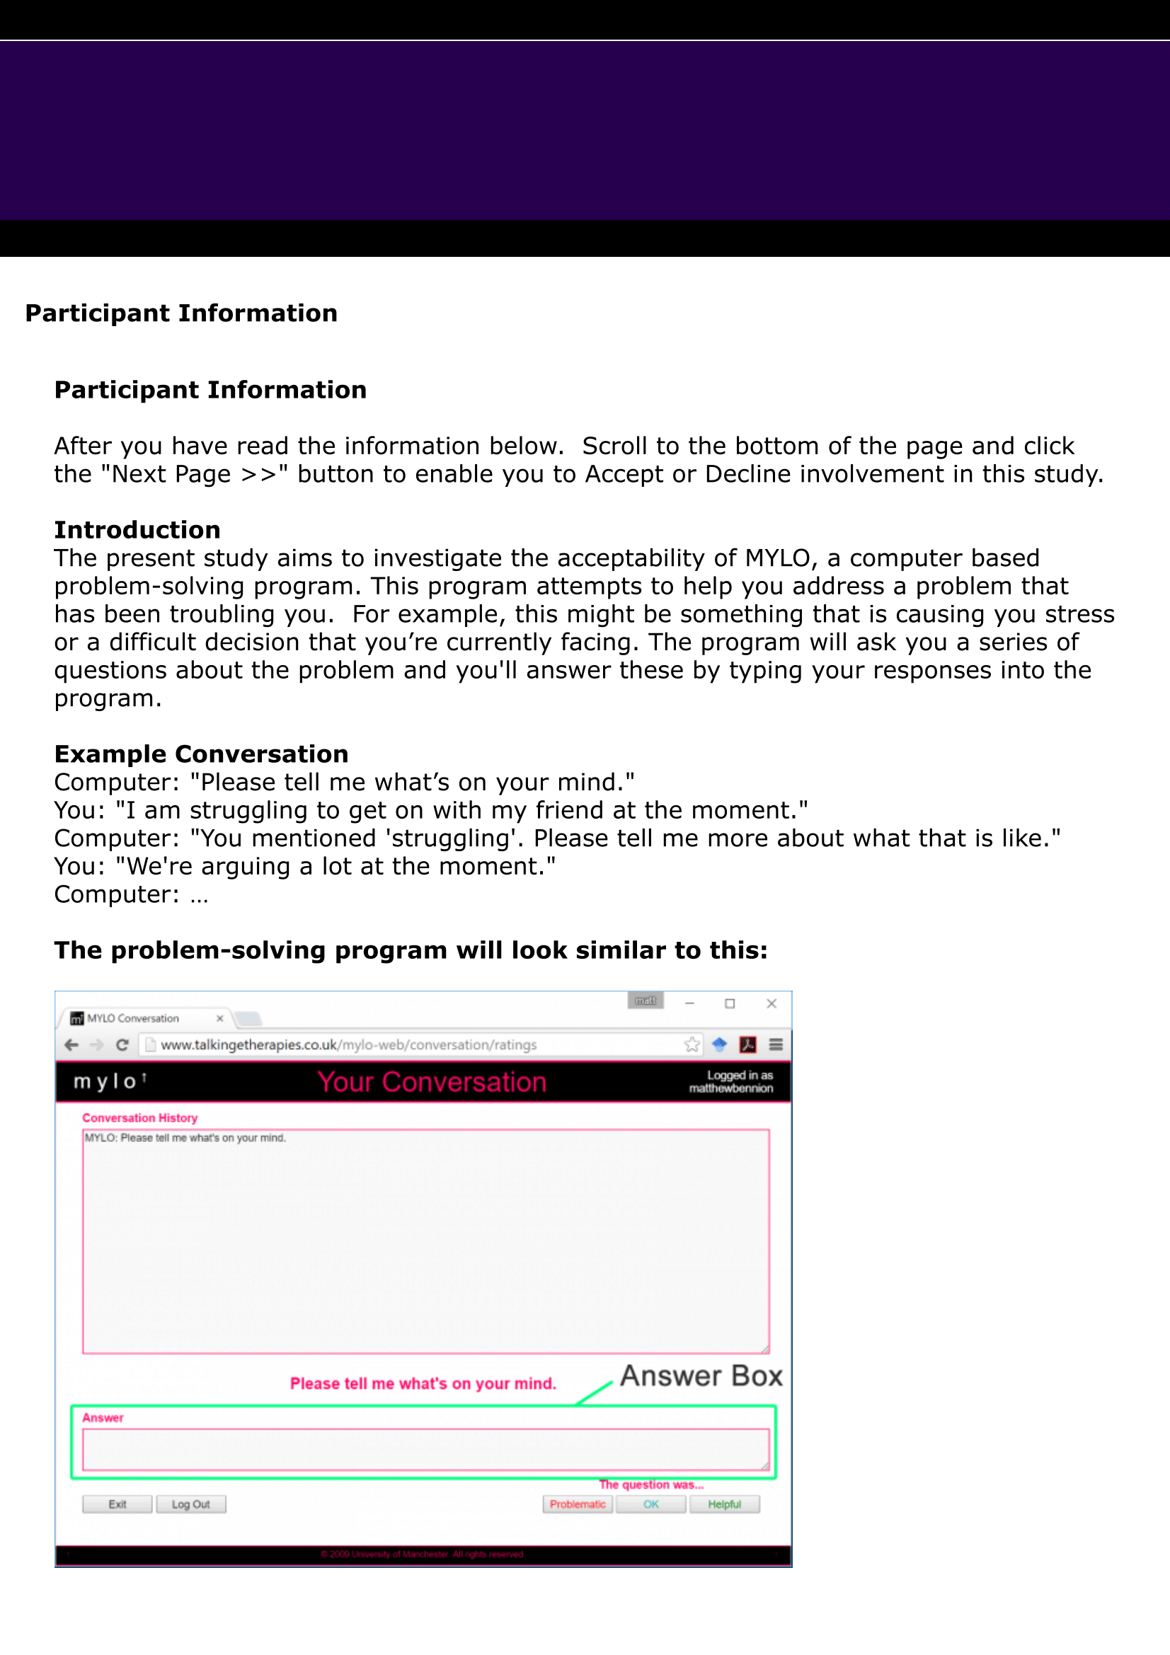
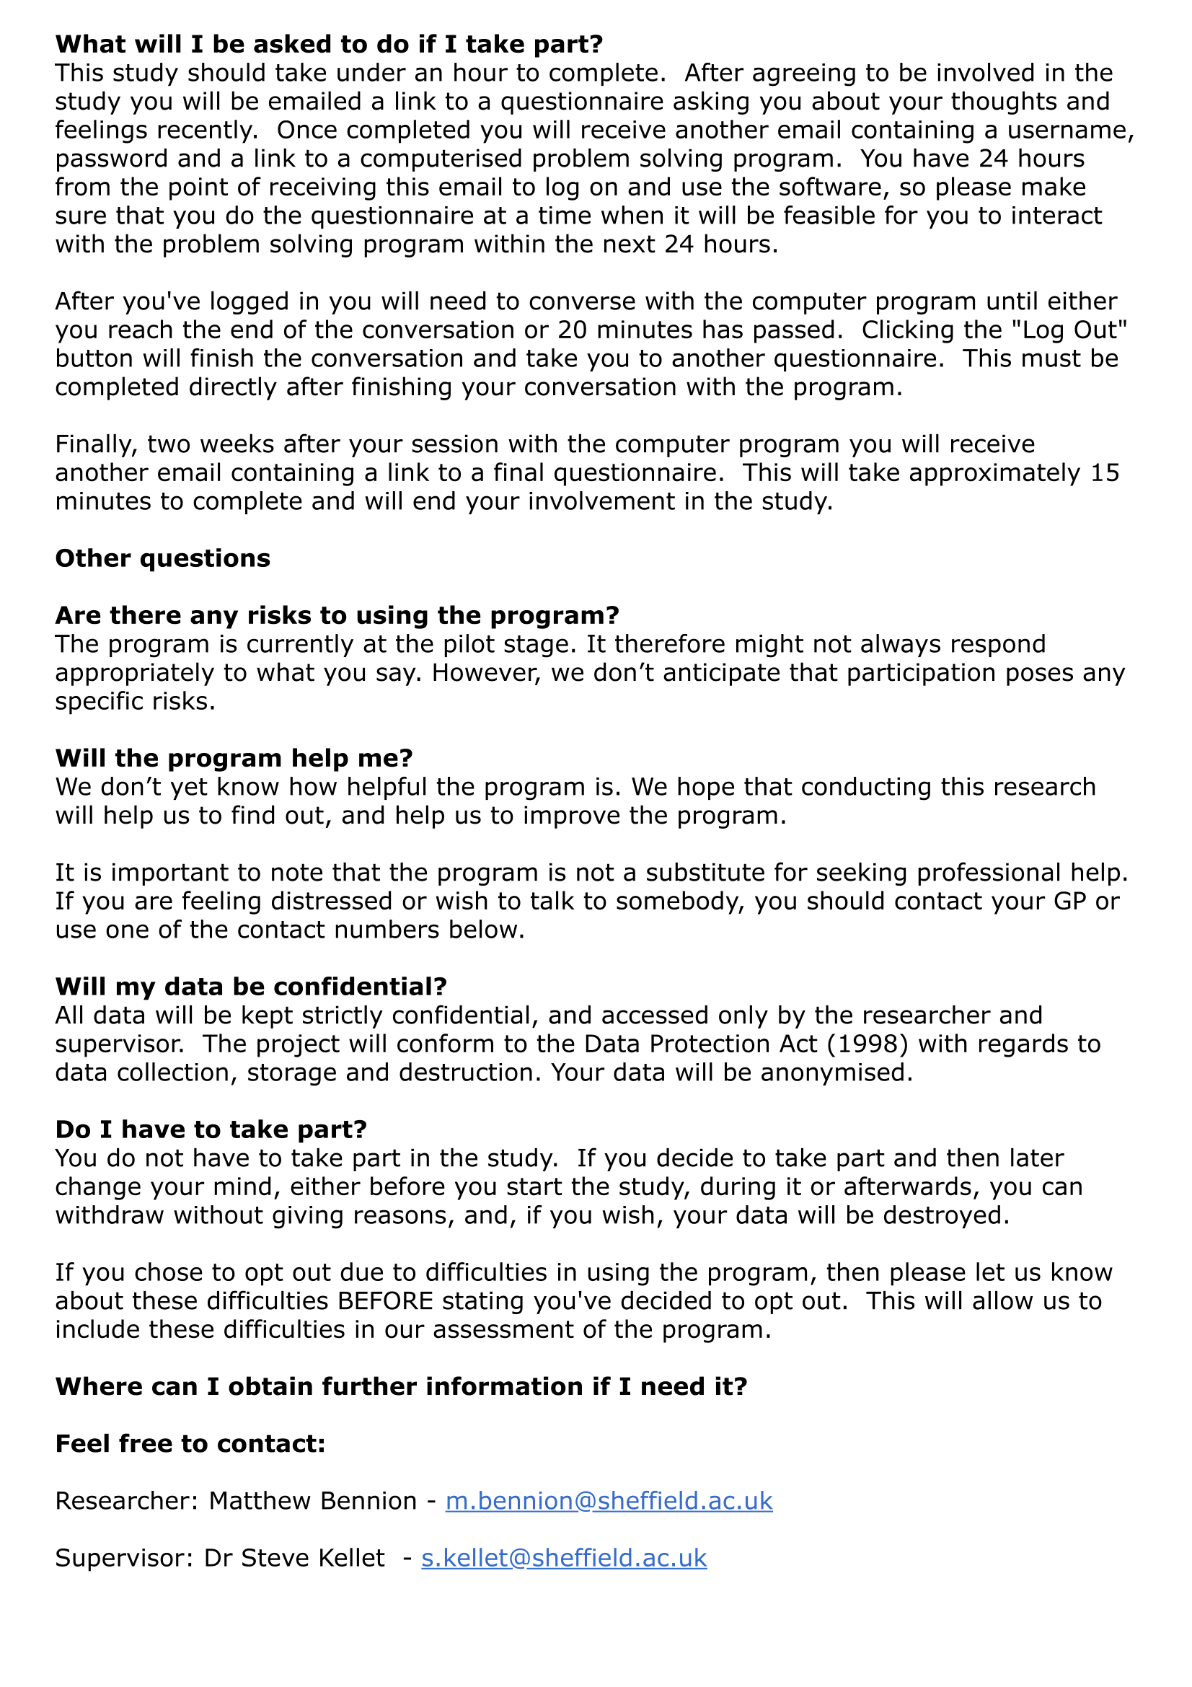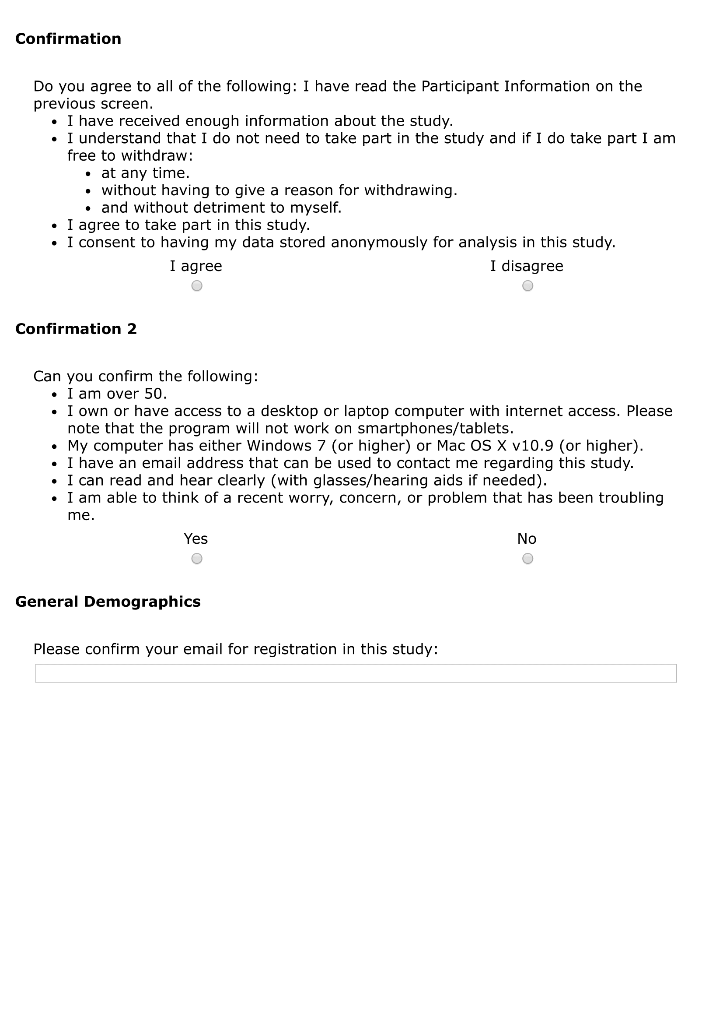
- MYLO Sound Test Screenshots
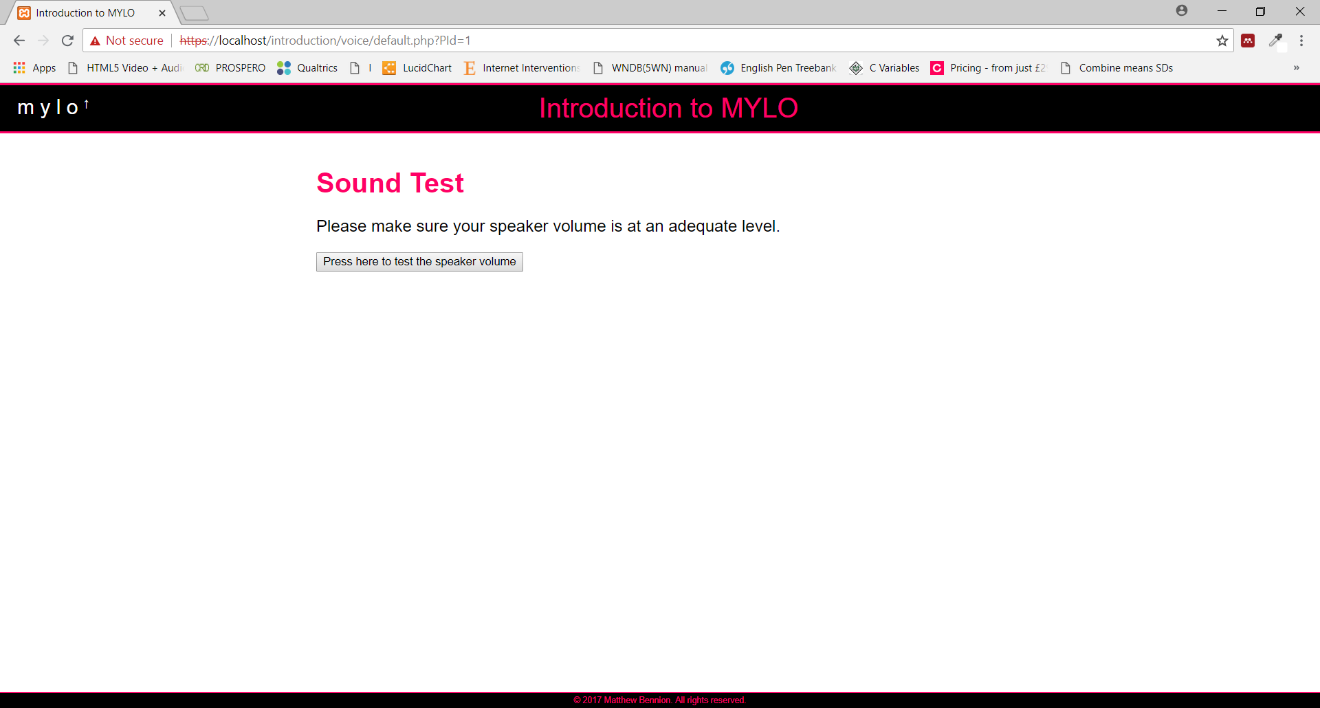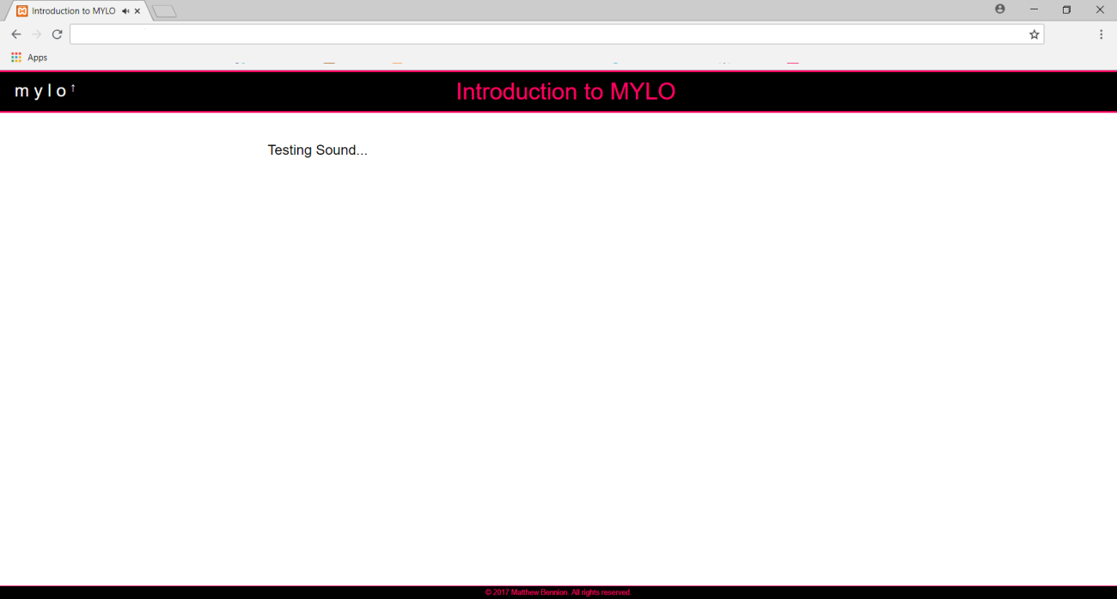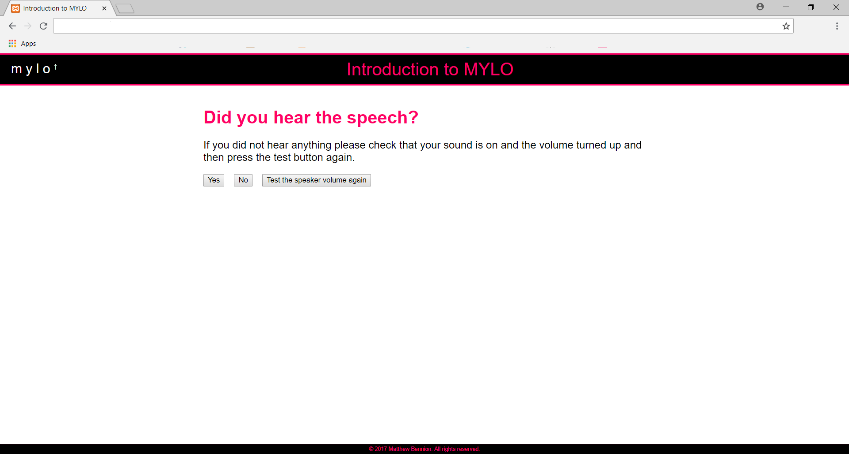
- Study VI Participant Debrief
Thank you for participating in this study.
You interacted with one of three versions of the same program. This is because we wanted to compare versions in order to determine which would be best at helping older adults solve problems.
Previous research has shown MYLO to be an acceptable problem-solving aid for young adults. This study is important because its results will assist in the further development of MYLO. In this study we randomly assigned participants to talk with either MYLO, MYLO with an introduction or MYLO with an introduction and speech. We expect to find MYLO with an introduction and speech to be the more acceptable problem-solving aid for older adults as it was specially tailored based on the feedback of older adults.
Thank you for your participation in our research. If you have any questions, please contact me using the details below.
Please remember, the program(s) involved in this study are not a substitute for seeking professional help. If you are feeling distressed, you should contact your GP.
If completing this study has made you feel worried or stressed:
You should contact your GP, who will be able to advise you on the support services available in your local area.
If you need urgent support, you can call
Samaritans on 116 123 or www.samaritans.org
MIND on 0300 123 3393 or www.mind.org.uk
You can also contact your GP.
If you'd like further information
For an overview of this project please watch the following video: https://youtu.be/djTNx0-z8QI
Contact information
If you have any questions or would like to know more about the research team's project, please contact
Matthew Bennion
PhD Researcher
Department of Psychology
University of Sheffield
m.bennion@sheffield.ac.uk
You can also contact Matthew’s supervisory team, Dr Steven Kellet, Prof Roger Moore and Prof Gillian Hardy at the University of Sheffield, by emailing s.kellet@sheffield.ac.uk

277 had websites. Some records had a generic website link to the general IAPT website (n = 122), while others had addresses that displayed ‘no page found’ (n = 31) or failed to reach any web page at all (n = 7). This left 117 out of 277 IAPT services with a valid web address.

