Investigating the HPV-Positive & HPV-Negative Oropharyngeal Cancer Tumour Microenvironment
in vivo and in vitro

By
Sarmad Sabah Hassan Al-Sahaf

Supervisors:
Dr. Craig Murdoch
Prof. Keith D Hunter
Dr. Robert Bolt

Thesis submitted in partial fulfilment of the requirements for the degree of Doctor of Philosophy

University of Sheffield
School of Clinical Dentistry
Unit of Oral and Maxillofacial Medicine and Surgery

July 2018

Acknowledgements
I would like to take this opportunity to give thanks and appreciation to my primary supervisor Dr. Craig Murdoch for his ongoing support and guidance throughout the project. Particularly, with his help with tissue culture training, laboratory work and other related experimental techniques. In addition, for providing me with the opportunity to take part in international conferences, along with offering so much of his time to teach me skills essential to PhD study and directions for my future career to extend beyond this project.
Additional thanks must go to my second supervisor Professor Keith D. Hunter for his personal efforts to source the tumour microarray sections and in orchestrating the collaborations with the Hallamshire Hospital for the in vivo element of the study. Special thanks go to Dr. Robert Bolt for his support and the donation of the cancer cell lines used in the project. In addition, I would like to thank my academic supervisor Dr. Shirin Shahrbaf for her sisterhood advice. Special thanks also to Dr. Helen Colley and Dr. Vanessa Hearnden for supply of the tonsillar fibroblasts.
I am grateful to Dr. Penny Ottewell for donation of the licensed drug Anakinra and to Dr. Darren Robinson from the microscopy core facility for his help with the immunofluorescence image acquisition techniques. I would also like to thank Ms. Brenka McCabe, Mr. Jason Heath, Mr. David Thompson, and Ms. Kirsty Franklin for offering tremendous technical expertise, and all the time with a smile. I would like to extend these thanks to the enormous support I had received from colleagues within my research team and further afield, with particular thanks to Dr. Naeima Hendawi for her role in the tumour microarray sections. Heartfelt thanks and acknowledgements to all the volunteers involved in this project.
Great gratitude and thanks for the Ministry of Higher Education and Scientific Research, Iraq for funding this research project, in addition to University of Baghdad, College of Dentistry for sponsoring me. Lastly, I would like to thank my family for giving me endless supports throughout this study and whole my life.

Publications
- The IL-1/IL-1R axis induces greater fibroblast-derived chemokine release in human papillomavirus-negative compared to positive oropharyngeal cancer. Sarmad Al-Sahaf, Keith D. Hunter, Robert Bolt, Penelope D. Ottewell, Craig Murdoch. (Int J Cancer, in revision).
- Distinct immune cell recruitment profile in HPV-positive compared to HPV-negative oropharyngeal cancer in vivo and in an in vitro 3D OPC co-culture model. Sarmad Al-Sahaf, Naeima B. Hendawi, Robert Bolt, Penelope D. Ottewell, Helen Colley, Keith D. Hunter, Craig Murdoch. (Submitted).
- Head and neck cancer and human papillomavirus: the emerging risk. Sarmad Al-Sahaf, Keith D. Hunter, Robert Bolt, Craig Murdoch. (Review article in preparation).
Oral Presentations at Conferences
- Comparison between HPV-positive and HPV-negative oropharyngeal cancer immune response and their consequences. Sarmad Al-Sahaf, Keith Hunter, Craig Murdoch. International Symposium on HPV Infection in Head and Neck Cancer. Leipzig, Germany. 3-4th Nov 2016.
- Development and characterization of a reproducible 3D HPV-positive/negative head and neck cancer co-culture system. Sarmad Al-Sahaf, Keith D. Hunter, Robert Bolt, Penelope D. Ottewell, Craig Murdoch. Biomaterials & Tissue Engineering Group. 19th Annual White Rose Meeting, Leeds, UK. 18th Dec 2017.
- Differential regulation of leukocyte chemoattractant capacity by HPV-positive or HPV-negative head and neck squamous cell carcinoma (HNSCC) cells is mediated by engagement of fibroblast IL-1R. Sarmad Al-Sahaf, Keith D. Hunter, Robert Bolt, Penelope D. Ottewell, Craig Murdoch. Second International Symposium on Tumour-Host interaction in Head and Neck Cancer and Third International Symposium on HPV Infection in Head and Neck Cancer. Essen, Germany. 25-27 Jan 2018.

Abstract
Human papillomavirus (HPV) is now recognised as a major aetiological agent in the pathogenesis of oropharyngeal carcinoma (OPC). HPV-positive tumours are associated with better outcomes compared to HPV-negative tumours, possibly due to differences in their aetiology, immune responses and/or the tumour microenvironment. Increased numbers of tumour-associated leukocytes have been observed in many cancers including OPC, with variable influence on prognosis depending on the leukocyte subpopulation investigated. Whether, HPV-status influences leukocyte recruitment to OPC remains unknown. The main aim of this study was to examine if differences exist in the immune responses between HPV-positive compared to HPV-negative OPC by examining levels of infiltrated leukocyte sub-populations, and to further determine the molecular mechanisms driving leukocyte recruitment into these two distinct forms of tumours.
Immunohistochemical staining of HPV-positive (n=40) and HPV-negative (n=19) OPC biopsies, followed by survival analysis showed that individuals with HPV displayed a distinct survival advantage. In terms of leukocyte abundance, HPV-negative OPC contained significantly (P<0.05) more neutrophils than HPV-positive tumours, whilst there was no difference in macrophage or T cell abundance between the two tumours except in the low expressive cases.
A subsequent in vitro study examined differences in the chemoattractant capacity of HPV-positive and HPV-negative OPC cell lines to determine if these factors were implicated in the neutrophil, macrophage and T cell recruitment observed in vivo. Gene and protein expression analysis demonstrated that both monocultures of HPV-positive and HPV-negative cell lines, along with normal tonsillar fibroblasts (NTF), expressed low chemokine levels, whilst NTF cultured with conditioned medium from HPV-negative OPC cells expressed significantly higher levels of all chemokines tested compared to NTF incubated with the medium from HPV-positive OPC cell lines. HPV-negative OPC cell lines expressed the pro-inflammatory cytokines IL-1α & β mRNA whereas HPV-positive cells did not, and NTF constitutively expressed IL-1R. Pre-treatment with the IL-1R antagonist, Anakinra, or siRNA to IL-1R1 significantly reduced chemokine secretion from NTF stimulated with conditioned medium from HPV-negative tumour cells or recombinant IL-1β (P<0.05). Similar data was obtained when cells were cultured all together in a 3D-model of OPC. In addition, in a 3D co-culture model, treatment with Anakinra significantly reduced the chemokines and number of infiltrating leukocytes into the model compared to untreated 3D cultures.
Taken together, these data suggest that secretion of chemokines is driven by the interaction between HPV-negative OPC cells and stromal tonsillar fibroblasts through an IL-1/IL-1R-mediated mechanism that is less prominent within the HPV-positive tumour microenvironment. These observations may explain differences in leukocyte sub-populations recruited to HPV-positive versus negative OPC and indicate that HPV-status is a key determinant in controlling the inflammatory tumour microenvironment. Controlling leukocyte infiltration into HPV-negative OPC using Anakinra may be of potential clinical benefit.

Contents
Acknowledgements 1
Publications 2
Abstract 3
List of figures 7
List of tables 11
List of abbreviations 12
Chapter one: Introduction 17
1.1. Head and neck cancer 17
1.1.1. Introduction 17
1.1.2. Risk factors for head and neck cancer 19
1.1.3. Classification and staging of head and neck cancer 21
1.1.4. Epidemiology of head and neck cancer 21
1.2. Human papillomavirus 23
1.2.1. Routes of HPV transmission 29
1.2.2. HPV-infection and pathogenesis in head and neck cancer 30
1.3. Molecular mechanism of HPV-positive and HPV-negative carcinogenesis 32
1.4. Head and neck cancer diagnosis and HPV-status detection 35
1.5. Prognosis of HPV-positive versus HPV-negative OPC 36
1.6. Head and neck cancer tumour microenvironment 38
1.6.1. Role of immune cells in head and neck cancer 41
1.6.2. Roles of cytokines/chemokines in shaping the head and neck cancer 42
1.6.3. Immune cells in oral squamous cell carcinoma 46
1.6.4. Immune cells in oropharyngeal cancer (OPC) 48
1.6.5. Immune cells in laryngeal cancer 50
1.6.6. Immune cells in nasopharyngeal cancer 51
1.6.7. Immune cells in HPV-positive versus HPV-negative OPC 51
1.7. Treatment modalities in head and neck cancer 52
1.7.1. Targeting cancer-associated fibroblast for head and neck cancer treatment 54
1.7.2. Immunotherapy 54
1.7.3. Vaccination 55
1.7.4. Markers 55
1.8. Head and neck cancer in vivo models 56
1.8.1. Head and neck cancer in vitro models 2D- versus 3D-models. 56
1.9. Hypothesis 61
1.10. Aims of the study 61
Chapter two: Material and methods 62
2.1. Materials 62
2.1.1. Reagents 62
2.1.2. Consumables 63
2.1.3. Kits 64
2.1.4. Instruments 65
2.1.5. Antibodies 65
2.2. Methods 66
2.2.1. Cell culture 66
2.2.2. Collection of conditioned media 70
2.2.3. Molecular assays 72
2.2.4. Immunoassays 75
2.2.5. Immunohistochmical staining 77
2.2.6. Tissue microarray (TMA) 78
2.2.7. Targeting IL-1R signalling and its role in cancer 79
2.2.8. Anakinra cytotoxicity assay 81
2.2.9. IL-1R1 protein expression analysis 82
2.2.10. IL-1R1 siRNA transient transfection 84
2.2.11. Tumour-stroma 3D-model co-culture 85
2.2.12. Statistics 93
2.2.13. Ethics 93
Chapter three: Prognostic values of tumour-infiltrating leukocytes in HPV-positive and HPV-negative OPC using a tissue microarray study. 94
3.1. Introduction 94
3.2. Aims 96
3.3. Methods 97
3.3.1. Demographic and clinico-pathological patient characteristics 98
3.3.2. Software settings used to analyze TMA 100
3.4. Results 103
3.4.1. HPV-status and prognosis 103
3.4.2. Tumour-infiltrating leukocytes 104
3.4.3. Tumour-associated neutrophil (TAN) infiltration 107
3.4.4. Tumour-associated macrophage (TAM) infiltration 108
3.4.5. Tumour-infiltrating lymphocytes (TIL) infiltration 109
3.5. Discussion 112
Chapter four: Differential chemokine expression in a 2D-model of the HPV-positive and HPV-negative oropharyngeal carcinoma tumour microenvironment. 120
4.1. Introduction 120
4.2. Aims 121
4.3. Methods 122
4.4. Results 123
4.4.1. Differential chemokines-/cytokines-expressions of stimulated-fibroblasts by HPV-positive/-negative OPC cell lines conditioned media. 123
4.4.2. Chemokine gene expression by HPV-positive/HPV-negative cell lines. 129
4.4.3. Chemokine protein production by stimulated-fibroblasts with the conditioned medium from HPV-positive or HPV-negative OPC. 136
4.4.4. Chemokine secretion by tonsillar fibroblasts after subsequent removal of HPV-positive or HPV-negative condition media. 139
4.4.5. Chemokine protein production by other batches of stimulated-fibroblasts with the conditioned medium from HPV-positive or HPV-negative OPC. 140
4.5. Discussion 143
Chapter five: Chemokines up-regulation in HPV-negative OPC is mediated by the IL-1/IL-1R axis, a 2D in vitro model study. 155
5.1. Introduction 155
5.2. Aims 156
5.3. Methods 157
5.4. Results 158
5.4.1. IL-1α/β expression is greater in HPV-negative compared to HPV-positive OPC cell lines. 158
5.4.2. SCC89 conditioned medium stimulates a time-dependant increase in CXCL8 secretion by NTF. 159
5.4.3. NTF express IL-1R1 161
5.4.4. The IL-1R antagonist (Anakinra) is not cytotoxic to NTF 164
5.4.5. Anakinra inhibits secretion of chemokines by NTF stimulated with the conditioned medium from SCC89 OPC cells 165
5.4.6. Anakinra inhibits secretion of chemokines by other donor of stimulated-fibroblasts (NTF) with the conditioned medium from SCC89 OPC cells 168
5.4.7. Reduced expression of IL-1R1 on NTF using siRNA transient transfection inhibits chemokine secretion upon simulation with SCC89 conditioned medium. 170
5.5. Discussion 176
Chapter six: Use of a 3-dimensional tumour/stromal model to examine leukocyte recruitment in HPV-positive and HPV-negative OPC. 184
6.1. Introduction 184
6.2. Aims 185
6.3. Methods 186
6.4. Results 187
6.4.1. Generation of HPV-positive and HPV-negative multi-cellular tumour spheroids. 187
6.4.2. Analysis of cell viability of HPV-positive and HPV-negative co-culture 3D-models. 192
6.4.3. Leukocyte chemoattractant secretions by HPV-positive and HPV-negative co-culture 3D-model. 193
6.4.4. Leukocyte chemoattractant secretion by HPV-positive and HPV-negative is co-inhibited by Anakinra. 195
6.4.5. Infiltration of leukocytes subsets into the 3D OPC model. 198
6.4.6. HPV-negative OPCs attract more leukocytes than HPV-positive OPC in co-culture models. 200
6.5. Discussion 206
Chapter seven: General discussion, future work and conclusions. 214
References 221
Appendices 269
Appendix 1 269
Appendix 2 271

List of figures
Figure 1.1. Diagram showing the anatomical sites of head and neck squamous cell carcinomas (HNSCC). Page (19)
Figure 1.2. Prevalence and mortality rates for lip, oral cavity and pharynx worldwide. Page (22)
Figure 1.3. Diagram demonstrating the human papillomavirus neoplastic progression in cervical epithelium. Page (25)
Figure 1.4. Schematic presentation demonstrating the genomic organization of HPV-16. Page (26)
Figure 1.5. Schematic diagram showing the effects of HPV oncogenic proteins on the host cell cycle. Page (28)
Figure 1.6. Schematic diagram demonstrating the histological/genomic progression of HPV-negative HNC. Page (33)
Figure 1.7. Schematic diagram showing the main components of the HNC tumour microenvironment. Page (41)
Figure 1.8. Diagram demonstrating the immune parameters that linked with outcome OPC. Page (50)
Figure 2.1. Haemocytometer counting chamber. Page (69)
Figure 2.2. Schematic image showing the 2D conceptual experimental design to model tumour-stroma microenvironmental interactions. Page (72)
Figure 2.3. Schematic images show the TMA preparation procedure. Page (79)
Figure 2.4. Images showing optimization of NTF densities. Page (80)
Figure 2.5. Schematic diagram showing the experiment design to conceptual 2D-model of tumour-stroma microenvironmental interactions. Page (81)
Figure 2.6. Schematic diagrams showing the procedure of spheroid production for both FaDu and UPCI SCC090. Page (86)
Figure 2.7. Schematic diagram showing a 3D co-culture model in collagen and histological section containing tumour spheroids co-cultured with NTF. Page (88)
Figure 2.8. Schematic image showing collection of conditioned media from tumour-stroma microenvironmental interactions in the 3D-model. Page (89)
Figure 2.9. Schematic diagram showing the layers obtained after density gradient centrifugation for isolation of the leukocytes from peripheral venous blood. Page (91)
Figure 2.10. Schematic images shows 3D-model collagen co-culture with leukocytes. Page (92)
Figure 3.1. Image demonstrating the software settings of the QuPath program used to analyse the TMA. Page (102)
Figure 3.2. Kaplan-Meier plot for overall survival of HPV-positive and HPV-negative OPC. Page (103)
Figure 3.3. Images showing representative examples of IHC staining of TMA sections examined in this study. Page (105)
Figure 3.4. Box plots showing the infiltration of MPO+ (TAN) in HPV-positive and HPV-negative OPC TMA sections. Page (108)
Figure 3.5. Box plots showing the infiltration of CD68+ (TAM) in HPV-positive and HPV-negative OPC TMA sections. Page (109)
Figure 3.6. Box plots showing the infiltration of CD3+ (TIL) in HPV-positive and HPV-negative OPC TMA sections. Page (111)
Figure 4.1. Human cytokines arrays of the conditioned medium from NTF06 cultured with the medium from HPV-positive or HPV-negative OPC cell lines. Page (124)
Figure 4.2. Human chemokine arrays of the conditioned medium from NTF06 cultured with the medium from HPV-positive or HPV-negative OPC cell lines. Page (128)
Figure 4.3. Chemokine gene expressions by HPV-positive and HPV-negative OPC cell lines. Page (132)
Figure 4.4. Chemokine gene expressions by stimulated-fibroblasts with the conditioned medium from HPV-positive or HPV-negative OPC cell lines. Page (135)
Figure 4.5. CXCL8, CCL2 and CCL5 Chemokine Expression by the HPV-positive/-negative OPC cell lines and by fibroblasts stimulated with the conditioned medium from HPV-positive or HPV-negative OPC cells. Page (138)
Figure 4.6. CXCL8 chemokine expression by NTF following stimulation with the conditioned medium from HPV-positive or HPV-negative OPC for 24 and 48 hours. Page (140)
Figure 4.7. CXCL8, CCL2 and CCL5 Chemokine Expression by other batches of NTF in response to the conditioned medium from HPV-positive and HPV-negative OPC cell lines. Page (142)
Figure 5.1. HPV-negative OPC cell lines express more IL-1α and IL-1β than HPV-positive cells. Page (195)
Figure 5.2. SCC89 HPV-negative conditioned medium or recombinant IL-1β stimulates increased CXCL8 secretion by NTF06 in a time-dependent manner. Page (161)
Figure 5.3. Western blotting analysis for IL-1R1 by NTF. Page (162)
Figure 5.4. Immunofluorescent images showing the expression of IL-1R1 by NTF. Page (163)
Figure 5.5. Anakinra showed no toxicity in NTF06. Page (165)
Figure 5.6. Stimulated-fibroblasts (NTF06) chemokine release by HPV-negative conditioned medium is driven by an IL-1/IL-1R1 axis. Page (167)
Figure 5.7. Different batches (donors) of NTFs respond in an IL-1R-dependent manner upon stimulation with SCC89 conditioned medium or IL-1β. Page (169)
Figure 5.8. IL-1R1 gene expression in IL-1R1 siRNA-transfected NTF. Page (171)
Figure 5.9. siRNA transfected NTF06 displayed decreased CXCL8 secretion in response to SCC89 conditioned medium. Page (173)
Figure 5.10. siRNA transfected NTF06 displayed decreased CXCL8 gene expression in response to SCC89 conditioned medium. Page (175)
Figure 6.1. Morphology of SCC90 HPV-positive and FaDu HPV-negative multi-cellular tumour spheroids. Page (187)
Figure 6.2. Light microscopy images showing cell numbers optimization of HPV-positive SCC90 and HPV-negative OPC spheroids. Page (188)
Figure 6.3. Light microscopy images showing HPV-positive and HPV-negative cancer cells grow as multi-cellular tumour spheroids using the agarose-coated overlay culture technique. Page (189)
Figure 6.4. Histological sections showing the morphological characteristics of multi-cellular tumour spheroids co-cultured with NTFs. Page (191)
Figure 6.5. Comparison of 3D-model to an in vivo human tumour section. Page (192)
Figure 6.6. Viability of HPV-positive or HPV-negative 3D-models and their components. Page (193)
Figure 6.7. HPV-negative co-culture 3D-models express more chemokines than HPV-positive. Page (195)
Figure 6.8. Anakinra decreases the additional chemokines secreted by HPV-positive, and HPV-negative co-culture 3D-models. Page (197)
Figure 6.9. Immunohistochemistry staining of CD66b, CD68 and CD3 antibodies expressions in 3D-model HPV-positive/-negative HNCs. Page (199)
Figure 6.10. The conditioned medium from HPV-negative OPC stimulated-NTF attracts more leukocytes than conditioned medium from HPV-positive OPC stimulated-NTF in collagen model. Page (201)
Figure 6.11. HPV-positive and HPV-negative leukocyte attraction in 3D-model co-cultured with fibroblasts in the absence or presence of 10µg/ml Anakinra. Page (203)
Figure 6.12. HPV-positive and HPV-negative leukocyte attraction in 3D-model co-culture models in the presence or absence of 1µg/ml Anakinra. Page (204)

List of tables
Table 1.1. Function of HPV late and early proteins. Page (29)
Table 1.2. Differences between HPV-positive/-negative HNCs characteristics from the clinical and biological view. Page (31)
Table 1.3. Summary of the immunological parameters in OPC. Page (50)
Table 2.1. Summary of cancer cell line information with HPV-status used in this study. Page (67)
Table 2.2. Patient data relating to the primary normal tonsil fibroblasts used in this study. Page (68)
Table 2.3. Reagents used to prepare cDNA. Page (73)
Table 2.4. Times and temperatures used to prepare cDNA. Page (73)
Table 2.5. qPCR primers and corresponding Hs codes used in this study. Page (74)
Table 2.6. Reagents used in qPCR reactions. Page (74)
Table 2.7. Times and temperatures used for qPCR. Page (75)
Table 2.8. SDS PAGE conditions used in this study. Page (83)
Table ‎2.9. List of transfection reagents used for NTF transfection. Page (85)
Table 2.10. Final volume of components used in the preparation of ten 3D collagen models. Page (87)
Table 3.1. Demographics and patient characteristics involved in this study at time of diagnosis. Page (99).

List of abbreviations
Alpha (α)
Antagonist (a)
Beta (β)
β-2-microglobulin (B2M)
Cancer-associated fibroblasts (CAF)
Chemoradiotherpy (CRT)
Cluster of differentiation (CD)
Complementary DNA (cDNA)
Conditioned media (CM)
Control (Ctrl)
Cyclin-dependant kinase (CDK)
Cytotoxic T-lymphocytes (CTL)
Dendritic cells (DC)
Deoxyribonucleic acid (DNA)
Diaminobenzidine (DAB)
4,6-diamidino-2-phenylindole (DAPI)
3-(4,5-Dimethylthiazol-2-yl)-2,5-diphenyltetrazolium bromide (MTT)
Disease free survival (DFS)
Dimethyl sulfoxide (DMSO)
Distilled water (dH₂O)
Dulbecco’s Modified Eagle's Medium (DMEM)
Early (E)
Enzyme Linked Immunosorbent Assay (ELISA)
Epidermal growth factor receptor (EGFR)
Epstein-barr virus (EBV)
Ethylene Diamine Tetraacetic Acid (EDTA)
Extra cellular matrix (ECM)
Foetal Bovine Serum (FBS)
Food and Drug Administration (FDA)
Formalin fixed paraffin embedded (FFPE)
Granulocyte macrophage-colony stimulating factor (GM-CSF)
G-protein coupled receptors (GPCR)
Hank's balanced salt solution (HPSS)
Head and neck cancer (HNC)
Head and neck squamous cell carcinoma (HNSCC)
High risk (HR)
Human leukocyte antigen (HLA)
Human papilloma virus (HPV)
Immunoglobulin (Ig)
Interleukin (IL)
In-Situ Hybridization (ISH)
Kilobases (kb)
Kilodalton (kDa)
Locoregional control (LRC)
Late (L)
Low risk (LR)
Macrophage Migration Inhibitory Factor (MIF)
Matrix metalloproteinase (MMP)
Messenger RNA (mRNA)
Micro (µ)
Molar (M)
Multi-cellular tumour spheroids (MCTS)
National health service (NHS)
Natural killer (NK)
Negative (-ve)
Normal tonsil fibroblast (NTF)
Number (n)
Optimum cutting temperature compound (OCT)
Oral squamous cell carcinoma (OSCC)
Oropharyngeal carcinoma (OPC)
Overall survival (OS)
Phosphate buffered saline (PBS)
Pico (p)
Platelet derived endothelial cell growth factor (PD-ECGF)
Polymerase chain reaction (PCR)
Positive (+ve)
Programmed death-1 (PD-1)
Reactive nitrogen species (RNS)
Reactive oxygen species (ROS)
Receptor (R)
Reconstitution buffer (RB)
Regulatory T cell (Treg)
Retinoblastoma (Rb)
Ribonucleic Acid (RNA)
Room temperature (RT)
Roswell park memorial institute medium (RPMI)
Squamous cell carcinoma (SCC)
Serum free (SF)
Silencing ribonucleic acid (siRNA)
Standard error of mean (SEM)
Standard of deviation (SD)
Three dimensions (3D)
Tissue microarray (TMA)
Tumour infiltrating lymphocytes (TIL)
Tumour associated neutrophills (TAN)
Tumour associated macrophage (TAM)
Tumour growth factor-β (TGF-β)
Tumour necrosis factor-α (TNF-α)
Tumour node metastasis (TNM)
Tumour microenvironment (TME)
Two dimensions (2D)
Vascular endothelial growth factor (VEGF)
Volume (v)
Western blotting (WB)
White blood cells (WBC)
World health organization (WHO)

Chapter one: Introduction

Head and neck cancer

Introduction
Head and neck cancer (HNC) is a heterogeneous group of malignancies arising from various regions of the head and neck. These regions include: oral cavity, nasopharynx, oropharynx, larynx, salivary glands as well as nasal and paranasal sinuses as demonstrated in figure 1.1. The vast majority of HNC arise from the squamous epithelium of the upper respiratory and digestive tract, so that the phrase head and neck squamous cell carcinoma (HNSCC) is frequently used to describe this group of cancers (Elliott et al., 2017, Edwards et al., 2017).
HNC is ranked sixth most prevalent cancer worldwide (Wallis et al., 2015a, Siegel et al., 2015) and despite advances in surgical, radio- or chemotherapeutic modalities, prognosis remains disappointingly poor with high morbidity and mortality rates at ~ 50 % for five year survival (Murdoch, 2007, Coca-Pelaz et al., 2018, Siegel et al., 2015). The median of overall survival for advanced cancer cases (i.e. metastatic and/or recurrent cancers) is approximately one year (Price and Cohen, 2012). The different cancers of the HNC region hold many dissimilarities in their clinical behaviour and vary from anatomical site to site.
HNC arises in four main anatomical sub-sites: the oral cavity, oropharynx, hypopharynx, and larynx may be affected. The oral cavity is identified by the lips anteriorly, the palate superiorly, and inferiorly by the circumvallate papillae. The oropharynx is outlined anteriorly by the circumvallate papillae and posteriorly by the pharyngeal wall. The hypopharynx is extended from the hyoid bone, to the cricoid cartilage. The laryngeal region is separated into supraglottic, glottic, and subglottic regions (Brockstein and Masters, 2006, Leemans et al., 2018). Owing to the complex anatomical location and the vital tumour-involved structures directed the objectives of treatment are not limited to improving survival, but also to conserving organ function (Argiris et al., 2008). Oral and oropharyngeal cancers are the most prevalent HNCs and present a major health public problem (Dwivedi et al., 2009, Bolt et al., 2017b). Therefore, a thorough understanding to the tumour nature and its microenvironment is paramount for improved HNC management.
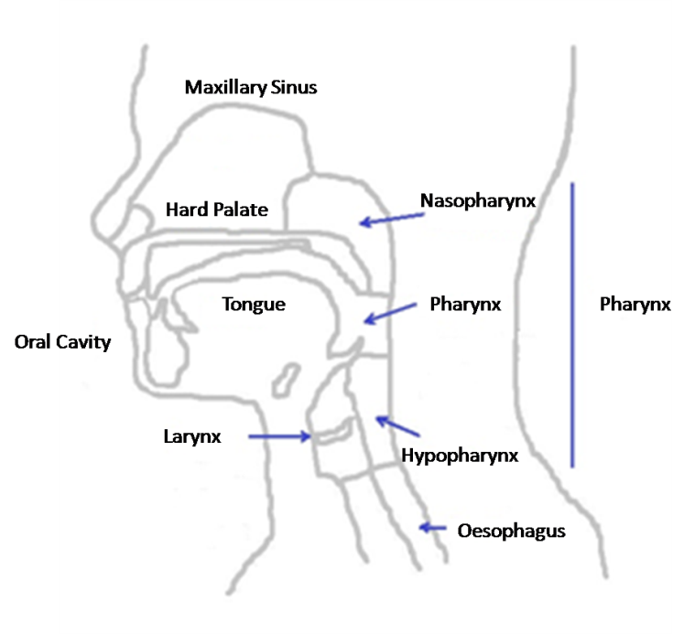
Figure 1.1. Diagram showing the anatomical sites of head and neck squamous cell carcinomas (HNSCC). The majority of cancers arise from the lining epithelium of the following regions: oral cavity (tongue, floor of the mouth, buccal mucosa), oropharynx (soft palate, tonsils, base of tongue), nasopharynx, hypopharynx, larynx (supraglotis, subglotis, glottis). Adapted from (Zvonko Magic, 2013).

Risk factors for head and neck cancer
In HNC, both genetic and environmental factors play an important role in carcinogenesis. Age, medical status, hereditary, infective, oral hygiene, immune status and geographical factors may all play a part in carcinogenesis. The role of nutrition is controversial, with low consumption of fruits and vegetables linked to an elevated incidence of HNC and evidence of depleted retinoic acid supplements in active smokers also linked to increase HNC. In contrast, types of food containing high levels of vitamins C and E may give some protection against HNC (Saman, 2012, Kasper et al., 2015).
By far the most important risk factors for HNC are alcohol consumption, tobacco use (smoking or chewing), areca nut use, and infection from viruses such as Epstein-Barr virus (EBV) and human papillomavirus (HPV) particularly subtypes 16 and 18 (Ragin and Taioli, 2007, Marur and Forastiere, 2008). Alcohol consumption, tobacco use and areca nut have been associated with most forms of HNC, whereas EBV infection is mainly associated with nasopharyngeal cancer in specific regions of the world and infection with high-risk HPV mostly associated with oropharyngeal cancer (OPC). Danaei et al. (2005) found that the possible risk effects of mortalities for oral cancer in countries with low and middle income due to smoking were responsible for approximately 42 % death and alcohol 16 %. While, in countries with high income were much higher death accounting for 71 % due to smoking and 33 % for alcohol consumption.
Risk of HNC associated with alcohol consumption include the genotoxic effects caused by the end product of ethanol metabolism; acetaldehyde, production of reactive nitrogen and oxygen species, inhibition of deoxyribonucleic acid (DNA) repair and production of DNA adducts. After long term exposure to these carcinogens, irreversible DNA damage may particularly affect key genes that regulate the cell cycle, leading to changes in gene expression and eventually improper mitosis. In addition, alcohol may exert its harmful effects either by directly damaging the oral mucosa or as a solvent for carcinogens from tobacco smoke, thereby augmenting the penetration of tobacco carcinogens into the epithelium and connective tissue (Pöschl and Seitz, 2004, Pai and Westra, 2009a).
Increased HNC risk with smoking occurs from the consequence of tobacco carcinogens nitrosamines and polycyclic hydrocarbons that have effects on genes controlling the cell cycle or genetic polymorphisms in enzymes such as cytochrome P450 that detoxify or inactivate these carcinogens thereby increasing their likelihood of altering chromosomal DNA (Zhang et al., 2011). Additionally, synergistic use of both alcohol and tobacco amplify the risk of HNC development more than 10-fold (Gillison et al., 2000). Although alcohol consumption and smoking increase the risk of developing HNC, only a fraction of people who take part in these activities go on to develop cancer, suggesting that genetic vulnerability plays a major role in the aetiology of HNC (Supic et al., 2011).
The risk associated with HPV is persistent HPV-infection with high-risk subtypes, in particular HPV16 (Sudbø, 2001, Ragin and Taioli, 2007). Persistent infection with high-risk HPV can lead to genomic instability in infected cells by deregulation of the cell cycle through inactivation of tumour suppressor proteins (Dahlgren et al., 2004, Wallace and Münger, 2018). Growing evidence confirms that HPV-related HNC are robustly associated with previous HPV-infection and the pattern of sexual behaviour (Pai and Westra, 2009a, Smith et al., 2004). About 20 - 25 % of the HNC are attributed to HPV and 70 % of the OPC are due to HPV, although this varies geographically.

Classification and staging of head and neck cancer
According to HPV-infection status, HNC is classified into HPV-positive and HPV-negative (any cause rather than HPV). So far, this is the only existing molecular HNC classification. Suh et al., suggested the demand for additional investigations to genetically classify HNC (Suh et al., 2015). The majority of patients with OPC (i.e. about 70 %) are HPV-positive (Kasper et al., 2015), therefore OPC can be further classified into virally and non-virally induced subtypes (Wallis et al., 2015b)

HNCs are staged according to the world health organization (WHO) by tumour node metastasis (TNM) system. Accurate staging of HNC is important to predict prognosis and aids treatment decisions (Huang and O’Sullivan, 2017). The newly published TNM 8th edition includes HPV-related OPC, separating the clinical and pathological TNM classification for HPV-positive/-negative OPC. The most significant difference of the new TNM from the former TNM 7th edition in relation to HPV-positive OPC is that HPV-status may provide a prognosis before starting the treatment (Lydiatt et al., 2017).

Epidemiology of head and neck cancer
By 2020, it is anticipated that approximately 833,000 and 151,000 new cases of HNC will occur worldwide and in Europe, respectively (Boscolo-Rizzo et al., 2018). HNC ranks sixth among the most common cancer types and is the eighth leading cause of death due to cancer worldwide (Warnakulasuriya, 2009, Ragin et al., 2007) (Figure. 1.2). There are extensive dissimilarities in HNC incidences by both sex (4:1 male to female ratio) and geographic region, the highest rate are located in the Indian subcontinent, eastern parts of Europe, Australia, Brazil, Southern Africa and some parts of the Pacific region (Warnakulasuriya, 2009, Ferlay et al., 2010). In 2015, there were a total of 12.061 cases reported in the United Kingdom with more than 50 % of the cases above 65 years of age (Ness et al., 2018, Beynon et al., 2018).
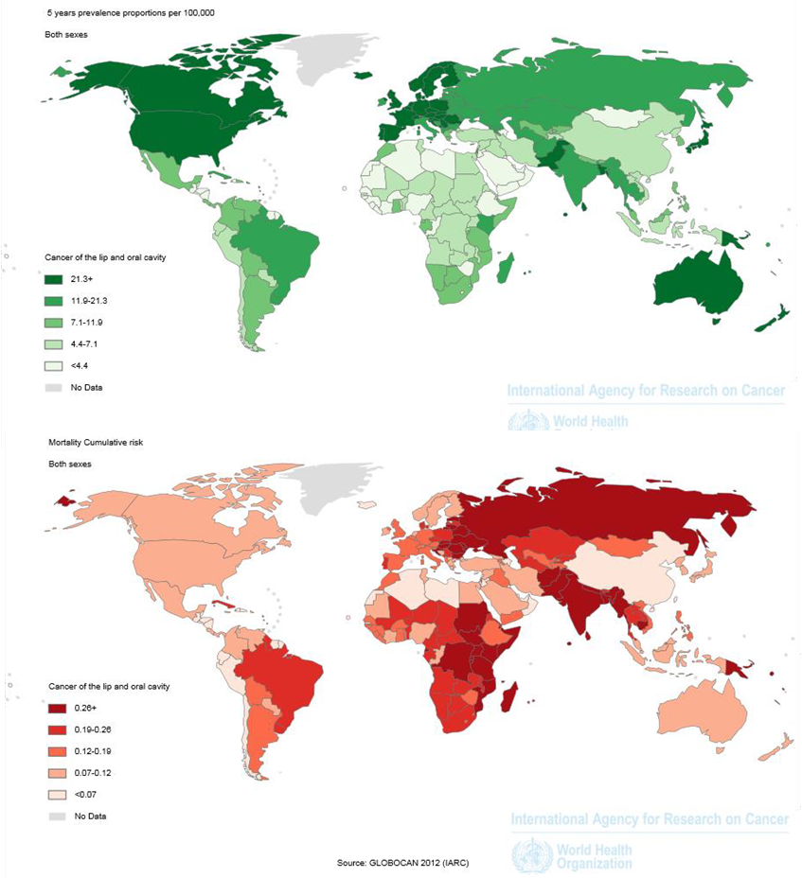
Figure 1.2. Prevalence and mortality rates for lip, oral cavity and pharynx worldwide. (A) Prevalence for 5 years and (B) Mortality rates of lip and oral cavity cancer worldwide in 2012. Data is shown as rates per 100,000 of the global population in both female and male, (Data obtained from GLOBOCAN 2012) (Cancer, 2012).

Recent statistics show that annually, 38-45,000 cases of HNC are attributed to HPV infection (Castellsagué et al., 2017, de Martel et al., 2017), with the majority of these cases presenting as OPC. The most recent pooled analysis data showed that 59.3 %, and 17.5 % in the USA, and Asia, respectively, which reflect extreme heterogeneity in the geographic prevalence of HPV-positive OPC (Anantharaman et al., 2017, Castellsagué et al., 2016). The incidence of HPV-positive OPC tumours in Europe and USA is increasing (Torre et al., 2015, Stein et al., 2015, Mehanna et al., 2016). Regional variations in Europe (41.4 %) are relatively pronounced with Southern European countries (24.2 %) such as east of Italy showing a lesser proportion of cases than Northern European countries (56.5 %) such as Sweden (de Martel et al., 2017, Baboci et al., 2016, Ndiaye et al., 2014).
The incidence of HPV-positive HNC is also increasing. Recently reported data showed that in UK there is significant increase in OPC with approximately parallel increase of cases due to HPV-positive and HPV-negative aetiology (Schache et al., 2016). In addition, recent retrospective studies have shown a significant increase of HPV-driven HNC over the last decades. In Netherlands, this rose from 5 % to 29 % between 1990 – 2010, Australia showed an increase from 19 % - 47 % between 1987 – 2005, and in United States showed a dramatic increase from 16.3 % for 1984-1989 to 72.7 % by 2000—2004 (Schroeder et al., 2017, Stein et al., 2015). The cause for this dramatic increase in HPV-related OPC is believed by many authors to be due to a change in the patterns of sexual practices that has occurred over the last few decades and mostly affects white males with a alcohol/smoking-history free (Marur et al., 2010b). Some data suggest that there is decline in the incidence of HPV-negative HNC (Hwang et al., 2015), which presumably is attributed to advancement in preventative strategies such as anti-smoking and alcohol campaigns, the movement in some Western societies towards non-tobacco methods of smoking (vaping) as well as improvements in preventative measures and some treatment modalities (O'Neill et al., 2015).

Human papillomavirus
Virtually all cases of cervical cancer (>95 %) are attributed to HPV-infection, so that most of the information about this cancer causing virus has come from this area (Haedicke and Iftner, 2013, Xu et al., 2018). HPV is a non-enveloped, double stranded DNA virus that has the ability to cause infection in humans. It is exclusively an intraepithelial pathogen targeting epithelial cells of the cervix, oropharyngeal and oral cavity, anus and penis (Petros et al., 2016). Infection from HPV does not occur unless there is a break or abrasion in the epithelium as shown in figure 1.3 (Stanley et al., 2012), therefore the virus has limited capacity for entry to the epithelial layer (Scott et al., 2001). A prerequisite for the success of viral infection is to keep an intact basement membrane in order to evade the immune response. The virus has the capacity to evade the immune response while residing in the epithelial layer, whilst subepithelial exposures lead to activation of the adaptive immune response. To date, about 200 serotypes of HPV have been discovered and these are generally divided into low- and high-risk groups. At least a 10 % difference in the nucleotide sequences encoding the L1 gene (the major viral capsid component) is considered sufficient to confer a distinct HPV serotype from other HPV serotypes (Groves and Coleman, 2015, Peate, 2018).

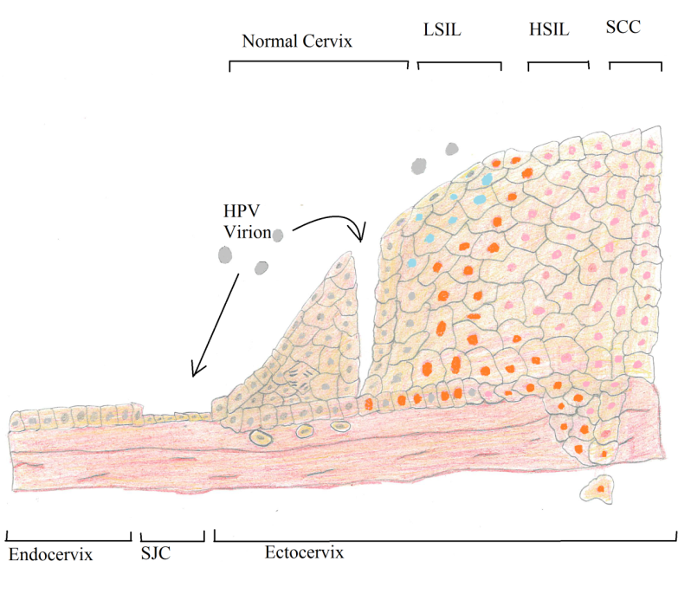
Figure 1.3. Diagram demonstrating the human papillomavirus neoplastic progression in cervical epithelium. HPV infects basal squamous epithelial cells following a break or abrasion in or near the squamo-columnar junction. In the normal HPV life-cycle expression of early genes maintained low copy numbers that are mainly episomal (red nuclei). As infected keratinocytes replicate and daughter cells move into the suparabasal layer, expression of HPV gene products E6 and E7 disrupt cell-cycle and allow cells to re-enter the cell cycle and produce an expanded epithelium that present clinically as warts (blue nuclei). Migration of keratinocytes to the upper layers cause amplified replication of the HPV-genome to high copy numbers (may be thousands). Abbreviations: squamocolumnar junction (SCJ), low grade squamous intraepithelial lesion (LSIL), high grade SIL (HSIL), squamous cell carcinoma, HPV early gene expression (red nuclei), HPV late gene expression (blue nuclei), unaffected nuclei (grey colour). Adapted from (Groves and Coleman, 2015).
HPV-associated neoplastic progression in cervical epithelium. HPV may infect basal squamous epithelial cells following
micro-trauma, or may target cells at or near the squamo-columnar junction (SCJ), including epithelial reserve cells. In the normal virus
life cycle, HPV early gene expression is initiated (red nuclei), while the H PV genome is maintained at low copy number as an episome. As
infected basal cells replicate and daughter cells move into the parabasal layer, expression of virus oncoproteins E6 and E7 allow cells that
would normally differentiate to re-enter the cell cycle and produce an expanded epithelium. Migration of cells to the upper layers causes
increased replication of the virus genome to high copy number, with expression of the virus E4 gene and often the structural proteins L1
and L2. These events allow encapsidation of the episomes into infectious virions, which are then shed from/with the cornied surface. Such
completion of the virus life cycle is supported in a low-grade squamous intra-epithelial lesion (LSIL) but not in a high-grade SIL (HSIL),
where disease progression is associated with deregulation of virus early gene expression and loss of late gene expression. Squamous cell
carcinoma (SCC) arises when cells gain the ability to penetrate the epithelial basement membrane and invade the underlying stroma
HPV-associated neoplastic progression in cervical epithelium. HPV may infect basal squamous epithelial cells following
micro-trauma, or may target cells at or near the squamo-columnar junction (SCJ), including epithelial reserve cells. In the normal virus
life cycle, HPV early gene expression is initiated (red nuclei), while the H PV genome is maintained at low copy number as an episome. As
infected basal cells replicate and daughter cells move into the parabasal layer, expression of virus oncoproteins E6 and E7 allow cells that
would normally differentiate to re-enter the cell cycle and produce an expanded epithelium. Migration of cells to the upper layers causes
increased replication of the virus genome to high copy number, with expression of the virus E4 gene and often the structural proteins L1
and L2. These events allow encapsidation of the episomes into infectious virions, which are then shed from/with the cornied surface. Such
completion of the virus life cycle is supported in a low-grade squamous intra-epithelial lesion (LSIL) but not in a high-grade SIL (HSIL),
where disease progression is associated with deregulation of virus early gene expression and loss of late gene expression. Squamous cell
carcinoma (SCC) arises when cells gain the ability to penetrate the epithelial basement membrane and invade the underlying stroma
The viral particle capsid is approximately 50 nm in diameter and is icosahedral in shape. The genome of HPV is approximately 8 kilobases (kb) in size and the viral DNA is complexed with histones of host cells (McKaig et al., 1998). It consists a total 9 genes that encode seven early (E) and two late (L) proteins (Ganguly and Parihar, 2009) as shown in figure 1.4. The two late genes encode the viral capsid structure, L1 is the major component of this capsid structure, while L2 has minor contribution, (McKaig et al., 1998). The L proteins are essential for virion formation, spread and transmission. As well as encapsulating the genetic material of the virus, the capsid also mediates host entry by binding to heparin sulfate proteoglycans in the epithelial basement membrane via the capsid structural protein L1 to activate endosomal absorption (Favre et al., 1975, Cerqueira et al., 2013). The early HPV protein-genes regulate the viral life-cycle, control cell mechanism for replication, transcription and translation of the HPV-proteins (Yu et al., 2010a, Fang et al., 2006).
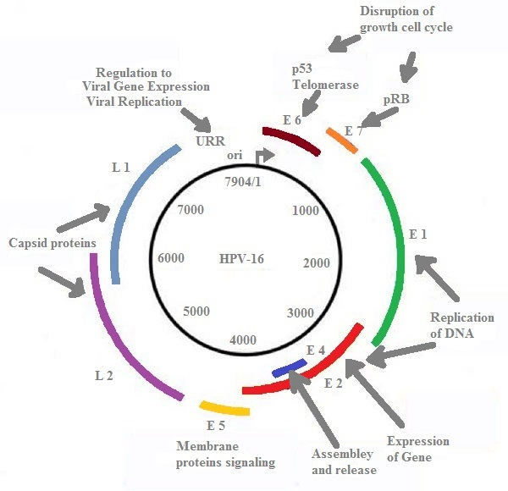
Figure 1.4. Schematic presentation demonstrating the genomic organization of HPV-16. This high-risk HPV serotype is known to be the main causative agent of HPV-positive OPC; early genes E1 - E7, late genes L1 - L2 (capsid). The HPV genome is double-stranded DNA circular structure. The genes are transcribed in clockwise. The non-structural proteins are E1-7 and the structural proteins are L1, L2 and long control region (LCR). LCR contains the DNA and works as regulator for DNA-replication. Adapted from (Kajitani et al., 2012).
Virally-infected keratinocytes must progress to superficial layers of epithelium layer prior virion release can happen. In fact, L1 production is controlled by the maturation of the basal cells to more superficial epithelium cells. For this reason stronger L1 expression is seen in the superficial epithelium layers (Yu et al., 2010b). At this stage thousands of viral-copies per each keratinocyte can be detected (Gadducci et al., 2013).
Table 1.1 summarizes the function of each viral-protein. Generally, E proteins are mostly involved in controlling viral replication. E1 acts as helicase, separating the DNA strand of the virus, enabling viral reproduction to take place by host cell factors (McKaig et al., 1998). E2 represents the main transcriptional regulation factor and joins the virus and host DNA together (Seo et al., 1993). E2 has another important role in down-regulating the oncoproteins E6 and E7 proteins (Lazo, 1999, zur Hausen, 1999), so that inactivation of E2 leads to over-expression of E6 and E7 (Huang et al., 2010). The role of E3 has yet to be fully identified. E4 is expressed after E1-3 and has a role in disruption of the host cytoskeleton filaments to assist viral particles release. E5 is oncogenic in some mammalian papillomavirus types and poses destabilization effect in the human cells, allows non-stop uncontrolled proliferation and prevents cell differentiation. E5 in the early stages of infection can cause up regulation of the epidermal growth factor receptor (EGFR) expressed by keratinocytes (Doorbar et al., 1991, zur Hausen, 2002b).
E6 and E7 are oncogenic proteins and are responsible for deregulation of the cell-cycle (Huang et al., 2010, zur Hausen, 2002b) as demonstrated in figure 1.5. Both of these oncogenic proteins work mainly on p53 and Rb (tumour suppressor proteins) (Ganguly and Parihar, 2009, Werness et al., 1990, Vozenin et al., 2010). E6 is complexed with E6-associated protein (E6-AP) that is later complexed with p53 to stimulate its ubiquitin-mediated degradation (zur Hausen, 2000, Lazo, 1999). E7 complexes with hypo-phosphorylated Rb that in turn binds with E2F (Lizano et al., 2009). When E7 interacts with Rb it leads to the release of E2F, which, in its free form, promotes DNA synthesis along with cell cycle progression (McKaig et al., 1998). Release of E2F by Rb only occurs because of phosphorylation, most notably via cyclin-dependant kinase (CDK4) that is stimulated during cell replication (Li et al., 1994).
The functional disruption of both p53 and Rb results in the loss of vital pathways in cell-cycle regulation. p53 usually acts to keep the cell at the G1/S regulation point where DNA injury is distinguished and this protein mediates DNA repair, and when appropriate activates apoptosis. Free E2F takes part with this process by inducing genes linked to cell-cycle progression and turnover (Lazo, 1999). It is essential to note that there are some controversies about the action of E2 protein, in addition to its role in repressing E6 & E7 viral-proteins, E2 also has the ability to keep the host cells in S-phase that allow virus to replicate.

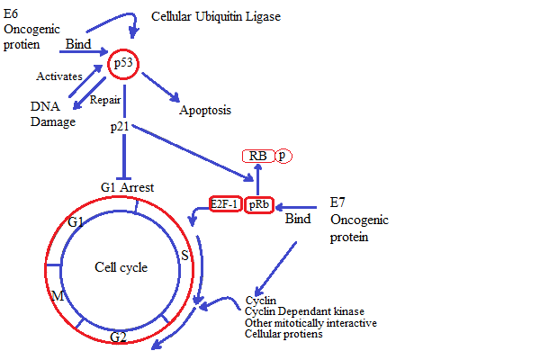
Figure 1.5. Schematic diagram showing the effects of HPV oncogenic proteins on the host cell cycle. HPV-oncogenic proteins E6 and E7 primarily bind to the genes encoding tumour suppressor proteins p53 and pRB, cell cyclins, and cyclin-dependent kinases. The E6 binds to p53 and targets it by cellular ubiquitin ligase. As a result, p53 that controls G1, apoptosis, and DNA repair are abrogated. The E7 binds to the hypophosphorylated RB and disrupts the complex between pRB and E2F-1. The E7 can also bind other mitotically cellular proteins such as cyclin. The outcome is stimulation of cellular DNA synthesis and unchecked continuous cell proliferation. Adapted from (Burd, 2003).

HPV proteins | Proteins function
L1 | Major capsid structural protein
L2 | Minor capsid structural protein and contributes to viral DNA localization to the host cell nucleus.
E1 | Starts replication of HPV-genome, activates helicase, keeps HPV-DNA episomal
E2 | HPV transcription, DNA replication and segregation of viral genomes.
E3 | No function for this protein known yet.
E4 | Assist packing of HPV genome, maturation of viral particles and interaction with RNA helicase.
E5 | Interacts with EGFR, activates PDGF receptor. Oncoprotein activity, permits non-stop proliferation of the host cell and prevents differentiation.
E6 | Inhibits normal regulation of the cell replication, degrades p53 in the presence of E6-AP. Interaction with several host proteins and major oncogenic protein.
E7 | Inhibits normal regulation of the cell replication, binds to RB, interacts with several host proteins and major oncogenic HPV-protein.
E8 | No function for this protein known yet.

Table 1.1. Function of HPV late and early proteins (Petros et al., 2016).

Routes of HPV transmission
Currently, HPV-infection is considered the most infectious sexual transmitted disease. However, the incidence of carcinogenesis by high-risk HPV infection in HNC varies from 0–100 % (Zvonko Magic, 2013). In addition, virtually all cervical malignancies are related to HPV (Watson, 2005).

Prenatal
HPV-infection can be transferred from the mother to the infant through the genital tract during partition. Transmission through this route is uncommon, and an asymptomatic child does not mean lack of infection, as the viral-latent period may take decades. However, HPV types -6 and -11 spread from vaginal warts during delivery can yield Juvenile-Onset Recurrent Respiratory Papillomatosis (JORRP) although this is rare (Sinal and Woods, 2005).

Genital infection
Most HPV-infection is attributed to sexual intercourse in adolescent females or in other sexual practices such as oral and anal sex mainly due to contacts of genital tissue (Burchell et al., 2006).

Hands
Research has shown that HPV-infection can occur between sexually active individuals by hand contact (Hernandez et al., 2008); however the spread of HPV-infection through hand-genital contact is an often neglected route of transmission (Winer et al., 2010).

Sharing objects
Virally-infected (contaminated) objects, in particular sex toys, may transmit disease (Tay, 1995), although transmission via this route other than sexual contact is not frequent (Burchell et al., 2006).

Blood
HPV-infection cannot be spread via blood since the infection occurs through skin contacts or mucosal break. However, researches have shown the presence of HPV DNA in the individual’s blood with HPV-positive cervical cancer (Bodaghi, 2005). The detections of HPV-DNA raise the possibility of infection by patterns other than a sexual route (Chen et al., 2009). Even though, HPV in blood is not similar in detection of the virus in cellular DNA, furthermore, it is unproven if HPV can reside in the blood of infected individuals (Krueger et al., 2010).

Surgery
HPV can be spread in health centres, particularly to medical employees, by the orally-acquired route during laser or electro-cautery application from surgical treatment of lesions caused by the virus although this is rare (Watson, 2005).

HPV-infection and pathogenesis in head and neck cancer
From the time of HPV-16 discovery in the 1970s, a role for HPV in malignancies was proposed (Zur Hausen, 2002a). The role of HPV in HNCs has been investigated since the 1980s by Harald Zur Hausen, since then E6 & E7 appeared to be the key players in the pathogenesis of HPV-related cervical cancer (Syrjänen, 2005). HPV-infection is a considerable threat since it is responsible for 4.8 % of human cancers (Forman et al., 2012). The majority of HPV-infections are transient and asymptomatic (zur Hausen, 2009). Moreover, most infections are removed by immune defence mechanisms in about 18 months (Stanley, 2008). There is much data supporting the relationship of HPV-oncogenic proteins with OPC (Hill, 2015).

HPV is generally classified into low- and high-risk groups (Singh et al., 2017). The persistent infection from high-risk HPV has the ability to cause oncogenic change within the tongue and tonsils mainly of the oropharyngeal areas. The main oncogenic HPV high-risk types that associated with development of carcinogenesis are HPV-16 and HPV-18 (Broglie et al., 2015). HPV-positive carcinogenesis effects starts with degradation of tumour suppressor proteins such as p53 and Retinoblastoma (Rb) promoting p16 over expression, while carcinogenesis due to alcohol and smoking (HPV-negative) occur via mutation and deactivation of p53 and p16INK4 genes (Pai and Westra, 2009b). Table 1.2 summarizes the differences between HPV-positive and HPV-negative HNC. The low prognosis in HPV-negative cancers may be attributed to severe modulation of the immune system and tumour microenvironment (Duray et al., 2010); however the immune response associated with this phenomenon is unclear.
Features | HPV-positive HNCs | HPV-negative HNCs
Predilection site | Oropharyngeal area | Non
Incidence | Increasing/ ~ 50 % in UK | decreasing/ ~ 50 % in UK
Aetiology | HPV (oral sex) | Smoking and alcohol
Field of cancerization | Not known | Yes
TP53 mutations | Infrequent | Frequent
Prognosis | Favourable | Poor
Age | below 60 years | over 60 years

Table 1.2. Differences between HPV-positive/-negative HNCs characteristics from the clinical and biological view (Leemans et al., 2011, Schache et al., 2016).

Molecular mechanism of HPV-positive and HPV-negative carcinogenesis
Cancers related to HPV-infection are considered as a biologically distinct disease entity and hold different molecular etiologic process than HPV-negative cancer (Suh et al., 2015). As aforementioned, viral-proteins E6 and E7 are known to play a critical role in developing HPV-positive cancer (figure 1.5). The main consequences of the oncogenic protein E6 and E7 are loss of the tumour suppressing functions of p53 and Rb, respectively. In HPV-negative HNC exposure to chemical carcinogens, principally from tobacco and smoking, lead to genetic aberration resulting in mutational loss of p53 and Rb/p16 function (Heffernan et al., 2010).

It is generally accepted that head and neck carcinogenesis is multistage process, starting with chromosome translocations and gene mutations thought to occur during the stages of carcinogenesis. In HNC the accumulation of genetic mutations in epithelia may present clinically as pre-malignant lesions that progress to carcinoma in situ and later invasive cancer as shown in figure 1.6. In HPV OPC there is currently limited evidence for clinically evident premalignant lesions (Kreimer, 2014, Califano et al., 1996a). In HPV-negative, early aberrations occur in the gene p53 (TP53) encoded on chromosome 17p13 and p16 encoded in chromosome 9p21 (Califano et al., 1996b, Braakhuis et al., 2004b). Loss of heterozygosity at chromosome 3p21 is also involved in the early events of tumour suppressor protein loss of function mapped to that locus (Braakhuis et al., 2004). Chromosome 3p has been shown to also be affected during the early stages of cancer development, in which 3 separate regions corresponding to tumour suppressor loci are influenced (Wu et al., 1997). Later events in alterations in the chromosome regions include 13q (the chromosome housing Retinoblastoma (Rb) and locus 11q133 that encods Cyclin D1 (a proto-oncogene) (Califano et al., 2000, Califano et al., 1996b). A noticeable feature, in HPV-negative carcinogenesis is loss of large portions or entire chromosomal arms resulting in large deletion (Braakhuis et al., 2004).

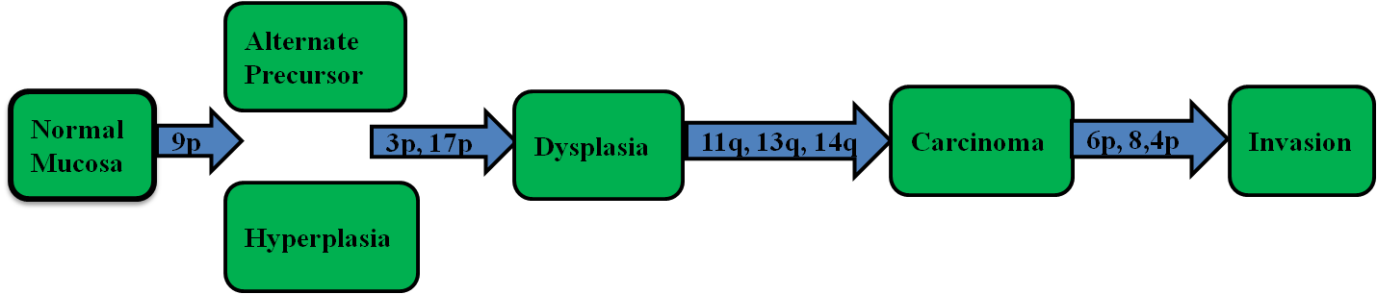

Figure 1.6. Schematic diagram demonstrating the histological/genomic progression of HPV-negative HNC. Histopathological progression associated with the genetic changes of HNCs depending on allelic loss. Genetic changes have been positioned showing the timing of the particular event. It is build up of changes, not essentially the order, which is important. A small benign hyperplastic lesion with 9p2l or 3p2l loss might give rise to dysplasia. The tumour suppressor genes include p53 and retinoblastoma in addition to the proto-oncogene cyclin D1 (Califano et al., 1996a).

In contrast, HPV-positive carcinogenesis is initiated with a smaller amount of genetic events. In addition, more conservative genetic aberrations occur in HPV-positive OPC in comparison to the gross deletions observed in HPV-negative OPC. In HPV-positive OPC, deletions on chromosomes 17p, 9p and 13q are not necessary for carcinogenesis owing to the effects of HPV-oncogenic proteins E6 and E7. Furthermore, unlike HPV-negative OPC, aberrations on chromosome 3p are uncommon in HPV-positive OPC. However, this is not easily illustrated by the classical functions of E6 and E7. It is important to note that these proteins may have more inhibitory actions on the tumour suppressor proteins encoded on these chromosomes due to the small genetic aberrations noticed (Braakhuis et al., 2004).

In cervical cancer the expression of E6 and E7 is regarded important, but not enough alone, to immortalize cells without additional genetic mutations. The aforementioned features related to HPV-carcinogenesis would imply this is also true in OPC, with HPV-infected cells requiring successive gene mutations for progression (zur Hausen, 2000, Subramanya and Grivas, 2008).
Losing the activity of both p53 and pRb tumour suppressor proteins is similar to the gene mutations observed in HPV-negative OPC, because cell proliferation is allowed proceed unchecked. In high-risk HPV, E7 causes more instability at cell division by stimulating centromere over-duplication during cell division, which is an independent effect of its action on pRb. The accumulation of these relatively small changes on the chromosome (in size and number in comparison to large deletions in the HPV-negative OPCs) eventually lead to changes in cell phenotype from dysplasia to carcinoma in situ, and then invasive carcinoma (Chow et al., 2010).
The ability of E6 to stimulate telomerase through increased activation of the hTERT promoter has emerged as one of the key functions of HPV-oncogenic protein E6. The activity of telomerase is considered as independent of the effects of E6 on p53, and has been found as a central process in combination with p16 abrogation for immortalization (Van Doorslaer and Burk, 2012). However, this finding is not supported by all authors. Away from the virally-induced immortalization, the increase in telomerase activity has been linked with increased risk of cervical cancer (Vega-Peña et al., 2013). Moreover, telomerase has been found to be reactivated in approximately 90 % of cancers (Kim et al., 1994), and repressed in mortal tissue. Therefore, telomerase activity induced by E6 protein is regarded clinically significant biomarker that may contribute for promotion of carcinogenesis.
HPV integration into the host chromosome, especially in cervical cells, has been implicated with carcinogenesis (McKaig et al., 1998). The main effect of integration is loss of E2 leading to expression of E6 and E7 later on as previously mentioned (in viral-proteins function). HPV integration into host DNA does not occur in benign lesions where HPV DNA is episomal and found in low copy numbers in the cells (Chow et al., 2010). During the process of keratinocyte differentiation and progression to the upper layers of the epithelium, E2 expression stops, allowing florid viral proliferation and viral particle release (Chow et al., 2010). By limiting viral replication in the basal layers, the virus immunogenicity remains minimal in an attempt to avoid the immune response. This has a host cell advantage by avoiding the potential mutagenic actions of HPV E6 and E7 onocproteins (Yugawa and Kiyono, 2009).
It is presently unclear as to whether the actions of E6 and E7 are the only mechanism by which HPV has oncogenic actions. It is plausible that the insertional site of HPV integration may lead to genetic aberrations that lead to carcinogenesis, but this is still matter of debate (Wentzensen et al., 2004). A systematic review of integration sites of HPV into the host chromosomes in cervical dysplasia and invasive cancer found randomly distributed integration sites spread across the host genome, although these was evidence of preferential integration at common fragile sites. Findings included in the systematic review support this, specifically for HPV-16, the viral type mostly implicated with OPC (Thorland et al., 2003). Subsequent studies have supported these findings with integration sites commonly occurring around cytogenetic bands 4q13.3, 8q24.21, 13q.22.1 and 17q2.1 (accounting for 23 % of the integration detected). Moreover, in cervical cancer cell lines, a common viral-DNA integration site was found in the region 8q24, the site of c-myc, a gene that has profound effects on the cell cycle. However, these findings still to be verified and if insertion at this site is associated with OPC (Krause et al., 2008, Peter et al., 2010).

Head and neck cancer diagnosis and HPV-status detection
There is no worldwide standardized diagnosis regime for HNC. Traditionally, patients are visually inspected, a biopsy taken if necessary and the histological sections from this examined microscopically to confirm diagnosis. Imaging screening test, such as computed tomography (CT-scan) and magnetic resonance image (MRI) to determine the stage and even the metastasis to another area (secondary tumour) (Argiris et al., 2008). Concerning the HPV-status, there is a wide differences worldwide of OPC linked to HPV-infection, with percentages ranging from 18 % to 72 % (Mirghani et al., 2014).

The main objective of any HPV detection test is to recognize the presence of HPV and its true implications in oncogenesis. A precise, feasible and cost effective test is essential for HPV-positive/-negative OPC determination. The integration status of HPV within host cells may have important implications as integration is linked to carcinogenesis. Biological assays to determine integrated versus episomal HPV presence have been developed but these tend to be complicated to perform and are non-high throughput. However, the presence of HPV or the expressions of proteins in response to the functional actions of HPV have emerged as valid biomarkers in the last years in OPC patients. These biomarkers enable the determination of the existence of the virus footprint at onset and during different steps of the disease, and may provide insights into required patient treatment regime (Bishop et al., 2012, Gloghini et al., 2015, Mills et al., 2017).

Although a number of HPV-status assays are currently available, none offer 100 % sensitivity and specificity when used as a single test (Volpi et al., 2017). For these reasons, step wise assays combining various approaches for the detection of HPV-status is the method of choice. These approaches include p16 IHC staining, DNA in situ hybridization (ISH) to detect presence of HPV-DNA, and polymerase chain reaction (PCR) (Ciniselli et al., 2016, Rooper et al., 2016).
These first two assays are usually performed to accurately determine the presence of transcriptionally-active HPV in formalin-fixed paraffin-embedded (FFPE) patient biopsies (Mendez-Pena et al., 2017, Mirghani et al., 2016). IHC for p16 is used as a surrogate marker for HPV presence and is interpreted as either positive or negative. However, false positive results from HPV-negative cancer have been reported. Moreover, several investigators have found that some HPV-positive tumours did not over-express p16 (Smeets et al., 2007, Adelstein et al., 2009, Allen et al., 2010, Weinberger et al., 2009). In situ hybridization assesses the absence or presence of hybridization signals within cancer cell nuclei based on the presence of HPV DNA or mRNA depending on the probe. PCR has been used to detect HPV in oropharyngeal rinse and gargle samples that contain epithelial cells, often to detect the prevalence of HPV. PCR also works well in fresh samples and demonstrates the presence or absence of viral DNA and amplification depending on the number of the viral copies within the infected cell. Determination of the HPV status within the tumour biopsy is complicated, because many testing procedures for HPV involvement are not 100 % perfect. For example, no blood-born phase of HPV-infection is evident during carcinogenesis so detected in either serum or blood cannot be used clinically.
Many of the aforementioned procedures detect presence of the virus but do not determine low or high risk types. Further tests are required such as type-specific PCR or ISH, next generation sequencing and INNO LiPA HPV genotyping to obtain this information (D'Souza et al., 2007). Genotype specific HPV-infection categories are, low-risk (LR-HPV) types such as 6- 11- 42- 43- 44- and 70 that generally cause warts, while the high-risk (HR-HPV) types 16-18- 31- 33- 35- 39- 45- 51- 52- 53- 54- 56- and 58 are associated with malignancy (Massad et al., 2013, Rautava et al., 2012).

Prognosis of HPV-positive versus HPV-negative OPC
The significant favourable prognosis of HPV-positive OPC is well recognized by meta-analysis of several studies (Gillison et al., 2000, Fakhry et al., 2008, Yuanyuan et al., 2015). At first it was hypothesized that the improvement seen was attributed to increase tumour radiosensitivity, and although HPV-positive OPC are more responsive to radiotherapy, improved prognosis of these tumours also appears to happen after surgery (Fischer et al., 2010, Licitra et al., 2006). The current view is that the favourable results of HPV-positive are mostly attributed to the lack of genetic aberration expressed in HPV-positive compared to HPV-negative OPC (Braakhuis et al., 2004a). The persistence of wild-type genes TP53 and RB are thought to support the altered behaviour in treatment responses. It has been proposed that cellular insult as a result of radiotherapy might prepare the cell to overcome the effects of HPV-oncogenic proteins, permitting p53 expression to re-establish (Mirghani et al., 2015). However, a study performed using siRNA to transfect TP53 in cell lines expressing E6/E7 resulted in increasing radioresistance (Kimple et al., 2013).

Even with the effects of HPV-infection on therapeutic success, specific effects have also been reported. Recently, Gubanova et al. (2012) found that the tumour suppressor protein Serine/threonine-protein kinase (SMG-1) is down regulated in a small cohort of HPV-positive OPC patients that is responsible for DNA surveillance. Indeed, down regulation occurred in HPV-negative cell lines and normal keratinocytes as well in response to E6/E7 transfection. Gubanova et al showed that, in vitro, up regulation of SMG-1 in HPV-positive cells led to decrease radiosensitivity, while down regulation of SMG-1 in HPV-negative cell lines results in increasing radiosensitivity. SMG-1 is one of many regulators of DNA-damage responses and it is itself stimulated by ionising radiation (Brumbaugh et al., 2004). In cases lacking SMG-1, the accumulation of irreparable DNA activates apoptosis; down regulation of SMG-1 in HPV-positive cells might provide an explanation for HPV-positive radiosensitivity.

Immune responses may also provide an explanation for the HPV-positive cancer favourable prognosis. It was proposed that radiotherapy might be the reason in an amplified immune response by several potential pathways. These pathways include: increased antigen presentation due to uptake of necrotic viral-infected cells; enhanced penetrations of leukocytes to the tumour mass as a consequence of reduction in cellular adhesion post-radiation therapy; up regulation of major histocompatibility complex (MHC-I) along with of pro-inflammatory cytokines like tumour necrosis factor (TNF) that may reverse HPV-tolerance (Vu et al., 2010). Alterations in HPV antigenicity because of treatment might also give explanations for the improvements in prognosis shown in surgical intervention of HPV-positive tumours. Local inflammatory reactions to the tissue caused by the trauma of excision. The immunity will also be influenced in the same way as a result of cellular contents released at the incomplete surgical margins.

The prognostic benefit of a HPV-positive status is reduced with heavy smokers and advanced stage. A study performed by (Ang et al., 2010) proposed that there is an intermediate group for favourable prognosis that lay between non-smoker HPV-positive/negative cancers in heavy smokers. The mechanism through which superior outcome is diminished in this intermediate group is unclear. However, it may be attributed to a change in cellular process generated by tobacco exposure that is affected by therapy. Alternatively, it might represent more genetic aberrations that cannot be targeted with a standardized treatment. This may offer an opportunity for the development of stratified regimes for patients with OPC by validating the risk factors.

Cancer cell repopulation following radiotherapy also important in HPV-positive OPC. Signalling cascades that drive cancer cell survival or proliferation might be an aspect of radioresistance. Inconsistent data, reported the degree of epidermal growth factor receptor (EGFR) signalling in HPV-positive/-negative cancers, even though experimental studies suggested that EGFR signalling is less active in HPV-positive OPC (Mirghani et al., 2015, Gupta et al., 2009).

The potential for phenotypically less aggressive HPV-positive OPC should be taken into consideration, which by virtue are quicker to respond to therapy. Lack of field cancerization is well recognised in HPV-positive OPC and may contribute, in part, to improved prognosis (Klozar et al., 2010). The reasons of survival benefit will have implications on provision of therapeutic target because HPV-infection may eventually be an independent prognostic aspect.

Head and neck cancer tumour microenvironment
HNC is a complex mixture of tissue components including epithelial cells, cancer cells and a number of other cell types that make up the surrounding stroma (Koontongkaew, 2013). Collectively, these cells and non-cellular components are termed as tumour microenvironment (TME) (figure 1.7). Currently, much effort has been exerted to characterise the TME in order to understand its role in tumour growth and progression (Stone et al., 2014, Koontongkaew, 2013, Junttila and de Sauvage, 2013). Cancerous tissue is a mixture of epithelial carcinoma cells as well as connective tissue known as the stroma. The stromal tissue is composed from cellular and non-cellular components. The cellular fraction includes cells involved with tissue architecture (fibroblasts), the inflammatory response (immune cells), and in angiogenesis (pericytes, endothelial cells and smooth-muscle cells), while the major non-cellular part of stroma is the extracellular matrix (ECM) that is composed of many proteins, such as collagen, laminin, fibronectin and proteoglycans (Miles and Sikes, 2014). Other non-cellular elements include nutrients, growth factors as well as oxygen and pH gradients.
The ECM provides architectural support for the tissue and is principally maintained and regulated by fibroblasts that can transform into cancer-associated fibroblasts (CAF) in cancer conditions. Evidence suggests that fibroblasts and some other cells types are activated and converted to CAF by factors released from the cancer cells or other stromal cellular components (De Kruijf et al., 2012). In healthy oropharyngeal tissue, the basement membrane that is composed of proteins, like laminins and collagen, makes a thin barrier layer between the stromal and epithelial tissues components (Kriegebaum et al., 2012). Conversely, in OPC, the cancerous cells breach the basement membrane, leading to the mixing of both stromal and cancer cell populations. It has been shown that stromal and cancerous cells are in cross talk and have the ability to create a microenvironment that is conducive to their own progression (Cirri and Chiarugi, 2012, Kalluri and Zeisberg, 2006a).
The cancer cells stimulate and activate stromal cells to adjust angiogenesis, inflammatory reactions, and then progression. This interaction enhances the secretion of factors such as inflammatory mediators, cytokines, chemokines, matrix metalloprotienases (MMPs) and growth factors (Mueller and Fusenig, 2004, Koontongkaew, 2013, Calon et al., 2014, Pan et al., 2015). The concept of the tumour-stroma cross talk and the microenvironment niche has focused cancer studies on TME components in order to facilitate the understanding of the underlying mechanisms that endorses cancer malignancy and open up new strategies for therapy in HNC (Koontongkaew, 2013, Curry et al., 2013).
Evidence gathered over the last decade suggests that CAF have an important role in cancer establishment. However, the precise mechanisms by which they do so remains to be elucidated (Kalluri and Zeisberg, 2006a). It is generally accepted that the heterogeneity of CAF is not genomic (i.e. not coming from DNA sequence changes). Instead, these changes in phenotype are epigenetic and therefore due to modifications of gene expression. This concept of CAF genetic stability makes these cells less prone to acquire resistance from pharmacological therapy that is frequently encountered with the genetically unstable cancer cells. For this reason a plethora of researches have focused on CAF and their potential as a therapeutic target and prognostic biomarker (Hassona et al., 2013).
Additionally, and equally important, HPV-positive cancers possess a mild TME than HPV-negative cancer which appears to be more active, and not causing cell lyses neither clear tissue, since the activated TME tends to be linked with aggressive cancer nature (Bolt et al., 2017b, Boccardo et al., 2010). There is accumulating data to show that inflammation plays a considerable role in HNC carcinogenesis. For these reasons determining if the presence of HPV influences inflammatory pathways in carcinogenesis or tumour progression is important.

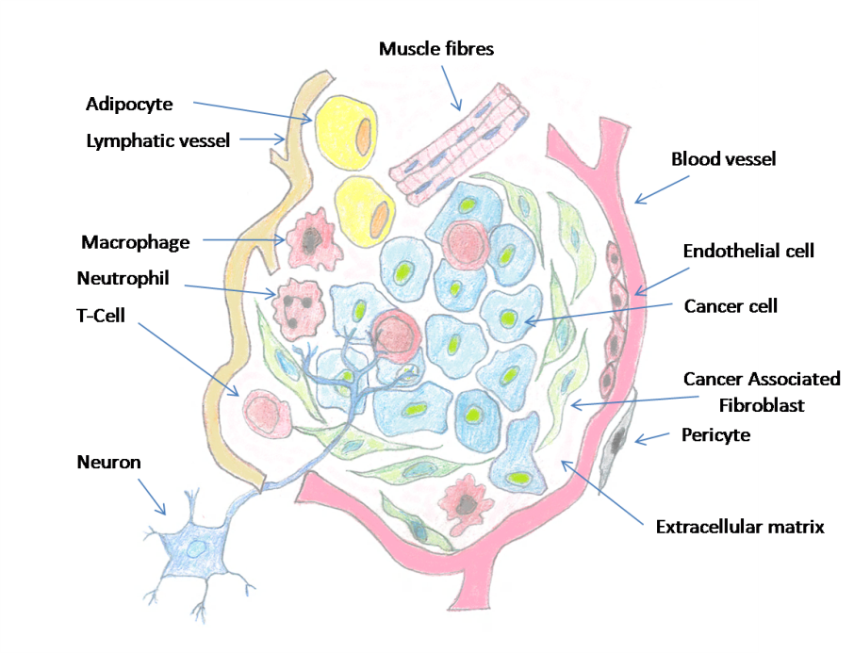
Figure 1.7. Schematic diagram showing the main components of the HNC tumour microenvironment. These components include cancer cells (light blue), fibroblasts (green), immune cells (pink Macrophage, T cell and Neutrophil), neurons (blue), adipocyte (yellow), muscle fibres (light serrated pink), blood vessels (light red), lymphatic vessel (orange) and pericytes (grey). Adapted from (Prajapati and Lambert, 2016).

Role of immune cells in head and neck cancer
In 1863 Rudolf-Virchow noted infiltrations of large numbers leukocytes into tumours (David, 1988). Since then, further data suggested an association between the presence of immune cells and cytokines in tumour/stroma and cancer progression (Mueller and Fusenig, 2004, Balkwill and Mantovani, 2001). The immune system in cancer has been described as a ‘double-edged sword’ (Tang et al., 2018). From one side immune cells attempt to eradicate the cancer cells, while on the other side adverse functions of these cells in the tumour environment can promote cancer progression (Yu et al., 2007). Data have shown that transformed cancer cells escape the immune surveillance in order to initiate tumour progression (Sakakura and Chikamatsu, 2013). The cancer cells then orchestrate an environment favourable to their survival and continuation. It is generally accepted that tumour cells coordinate the tumour microenvironment in a similar manner to that observed in chronic inflammation, providing factors that promote tumour growth and survival (Whiteside, 2006). Different leukocytes play distinct roles in the immune reaction; neutrophils are the first recruited-leukocytes to arrive at the inflammatory site, followed by monocytes and lymphocytes. These cells are also recruited to the tumour microenvironment by chemokines.

Roles of cytokines/chemokines in shaping the head and neck cancer
Cancers are increasingly recognized as a complex environment composed from various cell types that communicate in a complicated signalling network. It is essential to fully understand the cancer by comprehensively understanding the role of each cell type and how they interact within the tumour microenvironment. This involves understanding the cross talk among cells in the form of chemokines and cytokines and how these proteins exert their effects (Chow and Luster, 2014). Chemokines are small proteins ranging from 8-14 kDa, that have the ability to regulate cell trafficking by interactions with subtypes of seven transmembrane G-protein coupled receptors (GPCR) (Karin and Wildbaum, 2015). Chemokines are classified into four subgroups depending on the location of the first two N-terminal cysteine residues. These include CC, CXC, CX3C and XC subgroups. Currently, about 50 chemokines and 20 chemokine GCPRs have been identified (Bachelerie et al., 2014, Zlotnik et al., 2006).
The expression of various chemokine receptors by leukocytes, under particular conditions, leads to their selective recruitment into target tissues that are tailored to the infecting pathogen or abnormal insult (Frangogiannis, 2018, Griffith et al., 2014). This enables leukocytes to play a pivotal role in inflammation. Chemokines can be either pro- or anti-inflammatory, inducible, secreted proteins and are implicated in a diversity of immune responses, acting mainly as chemoattractants along with activators of leukocytes. Chemokines are secreted by numerous cell types, including cancer cells, tumour stroma cells (fibroblasts), cells that comprise the vasculature as well as leukocytes themselves. Much data have reported the contribution of chemokine signalling in tumour growth and metastasis (Wang et al., 2009, Zlotnik, 2006).
Generally, CC chemokines are attractants for cells of the myeloid lineage, lymphocyte sub-sets, eosinophils, natural killer (NK) cells and dendritic cells (DC). CXC chemokines are attractants for neutrophils as well as B- and T-lymphocytes subsets (Koelink et al., 2012). CXCL8 is the main chemoattractant for neutrophils and these cells have been associated with poor prognosis, increased tumour angiogenesis and metastasis (Tazzyman et al., 2013). Christofakis et al. (2008) found that, in vitro, HNC cells over-expressed CXCL1 and CXCL8, and suggested targeting these chemokines in pre-clinical experiments. Aside from chemoattraction, some studies have shown that chemokines are involved in the polarization of CD4+ T cell subtypes that is associated with good prognosis (Zohar et al., 2014, Wildbaum et al., 2002). Elevated levels of tumour-associated macrophages (TAM) are frequently, although not at all times linked with unfavourable outcome. TAM was associated with abundance of CCL2 (MCP-1) in experimental and human in various cancers, such as breast, ovarian pancreatic cancer and HNC (Solinas et al., 2009, Li et al., 2014).
Hamad et al. (2011) found that a number of pro-inflammatory cytokines were significantly expressed in serum and saliva of patients with HNC; including IL-1α, IL-6 and CXCL8. In addition, accumulating evidence indicates that cancer progress not only occurs by genetic changes and mutations, but also due to the inflammatory TME (Hanahan and Weinberg, 2011, Qian and Pollard, 2010, Joyce and Pollard, 2009, Valastyan and Weinberg, 2011, Thurlow et al., 2010). It is important to mention a finding by (Guo et al., 2016) in an experimental study of breast cancer. Blocking interleukin-1 receptor (IL-1R) with an IL-1R antagonist (IL-Ra) resulted in inhibition to tumour growth and metastasis associated with decreased myeloid cell numbers. This is suggesting that targeting the IL-1/IL1R axis in the TME may provide a novel therapeutic regime for cancer.
Furthermore, characterization of HPV-positive and HPV-negative HNC has reported distinct immune cell infiltrates, in addition to the cytokine and chemokine levels within the tumour tissue. The existence of a high level of intratumoral leukocytes infiltration may play a vital role in the significantly favourable response of HPV-positive patients to standard therapy. Moreover, characterization of the HNC immune profile might be an important prognostic tool to identify novel targets for therapeutic approaches, as well as immunotherapy (Partlová et al., 2015, Hunter et al., 2005, Bolt et al., 2017b).

Tumour-associated neutrophils
Neutrophils are the most abundant leukocyte sub-population in the circulation, accounting for about two-thirds of the circulating leukocytes. They are considered as key players of innate immunity and are derived from heamatopoietic stem cells in the bone marrow. Neutrophils have an array of toxic weaponry such as azurophillic granules, gelatinase and defensins acting as antimicrobial agents, in addition to matrix metallopeptidase 9 (MMP-9) and vascular endothelial growth factor (VEGF) that may aid wound healing following infection or injury. Neutrophils also produce reactive oxygen species (ROS) and proteinases, which can have an intense effect on host tissues during inflammatory response and may be the reason for the relatively short half-life of neutrophils 6-8 hours (Martin et al., 2003, Friedman, 2002, Gaudry et al., 1997). Neutrophils are recruited to sites by specific chemokines such as CXCL8, CXCL1-3 and CXCL5 by binding to receptors (CXCR1 and CXCR2) on their cell surface (Chosay et al., 1998, Hartl et al., 2008, Murphy et al., 2000).
At sites of inflammation, neutrophils phagocytose foreign agents and degranulate to neutralize the antigens. Inflammation is a crucial event to defend the human; however, inflammation is self-limiting and diminishes gradually after the causative factor repaired or removed. While, generally cancer inflammation is dysregulated (continuous) and so cancer has been described as ‘the wound that never heals’ (Desmoulière, 2008, Lin and Pollard, 2004).
Neutrophils are also a potent source of cytokines to attract other leukocyte types (Werner and Grose, 2003). Neutrophils have been detected in advanced stages of several tumours including HNC, where they are termed tumour-associated neutrophils (TAN) and can make up to 5-25 % of the tumour mass (Welch et al., 1989, Wang et al., 2015). TAN may help in malignant transformation, angiogenesis, tumour progression, and escaping immune surveillance (Eruslanov et al., 2014, Mantovani et al., 2011). Their presence has been correlated with poor patient survival in renal cell (Jensen et al., 2009) and hepatocellular carcinoma (Zhou et al., 2016, Kuang et al., 2011).
Neutrophils, until recently, were thought to be short-lived cells that arrive rapidly at the site of inflammation, then die, and are engulfed by macrophages. A growing body of evidence suggests a longer neutrophil life-span of 4-5 days in tumours. Pillay et al. (2010b) suggested that the tumour microenvironment generates conditions that can increase TAN longevity. In addition, Dixon et al. (2012) reported in a zebrafish model that in the tumour microenvironment factors extend TAN lifespan for up to 120 hours. Moreover, TAN are polarized into two distinct sub-types termed N1 and N2 (Galdiero et al., 2013b). Fridlender et al. (2009a) found that the N1 phenotype is anti-tumourigenic, with improved ability to eradicate cancer cells, activate cytotoxic T-lymphocytes, and have augmented pro-inflammatory cytokines expression such as tumour necrosis factor-α (TNF-α). In contrast the N2 phenotype is pro-tumourigenic, expressed elevated secretion of VEGF, MMP9, as well as increased secretion of CCL2, CCL5 that promotes monocyte attraction, and secretion of immunosuppressive factors (Jablonska et al., 2010).

Tumour-associated macrophages
Normally, monocytes are recruited by chemokines secreted from the site of inflammation, where they extravasate from the blood vessels into tissues and quickly differentiate into macrophages (Coussens and Werb, 2002). Once activated, macrophages start to produce reactive oxygen (ROS) and reactive nitrogen species (RNS) to fight infection or foreign insult. As stated previously, the inflammatory response to pathogens or injury is usually short-lived compared with that observed in the tumour microenvironment; here macrophages keep producing ROS and RNS causing DNA damage in the proliferating cells, thereby accelerating mutagenesis, and leading to carcinogenesis (Maeda and Akaike, 1998).
Macrophages, like neutrophils, can be also divided schematically into two major divisions: M1 and M2. M1 are the classically activated cells that generally act to defend the host against tumour, viral and other microbial infections. M2 differentiate upon activation with interleukins such as IL-4, L-13, IL-10 and glucocorticoids. M2 usually act as protumour and down‐regulate to M1‐mediated functions properties (Solinas et al., 2009). In HNC the TAM mainly recruited at the tumour microenvironment by bioactive molecules secreted either from the tumour cells or the neighbouring stromal cells. The chemokine CCL2 is the main TAM attractant (Curry et al., 2014), several in vitro and in vivo studies correlate its concentration levels with TAM densities in many other cancers, such as ovarian, breast and pancreatic tumours. TAM themselves also generate CCL2, suggesting the anti‐CCL2 antibodies combined with other chemotherapeutic medication as an anti‐tumour approach (Colombo and Mantovani, 2005). Other chemokines that are involved in TAM attraction are CCL5, CCL7, CXCL8, and CXCL12, in addition to cytokines and growth factors such as VEGF, PDGF and M‐CSF (Balkwill, 2004).

Tumour-infiltrating lymphocytes and other leukocytes subsets
The immune system distinguishes and eradicates tumour cells by means of adaptive immunity, particularly T-lymphocytes. However, that is not always the case in the local tumour microenvironment. In cancer patients, tumour cells grow steadily even in the presence of a blood supply filled with tumour-specific cytotoxic T-lymphocytes (CTL). Circulating lymphocytes have separate responsibility in the immune reaction (Senovilla et al., 2012). CTL are primed with tumour antigens in the lymph nodes and are capable of eradicating cancer cells. However, in about 70 % of HPV-positive HNC, as soon as the CTL enter into the tumour microenvironment and become tumour infiltrating lymphocytes (TIL) they are deactivated and fail to eradicate cancer cells because the tumour microenvironment contains many immuno-suppressive factors such as IL-10 (Lyford-Pike et al., 2013, Begum et al., 2005, Gillison et al., 2008). As an alternative, TILs become exhausted, anergic or apoptotic when they are enclosed by tumour cells, particularly when the tumour cells express programmed death ligand 1 (PD-L1), which leads to inactivate the immune cells (Dong et al., 1999, Zou and Chen, 2008).
Leukocytes not only interact with the malignant cells but also interact with each other (Whiteside, 2008). It was found that heterogeneous types of leukocytes within the tumour microenvironment such as dendritic cell (DC), natural killer (NK), mast, myeloid-suppresser, CD8+, CD4+ and T-memory (Senovilla et al., 2012). Considering, the main effecter cells directed against cancer cells are CD8+ T cells that have the ability to recognize and kill tumour cells (Fridman et al., 2012, Boissonnas et al., 2007). CD4+ cells are subdivided into helper T cells and regulatory T cell (Treg). Helper T cells produce plethora of cytokines and elevate the action of CD8+ while Treg have an immunosuppressive action.
DC forms a link between the innate and adaptive immune systems and acts as antigen-presenting cells. NK as the name implies, can kill malignant and virally-infected cells (Martinez et al., 2009). B-Lymphocytes are antigen-presenting cells along with production of cytokines and chemokines for the promotion of T cell actions (Nelson, 2010). Eosinophil cells are mainly related to allergic and parasitic disease responses, even though found in the tumour microenvironment, releasing materials which may kill the cancer cells and contribute to progress or regulate the tumour (Martinelli-Klay et al., 2009).

Immune cells in oral squamous cell carcinoma
Generally lymphocyte infiltration is associated with favourable outcomes in oral squamous cell carcinoma (OSCC) (Chiosea et al., 2015). A study with 259 patients reported the link between the prognosis of OSCC and the density of tumour-infiltrating lymphocytes (TIL) in the tumour/stroma. It was found that good prognosis was associated with a high density of TILs, although TILs subtypes were not differentiated. In another study with a smaller cohort of 87 patients treated with surgical intervention without pre-chemoradiotherpy (CRT) (Brandwein-Gensler et al., 2005, Watanabe et al., 2010a); results demonstrated low densities of TILs were linked with poor prognosis and a high recurrence rate. Immunohistochemistry of tumour sections showed high CD8+ T cells, above the median average and the survival time was longer, with opposite findings for the CD4+ T cell. Moreover, the ratio of the CD8+/CD4+ was not related to the overall survival (Costa et al., 2010).
In a different study of patients with OSCC subjected to preoperative CRT, a decline in TILs, particularly Treg cells, resulted in a higher CD8+/Treg ratio. While postoperative CRT leads to higher CD8+/FoxP3 ratio and this was linked with better prognosis and increased disease free survival (Tabachnyk et al., 2012). However, CD8+ density alone was not predictive. Cho and colleagues argued that the low TILs were associated with PD-L1 expression (PD-L1 causes TIL dysfunction), on the surface of OSCC cells (Cho et al., 2011). However, a small cohort study could not find any relationship between CD8+ NK cells and overall survival (Zancope et al., 2010). In addition, in OSCC elevated CD8+:Treg cell ratios appeared to be associated with improved prognosis. Another further OSCC study revealed the relationship of Tregs and the survival time with the following cells CD4, CD25, CTLA-4 and FoxP3 by IHC staining (Reichert et al., 2001, Moreira et al., 2010). The expression of FoxP3 in OSCC was about 60 % and their cell densities had no link to patient survival. However, in the same data low CD4+ and high CD25+ numbers were linked to increased survival (Liang et al., 2011).
Apart from TILs, other factors may be associated with prognosis. For example, interleukin-6 (IL-6) secreted by both cancer and immune cells has a role in tumour progression (Nibali et al., 2012). It was noticed that, in males, high IL-6 was associated with poor overall survival (OS) while in females there were no effect (Chen et al., 2012). IL-10 has immune suppression properties and is linked to HPV-positive OSCC, with increased IL-10 expression leading to poor prognosis (Chuang et al., 2012). In summary, the literature confirms that the lymphocyte population infiltrations, particularly higher CD8+ and dendritic cells (DC) and lower densities of Treg cells, could provide favourable information on prognosis in OSCC (Wallis et al., 2015b). However, these aforementioned relations were not consistent in all the studies, which could be attributed to the small cohort study and differences in patient sampling are the most probable explanation for these differences. Several chemokines/cytokines and cell-expressed receptors also seem to be of prognostic value, but their exact role in HNC remains to be fully elucidated.

Immune cells in oropharyngeal cancer (OPC)
An analysis resulting from diverse statistical studies showed good prognosis in the biomarkers of the OPC related to HPV, associated with significant overall survival and expressed tumour suppression protein p16, which is often used as surrogate marker for oncogenic HPV (Rainsbury et al., 2013a). As with OSCC, TIL studies are varied in HPV-positive OPC as seen in table 1.3. In one study TILs had no prognostic effect; however the elevated CD4+ as well as CD8+ in addition to the elevation in CD4+/CD8+ ratio, showed good prognosis and overall survival, even with the expression of epidermal growth factor receptor (EGFR), which is considered as a poor predictive factor. In the same study, higher CD8+, FoxP3+ and whole T cell counts were beneficial in the overall survival. A different study with 83 patients found higher CD8+ TIL numbers in HPV-positive than HPV-negative OPC. It was noticed that elevation in CD8+ T cell infiltration was linked with improved prognosis, while elevated Treg not linked to poor prognosis, whilst the ratio of CD8+/Treg predicted for favourable prognosis (Wansom et al., 2012; Nasman et al., 2012).
In a study of 115 patients either from OPCs or hypopharyngeal cancer (HP), patients were classified according to the disease-stage either with early or advanced (non-resectionable) stage disease. Higher CD20+ B-lymphocyte number was a good prognostic in the early disease-stage, whilst low CD20+ numbers in the late disease-stage would have more prognostic outcome (Distel et al., 2009a). Once again, higher CD8+ T cell densities were found to have a prognostic impact in the early stages of disease while higher Treg were not beneficial in prognosis. Higher CD3+ T cell infiltrations were associated with better survival and lesser rates of metastasis by IHC of 48 patient biopsy samples (Rajjoub et al., 2007b).
A study with 71 patients with HNC found that HPV-status did not affect TIL amounts, while in the same study patients with OPC (n= 22) showed a higher amount of CD3+ and Treg and these were associated with HPV-positive disease, but not linked with the survival time (Ritta et al., 2013). There was improvement in the disease free survival (DFS), in a study with 20 OPC, 5 hypopharyngeal (HP) cancers and 8 OSCC cases treated with surgical intervention without post-chemoradiotherapy. Higher levels of CD20+ B-lymphocyte infiltration around the tumour mass in the metastatic lymph nodes was observed. However there were no significant relation to TIL levels including the CD8+ and Treg in the primary tumours (Pretscher et al., 2009a). Cytokine expression in OPC, found that elevated IL-10 and platelet-derived endothelial cell growth factor (PD-ECGF) had poor prognosis.
Finally, similarities between OSCC and OPC with regard to favourable prognosis included higher levels of CD8+ numbers, while in OPC Treg have more favourable prognosis. EGFR, as shown in (figure 1.8) is associated with poor prognosis in both OSCC and OPC as well, and is supported by other studies (Wansom et al., 2012b, Malecki et al., 2012, Chandarana et al., 2013, Wallis et al., 2015a, Fujieda et al., 1999b).
Site | Parameter | Cases | Findings | References
OPC | Systematic analysis | - | HPV-positive, p-16 positive better OS. | (Rainsbury et al., 2013b)
OPC, HP | TIL | 115 | High CD8+ and CD20+ better OS and LRC and Low CD3+ and CD20+ better NED. | (Distel et al., 2009b).
Tonsil | TIL | 83 | High CD8+ better outcome independent of HPV. High CD8+/FoxP3 ratio better DFS both HPV-positive and HPV –negative. | (Näsman et al., 2012).
OPC, OSCC | IL-10, PD-ECG | 58 | High IL-10 and PD-ECGF expression bad prognosis, | (Fujieda et al., 1999a).
OPC | TIL | 48 | Lower metastases with high CD3+ count with HPV-negative, not HPV-positive. | (Rajjoub et al., 2007a).
BOT, Tonsil | TIL, EGFR | 46 | HPV-positive had better OS and DSS, high CD8+, total CD8+ and CD4+ and FoxP3. EGFR linked to low TIL, low EGFR had better OS and DSS. | (Wansom et al., 2012a)
OPC,HP | TIL | 33 | DFS for patients with high peritumoural CD20+ B cells in metastatic lymph nodes. No correlation between TIL in primary tumour and OS. | (Pretscher et al., 2009b).
Table 1.3. Summary of the immunological parameters in OPC. Abbreviations OPC (Oropharynx), OS (Overall Survivor), HP (Hypopharynx), TIL (Tumor Infiltrating Lymphocytes), OC (Oral Cavity), IL-10 (Interleukin), PD-ECGF (Platelet Derived Endothelial Cell Growth Factor), BOT (Base of Tongue), EGFR (Epidermal Growth Factor Receptor.

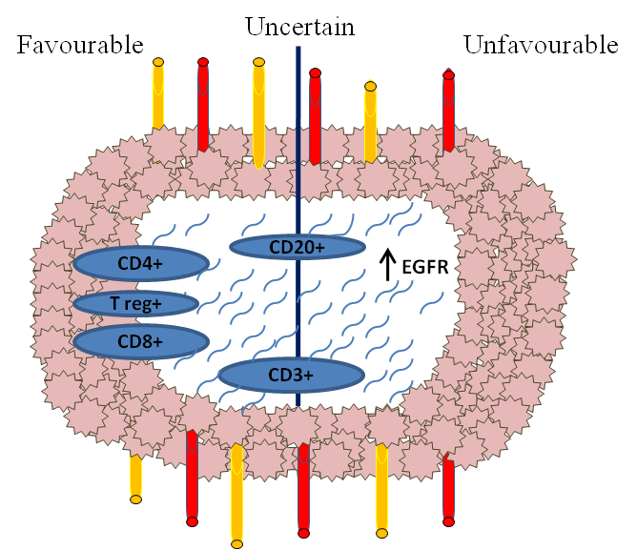
Figure 1.8. Diagram demonstrating the immune parameters that are linked with outcome in OPC. The parameters have been placed intra-tumourally in association with the blood (red vessels) and lymphatic vessels (yellow vessels), with accordance to favourable, unfavourable or uncertain. Adapted from (Wallis et al., 2015a).

Immune cells in laryngeal cancer
Lin reported in 84 supraglottic laryngeal cancer treated with surgery, infiltrating macrophages within the tumour and peritumour regions, that were associated with poor outcome, including disease free survival (DFS) and overall survival (OS) (Lin et al., 2011). In an earlier study, 98 patients were surgically treated for SCC of the larynx; analysis of tissue showed increased macrophage counts that were associated with poor prognosis, although this was found only in poorly differentiated tumours with a high incidence of recurrence (Morra et al., 1991). In advanced stage laryngeal carcinoma there was an association between the amount of T-lymphocytes (CD43+ and CD45+RO) and patients' improved survival, and no links were correlated with CD20+ B-lymphocyte or CD56+ and CD3+ T-Lymphocyte numbers (Gabriel et al., 1999). The higher intensity of S-100+ve dendritic cells hold good prognosis and low numbers were associated with less than 5 years survival time (Gallo et al., 1991).

Immune cells in nasopharyngeal cancer
High densities of Treg and ratio of Treg/CD8+ were found in 64 nasopharyngeal cancers (Yip et al., 2009). Elevated expression of macrophage migration inhibitory factor (MIF) in nasopharynx carcinoma and OSCC is associated with worse locoregional control (LRC) but not linked to overall survival (Liao et al., 2010). In contrast, elevation in MIF-positive TIL was related to good disease free survival (DFS) in addition to overall survival (Li et al., 2012). A strong relation was found between the CD8+ T cell and expression of PD-1 to poor LRC and survival when patients were treated by CRT (Hsu et al., 2010). The elevation in programmed death-1 (PD-1) and CD4+ TIL expression was not noticed with variation in the prognosis. The presence of S-100 DC in intratumoural nasopharyngeal carcinoma was associated with increased length in the survival time (Ma et al., 1995).

Immune cells in HPV-positive versus HPV-negative OPC
Increasing data supports fundamental role of the immune response in the development of HNCs. The immune system is suppressed in HNC so that the status of the immune system may be of prognostic value in HNC (Economopoulou et al., 2016). A variety of immunocompetent cells provide a network of host-defence, the balance between T-lymphocytes and the effects of tumour microenvironment are believed to shape the antitumour immune response. T cells, dendritic and natural killer cells, neutrophils and macrophages, are central players in the tumour microenvironment, whose functional changes moderate immunity (Chikamatsu et al., 2007, Varilla et al., 2013). HNC are characterised by low amounts of CD4+ and CD8+ T cells implying reduce in the effectors cells against the tumour. Indeed it is important to notice that, even within patients with no evidence of disease and after curative treatment, immune abnormalities could persist weeks or years (Schaefer et al., 2005).

The immune system also has an important role in HPV-positive OPC. There are considerable variations in the numbers of immune cells infiltrating OPC that are associated with HPV-status. Following HPV-infection, effector T cells are responsible for eradication of the virus, however HPV carcinogenesis is associated with weak effector T cell responses (Stern et al., 2012). Another important biomarker, PD1, a protein working as an immune checkpoint to prevent T cell activation, is found in tonsil-crypts and PD1-infiltrating lymphocytes has been recognized in HPV-positive OPC (Lyford-Pike et al., 2013). Interestingly, PD1-infiltrating lymphocytes is linked with favourable prognosis (Badoual et al., 2013).
In comparison with HPV-negative, HPV-positive cancers showed elevation of CD20+ B cells intratumouraly and FoxP3+ Treg in the enveloping border. Furthermore, there is a tendency inside the tumour toward higher numbers of CD8+ T cells and levels of HLA-G in HPV-positive OPC biopsies (Schlecht et al., 2007). Several studies have showed a higher population of CD8+ and Treg and increased CD8+/Treg ratio in HPV-positive OPC, which are linked to improved outcome (Näsman et al., 2012, Lukesova et al., 2014).

In contrast to T cells, increased eosinophil, neutrophil and macrophage infiltration are associated with poor outcome (Galdiero et al., 2013a, Alrawi et al., 2005). In a study with 128 patients, TAM numbers were significantly higher in HPV-positive compared to HPV-negative OPC, however, a non-significant increase in macrophage numbers was observed in the stroma (Oguejiofor et al., 2017). Lower neutrophils numbers were associated with better overall survival in HPV-positive OPC and laryngeal carcinoma pre-radiotherapy (Sumner et al., 2017, Gouw et al., 2018). Finally, gene expression is varied in cancer linked to HPV and this characteristic leads to secretion of a different cytokine profile than from that HPV-negative OPC resulting in different leukocyte recruitment (Tabachnyk et al., 2012).

Treatment modalities in head and neck cancer
Treatments for HNC are constantly adjusted in accordance with scientific knowledge. As mentioned previously there is no single therapy of choice for the treatment of HNC, but rather a choice of therapy. For this reason, finding biological parameters that can predict responses for therapy, in order to personalize therapy for that patient, is of paramount importance (Kies et al., 2009). Currently, there are no differences in the treatment of HPV-positive/-negative cancer although this may change due to the finding that individuals with HPV-positive OPC have increased survival rates so that some individuals may not require such toxic therapy (Chau et al., 2014). Radiation, chemotherapy, in addition to surgery are the chief modes of treatment for HNC, however the options depend on the stage and site of cancer.
Radiotherapy breaks the DNA strands in proliferating active cells and since the cancer cells grow to a great extent faster than their counterparts, this premise permits radiation to preferentially target cancer cells (Johnson and Jasin, 2000, Vissink et al., 2003). Chemotherapy, including platinum-based drugs cisplatin and carboplatin work by binding to DNA and inhibiting transcription (Johnstone et al., 2014), while taxane-based drugs such as docetaxel and paclitaxel work by stabilizing microtubules preventing chromosomal movements which lead to apoptosis (Fitzpatrick and de Wit, 2014). Both platinum and taxane-based chemotherapeutic agents are used with radiation, because they serve as radiosensitizers by inhibiting the repair of the damaged-DNA. The monoclonal antibody-targeted therapy, such as cetuximab, was developed to bind epidermal growth factor receptor (EGFR) (Specenier and Vermorken, 2012). This works by inhibition of the over-expressed EGFR in HNC cells, which will lead to down-regulation of cellular proliferation in cancer cells.
Radiation and chemotherapy harbour harsh side effects, however in early stages both surgery and radiation outcomes are comparable. Surgical intervention may reduce the side effects, however, most patients are diagnosed at late stages and so in many instances radiation has become the standard treatment with unresectable HNC (Mehra et al., 2008, Specenier and Vermorken, 2013) while resectable HNC may opt for surgical intervention following chemoradiotherapy (CRT). The recurrent or metastatic HNCs are treated with CRT, such as fluoracil and cisplatin, with the purpose to relieve symptoms and extend survival time (Argiris et al., 2008). HPV-positive OPC patients mostly present with favourable prognosis to radiation, however controversies remain with does the escalated treatment important for them to undergo similar therapeutic regime to that of HPV-negative tumours (Bossi et al., 2018, Riaz et al., 2017). Currently, trials such as RTOG 1016 and DeESCALaTE-HPV are underway to evaluate the possibility of de-escalation of treatment in HPV-positive OPC (Masterson et al., 2014, Fakhry et al., 2014). In addition, several other treatment approaches are becoming available such as transoral laser microsurgery and transoral robotic surgery (Hinni et al., 2015).

Targeting cancer-associated fibroblast for head and neck cancer treatment
There is ample data to suggest that cancer-associated fibroblasts (CAF) increase tumourogenesis. A number of different approaches have been developed to target CAF in efforts to treat cancers. Several strategies include targeting cellular-signals between CAF and other cells of the TME, such as secretion of tumour growth factor-β (TGF-β), a factor known to activate fibroblasts. However, results have shown that in early stages this therapy is tumour suppressing, while at advanced stages of cancer it has been implicated in promoting tumour growth (Paraiso and Smalley, 2013). Other potential targets, activin A and fibroblast activation protein (FAP), are involved in fibroblasts differentiation (Gonda et al., 2010, Routray et al., 2014). However, in vivo findings in colorectal, pancreatic, prostate and lung cancer neither were able to improve outcome clinically (Räsänen and Vaheri, 2010, Hofheinz et al., 2003).

Immunotherapy
Immunotherapy is manipulation of the human immune system for elimination of cancer cells and this is done either by activating host immunity or supplying engineered biological material (Masihi, 2001). The objective in immunotherapy is to achieve a biological mechanism to restore the correct immune function thereby eradicating cancer cells (Macnamara and Eftimie, 2015, Ling et al., 2018). Generally, immunotherapy approaches encompass adoptive T cell transfer, cancer-specific antibodies, cancer vaccines, cytokines, or immune-modulating agents (Szturz and Vermorken, 2017). Enhanced understanding of the immune systems role in TME led to the identification of a series of new immunotherapies targets. These include IRX-2 which contains biological cytokines such as IL-1β, IL-2, IL-6, CXCL8 (IL-8), granulocyte macrophage colony stimulating factor (GMC-SF), interferon-γ, and TNF-α, through the upgrading of the immune response against the tumour (Czystowska et al., 2009). IRX-2 prevents T cell apoptosis (Czystowska et al., 2011).
Dendritic cell vaccines, another immune therapy target, received considerable attention owing to their ability of activating robust immunity responses. They work by isolating DC from patients and stimulating them with tumour-antigen ex vivo, followed by injection of the DC into the patients again as a cellular vaccine (Inoue et al., 2015). Promising immunotherapy approach for HPV-positive is adoptive T cell transfer (ACT), as stated before it involves collecting and ex vivo expansion of the patient’s own T cells. Then, T cells are re-injected to the patient to improve anticancer immunity (June, 2007). Recently, the immune-checkpoint obstructions have revolutionized cancer immunetherapy, particularly the PD-1 blockade that has been found to be efficient therapy for metastatic melanoma and other types of cancers. Finally, even with the impressive improved survival, a big number of patients did not demonstrate robust responses (Krieg et al., 2018).

Vaccination
The primary goal of vaccination is producing high-titres antibodies that can neutralize and prevent initial HPV-infection (McCormack et al., 2018, Venuti et al., 2015). The HPV vaccination is effective for both female and male, and the most advantageous time is before first sexual intercourse (Pai and Westra, 2009b). Commercially available, prophylactic HPV-vaccines are either bivalent (Gardasil) for HPV-16, -18 or quadrivalent (Cervarix) for HPV-6, -11, -16, and -18 serotypes. HPV-vaccines are showing promising results with large randomized trials with cervical cancer. However, in HNC currently randomized trials are under researched although one trial (Costa Rica vaccine trial) showed promising data. Phase III clinical trial initial data showed that single dose of the HPV vaccine can give long-lasting protection against HPV-infection (Kreimer et al., 2018). At the present time there are promising results using virus-like particle (VLP) consisting of the external capsid of the HPV, in particular HPV-16 and HPV-18 as this is the main oncogenic serotype (Massad et al., 2013). Moreover, several vaccine trials are under investigation about HPV including peptide vaccines and bacterial vaccine targeting E6 and E7 (Economopoulou et al., 2016).

Markers
HPV-positive OPC still to be diagnosed at advanced stages despite all the developed diagnostic tools (Huber and Tantiwongkosi, 2014). A number of biological factors may help to predict for the susceptibility of HPV-associated OPC, these are cytokeratin (CK) 7, anterior gradient (AGR) 2, cluster differentiation (CD) 63, matrix metalloproteinase (MMP) 7, and guanine deaminase (GDA). All these were expressed in the tonsil, whilst in OPC differences in expression and diffusion was observed (Morbini et al., 2015).

Head and neck cancer in vivo models
These types of cancer models are popular due to more representative architecture of cancer tissues developing within a living organism with mice being most commonly used. An experimental mouse tumour model may be useful for a number of different cancer study purposes including validation of gene function, determination of novel cancer biomarker expression and anticancer drug studies (Cheon and Orsulic, 2011). However, several limitations may be encountered with the in vivo growth cancer cells. There are many inter-species dissimilarities between animal and human tissues in health and disease (Kimlin et al., 2013).
Many tumour models use cells that are implanted subcutaneously in immunocompromised mice to replicate human tumours. This is obviously a false environment for an OPC that usually develops in the oropharynx. However, implantation of cells into the oropharynx of a mouse is extremely difficult to the limitations of the animals’ oral cavity size and so on many occasions these xenograft murine models are impractical. In addition, murine models also use immunocompromised mice that are impractical for examining the immune response in tumours. In addition, the use of animal models is time consuming, expensive and poses considerable ethical considerations (Gurski et al., 2010). Finally, the reported data from these models experiments can be variable at best (Gaballah et al., 2008).

Head and neck cancer in vitro models 2D- versus 3D-models.

2D head and neck cancer experimental systems
Despite the limited spatial cell configuration, two dimensional (2D) cell cultures remains the most widely used method for in vitro cancer research (Sung et al., 2013, Imamura et al., 2015, Pickl and Ries, 2009). Conventionally, cells cultured in 2D are grown as flat, monolayer cells on tissue culture treated flasks. Although considerable knowledge has been obtained from 2D-model culture over the years several limitations arise from this type of cell culture. Cells in monolayer are cultured on a flat surface with cell-cell contacts only at the edges of the cells, whereas in native tissue cells live in a complex three dimensional (3D) environment with cell-cell or cell-matrix contacts along all cell surfaces (Ravi et al., 2015). Moreover, in vivo tissues are formed of multi-layered cells that is not evident in 2D culture (Kriegebaum et al., 2012). Tissues are generally made up of numerous cell types that communicate in vivo by releasing signalling factors, however in 2D most often only a single cell type is cultured, although co-cultures are becoming increasingly more common. Consequently, it is now appreciated that 2D cell culture is not very representative cells in vivo (Cukierman et al., 2001).

Head and neck cancer 3D-model systems
HNC arise from accumulation of various genetic aberrations that cause cell transformation, permitting for abnormal rapid growth and metastasis. With the aim of studying this complex heterogenous disease, representative 3D cancer models have been developed in a laboratory setting (Ruggeri et al., 2014), and these have offered considerable understanding and therapeutic advancement. 3D cancer models generally can be classified into two major categories, scaffold based and scaffold free.
The 3D-model cultures show increased stability and longer life-spans in comparison to 2D-model cultures (Antoni et al., 2015). 3D-models also create a more physiologically relevant spatial configuration more similar to that encountered by cells in vivo (Lee et al., 2008). This allows cells cultured in 3D in vitro models to express, somewhat, closer protein and gene expression profiles to the same cell types within animals (Abbott, 2003), allowing researchers to more closely predict the expression profile of cells in healthy or diseased tissue (Kimlin et al., 2013). In support of this, several researches showed clear differences in the cellular response of cells cultured in 2D versus 3D with regard to drug treatment. This has had significant implications in therapeutic drug development because 3D-models provide better information than 2D for pre-clinical models and better prediction of in vivo reactions to new drugs (Sung et al., 2013, Imamura et al., 2015, Pickl and Ries, 2009).
The 3D-models are not only becoming a more user friendly research that provide a more physiologically relevant environment, but they also bridge the gap between experimental animal and in vitro 2D experimental monolayer systems (Mazzoleni et al., 2009). Indeed, the European Chemicals Legislation recognized a need for construction of reproducible representative in vitro 3D-models to decrease the in vivo experimental models use for human related data (Lilienblum et al., 2008). Examples of in vitro 3D-models that are utilized for modelling disease and therapeutic tests include simple systems such as tumour spheroids to complex tissue engineered models including multiple cell types or even organ-on-a-chip technology. 3D tissue engineered models of normal oral mucosa are established and have been utilized in clinical studies (Bhargava et al., 2008). Moreover, tissue engineered models of tonsil epithelium have been developed (Grayson et al 2017).
Compared to normal tissue, it is challenging to develop cancerous tissue models because the biology is more dynamic as the tissue characteristics evolve with time progression. Consequently, the stage of the disease must be taken in account in developing cancerous tissue models, particularly the molecular characteristics of HNC are varies at different pathological stages (Leemans et al., 2011). Depending on this, Colley et al. 2011 developed a 3D cancer model that simulated the tumour progression from dysplastic phenotypic changes to early invasive oral carcinoma (Colley et al., 2011), suggesting that, with further development, these models may be the mainstay of experimental systems in the future. For HNC, 3D experimental systems are usually based on HNC epithelial cancer cells with or without fibroblasts and extracellular matrix. The matrix is usually not natural but often made from animal or human derived factors or polymers.

Hydrogel scaffolds
Hydrogels can be prepared from either natural or synthetic materials or a combination of both in order to mimic the extracellular matrix (ECM) tissue component, and are essential for support to enable model culture. Hydrogels are composed of highly cross-linked polymers with high H₂O content permitting fast diffusion of nutrients, oxygen as well as waste products between cells and its surrounding environment (Nguyen and West, 2002). In general, the main structural component of the ECM is type I collagen as this is a major component of human ECM (Rajan et al., 2006). For this reason, animal-based type I collagen is used for engineering various 3D-models systems, including oral (Dongari-Bagtzoglou and Kashleva, 2006), skin (Smola et al., 1998), mammary gland (Krause et al., 2008) and endothelial (Koh et al., 2008). Rat-tail, bovine, equine, and even plant-derived collagen is obtainable, and often used to represent the ECM (Griffin et al., 2008). In addition, a commercially available collagen-based skin substitute known as Apligraf or Aloderm has been used clinically to promote wound healing by combining collagen with human fibroblasts and keratinocytes. Moreover, a study group that designed their model to use human-derived tissue as scaffold then explanted to study infectious agents (Grivel and Margolis, 2009). Finally, fibrinogen scaffolds tissue models showed durable abilities to induce cells interactions and scaffold remodelling in comparison to synthetic scaffold (McManus et al., 2007).

Synthetic Scaffolds
Scaffolds can be produced from synthetic polymers in which cells can be cultured in 3D. These scaffolds are more reproducible, which is an advantage over the naturally derived scaffolds. Synthetic scaffolds are derived from polymers such as polyglycolic acid (PGA), poly-(L)-lactic acid (PLLA) and polystyrene (Yang et al., 2001).

Multi-cellular tumour spheroids (MCTS)
MCTS are generated by aggregation of cells in culture. They are produced by using different several methodologies including spinner flasks, hanging drop, static liquid overlay or by centrifugation (Fennema et al., 2013). For a simple standardized 3D-model, spheroids are often the choice of investigators. However, they do not represent multi-layered tissue architecture such as that observed in the oral mucosa or oropharynx (Kimlin et al., 2013). They do however mimic quite accurately invasive tumour islands often observed in OSCC and OPC. In the tumour microenvironment, spheroid provide a useful 3D-model for hypoxic, pH and nutrient gradients that better mimic the tumour (Sutherland et al., 1981, Breslin and O’Driscoll, 2013).

Therapeutic drug testing in 3D-model
Traditionally, the new chemotherapeutic medications are tested on cancer cells that are cultured in 2D monolayers tissue flask. However, 2D monolayer drug assay may not perfectly mimic 3D spatial configuration where cancer cells reside in vivo. Because of the artificial architecture, there are changes in signal transduction, gene expression, cellular movement, cell-to-cell signalling, morphology, and even cellular growth. A number of data reported that different gene expression in 2D- and 3D- models arrangements lead to inaccuracy in predicting responses of tumour cells to therapeutic drug (Bulysheva, 2012, Hongisto et al., 2013). The use of 3D-models culture has grown to be gradually more popular because of the structures resemblance with in vivo and better cell-to-matrix and cell-to-cell interactions. Indeed, the transition from 2D- to 3D-model cultures reported an elevation in chemoresistance to anticancer drugs.
It was proposed that the 3D-model cultures permit for ‘pro-survival’ signalling and an up regulation of genes expression that conferring drug resistance and even may limit the diffusion of drugs. In addition, different morphology is evident in 2D- compared with 3D-models because cancer cells are clustered and rounded in shape. Several researchers have demonstrated that tumour cells express different genes in 3D-models, such as an increase the genes responsible for cell invasion and migration including ‘Rho GTPases’ and ‘Focal adhesion kinase’ (FAK) (Gurski et al., 2010). An essential characteristic in developing 3D-models of HNC for therapeutic assays is to determine whether they can replicate such responses observed in vivo. Bulysheva et al. (2013) demonstrated that similar in vivo results with 2D culture, whereas the 3D-model culture showed resistant to paclitaxel. They proposed that resistance observed in their 3D-model might be attributed to the physical effects of silk scaffold (Kelly et al., 2014).

HNC 3D-models can be used to recognize the mechanisms of action of variables anti-cancer therapeutic targets that are currently in clinical trials. Kelly et al. (2014) assessed hypoxia in spheroid model using FaDu cancer cell lines, with chemotherapeutic drug. According to their observation, it was suggested the concurrent use of chemotherapy with radiation to increase the therapeutic effects. Moreover, Colley et al. (2014) found that 2D cultures were capable of internalizing the drugs faster than the 3D-model in HNCs. They used various HNC cell lines to assess the internalization kinetics of paclitaxe and doxorubicin in a polymersome delivery vehicle. However, the slower uptake rate of the 3D spheroid is more comparable to in vivo characteristics. Increasing the 3D-model complexity may closer imitate in vivo nature however, there will be difficulty in outlining effects of the various factors (Alemany-Ribes and Semino, 2014, Nagelkerke et al., 2013).

There are many challenges facing engineered 3D-models in HNCs, including a lack of available standardized protocols, issues in reproducibility, and autofluorescence, which can be challenging when imaging (Rimann and Graf-Hausner, 2012, Friedrich et al., 2009). However, assessing new chemotherapeutics target on tumour cells cultured in 3D cancer models may better recapitulate the drug sensitivity of these tumours in vivo (Bulysheva, 2012, Hongisto et al., 2013).

Conclusion
Current evidence suggests that HPV-positive OPCs are different from HPV-negative OPC. This may be due to differences in aetiology of carcinogenesis, their respective TME or both and this may lead to differences in leukocyte recruitment or the immune tumour environment that may have implications for tumour growth and prognosis.

Hypothesis
HPV-positive OPC tumour cells secrete different immune factors when compared to HPV-negative OPC tumour cells and the interaction of these immune factors with tonsillar fibroblasts within the TME influences leukocyte recruitment.
Targeting the immune factors or cell receptors that mediate these effects may provide a potential target for head and neck cancer therapy.

Aims of the study

- To assess the relative contribution of HPV-status with prognosis, and determine if there are any differences in tumour-associated leukocytes subtypes in HPV-negative compared to HPV-positive OPC using a tissue microarray of samples from individuals with confirmed HPV-positive and HPV-negative OPC.

- Use in vitro 2D mono or co-culture experiments to examine if differences exist in the leukocytes chemoattractant capacities of HPV-positive and HPV-negative OPC cell lines along with normal tonsillar fibroblasts (NTF) or if an interaction between these two cell types is required.

- Use siRNA technology along with specific molecule inhibitors to identify the molecular mechanisms through which leukocytes are recruited to the OPC tumour microenvironment and whether HPV-status influences such mechanisms.
- To validate any in vivo and 2D findings by developing an optimised and reproducible 3D in vitro model system.

Chapter two: Material and methods

Materials

Reagents
Reagents | Supplier Company, Country
Acetic acid | Sigma-Aldrich, UK
Agarose type V | Sigma-Aldrich, UK
Ammonium per sulphate (APS) | Sigma-Aldrich, UK
Anakinra (Kineret^{R}) | Amgen,Thousand Oaks, USA
Alexa Fluor 488 goat anti-mouse | ThermoFisher, USA
Bovine serum album (BSA) | Sigma-Aldrich, UK
Bicinchoninic acid assay (BCA) | ThermoFisher, USA
Cell trackerTM far red | ThermoFisher, USA
Cell trackerTM green | ThermoFisher, USA
Collagenase type I | ThermoFisher, USA
Colorplus protein ladder | ThermoFisher, USA
4,6-diamidino-2-phenylindole (DAPI) | Sigma-Aldrich, UK
Dimethylsulphoxide (DMSO) | Sigma-Aldrich, UK
Dulbecco's Modified Eagle's medium (DMEM) | Sigma-Aldrich, UK
Enhanced chemimluminescence (ECL) | ThermoFisher, USA
Ficoll-PaqueTM plus | GE Healthcare, UK
Foetal bovine serum (FBS) | Sigma-Aldrich, UK
Formaldehyde | Sigma-Aldrich, UK
Glass plate sandwich cassettes | Invitrogen, UK
Hank's balanced salt solution without Ca⁺², Mg⁺² (HBSS) | ThermoFisher, USA
4-(2-hydroxyethyl)-1-piperazineethanesulfonic acid (HEPES) | ThermoFisher, USA
L-glutamine | Sigma-Aldrich, UK
3-(4,5-Dimethylthiazol-2-yl)-2,5-diphenyltetrazolium bromide (MTT) | Sigma-Aldrich, UK
Milk powder | Marvel, UK
Optimum cutting temperature (OCT) compound | ThermoFisher, USA
Paraformaldehyde | Sigma-Aldrich, UK
Penicillin/streptomycin solution | Sigma-Aldrich, UK
Phosphate buffered saline (PBS) solution | Sigma-Aldrich, UK
Pierce ECL Western blotting substrate | ThermoFisher, USA
Ponceau solution | Sigma-Aldrich, UK
PrestoBlue® cell viability reagent | ThermoFisher, USA
ProLong™ Diamond anti-fade mountant with DAPI | ThermoFisher, USA
Recombinant human CXCL8 | Peprotech, UK
Recombinant human CCL2 | Peprotech, UK
Recombinant human CCL5 | Peprotech, UK
Recombinant human IL-1β | Peprotech, UK
Roswell Park Memorial Institute medium (RPMI-1640) | Sigma-Aldrich, UK
Radioimmunoprecipitation assay buffer (RIPA) buffer | Sigma-Aldrich, UK
Sodium azide | Sigma-Aldrich, UK
Sterile water | Baxter, UK
Stripping buffer | ThermoFisher, USA
Tetramethylethylenediamine (TEMED) | Sigma-Aldrich, UK
Trypsin-Ethylenediaminetetraacetic acid (EDTA) | Sigma-Aldrich, UK
Tryptan blue | Bio-Rad, USA
3,3’,5,5’-Tetramethylbenzidine solution (TMB) | BioLegend, USA
X-ray film | ThermoFisher, USA

Consumables
Consumables | Supplier
75cm² tissue culture flasks | Greiner, Bio-One, Germany
96 well tissue culture plates | Greiner, Bio-One, Germany
48 well tissue culture plates | Greiner, Bio-One, Germany
24 well tissue culture plates | Greiner, Bio-One, Germany
6 well tissue culture plates | Greiner, Bio-One, Germany
4 well rectangular multi-dish | R&D Systems, USA
8 well incubation tray with lid | RayBioTech, USA
Superfrost glass slides | Thermofisher, USA
XCell Sure lock Mini Cell | Invitrogen, UK

Kits

Name of the kits | Supplier
ABC Vectastain kit alkaline phosphates mouse IgG | Vector Labs, USA
ABC Vectastain kit alkaline phosphates rabbit IgG | Vector Labs, USA
BCA protein assay kit | ThermoFisher, USA
Bioline isolate RNA kit | Bioline, USA
CCL2 ELISA kit | BD Bioscience, USA
CCL5 ELISA kit | R&D Systems, USA
CXCL8 ELISA kit | BD Bioscience, USA
DAB substrate kit | Vector Labs, USA
High capacity cDNA reverse transcription kit | ThermoFisher, USA
Human Cytokine Array Panel A | R&D Systems, USA
Human Chemokine Antibody Array C1 | RayBioTech, USA
IL-1α ELISA kit | Peprotech, UK
IL-1β ELISA kit | BD Bioscience, USA
IL-1R siRNA transfection kit | Qiagen, Germany
TNFα ELISA kit | BD Bioscience, USA

Instruments
Instruments | Supplier
Axiovert 200 M microscope | Zeiss, Germany
Class II safety cabinet | Walker, UK
Spectrophotometer | TECAN, USA
Compact X4 Developer | Xograph Imaging Systems, UK
Cryostat | Microm, Germany
FACS calibur flow cytometer | Oxfordshire, UK
Galaxy CO2 incubators | Eppendorf, Germany
High Speed Centrifuge | Sigma-Aldrich, UK
Microcentrifuge | Sigma-Aldrich, UK
Microtome | Leica, Germany
NanoDrop 1000 | ThermoFisher, USA
Peltier thermal cycler | Bio-Rad, USA
Rotor-gene Q real-time PCR cycler | Qiagen, Germany
Slide Stainer | Leica, Germany
Tissue Microarray Kit (TMA) | Life Science, USA
Trans Blot® Turbo™ Transfer System | Bio-Rad, USA
VirTisBenchtop K Manifold freeze drier | SP Scientific, UK
Zeiss 880 AiryScan confocal laser microscope | Carl Zeiss, UK

Antibodies

Antibodies | Dilution factor (v/v) | Supplier | Clone  Number | Application | Reference
IL-1R1 | 1:100 | R&D, USA | 35730 | WB | (Bartke et al., 2005)
IL-1R1 | 1:100 | R&D, USA | 73229 | IF | (Martino et al., 2016)
CD66b | 1:50 | Beckman Coulter, USA | 80H3 | IHC | (Bramow et al., 2008)
CD68 | 1:100 | Dako, Denmark | KP1 | IHC | (Gollapudi et al., 2013)
CD3 | 1:100 | Dako, Denmark | M7254 | IHC | (Esendagli et al., 2008)
HLA | 1:100 | Sigma, Aldrich, UK | W6/32 | IF | (Nayak et al., 2016)
IgG1 | 1:100 | R&D, USA | P36.2.8.1 | IF/IHC | (Batard et al., 2000)

Abbreviations: Western blotting (WB), Immunofluorescnce (IF) and Immunohistochemistry (IHC). All the antibodies used in this study were selected according to their use in previously published studies on target cells.

Methods

Cell culture

Squamous cell carcinoma (SCC) cell line panel.
Three HPV-negative and three HPV-positive SCC cell lines were used in this study. Table 2.1 summarizes details of the SCC cell line panel used. The short tandem repeat (STR) profiling and HPV-status of the cell lines was confirmed by the Cytology Screening Unit, Royal Hallamshire Hospital, Sheffield Teaching Hospitals NHS Foundation Trust (details provided in appendix 1 and 2). The FaDu cell line was received from American type culture collection (ATCC), while the other cancer cell lines were received through material transfer agreement with Professor Susanne Gollin, University of Pittsburgh, USA.

Cell line | Site | Nature | HPV Status | P53 Status | 11q13 | Smoking & Drinking | Age & Gender | Grade & Stage | Differentiation  Status
UD SCC2 | Hypopharynx | Primary | + ve | Wild type | - | Yes, Yes | -, M | (-), T1N2M0 | -
UPCI SCC90 | Base of the tongue | Recurrence | +ve | Wild type | Not Amplified | Yes, Yes | 46, M | (3), T2N0 | Poor
UPCI SCC152 | Hypopharynx | Primary* | +ve | Wild type | Not  Amplified | Yes, Yes | 47, M | 2,(-) | -
UPCI SCC72 | Tonsil | Primary | - ve | Mut 179 | Amplified | Yes, Yes | 61, F | (2), T3N2b | Moderate
UPCI SCC89 | Tonsil | Primary | - ve | - | Amplified | Yes, Yes | 58, M | (2), T4N2b | Moderate
FaDu | Hypopharynx | Primary | - ve | Mut 248,273 | Amplified | Yes, Yes | 56, M | - | -

Table 2.1. Summary of cancer cell line information with HPV-status used in this study. (-) means information unavailable (White et al., 2007, Ragin et al., 2004, Rieckmann et al., 2013). * Some papers have reported that SCC152 is a recurrence of SCC90.

Normal tonsillar fibroblasts (NTF)

NTFs were isolated from tonsil tissue collected during routine tonsillectomies at the Royal Hallamshire Hospital, Sheffield Teaching Hospitals NHS Foundation Trust with written, informed consent (Ethical approval number 09/H1308/66). NTFs were kindly donated by Dr. Helen Colley, University of Sheffield. NTFs were used in this study because the cancer cell lines were derived from the oropharyngeal cancer (OPC) regions. NTFs were originally isolated from the tonsil connective tissue by fine mincing followed by digestion with 0.5 % (w/v) collagenase I overnight at 37°C. NTFs were used up to passage 6 for all experiments (Grayson et al., 2018). Details of the NTFs are provided in table 2.2.

Cells | NTF06 | NTF01 | NTF319 | NTF322
Gender | Female | Female | Male | Female
Age | 29 | 38 | 52 | 21

Table 2.2. Patient data relating to the primary normal tonsil fibroblasts used in this study.

Routine cell culture
All cell culture experiments and procedures were performed under aseptic technique in a laminar flow hood. SCC90, SCC72, SCC89 and NTF were cultured in DMEM supplemented with 10 v/v FCS, 2 mM L-glutamine, 100 IU/ml Penicillin and 100μg/ml streptomycin. SCC2, SCC152 and FaDu cells were cultured in RPMI-1640 supplemented with 10 v/v FCS, 2 mM L-glutamine, 100 IU/ml Penicillin and 100μg/ml streptomycin. All cells were incubated at 37˚C with 5 % CO₂ in a humidified environment. Cell growth and morphology were monitored by light microscopy and cells permitted to grow until they reached 70-80 % confluence, upon which they were either stored frozen for future use or sub-cultured for use in experiments. Growth medium was replaced every 2-3 days by aspiration of the old medium and replenishment with fresh medium. Cells were tested for the presence of mycoplasma infection.

Cell sub-culture
Culture medium was aspirated and the cells washed twice with excess sterilized phosphate buffer saline (PBS). Pre-warmed trypsin-EDTA solution was added and cells incubated for up to 5 minutes at 37°C with 5 % CO₂ to detach the cell monolayer from the tissue culture flask surface. Cell detachment was viewed microscopically and an equal volume of serum-containing medium was added in order to neutralize trypsin activity. The cell suspension was centrifuged at 400xg for five minutes. The cell pellet was re-suspended into the required volume of media and the number of cells counted using a haemocytometer. Cells were routinely cultured at 1x10⁶ cells in 10ml culture medium in a T75 cm² tissue culture flask.

Counting of the cells
Cell counting was routinely carried out using a Neubauer haemocytometer. Subsequent to harvesting the cells, 10μl of cell suspension was added to a clean haemocytometer chamber and the cell number measured by light microscopy under 10x magnifications. The numbers of cells in the four corners of the 1 mm² squares were counted, as shown in figure 2.1, and the average cell number multiplied by 10⁴ to calculate the number of cells in 1 ml.

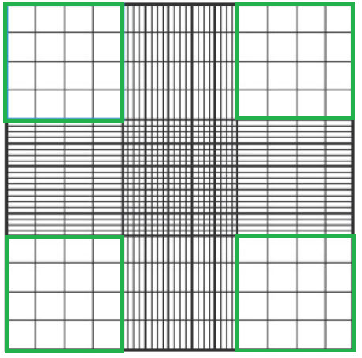
Figure 2.1. Haemocytometer counting chamber. Cells were counted in the green squares.

Cryopreservation storage and recovery of cells
To keep cells in long-term reserve, cells were re-suspended at a density of 1x10⁶ /ml in freezing medium (70 % DMEM, 20 % FCS, 10 % DMSO), aliquoted in cryovials and then stored over night at -80°C in a Mr. Frosty cooling box. This allows the temperature to be gradually lowered at 1°C per minute to avoid rapid freezing of cells. The cells were then transferred to a liquid nitrogen dewar at ~ 190°C for long term storage. For resurrection of cells, cryovials containing cells were thawed rapidly in a water bath at 37°C. The cells were re-suspended in 9ml of pre-warmed specific growth medium and centrifuged for 5 minutes at 400xg to remove any remaining DMSO. The cell pellet was re-suspended in 10 ml specific medium, placed in T75 cm² cell culture flask and incubated in a humidified incubator at 37°C, 5 % CO² as previously described.

Collection of conditioned media
In order to simulate cell-cell interactions in the stroma-tumour cell microenvironment, a conceptual two-dimensional (2D) model was established in tissue culture as shown in figure 2.2. It was hypothesized that factors released from tumour cells would be able to interact and stimulate-fibroblasts in the surrounding tumour microenvironment as part of the tumour progression process, and that these interactions would occur before fibroblasts progress to cancer-associated fibroblasts (Bolt et al., 2017b).

Four sets of conditioned media (CM) were therefore collected as described below:

- Collection of SCC cell line conditioned media

Cell lines UD SCC2, UPCI SCC90, UPCI SCC152, UPCI SCC72, UPCI SCC89 and FaDu were seeded at 1x10⁷ cells/T75 flask and incubated overnight in the appropriate culture media to enable the cells to settle and adhere to the culture flask. Cells were then washed three times in PBS and then incubated for 24 hours with 6 ml serum-free media. After 24 hours, conditioned media was aspirated from each flask and centrifuged at 400xg for 5 minutes to remove cellular debris. The conditioned media was then carefully aspirated and stored at -80°C for analysis or use in later experiments. The tumour cells were trypsinised and the cell pellets stored at -80°C for RNA isolation and further gene analysis.

- Collection of NTF conditioned media
NTF were cultured in T75 flasks until approximately 80 % confluent (~ 3x10⁶). Each flask was visually inspected on a daily basis utilizing a 10x objective lens until intracellular spaces had disappeared owing to fibroblast culture confluence. NTF cultures were then washed three times with PBS and then incubated with 6 ml serum-free NTF media for 24 hours. After 24 hours, conditioned media was aspirated from each flask and centrifuged at 400xg for 5 minutes to remove cellular debris. The conditioned media was then carefully aspirated and stored at -80°C for analysis or use in later experiments. NTF were trypsinised and the cell pellets stored at -80°C for further RNA isolation and gene analysis.

- Collection of SCC stimulated-NTF conditioned media – 24 hours
NTF were cultured in T75 flasks until approximately 80 % confluent (~ 3x10⁶), washed twice with PBS and then incubated with 6 ml SCC serum-free conditioned media (collected as described in A) for 24 hours. The SCC stimulated-NTF conditioned media was then aspirated, centrifuged at 400xg for 5 minutes to remove cellular debris and stored at -80°C for further analysis. The stimulated-fibroblasts were trypsinised and the cell pellets stored at -80°C for further gene analysis.

D- Collection of SCC stimulated-NTF conditioned media – 48 hours
In some experiments, the prolonged activity of SCC-stimulated-NTF was analysed. Here, NTFs were stimulated with SCC conditioned media and the 24 hours conditioned medium collected as described in section C. NTF were then washed twice with PBS and 6 ml of serum-free NTF media added and cells incubated for a further 24 hours (i.e. 48 hours in total). Conditioned medium was then collected, centrifuged at 400xg for 5 minutes to remove cellular debris and stored at -80°C for further analysis.

In total four batches of NTF were analysed from different individuals (NTF01, NTF06, NTF319, NTF322) either alone or upon stimulation with conditioned medium from the SCC tumour cell lines. These experiments were performed to check if the stimulated-fibroblasts display the same trend.

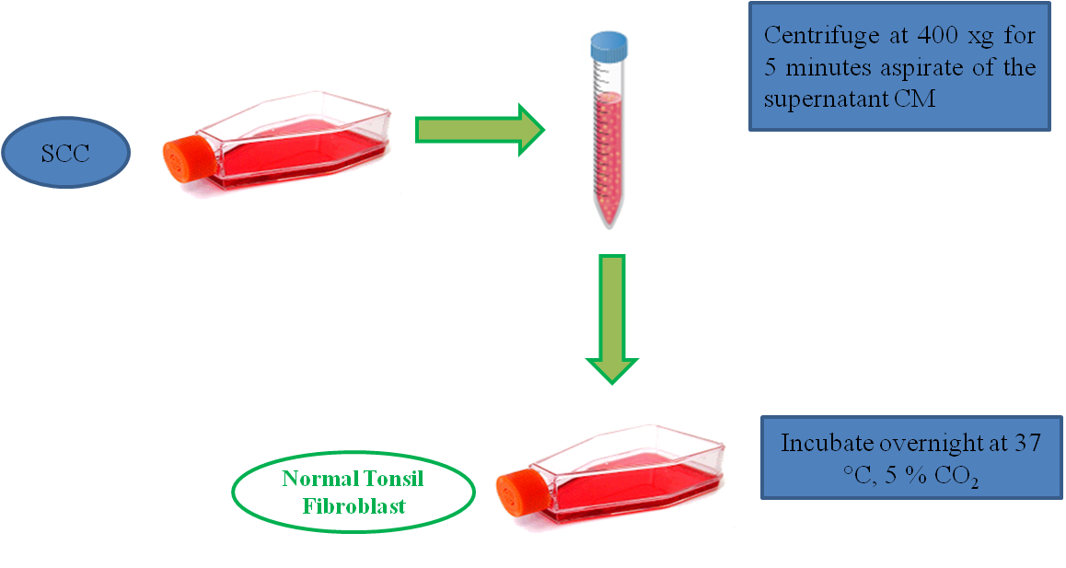
Figure 2.2. Schematic image showing the 2D conceptual experimental design to model tumour-stroma microenvironmental interactions. The above 2D-model proposed that SCC tumours secrete stimulating factors that may lead to stromal fibroblasts activation.

Molecular assays

RNA extraction
Total RNA was extracted from cell pellets using Bioline isolate RNA kit according to the manufacturer’s instructions. Briefly, cell pellets were lysed and filtered by centrifuging at 11,000xg for 1 minute. An equal volume of 70 % ethanol solution was added to the homogenized lysate to improve the RNA binding to the silica-based membrane of the spin column during centrifugation. Removal of contaminating genomic DNA was accomplished by incubation with DNase I at room temperature for 15 minutes. The column-bound RNA was washed three times and eluted with 40μl nuclease-free water. The purity and the concentration of the isolated RNA was quantified by means of Nano-Drop spectrophotometer and RNA samples with high purity (A260/A280 ratio equal to ~ 2.00) were utilized for complementary DNA (cDNA) synthesis and qPCR analysis.

Complementary DNA preparation (reverse transcription)
Single stranded cDNA was synthesized from total RNA using High Capacity cDNA Reverse Transcription kit according to the manufacturer's protocol. In all experiments, 500 ng of total RNA was reversed transcribed per reaction using the following reagents as shown in table 2.3.
Components | Volume/Reaction (μl)
10 ✕ RT Buffer | 2.0
25 ✕ dNTP Mix | 0.8
10 ✕ RT Random Primers | 2.0
MultiScribe™ Reverse Transcriptase | 1.0
Sample RNA | X ^{*1}
Nuclease free water | Up to 20.0

Table 2.3. Reagents used to prepare cDNA. ^{*1} (This volume is variable depending on the amount of RNA used in the reaction).
The samples were loaded into a thermal cycler and the machine programmed according to the recommended protocol as shown in table 2.4. At the end of the cycle run, the cDNA was stored at -20 ˚C for later qPCR analysis.
Step | Step 1 | Step 2 | Step 3 | Step 4
Temperature | 16 °C | 42 °C | 85 °C | 4 °C
Time | 10 minutes | 120 minutes | 5 minutes | ∞
Table 2.4. Times and temperatures used to prepare cDNA.

Quantitative polymerase chain reaction (qPCR)
Relative gene expression was detected using a Rotor-gene Q real-time PCR cycler in reaction cycles performed with pre-designed Taqman primers. The primers used and the reaction constituents are listed in table 2.5 and table 2.6 respectively. Quantifications for SCC gene expression were calculated using delta CT (ΔCT) values normalized to expression of the endogenous reference β-2-microglobulin (B2M) gene. The thermal cycles used in each PCR reactions are shown in table 2.7 and each run consisted of 40 cycles.
Primers | Hs code | Supplier company
CCL2 | Hs00234140 | Applied Biosystems, UK
CCL5 | Hs00982282 | Applied Biosystems, UK
IL-1R1 | Hs00991010 | Applied Biosystems, UK
CXCL8 | Hs00174103 | Applied Biosystems, UK
CXCL1 | Hs00236937 | Applied Biosystems, UK
CXCL16 | Hs00222859 | Applied Biosystems, UK
CXCL12 | Hs03676656 | Applied Biosystems, UK
CX3CL1 | Hs00171086 | Applied Biosystems, UK
CCL7 | Hs00171147 | Applied Biosystems, UK
MIF | Hs00236988 | Applied Biosystems, UK
IL-1β | Hs00174097 | Applied Biosystems, UK
IL-1α | Hs00174092 | Applied Biosystems, UK
CXCL5 | Hs01099660 | Applied Biosystems, UK

Table 2.5. qPCR primers and corresponding Hs codes used in this study.

Reagents | Volume (μl)
Master Mix | 5.0
TaqMan® gene’s primer | 0.5
Endogenous control primers (B2M) | 0.5
cDNA (500 ng) | 0.5
Nuclease-free water | 0.5
Total volume | 10.0
Table 2.6. Reagents used in qPCR reactions.

Step | Step 1 | Step 2 | Step 3
Temperature | 95 °C | 60 °C | 72 °C
Time | 10 seconds | 15 seconds | 20 seconds
Table 2.7. Times and temperatures used for qPCR.
For quality control purposes a no cDNA (negative control) sample was run and each reaction was performed in triplicate.
For measuring the relative change in gene expression of NTF compared with SCC-stimulated NTF the equation 2^{-ΔΔCT} was used. For the ΔΔC_{T} estimations to be valid the amplification efficiencies of the reference and target genes were assumed to be equal. The C_{T} values obtained from qPCR instrumentation were copied into Microsoft-Excel spreadsheet. Then, the change in expression of the target gene was normalized to the endogenous reference gene - B2M (Livak and Schmittgen, 2001). The 2^{-ΔΔCT} technique was utilized to estimate fold change in target gene expression between NTF and SCC-stimulated NTF where ΔΔC_{T} = ΔC_{T} control- ΔC_{T} Target.
The ΔC_{T} control was estimated by the following equation ΔC_{T} control = C_{T} target gene - C_{T} reference gene where C_{T} target-gene is the gene under analysis expressed by calibrator cell and C_{T} reference gene is CT for the reference gene B2M calculated in the same sample. Additionally, the ΔC_{T} target was estimated by the following equation ΔC_{T} target = C_{T} target gene - C_{T} reference gene where C_{T} target gene is gene under analysis expressed by the target cells and C_{T} reference gene is CT for the reference gene, B2M measured in the same sample. The fold change for each experiment was calculated, and the mean for these fold changes was utilized to illustrate gene expression on the mRNA level in each of the studied cells.

Immunoassays

Chemokine/Cytokine protein array
Human Chemokine Antibody Array C1/Human Cytokine Array Panel A array were used to investigate the conditioned media produced from stimulated-NTF (NTF06) with SCC cell line conditioned media from UD SCC02, UPCI SCC090, UPCI SCC072 and UPCI SCC089. The assay was performed according to the manufacture’s protocol. In brief, cytokine array membranes were blocked with bovine serum albumin (BSA), before incubation with the conditioned media from stimulated or un-stimulated samples for 2 hours. After washing, membranes were incubated with a cocktail of biotinylated detection antibodies for 1.5 hours. Membranes were washed again, incubated with horseradish peroxidase-conjugated streptavidin, washed and subjected to chemiluminescent detection using ECL substrate and hyper-film. The relative expression of each individual chemokines/cytokines was calculated semi-quantitatively using densitometry with Quantity One software (Biorad, CA, USA) by measuring the dot intensity by means of drawing circle around its circumference and comparing it to the positive/negative control (Acosta et al., 2008, Murdoch et al., 2007).

Enzyme linked immunosorbent assay (ELISA)
ELISA was used to quantify the protein levels of CXCL8, CCL2, CCL5, IL-1α, IL-1β, and TNFα in conditioned media in accordance with the manufacture’s protocols. Briefly, the wells of 96-well plates were coated with the required concentration of captured antibody and incubated for 24 hours. The following day, unbounded antibodies were removed by washing with washing buffer and the non-specific binding sites blocked with the recommended serum-containing solution. After that, standards and the samples were incubated at room temperature for 2 hours. The unbounded proteins were removed by washing and the recommended concentration of biotinylated detection antibody and horseradish peroxidase (HRP)-conjugated streptavidin were loaded and incubated to each well at room temperature. Finally, TMB substrate solution was added followed by the stopping solution to stop the reaction. A spectrophotometer was used to measure the colorimetric reaction and programmed to 450 nm with a 570 nm correction readings. The readings taken at 570 nm were subtracted from the readings at 450 nm and then mean readings of standards and samples obtained. A standard curve was plotted using Deltasoft software program using log-log analysis, and target protein concentrations were obtained from the standard curve.

Immunohistochmical staining

De-waxing of tissue sections
Immunohistochemistry (IHC) was utilized to detect the presence of specific cell markers in 3D-models and in tissue microarrays (TMA). Wax-embedded and frozen section tissues were sectioned 5 and 14μm respectively then mounted onto ‘SuperFrost’ glass slides. Complete paraffin (wax) removal was accomplished by immersing the slides in two changes of xylene. After that, the tissue sections were rehydrated through descending ethanol concentrations (100 %, 95 %, and 75 %) and the endogenous peroxidase blocked by using a solution of 3 % H₂O₂ diluted with methanol for 15 minutes. The tissue sections were washed with PBS for 5 minutes in preparation for antigen retrieval. The frozen sections were washed with PBS alone and antigen retrieval was not performed.

Antigen retrieval
Antigen binding sites can be masked by methylene bridges that are formed during tissue fixation. These antigens sites were unmasked using sodium citrate buffer solutions (1.18g + 400 ml dH₂O); to enhance the antigen unmasking the pH was adjusted to 6 and the antigen retrieval solution buffer pre-heated in a steamer to 95°C and then the tissue section slides were immersed in the solution for 15 minutes (or in the autoclave for 7 minutes with the highest temperature). The buffer solution was removed from the steamer and allowed to cool to room temperature, before being washed with TBS (PBS+0.05 % Tween20) for 5minutes.

Detection of leukocytes in 3D-model sections
Neutrophils, macrophages and T-lymphocytes in 3D-models were identified using specific markers, CD66b, CD68 and CD3 respectively. Following fixation and antigen retrieval, tissue sections were incubated with the recommended serum for each individual antibody in order to block non-specific binding sites. Normal goat serum was incubated with CD3 for 1 hour at room temperature. Horse serum was incubated with CD68 for 20 minutes at room temperature, while CD66b staining incubated with horse serum over night at 4°C. After incubation, the serum was removed and the appropriate concentration from each antibody was added (shown in section 2.1.5.) onto the tissue sections and incubated at room temperature for 2 hours for CD3 and CD66b, and overnight for CD68 at 4°C. After washing with TBS to remove the unbounded antibodies, suitable biotinylated secondary antibodies were added at room temperature for thirty minutes. Biotinylated anti-mouse secondary IgG antibody was used with CD66b and CD68 whilst biotinylated anti-rabbit secondary IgG antibody was used for CD3.
The benefit of utilizing a biotinylated secondary antibody is to increase the staining signal by creation of an avidin-biotin complex. Following washing with TBS, HRP-conjugated streptavidin was added at room temperature for 30 minutes. 3, 3'-diaminobenzidine (DAB) chromogen was used to develop colour and the reaction stopped by washing with dH₂O. Finally, the slide sections were counter stained with haematoxylin, acid alcohol, Scott’s tap water, dehydrated in ethanol and then immersed in xylene before mounting with DPX and cover slipped. Negative control was done using the same techniques; however without using primary antibody (or IgG was used as primary antibody) while the positive control was performed using sections from tissues known to abundantly express the target molecule.

Tissue microarray (TMA)
TMA is a novel useful approach to efficiently allow multiple histological analyses. TMAs are time saving, providing reliable data and can be used to study mRNA expression by in situ hybridization. Currently, TMAs have grown to be a standard research platform for histopathological analysis and correlations for large-scale studies. TMA make it achievable to hold up to 1000 separate tissue cores sample in array form (Pillay et al., 2010a, Kononen et al., 1998).
Tumour histology was examined by pathologists blinded to therapy and outcome according to the Royal College Guidelines 1998 and appropriate paraffin blocks chosen. The patients were treated in Weston Park Hospital Sheffield Teaching Hospitals NHS Foundation Trust. The cases were collected from 59 OPC (oropharyngeal cancer) patients retrospectively identified with HPV-positive (n=40) or HPV-negative (n=19) status (Dr. Robert Bolt, Ethical Approval, 12/LO/2018 NHS). The TMA preparation was done by Dr. Naeimma B Hendawi, as demonstrated in figure 2.3, using triplicate selected paraffin embedded tumour cores. Briefly, regions of interest in each block were identified and 1 mm diameter tissue cores acquired from the chosen representative regions. Next, the tissue cores were inserted into a recipient paraffin block at known locations. Finally, TMA were sectioned using a microtome and mounted on adhesive glass slides.
Automated immuno-staining was performed for CD3, CD68 and myeloperoxidase (MPO). The TMA sections were stained in the Histology Department of the Royal Hallamshire Hospital, Sheffield Teaching Hospitals NHS Foundation Trust via an automated staining machine, using optimized antibodies, with clinical pathology accreditation (CPA)-accredited to national diagnostic standards. The HPV-status of each tissue section was determined by p16 IHC and in situ hybridization (ISH). Slides were scanned to digital images using an Aperio ScanScope slide scanner and digital analyses performed using QuPath software program (Bankhead et al., 2017). In addition to image analysis, manual counting was performed for comparison with the digital analysis.
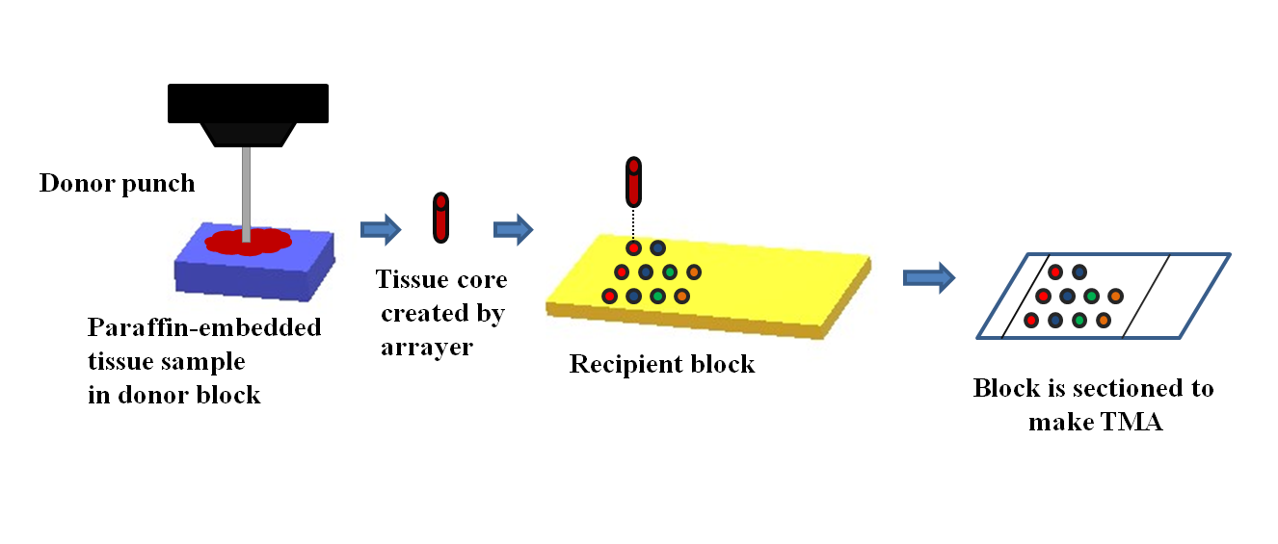
Figure 2.3. Schematic images show the TMA preparation procedure. Illustration of working principle, punch needle (left), recipient paraffin-block module (middle) and TMA in glass slide (right). Adapted from (Yang et al., 2012).

Targeting IL-1R signalling and its role in cancer
      - Measurement of chemokine release by stimulated-NTF with or without use of IL-1R antagonist (Anakinra)
Increasing numbers (5x10⁵, 6x10⁵, 7.5x10⁵, and 10x10⁵ NTFs per well) of NTF were cultured in 6-well plates to check the cell density and confluence as shown in figure 2.4.

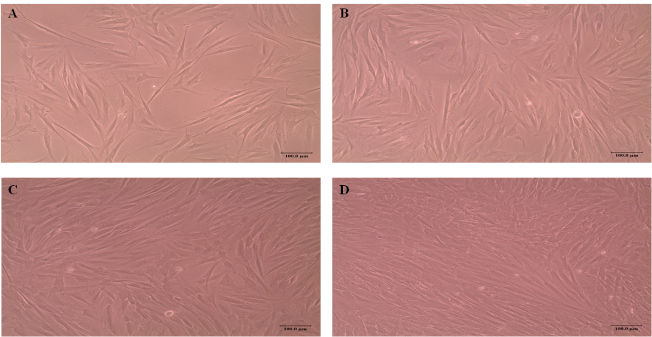

Figure 2.4. Images showing optimization of NTF densities. (A) 5x10⁵, (B) 6x10⁵, (C) 7.5x10⁵, and (D)10x10⁵. Scale bar= 100µm.

NTF at 6x10⁵ per well was chosen because of the suitable confluence in order to obtain sufficient protein and RNA for down-stream analysis. NTF were cultured in 2 ml complete media overnight to allow cells to adhere. Conditioned media (1 ml) from UPCI SCC89 cells was added to the NTF and cells incubated for up to 4 hours at 37°C with 5 % CO₂. Recombinant IL1-β (5 ng/ml) or serum-free medium alone were used as controls. IL1-β was selected to stimulate the fibroblasts, as it is a known pro-inflammatory cytokine that binds to IL-1R; UPCI SCC89 was chosen because conditioned medium from this cell line was shown to significantly increased chemokine secretion by NTF. Following incubation, conditioned media from the NTF was collected, centrifuged at 400xg to remove cell debris and stored at -80°C for later analysis by ELISA. NTF cells were lysed and total RNA extracted as detailed in section 2.2.3.1 for qPCR analysis.

Anakinra was used to block IL-1R expressed by NTF. In these experiments NTF were cultured with increasing concentrations of Anakinra (0.1-100µg/ml) or media alone prior to stimulation with 1ml conditioned media from UPCI SCC89 cells for 4 hours 1ml recombinant IL1-β (5 ng/ml) or serum-free media alone was used as controls. Following incubation conditioned media was collected from all samples, centrifuged at 400xg to remove cell debris and stored at -80°C for later analysis by ELISA. NTF cells were lysed and total RNA extracted as detailed in section 2.2.3.1 for qPCR analysis.

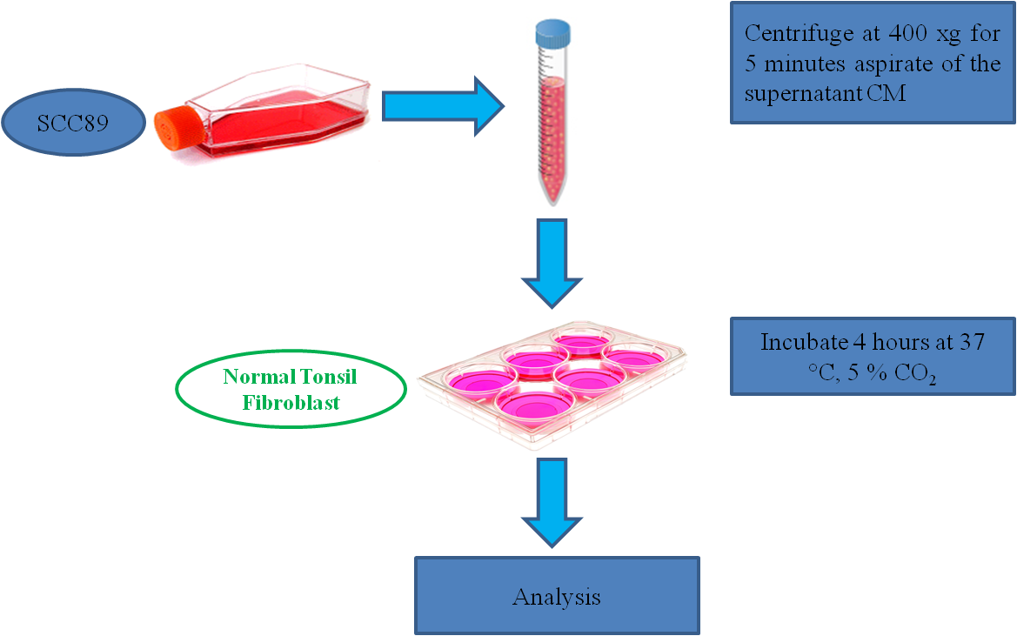

Figure 2.5. Schematic diagram showing the experiment design to conceptual 2D-model of tumour-stroma microenvironmental interactions. The above 2D-model proposed that microenvironmentally active tumour, represented by SCC, secrete stimulating factors. This may lead to stromal activation, stromal fibroblast represented by normal tonsil fibroblast. This in turn led to stromal release of further factors. This stimulation (up regulation) could be suppressed by targeting the IL-1/R axis by the recombinant antagonism of IL-1R (Anakinra).Abbreviation: conditioned media (CM).

Anakinra cytotoxicity assay
A cytotoxicity assay was performed to test the cytotoxic effects of Anakinra on NTF by measuring the metabolic activities of these cells as surrogate indicator for cell viability. NTF were harvested and seeded at 1x10⁴ cells per well in 96-well plates. Then increasing concentrations of Anakinra (0-500µg/ml) added to the wells and cells incubated for 24 hours in humidified incubator at 37°C and 5 % CO₂. At the end of incubation, cells were washed twice with PBS and 100μl of freshly prepared thiazolyl blue tetrazolium bromide (MTT) solution (0.5 mg/ml) was added to the cells that were then incubated for 2 hours at 37°C and 5 % CO₂. The mitochondrial dehydrogenases of living fibroblasts can reduce the MTT dye solution to an insoluble formazan dark blue dye. Finally, the MTT dye was removed, cells washed with PBS and 50µl of acidified isopropanol added to dissolve the blue crystals formed. The colorimetric reaction intensity was calculated by plate reader at 540 nm with correction at 630 nm wavelength. Readings were normalized to a control sample of untreated (0 mg/ml Anakinra) 100 % vital fibroblasts. Cells fixed with 10 % PBS buffered formalin (100 % dead cells) were also used as controls.

IL-1R1 protein expression analysis
      - Immunofluorescence microscopy
For IL1-R1 visualization, 1x10⁴ NTFs were cultured on sterilized glass cover slips in 24-well plates and incubated overnight in complete media at 37˚C with 5 % CO₂. In next day, cells were washed twice with sterile PBS and fixed with 2 % paraformaldehyde for 15 minutes. After fixation, the cells were washed twice with PBS and blocked incubated for 15 minutes with 0.1 % Triton X-100 and 5 % BSA in PBS. After two washes with PBS, cells were incubated with 5μg/ml of either anti-IL-1R1, HLA class I (positive control) or IgG (negative control) at 4°C overnight in PBS with 3 % BSA. NTF were then washed twice with PBS and incubated with secondary antibody Alexa Fluor 488 goat anti-mouse (1:1000 v/v) in PBS with 3 % BSA for 1 hour in the dark at room temperature. After further PBS washes, cover slips were mounted in ProLong™ Diamond anti-fade containing DAPI to counter-stain the nucleus. The slides were left overnight in the dark at room temperature to set and samples visualized using a Zeiss 880 AiryScan confocal laser microscope (Carl Zeiss, UK) and imaged using Fiji Java version 6 image software. In addition, to boost the fluorescence signal, the Alexa Fluor 488 goat anti-mouse secondary antibody was replaced with a goat anti-mouse biotin-conjugated secondary antibody (1:1000 v/v) in PBS for 30 minutes, followed by phycoerythrin-conjugated streptavidin (1:100 v/v) for 20 minutes in the dark at room temperature with PBS and 3 % BSA.

Western blotting

Extraction of proteins
NTF were washed with cold PBS and then harvested by scraping into 200µl of ice-cold lysis buffer (10 ml RIPA buffer supplemented with one tablet complete mini-EDTA-free protease inhibitor cocktail) and incubating on ice for 30 minutes followed by centrifugation at 11,000xg for 10 minutes. The resulting supernatant was removed and stored at -80ºC for protein assay. The protein concentration was quantified using the bicinchoninic acid assay (BCA) according to the manufacturer's instructions.

SDS-Page gel preparation
The 15 % acrylamide gels were prepared in assembled gel casting glass plate sandwich cassettes in thickness of 1.5 mm; the volumes of each reagent are shown in table 2.8.
Resolving gel | Stacking gel
Acrylamide 3.75 ml | Acrylamide 0.975 ml
Lower Tris 2.5 ml | Upper tris 2.1 ml
dH₂O 3.55 ml | dH₂O 4.725 ml
TEMED 5 µL | TEMED 17 µL
APS 10% 350 µL | APS 10% 100 µL

Table 2.8. SDS PAGE conditions used in this study.

Sample preparation and electrophoresis
Total protein lysate (10, 20 and 40 μg) was loaded with the equivalent volume of 2x SDS lysis buffer and heated at 95ºC in a hot-block for 5 minutes. After which, the gels were positioned into the XCell Sure lock Mini Cell according to manufacturer’s instructions with 1x SDS running buffer added into the centre and surrounding of the mini cell. Protein samples from NTF were loaded into wells. The Colorplus pre-stained protein ladder was used as molecular weight reference. The gels were run at 150 volts for 60 minutes.

Electro-transfer
The gels were transferred onto nitrocellulose membranes utilizing the Trans-Blot TorboTM transfer system. The settings of the machine were programmed with mixed molecular weight according to the manufacturer’s instructions. Then, the nitrocellulose membranes were stained with Ponceau solution to check for protein transfer and then washed with dH₂O.

Immuno-detection and membrane development
Following transfer, the nitrocellulose membrane was blocked with 5 % milk powder in 10 mM Tris-buffered saline containing 0.5 % Tween-20 (TBST) at room temperature on a shaker for 1 hour. Then, nitrocellulose membranes were incubated with primary antibody (mouse monoclonal anti-IL-1R1, 1:100 v/v in 5 % TBST) for 2 hours at room temperature on a shaking platform. After washing 3 times with TBST (10 minutes each wash) nitrocellulose membranes were incubated with secondary antibody (anti-mouse HRP, 1:3000 v/v in 5 % TBS-T) at room temperature in a shaking platform for 1 hour. Finally, the nitrocellulose membranes were washed 3 times, as described previously, and bands visualized using enhanced chemimluminescence (ECL) and Pierce ECL Western blotting substrate in accordance with the manufacturer’s protocol. Briefly, the membrane was covered with clear film, then exposed to an X-ray film in a dark room and developed by means of a Compact X4 Developer. Membranes were stripped of antibodies by utilizing 10 ml of stripping buffer for 30 minutes at room temperature on a shaking platform and followed by washing with TBS. Membranes were re-probed for β-actin as a loading control.

IL-1R1 siRNA transient transfection
siRNA knock-down of NTF IL-1R1 was performed according to the manufacturer's instructions (Qiagen). In brief, NTFs were seeded at density of ~ 3x10⁵ cells per well in 6-well plates in 2ml of serum-containing media and incubated at 37°C in 5% CO₂ for 24 hours. The following day, cells were washed twice with PBS and 2.3ml fresh media containing serum was added to each well and incubated. The transfection reagents (shown in the table 2.9) were diluted by adding 100 µl nuclease-free H₂O to 10 μM siRNA stock concentration. The transfection complexes were made up to a final concentration of 300 nM siRNA. The transfection complex was prepared for each well with 100µL serum free medium, 12 µl of Hi-Perfect transfection agent and 3 µL of siRNA (Each individual siRNA used are provided in table 2.9). The transfection complexes were mixed by vortexing for 10 seconds and incubated for 10 minutes at room temperature, to allow transfection complex formation. 110 µl of transfection complex was added drop-wise in each well and the plates swirled to ensure equal distribution of the transfection complex. Cells were incubated for different intervals 24, 48 and 72 hours at 37°C in 5 % CO₂ with serum-containing media, to identify the best transfection time. Control cells received transfection agent but no siRNA. After the incubation time, NTF were trypsinised and processed for gene and protein analysis. The transfection kit and reagents used in this study were selected according to their use in previously published study on oral fibroblasts (Jung et al., 2010).
Reagents | Description
1-SI00017598 | FlexiTube siRNA
2-SI00017591 | FlexiTube siRNA
3-SI00017584 | FlexiTube siRNA
4-SI00017577 | FlexiTube siRNA
HiPerFect | Transfection agent
Table ‎2.9. List of transfection reagents used for NTF transfection. All reagents were supplied by QIAGEN.

Tumour-stroma 3D-model co-culture
Fibroblasts play an important role in the tumour microenvironment and have been revealed to participate in driving cancer progression (Räsänen and Vaheri, 2010). To investigate the interactions between tumours and stroma, NTFs and multi-cellular tumour spheroids of UPCI SCC090 cells (HPV-positive) or FaDu cells (HPV-negative) were incorporated into a 3D collagen co-culture model in order to replicate the tumour-stroma interactions that occur in a 3D environment. Seeding densities for both NTF and spheroids were optimized according to the number of cells used in the 2D-model.

Spheroid generation
Spheroids for both FaDu and UPCI SCC090 (cells used in the 2D-model system) were produced by the liquid overlay technique from single cell suspensions as demonstrated previously (Colley et al., 2011). Briefly, 100 μl of molten 1.5 % agarose type IV in serum-free medium (3 g agarose to 200ml media) was added to each well of a 96-well plate and allowed to cool. Agarose IV-coated plates were stored inverted at 4°C. The tumour cells were cultured as monolayer in T75 flask and harvested as described in section 2.2.1.4. Cells were re-suspended at a seeding density of 1×10⁵ cells/ml in serum-containing media and 100 μl of the cell suspension added to each well of a pre-warmed agarose-coated 96-well plate using multichannel pipetting and incubated for 3-4 days at 37˚C, 5 % CO₂. Tissue culture media was replenished every two days by loading 100 μl of fresh serum-containing medium to each well and after that removing 100 μl medium. Spheroids formation is shown in figure 2.6. Spheroids for FaDu were generated previously by other studies (Colley et al., 2011); however, UPCI SCC090 spheroids were generated for the first time in our laboratory. Spheroids were used to represent the 3D architecture of tumours found in cancer patients.

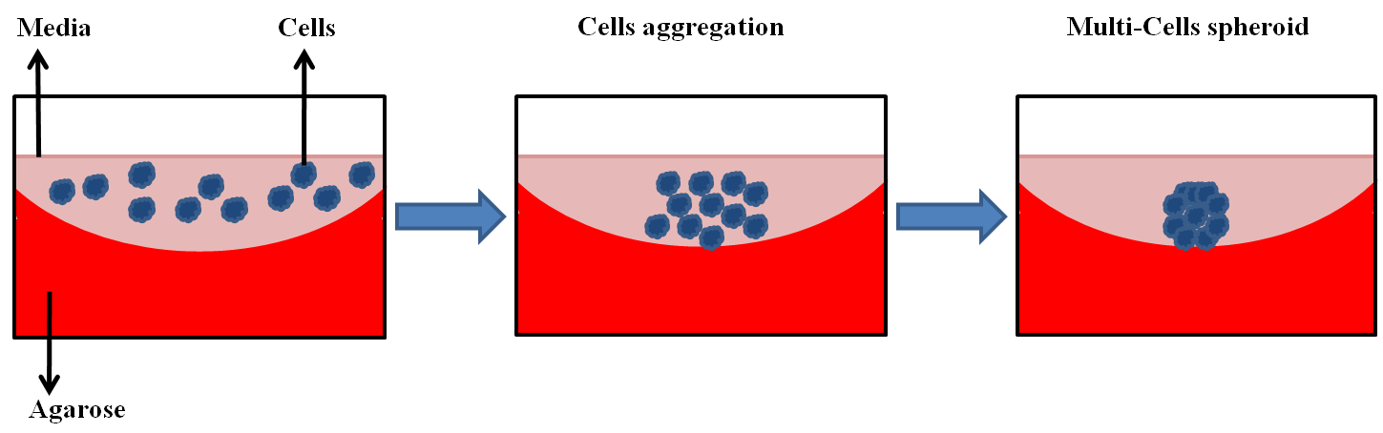

Figure 2.6. Schematic diagrams showing the procedure of spheroid production for both FaDu and UPCI SCC090.

Generation of 3D-coculture model system
Isolation of collagen type I from rat-tails.
Collagen type I was isolated from the tails of rats (kindly donated by the research group of Professor Fiona M. Boissonade, University of Sheffield). Rat tails were stored at -20^{ᵒ}C, and when required these were thawed and processed as described previously (Martino et al., 2016). Briefly, in sterile conditions, rat tails were folded and twisted to expose the underlying tendons and bone. The bone was sectioned, and exposed tendons were incised and washed in PBS twice vigorously. The tendons were dissolved in 0.1 M sterile acetic acid for 7 days at 4°C with stirring. The resultant collagen solution was freeze-dried using a ‘VirTisBenchtop K Manifold freeze drier’ and then stored at -80°C for later use. When required, collagen was re-dissolved in 0.1 M acetic acid to a concentration of 5 mg/ml and incubated at 4°C for 24 hours to be used thereafter in the 3D collagen co-culture model.

Preparation of 3D collagen co-culture model
The 3D collagen model was prepared as previously described (Dongari-Bagtzoglou and Kashleva, 2006) but with modifications. Briefly, keeping the whole components on ice, collagen type I was mixed with 10x RPMI (or DMEM), FBS, L-glutamine, reconstitution buffer RB (a mixture of 22 mg sodium bicarbonate added to 1 ml of 20 mM HEPES (476.6 mg of HEPES (MW=238.3) to 100 ml dH₂O) and media containing cells. Table 2.10 shows the components and their volumes used to prepare ten 3D collagen models. Sodium hydroxide (4 g NaOH in 100 ml) was used to neutralize the collagen to pH 7.4 using a pH meter.
Components | Volume (ml)
10x RPMI or DMEM | 1.00
RB | 1.00
FBS | 8.30
L-glutamine | 0.1
Collagen type I | 6.73
Medium | 0.33

Table 2.10. Final volume of components used in the preparation of ten 3D collagen models. Abbreviations: reconstitution buffer (RB) and fetal bovine serum (FBS).

Development of reproducible 3D-model tumour/fibroblasts co-culture.

3D collagen co-culture models were prepared by adding 2x10⁵ NTF within 1 ml of collagen along with 60 FaDu or UPCI SCC90 spheroids as shown in figure 2.7. The number of fibroblasts to tumour cells was calculated in accordance with the 2D-model work that kept the ratio of NTF to SCC cells at 1:3 as illustrated in section 2.2.2. Each FaDu or UPCI SCC90 spheroids consisted of approximately ~1x10⁴ cells. After embedding the cells and spheroids, the collagen gels were added to wells of a 48-well plate and allowed to set for at least 1h at 37˚C, 5 % CO₂. Once the 3D collagen co-culture model had set, 1 ml of serum-containing media was added and cells incubated for 24 hours at 37˚C, 5 % CO₂.

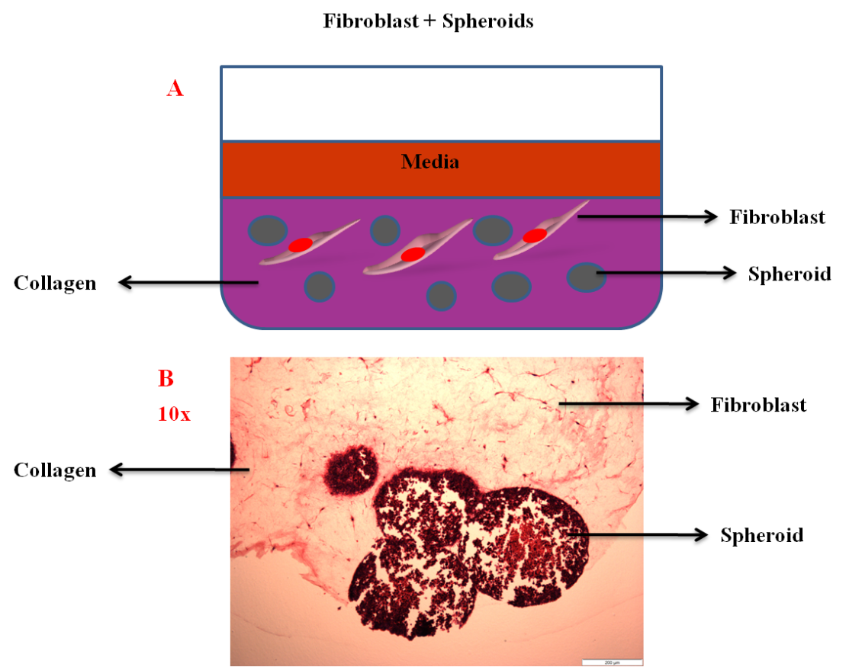

Figure 2.7. Schematic diagram showing a 3D co-culture model in collagen and histological section containing tumour spheroids co-cultured with NTF. (A) diagram demonstrating the component of the 3D-model co-culture. (B) Tissue section of the in vitro 3D-model showing the tumour spheroids embedded with fibroblasts after 48 hours. Scale bar 200µm.

3D-model vitality Assay PrestoBlue®
To check cell vitality in the 3D collagen co-culture model, PrestoBlue® viability assay was used according to the company’s protocol. Briefly, 3D collagen co-culture models were prepared as explained previously in section 2.2.10.4 and incubated with serum-containing medium for 48 hours at 37˚C, 5 % CO₂. The media was then aspirated and the 3D collagen models washed twice with serum-free medium before addition of fresh media loaded with 1:10 dilutions of PrestoBlue® reagent and cultures incubated for 2 hours. PrestoBlue® is quickly taken up by metabolically active cells where the reducing environment within vital cells changes the colour of the reagent dye. This colour change can be measured by fluorescence excitation at 560 nm and emission at 590 nm.

Generation 3D collagen co-culture model conditioned medium
Tumour spheroids and NTF were co-cultured in the collagen and incubated with 1ml serum-containing media for 24 hours at 37˚C in a 5 % CO₂. This incubation was performed to allow the spheroids and NTF to interact with each other and to stimulate NTF. The next day, the 3D collagen models were washed twice with serum-free media and incubated for a further 24 hours with 0.5 ml of serum-free medium. After that, conditioned media were collected, centrifuged at 400xg for 5 minutes to remove debris and then stored at -80ºC for later analysis as demonstrated in figure 2.8. Conditioned media were generated from NTF alone, tumour spheroids alone, NTF co-cultured with spheroids for FaDu or UPCI SCC90 and with and without the IL-1R antagonist, Anakinra.

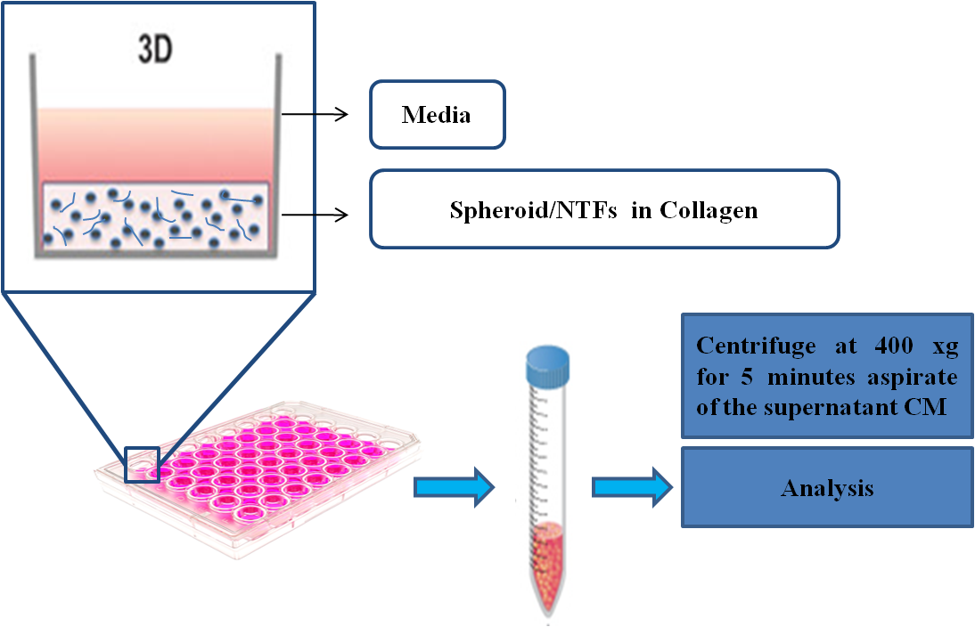

Figure 2.8. Schematic image showing collection of conditioned media from tumour-stroma microenvironmental interactions in the 3D-model. The above 3D-model proposed that microenvironmentally active tumours, represented by tumour spheroids, secrete stimulating factors.

Isolation of human leukocytes from peripheral blood by density gradient centrifugation method
Whole venous blood was collected to isolate leukocytes subsets. Density gradient centrifugation was utilized to isolate the leukocytes from whole blood in accordance with the modified process by (Murdoch et al., 2007). 15 ml of peripheral blood was collected by venepuncture of the brachial vein from healthy volunteers with written, informed consent (Dr. Craig Murdoch, University of Sheffield Ethical Approval 012597). The collected blood was anti-coagulated by adding 3.8 % sodium citrate and centrifuged to separate the plasma from whole blood cells for 20 minutes at 400 xg. The upper plasma layer was aspirated and the remaining blood cells (RBC/WBC) were diluted 1:1 v/v with Hank's Balanced Salt Solution (HPSS) without Ca⁺² or Mg⁺² to maintain an osmotic pressure and physiological pH. After that, 20 ml of Ficoll-Plaque was added to the bottom of the tube, 30 ml blood layered on top and centrifuged for 40 minutes at 400 xg at room temperature with the break set to zero. Subsequent to centrifugation, the blood was separated into four layers as shown in figure 2.9.
The mononuclear leukocyte layer (containing monocytes and lymphocytes) was cautiously aspirated into different fresh tubes while the neutrophils in the bottom polymorphonuclear granulocyte/erythrocyte layer were kept. In order to isolate the neutrophils, erythrocytes were lysed by means of hypertonic lysis utilizing cold sterile water for 30 seconds then adding an equal amount of 1.8 % NaCl to keep the suspension to an isotonic status. Neutrophils were centrifuged at 400xg for 15 minutes and the procedure repeated 4-5 times until all erythrocytes had been lysed. The mononuclear cell tube was made up to 50ml with HBSS, centrifuged at 400xg for 15 minutes and the supernatant discarded. This step of washing and re-suspending cells was repeated three times to produce a cell pellet of total mononuclear cells. Then, the neutrophil-pellet and mononuclear leukocyte pellet were re-suspended together in serum-containing medium and incubated for 45 minutes with Cell-Tracker far red (1:1000 v/v dilution) according to the manufactures instructions to a final concentration of 2 μM.
The far-red colour was chosen because the NTF have natural green auto-fluorescence so that far-red will differentiate leukocytes from NTF and tumour cells. Cells were incubated at 37˚C in 5 % CO₂ and then centrifuged, washed twice with HBSS to remove excess fluorescent Cell-Tracker from the media. The cells were incubated again for a further 45 minutes in serum-containing media at 37˚C in a 5 % CO₂. Cell viability was assessed by Tryptan blue exclusion (1:10 v/v dilution) and viability was greater than 95 % by microscopy. Finally, the cells divided in equal volumes and loaded on the top of the 3D collagen co-culture models.
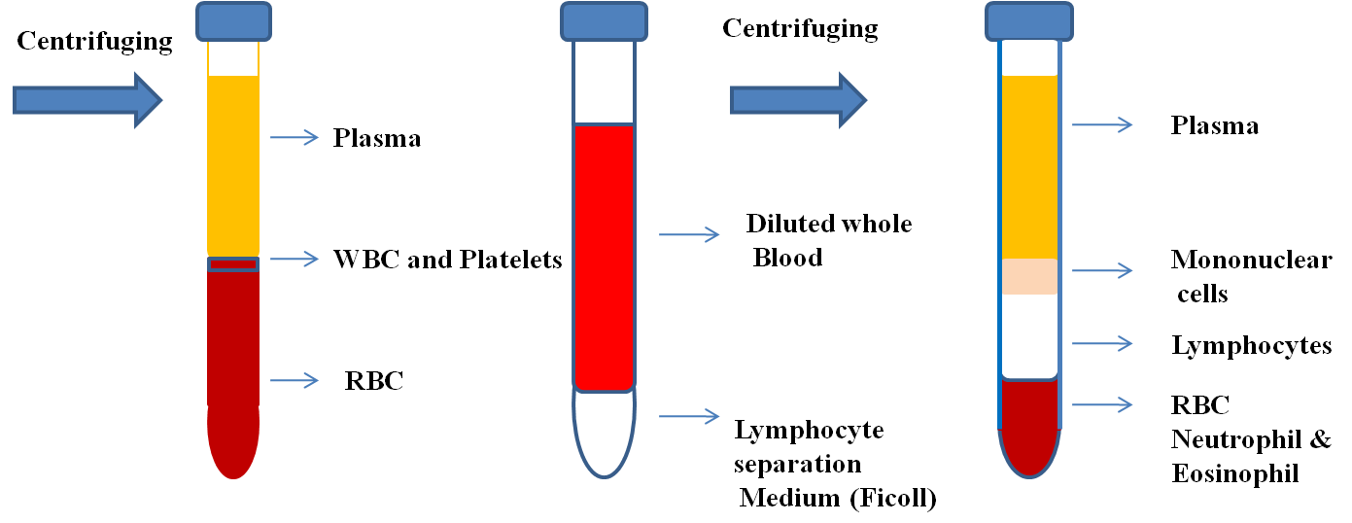

Figure 2.9. Schematic diagram showing the layers obtained after density gradient centrifugation for isolation of the leukocytes from peripheral venous blood.

Flow cytometric analysis of leukocytes chemotaxis using Cell-Tracker

A FACS Caliber flow cytometer was used to analyze the migration of freshly isolated leukocytes into 3D collagen co-culture models. After isolation of freshly isolated fluorescently-labelled leukocytes as previously mentioned in section 2.2.10.7, far-red-stained leukocytes were loaded on the top of the 3D collagen models and incubated for 24 hours at 37˚C in a 5 % CO₂ with serum-containing media (figure 2.10). The next day, the media was aspirated and the 3D collagen models washed twice with HBSS without Ca²⁺, Mg²⁺ to remove any non-migrated leukocytes. Collagenase type I was used to dissolve the collagen and harvest the cells. Collagenase I was made up at 10 mg/mL in HBSS and used at a final concentration of 2 mg/ml. The 3D collagen models were cut into smaller pieces using a scalpel and incubated on a shaker overnight at 37˚C in a 5 % CO₂. After dissolution of the collagen the cells in each well of the 48-well chamber were collected in a micro-tube, washed with HBSS, centrifuged at 400xg for 5 minutes and fixed in 300 μl of 2 % paraformaldehyde for flow cytometric analysis.

Four types of cultures in the 3D collagen models were used to compare between numbers of attracted leukocytes. The cultures were as follows: 3D collagen model alone (negative control), NTF alone, NTF/MTCS co-culture with either FaDu or UPCISCC90 MCTS. The samples were stored at 4ºC for later flow cytometry analysis.

The flow cytometry detectors of forward incidental light scatter (FSC) and side incidental light scatter (SSC) were programmed to calculate the values that optimized visualization of fluorescent-leukocytes stained with Cell-Tracker far-red. A threshold was used on the FSC detector to exclude small sub-cellular particles from acquisition. The samples were then acquired by FACS Calibur flow cytometer for a set time of 30 seconds. Finally, the numbers of events counted by the machine throughout this time were utilized as a measure of relative chemotaxis rate of leukocytes into the 3D collagen model. FlowJo software (TreeStar) was used to analyze the data.

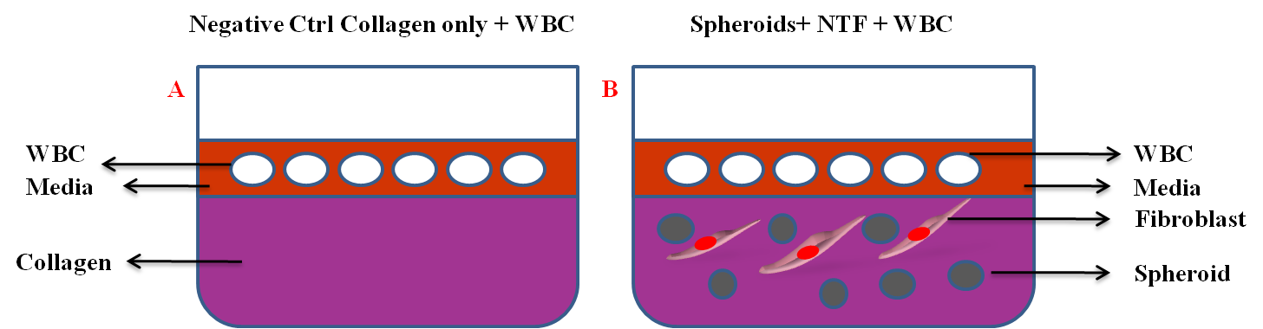

Figure 2.10. Schematic images shows 3D-model co-culture with leukocytes. (A) 3D-model hydrogels containing on its top WBC as control. (B) 3D co-culture model hydrogels of HNC spheroids co-cultured with NTF and WBC. Abbreviations leukocytes (WBC) and control (Ctrl).

Frozen section preparation
To prepare frozen sections, 3D collagen co-culture models with migrated leukocytes were fixed with 4 % paraformaldehyde for 24 hours. The 3D-models were frozen by means of OCT Compound as specimen matrix and sectioned in 14 µm slices using a cryostat. The frozen sections were mounted on adhesive glass slides and slides stained with ProLong Diamond™ anti-fade containing DAPI to stain the nucleus to visualize the fluorescent-leukocytes in the 3D-models. The slides were also stained by IHC to specifically visualize neutrophils (CD66b+), monocytes (CD68+) and T cells (CD3+) as illustrated in section 2.2.5. The stained sections were visualized using an inverted microscope supplied with a digital camera.

Statistics
Data presented are from three individual experiments performed in triplicate and the results are expressed as mean +/- standard deviation (SD) unless otherwise stated. Data were subjected to normality testing and statistical significances were estimated using parametric unpaired Student’s t-test or non-parametric Mann-Whitney U test to test the difference between two variables. Parametric one-way ANOVA and non-parametric Kruskal–Wallis test for multiple variables were used if more than two variables were tested. The results were considered statistically significant if p≤0.05. All statistical evaluations were performed using GraphPad Prism (version 7, USA). SPSS version 21 was used to analyse cumulative survival according to Kaplan-Meier method.

Ethics
All the experiments were done in an ethical manner. The volunteers/individuals participated in this study with written, informed consent with approval from the University of Sheffield Ethics Committee or National Research Ethical Approval. Use of archival TMA, the isolation and use of normal tonsil fibroblasts were permitted with National Research Ethical Approval as highlighted in the appropriate sections.

Chapter three: Prognostic values of tumour-infiltrating leukocytes in HPV-positive and HPV-negative OPC using a tissue microarray study.

Introduction

Leukocytes, primarily neutrophils, monocytes and lymphocytes orchestrate the host innate and adaptive immune responses toward infection. In addition, there is a large body of convincing data proposing these leukocytes infiltrate tumours where they play a role in cancer cell elimination or cancer progression, depending on the leukocyte subtype and activation status. In vitro studies have shown that cancer cells secrete cytokines such as CXCL12 and GMCSF/MSCF that have the ability to stimulate neutrophil and monocyte generation and release from the bone marrow. In addition, tumour cells also secrete chemokines that mediate their recruitment to the tumour environment (Dumitru et al., 2013b). In turn, it is known that these immune cells, once recruited, secrete factors such as growth factors and proteases that result in tumour angiogenesis and the attraction of more leukocytes subtypes (Tazzyman et al., 2009, Jablonska et al., 2010).

Several studies have shown that the presence of tumour-associated neutrophils (TAN) are associated with unfavourable outcome in many cancer types including HPV-negative HNC, including OPC (Donskov, 2013, Trellakis et al., 2011a). High levels of Tumour-associated macrophages (TAM) have also been associated with poor prognosis (Lechien et al., 2017). In contrast, high lymphocyte levels, in particular CD8+ (CTL) T-lymphocytes have been linked with better prognostication in HNC (Wallis et al., 2015b). Therefore, the levels of tumour-infiltrating leukocyte sub-types have been associated with disease burden or survival but the number of these cells varies in different tumour types and from patient to patient (Huang et al., 2015). To date, there is little known about the relative levels of tumour-infiltrating leukocyte subtypes in HPV-positive and HPV-negative OPC and if these levels are linked to disease burden and prognosis.

The majority of HPV-positive OPCs have a significantly better response to treatment than HPV-negative OPCs (Langendijk and Steenbakkers, 2017). However, some patients with HPV-positive OPC have been associated with poor prognosis mainly due to metastasis (Huang et al., 2013), or because of heavy smoking and they lose the significant favourable final therapeutic responses (Lassen et al., 2018, Sethi et al., 2012, Gillison et al., 2012). Since the number and type of tumour-infiltrated leukocytes appear to have prognostic value in various cancer types including HPV-negative HNC/OSCC, then these parameters may assist in individualising the therapeutic decisions for HPV-positive versus HPV-negative OPC (Gouw et al., 2018, Solinas et al., 2017, Hendry et al., 2017).

Tissue microarray (TMA) technology is a valuable technique to assess tumour biopsy sections from large cohorts of patients. TMAs are widely used in cancer research alongside immunohistochemistry (IHC) staining to examine the presence of potential biomarkers (Mulrane et al., 2017). In a TMA, small representative tumour areas from numerous patients can be examined on one microscope slide either by histological or IHC. This circumvents the necessity of cutting and staining individual sections from each patient, making the staining procedure and the analysis more manageable for large cohorts.

TMAs can be assessed by manual scoring of the stained sections on the microscopic slide using traditional estimation techniques. However, this method has been criticised as being subjective, with large intra-observation variances between pathologists noted that has an impact on data reproducibility (Hamilton et al., 2009, Polley et al., 2013). Moreover, the process is very time consuming and not particularly appropriate for large-scale tissue sample biomarker studies.

Current techniques now include digitally scanning the entire microscope slide with a high-resolution scanner such as ‘AperioScan’ to produce high quality images for further down-stream processing. Moreover, given the right parameters, these images can be analysed in a non-subjective automated manner using digital pathology techniques (Pantanowitz et al., 2011, Hamilton et al., 2014). Common software used includes Cell Profiler (Lamprecht et al., 2007), Icy (De Chaumont et al., 2012) and Fiji (Schindelin et al., 2012). The type of analysis for each software performs varies, as does their cost of purchase and therefore their availability to the scientific community. Open source software is only recently available (Nelissen et al., 2014, Deroulers et al., 2013).

Hypothesis

Individuals with HPV-positive OPC have a better prognosis than individuals with HPV-negative OPC in this patient cohort. In addition, there will be significant differences in the numbers of tumour-infiltrating leukocytes in the biopsies of patients with HPV-negative OPC compared to those with HPV-positive tumours and this will influence prognosis.

Aims

- To assess the usefulness of an open source software programme to analyse TMA made up from a cohort HPV-negative and HPV-positive OPC.

- Use biomarkers for presence of HPV along with clinical parameters to assess if HPV-status confers prognosis in OPC in this cohort of patients.

- Perform IHC directed against cell-type specific biomarkers to determine the levels of subpopulations of tumour-infiltrating leukocytes (neutrophils, macrophages and T-lymphocytes) and if these vary significantly in HPV-negative compared to HPV-positive OPC.

Methods

An analytical study was performed to inspect the relationship between HPV-status and three parameters of the tumour microenvironment: the presence of tumour-associated neutrophils (TAN), tumour-associated macrophages (TAM) and tumour-infiltrated lymphocytes (TIL). The leukocyte infiltrations in HPV-positive/HPV-negative OPC were analysed and compared with normal tonsil tissue sections as well. Representative tissue sections from each patient tumour wax-embedded block was stained with haematoxylin and eosin and examined by an expert oral pathologist (Prof. Keith D. Hunter) to confirm the histological diagnosis. Areas of tumour sections were chosen that displayed more than 70 % cellularity and minimal regions of necrosis. The TMAs were prepared and stained as previously described in section 2.2.6. The HPV-status was confirmed for each case depending on the expression of p16 and ISH for HPV16/18 E6/E7 (performed by Dr. Naeimma B. Hendawi, University of Sheffield) (Robinson et al., 2010).

The presence of infiltrating leukocytes was determined using IHC for cell type specific markers based on the literature. Myeloperoxidase was used as a specific marker for TAN, CD68 was used for TAM and CD3 used for tumour-infiltrating lymphocytes. The number of MPO+ neutrophils, CD68+ macrophages and CD3+ T lymphocytes (TIL) were analysed in whole 1 mm² core sections. Cores with insufficient histology (more than 50 % missing) or folded-tissues making them difficult for interpretation were excluded from the analysis (Nocito et al., 2001). Leukocytes within the blood vessels were not included in the analysis. The TMA was scanned and the images visualised on the computer screen to check for missing cores. The cumulative mean of percent to the positively expressed infiltrated leukocytes was calculated for individual patient biopsies to ensure that the resultant data was reliable and free from data variation. The TMA images were analysed digitally using Qupath software (Bankhead et al., 2017) and compared with manual counting for evaluation. The software settings used are described in section 3.3.2. The cores were taken from diagnostic biopsies and so detailed demographic and clinical patient information was obtained and recorded until death or loss in follow-up.

The stained TMAs were blindly evaluated with regard to HPV-status and treatment outcome. The mean percentage of the positive expression of each marker was used in this study because not all the cores contained the same number of cells. In some instances, the patient samples were subdivided into high and low expression groups (dichotomized labelling) depending on weather their value was greater or smaller than the median (median of means) (Balermpas et al., 2014a). The statistical analysis was performed using Graphpad prism version 7 using a non-parametric Mann Whitney test because the data was not normally distributed and for survival analysis SPSS version 21 was used to test for HPV-status effect in cumulative survival according to Kaplan-Meier method.

Demographic and clinico-pathological patient characteristics
The patients' characteristics are summarized in table 3.1 including demographic, clinical and pathological information at the time of diagnosis. In this study design the cohort was composed of 59 retrospective cases; 40 HPV-positive OPC and 19 HPV-negative OPC cases. The diagnosed patients were primarily treated by surgical intervention, radiotherapy, chemotherapy or a combination of methods between the periods 2002-2012. The HPV-status was ascertained at the time of tumour diagnosis and re-confirmed by p16 and ISH before conducting the leukocyte analysis. The cohort comprised of 14 (23.72 %) female and 45 (76.27 %) male with follow up time ranging from (6 months-7.6 years). The mean of ages for the entire cohort was 55.49 years. The mean age for HPV-positive cases was 55.13 years ranging from 29-66 years, while for HPV-negative mean age was 56.26 years ranging from 31-70 years. The OPC were located in tonsils (HPV-positive n=28, HPV-negative n=9), base of the tongue (HPV-positive n=11, HPV-negative n=7), posterior wall of pharynx (HPV-positive n=0, HPV-negative n=1), soft palate (HPV-positive n=0, HPV-negative n=1), and nasopharyngeal (HPV-positive n=1, HPV-negative n=1).

The lymph nodes were not involved (N0) in 3 cases for each HPV-positive/HPV-negative subgroup, while it was involved in ipsilateraly from single to multiple (N1-N2a) (HPV-positive n=28, HPV-negative n=13), while the contralateral or bilateral lymph node involvement (N2b-N3) were recorded as (HPV-positive n=7, HPV-negative n=3). There was no metastasis at the time of diagnosis, however during the follow-up 1 case of HPV-positive and 2 cases of HPV-negative suffered from distant metastasis. Recurrence was reported in 1 local recurrent case with HPV-positive and 2 cases divided between local and regional in the HPV-negative patients. Follow-up demonstrated a low number of deaths were only 1 patient died of disease in HPV-positive OPC, whilst 4 patients died in the HPV-negative cohort.

Characteristics |  |  | HPV-positive | HPV-negative
Total | 59 (100 %) |  | 40 (67.79 %) | 19 (32.21 %)
Gender | Female | 14 (23.72 %) | 10 (25 %) | 4 (21.05 %)
 | Male | 45 (76.27 %) | 30 (75 %) | 15 (78.94 %)
Age (year) | Average |  | 55.13 | 56.26
 | Range |  | 29-66 | 31-70
Alcohol¹ | Never |  | 3 (7.5 %) | 0 (0%)
 | Low |  | 22 (55 %) | 6 (31.57 %)
 | Heavy |  | 4 (10%) | 7 (36.84 %)
Smoking² | Smoker |  | 13 (32.5 %) | 9 (47.36 %)
 | Non-smoker |  | 11 (27.5 %) | 0 (0 %)
 | Ex-smoker |  | 9 (22.5) | 7 (36.84 %)
Site | Tonsil |  | 28 (70 %) | 9 (47.36 %)
 | Base of tongue |  | 11 (27.5 %) | 7 (36.84 %)
 | Post wall of pharynx |  | 0 (0 %) | 1 (5.26 %)
 | Soft palate |  | 0 (0 %) | 1 (5.26 %)
 | Nasopharyngeal |  | 1 (2.5 %) | 1 (5.26 %)
Disease stage | Stage I |  | 8 (20 %) | 2 (10.52 %)
 | Stage II |  | 16 (40%) | 5 (26.31 %)
 | Stage III |  | 5 (12.5 %) | 6 (31.57 %)
 | Stage IV |  | 10 (25 %) | 5 (26.31 %)
T-Stage³ | T1/T2 |  | 24 (60 %) | 7 (36.84 %)
 | T3/T4 |  | 15 (37.5%) | 11(57.89 %)
N-stage ⁴ | N0 |  | 3 (7.5 %) | 3 (15.78 %)
 | N1-N2a |  | 28 (70 %) | 13 (68.42 %)
 | N2b-N3 |  | 7 (17.5%) | 3 (15.78 %)
M-Stage |  |  | 0 (0 %) | 0 (0 %)
Grade⁵ | Poor |  | 25 (62.5 %) | 9 (47.36 %)
 | Moderately |  | 9 (22.5 %) | 8 (42.1 %)
 | Well |  | 2 (5 %) | 1 (5.26 %)
Recurrence | Local |  | 1 (2.5 %) | 4 (21.05 %)
 | Regional |  | 0 (0 %) | 2 (10.52 %)

Table 3.1. Demographics and patient characteristics involved in this study at time of diagnosis. Non-documented cases in the records as follow ¹(11 HPV-positive, and 6 HPV-negative),² (7 HPV-positive and 3 HPV-negative), ³(1 HPV-positive and 1 HPV-negative), ⁴ (2 HPV-positive not documented), ⁵ (4 HPV-positive and 1 HPV-negative).

Software settings used to analyze TMA
Image acquisition for stained TMA was obtained by high resolution scanning using an ‘AperioScan’ scanner. QuPath software was used to analyse the biomarkers in TMA images as previously described (Bankhead et al., 2017). Briefly, software settings used to quantify the IHC-stained cells was performed as outlined in figure 3.1 A-G. Separated project was performed for each individual biomarker within the program. The first step in the analysis process after importing the image was TMA dearraying (i.e. making a circle around each individual core as shown in figure 3.1 B. The circles were manually amended when necessary to adjust their location, position or alignment or were removed altogether when cores were missing or a visible defect in a core detected. All circles were standardised at 1.2 mm² in order to completely encircle the 1 mm² cores.

Next, stain estimation including the background was performed on each individual TMA image to improve the stain separation within the program. This was done by choosing a representative area that contained examples of background, strong or weak haematoxylin and DAB staining as shown in figure 3.1 C. The command ‘Analyse – preprocessing - Estimate stain vectors’ was selected within the Qupath program in order to identify the staining vectors within that selected area.

Tissue detection and cell counting is shown in figure 3.1 D-F. Here tissues were distinguished via thresholding a down-sampled and smoothed core-image within each TMA image figure 3.1 D. This was followed by cleaning up the resultant binary image via morphological processing. To perform this step the command ‘Analyse – Preprocessing Simple Tissue Detection’ was selected. The values for the threshold and pixel size were 220 and 4 µm respectively figure 3.1 E. The individual cells were spotted via stain separation utilizing colour deconvolution. In addition, peaks were distinguished in the haematoxylin channel alone or the combination of DAB and haematoxylin channels together after smoothing figure 3.1 F. Then, the negative or positive cells were assigned depending on the information from the smoothed DAB channel, by finding the centre of the nucleus figure 3.1 F. This was done by clicking the command ‘Analyse - Cell Analysis - Fast Cell Counts’. The designated area and the number of positive cells were utilized to count the number of positive cells per mm².

The detected cells are exported with marked - image for visual confirmation as shown in figure 3.1 F. The resultant data was generated by choosing the command ‘Measure - Show TMA – Measurements’ and data exported in a spreadsheet that was transferred to statistical software for further analysis.

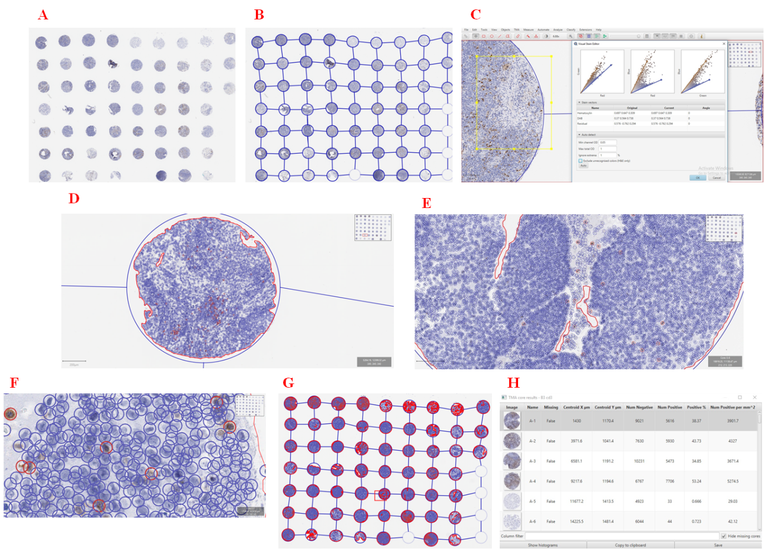

Figure 3.1. Image demonstrating the software settings of the QuPath program used to analyse the TMA. The TMA were scanned using and ‘Aperioscan’ scanner and the digital images imported into the QuPath program and displayed on the computer screen. (A) Typical TMA image showing core distribution. (B) TMA dearraying analysis grid. (C) TMA tissue detection in one core, scale bar=100 µm; stain estimation vectors in the selected area (yellow box) (D) Magnified TMA core tissue detection, scale bar=200 µm. (E) Increased magnification of a TMA core, scale bar 100 mm (F) Magnified TMA core showing cell selection based on haematoxylin-stained nuclei or DAB positive stained cells, scale bar 20 µm (G) TMA image after all cores were detected and cells counted. (H) TMA output measurements obtained from the QuPath program. All the images were taken from the program during software settings.

Results

HPV-status and prognosis
Kaplan-Meier survival analysis was used to assess HPV-status and its association with prognosis and overall survival. OPC cases were stratified for HPV-status and survival time for five years (60 months) follow-up as shown in figure 3.2. The stratification of patients in relation to HPV-status showed that individuals with HPV-positive OPC significantly (p=0.04) correlated with better overall 5-year survival than individuals with HPV-negative OPC.

Eleven fatality cases in this cohort were divided between n=5 HPV-positive and n=6 HPV-negative OPC. The fatalities in the HPV-related OPC cohort were without disease (n=2), due to infection (n=1), unknown cause of death (n=1), and only n=1 out of 5 died because of cancer. In the HPV-negative cases n=6 died-cases, died without disease (n=1), without evaluation (n=1) and n=4 out of 6 died because of disease (cancer). The deaths due to other causes were not included in the survival analysis. (n=number).

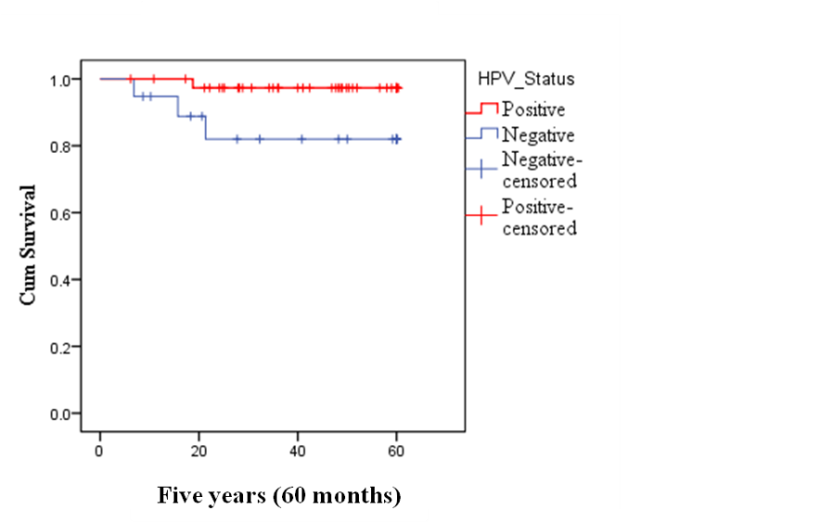

Figure 3.2. Kaplan-Meier plot for overall survival of HPV-positive and HPV-negative OPC. The analysis was stratified according to the number of deaths for HPV-positive versus HPV-negative in the total number of cohort for five-years (60 months) follow-up period. y axis is cumulative (cum survival), x axis is time (months).This graph was done by Dr. Naeimma B. Hendawi.

Tumour-infiltrating leukocytes
Tumour-infiltrated leukocytes subsets MPO (neutrophils), CD68 (macrophages) and CD3 (T cells) were analysed in 59 patients with OPC using TMA images obtained from paraffin-embedded tissues sections (representative images are shown in figure 3.3. Each infiltrated leukocytes subset was analysed as total number of infiltrating leukocytes and then by dichotomized labelling according to high and low infiltration depending on the median value of cases in addition to analysis according to the disease stage to test whether leukocytes infiltration along with HPV-status was stage dependent.

According to the patient information at the time of diagnosis, the majority of cases were male for HPV-positive (75 %) and HPV-negative (78.94 %) groups. Patients were younger in the HPV-positive group with an average of 55.13 years compared to an average of 56.26 years for the HPV-negative group. Alcohol consumption was reported in 22 HPV-positive patients and (100 %) in the HPV-negative cases. Concerning tobacco smoking, 26 cases of tobacco use was reported for HPV-positive and (100 %) for HPV-negative cases. Comprehensive analysis with all the leukocytes subsets showed no-significant effects of smoking or alcohol consumption and leukocyte infiltration (data not shown).
Figure 3.3. Images showing representative examples of IHC staining of TMA sections examined in this study. TMA glass slides for both HPV-positive and HPV-negative OPC were scanned by ‘Aperioscan’ scanner and the digital images analysed by QuPath as previously described. (A) MPO+ neutrophils (B) CD68+ macrophages (C) CD3+ T lymphocytes. Brown dots show positively stained cells within the cores. Top row is HPV-positive (HPV+ve) OPC, middle row is HPV-negative (HPV-ve) OPC, bottom row is control (Ctrl) normal tonsil mucosa. Scale bar=250µm for whole cores (left) and 50 µm for magnified cores (right).

Tumour-associated neutrophil (TAN) infiltration
The levels of MPO+ (TAN) were analysed in the whole 1 mm² core including the tumour and the surrounding stroma. Usually each OPC case was represented by more than one core; in these instances, the mean of MPO+ percent value was calculated per case. The total number of cases examined was 59 of which 40 (67.8 %) were HPV-positive OPC and 19 (32.2 %) were HPV-negative OPC. The mean ± SEM percent of MPO+ staining for all HPV-positive OPC cases was 5.12 ± 0.77 % while for HPV-negative the mean of MPO+ percent staining was 9.79 ± 1.55 %. This constitutes a significant increase (p=0.003) in the level of neutrophils in the tumours of HPV-negative compared to HPV-positive OPC (figure 3.4 A). High neutrophil expression was detected in 30 cases, in which 20 (50 %) were HPV-positive and 10 (52.63 %) HPV-negative. The mean for HPV-positive was 8.3 ± 1.2 % and 14.8 ± 1.6 % for HPV-negative; once again a statistically significant increase in HPV-negative compared to HPV-positive OPC (p=0.0016; figure 3.4 B). Similarly, the mean of OPC tumours with low neutrophil levels were HPV-positive 1.96 ± 0.18 % (n=20 (50 %) cases) compared to HPV-negative values of 4.21 ± 0.85 % (n=9 (47.36 %) cases) (p=0.0083; figure 3.4 C). Taken together, these data suggest that there are significantly more TAN in HPV-negative OPC than HPV-positive OPC.

The stage of OPC disease was subdivided into the four well recognised groups (I, II, III and IV) as shown in figure 3.4 D-G. When analysed statistically the data showed no significant different in the levels of TAN in HPV-positive compared to HPV-negative OPC at any disease stage examined (p=0.088, 0.54, 0.32 and 0.147 for stages I-V respectively).

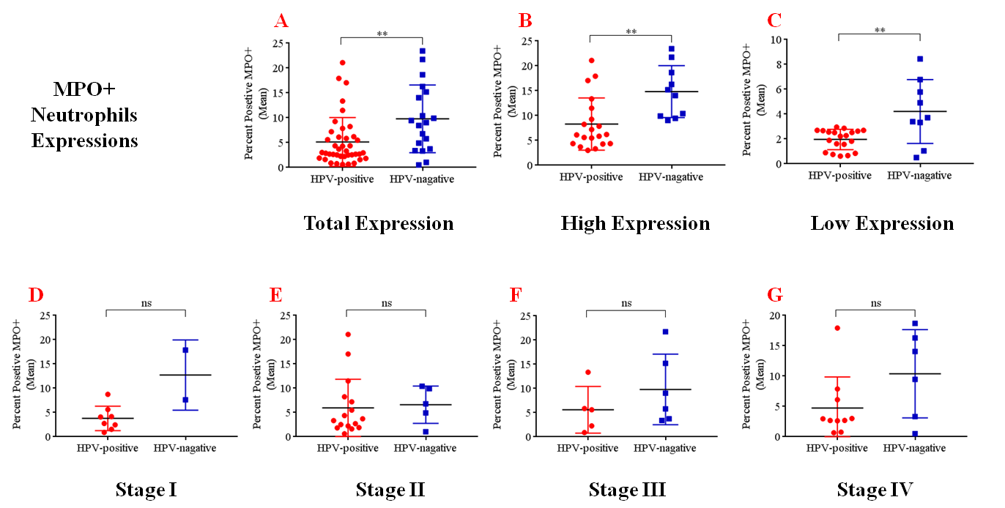

Figure 3.4. Box plots showing the infiltration of MPO+ (TAN) in HPV-positive and HPV-negative OPC TMA sections. The data shows the percentage of mean positive expression of MPO+ in HPV-positive and HPV-negative and were divided according to high and low expression according to the median value of the total means. (A) Total expression (B) High expression (C) Low expression. (D-G) Infiltration of MPO+ (TAN) according to disease stage. Statistical analysis was performed using a Mann-Whitney U non-parametric test. Data are presented in mean with SD . **p<0.01.

Tumour-associated macrophage (TAM) infiltration
Similar to TAN, the levels of CD68+ (TAM) was analysed in TMA cores including the tumour and the surrounding stroma. For TAM the total number of cases analysed was 57 of which 39 (67.8 %) were HPV-positive OPC and 18 (32.2 %) were HPV-negative. There was no significant difference in the level of TAM in HPV-positive OPC cores (7.07 ± 0.99 %) compared to HPV-negative OPC (6.0 ± 1.47 %; p=0.27) (figure 3.5 A). In cases with high levels of TAM, once again there was no significant difference (p=0.35) between HPV-positive OPC (11.34 ± 1.32 %; n=20 (51.28 %)) compared to HPV-negative OPC (9.7 ± 1.99 %; n=10 (55.55 %)) (figure 3.5 B). Interestingly, in OPC cases where mean TAM levels were low there was a significant (p=0.04) increase in TMA levels between HPV-positive (2.59 ± 0.35 %; n=19 (48.71 %)) compared to HPV-negative OPC (1.39 ± 0.16 %; n=8 (44.44 %)) (figure 3.5 C).
Similar to TAN, the stage of the disease regarding TAM infiltration showed no statistically significant differences (p=0.17, 0.57, 0.91, and 0.85 for stages I-V respectively) between HPV-positive and HPV-negative status (figure 3.5 D-G). Taken together, these data suggest that there is little difference in the infiltration of TAM into OPC regarding HPV-status, although there is more TAM in HPV-positive OPC when at low expression levels.

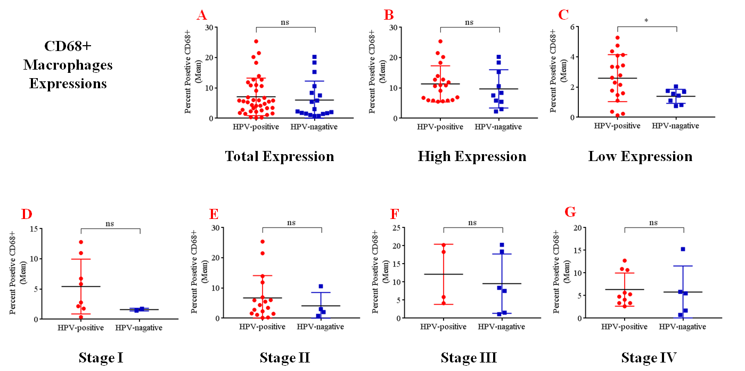

Figure 3.5. Box plots showing the infiltration of CD68+ (TAM) in HPV-positive and HPV-negative OPC TMA sections. The data show the percentage of mean positive expression of CD68+ in HPV-positive and HPV-negative and were divided according to high and low expression according to the median value of the total means. (A) Total expression (B) High expression (C) Low expression. (D-G) Infiltration of CD68+ according to disease stage. A statistical analysis was performed using a Mann-Whitney U non-parametric test. Data are presented in mean with SD. *p<0.05.

Tumour-infiltrating lymphocytes (TIL) infiltration
The levels of CD3+ (TIL) (i.e. total T-lymphocytes) were analysed in OPC TMA cores including the tumour and the surrounding stroma as shown in figure 3.6. For TIL, the total number of cases analysed was 55 of which 38 (69.1 %) were HPV-positive OPC and 17 (30.9 %) were HPV-negative. Mean levels of total TIL in HPV-positive OPC was (5.6 ± 0.87 %) which was not significantly different (p=0.33) to the levels of infiltrating HPV-negative tumours (4.3 ± 1.05 %). In high levels TIL cases, the mean score of HPV-positive and HPV-negative OPC were also not significantly different (HPV-positive 8.97 ± 1.22 %; n=20 (52.63 %); HPV-negative 7.6 ± 1.12 %; n=9 (52.9 %); p=0.84). Similar to TAM, low levels of TIL showed a statistically significant difference (p=0.03) in their levels between HPV-positive OPC (1.85 ± 0.32 %; n=18 (47.36 %)) compared to HPV-negative OPC (0.53 ± 0.06 %; n=8 (47.05 %)), suggesting the presence of more TIL in HPV-positive tumours but only when overall levels are low.

Finally, the when broken down into tumour stages there was no significant difference between HPV-positive and HPV-negative OPC at any tumour stage examined (p=0.22, 0.99, 0.24 and 0.76 for stages I-V respectively).

In summary, although only a relatively small cohort, this study observed significant differences in the levels of TAN with increased levels HPV-positive compared to HPV-negative OPC. There were no significant differences in infiltration of total TAM or TIL related to HPV-status. When at low levels, significant differences in the infiltration of TAM and TIL (more in HPV-positive compared to HPV-negative) were observed. There was no difference in infiltration levels of any of the leukocytes tested with regard to tumour stage.

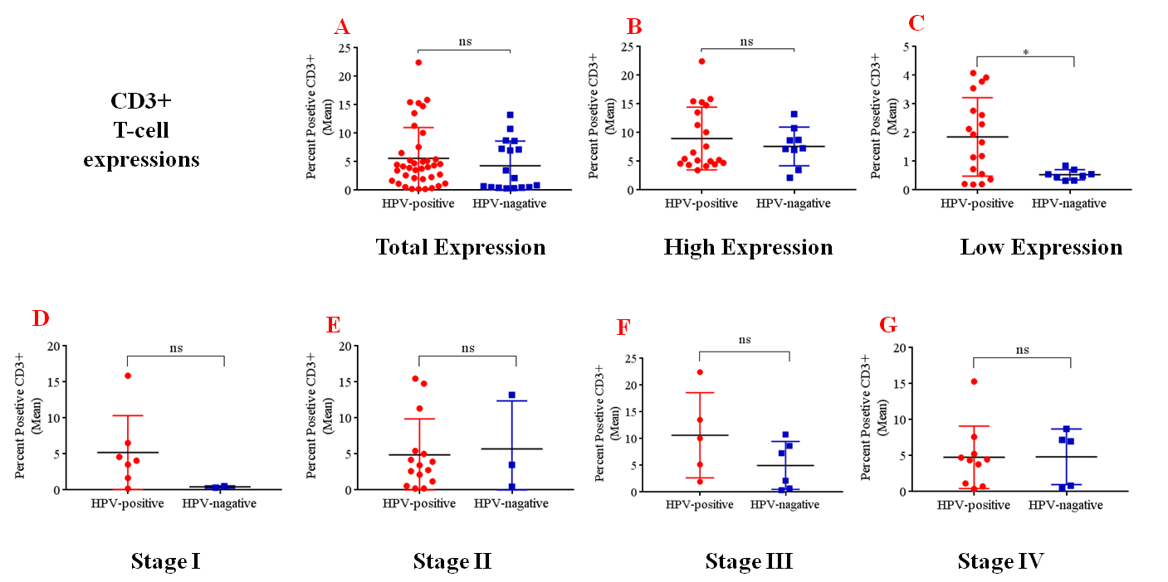

Figure 3.6. Box plots showing the infiltration of CD3+ (TIL) in HPV-positive and HPV-negative OPC TMA sections. The data show the percentage of mean positive expression of CD3+ in HPV-positive and HPV-negative and were divided according to high and low expression according to the median value of the total means. (A) Total expression (B) High expression (C) Low expression. (D-G) Infiltration of CD3+ according to disease stage. A statistical analysis was performed using a Mann-Whitney U non-parametric test. Data are presented in mean with SD. *p<0.05.

However, taking in consideration the small cohort number and the limited death related to the disease (cancer), other stratifications (i.e. according to Kaplan-Meier method) such as MPO+, CD68+ and CD3+ in relation to HPV-status were not involved since it will not depict the real prognostication (false negative). Particularly, the only HPV-positive OPC patient who died (case no. 49) was not included in CD3+ analysis because of the missing or folded tissues. However, an attempt was made to assess overall survival stratified according to the HPV-status, while according to leukocyte infiltration, the small cohort number and the very limited fatality related to OPC in this cohort made the analysis impossible.

Discussion
There are mainly two causative factor groups for OPC; one group is represented by alcohol/tobacco intake leading to genetic mutations and second group is represented by infection with high-risk HPV. It is well known that HPV-related OPC presents with a different molecular-profile of carcinogenesis than alcohol/tobacco-related disease (Dok and Nuyts, 2016, Ndiaye et al., 2014). Even though HPV-related OPCs are often diagnosed later and with frequent lymph nodes metastasis, their outcomes are significantly better. Indeed, significantly (p=0.04) improved overall outcome for HPV-positive OPC compared to HPV-negative disease was shown in the cohort examined in this study. Our data is in line with several previously reported studies showing the same trend for OPC. For example, the three-year survival rate for HPV-positive OPC was 82 % compared to 56 % for HPV-negative disease (p=0.001) (Ward et al., 2014, Partlová et al., 2015, O’Sullivan et al., 2012). This suggests that the cohort used in our study is similar to others and therefore is representative HPV-positive and HPV-negative OPC disease.

Recently, focus has increased on the distribution of leukocyte populations within tumours including subset compositions of these immune cells and if these are predictive of prognosis (Pages et al., 2010). The concept of immune cells influencing cancer progression is not new but addition of this to Hanahan and Weinberg’s hallmark of cancer concept and increasing use of the term ‘cancer-related inflammation’ has heightened interest (Hanahan and Weinberg, 2011). Currently, there is much information to suggest that tumour-infiltrating leukocytes in the tumour microenvironments (TME) can shape tumour progression in various cancer types (Gooden et al., 2011). Indeed, there is good evidence to show that both TAN and TAM correlate with poor prognosis in HPV-negative oral cancer (Li et al., 2002, Perisanidis et al., 2013), whereas increased numbers of TIL, specifically CD3+ TIL have been shown to correlate with improved survival (Balermpas et al., 2014a). This data provided motivation to examine levels of infiltrating leukocytes in HPV-positive and HPV-negative OPC, tumours that have very different aetiology and outcome. At the time this study was started there were no investigations into infiltrating leukocytes and their relationship with HPV-OPC status.

MPO antibody staining was chosen as a neutrophil-specific marker because it is constitutively expressed solely by polymorphonuclear neutrophils and is secreted during cytoplasmic degranulation (Amanzada et al., 2011). MPO has been used as a neutrophil specific marker in several other studies (Eruslanov et al., 2014). Moreover, clinically, MPO rather than CD66b (another commonly used neutrophil marker) is more commonly used to identify neutrophils in sections of diseased tissue. The antibodies for MPO appear to be more robust and reliable than CD66b for automated staining and so are used in clinical diagnostics. Importantly, this study showed significantly higher levels of MPO+ (TAN) in HPV-negative OPC than in HPV-positive OPC. This was also true when the TAN analysis was subdivided into high and low expression.

There are several in vitro and in vivo reports demonstrating the presence of high numbers of TAN in cancers and that these are associated with unfavourable prognosis. This has been documented in bronchoalveolar cancer, (Wislez et al., 2003) renal carcinoma, (Jensen et al., 2009) melanoma, (Schmidt et al., 2005) and HPV-negative HNC (oral cancer) (Trellakis et al., 2011a). The presence of high numbers of TAN has correlated with recurrence as well as metastasis. It is thought that molecules secreted by tumour cells or the TME recruit neutrophils, for example CXCL8 can recruit and activate neutrophils to the TME in lung carcinoma and other tumours. CXCL8 was found in high concentrations in cancer patients, and targeting the CXCR/CXCL8 receptor axis resulted in less disease burden in mice (De Larco et al., 2004, Haqqani et al., 2000, Allen et al., 2007, Tazzyman et al., 2011). Precisely what factors recruit neutrophils to OPC has yet to be determined but contributions from CXCL chemokines is likely.

Recently, evidence suggests that neutrophils possess relevant functions that aid malignancies (Uribe-Querol and Rosales, 2015, Mantovani et al., 2008). Within tumours, TAN have been found to secrete such factors as matrix metalloproteinase 9 (MMP9) and vascular endothelial growth factor (VEGF) that remodel the extracellular matrix promoting tumour angiogenesis. Other factors such as transforming growth factor beta (TGF-β) and IL-10 released by TAN increase cell proliferation, and instigate immune suppression (Dumitru et al., 2012, Brandau et al., 2013). In contrast, neutrophils have been described as ‘two sides of the same coin’ as they also have potent anti-cancer abilities via the secretion of granules that can destroy tumour cells and recruitment of other immune effector cells (Gregory and Houghton, 2011, Mantovani et al., 2011).

Most evidence point to TAN acting in a pro-tumour fashion. The increased levels of TAN in HPV-negative OPC might be one reason why HPV-negative OPCs have an unfavourable outcome compared to HPV-positive OPC that contain significantly less TAN. Unfortunately, the cohort size in this study was too small to test this hypothesis.

There is evidence that TAN can be further sub-divided into two distinct polarised states depending on their activation status (Scapini et al., 2000, Fridlender et al., 2009b, Mantovani, 2009). These have been described in murine studies as N1 and N2 phenotypes, with TGF-β being suggested as the major driver of the N2 pro-tumour phenotype of neutrophils (Fridlender et al., 2009b). It is known that oral cancers contain elevated levels of TGF-β (Marsh et al., 2011) and this factor is also thought to drive the formation of cancer-associated fibroblasts in oral cancer (Marsh et al., 2011). Therefore, it is possible that TAN within HPV-negative OPC may be of the N2 phenotype. It would be interesting to stain for N2 phenotype markers to examine if more TAN are N2 in HPV-negative OPC compared to HPV-positive OPC. Although, interestingly there are problems associated with this analysis as human markers for N2 TAN are not yet clearly defined.

Next, levels of TAM were investigated. TAMs have received considerable attention in cancer biology and are seen as an attractive target in therapeutic modalities. A number of pre-clinical and clinical studies have reported the negative effects of TAM infiltration into the TME and many studies have shown the potential effects of blocking macrophage recruitment to the TME (Noy and Pollard, 2014, Steidl et al., 2010, De Palma and Lewis, 2013, Hughes et al., 2015). This rationale promoted the analysis of TAM levels in HPV-positive and HPV-negative OPC. CD68 was chosen as a specific macrophages marker as it is frequently employed to specifically identify macrophages in healthy and pathological tissues (Gollapudi et al., 2013, Pulford et al., 1990).

A recent study by Seminerio et al. (2018) stated that tissue with transcriptionaly active HPV-infection (i.e. during HPV-disease progression) were associated with high CD68+ macrophages. Given this analysis it was envisaged that HPV-positive OPC might show increased recruitment of TAM. However, this study showed that there was no significant difference in the level of TAM in HPV-positive compared to HPV-negative OPC. The densities of CD68+ (TAM) were almost equal in both HPV-positive and HPV-negative tumours. However, only in low expression phase there was a significant increase in TAM. Increased levels of TAM have been previously observed in HPV-negative OSCC where they were associated with poor prognosis (Fujii et al., 2012). However, other studies reported non-significant differences in the proportions of TAM densities in HPV-positive compared to HPV-negative OPC (Oguejiofor et al., 2017, Russell et al., 2013) validating the findings of this study.

The TAMs are unlike tissue-resident phagocytic macrophages that are derived from the yolk sac. TAM are recruited to tumour sites as circulatory monocytes that rapidly differentiate to macrophages one in the tissue. Like TAN, TAMs have two phenotypes, the anti-tumour or inflammatory M1 macrophage or the pro-tumour M2 macrophage. M2 macrophages suppress the immune responses, promote tumour cells invasion and blood vessels intravasation and enhance angiogenesis (Coussens et al., 2013, Qian and Pollard, 2010). It is possible that the TAMs recruited to OPC are different in phenotype due to the viral load. However, this study did not differentiate between the M1 or M2 macrophage phenotypes because of the limited source of tissues sections.

The findings of this study showing that low TAM numbers are more frequent in HPV-positive OPC could indicate that these TAM are of an M1 phenotype that is associated with favourable prognosis as an anti-tumour function (van Esch et al., 2015). This speculation is supported by a recent observation that found a higher M1/M2 ratio in HPV-positive OPC (Chen et al., 2018). In addition, in a more comprehensive study, high cytotoxic T cell and increased of PD-L1 expression was observed in patients with higher densities of TAM (Abiko et al., 2015, Oguejiofor et al., 2017).

The area in which TAM reside within tumours may also be important. In other tumours, TAM have been shown to reside mainly in hypoxic or necrotic areas (Murdoch et al., 2004), whereas more recent studies have shown macrophages in peri-vascular areas that could direct the cancer cells toward the blood stream (Arwert et al., 2018). Lyford-Pike et al. (2013) observed that infiltrated CD68+ (TAM) in HPV-positive HNC originating in the tonsils, were mainly distributed in peri-tumoral areas rather than within tumour islands. However, their cohort was very small and included only tonsil cancers. Lewis and Pollard (2006) stated that TAM are prominently available in the stroma, virtually in all types of cancers. The analysis performed in this study did not examine the location of TAM in the TMA cores and so further analysis using the QuPath software may tease out if the spatial distribution of these cells within OPC is important.

Conversely, some studies have reported the association of high numbers of TAM with better prognosis in melanoma, (Piras et al., 2005), colorectal cancer, (Funada et al., 2003), and stomach cancer (Ohno et al., 2003). These pre-therapeutic findings could be explained by the findings of (Russell and Brown, 2013) who outlined that post-radiotherapy the tumours attracted myeloid cells that differentiated into TAM, a phenomena that also occurred post-chemotherapy (Shree et al., 2011). This post-therapeutic macrophage influx could hold some prognostic roles particularly after the vascular changes occurring due to chemo/radiotherapy.

TIL, particularly CD8+ cytotoxic T cell (CTC) cells represent the main host immune response against cancers, acting as adaptive immune function mediators. These cells can directly kill tumour cells by stimulating apoptosis by Fas ligand. Whereas, some T cells subsets such as Treg cells have immunosuppressive functions (Pretscher et al., 2009b, Nguyen et al., 2016). Substantial in vivo evidence supports that infiltrations of CD8+ were correlated with favourable outcome in oesophageal carcinoma and epithelial ovarian cancer (Cho et al., 2003, Sato et al., 2005). However, there are some controversies with anal carcinoma and Hodgkin lymphoma were in these were found to have unfavourable prognosis (Grabenbauer et al., 2006, Álvaro et al., 2005). The discovery of Treg cells have complicated the issue since increased tumour levels of these cells are reported to have negative effects in oesophageal, hepatocellular and ovarian carcinomas (Curiel et al., 2004, Kobayashi et al., 2007, Kono et al., 2006).

Due to time and tissue constraints this study did not perform a series of IHC on all the different T cell subtypes but instead used the T cell marker CD3 that is commonly used to identify the whole T cells lineages (Gooden et al., 2011) to assess the accumulation of all T cells within the OPC TME. CD3 antibody staining was selected as a pan T cell marker because it’s in conjunction with T cell receptor (TCR) and makes the TCR complex (Delves and Roitt, 1998). CD3 has been used as T cell specific marker in several other studies (He et al., 2006).

The findings of this study revealed no significant increase in the levels of CD3+ (T cells) in HPV-positive compared to HPV-negative OPC. A notable exception was that in cases with overall low expression, T cell density was significantly higher than in HPV-negative OPC. CD3+ has linked with a favourable ending in different tumour types including colorectal, breast, ovarian, oesophageal and anal cancers, hence our findings came in consistent with previous observations (Ward et al., 2014, Russell et al., 2013, Balermpas et al., 2014a, Dahlin et al., 2011).

The sole use of CD3+ as pan lymphocytes highlights a significant limitation of this study as this marker does not differentiate other T cell populations and so any differences in these will be masked in this study; however T cells subpopulations are not without controversies. For example Oguejiofor et al. (2017) reported from 124 patients that there were significantly higher CD8+ infiltrations associated with HPV-positive than HPV-negative OPC, in both the tumour and the stroma, which were linked with better clinical responses. The authors further suggested that the TIL could be different when derived from different parts of the oropharyngeal areas such as the tonsils, base of the tongue and the palates. Whilst, Ward et al. (2014) found that no significant differences between HPV-positive versus HPV-negative OPC regarding CD8+ infiltrations. Moreover, (Näsman et al., 2012) stated that CD8+ cells were linked with beneficial clinical outcome regardless of the HPV-status in tonsillar cancers.

The Treg cells are not away from the T cell subsets debate, as Treg cells have been associated with poorer prognosis and demonstrated immune suppressive characteristics. Lechner et al. (2017) found comparable distributions in the composition of tumour-infiltrating Treg in the TME of HPV-positive versus HPV-negative HNC. Unexpectedly, in one findings (Badoual et al., 2006) reported that Treg cells are associated with favourable prognosis in HNC, and high Treg cells infiltration is reported in HNC (Andersen et al., 2014). Heusinkveld et al. (2012) observed that the infiltrated Treg cells densities were not dependent on HPV-status in HNSCC. However, (Näsman et al., 2012) found Treg cells were significantly higher in HPV-positive tonsillar carcinoma with elevated CD8+/ Treg ratio. Similarly (Watanabe et al., 2010b) demonstrated higher CD8+/Treg cells infiltrations in oral cancer; however, this cohort did not analyse the HPV-status.

A study by Kong et al. (2009) analysed TIL in several HNCs regions including OPC. Their findings showed that significant differences between HPV-positive and HPV-negative cancer intratumoral densities of CD3+ T cells, and were only prognostic with HPV-negative cancer. In contrast (Balermpas et al., 2014a), found higher levels of CD3+ (TIL) associated with improved outcome in HNC cases, although, their cohort was composed mainly from elderly patients and contained a low proportion of HPV-positive cases. Furthermore, they reported a significantly lower CD8+ T cell infiltration in peri-tumoral areas in metastasized HNC, in involved lymph nodes compared with non-involved nodes. Decreased levels of CD8+ cytotoxic lymphocytes were also observed with the initial progression of neoplastic lesions (Kohrt et al., 2005, Cochran et al., 1987, Shinkai et al., 1996). These findings suggested that further investigations to determine the favourable effectors and the immunosuppressive TIL in HNC in relation to the HPV-status.

There are several limitations to this IHC study that are of note. The sample size was relatively small because OPC is not a commonly occurring cancer. Even though Sheffield Teaching Hospital is a regional centre for head and neck cancer diagnostics and treatment the number of OPC tumours available with full clinical follow-up data is still limited. Obtaining wax-embedded tumours from other UK sites would increase numbers and further power the study if time were available. The cohort size means that conclusions drawn may be treated with caution. However, some of the data produced was comparable to several other studies indicating that the small sample size may not be that significant.

The HPV-positive cases with concomitant smoking and viral protein expression are likely to affect immune responses and this needs to be addressed in future analysis. With this sample size it would be difficult to further stratify the cohort into HPV-positive/HPV-negative smokers versus non-smokers although this would be interesting. A likewise argument could also be put forward for alcohol consumption or other risk factors. Another potential drawback is using TMA compared to full tissues sections because the core sections might not be representative of the entire tumour. However, cores were chosen by an experienced pathologist with much experience in generating TMAs so this is unlikely. Some inconsistencies can arise in the IHC staining process although this is why the sections were stained using an automated process. The retrospective analysis is another intrinsic limitation because of the heterogeneity in the tumour stages and the treatment modalities that could affect overall survival.

In summary, data in this chapter show that HPV-positive OPC has better prognosis than HPV-negative OPC, data that confirms other previous findings. For the leukocyte analysis it shows, for the first time, that TAN are more prevalent in HPV-negative than HPV-positive OPC. Levels of TAM were not different with respect to HPV-status, findings that have been shown previously. Similarly the levels of CD3+ T cells were not different in HPV-positive and HPV-negative OPC. Others have also observed this but previous investigations have broken this into subsets with mixed results but generally indicating the elevated presence of CD8+ T cells in HPV-positive compared to HPV-negative OPC.

The IHC used here provides no molecular mechanism or if different pathways by these aetiology different forms of OPC are used to differentially recruit leukocytes. Certainly the leukocyte subsets analysed in this study are known to be recruited by very different chemokine/cytokines. The next chapter will use in vitro techniques to explore and compare HPV-positive and HPV-negative cell lines and their interaction with cells within the TME stroma to elucidate the likely leukocyte chemoattractants that recruit leukocytes, in particular neutrophils, monocytes and lymphocytes to HPV-positive and HPV-negative tumours.

Chapter four: Differential chemokine expression in a 2D-model of the HPV-positive and HPV-negative oropharyngeal carcinoma tumour microenvironment.

Introduction
Head and neck cancers (HNC) develop in the squamous epithelial cells of the upper aerodigestive tract. The most serious risk factors are use of tobacco and alcohol consumption, however, an increasing number of cancers arising in the oropharynx are also attributed to infection with high-risk HPV (Leemans et al., 2018, Trellakis et al., 2011a). The tumour microenvironment consists of a complicated molecular dynamic interaction among cancer cells, fibroblasts, the neighbouring stroma, vasculature and migrating immune cell populations (Hunter et al., 2011). Much data exists on the tumour microenvironment of oral squamous cell carcinoma, however little has been described on the role that HPV-status plays in the OPC microenvironment.
One of the critical interactions in the OPC tumour microenvironment is that between cancer cells and neighbouring stromal cells such as tonsillar fibroblasts (Allure, 2003, Kalluri and Zeisberg, 2006a). During tumour-progression evidence suggests that some tonsillar fibroblasts will turn into cancer-associated fibroblasts that have the capacity to drive tumour progression (Li et al., 2014, Underwood et al., 2015). Tumour cells and fibroblasts continuously interact in a paracrine fashion secreting factors that can drive tumour cell proliferation or remodel the extracellular matrix and are considered by some as ‘partners in crime’. During inflammation activated epithelial cells and fibroblasts can up-regulate and express various types of bioactive molecules including leukocyte chemoattractants (Kumar et al., 2017, Kuzet and Gaggioli, 2016).
The tumour microenvironment has been described as a ‘wound that never heals’ because of its predominantly pro-inflammatory composition and has also been shown to express elevated levels of pro-inflammatory factors, including chemokines. Moreover, many tumours, including OPC, as described in the previous chapter, contain large numbers of infiltrating leukocytes. These leukocytes have a distinct role in cancer progression and final therapeutic outcome (Nagarsheth et al., 2017) and are likely to be recruited by chemokines into the tumour microenvironment, although the impact of HPV-status on leukocytes recruitment in OPC is unknown.
Exploring the tumour microenvironment in HPV-positive/HPV-negative cancers may not only provide an insight into why presence of HPV offers a favourable outcome but might also present a potential target for the management of HPV-negative cancers (Bolt et al., 2017b).
The previous chapter showed that there was a difference in the numbers and types of leukocytes recruited to HPV-positive and HPV-negative OPC. It is therefore plausible that the chemotactic cues from within the tumour microenvironment in HPV-positive OPCs are different from those in HPV-negative OPCs and this might account for differences observed in tumour-associated leukocyte sub-populations in the previous chapter. However, to date there are little data on how tumour cells in regard to HPV-status may impact on chemokine expression in OPC. Therefore, this chapter evaluated the expression of chemokines within a 2D in vitro model of HPV-positive/HPV-negative tumour/stromal cell interactions to determine if HPV-status has an influence on the molecular drivers of leukocyte recruitment in OPC.
Hypothesis
There is a difference in the chemokine expression profile between HPV-positive and HPV-negative OPC tonsillar fibroblast interaction that may explain the leukocyte populations recruited to OPC in vivo.

Aims

- Use in vitro 2D monoculture investigations to examine the differences in leukocytes chemoattractant capacities and gene expression of HPV-positive/HPV-negative OPC cell lines Assess normal tonsillar fibroblasts (NTFs) gene and protein expression in response to stimulation with the conditioned medium derived from HPV-positive/-negative OPC cell lines.

- Using protein and molecular analysis to determine the mechanisms through which leukocytes are recruited to tumour microenvironment, and whether HPV-status influences such mechanisms.

Methods
To model cancer and stromal cells cross talk in the tumour microenvironment, a conceptual 2D tissue culture model was used as described in section 2.2.2. The cancer cell line culture involved the representative HPV-positive OPC cell lines UD-SCC2 and UPCI-SCC90 and the HPV-negative OPC cell lines UPCI-SCC72 and UPCI-SCC89. Hypopharyngeal carcinoma cell lines were used including UPCI-SCC152 (HPV-positive) and FaDu (HPV-negative). In addition, normal tonsillar fibroblasts (NTF) isolated from informed consented individuals (NTF06, NTF01, NTF319, and NTF322) were used (section 2.2.1.2.). Cells were cultured and their numbers optimized for conditioned medium collection as described in section 2.2.2. Cytokine/chemokine arrays (2.2.4.1.), ELISA (2.2.4.2.) and qPCR (2.2.3.3.) were used to screen the conditioned medium and RNA isolated from both OPC cells and stimulated-fibroblasts (NTF) by cancer cell conditioned media.

Results

Differential chemokines-/cytokines-expressions of stimulated-fibroblasts by HPV-positive/-negative OPC cell lines conditioned media.
A recent study by Bolt et al showed that conditioned medium from HPV-negative OPC cell lines increased the secretion of a number of proteins such as IL-6 and HGF by fibroblasts compared to conditioned medium from HPV-positive OPC cells. It was reasoned that this might also be true for chemokines, and may be one explanation as to why leukocyte populations are differentially recruited to HPV-positive and HPV-negative tumours as seen in chapter 3. Therefore, a human cytokine protein array was initially used to profile the cytokines released by tonsillar fibroblasts (NTF06) when stimulated with the conditioned medium derived from four OPC cell lines (2 HPV-positive and 2 HPV-negative) for 24 hours. A cytokine array was used because this technique offers a quick way to detect the differences in a number and levels of cytokines (36 in total) in the conditioned medium in one assay, therefore avoiding the use of performing multiple immunoassays.
NTF06 was stimulated with the conditioned medium from two HPV-positive OPC cell lines (UD SCC2 and UPCI SCC90) or two HPV-negative OPC cell lines (UPCI SCC72 and UPCI SCC89). In general, HPV-negative OPC cell lines stimulated NTF06 to secrete more cytokines and at elevated levels than HPV-positive OPC cell lines (figure 4.1 A-C).
Semi-quantitative densitometric analysis of array immunoblots (figure 4.1 C) revealed that conditioned medium from HPV-negative OPC cell lines alone caused NTF06 to secrete complement factor C5a, granulocyte-macrophage colony stimulating factor (GM-CSF), cleaved intercellular adhesion molecule-1 (ICAM-1), CXCL8, CCL5 and IL-1R antagonist (IL-1Ra). NTF06 secreted more CXCL1 and CCL2 when stimulated with conditioned medium form HPV-negative compared to HPV-positive OPC (although CCL2 section in response to SCC90 was high), whereas secretion of IL-6, macrophage-inhibitor factor (MIF) and SerpinE1 (also known as plasminogen activator inhibitor) was largely similar by HVP-negative and HPV-positive OPC stimulated NTF06 (figure 4.1 C). All other cytokines tested showed no secretion as determined by array analysis by NTF06 stimulated with the conditioned medium from any OPC cell line tested.
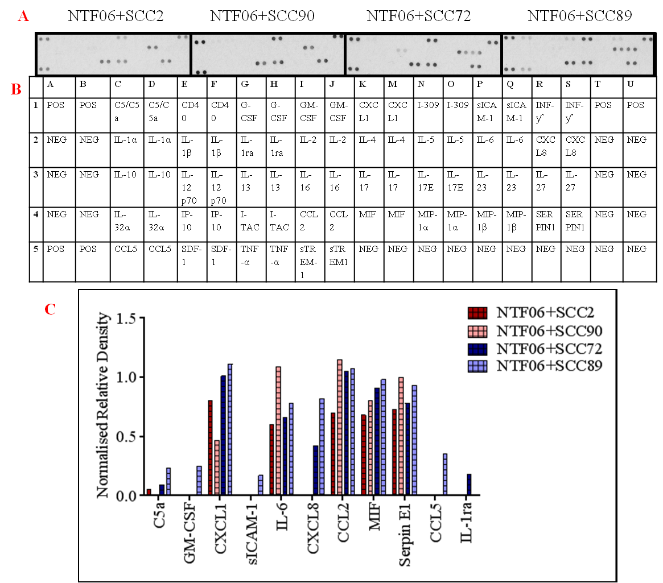
Figure 4.1. Human cytokines arrays of the conditioned medium from NTF06 cultured with the medium from HPV-positive or HPV-negative OPC cell lines. NTF06 cultured with conditioned media from HPV-positive/-negative OPC, for 24 hours showing the difference in the levels of cytokines secreted from stimulated NTF (A) Cytokine arrays were probed with conditioned medium generated from NTF06 incubated with SCC2 or SCC90 (HPV-positive) and SCC72 or SCC89 (HPV-negative). (B) Table showing the arrangement of cytokine antibodies spotted on the nitrocellulose membrane. (C) Bar chart showing the densitometry analysis where immunoblots were scanned and the density of the spots normalised to the intensity of the positive control spots after subtraction of negative control background to allow for comparisons. Abbreviations POS=Positive control, NEG=Negative control (White background).

Although the cytokine arrays data from single biological repeat provides an idea about the levels of a spectrum of cytokines released by HPV-positive/HPV-negative cancer cell-stromal NTF interaction, it did not reveal a complete picture of the leukocyte chemoattractant capacity. For this reason, a more comprehensive analysis of chemokines released by this interaction was examined using a human chemokine array that profiled 38 chemokines (figure 4.2).
Chemokine protein arrays profiling showed that the conditioned media from the HPV-negative OPC cell lines SCC72 and SCC89 generally induced a robust and marked increase in overall chemokine secretion by stimulated NTF06 compared to SCC2 and SCC90 HPV-positive cell lines. Semi-quantitative densitometric analysis showed abundant secretion of a broad spectrum of CXC, CX3CL and CCL chemokines with elevated secretion for HPV-negative-stimulated NTF06 compared to HPV-positive-stimulated NTF06. For example, it was observed that HPV-negative stimulated-NFT06 expressed almost double the level of chemokines XCL1, CX3CL1, CXCL5, -7, -9, -10, -11, -12, -13, -16, CCL7, -13, -15, -16, -17, -18, -22, -23, -24, -25, -26, and -28 than their HPV-positive counterparts
Some chemokines appeared to be expressed at equal levels by all OPC cell lines (CXCL1, CCL2, and GRO), whilst others were either very lowly expressed or not observed at all on the immunoblots (CCL1, CCL15, CCL19, CCL20, and CCL28) suggesting that these chemokines are not secreted. Overall, particularly large increases for neutrophil-specific (CXCL1, -5, -6, -8), monocyte-specific (CCL2, -7, -8) and T-lymphocyte-specific (CCL3, -4, -5) chemokines were observed for NTF-stimulated with HPV-negative compared to HPV-positive conditioned medium.
The chemokine array data from two biological repeats provides an interesting insight into chemokine burden induced by HPV-positive/HPV-negative OPC cells and with the possibility that this is mediated by interaction with stromal fibroblasts. However, there are inherent limitations with this data: it does not reveal the cell origin of chemokine production (OPC cell line alone, NTF alone or a combination of the two). In addition, some variations in the cytokine arrays and the chemokine arrays were noted, in particular for CXCL8 that was absent for HPV-positive OPC/NTF06 interactions in the cytokine array but expression was equal between HPV-positive and HPV-negative OPC/NTF06 interactions in the chemokine arrays (figure 4.1 and 4.2). A similar observation was seen for CCL2. This is likely because the arrays were purchased from different companies and use different antibodies with different affinities to capture CXCL8, giving different results. Moreover, the data is only semi-quantitative, based on relative densitometry, and so does not provide any quantitative levels of chemokines released.
Therefore the following sections will examine factors released by either OPC cells, NTF or a combination of both using more quantitative techniques (ELISA). In addition, quantitative polymerase chain reaction (qPCR), will be used to determine chemokine expression at the gene (mRNA) level or if chemokines are released without de novo mRNA synthesis. Several candidate chemokines for further analysis were chosen from the chemokine array data. These chemokines included: CXCL8, CXCL5, CXCL1 and MIF (mainly neutrophil attractants), CCL2 and CCL7 (mainly monocyte attractants), CCL5, CX3CL and CXCL12 (mainly T cell attractants) and CXCL16 (generally T cell and NK cells).

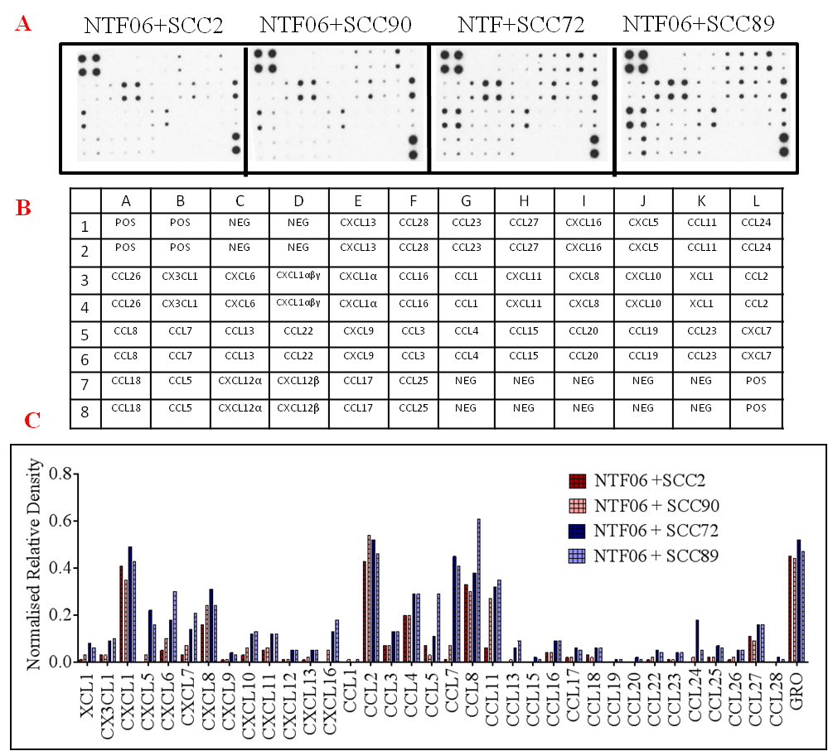
Figure 4.2. Human chemokine arrays of the conditioned medium from NTF06 cultured with the medium from HPV-positive or HPV-negative OPC cell lines. (A) Chemokine arrays probed with conditioned media from NTF06 incubated with the conditioned medium from SCC2 and SCC90 (HPV-positive) or SCC72 and SCC89 (HPV-negative) for 24 hours. (B) Table showing the arrangement of chemokine antibodies spotted on the nitrocellulose membrane. (C) Bar chart showing the densitometry analysis where immunoblots were scanned and the density of the spots normalised to the intensity of the positive control spots after subtraction of negative control background to allow for comparisons. Abbreviations: POS=Positive control, NEG=Negative control (White background)....................................................................................................................................

Chemokine gene expression by HPV-positive/HPV-negative cell lines.
Chemokine gene expressions by HPV-positive and HPV-negative OPC cell lines were investigated to determine if levels of chemokines found in the conditioned medium was due to expression by cancer cells. In order to increase robustness of the data the cell line panel was increased to include SCC152 (HPV-positive) and FaDu (HPV-negative) cancer cell lines. For qPCR analysis the gene β2-microglobulin was used as an endogenous reference control and gene expression relative to β2-microglobulin calculated.
Expression of genes encoding the neutrophil specific chemoattractant, CXCL8 was significantly increased (P<0.05) in HPV-negative as compared to HPV-positive OPC cell lines (figure 4.3 A). The gene encoding CXCL1 was expressed at low levels by all cells, however, it was statistically significant increase in FaDu when compared with the HPV-positive OPC cells (figure 4.3 B). Transcript levels of CXCL5 were also generally very low across all cell lines although significantly greater (p=0.0301) expression was observed for HPV-negative SCC72 compared to SCC2 HPV-positive cells (figure 4.3 C).
Genes encoding the monocyte specific chemokines CCL2 and CCL7 showed similar low transcript values. HPV-negative SCC72 demonstrated significantly higher expression than SCC2, SCC90 and SCC152 HPV-negative cells (p=0.0130, 0.0038 and 0.0123 respectively). For CCL7 HPV-positive SCC152 showed significantly greater expression than HPV-negative SCC89 (p=0.0044) and FaDu (p=0.0039) cancer cells (figure 4.3 D-E).
Genes encoding the T cell chemokines CCL5 and CX3CL1 were also investigated. Once again overall transcript levels were low, however, the gene encoding CCL5 showed significant (p<0.0001) increased expression in HPV-positive SCC2 cells compared with HPV-negative SCC72 and SCC89 cells; whereas, HPV-negative SCC89 showed significantly (p=0.0281) higher expression than HPV-positive SCC90. In addition, FaDu expressed significantly more CCL5 than HPV-positive SCC90 and SCC152 (p<0.0001). CX3CL1 gene expression was significantly (p<0.0001) increased compared to HPV-positive SCC72 only (figure 4.3 F-G).
CXCL12 transcript levels were low but showed a significant increase with the HPV-positive SCC90 cells compared with HPV-negative SCC89 and FaDu (p=0.001 and 0.0014 respectively (figure 4.3 H). The gene encoding MIF, recently identified as neutrophil chemoattractant, was increased in HPV-positive OPC cells SCC90 and SCC152 compared to HPV-negative cells (p<0.0001), however HPV-negative SCC2 cells showed significantly reduced expression (p=0.0422) compared to SCC72 cells (figure 4.3 I). Finally, expression of CXCL16, a chemokine for T and NK cells displayed a significance increase in expression in HPV-positive SCC152 cells compared with HPV-negative SCC89 cells (p=0.004) and FaDu (p=0.0232) (figure 4.4 J).

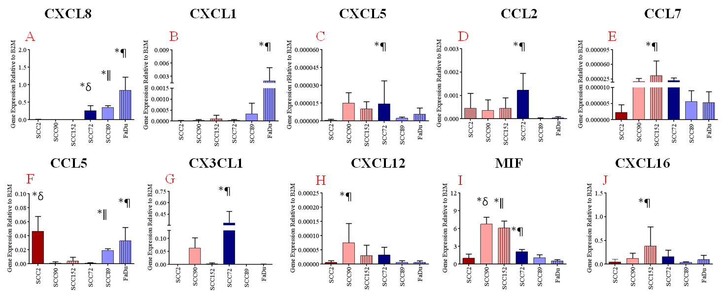

Figure 4.3. Chemokine gene expressions by HPV-positive and HPV-negative OPC cell lines. Cancer cell lines were cultured with the serum-free medium for 24 hour, RNA isolated and gene expression analyzed by qPCR for (A) CXCL8, (B) CXCL1, (C) CXCL5,(D) CCL2, (E) CCL7, (F) CCL5, (G) CX3CL1, (H) CXCL12, (I) MIF and (J) CXCL16. Bar charts are presented as mean ± SD gene expression relative to B2M. Statistical analysis was achieved using a one-way independent ANOVA with Tukey’s post-hoc multiple comparison test. *p<0.05. (A)*δ, *ǁ, and *¶ compared with SCC2, SCC90 and SCC152. (B) *¶ compared with SCC2, SCC90 and SCC152. (C)*¶ compared with SCC2. (D) *¶ compared with SCC2, SCC90 and SCC152. (E) *¶ compared with SCC89, and FaDu. (F)*δ compared with SCC72, and SCC89; *ǁ compared with SCC90; and *¶ compared with SCC90 and SCC152. (G) *¶ compared with SCC2, SCC90 and SCC152. (H) *¶ compared with SCC89, and FaDu. (I) *δ, *ǁ compared with SCC72, SCC89 and FaDu; *¶ compared with SCC2. (J) *¶ compared with SCC89, and FaDu.

Quantitative PCR was next used to examine chemokine gene expression of NTF in response to culture with conditioned medium from HPV-positive or HPV-negative OPC cells. Gene expression in NTF06 cultured with serum-free medium alone was used as a comparative control. Expression of genes encoding the largely neutrophil specific chemoattractants CXCL8, CXCL1 and CXCL5 were dramatically increased in NTF06 by the HPV-negative cell lines as compared to HPV-positive OPC treated NTF06 or NTF06 cells cultured alone (figure 4.4 A-C). The gene encoding CXCL8 displayed a statistically significance increase with SCC89 (p<0.0001) and FaDu (p=0.0185) compared with NTF06 alone, while CXCL1 showed a significant increase (p=0.0242) with SCC89 compared to all other cells.
Similar observations were found for genes encoding the monocyte-specific chemokines CCL2 and CCL7, although induction of CCL2 mRNA was less pronounced between NTF incubated with conditioned media from HPV-negative compared to HPV-positive cancer cells (figure 4.4 D-E). The gene encoding CCL2 showed statistically significant increase in expression in SCC89 (p=0.0011) and FaDu (p=0.0007), while CCL7 showed a significant increase (p=0.0008) with SCC89 as compared with NTF06 alone.
The genes encoding the T cell chemokines CCL5 and CX3CL1 were also increased by HPV-negative conditioned medium but only for SCC89 and FaDu cells (figure 4.4 F-G). However, the gene encoding CCL5 showed a statistically significant increase with SCC89 (p=0.0001) as compared with NTF06 alone. In all cases tested, the level of gene expression was directly related to cell type in terms of the ability to induce chemokine production by NTF06, with SCC89<FaDu<SCC72.
The genes encoding MIF, CXCL12 and CXCL16, showed similar gene expression for NTF stimulated by both HPV-positive and HPV-negative OPC cells (figure 4.4 H-J).
Taken together, the qPCR data suggest that HPV-negative cancer cells secrete factor(s) that induce chemokine gene expressions by NTF06. In addition, these factor(s) are largely absent from HPV-positive conditioned medium. Moreover, the gene expression displayed by the stimulated-fibroblasts were noticeable higher than those displayed by cancer cells alone suggesting that the important interaction as far as gene expression is concerned is between factors released by the cancer cells that affect fibroblast gene chemokine gene expression.

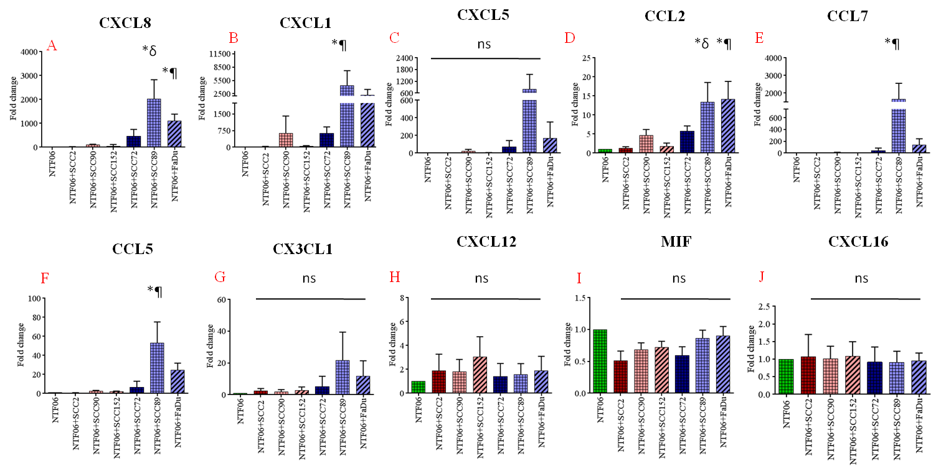
Figure 4.4. Chemokine gene expressions by stimulated-fibroblasts with the conditioned medium from HPV-positive or HPV-negative OPC cell lines. NTF06 were cultured with the conditioned medium from either HPV-positive cells (SCC2, SCC90, SCC152) or HPV-negative cells (SCC72, SCC89, FaDu) for 24 hours or NTF06 cultured alone (control) and gene expression analysed by qPCR for (A) CXCL8, (B) CXCL1, (C) CXCL5, (D) CCL2, (E) CCL7, (F) CCL5, (G) CX3CL1, (H) CXCL12, (I) MIF and (J) CXCL16. Data are presented as mean fold-change in gene expression ± SD compared to NTF06 alone (control) and statistical analysis was achieved using a one-way independent ANOVA with Tukey’s post-hoc multiple comparison test.*p<0.05. (A) *δ, and *¶ compared with NTF06 (non-stimulated fibroblasts), and to stimulated-fibroblasts (NTF06+SCC2), (NTF06+SCC90) and (NTF06+SCC152). (B) *¶ compared with NTF06 and to stimulated-fibroblast (NTF06+SCC2), and (NTF06+SCC2). (D) *δ, and *¶ compared with NTF06 and to stimulated-fibroblast (NTF06+SCC2), and (NTF06+SCC90). (E) *¶ compared with NTF06 and to stimulated-fibroblast (NTF06+SCC2), and (NTF06+SCC152). (F) *¶ compared with NTF06 and to stimulated-fibroblast (NTF06+SCC2), and (NTF06+SCC152). The others were non-significant neither with the NTF06 nor with the HPV-positive.

Chemokine protein production by stimulated-fibroblasts with the conditioned medium from HPV-positive or HPV-negative OPC.
ELISA was used to quantify the levels of chemokines secreted by cancer cells alone, NTF alone or NTF stimulated with the conditioned medium from either HPV-positive or HPV-negative OPC cells. Three chemokines were chosen for this analysis based on their increased abundance in the chemokine array. These were CXCL8 as this is mainly a neutrophil specific chemokine, CCL2 as this is a monocyte specific chemokine and CCL5, a T cell specific chemokine; parameters that also relate to the TMA performed in chapter three.
Both HPV-negative and HPV-positive cancer cell lines and NTF06 alone expressed extremely low levels of all chemokines tested (figure 4.5 A, B, and C). Upon stimulation with conditioned media from HPV-positive cancer cells (SCC2, SCC90, and SCC152) the amount of chemokine CXCL8 (figure 4.5 A) in the conditioned media was increased significantly (p<0.0001) with a mean ± SEM of 7965 ± 186.5, 5021 ± 927.4 and 6918 ± 291.2 pg/ml respectively, compared to NTF06 alone. In contrast, incubation of NTF06 with conditioned medium derived from HPV-negative (SCC72, SCC89 and FaDu) cancer cells significantly (p<0.0001) increased the amount of CXCL8 with a mean concentration of 9161 ± 327.8, 48176 ± 843.9 and 17453 ± 2817 pg/ml respectively, compared to NTF06.
Upon stimulation with conditioned medium from HPV-positive cancer cells (SCC2, SCC90, and SCC152) the amount of CCL2 (figure 4.5 B) in the conditioned media was increased 2426 ± 34, 4321 ± 133 and 7126 ± 302.8 pg/ml respectively. However, this was only significant (p<0.0195) for SCC152 compared to NTF06 alone. In the other counter group, incubation of NTF06 with conditioned media derived from HPV-negative (SCC72, SCC89 and FaDu) cancer cells significantly (p<0.0001) increased the amount of CCL2 with an average of 25598 ± 1629, 28334 ± 1927 and 45664 ± 4018 pg/ml respectively, compared to NTF06.
Stimulation of NTF with conditioned media from HPV-positive cancer cells (SCC2, SCC90, and SCC152) the amount of chemokine CCL5 (figure 4.5 C) in the conditioned media was non-significantly stimulated with an average of 3.562 ± 0.18, 28.4 ± 0.3 and 46.9 ± 0.97 pg/ml respectively, compared to NTF06 alone. In contrast, incubation of NTF06 with conditioned medium derived from HPV-negative (SCC72, SCC89 and FaDu) cancer cells significantly (p<0.0004 with FaDu) increased the amount of CCL5 with an average of 3470 ± 805.8, 4803 ± 818.5 and 2276 ± 117 pg/ml respectively, compared to NTF06.
In summary, the qPCR and ELISA chemokine protein secretion data showed that the conditioned media from the HPV-negative cell lines SCC72, SCC89 and FaDu induced a robust and marked increase in CXCL8, CCL2 and CCL5 chemokine gene and protein secretion by NTF06. In contrast, generally, the conditioned medium from SCC2, SCC90 and SCC152 HPV-positive cell lines induced significantly less chemokine gene expression and secretion. Taken together, these data suggest that HPV-negative cancer cells secrete factor(s) that induce chemokine gene expression, and in turn protein expression by NTF06. Moreover, these factor(s) are largely absent from HPV-positive conditioned media.

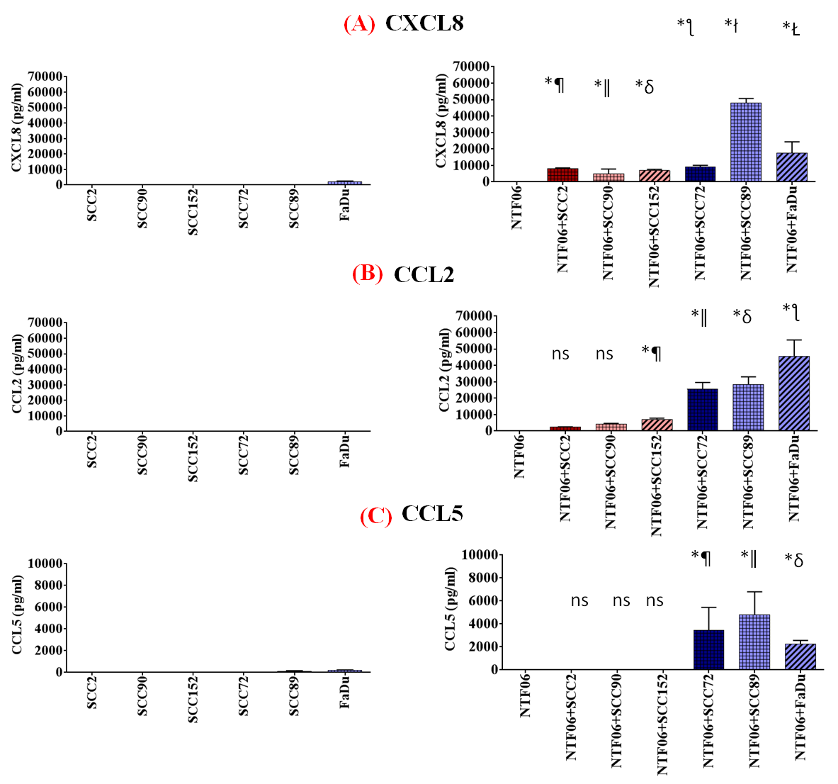
Figure 4.5. CXCL8, CCL2 and CCL5 Chemokine Expression by the HPV-positive/-negative OPC cell lines and by fibroblasts stimulated with the conditioned medium from HPV-positive or HPV-negative OPC cells. HPV-negative conditioned media stimulate markedly increased chemokine release from NTF06 than HPV-positive conditioned media. Chemokine levels were quantified by ELISA in the conditioned media of HPV-positive (SCC2, SCC90, SCC152) or HPV-negative (SCC72, SCC89, FaDu) tumour cells cultured alone for (A) CXCL8 (B) CCL2 (C) CCL5. NTF06 were cultured with the conditioned media produced from either HPV-positive (SCC2, SCC90, SCC152) or HPV-negative (SCC72, SCC89, FaDu) tumour cells for 24 hours and compared to NTF06 cultured alone. Data are presented as mean in chemokine secretion levels ± SD compared to NTF06 alone (control), and statistical analysis was achieved using a one-way independent ANOVA with Tukey’s post-hoc multiple comparison test. *p<0.05. (A) *¶, *ǁ, *δ, *ƪ, *ł, and *Ł compared with NTF06, (non-stimulated fibroblasts), while *ł, and *Ł compared to stimulated-fibroblasts (NTF06+SCC2), (NTF06+SCC90) and (NTF06+SCC152). (B) *¶, *ǁ, *δ, and *ƪ, compared with NTF06, while *ǁ, *δ, and *ƪ, compared to stimulate-fibroblasts (NTF06+SCC2), (NTF06+SCC90) and (NTF06+SCC152). (C) *¶, *ǁ, and *δ compared with NTF06, with stimulated fibroblasts (NTF06+SCC2), (NTF06+SCC90) and (NTF06+SCC152).

Chemokine secretion by tonsillar fibroblasts after subsequent removal of HPV-positive or HPV-negative condition media.
This experiment was performed to determine whether the effect from the HPV-positive/HPV-negative condition media was continuous or discontinued following removal of the cancer cell conditioned medium. Stimulated NTF were investigated with the chemokines CXCL8 (most highly expressed based on the qPCR and ELISA findings). Conditioned medium from the OPC cell lines SCC2 and SCC90 (HPV-positive) and SCC72 and SCC89 (HPV-negative) were used to stimulate NTF06 for 24 after which the medium was removed, NTF washed with PBS and then incubated with serum-free media for an additional 24 hours i.e. 48 hours in total.
ELISA data revealed that after 24 hours in the presence of the conditioned medium NTF produced a marked CXCL8 response with significantly (p<0.0001) greater responses observed for the HPV-negative compared to and HPV-positive stimulated NTF as previously shown. Indeed, all but SCC2 cells produced a CXCL8 response by NTF. However, a further 24 hours in culture the CXCL8 response was reduced to baseline levels of the unstimulated NTF (figure 4.6), suggesting that the CXCL8 is not prolonged for more than 24 hours.

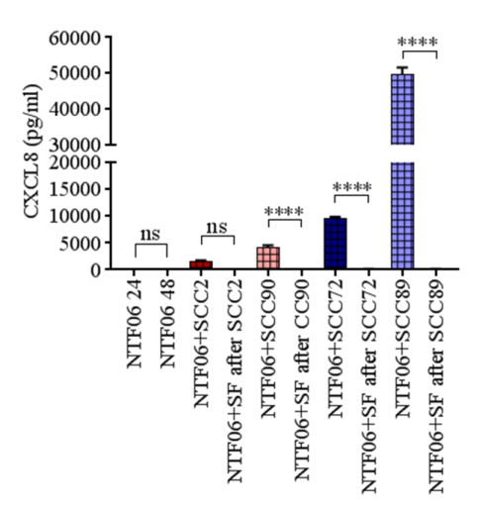
Figure 4.6. CXCL8 chemokine expression by NTF following stimulation with the conditioned medium from HPV-positive or HPV-negative OPC for 24 and 48 hours. CXCL8 release was quantified by ELISA in the conditioned media of stimulated-fibroblasts. NTF06 were cultured with the conditioned medium produced from either HPV-positive (SCC2, SCC90) or HPV-negative (SCC72, SCC89) OPC cells for 24 hours and post-stimulation with serum-free (SF) media incubation for another 24 hours Data are presented as mean ± SD, and statistical analyses were achieved using a one-way independent ANOVA with Tukey’s post-hoc multiple comparison test.

Chemokine protein production by other batches of stimulated-fibroblasts with the conditioned medium from HPV-positive or HPV-negative OPC.
Although the data from chemokine arrays, qPCR and ELISA for the stimulated-fibroblasts gave an idea as to the overall chemokine burden induced by HPV-negative tumour cell/stromal interactions. The reported data was generated only from a single fibroblast (NTF06) culture. Therefore, to ensure that the observed chemokine response was a general phenomenon and not specific to NTF06, fibroblasts (NTFs) from different individuals (NTF01, NTF319, and NFT322; see section 2.2.1.2 for their demographic information) were used in repeat experiments alongside conditioned medium from SCC2 and SCC90 (HPV-positive) as well as SCC72 and SCC89 (HPV-negative) OPC cells.
In general, the response of NTF01, NTF319 and NTF322 to the conditioned medium from both HPV-negative and HPV-positive tumour cells was similar to that observed for NTF06 as seen in figure 4.7. All three NTF batches displayed low chemokine release when unstimulated. Culture with conditioned medium from HPV-positive OPC cells displayed low chemokine content that were largely similar to the levels of unstimulated NTF in all cases. In contrast, conditioned medium from HPV-negative OPC cells induced chemokine secretion with SCC89 being more potent than SCC72 in all cases. Indeed, SCC72 cells produced a low CXCL8 response from all three NTF that was similar to that observed for NTF06. NTF01 appeared to respond less well to SCC72 conditioned medium than did NTF319 and NTF322. Statistical analysis was not carried out on these data because of the limited number of biological repeats.

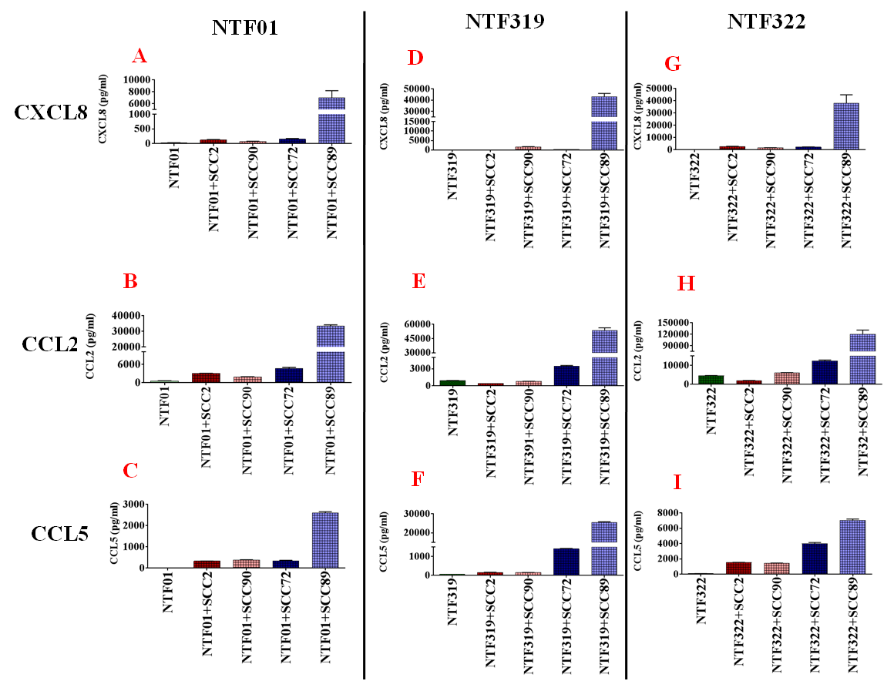
Figure 4.7. CXCL8, CCL2 and CCL5 Chemokine Expression by other batches of NTF in response to the conditioned medium from HPV-positive and HPV-negative OPC cell lines. Chemokine secretion was quantified by ELISA in the conditioned media of NTF (NTF01, NTF319, and NTF322) for the chemokines (CXCL8, CCL2, CCL5). NTF were cultured with the conditioned media produced from either HPV-positive (SCC2, SCC90) or HPV-negative (SCC72, SCC89) tumour cells for 24 hours and compared to NTFs cultured alone. (A-C) Chemokines were produced with conditioned media from NTF01 incubated with OPC conditioned media. (D-F) Chemokines were produced with conditioned media from NTF319 incubated with OPC conditioned media. (G-I) Chemokines were produced with conditioned media from NTF32 incubated with OPC conditioned media.

Discussion
Despite the often late diagnosis of HPV-positive OPC and lymph node involvement, prognosis is significantly better than that of their HPV-negative counterparts (Fakhry et al., 2014). It had been proposed that this improved prognosis may be related to differences in the immune response of these tumours (Spanos et al., 2009). This, by extension, might be related to levels of tumour-infiltrating leukocytes, as some leukocyte populations such as CD8 T cells have been associated with good prognosis whilst TAM have been related to poor prognosis in some HNC. Data from chapter three showed that leukocyte populations were observed in the TME of both HPV-positive and HPV-negative tumours. Moreover, HPV-negative OPC contained significantly more neutrophils than HPV-positive tumours. The data collectively points to leukocytes recruitments.
However, data relating to the nature of leukocyte-recruiting chemokines released from HPV-positive and HPV-negative OPC is lacking. Cells within a tumour do not act alone. The TME involves cellular dialogue in the guise of paracrine interactions between tumour cells and other stromal cells (Coussens and Werb, 2002, Kalluri, 2003) and these interactions appear to be crucial for many aspects of cancer progression (Kalluri and Zeisberg, 2006b). Therefore experiments in this chapter used a 2D in vitro model to examine the HPV-positive versus HPV-negative cancer cells/stromal (fibroblast) interactions, and how such interactions might influence micro-environmental chemokines release, which, by extension will recruit leukocytes.
The cells used in this study were comprised from representative HPV-positive and HPV-negative cell lines (Kawakami et al., 2013, Rieckmann et al., 2013). The initial array data demonstrated that the conditioned media from OPC, when incubated with NTF06 contained increased amounts of chemokines that encompass most of chemokine family members. Moreover, HPV-negative OPC/NTF interactions appeared to contain more abundant chemokines overall than HPV-positive OPC/NTF interactions, suggesting that HPV-status may influence chemokine secretion. The array study was unable to dissect which cell type (tumour cell or fibroblast) was the main producer of the chemokines.
Analysis of tumour cell chemokine expression at the gene level showed that OPC constitutively express a repertoire of chemokines but expression was generally at low transcript levels. A number of previous similar findings had reported that OPC cells express chemokines (Marcus et al., 2004, Partlová et al., 2015, St John et al., 2004). Gene expression of chemokines was slightly increased in HPV-negative to HPV-positive OPC for some chemokines but not others. To the best of our knowledge this is the first study to show differences in constitutive gene expression according to HPV-status in OPC.
Chapter three examined the infiltration of neutrophils, monocytes and lymphocytes in OPC. The initial array data suggested that the key chemokines secreted by OPC/stromal interactions were those likely to recruit neutrophils (CXCL8, CXCL1, and CXCL5), monocytes (CCL2, and CCL7) and T cells (CCL5, CX3CL1 and CXCL12, CXCL16). Therefore, the majority of the experiments performed in this chapter examined the expression of these factors at the gene and protein levels. Other chemokines may be important in other aspects of leukocyte biology but were not examined in this study.
CXCL1,-5 and -8 are all potent neutrophil chemoattractants that act by binding to CXCR1 and CXCR2, receptors expressed on the surface of neutrophils. Acosta and colleagues observed similar findings to the data presented in this study where HPV-negative OPC stimulated tonsillar fibroblasts. They found that stimulated human diploid fibroblasts to up-regulate CXCL8 and CXCL1 in addition to the pro-inflammatory cytokines IL-6 and IL-1β (Acosta et al., 2008). Our findings are also similar to other cancers types where fibroblasts co-cultured with lung cancer cell lines increased expression of CXCL1, -6 and -8 in addition to GM-CSF, CCL5 and VEGF (Rudisch et al., 2015).

CXCL8 is a chemokine secreted by a range of cells, including fibroblasts, keratinocytes and other HNC cell lines (Dumitru et al., 2011, Mascia et al., 2003). CXCL1 is chemokine found to induce neutrophil and endothelial cell chemotaxis and stimulate angiogenesis in a similar manner to CXCL8. Our data showed higher secretion of CXCL1 in the HPV-negative stimulations of fibroblasts. Allen et al. (2007) found CXCL1 was elevated in the sera of OPCs patients'. CXCL1 is associated with poor prognosis and useful biomarkers for treatment response and survival in OPC. Our findings demonstrated higher CXCL5 in HPV-negative stimulation to fibroblasts. CXCL5 is responsible for neutrophil and endothelial attraction (Zhang et al., 2010). In a well-designed study performed by (Miyazaki et al., 2006) they found that up-regulated expressions of CXCL5 chemokines in HNC were associated with tumour metastasis and invasions. Whilst, targeting its pathway lead to better prognosis
CXCL1, -5 and -8 are mostly related to neutrophil attraction, and these chemokines were in great release in the HPV-negative stimulated-fibroblast. In fact, the implications of these data suggests that the HPV-negative attract more neutrophils to the tumour microenvironment in nature, which are in support of our in vivo findings in chapter three and associated with the unfavourable prognostications of HPV-negative as had been illustrated before.
The CCL2 and CCL7 chemokines act as monocytes chemoattractants (Van Damme et al., 1992). The cytokine/chemokine arrays showed higher release of these factors from fibroblasts in response to exposure to HPV-negative cell line conditioned media from SCC72 and SCC89 than the HPV-positive SCC2. Although, the high experimental variability and kit sensitivities might account for the noticed elevated CCL2 expressions in SCC90 HPV-positive cell line in stimulated-fibroblasts. Conversely, the ELISA expression for CCL2 chemokine expressed lesser amount with the SCC90 than the HPV-negative in stimulated-fibroblasts (NTF06) and other fibroblasts batches as well.

There are clear links between the release of monocyte chemoattractants and unfavourable leukocytes populations within the tumour microenvironment. However, the clinical data on the roles of CCL2 and CCL7 chemokines in cancer prognosis are limited with variable suggestions between favourable and unfavourable effects. A study done by Chen et al. (2015) found that increased CCL2 expression was associated with increased tumour invasion and increased levels of pro-inflammatory IL-6, however this study was done in lung cancer cell lines. Concerning CCL7, (Jung et al., 2010), found that co-culture of cancer-associated fibroblasts with broad range of oral cancer cell lines showed that these carcinoma cell lines promoted CCL7 release in addition to other leukocytes-attractants by fibroblasts similar to the findings in this study. Jung et al further suggested that the profound chemokine release was linked with invasive and progressive carcinoma.

The monocyte recruiting chemokines and their role in OPC microenvironment requires a more detailed investigation, since the role of monocytes are different during cancer stages. Along with several cancers in other parts of the body reporting monocyte infiltration had better outcome such as melanoma, stomach and colorectal cancers (Lewis and Pollard, 2006).
CCL5, CX3CL1 and CXCL12 chemokines are mostly known as T cell chemokines. CCL5 is mainly associated with the attraction of T cells and reported to be expressed with the monocyte attractant CCL2 in many cancer types (Soria et al., 2008, Ding et al., 2016, Murdoch et al., 2004). A study done by (Chang et al., 2012) stated that the CCL5/CCR5 axis facilitated the progression in colorectal cancer and apoptosis of effector T cells, whilst CCL5 knockdown abolished the tumour growth in nude mice and decrease the immune suppression. In our findings, CCL5 release was elevated in both HPV-negative cell lines SCC89 and SCC72 in stimulated-fibroblast condition media. As has been discussed for previous factors (chemokines), the significance of CCL5 in HPV-negative is undetermined without further investigations in other cell lines. However, regardless of this limited point, it could be suggested that both HPV-negative (SCC89 and SCC72) cell line conditioned media showed evidence of CCL5 stimulation in fibroblasts more than the HPV-positive.

These findings might imply HPV-negative tumours possibly would contain T cells subpopulations supportive of tumour progression. Further experimentations of our findings would be required to confirm the role of CCL5 in both in vitro and in vivo settings. The chemokines CCL5 underwent further investigation by ELISA for the HPV-positive/HPV-negative cancer cells alone and the stimulated-fibroblasts as well, with an enlarged cell line panel. CX3CL1 and CXCL12 displayed very low expression at the protein and gene level. In a publication by (Marchesi et al., 2010) they stated that the CX3CR1/CX3CL1 axis has role in the tumour progression, increased migration to site of inflammatory dissemination just like the CXCR4/CXCL12 axis in central nervous system cancer. These data support the findings of this study by that these chemokines (CX3CL1 and CXCL12) are associated with increased unfavourable outcome, and might be implicated in part with the poor prognosis in HPV-negative tumours in OPC.

MIF (macrophage inhibitory factor) cytokine arrays data showed elevation in the HPV-negative stimulation. However, this finding should be treated with caution since it is derived from single biological repeat (n=1). Bernhagen et al. (2007) reported MIF as a neutrophil attractant along with the attraction of monocytes and T cells. Dumitru et al. (2011) reported that MIF enhance aggressiveness and metastatic potential of HNC in vitro. Furthermore, the IHC done by Dumitru for biopsy sections from HNC associated with high MIF expression were proportional with the infiltrated neutrophils and linked with lymph nodes metastasis and reduced survival. In conclusion, our cytokine data might indicate that the effects of MIF on neutrophils represent an additional support by which MIF might contribute to HPV-negative poor prognosis. However, our gene expression (n=3) data showed no statistical significance differences in regard to the HPV-status.

CXCL16 up-regulation induces the attraction mainly of T cells as well as other cells like NK, dendritic and plasma cells. In addition, CXCL16 plays a role in the inflammatory process (Vermeulen et al., 2004, Matsumura et al., 2008). Our chemokine data showed that elevated expressions in CXCL16 with the HPV-negative. Wente et al. (2008) outlined that CXCL16 was markedly increased in the sera of an in vivo study and associated with invasive pancreatic cancer nature. These might implicate evidence about the poor prognosis of HPV-negative in HNC according to the protein analysis findings, whilst the gene analysis showed non-significant differences in comparisons to both HPV-types.

Taken together, the array data suggested that the secretion of cytokines and chemokines by stimulated-fibroblasts media was higher in leukocyte-attractant factors in HPV-negative than HPV-positive OPC cells. These biomarkers from the HPV-negative were considered as potential drivers of leukocyte recruitment and by extension may be related to unfavourable prognosis due to the improper immunity in cancer patients. Despite this some chemokines do not directly correlate with the observed recruitments to the tumours microenvironment and as such are still considered as retaining potential to induce leukocytes-attractions in HPV-negative cell lines only, since HPV-positive cell lines demonstrate a comparative down-regulation of the same respective chemokines.

In general, the lack of the available clinical and experimental studies of these novel investigated-biomarkers in HNC and in particular in comparisons between the HPV-positive/HPV-negative tumours made every conclusion carefully derived. As a consequence, these in vitro 2D-model potential findings, concerning leukocytes recruitment, were extensively examined to further validate the data. Furthermore, the cytokines/chemokines constitute a wide range of activities that include angiogenesis (CXCL8) besides recruitment of immune cells to the TME. As such, they have cross-linked recruitment functions e.g. one chemokine may attract many leukocytes subsets at the same time. For example, studies have reported that over expression of CCL2 results in activation of basophils and recruitment of mast cells, (Valent, 1995, Alam et al., 1994), while CCL2 chemokine was regarded mainly as a monocyte attractant. Therefore, we chose the mainly well-known function for each individual cytokine/chemokine.

A crucial limitation of the cytokine array analysis is differences in antibody sensitivity between chemokines where some chemokines may bind with high affinity to the spotted antibodies, quickly saturating the antibody at low concentration, therefore not providing a visual difference at higher concentrations. In addition, densitometry is only semi-quantitative making associations difficult. Therefore, a more quantitative analysis for data using ELISA was required.
The chemokine/cytokines array data gave an explanation by the stimulated-fibroblasts to the specific differences between the HPV-positive/HPV-negative tumours. To further test the hypothesis, gene analysis was carried out to compare between HPV-status at the transcription level. Another two cell lines were added in this qPCR testing which are SCC152 (HPV-positive) and FaDu (HPV-negative).
A range of chemokine genes were chosen, namely CXCL1, CXCL5, and CXCL8 (mainly neutrophils attractants), CCL2, and CCL7 (mainly monocytes attractants), along with, CCL5, CX3CL1, and CXCL12 (mainly T cells attractants) were selected as well as MIF (neutrophils attractants), and CXCL16 (T cells and NK cells). These were identified through cytokine/chemokines array data, for further gene analysis to address the extent of stimulated-fibroblasts gene profile, with the purpose of determining if mRNA expression was increased in the interactions between the cancer cells and the fibroblasts.
Initially, HPV-positive and HPV- negative OPC cell lines were investigated to test the effects of these cell lines on the tumour microenvironment cell to cell communication at the gene level. The gene expression analysis for the cancer cells alone showed that chemokine gene transcriptions values were relatively low. The neutrophil attractant transcripts in HPV-negative cells were higher than in HPV-positive cell lines (only CXCL1 and CXCL8 but not CXCL5). While for the monocyte attractants, the HPV-negative cells were sometimes lower than HPV-positive, with the same trend concerning T cells. It was therefore concluded that for the cancer cells alone, both HPV-positive and HPV-negative, did not retain the potential to recruit leukocytes to the tumour microenvironments without stimulation. Wolff et al. (2011) reported in the analysis of mRNA expression in multiple HNC cancer cells that up-regulation mostly happened upon stimulation by radiation particularly with CCL2, CCL5 and several CXC chemokines (CXCL1-3 and CXCL9-12). They found also some HNC cell lines were not affected with the stimulation.
In connection with the gene analysis, it was shown that OPC cells alone did not express chemoattractant genes able to attract leukocytes according to the mRNA results. While, the stimulated-fibroblasts gene expression analysis showed that HPV-negative conditioned medium was able to activate the transcription of several chemokine-genes, whereas HPV-positive conditioned medium did not.
The gene data of stimulated-NTF by cancer conditioned medium was compared to fibroblasts (NTF) alone as control, and showed clear evidence about the interactions between the cancer cells and the fibroblasts in similar way to the chemokines arrays data. Li et al. (2014) outlined in an in vitro study that there were significant increases at the protein and gene levels for the chemokines CCL2, CCL5 and CXCL8, when cancer-associated fibroblasts underwent stimulation by the oral cancer cell line medium. Moreover, in two publications (Augsten et al., 2009, Muller et al., 2006) found in the prostate and salivary gland cancers respectively that mRNA for CXCL14 and CXCL12 was up regulated due to fibroblast activation in the tumour microenvironment.
According to our qPCR findings, the HPV-negative chemokine genes CXCL1, CXCL5 and CXCL8 (neutrophils), CCL2 and CCL7 (monocytes) and CCL5 and CX3CL1 (T cells) appear to be responsible to stimulate the fibroblasts to provide secretory for leukocytes attractions. The other chemokines genes examined such as MIF, CXCL12 and CXCL16 were comparable between both HPV-types. In the publication by (Jung et al., 2010) which also investigated the dialogue between the CAFs and oral cancer cells, they found over expression of chemokines genes CXCL1, CXCL8, CCL7. In addition, (Lajer et al., 2012) found that HPV-positive OPC had a distinct mRNA expression profile than HPV-negative OPC. Furthermore, they found that HPV-positive OPC holds similarities with the HPV-positive cervical cancers, however, they investigated mRNA transcription in tumour tissue from patient biopsies.

Along with array data findings, the main neutrophil, monocyte and T cell chemoattractants were represented by CXCL8, CCL2, and CCL5 chemokines respectively. Therefore, further quantitative analysis on these proteins by ELISA was performed on conditioned medium. Generally, the quantitative analyses showed that CXCL8, CCL2 and CCL5 chemokines were all secreted at very low levels by cancer cell lines and NTF06 alone. However, secretions were substantially increased when NTF06 were stimulated with the conditioned media from HPV-negative, but not by HPV-positive condition media.
NTF were next explored. Cervical cancer is virtually 100 % caused by HPV. Stone et al. (2014) and here there was high expression of CXCL8 by HPV-positive cervical cancer cells in vivo and in vitro. The finding of this study give implications that CXCL8 drives neutrophil recruitment is consistent to the in vivo and qPCR data to confirm that CXCL8 is expressed in higher amounts in the HPV-negative TME.

The next quantified chemokine by ELISA was CCL2 (monocyte attractant), also showed similar trend to CXCL8 chemokine secretions. Currently, a novel therapeutic for prostate cancer is a neutralizing monoclonal antibody for CCL2, which is in clinical trials (Izhak et al., 2018, Loberg et al., 2007). Moreover, our findings also sustain previous work made by (Li et al., 2014) who co-cultured cancer-associated fibroblasts with oral cancer cell lines which resulted in up-regulation of CCL2 and other neutrophils and T cell chemokines attractants. Moreover, they reported CCL2 up-regulation was associated with more infiltration of monocytes and lymph node metastases in oral squamous cell carcinoma.

The ELISA data demonstrated up-regulation in HPV-negative chemokine expression, despite some variation in the array data concerning the stimulated-fibroblasts expression with SCC90. However, ELISA is more quantitative and sensitive technique (up to 10 pg/ml) than the chemokine and cytokine arrays kits used in this study. In addition, the qPCR transcription data was compatible with the protein quantifications done by ELISA. However, our in vivo cohort showed non-significance difference between the HPV-positive and HPV-negative regarding macrophage infiltration, this notion definitely depending on the cancer cells behaviour and the associated patient variability along with our in vivo sample that involved 59 patients but only six cell lines in vitro. Further investigations concerning the CCL2 chemokine is suggested due its pivotal role in cancer and therapeutic potential for patients with OPC.

While the initial data by ELISA for CXCL8 and CCL2 provided satisfactory evidences for over expression in HPV-negative than HPV-positive, CCL5 provided the same proof by quantitative ELISA results. These verify the hypothesis since these three chemokines are the major players in cellular immune reactions. Soria and Ben-Baruch (2008) reported in breast cancer that over expression of CCL5 was associated with attraction of the pro-tumour leukocytes and inhibited the potential anti-tumour T cells activities in the tumour microenvironment. Moreover, Chuang et al. (2009) found in comparing numerous oral cancer cells, that the highly CCL5 expressing cell lines, chemokines were linked with enhanced migration of oral cancer cells, via increasing metalloproteinase‐9 (MMP‐9) production.

In contrast, the findings of this study could be criticized as CCL5 mainly attracts immune T cells, which might be linked to better prognosis. The elucidation to that is the HNC microenvironment is similar to many other cancers, secreting or expressing not only immunosuppressive factors leading to evasion but also disturbances, apoptosis and even pro-tumour effects by the immune cells. These secreted factors by T cells in HNC was reviewed by (Freiser et al., 2013) and included Galectin-1, FASL,TRAIL and PDL-1. Moreover, indeed it has been shown that HNC can induce the bone marrow to produce an abnormal hematopoiesis, which can influence the whole immune system (Pak et al., 1995, Young et al., 1996, Brakenhoff et al., 1999). These inhibitory factors might give clear images if investigated and compared between the HPV-positive/HPV-negative OPC expressions in the tumour microenvironment.

Potential critical points that probably the HPV-negative conditioned media could quickly stimulate fibroblasts to secrete chemokines in significant levels, particularly CXCL8. This was reviewed by (Zarogoulidis et al., 2014), and confirmed by Orjalo et al. (2009) who suggested that some cancer cells express pro-inflammatory mediators that are responsible for the up-regulation of chemokines that are implicated in leukocytes recruitment. Identification of these factor(s) in the HPV-negative OPC is the main scope of the next chapter.

To sum up, ELISA quantification of CXCL8, CCL2 and CCL5 in the respective media added weight to the hypothesis that these chemokines have potential to recruit leukocytes in HNC. In addition, ELISA permitted more precise quantification than the chemokine arrays findings, particularly that stimulated-fibroblasts were the main source of chemokines. In addition, data verified that the inflammasome of the HPV-negative microenvironment proposed by our 2D-model and ELISA results offered further confirmation to support that HPV-negative recruit more leukocytes. Furthermore, probably the most novel in part for this section, was using normal tonsillar fibroblasts to address the valid-effects by tumour cells, instead of culturing the already stimulated and genetically modified CAF.

Data showed relative absence of CXCL8 chemokine release by the fibroblasts upon removal of the stimulated conditioned media (after 48 hours) from cancer cells, represented by incubating the fibroblasts with serum free media. The CXCL8 chemokine releases reached to about the baseline secretions and comparable to the unstimulated fibroblasts (NTF06) please refer to figure 4.6. This experiment provided satisfactory evidence to support our hypothesis in cancer-stimulated–fibroblast play crucial role in the tumour microenvironments.

This experiment raises two pivotal implications: first, the fibroblast is one of the main players in the tumour microenvironment. Second, upon removal the effects of stimulation presented by tumour cells, which in turn represented by the surgery or by radiotherapy alone (sometimes) in the HPV-positive, the up-regulations of the chemokines expressions could be diminished thereby the attractant leukocytes as well. Conversely, in findings by, (Fujimori et al., 2005) they argued that a number of chemokines, including CXCL8, could be up-regulated post-ionizing radiation, which act as stimulating factors to the normal fibroblasts. However, this publication performed these experiments with normal lung fibroblasts. The immune status after the treatment was out of the scope for this project, and indeed the immune disturbance reactions post chemoradiotherpy is not clearly clarified and about 50 % of the patients as reviewed by Leemans et al. (2018) are suffering from recurrences after about two years, and this suggested further investigations.

The final experimentation of this chapter was using other fibroblasts (NTFs) batches (NTF01, NTF319 and NTF322) in order to show that the inducing fibroblasts phenomenon by cancer cells were not particular to one batch of NTF. Once more, our data succeed to display evidence that the phenomena were repeated across several different NTFs from different donors, except there were slight variations because the NTFs are different and thus respond differently. The main implication is that the overall effect is reproducible.

Despite the interesting findings, there were several limited points that must be borne in mind, mostly related to technology. This is an in vitro 2D-model culture and so does not represent in vivo findings since the cells did not take their topographic morphologies. Besides this, the fast proliferation of the immortalized cancer cells, raises the potential of phenotype drifting. Moreover, despite our cell line panel including six cancer cells with four batches of fibroblasts from different individuals, the findings presented herein are solely for these cells and might not be readily generalized. The chemokine/cytokine densitometry data provided considerable insight for important biological factors, and the probable tumour microenvironment nature in both HPV-types HNCs. However, they lack the sensitivities to some extent and the obtained data were semi-quantified. A further limitation is that the chemokine arrays are relatively high cost, and so triplicate biological repeats were unfeasible for this large amount of samples demonstrated in this chapter. It was done in duplicate, and duplicates spots are provided in each single membrane and high concordance were observed in spots within the arrays.

However, there are still difficulties to find 100 % HPV-representative tumour cells. Since the HPV-positive tumours cell lines had been extracted and immortalized from tumours with combined aetiology, i.e. the patients were known smoker or drinker. Ang et al. (2010) suggested in their findings that cancers with mixed aetiology hold an intermediate prognosis to that seen in HPV-positive/HPV-negative tumours. Despite, our findings in the previous chapter (chapter three) showed non-significances differences between HPV-positive/HPV-negative in relation to smoking status. Therefore, caution should be taken not to over-interpret the cell-culture observations related to these tumours cell lines, since they might not fully represent HPV-positive HNCs. However, no reported literature of HPV-positive HNCs for established cell line extracted from non-smoker patients, despite many attempts which have resulted in cell culture failure. This might reflect, in part, the less aggressive nature of HPV-positive tumours. Therefore, these obtained tumour cell lines offer in vitro pragmatic approach for comparisons between HPV-positive/-negative cancers.
In summary, these findings confirm the pivotal role of fibroblasts in the tumour microenvironment and their critical interaction with cancer cells in influencing the nature of the TME. In addition, to the stimulations were extended to the gene level in most of the investigated-transcripts that encoding the chemokine-genes. Some factors were in up-regulated expressions in both HPV-types. Moreover, these high secretory patterns were abolished from the fibroblasts upon removal of the stimulating condition media (supernatants) from the cancer cell lines, reconfirming the fibroblast-crosstalk-tumour cells. Furthermore, our data of stimulated-fibroblasts were mirrored in other fibroblasts batches (different donor) stimulations.

These findings stimulated investigation of the stimulating factor(s) expressed by HPV-negative OPC cells that instruct the fibroblasts (NTF) to secrete chemokines. Experiments on this inducing factor will be the scope of the next chapter.

Chapter five: Chemokines up-regulation in HPV-negative OPC is mediated by the IL-1/IL-1R axis, a 2D in vitro model study.

Introduction
The tumour microenvironment is a complicated network of cellular interactions of which immune responses form a part. Inflammatory bioactive factors derived either from the cancer or stromal cells help to orchestrate this intricate environment (Diakos et al., 2014). Although acute inflammation is known as a localised defensive response of normal tissue against infection or injuries, chronic inflammation can promote cancer in tissues including HNC (Aggarwal et al., 2006, Boccardo et al., 2010). Numerous pro-inflammatory factors have been identified in the tumour microenvironment and these most likely aid tumour progression once the tumour is established. These factors include TNF (tumour necrosis factor) and interleukins such as IL-1. These are stimulated in a complex signalling pathway and induced by carcinogens including smoke, alcohol and viral proteins such as HPV.
Considerable data indicate that cancers not only depend on genetic aberrations, but also on an inflammatory microenvironment that can promote tumour development, invasion and metastasis (Guo et al., 2016, Mantovani et al., 2008). The inflammatory mediators are derived from cells at the site of disease (Kumar et al., 2014). Of particular attention is IL-1, a pleiotropic cytokine with many functions in both physiological and pathological conditions (Lewis et al., 2006).
IL-1 has numerous roles as a pro-inflammatory cytokine and is largely implicated in inflammation, hematopoietic processes and immune regulation. Cancer cells such as prostate, breast, colon, lung, melanomas and HNC have been shown to express IL-1, where its expression is generally associated with poor prognosis (Guo et al., 2016). Evidences from lung cancer and melanoma indicate that tumour-derived IL-1 encourages the recruitment of myeloid cells such as macrophages and neutrophils by acting on fibroblasts and increasing the vascular permeability in the tumour microenvironment (Yoshino et al., 2006, Elaraj et al., 2006). The pro-inflammatory cytokine effects of IL-1 can be antagonised. For example IL-1 exerts its action by binding to IL-1R and Anakinra (Kineret) is a competitive IL-1R antagonist that binds to IL-1R. Anakinra is a licensed medication used mainly to treat rheumatoid arthritis that shows limited side effects and was not associated with vulnerability for opportunistic infections in more than 250,000 patients (Morton et al., 2014, Kuemmerle‐Deschner et al., 2011).
Data in the previous chapter showed that a factor in the conditioned medium of HPV-negative OPC cells stimulated NTF to secrete a plethora of chemokines. It is well known that pro-inflammatory cytokines such as IL-1 can stimulate the release of chemokines from fibroblasts (Jung et al., 2010). For these reasons it was postulated that the conditioned medium from HPV-negative OPC cells contained a pro-inflammatory factor driving chemokine secretion. The experiments performed in this chapter aimed to identify this pro-inflammatory factor and determine its molecular interaction with tonsillar fibroblasts.

Hypothesis
The conditioned medium of HPV-negative OPC cells contain a pro-inflammatory factor(s) that stimulates fibroblasts to secrete chemokines by interacting with a fibroblast receptor. That may give explanation to the additional chemokines expressions by the stimulated-fibroblasts.

Aims
- Use of in vitro 2D-monolayer cultures to identify the potential factor(s) responsible for the secretion of chemokines by NTF observed in particular with HPV-negative cell lines in the previous chapter.
- Using an antagonist to obstruct the stimulating axis, that will hypothetically inhibit the release of chemokine secretion.

Methods
A panel of HPV-positive and HPV-negative cancer cell lines were tested by qPCR (sections 2.2.3.1.), and ELISA (sections 2.2.4.2.) for expression of pro-inflammatory cytokines. Expression of receptors on fibroblasts was assessed using Western blotting (sections 2.2.9.2.), and by immunofluorescence staining followed by confocal microscopy (sections 2.2.9.1.). The fibroblasts were cultured in 6-well plates and their numbers optimized according to our 2D-model in chapter four. The cytotoxic effects of Anakinra were tested using MTT assay as described in (sections 2.2.8.). Chemokines secreted by stimulated-fibroblasts (pre-incubated with Anakinra) were measured by ELISA (section 2.2.4.2. and 2.2.7.1.). Transfection (silencing) for the IL-1R1 in fibroblasts were done as previously described in (sections 2.2.10.).

Results

IL-1α/β expression is greater in HPV-negative compared to HPV-positive OPC cell lines.
The findings of the previous chapter prompted the examination of pro-inflammatory cytokine expression by HPV-positive and HPV-negative OPC cell lines because chemokine gene expression by fibroblasts are predominantly induced by pro-inflammatory biologically active factors, usually through activation of mitogen-activated protein kinase (MAPK) and nuclear factor kappa-light-chain-enhancer of activated B cells (NF-κB) signalling pathways (Hoesel and Schmid, 2013).
Initially, tumour necrosis factor-α (TNFα) protein levels in the OPC conditioned medium were examined by ELISA. However, neither HPV-positive nor HPV-negative cells secreted TNFα (data not shown). Next, levels of IL-1α and IL-1β were examined. IL-1α was detected in the conditioned medium of all cell lines tested but the cytokine was present in significantly greater amounts in HPV-negative than HPV-positive cell lines with the exception of SCC72 cells (figure 5.1 A). Expression in SCC89 cells was very significant (p<0.0001) when compared with all the other HPV-positive cells, whilst FaDu was less so (p=0.03 and p=0.02 with SCC90 and SCC152 respectively). Interestingly, IL-1β could not be detected in the conditioned medium of any OPC cell lines by ELISA (figure 5.1 B).
Next, gene expression of IL-1α and IL-1β by both HPV-positive and HPV-negative OPC cell lines was examined. IL-1α gene transcripts were detected in all cell lines with the exception of SCC2 cells. Gene expression was significantly elevated in the HPV-negative lines SCC89 and FaDu (4- and 3-fold, respectively) compared to all HPV-positive cell lines (p<0.01); a trend that was similar for protein expression by these cells (figure 5.1 C). In contrast to the ELISA data, abundant gene expression of IL-1β was detected but only in HPV-negative OPC cell lines with highly significant increases observed in with SCC89 and FaDu cell lines (p<0.0001) (figure 5.1 D).
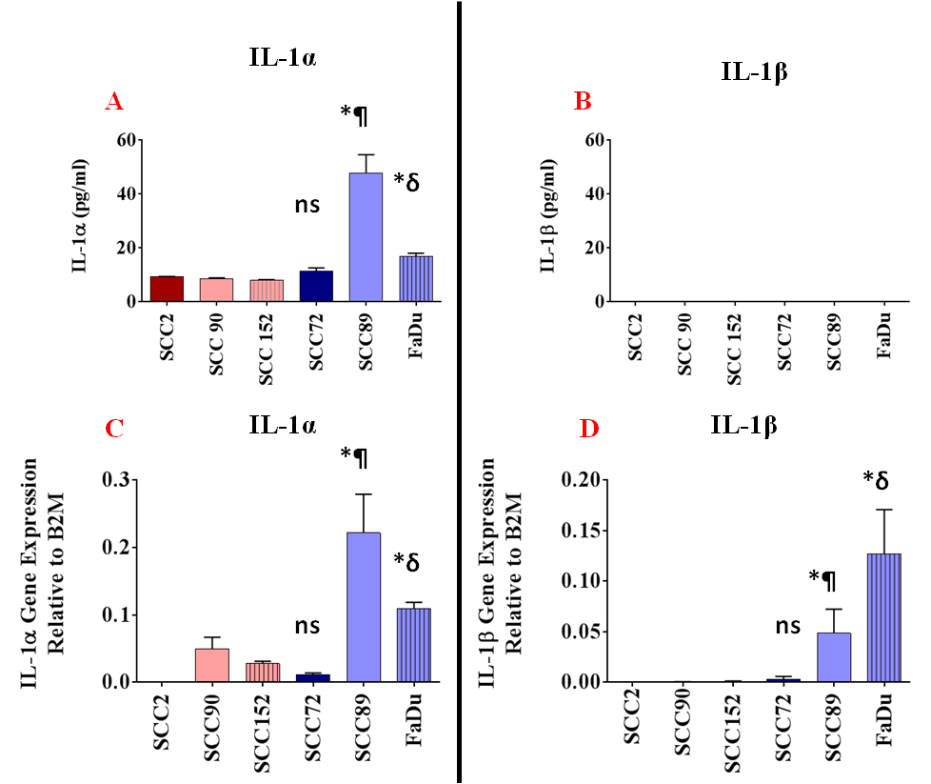
Figure 5.1. HPV-negative OPC cell lines express more IL-1α and IL-1β than HPV-positive cells. Levels of (A) IL-1α protein expression or (B) IL-1β protein expression in OPC conditioned medium (C) Gene expression of IL-1α and (D) Gene expression of IL-1β in HPV-positive (SCC2, SCC90, SCC152) or HPV-negative (SCC72, SCC89, FaDu) tumour cells. Cytokine levels were quantified by ELISA, while mRNA transcript levels were quantified by qPCR. Expression of IL-1α and IL-1β was normalized to the internal reference control gene, β2-microglobulin to provide measures of relative expression for each cell line. Statistical analysis was achieved using a one-way independent ANOVA with Tukey’s post-hoc multiple comparison test.*At least p<0.05. *¶, and *δ compared with SCC2, SCC90 and SCC152.

SCC89 conditioned medium stimulates a time-dependant increase in CXCL8 secretion by NTF.
To test if the conditioned medium for OPC HPV-negative cells induces chemokine secretion over time, NTF06 were incubated with conditioned medium from SCC89 cells (as previous data showed these cells to induce the most potent chemokine response). In addition to CXCL8 released examined over time (1, 4, 8 and 24 hours). Conditioned media collected from unstimulated NTF06 were used as a negative control whilst NTF06 incubated with recombinant IL-1β (high specific binding to IL-1R) was used as a positive control and CXCL8 release by NTF quantified by ELISA as shown in (figure 5.2). CXCL8 was measured because this chemokine was significantly increased by HPV-negative conditioned medium as shown in chapter four. Secretion of CXCL8 by NTF06 increased in a time-dependent manner for both recombinant IL-1β and the conditioned medium from SCC89 OPC cell line. NTF06 alone showed average CXCL8 levels of 22 ± 1, 23 ± 3, 132 ± 5, and 150 ± 16 pg/ml for 1, 4, 8 and 24 hours respectively), in contrast stimulated-NTF06 with SCC89 conditioned medium showed significant (at least p<0.05) increased secretion of CXCL8 at all time points tested (186 ± 6, 9316 ± 261, 16024 ± 481 and 22217 ± 214 pg/ml). In addition, stimulation with recombinant IL-1β increased CXCL8 expression further (243 ± 3, 19640 ± 1078, 29055 ± 2159 and 107914 ± 5444 pg/ml for 1, 4, 8 and 24 hours respectively). These data indicate that a pro-inflammatory factor within the SCC89 conditioned medium may increase chemokine secretion by NTF06 over time. Time-dependant assay for the stimulated fibroblasts was performed with a time point used according to the IL-1R antagonist (Anakinra) drug mean half-life, which is 4-6 hours.

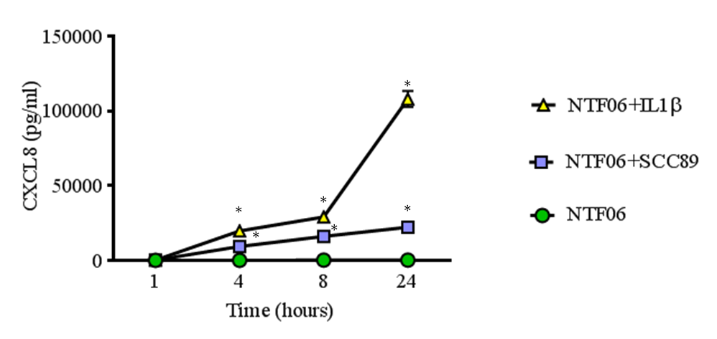
Figure 5.2. SCC89 HPV-negative conditioned medium or recombinant IL-1β stimulates increased CXCL8 secretion by NTF06 in a time-dependent manner. NTF06 were either cultured alone as control, stimulated with the conditioned medium from SCC89 cells or stimulated with 5ng/ml IL-1β. The NTF06 conditioned media was analysed for secretion of CXCL8 after 1, 4, 8 and 24 hours by ELISA. Data are presented as mean ± SD; statistical analysis was achieved using a one-way independent ANOVA with Tukey’s post-hoc multiple comparison test. * p<0.05 compared to unstimulated NTF (NTF06).

NTF express IL-1R1
Both isoforms of IL-1α and IL-1β potentiate their pro-inflammatory actions by binding to IL-1R1 expressed by target cells (Ghiringhelli et al., 2009, Mayer-Barber et al., 2011). Since HPV-negative cells express abundant IL-1 then it is plausible that this cytokine may be responsible for stimulating NTF if these cells express IL-1R. Expression of IL-1R1, the main receptor for IL-1 binding, was firstly analysed by Western blotting. However, this technique did not detect IL-1R1 despite many trials with different concentrations and various methods of protein harvesting (figure 5.3).

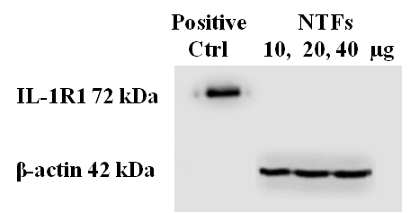
Figure 5.3. Western blotting analysis for IL-1R1 by NTF. The IL-1R1 protein expression in NTF could not be detected by Western blotting. The experiments were done by loading 10 µg, 20 µg, and 40µg of total protein extract. Recombinant IL-1R1 was used as positive control. Anti-β-actin was used as a loading control. Abbreviations: Control (Ctrl), kilo Dalton (kDa).

It is possible that IL-1R is expressed on the cell surface at low levels and that Western blotting using largely the cellular fraction is not a sensitive enough technique to detect plasma membrane expression of IL-1R. Therefore, expression of IL-1R1 was analysed by confocal images on 4 different batches of NTFs from different donors using a sensitive immunofluorescence antibody streptavidin-biotin triple labelling technique. Confocal immunofluorescence microscopy analysis showed punctate expression of IL-1R by NTF, providing evidence of both cell surface and intracellular receptor expression (figure 5.4). In these staining assays expression of HLA class I, a cell surface receptor expressed by all nucleated cells was used as a positive control and this showed abundant expressed on NTF, whilst IgG was used as an isotype antibody control and this showed negligible background staining, suggesting that staining using the IL-1R1 antibody was specific. Some variations were observed in IL-1R1 staining amongst the different batches of NTF from different donors, suggesting that expression varies from individual to individual. In addition to protein analysis of IL-1R1, mRNA transcripts were detected in NTF06 by qPCR (figure 5.8)
In summary, the data so far show that OPC cells, in particular HPV-negative cell lines, express abundant IL-1, while NTF express IL-R1, the receptor for IL-1. In addition, the conditioned medium from SCC89 HPV-negative cells induced secretion of CXCL8 by NTF in a time-dependent manner. These data indicate potential effects of this axis (IL-1/IL-1R) might be behind the stimulation of NTF in the tumour microenvironment.

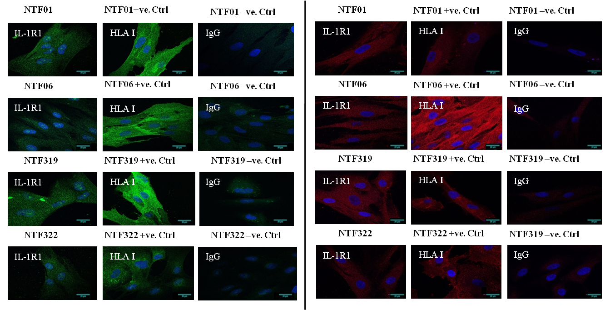
Figure 5.4. Immunofluorescent images showing the expression of IL-1R1 by NTF. NTF were fixed and permeabilised and stained with monoclonal antibodies for IL-1R1, HLA class I (positive control) or IgG (negative control) as shown in the green and red images on both sides, DAPI was used to counterstain the nuclei (blue). Images were visualized by confocal microscopy. NTF01, NTF06, NTF319, and NTF322 displayed cell surface and intracellular IL-1R1 expression. Scale bar 20 µm...........................................................................................................................................

The IL-1R antagonist (Anakinra) is not cytotoxic to NTF
The data thus far suggest a link between IL-1 in the conditioned medium of HPV-negative OPC cells and IL-1R expressed by NTF. To explore a causative relationship of the specific IL-1R antagonist, Anakinra was used to block the IL-1R on NTF. However, before testing the blocking activities of the drug it is important to investigate whether Anakinra is toxic toward NTF and at what concentration levels. Therefore, NTFs were incubated with increasing concentrations of Anakinra from 0.1 to 500 µg/ml. This range of doses were chosen according to the clinically recommended dose of Anakinra 1 mg/kg/day which is equivalent to 1 µg/ml (Holen et al., 2016). Toxicity was measured using an MTT assay, a marker of cell metabolism and a surrogate marker of cell viability.
The MTT cytotoxicity assay confirmed that Anakinra was not toxic to NTF06, even up to a concentration of 500 μg/ml (figure 5.5). The statistical analysis showed no significant effects on cell viability with any Anakinra-treated NTF06 (0.1 -500 μg/ml) compared to untreated NTF06. In contrast, use of formalin to fix and therefore kill the NTF06 showed a significant difference in cell viability compared to Anakinra-treated and untreated NTF06 (p<0.0001) showing that the assay had worked.

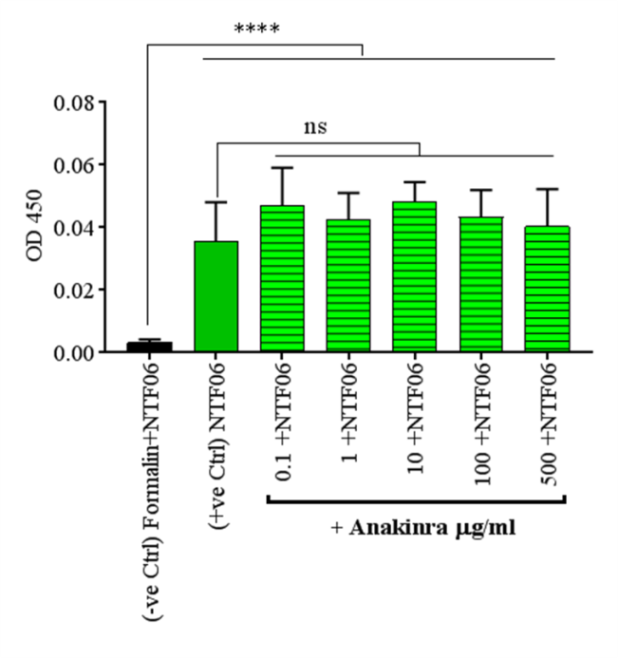
Figure 5.5. Anakinra showed no toxicity in NTF06. NTF06 were incubated with increasing concentrations of Anakinra and viability measured by MTT assay. Formalin-fixed (killed) cells were used as a negative control and NTF06 alone without Anakinra used as a positive control. All the Anakinra incubated-fibroblasts showed no significant difference with untreated NTF06, while all the Anakinra treated NTF06 showed significance difference to the formalin-fixed fibroblasts. Data are presented as mean ± SD statistical analysis achieved using a one-way independent ANOVA with Tukey’s post-hoc multiple comparison test. (* p<0.05). Abbreviation: Control=Ctrl,‘3-(4,5-Dimethylthiazol-2-yl)-2,5-Diphenyltetrazolium Bromide’=(MTT), and Optical Density= (OD).

Anakinra inhibits secretion of chemokines by NTF stimulated with the conditioned medium from SCC89 OPC cells
Anakinra was now used to determine if IL-1 in the HPV-negative OPC conditioned medium was responsible for stimulating the increase in chemokine expression by NTF06 in an IL-1R-dependent mechanism. The highly specific IL-1R antagonist Anakinra has a half-life of 4-6 hours therefore NTF were pre-incubated with Anakinra (1 to 100 μg/ml, concentrations known to be non-toxic) for 2 hours prior to stimulation with conditioned medium from SCC89 HPV-positive OPC cells for 4 hours, a time point previously shown to produce a significant increase in chemokine secretion compared to untreated NTF06 (figure 5.2).
As with previous data, both NTF06 and SCC89, when incubated alone, expressed minimal chemokines, whereas NTF06 incubated with SCC89 conditioned media in the absence of Anakinra were induced to secrete significant levels of CXCL8, CCL2 and CCL5 chemokines (figure 4.5).
Treatment of NTF06 with anakinra significantly (p<0.01) reduced secretion of CXCL8 and CCL2, reducing levels to that of unstimulated NTF06 in an Anakinra dose-dependent manner (figure 5.6 A and B). Interestingly, the pattern of CCL5 expression differed to that of CXCL8 and CCL2. Here, CCL5 was detected in SCC89 media alone, although secretion significantly increased when the media was incubated with NTF06 (p<0.01). Treatment with Anakinra non-significantly reduced CCL5 levels, other than with the concentration 10 µg/ml that showed significance (p=0.02) although not back to baseline, whilst treatment with 100 µg/ml displayed a non-significant decrease (figure 5.6 C). Taken together, these data show that Anakinra and therefore inhibition of IL-1R abrogates secretion of CXCL8 and CCL2 in an IL-1/IL-1R dependent manner.

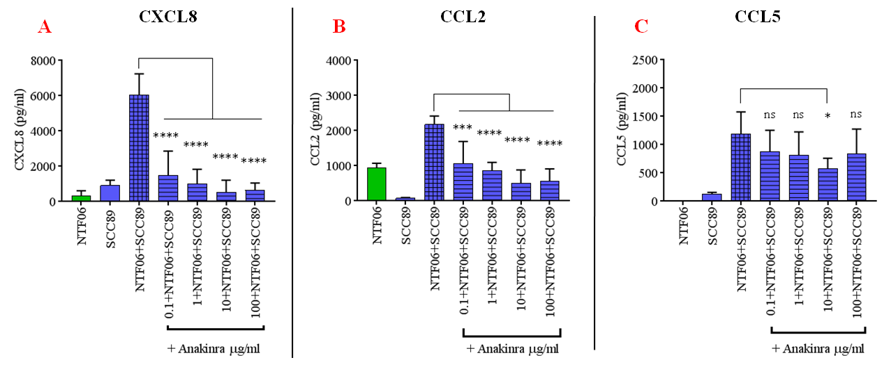
Figure 5.6. Stimulated-fibroblasts (NTF06) chemokine release by HPV-negative conditioned medium is driven by an IL-1/IL-1R1 axis. NTF06 cells were pre-incubated with Anakinra then stimulated with the conditioned media from HPV-negative SCC89 tumour cells and levels of chemokines (A) CXCL8, (B) CCL2 and (C) CCL5. Chemokines levels were quantified in the media by ELISA and compared to levels of these chemokines from stimulated-fibroblasts incubated with the conditioned media from SCC89 cells without treatment (pre-incubation) with Anakinra. The stimulated-fibroblasts pre-incubated with dose-responses increase of IL-1R antagonist (Anakinra) 0.1 µg/ml, 1 µg/ml, 10 µg/ml, and 100µg/ml. In each case chemokine secretion was significantly decreased by pre-incubation with the Anakinra in CXCL8 and CCL2. The statistical analyses were achieved using a one-way independent ANOVA with Tukey’s post-hoc multiple comparison test. * At least p<0.05.

Anakinra inhibits secretion of chemokines by other donor of stimulated-fibroblasts (NTF) with the conditioned medium from SCC89 OPC cells
To determine that this phenomenon was not due to one individual NTF batch, the Anakinra blocking experiment was repeated with other 3 batches of NTFs derived from separate donors (NTF01, NTF319 and NTF322) in the absence or presence of pre-treatment with 10 µg/ml Anakinra, a concentration shown to cause inhibition by NTF06 cells. Then, release of chemokines CXCL8, CCL2 and CCL5 by NTF in response to SCC89 conditioned medium was quantified by ELISA. In addition, these NTFs were stimulated with recombinant IL-1β also in the absence or presence of pre-treatment with 10 µg/ml Anakinra.
In general, the data showed same trend to that observed for NTF06 cells (figure 5.6). Incubation of all batches of NTFs with SCC89 conditioned medium led to a dramatic increase in secretion of CXCL8, CCL2 and CCL5 chemokines. Moreover, in each instance, pre-incubation with Anakinra resulted in a significant reduction of CXCL8 and CCL2 chemokine secretion that was not evident for CCL5 (figure 5.7). In addition, treatment of these NTFs with recombinant IL-1β also induced remarkable chemokine response that was likewise completely inhibited by the IL-1R antagonist. There was a decrease in CCL5 secretion by IL-1β-stimulated NTF when pre-incubated with Anakinra. These experiments were only performed to determine if this phenomenon was reproducible with other NTFs, so statistical analysis was not performed on these data, because of the limited number of biological repeats.

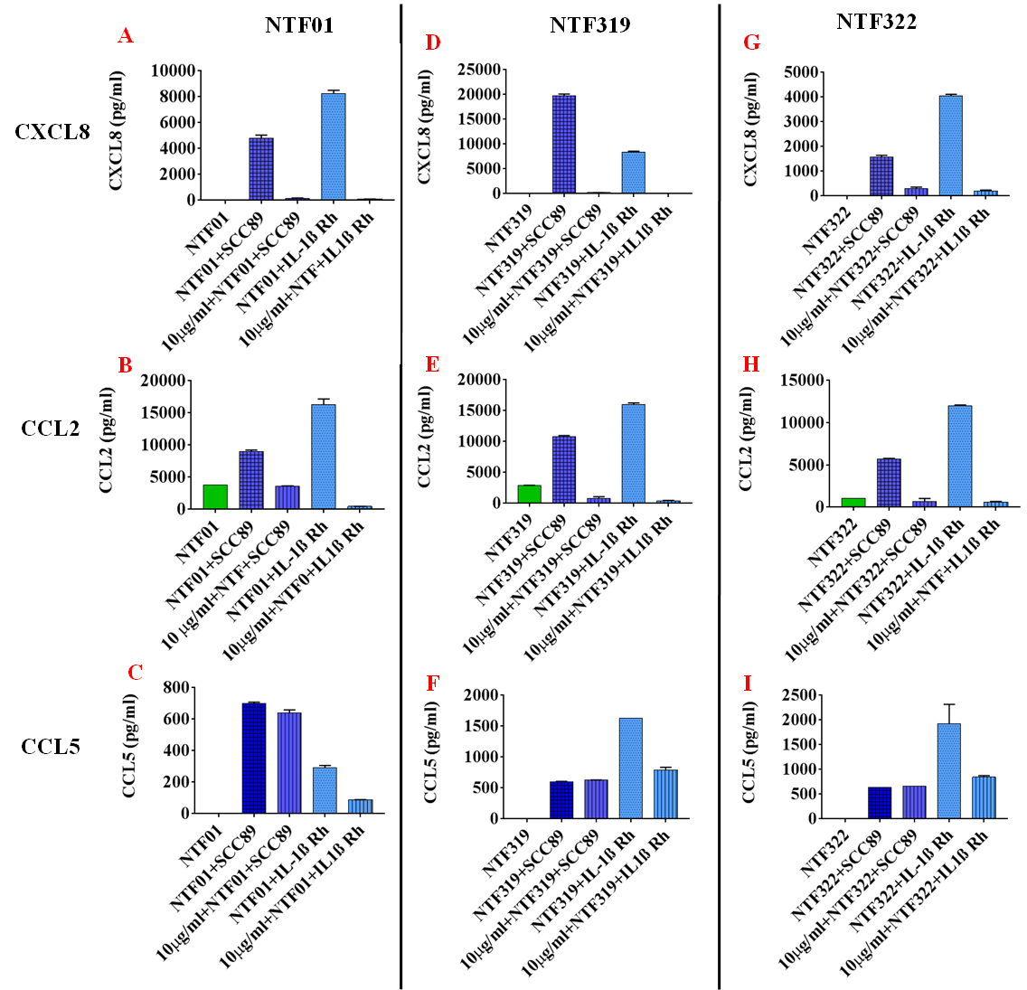
Figure 5.7. Different batches (donors) of NTFs respond in an IL-1R-dependent manner upon stimulation with SCC89 conditioned medium or IL-1β. NTF from different donors (A-C) NTF01, (D-F) NTF319, and (G-I) NTF322 incubated in the absence or presence of 10µg/ml Anakinra and then stimulated with either conditioned medium from SCC89 cells or recombinant IL-1β for 4 hours. Then, the levels of CXCL8, CCL2 and CCL5 were quantified in the conditioned media by ELISA and compared to levels from unstimulated-NTF. Data are from one experiment performed in triplicate.

Reduced expression of IL-1R1 on NTF using siRNA transient transfection inhibits chemokine secretion upon simulation with SCC89 conditioned medium.
Data thus far have used a synthetic inhibitor to block the IL-1R. It could be argued that this inhibitor has off-target effects that cause the reduction in chemokine secretion by NTF rather than by blocking the IL-1R. Therefore, to confirm that the increased chemokine secretion is mediated by the IL-1/IL-1R, expression of the IL-1R1 was inhibited using siRNA technology. Low passage NTF06 were transiently transfected with four siRNA probes specific for IL-1R1 and incubated for 24, 48, and 72 hours in order to determine which probe was most efficient at reducing IL-1R1 expression. The efficiency of IL-1R1 knockdown was evaluated by IL-1R1 specific qPCR primer. All four siRNA probes caused a significant decrease in NTF06 IL-1R1 expression after 24, 48 and 72 hours, in comparison to mock-transfected NTF06 (i.e. NTF incubated with transfection reagents but in the absence of siRNA probe) as shown in (figure 5.8).
According to the qPCR data, the most efficient siRNA probe was number 1, which consistently showed the lowest average decrease in IL-1R1 gene expression (0.003, 0.0038. and 0.006) with statistical significance (p=0.002, p< 0.001, and p< 0.001 respectively). In comparison to control transfected cells at time-points 24, 48, and 72 hours respectively, while the means of the control gene expression were 0.021, 0.023 and 0.06 respectively at these time-points. Consequently, siRNA probe number 1 was used in subsequent experiments. Expression of IL-1R1 was not totally eliminated by siRNA treatment in NTF.

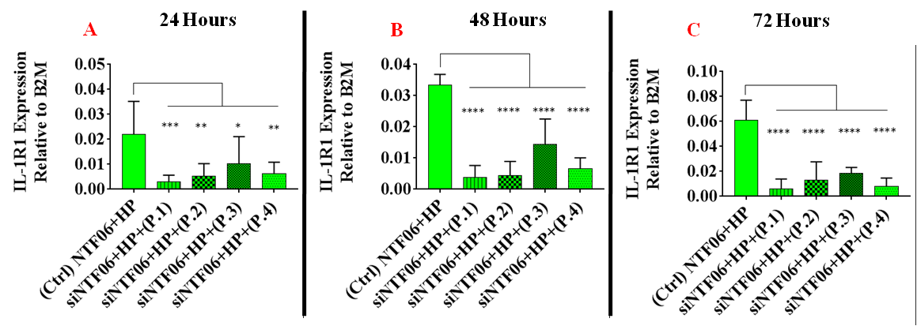
Figure 5.8. IL-1R1 gene expression in IL-1R1 siRNA-transfected NTF. NTF06 were incubated with the Hi-perfect transfection reagent and siRNA probes 1, 2, 3, and 4. Then the gene expression for IL-1R1 was analyzed by qPCR after (A) 24, (B) 48, (C) and 72 hours incubation. Expression of the endogenous control (B2M) was compared for each individual cell with the target expressed gene. The statistical analysis was achieved using each individual transfected fibroblasts (siNTF06) expression compared with, NTF incubated with Hi-perfect alone as mock-transfected control. Data were analysed by one-way independent ANOVA with Tukey’s post-hoc by multiple comparison test. * p<0.05, **p<0.01, ***p<0.001, and ****p<0.0001. Abbreviations: Control= (Ctrl), Probe= (P), transfected fibroblasts= siNTF06, and Hi-perfect transfection agent = (HP).

Next, NTF06 were transiently transfected with siRNA probe number 1 for IL-1R1 and then the NTF06 incubated with the conditioned medium from SCC89 HPV-negative OPC cells and CXCL8 chemokine released by these NTF were quantified using ELISA. NTF06 alone were used as negative controls. In addition, NTF06 alone or mock-transfected NTF06 stimulated with medium from SCC89 were used as further controls. The stimulation with the SCC89 medium was performed for 4 hours to mimic the experiment performed with Anakinra. Once again, NTF06 alone or mock-transfected NTF06 alone displayed negligible CXCL8 release (figure 5.9). Conditioned medium stimulated-NTF06 demonstrated a significant (p<0.001) increase in CXCL8 levels compared to NTF06 alone or mock-transfected NTF06. More importantly, secretion of CXCL8 by NTF06 cells treated with IL-1R1 siRNA and then stimulated with SCC89 conditioned medium was significantly less (3590 ± 350.8 pg/ml, p<0.0001) than the CXCL8 released by mock-transfected NTF06 stimulated with SCC89 conditioned medium (8054 ± 484.2 pg/ml, figure 5.9A) after 24 hours. Similar data was observed for transfections carried out after 48 where reductions in CXCL8 levels of SCC89 stimulated-siRNA treated NTF06 was 2202 ± 305 pg/ml compared to mock-transfected controls (6724 ± 1172 pg/ml, figure 5.9 B).
Despite, the significant decrease in CXCL8 chemokine release by siRNA treated NTF06. Levels of CXCL8 were not reduced to baseline levels of NTF06 alone. This may be due to inhibition of just IL-1R1, while other IL-1R family members may still interact with IL-1 in the SCC89 medium, or more likely that the siRNA transfection was not 100 % efficient therefore, the limited IL-1R remaining on the NTF06 cell surface were still able to interact with IL-1 in the SCC89 medium causing a CXCL8 response albeit reduced compared to mock-transfected cells.

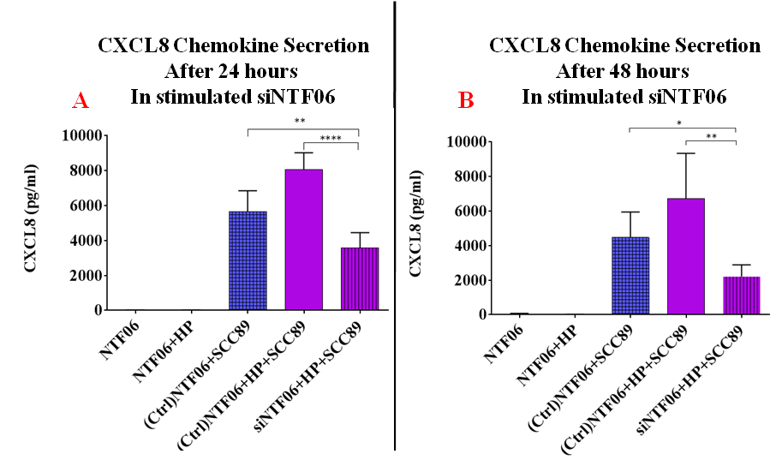
Figure 5.9. siRNA transfected NTF06 displayed decreased CXCL8 secretion in response to SCC89 conditioned medium. NTF06 were incubated with Hi-perfect (HP transfection agent) and siRNA probe 1. Then after (A) 24 hours of transfection, and (B) 48 hours of transfection, the NTF06 were stimulated with SCC89 conditioned medium for 4 hours and CXCL8 secretion was quantified by ELISA. The stimulated-transfected NTF06 (siNTF06+HP+SCC89) were compared with two controls stimulated-fibroblasts (NTF06+SCC89) and stimulated-fibroblasts incubated with the Hi-perfect transfection agent (NTF06+HP+SCC89). Statistical analysis was performed using a one-way independent ANOVA with Tukey’s post-hoc by multiple comparison tests. *p<0.05,****p<0.0001. Abbreviations: Transfected fibroblasts=siNTF06, Hi-perfect transfection reagent.

Investigations next examined if knockdown of IL-1R1 in NTF06 also reduced CXCL8 gene expression upon stimulation with the conditioned medium from SCC89 cells. Similar to data obtained for CXCL8 protein secretion, CXCL8 gene expression was significantly reduced in SCC89 conditioned medium-stimulated NTF06 when these cells were prior treated with siRNA for IL-1R1 when compared to stimulated NTF06 not receiving siRNA treatment. The reduction in CXCL8 gene expression attributed to IL-1R1 siRNA inhibition was about one-third than the mock-transfected control NTF06 at both 24 and 48 hours (p<0.001, figure 5.10 A and B).
Taken together, these data showed that IL-1 released from HPV-negative cells, in particular SCC89 OPC cells, interact with IL-1R expressed by NTF and that this interaction derived the gene expression and protein secretion of a subset of chemokines in particular CXCL8 and CCL2, but it appears not CCL5. This mechanism of induced chemokine secretion is significantly less apparent in HPV-positive OPC stimulated NTF. The IL-1/IL-1R axis is closely associated with chemokine release by stimulated-NTF and blocking IL-1R signalling by Anakinra or siRNA significantly decreases this stimulation. These observations identify that the IL-1/IL-1R axis as a central key mediator in the HPV-positive and HPV-negative tumour microenvironment.

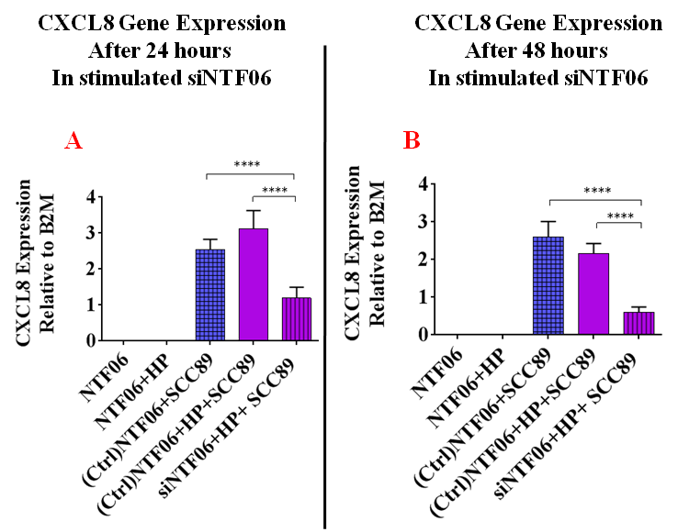
Figure 5.10. siRNA transfected NTF06 displayed decreased CXCL8 gene expression in response to SCC89 conditioned medium. NTF06 were incubated with the Hi-perfect transfection reagent and siRNA probe 1. Then after (A) 24 hours of transfection or (B) 48 hours of transfection, the NTF06 were stimulated with SCC89 conditioned medium for 4 hours and CXCL8 gene expression was analyzed by qPCR. The endogenous control (B2M) was used as control to be compared for each individual cell with the expressed gene. The gene expressions expressed by stimulated-transfected-fibroblasts (siNTF06+HP+SCC89) were compared with two controls stimulated-fibroblasts (NTF06+SCC89) and stimulated-fibroblasts incubated with the Hi-perfect transfection agent (NTF06+HP+SCC89). The statistical analysis was achieved using a one-way independent ANOVA with Tukey’s post-hoc by multiple comparison tests. * p<0.05. Abbreviations: Transfected fibroblasts=siNTF06, high perfect (HP) transfection agent.

Discussion
The tumour microenvironment is composed of a wide range of cellular constituents including tumour cells, leukocyte, endothelial cells, and stromal fibroblasts. The pathogenesis of cancer creates events leading to an imbalanced microenvironment. These pathological conditions affect the tissue homeostasis and various cell types disturbances through modulation of the immune system; where inflammation is a fundamental participant in the tumour microenvironment (Petruzzi et al., 2017, Mantovani et al., 2018). The inflammatory mediator repertoire is enormous in the tumour microenvironment and includes primarily pro- and anti-inflammatory mediators and various chemokines (Netea et al., 2017).

With particular interest is IL-1 with its (α, and β) isoforms; a pro-inflammatory cytokine with multi-functions in both physiological and pathological circumstances. A large number of reports point to IL-1 and its effects as occupying a central responsibility in tumour-related inflammation.

The main aim of the experiments presented in this chapter was to identify the molecules in the conditioned medium of HPV-negative OPC cells that were driving chemokine release by NTF. Since chemokine release tends to be due to a pro-inflammatory cytokine, initial screens were for expression of TNFα. However, this cytokine was not detected in the conditioned medium of the HPV-positive and HPV-negative OPC cell lines tested. Subsequently, thoughts turned to expression of IL-1 and its isoforms IL-1α and IL-1β. Indeed, gene expression of IL-1α was detected in both HPV-positive and HPV-negative OPC cell lines with significant increased expression observed in the HPV-negative cells. More striking was gene expression of IL-1β that was exclusively expressed in HPV-negative OPC cell lines, showing that HPV-negative rather than HPV-positive OPC cells predominantly express IL-1 isoforms. Interestingly, although abundant IL-1β gene expression was observed, IL-1β protein could not be detected in the conditioned medium of HPV-negative cells.

It is not certain why this is the case as the IL-1β standards gave optical density (OD) reading showing that the ELISA was working. It could be that levels were lower than the detection limit of the ELISA or that IL-1β is released within membrane bound vesicles and so not detected by the ELISA kit.
Recently, IL-1 appears to be involved in innate and adaptive immune reactions with new unforeseen vistas. Lopez-Pousa et al investigated the gene expression of IL-1α in more than 100 HNCs qPCR analysis and observed elevated expression of IL-1α was an associated factor for risk of metastasis and unfavourable survival (Lopez-Pousa et al., 2014). The other isoform, IL-1β, was identified by Wu et al as a central node gene in the tumour microenvironment by inducing tumorigenesis and chemokine expression (Wu et al., 2016). Silencing of IL-1β in oral cancer cells, as stated by Wu and colleagues, resulted in down regulation of many genes in addition to the role of IL-1β in the signalling pathway with neighbouring cells in the tumour microenvironment. A mismatch between the protein and mRNA expression of IL-1β was also observed in this study, and it is well documented that cell line mRNA transcripts are not always predictive to protein cellular secretion (Vogel and Marcotte, 2012, Kendrick, 2014).

Moreover, two publications reported that in mice, IL-1 showed similarities in the genetic pathways for both mice and humans. The authors found that the mice with defective IL-1β or IL-1R1 revealed protective mechanism against carcinogenesis (Krelin et al., 2007, Apte et al., 2006). Conversely, Murphy et al showed that over-expression of IL-1α in transgenic mice demonstrated resistance to skin papilloma against carcinogenic materials while control mice developed papillomas to those carcinogens (Murphy et al., 2003). However, the resistance might relate to the innate defence mechanism from physical and cellular roles that resist the initiation of skin papilloma in these transgenic mice models.

Curiously, a complete lack of IL-1β gene expression has also been observed in HPV-positive cervical carcinoma cells lines, implying HPV as a central driving force in IL-1β ablation. Niebler et al., showed that infection of primary keratinocytes with HPV-16 E6, but not E7, abrogated IL-1β processing and secretion in a proteasome-dependent manner that was mediated by ubiquitin ligase E6-AP and p53. The authors further suggested that continual IL-1β ablation lead to complete loss of IL-1β gene altogether as HPV-mediated malignancy develops (Niebler et al., 2013). It is tempting to speculate that a similar mechanism also exists in HPV-positive OPC cells and this may explain the difference in IL-1β expression between HPV-positive and HPV-negative OPC cells observed in this study.

It is broadly accepted that the tumour microenvironment should be inspected as a crucial and dynamic component in studying cancer. Moreover, all the constituents of this vital microenvironment are interacting in a complex network; recognition of the link between these pivotal players is essential for future therapeutic mechanisms. Therefore, to validate the postulation that IL-1 is a key player in the HPV-negative OPC stimulation of NTF, the IL-1R should be localized to NTF. Indeed, although IL-1R has been detected previously on inflamed gingival fibroblasts (Kanda-Nakamura et al., 1996), this is the first time expression of IL-1R1 has been detected on NTF. Findings showed that IL-1R1 was present in the cytoplasmic and membranous compartments. The IL-1R1 antibody for the immunofluorescent staining was chosen since it has been frequently employed and shows IL-R1 expression in many human cell types (Mattiola et al., 2015). In fact, all four batches of NTF (NTF01, NTF06, NTF319 and NTF322) were found to express IL-1R with some variations allied to donor variation.

In addition to protein analysis, gene transcript analysis demonstrated that NTF also express IL-1R at the gene level. However, IL-1R was not detected by Western blotting, which could be explained due to low expression of the IL-1R1 protein. Jung et al. (2010) detected IL-1R1 in cancer-associated fibroblasts in oral squamous carcinoma by Western blotting. This finding could be related to the use of cancer-associated-fibroblasts that may express elevated levels of IL-1R compared to NTF (MacGillivray et al., 2000).

Based on the data previously shown, this part of the study has attempted to identify the mediators of the interactions between tumour cells and stromal fibroblasts. Those were represented by prominent chemokine expression as shown in the previous chapter. The data supports the claim that both elements of the system are present: IL-1 from the cancer cells from one side, which is one of the most powerful pro-inflammatory cytokines and reported to be elevated during inflammation and cancer conditions (Mizutani et al., 1991, Apte et al., 2006). On the other side, the receptor IL-1R1 is expressed by fibroblasts, in which the two IL-1α/β isoforms work synergistically to excite multiple inflammatory signalling cascades. Hypothetically, blocking this reciprocal dialogue by therapeutic means may not only provide insight on how best to treat HPV-negative cancers, but also alleviate the long-term sequelae of aggressive treatment provided for the improved prognostic HPV-positive cancer. Additionally, it might give possibilities to modulate immune reactions in HPV-negative OPC to be in similar favourable prognosis that is associated with HPV-positive OPC.
A recently published review by (Mantovani et al., 2018) highlighted the importance of the IL-1/IL-1R axis in both malignant cells and fibroblasts and their responsibilities in cancer. Interrupting the IL-1/IL-1R axis may be important. To give these in vitro experiments a more clinical aspect, instead of using an antibody to block IL-1R, as previously done, a clinically licensed IL-1R antagonist (Anakinra, brand name Kineret) was utilized. The drug is used for the treatment of severe cases of rheumatoid arthritis. The endogenous IL-1R antagonist is naturally occurring, however many in vivo studies had reported elevated IL-1 concentrations during malignancies (Lewis et al., 2006) and this elevation is associated with virulent cancer phenotypes. Moreover, Anakinra has recently been repositioned as an anti-cancer medication for the treatment of myeloma (Wu et al., 2016). Therefore, repositioning Anakinra as probable drug in HNCs may hold many advantages in lowering cost required for drug development, reductions of approval time, and acceleration in its delivery for clinical use.
Anakinra was non-toxic to NTF even at high concentrations. It was unfeasible, due to cost consideration, to further increase in the dose of Anakinra above 500 µg/ml to test the therapeutic window (i.e. get cells death) of Anakinra in order to observe some toxicity. However, this in vitro test for single cell types did not exclude Anakinra toxic side effects in vivo.
Most of the reported adverse effects of Anakinra range from infection due to neutropenia, local skin-injection reaction, influenza like symptoms, headache, abdominal pain and other limited effects. Nevertheless, Anakinra has shown high safety and tolerance in the majority of patients, even with long-term treatment for up to 52 weeks in multi-centre trials for autoimmune disease (Nuki et al., 2002). However, autoimmune diseases are a different entity from malignant diseases. Further, investigations concerning Anakinra other side effects in HNCs are warranted and to observe any idiosyncratic reactions. Anakinra is contraindicated with patients that have renal impairments and those allergic to E coli-derived proteins.
In this study Anakinra was used in IL-1R blocking experiments to determine if cancer cell-derived IL-1 binding to NTF IL-1R. Anakinra is similar to the endogenous IL-1R-anatgonist that prevents binding of IL-1α/β to IL-1R in all the human tissue that are expressing IL-1R (Dinarello, 2010). NTF were pre-incubated for two hours to allow the Anakinra to bind IL-1R as previously shown (Chevalier et al., 2009). To show that CXCL8, CCL2 and CCL5 release is driven in NTF by the IL-1/IL-1R axis. The pharmacokinetic parameters demonstrated that the mean half-life of Anakinra in patients' sera was ~ 4 hours. For this reason, to precisely test the drug effects on the stimulated-NTF an assay was preformed to collect the conditioned medium from stimulated-NTF with SCC89 and recombinant IL-1β at different time points. The results provided evidence that stimulated-NTF gave significant responses following 4 hours in comparison with the non-stimulated fibroblasts.

Another crucial point related to the use of Anakinra was the concentrations used, since this study is the first time that this drug has been used to block IL-1R on NTF. Therefore, initially dose-escalation protocol starting from 0.1 to 100 µg/ml that was around the recommended dose for rheumatoid arthritis 1 µg/ml, in order to obtain the working-best concentration.
Pre-incubation of Anakinra with NTF exhibited clear dose-response relationship with even low doses of Anakinra significantly inhibiting chemokine secretion. In consistence with previous publication, Watari et al. (2014) found that in the highly aggressive lung cancer type expressing IL-1α/β. Watari et al, reported that using Anakinra significantly decreased CXCL8 expression in a murine cancer model. Moreover, they also observed a reduction in tumour infiltrating neutrophils that are mainly recruited by CXCL8.
Following confirmation of the decrease in CXCL8 level in the stimulated-NTF conditioned medium, dose-response experiments were done in similar manner to quantify CCL2 in NTF supernatants. Again, clear similar trends were observed with abrogation of IL-1 in the stimulated-fibroblasts with HPV-negative SCC89. Fascinatingly, doses of 10 µg/ml brought the CCL2 release even below the non-stimulated NTF. This could be advantageous since NTF secretes CCL2 in the normal state, which might participate, in part, in recruiting myeloid suppressor cells to the tumour microenvironment. Okamoto et al. (2010), pointed to analogous results in human melanoma cells, in which paracrine signal from IL-1 activated chemokine expression in neighbouring cells. In addition, they reported that an IL-1R antagonist significantly reduced levels of CCL2 in addition to other pro-inflammatory cytokines. Thus, IL-1 blockade might affect the number of infiltration of the tumour-associated macrophages.
However, CCL5 exhibited a different pattern from CXCL8 and CCL2, where CCL5 showed a non-significance decrease with 0.1 and 1 µg/ml doses of Anakinra. Although the dose of 10 µg/ml provided statistical significance, this gave unconvincing effects that could not be translated to in vivo biological nature, and this was depicted with other fibroblasts batches. Further investigations regarding Anakinra effects on the CCL5 chemokine is required to confirm its role in this axis.
A number of explanations were considered for the inconsistent findings between CXCL8 and CCL2 chemokines from one side and the CCL5 chemokine on the other side. Firstly, the explanation could be derived from the IL-1 physiological functions. IL-1 has effects on angiogenesis, as well as activation of endothelia, attractions of myeloid suppressor cells (tumour-associated macrophages and neutrophils) or activation of their chemoattractants, and lymphocytes (mainly Th17) (Mantovani et al., 2018). Therefore, it could be speculated that IL-1 has effects only on lymphocyte polarization but not on chemoattraction. Secondly, CCL2 and CCL5 act on different receptors (CCR2 for CCL2, and CCR1 and CCR5 for CCL5) and so their signalling pathways may be different (Zhang et al., 2015). Although, these results were not in absolute confirmation, it does reflect that Anakinra holds neglected inhibitory effects in response to CCL5 stimulation. Moreover, CCL2 and CCL5 tend to be activated in the same pathway via NF-kB, however this may not be the case in tonsillar fibroblasts.
In support of the Anakinra data, knockdown of IL-1R1 in NTF significantly inhibited HPV-negative SCC89 stimulation of NTF by up to ~ 50 %. While it was obviously noticed that Anakinra reduced the CXCL8 to background level. CXCL8 chemokine was chosen since the Anakinra revealed very prominent decrease effects on this secreted chemokine. The differences between the Anakinra and IL-1R1 siRNA transfection in chemokine reductions could be explained by a recent findings by, (Molgora et al., 2017) and reviewed by Mantovani et al. (2018), that other members of the IL-1R ten family members have distinct characteristics function and can still sending inflammatory signals. A supportive findings, were detected by, Okamoto et al. (2010), they outlined that IL-1R1 transfection inhibited the inflammasome pathway and cause downstream in secreted chemokines including CXCL8.

Anakinra could be mono-therapeutic option (unlikely) or in combination with other therapeutic modalities in the HNCs. Probably, the greatest benefits from a fibroblasts-targeting strategy might be their relative genetic stability with less opportunities to develop drug resistance, (Mueller and Fusenig, 2004). Although, Anakinra showed evidence suggested attenuating the activity of stimulated-fibroblasts (HPV-negative tumour cells), these conclusions were drawn from in vitro study and further investigations warranted.

Data in this chapter provides evidence that OPCs HPV-status may radically influence tumour biology by altering the inflammatory microenvironment. Indeed, increased levels of IL-1β have been found in the cell constituents of HPV-negative compared to HPV positive OPC, supporting the observations in this study (Partlová et al., 2015). One of the major roles of chemokines in tumour biology is to attract leukocytes to tumour tissue. Although no study has reported data specific to HPV-positive and HPV-negative OPCs, abundant tumour-associated macrophages and neutrophils have been found in HPV-negative tumours in experimental animal models, and in human HNC where they have been linked to poor prognosis, (Trellakis et al., 2011b, He et al., 2014, Dumitru et al., 2013a, Alves et al., 2017). This may be due to the actions of tumour-derived IL-1β on stromal tonsillar fibroblasts, as evidenced in this study.
Our investigations were extended in this chapter to involve other NTF batches (NTF01, NTF319, and NTF322) from other donors, in order to show that the Anakinra effects were not involved with just one single donor (NTF06). In general, despite some variability, the data succeed to display a similar trend. The dose 10 µg/ml of Anakinra was chosen as a best representative concentration from the previous findings with NTF06 cells.

However, our in vitro selected dose could be criticized as ten-fold the recommended does in rheumatoid arthritis. Nevertheless, the dose-regulations must be based on clinical response, which could be individualized with each patient. Furthermore, the European Medicines Agency in annex I concerning the Anakinra drug mentioned in clinical trial with 1015 patients no dose-limiting toxic effects were observed with up to 2 mg/kg/hour i.e. ~ 35-folds the recommended dose over three days period (Dinarello, 2018).

There were a number of limiting factors in this chapter that must be taken into consideration. Firstly, this study investigated in vitro the effects of only one HPV-negative SCC89 cell line on NTF, more cell lines or even cells from primary tumours are highly recommended for further confirmations. The side effects of Anakinra associated with the OPCs cannot be evaluated by in vitro, in particular the long-term idiosyncratic effects. The main scope of this chapter was related to the immune reactions, other biological factors were not quantified such as expression of vascular endothelial growth factor (VEGF), that many publications reported where Anakinra has a dramatic reduction in addition to the effects of this drug on the bone markers that by extension could prevent HNCs metastasis.
The findings of this chapter could be summarized as follows; that the HPV-negative cancer cells communicate with the stromal NTFs and this communication is mediated by an induced IL-1/IL-1R signalling mechanism. Furthermore, pre-incubation of NTF with Anakinra caused a significant reduction in the secretion of chemokines, in particular CXCL8 and CCL2. These findings shed light on the established role of IL-1/IL-1R axis and Anakinra antagonism effects on stimulated-NTF and their potential role in leukocyte-recruitment, since altering the chemokine secretions to the baseline level will lead to decrease the infiltrated-leukocytes by extension; this could provide potential rewarding approach for HNCs immune therapeutic modalities.
One main disadvantage with the experiments in this chapter is that they are performed in a 2D environment and that the OPC cells and NTF are distinctly separated. In the next chapter, further explorations concerning the effects of Anakinra in more anatomically representative 3D-model in both HPV-positive and HPV-negative tumour cells co-cultured with NTF will be used. In addition to, look at the effects of Anakinra on levels of chemokines and leukocyte recruitment.

Chapter six: Use of a 3-dimensional tumour/stromal model to examine leukocyte recruitment in HPV-positive and HPV-negative OPC.

Introduction
OPC now represents one of the most common malignancies encountered within the head and neck regions and rising to an alarming rates within the last decades (Kumar et al., 2016, Seminerio et al., 2018), and has grown to be a significant public health concern according to the recent surge of disease (Marur et al., 2010a, Näsman et al., 2009). A recently published UK-based study suggested that there is an equivalent increase in both HPV-positive and HPV-negative incidence in OPC (Schache et al., 2016). Efforts have been invested in fashioning therapeutic strategies towards HPV-positive OPC due to their better prognostic outcome and comparisons of the biological aspects of the tumour microenvironment in HPV-positive and HPV-negative OPC may aid development of future therapies (Bolt et al., 2017a). It is widely accepted that the malignant characteristics of cancer cells cannot be revealed without the crucial interplay with their local environment (Sounni and Noel, 2013, Hunter and Yeoman, 2013). Principally, cancer cells are neighboured by heterogeneous stromal cells such as fibroblasts and leukocytes that constitute the tumour microenvironment (Alonso-Nocelo et al., 2016) and it is a combination of all these cells as well as matrix that drive tumour progression.
Tumours develop in a three-dimensional (3D) special configuration where cells are in either close or intimate contact with each other or the extracellular matrix and where environmental gradients of molecules, pH or oxygen are crucially important biological parameters. Traditionally, laboratory experiments have been performed in cells grown on 2D surfaces as monolayer cultures and much important data and scientific breakthroughs have been generated using these simple techniques. However, 2D cultures have inherent restraints such as the lack of spatial context between cells, matrix and biological gradients which led to the development of 3D cell co-culture models (Alonso-Nocelo et al., 2016, Hunter et al., 2005).
3D culture can facilitate modelling the different cellular types and heterogeneities detected in vivo. Multi-cellular spheroids generated from cancer cell lines imitate the tumour architecture of non-vasculararised in vivo tumours and importantly contain biological gradients found in tumours that are absent in 2D culture (Desoize and Jardillier, 2000, Casey et al., 2001).
Experiments so far in this thesis have focussed on 2D culture of cells, whereby the conditioned medium from 2D cultured OPC cells is isolated and then placed onto 2D cultured NTF to mimic cross-talk between cells. In the tumour microenvironment cancer cells are in close proximity to fibroblasts that are within the tumour stroma and cell-to-cell communication by releasing of paracrine factors occurs over short distances. 3D tumour model systems containing tumour spheroids with a fibroblast-populated matrix have been previously used to mimic the tumour in vitro, (Amann et al., 2014), but not as yet for HPV-negative and HPV-positive tumours with NTF in addition to leukocytes infiltrations.
The main purpose of this chapter was to compare between HPV-positive and HPV-negative tumours and their interaction with NTF with regards to chemokine expression, leukocyte recruitment capacity and drug delivery (Anakinra) in a more realistic 3D hydrogel model system.

Aims
- To develop a reproducible 3D-model system that biologically mimics the conditions of OPC found in vivo by co-culturing either HPV-positive or HPV-negative multi-cellular tumour spheroids with NTFs within a type I collagen-based matrix.
- To measure the associated chemokine secretion in both HPV-positive and HPV-negative 3D OPC models, to assess if data observed in 2D-models (chapters 4 and 5) are replicated in 3D-models that more accurately reflect the tumour microenvironment.
- To measure the leukocyte recruitment capacities of both HPV-positive and HPV-negative 3D OPC models, in the absence or presence of the IL-1R antagonist (Anakinra).
- To determine if leukocyte recruitment in the 3D-model mimics those observed in vivo for OPC tumours (chapter 3) and if blockade of the IL-1/IL-1R axis can prevent leukocyte recruitment.

Methods
The process to generate 3D OPC model included three main steps: generation of multi-cellular tumour spheroids for HPV-positive and HPV-negative OPC cells, incorporation of these into a type 1 collagen matrix embedded with NTF and, finally, addition of freshly isolated human leukocytes after 24 hours. The multi-cellular tumour spheroids of both SCC90 HPV-positive and FaDu HPV-negative tumour cells were generated by an agarose over-lay technique as described on section 2.2.11.1. The cancer cell lines chosen were selected from the panel of cell lines cultured in 2D in previous experiments and their ability to form spheroids. The spheroids were grown in 96-well plates coated with agarose in the recommended culture media for 3 and 4 days after optimizing the seeding number and then underwent analyses for characteristic in vivo features such as morphology, central area of necrosis and viable rim. Rat-tail collagen type I was produced as described in section 2.2.11.2 and represented the extracellular stromal matrix (ECM). The viability of the 3D-model was determined by measuring cell metabolism using ‘PrestoBlue’ as described in section 2.2.11.5.
Following leukocyte infiltration into the 3D tumour models, immunohistochemistry (IHC) for the CD66b (neutrophils), CD68 (macrophages) and CD3 (T-lymphocytes) was performed as described in section 2.2.5. Chemokine secretion of CXCL8, CCL2 and CCL5 from the 3D-model was examined in the serum-free culture medium surrounding the model. In some experiments the 3D-models were pre-incubated in the absence or presence of the IL-1R antagonist (Anakinra). Chemokines were quantified using an ELISA as described in section 2.2.11.6., and 2.2.4.2. Leukocytes were isolated from the peripheral venous blood of healthy individuals and fluorescently labelled before adding to HPV-positive or HPV-negative 3D-models either with or without Anakinra as mentioned in section 2.2.11.7. Flow cytometry was used to quantify the numbers of infiltrated fluorescently-labelled leukocytes into the 3D- model as described in section 2.2.11.8.

Results

Generation of HPV-positive and HPV-negative multi-cellular tumour spheroids.
Although several types of tumour spheroids from other cancers have been generated, there are limited publications for HNC tumour spheroids. All six OPC cell lines were cultured using the liquid overlay technique. FaDu cells have previously been shown to generate spheroids using this technique and it was no surprise that these cells formed well-defined spheroids (Colley et al., 2011). The HPV-positive cell line also produced well-defined spheroids, for the first time that this has been reported. However, the other OPC cell lines produced cell aggregations only. Figure 6.1 demonstrates the spheroid morphology generated from both SCC90 and FaDu cells, utilizing the 96-well plate agarose overlay technique. Both SCC90 and FaDu were taken forward for the development of the 3D-model.

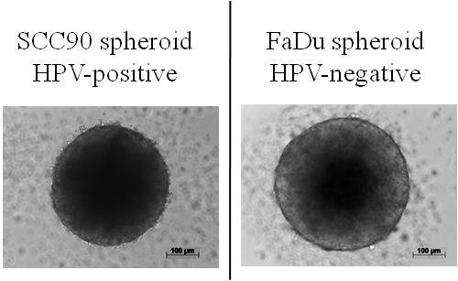
Figure 6.1. Morphology of SCC90 HPV-positive and FaDu HPV-negative multi-cellular tumour spheroids. Cells were trypsinised and seeded onto agarose-coated 96-well plates, to generate spheroids using the liquid overlay technique. After three days spheroids were visualised by light microscopy and images taken using Axiovision software. Scale bar is 100 µm.
Initially, the optimal seeding density was determined by plating 5,000, 10,000 or 15,000 cells from either cell line onto agarose coated wells and spheroid size and morphology examined over time. Upon assessment of the microscopic morphology, spheroids with 10,000 cells were chosen since spheroids generated with 5,000 cells produced spheroids that were very small while at 15,000 the spheroids were very large and developing areas of necrosis (figure 6.2).
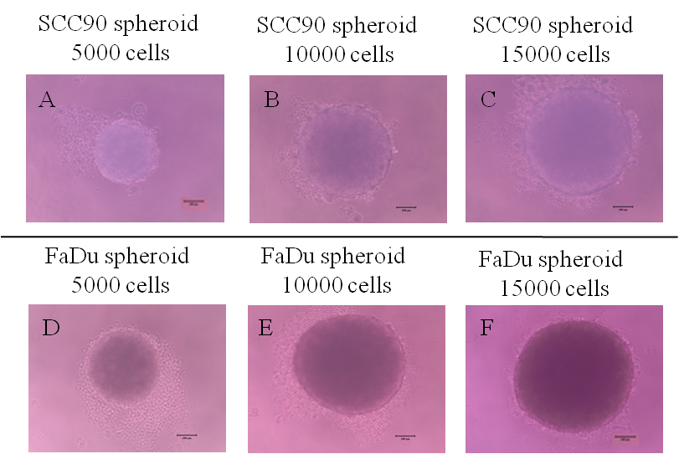
Figure 6.2. Light microscopy images showing cell numbers optimization of HPV-positive SCC90 and HPV-negative OPC spheroids. (A-C) Light microscopic images for HPV-positive SCC90 cells spheroids with cell densities 5,000, 10,000, and 15,000 cells per well. The images from (D-F) show HPV-negative FaDu cancer cells forming spheroids with cell densities 5,000, 10,000, and 15,000 per well. The tumour cells were seeded in concave-shaped and non-adherent agarose to prevent cells attachment to the tissue culture plastic. Cells were cultured using the overlay technique for three days. The spheroids were visualised in 96-well plates under light microscopy using Axiovision software. Scale bar is 100 μm.

HPV-positive SCC90 spheroids were smaller and less tightly arranged than HPV-negative FaDu spheroids. Subsequent experiments were performed to select the best time (three or four days culture), before spheroid were added to the NTF-populated collagen matrix. The desired spheroid consistency was the formation of a well-defined spheroid with a small hypoxic/necrotic centre, so that the spheroid would remain intact in a defined shape for the remainder of the experiment (i.e. following addition to the NTF populated matrix and further culture with leukocytes). Figure 6.3 shows spheroid development from 24-96 hours. After 24 hours, the HPV-positive SCC90 cells started to adhere to one another and aggregate in the centre of the agarose-coated well. This clumping continued and developed into a characteristic spherical shape after 48 hours. In contrast, HPV-negative FaDu cells produced spheroid morphology very quickly after the initial seeding time (figure 6.3 E-H). This difference could be related to the differences in adhesion molecule expression such as E-cadherin levels (Schmidt et al., 2016).
Over the next 72 hours the spheroids developed for both HPV-positive and HPV-negative cancer cells. In each case the spheroids became tight, compact and indestructible by pipetting with a uniform appearance and gradual size increase reaching an average diameter of 413 ± 11.35 μm for SCC90 spheroids and 576 ± 44.9 μm for FaDu spheroids. At the border of each spheroid some unattached cells can be seen. The spheroids continued to grow in size over the next 24 hours (96 hours overall) of culture. At the later time points a darker area could be seen in the centre of the growing spheroids particularly when the diameter was above 200 µm constituting a necrotic centre that was more evident following histological staining and analysis than by light microscopy (figure 6.4). For this reason, spheroids were co-cultured with NTF06 with both three or four day-old spheroids in order to pick the suitable time point.

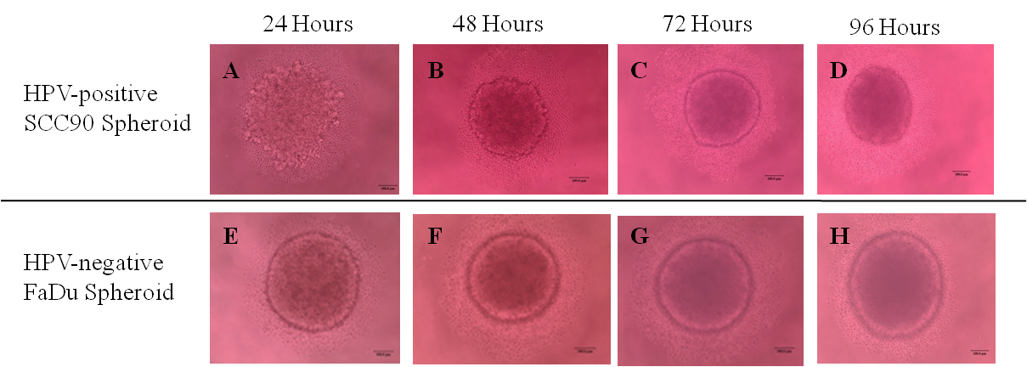
Figure 6.3. Light microscopy images showing HPV-positive and HPV-negative cancer cells grow as multi-cellular tumour spheroids using the agarose-coated overlay culture technique. (A-D) Light microscopy images for HPV-positive SCC90 spheroid formation, from 24-96 hours after seeding. The images from (E-H) show HPV-negative FaDu spheroids from 24-96 hours after seeding. The initial seeding densities were 10,000 cells/well. The multi-cellular spheroids exhibited darker necrotic cores after 72 hours for SCC90 and FaDu spheroids. The spheroids were visualised in 96-well plates under light microscopy using Axiovision software. Scale bar is 100 μm.

NTFs and spheroids from both HPV-positive SCC90 and HPV-negative FaDu were co-cultured in an independent model for each type and their numbers were optimized according to the 2D-model work presented in chapter 4. For example, in the 2D-monolayer culture work cancer cells were used at ~ 1x10⁷ to ~ 3x10⁶ NTF; a ratio 3:1. In the 3D-model the same ratio was kept by using ~ 6x10⁵ cancer cells (60 spheroids per 3D-model as each individual spheroid is 10.000 cells) to ~ 2x10⁵ of fibroblasts (NTF).
Upon histological analysis, the necrotic centre of the spheroids for both SCC90 and FaDu was noticed from 72 hours (figure 6.4 C-D and G-H) for SCC90 and FaDu co-cultured with NTF06. The H&E stained 3D-model sections demonstrated an evenly distributed fibroblast-populated matrix and tumour spheroids with a big increase in the necrotic area of these at 96 hours and this was associated with a corresponding shrinkage of the outer proliferating viable rim, which may result in fragile spheroids that may eventually rapture within the co-culture 3D-model (figure 6.4). Since an additional two days further culture is required in order for the collagen-embedded NTF to interact with the spheroids, 96 hour-old spheroids were considered inappropriate for further use. For these reasons, 72-hour spheroids were chosen for further co-culture with NTF.

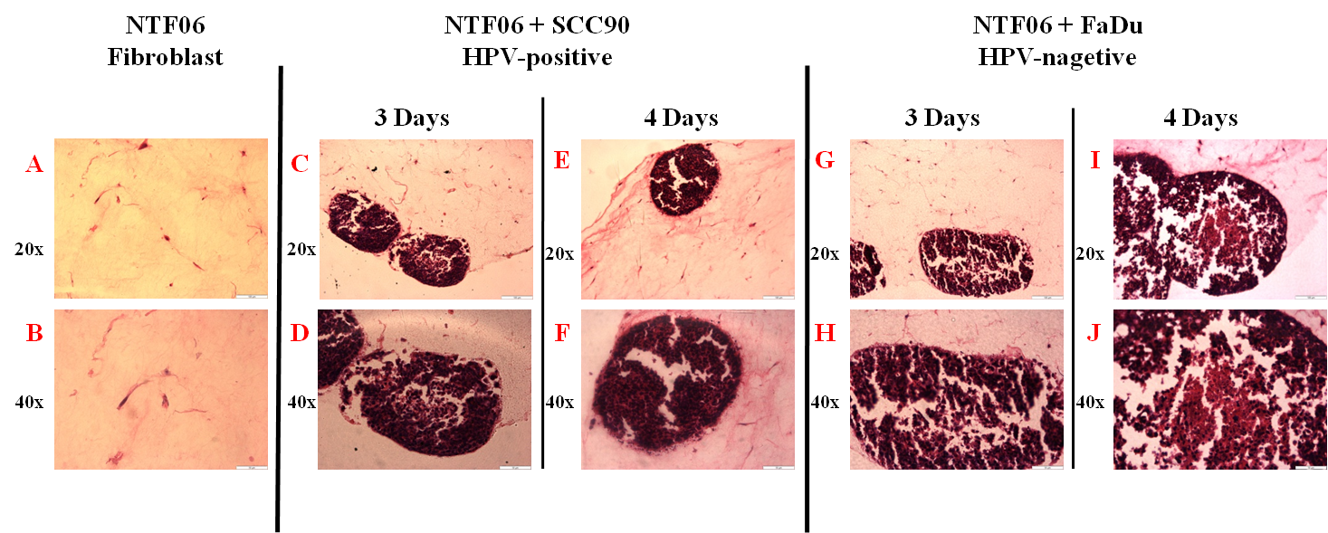
Figure 6.4. Histological sections showing the morphological characteristics of multi-cellular tumour spheroids co-cultured with NTFs. The sections are formalin-fixed paraffin wax-embedding at different magnifications from top descending to down 10x, 20x, and 40x to examine the necrotic cores commonly observed in OPC in vivo. (A-B) showing NTF06 cultured alone in collagen. (C-D) (3 days) of HPV-positive multi-cellular SCC90 spheroids cultured with NTF06 (E-F) (4 days). The images (G-H) (3 days) HPV-negative multi-cellular FaDu spheroids co-cultured with NTF06. The suitable necrotic core at day three is better than the four day-old spheroids, which develop into larger area later on as in (I-J) (4 days). Scale bars are 100 µm, 200 µm and 300 µm from top images descending down.

To validate the co-cultured 3D-model, sections were compared with in vivo human OPC tumours as shown in figure 6.5. The existence of tumour islands and within these a central necrotic region was observed in both 3D-model and in vivo tumour.

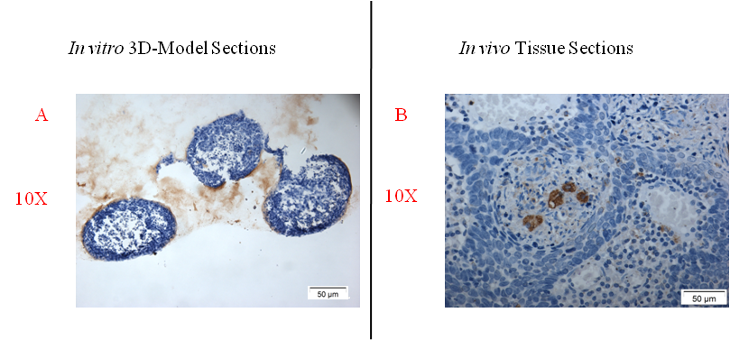
Figure 6.5. Comparison of 3D-model to an in vivo human tumour section. (A) in vitro 3D-model section, (B) in vivo tumour section. The biopsy section was kindly provided by Prof. Keith D. Hunter. Scale bar = 50 µM.

Analysis of cell viability of HPV-positive and HPV-negative co-culture 3D-models.
It was important to determine if NTFs and spheroids were viable within the collagen matrix, either alone or in combination. Cell viability was detected using ‘PrestoBlue’ reagent, a fast and sensitive non-destructive assay that detects cell metabolism. Each individual cell component of the 3D-model was embedded in collagen in separate wells of a 48-well plate, and SCC90 and FaDu spheroids were co-cultured with NTF06. Collagen-embedded 3D-model components were compared with collagen only as control (-ve Ctrl). Fluorescence readings were acquired after two hours of incubation.
The assay revealed that all cell components remained viable after 48 hours of embedding within collagen (i.e. day 5 for spheroids). The mean fluorescence readings for NTF06 alone (mean 2358 ± 82.4) was increased compared to collagen alone showing a viable cells content (figure 6.6). Similarly, SCC90 (2183 ± 253.4) and FaDu (3702 ± 737.1) multi-cellular spheroids alone also showed an increase in metabolism indicating that cells were metabolically active and therefore viable compared to collagen alone. Interestingly, SCC90 spheroids when co-cultured with NTF06 showed increase in metabolism with mean (3489 ± 267.3) although was statistically non-significant (p< 0.2) compared to NTF06 alone. The HPV-negative FaDu co-cultured with NTF06s were statistically significantly different (p<0.0001) when compared to NTF06 alone (7816 ± 433.3). It was noticed that the HPV-positive SCC90 co-cultured with NTF06 showed significantly (p <0.0001) lower metabolism in comparison with HPV-negative FaDu co-cultured with NTF06. These data showed that the greater the cell number content in the collagen the higher the fluorescence reading suggesting viability. The increased value for FaDu over SCC90 could be due to higher metabolism by these cells or greater proliferation rates.

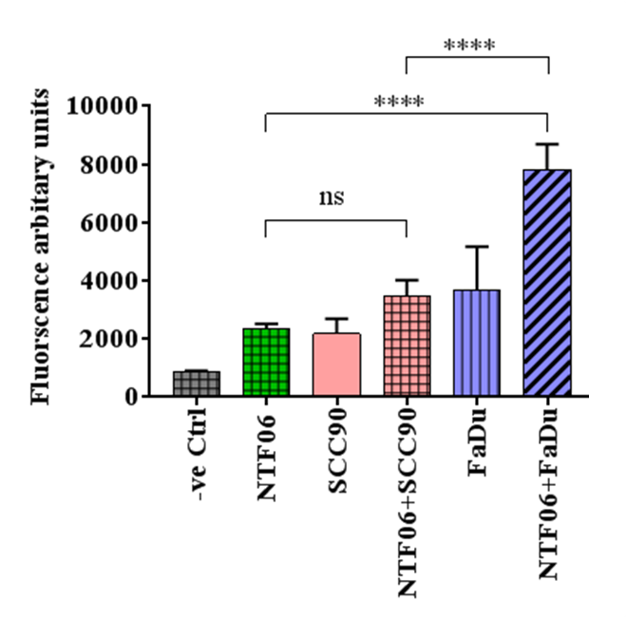
Figure 6.6. Viability of HPV-positive or HPV-negative 3D-models and their components. Cellular viability after 2 days of embedding into collagen-based 3D-model for NTF (NTF06), SCC90 tumour spheroids, NTF06 embedded with SCC90, FaDu spheroids and NTF06 embedded with FaDu spheroids. The control (-ve Ctrl) was collagen only. The NTF numbers were 2 x 10⁵ and 60 spheroids (i.e. 6 x 10⁵ cells), the 3D-models compartments were all incubated for two hours with the ‘PrestoBlue’ reagent and fluorescence units measured. Data are presented as mean ± SD statistical analysis achieved using a one-way independent ANOVA with Tukey’s post-hoc multiple comparison tests. (****p<0.0001).

Leukocyte chemoattractant secretions by HPV-positive and HPV-negative co-culture 3D-model.
Similar to 2D-models, chemokine secretion (CXCL8, CCL2 and CCL5) in the 3D OPC was quantified using ELISA for both HPV-positive and HPV-negative tumour spheroids embedded within a NTF-populated matrix. Tumour spheroids and NTFs were allowed to interact with each other for 24 hours, then, serum-free medium were added to the models and cultured for a further 24 hours. The resulting conditioned media was then collected and analysed. In some experiments the tumour models were incubated with serum-free media in the presence or absence of the IL-1R antagonist (Anakinra), and the levels of chemokines measured, as had been performed on 2D-models in chapters four and five.
Experiments were performed to examine if the stromal interactions and chemokine secretion observed in 2D-models, could be replicated in a 3D-model containing NTFs and OPC cells in contact with one another, as would be the case in an in vivo tumour.
CXCL8 secretion by NTF06 alone within a collagen gel was 110.4 ± 3.1 pg/ml, HPV-positive SCC90 spheroids alone expressed 88.4 ± 4.2 pg/ml. This level was increased when SCC90 spheroids were co-cultured with NTF06 to 3516.0 ± 561.9 pg/ml, although this failed to achieve statistical significance (p=0.055) compared to SCC90 spheroids alone. HPV-negative FaDu spheroids alone in collagen expressed 5281.0 ± 239.5 pg/ml and these levels were significantly increased when these spheroids were co-cultured with NTF06, expressing 39111.0 ± 1771.0 pg/ml (p<0.0001) in comparison to NTF06 alone, FaDu alone and SCC90/NTF co-cultures (figure 6.7 A).
Similar data was found when analysing secretion of CCL2 although CCL2 was secreted at lower levels than CXCL8. NTF06 alone produced 194.7 ± 5.9 pg/ml CCL2, HPV-positive SCC90 spheroids alone secreted slightly less at 139.2 ± 11.16 pg/ml CCL2 and this was increased when SCC90 spheroids were co-cultured with NTF06 to 281.2 ± 14.6 pg/ml. In contrast, FaDu HPV-negative spheroids alone secreted 1150 ± 37.19 pg/ml whilst FaDu spheroids co-cultured with NTF06 secreted significantly (p<0.001) more CCL2 3931.0 ± 283.2 pg/ml compared to NTF06 alone, SCC90 alone, SCC90+NTF and FaDu alone (figure 6.7 B)
The pattern of CCL5 production followed a similar trend to CXCL8 and CCL2. NTF06 alone was 61.9 ± 1.5 pg/ml, HPV-positive SCC90 spheroids alone secreted 131.0 ± 0.9 pg/ml and SCC90 spheroids co-cultured with the NTF06 was only slightly increased to 136.3 ± 0.70 pg/ml (p= 0.939). In contrast, HPV-negative FaDu spheroids alone expressed 2376 ± 85.48 pg/ml and this was significant increased further upon co-culture NTF06 at 3258 ± 129.3 pg/ml (p<0.0001) in comparison to NTF06 alone, and FaDu alone. CCL5 released by FaDu spheroids co-cultured with NTF was significantly more than for SCC90 spheroids co-cultured with NTF (p<0.0001) (figure 6.7 C).
These data show remarkable comparison to data observed in the 2D-models in the previous chapters and suggest that HPV-negative OPC cells within the 3D-model can activate NTF by paracrine signalling within the matrix.

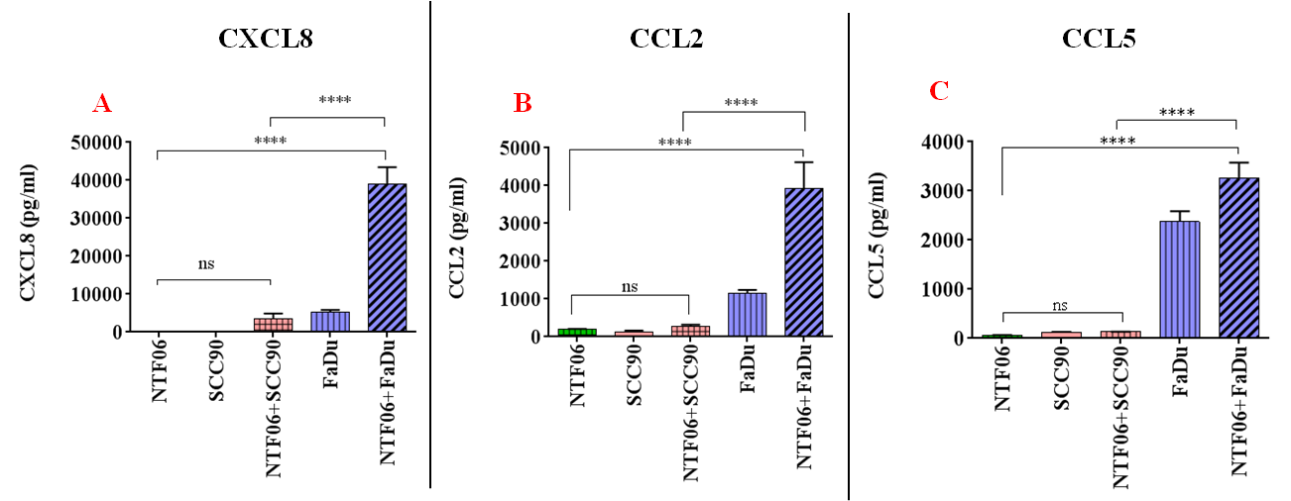
Figure 6.7. HPV-negative co-culture 3D-models express more chemokines than HPV-positive. The 3D-model of HPV-positive/-negative co-cultured with fibroblasts (NTF06) for 24 hours to interact with each other and then in the next 24 conditioned media collected and chemokines quantified by ELISA. (A) CXCL8 expression (B) CCL2 expression, and (C) CCL5 expressions. The 3D-model of HPV-positive/-negative co-culture compared with fibroblasts embedded alone (NTF06) as control. The statistical analyses were achieved using a one-way independent ANOVA with Tukey’s post-hoc multiple comparison test.

Leukocyte chemoattractant secretion by HPV-positive and HPV-negative is co-inhibited by Anakinra.
In chapter five Anakinra was used to block the interactions of IL-1 secreted by OPC cells with IL-1R expressed by NTF to reduce chemokine secretion by the fibroblasts in a 2D-model where the cells were cultured separately. Next, Anakinra inhibition experiments were performed in the 3D tumour/stroma models to test if this inhibition could be achieved when the cells were in close contact within the same 3D-model that mimics the tumour microenvironment in vivo. 3D-models containing either SCC90 or FaDu spheroid co-cultured with NTF were pre-incubated with 1µg/ml or 10µg/ml concentrations of Anakinra and chemokines CXCL8, CCL2 and CCL5 measured in the supernatant after 24 hours culture.
Once again the FaDu spheroid NTF co-cultures produced a significant increase in the levels of all 3 chemokines tested (33187 ± 5486 pg/ml CXCL8, 5230 ± 710.7 pg/ml CCL2, and 2206 ± 163.4 pg/ml CCL5) compared to SCC90/NTF co-cultures (3731 ± 534.6 pg/ml CXCL8, 513.9 ± 29.64 pg/ml CCL2, and 54.53 ± 6.9 pg/ml CCL5) (figure 6.8).
Pre-incubation with 1 µg/ml concentration of Anakinra produced a dramatic reduction of chemokine secretion for CXCL8 and CCL2 but not for CCL5 for FaDu spheroids co-cultured with NTF. Indeed, secretion of CXCL8 was reduced from 62479 ± 3165 pg/ml to 3346 ± 294.9 pg/ml upon Anakinra treatment (p<0.0001) and CCL2 was reduced from 1888 ± 356.9 pg/ml to 293.1 ± 3.78 pg/ml upon Anakinra treatment (p<0.0001). Interestingly, secretion of CCL5 by FaDu spheroid NTF co-cultures was not significantly reduced and levels remained elevated at this concentration of Anakinra. In contrast, secretion by SCC90 spheroids co-cultured with NTF was also reduced for each of the chemokines tested but this did not reach statistical significance (figure 6.8 A-C).
Results generated using 10 µg/ml pre-incubation concentrations of Anakinra showed very similar data to inhibition with 1 µg/ml Anakinra. Once again levels of CXCL8 and CCL2 were dramatically decreased when FaDu spheroids/NTF co-cultures were pre-incubated with Anakinra. Here, secretion of CXCL8 was reduced from 33187 ± 5486 pg/ml to 1486 ± 505.6 pg/ml (p<0.0001) and CCL2 was reduced from 5230 ± 710.7 pg/ml to 152.6 ± 11.66 pg/ml upon Anakinra treatment (p<0.0001). In contrast to treatment with 1 µg/ml, treatment with 10 µg/ml Anakinra significantly (p<0.0001) inhibited secretion of CCL5 into the conditioned medium of the FaDu/NTF co-culture model reduced from 2206 ± 163.4 pg/ml to 40.41 ± 12.49 pg/ml. This is suggesting that lower concentrations of Anakinra are required to block secretion of CXCL8 and CCL2 than CCL5. Once again, chemokine secretion by SCC90 spheroids co-cultured with NTF was also reduced but this did not reach statistical significance (figure 6.8 D-E).
Taken together, these data show that the same trend observed in the 2D-model culture experiments where cells were cultured independently from one another were replicated in 3D-models where tumour spheroids and NTFs were able to directly contact each other through paracrine activity. In addition, pre-incubation with Anakinra dramatically and significantly decreased chemokine secretion, particularly at 10µg/ml, showing that the IL-1/IL-1R axis can be blocked both in 2D and in 3D in vitro models.
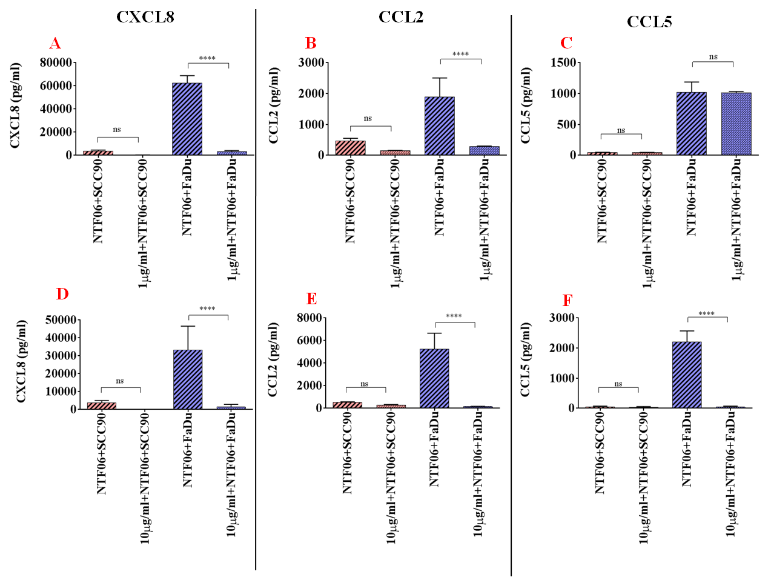
Figure 6.8. Anakinra decreases the additional chemokines secreted by HPV-positive, and HPV-negative co-culture 3D-models. The 3D-model of HPV-positive/-negative co-cultured with fibroblasts for 24 hours to interact with each other and then in the next 24 conditioned media collected and chemokines quantified by ELISA with/out pre-incubation of either 1 µg/ml Anakinra. (A) CXCL8 expression (B) CCL2 expression (C) CCL5 expressions; or 10 µg/ml Anakinra (D) CXCL8 expression (E) CCL2 expression and (F) CCL5 expressions. The 3D-model that pre-incubated with Anakinra compared to that 3D-model of HPV-positive/-negative co-cultured with fibroblasts. The statistical analyses were achieved using a one-way independent ANOVA with Tukey’s post-hoc multiple comparison test.

Infiltration of leukocytes subsets into the 3D OPC model.
Data thus far has shown that interaction of OPC cells, in particular HPV-negative cells with NTFs in both 2D and 3D in vitro models induce secretion of chemokines. To test if these chemokines can recruit leukocytes in a 3D-model, whole leukocytes isolated from peripheral venous blood were added on the top of the collagen gel for both HPV-positive and HPV-negative co-culture models and the presence of different leukocyte sub-populations in the gel assessed. In these experiments 3D-models were incubated for 24 hours to allow the spheroids and NTFs to interact with one other. The following day, isolated leukocytes were incubated with the 3D-model for a further 24 hours. Then, models were fixed, snap-frozen, embedded in OCT, sectioned and immunostained with antibodies directed against CD66b (neutrophils), CD68 (macrophages) and CD3 (pan T cells) to assess absence or presence of these leukocytes subsets. IgG staining was used as a negative control.
Assessment of sections of the 3D-models by light microscopy showed the presence of immuno-positive staining for CD66b+, CD68+ and CD3+ (figure 6.9) suggesting that all three different leukocyte subsets were able to migrate into the collagen matrix in the in vitro 3D-models containing OPC spheroids and NTFs. These data replicate those found in vivo in chapter three when sections of human tumours were immunostained for leukocyte sub-populations confirming that the 3D-models contain key features present in the tumour microenvironment. However, using this immunostaining approach it is not possible to readily quantify differences between leukocytes infiltrating into HPV-positive compared to HPV-negative OPC models. Therefore, flow cytometric analysis of disaggregated 3D-models was performed to obtain leukocytes densities within the models.

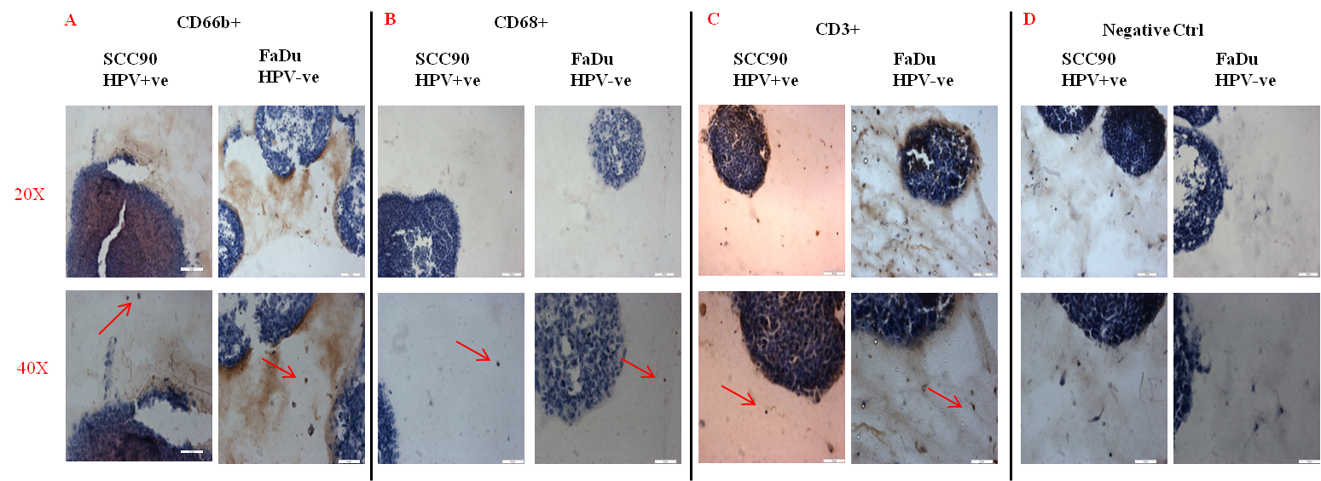
Figure 6.9. Immunohistochemistry staining of CD66b, CD68 and CD3 antibodies expressions in 3D-model HPV-positive/-negative HNCs. The 3D-models for HPV-positive/-negative co-cultured with fibroblasts incubated with leukocytes for 24 hours, then fixed and stained for immunohistochemistry characterizations of the main leukocytes subsets detections (A) CD66b+ (neutrophils) (B) CD68+ (macrophages) (C) CD3+ (T cells) and (D) IgG staining negative control. The red arrows are referring to the detected cells (+). The scale bars are 100µm, 200µm and 300µm from top images descending down............................................................................................................

HPV-negative OPCs attract more leukocytes than HPV-positive OPC in co-culture models.
Initially, collagen gels were made with the conditioned medium generated from NTF stimulated with either the medium from HPV-positive or HPV-negative OPC cell lines in the 2D co-culture system in order to test their capabilities for leukocyte recruitment. Peripheral blood leukocytes were isolated, labelled with cell tracker and added to collagen gels made from the conditioned medium from NTF06 stimulated with SCC90 (HPV-positive) or FaDu (HPV-negative). Control gels were made from serum-free medium alone. Gels were incubated for 24 hours, after which the gels were washed to remove non-migrated leukocytes; gels enzymatically dispersed using collagenase and the number of liberated leukocytes measured by flow cytometry. Data presented in figure 6.10 shows that leukocytes can migrate into collagen gels containing no chemoattractant but only in low numbers.
In contrast, markedly more leukocytes were recruited to the collagen gels made from NTF stimulated with HPV-negative OPC conditioned medium than from those made from HPV-positive OPC conditioned medium. The dot plots shown in (figure 6.10 C-E) also reveal that three distinct leukocyte populations can be observed in each of the tests, most likely representing neutrophils, monocytes and lymphocytes according to their size and granularity, although specific immunostaining of these cells was not performed. Experiments were carried out using leukocytes isolated from 3 different volunteers. The blood from each volunteer contained different amount of leukocytes and most likely different amounts of leukocyte sub-populations (Mohammed and Hassan, Zandecki et al., 2007). Moreover, the chemotactic capacity of leukocytes towards chemokines varies amongst individuals. Therefore, the variability within the experimental repeats reflects the genetic individuality from each of the volunteers making the data difficult to normalise and statistically analyse.

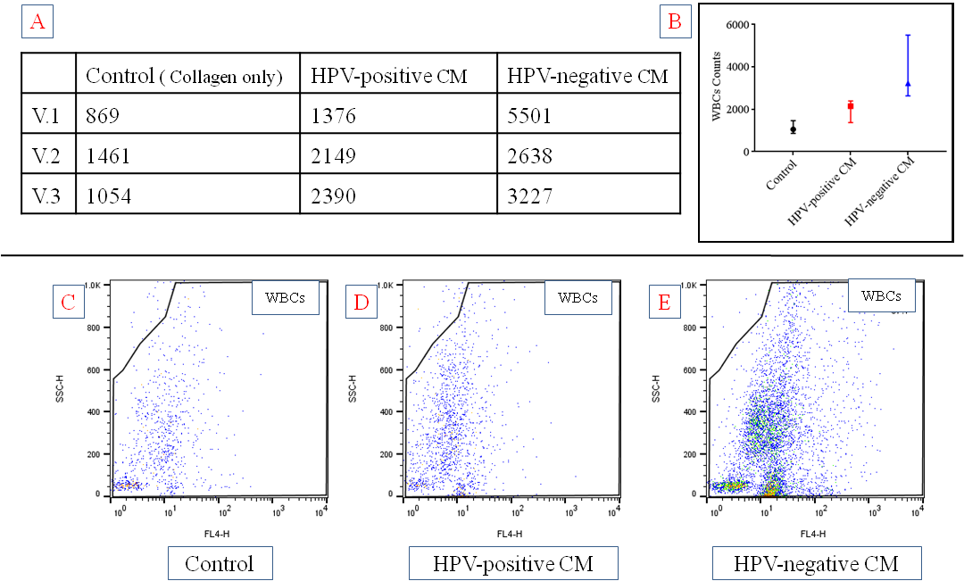
Figure 6.10. The conditioned medium from HPV-negative OPC stimulated-NTF attracts more leukocytes than conditioned medium from HPV-positive OPC stimulated-NTF in collagen model. Far-red fluorescently labelled leukocytes were incubated for 24 hours with collagen gels made from conditioned medium from HPV-negative or HPV-positive OPC stimulated NTF or serum-free medium alone. The number of leukocytes collected in 30 seconds by flow cytometry were assessed (A) Table shows the number of infiltrated leukocytes within each collagen gel from 3 different volunteer donors (V) (B) Whisker plots showing the distribution and number of leukocytes infiltrating the collagen gels. There is an increase in the number of leukocytes recruited to gels made from the conditioned medium of NTF following stimulation with HPV-negative compared to HPV-positive OPC (C-E) Dot plots from one representative experiment showing gating around the fluorescently labelled leukocytes for (C) Collagen only (control),(D) Collagen from the conditioned medium of NTF following stimulation with HPV-positive SCC90 OPC cells (E) Collagen from the conditioned medium of NTF following stimulation with HPV-negative FaDu OPC cells. The number of leukocytes was calculated according to the dots in the gated area. Data is median and range that representative of n=3 independent experiment. Abbreviations CM= conditioned media, WBC= white blood cells, V = Volunteer.

Next, leukocytes from fresh venous blood were isolated from peripheral blood and levels of leukocyte recruitment were assessed in both HPV-positive and HPV-negative OPC co-culture 3D-models by flow cytometric analysis. Fluorescently labelled (far-red) leukocytes were incubated with the 3D-model containing the multi-cellular spheroids co-cultured with NTF06 within the collagen. Control was collagen alone. Far-red labelled leukocytes were used to distinguish them from unlabelled OPC cells and NTFs. In addition, far-red was also compatible with use of collagen as this molecule has high background fluorescence in the green (488 nm) channel. In addition, some multi-cellular spheroids co-cultured with NTF06 were pre-incubated with Anakinra (either 1 or 10 µg/ml, (Holen et al., 2016)) to see if inhibiting the IL-1/IL-1R axis and therefore disruption of chemokine release could reduce leukocyte recruitment.
Data presented in figure 6.11 shows that for each of the donors tested there was increased recruitment of leukocytes toward HPV-negative/NTF co-culture 3D-models than for HPV-positive/NTF co-culture 3D-models. Moreover, pre-incubation with 10µg/ml concentrations of Anakinra markedly decreased the number of leukocytes infiltrating the collagen gels for both HPV-negative and HPV-positive NTF co-culture 3D-models. Interestingly, although leukocytes recruitment levels were much reduced upon treatment with Anakinra they were not totally abrogated and levels were still above those of the collagen only controls (figure 6.11).

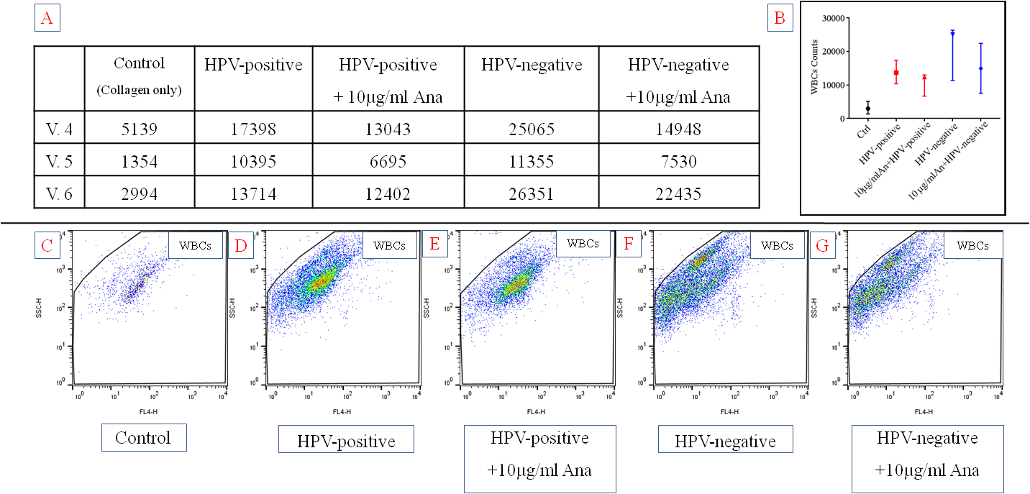
Figure 6.11. HPV-positive and HPV-negative leukocyte attraction in 3D-model co-cultured with fibroblasts in the absence or presence of 10µg/ml Anakinra. Leukocytes were incubated for 24 hours within the media of the 3D-model co-culture. (A) Table shows the numbers of the infiltrated leukocytes within the collagen gel for all tests examined (B) Whisker plots showing leukocyte numbers in the 3D-models by flow cytometric analysis. (C-G) Dots plots from one representative experiment showing gated fluorescently labelled leukocytes (C) Collagen only (control) (D) HPV-positive SCC90 co-culture 3D-model (E) HPV-positive SCC90 co-culture 3D-model pre-incubated with 10µg/ml Anakinra (F) HPV-negative FaDu co-culture 3D-model (G) HPV-negative FaDu co-culture 3D-model pre-incubated with 10µg/ml Anakinra. The numbers of leukocytes were measured according to the dots in the gated area after 30 seconds acquisition on the flow cytometer. Data is median and range that representative of n=3 independent experiment. Abbreviations CM= conditioned media, WBC= white blood cells, V = Volunteer, Ana = Anakinra.
Next, pre-incubation with Anakinra was used at a lower dose (1 µg/ml) since this dose of Anakinra may mimic that given in the clinic for other disease states (Holen et al., 2016). For this reason, OPC spheroids were incubated with Anakinra during a medium change and the 3D-model in the following 2 days; this might lead to better reduction in the leukocytes (total 3 days). The findings were similar to those for use of 10µg/ml concentrations of Anakinra (figure 6.11). Once again, increased leukocyte recruitment was observed for HPV-negative NTF models compared to HPV-positive NTF models for each volunteer studied.
Moreover, Anakinra at 1 µg/ml concentration reduced the numbers of leukocytes recruited for both HPV-positive and HPV-negative NTF co-culture models although it appears that the HPV-negative NTF co-culture models are more markedly affected by Anakinra treatment (figure 6.12). Even so, pre-treatment with Anakinra, even in this treatment regime, did not completely reduce leukocyte recruitment.

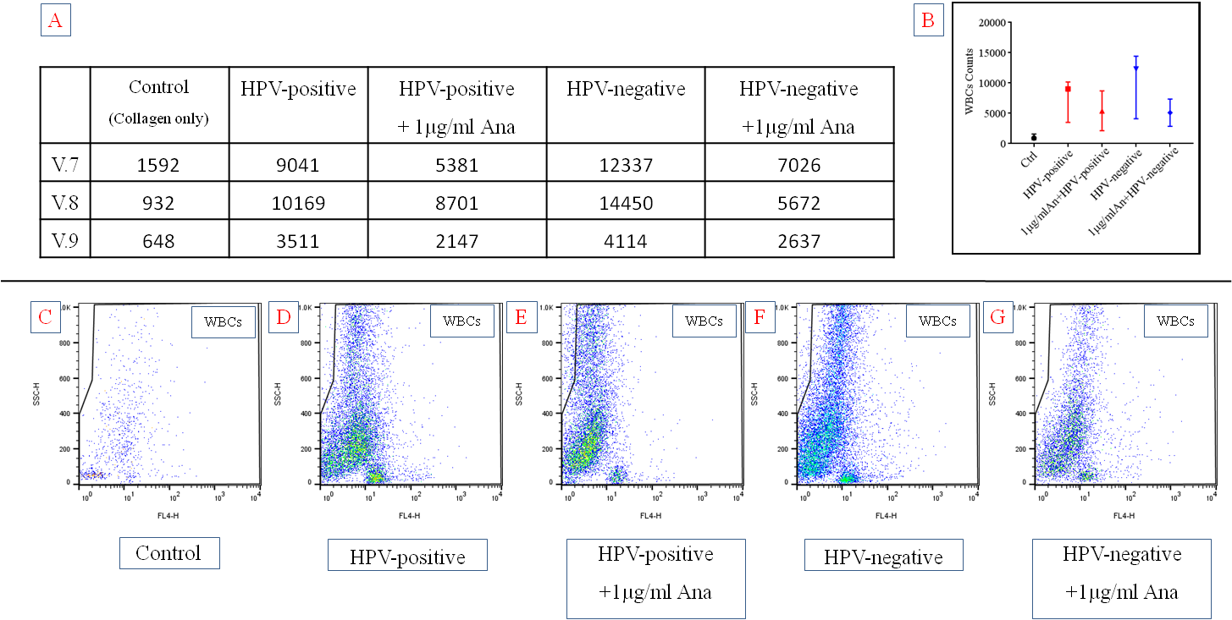
Figure 6.12. HPV-positive and HPV-negative leukocyte attraction in 3D-model co-culture models in the presence or absence of 1µg/ml Anakinra. Leukocytes were incubated for 24 hours within the media of the 3D-model co-culture. (A) Table shows the numbers of the infiltrated leukocytes within the collagen gel for all tests examined (B) Whisker plots showing leukocyte numbers in the 3D-models by flow cytometric analysis. (C-G) Dots plots from one representative experiment showing gated fluorescently labelled leukocytes (C) Collagen only (control) (D) HPV-positive SCC90 co-culture 3D-model (E) HPV-positive SCC90 co-culture 3D-model pre-incubated with 1µg/ml Anakinra (F) HPV-negative FaDu co-culture 3D-model (G) HPV-negative FaDu co-culture 3D-model pre-incubated with 1µg/ml Anakinra. The numbers of leukocytes were measured according to the dots in the gated area after 30 seconds acquisition on the flow cytometer. Data is median and range that representative of n=3 independent experiment. Abbreviations CM= conditioned media, WBC= white blood cells, V = Volunteer, Ana = Anakinra.

In summary, 3D-models of the OPC tumour microenvironment were successfully developed. Similar to the 2D-models, 3D-model analysis showed that HPV-negative OPC 3D-models secreted significantly more chemokines (CXCL8, CCL2 and CCL5) than HPV-positive OPC 3D-models. Moreover, inhibition of the IL-1/IL-1R axis by Anakinra almost entirely abrogated the secretion of CXCL8, CLL2 and CCL5 (albeit at higher Anakinra concentrations) that in turn markedly reduced leukocyte recruitment in these models. These data suggest that disruption of the IL-1/IL1R paracrine signalling system is possible in the tumour microenvironment and that this, in turn, can modulate the levels of leukocyte burden within these models.

Discussion
Worldwide, cancer is one of the primary sources of mortality. Many cancers are in decline or have improved treatments whereas OPC, in particular HPV-driven OPC is rapidly increasing (Motz et al., 2017, Chaturvedi et al., 2011). Studies show that the tumour microenvironment is important in tumour progression. As part of this the inflammatory response, leukocyte levels and type of leukocyte within the tumour microenvironment may be influential. Experiments performed in 2D-model in the previous chapters showed that HPV-negative OPC cells secreted IL-1 that was able to stimulate chemokine secretion by NTF via IL-1R. In these experiments, culture medium secreted by OPC cells grown as a monolayer were placed onto NTF also grown as a monolayer, with the resulting NTF medium analysed for chemokine content. Traditional 2D monolayer culture for cancer studies has limitations in identifying real nature biology of cancer, despite its imperative role in the studies pertaining to this field. There is an increasing recognition that cells cultured as monolayers act very differently than those in a 3D environment. In the 2D experiments the OPC and NTF cells were cultured in isolation as well as in a monolayer format; a scenario that is far removed from cells in vivo.
To mimic the in vivo situation, 3D-models of OPC were generated using tumour spheroids to mimic in vivo tumour islands/bodies within an NTF populated collagen matrix to mimic the tumour stroma. In this model the cells are spatially distributed in 3D, as they would be in tissue in vivo. They are also able to interact with the extracellular matrix and secrete factors that can find their way directly to recipient cells, facilitating paracrine and autocrine signalling mechanisms.
The 3D OPC model provides a step forward for the assessments of cancer cell stromal interactions in tumour progression. It provides a chance to examine each contributing factor that might facilitate cells cross-talk and may also provide a useful means for development of future therapeutic modalities. For accurate modelling of OPC, it is essential to incorporate as many characteristics of the naturally occurring solid tumours as possible such as necrosis and hypoxia, intracellular connections, in addition to diffusion gradients for nutrition and waste products, none of which are represented in 2D culture models.
Multi-cellular tumour spheroids have many different names including organoids, and tumouroids and the spheroid nomenclature is not consistent in the literature (Hirschhaeuser et al., 2010). Spheroids have strong intra-cellular junctions that may be attributed to E-Cadherin expression and this enables them to keep their integrity. Six OPC cancer cell lines were tested for spheroid generations, however only SCC90 (HPV-positive) and FaDu (HPV-negative) were able to generate spheroids from this panel using the agarose overlay technique. It is possible that spheroids could be produced from other cell lines using other techniques such as the hanging drop technique, although this was not attempted in this study.
The FaDu HPV-negative cancer cell line is well known to generate spheroids and has been used previously to model head and neck cancer (Colley et al., 2014, Colley et al., 2011, Young et al., 2018a). However, to the best of our knowledge, this is the first study to use spheroids generated by SCC90 HPV-positive cancer cells.
There are variable theories about the mechanism of spheroid formation. One theory postulates that formation is due to the effect of gravitational forces that result in cells clumping together (sedimentation) along with robust intra-cellular forces that may depend on E-Cadherin expression. A number of factors are important in spheroid generation such as initial seeding number, culture media and duration of suspension. In this study a seeding density of 10,000 for 24 hour was found sufficient and consistent with other findings (Friedrich et al., 2009, Vadivelu et al., 2015, Colley et al., 2011). Zhang et al. (2016) stated the low seeding numbers gave irregular shape spheroids in liquid overlay technique.
Ivascu and Kubbies (2006) highlighted that the most important distinguishing features of solid tumours that can be represented in the 3D spheroid model are the proliferating viable rim of tumour cells and the central necrotic region. FaDu and SCC90 spheroids both displayed a thick epithelium and a necrotic core, characteristics that made them good candidates to symbolise these cancers. The proliferative cells on the tumour periphery in vivo are neighbouring to the blood supply facilitating them to get the required nutrition for proliferation, which are responsible for the growth of the tumour. While the central core of the tumours beyond a certain diameter develops into hypoxia, since the cells are far from the blood vessels resulting in poor oxygen diffusion for this area (Ljungkvist et al., 2000). The deepest cell populations in the central core of the spheroids (tumours) go through cell death because of the accumulated waste products with limited nutrition supply. Necrosis was observed after 72 hours in both SCC90 and FaDu spheroids.
Hirschhaeuser et al. (2010) suggested that spheroids bigger than 500 μm in diameter, exhibit a necrotic centre. Conversely, SCC90 spheroids were revealing less than 500 μm diameter but still displayed areas of necrosis. This data is in the line with (Thomlinson and Gray, 1955), who reported that failure of delivery of nutrition supply and the required oxygen in further than the distance of 100-150 μm would develop necrosis. 3D embedded spheroid models are widely used in cancer investigations, but only limited use in HNC.
The naturally occurring matrices protein such as collagen, laminin and hyaluronic acid are often used (Suri and Schmidt, 2010). Collagen type I was used in this project as it is abundant in the connective tissue ECM and can be utilized to form hydrogel in the 3D-model to mimic the in vivo ECM (Devarasetty et al., 2017). However, collagen was not without disadvantages. Magdeldin et al. (2014), stated in their study that collagen is over-hydrated and further reported that collagen surface needs modifications in order to improve cells distribution, migration and attachment.
In a desire to improve the reproducibility, the cancer cells to NTFs ratio were optimized from the 2D-model in chapter four, since there is no specific in vivo ratio of tumour to stroma (Kim et al., 2015, Amann et al., 2014). The model generated in this study closely compared with its in vivo counterpart taking into consideration the tumour and stroma architecture. The histological analysis by H&E staining revealed that the multi-cellular spheroids maintain the tumour morphology and the fibroblasts (representing stroma) were uniformly distributed within the collagen hydrogel. In contrast, Magdeldin et al. (2014) reported cellular aggregations in the concentrated collagen matrix. This phenomenon might be due to long co-culturing in their models (14 days) with subsequent contraction. While, in the model used in this study, contraction was limited due to short co-culture time (2 days).

The next essential investigated factor was the viability of cells within the collagen 3D-model. This study used ‘PrestoBlue’ to evaluate the viability which is a sensitive resazurin-based method (Boncler et al., 2014, Xu et al., 2015). The purpose of this assay was to provide insight about the cell viability when cells/spheroids were embedded independently and co-cultured after same time-point. There was a marked significant increase in vitality (metabolic activity) within the co-culture 3D-model. That might indicate the cellular interactions between cancer cells and fibroblasts increase the metabolic activity. This condition particularly noticed with the HPV-negative co-culture. It also might be attributed to the cumulative effects of both the cancer cells with the fibroblasts jointly as shown with the HPV-positive 3D-model construct that gave about two-fold values. Another explanation is that the cancer cells have a higher proliferation rate and nutritional demand than normal primary fibroblasts that can result in increased metabolic activities of the co-culture.
These findings are consistent with many co-culture models indicating increased associated metabolic activity (Young et al., 2018b, Colley et al., 2011, Kim et al., 2014). In contrast different findings were observed from a study done on stroma-interactions with lung cancer cells investigated by (Amann et al., 2014), whom observed a decrease in viability through the course of co-culture within the collagen model. However, they reported the proliferation rate was increased by measuring Ki67 expression.

Immunohistochemistry staining was performed with CD66b (neutrophils), CD68 (Macrophages) and CD3 (pan T cells) to validate our model by representing similarities with human cancer biopsy sections. These antibodies were chosen for IHC because of their common use and expressed solely by these aforementioned leukocytes (Gollapudi et al., 2013, Esendagli et al., 2008, Bramow et al., 2008). The IHC staining confirmed that infiltrated models possessed key features of immune cells including the presence of the CD66b+, CD68+ and CD3+ within 3D-model in both HPV-positive and HPV–negative OPC. However, most of the detected cells were towards the surface of the collagen matrix that might be attributed to our 24 hours incubation period with the whole leukocytes. In addition, the cell migration might be related to the collagen surface tension, density and mechanical stiffness as reported by (Cheema and Brown, 2013). However, these findings need further mechanical investigations, and our main purpose was to compare between the immune profiles of HPV-positive and HPV-negative OPC. The incubation time chosen (24 hour), was used because neutrophils have a short half-life (16-24 hours ex-vivo) prior to apoptosis (Mackey et al., 2003). Although, neutrophils may experience longer half-life within the tumour microenvironment.

The conditioned media from the 3D-model in FaDu HPV-negative co-cultured with NTF expressed abundant CXCL8 (mainly neutrophils), CCL2 (mainly macrophages), and CCL5 (mainly T cells) that was significantly higher than the SCC90 HPV-positive. These data suggested the HPV-negative tumours have higher capacities to recruit leukocytes than their HPV-positive counterparts or NTF alone. These results associated with chemokine expression might imply unfavourable prognosis by HPV-negative OPC since CXCL8 is responsible for angiogenesis and neutrophils attractions, while CCL2 in charge for metastases and monocyte recruitment and CCL5 accountable for pan T cells attraction, which acts in different pattern in the tumour microenvironment.

Moreover, these data suggested that an active interaction (cross talk) between the NTFs and the tumour cells in vivo pointing to the crucial role of fibroblasts in the tumour microenvironment. These findings are supported by (Kim et al., 2015) concerning CXCL8 and CCL2 and (Stamati et al., 2014) with CCL5 who observed cancer-associated fibroblasts up-regulated chemokine expression in co-culture models. The peripheral serum concentration of CXCL8, CCL2, and CCL5 were detected to be higher with HNC patients than in healthy controls (Hoffmann et al., 2007, Chang et al., 2011, Huang et al., 1999). The levels of CXCL8, a neutrophil chemoattractant by the HPV-negative 3D-model were in parallel with the in vivo data (chapter three) which showed increased neutrophil infiltration into HPV-negative compared to HPV-positive OPC tumours. However, this was not evident with the CCL2 and CCL5 concerning macrophages and T cells chemoattractants respectively. Overall, the 3D-model findings were in similar pattern and reconfirmed the 2D-model (chapter four) data. Collectively our chemokines expressions findings in more applicable biological model were confirmatory that HPV-negative chemokines release higher than the HPV-positive and the critical role of fibroblasts co-cultured with cancer cells. The data warrant further investigation with other cell-lines to give the complete reciprocal milieu.

As mentioned in the chapter 5 up-regulation of chemokine expression by NTF when stimulated with cancer cells are mediated by IL-1/IL-1R axis. For this reason, it was postulated that blocking of pro-inflammatory IL-1 cytokine action with the clinically licensed receptor antagonist (Anakinra) would impede this up-regulations. Thus, the pharmacological efficacies of Anakinra were tested in the 3D-model at two concentrations 1 and 10 µg/ml. The CXCL8, CCL2, and CCL5 chemokines were clearly reduced with 10 µg/ml concentrations and were statistically significant with the FaDu, while at 1µg/ml revealed approximately similar trend, however less reduction in chemokine expression and mostly non-significant. The data presented here give a recommendation of the preferable concentrations (10 µg/ml) with precautions and suggest the concept of individualized treatment depending on each patient's serum chemokine expression. It was obviously noticed that SCC90 HPV-positive 3D-model with 1 µg/ml concentration was adequate to reduce the chemokines to the non-stimulated (baseline) level by fibroblasts expression.

Anakinra has shown an outstanding safety profile in patients with no risk of opportunistic infection (Dinarello, 2010). While still the proper time for delivering Anakinra in cancer requires further investigations. However, in a study by (Holen et al., 2016) on mice breast cancer, they subcutaneously injected Anakinra (1-10 mg/kg/day) for three days as preventive and 7 days as treatment. They observed a reduction in tumour progressions and metastases. In connection with the data in this study that extended these findings to include leukocyte recruitment capacity by HPV-positive and HPV-negative OPC in a 3D-model since higher leukocytes invasion holds an unfavourable prognosis with the immune responses to cancer (Bronte et al., 2006, Miller et al., 2016) in many cancer types.

The comparison was initially performed with the conditioned media from NTFs stimulated with HPV-positive and HPV-negative OPC and results showed that more leukocytes were recruited towards HPV-negative in comparison with the HPV-positive OPC. These findings are in good agreement with estimates by (Wang and Irvine, 2013) who attempted to recruit leukocytes in a computerized collagen 3D-model with the chemokines CCL19 and CCL21 that mainly attract T cells and mature dendritic cells. These authors also suggest targeting chemokine that recruit unfavourable leukocyte subsets and engineering chemokines that could create a favourable tumour microenvironment are likely to be effective in cancer treatment. Subsequently, multi-cellular spheroids co-cultured with NTFs showed the same tendency with more leukocyte recruitment in HPV-negative OPC 3D-models. However, there were variations in the numbers of leukocytes, which might be related to the differences in the individual responses and number of the circulatory leukocytes, immune status and age of the volunteers.

Finally, the last experiments involved incubation of the 3D-model with Anakinra for 24 hours in more clinically fashion. The 3D-models for both HPV-types were incubated with 1 and 10 µg/ml Anakinra concentrations in order to test the drug efficacies to reduce leukocyte recruitment toward the different tumour microenvironments. Evident reductions in infiltrated leukocytes were observed with 10 µg/ml Anakinra. The experiments with the concentration 1 µg/ml of Anakinra delivery were slightly modified, which were done by incubation of the 3D-model in similar manner to the clinically recommended for three days. In a more detailed study by (Watari et al., 2014), they observed that Anakinra in a murine model of lung cancer decreased CXCL8 and CCL2 secretions in addition to reduction in various leukocytes types infiltration and prevented lymph nodes metastases.

Additionally, two further studies, (Holen et al., 2016, Stanam et al., 2016) found that Anakinra not only manipulated the tumour microenvironment from the perspective of chemoattractants and leukocyte content, but also inhibited tumour growth by reducing VEGF and even overcome the drug resistance. The data presented here might suggest potential adjunctive treatment for HNC by using recombinant IL-1R antagonist (Anakinra), although it is clinically approved mainly for rheumatoid arthritis with a concentration of 100 mg/day. It is still debatable whether Anakinra is suitable as a cancer therapy as the malignant diseases have much more severe disease burden than connective tissue autoimmune diseases.

There was no drug resistance observed concerning Anakinra in our 3D-model, as many studies suggested involvement collagen fibres or the fibroblasts in desmoplastic reactions. In which, the external cellular matrix (ECM) act as physical barrier in prevention of the drug from reaching the accumulated-fibroblasts in dense ECM (Netti et al., 2000, Dittmer and Leyh, 2015, Paraiso and Smalley, 2013)

Although the 3D tumour spheroid/NTF leukocyte model is advancement in vitro model technology, various cell types are still missing such as endothelial, smooth muscle cells and bone cells that may affect leukocytes recruitment. The co-culture incubations were only for 48 hours, which might not be adequate to give chance for stromal interaction and leukocytes recruitment. The isolations of other leukocytes subsets such as the macrophages and lymphocytes that might point the favourable prognosis in OPC and our investigation did not involve other chemokines that may have been missed in the 2D analysis. Anakinra blocked the secretion of CXCL8, CCL2 and CCL5 by HPV-negative OPC co-culture models when used at high concentrations, but this is did not block leukocyte recruitment back to background levels. This suggests that other leukocyte chemoattractants may be still secreted by 3D-model. Another point is that other bioactive factors such as VEGF, PAF, and C5a that may not be regulated along the IL-1/IL-1R axis in HNC.

The study did not look at different leukocytes subsets by flow cytometric analysis, due to time and budget considerations, and this should be done in future work by using specific antibodies. In order to evaluate the recruitments capacities regarding HPV-status with each leukocytes subset, and weather it matches with the immunohistochemistry work done in chapter three i.e. increased neutrophils (N1 and N2), Macrophages (M1 and M2), T cells (CD4, CD8, Treg, and FoxP3) infiltrations, for further determination of each subset prognostication effects.
In summary, a tumour model that encapsulated the 3D environment and supportive milieu is desirable to effectively investigate the tumour microenvironment with regard to HPV-types. Chemokines and associated recruitment capacity for leukocytes were higher for HPV-negative models than HPV-positive OPC models, results that are consistent with 2D findings (chapter four & five). The IL-1/IL-1R tumour/stroma axis may be responsible for the increased neutrophil levels observed in HPV-negative OPC compared to HPV-positive OPC in tumour sections (chapter three). If increased leukocyte (in particular neutrophil) recruitment is associated with poor prognosis in HPV-negative OPC than reduction of chemokine secretion with Anakinra may hold promise as a potential adjunctive therapy in HPV-negative OPC.

Chapter seven: General discussion, future work and conclusions.
Numerous studies have investigated the prognostic consequences in HPV-positive and HPV-negative HNC and associated the prognosis with various sources. However, only a few studies have evaluated HPV-status in HNC and the immune response as an impact on patient outcome; even less have looked at OPC, the main site of HPV-infection. The majority of these studies have showed that the presence and levels of tumour-associated leukocytes are associated in some way with prognosis. For some time it has been known that HPV-positive OPC has a favourable prognosis than HPV-negative OPC (Tobouti et al., 2018, Chaturvedi, 2012), an observation that was also found in this study. The suggested reasons for this have caused much debate. One argument is that levels of inflammation in these tumours may be different because of their aetiology. For example, in HPV-negative HNC, the presence of macrophages and neutrophils has been associated with poor prognosis (Rachidi et al., 2016, Balermpas et al., 2014b), whereas lymphocytes subsets have been associated with improved prognosis (Uppaluri et al., 2008). Much less data is published for HPV-positive HNC, but very recently levels of CD8+ T cells have been associated with improved prognosis (Oguejiofor et al., 2017).
On this basis, this study investigated HPV-positive and HPV-negative OPC tissues sections, along with in vitro studies on the interaction of OPC cell lines with tonsillar stromal fibroblasts to explore the role of the OPC microenvironment in shaping the immune response and leukocyte recruitment. Further in vitro investigations regarding the factors responsible for mediating leukocyte recruitment to these tumours were also performed. These experimental studies were conducted initially in 2D-models, but then investigated in a novel 3D co-culture model that included several cell types to more accurately mimic the in vivo tumour microenvironment.
This study found that the improved cumulative survival (mortality significantly decreased) in HPV-positive OPC was similar to data of others (Zhai et al., 2017, Shimura et al., 2017). These findings motivated the exploration of the leukocytes spatial infiltration along with disease stage in tissue microarrays for both HPV-positive and HPV-negative OPC as predictive factors for better survival rates. In recent years there has been focussed attention on the composition of immune cell distributions within HNC, which might give a clue to the prognostic values associated with this type of cancer (Wood et al., 2017). Data reported in this thesis revealed significantly decreased levels of neutrophils within HPV-positive OPC compared to HPV-negative OPC. However a non-significant effect to the stage of the cancer was observed.
Studies have shown that elevated infiltrated neutrophils correlate with poor prognosis OSCC (Glogauer et al., 2015), which is likely to impact treatment. High density of tumour-associated neutrophils were linked with cancer progression and poorer final outcome in lung cancer (Gong et al., 2013). The work of Chen et al. (2018) published during the writing of this thesis support the data presented here as they reported that neutrophil infiltration is greatly elevated in HPV-negative than HPV-positive in OPC and laryngeal squamous carcinoma.
Levels of tumour-associated macrophages that we found were non-significant except in the low expressive cases that showed significant decrease in HPV-negative OPC. Other researchers have published variable results in different cancer types and macrophage phenotype depends on the signal in the tumour microenvironment (Utispan and Koontongkaew, 2017), besides the role of macrophages in tumour control or progression remains blurred. In recent findings by (Yuan et al., 2015) more M1 TAM infiltration was linked with favourable survival in lung cancer. Additionally, in a more advanced therapeutic study, promotion of M1 TAM phenotype lead to a reduction in M2 and correlated with reduced glioblastoma growth and better outcome (Xue et al., 2017). Unfortunately, analysis of TAM phenotype in HPV-positive and HPV-negative OPC was not conducted in this study but is warranted in the future.
The other investigated leukocyte subset was CD3 (tumour infiltrating T cells). Findings showed a non-significant CD3+, except in the low expression cases that showed statistically significant differences in HPV-positive versus HPV-negative OPC, and no correlation was found with stage of disease. However, this study did not examine the several different types of T cell subsets. Studies published during the course of this thesis appear to show that lymphocyte subsets are important, (De Meulenaere et al., 2017) demonstrated that high infiltrations of CD8⁺ T cell represent an independent prognostic marker in OPC. Whilst (Outh-Gauer et al., 2018, Rothschild et al., 2018) reported that low CD4+ are linked with favourable outcome in OPC. Although there are some inconsistent findings in the literature about the infiltrating T-lymphocytes subsets, in HPV-positive OPC T-lymphocyte infiltration seems associated with favourable prognosis that is absent in HPV-negative.
The data presented in this thesis demonstrated that HPV-positive OPC tissue had discrete immune cell infiltration profiles in comparisons to HPV-negative. These leukocytes infiltrations were generally linked with better prognosis, and probably help to act as anti-tumour immune reactions within HPV-positive tumours, which could be further programmed by immunotherapy or even during the routine therapeutic regime. Comprehensive exploration of tumour-associated leukocytes in HPV-positive versus HPV-negative and understanding the recruitment mechanisms of these leukocytes to the tumour microenvironment will not only hopefully allow for successful stromal therapy, but could even improve the HPV-negative prognosis to that of HPV-positive in OPC by modulating the immune responses.
Further prognostic immune cell markers are required to recover the definitive patient clinical course in order to personalize treatment. It is important to take in account that the investigated tumours in this study were derived from different anatomical sites that might not have similar neoplastic history and immune surveillances. Further investigations are required with sufficient power calculation to investigate the immune cell phenotypes infiltration within each independent anatomical site, (for example tonsils, base of the tongue, including the palate and pharyngeal areas), before and after chemo/radiotherapy or surgery to clearly point out the immune response relationship. It is unlikely that there will be a single immune cell marker expression that could be used either as a prognosis indicator or for determining treatment choices.
Explorations in chapter four revealed that the variabilities detected in chapter three would concur with the higher expression of chemokines detected at both protein and gene level in HPV-negative and HPV-positive cancer cell lines within the stromal stimulated-fibroblasts. Cytokine and chemokine expression are an essential part in modulating the tumour microenvironment. In addition, the cytokine/chemokine expression profiles were recognised to be dissimilar in HPV-positive and HPV-negative HNC (Ramqvist et al., 2018). Our novel findings for the increased release of CXCL8, CCL2, and CCL5 by HPV-negative OPC might be connected with the extent of infiltrated immune cells in HPV-negative compared to HPV-positive. In addition, that the HPV-negative tumour cells had the ability to stimulate stromal tonsillar fibroblasts to profoundly secrete chemokines and attract more leukocytes that may be linked with an unfavourable outcome.
Fibroblasts are the key player cells within the tumour microenvironment, have an important role in tumour development and therefore are a potential tool for new anti-cancer therapeutic strategies (Prakash and Pinzani, 2017). We report for the first time that tonsillar fibroblasts stimulated by the HPV-negative conditioned media showed significantly more chemokines release than by the HPV-positive OPC cells. Normal primary tonsillar fibroblasts were used to model initial interaction between cancer cells and stromal cells instead of using the already stimulated and genetically modulated cancer-associated fibroblasts, which are reported by Qin et al. (2018) to secrete a plethora of bioactive parameters including pro-inflammatory cytokines. This finding showed that the effects of cancer cells on the normal fibroblasts, in addition we identified the stimulated-fibroblasts as main regulator for chemokine secretion in the OPC microenvironment by screening multiple batches (donors) of fibroblasts. Consequently, it was concluded that fibroblasts were the key player in increased chemokines release particularly in the HPV-negative OPC. Simultaneously, these findings might possibly be a supplement to the associated poor prognosis in these tumours.
Chapter five aimed to answer the question about the signalling mechanism responsible for the dramatic increase in fibroblast chemokine expression via HPV-negative OPC cell lines. Cancer cell lines were examined for expression of pro-inflammatory cytokines and whether fibroblasts harboured a cognate receptor. Data suggest that HPV-negative OPC cell lines expressed significantly more IL-1α/β pro-inflammatory cytokines than HPV-positive tumour cells, and fibroblasts consistently expressed IL-1R. These data indicate, for the first time, that the IL-1/IL-1R axis is responsible for the up-regulation in immune activation associated with the HPV-negative OPC. However, cancer is complex multi-factorial disease and the role of other growth factors and pro-inflammatory cytokines in immune activation could not be excluded such as IL-2, IL-6, IL17, IL-36 as reported by several researchers (Lee et al., 2018, Brøndum et al., 2017, Lv et al., 2016).
The tumour microenvironment is able to determine the outcome of its dysfunctional cellular components, either by stimulating them to continue causing cancer, or become normal cells, or even eradicate them (Frankel et al., 2017). Therefore, current therapeutic strategies have been designed to obstruct the cross talk between cancer cells and associated cells in the tumour microenvironment. To the best of our knowledge, this study is the first to interrupt the immune response with HPV-negative OPC generated by stimulated-fibroblasts, using the IL-1R antagonist Anakinra. Pre-incubation of Anakinra with fibroblasts resulted in a significant reduction in NTF release of CXCL8 and CCL2. To further confirm, knockdown of IL-1R1 in fibroblasts resulted in significantly reduced levels of CXCL8 after stimulation with SCC89. The lesser decrease in chemokine secretion associated with transfected stimulated-fibroblasts compared with the base line reduction by Anakinra may be related to other family members of IL-1R, in which IL-1R3-7 may also send pro-inflammatory signals.
Poor outcome in many cancer types have been reported with elevated levels of IL-1. In a relevant publication, (Sun et al., 2015) reported that IL-1R1 was expressed in ~ 40 human tongue SCC, and knockout of IL-1R1 lead to interruptions of the IL-1β inflammatory signal on both mRNA and protein levels concerning CXC12/CXCR4 chemokine expression. Furthermore, (Wu et al., 2016) showed that that interrupting IL-1 not only inhibited carcinogenesis in premalignant lesions, but also interfered with the tumour growth in established malignancies in vitro and xenograft in vivo studies. Indeed, clinical trials with Anakinra are undergoing investigations now for treatment of breast cancer, colorectal cancer, myeloma, pancreatic cancer, and in lung cancer indicating that inhibition of IL-1 signalling may have therapeutic benefit. However, in HPV-positive/HPV-negative OPC similar trials have not been conducted so far. It would be interesting to see if Anakinra would have similar effects for OPC therapy. Taking into account the therapeutic window to deliver Anakinra along with individualised concentrations depend on the detected biomarkers (chemokines) concentrations in each patient’s serum. Caution should remain with the use of Anakinra specifically due to cancer-associated immune discrepancies, leading to development of opportunistic infections, and may endangering the patients' life. However, previous findings outlined the high safety and tolerance of this clinically approved drug (Watari et al., 2014, Apte and Voronov, 2017).
In chapter six a novel co-culture 3D-model using HPV-positive/HPV-negative cell lines together with primary fibroblasts for the analysis of tumour-stroma interactions, drug testing, and leukocyte recruitment capacities was developed. One of the difficulties in assembling a 3D-model co-culture is defining the diverse effects of neighbouring cells in tumour microenvironment including the chemical and physical spatial consequences. For addressing this, a strategy was developed to maintain tissue organization during co-culture by embedding multi-cellular tumour spheroids in collagen type I populated with fibroblasts to permit their cross talk (Elenbaas and Weinberg, 2001). The cancer cells are key components in any in vitro model, which permit reproducible direct comparisons between HPV-positive/HPV-negative OPC. While, patient-derived models provide limited abilities for comparison due to the heterogeneity and tumour histomorphological variability (Katt et al., 2016).
The 3D co-culture data showed that interactions of HPV-negative multi-cellular tumour spheroids and fibroblasts not only resulted in significantly up-regulated chemokine secretions compared with HPV-positive similar findings in the earlier 2D-model, but also to an increase of leukocyte recruitment. In addition, incubation with Anakinra decreased chemokine secretion and reduced the number of infiltrated leukocytes within the collagen co-culture. The 3D-model involved total leukocytes analysis to mimic the in vivo tumour microenvironment as much as possible and due to time and budget consideration did not investigate the other specific leukocytes subsets.
It is wise to mention that this project did not involve in vivo experimental study for the following reasons. Animal experiments in cancer studies and therapeutic development process are a critical step. In addition, numerous drawbacks such as time, cost and ethical considerations. Furthermore, it should be remembered that human biology is not fully represented by animals; consequently animal models may not be a good predictor of outcome. Another point, studying immune responses requires use of immuno-compromised animals which may not reflect the real picture and usually the tumours are planted in the peritoneal space which may affect chemokine expression. Any developments that can lessen animal research in the field are welcomed (Zloza et al., 2017, Haley, 2003).
A number of findings in this project warrant further future study. IHC analysis of markers for both HPV-positive/HPV-negative status tumour specimens, in combination with pre-/post-therapeutic regime, may allow clinical confirmation and validation of the in vivo work. Our tested cohort had a limited number of patients; therefore, a power calculated cohort representing all the oropharyngeal carcinomas anatomical sites would further enhance the study. In addition, tissue microarray assembly allocates better comprehensive analysis for N1/N2neutrophil infiltration, and M1/M2macrophage infiltration, and this could be correlated with survival.

Additionally, analysis of further components of the stimulated-fibroblast secretion, such as IL-6 and HGF, may also provide greater insight for alternative stimulation mechanism. Also, the possibilities of soluble receptor such as sIL-6R, sEGFR, and uPAR may be released by NTF due to activation by HPV-negative OPC cell lines, which are reported to be available in their conditioned media. The collection of patients' sera for both HPV-positive/HPV-negative OPC with healthy control, to analyse CXCL8, CCL2 and CCL5 chemokine levels, along with the principle biomarker IL-1α/β, in order to validate the in vitro investigations are warranted. In addition, in vivo delivering of Anakinra to HNC patients and measuring the aforementioned chemokine levels, besides its effects on the bone-related biomarkers to test Anakinra effects on the cancer metastasis could be performed in order to progress the clinical analysis concerning Anakinra drug administration. Furthermore, HNC xenograft of both early and late stage HPV-negative tumours could be performed to test the potential effects for Anakinra inhibition of carcinogenesis in the early rather than the late disease stage and provide final justification about the probable effects of this drug in the management of OPC.

Finally, conclusions for this study can be summarized in several points, first from the in vivo tumour sections; high infiltration of neutrophils contributes to poor clinical outcomes associated with the HPV-negative tumours, while the macrophage and T cell infiltrations may contribute to the encouraging prognosis in the tumour microenvironment associated with the HPV-positive OPC. Secondly, the inflammatory signalling mechanisms contribute to the organization of microenvironment in those tumours, through the activations of stromal-fibroblasts via the HPV-positive/HPV-negative cancer cells. These stimuli enabled the up-regulation of immune responses along with plethora of leukocyte chemo-attractants release particularly by HPV-negative tumours. IL-1α/β-driven inflammatory stimulations were responsible for the enhanced chemokine expression, which were significantly prominent in HPV-negative tumours. Thirdly, interrupting the IL-1/IL-1R stimulating axis with Anakinra resulted in suppression of chemokines in both 2D- and 3D-models and consequently reductions in the recruitment of the leukocytes capacities in HPV-negative to approximately the same level of HPV-positive cancer cells. Taken together, the immune responses may play paramount role in shaping the unfavourable prognosis reported with the HPV-negative OPC.

References
ABBOTT, A. 2003. Cell culture: biology's new dimension. Nature Publishing Group.
ABIKO, K., MATSUMURA, N., HAMANISHI, J., HORIKAWA, N., MURAKAMI, R., YAMAGUCHI, K., YOSHIOKA, Y., BABA, T., KONISHI, I. & MANDAI, M. 2015. IFN-γ from lymphocytes induces PD-L1 expression and promotes progression of ovarian cancer. British journal of cancer, 112, 1501.
ACOSTA, J. C., O'LOGHLEN, A., BANITO, A., GUIJARRO, M. V., AUGERT, A., RAGUZ, S., FUMAGALLI, M., DA COSTA, M., BROWN, C. & POPOV, N. 2008. Chemokine signaling via the CXCR2 receptor reinforces senescence. Cell, 133, 1006-1018.
ADELSTEIN, D. J., RIDGE, J. A., GILLISON, M. L., CHATURVEDI, A. K., D'SOUZA, G., GRAVITT, P. E., WESTRA, W., PSYRRI, A., MARTIN KAST, W. & KOUTSKY, L. A. 2009. Head and neck squamous cell cancer and the human papillomavirus: summary of a National Cancer Institute State of the Science Meeting, November 9–10, 2008, Washington, DC. Head & neck, 31, 1393-1422.
AGGARWAL, B. B., SHISHODIA, S., SANDUR, S. K., PANDEY, M. K. & SETHI, G. 2006. Inflammation and cancer: how hot is the link? Biochemical pharmacology, 72, 1605-1621.
ALAM, R., KUMAR, D., ANDERSON-WALTERS, D. & FORSYTHE, P. A. 1994. Macrophage inflammatory protein-1 alpha and monocyte chemoattractant peptide-1 elicit immediate and late cutaneous reactions and activate murine mast cells in vivo. The Journal of Immunology, 152, 1298-1303.
ALEMANY-RIBES, M. & SEMINO, C. E. 2014. Bioengineering 3D environments for cancer models. Advanced drug delivery reviews, 79, 40-49.
ALLEN, C., DUFFY, S., TEKNOS, T., ISLAM, M., CHEN, Z., ALBERT, P. S., WOLF, G. & VAN WAES, C. 2007. Nuclear factor-κB–related serum factors as longitudinal biomarkers of response and survival in advanced oropharyngeal carcinoma. Clinical Cancer Research, 13, 3182-3190.
ALLEN, C. T., LEWIS, J. S., EL‐MOFTY, S. K., HAUGHEY, B. H. & NUSSENBAUM, B. 2010. Human papillomavirus and oropharynx cancer: biology, detection and clinical implications. The Laryngoscope, 120, 1756-1772.
ALLURE, R. 2003. Basement membranes: Structure, assembly and role in tumor angiogenesis. Nat. Rev. Cancer, 3, 422-433.
ALONSO-NOCELO, M., ABUIN, C., LOPEZ-LOPEZ, R. & DE LA FUENTE, M. 2016. Development and characterization of a three-dimensional co-culture model of tumor T cell infiltration. Biofabrication, 8, 025002.
ALRAWI, S. J., TAN, D., STALER, D. L., DAYTON, M., ANDERSON, G. R., MOJICA, P., DOUGLAS, W., HICKS JR, W., RIGUAL, N. & LOREE, T. 2005. Tissue eosinophilic infiltration: a useful marker for assessing stromal invasion, survival and locoregional recurrence in head and neck squamous neoplasia. The Cancer Journal, 11, 217-225.
ÁLVARO, T., LEJEUNE, M., SALVADÓ, M. T., BOSCH, R., GARCÍA, J. F., JAÉN, J., BANHAM, A. H., RONCADOR, G., MONTALBÁN, C. & PIRIS, M. A. 2005. Outcome in Hodgkin's lymphoma can be predicted from the presence of accompanying cytotoxic and regulatory T cells. Clinical Cancer Research, 11, 1467-1473.
ALVES, A. M., DIEL, L. F. & LAMERS, M. L. 2017. Macrophages and prognosis of oral squamous cell carcinoma: A systematic review. J Oral Pathol Med.
AMANN, A., ZWIERZINA, M., GAMERITH, G., BITSCHE, M., HUBER, J. M., VOGEL, G. F., BLUMER, M., KOECK, S., PECHRIGGL, E. J. & KELM, J. M. 2014. Development of an innovative 3D cell culture system to study tumour-stroma interactions in non-small cell lung cancer cells. PloS one, 9, e92511.
AMANZADA, A., MALIK, I. A., NISCHWITZ, M., SULTAN, S., NAZ, N. & RAMADORI, G. 2011. Myeloperoxidase and elastase are only expressed by neutrophils in normal and in inflammed liver. Histochemistry and cell biology, 135, 305-315.
ANANTHARAMAN, D., ABEDI‐ARDEKANI, B., BEACHLER, D. C., GHEIT, T., OLSHAN, A. F., WISNIEWSKI, K., WUNSCH‐FILHO, V., TOPORCOV, T. N., TAJARA, E. H. & LEVI, J. E. 2017. Geographic heterogeneity in the prevalence of human papillomavirus in head and neck cancer. International journal of cancer, 140, 1968-1975.
ANDERSEN, A. S., SØLLING, K., SOPHIE, A., OVESEN, T. & RUSAN, M. 2014. The interplay between HPV and host immunity in head and neck squamous cell carcinoma. International journal of cancer, 134, 2755-2763.
ANG, K. K., HARRIS, J., WHEELER, R., WEBER, R., ROSENTHAL, D. I., NGUYEN-TÂN, P. F., WESTRA, W. H., CHUNG, C. H., JORDAN, R. C. & LU, C. 2010. Human papillomavirus and survival of patients with oropharyngeal cancer. New England Journal of Medicine, 363, 24-35.
ANTONI, D., BURCKEL, H., JOSSET, E. & NOEL, G. 2015. Three-dimensional cell culture: a breakthrough in vivo. International journal of molecular sciences, 16, 5517-5527.
APTE, R. N., DOTAN, S., ELKABETS, M., WHITE, M. R., REICH, E., CARMI, Y., SONG, X., DVOZKIN, T., KRELIN, Y. & VORONOV, E. 2006. The involvement of IL-1 in tumorigenesis, tumor invasiveness, metastasis and tumor-host interactions. Cancer and Metastasis Reviews, 25, 387-408.
APTE, R. N. & VORONOV, E. 2017. Immunotherapeutic approaches of IL‐1 neutralization in the tumor microenvironment. Journal of leukocyte biology, 102, 293-306.
ARGIRIS, A., KARAMOUZIS, M. V., RABEN, D. & FERRIS, R. L. 2008. Head and neck cancer. The Lancet, 371, 1695-1709.
ARWERT, E. N., HARNEY, A. S., ENTENBERG, D., WANG, Y., SAHAI, E., POLLARD, J. W. & CONDEELIS, J. S. 2018. A Unidirectional Transition from Migratory to Perivascular Macrophage Is Required for Tumor Cell Intravasation. Cell reports, 23, 1239-1248.
AUGSTEN, M., HÄGGLÖF, C., OLSSON, E., STOLZ, C., TSAGOZIS, P., LEVCHENKO, T., FREDERICK, M. J., BORG, Å., MICKE, P. & EGEVAD, L. 2009. CXCL14 is an autocrine growth factor for fibroblasts and acts as a multi-modal stimulator of prostate tumor growth. Proceedings of the National Academy of Sciences, 106, 3414-3419.
BABOCI, L., HOLZINGER, D., BOSCOLO-RIZZO, P., TIRELLI, G., SPINATO, R., LUPATO, V., FUSON, R., SCHMITT, M., MICHEL, A. & HALEC, G. 2016. Low prevalence of HPV-driven head and neck squamous cell carcinoma in North-East Italy. Papillomavirus Research, 2, 133-140.
BACHELERIE, F., BEN-BARUCH, A., BURKHARDT, A. M., COMBADIERE, C., FARBER, J. M., GRAHAM, G. J., HORUK, R., SPARRE-ULRICH, A. H., LOCATI, M. & LUSTER, A. D. 2014. International Union of Pharmacology. LXXXIX. Update on the extended family of chemokine receptors and introducing a new nomenclature for atypical chemokine receptors. Pharmacological reviews, 66, 1.
BADOUAL, C., HANS, S., MERILLON, N., VAN RYSWICK, C., RAVEL, P., BENHAMOUDA, N., LEVIONNOIS, E., NIZARD, M., SI-MOHAMED, A. & BESNIER, N. 2013. PD-1–expressing tumor-infiltrating T cells are a favorable prognostic biomarker in HPV-associated head and neck cancer. Cancer research, 73, 128-138.
BADOUAL, C., HANS, S., RODRIGUEZ, J., PEYRARD, S., KLEIN, C., AGUEZNAY, N. E. H., MOSSERI, V., LACCOURREYE, O., BRUNEVAL, P. & FRIDMAN, W. H. 2006. Prognostic value of tumor-infiltrating CD4+ T-cell subpopulations in head and neck cancers. Clinical cancer research, 12, 465-472.
BALERMPAS, P., MICHEL, Y., WAGENBLAST, J., SEITZ, O., WEISS, C., RÖDEL, F., RÖDEL, C. & FOKAS, E. 2014a. Tumour-infiltrating lymphocytes predict response to definitive chemoradiotherapy in head and neck cancer. British journal of cancer, 110, 501.
BALERMPAS, P., RÖDEL, F., LIBERZ, R., OPPERMANN, J., WAGENBLAST, J., GHANAATI, S., HARTER, P., MITTELBRONN, M., WEISS, C. & RÖDEL, C. 2014b. Head and neck cancer relapse after chemoradiotherapy correlates with CD163+ macrophages in primary tumour and CD11b+ myeloid cells in recurrences. British journal of cancer, 111, 1509.
BALKWILL, F. 2004. Cancer and the chemokine network. Nature Reviews Cancer, 4, 540.
BALKWILL, F. & MANTOVANI, A. 2001. Inflammation and cancer: back to Virchow? The lancet, 357, 539-545.
BANKHEAD, P., LOUGHREY, M. B., FERNÁNDEZ, J. A., DOMBROWSKI, Y., MCART, D. G., DUNNE, P. D., MCQUAID, S., GRAY, R. T., MURRAY, L. J. & COLEMAN, H. G. 2017. QuPath: Open source software for digital pathology image analysis. Scientific reports, 7, 16878.
BARTKE, I., CARR, F., CHIZZONITE, R., EUGUI, E., FERTIG, G., HAMILTON, A., LANZENDOERFER, M., RUEGER, P., SCHUMACHER, R. & TRUITT, T. 2005. Antibodies against interleukin-1 receptor and uses thereof. Google Patents.
BATARD, P., MONIER, M.-N., FORTUNEL, N., DUCOS, K., SANSILVESTRI-MOREL, P., PHAN, T., HATZFELD, A. & HATZFELD, J. A. 2000. TGF-(beta) 1 maintains hematopoietic immaturity by a reversible negative control of cell cycle and induces CD34 antigen up-modulation. J Cell Sci, 113, 383-390.
BEGUM, S., CAO, D., GILLISON, M., ZAHURAK, M. & WESTRA, W. H. 2005. Tissue distribution of human papillomavirus 16 DNA integration in patients with tonsillar carcinoma. Clinical Cancer Research, 11, 5694-5699.
BERNHAGEN, J., KROHN, R., LUE, H., GREGORY, J. L., ZERNECKE, A., KOENEN, R. R., DEWOR, M., GEORGIEV, I., SCHOBER, A. & LENG, L. 2007. MIF is a noncognate ligand of CXC chemokine receptors in inflammatory and atherogenic cell recruitment. Nature medicine, 13, 587.
BEYNON, R. A., LANG, S., SCHIMANSKY, S., PENFOLD, C. M., WAYLEN, A., THOMAS, S. J., PAWLITA, M., WATERBOER, T., MARTIN, R. M. & MAY, M. 2018. Tobacco smoking and alcohol drinking at diagnosis of head and neck cancer and all‐cause mortality: Results from head and neck 5000, a prospective observational cohort of people with head and neck cancer. International journal of cancer.
BHARGAVA, S., PATTERSON, J. M., INMAN, R. D., MACNEIL, S. & CHAPPLE, C. R. 2008. Tissue-engineered buccal mucosa urethroplasty—clinical outcomes. european urology, 53, 1263-1271.
BISHOP, J. A., MA, X.-J., WANG, H., LUO, Y., ILLEI, P. B., BEGUM, S., TAUBE, J. M., KOCH, W. M. & WESTRA, W. H. 2012. Detection of transcriptionally active high risk HPV in patients with head and neck squamous cell carcinoma as visualized by a novel E6/E7 mRNA in situ hybridization method. The American journal of surgical pathology, 36, 1874.
BOCCARDO, E., LEPIQUE, A. P. & VILLA, L. L. 2010. The role of inflammation in HPV carcinogenesis. Carcinogenesis, 31, 1905-1912.
BODAGHI, S. 2005. Could Human Papillomaviruses Be Spread through Blood? In: LAUREN V. WOOD1, G. R., CELIA RYDER1, SETH M. STEINBERG2 AND ZHI-MING ZHENG (ed.). J. Clin. Microbiol.
BOISSONNAS, A., FETLER, L., ZEELENBERG, I. S., HUGUES, S. & AMIGORENA, S. 2007. In vivo imaging of cytotoxic T cell infiltration and elimination of a solid tumor. Journal of Experimental Medicine, 204, 345-356.
BOLT, R., FORAN, B., MURDOCH, C., LAMBERT, D. W., THOMAS, S. & HUNTER, K. D. 2017a. HPV-negative, but not HPV-positive, oropharyngeal carcinomas induce fibroblasts to support tumour invasion through micro-environmental release of HGF and IL-6. Carcinogenesis.
BOLT, R., FORAN, B., MURDOCH, C., LAMBERT, D. W., THOMAS, S. & HUNTER, K. D. 2017b. HPV-negative, but not HPV-positive, oropharyngeal carcinomas induce fibroblasts to support tumour invasion through micro-environmental release of HGF and IL-6. Carcinogenesis, 1, 10.
BONCLER, M., RÓŻALSKI, M., KRAJEWSKA, U., PODSĘDEK, A. & WATALA, C. 2014. Comparison of PrestoBlue and MTT assays of cellular viability in the assessment of anti-proliferative effects of plant extracts on human endothelial cells. Journal of pharmacological and toxicological methods, 69, 9-16.
BOSCOLO-RIZZO, P., ZORZI, M., DEL MISTRO, A., DA MOSTO, M. C., TIRELLI, G., BUZZONI, C., RUGGE, M., POLESEL, J., GUZZINATI, S. & GROUP, A. W. 2018. The evolution of the epidemiological landscape of head and neck cancer in Italy: Is there evidence for an increase in the incidence of potentially HPV-related carcinomas? PloS one, 13, e0192621.
BOSSI, P., GRANATA, R., ORLANDI, E. & LICITRA, L. 2018. Comment on ‘Human papillomavirus association is the most important predictor for surgically treated patients with oropharyngeal cancer’. British journal of cancer.
BRAAKHUIS, B. J., SNIJDERS, P. J., KEUNE, W.-J. H., MEIJER, C. J., RUIJTER-SCHIPPERS, H. J., LEEMANS, C. R. & BRAKENHOFF, R. H. 2004a. Genetic patterns in head and neck cancers that contain or lack transcriptionally active human papillomavirus. Journal of the national cancer institute, 96, 998-1006.
BRAAKHUIS, B. J. M., SNIJDERS, P. J. F., KEUNE, W. J. H., MEIJER, C., RUIJTER-SCHIPPERS, H. J., LEEMANS, C. R. & BRAKENHOFF, R. H. 2004b. Genetic patterns in head and neck cancers that contain or lack transcriptionally active human papillomavirus. Journal of the National Cancer Institute, 96, 998-1006.
BRAKENHOFF, R. H., STROOMER, J. G., TEN BRINK, C., DE BREE, R., WEIMA, S. M., SNOW, G. B. & VAN DONGEN, G. A. 1999. Sensitive detection of squamous cells in bone marrow and blood of head and neck cancer patients by E48 reverse transcriptase-polymerase chain reaction. Clinical cancer research, 5, 725-732.
BRAMOW, S., FABER-ROD, J., JACOBSEN, C., KUTZELNIGG, A., PATRIKIOS, P., SORENSEN, P., LASSMANN, H. & LAURSEN, H. 2008. Fatal neurogenic pulmonary edema in a patient with progressive multiple sclerosis. Multiple Sclerosis Journal, 14, 711-715.
BRANDAU, S., DUMITRU, C. A. & LANG, S. Protumor and antitumor functions of neutrophil granulocytes. Seminars in immunopathology, 2013. Springer, 163-176.
BRANDWEIN-GENSLER, A., TEIXEIRA, M. S., LEWIS, C. M., LEE, B., ROLNITZKY, L., HILLE, J. J., GENDEN, E., URKEN, M. L. & WANG, B. Y. Y. 2005. Oral squamous cell carcinoma - Histologic risk assessment, but not margin status, is strongly predictive of local disease-free and overall survival. American Journal of Surgical Pathology, 29, 167-178.
BRESLIN, S. & O’DRISCOLL, L. 2013. Three-dimensional cell culture: the missing link in drug discovery. Drug discovery today, 18, 240-249.
BROCKSTEIN, B. & MASTERS, G. 2006. Head and neck cancer, Springer Science & Business Media.
BROGLIE, M. A., SOLTERMANN, A., HAILE, S. R., HUBER, G. F. & STOECKLI, S. J. 2015. Human papilloma virus and survival of oropharyngeal cancer patients treated with surgery and adjuvant radiotherapy. European Archives of Oto-Rhino-Laryngology, 272, 1755-1762.
BRØNDUM, L., ERIKSEN, J. G., SØRENSEN, B. S., MORTENSEN, L. S., TOUSTRUP, K., OVERGAARD, J. & ALSNER, J. 2017. Plasma proteins as prognostic biomarkers in radiotherapy treated head and neck cancer patients. Clinical and Translational Radiation Oncology, 2, 46-52.
BRONTE, V., CINGARLINI, S., MARIGO, I., DE SANTO, C., GALLINA, G., DOLCETTI, L., UGEL, S., PERANZONI, E., MANDRUZZATO, S. & ZANOVELLO, P. 2006. Leukocyte infiltration in cancer creates an unfavorable environment for antitumor immune responses: a novel target for therapeutic intervention. Immunological investigations, 35, 327-357.
BRUMBAUGH, K. M., OTTERNESS, D. M., GEISEN, C., OLIVEIRA, V., BROGNARD, J., LI, X., LEJEUNE, F., TIBBETTS, R. S., MAQUAT, L. E. & ABRAHAM, R. T. 2004. The mRNA surveillance protein hSMG-1 functions in genotoxic stress response pathways in mammalian cells. Molecular cell, 14, 585-598.
BULYSHEVA, A. 2012. Three Dimensional In Vitro Model of Head and Neck Squamous Cell Carcinoma.
BULYSHEVA, A. A., BOWLIN, G. L., PETROVA, S. P. & YEUDALL, W. A. 2013. Enhanced chemoresistance of squamous carcinoma cells grown in 3D cryogenic electrospun scaffolds. Biomedical Materials, 8, 055009.
BURCHELL, A. N., WINER, R. L., DE SANJOSE, S. & FRANCO, E. L. 2006. Chapter 6: Epidemiology and transmission dynamics of genital HPV infection. Vaccine, 24 Suppl 3, S3/52-61.
BURD, E. M. 2003. Human papillomavirus and cervical cancer. Clinical microbiology reviews, 16, 1-17.
CALIFANO, J., VAN DER RIET, P., WESTRA, W., NAWROZ, H., CLAYMAN, G., PIANTADOSI, S., CORIO, R., LEE, D., GREENBERG, B. & KOCH, W. 1996a. Genetic progression model for head and neck cancer: implications for field cancerization. Cancer research, 56, 2488-2492.
CALIFANO, J., VANDERRIET, P., WESTRA, W., NAWROZ, H., CLAYMAN, G., PIANTADOSI, S., CORIO, R., LEE, D., GREENBERG, B., KOCH, W. & SIDRANSKY, D. 1996b. Genetic progression model for head and neck cancer: Implications for field cancerization. Cancer Research, 56, 2488-2492.
CALIFANO, J., WESTRA, W. H., MEININGER, G., CORIO, R., KOCH, W. M. & SIDRANSKY, D. 2000. Genetic progression and clonal relationship of recurrent premalignant head and neck lesions. Clinical Cancer Research, 6, 347-352.
CALON, A., TAURIELLO, D. & BATLLE, E. TGF-beta in CAF-mediated tumor growth and metastasis. Seminars in cancer biology, 2014. Elsevier, 15-22.
CANCER, I. A. F. R. O. 2012. GLOBOCAN 2012: estimated cancer incidence, mortality and prevalence worldwide in 2012.
CASEY, R. C., BURLESON, K. M., SKUBITZ, K. M., PAMBUCCIAN, S. E., OEGEMA, T. R., RUFF, L. E. & SKUBITZ, A. P. 2001. β1-integrins regulate the formation and adhesion of ovarian carcinoma multicellular spheroids. The American journal of pathology, 159, 2071-2080.
CASTELLSAGUÉ, X., ALEMANY, L., QUER, M., HALEC, G., QUIRÓS, B., TOUS, S., CLAVERO, O., ALÒS, L., BIEGNER, T. & SZAFAROWSKI, T. 2016. HPV involvement in head and neck cancers: comprehensive assessment of biomarkers in 3680 patients. JNCI: Journal of the National Cancer Institute, 108.
CASTELLSAGUÉ, X., MENA, M. & ALEMANY, L. 2017. Epidemiology of HPV-Positive Tumors in Europe and in the World. HPV Infection in Head and Neck Cancer. Springer.
CERQUEIRA, C., LIU, Y., KUEHLING, L., CHAI, W., HAFEZI, W., VAN KUPPEVELT, T. H., KUEHN, J. E., FEIZI, T. & SCHELHAAS, M. 2013. Heparin increases the infectivity of Human Papillomavirus Type 16 independent of cell surface proteoglycans and induces L1 epitope exposure. Cellular Microbiology, 15, 1818-1836.
CHANDARANA, S. P., LEE, J. S., CHANOWSKI, E. J. P., SACCO, A. G., BRADFORD, C. R., WOLF, G. T., PRINCE, M. E., MOYER, J. S., EISBRUCH, A., WORDEN, F. P., GIORDANO, T. J., KUMAR, B., CORDELL, K. G., CAREY, T. E. & CHEPEHA, D. B. 2013. Prevalence and predictive role of p16 and epidermal growth factor receptor in surgically treated oropharyngeal and oral cavity cancer. Head and Neck-Journal for the Sciences and Specialties of the Head and Neck, 35, 1083-1090.
CHANG, K.-P., CHANG, Y.-T., LIAO, C.-T., YEN, T.-C., CHEN, I.-H., CHANG, Y.-L., LIU, Y.-L., CHANG, Y.-S., YU, J.-S. & WU, C.-C. 2011. Prognostic cytokine markers in peripheral blood for oral cavity squamous cell carcinoma identified by multiplexed immunobead-based profiling. Clinica chimica acta, 412, 980-987.
CHANG, L.-Y., LIN, Y.-C., MAHALINGAM, J., HUANG, C.-T., CHEN, T.-W., KANG, C.-W., PENG, H.-M., CHU, Y.-Y., CHIANG, J.-M. & DUTTA, A. 2012. Tumor-derived chemokine CCL5 enhances TGF-β–mediated killing of CD8+ T cells in colon cancer by T-regulatory cells. Cancer research, 72, 1092-1102.
CHATURVEDI, A. K. 2012. Epidemiology and clinical aspects of HPV in head and neck cancers. Head and neck pathology, 6, 16-24.
CHATURVEDI, A. K., ENGELS, E. A., PFEIFFER, R. M., HERNANDEZ, B. Y., XIAO, W., KIM, E., JIANG, B., GOODMAN, M. T., SIBUG-SABER, M. & COZEN, W. 2011. Human papillomavirus and rising oropharyngeal cancer incidence in the United States. Journal of clinical oncology, 29, 4294.
CHAU, N. G., RABINOWITS, G. & HADDAD, R. I. 2014. Human Papillomavirus-Associated Oropharynx Cancer (HPV-OPC): Treatment Options. Current Treatment Options in Oncology, 15, 595-610.
CHEEMA, U. & BROWN, R. A. 2013. Rapid fabrication of living tissue models by collagen plastic compression: understanding three-dimensional cell matrix repair in vitro. Advances in wound care, 2, 176-184.
CHEN, A. C.-H., KELEHER, A., KEDDA, M.-A., SPURDLE, A. B., MCMILLAN, N. A. J. & ANTONSSON, A. 2009. Human Papillomavirus DNA Detected in Peripheral Blood Samples From Healthy Australian Male Blood Donors. Journal of Medical Virology, 81, 1792-1796.
CHEN, C.-J., SUNG, W.-W., LIN, Y.-M., CHEN, M.-K., LEE, C.-H., LEE, H., YEH, K.-T. & KO, J.-L. 2012. Gender Difference in the Prognostic Role of Interleukin 6 in Oral Squamous Cell Carcinoma. Plos One, 7.
CHEN, W., GAO, Q., HAN, S., PAN, F. & FAN, W. 2015. The CCL2/CCR2 axis enhances IL-6-induced epithelial-mesenchymal transition by cooperatively activating STAT3-Twist signaling. Tumor Biology, 36, 973-981.
CHEN, X., YAN, B., LOU, H., SHEN, Z., TONG, F., ZHAI, A., WEI, L. & ZHANG, F. 2018. Immunological network analysis in HPV associated head and neck squamous cancer and implications for disease prognosis. Molecular Immunology, 96, 28-36.
CHEON, D.-J. & ORSULIC, S. 2011. Mouse models of cancer.
CHEVALIER, X., GOUPILLE, P., BEAULIEU, A., BURCH, F., BENSEN, W., CONROZIER, T., LOEUILLE, D., KIVITZ, A., SILVER, D. & APPLETON, B. 2009. Intraarticular injection of anakinra in osteoarthritis of the knee: A multicenter, randomized, double‐blind, placebo‐controlled study. Arthritis Care & Research, 61, 344-352.
CHIKAMATSU, K., SAKAKURA, K., WHITESIDE, T. L. & FURUYA, N. 2007. Relationships between regulatory T cells and CD8+ effector populations in patients with squamous cell carcinoma of the head and neck. Head & neck, 29, 120-127.
CHIOSEA, S., MAXWELL, J., SHUAI, Y., BRANDWEIN-GENSLER, M., PURGINA, B., LAI, C., WEISS, B., CANIS, M., FERRIS, R., KIM, S., DUVVURI, U., JOHNSON, J., SEETHALA, R. & THOMPSON, L. 2015. Early Squamous Cell Carcinoma of the Oral Tongue: Histologic Parameters and Local Control. Laboratory Investigation, 95, 322A-322A.
CHO, Y.-A., YOON, H.-J., LEE, J.-I., HONG, S.-P. & HONG, S.-D. 2011. Relationship between the expressions of PD-L1 and tumor-infiltrating lymphocytes in oral squamous cell carcinoma. Oral oncology, 47, 1148-1153.
CHO, Y., MIYAMOTO, M., KATO, K., FUKUNAGA, A., SHICHINOHE, T., KAWARADA, Y., HIDA, Y., OSHIKIRI, T., KUROKAWA, T. & SUZUOKI, M. 2003. CD4+ and CD8+ T cells cooperate to improve prognosis of patients with esophageal squamous cell carcinoma. Cancer research, 63, 1555-1559.
CHOSAY, J. G., FISHER, M. A., FARHOOD, A., READY, K. A., DUNN, C. J. & JAESCHKE, H. 1998. Role of PECAM-1 (CD31) in neutrophil transmigration in murine models of liver and peritoneal inflammation. American Journal of Physiology-Gastrointestinal and Liver Physiology, 274, G776-G782.
CHOW, L. T., BROKER, T. R. & STEINBERG, B. M. 2010. The natural history of human papillomavirus infections of the mucosal epithelia. Apmis, 118, 422-449.
CHOW, M. T. & LUSTER, A. D. 2014. Chemokines in cancer. Cancer immunology research, 2, 1125-1131.
CHRISTOFAKIS, E. P., MIYAZAKI, H., RUBINK, D. S. & YEUDALL, W. A. 2008. Roles of CXCL8 in squamous cell carcinoma proliferation and migration. Oral Oncology, 44, 920-926.
CHUANG, C.-Y., SUNG, W.-W., WANG, L., LIN, W.-L., YEH, K.-T., SU, M.-C., HSIN, C.-H., LEE, S.-Y., WU, B.-C., CHENG, Y.-W. & LEE, H. 2012. Differential Impact of IL-10 Expression on Survival and Relapse between HPV16-Positive and -Negative Oral Squamous Cell Carcinomas. Plos One, 7.
CHUANG, J. Y., YANG, W. H., CHEN, H. T., HUANG, C. Y., TAN, T. W., LIN, Y. T., HSU, C. J., FONG, Y. C. & TANG, C. H. 2009. CCL5/CCR5 axis promotes the motility of human oral cancer cells. Journal of cellular physiology, 220, 418-426.
CINISELLI, C. M., VOLPI, C. C., CORTELAZZI, B., GUALENI, A. V., BOTTELLI, S., PERRONE, F., PILOTTI, S., GLOGHINI, A. & VERDERIO, P. 2016. Reproducibility between messenger RNA real-time polymerase chain reaction and messenger RNA in situ hybridization in oropharyngeal squamous cell carcinoma patients. Human pathology, 47, 157-158.
CIRRI, P. & CHIARUGI, P. 2012. Cancer-associated-fibroblasts and tumour cells: a diabolic liaison driving cancer progression. Cancer and Metastasis Reviews, 31, 195-208.
COCA-PELAZ, A., TAKES, R. P., HUTCHESON, K., SABA, N. F., HAIGENTZ, M., BRADFORD, C. R., DE BREE, R., STROJAN, P., LUND, V. J. & MENDENHALL, W. M. 2018. Head and Neck Cancer: A Review of the Impact of Treatment Delay on Outcome. Advances in Therapy, 1-8.
COCHRAN, A. J., PIHL, E., WEN, D.-R., HOON, D. S. & KORN, E. L. 1987. Zoned immune suppression of lymph nodes draining malignant melanoma: histologic and immunohistologic studies. Journal of the National Cancer Institute, 78, 399-405.
COLLEY, H., HEARNDEN, V., JONES, A., WEINREB, P., VIOLETTE, S., MACNEIL, S., THORNHILL, M. & MURDOCH, C. 2011. Development of tissue-engineered models of oral dysplasia and early invasive oral squamous cell carcinoma. British journal of cancer, 105, 1582.
COLLEY, H. E., HEARNDEN, V., AVILA-OLIAS, M., CECCHIN, D., CANTON, I., MADSEN, J., MACNEIL, S., WARREN, N., HU, K. & MCKEATING, J. A. 2014. Polymersome-mediated delivery of combination anticancer therapy to head and neck cancer cells: 2D and 3D in vitro evaluation. Molecular pharmaceutics, 11, 1176-1188.
COLOMBO, M. P. & MANTOVANI, A. 2005. Targeting myelomonocytic cells to revert inflammation-dependent cancer promotion. Cancer research, 65, 9113-9116.
COSTA, N. L., GONCALVES ALENCAR, R. D. C., VALADARES, M. C., SILVA, T. A., MENDONCA, E. F. & BATISTA, A. C. 2010. The clinicopathological significance of the expression of Granzyme B in oral squamous cell carcinoma. Oral Oncology, 46, 185-189.
COUSSENS, L. M. & WERB, Z. 2002. Inflammation and cancer. Nature, 420, 860.
COUSSENS, L. M., ZITVOGEL, L. & PALUCKA, A. K. 2013. Neutralizing tumor-promoting chronic inflammation: a magic bullet? Science, 339, 286-291.
CUKIERMAN, E., PANKOV, R., STEVENS, D. R. & YAMADA, K. M. 2001. Taking cell-matrix adhesions to the third dimension. Science, 294, 1708-1712.
CURIEL, T. J., COUKOS, G., ZOU, L., ALVAREZ, X., CHENG, P., MOTTRAM, P., EVDEMON-HOGAN, M., CONEJO-GARCIA, J. R., ZHANG, L. & BUROW, M. 2004. Specific recruitment of regulatory T cells in ovarian carcinoma fosters immune privilege and predicts reduced survival. Nature medicine, 10, 942.
CURRY, J. M., SPRANDIO, J., COGNETTI, D., LUGINBUHL, A., BAR-AD, V., PRIBITKIN, E. & TULUC, M. Tumor microenvironment in head and neck squamous cell carcinoma. Seminars in oncology, 2014. Elsevier, 217-234.
CURRY, J. M., TULUC, M., WHITAKER-MENEZES, D., AMES, J. A., ANANTHARAMAN, A., BUTERA, A., LEIBY, B., COGNETTI, D., SOTGIA, F. & LISANTI, M. P. 2013. Cancer metabolism, stemness and tumor recurrence: MCT1 and MCT4 are functional biomarkers of metabolic symbiosis in head and neck cancer. Cell cycle, 12, 1371-1384.
CZYSTOWSKA, M., HAN, J., SZCZEPANSKI, M. J., SZAJNIK, M., QUADRINI, K., BRANDWEIN, H., HADDEN, J. W., SIGNORELLI, K. & WHITESIDE, T. L. 2009. IRX-2, a novel immunotherapeutic, protects human T cells from tumor-induced cell death. Cell Death and Differentiation, 16, 708-718.
CZYSTOWSKA, M., SZCZEPANSKI, M. J., SZAJNIK, M., QUADRINI, K., BRANDWEIN, H., HADDEN, J. W. & WHITESIDE, T. L. 2011. Mechanisms of T-cell protection from death by IRX-2: a new immunotherapeutic. Cancer Immunology Immunotherapy, 60, 495-506.
D'SOUZA, G., KREIMER, A. R., VISCIDI, R., PAWLITA, M., FAKHRY, C., KOCH, W. M., WESTRA, W. H. & GILLISON, M. L. 2007. Case-control study of human papillomavirus and oropharyngeal cancer. New England Journal of Medicine, 356, 1944-1956.
DAHLGREN, L., DAHLSTRAND, H. M., LINDQUIST, D., HÖGMO, A., BJÖRNESTÅL, L., LINDHOLM, J., LUNDBERG, B., DALIANIS, T. & MUNCK‐WIKLAND, E. 2004. Human papillomavirus is more common in base of tongue than in mobile tongue cancer and is a favorable prognostic factor in base of tongue cancer patients. International journal of cancer, 112, 1015-1019.
DAHLIN, A. M., HENRIKSSON, M. L., VAN GUELPEN, B., STENLING, R., ÖBERG, Å., RUTEGÅRD, J. & PALMQVIST, R. 2011. Colorectal cancer prognosis depends on T-cell infiltration and molecular characteristics of the tumor. Modern Pathology, 24, 671.
DANAEI, G., VANDER HOORN, S., LOPEZ, A. D., MURRAY, C. J., EZZATI, M. & GROUP, C. R. A. C. 2005. Causes of cancer in the world: comparative risk assessment of nine behavioural and environmental risk factors. The Lancet, 366, 1784-1793.
DAVID, H. 1988. Rudolf Virchow and modern aspects of tumor pathology. Pathology-Research and Practice, 183, 356-364.
DE CHAUMONT, F., DALLONGEVILLE, S., CHENOUARD, N., HERVÉ, N., POP, S., PROVOOST, T., MEAS-YEDID, V., PANKAJAKSHAN, P., LECOMTE, T. & LE MONTAGNER, Y. 2012. Icy: an open bioimage informatics platform for extended reproducible research. Nature methods, 9, 690.
DE KRUIJF, E., DEKKER, T., HAWINKELS, L., PUTTER, H., SMIT, V., KROEP, J., KUPPEN, P., VAN DE VELDE, C., TEN DIJKE, P. & TOLLENAAR, R. 2012. The prognostic role of TGF-β signaling pathway in breast cancer patients. Annals of oncology, 24, 384-390.
DE LARCO, J. E., WUERTZ, B. R. & FURCHT, L. T. 2004. The potential role of neutrophils in promoting the metastatic phenotype of tumors releasing interleukin-8. Clinical Cancer Research, 10, 4895-4900.
DE MARTEL, C., PLUMMER, M., VIGNAT, J. & FRANCESCHI, S. 2017. Worldwide burden of cancer attributable to HPV by site, country and HPV type. International journal of cancer, 141, 664-670.
DE MEULENAERE, A., VERMASSEN, T., ASPESLAGH, S., DERON, P., DUPREZ, F., LAUKENS, D., VAN DORPE, J., FERDINANDE, L. & ROTTEY, S. 2017. Tumor PD-L1 status and CD8+ tumor-infiltrating T cells: markers of improved prognosis in oropharyngeal cancer. Oncotarget, 8, 80443.
DE PALMA, M. & LEWIS, C. E. 2013. Macrophage regulation of tumor responses to anticancer therapies. Cancer cell, 23, 277-286.
DELVES, P.-I. & ROITT, I. 1998. Encyclopedia of immunology, Academic Press.
DEROULERS, C., AMEISEN, D., BADOUAL, M., GERIN, C., GRANIER, A. & LARTAUD, M. 2013. Analyzing huge pathology images with open source software. Diagnostic pathology, 8, 92.
DESMOULIÈRE, A. Tumors: wounds that do not heal. Similarities between tumor stroma generation and wound healing. 2nd Scar meeting, 2008.
DESOIZE, B. & JARDILLIER, J.-C. 2000. Multicellular resistance: a paradigm for clinical resistance? Critical reviews in oncology/hematology, 36, 193-207.
DEVARASETTY, M., SKARDAL, A., COWDRICK, K., MARINI, F. & SOKER, S. 2017. Bioengineered Submucosal Organoids for In Vitro Modeling of Colorectal Cancer. Tissue Engineering Part A, 23, 1026-1041.
DIAKOS, C. I., CHARLES, K. A., MCMILLAN, D. C. & CLARKE, S. J. 2014. Cancer-related inflammation and treatment effectiveness. The Lancet Oncology, 15, e493-e503.
DINARELLO, C. A. 2010. Why not treat human cancer with interleukin-1 blockade? Cancer and Metastasis Reviews, 29, 317-329.
DINARELLO, C. A. 2018. Overview of the IL‐1 family in innate inflammation and acquired immunity. Immunological reviews, 281, 8-27.
DING, Q., LU, P., XIA, Y., DING, S., FAN, Y., LI, X., HAN, P., LIU, J., TIAN, D. & LIU, M. 2016. CXCL9: evidence and contradictions for its role in tumor progression. Cancer medicine, 5, 3246-3259.
DISTEL, L. V., FICKENSCHER, R., DIETEL, K., HUNG, A., IRO, H., ZENK, J., NKENKE, E., BUETTNER, M., NIEDOBITEK, G. & GRABENBAUER, G. G. 2009a. Tumour infiltrating lymphocytes in squamous cell carcinoma of the oro- and hypopharynx: Prognostic impact may depend on type of treatment and stage of disease. Oral Oncology, 45, E167-E174.
DISTEL, L. V., FICKENSCHER, R., DIETEL, K., HUNG, A., IRO, H., ZENK, J., NKENKE, E., BÜTTNER, M., NIEDOBITEK, G. & GRABENBAUER, G. G. 2009b. Tumour infiltrating lymphocytes in squamous cell carcinoma of the oro-and hypopharynx: prognostic impact may depend on type of treatment and stage of disease. Oral oncology, 45, e167-e174.
DITTMER, J. & LEYH, B. The impact of tumor stroma on drug response in breast cancer. Seminars in cancer biology, 2015. Elsevier, 3-15.
DIXON, G., ELKS, P. M., LOYNES, C. A., WHYTE, M. K. & RENSHAW, S. A. 2012. A method for the in vivo measurement of zebrafish tissue neutrophil lifespan. ISRN hematology, 2012.
DOK, R. & NUYTS, S. 2016. HPV positive head and neck cancers: molecular pathogenesis and evolving treatment strategies. Cancers, 8, 41.
DONG, H., ZHU, G., TAMADA, K. & CHEN, L. 1999. B7-H1, a third member of the B7 family, co-stimulates T-cell proliferation and interleukin-10 secretion. Nature medicine, 5, 1365.
DONGARI-BAGTZOGLOU, A. & KASHLEVA, H. 2006. Development of a highly reproducible three-dimensional organotypic model of the oral mucosa. Nature protocols, 1, 2012.
DONSKOV, F. Immunomonitoring and prognostic relevance of neutrophils in clinical trials. Seminars in cancer biology, 2013. Elsevier, 200-207.
DOORBAR, J., ELY, S., STERLING, J., MCLEAN, C. & CRAWFORD, L. 1991. SPECIFIC INTERACTION BETWEEN HPV-16 E1-E4 AND CYTOKERATINS RESULTS IN COLLAPSE OF THE EPITHELIAL-CELL INTERMEDIATE FILAMENT NETWORK. Nature, 352, 824-827.
DUMITRU, C. A., GHOLAMAN, H., TRELLAKIS, S., BRUDEREK, K., DOMINAS, N., GU, X., BANKFALVI, A., WHITESIDE, T. L., LANG, S. & BRANDAU, S. 2011. Tumor‐derived macrophage migration inhibitory factor modulates the biology of head and neck cancer cells via neutrophil activation. International Journal of Cancer, 129, 859-869.
DUMITRU, C. A., LANG, S. & BRANDAU, S. 2013a. Modulation of neutrophil granulocytes in the tumor microenvironment: mechanisms and consequences for tumor progression. Semin Cancer Biol, 23, 141-8.
DUMITRU, C. A., LANG, S. & BRANDAU, S. Modulation of neutrophil granulocytes in the tumor microenvironment: mechanisms and consequences for tumor progression. Seminars in cancer biology, 2013b. Elsevier, 141-148.
DUMITRU, C. A., MOSES, K., TRELLAKIS, S., LANG, S. & BRANDAU, S. 2012. Neutrophils and granulocytic myeloid-derived suppressor cells: immunophenotyping, cell biology and clinical relevance in human oncology. Cancer immunology, immunotherapy, 61, 1155-1167.
DURAY, A., DEMOULIN, S., HUBERT, P., DELVENNE, P. & SAUSSEZ, S. 2010. Immune Suppression in Head and Neck Cancers: A Review. Clinical & Developmental Immunology.
DWIVEDI, R. C., KAZI, R. A., AGRAWAL, N., NUTTING, C. M., CLARKE, P. M., KERAWALA, C. J., RHYS-EVANS, P. H. & HARRINGTON, K. J. 2009. Evaluation of speech outcomes following treatment of oral and oropharyngeal cancers. Cancer treatment reviews, 35, 417-424.
ECONOMOPOULOU, P., PERISANIDIS, C., GIOTAKIS, E. I. & PSYRRI, A. 2016. The emerging role of immunotherapy in head and neck squamous cell carcinoma (HNSCC): anti-tumor immunity and clinical applications. Annals of translational medicine, 4.
EDWARDS, Z. C., TROTTER, E. W., TORRES-AYUSO, P., CHAPMAN, P., WOOD, H. M., NYSWANER, K. & BROGNARD, J. 2017. Survival of head and neck cancer cells relies upon LZK kinase-mediated stabilization of mutant p53. Cancer research, 77, 4961-4972.
ELARAJ, D. M., WEINREICH, D. M., VARGHESE, S., PUHLMANN, M., HEWITT, S. M., CARROLL, N. M., FELDMAN, E. D., TURNER, E. M. & ALEXANDER, H. R. 2006. The role of interleukin 1 in growth and metastasis of human cancer xenografts. Clinical Cancer Research, 12, 1088-1096.
ELENBAAS, B. & WEINBERG, R. A. 2001. Heterotypic signaling between epithelial tumor cells and fibroblasts in carcinoma formation. Experimental cell research, 264, 169-184.
ELLIOTT, D., NABAVIZADEH, N., HILUF, K. & HOLLAND, J. 2017. Head and Neck Cancer.
ERUSLANOV, E. B., BHOJNAGARWALA, P. S., QUATROMONI, J. G., STEPHEN, T. L., RANGANATHAN, A., DESHPANDE, C., AKIMOVA, T., VACHANI, A., LITZKY, L. & HANCOCK, W. W. 2014. Tumor-associated neutrophils stimulate T cell responses in early-stage human lung cancer. The Journal of clinical investigation, 124, 5466-5480.
ESENDAGLI, G., BRUDEREK, K., GOLDMANN, T., BUSCHE, A., BRANSCHEID, D., VOLLMER, E. & BRANDAU, S. 2008. Malignant and non-malignant lung tissue areas are differentially populated by natural killer cells and regulatory T cells in non-small cell lung cancer. Lung cancer, 59, 32-40.
FAKHRY, C., WESTRA, W. H., LI, S., CMELAK, A., RIDGE, J. A., PINTO, H., FORASTIERE, A. & GILLISON, M. L. 2008. Improved survival of patients with human papillomavirus–positive head and neck squamous cell carcinoma in a prospective clinical trial. Journal of the National Cancer Institute, 100, 261-269.
FAKHRY, C., ZHANG, Q., NGUYEN-TAN, P. F., ROSENTHAL, D., EL-NAGGAR, A., GARDEN, A. S., SOULIERES, D., TROTTI, A., AVIZONIS, V. & RIDGE, J. A. 2014. Human papillomavirus and overall survival after progression of oropharyngeal squamous cell carcinoma. Journal of clinical oncology, 32, 3365-3373.
FANG, L., BUDGEON, L. R., DOORBAR, J., BRIGGS, E. R. & HOWETT, M. K. 2006. The human papillomavirus type 11 E1 boolean AND E4 protein is not essential for viral genome amplification. Virology, 351, 271-279.
FAVRE, M., BREITBURD, F., CROISSANT, O. & ORTH, G. 1975. STRUCTURAL POLYPEPTIDES OF RABBIT, BOVINE, AND HUMAN PAPILLOMAVIRUSES. Journal of Virology, 15, 1239-1247.
FENNEMA, E., RIVRON, N., ROUWKEMA, J., VAN BLITTERSWIJK, C. & DE BOER, J. 2013. Spheroid culture as a tool for creating 3D complex tissues. Trends in biotechnology, 31, 108-115.
FERLAY, J., SHIN, H. R., BRAY, F., FORMAN, D., MATHERS, C. & PARKIN, D. M. 2010. Estimates of worldwide burden of cancer in 2008: GLOBOCAN 2008. International journal of cancer, 127, 2893-2917.
FISCHER, C. A., ZLOBEC, I., GREEN, E., PROBST, S., STORCK, C., LUGLI, A., TORNILLO, L., WOLFENSBERGER, M. & TERRACCIANO, L. M. 2010. Is the improved prognosis of p16 positive oropharyngeal squamous cell carcinoma dependent of the treatment modality? International journal of cancer, 126, 1256-1262.
FITZPATRICK, J. M. & DE WIT, R. 2014. Taxane mechanisms of action: potential implications for treatment sequencing in metastatic castration-resistant prostate cancer. European urology, 65, 1198-1204.
FORMAN, D., DE MARTEL, C., LACEY, C. J., SOERJOMATARAM, I., LORTET-TIEULENT, J., BRUNI, L., VIGNAT, J., FERLAY, J., BRAY, F., PLUMMER, M. & FRANCESCHI, S. 2012. Global Burden of Human Papillomavirus and Related Diseases. Vaccine, 30, F12-F23.
FRANGOGIANNIS, N. G. 2018. The Inflammatory Response in Tissue Repair. Inflammation: From Molecular and Cellular Mechanisms to the Clinic, 1517-1538.
FRANKEL, T., LANFRANCA, M. P. & ZOU, W. 2017. The Role of Tumor Microenvironment in Cancer Immunotherapy. Tumor Immune Microenvironment in Cancer Progression and Cancer Therapy. Springer.
FREISER, M. E., SERAFINI, P. & WEED, D. T. 2013. The immune system and head and neck squamous cell carcinoma: from carcinogenesis to new therapeutic opportunities. Immunologic research, 57, 52-69.
FRIDLENDER, Z. G., SUN, J., KIM, S., KAPOOR, V., CHENG, G., LING, L., WORTHEN, G. S. & ALBELDA, S. M. 2009a. Polarization of Tumor-Associated Neutrophil Phenotype by TGF-beta: "N1" versus "N2" TAN. Cancer Cell, 16, 183-194.
FRIDLENDER, Z. G., SUN, J., KIM, S., KAPOOR, V., CHENG, G., LING, L., WORTHEN, G. S. & ALBELDA, S. M. 2009b. Polarization of tumor-associated neutrophil phenotype by TGF-β:“N1” versus “N2” TAN. Cancer cell, 16, 183-194.
FRIDMAN, W. H., PAGES, F., SAUTES-FRIDMAN, C. & GALON, J. 2012. The immune contexture in human tumours: impact on clinical outcome. Nature Reviews Cancer, 12, 298-306.
FRIEDMAN, A. D. 2002. Transcriptional regulation of granulocyte and monocyte development. Oncogene, 21, 3377.
FRIEDRICH, J., SEIDEL, C., EBNER, R. & KUNZ-SCHUGHART, L. A. 2009. Spheroid-based drug screen: considerations and practical approach. Nature protocols, 4, 309.
FUJIEDA, S., SUNAGA, H., TSUZUKI, H., FAN, G.-K. & SAITO, H. 1999a. IL-10 expression is associated with the expression of platelet-derived endothelial cell growth factor and prognosis in oral and oropharyngeal carcinoma. Cancer letters, 136, 1-9.
FUJIEDA, S., SUNAGA, H., TSUZUKI, H., FAN, G. K. & SAITO, H. 1999b. IL-10 expression is associated with the expression of platelet-derived endothelial cell growth factor and prognosis in oral and oropharyngeal carcinoma. Cancer Letters, 136, 1-9.
FUJII, N., SHOMORI, K., SHIOMI, T., NAKABAYASHI, M., TAKEDA, C., RYOKE, K. & ITO, H. 2012. Cancer‐associated fibroblasts and CD163‐positive macrophages in oral squamous cell carcinoma: their clinicopathological and prognostic significance. Journal of oral pathology & medicine, 41, 444-451.
FUJIMORI, A., OKAYASU, R., ISHIHARA, H., YOSHIDA, S., EGUCHI-KASAI, K., NOJIMA, K., EBISAWA, S. & TAKAHASHI, S. 2005. Extremely low dose ionizing radiation up-regulates CXC chemokines in normal human fibroblasts. Cancer research, 65, 10159-10163.
FUNADA, Y., NOGUCHI, T., KIKUCHI, R., TAKENO, S., UCHIDA, Y. & GABBERT, H. E. 2003. Prognostic significance of CD8+ T cell and macrophage peritumoral infiltration in colorectal cancer. Oncology reports, 10, 309-313.
GABALLAH, K., COSTEA, D., HILLS, A., GOLLIN, S., HARRISON, P. & PARTRIDGE, M. 2008. Tissue engineering of oral dysplasia. The Journal of pathology, 215, 280-289.
GABRIEL, A., NAMYSLOWSKI, G., ZIOLKOWSKI, A., MORAWSKI, K., STEPLEWSKA-MAZUR, K. & URBANIEC, P. 1999. Immunohistochemical analysis of lymphocytic infiltration in the tumor microenvironment in patients operated on for laryngeal cancer. European Archives of Oto-Rhino-Laryngology, 256, 384-387.
GADDUCCI, A., GUERRIERI, M. E. & GRECO, C. 2013. Tissue biomarkers as prognostic variables of cervical cancer. Critical reviews in oncology/hematology, 86, 104-129.
GALDIERO, M. R., BONAVITA, E., BARAJON, I., GARLANDA, C., MANTOVANI, A. & JAILLON, S. 2013a. Tumor associated macrophages and neutrophils in cancer. Immunobiology, 218, 1402-1410.
GALDIERO, M. R., GARLANDA, C., JAILLON, S., MARONE, G. & MANTOVANI, A. 2013b. Tumor associated macrophages and neutrophils in tumor progression. Journal of cellular physiology, 228, 1404-1412.
GALLO, O., LIBONATI, G. A., GALLINA, E., FINISTORCHI, O., GIANNINI, A., URSO, C. & BONDI, R. 1991. LANGERHANS CELLS RELATED TO PROGNOSIS IN PATIENTS WITH LARYNGEAL CARCINOMA. Archives of Otolaryngology-Head & Neck Surgery, 117, 1007-1010.
GANGULY, N. & PARIHAR, S. P. 2009. Human papillomavirus E6 and E7 oncoproteins as risk factors for tumorigenesis. Journal of Biosciences, 34, 113-123.
GAUDRY, M., BRÉGERIE, O., ANDRIEU, V., EL BENNA, J., POCIDALO, M.-A. & HAKIM, J. 1997. Intracellular pool of vascular endothelial growth factor in human neutrophils. Blood, 90, 4153-4161.
GHIRINGHELLI, F., APETOH, L., TESNIERE, A., AYMERIC, L., MA, Y., ORTIZ, C., VERMAELEN, K., PANARETAKIS, T., MIGNOT, G. & ULLRICH, E. 2009. Activation of the NLRP3 inflammasome in dendritic cells induces IL-1β–dependent adaptive immunity against tumors. Nature medicine, 15, 1170.
GILLISON, M. L., D'SOUZA, G., WESTRA, W., SUGAR, E., XIAO, W., BEGUM, S. & VISCIDI, R. 2008. Distinct risk factor profiles for human papillomavirus type 16–positive and human papillomavirus type 16–negative head and neck cancers. Journal of the National Cancer Institute, 100, 407-420.
GILLISON, M. L., KOCH, W. M., CAPONE, R. B., SPAFFORD, M., WESTRA, W. H., WU, L., ZAHURAK, M. L., DANIEL, R. W., VIGLIONE, M. & SYMER, D. E. 2000. Evidence for a causal association between human papillomavirus and a subset of head and neck cancers. Journal of the National Cancer Institute, 92, 709-720.
GILLISON, M. L., ZHANG, Q., JORDAN, R., XIAO, W., WESTRA, W. H., TROTTI, A., SPENCER, S., HARRIS, J., CHUNG, C. H. & ANG, K. K. 2012. Tobacco smoking and increased risk of death and progression for patients with p16-positive and p16-negative oropharyngeal cancer. Journal of clinical oncology, 30, 2102-2111.
GLOGAUER, J., SUN, C. X., BRADLEY, G. & MAGALHAES, M. A. 2015. Neutrophils increase oral squamous cell carcinoma invasion through an invadopodia-dependent pathway. Cancer immunology research, canimm. 0017.2015.
GLOGHINI, A., VOLPI, C., GUALENI, A., CORTELAZZI, B., PERRONE, F. & PILOTTI, S. 2015. Defining the better algorithm for the accurate identification of HPV status among oropharyngeal squamous-cell carcinoma. Results from a pilot study. WCRJ, 2, e497.
GOLLAPUDI, K., GALET, C., GROGAN, T., ZHANG, H., SAID, J. W., HUANG, J., ELASHOFF, D., FREEDLAND, S. J., RETTIG, M. & ARONSON, W. J. 2013. Association between tumor-associated macrophage infiltration, high grade prostate cancer, and biochemical recurrence after radical prostatectomy. American journal of cancer research, 3, 523.
GONDA, T. A., VARRO, A., WANG, T. C. & TYCKO, B. Molecular biology of cancer-associated fibroblasts: can these cells be targeted in anti-cancer therapy? Seminars in cell & developmental biology, 2010. Elsevier, 2-10.
GONG, L., CUMPIAN, A. M., CAETANO, M. S., OCHOA, C. E., DE LA GARZA, M. M., LAPID, D. J., MIRABOLFATHINEJAD, S. G., DICKEY, B. F., ZHOU, Q. & MOGHADDAM, S. J. 2013. Promoting effect of neutrophils on lung tumorigenesis is mediated by CXCR2 and neutrophil elastase. Molecular cancer, 12, 154.
GOODEN, M. J., DE BOCK, G. H., LEFFERS, N., DAEMEN, T. & NIJMAN, H. W. 2011. The prognostic influence of tumour-infiltrating lymphocytes in cancer: a systematic review with meta-analysis. British journal of cancer, 105, 93.
GOUW, Z. A., DE BOER, J. P., NAVRAN, A., VAN DEN BREKEL, M. W., SONKE, J.-J. & AL-MAMGANI, A. 2018. Baseline peripheral blood leukocytosis: Biological marker predicts outcome in oropharyngeal cancer, regardless of HPV-status. Oral Oncology, 78, 200-206.
GRABENBAUER, G. G., LAHMER, G., DISTEL, L. & NIEDOBITEK, G. 2006. Tumor-infiltrating cytotoxic T cells but not regulatory T cells predict outcome in anal squamous cell carcinoma. Clinical Cancer Research, 12, 3355-3360.
GRAYSON, A. K., HEARNDEN, V., BOLT, R., JEBREEL, A., COLLEY, H. E. & MURDOCH, C. 2018. Use of a Rho kinase inhibitor to increase human tonsil keratinocyte longevity for three‐dimensional, tissue engineered tonsil epithelium equivalents. Journal of tissue engineering and regenerative medicine, 12, e1636-e1646.
GREGORY, A. D. & HOUGHTON, A. M. 2011. Tumor-associated neutrophils: new targets for cancer therapy. Cancer research, 71, 2411-2416.
GRIFFIN, M., COLLIGHAN, R., CHAU, D. & EDWARDS, E. V. 2008. Transglutaminase Crosslinked Collagen Biomaterial for Medical Implant Materials. Google Patents.
GRIFFITH, J. W., SOKOL, C. L. & LUSTER, A. D. 2014. Chemokines and chemokine receptors: positioning cells for host defense and immunity. Annual review of immunology, 32, 659-702.
GRIVEL, J.-C. & MARGOLIS, L. 2009. Use of human tissue explants to study human infectious agents. Nature protocols, 4, 256.
GROVES, I. J. & COLEMAN, N. 2015. Pathogenesis of human papillomavirus-associated mucosal disease. Journal of Pathology, 235, 527-538.
GUBANOVA, E., BROWN, B., IVANOV, S. V., HELLEDAY, T., MILLS, G. B., YARBROUGH, W. G. & ISSAEVA, N. 2012. Downregulation of SMG-1 in HPV-positive head and neck squamous cell carcinoma due to promoter hypermethylation correlates with improved survival. Clinical cancer research, 18, 1257-1267.
GUO, B., FU, S., ZHANG, J., LIU, B. & LI, Z. 2016. Targeting inflammasome/IL-1 pathways for cancer immunotherapy. Scientific reports, 6, 36107.
GUPTA, A. K., LEE, J. H., WILKE, W. W., QUON, H., SMITH, G., MAITY, A., BUATTI, J. M. & SPITZ, D. R. 2009. Radiation Response in Two HPV-Infected Head-and-Neck Cancer Cell Lines in Comparison to a Non–HPV-Infected Cell Line and Relationship to Signaling Through AKT. International Journal of Radiation Oncology• Biology• Physics, 74, 928-933.
GURSKI, L. A., PETRELLI, N. J., JIA, X. & FARACH-CARSON, M. C. 2010. 3D matrices for anti-cancer drug testing and development. Oncology Issues, 25, 20-25.
HAEDICKE, J. & IFTNER, T. 2013. Human papillomaviruses and cancer. Radiotherapy and oncology, 108, 397-402.
HALEY, P. J. 2003. Species differences in the structure and function of the immune system. Toxicology, 188, 49-71.
HAMAD, A.-W. R., GAPHOR, S. M., SHAWAGFEH, M. T. & AL-TALABANI, N. G. 2011. Study of serum and salivary levels of Proinflammatory cytokines, Potential Biomarkers in the Diagnosis of Oral Squamous Cell Carcinoma. Acad J Cancer, 4, 47-55.
HAMILTON, P. W., BANKHEAD, P., WANG, Y., HUTCHINSON, R., KIERAN, D., MCART, D. G., JAMES, J. & SALTO-TELLEZ, M. 2014. Digital pathology and image analysis in tissue biomarker research. Methods, 70, 59-73.
HAMILTON, P. W., VAN DIEST, P. J., WILLIAMS, R. & GALLAGHER, A. G. 2009. Do we see what we think we see? The complexities of morphological assessment. The Journal of pathology, 218, 285-291.
HANAHAN, D. & WEINBERG, R. A. 2011. Hallmarks of cancer: the next generation. cell, 144, 646-674.
HAQQANI, A. S., SANDHU, J. K. & BIRNBOIM, H. C. 2000. Expression of interleukin-8 promotes neutrophil infiltration and genetic instability in mutatect tumors. Neoplasia, 2, 561-568.
HARTL, D., KRAUSS-ETSCHMANN, S., KOLLER, B., HORDIJK, P. L., KUIJPERS, T. W., HOFFMANN, F., HECTOR, A., EBER, E., MARCOS, V. & BITTMANN, I. 2008. Infiltrated neutrophils acquire novel chemokine receptor expression and chemokine responsiveness in chronic inflammatory lung diseases. The Journal of Immunology, 181, 8053-8067.
HASSONA, Y., CIRILLO, N., LIM, K. P., HERMAN, A., MELLONE, M., THOMAS, G. J., PITIYAGE, G. N., PARKINSON, E. K. & PRIME, S. S. 2013. Progression of genotype-specific oral cancer leads to senescence of cancer-associated fibroblasts and is mediated by oxidative stress and TGF-β. Carcinogenesis, 34, 1286-1295.
HE, K. F., ZHANG, L., HUANG, C. F., MA, S. R., WANG, Y. F., WANG, W. M., ZHAO, Z. L., LIU, B., ZHAO, Y. F., ZHANG, W. F. & SUN, Z. J. 2014. CD163+ tumor-associated macrophages correlated with poor prognosis and cancer stem cells in oral squamous cell carcinoma. Biomed Res Int, 2014, 838632.
HE, R., GUO, D.-C., ESTRERA, A. L., SAFI, H. J., HUYNH, T. T., YIN, Z., CAO, S.-N., LIN, J., KURIAN, T. & BUJA, L. M. 2006. Characterization of the inflammatory and apoptotic cells in the aortas of patients with ascending thoracic aortic aneurysms and dissections. The Journal of thoracic and cardiovascular surgery, 131, 671-678. e2.
HEFFERNAN, C. B., O'NEILL, J. P. & TIMON, C. 2010. Oncogenic impact of human papilloma virus in head and neck cancer. Journal of Laryngology and Otology, 124, 941-944.
HENDRY, S., SALGADO, R., GEVAERT, T., RUSSELL, P. A., JOHN, T., THAPA, B., CHRISTIE, M., VAN DE VIJVER, K., ESTRADA, M. & GONZALEZ-ERICSSON, P. I. 2017. Assessing Tumor-Infiltrating Lymphocytes in Solid Tumors: A Practical Review for Pathologists and Proposal for a Standardized Method from the International Immuno-Oncology Biomarkers Working Group: Part 2: TILs in Melanoma, Gastrointestinal Tract Carcinomas, Non–Small Cell Lung Carcinoma and Mesothelioma, Endometrial and Ovarian Carcinomas, Squamous Cell Carcinoma of the Head and Neck, Genitourinary Carcinomas, and Primary Brain Tumors. Advances in anatomic pathology, 24, 311-335.
HERNANDEZ, B. Y., WILKENS, L. R., ZHU, X., THOMPSON, P., MCDUFFIE, K., SHVETSOV, Y. B., KAMEMOTO, L. E., KILLEEN, J., NING, L. & GOODMAN, M. T. 2008. Transmission of human papillomavirus in heterosexual couples. Emerging Infectious Diseases, 14, 888-894.
HEUSINKVELD, M., GOEDEMANS, R., BRIET, R., GELDERBLOM, H., NORTIER, J., GORTER, A., SMIT, V., LANGEVELD, A., JANSEN, J. & VAN DER BURG, S. 2012. Systemic and local human papillomavirus 16‐specific T‐cell immunity in patients with head and neck cancer. International journal of cancer, 131.
HILL, A. B. 2015. The environment and disease: association or causation? Journal of the Royal Society of Medicine, 108, 32-37.
HINNI, M. L., NAGEL, T. & HOWARD, B. 2015. Oropharyngeal cancer treatment: the role of transoral surgery. Current opinion in otolaryngology & head and neck surgery, 23, 132-138.
HIRSCHHAEUSER, F., MENNE, H., DITTFELD, C., WEST, J., MUELLER-KLIESER, W. & KUNZ-SCHUGHART, L. A. 2010. Multicellular tumor spheroids: an underestimated tool is catching up again. Journal of biotechnology, 148, 3-15.
HOESEL, B. & SCHMID, J. A. 2013. The complexity of NF-kappaB signaling in inflammation and cancer. Mol Cancer, 12, 86.
HOFFMANN, T. K., SONKOLY, E., HOMEY, B., SCHECKENBACH, K., GWOSDZ, C., BAS, M., CHAKER, A., SCHIRLAU, K. & WHITESIDE, T. L. 2007. Aberrant cytokine expression in serum of patients with adenoid cystic carcinoma and squamous cell carcinoma of the head and neck. Head & neck, 29, 472-478.
HOFHEINZ, R.-D., AL-BATRAN, S.-E., HARTMANN, F., HARTUNG, G., JÄGER, D., RENNER, C., TANSWELL, P., KUNZ, U., AMELSBERG, A. & KUTHAN, H. 2003. Stromal antigen targeting by a humanised monoclonal antibody: an early phase II trial of sibrotuzumab in patients with metastatic colorectal cancer. Oncology Research and Treatment, 26, 44-48.
HOLEN, I., LEFLEY, D. V., FRANCIS, S. E., RENNICKS, S., BRADBURY, S., COLEMAN, R. E. & OTTEWELL, P. 2016. IL-1 drives breast cancer growth and bone metastasis in vivo. Oncotarget, 7, 75571.
HONGISTO, V., JERNSTRÖM, S., FEY, V., MPINDI, J.-P., SAHLBERG, K. K., KALLIONIEMI, O. & PERÄLÄ, M. 2013. High-throughput 3D screening reveals differences in drug sensitivities between culture models of JIMT1 breast cancer cells. PloS one, 8, e77232.
HSU, M.-C., HSIAO, J.-R., CHANG, K.-C., WU, Y.-H., SU, I.-J., JIN, Y.-T. & CHANG, Y. 2010. Increase of programmed death-1-expressing intratumoral CD8 T cells predicts a poor prognosis for nasopharyngeal carcinoma. Modern Pathology, 23, 1393-1403.
HUANG, C.-F., MONIE, A., WENG, W.-H. & WU, T. 2010. DNA vaccines for cervical cancer. American journal of translational research, 2, 75-87.
HUANG, S. H. & O’SULLIVAN, B. 2017. Overview of the 8th edition TNM classification for head and neck cancer. Current treatment options in oncology, 18, 40.
HUANG, S. H., PEREZ-ORDONEZ, B., WEINREB, I., HOPE, A., MASSEY, C., WALDRON, J. N., KIM, J., BAYLEY, A. J., CUMMINGS, B. & CHO, B. J. 2013. Natural course of distant metastases following radiotherapy or chemoradiotherapy in HPV-related oropharyngeal cancer. Oral oncology, 49, 79-85.
HUANG, S. H., WALDRON, J. N., MILOSEVIC, M., SHEN, X., RINGASH, J., SU, J., TONG, L., PEREZ‐ORDONEZ, B., WEINREB, I. & BAYLEY, A. J. 2015. Prognostic value of pretreatment circulating neutrophils, monocytes, and lymphocytes in oropharyngeal cancer stratified by human papillomavirus status. Cancer, 121, 545-555.
HUANG, Y.-T., SHEEN, T.-S., CHEN, C.-L., LU, J., CHANG, Y., CHEN, J.-Y. & TSAI, C.-H. 1999. Profile of cytokine expression in nasopharyngeal carcinomas: a distinct expression of interleukin 1 in tumor and CD4+ T cells. Cancer research, 59, 1599-1605.
HUBER, M. A. & TANTIWONGKOSI, B. 2014. Oral and Oropharyngeal Cancer. Medical Clinics of North America, 98, 1299-+.
HUGHES, R., QIAN, B.-Z., ROWAN, C., MUTHANA, M., KEKLIKOGLOU, I., OLSON, O. C., TAZZYMAN, S., DANSON, S., ADDISON, C. & CLEMONS, M. 2015. Perivascular M2 macrophages stimulate tumor relapse after chemotherapy. Cancer research, 75, 3479-3491.
HUNTER, K., PARKINSON, E. K. & THAKKER, N. 2011. An overview of the molecular pathology of head and neck cancer, and its clinical implications. Periodontology 2000, 57, 132-149.
HUNTER, K. D., PARKINSON, E. K. & HARRISON, P. R. 2005. Profiling early head and neck cancer. Nature Reviews Cancer, 5, 127.
HUNTER, K. D. & YEOMAN, C. M. 2013. An update on the clinical pathology of oral precancer and cancer. Dental update, 40, 120-126.
HWANG, T.-Z., HSIAO, J.-R., TSAI, C.-R. & CHANG, J. S. 2015. Incidence trends of human papillomavirus-related head and neck cancer in Taiwan, 1995-2009. International Journal of Cancer, 137, 395-408.
IMAMURA, Y., MUKOHARA, T., SHIMONO, Y., FUNAKOSHI, Y., CHAYAHARA, N., TOYODA, M., KIYOTA, N., TAKAO, S., KONO, S. & NAKATSURA, T. 2015. Comparison of 2D-and 3D-culture models as drug-testing platforms in breast cancer. Oncology reports, 33, 1837-1843.
INOUE, K., SAEGUSA, N., OMIYA, M., ASHIZAWA, T., MIYATA, H., KOMIYAMA, M., IIZUKA, A., KUME, A., SUGINO, T. & YAMAGUCHI, K. 2015. Immunologically augmented skin flap as a novel dendritic cell vaccine against head and neck cancer in a rat model. Cancer science, 106, 143-150.
IVASCU, A. & KUBBIES, M. 2006. Rapid generation of single-tumor spheroids for high-throughput cell function and toxicity analysis. Journal of biomolecular screening, 11, 922-932.
IZHAK, L., WILDBAUM, G., WEINBERG, U., SHAKED, Y., ALAMI, J., DUMONT, D., FRIEDMAN, B., STEIN, A. & KARIN, N. 2018. Correction: Predominant Expression of CCL2 at the Tumor Site of Prostate Cancer Patients Directs a Selective Loss of Immunological Tolerance to CCL2 That Could Be Amplified in a Beneficial Manner. The Journal of Immunology, 200, 2509-2510.
JABLONSKA, J., LESCHNER, S., WESTPHAL, K., LIENENKLAUS, S. & WEISS, S. 2010. Neutrophils responsive to endogenous IFN-β regulate tumor angiogenesis and growth in a mouse tumor model. The Journal of clinical investigation, 120, 1151-1164.
JENSEN, H. K., DONSKOV, F., MARCUSSEN, N., NORDSMARK, M., LUNDBECK, F. & VON DER MAASE, H. 2009. Presence of intratumoral neutrophils is an independent prognostic factor in localized renal cell carcinoma. Journal of clinical oncology, 27, 4709-4717.
JOHNSON, R. D. & JASIN, M. 2000. Sister chromatid gene conversion is a prominent double‐strand break repair pathway in mammalian cells. The EMBO journal, 19, 3398-3407.
JOHNSTONE, T. C., PARK, G. Y. & LIPPARD, S. J. 2014. Understanding and improving platinum anticancer drugs–phenanthriplatin. Anticancer research, 34, 471-476.
JOYCE, J. A. & POLLARD, J. W. 2009. Microenvironmental regulation of metastasis. Nature Reviews Cancer, 9, 239.
JUNE, C. H. 2007. Adoptive T cell therapy for cancer in the clinic. The Journal of clinical investigation, 117, 1466-1476.
JUNG, D. W., CHE, Z. M., KIM, J., KIM, K., KIM, K. Y., WILLIAMS, D. & KIM, J. 2010. Tumor‐stromal crosstalk in invasion of oral squamous cell carcinoma: a pivotal role of CCL7. International journal of cancer, 127, 332-344.
JUNTTILA, M. R. & DE SAUVAGE, F. J. 2013. Influence of tumour micro-environment heterogeneity on therapeutic response. Nature, 501, 346.
KAJITANI, N., SATSUKA, A., KAWATE, A. & SAKAI, H. 2012. Productive lifecycle of human papillomaviruses that depends upon squamous epithelial differentiation. Frontiers in microbiology, 3, 152.
KALLURI, R. 2003. Basement membranes: structure, assembly and role in tumour angiogenesis. Nature reviews. Cancer, 3, 422.
KALLURI, R. & ZEISBERG, M. 2006a. Fibroblasts in cancer. Nature Reviews Cancer, 6, 392.
KALLURI, R. & ZEISBERG, M. 2006b. Fibroblasts in cancer. Nature reviews. Cancer, 6, 392.
KANDA-NAKAMURA, C., IZUMI, Y. & SUEDA, T. 1996. Increased expression of interleukin-1 receptors on fibroblasts derived from inflamed gingiva. J Periodontol, 67, 1267-73.
KARIN, N. & WILDBAUM, G. 2015. The role of chemokines in shaping the balance between CD4+ T cell subsets and its therapeutic implications in autoimmune and cancer diseases. Frontiers in immunology, 6, 609.
KASPER, D., FAUCI, A., HAUSER, S., LONGO, D., JAMESON, J. & LOSCALZO, J. 2015. Harrison's principles of internal medicine, 19e.
KATT, M. E., PLACONE, A. L., WONG, A. D., XU, Z. S. & SEARSON, P. C. 2016. In vitro tumor models: advantages, disadvantages, variables, and selecting the right platform. Frontiers in bioengineering and biotechnology, 4, 12.
KAWAKAMI, H., OKAMOTO, I., TERAO, K., SAKAI, K., SUZUKI, M., UEDA, S., TANAKA, K., KUWATA, K., MORITA, Y. & ONO, K. 2013. Human papillomavirus DNA and p16 expression in Japanese patients with oropharyngeal squamous cell carcinoma. Cancer medicine, 2, 933-941.
KELLY, C. J., HUSSIEN, K., FOKAS, E., KANNAN, P., SHIPLEY, R. J., ASHTON, T. M., STRATFORD, M., PEARSON, N. & MUSCHEL, R. J. 2014. Regulation of O2 consumption by the PI3K and mTOR pathways contributes to tumor hypoxia. Radiotherapy and Oncology, 111, 72-80.
KENDRICK, N. 2014. A gene’s mRNA level does not usually predict its protein level. Madison: Kendricklabscom.
KIES, M. S., HOLSINGER, F. C., LEE, J. J., WILLIAM JR, W. N., GLISSON, B. S., LIN, H. Y., LEWIN, J. S., GINSBERG, L. E., GILLASPY, K. A. & MASSARELLI, E. 2009. Induction chemotherapy and cetuximab for locally advanced squamous cell carcinoma of the head and neck: results from a phase II prospective trial. Journal of Clinical Oncology, 28, 8-14.
KIM, M.-J., KIM, K.-M., KIM, J. & KIM, K.-N. 2014. BMP-2 promotes oral squamous carcinoma cell invasion by inducing CCL5 release. PLoS One, 9, e108170.
KIM, N. W., PIATYSZEK, M. A., PROWSE, K. R., HARLEY, C. B., WEST, M. D., HO, P. D. L., COVIELLO, G. M., WRIGHT, W. E., WEINRICH, S. L. & SHAY, J. W. 1994. Specific association of human telomerase activity with immortal cells and cancer. Science, 266, 2011-2015.
KIM, S.-A., LEE, E. K. & KUH, H.-J. 2015. Co-culture of 3D tumor spheroids with fibroblasts as a model for epithelial–mesenchymal transition in vitro. Experimental cell research, 335, 187-196.
KIMLIN, L. C., CASAGRANDE, G. & VIRADOR, V. M. 2013. In vitro three‐dimensional (3D) models in cancer research: an update. Molecular carcinogenesis, 52, 167-182.
KIMPLE, R. J., SMITH, M. A., BLITZER, G. C., TORRES, A. D., MARTIN, J. A., YANG, R. Z., PEET, C. R., LORENZ, L. D., NICKEL, K. P. & KLINGELHUTZ, A. J. 2013. Enhanced radiation sensitivity in HPV-positive head and neck cancer. Cancer research, 73, 4791-4800.
KLOZAR, J., TACHEZY, R., ROTNÁGLOVÁ, E., KOŠLABOVÁ, E., SALÁKOVÁ, M. & HAMŠÍKOVÁ, E. 2010. Human papillomavirus in head and neck tumors: epidemiological, molecular and clinical aspects. Wiener Medizinische Wochenschrift, 160, 305-309.
KOBAYASHI, N., HIRAOKA, N., YAMAGAMI, W., OJIMA, H., KANAI, Y., KOSUGE, T., NAKAJIMA, A. & HIROHASHI, S. 2007. FOXP3+ regulatory T cells affect the development and progression of hepatocarcinogenesis. Clinical Cancer Research, 13, 902-911.
KOELINK, P. J., OVERBEEK, S. A., BRABER, S., DE KRUIJF, P., FOLKERTS, G., SMIT, M. J. & KRANEVELD, A. D. 2012. Targeting chemokine receptors in chronic inflammatory diseases: an extensive review. Pharmacology & therapeutics, 133, 1-18.
KOH, W., STRATMAN, A. N., SACHARIDOU, A. & DAVIS, G. E. 2008. In vitro three dimensional collagen matrix models of endothelial lumen formation during vasculogenesis and angiogenesis. Methods in enzymology, 443, 83-101.
KOHRT, H. E., NOURI, N., NOWELS, K., JOHNSON, D., HOLMES, S. & LEE, P. P. 2005. Profile of immune cells in axillary lymph nodes predicts disease-free survival in breast cancer. PLoS medicine, 2, e284.
KONG, C. S., NARASIMHAN, B., CAO, H., KWOK, S., ERICKSON, J. P., KOONG, A., POURMAND, N. & LE, Q.-T. 2009. The relationship between human papillomavirus status and other molecular prognostic markers in head and neck squamous cell carcinomas. International Journal of Radiation Oncology• Biology• Physics, 74, 553-561.
KONO, K., KAWAIDA, H., TAKAHASHI, A., SUGAI, H., MIMURA, K., MIYAGAWA, N., OMATA, H. & FUJII, H. 2006. CD4 (+) CD25 high regulatory T cells increase with tumor stage in patients with gastric and esophageal cancers. Cancer Immunology, Immunotherapy, 55, 1064-1071.
KONONEN, J., BUBENDORF, L., KALLIONIMENI, A., BÄRLUND, M., SCHRAML, P., LEIGHTON, S., TORHORST, J., MIHATSCH, M. J., SAUTER, G. & KALLIONIMENI, O.-P. 1998. Tissue microarrays for high-throughput molecular profiling of tumor specimens. Nature medicine, 4, 844-847.
KOONTONGKAEW, S. 2013. The tumor microenvironment contribution to development, growth, invasion and metastasis of head and neck squamous cell carcinomas. Journal of Cancer, 4, 66.
KRAUSE, S., MAFFINI, M. V., SOTO, A. M. & SONNENSCHEIN, C. 2008. A novel 3D in vitro culture model to study stromal–epithelial interactions in the mammary gland. Tissue Engineering Part C: Methods, 14, 261-271.
KREIMER, A. R. 2014. Prospects for prevention of HPV-driven oropharynx cancer. Oral oncology, 50, 555-559.
KREIMER, A. R., HERRERO, R., SAMPSON, J. N., PORRAS, C., LOWY, D. R., SCHILLER, J. T., SCHIFFMAN, M., RODRIGUEZ, A. C., CHANOCK, S. & JIMENEZ, S. 2018. Evidence for single-dose protection by the bivalent HPV vaccine—Review of the Costa Rica HPV vaccine trial and future research studies. Vaccine.
KRELIN, Y., VORONOV, E., DOTAN, S., ELKABETS, M., REICH, E., FOGEL, M., HUSZAR, M., IWAKURA, Y., SEGAL, S. & DINARELLO, C. A. 2007. Interleukin-1β–Driven inflammation promotes the development and invasiveness of chemical carcinogen–Induced tumors. Cancer research, 67, 1062-1071.
KRIEG, C., NOWICKA, M., GUGLIETTA, S., SCHINDLER, S., HARTMANN, F. J., WEBER, L. M., DUMMER, R., ROBINSON, M. D., LEVESQUE, M. P. & BECHER, B. 2018. High-dimensional single-cell analysis predicts response to anti-PD-1 immunotherapy. Nature medicine.
KRIEGEBAUM, U., MILDENBERGER, M., MUELLER-RICHTER, U. D., KLAMMERT, U., KUEBLER, A. C. & REUTHER, T. 2012. Tissue engineering of human oral mucosa on different scaffolds: in vitro experiments as a basis for clinical applications. Oral surgery, oral medicine, oral pathology and oral radiology, 114, S190-S198.
KRUEGER, H., STUART, G., GALLAGHER, R. & WILLIAMS, D. 2010. HPV and other infectious agents in cancer: Opportunities for prevention and public health, Oxford University Press.
KUANG, D.-M., ZHAO, Q., WU, Y., PENG, C., WANG, J., XU, Z., YIN, X.-Y. & ZHENG, L. 2011. Peritumoral neutrophils link inflammatory response to disease progression by fostering angiogenesis in hepatocellular carcinoma. Journal of hepatology, 54, 948-955.
KUEMMERLE‐DESCHNER, J. B., TYRRELL, P. N., KOETTER, I., WITTKOWSKI, H., BIALKOWSKI, A., TZARIBACHEV, N., LOHSE, P., KOITCHEV, A., DEUTER, C. & FOELL, D. 2011. Efficacy and safety of anakinra therapy in pediatric and adult patients with the autoinflammatory Muckle‐Wells syndrome. Arthritis & Rheumatology, 63, 840-849.
KUMAR, B., CIPOLLA, M. J., OLD, M. O., BROWN, N. V., KANG, S. Y., DZIEGIELEWSKI, P. T., DURMUS, K., OZER, E., AGRAWAL, A. & CARRAU, R. L. 2016. Surgical management of oropharyngeal squamous cell carcinoma: Survival and functional outcomes. Head & neck, 38.
KUMAR, V., ABBAS, A. K., FAUSTO, N. & ASTER, J. C. 2014. Robbins and Cotran Pathologic Basis of Disease, Professional Edition E-Book, Elsevier Health Sciences.
KUMAR, V., DONTHIREDDY, L., MARVEL, D., CONDAMINE, T., WANG, F., LAVILLA-ALONSO, S., HASHIMOTO, A., VONTEDDU, P., BEHERA, R. & GOINS, M. A. 2017. Cancer-associated fibroblasts neutralize the anti-tumor effect of CSF1 receptor blockade by inducing PMN-MDSC infiltration of tumors. Cancer cell, 32, 654-668. e5.
KUZET, S.-E. & GAGGIOLI, C. 2016. Fibroblast activation in cancer: when seed fertilizes soil. Cell and tissue research, 365, 607-619.
LAJER, C., GARNAES, E., FRIIS-HANSEN, L., NORRILD, B., THERKILDSEN, M. H., GLUD, M., ROSSING, M., LAJER, H., SVANE, D. & SKOTTE, L. 2012. The role of miRNAs in human papilloma virus (HPV)-associated cancers: bridging between HPV-related head and neck cancer and cervical cancer. British journal of cancer, 106, 1526.
LAMPRECHT, M. R., SABATINI, D. M. & CARPENTER, A. E. 2007. CellProfiler™: free, versatile software for automated biological image analysis. Biotechniques, 42, 71.
LANGENDIJK, J. A. & STEENBAKKERS, R. J. 2017. Optimizing Radiotherapy in HPV-Associated Oropharyngeal Cancer Patients. HPV Infection in Head and Neck Cancer. Springer.
LASSEN, P., LACAS, B., PIGNON, J.-P., TROTTI, A., ZACKRISSON, B., ZHANG, Q., OVERGAARD, J. & BLANCHARD, P. 2018. Prognostic impact of HPV-associated p16-expression and smoking status on outcomes following radiotherapy for oropharyngeal cancer: The MARCH-HPV project. Radiotherapy and Oncology, 126, 107-115.
LAZO, P. A. 1999. The molecular genetics of cervical carcinoma. British Journal of Cancer, 80, 2008-2018.
LECHIEN, J. R., NASSRI, A., KINDT, N., BROWN, D. N., JOURNE, F. & SAUSSEZ, S. 2017. Role of macrophage migration inhibitory factor in head and neck cancer and novel therapeutic targets: A systematic review. Head & neck, 39, 2573-2584.
LECHNER, A., SCHLÖßER, H., ROTHSCHILD, S. I., THELEN, M., REUTER, S., ZENTIS, P., SHIMABUKURO-VORNHAGEN, A., THEURICH, S., WENNHOLD, K. & GARCIA-MARQUEZ, M. 2017. Characterization of tumor-associated T-lymphocyte subsets and immune checkpoint molecules in head and neck squamous cell carcinoma. Oncotarget, 8, 44418.
LEE, M.-H., CHANG, J. T.-C., LIAO, C.-T., CHEN, Y.-S., KUO, M.-L. & SHEN, C.-R. 2018. Interleukin 17 and peripheral IL-17-expressing T cells are negatively correlated with the overall survival of head and neck cancer patients. Oncotarget, 9, 9825.
LEE, S.-H., MOON, J. J. & WEST, J. L. 2008. Three-dimensional micropatterning of bioactive hydrogels via two-photon laser scanning photolithography for guided 3D cell migration. Biomaterials, 29, 2962-2968.
LEEMANS, C. R., BRAAKHUIS, B. J. & BRAKENHOFF, R. H. 2011. The molecular biology of head and neck cancer. Nature reviews cancer, 11, 9.
LEEMANS, C. R., SNIJDERS, P. J. & BRAKENHOFF, R. H. 2018. The molecular landscape of head and neck cancer. Nature Reviews Cancer.
LEWIS, A. M., VARGHESE, S., XU, H. & ALEXANDER, H. R. 2006. Interleukin-1 and cancer progression: the emerging role of interleukin-1 receptor antagonist as a novel therapeutic agent in cancer treatment. Journal of translational medicine, 4, 48.
LEWIS, C. E. & POLLARD, J. W. 2006. Distinct role of macrophages in different tumor microenvironments. Cancer research, 66, 605-612.
LI, C., SHINTANI, S., TERAKADO, N., NAKASHIRO, K.-I. & HAMAKAWA, H. 2002. Infiltration of tumor-associated macrophages in human oral squamous cell carcinoma. Oncology reports, 9, 1219-1223.
LI, J., MO, H.-Y., XIONG, G., ZHANG, L., HE, J., HUANG, Z.-F., LIU, Z.-W., CHEN, Q.-Y., DU, Z.-M., ZHENG, L.-M., QIAN, C.-N. & ZENG, Y.-X. 2012. Tumor Microenvironment Macrophage Inhibitory Factor Directs the Accumulation of Interleukin-17-producing Tumor-infiltrating Lymphocytes and Predicts Favorable Survival in Nasopharyngeal Carcinoma Patients. Journal of Biological Chemistry, 287, 35484-35495.
LI, X., XU, Q., WU, Y., LI, J., TANG, D., HAN, L. & FAN, Q. 2014. A CCL2/ROS autoregulation loop is critical for cancer-associated fibroblasts-enhanced tumor growth of oral squamous cell carcinoma. Carcinogenesis, 35, 1362-1370.
LI, Y., NICHOLS, M. A., SHAY, J. W. & XIONG, Y. 1994. TRANSCRIPTIONAL REPRESSION OF THE D-TYPE CYCLIN-DEPENDENT KINASE INHIBITOR P16 BY THE RETINOBLASTOMA SUSCEPTIBILITY GENE-PRODUCT PRB. Cancer Research, 54, 6078-6082.
LIANG, Y. J., LIU, H. C. & LIAO, G. Q. 2011. Foxp3 expressed by tongue squamous cell carninoma cells correlates with clinicopathologic features and overall survival in tongue squamous cell carcinoma patients. Oral Oncology, 47, S49-S49.
LIAO, B., ZHONG, B.-L., LI, Z., TIAN, X.-Y., LI, Y. & LI, B. 2010. Macrophage Migration Inhibitory Factor Contributes Angiogenesis by Up-Regulating IL-8 and Correlates With Poor Prognosis of Patients With Primary Nasopharyngeal Carcinoma. Journal of Surgical Oncology, 102, 844-851.
LICITRA, L., PERRONE, F., BOSSI, P., SUARDI, S., MARIANI, L., ARTUSI, R., OGGIONNI, M., ROSSINI, C., CANTU, G. & SQUADRELLI, M. 2006. High-risk human papillomavirus affects prognosis in patients with surgically treated oropharyngeal squamous cell carcinoma. Journal of Clinical Oncology, 24, 5630-5636.
LILIENBLUM, W., DEKANT, W., FOTH, H., GEBEL, T., HENGSTLER, J., KAHL, R., KRAMER, P.-J., SCHWEINFURTH, H. & WOLLIN, K.-M. 2008. Alternative methods to safety studies in experimental animals: role in the risk assessment of chemicals under the new European Chemicals Legislation (REACH). Archives of toxicology, 82, 211-236.
LIN, E. Y. & POLLARD, J. W. Macrophages: modulators of breast cancer progression. Cancer and Inflammation: Novartis Foundation Symposium 256, 2004. Wiley Online Library, 158-172.
LIN, J.-Y., LI, X.-Y., TADASHI, N. & DONG, P. 2011. Clinical significance of tumor-associated macrophage infiltration in supraglottic laryngeal carcinoma. Chinese journal of cancer, 30, 280-6.
LING, D. C., BAKKENIST, C. J., FERRIS, R. L. & CLUMP, D. A. Role of Immunotherapy in Head and Neck Cancer. Seminars in radiation oncology, 2018. Elsevier, 12-16.
LIVAK, K. J. & SCHMITTGEN, T. D. 2001. Analysis of Relative Gene Expression Data Using Real-Time Quantitative PCR and the 2−ΔΔCT Method. Methods, 25, 402-408.
LIZANO, M., BERUMEN, J. & GARCIA-CARRANCA, A. 2009. HPV-related Carcinogenesis: Basic Concepts, Viral Types and Variants. Archives of Medical Research, 40, 428-434.
LJUNGKVIST, A. S., BUSSINK, J., RIJKEN, P. F., RALEIGH, J. A., DENEKAMP, J. & VAN DER KOGEL, A. J. 2000. Changes in tumor hypoxia measured with a double hypoxic marker technique. International Journal of Radiation Oncology• Biology• Physics, 48, 1529-1538.
LOBERG, R. D., YING, C., CRAIG, M., YAN, L., SNYDER, L. A. & PIENTA, K. J. 2007. CCL2 as an important mediator of prostate cancer growth in vivo through the regulation of macrophage infiltration. Neoplasia, 9, 556-562.
LOPEZ-POUSA, A., LEON, X., CAMACHO, M., VILA, L., SULLIVAN, I. G., LOPEZ, M., GARCIA, J., ANGUERA, G., ARQUEROS, C. & CONDORI, D. 2014. Expression of interleukin-1α (IL1-α) and risk of distant metastases (DM) in head and neck squamous cell carcinoma (HNSCC). American Society of Clinical Oncology.
LUKESOVA, E., BOUCEK, J., ROTNAGLOVA, E., SALAKOVA, M., KOSLABOVA, E., GREGA, M., ECKSCHLAGER, T., RIHOVA, B., PROCHAZKA, B. & KLOZAR, J. 2014. High level of Tregs is a positive prognostic marker in patients with HPV-positive oral and oropharyngeal squamous cell carcinomas. BioMed research international, 2014.
LV, Z., FAN, J., ZHANG, X., HUANG, Q., HAN, J., WU, F., HU, G., GUO, M. & JIN, Y. 2016. Integrative genomic analysis of interleukin‑36RN and its prognostic value in cancer. Molecular medicine reports, 13, 1404-1412.
LYDIATT, W. M., PATEL, S. G., O'SULLIVAN, B., BRANDWEIN, M. S., RIDGE, J. A., MIGLIACCI, J. C., LOOMIS, A. M. & SHAH, J. P. 2017. Head and neck cancers—major changes in the American Joint Committee on cancer eighth edition cancer staging manual. CA: a cancer journal for clinicians, 67, 122-137.
LYFORD-PIKE, S., PENG, S., YOUNG, G. D., TAUBE, J. M., WESTRA, W. H., AKPENG, B., BRUNO, T. C., RICHMON, J. D., WANG, H. & BISHOP, J. A. 2013. Evidence for a role of the PD-1: PD-L1 pathway in immune resistance of HPV-associated head and neck squamous cell carcinoma. Cancer research, 73, 1733-1741.
MA, C.-X., JIA, T.-C., LI, X.-R., ZHAND, Z.-F. & YIAO, C.-B. 1995. Langerhans cells in nasopharyngeal carcinoma in relation to prognosis. In Vivo (Attiki), 9, 225-229.
MACGILLIVRAY, M. K., CRUZ, T. F. & MCCULLOCH, C. A. 2000. The recruitment of the interleukin-1 (IL-1) receptor-associated kinase (IRAK) into focal adhesion complexes is required for IL-1β-induced ERK activation. Journal of Biological Chemistry, 275, 23509-23515.
MACKEY, M. C., APRIKYAN, A. & DALE, D. 2003. The rate of apoptosis in post mitotic neutrophil precursors of normal and neutropenic humans. Cell proliferation, 36, 27-34.
MACNAMARA, C. & EFTIMIE, R. 2015. Memory versus effector immune responses in oncolytic virotherapies. Journal of Theoretical Biology, 377, 1-9.
MAEDA, H. & AKAIKE, T. 1998. Nitric oxide and oxygen radicals in infection, inflammation, and cancer. BIOCHEMISTRY C/C OF BIOKHIMIIA, 63, 854-865.
MAGDELDIN, T., LÓPEZ-DÁVILA, V., VILLEMANT, C., CAMERON, G., DRAKE, R., CHEEMA, U. & LOIZIDOU, M. 2014. The efficacy of cetuximab in a tissue-engineered three-dimensional in vitro model of colorectal cancer. Journal of tissue engineering, 5, 2041731414544183.
MALECKI, K., GLINSKI, B., MUCHA-MALECKA, A., ROSZKOWSKI, K. & HETNAL, M. 2012. Predictive and prognostic value of p53, Ki-67 and EGFR in patients with advanced oral cavity and oropharyngeal cancer treated with induction chemotherapy. Przeglad lekarski, 69, 5-8.
MANTOVANI, A. 2009. The yin-yang of tumor-associated neutrophils. Cancer cell, 16, 173-174.
MANTOVANI, A., ALLAVENA, P., SICA, A. & BALKWILL, F. 2008. Cancer-related inflammation. Nature, 454, 436.
MANTOVANI, A., BARAJON, I. & GARLANDA, C. 2018. IL‐1 and IL‐1 regulatory pathways in cancer progression and therapy. Immunological reviews, 281, 57-61.
MANTOVANI, A., CASSATELLA, M. A., COSTANTINI, C. & JAILLON, S. 2011. Neutrophils in the activation and regulation of innate and adaptive immunity. Nature Reviews Immunology, 11, 519.
MARCHESI, F., LOCATELLI, M., SOLINAS, G., ERRENI, M., ALLAVENA, P. & MANTOVANI, A. 2010. Role of CX3CR1/CX3CL1 axis in primary and secondary involvement of the nervous system by cancer. Journal of neuroimmunology, 224, 39-44.
MARCUS, B., ARENBERG, D., LEE, J., KLEER, C., CHEPEHA, D. B., SCHMALBACH, C. E., ISLAM, M., PAUL, S., PAN, Q., HANASH, S., KUICK, R., MERAJVER, S. D. & TEKNOS, T. N. 2004. Prognostic factors in oral cavity and oropharyngeal squamous cell carcinoma. Cancer, 101, 2779-87.
MARSH, D., SUCHAK, K., MOUTASIM, K. A., VALLATH, S., HOPPER, C., JERJES, W., UPILE, T., KALAVREZOS, N., VIOLETTE, S. M. & WEINREB, P. H. 2011. Stromal features are predictive of disease mortality in oral cancer patients. The Journal of pathology, 223, 470-481.
MARTIN, C., BURDON, P. C., BRIDGER, G., GUTIERREZ-RAMOS, J.-C., WILLIAMS, T. J. & RANKIN, S. M. 2003. Chemokines acting via CXCR2 and CXCR4 control the release of neutrophils from the bone marrow and their return following senescence. Immunity, 19, 583-593.
MARTINELLI-KLAY, C. P., MENDIS, B. R. R. N. & LOMBARDI, T. 2009. Eosinophils and oral squamous cell carcinoma: a short review. Journal of oncology, 2009, 310132-310132.
MARTINEZ, F. O., HELMING, L. & GORDON, S. 2009. Alternative Activation of Macrophages: An Immunologic Functional Perspective. Annual Review of Immunology, 27, 451-483.
MARTINO, M. M., MARUYAMA, K., KUHN, G. A., SATOH, T., TAKEUCHI, O., MÜLLER, R. & AKIRA, S. 2016. Inhibition of IL-1R1/MyD88 signalling promotes mesenchymal stem cell-driven tissue regeneration. Nature communications, 7, 11051.
MARUR, S., D'SOUZA, G., WESTRA, W. H. & FORASTIERE, A. A. 2010a. HPV-associated head and neck cancer: a virus-related cancer epidemic. The lancet oncology, 11, 781-789.
MARUR, S., D'SOUZA, G., WESTRA, W. H. & FORASTIERE, A. A. 2010b. HPV-associated head and neck cancer: a virus-related cancer epidemic. Lancet Oncology, 11, 781-789.
MARUR, S. & FORASTIERE, A. A. Head and neck cancer: changing epidemiology, diagnosis, and treatment. Mayo Clinic Proceedings, 2008. Elsevier, 489-501.
MASCIA, F., MARIANI, V., GIROLOMONI, G. & PASTORE, S. 2003. Blockade of the EGF receptor induces a deranged chemokine expression in keratinocytes leading to enhanced skin inflammation. The American journal of pathology, 163, 303-312.
MASIHI, K. N. 2001. Fighting infection using immunomodulatory agents. Expert Opinion on Biological Therapy, 1, 641-653.
MASSAD, L. S., EINSTEIN, M. H., HUH, W. K., KATKI, H. A., KINNEY, W. K., SCHIFFMAN, M., SOLOMON, D., WENTZENSEN, N., LAWSON, H. W. & GUIDELINES, A. C. 2013. 2012 Updated Consensus Guidelines for the Management of Abnormal Cervical Cancer Screening Tests and Cancer Precursors. Obstetrics and Gynecology, 121, 829-846.
MASTERSON, L., MOUALED, D., LIU, Z. W., HOWARD, J. E., DWIVEDI, R. C., TYSOME, J. R., BENSON, R., STERLING, J. C., SUDHOFF, H. & JANI, P. 2014. De-escalation treatment protocols for human papillomavirus-associated oropharyngeal squamous cell carcinoma: a systematic review and meta-analysis of current clinical trials. European journal of cancer, 50, 2636-2648.
MATSUMURA, S., WANG, B., KAWASHIMA, N., BRAUNSTEIN, S., BADURA, M., CAMERON, T. O., BABB, J. S., SCHNEIDER, R. J., FORMENTI, S. C. & DUSTIN, M. L. 2008. Radiation-induced CXCL16 release by breast cancer cells attracts effector T cells. The Journal of Immunology, 181, 3099-3107.
MATTIOLA, I., PESANT, M., TENTORIO, P. F., MOLGORA, M., MARCENARO, E., LUGLI, E., LOCATI, M. & MAVILIO, D. 2015. Priming of human resting NK cells by autologous M1 macrophages via the engagement of IL-1β, IFN-β, and IL-15 pathways. The Journal of Immunology, 195, 2818-2828.
MAYER-BARBER, K. D., ANDRADE, B. B., BARBER, D. L., HIENY, S., FENG, C. G., CASPAR, P., OLAND, S., GORDON, S. & SHER, A. 2011. Innate and adaptive interferons suppress IL-1α and IL-1β production by distinct pulmonary myeloid subsets during Mycobacterium tuberculosis infection. Immunity, 35, 1023-1034.
MAZZOLENI, G., DI LORENZO, D. & STEIMBERG, N. 2009. Modelling tissues in 3D: the next future of pharmaco-toxicology and food research? Genes & nutrition, 4, 13.
MCCORMACK, S. E., CRUZ, C. R. Y., WRIGHT, K. E., POWELL, A. B., LANG, H., TRIMBLE, C., KELLER, M. D., FUCHS, E. & BOLLARD, C. M. 2018. Human papilloma virus–specific T cells can be generated from naïve T cells for use as an immunotherapeutic strategy for immunocompromised patients. Cytotherapy.
MCKAIG, R. G., BARIC, R. S. & OLSHAN, A. F. 1998. Hunan papillomavirus and head and neck cancer: Epidemiology and molecular biology. Head and Neck-Journal for the Sciences and Specialties of the Head and Neck, 20, 250-265.
MCMANUS, M. C., BOLAND, E. D., SIMPSON, D. G., BARNES, C. P. & BOWLIN, G. L. 2007. Electrospun fibrinogen: feasibility as a tissue engineering scaffold in a rat cell culture model. Journal of Biomedical Materials Research Part A, 81, 299-309.
MEHANNA, H., FRANKLIN, N., COMPTON, N., ROBINSON, M., POWELL, N., BISWAS–BALDWIN, N., PALERI, V., HARTLEY, A., FRESCO, L. & AL‐BOOZ, H. 2016. Geographic variation in human papillomavirus–related oropharyngeal cancer: Data from 4 multinational randomized trials. Head & neck, 38.
MEHRA, R., COHEN, R. B. & BURTNESS, B. A. 2008. The role of cetuximab for the treatment of squamous cell carcinoma of the head and neck. Clinical advances in hematology & oncology: H&O, 6, 742.
MENDEZ-PENA, J. E., SADOW, P. M., NOSE, V. & HOANG, M. P. 2017. RNA chromogenic in situ hybridization assay with clinical automated platform is a sensitive method in detecting high-risk human papillomavirus in squamous cell carcinoma. Human pathology, 63, 184-189.
MILES, F. L. & SIKES, R. A. 2014. Insidious changes in stromal matrix fuel cancer progression. Molecular Cancer Research, 12, 297-312.
MILLER, S., SENIOR, P. V., PRAKASH, M., APOSTOLOPOULOS, V., SAKKAL, S. & NURGALI, K. 2016. Leukocyte populations and IL-6 in the tumor microenvironment of an orthotopic colorectal cancer model. Acta Biochim Biophys Sin, 48, 334-341.
MILLS, A. M., DIRKS, D. C., POULTER, M. D., MILLS, S. E. & STOLER, M. H. 2017. HR-HPV E6/E7 mRNA in situ hybridization: validation against PCR, DNA in situ hybridization, and p16 immunohistochemistry in 102 samples of cervical, vulvar, anal, and head and neck neoplasia. The American journal of surgical pathology, 41, 607-615.
MIRGHANI, H., AMEN, F., MOREAU, F., GUIGAY, J., FERCHIOU, M., MELKANE, A. E., HARTL, D. M. & ST GUILY, J. L. 2014. Human papilloma virus testing in oropharyngeal squamous cell carcinoma: what the clinician should know. Oral oncology, 50, 1-9.
MIRGHANI, H., AMEN, F., TAO, Y., DEUTSCH, E. & LEVY, A. 2015. Increased radiosensitivity of HPV-positive head and neck cancers: Molecular basis and therapeutic perspectives. Cancer treatment reviews, 41, 844-852.
MIRGHANI, H., CASIRAGHI, O., GUERLAIN, J., AMEN, F., HE, M.-X., MA, X.-J., LUO, Y., MOURAREAU, C., DRUSCH, F. & LAKDHAR, A. B. 2016. Diagnosis of HPV driven oropharyngeal cancers: Comparing p16 based algorithms with the RNAscope HPV-test. Oral oncology, 62, 101-108.
MIYAZAKI, H., PATEL, V., WANG, H., EDMUNDS, R. K., GUTKIND, J. S. & YEUDALL, W. A. 2006. Down-regulation of CXCL5 inhibits squamous carcinogenesis. Cancer research, 66, 4279-4284.
MIZUTANI, H., BLACK, R. & KUPPER, T. S. 1991. Human keratinocytes produce but do not process pro-interleukin-1 (IL-1) beta. Different strategies of IL-1 production and processing in monocytes and keratinocytes. J Clin Invest, 87, 1066-71.
MOHAMMED, J. A. & HASSAN, S. S. Polycythemia and bleeding gum (clinical study). Scientific Journal Published by the College of Dentistry–University of Baghdad, 78.
MOHARAMZADEH, K., COLLEY, H., MURDOCH, C., HEARNDEN, V., CHAI, W., BROOK, I., THORNHILL, M. & MACNEIL, S. 2012. Tissue-engineered oral mucosa. Journal of dental research, 91, 642-650.
MOLGORA, M., BONAVITA, E., PONZETTA, A., RIVA, F., BARBAGALLO, M., JAILLON, S., POPOVIĆ, B., BERNARDINI, G., MAGRINI, E. & GIANNI, F. 2017. IL-1R8 is a checkpoint in NK cells regulating anti-tumour and anti-viral activity. Nature, 551, 110.
MORBINI, P., CAPELLO, G., ALBERIZZI, P., BENAZZO, M., PAGLINO, C., COMOLI, P. & PEDRAZZOLI, P. 2015. Markers of squamocolumnar junction cells in normal tonsils and oropharyngeal cancer with and without HPV infection. Histology and Histopathology, 30, 833-839.
MOREIRA, G., FULGENCIO, L. B., DE MENDONCA, E. F., LELES, C. R., BATISTA, A. C. & DA SILVA, T. A. 2010. T regulatory cell markers in oral squamous cell carcinoma: Relationship with survival and tumor aggressiveness. Oncology Letters, 1, 127-132.
MORRA, B., FERRERO, V., BUSSI, M., PACCHIONI, D., CERRATO, M. & BUSSOLATI, G. 1991. PERI AND INTRATUMORAL MACROPHAGE INFILTRATION IN LARYNGEAL CARCINOMA - AN IMMUNOHISTOCHEMICAL STUDY. Acta Oto-Laryngologica, 111, 444-448.
MORTON, A. C., ROTHMAN, A. M., GREENWOOD, J. P., GUNN, J., CHASE, A., CLARKE, B., HALL, A. S., FOX, K., FOLEY, C. & BANYA, W. 2014. The effect of interleukin-1 receptor antagonist therapy on markers of inflammation in non-ST elevation acute coronary syndromes: the MRC-ILA Heart Study. European heart journal, 36, 377-384.
MOTZ, K., CHANG, H.-Y., QUON, H., RICHMON, J., EISELE, D. W. & GOURIN, C. G. 2017. Association of transoral robotic surgery with short-term and long-term outcomes and costs of care in oropharyngeal cancer surgery. JAMA Otolaryngology–Head & Neck Surgery, 143, 580-588.
MUELLER, M. M. & FUSENIG, N. E. 2004. Friends or foes—bipolar effects of the tumour stroma in cancer. Nature Reviews Cancer, 4, 839.
MULLER, A., SONKOLY, E., EULERT, C., GERBER, P. A., KUBITZA, R., SCHIRLAU, K., FRANKEN‐KUNKEL, P., POREMBA, C., SNYDERMAN, C. & KLOTZ, L. O. 2006. Chemokine receptors in head and neck cancer: association with metastatic spread and regulation during chemotherapy. International journal of cancer, 118, 2147-2157.
MULRANE, L., GALLAGHER, W. M. & O’CONNOR, D. P. 2017. Assessment of Significance of Novel Proteins in Breast Cancer Using Tissue Microarray Technology. Mammary Gland Development. Springer.
MURDOCH, C., GIANNOUDIS, A. & LEWIS, C. E. 2004. Mechanisms regulating the recruitment of macrophages into hypoxic areas of tumors and other ischemic tissues. Blood, 104, 2224-2234.
MURDOCH, C., TAZZYMAN, S., WEBSTER, S. & LEWIS, C. E. 2007. Expression of Tie-2 by human monocytes and their responses to angiopoietin-2. The Journal of Immunology, 178, 7405-7411.
MURDOCH, D. 2007. Standard, and novel cytotoxic and molecular-targeted, therapies for HNSCC: an evidence-based review. Current Opinion in Oncology, 19, 216-221.
MURPHY, J.-E., MORALES, R. E., SCOTT, J. & KUPPER, T. S. 2003. IL-1α, innate immunity, and skin carcinogenesis: the effect of constitutive expression of IL-1α in epidermis on chemical carcinogenesis. The Journal of Immunology, 170, 5697-5703.
MURPHY, P. M., BAGGIOLINI, M., CHARO, I. F., HÉBERT, C. A., HORUK, R., MATSUSHIMA, K., MILLER, L. H., OPPENHEIM, J. J. & POWER, C. A. 2000. International union of pharmacology. XXII. Nomenclature for chemokine receptors. Pharmacological reviews, 52, 145-176.
NAGARSHETH, N., WICHA, M. S. & ZOU, W. 2017. Chemokines in the cancer microenvironment and their relevance in cancer immunotherapy. Nature Reviews Immunology, 17, 559.
NAGELKERKE, A., BUSSINK, J., SWEEP, F. C. & SPAN, P. N. 2013. Generation of multicellular tumor spheroids of breast cancer cells: how to go three-dimensional. Analytical biochemistry, 437, 17-19.
NÄSMAN, A., ATTNER, P., HAMMARSTEDT, L., DU, J., ERIKSSON, M., GIRAUD, G., ÄHRLUND‐RICHTER, S., MARKLUND, L., ROMANITAN, M. & LINDQUIST, D. 2009. Incidence of human papillomavirus (HPV) positive tonsillar carcinoma in Stockholm, Sweden: An epidemic of viral‐induced carcinoma? International Journal of Cancer, 125, 362-366.
NÄSMAN, A., ROMANITAN, M., NORDFORS, C., GRÜN, N., JOHANSSON, H., HAMMARSTEDT, L., MARKLUND, L., MUNCK-WIKLAND, E., DALIANIS, T. & RAMQVIST, T. 2012. Tumor infiltrating CD8+ and Foxp3+ lymphocytes correlate to clinical outcome and human papillomavirus (HPV) status in tonsillar cancer. PloS one, 7, e38711.
NAYAK, D., ZHOU, F., KREISEL, D., HACHEM, R. & MOHANAKUMAR, T. 2016. Long-Term Persistence of Alveolar Macrophages in Donor Lungs after Human Lung Transplantation. The Journal of Heart and Lung Transplantation, 35, S101.
NDIAYE, C., MENA, M., ALEMANY, L., ARBYN, M., CASTELLSAGUÉ, X., LAPORTE, L., BOSCH, F. X., DE SANJOSÉ, S. & TROTTIER, H. 2014. HPV DNA, E6/E7 mRNA, and p16INK4a detection in head and neck cancers: a systematic review and meta-analysis. The Lancet Oncology, 15, 1319-1331.
NELISSEN, B. G., VAN HERWAARDEN, J. A., MOLL, F. L., VAN DIEST, P. J. & PASTERKAMP, G. 2014. SlideToolkit: an assistive toolset for the histological quantification of whole slide images. PloS one, 9, e110289.
NELSON, B. H. 2010. CD20(+) B Cells: The Other Tumor-Infiltrating Lymphocytes. Journal of Immunology, 185, 4977-4982.
NESS, A., INGARFIELD, K., PAWLITA, M., THOMAS, S., WAYLEN, A., PRING, M. & WATERBOER, T. 2018. Prevalence of human papillomavirus antibodies and survival in people with head and neck cancer: Results from head and neck 5000. Laryngo-Rhino-Otologie, 97, 10389.
NETEA, M. G., BALKWILL, F., CHONCHOL, M., COMINELLI, F., DONATH, M. Y., GIAMARELLOS-BOURBOULIS, E. J., GOLENBOCK, D., GRESNIGT, M. S., HENEKA, M. T. & HOFFMAN, H. M. 2017. A guiding map for inflammation. Nature immunology, 18, 826.
NETTI, P. A., BERK, D. A., SWARTZ, M. A., GRODZINSKY, A. J. & JAIN, R. K. 2000. Role of extracellular matrix assembly in interstitial transport in solid tumors. Cancer research, 60, 2497-2503.
NGUYEN, K. T. & WEST, J. L. 2002. Photopolymerizable hydrogels for tissue engineering applications. Biomaterials, 23, 4307-4314.
NGUYEN, N., BELLILE, E., THOMAS, D., MCHUGH, J., ROZEK, L., VIRANI, S., PETERSON, L., CAREY, T. E., WALLINE, H. & MOYER, J. 2016. Tumor infiltrating lymphocytes and survival in patients with head and neck squamous cell carcinoma. Head & neck, 38, 1074-1084.
NIBALI, L., FEDELE, S., D'AIUTO, F. & DONOS, N. 2012. Interleukin-6 in oral diseases: a review. Oral Diseases, 18, 236-243.
NIEBLER, M., QIAN, X., HÖFLER, D., KOGOSOV, V., KAEWPRAG, J., KAUFMANN, A. M., LY, R., BÖHMER, G., ZAWATZKY, R. & RÖSL, F. 2013. Post-translational control of IL-1β via the human papillomavirus type 16 E6 oncoprotein: a novel mechanism of innate immune escape mediated by the E3-ubiquitin ligase E6-AP and p53. PLoS pathogens, 9, e1003536.
NOCITO, A., KONONEN, J., KALLIONIEMI, O. P. & SAUTER, G. 2001. Tissue microarrays (TMAs) for high‐throughput molecular pathology research. International journal of cancer, 94, 1-5.
NOY, R. & POLLARD, J. W. 2014. Tumor-associated macrophages: from mechanisms to therapy. Immunity, 41, 49-61.
NUKI, G., BRESNIHAN, B., BEAR, M. B. & MCCABE, D. 2002. Long‐term safety and maintenance of clinical improvement following treatment with anakinra (recombinant human interleukin‐1 receptor antagonist) in patients with rheumatoid arthritis: Extension phase of a randomized, double‐blind, placebo‐controlled trial. Arthritis & Rheumatology, 46, 2838-2846.
O'NEILL, C. B., BAXI, S. S., ATORIA, C. L., O'NEILL, J. P., HENMAN, M. C., SHERMAN, E. J., LEE, N. Y., PFISTER, D. G. & ELKIN, E. B. 2015. Treatment-related toxicities in older adults with head and neck cancer: A population-based analysis. Cancer, 121, 2083-2089.
O’SULLIVAN, B., HUANG, S. H., PEREZ-ORDONEZ, B., MASSEY, C., SIU, L. L., WEINREB, I., HOPE, A., KIM, J., BAYLEY, A. J. & CUMMINGS, B. 2012. Outcomes of HPV-related oropharyngeal cancer patients treated by radiotherapy alone using altered fractionation. Radiotherapy and oncology, 103, 49-56.
OGUEJIOFOR, K., GALLETTA-WILLIAMS, H., DOVEDI, S. J., ROBERTS, D. L., STERN, P. L. & WEST, C. M. 2017. Distinct patterns of infiltrating CD8+ T cells in HPV+ and CD68 macrophages in HPV-oropharyngeal squamous cell carcinomas are associated with better clinical outcome but PD-L1 expression is not prognostic. Oncotarget, 8, 14416.
OHNO, S., INAGAWA, H. & DHAR, D. K. 2003. The Degree of Macrophage Infiltration into the Cancer Cell Nest is a Significant Predictor. Anticancer research, 23, 5015-5022.
OKAMOTO, M., LIU, W., LUO, Y., TANAKA, A., CAI, X., NORRIS, D. A., DINARELLO, C. A. & FUJITA, M. 2010. Constitutively active inflammasome in human melanoma cells mediating autoinflammation via caspase-1 processing and secretion of interleukin-1β. Journal of Biological Chemistry, 285, 6477-6488.
ORJALO, A. V., BHAUMIK, D., GENGLER, B. K., SCOTT, G. K. & CAMPISI, J. 2009. Cell surface-bound IL-1α is an upstream regulator of the senescence-associated IL-6/IL-8 cytokine network. Proceedings of the National Academy of Sciences, 106, 17031-17036.
OUTH-GAUER, S., ALT, M., LE TOURNEAU, C., AUGUSTIN, J., BROUDIN, C., GASNE, C., DENIZE, T., MIRGHANI, H., FABRE, E. & MÉNARD, M. 2018. Immunotherapy in head and neck cancers: A new challenge for immunologists, pathologists and clinicians. Cancer treatment reviews.
PAGES, F., GALON, J., DIEU-NOSJEAN, M., TARTOUR, E., SAUTES-FRIDMAN, C. & FRIDMAN, W. 2010. Immune infiltration in human tumors: a prognostic factor that should not be ignored. Oncogene, 29, 1093.
PAI, S. I. & WESTRA, W. H. 2009a. Molecular pathology of head and neck cancer: implications for diagnosis, prognosis, and treatment. Annual Review of Pathological Mechanical Disease, 4, 49-70.
PAI, S. I. & WESTRA, W. H. 2009b. Molecular Pathology of Head and Neck Cancer: Implications for Diagnosis, Prognosis, and Treatment. Annual Review of Pathology-Mech Dis, 4, 49-70.
PAK, A. S., WRIGHT, M. A., MATTHEWS, J. P., COLLINS, S. L., PETRUZZELLI, G. J. & YOUNG, M. 1995. Mechanisms of immune suppression in patients with head and neck cancer: presence of CD34 (+) cells which suppress immune functions within cancers that secrete granulocyte-macrophage colony-stimulating factor. Clinical Cancer Research, 1, 95-103.
PAN, B., SHEN, J., CAO, J., ZHOU, Y., SHANG, L., JIN, S., CAO, S., CHE, D., LIU, F. & YU, Y. 2015. Interleukin-17 promotes angiogenesis by stimulating VEGF production of cancer cells via the STAT3/GIV signaling pathway in non-small-cell lung cancer. Scientific reports, 5, 16053.
PANTANOWITZ, L., VALENSTEIN, P. N., EVANS, A. J., KAPLAN, K. J., PFEIFER, J. D., WILBUR, D. C., COLLINS, L. C. & COLGAN, T. J. 2011. Review of the current state of whole slide imaging in pathology. Journal of pathology informatics, 2.
PARAISO, K. H. & SMALLEY, K. S. 2013. Fibroblast-mediated drug resistance in cancer. Biochemical pharmacology, 85, 1033-1041.
PARTLOVÁ, S., BOUČEK, J., KLOUDOVÁ, K., LUKEŠOVÁ, E., ZÁBRODSKÝ, M., GREGA, M., FUČÍKOVÁ, J., TRUXOVÁ, I., TACHEZY, R. & ŠPÍŠEK, R. 2015. Distinct patterns of intratumoral immune cell infiltrates in patients with HPV-associated compared to non-virally induced head and neck squamous cell carcinoma. Oncoimmunology, 4, e965570.
PEATE, I. 2018. Diseases in men caused by the human papillomavirus: Let's hear it for the boys. British Journal of School Nursing, 13, 14-17.
PERISANIDIS, C., KORNEK, G., PÖSCHL, P. W., HOLZINGER, D., PIRKLBAUER, K., SCHOPPER, C. & EWERS, R. 2013. High neutrophil-to-lymphocyte ratio is an independent marker of poor disease-specific survival in patients with oral cancer. Medical Oncology, 30, 334.
PETER, M., STRANSKY, N., COUTURIER, J., HUPÉ, P., BARILLOT, E., DE CREMOUX, P., COTTU, P., RADVANYI, F. & SASTRE‐GARAU, X. 2010. Frequent genomic structural alterations at HPV insertion sites in cervical carcinoma. The Journal of pathology, 221, 320-330.
PETROS, P., PANAGIOTIS, T., GEORGIOS, I., STEFANOS, Z., ZACHAROULA, K., ANASTASIA, B., GEORGIOS, G. & SIMONA, V. 2016. Human Papilloma Virus’ Life Cycle and Carcinogenesis. Maedica, 11, 48.
PETRUZZI, M. N. M. R., CHERUBINI, K., SALUM, F. G. & DE FIGUEIREDO, M. A. Z. 2017. Role of tumour-associated macrophages in oral squamous cells carcinoma progression: an update on current knowledge. Diagnostic pathology, 12, 32.
PICKL, M. & RIES, C. 2009. Comparison of 3D and 2D tumor models reveals enhanced HER2 activation in 3D associated with an increased response to trastuzumab. Oncogene, 28, 461.
PILLAY, J., DEN BRABER, I., VRISEKOOP, N., KWAST, L. M., DE BOER, R. J., BORGHANS, J. A., TESSELAAR, K. & KOENDERMAN, L. 2010a. In vivo labeling with 2H2O reveals a human neutrophil lifespan of 5.4 days. Blood, blood-2010-01-259028.
PILLAY, J., DEN BRABER, I., VRISEKOOP, N., KWAST, L. M., DE BOER, R. J., BORGHANS, J. A., TESSELAAR, K. & KOENDERMAN, L. 2010b. In vivo labeling with 2H2O reveals a human neutrophil lifespan of 5.4 days. Blood, 116, 625-627.
PIRAS, F., COLOMBARI, R., MINERBA, L., MURTAS, D., FLORIS, C., MAXIA, C., CORBU, A., PERRA, M. T. & SIRIGU, P. 2005. The predictive value of CD8, CD4, CD68, and human leukocyte antigen‐D‐related cells in the prognosis of cutaneous malignant melanoma with vertical growth phase. Cancer, 104, 1246-1254.
POLLEY, M.-Y. C., LEUNG, S. C., MCSHANE, L. M., GAO, D., HUGH, J. C., MASTROPASQUA, M. G., VIALE, G., ZABAGLO, L. A., PENAULT-LLORCA, F. & BARTLETT, J. M. 2013. An international Ki67 reproducibility study. Journal of the National Cancer Institute, 105, 1897-1906.
PÖSCHL, G. & SEITZ, H. K. 2004. Alcohol and cancer. Alcohol and alcoholism, 39, 155-165.
PRAJAPATI, P. & LAMBERT, D. W. 2016. Cancer-associated fibroblasts–Not-so-innocent bystanders in metastasis to bone? Journal of bone oncology, 5, 128.
PRAKASH, J. & PINZANI, M. 2017. Fibroblasts and extracellular matrix: Targeting and therapeutic tools in fibrosis and cancer. Elsevier.
PRETSCHER, D., DISTEL, L. V., GRABENBAUER, G. G., WITTLINGER, M., BUETTNER, M. & NIEDOBITEK, G. 2009a. Distribution of immune cells in head and neck cancer: CD8(+) T-cells and CD20(+) B-cells in metastatic lymph nodes are associated with favourable outcome in patients with oro- and hypopharyngeal carcinoma. Bmc Cancer, 9.
PRETSCHER, D., DISTEL, L. V., GRABENBAUER, G. G., WITTLINGER, M., BUETTNER, M. & NIEDOBITEK, G. 2009b. Distribution of immune cells in head and neck cancer: CD8+ T-cells and CD20+ B-cells in metastatic lymph nodes are associated with favourable outcome in patients with oro-and hypopharyngeal carcinoma. BMC cancer, 9, 292.
PRICE, K. A. & COHEN, E. E. 2012. Current treatment options for metastatic head and neck cancer. Current treatment options in oncology, 13, 35-46.
PULFORD, K. A., SIPOS, A., CORDELL, J. L., STROSS, W. P. & MASON, D. Y. 1990. Distribution of the CD68 macrophage/myeloid associated antigen. International immunology, 2, 973-980.
QIAN, B.-Z. & POLLARD, J. W. 2010. Macrophage diversity enhances tumor progression and metastasis. Cell, 141, 39-51.
QIN, X., YAN, M., WANG, X., XU, Q., WANG, X., ZHU, X., SHI, J., LI, Z., ZHANG, J. & CHEN, W. 2018. Cancer-associated Fibroblast-derived IL-6 Promotes Head and Neck Cancer Progression via the Osteopontin-NF-kappa B Signaling Pathway. Theranostics, 8, 921.
RACHIDI, S., WALLACE, K., WRANGLE, J. M., DAY, T. A., ALBERG, A. J. & LI, Z. 2016. Neutrophil‐to‐lymphocyte ratio and overall survival in all sites of head and neck squamous cell carcinoma. Head & neck, 38, E1068-E1074.
RAGIN, C., MODUGNO, F. & GOLLIN, S. 2007. The epidemiology and risk factors of head and neck cancer: a focus on human papillomavirus. Journal of dental research, 86, 104-114.
RAGIN, C. C. & TAIOLI, E. 2007. Survival of squamous cell carcinoma of the head and neck in relation to human papillomavirus infection: Review and meta‐analysis. International journal of cancer, 121, 1813-1820.
RAGIN, C. C. R., RESHMI, S. C. & GOLLIN, S. M. 2004. Mapping and analysis of HPV16 integration sites in a head and neck cancer cell line. International journal of cancer, 110, 701-709.
RAINSBURY, J. W., AHMED, W., WILLIAMS, H. K., ROBERTS, S., PALERI, V. & MEHANNA, H. 2013a. Prognostic biomarkers of survival in oropharyngeal squamous cell carcinoma: Systematic review and meta-analysis. Head and Neck-Journal for the Sciences and Specialties of the Head and Neck, 35, 1048-1055.
RAINSBURY, J. W., AHMED, W., WILLIAMS, H. K., ROBERTS, S., PALERI, V. & MEHANNA, H. 2013b. Prognostic biomarkers of survival in oropharyngeal squamous cell carcinoma: Systematic review and meta‐analysis. Head & neck, 35, 1048-1055.
RAJAN, N., HABERMEHL, J., COTÉ, M.-F., DOILLON, C. J. & MANTOVANI, D. 2006. Preparation of ready-to-use, storable and reconstituted type I collagen from rat tail tendon for tissue engineering applications. Nature protocols, 1, 2753.
RAJJOUB, S., BASHA, S. R., EINHORN, E. & COHEN, M. C. 2007a. Prognostic significance of tumor-infiltrating lymphocytes in oropharyngeal cancer. Ear, Nose & Throat Journal, 86, 506.
RAJJOUB, S., BASHA, S. R., EINHORN, E., COHEN, M. C., MARVEL, D. M. & SEWELL, D. A. 2007b. Prognostic significance of tumor-infiltrating lymphocytes in oropharyngeal cancer. Ear, nose, & throat journal, 86, 506-11.
RAMQVIST, T., NÄSMAN, A., FRANZÉN, B., BERSANI, C., ALEXEYENKO, A., BECKER, S., HAEGGBLOM, L., KOLEV, A., DALIANIS, T. & MUNCK-WIKLAND, E. 2018. Protein Expression in Tonsillar and Base of Tongue Cancer and in Relation to Human Papillomavirus (HPV) and Clinical Outcome. International journal of molecular sciences, 19, 978.
RÄSÄNEN, K. & VAHERI, A. 2010. Activation of fibroblasts in cancer stroma. Experimental cell research, 316, 2713-2722.
RAUTAVA, J., WILLBERG, J., LOUVANTO, K., WIDEMAN, L., SYRJANEN, K., GRENMAN, S. & SYRJANEN, S. 2012. Prevalence, Genotype Distribution and Persistence of Human Papillomavirus in Oral Mucosa of Women: A Six-Year Follow-Up Study. Plos One, 7.
RAVI, M., PARAMESH, V., KAVIYA, S., ANURADHA, E. & SOLOMON, F. 2015. 3D cell culture systems: advantages and applications. Journal of cellular physiology, 230, 16-26.
REICHERT, T. E., SCHEUER, C., DAY, R., WAGNER, W. & WHITESIDE, T. L. 2001. The number of intratumoral dendritic cells and zeta-chain expression in T cells as prognostic and survival biomarkers in patients with oral carcinoma. Cancer, 91, 2136-2147.
RIAZ, N., SHERMAN, E. J., KATABI, N., LEEMAN, J. E., HIGGINSON, D. S., BOYLE, J., SINGH, B., MORRIS, L. G., WONG, R. J. & TSAI, C. J. 2017. A personalized approach using hypoxia resolution to guide curative-intent radiation dose-reduction to 30 Gy: A novel de-escalation paradigm for HPV-associated oropharynx cancers (OPC). American Society of Clinical Oncology.
RIECKMANN, T., TRIBIUS, S., GROB, T. J., MEYER, F., BUSCH, C.-J., PETERSEN, C., DIKOMEY, E. & KRIEGS, M. 2013. HNSCC cell lines positive for HPV and p16 possess higher cellular radiosensitivity due to an impaired DSB repair capacity. Radiotherapy and oncology, 107, 242-246.
RIMANN, M. & GRAF-HAUSNER, U. 2012. Synthetic 3D multicellular systems for drug development. Current opinion in biotechnology, 23, 803-809.
RITTA, M., LANDOLFO, V., MAZIBRADA, J., DE ANDREA, M., DELL'OSTE, V., CANEPARO, V., PERETTI, A., GIORDANO, C., PECORARI, G., GARZARO, M. & LANDOLFO, S. 2013. Human papillomavirus tumor-infiltrating T-regulatory lymphocytes and P53 codon 72 polymorphisms correlate with clinical staging and prognosis of oropharyngeal cancer. New Microbiologica, 36, 133-144.
ROBINSON, M., SLOAN, P. & SHAW, R. 2010. Refining the diagnosis of oropharyngeal squamous cell carcinoma using human papillomavirus testing. Oral oncology, 46, 492-496.
ROOPER, L. M., GANDHI, M., BISHOP, J. A. & WESTRA, W. H. 2016. RNA in-situ hybridization is a practical and effective method for determining HPV status of oropharyngeal squamous cell carcinoma including discordant cases that are p16 positive by immunohistochemistry but HPV negative by DNA in-situ hybridization. Oral oncology, 55, 11-16.
ROTHSCHILD, U., MULLER, L., LECHNER, A., SCHLÖSSER, H. A., BEUTNER, D., LÄUBLI, H., ZIPPELIUS, A. & ROTHSCHILD, S. I. 2018. Immunotherapy in head and neck cancer–scientific rationale, current treatment options and future directions. Swiss Med Wkly, 148, w14625.
ROUTRAY, S., SUNKAVALI, A. & BARI, K. 2014. Carcinoma‐associated fibroblasts, its implication in head and neck squamous cell carcinoma: a mini review. Oral diseases, 20, 246-253.
RUDISCH, A., DEWHURST, M. R., HORGA, L. G., KRAMER, N., HARRER, N., DONG, M., VAN DER KUIP, H., WERNITZNIG, A., BERNTHALER, A. & DOLZNIG, H. 2015. High EMT signature score of invasive non-small cell lung cancer (NSCLC) cells correlates with NFκB driven colony-stimulating factor 2 (CSF2/GM-CSF) secretion by neighboring stromal fibroblasts. PloS one, 10, e0124283.
RUGGERI, B. A., CAMP, F. & MIKNYOCZKI, S. 2014. Animal models of disease: pre-clinical animal models of cancer and their applications and utility in drug discovery. Biochemical pharmacology, 87, 150-161.
RUSSELL, J. S. & BROWN, J. M. 2013. The irradiated tumor microenvironment: role of tumor-associated macrophages in vascular recovery. Frontiers in physiology, 4, 157.
RUSSELL, S., ANGELL, T., LECHNER, M., LIEBERTZ, D., CORREA, A., SINHA, U., KOKOT, N. & EPSTEIN, A. 2013. Immune cell infiltration patterns and survival in head and neck squamous cell carcinoma. Head & neck oncology, 5, 24.
SAKAKURA, K. & CHIKAMATSU, K. 2013. Immune suppression and evasion in patients with head and neck cancer. Advances in Cellular and Molecular Otolaryngology, 1, 21809.
SAMAN, D. M. 2012. A review of the epidemiology of oral and pharyngeal carcinoma: update. Head & neck oncology, 4, 1.
SATO, E., OLSON, S. H., AHN, J., BUNDY, B., NISHIKAWA, H., QIAN, F., JUNGBLUTH, A. A., FROSINA, D., GNJATIC, S. & AMBROSONE, C. 2005. Intraepithelial CD8+ tumor-infiltrating lymphocytes and a high CD8+/regulatory T cell ratio are associated with favorable prognosis in ovarian cancer. Proceedings of the National Academy of Sciences of the United States of America, 102, 18538-18543.
SCAPINI, P., LAPINET‐VERA, J. A., GASPERINI, S., CALZETTI, F., BAZZONI, F. & CASSATELLA, M. A. 2000. The neutrophil as a cellular source of chemokines. Immunological reviews, 177, 195-203.
SCHACHE, A. G., POWELL, N. G., CUSCHIERI, K. S., ROBINSON, M., LEARY, S., MEHANNA, H., RAPOZO, D., LONG, A., CUBIE, H. & JUNOR, E. 2016. HPV-related oropharynx cancer in the United Kingdom: an evolution in the understanding of disease etiology. Cancer research, 76, 6598-6606.
SCHAEFER, C., KIM, G., ALBERS, A., HOERMANN, K., MYERS, E. & WHITESIDE, T. 2005. Characteristics of CD4+ CD25+ regulatory T cells in the peripheral circulation of patients with head and neck cancer. British journal of cancer, 92, 913.
SCHINDELIN, J., ARGANDA-CARRERAS, I., FRISE, E., KAYNIG, V., LONGAIR, M., PIETZSCH, T., PREIBISCH, S., RUEDEN, C., SAALFELD, S. & SCHMID, B. 2012. Fiji: an open-source platform for biological-image analysis. Nature methods, 9, 676.
SCHLECHT, N. F., BURK, R. D., ADRIEN, L., DUNNE, A., KAWACHI, N., SARTA, C., CHEN, Q., BRANDWEIN-GENSLER, M., PRYSTOWSKY, M. B., CHILDS, G., SMITH, R. V. & BELBIN, T. J. 2007. Gene expression profiles in HPV-infected head and neck cancer. Journal of Pathology, 213, 283-293.
SCHMIDT, H., BASTHOLT, L., GEERTSEN, P., CHRISTENSEN, I. J., LARSEN, S., GEHL, J. & VON DER MAASE, H. 2005. Elevated neutrophil and monocyte counts in peripheral blood are associated with poor survival in patients with metastatic melanoma: a prognostic model. British journal of cancer, 93, 273.
SCHMIDT, M., SCHOLZ, C.-J., POLEDNIK, C. & ROLLER, J. 2016. Spheroid-based 3-dimensional culture models: Gene expression and functionality in head and neck cancer. Oncology reports, 35, 2431-2440.
SCHROEDER, L., BOSCOLO-RIZZO, P., DAL CIN, E., ROMEO, S., BABOCI, L., DYCKHOFF, G., HESS, J., LUCENA-PORCEL, C., BYL, A. & BECKER, N. 2017. Human papillomavirus as prognostic marker with rising prevalence in neck squamous cell carcinoma of unknown primary: A retrospective multicentre study. European Journal of Cancer, 74, 73-81.
SCOTT, M., NAKAGAWA, M. & MOSCICKI, A.-B. 2001. Cell-mediated immune response to human papillomavirus infection. Clinical and diagnostic laboratory immunology, 8, 209-220.
SEMINERIO, I., KINDT, N., DESCAMPS, G., BELLIER, J., LECHIEN, J. R., MAT, Q., POTTIER, C., JOURNÉ, F. & SAUSSEZ, S. 2018. High infiltration of CD68+ macrophages is associated with poor prognoses of head and neck squamous cell carcinoma patients and is influenced by human papillomavirus. Oncotarget, 9, 11046-11059.
SENOVILLA, L., VACCHELLI, E., GALON, J., ADJEMIAN, S., EGGERMONT, A., FRIDMAN, W. H., SAUTES-FRIDMAN, C., MA, Y., TARTOUR, E., ZITVOGEL, L., KROEMER, G. & GALLUZZI, L. 2012. Trial watch Prognostic and predictive value of the immune infiltrate in cancer. Oncoimmunology, 1, 1323-1343.
SEO, Y. S., MULLER, F., LUSKY, M., GIBBS, E., KIM, H. Y., PHILLIPS, B. & HURWITZ, J. 1993. BOVINE PAPILLOMA-VIRUS (BPV)-ENCODED E2 PROTEIN ENHANCES BINDING OF E1 PROTEIN TO THE BPV REPLICATION ORIGIN. Proceedings of the National Academy of Sciences of the United States of America, 90, 2865-2869.
SETHI, S., ALI‐FEHMI, R., FRANCESCHI, S., STRUIJK, L., VAN DOORN, L. J., QUINT, W., ALBASHITI, B., IBRAHIM, M. & KATO, I. 2012. Characteristics and survival of head and neck cancer by HPV status: a cancer registry‐based study. International journal of cancer, 131, 1179-1186.
SHIMURA, E., HAMA, T., SUDA, T., IKEGAMI, M., URASHIMA, M. & KOJIMA, H. 2017. The presence of HPV DNA in neck lymph node metastasis correlates with improved overall survival of patients with oropharyngeal cancer undergoing surgical treatment. Oncology, 92, 87-93.
SHINKAI, H., KITAYAMA, J., KIMURA, W., MUTO, T. & SHIBATA, Y. 1996. Functional expression of CD11a on CD8+ cells is suppressed in regional lymph nodes with cancer involvement in patients with gastrointestinal carcinoma. Cancer, 78, 1677-1685.
SHREE, T., OLSON, O. C., ELIE, B. T., KESTER, J. C., GARFALL, A. L., SIMPSON, K., BELL-MCGUINN, K. M., ZABOR, E. C., BROGI, E. & JOYCE, J. A. 2011. Macrophages and cathepsin proteases blunt chemotherapeutic response in breast cancer. Genes & development, 25, 2465-2479.
SIEGEL, R. L., MILLER, K. D. & JEMAL, A. 2015. Cancer statistics, 2015. CA: a cancer journal for clinicians, 65, 5-29.
SINAL, S. H. & WOODS, C. R. 2005. Human papillomavirus infections of the genital and respiratory tracts in young children. Seminars in pediatric infectious diseases, 16, 306-16.
SINGH, M., THAKRAL, D., KAR, H. K., RISHI, N., SHARMA, P. K. & MITRA, D. K. 2017. Distinct clinico-immunological profile of patients infected with human papilloma virus genotypes 6 and 11. VirusDisease, 28, 200-204.
SMEETS, S. J., HESSELINK, A. T., SPEEL, E. J. M., HAESEVOETS, A., SNIJDERS, P. J., PAWLITA, M., MEIJER, C. J., BRAAKHUIS, B. J., LEEMANS, C. R. & BRAKENHOFF, R. H. 2007. A novel algorithm for reliable detection of human papillomavirus in paraffin embedded head and neck cancer specimen. International journal of cancer, 121, 2465-2472.
SMITH, E. M., RITCHIE, J. M., SUMMERSGILL, K. F., KLUSSMANN, J. P., LEE, J. H., WANG, D., HAUGEN, T. H. & TUREK, L. P. 2004. Age, sexual behavior and human papillomavirus infection in oral cavity and oropharyngeal cancers. International journal of cancer, 108, 766-772.
SMOLA, H., STARK, H.-J., THIEKÖTTER, G., MIRANCEA, N., KRIEG, T. & FUSENIG, N. E. 1998. Dynamics of basement membrane formation by keratinocyte–fibroblast interactions in organotypic skin culture. Experimental cell research, 239, 399-410.
SOLINAS, C., PUSOLE, G., DEMURTAS, L., PUZZONI, M., MASCIA, R., MORGAN, G., GIAMPIERI, R. & SCARTOZZI, M. 2017. Tumor infiltrating lymphocytes in gastrointestinal tumors: controversies and future clinical implications. Critical reviews in oncology/hematology, 110, 106-116.
SOLINAS, G., GERMANO, G., MANTOVANI, A. & ALLAVENA, P. 2009. Tumor‐associated macrophages (TAM) as major players of the cancer‐related inflammation. Journal of leukocyte biology, 86, 1065-1073.
SORIA, G. & BEN-BARUCH, A. 2008. The inflammatory chemokines CCL2 and CCL5 in breast cancer. Cancer letters, 267, 271-285.
SORIA, G., YAAL-HAHOSHEN, N., AZENSHTEIN, E., SHINA, S., LEIDER-TREJO, L., RYVO, L., COHEN-HILLEL, E., SHTABSKY, A., EHRLICH, M. & MESHEL, T. 2008. Concomitant expression of the chemokines RANTES and MCP-1 in human breast cancer: a basis for tumor-promoting interactions. Cytokine, 44, 191-200.
SOUNNI, N. E. & NOEL, A. 2013. Targeting the tumor microenvironment for cancer therapy. Clinical chemistry, 59, 85-93.
SPANOS, W. C., NOWICKI, P., LEE, D. W., HOOVER, A., HOSTAGER, B., GUPTA, A., ANDERSON, M. E. & LEE, J. H. 2009. Immune response during therapy with cisplatin or radiation for human papillomavirus–related head and neck cancer. Archives of Otolaryngology–Head & Neck Surgery, 135, 1137-1146.
SPECENIER, P. & VERMORKEN, J. B. 2012. Biologic therapy in head and neck cancer: a road with hurdles. ISRN oncology, 2012.
SPECENIER, P. & VERMORKEN, J. B. 2013. Cetuximab: its unique place in head and neck cancer treatment. Biologics: targets & therapy, 7, 77.
ST JOHN, M. A., LI, Y., ZHOU, X., DENNY, P., HO, C. M., MONTEMAGNO, C., SHI, W., QI, F., WU, B., SINHA, U., JORDAN, R., WOLINSKY, L., PARK, N. H., LIU, H., ABEMAYOR, E. & WONG, D. T. 2004. Interleukin 6 and interleukin 8 as potential biomarkers for oral cavity and oropharyngeal squamous cell carcinoma. Arch Otolaryngol Head Neck Surg, 130, 929-35.
STAMATI, K., PRIESTLEY, J. V., MUDERA, V. & CHEEMA, U. 2014. Laminin promotes vascular network formation in 3D in vitro collagen scaffolds by regulating VEGF uptake. Experimental cell research, 327, 68-77.
STANAM, A., GIBSON-CORLEY, K. N., LOVE-HOMAN, L., IHEJIRIKA, N. & SIMONS, A. L. 2016. Interleukin-1 blockade overcomes erlotinib resistance in head and neck squamous cell carcinoma. Oncotarget, 7, 76087.
STANLEY, M. 2008. Immunobiology of HPV and HPV vaccines. Gynecologic Oncology, 109, S15-S21.
STANLEY, M. A., WINDER, D. M., STERLING, J. C. & GOON, P. K. C. 2012. HPV infection, anal intra-epithelial neoplasia (AIN) and anal cancer: current issues. Bmc Cancer, 12.
STEIDL, C., LEE, T., SHAH, S. P., FARINHA, P., HAN, G., NAYAR, T., DELANEY, A., JONES, S. J., IQBAL, J. & WEISENBURGER, D. D. 2010. Tumor-associated macrophages and survival in classic Hodgkin's lymphoma. New England Journal of Medicine, 362, 875-885.
STEIN, A. P., SAHA, S., KRANINGER, J. L., SWICK, A. D., YU, M., LAMBERTG, P. F. & KIMPLE, R. 2015. Prevalence of human papillomavirus in oropharyngeal cancer: a systematic review. Cancer journal (Sudbury, Mass.), 21, 138.
STERN, P. L., VAN DER BURG, S. H., HAMPSON, I. N., BROKER, T. R., FIANDER, A., LACEY, C. J., KITCHENER, H. C. & EINSTEIN, M. H. 2012. Therapy of human papillomavirus-related disease. Vaccine, 30, F71-F82.
STONE, S. C., ROSSETTI, R. A. M., LIMA, A. M. & LEPIQUE, A. P. 2014. HPV associated tumor cells control tumor microenvironment and leukocytosis in experimental models. Immunity, inflammation and disease, 2, 63-75.
SUBRAMANYA, D. & GRIVAS, P. D. 2008. HPV and Cervical Cancer: Updates on an Established Relationship. Postgraduate Medicine, 120, 7-13.
SUDBØ, J. 2001. Human papillomavirus infection as a risk factor for squamous-cell carcinoma of the head and neck. The New England journal of medicine, 345, 376-377.
SUH, Y., AMELIO, I., URBANO, T. G. & TAVASSOLI, M. 2015. Clinical update on cancer: molecular oncology of head and neck cancer. Cell death & disease, 5, e1018.
SUMNER, W., STOKES, W., OWEIDA, A., BERGGREN, K., RATHBUN, J., ABBOTT, D., RABEN, D., MCDERMOTT, J., GAN, G. & KARAM, S. 2017. Lower Pretreatment Neutrophil Count is Associated With Improved Distant Control and Overall Survival in Oropharyngeal and Laryngeal Cancer Patients Undergoing Definitive Radiation Therapy. International Journal of Radiation Oncology• Biology• Physics, 99, E374-E375.
SUN, Y., ZHU, D., WANG, G., WANG, D., ZHOU, H., LIU, X., JIANG, M., LIAO, L., ZHOU, Z. & HU, J. 2015. Pro-inflammatory cytokine IL-1β up-regulates CXC chemokine receptor 4 via Notch and ERK signaling pathways in tongue squamous cell carcinoma. PloS one, 10, e0132677.
SUNG, K. E., SU, X., BERTHIER, E., PEHLKE, C., FRIEDL, A. & BEEBE, D. J. 2013. Understanding the impact of 2D and 3D fibroblast cultures on in vitro breast cancer models. PloS one, 8, e76373.
SUPIC, G., JOVIC, N., KOZOMARA, R., ZELJIC, K. & MAGIC, Z. 2011. Interaction between the MTHFR C677T polymorphism and alcohol—impact on oral cancer risk and multiple DNA methylation of tumor-related genes. Journal of dental research, 90, 65-70.
SURI, S. & SCHMIDT, C. E. 2010. Cell-laden hydrogel constructs of hyaluronic acid, collagen, and laminin for neural tissue engineering. Tissue Engineering Part A, 16, 1703-1716.
SUTHERLAND, R., CARLSSON, J., DURAND, R. & YUHAS, J. 1981. Spheroids in cancer research. Cancer research, 41, 2980-2984.
SYRJÄNEN, S. 2005. Human papillomavirus (HPV) in head and neck cancer. Journal of clinical virology, 32, 59-66.
SZTURZ, P. & VERMORKEN, J. B. 2017. Immunotherapy in head and neck cancer: aiming at EXTREME precision. BMC medicine, 15, 110.
TABACHNYK, M., DISTEL, L. V. R., BUETTNER, M., GRABENBAUER, G. G., NKENKE, E., FIETKAU, R. & LUBGAN, D. 2012. Radiochemotherapy induces a favourable tumour infiltrating inflammatory cell profile in head and neck cancer. Oral Oncology, 48, 594-601.
TANG, C., JIANG, W. & YAP, T. A. 2018. Efficacy and Toxic Effects of Cancer Immunotherapy Combinations—A Double-Edged Sword. JAMA oncology.
TAY, S. K. 1995. Genital oncogenic human papillomavirus infection: A short review on the mode of transmission. Annals Academy of Medicine Singapore, 24, 598-601.
TAZZYMAN, S., BARRY, S. T., ASHTON, S., WOOD, P., BLAKEY, D., LEWIS, C. E. & MURDOCH, C. 2011. Inhibition of neutrophil infiltration into A549 lung tumors in vitro and in vivo using a CXCR2‐specific antagonist is associated with reduced tumor growth. International journal of cancer, 129, 847-858.
TAZZYMAN, S., LEWIS, C. E. & MURDOCH, C. 2009. Neutrophils: key mediators of tumour angiogenesis. International journal of experimental pathology, 90, 222-231.
TAZZYMAN, S., NIAZ, H. & MURDOCH, C. Neutrophil-mediated tumour angiogenesis: subversion of immune responses to promote tumour growth. Seminars in cancer biology, 2013. Elsevier, 149-158.
THOMLINSON, R. & GRAY, L. 1955. The histological structure of some human lung cancers and the possible implications for radiotherapy. British journal of cancer, 9, 539.
THORLAND, E. C., MYERS, S. L., GOSTOUT, B. S. & SMITH, D. I. 2003. Common fragile sites are preferential targets for HPV16 integrations in cervical tumors. Oncogene, 22, 1225.
THURLOW, J. K., PEÑA MURILLO, C. L., HUNTER, K. D., BUFFA, F. M., PATIAR, S., BETTS, G., WEST, C., HARRIS, A. L., PARKINSON, E. K. & HARRISON, P. R. 2010. Spectral clustering of microarray data elucidates the roles of microenvironment remodeling and immune responses in survival of head and neck squamous cell carcinoma. J Clin Oncol, 28, 2881-8.
TOBOUTI, P. L., BOLT, R., RADHAKRISHNAN, R., DE SOUSA, S. C. O. M. & HUNTER, K. D. 2018. Altered Toll-like receptor expression and function in HPV-associated oropharyngeal carcinoma. Oncotarget, 9, 236.
TORRE, L. A., BRAY, F., SIEGEL, R. L., FERLAY, J., LORTET‐TIEULENT, J. & JEMAL, A. 2015. Global cancer statistics, 2012. CA: a cancer journal for clinicians, 65, 87-108.
TRELLAKIS, S., BRUDEREK, K., DUMITRU, C. A., GHOLAMAN, H., GU, X., BANKFALVI, A., SCHERAG, A., HÜTTE, J., DOMINAS, N. & LEHNERDT, G. F. 2011a. Polymorphonuclear granulocytes in human head and neck cancer: enhanced inflammatory activity, modulation by cancer cells and expansion in advanced disease. International journal of cancer, 129, 2183-2193.
TRELLAKIS, S., BRUDEREK, K., DUMITRU, C. A., GHOLAMAN, H., GU, X., BANKFALVI, A., SCHERAG, A., HUTTE, J., DOMINAS, N., LEHNERDT, G. F., HOFFMANN, T. K., LANG, S. & BRANDAU, S. 2011b. Polymorphonuclear granulocytes in human head and neck cancer: enhanced inflammatory activity, modulation by cancer cells and expansion in advanced disease. Int J Cancer, 129, 2183-93.
UNDERWOOD, T. J., HAYDEN, A. L., DEROUET, M., GARCIA, E., NOBLE, F., WHITE, M. J., THIRDBOROUGH, S., MEAD, A., CLEMONS, N. & MELLONE, M. 2015. Cancer‐associated fibroblasts predict poor outcome and promote periostin‐dependent invasion in oesophageal adenocarcinoma. The Journal of pathology, 235, 466-477.
UPPALURI, R., DUNN, G. P. & LEWIS, J. S. 2008. Focus on TILs: prognostic significance of tumor infiltrating lymphocytes in head and neck cancers. Cancer Immunity Archive, 8, 16.
URIBE-QUEROL, E. & ROSALES, C. 2015. Neutrophils in cancer: two sides of the same coin. Journal of immunology research, 2015.
UTISPAN, K. & KOONTONGKAEW, S. 2017. Fibroblasts and macrophages: Key players in the head and neck cancer microenvironment. Journal of Oral Biosciences, 59, 23-30.
VADIVELU, R. K., OOI, C. H., YAO, R.-Q., VELASQUEZ, J. T., PASTRANA, E., DIAZ-NIDO, J., LIM, F., EKBERG, J. A., NGUYEN, N.-T. & ST JOHN, J. A. 2015. Generation of three-dimensional multiple spheroid model of olfactory ensheathing cells using floating liquid marbles. Scientific reports, 5, 15083.
VALASTYAN, S. & WEINBERG, R. A. 2011. Tumor metastasis: molecular insights and evolving paradigms. Cell, 147, 275-292.
VALENT, P. 1995. Cytokines involved in growth and differentiation of human basophils and mast cells. Experimental dermatology, 4, 255-259.
VAN DAMME, J., PROOST, P., LENAERTS, J.-P. & OPDENAKKER, G. 1992. Structural and functional identification of two human, tumor-derived monocyte chemotactic proteins (MCP-2 and MCP-3) belonging to the chemokine family. Journal of Experimental Medicine, 176, 59-65.
VAN DOORSLAER, K. & BURK, R. D. 2012. Association between hTERT activation by HPV E6 proteins and oncogenic risk. Virology, 433, 216-219.
VAN ESCH, E. M., VAN POELGEEST, M. I., TRIMBOS, J., FLEUREN, G. J., JORDANOVA, E. S. & VAN DER BURG, S. H. 2015. Intraepithelial macrophage infiltration is related to a high number of regulatory T cells and promotes a progressive course of HPV‐induced vulvar neoplasia. International journal of cancer, 136.
VARILLA, V., ATIENZA, J. & DASANU, C. A. 2013. Immune alterations and immunotherapy prospects in head and neck cancer. Expert opinion on biological therapy, 13, 1241-1256.
VEGA-PEÑA, A., ILLADES-AGUIAR, B., FLORES-ALFARO, E., LÓPEZ-BAYGHEN, E., LEYVA-VÁZQUEZ, M. A., CASTAÑEDA-SAUCEDO, E. & ALARCÓN-ROMERO, L. D. C. 2013. Risk of progression of early cervical lesions is associated with integration and persistence of HPV-16 and expression of E6, Ki-67, and telomerase. Journal of Cytology/Indian Academy of Cytologists, 30, 226.
VENUTI, A., CURZIO, G., MARIANI, L. & PAOLINI, F. 2015. Immunotherapy of HPV-associated cancer: DNA/plant-derived vaccines and new orthotopic mouse models. Cancer Immunology, Immunotherapy, 64, 1329-1338.
VERMEULEN, M. E., GAMBERALE, R., TREVANI, A. S., MARTINEZ, D., CEBALLOS, A., SABATTE, J., GIORDANO, M. & GEFFNER, J. R. 2004. The impact of extracellular acidosis on dendritic cell function. Critical Reviews™ in Immunology, 24.
VISSINK, A., JANSMA, J., SPIJKERVET, F., BURLAGE, F. & COPPES, R. 2003. Oral sequelae of head and neck radiotherapy. Critical Reviews in Oral Biology & Medicine, 14, 199-212.
VOGEL, C. & MARCOTTE, E. M. 2012. Insights into the regulation of protein abundance from proteomic and transcriptomic analyses. Nature Reviews Genetics, 13, 227.
VOLPI, C. C., CINISELLI, C. M., GUALENI, A. V., PLEBANI, M., ALFIERI, S., VERDERIO, P., LOCATI, L., PERRONE, F., QUATTRONE, P. & CARBONE, A. 2017. In situ hybridization detection methods for HPV16 E6/E7 mRNA in identifying transcriptionally active HPV infection of oropharyngeal carcinoma: an updating. Human pathology.
VOZENIN, M.-C., LORD, H.-K., HART, D. & DEUTSCH, E. 2010. Unravelling the biology of human papillomavirus (HPV) related tumours to enhance their radiosensitivity. Cancer Treatment Reviews, 36, 629-636.
VU, H. L., SIKORA, A. G., FU, S. & KAO, J. 2010. HPV-induced oropharyngeal cancer, immune response and response to therapy. Cancer letters, 288, 149-155.
WALLACE, N. A. & MÜNGER, K. 2018. The curious case of APOBEC3 activation by cancer-associated human papillomaviruses. PLoS pathogens, 14, e1006717.
WALLIS, S. P., STAFFORD, N. D. & GREENMAN, J. 2015a. Clinical relevance of immune parameters in the tumor microenvironment of head and neck cancers. Head and Neck-Journal for the Sciences and Specialties of the Head and Neck, 37, 449-459.
WALLIS, S. P., STAFFORD, N. D. & GREENMAN, J. 2015b. Clinical relevance of immune parameters in the tumor microenvironment of head and neck cancers. Head & neck, 37, 449-459.
WANG, F., ARUN, P., FRIEDMAN, J., CHEN, Z. & VAN WAES, C. 2009. Current and potential inflammation targeted therapies in head and neck cancer. Current opinion in pharmacology, 9, 389-395.
WANG, L., CHEN, C., LI, F., HUA, Q., CHEN, S., XIAO, B., DAI, M., LI, M., ZHENG, A. & YU, D. 2015. Down-regulation of neutrophil gelatinase-associated lipocalin in head and neck squamous cell carcinoma correlated with tumorigenesis, not with metastasis. International journal of clinical and experimental pathology, 8, 8857.
WANG, Y. & IRVINE, D. J. 2013. Convolution of chemoattractant secretion rate, source density, and receptor desensitization direct diverse migration patterns in leukocytes. Integrative Biology, 5, 481-494.
WANSOM, D., LIGHT, E., THOMAS, D., WORDEN, F., PRINCE, M., URBA, S., CHEPEHA, D., KUMAR, B., CORDELL, K. & EISBRUCH, A. 2012a. Infiltrating lymphocytes and human papillomavirus‐16–associated oropharyngeal cancer. The Laryngoscope, 122, 121-127.
WANSOM, D., LIGHT, E., THOMAS, D., WORDEN, F., PRINCE, M., URBA, S., CHEPEHA, D., KUMAR, B., CORDELL, K., EISBRUCH, A., TAYLOR, J., MOYER, J., BRADFORD, C., D'SILVA, N., CAREY, T., MCHUGH, J., WOLF, G. & PROGRAM, U. M. H. N. S. 2012b. Infiltrating lymphocytes and human papillomavirus-16-associated oropharyngeal cancer. Laryngoscope, 122, 121-127.
WARD, M., THIRDBOROUGH, S., MELLOWS, T., RILEY, C., HARRIS, S., SUCHAK, K., WEBB, A., HAMPTON, C., PATEL, N. & RANDALL, C. 2014. Tumour-infiltrating lymphocytes predict for outcome in HPV-positive oropharyngeal cancer. British journal of cancer, 110, 489.
WARNAKULASURIYA, S. 2009. Global epidemiology of oral and oropharyngeal cancer. Oral oncology, 45, 309-316.
WATANABE, Y., KATOU, F., OHTANI, H., NAKAYAMA, T., YOSHIE, O. & HASHIMOTO, K. 2010a. Tumor-infiltrating lymphocytes, particularly the balance between CD8(+) T cells and CCR4(+) regulatory T cells, affect the survival of patients with oral squamous cell carcinoma. Oral Surgery Oral Medicine Oral Pathology Oral Radiology and Endodontology, 109, 744-752.
WATANABE, Y., KATOU, F., OHTANI, H., NAKAYAMA, T., YOSHIE, O. & HASHIMOTO, K. 2010b. Tumor-infiltrating lymphocytes, particularly the balance between CD8+ T cells and CCR4+ regulatory T cells, affect the survival of patients with oral squamous cell carcinoma. Oral Surgery, Oral Medicine, Oral Pathology and Oral Radiology, 109, 744-752.
WATARI, K., SHIBATA, T., KAWAHARA, A., SATA, K.-I., NABESHIMA, H., SHINODA, A., ABE, H., AZUMA, K., MURAKAMI, Y. & IZUMI, H. 2014. Tumor-derived interleukin-1 promotes lymphangiogenesis and lymph node metastasis through M2-type macrophages. PLoS One, 9, e99568.
WATSON, R. A. 2005. Human Papillomavirus: Confronting the Epidemic-A Urologist's Perspective. Reviews in urology, 7, 135-44.
WEINBERGER, P. M., YU, Z., KOUNTOURAKIS, P., SASAKI, C., HAFFTY, B. G., KOWALSKI, D., MERKLEY, M. A., RIMM, D. L., CAMP, R. L. & PSYRRI, A. 2009. Defining molecular phenotypes of human papillomavirus–associated oropharyngeal squamous cell carcinoma: Validation of three-class hypothesis. Otolaryngology—Head and Neck Surgery, 141, 382-389.
WELCH, D. R., SCHISSEL, D. J., HOWREY, R. P. & AEED, P. A. 1989. Tumor-elicited polymorphonuclear cells, in contrast to" normal" circulating polymorphonuclear cells, stimulate invasive and metastatic potentials of rat mammary adenocarcinoma cells. Proceedings of the National Academy of Sciences, 86, 5859-5863.
WENTE, M. N., GAIDA, M. M., MAYER, C., MICHALSKI, C. W., HAAG, N., GIESE, T., FELIX, K., BERGMANN, F., GIESE, N. A. & FRIESS, H. 2008. Expression and potential function of the CXC chemokine CXCL16 in pancreatic ductal adenocarcinoma. International journal of oncology, 33, 297-308.
WERNER, S. & GROSE, R. 2003. Regulation of wound healing by growth factors and cytokines. Physiological reviews, 83, 835-870.
WERNESS, B. A., LEVINE, A. J. & HOWLEY, P. M. 1990. ASSOCIATION OF HUMAN PAPILLOMAVIRUS TYPE-16 AND TYPE-18 E6 PROTEINS WITH P53. Science, 248, 76-79.
WHITE, J. S., WEISSFELD, J. L., RAGIN, C. C., ROSSIE, K. M., MARTIN, C. L., SHUSTER, M., ISHWAD, C. S., LAW, J. C., MYERS, E. N. & JOHNSON, J. T. 2007. The influence of clinical and demographic risk factors on the establishment of head and neck squamous cell carcinoma cell lines. Oral oncology, 43, 701-712.
WHITESIDE, T. 2008. The tumor microenvironment and its role in promoting tumor growth.: Oncogene.
WHITESIDE, T. L. 2006. The role of immune cells in the tumor microenvironment. Link between Inflammation and Cancer: Wounds That Do Not Heal, 130, 103-124.
WILDBAUM, G., NETZER, N. & KARIN, N. 2002. Plasmid DNA encoding IFN-γ-inducible protein 10 redirects antigen-specific T cell polarization and suppresses experimental autoimmune encephalomyelitis. The Journal of Immunology, 168, 5885-5892.
WINER, R. L., HUGHES, J. P., FENG, Q., XI, L. F., CHERNE, S., O'REILLY, S., KIVIAT, N. B. & KOUTSKY, L. A. 2010. Detection of Genital HPV Types in Fingertip Samples from Newly Sexually Active Female University Students. Cancer Epidemiology Biomarkers & Prevention, 19, 1682-1685.
WISLEZ, M., RABBE, N., MARCHAL, J., MILLERON, B., CRESTANI, B., MAYAUD, C., ANTOINE, M., SOLER, P. & CADRANEL, J. 2003. Hepatocyte growth factor production by neutrophils infiltrating bronchioloalveolar subtype pulmonary adenocarcinoma: role in tumor progression and death. Cancer research, 63, 1405-1412.
WOLFF, H. A., ROLKE, D., RAVE-FRÄNK, M., SCHIRMER, M., EICHELER, W., DOERFLER, A., HILLE, A., HESS, C. F., MATTHIAS, C. & RÖDEL, R. M. 2011. Analysis of chemokine and chemokine receptor expression in squamous cell carcinoma of the head and neck (SCCHN) cell lines. Radiation and environmental biophysics, 50, 145-154.
WOOD, O., CLARKE, J., WOO, J., MIRZA, A. H., WOELK, C. H., THOMAS, G. J., VIJAYANAND, P., KING, E. & OTTENSMEIER, C. H. 2017. Head and Neck Squamous Cell Carcinomas Are Characterized by a Stable Immune Signature Within the Primary Tumor Over Time and Space. Clinical Cancer Research, 23, 7641-7649.
WU, C. L., ROZ, L., SLOAN, P., READ, A. P., HOLLAND, S., PORTER, S., SCULLY, C., SPEIGHT, P. M. & THAKKER, N. 1997. Deletion mapping defines three discrete areas of allelic imbalance con chromosome arm 8p in oral and oropharyngeal squamous cell carcinomas. Genes Chromosomes & Cancer, 20, 347-353.
WU, T., HONG, Y., JIA, L., WU, J., XIA, J., WANG, J., HU, Q. & CHENG, B. 2016. Modulation of IL-1β reprogrammes the tumor microenvironment to interrupt oral carcinogenesis. Scientific reports, 6, 20208.
XU, H.-H., ZHENG, L.-Z., LIN, A.-F., DONG, S.-S., CHAI, Z.-Y. & YAN, W.-H. 2018. Human papillomavirus (HPV) 18 genetic variants and cervical cancer risk in Taizhou area, China. Gene.
XU, M., MCCANNA, D. J. & SIVAK, J. G. 2015. Use of the viability reagent PrestoBlue in comparison with alamarBlue and MTT to assess the viability of human corneal epithelial cells. Journal of pharmacological and toxicological methods, 71, 1-7.
XUE, N., ZHOU, Q., JI, M., JIN, J., LAI, F., CHEN, J., ZHANG, M., JIA, J., YANG, H. & ZHANG, J. 2017. Chlorogenic acid inhibits glioblastoma growth through repolarizating macrophage from M2 to M1 phenotype. Scientific reports, 7, 39011.
YANG, J., ZHANG, M., SU, B., CHEN, X. & KANG, A. 2012. A novel tissue microarray instrumentation: The HT-1 tissue microarrayer. Indian Journal of Pathology and Microbiology, 55, 314.
YANG, S., LEONG, K.-F., DU, Z. & CHUA, C.-K. 2001. The design of scaffolds for use in tissue engineering. Part I. Traditional factors. Tissue engineering, 7, 679-689.
YIP, W., ABDULLAH, M., YUSOFF, S. & SEOW, H.-F. 2009. Increase in tumour‐infiltrating lymphocytes with regulatory T cell immunophenotypes and reduced ζ‐chain expression in nasopharyngeal carcinoma patients. Clinical & Experimental Immunology, 155, 412-422.
YOSHINO, Y., AOYAGI, M., TAMAKI, M., DUAN, L., MORIMOTO, T. & OHNO, K. 2006. Activation of p38 MAPK and/or JNK contributes to increased levels of VEGF secretion in human malignant glioma cells. International journal of oncology, 29, 981-987.
YOUNG, M., RODENHIZER, D., DEAN, T., D'ARCANGELO, E., XU, B., AILLES, L. & MCGUIGAN, A. P. 2018a. A TRACER 3D Co-Culture tumour model for head and neck cancer. Biomaterials, 164, 54-69.
YOUNG, M., RODENHIZER, D., DEAN, T., D'ARCANGELO, E., XU, B., AILLES, L. & MCGUIGAN, A. P. 2018b. A TRACER 3D Co-Culture tumour model for head and neck cancer. Biomaterials.
YOUNG, M. R. I., WRIGHT, M. A., LOZANO, Y., MATTHEWS, J. P., BENEFIELD, J. & PRECHEL, M. M. 1996. Mechanisms of immune suppression in patients with head and neck cancer: influence on the immune infiltrate of the cancer. International journal of cancer, 67, 333-338.
YU, H., KORTYLEWSKI, M. & PARDOLL, D. 2007. Crosstalk between cancer and immune cells: role of STAT3 in the tumour microenvironment. Nature Reviews Immunology, 7, 41-51.
YU, L., WANG, L., ZHONG, J. & CHEN, S. 2010a. Diagnostic Value of p16INK4A, Ki-67, and Human Papillomavirus L1 Capsid Protein Immunochemical Staining on Cell Blocks From Residual Liquid-Based Gynecologic Cytology Specimens. Cancer Cytopathology, 118, 47-55.
YU, L., WANG, L., ZHONG, J. & CHEN, S. 2010b. Diagnostic value of p16INK4A, Ki‐67, and human papillomavirus L1 capsid protein immunochemical staining on cell blocks from residual liquid‐based gynecologic cytology specimens. Cancer cytopathology, 118, 47-55.
YUAN, A., HSIAO, Y.-J., CHEN, H.-Y., CHEN, H.-W., HO, C.-C., CHEN, Y.-Y., LIU, Y.-C., HONG, T.-H., YU, S.-L. & CHEN, J. J. 2015. Opposite effects of M1 and M2 macrophage subtypes on lung cancer progression. Scientific reports, 5, 14273.
YUANYUAN, X., SULING, H., QUAN, Z., SHIXUN, Z., YUCHENG, Y., HOUYONG, K. & GUOHUA, H. 2015. The relationship between human papillomavirus and prognosis of oropharyngeal squamous cell carcinoma: a meta analysis.
ZANCOPE, E., COSTA, N. L., JUNQUEIRA-KIPNIS, A. P., VALADARES, M. C., SILVA, T. A., LELES, C. R., MENDONCA, E. F. & BATISTA, A. C. 2010. Differential infiltration of CD8(+) and NK cells in lip and oral cavity squamous cell carcinoma. Journal of Oral Pathology & Medicine, 39, 162-167.
ZANDECKI, M., GENEVIEVE, F., GERARD, J. & GODON, A. 2007. Spurious counts and spurious results on haematology analysers: a review. Part II: white blood cells, red blood cells, haemoglobin, red cell indices and reticulocytes. International journal of laboratory hematology, 29, 21-41.
ZAROGOULIDIS, P., KATSIKOGIANNI, F., TSIOUDA, T., SAKKAS, A., KATSIKOGIANNIS, N. & ZAROGOULIDIS, K. 2014. Interleukin-8 and interleukin-17 for cancer. Cancer investigation, 32, 197-205.
ZHAI, T.-T., VAN DIJK, L. V., HUANG, B.-T., LIN, Z.-X., RIBEIRO, C. O., BROUWER, C. L., OOSTING, S. F., HALMOS, G. B., WITJES, M. J. & LANGENDIJK, J. A. 2017. Improving the prediction of overall survival for head and neck cancer patients using image biomarkers in combination with clinical parameters. Radiotherapy and Oncology, 124, 256-262.
ZHANG, H., NING, H., BANIE, L., WANG, G., LIN, G., LUE, T. F. & LIN, C.-S. 2010. Adipose tissue-derived stem cells secrete CXCL5 cytokine with chemoattractant and angiogenic properties. Biochemical and biophysical research communications, 402, 560-564.
ZHANG, L., YU, M., DENG, J., LV, X., LIU, J., XIAO, Y., YANG, W., ZHANG, Y. & LI, C. 2015. Chemokine signaling pathway involved in CCL2 expression in patients with rheumatoid arthritis. Yonsei medical journal, 56, 1134-1142.
ZHANG, W., LI, C., BAGULEY, B. C., ZHOU, F., ZHOU, W., SHAW, J. P., WANG, Z., WU, Z. & LIU, J. 2016. Optimization of the formation of embedded multicellular spheroids of MCF-7 cells: How to reliably produce a biomimetic 3D model. Analytical biochemistry, 515, 47-54.
ZHANG, Z.-J., HAO, K., SHI, R., ZHAO, G., JIANG, G.-X., SONG, Y., XU, X. & MA, J. 2011. Glutathione S-transferase M1 (GSTM1) and glutathione S-transferase T1 (GSTT1) null polymorphisms, smoking, and their interaction in oral cancer: a HuGE review and meta-analysis. American journal of epidemiology, 173, 847-857.
ZHOU, S.-L., ZHOU, Z.-J., HU, Z.-Q., HUANG, X.-W., WANG, Z., CHEN, E.-B., FAN, J., CAO, Y., DAI, Z. & ZHOU, J. 2016. Tumor-associated neutrophils recruit macrophages and T-regulatory cells to promote progression of hepatocellular carcinoma and resistance to sorafenib. Gastroenterology, 150, 1646-1658. e17.
ZLOTNIK, A. 2006. Chemokines and cancer. International journal of cancer, 119, 2026-2029.
ZLOTNIK, A., YOSHIE, O. & NOMIYAMA, H. 2006. The chemokine and chemokine receptor superfamilies and their molecular evolution. Genome biology, 7, 243.
ZLOZA, A., PALUCKA, A. K., COUSSENS, L. M., GOTWALS, P. J., HEADLEY, M. B., JAFFEE, E. M., LUND, A. W., SHARPE, A. H., SZNOL, M. & WAINWRIGHT, D. A. 2017. Workshop on challenges, insights, and future directions for mouse and humanized models in cancer immunology and immunotherapy: a report from the associated programs of the 2016 annual meeting for the Society for Immunotherapy of cancer. BioMed Central.
ZOHAR, Y., WILDBAUM, G., NOVAK, R., SALZMAN, A. L., THELEN, M., ALON, R., BARSHESHET, Y., KARP, C. L. & KARIN, N. 2014. CXCL11-dependent induction of FOXP3-negative regulatory T cells suppresses autoimmune encephalomyelitis. The Journal of clinical investigation, 124, 2009-2022.
ZOU, W. & CHEN, L. 2008. Inhibitory B7-family molecules in the tumour microenvironment. Nature Reviews Immunology, 8, 467.
ZUR HAUSEN, H. 1999. Immortalization of human cells and their malignant conversion by high risk human papillomavirus genotypes. Seminars in Cancer Biology, 9, 405-411.
ZUR HAUSEN, H. 2000. Papillomaviruses causing cancer: Evasion from host-cell control in early events in carcinogenesis. Journal of the National Cancer Institute, 92, 690-698.
ZUR HAUSEN, H. 2002a. Papillomaviruses and cancer: from basic studies to clinical application. Nature reviews cancer, 2, 342.
ZUR HAUSEN, H. 2002b. Papillomaviruses and cancer: From basic studies to clinical application. Nature Reviews Cancer, 2, 342-350.
ZUR HAUSEN, H. 2009. Papillomaviruses in the causation of human cancers - a brief historical account. Virology, 384, 260-265.
ZVONKO MAGIC, G. S. 2013. DNA methylation in the pathogenesis of head and neck cancer. Methylation-From DNA, RNA and Histones to Diseases and Treatment, 185.

Appendices

Appendix 1
Laboratory Medicine Batch Analysis Worksheet forSTH Research Samples

STH Number | 15919 |  | Study Name | UOS CM 19.03.2018
Contact Details: | Name |  | Telephone/Bleep | email
Researcher | Craig Murdoch |  | 01142159367 | C.murdoch@sheffield.ac.uk
Study Sample Contact | As above
Laboratory Staff  (Discipline & Site) | Kay Ellis |  | RHH Cytology | Kay.Ellis@sth.nhs.uk
Important: Researchers please note that some laboratory reference ranges are sex dependant. If this applies to the tests that you require please ensure that you have identified the sex of the samples on this form otherwise the sex will go in the computer as ‘unknown’ and you may not get the appropriate reference ranges.
Laboratory  Data Entry | Medic Code |  | UOSCMX | Location Code | UOSCMX  NOTE: book in as private work
Tests Required: | Test Name |  |  | Test Code
 | Cytology HPV Testing |  |  | CYTHPV
Laboratory Contact | Confirm that the work has been completed; the results are available, and reports sent to the study. |  |  | Sign and Date: Maria Nip 20/04/2018
Reporting Location Details | Craig Murdoch, Charles Clifford Dental School,  EMAIL report to c.murdoch@sheffield.ac.uk
Research Coordinator (RCO)  Laboratory Medicine  Directorate Management Office,  Northern General Hospital |  | Please maintain a record of the worksheets completed for the study, and email the RCO when work has been completed.

WORK to COMPLETE
Study : |  |  | UOS CM 19.03.2018 |  | Site: |  | RHH
Researcher |  |  |  |  |  |  | Laboratory
Sent by: |  | Craig Murdoch |  |  |  |  | Received by: | Kay Ellis
Date Sent: |  |  |  |  |  |  | Date Received  by Laboratory: | 20/04/2018
Number of samples sent: |  | 6 |  |  |  |  | Number of sample received: | 6
Researcher To Complete: |  |  |  |  |  |  | Laboratory Information:
If there is a problem with a sample please contact the Researcher named on page 1.
For Study Codes and Tests Required for this Study see page 1.
Rack Position | Sample ID |  |  | Laboratory Barcode (if used) |  | Tick to Confirm Sample/ID checked, and Data Entered |  | Tick to Confirm Sample Analysed; or state reason for no result.
1 | SCC2 |  |  |  |  |  |  | HR HPV 16 positive
2 | SCC72 |  |  |  |  |  |  | Negative
3 | SCC89 |  |  |  |  |  |  | Negative
4 | SCC90 |  |  |  |  |  |  | HR HPV 16 positive
5 | SCC152 |  |  |  |  |  |  | HR HPV 16 positive
6 | FaDu |  |  |  |  |  |  | Negative

Appendix 2
Report 02/05/2018
Cell Line STR Profile Report
University of Sheffield Genomics Core Facility
Sample A. SCC2
Result summary
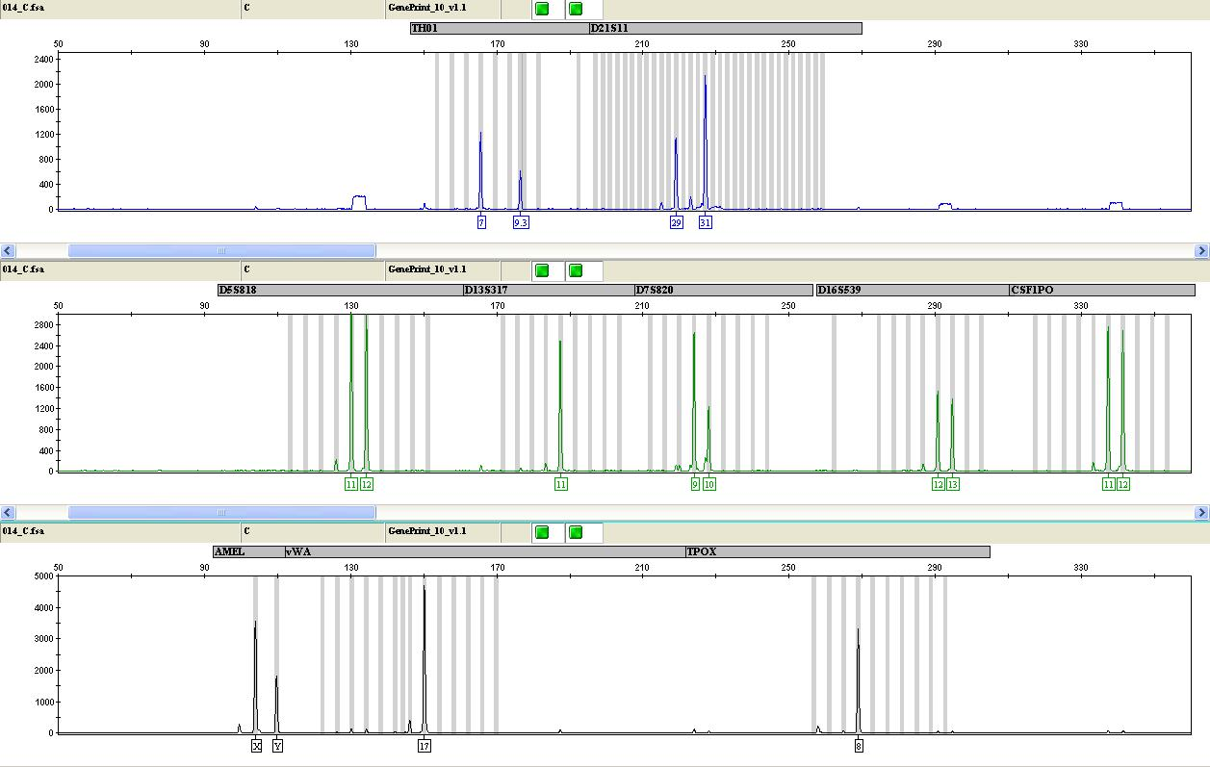

 | A |  |  |  | THO1 |  |  | D21S11 |  |  | D5S818 |  |  | D13S317 |  |  | D7S820 |  |  | D16S539 |  |  | CSFIPO |  |  | AMEL |  |  | vWA |  |  | TPOX
 | Tested Cell |  |  |  | 8,9 |  |  | 30 |  |  | 10,11 |  |  | 8 |  |  | 8,9 |  |  | 12,13 |  |  | 11,12 |  |  | X,Y |  |  | 15,18 |  |  | 8,10
 | Line (SCC2)
 | Cell line |  | Match
 |  |  |  |  |  |  |  |  |  |  |  |  |  | No match found above 80%

Report 02/05/2018
Cell Line STR Profile Report
University of Sheffield Genomics Core Facility
Sample B. SCC72
Result summary
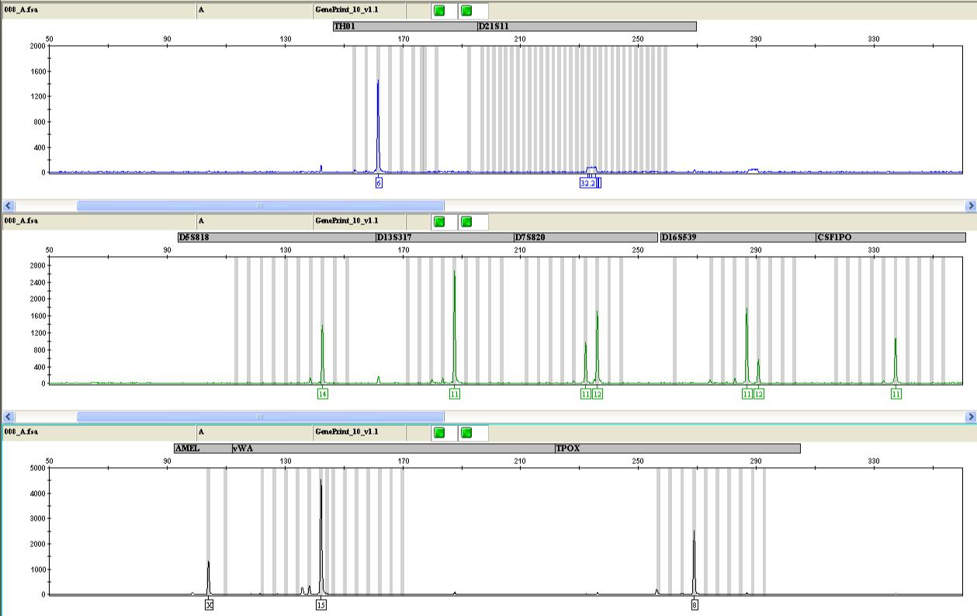

B |  |  |  |  | THO1 |  |  | D21S11 |  |  | D5S818 |  |  | D13S317 |  |  | D7S820 |  |  | D16S539 |  |  | CSFIPO |  |  | AMEL |  |  | vWA |  |  | TPOX
Tested Cell |  |  |  |  | 6,6 |  |  | - |  |  | 14,14 |  |  | 11,11 |  |  | 11,12 |  |  | 11,12 |  |  | 11,11 |  |  | X,X |  |  | 15,15 |  |  | 8,8
Line
(SCC72)
Cell line |  | Match

Report 02/05/2018
Cell Line STR Profile Report
University of Sheffield Genomics Core Facility
Sample C. SCC89
Result summary
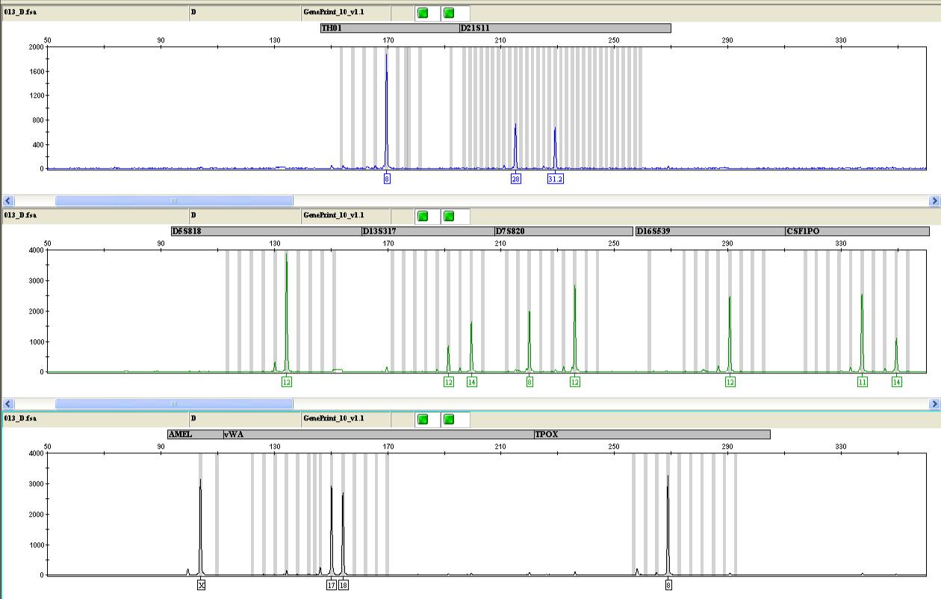

 | C |  |  |  | THO1 |  |  | D21S11 |  |  | D5S818 |  |  | D13S317 |  |  | D7S820 |  |  | D16S539 |  |  | CSFIPO |  |  | AMEL |  |  | vWA |  |  | TPOX
 | Tested Cell
 |  |  |  |  | 8,8 |  |  | 28,31.2 |  |  | 12,12 |  |  | 12,14 |  |  | 8,12 |  |  | 12,12 |  |  | 11,14 |  |  | X,X |  |  | 17,18 |  |  | 8,8
 | Line
 | (SCC89)
 | Cell line |  | Match
 |  |  |  |  |  |  |  |  |  |  |  |  |  | No match found above 80%

Report 02/05/2018
Cell Line STR Profile Report
University of Sheffield Genomics Core Facility
Sample D. SCC90
Result summary
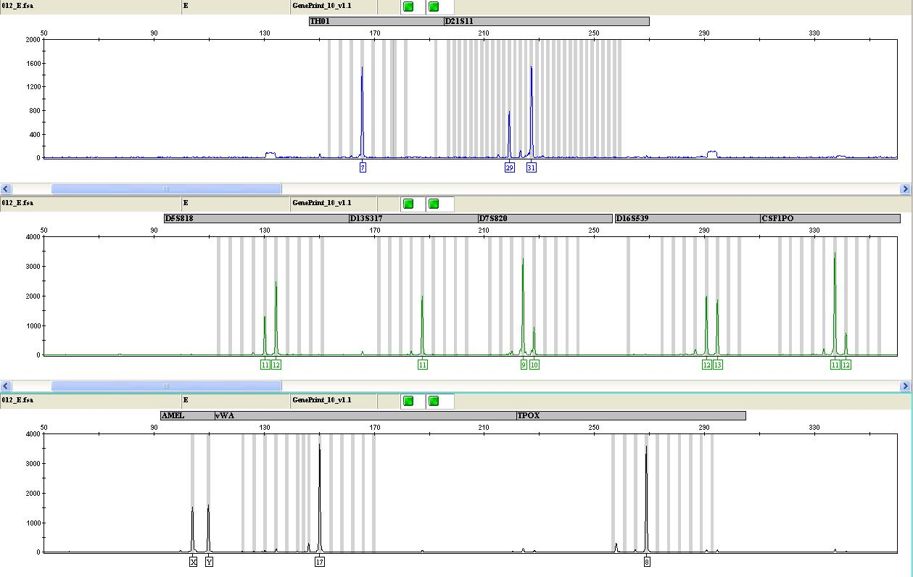

D |  |  |  |  | THO1 |  |  | D21S11 |  |  | D5S818 |  |  | D13S317 |  |  | D7S820 |  |  | D16S539 |  |  | CSFIPO |  |  | AMEL |  |  | vWA |  |  | TPOX
Tested Cell |  |  |  |  | 7,7 |  |  | 29,31 |  |  | 11,12 |  |  | 11,11 |  |  | 9,10 |  |  | 12,13 |  |  | 11,12 |  |  | X,Y |  |  | 17,17 |  |  | 8,8
Line
(SCC90)
Cell line |  | Match

Report 02/05/2018
Cell Line STR Profile Report
University of Sheffield Genomics Core Facility
Sample E. SCC152
Result summary

E |  |  |  |  | THO1 |  |  | D21S11 |  |  | D5S818 |  |  | D13S317 |  |  | D7S820 |  |  | D16S539 |  |  | CSFIPO |  |  | AMEL |  |  | vWA |  |  | TPOX
Tested Cell |  |  |  |  | 7,9.3 |  |  | 29,31 |  |  | 11,12 |  |  | 11,11 |  |  | 9,10 |  |  | 12,13 |  |  | 11,12 |  |  | X,Y |  |  | 17,17 |  |  | 8,8
Line
(SCC152)
Cell line |  | Match
UPCI-SCC- |  | 18/18 |  | 7,9.3 |  |  |  |  |  | 11,12 |  |  | 11,11 |  |  | 9,10 |  |  | 12,13 |  |  | 11,12 |  |  |  | X,Y |  | 17,17 |  |  | 8,8
152
SW756 |  | 15/18 |  | 9.3,9.3 |  |  |  |  |  | 11,12 |  |  | 11,11 |  |  | 10,12 |  |  | 12,13 |  |  | 11,12 |  |  |  | X,X |  | 17,17 |  |  | 8,8
Comment: Very close match to UPCI-SCC-090 (DSMZ ACC 670). UPCI-SCC-090 and UPCI-SCC-152 are derived from the same patient [White et al., 2007 Oral Oncol. 43 701]. The two cell lines have extremely similar STR profiles (see accompanying information): the percentage match between the two profiles is 95.8% and the two cell lines cannot be categorically distinguished by STR profiling.
Report 02/05/2018
Cell Line STR Profile Report
University of Sheffield Genomics Core Facility
Sample F. FaDu
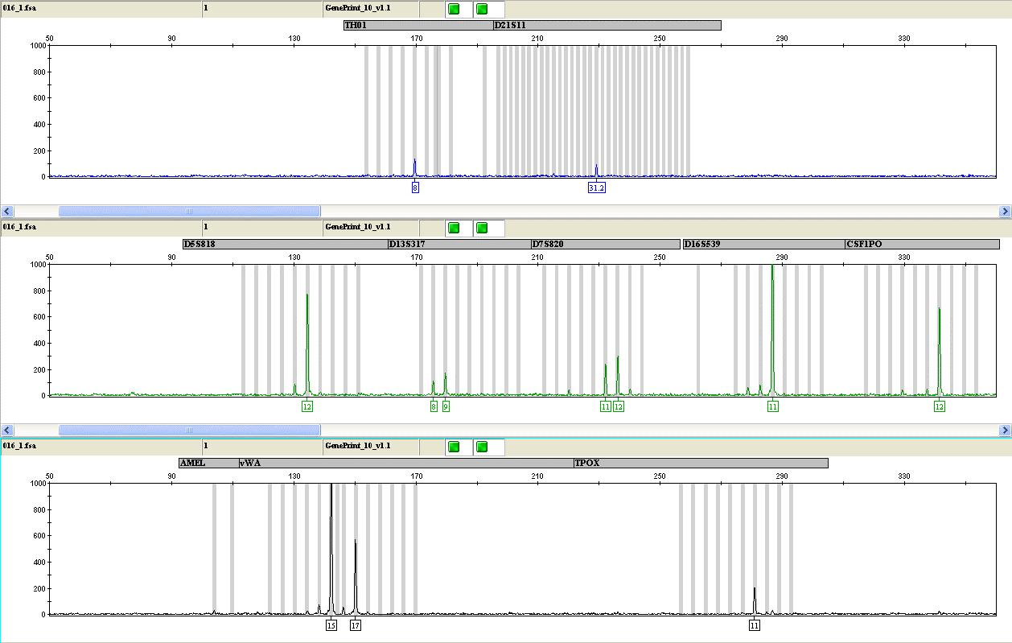
Result summary

 | F |  |  |  |  | THO1 |  |  | D21S11 |  |  | D5S818 |  |  | D13S317 |  |  | D7S820 |  |  | D16S539 |  |  | CSFIPO |  | AMEL |  | vWA |  |  | TPOX
 | Tested
 | Cell |  |  |  |  | 8,8 |  |  | 31.2,31.2 |  |  | 12,12 |  |  | 8,9 |  |  | 11,12 |  |  | 11,11 |  |  | 12,12 |  |  |  | 15,17 |  |  | 11,11
 | Line
 | (FaDu)
 | Cell |  |  | Match
 | line
 | FaDu |  | 16/16 |  | 8,8 |  |  |  |  |  | 12,12 |  |  | 8,9 |  |  | 11,12 |  |  | 11,11 |  |  | 12,12 |  |  |  | 15,17 |  |  | 11,11

Comment: Matches ATCC reference profile at 7/8 markers. The reference profile has three alleles at vWA; only two of these are present in the test sample. This is a 95.7% match, which meets ICLAC criteria for a match between test and reference.

"Samples from the same donor generally yield a result in the 80 -100 % match range (EV 0.8-1.0), while samples from different donors generally lie in the 0-55 % match range (EV 0-0.55)."*

“A small amount of STR profile variation may be seen between cultures derived from the same donor. This can be caused by genetic drift with passage, particularly in cell lines with microsatellite instability. Variation may also relate to laboratory differences in test methods or interpretation.”**

*Page 3- International Cell Line Authentication Committee: Guide to Human Cell Line Authentication.

