A novel method for solar heating of domestic water, with the opinions of main actors and consumers considered for its diffusion in the UK
A tale of two departments
James Peter Robert Williams MEng, MSc
Submitted in the departments of:
Mechanical Engineering and Psychology
Autumn 2018

(Blank page)

“It is extremely likely (95 percent confidence) more than half of the observed increase in global average surface temperature from 1951 to 2010 was caused by the anthropogenic increase in greenhouse gas concentrations and other anthropogenic forcing together.”
2013 Intergovernmental Panel on Climate Change

“The angry men know that this golden age (of fossil fuels) has gone; but they cannot find the words for the constraints they hate. Clutching their copies of Atlas Shrugged, they flail around, accusing those who would impede them of communism, fascism, religiosity, misanthropy, but knowing at heart that these restrictions are driven by something far more repulsive to the unrestrained man: the decencies we owe to other human beings.”
George Monbiot

“Ideas are like rabbits. You get a couple and learn how to handle them, and pretty soon you have a dozen”
John Steinbeck

Executive Summary

The UK’s climate change commitments and increasing domestic energy costs are compelling homeowners to find more efficient forms of energy to heat domestic hot water. Solar Thermal Panels (STP) are an established renewable technology which has been used for decades in the UK to heat domestic hot water. Yet the technology is not widely adopted in the UK and this dissertation determines some of the reasons why using a socio-technical approach.
A novel heating system is initially proposed which uses weather predictions to best determine the consumption pattern of hot water in a domestic property. Use of a control system is conducted with a resulting increase in efficiency and a decrease in domestic energy costs.
The work then focuses on understanding the opinions of the main actors in the STP market who have an influence on consumer adoption of STPs by conducting eight semi-structured interviews. Having identified the main actors, four semi-structured interviews were conducted in 2012 and another four in 2015. The main actors identified were: politicians; academics; community organisers; and manufacturers. Having identified these main actors as having an influence on consumer adoption of STPs the semi-structured interviews were conducted to determine their opinions of this domestic renewable technology. Additionally, questions surrounding the perceived reasons which have hindered, or helped, the adoption of this technology were investigated with the main actors suggesting that an independent governing body should be created to facilitate, potential adopters of this technology, to receive verifiable information concerning their specific needs.
As well as conducting these semi-structured interviews ten focus groups, five in 2012 and another five in 2015, were conducted with the general public to understand their opinions and concerns with this technology. Having conducted these focus groups, it was determined that cost issues concerning energy prices and capital costs were the primary concern of the participants. The participants cited costs as the main reason which would influence their decision to adopt or reject STP technology. Concerns regarding climate change were also cited as a factor for some participants, but, if the participants did not have available funds to invest in STP technology they would not be persuaded by the effects of anthropogenic climate change. There was a great deal of confusion with the participants concerning the operation and benefits of STPs with this confusion having a detrimental effect on the participant’s perceived benefits of STP technology. Manufacturers were described as over-selling the technologies capabilities whilst politicians were described as under-selling the technology for partisan reasons. The results of the focus groups highlighted a general positive opinion of STP technology, from the appearance of the panels to the benefits it could offer homeowners with a reduction in energy costs, but the effectiveness of the panels to provide sufficient quantities of hot water at sufficient temperatures was questioned.
The Technology Adoption Model was assessed as an effective model to describe consumer behaviour of this novel technology in all of these qualitative studies and the constructs of the TAM (Perceived Ease of Use and Perceived Usefulness) were evaluated as being constructs which describe consumer adoption. The qualitative studies evaluated the TAM and the TAM + Trust as containing constructs which were raised in the focus groups. However, there are other factors which are not encapsulated by these models which were raised as having an impact on consumers’ decisions. Participants’ “green identity” and understanding of the operation of this technology was shown to have a significant effect on consumer adoption decisions.

Acknowledgements

I would like to acknowledge and thank the tremendous help, support and understanding from my two supervisors Prof Stephen Beck and Dr Chris Jones have shown me throughout this process. They have made an incredibly difficult four years bearable and dare I say it, enjoyable. I’ve been very lucky to have you both as supervisors. Thank you.
The nurses, therapists, neurologists and all the other wonderful people who have helped me in the last five years have provided a foundation from which all else is possible. I would like to give a particular thank you to Liam Rice for all his help, support and understanding. It is an evolving struggle, but I’m getting there.
Thanks too to my family and friends have supported and have helped me retain a modicum of normality. Without regular trips to cafes, games of chess, nights out, dinners in all with a general silliness I wouldn’t have made it this far.
I would finally like to thank the members of staff involved with the creation of the E-Futures program here at the University of Sheffield. Their prescient vision of interdisciplinary research has suited me perfectly and is vital to the evolving energy market in the coming decades.

  - Glossary of Terms
A_{b} Absorptance of collector (-)
A_{C} Area of collector (m²)
BSRIA Building Services Research and Information Association
CC Concentrating Collector
C_{GAS} Cost of gas used by auxiliary boiler (£)
C_{P} Specific heat capacity of water (J/kg °C)
DCLG Department of Communities and Local Government
DECC The Department for Energy and Climate Change
DTI The Department for Trade and Industry
DNI Direct Normal Irradiation (W/m²)
dT Temperature difference between required temperature and temperature of water as it leaves the tank (°C)
E_{SAVE} Final energy savings from STP (£/yr)
ESTIF European Solar Thermal International Federation
ETC Evacuated Tube Collector
IEA International Energy Agency
FPC Flat Plate Collector
$F_{SOL}$ Solar Fraction (-)
GA Genetic Algorithm
GHG Greenhouse Gas
GHI Global Horizontal Irradiance (W/m²)
H Solar irradiation incident per unit area (W/m²)
I_{T} Total Irradiation on the STP (W/m²)
KTOE Kilotons of oil equivalent
LCA Life Cycle Analysis
m Mass of water (kg)
$ṁ$ Mass flow rate of the heating fluid (kg/s)
MATH Model of Adoption of Technology in Households
MGS Micro-Generation Strategy
MTOE Mega Tons of Oil Equivalent
n Day of year (-)
NVIVO Software package used in the qualitative analysis
PC Plastic Collector
PCM Phase Changing Material
PSO Particle Swarm Optimisation
PV PV Technology
Q_{AUX} Additional energy required by auxiliary boiler (W)
$Qcol$ Energy removed by the heat transfer fluid over the time period (W)
Q_{d} Energy required to heat the required volume of water (W)
$Q_{U}$ Useful Energy into the collector (W)
R Overall Reflectance of collector (-)
RHI Renewable Heat Incentive
SDHWS Solar Domestic Hot Water Systems
SPSS Statistical Package for the Social Sciences, Software package used in the qualitative analysis
SSF Sheffield Solar Farm (53.3810 °N 1.4861 °W)
STPs Solar Thermal Panels
ST Solar Thermal
STS Solar Thermal Systems
TALC Technology Adoption Life Cycle
TAM Technology Acceptance Model
T_{Out} Fluid outlet temperature (C)
TPB Theory of Planned Behaviour
Tr Transmittance of the collector (-)
TRA Theory of Reasoned Action
UTAUT Unified Theory of Acceptance and Use of Technology

Subscripts

_{AUX} Auxiliary
_{COL} Collector
_{D} Day
_{SOL} Solar
_{T} Total
_{W} Water
_{WCW} Water - copper – water

Greek Symbols

$α$ Plate Emissivity
$δ_{S}$ Solar Declination
Λ Latitude (°)
$η_{COL}$ Efficiency of collector (-)
$η_{0}$ Zero loss collector efficiency (-)
$ρ$ Glass Surface Reflectivity (-)
$τ$ Glass Tranmissivity (-)
T$α$ Tau-alpha product (-)
Table of Contents

Section |  | Page
1 | CHAPTER ONE, Introduction, the case for renewable energy | 1
1.1. | Defining the problem, global issues | 1
1.2. | Global energy consumption by sector | 3
1.3 | The UK’s energy consumption | 6
1.4 | Energy consumption in UK buildings | 7
1.5. | Defining the problem, a UK perspective | 8
1.6. | Hot water consumption in domestic buildings in the UK | 9
1.7. | The UK’s renewable energy market | 10
1.8. | Micro-generation Technologies | 12
1.9. | Solar energy | 14
1.10. | Recent advances in the solar thermal panel technology | 17
1.11. | The effect of solar water heating on energy usage in homes | 19
2 | CHAPTER TWO, Literature Review | 22
2.1. | Engineering Literature Review | 22
2.2 | Efficiency of various methods for heating water for domestic use | 24
2.3 | Efficiency of utilising solar thermal panels for heating water | 27
2.4 | Environmental benefits of STPs | 27
2.5. | Computer models for domestic solar applications | 30
2.6. | Stratification | 38
2.7. | The use of weather in previous studies | 42
2.8 | Matlab as a tool for simulating a solar thermal panel and the heating of a hot water tank | 46
2.9. | Recent innovations with solar thermal panels | 46
2.9.1. | Phase Changing Materials (PCM) used in solar domestic systems | 47
2.10. | Optimum tilt of the collector to receive maximum solar gain | 48
2.11. | Conclusions from the engineering literature, direction for this research | 54
2.12. | Psychology Literature Review | 56
2.12.1 | The value of using psychological methods to better understand the opinions of key stakeholders in the STP market | 56
2.13. | The Theory of Planned Behaviour (TPB) | 59
2.14. | The Model of Adoption of Technology in Households (MATH) | 60
2.15. | The Unified Theory of Acceptance and Use of Technology (UTAUT) | 62
2.16. | The Technology Adoption Model (TAM) | 63
2.17. | The Technology Adoption Model + Trust (TAM + Trust) | 65
2.18 | Conclusions from the psychology literature review and direction for this research | 66
2.19. | Final conclusions from the literature review | 67
3 | CHAPTER THREE, Computer simulations of a solar float plate collector incorporating weather predictions | 69
3.1. | Global Horizontal Irradiance (GHI) and Direct Normal Irradiance (DNI) in the UK | 69
3.2. | Parameters to measure when evaluating the performance of the STP system | 73
3.3. | Calculation of heat into panel from the sun | 75
3.4. | Additional energy required by an auxiliary boiler | 78
3.5. | Cost of using an auxiliary boiler | 78
3.6. | Final energy savings | 78
3.7. | Final choice of parameters to measure when evaluating the performance of the STP system | 79
3.8. | Calculating the heat from a solar thermal panel throughout the day | 80
3.9. | Final constants used in the Matlab program | 81
3.10. | The hot water tank | 82
3.11. | The heating coil | 83
3.12 | Calculating the heating up of the hot water tank | 83
3.13. | Conduction in the tank between slices | 85
3.14. | Simplifications in the Matlab program | 86
3.15. | Flow diagram of the Matlab program | 87
3.16. | Recorded direct, diffuse and total irradiance at Sheffield Solar Farm (SSF), between 19/02/2014 00:00 - 19/02/2015 23:59 | 89
3.17. | Recorded irradiance at SSF throughout a year | 90
3.18. | Options for choice of Tapping Cycle | 95
3.19. | Results from Matlab simulations | 106
3.20. | Discussion of Matlab results | 112
3.18. | Options for choice of Tapping Cycle | 96
3.19. | Results from Matlab simulations | 107
3.17. | Recorded irradiance at SSF throughout a year | 91
3.18. | Options for choice of Tapping Cycle | 96
3.19. | Results from Matlab simulations | 107
3.20. | Discussion of Matlab results | 112
3.21. | Conclusions from engineering work and potential future directions for research | 113
4 | CHAPTER FOUR, Qualitative studies, using semi-structured interviews with the main actors in the solar thermal market to understand their opinions of STPs | 114
4.1. | Introduction, the use of semi-structured interviews | 114
4.2. | Key stakeholders in the UK domestic heat market | 114
4.3. | Semi-structured interviews, methods | 118
4.3.1. | Summary of participants for the semi-structured interviews in 2012 and 2015 | 118
4.3.2. | Sampling of main actors in the STP market in 2012 & 2015 | 120
4.4. | Thematic analysis | 121
4.5. | Results from semi-structured interviews in 2012 and 2015 | 122
4.5.1. | Perceived Usefulness | 122
4.5.2. | Perceived ease of use | 123
4.5.3. | Trust issues | 128
4.6. | Discussion of results from semi-structured interviews in 2012 and 2015 | 133
4.7. | Conclusions of semi-structured interviews in 2012 and 2015 | 136
5 | CHAPTER FIVE, Focus groups in 2012 and 2015 | 138
5.1. | Introduction, the use of focus groups | 138
5.2. | Focus groups in 2012 and 2015 | 138
5.2.1. | Demographics of the focus groups, 2012 | 139
5.2.2. | Demographics of the focus groups, 2015 | 140
5.3. | Focus groups, procedure | 140
5.4. | Results of the focus groups in 2012 | 142
5.4.1. | Perceived benefits and concerns with solar thermal panels, 2012 | 142
5.4.2. | Reasons for adopting STPs or not adopting STPs, 2012 | 146
5.4.3. | Receiving information about STPs, 2012 | 146
5.4.4. | Trust issues, 2012 | 148
5.5. | Results of the focus groups in 2015 | 149
5.6. | Discussion of findings from focus groups, 2012 and 2015 | 152
5.7. | Conclusions from semi-structured interviews and focus groups 2012 and 2015 | 153
5.8. | The TAM and the TAM = Trust to describe consumer behaviour with respect to solar thermal panels | 154
5.9. | Potential direction for future research | 156
6 | CHAPTER SIX, Concluding remarks and future direction for research | 157
7 | APPENDIX | 160

List of Figures

Figure 1.1. | World Primary Energy Supply in 1973 and 2009 in Million tons of oil (MTOE) equivalent |  | 2
Figure 1.2. | Sectoral shares of global energy consumption |  | 3
Figure 1.3. | Residential energy consumption and annual growth rate in the 10 largest emitters of CO₂ in 2000 and 2011 |  | 4
Figure 1.4. | Global growth rates of different residential energy sources (2000 – 2011) |  | 5
Figure 1.5. | Final energy consumption in the UK by sector |  | 6
Figure 1.6. | Average UK domestic energy consumption by end-use and fuel type |  | 7
Figure 1.7. | Share of UK domestic energy consumption by end use and domestic energy spend |  | 8
Figure 1.8. | Litres of hot water consumed per person per day in the UK | 9
Figure 1.9. | The Earth’s Energy Budget | 14
Figure 1.9. | An Evacuated Tube Collector (l) and a Solar Thermal Panel (r) | 17
Figure 1.10. | The construction layers of a typical STP | 17
Figure 2.1. | Components of a solar water heater 10 largest emitters in 2000 and 2011 |  | 18
Figure 2.2. | The life cycle of solar thermal systems |  | 19
Figure 2.3. | The heat output of solar collectors at two different angles 20° and 60° |  | 20
Figure 2.4. | The variation of solar fraction with collector orientation |  | 21
Figure 2.5. | The Solar Domestic Heating System investigated by Biaou |  | 22
Figure 2.6 | The investigated hot water tanks by Furbo (2005) |  | 24
Figure 2.7 | The meteorological data for Zurich, Switzerland |  | 27
Figure 2.8 | The hot water system considered by Prud’homme (2001) |  | 28
Figure 2.9 | The predictive model used by Prud’homme (2001) |  | 29
Figure 2.10 | The position of the earth at different times of the year |  | 32
Figure 2.11 | The Declination Angle (δ) throughout the year using Eq. (2) |  | 34
Figure 2.12 | The Theory of Planned Behaviour (TPB) |  | 37
Figure 2.13. | The Model of Adoption in Households (MATH) |  | 39
Figure 2.14. | The Unified Theory of Adoption of Use of Technology (UTAUT) |  | 40
Figure 2.15. | The Technology Adoption Model (TAM) |  | 41
Figure 3.1. | The average annual sum for the Global Horizontal Irradiation (GHI) for the UK over the period 1994 – 2013 |  | 44
Figure 3.2. | The average annual sum for the Direct Normal Irradiation (DNI) for the UK over the period 1994 – 2013 |  | 45
Figure 3.3. | A pyrometer similar to the one used at the Sheffield Solar Farm⁴ |  | 46
Figure 3.4. | The proposed hot water tank |  | 56
Figure 3.5. | The heating coil in the hot water tank |  | 58
Figure 3.6. | Conduction from warmer slices to cooler slices of water within the hot water tank |  | 59
Figure 3.7. | Flow diagram of the Matlab program |  | 61
Figure 3.8. | Direct, Diffuse and Total Irradiance as measured at the Sheffield Solar Farm⁴ , 53.38 °N 1.48 °W, 19/02/2015 - 19/02/2015 |  | 63
Figure 3.9. | Direct, Diffuse and Total Irradiance as predicted by the MET Office +0Hrs |  | 64
Figure 3.10. | Direct, Diffuse and Total Irradiance as predicted by the MET Office +24Hrs |  | 65
Figure 3.11. | Figure 3.11. Direct, Diffuse and Total Irradiance at Sheffield Solar Farm ⁴ 00:00 - 23:59 19/02/2014 |  | 66
Figure 3.12. | Temperature of the heating coil from the STP 00:00- 23:59 19/02/2014 |  | 66
Figure 3.13. | Direct, Diffuse and Total Irradiance at Sheffield Solar Farm⁴ 00:00 - 23:59 19/05/2014 |  | 67
Figure 3.14. | Temperature of the heating coil from the STP 00:00- 23:59 19/02/2014 |  | 67
Figure 3.15. | Direct, Diffuse and Total Irradiance at Sheffield Solar Farm⁴ 00:00 - 23:59 19/08/2014 |  | 68
Figure 3.16. | Temperature of the heating coil from the STP 00:00- 23:59 19/08/2014 |  | 69
Figure 3.17. | Direct, Diffuse and Total Irradiance at Sheffield Solar Farm⁴ 00:00 - 23:59 19/02/2015 |  | 70
Figure 3.18. | Temperature of the heating coil from the STP 00:00- 23:59 19/02/2015 |  | 70
Figure 3.19. | The TAM |  | 85
Figure 6.1. | Volume of water tapped throughout a 24Hr period, Tapping Cycles #1, #2 & #3
Figure 6.2. | The cost of using a 90% efficient auxiliary boiler throughout a 24Hr period, Tapping Cycles #1, #2 & #

List of Tables

Table 1.1. | Comparative advantages and disadvantages of solar thermal technology | 16
Table 1.2. | Typical characteristics of a Flat Plate Collector | 17
Table 1.3. | Various methods to involve final users in the design process | 20
Table 2.1. | “Rules of Thumb” guide to daily hot water consumption | 24
Table 2.2. | The various heating methods employed in the UK to heat domestic hot water | 16
Table 2.3. | Stratification findings from various studies | 40
Table 2.4. | PCM materials and their properties | 47
Table 2.5. | The optimum tilt angle for maximum solar density, Northern Hemispheres | 51
Table 2.6. | The Energy, CO₂ and economic pay-back times (in years) of a solar panel | 56
Table 3.1. | The final constants used in the Matlab program, their values and units | 81
Table 3.2. | Options for Tapping Cycle choice | 96
Table 4.1. | Summary of participants for the semi-structured interviews in 2012 and 2015 | 119
Table 5.1. | The demographics for each focus group in 2012 | 139
Table 5.2. | The demographics for each focus group in 2015 | 140
Table 7.1. | Tapping Cycle #1 | 160
Table 7.2. | Tapping Cycle #2 | 161
Table 7.3. | Tapping Cycle #3 | 162
Table 7.4. | The various weather symbols predicted by the MET Office for the next (0Hrs) from 19/02/2014 00:00:00 – 26/06/2015 23:50:00The demographics for each focus group in 2015 | 163
Table 7.5. | The various weather symbols predicted by the MET Office for the day after tomorrow (24 hours) from 19/02/2014 – 26/06/2015 | 164
Table 7.6. | The three Tapping Cycles, the auxiliary heat required by a 90% efficient boiler per °K throughout a 24-hour period and the associated cost | 165
Table 7.7. | Baxi and Akverterm product specifications of STPs | 166
Table 7.8. | KingSpan and Worcester Bosch specifications of hot water tanks | 166
Table 7.9. | The inter-coder reliability for the 2012 focus groups | 168
Table 7.10. | The inter-coder reliability for the 2015 focus groups | 173
Table 7.11 | The Declination Angle (δ) for days in the middle of each month | 174

Chapter 1

Introduction, the case for renewable energy
The work contained in this dissertation describes a novel heating method for domestic hot water utilizing solar thermal panels. It assesses not only the technological benefits of employing a novel heating method, but also the opinions of the main actors within the solar thermal panel market. Their opinions are also considered to evaluate consumer motivations and barriers to adopting solar thermal panels in Sheffield, UK.
The dissertation begins by describing the global problem of anthropogenic climate change. Particular attention is given to the situation in the UK including the internationally binding agreements to reduce CO₂ emissions. The chapter then focuses on the use of hot water in domestic properties as being an area that has had less research attention in recent years and thus provides an opportunity for the current research.
The chapter finishes by highlighting the reasons for adopting a socio-technical approach which was used for this research.

Defining the problem, global issues
The technological advancements of the last fifty years, which have addressed many of the world’s problems, have been achieved in part through the increased use of energy (Angel et al. 2011). Advancements in medicines, healthcare, education as well as improving the global food supply is predicted to swell the global population to beyond 9.5 billion peoples by 2050 with 6.4 billion living in urban areas (Angel et al. 2011). However, with an increasing global population and individual nations wanting to take advantage of economic development through increased energy usage, inevitably there will be a resulting increase in global energy demand (Angel et al. 2011). Global energy demand at present predominantly comprises of fossil fuels (oil, gas and coal) with the burning of these finite resources resulting in the release of greenhouse gases (GHG) which has widely been accepted to contribute to global warming (Duyck, 2015; Sindico, 2016). The International Energy Agency (IEA) predicted in their 2015 World Energy Outlook report that the world is expected to increase energy demand by one third from 2010 to 2035 and that the world is:
“…failing to put the global energy system onto a more sustainable path.”
(World Energy Outlook 2015)
Against this backdrop of unsustainable energy use there have been a number of international agreements (Kyoto 1997, Rio 2012, Paris 2016 etc.) which have attempted to address the problem of unsustainable energy usage by compelling individual governments to make significant reductions to their GHG emissions (Sindico, 2016); (Duyck, 2015; IPCC, 2013) These binding targets require a reduction in GHGS of at least 80% by 2050 which will limit global warming to 2°C, the widely accepted temperature rise which needs to be prevented to avoid catastrophic climate change (World Energy Outlook 2013; World Energy Outlook 2015). These international agreements have, by their very nature, affected the fuel share globally as governments have increased the use of renewable energy systems and reduced their reliance on fossil fuels. Renewable energy sources today are more viable and sustainable as technological advancements have enabled nations to harvest the greatest amount of available energy from the local environment (World Energy Outlook 2015).
However, despite the recent growth in renewable energy the overall contribution of renewable energy as a proportion of the total energy supply system is still small, as shown by Figure 1.1. The move from fossil fuels to renewable sources of energy from 1973-2009 has also increased fuel security as peoples are able to access energy directly where it is required rather than having companies or governments supplying energy as it is demanded (World Energy Outlook 2013; World Energy Outlook 2015).
Figure 1.1. World Primary Energy Supply in 1973 and 2009 in Million tons of oil (MTOE) equivalent. “Other” includes: Wind; Solar; Geothermal and other renewable sources (World Energy Outlook 2015)
Figure 1.1. also shows the growth in total global energy demand which has seen a trebling from 6111 MTOE in 1973 to 2150 MTOE in 2009 (World Energy Outlook 2015). This is due, in part, to the growth in global population over the same time period (4 billion – 6.8 billion) and also due to the increasing development of countries (Agency, 2015). With increasing development, an increase in energy usage results (World Energy Outlook 2015). Currently, fossil fuels (oil, natural gas and coal) account for approximately 80% of the globe’s energy use with nuclear sources providing approximately 6% of the total energy supply. This indicates that in 2012 approximately 14% of the world’s energy supply comes from renewable sources (Agency, 2015).

Global energy consumption by sector
Global energy consumption is predominantly utilized in the transportation sector which accounts for 33% of the total energy demand as shown by Figure 1.2. The other sectors comprise the remaining proportion of the total: industry (29%); commercial (8%); residential (27%); and others (3% energy losses and self-use). Thus, approximately a third of global energy consumption is consumed in the residential sector and energy savings made in this sector will have potentially significant overall reductions in energy demand (A. Faiers & C. Neame, 2006).
Figure 1.2. Sectoral shares of global energy consumption (A. Faiers & C. Neame, 2006)
Energy demand from all buildings (commercial and residential) has grown at about 1.8% per year with the residential sector seeing approximately a 14% increase in energy consumption over the ten years from 2000 to 2010 (Nejat et al., 2015). This is despite improvements to the energy efficiency of buildings largely due to the airtightness of buildings being improved (Nejat et al., 2015). Over that same time period all energy sources consumed in the residential sector have seen a growth, with the exception of oil which has seen a fall of 8% which is due in part to the increase in renewable energy sources used in the home (Nejat et al., 2015). The global growth in renewable energy sources used in the residential sector has principally occurred in developed countries over the period 2000 - 2011 as developed countries are able to employ modern renewable technologies to generate energy from available renewable sources (Nejat et al., 2015). The 10 largest emitters of CO₂ globally and the annual growth rate from 2000 - 2011 in residential energy consumption in shown in Figure 1.3. (Nejat et al., 2015). Figure 1.3 shows that the UK has reduced its domestic consumption of energy by approximately by 17% from 2000 – 2011 which has been achieved primarily through an increase in better insulation of the average UK home (Nejat et al., 2015).
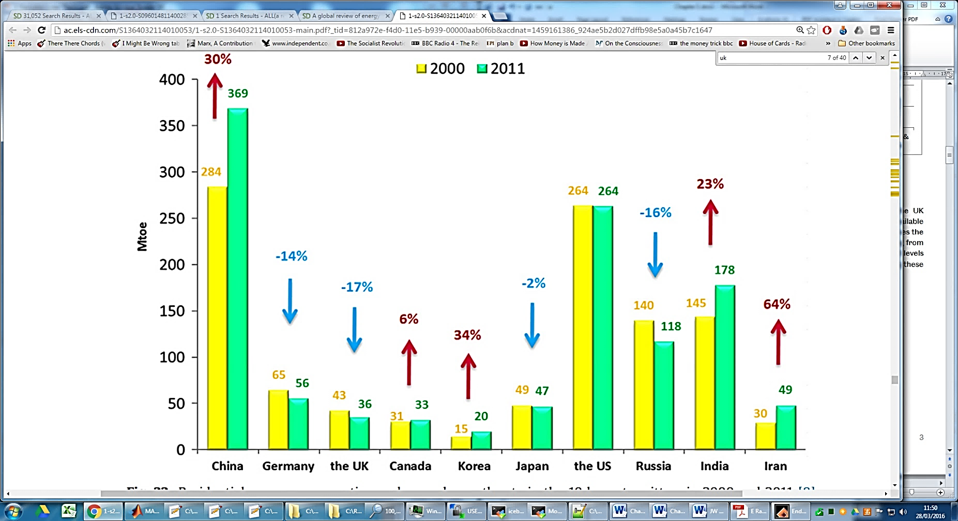
Figure 1.3. Residential energy consumption and annual growth rate in the 10 largest emitters of CO₂ in 2000 and 2011 (Nejat et al., 2015)
There are four countries shown in Figure 1.3. which have had a fall in residential energy consumption over this time period (Germany, the UK, Japan and Russia) (Nejat et al., 2015). This has been achieved in part due to improvements in energy efficient technologies being used in domestic properties. Modern renewable technologies used in the residential sector have had the highest growth rate of 57% from 2000-2011. In comparison, oil used in the residential sector has had a global growth rate of 8% from 2000-2011 as shown in Figure 1.4. (Nejat et al., 2015).
Figure 1.4. Global growth rates of different residential energy sources (2000 – 2011) (Nejat et al., 2015)

The smallest growth rate, as shown in Figure 1.4. is in coal which has only seen a 1% increase from 200-2011, a difference of over 50 times in comparison to modern renewable sources (Nejat et al., 2015).

The UK’s energy consumption

Overall energy consumption in the UK has been rising since the 1970’s, despite a fall in consumption in the industry sector and the services sector having a relatively stable demand over the same time period (Nejat et al., 2015). The UK in 2017 increased the amount of energy it consumed by approximately 1.6 % of the total in 2016. This increase is equivalent to 2,167 Kilo Tons of Oil Equivalent (KTOE) and was primarily due to an increase in the use of natural gas which experienced an increase of 3.2% (Nejat et al., 2015). The greater volatility in energy consumption is highlighted by Figure 1.5 as being quite extreme in the residential sector when compared to the three other sectors (transport, industry and service) and this is primarily due to fluctuating energy costs of conventional energy sources such as oil and natural gas (Nejat et al., 2015).

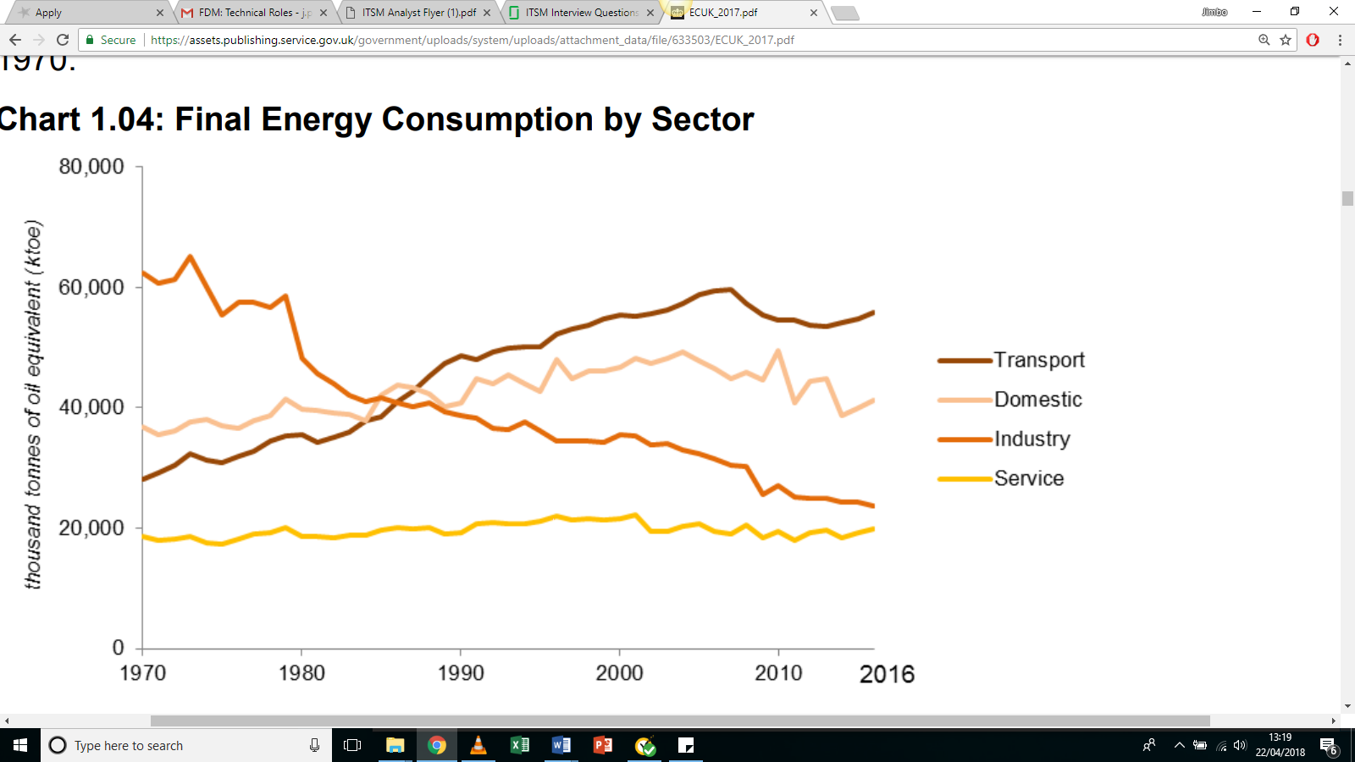
Figure 1.5. Final energy consumption in the UK by sector (Nejat et al., 2015)

Energy consumption in UK buildings
Energy consumption in all UK buildings accounts for approximately 41% of total energy has illustrated by Figure 1.5 which is one of the highest proportions in the world (Nejat et al., 2015). In the Appendix, Table 1.3 shows a breakdown of the total amount of energy used in the domestic sector in the UK over of the years 1990 – 2006. Using these 2006 figures, the proportion of energy used for generating hot water in UK domestic properties accounts for:
Proportion of energy used = Energy used in generating hot water for generating hot water Total energy used per household
= 460.1 x 10¹⁵ joules
1847.8 x 10¹⁵ joules
⇒24.9 % of total energy used in the home used for water heating
This simple calculation of the amount of domestic energy being used to heat water is in broad agreement with the 23% quoted by (S. R. Allen, 2008) and is shown in Figure 1.6. Heating water for use in domestic buildings thus represents a significant proportion of total energy use in the UK and improvements to the efficiency of water heating will have a corresponding reduction in total energy use.
Figure 1.6. Average UK domestic energy consumption by end-use and fuel type (S. R. Allen, 2008)

Defining the problem, a UK perspective
Energy consumption in the UK consists of about 27% - 32% being consumed in the residential sector (Boait et al., 2008; DECC, 2013). Specific household energy consumption will vary from household to household depending on a number of specific house demographics and uses: the household type; the use of appliances in the property; the behavioural patterns of the occupants; and the number of occupants living in the property (S. R. Allen, Hammond, & McManus, 2008). Domestic energy consumption by end use and the domestic energy spend in the UK is shown in Figure 1.7 and highlights water heating in domestic properties in the UK accounting for approximately 16% of domestic energy consumption and approximately 13% of domestic energy expenditure (Energy Consumption in the UK (2015)).
Figure 1.7. Share of UK domestic energy consumption by end use and domestic energy spend (DECC, 2013)

The results of the study by DECC are in broad agreement with the results of the study conducted by The Energy Saving Trust in 2005 (DECC, 2013; Trust, 2005).

Hot water consumption in domestic buildings in the UK
An assessment of the volume of hot water that is consumed in the UK by different households was conducted by The Energy Saving Trust in 2005 with the litres of hot water consumed per person per day shown in Figure 1.8. (Trust, 2005). In this study by The Energy Saving Trust over 10,000 homes in the UK were monitored to record how much water was utilised. The results of this study indicated that each property in the UK consumes between 45 and 60 litres of hot water per day and varies from property to property dependent on the demographic of the occupants of each property. The study also showed that the largest volume of hot water is consumed by single individuals aged less than 60 years old, consuming approximately 57 L per day (Trust, 2005).
Thus, the production of hot water is not only required each day for washing and cleaning, but it is also required at volumes of approximately 60 L. Individuals aged less than 60 years old are increasingly living on their own and this study from 2005 gives an accurate estimation of the hot water this required on a daily basis (Trust, 2005). The study in 2005 was only a snapshot of hot water consumption in the UK and so extrapolating to future hot water consumption in UK from this single study is likely to result in inaccurate predictions however it is expected that hot water consumption is unlikely to fall significantly in the coming years (Trust, 2005).

Figure 1.8. Litres of hot water consumed per person per day in the UK (Trust, 2005)

The UK’s renewable energy market
The UK’s renewable energy market has historically been divided by analysts into two groups representing the potential gains which could be achieved in their respective groups (Nejat et al., 2015). It is recognised that renewable energy gains can either be realised due to either an increase in the overall employment of renewable technologies, or by improvements to the efficiency of existing energy technologies (A. Faiers & C. Neame, 2006). The research conducted in this dissertation addresses both groups by: first, investigating a more efficient renewable technology; and second, by considering the adoption and use of that technology. The UK Renewable Energy Roadmap, a UK government document identified four key barriers to the deployment of cost-effective energy efficiency investment, namely:
- Embryonic markets;
- Information;
- Misaligned financial incentives; and
- Undervaluing energy efficiency.
(A. Faiers & C. Neame, 2006)

The UK government recognised that these four barriers represented significant obstacles to the widespread deployment of renewable technologies and endeavoured to mitigate or avoid these obstacles to ensure that investment in renewable technologies could be maximised to contribute to reducing the UK’s annual carbon output. The government also recognised in 2005 that whilst there were significant economic benefits that could be realised from making energy efficiency gains the energy efficient market is currently relatively small compared to the opportunity in the market (A. Faiers & C. Neame, 2006). This report, from 2015, also highlighted a lack of trusted information available to individuals and businesses so that informed decisions can be made about the suitability of energy efficient opportunities and that this was a significant barrier to the deployment of cost-effective energy efficient investment (A. Faiers & C. Neame, 2006).
The skewed financial incentives offered to investors of energy efficient technologies have impacted adoption of these technologies such that the benefits of investment (resulting in reducing CO₂ emissions and improving energy security) are not always realised directly by the consumer (DECC, 2013; A. Faiers & C. Neame, 2006). DECC also identified energy efficient technologies as being undervalued (in part due to poor information being readily available on their effectiveness) and that there is a lack of salience in the energy efficient market which engenders behavioural barriers and increases hassle costs for consumers (DECC, 2013). These four key impediments were highlighted by the UK government as being critical to realising the renewable energy potential within the UK and thus achieving the internationally agreements as set out in the Climate Change Act 2008 (DECC, 2013); (A. Faiers & C. Neame, 2006).
To assist the UK in achieving these targets the Renewable Heat Incentive 2011 (RHI) was launched in 2011 to support participants that generate and utilise renewable forms of heat in their properties. The scheme was the “world’s first long-term financial support programme for renewable heat” with participants being paid for generating and using the renewable heat they generate on their property (participants can claim for: biomass boilers; solar water heating; and certain heat pumps) (Abu-Bakar et al., 2013). The scheme was intended to circumvent or mitigate the four key barriers noted above and to encourage wider investment and adoption of renewable technologies and was proposed to ensure that 12% of the heat used in buildings is derived from renewable sources (Abu-Bakar et al., 2013).These four barriers are further justification for applying a mixed method approach as was adopted for this research as the barriers recognised encompass both technical issues (number 1 on the list: Embryonic Markets and Information), and behavioural issues (Information; Misaligned Financial Incentives; Undervaluing Energy Efficiency; and Undervaluing Energy Efficiency, numbers 2 to 4 the list) (DECC, 2013; (A. Faiers & C. Neame, 2006).
The UK Energy Road Map was published in 2005 and set out the UK government’s planned approach to utilising the potential renewable energy available in the UK (A. Faiers & C. Neame, 2006). The document set out clear objectives to ensure that the UK achieves the internationally agreed target of 15% of the UK’s energy consumption coming from renewable sources by 2020. This proportion is set to increase to 80% of 1990 levels by 2050 (A. Faiers & C. Neame, 2006). Utilising as much renewable energy as possible will assist in achieving these binding targets (A. Faiers & C. Neame, 2006; Watson et al., 2008).

Micro-generation Technologies
There has been significant growth in renewable technologies used in the domestic sector in the UK in recent years and this has primarily been achieved by an increase in decentralised energy systems (S. R. Allen, 2008). Decentralised energy systems, or micro-generation technologies, can denote community or district level technologies as well as technologies that provide individual households with either heat or electricity (S. R. Allen, 2008). There are a number of micro-generation technologies that have been highlighted by DECC as being technologies which can be installed and utilised for homes (DECC, 2013). These technologies include: Solar Thermal (ST) technologies; Photovoltaic (PV) technologies; micro-wind; micro-hydro; combined heat and power (CHP); micro-level fuel cells and heat pumps (A. Faiers & C. Neame, 2006). As well as assisting in reducing the production of domestic carbon emissions by 15% per annum, micro-generation technologies additionally have a positive effect on household fuel poverty by increasing access to domestic energy (A. Faiers & C. Neame, 2006). Thus, DECC have promoted the increased adoption of micro-generation technologies through the employment of schemes, initially the Micro-Generation Strategy (MGS) in 2010 (R. Scarpa & K. Willis, 2010).
The MGS was a precursor to the more focused The UK Renewable Energy Roadmap 2011 which evaluated why microgeneration technologies had not been adopted at great rates than had been envisaged (R. Scarpa & K. Willis, 2010). This scheme employed financial incentives to those homeowners which adopted a microgeneration technology as it was felt that homeowners would be incentivised by financial assistance to purchase microgeneration technologies (R. Scarpa & K. Willis, 2010).
Micro-generation technologies have one significant benefit over large-scale energy production plants, in that they produce the energy closer to where it is utilised and thus suffer little or no efficiency losses due to transportation which is particularly true of STPs (S. R. Allen, . et al., 2010). Hot water loses heat when stored in a hot water tank as a hot water tank is not 100% efficient and there will therefore always be some heat loses over time. Additionally, hot water is unable to be fed into a ‘National Grid’ system which is available in the case of electricity which can be fed into the National Grid to be used at other locations other than where it was first generated (S. R. Allen, . et al., 2010). Thus, microgeneration technologies have a role to play if the UK is to reduce its CO₂ output whilst maintaining its high use of energy (S. R. Allen et al., 2008; S. R. Allen, . et al., 2010). Understanding how consumers arrive at their decision about whether to adopt a microgeneration technology will improve the schemes and incentives used to encourage adoption of microgeneration technologies (S. R. Allen, 2008).
It has been noted by later researchers that the use of financial incentives does not necessarily result in a higher adoption rate of microgeneration technologies as consumers consider more factors than simply the financial benefits of adopting a microgeneration technology (S. R. Allen et al., 2008). Homeowners consider factors such as the perceived upheaval of installing the microgeneration technology as well as the continuing costs to maintain and service technology (R. Scarpa & K. Willis, 2010). The initial capital cost of the renewable technology is offset by cost savings which are achieved by installing the technology (Riccardo Scarpa & Ken Willis, 2010). Thus, cost savings for the homeowner are achieved only at a later date from when the microgeneration technologies is installed a variable which homeowners can evaluate when assessing payback period of the technology (R. Scarpa & K. Willis, 2010). Researchers have therefore suggested that the government increase the incentives made to potential adopters of microgeneration technology as microgeneration technologies typically have a long payback period (R. Scarpa & K. Willis, 2010).

Solar energy
The sun releases vast quantities of radiation energy to its surroundings, approximately 174PW (1PW = 10¹⁵ W) to the upper atmosphere of the Earth (Tian & Zhao, 2013). Whilst not all of this radiation arrives at the surface of the Earth (due to the atmosphere and particulates and clouds in the atmosphere) 51% of this amount does reach the Earth’s surface and is absorbed by the land and oceans as shown in Figure 1.9. Solar energy is the most abundant renewable energy resource and is available in both direct and indirect forms of solar radiation (Smil, 1991; Thür & Shah, 2006). To capture this solar energy, solar collectors are used to either store the radiated energy in the form of thermal energy in a working fluid (typically water or oil), or solar radiation is captured as electrical energy through the employment of PV systems (Thür & Shah, 2006).
Capturing as much solar energy which can then be utilised in domestic properties will positively contribute to the UK achieving the EU targets to reduce CO₂ emissions as renewable sources have no associated GHG emissions associated with their use (ESTIF, 2013). In 2011, STPs were the most established form of micro-generated technology in the UK accounting for at least 100,000 installed systems on domestic properties in the UK (ESTIF, 2013). Whilst not every property of the UK’s housing stock (an estimated 27 million dwellings) is suitable for STPs, this suggests that only 0.37% of the entire housing stock currently employ STPs (ESTIF, 2013). Homes which are considered to be a poor choice for STPs are typically orientated in a direction way from due south (in the northern hemisphere) as due south is the optimal direction for a home to be facing to receive the maximum amount of solar irradiation will be in contact with the STPs surface (Thür & Shah, 2006). For the southern hemisphere, the reverse is true, with north being the most advantageous direction to face solar collectors (Thür & Shah, 2006).

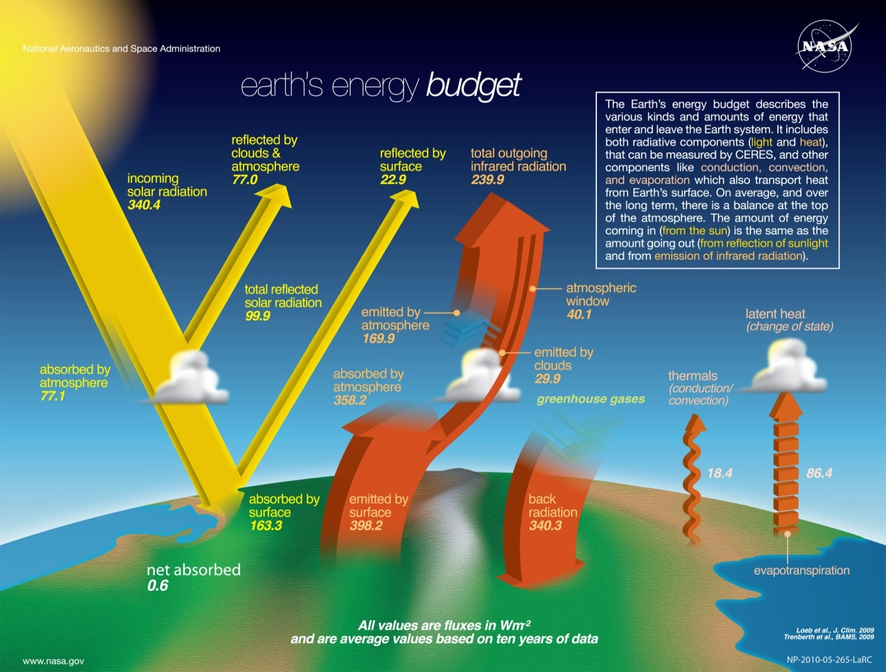
Figure 1.9. The Earth’s Energy Budget (NASA, 2016)

In 2008 the study by Allen et al highlighted both advantages and disadvantages of various micro-generation technologies in the UK including Solar Thermal (S. R. Allen, 2008). Table 1.1. shows the findings of the study which highlights that there are advantages to utilising STPs such as STPs being a reliable source of energy and an established technology (S. R. Allen, 2008). However, Allen noted that there are some disadvantages with STPS such as the technology is not currently being cost-effective (S. R. Allen, 2008).
The study noted that there is no cost-reduction potential and that there is a long payback period for the technology. The study found that a significant disadvantage of STPS technology in the UK is that during the winter months when the solar Irradiance and temperature are low. occupants would require a different energy source to heat their water.

Table 1.1. Comparative advantages and disadvantages of solar thermal technology (S. R. Allen et al., 2008)
Micro-generation technology | Typical capital costs | Advantages | Disadvantages
Solar thermal | £200 - £4500 | The solar resource is relatively reliable and predictable | Some systems require grid electricity supply
 |  | Proven/established technology | Low cost-reduction potential due to established designs
 |  | Visually unobtrusive | Not currently cost effective, but changing energy costs are changing this
 |  | Provides hot water all year round (however it will not meet demand in winter)
The study identified two disadvantages which are likely to change in the future which will impact the way in which consumers perceive the technology. The study identified rising energy costs as making STPS more cost-effective in comparison to conventional energy sources, as well as improvements to STP design resulting in shorter payback periods and thus more attractive to consumers (S. R. Allen et al., 2008).

In 2014 Burnett et al reviewed the UK’s solar energy resource and how climate change will impact the UK solar irradiation (Burnett, Barbour, & Harrison, 2014). The study analysed 30 years of observed historical monthly average sunshine duration data and found that the current UK average solar resource is 101.2 W/m², ranging from 128.4 W/m² in the south of the UK to 71.8 W/m² in the northwest of Scotland. They determined that the effects of climate change will increase the average resource in the south of the UK and only marginally decrease it in the northwest (Burnett et al., 2014). These two findings result in an overall mean increase in the solar resource, however there is likely to be a greater seasonal variability and the variations between geographical regions will become more pronounced (Burnett et al., 2014). The south of the UK is likely to experience a higher intra-variability than other locations in the UK in the coming years in areas which currently experience the greatest amount of solar radiation (Burnett et al., 2014).

Recent advances in the solar thermal panel technology
As well as STPs and Evacuated Tube Collectors (ETCs) there are other types of solar collectors which are used for water heating in domestic properties in the UK however they are not used extensively due to their poor performance in converting solar energy into heated water (Valan Arasu & Sornakumar, 2007). For solar heated water for use in domestic properties solar collectors are categorised into two main types: Flat Plate Collectors (FPCs); and ETCs. The term Flat Plate Collector and Solar Thermal Panel are often used interchangeably and so, for the remainder of this dissertation, the acronym STPs will be used.
Evacuated Tube Collectors are not considered in this dissertation as they do not benefit from some characteristics which STPs do, such as needing less maintenance and having long lifetimes (Srinivas, 2011).
The benefits that STPs have over ETCs when utilised on domestic properties include:
- A simpler design;
- A lower capital cost; and
- A longer lifetime than ETCs (due to STPs being reliable, sturdier, and operational for a larger amount of time under a greater number of weather conditions).
(Ayompe et al., 2011; Srinivas, 2011)
Based on the work by Ayompe and Duffy it is concluded that STPs are more suitable for domestic properties located in a similar climate to the UK and are therefore considered for the remainder of this dissertation.
STPs typically have an indicative temperature range of between 30-80 ºC and a concentration ratio of 1, see Table 1.2. (Ayompe et al., 2011; Brechin & Bhandari, 2011). This temperature range is ideal for personal showers or baths and the concentration ratio ensures that this temperature range is not exceeded. The various layers of material that are employed in the construction of a typical STP is shown in Figure 1.11. which shows insulating material surrounding the copper tubes to limit heat loss occurring from the heat fluid.
Table 1.2. Typical characteristics of a Flat Plate Collector (Ayompe et al., 2011; Srinivas, 2011)
(Perceptions of climate change worldwide)Motion | Collector type | Absorber type | Concentration ratio | Indicative temperature ration (ºC)
Stationary | Flat Plate Collector (STP) | Flat | 1 | 30-80

Figure 1.10. An Evacuated Tube Collector (l) and a Solar Thermal Panel (r) (Zambolin & Col, 2010)
From Figure 1.10. it can be seen that STPs are similar appearance to other solar technologies such as PV panels. This study by Zambolin & Del Col also note that due to the fact that PV panels are on the roofs of buildings they are relatively unobtrusive (Zambolin & Col, 2010). Figure 1.11. shows the basic construction a STP, and when combined with Figure 1.10. the overall construction of a STP can be determined.
Figure 1.11. The construction layers of a typical STP (Brechin & Bhandari, 2011)

The effect of solar water heating on energy usage in homes
Assessing the specific energy gains from using STPs compared to conventional energy sources for heating water in domestic properties is a complicated task as there are a number of factors that are dynamic and have an impact on the calculation. These factors include a variable weather pattern and a variable draw-off pattern of hot water as it is utilised in the property (Brechin & Bhandari, 2011). However, due to the efficient way in which STPs heat water for use in domestic properties, they have been utilised in UK for a number of years. Because STPs heat water directly rather than converting the sun’s energy into another form of energy, such as electricity, which would then have to be converted back into heat energy delivered to the water to heat it up, heating domestic water can be a superior method of heating water (Jaisankar et al., 2011). Direct conversion of solar energy to heating of water STPs can achieve 70% efficiency whereas other solar technologies such as PV panels (PV) can only achieve 17% (Jaisankar et al., 2011).
The adoption of STP technology has been recognised to be closely linked to not only the efficiency of STPs but also to other reasons including the capital cost of the technology as well as the disposal cost at the end of life of the technology (Medved & Černe, 2003). Previous studies have also shown that subjective perceptions about a particular technologies characteristics will affect a consumer willingness to adopt the technology (Baskaran & Bendig, 2013). The study by Baskaran highlighted the need for public and private sector initiatives to be employed when trying to promote adoption of micro-generation technologies (Baskaran & Bendig, 2013).
Potential benefits of understanding consumer opinions of STPs are derived from understanding the process by which consumers arrive at their final decision about whether to purchase a STP or not. Understanding the decision making process that consumers go through when deciding whether to adopt and STP could potentially lead to: improved policies affecting STPs; improving the information and advice about STPs which consumers access to inform their decisions; as well as improving the STP market by providing manufacturers with a clearer understanding of their potential customers (Baskaran & Bendig, 2013). These benefits will ultimately encourage STPs to be more widely adopted than it currently is in the UK (Abras & Preece, 2004). By considering the opinions of end users at the design stage (in this case the residents of the potential properties which would have a more efficient STPs system) is termed User-Centred Design (USD) (Norman & Draper, 1986). The work by Norman and Draper in 1986 centred on the needs and interests of users of computers (Norman & Draper, 1986). The end user is an active participant in the design process of the resulting product (Norman & Draper, 1986). (Monk, 2000). By understanding the opinions of consumers of STPs in this manner the use, success and resulting design performance is intended to be improved (Monk, 2000).
Abras (2004) suggested different methods and techniques to utilise when involving final users during the design of a technology and are shown in Table 1.3. (Abras & Preece, 2004). By understanding the opinions of potential users of the proposed novel technology and understanding the opinions of the main actors in the STP market will allow more suitable recommendations to be made to the STP market (Baskaran & Bendig, 2013).
Table 1.3. Various methods to involve final users in the design process (Norman & Draper, 1986)
(User-centered design)Technique | Purpose | Stage of the Design Cycle
Background Interviews and questionnaires | Collecting data related to the needs and expectations of users; evaluation of design alternatives, prototypes and the final artefact | At the beginning of the design project
Sequence of work interviews and questionnaires | Collecting data related to the sequence of work to be performed with the artefact | Early in the design cycle
Focus groups | Include a wide range of stakeholders to discuss issues and requirements | Early in the design cycle
On-site observation | Collecting information concerning the environment in which the artefact will be used | Early in the design cycle
Role Playing, walkthroughs, and simulations | Evaluation of alternative designs and gaining additional information about user needs and expectations; prototype evaluation | Early and mid-point in the design cycle
Usability testing | Collecting quantities data related to measurable usability criteria | Final stage of the design cycle
Interviews and questionnaires | Collecting qualitative data related to user satisfaction with the artefact | Final stage of the design cycle

Due to the novel nature of the proposed STP control system the second and third techniques as listed in Table 1.2. (e.g. by using interviews, questionnaires; and focus groups) will elucidate the opinions of the main actors and consumers in the STP market (Abras & Preece, 2004).
Conducting focused semi-structured interviews with the main actors in the STP market as well as conducting focus groups with end users will have direct applicability to this study. By considering a range of opinions in this manner the social acceptance of STPs can be improved which will have a positive effect on the adoption rate of the technology (Boait et al., 2008). By considering the informed opinions of the main actors within the solar thermal panel market the perceived benefits of STP’s within the UK can be determined resulting in improved suggestions being put for to the STP market (Boait et al., 2008).

Chapter 2
  - Literature review
  - This chapter is a review of recent published literature which pertains to this research and begins with the engineering aspect of this project and then highlights the recent published material concerning the psychological aspect. The chapter concludes with a summary of the literature and the research opportunities that are available for this dissertation.

Engineering Literature Review
Using the abundant solar energy provided by the sun (approximately 1.8 x 10¹⁴ kW falling on the Earth (approximately 150 million km from the Earth) is key to this research (Sahnoune et al., 2014). The amount of radiation that reaches the surface of the Earth is about 60% of this value, which equates to approximately 0.8 x 10¹⁴ kW. The rest is either absorbed by the atmosphere or reradiated away from the Earth (Sahnoune et al., 2014). At a conversion rate of 10% of this radiation, this is equivalent to four times the global generating capacity (Sahnoune et al., 2014). Within the UK approximately 27% - 32% of final energy consumption is demanded in the residential sector with a corresponding proportion of CO₂ emissions (Boait et al., 2008). The UK is obligated to reduce CO₂ emissions by 80% by 2050 with zero emissions from the housing sector (Boait et al., 2008). Assessing water heating to achieve these targets is a shrewd project as water heating in the UK accounts for approximately 16% of domestic energy consumption and approximately 13% of domestic energy expenditure as Figure 1.7. shows (A. Faiers & C. Neame, 2006).
The volume of hot water consumed per person each day in the UK will vary dependant on the individual, thus an assessment of the actual volume of hot water consumed is needed to ascertain the contribution that a Solar Thermal Panels System can provide in reducing domestic energy consumption and the associated carbon emissions with heating water. The results from a study that was published in 2008 by Defra that was tasked with determining exactly that and is shown in Figure 1.7.(Trust, 2005). The results shows that in the UK on average, between 46 and 59 litres of hot water is consumed per person per day depending on the household (Trust, 2005). The Energy Saving Trust (EST) was able to quantify the volume of hot water consumed each day through the use application of the following equation:
$V = 46 +26N$ (1)
(Trust, 2005)
Where:
V = volume of hot water (litres)
N = number of inhabitants

Other estimates for the daily consumption of hot water in domestic buildings assess different criteria. Rather than categorize occupants of a house based on the various demographics, The Building Services Research and Information Association (BSRIA) use a different set of criteria as shown in as shown in Figure 1.7.. The BSRIA provide information and guidance to companies to improve the design build and operation of buildings in the UK and publish an annual guide, the Rules of Thumb (Hawkins, 2011). The guide provides approximate data on a variety of design criteria including the consumption of hot water in the UK. The BSRIA is in part informed by the Code for Sustainable Homes (2010) which sets a maximum daily consumption volume of 120 litres of hot water per person per day (Hawkins, 2011). The proposed consumption volume for best performing homes is set at 80 litres per person per day (Hawkins, 2011). The maximum daily hot water demand for different types of building giving the maximum daily consumption of hot water (lt/person) and the total hot water consumption (lt/person) is shown in Table 2.1. (Hawkins, 2011).
This suggests that the volume of hot water consumed on average per person per day, in the UK, is significantly higher than study by The Energy Saving Trust which was completed in 2008. Of these two estimates, for the calculation of hot water consumed in a day, the more recent study by BSRIA is considered cautious and as the suggested consumption volume represents an estimate rather than a true figure (Hawkins, 2011).
Table 2.1. “Rules of Thumb” guide to daily hot water consumption (Hawkins, 2011)
(Rules of Thub, Guidelines for building services)Description | Maximum daily hot water consumption (l/person)
Houses
Economic, local authority | 120
Medium, privately owned | 120
Luxury, privately owned | 120
Flats
Economic, local authority | 68
Medium, privately owned | 115
Luxury, privately owned | 120
Other types of dwelling
Nursing staff accommodation | 120
Hostels | 115

Efficiency of various methods for heating water for domestic use
There are a number of different types of methods in which water used for washing and other sanitary purposes can be heated. Each method either heats water so that it can be used in the property instantaneously or the heated water is stored in a tank until it is needed for use. These two categories are split in the UK, with about 55% of domestic water used instantaneously for showers, baths or from taps. The data was taken from a 2009 English Housing Survey (Department of Communities and Local Government, DCLG) (Ministry of Housing, 2009).
The realistic behaviour and efficiency of heating systems were analysed using long term monitoring in the study by Thur, in their study of the annual energy saving potential of three different Solar Domestic Hot Water Systems (SDHWS), a 4m² 1500kWh; a 4m² 3000kWh; and a 2m² 1500 kWh, against different standard energy types: Gas boiler; Gas boiler + Electricity; and an Oil boiler (Thür & Shah, 2006). The study found a good level of similarity between the estimated fuel consumption and the measured fuel consumption. The study determined that when assuming a heating system which uses either an oil-fired boiler or a gas boiler the two factors that affect the energy savings of a heating system before solar heating is used:
- The boiler efficiency; and
- The boiler electrical consumption. (Thür & Shah, 2006)

Assuming that a heating system utilises either an oil fired boiler or a gas boiler, the energy savings of a heating system after a solar heating system is included depend on:
- The boiler efficiency;
- The boiler electrical consumption;
- The solar heating system electrical consumption;
- The solar systems’ net utilized solar energy; and
- Any energy savings from having the solar heating system turned off over periods of high solar energy (in the summer for example). (Thür & Shah, 2006)
The findings of Boait 2012 are shown in Table 2.2. which detail the populations of heating systems employed in the UK for domestic hot water (Boait et al., 2008). From this study it suggests that STPs comprise a significant minority of domestic hot water systems in the UK (Boait et al., 2008).
Table 2.2. The various heating methods employed in the UK to heat domestic hot water
System type | Storage (S) or instantaneous (I) | Number of dwellings (000s) | Proportion of total (%)
Electrically heated, on-demand | I | 340 | 2.5
Electric immersion heater, normal tariff | S | 612 | 2.7
Electric immersion heater, Economy 7 | S | 1673 | 7.5
Gas-fired non-condensing “combi” or water heater | I | 5498 | 24.8
Gas fired condensing “combi” | I | 4061 | 18.2
Gas-fired non-condensing with tank | S | 7653 | 34.3
Gas-fired condensing with tank | S | 1331 | 6.0
Other fuels with tank | S | 1122 | 5. 0
(Boait et al., 2008)
- “Economy 7” refers to an electricity tariff option available in the UK under which electricity is supplied within a 7 h overnight time window at a lower cost and also lower carbon intensity.
- “Combi” refers to a type of gas boiler which provides space heating by circulating hot water through a radiator network and heats water directly from the mains supply to deliver domestic hot water on demand.
- “Other fuels” comprise oil and solid fuels such as coal or biomass.

Table 2.2 indicates that the vast majority of homes in the UK utilise either gas-fired noncondensing Combi boilers either with or without a tank. This fact exemplifies the UK not utilising STP technology (Boait et al., 2008) to its full capacity and suggests that the modes of adoption of STP technology are poorly understood and provides a reason for conducting this research.

Efficiency of utilising solar thermal panels for heating water
Utilisation of STPs offer an effective and efficient way of converting the sun’s solar energy into thermal energy in the form of heated water (Jaisankar et al., 2011). As a direct conversion solar thermal technologies can achieve 70% efficiency which is high compared with other solar systems such as PV cells which can be used for heating water which only achieve an efficiency of about 17% (Jaisankar et al., 2011). For highly efficient STPs the efficiency can be improved by 23-37% whilst the cost is only increased by about 5% (K. Vejen, 2004).
The application of Solar Thermal technologies is closely linked to the cost of the solar systems and their efficiencies as the efficiency of STPs increases the cost per volume of heated water falls (Medved & Černe, 2003). As STP technology evolves and the technology is recognised by consumers the more likely people are to adopt the technology (Medved & Černe, 2003). Costs can be expected to fall as the technology benefits from economies of scale with regard to the manufacturing process and this will ultimately affect the technologies payback period (Medved & Černe, 2003).
The efficiency of flat-plate collectors is dependent on number of factors such as: the angle of elevation of the panels; the location of the panel on the Earth; the materials used in the construction of the panels; ambient temperature etc. (Medved & Černe, 2003). Thus STPs are not suitable for all domestic properties as they are aligned away from the optimal angle to the sun (due south in northern hemispheres) or the property is far away from the equator etc.

Environmental benefits of STPs
In previous years, an environmental analysis of technologies such as STPs centred on pollutants such as: sulphur dioxide (SO₂); nitrogen oxide (NO₂); carbon monoxide (CO): and particulates released during the manufacture or use of such technologies as these pollutants were considered having the most significant impact on the local environment (Brechin & Bhandari, 2011; Lachapelle & Rabe, 2012). In more recent years however, environmental analyses have expanded to a broader life cycle analysis which encapsulates all pollutants generated in the period from cradle to grave of a STP system (Brechin & Bhandari, 2011; Tagliafico & Rosa, 2014). By considering each stage of a product’s life-cycle and more accurate and precise determination of its environmental impact can be determined as more pollutants are considered and all stages are evaluated. Additionally, evaluating a STP in a UK climate rather than an overseas climate will lead to a more accurate evaluation of the overall environmental impact being made (Greening & Azapagic, 2014). A life cycle environmental impact assessment was conducted in 2012 by Koroneos et al of a solar thermal concentrating system, which assessed electricity generation, but it is mentioned here as their method was expanded upon for future life-cycle assessments on solar products (Koroneos & Nanaki, 2012).
A full environmental assessment was conducted by Greening and Azapagic in 2014 for domestic solar water heating (Greening & Azapagic, 2014). Greening and Azapagic assessed not only the manufacturing of components as the study by Koroneos had done in 2012 but they also considered additional stages of the life-cycle of a STP such as the maintenance of the STP during use of the STP and the final waste/disposal of the solar thermal system as shown in Figure 2.1(Greening & Azapagic, 2014; Koroneos & Nanaki, 2012). Greening and Azapagic noted that due to different life-cycle analyses being employed by different researchers it is often difficult to make an accurate comparison between them particularly as overall boundaries of the studies are rarely the same (Greening & Azapagic, 2014).
Their study in 2014 determined that STPs, when used in a UK climate, have on average a 7% lower environmental impact compared to the Evacuated Tube Collector (ETC) considered in their study (Greening & Azapagic, 2014). The majority of the environmental impacts (~60%) for both the STP and the ETC occur during the manufacturing process as this is the stage in which the most amount of energy is used and thus this is when the majority of the GHG emissions are generated (Greening & Azapagic, 2014). The period of time when the STP is in operation accounts for approximately 20% of the environmental impacts of the STP because of the need to have a traditional energy source needed to circulate the heated water (Greening & Azapagic, 2014). The authors made clear from their study that increasing the lifetime of the STP will reduce the overall environmental impact of the STP as carbon is offset by not using traditional fossil fuel based energy sources to heat domestic hot water (Greening & Azapagic, 2014).

Figure 2.1. The Life Cycle of solar thermal systems (Greening & Azapagic, 2014)
Figure 2.1 shows that that Greening and Azapagic incorporated maintenance as well as waste recycling and final disposal of the STP into their life cycle assessment (Greening & Azapagic, 2014). These projects occur when the STP is in operation (maintenance) and the very end of the STP’s life cycle (final disposal). The results of their study demonstrated that the environmental impacts of STP’s could be reduced by 36% if the overall efficiency of the water heating system was increased from 35% to 55% (Greening & Azapagic, 2014). Their study considered a lifetime of 25 years for the STP but they note that this assumption relies on accurate information from the manufacturers as to the lifetime of the system and is subject to change due to either the system is performing for a longer time period than 25 years, or the STP systems needing to be replaced due to technical issues (Greening & Azapagic, 2014). For these reasons they conducted a sensitivity analysis to ascertain exactly how changes to the lifetime of a STP impacts its environmental impact.
From their sensitivity analysis they determined that if a STP has a lifetime of between 15 and 20 years then the environmental impacts are increased by either 48% or 15% respectively (Greening & Azapagic, 2014). The environmental impacts are observed for the depletion of elements used in the construction of the STP and freshwater and human toxicity potential (Greening & Azapagic, 2014). The study also considered the converse situation, when a STP has a longer lifetime of 30 years. In these conditions they determined that the overall environmental impacts will be reduced by about 10%. This suggests that the overall environmental impact is very marginal once the STP is beyond its lifetime of approximately 25 years (Greening & Azapagic, 2014).

Computer models for domestic solar applications
Computer models have been used to investigate how certain parameters affect the performance of solar thermal systems since the late 1950s (Speyer, 1959). The application of computers was employed to benefit from the capability of computers to conduct vast computations rather than calculations by hand which has a limited capability. These early studies determined: that long-term storage is less economical than short term storage (Speyer, 1959). Using actual climactic data over relatively small-time intervals resulted in valid design optimisation was conducted in the 1960’s when it was determined that changes to the collector area has a significant impact on the annual heat output of the collector whereas other variables such as: the collector slope; orientation; and storage tank volume had a contrastingly small impact on annual heat output (Buchberg & Roulet, 1968; Speyer, 1968). These early studies benefited by using computers in two significant ways: the use of computers increased the overall accuracy of the results gained; and computers are better suited to take into account the transient nature of solar irradiance as it changes throughout the day (Buchberg & Roulet, 1968; Speyer, 1968).
Control of Solar Thermal System have therefore been employed since the mid-sixties with a greater focus placed on Solar Thermal Systems (STS) used for space heating rather than STS used for the heating of domestically used water (Buchberg & Roulet, 1968). Weather data was used by R.G. Courtney as it was collected at hourly intervals for ten years from the Meteorological Office in Kew (Courtney, 1977). Twelve meteorological variables were monitored at Kew and subsequently three of the variables: the global and diffuse radiation (measured on a horizontal plane) and ambient air temperature were used by R. G. Courtney (Courtney, 1977). From this data a UK based ‘weather profile’ could be made and used as the solar irradiance for the year (Courtney, 1977). The work used a standard interval of 0.1h as the input simulation interval for two reasons. Firstly there was found to be a significant effect on the simulations if the interval was increased to 0.25h and secondly when the simulation time was reduced to 0.1h there was a negligible effect (Courtney, 1977). The work by Courtney also found that the thermal systems were relatively insensitive to the angle that the panels were positioned at to the horizontal and the orientation that the panels were placed at (Courtney, 1977). The most prominent factor which determined the heat output of the system was the collector area with the annual heat output of the solar thermal panels doubling from approximately 3.5 GJ to approximately 7 GJ with the collector area increasing from 2m² to 6m² (Courtney, 1977). Figures 2.2 and 2.3 show the results of the research showing little difference in heat output between solar collectors that were placed at 20° or 60°.
Courtney kept the angle of inclination of his solar thermal panel in his program set 40° which is comparable to the optimum angle which would be equal to the latitude of the panel’s placement on the planet, which for Kew is 51.5°(Courtney, 1977).

Figure 2.2. The heat output of solar collectors at two different angles 20° and 60° (Courtney, 1977)

As Figure 2.2 shows, the heat output from solar collectors follows the irradiance pattern of the sun throughout a year with the summer months recording the highest heat output and the winter months the lowest (Courtney, 1977).
Courtney also found that the benefits of a clean collector compared to a dirty one were found to affect the heat output of the system by only 6%. This effect was considered to be the maximum difference between two collectors in different environments (one very dirty environment and one very clean) (Courtney, 1977).
In the 1980’s a study conducted at a different location found similar results to concerning the orientation of the solar thermal panels to the horizontal with the optimal angle set as the Latitude of the solar panel (Ammar & Ghoneim, 1989). This study was conducted in Alexandria, Egypt with Latitude of 31.2° and they calculated the variation in the solar fraction with a changing tilt angle of the solar panels. The results of their investigation show that the solar collector receives the maximum solar irradiance when it is orientated due south (0°) and is shown in Figure 2.3. (Ammar & Ghoneim, 1989).
Figure 2.3. The variation of solar fraction with collector orientation (Ammar & Ghoneim, 1989)
During the nineteen nineties the emphasis for utilising solar control systems for domestic hot water focused less on the social and economic benefits and more on diminishing traditional fossil fuel stocks and the environmental pollution created through using these fossil fuels (Carbonell & Consul). The economic benefits of utilising STPs were highlighted in a few studies in the nineteen nighties but the emphasis had clearly shifted as traditional forms of energy were becoming more expensive and sparse (Berbash & Calamai, 1995).
The advancement of computing ability that occurred after the 1990’s meant that weather predictions could be incorporated into STP systems to improve their accuracy and predicting power (Biaou & Bernier, 2008). Weather predictions were utilised to estimate the available energy from the sun throughout the day and allowed programming of solar systems to maximise the heating of water so that it is at a temperature which can be used in the home (Biaou & Bernier, 2008).
Figure 2.4. is a diagram of the flat plate panel system researched by Biaou and Bernier which would be located on the roof of a domestic property (Biaou & Bernier, 2008). Water is allowed to flow within the flat plate collector and is heated due to the sun’s rays. Connecting pipes transfer the heated water from the flat plate collectors with the heated water then circulated through a heat exchanger so that the heated water can give up its heat to a second line which is connected to a solar tank (Biaou & Bernier, 2008). The water having given up its heat in the heating exchanger can then circulated back to the collectors at a lower temperature with the whole process being repeated (Biaou & Bernier, 2008). The second-line, having water that is heated from heating exchanger, is allowed then to flow into a solar tank to be stored ready for use (Biaou & Bernier, 2008).
The flow rate of the water as it flows around the system is regulated by a controller which is connected to a pump/circulator. This controller measures the temperature of the water as it enters and leaves the heating changer so to maximise the transfer of heat energy from the sun’s energy to the heated water.
Due to potential differences in the heating pattern of the sun and the consumption pattern of hot water in the property, a backup tank is available in the property which utilises conventional fuels to heat the water up to the desired temperature (Biaou & Bernier, 2008).
Figure 2.4. The Solar Domestic Heating System investigated by Biaou (Biaou & Bernier, 2008)

To ensure that the heated water is at the required temperature when it is used, an auxiliary heater is used in conjunction with solar thermal panels. Electric heating elements are often used as the auxiliary heat supply, with them located at the top of the tank of water heating the tank from the “top down” (Furbo et al., 2005). A Solar Domestic Hot Water system (SDHW) was analysed it was shown that if there are periods when the demand on hot water is large, the volume of water that is heated by the auxiliary heater is similarly large, and vice versa. In this way the heating elements are controlled by a heating pattern that aims to replicate the hot water consumption and pattern of the user (Furbo et al., 2005).
This study by Furbo et al is significant for this research as they incorporated novel heating elements which are controlled so that the water in the tank is matched with the consumption of the heated water (Furbo et al., 2005). They reported that the annual performance of the smart SDHWS if between 5-35% higher than the traditional tank design. They also report that the smart solar tanks are suitable for “unknown, variable, large or small hot-water consumption” (Furbo et al., 2005). Estimates put the performance/cost ratio as improving by 25% with the capital costs of SDHWS systems employing smart solar tanks are approximately 10% more than if a traditional small SDHWS system is used (Furbo et al., 2005). This is dependent on the auxiliary heater uses electric heating elements rather than natural gas which are commonly used today in combi-boilers (Furbo et al., 2005). The study by Furbo stated that because hot water consumption is not known before the system is installed in the property larger hot-water tanks are used to be on the ‘safe’ side to ensure that the residents have sufficient hot water for use in the property (Furbo et al., 2005).
The heat storage of a SDHWS system is a hot-water tank that has an integrated heat exchanger that is positioned at the bottom of the tank in a spiral configuration. The top part of the tank is heated by the auxiliary energy supply system. They recognise that for larger hot-water systems the net utilised solar energy will be reduced as it is the ratio of the ‘tapped’ energy from the solar tank minus the amount of energy that is needed from the auxiliary energy source. This fact is compounded by the increased capital cost that larger systems naturally have. Put succinctly the larger the storage system is the less profitable the entire hot water system will be. Furbo et al (2005) determined that it is more advantageous to have the tank volume matched to the hot-water consumption (Furbo et al., 2005). The study analysed a range of hot water tanks with differing volumes ranging from 50-350 litres. The performance of these hot water tanks were tested with their utilized solar energy measured as a function of the volume of the hot water tank and the daily hot water consumption (Furbo et al., 2005). The results are shown in Figure 2.5. The conclusions of the study can be summarised as:
- Smaller water consumptions should have a smaller hot-water tank; and
- Larger hot-water consumptions should have a medium volume hot-water tank. (Furbo et al., 2005)

Figure 2.5. Results from Furbo et al testing how various volumes of hot water tank affect efficiency of a STP system (Furbo et al., 2005)
In the paper by Furbo et al 2005 states that a ‘smart’ solar tank is one that can be heated by two systems, one which is by solar energy and the other is from the conventional energy supply system (generally speaking electric heating elements). They explain that a few temperature sensors to measure the water temperature at the top of the tank is almost as good as an advanced control system that regulates the energy content in the top of the tank (Furbo et al., 2005). This statement is not quantified which makes it difficult to ascertain the precise benefits of having just a few temperature sensors in the tank as compared to having an advanced control system controlling the energy delivered to the water at the top of the tank.
In Figure 2.6. the investigated hot water tanks used in the study by Furbo are shown with the traditional tank also shown (Furbo et al., 2005).
Furbo et al recommend that there should be further investigations into smart solar tanks that utilise, as their auxiliary heat system either oil or gas-fired boilers as additional energy savings could potentially be made here.
Figure 2.6. The investigated hot water tanks by Furbo in 2005 (Furbo et al., 2005)

To address the difference in the heating from the sun and the consumption patterns used in homes Rodriguez et al 2012 looked at determining the optimum size of the storage tank (Rodríguez-Hidalgo et al., 2012). The study looked at addressing oversized storage tanks which have inherent inefficiencies due to their size. The hot water storage tanks are often oversized to ensure that there is sufficient hot water for the inhabitants who have variable lifestyles and will therefore consume water at different times (Rodríguez-Hidalgo et al., 2012). The study notes that specific lifestyles of the inhabitants of the property will vary greatly which will mean than hot water consumption for DHW systems is very variable and any analysis of solar thermal panel systems should take this into account.

Stratification
The need to store heated water within a solar heated boiler is complicated by the inconsistent heating profile of the sun and the lack of a matchup between when the sun is available and when the heated water is required (Furbo et al., 2005). Ensuring heat losses from the heated water are kept to a minimum, whilst the heated water is stored, guarantees that a maximum efficiency of the entire system can be obtained. An effective and efficient way of achieving this is through the employment of stratification in the tank with as little mixing of water with varying temperatures. As water at varying temperatures has differing volumes and therefore differing buoyancy’s, water at varying temperatures tends to settle out into layers which have differing temperatures (Han & Dai, 2009). Ensuring that these layers do not mix ensures that the heat within the tank is stored in an efficient way (Han & Dai, 2009; Zambolin & Col, 2010). Heated water stored in this way will allow the uppermost layer, which is the layer that is drawn off and used first, to remain at the greatest temperature, not being mixed with layers at a lower temperature (Han & Dai, 2009; Zambolin & Col, 2010). When comparing a fully mixed tank and a tank that has stable stratified layers when used with solar systems shows that the efficiency of the entire energy storage system can be increased by 10-20% (Han & Dai, 2009). An increase of 60% in average net energy and exergy efficiency can be achieved for seasonal thermal energy storage (Han & Dai, 2009). This high increase in efficiency is achieved via two main methods. First, the first is due to the fact that stratification causes the water to decrease in temperature of the water in the collector which increases the efficiency of the system (Han & Dai, 2009). Secondly, hot water tanks can benefit from stratification due to a stratified hot water tank requires less heating from an auxiliary heat source which will increase the overall system efficiency (Han & Dai, 2009).
Stratification reduces the amount of mixing of water at two different temperatures within the tank (Lavan & Thompson, 1977). Thermal stratification can be achieved via three main methods:
- Utilisation of vertically heated walls which, once a hot thermal boundary layer is formed draws hot water into the upper volume of the tank;
- A transfer of heat from a carefully placed heat exchanger either inside or outside the tank;
- Heated water introduced directly into the tank at appropriate heights. (Dongellini & Morini, 2015; Han & Dai, 2009; Lavan & Thompson, 1977)

Thus, thermal stratification within a hot water tank is desirable, but stratification can is dependent on a number of factors. There have been investigations into the cold water inlet geometry to ascertain the impact the device has on the thermal stratification of the tank (N. M. Brown & Lai, 2011; Gari & Loehrke, 1982; Han & Dai, 2009; Kenjo & Caccavelli, 2007). Whilst it has been determined that the Richardson and the inverse Peclet numbers are the two most important factors for establishing and maintaining stratification within thermal storage tank for some time .the more recent study observed that stable stratification is established for higher inlet Reynolds numbers at earlier times (t=0.2s). There has been extensive research into the effects various parameters have on thermal stratification. The findings from research conducted concerning stratification are summarised in Table 2.3.

As Table 2.3. details, stratification has been extensively researched for the previous 40 years about how various parameters impact stratification within the hot water tank. All of the studies note the benefits of achieving stratification within the tank for improving the efficiency of hot water heating. Studies have determined various ways in which stratification can be achieved and maintained within the hot water tank so as to improve the overall efficiency of heating water by preserving layers of water within the hot water tank which are at different temperatures.
These measures listed in Table 2.3. are both technical and thus complicated, and simple design adjustments which can have significant improvements to the overall efficiency of heating water.
Table 2.3. Stratification findings from various studies (Ammar & Ghoneim, 1989; N. M. Brown & Lai, 2011; Courtney, 1977; Gari & Loehrke, 1982; Han & Dai, 2009; K. Vejen, 2004; Kenjo & Caccavelli, 2007; L. Cai, 1993; van Berkel & Steenhoven, 1999; Zambolin & Col, 2010)
Author(s) | Year | Parameter | Conclusions | Stratification
Levan et al  R. G. Courtney | 1977 | Flow factor (based on Reynolds number, Grashof number, tank height diameter ratio) | Above 40-50 | Almost no mixing occurred
Gari et al | 1982 | Inclusion of manifold and adjustment of flow speed of inlet fluid into tank | Low collector flow rates are preferable to preserve stratification | The use of a manifold and/or baffles to reduce flow rate desirable
Zurigat, Y.H., P.R. Liche, A.J. Ghajar | 1991 | Richardson number | Ri < 3.6 | Inlet geometry has great influence on stratification
Zurigat, Y.H., P.R. Liche, A.J. Ghajar | 1991 | Richardson number | Ri > 10 | Inlet effect can be neglected
Al-Nimr, M. A. | 1993 | Peclet Number | At high Peclet | Stratification less apparent
L. Cai, W.E.S. | 1993 | Archimedean number and Reynolds number | Ar > 5 and Re < 1000 | The cold fluid will not extensively mix with the warmer fluid
van Berkel, J., C.C.M. Rindt,  A.A. van Steenhoven | 1999 | Richardson number | Ri 10-20 | Clear mixing appearing
K. Vejen, S.F., L.J. Shah | 2001 | Froude number and Reynolds number | Re = 6000 | Does not result in a significantly thermo-dine
Stewart | 2001 | Foude number and Reynolds number | Re = 6000 | Does not result in a significantly thermo-dine
K. Vejen | 2004 | Richardson number | Ri = 0.615 | Stratification is observed
Kenjo & Caccavelli | 2007 | Water introduced to tank at different heights | Improvements to stratification can be made with significant modifications to designer of hot water tank | Stratification is observed and preserved
Y. M. Han et al | 2009 | Height of tank, coil position | Heat exchanger position should be located in the upper part of the tank | Stratification influenced predominantly by inlet and outlet conditions
Brown & Lai | 2011 | Ri = 0.615 | A porous manifold was successfully used to reduce shear-induced mixing of fluids at different temperatures | Stratification is observed at a Richardson value as low as 0.615

The use of weather data in previous studies
A number of previous studies have utilised weather data in the testing of computer models of STPs to better improve the performance of the systems (Bornatico, Pfeiffer, Witzig, & Guzzella, 2012; Prud’homme & Gillet, 2001). Bornatico et al, 2012, recognised that the accuracy of solar thermal systems modelling is largely dependent on the availability of realistic data for such parameters as the solar irradiation, humidity etc .(Bornatico et al., 2012). To determine the optimal size of some components of a solar thermal system they utilised a Particle Swarm Optimisation (PSO) and the weather data as shown in Figure 2.7. for a mid-sized family home in Swiss city of Zurich. The results of the PSO were compared with the general Genetic Algorithm (GA). The Meteonorm database containing a combination of 8055 worldwide weather stations was utilised, and for any specific location. The closest weather station data was interpolated utilised. Weather data spanning a year, was generated using stocastic models utilising monthly mean values for weather data and Markov Transition Matrices (MTM). The generated weather data was checked with recorded whether for various statistical properties (average value, variance, autocorrelation) is deemed to have the same statistical properties, and was therefore representative has an accurate approximation (Bornatico et al., 2012).
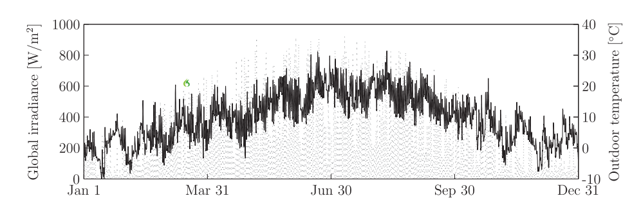
Figure 2.7. The meteorological data for Zurich, Switzerland used in the work by Bornatico et al 2012 (Bornatico et al., 2012)
(Optimal sizing of a solar thermal building installation using particle swarm optimization)

The results of the study by Bornatico et al 2012 determined that the PSO algorithm was marginally better than the compared GA with an optimal collector area determined as being 14.5 m² with the tank volume of 498.98 m (Bornatico et al., 2012).
Bornatico used weather predictions obtained from the Swiss Meteorological Institute (SMI) to show how improvements to the structural as well as the control of a solar thermal panel system can improve its efficiency (Bornatico et al., 2012). The researchers acknowledged that often, with regard to Solar Domestic Hot Water Systems the manufacturers know-how is often used in the design of the systems’ control strategies rather than being aware of changes to the demand profile of the hot water all the weather conditions (Prud’homme & Gillet, 2001). Instead of generating weather data, weather forecasts for solar radiation and ambient temperature were used in combination with users hot water demand profiles as inputs for a model based optimiser as shown in Figure 2.8. (Prud’homme & Gillet, 2001).
The heat exchanger utilised in this study was a mantle and as such it surrounded the entire storage tank with four valves at different heights being controlled by an autonomous switching law which only allowed one switch to be opened at any one time .(Prud’homme & Gillet, 2001).
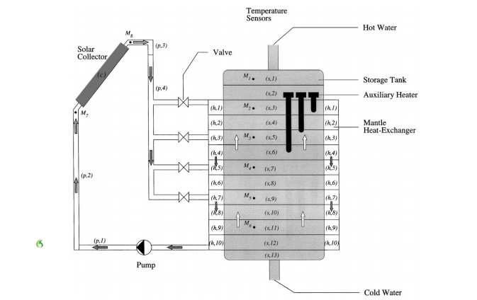
Figure 2.8. the hot water system considered by Prud’homme & Gillet, in 2001 (Prud’homme & Gillet, 2001)
Prud’homme and Gillet achieved significant improvements in both the home comforts achieved by the system and also in reducing the energy consumption needed to satisfy the hot water consumption patterns (Prud’homme & Gillet, 2001). The authors noted however that because these were simulations rather than real-world experiments there was a limitation to applying their results in a broader context. They also noted that there would be a difference mainly came from the quality of the disturbance estimates used in their simulations.
The predictive control method that Prud’homme & Gillet used to achieve better overall performances is shown in Figure 2.9. (Prud’homme & Gillet, 2001). The predictive model used in their study and also indicates how the system takes advantage of extra information such as the dynamic model of the system and other previously known dynamics of the system.
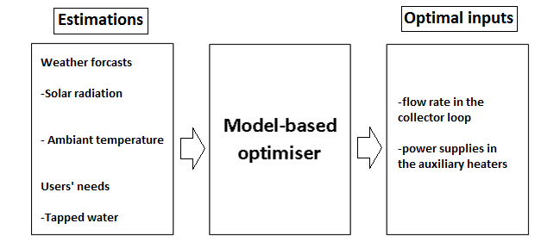
Figure 2.9. the predictive model used by Prud’homme (2001) (Prud’homme & Gillet, 2001)

A short sampling time for when new calculations could be made, in part, helps to solve this problem as they recognised as a shorter sampling time means that a higher number of calculations can be performed (Prud’homme & Gillet, 2001). Essentially, the program they used was implemented in a manner so as to be conservative enough to ensure that real-world draw off patterns were accounted for and yet optimised enough to ensure good comfort and energy benefits.
Fraisse et al looked(Fraisse, Bai, Le Pierrès, & Letz, 2009) at the various optimisation criteria for Solar Domestic Hot Water Systems (SDHWS) that use an electric auxiliary heater (Fraisse et al., 2009). The work was conducted in the first instance as they note that there were a number of criteria that were evaluated when considering the most important parameter without one single parameter being adjudged to be the most important (Fraisse et al., 2009). Various optimisation parameters included in previous studies, including: the solar fraction; energetic; environmental as well as economic (Fraisse et al., 2009). They note in their study that the energy and economic criteria are most often used to optimise solar heating systems, and the study was conducted to question whether this are the most valid and useful criteria to optimise (Fraisse et al., 2009).
The Life-Cycle Cost (LCC) was judged to be the total cost of system over 20 year period with the 2009 cost being calculated using given interest rates and discount rates (Fraisse et al., 2009). Fraisse et al (2009) note that optimisation of the system. In terms of energy is usually to reduce the energy consumption needed to raise the temperature of the water up to the set point at which the hot water is used.
They recognised that it is important to consider both the energy and financial aspects of SDHWS and noted that it is better to oversize the collector area rather than be more conservative in publicising the tank volume as the financial costs in doing so are prohibitive as there are thermal losses from the tank (Fraisse et al., 2009). They noted that there is significant work needed to be done to ensure that all the combinations of parameters are considered and evaluated thoroughly. They also noted that the highest performance solutions are still not realistic as the draw-off patterns on the system are only approximations of real world measurements (Fraisse et al., 2009).

Matlab as a tool for simulating a solar thermal panel and the heating of a hot water tank
The software tool Matlab has been utilised a number of times as a tool to simulate a solar thermal panel and the resulting hot water that is achieved from a flat plate panel (see (Buzás et al., 1998; Pellizzone et al., 2015; van Berkel & Steenhoven, 1999). Matlab has been utilised in this research for a number of reasons, namely:
- Matlab’s computing speed; and
- Matlab’s capability at calculating large arrays of data. (Dongellini & Morini, 2015)
Matlab has been used for previous studies concerned with calculating various parameters concerned with Solar Thermal Panels (see .(Optimization of solar flat collector inclination; Dynamic Simulation of Solar Thermal Collectors for Domestic Hot Water Production) A further benefit of utilizing the software tool Matlab is that there is no need to design and construct prototypes to obtain experimental data as the physical behaviour of solar thermal systems can be modelled and optimized (Carbonell & Consul).To simulate the heating of a hot water tank that is connected to a solar thermal panel the irradiance incident on the solar thermal panel needs to be calculated (Carbonell & Consul). The software is able to analyse large arrays of data allowing both a short sampling rate of the weather data (each minute), as well as the long duration of the complete dataset (493 days). In this way, sufficient weather variations as well as draw off patterns can be analysed to determine a more efficient heating system for domestic hot water.

Recent innovations with solar thermal panels
The relative success of material or technological advances which could improve the efficiency of STPs which have occurred over the last ten years have been dependent, in part, to cost constraints placed on the innovation (Fraisse et al., 2009; Furbo et al., 2005; Thür & Shah, 2006). This is due to the modest cost improvements that can be achieved with STP in a UK climate particularly when STPs are considered for home environments. However, there have been studies during that same time period which have investigated material gains which can be achieved when cost constraints are not at determining factor limiting the use of certain materials. Phase Changing Materials (PCM) have been extensively researched as they have superior thermal properties when compared with water which is often used as the heat transfer fluid in STP systems. Below is some of the research to highlight some of the findings concerning PCM.

    - Phase Changing Materials (PCM) used in solar domestic systems
Phase changing materials have benefits when applied to hot water boilers as they allow water at a higher temperature to be stored in the tank by the fact that phase changing materials (PCMs) have a much higher storage density and isothermal operation compared with water. As PCMs have this benefit they can be included in the design of Solar Domestic Hot Water Systems (SDHWS) to improve stratification and therefore the overall efficiency of the system. Three PCM materials were analysed: stearic acid; palmitic acid and myristic acid by Mazman et al 2009. All three acids were prepared in a ratio of 80:20 with paraffin (paraffin accounting for 80%). They were chosen as their melting temperatures are in the range 50-60°C and are therefore suitable to use in SDHWS (Mazman et al., 2009). The results of the experiments showed stearic acid performing the best with an overview of the results shown in Table 2.4.
PCM Mixture | Stearic acid | Palmitic acid | Myristic acid
H 9kJ/kg) | 150.1 | 150.1 | 190.9
Melting range (°C) | 49-53 | 48-52 | 61-65
Storage capacity (kJ) | 450.2 | 450.0 | 190.9
ΔT_{theoretical} ($°$C) | 3.5 | 7.8 | 4.5
ΔT_{experimental} (°C) | 2.6 | 4.9 | 1.6
Recovery efficiency (%) | 74 | 63 | 36
Table 2.4. PCM materials and their properties (Mazman et al., 2009)
The storage capacity of each of the acids was: 450.2 kJ; 450.0 kJ and 190.9 kJ respectively (Mazman et al., 2009). The study determined the increase in efficiency that can be achieved with the use of PCM (Mazman et al., 2009).
Tarhan et al (2006) investigated built in storage solar water heaters (BSSWHs) which utilised PCMs compared to those that did not PCMs (Tarhan, Sari, & Yardim, 2006). The drivers for conducting the study were: reducing the cost of the solar water heaters; making the design of the solar water heater (SWH) simpler (particularly for those residences that are in a rural setting); and improving the efficiency of the SWH system (Tarhan et al., 2006). The paper notes that the effect of the PCMs depended on the specific configuration of the PCM storage unit. Lauric acid was used as the PCM as it has a low thermal conductivity and high fusion heat which in turn means that PCMs have an advantageous low heat storage volume. The papers also notes that lauric acid when used as the PCM also has beneficial properties with regard to insulation particularly in the night as the temperature that it solidifies is 51-52 °C (Tarhan et al., 2006).

Optimum tilt of the collector to receive maximum solar gain
The installation Azimuth Angle (Ø_{S}) and the Tilt Angle (β) are the key variables which affect the level of solar radiation that can be captured by a solar collector (Chang, 2009). As the collectors are static on the roof of a property the Azimuth angle will vary throughout the day as the sun tracks across the sky. Previous studies have sought to optimise the operation of solar collectors in two key ways: either by optimising the solar gains from the collector or by reducing the materials used in the construction of the solar collector (Kantzioura, Kosmopoulos, & Zoras, 2012). There have been numerous studies to determine the optimum angle at which to tilt the solar collector so that it can absorb maximally the amount of solar radiation falling on it (Hafez, Soliman, El-Metwally, & Ismail, 2017; Kantzioura et al., 2012; Yao, Luo, Luo, Jiang, & Yang, 2015).
Previous studies have been conducted at different geographical locations around the world (Hafez et al., 2017; Kantzioura et al., 2012) in urban locations (Angel, Parent, Civco, Blei, & Potere, 2011; Kantzioura et al., 2012; Yao et al., 2015) as well as studies which have sought to determine the optimum angle for all locations around the world (Hafez et al., 2017) The orientation and the tilt of the solar collector are accepted as having a significant effect on the performance of the collector with solar collectors providing 70-80% of the energy required for heating water for use in domestic properties rising to 90-95% in hot climates (Hafez et al., 2017).
Rogers et al investigated the optimum tilt angle of solar collectors in cloudy conditions (Rogers, McManus, & Cooper, 2013). They determined that for collectors in cloudy conditions the tilt angle should be equal to the suns Zenith Angle e on a summer’s day. That is they determined that the optimal Tilt Angle at noon is the Latitude minus the Declination Angle (Rogers et al., 2013). They calculated four parameters each hour, they were:
- The efficiency of the solar panel;
- The energy collected by the panel;
- The net energy stored by the panels; and
- The temperature of the store at the end of the hour.
(Rogers et al., 2013)

To calculate the seasonal variation between the plane of the sun’s rays and the equator of the Earth as the Earth orbits the sun the Declination Angle (δ) can be determined throughout the year using Equation (7) and Table 6.12:

The Declination Angle (δ), is given by the equation:
 | $δ=\sin^{-1}(sin \left(23.45\right) \left(\sin_{365}^{360}d-81\right)){}$ | (2)
(Rogers et al., 2013)
Where:
$δ$ : Declination Angle (°)
d : Day of the year (January 1st =1)

The position of the earth at different times of the year is shown in Figure 2.10. Using Equation 2 it is possible to graph the declination angle cancel which has been done and is shown in Figure 2.11.

Figure 2.10. The position of the earth at different times of the year

The study by Stanciu and Stanciu in 2014 used three different models to estimate the solar irradiation density to determine the optimum tilt angle to set a solar collector at to receive the maximum solar density (G_{tTMAX}) (Stanciu & Stanciu, 2014) The three models that were assessed were: the Hottel and Woertz model (the simplest); the Liu & Jordan model which is an Isotropic diffuse model; and the Hay–Davis–Klucker–Reindl (HDKR) model. The study determined that the optimum tilt angle will vary depending on where the solar collector is located and depending on which month of the year it is. However, using that study as a guideline and with the location of Sheffield at a Latitude of 53.3810 °N it was decided that the tilt angle of the simulated collector for this study was to be set at 35 ° (Stanciu & Stanciu, 2014).

Table 2.5. The optimum tilt angle for maximum solar density, Northern hemispheres (Stanciu & Stanciu, 2014)
Latitude (°N) | June 21st |  | March 21st |  | September 21st |  | December 21st
 | max (G_{tTMAX)} (W/m² | Β_{OPT} (°) | max (G_{tTMAX)} (W/m² | Β_{OPT} (°) | max (G_{tTMAX)} (W/m² | Β_{OPT} (°) | max (G_{tTMAX)} (W/m² | Β_{OPT} (°)
0 | 852.600 | 0 | 983.237 | 0 | 971.667 | 0 | 1004.15 | 80
10 | 914.487 | 0 | 981.64 | 14 | 970.282 | 14 | 987.386 | 42
23.27 | 952.635 | 0 | 986.543 | 32 | 975.125 | 30 | 935.869 | 56
30 | 952.660 | 8 | 977.60 | 38 | 966.382 | 38 | 883.582 | 62
40 | 951.662 | 22 | 948.042 | 50 | 937.673 | 48 | 755.139 | 70
44.25 | 949.957 | 28 | 925.980 | 54 | 916.310 | 54 | 677.165 | 72
50 | 943.826 | 34 | 887.726 | 58 | 878.793 | 58 | 543.601 | 76
60 | 923.132 | 46 | 780.271 | 66 | 773.94 | 66 | 257.354 | 84
66.33 | 900.211 | 52 | 678.827 | 72 | 674.593 | 72 | 187.376 | 90
80 | 802.481 | 64 | 339.503 | 82 | 341.441 | 82 | - | -

The values of the Declination Angle (δ) for each day of the year using Equation 2 are graphed for an entire year as shown in Figure 2.11.

Figure 2.11 The Declination Angle (δ) throughout the year using Eq. (2)

To determine the total solar irradiance on a tilted flat plate collector the Hour Angle (ω) also needs to be calculated:
Where:  ω: Hour Angle  AST: Apparant Solar Time | ω= 15° × (AST −12) | (3)  (Stanciu & Stanciu, 2014)

There have been studies which have investigated the insolation on a tilted surface through use of experimental measurements dating from the sixties onwards. As computing power became more powerful, estimating the solar irradiation incident on a particular location (Liu & Jordan, 1960).
Tui (1960) noted the need to have intervals shorter than one hour to deal with many solar irradiation problems, yet the study they presented did not have intervals shorter than one hour for the solar radiation (Liu & Jordan, 1960) and therefore the monthly irradiation data for various locations were used at sampling intervals less than one hour (Liu & Jordan, 1960).

Conclusions from the engineering literature review, direction for this research
The literature review of the engineering aspects of this research revealed a few areas to consider in this research. The first thing to note is that computer simulations have a great number of advantages that should be capitalised in this research. The utilisation of computers allows a great degree of accuracy, speed and range of results to be calculated thus a more explanatory set of conclusions to be drawn from those results. For these reasons it is clear that using computer software to simulate STPs if highly beneficial and should form the backbone of the engineering aspect of this current research.
The use of computer software allows for a larger data set to be tested which means that the use of weather data in a similar manner to Bornatico et al is possible. Recorded weather is highly recommended rather than generated weather so as to actually give specific and accurate results. Additionally, using recorded weather with a programme that has variables that are changeable will give the resulting software a greater degree of freedom and allow the software to be applied to any number of locations that are able to provide the set constants for the program and the input data (the recorded weather). Whilst the application of computer software is highly beneficial there is a modicum of warning that the final accuracy of the software is dependent on the degree to which these variables are measured.
The daily consumption of hot water in the UK varies from person to person and throughout the year therefore to assess the effectiveness of a STP system accurately an accurate daily consumption pattern is needed. For this using the Tapping Cycles as described by the EU are the most beneficial for a number of reasons. Firstly, the Tapping Cycles are an accredited and tested method of assessing the capability of STPs to perform in the ‘real world’ and so their applicability here with computer simulations is prudent. Additionally, they provide consumption patterns that vary throughout a 24-hour period and so can be adjusted day by day. Whilst these “Tapping Cycles” do not consider the demographic and occupancy or various house type they do provide a benchmark which the resulting software can be tested against. They are also specific without having a wide variance in demand that is obvious from the various studies that have looked at UK hot water daily demand. The daily hot water consumption pattern will be different between houses of similar demographics and thus using the EU Tapping Cycles allows for a “High”, “Medium” or “Low” consumption pattern to be accounted for and so long as the various costs involved (monetary costs as well as the associated carbon costs) with using traditional energy sources is calculated for heating the water to the required temperature are made then any potential costs or benefits can be adjudged objectively.
The additional thermodynamic benefits of using PCM materials in the design of STP has been shown to have modest benefits and so their inclusion is not considered for the remainder of this dissertation as other, less expensive and less technical solutions have been investigated.

Psychology Literature Review

The value of using psychological methods to better understand the opinions of key stakeholders in the STP market
Designing a more efficient STP system to provide domestic hot water is only effective however if it is actually adopted and employed by consumers. Thus, if only 10% of the housing stock adopt STP technology and utilise it to its full capability (at 100% efficiency) then only 10% of the potential benefits of the technology can ever be realised. A Life Cycle Assessment (LCA) as performed by Comodi et al determined that a glazed solar panel similar to the STP proposed in the previous chapter has the following payback period in months at three different locations (Rome, Madrid and Munich) (Comodi et al., 2014). The three cities investigated are on comparable Latitude to Sheffield, particularly Munich. The results showing the payback period in terms of: energy (Energy Payback Time, EPBT); CO₂ (CO₂ Payback Time, CO₂ PBT) and economics (€ Payback Time, €PBT) are shown in Table 2.6. (Comodi et al., 2014).

Table 2.6. The Energy, CO₂ and economic pay-back times (in years) of a solar panel, (Comodi et al., 2014)
 | EPT | CO₂PBT | €PBT | EPT | CO₂PBT | €PBT
Rome, φ = 41.9000°N | 5 | 2 | 9 | 5 | 12 | 4
Madrid, φ = 40.4000°N | 4 | 2 | 11 | 5 | 13 | 4
Munich, φ = 48.1333°N | 5 | 2 | 11 | 6 | 16 | 4

A proportion of the UK housing stock could potentially have STPs installed on them but the efficiency of each system, as has been talked about in previous chapters, is highly dependent on the location, the angle of incidence of the collector and the application of the technology. STPs are therefore not suitable for all domestic properties in the UK as the technology would have a prohibitively low efficiency if located on some properties. As has been mentioned in Chapter 2 and 3 it was estimated in 2011 that 100,000 homes in the UK have STPs (ESTIF, 2013) which accounts for only 0.37% of the entire 27 million homes in the UK. Whilst not all of these domestic properties would be suitable for STPs it highlights how potential improvements in efficiency, as described in Chapter 3, can be greatly reduced if the adoption rate of the technology is low. The improved STP as described in Chapter 3 has to be used by people for it to benefit from the improvement in efficiency.
This is a good starting point to begin the psychological literature review, stated explicitly; if STPs are not adopted and used by consumers then they will provide no benefit in reducing the amount of energy used for heating domestic hot water. Understanding the decision making process consumers go through when making a decision about whether or not to adopt a STP Conversely, if STPs are not adopted and used, then they will not be capable of reducing carbon dioxide emissions associated with heating water from conventional energy sources. Due to the embodied energy used to design manufacture and install STPs unemployed STPs would actually cause a negative effect if one was trying to reduce carbon dioxide emissions. Therefore, when considering the more efficient STP system described in Chapter 3 it is prudent to understand the opinions of end user of STPs. Ultimately whether consumers decide to adopt STPs will govern the overall effectiveness of the technology at reducing carbon emissions and reducing domestic energy use. For this reason, understanding the reasons why consumers may or may not adopt a technology is important to ensuring that the maximal STP benefits can be realised. Additionally, understanding the opinions that consumers may have about STPs will clarify both the potential concerns as well as the perceived benefits consumers have concerning STPs.
The opinions of the main actors within the STP market are considered to be of significant value as they have a greater understanding of various aspects that impact on consumer decisions about whether to adopt STPs or not. The main actors with the STP industry have specialist knowledge concerning technological, social and political factors which will affect the social acceptability of STPs (Doblinger & Soppe, 2013; Simcock et al., 2014; Weijermars, Taylor, Bahn, Das, & Wei, 2012). main actors are well placed to not only be present when consumers are making their decisions about the technology but they are also in a position to influence the outcome of that decision (Doblinger & Soppe, 2013). This additional knowledge about the decision making process that consumers go through could potentially lead to better policies, information and advice for the STP market. Considering the opinions of end users at the design stage is often termed User-Centred Design (USD), the process by which consumers can provide their opinions differs depending on number of factors depending on the outcomes of the studies (Norman & Draper, 1986). Norman 1986 suggested various methods and techniques to utilise when involving users of a product are to be involved during the design of the produce (Norman & Draper, 1986). Table 1.2. shows the recommended techniques as suggested by Norman in 1986. A novel technology is being proposed and therefore by understanding the opinions of potential users STPs as well as considering the opinions of the main actors in the STP market more suitable recommendations can be made about STP use in the UK (Abras & Preece, 2004; Kitzinger, 1994).
The novel nature of the STP control system as described in the previous chapter it is prudent to consider using the first four techniques as listed in Table 1.2 (e.g. by using questionnaires and focus groups. As the suggested STP system as detailed in Chapter 3 is to be employed in domestic buildings conducting a sequence of work interviews with questionnaires as well as on-site observations are of less relevance for this study. However, conducting interviews as well as conducting focus groups has to have direct applicability to this study.
At the same time as studies which have investigated improving the efficiency of STPs there have also been investigations to assess potential consumer’s behavioural intention to use renewable technologies (Simcock et al., 2014). There has been widespread analysis of technology adoption with regard to companies and technologies associated with the workplace, but there has been less focus paid to adoption of technologies in the home. As technologies are becoming more widespread and their utilisation in the home is becoming more prevalent there has been a corresponding mounting need to assess end-user’s opinions of the technologies they are using. Recent investigations to assess the availability of domestic generation of electricity and heat in the UK was conducted in 2007 by Sauter and Watson (Sauter & Watson, 2007). They argued that for adoption of new micro-generation technologies social acceptance was paramount as without social acceptance, these technologies will remain underused if used at all (Sauter & Watson, 2007).
Their work cites previous work that assessed the social acceptance of larger renewable energy projects and the work has been expanded in more recent years (see: (S. R. Allen et al., 2008); (Sauter & Watson, 2007); (Kaldellis, 2005)); and (Stigka, Paravantis, & Mihalakakou, 2014). The overall ability of these largescale projects to maximise their potential is shaped by the social acceptance of these technologies (Sauter & Watson, 2007).
R. Wüstenhagen et al recognised in 2007 that smaller scale renewable energy projects often have more siting issues because they are more numerous in number than larger scale projects (Wüstenhagen, Wolsink, & Bürer, 2007). The siting of STPs is regarded as having fewer siting issues however as the technology is visually unobtrusive being placed on the roofs of houses (Wüstenhagen et al., 2007) (Sauter & Watson, 2007).
There have been a number of psychological models proposed in the last forty years which describe consumer adoption of technologies. A review of these models is made in the next section so that the model most applicable to the STP market in the UK can be selected for further investigation.

The Theory of Planned Behaviour (TPB)
The TPB explains how an individual could have their intention to perform a particular behaviour reinforced if they: have a positive attitude about performing the behaviour; believes that they can participate actively in the behaviour; if third parties whom the individual perceives as being influential has a positive intention to performing that behaviour; and if the actual behavioural intention is specific to performing the behaviour (Ajzen, 1991)
.
Figure 2.12. The Theory of Planned Behaviour (TPB) (Ajzen, 1991; J. & Mark, 2001)

Control
Beliefs
Behaviour
Actual Behavioural Control
Perceived Behavioural Control
Behavioural Beliefs
Normative
Beliefs
Behavioural Beliefs
Subjective
Norm
Attitude toward the Behaviour

The TPB as shown in Figure 2.12. shows that if a person has a positive belief towards using a product they will form a positive attitude toward using that product and that attitude will positively affect their behaviour (Ajzen, 1991; J. & Mark, 2001). The Theory of Planned Behaviour (TPB) has been described as one of the most influential and well-established theories of social behaviour even when applied in the context of environmental behaviour (J. & Mark, 2001). The TPB has been applied to a number of different situations within the energy sector, including within the context of a domestic setting. The TPB has been applied to wind farms transportation (Donald, Cooper, & Conchie, 2014), domestic electricity consumption and household energy efficiency interventions (Scott, Jones, & Webb, 2014).

The Model of Adoption of Technology in Households (MATH)
There have been further models which have been formulated to describe the adoption of technologies specifically in homes rather than a more general evaluation of technologies. The Model of Adoption of Technology in Households (MATH) incorporates the Theory of Planned Behaviour (TPB) and was designed to address the lack of consumer models of adoption that overtly concentrates on the home (S. A. Brown & Venkatesh, 2005). The MATH is shown in Figure 2.13. There are a number of significant differences between the interactions and intentions that are made within an organisation such as a company and a household, and it is these differences which therefore require a different model to explain the decisions that are made. These differences range from: the interactions between the actors (in this case the members of the family and their bargaining and compromises made at different times); the complex and varying tasks needed to be completed in a ‘full functioning home’; and the varying lifecycle of a household (due to external factors such as family income (S. A. Brown & Venkatesh, 2005).
The MATH has been researched extensively when applied to other household technologies such as high-speed broadband (see (Adams, Farrell, Dalgarno, & Oczkowski, 2017; Tsai & LaRose, 2015; Weiner, Puniello, Noland, Ciemnecki, & Turakhia, 2012) and the adoption of other highly technical systems such as computers (see Peng, Fan, & Dey, 2011). These technologies used in households are in the IT sector and not in the renewable sector, which means that the applicability of the MATH to this research is diminished as there is no precedent of the MATH being applied in the renewable sector.

Figure 2.13. The Model of Adoption in Households (MATH) (S. A. Brown & Venkatesh, 2005)
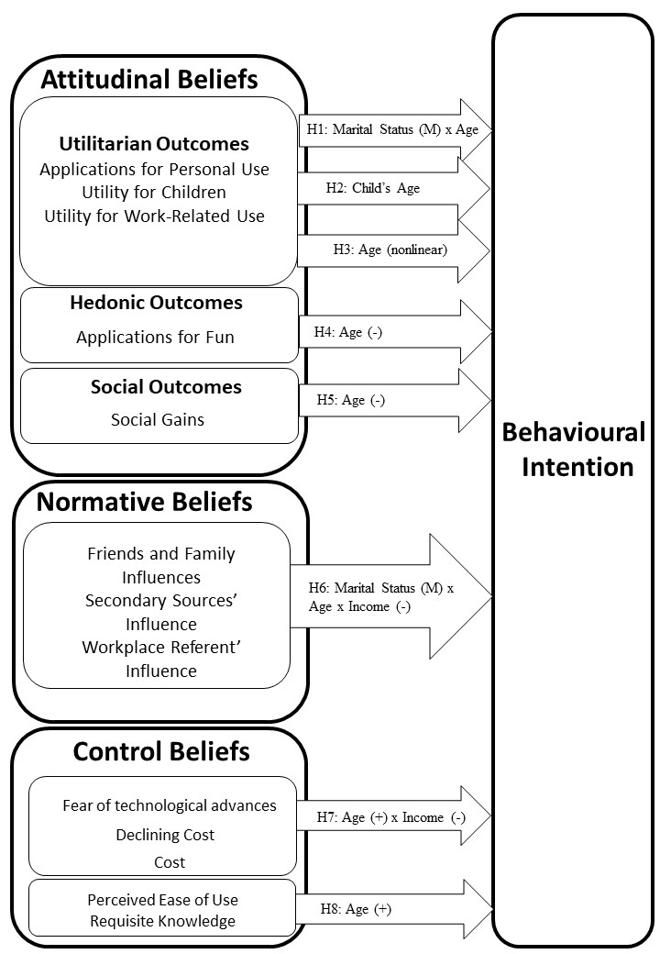

The Unified Theory of Acceptance and Use of Technology (UTAUT)

The Unified Theory of Acceptance and Use of Technology (UTAUT) was formulated to describe not only user intention to use a technology but also the user’s use of a technology. It was developed by V. Venkatech as a result of trying to unify the existing models that described this behaviour and into one single model. The UTAUT has four core variables: Performance Expectancy; Effort Expectancy; Social Influence; and Facilitating Conditions (Venkatesh, Morris, Davis, & Davis, 2003). The model also has four moderating variables: Gender; Age; Experience; and Voluntariness of Use (Venkatesh et al., 2003).The variables and their interactions are shown in Figure 2.14.

Figure 2.14 The Unified Theory of Acceptance and Use of Technology (UTAUT) (Venkatesh et al., 2003)
The UTAUT has been applied to technologies used in the renewable sector with some success but the UTAUT has not been applied in this sector, specifically in the UK (Rezaei & Ghofranfarid, 2018) (Elmustapha, Hoppe, & Bressers, 2018). In the same way that the MATH is less applicable to this research due to the model not having a precedence of being applied to renewable energy in the UK so too is the UTAUT.

The Technology Adoption Model (TAM)
In 1989 Davis proposed the Technology Adoption Model to describe consumer adoption of technologies based on two predictive factors: The Perceived Usefulness (PU) and the Perceived Ease of Use (PEOU) as shown in Figure 2.15.(Davis, 1989). The model is based on the Theory of Reasoned Action (TRA) which was proposed by Ajzen and Fishbein in 1975 (Fishbein, 1975) and describes how PU and PEOU influence consumers Attitude (AT) to use a technology and their Behavioural Intention to Use that technology. The TAM describes how consumers A and BI will influence the actual system Use (U) of the technology (Davis, 1989). The TAM shows how:
- PEOU has a significant positive influence on PU;
- PU has a significant positive influence on AT;
- PEOU has a significant positive influence on AT;
- PU has a significant positive influence on BI; and
- A has a significant positive influence on BI to use a technology.

(Davis, 1989; King & He, 2006)
In the 25 years since the TAM was first proposed it has been applied to a wide range of technologies, at different times, settings and populations (Liao, Palvia, & Chen, 2009). The TAM is grounded in psychological theory (Venkatesh et al., 2003) and whilst being prudent with its variables it has the capability of being expanded into more expansive theories, yet the TAM has not been assessed with regards to STPs in the UK (Venkatesh et al., 2003). The TAM has however been assessed in a domestic setting with respect to renewable technologies such as Smart Grids (Stragier, Hauttekeete, & Marez, 2010). In this study by Stragier et al they showed the applicability of the TAM at measuring the perception, attitude and intention to use Smart Grids (Stragier et al., 2010).
Using a quantitative survey with 500 responses the study determined that consumers PEOU and PU of Smart household technology had a strong influence on their Attitude towards using the technology (Stragier et al., 2010). Additionally it was shown that Attitude had a significant positive effect on Behavioural Intention to use the technology (Stragier et al., 2010).

Figure 2.15. The Technology Adoption Model (TAM) (Davis, 1989)
Perceived Usefulness (PU)
Attitude Toward Using the Technology (A)
External Variables
Perceived Ease of Use (PEOU)
Behavioural Intention to Use the Technology (BI)
Actual System Use (U)

The two constructs of the TAM, PEOU and PU, are formed prior to the utilisation of the technology and so are independent of the technologies actual ability to perform the given task. The TAM has been become one of the most widely used models in Information Studies (IS) due in part to its simplicity but also due to the model’s ability to be expanded upon and developed to include additional factors which make it more relevant to specific technologies (King & He, 2006). These “modifications” from other models have included the inclusion of: trust (Gefen, 2004); risk (Featherman & Pavlou, 2003); subjective norm; and expectation (Liao et al., 2009). The TAM has also been assessed with regard to potential moderating effects such as: gender (Rejón-Guardia, Sánchez-Fernández, & Muñoz-Leiva, 2013); culture (Straub, Keil, & Brenner, 1997); and varying characteristics of the technology (Plouffe, Hulland, & Vandenbosch, 2001).
The meta-analysis conducted by King and He assessed 88 studies, out of a total of 140 studies 52 studies were not included in their research as the eliminated studies did not constitute empirical research or they did not allow for a direct statistical test of the TAM (King & He, 2006) The meta-analysis determined that the TAM is a robust and a powerful model when predicting consumer behavioural intention to use a technology (King & He, 2006).
In 2010 Turner et al investigated whether the variables of the TAM are predictors of actual usage of the technology (Turner, Kitchenham, Brereton, Charters, & Budgen, 2010). Turner et al conducted a literature review of recent studies, assessing 79 studies in total. The results finding that Behavioural Intention to use a technology is likely to be correlated with actual system usage whilst PEOU and PU are less likely to be correlated with actual usage (Turner et al., 2010). The authors note that there should be care taken when applying the TAM to a context which is outside of the validated framework and that future studies investigating the applicability of the TAM report contextual information about the technology as well as the population being assessed (Turner et al., 2010). Developers of a new product have utilised the TAM at the start of the product design process as it predicts that the way in which consumers will use a technology (the frequency and the user’s ability to use the technology) is directly related to user’s Behavioural Intention to use the technology (Davis, 1989; Turner et al., 2010).

The Technology Adoption Model + Trust (TAM + Trust)
The original TAM model, as has been mentioned, has been expanded upon to incorporate different technologies and moderating effects. In particular, research has investigated the effect of Trust on consumer behaviour, especially when involving online information systems (Kantzioura et al., 2012). For technologies that are unfamiliar improving the trust consumers have with the both the technology as well as the sources of information available to them will result in a greater acceptance which will improve the adoption of the technology (Gefen, 2004; Kantzioura et al., 2012).

Due to the Technology Acceptance Model being untested with regards to STPs, it is expected that the original Davis model to not predict all of consumer behavioural intentions to use STP technology. This is because the original TAM model was parsimonious with its constructs which might inevitably mean factors which might affect modern technology adoption is not captured by the TAM. More recent iteration of the model, such as the TAM+Trust, will therefore potentially have greater explanatory power than the original TAM (Gefen, 2004). This is particularly true due to the fact that STP is relatively unfamiliar to the UK market when compared to other European countries such as Cyprus or Greece where STP technology is more established (Elmustapha et al., 2018).

Conclusions from the psychology literature review and direction for this research
Due to: it’s longevity: application to a variety of products but not STPs; the fact that it is grounded in psychological theory; it is parsimonious with its constructs; The TAM is a well-accepted model for describing consumer intension to adopt a technology and it has been assessed for not only the factors (PEOU and PU) described directly by the TAM (Perceived usefulness, perceived ease of use, and user acceptance of information technology)but also additional factors such as trust (Gefen, 2004) and risk (Featherman & Pavlou, 2003). The model has been extensively tested over this time period in a variety of contexts with PU and BI deemed as having a strong correlation to BI (King & He, 2006). However it has also been noted that the extensions to the model (such as the inclusion of trust (Gefen, 2004) or risk (Featherman & Pavlou, 2003) are likely to have greater explanatory power as these factors are contributing factors to moderate the impact of PEOU and PU. By assessing the opinions of both the main actors in the STP market as well as consumers a full assessment can be made of the most successful methods to aid its adoption in the UK market.
As previous researchers have noted, caution should be exercised when applying the TAM to technologies and situations which are beyond its validated framework. For this reason, an exploratory research method such as focus groups was opted for to determine whether the TAM would be applicable to Solar Thermal Panels in a UK context and whether further research using quantitative methods would be beneficial in determining the facts that influence consumer decisions about whether to adopt STPs in the UK.
Due to the novel nature of the technology descried in Chapter 2 it is expected that the results of a qualitative assessment of consumer opinions of STPs will result in the TAM +Trust model being better suited to the STP. For this reason, additional factors such as trust were recognised as being of significance in the resulting assessment of the data.

Final conclusions from the literature review

There has obviously been much research in previous years by researchers looking at improvements in efficiency which can be achieved through material or mechanical advancements The engineering section of the literature review highlighted the benefits other researchers had achieved when including weather predictions yet the research did not look at variable user behaviour of STP heating systems and this is where work is anticipated to yield additional efficiency gains. The application of computers to perform high numbers of calculations allows the inclusion of variable weather patterns over a long time period (Prud’homme & Gillet, 2001). Utilization of computers in this was will allow the resulting system to assess variable weather patterns as well as different draw-off patterns over a long time period (Bornatico et al., 2012; Prud’homme & Gillet, 2001). By analysing both weather patterns as well as draw-off patterns a more efficient overall system is predicted.
What has been analysed less in recent years is an analysis of the draw-off cycles when the heated water is utilised in domestic properties. This deficiency in research provides an opportunity of this current research to investigate as an area of research which has not been analysed in great depth.

The section of the literature review highlighting recent publications in psychology concerning the adoption of novel technologies in the renewable sector highlighted gaps in research in the STP sector. There have been recent studies in psychology assessing public opinions regarding renewable technologies in the UK but there haven’t been recent studies that have looked specifically at public opinions of STPs in the UK. Thus, assessing the opinions of the general public regarding STPs market, using psychological techniques is predicted to yield novel results. Previous studies have utilised techniques such as semi-structured interviews as well as focus groups to better understand the opinions of both participants who have a specialised knowledge of the subject as well as members of the general public (Kitzinger, 1994; Martin et al., 2014)

These two research methods, (using semi-structured interviews and focus groups) can be employed to best determine the opinions of both the main actors in the STP market as well as the opinions of the general public. These research methods are distinct in that they utilise different specific methods, but they both employ qualitative research methods to determine why people have the opinions they have. Whilst semi-structured interviews are conducted on a one-to-one basis focus groups allow individuals to not only discuss issues introduced by the facilitator but they also allow individuals to introduce new ideas. By utilising semi-structured interviews a more focused analysis of the opinions held by main actors in the STP market can be determined. The use of focus groups enables a wider range of opinions can be heard as well as participants collectively being able to raise more issues than if an individual was being interviewed individually.

Both of these qualitative research methods have been employed in the renewable sector in the UK and abroad (Baskaran & Bendig, 2013; Doblinger & Soppe, 2013; Kaldellis, 2005; Lienhoop, 2018; Pellizzone et al., 2015; Wüstenhagen et al., 2007).

Chapter 3
Computer simulations of a solar flat plate collector incorporating weather predictions

This chapter assesses the recent literature concerning solar thermal panels in conjunction with weather predictions to assess whether there are efficiency gains which can be made in terms of energy, cost and the corresponding reduction in carbon emissions.

Simulating the heating of a STP as the sun’s irradiance is incident on it, which is then connected to a hot water tank, was performed using the software Matlab. Recorded weather data from The Sheffield Solar Farm (SSF) is converted into the temperature of water as it leaves a flat plate panel. This water was then simulated to flow through a heating coil submerged in a hot water tank which then heats up the water within the tank.

  - Global Horizontal Irradiance (GHI) and Direct Normal Irradiance (DNI) in the UK

Figures 3.1. and 3.2 show the Average Solar Irradiation for the UK over one year averaged from 1994 – 2013 (SolarGIS Database) for the Global Horizontal Irradiation (GHI) and the Direct Normal Irradiation (DNI). These two figures highlight the variability in the available solar irradiation dependent on the Latitude that the solar collector is located at. The GHI varies between <800 kWh/m² - >1100 kWh/m² and the DNI varies between <400 kWh/m² - >1000 kWh/m². Figures 3.1. and 3.2. show the average annual sum for the Direct Normal Irradiation for the UK over the period 1994 – 2013 (SolarGIS Database).
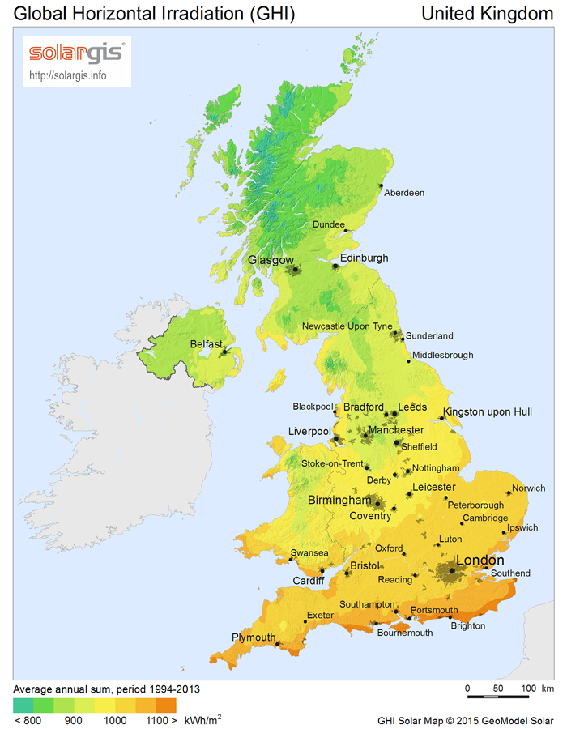
Figure 3.1. The average annual sum for the Global Horizontal Irradiation (GHI) for the UK over the period 1994 – 2013 (SolarGIS Database)

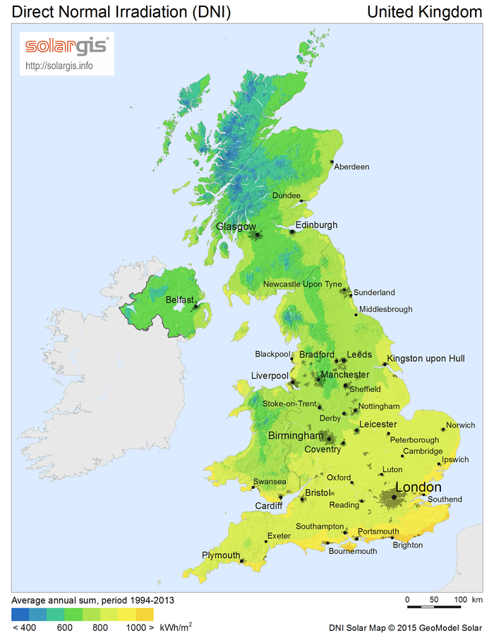
Figure 3.2. The average annual sum for the Direct Normal Irradiation (DNI) for the UK over the period 1994 – 2013 (SolarGIS Database)
Figures 3.1. and 3.2. show the variability in the annual solar GHI and DNI across the UK and show that the variability is dependent on the location of the static STP (with the latitude of the collector the most significant factor affecting the magnitude of solar irradiance) but also figures give the yearly average of solar irradiance. The solar irradiation is not on a shorter time length of a day or an hour which would allow a more accurate calculation of any efficiency gains that can be made from the STP system. Additionally, the demand for hot water varies over shorter time scales than a year and therefore the STP efficiency will vary over shorter time scales than a year. Stated explicitly, residents will have hot baths, hot showers or use the hot water tap each day at different times affecting the consumption pattern of hot water thus accurate calculations of the STPs efficiency cannot be made.
To obtain realistic solar irradiation values to calculate the variable availability of hot water from the STP real time values of solar irradiation are used which vary at shorter time intervals. This was done by recording irradiation readings from the Sheffield Solar Farm (SSF) at The University of Sheffield’s weather data monitoring observatory, The Sheffield Solar Farm, SSF, located at 53.3810 °N 1.4861 °W over 365 days. The Irradiance measurements were recorded at 2 minute intervals. Additional to this, the Direct component of the Irradiance can be adjusted depending on the location of the sun as it moves across the sky during each day and each month of the year (the Solar Azimuth Angle, Ø_{S} and the Solar Declination, δ see: 3.5). A pyrometer similar to the one shown in Figure 3.3. was employed to measure the Global Diffuse Irradiance and the Total Irradiance, and thus a calculation of the Direct Irradiance was made using:

 | $$Total Irradiation=Direct Irradiation+Diffuse Irradiation$$ | (4)
(L. T. Wong & Chow, 2001)
Thus:
 | $$Direct Irradiation= Total Irradiation- Diffuse Irradiation$$ | (5)
(L. T. Wong & Chow, 2001)

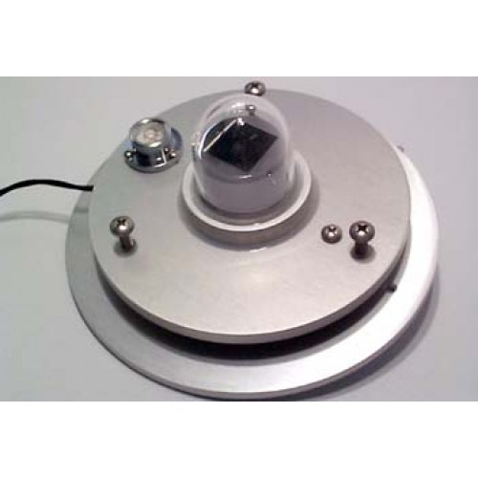
Figure 3.3. A pyrometer similar to the one used at the Sheffield Solar Farm

Parameters to measure when evaluating the performance of the STP system
There are various parameters used to evaluate the performance of a Solar Domestic Hot Water System (SDHWS) over its lifetime (usually 20 years) and choosing the correct parameter depends on the desired outcome .(Comparative study of various optimization criteria for SDHWS and a suggestion for a new global evaluation) It is widely accepted that combining SDHWS with conventional systems to obtain high efficiencies is dependent on correct sizing of the tank and having the most advantageous control of the system .(Comparative study of various optimization criteria for SDHWS and a suggestion for a new global evaluation) Various studies have looked at a number of parameters to optimise including: the Life Cycle Cost (LCC) (which will give a financial cost of the SDHWS over its estimated lifetime); the Solar Fraction (the amount of energy provided by the SDHWS divided by the total amount of energy required for hot water heating); or the Solar Collector Efficiency ($η_{COL}$) .(Solar Engineering of Thermal Processes)
The Collector Efficiency can be calculated using:
 | $$η_{COL}= Qcol / (H . A_{C})$$ | (Fraisse et al., 2009)
(6)
Where:
$η_{COL}$- Collector Efficiency
$Qcol$ - Energy removed by the heat transfer fluid over the year (kWH/min)
H - Solar irradiation incident over the time period (a minute) per unit area (kWh/m²min)
A_{C} - Area of collector (m²)

From (7) it can be inferred that the efficiency of the collector will vary depending on the irradiance incident on it and the amount of energy removed by the user. A calculation of the total energy required to heat the demanded volume of water divided by the amount of energy provided by the STP gives the Solar Fraction:
 | $$F_{SOL}=\frac{Q_{COL}}{Q_{d}}$$ | (Fraisse et al., 2009)
(7)

Where:
$F_{SOL}$ - Solar Fraction
$Q_{COL}$ - Energy removed by the heat transfer fluid over the time period (kWH/time)
Q_{d} – Energy required to heat the required volume of water(kWH/time)
The study by Fraisse et al determined that it is better to oversize the panel rather than the tank due to the heat losses from the tank and the additional financial costs when installing a larger tank can be high (Fraisse et al., 2009). This study by Fraisse et al 2009 also showed that often the costs from the auxiliary heater are not considered and so comparison of the actual performance of SDHWS and the modelled/predicted performance are not congregant (Fraisse et al., 2009). For these reasons the proposed system which suggests to the homeowner the most beneficial days to consume the generated hot water is prudent.
The Matlab program calculates these 4 parameters (Eq. 3, 4, 5 ,6) over the entire data set (365 days) for the recorded weather and the predicted weather for the following day. If the weather tomorrow is predicted to be hot and today’s weather is also hot, then the system will suggest consuming a high volume of water (Tapping Cycle#1).
The Matlab program utilises an external third party application which accounts for: the location of the collector on the globe (the longitude and latitude of the collector); the tilt of the collector with respect to the horizontal; the altitude of the collector (100m), and also includes the tracking of the sun as it moves across the sky throughout the day (which affects the Direct and Diffuse Irradiation incident on the tilted flat plate collector). The PV Performance Modelling Collaborative is an application for Matlab. The Matlab program also accounts for the poor transposing of the bean component recorded at the Sheffield Solar Farm, SSF when sun is close to the horizon. When the Solar Zenith is above 85°, at these times the Direct Irradiance is assumed to be 0, with the Diffuse Irradiance accounting for the Total Irradiance incident on the solar collector. The irradiation as measured by the pyrometer at these times is not reliable and so Direct Irradiance at these times is considered to be zero. This is with the collector set at a fixed altitude of 100m.

  - Calculation of heat into panel from the sun
To calculate how much irradiance is falling on a flat plate collector there are a number of assumptions that are made. These assumptions are:
- the flow rate ($ṁ)$ of the water coming from the flat plate panel is sufficient to assume that the coil can be considered to have the same initial temperature along its entire length equal to the temperature of the water as it leaves the collector (the coil can be considered as essentially a rod);
- single glazed, flat plate collector;
- south facing collector, γ_{s}=0°;
- located in Sheffield ¹, ϕ = 53.3836° N, 1.4669° W; and
- collector tilt, β=45°.
(Duffie & Beckman, 1980)
With the above assumptions the Solar Declination (δ_{s}) can now be calculated:
 | $$δ_{S}=23.45×\sin\left(\frac{360°×(284+n)}{365}\right)$$ | (8)

Where:
δ_{s} - Declination Angle
n -Day of year

The Overall Transmittance (Tr) of the collector can be calculated for the collector:
 | $$T_{r}≈τ\left(\frac{1-ρ}{1+ρ}\right)$$ | (9)
(Duffie & Beckman, 1980; Wong & Eames, 2015)
Where:
Tr - Overall Transmittance of solar radiation through the glass
$τ$ - Glass Transmissivity (-)
$ρ$ - Glass Surface Reflectivity (-)
With equation (8) it is possible to calculate the overall Absorptance (Ab) of solar irradiation into the panel for each time period for each day of the year:
 | $$Absorptance, A_{b}=\frac{(1-ρ)(1-τ)}{1-ρτ}$$ | (10)
(Wong & Eames, 2015)
Where:
A_{b} - Absorptance (-)
$τ$- Glass Tranmissivity (-)
$ρ$ - Glass Surface Reflectivity (-)
The Overall Reflectance (R) can now be calculated which is a function of the Glass Surface Reflectivity ($ρ$) and the Glass Transmissivity ($τ)$:
 | R = ρ$\left[1+ \frac{\left(1-ρ\right) τ2}{1-ρ2τ^{2}}\right]=1-Tr-A$_{b} | (11)
(Wong & Eames, 2015)
Where:
R - Overall Reflectance (-)
$ρ$ - Glass Surface Reflectivity (-)
$τ$- Glass Tranmissivity (-)
Tr - Overall Transmittance (-)
A_{b} - Absorptance (-)
With the Transmittance (Tr), Absorptance (Ab) and the Reflectance ® the “Tau-alpha” product can be now calculated using:
($τα)$ = $\frac{Tα}{1-\left(1-α\right)R}$
(12)
(Wong & Eames, 2015)
Where:
T$α$– Tau-alpha product (-)
$τ$ - Glass Tranmissivity (-)
$α$ – Plate Emissivity (-)
R – Reflectance (-)

With one final assumption, (that there are no heat losses from the top and the bottom of the flat plate collector) using the above equations, the final amount of the useful energy (Q_{U}) can be calculated for the solar thermal panel:
Useful Energy, Q_{U:}
 | $${ Q}_{U}=\dot{m }C_{P}\left(T_{f, out}-T_{f, in}\right)=A_{C}I_{T}η_{C}$$ | (13)
Where:
$Q_{U}$ - Useful Energy into the collector (W)
I_{T} – Total Irradiation on the STP (W/m²)
$ṁ$ -$mass flow rate of the heating fluid$ $(\frac{Kg}{m}/s$
C_{P} - Specific heat capacity of water (kJ/kgK)

By rearranging Equation (13) the Fluid Outlet Temperature (T_{f,out}) as it leaves the STP can be calculated as shown below in Equation (14):

$$T_{f, Out}=T_{f, in}+\frac{A_{C}I_{T}η_{C}}{\dot{m}C_{P}}$$ | (14)
Where:
T_{f,Out} - Fluid outlet temperature ©
$T_{f, in}$- Fluid inlet temperature ©
$A_{C}$ - Area of Collector (m²)
$η_{C}$- Efficiency of collector (-)
$ṁ$-$mass flow rate of the heating fluid$ $(kg/s$)
C_{P} - Specific heat capacity of water (kJ/kgK)
This final value of the temperature of the water, T_{Out}, as it leaves the flat plate collector is calculated at secondly intervals throughout each day of the year and the will vary:
- As the direct and diffuse irradiation vary throughout each day;
- As the day of the year varies, which correspondingly changes the angle of incidence of the direct radiation on the collector;
- As the temperature of the water already in the collector changes due to the tank heating up and the water being using throughout each day depending on the Tapping Cycle assigned to each day.

  - Additional energy required by an auxiliary boiler
At those times throughout the day when the heated water coming from the STP is insufficient for the demand then an auxiliary heater is designed using natural gas to raise the temperature of the water to the requisite temperature (45 °C). For each additional kilogram of water that has to be raised by each additional degree the additional heat required by an auxiliary boiler is given by:
 | $Q_{AUX}=C_{P} . m . d$T | (15)
Where:
Q_{AUX} - Amount of heat required by auxiliary heater (kJ)
C_{P} - Specific heat of water (kJ/kg.K)
$m$- mass of water (1 Kg)
dT - temperature difference between required temperature and temperature of water as it leaves the tank (°C)

  - Cost of using an auxiliary boiler
Using Eq. (15) and knowing the cost of gas (C_{GAS}), the cost of using an auxiliary boiler can be calculated:
 | Cost of using an auxiliary boiler = Q_{AUX} x Volume of water x C_{GAS}  to heat required volume of water  needed | (16)

  - Final energy savings
From (16) the Final Energy Savings can be calculated:

F$inal Energy Savings, E_{Save }=Energy needed for heating water via auxilliary boiler, E_{GAS}-Energy provided by STP$

(17)

  - Final choice of parameters to measure when evaluating the performance of the STP system
The final parameter choices to measure when evaluating the performance of the STP system which are similar to those measured by Rogers are:

- The Temperature of the water as it leaves the STP, Eq. (14);
- The Cost of Heating the required water, C_{Cost,} Eq. (16);
- The Final Energy Savings, E_{Save,} Eq. (17). (Rogers et al., 2013)

These three parameters represent the most important variable effects when applying an STP two domestic hot water production in a temperate climate such as the UK. By measuring the temperature of the heated water as it leaves the STP one is able to calculate the final two parameters as listed above (using equations 16 and 17). All three parameters have a direct impact on the user of the STP as these parameters impact on the effectiveness of the technology to perform its stated capability and they will impact on the householders’ finances. Thus, these three final parameters are considered for the remainder of this research when determining the engineering variables which will result in a more efficient hot water system utilised in a domestic setting.
  - Calculating the heat from a solar thermal panel throughout the day
To calculate the heat coming from a solar thermal panel a number of constants are initially needed, such as the location of the flat plate panel on the Earth (latitude, λ) and the tilt of the collector relative to the ground.
Using Eq. (9) and the constants from Table 3.3 the Transmittance can be calculated:
$$T_{r}≈τ\left(\frac{1-ρ}{1+ρ}\right)$$
(18)
$$T_{r}≈0.91\left(\frac{1-0.05}{1+0.05}\right)$$
$T_{r}$=0.823
Using Eq. (10) and the constants from Table 3.3 the Transmittance can be calculated:
$$Absorptance, A_{b}=\frac{\left(1-ρ\right)\left(1-τ\right)}{1-ρτ}$$
$$Absorptance, A_{b}=\frac{(1-0.05)(1-0.91)}{1-(0.05 . 0.91)}$$
$$Absorptance, A_{b}=\frac{\left(0.95\right)(0.09)}{1-0.0455}$$

$Absorptance, A_{b}=\frac{0.0855}{\begin{aligned}0.9545 \\ \end{aligned}}$
$$Absorptance, A_{b}=0.0896$$

Using Eq. (11) and the constants from Table 3.3 the Reflectance can be calculated:

R = ρ$\left[1+ \frac{\left(1-ρ\right) τ2}{1-ρ2τ^{2}}\right]$
(19)
R = 0.05$\left[1+ \frac{\left(1-0.05\right) {0.91}^{2}}{1-0.05²{0.91}^{2}}\right]$
R = 0.05 $\left[1+ \frac{ 0.7867}{0.989}\right]$ 0.786695
⇒ R = 0.071
The dimensions of the cylindrical tank (height and radius) as well as the dimensions of the heating coil (length and radius) are given in in Table 7.8. in the Appendix (Kingspan and Worcester Bosch).

  - Final constant values used in the Matlab program
In Table 3.3. the various constants, their values and their respective units used in the final Matlab program are shown. The constants relating to: the collector (blue); properties of water (green); the hot water tank (red); and the auxiliary boiler (grey). These constants are in accordance previous research which has conducted concerning STP’s in the UK (see (Duffie & Beckman, 1980) ; (L. T. Wong & Chow, 2001); (Fraisse et al., 2009); (Rogers et al., 2013); (Wong & Eames, 2015); (SolarGIS Database); and (Kingspan and Worcester Bosch).

Table 3.3. The final constants used in the Matlab code
Property, symbol in Matlab code | Symbol in Matlab program | Value | Unit
Capital cost of collector | CollectorCapitalCost | 3000 | £
Latitude of collector | Latitude | 53..380809 | º (Degrees)
Longitude of collector | Longitude | -1.485802 | º (Degrees)
Height above ground of collector | HeightCollector | 50 | m
Collector Area | CollectorPanelArea | 10 | m²
Tilt of collector | Tilt | 30 | º (Degrees)
Azimuth (angle collector pointed at) due south, Orientation | Orientation | 180 | º (Degrees)
Collector altitude | Altitude | 50 | m
Collector efficiency | CollectorEfficiency | 0.75 | -
Glass Transmissivity | Transmissivity | 0.91 | -
Glass Surface Reflectivity | SurfaceReflectivity | 0.05 | -
Plate Emissivity | Emissivity | 0.95 | -
Reflectance (-) | Reflectance | 0.070 | -
Specific Heat Capacity of Water | Cp | 4181 | J/kg/K
Density | Density | 988 | Kg/m³
Liquid Volume in panel | CollectorVolume | 1.2 | Litres
Flow Rate | MassFlowRate | 0.001 | kg/s
U value water – copper - water | Uwcw | 450 | W/m² K
Temperature of water needed | RequiredWaterTemp | 45 | ºC
Tank Volume | Volume | 200 | Litres
U value water to water | Uww | 1000 | W/m² K
Number of slices in tank, | NumberSlices | 200 | -
Height of tank, Height | Height | 2.0 | m
Radius Tank | RadiusTank | 0.453 | m
Length Coil | Length | 15 | m
Radius Coil | RadiusCoil | 0.0075 | m
Area of coil (2πRadiusCoil) | AreaCoil | 0.0691 | m²
Efficiency of auxiliary boiler | EfficiencyBoiler | 90%, 0.9 | -
Initial tank temperature | InitialTankTemp | 10 | ºC
Maximum operating temperature | MaxTemp | 232 | ºC
Maximum operating pressure | MaxPressure | 10 | Bar/Pascal
Accuracy of MET predictions | AccuracyMET | 80%, 0.8 | -
Cost of gas used in auxiliary boiler | CostGas2014 | 5.0200 | p/kWh
Specific CO₂ Emissions | GasCO₂ | 0.23 | kg_{CO2}/kg_{FUEL}
  - The hot water tank
The proposed hot water tank is shown in Figure 3.4. A heating coil runs through the tank and the dimensions as shown in Table 3.4. The heating coil is evenly distributed throughout the tank. The water in the tank is not shown in Figure 3.4. for clarity.
Figure 3.4. The proposed hot water tank
Hot water drawn off for consumption
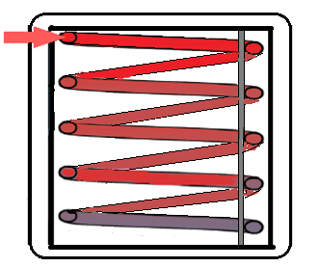
Perfect insulating material
Valve to allow heated water to be used
Hot water from the STP (ṁ)

Metal support
Perfect insulating material

Cooler water returning to STP (ṁ)
Valve to allow water in tank to be refilled

Cold water refilling hot water tank

A domestic hot water tank typically has a volume ranging from 190ltrs – 950 lts .(Megaflo eco, unvented hot water cylinders) An average of 200 lts is assumed and with the dimensions given in Table 3.3. it is possible to calculate the thickness of each 1 litre slice in the tank:
T_{slice} = $\frac{Height of tank}{Numberof slices}$ | (17)
T_{slice} = $\frac{2}{200}$

T_{slice} = $\frac{2}{200}$
T_{slice} = 0.01m

The heating coil
The total area of the heating coil can also be calculated using the radius of the heating coil and the length of the heating coil:
Total area of heating coil,
A_{c} $=Legth of coil \left(L_{coil}\right) . 2 . π . r$ | (18)

Where:
A_{C} - Area of heating coil (m²)
L_{C} – Length of heating coil (m)
r_{Coil} – Radius of coil (m)
A_{c}= 2 x π x
A_{c}=0.006282m²
Using the result from Eq. 17 and knowing the number of slices in the tank (200), the area that is heating each slice (A_{coil, slice}) can now be calculated:
A_{coil, slice,} = $\frac{ Total area of heating coil, Ac}{Number of slices}$ | (19)
A_{coil, slice,} = $\frac{ 0.0076}{200}$
A_{coil, slice,} = $\frac{0.006282}{200}$
A_{coil, slice} = 0.00003141 m²
A_{coil, slice} = 3.141 x 10⁻⁵ m²

  - Calculating the heating up of the hot water tank
The hot water tank is notionally divided up into one litre volumes so that there are 200 “slices” of water in the tank. The slice of water in the tank that is at the top of the tank (slice 1) is the first to be heated by the hot water coil and is heated up using Eq. 19). The water temperature for each slice of water gives the heat transfer rate$\dot{ Q}$:
 | $\dot{Q}$ = U_{W} x A_{TANK-SLICE} x ∆T | (20)
Where:
$\dot{Q}$ - Heat transfer rate (W)
Uw - Heat transfer coefficient of water, 800 (W/m²)
A_{TANK-SLICE}- Area the heat transfer is occurring over (m²)
∆T - difference in temperature between slice of water in tank and section of pipe (K)
With the coil dimensions known: (R_{coil,} L); the area of coil that is heating up each slice; the volume of water that is being heated up (1 litre); the heat capacity of water (C_{p}). The drop in temperature of each slice of tank is given by:
 | $dT=\frac{\dot{Q} dt}{m{ C}_{p}}$ | (21)
Where:
dT- Change in temperature (°C)
dt- time step (s)
C_{p}- heat capacity of water (J K⁻¹)
m - mass of water that is being heated (1 kg)

In Figure 3.5. three turns of the proposed heating coil in the hot water tank and shows the flow of water through the heating coil submerged in the hot water tank as well as the heat flow from the heating coil to the surrounding volume of water in the tank.

Figure 3.5. The heating coil in the hot water tank
Heating coil
Perfect insulating material
$$\dot{Q}$$
$$\dot{Q}$$
$$\dot{Q}$$
Hot water tank
$$\dot{Q}$$

Heat transfer from heating coil to the tank ( )
Flow of hot water through the heating coil (ṁ)
ṁ

A flow diagram which shows how the own program goes through each time interval and goes back through the loop is shown in Figure 3.7. The first 1 litre slice of water in the tank will heat up by:
dQ = U_{WCW} x A_{coil} x ΔT | (22)
ΔT =U_{WCW} . A_{coil} . $\frac{dQ}{ΔT}$
T2= T1 - $\frac{dQ}{ΔT}$
dQ = U_{WCW} A_{coil} ΔT  Where:  dQ - Flow of heat between slices  U_{WCW} - U Value (water – copper – water) - 400 (W/m²C)  A_{COIL} - Area of coil (m²)  ΔT - Difference in temperature between “slices” (°C) | (23)
  - Conduction in the tank between slices
As well as there being conduction from the heating coil to the water within the tank, there is also conduction from a warmer “slice” of water in the tank to an adjacent slice of water that is at a lower temperature. The conduction occurs over the surface area of the slice and so in a similar manner to Eq. (21) the conduction is given by:
 | $\dot{Q}$ = U x At_{ank} x ΔT | (24)
Where:
$\dot{Q}$ - Heat transfer rate (W)
At_{ank} - Area of tank (m)
U_{WAT-WAT} - U VALUE (Water – Water) – 800 (W/m²C)
∆T - Difference in temperature between the two slices (°C)

Figure 3.6. Conduction from warmer slices to cooler slices of water within the tank

Direction of conduction from a “slice” of hotter water to a “slice” of water at a lower temperature
Heated water from STP

Perfect insulating material
Cold water returning to the STP

As figure 3.6 shows, the conduction within the hot water tank starts from the top of the tank and goes down the tank. Conduction will occur when a hotter slice of water is touching a cooler slice of water and so will occur across the surface area of the hot water tank.

  - Simplifications in the Matlab program
The program has a number of simplifications acknowledged here:
- The Diffuse and Total Irradiation as measured from the Sheffield Solar Farm is assumed to be constant for the current minute that it was recorded over;
- The STP is not obscured and its total area is apparent to the sun’s rays;
- There are no top or bottom heat losses from the STP;
- It is assumed that there are no heat losses in the connecting pipes from the STP and the hot water tank;
- There are no heat losses from the hot water tank;
- There is no mixing in the tank during each Tapping Cycle;
- The volume of the heating coil is assumed to be zero;
- The heating coil is evenly distributed within the hot water tank;
- The flow of water through the heating coil from the STP is sufficient to consider it as a heated rod at the same temperature at the start of each minute;
- When there is a consumption of hot water (a Tapping Cycle occurs) the water volume is consumed within that minute and the “slices” of hot water are moved higher in the tank, with the water leaving the hot water tank to the auxiliary boiler and the corresponding volume of water consumed during the Tapping Cycle is replaced by new water filling up the bottom of the tank at 10°C.

  - Flow diagram of the Matlab program
The layout of the program is shown in Figure 3.7. showing the processes that were programmed into the Matlab program.

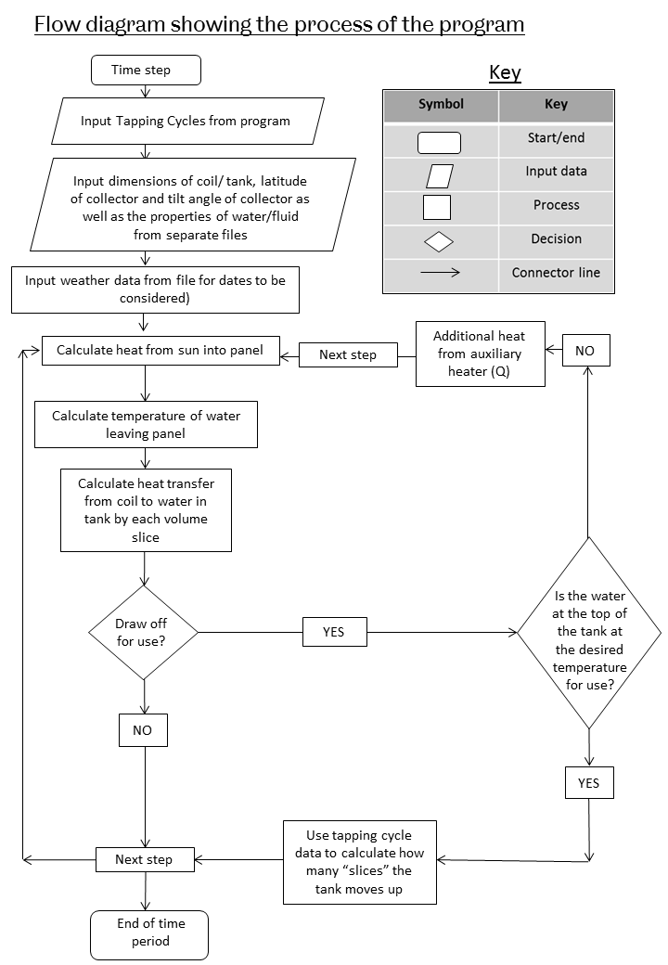
Figure 3.7. Flow diagram of the Matlab program
  - Recorded direct, diffuse and total irradiance at Sheffield Solar Farm SSF, between 19/02/2014 00:00 - 19/02/2015 23:59
Figure 3.8. shows the Diffuse and the Total Irradiance as measured at the Sheffield Solar Farm (53.3810 °N, 1.4861 °W) between the dates of 19/02/2015 - 19/02/2015. The Direct component of the irradiance was calculated using Eq (2) (Solar radiation model). To show the recorded values over the 365 days an average was taken each day with the resulting values of Direct, Diffuse and Total Irradiance being graphed. These three components of the solar irradiance are paramount to model the warming of the water in the solar collector precisely.

Figure 3.8. Direct, Diffuse and Total Irradiance as predicted by the MET +0Hrs 19/02/2014–19/02/2015 plotted with daily averages

  - Recorded irradiance at SSF throughout a year
The next four figures show recordings made at the SSF throughout a 24hr period on four separate days throughout 2015 and show how the recordings vary through the seasons of the year. Figure 3.9 shows the direct, diffuse and total irradiance as measured at the SSF on 01/01/2015. The solar irradiance is shown to be predominantly diffuse irradiance with direct irradiance comprising only a fraction of the total irradiance. This is to be expected at this time of year when the sun is low in the sky and thus the direct component of the irradiance is expected be low.

Figure 3.10 01/01/2015 00:00 – 23:59 Direct, diffuse and total irradiance as measured at SFF
Figure 3.11 03/03/2015 00:00 – 23:59 Direct, diffuse and total irradiance as measured at SFF
Figure 3.12 06/06/2015 00:00 – 23:59 Direct, diffuse and total irradiance as measured at SFF
Figure 3.13 01/09/2015 00:00 – 23:59 Direct, diffuse and total irradiance as measured at SFF

Figure 3.9 Direct, diffuse and total irradiance as measured at the SSF on 01/01/2015

In Figure 3.10. the direct, diffuse and total irradiance as measured at SFF on the 01/03/2015 and shows the spikes in solar radiation which occur between the hours of 09:00 and 14:00. Whilst some of the total solar irradiance is the direct irradiance (W/m²) the majority of the total irradiance is the diffuse component.
Figure 3.10. Direct, diffuse and total irradiance (W/m²) as measured at SSF on 01/03/2015

Figure 3.11. shows the measured irradiance at SFF on 01/06/2015 for the full 24 hrs. The direct irradiance component is more significant on this day than what it was on the first days of January and March of 2015 as the sun is higher in the sky in June than it was in January and March and this is shown in the recorded irradiance values as shown in Figures: 3.9.; 3.10.; and 3.11..
Figure 3.11. Direct diffuse and total irradiance as measured at SSF on 01/06/2015

In Figure 3.12. the measured direct, diffuse and total irradiance, at SSF on 01/09/2014 for the full 24hrs. The direct component is only marginal throughout the day, hardly rising above 100W/m² as the sun is low in the sky and so the diffuse component of irradiance comprises the majority of the total.
Figure 3.12. Direct diffuse and total irradiance as measured at SSF on 01/09/2014

  - Options for choice of Tapping Cycle
The decision about which Tapping Choice to implement is dependent on the predicted weather for today (0Hr) and tomorrow (24Hr). If:
- Total Irradiance is below 2kWh /m²/day this is classed as being low.
- Total irradiance is 2kWh /m²/day – 4kWh /m²/day this is classed as being medium.
- Total Irradiance as above 4kWh /m²/day this is classed as being high.
With these ranges it is possible to use the predicted weather for the next 24Hrs from the MET Office and compare it with today’s predicted weather (0Hr) from the MET Office. Using Table 3.2. it is then possible to decide about which Tapping Cycle to use today based on the predicted weather for today and tomorrow.

Table 3.2. Options for Tapping Cycle choice
Today’s Weather  Tomorrow’s Weather | Predicted high irradiance | Predicted medium irradiance | Predicted low irradiance
Predicted high irradiance | Tapping Cycle #1 | Tapping Cycle #1 | Tapping Cycle #2
Predicted medium irradiance | Tapping Cycle #1 | Tapping Cycle #2 | Tapping Cycle #3
Predicted low irradiance | Tapping Cycle #2 | Tapping Cycle #3 | Tapping Cycle #3

The decision about which Tapping Cycle is most appropriate to use for the coming day is only made one the predicted weather for today and tomorrow. It does not consider the previous Tapping Cycles that have occurred, but only matches the most appropriate Tapping Cycle with regards to the predicted weather and the total daily consumption of each Tapping Cycle. The three Tapping Cycles are shown in Figure 3.13. throughout a 24-hour period, with the consumption volumes and the time of day when the consumption occurs shown.

Figure 3.13. Volume of water tapped throughout 24Hrs, Tapping Cycles #1, #2 & #3

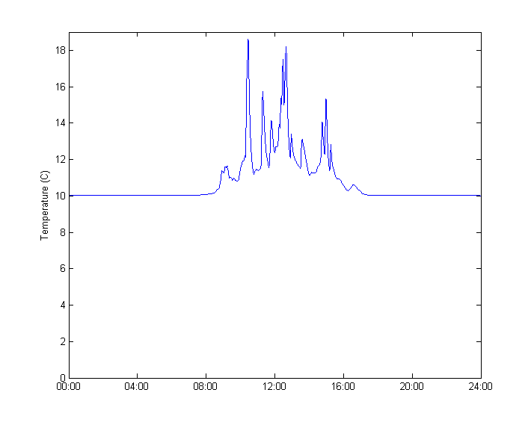
Figure 3.14. Temperature of the heating coil from the STP 00:00- 23:59 01/01/2015
In Figure 3.14. the temperature of the heating coil as measured on the first day of the year in 2015 (01/01/2015) is shown. The temperature increase in the hot water tank is very marginal, but this is to be expected at this time of year when the sun is at its lowest in the sky and thus the incident radiance on the STP would be low.
The temperature within the heating coil never falls below 10°C as this is the temperature of the water entering the heating coil tank from the mains supply.

Figure 3.14. shows the temperature of the heating coil only being increased to approximately 18°C the very short periods of the day, exactly at those times of the day when there is significant direct irradiance on the solar collector.

Figure 3.15. Direct, diffuse and total irradiance at SSF 00:00 – 23:59 19/05/2014
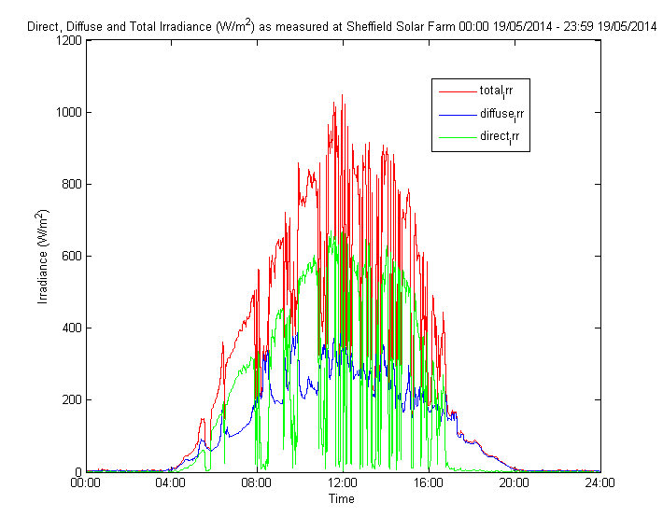
Figure 3.15. shows the direct, diffuse and total irradiance as measured at SSF on the 19/05/2014. As Figure 3.15 shows, the diffuse component of the total irradiance is not as erratic as the direct component which suggests that this day was bright with clouds (which would cause the direct component of sunlight to resemble the waveform that is shown with the direct component of light almost having a binary characteristic where it is either being incident on the STP (on) or not (off).

Figure 3.16. Temperature of the heating coil from the STP 00:00- 23:59 19/02/2014
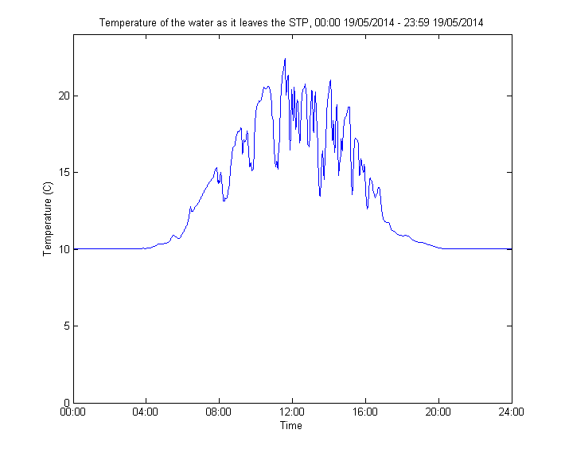

Figure 3.16. shows the temperature of the water in the heating coil has a similar characteristic in February as it did in January with sharp increases or decreases in temperature depending on the binary nature of the incident light on the STP. Again, the temperature of the heating coil never falls beneath 10 °C as this is the temperature of the water entering the STP, but there is a noticeable difference in shape to Figure 3.17. It is apparent when comparing the two figures that the heating of the coil occurs earlier in the day (from approximately 06:00) In February 2014.

Figure 3.17. Direct, diffuse and total irradiance at SSF 00:00 – 23:59 19/08/2014
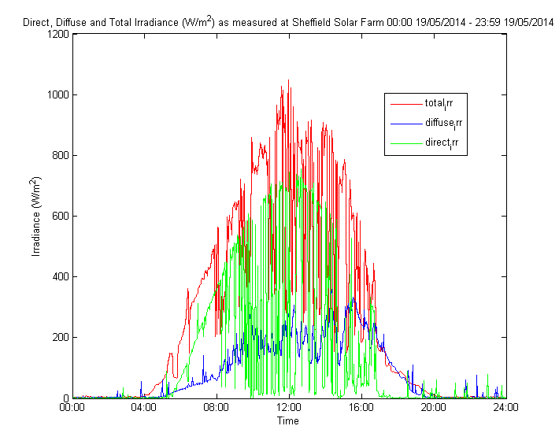
Figure 3.18. shows the temperature of the heating coil from the STP for the entire day on 19/8/2014. The temperature profile follows the general profile of the irradiance of that day as shown in Figure 3.17. with the maximum temperature of the heating coil being reached over the middle of the day when the sun is highest in the sky. After about 16:00 the temperature of the heating coil falls to the mains temperature of 10 °C as the sun drops to the horizon and the solar irradiance has greater amount of the earth’s atmosphere to travel through before it reaches the solar collector.

Figure 3.18. The temperature of the heating coil from the STP 00:00 - 23:59 19/08/2014
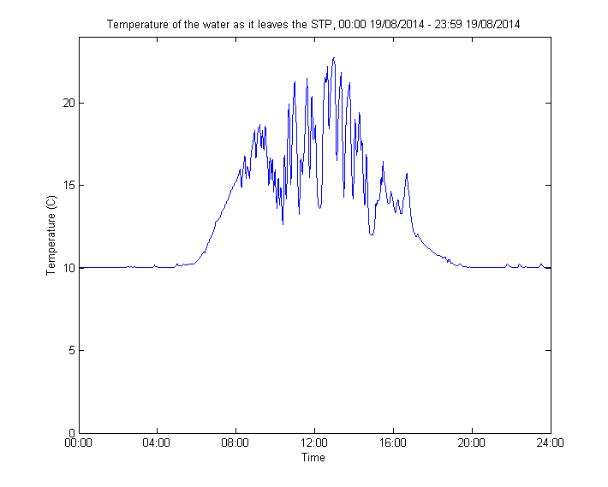

Figure 3.19. Direct, Diffuse and Total Irradiance at SSF 00:00 - 23:59 19/11/2014
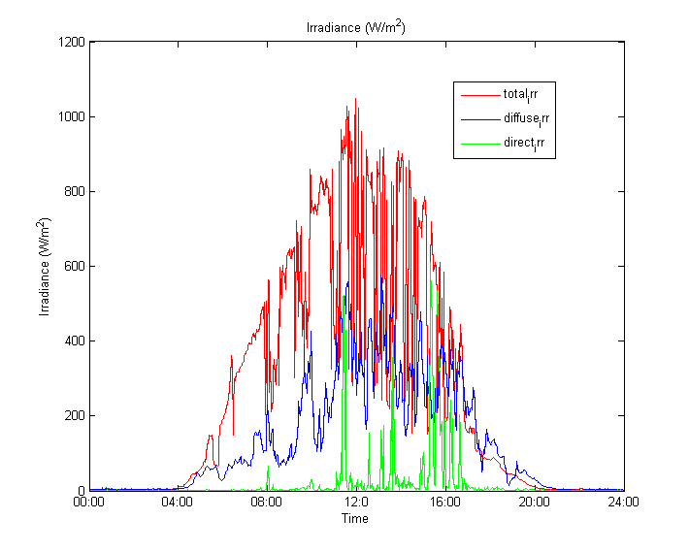
Figure 3.19. shows the direct, diffuse and total irradiance as recorded at SSF on 19/11//2014 from 00:00 – 23:59. On this November day, the sun is at a low Azimuth angle and therefore the total irradiance reaching the pyrometer situated at the SSF is low. The large variability in the direct irradiance component suggests that this day experienced significant cloud cover.

Figure 3.20. Temperature of the heating coil from the SSF 00:00 - 23:59 19/11/2014
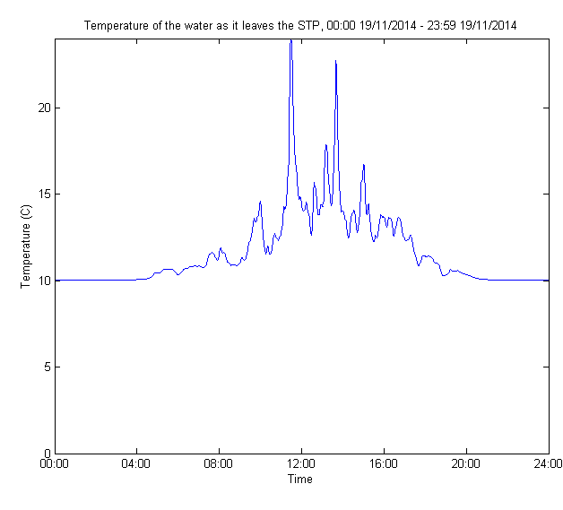
Figure 3.20. shows the resulting heat variability as being very marginal with the temperature of the coil only rising above 20°C at two brief moments during the day with the temperature of the coil rising only a couple of degrees during the times of the day when the sun is highest in the sky from 08:00 – 20:00.
Figure 3.21. Direct, diffuse and total irradiance at SSF 00:00 - 23:59 19/02/2015
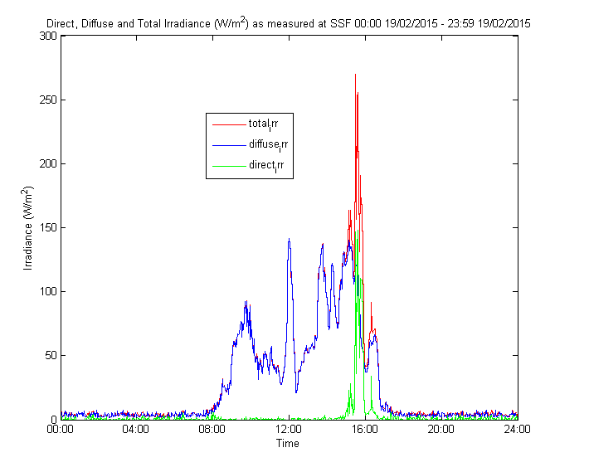
Figure 3.21. shows the recorded direct, diffuse and total irradiance as measured at the SSF from 00:00 - 23:59 on 19/02/2015. The direct component of the irradiance is a very small component if the total recorded irradiance as the azimuth angle is low and the sun’s radiation has to radiate through a greater amount of the earth’s atmosphere, reducing the amount of radiation that arrives at the solar collector.
As there is a low amount of solar radiation which arrives at the solar collector, the heating of the coil only changes marginally as shown by Figure 3.22. The changing temperature of the heating only increases by approximately 1.5°C for the majority of the day when the sun is at a high azimuth angle from about 08:00 – 16:00. The large spikes in the heating of the coil occurs at about 16:00 and matches the total irradiance as measured on this day in February 2015.
Figure 3.22. Temperature of the heating coil from the STP 00:00 - 23:59 19/02/2015
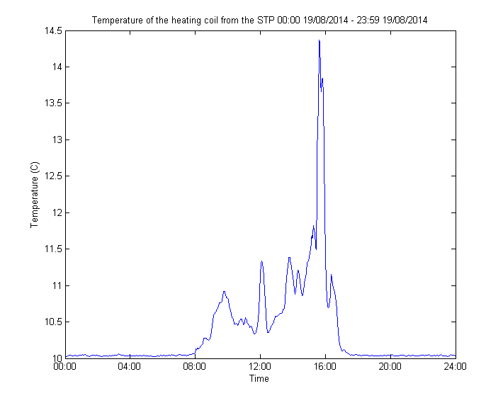

  - Results from Matlab simulations
The recorded irradiance as measured on 23/7/2014 was chosen as a single day with which to show the program operating under the different Tapping Cycles. The end of July was chosen as the it is often the middle of summer and will indicate the effectiveness of using the program choice of Tapping Cycle (in the winter when there is less irradiance the difference in the efficiency and cost savings will be least whereas in the summer the savings will be more pronounced). The temperature of the hot water tank as it heats up is using Tapping Cycle #2 is shown in Figure 3.23 with the top slice, the middle slice and bottom slice of the tank graphed (“Slice 1” is at the top of the tank and “Slice 150” is at the bottom of the tank).
Figure 3.23. The temperature of the tank at different slices, Tapping Cycle #1 00:00-23:59 23/07/2014
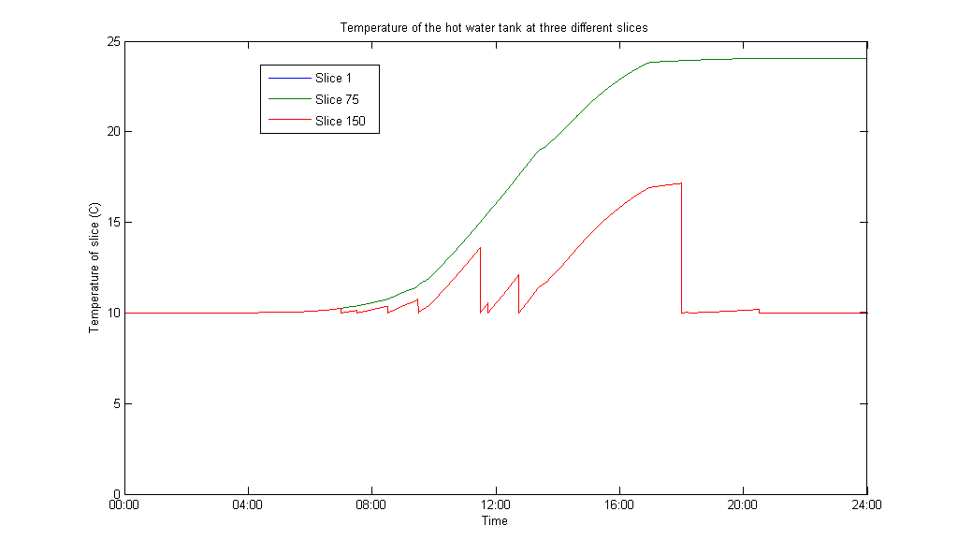

Figure 3.24. The cost of heating up the required volume of water to 45°C throughout 00:00-23:59 23/07/2014 utilising a STP using Tapping Cycle#1
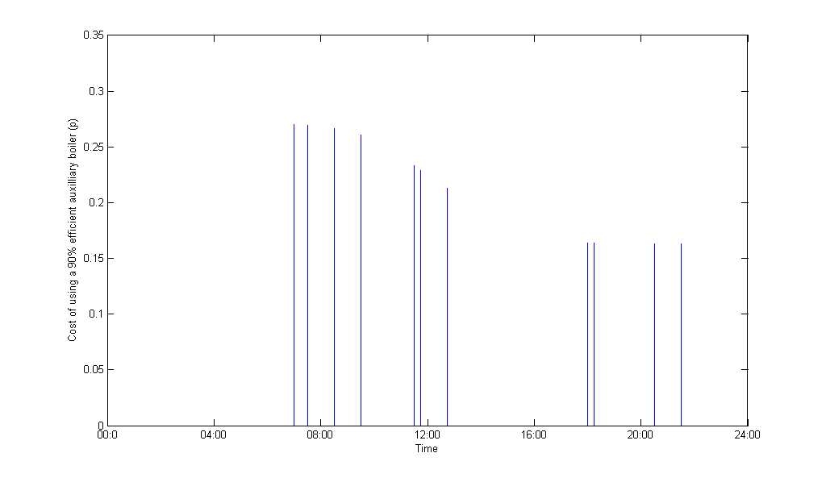

The cost of using an auxiliary boiler throughout the day is shown in Figure 3.24. At those times throughout the day when an auxiliary boiler is required to raise the heated water up to the desired temperature of 45°C the cost only exceeds 0.25p for four of the eleven tapping occasions.
The total cost of using an auxiliary boiler for that day is calculated as being 2p for the day using Tapping Cycle #1 with a STP connected to the hot water thank and an auxiliary boiler supplying the additional energy at those times when the temperature of the water is below 45°C. This compares with a cost of 29p incurred when utilising just an auxiliary boiler. The Final Energy Savings for that one day are simply 29p, a modest saving.

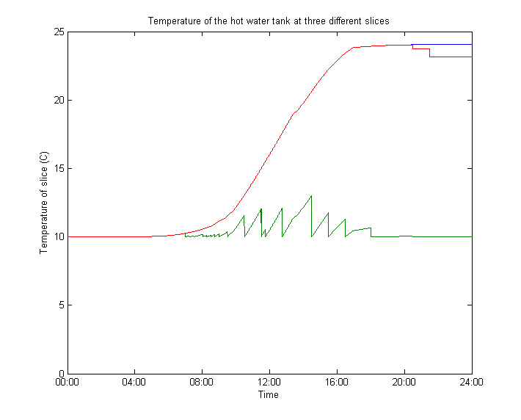
Figure 3.25. The temperature of the tank at different slices, Tapping Cycle #2 00:00-23:59 23/07/2014

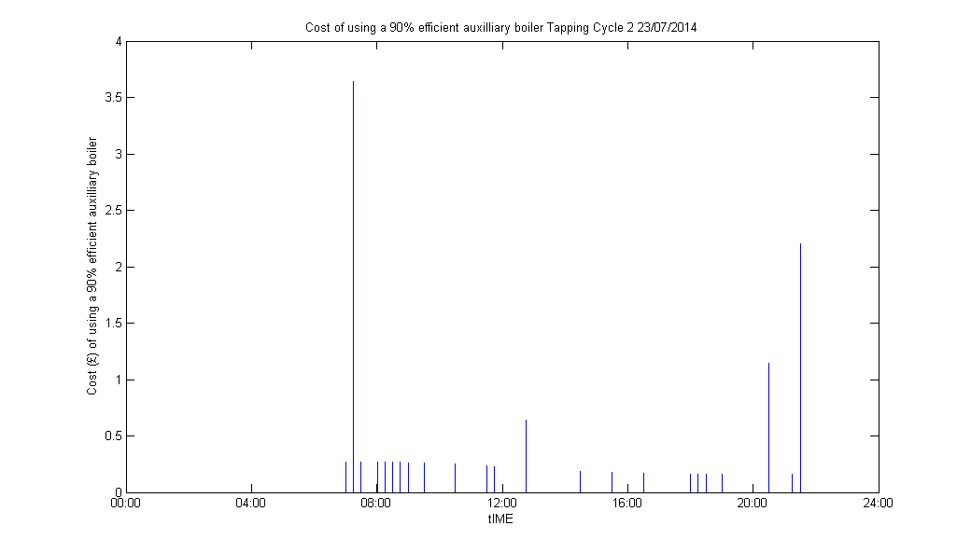
Figure 3.26. The cost of heating up the required volume of water to 45°C throughout 00:00-23:59 23/07/2014 utilising a STP using Tapping Cycle#2

The total cost of using an auxiliary boiler for that day is calculated as being 65p for the day using Tapping Cycle#2 with a STP connected to the hot water thank and an auxiliary boiler supplying the additional energy at those times when the temperature of the water is below 45°C. This compares with a cost of 80p incurred when utilising just an auxiliary boiler. The final energy savings for that one day are 15p, a modest saving.

In Figure 3.27. the temperature of the water within the simulated hot water tank is shown at different slices, The blue line profiles the temperature of the first slice within the hot water tank (representing the uppermost layer of the tank), the red line is the 100 slice in the tank, and the green line is layer 200 which is the layer at the bottom of the tank. From Figure 3.27. the temperature profile of the heated water within the hot water tank can be determined and it is clear, that on this summer’s day in 2014 the heated water within the hot water tank is not compromised by the water entering the tank during tapping cycles. This is evidenced by the tapping cycles only being apparent in slice 200 (the lowermost slice) within the tank. Tapping Cycle 3

Figure 3.27. The temperature of the tank at different slices, utilising a STP Tapping Cycle #3 00:00-23:59 23/07/2014
Slice 1
Slice 100
Slice 200

Figure 3.28. The cost of heating up the required volume of water to 45°C throughout 00:00-23:59 23/07/2014 utilising a STP using Tapping Cycle#3
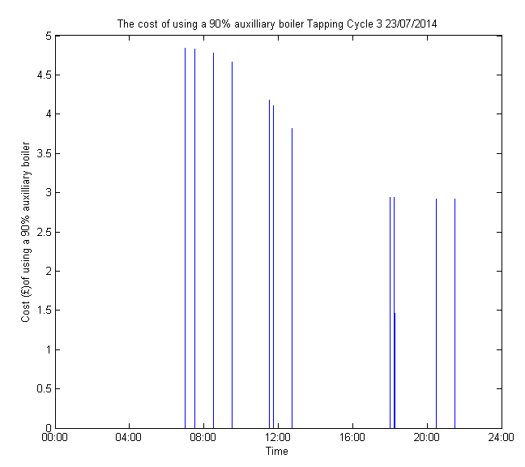

The total cost of using an auxiliary boiler for that day is calculated as being 27p for the day using Tapping Cycle#3 with a STP connected to the hot water thank and an auxiliary boiler supplying the additional energy at those times when the temperature of the water is below 45°C. This compares with a cost of £1.66p incurred when utilising just an auxiliary boiler. The Final Energy Savings for that one day are £1.39.

  - Discussion of Matlab results
The results show that the use of weather predictions when incorporated with a STP can result in cost savings which will be most during the winter months when the solar irradiance is at its lowest. However, during the summer months when there is a high amount of irradiance there are gains to be had from selecting the most appropriate Tapping Cycle matched with the available irradiance.
This novel method of selecting which Tapping Cycle or consumption pattern to apply to the hot water system relies on the user of the system responding to the suggestions of the STP system. Whilst in theory this assumption can be made, in practice people are unlikely to follow a strict regime perfectly. This is perfectly acceptable of course, but there will be a cost in the efficiency of the heating system and thus a monetary associated with using the conventional heating source to heat the water.
Using the STP system on a real boiler, in an actual home, is likely to reveal those times when people do not follow the suggested Tapping Cycle and favour their own unique consumption of hot water.
This novel approach to a STP system, as described in this chapter, has the potential to be expanded to encompass other hot water consumption patterns as the occupants of the household changes with different occupants. The consumption pattern can be modified to correlate with the individual consumption pattern of each unique household. Some residents might favour showers over baths as a personal choice and their consumption patterns might be misaligned with the consumption patterns as described by Tapping Cycle #1, #2 and #3. The described program could use previous hot water consumption patterns for future hot water consumption patterns and give advice about when it is most advantageous to use hot water dependant on the weather and solar irradiance. Additionally, homeowners might favour maximising cost benefits over efficiency gains of the system and if so, the described program is capable of adjusting to these changing constraints put on the program.
  - Conclusions from engineering work and potential future directions for research
The application of predicted weather to suggest optimal consumption patterns for homeowners shows that there are efficiency gains to be made by suggesting the most appropriate Tapping Cycles dependent on the predicted weather for today and tomorrow. The choice of the Tapping Cycles however is not dependent on previous consumption patterns and this offers new directions for future research. Future research could include not only the household occupants and the varying hot water usage specific to individuals but a future model could include the previous consumption patterns of the occupants into the decision making process about which is the most appropriate Tapping Cycle to select predicted on the weather. Thus future work could include a weekly consumption volume of water and occupants could specify their consumption volume limits on a weekly basis. Occupants could select the volume of water they are typical to use and this could be used as a minimum consumption volume.
Occupants could select the frequency of the highest demand profile (typically when having a bath) and could select the frequency of their baths on a weekly or monthly basis. This could change throughout the seasons of the year as the supply of hot water from the solar thermal panel changes.
Additionally, whilst the efficiency, temperature of hot water and cost of heating the generated hot water from an auxiliary heater have been calculated here greater prominence could be placed on those parameters that are suited to individual users. Some occupants may be more interested in reducing their CO₂ emissions and so this could be the parameter that is calculated and provided as a feedback to the occupant when suggesting the most suitable consumption patter for them to follow.
A final note should be made concerning the program as it stands in that it selects the most suitable Tapping Cycle and applies the consumption pattern as designated by (Commission, 2002). Previous studies have researched how differences to the hot water consumption patterns can influence an STP’s efficiency with the efficiency of the STP falling at either very low or very high flow rates. Further investigation to determine the full effect of flow rate on an STPs efficiency at these flow rate limits should be made to ascertain precisely how they will impact the described program and the resulting section of Tapping Cycle.
Chapter 4
  - Qualitative studies, using semi-structured interviews with the main actors in the solar thermal market to understand their opinions of STPs

This chapter assesses the opinions of the main actors within the STP market using semi-structured interviews. The studies were first conducted in 2012 and then again in 2015 with different participants in each year.

  - Introduction, the use of semi-structured interviews
Semi-structured interviews were chosen as the method to understand the opinions of the main actors in the solar thermal panel market as semi-structured interviews allow a specific and direct conversation which allows the required information can be elucidated effectively. At the same time it allows the participants to express their opinions in the way that they see fit. Another key benefit for employing this method is that it is time beneficial whilst not constraining the answers given by the participants. The structure of the interview is capable of being defined and arranged in such a way so that greater information on the key attributes that each participant has can be determined with regard to STPs (Weijermars et al., 2012).
A key topic to discern from the main actors was their opinions on what they perceive as available methods which could be employed to best diffuse this technology to the broader population. Conversely, any potential pitfalls which should be avoided in the diffusion of this technology were also investigated.
  - Key stakeholders in the UK domestic heat market
The UK government has expressed the need for “evidence based” decisions to be made with regard to energy and climate change thus the key stakeholders who will have influence the success or failure of a novel technology should be identified to ensure of renewable technologies (Martin et al., 2014). By identifying the key stakeholders in the STP market the degree to which STPs are accepted or rejected can be assessed (Fishbein, 1975; Weijermars et al., 2012).
The seven categories of ‘principle actors’ as described by Weijermars et al are listed below (Weijermars et al., 2012). They reference an IAC Report and highlight seven categories of key stakeholders which have an impact on the formulation of energy policy and difficult decisions that impact on achieving energy technologies (such as STPs) success or failure (Weijermars et al., 2012). The seven categories that the IAC report highlights are:
- Multinational organizations: IEA, UN World Bank, regional development banks etc.;
- Governments, national, regional local energy policy makers;
- Science and technology community: academia and associations;
- Private sector: industry, consultancies and foundations;
- Non-governmental organizations: World Energy Council, Earthrearch etc.;
- Media: Scholarly journals and Popular media, web radio TV;
- General public, social networks etc. (Weijermars et al., 2012)
The domestic STP system proposed means that there are a number of categories listed by the IAC that are not applicable to this study. Governments (local and national), the science community, the private sector and the general public have direct applicability for this research. To ensure expedient conclusions from this study that can be used by the STP market as a whole, the key stakeholders within the STP market were determined first before sampling could start.
By first considering the key stakeholders to speak to, the most beneficial method of data gathering can be established. The production of heated water using a STP necessitates the need for the physical hardware to be installed on a domestic property and so for this reason manufacturers of STPs are considered to be a key stakeholder in this work. The specialist knowledge which manufacturers have about this technology is in-depth knowledge about the operation and capability of STPs to provide heated water for domestic needs. This group of main actors will also have a greater understanding about any potential drawbacks to having this technology installed on a domestic property and the potential limitations of STPs to satisfy the demand of residents. These limitations may include specific technological considerations but may also encompass surrounding issues such as financial costs or pay-back periods. manufacturers are a likely source of information to ascertain potential ways in which the technology does not perform as expected (potentially of greater significance for a country such as the UK which does not have copious amounts of solar irradiation throughout the year) and the reaction, if any, by consumers to this performance deficit.
As well as manufacturers being considered as a key stakeholder group in the STP market academics are also considered as a key stakeholder as they have specialist knowledge about the operation and functionality of the technology. The applicability and potential benefits of the technology are well understood by academics particularly if their research utilises this domestic renewable technology. For this reason, academics with experience of STPs for domestic generation of renewable hot water are considered a key stakeholder to speak with and understand their opinions of STPs technology in the UK.
Other key stakeholders in the UK STP market as selected for this dissertation are politicians as they decide policies that could affect the UK STP market. Even though the operation and capability of this technology might be well understood by this group of key stakeholders if the political conditions are not agreeable then widespread adoption will not be possible for this novel technology. Politicians are considered a key stakeholder as the decisions made by politicians can influence the STP market and the ability of this technology to be widely adopted. Thus the opinions that politician have about STPs could influence the ability of this novel technology to be adopted widely.
A final key stakeholder group considered for this research are community organisers as they are potential sources of information for potential consumers to approach for guidance and advice prior to their adoption of the technology. Potential adopters of STPs are likely to seek information about a technology from a trusted source which will inform their decision. community organisers are potentially aware of various factors which could influence consumer adoption of this renewable technology. Factors such as the efficiency as well as the potential pay-back period of the technology are likely to be of interest to potential adopters of the technology. Community organisers are approached by the general public for their opinions on a variety of issues, which may not be familiar to potential adopters of a new unfamiliar technology such as STPs. This is particularly true if the technology in question provides a necessity such as hot water. It is expected that potential adopters of STPs would have concerns about how the new technology would be implemented in the home which they would raise with community organisers. Therefore, the opinions that community organisers have about STPs could therefore influence the final decision potential adopters of the technology regarding their final decision.
The categories of main actors with specialist knowledge of the STP industry selected were:
- manufacturers and Distributors;
- academics;
- community organisers; and
- politicians.
These four categories of main actors can broadly be categorized as: Groups 1 & 2 as having a greater understanding about the operation and ability of STPs at providing sufficient hot water for resident’s needs; and Groups 3 & 4 as having a greater knowledge about additional factors which will affect potential adopters’ final decision. These factors may include but is not restricted to the effects of current or upcoming legislation and may impact the STP industry or limit the benefits that residents may receive from owning STPs.
It should be noted that it was recognised prior to the research being conducted that there was potential for there to be overlap between the specialists’ knowledge that these four groups of main actors have. Their specific knowledge on a given topic is not restricted to the definition of that topic that is put on them here. The specific knowledge they have regarding that topic is specialised but that is not to say the participants don’t have knowledge that goes beyond their own specialisation. For example, a manufacturer may have an understanding of the legislation surrounding STPs but their specialist knowledge is on the operation and ability of STPs to provide hot water for domestic needs.
Previous studies have highlighted the importance of main actors that have an influence on the adoption rate and diffusion of renewable technologies such as wind power (Doblinger & Soppe, 2013). In this study the value of accessing the opinions of main actors is highlighted and the role their opinions have on the diffusion of renewable technologies to the wider population is emphasised (Doblinger & Soppe, 2013). Doblinger and Scoppe 2013 stresses that by taking a “bottom up” approach to understanding the adoption and diffusion of renewable technology by appreciating the opinions of “change-actors” one is more likely not to neglect any important factors that might facilitate this process (Doblinger & Soppe, 2013). This approach was the focus of DiMaggio who also stressed the importance of understanding the opinions of main actors as did Martin et al (Cooney, 2007; Martin et al., 2014).
Semi-structured interviews were chosen as the method to best achieve these opinions as semi-structured interviews allow a specific and direct conversation to be had thus the required information can be elucidated effectively whilst it allows the participants to express their opinions in the way that they see fit. Another key benefit for employing this method is that it is time beneficial whilst not constraining the answers given by the participants. The structure of the interview is capable of being defined and arranged in such a way so that greater information on the key attributes that each participant has can be determined with regard to STPs (Weijermars et al., 2012). A key topic to discern their opinion on is the methods that could be employed to maximally diffuse this technology to the broader population. Conversely any potential pitfalls which should be avoided in the diffusion of this technology were also investigated.

  - Semi-structured interviews, methods
Semi-structured interviews were conducted with the various main actors in the solar thermal panel industry as listed above to better understand their opinions about STPs and their specialist knowledge about STP technology. Once the main categories of main actors were identified, potential participants of this study were contacted to enquire about their availability to be included in this research.
Prior to the interviews being conducted, an interview question guide was prepared which can be found in Appendix 7.9. This interview guide served as a question prompt for the researcher however it is not rigidly adhered to as is the case with semi-structured interviews. The interviews were conducted by telephone for ease of access to the participants where necessary, or in person where possible. The conversations were audio recorded and the resulting conversations were transcribed verbatim so that no information was lost before the analysis of the transcripts could be conducted.
The structure of the conversations was prepared in advance and centred around the constructs of the TAM which is to say that the perceived usefulness and perceived ease of news was investigated. Additional factors which might impact the TAM such as trust was also included in the structure of the interviews

    - Summary of participants for the semi-structured interviews in 2012 and 2015
In Table 4.1. is a summary of the participants with specialist knowledge (main actors) which were involved with the semi-structured interviews. The sample size is small but it is felt that the conclusions drawn from the research has generalizability to a wider population for a number of reasons. Firstly, the two data sets, one from 2012 and a second from 2015 were very similar and no significant new nodes were apparent in the 2015 study. This suggests that there has not been a significant change in the STP market and the opinions that main actors within it have about the technology. This is a reasonable assumption as the planned Renewable Heat Incentive is still not fully available and there have been no significant advancement in the technology which would make the technology more appealing to potential adopters.

Table 4.1. Summary of participants for the semi-structured interviews in 2012 and 2015 (Martin et al., 2014; Turner et al., 2010)
Year | Participant | STP benefits/drawbacks | Personal reasons for adopting or not
2012 | academic |  | ?
2012 | politician | ?
2012 | manufacturer |  | ?
2012 | community organiser | ?
2015 | academic |  | ?
2015 | politician | ?
2015 | manufacturer |  | ?
2015 | community organiser | ?

There are distinct reasons why the various participants were chosen specifically for the semi-structured interviews concerning STPs. In Table 4.1. a “” denotes that the main actor is likely to have a greater understanding of the particular topic. A “?” denotes the main actors as potentially having a greater understanding of the topic. manufacturers were included in this research so as to gain valuable first-hand knowledge of the technology and its capabilities. Also this group of main actor was included as they have direct interaction with consumers who actually use the technology and so the benefits and the potential problems consumers have with the technology is more likely to be understood with this main actor included in this research. Additionally, manufacturers due in part to their interaction with the end users and them having a greater understanding of the STP market are more likely to have ideas about how the diffusion of this technology could be improved and any potential problems that are stifling this diffusion. academics are more likely to have specific knowledge about the benefits and the restrictions that the technology has. They are also more likely to have a deeper knowledge about the technical issues concerned with the technology and any potential barriers to adoption that this might invoke. Community organisers are more likely to understand the concerns or worries which consumers may have with the technology and the therefore will have a deeper understanding of the potential barriers to diffusion that may exist with the technology. As such Community organisers are more likely to have a greater understanding about methods which may exist to improve the diffusion of STPs. Finally, politicians are more likely to see potential barriers to the diffusion on STPs and could potentially offer methods by which to improve the diffusion of the technology. Due to the small number if semi-structured interviews the two data sets from 2012 and 2015 are discussed as being homogenous. There were very few differences between the two years with far more parallels arising between the two years than opposites and so it is reasonable to consider the semi-structured interviews as one data set.

In total, 8 semi-structured interviews took place, 4 in 2012 and 4 in 2015 with the following number of interviews conducted with each main actor:
- academics 2 interviews;
- manufacturers and distributors 2 interviews;
- community organisers 2 interviews; and
- politicians 2 interviews.
The resulting audio files were transcribed verbatim and then organised and coded using the software NVIVO 10 for analysis. An additional researcher second coded the resulting transcripts so as to ensure that the coding was validated. As with the focus groups, the semi-structured interviews were conducted in 2012 and at the end of the research period in 2015 to discover if there were any differences between the themes that were raised by the participants over the intervening years of this research project.

    - Sampling of main actors in the STP market in 2012 & 2015
The exploratory nature of this research, wanting to investigate and assess the opinions of the main actors in the STP market rather than measuring a specific variable, semi-structured interviews were chosen as the method best suited to elucidate the sought after information. Broadly speaking this part of the qualitative research was conducted to determine if the main actors perceived any significant factors which would hinder the adoption of STP technology and equally if it is perceived that there are factors which would help facilitate the adoption process. Interviews have been previously used in the energy market in recent studies such as Matus, Clark, Anastas, & Zimmerman, 2012 (Matus, Clark, Anastas, & Zimmerman, 2012).
These main actors were chosen as they are employed in their respective areas of expertise which make them relevant to this study and they additionally have experience of STPs through their jobs. They have been employed in or near to Sheffield (so as to keep consistency with the opinions of consumers in Sheffield). Internet searches discerned potential candidates for the study and prospective participants were contacted via email. The interviews were conducted via telephone with the exception of the academic in 2012 who was interviewed in person. No monetary compensation was offered or sought for their time.
The interview structure between the main actors was similar in that a more detailed discussion was conducted. There were some key differences but there were some key differences in the content depending on their specific area of expertise and the anticipated knowledge that each main actor has in that field. For example, more time and a greater emphasis were given to discussing technical issues with the academic and more time was devoted to discussing political issues with the politician.

  - Thematic analysis
The desired outcomes of these studies were:
- To gain specialist knowledge about how the technology can be applied to the wider public;
- To become aware not only of the potential benefits of STPs in Sheffield but also any potential problems that could be encountered in the application of the technology; and
- To appreciate if there are any differences between the first set of interviews in 2012 and the second set in 2015.

Because of the exploratory outcomes thematic analysis, as described by Guest et al Thematic Analysis was considered the most appropriate method to analyse the resulting transcripts for a number of reasons (Braun & Clarke, 2006; Guest, MacQueen, & Namey, 2011). Firstly, it allows categories to develop from the data the resulting understanding is fully supported by the data (Braun & Clarke, 2006; Guest et al., 2011). Thematic Analysis also benefits from being able to be used to inform future data gathering which will allow this research to develop in the future (Braun & Clarke, 2006; Guest et al., 2011).
Analysis of the resulting transcripts was performed in NVivo9 and NVivo10 and a coding manual produced for each year. The transcripts were second coded by an additional researcher and the resulting coding manuals compared with any disagreements being discussed until there was a greater than 70% agreement (Cohens Kappa greater than or equal to 0.5) (Kottner & Dassen, 2008). Appendix 6.10 has a complete list of all the themes/nodes.
Discussions between the main researcher and a colleague who performed the second coding of the resulting transcripts ensured that the coding manual with each of the respective codes was understood prior to analysis being conducted on the transcripts. This ensured that the resulting analysis was conducted scientifically and ethically.
  - Results from semi-structured interviews in 2012 & 2015
The results from the semi-structured interviews are framed around the TAM and the TAM+Trust as these models have both longevity and application to the renewable sector (Davis, 1989; Elmustapha et al., 2018; Gefen, 2004; Rezaei & Ghofranfarid, 2018; R. Scarpa & K. Willis, 2010). The opinions of the main actors did not vary considerably from 2012 to 2015. The major difference between the two years was an increased awareness of high domestic energy costs and global issues such as Climate Change were perceived to be of greater concern in 2015 than in 2012. The concerns about Climate Change were discussed as being a local and, national and international concern.

    - Perceived Usefulness

The main actors were clear that STPs have a benefit in providing not only hot water to homeowners but also reducing domestic energy costs. There was a perception that these benefits could help people who are most likely to suffer from fuel poverty in the UK and that there should be assistance from the government potentially in the form of grants to contribute to the capital costs of the STPs. It was commented on that the people STP technology could benefit the most in this manner were the least likely to be attracted to the technology in the first place. There was a general agreement that there isn’t the correct framework in place to support those least capable of adopting STP technology.
“I think you need some sort of incentive. I think the incentives are not necessarily in the right place.” manufacturer (2015).
“Consumers need to have some source of financial incentive, at the moment finding sources of funding is complex and not very helpful” community organiser 2012
“…this technology could really help poorer people but it’s difficult to see where helpful projects like this will come from. It’s a bit different in Scotland.” academic (2015)
The lack of support for potential investors was highlighted as a significant fact that consumers were not adopting STP technology as consumers are aware of the risks involved with the technology. That’s not to say that these risks are always real but the main actors were clear that potential consumers were not incentivised enough to adopt the technology, or to even find out more about the potential benefits. One opinion that was expressed multiple times with different main actors over both years was the benefit STP is could be for people with low incomes:
“…who do you think this could help?”
“People who are in during the day when it’s hot, families with small children use a lot of hot water would be one” community organiser (2012)
“… it could be very beneficial for people on low incomes” “...this technology should be aimed at building associations that’s where we feel we can make the biggest difference” academic (2015)
A clear conclusion from the main actors was that there should be an accredited body overseeing the STP market. An accredited body which is not biased but provides accurate and impartial advice to potential consumers of STPS. It was acknowledged that without an accredited body for forming this function consumers were left confused and ill-informed about the potential benefits of STP’s. The main actors recognised that people will access information from a multitude of sources and not all of the sources will be impartial or accurate which leads to the propagation of information which is partial and is inaccurate.
“I would be very keen to see planning decisions based on the viability [of a project] as well as aesthetic and social considerations. There should be a governmental body that validates and ensures these projects are viable this well as well funded to ensure the success. This should happen in the next 5 to 10 years. It will take institutional change though” academic (2015)
It was felt by the main actors in this study, that a reliable source of information has typically been how consumers view community organisers, as community organisers are not invested in the sale of STP technology (as STP manufacturers are), are an approachable source of information (where academics are sometimes perceived as not being) and are trusted by the community at large (where politicians are not).

    - Perceived Ease of Use
It was perceived that the general public’s understanding of STPs was poor and that social acceptance of STPs was therefore poor too. The main actors also wanted to ensure that they are well informed about the technology and a regulatory body was perceived as a good way of ensuring that they too were aware of the benefits and drawbacks of the technology. This was particularly true of the community organisers and politicians remarked that they had interactions with the general public where they were asked to disseminating accurate and unbiased opinions and they wanted to ensure that the information they were sharing was valid. Of key interest was the perceived difference in understanding that the main actors felt that had about STPs when compared to the general public. The participants of the semi-structured interviews accepted that they had a deeper and nuanced understanding of solar thermal panels and their potential benefits. Typical comments regarding this issue were:
“Quite often people are disappointed with the performance they get from their systems because they’re expecting something earth shattering.” academic (2012)
A significant reason for this difference in understanding about STP technology was explained by the way in which consumers receive any information about STPs. It was felt that people in general only receive biased opinions about the capability STPs. Information was either overly positive or negative (usually from family members) or there was an unfavourable misinformation disseminated through the media. The media was discussed as being a significant source of misinformation (due to their lack of impartiality
These misconceptions are perpetuated and are not adequately addressed by parties wishing to ensure justifiable information about the STP technology is widely understood by the general public
“A lot of people come to us with prior misinformation. There’s an awful lot of bad information out there.” manufacturer (2015)
It was commented on in the 2015 semi-structured interviews that there was a noticeable drop in the government urgency to reduce carbon levels between 2012 and 2015. This was despite international agreements to reduce carbon emissions being more pronounced. The fall in UK national carbon emissions was partly blamed on the ailing economy during this period and partly due to an improvement in the availability of energy efficient technologies. The change in the government’s position was attributed to the government deciding that there are more ‘pressing concerns’. The changing policy and a lack of a cohesive policy approach to carbon reduction by the government which may include STPs was perceived as being a reason for a lower adoption rate of STPs:
“Now he’s (Prime Minister David Cameron) saying, ‘We’ve got to get rid of the green crap in the dash for growth.’” politician (2015)
“things seem to be moving in the right direction, though sometimes I get the impression there’s no real focus” community organiser (2012)
It was not clear from both the semi-structured interviews conducted in 2012 and 2015 that the main actors didn’t fully understand the government’s position on both reducing greenhouse gases (GHG) and complying with international agreements. It was perceived that this lack of clarity was leading to poor decisions being made by consumers regarding adoption of domestic energy technologies as consumers were unsure of the national situation. This lack of clarity was allowing misinformation to either be generated by manufacturers or by people’s with a vested interest in spreading inaccurate information.
“I feel at the moment there’s not a coherent message being presented [to consumers].” academic (2015)
It was perceived that for STP technology to be widely adopted there needs to be government assistance to residents in the UK, possibly in the form of grants to assist with the capital costs associated adopting this technology. The main actors in both years were unsure about how developed and advanced government led initiatives such as the Green Deal are. This was again leading to misinformation and a lack of trust existing between the main actors and consumers, which was perceived hindering widespread adoption of the technology.
A number of main the actors remarked that potential consumers of STPs could approach them as a source of information when deciding on whether to adopt the technology. As potential sources of information for consumers about STP technology various main actors highlighted some potential problems within their “category” of main actors. Examples of these problems that the main actors saw in their own category of specialist area:
“Generally the real issue is a lack of awareness and understanding of what the technology is and how councillors can have a positive role over it.” politician (2012)
Misinformation about STP technology was seen as not only being a limiting factor in the adoption of the technology and was also perceived as being a significant factor which affects consumer acceptance of the technology once it has been adopted.
Whilst the main actors within the STP market could see the benefits (PU) of having STPs installed on their own homes only two participants actually had them installed on their property. A reduction in energy costs was the reason offered for having them installed as well as the fact that it is utilising a renewable resource.
Q; “What have you seen as the main benefit of having them?”
A: “Turning the gas boiler off in the summer is the principle one. We’ve got a display in the kitchen so it’s pretty useful to see how much energy is being produced in an amount of time; it keeps you in touch with the sun.” academic (2012)
The main reason that was given for not adopting STPs, even though the utility of STPs was appreciated was the capital costs and the long payback period. It was clear that the main actors had a trade-off made between the Perceived Ease of Use (PEOU) of STPs and the Perceived Usefulness (PU)) of having the technology. There was a perceived lack of an incentive similar to the Feed In Tariff (FIT) and participants were concerned about the payback period of STPs and the overall utility of the panels. The corresponding Perceived Ease of Use (PEOU) was the significant disruption installing the panels on a property would have on the residents as well as potential problems that may be created in the winter if the pipes used in the STP equipment with water flowing through them froze damaging the equipment.
Financial issues were raised a number of times which was interesting for a number of reasons. Firstly, as has been mentioned previously, only two of the main actors have adopted STPs on their home and so any costs and benefits, including any financial benefits, would not be experienced by the main actors directly. They were more likely to hear about the costs (including the financial costs) second hand which should be considered when thinking about the transferability of the data to larger populations. Additionally, it was made clear in a number of the semi-structured interviews that a low financial return was a reason that the participants hadn’t invested in the technology. The main actors had assessed the financial returns against the capital outlay and the low rate of return had stopped them from adopting the technology. This was of particular note as the main actors in the STP market have a deeper understanding of the costs and benefits of adopting STPs:
Q: “You’ve not been inclined to invest?”
A: “No. The solar PV was a much better return. Solar thermal could happen in the future, but it’s not on the horizon at the moment.” manufacturer (2012)
The previous quote and the next quote highlight that there was a perceived trade-off between solar PV and solar thermal due to the increased rate of return from having the government Feed-In-Tariff (FIT). So whilst the Perceived Usefulness (PU) of having STPs installed on domestic properties was recognised by the main actors (that the solar collectors would provide hot water to the residents) they still were conscious of the financial cost of either having the panels installed or the poor rate of return due to there not being a government scheme such as the Feed-In-Tariff attributed to solar thermal.
Q: “Do you have them (STPs) installed on your house?”
A:”Yes, on the house that we put it on. You have to choose and obviously, there was the financial incentive to go with the PVs. On top of that, again I haven’t looked into it in huge depth, but the amount of plumbing and disruption work for the photothermal is considerable. If you need to have a new tank, that’s reasonably expensive and then you’ve got to run all the pipes. Then you’ve got to make sure that what you do in the winter isn’t going to freeze up. You’ve got to make sure you remember to drain them all or whatever else. “
academic (2012)
It was perceived by the main actors which were interviewed that the benefits seen by the solar PV industry due to the Feed-In-Tariff (FIT) could be replicated in the STP market with a similar boost to the industry. However, the particulars of what such a scheme would involve was not ventured by the participants, yet it was highlighted a number of times by the main actors across both years that the application of a governmental scheme such as the FIT would be beneficial to the domestic solar thermal market.
A: “You said about how the Feed-In Tariff was a bit (of an) incentive because it was investment to go with PV. Would you like to see something like that with solar thermal?
Q: “I think you need some sort of incentive. I think the incentives are not necessarily in the right place.” manufacturer (2015)
There was an absence of detail about how such a scheme could be applied to the STP market but there was a perception that there should be a monetary incentive which could manifest in the form of a system similar to the FIT (which pays homeowners dependent on the size of their installation, or the National Grid buying back surplice electricity). A monetary rebate could be applied after installation of the technology or a government subsidized scheme to reduce investment costs of STP technology. It was commented on that STPs have a higher efficiency than solar PVs for heating water. It was perceived that the FIT introduced for PV technology has led to a greater number of people adopting PV technology over STPs.
“People seem to think that PV is the way to go because of the FITs but that’s not true really. They’re a lot more expensive and they don’t always generate electricity. Thermal panels will always work though and will always raise the temperature of the water in your tank.” academic (2015)

    - Trust issues
The issue of trust was raised as a primary factor which was perceived as influencing consumer’s decisions about adopting STPs. Participants of the focus groups highlighted the lack of trust they have regarding the information they receive from different sources such as the media, politicians, and manufacturers. The main actors acknowledged that consumers often approach them as a source of verifiable information concerning STP’s, but they also acknowledge that information they do have is not always justifiable and that they are not always aware of the most accurate information which can be trusted.
Additional to trust being perceived as influencing consumer perceptions of the technology trust was also perceived as having an effect on mitigating the prevalence of poor information regarding STPs. Poor information and the ability of STP technology to provide sufficient amounts of hot water at a sufficiently high enough temperature all year round was perceived as being a significant reason why consumers might not adopt the technology in the UK. However, the main actors across both years perceived this as being due to a lower general understanding of the capabilities of STPs which either gave consumers a very low expectation of the technology or vastly inflated anticipations particularly with regard to the technology’s ability to reduce energy costs immediately after installation.
The lower understanding that the general public have about STP technology, as perceived by the main actors within the STP market, has not changed significantly in the three-year gap between the two studies. This would also to suggest that any changes to governmental programs concerning STPs have had a limited impact on the consciousness of the general public. Additionally, the main actors saw this knowledge gap between their understanding of STPs and the general public as being a problem for the STP market in the UK. However, they also offered potential solutions to bridge the gap. In both 2012 and 2015 the academics saw their understanding of the technology in relationship to potential consumers and the wider public. The participants felt that their roles as academics endowed an impartial quality on them that they could use help people make more informed decisions. The participants in this study could see the unique position that this role endowed on them in comparison to other categories of main actors such as politicians or manufactures as they didn’t have a vested interest in marshalling public opinion. In this way the academics saw their role as a unique opportunity for them to provide potential adopters of the technology with an independent and neutral opinion on the positives and negatives of the technology. This is captured very well by the following quote:
Q: “Do you see academia helping with that viability by checking the viability of an installation in a property?”
A: “Academia has got a pretty essential role in that capacity. We’re the independent governors. Unlike government and government driven bodies, or commercial driven bodies, we should be able to offer a truly independent and impartial view on things.”
(academic 2015)
The flow of information and misinformation about STPs raised a significant and reoccurring theme in the semi-structured interviews as the previous quotes hint at. The issue of trust was raised a number of times by the main actors in various ways as being a significant factor affecting the way in which potential adopters view the technology. As has been said academics viewed their role as being impartial and thus they felt that consumers would have more trust in their opinions of the technology than they would if manufacturers or politicians were giving them their opinions. This is simply because it was felt that manufacturers and politicians would have a vested interest in shaping public opinion whereas academics not only had more technical information about the technology but they would remain impartial. It was acknowledged however, that there is a limit to the extent that trustworthiness would extend to particularly when concerned with an emotive issue such as a renewable technology:
Q: “If you were part of a governing body, would you be seen as a paradigm of trustworthiness?”
A: “The reality is probably not. It would depend on the context. I’ve experienced definite mistrust issues when it comes to discussing stuff with members of the public. Unfortunately, a lot of renewable technologies become very emotive issues for people. As a result, people decide they don’t like a technology. It’s very hard to sway them and have a rational conversation.” academic (2015)
Ensuring that sound information about the technology and its potential benefits and limitations was acknowledged a number of times during the semi-structured interviews over both years (2012 and 2015) as the following quotes show. As has been mentioned the main actors over both years felt that the media have a significant impact on the information that the general public have access to and thus have a significant impact on the levels of trust that consumers feel in all areas concerning STPs.
Q: “Can you expand on how you might improve this level of trust between academia and consumers?”
A: “This is a very tricky area. Whereas people within academia and within industry will tend to read quite specialist journals and publications, the majority of information that the public gets is driven through journalism and mainstream media. That’s where it’s tricky.” academic (2012)
To improve the level of trust in the STP market the main actors expressed a desire for academia to have a role as the main axis perceived the public as having an unbiased role and an accurate opinion of the capabilities of STPs in the UK. It was expressed that academia is not sensationalist or corrupted by third parties and so would provide the general public with stoic information about STP technology.
The main actors offered a few reasons why there was poor information on the capability of STP to provide hot enough water to domestic properties. This poor information with expectations of the property (high or low) which did not match up with the performance of the technology resulted in a lack of trust between consumers and the main actor they received the information from.
Q: “What sort of bad information?”
A: “This afternoon we had someone come into us who had been speaking to someone who told them they should be putting solar panels in and also an air force heat pump to heat the water. It’s overkill. There’s too much competition between the technologies for something like that. There’s no heating for the house being provided so it raises doubts in the individual’s mind.” manufacturer (2012)
This comment was particularly significant as the main actors could envisage different specialists conversing with each other and improving the flow of information between them and consumers and thus improving the flow of qualified opinions about STPs. This would in turn affect the decisions that potential adopters could make regarding STPs as well as improving the quality of information available to policy members thus having an overall benefit on the STP market.
To counter the effects of poor information and a lack of trust one suggestion that was offered in various ways by the main actors but all centred around having educational schemes for the different main actors so that if a prospective adopter of the technology approached them to understand their opinion of the technology they would be able to give an informed response.
Q; “What about the idea of getting good information out and linking up government bodies such as DECC? Is that a good way to go, councillors linking up with people from places such as DECC, perhaps manufacturers?”
A “There’s almost a role for an accredited councillor’s energy training course. There was an idea a few years ago, we called it the Councillors Housing Energy Action Team, or CHEAT for short. I think there’s definitely a role for that, so councillors can give informed comments.” Politician (2015)
A concern which was made clear from both the community organisers and the manufacturers in both years was the recognition that adopters of STPs raised concerns about the method of installation of the technology on their property and who would be doing the installation. Both of these groups of main actors recognised that the Perceived Ease of Use (PEOU) of having STPs installed on their properties was a significant concern for homeowners as the residents would want a regular supply of hot water during the installation process. Indeed, it was a reoccurring theme that people would want a single company to buy and install the panels. This was perceived by the main actors as being due to residents wanting as little disruption to their lives. It was felt that homeowners would not want a number of companies providing various services for each stage of the purchase and installation of the technology and that they would prefer to have a single company provide everything.
Q: “Is that a concern (having a single manufacturer/installer etc.) for consumers when they invest in this technology?”
A: “Not so much the maintenance. It tends to be a question that gets asks later. They’re more concerned about integration. They want one party to be responsible for integration. If we’re putting in a heat pump, and there’s under floor going in there, they would rather have one company doing both.” manufacturer (2012)
The installation process was perceived as not being a significant barrier to adoption of STP technology but the performance and the monetary return of the technology was seen as a significant barrier to adoption. The STPs were perceived as having a poor rate of return on investment and this would limit the investment of the technology by consumers. However, with greater financial support and an increased awareness of the technology the slow rate of return was perceived as not being a significant barrier to investment. If consumers understand the capabilities and limitations of the technology prior to investment through clearer information being disseminated by all the main actors (essentially any point of contact consumers may have with persons of involved with STP technology) then the poor rate of return was perceived as not limiting the level of investment by consumers in STP technology.

Q: “What are the main risks involved when people invest?”
A: “I think the difficulty is the perceived return. It’s a fairly substantial outlay, and without the renewable heat incentive the benefits are fairly scant.” manufacturer (2012)
As well as the above concerns being highlighted as a reason why consumers may not invest in the technology a simple reason was offered as to why some consumers may not be in a position to invest in the technology:
Q: “What are your reasons for not having solar thermal panels on your home?”
A: “The primary reason is because I’m not a homeowner. I’m renting. I don’t have any decision-making power over my current residence.” academic (2015)
Owning a property and being able to install STPs on a property was perceived as being a significant barrier to investment of STP technology. Residents that are renting a property was perceived as a being a main reason why consumers do not adopt STP technology as they do not have the capability to install a significant technology such as STPs on a property.
As well as the above potential concerns that consumers may have with the technology the one main actor who owns STPs offered a benefit to having STPs installed on a domestic property:
Q; “What have you seen as the main benefit of having them? [Installed at home]”
A: “Turning the gas boiler off in the summer is the principle one. We’ve got a display in the kitchen so it’s pretty useful to see how much energy is being produced in an amount of time; it keeps you in touch with the sun.” academic (2012)
There was a perception that the main actors should have more discussion with each other including across professions to ensure that there is a good agreement between them regarding their approach to STP technology and so that they are working towards a similar goal rather than in opposition with each other. This was perceived as being a crucial way in which the main actors could perform their roles, in that, by communicating with other main actors there would be more of a “homogenous” approach to STP technology.

  - Discussion of results from semi-structured interviews in 2012 and 2015

The various limiting factors to the adoption rate of STPs were raised by the main actors over both 2012 and 2015 being:
- insufficient funding for consumers of STPS;
- inadequate and inaccurate information provided to customers concerning STP’s;
- an unclear message from local and national government; and
- the lack of a governing body overseeing the STP market.

The main actors interviewed in 2012 and 2015 express the deficiency of these four areas as being the main limiting factors why STP is not adopted in higher rates than they are UK. These four factors are in broad agreement with the three key limiting factors as described by Juntman and Hyysalo 2015, namely:
- Technological limitations;
- Limited market demand; and
- Challenges in distribution in the community energy context.
(Juntunen and Hyysalo, 2015)
A key method, to remove these barriers was suggested by the main actors, was to increase financial support through the increased use of financial support schemes such as the Feed In Tariff which has proved successful in increasing the adoption rate of PV panels in the UK by mitigating upfront costs for consumers agrees with Juntumen and Hyysalo. They demonstrated the effect of utilising a “service-based” model which boosted the popularity of small-scale renewable energy technology and by doing so increased the adoption of such technology. Such a service-based tool for increasing consumer acceptance of STPs was supported by the findings from the semi-structured interviews in this current study.
The findings of this study have found that the main actors within the STP market perceive STP technology as having a direct benefit to residents of the UK, particularly elderly and residents of social housing as they are in their houses during the day when there is hot water being generated by the STP. Additionally, the main actors perceived this demographic of users as being more capable of adjusting their lifestyle to suit the supply of hot water. This disparity between when hot water is generated throughout the day and when the homeowner is available to utilize the hot was perceived as being solved by targeting retired and residents of social housing as they were perceived as being home during the day.
The main actors in this study perceive STP technology as appealing to a niche market initially but that a majority of the UK housing stock could benefit from utilising this technology to varying degrees. It was perceived that the diffusion of this technology will take time in a similar period that (Levinthal, 1998) and (Ruggiero, Varho, and Rikkonen, 2015) suggested and could be promoted through a clear governmental program with monetary incentives for residents.
The main actors interviewed for this study perceived that they had an important role to play in the diffusion of this technology, similar to the findings as presented by Ruggiero, Onkila and Kuittinen in 2014 (Ruggiero, Onkila & Kuittinen, 2014). Primarily this was to disseminate justifiable information about the potential benefits drawbacks to adopters before residents had STP systems installed on their domestic properties. Ensuring that residents had verifiable and realistic information about the capabilities of STP systems on properties before they make an investment was seen as a key role that the main stakeholders could perform. This could be done either directly through their interactions with potential adopters or by providing an accreditation for the STP industry, so that STP technology as well as installers of the panels have a level that is endorsed by the entire industry. The main actors perceived that this role has the capacity to both promote the technology as well as hinder its diffusion. In agreement with the findings as presented by (Ruggiero, Onkila, & Kuittinen 2014). The main actors in this study recognised that individually they themselves could be better informed about the capabilities of STP technology so that when they are sharing this information with the public they share information which is accurate and impartial.
This finding is in agreement with (Simcock et al., 2014) who illustrated how consumers interact with information about a domestic energy technology. The study by Simcock et al highlighted various factors which impact on householder perceptions about domestic energy information and illustrated the various ways in which householders’ access and use energy information in an interactive manner to form their perceptions about a particular technology. They argue that it is not a one-way dialogue and that the flow of information should happen in a two-way manner. By ensuring that the flow of information happened in this manner householders in their study perceived the information as being more useful as it was more tailored and contextualized to their specific situation. The main actors in this study highlighted the need for contextualised information to be made available not both householders but also other main actors in the STP market. By having a clearer and deeper understanding of the capabilities of STP technology the main actors in this study described the benefit to consumers in having more contextualised information and information that was specific to their needs.
The results from this study showed that there has been a change in perception by the main actors in the STP market that the combined pressures of internationally binding targets to reduce GHG emissions and residents individual desire to reduce energy costs are compelling more people to adopt this technology in 2015 than in 2015. The increased interest in STPs over the three years due to financial reasons was seen as a potential policy driver to increased adoption of this technology. The introduction of a policy tool similar to the Feed in Tariff as was introduced in the UK for domestic electricity generation was seen as a strong tool that could be employed by the government.
The need for a more homogenous approach to this technology is comparable to the findings of A. Faiers, C. Neame, & Cook in 2007 (A. Faiers, C. Neame, & Cook, 2007). They determined that, in the solar power industry, manufacturers and suppliers should work closely together to ensure that there is a greater agreement about the operational, economic and operational aspects of PV technology. This study with the main actors within the STP industry found similar results with a perception that this greater integration would improve the trust that consumers perceive with the technology and its potential benefits.
A clearer direction from the government through the use of supporting government policies and schemes is suggested for STP’s to improve the UK adoption rates. A scheme which is similar to the FIT is proposed as being a method to improve consumer adoption. This is a finding which was found by Juntumen in 2015 and whilst the author accepts that such a policy as applied to the STP market is the exception rather than the rule (such a scheme is employed in Spain) (Juntunen and Hyysalo, 2015) the author acknowledges that a similar policy could be employed to support the solar thermal market. This is particularly true when such technology is not widely adopted and is in the “early market phase” (Juntunen and Hyysalo, 2015).
The perceived increased interest in adoption of STP technology, due to a desire to reduce domestic energy costs and a desire to reduce carbon emissions, is not reflected however in the main actor’s personal STP adoption behaviour. The low adoption rate amongst the main actors in this study in 2012 and 2015 reflect the adoption rate of STP technology in the wider public in the UK. This is suggestive that the main actors, whilst having a better understanding of STP technology, this alone is not sufficient to encourage people to adopt STPs. Therefore, it can be concluded that there are other factors which impact on consumers decision whether or not to invest in STP’s or not.
  - Conclusions of semi-structured interviews 2012 & 2015
Semi-structured interviews with main actors within the STP market were conducted in 2012 and 2015 to establish their opinions of this renewable technology and some its surrounding issues. These semi-structured interviews were conducted with four different groups of main actors (academic; community organiser; manufacturer; and politician) in 2012 and 2015. There was no significant difference in the substance of the responses obtained in the semi-structured interviews in 2012 & 2015 which suggests that there have not been significant changes to the market over that time period. The main actors expressed a stagnation of policies designed to catalyse the UK STP market particularly in regards to new build homes and homes for low-income families.

A significant finding was that the main actors perceived a significant difference between their understanding of the technology and its capabilities and the general understanding the general public have of the technology. It was perceived that this was due to misinformation being propagated by companies (due to a desire to over-sell the technology) as well as the media who downplay the effectiveness of the technology. Ways in which this effect could be mitigated were suggested by the participants, by improving the quality of the information that potential adopters receive about the technology. Two key methods to achieve this were suggested: having an impartial and accredited standards body (which would oversee the endorsement of quality manufacturers and installers); and the increased involvement of academia. Academia was suggested by the participants of the semi-structured interviews as being a neutral body who the general public trust to provide impartial and accurate information about the effectiveness of the technology for specific homes. Participants commented on the “trustworthiness” of academics when providing them with information about domestic products and that they anticipated information coming from academics concerning STPs to be equally reliant.

The participants in both 2012 and 2015 considered STPs as being able to provide utility to residents by providing them with hot water, particularly residents who are at home for periods during the day when the sun is highest in the sky (over midday). The participants suggested that the elderly or unemployed who are at home during these periods they would be the most to benefit from STP technology. The demographics which would benefit most in this regard was suggested: the over 70’s; those with young children; or people living in disability housing. Due to the availability of hot water through the middle of the day when people are often not in the house these two demographic groups were seen as being better suited to the natural availability of hot water.
It was recognised by the participants that these two groups of people were unlikely to possess the available funds needed to invest in STP technology. Therefore, it was suggested by the participants that government support through financial means was needed to bypass this impediment.
There were a number of reasons offered as to why trust impacts people’s decisions about whether to invest in STPs which was either due to: manufacturers overselling the capability of STPs; the media downplaying the capability of STPs; or friends and families simply providing misinformation about the ability of STPs to provide sufficient hot water for the needs of a household (Juntunen and Hyysalo, 2015). It was perceived that the lack of trust that potential adopters of the technology have in the information they are receiving concerning STPs will lead them to make poor decisions about the suitability of them adopting the technology.
The issue of money was raised a number of times in the semi-structured interviews with the the main actors viewing the financial cost of investing in STPs as being the most significant barrier to adoption of the technology. This was framed as being the most significant impediment to the general public adopting in greater numbers than is currently adopting at present. Money issues arose during discussions about the dissatisfaction adopters had with the technology when their expectations were not met, particularly when their expectations were not met. The main actors across both years felt that there was low rate of return of investment in STPs and that this low rate of return was unlikely to change significantly in the coming years due to future technological advances being limited. Participants of the studies in 2012 and 2015 recognised that simply the financial return was not the only reason why consumers would adopt STPs and that for a significant proportion of adopters there are additional reasons why people might adopt, particularly consumers who want to improve their “Green credentials”.
- Chapter 5
Focus groups in 2012 and 2015

This chapter describes the focus groups which were held in 2012 and 2015 with members of the public as to better understand consumer opinions of STPS.

  - Introduction, the use of focus groups

The use of focus groups to best determine the opinions of the general public has been employed extensively within the renewable sector in the UK and beyond, particularly as this is a burgeoning sector and by accessing a larger range of opinions not only will more people be heard, but there is the opportunity for new and unexpected opinions to be expressed (A. Faiers & C. Neame, 2006; Kaldellis, 2005; Lienhoop, 2018; Rezaei & Ghofranfarid, 2018; Stigka et al., 2014; Wüstenhagen et al., 2007). Thus, new avenues of research can be discovered using this research method. For these reasons, the use of focus groups was employed in both years 2012 and 2015.
  - Focus groups in 2012 & 2015
To better understand consumer motivations and potential barriers to adoption of STPs focus groups were conducted as has been used in previous research (see (S. R. Allen et al., 2008; A. Faiers & C. Neame, 2006; A. Faiers et al., 2007; Lachapelle & Rabe, 2012; Lienhoop, 2018)). A summary of the findings is given at the end of the results section for each year before the conclusions and discussion.
The three different types of consumer identified for this research who were invited to participate in the focus groups were:
- Those that have STPs;
- Those that do not have STPs but are considering adopting them; and
- Those that do not have STPs and have never considered adopting them.
An online questionnaire with a list of potential participants held at the University of Sheffield was used prior to the focus groups and determined which specific focus group each participant would be assigned to. These groups were chosen so that in the focus groups there would be something common to all of the participants. Whilst in each focus group there was a good mix of individuals it is important to note that there was a difference in the demographics noticed for the groups that comprise those that do own STPs. The participants in these focus groups were generally retired, being over the age of 60, or they were international students who had STP’s connected to their houses in their home countries. The participants who were retired described themselves as having installed STP’s because they had available money to do so and wanted to be more environmentally active. Two factors which typified the responses of all the focus groups held.

    - Demographics of the focus groups, 2012
Prior to the focus groups a schedule was prepared in advance which can be found in Appendix 7.10 which roughly followed the schedules of Kaldellis 2005, A. Faiers 2006, A. Faiers 2007, Scarpa 2010 and Lachapelle 2012 (Riccardo Scarpa & Ken Willis, 2010) (A. Faiers & C. Neame, 2006; A. Faiers et al., 2007; Lachapelle & Rabe, 2012).
In Table 5.1. is an overview of the demographics of the participants involved in the focus groups held in 2012. Five focus groups were held in 2012 with a total of 25 participants involved. Ages ranged from 21-66 with 9F and 16M. Different professions included managers, students, two unemployed participants and a stay at home parent.

Table 5.1. The demographics for each focus group in 2012
 | Participants that do not have STPs on their homes and have never considered adopting STPs | Participants that do not have STPs but have considered adopting STPs | Participants who have STPs on their homes
Focus group # | 1 | 2, 3, 4 | 5
Number of focus groups held | 1 | 3 | 1
Number of participants in each focus group | 6 | 5, 6, 4 | 3
Gender in each focus group | 4M 2F | 2M 3F, 4M 2F, 3M 1F | 3M, 1F
Ages in each FG | 24 - 48 | 21 - 55, 21 - 54,  53 - 69 | 60 - 66
Recruitment method | Via email volunteer list | Via email volunteer list | Via email volunteer list

    - Demographics of the focus groups in 2015
In table 5.2. the demographics of the participants involved in the focus groups held in 2012 are shown. Again, five focus groups were held in 2015 with a total of 22 participants being involved. Ages ranged from 18-59 with 8F and 14M.

Table 5.2. The demographics for each focus group in 2015
 | Participants that do not have STPs on their homes and have never considered adopting STPs | Participants that do not have STPs but have considered adopting STPs | Participants who have STPs on their homes
Focus group # | 6 | 7, 8, 9 | 10
Number of focus groups held | 1 | 3 | 1
Number of participants in each focus group | 6 | 5, 4, 4 | 3
Gender in each focus group | 3M, 3F | 3M 2F, 3M 1F, 3M 1F | 2M, 1F
Age range in each focus group | 24 - 59 | 18 - 49, 20 - 32,  22 – 37 | 23 - 48
Recruitment method | Via email volunteer list | Via email volunteer list | Via email volunteer list

A range of professions were represented in both years ranging from participants who are students to doctors, electricians, IT systems specialists, some who were unemployed and some who were retired. There was also a range of housing situations with some participants owning their homes, others were paying off their mortgage, others rented privately and a few rented through the university. All of the participants shared their accommodation with someone else, either a family member or a friend, no one lived alone.

  - Focus groups, procedure
There were five focus groups held in 2012 and a further five held in 2015. The group sizes ranged from 4-7 and were conducted in the Psychology Department at The University of Sheffield. On arriving at the focus groups participants were invited to read an information sheet explaining the reason for their attendance which can be found in Appendix 6.22. The participants were all invited to have a drink and a snack as they arrived. The researcher briefly talked to the participants explaining the reason for their attendance at the focus groups and explained the basic rules surrounding general politeness and etiquette. The participants were then invited to introduce themselves and talk a little bit about themselves as way of a “getting to know you” activity to “break the ice”.
The researcher then described a way in which they use energy in the home and then invited each of the participants of the focus group to do the same. After each of the participants had described their own way of using energy in the home which ranged from use of electrical goods and natural gas for cooking to using hot water for bath’s. This started activity served as a good way to prime the participants to think about the various ways in which they use energy in the home. The facilitated discussion session that followed lasted from 15-25 minutes and uses of energy in the home were explored with differences between countries and individuals pursued.

The second facilitated discussion focussed on energy companies with participants discussing topics that ranged from: “Reasons for energy behaviour”; “Energy prices” to “Trust Issues”.
The structure of the focus groups was arranged so that more time was devoted to the final facilitated discussion which centred on “Solar Thermal Panels” as in this section participants were more comfortable with each other and the process and so participants were comfortable when talking with each other.
Each of the focus groups finished with participants receiving an information sheet which gave each participant places with which they could access to receive more information about STP’s as well as environmental information.
  - Results of the focus groups in 2012

The participants discussed many issues during the focus groups in 2012 and 2015 which can be condensed into four main areas: Perceived benefits and concerns with STP; Reasons for adopting STPs; Receiving information about STPs; and Trust issues shown in Appendix 6.10. and Appendix 6.11. These main areas of discussion were decided on prior to the focus groups commencing and followed the general pattern used by researchers for eliciting the maximum conversation in the final area of discussion which is also the area of discussion of greatest interest. These main areas of discussion where based around the constructs of the TAM model as this is the model which is being evaluated. As the discussions in each focus group progressed these main areas arose organically from the discussions without much intervention by the researcher who only directed the conversation between each main category.

    - Perceived benefits and concerns with STPs, 2012
There was a clear perception across all of the focus groups in both years that STPs would provide some utility to them if STPs were installed on their properties to varying degrees. The perception was that STP’s could provide some hot water for some of the year, but the perception was more keenly acknowledged by the participants who own STPs, than those who had never considered owning STPs.
Group #5, 2012: “just in a very few exceptions keeps me in hot water for almost six months of the year and for the rest of the year it just uses the back up. I have to use gas to supplement (Rogers et al.).”
Group #1, 2012: “I can’t see how it could work in this country, maybe in other whotter countries but not here, maybe a bit”
For participants who have considered adopting STP’s participants were agnostic to the benefits of STP’s in generating sufficient quantities of hot water at sufficient temperature needed for baths or showers.
Group #3, 2012: “I’d like to know exactly how much hot water I could get each day”
Group #2, 2012: “I dunno if it could work in this country, it might only work in the summer and be useless in the winter I don’t know ”
Participants recognised that the panels are designed to provide hot water which would then be used inside the property for baths or showers. The perceived utility of having STPs was apparent across all groups with only the amount of utility the STP panels would provide varying between the groups. However, even the groups containing participants that actually own STPs the participants didn’t fully understand the amount of hot water there panels were providing for them. The participants cited a reduction in the cost of their energy bills as a way of measuring how much hot water had been provided for them during the previous month but the participants described not having to quantify exactly how much hot water being generated in the previous month.
The disruption that could be caused by having the panels installed onto the participant’s property would have to be compensated by the monetary benefit the panels would have in reducing the costs of heating water. Indeed, it was commented on by one participant that they would be uninterested in the efficiency of the STPs and the perceived ease of getting the panels actually installed would take preference.
Group #2 2012, F: “I think that in sort of efficiency terms, I wouldn’t be interested... It looks like it could be a hassle. It would have to be worth the hassle. In terms of it getting put up there, that’d have to be fairly quick and painless.”
This was an interesting comment to make as it showed that she was trading some of the inconvenience of having the STPs installed (the PEOU) with the PU of having the STPs. This hinted that there was a trade-off between the PEOU and the PU with the PEOU having a greater utility to consumers.
A major concern that was apparent across each of the different groups that do not have solar thermal panels on their property was that the panels would not be capable of supplying them with sufficient enough hot water in the UK. It was discussed about whether England was “too cold and cloudy a country” or “too far away from the equator” to provide enough energy so as to provide all the hot water needs for the participants. The Perceived Usefulness (PU) of the panels was clearly a concern to the participants of the focus groups who had never used solar thermal panels before.
There were additional comments about the effectiveness of the panels to provide hot water throughout the day at different months of the year. The participants clearly were aware of how flat plate panels raise the temperature of water as they were concerned that during different seasons of the year the flat plate panels would not be capable of supplying all of their hot water demands.
Group #3, 2012, M: “I don’t believe it would provide enough hot water every day.”
Other participants combined their disbelief that the panels could provide sufficient volumes of hot water at a hot enough temperature with the concern that the panels would be too heavy for the roofs of their houses and might cause the roof to collapse. This was a reoccurring worry but each time the worry was repeated by different participants there seemed to be little actual concern and more of amusement at the idea of a roof collapsing.
Group #3, 2012, M: “How efficient is it is my question. You can get all four seasons in one day...I don’t mind water running through my roof so long as it’s safe and it doesn’t leak and my roof doesn’t come falling down.”
It was clear to all focus groups held with groups that do not own STPs that the panels would not be able to provide enough hot water for their needs in a UK climate but none of the participants raised the question of how water would be heated to a sufficient temperature in sufficient quantities. In the focus groups held with participants who do own STPs the perception was very positive about STPs ability to provide sufficient hot water:

The idea of water which has been heated by the sun being safe to drink was an issue that was raised a number of times in different groups, but what was common to each groups is that once a decision was made by a group member that there would no health risks inherent with sun heated water the worry in each focus group was dropped. Legionnaires Disease was mentioned a few times a potential risk to having STPs but there was quite often on participant who would claim that there were no health regards in the respect. Additionally, when Legionnaire’s Disease was raised it was felt that there was probably some regulation ensuring the safety of residents.
Group #2, 2012, F: “…I’d want to know not only can it heat the water safely, but that it’s well-insulated so it’s not going to freeze and water pipes burst and it’s a nightmare to repair it.”
It was clear during the focus groups and when listening back to the audio recordings that the participants were thinking about the pros and cons of having STPs installed on their roofs early on in the discussions. The participants were not only thinking about the benefits and utility of having the panels but also any potential costs and downsides to having STPs installed on their homes, even in the groups of participants that do not have STPs currently installed on their homes. Many participants confessed to not being well informed enough on specific suitability of having STPs on their properties as well as a proportion of participants being unclear about how STPs could achieve water hot enough to use in a bath or shower.
Group #3, 2012, M: “I don’t know enough of them about how they’d cope with the cold weather. It’s one thing having water pipes through your roof when it’s sunny but when it’s -16 (degrees Celsius) I’d wonder about them.
Not understanding how they worked exactly was true even in the focus groups with participants who have STPs installed on their homes. It was mentioned and agreed on that they didn’t care greatly about how the panels operate but they experienced the daily hot water and the monthly reduction in their domestic energy costs and that was good enough.
However, when an individual in the focus groups commented that they had used solar heated hot water in other countries the rest of the participants did not pursue their interest in the downsides with as much vigour. It placated them.
Group #2, 2012, F: “When I’m abroad I use baths and showers heated by the sun, no doubts about that whatsoever.”
It was clear that the utility of water being heated by the sun was of greater importance than any concerns the participants had with the water being heated by the sun. There were a few participants who had had some experience of solar collectors when abroad and the participants spoke favourably of their experiences. Not only of the water being hot enough but also of them liking the idea that the water was heated by the sun.
Participants also had various concerns with the panels from freezing or needing complex and expensive maintenance. Some participants wanted the maintenance to be completed by the manufacturer of the STP and others wanted to be able to repair panel if needs be.
Group #4, 2012, F: “A workman could easily get up there (on the roof). I’m a bit scared of falling off of roofs, so the idea of climbing up a ladder to get up to that one is a bit scary.
There was a clear perception across all of the focus groups that the lifetime of the panels was an important factor to consider prior to investing in the panels due to the inaccessibility of the panels for regular maintenance.

    - Reasons for adopting STPs or not adopting STPs, 2012
There were two key themes that came through each focus groups in both year’s about the reasons that consumers may buy STPs: to lower domestic energy costs; and to address Climate Change. Participants perceived STPs as providing utility by producing heated water daily although the participants were unsure of the effectiveness of the panels. The participants of the focus groups were largely unaware of the costs of the panels and the rate of return of the technology. It was perceived as being a significant investment and a long return on people’s investment yet participants were unable and unwilling to provide any estimates. It was remarked on a few times that STP would benefit people living further south in the UK
The value of STPs in addressing Climate Change was not quantified by any of the participants but the technology was perceived as being beneficial to reducing fossil fuel usage and therefore having a positive impact on Climate Change. A few participants recognised the panels as being a “badge of honour” that would inform neighbours and passers-by that they had “green credentials”. This was perceived as being a positive reason to have the panels and whilst it was also perceived that this would change in:
Group #4, M 25 “…five to ten years down the line everyone will be using them.”
If there were homes that do not have the panels participants perceived this as being detrimental and would conversely be seen as:
Group #5, F 20 “…people who don’t have it, it will be a badge of shame.”

    - Receiving information about STPs, 2012
The participants in 2012 to the focus groups felt that they had scant access to accredited and reliable information about STP. Information about the technology came via friends or family and it was widely accepted that this information was drawn on personal experience and may not be entirely reliable. The participants did want to receive information about this technology and some of the surrounding issues such as Climate Change so they could make an informed decision about whether the technology was suitable for their residence. Participants often used the internet and by speaking with friends or family who had had experience of using STP technology. It was recognised by the participants that quite often the information that they received was biased in some way and they would adjust their appraisal of the information they were receiving dependent on where the information came from. It was also expressed a number of times, irritation at having to do this research to understand energy technology, companies and issues. It was also perceived as being a time consuming and complex task.
Group #5, F, 56: “Yes, you have to do it (research energy companies and information) online unless you want to spend the entire day on the phone. It’s hard to compare one to the other because they all have a different scheme.”
Group #5, F, 22: “They’re just trying to sell me something. I might talk to them but I’ll always be reserved.”
Participants perceived energy companies as pursuing profits rather than providing qualified information about energy technologies to homeowners. Because of this the participants were untrusting and wary of energy companies as sources of reliable, specific information about domestic energy technologies such as STPs.
Group#7, F, 59 “So I would go to them [energy companies for information] but I wouldn’t trust them as much as other sources of information because they’re too keen to take your money.”
The participants to the focus groups in 2012 that had never considered adopting STPs before were particularly wary of information they received about domestic energy issues, especially when it came from energy companies or they received information from political figures. It was perceived particularly from this group of participants that the information they received from these quarters was not impartial and that they couldn’t trust the information they received.
Group #1, M, 24: “Well I think there is that feeling of somewhere you’re getting impartial advice from. Although people maybe telling you correct facts on both sides, quite often they may be leaving out other facts as well. So it’s that trying to find impartial information that is very hard. Googling it will give you a lot of information, but most of it will be partial.”

    - Trust issues, 2012
The lack of trust that participants expressed with receiving information about energy issues centred on energy companies which were perceived across all groups of participants as being focused on making money and not providing the best utility to the homeowner. As has been mentioned, this extended to the information that participants received about domestic energy technologies and to the way that energy companies record domestic energy consumption.
Group #3, F, 22: I don’t trust them. We sent them the meter reading and then you ring them up and they say, ‘We hadn’t even taken into account the meter reading when we sent you the bill.’ What’s the point?
In the group of participants that own STPs in 2012 it was remarked on positively that there was an unexpected benefit of having STPs, that they had little or no interactions with energy companies therefore they had no concerns about receiving biased information from energy companies. Once the STPs were installed on their properties the home generation of hot water meant that the participants were less concerned with energy prices and having to take time to understand the various energy tariffs available to them. Indeed, this group of participants were accepting of the tariffs they were charged by energy companies for other forms of domestic energy like electricity of natural gas.
Group #5, M, 66: “As long as they’re reasonably consistent (domestic energy bills). If it fluctuates then you’re in real trouble, aren’t you?”

Group #5, F, 60: “If something looked really weird you’d think, ‘Oh, there’s something wrong with my meter,’ or, ‘Somebody’s left something on all the time.’ Put a heater on in the bedroom for a whole week, or else there’s something wrong with the meter.”

  - Results of the focus groups in 2015
The focus groups held in 2015 were conducted in a similar manner to the focus groups conducted in 2012. The results gained from the focus groups held in 2015 are categorized and displayed in the same four main categories as shown for 2012, Perceived benefits and concerns with STPs; Reasons for adopting STPs; Receiving information about STPs; and Trust issues.
Each group was very receptive to the idea of sharing their opinions about this STPs, even if they initially believed to not hold a strong opinion about them. Perversely the participants in the focus groups held in 2015 held strong opinions about not having an opinion of the appearance of STPs.
Q: “Is the appearance of them an important factor when buying them, or not?”
Group #10, F: “I don’t think that’s important. You don’t actually see them all the time, so it doesn’t matter.”
Participants in all groups except the one containing participants who had never considered adopting STPs (Group #6) recognised the utility of having STPs and saw the appearance of the panels to be a secondary factor although they we perceived as not being attractive.
There were very positive reports from participants who had already adopted STPs for their homes or had used STPs whilst abroad. This was due in part because the focus groups in 2015 contained two Mexicans who had the panels installed on their homes in Mexico and therefore the technology was not as new as it might have been to a UK citizen. They were keen to highlight the positives of the technology as they saw fit which they perceived not as a financial benefit but as beneficial to the environment as fossil fuel based resources were not being used to heat their water. The group of participants that had STPs on their homes had similarities to the 2012 group of participants in that they were less concerned about the capital costs of the panels and were more conscious of the utility of the hot water the panels provide. This was even if they didn’t fully understand the operation of the panels or how much hot water would be produced for them from day to day. The participants voiced the inconvenience of not know the exact volume of hot water that would be produced day to day as being a mild irritation rather than something that troubled them.
It was discussed in a few of the focus groups the necessity of an auxiliary heater that would top the hot water tank up on those days that the panels didn’t produce sufficient volumes of hot water. This again was seen as a mild irritation and participants remarked that they didn’t mind so long as there was a technology in place to provide them with their hot water demands. This hinted that the participants were trading the Perceived Utility of the panels with the Perceived Ease of Use.
Energy issues and climate change were more prevalent in the focus groups held in 2015 with the justifications for the evidence of climate change being grounded in scientific understanding even if the science was not clearly understood.
Group #10, 2015, M: “I find it highly problematic that it’s turned into a form of belief, because for me it’s scientific evidence. The evidence is there. It’s statistical and probabilistic”
However, there were some participants that felt that it was too late to prevent climate change and that adaptation was a more suitable course of action. Adaptation and a change of behaviour was seen as a relatively easy thing to do but discussion turned to whether the public at large would be able to make the changes needed to address Climate Change the participants were less confident that “other” people would be capable of making the change, particularly “less affluent” people.
Q: “Do people think that global warming and climate change is an important thing that we should be concerned about?”
Group #6, 2015, M: “It’s too late to prevent anything. I mean, in some terms, the climate is always changing, so it is partly natural, but it’s something that we’ll have to adapt to in every department.”
The responsibility for dealing with Climate Change was firmly placed on developed countries however rather than developing countries, as developed countries were perceived to have used and continue to use high levels of energy leading to high carbon emissions. High carbon emissions were perceived as being a key factor causing anthropogenic climate change. It was clear across all the focus groups that developed nations had the responsibility to address Climate Change for this reason.
Group #9,2015, M: “I think places like America need to try and cut theirs (carbon emissions) massively. England definitely does as well, but I think they have to cut a lot less than the US”

Q: “Who has more responsibility (for climate change)?”
Group#10, 2015 M: “Absolutely we have more responsibility (than developing nations), because it’s a moral issue. Turning it into crude economics is extremely disgusting in my view.”
There was a reoccurring perception across both years that individuals and governments alike should be acting on Climate Change. There was a perception that individuals should be acting in harmony with governments and that there should be a better synergy between the two groups so that people are not acting in a conflicting way with other people.
Group # 9, 2015, F: “I think we have to (individually act on climate change), because I think a lot of, like, politics, the politicians are scared of doing it because it costs too much money, and then the voters just look at the money, and they don’t look at actually, are we going to have a society in this many years’ time?’ “
Participants thought that everyone has their part to play and it was perceived that there should be some sort of governance to ensure an effective approach to combatting Climate Change.
Q: “What do you think about that, is it governments, or individuals (that should act on climate change)?”
Group #10, 2015, M: “I think it’s both. I mean, yes, government is the manager of the country, but definitely the population, regular people, like you and me, we need to put our two cents on it.”

  - Discussion of findings from focus groups, 2012 & 2015
There were a number of key concerns which were raised by participants concerning the installation and operation of STPs. It was noted a number of times during the focus groups that prior to the STPs actually being installed on the property, the homeowners would first be approached by companies trying to sell them a product. The participants of the focus groups recognised that manufacturers often inflate and oversell the ability of their products and that this is probably true of STP’s. Therefore the participants of the focus groups felt that the opinions of manufacturers of STPs could be considered to be partial which is not what participants of focus groups wanted to hear. What they actually wanted to hear was and impartial advice and information about a STP’s ability to provide their specific home with sufficient quantities of hot water at sufficient temperature is.. The participants in the focus groups resented not being told the entire truth although they recognised that this was a common feature of most salespeople and whilst not a unique feature of the STP market.
The STP’s ability to survive freezing weather was a significant concern for many and enough of a concern that would halt participants of the focus groups investigating further the suitability of the technology for their homes. The participants believed that water being allowed to flow on their roof necessarily means that it would be in danger of freezing and thus causing damage to their homes. This perception was widely held and would stop potential installers of this technology from investigating further about the suitability of the technology.
However, the general perception was positive about STP technology at both addressing climate change and being able to reduce household energy bills, although there was a notable difference between the focus groups on this point. For those participants that own STP’s or have used technology either in this country or abroad, the overwhelming consensus was a positive one. The participants of these focus groups perceived that STPs were not only positive factor when reducing household energy consumption (and therefore reducing carbon emissions associated with traditional fuel use), but also participants had a positive experience of STPs being able to supply participants with hot water. This finding is in agreement with previous studies which has found that consumers not only
Participants were agnostic about the appearance of the panels, particularly as the STPs would the cited on the roofs of homes in therefore not visible. Participants were far more concerned with the usefulness of the panels in actually providing them with sufficient quantities of hot water at a sufficient temperature which they require it.

  - Conclusions from semi-structured interviews and focus groups 2012 & 2015
The main conclusions to be drawn from the entire qualitative research conducted in 2012 and 2015 are that there is a positive public opinion of STOPs as well as a positive opinion from the main actors regarding STPs and the potential benefits STPs can provide residents in the UK. This renewable technology may not be fully understood in its operation, but it is thought of as having a positive benefit in reducing domestic fuel consumption and thus reducing consumption of conventional fossil fuel based energies. STP’s are considered to be an effective but under used renewable technology by the main actors in the STP market. Thus, whilst the informed opinion is that STP technology can aid the UK in reducing its carbon output it is not used to its full potential. This opinion of the technology not being fully utilised is supported by the belief that there is not one clear message coming from UK government regarding this domestic renewable energy source.

The main actors perceived STP technology has having utility by being installed on residential properties and that the UK government should be providing assistance to ensure that the technology is adopted in locations where it is suitable. This assistance could come in the form of financial support to compensate the adopters for their capital cost or to have a financial program similar to the FIT. A clear methodology to provide this support was not discernible but it was perceived that something should be done so that the residents that would benefit from this technology the most (the over 70s and residents in social housing) due to the fact that they are more likely to be at home when the heated water is available throughout the day.

In the focus groups, consumers felt that there isn’t a cohesive message being delivered to them from the government or by other potential sources of information which they may access to learn more about the technology and its viability. More immediate concerns of cost were of greater significance to the participants than the effects of climate change which is perceived as a future problem whereas the financial cost associated with heating their water is an immediate concern. This was more acutely perceived in the groups that don’t have and haven’t considered adopting STPs. In the groups that have STPs they were more concerned with climate change and the effects of climate change. The participants explicitly stated that climate change and the effects of climate change were reasons why they had adopted STPs.

The focus groups highlighted some concerns that the general public have with the capability of STPs to withstand the cold weather and possible freezing of the panels in winter as well as there being a concern that ensuring the good maintenance of the panels would be difficult and problematic due to the inaccessibility of the panels.
The application of the TAM to explain consumer adoption of solar thermal panels appears justified with Perceived Ease of Use (PEOU) and Perceived Usefulness (PU) being prominent in both the general public’s mind as well as the minds of main actors with specialist knowledge. The issue of trust also was apparent and further indicates that the TAM +Trust is a more appropriate model to explain consumer adoption of STPs. However, without further research, it is difficult to make any further conclusions about these two models. It is clear from this research that whilst there is a perception amongst consumers that STP technology will provide them with a level of utility, there is significant confusion with the technology and its perceived utility which makes an accurate assessment of consumer behaviour difficult to determine. This finding is in alignment with a number of other studies which have also found that consumers of renewable technology in the UK are often ill informed and dissatisfied with the performance of their installations (A. Faiers & C. Neame, 2006; A. Faiers et al., 2007) (Elmustapha et al., 2018; R. Scarpa & K. Willis, 2010).

  - The TAM & the TAM + Trust to describe consumer behaviour with respect to solar thermal panels

There was a good deal of overlap between the constructs of the TAM and the topics that were raised in both the focus groups and the semi-structured interviews which suggests that there is a strong argument for the TAM providing a sufficient model with regard to consumer behaviour of STPs. However, the eight semi-structured interviews with the main actors within the STP market as well as focus groups with a total of XXX members of the general public the TAM appears to not capture all of consumer behaviour. The first set of four semi-structured interviews took place in 2012 with a further set conducted in 2015 with new participants. There was very little difference between the substance of what the main actors expressed in these interviews which suggests that the STP market is comparable, even though other factors, such as fuel prices, have changed over that time period.
The main findings of the semi-structured interviews showed that it was perceived that there was a mismatch between the capability of STPS to be capable of providing at least some of the hot water required each year in a UK climate and perceived capability by the general public at large. In both years main actors were of the opinion that STP technology was undervalued by the general public at large and was certainly underrepresented. Both the main actors and the public perceive the technology as having some usefulness (PU) even with the relatively low irradiance rate in the UK. Whilst the operation and overall utility of the technology is not well understood by both the main actors and the General Public it is perceived as being of value to residents wanting to reduce either their carbon footprint or their energy costs.
The participants of both the semi-structured interviews and the focus groups identified key factors affecting the Perceived Usefulness and the Perceived Ease of Use concerned with STPs.
The issue of Trust was prominent in both years and suggests that Trust is a key factor for consumers when making their decision about whether to adopt this technology or not. Trust is needed between consumers and the manufacturers of STPs as well as Trust having a pivotal role in affecting how consumers receive and incorporate information about STPs into their decision making process. If there is scant trust in the people disseminating information about STPs then they will have distorted expectations about the performance of STPs. Public opinion is not consistent with the opinions of the main actors within the STP market concerning STPs and thus more should be done to disseminate qualified information about the technology from a trusted source.
  - Potential direction for future research
The results of the semi-structured interviews are from a relatively small data set which might suggest that the opinions expressed are specific only to Sheffield. However, the specialist knowledge the participants have in their respective fields is not restricted to only Sheffield means that they . Due to the research methods and the diligence by which they were employed it is felt that the results garnered could be transferred to a wider population. However due to the availability of solar irradiance having a direct impact on the efficiency and utility of STPs it is felt that the global location and thus the availability of solar irradiance would affect the conclusions drawn from this study. This is particularly true of the conclusions obtained from the focus groups as factors such as: irradiance; money; government intervention; etc. will have varying impacts depending on the country the results are transferred to. Therefore, it is with caution that transferable conclusions are made and it is recommended that the opinions of a greater number of peoples are investigated in additional countries.
A further limitation of this current study was the recruitment of participants for the focus groups. Due to the participants coming from a pool of people on a mailing list held at the University of Sheffield making concrete conclusions based on the direct transferability of this study alone is again advised with caution.
To understand a greater number of opinions concerning STPs it is recommended that the results from these two qualitative studies are used to help construct a survey which can then be disseminated to a wider population and would then overcome the two of the above limitations. To overcome the final limitation (obtaining the opinions of peoples with a different availability of solar irradiance and different social limitations etc.) it is recommended that the quantitative study is conducted not only in Sheffield, UK but also in a country which has higher (or lower) irradiance availability. In this way a comparison between the two cities could be made and conclusions based on the effects of the listed factors could be made.

Chapter 6

Concluding remarks and future direction for research

The work contained in this dissertation assessed both a novel renewable technology (Solar Thermal Panels, STPs) in the UK as well as investigating the opinions of the main actors who can influence the overall public acceptability of the technology and therefore its ultimate success. As well as conducting semi-structured interviews with the main actors in the STP market focus groups were conducted with 10 different focus groups with members of the public.
Chapter 3 described incorporating weather predictions from the MET Office with a solar thermal panel system that can use the make predictions about the volume of hot water and cost savings available over the coming 48 Hrs based on weather reports issued by the MET Office. The resulting Matlab system saw an improvement in efficiency and cost savings when employing the weather predictions to make a choice about which Tapping Cycle to use for the following day. The Matlab program insured that on those days when the weather is good and there is a lot of solar irradiance the residents consumed the highest amount of hot water. They would do this by having baths rather than showers and this would utilise the hot water generated by the STP. Equally, on those days when there is not a lot of solar irradiance the residents would use the least amount of hot water (having showers rather than baths). Typically these were during the winter months when the sun is lower in the sky than during the summer months.
It is predicted that the system described could be further improved by researching additional parameters such as incorporating the total volume of hot water consumed over a week. The decision about which Tapping Cycle to utilise with this additional parameter incorporated would marshal the decision of the most appropriate consumption pattern. In essence this would mean that the selection of the most advantageous Tapping Cycle to utilise would be dependent on the volume of water already consumed that week.

The qualitative studies determined that there was significant over and under estimating of the capabilities of STPs which was resulting in poor decisions being made by consumers with regard to adoption of the technology. This, in turn, was causing further misinformation to propagate and is perceived as limiting the adoption of STP technology. To address this misinformation, the main actors suggested a regulatory body to oversee the industry which would not only provide consumers with an accredited source of information they could utilise to make more informed decisions but would also offer other main actors with a valuable source of information so that they could be kept informed of recent advice emanating from other main actors. Additionally, the main actors felt that this would assist the flow of information between other main actors and on to the general public at large.
The general public made it clear that they were agnostic about the capability of STPs to provide sufficient volumes of hot water and at sufficiently high temperatures particularly in the winter months and they were frustrated by the lack of individualised capability for their homes. Participants of the focus groups were aware of climate change and the need to reduce household carbon emissions but cost savings were of greater concern to them as these costs are more immediate and tangible.
Climate change and the effects of climate change was an explicit reason for some participants adopting STPs. Their “green credentials” meant that they had to adopt a domestic renewable energy technology and STPs was considered to be a good choice for them. The payback period and the weekly cost savings were of particular interest to all participants except those that own STPs who were less interested in financial rewards and were happy to be generating their own domestic energy and additional felt that the STPs were “badges of green honour” to display to neighbours.
A lack of understanding concerning STP technology was recognised both with consumers as well as with the main actors in the STP market. This lack of understanding impacted the verifiable information which the main actors are disseminating to the general population as well as individuals who are left with a misaligned appreciation of the technology and its viability. Information which consumers obtain to better inform themselves about the specific viability of a new STP installation, is not congregant to their specific needs. Thus, consumers are non-them wiser about the viability of a new STP installation on their properties and are not inclined to pursue the adoption process further.
One method to reduce this misinformation was proposed by the main actors by the introduction of a standards body which would be independent of manufacturers thus allowing it to be impartial. The proposed standards body would be a source of their verifiable information for both consumers as well as other main actors providing demonstrable advice.
A conclusion which can be drawn from both the semi-structured interviews as well as the focus groups was not only in need for an ombudsman overseeing the STP market but it was also the need for verifiable information to be effectively disseminated to the wider public. The focus groups conveyed a general positive opinion of STP technology. The operation of STP technology might not be fully understood by the general public or indeed by the main actors within the STP market, however the utility which STP technology could provide households was of far greater concern to the participants of the focus groups. In the focus groups held with participants who actually own STPs on their homes there was evidence that behavioural patterns concerning the use of hot water were modified depending on the predicted weather for that day. This would suggest that a system which tells the homeowner which days to have showers which days to have balance, as the proposed system in chapter 3 details, would be adhered to by the homeowners. Future work should analyse this further as the efficiency gains made by the more efficient proposed system would be nullified by inconsistent adherence to the Tapping Cycles.

Appendix
7.1. Tapping Cycles

Table 7.1. Tapping Cycle #1 (Commission, 2002)
EU reference Tapping Cycle #1, Low
# | Time of day hr. min start | Energy (kWh) | Type | Temperature desired(K), to be achieved during Tapping | Min. Temperature (K) | Flow rate, S=specific rate, R= 2/3 * S
1 | 07.00 | 0.105 | Small |  | 15 | S
2 | 07.30 | 0.105 | Small |  | 15 | S
3 | 08.30 | 0.105 | Small |  | 15 | S
4 | 09.30 | 0.105 | Small |  | 15 | S
5 | 11.30 | 0.105 | Small |  | 15 | S
6 | 11.45 | 0.105 | Small |  | 15 | S
7 | 12.45 | 0.315 | Dishwasher | 45 | 0 | R
8 | 18.00 | 0.105 | Small |  | 15 | S
9 | 18.15 | 0.105 | Clean |  | 30 | R
10 | 20.30 | 0.420 | Dishwasher | 45 | 0 | R
11 | 21.30 | 0.525 | Large |  | 30 | S
Total |  | 2.1 |  | Equivalent hot water litres at 60ºC=36
S-measurement at specific flow rate R-measurement at a minimum of 2/3 of the specific flow rate

Table 7.2. Tapping Cycle #2, Medium (Commission, 2002)
EU reference Tapping Cycle #2, Medium
# | Time of day hr. min start | Energy (kWh) | Type |  Temperature desired(K), to be achieved during Tapping | Min. Temperature (K) | Flow rate, S=specific rate, R= 2/3 * S
1 | 07.00 | 0.105 | Small |  | 15 | S
2 | 07.15 | 1.400 | Shower |  | 30 | S
3 | 07.30 | 0.105 | Small |  | 15 | S
4 | 08.01 | 0.105 | Small |  | 15 | S
5 | 08.15 | 0.105 | Small |  | 15 | S
6 | 08.30 | 0.105 | Small |  | 15 | S
7 | 08.45 | 0.105 | Small |  | 15 | S
8 | 09.00 | 0.105 | Small |  | 15 | S
9 | 09.30 | 0.105 | Small |  | 15 | S
10 | 10.30 | 0.105 | Floor | 30 | 0 | S
11 | 11.30 | 0.105 | Small |  | 15 | S
12 | 11.45 | 0.105 | Small |  | 15 | S
13 | 12.45 | 0.315 | Dishwasher | 45 | 0 | R
14 | 14.30 | 0.105 | Small |  | 15 | S
15 | 15.30 | 0.105 | Small |  | 15 | S
16 | 16.30 | 0.105 | Small |  | 15 | S
17 | 18.00 | 0.105 | Small |  | 15 | S
18 | 18.15 | 0.105 | Clean |  | 30 | R
19 | 18.30 | 0.105 | Clean |  | 30 | R
20 | 19.00 | 0.105 | Small |  | 15 | S
21 | 20.30 | 0.735 | Dishwasher | 45 | 0 | R
22 | 21.15 | 0.105 | Small |  | 15 | S
23 | 21.30 | 1.400 | Shower |  | 30 | S
Total |  | 5,845 |  | Equivalent hot water litres at 60ºC=100.2
S-measurement at specific flow rate R-measurement at a minimum of 2/3 of the specific flow rate

Table 7.3. Tapping Cycle #3 (Commission, 2002)
EU reference Tapping Cycle #3
# | Time of day hr. min start | Energy (kWh) | Type |  Temperature desired(K), to be achieved during Tapping | Min. Temperature (K) | Flow rate, S=specific rate, R= 2/3 * S
1 | 07.00 | 0.105 | Small |  | 15 | S
2 | 07.05 | 1.400 | Shower |  | 30 | S
3 | 07.30 | 0.105 | Small |  | 15 | S
4 | 07.45 | 0.105 | Small |  | 15 | S
5 | 08.05 | 3.605 | Bath | 30 | 0 | S
6 | 08.25 | 0.105 | Small |  | 15 | S
7 | 08.30 | 0.105 | Small |  | 15 | S
8 | 08.45 | 0.105 | Small |  | 15 | S
9 | 09.00 | 0,105 | Small |  | 15 | S
10 | 09.30 | 0.105 | Small |  | 15 | S
11 | 10.30 | 0.105 | Floor | 30 | 0 | S
12 | 11.30 | 0.105 | Small |  | 15 | S
13 | 11.45 | 0.105 | Small |  | 15 | S
14 | 12.45 | 0.315 | Dishwasher | 45 | 0 | R
15 | 14.30 | 0.105 | Small |  | 15 | S
16 | 15.30 | 0.105 | Small |  | 15 | S
17 | 16.30 | 0.105 | Small |  | 15 | S
18 | 18.00 | 0.105 | Small |  | 15 | S
19 | 18.15 | 0.105 | Clean |  | 30 | R
20 | 18.30 | 0.105 | Clean |  | 30 | R
21 | 19.00 | 0.105 | Small |  | 15 | S
22 | 20.30 | 0.735 | Dishwasher | 45 | 0 | R
23 | 21.00 | 3.605 | Bath | 30 | 0 | S
24 | 21.30 | 0.105 | Small |  | 15 | S
Total |  | 11.655 |  | Equivalent hot water litres at 60ºC= 199.8
S-measurement at specific flow rate R-measurement at a minimum of 2/3 of the specific flow rate

Table 7.4. The various weather symbols predicted by the MET Office for the next (0Hrs) from 19/02/2014 00:00:00 – 26/06/2015 23:50:00
Symbol number | Average of Direct Irradiation (W/m²) | Average of Diffuse Irradiation (W/m²) | Number of times symbol used by the MET Office in data set | Percentage of total (%)
0 | 57.67 | 40.79 | 89460 | 12.60
1 | 155.02 | 87.84 | 63000 | 8.87
2 | 38.31 | 45.24 | 56700 | 7.99
3 | 102.69 | 102.47 | 66960 | 9.43
5 | 72.38 | 105.01 | 3240 | 0.46
6 | 145.96 | 146.68 | 1980 | 0.28
7 | 42.34 | 73.74 | 236160 | 33.27
8 | 39.75 | 83.04 | 58860 | 8.29
9 | 30.91 | 26.23 | 10612 | 1.50
10 | 32.91 | 49.97 | 14040 | 1.98
12 | 29.65 | 59.18 | 45360 | 6.39
13 | 10.35 | 17.16 | 5220 | 0.74
14 | 26.70 | 53.87 | 9360 | 1.32
15 | 27.16 | 54.16 | 40680 | 5.73
16 | 103.41 | 30.96 | 540 | 0.08
17 | 149.15 | 87.76 | 180 | 0.03
18 | 36.75 | 35.15 | 3960 | 0.56
20 | 1.02 | 3.10 | 180 | 0.03
22 | 0.56 | 3.83 | 180 | 0.03
24 | 5.68 | 7.38 | 180 | 0.30
27 | 2.57 | 29.37 | 720 | 0.10
30 | 76.12 | 82.31 | 2160 | 0.05
 |  | Total | 709732 | 100%

Table 7.5. The various weather symbols predicted by the MET Office for the day after tomorrow (24 hours) from 19/02/2014 – 26/06/2015
Symbol number | Average of Direct Irradiation (W/m²) | Average of Diffuse Irradiation (W/m²) | Number of times symbol used by the MET Office in data set |  | Percentage of total (%)
0 | 58.36 | 41.51 | 74160 |  | 10.45
1 | 170.51 | 102.55 | 64080 |  | 9.03
2 | 36.30 | 43.93 | 55620 |  | 7.83
3 | 103.57 | 106.53 | 61920 |  | 8.72
5 | 0.61 | 4.02 | 180 |  | 0.03
6 | 0.36 | 37.84 | 360 |  | 0.05
7 | 41.41 | 67.66 | 255780 |  | 36.03
8 | 30.92 | 70.43 | 59940 |  | 8.44
9 | 36.40 | 34.69 | 9720 |  | 1.37
10 | 60.35 | 66.41 | 21420 |  | 3.02
12 | 23.80 | 56.32 | 44820 |  | 6.31
13 | 29.62 | 46.10 | 3240 |  | 0.46
14 | 45.10 | 62.70 | 9000 |  | 1.27
15 | 22.84 | 67.04 | 42480 |  | 5.98
16 | 30.69 | 33.68 | 900 |  | 0.13
17 | 50.38 | 39.28 | 180 |  | 0.03
18 | 2.45 | 15.20 | 1620 |  | 0.23
19 | 0.42 | 2.98 | 180 |  | 0.03
20 | 0.61 | 3.99 | 180 |  | 0.03
22 | 0.74 | 5.55 | 360 |  | 0.05
23 | 189.80 | 52.72 | 360 |  | 0.05
24 | 20.73 | 22.95 | 2520 |  | 0.35
25 | 308.87 | 85.53 | 180 |  | 0.03
27 | 0.67 | 9.43 | 540 |  | 0.08
30 | 1.54 | 9.08 | 180 |  | 0.03
 |  | Total | 709920 | 100%

Table 7.6. The three Tapping Cycles, the auxiliary heat required by a 90% efficient boiler per °K throughout a 24-hour period and the associated cost
Time | Tapping Cycle #1 (Volume, Litres) | Auxiliary Heat Required / °C (W) | Cost of gas / °C (@5.02 p/kWh) | Tapping Cycle #2 (Volume, Litres) | Auxiliary Heat Required / °C (W) | Cost of gas / °C (@5.0200 p/kWh) | Tapping Cycle #3 (Volume, Litres) | Auxiliary Heat Required/ °C (W) | Cost of gas / °C (@ 5.0200 p/kWh)
07:00 | 2 | 326 | 1.6 | 2 | 326 | 1.6 | 2 | 326 | 1.6
07:05 | 0 | 0 | 0 | 0 | 0 | 0 | 24 | 3912 | 19.6
07:15 | 0 | 0 | 0 | 27 | 0 | 22.1 | 0 | 0 | 0
07:30 | 2 | 326 | 1.6 | 2 | 326 | 1.6 | 2 | 326 | 1.6
07:45 | 0 | 0 | 0 | 0 | 0 | 0 | 2 | 326 | 1.6
08:00 | 0 | 0 | 0 | 2 | 0 | 1.6 | 0 | 0 | 0
08:05 | 0 | 0 | 0 | 0 | 0 | 0 | 62 | 10106 | 50.7
08:15 | 0 | 0 | 0 | 2 | 0 | 1.6 | 0 | 0 | 0
08:30 | 2 | 326 | 1.6 | 2 | 326 | 1.6 | 5 | 815 | 4.1
08:45 | 0 | 0 | 0 | 0 | 0 | 0 | 2 | 326 | 1.6
09:00 | 0 | 0 | 0 | 0 | 0 | 0 | 2 | 326 | 1.6
09:30 | 2 | 326 | 1.6 | 0 | 0 | 0 | 2 | 326 | 1.6
10:30 | 0 | 0 | 0 | 2 | 0 | 1.6 | 2 | 326 | 1.6
11:30 | 2 | 326 | 1.6 | 2 | 326 | 1.6 | 2 | 326 | 1.6
11:45 | 2 | 326 | 1.6 | 2 | 326 | 1.6 | 2 | 326 | 1.6
12:45 | 2 | 326 | 1.6 | 6 | 978 | 4.9 | 0 | 0 | 0
14:30 | 0 | 0 | 0 | 2 | 0 | 1.6 | 6 | 978 | 4.9
15:30 | 0 | 0 | 0 | 2 | 0 | 1.6 | 2 | 326 | 1.6
16:30 | 0 | 0 | 0 | 2 | 0 | 1.6 | 2 | 326 | 1.6
18:00 | 2 | 326 | 1.6 | 2 | 326 | 1.6 | 2 | 326 | 1.6
18:15 | 2 | 326 | 1.6 | 2 | 326 | 1.6 | 2 | 326 | 1.6
18:30 | 0 | 0 | 0 | 2 | 0 | 1.6 | 2 | 326 | 1.6
19:00 | 0 | 0 | 0 | 2 | 0 | 1.6 | 2 | 326 | 1.6
20:30 | 8 | 1304 | 6.5 | 6 | 3912 | 4.9 | 13 | 2119 | 10.6
21:00 | 0 | 0 | 0 | 0 | 0 | 0 | 62 | 10106 | 50.7
21:15 | 0 | 0 | 0 | 2 | 0 | 1.6 | 0 | 0 | 0
21:30 | 10 | 1629 | 8.2 | 27 | 21991.5 | 22.1 | 2 | 326 | 1.6
Total | 36 | 5867 | 29.1 | 98 | 29163.5 | 79.6 | 204 | 33252 | 166.2

Table 7.7. Baxi and Akverterm product specifications of STPs (Baxi, 2015) (Akva, 2015)
Company | Model Number | Capacity, V_{tank} (lt) | Height, H_{tank,} (mm) | Diameter, D (mm) | Area tank, A_{tank} (m²)
Baxi | Megaflo Eco 190 | 190 | 1401 | 276 | 0.2392
Baxi | Megaflo Eco 210 | 210 | 1502 | 276 | 0.2392
Baxi | Megaflo Eco 250 | 250 | 1760 | 276 | 0.2392
Akverterm | Akverterm Akva Solar300 | 300 | 2050 | 650 | 1.323
Akverterm | Akverterm Akva Solar500 | 500 | 2050 | 800 | 2.01
Akverterm | Akverterm Akva Solar750 | 750 | 2100 | 950 | 2.83

Table 7.8. KingSpan and Worcester Bosch specifications of hot water tanks
Company | Model Number | Dimensions (mm) | Volume of liquid, V_{plate,} (lt) | Heat Loss Coefficient (w/m²) | Zero Loss Collector Efficiency ${(η}_{o})$ | Glass Transmissivity (-)
Kingspan | Solar 1808 | 1946 x 946 x 105 | 1.27 | 3.472 | 0.75 | 91%
Kingspan | Solar 2108 | 2006 x 1059 x 105 | 1.7 | 3.472 | 0.75 | 91%
Worcester Bosch | Greenskies FKC-1S | 2057 x 1382 x 101 | 0.86 | 3.472 | 0.64 | 91.5 ± 0.5
Worcester Bosch | Greenskies FKC-1W | 2057 x 702 x 101 | 1.25 | 3.472 | 0.64 | 91.5 ± 0.5

Appendix 7.9. The semi-structured interview schedule
Questions in semi-structured interviews
Introduction
- Can you please say who you are and what you do for a living?
- Have you heard of solar thermal panels before?
- Do you have solar thermal panels on your house?

IF YES
How long have you had them?
Do you know the size of them?
What made you buy them?
Did your job influence your decision in any way? How?
Do you know how much hot water they produce for you?
Have there been any benefits from having from them? …explore….
Have there been any drawbacks to having them? …explore….
Would you/have you recommended the technology to other people? Why/why not? How would you go about getting reliable information about them now if you had to? (where would you go for good information and why?)

IF NO
Can you explain your reasons for no getting them?
Has your role influenced your decision in any way? How? …explore the reasons why...
Do you think there are any benefits to having solar thermal panels? …explore…
Do you think there are any downsides to having solar thermal panels? …explore…

Would you advise people to do the same as you or differently? …explore…
Influence of their job/role
- Has the work you do changed your opinion of STP technology? How? Has it reinforced any opinions you may have or has it changed your mind? …explore the reasons…
- Do you think your opinion is any different to the general public’s opinion? …explore the reasons why….. Is this a good thing for the market to grow?
- Do you think your opinion is any different other politicians opinion? …explore the reasons why….. Is this helpful for the market to grow?
IF YES
Why is it different? What does this mean? Would you like to see this changed? What would be the best method to change people’s opinions of the technology?
IF NO
Why are the opinions the same? What does this mean? Would you like to see this changed? What does this mean for the industry?
- What would be the best method to assist people to use this technology? …explore….

Upcoming legislation and other factors
- Do you know if the government has a stance on STP?
IF YES
What do you see as the key features? Has it changed at all recently? What will this mean? How does government legislature affect the STP industry?
IF NO
Are you interested to find out the government’s position ofn STP?Where would you go to find out about government policy on STP? Is this the same place where customers might go? Explore the different places.

- Are you aware of any upcoming legislation or policies that might affect the solar thermal panel industry? (Green Deal/RHI)
IF YES
How will it affect it? Why will it have this affect? What effect do you think this legislation will have? Would you do anything differently? Explore the different ways.

IF NO
Does no knowing this affect your role in any way? Would you want to see a change to any legislation affecting the industry? Explore any possible differences.

- Do you think it is better for the industry to have local/national/international focused legislation? …explore…
- Do you have an opinion about where you would like to see the STP industry in 5/10 years time? …explore….
- How do you think this would be best achieved?

STP Benefits
- What are the main benefits of having solar thermal panels?
- What are the main drawbacks?
- Are there any groups of people who would particularly benefit from having STPs?
- Do you do anything differently in your job to cater for these people?
IF YES
How? Which ways? Why? Do you see benefits?

IF NO
How? Which ways? Why not?
How the market might mature in the coming years
- How would you like to see the STP market in the UK progress?
- Where do you THINK it will be in 5-10 years’ time?
- Do you THINK there is a best way for this to happen?
- Can you see anything that might restrict this from happening? …explore…
IF YES
What are these obstacles? Will they affect the entire market? Are there ways around them?
IF NO
Will the industry mature seamlessly then?
- Will there be any groups of people who could help to encourage the market to mature?
- How much influence do you think your job will have on the STP market in the future?
  - Why?
  - Would you like to see this change?
- Do you think your opinion of the STP industry is different to other people in a similar position to you?
  - In which way?
  - Would you like to see this change?

Additional questions
- Has your understanding of renewable energy changed over the past few years? …Explore… How? Why?
- Does anyone come to you to talk about solar panels?
  - Explore, who, what do they ask and why do you think they ask that, Trust
- Why do you think they come to you?
- Do you think they might approach other people? …explore who and why….
- Have you noticed any change in peoples understanding about solar thermal panels or renewable energy in general for their homes?

Appendix 7.10 The focus groups schedule
Focus Group, Solar thermal panels
Thank you all for attending this focus group concerning solar thermal panels. My name is James and I will be conducting today’s focus group. I hope you will all enjoy and get something out of this exercise. I want to encourage you all to contribute and feel as though you have been heard. I am interested in your opinions and not what you think is the ‘right’ thing to say. There are no right or wrong answers. Please be as honest as possible and give your own opinions. Please allow other people to have their say and have only one person speaking at a time.
Section One- Introduction to energy (10)
- To start with can we take it in turn to say who we are and what you do for a living.
I’ll start.......
- To get us thinking about energy, can we think of a previous occasion where we have used lots of energy in the home?
- Are there any rooms in the home that use lots of energy?
- Explore why.
- Different country difference? Explore why?
- Has anyone noticed a change in energy habits recently? Explore why if any.
- Are you aware of how much energy you use in the home?
- Does energy use in the home concern anyone? What concerns are there if any?
Section Two- Energy use discussion (10)
I’d like to start this second section by talking about energy use in the home.
- Does anyone here record how much energy they use in the home?
- How?
- Is this an accurate method way to record energy use in the home
- Does accuracy matter?
- What does matter to people if they are recording their energy use?
- Energy prices what do they think?
- Has anyone changed their behaviour because of prices? Explore how.
- Is there anything else that has made someone change the amount/way they use energy in the home?

Section Three- Displaying energy use (10)
In this section I’d like to discuss how people find out about how much energy they use in the home.
- We talked about how we might monitor energy use in the home. What do people think of these different methods?
- Are these good ways to be shown energy use?
- Are there any bad elements to energy use being shown in this way?
- How would you like to be told?
- How often would you want to be told this information?
- Explain energy panel. Imagine you worked for an energy company designing a new panel to tell people their energy use. Ask to draw their ideal. What they would include.
- Why people have drawn what they did

Section Four-National/Global Issues (10)
In this section I would like to find out more about what you think of some national and global issues.
- Does anyone here believe in global warming?
- Can anyone explain why they believe/not believe in GW?
- Is GW important?
- Do people think GW is because of humans?
- Does anyone know what this government’s stance is on GW?
- What do people think of this government’s stance on GW?
- Would they want things to be done differently?
- Who has more responsibility, individuals or countries?
- Are we more or less responsible than other countries? Explore why.
- Should governments help individuals reduce their energy use? Explore why.
- How can governments help people reduce their energy use?
- How much involvement from governments?a

Section Five- Solar Thermal Panels (20)
In this final section I want to learn more about what you think about solar thermal panels.
- What sort of panels do people have? Flat panels or evacuated tubes?
What were your reasons for choosing these?
- How long have people had the panels?
- What do people think of using water used in the home that is heated by the sun?
- Did people have any concerns before buying the panels?
- Has anyone noticed their hot water usage change since having solar thermal panels?
- Do you know how much hot water your panels produce?
How? Is it important? Are you happy with this amount? Did you know this before you bought them?
- What do people think of their appearance? (PICTURES)
- Was appearance an import factor when deciding whether to invest in them? Why?
- Have there been any benefits from having solar thermal panels?
- Have there been any drawbacks from having solar thermal panels?
- Do people buy new technologies often? Why?
- Does anyone have any other energy saving/producing devices on their homes? Were you influenced by your experience of STP?
- Have you encouraged/discouraged anyone from investing in them Who? Why them?
- How would people describe their overall experience of their STP’s?

Table 7.9. The inter-coder reliability for the 2012 focus groups
Nodes | Number of times first researcher used the code | Number of times second researcher used the code | Inter-coder reliability per code
Accuracy of meter readings | 5 | 3 | 1
Appearance of STPs | 11 | 13 | 1
Change in energy behaviour | 28 | 43 | 1
Climate change | 30 | 30 | 1
Companies | 29 | 28 | 28/29 = 0.96
Company relationships | 14 | 14 | 1
Concern and drawbacks with STPs | 13 | 12 | 12/13 = 0.92
Displaying energy use | 3 | 3 | 1
Energy prices | 5 | 5 | 1
Energy use in the home | 50 | 49 | 49/50 = .98
Expectations with technology | 10 | 10 | 1
Government policy or issues | 47 | 48 | 47/48 = .97
High energy room in home | 10 | 10 | 1
Influencing others | 30 | 30 | 1
Interest in energy, energy issues | 26 | 26 | 1
Irritation with devices | 3 | 3 | 1
Knowledge of technology | 15 | 16 | 15/16 = .93
Known poor energy efficiency | 12 | 12 | 1
Money issues | 84 | 84 | 1
Other STP benefits | 11 | 11 | 1
Overseas energy use in the home | 23 | 23 | 1
Performance of STPs | 6 | 6 | 1
Recording energy usage | 27 | 27 | 1
Responsibility | 9 | 9 | 1
Sources of information | 36 | 36 | 1
Third-party opinions | 25 | 25 | 1
Trust issues | 21 | 21 | 1

Table 7.10. The inter-coder reliability for the 2015 focus groups
Nodes | Number of times first researcher used the node | Number of times second researcher used the node | Inter-coder reliability per node
Accuracy of meter readings | 3 | 3 | 1
Appearance of STPs | 13 | 13 | 1
Change in energy behaviour | 43 | 43 | 1
Climate change | 30 | 30 | 1
Companies | 29 | 28 | 28/29 = 0.96
Company relationships | 14 | 14 | 1
Concern and drawbacks with STPs | 13 | 12 | 12/13 = 0.92
Displaying energy use | 3 | 3 | 1
Energy prices | 5 | 5 | 1
Energy use in the home | 50 | 49 | 49/50 = .98
Expectations with technology | 10 | 10 | 1
Government policy or issues | 47 | 48 | 47/48 = .97
High energy room in home | 10 | 10 | 1
Influencing others | 30 | 30 | 1
Interest in energy, energy issues | 26 | 26 | 1
Irritation with devices | 3 | 3 | 1
Knowledge of technology | 15 | 16 | 15/16 = .93
Known poor energy efficiency | 12 | 12 | 1
Money issues | 84 | 84 | 1
Other STP benefits | 11 | 11 | 1
Overseas energy use in the home | 23 | 23 | 1
Performance of STPs | 6 | 6 | 1
Recording energy usage | 27 | 27 | 1
Responsibility | 9 | 9 | 1
Sources of information | 36 | 36 | 1
Third-party opinions | 25 | 25 | 1
Trust issues | 21 | 21 | 1

Table 7.12. The Declination Angle (δ) for days in the middle of each month
Month | Middle of month day (d) | Declination Angle (δ)
January | 15 | 0.841
February | 46 | 0.037
March | 74 | 0.611
April | 105 | 1.156
May | 135 | -0.146
June | 166 | -0.928
July | 196 | -0.325
August | 227 | 0.644
September | 258 | 1.130
October | 288 | -0.039
November | 319 | -0.843
December | 349 | -0.431

Additional collector specifications considered

Table 7.12. Glow Worm, SRV 2.3/SRH 23

Table 7.13. Glow Worm, SRV 2.3/SRD 23

Table 7.14. SolarCentury

Table 7.15. Grant Engineering Ltd

Table 7.16. Natural Sustainable Energy Resource Ltd, Thermasol TS8001

Appendix 7.16. Picture of a domestic solar thermal panel used in the focus groups

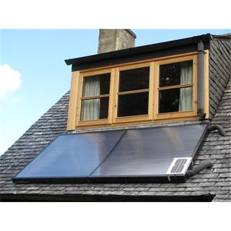

Appendix 7.17. Information Sheet used in focus groups
E-Futures PhD student
The Frederick Mappin Building
University of Sheffield
Department of Mechanical Engineering
Mappin Street
Attitudes towards solar thermal panels
Thank you for attending and welcome to today’s focus group on solar thermal panels. My name is James and I will be conducting this focus group which will be asking for your opinion on a number of issues. Please take a few minutes to read the information on this sheet which will tell you the format of the focus group and why I am conducting the research. If you have any questions after reading this sheet, then please ask.
Background Information: Solar thermal panels are flat collectors that can be fitted to the roof of your property to heat water which can then be used for baths, showers, or to heat your home via radiators. The technology is well understood but knowledge about what people think of the technology is less well known. My research is investigating what people think of this technology and some key issues concerned with the technology.
The Research Team: The research team comprises of me, James, Dr Chris Jones and Miss Fiona Scott all from The University of Sheffield. The research is not in conjunction with any company or business and your opinions shared today will not be passed on to any third parties and will only be seen by members of the research team.
The Focus Group: There will be seven people at today’s focus group will last about 60 minutes. We will touch on a number of issues about your opinions on solar thermal panels and some of the issues surrounding them. In order to maintain your confidentiality, you will be provided with a pseudonym (i.e. false name), which will be used in the transcript and any subsequent dissemination activity (e.g. reports, conferences, etc.) and when using quotes from the focus group discussion.
Focus Group Rules: To ensure that the conversation we have is productive and to ensure that everyone has a positive experience, we ask that you follow these simple ground rules. Please feel free to speak up and contribute to the discussion, but please allow one person to speak at any one time. There are no right or wrong answers and I am interested in your opinion rather than what you think is the ‘right’ opinion. If one of you is sharing a lot, I may ask you to let others talk. If you are a little quieter, I may ask for your opinion.
What Happens Next: Immediately after the focus group I will ask you to complete a short questionnaire that will ask a few questions about you. Within the next few months I will produce the anonymized transcript of today’s focus group for use in our analysis, which you will have the opportunity to review and approve.
Ethical Statement: This research has been reviewed and approved by the University of Sheffield, Department of Psychology, Ethics Sub-Committee (DESC). Any contact details or responses that you provide will only be used in relation to the above-mentioned research project.
7.18. Debrief Sheet used in focus groups

Attitudes to Solar Thermal Panels
Thank you for participating in today’s focus group. Your responses will help in understanding people’s opinions of solar thermal panels and some issues surrounding them. More effective solar thermal panels can then be designed which will ultimately mean the systems are more efficient. If you have any question concerning this focus group, or any of the issues that were raised, please do not hesitate to contact either James or Chris with your questions.
James Williams |  | Dr. Chris Jones
Email: j.p.r.williams@sheffield.ac.uk |  | Email: c.r.jones@shef.ac.uk
Tel: 0114 222 7820 |  | Tel: 0114 222 6592

Some useful websites:

For more information about The University of Sheffield, please visit: http://www.shef.ac.uk

For more information about E-Futures, please visit: http://e-futures.group.shef.ac.uk/page/home
For more information about solar thermal panels, please visit: http://www.energysavingtrust.org.uk
http://www.decc.gov.uk

Some interesting books:

Domestic Solar Energy: A Guide for the Home Owner, G. Harper, The Crowood Press Ltd, 2009
Sustainable Energy Without the Hot Air, D. MacKay, UIT, 2008

Renewable Energy-A User’s Guide, A. McCrea, The Crowood Press Ltd, 2008

References
Abras, C., D. Maloney-Krichmar, & Preece, J. (2004). User-centered design (4 ed.): Thousand Oaks: Sage Publications.
Abu-Bakar, S. H., et al. (2013). Is Renewable Heat Incentive the future? Renewable and Sustainable Energy Reviews, 26, p. 365-378.
Adams, P., Farrell, M., Dalgarno, B., & Oczkowski, E. (2017). Household Adoption of Technology: The Case of High-Speed Broadband Adoption in Australia. Technology in Society, 49, 37-47.
Agency, I. E. World Energy Outlook 2015: in World Energy Report 2015. International Energy Agency.
Agency, I. E. (2015). I.E.A. World Energy Outlook 2015.
Ajzen, I. (1991). The theory of planned behavior. Organizational Behavior and Human Decision Processes, 50(2), 179-211.
Akva. (2015). Akva Solar Thermal Stores.
Allen, S., Hammond, G., & McManus, M. (2008). Prospects for and barriers to domestic micro-generation: A United Kingdom perspective (Vol. 85).
Allen, S. R. (2008). Prospects for and barriers to domestic micro-generation: A United Kingdom Perspective. Applied Energy, 85(6), p. 528-544.
Allen, S. R., et al. (2010). Integrated appraisal of a Solar Hot Water system. Energy Econmics, 35(3), p. 1351-1362.
Ammar, A. A., A.M. Okaz, & Ghoneim, A. A. (1989). Investigation of optimum parameters for solar domestic hot water system in Alexandria, Egypt. Solar & Wind Technology, 6(5), p. 627-632.
Angel, S., Parent, J., Civco, D. L., Blei, A., & Potere, D. (2011). The dimensions of global urban expansion: Estimates and projections for all countries, 2000–2050. Progress in Planning, 75(2), 53-107.
Ayompe, L. M., et al. (2011). Comparative field performance study of flat plate and heat pipe evacuated tube collectors (ETCs) for domestic water heating systems in a temperate climate. Energy, 35(36), p. 3370-3378.
Baskaran, R., S. Managi, & Bendig, M. (2013). A public perspective on the adoption of microgeneration technologies in New Zealand: A multivariate probit approach. Energy Policy, 58, p. 177-188.
Baxi. (2015). Megaflo eco, unvented hot water cylinders.
Berbash, Y., M. Chandrashekar, & Calamai, P. (1995). Technology for sustainable development: A case study of solar domestic hot water heating in Ontario. Energy, 20(6), p. 495-510.
Biaou, A. L., & Bernier, M. A. (2008). Achieving total domestic hot water production with renewable energy. Building and Environment, 43(4), p. 651-660.
Boait, P. Jet al. (2008). Production efficiency of hot water for dmoestic use. Applied Energy, 85(6), p. 528-544.
Bornatico, R., Pfeiffer, M., Witzig, A., & Guzzella, L. (2012). Optimal sizing of a solar thermal building installation using particle swarm optimization. Energy, 41(1), 31-37.
Braun, V., & Clarke, V. (2006). Using thematic analysis in psychology. Qualitative Research in Psychology, 3(2), 77-101.
Brechin, S. R., & Bhandari, M. (2011). Perceptions of climate change worldwide. Wiley Interdisciplinary Reviews, 2(2), p. 871-885.
Brown, N. M., & Lai, F. C. (2011). Enhanced thermal stratification in a liquid storage tank with a porous manifold. Solar Energy, 85(7), p. 1409-1417.
Brown, S. A., & Venkatesh, V. (2005). Model of Adoption of Technology in Households: A Baseline Model Test and Extension Incorporating Household Life Cycle. MIS Quarterly, 29(3), 399-426.
Buchberg, H., & Roulet, J. R. (1968). Simulation and optimization of solar collection and storage for house heating. Solar Energy, 12(1), p. 31-50.
Burnett, D., Barbour, E., & Harrison, G. P. (2014). The UK solar energy resource and the impact of climate change. Renewable Energy, 71, 333-343.
Buzás, J., et al. (1998). Modelling and simulation aspects of a solar hot water system. Mathematics and Computers in Simulation, 48(1), p. 33-46.
Carbonell, D., J. Cadafalch, & Consul, R. Dynamic modelling of flat plate solar collectors. Analysis and validation under thermosyphon conditions. Solar Energy, 13, p. 100-112.
Chang, T. P. (2009). The Sun’s apparent position and the optimal tilt angle of a solar collector in the northern hemisphere. Solar Energy, 83(8), 1274-1284.
Commission, E. (2002). M/324 Mandate to CEN and CENELEC for the elaboration and adoption of measurement standards for household appliances: Water-heaters, hot water storage appliances and water heating systems.
Comodi, G., Bevilacqua, M., Caresana, F., Pelagalli, L., Venella, P., & Paciarotti, C. (2014). LCA Analysis of Renewable Domestic Hot Water Systems with Unglazed and Glazed Solar Thermal Panels. Energy Procedia, 61, 234-237.
Cooney, K. (2007). Fields, Organizations, and Agency: Toward a Multilevel Theory of Institutionalization in Action. Administration & Society, 39(6), 687-718.
Courtney, R. G. (1977). A computer study of solar water heating. Building and Environment, 12(2), p. 73-80.
Davis, F. D. (1989). Perceived Usefulness, Perceived Ease of Use, and User Acceptance of Information Technology. MIS Quarterly, 13(3), 319-340.
DECC. (2013). Energy Consumption in the UK (2015). Crown Copywrite. London.
Doblinger, C., & Soppe, B. (2013). Change-actors in the U.S. electric energy system: The role of environmental groups in utility adoption and diffusion of wind power. Energy Policy, 61, 274-284.
Donald, I. J., Cooper, S. R., & Conchie, S. M. (2014). An extended theory of planned behaviour model of the psychological factors affecting commuters' transport mode use. Journal of Environmental Psychology, 40, 39-48.
Dongellini, M., S. Falcioni, & Morini, G. L. (2015). Dynamic Simulation of Solar Thermal Collectors for Domestic Hot Water Production. Energy Procedia, 82, p. 630-636.
Duffie, J. A., & Beckman, W. A. (1980). Solutions manual for solar engineering of thermal processes. Madison, Wis.: Solar Energy Laboratory, University of Wisconsin-Madison.
Duyck, S. (2015). The Paris Climate Agreement and the Protection of Human Rights in a Changing Climate. Yearbook of International Environmental Law, 26, 3-45.
Elmustapha, H., Hoppe, T., & Bressers, H. (2018). Consumer renewable energy technology adoption decision-making; comparing models on perceived attributes and attitudinal constructs in the case of solar water heaters in Lebanon. Journal of Cleaner Production, 172, 347-357.
ESTIF. (2013). Solar Thermal Markets in Europe, Trends and Market Statistics.
A. Faiers, A., & C. Neame (2006). Consumer attitudes towards domestic solar power systems. Energy Policy, 34(14), 1797-1806.
A. Faiers, A., & C. Neame (2006). International Energy Agency. Energy Policy, 34(14), p. 160-168.
A. Faiers, A., C. Neame, & Cook, M. (2007). The adoption of domestic solar-power systems: Do consumers assess product attributes in a stepwise process? Energy Policy, 35(6), 3418-3423.
Featherman, M., & Pavlou, P. (2003). Predicting E-Services Adoption: A Perceived Risk Facets Perspective (Vol. 59).
Fishbein, M. a. A., Icek. (1975). Belief, attitude, intention, and behavior : an introduction to theory and research. Reading: Addison-Wesley Pub. Co.
Fraisse, G., Bai, Y., Le Pierrès, N., & Letz, T. (2009). Comparative study of various optimization criteria for SDHWS and a suggestion for a new global evaluation. Solar Energy, 83(2), 232-245.
Furbo, S. et al. (2005). Smart solar tanks for small solar domestic hot water systems. Solar Energy, 78(2), p. 269-279.
Gari, H. N., & Loehrke, R. I. (1982). A Controlled Buoyant Jet for Enhancing Stratification in a Liquid Storage Tank. Journal of Fluids Engineering, 1044(4), p. 475-481.
Gefen, D. (2004). What Makes an ERP Implementation Relationship Worthwhile: Linking Trust Mechanisms and ERP Usefulness. Journal of Management Information Systems, 21(1), 263-288.
Greening, B., & Azapagic, A. (2014). Domestic solar thermal water heating: A sustainable option for the UK? Renewable Energy, 63(0), p. 23-36.
Guest, G., MacQueen, K. M., & Namey, E. E. (2011). Applied Thematic Analysis: SAGE Publications.
Hafez, A. Z., Soliman, A., El-Metwally, K. A., & Ismail, I. M. (2017). Tilt and azimuth angles in solar energy applications – A review. Renewable and Sustainable Energy Reviews, 77, 147-168.
Han, Y. M., R.Z. Wang, & Dai, Y. J. (2009). Thermal stratification within the water tank. Renewable & Sustainable Energy Reviews, 13(5), p. 1014-1026.
Hawkins, G. (2011). Rules of Thub, Guidelines for building services: BSRIA.
IPCC. (2013). Annex I: Atlas of Global and Regional Climate Projections: AI. In T. F. Stocker, D. Qin, G. K. Plattner, M. Tignor, S. K. Allen, J. Boschung, A. Nauels, Y. Xia, V. Bex, & P. M. Midgley (Eds.), Climate Change 2013: The Physical Science Basis. Contribution of Working Group I to the Fifth Assessment Report of the Intergovernmental Panel on Climate Change (pp. 1311–1394). Cambridge, United Kingdom and New York, NY, USA: Cambridge University Press.
J., A. C., & Mark, C. (2001). Efficacy of the Theory of Planned Behaviour: A meta‐analytic review. British Journal of Social Psychology, 40(4), 471-499.
Jaisankar, S., et al. (2011). A comprehensive review on solar water heaters. Renewable and Sustainable Energy Reviews, 15(6), p. 3045-3050.
Juntunen, J. K., and Hyysalo, S. (2015). Renewable micro-generation of heat and electricity—Review on common and missing socio-technical configurations. Renewable and Sustainable Energy Reviews, 49, 857-870.
K. Vejen, S. F., L.J. Shah. (2004). Development of 12.5m2 solar collector panel for solar heating plane. Solar Energy Materials & Solar Cells, 84, p. 205-223.
Kaldellis, J. K. (2005). Social attitude towards wind energy applications in Greece. Energy Policy, 33(5), 595-602.
Kantzioura, A., Kosmopoulos, P., & Zoras, S. (2012). Urban surface temperature and microclimate measurements in Thessaloniki. Energy and Buildings, 44, 63-72.
Kenjo, L., C. Inard, & Caccavelli, D. (2007). Experimental and numerical study of thermal stratification in a mantle tank of a solar domestic hot water system. Applied Thermal Engineering(27), p. 1986-1995.
King, W. R., & He, J. (2006). A meta-analysis of the technology acceptance model. Information & Management, 43(6), 740-755.
Kitzinger, J. (1994). The Methodology of Focus Groups: The Importance of Interaction Between Research Participants (Vol. 16).
Koroneos, C. J., & Nanaki, E. A. (2012). Life cycle environmental impact assessment of a solar water heater. Journal of Cleaner Production, 37, p. 154-161.
L. Cai, W. E. S. (1993). Turbulent buoyant ﬂows into a two-dimension storage tank. International Journal of Heat and Mass Transfer, p. 4247-4256.
Lachapelle, E., C.P. Borick, & Rabe, B. (2012). Public Attitudes toward Climate Science and Climate Policy in Federal Systems: Canada and the United States Compared1. Review of Policy Research, 29(3), p. 334-357.
Lavan, Z., & Thompson, J. (1977). Experimental study of thermally stratified hot water storage tanks. Solar Energy, 19(19), p. 519-524.
Levinthal, D. A. (1998). The Slow Pace of Rapid Technological Change: Gradualism and Punctuation in Technological Change. Industrial and Corporate Change, 7(2), 217-247.
Liao, C., Palvia, P., & Chen, J.-L. (2009). Information technology adoption behavior life cycle: Toward a Technology Continuance Theory (TCT). Int. J. Inf. Manag., 29(4), 309-320.
Lienhoop, N. (2018). Acceptance of wind energy and the role of financial and procedural participation: An investigation with focus groups and choice experiments. Energy Policy, 118, 97-105.
Liu, B. Y. H., & Jordan, R. C. (1960). The interrelationship and characteristic distribution of direct, diffuse and total solar radiation. Solar Energy, 4(3), 1-19.
Martin, C. J., Taylor, P. G., Upham, P., Ghiasi, G., Bale, C. S. E., James, H., . . . Helmer, S. (2014). Energy in low carbon cities and social learning: A process for defining priority research questions with UK stakeholders. Sustainable Cities and Society, 10, 149-160.
Matus, K. J. M., Clark, W. C., Anastas, P. T., & Zimmerman, J. B. (2012). Barriers to the Implementation of Green Chemistry in the United States. Environmental Science & Technology, 46(20), 10892-10899.
Mazman, M., Cabeza, L. F., Mehling, H., Miquel, N., Evliya, H., & Paksoy, H. (2009). Utilization of phase change materials in solar domestic hot water systems (Vol. 34).
Medved, S., C. Arkar, & Černe, B. (2003). A large-panel unglazed roof-integrated liquid solar collector––energy and economic evaluation. Solar Energy, 75(6), p. 455-467.
Ministry of Housing, C. L. G. (2009). English Housing Survey. London:
Monk, A. (2000). User-centred design, in Home informatics and telematics2000. Springer, p. 181-190.
NASA. (2016). The Earth's Energy Budget. NASA.
Nejat, Pet al. (2015). A global review of energy consumption, CO2 emissions and policy in the residential sector (with an overview of the top ten CO2 emitting countries). Renewable and Sustainable Energy Reviews, 43, p. 843-862.
Norman, D. A., & Draper, S. W. (1986). User Centered System Design; New Perspectives on Human-Computer Interaction.
Pellizzone, A., et al. (2015). Exploring public engagement with geothermal energy in southern Italy: A case study. Energy Policy, 85(85), p. 1-11.
Peng, G., Fan, M., & Dey, D. (2011). Impact of network effects and diffusion channels on home computer adoption. Decision Support Systems, 51(3), 384-393.
Plouffe, C. R., Hulland, J. S., & Vandenbosch, M. (2001). Research Report: Richness Versus Parsimony in Modeling Technology Adoption Decisions—Understanding Merchant Adoption of a Smart Card-Based Payment System. Information Systems Research, 12(2), 208-222.
Prud’homme, T., & Gillet, D. (2001). Advanced control strategy of a solar domestic hot water system with a segmented auxiliary heater. Energy and Buildings, 33(5).
Rejón-Guardia, F., Sánchez-Fernández, J., & Muñoz-Leiva, F. (2013). The acceptance of microblogging in the learning process: The µBAM model. 2013, 3(1), 18.
Rezaei, R., & Ghofranfarid, M. (2018). Rural households' renewable energy usage intention in Iran: Extending the unified theory of acceptance and use of technology. Renewable Energy, 122, 382-391.
Rodríguez-Hidalgo, M. C., et al. (2012). Domestic hot water consumption vs. solar thermal energy storage: The optimum size of the storage tank. Solar Energy, 97(0), p. 897-906.
Rogers, J. G., McManus, M. C., & Cooper, S. J. G. (2013). Potential for reliance on solar water heating throughout the summer in northern cloudy climates. Energy and Buildings, 66, 128-135.
Ruggiero, S., Onkila, T., & Kuittinen, V. (2014). Realizing the social acceptance of community renewable energy: A process-outcome analysis of stakeholder influence. Energy Research & Social Science, 4, 53-63.
Ruggiero, S., Varho, V., & Rikkonen, P. (2015). Transition to distributed energy generation in Finland: Prospects and barriers. Energy Policy, 86, 433-443.
Sahnoune, F., et al. (2014). Comparative Study between Solar and Conventional Heating – Economic Study and Environmental Impact. Energy Procedia, 50, p. 841–852.
Sauter, R., & Watson, J. (2007). Strategies for the deployment of micro-generation: Implications for social acceptance. Energy Policy, 35(5), 2770-2779.
Scarpa, R., & Willis, K. (2010). Willingness-to-pay for renewable energy: Primary and discretionary choice of British households' Energy Econmics, 32(1), p. 129-136.
Scarpa, R., & Willis, K. (2010). Willingness-to-pay for renewable energy: Primary and discretionary choice of British households' for micro-generation technologies. Energy Economics, 32(1), 129-136.
Scott, F. L., Jones, C. R., & Webb, T. L. (2014). What do people living in deprived communities in the UK think about household energy efficiency interventions? Energy Policy, 66, 335-349.
Simcock, N., MacGregor, S., Catney, P., Dobson, A., Ormerod, M., Robinson, Z., . . . Marie Hall, S. (2014). Factors influencing perceptions of domestic energy information: Content, source and process. Energy Policy, 65, 455-464.
Sindico, F. (2016). Paris, climate change, and sustainable development. Climate Law, 6((1-2)), p. 130-141.
Smil, V. (1991). General energetics: energy in the biosphere and civilization: Wiley.
Speyer, E. (1959). Optimum storage of heat with a solar house. Solar Energy, 3(4), p. 24-48.
Speyer, E. (1968). Optimum storage of heat with a solar house. Solar Energy, 12(1), p. 24-48.
Srinivas, M. (2011). Domestic solar hot water systems: Developments, evaluations and essentials for “viability” with a special reference to India. Renewable and Sustainable Energy Reviews, 15(15), p. 3850-3861.
Stanciu, C., & Stanciu, D. (2014). Optimum tilt angle for flat plate collectors all over the World – A declination dependence formula and comparisons of three solar radiation models. Energy Conversion and Management, 81, 133-143.
Stigka, E. K., Paravantis, J. A., & Mihalakakou, G. K. (2014). Social acceptance of renewable energy sources: A review of contingent valuation applications. Renewable and Sustainable Energy Reviews, 32, 100-106.
Stragier, J., Hauttekeete, L., & Marez, L. D. (2010, 27-29 Sept. 2010). Introducing Smart grids in residential contexts: Consumers' perception of smart household appliances. Paper presented at the 2010 IEEE Conference on Innovative Technologies for an Efficient and Reliable Electricity Supply.
Straub, D., Keil, M., & Brenner, W. (1997). Testing the technology acceptance model across cultures: A three country study. Information & Management, 33(1), 1-11.
Tagliafico, L. A., F. Scarpa, & Rosa, M. D. (2014). Dynamic thermal models and CFD analysis for flat-plate thermal solar collectors - A review. Renewable & Sustainable Energy Reviews, 30(0), p. 526-537.
Tarhan, S., Sari, A., & Yardim, M. H. (2006). Temperature distributions in trapezoidal built in storage solar water heaters with/without phase change materials. Energy Conversion and Management, 47(15), 2143-2154.
Thür, A., S. Furbo, & Shah, L. J. (2006). Energy savings for solar heating systems. Solar Energy, 80(80), p. 1463-1474.
Tian, Y., & Zhao, C. Y. (2013). A review of solar collectors and thermal energy storage in solar thermal applications. Applied Energy, 104, p. 538-553.
Trust, E. S. (2005). Energy Use in Homes. DEFRA. London.
Tsai, H.-y. S., & LaRose, R. (2015). Broadband Internet adoption and utilization in the inner city: A comparison of competing theories. Computers in Human Behavior, 51, 344-355.
Turner, M., Kitchenham, B., Brereton, P., Charters, S., & Budgen, D. (2010). Does the technology acceptance model predict actual use? A systematic literature review. Information and Software Technology, 52(5), 463-479.
Valan Arasu, A., & Sornakumar, T. (2007). Design, manufacture and testing of fiberglass reinforced parabola trough for parabolic trough solar collectors. Solar Energy, 81(10), p. 1273-1279.
van Berkel, J., C.C.M. Rindt, & Steenhoven, A. A. v. (1999). Modelling of two-layer stratified stores. Solar Energy, 67(1-3), p. 65-78.
Venkatesh, V., Morris, M. G., Davis, G. B., & Davis, F. D. (2003). User Acceptance of Information Technology: Toward a Unified View. MIS Quarterly, 27(3), 425-478.
Watson, Jet al. (2008). Domestic micro-generation: Economic, regulatory and policy issues for the UK. Energy Policy, 36(8), p. 3095-3106.
Weijermars, R., Taylor, P., Bahn, O., Das, S. R., & Wei, Y.-M. (2012). Review of models and actors in energy mix optimization – can leader visions and decisions align with optimum model strategies for our future energy systems? Energy Strategy Reviews, 1(1), 5-18.
Weiner, M. D., Puniello, O. T., Noland, R. B., Ciemnecki, D., & Turakhia, C. (2012). Consider the non-adopter: Developing a prediction model for the adoption of household-level broadband access. Socio-Economic Planning Sciences, 46(3), 183-193.
Wong, I. L., & Eames, P. (2015). A method for calculating the solar transmittance, absorptance and reflectance of a transparent insulation system. Solar Energy, 111, 418-425.
Wüstenhagen, R., Wolsink, M., & Bürer, M. J. (2007). Social acceptance of renewable energy innovation: An introduction to the concept. Energy Policy, 35(5), 2683-2691.
Yao, R., Luo, Q., Luo, Z., Jiang, L., & Yang, Y. (2015). An integrated study of urban microclimates in Chongqing, China: Historical weather data, transverse measurement and numerical simulation. Sustainable Cities and Society, 14, 187-199.
Zambolin, E., & Col, D. D. (2010). Experimental analysis of thermal performance of flat plate and evacuated tube solar collectors in stationary standard and daily conditions. Solar Energy, 84(8), p. 1382-1396.

