THE UNIVERSITY OF SHEFFIELD

ELECTRICAL PROPERTIES OF PURE AND DOPED RUTILE CERAMICS

A thesis submitted for the degree of Doctor of Philosophy

YUN DANG

Supervisor: Prof. Anthony R. West
Department of Material Science and Engineering
June 2018

Acknowledgments

I would like to express my sincere gratitude to my supervisor, Professor Anthony R. West, for his supervision, invaluable support and encouragement on my Ph.D. research. I benefited from his profound insight, experience and scientific thinking. His enthusiasm and motivation on scientific research always impress me and give me a deep and long-term influence on my research.
I would like to thank Professor Derek C. Sinclair and Professor Ian M. Reaney for their guidance and valuable suggestion on my project. I would also like to thank the technician staffs for their help on my experiments, especially Mr. Andrew Mould on synthesis and characterization technique and Dr. Nik Reeves-McLaren on X-ray diffraction test and analysis.
Thanks to Dr. Fan Yang, Dr. Linhao Li, Dr. Zhilun Lu and Dr. Bo Dong for their help and useful discussions. My thanks also go to all members of the functional ceramics group.
I would like to thank my parents and my sisters for their everlasting love and support. I would never have finished this study without their encouragement and support.

Abstract

Rutile, TiO₂, has drawn significant attention due to its unique properties. In this project, the structural and electrical properties of undoped and Cr/Al/Ga/Zn-doped rutile have been investigated.
Undoped rutile is increasingly oxygen-deficient on heating in air above ~700 °C. The weight loss is generally too small for accurate measurement, but the electrical properties of quenched samples provide a sensitive qualitative indicator of oxygen content since their conductivity can vary by many orders of magnitude. The lattice parameters of quenched samples show an unusual dependence on quench temperature and, by implication, on oxygen stoichiometry. Lattice parameters increase with a small oxygen loss, δ; chemical expansion of the lattice occurs and is attributed to increase in average Ti-O bond lengths. At higher δ, lattice parameters start to decrease, giving a chemical contraction effect attributed to partial collapse of columns of edge-sharing TiO₆ octahedra in the rutile structure and elimination of oxygen vacancies by crystallographic shear, CS, plane formation.
Oxygen-deficient rutile samples quenched from above 700 °C are n-type, whereas samples annealed and measured at 450-500 °C are p-type and believed to be slightly oxygen-rich. Holes are located on oxide ions at or near the sample surface and arise from redox electron transfer between under-bonded surface oxide ions and adsorbed O₂ molecules. Samples annealed between 550 and 600 °C show cross-over between n- and p-type behavior.
Cr-doped rutile, Ti_{1-x}Cr_{x}O_{2-x/2-δ}, samples show a volume expansion at low Cr content, which is associated with the larger size of Cr³⁺ and the increase in average M-O bond length. At relatively higher Cr content, samples show an unusual volume contraction effect, which is also believed to be attributed to the formation of shear planes.
The electrical properties of Cr-doped rutile are very dependent on composition x. Impedance results show that at low dopant concentration (0.001 ≤ x ≤ 0.01), samples are two-phase mixtures. The phase identified by R₂C₂ is more resistive than R₁C₁ and has larger activation energy. R₂C₂ represents a phase with very small Cr³⁺ dopant concentration, i.e. x = 0.001 ± 0.0005, and R₁C₁ represents a phase with relatively higher dopant content, i.e. x = 0.008 ± 0.002. In addition, since Cr content of both phases are different, R₂C₂ may have random point defects, such as oxygen vacancies. With relatively higher dopant content, oxygen vacancies collapse to form shear planes, i.e. defects present in the phase R₁C₁ may be random shear planes. At low x, Cr-doped rutile samples show mixed conduction, with p-type electronic conduction and oxide ion conduction. The location of holes is thought to be related with O²⁻ ions as well.
At higher x, a p-n transition is observed; samples are semiconducting and have small activation energy (~0.2 eV). Such semiconductivity is attributed to intrinsic hopping of charge carriers associated with Cr-Cr or Cr-Ti. Since orbital overlap may occur, charge carriers could hop between Cr³⁺ and Ti⁴⁺ and thus, Cr⁴⁺ and Ti³⁺ are generated and samples become semiconducting. Moreover, if oxygen vacancies collapse to form shear planes, the distance between Cr-Cr or Cr-Ti in face-sharing octahedra in the shear planes are smaller, and hopping of charge carriers becomes easier and the conductivity increases. Moreover, polaron hopping is an alternative description of the amount of semiconductivity.
Electrical properties of Al-doped TiO₂ are dependent on cooling condition. Samples show a p-n transition with increasing quench temperature. The p-type conductivity is driven by surface absorption of oxygen and associated with O⁻ at the sample surface.
Ga-doped TiO₂ shows an n-p transition with increasing dopant concentration, whereas such electronic conduction is quite weak. Maybe with Ga³⁺ doping in TiO₂, ionic compensation is the main compensation mechanism.
With Zn²⁺ doping, it is clear that the homogeneity of rutile ceramics improves in some degree. However, Zn-doped samples still show evidence of a constriction resistance or a dipole orientation-related impedance. Zn-doped rutile samples show n-type conduction.

Introduction

Rutile, TiO₂, is an important functional material with a diverse range of applications in the form of either ceramics, films or nanoparticles. In its pure form, TiO₂ is a white insulating solid with a bandgap of 3.2 eV. On heating, it increasingly loses a small amount of oxygen above ~700 °C in air which is accompanied by a large increase in electronic conductivity ^{[1]}.
Crystallographic shear (CS) structures in non-stoichiometric rutile were first found in 1957 ^{[2]}. It has been reported that heavily-reduced rutile forms a homologous series of phases of general formula Ti_{n}O_{2n-1} based on CS structures. The oxygen vacancies that form on initial reduction are subsequently eliminated by a partial collapse of the structure to form the CS planes.
Pure TiO₂ is well-known to be an n-type semiconductor when oxygen-deficient. Recent publications ^{[1,3]} showed that oxygen deficiency correlated with quench temperature and conductivity. In addition, n-type rutile showed a decrease in conductivity with a dc bias due to trapping of electrons at the sample surface. The opposite effect was seen with p-type materials such as Ca-doped BiFeO₃, Mg-doped SrTiO₃ and Zn-doped CaTiO₃, which were acceptor-doped ^{[4-6]}. However, some early literature ^{[7-8]} based on TiO₂ thin films showed that the resistance decreased on application of dc bias and the switching mechanism involved coupled ionic and electronic transport across interfaces.
Many studies have been carried out on acceptor doped TiO₂ and showed that acceptor dopants converted n-type TiO₂ to p-type ^{[9-17]}. Consequently, the first objective of this project was to study the electrical properties of acceptor doped rutile and to see if an n-p crossover would be observed. In addition, it was of interest to determine the conditions, if any, under which undoped rutile may also show p-type behavior.

References
- Y Liu, AR West. J Am Ceram Soc. 96(2013):218-222.
- J Andersson, B Collen, U Kuylenstierna, et al. Acta Chem Scand. 11(1957):1641-1652.
- Y Liu, AR West. Appl Phys Lett. 103(2013):263508.
- N Masó, H Beltrá, M Prades, et al. Phys Chem Chem Phys. 16(2014):19408
- LG Escrig, M Prades, H Beltrá, et al. J Am Ceram Soc. 97(2014):2815-2824.
- QL Zhang, N Masó, Y Liu, et al. J Mater Chem. 21(2011):12894.
- R Waser, R Dittmann, G Staikov, et al. Adv Mater. 21(2009):25-26.
- MD Pickett, DB Strukov, JL Borghetti, et al. J Appl phys. 106(2009):074508.
- RK Sharma, MC Bhatnagar, GL Sharma. Sensor Actuator B. 45(1997):209-215.
- JY Cao, YJ Zhang, LQ Liu, et al. Chem Commun. 49(2013):3440-3442.
- YX Li, W Wlodarski, K Galatsis, et al. Sensor Actuator. 83(2002):160-163.
- C Gionco, S Livraghi, S Maurelli, et al. Chem Mater. 27(2015):3936-3945.
- ZH Li, DY Ding, CQ Ning. Nanoscale Res Lett. 8(2013):25-30.
- D Zwingel. Solid State Commun. 20(1976):397-400.
- J Yahia. Phys Rev. 130(1963):1711-1719.
- C Gionco, S Livraghi, S Maurelli, et al. Chem Mater. 27(2015):3936-3945.
- D Zwingel. Solid State Commun. 26(1978):775-777.

Contents

Chapter 1. Literature review 1
1.1 Structure and applications of TiO₂ 1
1.2 Oxygen-deficient rutile 7
1.2.1 Properties, applications and preparation 7
1.2.2 Defect chemistry 8
1.3 Doped TiO₂ 12
1.3.1 Properties, applications and synthesis 14
1.3.2 Defect chemistry of acceptor-doped TiO₂ 18
1.4 Electrical properties of TiO₂ 18
1.4.1 Electronic conduction 18
1.4.2 Ionic conduction 23
1.5 Objectives and outline of this study 25
1.6 References 26
Chapter 2. Experimental 32
2.1 Solid state synthesis 32
2.2 Density 33
2.3 X-ray diffraction 34
2.3.1 Fundamental 34
2.3.2 Experimental 38
2.4 Impedance spectroscopy 39
2.4.1 Theory 40
2.4.2 Experimental 43
2.5 EMF measurement 45
2.5.1 Introduction to oxide ion conductors 45
2.5.2 Experimental 46
2.6 Quenching 47
2.7 References 48
Chapter 3. Undoped TiO₂ 50
3.1 Introduction 50
3.2 Experimental 52
3.3 Results and discussion 53
3.3.1 Lattice parameters and chemical expansion/contraction 53
3.3.2 Electrical properties of slow-cooled TiO₂ 58
3.3.3 n-p transition in TiO₂ 62
3.3.4 Electrical properties and Schottky barriers of oxygen-deficient rutile, TiO_{2-δ} 75
3.3.5 Partially oxidized rutile and core-shell structure formation 79
3.4 Conclusions 83
3.5 References 85
Chapter 4. Cr-doped TiO₂ 87
4.1 Introduction 87
4.2 Experimental 90
4.3 Results 91
4.3.1 XRD 91
4.3.2 Electrical properties of Ti_{1-x}Cr_{x}O_{2-x/2-δ} 94
4.4 Discussion 118
4.4.1 Two phases 118
4.4.2 p-type conduction and the location of holes 119
4.4.3 Low-frequency spike and oxide ion conduction 120
4.4.4 Volume expansion / contraction 122
4.4.5 Semiconductivity in x ≥ 0.015 125
4.5 Conclusions 128
4.6 References 129
Chapter 5. Al-doped TiO₂ 131
5.1 Introduction 131
5.2 Experimental 134
5.3 Results 135
5.3.1 XRD 135
5.3.2 Electrical properties 138
5.4 Discussion 154
5.4.1 Solid solution limit and lattice expansion 154
5.4.2 Dependence of conductivity on cooling condition 155
5.4.3 Surface absorption of O₂ 156
5.4.4 p-n transition of Ti_{1-x}Al_{x}O_{2-x/2-δ} 156
5.5 Conclusions 157
5.6 References 158
Chapter 6. Ga-doped TiO₂ 161
6.1 Introduction 161
6.2 Experimental 165
6.3 Results 165
6.3.1 XRD 165
6.3.2 Electrical properties 166
6.4 Discussion 177
6.4.1 XRD, secondary phase and peak shifting 177
6.4.2 Effect of cooling rate 178
6.4.3 n-p transition 179
6.5 Conclusions 180
6.6 References 181
Chapter 7. Zn-doped TiO₂ 183
7.1 Introduction 183
7.2 Experimental 186
7.3 Results and discussion 187
7.3.1 XRD 187
7.3.2 Electrical properties 190
7.4 Conclusions 198
7.5 References 199
Chapter 8. Discussion 201
8.1 Structural properties 201
8.1.1 Dopants and possible compensation mechanism 201
8.1.2 Solid solution limits of doped TiO₂ 202
8.1.3 Oxygen nonstoichiometry and CS structures 203
8.2 Electrical properties 206
8.2.1 Undoped rutile 206
8.2.2 Doped rutile 210
8.3 References 213
Chapter 9. Conclusions 217
Chapter 10. Future work 221

Chapter 1. Literature review

1.1 Structure and applications of TiO₂
Titanium dioxide, TiO₂, occurs mainly in three crystalline polymorphs: rutile, anatase and brookite, of which rutile is the thermodynamically most stable form ^{[1]}. As shown in Figure 1-1 and Table 1-1, rutile has a body-centered tetragonal unit cell; the titanium cations are surrounded by an octahedron of 6 oxygen anions. In this project, rutile TiO₂ was used as the studied material.

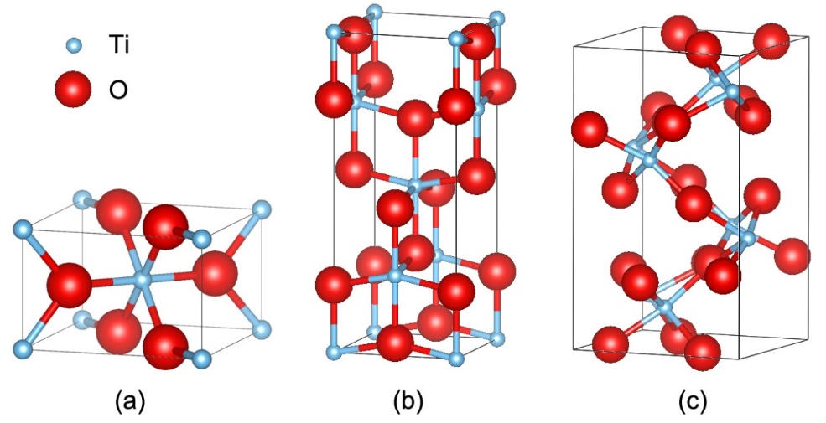
Figure 1-1. Crystal structures of (a) rutile, (b) anatase and (c) brookite
Table 1-1. Crystal structure and properties of TiO₂ ^{[2,3]}
Structure | Rutile | Anatase | Brookite
System | Tetragonal | Tetragonal | Orthorhombic
Space group | P4₂/mnm | I4₁/amd | Pbca
Lattice parameters ($Å$) | a=b=4.5936 c=2.9587 | a=b=3.784 c=9.515 | a=9.184 b=5.447 c=5.154
Density (gcm⁻³) | 4.13 | 3.79 | 3.99
Refractive index | 2.9467 | 2.5688 | 2.809
Band gap (eV) | 3.02 | 3.2 | 2.96

TiO₂ is an important functional material with a diverse range of applications in the form of either ceramics, films or nanoparticles.

Pigment
In recent decades, TiO₂ has replaced other materials as a source of light scattering in paints, plastics, rubber, paper and inks ^{[4]}. Since TiO₂ has good brightness and by far the highest refractive index of any white material, it has been widely used as the main component of pigments ^{[4]}. Pigmentary TiO₂ is stable, inert, non-toxic and has lower cost than most pigmentary materials. TiO₂ helps to enhance the mechanical strength and adhesion of the pigment. Furthermore, it can prevent the penetration of UV light (10-400 nm) due to the high optical absorbance, which contributes to prolong the life of pigments.

Photocatalysis
Semiconductor photocatalysis attracted much research interests in recent years in addressing environmental challenges. Various metal oxides are suitable for photocatalyst, such as TiO₂, ZnO and SnO₂ ^{[5]}, among which TiO₂ is close to being an ideal photocatalyst for industrial use since it is stable, non-toxic, cheap and has the most efficient photoactivity ^{[6]}. The photocatalytic history of TiO₂ began in Japan in the 1970s ^{[6]}, and is still being built on today with work to create more efficient photocatalysts. Applications of TiO₂ photocatalyst range from degradation of contaminants, self-cleaning to disinfection.
The basic theory of TiO₂ photocatalysis is initiated by absorption of photons, Figure 1-2. When TiO₂ is exposed to UV light, electrons in the valence band are excited to the conduction band, forming electrons with high activity and leaving behind holes. Photogenerated charge carriers recombine and dissipate the absorbed energy. When an electric field is applied, electrons and holes will diffuse and migrate to the surface, and undergo redox reaction with the particles that are adsorbed by catalyst particles ^{[3]}. The primary criterion for an efficient photocatalyst is that the redox potential lies within the band gap domain of the catalyst material ^{[3]}.
Figure 1-2. Schematic photocatalytic process of TiO2 ^{[5]} (Figure 3)
Dye Sensitization
The Dye-Sensitized Solar Cell, DSSC, which has impressive solar-to-electrical energy conversion efficiency (~11%) ^{[3]}, has been intensively studied as a new type of solar cell in recent years. It is based on the sensitization of a wide band gap semiconductor, such as TiO₂, via chemisorbed or physisorbed dyes, Figure 1-3 ^{[3,8]}. A typical DSSC consists a porous semiconductor dye, an electrode and an electrolyte of iodide-triiodide ions ^{[8]}.
TiO₂ is a promising and critical photoanode material for DSSCs due to its nanocrystalline mesoporous nature, which makes it have large surface area for dye adsorption ^{[8]}. So far, TiO₂ is the most successful DSSC photoanode material.
Figure 1-3. Schematic overview of a dye-sensitized solar cell ^{[7]} (Figure 4 & 5)

Gas sensing
A gas sensor is a device which could detect the presence of various gases. The detection principle of gas sensors is based on that some semiconducting metal oxides, such as TiO₂, SnO₂ and ZnO, may change their conductivity when they are in contact with certain gases ^{[2,9]}. Generally, when a gas is adsorbed on the surface, electrons will transfer between the semiconductor and the gas, resulting in an increase/decrease of the charge carrier concentration, and hence, an increase/decrease in conductivity ^{[9]}. Among all kinds of semiconductor sensors, the TiO₂ based gas sensor is favored because of its high sensitivity, rapid response, long-term stability and low cost ^{[10]}. It can detect various gases, such as oxidative gases (O₂ and NO₂) and reductive gases (CO, H₂ and NH₃), representing a resistance increase and decrease, respectively ^{[10]}.

Memristor
The resistive switching behavior was discovered and identified for application in the early 1960s, and it has been observed in many oxides, such as TiO₂, Cr₂O₃, (Ba,Sr)TiO₃, BiFeO₃ and Al₂O₃ ^{[11,12]}. The first device to be called a memristor was made from TiO₂ thin film ^{[13,14]}. In recent years, memristors have attracted significant interest due to their simple structures, high scalability, low power consumption, high operating speed and excellent compatibility ^{[12]}.
A typical memristor has a sandwiched structure which is designed to be a metal/insulator/metal structure with the storage medium sandwiched between two metal electrodes. Figure 1-4 shows the schematic structure of a typical TiO₂ memristor: once a voltage is applied across the electrodes, oxygen atoms diffuse from one side to another, of which the direction is dependent on the voltage polarity. Consequently, the thickness of TiO₂ changes, resulting in a change in resistance as well ^{[15]}.
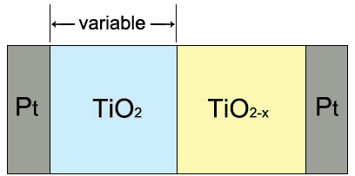
Figure 1-4. Schematic structure of a typical TiO₂ memristor

1.2 Oxygen-deficient rutile

1.2.1 Properties, applications and preparation
Undoped and stoichiometric rutile, TiO₂, is a white insulating material with a forbidden energy band gap of ~3.0 eV. In reducing atmospheres, TiO₂ loses oxygen and becomes an oxygen-deficient solid solution, TiO_{2-x} ^{[16]}. Reduction of TiO₂ could be written as:
$TiO_{2}↔TiO_{2-x}+\frac{x}{2}O_{2}$ (1-1)
where x is the deviation from oxygen stoichiometry. On heating, TiO₂ could also lose oxygen spontaneously from temperatures above ~700 °C without the need for a reducing atmosphere (e.g. H₂, CO). The oxygen loss is accompanied by a large increase in electronic conductivity: rutile ceramics quenched from 1400 °C are good n-type semiconductors with typical value 10⁻¹ Scm⁻¹ and activation energy 0.01 eV over a wide temperature range down to 20 K ^{[17]}.
More extensive oxygen loss occurs on heating in a reducing atmosphere giving rise to so-called black rutile ^{[18,19]}, of which the dark color is attributed to absorption of visible light. As mentioned before, TiO₂-based photocatalysts have been extensively investigated since they have good photocatalytic activity. However, because of its relatively wide bandgap, TiO₂ is active primarily in the UV light wavelength range (about 280-400 nm) ^{[18]}. Since the large band gap brings only small efficiency in using the solar spectra, lots of researchers have been focused on how to enhance the visible light absorption of TiO₂. Recently, “black rutile”, TiO_{2-x}, has been studied extensively as a photocatalyst material due to its extraordinary visible and infrared light absorption ^{[18]}.
There are mainly two types of method to prepare TiO_{2-x} for catalysis use: oxidation methods and reduction methods ^{[18]}: (i) for oxidation methods, TiH₂ is usually chosen as the starting material to obtain black rutile by Ti²⁺→Ti³⁺; (ii) for reduction of TiO₂, various reductants, such as H₂ ^{[20]}, CaH₂ ^{[21]}, Al ^{[19]}, Zn ^{[22]} and Mg ^{[18]} have been used.

1.2.2 Defect chemistry
Although numerous studies have been carried out on oxygen-deficient rutile, the types of major defect are still under discussion ^{[23]}. The defect models that have been postulated for reduced rutile involve titanium interstitials ^{[24-26]} and oxygen vacancies ^{[25]}. In addition, interaction between these defects may lead to the formation of extended defects such as crystallographic shear planes along with point defects ^{[16]}.

1.2.2.1 Titanium interstitials
For small departures from oxygen stoichiometry, the resulting solid solution TiO_{2-x} can be assumed to have a homogeneous distribution of point defects ^{[27,28]}. In terms of a defect structure primarily involving interstitial titanium, the defect may be expressed by the following equilibrium:
$TiO_{2}↔{Ti}_{i}^{m+}+me^{'}+O_{2}$ (1-2)
where ${Ti}_{i}^{m+}$ represents a positive charged interstitial titanium ^{[25]}. There have been some studies on titanium interstitials in reduce rutile: Ait-Younes et al. ^{[24]} have researched electromigration in TiO_{2-x} at 1050 °C and found that interstitial titanium ${Ti}_{i}^{3+}$ appeared to be the moving defect in the bulk of TiO_{2-x}; Marucco et al. ^{[26]} investigated the defect structure of TiO_{2-x} by reduction of TiO₂ between 800 and 1100 °C by means of thermogravimetric and electrical measurements; they reported that interstitial titanium ${Ti}_{i}^{4+}$ prevailed at temperatures higher than 900 °C.

1.2.2.2 Oxygen vacancies
In terms of a defect structure primarily involving oxygen vacancies, the defect may be expressed by the following equilibrium:
$O_{O}^{x}↔V_{O}^{..}+2e^{'}+\frac{1}{2}O_{2}$ (1-3)
where $O_{O}^{x}$ refers to oxygen in a normal lattice position, and $V_{O}^{..}$ refers to an oxygen vacancy ^{[25]}. Marucco et al. ^{[26]} showed that oxygen vacancies were prominent at rather low temperatures; when the oxygen partial pressure increased, oxygen vacancies were produced in the doubly ionized form $V_{O}^{..}$ at first and then changed to the singly ionized form $V_{o}^{∙}$.
Moreover, the presence of oxygen vacancies may lead to a lattice dilation, which is known as chemical expansion. Oxygen vacancy-induced chemical expansion has been reported in many oxides such as CeO₂ and ZrO₂. Such non-stoichiometric oxides may find applications in oxygen sensors, electrodes and cathodes of solid oxide fuel cells ^{[29-31]}.

1.2.2.3 Crystallographic shear planes
For larger deviations from stoichiometric TiO₂, a series of ordered compounds occurs. Such structures can be formed from TiO₂ by a “crystallographic shear” mechanism ^{[28]}. Crystallographic shear (CS) structures in non-stoichiometric transition metal oxides were first found by the Magnéli group ^{[32,33]}. They reported that in certain transition metal oxides, such as TiO₂, WO₃ and MoO₃, a series of homologous shear structures was found rather than continuous solid solutions. Recently, CS structures were also found in perovskites such as Fe-doped PbTiO₃ ^{[34]}.
In oxygen-deficient rutile, a homologous series of phases occurs of formula Ti_{n}O_{2n-1} (n=3, 4, ..., 10). Magnéli et al. ^{[32,33]} confirmed the existence of Ti_{n}O_{2n-1} and predicted that these structures could be derived from the rutile structure. Later, Wadsley et al. proposed the principle of CS structures which described how these structures might be derived from the rutile structure, Figure 1-5: first, a shear plane is formed, dividing the rutile structure into blocks; second, blocks are translated by a shear vector; finally, the overlapping parts, if any, are removed ^{[35]}.
Figure 1-5. Schematic of crystallographic shear operation ^{[35]} (Figure 1)

In recent years, with the improvement of techniques, numerous studies have been carried out on the CS structures of rutile following the work of Magnéli; these studies have been made using various techniques including electrical conductivity measurements ^{[35,36]}, thermoelectric property measurements ^{[35]}, electron microscopy ^{[27,28,37]} and X-ray diffraction ^{[32]}.
Harada et al. ^{[35]} and Bartholomew et al. ^{[36]} have investigated the electrical and thermoelectrical properties of Magnéli phases. All Ti_{n}O_{2n-1} specimens had n-type conduction and the conductivity increased with an increase in oxygen deficiency. Also, the Seebeck coefficient decreased with increasing deficiency of oxygen, which indicated that the crystallographic shear planes acted as the source for phonon scattering rather than carrier scattering ^{[35]}.
Electron microscopy has been widely used to investigate CS structures in oxygen-deficient rutile ^{[27,28,37]}. For instance, it has been reported that in the series of compounds Ti₄O₇ to Ti₉O₁₇, the shear plane was $(12\overline{1})$. Later studies showed that other shear planes were possible as well, e.g. $(13\overline{2})$. Figure 1-6 illustrates some examples of different shear planes ^{[27]}.
Figure 1-6. Schematic of (a) rutile TiO₂, (b) $(12\overline{1})$ and (c) $(13\overline{2})$ shear planes ^{[27]} (Figure 1)

As mentioned before, heavily reduced rutile may form a homologous series of phases based on CS structures. The oxygen vacancies that form on initial reduction are subsequently eliminated by a partial collapse of the structure to form the CS planes. However, a study of lightly-reduced rutile by transmission electron microscopy, TEM, also showed the presence of random CS planes in a TiO_{1.9970} sample, which was slow-cooled from 1050 °C to 700 °C and quenched to room temperature ^{[28]}. Figure 1-7 shows the phase diagram for the Ti-O system near TiO₂ ^{[28]}, from which it can be seen that a demixing to give Ti_{n}O_{2n-1} and TiO_{2-x} is possible under such cooling process.
Figure 1-7. Phase diagram for the Ti-O system near TiO₂ ^{[28]} (Figure 1) (data were calculated from the results of ● Zador ^{[39]}, + Blumenthal et al. ^{[40]}, △ Baumard ^{[41]} and o Picard et al. ^{[42]})

1.3 Doped TiO₂
Doping TiO₂ with different elements is considered an effective way to modify its physical and chemical properties. Numerous studies have been carried out on doped TiO₂, including using anion dopants, such as N, F, S and C ^{[43]} and cation dopants, such as Fe, Nb, Ni, Al, rare earth, etc. ^{[44-46]}.
Undoped TiO₂ is well-known to be an n-type semiconductor when oxygen-deficient. A recent publication ^{[17]} showed that oxygen deficiency correlated with quench temperature and conductivity. In addition, n-type rutile showed a decrease in conductivity with a dc bias due to trapping of electrons at the sample surface. The opposite effect could be seen with p-type materials which are acceptor-doped. As a consequence, the first objective of this project was to consider the effect of dc bias on acceptor-doped TiO₂ and to see if an n-p crossover would be observed. We have studied the electrical properties of acceptor-doped TiO₂ by impedance spectroscopy. Various elements were selected as acceptors due to their similar bond lengths to oxygen to Ti-O bond lengths and hence, the substitution of such acceptor cations for Ti⁴⁺ is expected to be easily achieved, Table 1-2.

Table 1-2. Some typical bond lengths to oxygen and coordination numbers ^{[38]}
Element | Bond length to oxygen ($\dot{A}$) and coordination numbers
Ti | Ti (IV) – O (6): 2.01
Al | Al – O (6): 1.93
Zn | Zn – O (6): 2.15
Ga | Ga – O (6): 2.00
Cr | Cr (III) – O (6): 2.02

1.3.1 Properties, applications and synthesis
Al-doped TiO₂
Al-doped TiO₂ has been studied extensively due to its unique properties. There are various methods which have been used to synthesize Al-doped TiO₂, such as solid state reaction ^{[47]}, deposition ^{[48-50]} and sol-gel methods ^{[51,52]}. Kassmi et al. ^{[48]} and Kim et al. ^{[49]} showed that with Al dopant, TiO₂-based capacitors exhibited low leakage current as well as high dielectric constant. Yüce and Saruhan ^{[50]} reported the promising results of Al-doped TiO₂ sensor layers for sensing NO₂ at temperatures even above 500 °C. Kumar and Verma ^{[51]} studied the reflectivity and photostability of Al-doped TiO₂ and found that with 0.1% Al doping, TiO₂ showed higher photostability with no change in reflectance, which gave it applications as an excellent coating pigment in industry. Also, Al-doped TiO₂ has been investigated as a potential diluted room temperature ferromagnet ^{[53]}. However, only a few studies on the electrical properties of Al-doped TiO₂ have been reported.
Zn-doped TiO₂
The synthesis of Zn-doped TiO₂ has been investigated using solid state reaction ^{[54]}, sol-gel ^{[55]}, hydrothermal ^{[56]}, deposition ^{[57]} and microemulsion methods ^{[58]}. Most research studies about Zn-doped TiO₂ focused on improving the photovoltaic and photochemical properties of TiO₂-based photocatalysts and DSSCs ^{[54, 56-59]}. However, the valence state of zinc in Zn-doped TiO₂ is still under discussion. Yu et al. ^{[55]} reported that the valence state of zinc is +2, and Zn²⁺ only existed as surface species, indicating that Zn²⁺ may not be doped into the TiO₂ lattice.
Ga-doped TiO₂
Ga-doped TiO₂ has been studied and synthesized using solid state reaction (heated at 1450 °C for 6 h) ^{[60]}, hydrothermal method ^{[61]}, pulsed laser deposition ^{[62]} and sol-gel method ^{[63]}. Liu et al. ^{[61]} investigated Ga-doped TiO₂ photocatalysts, which showed better photocatalytic activity than undoped TiO₂. Ga doping also introduced oxygen vacancies and created defect levels near the conduction band. Bao et al. ^{[62]} studied the ferromagnetic properties of Ga-doped TiO₂ films, which demonstrated room temperature ferromagnetism that depended on dopant concentration and oxygen partial pressure. They also reported that the ferromagnetism was not associated with impurities but with Ti vacancies. The electrical properties of Ga-doped polycrystalline TiO₂ have been studied by Lee et al. ^{[60]}. Samples exhibited an n-p transition with increasing oxygen partial pressure, Figure 1-8.
Figure 1-8. Conductivity versus oxygen partial pressure for 1 m/o Ga-doped polycrystalline TiO₂ ^{[60]} (Figure 2)

Cr-doped TiO₂
Cr-doped TiO₂ has a wide range of applications such as gas sensors and photoelectrode for solar cells ^{[64-67]}. Generally, synthesis methods of these sensing or electrode materials include sol-gel ^{[64]}, sputtering ^{[66]}, pulsed laser deposition ^{[67]} and hydrothermal methods ^{[68]}. Gibb and Anderson ^{[69]} studied Cr-doped TiO₂ by electron diffraction and electron microscopy and found that when Cr dopant concentration was larger than 15 mol%, (121) crystallographic shear planes were formed. The limiting composition of this Ti-Cr-O solid solution range was strongly temperature dependent. Santara et al. ^{[70]} reported about the ferromagnetism of Cr-doped TiO₂. Their results indicated that Cr³⁺ played an important role in ferromagnetic ordering in the presence of oxygen vacancies. The ferromagnetism property gives Cr-doped TiO₂ applications as a dilute magnetic semiconductor.
Figure 1-9. Variation of resistivity of different Cr doped TiO₂ at 700 and 800 °C as a function of pO₂ ^{[65]} (Figure 3)

The electrical properties of Cr-doped TiO₂ have been studied extensively. Lots of works showed that with an increase in Cr content, doped TiO₂ exhibited an n- to p-type change ^{[64,67,68,71]}. Rajnish et al. ^{[65]} reported that samples showed an n-p transition above an oxygen partial pressure of 1100 ppm, Figure 1-9. Li et al. ^{[68]} investigated the doping mechanism of Cr into TiO₂ and found that Cr³⁺ indeed replaced Ti in the lattice with oxygen vacancies. However, the reason for p-type conduction is still under discussion. Carpentier et al. ^{[72]} used impedance spectroscopy to characterize the electrical properties of Cr-doped TiO₂. Mixed conduction, both electronic and ionic, was exhibited in the pO₂ range from 1 to 10⁻⁵ atm, Figure 1-10.
Figure 1-10. (a) Z* plots of Cr-doped TiO₂ when Cr/(Cr+Ti) = 0.03 (b) plots of isothermal ionic conductivity against pO₂ for various Cr/(Cr+Ti) ^{[72]} (Figure 2 & 7)

1.3.2 Defect chemistry of acceptor-doped TiO₂
Take Cr³⁺ for example. There are mainly two possible point defects in the case of Cr-doped TiO₂: Cr³⁺ may substitute for Ti⁴⁺ with charge compensating oxygen vacancies, i.e.
${Cr}_{2}O_{3}↔2{Cr}_{Ti}^{'}+3O_{O}^{x}+V_{O}^{..}$ (1-4)
Alternatively, extra Cr³⁺ may enter interstitial sites, i.e.
$2{Cr}_{2}O_{3}↔{Cr}_{i}^{∙∙∙}+3{Cr}_{Ti}^{'}+6O_{O}^{x}$ (1-5)
or $2{Cr}_{2}O_{3}↔4{Cr}_{i}^{…}+3V_{Ti}^{''''}+6O_{O}^{x}$ (1-6)
Also, oxygen vacancies may be trapped by negatively charged ${Cr}_{Ti}^{'}$ to give clusters such as ${[{Cr}_{Ti}^{'}∙V_{O}^{..}]}^{•}$ or ${[{Cr}_{Ti}^{'}∙V_{O}^{..}∙{Cr}_{Ti}^{'}]}^{×}$.

1.4 Electrical properties of TiO₂

1.4.1 Electronic conduction
It is well-established that in the reduced regimes, TiO₂ shows n-type conductivity and can be represented as TiO_{2-δ}. Some studies ^{[16,73-75]} on electronic conductivity of TiO₂ have been carried out on a wide range of pO₂ and showed that at relatively low temperatures (below ~1200 K), TiO₂ exhibited n- to p-type transition under high pO₂, i.e. in the oxidized regimes, TiO₂ shows p-type conductivity and can be represented as TiO_{2+δ}. Figure 1-11 shows the effect of pO₂ on electrical conductivity for high-purity TiO₂ single crystal ^{[75]}. In the strongly reduced regime, doubly ionized oxygen vacancies are the predominant defect, and the simplified charge neutrality is ^{[74,75]}:
$2\left[V_{O}^{••}\right]=n$ (1-7)
Since the formation of the defect could be described using the Kröger–Vink notation by the following equilibrium:
$O_{O}^{×}↔V_{O}^{••}+2e^{'}+\frac{1}{2}O_{2}$ (1-8)
The equilibrium constant, K, for eq’n 1-8 could be expressed as:
$K={[V}_{O}^{••}]n^{2}{[pO_{2}]}^{1/2}$ (1-9)
Therefore, the concentration of electrons, n, is given by eq’n (1-7) and (1-9) as the following function of pO₂:
$n={(2K)}^{1/3}/{[{(pO_{2})}^{1/2}]}^{1/3}{=(2K)}^{1/3}{(pO_{2})}^{-1/6}$ (1-10)
As shown in Figure 1-11, the variation of conductivity with pO₂ in strongly reduced regime has a slope of -1/6 on logarithmic scales. The slope of the reduced regime can be derived by eq’n (1-9), giving n ∝ pO₂^{-1/4}. The mechanism of p-type conduction under high pO₂ is still under discussion.
Figure 1-11. Effect of pO₂ on electrical conductivity for TiO₂ ^{[75]} (Figure 20)

There are three main methods that could be used to determine the electronic conduction type of an electroceramic sample: by studying the Hall effect, Seebeck effect or the effect of pO₂.
Hall effect
The Hall effect, which was discover by Edwin Hall in 1897, shows that when a magnetic field is applied at right angles to a current-carrying conductor, an electric field is created in the perpendicular direction ^{[76]}. As a result, a potential difference develops, which is known as Hall voltage, V_{H}, eq’n (1-11),
$V_{H}={IB}/{qnd}$ (1-11)
where I is the current flow, B is the strength of magnetic field, q refers to charge, n is number of charge carriers and d stands for thickness of the sample. By measuring the value of the Hall voltage, the conduction type of the electroceramic sample could be determined, Figure 1-12 ^{[76]}. For an n-type semiconductor, the electric field is produced primarily by the negatively-charged electrons and hence, the Hall voltage is negative. For a p-type semiconductor, the Hall voltage is positive because of the positively charged holes.
Figure 1-12. Hall effect in (a) n-type and (b) p-type semiconductors ^{[76]}

Seebeck effect
When a temperature difference, △T, is applied to a sample, an electrical voltage is generated between the surfaces. This electrical potential is known as the Seebeck effect and the proportionality constant is called the Seebeck coefficient ^{[77,78]}. For an n-type semiconductor, the Seebeck coefficient is negative and for a p-type semiconductor, the Seebeck coefficient is positive, Figure 1-13 ^{[79]}.
Figure 1-13. Seebeck effect of n- and p-type semiconductors ^{[79]}

Effect of pO₂
In this project, the method used to determine the conduction type of rutile samples was by studying the effect of pO₂. As shown in eq’n (1-12) and (1-13),
$O^{2-}↔\frac{1}{2}O_{2}+2e^{-}$ (1-12)
$\frac{1}{2}O_{2}↔O^{2-}+2h^{•}$ (1-13)
if the conductivity decreases with increasing pO₂, the electrons are the majority carriers, reverse of eq’n (1-12), and hence, the conduction is n-type. If the conductivity increases with pO₂, the conduction is p-type as holes are generated with increasing pO₂, eq’n (1-13).
The dependence of conductivity on atmosphere can be understood using the schematic conductivity profiles shown in Figure 1-14. Take p-type materials for example. In order to account for the dependence of conductivity on pO₂, it is usually assumed that oxygen vacancies, $V_{O}^{••}$, are required, leading to an equilibrium between $V_{O}^{••}$ and holes, which can be written using the Kröger–Vink notation:
$V_{O}^{••}+\frac{1}{2}O_{2}↔O_{O}^{×}+2h^{•}$ (1-14)
with the corresponding mass action law given by:
$K=\left[O_{O}^{×}\right]{\left[h^{•}\right]}^{2}/ [V_{O}^{••}]{\left[pO_{2}\right]}^{\frac{1}{2}} =p^{2}/[V_{O}^{••}]{\left[pO_{2}\right]}^{\frac{1}{2}}$ (1-15)
where K is an equilibrium constant for the preceding reaction, 1-10, and p is the concentration of holes. Thus, p ∝ pO₂^{1/4}. Similarly, for n-type materials, the electron concentration, n, can be derived using the mass action law as well, giving n ∝ pO₂^{-1/4}. Therefore, in the n-type region, the variation of conductivity with pO₂ has an ideal slope of -1/4 on logarithmic scales and a slope of +1/4 for p-type behavior.
Oxide ion conductors have an electrolytic domain where oxide ions are the principal charge carriers. Below and above certain values of pO₂, conduction becomes predominantly electronic with n- and p-type behavior, respectively.
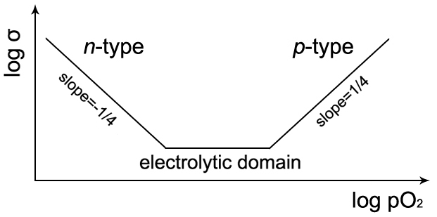
Figure 1-14. Schematic dependence of conductivity on pO₂

1.4.2 Ionic conduction
Ionic conduction, especially proton conduction, of TiO₂ has been studied by several groups ^{[80-82]}. Maglia et al. ^{[80]} investigated the conductivity of bulk nanometric TiO₂. The Arrhenius plots of conductivity are shown in Figure 1-15. Under dry atmosphere, a linear trend of the Arrhenius plot was observed. When the sample was exposed to humid atmosphere, the presence of proton conductivity was observed below 350 °C. The sample measured in humidity exhibited a conductivity value which is several orders of magnitude higher than that measured in dry atmosphere. Furthermore, the sample sintered at higher temperature showed higher relative density and lower residual porosity, leading to smaller conductivity in wet atmosphere.
Gaecia-Belmonte et al. ^{[81]} used impedance spectroscopy to study the conductivity of TiO₂ nanoparticles at different humidity. The complex plane plots are shown in Figure 1-16. A spike referred to the proton conduction was clearly observed at low frequency. Moreover, they reported that the protons were supplied mainly by chemisorbed water molecules, and the hopping sites were provided by physisorbed water molecules.
Figure 1-15. Arrhenius plots of nanometric TiO₂ with different sintering temperatures measured in wet and dry atmospheres ^{[80]} (Figure 5)
Figure 1-16. Z* plots at different relative humidity ^{[81]} (Figure 1)

1.5 Objectives and outline of this study
The original objective at the beginning of this study was to investigate the effect of pO₂ ad dc bias on the electrical properties of TiO₂-based ceramics. This was based on recent results ^{[17,83]} showing first, the oxygen deficiency in rutile and the associated level of n-type conductivity could be controlled by quenching sample from different temperatures and second, the n-type conductivity decreased on application of a dc bias during conductivity measurements.
Based on the results obtained, the objectives were redefined as: study the effect of pO₂ and dc bias on the electrical properties of TiO₂ doped with Zn, Al, Ga and Cr. The electrical properties of these doped TiO₂ are discussed in Chapter 4-7. Following initial studies which showed that doping TiO₂ with Zn was largely unsuccessful and had little effect on the electrical properties, attention has focused on three trivalent dopants: Al, Ga and Cr, which all appear to enter the rutile lattice to a certain extent and to have a major effect on the electrical properties. Phenomena that have been investigated include an n-p transition with increasing dopant content in Ga-doped TiO₂, and the new discovery of oxide ion conduction in Cr-doped TiO₂ and proton conduction in Al-doped TiO₂. The Cr-doped system is particularly interesting since the properties changed greatly with Cr doping content.
Undoped TiO₂ is talked in Chapter 3, which arose initially from the study into the effect of acceptor dopants on the electrical properties of TiO₂. In particular, the doped materials commonly showed p-type electrical conductivity and it was of interest to determine the conditions, if any, under which undoped rutile may also show p-type behavior. As part of the study, the lattice parameters of rutile quenched from various temperatures were recorded in the anticipation that chemical expansion effects associated with oxygen loss may be observed. The surprising result was obtained that indeed, chemical expansion does occur initially but is replaced by chemical contraction at higher oxygen loss. This anomalous behavior is attributed to a combination of two competing effects: oxygen loss and CS plane formation.

1.6 References
- H Tang, K Prasad, R Sanjinès, et al. J Appl Phys. 75(1994):2042-2047.
- U Diebold. Surface Sci Rep. 48(2003):53-229
- SM Gupta, M Tripathi. Chinese Sci Bull. 56(2011):1639-1657.
- JH Braun, A Baidins, RE Margabski. Prog in Org Coatings. 20(1992):105-138.
- AT Kuvarega, BB Mamba. Critical Rev in Solid State and Mat Sci. 42(2017):295-346.
- K Hashimoto, H Irie, A Fujishima. Japanese J of Appl Phys. 44(2005):8269-8285.
- A Hagfeldt, G Boschloo, LC Sun, et al. Chem Rev. 110(2010):6595-6663.
- ANB Zulkifili, K Terauchi, D Matsutake, et al. J Clean Energy Technol. 3(2015):382-387.
- A Decroly, A Krumpmann, M Debliquy, et al. Green Nanotechnology - Overview and Further Prospects. Dr Marcelo Larramendy InTech. https://www.intechopen.com/books/gr
- J Bai, BX Zhou. Chem Rev. 114(2014):10131-10176.
- DS Jeong, R Thomas, RS Katiyar, et al. Rep Prog Phys. 75(2012):076502.
- SG Hu, SY Wu, WW Jia, et al. Nanosci Nanotechnol Lett. 6(2014):729-757.
- E Gale. Semicond Sci Technol. 29(2014):104004.
- L Chua. IEEE Trans Circ Theo. 18(1971):507-519.
- Memristor Technology and its Different Types. http://www.efxkits.us/memristor-technology- different-types.
- J Nowotny, M Radecka, M Rekas. J Phys Chem Solids. 58(1997):927-937.
- Y Liu, AR West. J Am Ceram Soc. 96(2013):218-222.
- JJ Xu, ZL Tian, GH Yin, et al. Dalton Trans. 46(2017):1047-1051.
- CY Yang, Z Zhang, TQ Lin, et al. J Am Chem Soc. 135(2013):17831-17838.
- Z Lu, CT Yip, L Wang, et al. Chem Plus Chem. 77(2012):991-1000.
- S Tominaka. Inorg Chem. 51(2012):10136-10140.
- Z Zheng, B Huang, X Meng, et al. Chem Commun. 49(2013):868-870.
- K Hoshino, NL Peterson, CL Wiley. J Phys Chem Solids. 46(1985):1397-1411.
- N Ait-Younes, F Millot, P Gerdanian. Solid State Ionics. 12(1984):431-436.
- P Kofstad. J Phys Chem Solids. 23(1962):1579-1586.
- J Marucco, J Gautron, P Lemasson. J Phys Chem Solids. 42(1981):363-367.
- JS Anderson, RJD Tilley. J Solid Stat Chem. 2(1970):472-482.
- MG Blanchin, P Faisant, C Picard, et al. Phys Stat Sol. 60(1980):357-364.
- DS Aidhy, B Liu, YW Zhang, et al. Comput Mater Sci. 99(2015):298-305.
- D Marrocchelli, SR Bishop, HL Tuller, et al. Adv Funct Mater. 22(2012):1958-1965.
- SR Bishop. Acta Mech Sinica. 29(2013):312-317.
- S Andersson, B Collen, U Kuylenstierna, et al. Acta Chem Scand. 11(1957):1641-1652.
- S Andersson, B Collen, G Kruuse, et al. Acta Chem Scand. 10(1957):1635-1657.
- D Batuk, M Batuk, AA Tsirlin, et al. Angew Chem Int Ed. 54(2015):14787-14790.
- S Harada, K Tanaka, H Inui. J Appl Phys. 108(2010):083703.
- RF Bartholomew, DR Fankl. Phys Rev. 187(1969):828-833.
- C Kaito, M Iwanishi, T Harada, et al. Trans Jpn Inst Met. 24(1983):450-460.
- AR West. Solid State Chemistry and its Applications. John Wiley & Sons. 2014.
- S Zador. Electromotive Force measurements in High Temperature Systems. Institute of Mining and Metallurgy. 1968.
- RN Blumenthal, DH Whitmore. J Electrochem Soc. 110(1963):92-95.
- JF Baumard. Thèse Doctorat d’Etat des Sciences. Orléans. 1977.
- C Picard, P Gerdanian. J Solid State Chem. 14(1975):66-73.
- V Likodimos, CS Han, M Pelaez, et al. Ind Eng Chem Res. 52(2013):13957-13964.
- MS Park, SK Kwon, BI Min. Phys Rev B. 65(2002):161201.
- JF Baumard, E Tani. J Chem Phys. 67(1977):857-860.
- AW Xu, Y Gao, HQ Liu. J Catal. 207(2002):151-157.
- MMF Lima, DB Santos. Mater Sci Forum. 2003.
- M Kassmi, J Pointet, P Gonon, et al. J Appl Phys. 119(2016):244101.
- SK Kim, GJ Choi, SA Lee, et al. Adv Mater. 20(2008):1429-1435.
- A Yüce, B Saruhan. The 14th International Meeting on Chemical Sensors. 2012.
- S Kumar, NK Verma. J Mater Res. 28(2013):521-528.
- AA Murashkina, PD Murzin, AV Rudakova, et al. J Phys Chem C. 119(2015):24695-24703.
- C Gionco, S Livraghi, S Maurelli, et al. Chem Mater. 27(2015):3936-3945,
- TJ Chen, PY Shen. J Phys Chem C. 113(2009):328-332.
- YL Yu, JS Wang, W Li, et al. Cryst Eng Comm. 17(2015):5074-5080.
- F Zhu, PP Zhang, XJ Wu, et al. Chem Phys Chem. 62(2012):201200362.
- TT Duong, HJ Choi, SG Yoon. J Alloys Compd. 591(2014):1-5.
- M Sanchez-Dominguez, G Morales-Mendoza, MJ Rodriguez-Vargas, et al. J Environ Chem Eng. 3(2015):3037-3047.
- Y Zhang, LL Wang, BK Liu, et al. Electrochimica Acta. 56(2011):6517-6523.
- DK Lee, HI Yoo. Phys Chem Chem Phys. 10(2008):6890-6898.
- XM Liu, M Khan, WX Liu, et al. Ceram Int. 41(2015):3075-3080.
- NN Bao, JB Yi, HM Fan, et al. Scipta Materialia. 66(2012):821-824.
- AN Banejee, SW Joo, BK Min. J NanoMater. 2012:14.
- JM Booth, L Nguyen, CJ Rix, et al. Optoelectronic and Microelectronic Materials and Devices. 2000.
- RK Sharma, MC Bhatnagar, GL Sharma. Sensor Actuator B. 45(1997):209-215.
- E Comini, G Faglia, G Sberveglieri. Sensors IEEE. 2005.
- JY Cao, YJ Zhang, LQ Liu, et al. Chem Commun. 49(2013):3440-3442.
- XM Li, ZK Guo, T He. Phys Chem Chem Phys. 15(2013):20037-20045.
- RM Gibb, JS Anderson. J Solid State Chem. 4(1972):379-390.
- B Santara, K Imakita, M Fujii, et al. J Alloy Compd. 661(2016):331-334.
- A Bernasik, M Radecka, M Rekas, et al. Appl Surf Sci. 65/66(1993):240-245.
- JL Carpentier, A Lebrun, F Perdu. J Phys Chem Solids. 50(1989):145-151.
- K Singh, J Nowotny, V Thangadurai. Chem Soc Rev. 42(2013):1961-1972.
- MK Nowotny, T Bak, J Nowotny. J Phys Chem B. 110(2006):16270-16282.
- J Nowotny, T Bak, MK Nowotny, et al. J Phys Chem C. 112(2008):590-601.
- Hall Effect. Physics and Radio Electronics. www.physics-and-radio-electronics.com/electr onic-devices-and-circuits/semiconductor/halleffect.html
- DH Hu, Q Liu, J Tisdale, et al. Acsnano. 9(2015):5208-5213.
- Thermoelectrics. Northwestern University. http://thermoelectrics.matsci.northwestern.edu/ thermoelectrics/index.html.
- Thermoelectrics. University of Oslo. www.mn.uio.no/fysikk/english/research/projects/bate/t hermoelectricity.
- F Maglia, IG Tredici, G Spinolo, et al. J Mater Rev. 27(2012):1975-1980.
- G Garcia-Belmonte, V Kytin, T Dittrich, et al. J Appl Phys. 94(2003):5261-5264.
- A Thorne, A Kruth, D Tunstall, et al. J Phys Chem B. 109(2005):5439-5444.
- Y Liu, AR West. Appl Phys Lett. 103(2013):263508.

Chapter 2. Experimental

2.1 Solid state synthesis
Samples studied in this project were synthesized by the solid state method using the reactants shown in Table 2-1. A typical process of the solid state method is shown in Figure 2-1. Prior to weighing, raw materials were dried at different temperatures. Reactants were then mixed in an agate mortar and pestle for 40 min, with acetone added to form a paste. Reactants were mixed in stoichiometric amounts to obtain ~4 g batches. Pellets were prepared by a combination of uniaxial pressing (using a 10 mm-diameter die with a pressure of 0.4 ton) and cold isostatic pressing (with a pressure of 30 PSI). Pellets were placed in a Pt boat, heated at high temperatures (1200-1400 °C) in a muffle or tube furnace and cooled slowly (5 °C/min) inside the furnace, after which, some samples were given further heat treatment for comparison purposes.

Table 2-1. Details of raw materials
Reagent | Supplier | Particle size and purity | Drying temperature (°C)
TiO₂ | Sigma Aldrich | rutile, <5μm, ≥99.9% | 900
ZnO |  | <5μm, 99.9% | 600
Al₂O₃ |  | <10 micron, 99.8% | 900
Ga₂O₃ |  | ≥99.99% | 600
Cr₂O₃ | Johnson Matthey | 99% | 600

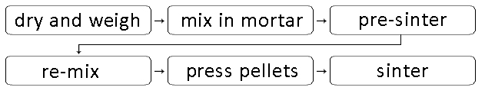
Figure 2-1. Typical process of solid state synthesis

2.2 Density
The theoretical density of electroceramics can be calculated by:
$ρ_{th}=\frac{nM}{NV}$ (2-1)
where n is the number of formula units in each unit cell, M is the molar mass, N is the Avogadro constant and V is the volume of unit cell. The unit cell volume, V, can be obtained from the X-ray Diffraction data. The actual density of samples was simply calculated by:
$ρ_{a}=\frac{m}{v}$ (2-2)
where m is the mass of pellets and v is the volume of pellets.

2.3 X-ray diffraction

2.3.1 Fundamental
X-ray diffraction, XRD, is an advanced technique used for revealing information about crystal structure, phase analysis, etc. ^{[1]}. X-rays were first found by Roentgen in 1895 when he was studying cathode-rays. In 1912, Laue proved the wave nature of X-rays. Following, the Braggs determined crystal structures by X-rays and obtained an equation, the Bragg's law ^{[1]}. These discoveries have made remarkable contributions to X-ray crystallography.

(1) Generation of X-rays
X-rays are produced when matter is irradiated by a beam of high-energy charged particles. In the laboratory, a tungsten filament is acted as the source of high-energy particles, i.e. electrons. Figure 2-2 shows schematic cross-section of a typical sealed-tube for X-ray generation. In experiments, first, the filament is heated to produce electrons; then, electrons are accelerated in a high-voltage (20-60 kV) electric field and collide with a metal target ^{[1-5]}. Cu, Cr, Fe, Co and Mo are commonly used target materials ^{[5]}.
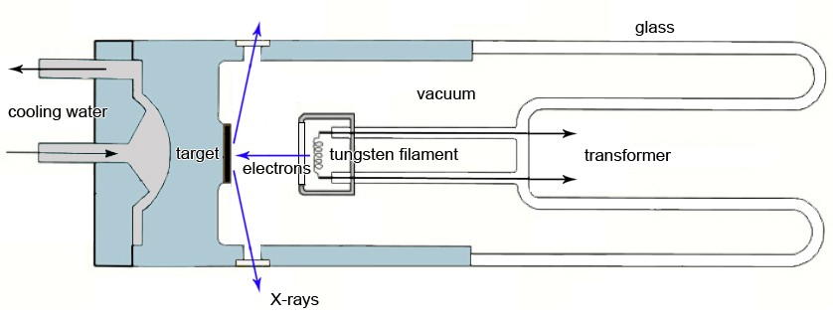
Figure 2-2. Schematic cross section of a sealed-tube
(2) Continuous spectrum
In the X-ray tube, when the beam electrons hit the target, their kinetic energy will reduce. During such deceleration, the electrons emit continuous spectrum of X-rays ^{[4]}. Figure 2-3 shows the continuous X-ray emission spectrum of Cu at different voltages. Continuous spectrum is usually monotonic and smooth.
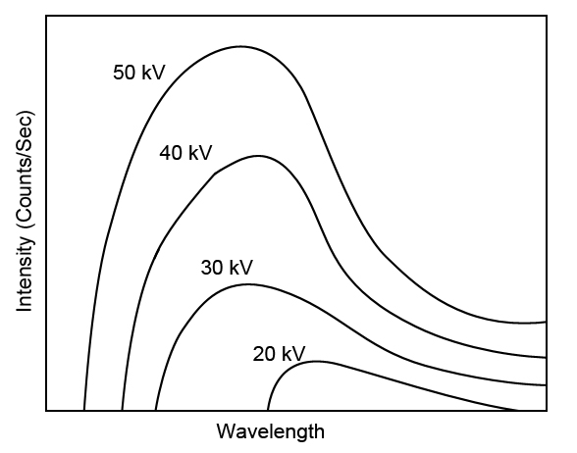
Figure 2-3. Continuous X-ray spectrum of Cu at different voltages

(3) Characteristic radiation
When the energy of the beam electrons is higher than a certain value (controlled by the target material), characteristic radiation appears, which shows discrete peaks in the X-ray spectrum. The characteristic peak results from the collision between electrons and the target materials. First, the collision ejects a tightly bound electron from the inner shell and leaves a vacancy. An electron in the outer shell then drops down into the inner shell to fill the vacancy. Consequently, energy differences between two levels give the radiation. As shown in Figure 2-4(a), if the vacancy in K-shell is filled by an electron from the L-shell, such radiation is called Kα radiation; If the vacancy is filled by an electron from the M-shell, such radiation is called Kβ radiation. In the Cu X-ray spectrum, when the resolution is high, Kα is seen to be a doublet: Kα₁ and Kα₂. Kβ has a wavelength of ~1.39 Å, while Kα₁ (~1.541 Å) and Kα₂ (~1.544 Å) have larger wavelengths ^{[1-5]}.
In laboratory, since the diffraction experiments usually require an essentially monochromatic X-ray source, the Kβ radiation has to be removed by a metal filter. For Cu radiation, Ni is the most commonly used foil filter ^{[5]}. To remove the Kα₂ radiation, a channel-cut monochromator is always used ^{[6]}.
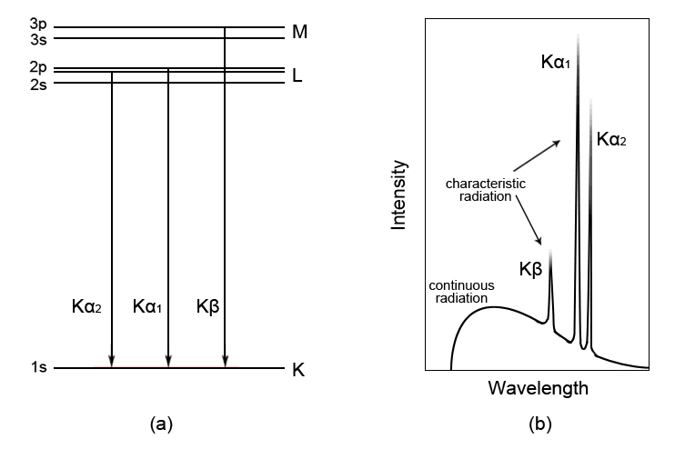
Figure 2-4. (a) Generation of Cu X-rays (b) X-ray emission spectrum of Cu

(4) Interaction of X-rays with matter and Bragg’s law
As shown in Figure 2-5, when X-rays bombard a crystal, they interact with atoms and generate scattered X-rays. Specifically, the incident X-rays are scattered by the electrons in each atom. Those electrons then act as a new radiate point source. Consequently, such scattered waves interfere with each other. In order for two waves to interfere constructively, Figure 2-6, they must be in phase ^{[1-4]}, i.e. the difference in their travel paths should be equal to nλ. As shown in the Bragg’s law, eq’n (2-3), d is the spacing of the crystal lattice, n is an integer, λ is the wave length of X-rays, and θ is the angle of incident X-rays.
2dsinθ=nλ (2-3)
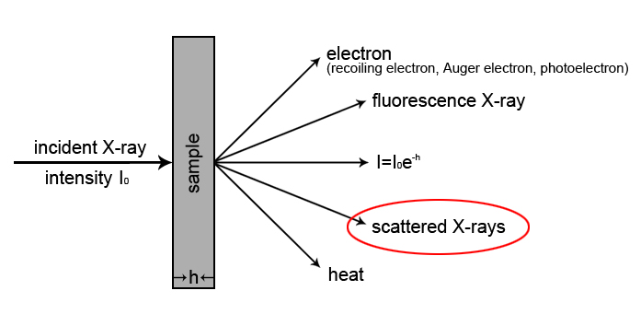
Figure 2-5. X-ray interacts with a sample

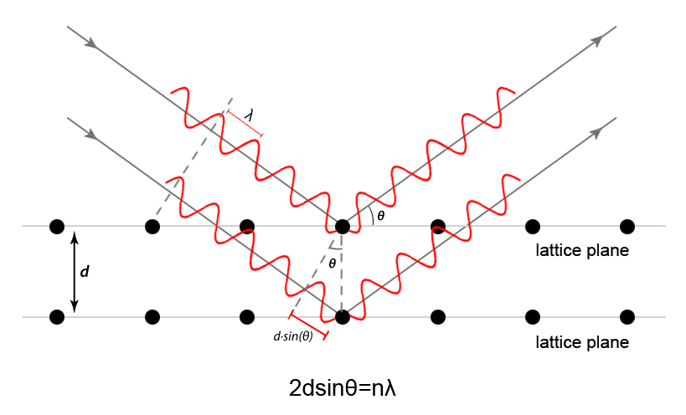
Figure 2-6. Principle of Bragg's law
Typical XRD equipment has several essential components: X-ray generator, goniometer, detector, measuring circuit, recording and analyzing system. The essential features of a conventional XRD equipment are shown in Figure 2-7 ^{[1-6]}.
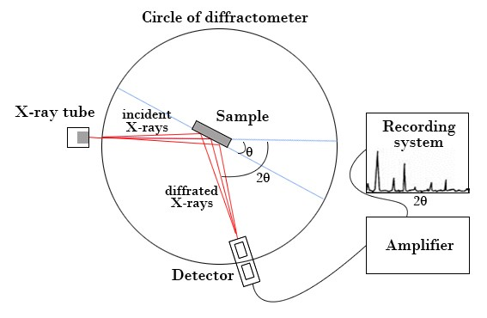
Figure 2-7. Basic features of a typical XRD equipment

2.3.2 Experimental
In this project, X-ray diffraction was used to determine phases present and lattice parameters. To study the phases present, powdered samples were prepared by using the same sintering condition with pellets. 2 g samples were placed in a holder and analyzed by XRD using a Siemens D5000 Diffractometer with a linear position-sensitive detector. Patterns were recorded in the range 10°<2θ<80°. A step size of 0.2° was used with a scan rate of 20 s/step.
To obtain accurate lattice parameters, samples were remeasured with internal silicon standard. First, some sintered pellets were crushed into powder and ground in an agate mortar and pestle to form fine powdered samples. 0.01 g mixture of sample and silicon powders were placed on a transparent thin plastic disc and mixed with a drop of PVA glue to form a thin paste. After the paste was dry, the plastic disc was put into a holder and analyzed by XRD using a STOE-STADI Cu PSD Diffractometer. Patterns were recorded in the range 10°<2θ<100°. A step size of 0.2° was used with a scan rate of 80 s/step.
Compare with Siemens D5000, the main advantage of STOE-STADI Cu PSD is that it could filter Kα₂ radiation by a single crystal monochromator. Therefore, for samples with tetragonal structures, such as rutile TiO₂ used in this project, it will be easier to observe (002) and (200) in XRD patterns.
Lattice parameters were determined by refinement of XRD data using the software WinXPow (ver.2.10, STOE&Cie GmbH, Hilpertstr., Germany). By comparing the position of internal silicon standard, a linear polynomial was created and calculated so that the position of all peaks could be calibrated. For all refinements, the final 2Theta window was less than 0.03° and the maximum delta (2Theta) was less than 3*average.

2.4 Impedance spectroscopy
Impedance spectroscopy, IS, is an advanced technique to characterize the microstructure and electrical properties of electroceramics. By applying an alternating voltage, impedance can be measured in the frequency domain. A great strength of impedance spectroscopy is that with appropriate data analysis, different electrically-active regions, such as grain, grain boundary and surface layer could be characterized ^{[9,10]}.

2.4.1 Theory
Impedance is a vector quantity which can be expressed by the sum of a real component (Z’) and an imaginary component (Z”), Z*=Z’–jZ”, where the imaginary number j=√-1. The magnitude and direction of Z* are plotted in Figure 2-8. Three other complex formalisms can be measured using impedance spectroscopy or derived from Z*: (i) the complex admittance Y*=(Z*)⁻¹; (ii) the complex electric modulus M*=jωC_{o}Z*, where ω is the angular frequency and C_{o} is the vacuum capacitance; (iii) the complex permittivity ε*=(M*)⁻¹.
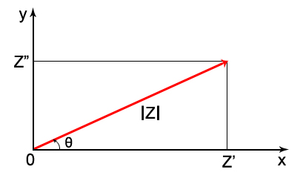
Figure 2-8. Z* plotted as a vector

Impedance is usually defined as Z=V/I and contains resistive (R) and reactive (L and/or C) components, both of which must be determined. For an ideal electroceramic sample, the electrical response to an ac voltage can be characterized by a resistance and a capacitance, usually placed in parallel, Figure 2-9(a). The Nyquist plot, Z” versus Z’, for the parallel RC circuit is a semicircle, as shown in Figure 2-9(b).
An equivalent circuit, such as Figure 2-9(a), could always help to model the electrical response and analyze impedance measurement data. The circuit usually contains a series of parallel elements. Each parallel element stands for a component. The equivalent circuit shown in Figure 2-10 is widely used to represent bulk and grain boundary phenomena.
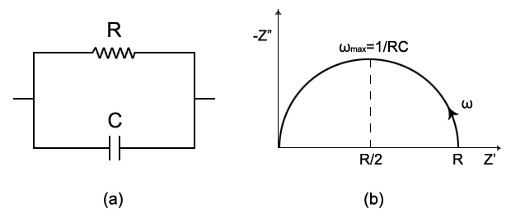
Figure 2-9. Schematic of (a) equivalent circuit and (b) complex impedance plot of a parallel RC circuit

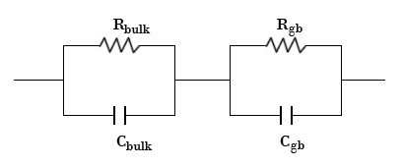
Figure 2-10. A commonly-used equivalent circuit to represent bulk and grain boundary phenomena

From the impedance spectrum, it is usually possible to identify different components based on their different capacitance values. In order to know the factors that control the magnitude of the capacitance values of different components, we consider the idealised ceramic using a brickwork model ^{[10]}, Figure 2-11. As we know, the capacitance can be given by:
$C=ε^{'}e_{0}\frac{A}{l}$ (2-4)
where $e_{0}$ is the permittivity of free space. Therefore, the capacitance values are controlled by the thickness of different components. Typical capacitance values and their possible interpretation are listed in Table 2-2 ^{[9,10]}.
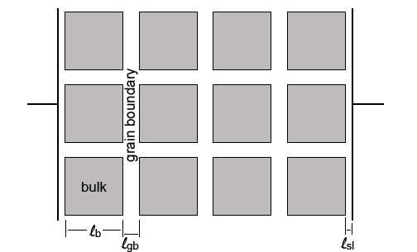
Figure 2-11. Brickwork model for an idealised ceramic

Table 2-2. Capacitance values and their possible interpretation ^{[9,10]}
Capacitance (Fcm⁻¹) | Phenomenon responsible
10⁻¹² | Bulk
10⁻¹¹ | Minor, second phase
10⁻¹¹-10⁻⁸ | Grain boundary
10⁻¹⁰-10⁻⁹ | Bulk ferroelectric
10⁻⁹-10⁻⁷ | Surface layer
10⁻⁷-10⁻⁵ | Sample-electrode interface
10⁻⁴ | Electrochemical reaction

2.4.2 Experimental
In this project, impedance spectroscopy was used to determine electrical properties. Before measurements, pellets were fabricated with electrodes prepared from Pt paste, heated at 900 °C for 2 h to remove the organic material and harden the Pt electrodes. Samples were placed in a crucible and heated in a tube furnace with a heating/cooling rate of 10 °C /min. After that, pellets with electrodes were loaded into a jig and placed in a tube furnace to carry out impedance measurements.
A combination of Agilent 4980A precision LCR meter (Agilent Technology, California, USA) and Modulelab XM Solartron analyzer (Solartron Analytical Ltd, Farnborough, UK) was used for open air measurements, of which the frequency were 0.01 kHz-1000 kHz and 0.01 Hz-1000 kHz respectively. Measurements at cryogenic temperatures were made by using a Cryocooler (Oxford Instruments Superconductivity, Abingdon, UK). A Solartron SI 1260 impedance analyzer (Solartron Analytical Ltd, Farnborough, UK) was used with a frequency range 0.01 Hz-1000 kHz for measurements under different oxygen partial pressure. The applied ac voltage for all samples was 100 mV. The jigs used for impedance measurements are shown in Figure 2-12.

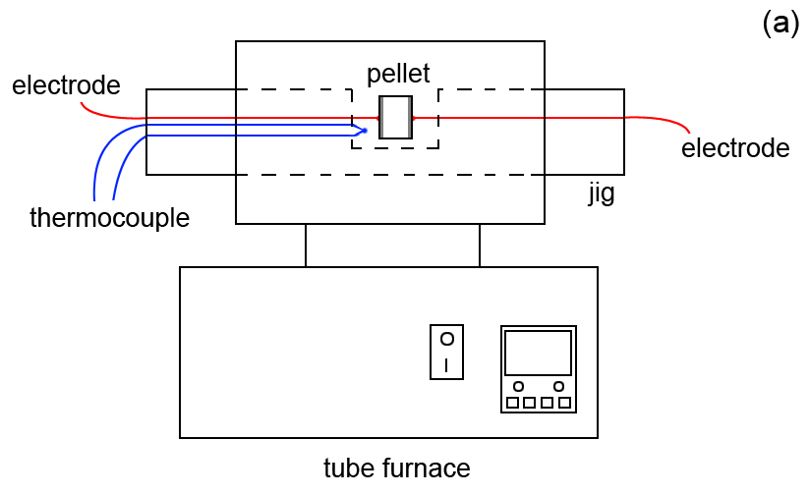
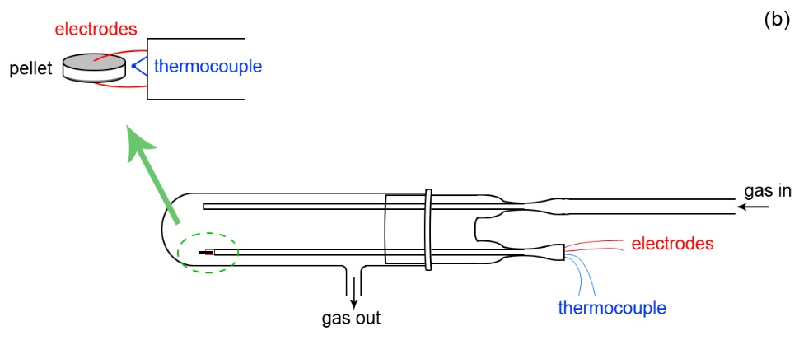
Figure 2-12. (a) The compression jig and (b) atmosphere jig

ZView software (Scribner Associates Inc, USA) was employed for data analysis. A geometric factor (GF) was needed for normalizing IS data. GF could be calculated as $gf={π{(d/2)}^{2}}/h$, shown in Figure 2-13. Arrhenius plots of conductivity against reciprocal temperature were plotted using IS data. The activation energy was calculated from the slope of Arrhenius plots.
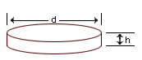
Figure 2-13. Calculation of geometric factors

2.5 EMF measurement

2.5.1 Introduction to oxide ion conductors
Oxide ion conductors are solid oxides that contain highly mobile oxide ions, which play an important role in fuel cells and oxygen sensors. In oxide ion conductors, current flow usually occurs by the movement of oxide ions, and the movement can be seen as the thermally activated hopping of oxide ions. Thus, the ionic conductivity of oxide ion conductors depends on temperature strongly ^{[11]}. Conductivity data of some typical oxide ion conductors are shown in Figure 2-14 ^{[3]}, of which the best-known one is yttria-stabilized zirconia, YSZ. In order to determine whether a sample is an oxide ion conductor or not, electromotive force, EMF, measurement is needed to measure the oxide ion transport number.
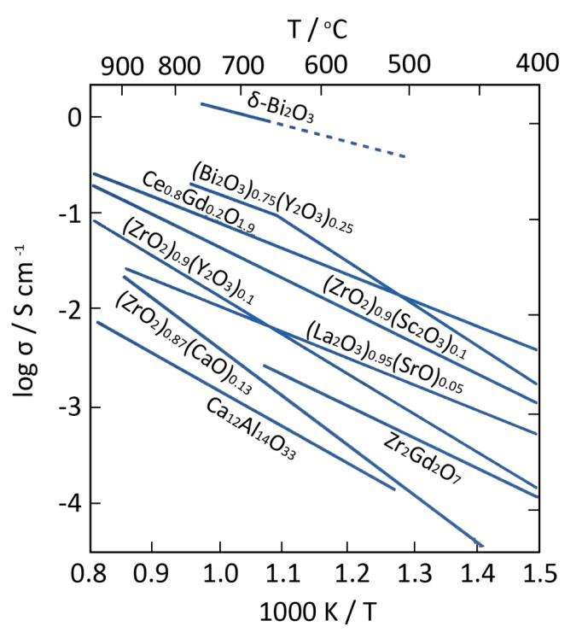
Figure 2-14. Conductivity data of some oxide ion conductors ^{[3]}

2.5.2 Experimental
In this project, oxide ion transport numbers were measured by using a Probostat system (NorECs Norwegian Electro Ceramics AS, Oslo, Norway). Figure 2-15 illustrates a schematic diagram of the setup for the EMF system and the cross-section of the tube.
A 20 mm-diameter pellet was prepared for EMF measurements. The pellet was pressed by uniaxial pressing with a pressure of 2 ton and cold isostatic pressing with a pressure of 30 PSI. After sintering, the pellet was coated with Pt electrodes on both sides.
As shown in Figure 2-15, the pellet was sealed onto a YSZ tube by glass frit. The YSZ tube here, with Pt coating on both sides, acted as an oxygen partial pressure monitor. There were four Pt wires which were connected to the inner sample electrode, outer sample electrode, inner YSZ tube electrode and outer YSZ tube electrode, respectively. During the measurement, the atmosphere outside the YSZ tube was kept as air. N₂ or O₂ was flowed into the YSZ tube via a gas tube, contacting the inner side of the sample and the tube. Thus, a difference in oxygen partial pressure was created. As YSZ is a pure ionic conductor, by measuring the voltage between inner and outer electrodes, we could compare the sample with YSZ and calculate the oxide ion transport numbers. Thus, the presence of oxide ion conduction was determined. All the voltages were measured by a Keithley 175 Autoranging Multimeter (Keithley, Ohio, USA). Measurements were taken at various temperatures between 600 °C and 800 °C. The heating/cooling rate of the furnace was 3 °C /min.
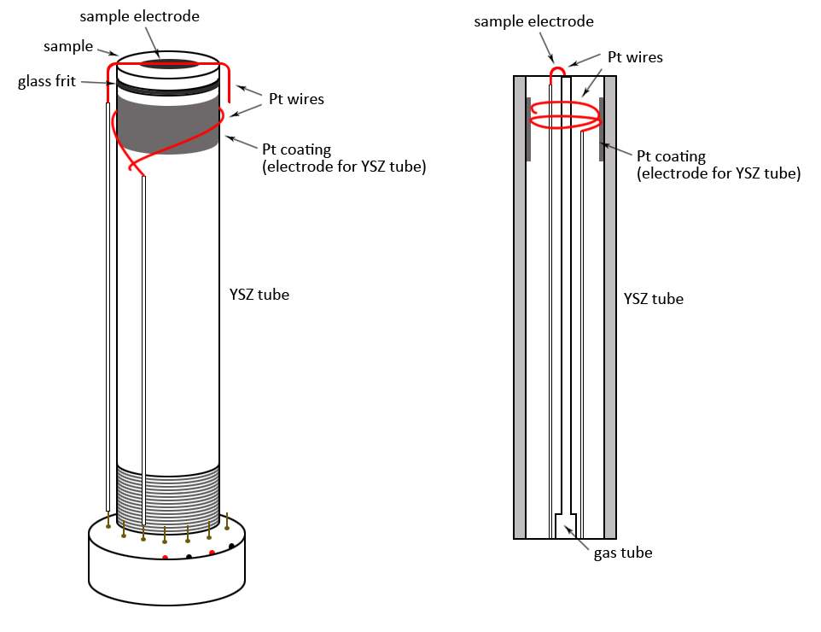
Figure 2-15. Schematic diagram of the setup for EMF measurement system

2.6 Quenching
Samples for quenching were put inside a Pt envelope and reheated in a vertical tube furnace, Figure 2-16, for several hours. A quenching media (liquid nitrogen) container was placed under the furnace. For quenching, a current is passed from the Pt wires. Consequently, the fine Pt wires attached with the envelope melt, and the sample drops into the liquid nitrogen.
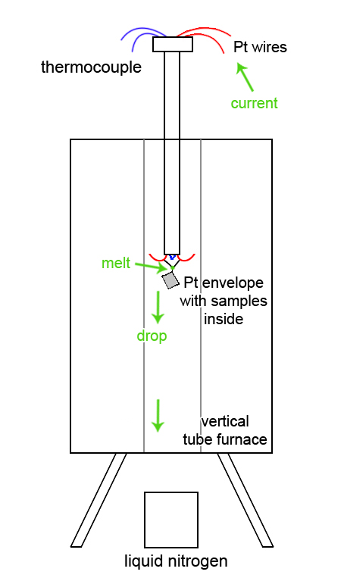
Figure 2-16. Schematic quench furnace

2.7 References
- F Wang. Modern materials testing methods. Beijing institute of technology press. 2006.
- D Henry and D Mogk. X-ray reflection in accordance with Bragg's Law. Montana State University. https://serc.carleton.edu/research_education/geochemsheets/BraggsLaw.html
- AR West. Solid state chemistry and its application. John Wiley & Sons. 2014.
- Y Leng. Materials Characterization. John Wiley & Sons. 2010.
- JK Cockcroft. Advanced certificate in powder diffraction. School of crystallography, Birkbeck College, University of London. http://pd.chem.ucl.ac.uk/pdnn/pdindex.
- BB He. Two-dimensional X-ray Diffraction. John Wiley & Sons. 2018.
- SE Dann. Reactions and characterization of solids. Royal Society of Chemistry. 2002.
- DA Skoog, FJ Holler, SR Crouch. Principles of instrumental analysis. Thomson Brooks. 2007.
- DC Sinclair. Bol Soc Esp Ceram Vidrio. 34(1995):55-65.
- JTS Irvine, DC Sinclair, AR West. Adv Mater. 2(1990):132-138.
- SJ Skinner, JA Kilner. Materialstoday. 6(2003):30-37.

Chapter 3. Undoped TiO₂

3.1 Introduction
TiO₂ is an important functional material with a diverse range of applications in the form of either ceramics, films or nanoparticles. For instance: TiO₂ has good brightness and can block UV light, which gives it applications as a component of white paints; TiO₂ is a promising and critical photoanode material of Dye-Sensitized Solar Cells (DSSCs) since it has unique photovoltaic and photochemical properties; it is widely employed as a photo-catalyst and was the key active component of the first memristor ^{[1-4]}.
In its pure form, TiO₂ is a white insulating solid with a bandgap of 3.2 eV. On heating, it increasingly loses a small amount of oxygen above ~700 °C in air which is accompanied by a large increase in electronic conductivity. For instance, ceramics quenched from 1300 °C are good n-type semiconductors with typical value 10⁻¹ Scm⁻¹ and activation energy 0.01 eV over a wide temperature range down to 20 K ^{[5]}. The loss of oxygen is reversed on slow-cooling in air. More extensive oxygen loss occurs on heating in a reducing atmosphere giving rise to so-called “black rutile” ^{[6,7]}.
Crystallographic shear (CS) structures in non-stoichiometric rutile were first found by the Magnéli group ^{[8]}. They reported that certain transition metal oxides, e.g. TiO₂, WO₃ and MoO₃, formed series of homologous shear structures, rather than continuous solid solutions, on reduction. Their discovery had a strong impact on understanding the crystal chemistry and defect structures of non-stoichiometric compounds. Heavily-reduced rutile forms a homologous series of phases of general formula Ti_{n}O_{2n-1} based on CS structures. The oxygen vacancies that form on initial reduction are subsequently eliminated by a partial collapse of the structure to form the CS planes. A study of lightly-reduced rutile by transmission electron microscopy, TEM, showed the presence of random CS planes in a sample quenched from 1050 °C and annealed at lower temperature ^{[9]}.
Memory devices have attracted substantial interest due to their potential applications in electronic circuits. The voltage-dependent resistance of TiO₂ has been reported by sereval groups ^{[10-12]}. Some early literature based on TiO₂ thin films showed that the resistance decreased on application of dc bias and the switching mechanism involved coupled ionic and electronic transport across interfaces, whereas TiO₂ ceramics showed an increased resistance with dc bias. This effect was controlled by the changes in equilibrium between different oxygen species at ceramic surfaces.
The present work arose initially from a study into the effect of acceptor dopants on the electrical properties of rutile. In particular, the doped materials commonly showed p-type electrical conductivity and it was of interest to determine the conditions, if any, under which undoped rutile may also show p-type behavior. As part of this study, the lattice parameters of rutile quenched from various temperatures were recorded in the anticipation that chemical expansion effects associated with oxygen loss may be observed. The surprising result was obtained that indeed, chemical expansion does occur initially but is replaced by chemical contraction at higher oxygen loss. This anomalous behavior is attributed to a combination of two competing effects: oxygen loss and CS plane formation. The purpose of this chapter is to study the effect of processing conditions, and to investigate the structural and electrical properties of both oxygen-stoichiometric and non-stoichiometric rutile ceramics.

3.2 Experimental
For structural characterization of samples with different oxygen stoichiometry, pure rutile, TiO₂, powders were used as-received. Initially, samples were sintered at 900 °C in air for 6 h to remove any volatile material and convert any anatase particles to rutile. Small quantities were then heated in Pt envelopes in a vertical tube quench furnace in atmospheres of either air or N₂ for 1 h before quenching into liquid N₂. Most samples were heated in air before quenching, but some were heated in N₂. For X-ray diffraction, a STOE-STADI Cu PSD diffractometer with Si internal standard for accurate lattice parameter measurement was used.
For electrical property measurements, pellets were prepared by either uniaxial pressing or cold isostatic pressing, sintered at 1250 °C for 8 h and cooled slowly to room temperature (cooling rate 5 °C/min) to give a final relative density of ~92%. For selected experiments, samples were given different heat treatments then: (i) reheated in air for 1 h at 1350 °C and quenched into liquid nitrogen (cooling rate ~10k °C/min); (ii) after quench, samples were annealed at 500 °C/600 °C for several hours. Electrodes were fabricated on opposite pellet faces using Pt paste which was decomposed and hardened by heating at 900 °C for 2 h for most samples; for selected experiments, InGa alloy was used also as electrodes. A combination of Agilent 4980A, Modulelab XM Solartron and Solartron SI 1260 instrumentation was used; for subambient measurements, an Oxford Cryocooler was used. A nominal ac voltage of 100 mV was used; in addition, a dc bias in the range 1-2 V was applied during some of the impedance measurements.

3.3 Results and discussion

3.3.1 Lattice parameters and chemical expansion/contraction
Refined lattice parameters for rutile powders heated in either air or N₂ and quenched into liquid N₂ are shown in Figure 3-1 and Table 3-1. Data are also shown for a sample that was slow-cooled from 1250 °C in air.

Table 3-1. Lattice parameters of TiO₂ with different cooling condition
Cooling condition | Lattice parameters
 | a=b ($Å$) | c ($Å$) | cell volume ($Å^{3}$)
Heated in air, slow-cooled from 1250 °C | 4.5920(4) | 2.9572(3) | 62.358(8)
Heated in air, quenched from 700 °C | 4.5923(1) | 2.9577(1) | 62.372(3)
Heated in air, quenched from 800 °C | 4.5939(2) | 2.9589(1) | 62.443(6)
Heated in air, quenched from 900 °C | 4.5961(1) | 2.9606(1) | 62.537(3)
Heated in air, quenched from 1000 °C | 4.5995(2) | 2.9628(2) | 62.680(4)
Heated in air, quenched from 1100 °C | 4.5996(2) | 2.9628(1) | 62.684(4)
Heated in air, quenched from 1200 °C | 4.5999(4) | 2.9625(4) | 62.686(9)
Heated in air, quenched from 1300 °C | 4.5982(4) | 2.9625(4) | 62.636(8)
Heated in N₂, quenched from 1200 °C | 4.5941(1) | 2.9594(1) | 62.459(4)
Heated in N₂, quenched from 1280 °C | 4.5922(2) | 2.9580(2) | 62.381(4)
Heated in N₂, quenched from 1300 °C | 4.5917(1) | 2.9579(1) | 62.364(4)

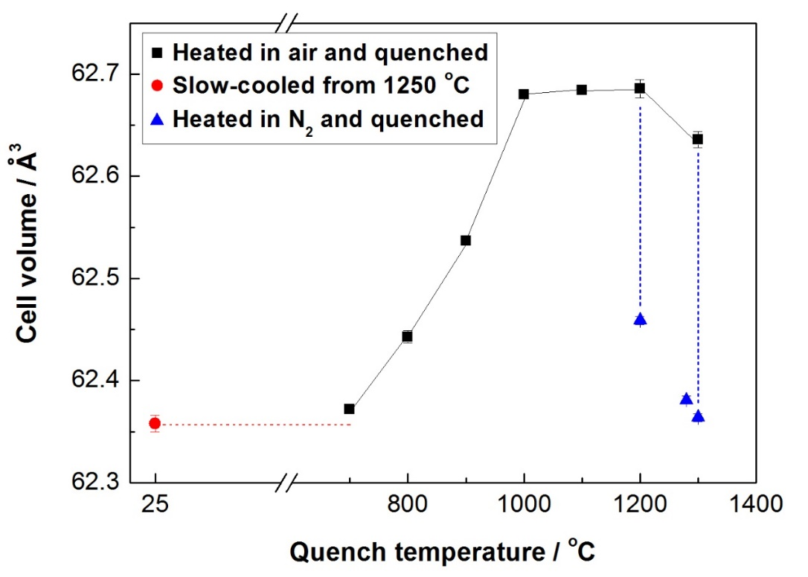
Figure 3-1. Cell volume against quench temperature; samples were quenched after annealing in either air or N₂; data for a slow-cooled sample are also shown
Lattice parameters and cell volume of samples quenched from 700-1000 °C increase increasingly rapidly with quench temperature and then show a slight increase between 1000-1200 °C before decreasing above 1200 °C, especially for the sample annealed in N₂.
It is well-known that when most materials are heated, their volume increases in small increments, in a phenomenon known as thermal expansion. Generally, the thermal expansion is reversible, i.e., during cooling, materials contract to their original size and the test could be repeated with no significant change ^{[13]}. All of the data shown in Figure 3-1 were recorded at room temperature and therefore, should not show any effects associated with standard thermal expansion. The increasing lattice parameters over the range 700-1000 °C are instead attributed to chemical expansion associated with increasing loss of oxygen from the sample with increasing quench temperature by the reaction mechanism:
$O_{O}^{×}↔V_{O}^{••}+2e^{'}+\frac{1}{2}O_{2}(g)$ (3-1)
to give non-stoichiometric rutile of general formula TiO_{2-δ} (where $O_{O}^{×}$ means oxide ions on a normal lattice site, $V_{O}^{••}$ means double-charged oxygen vacancies, $e^{'}$ means electrons in the conduction band and $O_{2}$ means gaseous oxygen). A consequence of oxygen loss is the generation of electrons which effectively reduce some Ti⁴⁺ to Ti³⁺. A combination of the larger radius of Ti³⁺ and a weaker Ti-O bond strength leads to chemical expansion associated with an increase in average Ti-O bond length, similar to that reported with other oxides ^{[14,15]}. The oxygen loss is preserved in rapidly quenched samples but can be regained by slow cooling in air or oxygen. The chemical expansion caused by oxygen loss is illustrated in Figure 3-2.
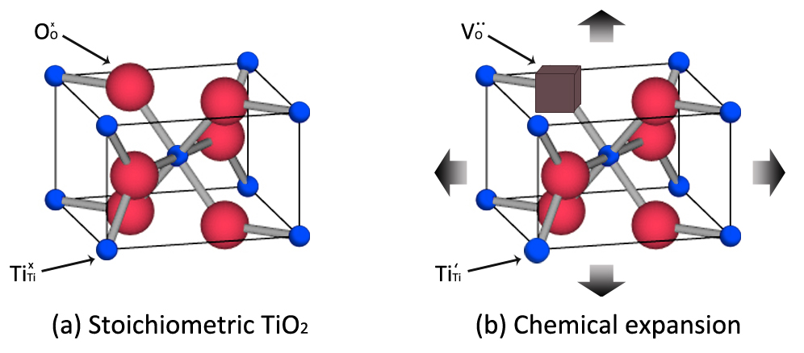
Figure 3-2. Schematic chemical expansion caused by oxygen loss

The decrease in lattice parameters above 1200 °C, especially for the sample heated in N₂ requires a different explanation because at these temperatures, further oxygen loss and continued lattice expansion is anticipated. It is well-established that CS structures form in materials such as acceptor-doped TiO₂, Nb₂O₅, MoO₃ and WO₃ as a means of eliminating oxygen vacancies; this leads to a partial collapse of the crystal structures to form CS planes which would be accompanied by a reduction in volume. We consider that similar CS planes form in oxygen-deficient rutile especially as the degree of oxygen-deficiency increases. At this stage, we have no direct evidence ourselves for the CS planes, nor whether they are random planar defects in the rutile lattice or form ordered structures. There is, however, clear evidence in the literature ^{[9]} of CS plane formation in samples of composition TiO_{1.9970} which were quenched from 1050 °C and subsequently annealed at lower temperature. From the data shown in Figure 3-1, it appears that CS planes start to form at temperatures as low as 1100 °C where the lattice expansion due to oxygen loss begins to be offset by the lattice contraction associated with CS plane formation.
Figure 3-3 illustrates how CS structures might form on reduction of rutile TiO₂: (a) Oxygen-stoichiometric TiO₂ has a body-centered tetragonal unit cell. The titanium cations are surrounded by an octahedron of 6 oxygen anions. (b) Upon reduction, Ti⁴⁺ cations are reduced to Ti³⁺ and oxygen deficiency occurs. In particular, the oxygen vacancies are not random but are located on certain planes. Thus, the rutile structure is divided into blocks. (c) As such a structure is unstable, blocks collapse by a shear displacement vector and the oxygen-deficient layer is eliminated. Therefore, CS plane is formed (outlined in red line in the schematic illustration) ^{[16,17]}. Such CS structure may lead to the lattice contraction.
Figure 3-3. Schematic formation of CS planes in reduced TiO₂ ^{[17]} (Figure 2)

3.3.2 Electrical properties of slow-cooled TiO₂
TiO₂ pellets slow-cooled (5 °C /min) in air from 1250 °C were characterized by impedance spectroscopy. Calculated pellet densities were 90-94% of the theoretical density. Impedance measurements were carried out as a function of frequency.
A typical set of impedance data is shown in Figure 3-4. The impedance complex plane plot, (a), shows two arcs, which indicates that the sample contains two main resistances, R₁ and R₂. The total resistance, R_{t}, is given by R₁+R₂. Z”/M” plots, (b), show one Debye peak in M” and two in Z”. The high frequency Z” peak is overlapped with the M” peak at the frequency ~300 kHz, which means these two overlapped peaks are associated with the same component. The M” spectrum has f_{max} ~300 kHz, R ~8.8×10⁴ Ωcm, C ~9.8×10⁻¹² F/cm and therefore corresponds to the bulk. The Z” spectrum has the low-frequency peak with f_{max} ~200 Hz, R ~1.1×10⁵ Ωcm, C ~5.8×10⁻⁹ F/cm, and is assigned to a conventional grain boundary. Spectroscopic plots of capacitance C’ at different temperatures are illustrated in (c). A plateau at high frequency is observed with the value of ~8.8 pFcm⁻¹ corresponding to a bulk permittivity of ~100, which agrees with the expected permittivity value for TiO₂. Also, a poorly-resolved plateau is observed at lower frequency with the value 4-7 nFcm⁻¹, and therefore is attributed to a grain boundary.
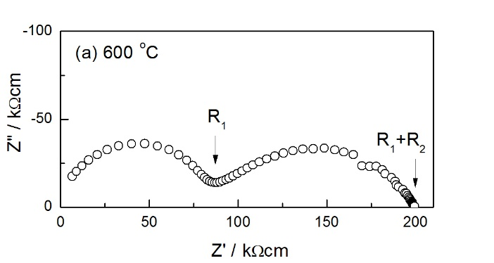
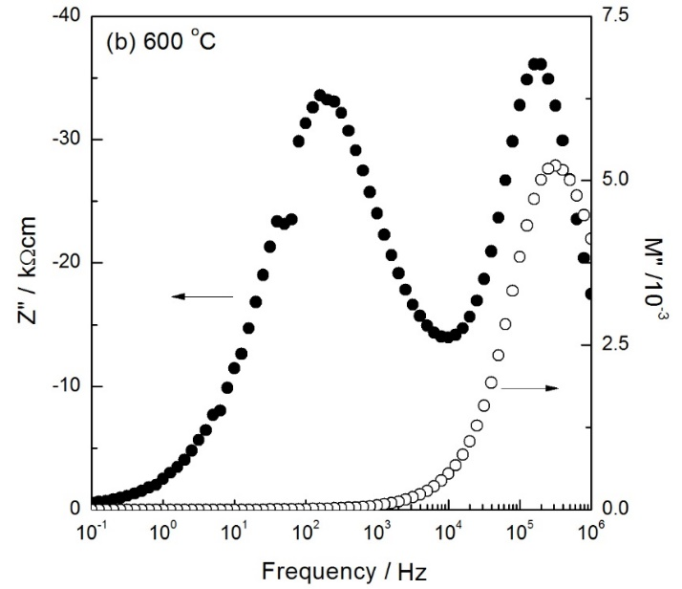
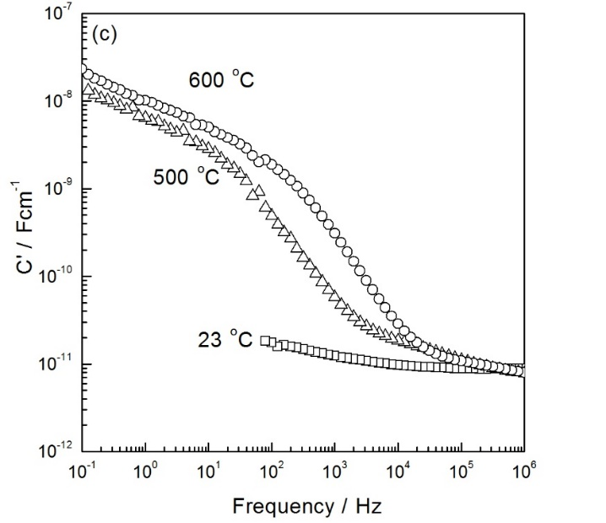
Figure 3-4. Typical impedance data of TiO₂ slow-cooled from 1250 °C (a) impedance complex plane plot (b) and Z”/M” spectroscopic plots measured at 600 °C, (c) spectroscopic plots of capacitance at different temperatures

Conductivity data of R₁, R₂ and R_{t} are plotted in Arrhenius format in Figure 3-5. The activation energy value of $σ_{total}$, 1.63 eV, corresponds approximately to half the band gap for TiO₂. Arrhenius behavior can be described as:
$σ=σ_{0}exp(-\frac{E_{a}}{kT})$ (3-2)
where $σ$ is the conductivity; $σ_{0}$ is the pre-exponential factor; k is the Boltzmann constant (8.6173303×10⁻⁵ eV/K); T is the measurement temperature and E_{a} is the activation energy, which can be defined as the energy barrier to be overcome for a chemical reaction or physical process.
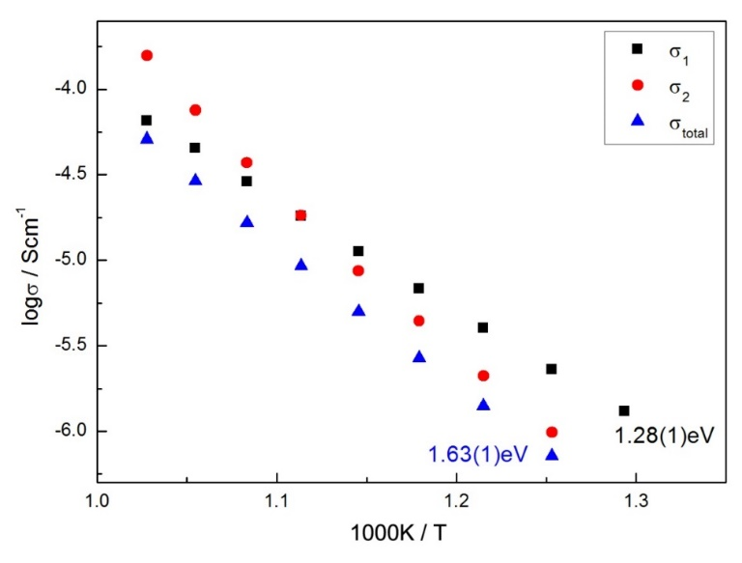
Figure 3-5. Arrhenius plots of TiO₂ slow-cooled from 1250 °C

It is notable that the Arrhenius plot of $σ_{2}$ looks non-linear, as shown in Figure 3-6(a). The interpretation is that during impedance measurements on heating, TiO₂ lost oxygen. The oxygen loss resulted in an n-type behavior, therefore the sample was more conductive at high temperatures. Since the Arrhenius plot of $σ_{1}$ was linear but $σ_{2}$ was not, it indicated that during heating, the grain boundary was easier to lose oxygen than the bulk. As shown in Figure 3-6(a), the grain boundary started to lose oxygen from temperatures as low as ~650 °C.
In order to see if the conductivity data $σ_{2}$ are reversible on cooling, impedance measurements were carried out from 700 °C to 550 °C, as shown in Figure 3-6(b). The conductivity data are almost fully reversible on cooling, but $σ_{2}$ measured at 550 °C is slightly smaller. The possible reason is that the original sample was not completely oxidized and therefore, its conductivity on cooling at 550 °C was lower because it had enough time to oxidize fully. The effect is very small however.
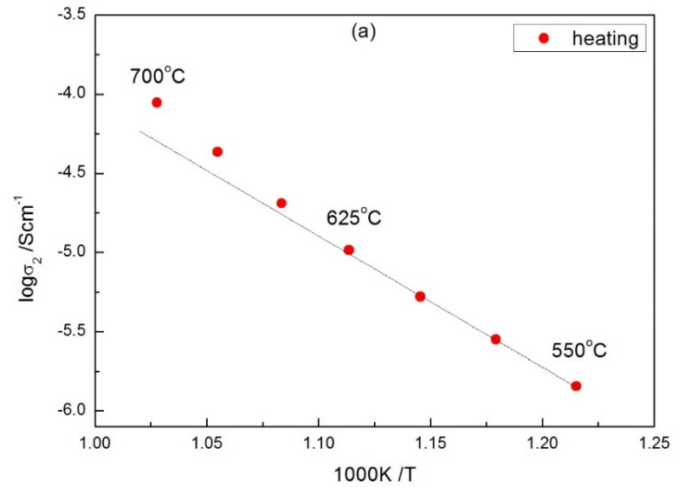
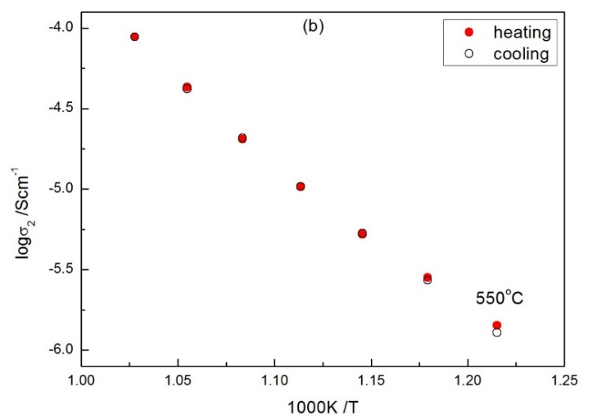
Figure 3-6. Arrhenius plots of $σ_{2}$ during heating and cooling on TiO₂

In summary, TiO₂ slow-cooled from 1250 °C was electrically inhomogeneous. The total resistance, R_{t}, was given by a resistive bulk and grain boundary. The Arrhenius plot of grain boundary conductivity was non-linear. The possible reason was that the grain boundary was easier to lose oxygen on heating. It could lose oxygen as low as ~650 °C. The difference in the sample bulk and the grain boundary impedances may result from several possible reasons: composition, oxygen content and structure.

3.3.3 n-p transition in TiO₂

3.3.3.1 Results
It is well-established that rutile loses an increasing amount of oxygen with increasing temperature above 700 °C ^{[5]}. The resulting material is an n-type semiconductor as shown by first, an increase in conductivity with decreasing oxygen partial pressure, pO₂, in the atmosphere surrounding the sample during impedance measurements, eq’n (3-1) and second, by a decrease in conductivity on application of a small dc bias voltage during the impedance measurements ^{[5,12]}. Although the amount of oxygen loss was barely detectable by thermogravimetry, dramatic changes in conductivity were observed and for instance, in rutile quenched from 1300 °C with an estimated stoichiometry of δ=0.001 in TiO_{2-δ}, the conductivity value was ~10⁻¹ Scm⁻¹ for temperatures down to 20 K ^{[5]}.
In this chapter, we focus on rutile ceramics annealed between 700 and 450 °C. For atmosphere and dc bias measurements, the sample was equilibrated sequentially in O₂, air and N₂ for 3 h at each temperature prior to impedance measurements. Measurements commenced at 700 °C and were repeated on stepwise cooling at 50 °C intervals over the range 700-450 °C. Separate tests showed that the conductivity changes on changing pO₂ were essentially reversible and reached a steady state after 1-2 h.
700-650 °C
Impedance data recorded at 700 °C and measured (i) in atmospheres of O₂, air and N₂ and (ii) with/without application of a dc bias during measurements in N₂ and O₂, are shown in Figure 3-7. In order to equilibrate the sample prior to measurements, the sample was loaded into the impedance jig and left at 700 °C for 3 h. The impedance data indicate the presence of two distorted arcs in the complex plane plots (a-c) which are attributed to bulk and grain boundary resistances, R₁ and R₂ respectively. In all cases, at 700 °C the resistances of both components increased either with increasing pO₂ or increasing dc bias.
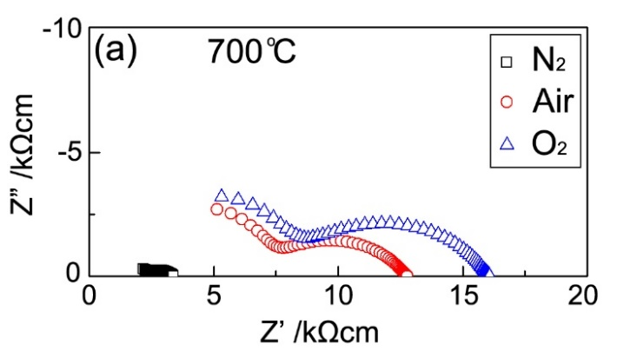
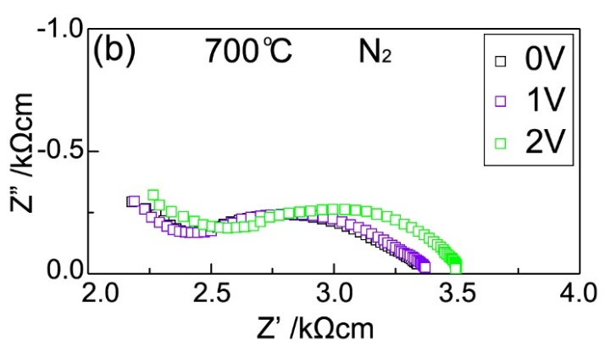
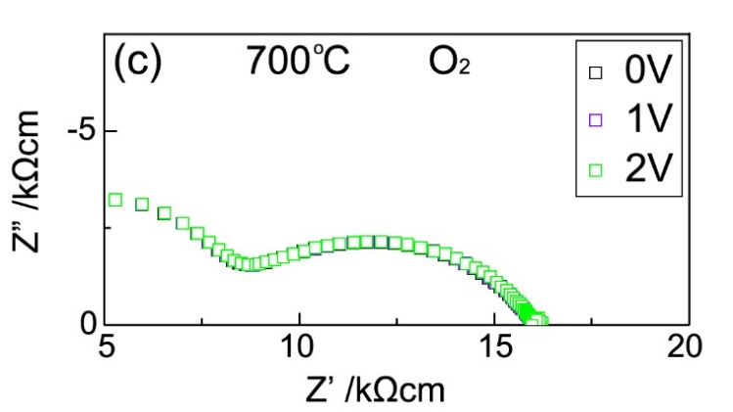
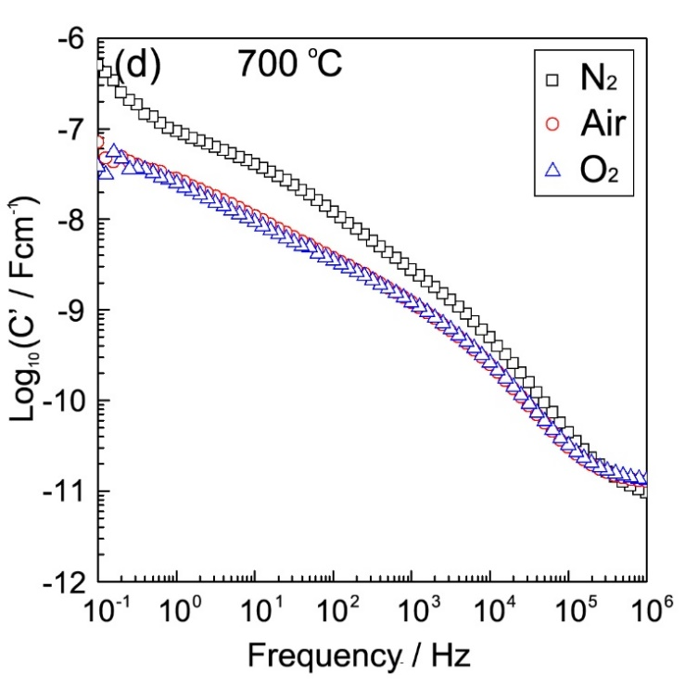
Figure 3-7. Z* plots of TiO₂ at 700 °C (a) in N₂, air and O₂, (b) with dc bias in N₂, (c) with dc bias in O₂; (d) C’ data in N₂, air and O₂

These results indicate that conduction is essentially n-type: as shown in the following reaction, when pO₂ decreases, the equation is shifted to the right-hand side. As a result, the concentration of electrons is larger, which indicates that electrons are the majority carriers, i.e. conduction is n-type.
$O^{2-}↔\frac{1}{2}O_{2}+2e^{-}$ (3-3)
Sensitivity to applied dc bias was observed only in N₂. As shown in Figure 3-7(c), almost no change in conductivity was observed in O₂ with a small dc bias. The possible reason is that when the TiO₂ sample was measured in N₂, the amount of oxygen loss was the most compared with that in O₂ and the defect electron concentration was the highest in N₂. Therefore, sensitivity to dc bias was observed only in N₂. Once the electrons are trapped, it is hard to see the effect of dc bias. That is to say, the changes associated with changing dc bias in O₂ were too small to have had any measurable effect on the overall conductivity.
Spectroscopic plots of capacitance C’ in different atmosphere are illustrated in Figure 3-7(d). A poorly-resolved plateau attributed to the grain boundary is observed at low frequency. The value of the plateau is ~8 nFcm⁻¹ (in air and O₂) and ~30 nFcm⁻¹ (in N₂). Since the C’ value in N₂ is the largest, it indicates that the thickness of the grain boundary is the smallest. As discussed above, the properties of the sample grain boundary may be affected by composition, oxygen content or structure. From the C’ data shown here, we could believe that the grain boundary electrical properties are mainly controlled by the oxygen content.
It is also notable that there may be a small amount of oxide ion conduction since the log C’/log f data show a low-frequency capacitance as high as 5×10⁻⁷ Fcm⁻¹ for the sample measured in N₂, Figure 3-7(d); the corresponding capacitance data in air and O₂ are smaller. These high capacitance values are attributed to the presence and mobility of oxygen vacancies in the lightly-reduced sample which are blocked at the electrodes. The smaller capacitance values in air and O₂ could indicate that the concentration of mobile oxygen vacancies is smaller, consistent with the expectation of a higher oxygen content, especially at the surface, of samples heated in air and O₂. Similar conclusions were obtained for the sample annealed and measured at 650 °C (Figure 3-8).
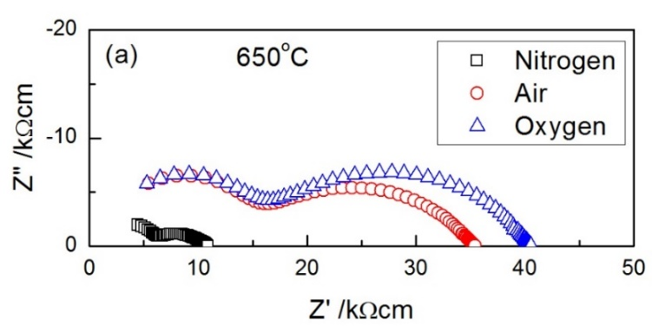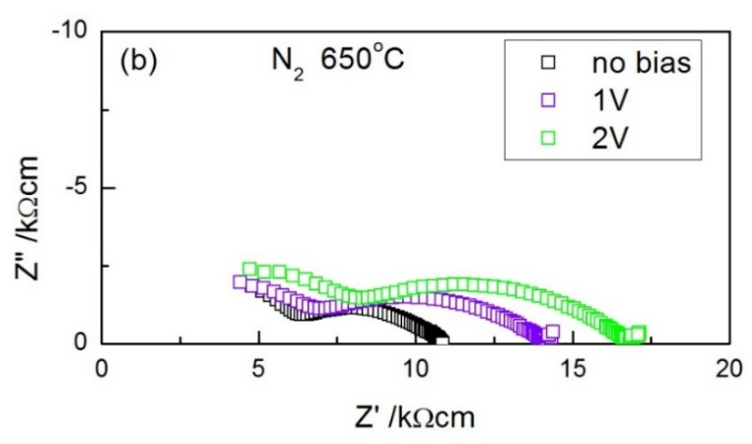
Figure 3-8. Effect of atmosphere and dc bias on impedance of TiO₂ at 650 °C

600-550 °C
Impedance data at 600 °C and 550 °C showed a cross-over between n-type and p-type behavior. At 600 °C, Figure 3-9(a), data in N₂ and air clearly show an n-type response but with a small switch to p-type when measured in O₂. At 550 °C, Figure 3-9(b), the sample is still n-type on comparing the data measured in N₂ and air, but is more clearly p-type in O₂.
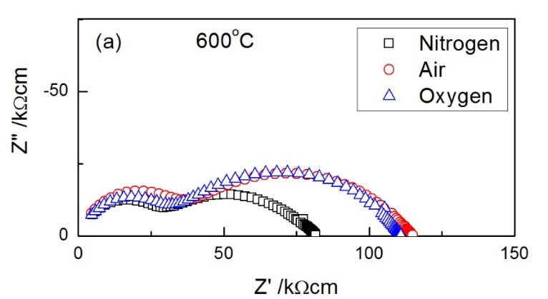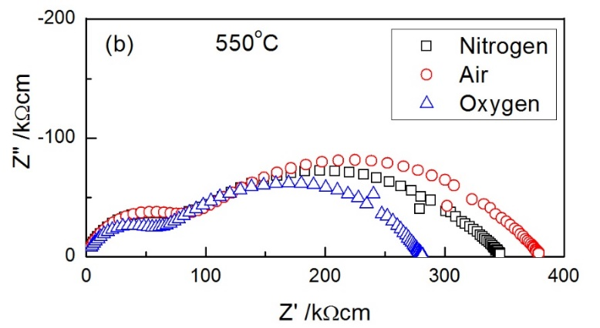
Figure 3-9. Effect of atmosphere on impedance of TiO₂ at 600 °C and 550 °C

500-450 °C
Impedance data were obtained similarly for the sample annealed at 500 °C; the results are shown in Figure 3-10(a). The sample resistances R₁ and R₂ were greatest in N₂ and smallest in O₂, consistent with p-type behavior, eq’n (3-4), since holes are generated with increasing pO₂:
$\frac{1}{2}O_{2}↔O^{2-}+2h^{•}$ (3-4)
Similar conclusions were obtained for a sample annealed and measured at 450 °C, Figure 3-10(b).
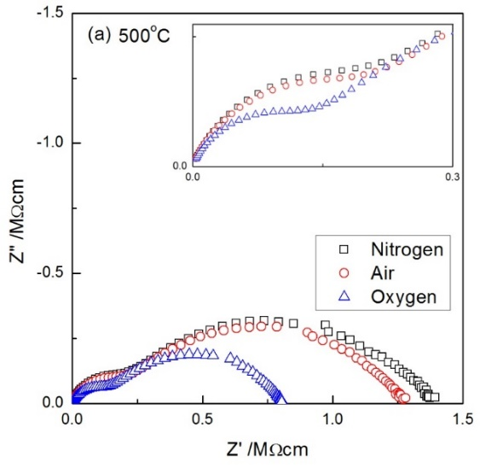
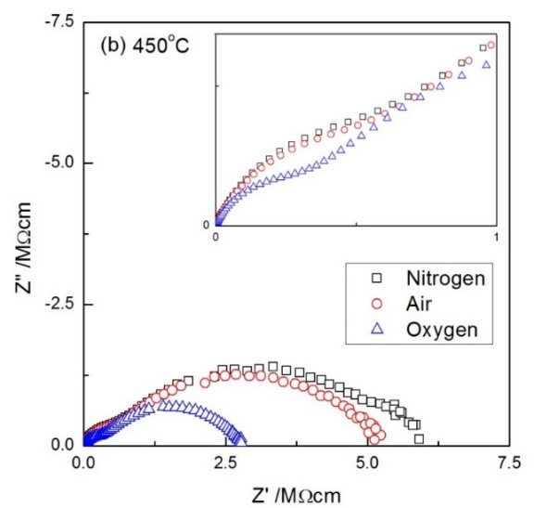
Figure 3-10. Effect of atmosphere on impedance of TiO₂ at 500 °C and 450 °C

In summary, rutile samples show an n-p transition in their electrical properties, depending on temperature. Thus, samples measured at 650 and 700 °C are n-type, those measured at 450 and 500 °C are p-type and those measured at intermediate temperatures, 550 and 600 °C show a cross-over between n-type and p-type behavior.

3.3.3.2 Dependence of conductivity on pO₂
The various conductivity responses for samples quenched from temperatures in the range 400-1300 °C are interpreted using the idealized variation of conductivity with pO₂ shown in Figure 3-11. Diagram (a) shows n- and p- type regions at low and high pO₂, respectively. In the n-type region, the variation of conductivity with pO₂ has an ideal slope of -1/4 on logarithmic scales and a slope of +1/4 for p-type behavior. At intermediate pO₂, there are two possible behaviors. Either the sample shows no ionic conduction at any pO₂ and therefore, conduction changes from n-type to p-type in a cross-over region. Alternatively, the sample may show oxide ion conduction and an electrolytic domain between n- and p- type regions where the conductivity is independent of frequency.
Although we do not have data over a wide pO₂ range, measurements in the three atmospheres of O₂, air and N₂ with pO₂ values of 1, 0.21 and approximately 10⁻³ bar O₂, respectively, nevertheless enable an interpretation of the experimental conductivity data using Figure 3-11. For samples quenched from temperatures in the range 650-1300 °C, samples are clearly n-type in all three atmospheres, N₂, air and O₂, Figure 3-11(b). Likewise, samples quenched from 450-500 °C appear to be p-type in all three atmospheres, Figure 3-11(c).
At 550 °C and 600 °C, samples are in the cross-over region, appear to be n-type in N₂ and p-type in O₂, but their precise behavior in air is uncertain, Figure 3-11(d, e). Capacitance data at 700 °C, Figure 3-7(d), show high values which are indicative of oxide ion conduction and therefore a small domain of partial or complete electrolytic behavior may be expected at intermediate pO₂ values.
These results are for samples that were presumed to be in equilibrium or pseudo-equilibrium after annealing for 3 h at each temperature. They show that for temperatures above 650 °C, samples annealed in air are n-type whereas on annealing below 500 °C in air, they are p-type. At temperatures in the range 550-600 °C, there is a smooth changeover between n-type and p-type behaviors and there is little evidence for an extensive electrolytic domain in which the conductivity would be independent of pO₂.
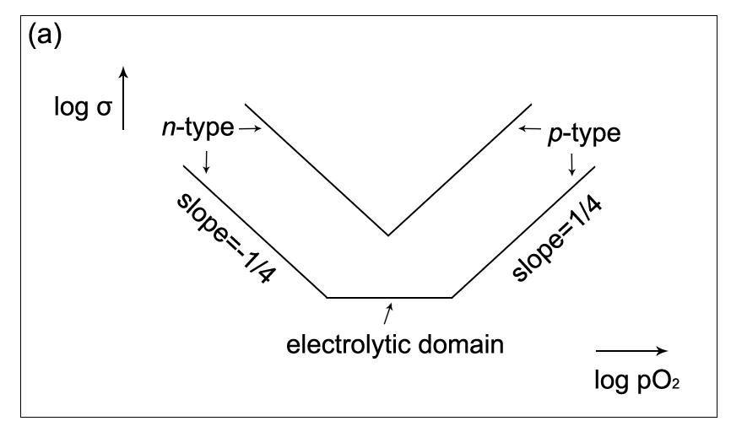
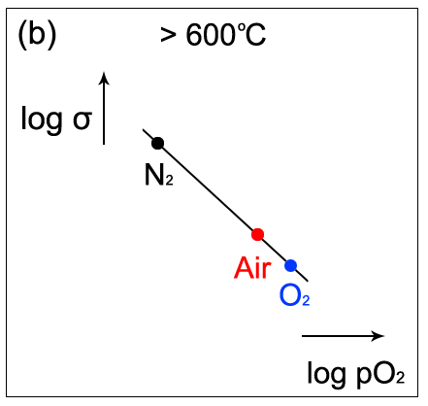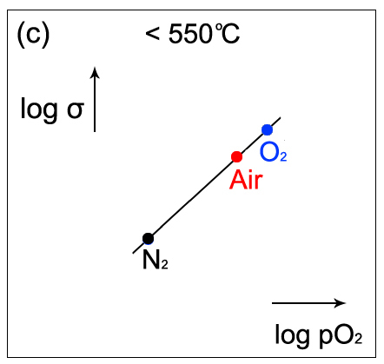
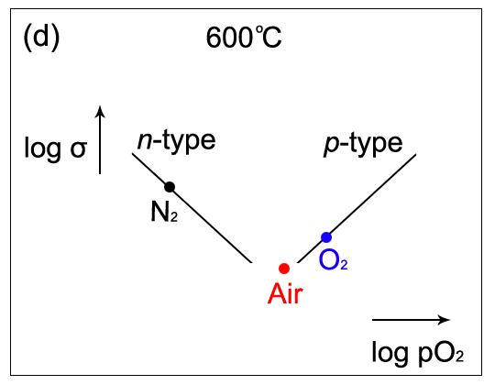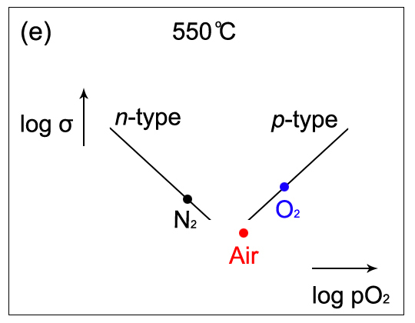
Figure 3-11. Schematic dependence of conductivity on atmosphere

3.3.3.3 Creation of discrete intergap states and conduction mechanisms
In the literature, for the n-type materials quenched from 700 °C and above ^{[5]}, the reported activation energy varied enormously from 0.67 to 0.01 eV as both the degree of oxygen loss and hence, the conductivity increased. This increase in conductivity commenced at a similar quench temperature to the onset of lattice expansion measured at room temperature, Figure 3-1. Both of these effects are attributed to oxygen loss from the sample and injection of electrons into the empty Ti 3d levels. The Arrhenius plot showing the conductivity of samples quenched from temperatures in the range 700 to 1400 °C is reproduced in Figure 3-12 ^{[5]}.
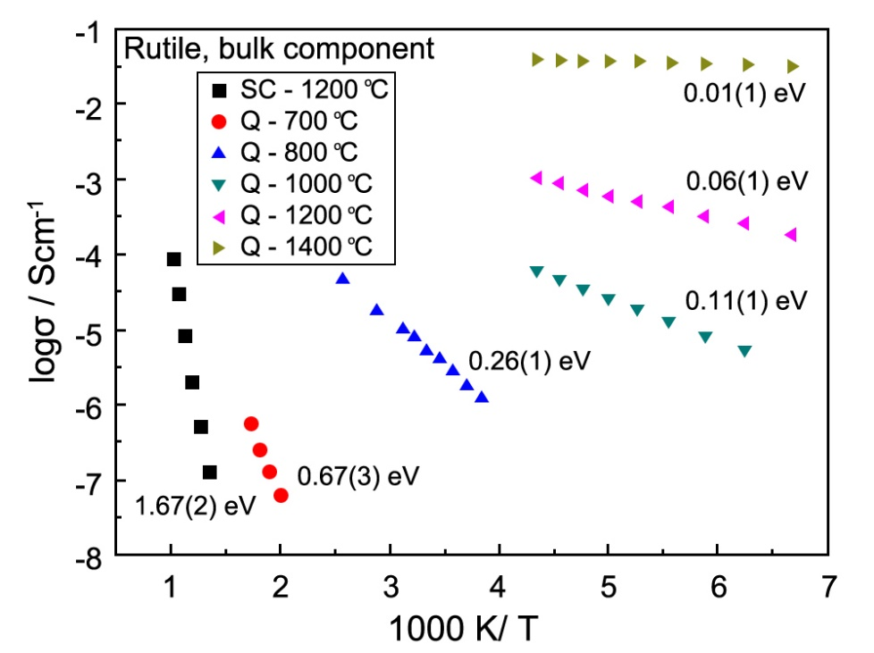
Figure 3-12. Arrhenius plot of bulk conductivity data after different heat treatment: SC, slow-cooled in air; Q, quenched into liquid N₂ ^{[5]}

In order to account for the large variation in activation energy with oxygen deficiency, it appears that electrons associated with oxygen loss occupy discrete intergap states, as shown schematically in Figure 3-13(a). With increasing oxygen deficiency, discrete levels higher in the bandgap are created and therefore, occupied. The activation energy for conduction, which represents promotion of electrons from the discrete intergap states to the conduction band, decreases, Figure 3-12. The dark colour of quenched, n-type samples, is attributed to absorption of visible light and promotion of electrons from the occupied intergap states. The absence of occupied intergap states also accounts for the observed white color of slow-cooled samples.
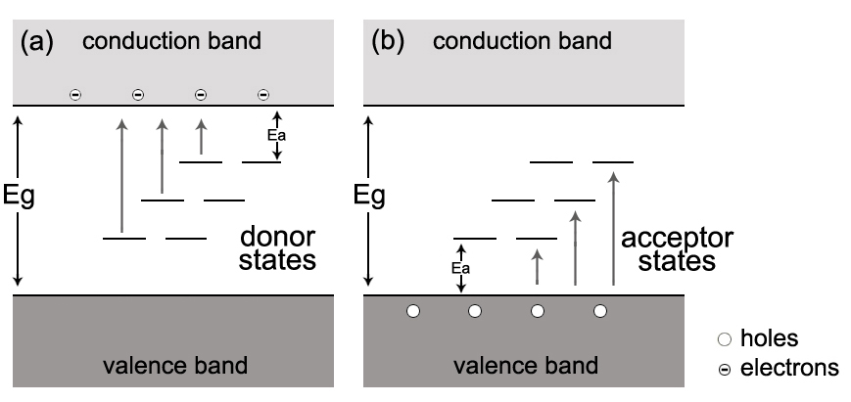
Figure 3-13. Occupied discrete states and (a) n-type conductivity associated with oxygen loss and associated donor states and (b) p-type conductivity associated with acceptor states produced by oxygen adsorption

3.3.3.4 n-type behavior and equilibria between different O species
As shown in Figure 3-7, the effect of pO₂ and dc bias on n-type conductivity was similar: the conductivity decreased with both increasing pO₂ and dc bias. When pO₂ is increasing, electrons are withdrawn from the sample interior, trapped by $O^{2-}$ at the surface. Therefore, the conductivity decreases. The explanation of applying a dc bias is similar to that of increasing oxygen partial pressure: in n-type materials, electrons are attracted to the positive electrode and again, are trapped by the oxide ions at the sample surface ^{[21]}.
Surface science studies show the presence of ions such as superoxide ($O_{2}^{-}$) and peroxide ($O_{2}^{2-}$) at the surfaces of many materials ^{[18-21]}. Although we have no direct data for the present material, TiO₂, the following equilibria are likely to be present at rutile surfaces:
$O_{2}(g)\underset{↔}{1}O_{2}(ads)\underset{↔}{2}O_{2}^{-}\underset{↔}{3}O_{2}^{2-}/O^{-}\underset{↔}{4}O^{2-}(surface)\underset{↔}{5}O^{2-}(bulk)$ (3-5)
which can be explained as: with increasing pO₂, first, the sample surface adsorbs O₂ molecules from the atmosphere; second, the O₂ molecules are ionized and/or dissociated to give superoxide, peroxide and $O^{-}$ ions; third, fully ionized and dissociated O₂ give lattice oxide ions which occupy pre-existing oxygen vacancies either at the surface or in the interior. Thus, the various equilibria 2 to 4 may be displaced to the right, by either increasing oxygen partial pressure or application of dc bias ^{[21]}. This accounts for the observation of n-type behaviour at 700 and 650 °C.

3.3.3.5 p-type behavior and formation of $O^{-}$ ions
The sample annealed at 450-500 °C was p-type, and therefore, a different mechanism must be responsible for the conductivity. In particular, it is necessary to identify the location of the holes which are now the main current carrier. Holes require the presence of a redox-active species that can readily ionize. In principle, there are three possible locations of holes: on Ti, impurities or O. Since Ti is in its maximum possible valence state, +4, it cannot be oxidized further and be the source and location of holes. Unwanted impurities such as Fe could be the location of holes, but high purity reagent grade TiO₂ was used for the experiments, and it is regarded as unlikely that such impurities are responsible. Oxide ions have the possibility to adopt oxidation states of -1 in either the peroxide ion, $O_{2}^{2-}$or the $O^{-}$ ion, as well as oxidation state -1/2 in the superoxide ion, $O_{2}^{-}$ and are the most likely locations of the holes. Although we have no direct evidence for any of these species in our rutile samples, all of them may be present, in different amounts, at sample surfaces as shown by eq’n (3-5); for simplicity, we refer to holes located on oxygen as $O^{-}$ ions.
In order to account for the formation of $O^{-}$ ions, facile ionization of $O^{2-}$ ions is required, which corresponds to the reverse of step 4, eq’n (3-5). Oxide ions at sample surfaces and interfaces may be coordinatively unsaturated and underbonded if their immediate coordination environment has less effective positive charge than 2+. Consequently, such underbonded $O^{2-}$ ions may ionize by the reverse of step 4, eq’n (3-5), which is driven to the left, either in a positive potential gradient or by surface adsorption and ionization of oxygen molecules in reactions such as:
$O_{2}+O^{2-}→O_{2}^{-}+O^{-}$ (3-6)
leading variously to species such as $O^{-}$ and $O_{2}^{-}$ ions. Although we have no direct evidence for $O_{2}^{-}$ or $O^{-}$ formation in the present rutile samples, evidence for $O_{2}^{-}$ ions formation and p-type conductivity was found in Ca-doped BaTiO₃ ^{[18,21]}.
In the p-type region, an excess of oxygen is required to trap the electrons that are liberated by ionization of underbonded $O^{2-}$ ions, eq’n (3-6). Consequently, the samples show a resulting small oxygen excess, TiO_{2+δ}, especially at the surfaces.
It was difficult to obtain an activation energy for conduction in the p-type region because first, the resistance was too high to measure at temperatures below ~450 °C, and second, at higher temperatures, associated with the onset of oxygen loss, conductivity Arrhenius plots, Figure 3-5, show upward curvature. Hence, the carrier concentration was not constant during impedance measurements over the range 500-700 °C and the measured activation energy contained both carrier creation and carrier mobility terms.
A simple band structure model to account for the p-type behavior is proposed here, as shown in Figure 3-13(b). The acceptor states are associated with adsorbed oxygen molecules on the sample surfaces; the holes which are created are located on underbonded oxide ions which are effectively at the top of the valence band.
These results show that the electrical properties of rutile are very dependent on cooling rate and conditions after the high temperature heat treatment. Rutile ceramics lose oxygen during sintering; the degree of oxygen uptake on subsequent cooling and therefore, the electrical properties, whether n-type or p-type may vary. Samples may be semiconducting if cooling rates are fast, insulating if rates are slow or heterogeneous with oxidized surfaces and reduced cores at intermediate cooling rates.

3.3.4 Electrical properties and Schottky barriers of oxygen-deficient rutile, TiO_{2-δ}
Rutile samples quenched from 1350 °C into liquid nitrogen were characterized by impedance spectroscopy. A typical set of impedance data measured at 40 K is shown in Figure 3-14. The impedance complex plane plot, (a), shows an approximately semicircular arc with nonzero high frequency intercept, R₁. The conductivity of R₁ is attributed to the sample bulk. The total resistance, R_{t}, is given by R₁+R₂. The resistance R₂ and associated capacitance C₂ (~0.6×10⁻⁹ Fcm⁻¹ at 40 K), Figure 3-14(b), are attributed to a Schottky barrier associated with the sample-electrode interface, as shown by the effect of dc bias, Figure 3-16(c). At 40 K, R₁ had a value of ~200 Ω, which was unaffected by the dc bias. However, R_{t} reduced rapidly from 175 kΩ with no dc bias to 75 kΩ after applying a 5 V dc bias for 5 min.
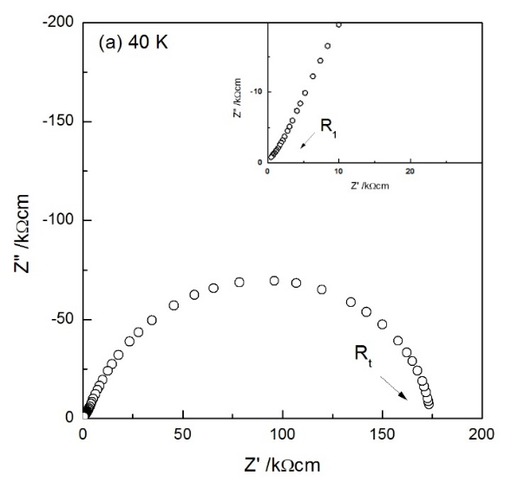
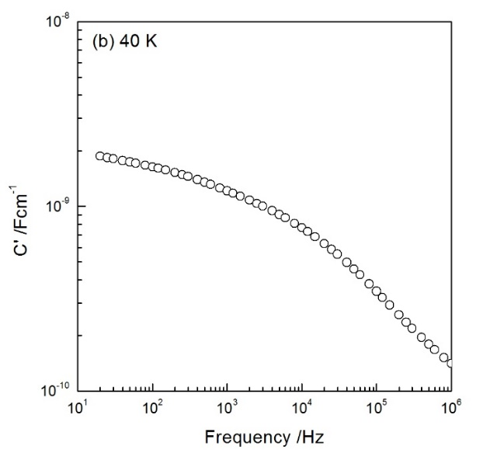
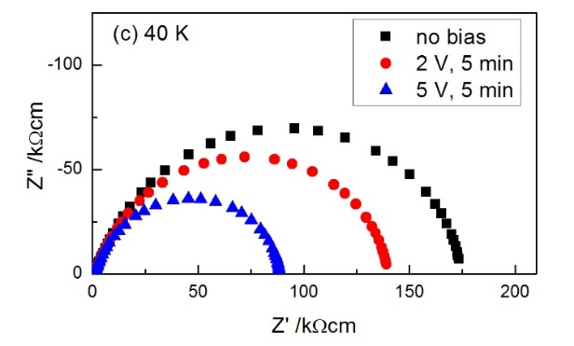
Figure 3-14. Impedance data for a TiO₂ sample quenched from 1350 °C (a) Z* plot, (b) capacitance C’ plot and (c) Z* plots at 40 K as a function of dc bias

To investigate the effect of dc bias on the Schottky barrier further, a rutile sample (quenched from 1350 °C, with InGa electrodes) was given a continuous 1 V bias over a period of 1 h. As shown in Figure 3-15, the total resistance decreases instantaneously when 1 V bias was applied. Subsequently, it decreases slowly, and a steady state is not reached even after 1 h. On removal of the bias, the resistance rapidly increases its value followed by a much more gradual increase, but the final value of R_{t} 1 h after removal of dc bias is smaller than the initial value.
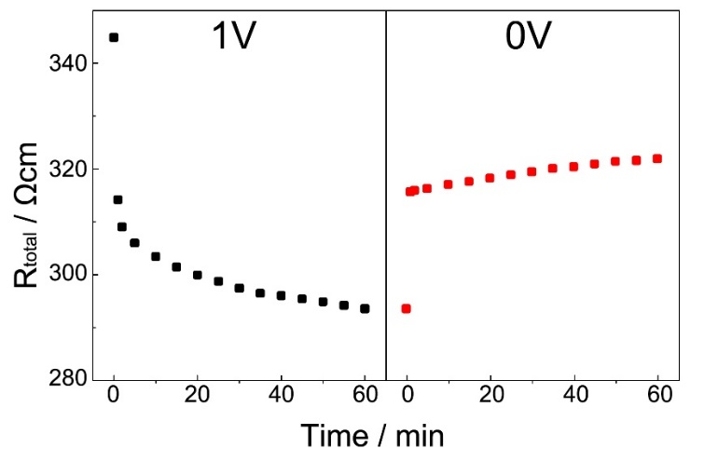
Figure 3-15. The variation of total resistance at room temperature as a function of time with 1 V bias and after removing the dc bias in air
It is well-known that the Schottky barrier is a potential energy barrier to electron transfer across a metal-semiconductor interface. Generally, the electron work function of semiconductors is smaller than that of metals, as a result, when a metal is in contact with a semiconductor, electrons flow from the semiconductor to the metal, and a depletion layer is formed near the interface, Figure 3-16(a). Under positive bias, the height of Schottky barrier decreases, Figure 3-16(b). Thus, the resistance of Schottky barrier is smaller, which is consistent with the results shown in Figure 3-15. However, the effect of dc bias on a typical Schottky barrier is instantaneous and the resistance reaches a steady state rapidly. The gradual decrease under dc bias from 5-60 min in Figure 3-15 needs another explanation.
Figure 3-16. Band structure of a typical Schottky barrier (a) without bias (b) with positive bias
Another possibility of “Schottky barrier” is shown in Figure 3-17. Oxygen molecules adsorb on the sample surface and react with the sample as follows:
$O_{2}+4e^{-}↔2O^{2-}$ (3-7)
a depletion layer forms near the interface. When a dc bias is applied, oxygen molecules are removed from the sample surface at the positive electrode, thus, eq’n (3-7) is shifted to the left-hand side; electrons are generated, and sample resistance becomes smaller. This process, i.e. desorption of O₂, is slow, which is consistent with the gentle decrease with bias from 5-60 min in Figure 3-15.
In summary, the Schottky barrier formed in the quenched TiO₂ may be a combination of two different barriers: (i) a typical Schottky barrier and (ii) a barrier formed by the reaction between sample and adsorbed oxygen molecules.
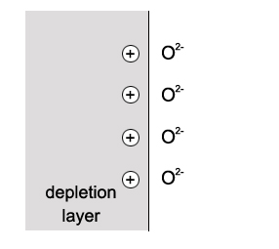
Figure 3-17. Schematic desorption of O₂ near interface

3.3.5 Partially oxidized rutile and core-shell structure formation
For a partial oxidation experiment, two rutile samples were reheated at 1350 °C for 2 h and quenched into liquid nitrogen. After that, they were annealed at 500 °C and 600 °C for 6 h respectively. Impedance measurements were carried out periodically during annealing. A typical set of impedance data on the sample annealed at 500 °C is shown in Figure 3-18. The impedance complex plane plot, (a), shows three poorly resolved arcs. The total resistance is given by R₁+R₂+R₃. In the Z” plot, (b), only two peaks can be observed in the frequency domain: one high frequency peak and one small shoulder peak at ~300 Hz. The interpretation of the spectroscopic plot of capacitance C’, (c), agrees with Z* plot and Z”/M” plots, in that the sample has three components: a highly conductive bulk; a resistive grain boundary with the capacitance ~10⁻⁹ F/cm; a surface layer with the capacitance ~10⁻⁶ F/cm. The rutile sample annealed at 600 °C showed similar impedance results to the 500 °C annealed sample.
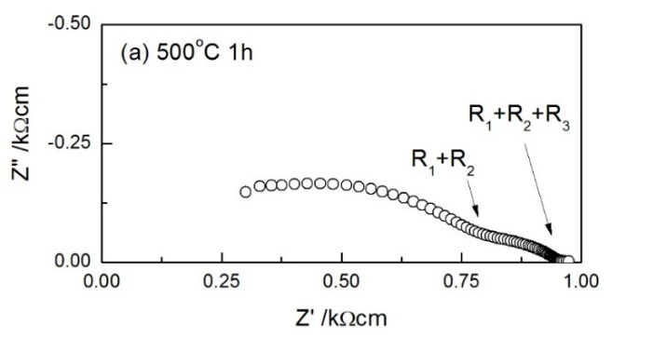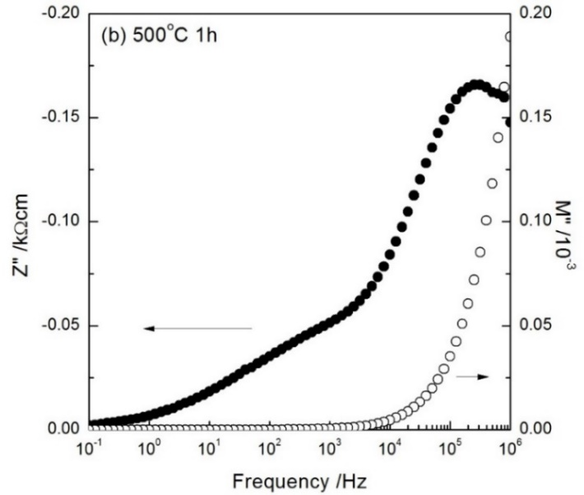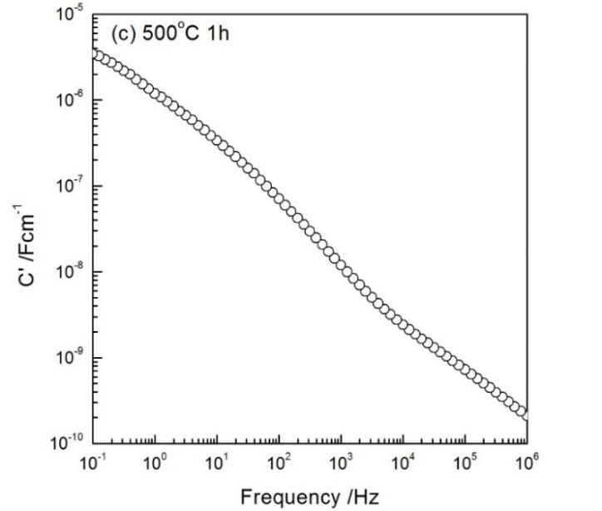
Figure 3-18. Typical impedance data of TiO₂ quenched from 1350 °C and annealed at 500 °C for 1 h (a) impedance complex plane plot, (b) Z”/M” spectroscopic plots (c) and spectroscopic plot of capacitance measured at 500 °C

With increased heating time at 500 °C, as shown in Figure 3-19, the Z” peak that represented the sample grain boundary increased in intensity and a new and more resistive peak at lower frequency appeared, which indicated that a surface layer was formed during annealing at 500 °C. Especially, the intensity of the lower frequency Z” peak increased with time substantially. The interpretation is that the sample was partial oxidized during annealing and developed a core-shell structure. With time, the conductive core was gradually oxidized and consumed by the thickening shell. However, a sharp interface between core and shell was not observed. It could be envisaged that there was a gradient in oxygen concentration and electrical conductivity.
Figure 3-20 shows the conductivity data of different components versus annealing time. It can be seen that during annealing, both the core and the shell need a long time, maybe several hours, to be fully oxidized. Also, there was indeed a gradient in oxygen concentration and electrical conductivity rather than a sharp interface.
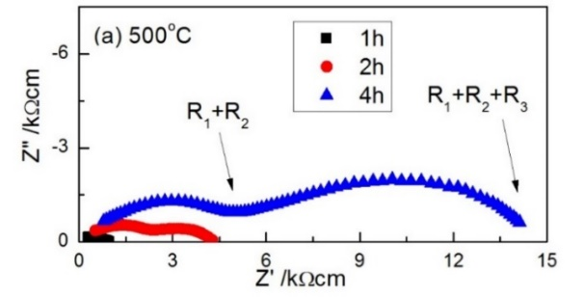
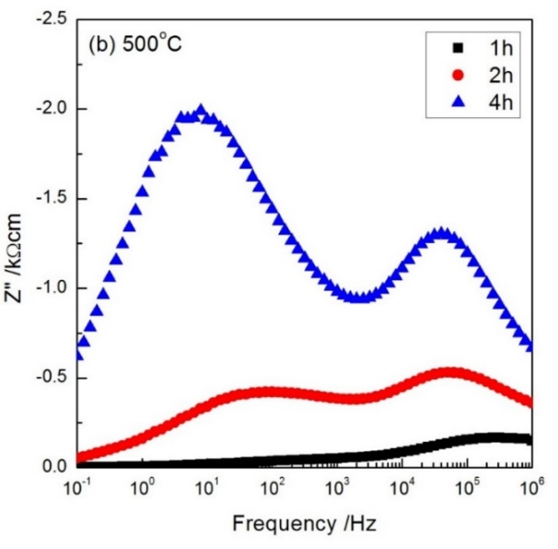
Figure 3-19. Impedance data of TiO₂ sample quenched from 1350 °C, annealed at 500 °C for different hours and measured periodically at 500 °C. Data presented as (a) Z* plots (b) Z” versus frequency

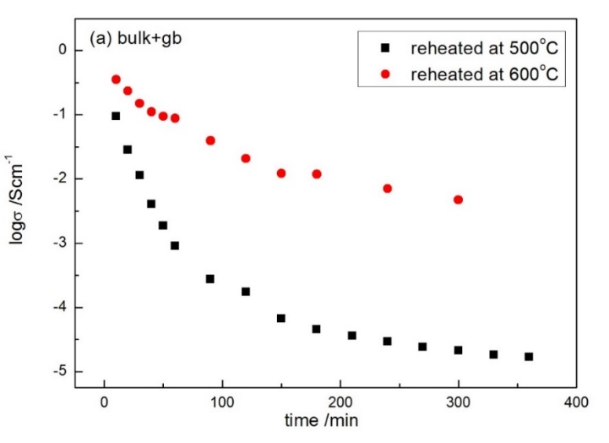
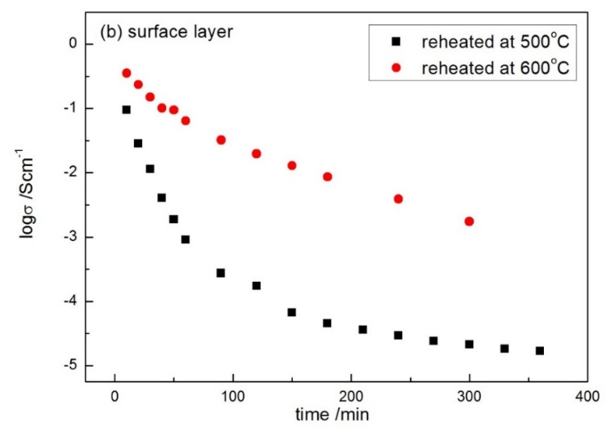
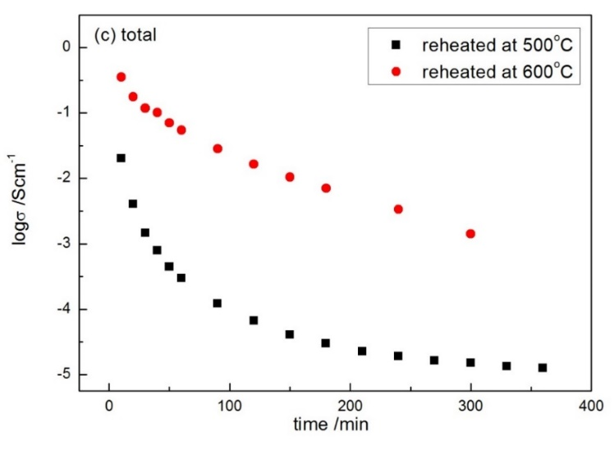
Figure 3-20. Conductivity data of TiO₂ quenched from 1350 °C, annealed at 500 °C and 600 °C versus time (a) bulk and grain boundary (b) surface layer (c) total

3.4 Conclusions
Oxygen-deficient rutile prepared by quenching between 700 and 1200 °C shows a chemical expansion effect which is attributed to oxygen loss and is similar in nature to that reported in other oxides such as CeO₂ and ZrO₂ ^{[14]}. On quenching from higher temperatures, it is expected that oxygen loss continues but nevertheless an unusual lattice contraction effect was observed. This is attributed to the accumulation and elimination of oxygen vacancies by the formation of crystallographic shear planes, and probably corresponds to the early stages of planar defect formation. In the later stages of oxygen loss, a homologous series of reduced rutile phases of formula Ti_{n}O_{2n-1} is expected although was not seen here.
TiO₂ slow-cooled (5 °C/min) from 1250 °C is electrically inhomogeneous. The total resistance, R_{t}, is given by a resistive bulk and grain boundary, and the grain boundary is easier to lose oxygen on heating than the bulk.
The occurrence of n-type semiconductivity and associated darkening is well-established in oxygen-deficient rutile. Oxygen loss commences at temperatures as low as 650 °C. At slightly lower temperatures, rutile is likely to be oxygen stoichiometric, but at 450 to 500 °C, the onset of p-type semiconductivity is observed. It is attributed to reaction of $O^{2-}$ ions at sample surfaces with gas phase $O_{2}$ molecules giving rise to hole creation with holes residing on oxygen, ideally as $O^{-}$ ions.
TiO₂ quenched (~10k °C/min) from 1350 °C is highly conducting and the total conductivity is given by the sample bulk and a Schottky barrier, which contains two possible forms: (i) a typical Schottky barrier and (ii) a barrier that formed by the reaction between the sample and the adsorbed oxygen molecules.
After annealing at 500 °C /600 °C for several hours, the quenched samples formed core-shell structures. With time, the conductive core was gradually oxidized and consumed by the thickening shell. However, a sharp interface between core and shell was not observed. Instead, a gradient in oxygen concentration and electrical conductivity was found.

References
- HY Yang, SK Zhu, N Pan. J Appl Polym Sci. 92(2004):3201-3210.
- U Bach, D Lupo, JE Moser, et al. Nature. 395(1998):583-585.
- K Nakata, A Fujishima. J Photochem Photobiol C. 13(2012):169-189.
- J Wu, RL McCreery. J Electrochem Soc. 156(2009):29-37.
- Y Liu, AR West. J Am Ceram Soc. 96(2013):218-222.
- JJ Xu, ZL Tian, GH Yin, et al. Dalton Trans. 46(2017):1047-1051.
- CY Yang, Z Wang, TQ Lin, et al. J Am Chem Soc. 135(2013):17831-17838.
- AM Stoneham, PJ Durham. J Phys Chem Solids. 34(1973):2127-2135.
- MG Blanchin, P Faisant, C Picard, et al. Phys Stat Sol. 60(1980):357-364.
- R Waser, R Dittmann, G Staikov, et al. Adv Mater. 21(2009):25-26.
- MD Pickett, DB Strukov, JL Borghetti, et al. J Appl phys. 106(2009):074508.
- Y Liu, AR West. Appl Phys Lett. 103(2013):263508.
- OJ Whittemore JR, NN Adult. J Am Ceram Soc. 39(1956):443-444.
- D Marrocchellli, SR Bishop, HL Tuller, et al. Adv Funct Mater. 22(2012):1958-1965.
- SR Bishop. Acta Mech Sinica. 29(2013):312-317.
- AR West. Solid State Chemistry and its Applications. John Wiley & Sons. 2014:108-109.
- S Harada, K Tanaka, H Inui. J Appl Phys. 108(2010):083703.
- PR Ren, N Masó, AR West. Phys Chem Chem Phys. 15(2013):20943-20950.
- PR Ren, N Masó, Y Liu, et al. J Mater Chem C. 1(2013):2426-2432.
- N Masó, AR West. Chem Mater. 24(2012):2127-2132.
- M Guo, N Masó, Y Liu, et al. Inorg Chem. 57(2018):64-77.

Chapter 4. Cr-doped TiO₂

4.1 Introduction
Cr-doped TiO₂ has been intensively studied since it has a wide range of applications such as gas sensors, photocatalysts, magneto-optic devices and photoelectrode for solar cells ^{[1-4]}. Recently, some investigators ^{[3]} studied the ferromagnetic property of Cr-doped TiO₂ and found that oxygen vacancies played an important role in ferromagnetism. However, the possible links between ferromagnetism and conductivity, and the presence of oxygen vacancies, whether they were random or collapsed to form planar defects are still under discussion.
The phase analysis on the TiO₂-Cr₂O₃ system has been studied by several investigators ^{[5-8]}. Phase relations between TiO₂ and Cr₂O₃ are summarized in a phase diagram, shown in Figure 4-1 ^{[5]}. Stability relations among various phases in the TiO₂-Cr₂O₃ system in air were determined in the temperature range of 1200-1500 °C.
With 0-4 mol% CrO_{1.5}, the TiO₂-Cr₂O₃ system is monophasic with rutile structure. Few defects are present apart from dislocations and damage caused by fracture, and the oxygen deficiency appears to be accommodated by point defects or small clusters ^{[6]}. Furthermore, there appears to be a limited solid solution range in which Cr³⁺ can be introduced into the rutile structure without the formation of extended defects. The limiting composition of this solid solution range is temperature-dependent.
Figure 4-1. Phase diagram of TiO₂-Cr₂O₃ system (Rt: rutile; E: Cr₂Ti₂O₇) ^{[5]} (Figure 1)

At higher chromium concentrations (4-22 mol% CrO_{1.5}), Ti_{n-2}Cr₂O_{2n-1} (6 ≤ n ≤ 11) ^{[6,7]} are formed. In the range of 4-11 mol% CrO_{1.5}, rutile structure still exists, and the system contains a mixture of rutile structure and crystallographic shear structures. When the concentration of CrO_{1.5} is larger than 11 mol%, the rutile structure disappears.
Discrete homologous phases Ti_{n-2}Cr₂O_{2n-1}, with n=6, 7, 8, 9, were found to be stable as single phases at certain temperatures. Among them, the lowest member observed in the literature is Ti₄Cr₂O₁₁, n=6, which appears to be stable above 1420 °C. The highest member, Ti₇Cr₂O₁₇, n=9, is stable above 1270 °C.
At high chromium concentration (> 25 mol% CrO_{1.5}), the so-called E phase appears. E phase, Cr₂Ti₂O₇, was first found by Hamelin ^{[8]}. It exists in a wide homogeneity range corresponding to the compositions of approximately 3 < n < 5 ^{[7]}.
Generally, an aliovalent dopant in a compound can be charge compensated ionically or electronically, or a combination of both. Moreover, some variables may affect charge compensation, for instance, pO₂, dopant content and temperature ^{[9]}.
When TiO₂ is doped with Cr³⁺, if only ionic compensation occurs, the defect reaction can be written as either:
${Cr}_{2}O_{3}→2{Cr}_{Ti}^{'}+3O_{O}^{x}+V_{O}^{••}$ (4-1)
i.e. Cr³⁺ substitutes for Ti⁴⁺ with charge compensating oxygen vacancies, and in this case, Cr-doped TiO₂ may show oxide ion conduction, or:
${2Cr}_{2}O_{3}→3{Cr}_{Ti}^{'}+6O_{O}^{x}+{Cr}_{i}^{•••}$ (4-2)
i.e. extra Cr³⁺ may enter interstitial sites.
Co-doping with Cr³⁺ and Ti³⁺ may also occur, which can be represented as:
$2{Ti}^{4+}+O^{2-}\underset{→}{{Cr}_{2}O_{3}}{Ti}^{3+}+{Cr}^{3+}+V_{O}+\frac{1}{2}O_{2}↑$ (4-3)
or ${TiO}_{2}+\frac{1}{2}{Cr}_{2}O_{3}→{Cr}_{Ti}^{'}+{Ti}_{Ti}^{'}+3O_{O}^{x}+V_{O}^{••}+\frac{1}{4}O_{2}$ (4-4)
If only electronic compensation occurs, the possible defect reaction can be written as:
${Cr}_{2}O_{3}+\frac{1}{2}O_{2}→2{Cr}_{Ti}^{'}+4O_{O}^{x}+{2h}^{•}$ (4-5)
and in this case, Cr-doped TiO₂ would probably show p-type conduction.
Pure TiO₂ is well-known to be an n-type semiconductor when oxygen-deficient. Recent publications ^{[10,11]} showed that oxygen deficiency correlated with quench temperature and conductivity. In addition, n-type rutile showed a decrease in conductivity with a dc bias attributed to trapping of electrons at the sample surface. The opposite effect was seen with p-type materials such as Ca-doped BiFeO₃, Mg-doped SrTiO₃ and Zn-doped CaTiO₃, which were acceptor-doped ^{[12-14]}. Many studies have been carried out on Cr-doped TiO₂ and showed that Cr doping could convert n-type TiO₂ to p-type ^{[1,4,15]}, however, the location of carriers, i.e. holes, was still under discussion. Consequently, the first objective of this chapter was to synthesize Cr-doped TiO₂ and to see if an n-p crossover would be observed. As part of this study, the electrical properties of Cr-doped TiO₂ were characterized by impedance spectroscopy. The surprising result was obtained that Cr-doped TiO₂ samples were mixed conductors with p-type and oxide ion conduction only when the dopant concentration was very small. With relatively higher dopant concentration, samples showed only electronic conduction and exhibited a p-n transition; this behavior is attributed to a combination of oxygen loss and CS plane formation.

4.2 Experimental
For structural characterization, samples of Ti_{1-x}Cr_{x}O_{2-x/2-δ} (x = 0.002, 0.005, 0.01, 0.015, 0.02, 0.03 and 0.05) were heated at 1350 °C for 8 h. For electrical property measurements, Ti_{1-x}Cr_{x}O_{2-x/2-δ} (x = 0.001, 0.002, 0.004, 0.005, 0.006, 0.008, 0.01, 0.015, 0.02, 0.03 and 0.05) pellets were sintered at 1350 °C for 8 h in air and cooled slowly in the furnace (5 °C/min). For selected experiments, samples were given further heat treatment: reheated at 1350 °C for 2 h in a vertical tube furnace and quenched into liquid nitrogen (~10000 °C/min). Oxide ion transport numbers were measured by using a Probostat system in the temperature range 600-800 °C.

4.3 Results

4.3.1 XRD
Ti_{1-x}Cr_{x}O_{2-x/2-δ} samples shown in Figure 4-2 are single phase by XRD, and patterns closely resemble those of tetragonal rutile structure, which indicates that the chromium dopants are well-dispersed in the TiO₂ matrix. Peaks of samples with x = 0.03 and 0.05 are broader and exhibit shoulders, which may indicate the appearance of lattice distortion. XRD patterns shown here are consistent with the phase diagram in the literature ^{[5]}, Figure 4-1. With such small dopant concentration, Cr³⁺ can be introduced into the rutile structure and form solid solution easily.
With chromium dopant, the color of rutile samples changed remarkably from white to grey-black, and visible brightness was significantly inhibited. The dark color of Cr-doped samples is attributed to absorption of visible light and promotion of electrons from the occupied intergap states. There are two possible reasons for creation of such intergap states: (i) due to Cr³⁺ doping; (ii) oxygen loss may occur at high temperatures, i.e. δ > 0, which produces the color centres of Ti³⁺ in the TiO₂:
$O^{2-}→\frac{1}{2}O_{2}+2e^{-}$ (4-6)
${Ti}^{4+}+e^{-}→{Ti}^{3+}$ (4-7)

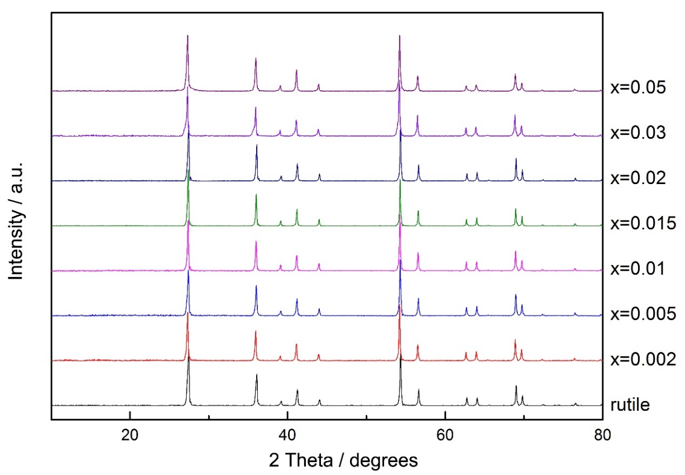
Figure 4-2. XRD patterns of Ti_{1-x}Cr_{x}O_{2-x/2-δ}

Refined lattice parameters for Ti_{1-x}Cr_{x}O_{2-x/2-δ} samples are summarized in Table 4-1 and Figure 4-3. With the increase of chromium dopant concentration, (i) the lattice parameter “a” increases but non-linearly; it shows a rapid increase followed by a gradual increase after x ≥ 0.005. (ii) “c” decreases non-linearly. (iii) cell volume increases rapidly, and then shows a decrease when x ≥ 0.005.

Table 4-1. Lattice parameters of Ti_{1-x}Cr_{x}O_{2-x/2-δ}
x | Lattice parameters
 | a=b (Å) | c (Å) | cell volume (Å³)
0 | 4.5910(4) | 2.9590(3) | 62.368(7)
0.002 | 4.5917(2) | 2.9586(2) | 62.378(5)
0.005 | 4.5924(3) | 2.9584(3) | 62.400(6)
0.01 | 4.5926(3) | 2.9583(2) | 62.399(5)
0.015 | 4.5928(3) | 2.9582(3) | 62.397(6)
0.02 | 4.5929(5) | 2.9578(4) | 62.393(10)
0.03 | 4.5933(3) | 2.9574(2) | 62.392(5)
0.05 | 4.5934(3) | 2.9569(3) | 62.387(6)
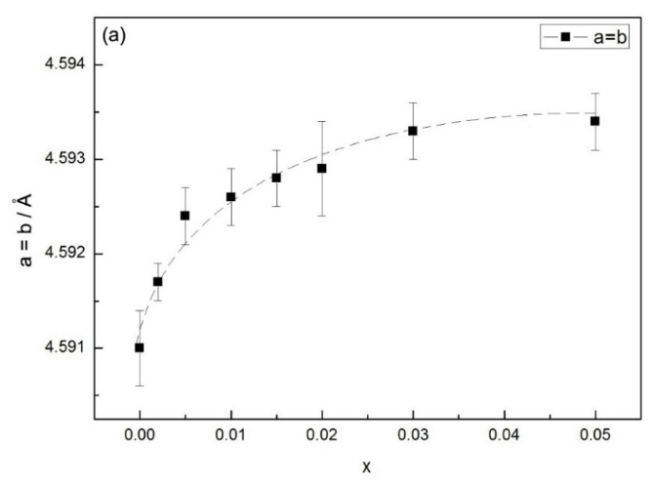
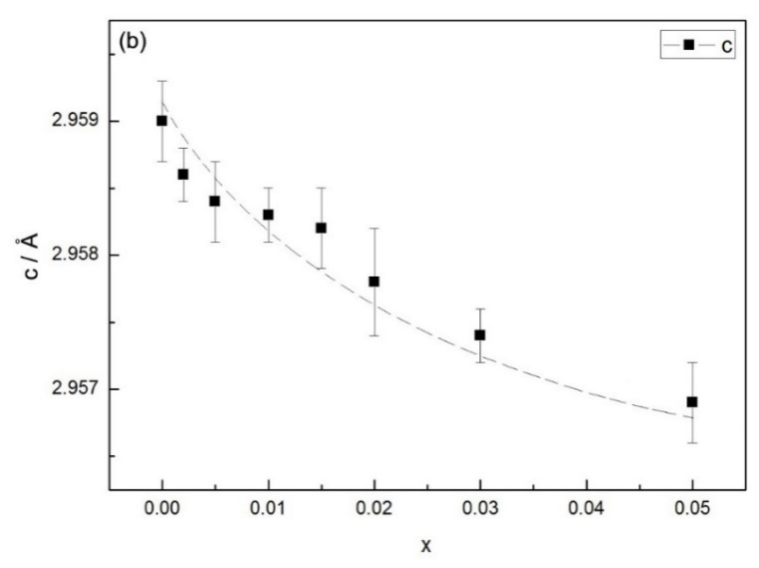
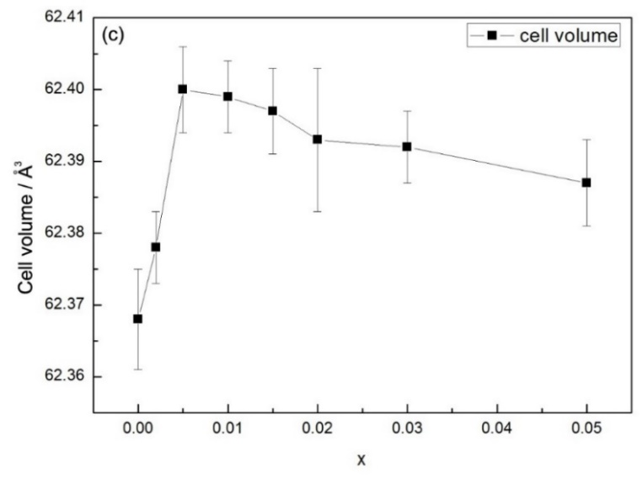
Figure 4-3. Lattice parameters (a) a = b, (b) c and (c) cell volume against x value

4.3.2 Electrical properties of Ti_{1-x}Cr_{x}O_{2-x/2-δ}

4.3.2.1 x ≥ 0.015

(a) Typical impedance data
For electrical property measurements, samples were made with a final relative density of ~90%. An x = 0.015 sample slow-cooled in air from 1350 °C was characterized by impedance spectroscopy. Measurements were carried out as a function of frequency.
A typical set of impedance data is shown in Figure 4-4. The Z* complex plane plot, (a), shows a single and almost ideal semicircular arc whose low-frequency intercept gives the total resistance of the sample. Combined Z" and M" plots, (b), show almost overlapping peaks for the two spectra at ~10⁴ Hz, which indicates that the electrical properties could be represented by a single parallel RC element for the sample bulk, without evidence of lower frequency grain boundary impedance. The capacitance data shown in (c) demonstrate a plateau at high frequency. The value of the plateau is ~10 pF, corresponding to a permittivity of ~113, thus represents the bulk response. Plots such as Figure 4-4 are typical of Cr-doped rutile samples with x ≥ 0.015.
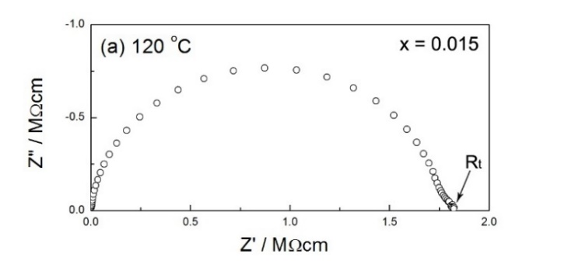
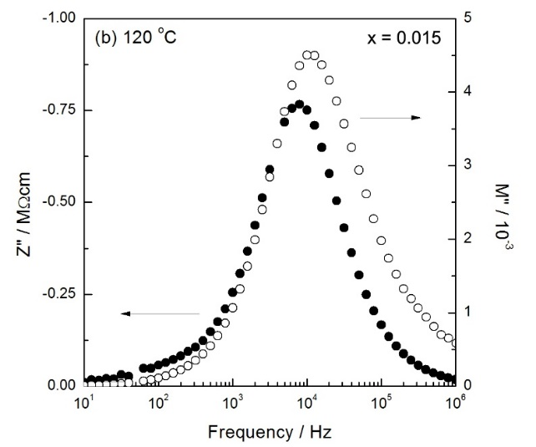
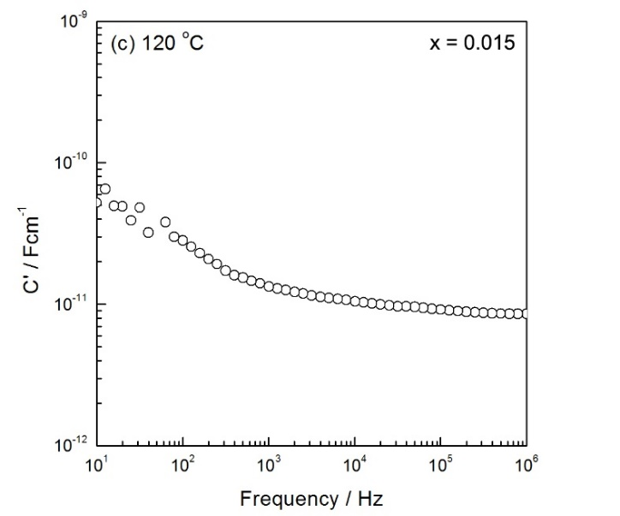
Figure 4-4. Typical impedance data of x = 0.015 slow-cooled from 1350 °C (a) impedance complex plane plot (b) Z”/M” spectroscopic plots (c) and spectroscopic plot of capacitance at 120 °C

Since samples with x ≥ 0.015 slow-cooled from 1350 °C are electrically homogeneous, from such data, total impedances, which corresponded approximately to the bulk resistances, were obtained and are shown in Arrhenius format in Figure 4-5. Linear plots are observed with quite small activation energy in the range of 0.2-0.27 eV. Data for undoped TiO₂ are also shown for comparison, from which it can be seen that with Cr³⁺ doping, the electrical property varies from insulating to semiconducting, and the carrier concentration increases with Cr³⁺ content.

(b) Effect of cooling rate
Conductivity data for x = 0.015 with different cooling conditions are shown in Arrhenius format, Figure 4-6. Linear plots are observed; the slow-cooled and quenched samples show similar conduction and thus, oxygen loss due to high sintering temperatures is unlikely.
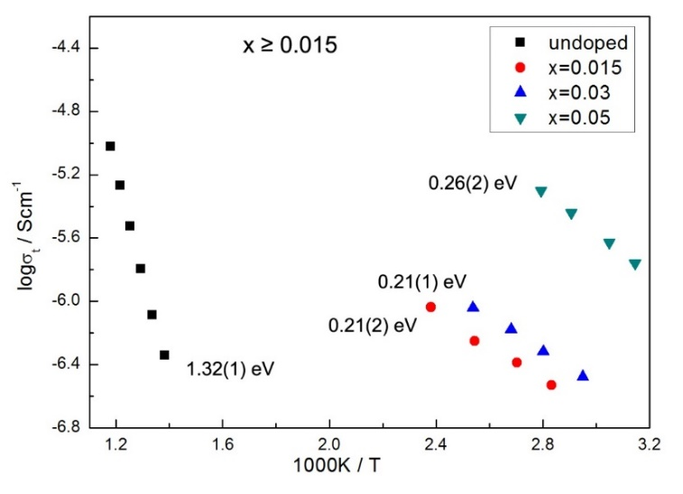
Figure 4-5. Arrhenius plots of samples with x ≥ 0.015 slow-cooled from 1350 °C; data for undoped TiO₂ are also shown

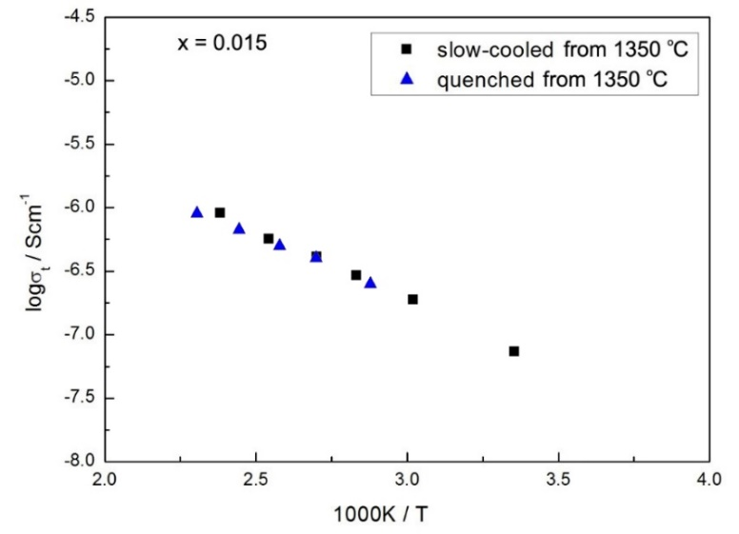
Figure 4-6. Arrhenius plots of x = 0.015 with different cooling rates: either slow-cooled or quenched from 1350 °C

(c) Effect of atmosphere and dc bias
Impedance data recorded at 120 °C and measured (a) in atmospheres of N₂, air and O₂ and (b) with/without application of dc bias during measurements in N₂ are shown in Figure 4-7. In order to equilibrate the x = 0.015 sample prior to measurements, it was loaded into the impedance jig and left at 120 °C for 2 h.
The impedance data shown in Figure 4-7 indicate the presence of only one almost ideal semicircular arc in the complex plane plot which is attributed to the total resistance. With increasing pO₂, Figure 4-7(a), resistance increases, indicating that the conduction is n-type, but the effect of pO₂ is relatively small. With application of a small dc bias, Figure 4-7(b), almost no change in conductivity can be observed.
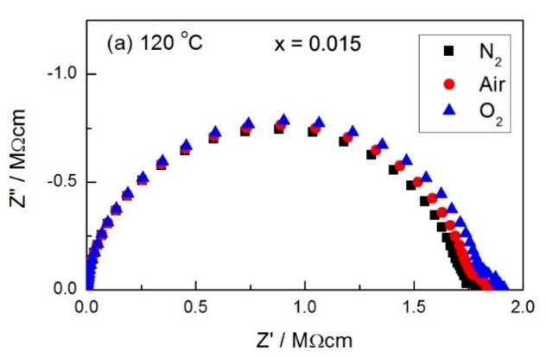
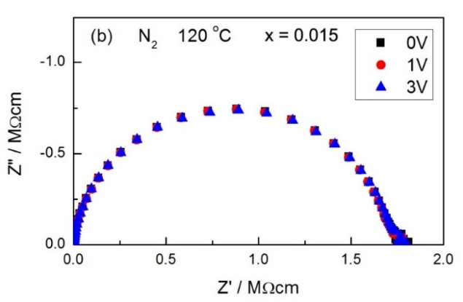
Figure 4-7. Z* plots of x = 0.015 at 120 °C (a) in N₂, air and O₂ (b) with dc bias in N₂
The effect of pO₂ for x = 0.03 and x = 0.05 are shown in Figure 4-8. In all cases with x ≥ 0.015, the conduction is essentially n-type.
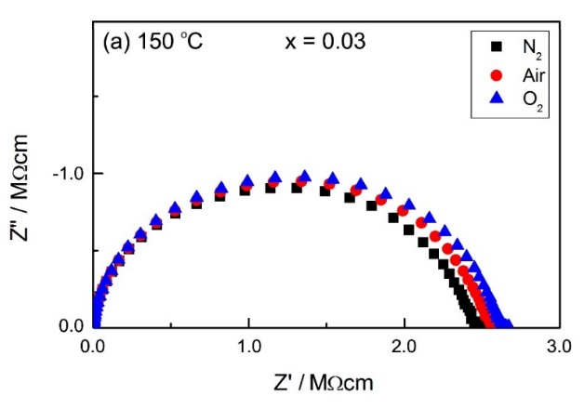
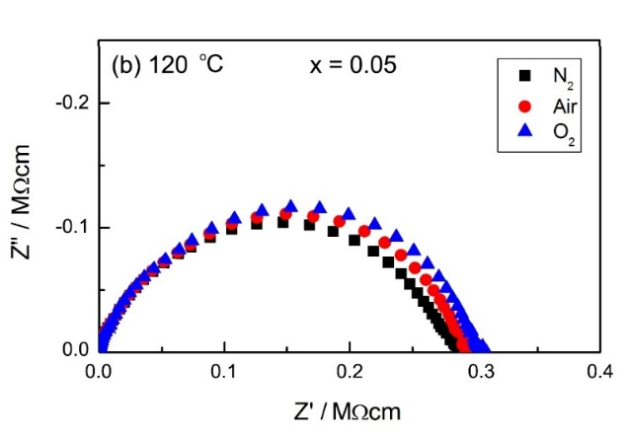
Figure 4-8. Effect of pO₂ of x = 0.03 and x = 0.05

4.3.2.2 x ≤ 0.01

(a) Typical impedance data
The electrical properties of an x = 0.005 sample slow-cooled in air from 1350 °C were evaluated using impedance measurements. A typical set of impedance data is shown in Figure 4-9. The impedance complex plane plot, (a), shows several overlapping arcs and a low-frequency impedance spike. The low-frequency intercept on the Z’ axis gives the total resistance of the sample. The inclined spike indicates that there may be ion blocking at the sample -electrode interface and the sample may exhibit ionic conduction. On replotting the same data in the Z”/M” spectroscopic plot format, (b), it is clear that the M” spectrum is a double peak; the low-frequency component occurs at about the same frequency as one of the Z” peaks, ~10⁴ Hz, whereas the higher frequency peak is beyond the available frequency range. The essentially coincident peaks of Z”/M” spectra at ~10⁴ Hz have a capacitance of ~10⁻¹¹ F. The Z” peak at ~10³ Hz has a capacitance of 10⁻¹⁰ F.
The same data presented as a spectroscopic plot of capacitance, (c), demonstrate three poorly-resolved plateaus. The high-frequency plateau is beyond the available frequency domain and has a value C₁ ~8×10⁻¹² F. The second, poorly-resolved plateau at ~10⁴ Hz has capacitance value C₂ ~10⁻¹¹ F. The third plateau at the lowest frequency has a capacitance C₃ of ~10⁻¹⁰ F. The capacitance values of C₁ and C₂ are similar and small, ~10⁻¹¹ F, corresponding to the permittivity of ~113, which is similar to the expected permittivity value of rutile. Hence, we consider that the x = 0.005 sample is electrically heterogeneous with three components, R₁C₁, R₂C₂ and R₃C₃.
Z* plots for samples with x = 0.001, 0.002 and 0.006 are shown in Figure 4-10. All compositions with 0.001 ≤ x ≤ 0.006 exhibit similar impedance response to that shown in Figure 4-9 and 4-10.
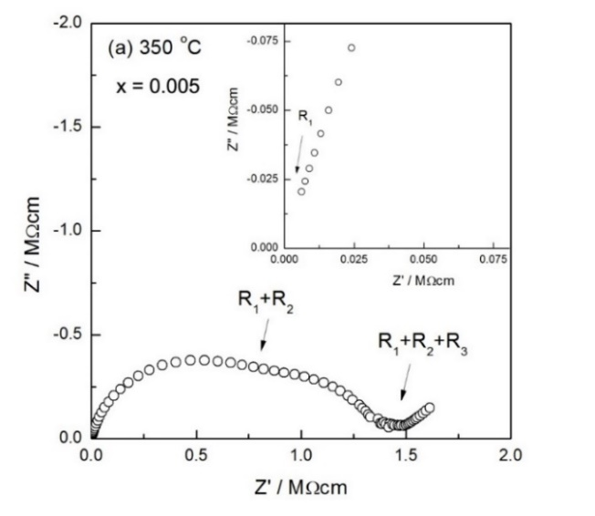
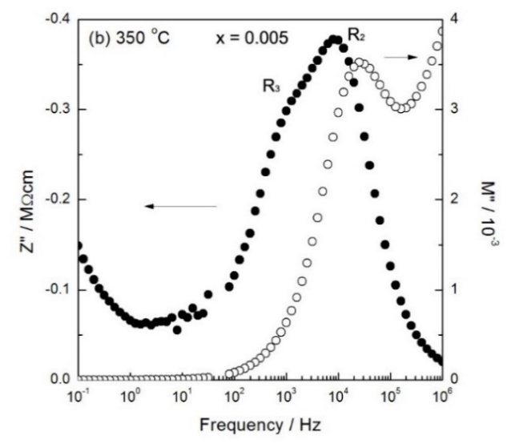
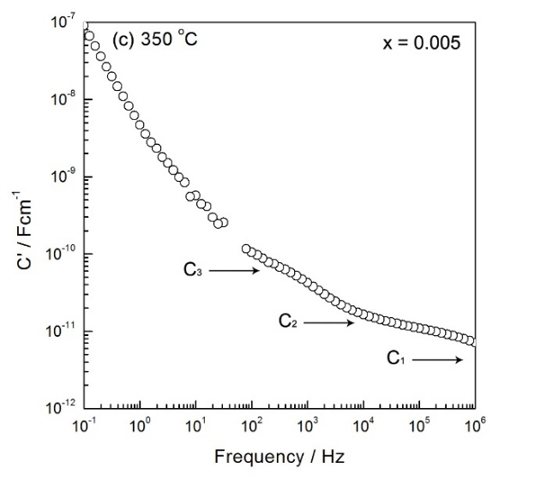
Figure 4-9. Typical impedance data of x = 0.005 slow-cooled from 1350 °C (a) impedance complex plane plot (b) Z”/M” spectroscopic plots (c) and spectroscopic plot of capacitance at 350 °C
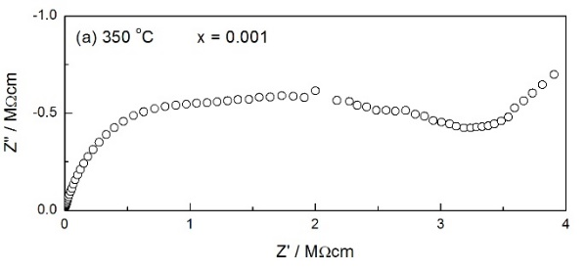
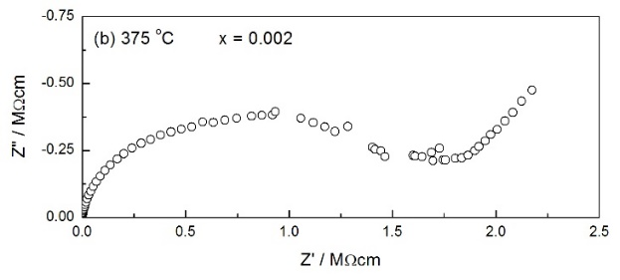
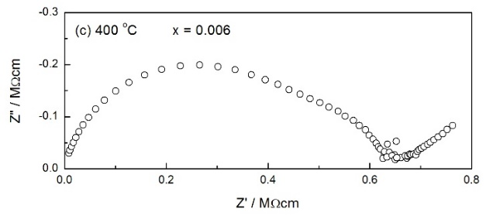
Figure 4-10. Z* plots of x = 0.001, 0.002 and 0.006 slow-cooled from 1350 °C

To investigate the high-frequency M” peak further, M” spectroscopic plots of the x = 0.005 sample at various temperatures are shown in Figure 4-11. It can be seen that the relative size of the two M” peaks is different at these temperatures. Specifically, at 200 and 250 °C, C₁ is larger than C₂. With the increase of measuring temperature, both C₁ and C₂ decrease. From 300 °C, C₁ starts to be smaller than C₂.
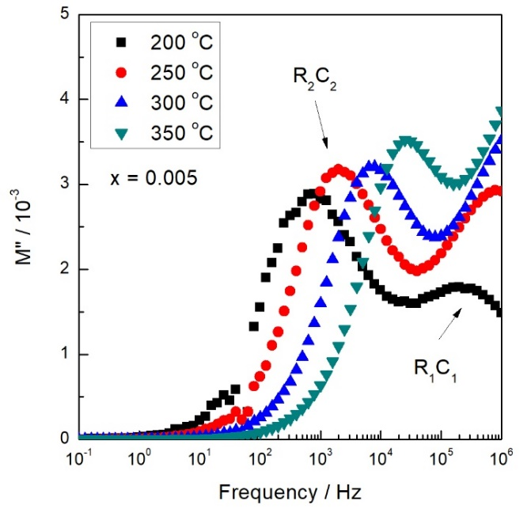
Figure 4-11. M” spectroscopic plots of x = 0.005 at various temperatures

Conductivity data for R₁, R₂ and R_{total} (= R₁+R₂+R₃) are plotted in Arrhenius format in Figure 4-12. Resistance values of R₂ and R_{total} were extracted from Z* plot, and R₁ values were extracted from the high-frequency M” peak. The activation energy of σ₂ is ~0.9 eV, which is similar to that of σ_{total}, while σ₁ has a much smaller activation energy of ~0.31 eV.
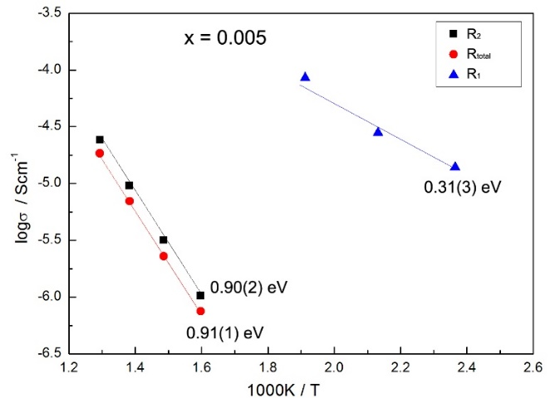
Figure 4-12. Arrhenius plots of x = 0.005 slow-cooled from 1350 °C
M” data of other low x compositions (x = 0.001, 0.002 and 0.006) are shown in Figure 4-13, which show different behavior from the M” data of x = 0.005 shown in Figure 4-11. (1) x = 0.001: C₁ is smaller than C₂; (2) x = 0.002: C₁ is slightly larger than C₂; (3) x = 0.006: C₁ is larger than C₂.

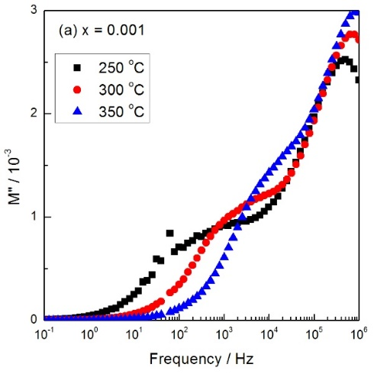
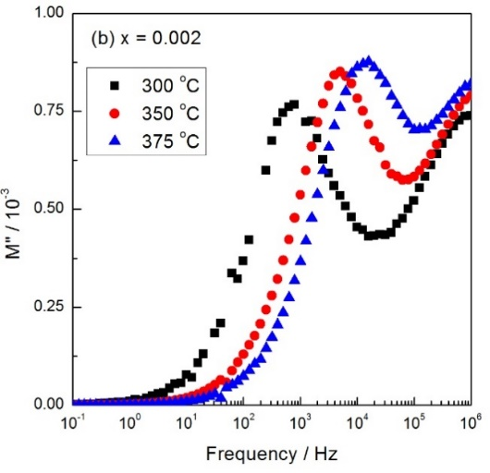
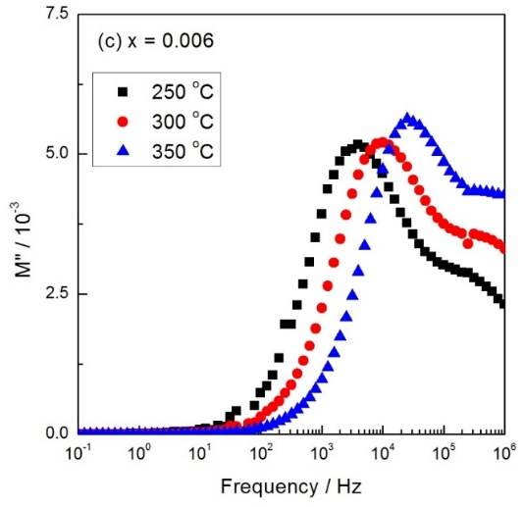
Figure 4-13. M” spectroscopic plots of x = 0.001, 0.002 and 0.006 at various temperatures

Moreover, as shown in Figure 4-11 and 4-13, it is notable that both C₁ and C₂ decrease with increasing temperature, i.e. they may show a negative temperature coefficient of permittivity (T_{cε}). The approximate permittivity values vs temperature of the two components are illustrated in Figure 4-14, and T_{cε} values are summarized in Table 4-2. With 0.001 ≤ x ≤ 0.006, both components, R₁C₁ and R₂C₂, show T_{cε} smaller than 1 K⁻¹. When x = 0.001, R₂C₂ exhibits a larger T_{cε} with value of ~2.43 K⁻¹. Since T_{cε} values may depend on microstructure and volume fraction of the components, the calculated values shown in Table 4-2 may not be accurate; nevertheless, both components show a negative T_{cε}.
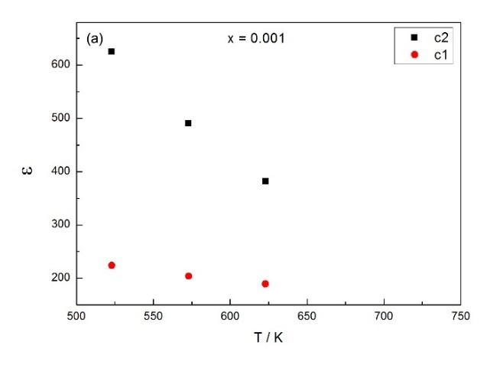
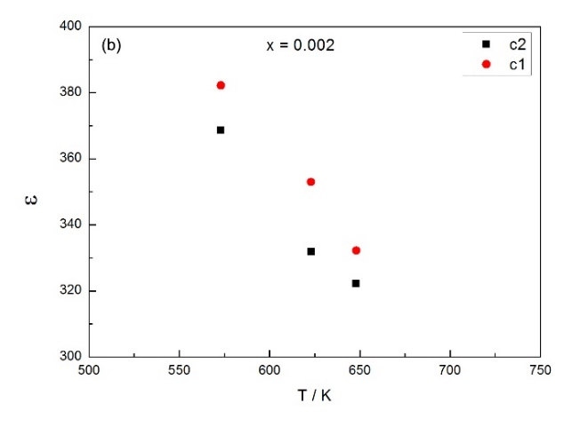
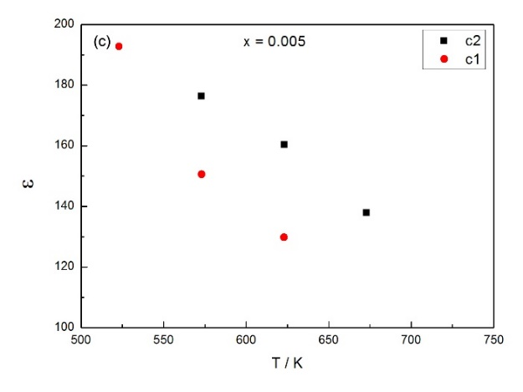
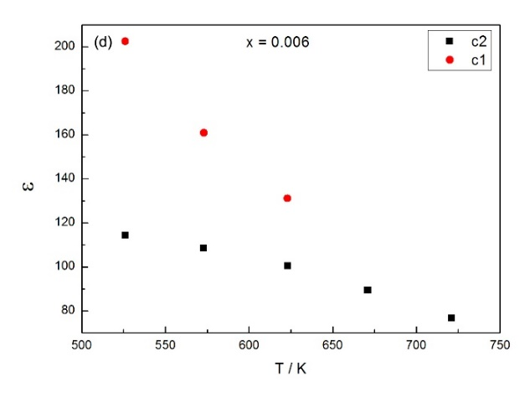
Figure 4-14. Estimated permittivity vs temperature of component R₁C₁ and R₂C₂

Table 4-2. Temperature coefficient of permittivity
x | undoped  rutile | 0.001 |  | 0.002 |  | 0.005 |  | 0.006
component |  | R₁C₁ | R₂C₂ | R₁C₁ | R₂C₂ | R₁C₁ | R₂C₂ | R₁C₁ | R₂C₂
T_{cp} / K⁻¹ | 0.21 | 0.35 | 2.43 | 0.65 | 0.65 | 0.63 | 0.38 | 0.73 | 0.22

The Arrhenius plots for f_{max} data, which were extracted from the M” peaks, are shown in Figure 4-15. Activation energy values are summarized in Table 4-3. With relatively low x, the component R₁C₁ shows higher conductivity and smaller activation energy than R₂C₂. Also, R₁C₁ has similar activation energy to high x samples. Therefore, we consider that maybe samples with 0.001 ≤ x ≤ 0.006 are two-phase mixtures.
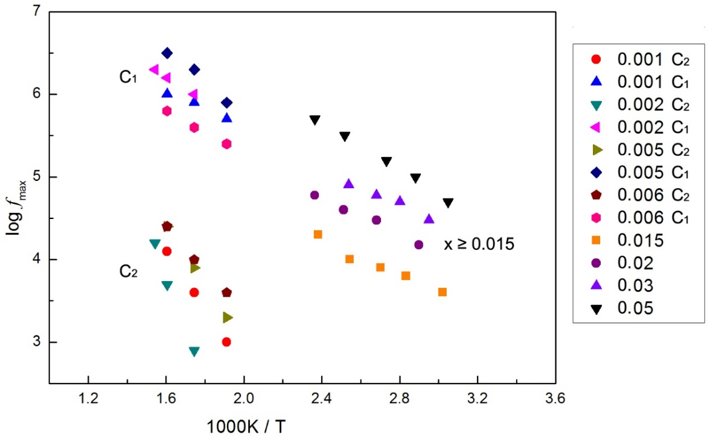
Figure 4-15. Arrhenius plots for f_{max} of M”

Table 4-3. Activation energy values of Ti_{1-x}Cr_{x}O_{2-x/2-δ}
x | Ea / eV
 | Component 1 | Component 2
0.001 | 0.20(2) | 0.71(3)
0.002 | 0.29(1) | 1.25(2)
0.005 | 0.39(1) | 0.71(1)
0.006 | 0.26(1) | 0.52(1)
0.015 | 0.21(3)
0.02 | 0.25(2)
0.03 | 0.20(4)
0.05 | 0.29(1)

Figure 4-16 shows the typical results of an x = 0.008 sample slow-cooled from 1350 °C. Impedance complex plane plots (a) show a broadened, asymmetric arc and a possible small low-frequency impedance spike. The low-frequency intercept gives the total resistance of the sample, R_{t}. M” and Z” spectra (b) both show a single peak at almost coincident frequencies. The experimental peaks are broadened, but not noticeably asymmetric. Capacitance plots, (c), show a limiting high-frequency plateau with an approximate value ~7 pF, corresponding to a permittivity of ~90. Also, a poorly resolved plateau is observed at ~10⁴ Hz with a value of ~10 pF.
Figure 4-17 shows the impedance results of an x = 0.01 sample slow-cooled from 1350 °C. Z* plot, (a), shows a broad semicircle at high frequencies and a small inclined spike at low frequencies. The Z”/M” spectroscopic plots (b) show peaks at high frequencies that are broader than expected for an ideal Debye peak. The capacitance plot, (c), shows evidence for a high-frequency plateau of the value ~8 pF and a poorly resolved intermediate plateau of the value ~10 pF.
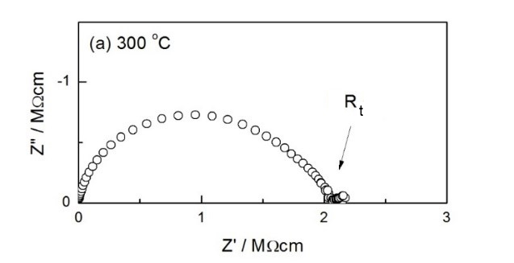
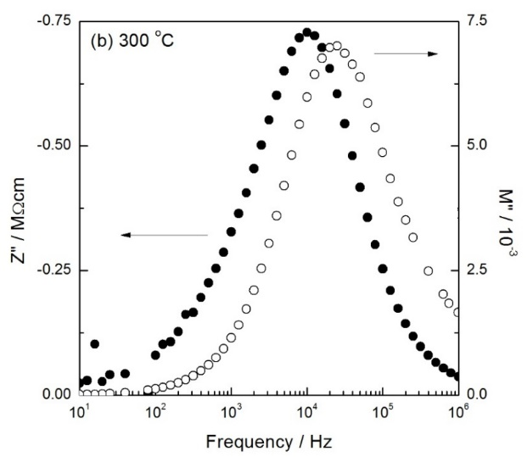
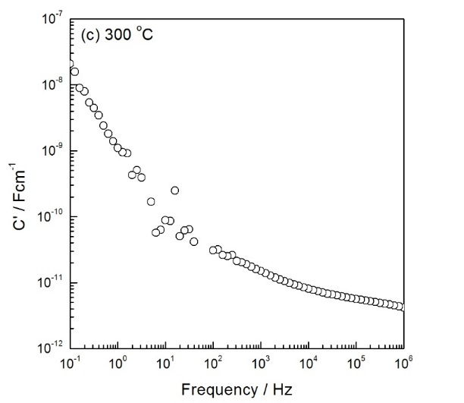
Figure 4-16. Typical impedance data of x = 0.008 slow-cooled from 1350 °C (a) impedance complex plane plot (b) Z”/M” spectroscopic plots (c) and spectroscopic plot of capacitance at 300 °C
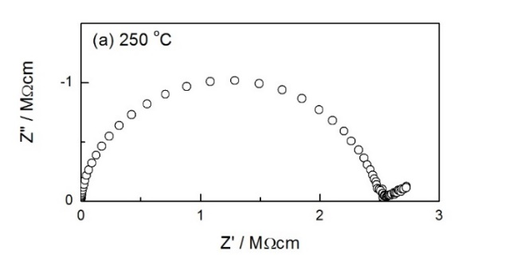
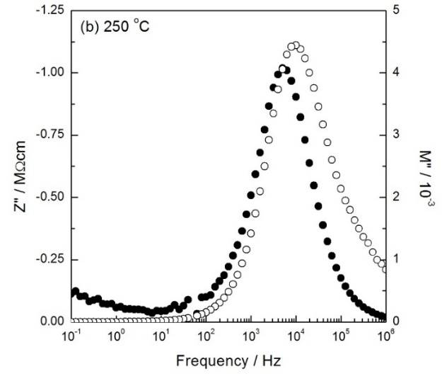
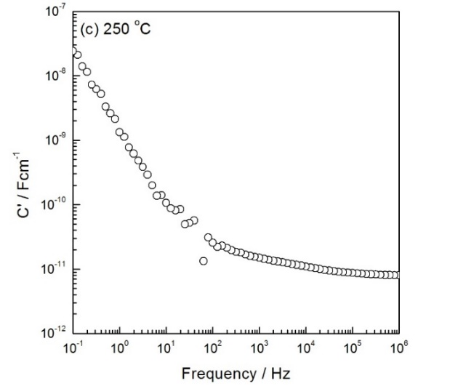
Figure 4-17. Typical impedance data of x = 0.01 slow-cooled from 1350 °C (a) impedance complex plane plot (b) Z”/M” spectroscopic plots (c) and spectroscopic plot of capacitance at 250 °C
Compared with 0.001 ≤ x ≤ 0.006, in this case, when x = 0.008 and 0.01, samples are still electrically inhomogeneous and contain several components. However, as shown in Figure 4-16(b) and 4-17(b), the two peaks in M” spectrum overlap and the M” spectrum only exhibits a broad peak. It is hard to separate the two components R₁C₁ and R₂C₂ in the M” spectrum as before. Moreover, there seems to be less evidence of ionic conduction since the low-frequency spike is smaller and C’ does not reach such high values at lowest frequencies.
Total conductivity data of Cr-doped samples with x ≤ 0.01 slow-cooled from 1350 °C are shown in Arrhenius format in Figure 4-18. Data for undoped TiO₂ are also shown for comparison. Linear plots are observed with different activation energy values. Conductivity increases with an increase in Cr³⁺ dopant concentration.
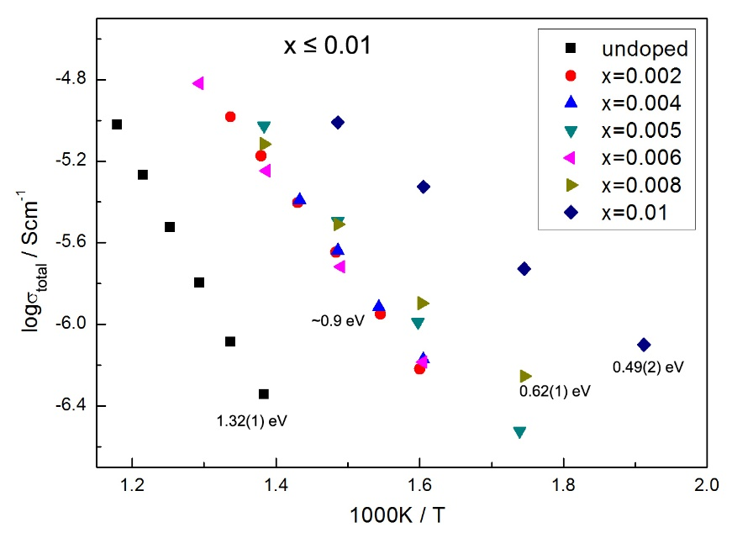
Figure 4-18. Arrhenius plots of samples with x ≤ 0.01

(b) Effect of atmosphere
In order to study the effect of atmosphere, impedance data were obtained for the x = 0.005 sample at 400 °C, Figure 4-19(a). The total resistance is greatest in N₂ and smallest in O₂, consistent with p-type behavior. The effect of pO₂ for x = 0.002 and x = 0.008 are also shown in (b) and (c). Similar conclusions were obtained.
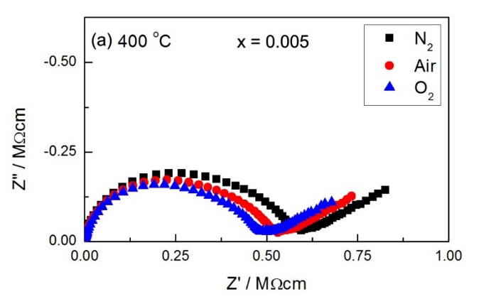
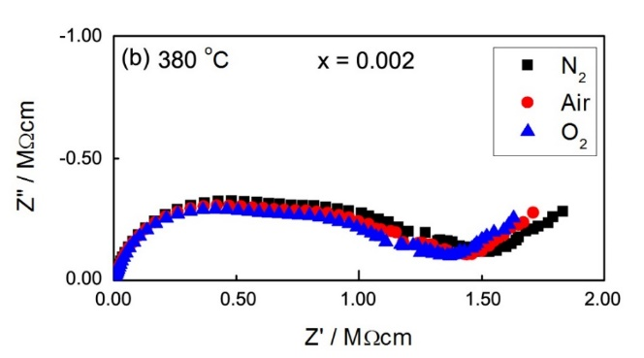
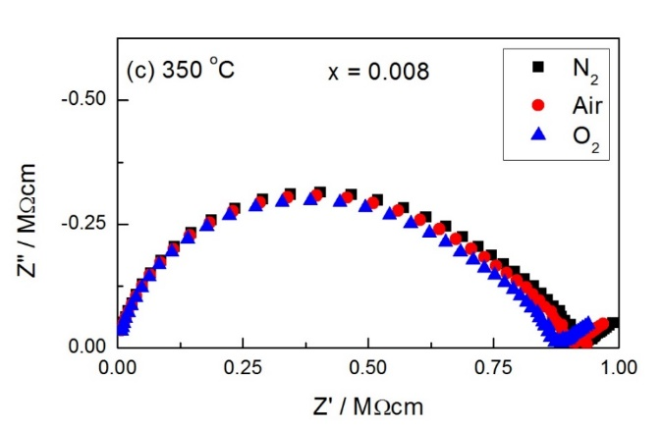
Figure 4-19. Effect of pO₂ of x = 0.005, 0.002 and x = 0.008
However, as discussed above, σ_{total} is some combination of σ₁ + σ₂ + σ₃. From such Z* plots shown above, it is hard to separate the effect of pO₂ on these three components. From such atmosphere-dependent impedance data, we could only conclude that σ_{total}, σ₂ and σ₃ show slightly p-type behaviour, but the effect of pO₂ on σ₁ is not clear.

(c) Oxide ion conduction and EMF measurements
As shown above in Z* plots of Cr-doped rutile samples with x ≤ 0.01, a low-frequency impedance spike, representing charge build-up at the blocking metal electrodes, can be observed. The impedance data of an x = 0.005 sample measured at 600 °C are shown in Figure 4-20. At such high temperature, the low-frequency spike is observed clearly in the Z* plot, (a); at low frequencies, it becomes an arc, giving an intercept (extrapolated) on the Z’ axis. The inclined spike is attributed to diffusion of oxygen molecules through the electrode. The log C’/log f data, (b), exhibit a low-frequency capacitance as high as ~10⁻⁵ Fcm⁻¹, characteristic of a blocking capacitance at the sample-electrode interface.

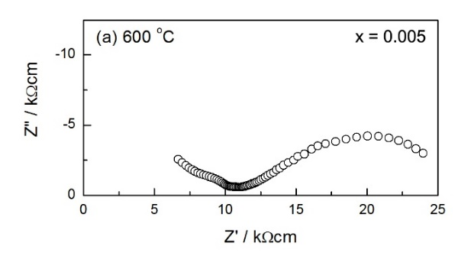
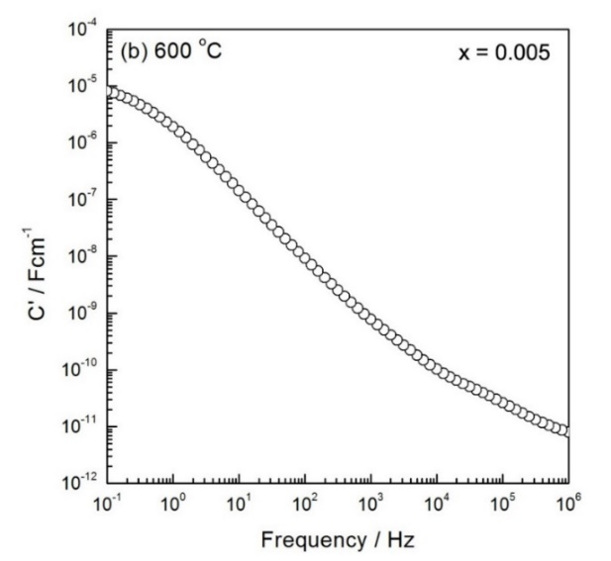
Figure 4-20. Impedance data of x = 0.005 slow-cooled from 1350 °C (a) impedance complex plane plot (b) spectroscopic plot of capacitance at 600 °C

In order to confirm the presence of oxide ion conduction, the ionic transport number was measured using the Electromotive Force, EMF, technique. The EMF technique for transport number determination is based on open cell voltage measurements on a sample equipped with two electrodes and subjected to a gradient in chemical potential ^{[21]}. As shown by the Nernst equation:
$E=-\frac{RT}{nF}ln\frac{p_{1}}{p_{2}}$ (4-8)
where E is the potential (electromotive force), R is the gas constant (8.314472 JK⁻¹mol⁻¹), T is the temperature in Kelvins, n is the number of electrons transferred, F is Faraday’s constant and p is oxygen partial pressure. During EMF measurements, pO₂ on either side of the sample is different, which gives the potential, E. By measuring E of the sample and comparing it with that of YSZ, the ionic transport number can be determined.
In this project, oxide ion transport numbers were measured by using a Probostat system. A 20 mm-diameter x = 0.005 pellet was prepared for measurements. The pellet was pressed by uniaxial pressing with a pressure of 2 ton and cold isostatic pressing with a pressure of 30 PSI. After sintering, the pellet was coated with Pt electrodes on both sides. For EMF measurements, the pellet was sealed onto a YSZ tube by a glass frit. The YSZ tube here, with Pt coating on both sides, acted as an oxygen partial pressure monitor. There were four Pt wires which were connected to the inner sample electrode, outer sample electrode, inner YSZ tube electrode and outer YSZ tube electrode, respectively. During the measurement, the atmosphere outside the YSZ tube was kept as air. N₂ was flowed into the YSZ tube via a gas tube, contacting the inner side of the sample and the tube. Thus, a difference in oxygen partial pressure was created. As YSZ is a pure ionic conductor, by measuring the voltage between inner and outer electrodes, we could compare the sample with YSZ and calculate the oxide ion transport number. Thus, the presence of oxide ion conduction was determined. All the voltages were measured by a Keithley 175 Autoranging Multimeter. Measurements were taken at various temperatures.
Figure 4-21 illustrates the potential vs measuring temperature of x = 0.005 together with YSZ, showing that with increasing temperature from 600 to 800 °C, the ionic transport number of the sample increases. However, the overall percentage of oxide ion conduction is very small: ~2.5% at 600 and 700 °C and 4.6% at 800 °C.
As discussed above, the sample shows not only oxide ion conduction, but also p-type conduction. Since σ changes with pO₂, which may affect the measured voltage, EMF measurements using O₂/air were also carried out for comparison, Figure 4-21(b). In both cases, the overall percentage of oxide ion conduction is similar. In all cases, samples show weak oxide ion conduction.

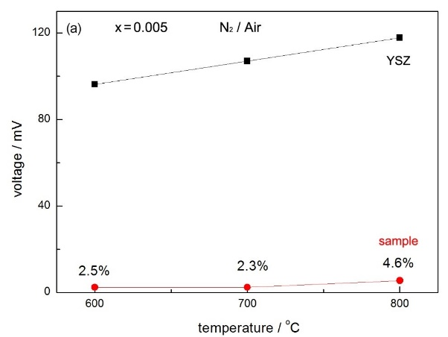
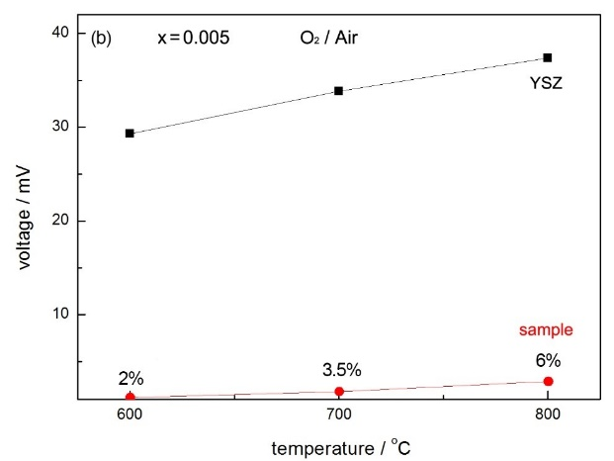
Figure 4-21. EMF measurements of x = 0.005 at various temperatures; data for YSZ are also shown

4.4 Discussion

4.4.1 Two phases
Samples with 0.001 ≤ x ≤ 0.006 were electrically inhomogeneous. As shown in Figure 4-9(c) (x = 0.005 slow-cooled from 1350 °C), the plateau shown at the lowest frequency has a capacitance C₃ of ~10⁻¹⁰ F, and therefore is attributed to a conventional grain boundary.
The interpretations of the other two components, R₁C₁ and R₂C₂, are more complicated. First, as shown in Figure 4-11 and 4-13, the relative heights of both R₁C₁ and R₂C₂ change with temperature and x, which indicates changes in capacitance values. As we know, the capacitance can be given by:
$C=ε^{'}e_{0}\frac{A}{l}$ (4-9)
where $e_{0}$ is the permittivity of free space. Therefore, the change in the relative heights of the two M” peaks may indicate either a change in relative volume fraction, or a difference in temperature-dependence of the permittivity of these two components.
Second, as shown in the Arrhenius plots, Figure 4-12 and 4-15, the component R₁C₁ has very small E_{a}, whereas R₂C₂ has similar E_{a} to the total response. We consider that R₂C₂ may be another part of the structure because of its small capacitance value. Therefore, a possible interpretation for these two components is that the component R₂C₂ represents a second phase in an inhomogeneous material, i.e. samples are two-phase mixtures.
As shown in the Arrhenius plot of f_{max}, Figure 4-15, it can be seen than the component R₂C₂ is more resistive than R₁C₁, and shows larger E_{a}. Therefore, we consider that R₂C₂ represents a phase with very small Cr³⁺ dopant concentration, i.e. x = 0.001 ± 0.0005, and R₁C₁ represents a phase with relatively higher dopant content, i.e. x = 0.008 ± 0.002.
Because of different dopant contents, the two phases may have different defect structures as well. Since the dopant concentration is very small, the phase R₂C₂ may have random point defects, such as oxygen vacancies. With relatively higher dopant content, oxygen vacancies may collapse to form shear planes, i.e. defects shown in the phase R₁C₁ may be random shear planes. In summary, samples with 0.001 ≤ x ≤ 0.006 contain two phases and a grain boundary.

4.4.2 p-type conduction and the location of holes
Since samples with low x value (x ≤ 0.01) show essentially p-type conduction, and in particular, the phase R₂C₂ is p-type, it is necessary to identify the location of the holes which are now the main current carrier.
Holes require the presence of a redox-active species that can readily ionize. In principle, there are four possible locations of holes: on Ti, Cr, impurities or O. Since Ti is in its maximum possible valence state, +4, it cannot be oxidized further and be the source and location of holes. Cr³⁺ is possible but unlikely to be ionized to Cr⁴⁺. There has been some literature ^{[3,22]} on Cr-doped TiO₂ which showed that the valence state of Cr was +3. Unwanted impurities such as Fe could be the location of holes, but high purity, reagent grade TiO₂ and Cr₂O₃ were used for the experiments, and it is regarded as unlikely that such impurities are responsible. Oxide ions have the possibility to adopt oxidation states of -1 in either $O_{2}^{2-}$ or $O^{-}$, as well as oxidation state -1/2 in $O_{2}^{-}$ and are the most likely locations of the holes.

4.4.3 Low-frequency spike and oxide ion conduction
The low-frequency spike in Z* plots of samples with low x value (x ≤ 0.01) indicates a capacitive sample-electrode contact effect and thus, the possibility of ionic conduction. For instance, generally, for an oxide ion conducting sample, the sample-electrode contact effect can be modeled by a Warburg diffusion element associated with a charge transfer resistance (R_{CT}) and a double layer capacitance (C_{DL}), Figure 4-22.
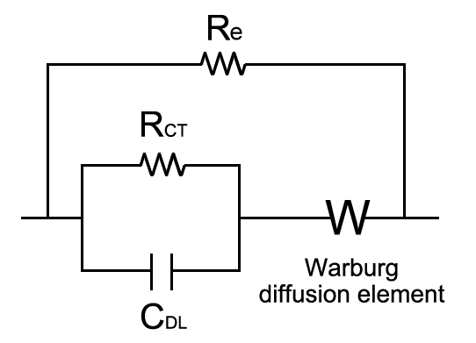
Figure 4-22. Equivalent circuit for sample-electrode contact effect of oxide ion conductors

For oxide ion conducting samples, redox reactions involving O₂ gas and oxide ions occur at the sample-electrode interface. At the positive electrode, oxide ions from the sample interior are discharged as O₂ gas and electrons are released; at the negative electrode, O₂ gas is adsorbed on the sample surface and reduced to oxide ions that diffuse into the sample. The associated charge transfer resistance, R_{CT}, quantifies the ease of the redox reactions at the two electrode-sample interfaces. R_{CT} is in parallel with the blocking capacitance and therefore, forms an additional parallel RC element which is in series with the sample impedance, Figure 4-22. Furthermore, at the lowest frequencies in impedance measurements, a Warburg impedance that represents diffusion of oxygen molecules towards and away from the sample-electrode interfaces is usually observed. It appears as a characteristic spike in Z* plot that is inclined ideally at 45° to the Z’ axis, Figure 4-23.
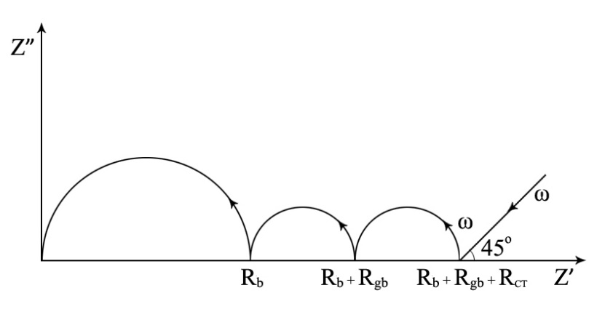
Figure 4-23. Schematic idealized impedance of an oxide ion conducting sample showing bulk, grain boundary, charge transfer and Warburg diffusion resistance components

The inclined spike is attributed to diffusion of oxygen molecules through the electrode. The log C’/log f data, Figure 4-20(b), exhibit a low-frequency capacitance as high as ~10⁻⁵ Fcm⁻¹. The high capacitance value is attributed to the presence and mobility of oxygen vacancies in the sample which are blocked at the electrodes.
Moreover, the inclined spike shown in Figure 4-20(a), which is different from that in Figure 4-23, turns over in the form of a semicircle, indicating that the diffusion of oxygen molecules is through a layer of finite thickness. The other interpretation of the low frequency intercept on Z* is that this represent the total (including electronic) conductivity through the sample.

4.4.4 Volume expansion / contraction
a, b and c
Figure 4-24(a) shows the crystal structure of rutile, considered as almost regular [TiO₆] octahedra sharing opposite edges, to form columns which are joined by sharing octahedral corners as shown. With doping, Cr³⁺ substitutes for Ti⁴⁺ with charge compensating oxygen vacancies. Generally, the Cr³⁺ ions are thought to be statistically distributed over regular cation sites in the rutile lattice. For instance, (b), Cr³⁺ may be located in two neighboring octahedra sharing an edge, with the oxygen vacancy on the edge. As the ionic radius of Cr³⁺ (0.615 Å) is larger than that of Ti⁴⁺ (0.605 Å) ^{[25]}, the lattice parameter “a” increases. However, the lattice parameter “c” decreases with Cr³⁺ doping, which may be attributed to the relatively smaller size of oxygen vacancies compared with oxide ions ^{[16,17]} and a partial collapse of the columns of octahedra in the “c” direction.
It is also notable that samples with low x appears to be two-phase mixtures, so the lattice parameters obtained in the range 0 < x ≤ 0.01 are just average values rather than accurate values. Therefore, it is hard to discuss the interpretations for the changes in lattice parameters.
However, since the phase which occupies a relatively large part of the sample has very low dopant content and point defects, and “a” and “c” show only continuous increase/decrease, we could conclude that the change in “a” and “c” are mainly affected by the larger size of Cr³⁺ ions and the smaller size of oxygen vacancies, respectively.

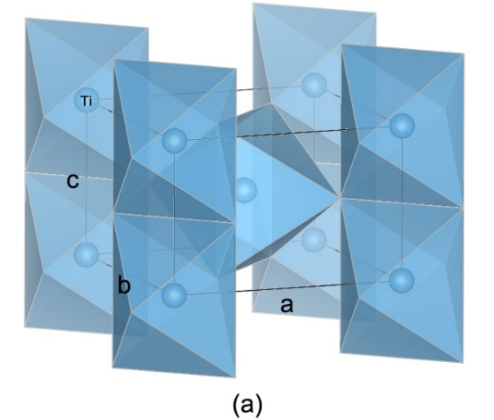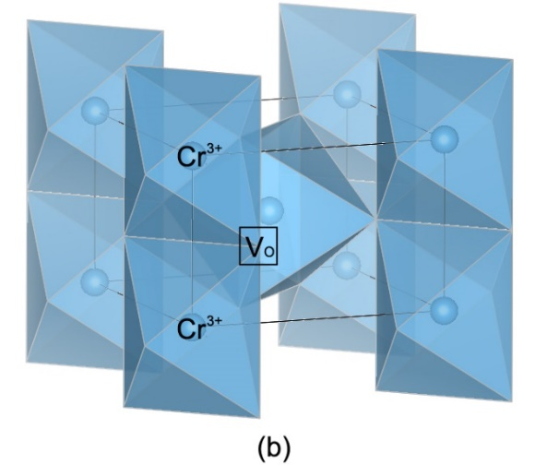
Figure 4-24. Rutile structure showing (a) linkage of almost regular [TiO₆] octahedra (b) 2Ti⁴⁺ substituted by 2Cr³⁺ and create one oxygen vacancy

Cell volume
All of the cell volume data shown in Figure 4-3(c) were recorded at room temperature and therefore, should not show any effects associated with standard thermal expansion. There are several possible reasons for the increasing cell volume over the range 0 ≤ x ≤ 0.005. First, it may be associated with larger size of Cr³⁺. Second, substitution of Ti⁴⁺ by Cr³⁺ may create oxygen vacancies and reduce M-O bond strength on average. As a result, the average M-O bond length increases, and cell volume expands. Third, maybe oxygen loss occurs at high temperature during sintering, i.e. δ > 0. In this case, as shown in eq’n (4-6) and (4-7), the oxygen loss generates electrons, which could reduce some Ti⁴⁺ to Ti³⁺, resulting in weaker bond strength and thus, larger Ti-O bond length, leading to increasing cell volume.
The decrease in lattice cell volume over the range x ≥ 0.005 requires a different explanation. It is well-known that shear structures form in materials such as acceptor-doped TiO₂, Nb₂O₅, WO₃, etc. as a means of eliminating oxygen vacancies; this leads to a partial collapse of the crystal structures to form shear planes which would be accompanied by a reduction in volume. We consider that similar shear planes form in Cr-doped TiO₂ especially as the dopant concentration increases. From the data shown in Figure 4-3, it appears that such shear planes of oxygen vacancies start to form at x value as low as 0.005 where the volume expansion begins to be offset by the volume contraction associated with shear plane formation.
As discussed above, when x ≤ 0.01, samples appears to be two-phase mixtures; when x ≥ 0.015, samples are single phase and show random planar defects. Therefore, the turning point of cell volume is expected to be in the range 0.01-0.015. However, the real turning point of the cell volume obtained here, ~0.005, is smaller. We consider that since samples contain two-phases at low x, the cell volumes we measured are an average of the two phases and therefore, it shows such transition from increase to decrease, and the turning point appears just in the two-phase mixtures range.
The change from volume expansion to volume contraction was found in undoped rutile as well, discussed in Chapter 3. However, there exist some differences between the expansion/contraction shown in pure rutile and Cr-doped rutile. The expansion found in pure rutile is attributed to oxygen loss and is similar in nature to the chemical expansion reported in other oxides such as CeO₂ and ZrO₂ ^{[18]}. On heating pure rutile at high temperatures, it loses oxygen and becomes nonstoichiometric. Therefore, a combination of the larger radius of Ti³⁺ and a weaker bond strength leads to chemical expansion associated with an increase in average Ti-O bond length. The increasing cell volume shown in Cr-doped rutile at low x is primarily due to a combination of the larger ionic radius of Cr³⁺ and the reduced average M-O bond strength.

4.4.5 Semiconductivity in x ≥ 0.015
As shown in Figure 4-5, with relatively higher dopant concentration, i.e. x ≥ 0.015, samples are semiconducting and show small activation energy ~0.2 eV. The effect of cooling rate, Figure 4-6, shows that the slow-cooled and quenched samples have similar conduction and thus, oxygen loss at high temperatures is unlikely. Therefore, we consider some other possibilities for such semiconducting behavior.
The first possible interpretation is due to intrinsic hopping of charge carriers associated with Cr. The term “intrinsic” used here describes those transport processes which are unaffected by external influence, in particular by changes in the defect structure brought about by deviations from stoichiometry. The possible intrinsic mechanism for production of electronic charge carriers is by charge transfer between Cr ions. Therefore, by hopping of carriers, samples are semiconducting, and carrier concentration increases with dopant content. Such carrier hopping has been reported in the literature ^{[19]}.
The second possibility is due to hopping of charge carriers associated with Cr and Ti. As orbital overlap may occur, charge carriers then hop between Cr³⁺ and Ti⁴⁺ and thus, Cr⁴⁺ and Ti³⁺ may be generated and samples become semiconducting. In addition, it can be seen from Figure 4-5 that the conduction mechanism does not change with dopant content, only the carrier concentration increases with x. The possible reason for the increasing carrier concentration is that maybe with high Cr³⁺ doping, oxygen vacancies collapse to form shear planes and thus, the distance between Cr and Cr, or Cr and Ti in face-sharing octahedra in the shear planes may become smaller. As a result, hopping of charge carriers becomes easier and the conductivity increases.
Polaron hopping may lead to semiconductivity as well. A conduction electron or hole together with its self-induced polarization in a semiconductor forms a quasiparticle, which is called a polaron ^{[23]}, Figure 4-25.
Figure 4-25. Schematic illustration of a polaron ^{[23]}

The formation of polarons in rutile has been reported in the literature ^{[24]}. Figure 4-26 gives the schematic illustration of the periodic potential distribution for a crystal. It was found that electrons might localize on different energy levels (shown by the yellow lines in Figure 4-26), resulting in a variety of polaron configurations. By hopping of polarons, the sample property may change from insulating to semiconducting. Alternatively, if oxygen vacancies are eliminated at high x due to CS plane formation, the possibility of oxide ion conduction decreases.
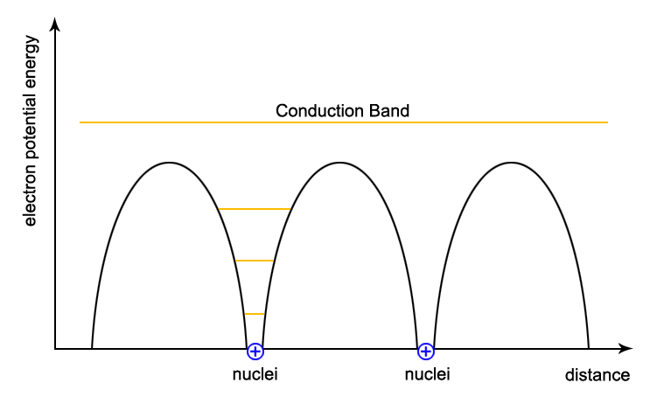
Figure 4-26. Schematic illustration of the periodic potential distribution for a crystal

In addition, polarons may be large or small, depending on spatial extent ^{[23]}, i.e. the original energy level of electrons. With higher dopant content, oxygen vacancies may collapse to form shear planes, and the distance between Cr and Ti in face-sharing octahedra is smaller, indicating a closer overlap of Cr/Ti orbitals. Consequently, polarons are likely to be large as well, and thus samples show higher carrier mobility.
As discussed in the introduction, Cr-doped rutile may be expected to show oxide ion conduction if ionic compensation occurs. However, as shown here in Figure 4-7 and 4-8, with high x, samples only exhibit n-type conduction. We consider that maybe oxide ion conduction does occur with high x, but it is too small to be observed and therefore samples with high x exhibit primarily n-type electronic conduction.

4.5 Conclusions
Cr-doped rutile with 0 ≤ x ≤ 0.005 shows an increased lattice volume which is attributed to the larger ionic radius of Cr³⁺ and the weaker average M-O bond strength. With higher Cr³⁺ dopant concentration, i.e. x ≥ 0.005, an unusual volume contraction effect was observed. This is attributed to the accumulation and elimination of oxygen vacancies by the formation of crystallographic shear planes.
The electrical properties are very dependent on composition x. Samples with lower x values, i.e. x ≤ 0.01, appear to be two-phase mixtures; R₂C₂ represents a phase with very small Cr³⁺ dopant concentration, i.e. x = 0.001 ± 0.0005, and R₁C₁ represents a phase with relatively higher dopant content, i.e. x = 0.008 ± 0.002. Moreover, the phase R₂C₂ may have random point defects, whereas R₁C₁ may have random shear planes. These two-phase mixtures show mixed conduction with p-type electronic conduction and a small amount of oxide ion conduction. $O^{-}$ ions are the most likely locations of the holes. With higher x value, i.e. x ≥ 0.015, samples are homogeneous and show a p-n transition. The n-type conduction is likely to be attributed to hopping of carriers based on Cr/Ti or polarons.

4.6 References
- RK Sharma, MC Bhatnagar, GL Sharma. Sensor Actuator B. 45(1997):209-215.
- BZ Tian, CZ Li, JL Zhang. Chem Eng J. 191(2012):402-209.
- B Santara, K Imakita, M Fujii, et al. J Alloy Compd. 661(2016):331-334.
- JY Cao, YJ Zhang, LQ Liu, et al. Chem Commun. 49(2013):3440-3442.
- CW Lee. Ber Dtsch Keram Ges. 47(1970):169.
- RM Gibb, JS Anderson. J Solid State Chem. 4(1972):379-390.
- S Sōmiya, S Hirano, S Kamiya. J Solid State Chem. 25(1978):273-284.
- M Hamelin. Bull Soc Chim Fr. 11-12(1957):1421-1431.
- Electronic vs ionic compensation of solutes. NPTEL India. nptel.ac.in/courses/113104005/l ecture12/12_6
- Y Liu, AR West. J Am Ceram Soc. 96(2013):218-222.
- Y Liu, AR West. Appl Phys Lett. 103(2013):263508.
- N Masó, H Beltrá, M Prades, et al. Phys Chem Chem Phys. 16(2014):19408
- LG Escrig, M Prades, H Beltrá, et al. J Am Ceram Soc. 97(2014):2815-2824.
- QL Zhang, N Masó, Y Liu, et al. J Mater Chem. 21(2011):12894.
- YX Li, W Wlodarski, K Galatsis, et al. Sensor Actuator. 83(2002):160-163.
- E Jedvik, A Lindman, MP Benediktsson, et al. Solid State Ionics. 275(2015):2-8.
- LA Bursill, MG Blanchin. J Solid State Chem. 51(1984):321-335.
- D Marrocchelli, SR Bishop. Adv Funct Mater. 22(2012):1958-1965.
- JA Crawford, RW Vest. J Appl Phys. 35(1964):2413-2418.
- AR West. Solid State Chemistry and its Application. John Wiley & Sons. 2014.
- HK Bentzer, N Bonanos, J Phair. Solid State Ionics. 181(2010):249-255.
- XM Li, ZK Guo, T He. Phys Chem Chem Phys. 46(2013):20037-20045.
- JT Devreese. Enc Appl Phys. 14(1996):383-409.
- LG Zhu, J Zhou, ZM Sun. Mater Res Lett. 6(2018):165-170.
- RD Shannon. Acta Cryst. 32A(1976):751-767.

Chapter 5. Al-doped TiO₂

5.1 Introduction
TiO₂ is widely used in various applications based on its specific electrical, optical and photochemical properties, and its application range can be extended by adding dopants. Al-doped TiO₂, for instance, is employed as pigment, photocatalyst, gas sensor, dielectric capacitor and ferromagnetic material ^{[1-6]}. The bond length of Al-O is 1.93 Å, which is similar to that of Ti-O, 2.01 Å ^{[7]}. Therefore, Al³⁺ is believed to be soluble in TiO₂.
As a trivalent dopant, Al³⁺ has one less electron than Ti⁴⁺ and thus, the charge could be compensated by different mechanisms. For instance, it may occur through oxygen vacancy formation, with one oxygen vacancy forming for two Al³⁺, giving the following defect reaction in Kröger-Vink notation:
${Al}_{2}O_{3}↔2{Al}_{Ti}^{'}+3O_{O}^{×}+V_{O}^{••}$ (5-1)
and in this case, Al-doped rutile may show oxide ion conduction. Also, extra Al³⁺ may enter interstitial sites. Another possible charge compensation mechanism may occur through hole formation, i.e. substituting one Ti⁴⁺ for Al³⁺ results in formation of an oxygen hole, $O^{-}$:
${Al}_{2}O_{3}↔2{(Al}_{Ti}^{'}+O_{O}^{•})$ (5-2)
and in this case, Al-doped rutile would probably show p-type conduction.
There have been some experimental and modelling studies of Al-doped rutile, primarily using density functional theory ^{[6,8-11]}. Gesenhues et al ^{[6]} studied the defect structure of Al-doped rutile and reported that with low amounts of dopant (0-0.8%), Al³⁺ substituted for Ti⁴⁺ with charge compensating oxygen vacancies, and with relatively large amounts of dopant (0.8-1%), extra Al³⁺ entered interstitial sites. An experimental study ^{[8]} also showed incorporation of Al³⁺ onto Ti sites in TiO₂, and Al³⁺ preferred to segregate to the surface. With modelling studies, Islam et al ^{[9]} reported the formation of localized oxygen holes in Al-doped rutile, and Stashans et al ^{[10]} showed that with Al doping, rutile produced oxygen hole polarons. Moreover, Iwaszuk et al ^{[11]} investigated Al³⁺ doping of rutile; DFT gave a solution with a localized oxygen hole and a distorted structure around the dopant site; oxygen vacancy compensation calculations showed ionic compensation should occur as well.
The Al₂O₃-TiO₂ system has been studied by several groups ^{[12-16]}. Phase relations between TiO₂ and Al₂O₃ are summarized in a phase diagram, Figure 5-1 ^{[12]}. Stability relations among various phases in the TiO₂-Al₂O₃ system in air were determined in the temperature range of 1100-2100 °C. The phase diagram shows that monophasic rutile solid solution exists only in a very small range. The limiting composition of this solid solution range is temperature dependent: Al₂O₃ shows solid solubility in TiO₂ of 1.5, 2 and 3 mol% at 1300, 1500 and 1700 °C, respectively. TiO₂ and Al₂O₃ start to react and form Al₂TiO₅ from 1200 °C. The melting point of Al₂TiO₅ is about 1860 °C, and it form eutectics with TiO₂ at 20 mol% Al₂O₃ and 1700 °C, with Al₂O₃ at 62 mol% and 1840 °C. Moreover, Al₂TiO₅ exists in two forms, α and β. The α-form is stable at high temperatures of 1820-1860 °C, while the β-form is stable at relatively lower temperatures ^{[16]}. No crystallographic shear structure is shown in the TiO₂-Al₂O₃ system.
Figure 5-1. Phase diagram of TiO₂-Al₂O₃ system ^{[12]}

It is well-known that acceptor centers can be generated in TiO₂ by Al-doping, even giving rise to p-type conductivity ^{[5,17-19]}. However, the reason for p-type conductivity and the location of holes are still under discussion. The nature of hole centres in Al-doped TiO₂ has been investigated by using the electron paramagnetic resonance, EPR, technique as the hole centers could be observed by EPR after irradiation using UV radiation ^{[5,18]}. Zwingel ^{[18]} reported that holes were located on impurities such as Fe³⁺, while Gionco ^{[5]} showed that centres based on hole trapping on an oxygen ion of the lattice ($O^{-}$) were observed and were paramagnetic, and holes were strongly localized in the O 2p nonbonding orbital of a three-coordinated O ion.
The immediate objective of this chapter was to determine the electrical properties of Al-doped TiO₂ and to see if an n-p transition can be observed by impedance measurements. The surprising result was obtained that indeed, p-type conduction was observed in Al-doped TiO₂, but the conduction type was strongly dependent on cooling condition. Samples could be either n-type or p-type or show a cross-over between n- and p-type due to different oxygen contents.

5.2 Experimental
For structural characterization, samples of Ti_{1-x}Al_{x}O_{2-x/2-δ} (x = 0.005, 0.01, 0.03, 0.05, 0.1) were heated at 1350 °C for 8 h. For X-ray diffraction, a Siemens D5000 diffractometer with Si internal standard for accurate lattice parameter measurement was used.
For electrical property measurements, samples with x = 0.005, 0.01 and 0.03 were sintered at 1350 °C for 8 h in air and cooled slowly in the furnace (5 °C/min). For selected experiments, samples were given further heat treatment: (i) reheated at various temperatures (1000-1350 °C) for 1 h in a vertical tube furnace and quenched into liquid nitrogen (~10000 °C/min); (ii) annealed from 1300 to 700 °C and cooled slowly (5 °C/min) to room temperature. Specifically, the anneals commenced at 1300 °C and were repeated on stepwise cooling at 100 °C intervals, and at each temperature, the sample was held for 24 h. Electrodes were fabricated on opposite pellet faces using Pt paste which was decomposed and hardened by heating at 900 °C for 2 h. A combination of Agilent 4980A and Modulelab XM Solartron was used for impedance measurements. For subambient measurements, an Oxford Cryocooler was employed. A Renishaw inVia micro-Raman spectrometer was used to record Raman spectra over the range 0-3000 cm⁻¹; the spectral excitation was provided by an Ar⁺ laser, using the 514.5 nm line.

5.3 Results

5.3.1 XRD
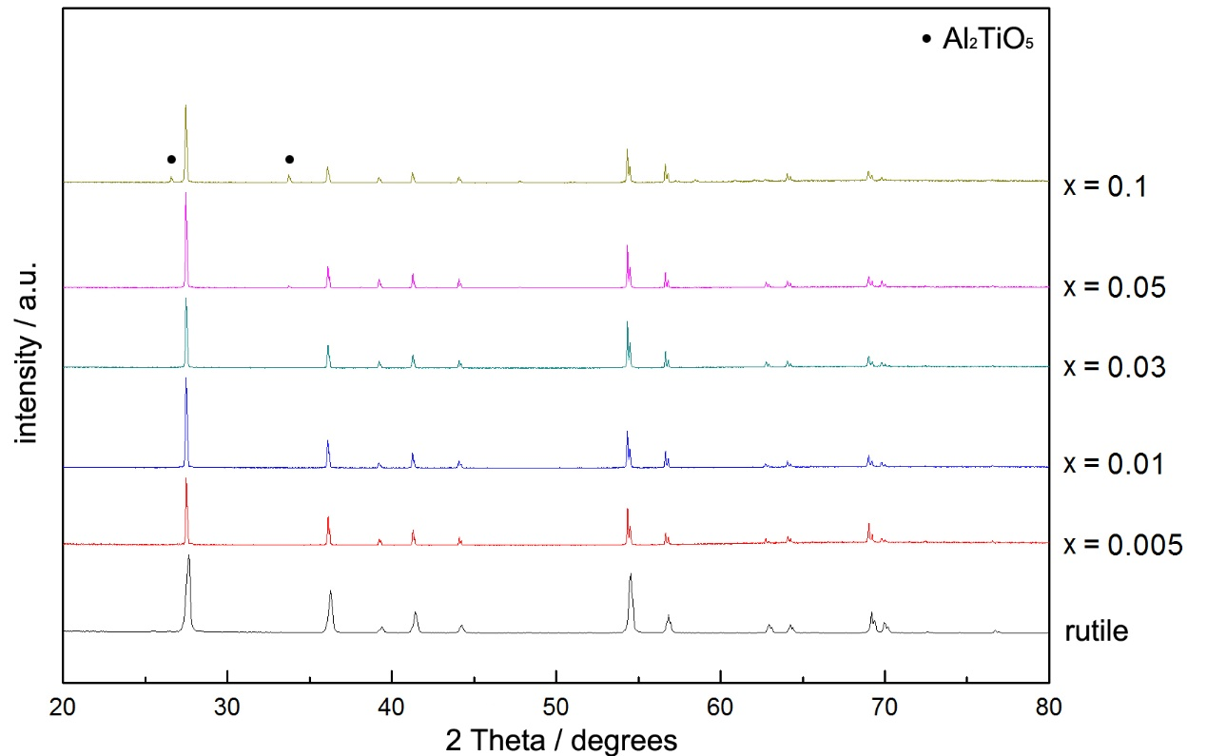
Figure 5-2. XRD patterns of Ti_{1-x}Al_{x}O_{2-x/2-δ}
XRD patterns of Al-doped TiO₂ are shown in Figure 5-2. Samples with 0.005 ≤ x ≤ 0.03 are single phase, and patterns closely resemble those of tetragonal rutile structure, which indicates that dopants are well-dispersed in the TiO₂ matrix. With Al³⁺ doping, peaks shift towards a lower angle, indicating an increase in lattice parameters (due to Bragg’s law):
$2dsinθ=nλ$ (5-3)
where n is a positive integer and λ is the wavelength of the incident wave. When x ≥ 0.05, samples still have rutile as the major phase but show a small amount of Al₂TiO₅ as the secondary phase, which agrees with the phase diagram reported in the literature ^{[12]}, Figure 5-1.
Refined lattice parameters for undoped rutile and x = 0.005, 0.01 and 0.03 are summarized in Table 5-1 and Figure 5-3. Compared with undoped rutile, lattice parameters and cell volume of x = 0.005 increase, consistent with the peak shifting shown in Figure 5-2. However, it appears that dopant content could not influence lattice parameters further as x = 0.005, 0.01 and 0.03 have almost the same a, c and cell volume values, which indicates that the solid solution limit may be ≤ 0.005.

Table 5-1. Lattice parameters of Ti_{1-x}Al_{x}O_{2-x/2-δ}
x | Lattice parameters
 | a=b (Å) | c (Å) | cell volume (Å³)
0 | 4.5910(4) | 2.9590(3) | 62.368(7)
0.005 | 4.6035(7) | 2.9650(6) | 62.835(14)
0.01 | 4.6038(8) | 2.9651(7) | 62.844(17)
0.03 | 4.6040(6) | 2.9647(6) | 62.843(14)

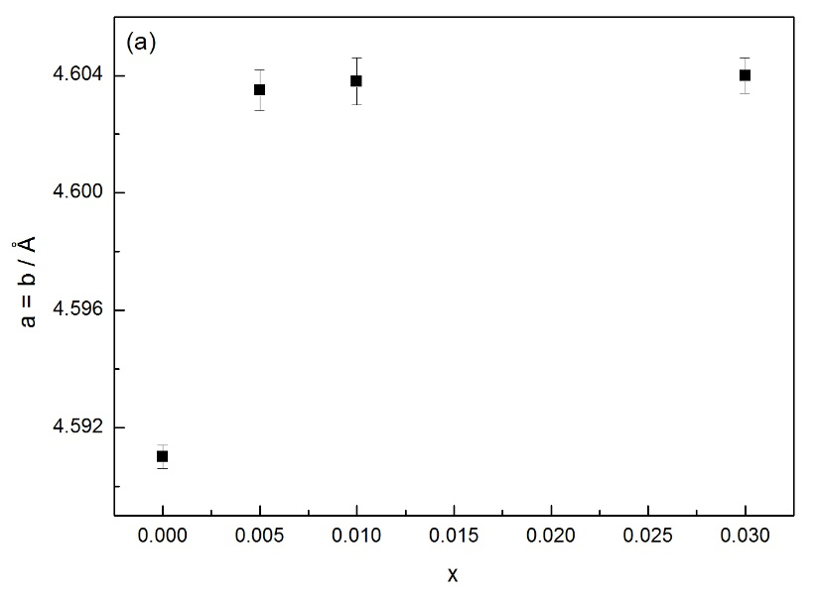
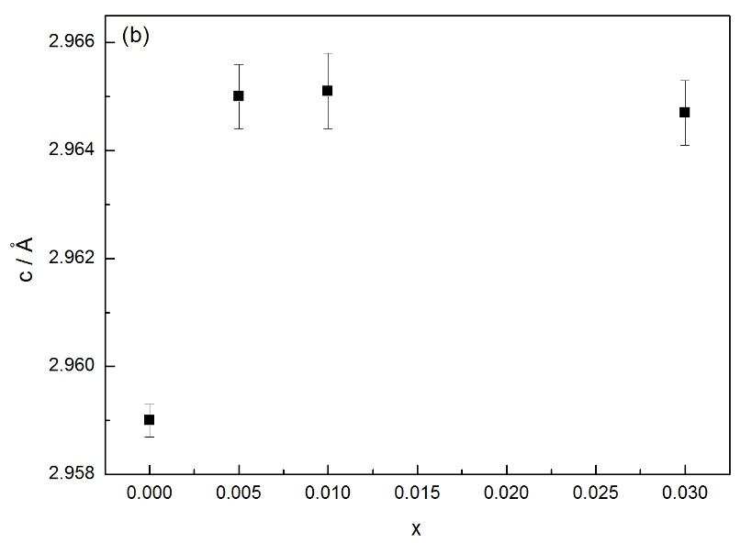
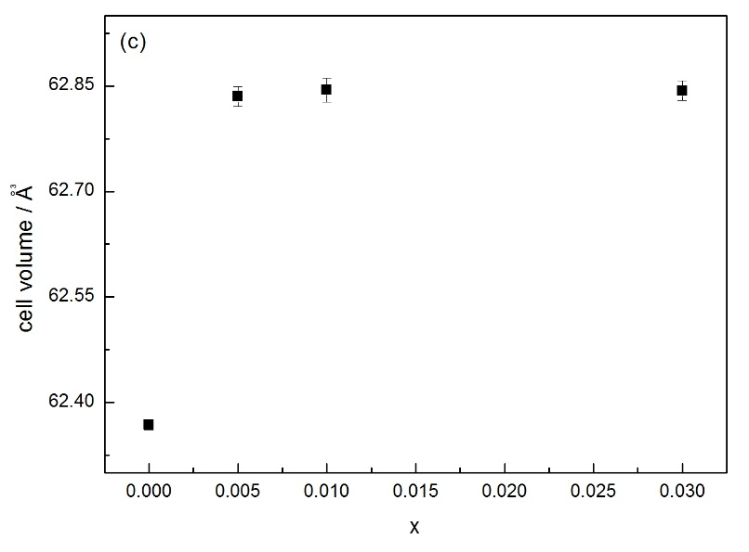
Figure 5-3. Lattice parameters vs x value

5.3.2 Electrical properties

5.3.2.1 Effect of cooling rate

(1) Slow-cooled
For impedance measurements, all pellets were sintered at high temperature and showed calculated pellet densities ~90% of the theoretical density. The electrical properties of x = 0.005 slow-cooled from 1350 °C were evaluated using ac impedance measurements. A typical impedance data set at 400 °C is shown in Figure 5-4. The impedance complex plane plot, (a), shows several overlapping arcs and a low-frequency spike. The low-frequency intercept on the Z’ axis gives the total resistance of the sample. The inclined spike indicates that there may be ion blocking at the sample-electrode interface and the sample may exhibit ionic conduction. On replotting the same data in the Z”/M” spectroscopic plot format, (b), it is clear that the M” spectrum is a double peak, and the low-frequency component occurs at about the same frequency as the Z” peak, ~10³ Hz. Spectroscopic plots of capacitance C’ at different temperatures are illustrated in (c). The C’ plot at 400 °C demonstrates several plateaus. The high-frequency plateau has a value C₁ of ~18 pF, and the poorly resolved plateau at 10³ Hz has capacitance value C₂ of ~10⁻¹⁰ F.
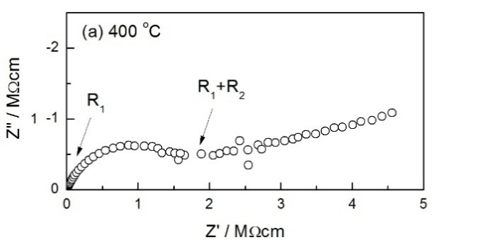
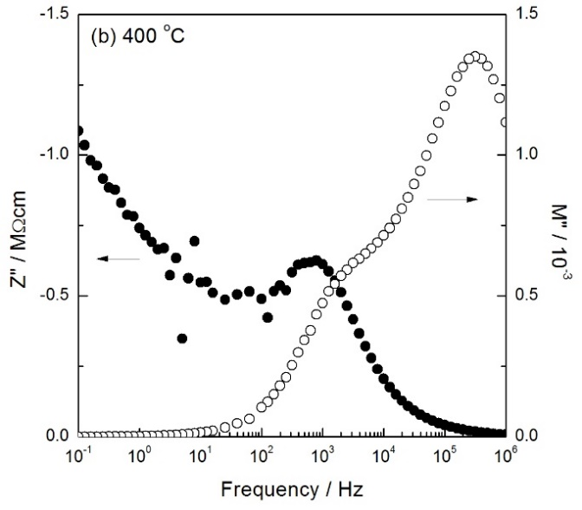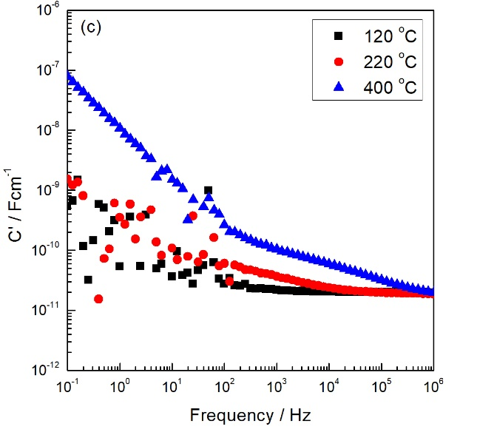
Figure 5-4. Typical impedance data for x = 0.005 slow-cooled from 1350 °C (a) impedance complex plane plot (b) and Z”/M” spectroscopic plots measured at 400 °C, (c) spectroscopic plots of capacitance at different temperatures

Conductivity data of R₁ and R_{total} are shown in Arrhenius format in Figure 5-5. Total resistance values were extracted from Z* plot, and R₁ values were extracted from the high-frequency M” peak. σ₁ shows relatively high conductivity and small activation energy.
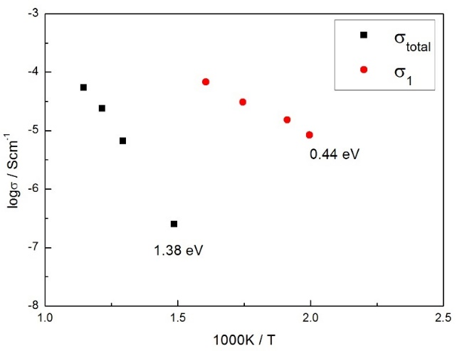
Figure 5-5. Arrhenius plots of σ₁ and σ_{total} of x = 0.005 slow-cooled from 1350 °C

(2) Quenched from 1000-1200 °C
To carry out a thorough investigation of the effect of cooling rate on the electrical properties, samples with x = 0.005 were quenched (~10000 °C/min) from various temperatures in the range 1000 to 1350 °C.
A typical set of impedance data for x = 0.005 quenched from 1100 °C is shown in Figure 5-6. All datasets show a similar impedance response to the slow-cooled sample shown in Figure 5-4. However, in this case, C₁ appears to be less than 10 pF.
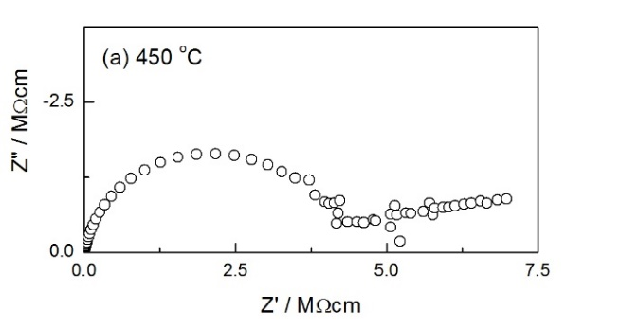
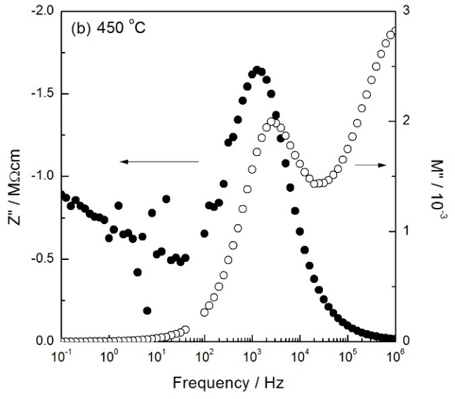
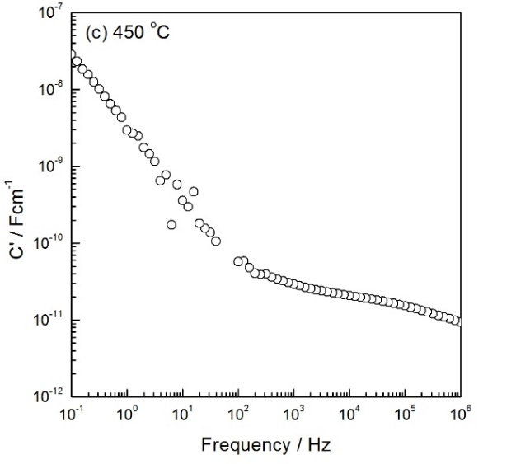
Figure 5-6. (a) Impedance complex plane plot, (b) Z”/M” spectroscopic plots and (c) capacitance spectroscopic plot for x = 0.005 quenched from 1100 °C

(3) Quenched from 1225-1350 °C
Typical results of an x = 0.005 sample quenched from 1350 °C are shown in Figure 5-7, and a different behavior was seen here. Impedance complex plane plots (a) show a single, almost ideal, semicircular arc whose low-frequency intercept gives the total resistance of the sample. The total resistance, R_{t}, essentially corresponds to the bulk resistance of the sample since impedance, Z” and modulus M” spectra of the same data, Figure 5-7(b), show in each case a single peak with their maxima at similar frequency. On replotting the same data in the capacitance spectroscopic plot (c), it is clear that capacitance data show a high-frequency plateau of magnitude ~10 pF, corresponding to a sample bulk permittivity of 110, in agreement with reported values for rutile.
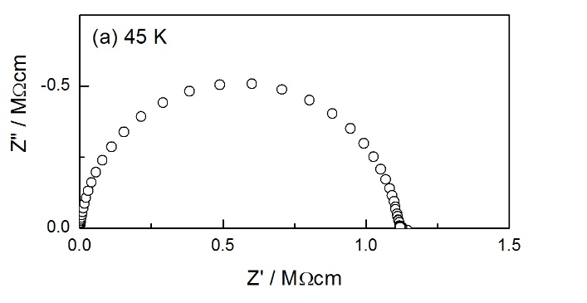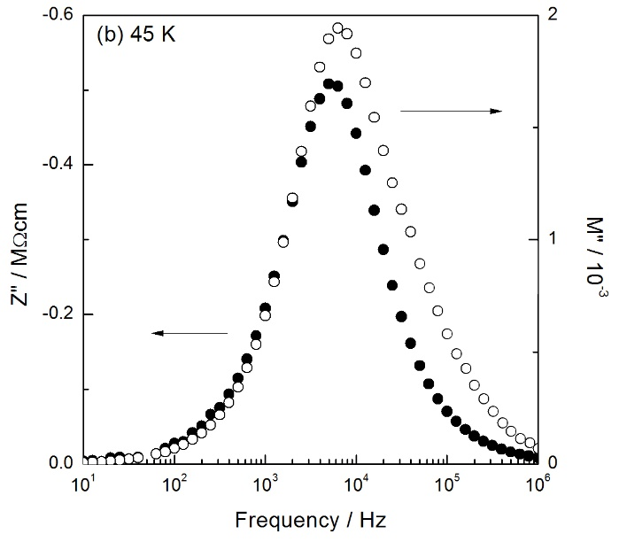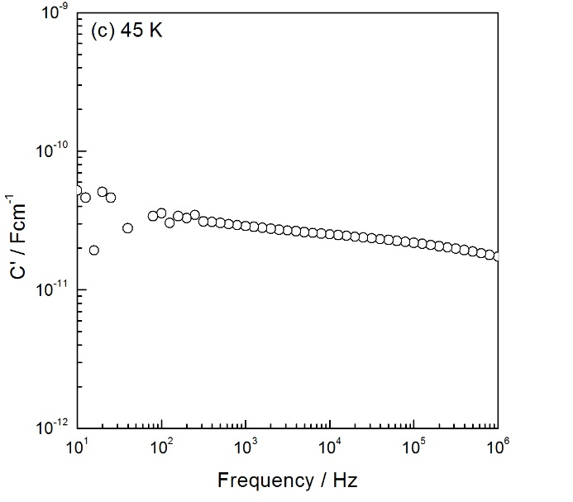
Figure 5-7. (a) Impedance complex plane plot, (b) Z”/M” spectroscopic plots and (c) capacitance spectroscopic plot for x = 0.005 quenched from 1350 °C

Compared with the sample slow-cooled or quenched from relatively low temperatures (≤1200 °C), in this case, the sample is homogeneous and shows very small bulk resistance. Such results indicate that oxygen loss may occur at high sintering temperatures and therefore, the sample is highly conducting.

(4) Amount of oxygen loss
Since the sample quenched from 1350 °C may lose oxygen, it is useful to evaluate the amount of oxygen loss. An x = 0.005 sample was quenched from 1350 °C and weighed before and after quench. For a sample of approximate weight 0.48 g, the maximum weight change was within experimental error, ±0.0001 g. This enables the maximum deviation, δ, from oxygen stoichiometry in the formula Ti_{1-x}Al_{x}O_{2-x/2-δ} to be estimated as 0 < δ ≤ 0.0017.
It is well known that TiO₂ can be reduced at high temperatures or in low pO₂ to give crystallographic shear, CS, structure ^{[20]}. Here in Al-doped TiO₂, this level of oxygen nonstoichiometry, δ ≤ 0.0017, is much less than that corresponding to the CS structures. However, such oxygen loss could give sufficient numbers of oxygen vacancies and thus, electrons are liberated and give a dramatic increase in conductivity, similar to undoped TiO₂.

(5) Dependence of conductivity on quench temperature, Q_{T}
Between the two extremes of behavior, i.e. slow-cooled and quenched from 1350 °C, x = 0.005 samples with a range of intermediate conductivities and activation energies were obtained, depending on sample temperature prior to quenching. Total resistance (R_{t}) data are presented as conductivity Arrhenius plots in Figure 5-8. Results show that the conductivity is very sensitive to quench temperature. In particular, those samples quenched from high temperatures, i.e. 1225-1350 °C, are highly conducting and have very small activation energies in the range 0.12-0.34 eV. However, samples quenched from 1200 °C and lower temperatures have similar activation energy with the slow-cooled sample, ~1.38 eV. It seems that samples start to lose oxygen above ~1225 °C, and this temperature is much higher than that of undoped TiO₂ in the literature, 700 °C ^{[20]}.
In order to carry out a further investigation of those samples which have similar activation energies, ~1.38 eV, conductivity data are replotted in detail in Figure 5-9. Data for a slow-cooled sample and a sample that was annealed in air for several days (called “very slow”, estimated cooling rate ~0.07 °C/min) are also shown. Parallel linear plots can be observed, indicating that these samples have the same conduction mechanism. However, the carrier concentration is different. Specifically, the sample annealed in air for several days has the largest carrier content, while the sample quenched from 1200 °C has the smallest carrier content.
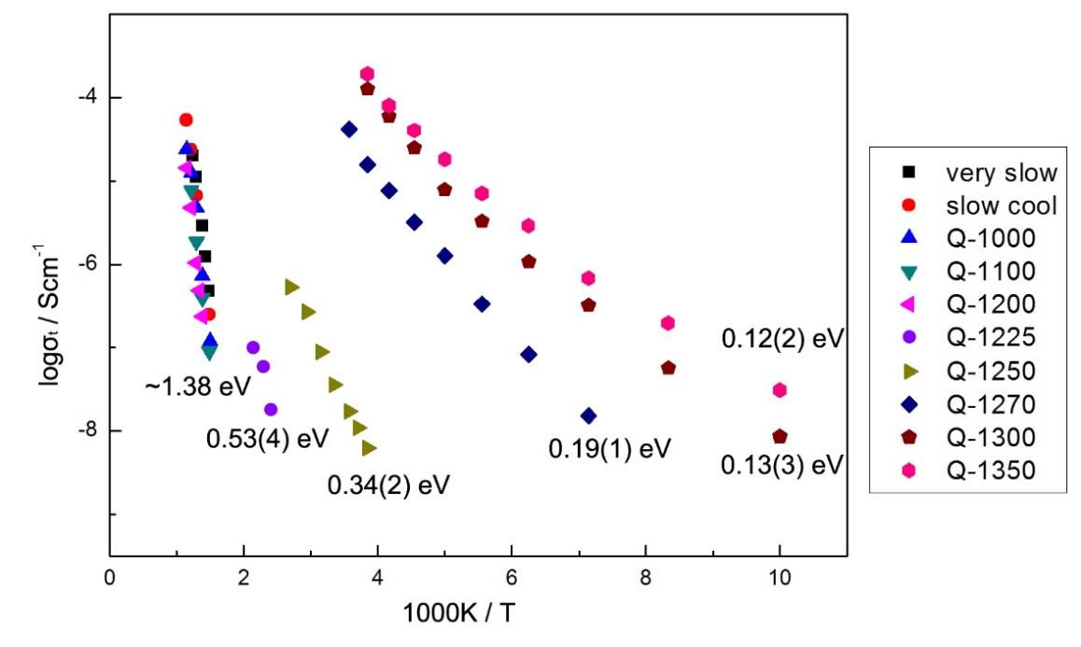
Figure 5-8. Total Arrhenius plot for x = 0.005 with different heat treatments; activation energies, in eV, are noted beside each data set
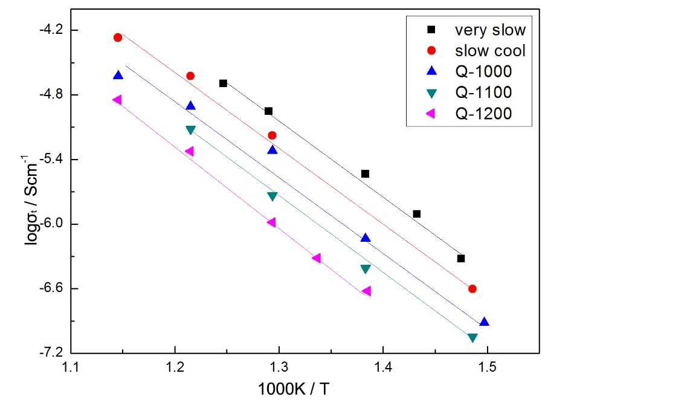
Figure 5-9. Total Arrhenius plot for x = 0.005 with different heat treatments

(6) Raman spectroscopy
To further investigate the oxygen species at the sample surface, the x = 0.005 sample annealed in air for several days was characterized by Raman spectroscopy. The Raman spectra are shown in Figure 5-10. All spectra show sharp bands at ~142 and 610 cm⁻¹ and asymmetric broader bands at ~237 and 447 cm⁻¹ in agreement with the literature rutile values ^{[21]}.
In the literature, p-type Ca-doped BaTiO₃ ^{[22]} sintered using a high oxygen pressure, HOP, furnace showed an extra peak at ~1125 cm⁻¹, which was believed to be associated with superoxide ions, $O_{2}^{-}$. Also, the Raman spectrum of CsO₂, KO₂ and RbO₂ ^{[23,24]} showed a peak in the range 1132-1146 cm⁻¹, which was attributed to a fundamental peak of $O_{2}^{-}$. However, the x = 0.005 sample studied here does not show any peak near 1125 cm⁻¹. The possible reason is that the $O_{2}^{-}$ content in this sample is not large enough to be detected by Raman spectroscopy.
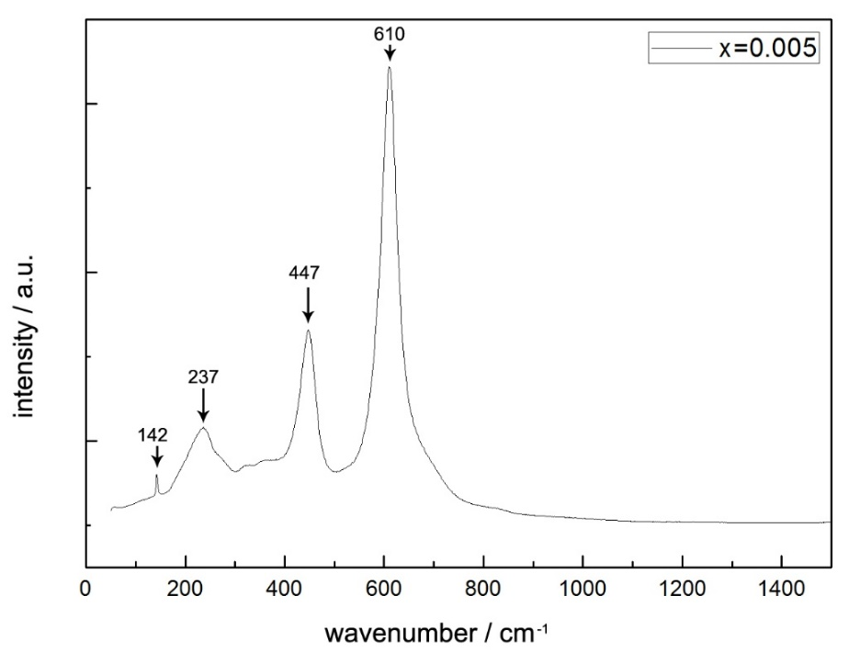
Figure 5-10. Room temperature Raman spectrum for x = 0.005 annealed in air for several days

5.3.2.2 Effect of pO₂ and dc bias

(1) SC and Q_{T} ≤ 1200 °C
The effect of pO₂ and dc bias on a slow-cooled x = 0.005 sample is shown in Figure 5-11. Impedance data were recorded at 450 °C and measured (i) in atmospheres of N₂, air and O₂ and (ii) with/without application of a dc bias during measurements in air. The conductivity increases with pO₂, (a), showing that as a consequence of absorption of O₂ at the sample surface, the origin of the conductivity is p-type electronic. Impedance measurements in air with dc bias show a small increase in conductivity as dc bias changes from 0 to 3 V, (b); this change also indicates p-type conduction, since the application of a small dc bias could withdraw electrons from the sample interior and thus, concentration of holes increases, i.e. p-type conduction increases.
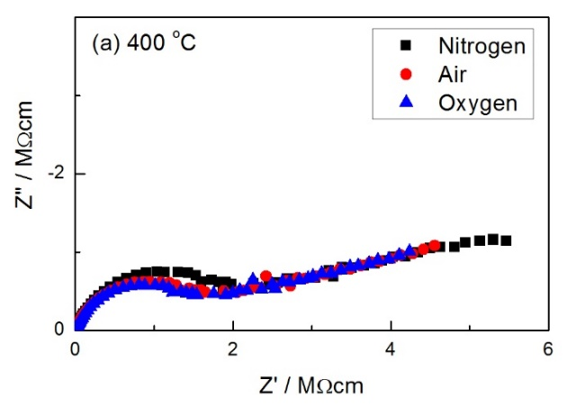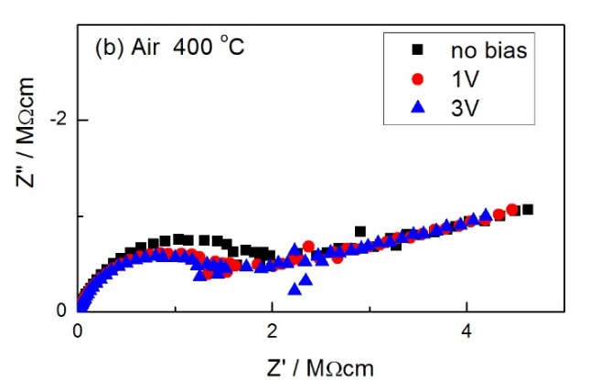
Figure 5-11. Z* plots of x = 0.005 slow-cooled from 1350 °C and measured at 400 °C (a) in N₂, air and O₂ and (b) with dc bias in air
Similar conclusions were obtained for an x = 0.005 sample quenched from 1100 °C, Figure 5-12.
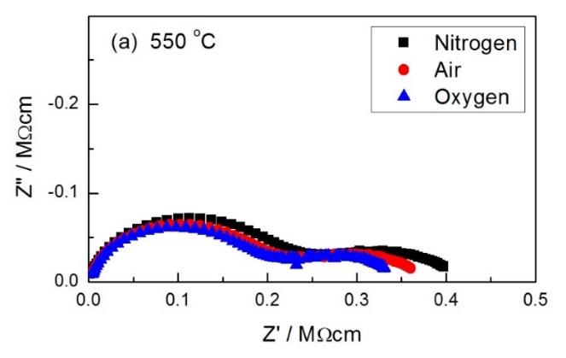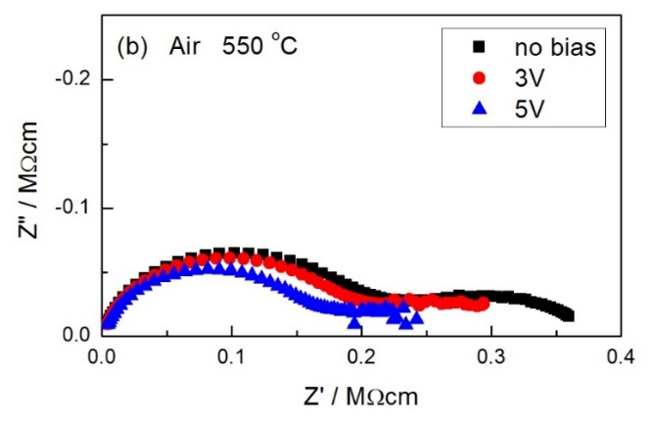
Figure 5-12. Z* plots of x = 0.005 quenched from 1100 °C and measured at 550 °C (a) in N₂, air and O₂ and (b) with dc bias in air

(2) Q_{T} ≥ 1225 °C
Impedance data of an x = 0.005 sample quenched from 1350 °C and measured in different atmospheres with/without dc bias are shown in Figure 5-13. The resistance increases either with increasing pO₂ or increasing dc bias, indicating n-type conduction.
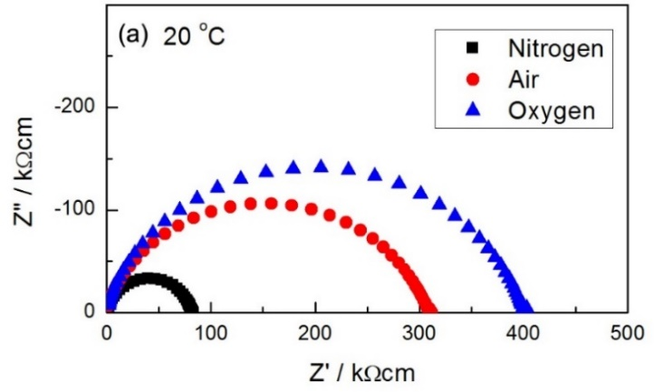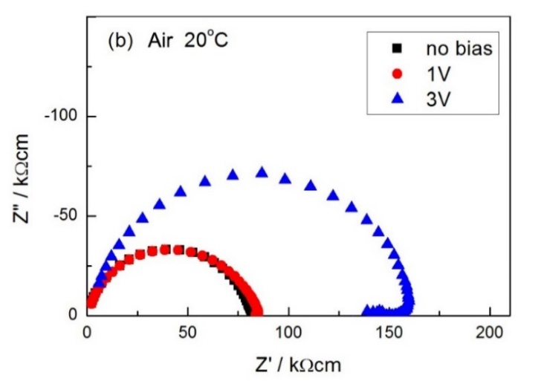
Figure 5-13. Z* plots of x = 0.005 quenched from 1350 °C and measured at 20 °C (a) in N₂, air and O₂ and (b) with dc bias in air

(3) 1200 < Q_{T} < 1225 °C
When the quench temperature, Q_{T}, is 1220 °C, impedance data still show slightly n-type conduction, Figure 5-14. However, sensitivity to both pO₂ and dc bias were very small.
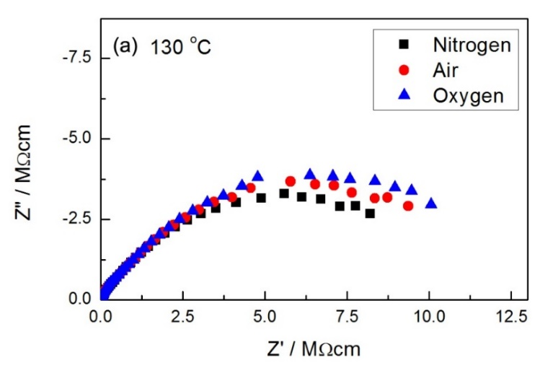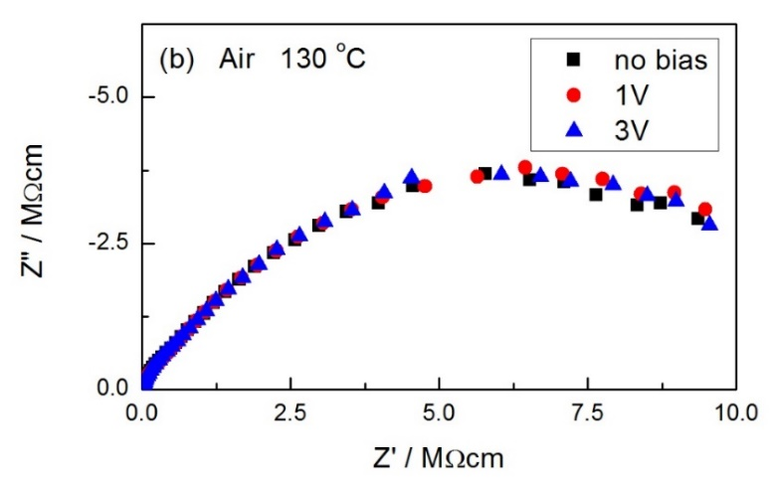
Figure 5-14. Z* plots of x = 0.005 quenched from 1220 °C and measured at 130 °C (a) in N₂, air and O₂ and (b) with dc bias in air

Similar conclusions were obtained for x = 0.01 and 0.03 samples as well. In summary, Al-doped TiO₂ samples show a p-n transition in their electrical properties with increasing quench temperature.

5.3.2.3 Effect of H₂O
As shown above, a low-frequency impedance spike, representing charge build-up at the blocking metal electrodes, is observed in the Z* plot of the sample slow-cooled from 1350 °C and quenched from 1000-1200 °C (Figure 5-4 and 5-11). This indicates the sample-electrode contact effect and thus, the possibility of ionic conduction.
Proton conduction of TiO₂ and Al₂O₃ has been studied by several groups ^{[25-28]}. Here in this chapter, the effect of H₂O uptake by Al-doped TiO₂ and the possibility of proton conduction was investigated by impedance measurements. An x = 0.005 sample slow-cooled from 1350 °C was loaded into the impedance jig and measured in wet air at room temperature. Total conductivity data as a function of time are shown in Figure 5-15. σ_{t} shows an instantaneous increase at first, followed by a gradual increase over 20 min and before reaching a steady state after 40 min.
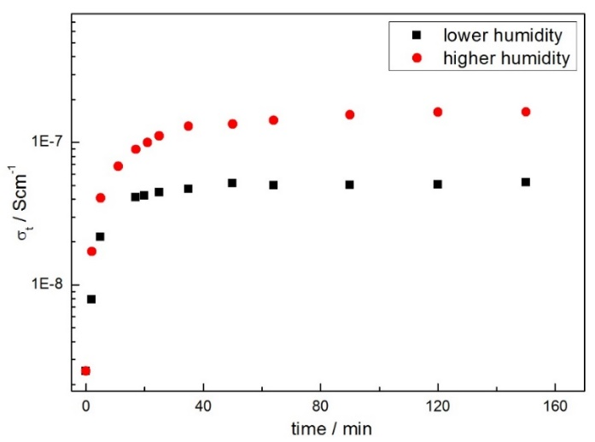
Figure 5-15. Total conductivity as a function of time measured in wet air for x = 0.005 slow-cooled from 1350 °C

The typical set of impedance data, recorded in dry/wet air at room temperature and presented in different formats, is also shown in Figure 5-16. When measured in dry air at room temperature, (a), the sample shows very large resistance. After the sample was held in wet air for 2 h, the impedance complex plane plot, (b), shows a broad arc at high frequencies and an inclined spike with some curvature at low frequencies. The Z” spectroscopic plot shows a gradually increasing incline at the lowest frequencies. The plot of log C’/log f, (d), shows evidence for a low-frequency plateau. With decreasing frequency, C’ increases to reach a value of ~5×10⁻⁷ F; this value is typical of ion blocking at a sample-electrode interface and the formation of a double-layer capacitance.

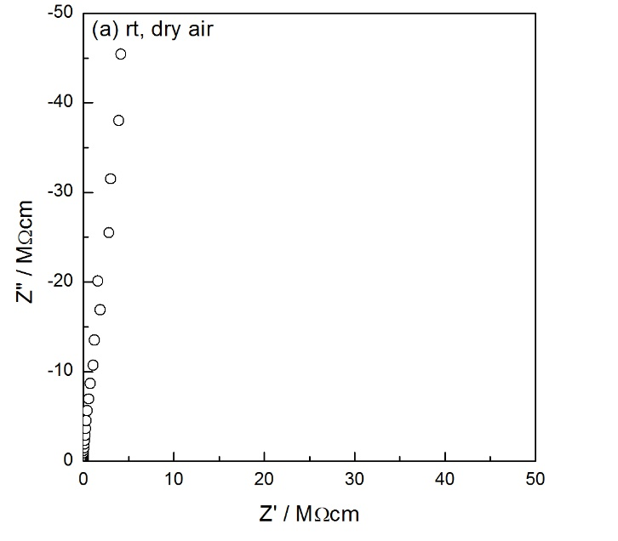
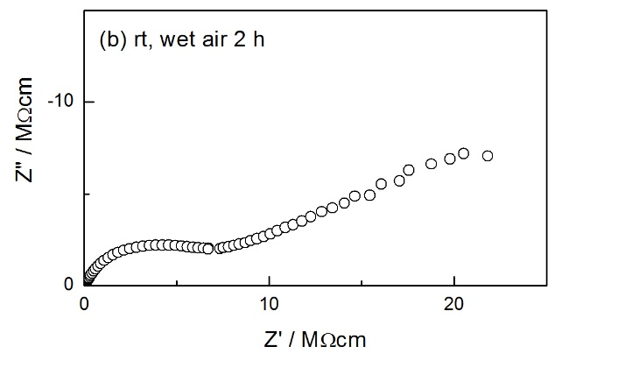
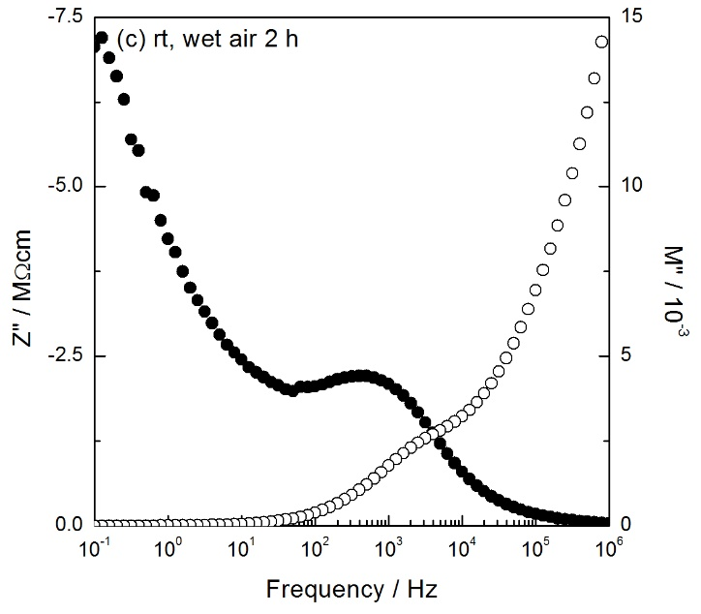
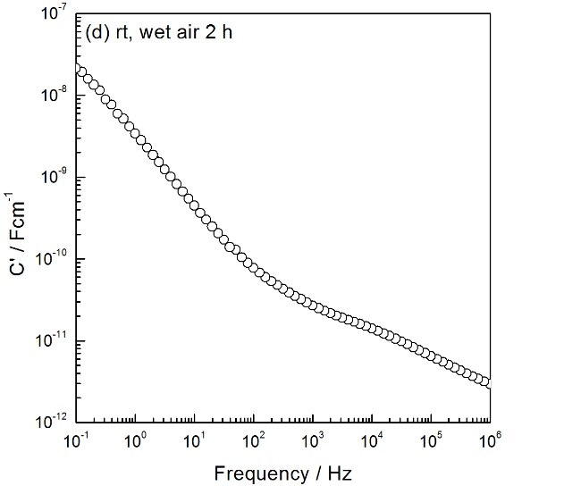
Figure 5-16. Impedance data of x = 0.005 in (a) dry air and (b-d) wet air at room temperature

In addition, higher humidity leads to larger σ_{t}. Impedance measurements were also made over wet air in a wide range of temperatures, shown as an Arrhenius plot in Figure 5-17. It can be seen that proton conduction is indeed observed but is very weak. Also, such conduction could be surface proton conduction.
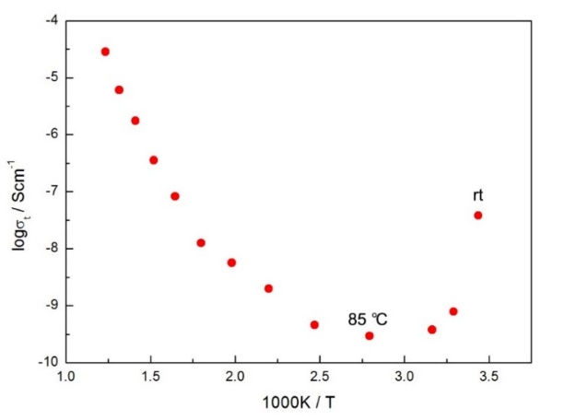
Figure 5-17. Temperature dependence of total conductivity measured in wet air for x = 0.005 slow-cooled from 1350 °C

5.4 Discussion

5.4.1 Solid solution limit and lattice expansion
All of the data in Table 5-1 were recorded at room temperature and therefore, should not show any effects associated with standard thermal expansion. We consider three possibilities for such increasing lattice parameters observed here. First, substitution of Ti⁴⁺ by Al³⁺ may create oxygen vacancies and reduce M-O bond strength on average. As a result, the average M-O bond length increases and thus, lattice parameters increase. Second, oxygen loss may occur due to high sintering temperature, i.e. δ > 0. In this case, as shown in eq’n (5-4) and (5-5), the oxygen loss generates electrons, which may reduce some Ti⁴⁺ to Ti³⁺, resulting in weaker bond strength and thus, larger Ti-O bond length.
$O^{2-}→\frac{1}{2}O_{2}+2e^{-}$ (5-4)
${Ti}^{4+}+e^{-}→{Ti}^{3+}$ (5-5)
The third possibility is that extra Al³⁺ may enter interstitial sites as:
$2{Al}_{2}O_{3}↔{Al}_{i}^{•••}+3{Al}_{Ti}^{'}+6O_{O}^{×}$ (5-6)
Such interstitial Al³⁺ may lead to lattice distortion and thus, increasing lattice parameters.
However, with the increase of Al³⁺ doping content, from x = 0.005 to 0.03, lattice parameters stay almost the same. The possible reason is that the solid solution limit of Al³⁺ doping into rutile is ≤ 0.005. Since the detection limit of XRD is ~3%, from the results shown in Figure 5-2, the amount of secondary phase existed in x = 0.01 and 0.03 may be too small to be detected.

5.4.2 Dependence of conductivity on cooling condition
Results on the variable conductivity of Al-doped TiO₂, Figure 5-8, show the importance of cooling rates. Although the oxygen loss in quenched samples is too small to be measured, very large variations in conductivity values are observed indeed.
Second, it has been reported that pure rutile could lose oxygen spontaneously in temperatures as low as 700 °C ^{[20]}. Similar to pure rutile, Al-doped TiO₂ loses oxygen at high temperatures as well. However, since Al³⁺ doping has already created high [$V_{O}^{..}$], at relatively low temperatures, further oxygen loss due to high temperature may be inhibited. Consequently, with Al³⁺ doping, rutile starts to lose oxygen only from a higher temperature, ~1225 °C.

5.4.3 Surface absorption of O₂
As shown in Figure 5-9, the sample annealed in air for several days has the largest carrier content, while the sample quenched from 1200 °C has the smallest carrier content. We consider the possible interpretation as to why these samples have p-type conduction. During cooling, since Al-doped TiO₂ may pick up oxygen, the following reaction occurs:
$O^{2-}+O_{2}(g)→O^{-}+O_{2}^{-}$ (5-7)
which is driven by surface absorption of $O_{2}$. Here, $O^{-}$ can be seen as holes located on oxygen vacancies. Therefore, compared with other samples, the sample annealed in air for several days has the longest time to absorb oxygen and thus, shows the largest carrier concentration.

5.4.4 p-n transition of Ti_{1-x}Al_{x}O_{2-x/2-δ}

(1) δ < 0, p-type
Samples slow-cooled in air and quenched from relatively low temperatures were p-type. In order for p-type conductivity to occur, holes must be generated, and the question arises as to the location of the holes. Frequently in the literature ^{[6]}, holes are assigned to the presence of impurities such as Fe. In this study, since high purity reactants were used, such explanation with impurities is not consistent with the results. Among the various elemental constituents, none of the cations can be oxidized to give holes. Also, in the literature ^{[29]}, the presence of Ti⁴⁺ and Al³⁺ were confirmed by X-ray photoelectron spectroscopy and Bader charge analysis. Therefore, the only possible source of holes is ionization of $O^{2-}$ ions surrounding the positively charged acceptor sites and thus, holes are located on oxygen as $O^{-}$ ions. With increasing pO₂, the p-type conduction is attributed to the absorption of oxygen by the sample, primarily at the surface, and the sample becomes oxygen-excess, i.e. δ < 0. The mechanism of applying a dc bias is similar to increasing pO₂; with the application of dc bias, electrons are withdrawn from the sample and trapped at the surface. $O^{2-}$ ions move to the anode to fill oxygen vacancies and thus, to maintain the electro neutrality, they are ionized and create holes. The p-type behavior seen here in Al-doped TiO₂ is similar in kind to those reported earlier with acceptor doped BaTiO₃ and CaTiO₃ ^{[22,30]}.

(2) δ > 0, n-type
Samples quenched from 1225-1350 °C show n-type conduction. The n-type conduction, i.e. δ > 0, is associated with the oxygen loss which occurred at high temperatures.

5.5 Conclusions
Al-doped TiO₂ forms a solid solution and Al³⁺ is well-dispersed in the TiO₂ matrix. With Al³⁺ doping, samples show increasing lattice parameters, which may be attributed to a reduction in average M-O bond strength, oxygen loss at high sintering temperatures or interstitial Al³⁺. However, dopant content did not influence lattice parameters further because the solid solution limit may be ≤ 0.005.
Samples slow-cooled from 1350 °C in air and quenched from 1000-1200 °C are electrically inhomogeneous. The total resistance is given by bulk and grain boundary. Samples quenched from high temperatures (≥ 1225 °C) are electrically homogeneous. Al-doped TiO₂ shows a p-n transition with increasing quench temperature: (1) Samples slow-cooled in air and quenched from 1000-1200 °C show p-type conduction. The p-type conductivity is driven by surface absorption of oxygen and thus, associated with $O^{-}$ at sample surface. (2) Samples quenched from 1225-1350 °C are n-type due to oxygen loss. In addition, weak proton conduction is found in slow-cooled samples and may be due to surface absorption of water.

5.6 References
- S Kumar, NK Verma. J Mater Res. 28(2013):521-528.
- AA Murashkina, PD Murzin, AV Rudakova, et al. J Phys Chem C. 119(2015):24695.
- A Yüce, B Saruhan. The 14th International Meeting on Chemical Sensors. IMCS 2012.
- SK Kim, GJ Choi, SY Lee, et al. Adv Mater. 20(2008):1429-1435.
- C Gionco, S Livraghi, S Maurelli, et al. Chem Mater. 27(2015):3936-3945.
- U Gesenhues, T Rentschler. J Solid State Chem. 143(1999):210-218.
- AR West. Solid State Chemistry and its Applications. John Wiley & Sons. 2014.
- D Gesenhues. Solid State Ionics. 1171(1997):101-103.
- MM Islam, T Bredow, A Gerson. Phys Rev B. 76(2007):045217.
- A Stashans, S Bermeo. Chem Phys. 363(2009):100-106.
- A Iwaszuk, M Nolan. J Phys Condens Matter. 23(2011):334207.
- P Pena, S Deaza. Ceramica. 33(1980):23-30.
- EN Bunting. Bur Stand J Res. 11(1933):719-725.
- S Hoffmann, ST Norberg, M Yoshimura. J Solid State Chem. 178(2005):2897-2906.
- R Camaratta, W Acchar, CP Bergmann. Rev Adv Mater Sci. 27(2011):64-68.
- KC Patil, MS Hegde, T Rattan, et al. Chemistry of Nanocrystalline Oxide Materials. World Scientific Publishing Co Ltd. 88-81.
- ZH Li, DY Ding, CQ Ning. Nanoscale Res Lett. 8(2013):25-30.
- D Zwingel. Solid State Commun. 20(1976):397-400.
- J Yahia. Phys Rev. 130(1963):1711-1719.
- Y Liu, AR West. J Am Ceram Soc. 96(2013):218-222.
- PS Narayanan. Proc Indian Acad Sci. 32(1950):279.
- PR Ren, N Masó, AR West. Phys Chem Chem Phys. 15(2013):20943.
- FJ Blunt, PJ Hendra, JR Mackenzie. Chem Commun. 6(1969):278-279.
- SA Hunter-Saphir, JA Creighton. J Raman Spectrosc. 29(1998):417-419.
- F Maglia, IG Tredici, G Spinolo, et al. J Mater Rev. 27(2012):1975-1980.
- G Garcia-Belmonte, V Kytin, T Dittrich, et al. J Appl Phys. 94(2003):5261-5264.
- A Thorne, A Kruth, D Tunstall, et al. J Phys Chem B. 109(2005):5439-5444.
- Z Chen, C Lu. Sensor Lett. 3(2005):274-295.
- DM de los Santos, T Aguilar, A Sánchez-Coronilla, et al. ChemPhysChem. 2(2014):71-84.
- QL Zhang, N Masó, Y Liu, et al. J Mater Chem. 21(2011):12894.

Chapter 6. Ga-doped TiO₂

6.1 Introduction
Doping of TiO₂ by introducing heteroatoms is considered as an effective way to modify its physical and chemical properties. Ga-doped TiO₂ has been studied intensively due to its unique properties, and it has a wide range of applications such as photocatalysts for water splitting and self-cleaning coatings, core component in dye-sensitized solar cells and diluted magnetic semiconductors ^{[1-4]}.
Since Ga³⁺ differs from Ti⁴⁺ in charge, several defect structures of Ga₂O₃ dissolved in TiO₂ can be imagined to compensate this. For instance, if ionic compensation occurs, Ga³⁺ may substitute for Ti⁴⁺ with charge compensating oxygen vacancies, or extra Ga³⁺ may enter interstitial sites. If electronic compensation occurs, holes may be induced due to Ga³⁺ dopant.
The phase diagram of the TiO₂-Ga₂O₃ system has been investigated by several groups ^{[5-8]}. Phase relations of TiO₂-Ga₂O₃ pseudobinary system have been determined at temperatures between 1100 and 1400 °C using X-ray diffraction, summarized in a phase diagram ^{[7]}, Figure 6-1. The phases occurring in the system are rutile, β-Ga₂O₃, Ga₂TiO₅ which exists above 1325 °C, and a series of oxides with the formula of Ga₄Ti_{n-4}O_{2n-2} (15 ≤ n ≤ 31, n odd), which exist above 1190 °C.
Figure 6-1. Phase diagram of TiO₂-Ga₂O₃ system (IP: intergrowth phases) ^{[7]}
Replacement of Ti⁴⁺ by Ga³⁺ gives a limited range of solid solutions ^{[5]}, however, the solid solution limit has not been determined in these studies ^{[5-8]}. The homologous series Ga₄Ti_{n-4}O_{2n-2} (15 ≤ n ≤ 23, n odd) was first reported by Gibb and Anderson ^{[5]} using electron microscopy, and their studies suggested that shear structures were derived from the rutile structure-type by the periodic repetition of displacement boundaries parallel to the (210) planes of rutile ^{[5,6]}. Later, the phases up to n = 31 were observed by Kamiya and Tilley ^{[7]}, and their studies showed that the width of the phase region occupied by the Ga₄Ti_{n-4}O_{2n-2} phases varied with temperature. In addition, these phases were often disordered and crystals frequently contained partially ordered intergrowths of oxides.
The electrical and ferromagnetic properties and the related defect structures of Ga-doped TiO₂ have been studied intensively by several investigators ^{[2-4, 9-13]}:
(1) $V_{Ti}^{''''}$, ferromagnetism and n-p transition: Some literature showed that the room temperature ferromagnetism in Ga-doped TiO₂ was associated not with the dopant, but with Ti vacancies ^{[4]}. Moreover, the presence of abundant Ti vacancies could switch the conductivity from n- to p-type with higher charge mobility ^{[9]}.
(2) $V_{O}^{••}$ and ionic compensation: Chandiran et al. ^{[10]} reported that the charge of Ga-doped TiO₂ was compensated by oxygen vacancies; by XPS spectroscopy, it was confirmed that the titanium valence state remained 4+. Hopper et al. ^{[2]} reported that Ga³⁺ substitution had no measurable effect on the conductivity due to ionic compensation.
(3) n-type conduction: it was reported that with Ga³⁺ doping, samples showed n-type conduction and Ti³⁺ ions were produced ^{[11]}.
(4) p-type conduction: Zwingel ^{[12]} and Gionco et al. ^{[3]} reported the p-type conduction in Ga-doped TiO₂ and by EPR spectra, it was shown that holes were strongly localised in O 2p nonbonding orbital.
(5) n-p transition with pO₂: Lee and Yoo ^{[13]} studied the conduction type and related defect structures in a wide range of pO₂, Figure 6-2 and 6-3. Similar to pure TiO₂, Ga-doped TiO₂ also exhibited an n- to p-type transition with increasing pO₂. By doping of Ga³⁺, the electronic stoichiometric composition of TiO₂ was made to fall in the range of pO₂ < 1.
Figure 6-2. Conductivity vs pO₂ for 1 mol% Ga-doped TiO2 at different temperatures ^{[13]} (Figure 2)
Figure 6-3. Kröger-Vink diagram of Ga-doped TiO₂ ^{[13]} (Figure 3)

The objective of this chapter was to study the properties of Ga-doped TiO₂ and to see if the conduction could be switched between n- and p-type by doping. In particular, the effect of cooling rate, pO₂ and dc bias were investigated. Results showed that an n-p transition was indeed exhibited with increasing dopant content. However, Ga³⁺ dopant only showed a small measurable effect on the conductivity.

6.2 Experimental
For structural characterization, samples of Ti_{1-x}Ga_{x}O_{2-x/2-δ} (x = 0.01 and 0.03) were heated at 1350 °C for 8 h in air. Phases were analyzed by XRD using Bruker D2 Phaser. For electrical characterization, pellets of Ti_{1-x}Ga_{x}O_{2-x/2-δ} (x = 0.01 and 0.03) were sintered at 1350 °C for 8 h in air and cooled slowly (5 °C/min) inside the furnace. For selected experiments, samples were given further heat treatment: reheated at 1000 °C for 1 h, taken out from the furnace and cooled rapidly (~100 °C/min) in air. Pellets were fabricated with Pt electrodes before further heat treatment. Impedance measurements were carried out using a combination of Agilent 4980A and Solartron SI 1260.

6.3 Results

6.3.1 XRD
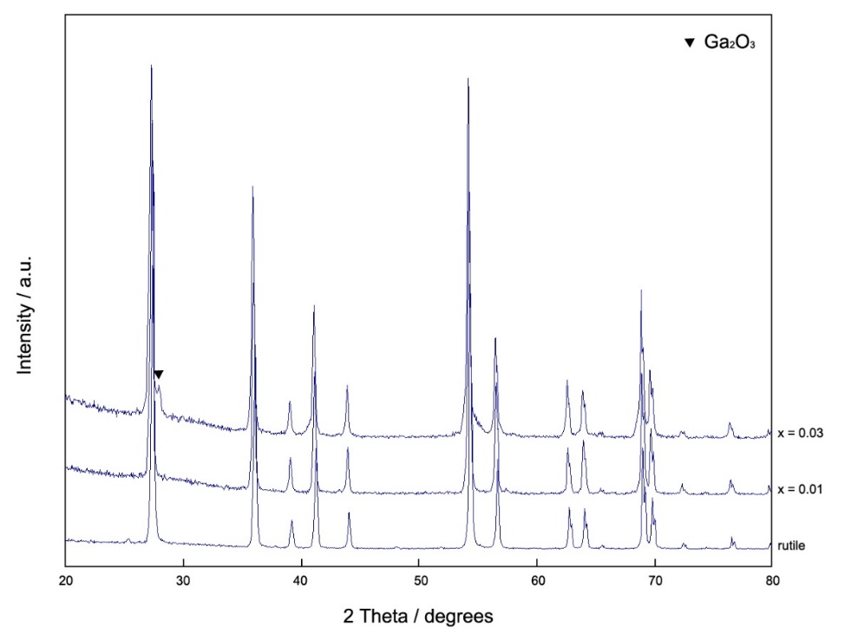
Figure 6-4. XRD patterns of Ti_{1-x}Ga_{x}O_{2-x/2-δ}
XRD patterns for compositions with x = 0.01 and 0.03 are shown in Figure 6-4, which closely resemble those of tetragonal rutile. With x = 0.01, the sample is single phase, whereas with higher dopant content, x = 0.03, the sample exhibits a secondary phase, Ga₂O₃. Therefore, it is indicated that the solid solution limit of Ga³⁺ doping in TiO₂ is less than x = 0.03. In addition, all peaks of x = 0.01 shift towards the lower angle side, indicating that a solid solution is indeed formed and lattice parameters increase.

6.3.2 Electrical properties
For electrical property measurements, all pellets were made with a relative density of ~90%. In order to characterize the electrical microstructure and measure the properties of the samples, impedance measurements were carried out as a function of frequency. Typical results of x = 0.01 slow-cooled from 1350 °C and measured at 500 °C, without application of a dc bias, are shown in Figure 6-5.
Impedance complex plane, Z*, plots, (a), show two overlapped arcs, indicating that the sample contains two main resistances, R₁ and R₂, which together dominate the total resistance. (a) also shows evidence for a small spike at low frequency, indicating that the sample may have a double layer phenomenon at the sample-electrode interface. On replotting the same data in the Z” and M” spectroscopic plot format, (b), it is clear that both Z” and M” show a single peak, but the Z” spectrum also shows a gradually increasing incline at the lowest frequencies. Capacitance data (c) show a limiting high frequency plateau with an approximate value 10⁻¹¹ Fcm⁻¹, corresponding to a permittivity of ~100 and which therefore represents the bulk response of the sample. At lower frequency, ~10³ Hz, a poorly-resolved plateau is observed at ~10⁻¹⁰ Fcm⁻¹ and thus represents a conventional grain boundary.
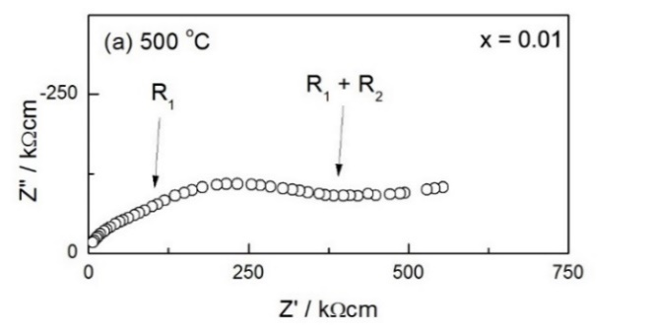
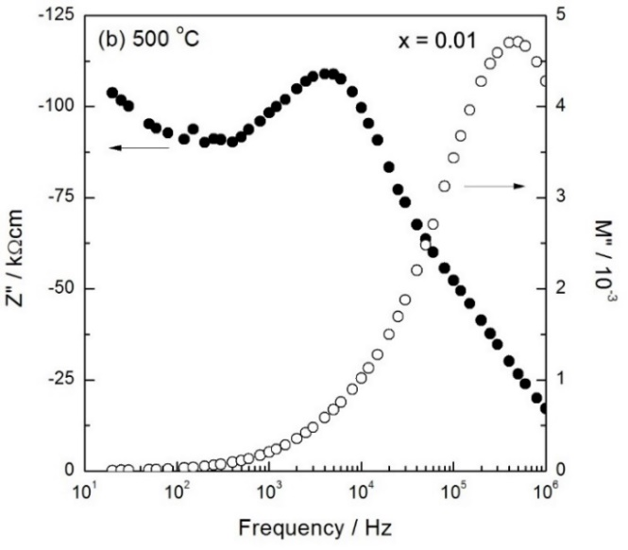
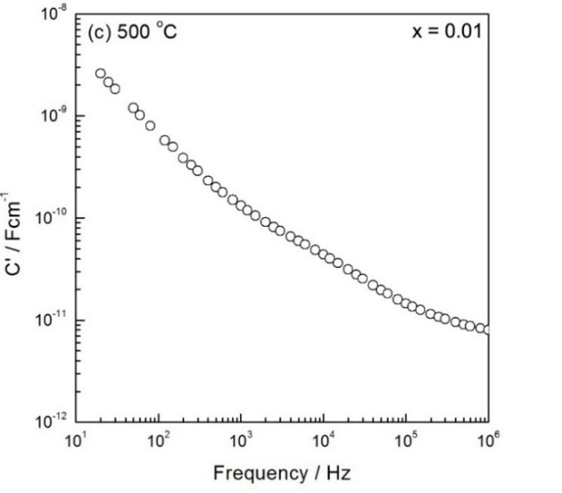
Figure 6-5. (a) Impedance complex plane plot, (b) M”/Z” spectroscopic plots and (c) spectroscopic plot of capacitance of x = 0.01 slow-cooled from 1350 °C

Similar data are seen for the composition with x = 0.03 slow-cooled from 1350 °C, but the M” peak of the x = 0.03 sample is broader, Figure 6-6. In summary, both x = 0.01 and x = 0.03 samples are electrically inhomogeneous. Samples contain two main components, bulk and grain boundary, which together dominate the total resistance. There is evidence for an additional capacitance at lower frequencies which may be characteristic of double layer phenomena at the sample-electrode interface.

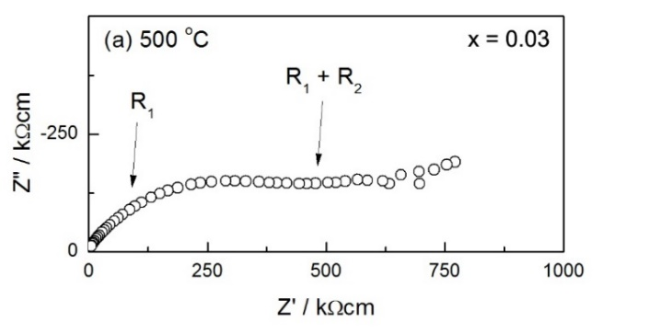
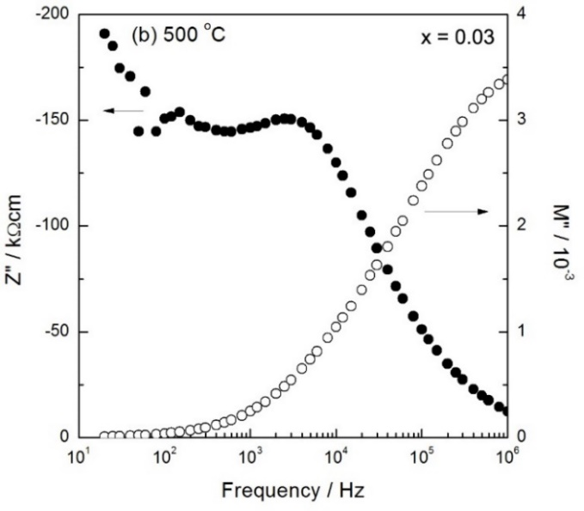
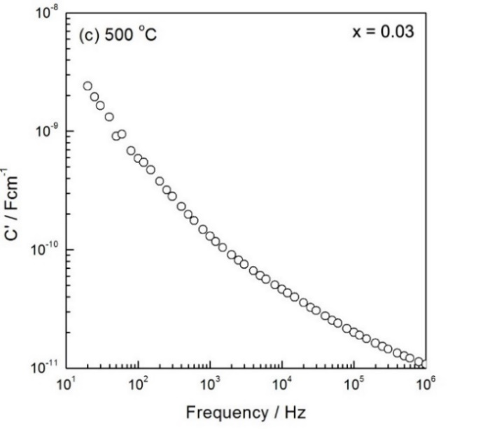
Figure 6-6. (a) Impedance complex plane plot, (b) M”/Z” spectroscopic plots and (c) spectroscopic plot of capacitance of x = 0.03 slow-cooled from 1350 °C

Total and bulk conductivity data were obtained approximately from the fitted low frequency intercepts of the Z* plots on the Z’ axis, Figure 6-7(a), and are plotted in Arrhenius format, Figure 6-7(b-c). In both (b) and (c), the Arrhenius plots are almost parallel, indicating that the conduction mechanism does not change with Ga³⁺ doping; differences in conductivities are therefore attributed to differences in mobile carrier concentration. However, with Ga³⁺ dopant, conductivity values of rutile just show a small variation, and the difference in conductivity between x = 0.01 and 0.03 is very small as well.
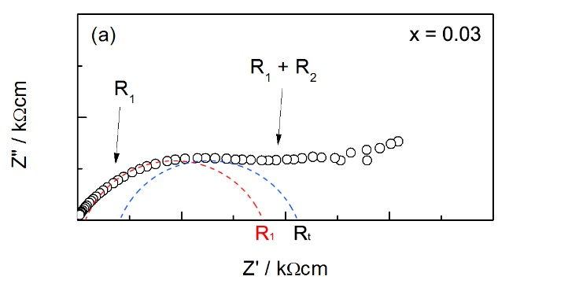
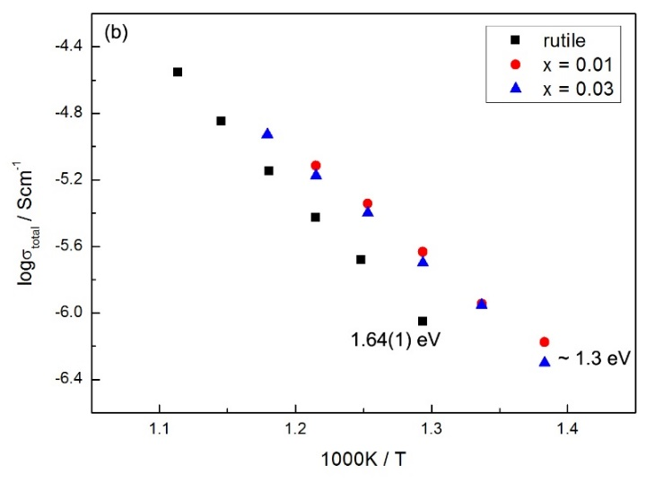
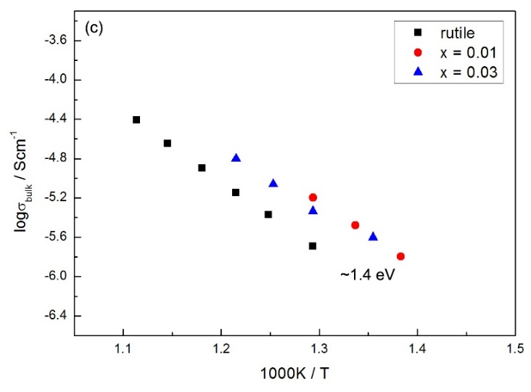
Figure 6-7. (a) How to obtain the fitted R₁ and R_{t}, Arrhenius plots of (b) total and (c) bulk conductivities of x = 0.01 and 0.03; conductivity data for undoped rutile are also shown

6.3.2.1 Effect of cooling rate
In order to study the effect of cooling rate, some samples were given further heat treatment by reheating at 1000 °C for 1 h and cooling rapidly in air (~100 °C/min). Typical impedance data for x = 0.01 are shown in Figure 6-8, exhibiting similar impedance response to the slow-cooled sample. In both cases, either cooled slowly or rapidly, samples are electrically inhomogeneous, and the total resistance is dominated by bulk and grain boundary. Also, to some degree, there shows evidence for double layer phenomena at the sample-electrode interface. Plots such as Figure 6-8 are typical for all rapid-cooled samples studied here.
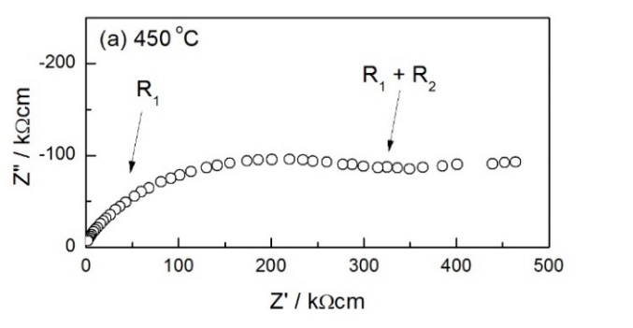
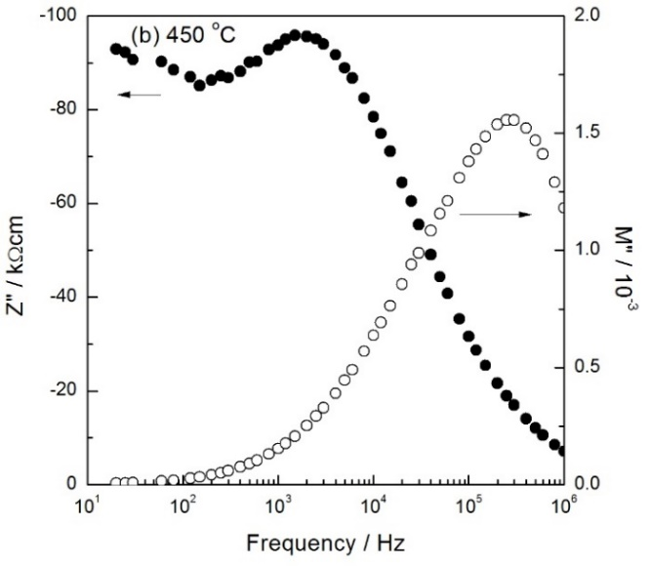
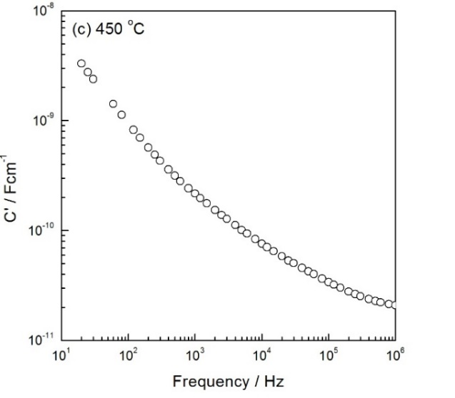
Figure 6-8. (a) Impedance complex plane plot, (b) M”/Z” spectroscopic plots and (c) spectroscopic plot of capacitance of x = 0.01 rapid-cooled from 1000 °C

Total and bulk conductivity for the composition with x = 0.01 are shown in Figure 6-9. Linear and parallel plots are observed. The rapid-cooled sample shows higher carrier concentration.
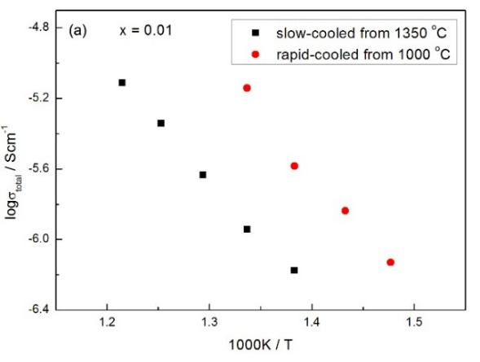
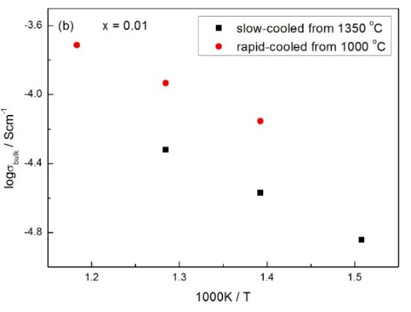
Figure 6-9. Arrhenius plots of (a) total and (b) bulk conductivities of x = 0.01 with different cooling conditions

Total and bulk conductivities for the composition with x = 0.03 are shown in Figure 6-10. Similar parallel plots are observed; however, in this case, the rapid-cooled sample has lower conductivity than the slow-cooled sample.
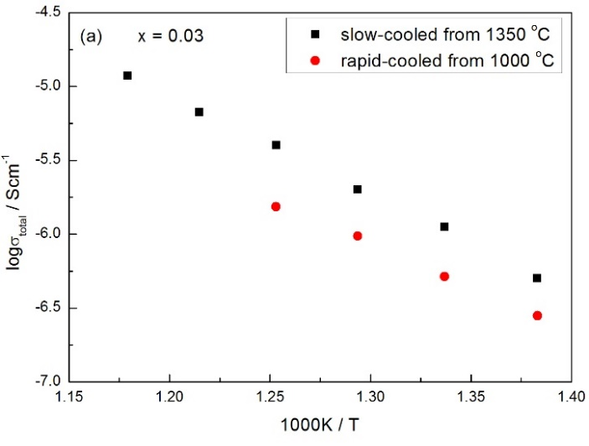
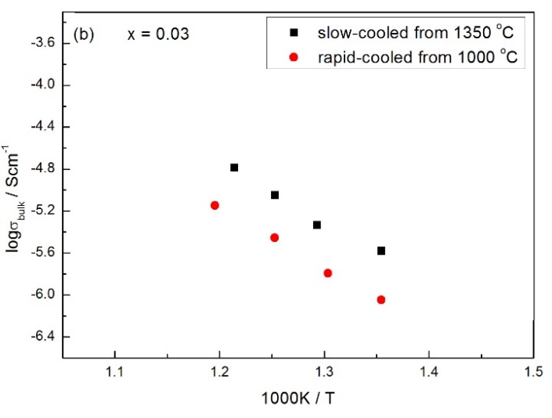
Figure 6-10. Arrhenius plots of (a) total and (b) bulk conductivities of x = 0.03 with different cooling conditions

6.3.2.2 Effect of pO₂ and dc bias

(1) x = 0.01
The effect of atmosphere during measurements without a dc bias is shown in Figure 6-11 for the composition with x = 0.01 (slow-cooled). Measurements were carried out first in N₂, and then in O₂. The conductivity increases with decreasing pO₂ showing that conduction is n-type. As shown by eq’n (6-1), with decreasing pO₂, the equation is displaced to the right-hand side.
$O^{2-}→\frac{1}{2}O_{2}+2e^{-}$ (6-1)
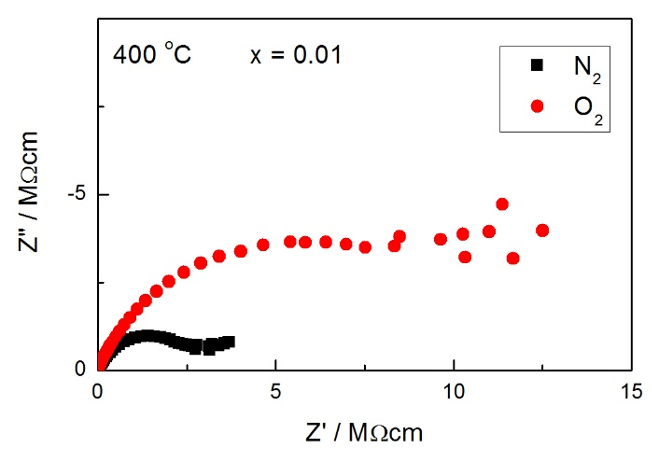
Figure 6-11. Impedance data in different measuring atmospheres at 400 °C for x = 0.01

In order to study the effects of applied dc voltage on the ac electrical properties, impedance measurements were made with a small dc bias of 10 V applied across the sample. A typical dataset, Figure 6-12, for 10 V bias at 550 °C shows R₁ and R₂ increase slightly, which also indicates n-type conduction. In summary, the results in Figure 6-11 and 6-12 show that a similar decrease in conductivity can be obtained by two entirely different tests, increasing the oxygen partial pressure in the atmosphere around the sample during measurements and application of a dc bias voltage.
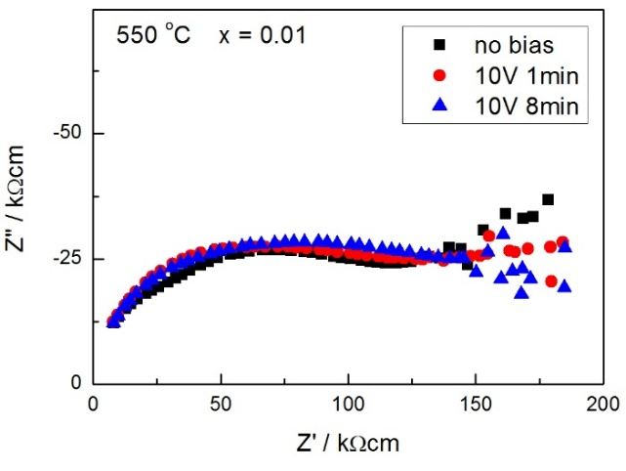
Figure 6-12. Impedance data with dc bias at 550 °C for x = 0.01

(2) x = 0.03
The effect of atmosphere for the composition with x = 0.03 is shown in Figure 6-13(a). The conductivity increases with pO₂ showing that, as a consequence of absorption of oxygen at the sample surface and the following ideal reaction is displayed to the right-hand side:
$\frac{1}{2}O_{2}→O^{2-}+2h^{•}$ (6-2)
the origin of the conductivity is p-type electronic. With application of 10 V dc bias, (b), both R₁ and R₂ show a big decrease after 8 min. This also indicates p-type conduction, since application of dc bias favors ionization of absorbed O₂ molecules on the sample surface and withdrawal of electrons from the sample interior and thus, concentration of holes increases, i.e. p-type conduction increases.
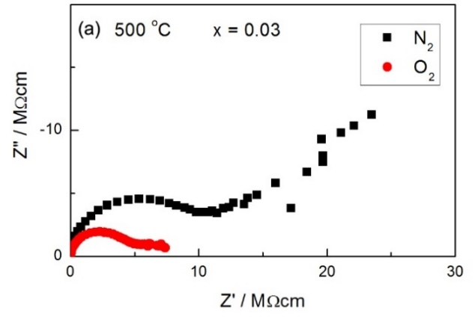
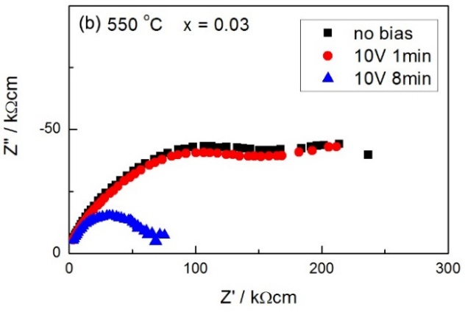
Figure 6-13. Impedance data (a) in different measuring atmospheres at 500 °C (b) with dc bias at 550 °C for x = 0.03

6.4 Discussion

6.4.1 XRD, secondary phase and peak shifting
XRD patterns show that the sample with x = 0.03 exhibits a secondary phase, Ga₂O₃. However, as shown in the phase diagram, Figure 6-1, if TiO₂ and Ga₂O₃ are fully reacted, Ga₂O₃ should not appear as a secondary phase. Since all the samples used for XRD measurements were slow-cooled from 1350 °C, we consider that maybe a solid solution formed at high temperatures but decomposed during cooling and thus, Ga₂O₃ appears as a secondary phase.
In addition, with Ga³⁺ doping, the position of all peaks shifted towards the lower angle side, indicating an increase on lattice parameters. Since the typical bond length of Ga-O (2.00 Å) and Ti-O (2.01 Å) are almost the same, the possible reasons for the increasing lattice parameters may be: (1) as ionic compensation may occurs, substitution of Ti⁴⁺ by Ga³⁺ creates oxygen vacancies and thus, reduces M-O bond strength on average. Consequently, the average M-O bond length increases and lattice parameters increase. (2) oxygen loss may occur during high-temperature processing, i.e. δ > 0, generating electrons and reducing Ti⁴⁺ to Ti³⁺, which leads to weaker Ti-O bond strength and thus, larger bond length. In this case, lattice parameters may increase as well.

6.4.2 Effect of cooling rate
As shown in Figure 6-5, the slow-cooled sample shows clear evidence of several overlapping arcs in Z* plots. From the phase diagram reported in the literature, Figure 6-1, it can be seen that there is a big change at 1190 °C with all the phases and solid solution formed at higher temperatures. The slow-cooled sample may be not have been fully reacted or may have decomposed on cooling and thus, was electrically inhomogeneous.
As shown in Figure 6-9, the Arrhenius plots, both total and bulk, of samples with different cooling conditions are almost parallel, indicating that the conduction mechanism does not change. There are several possible interpretations: (1) the cooling rate of rapid-cooled samples is ~100 °C/min, which may be still too slow for the sample to pick up oxygen on cooling. Thus, there is not much difference in activation energy. (2) maybe the reheating temperature, 1000 °C, is too low. At such temperature, maybe the sample just loses a very small amount of oxygen. Therefore, the rapid-cooled sample shows similar behavior to the slow-cooled sample.
Differences in conductivities are attributed to differences in charge carrier concentration, which is higher in the rapid-cooled sample. A possible interpretation is that samples with x = 0.01 may have n-type conduction. When the sample is heated, it may lose extra oxygen at high temperatures, i.e. δ > 0, eq’n (6-1), oxygen vacancies are created and electrons are generated. On slow-cooling, the sample picks up oxygen and therefore, the concentration of charge carrier, i.e. electrons, is smaller than that of the rapid-cooled sample.
When x = 0.03, the rapid-cooled sample has lower conductivity than the slow-cooled sample, which indicates that the charge carriers may be p-type electronic, i.e. holes, as oxygen loss from the rapid-cooled sample would lead to release of electrons and annihilation of hole charge carriers.

6.4.3 n-p transition
n-type
Ti_{1-x}Ga_{x}O_{2-x/2-δ} with the composition x = 0.01 shows slightly n-type conduction, which is commonly believed to be a consequence of oxygen loss during high-temperature processing, i.e. δ > 0, with the resulting injection of electrons, eq’n (6-1). This presumably involves reduction of Ti⁴⁺ to Ti³⁺. Such n-type conduction mechanism is similar to that of undoped rutile reported in the literature ^{[14]}.
However, our results also show that the activation energy is relatively large, ~1.3 eV, and conductivity values just show a very small variation from undoped rutile. Maybe the conduction is indeed electronic, but there only exist a very small amount of n-type with similar Ea.
p-type
Ti_{1-x}Ga_{x}O_{2-x/2-δ} with the composition x = 0.03 shows p-type conduction on absorbing oxygen. Such p-type conduction may be associated with nonstoichiometry followed by oxygen absorption leading to a hole conduction mechanism, eq’n (6-2). To further consider where the holes are located, we assume several possibilities here. In principle, holes may be trapped at negatively charged acceptors, whereas the ionization energy of Ga³⁺ is extremely high and it is unlikely that Ga³⁺ could be ionized. Similarly, Ti⁴⁺ could not be the source of holes. Since high purity reactants were used, impurities such as Fe are unlikely to be the source of holes as well. Therefore, we consider holes are located on oxygen as $O^{-}$ ions, which have also been reported in the literature ^{[3,12]}. Such p-type conduction and related $O^{-}$ ions have been found in Mg-doped SrTiO₃, Zn-doped CaTiO₃ and Ca-doped BaTiO₃ ^{[15-17]}.
n-p transition
The possible interpretation of an n-p transition is that when Ga³⁺ dopant concentration is small, samples lose oxygen at high temperatures, and residual n-type conduction occurs. With higher Ga³⁺ dopant concentration, oxygen absorption starts to occur and generates holes, leading to p-type conduction.

6.5 Conclusions
The solid solution limit of Ga³⁺ doping in TiO₂ is less than 3 mol% under the experimental conditions used here. With Ga³⁺ doping, lattice parameters increase due to large M-O bond length. Samples with x = 0.01 and x = 0.03 are both electrically inhomogeneous, and the total resistance is given by bulk and grain boundary; the slow-cooled samples may be not have been fully reacted or may have decomposed on cooling and thus, were electrically inhomogeneous. With increasing dopant content, from x = 0.01 to 0.03, samples show n-p transition, of which the n-type conduction may be attributed to oxygen loss at high temperatures, while the p-type conduction may be associated with electronic compensation and surface oxygen absorption. Further work is required, especially on heating samples at higher temperatures and quenching to try and improve the electrical homogeneity of samples.

6.6 References
- XM Liu, M Khan, WX Liu, et al. Ceram Int. 41(2015):2075-3080.
- EM Hopper, F Sauvage, AK Chandiran, et al. J Am Ceram Soc. 95(2012):3192-3196.
- C Gionco, S Livraghi, S Maurelli, et al. Chem Mater. 27(2015):3936-3945.
- NN Bao, JB Yi, XB Qin, et al. Scripta Mater. 66(2012):821-824.
- RM Gibb, JS Anderson. J Solid State Chem. 5(1972):212-225.
- DJ Lloyd, IE Grey, LA Bursill. Acta Cryst. B32(1976):1756-1761.
- S Kamiya, RJD Tilley. J Solid State Chem. 22(1977):205-216.
- Y Michiue, A Yamamoto, M Tanaka. Acta Cryst. B62(2006):737-744.
- SB Wang, L Pan, JJ Song, et al. J Am Chem Soc.137(2015):2975-1983.
- AK Chandiran, F Sauvage, L Etgar, et al. J Phys Chem C. 115(2011):9232-9240.
- M Salazar-Villanueva, A Cruz-López, AA Zaldívar-Cadena, et al. Mat Sci Semicon Proc. 58(2017):8-14.
- D Zwingel. Solid State Commun. 26(1978):775-777.
- DK Lee, HI Yoo. Phys Chem Chem Phys. 10(2008):6890-6898.
- Y Liu, AR West. J Am Ceram Soc. 96(2013):218-222.
- LG Escrig, M Prades, H Beltrán, et al. J Am Ceram Soc. 97(2014):2815-2824.
- QL Zhang, N Masó, Y Liu, et al. J Mater Chem. 21(2011):12894.
- PR Ren, N Masó, AR West. Phys Chem Chem Phys. 15(2013):20943.

Chapter 7. Zn-doped TiO₂

7.1 Introduction
In recent years, Zn-doped TiO₂ has drawn attention due to its unique properties and is widely used in dye-sensitized solar cells, photocatalysts and gas sensors for detecting NO₂ ^{[1-4]}.
ZnO is a wide-gap semiconductor with a band gap ~3.4 eV and crystallizes preferentially in the hexagonal wurtzite-type structure ^{[5]}, Figure 7-1. The phase analysis of the TiO₂-ZnO system has been investigated by several groups ^{[1,6,7]}. Phase relations of the pseudobinary system are summarized in a phase diagram, Figure 7-2 ^{[6,7]}. In the first comprehensive investigation, Dulin and Rase ^{[6]} studied the TiO₂-ZnO system above 1000 °C using quenching, hydrothermal, strip-furnace and solid-state-reaction techniques. Two zinc compounds were found in the system: Zn₂TiO₄, which melted congruently at 1549 °C, and ZnTiO₃, which dissociated hydrothermally at 945 °C to give Zn₂TiO₄ and TiO₂. In addition, two eutectics were found: one between ZnO and Zn₂TiO₄ at 32 mol% TiO₂, and another between Zn₂TiO₄ and TiO₂ at 58 mol% TiO₂. However, at lower temperatures, there was an uncertainty about the ranges of stability of some zinc compounds. Yang and Swisher ^{[7]} investigated the TiO₂-ZnO system later and found that Zn₂Ti₃O₈ was a thermodynamically stable compound up to a temperature of 800 °C, above which it transformed sequentially into ZnTiO₃ and then into Zn₂TiO₄. Moreover, it was reported in an early literature that the solid solution limit of Ti_{1-x}Zn_{x}O_{2-x} was approximately x = 0.2 ^{[1]}, which is not shown in the phase diagram.
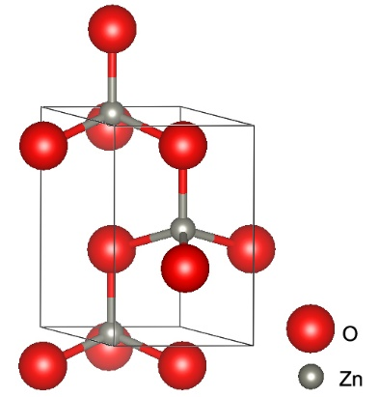
Figure 7-1. Crystal structure of wurtzite ZnO

Figure 7-2. Phase diagram of TiO₂-ZnO system ^{[6,7]}
In the case of Zn-doped TiO₂, the Zn²⁺ dopant may substitute for Ti⁴⁺ in C.N. six with charge compensating oxygen vacancies, eq’n (7-1). Alternatively, extra Zn²⁺ may enter interstitial sites and thus, a mixture of ${Zn}_{i}^{••}$ and ${Zn}_{Ti}^{''}$ may exist. If electronic compensation occurs, holes may be induced due to Zn²⁺.
$ZnO\underset{→}{{TiO}_{2}}{Zn}_{Ti}^{''}+O_{O}^{×}+V_{O}^{••}$ (7-1)
Defect structures in Zn-doped TiO₂ have been studied by several groups ^{[8,9]}. Yu et al. ^{[8]} used XPS and XRD to investigate the doping mechanism of Zn²⁺ and found the presence of oxygen vacancies at the sample surface. Chen and Shen ^{[9]} reported crystallographic shear planes in Zn-doped TiO₂. Their study showed that planar faults predominantly parallel to {121} and {132} planes were formed when the Zn-doped TiO₂ sample was quenched from 1300 °C; this was similar to the CS planes of nonstoichiometric Ti_{n}O_{2n-1} with specific extent of oxygen vacancies in the range of 4 ≤ n ≤ 9 and 12 ≤ n (even) ≤ 36, respectively.
It is well-established that rutile is an n-type semiconductor when equilibrated in an atmosphere of low oxygen activity, and the electrical conductivity in rutile is introduced by the oxygen nonstoichiometry. By doping of Zn²⁺, n-type conductivity of rutile was reported to be increased, whereas with larger dopant content, > 7 mol%, conductivity decayed due to formation of voids ^{[10]}. Han and Shao ^{[11]} reported that under O-rich conditions, Zn²⁺ energetically tended to be doped on the Ti sublattice sites in TiO₂ and act as shallow acceptors with significant hole mobility to assist p-type conductivity. However, Yu et al. ^{[8]} reported that Zn²⁺ ions could only exist as surface species other than being doped into the TiO₂ lattice.
The objective of this chapter was to investigate the properties of Zn-doped TiO₂ and to see if the conduction could be switched between n- and p-type by doping. The effect of cooling rate, oxygen partial pressure and dc bias were investigated by using impedance spectroscopy. Compared with undoped rutile studied in Chapter 3, results observed here showed that doping of Zn²⁺ indeed improved the homogeneity of rutile to some degree, whereas samples still showed n-type conduction.

7.2 Experimental
Samples of Zn-doped rutile were prepared by solid-state reaction of ZnO and TiO₂. For structural characterization, samples of Ti_{1-x}Zn_{x}O_{2-x-δ} (x = 0.001, 0.005, 0.01, 0.02, 0.03, 0.05 and 0.1) were heated at 1200 °C for 6 h in air. The phases present were analyzed by XRD using a Siemens D5000 Diffractometer.
For electrical property measurements, pellets of Ti_{1-x}Zn_{x}O_{2-x-δ} (x = 0.005 and 0.01) were sintered at 1200 °C for 6 h in air and cooled slowly (5 °C/min) inside the furnace. For selected experiments, samples were reheated at 1200 °C for 1 h and quenched into liquid nitrogen (~ 10000 °C/min). Pellets were fabricated with electrodes made from either Ag paste or sputtered Au. Impedance measurements were carried out using a combination of Agilent E4980A and Solartron SI 1260. For subambient measurements, an Oxford Cryostat was used. Impedance data were corrected for overall pellet geometry. Calculated pellet densities were ~92% of the theoretical density.

7.3 Results and discussion

7.3.1 XRD
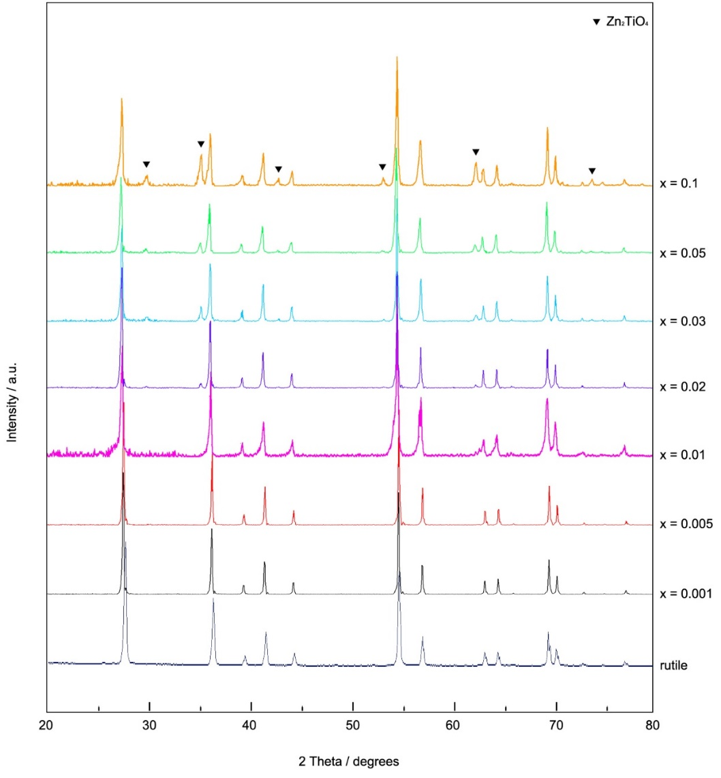
Figure 7-3. XRD patterns for Ti_{1-x}Zn_{x}O_{2-x-δ}
Powder XRD data are shown in Figure 7-3. The samples with x ≤ 0.01 appear to be single phase, and the patterns closely resemble that of tetragonal rutile. The samples with x ≥ 0.02 have rutile as the major phase, but with significant amounts of Zn₂TiO₄ as secondary phase, consistent with the literature phase diagram ^{[6,7]}. Therefore, the approximate solid solution limit of Zn²⁺ doping in TiO₂ is ≤ 1 mol%. In addition, the position of all peaks shifts towards the lower angle side, indicating an increase in lattice parameters.
Refined lattice parameters as a function of x are shown in Figure 7-4. With the increase of dopant concentration, (1) the lattice parameter “a” increases and reaches a stable value when x = 0.01; (2) “c” decreases first and increases slightly after x = 0.05; (3) cell volume increases non-linearly.
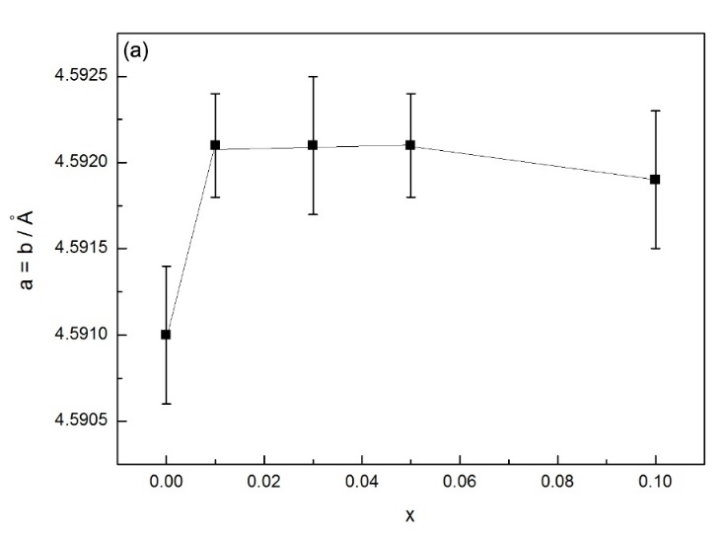
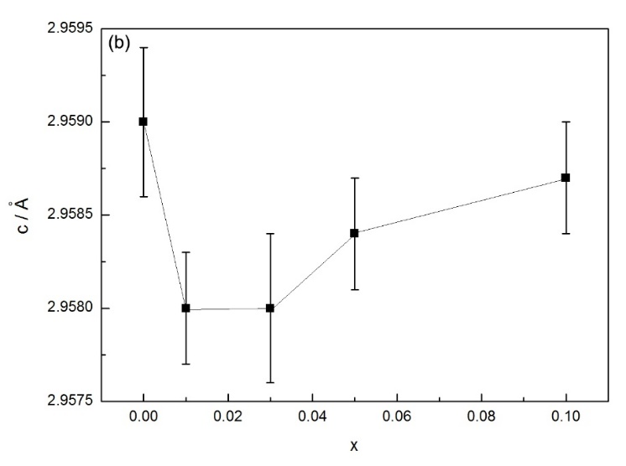
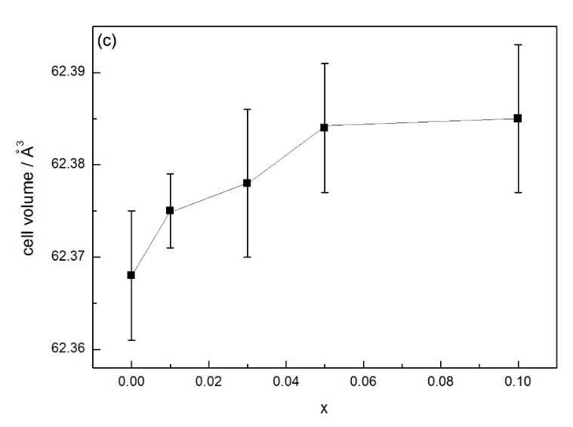
Figure 7-4. Lattice parameters as a function of x
a, b and c
Figure 7-5 gives the crystal structure of rutile, considered as almost regular [TiO₆] octahedra sharing opposite edges, to form columns which are joined by sharing octahedral corners as shown. With doping, generally, the Zn²⁺ ions are thought to be statistically distributed over regular cation sites in the rutile lattice. Since the typical bond length of Zn-O (2.15 Å) is larger than that of Ti-O (2.01 Å), the lattice parameter “a” increases, Figure 7-4(a). However, the lattice parameter “c” decreases with doping, Figure 7-4(b), which may be attributed to the relatively smaller size of oxygen vacancies compared with oxide ions ^{[12,13]} and partial collapse of the columns in the “c” direction.
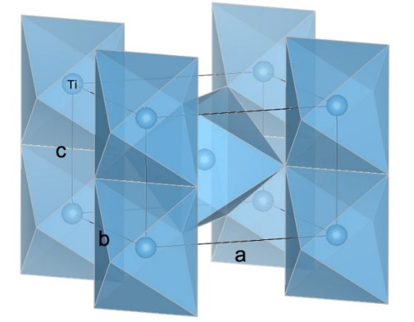
Figure 7-5. Rutile structure showing linkage of regular [TiO₆] octahedra

Cell volume
There are three possible interpretations for the increasing cell volume shown in Figure 7-4(c). First, substitution of Ti⁴⁺ by Zn²⁺ may create oxygen vacancies and reduce M-O bond strength on average. As a result, the average M-O bond length increases and thus, cell volume increases. Second, oxygen loss may occur during heating at high temperatures, i.e. δ > 0. In this case, the oxygen loss generates electrons, which may reduce some Ti⁴⁺ to Ti³⁺, resulting in weaker Ti-O bond strength and larger Ti-O bond length. Third, extra Zn²⁺ may enter interstitial sites, resulting in lattice distortion.
Compared with trivalent dopants such as Cr³⁺, the ionic radius of Zn²⁺ is much larger than that of Ti⁴⁺. Therefore, when Zn²⁺ ions substitute Ti⁴⁺ ions, if they retain an octahedral coordination, the charge compensating oxygen vacancies may be located on the second-nearest neighbour sites rather than the nearest neighbour sites. If the sample is oxide ion conduction, the position of oxygen vacancies will be an important factor for analysing its structural and electrical properties.

7.3.2 Electrical properties
Typical results of impedance measurements, without application of a dc bias, on an x = 0.005 sample sintered at 1200 °C for 6 h, followed by slow cooling in air are shown in Figure 7-6. The impedance complex plane plot (a) shows a single, almost ideal, semicircular arc whose low-frequency intercept gives the total resistance of the sample. A slight tail at low frequencies is also seen. M” and Z” spectra (b) show a single peak at almost coincident frequencies.
On replotting the same data in the C’ spectroscopic plot format, (c), it is clear that a high-frequency plateau of the value ~7 pF is observed, which corresponds to the permittivity of ~80. Furthermore, a poorly resolved intermediate plateau is observed with value ~ 10 pF; this value is too small for it to represent a conventional grain boundary since it corresponds to a significant volume fraction of the sample. Instead, we consider two possible interpretations for this poorly resolved plateau: (1) it may be attributed to a constriction resistance or narrow contacting necks between grains associated with the sample porosity or possible inhomogeneity in the distribution of Zn²⁺ dopant; this could happen if some precipitation occurred during cooling. (2) it may represent a dipole orientation-related impedance such as that reported for pure rutile ^{[14]} and YSZ ^{[15,16]}.
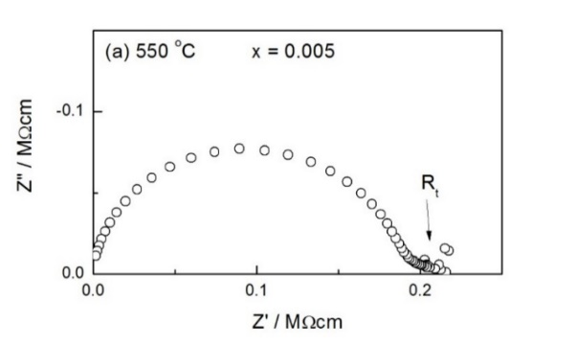
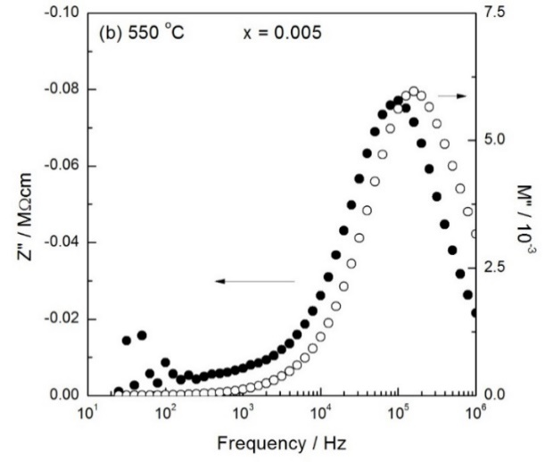
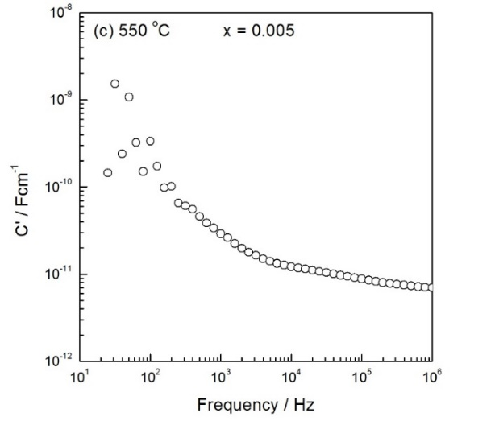
Figure 7-6. IS data for an x = 0.005 sample heated at 1200 °C and slow cooled, (a) impedance complex plane plot, (b) Z”/M” spectroscopic plots and (c) capacitance plot
Impedance data for an x = 0.01 sample are also shown, Figure 7-7, which show similar impedance response to the x = 0.005 sample.
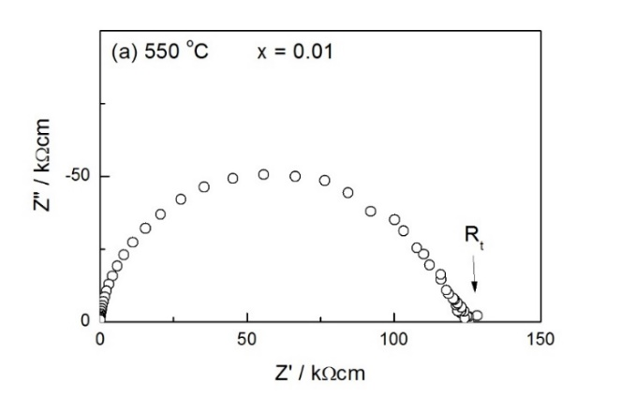
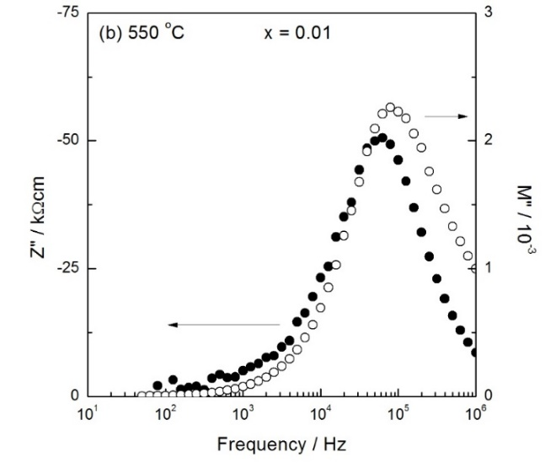
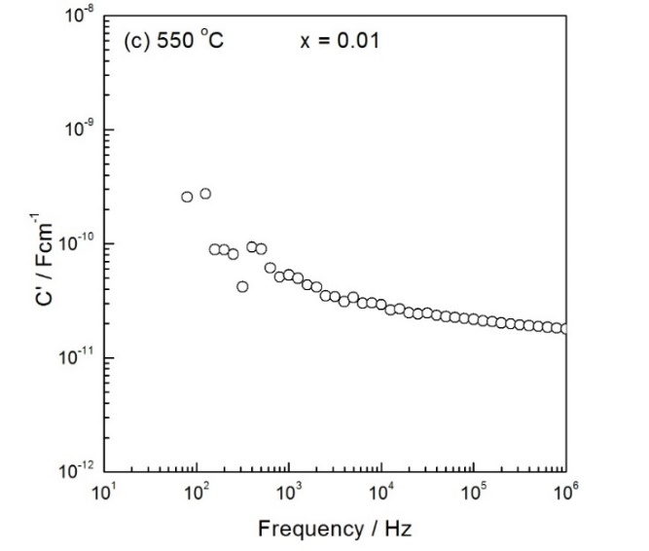
Figure 7-7. IS data for an x = 0.01 sample heated at 1200 °C and slow cooled, (a) impedance complex plane plot, (b) Z”/M” spectroscopic plots and (c) capacitance plot
Conductivity data are plotted in Arrhenius format in Figure 7-8. Resistances values are extracted from the low-frequency intercepts of the complex plane plots, on the Z’ axis. Data for an undoped rutile sample are also shown for comparison. All three sets of data show linear behavior with activation energy ~1.6 eV, which corresponds approximately to half the band gap reported for rutile, 3.0 eV. These oxidized Zn-doped rutile samples are therefore still very insulating. There are two possible explanations for such behaviour. First, maybe Zn²⁺ ions were not doped into the rutile lattice. Second, with Zn²⁺ dopants, only ionic compensation occurred and therefore, the activation energy and conduction mechanism of Zn-doped rutile did not change.
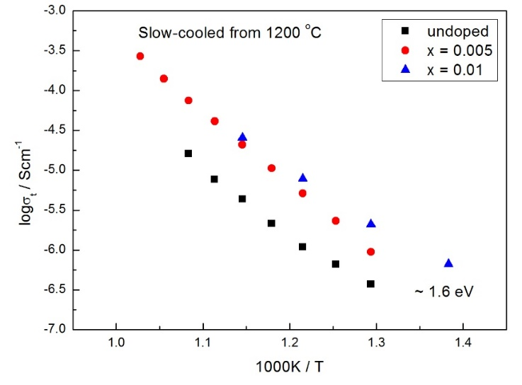
Figure 7-8. Arrhenius plots for Ti_{1-x}Zn_{x}O_{2-x-δ} (x = 0.005 and 0.01) and undoped TiO₂ sintered at 1200 °C for 6 h, followed by slow cooling in air

7.3.2.1 Effect of cooling rate
Impedance data for an x = 0.01 sample sintered at 1200 °C for 6 h, followed by quenching into liquid nitrogen are shown in Figure 7-9. The impedance complex plane plot (a) shows a broad arc. The low-frequency intercept on the Z’ axis gives the total resistance of the sample. Representation of the same data in Z”/M” spectroscopic plots (b) show a single peak in both cases with maxima at similar frequencies, whereas both peaks are quite broad. Capacitance data (c) show a high-frequency plateau and a poorly resolved plateau at lower frequencies. The high frequency component, C₁, ~7 pF at 20 °C, represents the bulk capacitance of the sample with a permittivity of ~80. The low frequency component, which has a capacitance value C₂ ~20 pF, may be attributed to a constriction resistance or a dipole orientation-related impedance. Plots such as Figure 7-9 are typical for all quenched samples, which show similar impedance response to slow-cooled samples.
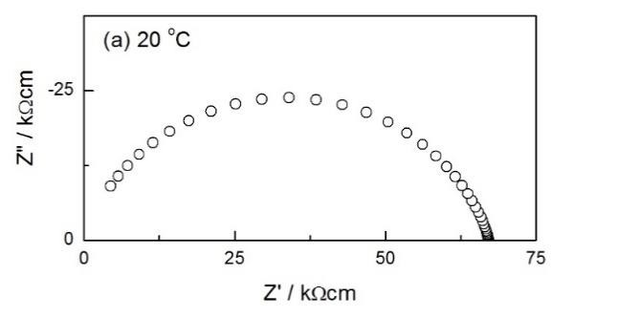
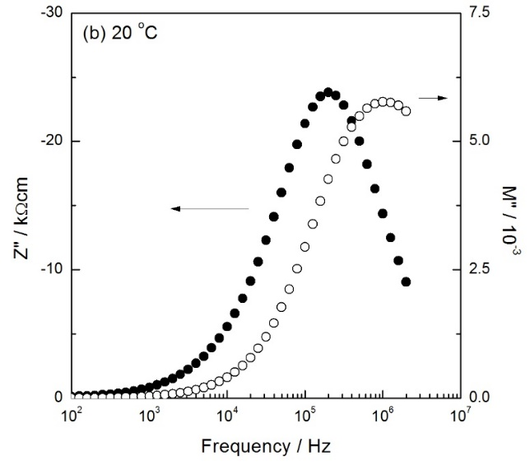
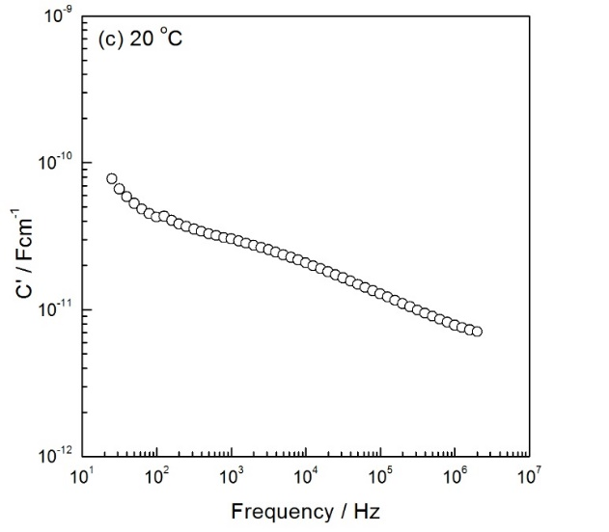
Figure 7-9. IS data for an x = 0.01 sample heated at 1200 °C and quenched, (a) impedance complex plane plot, (b) Z”/M” spectroscopic plots and (c) capacitance plot

Total conductivity data for the quenched sample are plotted in Arrhenius format in Figure 7-10 and show a linear response with activation energy 0.09(1) eV; the quenched sample is semiconducting. The origin of the semiconductivity is believed to be a consequence of oxygen loss during high-temperature processing, with the resulting injection of electrons into the crystal lattice leading to n-type semiconductivity, eq’n (7-3), which is similar to undoped TiO₂ discussed in Chapter 3. These results demonstrate the critical importance of cooling conditions at the end of sample processing and heat treatment.
$O_{O}^{×}→\frac{1}{2}O_{2}+2e^{'}+V_{O}^{••}$ (7-3)
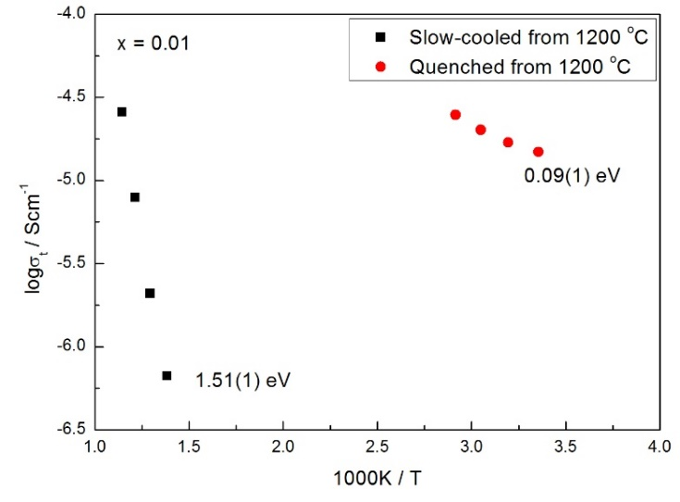
Figure 7-10. Arrhenius plots for x = 0.01 sintered at 1200 °C for 6 h, followed by either slow cooling or quenching

7.3.2.2 Effect of pO₂
The effect of atmosphere during measurements without a dc bias is shown in Figure 7-11 (slow-cooled sample). Measurements were carried out first in O₂, second in air and third in N₂. The value of total resistance is lowest in N₂ and highest in O₂; the conventional explanation for such atmosphere dependence is that conduction is predominantly n-type, eq’n (7-3), since electrons are generated with decreasing pO₂.
As discussed above in the introduction, when TiO₂ is doped with Zn²⁺, ionic compensation, electronic compensation or a combination of both may occur, and samples may show oxide ion conduction or p-type conduction. However, critically, as shown in Figure 7-6 and 7-7, there is no evidence of any additional impedance associated with charge transfer processes at the sample-electrode interface. The origin of the n-type semiconductivity observed here is therefore believed to be a consequence of oxygen loss during high-temperature processing. Although samples shown in Figure 7-11 are slow cooled, reoxidation which occurred on cooling may still not be complete. As a result, samples are slightly oxygen deficient and show n-type conduction.
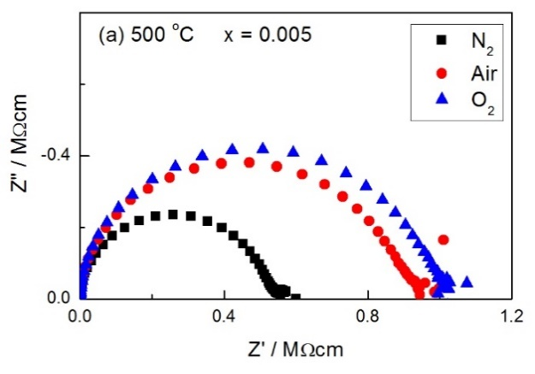
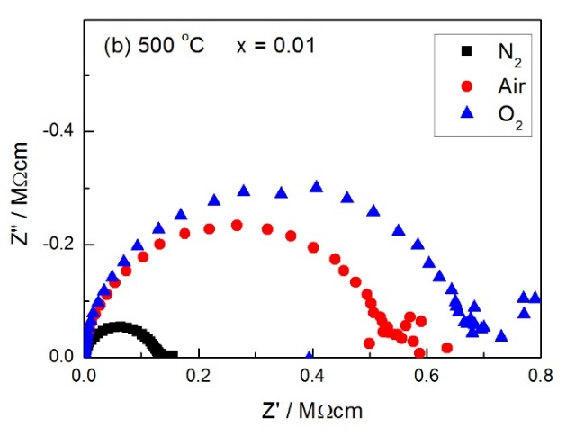
Figure 7-11. IS data in different measuring atmospheres at 500 °C

7.3.2.3 Effect of dc bias
In order to study the effects of applied dc voltage on the ac electrical properties, impedance measurements were made at the same time as a small dc bias from 1-5 V, was applied across the sample. Results show that total resistance increases with dc bias, indicating n-type conduction as well. The mechanism of applying a small dc bias is similar to that of increasing pO₂, since application of dc bias also favors ionization of absorbed O₂ molecules on the sample surface and withdrawal of electrons from the sample interior.

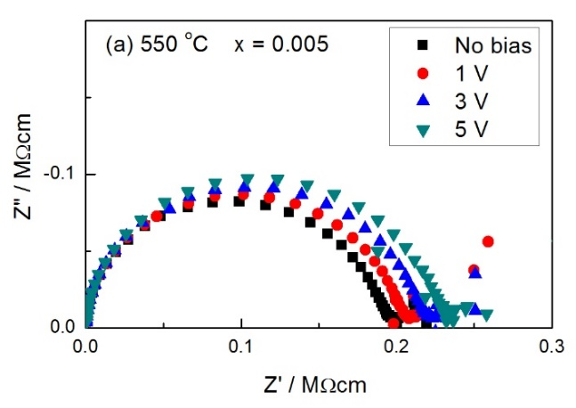
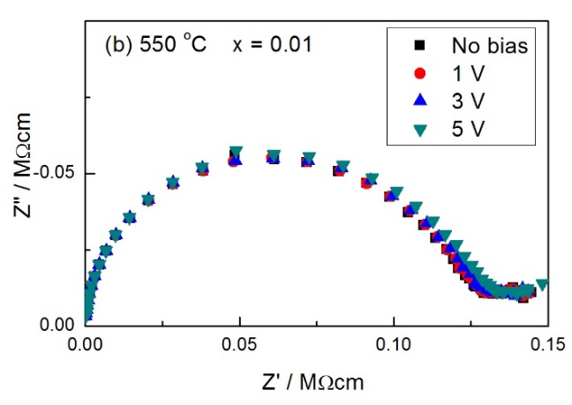
Figure 7-12. IS data in air with dc bias at 550 °C

7.4 Conclusions
Zn-doped rutile ceramics with formula Ti_{1-x}Zn_{x}O_{2-x-δ} have been prepared by solid state reaction. By XRD results, Zn²⁺ ions are believed to be doped into TiO₂, and the approximate solid solution limit is x = 0.01. With Zn²⁺ doping, cell volume increases due to oxygen loss and weaker M-O bond strength. By impedance measurements, it is shown that total resistance of Zn-doped TiO₂ is dominated by the bulk. Compared with undoped TiO₂ discussed in Chapter 3, it is clear that Zn²⁺ doping indeed improves the homogeneity of rutile ceramics to some degree. However, Zn-doped samples still show evidence of a constriction resistance, dipole orientation-related impedance or sample inhomogeneity. All samples show n-type conduction, and resistance increases with both pO₂ and dc bias.
No evidence of p-type behavior and oxygen uptake in slow-cooled samples are found even though there are oxygen vacancies associated with Zn doping. Also, samples easily go n-type with oxygen loss. Further work is needed to know if oxygen loss occurs more easily than in pure rutile or with dopants.

7.5 References
- J Andrade, ME Villafuerte-Castrejon, R Valenzuela, et al. J Mater Sci Lett. 5(1986):147-14 9.
- F Zhu, PP Zhang, XJ Wu, et al. Chem Phys Chem. 10(2012):362-367.
- RG Nair, S Mazumdar, B Modak, et al. J Photoch Photobio A. 345(2017):36-53.
- I Gaidan, D Brabazon, IUI Ahad. Ahs Sens. 17(2017):1995.
- C Klingshirn. Chem Phys Chem. 8(2007):782-803.
- FH Dulin, DE Rase. J Am Ceram Soc. 43(1960):125-131.
- J Yang, JH Swisher. Mater Charact. 37(1996):153-159.
- YL Yu, JS Wang, W Li, et al. Cryst Eng Comm. 17(2015):5074-5080.
- TJ Chen, PY Shen. J Phys Chem C. 113(2009):328-332.
- MC Wu, SH Chan, MH Jao, et al. Sol Energ Mat Sol C. 157(2016):447-453.
- XP Han, GS Shao. Phys Chem Chem Phys. 15(2013):9581.
- E Jedvik, A Lindman, MP Benediktsson, et al. Solid State Ionics. 275(2015):2-8.
- LA Bursill, MG Blanchin. J Solid State Chem. 51(1984):321-335.
- LG Zhu, J Zhou, ZM Sun. Mater Res Lett. 6(2018):165-170.
- MA Hernandez, AR West. J Mater Chem A. 4(2016):1298.
- M Jovani, H Beltran-Mir, E Cordoncillo, et al. Inorg Chem. 56(2017):7081-7088.

Chapter 8. Discussion

There is already an extensive literature on pure and doped TiO₂, oxygen non-stoichiometric rutile and comprehensive fundamental studies on defect equilibria in TiO₂ ^{[1-40]}. Here, we focus on the structural and electrical properties of pure and doped rutile ceramics, specifically, acceptor-doped, and main defect characteristics that dominate the structural and electrical properties. In this project, undoped and Cr/Al/Ga/Zn doped TiO₂ have been studied by using XRD and impedance spectroscopy.

8.1 Structural properties

8.1.1 Dopants and possible compensation mechanism
Doping TiO₂ with different elements is considered as an effective way to modify its physical and chemical properties. Numerous studies have been carried out on doped TiO₂, including using anion dopants, such as N, F, S and P and cation dopants, such as In, Fe, Nb, Ni, Al, rare earth, etc. ^{[1-16]}. In this present work, we mainly studied the acceptor-doped TiO₂.
Generally, an aliovalent dopant in a compound can be charge compensated ionically or electronically, or a combination of both. Take Cr³⁺ for example; when TiO₂ is doped with Cr³⁺, if ionic compensation occurs, the process may be represented by the following equilibria:
${Cr}_{2}O_{3}→2{Cr}_{Ti}^{'}+3O_{O}^{x}+V_{O}^{••}$ (8-1)
i.e. Cr³⁺ substitutes for Ti⁴⁺ with charge compensating oxygen vacancies.
Extra Cr³⁺ may enter interstitial sites as well:
${2Cr}_{2}O_{3}→3{Cr}_{Ti}^{'}+6O_{O}^{x}+{Cr}_{i}^{•••}$ (8-2)
Co-doping with Cr³⁺ and Ti³⁺ may also occur, which may be represented as:
$2{Ti}^{4+}+O^{2-}\underset{→}{{Cr}_{2}O_{3}}{Ti}^{3+}+{Cr}^{3+}+V_{O}+\frac{1}{2}O_{2}↑$ (8-3)
or ${TiO}_{2}+\frac{1}{2}{Cr}_{2}O_{3}→{Cr}_{Ti}^{'}+{Ti}_{Ti}^{'}+3O_{O}^{x}+V_{O}^{••}+\frac{1}{4}O_{2}$ (8-4)
If electronic compensation occurs, as a trivalent dopant, Cr³⁺ has one less electron than Ti⁴⁺, so that substitution of one Ti⁴⁺ for Cr³⁺ results in formation of a hole, which may be represented as:
${Cr}_{2}O_{3}+\frac{1}{2}O_{2}→2{Cr}_{Ti}^{'}+4O_{O}^{x}+{2h}^{•}$ (8-5)
The possible charge compensation mechanisms of acceptor-doped TiO₂ have been studied intensively by many groups ^{[5-13]}. According to the different compensation mechanisms, doped TiO₂ showed different defect structures, such as oxygen vacancies ^{[8,9]}, holes ^{[10,11]}, Ti³⁺ ^{[12]}, titanium vacancies ^{[13]}, etc.; structural and electrical properties varied as well.

8.1.2 Solid solution limits of doped TiO₂
The solid solution limits of M-doped TiO₂ estimated in this project are summarized in Table 8-1. Cr/Ga-doped TiO₂ have much larger solid solution than Al/Zn-doped TiO₂. Considering the ionic radii or typical M-O bond lengths, it is clear that if the size of M^{n+} is closer to that of Ti⁴⁺, it is easier for the transition metals to substitute Ti and form a solid solution. In the literature ^{[16]}, the calculated formation energies (using ab initio band calculations based on the density functional theory) for different metal-doped models show that Cr is much easier to substitute for Ti than is Zn, and it is suggested that the dopant (impurity) formation energy is sensitive to its ionic radius (of impurity).

Table 8-1. Solid solution limit of Ti_{1-x}M_{x}O_{2-(4-n)x/2-δ} and typical M-O bond lengths
M^{n+} | Ti⁴⁺ | Cr³⁺ | Al³⁺ | Ga³⁺ | Zn²⁺
Solid solution limit | - | 0.05 | 0.005 | 0.03 | 0.005
Ionic radius / Å ^{[14]} | 0.605 | 0.615 | 0.535 | 0.62 | 0.74
Typical bond lengths to oxygen: M-O(6) / Å ^{[15]} | 2.01 | 2.02 | 1.93 | 2.00 | 2.15

8.1.3 Oxygen nonstoichiometry and CS structures

8.1.3.1 Undoped rutile
In reducing atmospheres or on heating, TiO₂ loses oxygen and becomes TiO_{2-δ} ^{[17]}, where δ is the deviation from oxygen stoichiometry. Although numerous studies have been carried out on oxygen-deficient rutile, the types of major defect are still under discussion ^{[17-21]}. The defect models that have been postulated for reduced rutile involve titanium interstitials ^{[19-21]} and oxygen vacancies ^{[20]}. In addition, interaction between these defects may lead to the formation of extended defects such as crystallographic shear planes along with point defects ^{[17]}.
In the present work, lattice parameter and cell volume data for rutile powders heated at different temperatures in either air or N₂ and quenched into liquid N₂ were recorded. Two types of behavior can be distinguished, for samples quenched from 700-1000 °C and for samples quenched from 1200-1300 °C.
On quenching from 700-1000 °C, the parameters increased rapidly with quench temperature. The increases in lattice parameters are attributed to chemical expansion associated with loss of oxygen with increasing quench temperature to give non-stoichiometric rutile with oxygen vacancies. A consequence of oxygen loss is the release of electrons which effectively reduce some Ti⁴⁺ to Ti³⁺. A combination of the larger radius of Ti³⁺, a weaker Ti-O bond strength and an increase in average Ti-O bond length, similar to that reported with other oxides ^{[22,23]}, leads to chemical expansion.
On quenching from above 1000 °C, lattice parameters did not increase any further but instead, reached a maximum and then decreased, especially for samples annealed in N₂. Since the oxygen loss is expected to continue with increasing temperature, an additional factor must therefore influence the lattice parameters and cell volume of samples with larger δ values.
It is well-established that CS structures form in materials such as acceptor-doped TiO₂, Nb₂O₅, MoO₃ and WO₃ as a means of eliminating oxygen vacancies. This leads to a partial collapse of the crystal structures to form CS planes and is accompanied by a reduction in volume. We consider it highly likely that similar CS planes form in oxygen-deficient rutile as the degree of oxygen-deficiency increases. There is clear evidence in the literature ^{[24]} of CS plane formation in samples of composition TiO_{1.9970} which were quenched from 1050 °C and subsequently annealed at lower temperature. It appears that CS planes start to form in air at temperatures as low as 1100 °C where the lattice expansion due to oxygen loss begins to be offset by the lattice contraction associated with CS plane formation.

8.1.3.2 Doped rutile
In the literature, Cr ^{[25-28]} and Ga ^{[29-32]} doped TiO₂ have been reported to give shear structures. If the dopant concentration is relatively high (~5 mol% for Cr³⁺ doping ^{[25]} and ~7 mol% for Ga³⁺ doping ^{[30]}), oxygen vacancies are likely to be generated and lead to a partial collapse of the crystal structures to form shear planes. However, for Al and Zn-doped TiO₂, since the solid solution limit is relatively small, it may be hard for them to form shear planes.
In the present work, accurate lattice parameters of Cr-doped TiO₂ have been determined by XRD with Si internal standard. At relatively low dopant content, the cell volume increased; at higher dopant content, it then decreased.
All of the cell volume data were recorded at room temperature and therefore, should not show any effects associated with standard thermal expansion. There are several possible reasons for the increasing cell volume. First, it may be associated with larger size of Cr³⁺. Second, substitution of Ti⁴⁺ by Cr³⁺ may create oxygen vacancies and reduce M-O bond strength on average. Either way, as a result, the average M-O bond length increases, and cell volume expands. Third, maybe oxygen loss occurs at high temperature during sintering, i.e. δ > 0. In this case, the oxygen loss generates electrons, which could reduce some Ti⁴⁺ to Ti³⁺, resulting in weaker bond strength and thus, larger Ti-O bond length, leading to increasing cell volume.
The decrease in lattice cell volume at higher Cr content requires a different explanation. We consider that similar shear planes form in Cr-doped TiO₂ especially as the dopant concentration increases since oxygen vacancies are created as the main charge compensation mechanism. It appears that such shear planes of oxygen vacancies start to form at x value as low as 0.005.

8.2 Electrical properties

8.2.1 Undoped rutile
It is well-established that rutile loses an increasing amount of oxygen with increasing temperature above 700 °C ^{[33-37]}. The resulting materials are n-type semiconductors. Although the amount of oxygen loss was barely detectable by thermogravimetry, dramatic changes in conductivity were observed and for instance, rutile quenched from 1300 °C had stoichiometry δ=0.001 in TiO_{2-δ}, and a conductivity of ~10⁻¹ Scm⁻¹ for temperatures down to 20 K ^{[33]}, which is many orders of magnitude higher than that of oxygen-stoichiometric TiO₂.
In this project, we focus on rutile ceramics that were annealed and measured between 700 and 450 °C. At 700 °C, the samples were still weakly n-type but changed to p-type at lower annealing temperatures. The observed n-p transition is qualitatively similar to that expected from defect equilibria calculations and detailed conductivity measurements as a function of pO₂: transition temperatures reported variously were 1273 K at 10⁴ Pa, 1073 K at 10² Pa ^{[34]} and an extrapolated temperature of 515 K at 10⁻¹⁰ Pa O₂. Differences in the n-p cross-over temperature reported here and those in the literature ^{[34]} may be associated with the difficulties in obtaining true thermodynamic equilibrium at lower temperatures, especially for equilibria involving immobile defects such as Ti vacancies for which times of about 1000 h are required to establish equilibrium at 1323 K in comparison with 10-20 minutes for equilibration of Ti interstitials and oxygen vacancies ^{[34]}.
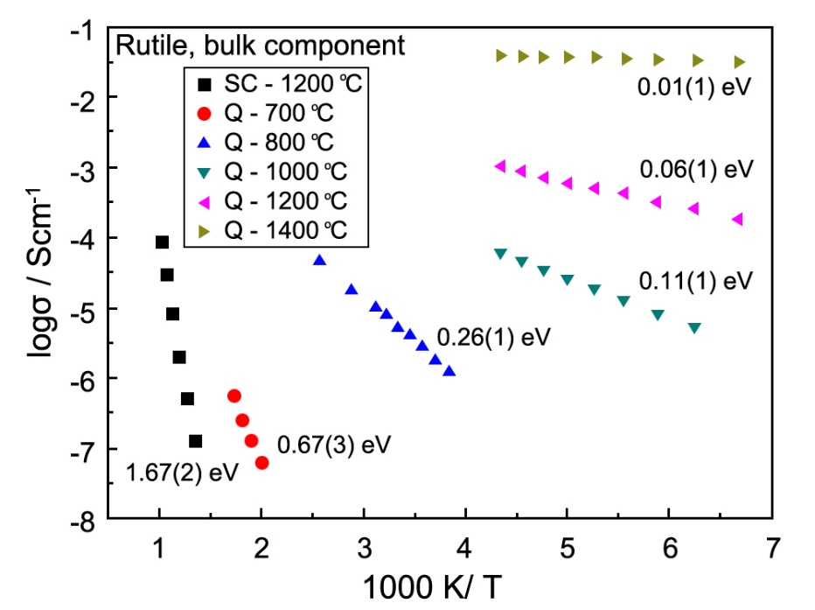
Figure 8-1. Arrhenius plot of bulk conductivity data after different heat treatment: SC, slow-cooled in air; Q, quenched into liquid N₂ ^{[33]}
For the n-type materials quenched from 700 °C and above, the reported ^{[33]} activation energy varied enormously between 0.67 and 0.01 eV as the degree of oxygen loss and hence the conductivity, increased. An Arrhenius plot showing the conductivity of samples quenched from temperatures in the range 700 to 1400 °C is reproduced in Figure 8-1. These oxygen-deficient quenched samples were all kinetically stable and did not undergo re-oxidation during conductivity measurements over the temperature ranges shown. In order to account for the large variation in activation energy with δ, it appears that electrons associated with oxygen loss must occupy discrete inter-gap states, as shown schematically in Figure 8-2(a). With increasing δ, discrete levels higher in the bandgap are increasingly occupied and the activation energy for conduction, which represents promotion of electrons from inter-gap states to the conduction band, decreases.
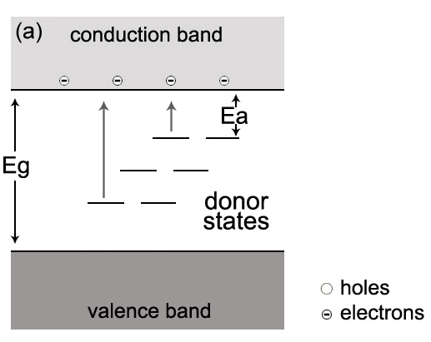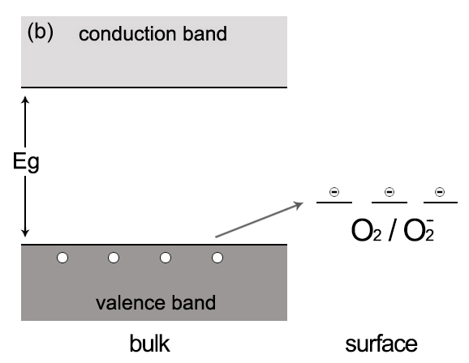
Figure 8-2. Occupied discrete states and (a) n-type conductivity associated with oxygen loss and (b) p-type conductivity associated with oxygen adsorption
A similar explanation applies, in principle, to the effect of pO₂ on p-type conductivity, but the reactions involved are more complex. Holes must be created/annihilated in response to the changes in pO₂. It is easy to see that, with decreasing pO₂ in the p-type region, electrons are liberated which annihilate holes and reduce the conductivity. But, for the opposite reaction to occur with increasing pO₂, it is necessary to have a spontaneous or facile mechanism of hole creation together with trapping of the liberated electrons.
We note that although p-type conductivity is widely observed in undoped materials, the origin and location of the holes in bulk materials is rarely discussed. Hole creation requires the presence of a redox-active species that can readily ionize. In principle, there are three possible locations of holes in rutile: Ti, impurities or O. First, since Ti is in its maximum possible valence state, +4, it cannot be oxidized further and be the source and location of holes. Second, unwanted impurities such as Fe could be the location of holes, but high purity, reagent grade TiO₂ was used for the experiments, and it is regarded as unlikely that such impurities are responsible. Third, oxide ions are regarded as the likely source and location of holes. Similar observations were made, and conclusions reached, to explain p-type conductivity in numerous BaTiO₃-related materials ^{[35-37]}. Oxide ions have the possibility to adopt oxidation states of -1 in either the peroxide ion, $O_{2}^{2-}$ or the $O^{-}$ ion, as well as oxidation state -1/2 in the superoxide ion, $O_{2}^{-}$.
We also propose a simple band structure model to account for the p-type behavior, as shown in Figure 8-2(b). The acceptor states are associated with adsorbed oxygen molecules on the sample surfaces; the holes that are created are located on under-bonded oxide ions which are effectively at the top of the valence band.

8.2.2 Doped rutile

8.2.2.1 Two phases of Cr-doped rutile
Impedance results of Cr-doped rutile showed that at low dopant concentration (0.001 ≤ x ≤ 0.01), samples were two-phase mixtures. The phase identified by R₂C₂ was more resistive than R₁C₁, and showed larger E_{a}. We consider that R₂C₂ represents a phase with very small Cr³⁺ dopant concentration, i.e. x = 0.001 ± 0.0005, and R₁C₁ represents a phase with relatively higher dopant content, i.e. x = 0.008 ± 0.002. Moreover, because of different dopant contents, the two phases may have different defect structures as well. Since the dopant concentration is very small, the phase R₂C₂ may have random point defects, such as oxygen vacancies. With relatively higher dopant content, oxygen vacancies may collapse to form shear planes, i.e. defects present in the phase R₁C₁ may be random shear planes.
However, the explanation and discussions of Cr-doped rutile with low dopant contents were not finished completely and need further work.

8.2.2.2 Semiconductivity of Cr-doped rutile
When the dopant content was relatively high (x > 0.01), Cr-doped rutile samples were semiconducting and showed small activation energy (~0.2 eV).
We consider several possible interpretations for such semi-conductivity shown in Cr-doped TiO₂. First, it may be attributed to intrinsic hopping of charge carriers associated with Cr. The term “intrinsic” used here describes those transport processes which are unaffected by external influence, in particular such as changes in the defect structure brought about by deviations from stoichiometry. The possible intrinsic mechanism for migration of electronic charge carriers is by charge transfer between Cr ions.
Second, hopping of charge carriers associated with Cr and Ti may also lead to semiconductivity. As orbital overlap may occur, charge carriers then hop between Cr³⁺ and Ti⁴⁺ and thus, Cr⁴⁺ and Ti³⁺ may be generated and samples become semiconducting. Moreover, as discussed above, when the dopant concentration is high, oxygen vacancies may collapse to form shear planes and thus, the distance between Cr and Cr, or Cr and Ti in face-sharing octahedra in the shear planes may become smaller. As a result, hopping of charge carriers becomes easier and the conductivity increases.
Polaron hopping is an alternative description of the amount of semiconductivity. By hopping of polarons, the sample property may change from insulating to semiconducting. In addition, polarons may be large or small, depending on their spatial extent ^{[38]}, i.e. the original energy level of electrons. With higher dopant content, oxygen vacancies may collapse to form shear planes, and the distance between Cr and Ti in face-sharing octahedra is smaller, indicating a closer overlap of Cr/Ti orbitals. Consequently, polarons are likely to be large as well, and thus samples show higher carrier mobility.

8.2.2.3 Effect of cooling rate of doped rutile
Similar to undoped rutile, Zn/Al-doped samples could also lose oxygen at high temperatures, and conductivity values would depend on quench temperature. In addition, since Al³⁺ and Zn²⁺ doping may have already created high [$V_{O}^{..}$], at relatively low temperatures, further oxygen loss due to high temperature may be inhibited. Consequently, we consider that extra oxygen loss at high sintering temperatures occur with Al/Zn; compared with undoped TiO₂, with Al³⁺ or Zn²⁺ doping, rutile starts to lose oxygen from a higher temperature than 700 °C. In addition, if CS structures form, the oxygen vacancies may come from a combination of oxygen loss and compensation for the acceptors, and samples are likely to show n-type conduction.
However, Ga/Cr-doped samples did not show much effect of cooling rate. Considering the ionic radii data shown in Table 8-1, a possible interpretation is that if the ionic radius of the acceptor dopant is similar to that of Ti⁴⁺, oxygen loss at high temperatures is likely to be prevented by the acceptor dopant, more or less. With Ga/Cr, if CS structures form, the oxygen vacancies are likely to come from the compensation for the acceptors.

8.2.2.4 Conduction type
Cr-doped rutile showed p-type conduction at low doping concentration, and the location of holes is thought to be related with O²⁻ ions, which have the possibility to adopt oxidation states of -1 in either $O_{2}^{2-}$ or $O^{-}$, as well as oxidation state -1/2 in $O_{2}^{-}$. When the dopant content was high, samples showed n-type conduction, which was attributed to carrier hopping on Cr and the possible shear structures.
Al-doped rutile also exhibited p-type conduction, which was attributed to the surface absorption of oxygen. After quenching from high temperatures, samples lost oxygen; oxygen vacancies might collapse to form shear structures and therefore, samples showed n-type conduction.
Ga-doped rutile showed very small effect of pO₂. A possible interpretation is that with Ga³⁺ doping, the charge is mainly compensated by formation of oxygen vacancies and thus, the sample shows almost oxide ion conduction, together with weak electronic conduction. With small amount of dopant, Ga-doped rutile shows slightly n-type conduction due to oxygen loss. With higher Ga³⁺ dopant concentration, electronic compensation starts to occur and generates holes, leading to p-type conduction.
Similarly with pure rutile, Zn-doped rutile also exhibits n-type conduction since it loses oxygen at high temperatures. In the literature, p-type conduction was found in Zn-doped TiO₂ under oxygen rich conditions ^{[39]}. However, it has also been reported that Zn²⁺ ions could exist only as surface species instead of being doped into the TiO₂ lattice ^{[40]}. It would be interesting to study the electrical properties of Zn-doped rutile under high pO₂.
Possible oxide ion conduction was found in Cr/Al/Ga-doped samples, but not in Zn-doped rutile. The possible reason is that the ionic radius of Zn²⁺ is quite different from that of Ti⁴⁺, and it is hard for ionic compensation to occur.

8.3 References
- AT Kuvarega and BB Mamba. Cri Cr Rev Sol State. 42(2017):295-346.
- J Nowotny, MA Alim, T Bak, rt al. Ionics. 21(2015):2019-2029.
- YJ Yang, YL Yu, JS Wang, et al. CrystEngComm. 19(2017):1100.
- HY Lee and J Robertson. J Appl Phys. 113(2013):213706.
- A Iwaszuk and M Nolan. J Phys Condens Matter. 23(2011):334207.
- U Gesenhues and T Rentschler. J Solid State Chem. 143(1999):210-218.
- DK Lee and HI Yoo. Phys Chem Chem Phys. 10(2008):6890-6898.
- DM de los Santos, T Aguilar, A Sánchez-Coronilla, et al. ChemPhysChem. 2(2014):71-84.
- AK Chandiran, F Sauvage, L Etgar, et al. J Phys Chem C. 115(2011):9232-9240.
- D Zwingel. Solid State Commun. 26(1978):775-777.
- D Zwingel. Solid State Commun. 20(1976):397-400.
- M Salazar-Villanueva, A Cruz-López, AA Zaldívar-Cadena, et al. Mat Sci Semicon Proc. 58(2017):8-14.
- NN Bao, JB Yi, HM Fan, et al. Scripta mater. 66(2012):821-824.
- Database of Ionic Radii. Atomistic Simulation Group, Materials Department of Imperial College. http://abulafia.mt.ic.ac.uk/shannon/ptable.php
- AR West. Solid State Chemistry and its Applications. John Wiley & Sons. 2014.
- YQ Wang, RR Zhang, JB Li, et al. Nanoscale Res Lett. 9(2014):46.
- J Nowotny, M Radecka, M Rekas. J Phys Chem Solids. 58(1997):927-937.
- K Hoshino, NL Peterson, CL Wiley. J Phys Chem Solids. 46(1985):1397-1411.
- N Ait-Younes, F Millot, P Gerdanian. Solid State Ionics. 12(1984):431-436.
- P Kofstad. J Phys Chem Solids. 23(1962):1579-1586.
- J Marucco, J Gautron, P Lemasson. J Phys Chem Solids. 42(1981):363-367.
- D Marrocchelli, SR Bishop, HL Tuller, et al. Adv Funct Mater. 22(2012):1958-1965.
- SR Bishop. Acta Mech Sinica. 29(2013):312-317.
- MG Blanchin, P Faisant, C Picard, et al. Phys Stat Sol. 60(1980):357-364.
- CW Lee. Ber Dtsch Keram Ges. 47(1970):169.
- RM Gibb, JS Anderson. J Solid State Chem. 4(1972):379-390.
- S Sōmiya, S Hirano, S Kamiya. J Solid State Chem. 25(1978):273-284.
- M Hamelin. Bull Soc Chim Fr. 11-12(1957):1421-1431.
- Y Michiue, A Yamamoto, M Tanaka. Acta Cryst. B62(2006):737-744.
- S Kamiya and RJD Tilley. J Solid State Chem. 22(1977):205-216.
- RM Gibb and JS Anderson. J Solid State Chem. 5(1972):212-225.
- DJ Lloyd, IE Grey, AL Bursill. Acta Cryst. B32(1976):1756-1761.
- Y Liu and AR West. J Am Ceram Soc. 96(2013):218-222.
- J Nowotny, MA Alim, T Bak, et al. Chem Soc Rev. 44(2015):8424-8442.
- PR Ren, N Masó, AR West. Phys Chem Chem Phys. 15(2013):20943-20950.
- PR Ren, N Masó, Y Liu, et al. J Mater Chem C. 1(2013):2462-2432.
- N Masó and AR West. Chem Mater. 24(2012):2127-2132.
- JT Devreese. Enc Appl Phys. 14(1996):383-409.
- XP Han and GS Shao. Phys Chem Chem Phys. 15(2013):9581.
- YL Yu, JS Wang, W Li, et al. Cryst Eng Comm. 17(2015):5074-5080.

Chapter 9. Conclusions

The electrical properties of pure and doped TiO₂ have been investigated in this thesis. The main conclusions are:

Undoped TiO₂
Oxygen-deficient rutile prepared by quenching between 700 and 1000 °C shows a chemical expansion, which is attributed to weakening and lengthening of the Ti-O bonds on reduction. In the later stages of oxygen loss, on quenching samples from higher temperature and especially, for samples heated in an atmosphere of low pO₂, the opposite effect of chemical contraction occurs and is attributed to partial structural collapse associated with elimination of oxygen vacancies and CS plane formation. On further oxygen loss, a homologous series of more heavily-reduced Magneli phases of formula Ti_{n}O_{2n-1} is expected, although was not seen here.
The occurrence of n-type semi-conductivity and associated darkening is well-established in oxygen-deficient rutile. Oxygen loss commences in air at temperatures as low as ~650 °C and can be detected because the conductivity is extremely sensitive to small levels of oxygen deficiency. At slightly lower temperatures, rutile is likely to be oxygen stoichiometric, but at 450 to 500 °C, the onset of p-type semi-conductivity is observed. It is attributed to reaction of underbonded $O^{2-}$ ions at sample surfaces with gas phase $O_{2}$ molecules and therefore, the TiO₂ has a slight oxygen excess. The holes reside on oxygen, ideally as $O^{-}$ ions.
The occurrence of p-type conductivity is commonly observed in ceramic oxides and is widely attributed in the literature to the presence of unavoidable impurities such as Fe. It is, of course, very difficult to avoid small amounts of such impurities but similar p-type behavior to that seen here has been reported in a range of acceptor-doped titanate ceramics prepared from high purity chemicals. Under-bonded oxide ions, such as those associated with either acceptor dopants or located at sample surfaces, are likely to have reduced ionization potentials. This is because the free $O^{2-}$ ion in the gas phase is spontaneously unstable and is stabilized in crystal lattices only because of the extra lattice energy associated with divalent anions compared to monovalent anions. It therefore appears likely that holes based on oxygen may be a general feature of p-type conductivity in many ceramic materials.

Cr-doped TiO₂
At low Cr content, i.e. 0 ≤ x ≤ 0.005, samples shown an increased lattice volume which is attributed to the larger ionic radius of Cr³⁺ and the weaker average M-O bond strength. At higher Cr³⁺ dopant concentration, i.e. x > 0.005, an unusual volume contraction effect was observed; this is attributed to the accumulation and elimination of oxygen vacancies by the formation of crystallographic shear planes.
The electrical properties of Cr-doped rutile are very dependent on composition x. Samples with lower x values, i.e. x ≤ 0.01, appear to be two-phase mixtures; the phase identified by R₂C₂ has very small Cr³⁺ dopant concentration, i.e. x = 0.001 ± 0.0005, and R₁C₁ represents a phase with relatively higher dopant content, i.e. x = 0.008 ± 0.002. In addition, R₂C₂ may have random point defects, whereas R₁C₁ may have random shear planes. These two-phase mixtures show mixed conduction with p-type electronic conduction and a small amount of oxide ion conduction. $O^{-}$ ions are the most likely locations of the holes. With higher x value, i.e. x ≥ 0.015, samples are homogeneous and show a p-n transition. The n-type conduction is likely to be attributed to hopping of carriers based on Cr-Cr, Cr-Ti or polarons.

Al-doped TiO₂
Al-doped TiO₂ shows a p-n transition with increasing quench temperature. (1) Samples slow-cooled in air and quenched from 1000-1200 °C show p-type conduction. The p-type conductivity is driven by surface absorption of oxygen and thus, associated with $O^{-}$ at sample surface. (2) Samples quenched from 1200-1225 °C show a cross-over between n-type and p-type behavior. (3) Samples quenched from 1225-1350 °C are n-type due to oxygen loss. In addition, weak proton conduction is found in slow-cooled samples, but only exist in temperatures below ~85 °C.

Ga-doped TiO₂
With increasing dopant content, from x = 0.01 to 0.03, samples show n-p transition, of which the n-type conduction may be attributed to extra oxygen loss at high temperatures, while the p-type conduction may be associated with electronic compensation and surface oxygen absorption. However, in both cases, such electronic conduction is quite weak. Samples may show mainly oxide ion conduction together with weak electronic conduction.

Zn-doped TiO₂
Zn-doped TiO₂ shows n-type conduction, and resistance increases with both pO₂ and dc bias.

Chapter 10. Future work

XRD results indicate the formation of crystallographic shear structures in reduced rutile. It would therefore be worthwhile to do TEM for such samples and to see if shear structures could be observed. In addition, impedance results indicate that undoped rutile shows p-type conduction after annealing in O₂; such p-type conduction is attributed to reaction of $O^{2-}$ ions at sample surfaces with gas phase $O_{2}$ molecules, giving rise to holes creation with holes residing on oxygen, ideally as $O^{-}$ ions. Since Raman spectroscopy is sensitive to anions, it could be an effective way to investigate the appearance of $O^{2-}$ or $O^{-}$ ions in such p-type rutile samples. Also, it could be of interest to sinter TiO₂ samples in a high oxygen pressure furnace, study the conduction mechanism and to see if it is increasingly p-type.
Impedance results of Al-doped TiO₂ show that samples may have two phases, and therefore it is worth to use SEM to detect the second phase. Also, conclusions of Chapter 5 indicate the appearance of proton conduction in Al-doped samples slow-cooled from high temperatures. However, such proton conduction is weak and only exists at temperatures below ~85 °C. This may indicate surface conduction of H⁺. It is therefore worth doing impedance measurements in wet/dry air for quenched samples as well and getting a better understanding about the proton conduction in Al-doped TiO₂.
The phase diagram of TiO₂-Ga₂O₃ in Chapter 6 shows a big change at 1190 °C with all the phases and solid solution formed at higher temperatures. Clearly, since impedance results shown in Chapter 6 are not good, probably because samples are not fully reacted, the effect observed on samples heated above and below 1200 °C need to be investigated further.
In the literature mentioned in Chapter 7, Zn²⁺ may not be able to enter the TiO₂ lattice and just exist in the surface. Also, Zn-doped TiO₂ shows similar impedance response to undoped TiO₂. Therefore, it would be worthwhile doing EDAX on Zn-doped TiO₂ crystals and seeing if Zn is prevented from solid solution formation. It would also be interesting to quench the doped samples from different temperatures to study the lattice parameters and the possible defect structures.
The present work arose from the electrical properties of pure rutile ceramics. The results obtained in this project reveal that with acceptor dopants, rutile may show n-type, p-type or mixed conduction. However, the origin of p-type behaviour and the possible existence of $O^{-}$ ions are not clear. Therefore, it is worth continuing the work on pure and doped TiO₂. It would be interesting to try some other experimental techniques, such as sol-gel method to synthesise high purity samples, EXAFS spectroscopy to acquire the position and charge of dopants, and to know the bond lengths and coordination numbers. Also, we could try more XRD and neutron diffraction for higher dopant samples. Proper phase diagram study may also be interesting. We could try the temperature dependent phase diagram study of solid solution limit, and use SEM and TEM to confirm single phase and mixtures. More dopants could be used as well, for instance, acceptor dopants and anion dopants. It would be interesting to investigate the structural and electrical properties of donor doped rutile ceramics. Also, it may be worthwhile studying the possible relationship between the electrical properties and other properties such as magnetic properties, photocatalytic properties, etc.

