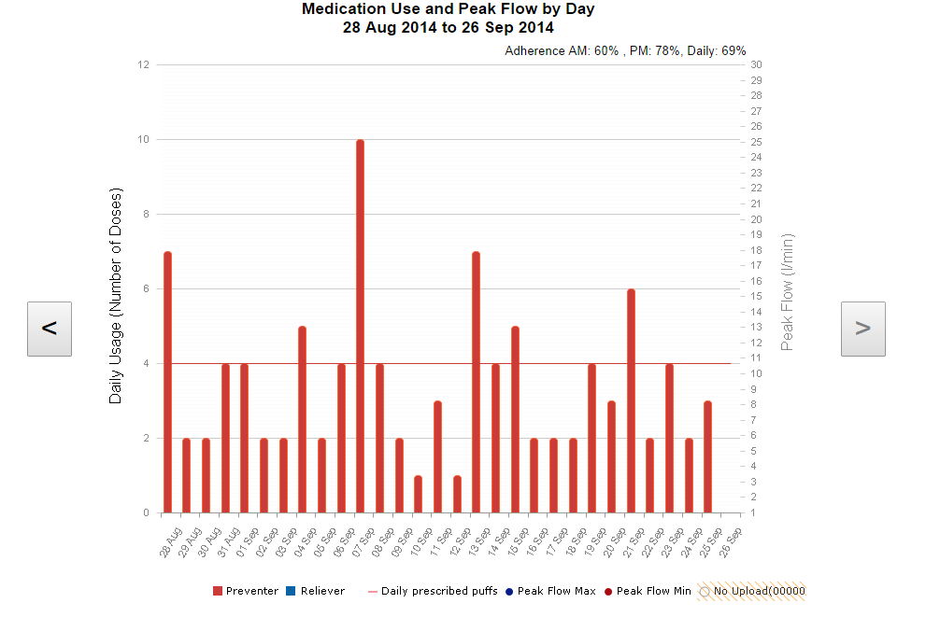

Electronic adherence monitoring and reminders in childhood asthma and cystic fibrosis

Thesis submitted for the Degree of Doctor of Medicine

School of Human Metabolism & Oncology

University of Sheffield

Robert Morton

Candidate no. 130239736

Supervisor: Heather Elphick

**Acknowledgements**

I would primarily like to thank Professor Heather Elphick, my supervisor, for all her hard work and support whilst I’ve been studying for this MD. Her calm and considered words of wisdom and encouragement have helped this thesis develop from a difficult start, to the body of work seen here. It is safe to say without her involvement this thesis would not have been possible, and I am truly grateful.

I would also like to thank Professor Mark Everard, also for his supervision and support. He devised the original idea for the asthma study, and initially supervised me before moving to Australia. Since he has been there he has continued to supervise and support me, even without the need or obligation of any official supervisory role.

I would like to thank Dr. Alan Rigby for his assistance with all the statistics in this thesis. His vast knowledge and practical application of statistics and methodology have greatly enhanced these studies.

I would like to thank Dr. Noreen West and Elaine Edwards for all their help and advice devising and implementing the Nebtext study.

I would like to thank Dr. David King and Dr. Will Daw for all their help setting up these studies, recruiting patients and carrying out study visits.

I would like to thank Laurie Smith for his expert advice regarding the respiratory physiology, lung function testing, and converting the lung function data to GLI values.

I would like to thank Dr Sonal Kansra, Dr Kelechi Ugonna, Dr Ruth O’Reilly and Dr Ben Bradbrook for accommodating the STAAR study in their asthma clinics. I would like to thank the specialist respiratory nurses Moira Gibbons, Nichola Butler, Anita Critchlow, Emma Sheppard and Bridget Howe for their help facilitating the STAAR study visits in clinic. I would like to thank the respiratory physiologists Karen O’Donnell and Royston Andrew for performing lung function on the participants. I would like to thank our pharmacist Jayne Clements for performing the randomisation.

I would like to thank the Sheffield Children’s Hospital Charity for providing funding for the STAAR study.

Finally, I would like to thank Alexandra Spooner and all the other staff in R&D at Sheffield Children’s Hospital for implementing the two studies.

**Dedication**

Dedicated to my wife Kim, and my boys George and Henry.

For all your love and support throughout.

**Disclaimer and Author’s Declaration**

The views expressed in this thesis are those of the author, and not necessarily those of the NHS, Sheffield Children’s Hospital or the University of Sheffield.

I declare that the work in this thesis is original work, and that it has not been previously submitted for a degree at any awarding institution.

**Research Achievements**

**Peer Reviewed Publications (Lead author)**

1. Morton RW, Elphick HE, Edwards E, et al. Investigating the feasibility of text message reminders to improve adherence to nebulized medication in children and adolescents with cystic fibrosis. *Patient Prefer Adherence* 2017;11:861-869.

2. Morton RW, Elphick HE, Rigby AS, et al. STAAR: a randomised controlled trial of electronic adherence monitoring with reminder alarms and feedback to improve clinical outcomes for children with asthma. *Thorax* 2017;72:347-354.

3. Morton R, Everard M. Adherence to Aerosol Medication. In: Dhand R, ed. *The Textbook of Aerosol Medicine*: The International Society for Aerosol Medicine (ISAM), 2015.

4. Morton RW. I'm sorry, doctor, my dog ate my inhaler: the trials and tribulations of a clinical researcher. *BMJ* 2015;530:h2097

7. Morton RW, Everard ML, Elphick HE. Adherence in childhood asthma: the elephant in the room. *Arch Dis Child* 2014;99:949-953.

8. Morton RW, Elphick HE. Rehospitalization for childhood asthma: Is adherence the key? *J Pediatr* 2014;165:211.

**International Oral Presentations**

1. Morton RW, Elphick HE, Daw W, Edwards E & West N: The Nebtext study: text message reminders to improve adherence to nebulised medication in children with Cystic Fibrosis. European Cystic Fibrosis Society annual congress**.** Basel, Switzerland. June 2016.

2. Morton RW, Elphick HE & Everard ML: RCT to investigate whether electronic adherence monitoring, with reminder alarms and feedback can improve clinical outcomes in childhood asthma. European Respiratory Society annual congress. Amsterdam, Holland. September 2015.

**National Policies/ Guidelines**

The results of the STAAR study were analysed and included in the 2017 NICE (National Institute of Health and Care Excellence) MedTech Innovation Guideline: Smartinhalers for asthma (MIB90). Avaialble at: <https://www.nice.org.uk/guidance/mib90>

**Prizes**

The STAAR study won the 2017 Royal College of Paediatrics and Child Health (RCPCH) Donald Patterson prize for: an article judged with respect to scientific content, clinical contribution and presentation, in recognition of excellence in research.

****

**“ keep watch on the faults of the patients, which often make them lie about the taking of things prescribed ”**

**Hippocates, Athens. 400 BC.**

**Abstract**

**Background**

Sub-optimal adherence to inhaled maintenance therapy is common in children with asthma and Cystic Fibrosis (CF), resulting in poor disease control and increased exacerbations.

Electronic monitoring with feedback has been shown to increase adherence in children with asthma by identifying and addressing intentional adherence barriers, and its use is now widespread in CF clinics in the UK. Medication reminders have been shown to be effective at addressing non-intentional adherence barriers in asthma, but have not been investigated in CF. This thesis aimed to investigate electronic monitoring with feedback and reminders to improve adherence and clinical outcomes in children with asthma and CF.

**Methods**

90 children with moderate asthma were recruited to the STAAR study, and randomised to receive an electronic monitoring device (EMD) with 3- monthly feedback of data and alarms, or an EMD without feedback or alarms for a year. The primary outcome was the difference in Asthma Control Questionnaire (ACQ) score, from baseline to 3,6,9 and 12 months. Secondary outcomes were adherence, number of oral steroids required, lung function, hospital admissions, days off school and quality of life. The sample size was calculated using repeated measure analysis, with an MID for the ACQ of 0.5.

17 children were recruited to the Nebtext study and sent reminder text messages for 6 months. The outcomes were difference in overall, weekend and weekday adherence rates before and during the text message period. The sample size was the maximum number of children with CF attending clinic in the recruitment period.

**Results**

STAAR

The mean [95% CI] difference in ACQ from baseline to 12 months was -1.14 [-1.6 to -0.7] in the intervention group, compared to -0.95 [-1.3 to -0.6] in the control group, with no significant difference between the two (P= 0.51).

The mean [95% CI] adherence rate for the intervention group was 71% [63-77], vs. 49% [28-54] in the control group (p = <0.001). The rate of exacerbations requiring oral steroids in the intervention group was 0.4 per 100 days, compared to 0.7 in the control group (p=0.008). The rate of hospitalisation was 0.03 in the intervention group vs. 0.13 in the control group (p = <0.01).

Nebtext

The mean [95% CI] pre-text adherence rate was 80% [65-94], compared to 79% [62-95] during the text period.

**Conclusion**

Electronic monitoring with feedback and alarms is effective at reducing exacerbations and hospitalisations in children with asthma. The addition of reminder texts to existing electronic monitoring in children with CF does not further improve high baseline adherence rates.

Table of Contents

[**Chapter 1- Overview 20**](#_Toc497490261)

[1.1 Introduction 21](#_Toc497490262)

[1.2 Aims 21](#_Toc497490263)

[1.3 Background 22](#_Toc497490264)

[1.4 Definition of adherence 22](#_Toc497490265)

[1.5 Scope and significance of Non-adherence 24](#_Toc497490266)

[1.6 Childhood Chronic Respiratory Conditions 24](#_Toc497490267)

[1.7 Thesis Objectives and scope of research 27](#_Toc497490268)

[1.8 Thesis Roadmap 28](#_Toc497490269)

[1.9 Summary 28](#_Toc497490270)

[**Chapter 2 – Introduction & Literature Review** 29](#_Toc497490271)

[2.1 Introduction 30](#_Toc497490272)

[2.2 Aims 30](#_Toc497490273)

[2.3 Methods of adherence measurement 31](#_Toc497490274)

[2.3.1 Direct questioning 31](#_Toc497490275)

[2.3.2 Self- Report Questionnaires 32](#_Toc497490276)

[2.3.3 Daily Diaries 33](#_Toc497490277)

[2.3.4 Phone Diaries 34](#_Toc497490278)

[2.3.5 Prescription Fill Data 35](#_Toc497490279)

[2.3.6 Canister weight/ Dose counters 36](#_Toc497490280)

[2.3.7 The “Dumping” Phenomenon 36](#_Toc497490281)

[2.3.8 Drug assays 37](#_Toc497490282)

[2.2.9 Electronic Monitoring Devices (EMDs) 37](#_Toc497490283)

[2.3.10 Electronically monitored Nebulised Therapy 38](#_Toc497490284)

[2.3.11 MEMS 40](#_Toc497490285)

[2.4 Inhaler Competency 40](#_Toc497490286)

[2.5 Evaluation of methods of adherence monitoring 41](#_Toc497490287)

[2.6 Reflections on the importance of objective adherence monitoring 43](#_Toc497490288)

[2.7 Adherence levels to inhaled steroids in children with asthma when recorded electronically 45](#_Toc497490289)

[2.8 Adherence rates to treatment in Cystic Fibrosis 47](#_Toc497490290)

[2.8.1 Chest Physiotherapy 47](#_Toc497490291)

[2.8.2 Pancreatic Enzymes/ Vitamin supplements 48](#_Toc497490292)

[2.8.3 Nebulised Therapy 48](#_Toc497490293)

[2.9 Trends in adherence rates for children with asthma and CF 49](#_Toc497490294)

[2.10 The Hawthorne Effect 50](#_Toc497490295)

[2.11 Consequences of non-adherence in childhood asthma 51](#_Toc497490296)

[2.11.1- Introduction 51](#_Toc497490297)

[2.11.2 – Aims 51](#_Toc497490298)

[2.11.3 - Consequences of non - adherence in asthma 52](#_Toc497490299)

[2.11.4 Increased morbidity and exacerbations 52](#_Toc497490300)

[2.11.5 Death 53](#_Toc497490301)

[2.11.6 Unnecessary escalations of treatment 53](#_Toc497490302)

[2.11.7 Increased health care utilisation and cost 53](#_Toc497490303)

[2.11.8 Consequences of non-adherence in childhood CF 54](#_Toc497490304)

[2.11.9 Poor disease control 54](#_Toc497490305)

[2.11.10 Increased health care utilisation and cost 55](#_Toc497490306)

[2.11.11 – Summary of consequences of sub-optimal adherence 55](#_Toc497490307)

[2.12 Policies and Guidance on adherence monitoring 56](#_Toc497490308)

[2.13 Barriers to adherence 59](#_Toc497490309)

[2.13.1 - Introduction 59](#_Toc497490310)

[2.13.2 – Aims 59](#_Toc497490311)

[2.13.3 Intentional Barriers 59](#_Toc497490312)

[2.13.4 Non-Intentional Barriers 60](#_Toc497490313)

[2.13.5 Barriers and adherence rates in different age groups 61](#_Toc497490314)

[2.13.6 Treatment Burden 63](#_Toc497490315)

[2.13.7 – Summary of adherence barriers 63](#_Toc497490316)

[2.14 Interventions to improve adherence in childhood asthma 64](#_Toc497490317)

[2.14.1 – Introduction 64](#_Toc497490318)

[2.14.2 - Aims 64](#_Toc497490319)

[2.14.3 Educational interventions 64](#_Toc497490320)

[2.14.4 Behavioural Interventions 65](#_Toc497490321)

[2.14.5 Alternative Dosing Regimens 67](#_Toc497490322)

[2.14.6 Direct Reminders 69](#_Toc497490323)

[2.14.7 Electronic monitoring and feedback 70](#_Toc497490324)

[2.14.8 Electronic monitoring with feedback and reminder alarms 72](#_Toc497490325)

[2.14.9 Interventions to improve adherence in CF 72](#_Toc497490326)

[2.14.10 Objective adherence monitoring 73](#_Toc497490327)

[2.14.11 Direct Reminders 73](#_Toc497490328)

[2.14.12 – Summary of adherence interventions 73](#_Toc497490329)

[2.15 Summary of evidence from literature review 74](#_Toc497490330)

[2.16 - Evidence Deficit 75](#_Toc497490331)

[2.17 - Research Hypothesis 75](#_Toc497490332)

[2.17.1 Adherence Conceptual Framework 75](#_Toc497490333)

[2.17.2 Complex Interventions 76](#_Toc497490334)

[2.18 Research Questions 78](#_Toc497490335)

[2.19 Aims and Objectives 78](#_Toc497490336)

[2.20 – Summary 79](#_Toc497490337)

[**Chapter 3 - Methods** 81](#_Toc497490338)

[3.1 Introduction 82](#_Toc497490339)

[3.2 Aims & Objectives 82](#_Toc497490340)

[3.3 STAAR study 83](#_Toc497490341)

[3.4 Participants & eligibility 84](#_Toc497490342)

[3.5 Recruitment & consent 84](#_Toc497490343)

[3.6 Ethical Approval 85](#_Toc497490344)

[3.7 Interventions 85](#_Toc497490345)

[3.7.1 Intervention Group 86](#_Toc497490346)

[3.7.2 Control Group 88](#_Toc497490347)

[3.8 Follow up visits 88](#_Toc497490348)

[3.9 Primary Outcome 91](#_Toc497490349)

[3.10 Secondary Outcomes 92](#_Toc497490350)

[3. 10.1 Adherence 92](#_Toc497490351)

[3.10.2 Exacerbations and clinical condition 92](#_Toc497490352)

[3.10.3 Lung function 93](#_Toc497490353)

[3.10.4 Illness perceptions and Medication Beliefs 93](#_Toc497490354)

[3.11 Sample Size 94](#_Toc497490355)

[3.12 Randomisation 94](#_Toc497490356)

[3.12.1 Sequence Generation 94](#_Toc497490357)

[3.12.2 Allocation 95](#_Toc497490358)

[3.12.3 Blinding 95](#_Toc497490359)

[3.13 Statistical Analysis 95](#_Toc497490360)

[3.14 Funding 96](#_Toc497490361)

[3.15 Changes to methods 97](#_Toc497490362)

[3.15.1 Electronic Monitoring Devices 97](#_Toc497490363)

[3.15.2 Lung Function 97](#_Toc497490364)

[3.15.3 Medicines Beliefs Questionnaire & Illness perceptions questionnaire 98](#_Toc497490365)

[3.15.4 Protocol Amendment 99](#_Toc497490366)

[3.16 The Nebtext Study 100](#_Toc497490367)

[3.17 Participants 100](#_Toc497490368)

[3.18 Intervention 101](#_Toc497490369)

[3.19 Outcomes 103](#_Toc497490370)

[3.20 Statistical Analysis 104](#_Toc497490371)

[3.21 Ethical Approval & Funding 104](#_Toc497490372)

[3.22 Changes to methods 104](#_Toc497490373)

[3.23 Summary 105](#_Toc497490374)

[**Chapter 4 - Results** 106](#_Toc497490375)

[4.1 Introduction 107](#_Toc497490376)

[4.2 Aims 107](#_Toc497490377)

[4.3 STAAR study results 107](#_Toc497490378)

[4.3.1 Recruitment and flow of participants 107](#_Toc497490379)

[4.3.2 Baseline Characteristics 111](#_Toc497490380)

[4.3.3 Primary Outcome 111](#_Toc497490381)

[. 113](#_Toc497490382)

[114](#_Toc497490383)

[4.3.4 Secondary Outcomes 115](#_Toc497490384)

[4.3.4.1 Lung Function – Rosenthal 1993 data 115](#_Toc497490385)

[4.3.4.2 Lung Function – GLI data 116](#_Toc497490386)

[4.3.4.3 Adherence 117](#_Toc497490387)

[118](#_Toc497490388)

[119](#_Toc497490389)

[4.3.4.4 Event rates 119](#_Toc497490390)

[4.3.4.5 Quality of Life 123](#_Toc497490391)

[4.3.4.6 Inhaled Steroid Dose 123](#_Toc497490392)

[4.3.4.7 BTS stage 124](#_Toc497490393)

[4.3.4.8 Medicines Beliefs Questionnaire 124](#_Toc497490394)

[4.3.4.9 Illness Perceptions Questionnaire 124](#_Toc497490395)

[4.3.4.10 Clinic Visits 125](#_Toc497490396)

[4.3.4.11 Broken/ forgotten/ lost devices 126](#_Toc497490397)

[4.3.4.12 Amendment data 126](#_Toc497490398)

[4.4 Results – Nebtext Study 128](#_Toc497490399)

[4.4.1Text Questionnaire Responses 128](#_Toc497490400)

[4.4.2 Recruitment and flow of participants 129](#_Toc497490401)

[4.4.3 Baseline Characteristics 131](#_Toc497490402)

[4.4.4 Overall Adherence 132](#_Toc497490403)

[4.4.5 Weekend/ Weekday/ Holiday adherence rates 134](#_Toc497490404)

[4.4.6 Missed days & doses 135](#_Toc497490405)

[4.4.7 Feedback Questionnaire 135](#_Toc497490406)

[7.5 Summary 136](#_Toc497490407)

[**Chapter 5 - Analysis of Results** 137](#_Toc497490408)

[5.1 Introduction 138](#_Toc497490409)

[5.2 Aims 138](#_Toc497490410)

[5.3 Analysis of results - STAAR Study 138](#_Toc497490411)

[5.3.1 Adherence 140](#_Toc497490412)

[5.3.2 ACQ 143](#_Toc497490413)

[5.3.3 Lung Function 149](#_Toc497490414)

[5.3.4 Oral steroids Required 151](#_Toc497490415)

[5.3.5 Hospital Admissions 154](#_Toc497490416)

[5.3.6 GP/ ED attendances 155](#_Toc497490417)

[5.3.7 Days off school due to asthma 157](#_Toc497490418)

[5.3.8 Quality of Life 159](#_Toc497490419)

[5.3.9 Inhaled Steroid Dose & BTS stage 159](#_Toc497490420)

[5.3.10 Medicines Beliefs & Illness Perceptions 160](#_Toc497490421)

[5.4 Analysis of Results – Nebtext study 161](#_Toc497490422)

[5.4.1 Overall adherence rates 161](#_Toc497490423)

[5.4.2 Weekday/ Weekend/ Holiday adherence rates 164](#_Toc497490424)

[5.4.3 Missed doses/ days 166](#_Toc497490425)

[5.4.4 Feedback Questionnaire 166](#_Toc497490426)

[5.5 Summary 167](#_Toc497490427)

[**Chapter 6 - Discussion** 168](#_Toc497490428)

[6.1 Introduction 169](#_Toc497490429)

[6.2 Aims 169](#_Toc497490430)

[6.3 Strengths of the STAAR study 169](#_Toc497490431)

[6.3.1 Strengths in comparison to previous studies using electronic adherence monitoring 170](#_Toc497490432)

[6.4 Limitations of the STAAR study 174](#_Toc497490433)

[6.4.1 Open label study 174](#_Toc497490434)

[6.4.2 Wrong Endpoint 174](#_Toc497490435)

[6.4.3 Device issues 175](#_Toc497490436)

[6.4.4 Multiple study centres 177](#_Toc497490437)

[6.4.5 Clinic visit cancellations and non- attendance 177](#_Toc497490438)

[6.4.6 Damaged & lost devices 178](#_Toc497490439)

[6.4 Popularity of the intervention 180](#_Toc497490440)

[6.5 Strengths of the Nebtext study 181](#_Toc497490441)

[6.6 Limitations of the Nebtext study 181](#_Toc497490442)

[6.6.1 Clinic adherence reviews & data analysis via the “psp.net” website 183](#_Toc497490443)

[6.7 Combined Thesis Findings 184](#_Toc497490444)

[6.7.1 Value of reminders vs. feedback 187](#_Toc497490445)

[6.8 Value of the intervention & future study implications 188](#_Toc497490446)

[6.8.1 Future asthma studies 188](#_Toc497490447)

[6.8.2 New generation electronic monitors for asthma 189](#_Toc497490448)

[6.8.3 Future CF studies 191](#_Toc497490449)

[6.8.4 Future of electronic adherence monitors in CF 193](#_Toc497490450)

[6.9 Summary 194](#_Toc497490451)

[**Chapter 7 - Conclusions** 196](#_Toc497490452)

[7.1 Introduction 197](#_Toc497490453)

[7.2 Aims 197](#_Toc497490454)

[7.3 Research questions answered 197](#_Toc497490455)

[7.3.1 Asthma 197](#_Toc497490456)

[7.3.2 CF 198](#_Toc497490457)

[7.4 Recommendations and policy change 198](#_Toc497490458)

[7.5 Summary 200](#_Toc497490459)

[**Chapter 8 - References** 202](#_Toc497490460)

[202](#_Toc497490461)

[**Appendix 1 – Study Protocols** 212](#_Toc497490462)

[214](#_Toc497490463)

[Enrolment 218](file:///C:\Users\UOS\Documents\Thesis\Thesis%20October%202017.docx#_Toc497490464)

[Recruitment 218](file:///C:\Users\UOS\Documents\Thesis\Thesis%20October%202017.docx#_Toc497490465)

[Follow-Up 218](file:///C:\Users\UOS\Documents\Thesis\Thesis%20October%202017.docx#_Toc497490466)

[Analysis 218](file:///C:\Users\UOS\Documents\Thesis\Thesis%20October%202017.docx#_Toc497490467)

[**Appendix 2 – Ethical Approval** 221](#_Toc497490468)

STAAR study [22](#_Toc497490469)2

Nebtext Study [22](#_Toc497490470)3

STAAR amendment [22](#_Toc497490471)4

[**Appendix 3 – Nebtext Questionnaire** 226](#_Toc497490472)

[**Appendix 4 – Interesting adherence graphs** 228](#_Toc497490473)

[A4.1 Good adherence in intervention group 229](#_Toc497490474)

[A4.2 Improved adherence due to successful intervention 230](#_Toc497490475)

[A 4.3 Hawthorne effect in control group 231](#_Toc497490476)

[A 4.4 Dose dumping in control participant 233](#_Toc497490477)

[A 4.5 Identification of device actuation without inhalation 234](#_Toc497490478)

[A 4.6 Importance of regular adherence reviews 235](#_Toc497490479)

[A 4.7 Poor adherence and asthma control in control group 237](#_Toc497490480)

[A 4.8 Decreased holiday adherence – control 238](#_Toc497490481)

[A 4.9 Good adherence in patient whose adherence had been doubted 239](#_Toc497490482)

[**Appendix 5 – Published Papers** 240](#_Toc497490483)

List of Figures

[Figure 1 Venn diagram illustrating similarities and differences between childhood asthma and cystic fibrosis. 27](#_Toc497490484)

[Figure 2 Adherium Smartturbo (left) & Smartinhaler (right) 38](#_Toc497490485)

[Figure 3 The “I-Neb” – Phillips Respironics, UK. 39](#_Toc497490486)

[Figure 4 Conceptual framework to understand adherence barriers –version of the framework altered with permission, published by Wildman et al. (2014) 76](#_Toc497490487)

[Figure 5 Complex intervention to improve adherence 77](#_Toc497490488)

[Figure 6 STAAR study logo 83](#_Toc497490489)

[Figure 7 Adherence feedback graph from www.smartinhalerlive.com 87](#_Toc497490490)

[Figure 8 Methodology flow diagram for “STAAR” trial 90](#_Toc497490491)

[Figure 9 Nebtext logo 100](#_Toc497490492)

[Figure 10 Methodology flow diagram for the Nebtext Study 102](#_Toc497490493)

[Figure 11 I-Neb text file showing date and time of all actuations 103](#_Toc497490494)

[Figure 12 CONSORT 2010 flow diagram showing passage of participants through study 109](#_Toc497490495)

[Figure 13 – Box and whisker plot showing the ACQ distribution at each study visit for groups A and B . 114](#_Toc497490496)

[Figure 14 – Box and whisker plot showing the FEV1% distribution (Rosenthal 1993) at each study visit for groups A and B. 116](#_Toc497490497)

[Figure 15 – Box and whisker plot showing the median adherence rates throughout the study for groups A and B. 118](#_Toc497490498)

[Figure 16- Number of GP/ED attendances required in groups A and B throughout the study 121](#_Toc497490499)

[Figure 17 – Number of days off school due to asthma in groups A and B throughout the study 121](#_Toc497490500)

[Figure 18 – Number of courses of oral steroids required in groups A and B throughout the study 122](#_Toc497490501)

[Figure 19 – Number of hospital admissions required in groups A and B throughout the study 122](#_Toc497490502)

[Figure 20 – Box and whisker plot showing the median mini paediatric quality of life (PQL) score throughout the study for groups A and B. 123](#_Toc497490503)

[Figure 21 – Message chosen as reminder text 128](#_Toc497490504)

[Figure 22 – Flow of participants through Nebtext study 130](#_Toc497490505)

[Figure 23 – Individual participant adherence rates for the pre-text and text periods 133](#_Toc497490506)

[Figure 24 – Sub-groups of baseline adherence – A= Good (80-100%), B = Moderate (50-79%), C= Poor ( <50%) 134](#_Toc497490507)

List of Tables

Table 1 – summary of the advantages and disadvantages of methods of monitoring adherence to ICS 42

Table 2 Adherence rates to inhaled corticosteroids when measured electronically 46

Table 3 – Mean adherence rates to therapy in children with CF when measured electronically 49

Table 4 Reasons for withdrawal from study 110

Table 5 – Baseline characteristics for groups A (intervention) and B (control). Data are mean (SD), or number (%). ICS = Inhaled Corticosteroid Dose, beclometasone equivalent. WB = White British, BA = Black African, BP = British Pakistani, BI = British Indian. Beta agonist use = score on ACQ question. 111

Table 6 – Mean, (SD) & [95% CI] ACQ scores for each study visit for groups A and B 112

Table 7 – Difference in mean (SD), [95% CI] ACQ scores . Difference of the difference is an estimated statistic. 112

Table 8 – Comparison for areas under the curve (AUC) for ACQ 112

Table 9 – Comparison of the overall mean, (SD) & [95% CI] values in groups A and B 113

Table 10 – Mean (SD) FEV1% predicted (Rosenthal 1993) scores for each study visit for groups A and B. 115

Table 11 – Mean, (SD) & [95% CI] FEV1% predicted (GLI) for each study visit for groups A and B . 117

Table 12 – Mean (SD) and Median (IQR) adherence rates throughout the study for groups A and B. 117

Table 13 – Morning (AM) and afternoon (PM) adherence rates for groups A and B 119

Table 14 – Comparison of morning (AM) and afternoon (PM) adherence rates between groups A and B 119

Table 15 – Event rates for the secondary outcomes in groups A and B 120

Table 16 – Total number of secondary outcome events for groups A and B 120

Table 17 – Between group comparisons for secondary outcomes for Groups A and B. BTS = British Thoracic Society. PQL = Paediatric quality of life questionnaire. Inhaled steroid dose is beclometasone equivalent dose. 124

Table 18 – Did not attend (DNA) rates and cancelled clinic appointment rates for groups A and B. 125

Table 19 – Number of feedback visits performed in group A. 125

Table 20 – Total number (%) of devices broken, forgotten and lost in groups A and B 126

Table 21 – GP attendances and steroids prescribed for groups A and B (GP data) 127

Table 22 – Between group comparisons for GP attendances and steroids prescribed during the study year (GP data) 127

Table 23 – Responses to text choice questionnaire 128

Table 24 – Baseline characteristics of participants in Nebtext study 131

Table 25 – total number of nebulised medications taken by participants at recruitment 131

Table 26 - Mean (SD) [95% CI] adherence rates for the pre-text and text periods. Adherence rates are percentages 132

Table 27 – Other outcome results for the pre-text and text periods. Adherence rates are percentages 135

Table 28 – secondary outcome results for the pre-text and text periods for participants with moderate adherence rates. Adherence rates are percentages 135

Table 29 - Nebtext feedback questionnaire results 136

Table 30 – Previous studies using electronic monitoring +/- feedback to improve outcomes in asthma. 139

Table 31 – Electronic Adherence monitors commercially for available for asthma in 2016 191

Table 32 – Electronic adherence monitors commercially for available for CF in 2016 194

**Abbreviations**

95% CI 95% Confidence Interval

ACQ Asthma Control Questionnaire

ACT Asthma Control Test

BTS British Thoracic Society

CF Cystic Fibrosis

EMD Electronic Monitoring Device

FEV1% Forced Expiratory Volume in 1 second - % predicted

GINA Global Initiative for Asthma

GLI Global Lung Initiative

ICON International Consensus on Paediatric Asthma

ICS Inhaled Corticosteroid

IQR Inter Quartile Range

IPQ Illness Perceptions Questionnaire

IV Intravenous

Mini PAQLQ Mini Paediatric Asthma Quality of Life Questionnaire

MBQ Medicines Beliefs Questionnaire

MPR Medicines Possession Ratio

NICE National Institute for Health and Care Excellence

NRAD National Review of Asthma Deaths

SD Standard Deviation

# Chapter 1- Overview

## 1.1 Introduction

In this chapter I will set the scene of this thesis by defining the term adherence, put it into historical context, and explain its significance in medicine. I will explore the importance of adherence in chronic childhood respiratory illnesses, and the potential to improve clinical outcomes by addressing adherence issues.

## 1.2 Aims

* To define adherence and justify the use of this term
* To outline the potential significance of sub-optimal adherence in medicine
* To justify the need for investigation of adherence in childhood asthma and CF
* To define the structure of the subsequent chapters

## 1.3 Background

The problem of adherence to prescribed medication is as old as medicine itself, as acknowledged by Hippocrates in 400 BC when he advised: “keep watch on the faults of the patients, which often make them lie about the taking of things prescribed”.

The accusatory tone of this statement, and inference that adherence is solely due to the dishonest patients being at “fault” has evolved somewhat since these primordial times, but the fundamental problem remains, over 2000 years later.

In the 1980s the surgeon general for the United States, Charles Everett Koop stated in a landmark speech that “drugs don’t work in people who don’t take them”. This seemingly obvious remark has been quoted many times over the succeeding years, but still little progress has been made addressing the issue. It is clear that any medication can only be effective if it is taken correctly and at adequate doses, but interventions to improve the situation have had limited success. Most estimates accept that only 50% of medication is taken as prescribed for chronic diseases in the developed world, and this is likely to be even lower in developing countries ([Sabate E (editor), 2003](#_ENREF_133)).

## 1.4 Definition of adherence

In 2003 the World Health Organisation assembled a panel of experts to investigate the extent of non-adherence to medication in chronic disease, and devise strategies to address the problem worldwide ([Sabate E (editor), 2003](#_ENREF_133)). In this document, after much deliberation, adherence was defined as “the extent to which a person’s behaviour – taking medication, following a diet, and/or executing lifestyle changes, corresponds with agreed recommendations from a health care provider” ([Sabate E (editor), 2003](#_ENREF_133)). An adherence rate is usually quoted as the percentage of prescribed doses actually taken by the patient ([Osterberg and Blaschke, 2005](#_ENREF_112)).

Adherence has superseded the term “compliance”, which is the amount of medication taken as prescribed, implying a unilateral and dictatorial process ([Horne, 2005](#_ENREF_64)). The agreement on a medication regimen between prescriber and patient is essential as it incorporates the needs and views of both the health professional and patient, and is therefore more likely to be followed.

A third term, “concordance”, is increasingly used in the UK. Concordance implies an on-going partnership between prescriber and patient. This incorporates all aspects of therapy, including the initial prescription and support to facilitate taking the medication([Horne, 2005](#_ENREF_64)). Any medication regimen should be agreed upon by both parties, and regular assessments and adjustments are made in order to achieve optimal success. Whilst this term goes furthest in acknowledging the importance of full patient involvement, it is yet to be universally recognised as there are currently no objective and comparable measurements of concordance available ([Horne, 2005](#_ENREF_64)).

For the purpose of this thesis I will be predominantly using the term adherence, as it is the most universally accepted, it acknowledges the importance of patient involvement, and objective rates can be calculated and compared.

## 1.5 Scope and significance of Non-adherence

Studies have suggested that overall adherence rates to medication in chronic conditions is lower than in acute conditions ([Osterberg and Blaschke, 2005](#_ENREF_112)). In both adults([Haynes et al., 2002](#_ENREF_59)) and children ([Quittner et al., 2008](#_ENREF_125)) rates of adherence in chronic disease have been reported around or below 50%. In adults, studies have shown adherence to treatment in type 2 diabetes is as low as 36%, hypertension 51% ([Sabate E (editor), 2003](#_ENREF_133)), and HIV/AIDS up to 75% ([Pop-Eleches et al., 2011](#_ENREF_121)). In adults with asthma, rates of adherence to inhaled steroids are consistently below 50% ([Williams et al., 2004](#_ENREF_157)), and have been shown to be as low as 23% ([Williams et al., 2010](#_ENREF_156)). It has been postulated that non- adherence is the single biggest modifiable cause for treatment failure in asthma ([Williams et al., 2004](#_ENREF_157)). Non-adherence is clearly a significant problem, and is likely to have extensive consequences for both patients and health care providers. For the patient, the consequences are treatment failure resulting in increased morbidity ([Milgrom et al., 1996](#_ENREF_96)), and even increased mortality ([Suissa et al., 2000](#_ENREF_142)). For health care providers, the consequences are increased health care utilisation ([McGrady and Hommel, 2013](#_ENREF_90)) and associated cost.

Non-adherence is therefore recognised by the WHO as a significant international problem, and has been outlined as a priority for policy makers worldwide ([Sabate E (editor), 2003](#_ENREF_133)).

## 1.6 Childhood Chronic Respiratory Conditions

Chronic respiratory conditions affect millions of children and their families worldwide, two of the most prevalent being asthma and cystic fibrosis in developed countries. In 2012 there were 300 million people affected by asthma worldwide, and its prevalence is increasing ([GINA, 2012](#_ENREF_53)). In the UK, 1.1 million children receive treatment for asthma, equating to 1 in 11 children affected by the disease ([Asthma UK, n.d.](#_ENREF_5)), a figure which is similar in the USA ([Centers for Disease Conrol and Prevention (CDC), 2012](#_ENREF_26)). There are approximately 70,000 people with Cystic Fibrosis (CF) worldwide ([Cystic Fibrosis Foundation, 2014](#_ENREF_34)), with 10,000 of these living in the UK ([UK CF Registry, 2013](#_ENREF_146)). Of these 10,000 people, 48% are under the age of 16 ([UK CF Registry, 2013](#_ENREF_146)).

For clinicians working with paediatric chronic respiratory conditions, adherence to regular treatment is a significant issue. Many maintenance therapies are prescribed, and the success of these is dependent on them being taken regularly, and at adequate quantities. Patients can be asked about how much they take their medication, but the accuracy of their answer is very difficult to determine. If the patients remain symptomatic despite seemingly effective prescribed medication, it is impossible to know the degree to which non-adherence is influencing this treatment failure. The clinician is then left with a dilemma of whether to increase the dose, escalate treatment options or change the prescribed medication. The clinician may even doubt the original diagnosis, leading to unnecessary and often expensive investigations to explore plausible alternatives.

There are obviously many differences between childhood asthma and CF, but they also share much common ground. When considering adherence, the two conditions share multiple key issues which have the potential to influence medication taking behaviour (figure 1). The key issue with regards to this thesis is that they both require regular preventative inhaled medication. This medication is essential in the maintenance of their condition, but often no immediate effects are felt by the patients. In addition, these patients will have symptom- free periods of relative good health, when taking regular medication may seem unnecessary. Therefore there need to be other external drivers of adherence. These may be the patients’ own motivation, that of their family, or other more structured medication prompts. Paediatric populations for both conditions share the same lifestyle issues, such as reluctance for young children to take medication, through to social factors associated with adolescents. Clinicians who care for patients with CF are also likely to care for childhood asthmatics, and therefore knowledge about adherence in one population is valuable and transferrable when treating the other.

Throughout this thesis I will be investigating adherence in both childhood asthma and CF, addressing issues which are common to both diseases, and those which are individual. I will predominantly focus on childhood asthma, as there is much more literature available on adherence in this field, with relatively few data on children with CF. Whilst I will briefly assess adherence to oral medications, I will primarily focus on adherence to inhaled medication.

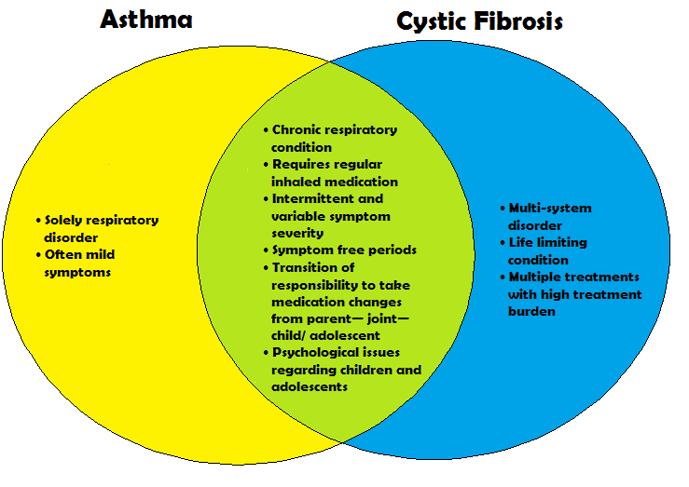

Figure 1 Venn diagram illustrating similarities and differences between childhood asthma and cystic fibrosis.

## 1.7 Thesis Objectives and scope of research

In this thesis I will initially assess the current knowledge on adherence to inhaled treatment in childhood asthma and CF, and the effect of previous interventions to improve adherence rates and clinical outcomes. Using this information I will identify specific evidence deficits, and devise potential interventions to fill these deficits. I will perform original research studies to investigate these novel interventions, and publish the results. I will then analyse these results in depth, and draw conclusions to inform future recommendations.

## 1.8 Thesis Roadmap

In chapter 2 I will review the existing literature in this field, in order to identify specific evidence deficits, and devise research questions aimed to fill these deficits. I will hypothesize on how prospective interventions could improve adherence and clinical outcomes in childhood asthma and CF, and set study aims and objectives.

In chapter 3 I will describe the methodology used for both studies, and I will report the results in chapter 4. In chapter 5 I will analyse all the results, comparing and contrasting these data with those from existing published studies.

In chapter 6 I will discuss the results in detail, with analysis of their significance and validity, and postulate how they should affect future studies and clinical practice.

I will conclude my findings in chapter 7, providing answers to my original research questions.

## 1.9 Summary

In this chapter I have defined adherence, and shown the significance of sub-optimal rates. I have explained its importance in childhood asthma and CF, and justified the necessity of further investigation of interventions to improve adherence in this thesis. I have described the structure of subsequent chapters. In the next chapter I will review the current literature in the field, and use this to identify evidence deficits which can be used to set specific research questions for this thesis.

# Chapter 2 – Introduction & Literature Review

## 

## 2.1 Introduction

In the previous chapter I showed that adherence is a significant issue in childhood asthma and CF, with great potential to improve clinical outcomes by improving adherence rates. In this chapter I will review and critique the available literature with regards to the methodology of adherence monitoring, the effect of sub-optimal adherence, and the success of previous interventions to improve adherence and outcomes. I will pool the data from previous studies using electronic adherence monitoring to get an accurate impression of the background rates of adherence in children with asthma and CF. By assessing the current data available, I will identify evidence deficits, and devise interventions to fill these deficits. I will hypothesize how the interventions will affect adherence rates and clinical outcomes.

## 2.2 Aims

This chapter aims to establish the current position of objective adherence monitoring in childhood asthma and CF. It aims to answer the following fundamental questions: What are the methods available for measuring adherence in paediatric populations, and are they objective, valid and reliable? If reliable and objective methods are used, what are the rates of adherence to therapy in children with asthma and CF? This will outline the extent of the problem in these populations. What are the consequences of non-adherence, both for the patients themselves, and health care systems as a whole? Why don’t children with asthma and CF manage to take their medications as prescribed, what are the barriers to adherence? Finally, and perhaps most importantly, what interventions are available to improve adherence and decrease morbidity?

I aim to analyse interventions available for improving adherence in childhood chronic respiratory diseases, and assess whether there is convincing evidence that they are effective. I aim to identify any evidence deficits, and key areas of future research in the field. Based on these I will develop a structured research question and testable hypotheses.

## 2.3 Methods of adherence measurement

There are many ways of assessing adherence to inhaled steroids, each with varying degrees of objectivity and validity (table 1). Often the only measure of adherence a clinician has is the direct questioning of children and their parents in clinic.

### 2.3.1 Direct questioning

Patients and parents can be directly asked how much they take their medication, and this is currently the standard method used in the clinical setting. Questions are often combined with a statement that all children sometimes forget their medication, to reduce the feeling of blame, and encourage honest answers. This method is entirely subjective, hoping the patient will answer both honestly and accurately. The clinician then has to make a judgement about which patients are accurate in their adherence reporting, and which are not. Burgess et al. showed that unfortunately this is something which is difficult to do. In a study of 51 asthmatic children, clinicians only correctly predicted 55% of the patients who were inaccurate in their adherence reporting, when levels were electronically monitored ([Burgess et al., 2008](#_ENREF_23)).

Fisher et al. explain that people generally want to please health care providers, to be looked upon favourably, and therefore don’t want to admit to non-adherence. This leads to over-reporting, and is known as the social desirability bias ([Fisher, 1993](#_ENREF_45)).

### 2.3.2 Self- Report Questionnaires

Self- report questionnaires are cheap, and easy to fill out in the clinical setting.

They aim to reduce the social desirability bias by making the process more confidential, and less personal by the use of indirect questioning ([Fisher, 1993](#_ENREF_45)). Questionnaires are also subjective however, and have been shown in numerous studies in children with asthma to over-estimate adherence when compared to more objective methods ([Burgess et al., 2008](#_ENREF_23), [Jentzsch et al., 2009](#_ENREF_72), [Nides et al., 1993](#_ENREF_107), [Tashkin et al., 1991](#_ENREF_143), [Bender et al., 2000](#_ENREF_11)). One American study of inner-city children showed that parents’ reported adherence was 85%, compared to under 25% when measured more objectively ([Otsuki et al., 2009](#_ENREF_113)). The parents in this study were asked to estimate how many doses their child had missed in the previous week, and an adherence rate was calculated according to the missed doses. This rate was compared to more objective pharmacy records of prescription refill over the past 3 months. In a second American study, 27 children and their parents were asked separately about their adherence. Both their answers were consistent, with similar reported rates of 80%. However, when electronically monitored, the rate was found to be only 50% ([Bender et al., 2000](#_ENREF_11)). Quittner et al. describe how the over-estimation in questionnaires is mainly due to the social desirability bias, but also due to inaccurate recall, and generalising behaviour over the time period rather than specific events ([Quittner et al., 2008](#_ENREF_125)).

In Cystic Fibrosis, older studies were also reliant on self-report questionnaires and daily diary cards to obtain information about adherence rates ([Passero et al., 1981](#_ENREF_116), [Conway et al., 1996](#_ENREF_32)). It seems self- report is still popular in CF clinics due to it being inexpensive and its ease of use. As with asthma however, self- report has been shown in studies to greatly over-estimate adherence in both adults ([Daniels et al., 2011](#_ENREF_36)), and children ([Modi et al., 2006](#_ENREF_97)). One study in adults recorded nebuliser adherence rates of 80% with self-report questionnaires but only 36% when electronically monitored ([Daniels et al., 2011](#_ENREF_36)). An American study showed both parent and child self-report to nebulised medication was 80%, compared to 47% when measured using the daily phone diary method (see later) ([Modi et al., 2006](#_ENREF_97)).

### 2.3.3 Daily Diaries

Daily diaries aim to avoid recall inaccuracies by providing day-to-day recording. Like questionnaires, they are also relatively cheap. However, diaries are also subjective, susceptible to the social desirability bias, and have therefore been shown to over-estimate adherence rates when compared to more objective measures ([Bender et al., 1998](#_ENREF_10), [Milgrom et al., 1996](#_ENREF_96), [Gibson et al., 1995](#_ENREF_52), [Krishnan et al., 2012](#_ENREF_81)). In an early American study of 24 children, median parent reported adherence was as high as 95%, compared to just 58% when measured electronically ([Milgrom et al., 1996](#_ENREF_96)). A Brazilian study investigated 102 childhood asthmatics, and reported adherence rates as high as 98% when recorded in a diary, compared to 52% when recorded electronically ([Jentzsch et al., 2009](#_ENREF_72)). However, this study investigated patients who were steroid naïve (never previously had inhaled steroids) and so the social desirability bias would have been increased, with a new, free medication available for the first time in the study. Also, as these patients had not used inhaled steroids before, it would have been difficult to establish a routine for regular use, and so adherence rates would be expected to be lower.

An additional bias is the patients who fill out diary cards regularly are also the patients who are more likely to be adherent to their medication. Alternatively, patients may have actually taken their medicine, but found filling out a diary card too much effort, or forgotten to do so, and therefore the information is potentially misleading.

An advantage of daily diaries is that they are amenable to technological advances, and real-time adherence data can be inputted by patients into PDAs or smartphones, thus reducing recall inaccuracies ([Modi AC, 2006](#_ENREF_98)).

In a multi-system disease like CF, diaries are useful because adherence can be recorded for a range of medications in a single diary. They are a simple way of monitoring patients’ diet, calorific intake, use of pancreatic enzymes and nebulised medication. Due to their ease of use studies have high rates of diary completion ([Schall et al., 2006](#_ENREF_135)). There are no studies directly comparing daily diary data with more objective data but it is highly likely they over-estimate adherence due to the self-desirability bias and inaccurate recall, as has been shown in asthma ([Milgrom et al., 1996](#_ENREF_96)).

### 2.3.4 Phone Diaries

Phone diaries were developed for use in CF clinics to try and reduce recall error and the social-desirability bias. They involve usually two phone calls a week, where parents report the treatments given and duration in the last 24 hours. They have been shown to be reliable and valid in CF populations ([Modi AC, 2006](#_ENREF_98)). One study showed that phone diaries revealed similar adherence rates to prescription refill and electronic monitoring ([Modi et al., 2006](#_ENREF_97)). However, some authors have highlighted that this method of adherence monitoring is labour intensive and expensive, and the time it takes to complete the call may actually add to the burden of treatment for children with CF and their parents ([Daniels et al., 2011](#_ENREF_36)). They suggest that the CF population is also highly medicalised, with specialised nurses who know the patients and families well. This method therefore may not be transferrable to more general medical conditions.

### 2.3.5 Prescription Fill Data

On review of numerous studies, it would seem that prescription fill data is more objective, and is commonly used in clinical practice when attempting to identify non-adherence. Data can be collected retrospectively, and medicine possession ratios (MPR) or prescription possession ratios (PPR) can be easily calculated ([Taylor et al., 2014](#_ENREF_144)) . Using this technique, it is possible to discover patients who don’t even own the prescribed level of medication, and the least adherent patients can be identified. Williams and colleagues showed that prescription refill data is useful in research to analyse adherence data for large cohorts of patients ([Williams et al., 2011](#_ENREF_155)). However it is clear that generalised rates can only be calculated over a longer time periods, with date or time specific rates impossible to calculate with this method. Due to this indirect adherence monitoring, prescription data has been shown in studies to over-estimate adherence ([Jentzsch et al., 2009](#_ENREF_72)). Jentzsch and colleagues showed that there is no guarantee that the dispensed medication is taken, in a study of childhood asthmatics where reported adherence levels were 70%, compared to 50% when measured electronically ([Jentzsch et al., 2009](#_ENREF_72)).

Prescription refill has been successfully used in a large study in America to determine overall adherence rates to pulmonary medication, in a cohort of children with CF ([Quittner et al., 2014a](#_ENREF_126)). However, it would seem that prescription refill potentially overestimates adherence rates in CF, as patients are prescribed multiple medications which are more likely to be dispensed in one visit to the pharmacy. This was demonstrated in an American study, where pharmacy refill indicated an adherence rate of 68% for nebulised medication, compared to just 48% when measured using the daily phone diary method ([Modi et al., 2006](#_ENREF_97)).

### 2.3.6 Canister weight/ Dose counters

Canister weight is often cited as a reliable objective measurement of adherence to inhaled steroids in asthma, and is a cheap method of analysis in research studies([Jentzsch et al., 2009](#_ENREF_72)). Krishnan et al. showed that counters can also objectively record the number of doses remaining, and a level of adherence can be calculated([Krishnan et al., 2012](#_ENREF_81)). It is apparent that both of these methods are also indirect measurements of adherence, and therefore cannot identify when the medication was taken, and potentially overestimate rates. An American study of children with asthma showed this by recording an adherence rate of 69% when calculated using canister weight, compared to 50% when electronically monitored ([Bender et al., 2000](#_ENREF_11)).

### 2.3.7 The “Dumping” Phenomenon

Walders et al. explain that prescription refill, canister weight and dose counters are all subject to the social desirability bias via the phenomenon of “dumping”, where patients actuate their inhaler many times, sometimes just before clinic, leading to over estimation of adherence ([Walders et al., 2005](#_ENREF_152)). When measured electronically, one adult study reported 18% of the patients showed some evidence of dose “dumping”, with one patient using the inhaler over 200 times on the morning of the clinic ([Tashkin et al., 1991](#_ENREF_143)) . It would seem the potential for this behaviour is increased in children, who may have the added pressure of parental praise or punishment to achieve good adherence rates.

### 2.3.8 Drug assays

Harrison and Tattersfield explain that drug assays for inhaled steroids are not a practical way of measuring adherence due to the short half-life of inhaled steroids ([Harrison and Tattersfield, 2003](#_ENREF_57)). Baum and Creer showed that plasma and urine drug assays for oral medications such as theophyllines and steroids can be performed to objectively assess recent adherence to these medications ([Baum and Creer, 1986](#_ENREF_8)). One German study used this methodology to show a sub-therapeutic level of theophylline in 38% of young asthmatics taking oral theophylline ([Langen et al., 2006](#_ENREF_83)). As theophylline only has a half- life of 8 hours, like inhaled steroids, any assay will only reflect medication use on the day of the test. It would seem there is no way of assessing long term adherence to these medications through drug assays.

### 2.2.9 Electronic Monitoring Devices (EMDs)

Electronic monitoring devices (EMDs) record the exact time and date that an inhaler is used, and are the most objective method of adherence monitoring (figure 2). Some experts in the field suggest that they are not yet universally acknowledged as the gold standard of adherence monitoring ([Quittner et al., 2008](#_ENREF_125), [Ingerski et al., 2011](#_ENREF_70)), due to some early studies reporting high rates of device malfunction ([Gong et al., 1988](#_ENREF_55), [Nides et al., 1993](#_ENREF_107), [O'Connor et al., 2004](#_ENREF_109), [McQuaid et al., 2003](#_ENREF_94)). With technological advances however, it is clear that EMDs have become much more reliable, and have shown a high degree of accuracy in bench ([Julius et al., 2002](#_ENREF_76), [Burgess et al., 2006](#_ENREF_24)) and clinical studies ([Nikander et al., 2011](#_ENREF_108), [Patel et al., 2013](#_ENREF_117)). EMDs are more expensive than other methods of monitoring, which may limit their use in clinical practice, but it is clear that adherence studies are increasingly using EMDs due to their unrivalled objective validity. Electronic monitors now have the facility to be linked with mobile telephones and smartphones, allowing remote, real-time adherence monitoring for patients and clinicians ([Patel et al., 2013](#_ENREF_117)). Reviews on these devices have suggested that limitations of electronic monitors are their high cost, and their detection of inhaler actuation rather than effective medication inhalation ([Quittner et al., 2008](#_ENREF_125)).

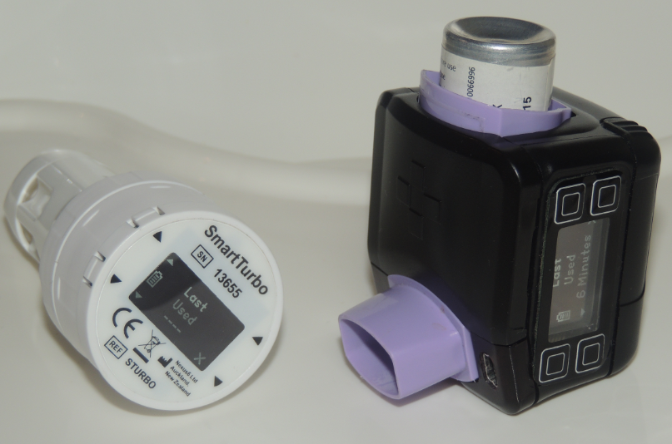

Figure 2 - Adherium Smartturbo (left) & Smartinhaler (right)

### 2.3.10 Electronically monitored Nebulised Therapy

Daniels et al. explain that topical delivery of aerosolised therapy via nebulisers is a relatively new development in the treatment of CF. Antibiotics, mucolytics, hypertonic saline and bronchodilators can all be delivered effectively through nebulisers, with many different brands on the market ([Daniels et al., 2013](#_ENREF_37)). New technology incorporates electronic adherence data into the devices, including the frequency of doses, and the duration. Figure 3 shows the “I-Neb”, manufactured by Phillips Respironics, UK.

[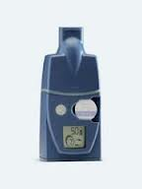](http://www.google.co.uk/imgres?imgurl=http://www.news-medical.net/image.axd?picture=2013/1/philips1.jpg&imgrefurl=http://www.news-medical.net/I-neb-AAD-System-from-Philips&h=240&w=180&tbnid=yl2vUqkdbt6jzM:&zoom=1&docid=AHspxhibKGIYRM&ei=q_GFU8reBIPH7AbIhYHgBA&tbm=isch&ved=0CGoQMygSMBI&iact=rc&uact=3&dur=2097&page=1&start=0&ndsp=22)

Figure 3 The “I-Neb” – Phillips Respironics, UK.

McCormack and colleagues explain how the “Adaptive Aerosol Delivery” system incorporated in these devices can also increase drug deposition to the lungs and significantly reduce treatment times ([McCormack et al., 2012](#_ENREF_89)). Studies have shown that a review of this adherence data can be easily incorporated into paediatric CF clinics, and this is becoming standard practice in many CF centres ([McNamara et al., 2009](#_ENREF_92)). Fischer et al. demonstrated that the “AkitaJet” (Vectura, UK) is an alternative jet nebuliser for inhaled antibiotics incorporating technology to electronically monitor adherence rates ([Fischer et al., 2009](#_ENREF_44)). Interestingly, neither of the devices available in Europe to electronically monitor adherence in CF are marketed in the USA.

### 2.3.11 MEMS

Electronic monitoring is increasingly used in CF adherence studies as technology advances. For oral medications such as enzymes and vitamins, the opening of pill bottles can be electronically monitored using systems such as the Medication Event Monitoring System (MEMS- AARDEX Inc., Union City, California). MEMS has been used with good effect in studies involving children with CF to monitor adherence to multivitamins and pancreatic enzymes ([Zindani et al., 2006](#_ENREF_160)). However, it is apparent there is no guarantee that when the bottle is opened, the child will take the medication, and has been shown to over-estimation of adherence when compared to phone diary data([Modi et al., 2006](#_ENREF_97)).

## 2.4 Inhaler Competency

It stands to reason that in order for an inhaled medication to be effective it must be inhaled in adequate quantities, and with the correct technique. Therefore a limitation common to all measurements of adherence is that there is no guarantee that the actuated medication is inhaled with the correct technique. Studies have shown that patients are often unable to take inhalers competently, even if they demonstrate good technique in clinic. This may be due to forgetting instructions, or knowing the correct method of use but choosing a different technique due to ease or social constraints. Separate British studies have shown that children and adults with asthma often demonstrated very poor device technique, despite detailed prior instruction ([Hardwell et al., 2011](#_ENREF_56), [Brennan et al., 2005](#_ENREF_19)).

## 2.5 Evaluation of methods of adherence monitoring

Table 1 analyses the different methods available for measuring adherence to inhaled steroids. Whilst any method is desirable if it is cheap and easy to perform, it is obsolete if the information gathered is inaccurate. This criticism is justified for subjective methods such as questioning, either directly or via questionnaires, and daily diary cards. It would seem that prescription data is helpful at identifying the least adherent patients, but cannot provide accurate time-sensitive data.

Electronic monitoring is clearly the most objective method of monitoring adherence, but in order for it to be useful in the clinical setting it needs to be cheap enough for health care providers to afford. To justify cost of such devices, evidence is required that they can not only improve adherence, but also improve patients clinically, which will in turn reduce health care costs. This association will be explored in more detail when discussing consequences of poor adherence. Electronic monitoring also needs to be simple enough to use in the clinical setting. The management and maintenance of devices, and downloading data with analysis and feedback of results must be straightforward enough for the clinical team to incorporate into the clinical setting without compromising other aspects of patient care. Electronic monitoring is currently more feasible in the research setting, with study funds available to purchase the devices, and staff available to facilitate their use.

|  |  |  |  |
| --- | --- | --- | --- |
| **Adherence measure** | **Advantages** | **Disadvantages** | **Least Objective**                                          **Most Objective** |
| Non– judgemental questioning by clinician | • Easy to perform in clinic  • Cheap | • Inaccurate  • Over-estimates adherence |
| Self-report questionnaires | • Easy to perform in clinic  • Cheap | • Inaccurate  • Recall inaccuracy  • Susceptible to self- desirability bias  • Over-estimates adherence |
| Daily diary cards | • Cheap  • Reduces recall inaccuracy  • Amenable to technological advances | • Inaccurate  • Susceptible to self- desirability bias  • Over-estimates adherence |
| Prescription– refill data | • Cheap  • Reduces self– desirability bias | • Inaccurate  • Over-estimates adherence  • Susceptible to dose “dumping”  • No guarantee dispensed medication is taken |
| Canister weight/ dose counters | • Cheap  • Reduces self- desirability bias | • Not time-sensitive  • Over-estimates adherence  • Susceptible to dose “dumping” |
| Drug assays | • Objective  • Accurate | • Impractical in clinical setting  • Short term adherence monitoring |
| Electronic Monitoring Devices (EMDs) | • Most Objective  • Accurate  • Continuous adherence monitoring | • Expensive  • Device malfunctions  • Detect device actuation, not inhalation |

Table 1 – summary of the advantages and disadvantages of methods of monitoring adherence to ICS

## 2.6 Reflections on the importance of objective adherence monitoring

Direct questioning, self- report questionnaires and diary cards are all subjective, and have been proven to be inaccurate. Canister weight, counters and prescription refill are all more objective, but still overestimate adherence, and without recording specific times are susceptible to the phenomenon of dumping. Drug assays only show short term adherence and are highly impractical outside the research setting.

In adherence studies, Tashkin and colleagues have shown that objective and accurate adherence monitoring is vital, as the social desirability bias is increased, leading to more over-estimation in self-report in questionnaires and diary cards and an increased level of “dumping” ([Tashkin et al., 1991](#_ENREF_143)). It is clear that inaccurate adherence data will give false positive results for an intervention, or skew potentially effective interventions towards the null hypothesis. Unfortunately, despite the inaccuracies of these techniques, a review of the literature shows that they have been used in the majority of adherence studies to date.

In a recent meta-analysis showing the effect of non- adherence on health care utilisation in paediatric chronic illness ([McGrady and Hommel, 2013](#_ENREF_90)), 10 studies were analysed, 9 of which involved children with asthma (none of the studies involved patients with CF). Of these 9 asthma studies only 2 used electronic monitors to record adherence levels ([Walders et al., 2005](#_ENREF_152), [McNally et al., 2009](#_ENREF_91)). 4 studies used self-report to measure adherence ([Ashkenazi et al., 1993](#_ENREF_4), [Bartlett et al., 2004](#_ENREF_7), [Bauman et al., 2002](#_ENREF_9), [Zhao et al., 2012](#_ENREF_159)), and 3 used prescription refill data ([Adams et al., 2001](#_ENREF_2), [Herndon et al., 2012](#_ENREF_61), [Smith et al., 2007](#_ENREF_138)).

The authors of this meta-analysis concluded that non-adherence leads to increased health care utilisation, which is of vital significance, however the results must be questioned due to the inadequacies of the adherence measures used in the majority of studies.

Similarly, another recent systematic review analysed interventions to enhance medication adherence in chronic childhood disease ([Dean et al., 2010](#_ENREF_38)). This review analysed 17 adherence studies, 7 of which were asthma studies. Again, there were no CF studies analysed in the review. Electronic monitoring was only used in 2 of the 17 studies, neither of which were asthma studies ([Berkovitch et al., 1998](#_ENREF_15), [Rapoff et al., 2002](#_ENREF_128)). Of the 7 asthma studies, 3 used self-report questionnaires to monitor adherence ([Smith et al., 1986](#_ENREF_137), [Bonner et al., 2002](#_ENREF_16), [van Es et al., 2001](#_ENREF_148)), 2 used diary cards ([Hughes et al., 1991](#_ENREF_68), [Holzheimer et al., 1998](#_ENREF_62)), 1 used prescription refill data ([Farber HJ, 2004](#_ENREF_42)), and 1 used a combination of diaries and drug assays ([Baum and Creer, 1986](#_ENREF_8)). The authors of this review concluded that education interventions alone are insufficient to promote adherence, but combined behavioural and educational interventions may increase efficacy ([Dean et al., 2010](#_ENREF_38)). With no accurate and reliable adherence measurements in these studies, the validity of the results must be questioned. Without accurate adherence data, potentially successful adherence interventions may be ignored, as the data is skewed towards the null hypothesis. Also, seemingly successful interventions may mislead future research and clinical practice due to unreliable results.

The lack of objective and reliable adherence monitoring in these meta-analyses highlights the need for increased use of electronic adherence monitoring in future research studies. Earlier studies would not have had the technology available to use electronic monitoring, and were therefore obliged to use less reliable methodology. However, of these 14 studies in the 2 meta-analyses which did not use electronic adherence monitors, 9 were carried out since the year 2000, when electronic monitors have been widely available and used effectively in earlier studies ([Gibson et al., 1995](#_ENREF_52), [Milgrom et al., 1996](#_ENREF_96), [Bender et al., 2000](#_ENREF_11)).

## 2.7 Adherence levels to inhaled steroids in children with asthma when recorded electronically

As described above, when many studies have recorded adherence levels to preventer inhalers in children, the methods used are often subjective, and therefore potentially inaccurate. Recent studies which have recorded adherence electronically can give us an objective indication of adherence levels in the paediatric asthma population. Table 2 pools the adherence data from these studies. Trials were found by searching the Pubmed database for the period January 1980 to October 2013 with the terms adherence/compliance and asthma and electronic and monitoring. The search was repeated with the same terms and the table updated in May 2016. Other studies were identified from reference lists from these studies. Studies were included if they were monitoring adherence only in children (aged <18). Where the trials involve an adherence intervention, only the control arm rates or rates at baseline are quoted. Studies were rejected if they looked at rates in populations which were already shown to be non-adherent. The mean rate of adherence is the overall rate of adherence for the whole duration of the respective studies.

If multiple adherence rates were recorded over time, the mean of these rates has been calculated.

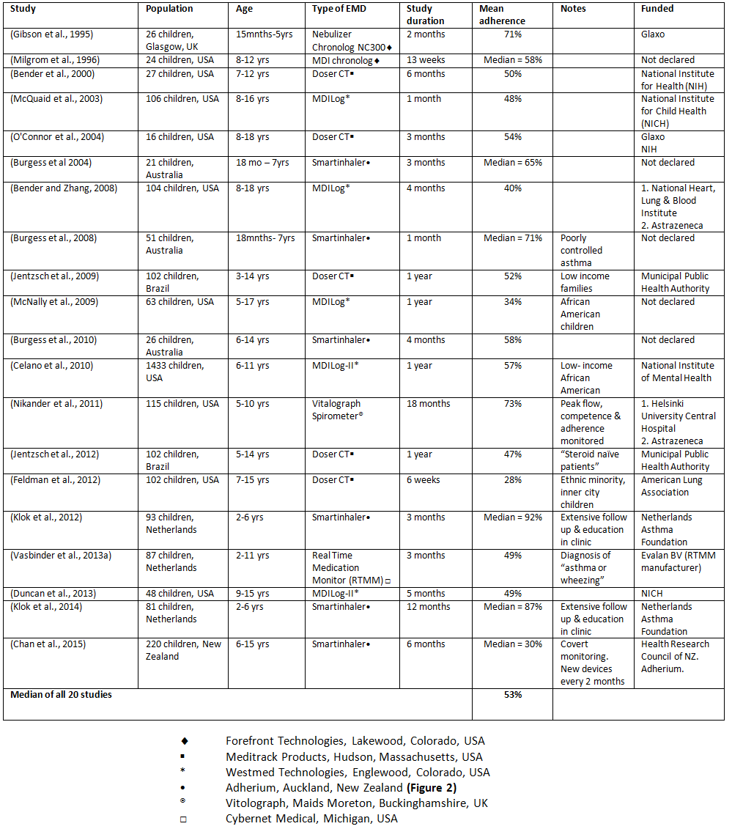

Table 2 Adherence rates to inhaled corticosteroids when measured electronically

Table 2 shows that overall adherence in the paediatric population is low, when recorded electronically. Half of the studies record adherence rates of less than 50%. All of the studies except one report adherence rates below 75%. The median value for all the 20 studies is just 53%. Of the 20 studies in this analysis, 6 were at least partially funded by drug companies or device manufacturers, who may have a commercial interest in the results, with increased adherence leading to increased sales in inhaled steroids, or decreased adherence improving electronic monitor sales. The studies which don’t declare their source of funding may potentially have also been funded by device manufacturers. This would potentially introduce a bias in the results, with pressure from these companies to publish results which would support the need for more electronic monitoring of adherence.

## 2.8 Adherence rates to treatment in Cystic Fibrosis

### 2.8.1 Chest Physiotherapy

Studies using self-report show adherence to chest physiotherapy in adults to be as low as 30% ([Myers and Horn, 2006](#_ENREF_102)). In a study in the 1980s children were shown to have slightly higher levels, at around 50%, although rates fall as children get older and disease severity progresses ([Passero et al., 1981](#_ENREF_116)). A more recent study showed adherence levels of around 70% when measured by self-report, but only 51% when measured by the daily diary method ([Modi et al., 2006](#_ENREF_97)). There have been no studies using objective methods to record adherence to chest physiotherapy.

### 2.8.2 Pancreatic Enzymes/ Vitamin supplements

Using self-filled diary cards, a recent American study reported a mean adherence level of 75% to pancreatic enzyme supplements in pre-adolescents with CF ([Schall et al., 2006](#_ENREF_135)). However, in the same year, a separate study also reported rates of up to 90% when self- report measures were used. This figure fell to just 46% with pharmacy refill data, 43% with electronic monitoring (MEMS), and only 27% when measured with a daily phone diary ([Modi et al., 2006](#_ENREF_97)). Another American study recorded adherence rates to oral multivitamins of 64% when measured electronically with MEMS ([Zindani et al., 2006](#_ENREF_160)), and showed these rates are higher in children below 12 years of age.

### 2.8.3 Nebulised Therapy

A recent large population study in America analysing data from 3287 people with CF, including children, shows that the mean MPR for pulmonary medications is 48% ([Quittner et al., 2014b](#_ENREF_127)), with adherence falling as age increases.

When measured electronically, a large adult study in the UK showed adherence rates to nebulised therapy to be only 36% ([Daniels et al., 2011](#_ENREF_36)). A study in the UK using electronic nebuliser data in paediatric patients showed the figure to be higher, with a mean of 67% ([McNamara et al., 2009](#_ENREF_92)). Adherence was shown to be higher for evening doses (75%) than in the mornings (58%), and rates were higher in younger children than adolescents. When this study was repeated with a similar cohort of patients, the overall adherence rate was consistent at 65%, and showed that adherence rates were higher on weekdays during term time ([Ball et al., 2013](#_ENREF_6)).

There are few studies which have investigated electronically recorded adherence rates to medication in children CF. The data from these studies is summarised in table 3.

|  |  |  |  |  |  |  |  |
| --- | --- | --- | --- | --- | --- | --- | --- |
| **Study** | **Population** | **Age** | **Medication** | **Duration** | **EMD** | **Mean** | **Funder** |
| ([Zindani et al., 2006](#_ENREF_160)) | 33 children,  USA | 6-19 yrs | Multivitamins | 3 months | MEMS | 64% | CF Foundation Traineeship Grant |
| ([Modi et al., 2006](#_ENREF_97)) | 36 children,  USA | 6-13 yrs | Pancreatic Enzymes | 3 months | MEMS\* | 43% | Agency for Healthcare & Research Quality |
| ([McNamara et al., 2009](#_ENREF_92)) | 28 children, UK | 2-15 yrs | Nebulised Antibiotics | 1 year | I-Neb♦ | 67% | RLCH R&D trust fund |
| ([Ball et al., 2013](#_ENREF_6)) | 24 children,  UK | 11-17 yrs | Nebulised Antibiotics | 1 year | I  I-Neb♦ | 65% | Not declared |

Table 3 – Mean adherence rates to therapy in children with CF when measured electronically

\* MEMS- Medication Event Monitoring System – Aardex, Union City, California, USA

♦ Philips Respironics, UK

## 2.9 Trends in adherence rates for children with asthma and CF

Data from these studies show that adherence rates are lower in older children and adolescents in asthma and CF ([McQuaid et al., 2003](#_ENREF_94), [McQuaid et al., 2012](#_ENREF_93), [Zindani et al., 2006](#_ENREF_160)), with the highest rates seen in children under the age of 6. In asthma, rates are lower in children from a poor socioeconomic background ([McQuaid et al., 2012](#_ENREF_93), [Feldman et al., 2012](#_ENREF_43), [McNally et al., 2009](#_ENREF_91), [Vasbinder et al., 2013a](#_ENREF_149), [Celano et al., 2010](#_ENREF_25)). The populations where adherence rates are highest are developed western countries such as the UK, the Netherlands, Australia & the USA, although these rates are often still below 75%. These studies with more adherent populations in developed countries also only included younger children ([Gibson et al., 1995](#_ENREF_52), [Klok et al., 2012](#_ENREF_78), [Burgess et al., 2008](#_ENREF_23), [Nikander et al., 2011](#_ENREF_108), [Klok et al., 2014](#_ENREF_79)). Adult studies have reported that adherence rates are higher in males than in females in both asthma([Gamble et al., 2009](#_ENREF_49)) and CF ([Quittner et al., 2014a](#_ENREF_126)), but this has not been shown in paediatric populations. The studies which have reported this trend in adults have used prescription refill data to measure adherence, so these findings can only confirm that more males collect their prescriptions than females, and not necessarily take their medication more.

### 2.10 The Hawthorne Effect

These adherence rates in research studies are likely to be higher than “real life”, because children and parents know the data is being recorded. This behaviour is known as the Hawthorne effect ([McCarney et al., 2007](#_ENREF_88)). In all the studies where adherence rates were recorded over a longer period, adherence rates decline over time, and the later lower rates are likely to represent the “real” adherence as the Hawthorne effect wanes ([Duncan et al., 2013](#_ENREF_40), [Jentzsch et al., 2012](#_ENREF_71), [Nikander et al., 2011](#_ENREF_108), [Burgess et al., 2010](#_ENREF_22), [Jentzsch et al., 2009](#_ENREF_72), [Bender and Zhang, 2008](#_ENREF_12)).

## 2.11 Consequences of non-adherence in childhood asthma

### 2.11.1- Introduction

As the data shows, the majority of children with asthma do not take their inhalers as prescribed, and in many populations they only take their inhalers half of the time. Inhaled steroids have been shown to improve lung function, decrease symptoms and reduce the need for beta agonists. It can take up to 4 weeks for inhaled steroids to have a full effect ([Adams et al., 2005](#_ENREF_1)). Regular inhaled steroids are more effective than intermittent treatment during exacerbations at decreasing lung inflammation, and improving lung function and asthma control ([Chauhan et al., 2013](#_ENREF_30)). If children are not taking their inhalers regularly, theoretically they are therefore more likely to have poor asthma control, poor lung function, suffer more symptoms and use beta agonists more regularly. Potential exceptions to this are children where the diagnosis of asthma is uncertain, or in very mild asthmatics ([Chauhan et al., 2013](#_ENREF_30), [Jentzsch et al., 2012](#_ENREF_71)).

Similarly, in CF, if children are not taking their nebulised mucolytics or antibiotics, their desired therapeutic effect will be diminished and they are likely to suffer detrimental health consequences as a result. The following sections will detail the consequences of sub-optimal adherence in childhood asthma and CF.

### 2.11.2 – Aims

* To detail the consequences of sub-optimal adherence in childhood asthma and CF
* To critique the studies and methodology for assessing and quantifying these consequences

### 2.11.3 - Consequences of non - adherence in asthma

### 2.11.4 Increased morbidity and exacerbations

Population studies in adults using prescription refill data have shown that the adherence rate required to significantly reduce the chance of an asthma exacerbation is 75% ([Williams et al., 2011](#_ENREF_155)).

Studies have shown that patients with low adherence rates are more likely to have poorly controlled asthma. In a study of 102 mild to moderate asthmatics, the group with controlled asthma had a higher electronically recorded adherence rate than those with uncontrolled asthma ([Jentzsch et al., 2012](#_ENREF_71)). Children with poor adherence are more likely to require rescue courses of oral steroids ([Milgrom et al., 1996](#_ENREF_96), [Bender and Zhang, 2008](#_ENREF_12)) and have worse lung function ([Krishnan et al., 2012](#_ENREF_81), [Duncan et al., 2013](#_ENREF_40)). However, some studies have failed to show a relationship between adherence and clinical outcome score. This is often due to the subjective nature of the adherence measurements used, with the inaccurate information likely to skew the data towards the null hypothesis ([Krishnan et al., 2012](#_ENREF_81)). When objective measurements have been used but no effect on control has been found, it is likely to be because the studies have been underpowered ([Burgess et al., 2010](#_ENREF_22), [Spaulding et al., 2012](#_ENREF_140)), or included very mild asthmatics in whom sub-optimal adherence does not have such an effect on clinical outcome ([Jentzsch et al., 2012](#_ENREF_71)). One study showed no relationship between inhaled steroid adherence and beta agonist use ([Walders et al., 2005](#_ENREF_152)). This possibly reflects the erratic use of beta agonists, and their habitual regular use even in well controlled asthmatics. Poor disease control is also often associated with poor symptom perception, and beta agonist use is often low despite its necessity.

### 2.11.5 Death

The National Review of Asthma Deaths (NRAD) investigated the causes of 195 deaths due to asthma in the UK between 2012 and 2013 ([Royal\_College\_of\_Physicians, 2014](#_ENREF_132)). They found that in 65% of deaths there were potentially preventable factors. Poor adherence to therapy was found to be a preventable cause in 34% of the deaths, both in adults and children.

### 2.11.6 Unnecessary escalations of treatment

Poor adherence can mislead clinicians into thinking a dose of ICS is ineffective, resulting in unnecessary steroid dose increases and escalation of treatment regimens. Add- on therapies such as montelukast, theophylline or omalizumab are used in patients with “difficult” asthma, who are symptomatic despite high doses of inhaled steroids. Theophylline requires close monitoring of serum levels, and omalizumab requires 2 to 4 weekly intra-muscular injections. Both of these drugs have a high treatment burden for both the patient and the health care providers, and their use could potentially be avoided if adherence to inhaled steroids was accurately assessed and improved.

### 2.11.7 Increased health care utilisation and cost

A recent systematic review shows that children with poor adherence have increased health care use ([McGrady and Hommel, 2013](#_ENREF_90)), leading to increased healthcare costs.

Poorer adherence rates correlate to increased GP visits ([Bauman et al., 2002](#_ENREF_9), [McNally et al., 2009](#_ENREF_91)), attendances at emergency departments ([Adams et al., 2001](#_ENREF_2), [Ashkenazi et al., 1993](#_ENREF_4), [McNally et al., 2009](#_ENREF_91), [Smith et al., 2007](#_ENREF_138), [Walders et al., 2005](#_ENREF_152), [Zhao et al., 2012](#_ENREF_159)) and hospital admissions ([Adams et al., 2001](#_ENREF_2), [Herndon et al., 2012](#_ENREF_61), [McNally et al., 2009](#_ENREF_91), [Zhao et al., 2012](#_ENREF_159)). As detailed above, of the 9 studies analysed in this systematic review , only 2 ([McNally et al., 2009](#_ENREF_91), [Walders et al., 2005](#_ENREF_152)) used electronic monitoring to assess adherence, potentially decreasing the validity of the outcomes.

Despite this, the trend towards more health care use as adherence falls would make sense, and high costs associated with non-adherence are well recognised in adults with asthma ([Bender and Rand, 2004](#_ENREF_13)). One retrospective adult study using prescription refill data showed that each 25% increase in the amount of time without inhaled steroids leads to a doubling of the hospitalisation rate ([Williams et al., 2004](#_ENREF_157)).

Poor adherence to inhaled steroids can result in unnecessary escalations of treatment, and add on therapies such as theophylline and omalizumab. Omalizumab is a monoclonal antibody, and is therefore an expensive drug. It costs between £1665 and £26,640 per patient per year depending on dose, and for this reason an assessment of adherence to inhaled steroids is recommended prior to commencing the course ([National\_Institute\_of\_Clinical\_Excellence, 2013](#_ENREF_106)).

### 2.11.8 Consequences of non-adherence in childhood CF

### 2.11.9 Poor disease control

Adult studies have shown that poor adherence to pulmonary medication leads to an increase in pulmonary exacerbations ([Eakin et al., 2011](#_ENREF_41)). In a American study of 95 people with CF (including patients as young as 6 years old), a low MPR significantly increased the risk of requiring a course of IV antibiotics to treat a pulmonary exacerbation ([Eakin et al., 2011](#_ENREF_41)).

### 2.11.10 Increased health care utilisation and cost

A recent large American study has shown that poor adherence to pulmonary medication is associated with increased health care utilisation ([Quittner et al., 2014a](#_ENREF_126)). This study looked at MPR data for 3,287 patients with CF, and included children as young as 6, with 44% of the patients younger than 18 years. The results showed that people with low adherence rates (< 50%) to nebulised therapy were significantly more likely to require hospitalisation for CF than those with high (>80%) adherence rates. Within the first year of follow up, it was calculated that the group with low adherence rates had significantly higher healthcare costs than those with high adherence rates ([Quittner et al., 2014a](#_ENREF_126)). In this study it was estimated that a patient with CF in the USA with low adherence rates cost health care providers $14,211 more than a patient with high adherence rates.

An earlier American study of 388 children and adults also showed that poor adherence rates to inhaled antibiotics showed a trend towards increased risk of hospitalisation and cost, although the results failed to reach statistical significance ([Wertz et al., 2011](#_ENREF_153)).

### 2.11.11 Summary of consequences of sub-optimal adherence

It is clear from the evidence of multiple studies that sub-optimal adherence rates to inhaled medication have significant detrimental consequences for children with childhood asthma and CF including poor disease control, with more frequent exacerbations requiring more medical attention.

## 2.12 Policies and Guidance on adherence monitoring

The Global initiative for Asthma (2012) suggests that the best way of assessing adherence is by “asking about therapy in a way that acknowledges the likelihood of incomplete adherence” ([GINA, 2012](#_ENREF_53)). This review has shown that this method is entirely subjective, and proven to be inaccurate. Direct questioning cannot give an accurate picture, with no way of knowing whether patients and parents are accurate in their adherence estimations.

The International Consensus ON paediatric asthma (ICON), published in 2012 acknowledges the importance and significance of non-adherence, particularly in adolescents. It advises that adherence should always be assessed before stepping up treatment. This guidance recommends that strategies to monitor adherence should be put into any new guidelines, but has no suggestion of how to do this ([Papadopoulos et al., 2012](#_ENREF_115)).

Non-adherence is acknowledged by the British Thoracic Society (BTS) as a cause for difficult to treat asthma, and it is recommended that adherence is checked in this group of patients ([British Thoracic Society, 2012](#_ENREF_20)). The society recommends prescription filling as an adequate and reliable measure of adherence, and suggests electronic monitoring is “only practical in clinical trials”. This conclusion is based on a study published fifteen years previously, in 1997 ([Berg et al., 1997](#_ENREF_14)), and more recent studies would suggest this not to be the case, as outlined above. As shown in this review, prescription refill is not an accurate measurement of adherence, and the advice from BTS should perhaps be updated to reflect these limitations, and the increased potential of electronic monitoring.

Prescription refill frequency is also recommended as adequate adherence monitoring for asthma by the National Institute for Health and Care Excellence (NICE)([National\_Institute\_for\_Health\_and\_Care\_Excellence, 2013](#_ENREF_103)). This advice again is also potentially misleading, as prescription refill will only identify the very least adherent patients, and just because people collect their prescriptions does not mean they necessarily take their medication. Prescription refill rates are often overestimated, and can be falsely elevated through dose dumping.

NICE also recommends optimising standard asthma therapy before commencing omalizumab. Clinicians are urged to “document compliance with high dose inhaled corticosteroids”, but there is no advice regarding what type of measurement is required([National\_Institute\_of\_Clinical\_Excellence, 2013](#_ENREF_106)). As commissioning policies are often based on NICE recommendations, accurate adherence data is of paramount importance, and a statement on the optimal methods of adherence measurement would be beneficial in this guideline.

Policy makers and authors of guidelines seem to be reluctant to recommend electronic monitoring to measure adherence. This is likely due to the increased cost of electronic monitoring, and a lack of evidence it can be used effectively and reliably in clinical practice. However, to suggest that other more subjective methods of adherence measurement are adequate is potentially now outdated advice, since the weight of evidence suggests that they are inaccurate and potentially misleading. Further evidence that electronic devices can be used effectively in the clinical setting, and that they justify their cost by improving health outcomes is required before policy makers will advocate their use in the routine care of asthmatic patients.

The 2015 NICE guideline for the diagnosis and monitoring of asthma has recognised the importance of the issue, and called for further research into the use of electronic adherence monitoring ([National\_Institute\_for\_Health\_and\_Care\_Excellence, 2015](#_ENREF_104)).

With regards to CF, there is no advice to record adherence rates to treatment in either the 2011 UK CF trust guideline ([Cystic\_Fibrosis\_Trust, 2011](#_ENREF_35)) or the 2013 American Cystic Fibrosis Foundation pulmonary guideline ([Mogayzel et al., 2013](#_ENREF_100)). In the USA there aren’t even any devices available on the market to electronically monitor adherence to medication in CF. This reluctance to acknowledge the significance of adherence to treatment in CF is concerning, and probably due to the lack of clear evidence linking sub-optimal adherence and poor clinical outcome in patients with CF.

## 2.13 Barriers to adherence

### 2.13.1 - Introduction

There are many reasons why children fail to take their inhaled medication as prescribed, known as barriers to adherence. A substantial body of work by Rob Horne and colleagues over the past 2 decades has defined and categorised these barriers as intentional and non-intentional ([Horne and Weinman, 2002](#_ENREF_65)). It is essential to have a good understanding of the barriers to adherence, in order to devise successful interventions to overcome them and improve rates. In this section I will review the intentional and non-intentional adherence barriers in asthma and CF, and evaluate studies looking at contributing factors to these barriers.

### 2.13.2 – Aims

* To identify intentional barriers to adherence in children with asthma and CF
* To identify non-intentional barriers to adherence in children with asthma and CF
* To evaluate contributing and exacerbating factors to these barriers

### 2.13.3 Intentional Barriers

Horne and Weinman explain that for a child to take their medication, they and their parents have to accept their diagnosis, and agree that regular treatments are necessary to improve the condition. They also have to trust inhaled steroids, or nebulised medication, and have few concerns about their side effects. These factors can be defined as illness perceptions and medication beliefs, and apply to both asthma and CF ([Horne and Weinman, 2002](#_ENREF_65)). Studies have shown that adherence is worse in children whose parents have a more negative perception of asthma, and doubt the necessity for inhaled steroids, with more concerns about their side effects ([Koster et al., 2011](#_ENREF_80), [Klok et al., 2012](#_ENREF_78), [McQuaid et al., 2012](#_ENREF_93)). One Dutch study showed that children with parents who had positive views about inhaled steroids and fewer concerns about their side-effects were more adherent than those with negative views([Klok et al., 2012](#_ENREF_78)). In this study, the mean adherence overall was 92% when measured electronically, and 94% of parents expressed positive views about inhaled steroids. This is an unusually high adherence rate for any population, possibly due to the fact that the children in this study were followed up with an intensive program of education and support. These results are therefore unlikely to be reproducible in other populations with less intensive health care regimens.

Quittner and Modi describe that in CF, whilst parents may not have the same concerns over the side-effects of inhaled steroids, parents still have concerns over the amount of medication their child has to take, often leading to decreased adherence ([Modi and Quittner, 2006](#_ENREF_99)). Poor child and parental knowledge of the use and necessity of regular medication in CF has been shown to be associated with poor self-reported adherence rates ([Ievers et al., 1999](#_ENREF_69)).

### 2.13.4 Non-Intentional Barriers

If parents and children have a positive view of their disease, and trust inhaled medication, they are more likely to be motivated to take the medication regularly. In these patients, if adherence is sub-optimal, it is usually due to non-intentional factors. When patients with asthma and their parents are asked about barriers to adherence, commonly reported answers are: simply forgetting, being busy and forgetting, trouble incorporating medication into a daily routine, child reaction to medication, and being asleep before the evening dose ([Burgess et al., 2008](#_ENREF_23)).

A study of 37 children with CF investigated non-intentional barriers to treatment in CF. The children reported that the biggest barriers to nebulised treatment were forgetting, taste, and time management. The parents also reported barriers as forgetting, time management, and the child’s oppositional behaviour ([Modi and Quittner, 2006](#_ENREF_99)). This study also showed that children and parents who reported higher numbers of barriers had lower adherence rates. A qualitative study interviewed 25 adolescents with CF and the most common adherence barriers identified were forgetting, and difficulty incorporating the burden of treatment into daily routine ([George et al., 2010](#_ENREF_50)). The adolescents in this study also reported not taking medication due to no perceived benefit, planned non-adherence for other reasons, and using an alternate regimen to that prescribed.

### 2.13.5 Barriers and adherence rates in different age groups

Orrell-Valente et al. showed that in the paediatric population, responsibility for taking inhalers gradually changes from entirely that of the parents in the younger children, to that of the child in adolescence ([Orrell-Valente et al., 2008](#_ENREF_110)). Studies show that younger children have higher rates of adherence ([McQuaid et al., 2003](#_ENREF_94), [McQuaid et al., 2012](#_ENREF_93)), suggesting that when the responsibility is that of the parents it is more likely the inhalers will be taken. A study investigating at what age children take responsibility for their daily medications showed that younger children with less responsibility were more adherent to inhaled steroids ([Orrell-Valente et al., 2008](#_ENREF_110)).

Quittner and others have shown that adherence rates are low in adolescents with asthma and CF ([McQuaid et al., 2003](#_ENREF_94), [McNamara et al., 2009](#_ENREF_92), [Quittner et al., 2014a](#_ENREF_126)), and studies have identified four key barriers to adherence in this age group ([Rhee et al., 2010](#_ENREF_129)):

* Negative perceptions about treatment and health- care providers ([Cohen et al., 2003](#_ENREF_31))
* Cognitive difficulty resulting in difficulty following instructions and forgetfulness ([Penza-Clyve et al., 2004](#_ENREF_119))
* Social barriers & reluctance to take medication in front of peers ([Rhee et al., 2007](#_ENREF_130))
* Denial of symptoms or poor symptom perception ([Logan et al., 2003](#_ENREF_85))

It is clear that there are complex issues regarding adherence in adolescents, and a combination of both intentional and non-intentional barriers are evident. Younger children are more likely to have structured routines, into which set medication behaviour can be incorporated. By adolescence however, their lifestyles are more chaotic, and set routines are less common. The absence of a strict time to get up, or go to bed, and more time spent out socialising with friends makes set medication regimens more difficult to follow. This pattern of adherence was well demonstrated in a British study by Ball and colleagues ([Ball et al., 2013](#_ENREF_6)). They analysed the electronic I-neb data for 24 adolescents (11-16 years) with CF, and found that rates were highest on week days during term time. This shows that during these times, medication taking behaviour can be incorporated into this set routine. In the absence of this, at weekends and school holidays, lifestyles are more chaotic, and adherence rates fall as a result.

The complexity of medication regimens also effects adherence, and children with multiple medications at different times are less likely to be able to take them all as prescribed ([McQuaid et al., 2012](#_ENREF_93), [Koster et al., 2011](#_ENREF_80)).

### 2.13.6 Treatment Burden

As cystic fibrosis is a multi-organ disease, people with CF have multiple treatments and procedures to carry out each day in order to maintain good health. In addition to these, patients are expected to take a high calorie diet of 120% the energy needs of a healthy child, with 40% of these calories from fat ([Borowitz et al., 2002](#_ENREF_17)). Sawicki et al. showed that the median number of treatments for adults with CF is 7, equating to an average time taking treatments of 108 minutes per day ([Sawicki et al., 2009](#_ENREF_134)). These figures are likely to be similar in older children and adolescents. This results in a high treatment burden for people with CF and an almost inevitable fall in adherence to some treatments due to lifestyle pressures and time constraints.

Adult asthma studies have shown that patients have higher adherence rates when prescribed inhaled steroids once daily rather than twice, so this is also likely to be the case in paediatric populations ([Price et al., 2010](#_ENREF_122)). Due to the complexity and diversity of adherence barriers, patient involvement is paramount when planning regimens, in order to appreciate the effect of medication taking on their lives, and devise successful strategies to lessen this treatment burden.

### 2.13.7 – Summary of adherence barriers

Adherence barriers have been shown to be both intentional and non-intentional, and are often likely to be a combination of both. Different barriers are apparent for children of different ages, and are likely to be exacerbated by a high treatment burden, particularly in CF.

## 2.14 Interventions to improve adherence in childhood asthma

### 2.14.1 – Introduction

Numerous previous studies have investigated interventions to overcome adherence barriers in children with asthma and CF. These can be broadly categorised into educational interventions, behavioural interventions, or interventions with components of both. Interventions with components of both include those which aim to rationalise dosing regimens, or those which monitor adherence rates and then either directly prompt medication taking using alarms, or feed this data back to patients to initiate behaviour change. In this section I will review and critique these studies, in order to understand the success or failure of these interventions, to identify an evidence deficit and inform the necessary direction of my research studies.

### 2.14.2 - Aims

* To review studies using adherence interventions in childhood asthma and CF
* To identify successful and unsuccessful components of these interventions

### 2.14.3 Educational interventions

Educational interventions aim to address some of the intentional factors affecting adherence rates. Recent meta-analyses have concluded that interventions based on improving education alone have variable effects on adherence rates in children ([Dean et al., 2010](#_ENREF_38), [Haynes et al., 2008](#_ENREF_58)). Some studies have shown that adherence can be improved with educational strategies ([Farber HJ, 2004](#_ENREF_42), [Hederos et al., 2005](#_ENREF_60)), although the adherence monitoring in these studies was not electronic and therefore potentially inaccurate.

Many studies have failed to show a significant difference in adherence rates between the two groups when educational interventions are used alone ([Hughes et al., 1991](#_ENREF_68), [Holzheimer et al., 1998](#_ENREF_62), [Baum and Creer, 1986](#_ENREF_8), [Otsuki et al., 2009](#_ENREF_113)) , although again, all the adherence monitoring in these trials was subjective. However, as the same method of analysis was used for both groups, the studies’ results are still credible. One study showed no improvement in adherence rates for a group of inner city children who underwent an intensive educational program ([Otsuki et al., 2009](#_ENREF_113)). The methods of adherence measurement in this study were self-report and prescription refill. The study did find that symptoms improved and patients used fewer oral steroids in the educational group, perhaps reflecting increased adherence which was not identified due to the inaccurate measurements of adherence used.

Another American study used an intensive 3 month educational intervention, working with both patients and practitioners ([Bonner et al., 2002](#_ENREF_16)). They reported an improvement in adherence rates in the intervention group, but the measurement used was self- report, and therefore potentially inaccurate. This intervention was also labour intensive, and over a short study period, rendering it unfeasible outside the research setting when longer follow-up is required.

### 2.14.4 Behavioural Interventions

Behavioural interventions encompass a wide variety of strategies including intensive healthcare support programmes ([Duncan et al., 2013](#_ENREF_40), [Gerald et al., 2009](#_ENREF_51)), motivational coaching techniques ([Bonner et al., 2002](#_ENREF_16)), and lifestyle planning ([Smith et al., 1986](#_ENREF_137)), with a common aim to address both intentional and non-intentional barriers to adherence. The results from trials investigating these interventions are reported more positively, potentially indicating that adherence and clinical outcome can be improved with behavioural strategies. However, when these studies are critically analysed, they are often flawed methodologically. One American study used a teamwork intervention enhancing motivation in 45 adolescents with asthma and emphasized the importance of shared asthma responsibility ([Duncan et al., 2013](#_ENREF_40)). The teamwork intervention also involved the feedback of electronically recorded adherence rates. They compared this intervention to standard care, and to a purely educational intervention. Mean adherence rates, when measured electronically were 49% in the standard care group, 48% in the education group and 84% in the teamwork group. However, there were some methodological flaws in this study. Participants in this study were paid up to $200 ($50 per session), and adherence rates for the middle 10 days between sessions were omitted. There was a modest improvement in self -reported symptom scores but no improvement in lung function by the end of the short 5 month follow up period. The improved adherence may have been due to the cash incentive, and this would have been more prominent around the dates of the review sessions. By omitting data for the middle 10 days, when the cash incentive and social desirability bias was less, a further bias was introduced. The short 5 month follow up also failed to show whether the elevated rates could be maintained, which other studies have proven to be difficult to achieve. Self- reported symptom scores could have been falsely elevated due to the participants feeling obliged to score symptoms less, after receiving a labour intensive intervention and a cash reward. A failure to achieve an improvement in the objectively measured lung function is either because the study was inadequately powered to show this (n = 48), or because the intervention was actually ineffective, with adherence data over a short time period, with participants feeling obliged to under-score symptoms due to the cash incentive. Despite these limitations, the reported effect of this intervention shows both the potential importance of parent and adolescent involvement, and the use of electronic adherence measurements to ensure positive results are identified accurately. Behavioural interventions like this are labour intensive, increasing their cost and decreasing their feasibility in clinical practice. A second American study investigated a school based programme, where children were supervised at school to take their medication ([Gerald et al., 2009](#_ENREF_51)). Prescription refill data reported an apparent increase in adherence (although actual data not published) and a decrease in asthma exacerbations in the intervention group. This intervention is essentially Directly Observed Therapy, which has achieved success when treating Tuberculosis (TB) ([Frieden et al., 2003](#_ENREF_47)). This intensive approach is appropriate when treating TB due to the highly infectious nature of the disease, and the importance of a high adherence rate for a short, specific time period of 6 months. It is unlikely that this expensive and labour intensive approach is feasible for asthma, a condition which is not infective, has relatively milder symptoms and is chronic in nature, requiring any such direct observation to be carried out for a much longer period of time. This study also only provided the intervention during school time, leaving the patients vulnerable and even less likely to take their medication in the school holidays, having become potentially dependent on the school staff. Taking medication at home would now be an unfamiliar procedure to patients and parents, and a decline in their adherence and subsequent asthma control would be inevitable.

### 2.14.5 Alternative Dosing Regimens

Higher adherence rates would potentially be seen in asthma if inhaled steroids only had to be taken once a day, due to increased convenience for patients. A study of 1233 participants over the age of 12 with mild to moderate asthma investigated the effect of once daily mometasone, versus twice daily. The participants in this study were randomised to receive either 400mcg od or 200 mcg bd, for 12 weeks. The measurements of adherence used were dose counters and self-report. Over the 12 week period, the once daily group had adherence rates of 93% (counters), and 97% (self-report), compared to 90% (counters) and 95% (self-report). Whilst the once daily group had significantly higher rates, all adherence rates in this study were unusually high. The high self-reported rates are likely to be due to the social desirability bias, and the dose counter rates could have been falsely elevated by dose dumping. Despite the methodological flaws, it would seem that once daily dosing has the potential to increase adherence rates due to it being more convenient. Some studies have shown that once daily doses of inhaled steroids such as fluticasone and mometasone are as effective when taken once daily as twice ([Jonasson et al., 1998](#_ENREF_74)). Further studies have shown that twice daily regimens are more effective at optimising clinical parameters for children with difficult to treat asthma, although many stable asthmatics can be sufficiently controlled with once daily regimens ([Boulet, 2004](#_ENREF_18)).

Some adult studies have shown that combined steroid and long acting bronchodilators, using regimens such as “SMART” (Single Maintenance And Reliever Therapy), are at least effective as standard maintenance therapy ([Quirce et al., 2011](#_ENREF_124)), and may even increase the time to first exacerbation. A study in the UK recruited 71 adult asthmatics, and randomised them to either standard budesonide twice daily, or a budesonide/ formeterol inhaler used as required (once daily), for 6 months ([Sovani et al., 2008](#_ENREF_139)). The control group had an adherence rate of 60%, compared to 80% in the intervention group, as measured by dose counters, leading the authors to conclude that adherence was improved by the SMART regimen. In this study it was impossible to determine what the “expected” dose in the as required group was, as the participants took their inhaler when they experienced symptoms. Therefore, there could have been many days with no inhaler, or some days with multiple uses. The dose counters were not time specific, so just gave an indication of an overall 6 monthly dose of inhaled steroid. These counters are also susceptible to dose dumping, and therefore the adherence data in this study is far from robust. No studies to date investigating the use of the SMART regimen in children or adults that have used electronic adherence monitoring to determine actual steroid doses received over specific periods of time ([Chapman et al., 2010](#_ENREF_28)). Therefore, whilst this alternative dosing regimen has the potential to improve asthma outcomes, without any accurate time sensitive data its effect on adherence is currently unknown.

### 2.14.6 Direct Reminders

Recent asthma studies using direct adherence prompts such as alarms ([Charles et al., 2007](#_ENREF_29)) or text messaging ([Petrie et al., 2012](#_ENREF_120)) have had encouraging results when tested in adult populations. One recent review of reminder systems in adult populations concluded that whilst adherence can be improved, they have shown no improvement in symptom scores and clinical outcome ([Tran et al., 2014](#_ENREF_145)). One study in adults showed adherence rates of 82% in the group who received daily text message reminders, compared to 70% in the control group ([Strandbygaard et al., 2010](#_ENREF_141)). The adherence measurement used in this study was counting remaining doses and therefore the results are potentially inaccurate due to the potential for dose dumping. When electronic monitoring was used to record adherence, results are also encouraging. In a study of 110 adults, the group who received medication alarm prompts had an adherence level of 93%, compared to just 74% in the group without ([Charles et al., 2007](#_ENREF_29)). This study failed to show any difference in clinical score between the 2 groups however. This may be due to the high level of adherence in both groups, with the control rate of 74% likely to be adequate to prevent exacerbations, and potentially due to the Hawthorne effect. Alternatively, the short follow up period of 6 months may not have been adequate to demonstrate significant clinical differences between the 2 groups.

In 2015 Chan and colleagues published a paper investigating the effect of electronic adherence monitoring with reminder alarms in children with asthma in New Zealand ([Chan et al., 2015](#_ENREF_27)). They recruited 220 participants aged 6-15, and randomised them to either electronic monitoring with reminder alarms (intervention, n=110) or just electronic monitoring with no alarms (control, n=110). They followed up participants every 2 months for 6 months and recorded a median adherence rate in the intervention group of 84%, compared to just 30% in the control group. The adherence rates in both groups steadily fell at each 2 month visit. The intervention group had better patient reported asthma control, but there was no difference in objective measures such as FEV1%, days off school due to asthma, emergency department attendance or use of reliever inhalers. All monitoring in this study was covert, and patients were falsely told the devices were collected at each visit “to be cleaned” (when the devices were actually taken for the data to be downloaded).

### 2.14.7 Electronic monitoring and feedback

The rationale of these interventions is that by making objective adherence data available to patients and clinicians, people with sub – optimal adherence can be identified, and personalised strategies put in place to increase rates. With accurate adherence data becoming transparent, social desirability can work in a positive way, enabling open and honest dialogue between the patient and clinician.

Objective adherence monitoring with an EMD and structured feedback has been shown to increase adherence rates in children with asthma ([Burgess et al., 2010](#_ENREF_22), [Spaulding et al., 2012](#_ENREF_140)). An Australian study electronically monitored adherence of 26 patients over a 4 month period ([Burgess et al., 2010](#_ENREF_22)). Patients were randomised to either receive monthly feedback on their adherence, or no feedback. They found that the adherence in the feedback group was 79%, compared to 58% in the control group. The feedback group also had a trend towards better lung function and clinical symptom scores, although these results didn’t reach statistical significance due to the small number of participants in the study, and the short study duration. Another small American study also showed that adherence could be improved by electronic monitoring and structured feedback ([Spaulding et al., 2012](#_ENREF_140)). This study only followed 5 patients for 4 months, with no control group, and it is therefore difficult to make any firm conclusions from this data. Larger studies in adults have shown increased adherence rates in patients whom receive objective adherence feedback ([Nides et al., 1993](#_ENREF_107)). A study of 237 adults with asthma in the 1990s reported an electronically recorded adherence rate of 89% in the feedback group, compared to 69% in the control group ([Nides et al., 1993](#_ENREF_107)). However, this study monitored reliever doses (ipratropium bromide), had a short duration of 4 months, and had a significantly higher proportion of smokers in the control group. Patients who have decided to make a difficult lifestyle choice like smoking cessation are more likely to be adherent to their medication and therefore a significant bias was inadvertently introduced. This study also failed to investigate whether the improved adherence had any effect on objective clinical measurements.

### 2.14.8 Electronic monitoring with feedback and reminder alarms

There has been one previous study investigating the combined use of electronic monitoring with feedback and reminder alarms in adults. In 2014 Foster et al. published results from a cluster randomised control trial where adults (14-65) with asthma in general practice were randomised to receive either usual care (UC), inhaler reminders with device feedback (IRF) personalised adherence discussions without adherence data or feedback (PAD) or PAD and IRF combined ([Foster et al., 2014](#_ENREF_46)). Participants were followed up for 6 months, and adherence rates for those who received feedback were 73%, compared to 46% in the control group. There was no significant difference between the groups for asthma control (as determined by the ACT score), FEV1%, exacerbations or oral steroid use.

### 2.14.9 Interventions to improve adherence in CF

Behavioural and educational interventions have been studied to improve adherence in CF, although the outcomes measured are normally clinical outcomes such as lung function and exacerbations, and not specifically objectively measured adherence rates([Glasscoe and Quittner, 2008](#_ENREF_54)). Many studies have investigated adherence interventions for chronic conditions in adults, but of 69 RCTs analysed in a recent Cochrane review, none were investigating adherence in Cystic Fibrosis ([Haynes et al., 2008](#_ENREF_58)).

### 2.14.10 Objective adherence monitoring

There are no published studies investigating objective adherence monitoring and feedback to increase adherence in children with cystic fibrosis.

As previously discussed, despite a lack of evidence, nebulisers now have the technology to record adherence rates, and feedback of this data is now standard practice in the UK ([McNamara et al., 2009](#_ENREF_92)).

### 2.14.11 Direct Reminders

Text messages are a simple way of reminding people to take their medication, and have been shown to be successful at increasing adherence to treatment in other chronic diseases such as diabetes ([Vervloet et al., 2012](#_ENREF_151)) and people with HIV ([Mbuagbaw et al., 2013](#_ENREF_87)).

Children with CF have been shown to be amenable to text message reminders in a small feasibility study of 20 children aged 5-12 years ([Johnson et al., 2011](#_ENREF_73)). This study showed that children as young as 7 may be able to receive text message reminders.

Mobile phone interventions to improve adherence in children and adults with CF have been shown to be feasible, acceptable and useful ([Marciel et al., 2010](#_ENREF_86)), although no RCTs have been performed using objective adherence monitoring to test this technology.

### 2.14.12 – Summary of adherence interventions

Studies using educational interventions, behavioural interventions, or a combination of both a have had limited success at improving adherence rates and outcomes. Some studies have investigated electronic monitoring with alarms, feedback of data, or both with some success. Unfortunately these studies have had methodological flaws or been underpowered to demonstrate a significant increase in clinical outcome.

## 2.15 Summary of evidence from literature review

The review of the literature has shown that adherence to inhaled treatment is low in both asthma and CF, with significant consequences for both the patients themselves and health care providers. Traditional methods of measuring adherence are subjective, and multiple studies have shown them to be inaccurate. Electronic monitoring is now readily available, accurate and feasible in the research setting.

Barriers to adherence can be classified as intentional and non – intentional, and these barriers are often diverse, with different factors prominent for different patient populations.

Many studies investigating interventions to improve adherence in childhood populations have used subjective and inaccurate adherence measurements, and therefore the validity of their results must be questioned.

Interventions attempting to address solely educational issues have failed to show an improvement in adherence or clinical outcome. Behavioural interventions have had potentially more success at improving adherence, although their methodology is often flawed, using labour intensive interventions unfeasible in clinical practice. These interventions have also failed to show a significant improvement in clinical outcome.

Studies in both adults and children have shown that the feedback of electronically monitored adherence data can improve adherence rates, although these studies have been either underpowered, methodologically flawed, or with too short follow – up periods to demonstrate an improvement in clinical outcome. Studies have shown that direct medication reminders are effective at improving adherence rates, but have also failed to show an improvement in clinical outcome.

## 2.16 - Evidence Deficit

The literature review has shown there have been no studies in either children or adults, with asthma or CF which have demonstrated an effective and clinically feasible adherence intervention, which has achieved a significant and sustained improvement in adherence and clinical outcomes. Previous studies have either been underpowered, or had methodological flaws when measuring adherence rates which have potentially reduced the validity of their results.

## 2.17 - Research Hypothesis

### 2.17.1 Adherence Conceptual Framework

As demonstrated in the review of literature, non-adherence is likely to be a combination of intentional and non-intentional factors, and in order to improve adherence, both factors need to be addressed. Previous interventions have potentially failed because they have only addressed one of these factors. In order for a patient to achieve full adherence, they and their parents need to have a positive view of asthma/ CF and inhaled medication, **and** have the capability and opportunity to take the medication regularly. Once this has been achieved, the regular behaviour of taking medication can become a habit, and on-going adherence will be more routine. Based on this premise, a conceptual framework for adherence and habit formation has been proposed by Martin Wildman and colleagues, figure 4, ([Wildman and Hoo, 2014](#_ENREF_154)). Long –term adherence rates and subsequent clinical outcome can only be improved if this medication taking habit can be established.

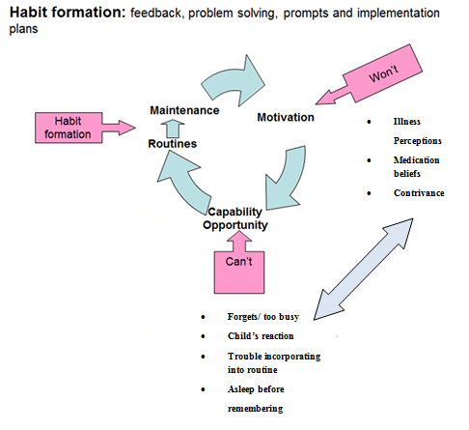

Figure 4 Conceptual framework to understand adherence barriers –version of the framework altered with permission, published by Wildman et al. (2014)

### 2.17.2 Complex Interventions

Complex interventions involve multiple facets and are successful at improving health care measures when carefully devised, and flexible enough to adapt to different population groups([Craig et al., 2008](#_ENREF_33)). Complex interventions are likely to be the most effective way of improving adherence and health outcomes in paediatric asthma and CF as they will be able to address both the intentional and non-intentional barriers to adherence. A successful complex intervention would include an education/ behavioural aspect to establish and maintain positive illness perceptions and medication beliefs. A second facet would be a practical aid to facilitate taking the medication. Electronic monitoring and feedback would make adherence transparent, enabling an open dialogue to improve medication beliefs and illness perceptions, and thus increase motivation. Direct adherence alarms would be a second facet to improve the capabilities and opportunities for the patient to take their medication, figure 5. The feedback of electronic data would also identify specific practical barriers to adherence, which can then be addressed.

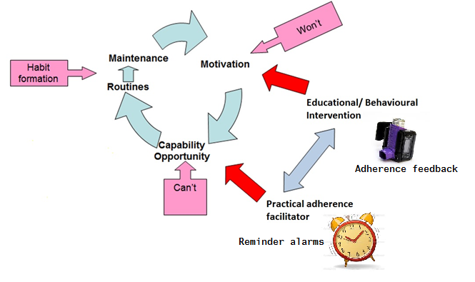

Figure 5 Complex intervention to improve adherence

## 2.18 Research Questions

The review of current literature and hypothesis for potential interventions to fill the evidence deficit leads to the following research questions:

1. Can a complex intervention comprising electronic adherence monitoring and feedback, with regular reminder alarms improve clinical outcome and adherence in children with asthma?

2. Can a complex intervention comprising electronic adherence monitoring and feedback, with regular reminders improve adherence to inhaled therapy in children with Cystic Fibrosis? Is this intervention feasible and amenable in a paediatric clinical setting?

These questions are worthy of investigation because I have demonstrated that adherence is a significant issue in paediatric chronic respiratory diseases, with detrimental consequences of sub-optimal adherence. There are no existing interventions which are both feasible and successful at improving clinical outcomes, and so further research in this field is essential, as declared by the Global Initiative for Asthma ([GINA, 2012](#_ENREF_53)). The National Institute for Health and Care Excellence (NICE) has recently declared the use of electronic monitoring to improve adherence in asthma a research recommendation, and urges further work in this field ([National\_Institute\_for\_Health\_and\_Care\_Excellence, 2015](#_ENREF_104)).

## 2.19 Aims and Objectives

There are two specific aims of this thesis. The first is to design and implement a randomised control trial to investigate whether :- an intervention comprising electronic adherence monitoring with objective feedback, and direct reminder alarms can improve clinical outcomes and adherence levels to inhaled steroids in children with asthma. This study aims to be clinically practical and sufficiently powered to detect a statistical difference between the two groups at the end of a 12 month follow-up period.

The second aim is to design and implement a feasibility study to investigate whether :- the addition of regular reminder text messages to the electronic adherence monitoring already established in standard care can improve adherence levels to nebulised medication in children with cystic fibrosis. This study will generate pilot data to help power and inform future larger studies to investigate whether this intervention can significantly improve adherence levels and clinical outcomes in this population.

## 2.20 – Summary

Adherence to inhaled medication is a significant issue in paediatric asthma and cystic fibrosis, with average rates in paediatric populations of around 50%. These sub-optimal rates often lead to detrimental clinical consequences. With improved technology electronic adherence monitors are emerging as the most accurate and reliable method of adherence monitoring, with other more subjective methods shown to be inaccurate. Barriers to adherence can be classified as intentional, and non-intentional, and are often a combination of the two. Educational or behavioural interventions to overcome these barriers and improve adherence rates have had limited success to date. The use of electronic monitoring, with the feedback of data and reminder alarms is a promising complex intervention whose potential has been demonstrated by previous studies, although they have not shown to improve clinical outcome either due to methodological issues or being underpowered.

In the next chapter I will describe the methodology for 2 separate studies to investigate complex interventions comprising electronic adherence monitoring with feedback and alarms to improve adherence rates and clinical outcomes in children with asthma and CF.

# Chapter 3 - Methods

# 

## 

## 3.1 Introduction

In this chapter I will describe the methodology used in two separate studies to answer the research questions generated in the previous chapter. These questions are:

1. Can a complex intervention comprising electronic adherence monitoring and feedback, with regular reminder alarms improve clinical outcome and adherence in children with asthma?

2. Can a complex intervention comprising electronic adherence monitoring and feedback, with regular reminders improve adherence to inhaled therapy in children with Cystic Fibrosis? Is this intervention feasible and amenable in a paediatric clinical setting?

I will describe the rationale for the use of this methodology, and detail the methods used. The full protocols for both studies are available in appendix 1.

## 3.2 Aims & Objectives

The aim of this chapter is to describe the methodology used for the STAAR and Nebtext studies in detail, in order to adequately investigate the research questions generated in the introduction. The objective of this chapter, in addition to the protocols in the appendix is to give sufficient information to facilitate the reproduction of similar future studies in this field.

## 3.3 STAAR study



Figure 6 STAAR study logo

In order to investigate whether a complex intervention comprising electronic adherence monitoring with reminder alarms and feedback was effective at improving adherence and outcomes, I designed a prospective randomised controlled trial. This study was designed to be sufficiently powered to detect between group differences in asthma control using the validated Asthma Control Questionnaire (ACQ). The study was designed to use the most up-to-date technology available, and the most accurate electronic adherence monitors in order to increase the reliability if adherence data generated. Importantly, the study was designed to be clinically practical, with the intervention intended for use in standard paediatric clinics in the UK and internationally. The study duration had to be long enough to demonstrate sustained improvement in adherence rates and clinical outcomes.

The STAAR (Study of Asthma Adherence Reminders) was a parallel group randomised control trial with patients allocated to intervention: control groups at a 1:1 ratio.

The full STAAR study protocol has been registered with ClinicalTrials.gov, number NCT02451709, and is also available in appendix 1.

## 3.4 Participants & eligibility

In order to accurately represent the paediatric population in question, children were eligible if they were aged 6 years to 16 years 11 months at recruitment. In children younger than 6 years there is often ambiguity about their diagnosis of asthma (other differential diagnoses include viral episodic wheeze, multi trigger wheeze and in the youngest infant, bronchiolitis). In addition, the ACQ questionnaires used for the primary outcome (see later) were validated for use in children 6 years and older.

All children were eligible if they had a diagnosis of asthma, as diagnosed by a doctor. This diagnoses was confirmed at recruitment, and children were withdrawn from the study if this diagnosis was changed during the study. All children had to be taking regular inhaled steroids for their asthma – at least BTS stage 2 – for at least 3 months to ensure any change in clinical condition wasn’t due to a novel treatment. Children who were on steroids less than this or had been commenced on the recruitment visit were ineligible. In order to investigate only children with moderate asthma, with more potential for clinical improvement, participants were only eligible for the study if they had an ACQ score of at least 1.5. For a full list of eligibility criteria, see the study protocol in appendix 1.

## 3.5 Recruitment & consent

Participants were recruited from secondary and tertiary paediatric asthma clinics at Sheffield Children’s Hospital and Rotherham General Hospital. It was important to perform this study in secondary and tertiary clinics, in order to demonstrate the feasibility and potential benefits in both these settings. Potentially eligible participants were identified from clinic lists and approached by the clinical team, who informed the research team.

Information sheets were given to patients and parents, written in age appropriate language.

As a thank you for taking part, all participants were given a £10 shopping voucher at recruitment. This shopping voucher was given at recruitment rather than at completion of the study to act as a “thank you” for taking the time to fill out the consent forms, rather than an incentive to stay in the study, and potentially affect medication adherence as a result. For full details of recruitment and consent please see the protocol in appendix 1.

## 3.6 Ethical Approval

The study was given a favourable ethical opinion by the National Research Ethics Service (NRES) Yorkshire & The Humber- Sheffield Division on 27/9/13. (see appendix 2). The ethics panel were generally positive about the study, although they had some concerns about the potentially judgemental nature of the adherence feedback conversations. Some members also had concerns about the term “adherence” in general, preferring a more inclusive term such as concordance. In order to allay these fears, I explained the term adherence in detail, and how it incorporates the views and beliefs of the patients, rather than the more dictatorial term compliance. On their recommendation I re-worded many of the patient information leaflets to have more inclusive phrases, and less potentially judgemental content.

## 3.7 Interventions

At recruitment, before randomisation, all participants were given a standard primer education, teaching the chronic inflammatory process behind asthma, and emphasizing the importance of regular inhaled medication in its treatment. This was to standardise the educational background of all participants. In reality, all participants will have had very different levels of knowledge about asthma and the importance of inhaled steroids, but these different levels should be evenly distributed in both study groups due to randomisation. Inhaler technique was also assessed at recruitment by a qualified asthma nurse in order to standardise and optimise technique. All participants will have had varying inhaler technique, but will have been randomly distributed into the two study groups.

### 3.7.1 Intervention Group

Each child randomised to the intervention group had an electronic monitor attached to their regular ICS inhaler. The monitors used were “smartinhalers” (Nexus 6 (now Adherium), Auckland, New Zealand), either a “smarttrack” for seretide inhalers (GlaxoSmithKline), or a “smartturbo” for symicort inhalers (AstraZeneca). These monitors electronically logged the date and time of each inhaler actuation. These devices were commercially available, had a “CE” safety mark, and were fully validated for adherence monitoring in asthma ([Burgess et al., 2006](#_ENREF_24)). These devices were chosen for the study because they had been shown in numerous bench and clinical studies to be accurate and reliable, with low malfunction rates ([Patel et al., 2013](#_ENREF_117)). In comparison to some other electronic monitors, the devices were able to store adherence data for 12 months, which allowed data to be downloaded at a later date if devices were forgotten at study visits.

The children were told the devices recorded the time and date the inhalers were used. At 3, 6, 9 and 12 months, the adherence data was downloaded to the “smartinhalerlive” website (<http://www.smartinhalerlive.com>), and the information for the previous 3 months was reviewed with both the patient and their parent/ carer. The adherence level was shown on a graph (figure 7) discussed, and any barriers to adherence identified. A plan of action was devised to improve adherence (if necessary), by the patient, parent and research team member. An adherence target for the next study visit was set. All adherence conversations were non-judgemental, there was no blame apportioned to poor adherers, and future improvements were predicted and encouraged.

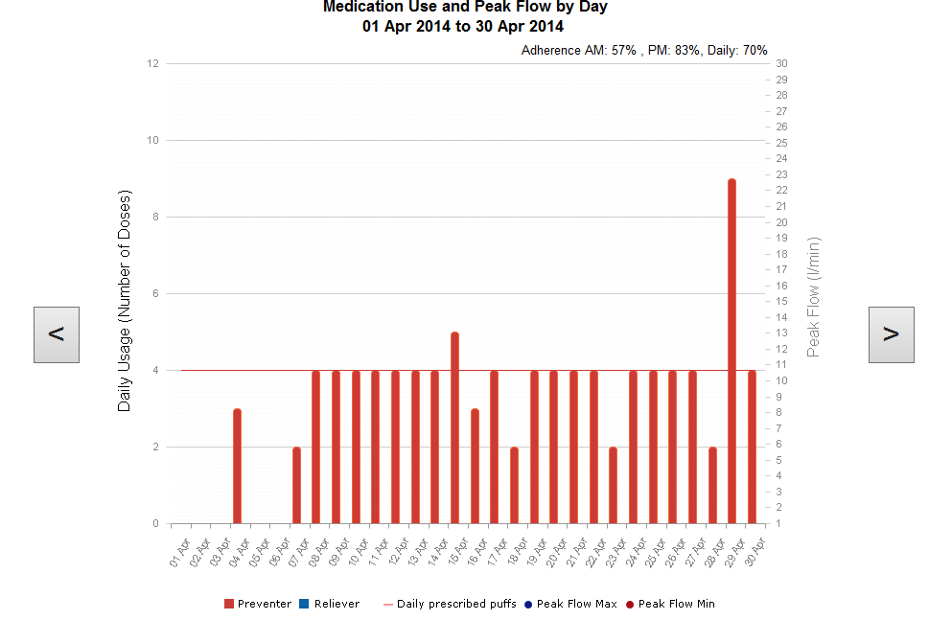

Figure 7 Adherence feedback graph from www.smartinhalerlive.com

The electronic devices in the intervention group were set to play reminder alarms at agreed times in the morning and evening, with different times available for weekdays and weekends. The alarms were popular children’s/ adolescent’s music, TV theme tunes or character/ animal noises. The children could choose a single alarm or a random combination of all the alarms. The alarm sounded if the inhaler had not been actuated in the previous 6 hours, and were therefore set for times just after the child would normally take their inhaler. Without actuation, the alarm rang for 5 seconds, every minute for 15 minutes.

The rationale for this approach was that all participants at recruitment were presumed to be adherent in order to be non- judgemental, therefore any intervention would have to not affect their exist behaviour if not required. If the participant already had optimal adherence behaviour, the alarms would not sound, and would only be activated if doses were late and therefore would potentially be missed. The reminder times and settings were set on the computer, and the devices were then locked to prevent any tampering with alarms and settings. Device alarm settings and times were reviewed at each study visit and changed if necessary. This locking of devices was in contrast to how the devices are used commercially, where patients can set their own alarms and turn alarms off if required. Whilst this may be a desirable feature of an adherence prompting device outside the study setting, it was essential to lock the devices to prevent children turning the alarms off, in order to know that the alarm part of the intervention was present in all participants.

### 3.7.2 Control Group

Participants in the control group had the same electronic monitor attached to their regular ICS inhaler (smartinhaler or smartturbo- Adherium, NZ). The data was downloaded at 3, 6, 9 and 12 months but not reviewed with patients, parents or clinicians. Children were also told the device recorded the date and time the inhaler was used, but the data would not be reviewed with them. The alarms on the control devices were switched off, and the devices were locked to avoid tampering.

## 3.8 Follow up visits

Recruitment and study visits for both the intervention and control groups were carried out in standard asthma clinics at Sheffield Children’s Hospital and Rotherham General Hospital, by a member of the research team. If patients were not due in clinic around the study visit time, extra study visits were performed at Sheffield Children’s Hospital. Throughout the study all participants received their standard asthma care, and all clinical decisions about their treatment were made by the clinical team and not the research team. Visits were performed every 3 months because this is the frequency of asthma clinic appointments in both Sheffield and Rotherham, and therefore the visits could be accommodated on the standard asthma or respiratory clinics. The study visits were performed at these standard clinics in order to maximise the pragmatism of the intervention, they were also performed in standard clinic rooms rather than a specific research setting. Figure 8 shows the flow of participants through the study. If any participants dropped out of the study, their remaining data was collected if possible and continued consent was granted in order to perform an intention-to-treat analysis.

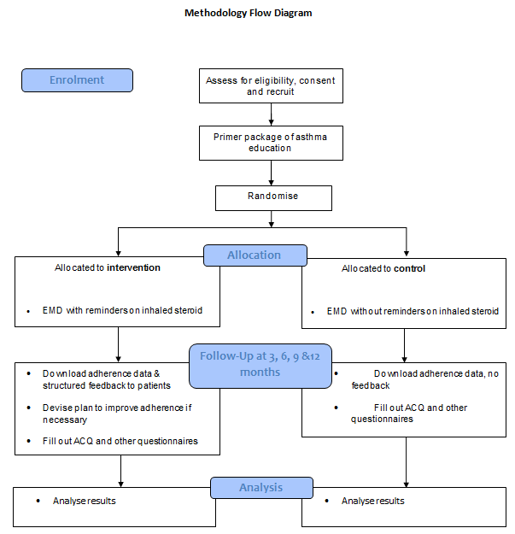

Figure 8 Methodology flow diagram for “STAAR” trial

## 3.9 Primary Outcome

The primary outcome for this study was change in ACQ score. The ACQ is an interviewer administered validated questionnaire for children aged 6 years and older ([Juniper et al., 2010](#_ENREF_77)). The score is a mean value of 6 symptom and activity limitation based question scores for the previous week , and an FEV1 % predicted score. The score is between 0 and 6, with a higher score indicating poorer asthma control. This questionnaire was chosen because it is well validated for the age of the participants and is widely used in clinical practice. As all questionnaires are potentially subjective, the ACQ has an advantage in that it includes an FEV1 % predicted score, which is objectively measured.

The data was collected at 3, 6, 9 and 12 month study visits which were at the same time as the standard clinic appointments. Due to variability in the timing of standard clinics, and to avoid missing study visits or having to arrange extra study visits, each data point entry was rounded to the nearest 3 month point within a time scale as follows:

3 month study visit = 2 months 15 days to 5 months (time post recruitment)

6 month study visit = 5 months & 1 day to 8 months

9 month study visit = 8 months & 1 day to 11 months

12 month study visit = 11 months & 1 day to 14 months

The general pattern of taking one moth prior, and two months post appointment was taken to allow the maximum number of study visits within the 12 month follow-up period. This would minimise missed appointments, where the vast majority if appointments were booked by the clinical and not the study team . The first time period was not until 2 months 15 days to ensure no visits were performed without adequate time for the intervention to take effect. The 12 month study visit time period incorporated 2 months post study to allow all participants to complete the study with maximal data collection. If a study visit within the specified time period was missed, no data was recorded for that visit, but recorded for the later time period stated. This pattern of data collection was most similar to the way clinics are booked and attended in standard clinical practice.

## 3.10 Secondary Outcomes

The following secondary outcomes were also recorded at the above 3,6,9 and 12 month appointments. For precise details of the secondary outcomes and their method of collection please refer to the protocol in appendix 1.

### 3.10.1 Adherence

Adherence data from the electronic devices were uploaded to the internet at each study visit and reviewed with the children and their parents/ carers. A morning (AM) and evening (PM) adherence level for the same time periods were also recorded.

### 3.10.2 Exacerbations and clinical condition

Secondary outcomes recorded to give an indication of the number of asthma exacerbations suffered were the number of unplanned GP or ED visits, number of courses of rescue oral steroids required, number of days off school due to asthma, and the number of hospital admissions. All of these outcomes were reported by parents/ cares, in the duration of time since the last study visit. Parental report was used because it was the most practically feasible, and had been used successfully in other similar studies. Asthma severity at baseline and throughout the study was measured by recording the dose of inhaled steroid each participant was on, and standardising this by calculating a beclometasone equivalent dose. The quality of life of participant throughout the study was recorded using the mini Paediatric Asthma Quality of Life Questionnaire (mini PAQLQ) which was validated for use in children aged 6-16 years ([Wing et al., 2012](#_ENREF_158)).

### 3.10.3 Lung function

Lung function was measured at baseline and every study visit, and a % predicted forced expiratory volume in one second recorded (FEV1%). This parameter gives an indication of the degree of bronchoconstriction in uncontrolled asthma and is used is measured at all asthma clinics in Sheffield and Rotherham as standard. The data from lung function performed in the clinical setting were recorded for the study.

### 3.10.4 Illness perceptions and Medication Beliefs

Parents’ perceptions about asthma, and their beliefs and concerns about inhaled corticosteroids were recorded at baseline and 12 months using validated questionnaires. The Brief Illness Perception Questionnaire produced a score of 0-10, which is a mean of 8 responses ([Broadbent et al., 2006](#_ENREF_21)). A higher score indicated a more threatening view of asthma. The Beliefs about Medicines Questionnaire produced a score of 1-5, which was a mean of 10 responses. A higher score indicated more parental concerns and doubts about inhaled steroids ([Horne et al., 1999](#_ENREF_66)).

## 3.11 Sample Size

The sample size was calculated using repeated measure analyses:

This was based on 1 baseline recruitment visit, and 4 follow up visits.

For ACQ in children the minimum important difference (MID) = 0.5, SD = 1.17. This was calculated by taking the mean from table 6 in the Juniper paper on the validation of the ACQ in children. ([Juniper et al., 2010](#_ENREF_77)).

Significance of 5% (α = 0.05) Power = 80%

Repeated measure correlation = 0.4

Sample size calculation based on statistics table, ([Frison and Pocock, 1992](#_ENREF_48))

n = 38, study size = 76

With a 15% attrition rate, total number of patients required = 89 (45 intervention, 45 controls).

## 3.12 Randomisation

Participants were randomised to either the intervention or control group at a 1:1 ratio.

### 3.12.1 Sequence Generation

Participants were randomised using unstratified permuted block randomisation. This resulted in equal block sizes of 45. A list of allocation order was created from a computer generated random number sequence. This sequence was generated by an independent pharmacist (Jayne Clements, Sheffield Children’s Hospital), using a computer programme, who produced the allocation order. This allocation order was taken by the pharmacist to the respiratory secretaries’ office, who explained how to use it.

### 3.12.2 Allocation

The allocation order list was kept by the respiratory secretaries at Sheffield Children’s Hospital to optimise allocation concealment. When a participant was recruited, the researcher rang the respiratory secretaries, who confirmed eligibility and allocated a study number and group from the list.

### 3.12.3 Blinding

Clinical staff were blinded to the adherence data in the control group, but could view the adherence data of the intervention group if requested. Due to the nature of the intervention, blinding of the research staff or participants was not feasible.

## 3.13 Statistical Analysis

Statistical analysis of data was performed by myself with supervision from Dr. Alan Rigby, University of Hull. Data was databased at each study visit by myself using Microsoft Excel 2010.

Data were analysed using an Intention to Treat Analysis. The data were analysed using Microsoft Excel 2010, and Stata by Statacorp.

The primary outcome (ACQ score) was analysed using two approaches. Firstly, a paired difference of the baseline and 12 month mean values were calculated, and these values were compared between groups using a two tailed student T Test. The student T test was also used to compare mean outcomes at each study visit and an overall mean. Secondly, an area under the curve was calculated for each group, accounting for each study visit value. The areas between the two groups were compared.

For the secondary outcomes which were events (GP/ED visits, oral steroids required, school days missed and hospital admissions), event rates per 100 days in the study were calculated for each group and compared by poisson regression. For non- event secondary outcomes, a 2 tailed independent student T-test was used to compare all the values for each study visit between groups.

Adherence rates were reported as both means and standard deviations (SD), and medians and inter quartile ranges (IQR). Whilst mean adherence rates are more accurately compared statistically between groups, the data is often not normally distributed, due to a skew towards very low rates, particularly if devices are broken or lost. Median adherence rates are therefore often published, to record the midline rate without the influence of potentially misleading outliers. Trends and patterns for median rates are also more easily viewed using box and whisker plots.

## 3.14 Funding

The study was commenced with funds from the respiratory department at Sheffield Children’s Hospital. An application for funding was made to the Sheffield Children’s Hospital Charity, and the study was granted £21,235 in February 2014.

## 3.15 Changes to methods

### 3.15.1 Electronic Monitoring Devices

Shortly after the study commenced, it became apparent that the “smartinhaler” devices were not compatible with standard beclomethasone “clenil” inhalers. The smartinhalers were only compatible with either fluticasone (Flixotide, GlaxoSmithKline, UK) or a combination of fluticasone and serevent (Seretide, GlaxoSmithKline, UK). The “smartturbo” devices were compatible with a combination of budesonide and formoterol (Symbicort, Astrazeneca, UK).

Since no participants were on a single flixotide inhaler at recruitment, all participants were taking these combination inhalers, making them at least BTS level 3.

### 3.15.2 Lung Function

All lung function measurements were initially recorded as an FEV1 % predicted using the Rosenthal 1993 reference data set, as these were the predicted values generated by the pneumotachograph spirometers (Carefusion, CA, USA) used in Sheffield and Rotherham clinically. The Rosenthal reference data set of values included lung function data from 772 healthy Caucasian white children aged 4-18 yrs. ([Rosenthal et al., 1993](#_ENREF_131)). During the study, and after discussion with our respiratory physiologist, it became apparent that this reference data set was outdated, and inappropriate for our study population. In 2012 a new reference data set was published, the Global Lung Initiative (GLI)([Quanjer et al., 2012](#_ENREF_123)). These new data reference values were based on 97,359 healthy individuals aged 3-95 years, and included extensive comparative lung function values from all ethnicities, not just white Caucasians. The GLI data reference ranges therefore give far more accurate predicted values, in all ethnicities and for all ages. The GLI % predicted values are more sensitive to change in lung function over time, particularly during puberty. Our study population comprised 60% Caucasians, and 40% other ethnicities, including British Pakistani, black African, British Indian, Asian other (China etc.) and black Caribbean. Therefore it was important to convert all the lung function FEV1% predicted values to GLI values to obtain more accurate lung function results. Unfortunately, some of the original FEV1 raw data values weren’t accessible for re-calculation, as they had been performed on mobile spirometers which hadn’t saved the data. 259 out of a possible 360 (72%) lung function values could be used to calculate a GLI FEV1% predicted. Therefore, we kept the original lung function data as a Rosenthal 1993 % predicted, and also calculated a GLI % predicted for each available lung function value.

The above amendments did not lead to a protocol amendment as they did not fundamentally change the type of participants recruited or data collected. Participants recruited were still poorly controlled, as specified by an ACQ score of at least 1.5, but with minor differences to their inhaled medication. The raw lung function data and the method of measurement was still exactly the same, it was just the interpretation of this data with reference to the new published reference ranges which changed.

### 3.15.3 Medicines Beliefs Questionnaire & Illness perceptions questionnaire

During the study it became apparent that parents had limited time available for study visits, as they were incorporated into the standard busy asthma clinics. Therefore, in order to save time in the final study visit, the MBQs and IPQs which weren’t completed in clinic were sent out to parents in the post, to be competed and returned in a pre-paid envelope.

### 3.15.4 Protocol Amendment

In January 2015, we made an amendment to our study protocol, approved by the NRES committee (approval letter in appendix 2). It became apparent that parents sometimes had difficulty recording and remembering how many times they had visited the GP, or received oral steroids in the past 3 months. We therefore contacted GPs to ask them to check their database to see how many times each participant had visited their practice, and how many courses of oral steroids were required. We asked them to record data for the year the participant was in the study, and the previous year before the study for comparison. As this data retrieval was not on the original consent form, we sent out new consent forms to all participants’ parents to be signed and sent back. Once we received written consent, we then contacted the GP in writing for the information to be sent back to the study team.

## 3.16 The Nebtext Study

****

Figure 9 Nebtext logo

The “Nebtext” study was a historical control feasibility study to assess the effectiveness of reminder text messages on improving adherence to nebulised medication. Data from a 6 month study period where text messages were received were compared to the 6 months prior to commencement. The study was designed as a feasibility study, to investigate whether this approach was practical, and had any potential to improve adherence rates. The study was designed to generate data which could inform and direct future larger studies using similar interventions. As with the STAAR study, the intervention was designed to be clinically pragmatic, with minimal intervention required from the clinical or research study teams. For full details of the study methods, please refer to the full protocol in appendix 1.

## **3.17 Participants**

Eligible participants for the study were children with CF aged 5-16 years. All children of this age were eligible if they attended CF clinics at Sheffield Children’s Hospital Children and took at least one nebulised medication via the I-Neb ([McCormack et al., 2012](#_ENREF_89)). Children taking medication via the I-neb already had regular adherence reviews with the physiotherapists in their regular CF clinics, where data would be uploaded to the internet and rates reviewed. Physiotherapists would discuss the data with the children and parents, and devise strategies to improve adherence, if necessary.

## 3.18 Intervention

Reminder text messages were sent to all participants in the study for 6 months. The most popular reminder text message was chosen from a list using a pre-study questionnaire in clinic (see appendix 3 for the questionnaire). If the participant was under 12 years of age at recruitment, the texts were sent to both the participant and parent, if 12 years or older, just the participant. Texts could be sent up to twice a day, different times were possible for weekdays and weekends, and school holidays.

The texts were sent from the Sheffield Children’s Hospital automated outpatient text reminder service at no added cost. This service is normally used to send reminder text messages for upcoming clinic appointments. A programme was written to manipulate this service to send daily reminder texts by Richard Jackson, at the IT department of Sheffield Children’s Hospital.

Participants received their standard clinical care during the 6 months, and did not receive any study visits, although they could contact the study team if there were any issues regarding the text messages.

During the study period adherence rates were recorded electronically using the I-Neb nebulisers, and data fed back to the patients by the clinical team, the process was not altered in any way for the study. Members of the study team were not present at the adherence reviews. I-Nebs were retrieved and all data was downloaded by the clinical team, with no intervention from the study team.

Figure 9shows the methodology flow diagram for the Nebtext study. As this was a feasibility study with small participant numbers, there was no randomisation, but data from the intervention period were compared to those from the 6 month period prior to commencement.

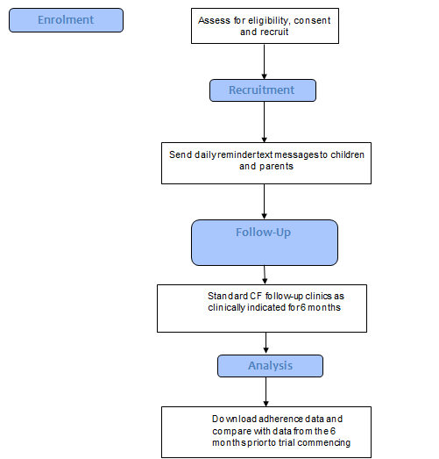

Figure 10 Methodology flow diagram for the Nebtext Study

## 3.19 Outcomes

Outcomes for this study were recorded at completion of the study using the data from the I-neb devices for the 6 month study period, and the prior 6 months. Specific outcomes were overall adherence rate, weekday and weekend adherence rates, total number of missed days, and total number of missed doses. School holiday adherence rates were recorded, for the Christmas holidays in the study period, and the summer holidays in the previous 6 months. Adherence data was downloaded from the I-neb devices, and analysed as a text file (figure 11). For full details of the outcomes and methods of recording, please refer to the study protocol in appendix 1.

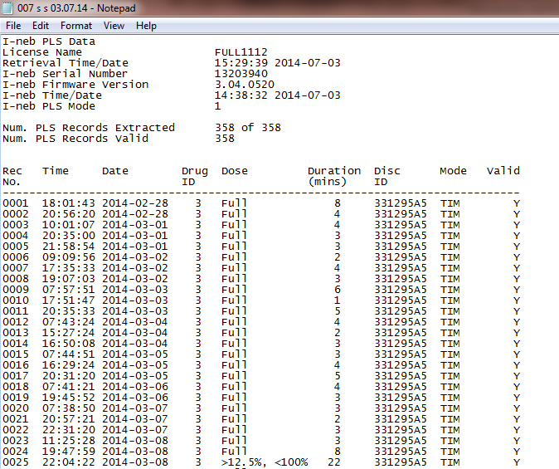

Figure 11 I-Neb text file showing date and time of all actuations

At the end of the study, questionnaires were handed to participants, and data regarding the popularity and perceived benefits of the texts were recorded.

## 3.20 Statistical Analysis

As this was a feasibility study without randomisation, no power calculation was performed, and statistical analysis was minimised, in line with recommendations ([Lancaster et al., 2004](#_ENREF_82)). The data was databased on Microsoft Excel 2010 by myself, with analysis also using Excel.

Mean and median adherence rates were calculated and means compared using a paired Student’s *t*-test. The sample size was the maximum number of eligible participants attending CF clinic in Sheffield during the recruitment period of October 23rd 2014 to December 19th 2014.

## 3.21 Ethical Approval & Funding

Ethical approval for the study was granted by the NRES committee South West – Exeter on 22/10/14 ( For approval letter see appendix 2). Text messages sent from outpatient reminder service incurred no charge. No extra time was required by clinical staff to accommodate the study.

## 3.22 Changes to methods

The analysis of data was originally intended to be analysed using the I-Neb website [www.psp.net](http://www.psp.net), in addition to a manual calculation. The data from the text files generated by the I-Nebs were inputted into the website, and an adherence rate was given, with the number of missed doses. Graphical representation of adherence rates for weekdays and weekends website was displayed on the web page. This was the way adherence data was reviewed in clinic with clinicians and patients. In October 2015, during analysis of results, Respironics discontinued this website, to be replaced by a new web based system, “Insight”. Unfortunately this new system was not yet established during the period of results analysis. Therefore, all data analysis was done manually using the text files, as described above. This change in results analysis did not affect the way the study was conducted, therefore it did not warrant an official protocol amendment.

## 3.23 Summary

The STAAR study was an RCT designed to investigate whether an intervention comprising electronic adherence monitoring with reminder alarms and feedback could improve adherence and clinical outcomes in children with asthma. The study ran for 12 months and the primary outcome was asthma control, as defined by the Asthma Control Questionnaire (ACQ). Secondary outcomes included electronic adherence rate, and exacerbations requiring a dose of oral steroids. The study was designed to be clinically practical, and study visits took part in existing clinics at Sheffield Children’s Hospital and Rotherham General Hospital.

The Nebtext study was a feasibility study to investigate the potential of reminder text messages to improve adherence rates to nebulised medication in children with CF. The reminder text messages were designed to complement the existing practise of electronic adherence monitoring and feedback in clinic.

# Chapter 4 - Results

## 4.1 Introduction

In the previous chapter I described the methodology for two original studies, the STAAR study (STudy of Asthma Adherence Reminders), and the Nebtext study. In this chapter I will record the results from both of these studies. In the first section I will describe how both of the studies ran, the numbers recruited and detail the results from all the outcomes measured. I will also present data from outcomes which were non pre-specified, but were important in the context of the studies, including adverse events. In the second section of this chapter I will analyse the results, theorising why they were seen and comparing them to other published work.

## 4.2 Aims

* To accurately record the recruitment and retention of participants in the STAAR and Nebtext studies.
* To accurately record the pre-specified primary and secondary outcomes for the STAAR and Nebtext studies.
* To record the adverse events from the STAAR and Nebtext studies
* To analyse the results of both studies, and theorise why these results were seen
* To compare and contrast the results of these studies with other published work

## 4.3 STAAR study results

### 4.3.1 Recruitment and flow of participants

Between October 2013 and August 2014 117 notes for 117 potential participants attending secondary or tertiary asthma clinics in Sheffield and Rotherham were assessed for eligibility. 23 of these did not meet the inclusion criteria. When approached, 3 participants declined to take part, and a further participant disclosed they were on long term steroids for nephrotic syndrome, and therefore ineligible.

The remaining 90 participants were consented and randomised (81 in Sheffield, 9 in Rotherham). 47 were randomised to group A (intervention), and 43 were randomised to group B (control). The unequal group numbers was because 2 participants were not crossed off the list when recruited by secretaries. Therefore 2 Bs became As.

After randomisation, one participant was withdrawn from the study as their ACQ was 1.3 and therefore ineligible. The score was wrongly calculated before FEV1% was recorded, and when this added, the ACQ score was 1.3. Due to their ineligibility, the participant’s baseline data was not included, nor any data collected. During the course of the study, 12 participants dropped out of the study, 8 from group A, and 4 from group B. The reasons for withdrawal are shown in table 4. The CONSORT 2010 flow chart for participants through the trial and reasons for withdrawal are shown in Figure 12.

C:\Users\UOS\Documents\STAAR\STAAR figures\Figure 3.tif

Figure 12 CONSORT 2010 flow diagram showing passage of participants through study

|  |  |  |  |
| --- | --- | --- | --- |
| Participant | Group | Days in study | Reason for Withdrawal |
| 4 | A | 1 | “Clenil” device, incompatible with smartinhaler |
| 9 | A | 0 | Lost to follow up. DNA x 2, then discharged from clinic and uncontactable |
| 14 | A | 1 | Withdrew consent after discussion with father |
| R04 | B | 0 | DNA all appointments and completely uncontactable |
| 21 | A | 286 | Mother unhappy with clinic letter to GP suggesting STAAR had improved child’s asthma. Therefore withdrew consent at 9 months study visit |
| 43 | B | 182 | Lost to follow up. Uncontactable after 6 months. DNA and cancelled 10 clinic appointments |
| 46 | A | 429 | Started taking cortisone for adrenal insufficiency. Continued with intervention throughout |
| 49 | B | 77 | Commenced on triamcinolone by clinicians due to safeguarding concerns of neglect. Completely lost device |
| 51 | A | 0 | Lost to follow up. DNA clinic x3 and uncontactable. |
| 55 | A | 309 | Lost to follow up. Transitioned to adult clinic and completely lost device |
| R08 | B | 119 | Mother withdrew consent. Cited reason that inconvenient to remind child to take inhalers. |
| 62 | A | 341 | Intentionally removed device and lost it completely. Remained in study for visits & data collection. |

Table 4 Reasons for withdrawal from study

### 4.3.2 Baseline Characteristics

The baseline characteristics for groups A (intervention) and B (control) are shown in table 5.

|  |  |  |
| --- | --- | --- |
|  | **Group A** (n=47) | **Group B** (n=42) |
| Age (years) | 10.4  (2.9) | 10.2  (2.9) |
| Sex male | 28(60%) | 22(52%) |
| ACQ | 2.5(0.8) | 2.3(0.7) |
| FEV1 % (R) | 87.0  (17.8) | 83.3  (16.6) |
| FEV% (GLI) | 87.2 (14.9) | 88.0 (13.4) |
| MPQLQ | 4.3(1.5) | 4.6(1.2) |
| ICS dose | 697.9(348.6) | 664.3(280.1) |
| BTS level | 3.5(0.6) | 3.4(0.5) |
| GP/ED visits | 1.9(2.2) | 2.1(2.0) |
| Beta agonist use in prev week | 2.5(1.3) | 2.3(1.3) |
| School days missed | 3.5(4.4) | 3.8(5.7) |
| Oral steroids | 1.2(1.8) | 1.2(1.3) |
| Hospital admissions | 0.3(0.6) | 0.2(0.6) |
| MBQ score | 2.5 (0.5) | 2.6 (0.4) |
| IPQ score | 5.6 (1.3) | 5.3 (0.9) |
| Ethnicity WB  BA  BP  BI  AO  BC | 30(64%)  3((6%)  11(23%)  0(0%)  1(2%)  2(4%) | 24(57%)  6(14%)  11(26%)  1(2%)  0(%)  0(%) |
| Time from asthma diagnosis years | 6.0 (3.7) | 6.7 (3.7) |

Table 5 – Baseline characteristics for groups A (intervention) and B (control). Data are mean (SD), or number (%). ICS = Inhaled Corticosteroid Dose, beclometasone equivalent. WB = White British, BA = Black African, BP = British Pakistani, BI = British Indian. Beta agonist use = score on ACQ question.

### 

### 4.3.3 Primary Outcome

The ACQ scores significantly reduced (asthma control improved) for both groups from baseline to 3,6,9 and 12 month study visits. Table 6 shows the mean (SD) [95% CI] ACQ values at each study visit, and the combined mean of all 4 study visits. Baseline to study visit means were compared by a 2 tail paired T test. A 2 tailed independent T test was used to compare groups A and B at each study visit. There was no significant difference between the two groups except for at 9 months, where group A had a significantly lower ACQ (better asthma control).

|  |  |  |  |  |  |  |
| --- | --- | --- | --- | --- | --- | --- |
| Group | Baseline  Mean (SD)  [95% CI] | 3 months | 6 months | 9 months | 12 months | Combined mean |
| Mean (SD) [95% CI] | Mean (SD)  [95% CI] | Mean (SD)  [95% CI] | Mean (SD)  [95% CI] | Mean (SD)  [95% CI] |
| A | 2.7  (0.9)  [2.4-2.9] | 1.7  (1.0)  [1.3-2.0] | 1.7  (1.2)  [1.3-2.1] | 1.4  (1.0)  [1.0-1.7] | 1.6  (1.2)  [1.2-2.0] | 1.5  (0.8)  [1.3-1.7] |
| B | 2.5  (0.8)  [2.2-2.7] | 1.6  (0.9)  [1.3-1.9] | 1.6  (1.1)  [1.2-2.0] | 2.0  (1.2)  [1.5-2.4] | 1.5  (1.1)  [1.2-1.9] | 1.6  (0.8)  [1.4-1.9] |
| A vs. B  p value | 0.294 | 0.734 | 0.923 | 0.0486 | 0.76 | 0.448 |

Table 6 – Mean, (SD) & [95% CI] ACQ scores for each study visit for groups A and B

Table 7 shows the paired mean ACQ and FEV1% differences for groups A and B. Table 8 shows a comparison of the areas under the curve (AUC) for groups A and B.

|  |  |  |  |  |  |  |  |
| --- | --- | --- | --- | --- | --- | --- | --- |
| Outcome | Group A  baseline | Group A  12 months | Paired  mean difference | Group B  baseline | Group B  12 months | Paired  mean difference | Difference of the difference |
| ACQ | 2.65  (0.85)  [2.4-2.9] | 1.58  (1.23)  [1.2-2.0] | -1.14  (1.37)  [-1.6 to -0.7] | 2.47  (0.75)  [2.2-2.7] | 1.50  (1.07)  [1.2-1.9] | -0.95  (1.12)  [-1.3 to -0.6] | -0.18  [-0.76 to 0.38] |

|  |  |  |  |  |
| --- | --- | --- | --- | --- |
| **Group A** | **Group B** | **Difference** | **95% CI** | **P** |
| 1.7 | 1.6 | 0.09 | (-0.26,0.45) | 0.52 |

Table 7 – Difference in mean (SD), [95% CI] ACQ scores . Difference of the difference is an estimated statistic.

Table 8 – Comparison for areas under the curve (AUC) for ACQ

Table 9 shows a comparison of the ACQ means between groups A and B. Means were compared by 2 tailed independent student T test. The ACQ difference from baseline was a mean of the difference from baseline values for the 4 study visits (e.g. if the baseline ACQ was 2.5, and a study visit score was 1.5, the ACQ difference for that study visit was 1.0).

|  |  |  |  |
| --- | --- | --- | --- |
| **Outcome** | **Group A**  **Mean**  **(SD)**  **[95% CI]** | **Group B**  **Mean**  **(SD)**  **[95% CI]** | **P value** |
| ACQ total | 1.50  (0.8)  [1.3-1.7] | 1.63  (0.8)  [1.4-1.9] | 0.53 |
| ACQ 1st 6 months | 1.52  (0.8)  [1.3-1.8] | 1.58  (0.9)  [1.3-1.9] | 0.99 |
| ACQ 2nd 6 months | 1.44  (1.0)  [1.2-1.7] | 1.66  (1.0)  [1.3-2.0] | 0.37 |
| ACQ difference from baseline | 1.17  (1.0) | 0.82  (0.7) | 0.078 |

Table 9 – Comparison of the overall mean, (SD) & [95% CI] values in groups A and B

**.**

Figure 13 shows the ACQ median and inter-quartile ranges for each study group at 3,6,9 and 12 months. In both groups scores fell significantly after 3 months and remained low for the duration of the study. For all box plots in results, the median is the bar, the 25th centile is the lower box edge and the 75th centile is the upper box edge. The whiskers (line above or below the box) indicate the highest/ lowest values within 1.5 IQR of the box edge. The dots indicate outliers.

**C:\Users\UOS\Documents\STAAR\STAAR figures\Figure 4.tif**

Figure 13 – Box and whisker plot showing the ACQ distribution at each study visit for groups A and B .

### 

### 4.3.4 Secondary Outcomes

### 4.3.4.1 Lung Function – Rosenthal 1993 data

FEV1% predicted increased in both groups, but there was no significant difference between baseline and visit values for either group, or between groups (table 10). The Rosenthal data are the % predicted FEV values as compared to the 1993 Rosenthal data reference ranges. These were the original data collected. The Global Lung Initiative (GLI, 2012) data were calculated later (and shown afterwards).

|  |  |  |  |  |  |  |
| --- | --- | --- | --- | --- | --- | --- |
| Group | Baseline  Mean (SD) | 3 months | 6 months | 9 months | 12 months | Combined mean |
| Mean  (SD)  [95% CI] | Mean  (SD)  [95% CI] | Mean  (SD)  [95% CI] | Mean  (SD)  [95% CI] | Mean  (SD)  [95% CI] |
| A | 87.0  (18.0)  [82.0-91.1] | 90.4  (17.7)  [84.1-96.6] | 89.8  (17.0)  [82.8-96.7] | 90.9  (14.6)  [85.7-96.1] | 89.9  (14.3)  [85.5-94.2] | 91.5  (14.2)  [87.1-95.9] |
| B | 83.3  (16.4)  [78.4-88.3] | 87.1  (13.3)  [82.4-91.9] | 85.2  (21.1)  [77.7-92.7] | 86.0  (13.8)  [81.1-91.0] | 87.3  (16.2)  [81.8-92.7] | 86.7  (13.4)  [82.6-90.9] |
| A vs. B  P value | 0.31 | 0.43 | 0.38 | 0.11 | 0.48 | 1.27 |

Table 10 – Mean (SD) FEV1% predicted (Rosenthal 1993) scores for each study visit for groups A and B.

Figure 14 shows the FEV1% median and interquartile ranges for each study group at 3,6,9 and 12 months.



Figure 14 – Box and whisker plot showing the FEV1% distribution (Rosenthal 1993) at each study visit for groups A and B.

### 4.3.4.2 Lung Function – GLI data

FEV1% predicted increased in group A (intervention) from baseline to 3, 6, 9 and 12 months, but the difference was not significant (table 11). The FEV1% in group B (control) initially decreased, then returned to the baseline value, this difference was not significant. Despite a lower baseline FEV1% predicted, group A had a persistently higher mean at each study visit than group B, although this difference between groups was not significant.

|  |  |  |  |  |  |  |
| --- | --- | --- | --- | --- | --- | --- |
| Group | Baseline  Mean (SD) | 3 months | 6 months | 9 months | 12 months | Combined mean |
| Mean  (SD)  [95% CI] | Mean  (SD)  [95% CI] | Mean  (SD)  [95% CI] | Mean  (SD)  [95% CI] | Mean  (SD)  [95% CI] |
| A | 87.2  (14.9)  [83.0-91.5] | 90.6  (14.2)  [85.6-95.6] | 89.2  (16.4)  [83.4-95.2] | 89.8  (12.4)  [85.4-94.1] | 91.4  (12.4)  [87.5-95.2] | 91.3  (12.8)  [87.4-95.2] |
| B | 88.0  (13.4)  [83.9-92.1] | 86.4  (14.0)  [81.2-91.7] | 85.9  (18.7)  [79.4-92.4] | 88.5  (12.8)  [84.0-93.0] | 88.5  (15.3)  [84.0-94.0] | 88.0  (13.1)  [83.8-91.8] |
| A vs. B  P value |  | 0.27 | 0.46 | 0.69 | 0.45 | 0.22 |

Table 11 – Mean, (SD) & [95% CI] FEV1% predicted (GLI) for each study visit for groups A and B .

### 4.3.4.3 Adherence

|  |  |  |  |  |  |  |  |  |  |  |
| --- | --- | --- | --- | --- | --- | --- | --- | --- | --- | --- |
|  | 3 months | | 6 months | | 9 months | | 12 months | | Overall | |
|  | Mean  (SD)  [95% CI] | Median (IQR) | Mean  (SD)  [95%CI] | Median (IQR) | Mean  (SD)  [95% CI] | Median (IQR) | Mean  (SD)  [95% CI] | Median (IQR) | Mean  (SD)  [95% CI] | Median (IQR) |
| Group A | 72.6  (22.4)  [65.7-79.5] | 80.5  (59-89) | 76.1  (23.3)  [68.6-83.6] | 85.0  (64-92) | 69.3  (23.1)  [61.4-77.1] | 74.0  (55-88) | 68.6  (31.3)  [58.1-79.2] | 80.0  (63-90) | 70.5  (22.8)  [63.6-77.3] | 75.3  (59-88) |
| Group B | 56.8  (23.9)  [40.3-56.8] | 62.0  (42-75) | 51.3  (29.6)  [49.0-64.6] | 59.0  (28-75) | 42.5  (31.1)  [40.8-61.7] | 43.0  (4-70) | 39.8  (32.4)  [31.3-53.9] | 43.0  (6-65) | 48.6  (26.0)  [28.2-51.4] | 50.5  (24-66) |
| P | 0.004 |  | <0.001 |  | <0.001 |  | <0.001 |  | <0.001 |  |

The mean adherence rate for the study was significantly higher in group A ( 70.5%) than group B (48.6%). Group A had significantly higher rates of adherence throughout the study (table 12) The mean rates declined in both groups as time in study increased, more markedly in group B. When the medians are analysed, the rates were maintained in group A, but declined in group B (table 8, figure 3).

Table 12 – Mean (SD) and Median (IQR) adherence rates throughout the study for groups A and B.

Figure 15 shows the median and interquartile range for adherence throughout the study for groups A and B.

**C:\Users\UOS\Documents\STAAR\STAAR figures\Figure 5.tif**

Figure 15 – Box and whisker plot showing the median adherence rates throughout the study for groups A and B.

Afternoon (PM) adherence rates were significantly higher than morning (AM) rates in both groups, at all study visits (table 13). Morning and afternoon rates were both significantly higher in group A than group B (table 14).

|  |  |  |  |  |  |  |  |  |  |  |
| --- | --- | --- | --- | --- | --- | --- | --- | --- | --- | --- |
|  | 3 months | | 6 months | | 9 months | | 12 months | | Overall | |
| A | B | A | B | A | B | A | B | A | B |
| Mean AM adherence (SD)  [95% CI] | 69.7 (23.9)  [62.2-77.3] | 52.3 (26.7)  [43.5-61.0] | 73.8 (24.7)  [65.9-81.8] | 47.5 (31.3)  [36.5-58.5] | 66.9 (24.6)  [58.4-75.4] | 39.2 (31.0)  [27.9-50.4] | 66.8 (31.3)  [56.3-77.3] | 34.0 (31.4)  [22.8-45.2] | 68.4 (23.2)  [61.4-75.4] | 44.0  (27.3)  [35.3-52.7] |
| Mean PM adherence (SD)  [95% CI] | 74.5 (21.8)  [67.7-81.4] | 62.4 (24.1)  [54.5-70.3] | 76.9 (23.5)  [69.2-84.6] | 57.2 (30.2)  [46.4-68.0] | 72.8 (24.0)  [64.3-81.3] | 45.6 (32.6)  [35.5-59.3] | 70.7 (32.1)  59.7-81.7] | 46.4 (34.6)  [33.8-59.1] | 72.3 (22.9)  [65.3-79.3] | 54.8 (26.2)  [46.4-63.1] |
| P | 0.0019 | <0.001 | 0.02 | 0.032 | 0.01 | 0.03 | 0.03 | <0.001 | <0.001 | <0.001 |

Table 13 – Morning (AM) and afternoon (PM) adherence rates for groups A and B

|  |  |  |  |
| --- | --- | --- | --- |
|  | Group A | Group B | P |
| Mean (SD)Adherence AM overall | 68.4  (23.2)  [61.4-75.4] | 44.0  (27.3)  [35.3-52.7] | <0.001 |
| Mean (SD)Adherence PM overall | 72.3  (22.9)  [65.3-79.3] | 54.8  (26.2)  [46.4-63.1] | <0.001 |
| p | <0.001 | <0.001 |  |

Table 14 – Comparison of morning (AM) and afternoon (PM) adherence rates between groups A and B

### 4.3.4.4 Event rates

The event rates per 100 days in the study for secondary outcomes are shown in table 15. Participants in the intervention group required significantly fewer courses of oral steroids and hospital admissions than those in the control group. Participants also attended the GP/ED less frequently , and had fewer days off school due to asthma, although these differences were not significant.

Table 16 shows the total number of events in each group, with the mean length of time in study for each group. Figures 16,17,18 & 19 show when the events occurred throughout the study.

|  |  |  |  |
| --- | --- | --- | --- |
|  | **Event rate (per 100 child days)** | | **P value** |
| **Group A** | **Group B** |
| GP/ED visits (n=193) | 0.582 | 0.650 | 0.316 |
| Days off school due to asthma (n=462) | 1.365 | 1.606 | 0.1 |
| Courses of oral steroids (n=156) | 0.411 | 0.676 | 0.008 |
| Hospital admissions (n=20) | 0.0254 | 0.129 | <0.001 |

Table 15 – Event rates for the secondary outcomes in groups A and B

|  |  |  |
| --- | --- | --- |
|  | **Group A** | **Group B** |
| Mean (SD) days in study | 351 (117) | 358 (101) |
| GP/ED visits | 94 | 99 |
| Days off due to asthma | 224 | 238 |
| Courses of oral steroids | 65 | 91 |
| Hospital admissions | 4 | 16 |

Table 16 – Total number of secondary outcome events for groups A and B

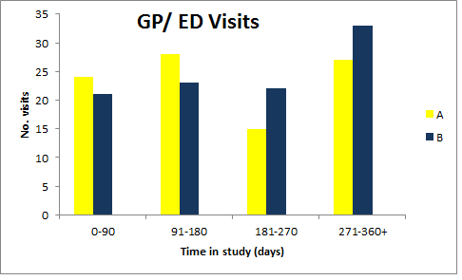

Figure 16- Number of GP/ED attendances required in groups A and B throughout the study

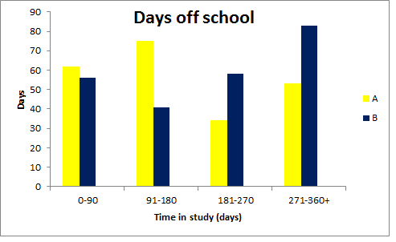

Figure 17 – Number of days off school due to asthma in groups A and B throughout the study

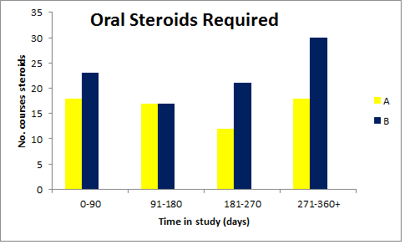

Figure 18 – Number of courses of oral steroids required in groups A and B throughout the study

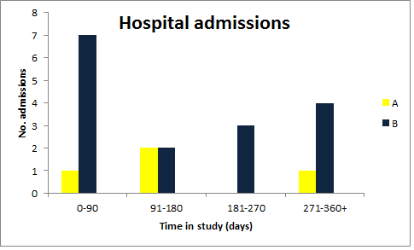

Figure 19 – Number of hospital admissions required in groups A and B throughout the study

### 4.3.4.5 Quality of Life

The Quality of life (mini PAQLQ score) improved steadily and significantly throughout the study in both groups A and B (figure 20, table 17). There was no significant difference between the two groups (table 17).



Figure 20 – Box and whisker plot showing the median mini paediatric quality of life (PQL) score throughout the study for groups A and B.

### 4.3.4.6 Inhaled Steroid Dose

The dose of inhaled steroids required in group A slightly decreased in group A, and increased in group B from baseline to 12 months. Neither change was statistically significant when compared from baseline or between groups (table 17).

### 4.3.4.7 BTS stage

There was no change in BTS stage for either group A or B. There was no difference from baseline to 12 months or between groups (table 17).

### 4.3.4.8 Medicines Beliefs Questionnaire

The MBQ score decreased (beliefs improved) in both groups from baseline to 12 months. The difference from baseline and between groups was not significant (table 17).

### 4.3.4.9 Illness Perceptions Questionnaire

The IPQ score decreased (illness perceptions improved) in both groups from baseline to 12 months. The difference from baseline and between groups was not significant (table 17).

|  |  |  |
| --- | --- | --- |
|  | **Baseline**  **Mean (SD)**  **[95% CI]** | **12 months**  **Mean**  **(SD)**  **[95% CI]** |
| BTS Group A | 3.5 (0.6)  [3.3-3.6] | 3.5 (0.5)  [3.3-3.7] |
| BTS Group B | 3.4 (0.5)  [3.3-3.6] | 3.5 (0.6)  [3.3-3.5] |
|  |  | P = 0.82 |
| Inhaled steroid dose Group A | 697.9 (348.6)  [598.2-797.5] | 672.7 (303.0)  [569.2-776.2] |
| Inhaled steroid dose Group B | 664.3 (280.0)  [579.6-749.0] | 767.1 (369.6)  [644.4-889.6] |
|  |  | P = 0.25 |
| PQL Group A | 4.3 (1.5)  [3.9-4.8] | 5.4 (1.2)  [5.0-5.8] |
| PQL Group B | 4.6 (1.2)  [4.2-5.0] | 5.6 (1.1)  [5.2-6.0] |
|  |  | P = 0.53 |
| MBQ Group A | 2.5 (0.5)  [2.4-2.6] | 2.3 (0.5)  [1.9-2.8] |
| MBQ Group B | 2.6 (0.4)  [2.5-2.8] | 2.5 (0.4)  [2.3-2.7] |
|  |  | P = 0.56 |
| IPQ Group A | 5.6 (1.3)  [5.2-6.0] | 4.4 (1.4)  [3.7-5.5] |
| IPQ Group B | 5.3 (0.9)  [5.0-5.6] | 4.8 (0.9)  [4.3-5.2] |
|  |  | P = 0.21 |

Table 17 – Between group comparisons for secondary outcomes for Groups A and B. BTS = British Thoracic Society. PQL = Paediatric quality of life questionnaire. Inhaled steroid dose is beclometasone equivalent dose.

### 4.3.4.10 Clinic Visits

Table 18 shows the rates of did not attend (DNA) and cancelled clinic appointments in groups A and B. Wherever possible, appointments were re-scheduled. However as some patients were not scheduled a clinic appointment at or around a 3 month interval, or had cancelled an appointment without the possibility of obtaining a replacement appointment, 35 non-clinical study visits (15 intervention, 20 control) were performed. Despite these visits, the high number of cancelled or missed appointments impacted on the ability to provide feedback at each of the three scheduled time points (3,6 & 9 months). Table 19 shows the number of successful feedback visits for group A (total number of participants randomised to group A, n = 47).

|  |  |  |  |  |  |
| --- | --- | --- | --- | --- | --- |
|  | **Total no. study visits** | **Mean no. visits per participant** | **DNA** | **Cancelled** | **Total (DNA +cancelled)** |
| Group A | 136 | 2.9 | 38 | 37 | 75 |
| Group B | 124 | 3.0 | 33 | 35 | 68 |
| Total | 260 |  | 71 | 72 | 143 |

Table 18 – Did not attend (DNA) rates and cancelled clinic appointment rates for groups A and B.

|  |  |
| --- | --- |
| **No. feedback visits** | **No. participants (%)** |
| 0 | 7 (15) |
| 1 | 13 (28) |
| 2 | 10 (21) |
| 3 | 17 (36) |

Table 19 – Number of feedback visits performed in group A.

### 4.3.4.11 Broken/ forgotten/ lost devices

Table 20 shows the total frequency of devices broken, forgotten or lost**.**  Missed data from forgotten devices was downloaded at a later clinic appointment. Group A had higher rates of devices being reported to be lost or broken by the child, and a greater incidence of these “broken” devices actually damaged beyond repair when later inspected by the study team, hence requiring replacement devices. Reasons given for being damaged (just reported, or actually broken) included lost/flat battery, dropped on floor, dropped in liquid, alarms not starting, alarms not stopping, screens peeled off.

|  |  |  |
| --- | --- | --- |
|  | **Group A**  **(47 participants)** | **Group B**  **(42 participants)** |
| Device reported as “broken” by child | 23(50%) | 8 (19%) |
| Devices damaged beyond repair, requiring replacement | 17(37%) | 2 (5%) |
| Participant forgot to bring device to clinic | 10 (22%) | 18 (43%) |
| Devices lost completely | 5(11%) | 2 (5%) |

Table 20 – Total number (%) of devices broken, forgotten and lost in groups A and B

### 4.3.4.12 Amendment data

Consent forms were sent to the remaining 73 participants in Sheffield to obtain GP data, 52 were received back. Requests for data were sent to these 52 GPs and 32 responses were received (32/73 = 44%). 10 responses were for Group A participants (total 37 participants, 27%), 19 responses were for group B participants (total 36, 53%). Mean rates for GP attendance and oral steroids required were less in the study year than the previous year for both groups A and B, although this difference was not significant (table 21). During the study year, participants in group A required fewer GP appointments for asthma, and fewer courses of oral steroids, however this difference was not significant (table 22).

|  |  |  |  |  |  |  |  |  |
| --- | --- | --- | --- | --- | --- | --- | --- | --- |
| **Outcome** | **Group A** | | | | **Group B** | | | |
|  | Prev. Year | Study Year | Difference | P value | Prev. Year | Study Year | Difference | P value |
| GP attendances  Mean (SD)  [95% CI] | 3.6  (3.3)  [1.8-5.4] | 1.4  (1.6)  [0.5-2.3] | -2.2 | 0.06 | 2.8  (3.2)  [1.3-4.2] | 2.1  (2.2)  [1.1-3.1] | -0.7 | 0.31 |
| Oral steroids prescribed  Mean (SD)  [95% CI] | 1.2  (1.6)  [0.3-2.1] | 0.4  (0.6)  [0.0-0.7] | -0.8 | 0.16 | 1.8  (2.0)  [0.9-2.8] | 1.2  (1.6)  [0.5-1.9] | -0.6 | 0.10 |

Table 21 – GP attendances and steroids prescribed for groups A and B (GP data)

|  |  |  |  |  |
| --- | --- | --- | --- | --- |
|  |  | **Group A** | **Group B** | **P value** |
| Mean events in study year  Mean (SD)  [95% CI] | GP attendances | 1.4 (1.6)  [0.5-2.3] | 2.1 (2.2)  [1.1-3.1] | 0.3 |
| Oral steroids prescribed | 0.4 (0.6)  [0.0-0.7] | 1.2 (1.6)  [0.5-1.9] | 0.06 |

Table 22 – Between group comparisons for GP attendances and steroids prescribed during the study year (GP data)

## 4.4 Results – Nebtext Study

### 4.4.1 Text Questionnaire Responses

28 responses were received to questionnaires given out in the CF clinic shown in table 23. The text which received the most votes (43%) was “It’s Neb o ‘clock! :)” and therefore this was used as the reminder text for the study (figure 21).

|  |  |
| --- | --- |
| **Text** | **No. votes (%)** |
| Please remember to take you nebuliser :) | 1 (4%) |
| Don’t forget your neb :) | 4 (14%) |
| It’s time for your neb :) | 4 (14%) |
| Dr West says it’s time for your neb :) | 5 (18%) |
| Elaine says it’s time for your neb :) | 3 (11%) |
| It’s neb time! :) | 7 (25%) |
| It’s neb o’clock! :) | 12 (43%) |
| None of the above | 4 (14%) |

Table 23 – Responses to text choice questionnaire



Figure 21 – Message chosen as reminder text

### 4.4.2 Recruitment and flow of participants

In October 2014 there were 22 children taking at least one medication via the I-neb attending clinic in Sheffield. These children were assessed for eligibility and the 18 of these who attended clinic between October and December 2014 were approached and consented to take part in the trial. One participant declined to take part, and 17 participants were recruited to the trial. One participant withdrew after 21 days of the trial, and one after 31 days, both citing the reason that their adherence was already satisfactory and they did not think texts would help (figure 22).

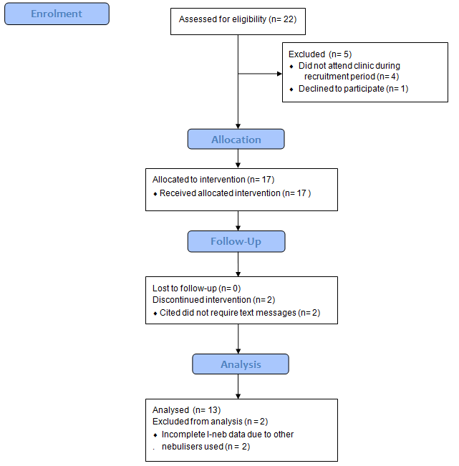

Figure 22 – Flow of participants through Nebtext study

When the I-neb data was analysed, 2 of the participants had incomplete data available. It transpired that these participants used additional inhalation devices (Podhaler – Novartis) for various periods of time, and therefore accurate adherence rates could not be calculated. Therefore data was analysed for the remaining 13 participants.

### 4.4.3 Baseline Characteristics

The baseline characteristics of the 17 participants recruited to Nebtext are shown in table 24.

|  |  |
| --- | --- |
| **Characteristic** | **Baseline mean [SD] or n (%)** |
| Age | 11.9 [2.9] |
| Age ≥12 | 11 (65%) |
| Sex male | 4 (24%) |
| FEV1% | 80.5% [14.3] |
| No. nebulised actuations/ day | 2.6 [1.5] |

Table 24 – Baseline characteristics of participants in Nebtext study

At recruitment, participants were taking a number of different nebuliser combinations, shown in table 25.

|  |  |  |
| --- | --- | --- |
| **Total number of actuations per day** | **No. Participants/ Medications** | |
| 1 | 5 | DNase od |
| 2 | 1 | Promixin bd |
| 3 | 2 | DNase od  Promixin od |
| 4 | 2 | Bramitob bd  (2 actuations bd) |
| 2 | DNase od  Promixin bd  Hypertonic Saline od |
| 5 | 1 | Bramitob bd  (=4 doses)  DNase od |

Table 25 – total number of nebulised medications taken by participants at recruitment

### 4.4.4 Overall Adherence

The overall adherence results for the 13 participants are shown in table 26.

There was no difference in overall adherence rates between the pre text or text periods. Of the 13 participants with data analysed, when compared to the previous 6 months the adherence increased by at least 5% in 2 participants, decreased in 2, and was unchanged in 9 (figure 23). The 3 baseline adherence sub groups of poor, moderate and good adherence are demonstrated in figure 24. Data was analysed for 8 participants using the psp.net website, before it was discontinued in October 2015 (table 26). Data for the 3 participants with baseline moderate adherence rates are shown in table 28.

|  |  |  |  |  |
| --- | --- | --- | --- | --- |
|  | **psp.net data, n=8** | | **Manual calculation, n=13** | |
| Mean (SD)  [95% CI] | Median (IQR) | Mean (SD)  [95% CI] | Median (IQR) |
| Pre-text period | 91.3 (11.7)  [83.7-98.8] | 94.8 (84-98) | 80.6 (25.0)  [67.0-94.2] | 95.2 (68-98) |
| Text period | 94.9 (6.1)  [90.9-98.8] | 96.1 (91-98) | 80.2 (29.5)  [64.2-96.3] | 94.8 (76-98) |
| P | 0.2 |  | 0.9 |  |

Table 26 - Mean (SD) [95% CI] adherence rates for the pre-text and text periods. Adherence rates are percentages

Figure 23 – Individual participant adherence rates for the pre-text and text periods

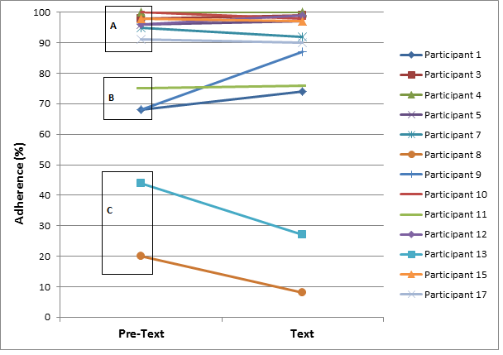

Figure 24 – Sub-groups of baseline adherence – A= Good (80-100%), B = Moderate (50-79%), C= Poor ( <50%)

### 4.4.5 Weekend/ Weekday/ Holiday adherence rates

There was no overall difference between the pre- text and text periods for weekday adherence, weekend adherence, school holiday adherence and mean missed days (table 27).

### 

### 4.4.6 Missed days & doses

There were fewer missed doses during the text period, but the difference was not significant (table 27).

|  |  |  |  |  |  |  |  |  |
| --- | --- | --- | --- | --- | --- | --- | --- | --- |
|  | Mean (SD)  [95% CI]  weekday adherence | Median (IQR) weekday adherence | Mean (SD)  [95% CI] weekend adherence | Median (IQR) weekend adherence | Mean (SD)  [95% CI] school holiday adherence | Median (IQR) school holiday adherence | Mean(SD)  [95% CI] missed doses | Mean (SD)  [95% CI] missed days |
| Pre-text period | 79.5 (25.7)  [65.0-94.0] | 94.1 (73-96)  [ | 79.5 (25.8)  [65.5-93.5] | 95.4 (64-98) | 80.6 (27.6)  [64.9-96.2] | 93.5 (73-97) | 75.9 (104.0)  [19.3-132.4] | 20.2 (38.2)  [0.0-40.9] |
| Text period | 78.5 (29.8)  [61.7-95.4] | 91.5 (77-98)  [ | 80.5 (30.6)  [63.9-97.2] | 95.2 (82-98) | 77.4 (32.8)  [58.8-96.0] | 92.5 (81-95) | 58.1 (71.4)  [19.3-97.0] | 26.2 (51.0)  [0.0-54.0] |
| P | 1.0 |  | 1.0 |  | 0.43 |  | 0.42 | 0.21 |

Table 27 – Other outcome results for the pre-text and text periods. Adherence rates are percentages

|  |  |  |  |  |  |  |  |  |
| --- | --- | --- | --- | --- | --- | --- | --- | --- |
| Participant | Mean adherence (overall) Pre-text | Mean adherence (overall) Text | Mean weekday adherence  Pre-text | Mean weekday adherence Text | Mean weekend adherence  Pre-text | Mean weekend adherence Text | Mean school holiday adherence Pre-text | Mean school holiday adherence Text |
| 1 | 68 | 73 | 68 | 70 | 69 | 83 | 85 | 92 |
| 9 | 68 | 87 | 74 | 86 | 54 | 89 | 68 | 94 |
| 11 | 75 | 76 | 79 | 79 | 64 | 70 | 75 | 80 |

Table 28 – secondary outcome results for the pre-text and text periods for participants with moderate adherence rates. Adherence rates are percentages

### 4.4.7 Feedback Questionnaire

Results from the feedback questionnaire are shown in table 29. The text messages were popular, with 100% of participants finding the messages at least sometimes useful, and 0% of participants minded receiving text messages.

|  |  |  |  |  |
| --- | --- | --- | --- | --- |
|  | Really useful all the time | Sometimes useful | Never useful | |
| Did you find it useful to receive text messages? | 17% | 83% | 0% | |
|  | Weekdays | Weekends | School holidays | Never useful |
| When were texts most useful? | 33% | 22% | 33% | 11% |
|  | Yes | | No | |
| Did you or your parents mind getting texts sent? | 0% | | 100% | |
| Do you think text messages are a good way to remind you to take your nebuliser? | 100% | | 0% | |

Table 29 - Nebtext feedback questionnaire results

## 7.5 Summary

The results from the STAAR study show that there was no difference between the intervention and control groups for the primary outcome, ACQ. The intervention group had significantly higher adherence rates, and significantly lower rates of exacerbation requiring a course of oral steroids or a hospital admission.

The results from the Nebtext study show that the intervention was successfully implemented and patients are amenable to this approach. There were no differences in adherence rates or other outcomes between the text period and the previous 6 months without text message reminders.

In the next chapter I will analyse the results of both studies, and compare them to previous adherence studies.

# Chapter 5 - Analysis of Results

## 5.1 Introduction

In the previous chapter I presented the results of the STAAR and Nebtext studies. In this chapter I will analyse the results of these studies in detail, and postulate why these results were seen. I will compare the results from these studies to those in previous adherence studies, to identify similarities and differences, and theorise as to why these trends were seen.

## 5.2 Aims

* To analyse the results of the STAAR study, and compare these to previous adherence studies.
* To analyse the results of the Nebtext study and compare these to previous adherence studies.

## 5.3 Analysis of results - STAAR Study

The results of the STAAR study show that the intervention used was effective at improving adherence rates, and maintaining these high rates for a year. This is compared to the control group, whose rates were significantly lower, and fell further throughout the study period. Despite this improvement in adherence, there was no difference between the two groups for the primary outcome, ACQ, which improved in both groups. There was however a significantly lower number of asthma exacerbations requiring oral steroids and hospital admissions in the intervention group. Throughout this results analysis and subsequent discussion chapter I will be referring to the previous studies performed using electronic adherence monitors with reminders, feedback or both to improve outcomes in asthma. Table 30 summarises the results of these studies.

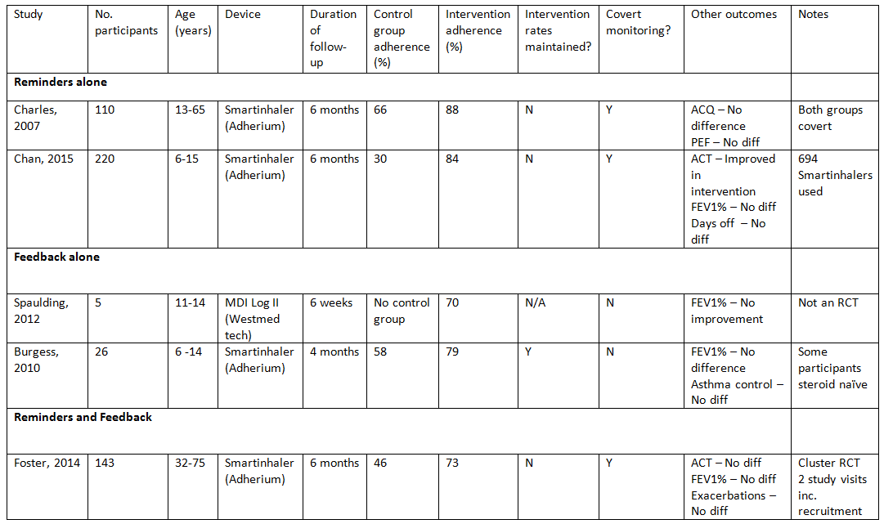

Table 30 – Previous studies using electronic monitoring +/- feedback to improve outcomes in asthma.

References for table 30: ([Charles et al., 2007](#_ENREF_29)), ([Chan et al., 2015](#_ENREF_27)), ([Spaulding et al., 2012](#_ENREF_140)), ([Burgess et al., 2010](#_ENREF_22)), ([Foster et al., 2014](#_ENREF_46))

### 5.3.1 Adherence

The aim of the intervention was to increase adherence rates to inhaled steroids by addressing both the intentional and non – intentional adherence barriers faced by children with asthma. By overcoming these barriers the intervention group had significantly higher adherence rates than the control group at all 4 time points (figure 15, table 12). The high mean and median adherence rates were maintained in the intervention group, but fell progressively in the control group. The intervention median adherence rate was maintained around above 75% for the entire year, but steadily fell from 62% (3 months) to 43% (12 months) in the control group. This study is the first to demonstrate a sustained improvement in adherence rates for a follow-up period of a year. Previous adherence intervention studies have had shorter follow-up periods and seen rates fall over time. Foster et al. ([Foster et al., 2014](#_ENREF_46)) demonstrated improved adherence rates with electronic monitoring, feedback and alarms in adults, but saw the adherence rates fall in the intervention group at each time point for 6 months. In the Foster study, whilst data could be reviewed online, participants only received one formal adherence review in the study, and it is unclear from their methods when this was. Therefore the adherence rates could fall over time with only minimal intervention possible. Charles et al. also significantly increased adult adherence rates using covert monitoring and reminder alarms, but also saw the adherence rates in their intervention group fall progressively during the 6 month follow- up period([Charles et al., 2007](#_ENREF_29)). Chan et al. found similar results in children using the same smartinhaler devices with the reminder alarms switched on ([Chan et al., 2015](#_ENREF_27)). They found adherence rates were significantly improved in the intervention group, but rates fell progressively at each 2 monthly study visit for 6 months. Burgess and colleagues([Burgess et al., 2010](#_ENREF_22)) maintained high adherence rates by feeding back electronic adherence data to children with asthma, but had intensive monthly follow up visits over a short period of 4 months.

The high rates in our intervention group were maintained by regular adherence reviews with open discussion. Any falling rates could be discovered, and barriers identified. Strategies to overcome these barriers could be devised, and targets set for the next study visit. The reminder alarms could prompt use of the inhaler if the dose was forgotten. Strategies to improve adherence rates would often involve utilising the reminder alarms, either by changing times, changing the tunes or changing the location of the inhalers at the times of the alarms. The effect of this is seen in the adherence rates from 3 to 6 months, and 9 to 12 months (table 12, figure 13). At the initial 3 month study visit, the median rate was 81%. With the feedback intervention, rates were then improved at 6 months to 85%. This effect had waned by 9 months, with the median rate lower at 74%. This fall was identified at the adherence review, and the situation could be re-addressed, with a fresh identification of barriers, and development of new solutions. The success of the new strategies was seen at 12 months, when the median rate was back up at 80%. This demonstrates the importance of an on-going and prolonged review of adherence behaviour. New barriers will emerge over time, as children grow and routines change, and these will need to be identified and addressed. Similarly, the effect of any suggested plan to improve adherence is likely to be short-lived, waning over time. This diminishing effect can be identified at adherence reviews and new strategies put in place. Specific examples of adherence rates improving as a result of the feedback reviews are shown in appendix 4.

The 3 month median control group rate in our study was 62%, which steadily fell to 43% by 12 months. The initial higher rate is likely due to the Hawthorne effect. Control participants were aware their adherence was being monitored in a study, and were also educated about the importance of adherence taught in the primer session. They therefore took their preventer inhalers more often in the period after recruitment, either due to self- motivation, or prompting by parents. This effect waned throughout the year as their behaviour gradually returned to normal, and their adherence rates returned to baseline levels in the absence of intervention.

The falling adherence rates seen in our control group, in the absence of intervention, were also reported in the control groups of the Chan, Foster, Charles and Burgess studies, with end study median rates of 30%, 29% and 73% and 55% respectively after 6 months (4 months in the Burgess study). In 2012 Jentzsch and colleagues performed a study of 102 childhood asthmatics, where adherence rates were electronically monitored over a year, in the absence of intervention ([Jentzsch et al., 2012](#_ENREF_71)). The median adherence rates fell progressively from 48% at 4 months, to 42% at 8 months, and just 39% at 12 months. The 39% at 12 months seen by Jentzsch et al. is similar to the median 43% see in our control group.

AM & PM adherence

Afternoon adherence rates were significantly higher than those in the morning in both groups, at all 4 time points (table 13). Both morning and afternoon rates were significantly higher in the intervention group at all 4 time points (table 14). The likely reason for higher afternoon rates is that morning doses had to be taken within a limited time frame in the week, between getting up and before the child left for school. This is often a busy time for families, and inhalers are easily forgotten. If the dose was missed, and the child went to school, even if they later remembered, they couldn’t take the medication. In the intervention group, when everyone had gone out in the morning, even if the device played reminder alarms, neither the child nor family was around to hear them. In contrast, there was far more time in the evening to take inhalers. Children could have taken their inhalers at any point between returning from school and going to bed, with more time available, and the opportunity to later remember forgotten doses was far greater. In the intervention group, the reminder alarms would have been more effective in the evening. When alarms sounded, there was more chance the child, parent or sibling is in the house to hear them and prompt inhaler actuation. This pattern of higher adherence in the evenings has been previously recorded both in children with asthma ([Jonasson et al., 2000](#_ENREF_75)) and CF ([McNamara et al., 2009](#_ENREF_92)).

### 5.3.2 ACQ

Despite significantly higher adherence rates in the intervention group, maintained for a year, there was no overall significant difference in the ACQ score between the intervention and control groups (tables 6,7,8 & 9, figure 13). At nine months, the mean ACQ in the intervention group was significantly lower than in the control group (1.4 vs. 2.0), but by 12 months this difference had disappeared (table 6).

The ACQ scores improved significantly in both groups by 3 months, and this improvement was maintained beyond the minimal important difference (MID) for the ACQ of 0.5 throughout the 12 months (table 6). One reason for this is the inclusion criteria for the study. Participants were only eligible for the study if their ACQ score on the day of recruitment was less than 1.5, signifying poorly controlled asthma in the past week. These poorly controlled asthmatics saw a clinician on the day of recruitment, who used their clinical judgement to make a suitable plan to improve clinical symptoms. This may have been in the form of increased inhaled steroid doses, add –in therapy, or a course of oral steroids. Therefore it is very likely that the patients who were poorly controlled on the day of recruitment would improve from that time forward, as seen with the ACQ scores. Patients who were well controlled on the day of recruitment but whose asthma control later deteriorated were ineligible for the study, and therefore a pattern of falling ACQ scores throughout the study, in either group was highly unlikely.

Another reason for improved ACQ scores in both groups was the Hawthorne effect ([McCarney et al., 2007](#_ENREF_88)). The control participants received the primer education package emphasizing the importance of regular inhaled steroids, and then a device was attached to their inhaler which electronically monitored their adherence, and they were fully aware of this. They were more aware of adherence issues, and habits will have changed as a result, potentially increasing adherence rates. An example of this is a parent in the control group who came to a study visit saying that since the study started they had set regular alarms on their mobile phone to remind their son to take his inhalers (example with adherence graph shown in appendix 4). Another way the Hawthorne effect could improve the ACQ in the control group was the persistence of study visits within the standard asthma clinic. When a participant in the study was due in clinic, the patient or parent was called by a member of the study team to remind them to bring their device for download. This prompted participants to come to clinic who would have otherwise forgotten, or not attended for other reasons. Despite this there was still a high rate of non- attendance or cancelled appointments in the study (table 18, discussed further later). When these appointments were missed, a member of the study team asked the clinical team to re-book the appointments, or arranged an additional non clinical study visit (15 intervention, 20 control group). This increased attendance and clinician contact throughout the year would have had positive effects on the participants’ asthma control in both groups.

Participants in the control group were admitted to hospital more frequently, and received more courses of oral steroids than those in the intervention group (tables 15 &16, figures 18 &19). It has been shown that hospital admissions improve asthma control and adherence to inhaled steroids in the period post discharge ([Williams et al., 2004](#_ENREF_157)), and this was potentially seen with the improved ACQ scores. If the control participants received more courses of oral steroids, either from their GP or ED, their asthma control is likely to have been improved as a result, reflected in lower ACQ scores.

The Foster and Charles studies recorded a similar pattern of self- reported outcomes in adult participants ([Foster et al., 2014](#_ENREF_46), [Charles et al., 2007](#_ENREF_29)). In the Foster study, participants in the intervention group had increased adherence, fewer objective exacerbations (although not significantly) and improved self-reported asthma control in both groups, with no between- group differences using a similar intervention. This shows that even in adults, whose understanding of questionnaires is greater, subjective self-reported asthma questionnaires may not give the most accurate indication of true asthma control. In the Charles study, despite significantly higher adherence rates, there was no difference between groups for ACQ scores.

Alternatively, the explanation of why there was not a significant between - group difference in self- reported asthma control despite improved adherence was that the ACQ scores were subjective, and not an accurate reflection of asthma control. The control participants required significantly more hospital admissions, and more courses of oral steroids, both objective measures showing poorer asthma control, yet their self -reported ACQ scores were equivalent to those of the intervention group.

The ACQ score is a subjective measure, which is dependent on the opinion of the child about their symptoms on that day. Children in the intervention group may have felt comfortable to answer more honestly about the severity of their symptoms, as there was improved open dialogue with the study team due to the non-judgemental adherence discussions. The control participants may have been more guarded with their answers, and been in denial of symptoms, as is known to be the case in standard clinical practice, particularly in adolescents ([Osman, 2002](#_ENREF_111)). Also, if control participants knew their adherence had been poor and was being recorded, they may deny symptoms in a show of defiance to parents and doctors that the medication and adherence intervention was not necessary ([Horne and Weinman, 2002](#_ENREF_65)). In addition, the ACQ only reflects short term asthma control (previous 7 days). A patient with generally poorly controlled asthma could report a low score after a recent course of steroids, or a generally well asthmatic could score highly due to an acute flare- up due to a viral exacerbation.

The ACQ is validated for children aged 6-16, and it is recommended that for patients under 10 years of age, the questionnaire is administered by a clinician or study member ([Juniper et al., 2010](#_ENREF_77)). To ensure the administration of the ACQ was accurate and universal throughout the study, all participants had the questionnaire administered by a study team member. Whilst this seemed the most objective way to perform the questionnaire, it may have been that the results for participants over 10 years were less accurate as a result, with children over 10 preferring to have their own time to answer questions without the influence of clinicians or parents/ carers. Some experts have questioned the validity of the ACQ in children, in particular it’s universal applicability for all age groups, particularly if there is a variation of its administration away from the age specific protocol, as there was in our study ([van den Bemt et al., 2011](#_ENREF_147)).

An alternative questionnaire to the ACQ would have been to use the Asthma Control Test (ACT). This questionnaire is similar to the ACQ, and is validated in children as young as 4 years ([Liu et al., 2007](#_ENREF_84)). The test is potentially advantageous, as it is less time specific, asking about asthma control over 4 weeks. The authors of the ACT say it is also easier for children to understand, as it has simple smiley or sad faces to indicate control. The study by Chan et al. used the ACT to record self-reported asthma control, and showed that the increased adherence rates achieved by electronic adherence monitoring and alarms was accompanied by significantly increased ACT scores in the intervention group ([Chan et al., 2015](#_ENREF_27)). However, they failed to show an improvement in any objective clinical outcomes. The ACT is potentially even more subjective than the ACQ, with scores entirely dependent on the child’s opinion (no score for lung function) and self- administered, rendering it susceptible to parental help and influence on answers. The intervention group in the Chan study may have answered more positively, with help from parents, due to the regular (2 monthly) interactions with a study team helping their asthma, with replacement electronic devices which were novel and fun given each time. In contrast, the control group were covertly monitored. Without gaining anything from the additional study visits and potentially feeling cheated if they had realised the true function of the monitors, they may have answered more negatively, knowing it would not affect their clinical care.

Both questionnaires were initially designed for adults, and when validated in children, both the authors of the ACQ ([Juniper et al., 2010](#_ENREF_77)) and ACT ([Liu et al., 2007](#_ENREF_84)) acknowledge their limitations. There will always be difficulties performing these tests on children, who will find certain answers and phrases more difficult to understand and interpret in relation to how well their asthma is controlled. The ACQ was chosen for this study because it has an objective element (FEV1%), and it is has the most robust validation in children aged 6-16 years ([Juniper et al., 2010](#_ENREF_77)).

Another possible explanation for a lack of improvement in ACQ was because the intervention was not effective enough, and the improved adherence rates achieved were insufficient to improve asthma control. Williams et al. reported a significant improvement in asthma control with prescription refill adherence rates in excess of 75%, with actual rates likely to be lower than this (as there is no guarantee all dispensed medication is taken ([Williams et al., 2011](#_ENREF_155))). The electronically recorded mean rate of 70%, or median rate of 80% in the intervention group should therefore have been sufficient to improve asthma control as it did in the large cohort of adult patients studied by Williams et al, and as would be apparent by the fewer exacerbations seen requiring oral steroids or a hospital admission.

A further possible explanation for why the ACQ scores weren’t improved in the intervention group is because the adherence rates recorded by the monitors were misleading. Adherence rates were recorded when the device was pressed, rather than a direct measure of inhalation with the correct technique. This is a limitation of the study which will be discussed further later.

However, regardless of the actual adherence rate in both groups, when objectively measured (doses of oral steroids required or hospital admissions), the asthma control in the intervention group was better than that in the control group. Therefore it is likely that it was the ACQ scores which were inaccurate due to subjective measurements. However, this study was not powered to detect between-group differences in rates of oral steroid use and hospital admissions, but to detect a difference in ACQ. Given the potentially subjective nature of this questionnaire, and the scope for variability, it may be that the minimum important difference of 0.5 was too small, and in order to detect a difference in ACQ, the MID and corresponding sample size should have been larger.

### 5.3.3 Lung Function

Rosenthal FEV1% predicted data

Table 10 shows that the FEV1% improved from baseline in both groups, at all 4 time points. The improvement from baseline was not significant in either group however, and there was no significant difference between groups.

GLI FEV1% predicted data

Table 11 shows that in the intervention group, the FEV1% predicted improved from a mean of 87.2% at baseline, to 91.4% at 12 months. This improvement was not quite statistically significant however (P=0.08). When a combined mean of all the FEV1% predicted values for all 4 study visits was calculated for each participant and compared to baseline, there was also an increase to 91.3%, Again, this improvement from baseline during the study was not quite significant (P=0.056). In the control group, the mean FEV1% fell from baseline (88%) at 3 and 6 months, and returned to the baseline value at 9 and 12 months. Whilst the intervention group had higher FEV1% predicted values throughout the study, there was not a significant difference between the 2 groups at any time point, or for the combined study visit means (table 11).

The lung function in the intervention group is likely to have increased due to the improved asthma control brought about by sustained higher rates of adherence to inhaled steroids. Potentially, the difference from baseline and between the 2 groups failed to reach significance because only 72% of the lung function values were available as a GLI FEV1% predicted, which was more accurate in our ethnically diverse study population, and sensitive to change. With all the data available for GLI FEV1% values, we may have seen a significant increase in lung function in the intervention group.

The slightly improved FEV1% in the control group may reflect the short term nature of FEV1%, and the higher values may be due to a recent course of oral steroids, which were more common in the control group. FEV1% is also improved by the recent use of long acting beta agonists, and participants in the control group are likely to have taken these on the morning of the study visit, as they knew they were coming to clinic.

Alternatively, it may be that the lung function in the intervention group did not improve significantly despite improved asthma control and fewer exacerbations because FEV1% predicted is not actually an accurate measurement of asthma severity and airway obstruction in children. Indeed, some studies looking at large sets of FEV1% predicted data in childhood asthmatics have concluded that the severity of asthma is not accurately represented by FEV1% predicted ([Paull et al., 2005](#_ENREF_118)).

The comparative adherence intervention studies by Chan, Foster, Charles and Burgess also failed to show a significant improvement in FEV1% predicted between treatment groups despite increased adherence rates. In the Chan study, both groups had increased FEV1% from a baseline mean of 90% (control) and 92% (intervention), to a 6 month FEV1% of 97% in the control group and 101% in the intervention group. However, the between group difference was not significant ([Chan et al., 2015](#_ENREF_27)). The adults in the Foster study had lower baseline FEV1% (77%), and there was no improvement in either group throughout the study ([Foster et al., 2014](#_ENREF_46)). In the Burgess study, the baseline FEV1% was also lower, at 75%, and was increased in both groups to 87% ([Burgess et al., 2010](#_ENREF_22)). Interestingly, none of these papers published which comparative data reference values they used, which would suggest they did not convert the data to the GLI values (apart from the Burgess study, which was performed before the GLI reference values were published). By using outdated and inaccurate data reference values, their chances of recording a significant improvement or difference between groups was potentially reduced.

### 5.3.4 Oral steroids required

The participants in the intervention group required significantly fewer courses of oral steroids per 100 days in the study than those in the control group (table 15). Figure 18 shows that the control group required more steroids throughout the study, and the rates in this group were further increased in the second 6 months. Courses of oral steroids required are an objective measurement of asthma control, and a good reflection of the total number of significant asthma exacerbations, as they are prescribed by any clinician who assesses the child to be unwell, whether this is at the GP, in ED, during a hospital admission or in the asthma clinic itself.

These results suggest the increased adherence to inhaled steroids in the intervention group improved asthma control to a degree where exacerbations were fewer, and fewer steroids were required. During the second 6 months of the study, control group adherence rates continued to fall whilst the high rates were maintained in the intervention group. By the second six months, any Hawthorne effect had diminished in the control group, and as their adherence rates fell to baseline levels, they suffered an increased number of exacerbations requiring steroids.

Williams et al. analysed the adherence and outcome data for 298 adults enrolled onto a prospective asthma cohort study ([Williams et al., 2011](#_ENREF_155)). By reviewing prescription refill data and calculating hazard ratios, they concluded that a mean adherence rate of 75% is required to significantly reduce the chance of an exacerbation requiring oral steroids, a hospital admission, or an attendance at ED. Given that the adherence data in the Williams study was prescription refill, and only measures dispensed rather than taken medication, the actual adherence rates required to reduce the chance of an exacerbation are likely to be lower. Our study supports this association, with participants in the intervention group having a mean adherence rate of 71% (median 75%), and suffering significantly fewer exacerbations requiring steroids or a hospital admission than those in the control group with lower mean rates of 49% (median 51%).

The rates of oral steroids required and GP attendances during the study were self-reported, and potentially inaccurate. Therefore we made an amendment, and obtained GP data about the number of courses of steroids required and GP attendances for the study year and previous year. Ethical approval of the amendment meant data could only be obtained if the consent form was sent back by parents, and the GP practice filled in the data retrieval form. Due to this data was only available for 10 participants in the intervention arm, and 19 in the control arm. This data showed that both groups required fewer oral steroids and GP attendances in the study year (table 21). The intervention group seemed to require far fewer courses of oral steroids than the control group (mean 0.4 vs. 1.2, table 22), although the difference was insignificant (P= 0.06), possibly due to the small participant numbers.

Bender et al. studied electronic adherence data for 104 children with asthma, and investigated associations between adherence and asthma control. They also found that poor adherence rates led to significantly increased rates of exacerbations requiring oral steroids, but had no effect on self-reported asthma control ([Bender and Zhang, 2008](#_ENREF_12)). In one of the first studies using electronic monitors to record adherence in children with asthma, Milgrom and colleagues investigated patterns of exacerbations in 26 children aged 8-12 ([Milgrom et al., 1996](#_ENREF_96)). They found that over 13 weeks, the participants who had at least one exacerbation requiring a course of oral steroids had significantly lower adherence rates (median 14%) than those who did not (median 68%). In contrast to these findings, Klok et al. investigated the relationship between adherence and asthma control in a group of 81 children aged 2-6 and found no relationship between adherence rates and courses of oral steroids required ([Klok et al., 2014](#_ENREF_79)). However, all the children in this study had unusually high adherence rates (median 87%), as they were involved in an intensive asthma education and support programme. Only 15 courses of steroids were required in total over the year follow-up, possibly due to the overall high adherence rates, and there was no difference between the median adherence rate (87%) for those that required the steroids and those that didn’t (87%). Due to their age, a high proportion of these children did not have true atopic asthma, but instead episodic viral wheeze, in which oral steroids have been shown to be ineffective for exacerbations ([Panickar et al., 2009](#_ENREF_114)).

Our study is the first to demonstrate a significant decrease in exacerbations requiring oral steroids using this approach. There was no significant difference seen between groups in the studies by Chan ([Chan et al., 2015](#_ENREF_27)), Burgess ([Burgess et al., 2010](#_ENREF_22)) or Foster ([Foster et al., 2014](#_ENREF_46)). The high rates of adherence achieved in our intervention group and maintained over the year is likely to be the reason for this difference. The other studies failed to maintain high rates of adherence, and only had short follow up periods of six months (four months in the Burgess study). The control group required more oral steroids in the second six months, as their adherence fell, and it is these second six months when the difference between groups became statistically significant (figure 18).

### 5.3.5 Hospital Admissions

The rate of hospital admissions for the participants in the control group per 100 days in the study was 5 times higher than those in the intervention group, a significant difference (table 15). In total, participants in the control group required 16 hospital admissions over the year, compared to just 4 in the intervention group (table 16). The control group participants had a high admission rate in the first 3 months (7 admissions), and then increasing rates over the next 9 months, with a similar trend to that seen with oral steroids required in the last 6 months of the study (figure 19). The initial high rate of admissions required could be a reflection of their poorly controlled asthma at the time of recruitment (and hence eligible for the study). In the 3 months after recruitment, they continued to have poorly controlled asthma requiring an admission. Their subsequent rates of admission then fell after the admission as they gained better control of their asthma, possibly through courses of oral steroids and increased surveillance by GPs and hospital clinicians. The rates then gradually increased as the time after the admission increased and their control deteriorated. The participants in the intervention group were protected from these early admissions by having higher rates of adherence to inhaled steroids (median rate 81 vs. 62%, table 12) and better asthma control as a result.

In the second 6 months of the study, hospital admission rates increased in the control group (figure 19). As the adherence rates in the control group declined, asthma control deteriorated, and a hospital admission was more likely to be required. In comparison, the participants in the intervention group maintained high adherence rates, better asthma control, and required significantly fewer admissions. When analysing the data for the 20 hospital admissions required in this study, for both groups, the mean adherence rate for the 3 months preceding an admission was 47%.

These results are in support of the above Williams paper, which concluded that during their analysis of 298 adults with asthma, those with lower rates of adherence were significantly more likely to require a hospital admission ([Williams et al., 2011](#_ENREF_155)). Williams and colleagues previously performed a similar large retrospective cohort study of 176 adults’ prescription refill data to investigate the link between adherence and hospitalisations. They concluded that for every 25% increase in time without inhaled steroids, the rate of asthma related hospitalisation doubled ([Williams et al., 2004](#_ENREF_157)).

### 5.3.6 GP/ ED attendances

There were similar rates of attendance to GP and ED in both the intervention and control groups (table 15). Figure 16 shows that for the first 6 months, both groups required more attendances than in the second 6 months. Although the intervention group visited their GP or ED more frequently in the first 6 months, they required fewer courses of oral steroids or hospital admissions. In our group of poorly controlled asthmatics, patients and families will have been used to visiting GPs regularly to get symptoms checked, with earlier attendance or milder symptoms due to a past history of severe exacerbations. This pattern of habitual attendance may have been exacerbated in the first 6 months in the intervention group, due to a heightened awareness of symptoms due to the reminder alarms and increased exposure to their asthma. As the study progressed into the second six months, the higher rates of adherence and improved asthma control in the intervention group gradually decreased the need for as many attendances at the GP or ED.

The other comparable studies using electronic monitoring and reminders to improve adherence either did not have attendances as an outcome ([Foster et al., 2014](#_ENREF_46)) , ([Burgess et al., 2010](#_ENREF_22)), or did not report their results for the outcome, presumably because there was no difference ([Chan et al., 2015](#_ENREF_27)).

In our study, during the first 6 months, the participants in the control group went to the GP or ED fewer times, but when they did go, they were more unwell, and were more likely to require a course of steroids or an admission.

As with courses of steroids, the amendment GP data obtained showed that both groups required fewer attendances at the GP in the study year compared to the previous year (table 21). During the study year, those in the intervention group required far fewer attendances than the previous year, although the difference was not significant. During the study year, those in the intervention group required fewer GP visits than those in the control group, but the difference was not significant (table 22).

These higher rates of attendance for those in the control group and lower adherence rates would support the findings of a study by McNally et al., who looked at the relationship between adherence rates (prescription refill) and attendances at GP and ED for 63 children aged 5-17 ([McNally et al., 2009](#_ENREF_91)). They found that the rates of attendance were significantly higher in the group of children with low adherence rates (lowest 25% of participants) than those with the highest rates (top 25% of participants).

During the second six months of the study, participants in the control group went to the GP or ED more frequently than those in the intervention group (figure 16). This increased trend at 6 and 9 months mirrors that seen for courses of oral steroids, hospital admissions, and school days lost (figures 17-19). As adherence rates in the control group fell to lower baseline levels, asthma control deteriorated and they required increasing numbers of GP/ED attendances, courses of oral steroids, days off school and hospital admissions. This is in comparison to the intervention group who maintained higher adherence rates to inhaled steroids and subsequently better asthma control.

### 5.3.7 Days off school due to asthma

Over the duration of the study, there was a lower rate of days off school due to asthma per 100 days in the intervention group, but this difference was not statistically significant (tables 15 & 16). This data is based on all the participants randomised (47 vs. 42), a full ITT analysis. The full ITT analysis included two participants in the intervention group who dropped out of the study because they took the device off the monitor at the start of the study and lost it. They therefore had no reminders or any electronic adherence monitoring. Between these two participants, they had a total of 32 days off school due to asthma over the year, more than 6 weeks (event rate of 4.4 school days missed per 100 days on study). When the data was analysed with a modified ITT, without the data from those whom dropped out, the event rate was significantly lower in the intervention group (1.21 vs. 1.63, P=0.006).

Analysing all the data with the full ITT, Figure 17 shows that there were more days off in the intervention group at 3 and 6 months, and this trend is reversed at 9 and 12 months. Days off school is a subjective measurement, with different patients and families having different thresholds for staying off school, and parents often generalising rates over the 3 month period. It may be that in the first 6 months of the study, the intervention participants and families were far more aware of their asthma on a daily basis, due to the regular alarms, and increased medication taking. Potentially, children may have used this to over emphasize symptoms to take time off school. Alternatively, when recalling days off in the past 3 months, parents may have attributed any days off unwell for any other cause (e.g. febrile, coryzal) to asthma, due their increased awareness of the condition and willingness to co-operate with the study. The trend is reversed in the second 6 months, with intervention participants requiring fewer days off, possibly due to better asthma control due to increased adherence to inhaled steroids.

In the electronic monitoring and alarms without feedback study by Chan et al, they investigated days off school as their primary outcome, but also failed to show a significant difference between groups ([Chan et al., 2015](#_ENREF_27)). The control group also had a higher percentage of days off during the 6 months study period (1.9% vs. 1.7%), although the difference was not significant. Although days off school was a primary outcome for this study, and the power calculation for the study was based on this outcome, they still used parental report to assess the number of days off, and analysed total school days off rather than those just related to asthma. It is therefore perhaps not surprising that an intervention designed to improve solely asthma control had no effect on all causes of school absence.

### 5.3.8 Quality of Life

The quality of life for participants in both groups (mini PAQLQ score) significantly improved throughout the study (figure 20, table 17). As with the ACQ scores, this is likely to be due to all participants having poorly controlled asthma at recruitment. The trend of poorly controlled asthma improving was inevitable as only poorly controlled (ACQ >1.5) participants were eligible. Any asthmatics who were well controlled at baseline but later became more unwell throughout the study period were ineligible, and therefore the overall trend of improving asthma control with associated improvements in quality of life was seen. In addition, as previously described, the Hawthorne effect meant that participants in the control group had better asthma control, and quality of life as a result. As with the ACQ, the PAQLQ is a subjective measure, and children may have answered with more denial of symptoms in the control group. Many questions on the mini PAQLQ are very similar to those on the ACQ, accounting for the similar results of improving scores in both groups.

When this intervention was used in adults in the Foster study, they also reported a significant increase in quality of life scores for both groups during the study from baseline, with no between group differences ([Foster et al., 2014](#_ENREF_46)). The studies by Chan, Charles and Burgess did not record quality of life scores as an outcome.

### 5.3.9 Inhaled Steroid Dose & BTS stage

Table 17 shows that the dose of inhaled steroids increased in the control group, but decreased in the intervention group, although this difference was not significant. Potentially, the control group participants’ dose of inhaled steroids was progressively increased by clinicians in line with BTS stepwise recommendations, as the asthma control remained poor. In the intervention group, as asthma control improved, the dose of inhaled steroid required was weaned. These changes in inhaled steroid doses meant that the mean BTS stage remained the same for participants in the intervention group at 12 months, and slightly increased in the control group, although again, the difference was not significant.

### 5.3.10 Medicines Beliefs & Illness Perceptions

Table 17 shows that the medicine beliefs and illness perceptions for participants in both groups improved from baseline to 12 months. The difference was not significant, and there was no difference between groups however. This would indicate that by being involved in a research study with regular asthma education improved all participants’ views about asthma and the benefits of inhaled steroids. Unfortunately, due to the questionnaires being sent out to participants as described in changes to methods, not all questionnaires were completed at 12 months. Questionnaires were only sent to those participants in Sheffield (n=81), and although 81 were sent out, only 25 were received back in pre-stamped envelopes (12 group A, 13 group B). Therefore the results are potentially biased, as these 31% of responses are more likely to have come from the participants with better engagement with services and therefore a more positive view of asthma and inhaled steroids.

## 

## 5.4 Analysis of Results – Nebtext study

The results of this study show that it was feasible to send reminder text messages to children and adolescents with CF, and they are amenable to this approach. In a group of patients with high baseline adherence already receiving regular feedback, rates were not increased further by the addition of reminder text messages. This was the first study in children or adults with CF to use text message reminders in an attempt to improve electronically recorded adherence rates to nebulised medication.

### 5.4.1 Overall adherence rates

When manually analysed, the mean adherence rate for the pre-text period was high, at 81%, and this rate was maintained but not increased at 80% during the 6 month text period (table 26). Of the 13 participants with data analysed, rates were increased by at least 5% in 2 participants, unchanged in 9, and decreased by at least 5% in 2 (figure 23).

The majority of participants in this study already had established systems in place to facilitate taking their nebulisers on a regular basis. These systems were successful due to regular adherence reviews with the physiotherapists in clinic, emphasizing the importance of good adherence, identifying any barriers and subsequent fall in rates, and developing strategies for improvement if necessary.

The text messages did not improve rates overall due to a ceiling effect. The rates were already optimal (>90%) in the majority of participants, and therefore there was little or no potential for rates to be increased further.

The pre-text and text period adherence rates seen in our study are higher than those published by other studies analysing electronic adherence data in children with CF. In 2009, McNamara et al retrospectively reviewed I-neb data for 28 children aged 2-14 years in Liverpool, UK ([McNamara et al., 2009](#_ENREF_92)). They recorded a mean rate of 67% over 12 months, with rates significantly higher in the evenings. This figure was supported by Ball et al in 2013, recording a mean rate of 65% over 12 months for 24 adolescents aged 11 to 16 years in Liverpool and Leeds ([Ball et al., 2013](#_ENREF_6)). The difference seen could be due to the timing of the studies. When the McNamara and Ball studies were performed, the I-neb technology was relatively new, and adherence reviews were just being developed. In the years since these studies, and based on their results, adherence reviews in CF clinics have become more established, with physiotherapists and patients more familiar with the approach. The adherence reviews used now are therefore more effective, with better strategies in place to facilitate the improved adherence rates seen in our study.

Alternatively, the difference in rates seen could be due to different methods used. Both the McNamara and Ball studies reviewed adherence data retrospectively, analysing all I-neb data from participants attending clinics in their centres. With this approach, data from all participants, and not just the most adherent can be analysed. In our study, the prospective nature and the necessity of informed consent meant that any participants could refuse consent, or withdraw from the study. It is likely that the participants with low existing rates of adherence would be less keen to participate, potentially leaving only the more adherent participants in the study. If this was the case, the adherence rates in our study population are not truly representative of the overall rates for children with CF in Sheffield. We can perhaps presume that the overall rates are similar to those retrospectively recorded in Liverpool in Leeds, as they are similar populations.

The 13 participants in our study can be sub-divided according to their baseline adherence rates to good (>80%), moderate (50-79%), and poor (<50%) (figure 24). Of the 8 participants with good pre-text adherence rates >80% (figure 24, group A), all 8 actually had rates in excess of 90%. All of these high rates were maintained during the text period. The effective systems in place to facilitate these high adherence rates are likely to reflect positive views towards CF and nebulised medication, which are supported and maintained during the regular adherence reviews in clinic.

In the 3 participants with existing moderate rates of adherence (figure 24, group B, table 28), rates improved by at least 5% during the text period in two, and remained the same in the third. This would suggest that text message reminders were potentially of use in participants with existing moderate rates of adherence. In this group, although some successful systems were in place to facilitate taking their nebulisers, they were not optimal, and doses were often forgotten. The reminder text messages prompted use of the nebulisers on the occasions they would have been forgotten, and in conjunction with the adherence reviews, rates were improved. Without the selection bias due to potentially only adherent participants taking part and staying in the study, it is likely far more patients actually had existing moderate adherence rates, equivalent to those seen in the retrospective analyses by McNamara and Ball. Therefore, it is possible that if the text messages were sent to all children and adolescents with CF in Sheffield, or just those with pre-existing moderate adherence, a greater effect would have been seen, with rates improved during the text period.

In the sub-group of 2 participants with poor pre-text adherence (figure 23, group C), rates fell even further during the text period. These participants did not have any effective systems in place for facilitating the regular use of their nebulisers, despite regular adherence reviews in clinic. This is likely to reflect negative attitudes towards CF and nebulised medication. In the absence of any effective systems to facilitate taking nebulisers regularly, text messages alone were unable to improve adherence rates. During the text period, rates actually fell, potentially indicating that they were detrimental. This is an important finding in any adherence intervention study. In the patients with the lowest adherence rates and regular clinic reviews, there may have been a level of conflict between patients and parents, due to the known poor adherence identified in clinic. This conflict would potentially lead to oppositional behaviour from the child around the times nebulisers were due, a common barrier cited by parents and adolescents([Modi and Quittner, 2006](#_ENREF_99)). The text message reminders may have further added to the conflict and oppositional behaviour on a daily basis, and rates fell even further as a result.

If text messages were to be used in clinical practice, the fall in rates would be identified at the adherence reviews, and their popularity could be discussed. If it was apparent that texts were not helping, and fuelling negative responses and oppositional behaviour, they could be stopped. Reasons for non-adherence could be explored prior to commencing texts, and only those in whom non-intentional barriers were identified would then be eligible to receive texts.

### 5.4.2 Weekday/ Weekend/ Holiday adherence rates

The overall mean adherence rates at weekends, weekdays and school holidays were high in the pre-text period, and they did not significantly change during the text period (table 27). There was no overall difference between weekday, weekend or holiday rates in either the pre-text or text periods. These results differ from those seen by Ball et al, who reported significantly lower rates of 60% on weekdays, compared to 67% at weekends, and 51% in school holidays, compared to 66% during term time ([Ball et al., 2013](#_ENREF_6)). The overall adherence rates in the Ball study were lower due to retrospective data collection, and it is likely that rates were lower at weekends and holidays in the absence of routine. During the week in term time, people often have standard and structured routines, into which regularly taking nebulisers can be integrated. At the weekend and during school holidays however, these routines around which to arrange nebulisers are absent, with activities and times varying on a daily basis, and therefore doses are more easily forgotten. In addition, during the I-neb adherence reviews, plans made to improve adherence are usually based on routine, for example taking nebulisers before school, or after evening clubs, resulting in the higher rates seen during weekdays in term time. Our overall adherence rates were higher, showing that the effective routines in place for the participants were successful during the week and at weekends both in term time and holidays.

When the results are analysed for the 3 participants with moderate pre-text adherence (table 28), weekend and holiday rates were increased by at least 5% in all 3 participants during the text period. This would suggest that the text messages were potentially useful for reminding these participants to take their nebulisers in the absence of their usual routine, when doses may have been otherwise forgotten.

For participants with low pre-text adherence rates, there was a further fall in adherence rates during weekdays, weekends and school holidays, suggesting the text messages were of no value during those times, or even detrimental. The messages may have exacerbated oppositional behaviour, particularly at weekends and holidays when children and adolescents want to relax and enjoy their spare time, but parents try and persuade them to take their nebulised medication.

### 5.4.3 Missed doses/ days

There were fewer missed doses during the study period overall, although the difference was not significant (table 27). There were more total days missed during the text period, but again the difference was not significant. Potentially the fewer missed doses were due to the text messages prompting participants to take doses they would have otherwise forgotten. The majority of the days (75%) missed during the text period were by the 2 participants in the study with the lowest adherence rates, skewing the data and making any interpretation difficult.

### 5.4.4 Feedback Questionnaire

The results from the feedback questionnaire show that the majority of participants found the text messages useful some of the time rather than all of the time (table 29). This would indicate that text reminders would be of more use for short periods of time, with greater impact. Texts could be sent for short periods when adherence is particularly important, for example during pseudomonas eradication regimens or school holidays ([Doring et al., 2012](#_ENREF_39)).

Participants found the messages equally useful during weekdays, weekends and school holidays. All participants thought text messages were a good idea to remind people to take their nebulisers, and no-one minded being sent text reminders during the study.

## 5.5 Summary

In this chapter I have analysed the data from the two separate studies, and postulated why these results were seen. In the STAAR study, the improved and sustained adherence rates in the intervention group led to improved asthma control, with participants suffering fewer exacerbations requiring a course of oral steroids or a hospital admission. Despite the improved adherence, there was no difference between groups for the ACQ scores however. This is potentially because the ACQ is a subjective questionnaire and does not accurately reflect the asthma control of the participants. Alternative explanations for the no difference in ACQ are that the adherence rates recorded were misleading, or the study was not sufficiently powered to show an improvement in clinical control measured by this questionnaire.

The results of the Nebtext study show that the text message intervention was feasible and popular, but the texts did not further improve high baseline adherence rates. The baseline adherence rates in this study were higher than those recorded retrospectively in similar studies and therefore the potential for improvement was limited.

In the next chapter I will discuss the results of these two studies further and how they should influence further research in the field.

# Chapter 6 - Discussion

## 

## 6.1 Introduction

In this chapter I will discuss the strengths and limitations of the STAAR and Nebtext studies individually in order to verify the validity of the results. I will then combine the findings of the two studies, along with other published work to identify the most and least successful aspects of adherence interventions. Based on what I have discovered in the two studies, I will recommend the direction of future research studies in the field.

## 6.2 Aims

* To discuss the strengths and limitations of the STAAR and Nebtext studies
* To identify the common most successful facets of the interventions
* To use the results of these studies to inform future research in the field

## 6.3 Strengths of the STAAR study

The STAAR study is the first to use electronic monitoring with feedback and alarms in a clinically practical way to improve and maintain adherence rates to inhaled steroids over a prolonged period of time. These improved rates of adherence significantly decreased the number of severe exacerbations requiring oral steroids or hospital admissions.

The study has good external validity, and generalizability to all poorly controlled childhood asthmatics in the UK, as the participants were recruited from asthma clinics, in both a tertiary hospital and district general hospital. Study visits were performed in these standard asthma clinics, with minimal extra clinician contact in either group and all clinical decisions made by clinicians and not study team members. The follow-up period of a year was long enough to ensure any effect of the intervention was sustainable in clinical practice, and not short-lived due to the Hawthorne effect. The median adherence rate in our control group of 51% is equivalent to the median rate of 53% seen when all the data was pooled from the 20 previous studies which had electronically recorded adherence rates in children (see introduction).

### 6.3.1 Strengths in comparison to previous studies using electronic adherence monitoring

In comparison to previous studies performed using similar interventions to improve adherence and outcomes, our study is the first to show a sustained improvement in adherence rates over a prolonged follow up period of 12 months, and the first to report a significant improvement in asthma exacerbations.

Our study has significant methodological advantages over the four previous RCTs using electronic monitors and alarms with or without feedback (table 30). In 2010 Burgess and colleagues reported significantly improved adherence (median rates 79% vs. 58%) using electronic monitoring (smartinhalers) and feedback in a group of children aged 6 to 14 years ([Burgess et al., 2010](#_ENREF_22)). They randomised 26 children with poorly controlled asthma (14 intervention vs. 12 control) to receive either electronic adherence monitoring and monthly feedback (with no reminder alarms), or electronic monitoring and no feedback. The participants in the control group were covertly monitored. All participants were changed onto fluticasone inhalers, and they were seen intensively (every month) for a short follow up period (4 months). Perhaps not surprisingly with the frequent clinical interactions and new potent inhaled steroids, both groups improved self- reported asthma control. With such a short follow-up period, any benefits from the increased adherence rates in the control group could not be demonstrated. The asthma control in this study was measured by a self- designed and non-validated questionnaire, rendering the results difficult to interpret beyond their patient population. The small numbers in this study also meant it was underpowered to show any significant difference in outcomes between groups. This single intervention was good at identifying adherence barriers through feedback and discussion, but offered no practical solutions to facilitate medication taking in the form of reminder alarms, and therefore would be unlikely to achieve success over a prolonged period of time.

In 2015 Chan and colleagues performed an RCT involving 220 children aged 6-15 investigating the use of electronic adherence monitors (also smartinhalers) with alarms to improve adherence ([Chan et al., 2015](#_ENREF_27)). They reported higher adherence rates in the intervention group, and better self-reported asthma control, as measured by the Asthma Control Test (ACT). However, the adherence rates and ACT scores fell at each study visit in the intervention group, suggesting if the study had a longer follow up period, the results may have been insignificant. They reported no difference in objective measurements of asthma exacerbations or days off school. Like the Burgess study, all participants were switched to inhaled fluticasone, and seen out of clinic, either at the university or at home, every 2 months for 6 months. This approach is far removed from standard clinical practice, and any effects could well have been due to the change in medication to a more potent inhaled steroid, or the greatly increased amount of clinical contact. Adherence monitoring in both groups was covert, with no feedback of data to participants in either group, and the devices were taken away each study visit to be “cleaned” and replaced with new devices. This approach is ethically suspect and it is unlikely that ethical committees in the UK would approve such methods which may be viewed as participants as devious. When the STAAR study was reviewed by the ethical committee, they were very clear that all monitoring should be clearly explained to the participants, in order for participants in both groups to give fully informed consent. In addition, the true purpose of a covert electronic adherence monitor may well have been suspected, and so participants in both groups will have actually known they were being monitored. Participants in the control group may have felt deceived, and their relationship with the study or even clinical team will have suffered as a result. They would therefore have been more defiant or untruthful when answering questions on the ACT. Due to this ethically suspect approach, and intensive out of clinic approach, the results of this study are difficult to interpret in a clinical context.

In 2007 Charles and colleagues had previously performed a similar study to that by Chan in adults, using smartinhalers to electronically monitor adherence and play reminder alarms for 24 weeks, without any feedback of data ([Charles et al., 2007](#_ENREF_29)). The median adherence rate in the intervention group was 93%, vs. 74% in the control group, although rates fell throughout the study in both groups. There were no differences in either subjective (ACQ) or objective (peak expiratory flow) measurements of asthma control. Both groups in this study were covertly monitored, and as in the Chan study, this is an approach which is infeasible in clinical practice.

Foster and colleagues performed a similar study to ours in 2014, investigating the use of a complex intervention consisting of electronic adherence monitoring and reminders in adults with asthma seen in general practice ([Foster et al., 2014](#_ENREF_46)). 143 participants were randomised to either usual care (UC), regular generalised personal adherence discussions (PAD), Inhaler reminder plus feedback (IRF, – smartinhalers with reminders switched on, and feedback via the website, and via GPs), or IRF plus PAD. All control participants were covertly monitored. Participants were followed up for 6 months, with only 2 specific study visits (including one at recruitment), although GPs/ patients could arrange as many extra visits as they felt necessary. They found that the participants in the 2 groups receiving alarms and feedback (IRF, IRF + PAD) had higher adherence rates (79% vs. 46%) but as explained earlier, adherence rates in the intervention group fell at each study visit. There was no difference between any groups for self-reported asthma control (ACT), there were fewer exacerbations requiring oral steroids in the intervention group, but this difference was not significant. This study was a cluster RCT, with participants randomised according to GP practice, without any individual randomisation, rendering the recruitment of participants open to allocation bias. There was no record of the actual number of times participants were seen by their practitioner, and therefore certain groups with different GPs may have had far more clinical contact. All patients were well controlled at baseline, only receiving primary care for their asthma. Any patient experiencing a significant exacerbation within the last month was excluded, therefore it may have been difficult to demonstrate any significant improvement in asthma control. In this adult study, due to the cluster randomisation and different social classes at each GP, 22% of the participants in the feedback and alarms group were current smokers, and 37% ex- smokers, higher than the other 3 groups. This is very likely to have negatively affected their asthma control during the study period. The follow-up period was only 6 months, a relatively short follow-up period to assess the effect of the intervention in mild asthmatics, given that only 20% of participants suffered an asthma exacerbation in that time. Therefore, although this study used a similar approach, the participants and study design were very different to ours, and this is potentially why they failed to show any significant clinical benefits by using monitoring, feedback and alarms.

## 6.4 Limitations of the STAAR study

### 6.4.1 Open label study

As this was an open label study there was a risk of bias, and that the intervention patients would be treated differently to the control group. This risk was minimised by ensuring both groups had the same amount of study visits (136 group A, mean 2.9 vs. 124 group B mean 3.0, table 18). The risk of difference in care received was minimised by all clinical decisions being made by the clinical team and not the study team, and no members of the study team saw any participants clinically outside of the study. The nature of the intervention meant it was vital that adherence data was openly available, and therefore the participants or staff could not be blinded. The control participants were aware that their adherence was being monitored, and a Hawthorne effect was evident in the control group, as detailed above.

## 6.4.2 Potentially wrong endpoint

This results from this study have shown that there was no difference in the primary outcome of ACQ between the two groups. As explained in the prior discussion this may be because the ACQ is not an accurate and objective way of assessing asthma control in children. In contrast, the participants in the intervention group had significantly fewer exacerbations requiring a course of oral steroids or admission to hospital. However, these were not the primary outcome for the study, and therefore the study was not powered to detect a difference between groups for these rarer clinical events. As these clinical outcomes are more objective and accurate, they could have been the primary outcome, but the sample size would have to be larger to accurately detect between group differences. Alternatively, since other studies have shown an improvement in clinical outcomes with improved adherence, and ACQ is a validated measurement of asthma control, our study was just too small to detect this difference in control between groups.

### 6.4.3 Device issues

The devices used in this study logged an actuation when the inhaler was pressed, but there was no guarantee the medication was inhaled. Participants or families in the intervention group would be more likely to press the device without inhalation as a way of stopping the alarms. This behaviour would increase the adherence rates seen, but have no effect on clinical outcomes. This is potentially why we saw a significantly increased adherence rate but without any effect on the ACQ. In an attempt to counter this behaviour during the study, extra actuations could be identified during the review of adherence data. Erratic use, often with many more actuations than prescribed on many days would signal pressing of the device without inhalation, and prompt further investigation and discussion. Similarly, dose dumping could be identified and rectified. One example was of a child who had seemingly good adherence rates (capped at 100% per day) but poor asthma control. On review of his data, the device was actuated many times every day, in an erratic fashion. When questioned about this, the mother recalled often seeing the child’s younger brother in the bedroom actuating the inhaler. After the study visit the inhaler was put in a locked cupboard in the kitchen, allowing the mother to hear the alarms and prompt her son to take his medication, and to keep the device away from the younger brother. At the next clinic visit, the adherence graph showed a more normal pattern, and asthma control was improved. The adherence graphs for this participant are shown in appendix 4.

In the control group, dose dumping was frequently seen, and continued without intervention, with examples of this shown in appendix 4.

Actuation of the devices to stop alarms without inhalation, dose dumping or random actuations by children are limitations of all studies using these devices. In studies without feedback of adherence data, such as the Chan study ([Chan et al., 2015](#_ENREF_27)), there is no way of identifying this behaviour, and the documented high adherence rates may be due to inappropriate actuation. They did not report any dose dumping behaviour, but it was very likely, particularly as there were no feedback discussions, so any child who suspected the real function of the device would be more likely to dose dump, knowing this would not be found out by the study team and parents. This was potentially why the Chan study failed to find an improvement in asthma exacerbations.

All electronic monitors currently on the market log an actuation by detecting canister movement within the inhaler chamber, and they cannot therefore differentiate between inhaled actuations, or the device being pressed for any other reason. Future devices could be designed using thermistors to more accurately detect inhalations. Thermistors involve a filament detecting directional air flow to log an actuation, and have been used successfully in respiratory rate monitors ([Al-Khalidi et al., 2011](#_ENREF_3)). The MDI Log II (Westmed technologies, CA) was previously available on the market, and detected actuations with a thermistor, but this is no longer commercially available.

There was no guarantee that all actuations in either group were inhaled with the correct technique, which has been shown to be generally poor in children and adults with asthma ([Brennan et al., 2005](#_ENREF_19)). The primer education package and regular checks of inhaler technique in the clinic visits by asthma nurses minimised this effect, and the open adherence discussions could also identify any issues with taking the inhalers and seek to resolve these.

### 6.4.4 Multiple study centres

This RCT was performed in 2 different study centres, Sheffield and Rotherham. 81 participants were recruited in Sheffield and nine in Rotherham. Of the nine participants in Rotherham, four were randomised to the intervention and five to the control groups. Two of the control group participants dropped out, one parent withdrew consent and the other participant was lost to follow up and un-contactable. The care these nine participants received in the Rotherham clinic would have been different to that given in Sheffield, potentially introducing confounding factors. The small numbers equally spread across the two groups meant this did not adversely affect the results, whilst improving the study’s external validity.

### 6.4.5 Clinic visit cancellations and non- attendance

As this study was set in standard asthma clinics, there was a high rate of participants cancelling their clinic appointments, or simply not attending. In the study overall, there were 143 asthma appointments missed by participants during the study period, with similar numbers in groups A and B (table 18). As some patients were not due in clinic at the 3 monthly interval, or had cancelled, 35 extra study visits were performed by the study team (15 group A, 20 group B). The “did not attend” (DNA) rate for this study overall was 71/360 = 19.7%. The DNA rate for the Sheffield participants was 49/324 =15.1%, and for the Rotherham participants was 22/36 = 66.1%. The Sheffield Children’s Hospital respiratory clinic DNA rate in 2016 was 11.6%, showing that the DNA rate in the Sheffield participants was slightly higher than the normal value. This may have been because participants were aware that their adherence was being monitored, and wanted to stay away from clinic to avoid poor adherence being identified and judged. Similar DNA rates in control participants reduce this possibility however. Alternatively, the participants may have been complacent about clinic visit attendance knowing that as they were in the study, we would ring to arrange an alternative appointment. The overall asthma control in our study population was much improved from baseline, and therefore participants may not have attended clinic because they felt well, a common reason for non-attendance at clinic appointments ([Murdock et al., 2002](#_ENREF_101)).

The high rate of non- attendance in Rotherham may have been because the study visits were all carried out in a nurse-led clinic. The standard DNA rates for this clinic are not available, but it is likely they are higher than the Sheffield rate of 11%, as patients are more likely to miss appointments if they know a consultant is not present. Nurse led clinic appointments are also normally easier to re-book, with waiting lists shorter. Therefore, patients could have been complacent, and missed appointments knowing either the study team or nurse would re-book an appointment at their convenience. In addition, Rotherham is an area with a high level of social deprivation, a factor which is strongly associated with non- attendance at GP appointments and outpatient clinics, due to less access to transport and more disorganised home circumstances ([Sharp and Hamilton, 2001](#_ENREF_136))

### 6.4.6 Damaged & lost devices

50% of children in the intervention group and 18% in the control group reported the device as broken at some point in the study (table 20). When these devices reported as broken were inspected by the study team, 73% of them (37% overall) were found be broken beyond repair, requiring a replacement device. 11% of devices in the intervention group, and 5% in the control group were reported to be lost. Patel and colleagues reported a smartinhaler malfunction rate of 1.9%, and 3.5% lost when assessing 2642 monitors given to adults in a clinical study ([Patel et al., 2013](#_ENREF_117)). The rates of malfunction and loss in our study are much higher, possibly because our study involved children, who are more likely to tamper with or lose devices. All devices in this study were locked to avoid tampering, but ironically this may have led to children actually tampered with them more, trying to activate or change alarms, but breaking them in the process. The higher rates of malfunction and breakage in our study may indicate that some of the devices were deliberately broken or lost by the children. The higher malfunction and loss rates in the intervention group suggests that children were more likely to break or lose their device when they know their adherence is being monitored. When Chan et al. ([Chan et al., 2015](#_ENREF_27)) used these devices, they reported that data was available from 98% of devices, and none were reported as broken. In their methods they state that they replaced devices every 2 months for 220 participants, replacing the original device at the third visit, therefore using 2 devices per participant (440 in total). In their results, they reported that they used a total of 694 devices, suggesting there were far more broken or damaged than the 0% they reported. The Chan study was funded by Adherium, the company who manufacture the smartinhaler devices, and it is possible that they didn’t want the actual data regarding malfunction and breakage published. Studies by Foster ([Foster et al., 2014](#_ENREF_46)), Burgess ([Burgess et al., 2010](#_ENREF_22)) , Charles ([Charles et al., 2007](#_ENREF_29)) and Jentzsch ([Jentzsch et al., 2012](#_ENREF_71)) using these devices also failed to report the device malfunction rate. In the study by Klok and colleagues ([Klok et al., 2014](#_ENREF_79)), they reported that some devices had technical failure, were damaged, or left at home, but they did give any specific rates of malfunction or breakage ([Klok et al., 2014](#_ENREF_79)).

The rate of malfunction, breakage and loss of devices is an important outcome from this study, and it is inevitable and perhaps not surprising in a “real world” study using participants under 16. In order for other clinicians and centres to interpret our results, and plan services using these devices, they need to be fully aware of their limitations in paediatric patients. During study visits, we were unable to download and review adherence data from devices that were damaged, lost or forgotten. In addition to this, many visits were missed or cancelled, without the opportunity to re-appoint before the next study visit was due. The effect of the intervention was therefore diluted. Table 19 shows that of the 47 participants in the intervention group, only 17 (36%) received 3 adherence feedback visits at 3,6 and 9 months. Whilst this is a limitation of the study, it gives our findings of improved adherence and reduced exacerbations more credibility and external validity in clinical practice. If this approach is to be used clinically with other children in the UK, non -attendance and breakage are inevitable, and the results from our study will be of use to anticipate issues with the devices and plan services accordingly.

### 6.4 Popularity of the intervention

The high rates of device breakage and clinic non-attendance may suggest that this intervention is unpopular with at least some of the participants. To avoid enforcing an unpopular intervention on children and families, the adherence reviews enable an open and honest discussion. If used in clinical practice, in order to avoid the alienation of poorly controlled asthmatics through non- attendance at clinic, or persistent deliberate breakage of devices, patients and parents should be encouraged to tell clinicians if they do not like the devices, and they can be removed if necessary.

Throughout the study it was apparent however that the majority of participants liked the devices, and asked to keep them beyond the study period. The intervention seemed to be popular with participants and study team members, with children keen to review data at adherence reviews. Children enjoyed setting targets, and being told how their adherence rates compared to everyone else in the study (anonymously). Howard et al. recently performed a qualitative study investigating the opinions of seven adolescents using the smartinhaler devices and adherence monitoring for a month ([Howard S, 2015](#_ENREF_67)). They performed regular questionnaires and interviews, and reported that the devices are popular, with adolescents stating they are happy to review adherence data with parents and clinicians.

## 6.5 Strengths of the Nebtext study

This was the first study to investigate the effect of reminder text messages on electronically recorded adherence to nebulised medication in children or adults with CF. The study had good external validity, as all the participants were taking standard nebulised medication via the I-neb, and having regular adherence reviews, as is standard practice in the UK. The automated text message system which was manipulated for the intervention was used free of charge, and versions of this system are used by the majority of hospital trusts in the UK. This intervention was clinically practical, as once the intervention was commenced, the participants required no extra time or attention either by clinical staff or study team members. The feedback from questionnaires was positive, showing the texts were popular, and patients and parents don’t mind being sent regular text messages.

## 6.6 Limitations of the Nebtext study

This study used all the participants available in the Sheffield with CF attending clinic during the recruitment period, but the numbers were too small to carry out a randomised controlled trial. Therefore, all participants received text messages, comparing adherence data to a retrospective control period. Other confounding factors may have influenced adherence outcomes in the two different time periods, including seasons, participant maturity and changing home or school circumstances. By comparing data to the 6 months immediately previous, any changes over time were minimised. An advantage of the retrospective control period was that the pre-text data in this period was a good reflection of their normal behaviour, without any Hawthorne effect seen due to being enrolled in a clinical trial.

The holiday periods in the two time periods were different as one was summer, and one Christmas. This was unavoidable in the 6 month comparative periods, and common features of holiday behaviour would have been present in both.

As this was a prospective study with informed consent taken, any participant was free to decline participation, or withdraw at any time. One patient declined participation, and two further participants withdrew from the study, citing the reason as they didn’t require text messages. These 3 participants potentially had poor pre-text adherence rates, not wanting to enter into a study where their rates were reviewed and potentially judged or criticised. Therefore, adherence rates in the study were falsely elevated, due to this selection bias.

The text messages sent were the same every day, and there was likely to have been a degree of habituation to the automated messages, reducing their daily impact. Feedback from the questionnaires showed the majority of participants (83%) thought the texts were useful some of the time, rather than all of the time (17%). Any potential impact of reminder text messages is likely to be short term, as patients get used to the same regular messages and start to ignore them. They may therefore have the most value at selected short periods of time, at weekends or school holidays. A future study using text messages could assess their value at varying frequencies, for example once a week or just at weekends/ school holidays.

Habituation and reminder fatigue may be also overcome by changing the texts received, or only sending reminder messages if the nebuliser had not been actuated. This approach is being investigated in a study to improve adherence to inhaled medication in asthma using a Real Time Medication Monitoring (RTMM) system ([Vasbinder et al., 2013b](#_ENREF_150)).

Text messages can only address non-intentional adherence barriers, and as previously mentioned, an assessment of the key adherence barriers prior to commencement of the trial would have been useful to identify those participants in whom the intervention was likely to have the most beneficial effects.

### 6.6.1 Clinic adherence reviews & data analysis via the “psp.net” website

During the analysis of results, the psp.net website was discontinued, meaning only 8 participants’ data was analysed using this website. The data generated by I-nebs could also be analysed manually in a text file format, a process which was time consuming, but more accurate, as daily adherence rates could be capped at 100%. This also allowed accurate weekend rates to be calculated, something which was not possible with psp.net.

The psp.net website was of value where the patient was taking a fixed number of nebulisers for a fixed amount of time, but less useful when patients are on multiple medications via their I-neb, as there is no way of determining which medications were taken. Clinic adherence reviews are therefore often performed by manually analysing data in the text format, which is a cumbersome and time consuming process. I-neb adherence reviews can only be performed if the patient actually brings their I-neb with them to clinic, introducing a bias to the results seen in clinic. The most adherent patients will bring their nebuliser, happy to review the positive data, whereas the least adherent patients will often “forget” their I-neb to avoid being looked upon unfavourably by the medical team. It is these least adherent patients who would benefit most from an open and structured dialogue about the adherence barriers they face, but without any data to review and discuss, health professionals are powerless to intervene. This trend of high adherence in those who brought their I-nebs regularly was seen in our study. At the start of analysis, the data from the 8 participants who had brought their nebuliser to clinic regularly was available to analyse on the psp.net website, before it was discontinued. The mean for these first 8 participants from the psp.net website was a higher than average 91% pre-text, increasing even further to 95% during the text period (these values are higher than the manually calculated 89% pre-text and 92% text period values for these first 8 participants, because the psp.net website did not cap daily adherence at 100%).

The newer “Insight” system introduced by Philips tries to counter the problem of patients not bringing their nebulisers to clinic by enabling the devices to be docked at home and uploaded via the internet. Unfortunately this system still requires the patient to remember to dock the device, something which can also be forgotten.

## 6.7 Combined Thesis Findings

The two studies we have performed have used a complex intervention consisting of electronic adherence monitoring, with feedback and reminder alarms with an aim to improve adherence and outcomes in childhood asthma and CF. The STAAR study showed that by using this technique, adherence can be improved, and the higher rates can be sustained over a year. These higher adherence rates did not improve self-reported asthma control, but did significantly reduce the number of exacerbations requiring oral steroids or hospital admissions. The Nebtext study successfully sent reminder text messages to patients who were already having regular reviews of their electronically monitored adherence rates in clinic. Perhaps due to this existing monitoring and feedback, baseline adherence rates were high, and there was no overall additional effect seen by the messages. The technology used was implemented successfully, and the participants were amenable to this technique, showing it would be feasible to explore this approach further in future studies.

Both studies had excellent external validity because they recruited children from standard asthma and CF clinics, and used practical interventions in the standard clinical setting. Both studies were granted ethical approval, and recruited to target. They were both completed in a timely manner, and were popular interventions, receiving positive feedback from the participants involved.

Whilst asthma and CF are two very different conditions, common aspects of adherence behaviour and the response to intervention have been identified. In both studies, it was clear that some patients had pre-existing good adherence to regular medication. They had positive views of their condition, and the necessity of taking regular medication. They had good family support, and had developed good systems to facilitate taking medication. The high adherence rates seen in the studies in both intervention and control groups were likely to be due to these existing systems. In this group, adherence monitoring with feedback and alarms is unnecessary. These patients can be identified with the open adherence monitoring, and the intervention can be discontinued if agreed by patients and families. A second group of patients had more moderate existing adherence rates, but positive views of their condition and the necessity of regular medication. This is likely to represent the majority of paediatric patients, and they were amenable to a practical intervention reviewing their adherence data, identifying adherence barriers, and devising effective strategies to overcome these. Reminders in the form of device alarms or regular text messages were utilised to overcome practical adherence barriers such as forgetting doses. In the STAAR study, the combined intervention was novel in the intervention group, and its effect was shown by increased and maintained adherence rates in this group. In the Nebtext study, adherence feedback was already in place for all participants, and its effect was shown by the pre-existing high adherence rates in excess of 80%. The addition of reminder texts had limited effect in those with high existing rates of adherence, but were potentially of benefit to those with these more moderate rates of adherence, for limited periods of time.

In both asthma and CF, a third group of patients had poor existing adherence rates, and were resistant to an intervention to improve these. These participants either refused consent, or withdrew from the studies. For those who remained in the STAAR study, they avoided the intervention by missing appointments, or deliberately breaking or losing their devices. In the Nebtext study, adherence reviews were avoided by forgetting to bring their I-neb to download the adherence data. For some participants, missing appointments, and breaking/forgetting/losing devices was unintentional, but the chaotic nature of their behaviour leading to these events still rendered the interventions ineffective. For two participants in the Nebtext study, and likely some in the STAAR study, the addition of text messages was potentially even detrimental to adherence rates, via the exacerbation of oppositional behaviour. If electronic monitoring is introduced into standard clinical practice in asthma and CF, the results of these two studies have shown that close monitoring of all outcomes including adherence, clinic attendance and device breakage is essential. If it becomes apparent that the approach is unpopular with patients, and even potentially detrimental via non- attendance at clinic or decreased adherence, an open discussion should ensue, and the unpopular intervention discontinued.

### 6.7.1 Value of reminders vs. feedback

The value of the combined intervention was that both intentional and non-intentional adherence barriers could be overcome. The two aspects of the intervention complemented each other leading to an increase in adherence rates. At adherence reviews in the STAAR study, strategies to improve adherence could be devised, which would involve the use of reminder alarms, with times tailored to each individual and circumstance. In the Nebtext study, the existing clinic reviews of electronic adherence data meant the baseline adherence rates were high. There was limited value of the addition of text messages, and this was likely to be because there was a disconnect between the two interventions. Adherence reviews could identify patients with sub-optimal adherence, and devise plans to improve rates. However, these plans could not involve manipulating texts, as the same texts were sent every day at the same time regardless of the adherence review, resulting in habituation and reminder fatigue.

The results of these two studies combined with others would suggest that the feedback aspect of the intervention is more effective to improve and maintain high adherence rates over a prolonged period of time, whereas reminders are useful for short periods, at specific times identified by the adherence reviews. Regular feedback of accurate electronic data sustained high adherence rates for the intervention group in the STAAR study throughout the year. This was the first study to demonstrate these high levels of adherence over a year, although the previous study by Burgess et al. maintained high rates over four months using regular feedback of adherence data ([Burgess et al., 2010](#_ENREF_22)). All other studies using reminders in the absence of feedback have failed to maintain high adherence rates, with the intervention only working for a limited period of time, and as a result they have failed to show an improvement in objective clinical outcomes([Chan et al., 2015](#_ENREF_27), [Charles et al., 2007](#_ENREF_29)). The equivalent study in adults using reminders and feedback also failed to maintain adherence rates and improve clinical outcomes due to minimal and ineffective adherence reviews, with multiple confounders confusing results due to cluster randomisation ([Foster et al., 2014](#_ENREF_46)).

## 6.8 Value of the intervention & future study implications

### 6.8.1 Future asthma studies

The results of this study have shown that electronic adherence monitoring with regular feedback and reminder alarms are effective at reducing severe exacerbations in children with poorly controlled asthma. As this study was clinically practical, and likely to be economically advantageous, this approach can be recommended for use in all children with poorly controlled asthma. To improve the intervention, alarms could be used sparingly, at specific times identified by the adherence reviews. The alarms could be set and altered by the participants to optimise their effect. This would avoid the use of alarms in children who do not need them, and prevent device actuation without inhalation, and thus generating false adherence data. This would also decrease the rates of device malfunction and breakage due to the persistent sounding of unpopular alarms. To further refine the most appropriate use of this intervention, future studies could recruit participants to groups with adherence feedback, with and without alarms. The primary outcome for the study should be an objective measure of asthma control, and based on the results of this study, the number of courses of oral steroids would be optimal, as this outcome reflects all serious exacerbations. The value of asthma control outcomes rather than potentially misleading adherence data due to actuation without inhalation would mean that the control group could have no adherence monitoring at all, to avoid the Hawthorne effect.

This future study would need to have a larger sample size in order to accurately assess the efficacy of the intervention using exacerbations as a primary outcome. In addition, in order to assess the wider financial effects and benefits of this intervention, a detailed economic evaluation should be incorporated. This would assess the financial cost of the devices and their use in clinic, against the cost of poorly controlled asthma and its consequences for the child, the family, and the NHS.

### 6.8.2 New generation electronic monitors for asthma

Table 31 shows the electronic monitoring devices currently commercially available for inhaled steroids. The new generation of adherence monitors by Adherium enable more detailed adherence reviews by uploading data via a wireless internet connection, and therefore this can be continually reviewed online by patients and clinicians alike. Future devices could incorporate a thermistor to log actuations, to accurately record inhalations rather than potentially misleading movements of the canister. These devices were previously manufactured, such as the “MDI log”, (Westmed Technologies, USA), but are no longer commercially available. The devices manufactured by Adherium are currently the best devices available for electronic monitoring, as they can store data for a year, and with wireless downloads, previous data can be stored online. Whilst cheaper, the “Doser CT” devices (Meditrack, Hudson, USA) can only store data for one month, and therefore have limited clinical value. The “Propeller” devices (Propeller Health, Madison, USA) are new on the market. They have received major financial investment in the USA, and are targeted at the use with reliever medication in asthma and COPD. They track the use of bronchodilator MDIs via the Global Positioning System (GPS), and upload the data to the internet, smartphones and a central monitoring system. Patients and clinicians can receive feedback of location, time and frequency of asthma exacerbations requiring bronchodilators, discuss these patterns and plan care accordingly. A recent RCT has reported that by monitoring bronchodilator use in adults with asthma and COPD and feeding back the data, the frequency of bronchodilator use was reduced ([Merchant et al., 2016](#_ENREF_95)). However, this approach had no effect on the overall ACT, or any objective clinical outcomes, merely showing reliever use is rationalised by external monitoring and clinician feedback. Unfortunately, the technology is entirely focused on reliever medications, without any investment or studies in adherence to preventer medication. This is a shame and shows a lack of insight into preventative nature of asthma treatment. However, these devices are already compatible with MDI inhalers, and with their major financial investment and their highly technologically advanced devices, there is much potential to adapt the software to monitor the use of preventer inhalers and revolutionise the market.

|  |  |  |  |  |  |
| --- | --- | --- | --- | --- | --- |
| **Device** | **Manufacturer** | **Medications** | **Storage capacity** | **Cost per unit** | **Notes** |
| Doser CT  DOSER Photo | Meditrack, Hudson, USA | All MDI medications | 30 days | $28 | Attaches to top of MDI, counts remaining doses |
| Propeller  C:\Users\UOS\AppData\Local\Microsoft\Windows\Temporary Internet Files\Content.IE5\MO50DZSB\PropellerHealth_Apps_Sensor.png | Propeller Health, Madison, USA | All MDI medications | 2 years | Varies according to package used | Real-time use mapped via smartphone technology |
| Smartinhaler[https://encrypted-tbn1.gstatic.com/images?q=tbn:ANd9GcSVMeMqXdDshrzNoShmpm5MMwD2rSL9FQmehmAFI_uE8fN4AgWkTw](http://www.google.co.uk/imgres?imgurl=http://www.smartinhaler.com/assets/sm/upload/c0/dt/qi/y9/SmartTouch%20AV%20Dulera.png&imgrefurl=http://www.smartinhaler.com/products/devices/&h=400&w=400&tbnid=hBdBs_0_vQ6ElM:&zoom=1&docid=yKLH1lZkJAB8EM&ei=cK-mU83VFOqK0AWz4YHgBw&tbm=isch&ved=0CEoQMygiMCI&iact=rc&uact=3&dur=4401&page=2&start=18&ndsp=23) | Adherium, Auckland, New Zealand | All MDI medications | 1 year | £150 - £250 | Full web-based and smart-phone |

Table 31 – Electronic Adherence monitors commercially for available for asthma in 2016

### 6.8.3 Future CF studies

The results for this study show that text messages are a practical and feasible way of providing adherence reminders to children and young people with CF. In the small study population with existing high baseline adherence rates however, they proved to be of limited value in addition to regular adherence reviews. The messages are potentially of most value to patients with pre-existing moderate adherence rates, particularly at weekends and school holidays, in the absence of routine. However, they may actually exacerbate oppositional behaviour, and lead to a decrease in adherence rates. Using the results of this feasibility study, future studies could be conducted in one of two ways. A large, multi- centre RCT could be conducted randomising children and adolescents to either text message reminders or standard care. Participants should only be eligible with pre-existing moderate or low adherence rates (<80%), electronically recorded by the I-neb. Texts could either be sent every day, every 48hrs, or only sent at weekends and school holidays. The primary outcome could be overall adherence rates, weekend/ holiday rates, or a relevant clinical outcome such as FEV1% or exacerbations requiring IV antibiotics. In a larger RCT, secondary outcomes could include measurements of disease control, such as FEV1% and number of respiratory exacerbations requiring a course of IV antibiotics. Regular adherence reviews in the study would carefully identify any participants with falling adherence rates, and if attempts at improvement were unsuccessful, participants could be withdrawn to prevent adverse effects from the intervention via negative interactions and oppositional behaviour.

Alternatively, a future use of this intervention could be in the form of a service evaluation. We have shown in this study that the intervention is cheap, ethical, clinically feasible, and popular with patients and parents. Therefore, CF units could start to use text messages with confidence in their department to investigate their effect in different situations. Texts could be sent to all children on nebulised medication, either all the time, or just at weekends, school holidays or limited periods of time where adherence is particularly important, for example during pseudomonas eradication regimens. Rates could be compared retrospectively, and as all patients’ data would be reviewed rather than just the most adherent, any effect of the intervention would be clearly seen.

### 6.8.4 Future of electronic adherence monitors in CF

The future for electronic monitoring of nebulised medications in CF should be a system where the data is automatically uploaded remotely via wireless internet, not requiring any patient involvement. All patients’ data could then be reviewed, and the least adherent patients could be identified and helped. Close monitoring of all patients to identify those who do not require reminders and in whom the reminders are proving detrimental would be essential. The nebulisers themselves should have a way of identifying which medication is taken, and adherence reviews can then be based on more accurate individual data. Nebulisers could be fitted with reminder alarms which can be activated if necessary, and only sound if the device has not been actuated. The new Insight system can remotely upload adherence data, and Philips Respironics is currently in the process of designing devices which can differentiate medications, but they are not yet currently commercially available. However, the I-neb is only officially manufactured for Promixin (Colistin, manufactured by Profile Pharma ltd.), although other medications can be nebulised through it. The lack of financial incentive to adapt this technology for rival drug company products is likely to be a major barrier to the successful development of this technology. Table 32 shows the electronic adherence monitors currently available for patients with CF. Whilst there are currently no electronic adherence monitors available in the USA, negotiations are currently underway between Kristin Riekert, a leader in the field of adherence research (John Hopkins University, Baltimore), and the Propeller group currently using smartphone technology to monitor asthma adherence (described above). Technology is being developed to electronically monitor PARI nebs (Vancouver, Canada), via the E-track system, although this is only currently available in the research setting ([Hoo et al., 2016](#_ENREF_63)).

### 

|  |  |  |  |  |  |
| --- | --- | --- | --- | --- | --- |
| **Device** | **Manufacturer** | **Medications** | **Storage capacity** | **Cost per unit** | **Notes** |
| I-Neb  [https://encrypted-tbn3.gstatic.com/images?q=tbn:ANd9GcQdkXzkoxR9Vai6KnffOWlyrmIT_7wmjynBILcwqB9bndkzl7VX](http://www.google.co.uk/imgres?imgurl=http://www.news-medical.net/image.axd?picture=2013/1/philips1.jpg&imgrefurl=http://www.news-medical.net/I-neb-AAD-System-from-Philips&h=240&w=180&tbnid=yl2vUqkdbt6jzM:&zoom=1&docid=AHspxhibKGIYRM&ei=q_GFU8reBIPH7AbIhYHgBA&tbm=isch&ved=0CGoQMygSMBI&iact=rc&uact=3&dur=2097&page=1&start=0&ndsp=22) | Philips Respironics, UK | Antibiotics (officially Promixin), mucolytics | 5 years | £850 - £1300 | Officially only manufactured for Promixin (colistin), but other meds can be used |
| AkitaJet | Vectura, Germany | Antibiotics, mucolytics | “all” data stored on a smart card | £2577 (Belgium)- £3171 (Europe) |  |

Table 32 – Electronic adherence monitors commercially for available for CF in 2016

## 6.9 Summary

The STAAR study had significant strengths including the use of a practically feasible intervention which improved adherence and sustained the effect over a 12 month period. The study had good internal and external validity, and its methodology had significant advantages over similar adherence studies in children with asthma. Limitations of the study were that it potentially used the wrong primary outcome (ACQ), where a clinical outcome such as exacerbations may have been advantageous. Future studies using a similar approach should consider using exacerbations as a primary outcome, and include a full economic evaluation.

The Nebtext study was the first of its kind using electronic adherence data, and it showed that sending regular text messages to children with CF is feasible, practical and popular. Although it was a small study, the data generated here can inform future studies in the field using the texts in specific populations or at specific times.

# Chapter 7 - Conclusions

## 7.1 Introduction

Throughout this thesis I have looked at the issue of adherence in childhood asthma and CF, and using on the findings of previous studies I have designed and implemented two original research studies using novel interventions. In this chapter I will conclude the findings of the two studies to answer the research questions generated in the introduction. I will use my findings to provide recommendations for future clinical practice and policy.

## 7.2 Aims

* To use the data and findings from the STAAR and Nebtext studies to answer the research questions posed in the introduction
* To use the data and findings from these studies to inform future clinical practice and policy

## 7.3 Research questions answered

### 7.3.1 Asthma

**Research question 1: Can a complex intervention comprising electronic adherence monitoring and feedback, with regular reminder alarms improve clinical outcome and adherence in children with poorly controlled asthma?**

The results of the STAAR study have shown that an intervention comprising electronic adherence monitoring with regular feedback in clinic, and reminder alarms can improve clinical outcomes and adherence in children with poorly controlled asthma. The children in the intervention group suffered significantly fewer asthma exacerbations requiring a course of oral steroids or a hospital admission. The children in the intervention group had significantly higher rates of adherence to inhaled steroids, and these high rates were sustained over a 12 month follow-up period. This is the first study of its kind to show significant and sustained clinical benefits using this approach, and it is also the first study to use this approach in a clinically practical way. As this was the first study to use these devices in standard clinical practice, the rates of loss , breakage and malfunction were high, and this was the first study using this technology to accurately report these outcomes.

### 7.3.2 CF

**Research Question 2. Can a complex intervention comprising electronic adherence monitoring and feedback, with regular reminders improve adherence to inhaled therapy in children with Cystic Fibrosis? Is this intervention feasible and amenable in a paediatric clinical setting?**

The results from the Nebtext study have shown that it is feasible to combine regular text message reminders with the existing electronic adherence monitoring and feedback. This combination had no overall effect on the adherence of the small group of children in this study, who had existing high baseline rates. This was the first study to use reminder text messages on children with CF, whilst electronically monitoring adherence rates.

The data from this study can be used to design future research studies, or this approach can be used in clinical practice and the patient outcomes audited at a departmental level.

## 7.4 Recommendations and policy change

This thesis has shown that sub-optimal adherence to inhaled medication in childhood asthma and CF is a common and significant problem, resulting in detrimental consequences for both the patient and healthcare provider. Subjective methods of adherence monitoring are flawed, and therefore electronic monitoring is essential to record the most accurate rates possible. When guidelines written by the BTS, ICON, and the UK CF registry are updated, they should therefore emphasize the importance of electronic adherence monitoring. For children with poorly controlled asthma, we have shown that the use of these monitors with regular feedback in clinic can significantly reduce the rate of severe exacerbations. These outcomes have been achieved despite the realistic use and misuse of the devices by children in the clinical setting. The BTS has questioned the use of these devices due to their cost, but we have demonstrated that they are likely to be cost effective, even at current prices. With increased use and commercial competition, devices will become cheaper and make them even more financially viable. To optimise the effect and economic benefit of these devices, they should only be used in children with poorly controlled asthma, and if they are found to be ineffective due to breakage or increased patient non-attendance at clinic, they should be removed.

NICE innovation guideline 2017

In January 2017 NICE published a technology and innovation guideline advising the use of electronic adherence monitors, and specifically the “smartinhaler” in the treatment of asthma([National\_Institute\_for\_Health\_and\_Care\_Excellence, 2017](#_ENREF_105)). This guideline incorporated the data from the STAAR study, along with the data from the four other similar studies. ([Chan et al., 2015](#_ENREF_27), [Howard S, 2015](#_ENREF_67), [Burgess et al., 2010](#_ENREF_22), [Foster et al., 2014](#_ENREF_46), [Charles et al., 2007](#_ENREF_29)). The authors’ concluded that these devices are effective at improving adherence rates to inhaled steroids (compared to standard care), and recommended them for use. The authors concluded that whilst there is potential for these devices to improve clinical outcomes, there is insufficient evidence to date to confirm this effect. The authors acknowledged the clinical benefits seen in the STAAR study, but called for further research in the field, given that the other studies failed to show these benefits in all populations. The authors also recommended larger RCTs using this technology, with clinical measures as the primary outcome, and incorporating a full economic evaluation.

Whilst this guideline is encouraging, they have stopped short of acknowledging this approach to improve clinical outcomes in all populations. Based on the results of the STAAR study, we have shown that clinical outcomes can be improved in children aged 6-16 years with poorly controlled asthma, and would recommend their use in this specific population.

There is less evidence for the use of this technology in CF, although electronic monitoring with feedback is already effectively used in clinical practice, as shown by the high baseline adherence rates in our study population. A large RCT should be performed to investigate the use of the newest “Insight” technology combined with alarms and structured feedback to improve clinical outcomes in CF. If this intervention is shown to improve clinical outcomes, the results can be used to influence and guide future policy.

The existing technology available to electronically monitor both asthma and CF is now well established, and with an increased evidence base for its efficacy, should be utilised more widely in clinical practice. Future studies should investigate how to optimise and refine this approach, and incorporate emerging technology using remote monitoring and smartphone applications. With rapid technological advances in current devices and software available, it’s an intriguing time for electronic adherence monitoring, and its potential to significantly improve the lives of children with asthma and cystic fibrosis.

## 7.5 Summary

The STAAR study was the first study using electronic adherence monitoring with feedback and alarms to demonstrate a sustained improvement in adherence and clinical outcomes in children with asthma. The Nebtext study showed it is feasible to use regular reminder text messages to children with CF, and whilst they are amenable to this approach, the reminders have a limited effect when used on a group of patients with high baseline adherence rates.

# Chapter 8 - References

# 

ADAMS, N. P., BESTALL, J. B., MALOUF, R., LASSERSON, T. J. & JONES, P. W. 2005. Inhaled beclomethasone versus placebo for chronic asthma. *Cochrane Database Syst Rev***,** CD002738.

ADAMS, R. J., FUHLBRIGGE, A., FINKELSTEIN, J. A., LOZANO, P., LIVINGSTON, J. M., WEISS, K. B. & WEISS, S. T. 2001. Impact of inhaled antiinflammatory therapy on hospitalization and emergency department visits for children with asthma. *Pediatrics,* 107**,** 706-11.

AL-KHALIDI, F. Q., SAATCHI, R., BURKE, D., ELPHICK, H. & TAN, S. 2011. Respiration rate monitoring methods: a review. *Pediatr Pulmonol,* 46**,** 523-9.

ASHKENAZI, S., AMIR, J., VOLOVITZ, B. & VARSANO, I. 1993. Why do asthmatic children need referral to an emergency room? *Pediatr Allergy Immunol,* 4**,** 93-6.

ASTHMA UK. n.d. *Asthma Facts & FAQs* [Online]. Available: <http://www.asthma.org.uk/asthma-facts-and-statistics> [Accessed 28/03/14].

BALL, R., SOUTHERN, K. W., MCCORMACK, P., DUFF, A. J., BROWNLEE, K. G. & MCNAMARA, P. S. 2013. Adherence to nebulised therapies in adolescents with cystic fibrosis is best on week-days during school term-time. *J Cyst Fibros,* 12**,** 440-4.

BARTLETT, S. J., KRISHNAN, J. A., RIEKERT, K. A., BUTZ, A. M., MALVEAUX, F. J. & RAND, C. S. 2004. Maternal depressive symptoms and adherence to therapy in inner-city children with asthma. *Pediatrics,* 113**,** 229-37.

BAUM, D. & CREER, T. L. 1986. Medication compliance in children with asthma. *J Asthma,* 23**,** 49-59.

BAUMAN, L. J., WRIGHT, E., LEICKLY, F. E., CRAIN, E., KRUSZON-MORAN, D., WADE, S. L. & VISNESS, C. M. 2002. Relationship of adherence to pediatric asthma morbidity among inner-city children. *Pediatrics,* 110**,** e6.

BENDER, B., MILGROM, H., RAND, C. & ACKERSON, L. 1998. Psychological factors associated with medication nonadherence in asthmatic children. *J Asthma,* 35**,** 347-53.

BENDER, B., WAMBOLDT, F. S., O'CONNOR, S. L., RAND, C., SZEFLER, S., MILGROM, H. & WAMBOLDT, M. Z. 2000. Measurement of children's asthma medication adherence by self report, mother report, canister weight, and Doser CT. *Ann Allergy Asthma Immunol,* 85**,** 416-21.

BENDER, B. & ZHANG, L. 2008. Negative affect, medication adherence, and asthma control in children. *J Allergy Clin Immunol,* 122**,** 490-5.

BENDER, B. G. & RAND, C. 2004. Medication non-adherence and asthma treatment cost. *Curr Opin Allergy Clin Immunol,* 4**,** 191-5.

BERG, J., DUNBAR-JACOB, J. & SEREIKA, S. M. 1997. An evaluation of a self-management program for adults with asthma. *Clin Nurs Res,* 6**,** 225-38.

BERKOVITCH, M., PAPADOURIS, D., SHAW, D., ONUAHA, N., DIAS, C. & OLIVIERI, N. F. 1998. Trying to improve compliance with prophylactic penicillin therapy in children with sickle cell disease. *Br J Clin Pharmacol,* 45**,** 605-7.

BONNER, S., ZIMMERMAN, B. J., EVANS, D., IRIGOYEN, M., RESNICK, D. & MELLINS, R. B. 2002. An individualized intervention to improve asthma management among urban Latino and African-American families. *J Asthma,* 39**,** 167-79.

BOROWITZ, D., BAKER, R. D. & STALLINGS, V. 2002. Consensus report on nutrition for pediatric patients with cystic fibrosis. *J Pediatr Gastroenterol Nutr,* 35**,** 246-59.

BOULET, L. P. 2004. Once-daily inhaled corticosteroids for the treatment of asthma. *Curr Opin Pulm Med,* 10**,** 15-21.

BRENNAN, V. K., OSMAN, L. M., GRAHAM, H., CRITCHLOW, A. & EVERARD, M. L. 2005. True device compliance: the need to consider both competence and contrivance. *Respir Med,* 99**,** 97-102.

BRITISH THORACIC SOCIETY. 2012. *BTS/SIGN Guideline on the management of asthma.* [Online]. Available: https://[www.brit-thoracic.org.uk/document-library/clinical-information/asthma/btssign-guideline-on-the-management-of-asthma/](http://www.brit-thoracic.org.uk/document-library/clinical-information/asthma/btssign-guideline-on-the-management-of-asthma/) [Accessed 29/03/14].

BROADBENT, E., PETRIE, K. J., MAIN, J. & WEINMAN, J. 2006. The brief illness perception questionnaire. *J Psychosom Res,* 60**,** 631-7.

BURGESS, S. W., SLY, P. D. & DEVADASON, S. G. 2010. Providing feedback on adherence increases use of preventive medication by asthmatic children. *J Asthma,* 47**,** 198-201.

BURGESS, S. W., SLY, P. D., MORAWSKA, A. & DEVADASON, S. G. 2008. Assessing adherence and factors associated with adherence in young children with asthma. *Respirology,* 13**,** 559-63.

BURGESS, S. W., WILSON, S. S., COOPER, D. M., SLY, P. D. & DEVADASON, S. G. 2006. In vitro evaluation of an asthma dosing device: the smart-inhaler. *Respir Med,* 100**,** 841-5.

CELANO, M. P., LINZER, J. F., DEMI, A., BAKEMAN, R., SMITH, C. O., CROFT, S. & KOBRYNSKI, L. J. 2010. Treatment adherence among low-income, African American children with persistent asthma. *J Asthma,* 47**,** 317-22.

CENTERS FOR DISEASE CONROL AND PREVENTION (CDC). 2012. *Asthma's Impact on the Nation- Data from the CDC asthma control programme* [Online]. Available: <http://www.cdc.gov/asthma/impacts_nation/asthmafactsheet.pdf> [Accessed 28/03/14].

CHAN, A. H., STEWART, A. W., HARRISON, J., CAMARGO, C. A., JR., BLACK, P. N. & MITCHELL, E. A. 2015. The effect of an electronic monitoring device with audiovisual reminder function on adherence to inhaled corticosteroids and school attendance in children with asthma: a randomised controlled trial. *Lancet Respir Med*.

CHAPMAN, K. R., BARNES, N. C., GREENING, A. P., JONES, P. W. & PEDERSEN, S. 2010. Single maintenance and reliever therapy (SMART) of asthma: a critical appraisal. *Thorax,* 65**,** 747-52.

CHARLES, T., QUINN, D., WEATHERALL, M., ALDINGTON, S., BEASLEY, R. & HOLT, S. 2007. An audiovisual reminder function improves adherence with inhaled corticosteroid therapy in asthma. *J Allergy Clin Immunol,* 119**,** 811-6.

CHAUHAN, B. F., CHARTRAND, C. & DUCHARME, F. M. 2013. Intermittent versus daily inhaled corticosteroids for persistent asthma in children and adults. *Cochrane Database Syst Rev,* 2**,** CD009611.

COHEN, R., FRANCO, K., MOTLOW, F., REZNIK, M. & OZUAH, P. O. 2003. Perceptions and attitudes of adolescents with asthma. *J Asthma,* 40**,** 207-11.

CONWAY, S. P., POND, M. N., HAMNETT, T. & WATSON, A. 1996. Compliance with treatment in adult patients with cystic fibrosis. *Thorax,* 51**,** 29-33.

CRAIG, P., DIEPPE, P., MACINTYRE, S., MICHIE, S., NAZARETH, I. & PETTICREW, M. 2008. Developing and evaluating complex interventions: the new Medical Research Council guidance. *BMJ,* 337**,** a1655.

CYSTIC FIBROSIS FOUNDATION. 2014. *Cystic Fibrosis Foundation* [Online]. Bethesda, Maryland, USA. Available: <http://www.cff.org/AboutCF/> [Accessed 28/03/14].

CYSTIC\_FIBROSIS\_TRUST. 2011. *Standards for the clinical care of children and adults with cystic fibrosis in the UK. Second edition* [Online]. Available: [www.cysticfibrosis.org.uk/media/82070/CD\_Standards\_of\_Care\_Dec\_11.pdf](http://www.cysticfibrosis.org.uk/media/82070/CD_Standards_of_Care_Dec_11.pdf) [Accessed 19/05/15].

DANIELS, T., GOODACRE, L., SUTTON, C., POLLARD, K., CONWAY, S. & PECKHAM, D. 2011. Accurate assessment of adherence: self-report and clinician report vs electronic monitoring of nebulizers. *Chest,* 140**,** 425-32.

DANIELS, T., MILLS, N. & WHITAKER, P. 2013. Nebuliser systems for drug delivery in cystic fibrosis. *Cochrane Database Syst Rev,* 4**,** CD007639.

DEAN, A. J., WALTERS, J. & HALL, A. 2010. A systematic review of interventions to enhance medication adherence in children and adolescents with chronic illness. *Arch Dis Child,* 95**,** 717-23.

DORING, G., FLUME, P., HEIJERMAN, H. & ELBORN, J. S. 2012. Treatment of lung infection in patients with cystic fibrosis: current and future strategies. *J Cyst Fibros,* 11**,** 461-79.

DUNCAN, C. L., HOGAN, M. B., TIEN, K. J., GRAVES, M. M., CHORNEY, J. M., ZETTLER, M. D., KOVEN, L., WILSON, N. W., DINAKAR, C. & PORTNOY, J. 2013. Efficacy of a parent-youth teamwork intervention to promote adherence in pediatric asthma. *J Pediatr Psychol,* 38**,** 617-28.

EAKIN, M. N., BILDERBACK, A., BOYLE, M. P., MOGAYZEL, P. J. & RIEKERT, K. A. 2011. Longitudinal association between medication adherence and lung health in people with cystic fibrosis. *J Cyst Fibros,* 10**,** 258-64.

FARBER HJ, O. L. 2004. Trial of an asthma education program in an inner city pediatric emergency department. *Pediatr Asthma Allergy Immunol,* 17**,** 107-15.

FELDMAN, J. M., KUTNER, H., MATTE, L., LUPKIN, M., STEINBERG, D., SIDORA-ARCOLEO, K., SEREBRISKY, D. & WARMAN, K. 2012. Prediction of peak flow values followed by feedback improves perception of lung function and adherence to inhaled corticosteroids in children with asthma. *Thorax,* 67**,** 1040-5.

FISCHER, A., STEGEMANN, J., SCHEUCH, G. & SIEKMEIER, R. 2009. Novel devices for individualized controlled inhalation can optimize aerosol therapy in efficacy, patient care and power of clinical trials. *Eur J Med Res,* 14 Suppl 4**,** 71-7.

FISHER, R. J. 1993. Social Desirability Bias and the Validity of Indirect Questioning. *Journal of Consumer Research,* 20**,** 303-315.

FOSTER, J. M., USHERWOOD, T., SMITH, L., SAWYER, S. M., XUAN, W., RAND, C. S. & REDDEL, H. K. 2014. Inhaler reminders improve adherence with controller treatment in primary care patients with asthma. *J Allergy Clin Immunol*.

FRIEDEN, T. R., STERLING, T. R., MUNSIFF, S. S., WATT, C. J. & DYE, C. 2003. Tuberculosis. *Lancet,* 362**,** 887-99.

FRISON, L. & POCOCK, S. J. 1992. Repeated measures in clinical trials: analysis using mean summary statistics and its implications for design. *Stat Med,* 11**,** 1685-704.

GAMBLE, J., STEVENSON, M., MCCLEAN, E. & HEANEY, L. G. 2009. The prevalence of nonadherence in difficult asthma. *Am J Respir Crit Care Med,* 180**,** 817-22.

GEORGE, M., RAND-GIOVANNETTI, D., EAKIN, M. N., BORRELLI, B., ZETTLER, M. & RIEKERT, K. A. 2010. Perceptions of barriers and facilitators: self-management decisions by older adolescents and adults with CF. *J Cyst Fibros,* 9**,** 425-32.

GERALD, L. B., MCCLURE, L. A., MANGAN, J. M., HARRINGTON, K. F., GIBSON, L., ERWIN, S., ATCHISON, J. & GRAD, R. 2009. Increasing adherence to inhaled steroid therapy among schoolchildren: randomized, controlled trial of school-based supervised asthma therapy. *Pediatrics,* 123**,** 466-74.

GIBSON, N. A., FERGUSON, A. E., AITCHISON, T. C. & PATON, J. Y. 1995. Compliance with inhaled asthma medication in preschool children. *Thorax,* 50**,** 1274-9.

GINA 2012. From the Global Strategy for Asthma Management & Prevention. *Global Initiative for Asthma (GINA),* Available from: <http://www.ginasthma.org/>. [Accessed 28/03/14]

GLASSCOE, C. A. & QUITTNER, A. L. 2008. Psychological interventions for people with cystic fibrosis and their families. *Cochrane Database Syst Rev***,** CD003148.

GONG, H., JR., SIMMONS, M. S., CLARK, V. A. & TASHKIN, D. P. 1988. Metered-dose inhaler usage in subjects with asthma: comparison of Nebulizer Chronolog and daily diary recordings. *J Allergy Clin Immunol,* 82**,** 5-10.

HARDWELL, A., BARBER, V., HARGADON, T., MCKNIGHT, E., HOLMES, J. & LEVY, M. L. 2011. Technique training does not improve the ability of most patients to use pressurised metered-dose inhalers (pMDIs). *Prim Care Respir J,* 20**,** 92-6.

HARRISON, T. W. & TATTERSFIELD, A. E. 2003. Plasma concentrations of fluticasone propionate and budesonide following inhalation from dry powder inhalers by healthy and asthmatic subjects. *Thorax,* 58**,** 258-60.

HAYNES, R. B., ACKLOO, E., SAHOTA, N., MCDONALD, H. P. & YAO, X. 2008. Interventions for enhancing medication adherence. *Cochrane Database Syst Rev***,** CD000011.

HAYNES, R. B., MCDONALD, H., GARG, A. X. & MONTAGUE, P. 2002. Interventions for helping patients to follow prescriptions for medications. *Cochrane Database Syst Rev***,** CD000011.

HEDEROS, C. A., JANSON, S. & HEDLIN, G. 2005. Group discussions with parents have long-term positive effects on the management of asthma with good cost-benefit. *Acta Paediatr,* 94**,** 602-8.

HERNDON, J. B., MATTKE, S., EVANS CUELLAR, A., HONG, S. Y. & SHENKMAN, E. A. 2012. Anti-inflammatory medication adherence, healthcare utilization and expenditures among Medicaid and children's health insurance program enrollees with asthma. *Pharmacoeconomics,* 30**,** 397-412.

HOLZHEIMER, L., MOHAY, H. & MASTERS, I. B. 1998. Educating young children about asthma: comparing the effectiveness of a developmentally appropriate asthma education video tape and picture book. *Child Care Health Dev,* 24**,** 85-99.

HOO, Z. H., CURLEY, R., CAMPBELL, M. J., WALTERS, S. J., HIND, D. & WILDMAN, M. J. 2016. Accurate reporting of adherence to inhaled therapies in adults with cystic fibrosis: methods to calculate "normative adherence". *Patient Prefer Adherence,* 10**,** 887-900.

HORNE, R. 2005. Concordance, adherence and compliance in medicine taking: a conceptual map and research priorities.: National Co-ordinating centre for NHS service delivery and organisation (NCCSDO).

HORNE, R. & WEINMAN, J. 2002. Self-regulation and Self-management in Asthma: Exploring The Role of Illness Perceptions and Treatment Beliefs in Explaining Non-adherence to Preventer Medication. *Psychology & Health,* 17**,** 17-32.

HORNE, R., WEINMAN, J. & HANKINS, M. 1999. The beliefs about medicines questionnaire: The development and evaluation of a new method for assessing the cognitive representation of medication. *Psychology & Health,* 14**,** 1-24.

HOWARD S, L. A., YULE C 2015. Exploring the attitudes of adolescents with asthma towards monitoring and sharing of data on their inhaler use. *European Respiratory Journal,* 46 (supplement 59).

HUGHES, D. M., MCLEOD, M., GARNER, B. & GOLDBLOOM, R. B. 1991. Controlled trial of a home and ambulatory program for asthmatic children. *Pediatrics,* 87**,** 54-61.

IEVERS, C. E., BROWN, R. T., DROTAR, D., CAPLAN, D., PISHEVAR, B. S. & LAMBERT, R. G. 1999. Knowledge of physician prescriptions and adherence to treatment among children with cystic fibrosis and their mothers. *J Dev Behav Pediatr,* 20**,** 335-43.

INGERSKI, L. M., HENTE, E. A., MODI, A. C. & HOMMEL, K. A. 2011. Electronic measurement of medication adherence in pediatric chronic illness: a review of measures. *J Pediatr,* 159**,** 528-34.

JENTZSCH, N. S., CAMARGOS, P., SARINHO, E. S. & BOUSQUET, J. 2012. Adherence rate to beclomethasone dipropionate and the level of asthma control. *Respir Med,* 106**,** 338-43.

JENTZSCH, N. S., CAMARGOS, P. A., COLOSIMO, E. A. & BOUSQUET, J. 2009. Monitoring adherence to beclomethasone in asthmatic children and adolescents through four different methods. *Allergy,* 64**,** 1458-62.

JOHNSON, K. B., CULPEPPER, D., SCOTT, P., GORDON, J. S. & HARRIS, C. 2011. The utility of providing automated medication dose reminders to young children on chronic medication. *J Telemed Telecare,* 17**,** 387-91.

JONASSON, G., CARLSEN, K. H. & BLOMQVIST, P. 1998. Clinical efficacy of low-dose inhaled budesonide once or twice daily in children with mild asthma not previously treated with steroids. *Eur Respir J,* 12**,** 1099-104.

JONASSON, G., CARLSEN, K. H. & MOWINCKEL, P. 2000. Asthma drug adherence in a long term clinical trial. *Arch Dis Child,* 83**,** 330-3.

JULIUS, S. M., SHERMAN, J. M. & HENDELES, L. 2002. Accuracy of three electronic monitors for metered-dose inhalers. *Chest,* 121**,** 871-6.

JUNIPER, E. F., GRUFFYDD-JONES, K., WARD, S. & SVENSSON, K. 2010. Asthma Control Questionnaire in children: validation, measurement properties, interpretation. *Eur Respir J,* 36**,** 1410-6.

KLOK, T., KAPTEIN, A. A., DUIVERMAN, E. J. & BRAND, P. L. 2012. High inhaled corticosteroids adherence in childhood asthma: the role of medication beliefs. *Eur Respir J,* 40**,** 1149-55.

KLOK, T., KAPTEIN, A. A., DUIVERMAN, E. J. & BRAND, P. L. 2014. It's the adherence, stupid (that determines asthma control in preschool children)! *Eur Respir J,* 43**,** 783-91.

KOSTER, E. S., RAAIJMAKERS, J. A., VIJVERBERG, S. J. & MAITLAND-VAN DER ZEE, A. H. 2011. Inhaled corticosteroid adherence in paediatric patients: the PACMAN cohort study. *Pharmacoepidemiol Drug Saf,* 20**,** 1064-72.

KRISHNAN, J. A., BENDER, B. G., WAMBOLDT, F. S., SZEFLER, S. J., ADKINSON, N. F., JR., ZEIGER, R. S., WISE, R. A., BILDERBACK, A. L. & RAND, C. S. 2012. Adherence to inhaled corticosteroids: an ancillary study of the Childhood Asthma Management Program clinical trial. *J Allergy Clin Immunol,* 129**,** 112-8.

LANCASTER, G. A., DODD, S. & WILLIAMSON, P. R. 2004. Design and analysis of pilot studies: recommendations for good practice. *J Eval Clin Pract,* 10**,** 307-12.

LANGEN, U., KNOPF, H. & MELCHERT, H. U. 2006. [Drug therapy of asthma. Results of the 1998 German National Health Interview and Examination Survey]. *Bundesgesundheitsblatt Gesundheitsforschung Gesundheitsschutz,* 49**,** 903-10.

LIU, A. H., ZEIGER, R., SORKNESS, C., MAHR, T., OSTROM, N., BURGESS, S., ROSENZWEIG, J. C. & MANJUNATH, R. 2007. Development and cross-sectional validation of the Childhood Asthma Control Test. *J Allergy Clin Immunol,* 119**,** 817-25.

LOGAN, D., ZELIKOVSKY, N., LABAY, L. & SPERGEL, J. 2003. The Illness Management Survey: identifying adolescents' perceptions of barriers to adherence. *J Pediatr Psychol,* 28**,** 383-92.

MARCIEL, K. K., SAIMAN, L., QUITTELL, L. M., DAWKINS, K. & QUITTNER, A. L. 2010. Cell phone intervention to improve adherence: cystic fibrosis care team, patient, and parent perspectives. *Pediatr Pulmonol,* 45**,** 157-64.

MBUAGBAW, L., VAN DER KOP, M. L., LESTER, R. T., THIRUMURTHY, H., POP-ELECHES, C., YE, C., SMIEJA, M., DOLOVICH, L., MILLS, E. J. & THABANE, L. 2013. Mobile phone text messages for improving adherence to antiretroviral therapy (ART): an individual patient data meta-analysis of randomised trials. *BMJ Open,* 3**,** e003950.

MCCARNEY, R., WARNER, J., ILIFFE, S., VAN HASELEN, R., GRIFFIN, M. & FISHER, P. 2007. The Hawthorne Effect: a randomised, controlled trial. *BMC Med Res Methodol,* 7**,** 30.

MCCORMACK, P., SOUTHERN, K. W. & MCNAMARA, P. S. 2012. New nebulizer technology to monitor adherence and nebulizer performance in cystic fibrosis. *J Aerosol Med Pulm Drug Deliv,* 25**,** 307-9.

MCGRADY, M. E. & HOMMEL, K. A. 2013. Medication Adherence and Health Care Utilization in Pediatric Chronic Illness: A Systematic Review. *Pediatrics,* 132**,** 730-740.

MCNALLY, K. A., ROHAN, J., SCHLUCHTER, M., RIEKERT, K. A., VAVREK, P., SCHMIDT, A., REDLINE, S., KERCSMAR, C. & DROTAR, D. 2009. Adherence to combined montelukast and fluticasone treatment in economically disadvantaged african american youth with asthma. *J Asthma,* 46**,** 921-7.

MCNAMARA, P. S., MCCORMACK, P., MCDONALD, A. J., HEAF, L. & SOUTHERN, K. W. 2009. Open adherence monitoring using routine data download from an adaptive aerosol delivery nebuliser in children with cystic fibrosis. *J Cyst Fibros,* 8**,** 258-63.

MCQUAID, E. L., EVERHART, R. S., SEIFER, R., KOPEL, S. J., MITCHELL, D. K., KLEIN, R. B., ESTEBAN, C. A., FRITZ, G. K. & CANINO, G. 2012. Medication adherence among Latino and non-Latino white children with asthma. *Pediatrics,* 129**,** e1404-10.

MCQUAID, E. L., KOPEL, S. J., KLEIN, R. B. & FRITZ, G. K. 2003. Medication adherence in pediatric asthma: reasoning, responsibility, and behavior. *J Pediatr Psychol,* 28**,** 323-33.

MERCHANT, R. K., INAMDAR, R. & QUADE, R. C. 2016. Effectiveness of Population Health Management Using the Propeller Health Asthma Platform: A Randomized Clinical Trial. *J Allergy Clin Immunol Pract,* 4**,** 455-63.

MILGROM, H., BENDER, B., ACKERSON, L., BOWRY, P., SMITH, B. & RAND, C. 1996. Noncompliance and treatment failure in children with asthma. *J Allergy Clin Immunol,* 98**,** 1051-7.

MODI, A. C., LIM, C. S., YU, N., GELLER, D., WAGNER, M. H. & QUITTNER, A. L. 2006. A multi-method assessment of treatment adherence for children with cystic fibrosis. *J Cyst Fibros,* 5**,** 177-85.

MODI AC, Q. A. 2006. Utilizing computerized phone diary procedures to assess health behaviors in family and social contexts. *Childrens Health Care,* 35**,** 29-45.

MODI, A. C. & QUITTNER, A. L. 2006. Barriers to treatment adherence for children with cystic fibrosis and asthma: what gets in the way? *J Pediatr Psychol,* 31**,** 846-58.

MOGAYZEL, P. J., JR., NAURECKAS, E. T., ROBINSON, K. A., MUELLER, G., HADJILIADIS, D., HOAG, J. B., LUBSCH, L., HAZLE, L., SABADOSA, K. & MARSHALL, B. 2013. Cystic fibrosis pulmonary guidelines. Chronic medications for maintenance of lung health. *Am J Respir Crit Care Med,* 187**,** 680-9.

MURDOCK, A., RODGERS, C., LINDSAY, H. & THAM, T. C. 2002. Why do patients not keep their appointments? Prospective study in a gastroenterology outpatient clinic. *J R Soc Med,* 95**,** 284-6.

MYERS, L. B. & HORN, S. A. 2006. Adherence to chest physiotherapy in adults with cystic fibrosis. *J Health Psychol,* 11**,** 915-26.

NATIONAL\_INSTITUTE\_FOR\_HEALTH\_AND\_CARE\_EXCELLENCE. 2013. *Asthma. NICE quality standard 25* [Online]. Available: https://[www.nice.org.uk/guidance/qs25/chapter/Quality-statement-5-Review](http://www.nice.org.uk/guidance/qs25/chapter/Quality-statement-5-Review) [Accessed 15/05/15].

NATIONAL\_INSTITUTE\_FOR\_HEALTH\_AND\_CARE\_EXCELLENCE. 2015. *Asthma: diagnosis and monitoring of asthma in adults, children and young people. NICE guideline, draft for consultation.* [Online]. Available: <http://www.nice.org.uk/guidance/gid-cgwave0640/resources/asthma-diagnosis-and-monitoring-draft-nice-guideline2> [Accessed 18/05/15].

NATIONAL\_INSTITUTE\_FOR\_HEALTH\_AND\_CARE\_EXCELLENCE. 2017. *Smartinhaler for asthma. Medtech innovation briefing.* [Online]. Available: https://[www.nice.org.uk/advice/mib90](http://www.nice.org.uk/advice/mib90) [Accessed 15/03/17].

NATIONAL\_INSTITUTE\_OF\_CLINICAL\_EXCELLENCE. 2013. *Omalizumab for treating severe persistent allergic asthma (review of technology appraisal guideline 133 & 201)* [Online]. Available: <http://www.nice.org.uk/guidance/ta278> [Accessed 15/05/15].

NIDES, M. A., TASHKIN, D. P., SIMMONS, M. S., WISE, R. A., LI, V. C. & RAND, C. S. 1993. Improving inhaler adherence in a clinical trial through the use of the nebulizer chronolog. *Chest,* 104**,** 501-7.

NIKANDER, K., TURPEINEN, M., PELKONEN, A. S., BENGTSSON, T., SELROOS, O. & HAAHTELA, T. 2011. True adherence with the Turbuhaler in young children with asthma. *Arch Dis Child,* 96**,** 168-73.

O'CONNOR, S. L., BENDER, B. G., GAVIN-DEVITT, L. A., WAMBOLDT, M. Z., MILGROM, H., SZEFLER, S., RAND, C. & WAMBOLDT, F. S. 2004. Measuring adherence with the Doser CT in children with asthma. *J Asthma,* 41**,** 663-70.

ORRELL-VALENTE, J. K., JARLSBERG, L. G., HILL, L. G. & CABANA, M. D. 2008. At what age do children start taking daily asthma medicines on their own? *Pediatrics,* 122**,** e1186-92.

OSMAN, L. M. 2002. Psychological factors in asthma control and attack risk. *Thorax,* 57**,** 190-1.

OSTERBERG, L. & BLASCHKE, T. 2005. Adherence to medication. *N Engl J Med,* 353**,** 487-97.

OTSUKI, M., EAKIN, M. N., RAND, C. S., BUTZ, A. M., HSU, V. D., ZUCKERMAN, I. H., OGBORN, J., BILDERBACK, A. & RIEKERT, K. A. 2009. Adherence feedback to improve asthma outcomes among inner-city children: a randomized trial. *Pediatrics,* 124**,** 1513-21.

PANICKAR, J., LAKHANPAUL, M., LAMBERT, P. C., KENIA, P., STEPHENSON, T., SMYTH, A. & GRIGG, J. 2009. Oral prednisolone for preschool children with acute virus-induced wheezing. *N Engl J Med,* 360**,** 329-38.

PAPADOPOULOS, N. G., ARAKAWA, H., CARLSEN, K. H., CUSTOVIC, A., GERN, J., LEMANSKE, R., LE SOUEF, P., MAKELA, M., ROBERTS, G., WONG, G., ZAR, H., AKDIS, C. A., BACHARIER, L. B., BARALDI, E., VAN BEVER, H. P., DE BLIC, J., BONER, A., BURKS, W., CASALE, T. B., CASTRO-RODRIGUEZ, J. A., CHEN, Y. Z., EL-GAMAL, Y. M., EVERARD, M. L., FRISCHER, T., GELLER, M., GEREDA, J., GOH, D. Y., GUILBERT, T. W., HEDLIN, G., HEYMANN, P. W., HONG, S. J., HOSSNY, E. M., HUANG, J. L., JACKSON, D. J., DE JONGSTE, J. C., KALAYCI, O., AIT-KHALED, N., KLING, S., KUNA, P., LAU, S., LEDFORD, D. K., LEE, S. I., LIU, A. H., LOCKEY, R. F., LODRUP-CARLSEN, K., LOTVALL, J., MORIKAWA, A., NIETO, A., PARAMESH, H., PAWANKAR, R., POHUNEK, P., PONGRACIC, J., PRICE, D., ROBERTSON, C., ROSARIO, N., ROSSENWASSER, L. J., SLY, P. D., STEIN, R., STICK, S., SZEFLER, S., TAUSSIG, L. M., VALOVIRTA, E., VICHYANOND, P., WALLACE, D., WEINBERG, E., WENNERGREN, G., WILDHABER, J. & ZEIGER, R. S. 2012. International consensus on (ICON) pediatric asthma. *Allergy,* 67**,** 976-97.

PASSERO, M. A., REMOR, B. & SALOMON, J. 1981. Patient-reported compliance with cystic fibrosis therapy. *Clin Pediatr (Phila),* 20**,** 264-8.

PATEL, M., PILCHER, J., TRAVERS, J., PERRIN, K., SHAW, D., BLACK, P., WEATHERALL, M. & BEASLEY, R. 2013. Use of metered-dose inhaler electronic monitoring in a real-world asthma randomized controlled trial. *J Allergy Clin Immunol Pract,* 1**,** 83-91.

PAULL, K., COVAR, R., JAIN, N., GELFAND, E. W. & SPAHN, J. D. 2005. Do NHLBI lung function criteria apply to children? A cross-sectional evaluation of childhood asthma at National Jewish Medical and Research Center, 1999-2002. *Pediatr Pulmonol,* 39**,** 311-7.

PENZA-CLYVE, S. M., MANSELL, C. & MCQUAID, E. L. 2004. Why don't children take their asthma medications? A qualitative analysis of children's perspectives on adherence. *J Asthma,* 41**,** 189-97.

PETRIE, K. J., PERRY, K., BROADBENT, E. & WEINMAN, J. 2012. A text message programme designed to modify patients' illness and treatment beliefs improves self-reported adherence to asthma preventer medication. *Br J Health Psychol,* 17**,** 74-84.

POP-ELECHES, C., THIRUMURTHY, H., HABYARIMANA, J. P., ZIVIN, J. G., GOLDSTEIN, M. P., DE WALQUE, D., MACKEEN, L., HABERER, J., KIMAIYO, S., SIDLE, J., NGARE, D. & BANGSBERG, D. R. 2011. Mobile phone technologies improve adherence to antiretroviral treatment in a resource-limited setting: a randomized controlled trial of text message reminders. *AIDS,* 25**,** 825-34.

PRICE, D., ROBERTSON, A., BULLEN, K., RAND, C., HORNE, R. & STAUDINGER, H. 2010. Improved adherence with once-daily versus twice-daily dosing of mometasone furoate administered via a dry powder inhaler: a randomized open-label study. *BMC Pulm Med,* 10**,** 1.

QUANJER, P. H., STANOJEVIC, S., COLE, T. J., BAUR, X., HALL, G. L., CULVER, B. H., ENRIGHT, P. L., HANKINSON, J. L., IP, M. S., ZHENG, J. & STOCKS, J. 2012. Multi-ethnic reference values for spirometry for the 3-95-yr age range: the global lung function 2012 equations. *Eur Respir J,* 40**,** 1324-43.

QUIRCE, S., BARCINA, C., PLAZA, V., CALVO, E., MUNOZ, M., AMPUDIA, R. & CAPEL, M. 2011. A comparison of budesonide/formoterol maintenance and reliever therapy versus conventional best practice in asthma management in Spain. *J Asthma,* 48**,** 839-47.

QUITTNER, A. L., MODI, A. C., LEMANEK, K. L., IEVERS-LANDIS, C. E. & RAPOFF, M. A. 2008. Evidence-based assessment of adherence to medical treatments in pediatric psychology. *J Pediatr Psychol,* 33**,** 916-36; discussion 937-8.

QUITTNER, A. L., ZHANG, J., MARYNCHENKO, M., CHOPRA, P. A., SIGNOROVITCH, J., YUSHKINA, Y. & RIEKERT, K. A. 2014a. Pulmonary Medication Adherence and Health-care Use in Cystic Fibrosis. *Chest,* 146**,** 142-51.

QUITTNER, A. L., ZHANG, J., MARYNCHENKO, M., CHOPRA, P. A., SIGNOROVITCH, J., YUSHKINA, Y. & RIEKERT, K. A. 2014b. Pulmonary medication adherence and healthcare utilization in cystic fibrosis. *Chest*.

RAPOFF, M. A., BELMONT, J., LINDSLEY, C., OLSON, N., MORRIS, J. & PADUR, J. 2002. Prevention of nonadherence to nonsteroidal anti-inflammatory medications for newly diagnosed patients with juvenile rheumatoid arthritis. *Health Psychol,* 21**,** 620-3.

RHEE, H., BELYEA, M. J. & BRASCH, J. 2010. Family support and asthma outcomes in adolescents: barriers to adherence as a mediator. *J Adolesc Health,* 47**,** 472-8.

RHEE, H., WENZEL, J. & STEEVES, R. H. 2007. Adolescents' psychosocial experiences living with asthma: a focus group study. *J Pediatr Health Care,* 21**,** 99-107.

ROSENTHAL, M., BAIN, S. H., CRAMER, D., HELMS, P., DENISON, D., BUSH, A. & WARNER, J. O. 1993. Lung function in white children aged 4 to 19 years: I--Spirometry. *Thorax,* 48**,** 794-802.

ROYAL\_COLLEGE\_OF\_PHYSICIANS 2014. Why asthma still kills: the National Review of Asthma Deaths (NRAD) Confidential Enquiry Report. London: RCP.

SABATE E (EDITOR). 2003. *Adherence to long term therapies: evidence for action.* [Online]. Available: <http://whqlibdoc.who.int/publications/2003/9241545992.pdf> [Accessed 28/03/14].

SAWICKI, G. S., SELLERS, D. E. & ROBINSON, W. M. 2009. High treatment burden in adults with cystic fibrosis: challenges to disease self-management. *J Cyst Fibros,* 8**,** 91-6.

SCHALL, J. I., BENTLEY, T. & STALLINGS, V. A. 2006. Meal patterns, dietary fat intake and pancreatic enzyme use in preadolescent children with cystic fibrosis. *J Pediatr Gastroenterol Nutr,* 43**,** 651-9.

SHARP, D. J. & HAMILTON, W. 2001. Non-attendance at general practices and outpatient clinics. *BMJ,* 323**,** 1081-2.

SMITH, N. A., SEALE, J. P., LEY, P., SHAW, J. & BRACS, P. U. 1986. Effects of intervention on medication compliance in children with asthma. *Med J Aust,* 144**,** 119-22.

SMITH, S. R., WAKEFIELD, D. B. & CLOUTIER, M. M. 2007. Relationship between pediatric primary provider visits and acute asthma ED visits. *Pediatr Pulmonol,* 42**,** 1041-7.

SOVANI, M. P., WHALE, C. I., OBORNE, J., COOPER, S., MORTIMER, K., EKSTROM, T., TATTERSFIELD, A. E. & HARRISON, T. W. 2008. Poor adherence with inhaled corticosteroids for asthma: can using a single inhaler containing budesonide and formoterol help? *Br J Gen Pract,* 58**,** 37-43.

SPAULDING, S. A., DEVINE, K. A., DUNCAN, C. L., WILSON, N. W. & HOGAN, M. B. 2012. Electronic monitoring and feedback to improve adherence in pediatric asthma. *J Pediatr Psychol,* 37**,** 64-74.

STRANDBYGAARD, U., THOMSEN, S. F. & BACKER, V. 2010. A daily SMS reminder increases adherence to asthma treatment: a three-month follow-up study. *Respir Med,* 104**,** 166-71.

SUISSA, S., ERNST, P., BENAYOUN, S., BALTZAN, M. & CAI, B. 2000. Low-dose inhaled corticosteroids and the prevention of death from asthma. *N Engl J Med,* 343**,** 332-6.

TASHKIN, D. P., RAND, C., NIDES, M., SIMMONS, M., WISE, R., COULSON, A. H., LI, V. & GONG, H., JR. 1991. A nebulizer chronolog to monitor compliance with inhaler use. *Am J Med,* 91**,** 33S-36S.

TAYLOR, A., CHEN, L. C. & SMITH, M. D. 2014. Adherence to inhaled corticosteroids by asthmatic patients: measurement and modelling. *Int J Clin Pharm,* 36**,** 112-9.

TRAN, N., COFFMAN, J. M., SUMINO, K. & CABANA, M. D. 2014. Patient reminder systems and asthma medication adherence: a systematic review. *J Asthma*.

UK CF REGISTRY. 2013. *Annual Data Report 2012* [Online]. Available: https://[www.cysticfibrosis.org.uk/media/316760/Scientific%20Registry%20Review%202012.pdf](http://www.cysticfibrosis.org.uk/media/316760/Scientific%20Registry%20Review%202012.pdf) [Accessed 28/03/14].

VAN DEN BEMT, L., VAN BRAGT, S. & SCHERMER, T. 2011. The Asthma Control Questionnaire for children: still more questions than answers. *Eur Respir J,* 37**,** 1534; author reply 1534-5.

VAN ES, S. M., NAGELKERKE, A. F., COLLAND, V. T., SCHOLTEN, R. J. & BOUTER, L. M. 2001. An intervention programme using the ASE-model aimed at enhancing adherence in adolescents with asthma. *Patient Educ Couns,* 44**,** 193-203.

VASBINDER, E., DAHHAN, N., WOLF, B., ZOER, J., BLANKMAN, E., BOSMAN, D., VAN DIJK, L. & VAN DEN BEMT, P. 2013a. The association of ethnicity with electronically measured adherence to inhaled corticosteroids in children. *Eur J Clin Pharmacol,* 69**,** 683-90.

VASBINDER, E. C., JANSSENS, H. M., RUTTEN-VAN MOLKEN, M. P., VAN DIJK, L., DE WINTER, B. C., DE GROOT, R. C., VULTO, A. G. & VAN DEN BEMT, P. M. 2013b. e-Monitoring of Asthma Therapy to Improve Compliance in children using a real-time medication monitoring system (RTMM): the e-MATIC study protocol. *BMC Med Inform Decis Mak,* 13**,** 38.

VERVLOET, M., VAN DIJK, L., SANTEN-REESTMAN, J., VAN VLIJMEN, B., VAN WINGERDEN, P., BOUVY, M. L. & DE BAKKER, D. H. 2012. SMS reminders improve adherence to oral medication in type 2 diabetes patients who are real time electronically monitored. *Int J Med Inform,* 81**,** 594-604.

WALDERS, N., KOPEL, S. J., KOINIS-MITCHELL, D. & MCQUAID, E. L. 2005. Patterns of quick-relief and long-term controller medication use in pediatric asthma. *J Pediatr,* 146**,** 177-82.

WERTZ, D. A., CHANG, C. L., STEPHENSON, J. J., ZHANG, J. & KUHN, R. J. 2011. Economic impact of tobramycin in patients with cystic fibrosis in a managed care population. *J Med Econ,* 14**,** 759-68.

WILDMAN, M. J. & HOO, Z. H. 2014. Moving cystic fibrosis care from rescue to prevention by embedding adherence measurement in routine care. *Paediatr Respir Rev,* 15 Suppl 1**,** 16-8.

WILLIAMS, L. K., PETERSON, E. L., WELLS, K., AHMEDANI, B. K., KUMAR, R., BURCHARD, E. G., CHOWDHRY, V. K., FAVRO, D., LANFEAR, D. E. & PLADEVALL, M. 2011. Quantifying the proportion of severe asthma exacerbations attributable to inhaled corticosteroid nonadherence. *J Allergy Clin Immunol,* 128**,** 1185-1191 e2.

WILLIAMS, L. K., PETERSON, E. L., WELLS, K., CAMPBELL, J., WANG, M., CHOWDHRY, V. K., WALSH, M., ENBERG, R., LANFEAR, D. E. & PLADEVALL, M. 2010. A cluster-randomized trial to provide clinicians inhaled corticosteroid adherence information for their patients with asthma. *J Allergy Clin Immunol,* 126**,** 225-31, 231 e1-4.

WILLIAMS, L. K., PLADEVALL, M., XI, H., PETERSON, E. L., JOSEPH, C., LAFATA, J. E., OWNBY, D. R. & JOHNSON, C. C. 2004. Relationship between adherence to inhaled corticosteroids and poor outcomes among adults with asthma. *J Allergy Clin Immunol,* 114**,** 1288-93.

WING, A., UPTON, J., SVENSSON, K., WELLER, P., FLETCHER, M. & WALKER, S. 2012. The standardized and mini versions of the PAQLQ are valid, reliable, and responsive measurement tools. *J Clin Epidemiol,* 65**,** 643-50.

ZHAO, J., HE, Q., ZHANG, G., CHEN, Q., BAI, J., HUANG, Y., CHEN, Q., NI, C., HUANG, S., TANG, S., LI, Y., ZHENG, H., BIN, B., CHEN, S., ZHU, X., LIU, C., ZHANG, S., ZHANG, Y., ZHOU, X., LIN, R., ZHAO, S., HAO, C., LI, M., SUN, J., LI, Y., CHEN, F., SHEN, Z., HOU, W., CHENG, H., GAO, Y., DING, M., HUANG, Y., SHANG, Y., CHEN, Y., CAO, L., CHENG, L. & WANG, C. 2012. Status of asthma control in children and the effect of parents' knowledge, attitude, and practice (KAP) in China: a multicenter study. *Ann Allergy Asthma Immunol,* 109**,** 190-4.

ZINDANI, G. N., STREETMAN, D. D., STREETMAN, D. S. & NASR, S. Z. 2006. Adherence to treatment in children and adolescent patients with cystic fibrosis. *J Adolesc Health,* 38**,** 13-7.

# Appendix 1 – Study Protocols

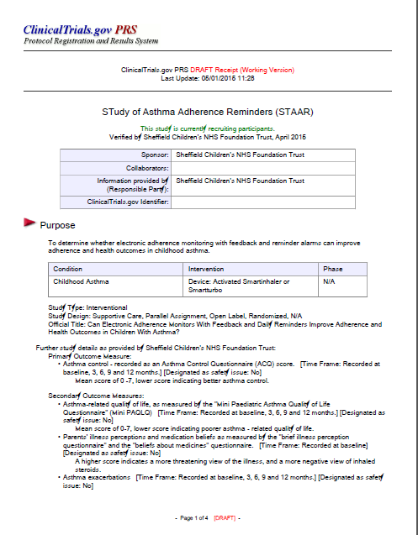

# 

****



**Can text message reminders improve adherence to nebulised treatments in children with Cystic Fibrosis?**

**Background**

* There are 70,000 people with cystic fibrosis worldwide1, with 10,000 of these living in the UK2. Of these 10,000 people, 48% are under the age of 162.
* Children with CF require daily treatments which include physiotherapy, oral enzymes, vitamins and antibiotics, and nebulised treatments. Due to this high treatment burden, adherence levels to these medications is often low3. New technology enables adherence data for nebulised therapies to be recorded electronically, and rates in children have been recorded at only 67%4. Adherence is lower at weekends and during school holidays, in the absence of a usual routine5.
* Low adherence to pulmonary treatment in CF has been shown to lead to increased morbidity, health care utilisation and cost6.
* Barriers to adherence to nebulised treatment include time management problems, oppositional behaviour and forgetting the medication7.
* Text messages are a simple way of reminding people to take their medication, and are successful at increasing adherence to treatment in other chronic diseases such as asthma8, diabetes9 and people with HIV10.
* Children with CF have been shown to be amenable to text message reminders11, and they are therefore potentially a cheap, simple and effective way of increasing adherence to treatment in this population.

**Study Objectives**

To determine whether sending daily reminder text messages can improve adherence to nebulised therapy in children with CF. Secondary objectives are to see if these reminders can improve lung function in this population.

Primary Outcome Measure

* Adherence to nebulised therapy, electronically recorded by the iNeb (Phillips Respironics, UK)12. Adherence is the percentage of prescribed doses actually taken.

Secondary Outcome measures

* Lung function (FEV1 % predicted)

**Study Design**

The study will be an interventional feasibility study to assess the effectiveness of reminder text messages on improving adherence. Participants will be recruited from the Sheffield Children’s Hospital CF clinic, which manages children with CF in the South Yorkshire region.

Each participant will be consented, and their mobile phone number and parents’ mobile phone number will be documented.

At pre-arranged times, a text message will be sent to remind them to take their nebuliser. This may be once, twice, or three times a day depending on how many times they take a nebuliser. The texts will be sent from the Sheffield Children’s Hospital outpatient text reminder service, and will consist of a simple non-judgemental reminder message. The content of the message will be determined by asking the opinions of the children in the CF clinic. If the child is below 12 years of age, a text will be sent to both the child and their parents. If they are above 12, a text will just be sent to the child. Text reminders will be sent for a 6 month period.

Adherence will be recorded electronically using the iNeb nebulisers, and the data will be fed-back to the children and parents. This is currently standard practice in paediatric Cystic Fibrosis clinics. Adherence data from the 6 month intervention period will be compared with the equivalent 6 month period the previous year to assess the effect of the intervention.

**Methodology Flow Diagram**

Primer package of adherence education

Assess for eligibility, consent and recruit

## Enrolment

## Recruitment

Send daily reminder text messages to children and parents

## Follow-Up

Standard CF follow-up clinics as clinically indicated for 6 months

## Analysis

Download adherence data and compare with data from the 3 months prior to trial commencing

**Selection of Participants**

Participants will be selected from the CF clinic list at Sheffield Children’s Hospital. Children who have a diagnosis of Cystic Fibrosis and take a medication via an iNeb will be approached to take part in the study when they attend clinic. Medication via an iNeb will be either antibiotics, mucolytics, bronchodilators or saline. There are currently 28 children in the Sheffield clinic who take medication via an iNeb.

Inclusion Criteria

* Aged 6 years to 16 years
* Diagnosis of Cystic Fibrosis
* Taking at least one medication via an iNeb (Phillips Respironics) for at least 3 months prior to trial start
* Child or parent has a mobile phone

Exclusion Criteria

* Cannot speak or read English

**Data Collection & Statistical Analysis**

Adherence data form the iNeb will be downloaded each time the child comes to clinic, as is current standard practice. At the completion of the 6 month period, the overall and monthly adherence rates will be calculated, and compared to the data from the equivalent 6 month period the previous year.

Continuous data will be summarised by the median (25th - 75th centile). Categorical data will be summarised by the percentage.

As this is a feasibility study, statistical testing will be minimised, in line with recommendations13. Where statistical tests are applied, an arbitrary level of 5% significance (2 tailed) will be used.

We plan on recruiting all 28 children in Sheffield who take nebulised medication. This number is robust enough to generate an estimate of variability to power a larger clinical trial, and also allows for any loss-to-follow-up14.

The "Stata" statistical computer package will be used to analyse the data.

**Costing of Study**

Text messages sent from outpatient reminder service incur no charge. The cost of printing of information leaflets and other study admin will be covered by respiratory department funds. Dr Robert Morton will carry out the study as part of his MD, and he is already employed by the university, therefore there will be no additional staff costs for this study.

**References**

1. Cystic Fibrosis Foundation. Cystic Fibrosis Foundation. Volume 2014. Bethesda, Maryland, USA, 2014.

2. UK CF Registry. Annual Data Report 2012. Volume 2014, 2013.

3. Modi AC, Lim CS, Yu N, et al. A multi-method assessment of treatment adherence for children with cystic fibrosis. J Cyst Fibros 2006;5:177-85.

4. McNamara PS, McCormack P, McDonald AJ, et al. Open adherence monitoring using routine data download from an adaptive aerosol delivery nebuliser in children with cystic fibrosis. J Cyst Fibros 2009;8:258-63.

5. Ball R, Southern KW, McCormack P, et al. Adherence to nebulised therapies in adolescents with cystic fibrosis is best on week-days during school term-time. J Cyst Fibros 2013;12:440-4.

6. Quittner AL, Zhang J, Marynchenko M, et al. Pulmonary medication adherence and healthcare utilization in cystic fibrosis. Chest 2014.

7. Modi AC, Quittner AL. Barriers to treatment adherence for children with cystic fibrosis and asthma: what gets in the way? J Pediatr Psychol 2006;31:846-58.

8. Tran N, Coffman JM, Sumino K, et al. Patient reminder systems and asthma medication adherence: a systematic review. J Asthma 2014.

9. Vervloet M, van Dijk L, Santen-Reestman J, et al. SMS reminders improve adherence to oral medication in type 2 diabetes patients who are real time electronically monitored. Int J Med Inform 2012;81:594-604.

10. Mbuagbaw L, van der Kop ML, Lester RT, et al. Mobile phone text messages for improving adherence to antiretroviral therapy (ART): an individual patient data meta-analysis of randomised trials. BMJ Open 2013;3:e003950.

11. Johnson KB, Culpepper D, Scott P, et al. The utility of providing automated medication dose reminders to young children on chronic medication. J Telemed Telecare 2011;17:387-91.

12. McCormack P, Southern KW, McNamara PS. New nebulizer technology to monitor adherence and nebulizer performance in cystic fibrosis. J Aerosol Med Pulm Drug Deliv 2012;25:307-9.

13. Lancaster GA, Dodd S, Williamson PR. Design and analysis of pilot studies: recommendations for good practice. J Eval Clin Pract 2004;10:307-12.

14. Julious SA. Sample size of 12 per group rule of thumb for a pilot study. Pharmaceutical Statistics 2005;4:287-291.

# Appendix 2 – Ethical Approval

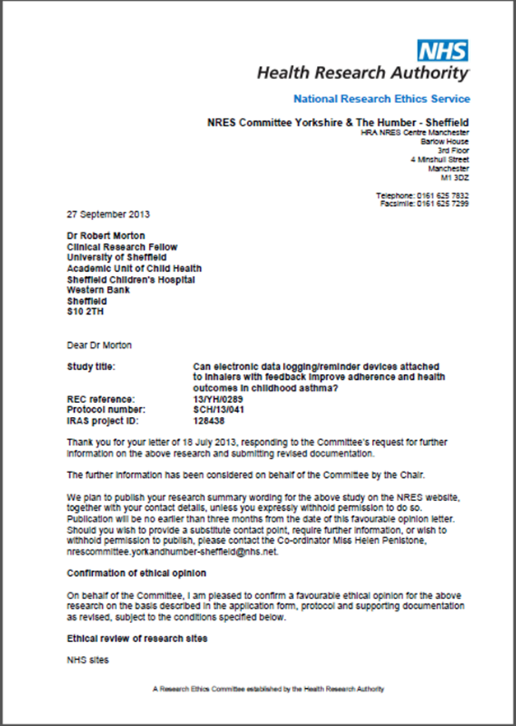

# 

# 

# 

# Appendix 3 – Nebtext Questionnaire



# Appendix 4 – Interesting adherence graphs

The following review graphs illustrate different adherence behaviours encountered during the STAAR study. For all graphs, the individual red bars are the daily number of inhaler actuations. The adherence target is the grey horizontal line.

## A4.1 Good adherence in intervention group

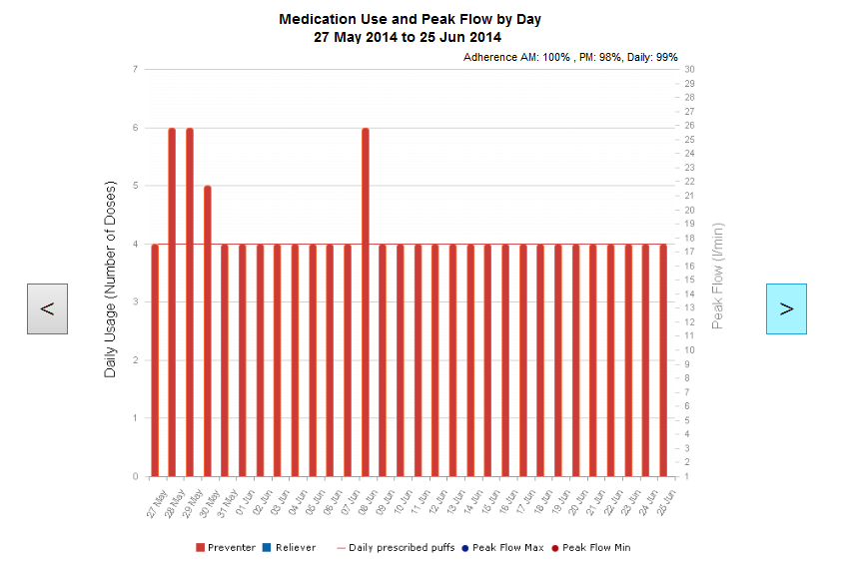

Participant 035, perfect adherence with regular adherence reviews.

## A4.2 Improved adherence due to successful intervention

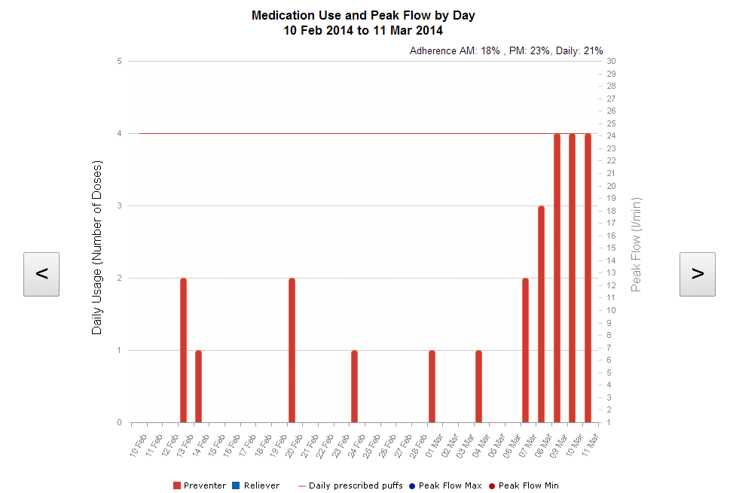

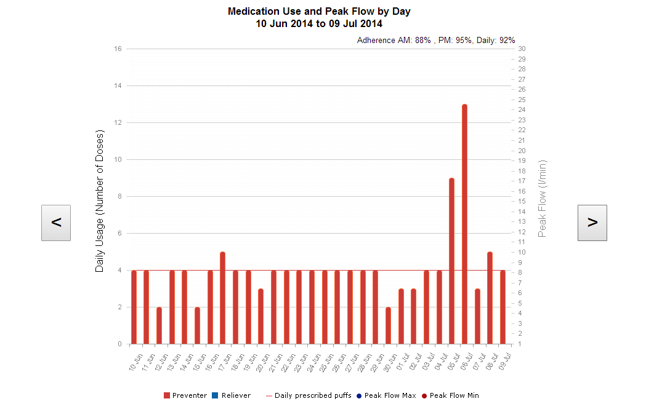

Participant 022, good result from feedback. In the top graph was telling mother she was taking inhaler, but only 33% adherent. Shown to be non-adherent at adherence review, mother unaware. Participant only 7 years old, therefore plan was for mother supervise inhalers, as previously thought unnecessary. Increased to overall 83% at next visit. Some evidence of dose dumping on the days preceding the next adherence review.

## A 4.3 Hawthorne effect in control group

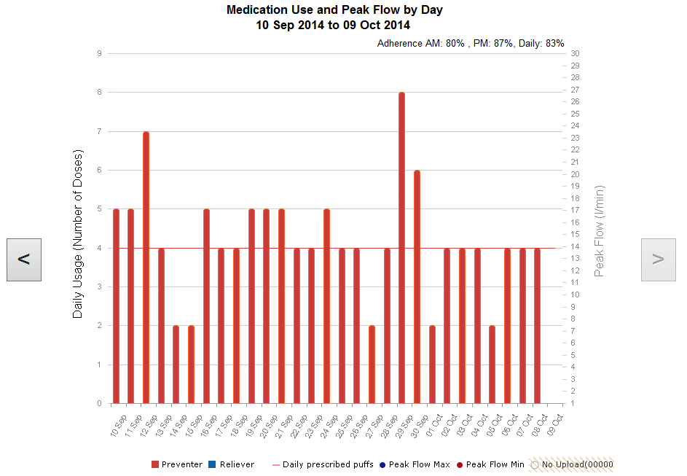

Participant 065 – Control. Mother very happy with device, really useful to remind him (even though no alarms or feedback). Both she and his father had set reminders and “shouted him to remember it every day”. FEV1 100% predicted.

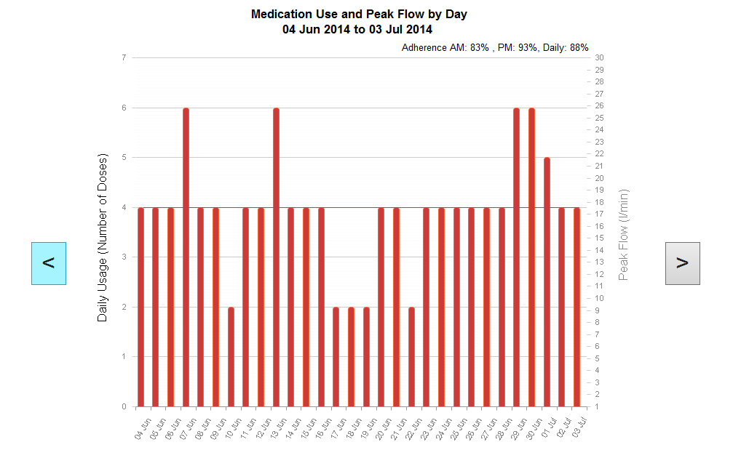

Participant 047- Control. “More aware of device, takes inhaler more than before, can see the inhaler better”.

## A 4.4 Dose dumping in control participant

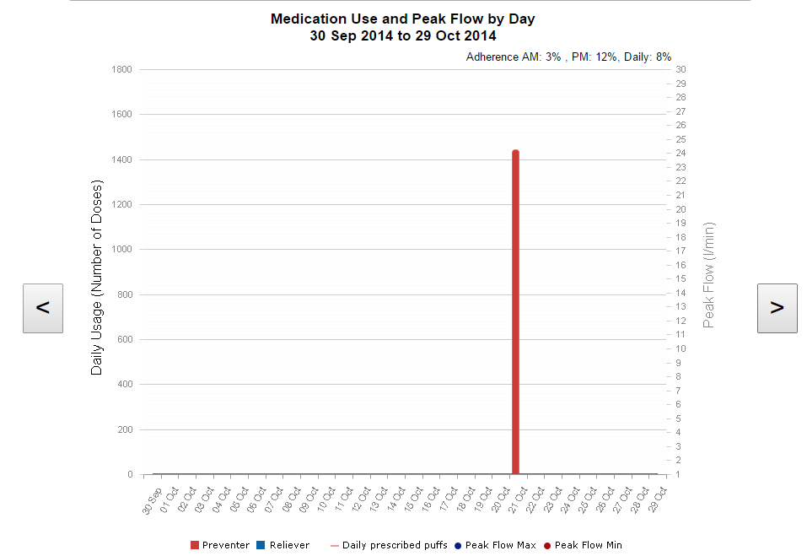

Participant 001. Control, initially doing really well. Stopped taking inhaler at the start of the summer holidays. Pressed 1400 in the ½ term before finishing the study to make up for it! Device then “lost” battery and broken.

## A 4.5 Identification of device actuation without inhalation

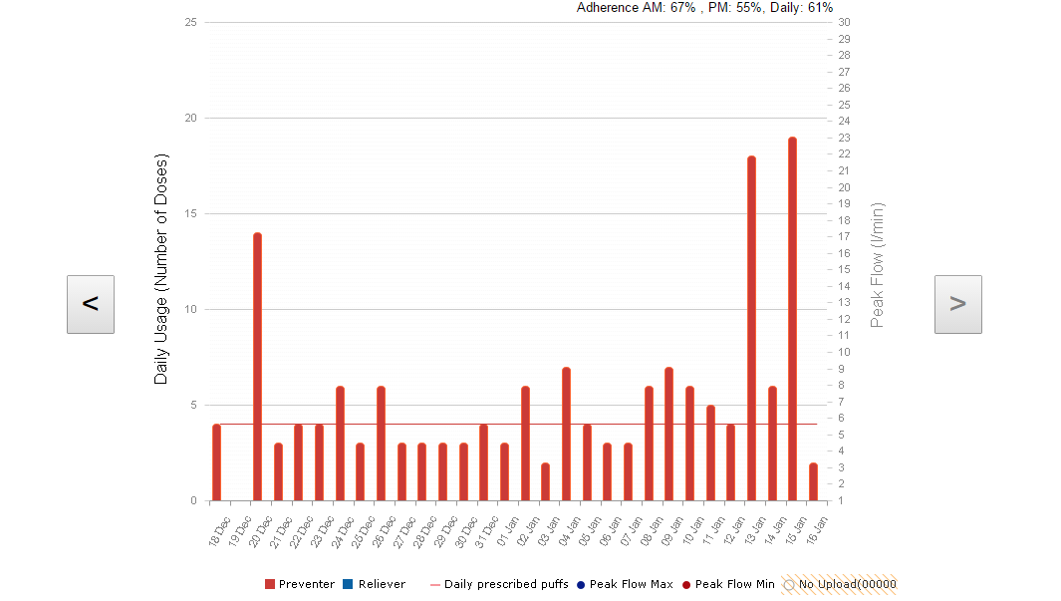

Participant 054- intervention. Erratic use of device with often more actuations of device than prescribed. Inhaler had no doses remaining when checked. Parent reported that “little brother always got the device and pressed it” no way of knowing whether the true adherence is 61% or lower. Planned to keep inhaler in cupboard downstairs out of reach of brother, and easier to be seen and heard.

## A 4.6 Importance of regular adherence reviews

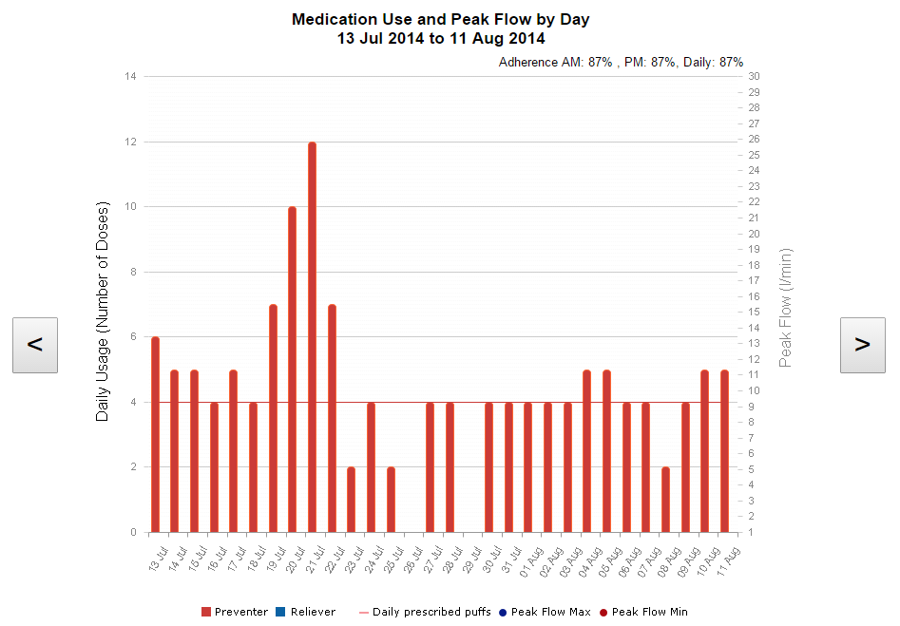

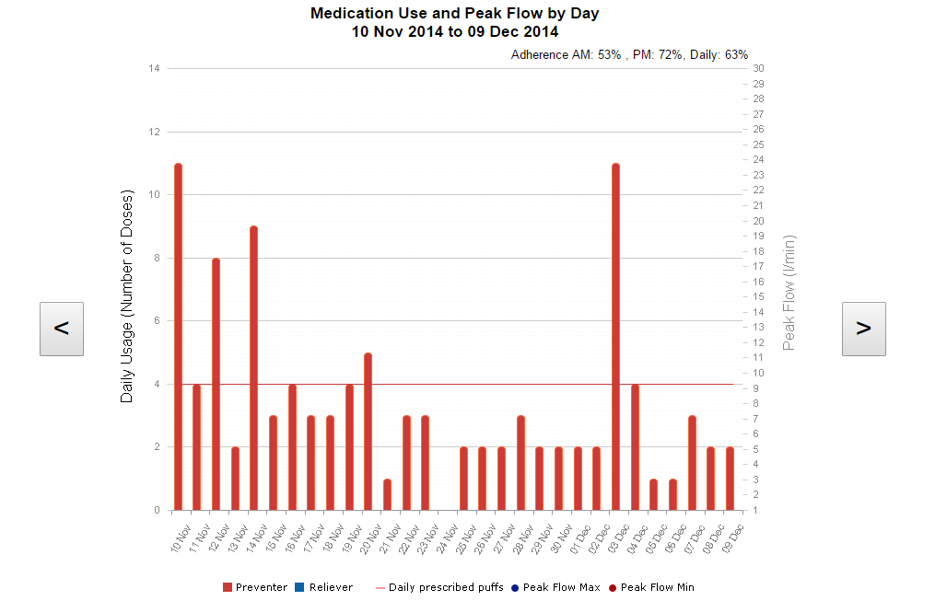

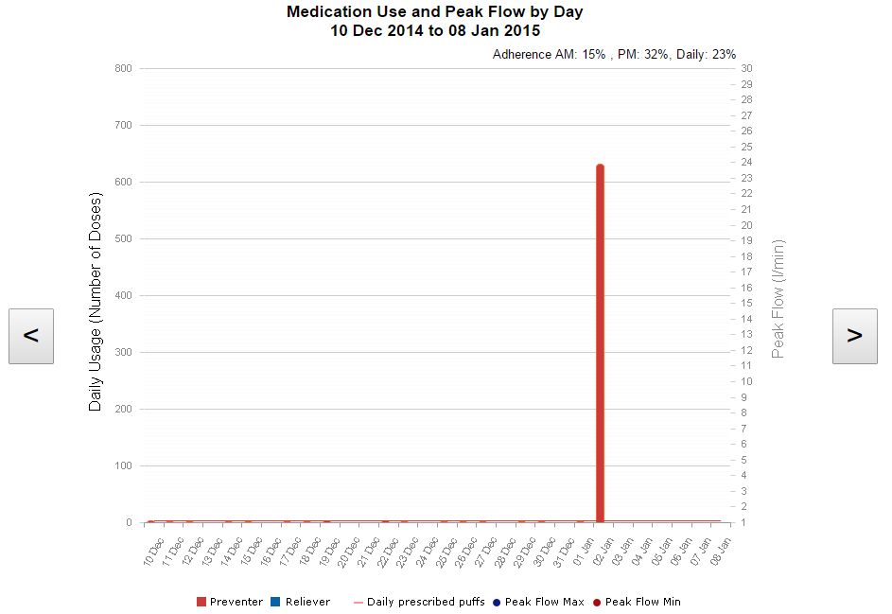

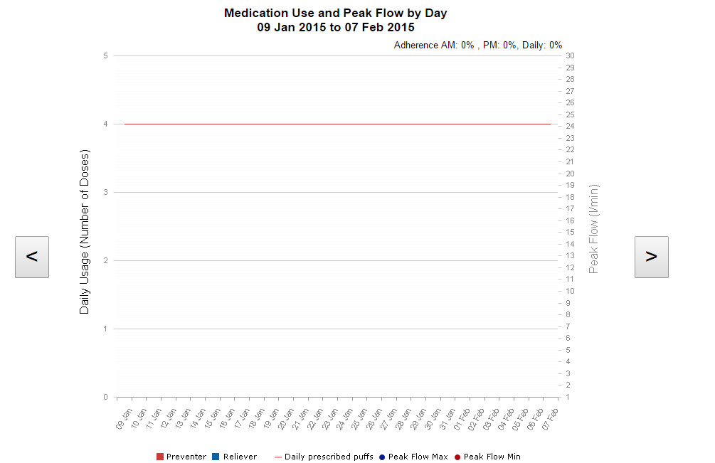

All above participant 050, intervention. Started off really well, embraced the alarms, adherence >80% . Was well in July, so no follow up appointments booked until 7 months later. In this time, adherence steadily fell, until pressed 600 times in Christmas holidays and broke the device. Shows that alarms only effective if consolidated with regular adherence reviews. Also, patients can become reliant on alarms, and when the alarms stop, adherence falls in the absence of the medication prompts.

## A 4.7 Poor adherence and asthma control in control group

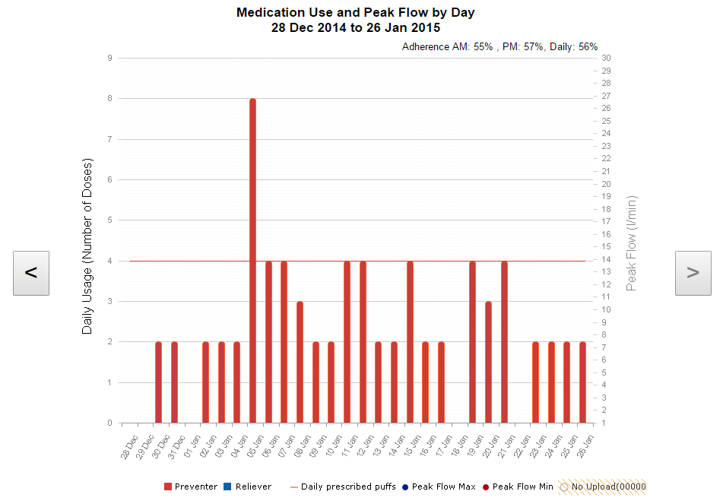

Participant 008 - control. Unwell with poor adherence despite patient and parent reporting good adherence. Required an admission to hospital shortly after this graph.

## A 4.8 Decreased holiday adherence – control

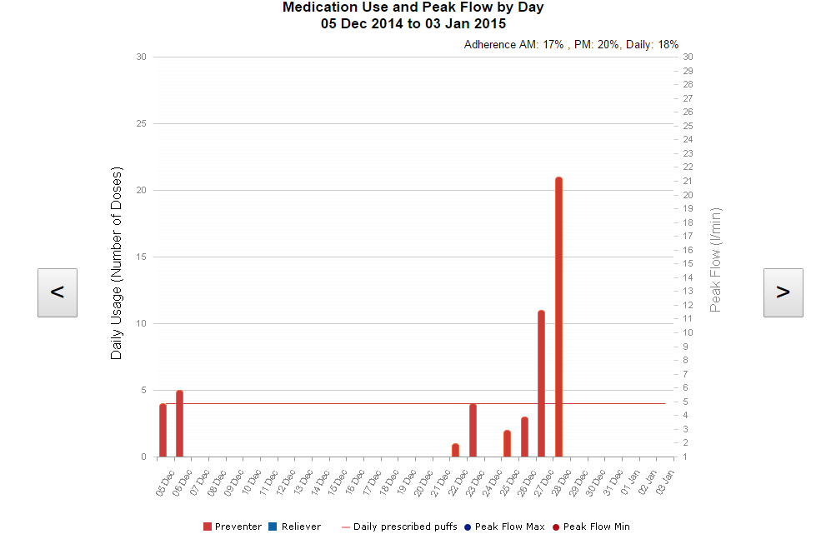

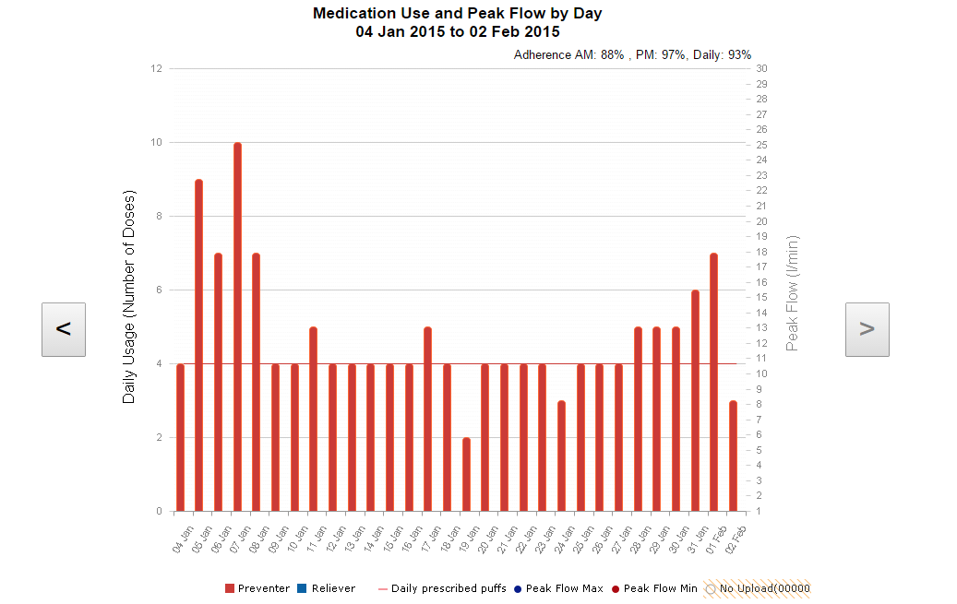

Participant 052 - control. Good adherence all year, except Christmas holidays. Dropped to 17%, then back up to 93% when school and routine returned.

## A 4.9 Good adherence in patient whose adherence had been doubted

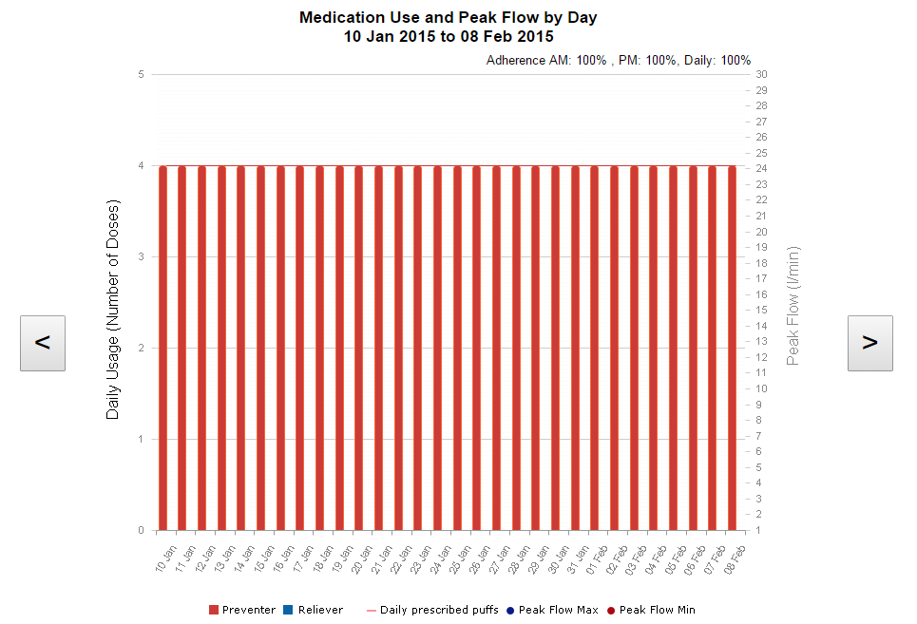

Participant 037 - control. Lost device on holiday, symptomatic, given a second device. Commenced on theophylline and omilazumab. Suspected poor adherence by clinical team. Graph shows 100% adherence. Demonstrates that open adherence monitoring is important to identify the patients who do actually take in halers but are perhaps doubted.

# Appendix 5 – Published Papers

