|  |  |
| --- | --- |
|  | **Department of**  **Mechanical**  **engineering** |

**Upper body accelerations as a biomarker**

**of gait impairment in the early stages of Parkinson's disease**

By Christopher Buckley

Supervisor: Dr Claudia Mazzà

Co-Supervisors: Professor Lynn Rochester & Dr Brook Galna

DDP supervisor: Dr Alberto Marzo

October 2017

A thesis submitted in partial fulfillment of the requirements for the degree of Doctor of Philosophy

**Abstract**

Neurodegenerative diseases such as Parkinson’s disease (PD) impair the ability to walk safely and efficiently. Currently, clinical rating scales designed to assess gait are often described to be subjective and lacking sensitivity to detect gait impairments at the early stage of the disease. Devices are available to objectively measure gait within research laboratories; however, they are often expensive and require trained expertise. Inertial measurement units (IMUs) may be an ideal device to measure gait while overcoming many of the limitations of other devices. They can measure movements of the upper body, which in PD is known to be impaired, and therefore may enable the calculation of a variety of acceleration based variables better capable to quantify impaired gait in PD.

This thesis aimed to determine the ability of a variety of acceleration based variables obtained from different location of the upper body to detect movements symptomatic to PD from age matched controls. Variables yet to be applied to PD were tested and methodological reasons for why differing results found in the literature was analysed, in an attempt to develop a refined methodology specific to PD. Acceleration based variables were tested relative to, and combined with, variables obtained from a 7m pressure sensitive mat. It was tested whether these variables bring additional information about a patient’s gait or if they are merely a reflection of lower limb mechanics, and, whether they can classify PD gait independently or in combination with a pre-existing spatiotemporal model of gait.

Results showed that for a large population of people with early stage PD, upper body acceleration variables not previously applied to PD were capable to highlight gait impairments. However, attention must be made to the processing of the acceleration signals as the method used to realign signals to a global reference can significantly impact a variable’s sensitivity to PD. Lastly, it was shown that the majority of upper body acceleration variables are unique from typically measured spatiotemporal information, and when using a multivariate approach, were equally capable to highlight gait impairment in PD. This thesis therefore proposes that variables calculated from the upper body using IMUs can be useful biomarkers of gait impairment at the early stage of PD, and if possible, should be used in conjunction with traditional approaches.

# Acknowledgments

Firstly, I would like to thank the MRC and Arthritis Research UK as part of the MRC-Arthritis Research UK Centre for Integrated research into Musculoskeletal Ageing (CIMA) for their part in funding this PhD.

Secondly I would like to express my sincere gratitude to Dr Claudia Mazzà for her continued support and inspiration for the entirety of my PhD. Since my first day in Sheffield, Claudia welcomed me and provided both social and professional support in a new and unfamiliar research department. I really appreciate Claudia’s teaching and her trust in me which allowed time for me to develop my own research ideas and as an independent researcher. I admire Claudia as a successful researcher and someone who has many friends in the research community which is something I want to replicate with my ambitions to stay within academia. Lastly, I would like to thank Claudia for being someone I could trust and talk with away from work throughout the good times and inevitable tough times during this project. I certainly value her friendship now and into the future.

I would also like to express my gratitude to both Professor Lynn Rochester and Dr Brook Galna. Although being in another institution, I never once felt that I could not contact them if a problem occurred during my PhD. I really appreciate Lynn’s highly experienced input to my project and connecting it to the bigger picture of the field. Lynn’s incredible career and influence surely stands as an inspiration, not only from her research track record and her reputation for being one of the key figures in the gait and posture society, but also being a good laugh, friendly and approachable to all. Also, I would like to express appreciation to Brook’s input to the project and his invaluable input to the statistical analysis by clearly explaining concepts I originally struggled with. I certainly value Brook’s friendship, guidance and encouragement to help me remain in an academic career.

I would also like to thank all members of the INSIGNEO team who supported me every day, and without question, taught me a lot both inside and outside the world of research. They helped me to continue to work hard with a smile on my face. I will fondly remember them as a fun group and keep them as close friends.

Lastly, I would like to thank my family and closest friends for always being there for me and willing to help in any way they can. I especially would like to thank my Mum for always believing in me from a young child struggling with Dyslexia, to now someone who has submitted a PhD thesis, it would not have been possible without her.

Table of Contents

Acknowledgments ii

Chapter 1. Gait analysis in Parkinson’s disease 1

1.1 Gait as a biomarker for Parkinson’s disease 2

1.2 Traditional approaches to measuring gait in PD. 6

1.3 Accelerometers and Inertial sensors for the assessment of gait 11

1.4 Measuring movements of the upper body to quantify gait 13

1.5 Aim and objectives 17

Chapter 2. Wearable inertial measurement units for the investigation of human movement 20

2.1 Inertial sensors as a tool for clinical gait analysis 21

2.1.1 Accelerometer 22

2.1.2 Gyroscope 24

2.1.3 Magnetometers 25

2.1.4 Quantification and characterization of upper body movement 26

2.1.5 Signal processing techniques 30

2.2 Acceleration derived variables from the trunk and head 30

2.2.1 Acceleration Root Mean Square (RMS) 31

2.2.2 Jerk (J) 33

2.2.3 Jerk ratio (JR) 35

2.2.4 Harmonic ratio (HR) 35

2.2.5 Autocorrelation (step regularity, stride regularity, symmetry) 38

2.2.6 Coefficient of attenuation (CoA) 40

Chapter 3. Piloting a multiple body segment approach for highlighting Parkinson’s disease symptoms during gait 42

3.1 Introduction 43

3.2 Methodology 44

3.2.1 Subjects 44

3.2.2 Measurement protocol 45

3.2.3 Data processing 47

3.2.4 Signal realignment 47

3.2.5 Variables. 48

3.2.6 Statistical analysis 49

3.3 Results 50

3.3.1 Coefficient of attenuation 51

3.3.2 Acceleration RMS 53

3.3.3 Harmonic ratio 54

3.4 Discussion 55

3.5 Conclusion 57

Chapter 4. The impact of pre-processing techniques upon acceleration variables during gait in Parkinson’s disease 58

4.1 Introduction 59

4.2 Method 61

4.2.1 Realignment methods 61

4.2.2 Statistical analysis 66

4.3 Results 66

4.4 Discussion 70

4.5 Conclusion 74

Chapter 5. Upper body acceleration variables as a unique biomarker of impaired gait in PD 75

5.1 Introduction 76

5.2 Method 77

5.2.1 Multivariate spatiotemporal gait model 77

5.2.2 Multivariate upper body acceleration models 78

5.2.3 Statistical analysis 79

5.3 Results 81

5.3.1 Correlation analysis 83

5.3.2 Univariate analysis 85

5.3.3 Multivariate analysis 87

5.4 Discussion 89

5.5 Conclusion 91

Chapter 6. Discussion 93

6.1 Summary 94

6.2 Limitations and future work 98

6.3 Conclusion 101

References 103

Appendix …………………………………………………………...112

# Chapter 1. Gait analysis in Parkinson’s disease

This introductory chapter will briefly discuss the concept of using gait as a biomarker in Parkinson’s disease (PD). It will briefly describe the typical impairments that people with PD have and will specifically focus on the impairments that occur during gait. The chapter will then highlight the methods traditionally used in to quantify gait in PD, explaining both the advantages and disadvantages of the adopted techniques. The concept of using an accelerometer or an inertial measurement unit (IMU) for gait analysis will then be introduced and the advantages of this approach relative to previous utilised methods will be discussed. Thereafter, this chapter will focus upon measuring movements of the upper body with an accelerometer/IMU during gait and why this may be valuable approach in PD.

## Gait as a biomarker for Parkinson’s disease

Parkinson’s disease is one of the most common neurodegenerative disorders which occurs in 1% of the population over the age of 60 and its prevalence increases with age [1]. More specifically, it is a progressive neurodegenerative movement disorder that impacts the physical, psychological, social and functional status of individuals [2]. The disease is caused by the degeneration of dopamine producing neurons in the region of the brain called the Substantia nigra. Movement is impaired due to a reduced ability to perform controlled movements which is commonly by the noticeable symptom of a resting tremor. Other debilitating symptoms involve an increased rigidity in the muscles creating a stiffness type feeling, Bradykinesia (a slowness of movement), problems initiating movement and lastly postural instability. Non-motor symptoms include problems with mood, sleep and memory. Collectively all symptoms have obvious negative impacts upon the quality of life of those with PD.

Currently there is no cure for the disease but a variety of interventions exist with the most common being medication based, which try to increase dopamine production in the brain. Surgical interventions such as deep brain stimulation also exists. Lastly physical rehabilitation/exercise programs have also been proposed to help reduce the impact of the symptoms [3]. However, although appearing to be effective, the treatment of PD is complex due to the progressive nature and the array of motor and non-motor symptoms which experience varying side effects between early and late stages of the disease or even during an intervention. Collectively this makes it hard to objectively diagnose and assess progression [4]. Due to this complexity, the interventions role in clinical practice is not firmly established on grounds of sound clinical data for each symptom and it is therefore hard to determine the best way to intervene as current clinical biomarkers are lacking in accuracy [3]. Moreover for neurological rehabilitation programs, it is often the case that patients cannot accurately convey or may lack the insight or ability to tell the clinician about their progress [5]. One way to be able to quantify if a desired effect of an intervention is achieved is to use clinical rating scales. However current clinical rating scales, such as the Berg balance scale, the Tinetti gait and balance assessment, the Timed up and Go test and the postural instability and gait disability (PIGD) score derived from the Unified Parkinson’s Disease Rating Scale (UPDRS) [6], are viewed as not sensitive enough to detect postural instability, especially in the early stage of the disease [7]. As PD progresses and in the late staged of the disease, postural instability increasingly becomes the most disabling symptoms of PD and increases the likelihood of experiencing a fall which occur in up to 68% of people of PD [8,9]. Falls have devastating effects such as fracture, hospitalization, loss of independence and restriction of activities [10]. As a result, accurately and objectively measuring postural stability may be very valuable as a biomarker to measure disease progression from the early stages of the disease and to objectively test the effect of interventions [5].

One promising option is to use clinically viable devices capable of measuring movement in an attempt to measure postural stability early into the disease and improve the sensitivity of detecting and measuring postural instability [5,11]. Such devices will also be useful to objectively confirm the impact of interventions (therefore helping to know which is best to implement) and perhaps clarify the impact of many symptoms of the disease as it progresses or potential improves [12]. One established instrumented method to measure postural instability and movement is through gait analysis. For people with PD, a key result of reduced movement control is an impaired gait and it is in fact one of the cardinal features of the disease and a significant cause for disability [13]. Consequently, measuring gait in PD is promoted to be a powerful tool to identify incipient pathology, contribute towards diagnostic algorithms, and quantify disease progression [14]. Because of this, large cohort studies analyzing PD gait have been conducted and PD gait is well characterized.

The most commonly measured aspect of gait is gait speed, which has often been used to measure health status of a variety of diseases due to its correlation to functioning well in a community, length of hospital stay and mortality [15]. Although gait speed is a useful measure of health status and can be calculated using inexpensive equipment within a clinic, reduced gait speed is not specific to PD. To discover gait variables that characterize PD gait specifically, Hass et al., [16] collected lower limb spatiotemporal gait data from 310 individuals with idiopathic Parkinson’s disease in order to establish normative values of gait for people with PD and to characterize the movements different from normative gait. It was found that individuals with the greatest Parkinson’s disability walked significantly slower with shorter steps and stride lengths than the mild and moderately affected groups. Also, the most affected patients spent more time with both feet on the ground (double support phase), and walked with a wider base of support (step width) than the moderately disabled patients. These results coincide with a general description of PD gait that is widely accepted as a gait cycle which displays low walking velocity, small stride length creating shuffling type steps, reduced or absent arm swing that is asymmetric, and 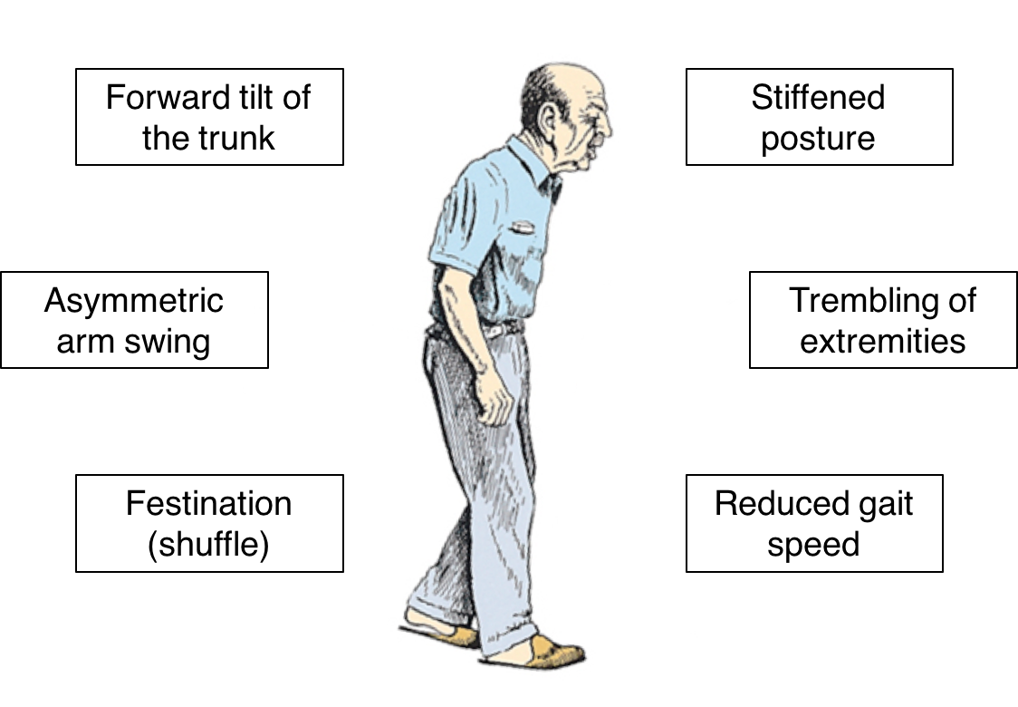rigidity in the trunk movements while showing a forward tilt (see figure 1.1) [17].

Figure 1.1. An illustration of the generally recognized description of PD gait as shown by hass et al., [16]. Illustration adapted from: http://www.senecapt.com/parkinsons-disease

More recently, in addition to directly measuring spatiotemporal information of the feet which can be described as typical measurements of gait, research has also started to investigate whether dynamic features of gait can also characterize movements indicative of PD. Dynamic features of gait involves the analysis into the inconsistency of spatiotemporal measures across multiple steps and are typically are represented by the within-person standard deviation (SD) or the coefficient of variation [14] and described as measures of gait variability. It is believed that stride to stride fluctuations in walking offers complimentary ways of quantifying locomotion for the use of an objective biomarker. In addition to being complimentary, a summary of recent results claims that gait variability may be more sensitive than other measures of gait and that the proposed measures can provide clinical indexes of gait instability and fall risk [18].

In PD, disease specific changes are described to include gait asymmetry and diminished coordination, a loss of consistency in the ability to produce a steady gait rhythm which creates a high stride to stride variability. As a result, high gait variability is seen throughout the disease and even at the early stages since diagnosis when they are not taking medication [19], and increases with disease severity [1]. As such, gait variability has therefore received much interest as a good biomarker to track disease progression, intervention response and be a measure for postural instability. It was found that gait variability measures improved from taking levodopa (the most used antiparkinsonian medications) both for PD patients who fall and have yet to fall. Interestingly however, the typical gait measure (average stride time) was not seen to change in both groups following the intervention. Therefore, gait variability is evidence that going beyond the typical measurements and statistical summaries of gait may improve discriminatory power and provide a more complete characterization of gait in pathologies.

## Traditional approaches to measuring gait in PD.

Traditionally, when assessing gait in PD the attention has been focused on kinematic, kinetic, and electromyography changes in the lower extremity [17], measured with devices such as footswitches, electronic walkways, electromyography, and 3-dimensional motion analysis [14]. Currently for the kinetic and kinematic assessment of gait, 3-dimensional analysis using optoelectronic systems with multiple cameras in addition to the electromyography analysis of muscle activation is the gold standard. For routine clinical use on large groups, their applicability is limited due to high costs, long preparation time, and need for trained specialist staff to operate [14,20]. Moreover, despite having been used in PD for research purposes [21,22], these tools are certainly more relevant when building musculoskeletal biomechanical models or for supporting specific clinical decisions such as guiding musculoskeletal surgical intervention, which is not so common in neuro-degenerative diseases.

A good and utilised alternative for clinical applications are pressure sensitive walkways which are able to provide quantitative, reliable and repeatable assessments of gait [23]. Typically, they cover several meters of the floor so that successive foot placements are detected as participants walk over them therefore allowing to measure both spatiotemporal and dynamic measurements of gait. Relative to 3D motion capture systems, they are considered practical for a clinical environment as once placed upon the floor they are unobtrusive and can be placed in a smaller space such as a corridor. Also, once familiar with the software, little post processing is required. As previously stated, the use of pressure sensitive mats has allowed for normative values to characterize PD gait for a selection of spatiotemporal gait variables. These variables are obtained as the device is capable to detect the initial and final contact of the foot when it is in contact with the mat (deemed the initial contact (IC) and final contact (FC)). Once recorded, the provided software is then capable of validly and reliably calculating typical spatiotemporal parameters during gait [24]. These include, step length, stride length, support base, step time, swing time, stance time, single support time, double support time and average velocity. Figure 1.2 illustrates how each parameter is defined.

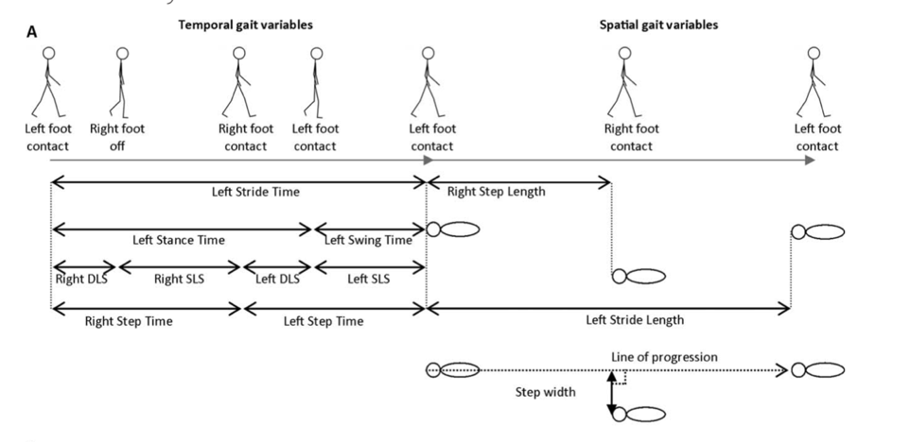

Temporal variables

Spatial variables

Figure 1.2. Highlights how the spatiotemporal gait parameters that can be calculated from a pressure sensitive mat. The temporal variables are shown on the left, and spatial variables are shown on the right. SLS indicates single limb support time; DLS, double limb support time. Adapted from [14]

Recently, multivariate models that utilize the variables obtained by devices such as pressure sensitive mats have been proposed with the intention that multiple variables are stronger at classifying pathological gait. This approach can provide a clear framework for selecting variables which can describe the complex multidimensional nature of gait and hence facilitate hypothesis-driven research to explain underlying gait mechanisms, identify contributory features to gait disturbance, and examine the effect of intervention. The model proposed by Lord et al. [25] was created using data from a cohort of 189 elderly participants and then replicated for 121 people with PD. It contains 5 conceptual domains and was constructed using principle component analysis (varimax procedure), which determined the sixteen core variables to be included in the model. For the domains, the percentage of the total variance of gait explained by each domain and the variables contained within the domains see 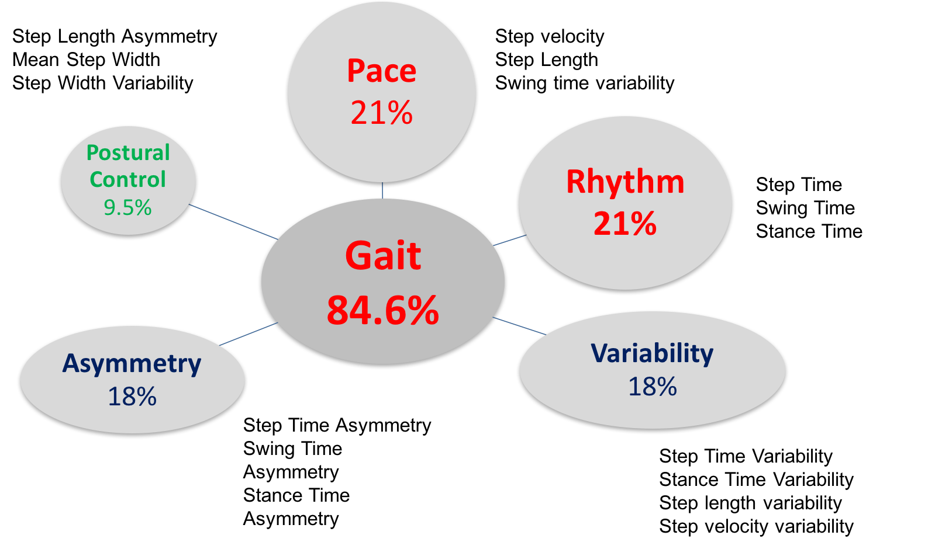figure 1.3

Figure 1.3. The sixteen-variable spatiotemporal gait model separated into each domain and the domains percentage of total variance of gait explained following principle component analysis.

Figure 1.4 provides an example of how a multivariate model can be used to highlight movements symptomatic of PD [14,25].

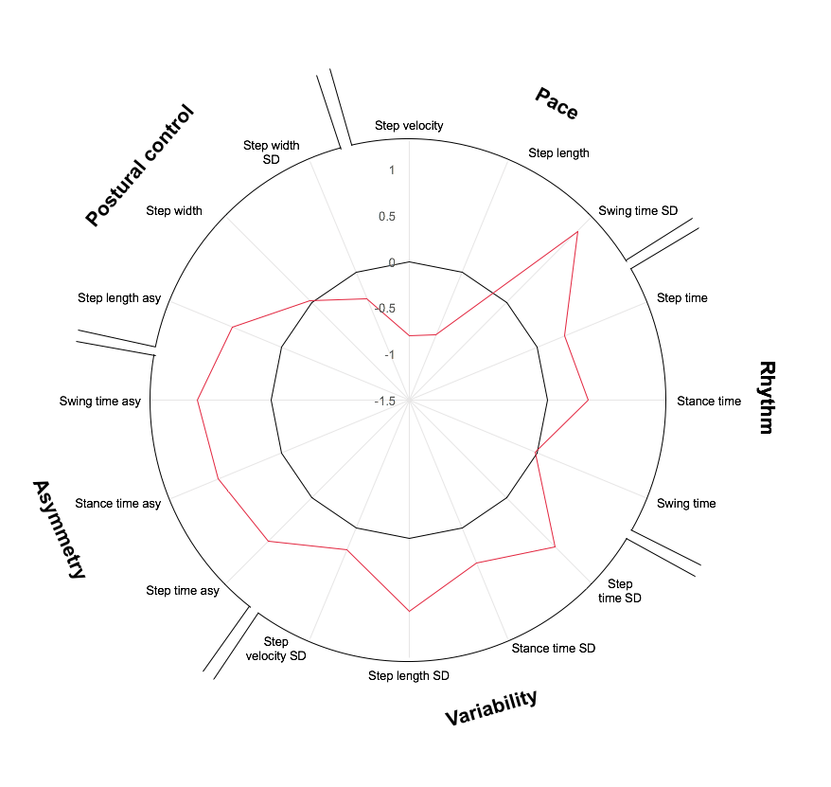

16 variable Spatiotemporal gait model

Figure 1.4. Radar plot illustrating each variable from 16 variable spatiotemporal model. The central line represents the control data. Deviation from zero along the X axis radiating from the centre of the plot represents how many standard deviations (based upon the control means and standard deviations) the PD differ from the controls.

However, although feasible and useful for clinical use, pressure sensitive mats and are not without limitations. As a matter of fact, these mats are large and heavy, meaning, they are not portable and still require a designated space. Furthermore, they are still expensive and are not obtainable for all clinics where gait may be assessed. Therefore, serching for an alternative technique or device capable of objectively quantifying PD gait remains waranted.

## Accelerometers and Inertial sensors for the assessment of gait

One alternative device for measuring gait is an accelerometer, which has recently grown to be a popular method also to assess movement in PD [5,6]. Accelerometers were first promoted to monitor the motion of human movement as early as the 1950s but were drastically limited due to high costs and size [26]. Since then however both limitations have reduced due to advances in integrated microelectromechanical systems which has greatly enabled a reduction in the size and cost of a device [27]. This now means their application to gait is feasible and consequently a growing interest for both researchers and clinicians to objectively measure disease related outcomes using wearable devices has developed [6,28]. The reason for such interest is that they have the ability to overcome many limitations of previously used gait analysis devices as they are relatively inexpensive, can measure successive steps, can measure gait outside of a laboratory, they do not restrict movement, are a direct measure of acceleration and can be applied by minimally trained clinicians [6,9,12,29]. As such research has emerged to assess the use of accelerometers or more recently inertial measurement units (device containing a tri-axial accelerometer alongside a gyroscope and a magnetometer) to be able to quantify gait and devices are now commercially available for this purpose [5]. Furthermore, a perspective is emerging whereby accelerometers have become the preferred choice for gait analysis if needing to collect continuous, unobtrusive and reliable human movement monitoring [26].

The direct measurement of accelerations from any/multiple locations of the body can allow the calculations of a variety of gait metrics. These range from simple shock absorption [30], to a highly complicated calculation of joint angles more typically measured with 3d motion capture devices [31]. However although very promising work has been conducted to achieve full kinematic gait analysis with the use of inertial sensors and examples even exist in pathologies [32], there is still much work to do in this area to be applied clinically. Arguably for this purpose, the most robust use for accelerometer-based gait analysis is the determination of temporal parameters from foot contact events [29]. As a result; many algorithms which utilize acceleration and gyroscope signals from different locations of the body have been produced [33–36], and more recently have been validated in a variety of environments [37].

With these algorithms, a logical natural progression would be to try to replicate the variables that have been collected and proven useful for gait stability measures from previous gait analysis devices such as pressure sensitive mats. Recently this has been attempted and with the use of a single accelerometer located on the pelvis [38–41]. From these studies, it was shown that 14 out of the 16 variables included in the previously highlighted multivariate spatiotemporal model could be calculated. Out of these fourteen, the agreement between the accelerometer based variables and those obtained from a pressure sensitive mat was excellent for four (ICCs 0.913–0.983); moderate for four (ICCs 0.508–0.766); and poor for six characteristics (ICCs 0.637–0.370) [40]. The remaining variables that could not be calculated was step width and step width variability which both are contained within the model’s postural control domain and currently cannot be calculate with a single sensor. A recent study has since proposed the idea that due to not being able to replicate variables representative to the postural control domain additional algorithm development would be welcomed to provide measures of postural control [39].

Although replicating a previous model is promising and with a very large potential for the application of gait analysis outside of a laboratory, the question can be asked why are researchers attempting to replicate previously popular gait variables as calculated using devices that detect movement using different technological methods? Due to continuously measuring acceleration over time, limiting accelerometers to calculate discrete gait variables may in fact be limiting their ability to measure additional components of gait throughout the entire gait cycle from different locations of the body [40,42,43]. Accelerometer based gait analysis therefore opens the potential to characterise gait in a new way with the potential to add to previous models or perhaps by creating new models using accelerations alone. For example, a single component of an acceleration signal can be analysed using a variety of established signal processing techniques, such as the analysis of the signals within their frequency domain. These addition techniques potentially open the opportunity to extract and discover unique characteristics of the movement not captured using more traditional methods. Currently it is unknown whether these varying alternative techniques of analysing signals derived from movement data are clinically beneficial for populations such as those with Parkinson’s disease.

## Measuring movements of the upper body to quantify gait

One approach to quantify gait continuously with an accelerometer during the entire gait cycle is the measure the movement of the upper body to as a measure of balance control and stability. One reason to measure the movements of the upper body is because two-thirds of our body mass is located two-thirds of body height above the ground meaning during gait we are an inherently unstable system unless a control system is continuously acting [44]. As such measuring our ability to control the movement of this unstable mass will be a direct measure of balance and stability [29]. For nearly fifty years in the context of PD research there has been the belief that postural activity in the upper body should be regarded as a function in its own right and not merely as a component of movement [45]. Further support is later provided by a paramount figure in biomechanics David Winter, who stated that the upper body was not merely a passive passenger unit during gait but a contributor to locomotion in its own right [44]. Therefore, potentially in PD, recording the movement of the upper body with the use of accelerometers may provide information about their upper body’s ability or inability to perform its fundamental dynamic role during walking. For a healthy subjects the fundamental dynamic role of the upper body is to, attenuate acceleration, ensure an upright posture, and stabilizing the optic flow and vestibular signals using an active feed-forward control of the paraspinal muscles [46,47].

Measuring the upper body’s movement using an accelerometer as a measure of impaired postural control started to develop in the early 1990s. Most notably Yack and Berger initially found that between young subject and elderly subjects both stable and unstable during gait temporal data combined with peak acceleration data, and the ratio of even to odd signal harmonics revealed that information derived from an accelerometer attached to the upper body was valuable in describing the underlying dynamics of unstable gait [48]. Another early influential investigation was performed by Moe-Nilssen who showed that a accelerometer located close to the center of mass and measured acceleration of a range of walking speeds was a valid method for assessing balance dysfunction during walking [43,49]. Thereafter it was shown that using these methods, acceleration based variables can highlight different aspects of motion that are undescribed by typical gait parameters. Furthermore these new measures were more indicative to postural control decline [50]. In fact this is a viewpoint that has emerged from the early upper body movement research which promotes that easily quantified temporal and spatial measures are not sensitive enough to distinguish subtle differences that may exist in the unstable population, whereas, acceleration analysis can provide a specific quantifiable measure of stability [48].

Within the investigations designed to measure upper body motion, a trend emerged whereby an importance was given to of measuring the movement of the head [51–53]. The reason for measuring the movement of the head is due to two of the three major sensory inputs for required for gait are contained solely in the head. The first is vision which has obvious requirements to in planning our locomotion and in avoiding obstacles that may be in the way. The second is the vestibular system housed within the inner ear and acts as a gyro for sensing linear and angular accelerations and therefore is required to remain balanced. As a result, the head is described as a naturally frame of reference during gait. The control of head position in space is however a complex process that integrates information from a variety of sources [51]. The importance of the head and the requirement to remain a stable platform for both the visual and vestibular systems is known as a head stabilization in space theory which states the goal of the upper body is to provide a stable platform for the head while walking [51,52,54,55]. This theory was proven through altering walking speed, cadence and step length and showing that these adapt to optimize the stability of the head. It was shown that healthy individuals walk in a manner that maximizes V and AP stability while maintaining adequate, though suboptimal ML stability [56]. Because of this prioritization of head stability, attaching an accelerometer to the head is therefore proposed to be a strong measure of overall walking stability [57].

Specifically to PD, upper body acceleration during gait have been measured in the past [9,11,58–61]. Collectively these investigations show that it is likely an increased axial rigidity, asymmetrical arm swing and a flexed posture causing an en-bloc type movement strategy is altering a gait pattern not replicative to healthy controls. Furthermore, recent research is promoting the use of accelerations variables to classify fallers from non-fallers, different PD subtypes and even people at a higher risk of developing PD [6]. Although the mentioned studies can promote the use of measuring upper body movements during gait, most of them have investigated solely one variable, from a range of ages, using small sample sizes. Furthermore, these past investigations often have not been performed in conjunction with typically measured spatiotemporal gait variables, meaning, it is currently unclear whether there is any additional benefit from these newly proposed variables. A recent review has stated that upper body movement investigations in PD, 31% were of low methodological quality, while 58% were of moderate methodological quality and 11% were of high methodological quality [6]. A more recent investigation has even highlighted that comparison between articles for the same gait variable (the harmonic ratio), has shown that large differences exist in the variables values despite measuring movements of supposedly the same population and this is due to a lack of standardization in data collection and processing techniques [62]. Lastly, not all proposed walking stability measures have been used in PD while being promoted for different populations. Consequently, currently it is not yet possible to know which upper body acceleration variables are fit for the purpose to be used as a biomarker in early stage PD.

Overall the majority of research that has attempted to find objective and sensitive gait biomarkers for PD has focused on participants with moderate to advanced stage symptoms and consequently limited knowledge is known about the early stage development of gait decline [13]. However, it appears contradictory to search for biomarkers at the latter stages of the disease when interventions are likely to be most effective when the need to be used is detected early. Combining this with the knowledge that PD patients early into the symptoms exhibit very subtle movement characteristics that can only be evidenced by very sensitive tools [11], there is an obvious need for research into early stage PD and for devices more sensitive and specific to the early symptoms of the disease during gait, while being relatively cheaper than alternative devices such as pressure sensitive mats. It is therefore proposed that accelerometers used to measure movement of the upper body may improve the sensitivity and specificity of detecting movements symptomatic to the early stages of PD.

## Aim and objectives

A nice metaphor why the movement of the upper body may contribute to a better characterization of gait in early stage PD is the concept of footsteps in the sand. For example, imagine there is an imprinted gait pattern which can portray spatiotemporal information like typically measured in discrete gait measures. However, it is possible that two people with different walking patterns create the exact same sequence of footprints. Therefore it is only possible to distinguish between these two people if movement above the ground was measured between the foot placements [11]. It is hypothesised that, measuring upper body accelerations will provide additional information about the PD gait cycle and this will provide new clinically relevant measures capable to objectively quantify impairment at the early stage of the disease. This thesis therefore aims to determine whether a variety of signal processing techniques used to assess movements of the head and trunk can quantify gait impairment in the early stages of Parkinson’s disease alone and in conjunction with traditionally used measures. To answer this question, the following objectives have been established:

* To discover if upper body acceleration variables previously proposed to measure postural instability during gait for the elderly and other pathological populations, but yet to be studied in PD, can be sensitive to the movement at the early stage of the disease. In particular, to discover whether a multi-segmental approach is sensitive to the disease.
* To clarify reasoning why variable values may range within the literature as currently comparable populations are producing a large range of values for the same variable. The focus will be on methodological differences for potential sources of inconsistencies and will specifically focus upon different methods used to realign signals of accelerometers to a global reference frame which is considered a requirement prior to calculating movement based variables form the upper body.
* To discover if the information obtained from the upper body acceleration is unique or merely a consequence of the lower body mechanics for both people with PD and age matched controls. And, as a consequence, to discover if this information is complementary to a typical spatiotemporal gait model obtained using a pressure sensitive mat.

Following an introduction to acceleration derived gait analysis, this thesis will attempt to answer this aim whereby objectives 1, 2 and 3 will be addressed in chapter 3, 4 and 5, respectively.

# Wearable inertial measurement units for the investigation of human movement

This chapter will assess the use of an accelerometer, based within inertial sensor, for the analysis of gait when placed upon the upper body. It will highlight the components that make an inertial sensor and how each component may contribute to the analysis of human motion. An indication of how accelerations from the upper body can be represented and how they appear from multiple segments will then be presented. Thereafter it will describe the variables that can be extracted from the acceleration signals, focusing on those of interest for the scope of this thesis and how they are calculated.

## Inertial sensors as a tool for clinical gait analysis

During the last few decades there has been a huge technological advancement in inertial measurement units which had greatly been aided by the advent of micromachined electro–mechanical system (MEMS) technology, which reduced the size and cost of the technology [26]. In the past, they were typically used in the aeronautical and naval fields (i.e. inertial navigation systems), however, now they are small enough to be unobtrusively attached to any system, which therefore includes the human body. As such small unobtrusive and commercially available IMUs are being used for measuring human movement in many different ways and tasks such as, assessing ambulatory movement, posture, postural transitions, energy expenditure, rate and intensity of movement and quality of gait [26]. PD is no exception to this with a recent systemic literature review stating that since 2005, IMUs were the most frequently used technology system (50% of articles) and surpassed the typical gold standard of optoelectronic systems which were only used for 9% of articles included in the review [63]. For the purpose of human movement assessment, it is also predicted that the use of IMUs will only increase as the technology is now included within many commercially available devices such as mobile phones, meaning a large percentage of the global population are in contact with an IMU for the majority of their day [63].

An inertial measurement unit is a term for a device which houses accelerometers and gyroscopes to give information about both linear acceleration and angular velocity, respectively. Then combining this information with that of a magnetometer all within a single synchronized device, data from all sensors can be fused together to provide a 3D orientation estimation of the sensor with respect to the magnetic North [64]. When a Magnetometer is included, either terms magnetic–IMU or M–IMU are found in the literature; to comply with most of the literature, the term IMU will be used for the remainder of this thesis by implying that the sensor also contains a magnetometer. Although mono-axial systems exist, IMUs are typically tri-axial and therefore both linear and angular movement can be split into orthogonal components which can be assessed collectively or in isolation in three dimensions [26]. For commercial use, sensors for human movement applications typically come packaged with sensor specific software packages to view and export the data. These software often contain propriety algorithms which for the more expensive devices’ also include software which aim to calculate numerous movement based variables for clinically relevant movements in attempt to improve the feasibility of clinical applications [5].

The separate components of an IMU will now be assessed in more detail

### Accelerometer

The way in which accelerometers detect movement is simply described as a mass-spring system and by using the principles of Hook’s law and Newton’s 2nd law of motion. Essentially when the spring is submitted to a compression or stretching force as a result of an acceleration along its sensitive axis, the mass at the end of the spring tends to resist the change in movement owing to its own inertia and generates a restoring force proportional to the stretch/compression [29]. When upon a large mass such as upon the earth, besides the linear acceleration caused from movement, a constant static component due to gravity exists. Accelerometers are typically grouped into three categories piezoresistive, piezoelectric and differential capacitive accelerometers, according to their sensing technologies. Each of these types of accelerometers is used for a specific purpose based on the design of the device. Typically, in human movement analysis differential capacitive accelerometers are the most commonly used due to their small size, reduced power consumption and a faster response compared to piezoresistive and piezoelectric accelerometers [65]. They work by containing an oscillator or any stationary component that has the ability to store capacitance, which when moved, the generated capacitance or energy is sensed by the capacitive accelerometer's native sensors which in turn are connected to an electrical circuitry that measures the intensity and magnitude of the acceleration with respect to the electrical current.

Tri-axial accelerometers are now highly affordable for research purposes and when used alone (i.e. not combined to make an IMU), their battery can last for long periods, thus opening the opportunity to measure gait over extended periods. Now this is possible, gait research has emerged whereby the focus has shifted to obtaining variables indicative to free-living rather than variables obtained within a clinic or laboratory with the believe that they are more informative to real gait rather than those obtained under observation [66,67]. Therefore, if variables obtained solely from an accelerometer are useful for characterizing PD gait, due to the reduced power consumption, these variables are more applicable for free-living applications. Consequently, for this thesis an emphasis has been made to quantify movements only using the data from the accelerometer as this has positive implications of using such variables for more applications of measuring gait both inside and outside a clinic.

### Gyroscope

Gyroscopes are devices capable to measure rotation rate about an axis. Their output is based upon the measurement of Coriolis force which is a force given when moving at a linear velocity and its reference frame is rotated with an angular velocity. To do this it converts rotary motion of an object to a measurable linear motion [68]. Relative to accelerometers, gyroscopes require increased power and are therefore often costly to investigations that aim to measure movement over extended periods of time when batteries are typically small to be less cumbersome for the participants. Gyroscopes therefore are often seen as an additional measure (mainly used for the purpose of estimating the sensor orientation) but in some cases, when focusing on segmental motion, the analysis of their signals can improve measurements of crucial gaits events: when placed upon the shank. For example, they can provide more accurate estimates of initial contact of a foot or final contact of a foot for pathological populations [36]. Another area in which gyroscopes may significantly improve the assessment of pathologies is when investigating movements implying large angular displacements, such as quantifying the movements of the head or investigating turning during gait, which has been proven to be extremely informative when investigating falls and reduced quality of life for people with PD [69]. Therefore, when placed on the upper body the inclusion of a gyroscope would facilitate the calculation of addition turn based variables such as, number of turns per hour, turn angle amplitude, turn duration, turn mean velocity, and number of steps per turn [69]. Currently however it is not yet known if turn based variables are more indicative of PD than linear acceleration gait based measures therefore a bias remains for measuring acceleration based variables within the literature. Despite the potential benefits of measuring turns, this thesis will continue this bias due to focusing on acceleration derived variables for the aforementioned reason of focusing on acceleration derived variables which may facilitate data collection in increased environments

### Magnetometers

Within an IMU, the purpose of a magnetometer is somewhat different than an accelerometer or a gyroscope due to being nearly entirely complementary to them. Tri-axial magnetometer provides a measure of the local magnetic flux vector. When within a homogenous magnetic field, magnetometers are sensitive to the Earth’s magnetic field and consequently acts as a digital compass. When assessing human motion, the accuracy of the sensors can vary widely depending on many factors, such as the conditions of motion, magnetic environment (e.g. ferromagnetic disturbances in the proximity of the device) or the position of the sensors [64].

Collectively with acceleration signals, the addition of a magnetometer allows the approximating of the orientation of the IMU through combining the detected north and the earth’s gravitational constant within the signal [70]. The most established technique in the field of human movement uses Kalman filters and quaternions [71]. Quaternions are a four-component output that through the extension of complex numbers allow fast computation and simple expressions for complex rotations and rotating reference frames while being independent from a conventional cardinal order [42]. Currently there are no movement based variables that rely solely on the magnetometer output.

### Quantification and characterization of upper body movement

As stated in Chapter 1, one current focus of research has been to measure movement of the upper body during gait and IMUs are very capable to measure it [6]. In summary, there are many advantages of measuring the movement of the upper body such as providing new measures of postural stability [6]. These upper body variables highlight different aspects of motion and therefore may capture important clinical features of PD gait that are not already described by more traditionally measured spatiotemporal measurements and are more indicative of impaired control [50,59]. However, even within the upper body, there is no consensus for the best placement of IMUs and signals and variables that can possibly be calculated can vary. For example a sensor inferiorly located on the spine or close to the pelvis allow for a better step detection due to being closer to the ground, while movements of the head may be further indicative of impaired postural control [57].

Previously Godfrey et al., [26] stated that the output of an accelerometer worn on the body is dependent on four factors, the position in which it is placed, its orientation at this location, the posture of the subject and the activity being performed by the subject. Consequently, placing multiple sensors on the upper body can provide different information as not all sensors will be placed in a uniform manner due to varying body orientations and postures during gait.

To aid the interpretation of movements from the upper body, techniques are adopted so that the orthogonal signals from a tri-axial accelerometer correspond to imaginary planes of motion used to quantify and describe movement (figure 1.3). These planes are positioned through the body at right angles and they intersect at the center of mass of the body and are called the principal or cardinal planes [26]. The sagittal plane (SP) divides the body into left and right halves and movement in this plane occurs in the anteroposterior direction (forward (anterior) and backwards (posterior)). The frontal plane divides the body into front and back halves and movement in this plane is represented by movement in the mediolateral directions (left and right of the participant (medial refers to a position close to the midline of the body or movement that moves towards the midline and the opposite of medial is lateral and describes a position). Lastly, the transverse plane divides the body into upper body and lower body with movement on the longitudinal axis. In addition, locations that vary in height upon the human body are referred to as inferior and superior. The terms superior and inferior relate to the position on the body an object may lie. If an object is located on the superior aspect of the body it is above a reference point and closer to the head while inferior places it below the same reference point and closer to the feet. Moving superiorly or inferiorly can be described as movement in the vertical direction (V).

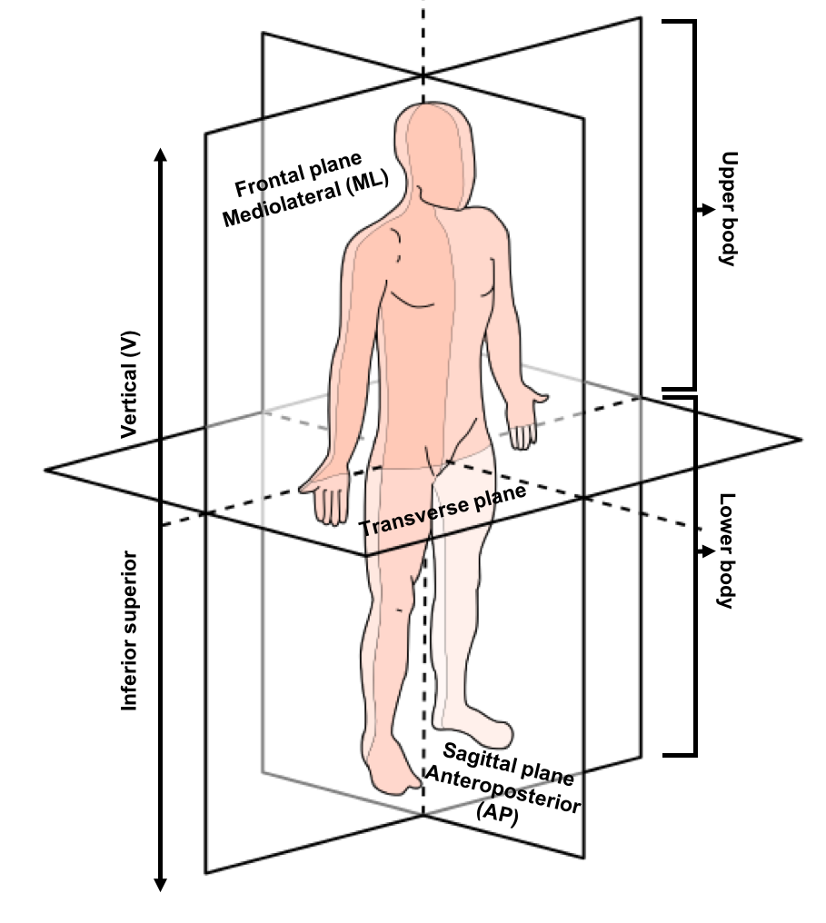

Figure 2.1 An indication of a human body divided into the three planes of motion and the movement possible within those planes. Figure adapted from https://commons.wikimedia.org./wiki/File:Anatomical_Planes.svg#/media/File:Anatomical_Planes-en.svg

Therefore, if adopting an anatomical reference to describe movement of the upper body it is possible to objectively quantify movements from different body segments using the tri-axial components of motion as measured by IMUs attached to them. An example of this and how acceleration signals can vary during a single stride isolated from a gait trial when obtained from different body locations are shown in figure 2.2. These signals and direction of motion are the premise for calculating variables descriptive of postural control during gait form the upper body.

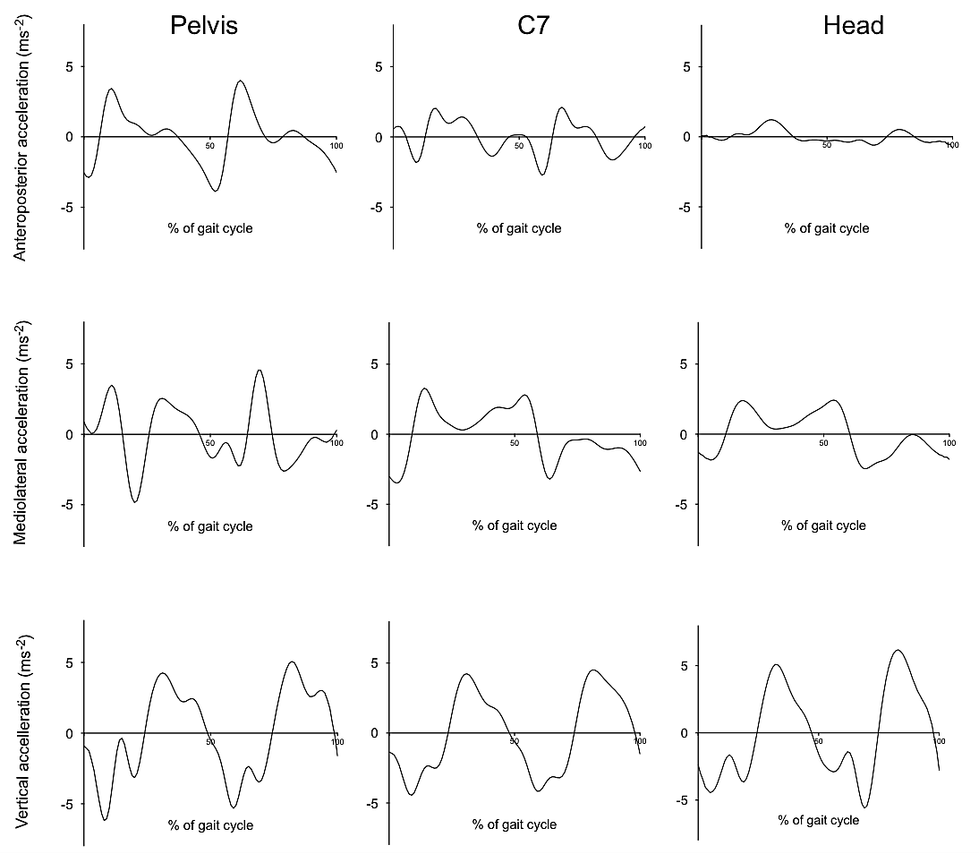

Figure 2.2. An example of the acceleration signals measured by the three sensors for one control participant’s stride in the anteroposterior (+ = anterior, - = posterior), mediolateral (+ = Medial, - = lateral) and vertical (+ = Superior, - = inferior) directions

### Signal processing techniques

Prior to the calculation of acceleration based gait variables, signal processing methods are often adopted to reduce noise and unwanted artifacts in the movement signals [6]. One aspect of the processing is to filter the signal. Recently a publication assessing the impact of denoising the gait acceleration signals from the pelvis showed that the choice of processing technique used to denoise the signals had little significant effect upon the subsequently calculated gait variables for a selection of elderly, people with PD and people with peripheral neuropathy [72]. Despite this, the most commonly adopted filer for upper body gait signals is a low pass Butterworth filter with a cut-off frequency of 20Hz [6]. As such, to remain consistent and to aid the comparison with previous publication’s results, the same filter will be used for this thesis. In addition to filtering the signal, the mean value was removed so to remove the gravitational constant within the vertical singnal and consequently aid graphical inspection of the signals whereby all single component signals are relative to zero upon the Y axis. All gait variables are then calculated from these processed signals.

## Acceleration derived variables from the trunk and head

With the commercial development of IMU there has been a consequential increase in research proposing acceleration based measures that are capable to indicate postural control differences during gait [12]. Each proposed measure however can be specific to a certain methodology, and as such, can often limit its generalized use for other studies. For example, many gait stability measures such as the Lyapunov exponents or the Floquet multipliers require a minimum of 250 successive steps to be reliably calculated [73]. Therefore, they can only be applied to studies with a large testing area to obtain successive steps. For the scope of this thesis, the variables of interest will be chosen by considering two main constraints:

* Applicability: they must be reliable when calculated from clinical laboratory based data (e.g. calculated on a single stride basis or over a short distance of subsequent strides).
* Distinctiveness: the variables will have to highlight complementary domains of motion, such as amplitude, regularity, smoothness, etc

Accordingly, the variables selected to be used within this thesis are described in the following paragraphs.

### Acceleration Root Mean Square (RMS)

Arguably, the most prevalent method of processing the raw acceleration is perhaps the calculation of RMS acceleration [6]. The RMS is used to provide a single value representative of this dispersion relative to zero for each single stride [29,74] and was calculated using equation 2.1:

2.1

$$x_{RMS}= \sqrt{\frac{1}{N}\sum_{n=1}^{N}{{\left\lceil x_{n}\right\rceil }^{2}}}$$

where x is the vector of interest and the summation is performed either along a step or along a stride.

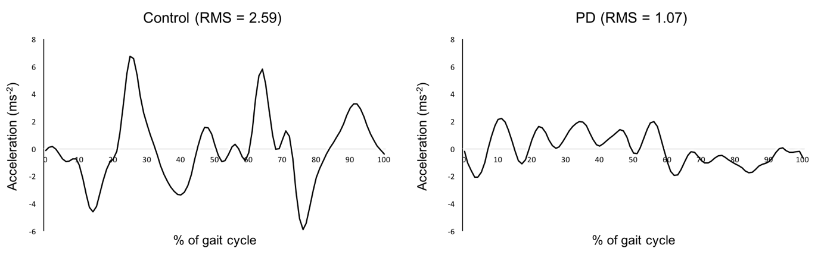Figure 2.3 shows an example of the acceleration RMS ($RMS\left(a\right)$) as calculated using the Matlab root mean square (RMS).

Figure 2.3 example of an acceleration signal obtained from the pelvis in the ML direction and of the corresponding RMS as calculated from a single stride from a control and participant with PD.

Typically, due to the positive correlative relationship between walking speed and acceleration variables [54], the RMS is proposed to reflect the magnitude of walking through being a measure of the magnitude of the variability of the amplitude of the acceleration signal. Smaller RMS values have been found for those at risk of falling who walk slower with a more conservative walking strategy [52,75].

### Jerk (J)

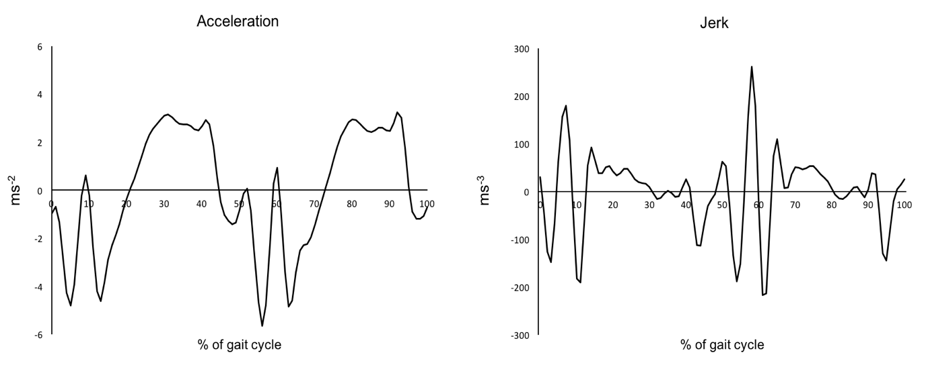 The jerk is the first time derivative of the acceleration signals and can be calculated using the Matlab function *diff*(a)*sample frequency of the accelerometer. It is promoted as a measure of smoothness during gait [76]. Figure 2.4 shows the affect differentiating an acceleration signal to create a jerk signal for a single stride for one control participant.

Figure 2.4. An example of the acceleration and the subsequently calculated jerk obtained from a single stride for one control participant.

Once the Jerk is calculated over the entire gait cycle, a summary Jerk RMS can be calculated, for each component of the acceleration signal, by calculating its RMS for each stride using equation 2.1 [67]:

(2.2)

(?)

$$J=RMS\left(\dot{a}\right)$$

Figure 2.5 shows an example of the jerk signal and the corresponding RMS as calculated using the Matlab root mean square (RMS) upon the differentiated acceleration signal.

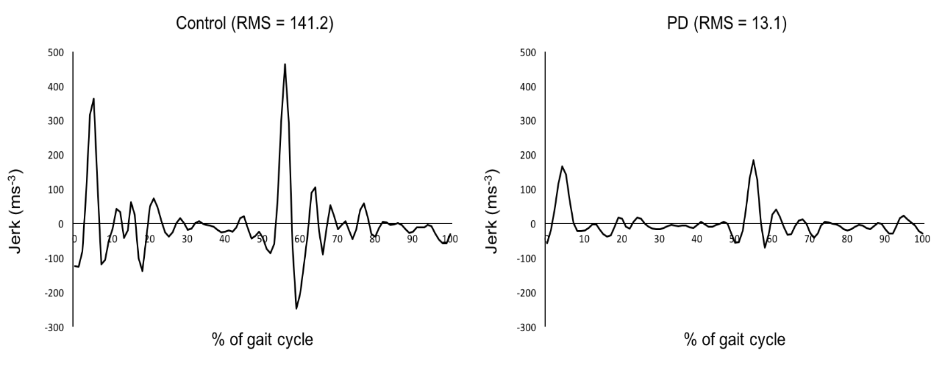

Figure 2.5. An example of a jerk signal obtained from the pelvis in the V direction and of the corresponding RMS as calculated from a single stride from a control and participant with PD.

Although less popular than acceleration RMS, calculating the RMS from a jerk signal obtained from the upper body during gait has been shown to differentiate between the elderly and the young and healthy during steady state walking. This was particularly from movements in the mediolateral direction and form the head [76] Furthermore, jerk RMS has also been shown to highlight those with PD form healthy controls and even those with PD from those with ataxia with an evident reduction in jerk RMS values [67]. Both investigations did however highlight the association between a reduced gait speed impacting the results in the vertical direction while the jerk signals may be better representative of postural control in the mediolateral direction [67,76]. It is currently not known whether both acceleration and jerk RMS provides any additional information from gait speed alone for distinguishing movements symptomatic to PD.

### Jerk ratio (JR)

The Jerk ratio was proposed by Brodie et al., [76]. The ratio utilises jerk RMS values as calculated above, however, it creates a highly reliable, normally distributed dimensionless parameter. Between elderly and the young and healthy, it has been shown be an optimal parameter to highlighting differences in dynamic stability but has yet to be tested in PD. Through principle component analysis it was shown to distinct from other acceleration-derived gait parameters (including single component jerk RMS) and not strongly associated with walking speed. On average, the young healthy presented more negative ratios relative to the elderly participants and as such a more negative jerk ratio is deemed to be favorable and representative of better gait.

The JR is calculated by making log ratios from the derivatives of the RMS taken from the AP, ML relative to the V signals using equation 2.3 and 2.4, respectively:

(2.3)

(2.4)

$${JR}_{AP }=10\log_{10} \left(\frac{ J_{AP}}{ J_{V}}\right)$$

$${JR}_{ML }=10\log_{10} \left(\frac{J_{ML}}{J_{V}}\right)$$

### Harmonic ratio (HR)

The harmonic ratio was originally described by Gage [77] and is an upper body specific measure indicative of the step-to-step (a)symmetry within a stride. It has been a prominent variable used in PD gait [55,58,78]. It is a measure based upon the premise that a stride contains two steps and therefore, during continuous walking, accelerations should repeat in multiples of two. The variable quantifies how well these accelerations are repeated in each stride compared to when accelerations do not repeat and are therefore out of phase. The ratio of in and out of phase accelerations is therefore a measure of how well the participant is walking [79].

To calculate the harmonic ratio, it is required to evaluate the harmonic content of the acceleration signal using the stride frequency as the frequency component [29]. Following a fast Fourier transform, a ratio can be created from the first 20 harmonics extracted from the Fourier series (figure 2.6). Due to the AP and V components of the signals being biphasic, the ratio for these components is determined by the sum of the even harmonics (in phase movement) divided by the sum of the odd harmonics (out of phase movement). For the ML component of the signal due to only showing only one dominant acceleration peak (whereby the odd harmonics are in-phase and even harmonic out-of-phase), the opposite is performed. As a gait measure, a higher harmonic ratio is favorable as it indicates a better symmetry between steps within a single stride

For the AP and V components, the HR was defined as (equation 2.5):

${HR}_{AP, V}=\frac{Σ Amplitudes of even harmonics}{Σ Amplitudes of odd harmonics}$

(2.5)

For the ML component the HR was defined as:

(2.6)

${HR}_{ML}=\frac{Σ Amplitudes of odd harmonics}{Σ Amplitudes of even harmonics}$

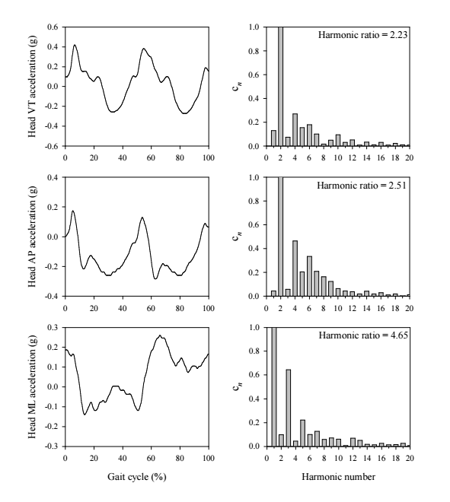

(a)

(b)

Figure 2.6. An indication of a single stride acceleration signal taken measured at the head in the V, AP and ML direction (a) and the corresponding first 20 harmonic content (b). Figure has been adapted with permission from [74].

### Pictures/grouped%20stride.pngAutocorrelation (step regularity, stride regularity, symmetry)

Unbiased Autocorrelations differ from the aforementioned variables due to requiring subsequent strides to be calculated. Figure 2.7 shows the difference between an acceleration signal obtained from a single stride relative to a signal obtained over subsequently collected strides grouped together

Figure 2.7. An indication of the different acceleration signal obtained from the pelvis in the mediolateral direction relative to a signal obtained over multiple subsequent strides grouped together

Originally proposed by Moe-Nilssen and Helbostad [80], the autocorrelation is a measure with three outcomes, step regularity, stride regularity and symmetry and is typically measured form the pelvis. The variable works under the premise that subsequent strides should be periodic as efficient walking should be a cyclical repeated movement [81]. The autocorrelation procedure tests this premise by determining within an acceleration signal which characteristics are periodic or irregular.

In order to calculate using an acceleration signal, the autocorrelation function is represented by a sequence of autocorrelation coefficients over increasing time lags whereby peaks are recorded when lags are equivalent to the periodicity of the signal. Therefore, plotting this time lagged series allows to inspect the structure of a cyclic component within a time series. Because relative to the original time series, the time phase shifts with identical results in both positive and negative direction, the autocorrelation plot is symmetrical with the zero-shift located centrally (figure 2.8 b). From this zero phase center value, the following peak values in the positive direction are representative of the first and second dominant period (figure 2.8 c). For accelerations obtained from the upper body these dominant periods are therefore equal to steps (Ad1) and strides (Ad2)

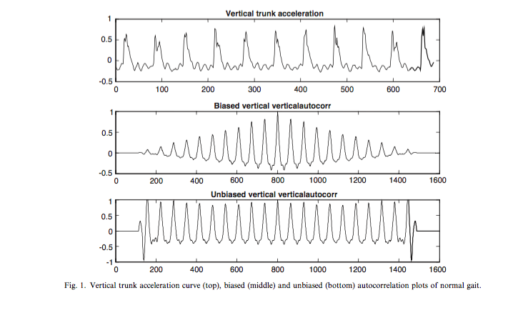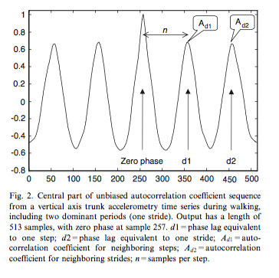

(b)

(c)

(a)

Figure 2.8. An indication of the unbiased autocorrelation plot (b) calculated from vertical pelvis accelerations (a) and the normalized zero phase central section (c) with step regularity (Ad1) and stride regularity (Ad2) highlighted. Adapted with permission from [80].

Once normalized so that the zero-phase value is equal to one, an adapted find peaks function in Matlab is used to locate both Ad1 and Ad2. The Y axis values are then taken as representatives for the quality of step and stride regularity whereby values closest to 1 is favorable (due to the normalization, 1 is the maximum possible value). The same procedure is used for the ML component of the acceleration signal with the exception that Ad1 will be negative in value therefore the absolute value is taken. From both Ad1 and Ad2 a measure of gait symmetry can be calculated via a ratio of Ad1 divided by Ad2.

The generic unbiased autocorrelation function of the sample sequence x(i) was computed using equation 2.7:

(2.7)

$$Ad\left(m\right)= \frac{1}{N-\left|m\right|}\sum_{i=1}^{N-\left|m\right|}{x\left(i\right)}∙x\left(i+m\right)$$

where N is the number of samples and m is the time lag expressed as number of samples.

### Coefficient of attenuation (CoA)

The coefficient differs from the aforementioned variables due to being calculated by the movement of multiple segments of the upper body. The CoA is a measurement of attenuation of accelerations through the trunk and head, and has previously been shown as a strong postural control indicator for children, adults, and elderly individuals [54,82,83].

The CoAs is computed using the RMS values of the head (${RMS}_{H}$), shoulder (${RMS}_{S}$) and pelvis (${RMS}_{P}$) as seen in the following equations:

(2.8)

$${CoA}_{PH}=\left(1- \frac{{RMS}_{H}}{{RMS}_{P}}\right)× 100$$

(2.9)

$${CoA}_{PS}=\left(1- \frac{{RMS}_{S}}{{RMS}_{P}}\right)× 100$$

(2.10)

$${CoA}_{SH}=\left(1- \frac{{RMS}_{H}}{{RMS}_{S}}\right)× 100$$

${CoA}_{PH}$ represents the attenuation from the pelvis to the head (equation 2.8), ${CoA}_{PS}$ represents the attenuation from the pelvis to the shoulder (equation 2.9) and ${CoA}_{SH}$ represents the attenuation from the shoulder to the head (equation 2.10). Each equation provides a percentage representing the amount of acceleration that is attenuated from the inferior sensors to the superiorly located sensor. A positive coefficient indicates reduced acceleration at the superiorly located sensor relative to the inferiorly located sensor. A negative coefficient value indicates a greater acceleration at the superiorly located sensor.

This chapter introduced using an IMU for gait analysis performed using acceleration signals obtained from the upper body. It highlighted what makes an IMU and the concepts required to apply meaning to the signals obtained from the upper body. Applicable variables found within the literature were highlighted and how they may be calculated was explained. These variables will therefore be the ones utilised within the following chapters. The next chapter will highlight how the multi-segment approach utilizing the coefficient of attenuation, which is yet to be assessed in PD, may be specifically informative to disease specific symptoms.

# Piloting a multiple body segment approach for highlighting Parkinson’s disease symptoms during gait

Although the measurement of upper body movement during gait for people with PD has been studied in the past, no study has yet taken a multi segment approach while this has been valuable in postural control analysis in other populations to highlight unique physiological mechanisms. In PD it is predicted that due to symptoms impairing the upper body such as increased rigidity, it is hypothesized they will be less capable to attenuate accelerations from inferiorly located segments to superiorly located segments such as the head. This is important as a key priority during gait is to keep the head as stable as possible. This chapter therefore will test the theory that people with PD are less able to attenuate accelerations that originate from the feet during gait from disturbing the stability of their heads. It will be the first investigation to determine if there is value in simultaneously quantifying different segments of the upper body relative to each other for people with PD.

A substantial part of the material presented in this section has been included in:

**C. Buckley, B. Galna, L Rochester, C. Mazzà,** Attenuation of Upper Body Accelerations during Gait : Piloting an Innovative Assessment Tool for Parkinson ’ s Disease. Biomed Res Int 2015:6. doi:doi.org/10.1155/2015/865873.Written permission was obtained from all the co-authors.

## Introduction

As previously highlighted, the use of acceleration variables to quantify gait differences between those who are healthy and people with PD holds much promise for the purpose of providing objective biomarkers. However, despite a recent explosion of different metrics proposed to be useful for this purpose during prescribed balance and gait tasks, their clinical use is limited. This is partly due to the perspective that they do not yet qualify as behavioral biomarkers, because many balance and gait impairments observed in PD are not specific to the disease, or been related to specific pathophysiological biomarkers [12]. To overcome this a recent review states that the most useful gait and balance biomarkers for people with PD will be those sensitive and specific and descriptive to the underlying disease process [12].

One pathophysiological biomarker in PD is an increased axial rigidity which is clinically referred to as an increased resistance when passively stretching a muscle and reported by patients as a feeling of stiffness that is often across the shoulders and the neck at the early stages of the disease [84]. Previous gait research has shown that the movement of the trunk is impaired for people with PD and its quantification can identify the extent of axial rigidity and can be a sensitive measure for early diagnosis when other gait measures such as stride duration and its variability cannot [17]. However, in order to quantity axial rigidity this previous study used an opt-electronic tracking device which can be limited for clinical uilisation and due to measuring displacement may not be as sensitive as devices which measure acceleration directly.

The coefficient of attenuation (CoA) is an acceleration derived variable that can be calculated using IMU data and therefore may be more applicable for a clinical assessment. Originally, its focus was to quantity a person’s ability to best maintain head stability during gait due to its importance of containing the visual and vestibular systems that are critical for navigation and pre planning adaptive motor strategies [51]. Combining the fact that vision is known to be affected in gait for people with PD [85] and a known increased rigidity, the coefficient of attenuation may be an ideal metric to quantify impairments specific to the disease, however, its use within PD has yet to be examined

Within this framework, it was hypothesized that due to an increased axial rigidity in PD it will impair their ability to attenuate accelerations created during gait from inferiorly located segments to superiorly located segments such as the head. To address this aim, accelerations of the head, trunk, and pelvis were assessed during gait in a small cohort of people with PD and an age-matched control group.

## Methodology

### Subjects

Participants were recruited by the clinical ageing research unit at Newcastle university into ICICLE-GAIT, a collaborative study within ICICLE-PD, an incident cohort study (Incidence of Cognitive Impairment in Cohorts with Longitudinal Evaluation – Parkinson’s disease) of patients within four months of diagnosis of PD. In addition to the participants with PD, age matched controls were also recruited. These controls were deemed healthy and could walk unassisted for the duration of the testing protocol. For both groups both males and females were recruited. PD participants were excluded from ICICLE-GAIT if they had any neurological (other than PD), orthopaedic, or cardiothoracic conditions that may have markedly affected their walking or safety during the testing sessions. The PD participants had to be diagnosed with idiopathic PD according to the UK Parkinson’s Disease Brain Bank criteria and were excluded if they presented significant memory impairment (Mini Mental State Exam (MMSE) ≤24 [86]), dementia with Lewy bodies, drug induced parkinsonism, “vascular” parkinsonism, progressive supranuclear palsy, multiple system atrophy, corticobasal degeneration, or poor command of English. None of the participants demonstrated severe tremor or dyskinesia. This study was conducted according to the Declaration of Helsinki and had ethical approval from the Newcastle and North Tyneside research ethics committee. All participants signed an informed consent form.

### Measurement protocol

The participants with PD and their age-matched controls walked at their preferred pace for two minutes around a 25m oval circuit marked by cones and contained within a laboratory. The straight section of the oval circuit contained a 7m long commercially available pressure sensitive electronic walkway (Platinum model GAITrite, software version 4.5, CIR systems, United States of America) (figure 3.1 a) [87]. The GAITrite mat consists of two components, the mat itself, and a personal computer with the GAITrite software installed. The mat is composed of a series of sensors, organized in a 48 × 288 grid pattern sandwiched between 2 layers of vinyl. The embedded sensors are triggered when mechanical pressure is applied irrespective of source, be it from foot contact or a mechanical device. Data from the triggered sensors are collected by on-board processors connected in series and fed to the computer through a serial port. The spatiotemporal information is then processed in within the GAITrite software.

Accelerations were measured using three IMUs (128 Hz, Opal™, APDM Inc, Portland, OR, USA) firmly attached to the upper body using medical grade adhesive tape and Velcro straps. The sensors attached using tape were located at L5 vertebra to represent movements at the pelvis level and the 7th cervical vertebra to represent the shoulder level (S) (figure 3.2 b). The sensor attached using the Velcro strap was located at the back of the head. The sensor’s X axis pointed downwards representing the vertical direction relative to the participant (V), the Y axis pointed to the left relative to the participant’s direction of motion and representing the medio-lateral direction (ML). The Z axis pointed backwards (relative to the participant’s motion) representing the anterior-posterior direction (AP). The GAITrite and the IMUs were synchronized (±1 sample) using a custom-made cable and the data was collected at 128Hz using the same A/D converter.

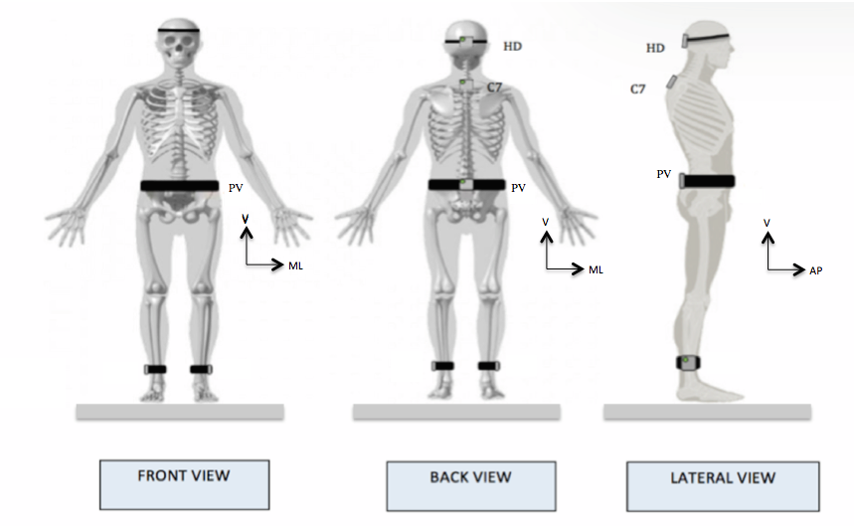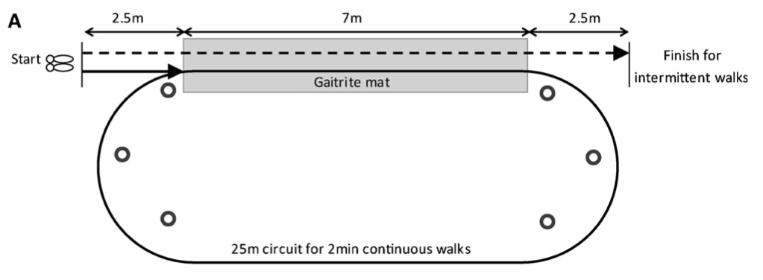

a

b

Figure 3.1 Indication of the 25m circuit containing the GAITrite system (a) and a diagram highlighting the placement of the IMUs placed at the head, C7 and Pelvis (b). Adapted from [87].

### Data processing

The lower body spatiotemporal variables were collected from the GAITrite mat through measuring the placement of the participant’s feet over successive steps. Each pass of the mat was visually inspected to remove problematic steps that would have impaired the analysis. The removed steps were ones where the foot was not entirely in contact with the mat (e.g. the participant stepped on the edge of the mat), or there was an evident dragging type motion of the foot which would have stopped the ability to correctly classify the gait characteristics of the step. Once visually inspected and the false foot placements were removed. MATLAB (version 8.4.0, R2014b) was used to take the raw data exported from the GAITrite and calculate each participant’s mean for the spatiotemporal variables. Due to the IMUs being triggered by the GAITrite, the acceleration data was segmented following gait events as detected by the GAITrite. This ensured only steady state straight line gait data was analysed.

### Signal realignment

Prior to the calculation of the acceleration variables, an addition pre-processing technique was required to account for sensors on the upper body not being uniformly aligned with each other and to avoid directional crosstalk. The method chosen replicated Mazzà et al., [83]. Briefly the method uses the quaternion output of the IMUs to align all sensors to a uniform global reference frame. The method first requires determining whether the quaternion output is consistent throughout the area of testing and not impacted by a non-uniform magnetic field within the laboratory. This was achieved by placing multiple IMUs upon the GAITrite so that their vertical component aligned to the earth’s vertical axis, the (AP) direction aligned to the direction of the participant’s walking direction and the medio-lateral (ML) axis was defined according to a right-handed reference frame. Once placed upon the mat, a trial is recorded and checked to determine if the quaternion output was comparable between sensors. For this laboratory this was deemed true and therefore the quaternion output from a central location of the GAITrite was selected as the laboratory’s global reference.

Once a global reference frame for the laboratory has been established, the local reference frame of each sensor during the walking trial was reoriented for each time sample to the newly established global reference in an attempt to achieve uniform alignment between sensors [83,88]. To do this the movement trials’ quaternion output representing the local reference frame for each sensor located on the participant is measured. This quaternion data is then multiplied by the inverted quaternion output of the global reference. To multiply both quaternion signals together, the global reference frame is multiplied by the local reference frame on a single sample basis using the openly available Matlab function “*quatmultiply”*. Following this multiplication, another Matlab function “*quat2rot”* is used to create a rotation matrix from this newly calculated quaternion but with the dimensions of the tri-axial accelerometer signals. Lastly, the generated rotation matrix is then used to multiply the raw acceleration data recorded during the participants’ walking trials on a single sample basis thus generating a new acceleration signal that has been aligned to the global reference frame.

### Variables.

The coefficient of attenuation was calculated as described in chapter 2. In addition to the coefficient of attenuation, the acceleration RMS calculated at each sensor location to discover whether an additional classification ability was achieved through multiple segments rather than the movement of a single segment. Also, the harmonic ratio was calculated to determine if the coefficients could classify the two groups better than a variable commonly reported to classifying gait impairment in PD [6]. Both the RMS and the HR variables were calculated as highlighted in Chapter 2.

### Statistical analysis

A series of two-tailed paired-tests were used to test the difference between groups. The level of significance was set at p = 0.05. Given the exploratory nature of this study and the small sample size, the value was not adjusted for multiple comparisons.

## Results

The characteristics of the participants are reported in Table 3.1. Due to the exploratory nature of the investigation and the availability of data at the time that it was conducted during the PhD, a relatively small sample size of 13 people with PD and 19 age match controls was used.

Table 3.1. The mean (±SD) participant characteristics and spatial-temporal gait variables for the PD and Control group.

|  |  |  |  |
| --- | --- | --- | --- |
|  | PD (n13) | Control (n19) | *P* (*t*-test) |
| Age (years) | 69.70 ± 11.12 | 70.20 ± 6.7 | 0.90 |
| Height (m) | 1.70 ± 0.1 | 1.72 ± 0.10 | 0.99 |
| Mass (Kg) | 77.90 ± 13.3 | 83.20 ± 14.20 | 0.30 |
| BMI | 26.10 ± 3.3 | 28.00 ± 4.5 | 0.20 |
| MDS UPDRS III | 35.60 ± 12.6 | NA | NA |
| Hoehn & Yahr stage | HY II: 11; HY III: 2 | NA | NA |
| Gait speed (m/s2) | 1.22 ± 0.22 | 1.32 ± 0.15 | 0.14 |
| Step time (s) | 0.54 ± 0.21 | 0.54 ± 0.44 | 0.97 |
| Step length (cm) | 0.66 ± 0.12 | 0.71 ± 0.07 | 0.15 |
| Step width (cm) | 0.09 ± 0.03 | 0.09 ± 0.02 | 0.46 |

1. *Significant difference at *p* <0.05.
2. BMI: Body Mass Index.
3. MDS UPDRS III: Movement Disorders Society revised Unified Parkinson’s Disease Rating Scale – Movement subsection [34].
4. HY: Hoehn and Yahr stage [35].

### Coefficient of attenuation

People with PD did not attenuate AP or ML accelerations as well as controls (Figure 3.2). For $C_{PH}$, a significant difference existed between PD and the control participants in the ML direction (0.12 ± 34.7% vs 33.8 ± 21.3%, *p* = 0.003). For $C_{PS}$, a significant difference existed between PD and controls in the AP (16.0 ± 15.6% vs 33.1 ± 12.4%, *p* = 0.002), as well as the ML direction (5.5 ± 24.5% vs 27.7 ± 18.6%, *p* = 0.009). For $C_{SH}$ a significant difference existed between the PD and the control group in the ML direction (-3.6 ± 15.5% vs 9.4 ± 15.3%, *p*= 0.031).

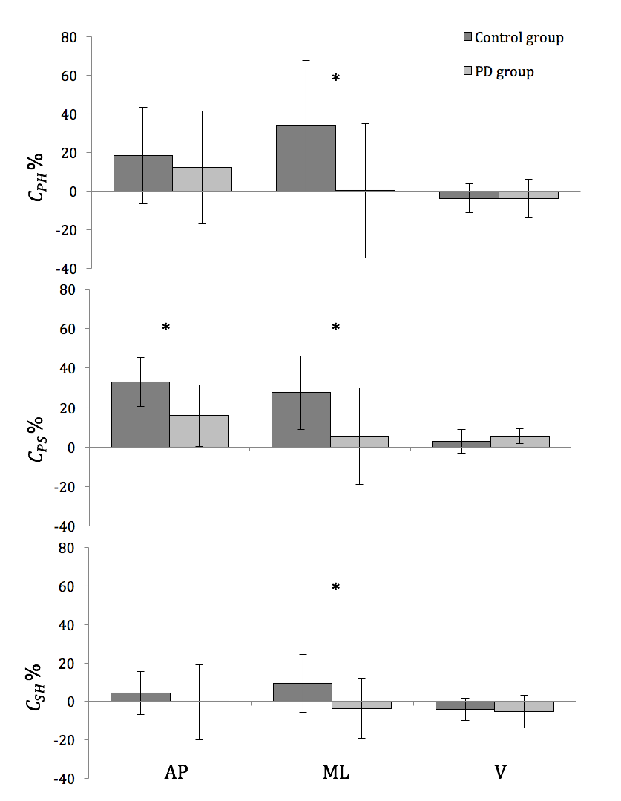

Figure 3.2: Mean (±SD) values of the attenuation coefficients (𝐶PH, 𝐶PS, and 𝐶SH) of the three acceleration components (AP = anterior/posterior, ML = medial/lateral; V = vertical), computed for the control and group with PD. ∗𝑃 < 0.05. Adjusted from [89].

### Acceleration RMS

Significantly higher ML head accelerations were observed in people with PD compared to controls (1.08 ± 0.29 m/s2 vs 0.86 ± 0.21 m/s2, *p* = 0.024) but not at the pelvis or the shoulder level. There were no other significant between-group differences (Table 3.2).

Table 3.2. The mean (±SD) Root mean square (RMS) for the PD and the control participants calculated at the head (H), Shoulder (S) and the Pelvis (P) levels.

|  |  |  |  |  |
| --- | --- | --- | --- | --- |
| Sensor location | Component | PD | Control | *p* (*t*-test) |
| H | AP | 1.02 ± 0.24 | 0.92 ± 0.20 | 0.22 |
|  | ML | 1.08 ± 0.29 | 0.86 ± 0.21 | 0.02* |
|  | V | 2.15 ± 0.74 | 2.41 ± 0.47 | 0.26 |
| S | AP | 1.03 ± 0.18 | 0.96 ± 0.16 | 0.31 |
|  | ML | 1.05 ± 0.24 | 0.96 ± 0.17 | 0.25 |
|  | V | 2.04 ± 0.64 | 2.28 ± 0.46 | 0.24 |
| P | AP | 1.28 ± 0.38 | 1.47 ± 0.33 | 0.14 |
|  | ML | 1.17 ± 0.36 | 1.41 ± 0.42 | 0.11 |
|  | V | 2.16 ± 0.70 | 2.35 ± 0.47 | 0.37 |

1. *Significant difference at *p* <0.05
2. H: Head; S: Shoulder level; P: Pelvis
3. AP: anterior/posterior; ML: medial/lateral; V = vertical

### Harmonic ratio

The HRs showed no significant differences between the PD and control participants (Table 3.3).

Table 3.3. The mean (±SD) Harmonic ratios for the PD and the control participants calculated at the head (H), Shoulder (S) and the Pelvis (P) levels.

|  |  |  |  |  |
| --- | --- | --- | --- | --- |
| Sensor location | Component | PD | Control | *p* (*t*-test) |
| H | AP | 0.82 ± 0.31 | 0.69 ± 0.31 | 0.29 |
|  | ML | 1.4 ± 0.47 | 1.35 ± 0.52 | 0.76 |
|  | V | 2.39 ± 0.53 | 2.85 ± 0.74 | 0.08 |
| S | AP | 0.85 ± 0.34 | 0.86 ± 0.28 | 0.95 |
|  | ML | 0.91 ± 0.43 | 1.04 ± 0.27 | 0.34 |
|  | V | 2.77 ± 0.78 | 3.32 ± 1.04 | 0.12 |
| P | AP | 1.44 ± 0.39 | 1.47 ± 0.57 | 0.87 |
|  | ML | 1.16 ± 0.58 | 1.04 ± 0.46 | 0.56 |
|  | V | 2.39 ± 0.57 | 2.86 ± 2.86 | 0.16 |

1. *Significant difference at *p* <0.05
2. H: Head; S: Shoulder level; P: Pelvis
3. AP: anterior/posterior; ML: medial/lateral; V = vertical

## Discussion

The investigation was the first to show that measuring the attenuation of acceleration during gait also can provide a sensitive measure of postural control in people with Parkinson’s disease (PD) which is likely to be a result of a symptom specific to the disease e.g an increased axial rigidity. The results of this investigation also provided further evidence that people with PD walked with greater magnitude of ML head accelerations. In contrast to previous findings and expectations, the harmonic ratio was unable to detect PD gait, in this sample of people with PD.

The inability to control the head accelerations during gait was interpreted as a result of poor postural control for the PD participants and a failure to stabilise their head in space [54,82,83]. This is particularly crucial for people with PD because of their aforementioned increased dependence upon visual input for correcting postural control [90] where higher accelerations are likely disturbing their visual system, leading to an impaired ability to preplan effective motor strategies [51] which may cause an increased likelihood to fall. Although they might be a useful measure of postural control, RMS values of head accelerations alone are known to be dependent upon step length and gait speed [56]. Despite no significant differences being observed for these parameters between the PD and the control group in this sample, it is common that PD affects both gait speed and step length [17,21,91]. As a result, the magnitude of accelerations may lack sensitivity when used for discriminating PD patients, which in other studies and more impaired PD patients have been shown to possess a decreased step length and gait speed, when compared to age-matched controls.

Alternatively, being computed as a ratio between synchronized accelerations measured during the same trial [54], the coefficients of attenuation do not suffer from being speed dependent. In the current investigation; the coefficients of attenuation provided insight into why the PD participants demonstrated greater accelerations at the head. Participants with PD were less able to attenuate accelerations through the trunk, as shown by impaired pelvis-shoulder attenuation coefficients, which were reduced on average by at least a half in the PD cohort, both in the AP and in the ML direction. It is not possible to fully explain why the people with PD did not attenuate accelerations well through the upper body; however, it may be associated with *en-bloc* movement which is said to be a consequence of axial rigidity. For example, It has previously been stated that increased rigidity may cause underlying changes in the physiological and mechanical functioning of the axial muscles which results in *en-bloc* movement, where the head, trunk and pelvis move together as one rigid unit [22,92]. It therefore might be assumed that the same mechanisms could be responsible for poor attenuation of accelerations through the spine in PD. However, more research is certainly needed to test this hypothesis and explain the mechanisms ruling altered head accelerations and poor attenuation in PD, as well as the implications of poor head stability on vision and postural control.

Interestingly, the findings regarding attenuation coefficients were strongest in the ML direction. Similar results were found even when analysing healthy elderly subjects [93]. The fact that instability was predominantly found in the ML direction, suggests that when utilising a coefficient of attenuation, the ML direction is potentially most informative of an impaired walking stability. Consequently, assessments in the ML direction may be best for proxy measures of postural control in PD.

In contrast with our hypothesis and previous studies results [58], the harmonic ratio was not capable to distinguish different movements between the two groups. It is possible, that we were statistically underpowered to detect group difference, as suggested by a 25% reduction of AP HRs and 16% reduction of ML HRs at the head in the PD group that did not reach statistical significance (*p* = 0.106). Alternatively, the results show that the harmonic ratio was unable to detect the differences in gait at the early stage of the disease of the participants. If so, potentially it highlights that the coefficient of attenuation may be a favorable measure if detecting impairments at the early stage of the disease. Further research is required to determine the effectiveness of harmonic ratios as a sensitive measure to PD at different stages of their disease progression and whether the coefficient of attenuation is indeed advantageous at the early stages of PD.

## Conclusion

The chapter showed the magnitude of ML head accelerations and attenuation of upper body acceleration were sensitive to PD and consequently hold promise as useful proxy measures that can be utilised in clinics and potentially community settings. It is proposed that the inability to attenuate acceleration is a result of disease specific axial rigidity and therefore the coefficient of attenuation may be advantageous to other variables proposed to quantify gait impairment in PD.

# The impact of pre-processing techniques upon acceleration variables during gait in Parkinson’s disease

Currently much work is being performed to establish the best way to orientate IMUs to a meaningful global reference. However, despite new methods being created that utilise the increased output of IMUs (e.g. the calculation of quaternions), the most prominent realignment method used in the literature is nearly twenty years old and only utilises acceleration signals [43]. Within human movement literature, while publications are promoting variables obtained from the upper body to be sensitive to PD, the realignment methodology used is certainly not uniform as no consensus exists for how the data should be collected and processed. Combining this with the conflicting results found in the previous chapter regarding the HR not being sensitive to PD while other investigations promote it for this purpose, we believed the pre-processing stage of realigning may impact a variable’s ability to detect movements symptomatic of PD gait. This chapter therefore attempts to discover whether the realignment method used can create a conflict between the literature for what variables can highlight gait impairment in PD.

A substantial part of the material presented in this section has been included in:

**C. Buckley, B. Galna, L Rochester, C. Mazzà,** Quantification of upper body movements during gait in older adults and in those with Parkinson’s disease: impact of acceleration realignment methodologies. Gait Posture 2017;52:265–71. doi:10.1016/j.gaitpost.2016.11.047. Written permission was obtained from all the co-authors.

## Introduction

The previous chapter showed that the harmonic ratio was not sensitive to PD when typically being one of the most popularly promoted variables for detecting PD gait [6]. One difference between that investigation and those promoting the harmonic ratio was a pre-processing technique previously utilised for the coefficient of attenuation to align the sensor’s local reference frames to a global reference. More recently it has been highlighted that although supposedly measuring the same populations, the harmonic ratio ranges in values between investigations, and consequently shown that varying methodologies used to calculate the harmonic within the literature (including realignment techniques) could impact the variables values [62,72]. Because the harmonic ratio was sensitive to non-standardized measurement protocols it may explain why our previous investigation did not show the harmonic ratio to be sensitive to PD.

As previously highlighted, IMUs overcome many of the limitations of more traditionally used optoelectronic systems. However unlike optoelectronic systems that can be calibrated to establish a global reference prior to data collection, caution is required for analysis of the upper body using IMUs because a limitation of IMUs is that their outputs are relative to their own local reference frame [71]. Therefore the likelihood of varying postures between participants, such as an increased flexed trunk found for people with PD [16], and varying sensor locations upon the upper body does not allow for separate sensors to be uniformly aligned (see figure 4.1). The absence of uniform alignment therefore provides potential for directional crosstalkerrors to occur when making comparisons of upper body gait variables between different 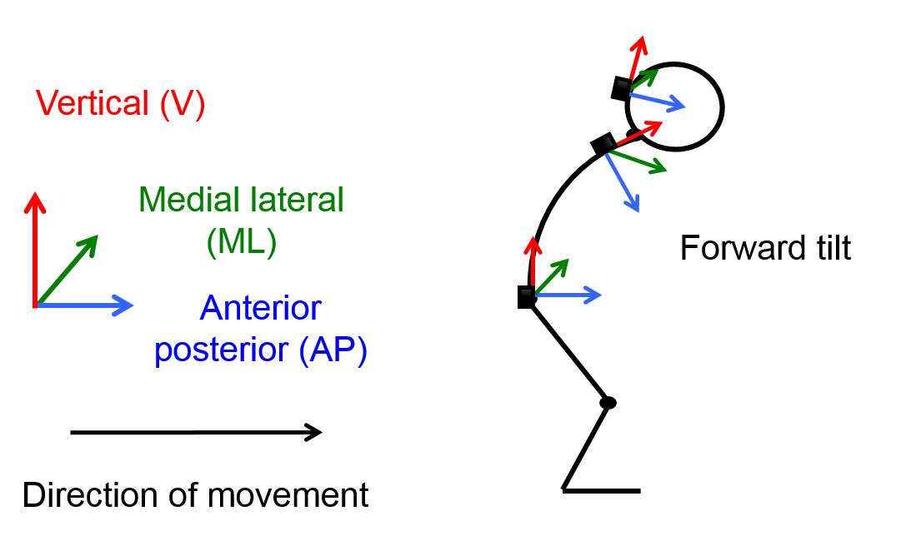participants, groups and sensor locations [43,72].

Global reference frame Local reference frame

Figure 4.1. Representation of how the local reference frames of sensors placed upon the pelvis, shoulder level and head may not be uniformly aligned to earth global reference and the potential source of directional crosstalk errors.

To overcome potential crosstalk problems, different techniques have been proposed to align IMU local reference frames to a meaningful global reference [20,43,82]. The impact of one of these methods upon gait variables obtained from the pelvis has been shown to affect the upper body variables and potentially lead to better discrimination [62,72]. However, these investigations only analysed a selection of upper body variables promoted to measure upper body control and did not assess segments superiorly located from the pelvis, which may test particular realignment methods ability to work effectively. Currently, the influence of different methods to realign IMU sensor outputs on a wider selection of upper body variables at different locations of the body is unknown yet they are being inconsistently used within the literature.

It was hypothesised that differences in realignment methods will influence upper body outcome measures in both healthy elderly and people with PD not only as a consequence of different signal processing techniques, but also as a result of postural differences and walking mechanics impacting the acceleration signals between the two groups. Therefore if upper body variables are to be used to quantify gait impairments for people with PD, a detailed understanding of the impact of pre-processing techniques is essential if data are to be compared across studies [72]. This investigation aimed to describe how different methods designed to realign IMUs to a comparable global reference impact acceleration derived upper body variables known to be sensitive to impaired upper body control. To exemplify the potential impact of these alterations, we also investigated whether the choice of realignment method impacts upon the ability of upper body variables to discriminate PD from age-matched controls.

## Method

For this chapter, the same processing procedure was used as in Chapter 3, the only exception being the use of different realignment methods that was implemented prior to the filtering process.

### Realignment methods

All realignment methods have been implemented following the descriptions from the papers where they were originally proposed.

**Method 1 (M1):** Raw data was used to represent studies whereby no realignment correction was applied [58,94]. Variables calculated based upon the uncorrected data were also shown to act as reference to see how the following methods impacted the original signal and the subsequently calculated variables.

**Method 2 (M2):** M2 is a realignment method that only relies on the on the acceleration signal during gait and was originally proposed by Moe-Nilssen in 1998 [43]. It remains the most widely used within the literature [6,95]. For gait data, the method relies upon the assumption that the acceleration in the anterior-posterior (AP) direction are constant (i.e. the AP axis is aligned with the vector representing the subject’s mean velocity of progression, and moving consistently with it). The method works by transforming the tri-axial acceleration data into a horizontal-vertical coordinate system through using trigonometry relating to a Cartesian coordinate system. Thereafter it calculates a correction needed, based upon the best estimates of the angles of misalignment ($θ$), between the true horizontal-vertical and that of the signals obtained during gait in the anterior-posterior ($a_{a}$) and mediolateral ($a_{m}$) accelerations [43,95]. The required rotation angle is calculated using the principle that the average value of aa and am will approach the sin of the angles within the same directions. Then calculating the angle arcsin, it is possible to determine the values needed to correct the misalignment in four stages (Deduced by the equations 4.1 to 4.4).

Correction in the anterior-posterior plane:

(4.1)

$$a_{A}= a_{a}cosθ_{a}-a_{V}sinθ_{a}$$

To create an interim correction (a’V) in the vertical direction, to be derived before a true value for aV can be calculated:

(4.2)

$${a'}_{V}= a_{a}sinθ_{a}+θ_{V}cosθ_{a}$$

The interim values in the vertical direction used to derive aM :

(4.3)

$$a_{M}= a_{m}cosθ_{m}-{a'}_{V}sinθ_{m}$$

Finally, aV can now be estimated:

(4.4)

$$a_{V}= a_{m}sinθ_{m}+{a'}_{V}cosθ_{m}-1g$$

Where:

$g$ = gravity acceleration

$a_{a}$ = measured AP signal

$a_{A}$ = estimated AP acceleration in the horizontal plane

$a_{m}$ = measured AP signal

$a_{M}$ = estimated AP acceleration in the horizontal plane

$a_{v}$ = measured V signal

${a'}_{V}$ = estimated provisional V acceleration

$a_{V}$ = estimated V acceleration

$θ_{a}$ = angle between the horizontal plane and a measured anteroposterior vector

$θ_{m}$ = angle between the horizontal plane and the measured ML acceleration vector.

**Method 3 (M3):** Proposed as a progression from M2, M3 attempts to improve it through removing low-frequency movements not associated to gait such as “head nodding” and therefore improve data quality [20]. The required correction is performed by making mathematical corrections to align the local sensor’s axis with the global coordinate system. It has previously been validated with a optoelectronic cameras using elderly participants with sensors located on their pelvis and the top of their head [20]. How this method attempts to improve from M2 is through implementing a filter individually scales to each participant’s specific step frequency. The participant’s step frequency is calculated using discrete Fourier transform (Matlab’s *fft()* function) and assessing the acceleration signal in the frequency domain. Using the signals from the sensor located on the pelvis, the participants step frequency is found in the first dominant peak within the AP and V direction, whereas, their stride frequency is found in the first dominant peak in the ML direction.

Once the participants step frequency is identified, the acceleration signal is filtered using a low pass 4th order Butterworth filter (Matlabs’s filtfilt() function) with a cut off frequency scaled to one quarter of the identified step frequency. The purpose of this is to remove the low frequency movements representative to slow changes in orientation and not gait. This newly calculated filtered signal can be used to remove the low frequency error from the acceleration signals of interest by acting as a floating unit vector (LFA) and a reference for the required orientation. This is possible because steady state walking was used for the method, therefore, theoretically meaning, if no orientation error were present, then the LFA would have been coincident to the gravitational acceleration (e.g. G = [0, 0, 9.81]′) (e.g. perfectly aligned with gravity). However, because for the upper body this is not always the case, the slow changing sensor orientation causes the newly created LFA to be angled away from the vertical. The filtered signal is therefore used to know how much the sensors orientation differs from gravitational acceleration and consequently the basis for a correction can be made.

The required continuous rotational corrections are calculated by converting the LFA vector (LFA = [LFAAP, LFAML, LFAV]′) into an angular correction (*θ*) about a floating unit vector (u = [*ux, uy, uz*]′) in the *XY*-plane at each sample. The required angular correction (*θ*) is calculated using equation (4.5). Pairing this together with the required floating axis (U) using equation (4.6) on a single sample bases, using dot and cross products of the LFA and gravitational acceleration vectors (*G*), a required pitch and role correction can be calculated in the form of a rotation matrix (equation 4.7). The rotation matrix for the pitch and roll corrections is calculated using equation 4.7 by using the previously calulated (*θ*, radians) about the unit vector (*u*). This rotation matrix is then applied to the raw acceleration data from the sensors attached to the participant (A = [*A*AP, *A*ML, *A*VT]′) to give acceleration corrected for pitch and roll (ACorr, equation (4.8)).



(4.5)



(4.6)

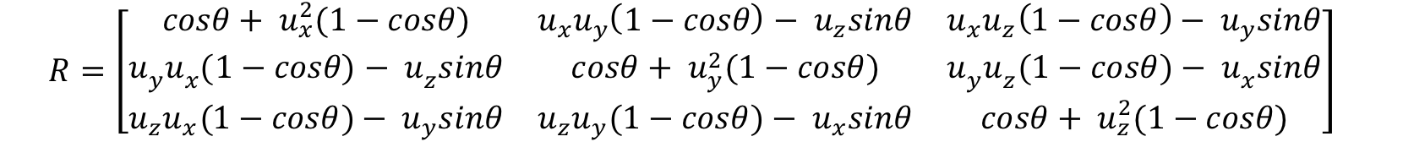

(4.7)



(4.8)

Where:

$θ$ = pitch and roll angular corrections

$G$ = gravity acceleration

$LFA$ = floating unit vector

$U$ = floating axis

$R$ = rotation matrix

$A$ = acceleration signal

$A_{corr}$ = corrected acceleration signal

**Method 4 (M4):** M4 differs from the previous three as it uses the IMU’s quaternion output to provide a global reference frame [70,82]. A complete description of the method was reported in chapter 3 (3.2.4).

### Statistical analysis

A mixed-design ANOVA was used to determine if the realignment method affected each characteristic regardless of group (method main effect) and whether the group differences were impacted by the use of the different methods (interaction effect). The within repeated measures factor was defined by the realignment methods. If the residuals from the ANOVA were not normally distributed for each variable, a transformation was performed on the participants’ values to ensure normality. To further investigate the discriminant ability of the investigated variables, and to reduce the chance of occurring a type-1 error, paired samples t-tests were only performed for the upper body variables where an interaction occurred. This analysis tested if the two groups differed significantly independent of realignment method. The *p* value (significance set at 0.05) and effect size of each comparison was calculated.

## Results

The characteristics of the participants are reported in Table 4.1

Table 4.1. The mean (±SD) participant characteristics and spatial-temporal gait variables for the PD and Control group

|  |  |  |  |  |
| --- | --- | --- | --- | --- |
|  | PD (n=60) | Control (n=54) | *P* (*t*-test) | |
| Age (years) | 68.5 ± 9.1 | 71.1 ± 6.7 | 0.10 |
| Height (m) | 1.68 ± 0.1 | 1.71 ± 0.1 | 0.21 |
| Mass (kg) | 77.5 ± 16.8 | 78.7 ± 16.5 | 0.69 |
| MDS UPDRS III | 26.0 ± 21.6 | NA | NA |
| Hoehn & Yahr | HY I: 1; HY II: 52; HY III: 7 | NA | NA |
| Number of strides | 20 ± 3 | 21 ± 3 | 0.06 |
| Step frequency (s/m) | 109.6 ± 9.1 | 111.7 ± 9.0 | 0.22 |
| Step velocity (m/s) | 1.13 ± 0.23 | 1.29 ± 0.18 | p<.001 |
| Step time (s) | 0.55 ± 0.05 | 0.54 ± 0.04 | 0.19 |
| Step length (m) | 0.62 ± 0.11 | 0.69 ± 0.08 | p<.001 |
| Step width (m) | 0.09 ± 0.03 | 0.09 ± 0.02 | 0.39 |

1. *Significant difference at p <0.05

Figure 4.2 provides a visual example of the impact of each realignment method upon the acceleration signal for all levels and directions analysed during an example stride. Vertical signals varied the least between the realignment methods and the realignment method had most impact for acceleration signals measured at the shoulder level

Figure 4.2. An indication of the method effect upon the acceleration signals measured by the three sensors for one control participant’s stride in the anterior-posterior (AAP), medio-lateral (AML) and vertical (AV) directions. Adapted from [96].



There was a significant method main effect for all upper body variables, meaning that each upper body variable differed significantly between the four realignment methods irrespective of group.

Significant interactions were seen for 12 of the 42 upper body variables. All variables are shown for both groups and the four realignment methods (table 4.2). Post-hoc analysis revealed that for select upper body variables, significant differences and between groups effect sizes were inconsistent between the realignment methods (table 4.3). For example, the CoAPS in the AP direction showed the control group had significantly greater levels of attenuation for M2 (*p* = 0.01, *d* = -0.10), M3 (*p* < 0.01, *d* = 0.62) and M4 (*p* = 0.02, *d* = 0.44) as opposed to M1 where the control group had reduced amount of attenuation and no significant difference (*p* = 0.76, *d* = -0.10).

.

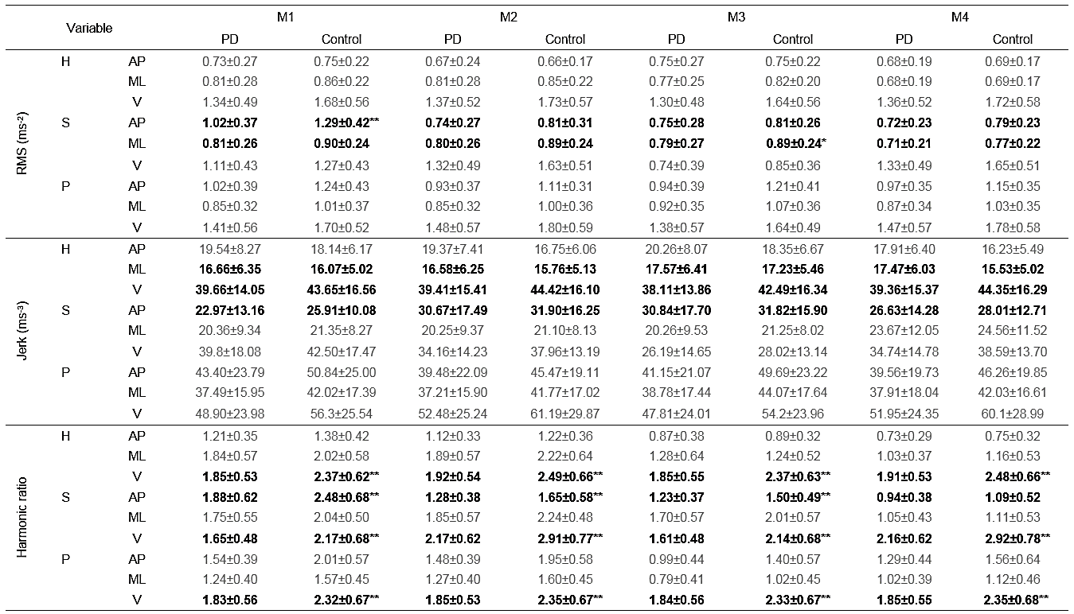Table 4.2. The PD and control group upper body variables values for the four realignment methods. Group by method interactions are highlighted in bold and the post hoc between group differences are indicated. Adapted from [96].

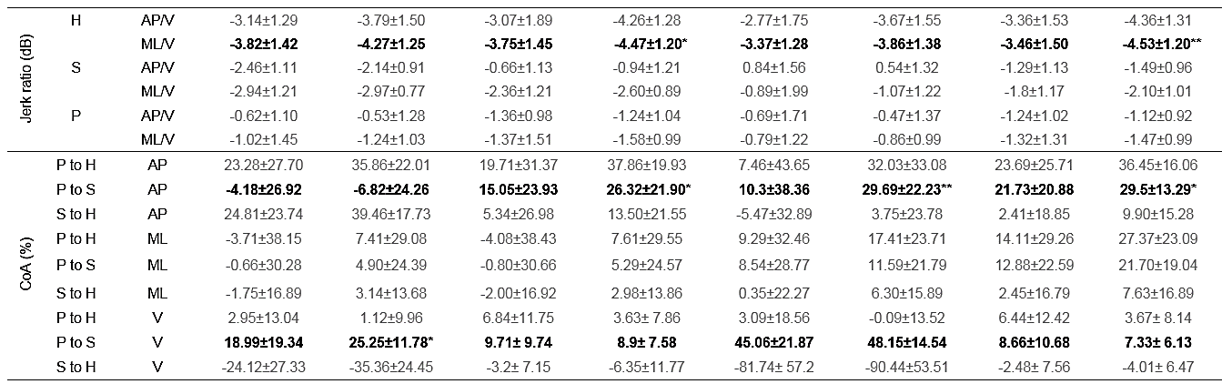

1. **bold** indicates the variables where a significant interaction effect was recorded
2. **\*** highlights a significant difference between groups at the *p* < 0.05 level
3. **\*\*** highlights a significant difference between groups at the *p* < 0.001 level
4. *H = head level. S = shoulder level. P = pelvis level*
5. *AP = anterior-posterior. ML = medio-lateral. V = vertical*

Table 4.3. The post-hoc paired sample t-test *p* values and effect size (*d*) values for all variables and realignment methods where an interaction occurred.



1. *H = head level. S = shoulder level. P = pelvis level*
2. *AP = anterior-posterior. ML = medio-lateral. V = vertical*

## Discussion

This was the first study to test the impact of different realignment techniques upon acceleration signals obtained at different locations of the upper body during gait. Results showed that the realignment method significantly altered the values of variables derived from upper body accelerations, irrespective of group. In some cases, the amount of these alterations were such to even impact the variables ability to discriminate between PD and healthy controls.

The effect of the realignment technique on the sensitivity of upper body variables to discriminate pathology has been investigated previously, comparing realignment method M1 and M2, at one sensor location (P), during treadmill walking and considering different variables from those investigated in this study (HR being the only variable in common) [72]. Similar to this study, it was shown that tilt correction can affect discrimination amongst patient groups [72]. This agreement both confirms the need to realign raw acceleration signals and additionally shows that different realignment methods can have clear implications for interpretation of results when assessing upper body variables ability to detect pathological movements.

While different realignment methods have been highlighted within this current investigation, additional inconsistencies found within the literature, such as varying populations, group ages, gait speeds, disease severity and processing techniques do not easily allow for cross investigation comparisons. Nonetheless, the current investigation’s results did reflect similar findings to past investigations. For example, although the current investigations HR values where lower than past investigations, the PD group recorded lower HR values relative to the controls for all sensor locations and directions [58,78].

The jerk values where a significant interaction effect was recorded were mildly affected by the choice of the realignment method, but regardless of which technique was used to compute them, they did not discriminate between the two groups. On one hand this may suggest that the jerk is more robust than the other variables (likely due to relevant values being a measurement of the acceleration signal differences rather than of their magnitude), on the other hand, this result may question its use in the assessment of patients with PD. Nonetheless, whether this might be due to the effect of confounding factors (e.g. the gait speed) remains to be investigated.

The CoA recorded the largest differences between the four methods. A possible explanation is the calculation of the CoA utilises signals from different locations of the upper body, meaning, differences in posture at these different locations may increase the chance of directional crosstalk. For example, the increased flexion of the trunk as evident for people with PD could mean an increased likelihood of crosstalk between signals at the shoulder level relative to other segments, or from the controls who likely walk with reduced flexion at the trunk. Theoretically, M4 due to its use of a uniform global reference for all locations rather than an estimated reference that may vary in accuracy due to the physical orientation of the sensors, is a better suited method if wanting to use the CoA to assess directional specific levels of attenuation in PD. However, M4 is limited by having to predefine and validate each laboratory’s global reference prior to data collection which is known to be unreliable between locations.

From visual inspection of figure 1, the pelvis V acceleration signals were the least affected by the different realignment methods, meaning, if variables are sensitive to PD from the V signal alone, they may be able to circumvent the need to realign the signals. Previous research suggested that movements in the ML direction better highlight postural control decline, whereas movements in the V direction primarily reflect walking speed differences [17,76,97]. Currently it is not clear what is best between having a robust variable that requires little or no processing, or from having variables likely to be more descriptive of postural control decline as obtained using a more complex realignment method. Future research is warranted to establish whether a particular combination of variable and realignment method is most capable to highlight PD specific postural control impairments during gait. Nonetheless, at present, the authors predict that due to the recent abilities to use IMUs over extended periods and the interest to obtain free living gait analysis [41], the method that is least impacted by the environment, sensor location and requires the least processing, while still being sensitive to PD, may dictate which method is best. If this prediction is valid, methods such as M2 and M3 or similar, due to an ability to be utilised in different environments, would be the most favored methodologies to utilise in assessing upper body control.

A limitation with the current investigation was that it was not possible to record correctly aligned gold standard reference values for each groups’ upper body accelerations. As such, it was only possible to make comparisons between the four methods and it was not possible to objectively discriminate differences between the two groups due to upper body postures, movement patterns, or solely due to signal processing choices. An additional limitation within the current investigation was not controlling for gait speed. Although this would not impact the within group comparisons, the between group observations must be interpreted with caution as for some variables, group differences will merely be a reflection of the significant difference in gait speed [97]. Future research looking into discriminating the effect of body postures and upper body control while removing confounding gait variables are encouraged to overcome these uncertainties and facilitate a definite choice of the most robust realignment method. An additional limitation of this investigation was the assessment of only the selected variables. Many other upper body variables have been proposed within the literature but due to the previously highlighted methodological limitations could not be calculated in this study (e.g. stability measures such as the Lyapunov exponent) [9]. Future research is warranted to discover whether realignment methods impact a wider range of upper body gait variables proposed to measure postural control decline during gait.

## Conclusion

The highlighted investigation and this chapter’s content is the first to show the impact of four different upper body acceleration realignment methods upon the selected upper body variables and their ability to detect PD. Realignment methods altered the results of all variables and for specific variables, was able to determine the variable’s ability to highlight movements indicative of PD. This chapter showed reasoning for discrepancies found between investigations for a broader range of variables that has previously been examined in the literature. Caution is therefore encouraged when comparing results from studies that use different realignment methods. Prior to a consensus of the most suitable realignment method for monitoring upper body accelerations during gait, we recommend researchers describe in greater detail and validate realignment techniques.

# Upper body acceleration variables as a unique biomarker of impaired gait in PD

As a result of the previous chapter the method of realignment selected for the subsequent chapters was M2. Furthermore, due to the complication of calculating movement from the C7, such as the greater influence of a stooped posture, only variables from the head and pelvis will be calculated in the subsequent analysis. In addition to these methodological concerns, other uncertainties remain in the literature. For example, due to rarely being simultaneously assessed together, it is unknown if variables calculated from the upper body are unique from standard spatiotemporal characteristics. Furthermore, if unique, it is unknown if there is any addition benefit for assessing upper body movement in conjunction with more traditional measured variables. Lastly it is also not known which upper body acceleration based variables are best to characterise PD gait, or, from what location is the most useful information obtained. The focus of this chapter was to determine whether acceleration derived upper body variables are unique from that obtained from a clinically utilised device (i.e. the GAITrite) and to see how well each variable, sensor location and models made from combined information from different multivariate models, can best discriminate movements symptomatic of PD gait.

A substantial part of the material presented in this section has been included in:

**C. Buckley, B. Galna, L Rochester, C. Mazzà** Upper body accelerations as a biomarker of gait impairment in the early stages of Parkinson’s disease. Under review at Gait and Posture. Written permission was obtained from all the co-authors.

## Introduction

As previously stated, a majority of research and clinical analysis of PD gait has been performed in research laboratory settings and is primarily focused on movement of the lower limbs, especially end point trajectories of the feet which are expressed by standard spatiotemporal measures (such as step length and cadence) [25]. This information has now been developed into multivariate models that are proposed to better characterize the multidimensional complexity of gait for numerous pathologies [14,25] The emergence of small, lightweight inertial measurement units (IMUs) has facilitated measurement of upper body motion, which is known to be impaired in PD due to increased axial rigidity, asymmetrical arm swing and flexed posture [21,22,89]. Consequently, new variables which describe gait using IMUs have been developed [6]. These upper body variables highlight different aspects of motion and therefore may capture important clinical features of PD gait that are not already described by spatiotemporal measurements and are more indicative of impaired control [50,59]. Being able to measure gait using body worn sensors such as the IMUs might be more easily applied to clinics and free-living environments [9,38,39].

Although certain upper body variables can indicate a reduced quality of gait in PD [55,58,60], previous studies have typically assessed few variables using small sample sizes [6]. Furthermore, as movements of the upper and lower body are rarely assessed in conjunction with each other [59], it is unknown whether upper body movements describe unique information or are merely a reflection of impaired lower body gait mechanics. If measuring movements of the upper body in PD can provide unique information, their inclusion to current gait models may improve objective measurement of gait impairments symptomatic of PD. Our aims in this study were therefore, to establish whether: i) upper body accelerations during gait are correlated with spatiotemporal characteristics; and ii) if upper body accelerations can discriminate between people with PD and age-matched controls independently and in combination with the standard spatiotemporal characteristics.

## Method

For this chapter, the same processing procedure was used as the previous.

### Multivariate spatiotemporal gait model

As stated in the chapter 1, a recent approach for characterising gait of different pathologies is to utilise multiple variables within a model as opposed to relying on the discrimination capability of a single variable. For this chapter the previously highlighted 16 variable model as proposed by Lord et al., [25] will be used. The requirements of the model were its ability to be applied to a broad range of gait pathologies and to add further detail, it considered the following:

* The inclusion of a sufficient number of gait characteristics to ensure that the model accurately represents the underlying construct of gait, while avoiding duplication and redundancy in the model (eg, step length but not stride length).
* The use of step rather than stride characteristics as step variability measures are more reliable [87]).
* Preservation of original measurement units (eg, step time rather than cadence).
* Inclusion of measures for step asymmetry because of their diagnostic and predictive utility [19].
* Use of *SD* rather than coefficient of variation because it provides clarity for interpretation [98].

Most variables are exported directly from the GAITrite software with the exception of the variability and asymmetry measures which are calculated as follows.

The variability measures are calculated by taking the standard deviation from left and right steps separately and then combined (equation 5.1). The combined standard deviation of left and right steps was calculated by taking the square root of the mean variance of the left and right steps. This method avoids confounding step-to- step variability with variation originating from asymmetry between left and right steps.

(5.1)

$${SD}_{Left \& Right}= \sqrt{\frac{{Variance}_{Left steps}+ {Variance}_{Right steps}}{2}}$$

Asymmetry measures were calculated by generating the absolute difference between the mean values of the right foot values from the left foot values (equation 5.2)

(5.2)

$$Asymmetry= \left|Right foot mean-Left foot mean\right|$$

### Multivariate upper body acceleration models

To aid comparison with the spatiotemporal gait model which is separated into domains, the upper body acceleration variables were also subjectively grouped into five conceptual domains based upon the gait construct the variable was defined to measure. Like the spatiotemporal model this was done to aid the interpretation of results and was performed as an improvement to articles proposing a single variable as a biomarker by looking at the results in a multifaceted way. Through grouping the variables into domains it is believed it will aid determining if the newly created acceleration models are complimentary to the domain based spatiotemporal model or equally capable to characterize PD gait alone. The upper body acceleration domains were as follows:

* Magnitude: represented from the acceleration RMS (RMS) [43,82].
* Smoothness: represented by jerk RMS (jerk) [12,67] and the jerk ratio [76].
* Attenuation: represented by the coefficient of attenuation (CoA) [54].
* Regularity: represented by the step and stride output from calculating the unbiased autocorrelation [80].
* Symmetry: represented by both the symmetry output from the autocorrelation (Auto sym) [24,25] and the harmonic ratio (HR) [58].

### Statistical analysis

Group means and standard deviations of all variables were calculated to provide reference values for each group. To answer whether the upper body accelerations were correlated with the spatiotemporal characteristics (aim 1), Pearson’s correlations were calculated. To address the second aim, a univariate analysis (receiver operator characteristic (ROC) curve) was first used to quantify how well each upper body acceleration variable could discriminate between people with PD and age-matched controls. Variables with AUC below 0.6 were removed to refine the models and avoid overfitting each model in the subsequent multivariate analysis. A multivariate analysis (binary logistic regression followed by ROC) was then performed using variables from the head, pelvis and the spatiotemporal model independently and in combination with each other. For the independent analysis, participant descriptors (e.g. age, sex, height and mass) were controlled for by force entering them into the analysis as an initial block. Block two was performed in a forward stepwise fashion. To test whether additional classification could be achieved using the acceleration variables in combination to the spatiotemporal model’s variables, a three-block model was also used. The spatiotemporal variables were first entered in block two (forward stepwise) and the upper body acceleration variables were then added in a forward stepwise fashion in block three.

## Results

The characteristics of the participants are displayed in table 5.1.

Table 5.1. The mean (±SD) participant characteristics and spatial-temporal gait variables for the PD and Control group.

|  |  |  |  |
| --- | --- | --- | --- |
|  | PD (n70) | Control (n64) | *P* (*t*-test) |
| Age (years) | 69.2 ± 9.89 | 71.57 ± 6.81 | 0.11 |
| Height (m) | 1.68 ± 0.08 | 1.69 ± 0.08 | 0.31 |
| Mass (Kg) | 76.94 ± 16.04 | 80.12 ± 13.09 | 0.22 |
| BMI | 27.12 ± 5.15 | 27.31 ± 5.07 | 0.83 |
| MDS UPDRS III | 38.38 ± 11.88 | NA | NA |
| Hoehn & Yahr stage | HY II: 62; HY III: 8 | NA | NA |

1. *Significant difference at *p* <0.05
2. BMI: Body Mass Index
3. MDS UPDRS III: Movement Disorders Society revised Unified Parkinson’s Disease Rating Scale – Movement subsection [34]
4. HY: Hoehn and Yahr stage [35]

Table 5.2 shows all variable values and their corresponding univariate AUC values to act as reference for all variables used within this chapter.

Table 5.2. Mean, standard deviation and univariate AUC values of all spatiotemporal and upper body acceleration variables for people with PD and controls.

1. AP = anterior-posterior. ML = medio-lateral. V = vertical
2. SD = standard deviation

### Correlation analysis

Figure 5.1 shows a heat map indicating the correlations between the different spatiotemporal and upper body acceleration variables for both groups. Most the variables did not highly correlate with the variables within the spatiotemporal model (67% and 78% of variables recorded a r < 0.4 for the control and PD group, respectively). Spatiotemporal variables describing Pace were correlated with all upper body domains, although strong correlations were only seen between with step regularity. Bar a few exceptions, the absolute difference between the PD and control group *r* values was similar between both groups therefore highlighting similar coupling between upper body accelerations and lower body spatiotemporal characteristics in both groups.

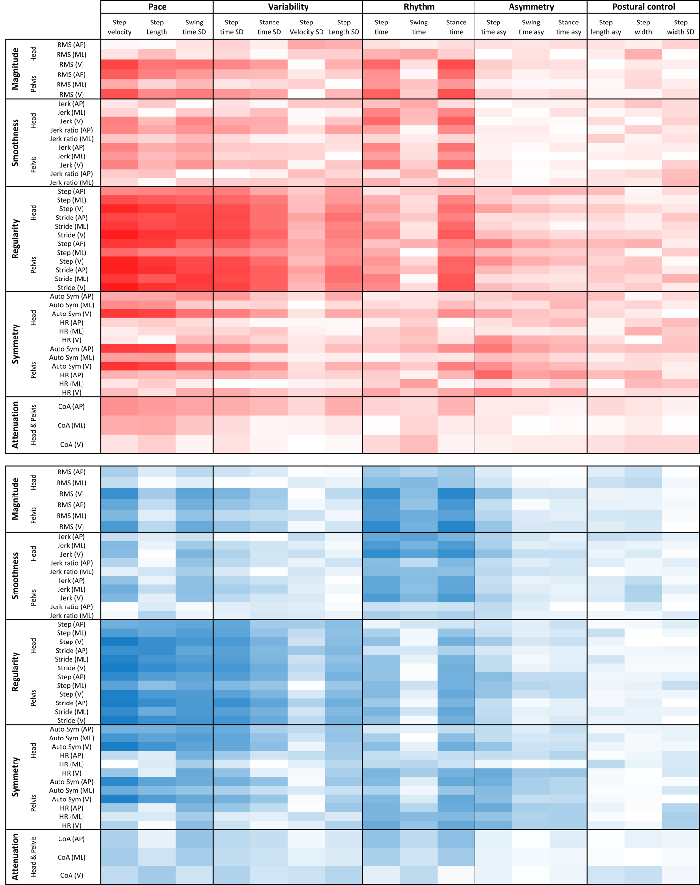



1. AP = anterior-posterior. ML = medio-lateral. V = vertical
2. SD = standard deviation Asy = asymmetry

Figure 5.1. Heat map displaying the Pearson’s product-moment correlation coefficients (r) between the variables representing spatiotemporal and upper body acceleration domains for both the PD (Red) and control group (Blue).

### Univariate analysis

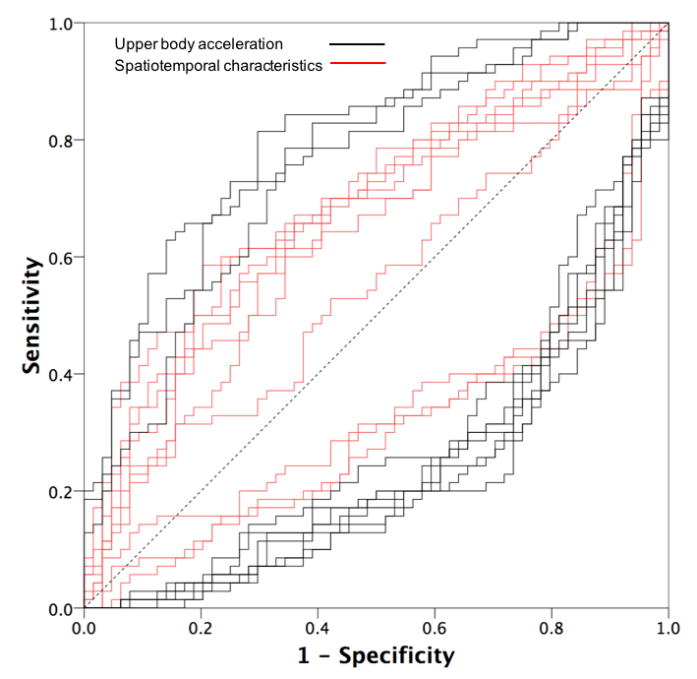Univariate ROC curve analysis showed that 10 out of the 16 spatiotemporal variables (62%) and 37 out of the 49 upper body variables (75%) significantly discriminated between the two groups (AUC >0.6; p<0.05). The single best discriminating variable of PD gait was step regularity obtained from calculating the autocorrelation from ML pelvis acceleration (AUC = 0.81). The highest AUC for the spatiotemporal values was swing time variability (AUC = 0.70). The top ten classifiers for the spatiotemporal model and the upper body acceleration variables are shown in figure 5.2. Figure 5.3 shows the spatiotemporal model [14] and the conceptual acceleration based models following the univariate variable reduction. Each model shows the deviation of the Z score as calculated using the age matched controls mean and standard deviation values as a reference.

Figure 5.2. ROC for the top ten classifiers from the spatiotemporal model and the top ten from the upper body acceleration variables.

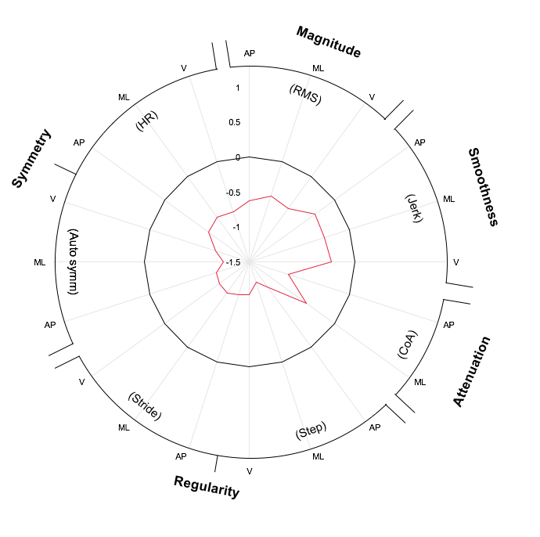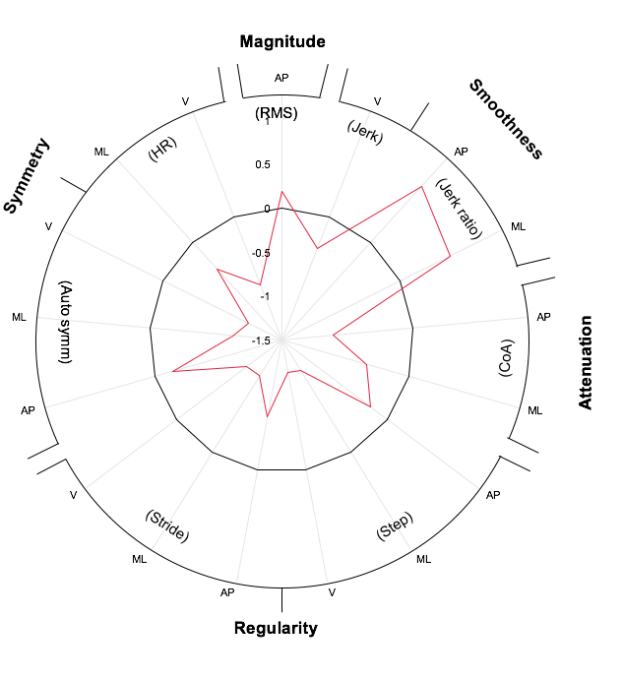

Spatiotemporal

Pelvis

Head

1. AP = anterior-posterior. ML = medio-lateral. V = vertical
2. SD = standard deviation Asy = asymmetry

Figure 5.3. Radar plot illustrating each variable from the spatiotemporal, head and the pelvis model. The central line represents the control data. Deviation from zero along the X axis radiating from the center of the plot represents how many standard deviations (based upon the control means and standard deviations) the PD differ from the controls.

### Multivariate analysis

The AUC values and variables in the 2 block multivariate model is shown in Table 5.3. The force entered patient demographic information in Block 1 recorded a AUC of 0.729 (CI95%: 0.64-0.81). When the gait variables were then entered in a forward stepwise fashion, all model’s AUCs were greater than 0.88, confirming the importance of looking at a gait in a multi-facet way when using it as a biomarker in PD. When using the two block method there was only a difference of 0.025 AUC between the poorest (spatiotemporal model, AUC: 0.88, CI95%: 0.83-0.94) and best (head model, AUC: 0.91, CI95%: 0.86-0.96) model. The AUC values and variables in the 2 block multivariate model is shown in Table 5.4. The 3 block analysis, where the spatiotemporal variables were entered in block 2 (forward stepwise) and the acceleration based variables where subsequently entered in block 3 (also forward stepwise), achieved significant improvements to the spatiotemporal model. However, the AUC only increased by 0.01, 0.02 and 0.02 for the head model, pelvis model and the combined information from the head and pelvis model, respectively.

Table 5.3. Results of the two block multivariate analysis: area under the curve (AUC and 95 CI) values and list of the variables included in the model following forward stepwise regression.

1. AP = anterior-posterior. ML = medio-lateral. V = vertical
2. SD = standard deviation

Table 5.4. Results of the three block multivariate analysis: area under the curve (AUC and 95 CI) values and list of the variables included in the model following forward stepwise regression.

1. AP = anterior-posterior. ML = medio-lateral. V = vertical
2. SD = standard deviation

## Discussion

This study showed that even when using a multidimensional gait model, not all information about impaired PD gait can be captured through measuring spatiotemporal information and as such upper body accelerations provide novel information about gait. For the purpose of discriminating between the two groups, this information was as good, if not better, than standard spatiotemporal gait characteristics. The upper body is therefore not merely a passenger unit during gait and its motion may be a useful biomarker for PD. When combined with the spatiotemporal information, upper body acceleration variables contributed to a better description PD gait, even if it was only a marginally improved discrimination ability.

Surprisingly, none of the upper body variables were highly correlated with the variables within the postural control domain within the spatiotemporal model, despite often being defined as a direct measure of postural control [6]. This lack of correlation may suggest that the different variables measure different aspects of postural control. Previous studies that focused on the movement of the head during gait for people with PD concluded that a lack of correlation between acceleration based gait stability measures and lower body mechanics suggests they are distinct and can provide separate targets for therapy [60]. The fact that unique and improved discriminative information was obtained through measuring upper body accelerations supports the idea that new and useful information is gained relative to just spatiotemporal characteristics and that a multidimensional analysis of gait may help to further understand the complexity of gait impairment and progression in PD [99]. Therefore, this uncorrelated and additional information supports that this information should be assessed in conjunction and potentially provide separate targets for therapy.

Regarding the variables that did correlate, such as the variables within the regularity and pace domains, the acceleration regularity variables achieved higher AUC variables than the pace domain spatiotemporal variables (with only one exception). As pace provides very useful information about disease progression [15], the potential of obtaining a proxy measure outside a controlled environment may be advantageous. Previous work stated that the relationship between walking speed, regularity and symmetry needs further analysis to discover if they are the same or separate constructs of gait [80]. Although this was not the focus of the investigation, the fact that regularity and symmetry variables correlated with the variables from the pace domain but were better capable to classify PD gait, opens the opportunity for acceleration based measures to replace or be combined with more traditionally used variables within multivariate gait models. One example where this may be beneficial is within the recent emphasis of trying to obtain relevant gait measures from participants in a free living environment [38,39]. For example, when recently attempting to replicate the spatiotemporal model using a single accelerometer located on the pelvis [39], step width and step width variability could not be calculated and the postural control domain in the model could not be replicated. Future research is therefore warranted to determine if the accelerations variables shown to be effective to characterise PD gait in the current investigation can add to the free-living spatiotemporal model as a new representation of the postural control domain.

Negligible differences in the ability to classify the PD based on their gait were found between the spatiotemporal model and those from the head or pelvis accelerations models. Therefore, if physical and economical resources are limited, models created from upper body accelerations could equally be used to classify PD gait. For this purpose, a sensor placed upon the pelvis may be the most applicable due to its methodically preferable location and ability to detect stride timing information in a variety of environments [37,96]. Furthermore if placed at the pelvis, the variables in the current investigations can potentially be combined further variables such as stability measures [100] and turning characteristics [69], which were not included in this study due to methodological limitations but could be extracted from free-living data where an increased number of strides are collected.

The reported results showed that movements and multiple variables from the upper body can classify PD gait and as such this study represents an important step toward their adoption as useful biomarkers in the clinic or free-living environment. Nonetheless, discovering which of these (or any other) variables are sensitive and specific to the underlying disease process in PD [12] is a next essential step. However, longitudinal assessments and intervention studies are needed to examine how well upper body accelerations can track changes to gait due to disease progression and response to intervention [6,12], particularly in free-living and clinical settings where it is often impractical to measure gait using traditional methods of three-dimensional motion capture or instrumented walkways.

## Conclusion

Most upper body acceleration variables provided additional and unique information about PD gait with respect to a traditional spatiotemporal gait model. The current results show promise for using acceleration based variables to highlight movements symptomatic of PD gait either alone or in addition to spatiotemporal characteristics. Until it is known exactly which variables are best for the desired purpose of using gait as a biomarker, we recommend acceleration variables should still be assessed in conjunction to spatiotemporal variables in an attempt to record a holistic characterisation of PD gait. The results of this investigation warrants continued research to refine the best characterisation of PD gait using multiple techniques and different domains of gait.

# Discussion

This chapter will provide a collective summary of all the chapters presented within this thesis and highlight how each result driven chapter (e.g. chapters 3,4 and 5) has made a contribution to the field. Thereafter, the limitations of these chapters will be presented and discussed relative to how future work could be conducted to address these limitations. Lastly it will provide a brief summary of the entire thesis as a conclusion.

## Summary

This thesis attempted to answer whether recording the movement of the upper body during gait is useful to determine biomarkers at the early stage of PD. Previously, the movement of the upper body has often been neglected in gait analysis and PD is no exception despite disease specific symptoms impairing its control [12]. This previous neglect of potentially useful information can be partly explained by technological limitations with traditional clinically applicable devices, such as pressure sensitive mats, being designed for the measurement of spatiotemporal information obtained from the feet only. However, as discussed in chapters 1 and 2, the technical and commercial development of IMUs have made them an ideal technology to measure gait by looking also at other features that characterise it. Due to relatively cheap costs and ease of use they are clinically applicable while also opening the ability to assess gait away from clinics and in the environments of those being assessed. IMUs also are highly suitable to assess movements of the upper body due to their continuous measurement of movements throughout the gait cycle which consequently facilitates the calculation of new variables proposedly better representative of balance and postural control.

Within the literature, many different acceleration derived variables that assess the quality of gait have been proposed and this has been upon many different populations. These include, between the young and old [76], fallers and non-fallers [55], genders [82], healthy and those with different pathologies [60], or even subtypes within the same pathology [46,101]. Although all these investigations are attempting to contribute to the same cause, this inconsistent selection and reporting of gait characteristics has further contributed to an incomplete understanding of gait impairment and its evolution, whereby the variety within the literature has led to some confusion regarding which variables can be applied for different purposes [13]. This thesis attempted to add some clarity to the confusion by assessing multiple variables upon people with early stage PD and to discover which are best to assess the expected impairments in the upper body’s movement during gait.

The first step toward this goal, presented in chapter 3, was to assess a variable previously shown to highlight postural control impairment during gait [54,82,83], but yet to be tested upon people with PD. This chapter’s highlighted paper was the first to apply the CoA to people at the early stages of PD which was surprising due a known symptom of increased axial rigidity in PD [22,102] and an increased reliance on visual input during gait [85]. The results showed that the small group of people with PD had an impaired ability to attenuate accelerations generated at inferiorly located segments from impacting superiorly located segments such as the head and this was particularly in the ML direction. Unexpectedly, the HR which has previously been shown to show impairment in PD gait did was not significantly different between the two groups potentially showing the CoA be more sensitive at the early stages of PD. Since its publication, these results have also been shown in a more recent publication showing a reduced coupling between segments of different heights in People with PD [59]. These publications therefore show that the CoA is a sensitive parameter to PD and we propose it to be indicative of axial rigidity which is symptomatic of PD and not easily quantified by other means of assessment when walking.

As shown in the chapter 3, the fact that the HR was not sensitive to PD was surprising based upon its prevalent use in the literature for that purpose [55,58,78]. Although this was just one example, this disagreement and mixed results between investigations was found to be prevalent within literature proposing upper body variables to be sensitive to impaired gait. One aspect where chapter 3 differed from most highlighted investigations was a pre-processing technique of realigning the sensors’ local reference output to a known and meaningful global reference using a pretrial calibration and the IMUs quaternion output [82]. Although theoretically optimum for assessing multiple segments of the body at once, this method is unlike the majority of other investigations in the literature [96]. We therefore investigated whether the method used to realign gait data obtained from the upper body can impact the variable’s values and consequential sensitivity to detect movements symptomatic to PD. The results showed that between the 4 different methods selected from the literature, these could significantly alter the values of the variables, and also for certain variables, their sensitivity to detect the PD from the age matched controls. This paper therefore contributes to the field firstly by highlighting the significance for future investigations to consider the most appropriate realignment method for the variable. For example, due to its predefined global reference, the M4 quarternion method may be the most appropriate to variables utilising multiple segments. Whereas, M2 may be more applicable to different environments but may only be ideal for variables calculated from segments similar to the pelvis that have limited degrees of freedom when walking. This investigation secondly contributes to the field by providing an example of how the method used can alter the proposed variables and therefore provides an indication for the variables lack of robustness to methodological differences found within the literature [72]. As a result, the highlighted publication is evidence that a methodological consensus is required between investigations attempting to assess whether upper body acceleration variables are beneficial as a biomarker in PD and also other populations/applications [103].

Using the information gained from chapter 4, such as discarding variables calculated from the C7 and the adoption of the realignment M2 due to its increased applicability, chapter 5 attempted to address other uncertainties within the literature. Firstly, the chapter attempted to discover if the information gained form the upper body was independent from the information that can be gained from typical spatiotemporal variables and therefore complementary to readily applied methods. Secondly, the chapter attempted to discover if the information was useful to characterize PD both alone and in combination to readily used multivariate gait models. The results showed that both independent and non-independent information was found. For example, some domains correlated (e.g. regularity and pace) while others did not (e.g. the unexpected low correlations between the acceleration variables and the spatiotemporal postural control domain). Overall using a univariate approach which is prevalent in the literature, the acceleration derived parameters performed better at discriminating between the PD and control group. However, when using a multivariate model approach, although recording a slightly higher AUC (0.018 and 0.008 higher AUC for the head and pelvis models respectively), the acceleration derived models were highly comparable to the more traditional spatiotemporal model. Furthermore, when assessing if any addition complimentary discrimination ability could be achieved from assessing the upper body movements in conjunction with the spatiotemporal model, the regression did include an additional acceleration variable but the increased AUC was negligible (a highest increase of 0.006 AUC when step regularity is included following the force entered spatiotemporal model).

Firstly, from the results presented in chapter 5, it is very positive to discover that an acceleration based model performed equally well as a more traditional spatiotemporal despite being calculated at a much reduced cost and using a technology more applicable to more environments and ideally suited for obtaining free-living gait [38]. The investigation also contributed to the field through confirming that unique advantageous information can be discovered from measuring multiple variables descriptive of the movement of the upper body [6,12,104,105]. It did this through taking a domain approach which, like the spatiotemporal model, has the potential to aid the interpretation of results that attempt to comprehend the multidimensional complexity of gait. These proposed accelerations based multidimensional models have strong potential to be built with additional variables not assessed in this thesis and therefore multivariate models have further potential to be improved in the future to better characterise gait impairments in PD and other pathologies that impair gait [106]. Therefore, it is encouraged to continue measuring all movements possible for a better characterization of PD gait to create a better understanding for which variables, or combination of variables within a multivariate model, are best for the purpose of being a biomarker in the early stages of PD.

## Limitations and future work

A number of limitations have been listed in each chapter and future work has been suggested. This thesis focused on finding variables descriptive of movement that differed between people with early stage PD and those of healthy age matched controls. Although this is meaningful for discovering which upper body variables may best to characterize the impairment found for those with PD, it does not specifically answer which variables, or even if measuring the movement of the upper body during gait altogether, is beneficial for the purpose of being an objective biomarker for the disease [6,12,46]. As such there is a clear need for longitudinal studies looking into how gait variables change over time for the elderly and whether this rate of change is different when assessed with the proposed sensitive variable upon different pathologies. Fortunately, the study in which the data was obtained from for this thesis is a longitudinal study named the ICICLE-Gait, whereby participants are reassessed at 18,36,54 and 72 month follow-ups. Therefore, future work is already prepared to discover whether the variables analyzed in this thesis are able to be biomarkers for disease progression over an 18-month period.

In addition to being a biomarker of disease progression, measuring gait has also been proposed as a biomarker to detect proposed subtypes in PD [46,101]. Between different individual patients the rate of progression of Parkinson’s disease (PD) differs widely, which raises the question regarding whether different subtypes of Parkinson’s disease have different rates of progression [4,107]. If so, knowing which subtype a particular person belongs may help prognosis and treatment [4]. Future research is therefore warranted to discover whether gait measurements like those proposed in this thesis can help stratify PD into more specific subtypes. If possible and the recognition of subtypes is improved, this may also consequently improve specific intervention efficiency through reducing the variability of participants recruited [107].

Although an effort was made to select a comprehensive selection of variables proposed in the literature to assess gait, a limitation of this thesis was that not all variables proposed in the literature could be included. For example, the HR alone has multiple ways in which it can be calculated, such as the 8 step method proposed by Brodie et al. ,[108] to be favorable at detecting fallers from the healthy elderly. Or, the more recently proposed normalized index of the HR that Pasciuto et al., [62] proved to be more robust to methodological differences and easier to interpret than the traditional HR used in this investigation. Future research is therefore required to discover whether the variables used in this thesis are the optimum for detecting movements indicative of early stage PD. Furthermore, the methodical constraints of obtaining gait within the laboratory and from utilising a GAITrite mat, limited the number of consecutive strides analyzed and consequently limited the analysis to variables which are calculated over single or few consecutive strides. A large body of literature exists which utilize nonlinear dynamic systems analysis to create variables proposed to be measures of gait stability [109]. These measures include variables such as Poincaré plots, Lyapunov exponents, maximum Floquet multipliers, recurrence quantification analysis and multiscale entropy [110]. However as shown by Riva et al., [73] these parameters require a minimum of 130 strides to reliably be calculated and where therefore not suitable for clinical applications. Future research is warranted to discover whether, if a protocol allowed, these highlighted stability variables can combine with those proposed in this thesis to create a better characterization of PD gait.

One area of gait research that could facilitate the measurement of the above highlighted stability measures is, due to containing longer walking series, the measurement of free-living gait [111]. Each chapter of this thesis has acknowledged the benefits of measuring free-living gait and the potential of these variables to be measured by a single accelerometer worn by participants over an extended period [89]. During the time of this thesis, significant time was given to obtain data and validate the algorithms required to accurately detect gait events from accelerometers and IMUs within a free-living environment, which resulted in the co-authorships of the paper of Storm et al., [37] and Tamburini et al [112] . From this investigation, data was also obtained from the upper body. Future research will therefore discover whether the variables proposed in this thesis to be sensitive to PD are affected by the environment and testing condition in which they are measured. This proposed work and will help determine if it is possible to translate the variables useful when obtained within a clinic, to be applied in a free-living data collection protocol and upon those with PD. If they remain useful, free-living data collection opens up many avenues to build highly comprehensive multivariate models due to the ability to measure many variables not only during gait but also, through accurate activity recognition [113], potentially during dynamic tasks such as sit to standing and turns [114], and even physical activity parameters [115]. Consequently, it is proposed that future research should discover whether a comprehensive multivariate model as obtained from free-living data can together contribute to a better characterization of PD and other pathological gait.

## Conclusion

At the early stage of PD, gait impairments are subtle and open to the interpretation to both the individual and clinicians. As such, simple and quantitative methods for gait and balance evaluation are desirable to add objective information about the status of the health individual [27]. This thesis, relative to many articles found in the literature, used a large cohort of people with early stage PD and elderly matched controls to show that variables calculated using accelerations obtained from multiple locations of the upper body were capable to highlight movements symptomatic to PD. It also showed that these variables are sensitive to methodology differences found within the literature and this may explain why variables values may vary between investigations. Therefore, if adopting a methodology that is most prevalent in the literature and avoiding measuring movement from segments susceptible to methodical errors such as directional cross-talk, the variables analysed in this thesis were found to be both independent and equally capable to highlight gait impairments relative to variables typically assessed within a clinical environment, such as spatiotemporal movement of the feet. This result is encouraging as relative to the equipment needed to obtain spatiotemporal information of the feet, accelerometers are inexpensive and more applicable to obtaining data in a variety of environments. Future research is certainly warranted to discover if more variables capable to be calculated using an IMU can combine with those proven to be useful in this thesis to provide a more holistic description of PD gait to serve as a biomarker for the pathology. It is predicted that a longitudinal study utilising the variables analysed in this thesis and data obtained in a free-living environment will further confirm their use a biomarker in PD and potentially other pathologies were gait is impaired.

# References

[1] J.M. Hausdorff, Gait dynamics in Parkinson ’ s disease : Common and distinct behavior among stride length , gait variability , and fractal-like scaling Gait dynamics in Parkinson ’ s disease : Common and distinct behavior among stride length , gait variability , and frac, 26113 (2009). doi:10.1063/1.3147408.

[2] V.A. Goodwin, S.H. Richards, R.S. Taylor, A.H. Taylor, J.L. Campbell, The Effectiveness of Exercise Interventions for People with Parkinson ’ s Disease : A Systematic Review and Meta-Analysis, 23 (2008) 631–640. doi:10.1002/mds.21922.

[3] O. Rascol, C. Goetz, W. Koller, W. Poewe, C. Sampaio, Treatment interventions for Parkinson ’ s disease : an evidence based assessment, 359 (2002) 1589–1598.

[4] T.C. Vu, J.G. Nutt, N.H.G. Holford, Disease progress and response to treatment as predictors of survival, disability, cognitive impairment and depression in Parkinson’s disease, Br. J. Clin. Pharmacol. 74 (2012) 284–295. doi:10.1111/j.1365-2125.2012.04208.x.

[5] M. Mancini, L. King, A. Salarian, L. Holmstrom, J. Mcnames, F.B. Horak, Mobility Lab to assess balance and gait with synchronized body-worn sensors, Bioeng. Biomed. Sci. Suppl 1 (2012) 1–5. doi:10.4172/2155-9538.S1-007.

[6] R.P. Hubble, G. Naughton, P. Silburn, M.H. Cole, Wearable sensor use for assessing standing balance and walking stability in people with Parkinson’s Disease: a systematic review, PLoS One. 10 (2015) e0123705. doi:10.1371/journal.pone.0123705.

[7] M. Visser, J. Marinus, B.R. Bloem, H. Kisjes, B.M. Van Den Berg, J.J. Van Hilten, Clinical Tests for the Evaluation of Postural Instability in Patients With Parkinson ’ s Disease, 84 (2003). doi:10.1053/S0003-9993(03)00348-4.

[8] M. a. McVey, A.P. Stylianou, C.W. Luchies, K.E. Lyons, R. Pahwa, S. Jernigan, J.D. Mahnken, Early biomechanical markers of postural instability in Parkinson’s disease, Gait Posture. 30 (2009) 538–542. doi:10.1016/j.gaitpost.2009.08.232.

[9] A. Weiss, T. Herman, N. Giladi, J.M. Hausdorff, Objective assessment of fall risk in Parkinson’s disease using a body-fixed sensor worn for 3 days, PLoS One. 9 (2014). doi:10.1371/journal.pone.0096675.

[10] B.R. Bloem, Postural instability in Parkinson’s disease., Clin. Neurol. Neurosurg. 94 (1992) 41–45.

[11] A. Sant’Anna, A. Salarian, N. Wickström, A new measure of movement symmetry in early Parkinson’s disease patients using symbolic processing of inertial sensor data., IEEE Trans. Biomed. Eng. 58 (2011) 2127–2135. doi:10.1109/TBME.2011.2149521.

[12] F. Horak, M. Mancini, Objective biomarkers of balance and gait for Parkinson’s disease using body‐worn sensors, Mov. Disord. 28 (2013) 1544–1551. doi:10.1002/mds.25684.

[13] B. Galna, S. Lord, D.J. Burn, L. Rochester, Progression of Gait Dysfunction in Incident Parkinson ’ s Disease : Impact of Medication and Phenotype, 30 (2015) 13–17. doi:10.1002/mds.26110.

[14] S. Lord, B. Galna, L. Rochester, Moving forward on gait measurement: Toward a more refined approach, Mov. Disord. 28 (2013) 1534–1543. doi:10.1002/mds.25545.

[15] S. Fritz, M. Lusardi, Walking speed: the sixth vital sign, J. Geriatr. Phys. Ther. 32 (2009) 1–5. doi:10.1519/00139143-200932020-00002.

[16] C.J. Hass, P. Malczak, J. Nocera, E.L. Stegemoller, A. Shukala, I. Malaty, C.E. Jacobson IV, M.S. Okun, N. McFarland, Quantitative normative Gait data in a large cohort of ambulatory persons with parkinson’s disease, PLoS One. 7 (2012) 1–5. doi:10.1371/journal.pone.0042337.

[17] R. Van Emmerik, Identification of axial rigidity during locomotion in Parkinson disease, Arch. Phys. Med. Rehabil. 80 (1999) 186–191. http://www.sciencedirect.com/science/article/pii/S0003999399901193 (accessed July 30, 2014).

[18] J.M. Hausdorff, Gait variability : methods , modeling and meaning Example of Increased Stride Time Variability in Elderly Fallers Quantification of Stride-to-Stride Fluctuations, J. Neuroeng. Rehabil. 2 (2005) 1–10. doi:10.1186/1743-Received.

[19] R. Baltadjieva, N. Giladi, L. Gruendlinger, C. Peretz, J.M. Hausdorff, Marked alterations in the gait timing and rhythmicity of patients with de novo Parkinson ’ s disease, 24 (2006) 1815–1820. doi:10.1111/j.1460-9568.2006.05033.x.

[20] M. a D. Brodie, T.R. Beijer, C.G. Canning, S.R. Lord, Head and pelvis stride-to-stride oscillations in gait: validation and interpretation of measurements from wearable accelerometers, Physiol. Meas. 36 (2015) 857–872. doi:10.1088/0967-3334/36/5/857.

[21] M.H.M. Cole, P. a P. Silburn, J.M. Wood, C.J. Worringham, G.K. Kerr, Falls in Parkinson’s disease: kinematic evidence for impaired head and trunk control, Mov. Disord. 25 (2010) 2369–2378. doi:10.1002/mds.23292.

[22] S. Mesure, J. Azulay, J. Pouget, B. Amblard, Strategies of segmental stabilization during gait in Parkinson’ s disease, Exp. Brain Res. 129 (1999) 573–581. http://link.springer.com/article/10.1007/s002210050927 (accessed July 30, 2014).

[23] M. Wood, M.A. Cleary, L. Alderson, A. Vellodi, Changes in gait pattern as assessed by the GAITRite i walkway system in MPS II patients undergoing enzyme replacement therapy, 32 (2009). doi:10.1007/s10545-009-1103-2.

[24] A.L. Mcdonough, M. Batavia, F.C. Chen, S. Kwon, J. Ziai, A.M. Al, M. Batavia, C. Fc, The Validity and Reliability of the GAITRite System ’ s Measurements : A Preliminary Evaluation, (2001) 0–6. doi:10.1053/apmr.2001.19778.

[25] S. Lord, B. Galna, J. Verghese, S. Coleman, D. Burn, L. Rochester, Independent domains of gait in older adults and associated motor and nonmotor attributes: validation of a factor analysis approach., J. Gerontol. A. Biol. Sci. Med. Sci. 68 (2013) 820–7. doi:10.1093/gerona/gls255.

[26] A. Godfrey, R. Conway, D. Meagher, G. Ólaighin, Direct measurement of human movement by accelerometry, 30 (2008) 1364–1386. doi:10.1016/j.medengphy.2008.09.005.

[27] K.M. Culhane, M. O’Connor, D. Lyons, G.M. Lyons, Accelerometers in rehabilitation medicine for, (2005) 556–560. doi:10.1093/ageing/afi192.

[28] J.M.T. Van Uem, T. Isaacs, A. Lewin, E. Bresolin, D. Salkovic, A Viewpoint on Wearable Technology-Enabled Measurement of Wellbeing and Health-Related Quality of Life in Parkinson ’ s Disease, 6 (2016) 279–287. doi:10.3233/JPD-150740.

[29] J. Kavanagh, H. Menz, Accelerometry: a technique for quantifying movement patterns during walking, Gait Posture. 28 (2008) 1–15. doi:10.1016/j.gaitpost.2007.10.010.

[30] F. de Wet, M. Dent, M. Heyns, J. Pretorius, Shock absorption potential of different mouth guard materials, (1999).

[31] D. Churchill, Quantification of human knee kinematics using the 3dm-gx1 sensor, Microstain Inc. (2004) 1–12. http://scholar.google.com/scholar?hl=en&btnG=Search&q=intitle:Quantification+of+Human+Knee+Kinematics+Using+the+3DM-GX1+Sensor#0 (accessed July 30, 2014).

[32] B. Mazuquin, J. Batista, L. Pereira, J. Dias, M. Silva, R. Carregaro, P. Lucareli, F. Moura, J. Cardoso, Kinematic Gait Analysis Using Inertial Sensors with Subjects after Stroke in Two Different Arteries, Jounral Phys. Ther. Sci. (2014).

[33] J. McCamley, M. Donati, E. Grimpampi, C. Mazzà, An enhanced estimate of initial contact and final contact instants of time using lower trunk inertial sensor data, Gait Posture. 36 (2012) 316–318. doi:10.1016/j.gaitpost.2012.02.019.

[34] W. Zijlstra, A.L. Hof, Assessment of spatio-temporal gait parameters from trunk accelerations during human walking, Gait Posture. 18 (2003) 1–10.

[35] D. Trojaniello, A. Cereatti, U. Della, Gait & Posture Accuracy , sensitivity and robustness of five different methods for the estimation of gait temporal parameters using a single inertial sensor mounted on the lower trunk, Gait Posture. 40 (2014) 487–492. doi:10.1016/j.gaitpost.2014.07.007.

[36] D. Trojaniello, A. Cereatti, E. Pelosin, L. Avanzino, A. Mirelman, J.M. Hausdorff, U. Della Croce, Estimation of step-by-step spatio-temporal parameters of normal and impaired gait using shank-mounted magneto-inertial sensors : application to elderly , hemiparetic , parkinsonian and choreic gait, (2014) 1–12.

[37] F.A. Storm, C.J. Buckley, C. Mazzà, Gait event detection in laboratory and real life settings: Accuracy of ankle and waist sensor based methods, Gait Posture. 50 (2016) 42–46. doi:10.1016/j.gaitpost.2016.08.012.

[38] S. Del Din, A. Godfrey, B. Galna, S. Lord, L. Rochester, Free-living gait characteristics in ageing and Parkinson ’ s disease : impact of environment and ambulatory bout length, J. Neuroeng. Rehabil. (2016) 1–12. doi:10.1186/s12984-016-0154-5.

[39] R. Morris, A. Hickey, S. Del Din, A. Godfrey, S. Lord, L. Rochester, A model of free-living gait: A factor analysis in Parkinson’s disease, Gait Posture. 52 (2017) 68–71. doi:10.1016/j.gaitpost.2016.11.024.

[40] S. Del Din, A. Godfrey, L. Rochester, Validation of an Accelerometer to Quantify a Comprehensive Battery of Gait Characteristics in Healthy Older Adults and Parkinson ’ s Disease : Toward Clinical and at Home Use, 20 (2016) 838–847.

[41] A. Godfrey, S. Del Din, G. Barry, J.C. Mathers, L. Rochester, Instrumenting gait with an accelerometer: A system and algorithm examination., Med. Eng. Phys. 37 (2015) 400–7. doi:10.1016/j.medengphy.2015.02.003.

[42] P. Esser, H. Dawes, J. Collett, K. Howells, IMU: inertial sensing of vertical CoM movement, J. Biomech. 42 (2009) 1578–1581. doi:10.1016/j.jbiomech.2009.03.049.

[43] R. Moe-Nilssen, A new method for evaluating motor control in gait under real-life environmental conditions . Part 1 : The instrument, Clin. Biomech. 13 (1998) 328–335.

[44] D. Winter, Human balance and posture control during standing and walking, Gait Posture. 3 (1995) 193–214.

[45] J.P. Martin, A short essay on posture and movement, J. Neurol. Neurosurg. Psychiatry. 40 (1977) 25–29. doi:10.1136/jnnp.40.1.25.

[46] M. Iosa, A. Fusco, M. Giovanni, S. Paolicci, Development and decline of upright gait stability, Front. Aging …. 6 (2014) 14. doi:10.3389/fnagi.2014.00014.

[47] F. Prince, D. Winter, P. Stergiou, S. Walt, Anticipatory control of upper body balance during human locomotion, Gait Posture. (1994) 19–25. http://www.sciencedirect.com/science/article/pii/0966636294900132 (accessed October 8, 2014).

[48] H.J. Yack, R.C. Berger, Dynamic Stability in the Elderly: Identifying a Possible Measure, J. Gerontol. 48 (1993) M225–M230. doi:10.1093/geronj/48.5.M225.

[49] R. Moe-Nilssen, Test-retest reliability of trunk accelerometry during standing and walking, Arch. Phys. Med. Rehabil. 1998 (1998) 1377–1385. http://www.sciencedirect.com/science/article/pii/S0003999398902313 (accessed July 30, 2014).

[50] R. Moe-Nilssen, J. Helbostad, Interstride trunk acceleration variability but not step width variability can differentiate between fit and frail older adults, Gait Posture. 21 (2005) 164–170. doi:10.1016/j.gaitpost.2004.01.013.

[51] T. Pozzo, A. Berthoz, L. Lefort, Head stabilization during various locomotor tasks in humans, Exp. Brain Res. (1990) 97–106. http://link.springer.com/article/10.1007/BF00230842 (accessed July 30, 2014).

[52] H. Menz, Acceleration patterns of the head and pelvis when walking are associated with risk of falling in community-dwelling older people, Journals …. 58 (2003) 446–452. http://biomedgerontology.oxfordjournals.org/content/58/5/M446.short (accessed July 30, 2014).

[53] J. Kavanagh, S. Morrison, R. Barrett, Coordination of head and trunk accelerations during walking, Eur. J. Appl. …. 94 (2005) 468–75. doi:10.1007/s00421-005-1328-1.

[54] C. Mazzà, M. Iosa, F. Pecoraro, A. Cappozzo, Control of the upper body accelerations in young and elderly women during level walking, J. Neuroeng. Rehabil. 10 (2008) 1–10. doi:10.1186/1743-0003-5-30.

[55] M.M.D. Latt, H.H.B. Menz, V.S. Fung, S.R. Lord, Acceleration patterns of the head and pelvis during gait in older people with Parkinson’s disease: a comparison of fallers and nonfallers, J. Gerontol. 64 (2009) 700–6. doi:10.1093/gerona/glp009.

[56] M. Latt, H. Menz, V. Fung, S. Lord, Walking speed, cadence and step length are selected to optimize the stability of head and pelvis accelerations, Exp. Brain Res. 184 (2008) 201–209. doi:10.1007/s00221-007-1094-x.

[57] J. Kavanagh, R. Barrett, S. Morrison, The role of the neck and trunk in facilitating head stability during walking, Exp. Brain Res. 172 (2006) 454–463. doi:10.1007/s00221-006-0353-6.

[58] K. a Lowry, A.L. Smiley-Oyen, A.J. Carrel, J.P. Kerr, Walking stability using harmonic ratios in Parkinson’s disease., Mov. Disord. 24 (2009) 261–7. doi:10.1002/mds.22352.

[59] J. Kim, Y. Kwon, J. Heo, G. Eom, M. Kwon, G. Tack, S. Koh, Acceleration Pattern of the Upper Body During Level Walking in Patients With Parkinson’S Disease, J. Mech. Med. Biol. 16 (2016) 1640025. doi:10.1142/S021951941640025X.

[60] M. a D. Brodie, C.G. Canning, T.R. Beijer, S.R. Lord, Uncontrolled head oscillations in people with Parkinson’s disease may reflect an inability to respond to perturbations while walking, Physiol. Meas. 36 (2015) 873–881. doi:10.1088/0967-3334/36/5/873.

[61] C. Zampieri, A. Salarian, P. Carlson-Kuhta, K. Aminian, J.G. Nutt, F.B. Horak, The instrumented timed up and go test: potential outcome measure for disease modifying therapies in Parkinson’s disease., J. Neurol. Neurosurg. Psychiatry. 81 (2010) 171–176. doi:10.1136/jnnp.2009.173740.

[62] I. Pasciuto, E. Bergamini, M. Iosa, G. Vannozzi, A. Cappozzo, Overcoming the limitations of the Harmonic Ratio for the reliable assessment of gait symmetry, J. Biomech. 53 (2017) 84–89. doi:10.1016/j.jbiomech.2017.01.005.

[63] S.-F. A, E. M, G. C, S. D, H. M, D. J, J. van Uem, F. J, New Methods for the Assessment of Parkinson ’ s Disease ( 2005 to 2015 ): A Systematic Review, 31 (2016) 1283–1292. doi:10.1002/mds.26723.

[64] K. Lebel, P. Boissy, H. Nguyen, C. Duval, Inertial measurement systems for segments and joints kinematics assessment : towards an understanding of the variations in sensors accuracy, Biomed. Eng. Online. (2017) 1–16. doi:10.1186/s12938-017-0347-6.

[65] R.J. Elble, J. Mcnames, Reviews Using Portable Transducers to Measure Tremor Severity, (n.d.) 1–12. doi:10.7916/D8DR2VCC.

[66] M.A.D. Brodie, M.J.M. Coppens, S.R. Lord, N.H. Lovell, Y.J. Gschwind, S.J. Redmond, M.B. Del Rosario, K. Wang, D.L. Sturnieks, M. Persiani, K. Delbaere, Wearable pendant device monitoring using new wavelet-based methods shows daily life and laboratory gaits are different, Med. Biol. Eng. Comput. 54 (2016) 663–674. doi:10.1007/s11517-015-1357-9.

[67] P. Fazio, G. Granieri, I. Casetta, E. Cesnik, S. Mazzacane, P. Caliandro, F. Pedrielli, E. Granieri, Gait measures with a triaxial accelerometer among patients with neurological impairment, Neurol. Sci. 34 (2013) 435–440. doi:10.1007/s10072-012-1017-x.

[68] H. Zeng, Y. Zhao, Sensing Movement: Microsensors for Body Motion Measurement, (2011) 638–660. doi:10.3390/s110100638.

[69] M. El-Gohary, S. Pearson, J. McNames, M. Mancini, F. Horak, S. Mellone, L. Chiari, Continuous monitoring of turning in patients with movement disability, Sensors (Switzerland). 14 (2014) 356–369. doi:10.3390/s140100356.

[70] P. Picerno, A. Cereatti, A. Cappozzo, Joint kinematics estimate using wearable inertial and magnetic sensing modules, Gait Posture. 28 (2008) 588–595. doi:10.1016/j.gaitpost.2008.04.003.

[71] E. Bergamini, G. Ligorio, A. Summa, G. Vanozzi, A. Capozzo, A. Sabatini, Estimating orientation using magnetic and inertial sensors and different sensor fusion approaches: accuracy assessment in manual and locomotion tasks, Sensors (Basel). 14 (2014) 1–17. doi:10.3390/s140x0000x.

[72] A. Millecamps, K.A. Lowry, J.S. Brach, S. Perera, M.S. Redfern, E. Sejdić, Understanding the effects of pre-processing on extracted signal features from gait accelerometry signals, Comput. Biol. Med. 62 (2015) 164–174. doi:10.1016/j.compbiomed.2015.03.027.

[73] F. Riva, M.C. Bisi, R. Stagni, Gait variability and stability measures : Minimum number of strides and within-session reliability, Comput. Biol. Med. 50 (2014) 9–13. doi:10.1016/j.compbiomed.2014.04.001.

[74] H. Menz, S. Lord, R. Fitzpatrick, Acceleration patterns of the head and pelvis when walking on level and irregular surfaces, Gait Posture. 18 (2003) 35–46. http://www.sciencedirect.com/science/article/pii/S0966636202001595 (accessed July 30, 2014).

[75] H. Menz, S. Lord, R. Fitzpatrick, Age‐related differences in walking stability, Age Ageing. 32 (2003) 137–142. http://ageing.oxfordjournals.org/content/32/2/137.short (accessed July 30, 2014).

[76] M. a. D. Brodie, H.B. Menz, S.R. Lord, Age-associated changes in head jerk while walking reveal altered dynamic stability in older people, Exp. Brain Res. 232 (2014) 51–60. doi:10.1007/s00221-013-3719-6.

[77] H. Gage, Accelerographic analysis of human gait, The american society of mechanical engineers, 1967.

[78] E. Sejdic, K. Lowry, J. Roche, M. Redfern, J. Brach, A comprehensive assessment of gait accelerometry signals in time, frequency and time-frequency domains, IEEE Trans. Neural Syst. Rehabil. Eng. 22 (2013) 603–612. http://ieeexplore.ieee.org/xpls/abs_all.jsp?arnumber=6525404 (accessed October 8, 2014).

[79] H. Menz, S. Lord, Walking stability and sensorimotor function in older people with diabetic peripheral neuropathy, Arch. Phys. …. 85 (2004) 245–52. doi:10.1016/j.apmr.2003.06.015.

[80] R. Moe-Nilssen, J.L. Helbostad, Estimation of gait cycle characteristics by trunk accelerometry, J. Biomech. 37 (2004) 121–126. doi:10.1016/S0021-9290(03)00233-1.

[81] C. Yang, Y. Hsu, K. Shih, J. Lu, S. Kong, W.H. Memorial, S. Lin, Real-Time Gait Cycle Parameter Recognition Using a Wearable Accelerometry System, (2011) 7314–7326. doi:10.3390/s110807314.

[82] C. Mazzà, M. Iosa, P. Picerno, A. Cappozzo, Gender differences in the control of the upper body accelerations during level walking, Gait Posture. 29 (2009) 300–303. doi:10.1016/j.gaitpost.2008.09.013.

[83] C. Mazzà, M. Zok, A. Cappozzo, Gait & Posture Head stabilization in children of both genders during level walking, Gait Posture. 31 (2010) 429–432. doi:10.1016/j.gaitpost.2010.01.012.

[84] R.C.L. Vela-desojo, J.C. Miangolarra-page, Y. Macı, Axial rigidity and quality of life in patients with Parkinson ’ s disease : a preliminary study, (2011) 817–823. doi:10.1007/s11136-010-9818-y.

[85] B. Galna, S. Lord, D. Daud, N. Archibald, D. Burn, L. Rochester, Visual sampling during walking in people with Parkinson’s disease and the influence of environment and dual-task., Brain Res. 1473 (2012) 35–43. doi:10.1016/j.brainres.2012.07.017.

[86] M. Folstein, S. Folstein, P. McHugh, Mini Mental State: A practical method for grading the cognitive state of patients for the clinician, 12 (1975) 189–198.

[87] B. Galna, S. Lord, L. Rochester, Is gait variability reliable in older adults and Parkinson’s disease? Towards an optimal testing protocol, Gait Posture. 37 (2013) 580–585. doi:10.1016/j.gaitpost.2012.09.025.

[88] A. Godwin, M. Agnew, J. Stevenson, Accuracy of inertial motion sensors in static, quasistatic, and complex dynamic motion., J. Biomech. Eng. 131 (2009) 1–5. doi:10.1115/1.4000109.

[89] C. Buckley, B. Galna, L. Rochester, C. Mazzà, Attenuation of Upper Body Accelerations during Gait : Piloting an Innovative Assessment Tool for Parkinson ’ s Disease, Biomed Res. Int. (2015) 6. doi:doi.org/10.1155/2015/865873.

[90] M. Mancini, F. Horak, Trunk accelerometry reveals postural instability in untreated Parkinson’s disease, Parkinsonism Relat. Disord. 17 (2011) 557–562. doi:10.1016/j.parkreldis.2011.05.010.

[91] J. Barth, J. Klucken, P. Kugler, T. Kammerer, R. Steidl, J. Winkler, J. Hornegger, B. Eskofier, Biometric and mobile gait analysis for early diagnosis and therapy monitoring in Parkinson’s disease., Conf. Proc. ... Annu. Int. Conf. IEEE Eng. Med. Biol. Soc. IEEE Eng. Med. Biol. Soc. Annu. Conf. 2011 (2011) 868–71. doi:10.1109/IEMBS.2011.6090226.

[92] J. Spildooren, S. Vercruysse, E. Heremans, B. Galna, J. Vandenbossche, K. Desloovere, W. Vandenberghe, A. Nieuwboer, Head-pelvis coupling is increased during turning in patients with Parkinson’s disease and freezing of gait, Mov. Disord. 28 (2013) 619–625. doi:10.1002/mds.25285.

[93] T. Doi, T. Asai, S. Hirata, H. Ando, Dual-task costs for whole trunk movement during gait, Gait Posture. 33 (2011) 712–714. doi:10.1016/j.gaitpost.2010.12.017.

[94] T. Doi, S. Hirata, R. Ono, K. Tsutsumimoto, S. Misu, H. Ando, The harmonic ratio of trunk acceleration predicts falling among older people: results of a 1-year prospective study., J. Neuroeng. Rehabil. 10 (2013) 1–7. doi:10.1186/1743-0003-10-7.

[95] S. Del Din, A. Hickey, C. Ladha, S. Stuart, A.K. Bourke, P. Esser, L. Rochester, A. Godfrey, Instrumented gait assessment with a single wearable: an introductory tutorial, F1000Research. 5 (2016) 2323. doi:10.12688/f1000research.9591.1.

[96] C. Buckley, B. Galna, L. Rochester, C. Mazzà, Quantification of upper body movements during gait in older adults and in those with Parkinson’s disease: impact of acceleration realignment methodologies, Gait Posture. 52 (2017) 265–271. doi:10.1016/j.gaitpost.2016.11.047.

[97] J.L. Helbostad, R. Moe-Nilssen, The effect of gait speed on lateral balance control during walking in healthy elderly, Gait Posture. 18 (2003) 27–36. doi:10.1016/S0966-6362(02)00197-2.

[98] S. Lord, T. Howe, J. Greenland, L. Simpson, L. Rochester, Gait variability in older adults: A structured review of testing protocol and clinimetric properties, Gait Posture. 34 (2011) 443–450. doi:10.1016/j.gaitpost.2011.07.010.

[99] S. Aghanavesi, J. Westin, A review of Parkinson’s disease cardinal and dyskinetic motor symptoms assessment methods using sensor systems, in: 2016: pp. 52–57.

[100] S. Bruijn, O. Meijer, Assessing the stability of human locomotion: a review of current measures, J. R. Soc. Interface. 10 (2013) 1–24. http://www.pubmedcentral.nih.gov/articlerender.fcgi?artid=3645408&tool=pmcentrez&rendertype=abstract (accessed July 30, 2014).

[101] T. Herman, A. Weiss, M. Brozgol, N. Giladi, J.M. Hausdorff, Gait and balance in Parkinson ’ s disease subtypes : objective measures and classification considerations, (2014) 2401–2410. doi:10.1007/s00415-014-7513-6.

[102] A. Winogrodzka, R.C. Wagenaar, J. Booij, E.C. Wolters, Rigidity and bradykinesia reduce interlimb coordination in Parkinsonian gait, Arch. Phys. Med. Rehabil. 86 (2005) 183–189. doi:10.1016/j.apmr.2004.09.010.

[103] P.B. Shull, W. Jirattigalachote, M. a Hunt, M.R. Cutkosky, S.L. Delp, Quantified self and human movement: A review on the clinical impact of wearable sensing and feedback for gait analysis and intervention., Gait Posture. 40 (2014) 11–9. doi:10.1016/j.gaitpost.2014.03.189.

[104] M. Iosa, A. Fusco, G. Morone, L. Pratesi, P. Coiro, V. Venturiero, D. De Angelis, M. Bragoni, S. Paolucci, Assessment of upper-body dynamic stability during walking in patients with subacute stroke, J. Rehabil. Res. Dev. 49 (2012) 439.

[105] W. Maetzler, M. Mancini, I. Liepelt-Scarfone, Impaired trunk stability in individuals at high risk for Parkinson’s disease, PLoS One. 7 (2012) 1–6. doi:10.1371/journal.pone.0032240.

[106] Vervoort. D, Vuillerme. N, N. Kosse, T. Hortobágyi, L. C, Multivariate Analyses and Classification of Inertial Sensor Data to Identify Aging Effects on the Timed-Up-and-Go Test Multivariate Analyses and Classification of Inertial Sensor Data to Identify Aging Effects on the Timed-Up-and-Go Test, (2016). doi:10.1371/journal.pone.0155984.

[107] T.C. Vu, J.G. Nutt, N.H.G. Holford, Progression of motor and nonmotor features of Parkinson’s disease and their response to treatment, Br. J. Clin. Pharmacol. 74 (2012) 267–283. doi:10.1111/j.1365-2125.2012.04192.x.

[108] M. a D. Brodie, H.B. Menz, S.T. Smith, K. Delbaere, S.R. Lord, Good lateral harmonic stability combined with adequate gait speed is required for low fall risk in older people, Gerontology. 61 (2015) 69–78. doi:10.1159/000362836.

[109] S.M. Bruijn, O.G. Meijer, P.J. Beek, J.H. Van Dieen, Assessing the stability of human locomotion : a review of current measures, (2013).

[110] F. Riva, M.C. Bisi, R. Stagni, Influence of Input Parameters on Dynamic Orbital Stability of Walking : In-Silico and Experimental Evaluation, 8 (2013) 1–7. doi:10.1371/journal.pone.0080878.

[111] S. Del Din, A. Godfrey, C. Mazza, S. Lord, L. Rochester, Free-Living Monitoring of Parkinson ’ s Disease : Lessons From the Field, 31 (2016) 1293–1313. doi:10.1002/mds.26718.

[112] A.P. Tamburini, F. Storm, C. Buckley, C. Bisi, R. Stagni, C. Mazz, Moving from laboratory to real life conditions: Influence on the assessment of variability and stability of gait, Gait Posture. (2017). doi:10.1016/j.gaitpost.2017.10.024.

[113] F. Attal, S. Mohammed, M. Dedabrishvili, F. Chamroukhi, Physical Human Activity Recognition Using Wearable Sensors, (2015) 31314–31338. doi:10.3390/s151229858.

[114] L. Palmerini, S. Mellone, G. Avanzolini, F. Valzania, L. Chiari, Quanti fi cation of Motor Impairment in Parkinson ’ s Disease Using an Instrumented Timed Up and Go Test, 21 (2013) 664–673.

[115] G. Cai, Y. Huang, S. Luo, Z. Lin, H. Dai, Q. Ye, Continuous quantitative monitoring of physical activity in Parkinson ’ s disease patients by using wearable devices : a case-control study, (2017) 1657–1663. doi:10.1007/s10072-017-3050-2.

# Appendix

**Publications**

**Peer reviewed journals**

Buckley C, Galna B, Rochester L, Mazzà C. Attenuation of Upper Body Accelerations during Gait : Piloting an Innovative Assessment Tool for Parkinson’s Disease. Biomed Res Int 2015:6. doi:doi.org/10.1155/2015/865873.

Buckley C, Galna B, Rochester L, Mazzà C. Quantification of upper body movements during gait in older adults and in those with Parkinson’s disease: impact of acceleration realignment methodologies. Gait Posture 2017;52:265–71. doi:10.1016/j.gaitpost.2016.11.047.

Buckley C, Galna B, Rochester L, Mazzà C. Measuring upper body motion provides unique information about gait impairment in the early stages of Parkinson’s disease. Gait Posture 2017;57:15–6. doi:10.1016/j.gaitpost.2017.07.015.

Buckley C, Galna B, Rochester L, Mazzà C. Upper body accelerations as a biomarker of gait impairment in the early stages of Parkinson's disease Gait Posture 2017; Under review

Storm FA, Buckley CJ, Mazzà C. Gait event detection in laboratory and real life settings: Accuracy of ankle and waist sensor based methods. Gait Posture 2016;50:42–6. doi:10.1016/j.gaitpost.2016.08.012.

Tamburini AP, Storm F, Buckley C, Bisi C, Stagni R, Mazz C. Moving from laboratory to real life conditions: Influence on the assessment of variability and stability of gait. Gait Posture 2017. doi:10.1016/j.gaitpost.2017.10.024.

**Conference proceedings**

Buckley. C., Galna, B., Rochester, L., & Mazzà, C. (2015 July). Is altered upper body control during gait in people with Parkinson’s disease simply due to altered lower limb mechanics? International Society for Posture and Gait Research congress. Seville, SP.

Buckley. C., Galna, B., Rochester, L., & Mazzà, C. (2017 June) Upper body motion provides additional unique information about gait in people with Parkinson’s disease. International society of posture and gait research, Fort Lauderdale, USA.

Buckley. C., Galna, B., Rochester, L., & Mazzà, C. (2015 July). Quantification of head and trunk accelerations during gait as a proxy measure of postural control in Parkinson’s disease. Oral presentation at the International Society of Biomechanics, Glasgow, SC.

Buckley. C., Galna, B., Rochester, L., & Mazzà, C. (2017 July) Upper and lower body movements should both be investigated for an accurate description of gait in Parkinson’s disease. International society of biomechanics, Brisbane, Auz.

Buckley. C., Galna, B., Rochester, L., & Mazzà, C. (2016 July). Effects of different realignment techniques on acceleration derived gait variables for older individuals with or without Parkinson’s disease. International Symposium on 3D Analysis of Human Movement, Taipei, TW.

Buckley. C., Galna, B., Rochester, L., & Mazzà, C. (2015 June). Head and trunk accelerations during gait as a measure of walking stability in Parkinson's disease? Poster presention at the International Conference on Ambulatory Monitoring of Physical Activity and Movement, Limerick, IR.

Buckley. C., Storm. S., & Mazzà, C. (2017 June). How much does healthy gait change when moving away from a laboratory? International Conference on Ambulatory Monitoring of Physical Activity and Movement, Maryland, USA.

Buckley. C., Galna, B., Rochester, L., & Mazzà, C. (2017 Sept) Measuring upper body motion provides unique information about gait impairment in the early stages of Parkinson’s disease. European society for movement analysis, Trondheim, Nor. (Best paper nomination)

Storm. F., Buckley. C., Galna, B., Rochester, L., & Mazzà, C. (2015 September). Do Environment and Type of Walking Influence Gait Temporal Parameters of Straight Walking? National congress for Italian society of clinical movement analysis. Padova, IT.

Storm. F., Buckley. C., & Mazzà, C. (2016 July). Accuracy of two algorithms for gait events detection in free-living settings. International Symposium on 3D Analysis of Human Movement, Taipei, TW.

Galna C., Buckley C., Hickey A., Del Din S., Godfrey A., Mazzà C., Rochester L (2015 July) “In search of the underlying mechanisms responsible for impaired gait-related postural control in people with Parkinson’s disease”, Conf Proc of the International Society of Biomechanics: 58 – 59.