Using an ecosystem services approach to protect freshwater ecosystems: linking ecology, ecotoxicology and cultural values

By:

Yuan Pan

A thesis submitted in partial fulfilment of the requirements for the degree of
Doctor of Philosophy

The University of Sheffield
Faculty of Science
Department of Animal & Plant Sciences

September 2017
Acknowledgements
I would like to thank my supervisors, Professor Lorraine Maltby and Dr Stuart Marshall for their continual support during the project.
In addition, I would like to thank Professor Yue Che at China East Normal University for his advice and for helping me to find research assistants in China. I would like to thank all the Chinese master’s students who helped me to gather data for Chapter 4.
I would also like to thank Dr Peter Craig at Durham University, who kindly provided me with his source code for the hSSD model in Chapter 5 and offered me advice. Furthermore, I would like to thank Jayne Ashe who worked with me on the development of ecological scenarios.
In addition to those I have already acknowledged, I would like to thank everyone in the E floor office. In particular, Cat Stokowska, Chris Griffiths and Olivia Richardson for advice and support during the write-up of my PhD thesis. Finally, I would like to thank Shar for her understanding and encouragement and my family for their support.
I have been sponsored by a United Kingdom Natural Environmental Research Council CASE studentship with Unilever (NE/L501682/1).

Using an ecosystem services approach to protect freshwater ecosystems: linking ecology, ecotoxicology and cultural values

Summary:
Freshwater ecosystems are vital to humans but they suffer from multiple threats. A particular threat is chemical pollution, which is increasing in developing countries such as China. Current approaches to protect freshwater ecosystems from pollution have challenges. Although chemicals can provide human benefits, there are environmental costs that impact human well-being. Furthermore, it is difficult to decide what to protect where. Therefore, one approach is to identify ecosystem services (i.e. the benefits that we receive from nature) that are valued by society to set protection goals.
The two main objectives of this thesis are: i) to investigate which factors affect the perceived value of ecosystem services by different sections of society; ii) to improve the ecological realism of chemical risk assessments.
The ecosystem values of different sections of society were investigated: rural versus urban, Chinese versus British, respondents in different cities. Rural respondents valued freshwater ecosystems services more than urban respondents. British respondents valued ecosystem services more than Chinese respondents, potentially due to cultural differences. Respondents in different cities can prioritise different freshwater ecosystem services. Furthermore, Lake Tai in China was used as a case study to investigate the consequence of ecological changes to ecosystem services provision. The results indicate that pollution, habitat loss and overexploitation have led to the ecosystem services deterioration. Finally, ecological scenarios were developed for river macroinvertebrate communities and species sensitivity distributions of these scenarios were compared using different chemicals. The results illustrated that species composition can affect the sensitivity profile of communities, so the ecosystem service provision to chemical stress is not the same everywhere.
The results of this thesis indicate that using an ecosystem services approach to link ecology, ecotoxicology and cultural values may result in a more spatially resolved and effective environment risk assessment that optimizes human well-being and the benefits of chemicals.

Contents
Chapter 1: Introduction
  - Importance of freshwater ecosystems and threats………………………………1
  - Threat to freshwater ecosystems from chemical pollution……………………...2
  - Current protection of freshwater ecosystems from chemical pollution…………3
  - Challenges of current approaches……………………………………………….5
  - An ecosystem services approach to protect freshwater ecosystems…………….9
  - Aims and objectives…………………………………………………………….11

Chapter 2: Different sections of society and their ecosystem values: rural versus urban and cross-cultural effects
2.1 Introduction………………………………………………………………………14
2.2 Methods…………………………………………………………………………..18
2.2.1. Study areas…………………………………………………………………………18
2.2.2. Questionnaire surveys……………………………………………………………...20
2.2.3. Data analysis…………………………………………………………………….....24
2.2.4. Ethics statement……………………………………………………………………26
2.3 Results…………………………………………………………………………....26
2.3.1. Demographic information………………………………………………………….26
2.3.2. Uses and value of the local river…………………………………………………...27
2.3.3. Willingness to pay for ecosystem services………………………………………...33
2.3.4. Environmental knowledge and attitudes…………………………………………...37
2.3.5. Potential threat to ecosystem services……………………………………………...39
2.4 Discussion………………………………………………………………………..40
2.4.1. Rural and urban communities……………………………………...........................40
2.4.2. Potential threat to ecosystem services………………………………………...........44
2.4.3. China and the UK…………………………………………………………………..45
2.4.4. Limitations and further work………………………………………………………48
2.5 Main findings…………………………………………………………………….49

Chapter 3: Consequences of spatial and temporal changes at Lake Tai (Taihu) on ecosystem services provision
3.1 Introduction………………………………………………………………………51
3.2 Methods…………………………………………………………………………..56
3.3 Results and discussion……………………………………………………………58
3.3.1. Population growth and land use changes………………………………………….58
3.3.2. Chemical pollution and water quality……………………………………………..60
3.3.3. Capture fisheries and aquaculture………………………………………………....66
3.4 Conclusion………………………………………………………………………..75

Chapter 4: Using two methods to value ecosystem services: a case study on Lake Tai, China
4.1 Introduction………………………………………………………………………77
4.2 Methods…………………………………………………………………………..82
4.2.1. Direct questionnaire survey………………………………………………………..82
4.2.2. Social media photographs………………………………………………………….86
4.2.3. Data analysis……………………………………………………………………….87
4.2.4. Ethics statement……………………………………………………………………88
4.3 Results……………………………………………………………………………88
4.3.1. Demographic information………………………………………………………….88
4.3.2. Use and prioritisation of ecosystem services……………………………………....90
4.3.3. Willingness to pay for ecosystem services………………………………………...95
4.4.4. Comparison of methods…………………………………………………………....99
4.4 Discussion………………………………………………………………………101
4.4.1. Different sections of society……………………………………………………..101
4.4.2. Willingness to pay……………………………………………………………….105
4.4.3. Comparison of methods………………………………………………………….107
4.5 Main findings…………………………………………………………………...109

Chapter 5: Using ecological scenarios to improve the ecological realism of chemical risk assessments
5.1 Introduction……………………………………………………………………..112
5.2 Methods…………………………………………………………………………117
5.2.1. Selection of ecological scenarios…………………………………………………117
5.2.2. Species sensitivity distributions…………………………………………………..118
5.3 Results…………………………………………………………………………..120
5.3.1. Toxicity datasets and ecological scenario assemblages………………………….120
5.3.2. Comparison of assemblage sensitivity …………………………………………..120
5.3.3 Comparison of hSSD and conventional SSD analyses…………………………...121
  - Discussion………………………………………………………………………133
5.4.1. Variation in the sensitivity of invertebrate assemblages to toxic chemicals……..134
5.4.2. Toxicity thresholds derived from conventional SSDs and the hSSD model……..136
5.4.3. Caveats and limitations……………………………………………………………137
  - Conclusion………………………………………………………………………138

Chapter 6: General Discussion
6.1 Main findings…………………………………………………………………...140
6.2 Sections of society……………………………………………………………...140
6.3 Case study using Lake Tai……………………………………………………...142
6.4 Environmental risk assessments and species sensitivity distributions………….144
6.5 Approaches used in the thesis…………………………………………………..145
6.7 Conclusion……………………………………………………………………....147

Appendices
Appendix 2.1: Direct questionnaire in English
Appendix 2.2: Online questionnaire in English
Appendix 2.3: Copy of published paper in Ecosystem Services
Appendix 3.1: List of species found in Lake Tai, China
Appendix 4.1: Direct questionnaire in English
Appendix 5.1: Toxicity dataset for chlorpyriphos
Appendix 5.2: Toxicity dataset for copper
Appendix 5.3: Toxicity dataset for pentachlorophenol
Appendix 5.4: Toxicity dataset for LAS
Appendix 5.5: R source code for running hSSD model

Chapter 1
Introduction

1.1 Importance of freshwater ecosystems and threats
Freshwater ecosystems can be classified into three main groups: lakes and ponds, rivers and streams, and wetlands. They are dynamic habitats that are linked to and affect both marine and terrestrial ecosystems (Baron et al., 2002). Although only accounting for 1% of the earth’s surface, freshwaters play an important role in supporting global biodiversity and human populations (Postel, 2000). However, freshwater ecosystems are under threat from declining water quality and quantity, habitat modification, overfishing and biological invasions (Dudgeon et al 2006). Many freshwater ecosystems around the world are suffering from severe anthropogenic impacts (Dodds et al., 2013), a threat that will increase as the global human population rises (Arthington et al., 2010). Whereas some major rivers around the world have been exposed to anthropogenic activities for thousands of years, others have only been exposed to human inhabitation more recently (Dudgeon, 2000).
The amount of available fresh water is decreasing around the world. In most highly urbanised regions, water is used unsustainably due to high demands from rising human populations (Vorosmarty et al., 2010). This has resulted in the depletion of rivers and lakes (Richter et al., 2013) and a large proportion of major rivers worldwide are now dry for a significant period of time (Liu and Diamond, 2005). Apart from water shortages, freshwater ecosystems are also suffering from endemic species loss, including the loss of large and charismatic species such as freshwater crocodiles and river dolphins (Dudgeon et al., 2006). In comparison to terrestrial ecosystems, freshwater ecosystems are suffering from higher rates of biodiversity decline (Collen et al., 2014) . There is likely to be around 15,000 freshwater species that have become endangered or extinct due to anthropogenic activities (Strayer and Dudgeon, 2010). Pollution is a major threat to freshwater ecosystems and is the second most important global driver of freshwater biodiversity loss after habitat loss or degradation (Collen et al 2014).

1.2 Threat to freshwater ecosystems from chemical pollution
Chemical pollution may be derived from multiple sources including intensive agriculture, mining, domestic waste water and industrial processes (Malaj et al., 2014). It affects both developing regions with an expanding chemical industry as well as developed regions with a maturing chemical industry (Han et al., 2015). The chemical industry has developed rapidly around the globe and in particular China rose from having the third highest chemical sales in the world to being the first (Jian, 2007). In 2013, Chinese chemical sales were valued at €1047 billion, which accounted for 33.2% of global chemical sales. The rise in global chemical sales from 2012 to 2013 was mainly driven by Chinese chemical sales, which increased by €129 billion over a year (CEFIC, 2017). Although China is still a developing country, it has now become one of the key players in the global chemical industry. The European Union (EU) ranked second in the world for chemicals sales in 2013 and it was valued at €527 billion, accounting for 16.7% of global chemical sales. Although the EU’s chemical industry is still a major driver of the economy, global competition from China is increasing at an unprecedented speed. In just a decade (2003-2013), the EU’s contribution to world chemical sales has dropped by 14.5%. Over the course of ten years, the EU’s contribution to global chemical sales had fallen from first place. Chemical sales in China are now nearly double the amount of the EU and China has become the top-ranking country in terms of global chemical sales (CEFIC, 2017). As a result of the rising global chemical industry, chemicals are now commonly found in many freshwater ecosystems around the world, either in their original or degraded states (Gessner and Tlili, 2016) .
Chemical pollution to freshwater ecosystems are especially problematic in developing countries such as China, where the water quality of freshwater ecosystems has decreased significantly in the past thirty years. This is due to a combination of reasons that include urbanisation and increased economic growth (Huo et al., 2014). Chinese freshwater ecosystems have suffered from several large scale chemical pollution accidents in recent years as the chemical industry has expanded. A key reason is because large numbers of Chinese chemical plants are situated near river and lakes. In 2005, there was a large chemical explosion that resulted in the severe chemical pollution of the River Songhua (Han et al., 2016). In 2007, approximately two million people in the city of Wuxi did not have access to drinking water for several days (Zhang et al., 2010b). Their tap water was contaminated by volatile sulphide chemicals that originated from a mass cyanobacteria outbreak in the nearby lake, Lake Tai (Taihu). This was caused by a combination of possible reasons, including the increased discharge of domestic and industrial wastewater into Lake Tai (Shi and Qi, 2012). Even across Europe, organic chemical pollution still threatens freshwater ecosystems in many countries and this is a larger scale problem than previously . This ultimately affects freshwater fish and macroinvertebrate communities inhabiting European freshwater ecosystems (Malaj et al., 2014). Effective risk management of chemicals is a top priority around the world and risk assessment is a tool to achieve risk management. The challenge of modern society is to sustainably manage chemical production whilst minimizing the negative impacts that these production can have on ecosystems and human health (Dodds et al., 2013). Although improving environmental protection is one of the major issues for developing countries like China, it is difficult for policy makers to prioritise environmental protection over economic growth because the two often seem to be at conflict with each other. In this current era, one of the most vital but challenging tasks is to find a balance between meeting human demands for fresh water and protecting freshwater ecosystems (Postel, 2000).

1.3 Current protection of freshwater ecosystems from chemical pollution
Current environmental risk assessment (ERA) of chemicals in the European Union (EU) is controlled by several chemical legislations. There are different chemical legislations for general chemicals and biological active chemicals (e.g. pharmaceuticals and plant protection products). General chemical substances imported, manufactured and marketed in the EU are regulated by the Registration, Evaluation, Authorisation and restriction of Chemicals (REACH). This is a significant piece of legislation that was formed in 2006, which aims to improve the safety of general chemicals, as well as reducing their risks to humans and the environment (Beyer et al., 2014). REACH has shifted the responsibility of ensuring chemical safety towards companies rather than governmental agencies (Williams et al., 2009). Compared to previous legislation, REACH is a more extensive and transparent regulation that aims to improve environmental protection and human well-being in the EU without hindering the development of the chemical industry. Biologically active chemicals, however, are controlled by more specific legislations such as the Biocidal Products Regulation (EU No. 528/2012) and the Directive on the Sustainable Use of Pesticides (2009/128/EC). In addition, there is legislation on specific chemicals with unique characteristics such as detergents and fertilisers.
The chemical risk information provided by REACH can help another piece of EU legislation, the Water Framework Directive (WFD). The WFD was formed in 2000 and aims to improve the ecological and chemical status of river basins across the EU by a set deadline (Hering et al., 2010) . This is a major piece of legislation that has resulted in a change in the way that EU waters are regulated. The WFD is an integrated approach that uses river basins as a geographical unit for environmental protection, rather than national boundaries (Vlachopoulou et al., 2014). In addition, the WFD concentrates on setting targets for monitoring the chemical and ecological status of water bodies. In fact, much more emphasis has been placed upon the ecological status of a water body and this is used as an important measure for its quality.
The WFD has produced a list of priority chemical substances that must be monitored in river basins and set down their environmental quality standards, based on their potential risk to ecosystems (Barbour and Paul, 2010). In addition, the WFD can use retrospective risk assessments to detect the level of certain chemicals in ecosystems (i.e. chemical monitoring) and investigate their impacts on the biodiversity using biomonitoring. Retrospective risk assessments can, therefore, be particularly effective in the investigation of entire ecosystems and their ecological management(Woodward et al., 2013) .
Although ERAs are most developed in the EU and North America (Beyer et al., 2014), there are now rising concerns in developing countries. As the economies of developing countries increase, so does the usage of chemicals (Han et al., 2015) . This is particularly true for China. Due to the rise of the Chinese chemical industry and the lack of strict enforcement of environmental legislations, this has resulted in large scale chemical pollution accidents (Duan et al., 2011) and the severe pollution of 30% of all Chinese rivers (Ravesteijn et al., 2009). Worryingly, there has been less research into the ERA of Chinese freshwater ecosystems compared to the EU. Applying European ERA procedures directly to China may be inappropriate, because China contains many unique freshwater ecosystems and endemic species (Huo et al., 2014).
1.4 Challenges of current approaches
Performing ERAs of chemicals is important to protect ecosystems around the world. The goal of ERA is to assess risk and one of the consequences can be to identify threshold concentrations of chemicals that will not result in negative effects on ecosystems. ERAs determine the inherent toxicological properties of a chemical and compare them to predicted environmental concentrations. Data from ecotoxicological and toxicological tests are then used to set down chemical standards (Beyer et al., 2014). This ensures that hazardous chemical substances are emitted into the environment at safe concentrations and prevents substances of very high concern (i.e. carcinogenic, mutagenic or substances that can bioaccumulate) from reaching the environment (Caracciolo et al., 2013).
Although protection goals are used to set down legislation and guide ERAs, single species are usually tested to investigate environmental risk, and this is then extrapolated to protect higher level populations (Brown et al., 2017; De Laender and Janssen, 2013). This is because traditional ecotoxicology stems from toxicology, and therefore predominantly investigates the effects of chemicals on individuals in laboratory conditions.
As protecting biodiversity is commonly regarded as an important protection goal in several European environmental legislations (Brown et al., 2017), investigating how chemicals can adversely affect biodiversity is an important area of research for ecotoxicologists (Artigas et al., 2012). Effects on biodiversity are frequently assessed by ecologists at the scale of populations or entire ecosystems (Gessner and Tlili, 2016). There needs to be increased interdisciplinary research that links ecology with ecotoxicology(Franco et al., 2017). To increase the understanding of chemical pollution on ecosystems, ecological data and modelling should be incorporated into ecotoxicological research (Galic et al., 2012). This is because traditional ERA of chemicals uses endpoints (e.g. mortality rates of laboratory tested species) that are difficult to link to ecosystems (Belanger et al., 2017).
Chemicals provide us with many benefits that enhance human well-being. Some examples include fertilisers and pesticides for increased agricultural production, pharmaceuticals to treat diseases, surfactants for sanitation purposes and synthetic fragrances for perfumes (Maltby, 2013). In modern society, the use of chemicals in everyday life is a necessity and unavoidable. Nevertheless, chemicals can pollute ecosystems and as a result decrease the benefits to human society. For example, chemical pollution of freshwater ecosystems can reduce the production of edible fish and decrease water quality, which is important for freshwater provision. There are therefore trade-offs that must be made to ensure appropriate chemical usage (Maltby et al., 2017a). Evaluating the acceptability of trade-offs between the human well-being benefits of chemical use and the environmental costs should involve the general public who can be affected by the positive and potentially adverse effects of chemicals. Engaging and involving the public is an important part of ERAs (Artigas et al., 2012). Therefore, we should investigate the extent to which negative effects on the environment are acceptable to stakeholders. One way to approach this problem is using the concept of ecosystem services.
1.5 Ecosystem Services
Ecosystem services are the multiple benefits that we receive from nature (Costanza et al., 1997). They are vital to human well-being and society may not function if these ecosystem services became unavailable (Covich et al., 2004). The ecosystem services approach focuses on human health and well-being, as well as ensuring that what we protect in nature is valued by stakeholders. One of the first and most popular methods of categorising ecosystem services was formed by the Millennium Ecosystem Assessment, which groups ecosystem services into four categories: provisioning, cultural, regulating and supporting (MA, 2005). Two of the most important provisioning services are a supply of fresh water and food security. Cultural services are non-material benefits such as the aesthetic appeal of nature and recreational value. Regulating services include flood regulation and water purification. Finally, supporting services such as nutrient cycling forms the basis of other services. Without supporting services, other services would cease to function.
Under the generic term of ecosystem services, final ecosystem services can be distinguished from intermediate ecosystem services. The term final ecosystem service has been defined as natural components that directly benefit human well-being (Boyd and Banzhaf, 2007). In comparison, intermediate ecosystem services contribute to the production of final ecosystem services but they are not directly used by humans. The concept of intermediate and final ecosystem services is important during ecosystem valuation studies because it reduces the likelihood of “double counting”(Fu et al., 2011). “Double counting” occurs when a single ecological component is recorded as two different categories of ecosystem services (Fisher et al., 2009). In 2010, the Common International Classification of Ecosystem Services (CICES) was developed. CICES used the MEA as its base framework and improved the MEA’s definition of ecosystem services. The main objective is to standardise the definition of ecosystem services around the world, which is vital to improve the effectiveness and comparability of ecosystem service studies. Therefore, it is important to clearly define the ecosystem services under investigation. A clear definition enables the concept of ecosystem services to become a functional framework that can be used in real-life circumstances (Nahlik et al., 2012) .
The ecosystem services approach aims to interlink environmental policies, changes in ecosystem services and the effects on human well-being. One of its central ideas is that healthy ecosystems are at the heart of improved human well-being (Bennett et al., 2015) . The ecosystem services framework is a relatively new concept that will improve the transparency of environmental policies by making trade-offs explicit(Costanza et al., 2014) . It allows decision makers to assess the benefits that ecosystems provide to society and highlights the cost of losing ecosystem services. Previous research has demonstrated that economic growth can co-occur with the improved provision of ecosystem services, if there are effective environmental protection policies in place(Ouyang et al., 2016) . The ecosystem services approach aims to make trade-offs explicit and there is an emphasis on ensuring the sustainability of ecosystem services that benefit society (Atkinson et al., 2012).
One of the novel aspects of the ecosystem services approach is that it is interdisciplinary, by combining ecology, economics and social sciences into one unified idea (Kenter et al., 2015). It promotes the incorporation of public participation into environmental decision-making processes, as well as strengthening the link between human well-being and ecosystems. Nevertheless, it is difficult to protect everything in the environment and a key question for decision makers is what do we want to protect? This question can be partly resolved by asking the public directly and investigating society’s values. Identifying ecosystem services that are important to society can help decision makers to prioritize specific services for protection.
The concept of ecosystem services can be grouped into two fields of research . The first is the field of environmental economics, which can be seen as more anthropocentric. This is centred around the idea that humans can exploit the resources of nature sustainably. Studies focus on the economical valuation of ecosystem services, in particular ecosystem services that have a quantifiable value (Bateman et al., 2011; Hanley et al., 2006) . Although there are controversies over attaching a value to nature, valuation can increase the publicity of ecosystem services and create stronger impacts on policy makers (Costanza et al., 1997). Without some form of valuation, ecosystem services are likely to be regarded as free resources. As most ecosystem services are public goods, their economic valuation is not the same as privatisation. By calculating the value of ecosystem services, we can assess potential trade-offs and improve the transparency of decision making processes (Costanza et al., 2014) .
In 2007, the Economics of Ecosystems and Biodiversity (TEEB) initiative was started that aimed to highlight the economic value of ecosystem services around the world (Kumar et al., 2013). The initiative brings together ecologists and economists to work collaboratively in the field of ecosystem services valuation (MacDonald and Corson, 2012). The TEEB initiative shows that economics can be a powerful tool to increase the visibility of ecosystem services and help to inform policy makers during decision making processes (Ring et al., 2010) . The term natural capital is commonly used in conjunction with ecosystem services, which is “the world’s stock of natural resources” and this emphasises the idea that ecological health is important to sustaining the economy (Guerry et al., 2015). The Natural Capital Project (www.naturalcapitalproject.org) aims to assess the value of ecosystem services globally and to incorporate this into environmental decision-making processes (Daily et al., 2009) .
The second is the field of environmental psychology, which explores the relationships between humans and nature. These types of research investigate the value of cultural ecosystem services, which are abstract and intangible benefits to humans with no economic value (Zoderer et al., 2016). Cultural services are the most difficult to incorporate into ecosystem service studies and they are less studied compared to provisioning or regulating services (Blicharska et al., 2017). When humans interact with cultural services, they are perceived and valued by human minds (Daniel et al., 2012) . The perceived value can be different for individuals depending on their attitudes, beliefs and culture (Kenter et al., 2015). Human culture is a complex concept and it can be defined as the different types of learned human behaviour, including knowledge and a sense of morality. Culture affects how a person thinks and behaves in society, thus it can influence how people view ecosystems (Daniel et al., 2012). Different cultural backgrounds can influence a person’s interaction with nature and the perceived value of ecosystem services in society (Hodgson et al., 2007).
Within cultural services, there is the intrinsic value of nature. Many people value nature for itself and this view has long existed in the field of conservation biology (Hernandez-Morcillo et al., 2013). Interacting with and viewing nature have both been linked to the psychological well-being of humans. In general, people from low income backgrounds have more health problems and higher mortality rates than those from high income backgrounds. Neverthless, low income populations that are in contact with green spaces have lower mortality rates and interactions with nature counteract the effects of low income on health (Mitchell and Popham, 2008). People living in areas with more green spaces have reported better physical and mental health (de Vries et al., 2003; Van Herzele and de Vries, 2012). In addition, even indirect contact with nature can have a positive effect on human well-being. Viewing nature (e.g. trees or gardens) outside one’s window increased the psychological well-being of communities (Kaplan, 2001). The positive effects of nature on mental health is an important benefit to human society. Although the two fields of research discussed above seem to be separate from each other and they are often investigated by researchers from different disciplines, it is important to form strong links between the two to form a more holistic view of ecosystem services and to better inform policy makers (Piccolo, 2017).

1.6 An ecosystem service approach to protect freshwater ecosystems

Using the ecosystem services approach will improve current ERAs and enable better communication with policy makers and the general public (Schafer, 2012). Policy makers can make more transparent decisions that can be justified, because ecosystem services are multiple benefits that human society obtain from nature. ERAs are linked to and can impact ecosystem services. This is because risk management can change the level of stressors acting on ecosystems and this will ultimately affect ecosystem services provision (Munns et al., 2016). By identifying ecosystem services that are valued by society, this can help policy makers to prioritise specific services for protection. The specific protection goals prioritized can then be used to guide ERAs. Therefore, the ecosystem services approach represents a common framework that can be used for environmental protection.
Chemical legislation is based upon the results of ERAs. Currently, ERAs in the EU require standard toxicity tests to be conducted. These usually involve a few laboratory grown test species and the testing of single chemicals. There is insufficient ecological realism in current ERAs to fully protect freshwater ecosystems and their biodiversity (Franco et al., 2017) . In addition, the wording of protection goals for ERAs are usually generic in the EU. They are frequently phrased as “having no unacceptable or negative effects on biodiversity or ecosystems.” Due to the lack of specific protection goals, it is difficult to access the effectiveness of these generic protection goals (Maltby et al., 2017a) .
Current ERAs do not take into account spatial variability, within a geographic region and across different countries. Societal differences also mean that the perceived value of the environment is not the same everywhere (Chan et al., 2012b) . In addition, the sensitivity of ecological communities to chemicals may not be the same everywhere (Maltby et al., 2005).
There is increased awareness within the field of ecotoxicology that current standard tests conducted on individual species are not enough to form the basis of ERAs. There has been research into incorporating ecological models into ecotoxicology (Hommen et al., 2010; Hommen et al., 2016) , the use of biological functional traits (Kefford et al., 2012; Spooner and Vaughn, 2012; Van den Brink et al., 2011) , mesocosm studies (Roussel et al., 2007) , and the use of species sensitivity distributions (Aldenberg and Jaworska, 2000; Belanger et al., 2017; Maltby et al., 2005). These researches have all attempted to improve the ecological realism of ecotoxicological research, which will be the first steps to linking ecotoxicological research with the ecosystem services framework.
There has been extensive research into the concept of ecosystem services between ecologists, economists and social scientists. Neverthless, there has been less research into the ecosystem services of developing countries such as China. China makes an interesting case study because it is a country with large chemical use, rapid urbanization and industrial development, as well as limited environmental regulation. In addition, few studies have compared whether there are cross-cultural effects between the perceived ecosystem values of respondents from a developing and developed country. There is a need to compare the ecosystem values of different sections of society, between different cultures and between different communities (e.g. rural versus urban).
The chapters of this thesis link ecology, ecotoxicology and social sciences into one unified idea using the concept of ecosystem services. In particular, this thesis provides a potential framework of how to make ecotoxicological models more ecologically relevant and therefore easier to communicate to policy makers and the general public. Using an ecosystem services approach to link ecology, ecotoxicology and cultural values may result in a more spatially resolved and effective ERA that optimizes human well-being and the benefits of chemicals.

1.7 Aims and objectives
The overall aim of my thesis is to investigate how the ecosystem services framework can be incorporated into the environmental protection of freshwater ecosystems, using methods from ecology, ecotoxicology and social sciences. The objectives are as follows:
- To investigate the factors that affect the perceived value of freshwater ecosystem services by different sections of society.
- Do rural and urban communities use and prioritize different freshwater ecosystem services, and is there a difference between the perceived value of freshwater ecosystem services? (Chapter 2)
- Do the perceived values of freshwater ecosystem services differ between a developing region such as China and a developed region such as the UK? (Chapter 2)

- Use Lake Tai in China as a case study to investigate its ecosystem services provision, as well as how communities use and value the lake.
- To explore the consequences of ecological changes to ecosystem services provision at Lake Tai in China. (Chapter 3)
- To compare two methods of eliciting information on the use of ecosystem services: direct questionnaires and the use of social media photographs and how different communities value the lake (Chapter 4).

- To improve the ecological realism of current ecotoxicological models by using the hierarchical species sensitivity distribution model.
- To investigate whether inherent sensitivities to different chemicals vary in different macroinvertebrate communities and therefore improve the ecological realism of species sensitivity distributions (Chapter 5).

Objective 1 was addressed by undertaking two comparative studies: (i) a direct questionnaire survey in a Chinese village and city in the same region (i.e. rural versus urban); (ii) an online questionnaire survey that targeted university students and staff in the UK and China (i.e. British versus Chinese). Respondents were asked about their use of the local river, to prioritise the ecosystem services provided by their local river and whether they were willing to pay to protect ecosystem services. This information was used to investigate whether culture affected how respondents valued their local freshwater ecosystem services (Chapter 2).
Objective 2 was addressed by collating fragmented data on Lake Tai present in the Chinese research literature and grey literature and by conducting a large direct questionnaire survey in four cities and their surrounding rural regions around Lake Tai. The collated data included information on population changes, water quality changes and fish populations. The various sources of data were combined and used to investigate the effects on ecosystem services provision (Chapter 3). The questionnaire investigated how different communities used and valued their local freshwater ecosystem services. In addition, a novel method using data from a Chinese social media platform was used to investigate how locals and tourists valued the ecosystem services provided by Lake Tai (Chapter 4).
Objective 3 was addressed using the hierarchical species sensitivity distribution (hSSD) model developed by Peter Craig (University of Durham). Biomonitoring data used to develop the River Invertebrate Prediction and Classification System (RIVPACS) and acute toxicity data on four chemicals (pentachlorophenol, copper, linear alkylbenzene sulphonate and chlorpyriphos) were collated. The biomonitoring data were used to identify macroinvertebrate communities representative of minimally impacted English rivers. The toxicity data were combined with the hSSD model to assess variation in chemical sensitivity between communities for chemicals with different toxic modes of action (Chapter 5).

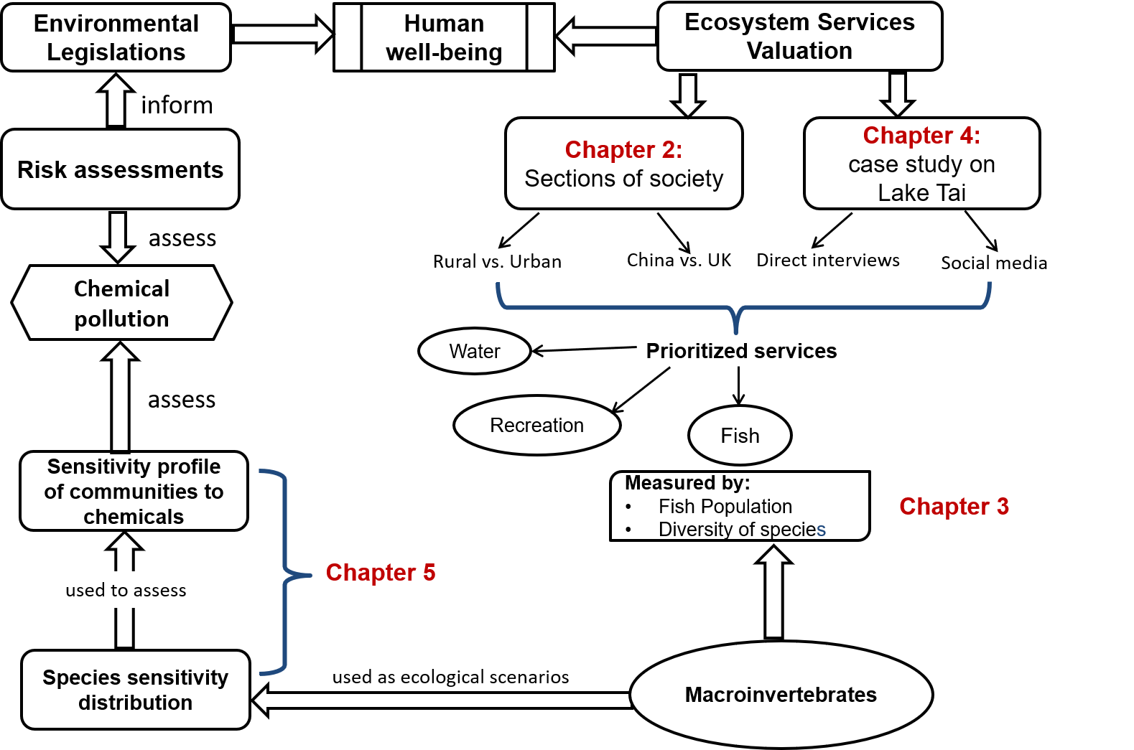
Figure 1: A conceptual diagram depicting the different chapters of the thesis and the links between them

Chapter 2*
Different sections of society and their ecosystem values: rural versus urban and cross-cultural effects
*Part of Chapter 2 (i.e. the rural versus urban study) has been published in another format in the journal Ecosystem Services (Pan et al. (2016); Appendix 2.2).

2.1 Introduction
The ecosystem services framework is an interdisciplinary concept that combines ecology, economics and sociology into one unified idea, and its central goal is to benefit human society (de Groot et al., 2010). It promotes increased public participation into environmental decision making, as well as strengthening the link between ecosystem protection and human well-being (Chan et al., 2006; Merrington et al., 2014). By definition, an ecosystem service requires beneficiaries that value it (Turner et al., 2010). Stakeholders include different sections of society whose perceived value of ecosystem services can vary (McKinney, 2006).
Although ecosystems services benefit human society not all sections of society benefit from or value the same ecosystem services. The perceived ecosystem values of individuals can be affected by previous encounters with nature, an individual’s disposable income and education levels (Huang et al., 2013; Miller, 2006; Restall and Conrad, 2015). How an individual interacts with and values nature may vary at different spatial scales: by country and by populations within a country (i.e. rural versus urban communities).
People living in different countries will have varying experience of nature and they can have different ecosystem values. Previous research has suggested that nationality can affect environmental attitudes (McKercher et al., 2011), and that respondents in higher income countries are more likely to have pro-environmental attitudes (Franzen and Meyer, 2010). Furthermore, researchers have found that respondents’ perception of nature is influenced by their nationality by conducting questionnaire surveys in a Chinese and British national park (Fox and Xu, 2017). The results of previous research suggest that growing up in a developing or developed country can affect how important one thinks nature is.
Within a country, urban populations generally have less frequent interactions with natural ecosystems than rural populations (McKinney, 2006). Therefore, they may be less emotionally attached to ecosystems. This can lead to them considering ecosystem services to be of relatively low value. Previous research has suggested that rural communities may interact with nature more frequently and as a result have more pro-environmental attitudes than urban communities (Berenguer et al., 2005; Kennedy et al., 2009).
Investigating societal differences is important for environmental protection because we need to understand and measure differences in perceived values. As we are unable to protect everything, trade-offs need to be made regarding which ecosystem services are prioritised and protected (Brown et al., 2017). Potential societal differences in perceived ecosystem values raises the challenging question of whose values should be used to prioritise ecosystem services for protection?
Ecosystem valuation is a method that can identify ecosystem services valued by stakeholders, defined as “groups or individuals that affect or are affected by ecosystem services” (Hein et al., 2006). As discussed above, they include different sections of society whose perceived value of ecosystem services can vary (McKinney, 2006). Ecosystem valuation can help decision makers to prioritise specific services for protection (Spash, 2008), but there is debate in the scientific literature regarding the effectiveness of ecosystem valuation projects (Nunes and van den Bergh, 2001). Some scientists argue that a value should not be placed upon nature but without some form of valuation ecosystem services are frequently regarded as free resources by decision makers and the public (Liu et al., 2010). Ecosystem valuation can highlight the cost to current and future generations of losing ecosystem services and therefore encourage decision makers to place more importance on ecosystem protection (Liu and Costanza, 2010). Successful ecosystem valuation projects, such as The Economics of Ecosystems and Biodiversity (TEEB), can promote the benefits of ecosystem protection and investigate the cost of environmental degradation (Kumar et al., 2013). This is particularly important in developing countries, where economic development may be at the expense of ecosystem protection. Successful ecosystem valuation projects can generate increased publicity for nature and create stronger impacts on environmental decision makers (MacDonald and Corson, 2012).
As ecosystem valuation concentrates on “value”, the term must be defined more precisely (Loomis et al., 2000). Value can be separated into two categories in the context of ecosystem valuation: use and non-use values. Use values can be traded in the market and have an easily measured economic value (Turner et al., 2010). They include provisioning services such as food and water. In comparison, non-use values benefit human society indirectly and they are more challenging to measure because they are not traded in the economic market. They include cultural services, such as the recreational or spiritual value of ecosystems (Hodgson et al., 2007). Although the non-use values of ecosystems cannot be measured directly in a financial market, they can be as important to human well-being as use values (Chan et al., 2012b).
One method used to measure the non-use values of ecosystems is contingent valuation (Bateman et al., 2011). Contingent valuation is a method that asks respondents directly for their willingness to pay for non-market value goods using questionnaires (Ciriacy-Wantrup, 1947). Although contingent valuation is one of the most popular methods for measuring non-use values in environmental studies, there is controversy over its effectiveness (Carson et al., 2001; Hanemann, 1994). Some scientists have argued that collecting data on people’s behaviour that can be measured or observed directly is more reliable than using contingent valuation, which investigates hypothetical behaviour. Nevertheless, this method can be useful for where ecosystem services can be valued even when there is no direct behavioural link (Carson et al., 2001). For example, some individuals can value biodiversity (i.e. the presence of certain species) even when they will never directly see the species. In such circumstances, contingent valuation can be beneficial for investigating the value of ecosystems.
Nevertheless, there is less use of contingent valuation in developing countries (Whittington, 2002). In addition, cultural differences may make the approach more difficult in some regions. For example, the method has been applied less frequently in China (Jim and Chen, 2006). This is because incorporating public opinions into Chinese environmental decision making has only been promoted recently (Xu et al., 2003). There is now an increased need for Chinese ecosystem valuation studies and investigating the effectiveness of contingent valuation studies in China is valuable for setting out a framework to prioritise ecosystem services (Liu and Costanza, 2010).
Urbanization is a major threat to biodiversity and ecosystem service delivery in developing countries (Radford and James, 2013). In 2014, 54% of the global population lived in urban area and this is predicted to rise to 66% in 2050 (UN, 2014). In particular, Chinese urban populations are expected to increase by 292 million people by 2050. Urbanisation and economic growth can lead to the increased use of home and personal care (HPC) products in developing countries such as China (Liu and Wong, 2013). Chemicals found in HPC products can pollute freshwater ecosystems through direct discharge and domestic waste systems. As many ecosystems are continuously exposed to a variety of HPC chemicals, there is a rising concern regarding their effects worldwide (Peng et al., 2013).
The primary aim of this research was to evaluate how the perceived value of ecosystem services varied between two different sections of Chinese society (urban and rural) as well as between Chinese and British communities. It also evaluated how the use of HPC products varied between rural and urban Chinese communities. The study was designed to investigate three questions:
1) Do rural and urban communities use and value different ecosystem services and if so, what are the reasons?
2) Are there differences between HPC product usage in rural and urban communities? Can they potentially threaten ecosystem services?
3) Do Chinese and British communities differ in their perceived values of freshwater ecosystem services and if so, what are the reasons?

In China, the development of rural regions is significantly slower than that of urban regions. There are also marked differences between Chinese rural and urban populations in terms of education and income levels. Most of the environment-based ecosystem valuation studies conducted in China have only explored the values of ecosystem services in a general group of respondents, without specifically accounting for different sections of society and spatial scales (Shang et al., 2012; Wang et al., 2013; Xu et al., 2003; Zhao et al., 2013). There is, therefore, a knowledge gap concerning how different sections of Chinese society value ecosystem services and whether Chinese ecosystem values differ from a Western country. Investigating whether there is a rural and urban divide between how Chinese respondents value ecosystem services is particularly important for setting effective protection goals. In addition, investigating whether there are cross-cultural differences between the ecosystem values of Chinese and Western respondents will highlight any differences in the perceived value of nature.
To investigate whether different sections of society differ in their perceived values of ecosystem services, a direct questionnaire survey was conducted in a Chinese village and a city situated within the same region. In addition, an online questionnaire survey targeted at university communities was conducted in China and the UK for comparison. Although the studies use the format of the contingent valuation method to estimate respondents’ perception of ecosystem services, its objective is not to measure respondents’ willingness to pay estimates. This is not an attempt to value ecosystem services in monetary terms, but to use contingent valuation as a method to compare perceived ecosystem values between two sections of society.

2.2 Methods
2.2.1 Study Areas
Rural versus urban communities
For the direct questionnaire survey, the study areas consisted of a rural village (Dukou) and an urban city (Fushan district of Yantai city). Both are situated in the northeast of Shandong province, China. Dukou village is c.30km away from Yantai City. There are c.250 households in the village, with an average of three members per household. Most of the inhabitants are apple and cherry farmers. The River Baiyang runs through the village and is connected to the Menlou Reservoir nearby. Although the reservoir provides drinking water for Yantai city, it does not provide drinking water for Dukou village. The village’s drinking water is drawn from groundwater.
Fushan is one of the four urban districts in Yantai, with a population of around 280,000 people. Two rivers run through Fushan district: River Jiahe, which flows from the Menlou Reservoir, and its tributary River Liuzi (Figure 2.1). All urban respondents visited the River Liuzi rather than the River Jiahe as it was closer to them.

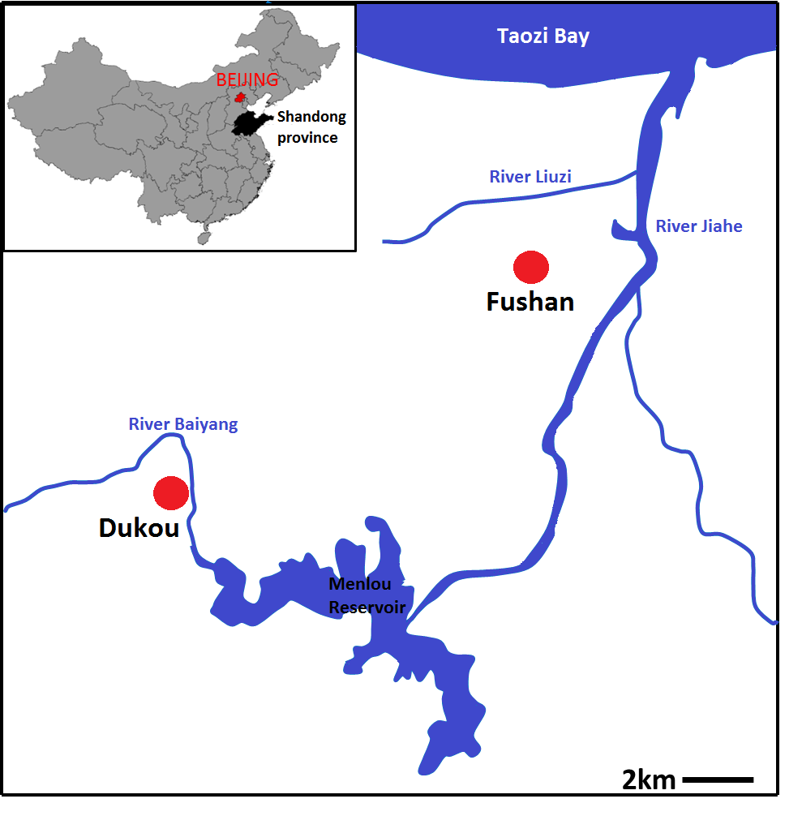
Figure 2.1: The position of Shandong province within China (top left) and the position of the study areas (Fushan and Dukou village).

China versus UK
The online questionnaire was distributed via an email link in Chinese and British universities. The study groups mainly targeted three universities in different regions in China and three universities in different regions in the UK. The three British universities targeted are: University of Sheffield, Imperial College London and Reading University. The three Chinese universities chosen are: Nanjing University in Jiangsu Province, East China Normal University in Shanghai and Liverpool-Xian Jiaotong University in Suzhou, Jiangsu Province.

2.2.2 Questionnaire Surveys
Rural vs. Urban
Sixty community-based interviews were conducted by one interviewer, who is a native speaker of Mandarin Chinese, in July 2014: 30 interviews in Dukou and 30 in Fushan. Interviews were only conducted after the respondent consented verbally. Respondents were interviewed individually to avoid the influence of others.
In the village, the interviewer started at one end of the main street in the village and knocked on every third household door. One person from each household was interviewed, and this was usually the person who was the decision maker for the household. In the city, every third person encountered by the interviewer was approached in two residential districts. Both female and male respondents were approached in equal proportions. Nevertheless, female respondents were generally more willing to answer questionnaires than males. This resulted in a higher proportion of female respondents in the final dataset. Interviews were conducted over a period of six days, in the morning and the afternoon to accommodate for temporal differences and reduce potential biases.
All respondents were interviewed directly on a one-to-one basis in an informal manner to make them feel at ease. They were also interviewed individually to avoid the influence of others on the response. The questionnaire was in Mandarin Chinese (English version questionnaire attached in Appendix 2.1) and all respondents were assured of their anonymity. No details were taken that could trace the questionnaire answers back to a specific individual. Furthermore, interviews were only conducted after the respondent consented verbally. The questionnaire took approximately 25 minutes to conduct and it was composed of five sections:
- Background questions that asked for the respondent’s demographic information such as: gender, maximum education level and age.
- Respondents’ interactions with and their attitudes towards the local river
- Respondents’ use of house and personal care (HPC) products and the fate of HPC products
- Respondents’ willingness to pay for freshwater ecosystem services
- Respondents’ knowledge and attitudes towards environmental protection
Section ii) explores how frequently the respondent interacted with the local river, which freshwater ecosystem services they used and which services they valued. Section iii) provides information on how respondents could potentially increase the source of water contamination by using HPC products, which can enter freshwater ecosystems via the household drain or through direct laundry washing activities conducted by the river. Section iv) of the questionnaire investigates the respondent’s perceived value of freshwater ecosystem services. The Contingent Valuation Method (CVM) was used to investigate the respondent’s willingness to pay (WTP) for freshwater ecosystem services via two hypothetical questions. The first question asked whether respondents would be willing to donate money towards a project to save the local river from complete disappearance. The second question asked whether respondents would be willing to donate money to improve the quality of the local river. The two hypothetical questions were worded as below:
- “If the local river (i.e. River Baiyang in the rural community and River Liuzi in the urban community) will disappear completely in one year’s time but the Ministry of Environmental Protection can save it, will you be willing to donate money to this project? Please assume that all the money raised will only be used for saving the local river. Please take your income and other expenditures into account.”
- “If the Ministry of Environmental Protection wants to carry out a project to improve the quality of the local river over the next 5 years and you assume that all the money raised will only be used for improving the local river, will you be willing to donate money to achieve this? This project will result in: an increase in wildlife in and around the local river, improved water quality and less water pollution. Please take your income and other expenditures into account.” (Respondents were asked about their satisfaction level with the protection of their local river to ascertain the individual’s perception of river water quality, which may affect their willingness to pay)
The local river disappearing completely represents an extreme case scenario where all ecosystem services provided by the river will disappear. This scenario was chosen because it impacts all respondents more severely as some respondents only used a few ecosystem services.
In addition, respondents that were willing to donate money were asked what percentage of their yearly income they were willing to donate for the next five years towards the two hypothetical projects using a bidding amount method, which started at 30% and was then lowered to 20%, 10%, 5%, 1% and <1% respectively. The bidding amount method and the percentage values were selected based on a pilot survey. The bidding amount method elicited more responses compared to an open-ended question. Percentage values instead of monetary values were asked because this study is not a monetary valuation of ecosystem services. It aims to compare the perceived value of services using contingent valuation.
Following this question, debriefing questions asked why respondents were willing to pay or not. In addition, respondents were asked how confident they felt about their answer and how difficult they thought it was to make the decision. These questions aimed to improve the quality of the study. Finally, section v) provides insight into the respondent’s environmental awareness of how anthropogenic activities may impact on the environmental quality and hence the delivery of ecosystem services.

China vs. UK
Students and staff from the chosen British and Chinese universities were randomly recruited to answer an online questionnaire via circulation of a university-wide email message. Although there is bias in only targeting respondents that are affiliated with universities, the aim of this study is to investigate potential differences between the ecosystem values of Chinese and British respondents. As the bias towards university respondents was the same for both sets of respondents the results are comparable.
The questionnaire was hosted on the online survey site: Survey Gizmo (https://www.surveygizmo.com/). The questionnaire was available in both Chinese and English (See Appendix 2.2 for English version). Some Chinese respondents reported that they could not access Survey Gizmo in China so the Chinese version of the questionnaire was also hosted on a Chinese online survey site: Wen Juan Wang (https://www.wenjuan.com/). Before the start of the online questionnaire, the respondents were shown an introduction page that explained who I was, the study objectives and the approximate length of the questionnaire. In addition, the respondents were assured that the questionnaire was anonymous and their names would not be required. No details would be taken that could be used to trace the questionnaire answers back to a specific individual.
The respondents were then asked to answer the question: “Are you prepared to participate in this survey and answer the following questions.” They had to answered yes to proceed with the questionnaire. The main body of the online questionnaire is composed of 4 sections:
- questions regarding the respondent’s use, interactions with and attitudes towards the local rivers
- environmental knowledge and attitudes questions
- freshwater ecosystem services valuation questions
- background demographic questions (e.g. gender and age)
Section 1 investigates the frequency of the respondent’s interaction with the local river and two common activities that they did when visiting the river, using an open-ended question. Respondents were then asked to rank six ecosystem services in order of importance to them. The six services were: food provision, freshwater provision, recreation, aesthetic appeal (i.e. view), flood regulation, and water purification. The ecosystem services were illustrated with simple examples for clear understanding. To avoid bias towards selecting the first option, the ecosystem services were ordered randomly for each respondent that answered the online questionnaire. Section 2 provides insight into respondents’ environmental awareness of how anthropogenic activities may impact on the environmental quality and hence the delivery of ecosystem services.
Section 3 of is the most important part of the study, because it investigates the perceived value of freshwater ecosystem services. This was investigated by using the contingent valuation method (CVM). Respondents were asked two hypothetical questions that explored their willingness to pay (WTP) for freshwater ecosystem services. The first hypothetical question asked whether respondents would be willing to pay to prevent the disappearance of the local river. The second question asked whether respondents would be willing to pay to improve the quality of the local river. In addition, respondents that were willing to pay were asked what percentage of their yearly income they were willing to give for the next five years out of 6 choices (30%, 20%,10%,5%,1% and <1%). A percentage value of the respondent’s income was asked for because this study is not concerned with calculating an exact monetary value for willingness to pay. Instead this study aims to investigate the perceived value of freshwater ecosystem services by using money as a proxy. As most of the respondents were students, they were given a hypothetical average salary of £25,000 per year in the UK and 35,000 Yuan per year in China.
The two hypothetical questions in the questionnaire attempt to evaluate the perceived value of different freshwater ecosystem services. The first question investigates the existence value of the local river by asking whether respondents would be willing to pay to prevent its disappearance. The second question, however, investigates the value of biodiversity in and around the local river.
The two hypothetical questions were worded as below:
- “If your local river will disappear completely in one year’s time but the Environmental Agency can save it, will you be willing to donate money for this project to save the river? Please assume that all the money raised will only be used for saving the river. Please take your income and other expenditures into account. If you are currently a student and have no income: Assume that you are earning £25,000 per year after graduation, will you be willing to donate to save the local river?”
- “If the Environmental Agency wants to carry out a project to improve the quality of the local river over the next 5 years and you assume that all the money raised will only be used for improving the river, will you be willing to donate money to achieve this?
This project will result in: i) more wildlife (animals & plants) in and around the river; ii) better river water quality (i.e. less pollution, less rubbish in the river) and iii) a river that is not smelly. Please take your income and other expenditures into account. If you are currently a student and have no income: Assume you are earning £25,000 per year after graduation, will you be willing to donate money to improve the quality of the local river?”

2.3.3 Data Analyses
Rural vs. Urban
All statistical analyses were carried out in R 3.0.2 (R Development Core Team, 2013). The dataset was analysed to investigate the factors that affected the respondent’s willingness to pay for freshwater ecosystem services. Using logistic regression, a generalised linear model (GLM) with a binomial family error was used because the response variable (willing to pay or not) has a dichotomous outcome. The maximal GLM model was fitted first and the dredge function from the MuMIN package was used to find the minimally adequate model. The minimally adequate model was selected based on Akaike’s information criterion (AIC), where the model with the smallest AIC value was selected.
The maximal GLM model included the following predictors: respondent’s age, maximum education level, gender, the place where they lived, did they visit the river, and their satisfaction level with the protection of the local river. All the information was collected as part of questionnaire.
China vs. UK
The data were analysed to investigate the factors that affected which ecosystem services were prioritised by respondents, and whether there was a cross-cultural difference between China and the UK. In addition, the factors that affected whether respondents were willing to pay or not to protect their local environment were investigated.
The results of the data were analysed in R 3.0.2 (R Development Core Team, 2015). A multiple correspondence analysis (MCA) was conducted on the questionnaire results using the factominer package in R. The MCA analysis investigated the variables that explained the most variance in the data and which variables were correlated with others. The results of the MCA were plotted graphically using the package factoextra to display the associations between different variables. The eigen-values and explained variances for each dimension were calculated and plotted graphically.
Next, a hierarchical classification was performed on the MCA to sort the individual respondents into several clusters. This produced a hierarchal tree that suggested the number of clusters in the data, and a factorial map where the individual respondents are coloured according to different clusters.
The questionnaire results were also analysed to investigate the factors that could affect whether respondents were willing to pay or not for their prioritised freshwater ecosystem service. Using logistic regression, a generalised linear model (GLM) with a binomial family error was used because the response variable (willing to pay or not) has one dichotomous outcome. First, the maximal GLM model was fitted and then used the dredge function from the MuMIN package to find the minimally adequate model. The dredge function selects models based on AIC values.
The maximal GLM model included the following predictors: where the respondent lived, the respondent’s nationality, whether they have visited their local river, would they miss the local river if it disappeared, their satisfaction with the protection of the local river and their level of environmental knowledge.
2.3.4 Ethics statement
This study was formally approved by the Animal and Plant Sciences Department Ethics committee at the University of Sheffield, UK. Before the start of each interview, all respondents were informed of the objectives and methodology of the questionnaire. We obtained verbal informed consent from all respondents. Only adults (i.e. over the age of 18) were interviewed during the study.

2.3. Results
2.3.1 Demographic information
Rural vs. Urban
Overall, 60% of respondents were female and 40% were male. In the village, 56.7% of respondents were female and 43.3% were male. In the city, 63.3% of respondents were female and 36.7% were male. The maximum education level for the majority of rural respondents was secondary school (86.7%). The rest of the rural respondents listed sixth form or college as their maximum education level (13.3%). In contrast, the maximum education level for the majority of urban respondents was an undergraduate degree (63.3%). This was followed by sixth form or college (30%), and secondary school (3.3%). On average, rural respondents had a lower education level than urban respondents. Rural respondents generally earned less per month compared to urban respondents. 73.3% of rural respondents earned less than 2000 RMB per month. 43.3% of urban respondents earned 2001-4000 RMB per month (Table 2.1).

Table 2.1: The monthly income of respondents in Chinese Yuan in Dukou village and Fushan city region, China.
Income (Yuan / month) | Rural | Urban
<2000 | 22 | 8
2001-4000 | 7 | 13
4001-6000 | 1 | 9

China vs. UK
In total, 343 responses were collected from Survey Gizmo and Wen Juan Wang. One hundred and forty-eight of the respondents were British, 143 respondents were Chinese and 40 respondents were of other nationalities. Within the British nationals, there were 6 respondents that were British born Chinese. Two hundred and eleven respondents lived in the UK, 126 respondents lived in China, and 5 respondents lived elsewhere. Within the respondents that lived in the UK, 31 respondents were Chinese nationals (Table 2.2).
Fifty seven percent of the respondents were female, 42% were male and one percent identified with another gender identity. The majority of respondents had a postgraduate degree or an undergraduate degree for their highest level of education. Eight percent of the respondents were university academic staff, 12% were university non-academic staff, 33% were undergraduate students, 18% were masters students, 23% were PhD students and 5% belonged to other job categories. As the majority of respondents were students, there was little income information.

Table 2.2: The nationality of the respondents and where they live from the online questionnaire

 | China | UK
British | 0 | 147
Chinese | 121 | 31
Other nationality | 5 | 33

2.3.2 Uses and value of the local river:
Rural vs. Urban
Most rural respondents visited the local river (96.7%, n=30). By comparison, just over half of the urban respondents visited the local river (56.7%). On average, rural respondents lived closer to and visited their local river more frequently than urban respondents. Most rural respondents lived within 10 minutes walking distance to the local river (86.7%). Only 26.7% of urban respondents, however, lived within 10 minutes walking distance to the local river (Table 2.3). 65.5% of rural respondents visited the local river daily (n=29) but only 11.8% of urban respondents visited daily (n=17).
Table 2.3: The average time that it took respondents to walk to the local river in Dukou village and Fushan city region, China.
Walking time to local river (minutes) | Rural | Urban
<10 | 26 | 8
11-20 | 4 | 8
21-30 | 0 | 6
31-40 | 0 | 4
41-50 | 0 | 2
51-60 | 0 | 0
>60 | 0 | 2

Fourteen respondents in the village reported conducting two activities frequently by the river and 16 respondents reported one activity. In contrast, only 4 urban respondents reported conducting two activities frequently by the river and 13 reported one activity. The most common activity for both rural and urban respondents was walking by the river banks, which is classified as recreation in terms of ecosystem services (Figure 2.2a).
Both rural and urban respondents thought that recreation was the most important freshwater ecosystem service to them (Figure 2.2b). Rural respondents indicated that washing clothes was the second most important to them, whereas urban respondents chose the view by the river. This is in concurrence with Figure 2.2, indicating that the most frequently conducted activity is the most valued freshwater ecosystem service.
Although rural respondents conducted more activities by the local river (Figure 2.2a), they named fewer ecosystem services than urban respondents (Figure 2.2b). Urban respondents recognised a wider range of freshwater ecosystem services, such as wildlife and flood prevention.
Figure 2.2: Most frequently used and prioritised freshwater ecosystem services of the local river by rural and urban respondents. Some respondents listed two frequent activities and others listed one.
China vs. UK
There were marked differences in the ecosystem services prioritised by British and Chinese respondents (MCA plot, Figure 2.4). Chinese respondents living in China were more likely to prioritise freshwater provision (i.e. Water) as the most important ecosystem service (Ranking=1) and to rank recreation and view the lowest (Ranking=6). In contrast, respondents that live in the UK and that are British nationals were more likely are more likely to prioritise aesthetic appeal (i.e. View) as the most important ecosystem service and recreation as the second most important.
When the individual respondents were colour coded on the MCA plot to display either where they lived (Figure 2.5a) or their nationality (Figure 2.5b), two clusters were apparent; one for respondents that lived in the UK and one for those that lived in China. Individuals that lived in the UK were in the bottom left region of the MCA plot whereas Individuals living in China were in the top right region of the plot. This indicated that the Chinese and British respondents were prioritising different ecosystem services (Figure 2.4).
A hierarchical classification conducted on the principal components of the MCA sorted the individual respondents into three main clusters (Figure 2.6). Two clusters represented British respondents living in the UK (Cluster 1 and Cluster2) and one cluster represented Chinese respondents living in China (Cluster 3). The respondents in Cluster 1 and Cluster 2 shared several characteristics, but differed in whether they visited their local river, prioritised water purification and staff category (Table 2.4). Respondents in Cluster 3 shared no defining characteristics with the other two clusters.

Table 2.4: The three clusters formed by the hierarchical classification conducted on the principal components of the multiple correspondence analysis, and the variables that explain the clusters.
 | Cluster 1 | Cluster 2 | Cluster 3
1 | Ranked view as most important | Ranked view as most important | Ranked view as the fifth most important
2 | Ranked recreation as second most important | Ranked recreation as second most important | Ranked water provision as the most important
3 | British & lives in the UK | British & lives in the UK | Ranked recreation as fifth or sixth most important
4 | Visited their local river | Ranked water provision as the fifth most important | Chinese and lives in China
5 | Ranked water provision as the fifth or six most important | Ranked water purification as the fourth, fifth or sixth most important | Ranked water purification as the most or second most important

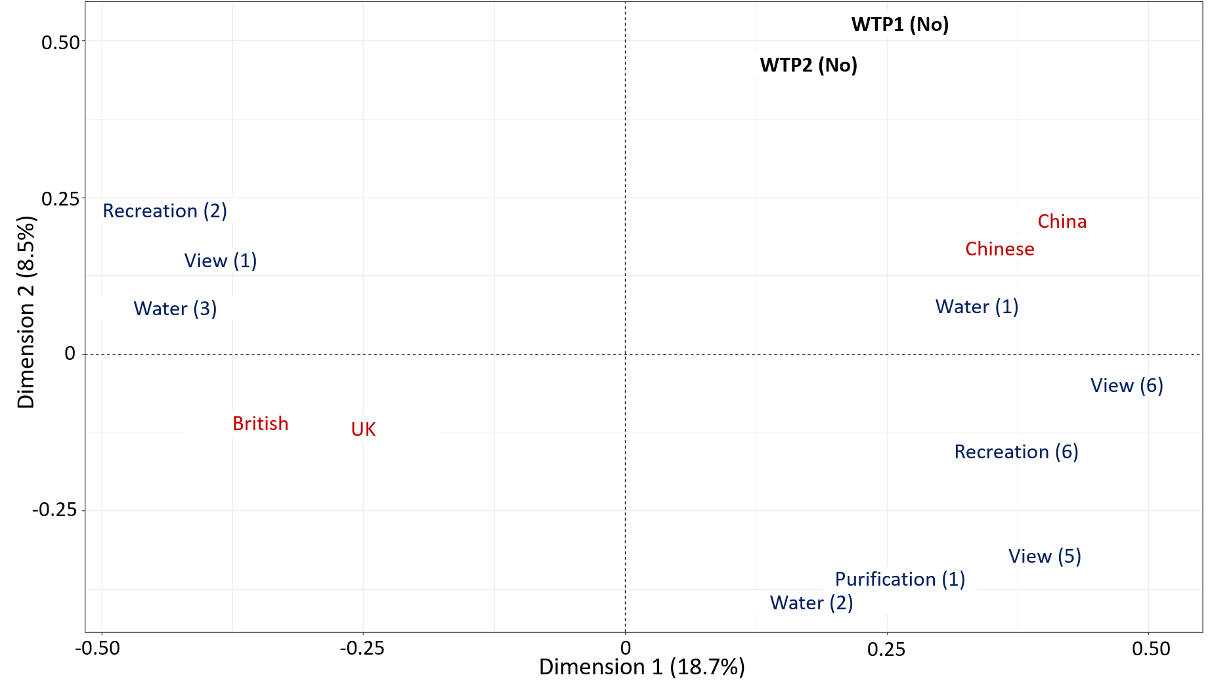Figure 2.4: A multiple correspondence analysis (MCA) plot depicting the top fifteen variables that contribute the most to the explained variances in the questionnaire data. Blue text = ranking of the freshwater ecosystem service (from 1 to 6). Red text = nationality and place of inhabitancy. Black text = Unwilling to pay for their prioritised ecosystem service: WTP1(No) and to improve the environmental quality of their local river: WTP2 (No).

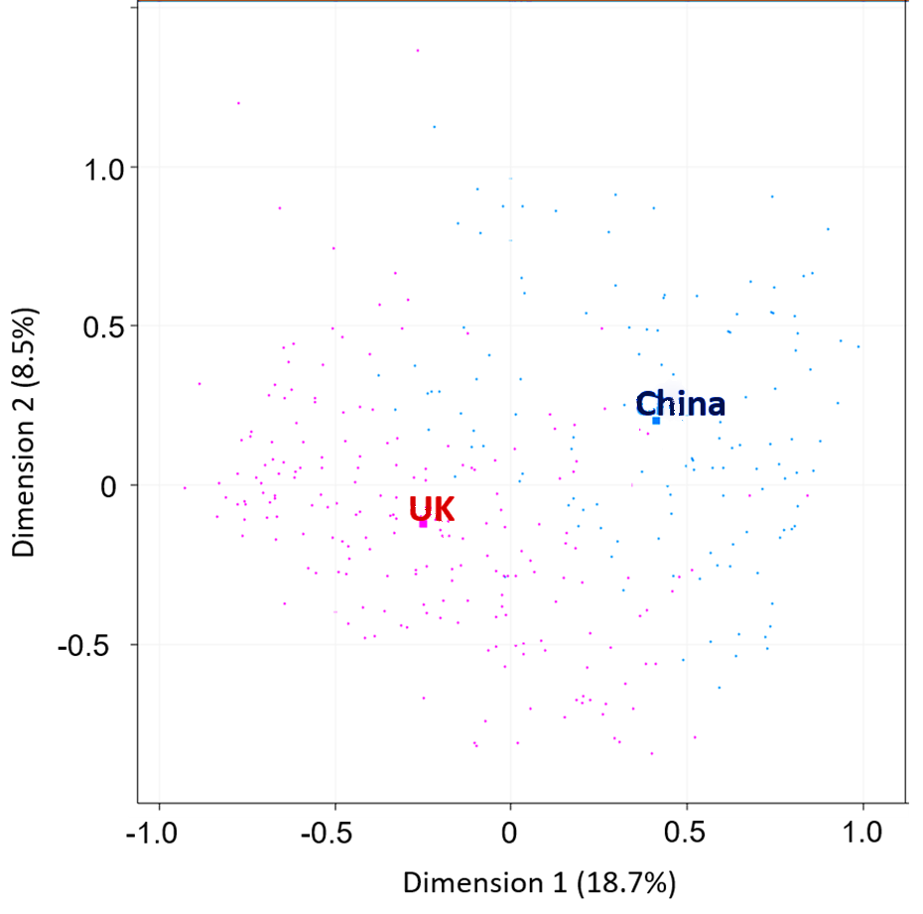
Figure 2.5: A multiple correspondence analysis (MCA) plot with the individual respondents colour coded according to where they live (UK and China).

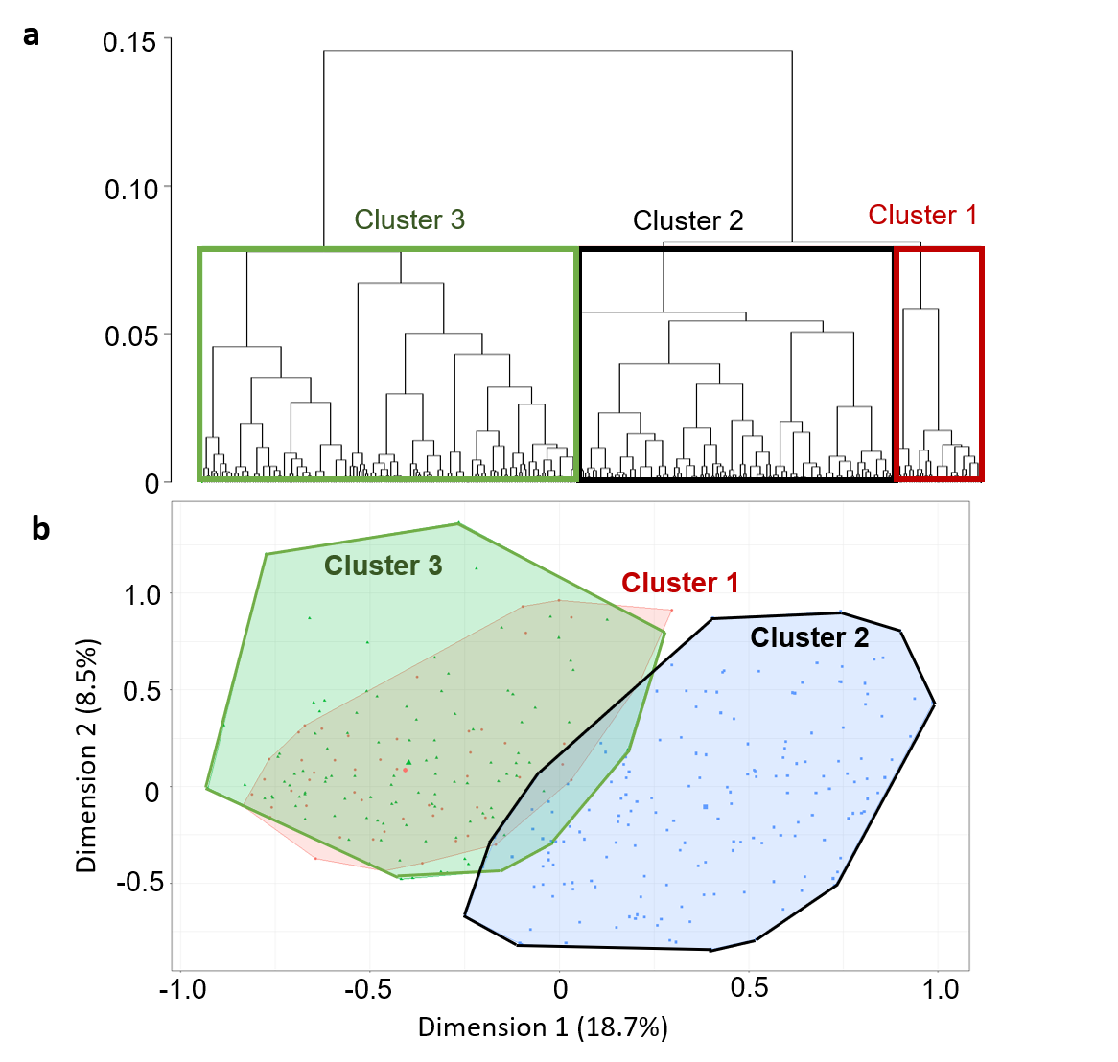
Figure 2.6: a) Hierarchical tree; b) Hierarchical clusters shown on a biplot based on the hierarchical classification performed on the principal components of the MCA.
2.3.3. Willingness to pay for ecosystem services
Rural vs. Urban
Rural respondents valued freshwater ecosystem services more than urban respondents. Ninety percent of rural respondents were willing to pay to save the local river whereas only 53.3% of urban respondents were, and rural respondents were willing to pay proportionally more than urban respondents. When asked what percentage of their income they were willing to pay per year for the next five years, the median value for rural respondents was 10% and for urban respondent this was 1%. Only one factor in the maximal model significantly affected whether respondents were willing to pay or not: the place where they lived (Table 2.5). Urban respondents were significantly less willing to pay to save the local river compared to rural respondents (Table 2.6).

Table 2.5: The top four models for the predictors that affect the respondent’s willingness to pay to save the local river.
Model Number | Variables in model | d.f. | AIC value | delta AIC | weight
1 | Place | 2 | 65.2 | 0 | 0.276
2 | Gender+ Place | 3 | 66.4 | 1.2 | 0.152
3 | Place+ Visit river | 3 | 66.7 | 1.5 | 0.130
4 | Education | 4 | 67.9 | 2.73 | 0.071

Table 2.6: Results of the minimally adequate model for the effects of place of inhabitancy on the respondent’s willingness to pay to save the local river. Estimate values show how coefficients differ from the intercept of Place (Rural).
 | Estimate | Standard Error | T value | P value
Intercept | 2.20 | 0.62 | 3.55 | <0.001
Place (Urban) | -2.06 | 0.72 | 2.86 | 0.006

Similarly, 90% of rural respondents were willing to pay to improve the quality of the local river compared to 43.3% of urban respondents and again rural respondents were willing to pay proportionally more. When asked about what percentage from their income they were willing to pay per year for the next five years, the median value for rural respondents was 5% and for urban respondents it was 1%. Two factors in the maximal model affected whether respondents were willing to pay or not: the maximum level of education and gender (Table 2.7). Male respondents were slightly less willing to pay than females, but the result was not significant. Respondents with an undergraduate degree were significantly less willing to pay to improve the quality of the local river compared to respondents with secondary school as their maximum level of education (Table 2.8). All respondents with an undergraduate degree were in the urban population.

Table 2.7: The top four models for the predictors that affect the respondent’s willingness to pay to improve the quality of the local river.
Model Number | Variables in model | d.f. | AIC value | delta AIC | weight
1 | Education+Gender | 5 | 57.4 | 0 | 0.33
2 | Education | 3 | 58.9 | 1.56 | 0.150
3 | Education+Gender+Place | 5 | 59.1 | 1.73 | 0.138
4 | Education+Gender+ Visit river | 5 | 59.7 | 2.37 | 0.100

Table 2.8: Results of the minimally adequate model for the effects of gender and level of education on the respondent’s willingness to pay to improve the quality of the local river. Estimate values show how coefficients differ from the intercept of Gender (male) and Education (secondary school).
 | Estimate | Standard Error | T value | P value
(Intercept) | 2.99 | 0.89 | 3.37 | <0.001*
Gender(Male) | -1.54 | 0.86 | -1.80 | 0.072
Education (Sixth form) | -0.50 | 1.02 | -0.49 | 0.627
Education (Undergraduate degree) | -3.69 | 0.95 | -3.87 | <0.001*

China vs. UK
Respondents living in Britain valued freshwater ecosystem services more than those living in China. Sixty-nine point five of the respondents living in China were willing to pay to protect their prioritised ecosystem service, whereas 89.6% of respondents living in the UK were willing to pay (Chi-squared = 20.54, d.f. = 1, p<0.001). Eighty-five point eight of respondents living in the UK were willing to pay to improve the environmental quality of their local river, and 71.9% of the respondents living in China were willing (Chi-squared = 9.09, df = 1, p<0.05).
The generalised linear model (GLM) results showed that two variables significantly affected whether respondents were willing to pay or not to protect their prioritised ecosystem service (Table 2.9). Respondents that lived in the UK and said that they would miss their local river if it disappeared were significantly more willing to pay to protect their prioritised freshwater ecosystem service, compared to respondents that lived in China (Table 2.10). The second GLM model also showed that only two variables affected whether respondents were willing to pay or not to improve the quality of their local river (Table 2.11). Respondents that were Chinese were significantly less willing to pay to improve the quality of their local river compared to their British counterparts (Table 2.12).

Table 2.9: The top four models for the predictors that affect the respondent’s willingness to pay to improve the quality of their prioritised freshwater ecosystem service.
Number | Variables in model | d.f. | AIC value | delta AIC | weight
1 | Place of inhabitancy +Miss river? | 3 | 298.6 | 0 | 0.212
2 | Place of inhabitancy + Miss river? + Nationality | 5 | 299.4 | 0.75 | 0.146
3 | Miss river? + Nationality | 4 | 299.5 | 0.85 | 0.138
4 | Place of inhabitancy +Miss river? + Visit River? | 4 | 300.0 | 1.40 | 0.105

Table 2.10: Results of the minimally adequate model for the effects of place of inhabitancy and whether respondents would miss the local river if it disappears on the respondent’s willingness to pay to save the local river. Estimate values show how coefficients differ from the intercept of place of inhabitancy (China).
 | Estimate | Standard Error | t value | p value
(Intercept) | -0.40 | 0.51 | -0.79 | 0.43
Place of inhabitancy (UK) | 1.38 | 0.30 | 4.58 | <0.0001*
Miss river? (Yes) | 1.31 | 0.50 | 2.60 | 0.0094*

Table 2.11: The top four models for the predictors that affect the respondent’s willingness to pay to improve the quality of their local river.
Number | Variables in model | d.f. | AIC value | delta AIC | weight
1 | Nationality +Miss river? | 4 | 327.3 | 0 | 0.094
2 | Nationality +Miss river? + Place of inhabitancy | 5 | 327.4 | 0.08 | 0.090
3 | Nationality | 3 | 328.7 | 0.75 | 0.064
4 | Place of inhabitancy +Miss river? | 3 | 328.3 | 0.93 | 0.059

Table 2.12: Results of the minimally adequate model for the effects of nationality and whether respondents would miss the local river if it disappears on the respondent’s willingness to pay to save the local river. Estimate values show how coefficients differ from the intercept of place of inhabitancy (China).
 | Estimate | Standard Error | t value | p value
(Intercept) | 0.89 | 0.51 | 1.75 | 0.079
Miss river? (Yes) | 0.87 | 0.50 | 1.74 | 0.081
Nationality (Chinese) | -0.69 | 0.29 | -2.35 | 0.019*
Nationality (Other) | 1.23 | 0.76 | 1.61 | 0.108

2.3.4 Environmental knowledge and attitudes
Rural vs. Urban
All respondents believed that protecting the environment is important. Most respondents reported that they have some knowledge regarding environmental issues (85%, n=60). Thirteen point three percent of respondents reported having no environmental knowledge and 1.67% reported having a lot of environmental knowledge. In the village, 76.7% of respondents listed freshwater pollution as their utmost concern (Figure 2.7). In the city, however, only 30% of respondents listed freshwater pollution as their major concern. Most city respondents were most concerned by air pollution (70%, n=30).
All respondents agreed that protecting the local river is important (n=60). When asked about their opinions regarding the current local river protection, however, only 16.7% of respondents reported that they were satisfied. 43.3% were unsatisfied with the current local river protection, 38.3% were neither satisfied nor dissatisfied and 1.7% did not know. In the rural community, 16.67% were satisfied, 40% were unsatisfied, and 36.67% were neither satisfied nor dissatisfied and 3.33% did not know. In the urban community, 13.33% were satisfied, 46.67% were unsatisfied, and 40% were neither satisfied nor dissatisfied.
Figure 2.7: The type of pollution that respondents were most concerned about in Dukou village and Fushan city region, China.

China vs. UK
There was no significant difference between the opinions of respondents living in the UK or China on the importance of environmental protection (Fisher’s exact test, p>0.05). In both cases, over 80% of respondents thought that environmental protection was very important. There was also no significant difference between the types of pollution that respondents in China and the UK were most concerned about (Fisher’s exact test p = 0.873; Figure 2.8). Both types of respondents were most concerned about air pollution and least concerned about noise pollution (Figure 2.9)
There was a significant difference between the opinions of respondents in China and the UK regarding the importance of protecting their local river (Fisher’s exact test, p=0.005). More respondents in China thought that protecting their local river is very important compared to their counterparts in the UK. 85.2% of respondents in China thought that protecting their local river is very important compared to 70.8% in the UK.
Figure 2.8: The type of pollution that respondents living in China and the UK were most concerned about.
2.3.5 Potential threat to ecosystem services
Urban respondents used a wider range of HPC products compared to rural respondents (Figure 2.9). None of the rural respondents used hand wash or fabric conditioner but urban respondents did. The three HPC products that are predominantly used in the rural community were toothpaste, laundry powder and bar soaps.
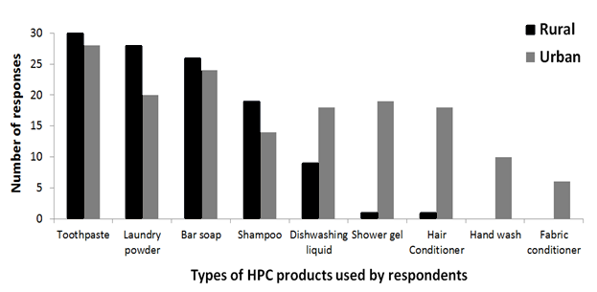Figure 2.9: A comparison between the types of home and personal care products used by rural and urban respondents in Dukou village and Fushan city region, China.
2.4. Discussion
The primary aim of this study was to evaluate how the perceived value of ecosystem services varied between two different sections of Chinese society: urban and rural, as well as between Chinese and British university communities. The results showed that rural and urban communities used and valued different ecosystem services. Rural communities valued ecosystem services more than the urban respondents because they were more willing to pay for them. Chinese and British respondents also differed in their perceived values of ecosystem services, and their prioritisation of ecosystem services. The results highlight a potential rural and urban divide in ecosystem values, as well as a divide between cultures.

2.4.1. Rural and urban communities
There are conflicting views regarding the environmental attitudes of rural versus urban communities in the scientific literature. Some studies have suggested that urban communities have more pro-environmental attitudes than rural communities (Bjornlund et al., 2013; Yu, 2014). In contrast, other studies have indicated the opposite view (Berenguer et al., 2005; Kennedy et al., 2009). In this study, the direct questionnaire survey results indicate that rural and urban respondents use and value different freshwater ecosystem services. More rural respondents used local freshwater ecosystem services compared to urban respondents. Rural and urban communities have different lifestyles and this affects the types of freshwater ecosystem services used. Nevertheless, both communities chose recreation as the most important ecosystem service to them. Indeed, walking by the local river banks was the most popular activity undertaken by both rural and urban respondents. Previous research by Shang et al. (2012) also found that river networks in Shanghai were most frequently used for recreational purposes by respondents. In addition, they reported that most respondents walked by the local river banks. Although this study was conducted in a different Chinese region compared to Shang et al., the results of the two studies are similar.
Urban respondents named six different ecosystem services that were important to them whereas rural respondents only named three services. Urban respondents valued some services that they did not use directly, possibly because urban respondents had a higher education level than rural respondents. As a result, urban communities may be more aware of environmental issues and named a wider range of ecosystem services. In comparison, rural respondents only valued the ecosystem services that they used directly such as the recreational purposes of the local river. Previous research has shown that urban communities prioritise cultural services such as aesthetic value, whereas rural communities tend to value provisioning services (Martin-Lopez et al., 2012). Interestingly, every rural respondent prioritised an important ecosystem service but three urban respondents believed that ecosystem services were not important to them at all. This suggests that some urban respondents may think that they are not connected to nature in any way.
Through further discussions with rural respondents, which were not part of the questionnaire, it became apparent that they relied on the local river directly for many things. These included: climate regulation during the hot summer months, river water for crop irrigation and washing clothes, as well as waste disposal.
Only rural respondents used the local river to help them cool down during the summer. This is because urban respondents are richer so they are more likely to purchase fans or air conditioning for temperature regulation in the summer. Most rural households did not have air conditioning so villagers visited the local river banks frequently during the summer months to cool down. Rivers have a cooling effect in the summer and a warming effect in the winter, thus impacting the local microclimate (Volker et al., 2013). Chinese researchers found that there can be a temperature difference of 2 ºC next to the Yangtze River compared to the centre of an urban community (Ganbo et al., 2011). A study in Japan also found a decrease in temperature of 5 degrees Celsius above a river during hot seasons and that this cooling effect extended to nearby regions (Murakawa et al., 1991). It can be concluded that rivers provide a cooler environment for local communities during the summer and can improve human well-being.
As most rural respondents are farmers, they frequently channel water from the local river to irrigate agricultural land because it is regarded as abundant and as a “free resource”. Through observation, there are large areas of agricultural lands (crops and cherry orchards) surrounding the local river. Therefore, a considerable volume of water must be required to irrigate the lands. The local river provides fresh water for irrigation purposes in the rural village.
Chinese urban respondents in this study were less willing to pay for freshwater ecosystem services than rural respondents for both questions: 1) to save the local river; 2) to improve the quality of the local river. Rural respondents lived closer to their local river and visited it more frequently than urban respondents. Any potential changes to the local river will affect rural respondents more quickly and directly than urban respondents. By interacting with the local river frequently, rural respondents may be more aware of the value of the local river and therefore feel a closer connection to it (Shang et al., 2012). This likely influenced their willingness to pay for freshwater ecosystem services.
Urban inhabitants usually live further away from freshwater ecosystems and many ecosystem services are brought to them directly, such as drinking water through pipes and waste removal systems. They do not physically see the benefits that freshwater ecosystem provides them (Keniger et al., 2013). Fewer urban respondents visited the local river and when they did, they only conducted indirect and recreational activities by the local river. Therefore there is a spatial disconnect between where the freshwater ecosystem services are produced and where they are ultimately used in urban cities (McKinney, 2006). This is reflected by the fact that urban respondents are more concerned about air pollution than freshwater pollution. Urban respondents are more exposed to the severity of air pollution in China via the news on television or on the internet. Furthermore, they can physically observe how air pollution negatively affects them in the form of smog. By comparison, a polluted river does not affect them as severely because urban inhabitants do not use the river water directly for any purpose. This is the possible reason for why urban respondents are less willing to pay for freshwater ecosystem services.
Interestingly, Shang et al., (2012) conducted a similar contingent valuation study in Shanghai on payment for river ecosystem services. They also found that the mean WTP of the rural respondents was higher than for the urban respondents. This indicates that between two different regions in China, rural and urban communities value freshwater ecosystem services differently. This pattern of rural urban divide may be present across multiple regions in China. This has implication for the setting of Chinese environmental protection goals. It raises two key questions:
- Should environmental protection goals be different for Chinese rural and urban regions if ecosystem values show considerably variance?
- What will occur as Chinese rural regions develop and their ecosystem values change with time? How should environmental protection goals adapt to temporal change?
For rural respondents, their WTP median was higher for saving the local river than for improving the quality of the local river (10% vs. 5%). This indicates that they regarded the existence value of the local river more highly than the quality of the river. A likely reason is because many of the activities carried out by rural respondents in the river are independent of the river quality. As a result, they were less concerned about the quality of the river. The presence of the river is much more valuable to the rural respondents.
Interestingly, the WTP median of urban respondents was the same for both questions: saving the river and improving the river quality. Nevertheless, the number of urban respondents willing to pay to save the local river was higher than for improving the river quality (53.3% vs. 43.3%; n=30). This difference of 10% suggests that urban respondents also valued the existence of the local river more highly than its quality. This can be explained by the large proportion of urban respondents that listed recreation (e.g. walking by the river banks) as the most important freshwater ecosystem service to them. Recreational activities by the river can be conducted regardless of the river quality, as long as the local river remains present.
The potential existence of a rural-urban divide in the prioritization of ecosystem services raises important questions for the setting of environmental protection goals. Whereas both rural and urban respondents prioritized direct recreation uses (walking by and view of the river), only rural respondents prioritized the river as a water source (for washing) and only urban respondents prioritized flood prevention. One way of reducing flooding is to slow the downstream movement of water by increasing connectivity between the river and its upstream floodplain (Ward et al., 1999). Storing water in wetlands may make the river less accessible and reduce its utility for washing clothes, keeping cool or recreation. In this study, the rural population was upstream of the urban population so setting protection goals that prioritized flood prevention in urban areas may reduce the delivery of ecosystem services prioritized by the rural community.

2.4.2 Potential threat to ecosystem services
All rural women interviewed for this study regularly washed their clothes in the local river. They gave three reasons for this practice: 1) the local river water is “free” as compared to tap water which requires financial payment; 2) there is an abundance of water in the local river and the water flow rate is faster than from the tap; 3) washing clothes by the river is a highly sociable activity where the local women can also chat. A study conducted in rural South Africa also found that women in villages washed their clothes in the local river on a frequent basis (Gordon et al., 2009). There was also a social reason for washing clothes in the river. In the summer seasons, the women washed their clothes in the river in groups but they did not do so in the winter seasons. The Chinese rural respondents in this study, however, have piped water in their households but they still washed clothes in the local river due to other reasons. Unfortunately, washing clothes directly in the river means that house and personal care (HPC) chemicals from laundry powder or soaps can directly enter freshwater ecosystems. Chemicals found in HPC products have the potential to adversely affect the provisioning of ecosystem services.
There was no waste treatment system in the village and household waste entered the local river directly. Many villagers were aware of this and knew the importance of the local river for removing their household waste. The lack of a waste treatment system coupled with laundry activities by the river also mean that large amounts of HPC chemicals can enter the local river directly HPC products such as laundry powder are a potential threat to freshwater ecosystems and human well-being by causing chemical pollution (Figure 2.10). In addition, the discharge of untreated household sewage and nutrients are also threats to the local ecosystem. Figure 2.10 shows a potential framework for linking the potential threats to freshwater ecosystems to the impacts on ecosystem services that are valued by society.
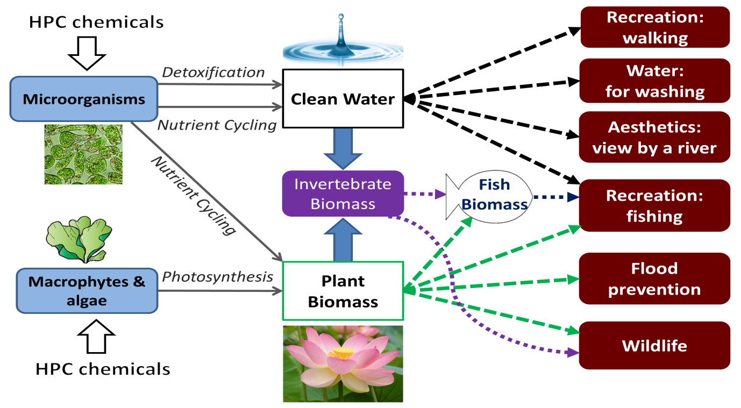
Figure 2.10: Ecological components linked to the provision of freshwater ecosystem services and potential threats from home and personal care (HPC) chemicals.

2.4.3 China and the UK
This online questionnaire results show that there are spatial differences between societal values concerning environmental protection. In this case, the spatial scale is across two countries (i.e. China and the UK). Their perceived value of freshwater ecosystem services is considerably different, potentially due to differences in culture. If the views of society are considered during the formation of protection goals, then we must recognise that ecosystem values are not the same everywhere. Specific protection goals should be set down for different areas.
The results indicate cross-cultural effects on the perceived value of freshwater ecosystem services, i.e. there are differences between the Chinese and British respondents. The Chinese respondents are more likely to prioritise provisioning ecosystem services as most important to them, whereas the British respondents are more likely to prioritise cultural ecosystem services. This suggests that if we form protection goals based upon people’s perceived values, there will be different goals for the two countries. In China, the focus will on be protecting provision services such as food and water provision. In contrast, the focus will be on protecting cultural services such as aesthetic appeal and recreation in the UK.
Cultural services are not necessities, compared to provisioning services. Cultural services include the aesthetic appeal of ecosystems, recreational value and the intrinsic value of nature (Kenter et al., 2015). In a developed country such as the UK, the average person is wealthier than the average person in a developing country such as China. As a result, British people may value cultural ecosystem service more than Chinese people because they are intangible benefits to humans. Several previous studies have found that Chinese tourists have lower perceived values of the aesthetic appeal of nature (Harris, 2006, 2008; Packer et al., 2014).
Culture can have a significant effect on how people view and value nature. A potential reason is because in different countries with different cultures, nature can be portrayed in a different light by the media. The media’s representation of nature can influence people’s views (Buijs, 2009). In addition, people’s past experiences and memories affect how they perceive nature. This is shaped by a person’s native homeland (Chan et al., 2012a). Geographical and historical differences between different countries will affect how people view the natural environment. Communities from different cultures have different beliefs and this will affect how they perceive the environment, as well as their interactions with nature (Xu and Fox, 2014).
Traditionally, the Chinese people’s connection to nature is heavily influenced by the religions Taoism and the philosophical teachings of Confucianism. Both emphasise the importance of the unity between humans and nature, and the idea of living in harmony with nature (Ye and Xue, 2008). Nevertheless, the introduction of Marxism and the Chinese cultural revolution that promoted the idea of humans conquering nature, all altered how the Chinese view and value nature (Fox and Xu, 2017). Due to the rapid rise in economy and urbanisation in China, the Chinese have become more interested in materialism and protecting nature has been put on a backseat (Deng et al., 2015). As a developing country, previous research has suggested that Chinese people tend to value nature less than economic growth (Packer et al., 2014). In addition, the Chinese people generally appreciate the aesthetic value of nature less than their Western counterparts (Harris, 2006). Therefore, it has been suggested that Chinese people have an anthropocentric view that regards humans as the centre of the world. This means that they believe humans to be the highest-ranking life forms and other life forms can be exploited for the sake of humans (Packer et al., 2014). The traditional and modern Chinese views of nature are conflicting, so there is uncertainty regarding how Chinese people really view the environment (Harris, 2008).
People living in a developed country, such as the UK, are more likely to be wealthier and therefore have more spare money to protect the environment. In comparison, people living in developing countries are poorer and may not see environmental protection as their utmost concern. The Chinese respondents in this study are less willing to pay to protect their prioritised ecosystem service and to improve the quality of their local river. Through reading the comments for why respondents in China are not willing to pay, the potential reason is because they do not think that protecting nature is important to them. Below are some of the common comments displayed by Chinese respondents:
- “I already pay tax, so why should I pay more?”
- “This is not my responsibility. It is the government’s responsibility.”
- “I don’t have enough spare money for environmental protection.”
Respondents that said they will miss their local river if it disappears are significantly more willing to pay to protect their prioritised ecosystem service. I have used the question of whether they will miss the river’s disappearance to indicate their emotional attachment to their local river. Previous literature has suggested that people who are more emotionally attached to nature are more supportive of environmental protection (Cox et al., 2017). The results of this study support this hypothesis and show that if a person is more emotionally attached to an ecosystem, then they are more willing to pay money to protect the ecosystem services.
The results of this study support the idea that Chinese people have more anthropocentric views compared to their Western counterparts. Firstly, Chinese respondents are less willing to pay to protect ecosystem services and to improve the quality of their local river. Secondly, they value provisioning services more than cultural services. Provisioning services provide people with direct benefits that can be easily quantified whereas the benefits of cultural services are not easily perceived and intangible.
The concept of ecosystems services is essentially anthropocentric, as they are the benefits that humans received from nature. Chinese respondents from the online questionnaire survey may have a more anthropocentric view of nature than the British respondents, so they may be more willing to protect nature if they are presented with the concept of ecosystem services.

2.4.4 Limitations and further work
Rural vs. Urban
Although investigating respondents’ preferences for ecosystem services is useful for informing environmental decision-making processes, there is a tendency for over-valuing provisioning and cultural services (Liu et al., 2010). This is true for the direct questionnaire survey where respondents valued two cultural services most highly: the recreational value and aesthetic appeal of the river. As illustrated by Figure 5, the two cultural services and one provisional service that are perceived as most important by respondents are in reality supported by various other ecosystem services. The public, however, rarely acknowledges the value of regulating or supporting ecosystem services because they cannot be observed or used directly. Therefore, to set effective environmental protection goals, ecosystem valuation must be combined with other methods such as ecosystem modelling and ecosystem services mapping to provide a fuller perspective on the value of ecosystem services (Costanza et al., 2002).
This study is limited by its small sample size of only 60 respondents. Nevertheless, it has identified a potential pattern of Chinese rural and urban divide in terms of ecosystem values. In addition, it sets out a framework for investigating freshwater ecosystem values in Chinese rural and urban communities. Future work could expand upon this study by using this method in another region of China and investigating whether this pattern between rural and urban communities still occurs. In addition, several pairs of “cities versus villages” could be identified to increase the sample size and the number of replicates for the questionnaire survey.
Chinese vs. UK
Compared to the use of direct questionnaire surveys, online questionnaires can reach large numbers of respondents more quickly and cheaply (Riva et al., 2003). Direct questionnaire surveys are labour intensive, can introduce the bias of interviewers and the presence of an interviewer may affect the truthfulness of sensitive questions (Rhodes et al., 2003). For example, respondents may supply an answer that they think the interviewer wants to hear rather than their truthful answer. In comparison, an online questionnaire provides more anonymity than a direct questionnaire. As a result, the answers may be more honest. Furthermore, a respondent can answer an online questionnaire at any time they want in the comfort of their own homes (Wright, 2005).
Nevertheless, online questionnaires cannot target individuals that have no access to the internet or cannot use the internet (e.g. elderly people). In addition, another disadvantage is that respondents choosing to answer the online questionnaire are already interested in the topic investigated. This can create a bias in the sample. As a result of this, respondents that answer online questionnaires are generally wealthier and more educated than the average respondent.
The online questionnaire survey targeted university students and staff, which makes the results slightly biased and restrictive. The main objective, however, is to investigate whether there are any cross-cultural differences between Chinese and British respondents. Therefore, it is valid to compare between Chinese and British university respondents. Apart from their nationality and the place that they live, other demographic factors should be more similar and reduce the amount of variation in other factors.

2.5 Main findings
By using the contingent valuation method, the direct questionnaire survey results indicate that there are clear differences between perceived values of freshwater ecosystem services between a Chinese rural and urban community, as well as between Chinese and British respondents. In the direct questionnaire survey, rural respondents used ecosystem services more frequently and were more willing to pay to protect them. The possible reason for this is due to higher levels of ecosystem interaction in rural communities compared to urban communities. The greater use and diversity of HPC products in urban areas, coupled with the lower valuation of ecosystem services by urban respondents, may enhance the risk of adverse ecological impacts and impaired ecosystem service benefits in urban rivers. In addition, this could result in decisions to protect ecosystem services prioritized by urban communities having an adverse effect on the supply of ecosystem services prioritized by rural communities.
The results of the online questionnaire survey are particularly important when considering the setting of environmental protection goals in different countries. The results show that there are cross-cultural differences between the prioritisation and perceived value of freshwater ecosystem services, as well as whether respondents are willing to pay or not for ecosystem services. Past experiences can affect the perceived value of nature, which can be shaped by a person’s country of origin. This indicates that there will be different ecosystem service protection goals for different countries if public opinions are used. The difference between a developing and developed country must be considered.
Although contingent valuation has its limitations, it does illustrate an approach for investigating perceived ecosystem values in different sections of society. Furthermore, it has identified a potentially important difference in the prioritization of ecosystem services by different sections of society and raises the question: If decision-makers use public opinions to inform policy, whose ecosystem values should count?

Chapter 3
Consequences of spatial and temporal changes at Lake Tai (Taihu) on ecosystem services provision

3.1 Introduction
Lake Tai (Taihu) is the third largest freshwater lake in China, with a total surface area of 2250 km² (Qin et al., 2007). It is situated in Jiangsu province in the east of China and is surrounded by three large cities: Suzhou in the East, Wuxi in the North and Huzhou in the South (Figure 3.1). Lake Tai is a shallow lake with a mean depth of 2 m (Ai et al., 2015) and is subdivided into eight different sections (Figure 3.2). The lake sits within the Taihu basin, which has a total area of 36,500 km² and crosses three provinces as well as the Shanghai city region (Reidsma et al. 2012, Figure 3.1). The Taihu basin is one of the wealthiest regions in China, providing 12.5% of the gross national product whilst only occupying 0.4% of the national land area (Ai et al., 2015).
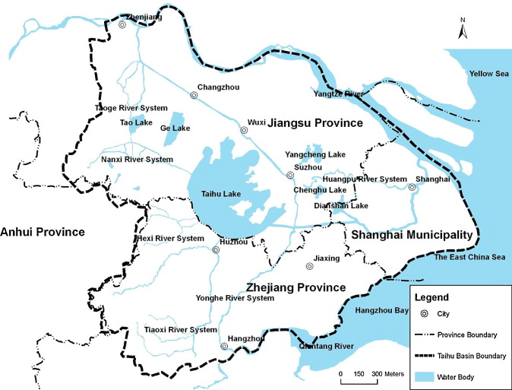
Figure 3.1: A map depicting Lake Tai (Taihu) and the surrounding regions (Reidsma et al., 2012)

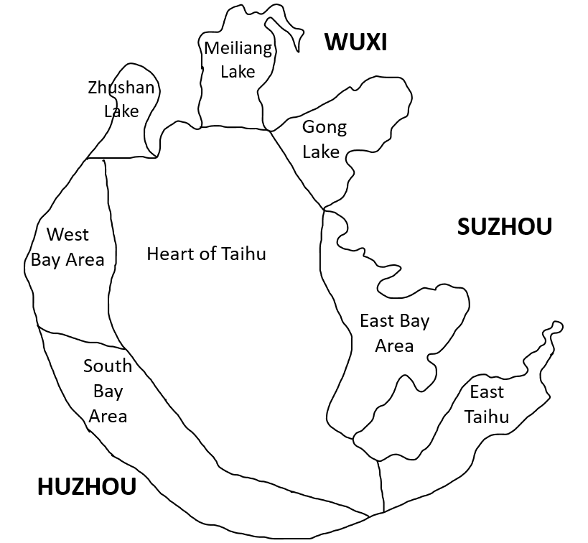
Figure 3.2: A map depicting Lake Tai and its nearby major cities, as well as the different sections of the lake and their names. Figure is based on the Taihu Health Status Reports, which are published by the Taihu Basin Authority of Ministry of Water Resources online (http://www.tba.gov.cn) and section names have been translated from Chinese.

Lake Tai is the major source of drinking water for the Yangtze River delta region (Wang et al., 2014) and the Taihu basin is particularly important for agriculture and aquaculture (Li et al., 2008). The area produces high quantities of rice, freshwater fish and crabs (Yang et al., 2003). It has been known as “the land of fish and rice” throughout Chinese history (Huang et al., 2013). The main ecosystem services provided by Lake Tai are summarised in Table 3.1 using the Common International Classification of Ecosystem Services (CICES; https://cices.eu/), to improve the standardisation of ecosystem service assessments.

Table 3.1: The main ecosystem services provided by Lake Tai, classified using the Common International Classification of Ecosystem Services.
 | Ecosystem Service | Examples from Lake Tai | Reference
Provisioning services | Cultivated crops | Rice and wheat  -Rice in the summer  -Wheat in the winter. | (Qiao et al., 2012)
 | Wild plants, algae and their outputs | Aquatic plants  -Lotus roots  -Water caltrop (Trapa natans)  -Chinese water chestnuts  (Eleocharis dulcis) | (Jiang and Cao, 2008)
 | Wild animals and their outputs | Fish and shellfish  -See Appendix 3.1 for species list | (Zhu et al., 2007)
 | Animals from in-situ aquaculture | Fish and shellfish  - Farming of bream and carp (1)  - Farmed Chinese mitten crabs (2) | (Zhu et al., 2007) ₁  (Li and Yang, 1995) ₂
 | Surface water for drinking | Water abstracted from Lake Tai for drinking | (Zhang et al., 2010b)
 | Fibres and other materials from plants, algae and animals for direct use or processing | Lake Tai pearls for jewellery and Chinese medicine
 | Materials from plants, algae and animals for agricultural use | Algal species collected from the lake to feed farmed fish | (Gu et al., 2003)
 | Surface water for non-drinking purposes | Water used for irrigating farmland and for industrial factories surrounding Lake Tai.
Regulation and maintenance | Filtration/sequestration/storage/accumulation by ecosystems | Accumulating and filtering pollutants in lake sediments. | (Cai et al., 2013)
 | Dilution by atmosphere, freshwater and marine ecosystems | Diluting wastewater output in the lake.
 | Buffering and attenuation of mass flows | Transportation of sediment
 | Flood protection | Regulation and protection against floods
 | Maintaining nursery populations and habitats | Provided habitats for young aquatic animals
 | Micro and regional climate regulation | Regulating temperatures (i.e. cooler by the lake in summer).
Cultural services  E | Experiential use of plants, animals and land-/seascapes in different environmental settings | Bird watching in wetlands around Lake Tai.
 | Physical use of land-/seascapes in different environmental settings | Walking, recreational fishing, boating, cycling around the lake
 | Scientific | Frequently used for research purposes | (Ai et al., 2015)  (Lu et al., 2013)
 | Educational | Well-known lake in China that appears on television and online
 | Heritage/Cultural | Cultural site of heritage for fishermen with 500 years of history. The origin of Wu-Yue culture.
 | Entertainment | Documented in Chinese nature programs
 | Symbolic | Symbolic plant and animals  -The three whites of Lake Tai (aquatic animals)  -The eight deities of the water (aquatic plants)
 | Sacred/religious | Buddhist temples and statues around Lake Tai

The human population around the lake has increased rapidly since the 1980s, resulting in significant land use changes (Le et al., 2010). Land reclamation has included the draining of wetlands that are important for biodiversity (Woodward and Wui, 2001) and provide multiple ecosystem services that benefit local human communities (Mitsch and Gosselink, 2000). Wetlands are natural buffers that regulate water quality, filter water, regulate floods and provide habitats for wildlife (Sun et al., 2015). The loss of wetlands accompanied by the increase in urbanisation has increased the intensity of anthropogenic threats to Lake Tai (Shi and Qi, 2012).
In recent years, urbanisation has developed at an unprecedented speed around Lake Tai. From 2000 to 2005, the mean urban growth rate was extremely high (i.e. 12,567 ha/year) and the total urban area surrounding Lake Tai almost doubled in size between 1985 and 2005 (Tu et al., 2009). The increasing urbanisation has resulted in an increased demand for water supply (Zhang et al., 2010b). High levels of water abstraction coupled with the shallowness of the lake have resulted in water shortages during periods of high temperatures (Qin et al., 2007). Furthermore, increased volumes of wastewater generated from urban households have contributed to the eutrophication of the lake (Qin et al., 2007). Another factor that has contributed to eutrophication is aquaculture, which has intensified over the last twenty years to meet increased demands (Wang et al., 2014). Discharges from aquaculture feeds and waste products all contribute to the nutrient load and negatively impact the lake ecosystem (Cai et al., 2013).
The water quality of Lake Tai has deteriorated steadily since the 1980s, which is when rapid urbanisation first started around the lake (Zhang et al., 2010b). It is now one of the most polluted and threatened freshwater lakes in China, suffering from frequent outbreaks of blue-green algal blooms in the summer months (Guo, 2007). In 2007, a severe bloom of toxic blue-green algal in Lake Tai, near the city of Wuxi, resulted in water intakes being closed and millions of people in Wuxi had no access to clean tap water for five days. Local communities were forced to rely on bottled water purchased from supermarkets, resulting in shortages and price increases in local bottled water. This serious eutrophication event led to a total loss of $44 billion, which included the price of providing bottled water to local communities and removing the decomposing algae from the lake (Huang et al., 2013).
Lake Tai is a Chinese freshwater ecosystem that produces many irreplaceable ecosystem services to the surrounding communities. Nevertheless, it suffers from multiple anthropogenic stressors that threaten the provision of these vital ecosystem services. These include population growth, increased wastewater output, water pollution and increasing aquaculture. To my knowledge, there is limited research that investigates these potential threats to ecosystem services provision as a whole, and how the threats have changed through time. The aim of this chapter is to collate the fragmented information available on Lake Tai, much of which is in the grey literature or published in Chinese journals, and to use this information to:
- Describe spatial and temporal changes in human population around the lake, waste water output, water quality, aquaculture and natural fisheries
- Explore the consequences of ecological changes to freshwater ecosystem service provision

3.2. Methods:
Data on human population changes in the major cities surrounding Lake Tai were collected from the Yearly Statistics Books of Suzhou, Wuxi and Huzhou respectively (2016), because population growth can negatively impact an ecosystem’s natural resources. The data collected spanned the period from 2000 to 2014.
The Carlson’s Trophic State Index (TSI) based on Chlorophyll a, concentrations of ammonia, total nitrogen and total phosphorus and chemical oxygen demand measurements of Lake Tai were collected from the yearly Taihu Health Status Reports, which are published by the Taihu Basin Authority of Ministry of Water Resources online (http://www.tba.gov.cn) for the period 2008 to 2013 (http://www.tba.gov.cn//tba/content/TBA/lygb/index.html). Additional data from 1960 to 2007 were extracted from the book by Qin (2008). Data on total waste outputs between 2000-2013 from the major cities surrounding Lake Tai were collated from the Yearly Statistics Books of Suzhou, Wuxi and Huzhou (National Bureau of Statistics of China, 2016). This data was used to investigate the potential effects on ecosystem services, as water quality can be an indicator of freshwater provision for a lake ecosystem.
Using the search engines “Web of Science”, “Google Scholar” and “Baidu Scholar (in Chinese)”, the keywords “temporal changes”, “fish populations” and “Taihu” (in Chinese and in English) were used to search for scientific papers or reports that contained data regarding the temporal changes in fish populations in Lake Tai. All papers or reports in Chinese were translated into English by the author. Data on the yield of natural fish catches and species composition of natural fish catches from Lake Tai was extracted from Gu et al. (2009), from 1950-2000. These data were then plotted as graphs. A food web for the economically important freshwater fish species found in Lake Tai was constructed using the species composition data from capture fisheries and feeding behaviour data collected from FishBase (http://www.fishbase.org). FishBase is the largest and most comprehensive database for fish species in the world and contains information on fish behaviour, habitat and taxonomy. Changes in fish populations or food web structures can affect the ability of Lake Tai to provide food for local communities, as fish is an important source of protein from freshwater lakes.
A list of fish species found in Lake Tai, as determined by historical surveys in 1986 and 2006, was obtained from a research paper (Shi et al., 2014). The feeding behaviour and average size of the fish species found in Lake Tai were obtained from FishBase. The difference in the number of fish species caught in Lake Tai between the 2006 and 1986 historical surveys was calculated. Finally, data on the production and economic value of farmed fish and Chinese mitten crabs for the period 1984 to 1999 were obtained from Gu et al. (2003). Freshwater crabs also provide an important source of food for local communities, but farmed crabs can also pollute water and negatively impact other ecosystem services.
The collated data and information were categorised into three areas: population growth and land use changes; chemical pollution and water quality; capture fisheries and aquaculture. For each area, temporal and spatial changes were described and the impacts on ecosystem services provision evaluated.

3.3 Results and discussion
3.3.1 Population growth and land use changes
Suzhou is the largest city surrounding Lake Tai. Although its total land area has remained the same since 1983, the human population of the city has been increasing (Tu et al., 2009). The population increased by 56% between 2000 and 2014 (i.e. from 6.79 million to 10.6 million), with the greatest rate of increase occurring from 2005 to 2010 (Figure 3.3). The population of the other two cities, Wuxi and Huzhou, has also increased since 2000, but at a much slower rate. The population of Wuxi has increased by 28% since 2000 and in 2014 was 6.5 million, whereas the population of Huzhou has only increased by 2% since 2000 and in 2014 was 2.6 million (Figure 3.3)
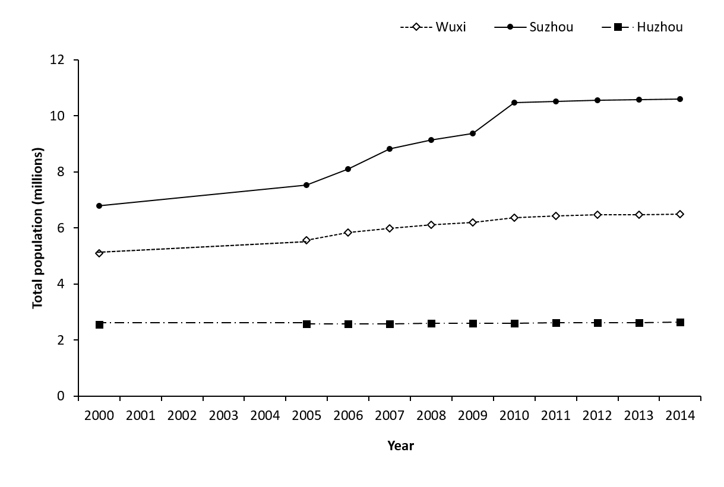
Figure 3.3: Changes to the total population in the three major cities: Suzhou (●), Wuxi (◊) and Huzhou (■) surrounding Lake Tai. Note that the total land area of the cities has remained constant over the period 2000 to 2014. (Based on data from the Yearly Statistics Books of Suzhou, Wuxi and Huzhou).

A rising population demands more food, energy and water provision and can therefore drives land use changes (Postel et al., 1996). There is increased stress on local freshwater ecosystem services because more water must be extracted for human consumption and agricultural irrigation. This can lead to unsustainable water extraction and lakes can become dry during the summer months (Ai et al., 2015). As cities surrounding Lake Tai become more urbanised, each household will use more water (Postel, 2000). This will potentially have a negative impact on the ecosystem services provision of Lake Tai, because the demand for water provision will be higher than the supply.
Due to population growth, around 160 km² of wetlands have been reclaimed around Lake Tai and converted into agricultural land (Lu et al., 2007). Wetlands are commonly undervalued habitats that provide many vital ecosystem services, which include water filtration, flood prevention, food provision and habitat provision for wildlife (An et al., 2007). Wetlands can naturally filter out pollutants and absorb toxic chemicals (Kong et al., 2014). Thus, they can improve the water quality of Lake Tai by acting as natural waste treatment systems. In addition, wetlands reduce the probability of flash flooding because they can absorb heavy rainfall and release the water slowly over time (Sun et al., 2015).
Economic development in developing countries frequently seem to be at conflict with environmental protection and this is especially true in China (Liu and Diamond, 2005). Using the ecosystem services approach, however, may offer a solution to this problem (Liu and Costanza, 2010). For example, wetland reclamation around Lake Tai seemed beneficial economically because it increased agricultural land area and food production. Nevertheless, this resulted in the deterioration of ecosystem services provided by the wetlands. Lake Tai lost its natural filtration system, and this has exacerbated the problem of eutrophication. Extreme nutrient pollution has resulted in severe algal blooms, and the cost of environmental restoration has been high (Yang et al., 2008). Although the provision of ecosystem services is free, the cost of destroying them can be high.
A recent study conducted at Lake Tai demonstrated that constructed wetlands are efficient at removing phosphorous and nitrogen from eutrophic lake water (Li et al., 2008). These natural filtration systems are relatively cheap and easily managed when compared to artificial waste treatment. If large areas of wetlands around Lake Tai had not been converted in the first place, then the ecosystem services provided by wetlands would have been preserved. The high cost of reversing lake eutrophication could have been reduced.

    - Chemical pollution and water quality
The number of chemical factories surrounding Lake Tai has increased drastically since the 1980s, which has led to a rise in industrial wastewater that enters the lake (Guo, 2007). This industrial pollution problem is especially prominent in the city of Yixing, which is situated to the north-west and upstream of Lake Tai (Le et al., 2010). Compared to other cities surrounding the lake, chemical plants and textile mills are a major source of income for Yixing. Although the local government is concerned with the environmental quality of Lake Tai (Guo, 2007), chemical factories provide many jobs and shutting them down will impact the local economy negatively. As a result, environmental protection has not been perceived as a priority and this has aggravated the eutrophication problem (Qin et al., 2007).
In addition to industrial pollution, there are large volumes of household wastewater entering Lake Tai. The two biggest cities surrounding Lake Tai are Suzhou and Wuxi, which pump large quantities of wastewater into the lake. From 2007-2013, the total wastewater output from Suzhou, Wuxi and Huzhou have increased steadily (Figure 3.4). The largest increase in wastewater output was in Suzhou, where there was a rise of approximately 400 million tons. Municipal wastewater has increased in all three cities surrounding Lake Tai due to the rising urban population and the cities expanding in size. In China, there is a huge influx of people that migrate to cities from the rural regions in search of a better life. Major cities around Lake Tai, especially Suzhou and Wuxi, are affluent and they attract many migrants. In fact, Suzhou has now become a mega-city and is ranked seventh in China in terms of its GDP. It contains China’s second largest migrant population, with over half of the Suzhou population being migrants.

Figure 3.4: Changes to the total wastewater output (billion tons) from the three major cities surrounding Lake Tai, from 2004 to 2013. ● represent Suzhou, ◊ represent Wuxi and ■ represents Huzhou (data from the Yearly Statistics Books of Suzhou, Wuxi and Huzhou).

According to the Health Status Report of Lake Tai in 2014, regions of the lake close to Yixing (i.e. Zhushan Lake and the West Bay Area) had the worst water quality in terms of chemical nutrient loads (Figure 3.5a) and had the highest chlorophyll A concentrations and blue-green algal densities (Figure 3.5b). The average chlorophyll A concentration for Lake Tai was 28.75 mg/m³. Chlorophyll A concentrations were higher than average for Zhushan Lake and West Bay Area and lower than average for East Taihu and the East Bay Area. East Lake Tai and the East Bay Area are close to Suzhou, where a major source of income is from tourism. Algal blooms in Lake Tai can result in an off-putting smell, which are unattractive for tourists (Yang et al., 2008).

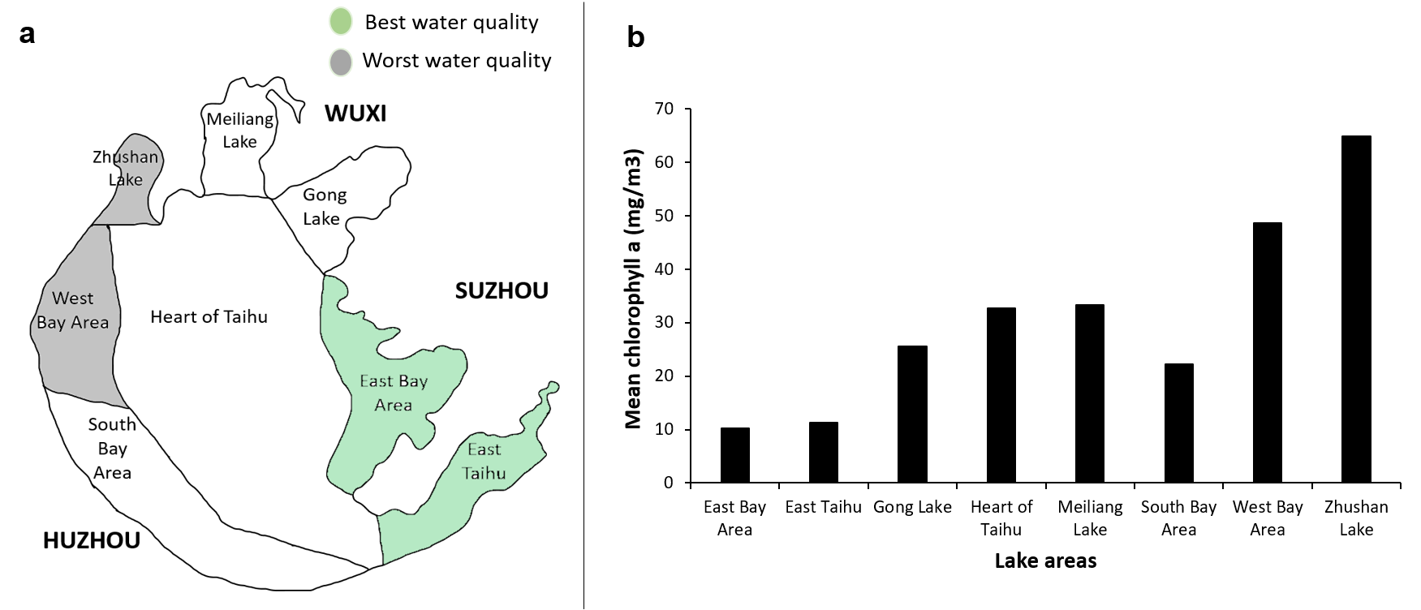
Figure 3.5: Water quality for Lake Tai. The map (a) highlights lake areas with the poorest water quality (grey) and those with the best water quality (green). Mean concentrations of chlorophyll A for each lake area are presented in panel b.

Historically Lake Tai was an oligotrophic lake, with a Carlson’s Trophic State Index (TSI) of 35 in 1960 (Figure 3.6). A TSI of <40 is oligotrophic, 40-50 is mesotrophic, 50-70 is eutrophic and >70 is hypereutrophic. In addition, the concentrations of nitrogen, phosphorus and chemical oxygen demand (COD) of Lake Tai water were all much lower in 1960 (Figure 3.7). In the 1980s, the Chinese economy increased at unprecedented speed and this caused a negative impact on the lake water quality (Dai, 2014). More chemical factories were built and there was rapid urbanisation around Lake Tai (section 2.3.1). There was increased industrial and domestic wastewater discharges into the lake from the surrounding cities and Lake Tai had quickly become eutrophic by the end of the 1980s (Zhang et al., 2010b). Blue-green algal blooms became a frequent event during the summer months. From the end of the 1980s onwards, the TSI of Lake Tai has remained above 40 indicating a eutrophic status (Figure 3.6).
Lake Tai provides local communities with drinking water, which is an irreplaceable ecosystem service. Freshwater from the lake is also used for irrigation and industrial purposes (He et al., 2015). In addition, good water quality is key to providing many cultural ecosystem services. These include recreational activities such as fishing, cycling, walking and sailing on the lake. A lake with clear water provides aesthetic appeal and will attract more tourists, thus benefiting economic development. The chemical pollution at Lake Tai negatively affects its ecosystem services provision and provides less benefits to society (Ai et al., 2015).

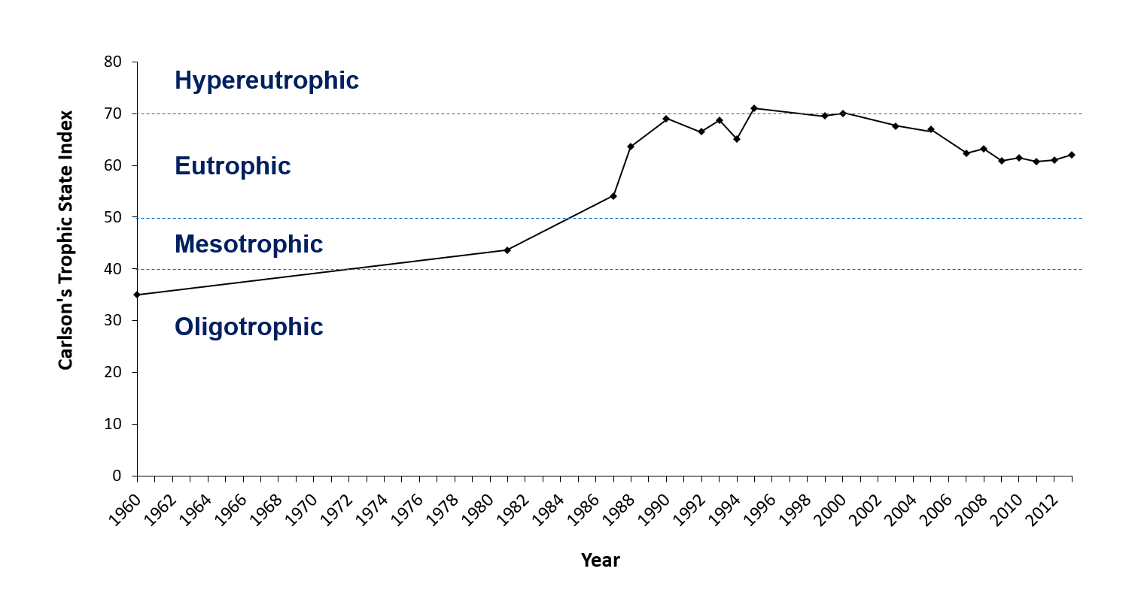Figure 3.6: Changes in the Carlson’s trophic state index (TSI) of Lake Tai from 1960-2013 (based on data from the yearly Taihu health status reports).

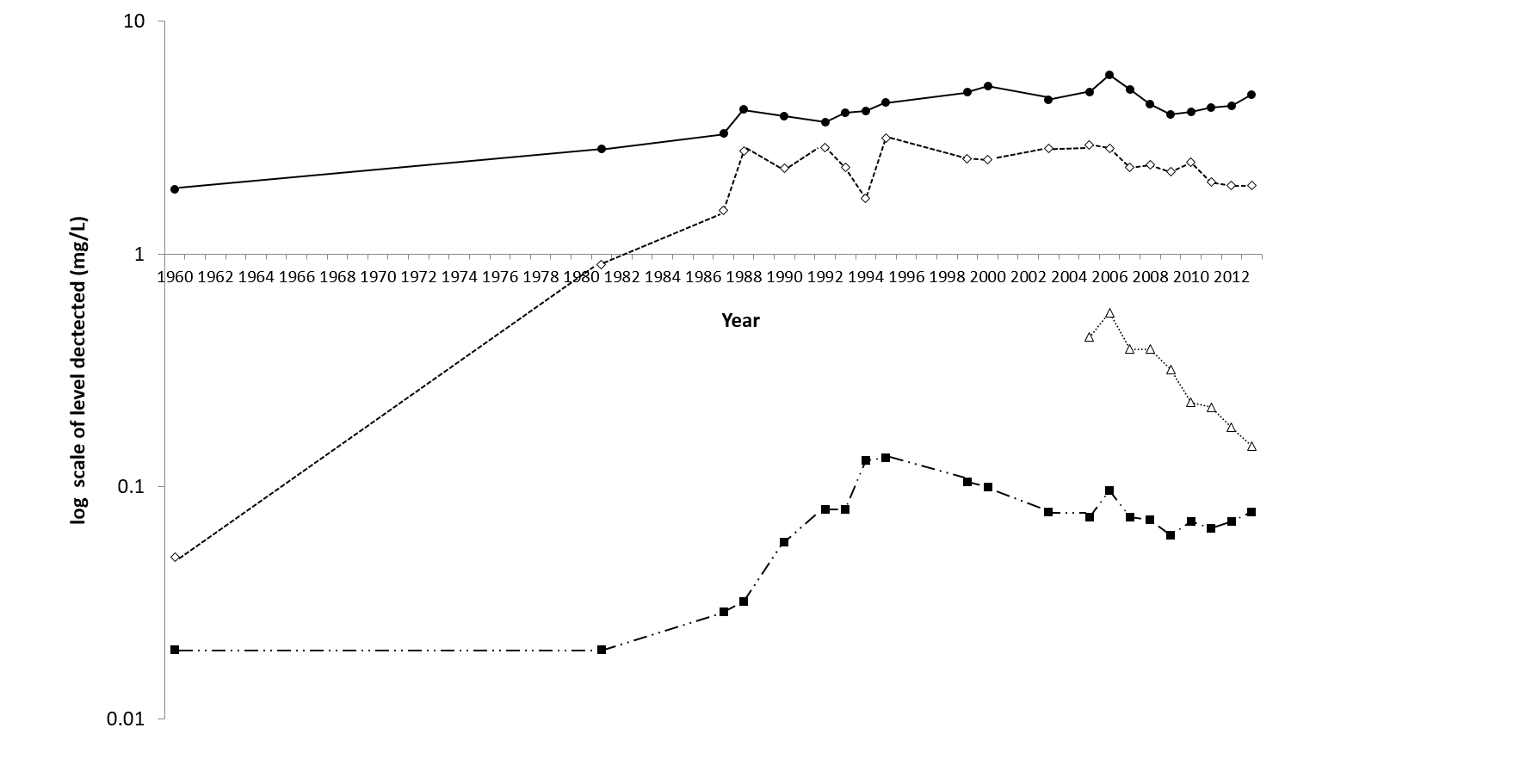 Figure 3.7: Changes in the chemical oxygen demand (●), concentration of total nitrogen (◊), ammonia (△) and total phosphorus (■) in Lake Tai from 1960-2013. (Based on data from the yearly Taihu health status reports

    - Capture fisheries and aquaculture
One of the most important ecosystem services provided by freshwater ecosystems is food provision. In addition to provisioning services, fish also provide cultural services such as recreational value (i.e. fishing) and symbolic fish species can act as cultural symbols. In China, there has been a long tradition of freshwater aquaculture for over 2500 years (Cao et al., 2007). Aquaculture contributes significantly to the Chinese economy and China now produces the largest amount of inland aquaculture products globally (Wang et al., 2015). In 2015, the total production for freshwater aquaculture reached 30,622,700 tons ( China Fishery Statistical Yearbook, 2016). The total land area used for freshwater aquaculture in China is 6,147,240 hectares, of which 1,022,350 hectares consist of lake aquaculture (China Fishery Statistical Yearbook, 2016).
Lake Tai is situated between Jiangsu and Zhejiang province, and it is the largest freshwater lake in these two provinces. In Jiangsu province, the total economic output value for freshwater aquaculture was 18.5% of the total value for the whole of China (Table 3.2). In Zhejiang province, the total economic output value for freshwater aquaculture was 3.8% of the total for China. Together, freshwater aquaculture in Jiangsu and Zhejiang made up 22.3% of the total economic output value for China (China Fishery Statistical Yearbook, 2016). In addition, capture fisheries in the region also contribute significantly to the economy. In 2015, the total freshwater capture fisheries output in Jiangsu was 14.3% of the total Chinese yield and in Zhejiang this was 3.9% of the total Chinese yield. It is clear that Jiangsu province is a key player in Chinese freshwater aquaculture and inland capture fisheries. As the largest inland lake in Jiangsu province, we can assume that Lake Tai fisheries contribute significantly to the province’s economy and provide important sources of protein to surrounding communities.

Table 3.2: Economic output and yield values for freshwater aquaculture and inland capture fisheries in Jiangsu and Zhejiang provinces, which is where Lake Tai is situated. Data obtained for 2015 from the China Fishery Statistical Yearbook, 2016.
 | Jiangsu province | Zhejiang province | China
Freshwater aquaculture:
1. Economic output value (Yuan) | 98,593,147,500 | 20,145,210,000 | 530,137,105,263
2. Yield (tons) | 3,403,218 | 1,019,515 | 30,659,622
Inland capture fisheries:
Yield (tons) | 325,411 | 88,429 | 2,275,601

The most famous aquatic food products from Lake Tai are “the three whites of Taihu” and Chinese tourists specifically travel to the lake to taste them (Lin et al., 2008). The “three whites of Taihu” include: white fish (Erythroculter ilishaeformis), white prawns (Palaemonetes sinensis) and silver fish (Neosalanx tangkahkeii). According to the China National Tourism Administration in 2016, Lake Tai had the highest number of tourists in China with 60,380,000 people visiting the lake over the period of one year and contributing significantly to the local economy. These three freshwater species are more than just food for the Chinese people, as they have become a symbol that represent Lake Tai (Qiu and Lu, 2016).

Freshwater fish in Lake Tai
Before the 1980s, the fishing industry in Lake Tai relied heavily on capture fisheries (Li et al., 2010). From 1980 onwards, however, fish aquaculture started to rise in popularity. By the 1990s, the total land area used for fish aquaculture in Lake Tai was 32 km² (Yang et al., 2003). Most aquaculture is concentrated in the eastern region of Lake Tai in East Taihu. The total area of East Taihu is 131.25 km² and it was covered by 124.9 km² of macrophytes in 1995 (Yang et al., 1995), providing a perfect habitat for culturing fish.
At the start of the 1980s, large scale fish pen cultures were established in East Taihu and they gradually expanded in area (Yang et al., 1995). The main types of cultured freshwater fish were herbivorous species that fed on naturally occurring macrophytes (Cai et al., 2013). Towards the end of the 1980s, there was a shift towards smaller scale fish pen cultures. This led to the use of artificial fish feed, which increased the density of fish pen cultures in the lake.
Neverthless, the presence of aquaculture produces a lot of waste which increases the nutrient load of Lake Tai. This leads to a rapid increase in bacteria, phytoplankton and zooplankton growth. Previous research has shown that after one year, the abundance of phytoplankton was triple than that of regions with no aquaculture (Qin et al., 2007). Therefore, aquaculture contributes to the problem of algal bloom (Cai et al., 2013). Although aquaculture provides communities with food and economic incomes, it negatively impacts a vital ecosystem services provided by Lake Tai (i.e. freshwater provision).
Although aquaculture is productive in Lake Tai, there are species of fish that are not suited to artificial cultures. Therefore, capture fisheries are still present. In Lake Tai, the total yield of capture fisheries has increased from the 1950s to the 2000s (Figure 3.8). Increased yield can be a result of increasing fishing intensity. A possible reason is due to rising human demands and improved fishing gears (Gu et al., 2009). From 1983 to 1993, the number of fishing boats increased by 2.5 times in Lake Tai and the number of motorised boats rose to 2583 from 324 (Li, 1999). The increase in fish yield has been accompanied by a shift in the species composition. In 1952, the fishery catch was based on eight species and the composition (based on fish biomass) was relatively balanced (Figure 3.9). By 2003, the fishery catch was based on seven species, but over 50% was comprised of lake anchovies. The yield composition of the predatory topmouth culter (Culter albernus) decreased, whereas lake anchovies (Coilia ectenes taihuensis) increased. A potential reason that lake anchovies have become the dominant fish species may be due to less predation from fish such as the topmouth culter.

Figure 3.8: Changes in total catches (tons) from capture fisheries in Lake Tai from 1950 to 2000. Based on data from Gu et al. (2009).

Table 3.3: Ecological characteristics of the most commonly caught fish species in Lake Tai. (Based on data from Gu et al. (2009) and from FishBase).
Species | Common name | Feeding type | Migratory | Average Size (cm)
Coilia ectenes taihuensis | Lake anchovy | Zooplanktivore | Non-migratory | 21
Neosalanx taihuensis | Icefish | Zooplanktivore | Migratory | 6.3
Hypophthalmichthys molitrix | Silver carp | Planktivore | Migratory | 51.7
Aristichthys nobilis | Big head carp | Planktivore | Semi-migratory | 65
Cyprinus carpio | Common carp | Omnivore | Non-migratory | 34.9
Mylopharyngodon piceus | Black carp | Benthivore | Migratory | 91.5
Ctenopharyngodon idella | Grass carp | Planktivore | Semi-migratory | 68.6
Culter albernus | Topmouth culter | Piscivorous | Non-migratory | 28

The fish species targeted by capture fisheries vary in size, feeding behaviour, and life history characteristics (Table 3.3). Another potential reason for the increase in anchovies is the rise in fishing intensity. Fish with shorter reproduction periods such as the lake anchovy gained a survival advantage because they could recover more quickly (Qin et al., 2007). Unfortunately, the rise in lake anchovies may have contributed to increased algal abundance due to trophic cascades. The feeding behaviour of fish species can influence the probability of algal blooms. Lakes that have large communities of piscivorous fish will have an abundance of zooplankton because piscivorous fish prey on other fish species, including zooplanktivorous fish, reducing the predation pressure on zooplankton (Carpenter et al., 1985). Previous research suggests that lake anchovies primarily feed on zooplankton and their increase has the potential to decrease zooplankton, thereby reducing grazing pressure on algal and resulting in increased algal abundance (Yang et al., 2012).

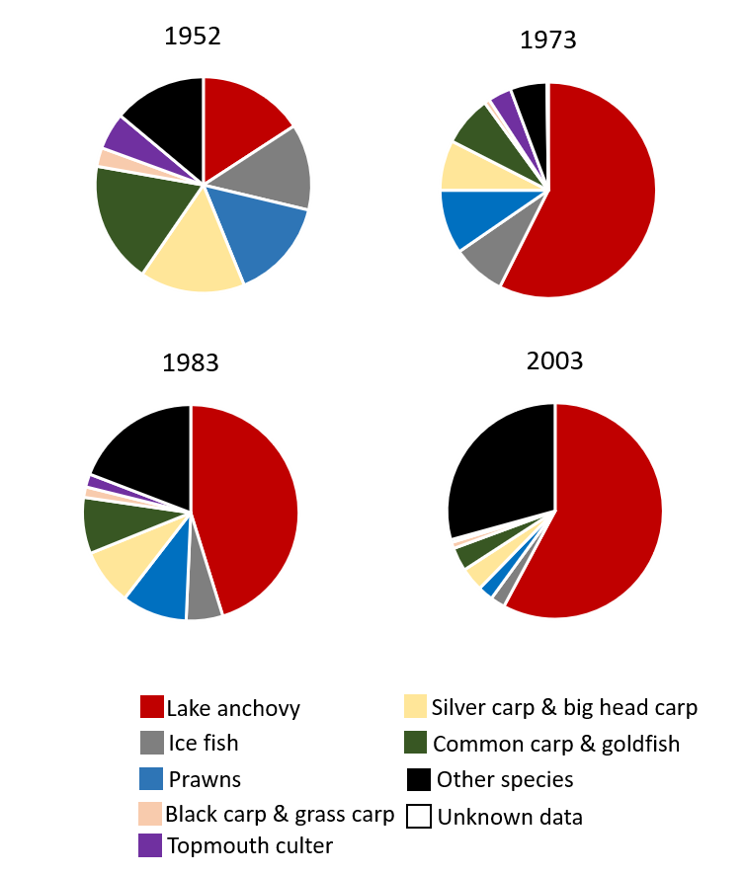
Figure 3.9: Temporal changes in the percentage composition of capture fishery catches in Lake Tai based on fish biomass, from 1952-2003. Based on data from (Gu et al., 2009).

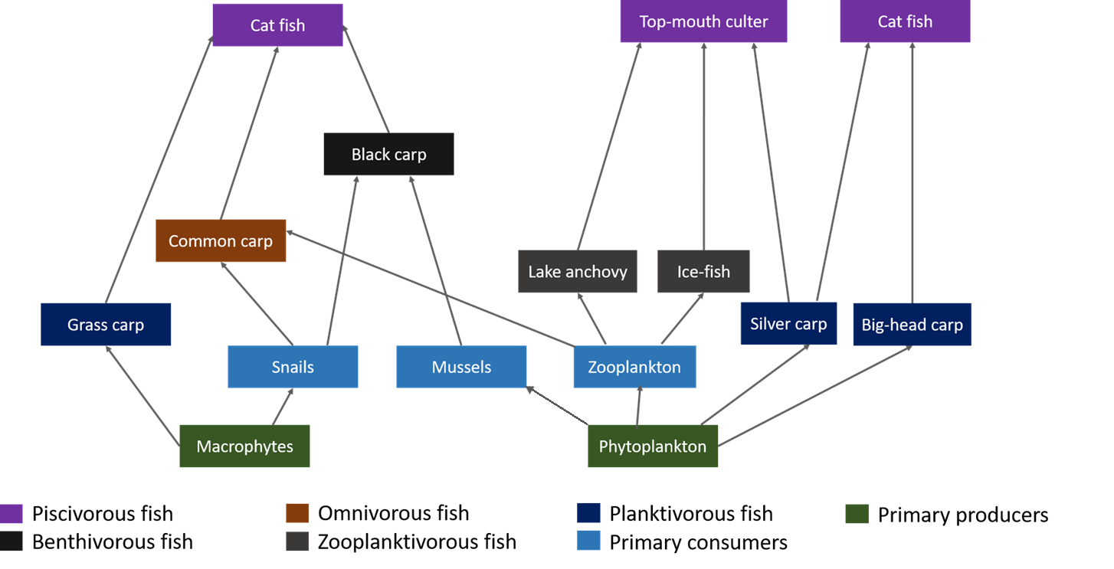

Figure 3.10: Food web depicting the relationships between some of the economically valuable fish species, their preys and food sources in Lake Tai (Taihu). Data collected from (Gu et al., 2009), in Chinese. The food web has been developed based on the author’s wider reading.
A rising population of lake anchovies may also lead to interspecific competition with ice-fish (Figure 3.10). The food web shows that the predominant food source for lake anchovies and ice-fish is zooplankton. Normally there is no direct competition because the lake anchovy primarily feeds on Cladocera whereas the icefish primarily feeds on Copepoda (Chen and Zhu, 2008). Nevertheless, lake anchovies will feed on Copepoda if there is competition for food. As the number of lake anchovies increased, this could have caused competition between lake anchovies and ice-fish. There are intense fishing pressures on ice-fish because they are more economically valuable than lake anchovies. This could have contributed to the population decline of ice-fish in Lake Tai (Figure 3.9).
Carps are also economically important fish species in Lake Tai that have been cultivated in China for over a thousand years (Duan et al., 2009). In Lake Tai, four species of carp have frequently been restocked to replenish the natural carp community: big-head carp, silver carp, grass carp and black carp (Li et al., 2016). The restocking of carps can led to environmental problems (Holmlund and Hammer, 1999). For example, grass carps have strong feeding preferences for specific macrophytes. Previous research has indicated that they prefer plant species in the genus Potamogeton over other plant species (Henson and Sliger, 1993). Thus, plants species that are not preferred by grass carps can end up dominating the lake. In addition, artificial fish restocking can create problems. The ecosystem may become dependent on artificial restocking and unable to function by itself (Duan et al., 2009). Potential problems in the fish population may be masked by the continuous restocking. Although fish restocking can seem beneficial to yields, they can affect the ecosystem permanently in the long term by decreasing the overall biodiversity. This can negatively impact ecosystem functions, and therefore affect the ecosystem services produced.
In an ecological survey conducted in 1986, there were 107 species of fish found in Lake Tai (Appendix 3.1). By 2006, however, a similar survey found only 60 species of fish (Shi et al., 2014). This drastic drop was caused by a loss of migratory species and piscivorous fish at higher trophic levels. There has been a change in the species composition of fish because of the rise in intensive fishing and a decrease in the connectivity between the lake and the Yangtze river due to dam constructions. Previous research has shown that smaller fish species are now more common and many migratory species have been lost (Zhu et al., 2007).
Chinese mitten crabs in Lake Tai
By the end of the 1990s, fish aquaculture started to decrease in popularity and freshwater crab farming became more popular in Lake Tai due to shifting market demands (Figure 3.11). The species of freshwater crabs farmed is the Chinese mitten crab (Eriocheir sinensis), where it naturally occurs (Wang et al., 2006). Although they are an invasive species in European countries, there has been an increased demand for mitten crabs across China due to its delicate taste (Wang et al., 2006). The ability to purchase and consume expensive Chinese mitten crabs is now seen as a status symbol (He et al., 2009). The price of Chinese mitten crabs has increased rapidly in recent years (Cheng et al., 2008). They provide a substantial source of income for communities surrounding Lake Tai (Cai et al., 2012). Crab culture requires less input and produces more profit when compared to traditional fish cultures (Figure 3.12). This is a major incentive for rearing Chinese mitten crabs in Lake Tai.
Despite the economic benefits that Chinese mitten crabs provide, crab farming can contribute to the deterioration of water quality (Cheng et al., 2008). Both crab feed and crab waste increase the amount of nutrient input into the lake (Wang et al., 2006). In addition, pharmaceuticals such as antibiotics used in crab framing can pollute the lake water and sediment (Cai et al., 2012).
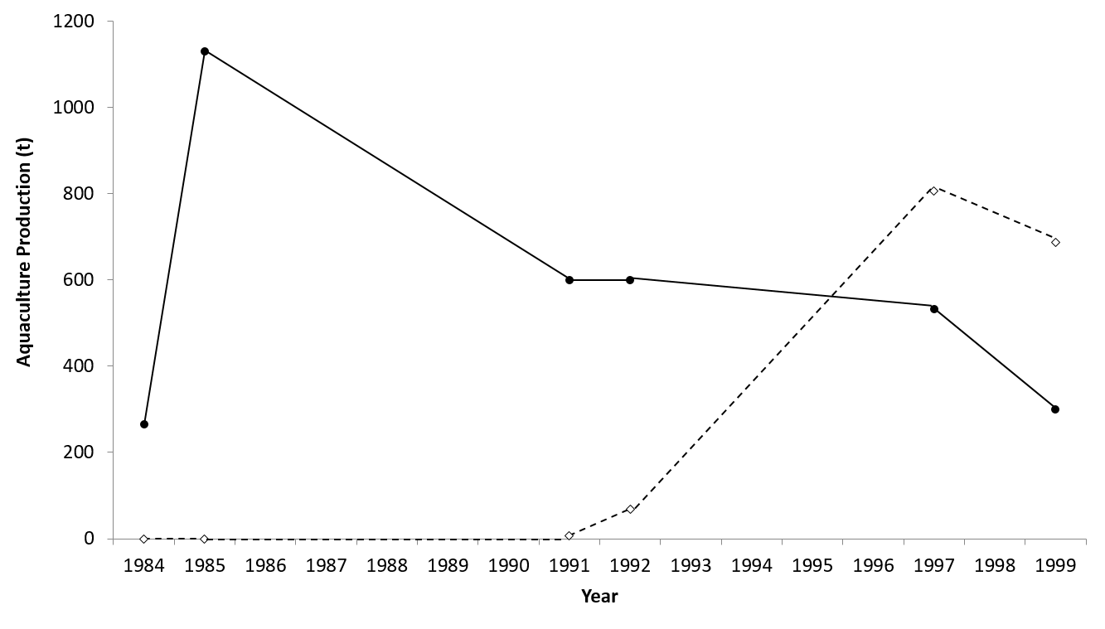
Figure 3.11: Temporal changes from 1984-1999 regarding the production of farmed freshwater fish (black line) and Chinese mitten crabs (dotted line) in Lake Tai. Data collect from (Gu et al., 2003), in Chinese.
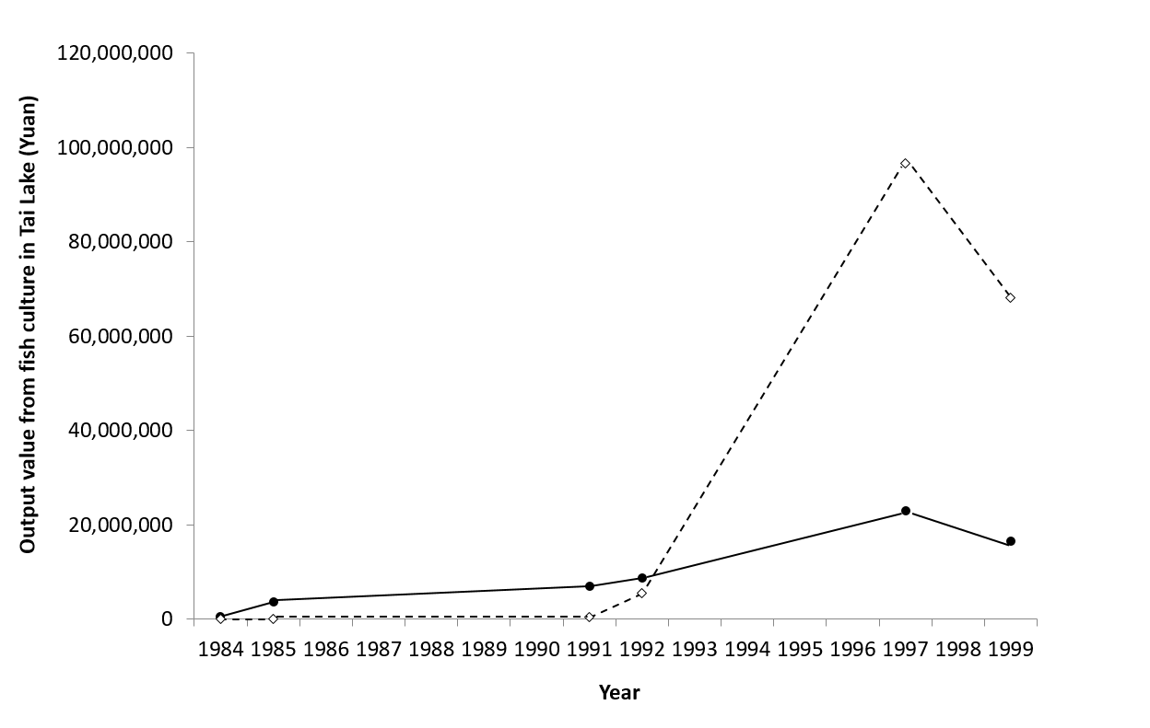
Figure 3.12: Temporal changes in the economic value of farmed freshwater fish (black line) and Chinese mitten crabs (dotted line) in Lake Tai, from 1984-1999. Data collected from (Gu et al., 2003), in Chinese.

3.4 Conclusion
Freshwater ecosystems such as Lake Tai provide humans with many benefits, including fresh water, food (e.g. fish and crabs), recreation, aesthetic value, a sense of place and tourism. Nevertheless, the resources provided by nature are frequently seen as free in our society. The evidence presented in this chapter indicates that there have been increased anthropogenic pressures exerted on Lake Tai in recent years. One of the major pressures, urbanisation, has contributed to increased wastewater production into the lake. In addition, increased aquaculture (i.e. fish and Chinese mitten crabs) in the lake has also increased its nutrient load. As a result, severe eutrophication has occurred and led to large scale algal blooms. In addition, the increasing fishing intensity in Lak Tai has altered the composition of fish communities. This has led to an increase in lake anchovies that feed on zooplankton, and as a result less algae are consumed by zooplankton. This does not help to alleviate the algal bloom problem at Lake Tai.
The problem of algal blooms has caused declines in the provision of freshwater ecosystem services, in terms of cultural (i.e. aesthetics and recreation) and provisional services (i.e. water provision). Worryingly, this has led to the temporary loss of water supply to surrounding communities in 2007 and high economic loss. The threats to the freshwater ecosystem services provided by Lake Tai has been summarised in the conceptual diagram below, which links different sections of this chapter as a whole (Figure 3.13).
In a developing country, such as China, environmental protection is frequently put on a back seat because it is seen as in conflict with economic development. There are limited resources for environmental protection in developing countries and we cannot afford to protect everything everywhere. Therefore, the ecosystem services approach is important in assessing the potential threats to ecosystem services and to make appropriate trade-offs.

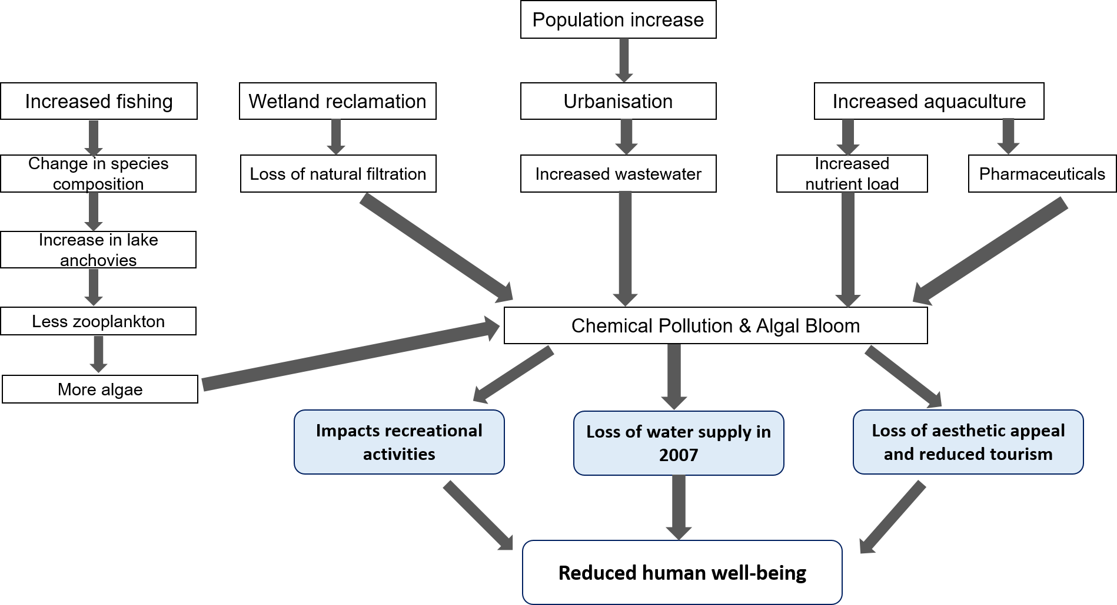
Figure 3.13: Conceptual diagram showing the threats to freshwater ecosystem services at Lake Tai, China. Blue boxes represent impacted ecosystem services.

Chapter 4
Using two methods to value ecosystem services: a case study on Lake Tai, China

4.1 Introduction
Freshwater ecosystems, such as Lake Tai, provide many benefits to humans that are known as ecosystem services (Dodds et al., 2013). Nevertheless, many freshwater ecosystems in developing countries are under severe threats (Malaj et al., 2014). Environmental management must be improved to provide better protection for these vulnerable ecosystems, by linking scientific research and environmental policy (Diaz et al., 2015). Nevertheless, managing ecosystems will favour some species over others. For example, to increase food and freshwater provision we may increase the pressures on terrestrial and freshwater ecosystems. Trade-offs must be made when ecosystems are managed (Maltby et al., 2017b).
Therefore, scientists and environmental policy makers must ask the following questions: i) what do we value in an ecosystem; ii) what and where do we want to protect? These two questions can be approached using the ecosystem services framework, which can be used to set down effective and specific protection goals (Brown et al., 2017; Maltby et al., 2017a). This is vital for developing countries that suffer from unsustainable development and environmental degradation (Deng et al., 2015). One method for exploring what we value in an ecosystem is to incorporate or increase public participation into environmental decision making processes (Restall and Conrad, 2015). Public perceptions can help scientists to identify which ecosystem services are used and valued by communities, as well as playing a significant role in identifying protection goals for ecosystems.
When evaluating public perceptions, it is important to recognise that there may be varying ecosystem values depending on who the ‘public’ are. It is important to understand who are the stakeholders that will benefit from the ecosystem services and which services are required from a specific ecosystem (Suwarno et al., 2016). Different sections of society may not have the same ecosystem values and this should be considered during the establishment of protection goals. The results of Chapter 2 indicate that different sections of society can have varying ecosystem values. When a Chinese rural and urban community situated in the same geographical region were compared, rural residents interacted more frequently with the local freshwater ecosystem and valued it more highly than urban residents (Pan et al 2016). Previous research papers have shown that urban populations have less direct and intentional interactions with nature (Cox et al., 2017; Soga et al., 2016; Zhang et al., 2014), which can in turn affect their willingness to protect nature. However, it is not just rural and urban communities that may differ in their different levels of interaction with nature and therefore potentially have varying ecosystem values. Previous research has shown that women are more likely to conduct pro-environmental behaviours than men, especially in older women compared to older men (Steel, 1996). More recent research has also confirmed that women may have more pro-environmental attitudes (Liobikienė and Juknys, 2016). Other research has shown that middle aged populations are the most aware of environmental impacts compared to younger and older populations (Morrison and Beer, 2017). In addition, some research papers have suggested that being more educated is linked to pro-environmental attitudes (Casey and Scott, 2006; Liobikienė and Juknys, 2016).
How sections of society use and value ecosystem services can be investigated using direct methods such as direct questionnaire surveys that ask respondents behaviours and values directly. Indirect methods are ones that reveal the behaviours or values of respondents though other means, without asking them directly. Although there has been research into the valuation of provisional ecosystem services using direct questionnaires (Costanza et al., 1997; Wen et al., 2010), less research has been conducted on the valuation of cultural ecosystem services (Chan et al., 2012a). Direct questionnaire surveys have been used to investigate many different areas of ecology and conservation biology (Che et al., 2013; Mwanga and Lwambo, 2013; Soga et al., 2015). They have a high response rate and large amounts of information can be gathered. In addition, direct questionnaires can target specific sections of society that may be difficult to obtain information from using other methods (e.g. rural communities or ethnic minorities). Nevertheless, there are disadvantages to this method. Direct questionnaire surveys require a long time to conduct and they are extremely costly. The logistics of conducting a direct questionnaire survey can be difficult to plan, especially if the project is conducted abroad (Jim and Chen, 2006). In addition, it is not possible to tell how truthful a respondent’s answer is. Although a respondent may say that they do something in a questionnaire, they may not actually carry out the action in real life. This is known as hypothetical bias (Haab et al., 2013). It is difficult to investigate the realistic action of respondents, but only the potential action of a respondent (Soga et al., 2016).
In contrast to direct questionnaire surveys, a novel and indirect method of valuing cultural ecosystem services has started to emerge, which capitalises on the increasing popularity of social media platforms. The increasing use of social media around the world represents an important source of information that can offer significant insights into user preferences (Figueroa-Alfaro and Tang, 2017). The use of social media data can generate extremely large datasets over a short period of time. The cost of obtaining social media data is minimal and researchers can gain data from different regions of the world remotely without ever travelling there (Tenerelli et al., 2016). Photographs that are posted on social media platforms can act as indicators for the number of people visiting an ecosystem, as well as suggesting that a place is worthy of being photographed and shared (Gliozzo et al., 2016). Therefore, if a place is frequently photographed by social media users and shared on social media then we can infer that it is valuable to the users. Social media photographs can provide new perspectives on how humans interact with ecosystem services (Figueroa-Alfaro and Tang, 2017).
Social media data are, however, prone to biases because only a select section of society have access to the internet and use social media platforms. These tend to be younger people living in more affluent areas (Gliozzo et al., 2016). Furthermore, people that have travelled longer distances are generally more likely to share photographs on social media because the trip is perceived as more exciting and worthwhile to share with others (Wood et al., 2013). In contrast, people that have travelled shorter distances are less likely to share photographs and this behaviour cannot be represented by social media photographs.
Cultural ecosystem services are intangible benefits that we receive from nature and they can be difficult to measure and quantify using traditional methods (Chan et al., 2012b). Unlike provisioning and regulating ecosystem services, cultural ecosystem services are non-use values. They are often overlooked during ecosystem service valuations because they are non-materialistic and abstract (Daniel et al., 2012). Nevertheless, cultural ecosystem services are intangible benefits that we receive from nature and they are important to human well-being (Hernandez-Morcillo et al., 2013). Cultural ecosystem services are difficult to incorporate into ecosystem service valuations and a potential solution is using social media data (Kenter et al., 2015).
Previous research using social media have used Western social media platforms such as Flickr or Google’s Panoramio for data collection, but these remain inaccessible to Chinese internet users (Keeler et al., 2015; Sonter et al., 2016). This is because many Western internet sites are restricted in China so Chinese citizens often use a native alternative platform. Sina Weibo is the dominant microblogging social media platform in China and it has been described as a mixture between Twitter and Facebook (Sullivan, 2013). Although the format of Weibo is very much like Twitter, more Weibo users post information about their private lives whereas more Twitter users use the site for work and official purposes (Wang et al., 2017). Weibo is one of the most popular Chinese internet sites, with approximately 600 million registered users and with 222 million monthly active users (Guan et al., 2014). Due to the broad coverage of Weibo users in China, it may be a valuable research tool for the valuation of cultural ecosystem services (Zhang and Pentina, 2012). Previous research has been conducted into the entertainment value of Weibo (Chan et al., 2012c), the emotions in the text that is posted on Weibo(Li and Xu, 2014) and text mining for user interests (Liu et al., 2012).
This chapter builds upon the results of Chapter 2 by using Lake Tai as a specific case study. Lake Tai is the third largest freshwater lake in China and it provides multiple ecosystem services to surrounding communities. Nevertheless, it suffers from many anthropogenic pressures that have affected the provision of these ecosystem services. The spatial and temporal changes that have occurred at Lake Tai and their effects on ecosystem services provision were discussed in Chapter 3. The water quality of the lake has rapidly deteriorated due to increased urbanisation and land use changes, as well as suffering from serious chemical pollution (Huang et al., 2013).
Lake Tai has a surface area of 2250 km² and is surrounded by four major cities and many smaller communities (Chapter 3). It therefore makes an ideal case study to investigate large-scale spatial variation in perceptions for a single ecosystem. It is also an important tourist attraction and therefore provides an opportunity to compare the perceptions of tourists and the local population, both rural and urban. Lake Tai was therefore used to address the following research questions:
- Do different sections of society prioritise different freshwater ecosystem services?
- across different cities?
- between rural and urban communities?
- between locals and tourists?
- Which factors affect whether respondents are willing to pay or not for freshwater ecosystem services?
Information to address these questions were obtained using both direct (questionnaires) and indirect (social media photographs) methods for eliciting information on the ecosystem preferences and values of communities at Lake Tai. A further research objective was therefore:
- To compare two methods of eliciting information on the use of ecosystem services: direct questionnaires and the use of social media photographs
- Can we use social media to find out which cultural services are important?

Rural and urban communities associated with four major cities surrounding Lake Tai were interviewed for the study. In addition, information on the types of cultural ecosystem services used by locals and tourists that visit Lake Tai was obtained from the Chinese social media platform Sina Weibo. To my knowledge, this study is the first to investigate the possibility of using a social media platform to evaluate the use of ecosystem services in China.

4.2 Methods
4.2.1. Direct questionnaire survey
Five hundred community-based interviews were conducted by six interviewers in July 2014. Interviewers consisted of four females and two males that are of similar age (approximately 23 years old). All interviewers were native speakers of Mandarin Chinese and were university students that had previous experience of conducting social interviews in China.
Questionnaires were conducted across the four major cities surrounding Lake Tai (Suzhou, Wuxi, Yixing and Huzhou), and their bordering rural communities (10-30 Km from city). At each city, half of respondents were from rural communities on the borders of the city and the other half from urban communities. Twenty-five interviews were conducted at each study site and overall, 257 interviews were conducted in 10 rural sites and the other 257 in 10 urban sites (Table 4.1).
All study sites were chosen before the start of the project using aerial satellite maps from the Chinese search engine, Baidu. Suzhou and Wuxi are larger cities than Huzhou and Yixing. Therefore, the author decided to conduct more questionnaires at Suzhou and Wuxi to reflect the size of the different cities. Rural communities were chosen according to the set of criteria below:
- Proximity (within walking distance) to Lake Tai
- Not a village used for tourism purposes
If a chosen rural site appeared to be a tourism village or it no longer existed, then we chose the nearest suitable village as a sample site. After discussion with a local Chinese professor (Professor Yue Che, China East Normal University) with prior experience of conducting questionnaire surveys in the Lake Tai regions, urban sites consisted of local parks that were frequently visited the older community and local shopping malls that were frequented by the younger community. This helped to ensure an even spread of ages in the sample as both younger and older respondents were targeted. The spatial distribution of study sites is shown in Figure 4.1.

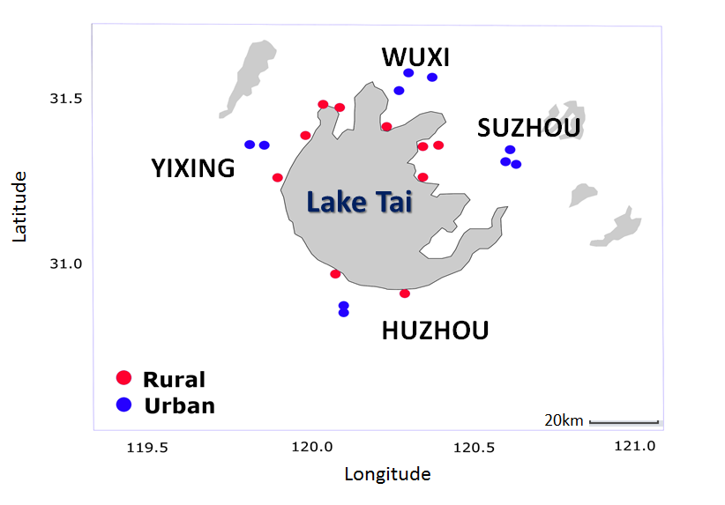
Figure 4.1: Locations of the four study cities around Lake Tai and the spatial distribution of the 20 study sites: rural (red dots) and urban (blue dots).

Table 4.1: The questionnaire survey design that shows the sites that were investigated around Lake Tai, China.
Site Number | City area | Rural or Urban | Place investigated | Coordinates
1 | Suzhou | Rural | Huzhong Village | 31.26,120.34
2 | Suzhou | Rural | Hangchuanbang Village | 31.36,120.39
3 | Suzhou | Rural | Mashan Village | 31.36,120.34
4 | Suzhou | Urban | Shilu Mall | 31.31,120.59
5 | Suzhou | Urban | Wanda Mall | 31.34,120.61
6 | Suzhou | Urban | Suzhou Park | 31.30,120.62
7 | Wuxi | Rural | Zhantoushang village | 31.41,120.23
8 | Wuxi | Rural | Taige village | 31.47,120.09
9 | Wuxi | Rural | Chenshu village | 31.48,120.04
10 | Wuxi | Urban | Suning Mall | 31.58,120.30
11 | Wuxi | Urban | New City Central Park | 31.56,120.37
12 | Wuxi | Urban | Lihu Park | 31.52,120.27
13 | Yixing | Rural | Shidu Village | 31.39,119.98
14 | Yixing | Rural | Yinjia Village | 31.26,119.89
15 | Yixing | Urban | Yixing Sports Park | 31.36,119.81
16 | Yixing | Urban | Wanda Mall | 31.36,119.85
17 | Huzhou | Rural | Beizhang Village | 30.98,120.08
18 | Huzhou | Rural | Yigao Village | 30.92,120.29
19 | Huzhou | Urban | Dongwu Guoji Square | 30.87,120.10
20 | Huzhou | Urban | Zhebei Dasha | 30.86, 120.09

In rural communities, respondents were contacted opportunistically by knocking on household doors. Only one member from each household was interviewed. In the city, respondents were approached opportunistically either in local parks or local shopping malls. Both female and male respondents were approached in equal proportions.
All respondents were interviewed directly on a one-to-one basis in an informal manner to make them feel at ease. They were also interviewed individually to avoid the influence of others on the response. The questionnaire was in Mandarin Chinese (English version provided in Appendix 4.1) and written by the author. Before the project, the questionnaire was reviewed by a Chinese professor (Professor Yue Che, China East Normal University) with previous experience of conducting social surveys in the study region.
All respondents were assured of their anonymity and no details were taken that could be used to trace the questionnaire answers back to a specific individual. Respondents were interviewed one at a time, to avoid the influence of others on the answers. Furthermore, interviews were only conducted after the respondent consented verbally. The questionnaire took about 25 minutes to conduct and was composed of four sections:
- Background demographic questions: gender, maximum education level and age.
- Respondent’s interactions with and their attitudes towards Lake Tai
- Respondents’ prioritisation and willingness to pay for freshwater ecosystem services
- Respondent’s knowledge and attitudes towards environmental protection
Section ii) explores how frequently the respondent interacted with the lake and which freshwater ecosystem services they used, using an open-ended question. Section iii) investigates the respondent’s prioritisation and perceived value of freshwater ecosystem services. Respondents were first asked to rank six ecosystem services in order of importance to them. The six services were: food provision, freshwater provision, flood regulation, recreation, microclimate regulation and cultural heritage. To avoid bias towards the first option, the services were read out to the respondent in a random order for each interview. The Contingent Valuation Method (Adamowicz et al., 1998) was used to investigate the respondent’s wiliness to pay (WTP) for freshwater ecosystem services via two hypothetical questions. The first question asked whether respondents would be willing to donate money towards a project to protect the freshwater ecosystem services that they prioritised. The second question asked whether respondents would be willing to donate money to improve the quality of Lake Tai. The two hypothetical questions were worded as below:
- “In Q10, you have chosen (insert service chosen as number 1) as the most important. Will you be willing to donate money towards a project that will protect this service and prevent it from disappearing? This project will be overseen by the Ministry of Environmental Protection. Assume that all the money raised will only be used for saving (insert service chosen). Please take your income and other expenditures into account.”
- “If the Ministry of Environmental Protection wants to carry out a project to improve the quality of Lake Tai over the next 5 years and you assume that all the money raised will only be used for improving the lake, will you be willing to donate money to achieve this? This project will result in: i) more wildlife (animals & plants) in and around the lake; ii) better water quality (i.e. less pollution, less rubbish); iii) a lake that is not smelly. Please take your income and other expenditures into account.”

Respondents that were willing to donate money were then asked what percentage of their yearly income they were willing to donate for the next five years towards the two hypothetical projects using a bidding amount method (REF), which started at 30% and was then lowered to 20%, 10%, 5%, 1% and <1% respectively. A percentage value of the respondent’s income was asked for because this study is not concerned with calculating an exact monetary value for willingness to pay. Instead this study aims to investigate the perceived value of freshwater ecosystem services by using money as a proxy. Finally, section vi) provides insight into the respondent’s environmental awareness of how anthropogenic activities may impact on the environmental quality and hence the delivery of ecosystem services.

4.2.2. Social media photographs
The popular Chinese social media platform, Sina Weibo (i.e. Sina Microblog), was used to investigate the types of cultural ecosystem services that are photographed by Weibo users. Sina Weibo is owned by the Sina cooperation (founded in 1999), which is one of the largest online media companies in China. Weibo was started by the Sina cooperation in August 2009 (Wang et al., 2017).
Using the advanced search function, all Weibo posts from personal users (i.e. not advertising accounts) that contained photos and with the hashtag Taihu (i.e. Lake Tai) were collected from the year 2009 to 2016. All photos were then sorted into ecosystem service categories according to their content and tagged to publicly available demographic data collected from the user’s account. Publicly available demographic data included the user’s gender, place of residence and age. When possible, the location where the photo was taken was recorded.
The main ecosystem services depicted in the social media photographs were categorised according to the definitions below. The categories include six cultural ecosystem services and one provisioning service (i.e. food). Food was included because it was a specific ecosystem service to Lake Tai. Photographs did not depict general food produce from Lake Tai, but specific foods such as Lake Tai crabs or fish. The categories were:
- Religious sites: depicts Buddhist temples or spiritual sites of significance
- Recreation: depicts fishing, walking, cycling, or other recreational activities
- Aesthetic view: depicts the beauty of Lake Tai. This is typically a landscape photo of the lake and/or its surroundings (usually a depiction of blue sky and Lake Tai or sunset scenes over Lake Tai).
- Beauty of nature: depicts and focuses on the beauty of animal or plant species found around or in Lake Tai.
- Historical sites: depicts ancient buildings or bridges around Lake Tai
- Food: depicts the local food produce from Lake Tai, such as fish, crabs, prawns or edible aquatic plants
- Architecture: significant or prominent buildings situated around Lake Tai. This category was included to take into account that social media users specifically went to Huzhou to take photos of the Moon Hotel, which is built on the surface of Lake Tai.
4.2.3 Data Analysis
All statistical analyses were carried out in the open source statistical program, R 3.0.2 (R Development Core Team, 2015). Chi-squared tests or Fisher’s exact tests were conducted on demographic variables. Using the factominer package in R, a multiple correspondence analysis (MCA) was performed on the questionnaire survey data to see which factors might affect a respondent’s willingness to pay to protect ecosystem services and the Lake Tai. The MCA investigated which variables explained the variance in the data and which variables were closely connected to each other. The results were plotted graphically to display the associations between different variables.
The questionnaire survey data were also analysed to investigate the factors that affected the respondent’s willingness to pay for their prioritised ecosystem service. A generalised linear model (GLM) with a binomial family error was used because the response variable (willing to pay or not) is dichotomous. The maximal GLM model was fitted first and the dredge function from the MuMIN package was used to find the minimally adequate model. The maximal GLM model included the following predictors: respondent’s gender, age, income, the place where they lived (rural or urban), the city region that they lived in, the ecosystem service that they prioritised and would they miss the lake if it disappears.
The demographic data (i.e. gender and age) of the social media study and the questionnaire survey was compared using a Chi-squared and t-test to see if there were differences between the respondents. In addition, chi-squared tests were used to test whether different numbers of photographs were taken at different cities around the lake and whether local and tourists took different types of photographs. The latitudinal and longitudinal data collected were used to plot a spatial map of where social media users were travelling from to visit Lake Tai using the statistical software R. The distance travelled by each social media user was also calculated and then plotted as a histogram.
4.2.4 Ethics statement
This study was formally approved by the Department of Animal and Plant Sciences Ethics committee at the University of Sheffield, UK. Before the start of each interview, all respondents were informed of the objectives and methodology of the questionnaire. We obtained verbal informed consent from all respondents. Only adults (i.e. over the age of 18) were interviewed during the study.
4.3 Results
4.3.1. Demographic information
In the questionnaire survey, the respondents were distributed evenly between females and males (Table 4.2; Figure 4.2). There was no significant difference between the number of female and male respondents in rural and urban regions (Chi-squared = 3.43, df = 1, p-value = 0.064), and between the different city regions (Chi-squared = 5.99, df = 3, p-value = 0.11). The majority of respondents had a low education level (maximum education level=middle school). Urban respondents had significantly higher education levels than rural respondents, with more urban respondents having undergraduate degrees (Fisher’s exact test, p<0.005).
For the social media photographs, 234 posts from different users that contained photographs of Lake Tai were collected from Sina Weibo. The time period spanned from May 2010 to July 2016. Sina Weibo was started in on the 14th of August 2009 so the first post found in this study was from when Weibo first began in China.
The majority of the social media users were female (60.7%). A high proportion of the social media users were born in the 1980s or the 1990s, and they were relatively young in age (Table 4.2). This reflects the general age structure of social media users on Weibo, with users being predominantly in their 20s and 30s (Sullivan, 2013).
Table 4.2: Demographic information regarding the respondents that were interviewed for the questionnaire survey and the social media users.
 | Questionnaire survey |  | Social media users
 | No. of respondents | % of individuals | No. of respondents | % of individuals
Female | 255 | 50.3 | 142 | 60.7
Male | 252 | 49.7 | 92 | 39.3
Median age | 47 | - | 28 | -
Locals | 514 | 100 | 59 | 26.3
Tourists | 0 | 0 | 165 | 73.7

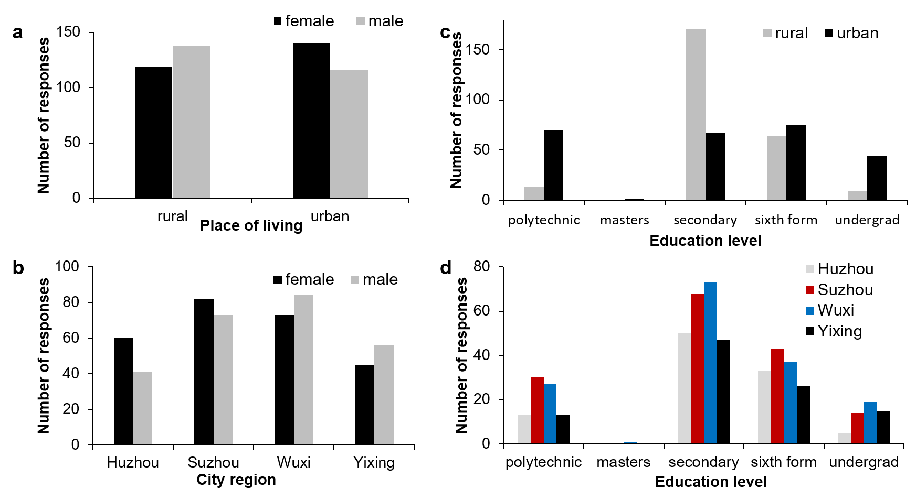Figure 4.2: Gender ratios in a) rural and urban communities; b) in different city regions. The distribution of education levels in a) rural and urban communities; b) in different city regions.
4.3.2. Use and prioritisation of ecosystem services
- Between different cities regions
In the questionnaire survey, the majority of respondents interviewed have visited Lake Tai in the past (88.9%; n=514). The highest proportion of respondents that have visited the lake was in Huzhou (96%). This was followed by Wuxi (92.4%), Yixing (87.1%) and Suzhou (81.9%). The four most frequently conducted activities by Lake Tai are playing and walking by the lake, enjoying the beautiful view, as well as fishing in the lake (Figure 4.4). Fifty-five respondents fished in Lake Tai and most respondents that fished were either from Suzhou (40%) or from Wuxi (47.3%).
The majority of respondents prioritised freshwater provision as the most important ecosystem service of Lake Tai (Figure 4.5). There were, however, differences between the four cites for the other ecosystem services. More respondents in Huzhou and Yixing prioritised flood prevention compared to respondents in Suzhou and Wuxi. In contrast, more respondents in Suzhou and Wuxi prioritised food provision than Huzhou and Yixing (Figure 4.5).
The results from the social media photographs show no photographs were taken at Yixing, whereas there were photographs taken at the other three city regions investigated in the questionnaire survey. Social media users took photographs of different ecosystem services at different cities surrounding the lake (Figure 4.3: Figure 4.6). There were significantly more photographs taken of the lake’s view at Suzhou and Wuxi, compared to Huzhou (Chi-squared=12.52, df=2, p=0.002). Interestingly, not all photographs of views were the same. More social media users photographed architecture (i.e. a famous hotel built on the lake) at Huzhou, but most users photographed a scenic view of the lake at Suzhou and Wuxi (Figure 4.3). Scenic views were either a panoramic view of the lake or sunset over the lake.

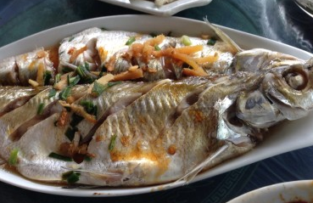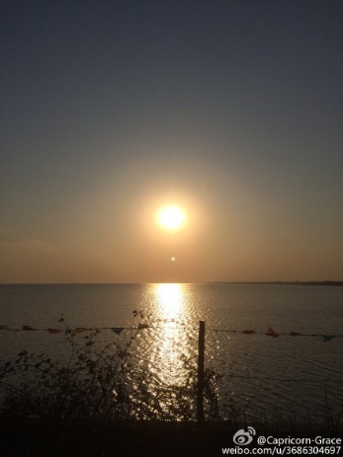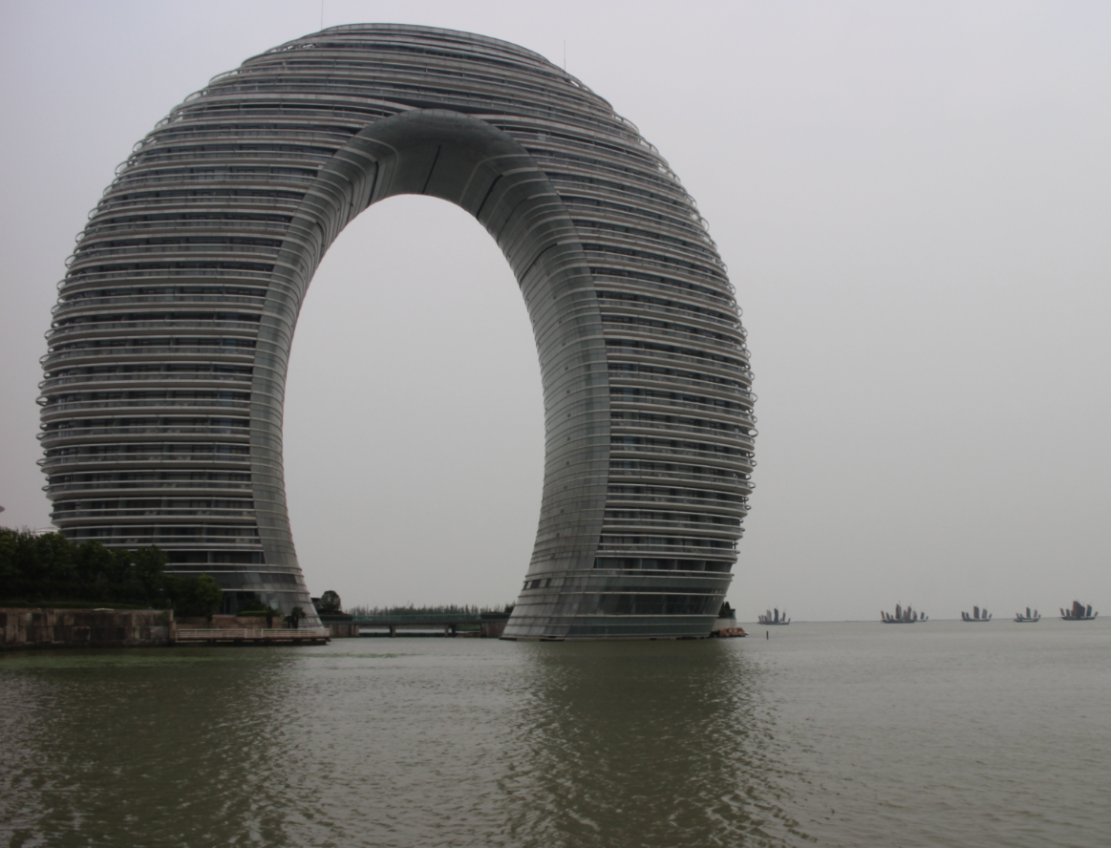
Figure 4.3: Example photographs posted by social media users on Sina Weibo (left to right: fish from the lake, a sunset over the lake and the Moon hotel at Huzhou).

Figure 4.4: The top four most frequently used ecosystem services by the respondents in the four cities regions (rural and urban) surrounding Lake Tai: Huzhou (grey), Suhzou (red), Wuxi (blue) and Yixing (black).
Figure 4.5: The prioritised ecosystem services for Lake Tai across the four major cities surrounding the lake: Huzhou (grey), Suhzou (red), Wuxi (blue) and Yixing (black). Food represents the provision of edible aquatic plants and animals.

Figure 4.6: The types of cultural ecosystem services and a provisional ecosystem service (food) photographed by social media users at three major cities surrounding Lake Tai (Taihu), China. Huzhou is represented by grey bars, Suzhou by red bars and Wuxi by blue bars. There were no photographs taken at Yixing.

- Rural and urban regions
In the direct questionnaire survey, 90.7% of rural respondents and 87.2% of urban respondents have visited the lake. On average, rural respondents lived significantly closer to (Chi-squared = 389.07, df = 8, p< 0.005) and visited Lake Tai more frequently (Chi-squared = 170.28, df = 5, p < 0.005) than urban respondents (Figure 4.7; Figure 4.8).
Forty-five point five percent of rural respondents lived within ten minutes walking distance of Lake Tai, whereas this was 1.17% for urban respondents. 79.8% of urban respondents lived more than 60 minutes walking distance to the lake (Figure 4.7). 40.1% of rural respondents visited the lake daily, whereas only 2.33% of urban respondents visited daily (n=257). 34.2% of urban respondents visited the lake on a variable basis. In rural communities, a significantly higher percentage of respondents prioritised flood prevention and food provision than in urban communities (Figure 4.9; Chi-squared = 29.26, df = 5, p-value<0.05). Cultural heritage (such as famous historical sites and religious temples) were more valued in urban communities.

Figure 4.7: The average time it takes for rural (grey bars) and urban respondents (black bars) to walk to Lake Tai in minutes for the direct questionnaire survey.

Figure 4.8: The number of rural (grey bars) and urban (black bars) respondents that visit Lake Tai based on their visiting frequency (daily, weekly, monthly, yearly or variable) for the direct questionnaire survey.
Figure 4.9: The prioritised ecosystem services for Lake Tai between rural (grey bars) and urban (black bars) communities surrounding the lake in the direct questionnaire survey.

- Locals and tourists
The analysis of social media photographs indicated that most social media users taking photographs at Lake Tai were tourists (73.7%). Locals took fewer photographs at the lake but this does not reflect the actual visiting frequencies of locals and tourists. Locals may visit the lake frequently but may be less likely to take photographs than tourists. Locals (i.e. living in a city surrounding Lake Tai) and tourists displayed no significant differences between the types of cultural ecosystem services that they photographed (Figure 4.10; Fisher’s exact test, p=0.47).
Figure 4.10: The types of cultural ecosystem services and a provisional ecosystem service (food) photographed by locals (grey bars) living near Lake Tai and visiting tourists (black bars).

4.3.3 Willingness to pay for ecosystem services
The data collected from the direct questionnaire survey was used to performed a multiple correspondence analysis (MCA). The first two axes (Dimension 1 and Dimension 2) explained 46% of the variance in the data. Dimension 1 is categorised by WTP 1 (willing to pay or not for their prioritised ecosystem service), WTP 2 (willing to pay or not to improve the environmental quality of Lake Tai), the respondent’s prioritised ecosystem service and whether respondents will miss the lake. Dimension 2 on the MCA plot is categorised by whether respondents fished, whether the community is rural or urban and their prioritised ecosystem service (Figure 4.12).
A biplot of the MCA is presented in Figure 4.11, which represents the top fifteen variables that contribute the most to the explained variances in the data. Respondents that prioritised freshwater provision and said that they will miss the lake if it disappears were more willing to pay for their prioritised ecosystem service (WTP1) and to improve the overall environmental quality of Lake Tai (WTP 2). In contrast, respondents that prioritised recreation and said that they will not miss the lake if it disappears and were less willing to pay for both WTP1 and WTP2. Respondents that fished in the lake were more likely to live in a rural community and prioritise food provision and flood regulation. Urban respondents were less likely to fish in Lake Tai and more likely to prioritise cultural heritage.

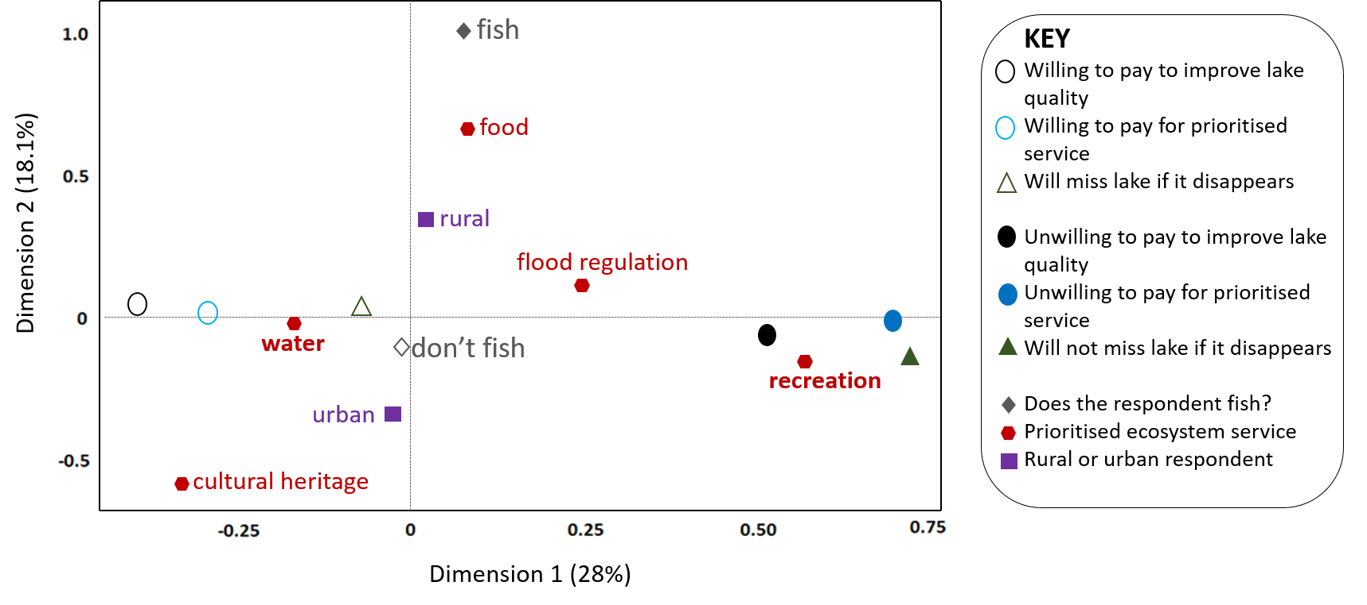
Figure 4.11: A multiple correspondence analysis (MCA) plot depicting the top fifteen variables that contribute the most to the explained variances in the data.

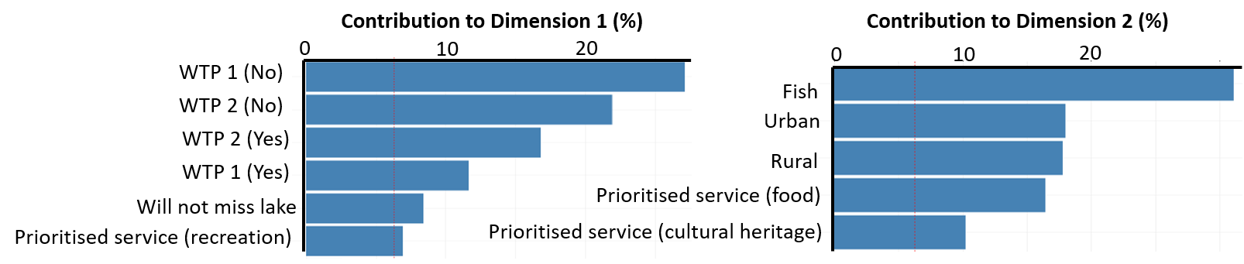
Figure 4.12: The significant contributing variables to Dimension 1 and Dimension 2 of the multiple correspondence analysis (MCA) plot.
Overall, more respondents were willing to improve the quality of their prioritised ecosystem service (361 willing to pay, 153 unwilling to pay) compared to the number willing to pay to improve the overall environmental quality of Lake Tai (291 willing to pay, 223 unwilling to pay). Respondents that were willing to pay for their prioritised services were significantly more willing to pay to improve the overall environmental quality (Table 4.3, Chi-squared = 165.64, df = 1, p-value < 0.05). On average, respondents were willing to pay a slightly higher percentage of their salary to improve the quality of their prioritised service than to improve the overall environmental quality of Lake Tai (Figure 4.13).
The minimally adequate generalised linear model (GLM) for willingness to pay or not to improve the quality of the prioritised ecosystem service contained only three variables out of a total of seven variables in the maximal model: which ecosystem service the respondent prioritised, whether they will miss the lake if it disappears and the age of the respondent (Table 4.4). Respondents that said they will miss the lake if it disappears were significantly more willing to pay for their prioritised service. In addition, older respondents were significantly less likely to pay for their prioritised service. Different sections of society (i.e. rural or urban, between different city regions) did not differ significantly in the respondents’ willingness to pay in the model.

Table 4.3: The number of respondents willing or not to pay for their prioritised ecosystem service (WTP 1) and to improve the overall environmental quality of Lake Tai (WTP 2).
 | WTP 2 (No) | WTP 2 (Yes)
WTP 1 (No) | 133 | 20
WTP (Yes) | 90 | 271

Table 4.4: The minimally adequate generalised linear model (GLM) to explain whether respondents were willing to pay or not for their prioritised ecosystem service. The intercept represents respondents that will not miss the river if it disappears and respondents that prioritised microclimate regulation.
 | estimate | standard error | t value | p value
Intercept | 0.22 | 0.66 | 0.33 | 0.74
Miss lake if it disappears? (Yes) | 1.05 | 0.33 | 3.20 | <0.001*
Prioritised service (culture) | 0.72 | 0.66 | 1.09 | 0.28
Prioritised service (flood prevention) | 0.21 | 0.60 | 0.35 | 0.73
Prioritised service (food) | -0.15 | 0.59 | -0.26 | 0.80
Prioritised service (recreation) | -0.61 | 0.60 | -1.02 | 0.31
Prioritised service (water) | 0.69 | 0.55 | 1.25 | 0.21
Age of respondent | -0.01 | 0.01 | -2.12 | 0.03*

Figure 4.13: The percentage of the respondent’s yearly salary that they were willing to pay to protect their prioritised service (black bars) and to improve the overall quality of Lake Tai (grey bars).
4.3.4. Comparison of methods: questionnaires vs. social media
The gender ratio of respondents between the questionnaire survey and the social media study was significantly different (Chi-squared=6.95, p=0.0084). There were significantly lower number of males in the social media study. The mean age of the respondents in the social media study was significantly younger than those from the questionnaire survey (t=9.68, p<0.001).
Using the direct questionnaires, we were able to obtain more information and demographic data from the respondents. In addition, we could gather qualitative data regarding the opinions of the respondents. In comparison, only limited data on demographic could be obtained using the social media platform. This is because many social media users did not fill in their demographic information to protect their own privacy. The social media data also contained temporal variation as the photographs were collected over a number of years, whereas the questionnaire survey was conducted during one time period. There was significant difference between the types of ecosystem service photographed across the years (Chi-squared=31.96, df=18, p=0.022). For example, there were fewer photographs of the lake’s view in 2014 and no photographs of recreation in 2015. Therefore, care should be taken when comparing the two datasets.

There were differences in demographics between questionnaire respondents and social media users. In terms of cultural services, questionnaire survey respondents most frequently used the lake for its recreational purposes and aesthetic appeal (Figure 4.4). Similarly, view and recreation were the most photographed ecosystem services according to the content analysis of social media photographs (Figure 4.9).
Not all cities around the lake were photographed equally: Suzhou and Wuxi were photographed more than Huzhou and there were no photos taken at Yixing out of the ones that could be assigned to a location. The number of photographs taken of a location is a function of the number of people able to access a location and its attractiveness as a tourist destination. Most tourists visiting Lake Tai had travelled between 100 and 300 km, although some had travelled more than 3000 km (Figure 4.15a). The majority of tourists are travelling from locations connected to Lake Tai by the high-speed train network (Figure 4.15b). High speed train stations have been built at all four cities that were investigated in the questionnaire survey: Suzhou, Wuxi, Huzhou and Yixing.
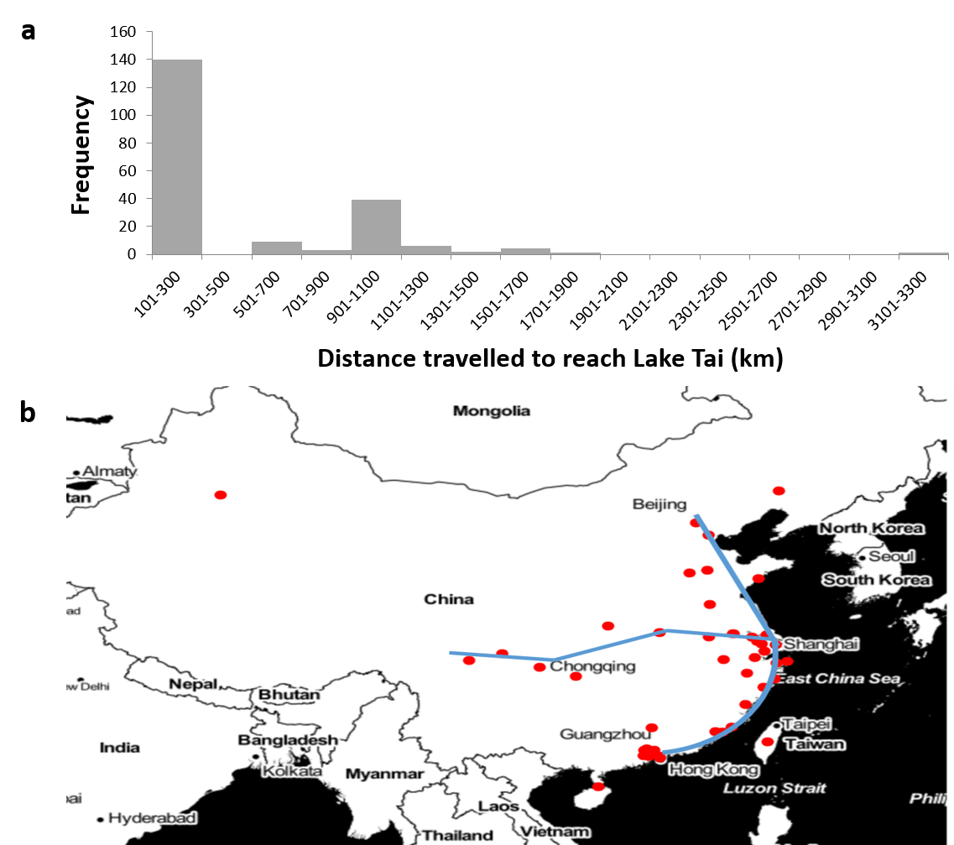
Figure 4.15 a) The distances travelled by social media users to the lake and b) the locations where social media users are travelling from (red dots) to reach Lake Tai and the high-speed rail networks within China (blue line).

4.4. Discussion
4.4.1 Different sections of society:
Lake Tai covers an extremely large area and it provides many different ecosystem services (Ai et al., 2015). These include freshwater provision and food provision such as fish and crabs (See Chapter 3). Both rural and urban communities in all four of the city regions studied, prioritised freshwater provision as the most important ecosystem service provided by Lake Tai in the questionnaire survey. This contrasts with the study reported in Chapter 2 in which recreation was prioritised as the most valued freshwater ecosystem service in a Chinese rural and urban community (Pan et al., 2016). The high prioritisation of freshwater provision at Lake Tai suggests that most of the local respondents are aware that the lake is the source of their freshwater and of its vital importance to their well-being (Ai et al., 2015). In fact, many respondents told the interviewers that Lake Tai was essential for their living because it provided them with fresh water. In addition, many respondents knew of the severe algal bloom event in 2007 as described it as “a terrible disaster”. In 2007, there was a severe algal bloom outbreak in Lake Tai that polluted the drinking water of Wuxi city (Zhang et al., 2010b). Millions of local communities had no access to drinking water and had to resort to drinking bottled water for several days. As a result, there was outrage amongst the general public living around Lake Tai (Yang et al., 2008). The news was broadcasted across national television and this raised awareness of Lake Tai’s importance to local communities. Previous research shows that major disaster events can increase the publicity of natural ecosystems and emphasise the ecosystem services that benefit local communities (Huang et al., 2013). In addition, another paper has indicated that the widely publicised algal bloom disaster at Lake Tai in 2007 caused communities around a nearby Chinese lake to become more concerned about changes to the environment (Huang et al., 2010). When an essential ecosystem service (i.e. freshwater provision) becomes unavailable, local communities are more likely to appreciate the importance of the ecosystem. Therefore, this suggests that increased publicity and education will help local communities to better appreciate and value ecosystems.
Although respondents are from the same community, there is a range of ages between the respondents. As a result, they may have different experiences about the environment and Lake Tai. The results of Chapter 3 showed that there have been changes in water quality and fish populations over the years at Lake Tai. If an ecosystem has suffered from degradation over a period of time and there is little communication between people of different ages, then older respondents may have a different expectation of the environment than younger generations (Papworth et al., 2009; Turvey et al., 2010). The younger generation may think that the degraded ecosystem is normal and this is known as shifting baseline syndrome (Pauly. 1995) . This potential challenge must be considered if human perceptions of nature are used to guide environmental policies.
Yixing is one of the major cities around Lake Tai, but there were no social media photographs taken at Yixing. Although Yixing is accessible by the high-speed train network, it has many chemical factories and plants that has resulted in severe pollution of the lake water in that region (Yang et al., 2015). Whist conducting the questionnaire survey in the Yixing area, severe algal blooms were observed and the lake water gave off an unpleasant smell.
Previous research has shown that the public’s perception of a place can influence the types of photographs that are taken (Richards and Friess, 2015). In this study, more social media users took photographs at Suzhou and Wuxi compared to Huzhou. Compared to Huzhou, Suzhou and Wuxi are bigger cities that are more famous tourist destinations in China. Thus, Suzhou and Wuxi attract more tourists and there may be more social media users taking photographs at these two cities.
There were differences between the types of ecosystem services that were photographed in different regions around Lake Tai. At Huzhou, social media users predominantly took photographs of a hotel that is built on Lake Tai (i.e. architecture). The Sheraton Huzhou Hot Spring Hotel (also known as the Moon Hotel; see Figure 4.3) is a unique piece of architecture that aims to depict the harmony between humans and nature, a long-standing concept within Chinese culture. The luxury hotel has become a landmark feature in Huzhou and it is clear that social media users specifically visit Huzhou to view and take photographs of the Moon Hotel. Although the water of Lake Tai is included in these photographs, it is the hotel that is the main attraction, rather than the lake. In comparison, most social media users took photographs of the view of Lake Tai at Suzhou and Wuxi. This was either a panoramic shot of the lake water or a sunset over the lake. Therefore, the ecosystem service valued at Suzhou and Wuxi is the aesthetic appeal of Lake Tai itself. This is in accordance with previous literature that had suggested the aesthetic value of nature is important to humans (Brady, 2006; Cooper et al., 2016).
Apart from different cities surrounding Lake Tai, the results of the questionnaire survey found that food provision (i.e. fish and other edible species from the lake) and flood prevention were more valued by rural communities whereas cultural heritage was more valued by urban communities. This is probably because a large proportion of rural respondents lived closer to Lake Tai and interacted with the lake more frequently than urban respondents. Previous research has shown that interactions with nature in the past can affect a respondent’s environmental values (Güsewell and Ruch, 2012; Tam, 2013). In addition, previous research has shown that Chinese rural communities are more concerned with issues regarding agriculture (Yu, 2014). Rural communities may depend more directly on the provision of ecosystem services for their livelihood (Freudenburg, 1991). In this study, some rural respondents were professional fishermen who relied on Lake Tai for a living. A higher proportion of rural respondents prioritised flood prevention in the city regions of Huzhou and Yixing compared to Suzhou and Wuxi. A possible reason provided by the rural respondents was that their agricultural land near the lake had been flooded by water previously. Due to this prior knowledge, they knew that effective management of Lake Tai was important for flood regulation and preventing their agricultural land from being flooded again. In contrast, rural respondents in Suzhou and Wuxi never had their agricultural landed flooded by lake water so they were less aware that the lake could regulate floods. This result shows that previous experiences can affect the prioritisation of ecosystem services. In the questionnaire survey, rural respondents prioritised ecosystem services that could directly affect them. This is because these ecosystem services impacted their day to day livelihood so they were more important to the rural communities.
In comparison to rural communities, the urban communities lived further away from Lake Tai and interacted with it less frequently. Previous research has shown that people who interact less with nature can feel disconnected from nature (Soga et al., 2016). As a result of this, people will feel less emotionally linked to nature, value it less and become less willing to protect the environment (Restall and Conrad, 2015). Urban cities are man-made spaces that have limited green spaces and are generally situated far away from natural ecosystems (Zhang et al., 2014). This is true for the cities that have been investigated in this study, and the rural regions are closer to Lake Tai. Therefore, urban communities can have different ecosystem values compared to rural communities. A previous paper has suggested that rural communities can be more concerned about environmental protection than urban communities (Berenguer et al., 2005). In the questionnaire survey, urban respondents generally had a higher education level than rural respondents, so they cared more about a rather abstract cultural ecosystem service (i.e. cultural heritage). This is in accordance with previous research that showed cultural services such as aesthetic and existence values are prioritised by urban communities compared to provisioning services such as food (Martin-Lopez et al., 2012). The author defined cultural heritage as preserving the Buddhist temples and historical architecture around Lake Tai. Cultural ecosystem services are intangible benefits that we receive from nature (Blicharska et al., 2017) and are therefore much more difficult to quantify and measure than provisioning and regulating ecosystem services (Hernandez-Morcillo et al., 2013).
The social media study also investigated how tourists used the ecosystem services at Lake Tai. By over-laying the high-speed train rail network map over the map of where social media users were travelling from in China, a potential relationship between the two was observed. Many social media users came from cities where there are high-speed train stations. A possible reason is because high speed trains are a cheap and relatively fast way to travel within China. A second-class ticket on the high-speed train is cheaper than a plane ticket and quicker than the traditional trains. The ease of accessibility to Lake Tai via high speed trains has likely increased tourism in the area.
The distance that a person travels to visit a place can represent how much they value a particular ecosystem. The “travel cost method” hypothesises that people who spend more money and time to visit a place will value it more (Keeler et al., 2015). The results of the social media study indicate that some users travelled considerable distances to visit Lake Tai. This suggests that the lake is not only valuable to nearby communities, but also to faraway communities living in other regions of China.

4.4.2. Willingness to pay
Most respondents were willing to pay to protect their prioritised ecosystem service (70.2%) and to improve the overall environmental quality of Lake Tai (56.6%). Interestingly, more respondents valued their prioritised service than the overall environmental quality of the lake. This may be because most respondents did not understand that their prioritised ecosystem service (e.g. freshwater provision) was in fact supported by other ecological functions and processes. Most respondents did not realise that the overall environmental quality of Lake Tai contributed to the quality of their prioritised provisioning service. A previous research paper has noted that management policies often focus on provisional services because they can be understood more directly by stakeholders (Rodriguez et al., 2006).
Respondents that prioritised Lake Tai as a source of freshwater provision and said that they will miss Lake Tai if it disappears were more willing to pay for this ecosystem service and pay to improve the overall environmental quality of Lake Tai. “Missing Lake Tai” is used a measure of the respondent’s emotional attachment and connectedness to Lake Tai. If respondents said that they will not miss the hypothetical disappearance of Lake Tai, then this suggests they feel detached from this ecosystem. Previous research has shown that when a person is not emotionally attached to the natural world, then they will value nature less (Lumber et al., 2017; Schultz et al., 2004; Soga et al., 2016; Tam, 2013; Tang et al., 2015). The result of this study supports previous claims that how connected people feel towards the natural world could be important in influencing their ecosystem values.
Interestingly, respondents that prioritised freshwater provision as the most important ecosystem service were more willing to pay to improve the water quality of Lake Tai. Some of the common reasons provided by the respondents were:
- “The lake water affects my living quality and is important for my own health”
- “The lake provides us with a source of drinking water and our livelihood depends on it”
- “Everyone has a responsibility to protect the local environment. It will benefit ourselves and future generations.”
Many of the respondents realised the importance of Lake Tai to maintaining their own living standards, health and general well-being. Although they may not understand the term ecosystem services, this study clearly illustrates that some respondents understand the multiple benefits provided by Lake Tai. In addition, they understand that the freshwater resource provided by the lake is irreplaceable and vital for human survival. Previous research has suggested that as the Lake Tai region is highly developed economically, local communities were more concerned about potential environmental risks and the impacts on their living standards compared to other Chinese lake regions (Huang et al., 2013).
The common response for why respondents were not willing to pay was that they did not have enough spare money or that they felt protecting the environmental was the government’s responsibility. The latter reason is common in terms of the general public’s attitude towards environmental protection in China because Chinese people that are unwilling to pay to protect the environment expect others to take responsibility, especially the government (Harris, 2006). This may due to the governance structure of environmental bureaus in China, which is top-down. Therefore, the general public will expect the government at the top to sort out any environmental problems. A valuation study investigating willingness to pay for forestry in Ethiopia also found that some respondents said that the government should pay rather than them (Mekonnen, 2000).
Compared to the public in developed Western countries, the Chinese public have less knowledge regarding environmental issues (Harris, 2006). Recent research in China showed that higher income and urban respondents are more likely to have pro-environmental attitudes (Chen et al., 2011). In this study, urban communities generally have higher education levels and higher income than rural communities. Previous research regarding perceived risks in Chinese lakes showed that low income and lower educated communities cared less about ecosystems (Huang et al., 2013). Low income Chinese communities are less concerned about environmental protection, especially if they feel that it will negatively impact their financial income. Nevertheless, there has been increased publicity for environmental issues in the Chinese media due to several major environmental disasters (Liu and Costanza, 2010). The severe smog in major Chinese cities, algal bloom and chemical pollution in major lakes have all increased the publicity of environmental protection in China (Huang et al., 2013).
4.4.3. Comparison of methods
Direct questionnaires have been used in ecological studies to increase stakeholder participation or when researchers need to investigate the attitudes and opinions of humans towards the environment (White et al., 2005). Nevertheless, there are potential challenges of conducting questionnaire surveys in a foreign country such as China. Firstly, they are time consuming and expensive. Secondly, there can be low response rates as many people asked can refuse to answer the questionnaire. There may also be interviewer bias as there was a team that conducted the questionnaire survey at Lake Tai. Finally, Chinese culture is different to Western culture and respondents may lack trust in researchers (Stening and Zhang, 2007).
Therefore, it is important to investigate alternative and novel methods of valuing ecosystem services in China. In particular, cultural ecosystem services are often ignored in valuation studies because they are difficult to quantify (Chan et al., 2012a). There has been increased interest in using social media data to capture the value of cultural ecosystem services (Figueroa-Alfaro and Tang, 2017; Ghermandi, 2016; Keeler et al., 2015; Sonter et al., 2016) but many of these studies have only looked at the number of photographs taken at specific locations (Keeler et al., 2015). The number of photographs taken at sites have been used an indicator of the importance of cultural ecosystem services, and this has been incorporated into the popular ecosystem service mapping model InVEST (Nelson et al., 2009). However, we cannot understand which parts of the ecosystem people value from the number of photographs alone. It is necessary to consider the content of the photographs. Few studies have investigated the actual content of the social media photographs and categorised them to understand people’s behaviours (Richards and Friess, 2015).
This current study categorises the content of social media photographs obtained from Sina Weibo, a Chinese social media platform, to investigate how social media users value ecosystem services provided by Lake Tai. To my knowledge, this is the first study conducted using Chinese social media platforms to value ecosystem services. The results of this study suggest that the use of social media data may be an effective way of improving cultural ecosystem service valuation.

Table 4.5: A comparison of the direct method (questionnaire survey) and the indirect method (social media photographs) used for this study.
 | Direct method | Indirect method
Time required | 3 days | Over two weeks
Number of people required | 1 | 7 (including 1 driver)
Cost of data collection | Negligible  - Laptop | High  - Plane ticket  - Hiring volunteers  - Hiring a minibus  - Accommodation costs

Nevertheless, it is important to acknowledge that there are potential biases in using social media data. Firstly, only a select group of people will have access to the internet and use social media platforms. This is not a representative sample of the whole population, but rather a specific sub-group (Tenerelli et al., 2016). Generally, social media users are wealthier and younger than the general population. In addition, on average there are more females using social media than males. Secondly, not all ecosystem services can be easily depicted through photographs. Therefore, they may be some cultural services that are difficult to depict. Some examples can include cultural heritage and existence value, which are rather abstract ideas and cannot be depicted easily through photographs. Thirdly, locals living near the lake are generally less likely to take photos of a nearby ecosystem compared to tourists who have travelled to specifically see the ecosystem (Wood et al., 2013). Local people may visit the lake frequently but they may not take photographs as it is a frequent sight for them. This behaviour, however, cannot be captured through social media data. In addition, social media photographs were taken over a number of years and there was temporal variation between the content of the photographs.
Despite the potential biases, the economic cost and time spent on a social media study is considerably less than a traditional questionnaire survey (Sonter et al., 2016). The direct questionnaire survey conducted for this chapter investigated how local communities prioritized ecosystem services. The project took over two weeks, six team members and the hiring of a minibus for transportation in China. The economic cost and time spent on the direct questionnaire survey project was considerably high. In comparison, the indirect social media study took only four days of collecting data by the author on a computer in the UK.
The direct questionnaire survey also has its advantages. Rural communities that live in remote regions can be underrepresented in studies and the questionnaire survey specifically targeted rural populations. Many rural communities do not have access to the internet so their ecosystem values will not be captured by social media photographs. Using direct questionnaire surveys, the interviewer can collect much more detailed data and additional qualitative data. This is simply impossible with the use of social media photographs.
Social media platforms are increasing in popularity globally. They provide a free and rich source of data that can quickly provide insight into which cultural services are important in a particular habitat. It is evident that the use of social media data cannot be used alone (Richards and Friess, 2015). It must be complemented by other ecosystem service valuation methods, such as direct questionnaire surveys and the mapping of ecosystem services. Nevertheless, this novel method can help to increase the representation of cultural ecosystem services in valuation studies. Identifying the content of social media photographs can be an efficient way of gaining insight into the importance of cultural services in China and thus help the management of cultural ecosystem services.
4.5 Main findings
This study has investigated the perceived ecosystem values of different sections of society in China using two different methods: questionnaire surveys and social media data. The results show that:
- different sections of society can prioritise different freshwater ecosystem services: across different cities, and between rural and urban communities.
- two factors significantly affected respondents’ willingness to pay for freshwater ecosystem services: whether the respondent will miss the lake if it disappears and which ecosystem service the respondent prioritised.
- social media can a be a potential useful tool to determine the value of cultural services, especially through analysing the contents of the photographs. However, social media targets a specific section of the population and miss out communities without internet access. Therefore, it must be used in conjunction with other methods such as questionnaire surveys.
Based on the study results, the potential protection goals for Lake Tai may be to concentrate on the conservation of two ecosystem services: freshwater provision and aesthetic appeal. The questionnaire survey results suggest that freshwater provision is highly prioritised by the local communities, whereas the social media data suggest that the aesthetic appeal of the lake is high prioritised. Depending on the method used to assess people’s preferences, suggested protection goals may be different. Neverthless, it is important to remember that the social media study included tourists whereas the questionnaire survey only included local communities.
Variation in the perceived value of ecosystem services in different sections of society needs to be considered during the formations of environmental policies. Communities can have different previous experiences with Lake Tai so there may be shifting baselines regarding how they perceive the ecosystem quality. Traditionally, Chinese environmental protection has always been a top-down approach. Nevertheless, recently China has been keen to improve environmental protection by increasing public engagement. Adopting the ecosystem service framework could be an effective way of linking what people are valuing to setting environmental protection goals.
The challenge is to translate what is measured traditionally in an ecosystem to what the public are actually valuing. There needs to be improved links made scientific research and environmental policy. The results of this chapter aim to link what people value, scientific research and environmental policy by using the ecosystem services approach. To improve environmental policy, we must develop specific protection goals based on ecosystem services.
Chapter 5
Using ecological scenarios to improve the ecological realism of chemical risk assessments

  - Introduction:
Chemicals, which include pharmaceuticals, agrochemicals and disinfectants, are extremely important and useful to human society, but can also be a risk to human health and the environment (Malaj et al., 2014; Maltby, 2013). Effective chemical risk assessment is vital for environmental protection but there are two major problems in current chemical risk assessment procedures (Caracciolo et al., 2013). The first is the lack of ecological realism and the second is the lack of specific protection goals(Franco et al., 2017). Although ecotoxicology has the prefix “eco”, the integration between ecology and toxicology is insufficient in this field (Segner, 2011).
Ecology stems from field observational studies and it investigates a wide range of scales, from individual organisms to large communities. It attempts to deal with multiple confounding variables that can potentially affect the end results. In comparison, ecotoxicology stems from chemistry and toxicology and although it may also investigate effects at different scales of biological organization, it predominantly investigates effects on individual organisms (Van den Brink et al., 2011). The use of ecotoxicological studies to inform regulation is one of the main reasons for the focus on individuals. Regulatory decisions need to be based on information that is robust and reliable and it is easier to conduct standardised laboratory tests on individual organisms than populations. Regulatory toxicity tests generally measure the effects of a single chemical, rather than chemical mixtures, on relatively few species (Beyer et al., 2014; Chapman et al., 1998). The species used in ecotoxicological studies are often those that can be easily cultured in the laboratory.
Whereas single-species laboratory studies of the effects of single chemicals on a small number of species may not be representative of realistic ecological communities, risk assessment approaches aim to be protective rather than ecologically realistic(Brown et al., 2017). The testing of species under specified conditions and the use of application factors to derive predicted no effect concentrations from the toxicity data of the most sensitive species, provide a margin of safety when assessing ecological risk (Chapman et al., 1998). Nevertheless, there are differing opinions regarding how protective the current approach is and there is a move towards using more ecologically realistic approaches (Belanger et al., 2017; Dyer et al., 2008). Ultimately the goal of ecotoxicology is to protect ecosystems from the negative impacts of chemicals, so we must investigate at higher levels than individual species to improve risk assessments (Franco et al., 2017). The effects of chemicals on populations and communities are currently investigated in mesocosm studies and field studies (Roussel et al., 2007).
It is impossible to protect all species everywhere and the current regulatory approach to the ecological risk assessment of chemicals may also be over-protective in certain ecosystems where sensitive species may not be present. Therefore, we should form specific protection goals and protection goals may vary for different ecosystems (Kefford et al., 2012; Nienstedt et al., 2012). One way forward is to identify the important ecosystem services that are provided by an ecosystem and base protection goals upon them (Nienstedt et al., 2012; Van Wensem et al., 2017). Ecosystem services are the benefits that we receive from nature and they can be directly linked to management issues such as food provision or aesthetic value (Costanza et al., 2014). In addition, the concept of ecosystem services allows us to identify the functional traits of species that are directly linked to the provision of services (Spooner and Vaughn, 2012).
Franco et al. (2017) suggested the formation of environmental scenarios to improve the ecological realism of risk assessments. An environmental scenario is composed of an exposure scenario and an ecological scenario. The exposure scenario considers the exposure pathway of chemicals and is confined by specific temporal and spatial scales. It is composed of the emission scenario (i.e. usage of chemicals, how waste water is treated) and the environmental fate of the chemical. In the case of freshwater ecosystems, the formation of spatially explicit models will help to highlight river catchments that are at risk from chemical exposure (Franco et al., 2017). In contrast to exposure scenarios, the definition of an ecological scenario is less clear. Rico et al. (2016) suggested that “ecological scenarios are composed of the abiotic and biotic variables that can impact population recovery and the effects of chemicals”.
Biomonitoring data from ecological surveys such as the EU Water Framework Directive (WFD) are important sources of information to form ecological scenarios (Beyer et al., 2014). They provide data on the taxonomic composition of ecological communities and abiotic parameters regarding the ecosystem (e.g. flow velocity and depth of rivers). The WFD specifies that the ecological status of rivers must be assessed using a range of taxonomic groups, including macroinvertebrates (Vlachopoulou et al., 2014). Historically in the UK, The RIVPACS (River Invertebrate Prediction And Classification System) has been used to assess the ecological status of rivers since the 1990s (Clarke et al., 2003). Since the introduction the EU WFD, some parts of RIVPACS have been adopted into the WFD (Vlachopoulou et al., 2014). RIVPACS was based on sampling macroinvertebrates at a very large number of minimally impacted sites. The invertebrate data was then used to cluster the sites using the program TWINSPAN. It is these clusters that form the RIVPACS end-groups or site types, and there are 35 in Great Britain and 11 in Northern Ireland (Clarke et al., 2003).
Aquatic macroinvertebrates can act as good ecological indicators of ecosystems because they are a diverse group and are commonly found in all aquatic ecosystems. Their composition in an ecosystem can reflect the environmental quality because most macroinvertebrates cannot move long distances (Cardinale, 2011). In addition, aquatic macroinvertebrates provide many ecosystem services. Macroinvertebrates provide supporting ecosystem services such as nutrient cycling and decomposition (Suter and Cormier, 2015) and cultural ecosystem services, including recreation and aesthetic appeal. Children often go “pond dipping” as a recreational activity and macroinvertebrates provide a source of education for children. Dragonflies, damselflies and mayflies are beautiful organism so they provide high aesthetic and recreational value for humans (Suter and Cormier, 2015). Furthermore, they provide cultural values because they are the source of inspiration for paintings, poems and literature books. Finally, macroinvertebrates are an important food source for many different species. These include amphibians, fish, aquatic birds and bats (Macadam and Stockan, 2015).
The RIVPACS end-groups can be potentially used as ecological scenarios to identify toxicity thresholds for different chemicals that may enter freshwater ecosystems and negatively impact them (De Laender et al., 2015). One question that needs to be addressed during the construction of ecological scenarios is whether the potentially vulnerable species are sensitive to chemicals. Vulnerability is affected by exposure, sensitivity and the recovery rate of the species. The duration of chemical exposure can affect the recovery of a species. For example, down the drain chemicals are discharged continuously and the exposure to these chemicals will be at low levels but constant (Hodges et al., 2012). This is in contrast to pesticide pollution from surface run-offs, which does not occur constantly (Huber et al., 2000).
Ecological scenarios can be used to improve chemical risk assessments by defining the boundaries for ecotoxicological models that predict chemical toxicity thresholds and effects (Franco et al., 2017), by identifying specific species for toxicity testing, or by establishing the communities whose species sensitivity distributions (SSDs) should be analysed. Ecological scenarios differ in species composition and species differ in their relative sensitivity to toxicants. A key question that should be asked, therefore, is do all ecological scenarios have the same sensitivity distribution and toxicity thresholds? If not, how does the species composition of an ecological scenario affect the toxicity thresholds for different types of chemicals.
SSDs model interspecific variation in toxicological sensitivity to a chemical substance and assume that a parametric (e.g. logistic or normal) or non-parametric distribution can be used to describe the sensitivity distribution (Shi et al., 2014). SSDs can be used to calculate the concentration of a chemical that is considered to protect a specified fraction of species in a community (Posthuma et al., 2002). The threshold is known as the hazardous concentration (HC) and can be calculated for any proportion (p) of an assemblage. The most commonly used HCp value in chemical regulation is the HC5 (Belanger et al., 2017). The HC5 is the concentration at which 5% of the species represented by the SSD are adversely impacted by the chemical and 95% are protected (Duboudin et al., 2004).
Aldenberg and Jaworska (2000) published the statistical model used for the construction of SSDs and the calculation of the HC5 value. This led to the release of the ETX software, which is now widely used in ecotoxicological research. The construction of SSDs can be summarised in three steps:
- The collection and assemblage of a toxicity dataset for a chemical of interest
- Describing the toxicity dataset using a parametric or non-parametric distribution and plotting the SSD as a cumulative distribution function
- Finding the HCp of a SSD and using it to set down environmental quality criterion
One of the criticisms of the use of SSDs to set quality criteria is that the model makes the key assumption that species use for toxicity testing are selected at random from the pool of species potentially exposed (Forbes and Calow, 1999). The assumption of randomly selected species is not true because tested species are usually ones that are easily cultured in the laboratory. Although the toxicity dataset used to construct a SSD should be representative of a realistic ecological community and be randomly sampled, the reality is that toxicity data are confined by laboratory limitations. There are more toxicity data available for species that are easily cultured in the laboratory (e.g. Daphnia), which may not be representative of a realistic ecological community. Furthermore, the richness of a toxicity dataset depends on the chemical investigated, with some chemicals being tested more frequently and extensively than others (Hickey and Craig, 2012).
The assumption of randomly selected species also assumes that species forming the SSD are interchangeable and effectively that the species composition of the SSD does not matter (Hickey and Craig, 2012). However, we know that species differ in their sensitivity to toxicants and species that are taxonomically more similar and with similar functional rates will have similar chemical sensitivities. For example, by using a toxicity dataset on the effect of pesticides on fish species, a study showed that species cannot be interchanged freely (Craig et al., 2012).
In comparison to conventional SSDs, the hierarchical SSD (hSSD) was developed to improve the ecological realism of SSD models (Hickey and Craig, 2012). This is a Bayesian hierarchical model that generalises the Aldenberg and Jaworska (2000) log-normal SSD model. It is based on the observations that (1) species closer in taxonomy tend to have more similar sensitivities to each other compared to species that are further apart taxonomically (unpublished paper) and (2) that the sensitivity of one species can be used as a surrogate to predict the sensitivity of another species (Dyer et al., 2008). This knowledge has been used in the hSSD model to predict the sensitivity of species with no toxicity data by using taxonomic information and toxicity data for related species (unpublished paper).
The hSSD model is based on a large dataset that was published by de Zwart et al. (2002) on chemical toxicities to aquatic species. This was analysed to investigate the patterns between species sensitivities and their taxonomic structure. The hSSD model uses a database of existing acute toxicity data, as well as the quantitative relationship between taxonomy relatedness and toxicity to predict HCp values for a specified ecological community.
The hSSD approach uses a hierarchical random effects model of sensitivity to many chemicals of many species, with a Bayesian inference. The hierarchy is based around the taxonomical tree structure, with the classification from the Catalogue of Life (http://www.catalogueoflife.org/). In the model, a species’ probability of being generally less or more sensitive than an average species is calculated. As a result, the model is more accurate at predicting the sensitivity for an untested species when the untested species is closer taxonomically to a tested species.
To my knowledge, there are currently no published studies that have investigated the potential of the hSSD model at investigating whether there are variations between the sensitivities of different natural ecological communities to different chemicals. This is because there is little toxicity data on some species found in natural ecosystems and as a result it is complicated to investigate the effects of a chemical on ecological communities. The lack of toxicity data represents a significant problem in improving the ecological realism of chemical risk assessments.
This study aims to improve the ecological realism of risk assessments by developing a number of ecological scenarios for river macroinvertebrate communities and comparing the sensitivity distributions of species within those scenarios to different chemical toxicants. Scenarios are based on macroinvertebrate biomonitoring data used to develop RIVPACS in the UK and the hSSD model is used to calculate chemical threshold values.
The objectives of the study are as follows:
- To use the hSSD model to compare the sensitivity of invertebrate assemblages representing different ecological scenarios to a range of chemicals.
- To compare the results of conventional SSDs with the outputs of the hSSD model based on ecologically relevant assemblages.

5.2 Methods
5.2.1 Selection of ecological scenarios
Macroinvertebrates were chosen as the focal taxonomic group and the RIVPACS end-group dataset was obtained from the Centre for Ecology and Hydrology website (https://www.ceh.ac.uk/services/rivpacs-reference-database). Scientists carefully selected short stretches of rivers that represent the best examples of minimally impacted sites in Great Britain and Ireland. In total, there are 35 types of sites in Great Britain and 11 in Ireland. At each site, scientists then used standardised methods to sample macroinvertebrates and collected environmental data. In the RIVPACS dataset, the twenty-five most frequently occurring macroinvertebrate species have been identified for each reference site (i.e. endgroups).
The focus of this study was rivers in England and therefore all the end-groups in other areas were discarded. This reduced the number of RIVPACS end-groups to 13. RIVPACS end-groups list species according to their probability of occurrence. For each end-group, the 25 species with the highest probability of occurrence were selected to form the representative assemblage. Similarity in species composition between the 13 assemblages was analysed using a hierarchical cluster analysis, performed using Bray-Curtis dissimilarity, and visualised as a dendrogram (vegan package in the open source statistical program R). The Average Score per Taxa (ASPT), derived from the Biological Monitoring Working Party (BMWP) score, was calculated for each assemblage to provide a measure of pollution sensitivity (Hawkes, 1998)

5.2.2. Species sensitivity distributions
Species sensitivity distributions were generated for four chemicals with different characteristics. Pentachlorophenol (PCP) is a pesticide and biocide (disinfectant), copper is a metal with biocidal properties, linear alkylbenzene sulfonate (LAS) is an anionic surfactant and chlorpyriphos is an insecticide.
Toxicity data sets used in the analysis are presented in Appendix 5.1-5.4. The PCP and chlorpyriphos toxicity datasets were from Maltby et al (2005). The PCP dataset contained 69 invertebrate acute toxicity values and the chlorpyrifos dataset contained acute toxicity data for 44 invertebrate taxa. The copper toxicity dataset was obtained from Brix et al. (2001) and contained acute toxicity values adjusted to 50 mg/L water hardness for 43 invertebrate taxa. The LAS dataset was obtained from the appendix of a PhD thesis by Naomi N. Blake and contained acute toxicity data for 34 invertebrate species (Blake, 2001).
An acute SSD was generated for each chemical using all available invertebrate toxicity data. The MASS package in R was used to fit a log-normal distribution to the toxicity data and the HC5 value was calculated from the distribution. The HC5 (i.e. median HC5) is the concentration for which 95% of species with 50% certainty have a higher LC50 or EC50 value. Ninety percent confidence intervals were calculated for each HC5 value using parametric bootstrapping. The lower 90% confidence bound of the HC5 (lower limit HC5) is the concentration for which 95% of species with 95% certainty of have a higher LC50 or EC50 value (Maltby et al., 2005). Plots, showing the individual toxicity data points, the predicted SSD and 5% and 95% confidence limits were generated using the ggplot2 package in R.
For each of the four study chemicals, the hSSD model was used to generate SSDs for each of the 13 ecological scenario assemblages. This model, which was developed by Peter Craig at Durham University, is available as a hSSD software tool which can be downloaded from: www.maths.dur.ac.uk/~dma0psc/ecorisk/PDxGrwJMBC6AacPv34huMQr5rZ8/. However, for the analysis performed here it was necessary to access the model calculations used to generate the hSSD plots. Peter Craig kindly provided the original source code so that the hSSD model could be assembled and run within R (code available upon request).
The R source code for the hSSD model requires three files to run:
  - dbAnalysis.h5: This is the result of analysing a large aquatic ecotoxicological database and the sensitivity relationships between species.
  - A csv file that contained the acute toxicity dataset for a specific chemical of interest. EC50 or LC50 data must be inputted as logarithm (base 10) values.
  - A csv file that contains the species to be included in the ecological scenario, with their taxonomic information provided
The dbAnalysis.h5 file was obtained from Peter Craig and the two csv files were generated by the author as part of this study. There were four acute toxicity files (one for each chemical: PCP, copper, LAS, chlorpyriphos) and 13 ecological scenario files, one for each assemblage. The taxonomic classification of each species in the ecological scenario was inputted into the hSSD model, using the Catalogue of Life classifications (http://www.catalogueoflife.org/).
By combining the ecological scenario with the acute toxicity dataset of a specific chemical, the hSSD tool calculated the HCp for that ecological scenario. In total, 52 hSSDs and associated HCp values were calculated. Each ecological scenario has a finite number of species (i.e. 25 species), so the HC5 cannot be calculated exactly in terms of the number of species as the hSSD model uses a Bayesian inference. Therefore, the HCp value provided is the largest p which is less than or equal to 5% and for 25 species this is the HC4 value. The hSSD source code was used to produce an output sample size of 1,000 from the posterior distribution of the HC4 for each scenario. The mean of these values was used as an estimate of the HC4. The 90% credible intervals for the HC4 was produced by computing the 5% and 95% quantiles.

  - Results
5.3.1. Toxicity datasets and ecological scenario assemblages
The acute toxicity datasets for PCP, copper and LAS all contained species from a range of invertebrate taxonomic groups including crustaceans, insects, molluscs and annelids. In addition, the copper and LAS data sets contained toxicity data for flatworms. In contrast, the toxicity dataset for chlorpyriphos was mainly composed of insect species (Figure 5.1). The taxonomic profiles for each of assemblage are presented in Table 5.1. Assemblages 17-30 contained many insects and few molluscs, whereas assemblages 41-43 contained more molluscs and fewer insects. All assemblages contained fewer crustaceans than the toxicity datasets, which contained data for a number of microcrustaceans. However, even within the malacostracan crustaceans, there were generally more species represented in the toxicity datasets than in the assemblages.
The hierarchal cluster relationship dendrogram shows that there are three clusters of RIVPACS end-group assemblages that are similar in species composition (Figure 5.2). Cluster 1 is composed of end-groups 17, 25,29, and 30 and is characterised by many insect species. Cluster 2 is composed of end-groups of 34, 35, 36, 37 and 38 and is characterised by a medium number of insects and molluscs. Cluster is composed of end-groups 41, 42 and 43 and is characterised by lower numbers of insect species and more mollusc species.

Figure 5.1: Taxonomic variation within the acute toxicity datasets for each of the four chemicals investigated.

Table 5.1: Taxonomic variation within the macroinvertebrate assemblages derived from RIVPACS IV end-groups found within England. All assemblages contain 25 species and are numbered according to the end-group from which they are derived. The Average Score Per Taxon (ASPT) score was calculated for each assemblage and ranges from 0 (no scoring taxa present) to 10 (only pollution sensitive taxa present).

Assemblage | Crustaceans (Malacostraca) | Insects | Molluscs | Oligochaetes | Flatworms | Others | ASPT  score
17 | 1 | 21 | 1 | 1 | 0 | 2 | 5.52
25 | 0 | 20 | 1 | 3 | 0 | 1 | 6.05
29 | 0 | 20 | 1 | 2 | 1 | 1 | 6.06
30 | 1 | 19 | 2 | 2 | 1 | 0 | 4.88
34 | 2 | 12 | 7 | 4 | 0 | 0 | 4.05
35 | 1 | 16 | 3 | 4 | 0 | 1 | 4.68
36 | 2 | 16 | 2 | 4 | 0 | 1 | 4.25
37 | 1 | 14 | 5 | 4 | 0 | 1 | 3.89
38 | 3 | 13 | 3 | 5 | 0 | 1 | 4.05
40 | 1 | 18 | 1 | 5 | 0 | 0 | 5.42
41 | 2 | 10 | 6 | 6 | 0 | 1 | 3.37
42 | 2 | 10 | 7 | 5 | 0 | 1 | 3.11
43 | 2 | 7 | 9 | 6 | 0 | 1 | 3.59

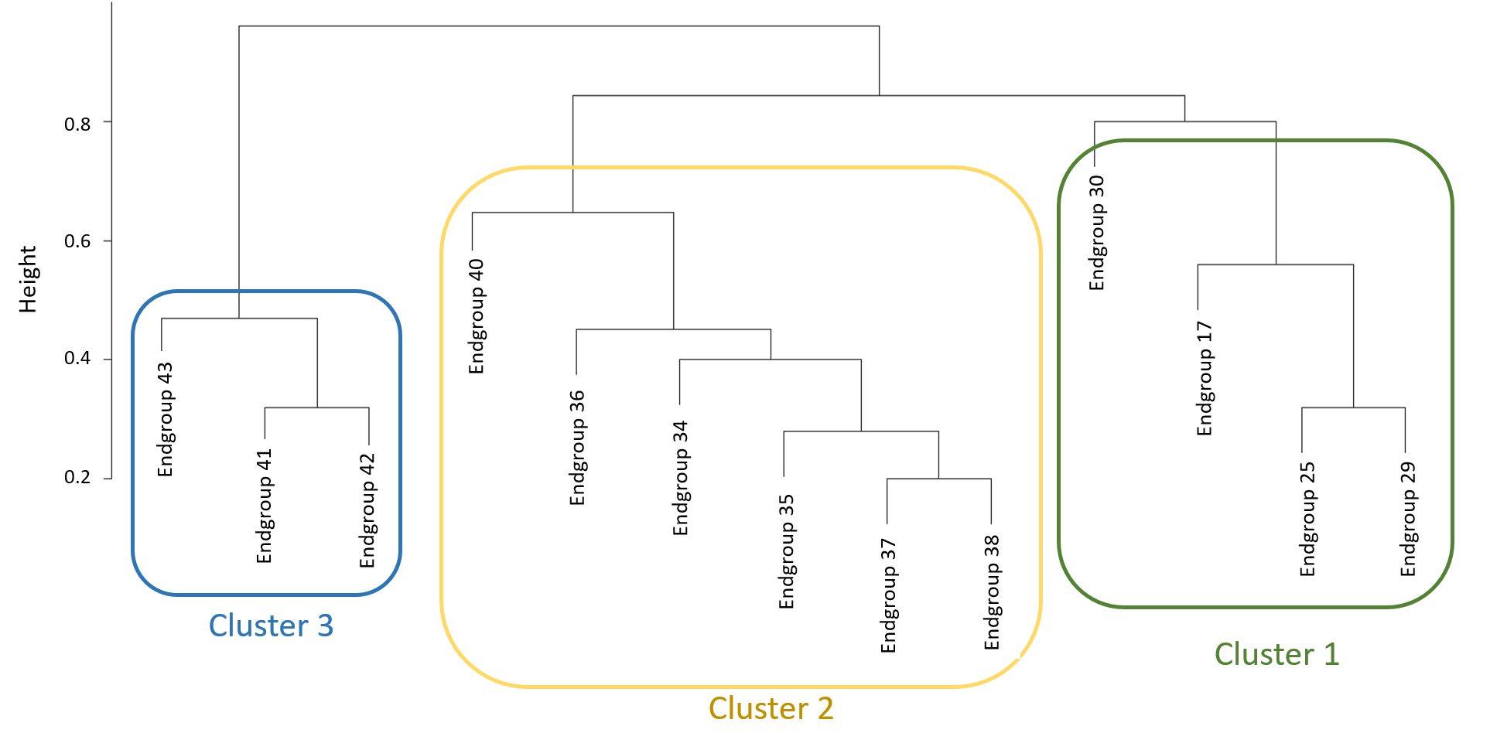
Figure 5.2: Dendrogram depicting the hierarchical cluster relationship between RIVPACS IV end-groups using Bray-Curtis dissimilarity. Species in one cluster are more similar in species composition.

5.3.2. Comparison of assemblage sensitivity
ASPT values are a measure of the pollution sensitivity of an invertebrate assemblage. Values range from 0 to 10 and the higher the score the greater the average pollution sensitivity of the taxa present in the assemblage (Clarke et al., 2002). The ASPT for each of the end-group assemblages ranged from 3.11 to 6.06 (Table 5.1) and differed significantly between clusters (F = 16.8, p<0.001). Cluster 1 contained the most pollution sensitive taxa (mean ASPT score = 5.63) and Cluster 3 contained the least pollution sensitive taxa (mean ASPT score = 3.36). ASPT is a general pollution index and is derived from the BMWP score, which was developed primarily for organic pollution (Sandin and Hering, 2004). The relative sensitivity of species varies depending on the toxic mode of action of the chemical (Russom et al., 1997) and the hSSD model was used to investigate variation in the relative sensitivity of assemblages to four different types of chemicals.
HC4 values varied across assemblages and the magnitude of this variation (i.e. highest HC4/lowest HC4) ranged from 1.66 to 3.17 depending on the chemical. The greatest range in HC4 values was observed for PCP (Table 5.2) and Cluster 1 assemblages were less sensitive to PCP (i.e. higher mean HC4 value) than Cluster 3 assemblages (F = 6.87, p=0.015). Similar differences in sensitivity between clusters were observed for copper and LAS (Table 5.3 &5.4). with assemblages in Cluster 3 having lower HC4 values and being more sensitive than those in Cluster 1. However, whereas the difference between mean HC4 values for Cluster 1 and Cluster 3 assemblages was statistically significant for Cu (F = 24.6, p <0.001) it was not statistically significant for LAS (F = 1.95, p =0.193). Interestingly, this same pattern does not hold for chlorpyriphos, where the mean HC4 value for Cluster 1 was lower than that of Cluster 3 (Table 5.5; F = 3.83, p = 0.058).

5.3.3 Comparison of hSSD and conventional SSD analyses.
The hSSD analysis generates an HC4 value whereas a HC5 value is generated by the conventional SSD analysis, which would be a lower concentration than the corresponding HC5 value. Comparing the conventional HC5 value calculated using all the toxicity data and the HC4 values for each on the 13 assemblages, it is apparent that the assemblage HC4 values are considerably greater than the conventional HC5 value for all 13 assemblages and for each of the four chemicals (Figure 5.3-5.6). For many assemblages, the HC4 value is greater than the upper 90% confidence bound for the conventional HC5 value. However, it should be noted that the confidence intervals are wider for a hSSD than a conventional SSD (Tables 5.2-5.5). Only the HC4 value for endgroup 17 and 25 for PCP is significantly different from the HC5 of the traditional SSD (i.e. their confidence intervals did not overlap; Table 5.2).
Conventional SSD plots, generated using acute toxicity data for all invertebrates in each of the toxicity datasets, are presented in Figures 5.7-5.10. For pentachlorophenol, insects were at the top of the distribution, crustaceans and molluscs were at the bottom. For LAS, there was no specific pattern between the taxonomic groups. For copper, crustaceans were at the bottom of the distribution and insects dominated the toxicity data for chlorpyriphos.
HC5 values derived from the SSDs were lowest for chlorpyriphos (HC5=0.84 ug/L; Figure 5.10) and highest for LAS (HC5=1036.58 ug/L; Figure 5.9). Pentachlorophenol has a HC5 of 53.7 ug/L (Figure 5.7) and copper has a HC5 of 6.16 ug/L (Figure 5.8), with the toxicity data used adjusted to 50 mg/L water hardness.

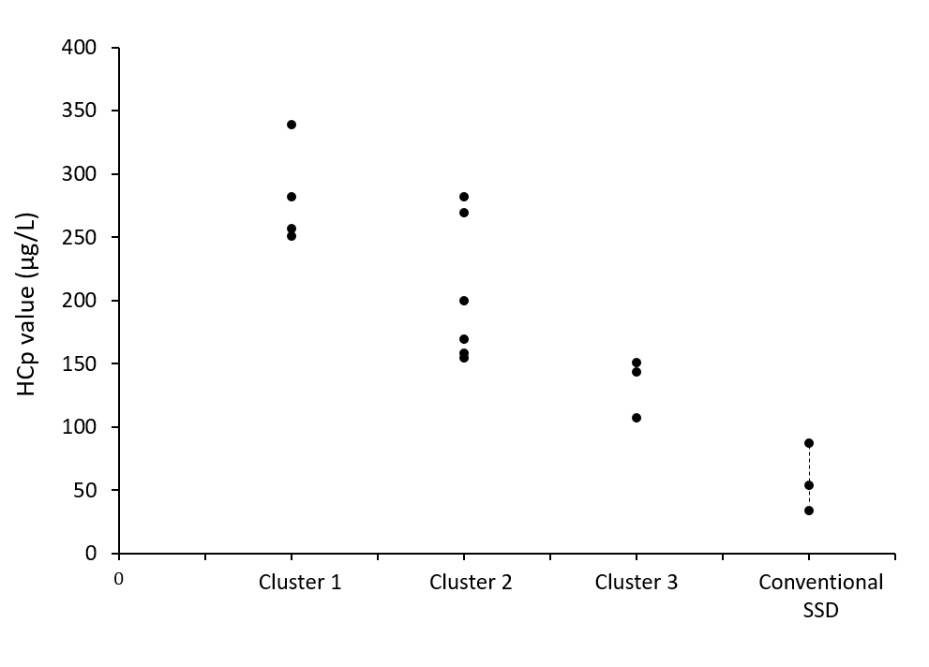
Figure 5.3: HCp values calculated for pentachlorophenol. The mean HC4 values for the RIVPACS endgroups in Cluster 1-3 as calculated using hSSD, and the HC5 and 90% confidence intervals as calculated using the conventional SSD.
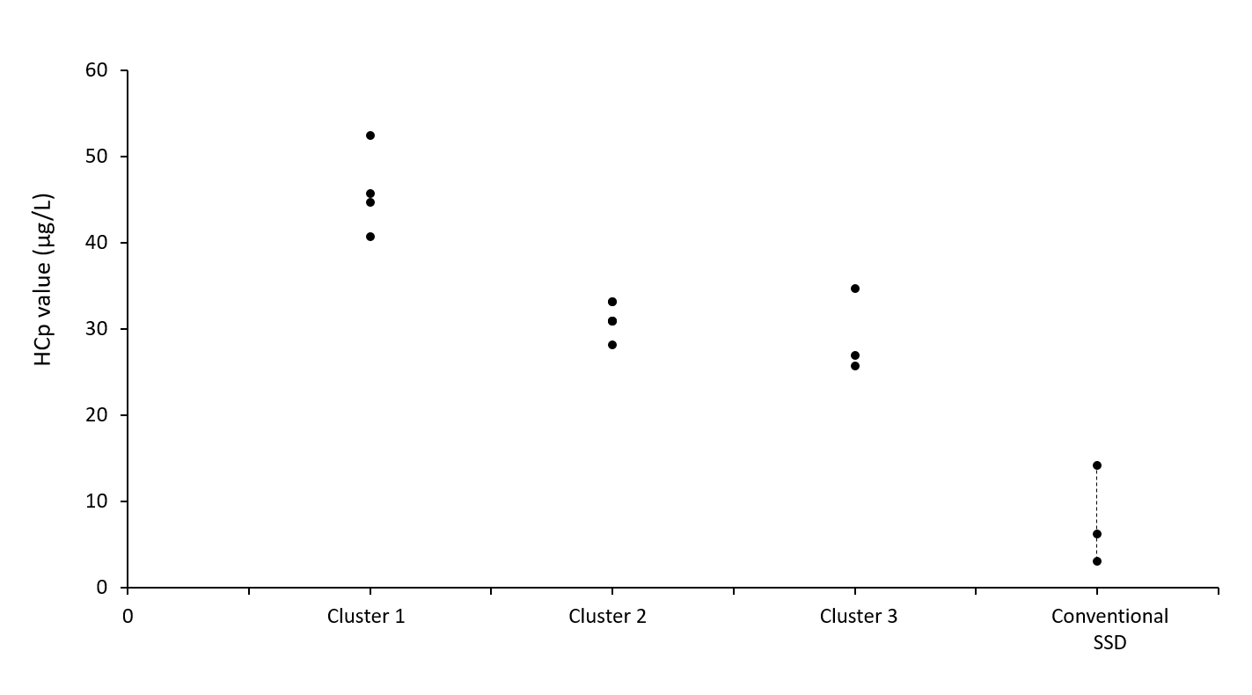
Figure 5.4: HCp values calculated for copper. The mean HC4 values for the RIVPACS endgroups in Cluster 1-3 as calculated using hSSD, and the HC5 and 90% confidence intervals as calculated using the conventional SSD.

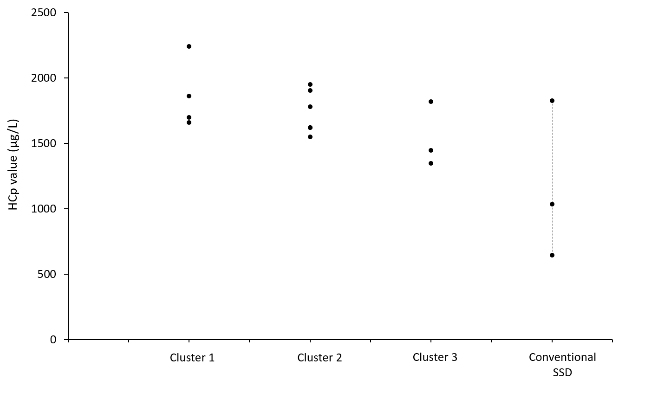
Figure 5.5: HCp values calculated for linear alkylbenzene sulphonate (LAS). The mean HC4 values for the RIVPACS endgroups in Cluster 1-3 as calculated using hSSD, and the HC5 and 90% confidence intervals as calculated using the conventional SSD.
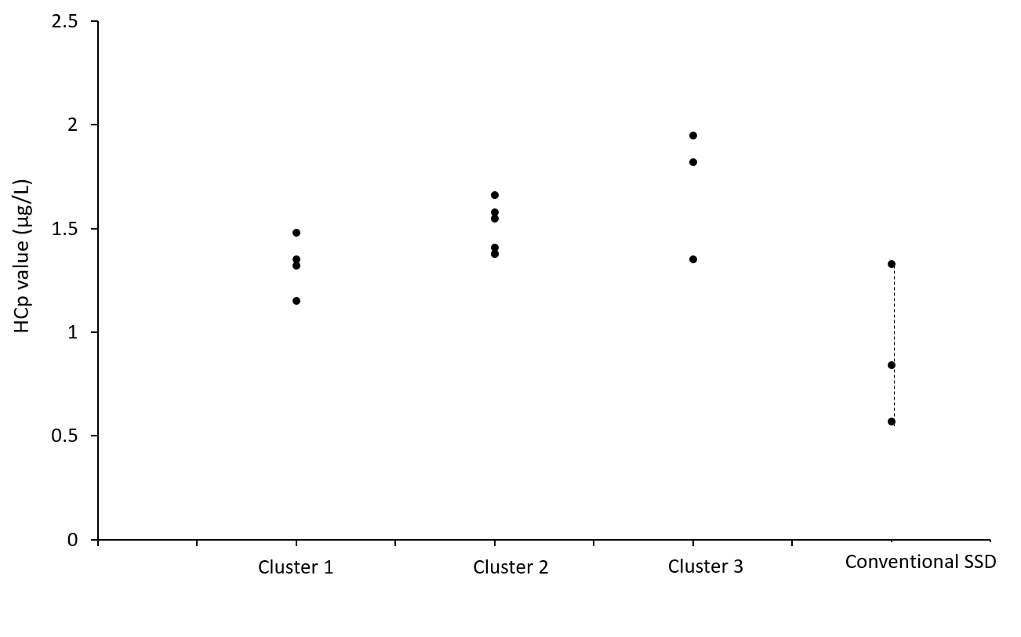
Figure 5.6: HCp values calculated for chlorpyriphos. The mean HC4 values for the RIVPACS endgroups in Cluster 1-3 as calculated using hSSD, and the HC5 and 90% confidence intervals as calculated using the conventional SSD.

Figure 5.7: Species sensitivity distribution plot for pentachlorophenol (PCP) using a log normal distribution. Raw toxicity data points (dots), predicted distribution (red line) with 90% confidence intervals (dashed black lines). Red dots represent insects, black dots represent other crustaceans, grey dots represent malacostraca (crustacean), blue dots represent oligochaetes, brown dots represent molluscs.

Figure 5.8: Species sensitivity distribution plot for LAS using a log normal distribution. Raw toxicity data points (dots), predicted distribution (red line) with 90% confidence intervals (dashed black lines). Red dots represent insects, black dots represent other crustaceans, grey dots represent malacostraca (crustacean), blue dots represent oligochaetes, brown dots represent molluscs.

Figure 5.9: Species sensitivity distribution plot for copper using a log normal distribution. Raw toxicity data points (dots), predicted distribution (red line) with 90% confidence intervals (dashed black lines). Red dots represent insects, black dots represent other crustaceans, grey dots represent malacostraca (crustacean), blue dots represent oligochaetes, brown dots represent molluscs.

Figure 5.10: Species sensitivity distribution plot for chlorpyriphos using a log normal distribution. Raw toxicity data points (dots), predicted distribution (red line) with 90% confidence intervals (dashed black lines). Red dots represent insects, black dots represent other crustaceans, grey dots represent malacostraca (crustacean), blue dots represent oligochaetes, brown dots represent molluscs.

Table 5.2: The mean HC4 value for each ecological scenario (RIVPACS end-groups) for pentachlorophenol, as calculated by the hSSD model. The 95% credible intervals and the cluster that the end-group belongs to in the hierarchical cluster analysis are also shown.

RIVPACS end-group | Mean HC4 (μg/L) | Lower  credible  interval | Upper credible interval | Cluster number in dendrogram
17 | 338.84 | 125.89 | 794.33 | Cluster 1
25 | 281.83 | 89.13 | 812.83 | Cluster 1
29 | 257.04 | 85.11 | 691.83 | Cluster 1
30 | 251.19 | 60.25 | 660.59 | Cluster 1
34 | 154.88 | 46.77 | 398.11 | Cluster 2
35 | 199.53 | 66.07 | 489.78 | Cluster 2
36 | 281.84 | 70.79 | 758.58 | Cluster 2
37 | 158.49 | 47.86 | 407.38 | Cluster 2
38 | 169.82 | 38.90 | 457.09 | Cluster 2
40 | 269.15 | 81.28 | 676.08 | Cluster 2
41 | 151.36 | 42.66 | 380.19 | Cluster 3
42 | 143.24 | 38.79 | 374.68 | Cluster 3
43 | 107.15 | 33.88 | 263.03 | Cluster 3

Table 5.3: The mean HC4 value for each ecological scenario (RIVPACS end-groups) for copper, as calculated by the hSSD model. The 95% credible intervals and the cluster that the end-group belongs to in the hierarchical cluster analysis are also shown.

RIVPACS end-group | Mean HC4 (μg/L) | Lower  credible  interval | Upper  credible  interval | Cluster number in dendrogram
17 | 44.67 | 8.32 | 186.21 | Cluster 1
25 | 52.48 | 7.94 | 208.93 | Cluster 1
29 | 40.74 | 7.41 | 158.49 | Cluster 1
30 | 45.71 | 10.00 | 190.55 | Cluster 1
34 | 33.11 | 8.71 | 100.00 | Cluster 2
35 | 30.90 | 8.51 | 85.11 | Cluster 2
36 | 33.11 | 7.76 | 117.49 | Cluster 2
37 | 30.90 | 7.41 | 77.62 | Cluster 2
38 | 28.18 | 6.17 | 79.43 | Cluster 2
40 | 30.90 | 6.61 | 91.20 | Cluster 2
41 | 25.70 | 4.90 | 69.18 | Cluster 3
42 | 34.67 | 7.94 | 100.00 | Cluster 3
43 | 26.92 | 5.50 | 75.86 | Cluster 3

Table 5.4: The mean HC4 value for each ecological scenario (RIVPACS end-groups) for linear alkylbenzene sulphonate (LAS), as calculated by the hSSD model. The 95% credible intervals and the cluster that the end-group belongs to in the hierarchical cluster analysis are also shown.

RIVPACS  end-group | Mean HC4 (μg/L) | Lower  credible  interval | Upper credible  interval | Cluster number in dendrogram
17 | 2238.72 | 874.98 | 4677.35 | Cluster 1
25 | 1698.24 | 588.84 | 3981.07 | Cluster 1
29 | 1659.59 | 588.84 | 3801.89 | Cluster 1
30 | 1862.09 | 758.58 | 3981.07 | Cluster 1
34 | 1778.28 | 645.65 | 3890.45 | Cluster 2
35 | 1621.81 | 575.44 | 3715.35 | Cluster 2
36 | 1949.84 | 676.08 | 4365.16 | Cluster 2
37 | 1905.46 | 524.81 | 4168.69 | Cluster 2
38 | 1548.82 | 478.63 | 3630.78 | Cluster 2
40 | 1621.81 | 562.34 | 3548.13 | Cluster 2
41 | 1445.44 | 416.87 | 3630.78 | Cluster 3
42 | 1819.70 | 524.81 | 4466.84 | Cluster 3
43 | 1348.96 | 416.87 | 4570.88 | Cluster 3

Table 5.5: The mean HC4 value for each ecological scenario (RIVPACS end-groups) for chlorpyriphos, as calculated by the hSSD model. The 95% credible intervals and the cluster that the end-group belongs to in the hierarchical cluster analysis are also shown.
RIVPACS end-group | Mean HC4 (μg/L) | Lower  credible  interval | Upper credible  interval | Cluster number in dendrogram
17 | 1.48 | 0.46 | 3.31 | Cluster 1
25 | 1.35 | 0.45 | 3.02 | Cluster 1
29 | 1.15 | 0.30 | 2.88 | Cluster 1
30 | 1.32 | 0.40 | 2.88 | Cluster 1
34 | 1.66 | 0.46 | 3.80 | Cluster 2
35 | 1.38 | 0.37 | 3.31 | Cluster 2
36 | 1.38 | 0.46 | 3.02 | Cluster 2
37 | 1.58 | 0.50 | 3.72 | Cluster 2
38 | 1.55 | 0.42 | 3.55 | Cluster 2
40 | 1.41 | 0.42 | 3.02 | Cluster 2
41 | 1.95 | 0.58 | 4.27 | Cluster 3
42 | 1.82 | 0.52 | 4.47 | Cluster 3
43 | 1.35 | 0.42 | 4.57 | Cluster 3

5.4 Discussion
Species sensitivity distributions (SSD) are models aiming to explain the interspecific variation in toxicological sensitivity to a chemical. SSDs assume that a statistical function can be used to describe the distribution and that the species used to construct the distribution are interchangeable (Posthuma et al., 2002). However, in natural ecosystems all species do not co-occur in the same place so the assumption of randomly selected species is inaccurate. In fact, one of the main criticisms for the SSD approach is that the ecological community used is unrepresentative of a realistic ecological community (Maltby et al., 2005). What is not clear, however, is how difference in species composition translate to differences in sensitivity distributions and hence the validity of threshold values derived from SSDs using a non-random subset of species. Therefore, we need to compare the species sensitivity distributions of different assemblages. It has been suggested that conventional SSDs should be more specific to the ecosystem of concern, by using toxicity data for species that are present in the ecosystem (Shi et al., 2014). Nevertheless, there is a lack of toxicity data for many species found in natural ecosystems. A possible solution to this problem is the use of hSSD. This study has used the hSSD model in an attempt to improve the ecological realism of conventional SSDs, by comparing the toxicity threshold for different assemblages and different chemicals. The results show that there is variation between the chemical toxicity thresholds for different species assemblages.

    - Variation in the sensitivity of assemblages to chemicals.
The sensitivity of the assemblages varies according to the cluster that they belong and the relative sensitivity also varies by chemical. The thirteen assemblages (i.e. RIVPACS endgroups) form three distinct clusters based on their similarity in species composition. The different assemblages can be narrowed down based on their taxonomic differences. Therefore, we can use the three clusters as potential ecological scenarios.
The hSSD model was used to calculate toxicity thresholds (HC4 values) for the different assemblages. A similar pattern emerged for PCP, copper and LAS. The HC4 value was the highest for Cluster 1 assemblages (i.e. least sensitive) and the lowest for Cluster 3 (i.e. most sensitive). In contrast, for chlorpyrifos, the mean HC4 was more similar for the three clusters. The ASPT scores showed that Cluster 1 had higher scores and Cluster 3 had lower scores on average. This is because Cluster 1 was defined by insect species that are sensitive to insecticide and Cluster 3 was define by mollusc species that are less sensitive to insecticides.
When conducting chemical risk assessments, the toxic mode of action of the specific chemical should be considered. For example, whether the chemical is an insecticide or molluscicide (Maltby et al., 2005). For PCP, the range in sensitivity for different assemblages is up to three orders of magnitude. Endgroup 17 in Cluster 1 had a mean HC4 of 338.84 μg/L whereas endgroup 43 in Cluster 3 had a mean HC4 of 107.15 μg/L. There was a similar pattern in sensitivities between the clusters for copper and LAS. Interestingly, chlorpyriphos was the only chemical that displayed a different pattern. The mean HC4 value was more similar between the different clusters. The possible reason behind the patterns in the results of this study is due to different chemical modes of action, which is explained in the paragraphs below.
Pentachlorophenol (PCP) is a general biocide that was widely used in the past to preserve wood from fungi (Jin et al., 2012). In addition, it has been used as a molluscicide in the past to control schistosomiasis by killing aquatic snails (Zheng et al., 2012) and to inhibit the growth of microbes (Weinbach, 1956). The results of this study indicate that Cluster 1 assemblages were the least sensitive to PCP possibly because they contained the lowest number of molluscs, as PCP is a molluscicide. Endgroup 17 in Cluster 1 only contained one mollusc species and was the least sensitive ecological scenario with the highest HC4 value. In contrast, endgroup 43 in Cluster 3 has the lowest HC4 value and contained the highest number of mollusc species. As there are more molluscs in Cluster 3, these assemblages may be more sensitive to PCP.
Copper is a transition metal and high levels can be toxic to aquatic organisms, including algae and molluscs (Lu et al., 2013). Copper based chemicals are used in fungicides and fertilisers for agriculture (Roussel et al., 2007). Too much copper ions within the cell bind to the sites of other metal ions and result in altered cell metabolism. In addition, copper ions can result in the formation of oxyradicals and cause damage to the DNA structure (Stohs and Bagchi, 1995). Previous research has found that copper causes adverse effects in freshwater macroinvertebrates (Magalhaes et al., 2015). It has been found to be highly toxic to molluscs both in laboratory conditions (de Oliveira et al., 2004) and mesocosm studies (Gardham et al., 2014). Like the patterns displayed for PCP, endgroups 17-30 in Cluster 1 were the least sensitive to copper possibly because they contained the least number of molluscs. Endgroup 17 was the least sensitive ecological scenario with the highest HC4 value as this endgroup only contain one mollusc species. Endgroups 41-43 in Cluster 3 were the most sensitive to copper possibly because they contain the highest numbers of mollusc. Endgroup 43 contains 9 mollusc species and had the lowest HC4 value out of all the assemblages. Previous research has suggested that the higher toxicity of copper to aquatic snails is due to their shells. Copper is usually found as a compound in aquatic ecosystems, such as in the form of copper carbonate (Shuhaimi-Othman et al., 2012). As snails require carbonate for their shells, copper may be absorbed as copper carbonate. Once inside the snail, the carbonate is used for shell formation and the copper will accumulate within the soft tissues and cause toxicity (Hoang and Rand, 2009).
LAS is an anionic surfactant that is commonly found in laundry detergents (Belanger et al., 2002). Previous mesocosm studies have shown that mayflies and clams may be particularly sensitive to the effects of LAS (Belanger et al., 1995). The results of this study showed that there was a 1.7 times difference between endgroup 17 and endgroup 43. LAS is considered to be a general narcotic with a membrane disrupting mode of action (Jensen et al., 2001). Although LAS is toxic to aquatic organisms in the laboratory, it is partially degraded within waste treatment plants before entering aquatic ecosystems. Previous research shows that as the chain length of LAS shortens, its toxicity also decreases (Kimerle and Swisher, 1977). In this study, LAS is the least toxic chemical to the assemblages.
Chlorpyriphos is the fourth chemical investigated in this study. It is an insecticide and this means that aquatic insects are more sensitive to the chemical than other taxonomic groups, because they can absorb chlorpyriphos directly from the water (Pope, 1999). Chlorpyriphos acts by binding to the neurotransmitter acetylcholine in insects and prevents acetylcholinesterase from deactivating acetylcholine, which results in the malfunction of the nervous system. Previous research has shown that molluscs and annelids are less sensitive to the effects of chlorpyriphos (Raven and George, 1989). The results of this study showed that the hSSD model predicts similar sensitivity thresholds for different clusters for chlorpyriphos, ranging from 1.15 to 1.95 μg/L. The difference in sensitivities is not as great as for the other three chemicals investigated. Nevertheless, endgroup 29 in Cluster 1 was the most sensitive ecological scenario. A possible reason is because the endgroups contained the highest number of insects compared to other endgroups. In comparison, endgroups 41 and 42 in Cluster 3 were the least sensitive to chlorpyriphos. The possible reason being that these endgroups contained the least number of insects. Indeed, endgroup 29 in Cluster 1 had the highest ASPT score and endgroups 41 and 42 in Cluster 3 had lower ASPT scores.

5.4.2. Toxicity thresholds for conventional SSDs and the hSSD model
Based on ecological relevant assemblages using the RIVPACS endgroups, toxicity threshold from conventional SSDs and the hSSD model have been derived. From an environmental risk assessment perspective, it is important to assess whether the median or lower limit of HC5 values calculated from conventional SSDs are sufficiently protective of ecosystems. The HC4 values calculated by the hSSD model are considerably higher than the median HC5 values calculated by the conventional SSD, and many HC4 values are higher than the upper confidence interval of the HC5 value. This indicates that the threshold value calculated from conventional SSDs may be overprotective for some chemicals and ecosystems. Using the conventional SSD, the upper confidence interval calculated for the HC5 is overprotective in many cases compared to using the hSSD model.
There needs to be a balance between protecting ecosystem services and maintaining the benefits that we receive from using chemicals (Maltby, 2013). Although overprotection will protect ecosystem services, this can decrease and limit the benefits from chemical usage (Maltby et al., 2017a). The results of this study show that depending on species composition, some communities may be more vulnerable to the effects of chemicals whereas other communities are less vulnerable.

5.4.3. Caveats and limitations
In principle, the hSSD model is advantageous over the conventional SSD because it has the potential to estimate the true chemical threshold value for a realistic ecological community. The hSSD is particularly useful when there are no toxicity data available for the species present in the natural ecological community. Nevertheless, the results of this study show that there are wide confidence intervals for the chemical threshold values (i.e. HCp values). The hSSD model predicts similar sensitives for species that are closer taxonomically compared to species that are more distantly related taxonomically (Craig et al., 2012). Therefore, the hierarchical model will predict a chemical threshold value (HCp) with smaller confidence intervals if the tested species in the toxicity dataset are more taxonomically related to the untested species in the ecological scenario. As a result, the amount of taxonomic variation in the provided toxicity dataset and the composition of the ecological scenario will affect the outcome of the hierarchical model. In an unpublished paper, Peter Craig has suggested that the acute toxicity dataset provided affects the outcome of the hSSD model even more than the specified ecological scenario.
Despite the many advantages of hSSD over conventional SSDs, there are some caveats to the hierarchical model. The original toxicity database that was used to build the hSSD model only contained data on aquatic animals and there were no data on aquatic plant species. In addition, the range of species was relatively limited compared to the diversity found in natural aquatic ecosystems. As a result, it is currently unfeasible to calculate a chemical threshold value for an aquatic plant community in the hSSD model. Nevertheless, aquatic plants may be the most sensitive species for some chemicals (e.g. LAS).
Secondly the hSSD model was built using acute toxicity data, and this means that many chronic toxicity data cannot be used in the model. Therefore, there is a decrease in the number of toxicity data that could be used in the hSSD model. In addition, LAS is found in home and personal care (HPC) products. HPC chemicals are found in low levels in the environment but ecosystems can be continuously exposed to them (Price et al., 2010). Therefore, investigating the chronic effects of HPC chemicals may be more useful than acute effects due to continuous exposure. Finally, the hSSD model treats different chemicals as interchangeable. Nevertheless, different chemicals have varying properties and different modes of action. These should be considered and incorporated into the hSSD model in the future.

5.5 Conclusion
The results of this study illustrate the importance of species composition in calculating sensitivity thresholds from SSDs and possible ecological scenarios for ERA. In summary, the hSSD model provides one potential tool for estimating the chemical threshold value of realistic ecological communities. Furthermore, identifying clusters from the RIVPACS end-groups have provided a set of realistic ecological scenarios to test in the hSSD model.
The effects on chemical threshold values were investigated by varying the species composition and the chemical of interest. The results suggest that different ecological scenarios do not all have the same sensitivity profile to a chemical of interest. Therefore, the use of conventional SSDs may not fully reflect the potential responses of realistic ecological communities.
Currently, chemical risk assessment only investigates a limited number of standard test species. Risk assessments aim to protect the environment, but the connection between laboratory tests and nature remains obscure (Nienstedt et al., 2012). There needs to be increased interdisciplinary research between ecologists and ecotoxicologists, which will improve ecological realism in ecotoxicological studies(Maltby et al., 2017b). This study has demonstrated an approach that uses ecological data to form potential ecological scenarios that can be used in environmental risk assessments.
Chapter 6
General Discussion

6.1 Main findings
This thesis aimed to use an ecosystem approach for the protection of freshwater ecosystems, and to link the fields of ecology, ecotoxicology and cultural values. The first objective was to investigate whether different section of society valued freshwater ecosystem services differently. The results indicated that different sections of society have varying ecosystem values, depending on different factors (i.e. rural versus urban communities, Chinese versus British respondents). This has wider implications for the setting of protection goals, as it suggests that different sections of society will have different desires and what they value in an ecosystem can vary.
The second objective was to use a specific freshwater ecosystem (i.e. Lake Tai in China) and explore the consequences of changes to the provision of ecosystem services, as well as to investigate how communities use and value the lake. The results showed that multiple anthropogenic stressors including chemical pollution, have led to the deterioration of freshwater ecosystem service provision by the lake. In addition, it highlighted that communities who have an emotional attachment to an ecosystem and prioritise provisional services over cultural services are more willing to pay to protect the ecosystem.
The third objective was to investigate whether inherent sensitivities to different chemicals vary in different macroinvertebrate communities and therefore improve the ecological realism of environmental risk assessments. Using species sensitivity distributions, the results suggested that species composition can affect the community’s sensitivity profile. Therefore, the negative effects of chemical stress on ecosystem services provision is not the same for all ecosystems.

6.2 Sections of society
The thesis results indicate that different sections of society have varying perceived values of freshwater ecosystem services, and this is dependent on a range of factors. In the first part of Chapter 2, the objective was to investigate whether there was a rural urban divide between how respondents used and valued their local freshwater ecosystem services. The results showed that Chinese rural respondents placed a higher value on their local freshwater ecosystem services compared to their urban counterparts, using willingness to pay as a proxy to measure the respondent’s perceived value of ecosystem services. Rural respondents were more willing to pay to protect their local freshwater ecosystem services. The potential reason is because rural respondents interacted more frequently with their local river than urban respondents and may therefore be more emotionally connected to their local river. The urban respondents lived upstream of the rural respondents. Therefore, if we based protection goals on the values of the urban community, the rural community will be impacted as a result. This raised the important question of whose values should count during the setting of protection goals if there are conflicts between different sections of society.
In the second part of Chapter 2, the study results showed that culture significantly affected the perceived values of local freshwater ecosystem services, and whether respondents were willing to pay or not to protect ecosystem services. There was a divide between the ecosystem values of Chinese and British university respondents. Chinese respondents prioritised provisional services (i.e. food and water provision) as the most important to them whereas British respondents prioritised cultural services as the most important (i.e. recreation and aesthetic value). Furthermore, British respondents were more willing to pay to protect their local freshwater ecosystem services than Chinese respondents. The results highlighted the fact that that Chinese respondents may have a more anthropocentric view of nature than their British counterparts. Tam et al. (2013) also found that American respondents were more connected to nature and performed more positive ecological behaviours than Chinese respondents. A potential reason given by the authors is that American respondents interacted frequently with nature as children.
The results of Chapter 2 have implications for the setting of protection goals in environmental policies, because it highlights potential trade-offs that must be made when different sections of society have varying ecosystem values. Trade-offs must be made during the formation of environmental protection goals because we do not have the capability and financial resources to protect everything everywhere (Maltby et al., 2017b). A potential method is to base protection goals on the perceived ecosystem values of the public. Nevertheless, prioritising certain ecosystem services by a particular section of society can negatively impact another section of society if they share common resources. Furthermore, as urbanisation continually increases in developing countries, will ecosystem values change as rural communities become more urbanised? Chapter 2 highlights the complexity of varying ecosystem values in different sections of society. People will not have the same values depending on where they live (i.e. rural or urban) or the culture (i.e. Chinese or British) that they have been brought up in. The results also show that although the perceived ecosystem values of the public can inform environmental policy, other ecosystem service assessments must be conducted to better inform decision makers.
6.3 Case study using Lake Tai
Both Chapters 3 and 4 use Lake Tai (Taihu) in China as a case study to investigate its ecosystem services provisions and how communities value the lake’s ecosystem services. Lake Tai was chosen as a case study because it is the third largest freshwater lake in China, supports large populations that live around the lake and provides many ecosystem services to human society (Ai et al., 2015). Neverthless, it is threatened by multiple stressors, including severe chemical pollution (Qin et al., 2007).
In Chapter 3, the results showed that there have been rapid increases in human populations surrounding Lake Tai, as well as increased waste output. Previous research has shown that urbanisation can result in the deterioration of ecosystem services and negatively impact human well-being (Radford and James, 2013). As urbanisation increases around the world, it is important to consider its effects on nature. At Lake Tai, urbanisation has been coupled with the decreasing water quality of the lake and increased nutrient input (Guo, 2007). Previous research papers also suggest that land use changes around Lake Tai (e.g. increased agriculture and rapid urbanisation) and intensive aquaculture have adversely impacted the ecological quality and water quality of the lake (Xie et al., 2017; Xu et al., 2017; Zhang et al., 2017). In addition, the results of Chapter 3 indicate that the total catches of capture fisheries have drastically increased from 1950-2000 and the species composition of fish in Lake Tai has been altered as a result. In summary, the increase in human populations around Lake Tai has led to changes in land use through urbanisation and intensive agriculture. Changes to land use have negatively impacted the ecology of the lake, including fish populations. Ultimately, this has resulted in adverse impacts on the provision of ecosystem services (He et al., 2015).
In Chapter 4, the results of the first study showed that rural and urban communities around Lake Tai prioritised different freshwater ecosystem services. In addition, respondents that prioritised water provision and had a closer emotional connection to the lake were more willing to pay to protect their prioritised ecosystem service and the lake. Respondents that prioritised recreation and had less of an emotional connection to the lake were unwilling to pay to protect their prioritised ecosystem service and the lake. This is in accordance with previous research investigating the connectedness to nature scale, which suggested that people who feel more emotionally connected to nature may be more likely to protect the environment (Mayer and Frantz, 2004; Soga et al., 2015; Tang et al., 2015). Lumber et al. (2017) also suggested that increased emotional contact with nature can increase how connected respondents feel towards nature. In summary, the results of Chapter 4 and previous literature suggest that increased promotion of connecting people to nature may increase pro-environmental attitudes in the general public.
The second study in Chapter 4 showed that Chinese social media platforms can be a potential tool for eliciting information on the perceived values of cultural services. The aesthetic value of the lake and recreation were the most photographed cultural services by the social media users. The results also indicated that most tourists travelling to Lake Tai came from locations that were connected by the Chinese high-speed train network. To my knowledge, this is the first exploratory study that uses the Chinese social media platform Sina Weibo to investigate the perceived values of cultural ecosystem services. As Chinese internet users do not have access to Western social media platforms, the use of Chinese social media platforms may be useful to estimate the value of Chinese cultural ecosystem services. A recent review article of ecosystem service research in China stated that few Chinese papers have investigated the incorporation of cultural ecosystem services into valuation studies and that more studies should concentrate on cultural services (Jiang, 2017). The use of social media data could be a potential way of incorporating cultural services into ecosystem service valuations.
Chapters 3 and 4 have taken a large ecological component (i.e. Lake Tai in China) and investigated temporal and spatial changes to the provision and perceived value of ecosystem services. Although Lake Tai is an ecosystem in China, it is comparable to many major freshwater ecosystems around the world that are also suffering from multiple stressors (Collen et al., 2014). Previous research has also suggested that land use changes and eutrophication are major threats to many lake ecosystems around the world (Schallenberg et al., 2013). In addition, the results have highlighted that different factors can affect how communities perceive the value of ecosystem services. These include emotional attachments to an ecosystem and which ecosystem service is prioritised.
Currently, there is a lack of a common framework for ecosystem service studies in China (Zhang et al., 2010a). There needs to be consistency in the classification of ecosystem services to make studies comparable (Jiang, 2017). Therefore, in Chapter 3 the ecosystem services provided by Lake Tai have been categorised using the Common International Classification of Ecosystem Services (CICES; https://cices.eu/). This classification system aims to be more comprehensive than previous systems (i.e. MA or TEEB) and standardise ecosystem service classifications.
6.4 Environmental risk assessments and species sensitivity distributions
Species sensitivity distributions (SSD) are models explaining the interspecific variation in toxicological sensitivity to a chemical substance and they assume that a statistical function can be used to describe the distribution (Posthuma et al., 2002). Current SSDs are constructed from a non-random set of species and it remains unclear whether differences in species composition will affect the results of a species sensitivity distribution (Belanger et al., 2017). To investigate this issue, we need to investigate the SSDs of different ecological communities. However, the problem is that there is lack of toxicity data for many species found in natural ecosystems (Aldenberg and Jaworska, 2000). Therefore, the use of hierarchical SSDs (hSSD) represents a possible solution. In fact, a recent paper on future recommendations for SSDs highlights the potential of the hSSD model developed by Peter Craig (Belanger et al., 2017).
In Chapter 5, the hSSD model (i.e. a hierarchical Bayesian model) developed by Peter Craig at Durham University was used to improve the ecological realism of current risk assessments. The results showed that compared to conventional SSDs, the hSSD model can estimate the sensitivity threshold of an ecological community to a chemical when there are no toxicity data for the species in the ecological community. As most toxicity tests are performed on species that are easily reared in laboratories, there are few toxicity data on species found in realistic ecosystems (Hickey and Craig, 2012). The lack of toxicity data is a problem in ecotoxicology. Using mechanistic models like hSSD, however, provides a potential solution to the problem.
To my knowledge, the hSSD model is still under development so there have been no published papers on the application of the hSSD model. Nevertheless, the model has the potential to improve the ecological realism of current SSD models and help to relate ecotoxicology to the concept of ecosystem services. Using the novel hSSD model, the results of Chapter 5 show that the species composition of an ecological community can affect the community’s sensitivity threshold to a specific chemical, but there are wide confidence intervals. This supports previous claims that species are not randomly interchangeable in a conventional SSD (Craig et al., 2012).
Current protection goals stated in European environmental risk assessments (ERA) are too general and they may not protect ecosystem services (Nienstedt et al., 2012). In addition, it is important to define the spatial scale at which ecosystem services are protected (Schafer, 2012). The ecosystem service approach is needed to develop more specific protection goals, and this will also improve communication between ecotoxicologists, risk managers and stakeholders (Brown et al., 2017; Maltby et al., 2017a; Munns et al., 2016; Van Wensem et al., 2017).
Using ecological models can be a way of improving ERAs, but there are trade-offs between maintaining ecological realism and model complexity. Setting specific protection goals requires increased collaboration between stakeholders, ecologists, ecotoxicologists and economists (Galic et al., 2012; Rutgers et al., 2012). To address this problem, stakeholders have been interviewed in Chapters 2 and 4. Furthermore, ecological data have been integrated with ecotoxicological models in Chapter 5.
6.5 Approaches used in the thesis

Different approaches have been used in the thesis and the results suggest that an interdisciplinary approach is required for the investigation of ecosystem services to provide a more holistic viewpoint. This is because ecosystem services benefit human well-being so humans must be considered in the approach. Therefore, the sole use of ecological methods is insufficient and social science methods must also be used. The thesis has shown that ecosystem services can be the concept that unifies different fields of research. To my knowledge, this is the first study to link these three fields using the concept of ecosystem services.
The thesis has used a range of methods from ecology, ecotoxicology and social sciences. Chapter 2 and Chapter 4 have used questionnaire surveys and data from social media platforms. Chapter 3 has used ecological data from governmental reports and the scientific literature. Chapter 5 has used ecological data, SSDs and hSSDs, a novel ecotoxicological model to estimate the sensitivity threshold of an ecological community.
During ecosystem service studies, it is important to evaluate the perceived value of ecosystem services. This is because ecosystem functions only become ecosystem services when they have beneficiaries. Therefore, it is vital to incorporate human needs and values into this approach. Previous research has also identified a need for improvement in the integration of socio-economic data into ecosystem service studies (Reid et al., 2010). There needs to more emphasis on the social science aspects of ecosystem services to improve communication between ecosystem services research and environmental policy. To address this specific need, considerable social science methods have been used in this thesis. They include the use of direct questionnaire surveys in Chapter 2 and Chapter 4, the use of an online questionnaire survey in Chapter 2 and eliciting information from a social media platform in Chapter 4. Chapter 2 and 4 have used contingent valuation method.
There are arguments against the valuation of nature in the scientific literature, but without some form of valuation nature will always be seen as a free resource (Costanza et al., 2014). The ecosystem services approach puts nature on the same level as the economy. We are making decisions and trade-offs about the environment all the time, by expressing our preferences towards certain aspects of nature and not others. Therefore, it can be argued that the value of nature is not unmeasurable (Bartha and DesRoches, 2017).
One of the disadvantages of using contingent valuation is that it is a hypothetical method, because it asks for a respondent’s willingness to pay in a hypothetical environment (Haab et al., 2013). We cannot be sure that the respondent will pay or not in a realistic situation and this is known as hypothetical bias. Neverthless, revealed preference methods cannot quantify non-use values whereas contingent valuation is the only method that can (Bateman et al., 2011). Therefore, the effectiveness of contingent valuation in ecosystem service studies should undergo continual investigation and research.
Using online questionnaires surveys can be restrictive, by only targeting respondents that have access to the internet (Chapter 2). In addition, most respondents are from urban cities. Nevertheless, they can target respondents across large spatial scales in a short amount of time. In addition, the cost of running online questionnaires is low. Due to the limitations of online questionnaires, other methods have been used in the thesis to complement the use of online questionnaires: direct questionnaire surveys in Chapters 2 and 4; data from social media platforms in Chapter 4.
In Chapter 5, the hSSD model used is still under development and as a result it has limitations. The toxicity database that the model is based on only contains aquatic animal species and no plant species. As a result, the database is still limited and could be improved in the future. In addition, chronic toxicity data cannot be used in the hSSD model because it was built using acute toxicity data. Neverthless, with continual development the hSSD model represents a potential tool for estimating the chemical threshold of natural ecological communities.

6.6 Conclusion
The concept of ecosystem services is a growing field that is rapidly gaining more attention across different disciplines (Costanza et al., 2014; Duvic-Paoli, 2017). This thesis shows that an ecosystem service approach can be used to improve the protection of freshwater ecosystems. The main results are: i) different sections of society use and prioritise different ecosystem services (i.e. rural versus urban, Chinese versus British); ii) a large freshwater lake (i.e. Lake Tai in China) has suffered from multiple stressors that have led to the deterioration of ecosystem services provision; iii) communities that have an emotional attachment to an freshwater ecosystem and prioritise provisioning services are more willing to pay to protect the ecosystem; iv) species composition can affect the sensitivity profile of communities so the effects of chemical stress on ecosystem service provision is not equal everywhere.
The results have suggested that the ecosystem service approach is a novel and different way of framing the story between humans and nature, as well as highlighting the fact that nature is vital for human-well-being. Using this approach, there may be improved communication between scientists, environmental policy makers and the general public. One method for improved communication with the public is the valuation of cultural services, which are intangible benefits from nature that are important to human well-being. Obtaining data from social media platforms for valuing cultural services is gaining attention recently, and this has been investigated in Chapter 4. Social media represent a vast and free source of information that should be better used for research purposes in the future (Sonter et al., 2016). Several papers have investigated the use of Western social media platforms (e.g. Flickr, Panoramio) in ecosystem services research (Figueroa-Alfaro and Tang, 2017; Ghermandi, 2016; Keeler et al., 2015; Richards and Friess, 2015), but to my knowledge there has been no research on investigating the potential of Chinese media platforms. As Chinese users are restricted from using Western social media platforms, this is an interesting area of research. My thesis has only conducted a pilot study on the potential of using Chinese social media platforms and this needs to be explored further in the future.
In addition to investigating the values of society, it is also important to investigate how the ecosystem services approach will improve environmental risk assessments. Compared to ecologists, ecotoxicologists have researched less into the ecosystem services approach (Franco et al., 2017). Neverthless, the results of ecotoxicological studies inform environmental legislations that aim to protect ecosystems (Maltby et al., 2017a). Therefore, in the future it is important for ecotoxicologists to collaborate with ecologists in investigating the ecosystem services approach. In Chapter 5, ecological data has been linked with ecotoxicological models.
Ecotoxicological models can only work within set boundaries. Therefore, ecological scenarios are needed to identify specific species for toxicity tests and be used in ecological models (Rico et al., 2016). In addition, ecological scenarios can form the communities whose SSDs are worth exploring.
In summary, specifying the definition of ecosystem services is important for future studies to be comparable (Nahlik et al., 2012). Furthermore, using a range of methods from different disciplines allow us to investigate ecosystem services more holistically. Methods from economics, social sciences, ecology and ecotoxicology can all contribute to improving the ecosystem services approach. It is no longer sufficient to only work within one’s own discipline, and we must collaborate with researchers from other disciplines. The ecosystem services approach can be the concept that links interdisciplinary researchers together.

References
Adamowicz, W., P. Boxall, M. Williams, and J. Louviere, 1998, Stated preference approaches for measuring passive use values: Choice experiments and contingent valuation: American Journal of Agricultural Economics, v. 80, p. 64-75.
Ai, J. Y., X. Sun, L. Feng, Y. F. Li, and X. D. Zhu, 2015, Analyzing the spatial patterns and drivers of ecosystem services in rapidly urbanizing Taihu Lake Basin of China: Frontiers of Earth Science, v. 9, p. 531-545.
Aldenberg, T., and J. S. Jaworska, 2000, Uncertainty of the hazardous concentration and fraction affected for normal species sensitivity distributions: Ecotoxicology and Environmental Safety, v. 46, p. 1-18.
An, S. Q., H. B. Li, B. H. Guan, C. F. Zhou, Z. S. Wang, Z. F. Deng, Y. B. Zhi, Y. H. Liu, C. Xu, S. B. Fang, J. H. Jiang, and H. L. Li, 2007, China's natural wetlands: Past problems, current status, and future challenges: Ambio, v. 36, p. 335-342.
Arthington, A. H., R. J. Naiman, M. E. McClain, and C. Nilsson, 2010, Preserving the biodiversity and ecological services of rivers: new challenges and research opportunities: Freshwater Biology, v. 55, p. 1-16.
Artigas, J., G. Arts, M. Babut, A. B. Caracciolo, S. Charles, A. Chaumot, B. Combourieu, I. Dahllof, D. Despreaux, B. Ferrari, N. Friberg, J. Garric, O. Geffard, C. Gourlay-France, M. Hein, M. Hjorth, M. Krauss, H. J. De Lange, J. Lahr, K. K. Lehtonen, T. Lettieri, M. Liess, S. Lofts, P. Mayer, S. Morin, A. Paschke, C. Svendsen, P. Usseglio-Polatera, N. van den Brink, E. Vindimian, and R. Williams, 2012, Towards a renewed research agenda in ecotoxicology: Environmental Pollution, v. 160, p. 201-206.
Atkinson, G., I. Bateman, and S. Mourato, 2012, Recent advances in the valuation of ecosystem services and biodiversity: Oxford Review of Economic Policy, v. 28, p. 22-47.
Barbour, M. T., and M. J. Paul, 2010, Adding value to water resource management through biological assessment of rivers: Hydrobiologia, v. 651, p. 17-24.
Baron, J. S., N. L. Poff, P. L. Angermeier, C. N. Dahm, P. H. Gleick, N. G. Hairston, R. B. Jackson, C. A. Johnston, B. D. Richter, and A. D. Steinman, 2002, Meeting ecological and societal needs for freshwater: Ecological Applications, v. 12, p. 1247-1260.
Bartha, P., and C. T. DesRoches, 2017, The Relatively Infinite Value of the Environment: Australasian Journal of Philosophy, v. 95, p. 328-353.
Bateman, I. J., G. M. Mace, C. Fezzi, G. Atkinson, and K. Turner, 2011, Economic Analysis for Ecosystem Service Assessments: Environmental & Resource Economics, v. 48, p. 177-218.
Belanger, S., M. Barron, P. Craig, S. Dyer, M. Galay-Burgos, M. Hamer, S. Marshall, L. Posthuma, S. Raimondo, and P. Whitehouse, 2017, Future needs and recommendations in the development of species sensitivity distributions: Estimating toxicity thresholds for aquatic ecological communities and assessing impacts of chemical exposures: Integrated Environmental Assessment and Management, v. 13, p. 664-674.
Belanger, S. E., J. W. Bowling, D. M. Lee, E. M. LeBlanc, K. M. Kerr, D. C. McAvoy, S. C. Christman, and D. H. Davidson, 2002, Integration of aquatic fate and ecological responses to linear alkyl benzene sulfonate (LAS) in model stream ecosystems: Ecotoxicology and Environmental Safety, v. 52, p. 150-171.
Belanger, S. E., E. M. Meiers, and R. G. Bausch, 1995, Direct and indirect ecotoxicological effects of alkyl sulfate and alkyl ethoxysulfate on macroinvertebrates in stream mesocosms: Aquatic Toxicology, v. 33, p. 65-87.
Bennett, E. M., W. Cramer, A. Begossi, G. Cundill, S. Diaz, B. N. Egoh, I. R. Geijzendorffer, C. B. Krug, S. Lavorel, E. Lazos, L. Lebel, B. Martin-Lopez, P. Meyfroidt, H. A. Mooney, J. L. Nel, U. Pascual, K. Payet, N. P. Harguindeguy, G. D. Peterson, A. H. N. Prieur-Richard, B. Reyers, P. Roebeling, R. Seppelt, M. Solan, P. Tschakert, T. Tscharntke, B. L. Turner, P. H. Verburg, E. F. Viglizzo, P. C. L. White, and G. Woodward, 2015, Linking biodiversity, ecosystem services, and human well-being: three challenges for designing research for sustainability: Current Opinion in Environmental Sustainability, v. 14, p. 76-85.
Berenguer, J., J. A. Corraliza, and R. Martin, 2005, Rural-urban differences in environmental concern, attitudes, and actions: European Journal of Psychological Assessment, v. 21, p. 128-138.
Beyer, J., K. Petersen, Y. Song, A. Ruus, M. Grung, T. Bakke, and K. E. Tollefsen, 2014, Environmental risk assessment of combined effects in aquatic ecotoxicology: A discussion paper: Marine environmental research, v. 96, p. 81-91.
Bjornlund, H., C. Parrack, and R. C. De Loe, 2013, Segmenting the Urban and Rural Populations of Southern Alberta for Improved Understanding of Policy Preferences for Water Reallocation: Society & Natural Resources, v. 26, p. 1330-1350.
Blake, N., 2001, The effect of species composition on community responses to toxicants: a comparison of species sensitivity distribution curves and mesocosm studies, University of Sheffield, 166 p.
Blicharska, M., R. J. Smithers, M. Hedblom, H. Hedenas, G. Mikusinski, E. Pedersen, P. Sandstrom, and J. Svensson, 2017, Shades of grey challenge practical application of the cultural ecosystem services concept: Ecosystem Services, v. 23, p. 55-70.
Brady, E., 2006, Aesthetics in practice: Valuing the natural world: Environmental Values, v. 15, p. 277-291.
Brown, A. R., G. Whale, M. Jackson, S. Marshall, M. Hamer, A. Solga, P. Kabouw, M. Galay-Burgos, R. Woods, S. Nadzialek, and L. Maltby, 2017, Toward the Definition of Specific Protection Goals for the Environmental Risk Assessment of Chemicals: A Perspective on Environmental Regulation in Europe: Integrated Environmental Assessment and Management, v. 13, p. 17-37.
Buijs, A. E., 2009, Lay People's Images of Nature: Comprehensive Frameworks of Values, Beliefs, and Value Orientations: Society & Natural Resources, v. 22, p. 417-432.
Cai, C. F., X. H. Gu, H. Z. Huang, X. Y. Dai, Y. T. Ye, and C. J. Shi, 2012, Water quality, nutrient budget, and pollutant loads in Chinese mitten crab (Eriocheir sinensis) farms around East Taihu Lake: Chinese Journal of Oceanology and Limnology, v. 30, p. 29-36.
Cai, C. F., X. H. Gu, Y. T. Ye, C. G. Yang, X. Y. Dai, D. X. Chen, and C. Yang, 2013, Assessment of pollutant loads discharged from aquaculture ponds around Taihu Lake, China: Aquaculture Research, v. 44, p. 795-806.
Cao, L., W. Wang, Y. Yang, C. Yang, Z. Yuan, S. Xiong, and J. Diana, 2007, Environmental impact of aquaculture and countermeasures to aquaculture pollution in China: Environmental Science and Pollution Research, v. 14, p. 452-462.
Caracciolo, A. B., G. De Donato, A. Finizio, P. Grenni, S. Santoro, and A. B. Petrangeli, 2013, A New Online Database on Chemicals in Accordance with REACH Regulation: Human and Ecological Risk Assessment, v. 19, p. 1682-1699.
Cardinale, B. J., 2011, Biodiversity improves water quality through niche partitioning: Nature, v. 472, p. 86-U113.
Carpenter, S. R., J. F. Kitchell, and J. R. Hodgson, 1985, Cascading trophic interactions and lake productivity: Bioscience, v. 35, p. 634-639.
Carson, R. T., N. E. Flores, and N. F. Meade, 2001, Contingent valuation: Controversies and evidence: Environmental &amp; Resource Economics, v. 19, p. 173-210.
Casey, P. J., and K. Scott, 2006, Environmental concern and behaviour in an Australian sample within an ecocentric – anthropocentric framework: Australian Journal of Psychology, v. 58, p. 57-67.
CEFIC, 2017, The European Chemical Industry Council. (http://www.cefic.org/)
Chan, K. M. A., A. D. Guerry, P. Balvanera, S. Klain, T. Satterfield, X. Basurto, A. Bostrom, R. Chuenpagdee, R. Gould, B. S. Halpern, N. Hannahs, J. Levine, B. Norton, M. Ruckelshaus, R. Russell, J. Tam, and U. Woodside, 2012a, Where are Cultural and Social in Ecosystem Services? A Framework for Constructive Engagement: Bioscience, v. 62, p. 744-756.
Chan, K. M. A., T. Satterfield, and J. Goldstein, 2012b, Rethinking ecosystem services to better address and navigate cultural values: Ecological Economics, v. 74, p. 8-18.
Chan, K. M. A., M. R. Shaw, D. R. Cameron, E. C. Underwood, and G. C. Daily, 2006, Conservation planning for ecosystem services: Plos Biology, v. 4, p. 2138-2152.
Chan, M., X. Wu, Y. Q. Hao, R. Xi, and T. Jin, 2012c, Microblogging, Online Expression, and Political Efficacy Among Young Chinese Citizens: The Moderating Role of Information and Entertainment Needs in the Use of Weibo: Cyberpsychology Behavior and Social Networking, v. 15, p. 345-349.
Chapman, P. M., A. Fairbrother, and D. Brown, 1998, A critical evaluation of safety (uncertainty) factors for ecological risk assessment: Environmental Toxicology and Chemistry, v. 17, p. 99-108.
Che, Y., K. Yang, Y. Jin, W. Q. Zhang, Z. Y. Shang, and J. Tai, 2013, Residents' concerns and attitudes toward a municipal solid waste landfill: integrating a questionnaire survey and GIS techniques: Environmental Monitoring and Assessment, v. 185, p. 10001-10013.
Chen, X. D., M. N. Peterson, V. Hull, C. T. Lu, G. D. Lee, D. Y. Hong, and J. G. Liu, 2011, Effects of attitudinal and sociodemographic factors on pro-environmental behaviour in urban China: Environmental Conservation, v. 38, p. 45-52.
Chen, Y. F., and S. Q. Zhu, 2008, Diet overlap of lake anchovy (Coilia ectenes) and ice fish (Neosalanx tangkahkeii taihuehsis) and the relationship between their harvests in Lake Taihu: Journal of Freshwater Ecology, v. 23, p. 463-465.
Cheng, Y. X., X. G. Wu, X. Z. Yang, and A. H. Hines, 2008, Current trends in hatchery techniques and stock enhancement for Chinese mitten crab, Eriocheir japonica sinensis: Reviews in Fisheries Science, v. 16, p. 377-384.
China_Fishery_Statistical_Yearbook, 2016, China Agriculture Press
Clarke, R. T., M. T. Furse, R. J. M. Gunn, J. M. Winder, and J. F. Wright, 2002, Sampling variation in macroinvertebrate data and implications for river quality indices: Freshwater Biology, v. 47, p. 1735-1751.
Clarke, R. T., J. F. Wright, and M. T. Furse, 2003, RIVPACS models for predicting the expected macroinvertebrate fauna and assessing the ecological quality of rivers: Ecological Modelling, v. 160, p. 219-233.
Collen, B., F. Whitton, E. E. Dyer, J. E. M. Baillie, N. Cumberlidge, W. R. T. Darwall, C. Pollock, N. I. Richman, A. M. Soulsby, and M. Bohm, 2014, Global patterns of freshwater species diversity, threat and endemism: Global Ecology and Biogeography, v. 23, p. 40-51.
Cooper, N., E. Brady, H. Steen, and R. Bryce, 2016, Aesthetic and spiritual values of ecosystems: Recognising the ontological and axiological plurality of cultural ecosystem 'services': Ecosystem Services, v. 21, p. 218-229.
Costanza, R., R. dArge, R. deGroot, S. Farber, M. Grasso, B. Hannon, K. Limburg, S. Naeem, R. V. Oneill, J. Paruelo, R. G. Raskin, P. Sutton, and M. vandenBelt, 1997, The value of the world's ecosystem services and natural capital: Nature, v. 387, p. 253-260.
Costanza, R., R. de Groot, P. Sutton, S. van der Ploeg, S. J. Anderson, I. Kubiszewski, S. Farber, and R. K. Turner, 2014, Changes in the global value of ecosystem services: Global Environmental Change-Human and Policy Dimensions, v. 26, p. 152-158.
Costanza, R., A. Voinov, R. Boumans, T. Maxwell, F. Villa, L. Wainger, and H. Voinov, 2002, Integrated ecological economic modeling of the Patuxent River watershed, Maryland: Ecological Monographs, v. 72, p. 203-231.
Covich, A. P., M. C. Austen, F. Barlocher, E. Chauvet, B. J. Cardinale, C. L. Biles, P. Inchausti, O. Dangles, M. Solan, M. O. Gessner, B. Statzner, and B. Moss, 2004, The role of Biodiversity in the functioning of freshwater and marine benthic ecosystems: Bioscience, v. 54, p. 767-775.
Cox, D. T. C., H. L. Hudson, D. F. Shanahan, R. A. Fuller, and K. J. Gaston, 2017, The rarity of direct experiences of nature in an urban population: Landscape and Urban Planning, v. 160, p. 79-84.
Craig, P. S., G. L. Hickey, R. Luttik, and A. Hart, 2012, Species non-exchangeability in probabilistic ecotoxicological risk assessment: Journal of the Royal Statistical Society Series a-Statistics in Society, v. 175, p. 243-262.
Dai, L. P., 2014, Exploring China's approach to implementing 'eco-compensation' schemes: the Lake Tai watershed as case study considered through a legal lens: Water International, v. 39, p. 755-773.
Daily, G. C., S. Polasky, J. Goldstein, P. M. Kareiva, H. A. Mooney, L. Pejchar, T. H. Ricketts, J. Salzman, and R. Shallenberger, 2009, Ecosystem services in decision making: time to deliver: Frontiers in Ecology and the Environment, v. 7, p. 21-28.
Daniel, T. C., A. Muhar, A. Arnberger, O. Aznar, J. W. Boyd, K. M. A. Chan, R. Costanza, T. Elmqvist, C. G. Flint, P. H. Gobster, A. Gret-Regamey, R. Lave, S. Muhar, M. Penker, R. G. Ribe, T. Schauppenlehner, T. Sikor, I. Soloviy, M. Spierenburg, K. Taczanowska, J. Tam, and A. von der Dunk, 2012, Contributions of cultural services to the ecosystem services agenda: Proceedings of the National Academy of Sciences of the United States of America, v. 109, p. 8812-8819.
de Groot, R. S., R. Alkemade, L. Braat, L. Hein, and L. Willemen, 2010, Challenges in integrating the concept of ecosystem services and values in landscape planning, management and decision making: Ecological Complexity, v. 7, p. 260-272.
De Laender, F., and C. R. Janssen, 2013, Brief communication: The ecosystem perspective in ecotoxicology as a way forward for the ecological risk assessment of chemicals: Integrated Environmental Assessment and Management, v. 9, p. E34-E38.
De Laender, F., M. Morselli, H. Baveco, P. J. Van den Brink, and A. Di Guardo, 2015, Theoretically exploring direct and indirect chemical effects across ecological and exposure scenarios using mechanistic fate and effects modelling: Environment International, v. 74, p. 181-190.
de Oliveira, E. C., R. M. Lopes, and F. J. R. Paumgartten, 2004, Comparative study on the susceptibility of freshwater species to copper-based pesticides: Chemosphere, v. 56, p. 369-374.
de Vries, S., R. A. Verheij, P. P. Groenewegen, and P. Spreeuwenberg, 2003, Natural environments - healthy environments? An exploratory analysis of the relationship between greenspace and health: Environment and Planning A, v. 35, p. 1717-1731.
Deng, X. Z., J. K. Huang, S. Rozelle, J. P. Zhang, and Z. H. Li, 2015, Impact of urbanization on cultivated land changes in China: Land Use Policy, v. 45, p. 1-7.
Diaz, S., S. Demissew, J. Carabias, C. Joly, M. Lonsdale, N. Ash, A. Larigauderie, J. R. Adhikari, S. Arico, A. Baldi, A. Bartuska, I. A. Baste, A. Bilgin, E. Brondizio, K. M. A. Chan, V. E. Figueroa, A. Duraiappah, M. Fischer, R. Hill, T. Koetz, P. Leadley, P. Lyver, G. M. Mace, B. Martin-Lopez, M. Okumura, D. Pacheco, U. Pascual, E. S. Perez, B. Reyers, E. Roth, O. Saito, R. J. Scholes, N. Sharma, H. Tallis, R. Thaman, R. Watson, T. Yahara, Z. A. Hamid, C. Akosim, Y. Al-Hafedh, R. Allahverdiyev, E. Amankwah, S. T. Asah, Z. Asfaw, G. Bartus, L. A. Brooks, J. Caillaux, G. Dalle, D. Darnaedi, A. Driver, G. Erpul, P. Escobar-Eyzaguirre, P. Failler, A. M. M. Fouda, B. Fu, H. Gundimeda, S. Hashimoto, F. Homer, S. Lavorel, G. Lichtenstein, W. A. Mala, W. Mandivenyi, P. Matczak, C. Mbizvo, M. Mehrdadi, J. P. Metzger, J. B. Mikissa, H. Moller, H. A. Mooney, P. Mumby, H. Nagendra, C. Nesshover, A. A. Oteng-Yeboah, G. Pataki, M. Roue, J. Rubis, M. Schultz, P. Smith, R. Sumaila, K. Takeuchi, S. Thomas, M. Verma, Y. Yeo-Chang, and D. Zlatanova, 2015, The IPBES Conceptual Framework - connecting nature and people: Current Opinion in Environmental Sustainability, v. 14, p. 1-16.
Dodds, W. K., J. S. Perkin, and J. E. Gerken, 2013, Human Impact on Freshwater Ecosystem Services: A Global Perspective: Environmental Science & Technology, v. 47, p. 9061-9068.
Duan, W. L., G. H. Chen, Q. Ye, and Q. G. Chen, 2011, The situation of hazardous chemical accidents in China between 2000 and 2006: Journal of Hazardous Materials, v. 186, p. 1489-1494.
Duan, X. B., S. P. Liu, M. G. Huang, S. L. Qiu, Z. H. Li, K. Wang, and D. Q. Chen, 2009, Changes in abundance of larvae of the four domestic Chinese carps in the middle reach of the Yangtze River, China, before and after closing of the Three Gorges Dam: Environmental Biology of Fishes, v. 86, p. 13-22.
Duboudin, C., P. Ciffroy, and H. Magaud, 2004, Effects of data manipulation and statistical methods on species sensitivity distributions: Environmental Toxicology and Chemistry, v. 23, p. 489-499.
Dudgeon, D., 2000, Large-scale hydrological changes in tropical Asia: Prospects for riverine biodiversity: Bioscience, v. 50, p. 793-806.
Dudgeon, D., A. H. Arthington, M. O. Gessner, Z. I. Kawabata, D. J. Knowler, C. Leveque, R. J. Naiman, A. H. Prieur-Richard, D. Soto, M. L. J. Stiassny, and C. A. Sullivan, 2006, Freshwater biodiversity: importance, threats, status and conservation challenges: Biological Reviews, v. 81, p. 163-182.
Duvic-Paoli, L. A., 2017, The Intergovernmental Science-Policy Platform for Biodiversity and Ecosystem Services or the Framing of Scientific Knowledge within the Law of Sustainable Development: International Community Law Review, v. 19, p. 231-269.
Dyer, S. D., D. J. Versteeg, S. E. Belanger, J. G. Chaney, S. Raimondo, and M. G. Barron, 2008, Comparison of species sensitivity distributions derived from interspecies correlation models to distributions used to derive water quality criteria: Environmental Science & Technology, v. 42, p. 3076-3083.
Embke, H. S., P. M. Kocovsky, C. A. Richter, J. J. Pritt, C. M. Mayer, and S. S. Qian, 2016, First direct confirmation of grass carp spawning in a Great Lakes tributary: Journal of Great Lakes Research, v. 42, p. 899-903.
Figueroa-Alfaro, R. W., and Z. H. Tang, 2017, Evaluating the aesthetic value of cultural ecosystem services by mapping geo-tagged photographs from social media data on Panoramio and Flickr: Journal of Environmental Planning and Management, v. 60, p. 266-281.
Fisher, B., R. K. Turner, and P. Morling, 2009, Defining and classifying ecosystem services for decision making: Ecological Economics, v. 68, p. 643-653.
Forbes, V. E., and P. Calow, 1999, Is the per capita rate of increase a good measure of population-level effects in ecotoxicology?: Environmental Toxicology and Chemistry, v. 18, p. 1544-1556.
Fox, D., and F. F. Xu, 2017, Evolutionary and socio-cultural influences on feelings and attitudes towards nature: a cross-cultural study: Asia Pacific Journal of Tourism Research, v. 22, p. 187-199.
Franco, A., O. R. Price, S. Marshall, O. Jolliet, P. J. Van den Brink, A. Rico, A. Focks, F. De Laender, and R. Ashauer, 2017, Toward Refined Environmental Scenarios for Ecological Risk Assessment of Down-the-Drain Chemicals in Freshwater Environments: Integrated Environmental Assessment and Management, v. 13, p. 233-248.
Franzen, A., and R. Meyer, 2010, Environmental Attitudes in Cross-National Perspective: A Multilevel Analysis of the ISSP 1993 and 2000: European Sociological Review, v. 26, p. 219-234.
Freudenburg, W. R., 1991, RURAL-URBAN DIFFERENCES IN ENVIRONMENTAL CONCERN - A CLOSER LOOK: Sociological Inquiry, v. 61, p. 167-198.
Fu, B. J., C. H. Su, Y. P. Wei, I. R. Willett, Y. H. Lu, and G. H. Liu, 2011, Double counting in ecosystem services valuation: causes and countermeasures: Ecological Research, v. 26, p. 1-14.
Galic, N., A. Schmolke, V. Forbes, H. Baveco, and P. J. van den Brink, 2012, The role of ecological models in linking ecological risk assessment to ecosystem services in agroecosystems: Science of the Total Environment, v. 415, p. 93-100.
Ganbo, H., C. Hong, Y. Li, C. Ying, and H. Mengtao, 2011, Field measurements on micro-climate and cooling effect of river wind on urban blocks in Wuhan city: Multimedia Technology (ICMT), 2011 International Conference on, p. 4446-4449.
Gardham, S., A. A. Chariton, and G. C. Hose, 2014, Invertebrate community responses to a particulate- and dissolved-copper exposure in model freshwater ecosystems: Environmental Toxicology and Chemistry, v. 33, p. 2724-2732.
Gessner, M. O., and A. Tlili, 2016, Fostering integration of freshwater ecology with ecotoxicology: Freshwater Biology, v. 61, p. 1991-2001.
Ghermandi, A., 2016, Analysis of intensity and spatial patterns of public use in natural treatment systems using geotagged photos from social media: Water Research, v. 105, p. 297-304.
Gliozzo, G., N. Pettorelli, and M. Haklay, 2016, Using crowdsourced imagery to detect cultural ecosystem services: a case study in South Wales, UK: Ecology and Society, v. 21, p. 12.
Gordon, A. K., W. J. Muller, N. Gysman, S. J. Marshall, C. J. Sparham, S. M. O'Connor, and M. J. Whelan, 2009, Effect of laundry activities on in-stream concentrations of linear alkylbenzene sulfonate in a small rural South African river: Science of the Total Environment, v. 407, p. 4465-4471.
Gu, X., X. Wang, and W. Hu, 2003, Effect of Fishery Development on Water Environment and Its Eco-countermeasure in East Lake Taihu (in Chinese): Shanghai Environmental Sciences, v. 22, p. 702-704.
Gu, X., S. Zhu, L. Wu, P. Cao, X. Bai, Y. Zhang, and J. He, 2009, The natural fishery and the development countermeasures in Lake Taihu (in Chinese): Journal of Lake Sciences, v. 21, p. 94-100.
Guan, W. Q., H. Y. Gao, M. M. Yang, Y. Li, H. X. Ma, W. N. Qian, Z. G. Cao, and X. G. Yang, 2014, Analyzing user behavior of the micro-blogging website Sina Weibo during hot social events: Physica a-Statistical Mechanics and Its Applications, v. 395, p. 340-351.
Guerry, A. D., S. Polasky, J. Lubchenco, R. Chaplin-Kramer, G. C. Daily, R. Griffin, M. Ruckelshaus, I. J. Bateman, A. Duraiappah, T. Elmqvist, M. W. Feldman, C. Folke, J. Hoekstra, P. M. Kareiva, B. L. Keeler, S. Z. Li, E. McKenzie, Z. Y. Ouyang, B. Reyers, T. H. Ricketts, J. Rockstrom, H. Tallis, and B. Vira, 2015, Natural capital and ecosystem services informing decisions: From promise to practice: Proceedings of the National Academy of Sciences of the United States of America, v. 112, p. 7348-7355.
Guo, L., 2007, Ecology - Doing battle with the green monster of Taihu Lake: Science, v. 317, p. 1166-1166.
Güsewell, A., and W. Ruch, 2012, Are there multiple channels through which we connect with beauty and excellence?: The Journal of Positive Psychology, v. 7, p. 516-529.
Haab, T. C., M. G. Interis, D. R. Petrolia, and J. C. Whitehead, 2013, From Hopeless to Curious? Thoughts on Hausman's "Dubious to Hopeless" Critique of Contingent Valuation: Applied Economic Perspectives and Policy, v. 35, p. 593-612.
Han, D. M., M. J. Currell, and G. L. Cao, 2016, Deep challenges for China's war on water pollution: Environmental Pollution, v. 218, p. 1222-1233.
Han, W., Y. Yu, Y. Zhang, N. Li, and L. Wang, 2015, Progress on Risk Assessment and Risk Management for Import & Export Chemicals in China: Asian Journal of Ecotoxicology, v. 10, p. 142-153.
Hanemann, W. M., 1994,Valuing the environment though contingent valuation: Journal of Economic Perspectives, v. 8, p. 19-43.
Hanley, N., R. E. Wright, and B. Alvarez-Farizo, 2006, Estimating the economic value of improvements in river ecology using choice experiments: an application to the water framework directive: Journal of Environmental Management, v. 78, p. 183-193.
Harris, P. G., 2006, Environmental perspectives and behavior in China - Synopsis and bibliography: Environment and Behavior, v. 38, p. 5-21.
Harris, P. G., 2008, Green or Brown? Environmental Attitudes and Governance in Greater China: Nature + Culture, v. 3, p. 151-182.
Hawkes, H. A., 1998, Origin and development of the Biological Monitoring Working Party score system: Water Research, v. 32, p. 964-968.
He, J., X. Gu, and G. Liu, 2009, Effect and optimization model of enclosure crab culture in East Lake Taihu (in Chinese): Journal of Lake Sciences, v. 21, p. 523-529.
He, J., X. Sun, and X. D. Zhu, 2015, Spatial disparities of the willingness of the residents to pay for the wetland restoration of Taihu Lake and its integration into decision making: a case study on Wuxi, China: Environmental Monitoring and Assessment, v. 187, p. 15.
Henson, J. W., and W. A. Sliger, 1993, Aquatic macrophytes in Reelfoot Lake after the release of grass carp: Journal of the Tennessee Academy of Science, v. 68, p. 58-62.
Hering, D., A. Borja, J. Carstensen, L. Carvalho, M. Elliott, C. K. Feld, A. S. Heiskanen, R. K. Johnson, J. Moe, D. Pont, A. L. Solheim, and W. Van De Bund, 2010, The European Water Framework Directive at the age of 10: A critical review of the achievements with recommendations for the future: Science of the Total Environment, v. 408, p. 4007-4019.
Hernandez-Morcillo, M., T. Plieninger, and C. Bieling, 2013, An empirical review of cultural ecosystem service indicators: Ecological Indicators, v. 29, p. 434-444.
Hickey, G. L., and P. S. Craig, 2012, Competing Statistical Methods for the Fitting of Normal Species Sensitivity Distributions: Recommendations for Practitioners: Risk Analysis, v. 32, p. 1232-1243.
Hoang, T. C., and G. M. Rand, 2009, Exposure routes of copper: Short term effects on survival, weight, and uptake in Florida apple snails (Pomacea paludosa): Chemosphere, v. 76, p. 407-414.
Hodges, J. E. N., C. M. Holmes, R. Vamshi, D. Mao, and O. R. Price, 2012, Estimating chemical emissions from home and personal care products in China: Environmental Pollution, v. 165, p. 199-207.
Hodgson, S. M., L. Maltby, A. Paetzold, and D. Phillips, 2007, Getting a measure of nature: cultures and values in an ecosystem services approach: Interdisciplinary Science Reviews, v. 32, p. 249-262.
Holmlund, C. M., and M. Hammer, 1999, Ecosystem services generated by fish populations: Ecological Economics, v. 29, p. 253-268.
Holthuis, L. B., 1980, FAO species catalogue. Volume 1-Shrimps and prawns of the world. An annotated catalogue of species of interest to fisheries.
Hommen, U., J. M. Baveco, N. Galic, and P. J. van den Brink, 2010, Potential Application of Ecological Models in the European Environmental Risk Assessment of Chemicals I: Review of Protection Goals in EU Directives and Regulations: Integrated Environmental Assessment and Management, v. 6, p. 325-337.
Hommen, U., V. Forbes, V. Grimm, T. G. Preuss, P. Thorbek, and V. Ducrot, 2016, How to Use Mechanistic Effect Models in Environmental Risk Assessment of Pesticides: Case Studies and Recommendations from the SETAC Workshop MODELINK: Integrated Environmental Assessment and Management, v. 12, p. 21-31.
Huang, L., Y. T. Han, Y. Zhou, H. Gutscher, and J. Bi, 2013, How Do the Chinese Perceive Ecological Risk in Freshwater Lakes?: Plos One, v. 8, p. 12.
Huang, L., K. Sun, J. Ban, and J. Bi, 2010, Public Perception of Blue-Algae Bloom Risk in Hongze Lake of China: Environmental Management, v. 45, p. 1065-1075.
Huber, A., M. Bach, and H. G. Frede, 2000, Pollution of surface waters with pesticides in Germany: modeling non-point source inputs: Agriculture Ecosystems & Environment, v. 80, p. 191-204.
Huo, S. L., B. D. Xi, J. Su, W. C. Sun, F. C. Wu, and H. L. Liu, 2014, The protection of high quality waters in China calls for antidegradation policy: Ecological Indicators, v. 46, p. 119-120.
Jensen, J., H. Lokke, M. Holmstrup, P. H. Krogh, and L. Elsgaard, 2001, Effects and risk assessment of linear alkylbenzene sulfonates in agricultural soil. 5. Probabilistic risk assessment of linear alkylbenzene sulfonates in sludge-amended soils: Environmental Toxicology and Chemistry, v. 20, p. 1690-1697.
Jiang, J. Z., and B. S. Cao, 2008, Varieties of aquatic vegetables and their utilization in China: Acta Horticulturae, v. 769, p. 77-82.
Jiang, W., 2017, Ecosystem services research in China: A critical review: Ecosystem Services, v. 26, p. 10-16.
Jim, C. Y., and W. Y. Chen, 2006, Recreation-amenity use and contingent valuation of urban greenspaces in Guangzhou, China: Landscape and Urban Planning, v. 75, p. 81-96.
Jin, X. W., J. M. Zha, Y. P. Xu, J. P. Giesy, and Z. J. Wang, 2012, Toxicity of pentachlorophenol to native aquatic species in the Yangtze River: Environmental Science and Pollution Research, v. 19, p. 609-618.
Kaplan, R., 2001, The nature of the view from home - Psychological benefits: Environment and Behavior, v. 33, p. 507-542.
Keeler, B. L., S. A. Wood, S. Polasky, C. Kling, C. T. Filstrup, and J. A. Downing, 2015, Recreational demand for clean water: evidence from geotagged photographs by visitors to lakes: Frontiers in Ecology and the Environment, v. 13, p. 76-81.
Kefford, B. J., R. B. Schafer, and L. Metzeling, 2012, Risk assessment of salinity and turbidity in Victoria (Australia) to stream insects' community structure does not always protect functional traits: Science of the Total Environment, v. 415, p. 61-68.
Keniger, L. E., K. J. Gaston, K. N. Irvine, and R. A. Fuller, 2013, What are the Benefits of Interacting with Nature?: International Journal of Environmental Research and Public Health, v. 10, p. 913-935.
Kennedy, E. H., T. M. Beckley, B. L. McFarlane, and S. Nadeau, 2009, Rural-Urban Differences in Environmental Concern in Canada: Rural Sociology, v. 74, p. 309-329.
Kenter, J. O., L. O'Brien, N. Hockley, N. Ravenscroft, I. Fazey, K. N. Irvine, M. S. Reed, M. Christie, E. Brady, R. Bryce, A. Church, N. Cooper, A. Davies, A. Evely, M. Everard, R. Fish, J. A. Fisher, N. Jobstvogt, C. Molloy, J. Orchard-Webb, S. Ranger, M. Ryan, V. Watson, and S. Williams, 2015, What are shared and social values of ecosystems?: Ecological Economics, v. 111, p. 86-99.
Kimerle, R. A., and R. D. Swisher, 1977, Reduction of aquatic toxicity of linear alkylbenzene sulfonate (LAS) by biodegradation: Water Research, v. 11, p. 31-37.
Kong, F. B., K. Xiong, and N. Zhang, 2014, Determinants of Farmers' Willingness to Pay and Its Level for Ecological Compensation of Poyang Lake Wetland, China: A Household-Level Survey: Sustainability, v. 6, p. 6714-6728.
Kumar, P., E. Brondizio, F. Gatzweiler, J. Gowdy, D. de Groot, U. Pascual, B. Reyers, and P. Sukhdev, 2013, The economics of ecosystem services: from local analysis to national policies: Current Opinion in Environmental Sustainability, v. 5, p. 78-86.
Le, C., Y. Zha, Y. Li, D. Sun, H. Lu, and B. Yin, 2010, Eutrophication of Lake Waters in China: Cost, Causes, and Control: Environmental Management, v. 45, p. 662-668.
Li, K. M., 1999, Management and restoration of fish communities in Lake Taihu: China. Fisheries Management and Ecology, v. 6, p. 1-8.
Li, L. F., Y. H. Li, D. K. Biswas, Y. G. Nian, and G. M. Jiang, 2008, Potential of constructed wetlands in treating the eutrophic water: Evidence from Taihu Lake of China: Bioresource Technology, v. 99, p. 1656-1663.
Li, M. Z., Z. H. Duan, X. Gao, W. X. Cao, and H. Z. Liu, 2016, Impact of the Three Gorges Dam on reproduction of four major Chinese carps species in the middle reaches of the Changjiang River: Chinese Journal of Oceanology and Limnology, v. 34, p. 885-893.
Li, W., and Q. Yang, 1995, Wetland utilization in Lake Taihu for fish farming and improvement of lake water quality: Ecological Engineering, v. 5, p. 107-121.
Li, W. Y., and H. Xu, 2014, Text-based emotion classification using emotion cause extraction: Expert Systems with Applications, v. 41, p. 1742-1749.
Li, Y. K., B. Song, Y. Chen, L. Q. Chen, N. Yu, and D. Olson, 2010, Changes in the trophic interactions and the community structure of Lake Taihu (China) ecosystem from the 1960s to 1990s: Aquatic Ecology, v. 44, p. 337-348.
Lin, J., L. Wu, and Z. Shen, 2008, The present situation and development of Taihu Lake fisheries management (in Chinese): Chinese Aquaculture, v. 12, p. 26-28.
Liobikienė, G., and R. Juknys, 2016, The role of values, environmental risk perception, awareness of consequences, and willingness to assume responsibility for environmentally-friendly behaviour: the Lithuanian case: Journal of Cleaner Production, v. 112, p. 3413-3422.
Liu, J. G., and J. Diamond, 2005, China's environment in a globalizing world: Nature, v. 435, p. 1179-1186.
Liu, S., R. Costanza, S. Farber, and A. Troy, 2010, Valuing ecosystem services Theory, practice, and the need for a transdisciplinary synthesis, in K. Limburg, and R. Costanza, eds., Ecological Economics Reviews: Annals of the New York Academy of Sciences, v. 1185: Malden, Wiley-Blackwell, p. 54-78.
Liu, S. A., and R. Costanza, 2010, Ecosystem services valuation in China: Ecological Economics, v. 69, p. 1387-1388.
Liu, Z. Y., X. X. Chen, and M. S. Sun, 2012, Mining the interests of Chinese microbloggers via keyword extraction: Frontiers of Computer Science, v. 6, p. 76-87.
Loomis, J., P. Kent, L. Strange, K. Fausch, and A. Covich, 2000, Measuring the total economic value of restoring ecosystem services in an impaired river basin: results from a contingent valuation survey: Ecological Economics, v. 33, p. 103-117.
Lu, G. H., X. F. Yang, Z. H. Li, H. Z. Zhao, and C. Wang, 2013, Contamination by metals and pharmaceuticals in northern Taihu Lake (China) and its relation to integrated biomarker response in fish: Ecotoxicology, v. 22, p. 50-59.
Lu, J. W., H. J. Wang, W. D. Wang, and C. Q. Yin, 2007, Vegetation and soil properties in restored wetlands near Lake Taihu, China: Hydrobiologia, v. 581, p. 151-159.
Lumber, R., M. Richardson, and D. Sheffield, 2017, Beyond knowing nature: Contact, emotion, compassion, meaning, and beauty are pathways to nature connection: Plos One, v. 12, p. 24.
MA, 2005, Ecosystems and Human Well-being: Wetlands and water synthesis, in M. E. Assessment, ed., Washington DC., p. 80.
Macadam, C. R., and J. A. Stockan, 2015, More than just fish food: ecosystem services provided by freshwater insects: Ecological Entomology, v. 40, p. 113-123.
MacDonald, K. I., and C. Corson, 2012, TEEB Begins Now': A Virtual Moment in the Production of Natural Capital: Development and Change, v. 43, p. 159-184.
Magalhaes, D. D., M. R. D. Marques, D. F. Baptista, and D. F. Buss, 2015, Metal bioavailability and toxicity in freshwaters: Environmental Chemistry Letters, v. 13, p. 69-87.
Malaj, E., P. C. von der Ohe, M. Grote, R. Kuhne, C. P. Mondy, P. Usseglio-Polatera, W. Brack, and R. B. Schafer, 2014, Organic chemicals jeopardize the health of freshwater ecosystems on the continental scale: Proceedings of the National Academy of Sciences of the United States of America, v. 111, p. 9549-9554.
Maltby, L., 2013, Ecosystem Services and the Protection, Restoration, and Management of Ecosystems Exposed to Chemical Stressors: Environmental Toxicology and Chemistry, v. 32, p. 974-983.
Maltby, L., N. Blake, T. C. M. Brock, and P. J. Van Den Brink, 2005, Insecticide species sensitivity distributions: Importance of test species selection and relevance to aquatic ecosystems: Environmental Toxicology and Chemistry, v. 24, p. 379-388.
Maltby, L., C. Duke, and J. Van Wensem, 2017a, Ecosystem Services, Environmental Stressors, and Decision Making: How Far Have We Got?: Integrated Environmental Assessment and Management, v. 13, p. 38-40.
Maltby, L., M. Jackson, G. Whale, A. R. Brown, M. Hamer, A. Solga, P. Kabouw, R. Woods, and S. Marshall, 2017b, Is an ecosystem services-based approach developed for setting specific protection goals for plant protection products applicable to other chemicals?: Science of the Total Environment, v. 580, p. 1222-1236.
Martin-Lopez, B., I. Iniesta-Arandia, M. Garcia-Llorente, I. Palomo, I. Casado-Arzuaga, D. G. Del Amo, E. Gomez-Baggethun, E. Oteros-Rozas, I. Palacios-Agundez, B. Willaarts, J. A. Gonzalez, F. Santos-Martin, M. Onaindia, C. Lopez-Santiago, and C. Montes, 2012, Uncovering Ecosystem Service Bundles through Social Preferences: Plos One, v. 7, p. 11.
Mayer, F. S., and C. M. Frantz, 2004, The connectedness to nature scale: A measure of individuals' feeling in community with nature: Journal of Environmental Psychology, v. 24, p. 503-515.
McKercher, B., S. F. H. Pang, and B. Prideaux, 2011, Do Gender and Nationality Affect Attitudes towards Tourism and the Environment?: International Journal of Tourism Research, v. 13, p. 266-300.
McKinney, M. L., 2006, Urbanization as a major cause of biotic homogenization: Biological Conservation, v. 127, p. 247-260.
Mekonnen, A., 2000, Valuation of community forestry in Ethiopia: a contingent valuation study of rural households: Environment and Development Economics, v. 5, p. 289-308.
Merrington, G., Y. J. An, E. P. M. Grist, S. W. Jeong, C. Rattikansukha, S. Roe, U. Schneider, S. Sthiannopkao, G. W. Suter, R. Van Dam, P. Van Sprang, J. Y. Wang, M. S. Warne, P. T. Yillia, X. W. Zhang, and K. M. Y. Leung, 2014, Water quality guidelines for chemicals: learning lessons to deliver meaningful environmental metrics: Environmental Science and Pollution Research, v. 21, p. 6-16.
Miller, J. R., 2006, Restoration, reconciliation, and reconnecting with nature nearby: Biological Conservation, v. 127, p. 356-361.
Mitchell, R., and F. Popham, 2008, Effect of exposure to natural environment on health inequalities: an observational population study: Lancet, v. 372, p. 1655-1660.
Mitsch, W. J., and J. G. Gosselink, 2000, The value of wetlands: importance of scale and landscape setting: Ecological Economics, v. 35, p. 25-33.
Morrison, P. S., and B. Beer, 2017, Consumption and Environmental Awareness: Demographics of the European Experience, in H. Shibusawa, K. Sakurai, T. Mizunoya, and S. Uchida, eds., Socioeconomic Environmental Policies and Evaluations in Regional Science: Essays in Honor of Yoshiro Higano: Singapore, Springer Singapore, p. 81-102.
Munns, W. R., A. W. Rea, G. W. Suter, L. Martin, L. Blake-Hedges, T. Crk, C. Davis, G. Ferreira, S. Jordan, M. Mahoney, and M. G. Barron, 2016, Ecosystem services as assessment endpoints for ecological risk assessment: Integrated Environmental Assessment and Management, v. 12, p. 522-528.
Murakawa, S., T. Sekine, K. I. Narita, and D. Nishina, 1991, Study of the Effects of a River on the Thermal Environment in an Urban Area: Energy and Buildings, v. 16, p. 993-1001.
Mwanga, J. R., and N. J. S. Lwambo, 2013, Pre- and post-intervention perceptions and water contact behaviour related to schistosomiasis in north-western Tanzania: Acta Tropica, v. 128, p. 391-398.
Nahlik, A. M., M. E. Kentula, M. S. Fennessy, and D. H. Landers, 2012, Where is the consensus? A proposed foundation for moving ecosystem service concepts into practice: Ecological Economics, v. 77, p. 27-35.
National Bureau of Statistics of China, 2016, http://www.stats.gov.cn/ (in Chinese).
Nelson, E., G. Mendoza, J. Regetz, S. Polasky, H. Tallis, D. R. Cameron, K. M. A. Chan, G. C. Daily, J. Goldstein, P. M. Kareiva, E. Lonsdorf, R. Naidoo, T. H. Ricketts, and M. R. Shaw, 2009, Modeling multiple ecosystem services, biodiversity conservation, commodity production, and tradeoffs at landscape scales: Frontiers in Ecology and the Environment, v. 7, p. 4-11.
Nienstedt, K. M., T. C. M. Brock, J. van Wensem, M. Montforts, A. Hart, A. Aagaard, A. Alix, J. Boesten, S. K. Bopp, C. Brown, E. Capri, V. Forbes, H. Kopp, M. Liess, R. Luttik, L. Maltby, J. P. Sousa, F. Streissl, and A. R. Hardy, 2012, Development of a framework based on an ecosystem services approach for deriving specific protection goals for environmental risk assessment of pesticides: Science of the Total Environment, v. 415, p. 31-38.
Nunes, P., and J. van den Bergh, 2001, Economic valuation of biodiversity: sense or nonsense?: Ecological Economics, v. 39, p. 203-222.
Ouyang, Z., H. Zheng, Y. Xiao, S. Polasky, J. Liu, W. Xu, Q. Wang, L. Zhang, E. M. Rao, L. Jiang, F. Lu, X. K. Wang, G. B. Yang, S. H. Gong, B. F. Wu, Y. Zeng, W. Yang, and G. C. Daily, 2016, Improvements in ecosystem services from investments in natural capital: Science, v. 352, p. 1455-1459.
Packer, J., R. Ballantyne, and K. Hughes, 2014, Chinese and Australian tourists' attitudes to nature, animals and environmental issues: Implications for the design of nature-based tourism experiences: Tourism Management, v. 44, p. 101-107.
Pan, Y., S. Marshall, and L. Maltby, 2016, Prioritising ecosystem services in Chinese rural and urban communities: Ecosystem Services, v. 21, p. 1-5.
Papworth, S. K., J. Rist, L. Coad, and E. J. Milner-Gulland, 2009, Evidence for shifting baseline syndrome in conservation: Conservation Letters, v. 2, p. 93-100.
Pauly, D., Anecdotes and the shifting baseline syndrome of fisheries: Trends in Ecology &amp; Evolution, v. 1995, p. 430.
Peng, Y., Y. Luo, X. P. Nie, W. Liao, Y. F. Yang, and G. G. Ying, 2013, Toxic effects of Triclosan on the detoxification system and breeding of Daphnia magna: Ecotoxicology, v. 22, p. 1384-1394.
Piccolo, J. J., 2017, Intrinsic values in nature: Objective good or simply half of an unhelpful dichotomy?: Journal for Nature Conservation, v. 37, p. 8-11.
Pope, C. N., 1999, Organophosphorus pesticides: do they all have the same mechanism of
toxicity?: Journal of Toxicology and Environmental Health, Part B, v. 2, p. 161-181.
Postel, S. L., 2000, Entering an era of water scarcity: The challenges ahead: Ecological Applications, v. 10, p. 941-948.
Postel, S. L., G. C. Daily, and P. R. Ehrlich, 1996, Human appropriation of renewable fresh water: Science, v. 271, p. 785-788.
Posthuma, L., G. Suter, and T. T raas, 2002, Species sensitivity distributions in ecotoxicology, Boca Raton (FL) : Lewis Publishers, CRC Press, 616 p.
Price, O. R., G. O. Hughes, N. L. Roche, and P. J. Mason, 2010, Improving Emissions Estimates of Home and Personal Care Products Ingredients for Use in EU Risk Assessments: Integrated Environmental Assessment and Management, v. 6, p. 677-684.
Qiao, J., L. Yang, T. Yan, F. Xue, and D. Zhao, 2012, Nitrogen fertilizer reduction in rice production for two consecutive years in the Taihu Lake area: Agriculture, Ecosystems & Environment, v. 146, p. 103-112.
Qin, B., 2008, Lake Taihu, China (Dynamics and Environmental Change), Springer.
Qin, B. Q., P. Z. Xu, Q. L. Wu, L. C. Luo, and Y. L. Zhang, 2007, Environmental issues of Lake Taihu, China: Hydrobiologia, v. 581, p. 3-14.
Qiu, J., and S. Lu, 2016, Technological advances in rearing the Erythroculter (in Chinese): Fisheries Guide, v. 2, p. 51-53.
Radford, K. G., and P. James, 2013, Changes in the value of ecosystem services along a rural-urban gradient: A case study of Greater Manchester, UK: Landscape and Urban Planning, v. 109, p. 117-127.
Raven, P. J., and J. J. George, 1989, Recovery by riffle macroinvertebrates in a river after a major accidental spillage of chlorpyrifos : Environmental Pollution, v. 59, p. 55-70.
Ravesteijn, W., X. Song, and R. Wennersten, 2009, The 2000 EU water framework directive and Chinese water management: experiences and perspectives: River Basin Management V, v. 124, p. 37-46.
Reid, W. V., D. Chen, L. Goldfarb, H. Hackmann, Y. T. Lee, K. Mokhele, E. Ostrom, K. Raivio, J. Rockstrom, H. J. Schellnhuber, and A. Whyte, 2010, Earth System Science for Global Sustainability: Grand Challenges: Science, v. 330, p. 916-917.
Reidsma, P., S. Feng, M. van Loon, X. Luo, C. Kang, M. Lubbers, A. Kanellopoulos, J. Wolf, M. K. van Ittersum, and F. Qu, 2012, Integrated assessment of agricultural land use policies on nutrient pollution and sustainable development in Taihu Basin, China: Environmental Science & Policy, v. 18, p. 66-76.
Restall, B., and E. Conrad, 2015, A literature review of connectedness to nature and its potential for environmental management: Journal of Environmental Management, v. 159, p. 264-278.
Rhodes, S. D., D. A. Bowie, and K. C. Hergenrather, 2003, Collecting behavioural data using the world wide web: considerations for researchers: Journal of Epidemiology and Community Health, v. 57, p. 68-73.
Richards, D. R., and D. A. Friess, 2015, A rapid indicator of cultural ecosystem service usage at a fine spatial scale: Content analysis of social media photographs: Ecological Indicators, v. 53, p. 187-195.
Richter, B. D., D. Abell, E. Bacha, K. Brauman, S. Calos, A. Cohn, C. Disla, S. F. O'Brien, D. Hodges, S. Kaiser, M. Loughran, C. Mestre, M. Reardon, and E. Siegfried, 2013, Tapped out: how can cities secure their water future?: Water Policy, v. 15, p. 335-363.
Rico, A., P. J. Van den Brink, R. Gylstra, A. Focks, and T. C. M. Brock, 2016, Developing ecological scenarios for the prospective aquatic risk assessment of pesticides: Integrated Environmental Assessment and Management, v. 12, p. 510-521.
Ring, I., B. Hansjurgens, T. Elmqvist, H. Wittmer, and P. Sukhdev, 2010, Challenges in framing the economics of ecosystems and biodiversity: the TEEB initiative: Current Opinion in Environmental Sustainability, v. 2, p. 15-26.
Riva, G., T. Teruzzi, and L. Anolli, 2003, The use of the Internet in psychological research: Comparison of online and offline questionnaires: Cyberpsychology & Behavior, v. 6, p. 73-80.
Rodriguez, J. P., T. D. Beard, E. M. Bennett, G. S. Cumming, S. J. Cork, J. Agard, A. P. Dobson, and G. D. Peterson, 2006, Trade-offs across space, time, and ecosystem services: Ecology and Society, v. 11, p. 14.
Roussel, H., S. Joachim, S. Lamothe, O. Palluel, L. Gauthier, and J. M. Bonzom, 2007, A long-term copper exposure on freshwater ecosystem using lotic mesocosms: Individual and population responses of three-spined sticklebacks (Gasterosteus aculeatus): Aquatic Toxicology, v. 82, p. 272-280.
Russom, C. L., S. P. Bradbury, S. J. Broderius, D. E. Hammermeister, and R. A. Drummond, 1997, Predicting modes of toxic action from chemical structure: Acute toxicity in the fathead minnow (Pimephales promelas): Environmental Toxicology and Chemistry, v. 16, p. 948-967.
Rutgers, M., H. J. van Wijnen, A. J. Schouten, C. Mulder, A. M. P. Kuiten, L. Brussaard, and A. M. Breure, 2012, A method to assess ecosystem services developed from soil attributes with stakeholders and data of four arable farms: Science of the Total Environment, v. 415, p. 39-48.
Sandin, L., and D. Hering, 2004, Comparing macroinvertebrate indices to detect organic pollution across Europe: a contribution to the EC Water Framework Directive intercalibration: Hydrobiologia, v. 516, p. 55-68.
Schafer, R. B., 2012, Biodiversity, ecosystem functions and services in environmental risk assessment: Introduction to the special issue: Science of the Total Environment, v. 415, p. 1-2.
Schallenberg, M., M. D. de Winton, P. Verburg, D. J. Kelly, K. D. Hamill, and D. P. Hamilton, 2013, Ecosystem services of lakes: Ecosystem services in New Zealand: conditions and trends. Manaaki Whenua Press, Lincoln, p. 203-225.
Schultz, P. W., C. Shriver, J. J. Tabanico, and A. M. Khazian, 2004, Implicit connections with nature: Journal of Environmental Psychology, v. 24, p. 31-42.
Segner, H., 2011, Moving beyond a descriptive aquatic toxicology: The value of biological process and trait information: Aquatic Toxicology (Amsterdam), v. 105, p. 50-55.
Shang, Z. Y., Y. Che, K. Yang, and Y. Jiang, 2012, Assessing Local Communities' Willingness to Pay for River Network Protection: A Contingent Valuation Study of Shanghai, China: International Journal of Environmental Research and Public Health, v. 9, p. 3866-3882.
Shi, H., and L. K. Qi, 2012, Governance of water pollution in the Tai Lake Basin -Based on the governance experience of the Thames River basin: Renewable and Sustainable Energy, Pts 1-7, v. 347-353, p. 3251-3259.
Shi, R., C. H. Yang, R. H. Su, J. R. Jin, Y. Chen, H. L. Liu, J. P. Giesy, and H. X. Yu, 2014, Weighted species sensitivity distribution method to derive site-specific quality criteria for copper in Tai Lake, China: Environmental Science and Pollution Research, v. 21, p. 12968-12978.
Shuhaimi-Othman, M., R. Nur-Amalina, and Y. Nadzifah, 2012, Toxicity of Metals to a Freshwater Snail, Melanoides tuberculata: Scientific World Journal, p. 10.
Soga, M., K. J. Gaston, T. F. Koyanagi, K. Kurisu, and K. Hanaki, 2016, Urban residents' perceptions of neighbourhood nature: Does the extinction of experience matter?: Biological Conservation, v. 203, p. 143-150.
Soga, M., Y. Yamaura, T. Aikoh, Y. Shoji, T. Kubo, and K. J. Gaston, 2015, Reducing the extinction of experience: Association between urban form and recreational use of public greenspace: Landscape and Urban Planning, v. 143, p. 69-75.
Sonter, L. J., K. B. Watson, S. A. Wood, and T. H. Ricketts, 2016, Spatial and Temporal Dynamics and Value of Nature-Based Recreation, Estimated via Social Media: Plos One, v. 11, p. 16.
Spash, C. L., 2008, How much is that ecosystem in the window? The one with the bio-diverse trail: Environmental Values, v. 17, p. 259-284.
Spooner, D. E., and C. C. Vaughn, 2012, Species' traits and environmental gradients interact to govern primary production in freshwater mussel communities: Oikos, v. 121, p. 403-416.
Steel, B. S., 1996, Thinking Globally and Acting Locally?: Environmental Attitudes, Behaviour and Activism: Journal of Environmental Management, v. 47, p. 27-36.
Stening, B. W., and M. Y. Zhang, 2007, Methodological Challenges Confronted when Conducting Management Research in China: International Journal of Cross Cultural Management, v. 7, p. 121-142.
Stohs, S. J., and D. Bagchi, 1995, Oxidative mechanisms in the toxicity of metal ions: Free Radical Biology and Medicine, v. 18, p. 321-336.
Strayer, D. L., and D. Dudgeon, 2010, Freshwater biodiversity conservation: recent progress and future challenges: Journal of the North American Benthological Society, v. 29, p. 344-358.
Sullivan, J., 2013, China’s Weibo: Is faster different?: New Media & Society, v. 16, p. 24-37.
Sun, X., S. Xiong, X. J. Zhu, X. D. Zhu, Y. F. Li, and B. L. Li, 2015, A new indices system for evaluating ecological-economic-social performances of wetland restorations and its application to Taihu Lake Basin, China: Ecological Modelling, v. 295, p. 216-226.
Suter, G. W., and S. M. Cormier, 2015, Why Care About Aquatic Insects: Uses, Benefits, and Services: Integrated Environmental Assessment and Management, v. 11, p. 188-194.
Suwarno, A., L. Hein, and E. Sumarga, 2016, Who Benefits from Ecosystem Services? A Case Study for Central Kalimantan, Indonesia: Environmental Management, v. 57, p. 331-344.
Swanson, L. A., 1996, 1.19850+ billion mouths to feed: food linguistics and cross-cultural, cross-“national” food consumption habits in China: British Food Journal, v. 98, p. 33-44.
Tam, K. P., 2013, Concepts and measures related to connection to nature: Similarities and differences: Journal of Environmental Psychology, v. 34, p. 64-78.
Tang, I. C., W. C. Sullivan, and C. Y. Chang, 2015, Perceptual Evaluation of Natural Landscapes: The Role of the Individual Connection to Nature: Environment and Behavior, v. 47, p. 595-617.
Tenerelli, P., U. Demsar, and S. Luque, 2016, Crowdsourcing indicators for cultural ecosystem services: A geographically weighted approach for mountain landscapes: Ecological Indicators, v. 64, p. 237-248.
Tu, X. S., L. J. Pu, M. Zhu, J. Wu, and Ieee, 2009, Spatio-temporal patterns of urban growth in the area around Taihu Lake, China: 2009 Joint Urban Remote Sensing Event, Vols 1-3, p. 1416-1422.
Turner, R. K., S. Morse-Jones, and B. Fisher, 2010, Ecosystem valuation A sequential decision support system and quality assessment issues, in K. Limburg, and R. Costanza, eds., Ecological Economics Reviews: Annals of the New York Academy of Sciences, v. 1185: Malden, Wiley-Blackwell, p. 79-101.
Turvey, S. T., L. A. Barrett, Y. J. Hao, L. Zhang, X. Q. Zhang, X. Y. Wang, Y. D. Huang, K. Y. Zhou, T. Hart, and D. Wang, 2010, Rapidly Shifting Baselines in Yangtze Fishing Communities and Local Memory of Extinct Species: Conservation Biology, v. 24, p. 778-787.
Van den Brink, P. J., A. C. Alexander, M. Desrosiers, W. Goedkoop, P. L. M. Goethals, M. Liess, and S. D. Dyer, 2011, Traits-Based Approaches in Bioassessment and Ecological Risk Assessment: Strengths, Weaknesses, Opportunities and Threats: Integrated Environmental Assessment and Management, v. 7, p. 198-208.
Van Herzele, A., and S. de Vries, 2012, Linking green space to health: a comparative study of two urban neighbourhoods in Ghent, Belgium: Population and Environment, v. 34, p. 171-193.
Van Wensem, J., P. Calow, A. Dollacker, L. Maltby, L. Olander, M. Tuvendal, and G. Van Houtven, 2017, Identifying and Assessing the Application of Ecosystem Services Approaches in Environmental Policies and Decision Making: Integrated Environmental Assessment and Management, v. 13, p. 41-51.
Vlachopoulou, M., D. Coughlin, D. Forrow, S. Kirk, P. Logan, and N. Voulvoulis, 2014, The potential of using the Ecosystem Approach in the implementation of the EU Water Framework Directive: Science of the Total Environment, v. 470, p. 684-694.
Volker, S., H. Baumeister, T. Classen, C. Hornberg, and T. Kistemann, 2013, Evidence for the temperature-mitigating capacity of urban blue space – a health geographic perspective: Erdkunde, v. 67, p. 355-371.
Vorosmarty, C. J., P. B. McIntyre, M. O. Gessner, D. Dudgeon, A. Prusevich, P. Green, S. Glidden, S. E. Bunn, C. A. Sullivan, C. R. Liermann, and P. M. Davies, 2010, Global threats to human water security and river biodiversity: Nature, v. 467, p. 555-561.
Wang, H., Y. Shi, Y. Kim, and T. Kamata, 2013, Valuing water quality improvement in China: A case study of Lake Puzhehei in Yunnan Province: Ecological Economics, v. 94, p. 56-65.
Wang, H. Z., H. J. Wang, X. M. Liang, and Y. D. Cui, 2006, Stocking models of Chinese mitten crab (Eriocheir japonica sinensis) in Yangtze lakes: Aquaculture, v. 255, p. 456-465.
Wang, J., and G. Zhao, 2005, Taihu silverfish artificial propagation technology (in Chinese): Chinese Aquaculture, v. 5, p. 48-49.
Wang, Q. D., L. Cheng, J. S. Liu, Z. J. Li, S. Q. Xie, and S. S. De Silva, 2015, Freshwater aquaculture in PR China: trends and prospects: Reviews in Aquaculture, v. 7, p. 283-302.
Wang, R., S. M. Rho, B. W. Chen, and W. D. Cai, 2017, Modeling of large-scale social network services based on mechanisms of information diffusion: Sina Weibo as a case study: Future Generation Computer Systems-the International Journal of Escience, v. 74, p. 291-301.
Wang, Y., J. Xu, X. Yu, and G. Lei, 2014, Fishing down or fishing up in Chinese freshwater lakes: Fisheries Management and Ecology, v. 21, p. 374-382.
Ward, J. V., K. Tockner, and F. Schiemer, 1999, Biodiversity of floodplain river ecosystems: Ecotones and connectivity: Regulated Rivers-Research & Management, v. 15, p. 125-139.
Weinbach, E. C., 1956, Biochemical basis for the toxicity of pentachlorophenol, v. 124, p. 940-940.
Wen, J. Q., L. J. Pu, and S. C. Li, 2010, The Spatial-temporal Changes of the Ecosystem Service Value by Land Use and Land Cover Change in Circum-Taihu Lake region: 2010 18th International Conference on Geoinformatics, p. 6.
White, P. C. L., N. V. Jennings, A. R. Renwick, and N. H. L. Barker, 2005, Questionnaires in ecology: a review of past use and recommendations for best practice: Journal of Applied Ecology, v. 42, p. 421-430.
Whittington, D., 2002, Improving the performance of contingent valuation studies in developing countries: Environmental & Resource Economics, v. 22, p. 323-367.
Williams, E. S., J. Panko, and D. J. Paustenbach, 2009, The European Union's REACH regulation: a review of its history and requirements: Critical Reviews in Toxicology, v. 39, p. 553-575.
Wood, S. A., A. D. Guerry, J. M. Silver, and M. Lacayo, 2013, Using social media to quantify nature-based tourism and recreation: Scientific Reports, v. 3, p. 7.
Woodward, G., C. Gray, and D. J. Baird, 2013, Biomonitoring for the 21st Century: new perspectives in an age of globalisation and emerging environmental threats: Limnetica, v. 32, p. 159-173.
Woodward, R. T., and Y. S. Wui, 2001, The economic value of wetland services: a meta-analysis: Ecological Economics, v. 37, p. 257-270.
Wright, K. B., 2005, Researching Internet-Based Populations: Advantages and Disadvantages of Online Survey Research, Online Questionnaire Authoring Software Packages, and Web Survey Services: Journal of Computer-Mediated Communication, v. 10, p. 00-00.
Xie, C., X. Huang, H. Q. Mu, and W. Yin, 2017, Impacts of Land-Use Changes on the Lakes across the Yangtze Floodplain in China: Environmental Science & Technology, v. 51, p. 3669-3677.
Xu, F. F., and D. Fox, 2014, Modelling attitudes to nature, tourism and sustainable development in national parks: A survey of visitors in China and the UK: Tourism Management, v. 45, p. 142-158.
Xu, X. B., G. S. Yang, Y. Tan, X. G. Tang, H. Jiang, X. X. Sun, Q. L. Zhuang, and H. P. Li, 2017, Impacts of land use changes on net ecosystem production in the Taihu Lake Basin of China from 1985 to 2010: Journal of Geophysical Research-Biogeosciences, v. 122, p. 690-707.
Xu, Z. M., G. D. Cheng, Z. Q. Zhang, Z. Y. Su, and J. Loomis, 2003, Applying contingent valuation in China to measure the total economic value of restoring ecosystem services in Ejina region: Ecological Economics, v. 44, p. 345-358.
Yang, G. J., B. Q. Qin, X. M. Tang, Z. J. Gong, C. N. Zhong, H. Zou, and X. D. Wang, 2012, Contrasting zooplankton communities of two bays of the large, shallow, eutrophic Lake Taihu, China: Their relationship to environmental factors: Journal of Great Lakes Research, v. 38, p. 299-308.
Yang, L. Y., L. B. Zhang, Y. Li, and S. T. Wu, 2015, Water-related ecosystem services provided by urban green space: A case study in Yixing City (China): Landscape and Urban Planning, v. 136, p. 40-51.
Yang, M., J. W. Yu, Z. L. Li, Z. H. Guo, M. Burch, and T. F. Lin, 2008, Taihu Lake not to blame for Wuxi's woes: Science, v. 319, p. 158-158.
Yang, Q., W. Li, L. Yu, and J. Wei, 1995, Pen-fish-farming development in east Taihu Lake and its effects on lake environment (in Chinese): Journal of Lake Sciences, v. 7, p. 256-262.
Yang, Z. F., L. Q. Chen, Z. L. Zhou, Y. Chen, and L. K. Wu, 2003, Effect of fishery development on water environment and its countermeasures in Taihu Lake, v. 11, p. 156-158.
Ye, W., and X. M. Xue, 2008, The Differences in Ecotourism between China and the West: Current Issues in Tourism, v. 11, p. 567-586.
Yu, X., 2014, Is environment ‘a city thing’ in China? Rural–urban differences in environmental attitudes: Journal of Environmental Psychology, v. 38, p. 39-48.
Yunkai, L., Y. Chen, B. Song, D. Olson, N. Yu, and C. Liqiao, 2009, Ecosystem structure and functioning of Lake Taihu (China) and the impacts of fishing: Fisheries Research, v. 95, p. 309-324.
Zhang, B. A., W. H. Li, and G. D. Xie, 2010a, Ecosystem services research in China: Progress and perspective: Ecological Economics, v. 69, p. 1389-1395.
Zhang, L. X., and I. Pentina, 2012, Motivations and Usage Patterns of Weibo: Cyberpsychology Behavior and Social Networking, v. 15, p. 312-317.
Zhang, W. Z., E. Goodale, and J. Chen, 2014, How contact with nature affects children's biophilia, biophobia and conservation attitude in China: Biological Conservation, v. 177, p. 109-116.
Zhang, X. J., C. Chen, J. Q. Ding, A. X. Hou, Y. Li, Z. B. Niu, X. Y. Su, Y. J. Xu, and E. A. Laws, 2010b, The 2007 water crisis in Wuxi, China: Analysis of the origin: Journal of Hazardous Materials, v. 182, p. 130-135.
Zhang, Y. H., N. Yang, J. W. Xu, and Y. X. Yin, 2017, Long-Term Study of the Relationship between Precipitation and Aquatic Vegetation Succession in East Taihu Lake, China: Scientifica, p. 8.
Zhao, J., Q. X. Liu, L. Q. Lin, H. F. Lv, and Y. Wang, 2013, Assessing the comprehensive restoration of an urban river: An integrated application of contingent valuation in Shanghai, China: Science of the Total Environment, v. 458, p. 517-526.
Zheng, W. W., H. Yu, X. Wang, and W. D. Qu, 2012, Systematic review of pentachlorophenol occurrence in the environment and in humans in China: Not a negligible health risk due to the re-emergence of schistosomiasis: Environment International, v. 42, p. 105-116.
Zhu, S., Z. Liu, and X. Gu, 2007, Changes of the fish fauna and fish yield analysis in Lake Taihu: Journal of Lake Science, v. 19, p. 664-669.
Zoderer, B. M., P. S. L. Stanghellini, E. Tasser, J. Walde, H. Wieser, and U. Tappeiner, 2016, Exploring socio-cultural values of ecosystem service categories in the Central Alps: the influence of socio-demographic factors and landscape type: Regional Environmental Change, v. 16, p. 2033-2044.

Appendix 2.1
Interview number:
Location of interview:
Opening statement: “I am a PhD student at a UK university, studying environmental research. I am conducting a study on rivers, and I would like to ask you some questions because you know more about the local environment than I do. I have a questionnaire that takes a small amount of time to complete. All information that you tell me will be completely confidential. I will not write down your name and you will not be identified. I just want to try to learn more about the local environment from you.”

Are you prepared to participate in this survey and answer the following questions?
Y / N
1. River Questions
- How long does it take for you to walk to the nearest river?
⃝ <10 mins
⃝ 10 – 20 mins
⃝ 21-30 mins
⃝ 31- 40 mins
⃝ 41- 50 mins
⃝ 51-60 mins
⃝ > 60 mins

- Do you visit the river? ⃝Y ⃝ N Go to 4b)
- If Y, how often?
⃝ Everyday
⃝ Weekly
⃝ Monthly
⃝ Yearly

- Do you actively decide to visit the river? ⃝Y ⃝ N Go to 4b)
a) If Y, how often?
⃝ Everyday
⃝ Weekly
⃝ Monthly
⃝ Yearly

- If Y, what do you do when you go there?
List the things that you do most frequently.
_______________________________________________________________

- a) Out of the choices below, which one is the most important to you?
⃝ Catching fish/crustaceans in the river
⃝ Using the river water for washing clothes
⃝ Using the river for recreation (e.g. swimming, walking by the river banks)
⃝ Enjoying the view by the river
⃝ Wildlife in the river
⃝ The river defines / is part of the village
⃝ The river prevents flooding
⃝ Other________________________________________________________

b) Are any of the choices below important to you? Go to Q7)
⃝ Catching fish/crustaceans in the river
⃝ Using the river water for washing clothes
⃝ Using the river for recreation (e.g. swimming, walking by the river banks)
⃝ Enjoying the view by the river
⃝ Wildlife in the river
⃝ The river defines / is part of the village
⃝ The river prevents flooding
⃝ Other__________________________________________________________

- Do you wash clothes in the river? ⃝Y ⃝ N
If Y, why?
_______________________________________________________________

- Do you go fishing in the local river? ⃝Y ⃝ N
If Y, do you:
⃝ Fish for food?
⃝ Carry out recreational fishing?
⃝ Other__________________________________________________________

- In the last 10 years, has the river changed in any way? ⃝Y ⃝ N
If Y, how was the river changed?
_______________________________________________________________

- In the last 5 years, has the river changed in any way? ⃝Y ⃝ N
If Y, how was the river changed?
_______________________________________________________________

- If the local river disappears completely, will you miss it? ⃝Y ⃝ N
If Y, why?
_______________________________________________________________

- Please tick one choice from below that applies to you:
⃝ I think protecting the local river is important
⃝ I think protecting the local river is unimportant
⃝ I have no opinion
Why?__________________________________________________________

- Are you satisfied with how the local river is being protected currently?
⃝ Satisfied
⃝ Neither satisfied, nor dissatisfied
⃝ Dissatisfied
Why?__________________________________________________________

2. Chemical Usage Questions
- From the choices below, which chemical household products do you use?
⃝ Washing up liquid
⃝ Washing powder
⃝ Soaps
⃝ Shampoo and body washes
⃝ Toothpaste
⃝ Other__________________________________________________________

- Please list the major brands that you buy when you shop for chemical household products?
_______________________________________________________________

3. Environmental Questions
- Where do you get information about the environment?
⃝ Internet
⃝ TV
⃝ Newspaper
⃝ Community outreach programs
⃝ Chatting with relatives and friends
⃝ Other__________________________________________________________

- Please tick one choice from below that applies to you:
⃝ I have a lot of knowledge about environmental issues
⃝ I have some knowledge about environmental issues
⃝ I have little knowledge about environmental issues
⃝ I have no knowledge about environmental issues

- Please tick one choice from below that applies to you:
⃝ I think protecting the environment is important
⃝ I think protecting the environment is unimportant
⃝ I have no opinion

- Out of the choices below, which one are you most concerned about?
- Air pollution
- Noise pollution
- Soil Pollution
- Freshwater pollution
- Other_______________________________________________________

4. Ecosystem Services Valuation
I am now going to ask you two hypothetical questions to investigate how residents view the local river. Please think about the situation carefully before answering.
- If the river will disappear completely in a year’s time but the Ministry of Environmental Protection can save it, will you be willing to pay money? Please assume that all the money raised will only be used for saving the local river. Please take your income and other expenditures into account.
⃝Y ⃝ N
If Y, go to 18
If N, go to 19

- i) If Y, are you willing to pay X % from your income per year for the next 5 years to save the local river? Please take your income and other expenditures into account. (Begin at 40%, if N then reduce to 30%, 20%, 10%, 5% and 1% respectively)

_______________________________________________________________

ii) If Y, what influenced your decision to pay money?
_______________________________________________________________

iii) On a scale of 1-5, you are ________about your answer
Not confident 1 2 3 4 5 Very confident

iv) On a scale of 1-5, it was ______ for you to make the decision:
Very easy 1 2 3 4 5 Very difficult

- If N, why are you unwilling to pay?
_______________________________________________________________

- If the Ministry of Environmental Protection wants to carry out a project to improve the quality of the local river over the next 5 years and you assume that all the money raised will only be used for improving the local river, will you be willing to pay money to achieve this? This project will result in: an increase in aquatic life, better water quality and decreased water pollution. Please take your income and other expenditures into account.
⃝Y ⃝ N
If Y, go to 15
If N, go to 16

- i) If Y, are you willing to pay X % from your income per year for the next 5 years to improve the local river quality? Please take your income and other expenditures into account. (Begin at 40%, if N then reduce to 30%, 20%, 10%, 5% and 1% respectively)
_______________________________________________________________

ii) If Y, what influenced your decision to pay money?
_______________________________________________________________

iii) On a scale of 1-5, you are ________about your answer
Not confident 1 2 3 4 5 Very confident

iv) On a scale of 1-5, it was ______ for you to make the decision
Very easy 1 2 3 4 5 Very difficult

- If N, why are you unwilling to pay?
_______________________________________________________________

5. Background Questions
Finally, could you give some more information about yourself to put your other answers in a greater context?
- Gender: ⃝ M ⃝ F

- Age:
- <20
- 21-30
- 31-40
- 41-50
- 51-60
- 61-70
- 71-80
- >80

- Maximum education level:
- Secondary school & below
- Sixth form/ College
- Undergraduate degree
- Post-graduate degree and above

- Occupation:

- What is your income per month?
- <2000 RMB
- 2000-4000 RMB
- 4001-6000 RMB
- 6001-8000 RMB
- >8000 RMB

- How many people live in your household?

- How many years have you lived in this village?

Appendix 2.2
Online questionnaire
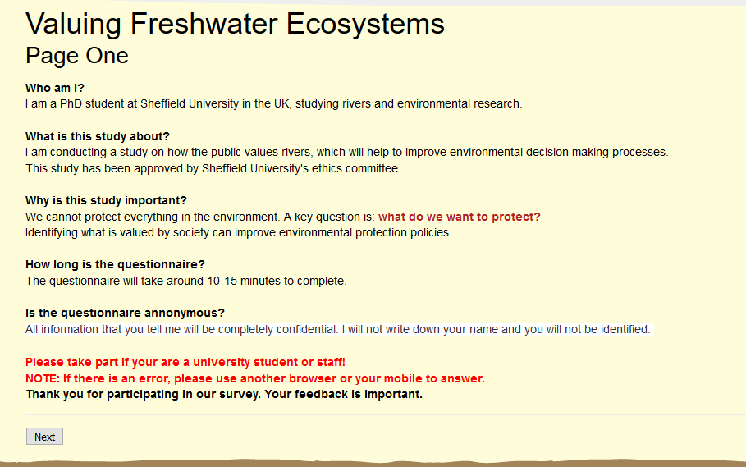
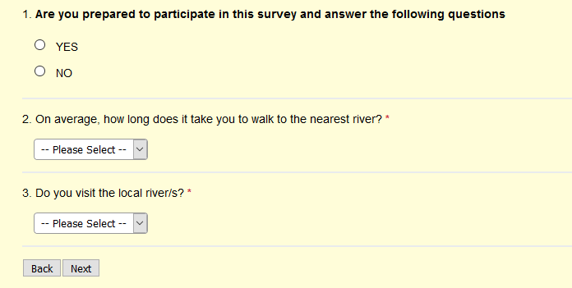
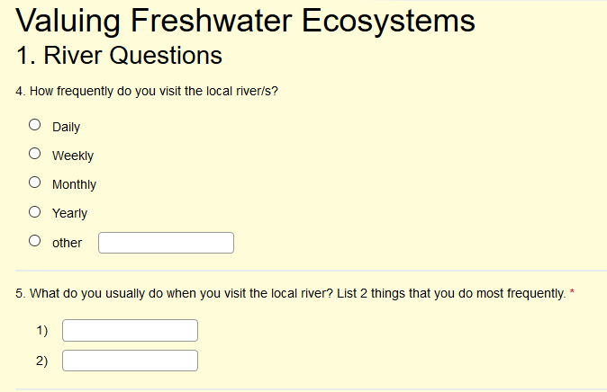
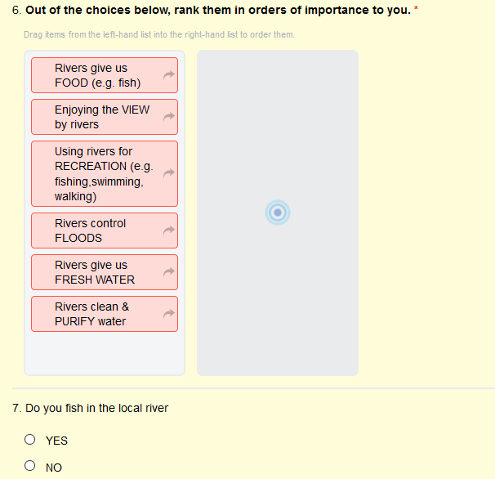
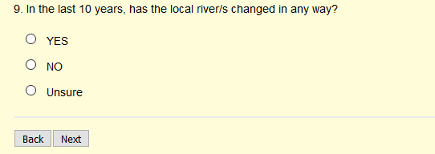
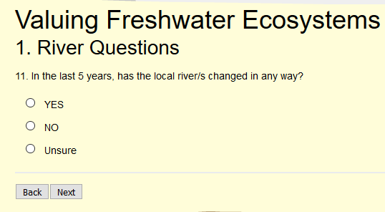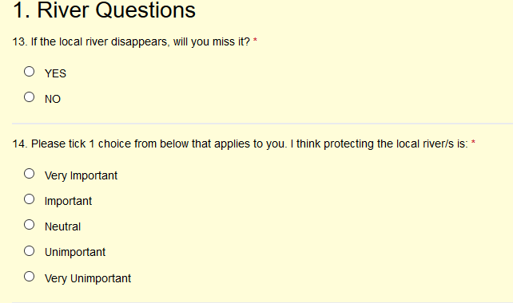
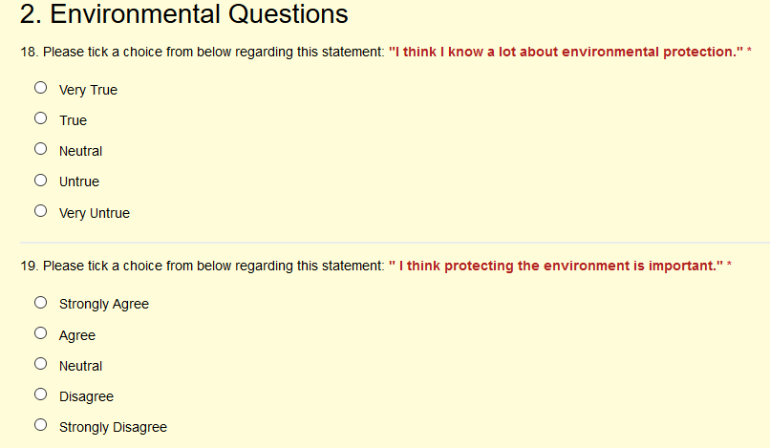
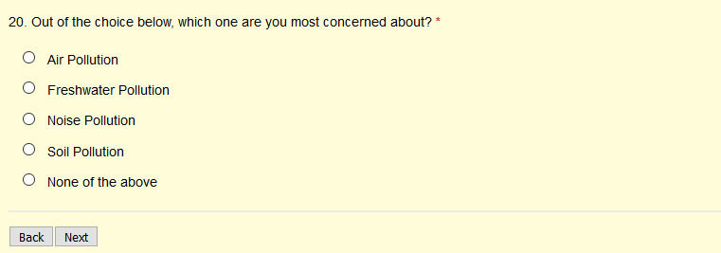
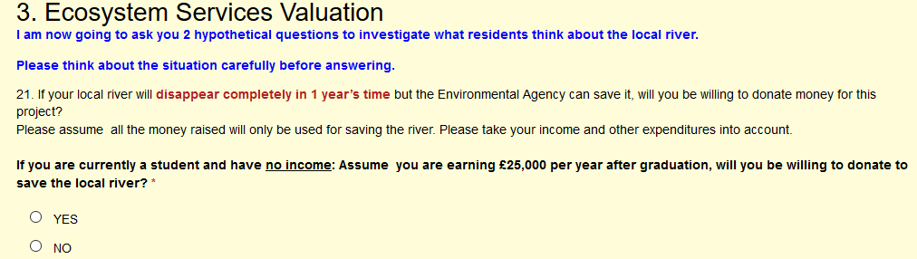
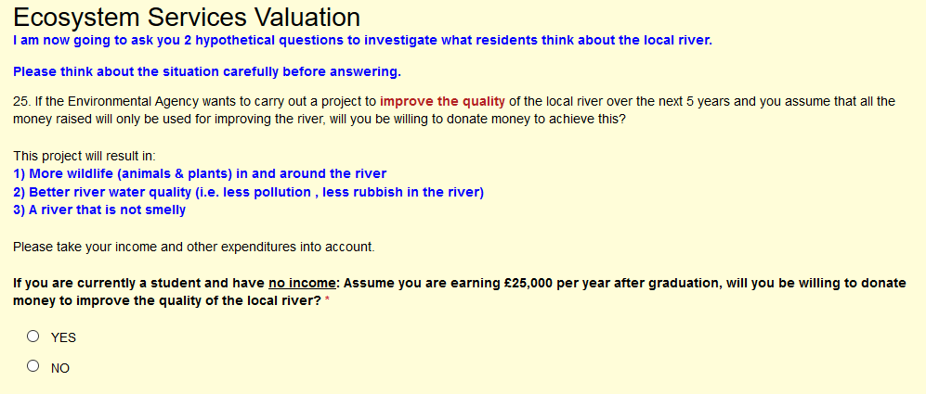
Appendix 3.1
Table: Fish species change from 1980 to 2006 as determined during historical surveys of Lake Tai (provided by Hong Ling Liu, Nanjing University, China).
Species found in 1986 | Species found in 2006
Acipenser sinensis
Macrura reetesii
Coilia ectenes | Coilia ectenes
Coilia ectenes taihuensis
Coilia brachygnathus | Coilia brachygnathus
Reganisalanx brachyrostratis
Protosalanx hyalocranius | Protosalanx hyalocranius
Neosalanx tanghahkeii taihuensis | Neosalanx tanghahkeii taihuensis
Neosalanx oligodontis | Neosalanx oligodontis
Anguilla japonica
Cyprinus carpio | Cyprinus carpio
Carassius auratus | Carassius auratus
Pseudorasbora parrva | Pseudorasbora parrva
Sarcocheilichtys siensis | Sarcocheilichtys siensis
Sarcocheilichtys nigripinnis | Sarcocheilichtys nigripinnis
Abbottina rivularis | Abbottina rivularis
Abbottina fukiensis
Saurogobio dabryi
Saurogobio dumerili
 | Squalidus noteas
Paracanthobrama guichenoti | Paracanthobrama guichenoti
Rhinogobio typus
Coreius heterodon
Gnathopogon argentatus
Gnathopogon sihuensis
Gnathopogon wolteisorffi
Hemibarbus maculatus | Hemibarbus maculatus
Hemibarbus labeo | Hemibarbus labeo
Aphyocypris chinensis
Elopichthys bambusa | Elopichthys bambusa
Opsariichthys uncirostris bidens
Squaliobarbus curriculus | Squaliobarbus curriculus
Ochetobibus elongatus
Mylopharyngodon piceus | Mylopharyngodon piceus
Ctenopharyngodon idellus | Ctenopharyngodon idellus
Toxabramis swinhonis | Toxabramis swinhonis
Parabramis pekinensis
 | Pseudobrama simoni
Megalobrama amblycephala | Megalobrama amblycephala
Megalobrame terminalis
Hemicculter leuciclus | Hemicculter leuciclus
Hemiculter bleekeri
Culter erythropterus | Culter erythropterus
Erythroculter ilishaeformis | Erythroculter ilishaeformis
Erythroculter mongolicus | Erythroculter mongolicus
Erythroculter dabryi
Erythroculter
Parapelecus argenteus
Parapelecus engraulis
Distoechodon tumirostris
Acanthobrama simoni
Plagiognathops microlepis
Xenocypris davidi
Xenocypris argentea
Acheilognathus
 | Acheilognathus gracilis
Acanthorhodeus macropterus | Acanthorhodeus macropterus
Acanthorhodeus barbatutus | Acanthorhodeus barbatutus
Acanthorhodeus tonkinensis | Acanthorhodeus tonkinensis
Acanthorhodeus taenianalis
Acanthorhodeus chankaensis
Pararsilurus fangi
Rhodeus sinensis
Rhodeus ocellatus
Rhodeus light | Rhodeus light
Aristichthys nobilis | Aristichthys nobilis
Hypohthalmichthys molitrix | Hypohthalmichthys molitrix
Sinilabeo decorus tungting
Myxocypriuus asiaticus
Cobitis taenia | Cobitis taenia
Botia xeaiithi
Botia wui
 | Paramisgurnus dabryanus
Misgurnus mizolepis
 | Pararhychobdella sinemsis
Misgurnus anguillicaudatus | Misgurnus anguillicaudatus
Pseudobagrus fulvidraco | Pseudobagrus fulvidraco
Pseudobagrus eupogon
Pseudobagrus nitidus
Leiocassis longirostris
Leiocassis ussuriensis
LeiocassisL albomargintus
LeiocassisL taeniatus
LeiocassisL adiposalis
Silurus asotus | Silurus asotus
Oryzias latipes
Hemirhamphus intermedius | Hemirhamphus intermedius
Mugil cephalus
Mugil soiuy
Monopterus albus | Monopterus albus
Siniperca scherzeri
Siniperca chuatsi | Siniperca chuatsi
Siniperca kneri
Lateolabrax japonicus | Lateolabrax japonicus
Hypseleotris swinhnonis | Hypseleotris swinhnonis
Odontobutis obscurus | Odontobutis obscurus
Odontamblyopus rubicundus
Ctenogobius giurinus | Ctenogobius giurinus
Ctenogobius cliffordpopei
Taenioides cirratus
Macropodus chinensis | Macropodus chinensis
Caltionymus olidus
Ophicephalus argus | Ophicephalus argus
Channa asiatica
Mastacembelus aculeatus
Trachidermus fasciatus
Cynoglessus graclfls
Cynoglossus trigrammus
Cynoglossus purpureomaculatus
Fugu obscurus
Fugu ocellatus

Appendix 4.1
Interview Location:
Interviewer name:
Opening statement: “I am a university student studying environmental research. I am conducting a study on Lake Tai and I would like to ask you some questions because you know more about the local environment than I do. I have a questionnaire that takes around 10-15 minutes to complete. All information that you tell me will be confidential. I will not write down your name and you will not be identified. I just want to learn more about the local environment from you.”

Are you prepared to participate in this survey and answer the following questions?
Y / N
1. Lake Questions
- Do you visit Lake Tai?
⃝ Y
⃝ N Go to Q8

- If Y, how often do you visit Lake Tai?
⃝ Daily basis
⃝ Weekly basis
⃝ Monthly basis
⃝ Yearly basis
⃝ Other_______________________________________________________

- List 2 things that you do most frequently when you visit Lake Tai?
⃝____________________________________________________________
⃝____________________________________________________________

- On average, how long does it take for you to walk to Lake Tai?
⃝ <10 mins
⃝ 10 – 20 mins
⃝ 21-30 mins
⃝ 31- 40 mins
⃝ 41- 50 mins
⃝ 51-60 mins
⃝ > 60 mins
⃝ Unsure

- Do you wash clothes in Lake Tai? ⃝Y ⃝ N
If Y, why?
______________________________________________________________________________________________________________________________

- Do you go fishing in Lake Tai? ⃝Y ⃝ N
If Y, do you:
⃝ Fish for food?
⃝ Only carry out recreational fishing?
⃝ Other__________________________________________________________

- In the last 10 years, has Lake Tai changed in any way? ⃝Y ⃝ N
If Y, how has it changed?
_______________________________________________________________

- In the last 5 years, has Lake Tai changed in any way? ⃝Y ⃝ N
If Y, how has it changed?
_______________________________________________________________

- If Lake Tai disappears completely, will you miss it? ⃝Y ⃝ N
If Y, why?
_______________________________________________________________

- Please tick 1 choice from below that applies to you. “I think protecting Lake Tai is:”
⃝ Very Important
⃝ Important
⃝ Neutral
⃝ Unimportant
⃝ Very unimportant
Why?__________________________________________________________

- Are you satisfied with how Lake Tai is being protected currently?
⃝ Very Satisfied
⃝ Satisfied
⃝ Neutral
⃝ Dissatisfied
⃝ Very dissatisfied
Why?__________________________________________________________

2. Ecosystem Services Valuation
- a) Out of the choices below, rank them in orders of importance to you (1= Most important, 6=Least important).
⃝ Lake Tai give us FOOD (e.g. fish, crabs, prawns, edible plants)
⃝ Lake Tai give us FRESH WATER
⃝ Using Lake Tai for RECREATION (e.g. fishing, swimming, walking)
⃝ Lake Tai is a CULTURAL heritage site (Buddhist temples, origin of Wu-Yue culture)
⃝ Lake Tai controls FLOODS
⃝ Lake Tai regulates the CLIMATE (cooling effects in the summer)
Now I am going to ask you 2 hypothetical questions to investigate how you value Lake Tai. Please think about the situation carefully before answering.

- In Q10, you have chosen (insert service chosen as Number 1) as the most important. Will you be willing to donate money towards a project that will protect this and prevent it from disappearing?
This project will be overseen by the Ministry of Environmental Protection.
Assume that all the money raised will only be used for saving (insert service chosen).
Please take your income and other expenditures into account.
⃝Y Go to Q12 ⃝ N Go to Q13

- i) If Y, are you willing to pay X % from your income per year for the next 5 years? Please take your income and other expenditures into account.
(Begin at 30%, if N then reduce to 20%, 10%, 5%, 1% and <1% respectively)
_______________________________________________________________

ii) If Y, what influenced your decision to pay money?
_______________________________________________________________

iii) On a scale of 1-5, you are ________about your answer
Not confident 1 2 3 4 5 Very confident

- If N, why are you unwilling to pay?
_______________________________________________________________

- If the Ministry of Environmental Protection wants to carry out a project to improve the quality of Lake Tai over the next 5 years, will you be willing to donate money to achieve this?
This project will result in:
1) More wildlife (animals & plants) in and around the lake
2) Better water quality (i.e. less pollution , less rubbish)
3) A lake that is not smelly
Assume that all the money raised will only be used for improving Lake Tai.
Please take your income and other expenditures into account.
⃝Y Go to Q15 ⃝ NGo to Q16

- i) If Y, are you willing to pay X % from your income per year for the next 5 years? Please take your income and other expenditures into account. (Begin at 30%, if N then reduce to 20%, 10%, 5% ,1% and <1%respectively)
_______________________________________________________________

ii) If Y, what influenced your decision to pay money?
_______________________________________________________________

iii) On a scale of 1-5, you are ________about your answer
Not confident 1 2 3 4 5 Very confident

- If N, why are you unwilling to pay?
_______________________________________________________________

3. Environmental Questions
- Please tick a choice from below regarding this statement: "I think I know a lot about environmental protection."
⃝ Strongly agree
⃝ Agree
⃝ Neutral
⃝ Disagree
⃝ Strongly disagree

- Please tick a choice from below regarding this statement: “I think protecting the environment is important."
⃝ Strongly agree
⃝ Agree
⃝ Neutral
⃝ Disagree
⃝ Strongly disagree

- Out of the choices below, which one are you most concerned about?
- Air pollution
- Noise pollution
- Soil Pollution
- Freshwater pollution
- Other_______________________________________________________

4. Background Questions
- Gender : ⃝ M ⃝ F

- Age:

- Maximum education level:
- Primary school & below
- Secondary school
- Sixth form/ College
- Undergraduate degree
- Post-graduate degree and above

- Occupation:

- What is your average income per month?
- <1000 RMB
- 1000-2000 RMB
- 2001-3000 RMB
- 3001-4000 RMB
- 4001-5000 RMB
- 5001-6000 RMB
- 6001-7000 RMB
- 70001-8000 RMB
- >8000 RMB

- How many years have you lived in your current home?

Appendix 5.1
Macroinvertebrate acute toxicity data for chlorpyriphos.
Species | mean LC50 (ug/L)
Aedes aegypti | 33.3
Aedes albopictus | 3.3
Aedes cantans | 1.1
Aedes communis | 1.2
Aedes dorsalis | 5
Aedes excrucians | 3.3
Aedes punctor | 2.7
Anopheles albimanus | 8
Anopheles freeborni | 1.85
Anopheles gambiae | 1.4
Belostoma sp | 15
Berosus styliferus | 9
Chaoborus americanus | 1.29
Chaoborus punctipennis | 5.4
Chironomus crassicaudatus | 52
Chironomus decorus | 17.8
Chironomus tepperi | 1.3
Chironomus utahensis | 1.2
Claassenia sabulosa | 1.19
Corixa punctata | 3.31
Cricotopus sp | 75.5
Crocothemis erythraea | 5.8
Culex quinquefasciatus | 2.17
Culex tarsalis | 2
Culicoides variipennis | 3.36
Culiseta annulata | 3.5
Cyprinotus incongruens | 10
Daphnia magna | 3.62
Dicrotendipes californicus | 7
Gammarus lacustris | 44
Glyptotendipes paripes | 12
Hydrophilus triangularis | 20
Hygrotus sp | 40
Laccophilus decipiens | 4.6
Laccophilus fasciatus | 2.1
Neoplea striola | 1.22
Notonecta undulata | 35.2
Orconectes immunis | 6
Pteronarcys californica | 14
Simulium vittatum | 27
Thermonectus basillaris | 6
Toxorhynchites moctezuma | 20
Triops longicaudatus | 4
Tropisternus lateralis | 8

Appendix 5.2
Macroinvertebrate acute toxicity data for copper.
Species | mean LC50 (ug/L)
Acroneuria lycorias | 10242
Alona affinis | 386.3
Amnicola sp. | 900
Anodonta imbecilis | 105.3
Campeloma decisum | 1877.4
Ceriodaphnia reticulata | 5.2
Cherax destructor | 1254.7
Chironomus decorus | 833.6
Chironomus riparius | 247.1
Chironomus tentans | 197.2
Corbicula malinensis | 7184.8
Corbiculina australis | 5115.3
Crangonyx pseudogracilis | 1290
Cypris subglobosa | 115.8
Daphnia ambigua | 24.8
Daphnia magna | 18.1
Daphnia parvula | 26.4
Daphnia pulex | 8.8
Daphnia pulicaria | 9.3
Daphnia rosea | 69
Gammarus pseudolimnaeus | 22.1
Gammarus pulex | 21
Goniobasis livescens | 166.2
Gyraulus circumstriatus | 56.2
Limnodrilus hoffmeisteri | 53.1
Lophopodella carteri | 135
Lumbriculus variegatus | 242.7
Macrobrachium sp. | 204.4
Moina dubia | 19.2
Oronectes rusticus | 1397.3
Paratya australensis | 94
Physa heterostropha | 35.9
Physa integra | 43.1
Procambarus clarkii | 1989.6
Simocephalus serrulatus | 95.9
Tropocyclops prasinus mexicanus | 516.9
Tubifex tubifex | 32.7
Velesunio angasi | 19531.1

Appendix 5.3
Macroinvertebrate acute toxicity data for LAS.
Species | mean LC50 (ug/L)
Aedes aegypti | 9800
Agapetus fuscipes | 14400
Anodonta cygnea | 200000
Asellus sp. | 81300
Branchiura sowerbyi | 4500
Campeloma decisum | 27000
Ceriodaphnia sp. | 5300
Chironomus riparius | 9900
Chironomus tentans | 12900
Chironomus thummi | 2800
Daphnia magna | 2800
Daphnia pulex | 8600
Dero sp. | 1700
Dugesia bengalensis | 1800
Ecdyonurus dispar | 3900
Erpobdella octoculata | 7800
Gammarus pseudolimnaeus | 7000
Gammarus pulex | 6295.062
Goniobasis sp. | 42200
Hyalella azteca | 3500
Hydropsyche angustipennis | 62200
Isonychia sp. | 5300
Leuctra sp. | 2800
Limnodrilus hoffmeisteri | 1900
Lumbriculus variegatus | 1900
Paratanytarsus parthenogeneticus | 23000
Physa integra | 9000
Planaria sp. | 1800
Polycelis tenticulata | 1800
Rhabditis sp. | 16000
Rhithrogena semicolorata | 4300
Rhyacophila dorsalis | 13500
Simocephalus vetulus | 30000
Unio elongatulus | 182500

Appendix 5.4
Macroinvertebrate acute toxicity data for pentachlorophenol.
Species | mean LC50 (ug/L)
Hirudo medicinalis | 5000
Plectus communis | 4981.68
Cephalobus persegnis | 2557.44
Rhabditis sp. | 2424.24
Brachionus plicatilis | 1930
Lumbriculus variegatus | 1485.93
Brachionus calyciflorus | 1283.42
Tylenchus elegans | 1198.8
Sphaerium novaezelandiae | 1100
Dorylaimus stagnalis | 959
Aporcelaimellus obtusicaudatus | 959
Viviparus bengalensis | 735.5
Hydra oligactis | 730
Corbicula manilensis | 632.5
Tobrilus gracilis | 506.2
Limnodrilus hoffmeisteri | 500
Gillia altilis | 493
Helisoma trivolvis | 400
Lymnaea stagnalis | 366.61
Dugesia tigrina | 320
Erpobdella octoculata | 250
Physa gyrina | 220
Lymnaea acuminata | 160
Brachionus rubens | 160
Aplexa hypnorum | 142
Biomphalaria glabrata | 134.16
Prionchulus punctatus | 133.2
Dugesia lugubris | 130
Lymnaea luteola | 112
Dreissena polymorpha | 52
Mysis relicta | 54100
Ischnura elegans | 42000
Culex pipiens | 34000
Tanytarsus dissimilis | 28031.45
Culex tritaeniorhynchus | 20900
Corixa punctata | 11000
Aedes aegypti | 7200
Cypris subglobosa | 6560
Cloeon dipterum | 5900
Asellus intermedius | 3200
Asellus racovitzai | 2370
Tanais stanfordi | 1800
Ceriodaphnia pulchella | 1790
Daphnia cucullata | 1500
Callibaetis skokianus | 1300
Philarctus quaeris | 1260
Pteronarcys dorsata | 1210
Streptocephalus texanus | 1040
Daphnia carinata | 782.32
Asellus aquaticus | 761.58
Gammarus pulex | 700
Daphnia pulex | 686.33
Pontoporeia hoyi | 600
Daphnia magna | 444.57
Streptocephalus rubricaudatus | 430
Nemoura cinerea | 380
Chironomus thummi | 333.66
Gammarus pseudolimnaeus | 309.42
Ceriodaphnia dubia | 288.8
Ceriodaphnia reticulata | 280.8
Deleatidium sp. | 218.8
Gammarus fasciatus | 210
Crangonyx pseudogracilis | 170
Streptocephalus torvicornis | 170
Simocephalus serrulatus | 167.86
Mesocyclops leuckarti | 138
Boeckella delicata | 126
Calamoecia lucasi | 52
Parastenocaris germanica | 34

