Jennifer Anne Campbell
Is pancreatic exocrine insufficiency an underrecognised diagnosis?

Supervisors: Dr Andrew Hopper, Prof David Sanders, Prof Nigel Hoggard

Statement of Probity
I confirm that I shall abide by the University of Sheffield’s regulations on plagiarism and that all written work shall be my own and will not have been PLAGIARISED from other paper-based or electronic sources. Where used, material gathered from other sources will be clearly cited in the text.

Signature: ……………………………………………
Date: ……………………………………

Name: ……………………………………………………………………………………..

Acknowledgements
I wish to thank my supervisors for their support, encouragement and constructive criticism provided during my MD; Dr Andy Hopper, Prof David Sanders and Prof Nigel Hoggard. I wish to acknowledge Prof Simon Cross for support with histology images and Dr James Hampton and Dr Ragu Vinagayam for assistance with cross-sectional imaging. I also wish to acknowledge Dr Matthew Kurien for his friendship and advice given throughout my studies, also my father’s proof reading skills have been invaluable. Finally, I wish to thank my husband, Richard Warley, has for his love and support over the two years of study, during which time we have got married and had our first child, Theo.

Abstract
The prevalence of pancreatic exocrine insufficiency (PEI) has been estimated at 11.5% of population in adults aged 50-75 years old. Advanced disease can present with weight loss and malnutrition but early features may be subtle, for example diarrhoea, abdominal discomfort or bloating. These symptoms may not trigger screening for pancreatic dysfunction in routine clinical practice. The implications of a missed diagnosis of PEI include osteoporosis, malnutrition, chronic pain and increased morbidity. In some cases, patients may present with exocrine insufficiency due to underlying malignancy which requires identification and treatment.

PEI is easily screened for using faecal elastase-1 (FEL-1) in stool samples. Current recommendations from the British Society of Gastroenterology advocate checking pancreatic function in patients presenting with diarrhoea and other abdominal symptoms. FEL-1 is the most widely available test of pancreatic function and broadly speaking is acceptable to patients.

Data from post mortem studies assessing the prevalence of chronic pancreatitis (CP) in the general population estimate between 6 and 12% of individuals may be affected. CP is significantly associated with development of PEI. The risk of developing PEI increases with duration of disease.

The null hypothesis set out is: PEI is adequately recognized. This body of work aims to quantify the prevalence of chronic pancreatitis with a novel method- post mortem computed tomography. I will then examine the prevalence of PEI in secondary care and primary care. Finally, I will assess whether elastography can be employed to test for CP and predict PEI.

The following four studies will form the body of this thesis:

Study 1: What is the prevalence of chronic pancreatitis using “Digital Autopsy”- a novel study using post mortem computed tomography
Study 2: What is the prevalence of pancreatic exocrine insufficiency in secondary care?
Study 3: What is the prevalence of pancreatic exocrine insufficiency in primary care?
Study 4: What is the accuracy of endoscopic ultrasound elastography as a test for chronic pancreatitis?

Table of Contents
Acknowledgements 2
Abstract 3
Table of Contents 5
List of Tables 9
List of Abbreviations 10
CHAPTER 1: Overview of pancreatic exocrine insufficiency and chronic pancreatitis 11
1.0 Introduction 12
1.1 Normal pancreatic exocrine function & physiology 12
1.2 Pancreatic exocrine insufficiency 14
1.2.1 Pancreatic exocrine insufficiency- causes and prevalence 14
1.2.2 Pancreatic exocrine insufficiency: clinical presentation 18
1.2.3 Pancreatic exocrine insufficiency: diagnosis 19
1.3 Chronic pancreatitis 22
1.3.1 Chronic pancreatitis: prevalence 22
1.3.2 Chronic pancreatitis: causes and risk factors 24
1.3.2 Chronic pancreatitis: clinical presentation 26
1.3.3 Chronic pancreatitis: diagnosis 28
1.4 Pancreatic exocrine insufficiency and chronic pancreatitis 42
1.5 Consequences of pancreatic exocrine insufficiency and chronic pancreatitis 44
1.5.1 Malnutrition 44
1.5.2 Osteoporosis and reduced bone mineral density 45
1.5.3 Quality of life 46
1.5.4 Pancreatic cancer 47
1.6 Conclusions 47
1.7 Aims of this thesis 48
1.8 Patient recruitment and methodology 49
1.9 Extent of assistance 50
CHAPTER 2: What is the prevalence of chronic pancreatitis at post mortem? A novel study using “digital autopsy” 51
2.1 Summary 52
2.2 Introduction 53
2.3 Methods 55
2.4 Results 57
2.5 Discussion 61
CHAPTER 3: What is the prevalence of exocrine pancreatic insufficiency in secondary care? A dual centre study 66
3.1 Summary 67
3.2 Introduction 68
3.3 Methods 69
3.4 Results 70
3.5 Discussion 75
CHAPTER 4: What is the prevalence of exocrine pancreatic insufficiency in primary care? 83
4.1 Summary 84
4.2 Introduction 85
4.3 Methods 86
4.4 Results 87
4.5 Discussion 92
CHAPTER 5: What is the accuracy of endoscopic ultrasound elastography as a test for chronic pancreatitis? 98
5.1 Summary 99
5.2 Introduction 100
5.3 Methods 102
5.4 Results 106
5.5 Discussion 111
CHAPTER 6: Summary, conclusions and future directions 115
6.1 Are chronic pancreatitis and pancreatic exocrine insufficiency under recognised? 116
6.2 A shift in understanding: The relationship between chronic pancreatitis and pancreatic exocrine insufficiency 117
6.3 Is endoscopic ultrasound- elastography useful in the diagnosis of chronic pancreatitis? 120
6.4 Future Directions 120
Appendix 1- Publications, abstracts and prizes 122
Appendix 2- Patient information sheet 125
Appendix 3- Consent form 130
Appendix 4- Data collection sheet 131
References 132

List of figures
Figure 1.1 | Primary and secondary causes of pancreatic exocrine insufficiency
Figure 1.2 | Differential diagnosis of chronic pancreatitis
Figure 1.3 | Haemotoxylin and eosin stained section of chronic pancreatitis with atrophic glands set in densely fibrous stroma with some residual endocrine cell islets
Figure 1.4 | Plain abdominal xray showing pancreatic calcification in the upper abdomen
Figure 1.5 | Complications of chronic pancreatitis
Figure 1.6 | Axial computed tomography images demonstrating characteristic features of chronic pancreatitis
Figure 1.7 | Magnetic resonance imaging changes of chronic pancreatitis
Figure 1.8 | Normal endoscopic ultrasound appearances of pancreas
Figure 1.9 | Application of Rosemont criteria
Figure 1.10 | Split screen elastography images of normal pancreatic tissue
Figure 1.11 | Endoscopic ultrasound image showing normal tail of pancreas and elastography overlay
Figure 2.1 | iGene digital autopsy facility, Sheffield
Figure 2.2 | Non- pancreatic post mortem computed tomography images
Figure 2.3 | Post mortem computed tomography changes affecting the pancreas
Figure 2.4 | Graph demonstrating increasing frequency of chronic pancreatitis change with increasing age
Figure 5.1 | Tips of three conventional endoscopes
Figure 5.2 | Enrolment pathway for elastography study
Figure 5.3 | Graph showing relationship between number of Rosemont features of chronic pancreatitis and average strain ratios
Figure 5.4 | Receiver operating characteristic curve of endoscopic ultrasound- elastography for diagnosis of chronic pancreatitis
Figure 6.1 | Evolving concepts in pancreatic disease

List of Tables
Table 1.1 | Causes and mechanisms of pancreatic exocrine insufficiency
Table 1.2 | Prevalence of pancreatic exocrine insufficiency in high risk subgroups
Table 1.3 | Sensitivity and specificity of faecal elastase-1 and faecal chymotrypsin compared to gold standard secretin-caerulin
Table 1.4 | Prevalence of chronic pancreatitis
Table 1.5 | TIGAR-O classification of chronic pancreatitis
Table 1.6 | Modified Cambridge classification for chronic pancreatitis
Table 1.7 | Rosemont criteria for diagnosis of chronic pancreatitis
Table 1.8 | Summary of literature assessing prevalence of pancreatic exocrine insufficiency in chronic pancreatitis patients
Table 2.1 | Reasons for excluding scans from analysis
Table 2.2 | Observed features suggestive of chronic pancreatitis in 356 post mortem computed tomography scans
Table 3.1 | Prevalence of low faecal elastase-1 by symptom
Table 3.2 | Prevalence of low faecal elastase-1 by co-morbidity
Table 4.1 | Faecal elastase-1 results for primary and secondary care groups
Table 4.2a | Primary care indication for faecal elastase-1 testing
Table 4.2b | Secondary care indication for faecal elastase-1 testing
Table 4.3 | Comorbidity analysis for primary and secondary care
Table 5.1 | Inclusion and exclusion criteria for endoscopic ultrasound- elastography recruitment
Table 5.2 | Breakdown of aetiology of chronic pancreatitis in study group
Table 5.3 | Strain ratios in head, body and tail of pancreas in control patients and those with chronic pancreatitis
Table 5.4 | Accuracy of endoscopic ultrasound- elastography in the diagnosis of chronic pancreatitis

List of Abbreviations
AUC- Area under curve  BMD- Bone mineral density  BSG- British Society of Gastroenterology  CCK- cholecystokinin  CP- chronic pancreatitis  CBD- common bile duct  CF- cystic fibrosis  CT- computed tomography  DXA- Dual-energy x-ray absorption  ERCP-Endoscopic retrograde cholangiopancreatography  EUS- Endoscopic ultrasound  EUS-E Endoscopic ultrasound elastography  FEL-1 Faecal elastase-1  FNA- Fine needle aspiration  GP- General Practitioners  IBD- Inflammatory bowel disease | HIV- Human Immunodeficiency Virus  MRCP-Magnetic resonance cholangiopancreatography  MRI- Magnetic resonance imaging  NICE- National Institute for Clinical Excellence  MPD- Main pancreatic duct  OR- odds ratio  PEI- Pancreatic exocrine insufficiency  PERT- Pancreatic enzyme replacement therapy  PI- principle investigator  PMCT- post mortem computed tomography  ROC- Receiver operating characteristic  ROI- region of interest  S-MRCP- Secretin stimulated magnetic resonance cholangiopancreatography  T1DM- Type 1 diabetes mellitus  T2DM- Type 2 diabetes mellitus  US- Ultrasound

CHAPTER 1: Overview of pancreatic exocrine insufficiency and chronic pancreatitis

1.0 Introduction
The pancreas is critical for maintenance of physiological digestion and metabolism. This chapter will explore normal pancreatic exocrine function and exocrine insufficiency. Pancreatic exocrine insufficiency (PEI) has been described as “the alteration of pancreatic function leading to maldigestion” (1) and “reduction in pancreatic enzyme activity in the intestinal lumen to a level that is below the threshold required to maintain normal digestion” (2). It occurs in response to loss of pancreatic parenchyma, main pancreatic duct obstruction, decreased hormonal stimulation and inactivation of enzymes (3). It is widely accepted that steatorrhoea is a late presentation of PEI (4) which means there is may be a subtle prodromal phase of non-specific symptoms and development of malnutrition which could be difficult to detect prior to the onset of classical symptoms.

Consequences of PEI include maldigestion and impaired nutrient absorption which together form a malabsorption syndrome (5, 6). Deficiencies of fat-soluble vitamins and micronutrients can manifest. Other significant consequences of PEI associated malnutrition include osteoporosis, low-trauma fractures, cardiovascular problems and increased susceptibility to infection (7, 8). Patients with malnutrition complicating PEI are likely to experience pain (9). The consequences of PEI can be minimized with early diagnosis and implementation of pancreatic enzyme replacement therapy (PERT). PERT can also improve patients’ quality of life (QOL) (10).

1.1 Normal pancreatic exocrine function & physiology
The pancreas is a glandular organ situated in the upper abdomen. It can be divided into three anatomical areas- tail, body and head. It is comprised of functional units termed tubuloacinar glands which lie along its length and are responsible for producing exocrine secretions. Secretions are channelled through a system of drainage ducts; firstly, intercalated ducts then interlobar ducts and then into the main pancreatic duct (MPD). The MPD delivers secretions to the duodenum via the ampulla of Vater. Pancreatic secretions contain two different substances, firstly, an enzyme-rich fluid and secondly, an isotonic aqueous fluid, rich in bicarbonate ions. Pyramidal epithelial cells (acinar cells) secrete digestive enzymes in pancreatic fluid (amylase, trypsin and lipase amongst others). Centro-acinar cells of the upper ducts produce bicarbonate-rich fluid to neutralize chyme entering the duodenum from the stomach. Bicarbonate-rich fluid is continuously secreted, but production can be increased 14 fold in response to a meal (11).

The mechanisms by which pancreatic fluid is secreted during a meal can be classified in three stages- cephalic, gastric and intestinal. When food enters the mouth, the cephalic phase begins. The impending meal stimulates vagal cholinergic fibres and results in enzyme production from acinar cells. The fluid contains little bicarbonate. Arrival of a food bolus into the stomach stimulates G cells to release gastrin thus augmenting pancreatic enzyme and bicarbonate secretion. The intestinal phase is the most significant, occurring when food enters the first part of the duodenum. Lipids and peptides stimulate release of cholecystokinin (CCK) into the circulation; enzymes are secreted by the acinar cells in response. The effect of CCK is potentiated by secretin occurring in response to acidic chyme from the stomach (11).

1.2 Pancreatic exocrine insufficiency

1.2.1 Pancreatic exocrine insufficiency- causes and prevalence
There are several mechanisms that lead to the development of PEI. They can be classified as diseases affecting the pancreatic parenchyma, ductal blockages obstructing flow of secretions, decreased stimulation of pancreatic tissue and disruption of normal anatomy and motility. The causes of PEI are summarised in table 1.1.

Table 1.1 Causes and mechanisms of pancreatic exocrine insufficiency
Mechanism | Causes
Impairment or loss in production | Chronic pancreatitis  Pancreatic surgery  Cystic fibrosis  Diabetes mellitus
Normal pancreas, decreased duodenal enzyme delivery | Pancreatic malignancy with ductal obstruction  MPD obstruction- malignancy at ampulla  Coeliac disease: ↓CCK secretion  Zollinger-Ellison: deactivation of enzymes due to ↓pH
Abnormal anatomy or motility | Gastric surgery  Short bowel syndrome  Inflammatory bowel disease (Crohn’s)

Causes of PEI can also be classified into primary and secondary aetiologies. These are summarized in figure 1.1. Overlap can exist in the causative mechanisms responsible for PEI and also between primary and secondary aetiologies.
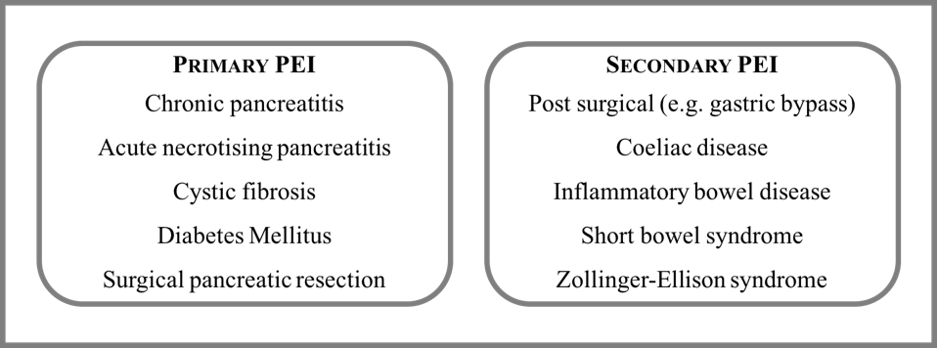
Figure 1.1: Primary and secondary causes of pancreatic exocrine insufficiency

The pancreas has a large reserve capacity and clinical steatorrhoea may not be detected until at least 90% of pancreatic acinar function is lost (4). PEI is most commonly seen in chronic pancreatitis (CP) where between 50-80% of exocrine function can be lost in comparison with healthy individuals (12). It is also common in severe acute pancreatitis (12% of patients low FEL-1 (13) and necrotising pancreatitis (up to 90% (14)). Up to 85% of cystic fibrosis (CF) patients develop PEI (15) and routine screening is established in the CF population. Although survival into adulthood for CF patients is becoming increasingly common, most CF literature is in the paediatric field and will not be included further in this work.

Pancreatic cancer causing ductal obstruction can result in PEI (16) and altered anatomy following pancreatic and gastric surgery commonly results in exocrine dysfunction (17, 18). Patients with diabetes (both type 1 and type 2) have high rates of PEI compared to the general population (19-22). Patients with human immunodeficiency virus (HIV) (23-25), coeliac disease (26-28) and inflammatory bowel disease (IBD) (29, 30) have been shown to be at increased risk of PEI (table 1.2).

Table 1.2: Prevalence of pancreatic exocrine insufficiency in high risk subgroups
Study | Year | Association | Patients | PEI Prevalence | Method
Angelini G et al. (29) | 1988 | IBD | 27 | 40.7% | Secretin-caerulin test
Maconi et al. (30) | 2006 | IBD | 200 | 18% | FEL-1 <200µg/g
Carroccio A et al. (26) | 1998 | Coeliac | 30 | 33% | FEL-1 <200µg/g
Walkowiak J et al. (27) | 2001 | Coeliac | 16 | 56.2% | FEL-1 <200µg/g
Leeds et al. (28) | 2005 | Coeliac | 209 | 14.8% | FEL-1 <200µg/g
Hardt PD et al. (19) | 2000 | Diabetes | 114 | 56.7% T1DM  35% T2DM | FEL-1 <200µg/g  FEL-1 <200µg/g
Icks et al. (22) | 2001 | Diabetes | 112 | 25.9% | FEL-1 <100µg/g
Hardt PD et al. (31) | 2003 | Diabetes | 1021 | 40.7%  22.9% | FEL-1 <200µg/g  FEL-1 <100µg/g
Nunes et al. (21) | 2003 | Diabetes | 42 | 36% | FEL-1 <200µg/g
Price DA et al. (24) | 2005 | HIV | 22 | 36.3% | FEL-1 <200µg/g
Martin et al. (23) | 2013 | HIV | 233 | 45% | FEL-1 <200µg/g
Yilmaz et al. (25) | 2017 | HIV | 100 | 32%  20% | FEL-1 <200µg/g  FEL-1 <100µg/g
Friess et al. (18) | 1996 | Post total gastrectomy | 12 | 100% | Secretin-caerulin test
IBD- inflammatory bowel disease, T1DM- type 1 diabetes mellitus, T2DM- type 2 diabetes mellitus, HIV- human immunodeficiency virus, IBS- irritable bowel syndrome

Whilst PEI is known to occur in certain disease states, there is relatively little data quantifying the prevalence of PEI in the general population. PEI has potential to be overlooked as a potential cause of symptoms in patients with irritable bowel syndrome (IBS). The British Society of Gastroenterology (BSG) recommends testing for exocrine pancreatic dysfunction in all adult patients with chronic diarrhoea and endorses the use of FEL-1 as an initial screening test (32).

A retrospective study by Emmanuel et al. assessing faecal biomarkers including FEL-1 in over 3500 patients with chronic gastrointestinal symptoms consistent with IBS reported 13.3% of patients had low FEL-1 levels (<200µg/g) (33). This study assessed patients’ symptoms retrospectively using a questionnaire and patients with symptoms fulfilling Rome III criteria for IBS were included. A second study reported FEL-1 results under 100µg/g in 6.1% of patients fulfilling Rome II criteria for IBS. Over 300 patients were included. Patients with diarrhoea predominant IBS (D-IBS) and low FEL-1 showed significant symptomatic benefit when treated with PERT (34). Both these studies support testing for PEI in patients with IBS symptoms, as the diagnostic yield is significant. If testing in routine clinical practice is not performed there is potential for a large group of IBS patients with PEI to remain undiagnosed.

It is accepted that pancreatic function declines with age. The largest study supporting this assessed 914 adults aged 50-75(35). Evidence of PEI, as defined by low FEL-1, was present in 11.5% of patients with covariate analysis showing FEL-1 levels declined with age (35). A second study of 159 adults aged 60-92 found 21.7% with evidence of PEI. Once more, FEL-1 levels were shown to correlate negatively with age (36). More recently, the association between increasing age and PEI has been shown in over 3500 adults with IBS tested with FEL-1. Only 9.2% of those under 50 had low FEL-1, low FEL-1 was found in 16.8% of 50-69 year olds and in 23.1% of those over 70 (33). These studies demonstrate positive association between PEI and increasing age.

Imaging techniques including ultrasound (US), but mainly computed tomography (CT) have demonstrated a correlation between increasing age and decreasing pancreatic volume (37, 38). The largest US study with 1000 recruits between 18-65 years showed a significant negative relationship between age and pancreatic size (37). Another large study which used CT to assess pancreatic volume from birth to 100 years described a linear increase in pancreatic volume which peaked between 20-60 years and declined thereafter (38). There have been some negative studies that did not support the link between advancing age and decline in pancreatic volume, however, these have been small and the data may not be so reliable (39, 40). Magnetic resonance imaging (MRI) has demonstrated fatty replacement of normal pancreatic tissue associated with increasing age (41) after the age of 40 years (42). Age-related decline in pancreatic function has been observed using dynamic CT in adults up to 75 years old (43). The changes seen with increasing age have been attributed to small vessel atherosclerosis (as in chronic kidney disease) (44, 45).

The results from studies of exocrine function and imaging suggest that decreasing pancreatic function with age, accompanied by structural change is common and can be seen in the absence of other gastrointestinal diseases. Failure to consider PEI as a cause of gastrointestinal symptoms in older adults could lead to under-diagnosis, leaving patients at risk of developing complications of PEI as well as impacting quality of life.

1.2.2 Pancreatic exocrine insufficiency: clinical presentation
Symptoms of PEI are variable but can include diarrhoea, offensive smelling stools, steatorrhoea, bloating, abdominal pain and weight loss. Clinical features of malnutrition and muscle wasting may also be present (2). Intestinal motility mediators are thought to be affected by a change in digestion and move nutrient absorption away from the proximal small intestine which could result in developing these symptoms (12). Diagnosing PEI early can be challenging due to the non-specific nature of symptoms and potential absence of abnormalities on imaging. “Compensated exocrine insufficiency” may exist in patients with mild to moderate PEI prior to the onset of steatorrhoea and malabsorption (12). These patients have subnormal enzyme activity but maintain normal digestive processes and should be identified early before complications develop. In early PEI patients may have subtle or non-specific symptoms that could fit diagnostic criteria for IBS- early testing with FEL-1 will minimise these patients being under-diagnosed.

1.2.3 Pancreatic exocrine insufficiency: diagnosis
In patients who present with features of severe PEI (weight loss, steatorrhoea, abdominal pain) and history and baseline imaging confirms structural pancreatic abnormalities consistent with CP, intensive testing of pancreatic function is deemed unnecessary and patients should be offered a trial of PERT (17, 46). However, where such profound features of malabsorption are absent, methods of assessing pancreatic function are necessary.

Tests of pancreatic function can be classified as direct and indirect methods. Direct tests involve hormonal stimulation of the pancreas and boast the greatest sensitivity and specificity. They are, however, time and labour intensive. The secretin-caerulin test is widely regarded as the gold standard direct test. Patients undergo duodenal intubation whilst supine. Intravenous secretin and caerulin are administered and pancreatic secretions are aspirated from the duodenum and analysed (47). This test is not readily accessible and there is little validation of normal values. The scope for further research with this test is limited due to its invasive nature and poor tolerability (48).

Other more acceptable methods to assess pancreatic function have been developed. Indirect tests involve ingestion of a labelled substance which is broken down by pancreatic juices (49). The labelled element (e.g. (¹³C-MTG)) is then measured in blood samples, exhaled air or urine; low levels suggest PEI. The limitations of these tests include malabsorption of the substrate in the presence of small intestinal or hepatic pathology which can affect results.

The coefficient of fat absorption test is regarded as the gold standard for diagnosing steatorrhoea seen in advanced PEI (3), though it is unattractive to both patients collecting samples and laboratory staff processing them. Patients must consume 100g fat/24 hours for 120 hours then collect complete stool of the last 72 hours of the test (50). The test is only useful for detecting advanced disease, and is not widely available and is mainly reserved for use in research settings.

To make PEI screening more accessible and acceptable, tests measuring pancreatic enzymes in faeces were developed. Initially faecal chymotrypsin measurement was trialled, but was slightly flawed as chymotrypsin from PERT could not be differentiated from endogenous enzymes in stool (51). Patients on PERT could, therefore, have normal faecal chymotrypsin levels despite having exocrine dysfunction if the test was conducted whilst taking enzyme supplements.

FEL-1 is an endogenous pancreatic enzyme that passes through the gut unchanged, which is unique in comparison to other pancreatic enzymes (52). Although elastase-1 constitutes just over 5% of pancreatic enzyme output it has been shown to reliably mirror production of more abundant pancreatic enzymes (53, 54) so is a useful surrogate for exocrine function. FEL-1 is a highly sensitive and specific marker of severe PEI although less robust in mild and moderate disease (Table 4). A German study found that FEL-1 was superior to faecal chymotrypsin in diagnosis of PEI in comparison to the secretin-caerulin test. 79 patients had the then standard secretin-caerulin test and results were compared with faecal chymotrypsin and FEL-1 values. It was this study that validated the use of FEL-1 (53). The data have been summarized in table 1.3.

Table 1.3: Sensitivity and specificity of faecal elastase-1 and faecal chymotrypsin compared to gold standard secretin-caerulin (53)
Degree of PEI | FEL-1 <100µg/g | FEL-1 <200µg/g | Chymotrypsin <3U/g (%)
Mild- Sensitivity % | 50 | 63 | 25
Moderate- Sensitivity % | 93 | 100 | 50
Severe- Sensitivity % | 96 | 100 | 86
Overall Sensitivity % | 86 | 93 | 64
Overall Specificity % | 98 | 93 | 89
PEI: pancreatic exocrine insufficiency, FEL-1: faecal elastase-1

A limitation of the FEL-1 assay is that stool samples should not be taken during acute diarrhoeal illnesses and should not be contaminated with urine or water from toilet basins. Dilution of the specimen can result in false positive results and over diagnosis of PEI. Manufacturers of FEL-1 assays advise repeating the stool sample in the event of diagnostic uncertainty or borderline results (55). This potential error in diagnosis can be reduced by centrifuging or drying the sample prior to analysis (34, 56).

Current BSG guidelines for investigation and management of chronic diarrhoea advocate FEL-1 measurement as an initial marker of pancreatic function due to its ease of availability and acceptability to most patients (32). Considering its availability, ease of use and straightforward, comprehensible results, FEL-1 is the most appropriate test of pancreatic function, even allowing for its shortfalls in mild PEI (47). Several assays are available, but the ScheBo® Pancreatic Elastase 1 assay manufactured by ScheBo Biotech AG is the most commonly cited.

1.3 Chronic pancreatitis

1.3.1 Chronic pancreatitis: prevalence
The reported prevalence of CP is variable with estimates ranging from 13.5- 52.4 per 100,000 population (57-62). There is a mismatch between the incidence and prevalence of CP. The expected prevalence of CP has been calculated at 120-143 per 100,000 of population based on an incidence of CP of 7.8 per 100,000 of population per year, assuming an average life expectancy of 20 years following diagnosis (58). This estimation of prevalence of CP greatly exceeds published data which have been summarized in table 1.4. This discrepancy between the observed prevalence of CP and its projected prevalence based on incidence suggests that CP is under-recognised and under-diagnosed.

Table 1.4 Prevalence of chronic pancreatitis
Study | Year | Country | Prevalence per 100,00 population
Dzieniszewski et al. (57) | 1982-7 | Poland | 17.0
Yadav et al. (60) | 1997-2006 | USA | 41.8
Levy et al. (58) | 2003 | France | 26.4
Wang et al. (59) | 2003 | China | 13.5
Hirota et al. (61) | 2007 | Japan | 52.4
Dominguez et al. (62) | 2011 | Spain | 49.3

  - 1.3.1.1 Post mortem prevalence
Studies assessing the prevalence of CP at post mortem report between that 5.3-13.0% of individuals showed changes consistent with CP at conventional autopsy (63, 64). The largest study reviewed over 3800 autopsy cases in a single centre and reported finding changes consistent with CP in 5.3% of non-diabetics and 11.2% of diabetics (64). Significantly more males were affected in the study than females. A second study of 394 consecutive autopsy specimens showed 13% had evidence of pancreatic inflammation (63).

More recently, 18 post mortem pancreas specimens (median age 65, range 52-87, 100% male) were scanned with endoscopic ultrasound (EUS) to assess for changes consistent with CP (65). They underwent standard histological assessment with 6 individuals showing evidence of autolysis. 11 non-autolyzed samples were analysed with EUS. 3 showed EUS changes consistent with CP (echogenic MPD, lobularity, echogenic foci or side branch dilatation). Overall, 72% (13/18) of patients showed evidence of CP. 10/11 showed histological evidence of CP (fibrosis, ductal proliferation) and EUS changes were shown to correlate with histopathological changes. Although this study reported high rates of CP, there were only 18 patients included which may affect the reliability of the results. The rates of CP changes noted were markedly higher than in other post mortem and in vivo prevalence studies (65).

Overall, there is a significant difference in the rates of CP detected at post mortem and in living subjects which suggests that there is a failure to diagnose patients with CP.

1.3.2 Chronic pancreatitis: causes and risk factors
CP is a progressive chronic condition characterised by irreversible fibrosis of the parenchyma with calcification of the MPD and its branches (66). Permanent and progressive damage leads to impairment of endocrine and exocrine function (60). There are multiple risk factors for CP which have been described using the TIGAR-O classification system (66). They are subdivided into toxic-metabolic (including alcohol and smoking), idiopathic, genetic, autoimmune, recurrent and severe acute pancreatitis and obstructive aetiologies (table 1.5). This body of work will concentrate on smoking and alcohol as modifiable risk factors for CP. There is potential for patient education in these areas which could change the course of CP and lessen patient symptoms (67).

Table 1.5: TIGAR-O classification of chronic pancreatitis (66)
Toxic-metabolic
Alcohol
Tobacco smoking
Hypercalcaemia
Chronic renal failure
Medication (azathioprine, tetracycline, valproate, oestrogens)
Idiopathic
Early onset
Late onset
Tropical
Genetic
Autosomal dominant
Autosomal recessive (cystic fibrosis)
Autoimmune
Isolated autoimmune chronic pancreatitis
IgG4 disease
Syndromic associations (Sjögren’s, inflammatory bowel disease, primary biliary cirrhosis)
Recurrent and severe acute pancreatitis
Post necrotic and severe acute pancreatitis
Post radiotherapy
Ischaemia
Obstructive
Pancreatic divisum
Duct obstruction (tumour or stones)

Smoking and excessive alcohol consumption have been implicated as causative factors in 75% of cases of CP (62). Cigarette smoking has been shown to be “an independent, dose-dependent risk factor for CP”; with odds ratio (OR) of 1.5 associated with smoking less than 12 pack years. The OR of CP increases to 8.34 with a history of greater than 35 pack years smoking (68). Other studies have shown dose related relationships between smoking and risk of CP (OR 1.65 >100 cigarettes per lifetime, OR 1.8 current smokers, OR 1.87 >1 pack per day) (69). Smoking has also been shown to accelerate the progression from acute to chronic pancreatitis (70) and is associated with early presence of calcification (71) and increased mortality (72).

The association between CP and alcohol consumption is widely reported and recognised. The North American Pancreatitis Study 2 reported 12.2% of CP patients were “at risk drinkers” (73). It has also been shown by Yadav et al. that very heavy drinking (>35 drinks per week) was an independent risk factor for CP compared to light drinking (<3 drinks per week) or complete abstinence (OR 3.10) (68). Unfortunately, Yadav’s paper does not define how much alcohol constitutes one “drink”. The speed at which CP progresses is linked to continued exposure to alcohol and tobacco smoking (74). It is imperative that as well as smoking cessation advice, patients are also advised on importance of avoiding heavy drinking to minimize effects on the pancreas. Providing evidence based advice to young patients presenting with acute pancreatitis has the potential to reduce the number of individuals developing CP at a later stage in life.

1.3.2 Chronic pancreatitis: clinical presentation
The hallmark features of CP include relapsing, remitting epigastric pain that frequently radiates to the back. Pain may be seen in combination with features of malabsorption and malnutrition (75). Recognition of CP can be difficult in its early stages as there are other differential diagnoses that can manifest with similar presentations (figure 1.2) (76, 77). It is, therefore, essential that a rigorous diagnostic protocol is used in its diagnosis.

- Acute cholecystitis
- Biliary colic
- Acute pancreatitis
- Irritable bowel syndrome
- Peptic ulcer disease
- Pancreatic cancer
- Post-herpetic neuralgia
- Gastroparesis.
- Intestinal obstruction, ischaemia, or infarction
- Abdominal aortic aneurysm
- Thoracic radiculopathy
- Myocardial infarction
Figure 1.2: Differential diagnosis of chronic pancreatitis (77)

Some symptoms, such as upper abdominal pain, weight loss and loose stools, are not specific to CP and may be attributed to other diagnoses (77). Though the textbook description of epigastric pain radiating to the back is often present, the pain can also radiate to the flanks and be described differently in different patients. The duration and frequency of pain events can vary, but it is likely to worsen and intensify as the condition progresses (75).

CP can occasionally be diagnosed if a patient presents with jaundice resulting from biliary obstruction, or cholangitis due to inflammation in the head of pancreas with compression of the bile duct.

As the duration of CP diagnosis increases, so too does the probability of developing complications such as diabetes and PEI (78, 79). Those with CP are at increased risk of pancreatic cancer (80) and have increased mortality due to cardiovascular complications (81). 10-year survival is reduced by between 20-30% in CP patients compared to the general population so regular follow up is essential (82).

1.3.3 Chronic pancreatitis: diagnosis
Clinical suspicion of CP alone is inadequate to formulate a diagnosis of CP. The most specific method to confirm a diagnosis of CP is histological assessment, however, in routine clinical practice, this is rarely performed due to the invasive nature of the test and associated risks (76). The classical features of CP histologically include reduction in number of acinar cells, irregular interlobular fibrosis, infiltration of inflammatory cells, and relative preservation of intralobular ducts and islets (83) (Figure 1.3). There is wide intra-observer variability when assessing histology specimens due to limited consensus for grading and also that the distribution of CP can be patchy and therefore, could be missed on biopsy (84). A composite evaluation is most often employed, taking into account clinical history, risk factors, cross sectional imaging and assessment of pancreatic function (85). No single test provides diagnostic certainty, especially in the early course of disease.

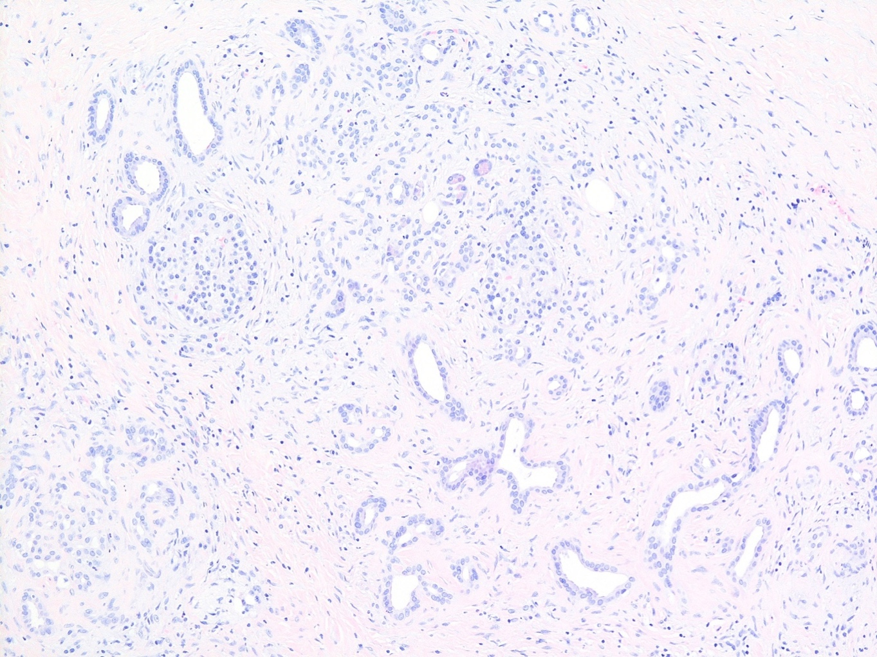
Figure 1.3: Haemotoxylin and eosin stained section of chronic pancreatitis with atrophic glands set in a densely fibrous stroma with some residual endocrine cell islets

  - 1.3.3.1 Radiology and pancreatic disease & function
In 1973, radiological features of CP viewed on plain abdominal films were described and it was suggested that pancreatic calcification was the most common detectable indicator of CP (86) (Figure 1.4). Pancreatic calcification may be seen in 30% of patients with CP although is not diagnostic (87). There have been significant developments in pancreatic imaging and the most frequently used modalities in assessing CP are computed tomography (CT), magnetic resonance (MR) and endoscopic ultrasound (EUS).
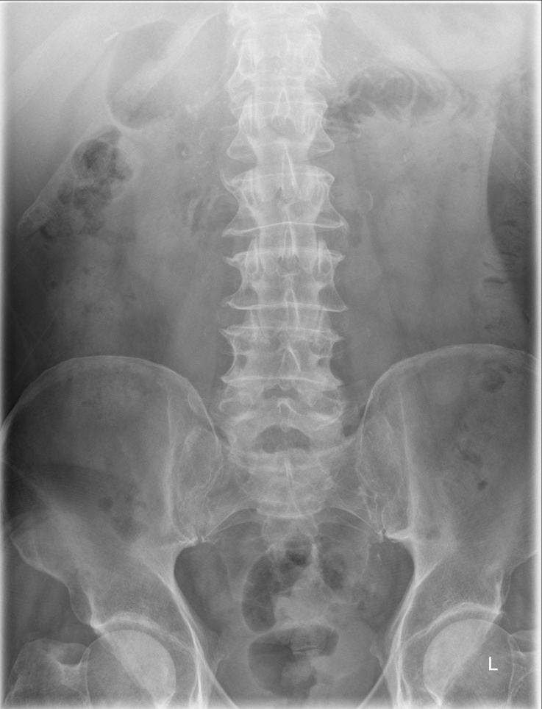
Figure 1.4: Plain abdominal x ray showing pancreatic calcification in the upper abdomen

  - 1.3.3.2 Computed Tomography
Contrast enhanced CT is frequently the first line investigation for patients referred to secondary care with symptoms that may be suggestive of CP (17, 66, 88), it is also recommended by the National Institute for Clinical Excellence (NICE) (77). CT is useful for detecting advanced or especially severe CP as well as identifying complications of CP such as cancers or pseudocysts (Figure 1.5). The sensitivity of CT for CP exceeds trans-abdominal ultrasound (75-90% versus 60-70%) although its specificity is similar (85% CT versus 80-90% for ultrasound) (87).
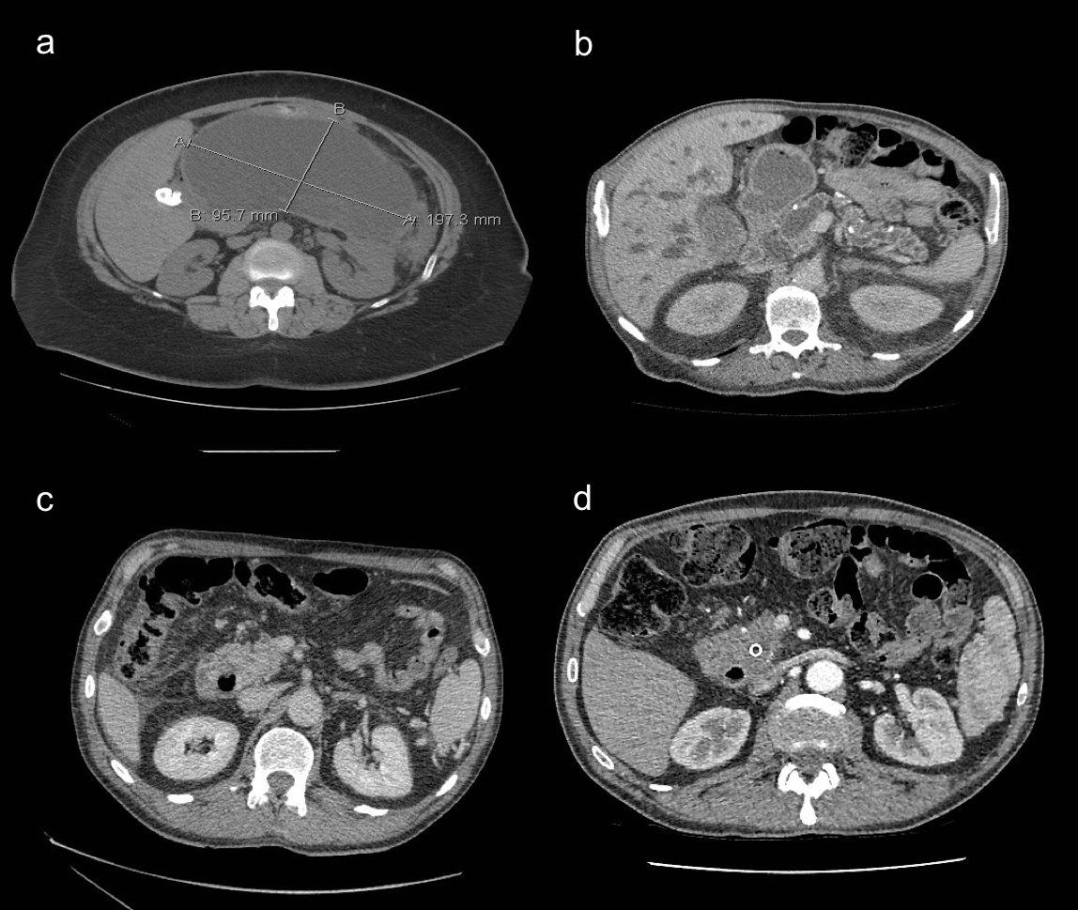
Figure 1.5: Complications of chronic pancreatitis a) CT showing large pancreatic pseudocyst, b) CT image showing obstructing head of pancreas tumour with intrahepatic duct dilatation and main pancreatic duct dilatation as well as calcification in the body and tail of pancreas, c) CT showing head of pancreas tumour with dilated common bile duct, d) CT image showing stent in main pancreatic duct (same patient as image c)

The characteristic features of CP seen on CT comprise MPD dilatation, calcification of parenchymal tissue and pancreatic atrophy (Figure 1.6) (89-91). These features are subject to intra-observer variability and, to standardise reporting, the Cambridge classification was developed (Table 1.6) (92). It has subsequently been modified to for use with CT, MR and EUS and provides a standardised way of reporting changes in the pancreas (92, 93).
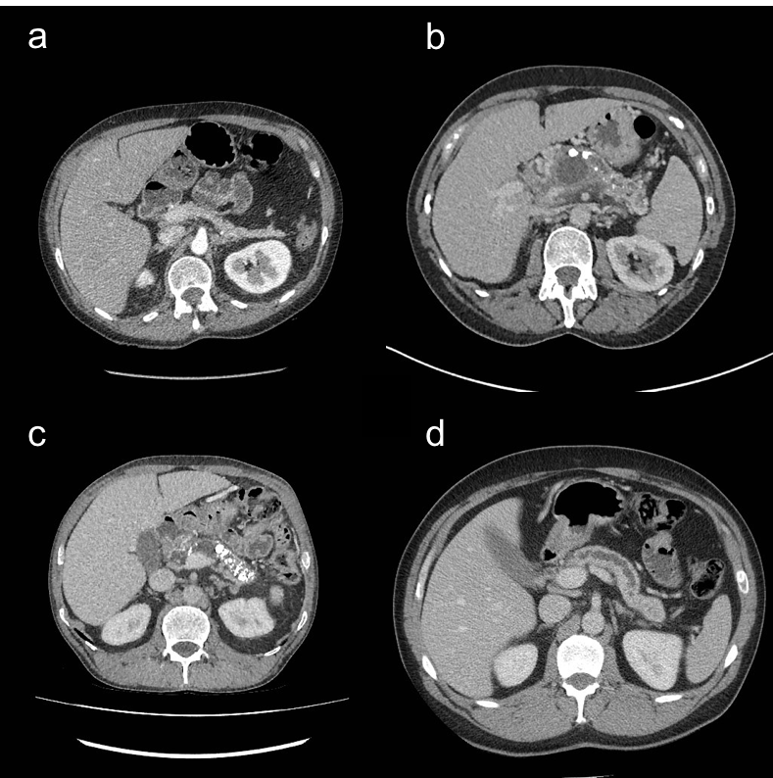
Figure 1.6: Axial CT images demonstrating characteristic features of chronic pancreatitis. a) pancreatic atrophy, b) calcification, main pancreatic duct dilatation (MPD) and cystic change in head of pancreas, c) calcification in tail of pancreas, d) MPD dilatation

Table 1.6 Modified Cambridge classification for chronic pancreatitis (92, 93)
Class | Degree of abnormality | Definition
Cambridge 1 | Normal | Pancreatic ducts normal
Cambridge 2 | Equivocal | 1-2 side branches and MPD 2-4mm
Cambridge 3 | Mild disease | ≥ 3side branches & MPD 2-4mm
Cambridge 4 | Moderate disease | ≥ 3 side branches and MPD >4mm
Cambridge 5 | Marked disease | MPD >4mm and irregular, intra-ductal calculus, stricture or obstruction with severe dilatation
MPD: main pancreatic duct

  - 1.3.3.3 Magnetic resonance imaging
MR is felt to be more sensitive in patients with early or mild CP (88) and can be used to evaluate the structure of pancreatic parenchyma using a combination of T1 and T2 weighted images and with use of intravenous contrast material (gadolinium) (94). Changes of CP including fibrosis, duct changes and atrophy can be detected, however, calcification is harder to demonstrate, especially if subtle. Small areas of calcification are better demonstrated with CT (Figure 1.7) (94).

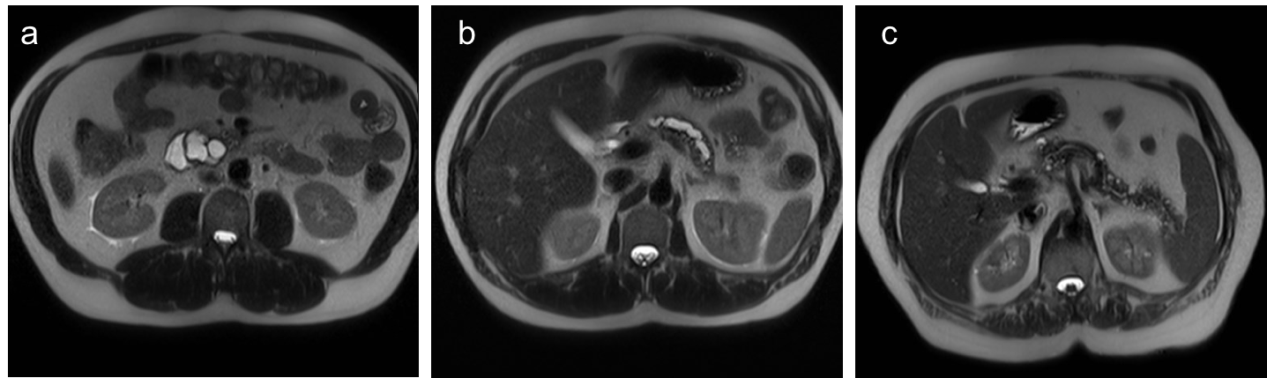
Figure 1.7: MR changes of chronic pancreatitis. a) cystic change in head of pancreas, b) dilated main pancreatic duct, c) calcification throughout body and tail of pancreas

Over a quarter of a century ago, magnetic resonance cholangiopancreatography (MRCP) was described (95). The technique was developed as a non-invasive alternative to diagnostic ERCP to demonstrate ductal pathology. MRCP is advantageous compared to endoscopic retrograde cholangiopancreatography (ERCP) as it is non-invasive, avoiding common bile duct (CBD) cannulation and contrast injection. 30-day complication rates of up to 15.9% have been reported, mainly due to pancreatitis (96). The BSG, however, sets audit standards for ERCP where complication rates should not exceed 5% for pancreatitis, 2% for bleeding requiring transfusion and perforation, and 1% for mortality (97). MRI and MRCP can be used successfully in combination to show parenchymal and ductal features of CP without need for radiation (88).

More recently, secretin-stimulated MRCP (S-MRCP) has been developed to provide a dynamic assessment of pancreatic function as well as structure. The technique assesses pancreatic fluid outputs in response to secretin. In normal physiological states secretin, is produced by duodenal mucosa when gastric contents arrive in the small intestine causing pH to drop. It stimulates bicarbonate release from the pancreas into the MPD and a temporary increase in pressure at the sphincter of Oddi (98). These processes result in MPD dilatation and allow for clearer delineation of anatomy at (99). Images are acquired prior to and at regular intervals following secretin administration. A healthy pancreas responds rapidly and maximal effects are reached after 2-5 minutes. The effect wears off after 10 minutes (100). In addition to improving visualisation of ductal anatomy, S-MRCP can be used for quantitative assessment of exocrine function.

S-MRCP has shown promising results in distinguishing patients with normal pancreas from those with equivocal, early and established CP. 134 patients with chronic abdominal pain were found to have significant differences in pancreatic output following secretin injection (101). S-MRCP has yet to be adopted in the Mayo diagnostic criteria for CP, so more work is needed to assess its role in CP diagnosis (94).

  - 1.3.3.4 Endoscopic ultrasound and elastography
“Endoscopic ultrasonography has become the method of choice for the diagnosis of CP in clinical practice” (102). EUS examines pancreatic parenchyma and ductal anatomy (figure 1.8). It allows high resolution imaging to be acquired near the pancreas and can detect subtle changes not seen with other imaging modalities (hyperechoic duct margins, early parenchymal lobularity, small cystic changes and side branch dilatation (103).

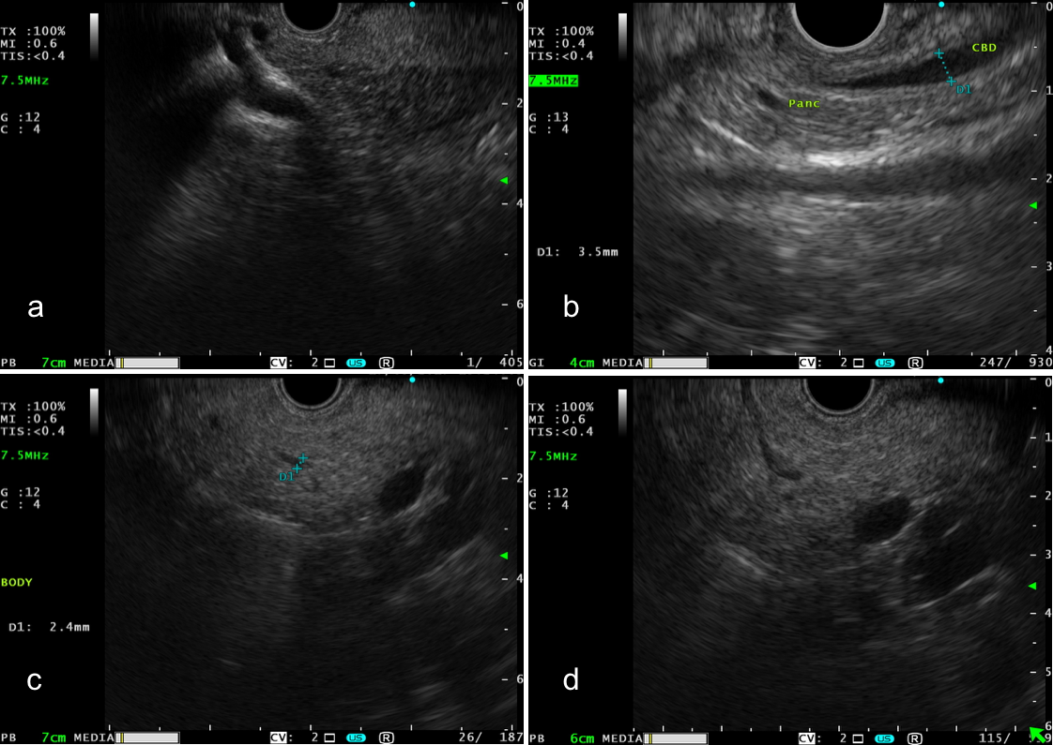
Figure 1.8: Normal endoscopic ultrasound appearances (EUS) of pancreas. a) linear EUS of pancreatic head showing delineation between dorsal and ventral pancreas, b) radial EUS view of normal pancreatic head showing normal common bile duct and pancreatic duct, c) linear EUS view of pancreatic body, duct measures 2.4mm in cross section, d) linear EUS view of pancreatic body showing pancreatic duct in longitudinal section.

To standardise EUS reporting of CP, the Rosemont classification was developed by expert EUS endoscopists in 2007. Parenchymal and ductal features are evaluated and changes are classified as consistent with, suggestive of, or indeterminate for CP (104). The characteristics used in Rosemont are summarized in table 1.7. Figure 1.9 explains how EUS features are translated into a diagnosis of CP. One criticism of Rosemont is the fine line between the boundaries in the classification system. It is also not clear if the term “indeterminate for chronic pancreatitis” is synonymous with “early chronic pancreatitis”. Subjectivity from endoscopists and intra-observer variability could result in over- or under-estimation of CP characteristics and, hence, influence rates of CP diagnosis (82).

Finding more than 5 Rosemont characteristics of CP has been shown to have 100% specificity and 100% negative predictive value for CP (105). The study assessed 56 patients evaluated with EUS and secretin-stimulated pancreatic function tests in the investigation of chronic abdominal pain, with or without CP. The conclusion was that EUS was an excellent means of diagnosing CP when 6 or more Rosemont criteria were present. It remains unclear if finding fewer than 6 criteria could be associated with early CP. These patients would need to be followed up to determine if the changes seen were truly representative of early stage disease.

Table 1.7: Rosemont criteria for diagnosis of chronic pancreatitis (104)
Feature | Definition | Criteria classification | Histological comparison
Hyperechoic foci & shadowing | Echogenic structures ≥2mm with shadowing | Major A | Parenchymal calcification
Lobularity & honeycombing | ≥5mm rim enhancing lesions, echopoor centre, ≥3 contiguous lobules | Major B | Unclear
Lobularity, no honeycombing | ≥5mm rim enhancing lesions, echopoor centre, non-contiguous lobules | Minor | Unclear
Hyperechoic foci, no shadowing | Echogenic foci ≥2mm with no shadowing | Minor | Unclear
Cystic change | Anechoic structures ± septae | Minor | Pseudocyst
Stranding | Lines ≥3mm in different directions | Minor | Unclear
MPD stones | Echogenic structures in MPD & acoustic shadowing | Major A | Calculi
Irregular MPD | Uneven contour | Minor | Unclear
Side branch dilatation | ≥3 anechoic structures arising from MPD ≥1mm | Minor | Side-branch ectasia
MPD dilatation | ≥3.5mm body / >1.5mm tail | Minor | MPD dilatation
Hyperechoic MPD border | Echogenic distinct structure greater than 50% of MPD in body or tail | Minor | Ductal fibrosis

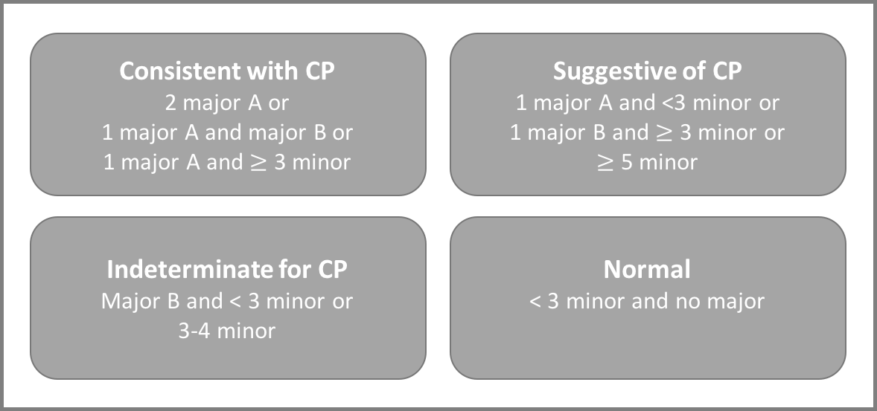
Figure 1.9 Application of Rosemont Classification (104)
The application of EUS has expanded with development of EUS elastography (EUS-E) of the pancreas using high frequency ultrasound to measure tissue stiffness. Elastography has established use in assessing breast and prostate cancers (106, 107). The technique assumes that direct compression of a target organ by the EUS probe generates strain, much like pressing down on a coiled spring. Tissue of varying stiffness displace differently in the same way as springs of varying strength, allowing differentiation between soft normal tissue and more solid abnormal tissue which is seen in malignant lesions and in the presence of fibrosis (108).

EUS-E is performed using the standard EUS endoscope and appears on screen in a similar way to colour Doppler. A split screen view is generated with the standard B-mode EUS image and EUS-E images side by side. A region of interest (ROI) is selected which should include target tissue and normal surrounding tissue. Elastography is shown with a colour map within the ROI (using a scale of 1 to 255). Hard tissue appears blue, intermediate as green, medium as yellow and soft as red (109). Normal pancreatic tissue should appear diffusely green (figure 1.10) (109). More solid tissue, as in pancreatic neoplasms appears dark blue (110, 111).

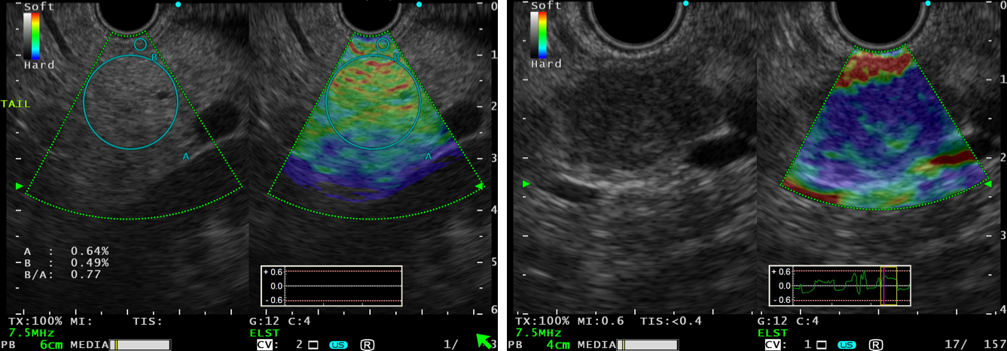
Figure 1.10: Split screen elastography image of normal pancreatic tissue. Seen as green (left) and split screen elastography image demonstrating pancreatic cancer shown as dark blue (right)

EUS-E was first described in the pancreatic community to enhance localisation and diagnosis of pancreatic tumours. Pooled meta-analyses support the utility of EUS-E with sensitivity of 95-97% and specificity of 67-76% for the diagnosis of pancreatic tumours (112-114). A study by Iglesias-Garcia et al. assessed 130 patients with solid pancreatic tumours and reported high accuracy for diagnosis of malignancy (sensitivity 100%, specificity 85.5%, overall accuracy 94%) (115). These results have not been replicated in other centres, with Hirsch et al. reporting poor results in a study of 70 patients (sensitivity 41%, specificity 53%, overall accuracy 45%) (116). These variations reflect the difficulties in image acquisition for a qualitative technique that is subject to many confounding factors (e.g. degree of tissue compression and movement artefact).

EUS-E has been further enhanced with the ability to measure tissue stiffness quantitatively by measuring strain ratios. To calculate the strain ratio, two areas are manually selected on the EUS-E image. Area A is selected as the largest area representative of the tissue under evaluation. Area B is an area of normal soft tissue adjacent to the pancreas (e.g. intestinal mucosa or fat) (figure 1.11) (109). The strain ratio is calculated as “ratio of the strain of reference tissue (B) divided by the strain of target tissue (A)”; the higher the strain ratio, the harder the tissue (117). Strain ratios of more than 6.04 have been reported to have 100% sensitivity for the identification of malignant tumours and strain ratios exceeding 15.41 have reported 100% specificity for malignancy (118).

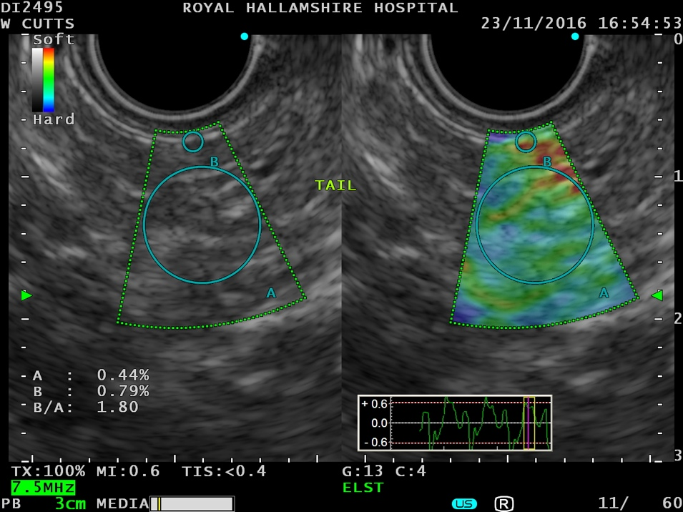
Figure 1.11: Endoscopic Ultrasound image showing normal tail of pancreas (left) and elastography overlay (right). Circles A and B are shown which represent pancreatic tissue and adjacent mucosa respectively. Strain ratio 1.80

EUS strain ratios have been shown to be highly accurate for diagnosing CP when compared to viewing EUS using Rosemont. A study examining 191 patients, 92 of whom had CP reported association between presence of EUS criteria and elastography strain ratios (r=0.813; p<0.0001) (102). A second study published in 2016 reported elastography was a helpful diagnostic tool providing objective information in the diagnosis of CP (119). The authors reported that elastography readings could reliably predict pancreatic fibrosis and that they correlated with number of Rosemont criteria supporting a diagnosis of CP.

1.4 Pancreatic exocrine insufficiency and chronic pancreatitis
PEI is traditionally regarded as a late complication of CP (4, 50, 120) and not necessarily as a separate disease entity. In CP, chronic and progressive inflammation of pancreatic parenchymal tissue impairs the ability of the acini to produce appropriate amounts of enzymes (66). The pancreas has a large functional reserve and produces excessive amounts of enzymes in normal individuals. The extent of PEI in patients with CP is highly variable and is subject to the degree of parenchymal damage and, therefore, the ability of the pancreas to compensate (12).

A frequently cited study suggest that clinically detectable PEI occurs when more than 90% of pancreatic function is lost (50) and that PEI develops a median of 12 years after diagnosis of chronic pancreatitis (121). This implies that not all patients with CP will have PEI, but carry the risk of developing it over the course of the disease. As individual patients vary, so must the rate at which the pancreatic parenchyma is damaged, and thus enzyme output will fall at different rates. This gradual decline in function may result in a period of sub-clinical PEI if symptoms are insidious or difficult to elicit clinically. Clinicians must be astute and screen for PEI in the CP population to ensure patients with PEI are not under-recognised (3). Patients with undiagnosed CP may present with symptoms suggestive of maldigestion and testing for PEI in these patients could increase diagnosis of both PEI and CP. This would allow earlier detection, intervention and modification of risk factors, especially smoking and alcohol consumption.

Table 1.8 summarises studies assessing prevalence of PEI in CP patients. Most studies assess presence of PEI using clinical history of malabsorption symptoms (122). This is a rather subjective measure and may underestimate the prevalence of PEI in patients with mild symptoms. Weight loss and fatty stools are the end stage of PEI and more subtle symptoms such as diarrhoea and abdominal pain may have been missed. A more objective and reliable method of screening for PEI in the CP population is FEL-1 measurement. The study reporting detection of PEI in CP using FEL-1 had fewer patients but is likely to have more reliable results (123). This study did not report a relationship between duration of CP diagnosis and the prevalence of PEI. Nevertheless, finding that over half of patients had evidence of PEI is significant and underlines the importance of PEI screening in CP.

Table 1.8: Summary of literature assessing prevalence of pancreatic exocrine insufficiency in chronic pancreatitis patients
Study | Year | Patients | % PEI | Method
Eddes et al. (122) | 1999 | 45 | 56% | Clinical (weight loss, steatorrhoea)
Jarosz et al. (124) | 2003 | 389 | <5-year history 5.1%  3-10-year history 19.4%  >10-year history 36.5% | Clinical
Dumasy et al. (125) | 2004 | 1020 | <5-year history 63%  >10-year history 94% | Clinical steatorrhoea
Levy et al. (58) | 2006 | 1748 | 36% | 76% clinical  6% faecal enzymes  27% faecal fat
Frulloni et al. (126) | 2009 | 893 | 31-45% | Not reported
Haas et al. (123) | 2015 | 50 | 56% | Faecal elastase-1

The disease course in CP complicated by PEI is variable. Those with early onset idiopathic pancreatitis have been shown to develop PEI and pancreatic calcification more slowly than those with alcoholic or late onset idiopathic pancreatitis (127). The same study reported that pain was more common at presentation in idiopathic early onset pancreatitis compared to alcoholic or late onset pancreatitis. Nearly half of patients with late onset idiopathic pancreatitis did not experience pain at all.

The most striking data showing the incidence-based, expected prevalence of CP greatly exceeds the observed prevalence of CP (58). Data from post mortem studies shows a higher prevalence of CP after death than observed in vivo. This supports the hypothesis that CP is under-recognised. Therefore, as PEI affects such a significant proportion of CP patients it is reasonable to deduce that it is also under-recognised.

1.5 Consequences of pancreatic exocrine insufficiency and chronic pancreatitis

1.5.1 Malnutrition
Malnutrition is frequently observed through abnormal biochemical parameters and anthropometric measurements in CP and PEI (1, 3, 128). Factors such as pain, nausea and vomiting, concomitant diabetes mellitus and alcohol ingestion can all contribute to malnutrition (3).

Fat-soluble vitamin (A, D, E & K), micronutrient and lipoprotein deficiencies, are consequences of PEI and CP (13, 129, 130). Deficiencies of fat-soluble vitamins were reported in 81.5% of CP patients in one study, although deficiencies of vitamins A, E and K almost never occurred in the absence of vitamin D deficiency (p<0.001) (131). One could, therefore, argue that screening for vitamin A, E and K deficiencies in the presence of normal vitamin D is unnecessary; though basing this assertion on one study may be unwise. Whilst fat-soluble vitamin deficiencies can be detected frequently, their clinical manifestations are rarely observed except where other diagnoses coexist (diabetes, coeliac disease, post-surgical) (3).

The 2017 European guidelines for diagnosis and treatment of chronic pancreatitis recommend that all patients with CP, especially those with malnutrition should be undergo “nutritional assessment and individualised dietary counselling by an experienced dietician” (3). Those with “clinical symptoms or laboratory signs of malabsorption” should be treated with PERT (3). Restriction of fat intake should be avoided, instead promotion of regular high-calorie meals is important along with PERT (3).

1.5.2 Osteoporosis and reduced bone mineral density
Both CP and PEI are associated with increased risk of osteoporosis and low trauma fracture (123). The prevalence of low trauma fracture in patients with CP has been estimated at 4.8%, which is significantly higher than controls without CP (1.1% p<0.001) (8). Around 25% of patients with CP have been shown to have bone mineral density (BMD) changes consistent with osteoporosis and up to two-thirds have changes consistent with osteoporosis or osteopenia (7). Patients with PEI and vitamin D deficiency, excess alcohol consumption, chronic inflammation or those that smoke have higher risk of decreased BMD compared to those without (8).

In a prospective study of 50 men with CP (those with conditions known to influence BMD were excluded) 56% had PEI (FEL-1 <200µg/g). 75% (21/28) of those with PEI reported history of fractures. 15 were assessed with dual energy x-ray absorption (DXA) with 60% and 6.6% having evidence of osteopenia and osteoporosis respectively. A trend was shown between low FEL-1 and decreased T score on DXA (123). Women were excluded from the study to minimize bias due to peri-menopausal hormonal influences on BMD.

Patients with CP and PEI should be offered screening with dual-energy X-ray absorptiometry (DXA) as well as regular measurement of serum vitamin D (3).

1.5.3 Quality of life
CP is known to seriously impact on patients’ quality of life (QOL) (132). QOL can be improved by intervening with pancreatic enzyme replacement therapy (PERT) and by optimising nutrition (9, 10). A study of 206 patients with CP and PEI already treated with PERT was compared to 86 patients with PEI who had not previously received PERT (10). Symptoms were documented and QOL assessed (gastrointestinal quality of life index) at 0, 6 and 12 months. Significant improvements in pain and QOL were reported in both groups (p<0.001). It is unclear why patients already established on PERT gained symptom and QOL improvement without an alteration in treatment. It is feasible that increased support during the study and advice regarding correct administration of PERT contributed to improvement of symptoms in these patients.

Improved nutritional status in PEI can reduce hospital admissions and pain (9). By evaluating CP patients at 0, 6 and 12 months with “Mynutritionindex” it has been shown that better nutritional parameters at baseline are associated with fewer admissions (p=0.012) and less frequent episodes of pancreatic pain (p<0.001) than those with poor nutrition (9).

1.5.4 Pancreatic cancer
CP is a risk factor for development of pancreatic cancer (133), especially in those who smoke (134, 135) or have diabetes mellitus(136). The risk of pancreatic cancer in patients with CP increases with duration of disease (137). A large retrospective multi-centre study of 2015 patients using data from 6 countries reported that 56 malignancies were detected over an average follow up period of 7.4 years. The cumulative risk of pancreatic malignancy was 1.8% and 4.0% 10 and 20 years post-diagnosis respectively. CP was shown to be an independent risk factor for pancreatic malignancy when corrected for sex, country of residence and type of pancreatitis (80). There is currently no recommendation supporting screening for pancreatic cancer in CP in the UK (124, 138).

1.6 Conclusions
I have presented evidence which I feel shows the prevalence of CP quoted in the literature is likely to be under-estimated. Post mortem studies have reported far higher prevalence of CP than studies assessing live populations.

I have also explored evidence that suggests PEI is an under-recognised diagnosis. Diagnosed cases of PEI may represent the tip of the iceberg with many remaining undetected. By lowering the threshold for assessing pancreatic function by screening not just those with CP but those with subtle gastrointestinal symptoms, individuals could be identified earlier to ensure they receive appropriate, timely treatment.

The diagnosis of CP is challenging and relies on multiple diagnostic modalities. Elastography is a relatively new technique available to endosonographers and initial work has suggested it may be useful in the diagnosis of chronic pancreatitis.

1.7 Aims of this thesis
This chapter has reviewed both PEI and CP, in particular, the prevalence of both pathologies and the modalities available for diagnosis. I feel the true prevalence of CP has yet to be determined and that significant evidence exists to support adopting an approach of case finding for PEI. Diagnosis, particularly in the early stages of CP remains challenging. To enhance the evidence in this field I have asked the following questions (hypotheses in italics)

What is the prevalence of radiological features of chronic pancreatitis at post mortem?
Computed tomography can identify chronic pancreatitis at post mortem

What is the prevalence of pancreatic exocrine insufficiency in secondary care gastroenterology clinics?
Pancreatic insufficiency is common in secondary care gastroenterology clinics

What is the prevalence of pancreatic exocrine insufficiency in primary care?
Pancreatic insufficiency is common in primary care patients with symptoms of maldigestion

What is the accuracy of endoscopic ultrasound elastography as a test for chronic pancreatitis?
Endoscopic ultrasound elastography is a useful technique to identify chronic pancreatitis

I will address the questions in the following four chapters. Each chapter can be read independently of others and answers each question in turn. Together, these studies seek to provide novel information regarding the prevalence of both CP and PEI as well as assessing a relatively new technique that may improve diagnosis of early CP.

Changes in clinical practice may be influenced because of the work contained in my thesis. Full manuscripts have been published or submitted for publication to peer-reviewed journals (for chapters 2-4). As a result of writing the introduction and conducting the literature review (chapter 1) a review article has been published in “The Practitioner” (139). Chapter 2 has been submitted to United European Gastroenterology Journal as an original article and has been presented as an abstract at BSG 2016 (140).

Chapter 3 has been published in Journal of Gastroenterology and Liver Diseases (141) and as a poster presentation at BSG 2014 (142). Chapter 4 been submitted to the European Journal of General Practice and presented at BSG in 2015 (143). Chapter 5 has been presented as a poster of distinction at BSG 2017 (144). Chapter 6 summarises the project and suggests future avenues of research that could be pursued. Key concepts from chapter 6 have been published in the American Journal of Gastroenterology as a letter to editor (145) and also in Gut as a letter to editor (146).

1.8 Patient recruitment and methodology
Each chapter has different patient recruitment and methods. Each chapter contains a methods section which explains recruitment processes, methodology and analysis.

1.9 Extent of assistance
I am very grateful to several people for their advice, guidance and support during the studies contained within my thesis. I conceived and designed all studies contained in the thesis. I am especially grateful to Dr James Hampton (Consultant Radiologist, Royal Hallamshire Hospital) for his input helping to report post mortem images. Funding to acquire the elastography processor equipment necessary was provided by grants from Westfield Health and Sheffield Hospitals Charity. This equipment was essential for completion of my thesis.

CHAPTER 2: What is the prevalence of chronic pancreatitis at post mortem? A novel study using “digital autopsy”

2.1 Summary
Introduction: CP is a chronic disease where parenchymal fibrosis and calcification along with MPD dilatation (66) manifests with a syndrome of chronic abdominal pain, malnutrition and PEI (4, 147). There is a discrepancy between the observed incidence and expected prevalence of CP (58), suggesting it may be under-diagnosed or under-recognised. Studies estimate the post mortem prevalence of CP to be around 5.3-13% (63, 64) which is far greater than the reported prevalence of 13.5-52.4 per 100,000 population (57-62).

CT is often used in assessing patients with potential CP diagnoses to gain a structural overview of the pancreas as well as excluding other significant pathologies such as malignancy (88). “Digital autopsy” is a non-invasive alternative to conventional dissection post mortem examinations. CT scanning is used to provide cross sectional imaging which can be used to help determine cause of death and avoid invasive post mortem. I aimed to evaluate the prevalence of radiological changes of CP with this technique.

Methods: Consecutive non-contrast post mortem CT (PMCT) scans were reviewed. Simple demographic information was collected (sex, age at death) as well as interval between death and scan. Medical history, smoking and alcohol consumption were recorded where the information was available. The presence of pancreatic calcification, atrophy and MPD dilatation were noted as radiological indicators of CP. Smaller ductal changes were not assessed due to lack of intravenous contrast.

Results: 382 scans were reviewed (mean age 66.6 years, 58.2% male). 26 scans were excluded due to inadequate pancreatic views (18 due to decomposition). Scans were performed 0 to 21 days after death (median 3.0 days). 100/356 (28.1%) of those scanned had features of CP. 48/356 (13.5%) had calcification, 57/356 (16.0%) had atrophy and 2/356 (0.6%) MPD dilatation. Patients over 75 were more likely to have changes consistent with CP compared to those under 75 (40.8% versus 18.9% p<0.0001). The risk of finding atrophy and calcification increased by 0.3% and 0.2 % per year respectively. Presence of diabetes mellitus was significantly associated with radiological signs of CP.

Conclusions: This novel work shows the prevalence of CP seen at PMCT is higher than observed in clinical practice supporting the hypothesis that CP is under-diagnosed.

2.2 Introduction
A small amount of data exists assessing the prevalence of CP at post mortem. A 1963 paper reviewed over 3800 autopsy cases in a single centre and reported finding changes consistent with CP in 5.3% of non-diabetics and 11.2% of diabetics (64). Significantly more males were affected in the study than females. A separate study of 394 consecutive autopsy specimens showed 13% had evidence of pancreatic inflammation (63).

More recently, 18 post mortem pancreas specimens (median age 65, range 52-87, 100% male) were scanned with endoscopic ultrasound (EUS) to assess for changes consistent with CP (65). They underwent standard histological assessment with 6 individuals showing evidence of autolysis. 11 non-autolyzed samples were analysed with EUS- 3 showed EUS changes consistent with CP (echogenic MPD, lobularity, echogenic foci or side branch dilatation). Overall, 72% (13/18) of patients showed evidence of CP. 10/11 showed histological evidence of CP (fibrosis, ductal proliferation). EUS changes were shown to correlate with histopathological changes. Although this study reported high rates of CP, there were only 18 patients included which may affect the reliability of the results. The rates of CP changes were markedly higher than in other post mortem and in vivo prevalence studies (65).

The post mortem literature assessing prevalence of CP in the general population consistently reports higher prevalence rates than in vivo studies.

Digital autopsy is a relatively new technique which harnesses cross sectional imaging to establish a cause of death and aims to avoid the routine use of traditional dissection post mortems (148). Imaging can be useful to demonstrate injuries or trauma more so than conventional post mortem (149). It can also be used to assess factors that may have contributed to cause of death, for example widespread malignancy, which may then allow for a more limited targeted post mortem (150). CT has been shown to be superior to MRI when used for digital autopsy (151) and has become the favoured method, in part for its ability to characterise fractures (148).

The first digital autopsy facility offering digital autopsy for deaths in the community referred to the coroner in Sheffield in 2013. Pathologists select cases appropriate for PMCT. Patients have full body non-contrast CT scans performed by a radiographer which are then reported by a radiologist. A scan report which includes the cause of death (if it has been identified) is then reported to the pathologist. The pathologist carries out an external examination of the deceased and after considering the report from the digital autopsy will issue a cause of death if enough information is available. If further information is required to establish a cause of death, minimally invasive techniques can be used to acquire this information without subjecting the deceased to a full post mortem.

CT scanning harvests a large amount of data and creates a pool of information with vast potential research applications. I sought to use this pool of information to calculate the prevalence of CP seen at PMCT in an unselected population.

2.3 Methods
Consecutive non-contrast PMCT scans undertaken from January 2014 to August 2016 were reviewed from three centres (Sheffield (figure 2.1), Sandwell and Bradford). The reports were confirmed and verified by a consultant radiologist with expertise in gastrointestinal and post mortem autopsy. Sex, age at death and time interval between death and scan were recorded, and where possible, medical co-morbidities and smoking history were also recorded. The data available (both demographic and medical) were restricted to that provided to the coroner’s office after death. Access to medical records was not possible. Simple descriptive statistics were used to describe rates of changes consistent with CP (Microsoft Excel 15.61). ‘Graph pad’ was used to assess if there was a difference in age of patients with and without changes of CP (Fishers test). Linear regression (SPSS version 21) was used to describe relationship between age and CT findings.

The coroner decided which patients referred after unexpected deaths would be suitable for digital autopsy. Families of patients requiring blood samples or those where poisoning was suspected were not offered digital autopsy. In cases where the coroner deemed digital autopsy appropriate, families were offered PMCT at a cost of £500. In forensic cases, the cost of PMCT was met by the coroner’s office.

Two different CT scanners were used: GE Electric OPTIMA CT66064-slice CT system (General Electric, USA); SOMATOM Definition AS 64-slice CT System (Siemens Healthineers, Germany) (Figure 2.1). The initial scanning protocol included whole body scans with the patient in the anatomical position. The presence of the arms beside the torso resulted in some image artefact in the thorax and upper abdomen. This was due to scattering of x-rays on passing through arm bones- a phenomenon known as “x-ray beam hardening” (152). To reduce artefact the scanning protocol was changed for all scans. After acquiring an “arms down” whole body sequence, the arms were raised above the head (where possible) and a second thorax, abdomen and pelvis sequence was performed. Reasons for not raising the arms included forensic cases or in cases where advanced decomposition had taken place. In these individuals, images were reviewed from the whole-body series.

Ethical approval to analyze and publish post-mortem data was obtained (reference 12/YH/0510).
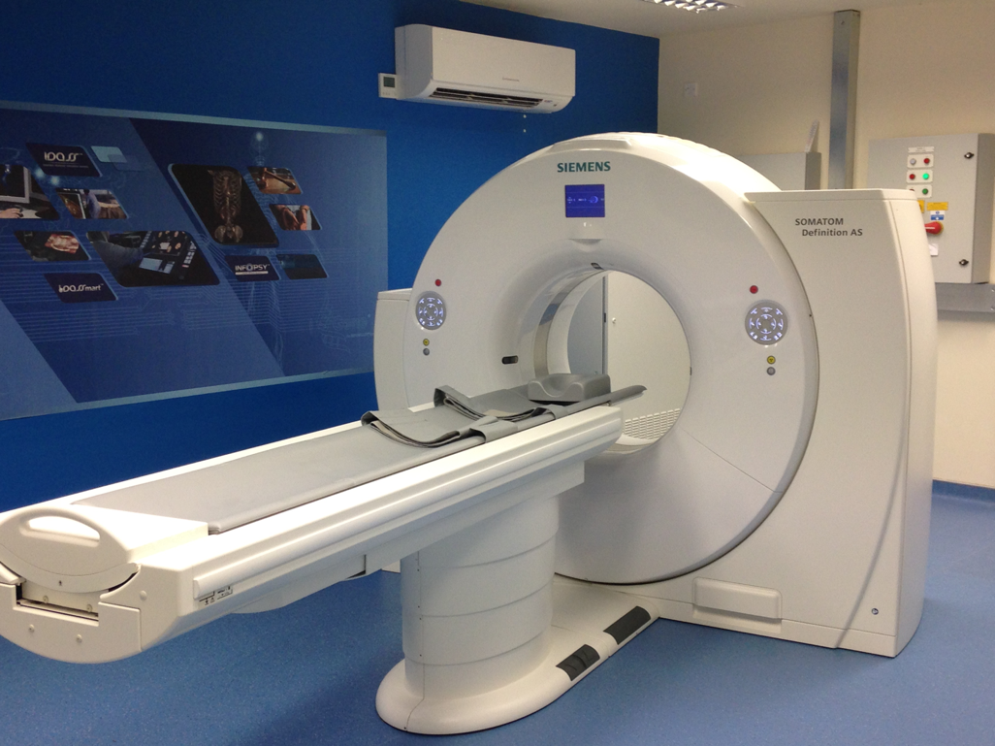

Figure 2.1: iGene digital autopsy facility, Sheffield

2.4 Results
384 scans were reviewed representing 384 patients. The mean age was 66.6 years, (SD 19.6), 58.2% were male. 26 scans were excluded due to inadequacy of pancreatic views (table 2.1) (mean age 55.6 years, SD 17.9, 80.8% male). This left 356 scans suitable for inclusion (mean age 66.1 years, SD 15.6, 63.5% male). Excluded patients were significantly younger than patients included in the study (p=0.008). 116 scans were analysed from whole-body series, whilst 240 were assessed from “arms up” perspective.

Table 2.1: Reasons for excluding scans from analysis
Reason for exclusion | Number
Advanced decomposition | 18
Brain only scan | 3
Significant intra-abdominal lymphadenopathy | 1
Extensive peritoneal fluid collection | 1
Artefact | 1
Paucity of intra-abdominal fat | 1
Disrupted anatomy- previous conventional post mortem | 1

Images were acquired between 0 and 21 days after death (median 3.0 days). No significant difference (p=0.77) was seen when assessing interval between death and scan in those with decomposition (3.61 days) and those without decomposition (3.39 days). Figure 2.2 shows examples of decomposition meaning subjects were excluded.

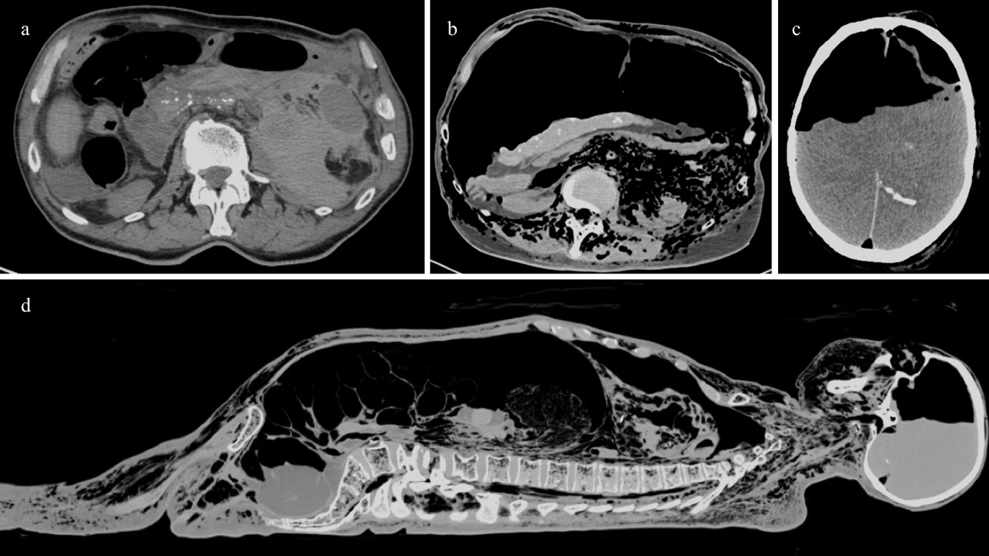
Figure 2.2: Non- pancreatic PMCT images. a: ruptured abdominal aortic aneurysm, b: severe decomposition, c: intracranial decomposition, d: sagittal whole-body view illustrating extensive decomposition

Features suggestive of CP were observed in 100/356 (28.1%) of those scanned. Figure 2.3 shows examples of PMCT findings. Table 2.2 summarises the proportion of findings. No difference was detected in rates of CP when comparing patients scanned with arms up and arms down (63/240 versus 37/116 p=0.31).

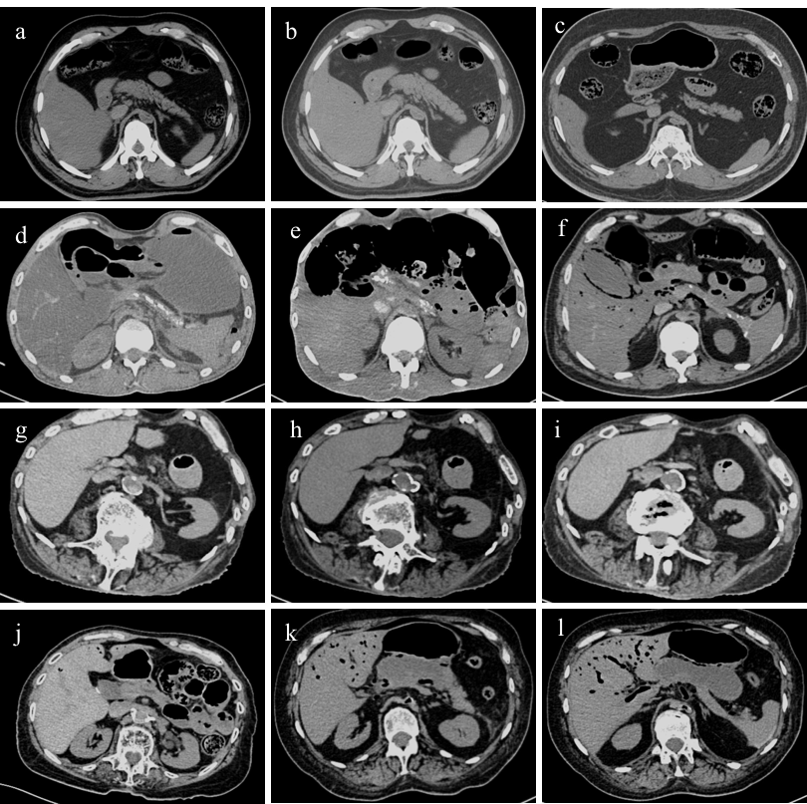
Figure 2.3 PMCT changes affecting the pancreas. a-c: normal pancreas, d-f: pancreatic calcification, g-i: pancreatic atrophy, j: MPD dilatation, k & l: pancreatic pseudocyst

Table 2.2: Observed features suggestive of chronic pancreatitis (CP) in 356 post mortem CT scans
CP Feature | N= (%) [95%CI]
Atrophy | 57 (16.01) [0.16-0.20]
Calcification | 48 (13.48) [0.10-0.17]
Pancreatic duct dilatation | 2 (0.56) [0.00-0.02]
Pseudocyst | 2 (0.56) [0.00-0.02]
Any of above or combination | 100 (28.08) [0.24-0.32]

There was, however, a significant difference in CP changes in those less than 75 years old and those over 75 years (18.9% versus 40.8% p<0.0001). Even after excluding atrophy from the analysis, a significant difference remained in the rates of CP changes in the two age groups (under 75 7.5% versus over 75 20.4% p=0.0005). The prevalence of atrophy and calcification increased with age at a rate of 0.3% and 0.2% per year respectively. These changes are illustrated in figure 2.3. Patients with diabetes mellitus had significantly higher rates of CP changes compared to non-diabetics (41.4% versus 24.8% p=0.0075).

Percentage change consistent with CP
Age in years
Figure 2.4: Graph demonstrating increasing frequency of chronic pancreatitis change with increasing age

2.5 Discussion
This study has shown prevalence of CP as seen on PMCT for the first time. Of those scanned, 28.1% showed features consistent with CP including calcification, atrophy and duct dilatation. This figure is far higher than rates of CP published in previous autopsy studies (5.3-13%) (63, 64).

When assessing and diagnosing CP in clinical practice, the most specific method is histology (76), however, this is rarely feasible in clinical practice and is also subject to lack of agreement in terms of diagnostic criteria (153). A composite assessment using imaging (EUS, MRI and CT) in addition to assessment of risk factors and assessment of exocrine function is used (3, 147).

Contrast-enhanced CT is the most common initial investigation when investigating patients who could have CP (3, 17, 66, 88). Textbook features of CP are parenchymal calcification and atrophy as well as MPD dilatation (89-91). CT is useful in the initial diagnostic pathway as it can detect advanced disease and complications of pancreatitis, as well as assessing for malignancy. MRI and EUS are more sensitive in early stages of mild CP (88). In this project, as the patients were deceased, intravenous contrast was not given, meaning detailed assessment of ductal anatomy was not possible.

Autolysis or decomposition prevented analysis of 18/382 (4.7%) of scans in this project. The most significant factor known to influence degradation of internal organs is time: the pancreas is more quickly affected than organs such as the liver, lungs or heart (154). Histological assessment of islet cell autolysis reports complete destruction from as little as 36 hours after death (155). In this series, I have not demonstrated a significant difference in pancreatic decomposition in relation to interval from death to scan, therefore I do not feel that the results have been affected by post mortem degradation.

Calcification of the pancreatic parenchyma is the most specific marker for diagnosis of CP on CT (88) and is seen in up to 50% of patients with CP (156). Calcification is a sign of advanced disease and results from calcium carbonate formation in intra-ductal protein plugs (157). 48/356 (13.5%) patients had calcification in this study. As calcification is the most reliable marker of CP on CT and its visualisation is independent of intravenous contrast, it can be relied upon to conclude that 13.5% of patients assessed had evidence CP when alive. The proportion of patients in this group with calcification is very similar to previously cited prevalence of CP seen at CT of 5.3-13% (63, 64), which I feel adds to the robustness of this data and supports previous estimates.

Assessment of pancreatic volume is not as reliable as calcification as a marker of CP as atrophy and enlargement have been reported in 54% and 30% of CP cases respectively (156). Atrophy can also be observed in individuals without pancreatic disease in association with increasing age (158) and in those with diabetes mellitus (159). The results in this chapter support the theory that atrophy becomes more common with age, with the observed increase in atrophy with advancing age (0.3% per year) in the cohort. If atrophy is part of the ageing process and not solely due to CP, it is likely that some of the cases where atrophy was present were not due to CP, therefore, the total prevalence of CP of 28.1% may be exaggerated.

In order not to exaggerate the prevalence of CP using atrophy as a marker, figure 2.3 shows the increase in CP changes for those with and without atrophy. Even when excluding atrophy there is still a notable rise in the prevalence of CP seen on CT with age.

Age-related atrophy should not be ignored as it may be relevant in the context of PEI. PEI is also known to become more prevalent with increasing age (35). Although both atrophy and PEI are known to increase in prevalence with age, the relationship between pancreatic morphology and function is poor and some patients with PEI can have normal pancreatic imaging (90). It is possible to deduce that atrophy seen with advancing age leads to a reduction in pancreatic exocrine function and as a result, PEI. Patients affected in this way may not present with typical histories or features of CP but may present with less specific gastrointestinal symptoms such as loose stools, abdominal pain or weight loss. There is a risk that these patients remain undiagnosed and risk malnutrition and changes to bone mineral density seen with PEI.

Patients excluded from this study were significantly younger than those included. It could be suggested that removing these younger patients from the study could have slightly inflated the prevalence of CP changes, as higher rates of change would be anticipated in an older cohort. On the other hand, patients included in the study were potentially in good health prior death, as seeing a GP with a chronic illness linked to the cause of death would have negated the need for PMCT. Also, those with suicide or traumatic deaths could be expected to be in reasonable health prior to death compared to those with chronic illnesses. It is possible that these factors could have introduced selection bias and diluted the prevalence of CP changes in the cohort.

The MPD in healthy individuals should measure no more than 3mm in the head, 2mm in the body and 1mm in the tail (160), unless gross dilatation is present, intravenous contrast is required to detect subtle changes on CT (161). Only 2/356 (0.6%) of patients in this work were found to have a dilated MPD. This study was limited in the extent to which ductal anatomy could be assessed as all scans were performed without contrast, and therefore, small calibre changes in the main and certainly side ducts would not have been detected.

Both tobacco smoking and high levels of alcohol consumption are associated with development of CP (68). Some guidelines advocate ceasing smoking and drinking to slow the course of CP (3). I have been unable to show a significant difference between smoking nor alcohol in terms of the association between their use and finding CP changes on CT. Limited information was available to me during the data collection phase of the study. The only information available was that given to the coroner’s office post mortem. Various professions (doctors, police officers) or the deceased’s family had provided information and the quality varied depending on the circumstances of each individual case.

Where information was available regarding tobacco or alcohol habits, it was recorded, but the rates will have been under-estimated. If the information had been available in completeness, I feel significant associations would have been demonstrated between history of smoking or excess alcohol consumption and presence of changes consistent with CP.

My results demonstrate significant association between detection of changes consistent with CP and diagnosis of diabetes mellitus. The association between diabetes mellitus and chronic pancreatitis is recognised in the literature, as is the risk of developing diabetes due to CP (78, 162). The duration of diabetes mellitus diagnosis is known to increase the likelihood of pancreatic atrophy (159). Studies have shown that 70-90% of CP patients can be affected by diabetes (162, 163). PEI can manifest in up to 56.7% of type 1 diabetics and in up to 35.0% of type 2 diabetics (19). As with smoking and alcohol histories, the prevalence of diabetes mellitus in this population could have been under estimated due to the reasons outlined above regarding acquisition of clinical information. It is important to fully investigate the cause of diabetes mellitus at diagnosis, especially in older patients to avoid missing CP as an underlying cause (31).

This chapter presents a novel method for the detection of CP and has shown rates similar to those described in previous post mortem studies. The post mortem prevalence reported here is far more than the prevalence of CP described in studies of live patients which supports the fact that CP is an under-recognised diagnosis. The results also show a significant association between CP and ageing and diabetes mellitus, strengthening the growing body of evidence in this field.

CHAPTER 3: What is the prevalence of exocrine pancreatic insufficiency in secondary care? A dual centre study

3.1 Summary
Introduction: There has been little work assessing the prevalence of PEI in patients with non-specific gastrointestinal symptoms. Recently, Emmanuel et al. described 13.3% of over 2600 patients tested with FEL-1 had abnormal levels (33). This chapter sets out to identify the prevalence of PEI in secondary care as defined as low FEL-1. I aimed to assess if presence of any co-morbidities or presenting symptoms could predict a diagnosis of PEI. Patients’ response to treatment was also assessed as a secondary aim.

Methods: A retrospective analysis of case notes was performed in two gastroenterology clinics (Sheffield & Middlesbrough). Patients tested with FEL-1 for PEI from 2009 to 2013 were identified. Patient demographics and past medical history were noted. The indication for testing was also noted. Where patients received PERT, the dose and patient reported response to supplementation was recorded. Logistic regression analysis determined if symptoms or comorbidities could predict finding a low FEL-1 level suggestive of PEI.

Results: In total, 1821 patients were included, of which 13.1% had a FEL-1 level <200µg/g in keeping with PEI. On further breakdown, 5.6% had FEL-1 100-200µg/g (denoting mild PEI), 5.2% had levels 15-100µg/g (moderate PEI) and 2.4% <15µg/g (severe PEI). Regression analysis revealed that presence of weight loss or history of steatorrhoea were most significantly associated with finding low FEL-1 (p=0.001). When assessing patient comorbidities, reduced FEl-1 was strongly associated with history of high alcohol intake, diabetes mellitus and HIV infection (p <0.001). Of those who received PERT, 80.0% improved symptomatically, but there was no difference in benefit to symptoms between those on high and low dose supplementation (p=0.761).

Conclusions: Screening individuals presenting to general gastroenterology clinics with non-specific symptoms for PEI with FEL-1 has a significant yield and patients improve with PERT.

3.2 Introduction
In the previous chapter, I began by showing the discrepancies between clinically reported prevalence of CP and the rates reported at post mortem. I then demonstrated using PMCT that radiological changes consistent with CP were frequently found in unselected individuals. PEI is well recognised as a complication of CP and can develop at any stage in the disease process, although it becomes more prevalent with advanced disease (3, 121). PEI can also present in association with other diseases, this is shown in table 1.2.

I aimed to determine the prevalence of low FEL-1 in patients presenting to gastroenterology clinics with non-specific gastrointestinal symptoms by case finding.

The suggestion has been made that PEI could be seen early in the course of CP and, therefore, may go unrecognised (47). PEI has been recognised in 6.1 to 21.7% of patients seen with gastrointestinal symptoms (33-36). The United Kingdom (UK) sees about 11,000 new PEI diagnoses per year (164). Pancreatic function has been shown to decline with increasing age (35, 36), so the elderly may be at risk developing PEI in the absence of CP and risk going undiagnosed. Missing the opportunity to intervene with PERT may result in more complications of exocrine failure developing (165), including malabsorption of protein, carbohydrate and fat soluble vitamins, and osteoporosis (166).

BSG guidelines for investigation of chronic diarrhoea advocate use of FEL-1 as a screening tool for pancreatic exocrine dysfunction (32). Although not the gold-standard screening tool, it is felt to be an appropriate first line investigation of pancreatic function due to its ease of use and acceptability for patients (167). It is non-invasive and quick for patients to perform and can also be used when patients are established on PERT (167). The limitations and benefits of FEL-1 testing for detection of PEI have been discussed in Chapter 1 of this thesis.

I aimed to calculate the prevalence of PEI using FEL-1 in patients presenting to gastroenterology clinics using FEL-1. I also sought to determine the effect that PERT had on patients’ symptoms.

3.3 Methods
Patients attending gastroenterology clinics in two centres (Sheffield and Middlesbrough) were identified retrospectively from clinic notes. Those seen from 2009 to 2013 and who underwent FEL-1 testing were included. Individuals with pancreatic cancer, CP or PEI were not included. Those with structural pancreatic abnormalities on imaging prior to testing were also excluded.

Demographics, indication for screening and relevant medical conditions were noted. (diabetes mellitus, HIV, excess alcohol intake, coeliac disease, IBD). Co-morbidities recorded included alcohol excess (>21 units/week for men and >14 units per week for women), diabetes mellitus, HIV, coeliac disease (with histological confirmation), diarrhoea predominant IBS (meeting Rome II criteria) and IBD (ulcerative colitis or Crohn’s disease). In those with low FEL-,1 I reviewed if pancreatic imaging had been performed and recorded the results.

An enzyme-linked immune-absorbent assay (ELISA) utilising monoclonal antibodies specific for FEL-1 was used. The reference standard of FEL-1 <200µg/g was regarded as abnormal (55). FEL-1 100µg/g-200µg/g was classed as mild insufficiency, 15-100µg/g moderate insufficiency and <15µg/g severe insufficiency.

Simple descriptive statistics were used to illustrate demographics and indication for performing FEL-1 screening (Microsoft Excel 15.61). Binary logistic regression was used to assess whether co-morbidity or symptoms could predict finding low FEL-1 (SPSS v 20). Daily PERT doses and patient reported improvement to therapy were recorded. I used Fishers exact test (‘Graph pad’) to assess if those treated with greater than 120000 units of lipase per day gained greater benefit to symptoms than those treated with lower doses.

The project received prospective approval by the local research departments (STH 16190, South Tees 4182).

3.4 Results
1878 patients were initially identified, but 57 were excluded due to diagnoses of CP, malignancy and PEI (median age 62.5 years, range 27-90 years, 54.4% female). 1821 were suitable for inclusion into the study. 61.0% were female (1111) with a median age of 51.3 years (range 16-93). FEL-1 <200µg/g was present in 13.1% (238/1821). Table 3.1 shows FEL-1 results sub-divided into normal (FEL-1 >200µg/g), mild PEI (FEL-1 100-200µg/g), moderate to severe PEI (FEL-1 <15-100µg/g). The predominant symptom prompting testing is also shown. Comorbidities are shown in association with FEL-1 results are listed in table 3.2.

Table 3.1: Prevalence of low FEL-1 by symptom
Predominant symptom | Prevalence | FEL-1 >200µg/g |  |  | FEL-1 100-200µg/g |  |  | FEL-1 <100µg/g
 | n (%) | n | OR  (95% CI) | p= | n | OR  (95% CI) | p= | n | OR  (95% CI) | p=
Diarrhoea | 1229 (67.49) | 1069/1229 | 16.70  (3.21-86.82) | 0.83 | 68/1229 | 0.35  (0.042-2.96) | 0.07 | 92/1229 | 0.06  (0.01-0.26) | 0.73
Abdominal pain | 356 (19.55) | 318/356 | 20.92  (3.92-111.58) | 0.99 | 14/356 | 0.25  (0.03-2.18) | 0.03 | 24/356 | 0.05  (0.01-0.26) | 0.59
Weight loss | 110 (6.04) | 85/110 | 8.50  (1.55-46.50) | 0.38 | 12/110 | 0.73  (0.08-6.63) | 0.39 | 13/110 | 0.10  (0.02-0.50) | 0.05
Bloating | 62 (3.41) | 56/62 | 23.33  (3.69-147.41) | 0.91 | 3/62 | 0.31  (0.02-3.41) | 0.11 | 3/62 | 0.04  (0.01-0.25) | 0.38
Other | 48 (2.64) | 45/48 | 37.50  (5.01-280.91) | 0.73 | 1/48 | 0.12  (0.01-2.31) | 0.07 | 2/48 | 0.03  (0.001-0.03) | 0.19
Nausea | 9 (0.49) | 9/9 | - | 1.0 | 0/9 | - | 1.0 | 0/9 | - | 1.0
Steatorrhoea | 7 (0.38) | 2/7 | Reference | 0.01 | 1/7 | Reference |  | 4/7 | Reference | <0.001
Total | 1821 | 1584 |  |  | 99 |  |  | 138

The main symptom reported by patients is shown. Multivariate analysis was undertaken of symptoms as risk factors for low FEL-1. P values were calculated with multivariate binary logistic regression analysis and denote significance of each symptom as a predictor finding low faecal elastase-1. The lowest prevalence variable (steatorrhoea) was used as the reference variable for calculating odds ratios for the risk of low FEL-1.

Table 3.2: Prevalence of low FEL-1 by co-morbidity
Predominant symptom | Prevalence | FEL-1 >200µg/g |  |  | FEL-1 100-200µg/g |  |  | FEL-1 <100µg/g
 | n (%) | n | OR (95% CI) | p= | n | OR (95% CI) | p= | n | OR (95% CI) | p=
Alcohol | 104 (5.71) | 66/104 | 2.12  (0.81-5.58) | <0.001 | 9/104 | 0.16  (0.06-0.55) | 0.17 | 29/104 | 1.55  (0.48-5.02) | <0.001
Diabetes Mellitus | 124 (6.81) | 82/124 | 2.39  (0.92-6.21) | <0.001 | 24/124 | 0.46  (0.16-1.24) | <0.001 | 18/124 | 4.68  (1.12-14.43) | 0.007
IBS | 332 (18.23) | 319/332 | 29.99  (10.59-84.96) | <0.001 | 8/332 | 0.05  (0.01-0.15) | 0.08 | 5/332 | 4.06  (1.34-12.28) | 0.001
Coeliac disease | 183 (10.05) | 161/183 | 8.94  (3.33-24.00) | 0.68 | 9/183 | 0.09  (0.03-0.30) | 0.92 | 13/183 | 4.31  (1.41-13.14) | 0.632
IBD | 127 (6.97) | 96/127 | 5.01  (1.91-13.14) | <0.001 | 14/127 | 0.23  (0.08-0.67) | 0.005 | 17/127 | 0.61  (0.18-2.07) | 0.006
Acute pancreatitis | 42 (2.31) | 28/42 | 2.44  (0.82-7.27) | 0.01 | 3/42 | 0.14  (0.03-0.640 | 0.91 | 11/42 | 1.42  (0.39-5.18) | 0.004
HIV | 20 (1.10) | 9/20 | Reference | <0.001 | 7/20 | Reference | <0.001 | 4/20 | Reference | 0.108
Total patients | 1821

All co-morbidities were recorded i.e. patients may have had more than one co-morbidity listed. Multivariate analysis was undertaken of independent diseases as risk factors for low FEL-1. P values were calculated with binary logistic regression analysis and show significance of presence of co-morbidities in predicting presence of low FEL-1. The lowest prevalence variable (HIV) was used as the reference variable for calculating odds ratios for the risk of low FEL-1.

Imaging
Of those with abnormal FEL-1, 84.9% (202/238) had pancreatic imaging. Abnormalities of the pancreas were detected in 34.2% (69/202). 63.7% of patients had CT imaging, while 29.2% had abdominal US and 7.1% MRI. Changes consistent with CP were reported in 60/202 patients. 20 had pancreatic calcifications, 35 atrophic pancreas, 3 duct dilatation, 7 cystic abnormalities and 4 had pseudocysts. There were 6 patients with features suggestive of acute or resolving pancreatitis and 2 new pancreatic cancers were identified.

15.1% of patients with low FEL-1 did not have abdominal imaging. Age was not shown to be a factor when comparing those who had imaging and those who did not (57.9 versus 54.5 p=0.24). As some patients came from out of area, it is possible that they had imaging which was not available when the data were collected. Had results of scans been omitted from clinic notes, there is potential to under report imaging rates in this group.

Pancreatic Enzyme Replacement Therapy
It was identified from medical records that 59.27% (147/248) of those with FEL-1 <200µg/g received supplementation with PERT. Dosages from 30000 to 420000 units of lipase per day, (median dose 120000 units) were used. Of those treated, 79.6% (117/147) patients were noted to have symptomatic benefit when reviewing clinic letters. The information contained in clinic letters had to be relied upon to assess benefit from therapy. When comparing subjectively reported symptomatic relief, there was no difference between patients receiving less than 120000 units per day (21/64) and those receiving 120000 units or more per day (43/64 p=0.761).

3.5 Discussion
Patients were screened with FEL-1 as it is readily available and acceptable to patients. There is debate as to which test of pancreatic function is best as specificity and sensitivity vary between methods. Methods to detect PEI have been discussed in chapter 1. The best methods (direct) are often invasive, time consuming and poorly tolerated by patients. The gold-standard secretin-caerulin test falls into the category of being poorly accepted by patients whilst being time consuming and having limited availability (53). Indirect methods assaying faecal enzyme levels are seen more commonly (164). Of these, FEL-1 is most common, being superior to alternatives e.g. faecal chymotrypsin (52, 53). There is emerging discussion in the pancreatic community that FEl-1 is a useful screening tool for PEI in patients with both pancreatic and non-pancreatic pathologies. Reasons to support its use include its non-invasive nature, quick processing time and that PERT does not have to be discontinued to perform the test (167). The BSG advocates FEL-1 as a useful screening test for PEI in routine clinical practice when investigating chronic diarrhoea (32).

The accepted reference standards for FEL-1 in the diagnosis of PEI are debated in the literature. A comparison of the coefficient of fat analysis with FEL-1 suggested that PEI could only be diagnosed in CP patients with certainty when levels dropped below 15µg/g (168). Data from other series suggest that FEL-1 is 100% sensitive using a cut off less than 100µg/g, 89-100% sensitive in moderate PEI and only 33-65% sensitive in mild disease (53, 149, 150).

There is potential to over-diagnose PEI in patients presenting with conditions where diarrhoea is a feature (e.g. inflammatory bowel disease) as assessment of dilute stools can produce false positive results. FEL-1 assay instructions advocate a second confirmatory test if a very liquid or dilute stool is presented for analysis to improve reliability of the test (55). Due to the retrospective nature of this study, patients did not have confirmatory stool tests performed. It is theoretically possible that a small number of the 13.1% identified with low FEL-1 were false positives. I do not feel that this number is likely to have been significant and this potential for error should be accepted within the methodology of the study.

There is still sufficient evidence in this work to support the use of FEL-1 in assessment of patients presenting with gastrointestinal symptoms in secondary care. It may be prudent to exercise caution and employ clinical judgement on a patient by patient basis to avoid making an incorrect diagnosis of PEI based on a single stool sample alone. Conversely, in patients where a high pre-test probability exists retesting may not be deemed appropriate.

The results presented suggest that low FEL-1 results are common in those seen in gastroenterology specialist clinics in patients with a variety of symptoms, many of whom could be misdiagnosed as IBS. Analysis of the data has shown that history of weight loss or patient-reported steatorrhoea were strong predictors of finding low FEL-1. Ideally quantification of faecal fat should be used to define steatorrhoea, however, the study methodology dictated that patient-reported steatorrhoea had to be relied upon and may be subject to reporting bias.

The main strength of this work is the large sample size. I have reported similar rates of low FEL-1 (13.1% <200µg/g) in comparison with other studies (33-36). This information supports that screening for PEI in secondary care gives a high yield. This could be countered by arguing that the patients in the study had already undergone selection bias by referral to secondary care and hence the prevalence of PEI has been over-estimated. It could also be said that gastroenterologists are more likely to perform FEL-1 testing than primary care physicians or other secondary care specialists, accounting for the high yield seen in this work.

I feel that the reported prevalence in this study is fair, as effort was made to exclude those with very high pre-test probability of PEI (i.e. those with pancreatic cancer, CP or pre-existing PEI). Education of secondary care gastroenterologists to highlight the high prevalence of PEI in clinical practice should raise awareness and encourage testing of patients presenting with a variety of gastrointestinal symptoms to avoid missing diagnoses and potentially labelling patients with functional gut disorders.

The prevalence of PEI reported in this study is likely to be higher than that of the general population as only symptomatic individuals were included. The work is generalisable, however, as there may be a proportion of the population who consider themselves asymptomatic but have risk factors for PEI and were they investigated could actually have low FEL-1 and see a change to their bowel function with the introduction of PERT. The challenge in clinical practice is how to identify these individuals who may have a high threshold for reporting relatively minor symptoms.

Due to the retrospective nature of this work it was impossible to reliably obtain smoking histories from the clinical records examined. Smoking is known to be an “independent, dose-dependent risk factor for CP” and is highly likely to be implicated in the development of PEI (68, 69). It would have been helpful to have information regarding smoking habits in this cohort to determine if there was an association between tobacco consumption and development of PEI. If my data had shown an association between tobacco consumption and PEI it would have strengthened the published evidence base on this topic also adding weight to the argument that smoking should be discouraged to reduce risk of future CP and possibly PEI. I feel that within the constraints of the methodology this is an acceptable limitation to the study as the primary outcome was to determine prevalence of PEI.

  - Symptoms
Most patients studied reported diarrhoea as their significant presenting symptom (67.0%). This is consistent with reported symptom prevalence in other series assessing symptoms presenting to gastroenterological practice (169). Chronic diarrhoea is also incredibly common in the Western world with around 4-5% of adults estimated to be affected (170, 171).

Both weight loss and steatorrhoea were strongly associated with low FEL-1 (<100µg/g) suggestive of severe PEI (p<0.001). This is unsurprising since fat malabsorption manifesting as steatorrhoea is highly specific to PEI (172). Weight loss is not specific to PEI however, it is associated with malnutrition seen in patients with severe PEI (3). The strong association between weight loss and diagnosis of PEI should prompt FEL-1 testing, even in the absence of chronic diarrhoea.

  - Co-morbidity
PEI screening is advocated in patients with diabetes mellitus who present with diarrhoea(173). Published prevalence of PEI (FEL-1 <100µg/g) in patients with diabetes mellitus is between 12 and 44%(19, 22, 173). I found 14.5% of diabetic patients had low levels of FEL-1 which is consistent with previously published data cited above.

20 patients in the cohort were known to have HIV infection. Of these, 55.0% (12/20) had low FEL-1 levels. 95% (18/20) reported diarrhoea as the main symptom. There is a limited body of evidence reporting prevalence of PEI in HIV positive individuals, but estimates of prevalence are high (36-50%) (24, 174). Despite the low number of patients with HIV in this group, the prevalence is significant enough that I feel testing for PEI in HIV positive patients should be strongly encouraged.

The link between elevated alcohol intake and increased risk of CP is well established (60), however, there are limited data in relation to a link between PEI and increased alcohol intake. 7% of patients with alcohol-related liver disease have been shown to have PEI in one study (175). I have found evidence of PEI in 36.5% (FEL-1 <200µg/g) and 27.9% (FEL-1 <100µg/g) of those with a history of excess alcohol intake. This supports screening for PEI in patients with history of alcohol excess and gastrointestinal symptoms.

  - Imaging
Cross sectional imaging with CT, MRI and abdominal ultrasound demonstrated one third of patients had pancreatic pathology consistent with CP. Two patients were found to have evidence of previously undiagnosed pancreatic malignancy. Pancreatic cancer is a late complication of CP and the risk increases with disease duration (137). I feel the pick-up rate for CP and malignancy in this cohort supports the routine imaging when PEI is first identified.

It was only possible to assess imaging results in those with low FEL-1. Most patients in the cohort were under assessment for chronic diarrhoea, the investigation of which does not routinely use abdominal imaging. I have, therefore, been unable to perform any analysis on prevalence of structural pancreatic abnormalities in patients with normal FEL-1.

Pancreatic Enzyme Replacement Therapy
79.6% (117/147) of those treated with PERT had documented improvement in symptoms when reviewing clinical letters. Due to the retrospective methodology, the exact benefit conferred is difficult to determine. Bias could affect this result at several points. These include how patients reporting symptoms to doctors, the standard of documentation in the records and interpretation of the raw data when collected. One could also argue that patients derived placebo effect from PERT and their low FEL-1 levels could have been false positive results.

20.4% of patients treated with PERT (30/147) did not show improvement in symptoms. This could be explained if they did, in fact have false-positive stool samples and PEI was not the correct diagnosis. Also, these individuals may not have been prescribed high enough doses of enzyme supplementation. Within the sample assessed doses of PERT varied hugely from 30000 units of lipase per day in total (10000 units with each meal) to 420000 units per day. The aim of enzyme therapy is to replicate normal exocrine function to maintain normal nutritional parameters and weight (175). The ideal dose of PERT varies according to age of the individual, degree of endogenous pancreatic function and fat content of meals. In healthy subjects, it is felt that 30000 units of lipase is necessary to allow for a physiological digestive process (176). Studies looking at optimal PERT doses for PEI suggest between 25000 and 50000 units of lipase are necessary per meal to achieve near normal digestion (177-179). The data I have presented in this chapter are insufficient to make suggestions regarding adequate doses of PERT. What is clear from my work is that clinicians may not clearly understand optimum doses of PERT and may benefit from education in this area to avoid under-dosing patients. A protocol for PERT dosing may be helpful and could be developed in the future.

Several biochemical markers including magnesium, haemoglobin, albumin and retinol binding protein have been shown to predict a diagnosis of PEI (172). Fat soluble vitamin deficiencies are common in patients with CP affecting up to 63% (180). Also of note, nutritional deficiencies can present in patients with CP prior to the onset of clinically significant PEI (181). Again, due to the retrospective methodology in my study I am unable to present information regarding nutritional deficiencies in patients with PEI. This would be an interesting area to pursue in the future.

In this chapter I have shown that PEI, as defined as low FEL-1, is present in a significant proportion of patients presenting to gastroenterology with non-specific symptoms that could sometimes be misdiagnosed as suffering from functional gut disorders. The gradual decline in pancreatic function seen in diseases such as CP and diabetes mellitus mean that affected patients should be screened for PEI when presenting with even subtle gastrointestinal symptoms. There is another group of patients seen in my data who did not have risk factors for PEI but who had evidence of PEI and responded to PERT. The gradual decline in pancreatic function may lead to initially insidious symptoms of PEI which are difficult to distinguish from other conditions especially functional disorders. These patients should be identified as early as possible to allow intervention with lifestyle advice regarding smoking and alcohol consumption and to allow instigation of PERT.

In conclusion, my results support adopting a low threshold for screening for PEI in patients presenting to secondary care with gastrointestinal symptoms even in the absence of risk factors. Once identified as having low FEL-1, patients should have cross sectional imaging to exclude malignancy, an assessment of risk factors for future development of CP and screening for complications such as nutritional deficiencies and osteoporosis. As nearly 80% of patients responded favourably to PERT there is potential to improve quality of life with early treatment.

CHAPTER 4: What is the prevalence of exocrine pancreatic insufficiency in primary care?

4.1 Summary
Introduction: The previous chapter showed the prevalence of low FEL-1 in secondary care is 13.1%. Scant data exists regarding prevalence of PEI in primary care, although patients frequently present to their general practitioner (GP) with non-specific gastrointestinal symptoms. In this chapter, I aim to calculate the prevalence of PEI in primary care and compare it to the prevalence of PEI in an augmented secondary care group.

Methods: A retrospective analysis of patient case notes was carried out in two UK regional centres (Sheffield and Middlesbrough). Distinction was made between requests originating from primary and secondary care clinicians. FEL-1 <200µg/g was considered abnormal. Demographics, indication, co-morbidities, response to enzyme replacement and imaging results were recorded. Odds ratios were calculated to assess if presence of a particular symptom or co-morbidity increased the likelihood of detecting low FEL-1. In patients with FEL-1 <200µg/g, results of imaging and response to PERT were noted.

Results: 149 primary and 1951 secondary care patients were included; 15.4% and 12.8% had low FEL-1 respectively. Weight loss and steatorrhoea were significantly associated with higher frequencies of low FEL-1 as were presence of diabetes, excess alcohol intake and inflammatory bowel disease. Patients with low FEL-1 showed response to PERT; similar responses were recorded in primary (83.8%) and secondary care (82.6%).

Conclusions: Given the significant yield, PEI could be screened for in patients with gastrointestinal symptoms when considering referral to secondary care. This may enable earlier diagnosis and streamline care pathways.

4.2 Introduction
Non-specific gastrointestinal symptoms account for almost 10% of primary care consultations (182) with IBS affecting up to 25% of the adult population at some point in their lives (183). Over half of patients with non-specific gastrointestinal symptoms consult their GP (184) of which 20% require onward referral to secondary care gastroenterology for further investigation or treatment (185).

British and American guidelines recommend screening for PEI in patients with chronic or post-prandial diarrhoea (32, 186). Symptoms of PEI include passage of loose or fatty stools, abdominal pain or bloating and occur as a result of reduction in pancreatic enzyme secretion or activity. It is increasingly being identified as a cause of subtle maldigestion symptoms especially in those meeting diagnostic criteria for IBS (33, 34). PEI has been detected in 6.1-13.3% of patients with diarrhoea-predominant IBS symptoms (33, 34) with up to 94.7% showing improvement when treated with PERT (34).

PEI most often complicates CP and cystic fibrosis after irreversible damage to the parenchyma occurs and is more common with increasing disease duration (2). Prevalence of PEI in CP has been demonstrated in table 1.4. PEI can be seen in up to 76% of cases of pancreatic adenocarcinoma (187, 188). Its management involves secondary care referral where cross-sectional imaging is performed. This gives an overview of pancreatic structure, assessing for CP and excluding malignancy (189). Multi-disciplinary management is initiated consisting of support for smoking and alcohol cessation, dietetic input for nutritional assessment and PERT, and screening for complications such as malnutrition and osteoporosis (2).
FEL-1 is commonly used to screen for PEI in secondary care due to its ease of use and acceptability to patients (178, 190). It is equally appropriate to use FEL-1 in primary care as stool samples are stable at room temperature for 7 days (55). Patients can collect samples at home and return them to their GP practices without concern that the results will be affected. Testing for FEL-1 can be performed at the same time as sending stools for microscopy and faecal calprotectin when investigating gastrointestinal symptoms. Detection of low FEL-1 in primary care could be helpful to assist differentiation between functional and organic disease and may help streamline referral to hospital providers.

I set out to calculate the prevalence of PEI in symptomatic patients in primary care and then compare the results with a group of similar patients from secondary care.

4.3 Methods
Patients who had FEL-1 measurement between 2009 and 2014 were retrospectively identified in two centres (Sheffield and Middlesbrough). The origin of the request was recorded. A first group (primary care) of patients having samples requested by a GP (not on behalf of a secondary care provider) was formed. A second group (secondary care) was formed of patients who had requests originating in secondary care. Patients were excluded from the study if they had a pre-existing diagnosis of PEI, CP, pancreatic malignancy or previous pancreatic surgery. Patients were excluded from the primary care group if the request had originated in secondary care. Children under the age of 16 were also excluded. Age, sex, comorbidities and indication for screening were noted. History of excess alcohol consumption (more than 21 units per week for men and more than 14 units per week for women), coeliac disease, HIV and IBD were recorded.

Identical sandwich enzyme-linked immune-absorbent assays (ELISA) were used in both centres containing monoclonal antibodies for FEL-1. Results of <200µg/g were considered abnormal. Odds ratios were calculated for symptoms and comorbidities to establish if any variable was associated with finding low FEL-1. In those with low readings cross-sectional pancreatic imaging was reviewed and response rates to PERT were noted.

Simple descriptive statistics were calculated to describe demographics and common indicators for testing (Microsoft Excel 15.61). Odds ratios were calculated for symptoms and comorbidities (‘Graph pad’). Fishers Exact test (‘Graph pad’) was used to compare response to high dose PERT (>120,000/day). Prospective approval was granted (Sheffield Teaching Hospitals NHS Foundation Trust16190, South Tees 4182).

4.4 Results
2243 patients were identified having been tested for PEI with FEL-1 over a 5-year time scale. 42 patients were excluded from the primary care group (median age 57.1 years, range 2.9-83.4 years, 42.9% male) leaving 149 patients for inclusion (median age 60.0 years, range 16.2-85.2 years, 59.7% female). Reasons for exclusion included age less than 16, origin of request in secondary care, pre-existing diagnosis of pancreatic cancer, previous pancreatic surgery and duplicate samples. The patients excluded from primary care were significantly younger than those included in the study group (p=0.001). 101 patients were excluded from the secondary care group (median age 58.3 years, 50.5% female) with 1951 suitable for inclusion (median age 51.0 years, 45.2% female). The patients included in the secondary care group were older than those excluded (p=0.02).

15.4% of patients tested in primary care had low FEL-1 levels (23/149) compared with 12.8% of secondary care patients (249/1951). No difference was demonstrated between detection rates of low FEL-1 in either group (table 4.1)

Table 4.1: Faecal elastase-1 results for primary and secondary care groups
Faecal elastase-1 (µg/g) | Primary care  n (%) | Secondary care n (%) | P value
>200µg/g  Normal | 126  (84.6) | 1702  (87.2) | 0.80
<200µg/g  Pancreatic exocrine insufficiency | 23  (15.4) | 249  (12.8) | 0.42
<100µg/g  Severe pancreatic exocrine insufficiency | 11  (10.9) | 140  (7.18) | 0.17

P value demonstrates if there is a significant difference in rates of low FEL-1 between the two groups

  - Indication for testing
Tables 4.2a and 4.2b show the symptoms that initiated clinicians to test for PEI in primary and secondary care respectively. Weight loss or history of steatorrhoea had the highest prevalence of low FEL-1 in both groups.

Table 4.2a: Primary care indication for faecal elastase-1 testing (n=149)
Indication for request  (n=) | FEL<200 n (%)  OR (95% CI)  P value
Abdominal pain (36) | 4 (11.1)  Reference  0.74
Diarrhoea (100) | 15 (15.0)  1.4 (0.4-4.3)  0.61
Weight loss (36) | 13 (36.1)  3.25(1.0-10.9)  0.05
Clinical steatorrhoea (12) | 5 (41.7)  3.75 (0.9-16.7)  0.07

Table 4.2b: Secondary care indication for faecal elastase-1 testing (n=1951)

Indication for request(n=) | FEL<200 n (%)  OR (95% CI)  P value
Bloating (230) | 18 (7.8)  Reference  0.16
Abdominal pain (317) | 29 (9.2)  1.17 (0.6-2.1)  0.57
Diarrhoea (1427) | 180 (12.6)  1.61 (1.0-2.7)  0.38
Weight loss (216) | 45 (20.8)  2.7 (1.5-4.7)  <0.001
Clinical steatorrhoea (13) | 7 (53.9)  6.98 (2.4-19.4)  <0.001

Similar proportions in both cohorts were screened for PEI based on history of abdominal pain
(36/149 compared with 317/1951, p=0.53) and weight loss (36/149 compared with 216/1951, p=0.16). In the secondary care group, diarrhoea (100/149 compared with 1437/1951, p<0.001) and bloating (6/149 compared with 230/1951, p<0.001) were more frequent symptoms prompting testing. Steatorrhoea was the cited as reason for screening in significantly more patients in primary care compared to secondary care (12/149 versus 13/1951, p<0.001).
Table 4.3 shows that diabetes mellitus, history of excess alcohol consumption and IBD (and HIV in secondary care) increased the likelihood of finding low FEL-1.

Table 4.3: Comorbidity analysis for primary and secondary care
Comorbidity | Patients n=149 | n | FEL-1<200µg/g  % (95% CI) | OR (95%CI) | p
None
Primary care  Secondary care | 123  1379 | 12/123  115/1379 | 9.8 (4.6-15.1)  8.3 (6.8-9.8) | Reference  Reference | -  -
Diabetes
Primary care  Secondary care | 10  134 | 5/10  43/134 | 50.0 (13.0-81.0)  32.1 (24.2-40.0) | 4.4 (1.0-19.2)  3.85 (2.6-5.7) | <0.05  <0.001
Alcohol
Primary care  Secondary care | 7  109 | 3/7  36/109 | 42.9(6.2-79.6)  33.0 (24.2-41.9) | 4.4 (1.0-19.2)  3.96 (2.6-6.0) | <0.05  <0.0001
IBD
Primary care  Secondary care | 7  135 | 3/7  34/135 | 42.9 (6.2-79.6)  25.2 (18.0-32.7) | 4.4 (1.0-19.2)  3.0 (2.0-4.6) | <0.05  <0.001
Coeliac disease
Primary care  Secondary care | 1  199 | 1/1  22/199 | 100.0 (100-100)  11.1 (6.7-16.4) | 10.2 (0.6-174.5)  1.3 (0.8-2.1) | 0.1  0.3

  - Imaging
78.2% of patients (18/23) with abnormal FEL-1 from the primary care group had pancreatic imaging in comparison with 84.7% of patients (211/249) from the secondary care cohort (p=0.38). No significant discrepancy was identified in findings consistent with CP on imaging in the primary care (44.4%) and secondary care (26.1%) groups (8/18 versus 55/211, p=0.23). No new cases of pancreatic malignancy were found in the primary care group; however, 2 new cases were found in the secondary care group.

  - Pancreatic Enzyme Replacement Therapy
73.9% (17/23) patients were treated with PERT in the primary care group. Of those treated, 82.3% (14/17) improved symptomatically. 60.2% (150/249) were treated in the secondary-care cohort with response rates of 83.8% (125/150). There was no significant difference in response rates when the two groups were compared (p=0.98). Precise information regarding dosing of PERT could only be retrieved from notes in 7/17 primary care cases and 69/150 secondary care cases. Total daily doses of PERT varied from 30,000 to 240,000 units of lipase per day in primary care and 30,000 to 360,000 units of lipase per day in secondary care. the median total daily dose was 120,000 units per day. Symptomatic response to PERT with doses less than 120,000 units of lipase per day was no different to doses exceeding 120,000 units lipase per day (p=1.00).

When comparing response rates to PERT in all patients, those with CP on imaging and those without CP had similar response rates (87.2% versus 82.2%, p=0.48).

4.5 Discussion
Gastrointestinal symptoms such as diarrhoea, abdominal pain and weight loss can all be seen in PEI. I have shown that case finding in primary care is useful to detect PEI with a yield of 15.4%. This is comparable to the prevalence in secondary care of 12.8%. These results are in keeping with published evidence reporting the prevalence of PEI in 6.1-13.3% of individuals with gastrointestinal symptoms (33, 34). I have shown that patients experience benefit to symptoms with PERT even in the absence of pancreatic abnormalities on imaging. Therefore, a normal pancreas on imaging does not exclude PEI.

As discussed in chapter 3, FEL-1 is a simple test to perform and is unaffected by dietary fat intake or PERT (189). FEl-1 is highly specific for PEI (93%) and its sensitivity for diagnosing moderate to severe PEI is excellent (93-100%) (53). It is less reliable in mild disease with a sensitivity of 50-63% (53).

False positive results have been seen in 7% of healthy individuals and 38% of individuals with diarrhoeal illnesses that dilute enzyme concentrations in the stool (191). Where loose or dilute specimens are presented for analysis the test should be repeated to avoid diagnosis of PEI based on false positive samples (55). A composite assessment should be undertaken when assessing patients with PEI considering patients history and risk factors as well as structural and functional assessment of the pancreas (2).

Although CP is the most commonly seen cause of PEI (2), it does not have to be present for a diagnosis of PEI to be made. The pancreas is a robust organ, overproducing enzymes in healthy individuals and PEI may not present until over 90% of function is lost (12, 50). Other conditions known to be associated with PEI such as diabetes mellitus (21, 22, 31) , HIV (23, 24) and IBD (29, 30) may present in the absence of CP. There is also evidence to suggest that PEI is a consequence of ageing in the absence of CP in between 11.5 and 21.7% of older adults(35, 36). When assessing only adults aged between 50 and 75 years from the cohort described in this chapter, 14.9% had low FEL-1 results, which is keeping with previously published estimates.

I have shown that individuals with low FEL-1 but without radiological features of CP can benefit from PERT in 82.2% of cases. The response rates in those with low FEL-1 and evidence of CP on imaging were similar with response to PERT in 87.2% (p=0.48). This adds weight to the argument that PEI can present separately to CP. Maldigestion symptoms from PEI can be subtle and be easily confused with other conditions such as functional gut disorders (192). Screening for PEI should not, therefore, be restricted to those with risk factors and/or CP, but should be extended to all individuals with gastrointestinal symptoms that may represent PEI. PERT has been shown to have some benefit in reducing pain (193) and may also improve quality of life through symptom resolution (194).

From a primary care perspective, the most relevant risk factor for PEI is likely to be diabetes mellitus. PEI has been detected in 25.9-56.7% of patients with diabetes mellitus and gastrointestinal symptoms (19, 20, 22) and becomes more common with increasing disease duration (195). My results show that low FEL-1 was seen in 50% of individuals in primary care with diabetes mellitus and in 32.1% in secondary care. The higher detection reported in primary care may represent targeted use of FEL-1 testing by GPs due to risk factor awareness. In secondary care gastroenterology, it is likely that FEL-1 was used in a more widespread fashion, hence relatively lower detection rates.

Evidence supporting a link between excess alcohol consumption and PEI is limited, although PEI has been described in around 7% of adults with alcohol-related liver disease (175). In the CP population rates of excess alcohol intake have been reported in 12.2% (73). The data in this chapter showed that in those with a history of increased alcohol intake, 42.9% in primary care and 33.0% in secondary care, had low FEL-1. The statistical association between excess alcohol intake and PEI was also significant. These results should remind clinicians of the importance of a thorough alcohol history as part of assessment of gastrointestinal symptoms. Alcohol abstinence has been shown to reduce pain from CP and symptoms of PEI (16). Making an early connection between symptoms suggestive of PEI and alcohol consumption and identifying PEI is likely to benefit patients.

As in chapter 3, this work is limited by the lack of data in medical notes regarding patients’ smoking habits. Tobacco consumption has an established role in the development of CP(68). It therefore likely that smoking plays a role in PEI. Had this study been conducted prospectively, complete data regarding smoking could have been collected which would have strengthened the work greatly. In CP, smoking increases early appearance of calcification within the pancreas (71). Stopping smoking as early as possible may alter the progression toward calcific disease, from this, one could deduce that progression of PEI could also be slowed in CP patients and potentially those with PEI in the absence of CP.

Doses of 30,000 units lipase are recommended to maintain physiological digestion and absorption in healthy subjects(176). Doses required in PEI range between 25,000 and 50,000 units of lipase per meal (178, 179, 196). There was wide variation in prescribing practices seen in this study and there was no difference in benefit to symptoms in patients taking less than 120,000 and those taking more than 120,000 units per day. Differences in prescribing vary between clinicians and may be affected by patient’s age, fat content of diet and the degree of PEI in individual patients.

My work in this and the previous chapter has shown that PEI is under-recognised, therefore education to increase clinicians’ awareness of the condition and the ease with which screening can be performed in both primary and secondary care is justified. I have already published chapter 3 as an original article in a peer reviewed journal and have submitted this chapter for consideration of publication to a primary care journal. I have published a review article in a leading primary care journal (Practitioner) which discusses current management of chronic pancreatitis and the relevance of screening for PEI in high risk groups found in primary care. In addition, I have presented both primary and secondary care projects at the British Society of Gastroenterology annual meetings which generated considerable interest and discussion.

I have spoken at journal club and training meetings within South Yorkshire to promote understanding of PEI and which patients should be screened in secondary care. I also delivered an interactive session on pancreatic insufficiency on a continuing professional development course for GPs in Derbyshire. 2018 will see the first Sheffield Pancreatic Forum which has been organised by my research group to promote the understanding of managing pancreatic diseases and highlighting new advances in the field. The day has been designed to attract physicians, surgeons, nurses and dieticians reflecting the diversity of the field of pancreatology, including PEI.

Education and raising awareness of PEI and the use of FEL-1 in its diagnosis is only part of the challenge. Once awareness is improved, clinicians must accept the test before engaging with testing. Similarities can be drawn between FEL-1 testing and the introduction of faecal calprotectin testing for IBD (197). In order for primary care to accept and use FEL-1 clear evidence will be required to show early testing can improve patient pathways and that its use is cost effective. It would also be beneficial to develop a decision aid for the use of FEL-1 for GPs to provide confidence when testing.

To conclude; I have shown that screening for PEI using FEL-1 in primary care has a significant yield of 15.4% with similar rates seen in secondary care. Early detection of PEI in primary care could help streamline referral pathways to appropriate secondary care teams, facilitating specialist targeted assessment, modification of risk factors and initiation of PERT. All patients with low FEL-1 should be referred to secondary care. PEI should be suspected in patients with gastrointestinal symptoms, especially in the presence of other risk factors.

CHAPTER 5: What is the accuracy of endoscopic ultrasound elastography as a test for chronic pancreatitis?

5.1 Summary
Introduction: EUS is commonly used to in the diagnostic assessment of CP as early structural changes can only be seen in advanced disease with conventional radiology tests (102). Thus, the diagnosis of CP early in the disease course remains challenging. EUS is, however, subjective with sub-optimal intra-observer agreement especially in the presence of inflammation (198). The Rosemont criteria (104) which have been used to describe radiological features of CP has been criticised for their subjectivity and intra-observer variability. EUS-elastography (EUS-E) provides quantitative measurements of pancreatic tissue stiffness and is a potential alternative or adjunct in the diagnosis of CP (109). A single-centre Spanish study has described EUS-E as a ‘reliable tool’ in the diagnosis of CP (102). It reported strain ratios of >2.25 had a diagnostic accuracy of >90%. I designed this study to assess if EUS-E could accurately identify CP compared to EUS Rosemont scores.

Methods: Prospective recruitment was undertaken of two groups of patients. Individuals referred for assessment of suspected CP were compared to patients referred for EUS with unexplained upper abdominal pain. Prior to EUS, all individuals had pancreatic imaging with either CT or MRCP. Patients were asked to provide a stool specimen for FEL-1 testing.

Standard pancreatico-biliary EUS examinations including Rosemont grading were performed with a linear EUS endoscope. EUS-E was used to measure strain ratios from head, body and tail of pancreas and the mean of three readings calculated. Relationship between mean strain ratios and number of features of CP was assessed using linear regression. Student’s t test was used to assess for discrepancies in strain ratios in patients with normal and low FEL-1 levels. It was also used to compare strain ratios in CP patients and upper abdominal pain controls.

Results: 44 patients were recruited (17 CP group median age 55.5 years, range 24.1-82.3, 9 males. 27 control patients, median age 45.9, range 25.1-82.6, 12 males). There was a statistically significant difference in mean strain ratios when comparing the two groups (2.81 compared to 12.82; p=0.0098). When using a strain ratio of 2.25 as a cut off EUS-E has a sensitivity of 100% and specificity of 60.0% for diagnosis of CP (PPV= 52.0%, NPV= 100%) compared to Rosemont classification. Greater numbers of Rosemont features were found where higher strain ratios were present (r²=0.3165, p=<0.0001). There was a statistically significant difference in strain ratios in patients with normal and low FEL-1 levels (3.58 versus 13.38, p=0.0158).

Conclusion: EUS-E is a useful tool to exclude a diagnosis of CP in patients with a low pre-test probability of the disease. Increasing strain ratios appear to correlate with increasing number of Rosemont features, although not to the same extent as in Iglesias-Garcia study.

5.2 Introduction
CP is a chronic inflammatory condition where progressive fibrosis and scarring leads to loss of pancreatic exocrine and endocrine function and can lead to development of malnutrition, weight loss, abdominal pain and impaired quality of life (50, 129, 130). Patients with CP have a higher risk of pancreatic adenocarcinoma compared to the general population (72) so it is vital that they are identified early in the disease. There are numerous causes of CP. Early detection and treatment can prevent irreversible changes and symptoms developing.

Abdominal US, CT and MRI are currently used to investigate patients with symptoms suggestive of CP (198). These tests may, however, fail to show early changes in the bile ducts or small areas of inflammation in pancreatic tissue. In areas of diagnostic uncertainty, EUS is used to provide a more detailed assessment (102).

EUS uses a flexible endoscope (like a gastroscope figure 5.1) passed into the stomach via the mouth. Compared to a gastroscope, the EUS scope has a tiny ultrasound probe on the tip which is used to acquire high resolution detailed images of the pancreas and other extra-luminal structures (lymph nodes, bile ducts, mediastinum) lying only centimetres from the tip of the probe. Despite the advantages of EUS, image interpretation can be extremely challenging, especially in the presence of inflammation (198). Morphological changes of CP seen at EUS have been classified according to the Rosemont classification (104), however, the findings are subjective with sub-optimal intra-observer agreement.

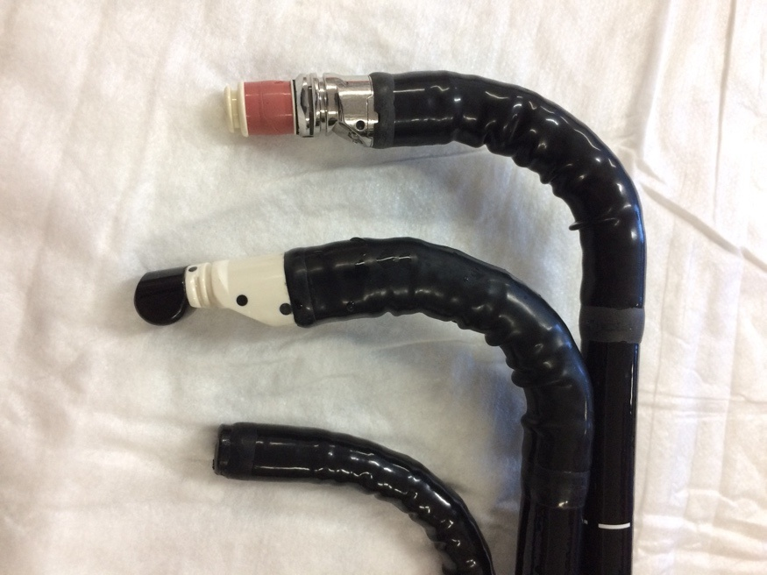
Figure 5.1: Tips of three conventional endoscopes. (Top to bottom; radial EUS scope, linear EUS scope, standard gastroscope)

Elastography is an ultrasound technique used to assess stiffness of tissues in the body. It has established applications in detecting chronic liver disease, and improving diagnostic accuracy in breast and prostate cancers (109). Pancreatic elastography is performed during standard EUS examinations (in a similar manner to Doppler). Tissue elasticity is measured and represented with different colours (on a scale of 1 to 255). The colour signal (red-green-blue) is then superimposed on the conventional grey-scale image. Areas of increased stiffness are marked with dark blue, intermediate areas with green and soft tissue areas with red. Areas of interest can be marked to give an elasticity reading and this is also compared to a control area of stomach or duodenal wall to calculate a ratio (strain ratio) (109).

Elastography is routinely used after several studies showed it can be successfully used to identify malignant pancreatic and lymph node masses with high sensitivity, allowing accurate targeting of fine needle aspiration (FNA) biopsies and early confirmation or exclusion of cancer (110) (199).

I aimed to demonstrate that changes of CP can be detected using EUS-E. Detecting change at an early stage will benefit patients and potentially reduce complications that result from CP such as malnutrition, pain and osteoporosis.

5.3 Methods
Patients were recruited prospectively after being identified when referred for EUS examination. Those undergoing a full pancreas assessment due to tests suggestive of CP and those with unexplained abdominal pain without suspicion of CP were identified. All patients had CT or MRCP assessment of the pancreas prior to undergoing EUS-E. Inclusion and exclusion criteria are shown in table 5.1.

Table 5.1: Inclusion and exclusion criteria for EUS-E recruitment
Inclusion criteria | Exclusion criteria
- Age 18 or over  - Patients referred for EUS for investigation of abdominal pain without a cause found on assessment with MRCP/CT and FEL-1  - Patients referred for EUS for chronic pancreatitis assessment based on MRI/CT and/or FEL-1 testing | - Patients with known solid pancreatic lesions  - Patients under the age of 18  - Patients who decline EUS examination  - Patients referred for EUS with indications other than epigastric pain or suspicion of chronic pancreatitis e.g. Patient referred for assessment of oesophageal cancer or lymph node biopsy

After reading the patient information sheet, eligible participants were consented by the principle investigator (PI). Patients recruited to the study had standard EUS assessment of the pancreas using Rosemont criteria for the diagnosis of CP and EUS-E measurements from the head, body and tail of pancreas. The ROI was selected to include the maximum area of pancreatic tissue under the probe whilst excluding blood vessels and ducts.

There was no randomization or blinding as the endoscopists (JC &AH) needed to be aware of the indication for referral to carry out a complete examination. The project was carried out at a single centre (Royal Hallamshire Hospital, Sheffield) where EUS procedures are performed.

The sample size was set at minimum 34 patients consisting of 17 CP patients and 17 patients with unexplained upper abdominal pain referred for EUS. A single feasibility study by Iglesias-Garcia et al. examining elastography in pancreatic cancer and chronic pancreatitis found strain ratios of 1.8 versus 2.68 respectively (102). The upper limit of normal for strain ratio was 2.25. A power calculation was undertaken using clincalc.com. This was based on the average strain ratio in the known population (control group) published in Iglesias-Garcia’s paper (1.8 ) with standard deviation of 0.41 (this was derived by calculating the standard error from the upper limit of the 95% confidence interval quoted in the paper- 1.93). The value used for the study group was 2.25 as anything above this limit would suggest CP. A 1:1 enrolment ratio was used, alpha 0.05, power 90%.

The endoscopy department at the Royal Hallamshire Hospital performs over 500 EUS procedures per year. By analysing previous procedures performed and considering exclusion criteria, it was feasible to expect to complete recruitment within 6-12 months. Figure 5.2 demonstrates the enrolment process for the study.

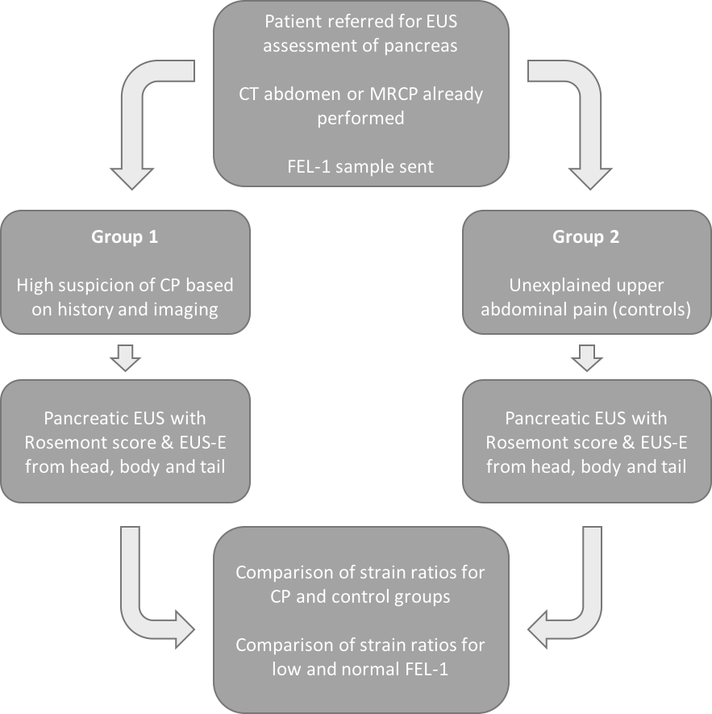
Figure 5.2: Enrolment pathway for study

Data were collected on anonymised data collection sheets at the time of endoscopy (Appendix 3). The data were collated on a spreadsheet and analysed. Simple descriptive statistics were used to describe the population (Microsoft Excel 15.61). Sensitivity and specificity of EUS for diagnosis of CP was calculated compared to CT and EUS diagnostic criteria for CP. The association between EUS elastography score and standard EUS/Rosemount criteria was analysed using linear regression.

I selected ROC curve analysis as a means of demonstrating the diagnostic accuracy of strain ratios in the diagnosis of CP. ROC curves are used to discriminate normal from abnormal results by plotting the true positive rate as a function of the false positive rate (1-specificity) (200). A test with perfect ability to distinguish between healthy and diseased cases would have a ROC curve closely related to the top left corner of the graph area. The area under the curve (AUC) value gives an indication of the overall diagnostic accuracy. The closer the value to 1, the more reliably the test can discriminate normal and abnormal results. In order to construct the ROC curve, I compiled a two-column table with dichotomised outcomes of CP yes/ no (1/0) and strain ratios in a second column. Analysis was performed in SPSS version 21.

Existing endoscopy unit protocols for EUS were followed. There were no additional considerations for this project. Patients were at liberty to withdraw from the study at any point. Should an individual decide to withdraw consent their future care would not have been affected. Patient consent forms and data collection sheets were stored securely. Electronic data was stored on a secure NHS computer. Patients were assigned a unique identifier number which was recorded and filed with their consent form.

5.4 Results
44 patients fulfilled inclusion criteria and were successfully recruited into the study (median age 50.5 years, range 24.2-82.6; 21 male). 17 patients had a pre-existing diagnosis of CP (median age 55.56 years, range 24.19-82.29; 9 male) and 27 were referred for EUS for investigation of unexplained upper abdominal pain (median age 45.89 years, range 25.08-82.64; 12 male). The aetiology of CP patients’ disease is broken down in table 5.2. 42/43 patients had EUS examinations under conscious sedation with combination fentanyl and midazolam. 1 patient was examined with general anaesthesia (propofol).

Table 5.2: Breakdown of aetiology of chronic pancreatitis in study group
Aetiology | n= | Proportion male
Idiopathic | 8 | 3/8
Alcoholic | 7 | 5/7
Genetic | 1 | 0/1
Radiation induced | 1 | 1/1

When classified according to the gold standard Rosemont assessment, 15 (34.9%) were found to have pancreatic EUS features consistent with (13/15) or suggestive of (2/15) CP. 7 patients had 5 or more EUS features of CP and 9 patients had 3 or 4 features of CP. EUS-E was successfully performed in all study participants. Table 5.3 shows the average strain ratios in controls and CP patients and makes comparison at the different areas measured (body, head and tail) and as an average across the whole pancreas. The average strain ratios were significantly higher in those with CP as compared to controls being investigated for unexplained upper abdominal pain.

Table 5.3: Strain ratios in head, body and tail of pancreas in control patients and those with chronic pancreatitis. Average strain ratios are given at the bottom of the table.
 | Controls  Mean (95% CI) | Chronic pancreatitis  Mean (95% CI) | P value
Head | 3.33 (2.16-4.50) | 9.43 (1.40-17.65) | 0.0058
Body | 2.03 (1.09-2.96) | 12.52 (2.01-23.03) | 0.0127
Tail | 3.08 (1.22-4.94) | 16.49 (-8.29-41.26) | 0.1637
Average | 2.81 (1.80-3.81) | 12.82 (3.21-22.43) | 0.0098

A significant correlation was demonstrated between average strain ratio and total number of Rosemont criteria (r = 0.317; p<0.0001). Figure 5.3 demonstrates this relationship. Two outlying values (strain ratios 70.77 (8 Rosemont features) and 51.44 (4 Rosemont features)) have been excluded from the graph for ease of viewing. These values have not been excluded from the data analysis.
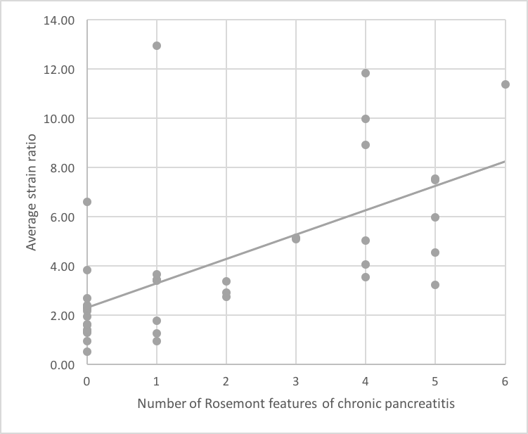

Figure 5.3: Graph showing relationship between number of Rosemont features of chronic pancreatitis and average strain ratios. (r=0.316; p<0.0001)

Patients with 0-2 Rosemont features of CP had significantly lower strain ratios than those with 3-4 features of CP (2.78 [SD 1.84-3.72] versus 11.66 [-0.02-23.34]; p=0.0049). There was no significant difference in strain ratios when comparing patients with 3-4 Rosemont features with those with ≥5 features (11.66 [-0.02-23.34] versus 15.84 [-10.98-34.08]; p=0.6798). Average strain ratios were significantly higher in patients with low FEL-1 levels than those with normal FEL-1 (13.38 compared with 3.58; p=0.0158).

The accuracy of EUS-E in the diagnosis of CP using a cut off strain ratio of 2.25 is shown in ta. Accuracies have been shown using different means of diagnosis. Regardless of method of diagnosis, the sensitivity and NPV of EUS-E both remain 100%.

Table 5.4: Accuracy of endoscopic ultrasound- elastography in the diagnosis of chronic pancreatitis. Each column shows accuracies for different diagnostic modalities and cut offs used in diagnosis of CP.
 | CT diagnosis | ≥5 EUS Rosemont features | ≥3 EUS Rosemont features | Rosemont consistent with CP | Rosemont suggestive/consistent CP
Sensitivity  (95% CI) | 100%  (80.49% - 100%) | 100%  (59.04-100%) | 100%  (79.41-100%) | 100%  (75.29-100%) | 100%  (78.20-100%)
Specificity  (95% CI) | 46.15%  (26.59%-66.63%) | 33.3%  (18.56-50.97%) | 44.44%  (25.48-64.68%) | 60.0%  (40.60-77.34%) | 64.29%  (44.07-81.36%)
PPV  (95% CI) | 54.84%  (45.97%-63.41%) | 22.58%  (18.80-26.87%) | 51.61%  (43.22-59.91%) | 52.00%  (41.14-62.68%) | 60.0%  (47.71-71.14%)
NPV | 100% | 100% | 100% | 100% | 100%
Accuracy | 66.66% | 46.51% | 65.11% | 60.47% | 65.12%

ROC curve analysis of strain ratio for CP diagnosis demonstrated area under curve 0.910 (95% CI 0.819-1.00) (Figure 5.4). The graph is also very close to the top left of the plot area, suggesting that strain ratios can be used with a high degree of confidence in the diagnosis of CP.

Figure 5.4: Receiver operating characteristic curve of endoscopic ultrasound-elastography for the diagnosis of chronic pancreatitis

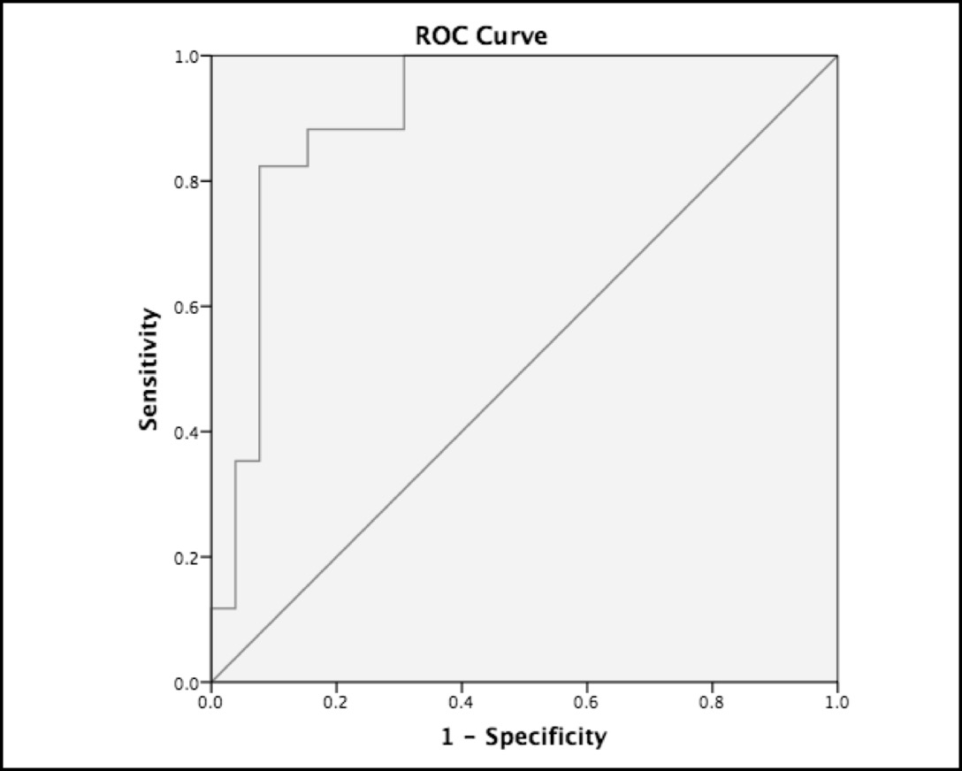

5.5 Discussion

In this chapter, I have shown that EUS-E is highly sensitive in the diagnosis of CP and has a high negative predictive value although the specificity for diagnosis of CP is low. Based on my results, EUS-E appears to be a useful tool in the evaluation of those with unexplained upper abdominal pain to exclude a diagnosis of CP as a contributing factor towards to symptoms.

CP is difficult to diagnose, particularly in its early stages. There is no single gold standard test for CP (76). The most sensitive test is histological assessment, however, this is rarely performed due to the technicalities, associated risk of obtaining tissue and lack of intra-observer agreement on biopsy (153). All patients should undergo CT imaging to exclude malignancy in the initial work up for assessment of CP (3, 76). All patients in this study who had radiological evidence of CP on CT imaging prior to EUS were shown to have strain ratios greater than 2.25.

EUS has been widely reported as the most accurate means of diagnosing CP, above CT and MRI (82, 103, 104). It is accepted that as the severity of disease progresses, the number of features observed at EUS also increases with more than 5 features making a diagnosis of CP very likely and 2 or fewer features making a diagnosis unlikely (104). I have demonstrated a significant correlation between the number of Rosemont features of CP and increasing strain ratio which supports the utility of EUS-E in the diagnosis of CP. The strength of relationship shown in this work is not as strong as in Iglesias-Garcia’s paper (102) on which this study was designed (r=0.317, p<0.0001 compared with r=0.813, p<0.0001).

Average strain ratios differed significantly in those with known CP and in controls under investigation for unexplained epigastric pain. The specificity of EUS-E compared to Rosemont classification and number of EUS features of CP is poor, therefore a high strain ratio in the absence of any other diagnostic features should not be used to make a diagnosis of CP. Conversely, due to the high sensitivity and negative predictive value, a normal strain ratio is reassuring and could be used to exclude a diagnosis of CP in the presence of normal CT and Rosemont score.

Patients with low FEL-1 readings suggestive of PEI were significantly more likely to have high strain ratios compared to those with normal FEL-1 levels. Dominguez-Munoz and colleagues have previously demonstrated that patients with CP and PEI have significantly higher strain ratios when assessed with EUS-E (201). However, the ¹³C-mixed triglyceride breath test was used to assess for PEI rather than FEL-1 as in this study. Iglesias-Garcia and colleagues have suggested that EUS-E can be used as a marker of severity of CP with higher strain ratios indicating more severe disease (102). Assuming this to be true, it is not surprising that patients with PEI (and therefore more advanced CP) should have higher strain ratios regardless of whether PEI is quantified by FEL-1 or breath test.

In designing this study, I aimed to reduce bias as much as possible. CP is sometimes a patchy disease (202), so taking three strain ratio measurements from head, body and tail of the pancreas was included in the methodology to improve the reliability of strain ratios recorded. EUS-E examinations were performed by myself and one other colleague. We had both been trained in the use of elastography and are independent endosonographers. It was not possible for the endoscopists to be blinded in terms of whether subjects were controls or CP patients as this information was crucial in performing a clinical assessment.

Although EUS-E is a quantitative measure of tissue stiffness, it is still subject to variability in image acquisition. I observed it can be difficult to obtain a stable image, especially in some cases with pronounced respiratory or cardiac movement artefact. There is also a potential measurement error in obtaining elastographic images when selecting the ROI. The placement of circles A and B necessary to obtain a strain ratio remains operator-dependent and could influence results. Intra-observer variability has previously been reported as a limitation of EUS-E for assessment of solid pancreatic masses (110), therefore, it is reasonable that it plays a role in EUS-E assessment regardless of the pathology examined. Most patients in this study received conscious sedation for the test, therefore, I felt it would not have been appropriate to perform two consecutive examinations by two endoscopists. Performing more than three readings could improve the reliability of results, but would also add to procedure time which may affect tolerability of the procedure and therefore impair image acquisition.

In summary, I have shown elastography to be a useful tool in the exclusion of CP. The number of Rosemont features appear to correlate with increasing strain ratios, implying that the strain ratio increases with the severity of CP. EUS-E could be viewed as a useful adjunct to support investigations such as CT and standard EUS assessment to exclude CP.

CHAPTER 6: Summary, conclusions and future directions

6.1 Are chronic pancreatitis and pancreatic exocrine insufficiency under recognised?
The prevalence of CP reported in chapter 2 is comparable to reported rates in traditional dissection post mortem studies (63, 64). The work from my thesis and these existing studies come together to support the hypothesis that CP is under-recognised. I have also shown important associations between CP and increasing age and presence of diabetes mellitus. It is not clear, however, how many of the patients included in chapter 2 had signs or symptoms of CP whilst alive.

In both chapters three and four I demonstrated that by adopting a case finding approach, PEI as defined by low FEL-1 can be detected in a significant proportion of patients in both primary and secondary care. The results I obtained are similar to those published in previous series assessing rates of PEI in individuals with IBS type symptoms (33, 34). My work strengthens evidence already published in the literature and supports the hypothesis that PEI is common in both secondary and primary care patients with gastrointestinal symptoms. The benefits of early detection include early treatment with PERT to provide symptomatic benefit and modification of risk factors such as smoking and alcohol intake.

I feel that the work in chapters 2-4 support the hypotheses that both CP and PEI are common pathologies and that testing is important, even in early disease when symptoms may be subtle. I have highlighted groups of patients, including older adults and those with diabetes mellitus or HIV are particularly at risk of PEI and early screening should be used at onset of any gastrointestinal symptoms or weight loss. The data from chapter 3 illustrate importantly, that individuals with normal pancreatic imaging can have PEI and respond to PERT. Clinicians should, therefore, not be reassured by a normal CT or MRCP when excluding pancreatic exocrine dysfunction.

6.2 A shift in understanding: The relationship between chronic pancreatitis and pancreatic exocrine insufficiency
I have highlighted the importance of identifying conditions that appear to increase the risk of PEI and CP. The rationale for doing so is to allow intervention with support to modify risk factors such as smoking and alcohol consumption. Where necessary, PERT and comprehensive dietetic support can be provided to improve symptoms and minimize the development of complications such as osteoporosis. These interventions are known to slow the cascade of events leading to more severe disease (164). Slowing disease progression should reduce pain, improve malnutrition and morbidity, and ultimately improve quality of life.

The discrepancy between the post mortem prevalence of CP (up to 13 % (63, 64) and 13.5% in chapter 2) and the clinical prevalence of 41.8 per 100,000 (60) implies that there are many patients with undiagnosed sub-clinical or subtle CP. Classically, PEI has been regarded as an end-stage event in the disease course of CP but I have shown that it can present (and respond to PERT) in patients who have normal pancreatic imaging. The scenario of PEI with normal MRCP imaging has also been shown to occur in 21% of patients with diabetes mellitus (203).

Figure 6.1 (145) illustrates a new concept regarding the disease process in PEI which I conceived in conjunction with the research team. This has been published in the American Journal of Gastroenterology. I feel there is sufficient evidence to support a change in thinking to class PEI as a separate disease entity to CP especially in its early stages. Its presence with gastrointestinal symptoms indicative of maldigestion in the absence of structural changes of CP could suggest a different route for development of CP and its complications. Screening in symptomatic individuals and identifying PEI prior to the onset of structural pancreatic change could be important to potentially halt the progression of disease. By modifying risk factors, such as smoking and alcohol, at an early stage it may be possible to slow or arrest development of classic CP with its complications of malnutrition, pain and osteoporosis (204).

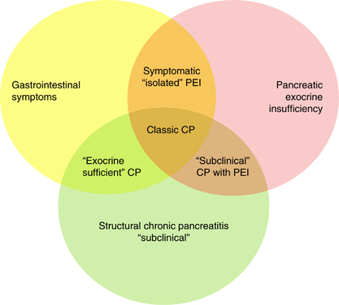

Figure 6.1: Evolving concepts in pancreatic disease. Diagram showing links between pancreatic exocrine insufficiency (PEI) and structural pancreatitis changes with or without symptoms. Structural pancreatitis changes can be subclinical when post mortem data and actual prevalence is compared, and symptomatic PEI may exist in isolation (sometimes referred to as maldigestion) prior to chronic changes developing, which may represent an alternative pathway to classic chronic pancreatitis (145).
Figure and legend reproduced in accordance with copyright policy of American Journal of Gastroenterology.

6.3 Is endoscopic ultrasound- elastography useful in the diagnosis of chronic pancreatitis?
The results from chapter 5 support the utility of EUS-E as a useful tool to exclude a diagnosis of CP in those with unexplained upper abdominal pain. I have not been able to show high enough specificity to support the use of EUS-E as a stand-alone diagnostic modality for CP. It is a useful adjunct to support investigations such as CT and standard EUS assessment to exclude CP as a diagnosis given its high negative predictive value.

6.4 Future Directions
Given that PMCT has never been used previously to determine prevalence of CP, further validation of this technique is required. The high prevalence demonstrated has significant clinical consequences, as there may be substantial numbers of individuals in the general population with undiagnosed or unrecognised CP.

Validation of the findings from my PMCT study could be undertaken by assessing CT scans performed in live patients. The most appropriate scans to assess for direct comparison would be non-contrast CT Thorax scans (where the pancreas is imaged with the inferior portion of the lungs). Examining non-contrast CT abdomen studies may introduce selection bias as subjects would have high pre-test probability of intra-abdominal pathology compared to those undergoing thoracic assessment. With prospective methodology, full patient histories could be obtained including comprehensive risk factor assessment for important comorbidities (diabetes mellitus) and smoking and alcohol habits. Gathering smoking history of patients having thoracic CTs would be important due to its link with developing CP (68). Those undergoing thoracic CTs may be more likely to have significant smoking histories, so this would need to be accounted for in the methodology.

Having demonstrated high detection rates of PEI in patients with gastrointestinal symptoms in both secondary and primary care I feel the next step would be to undertake a prospective validation study. This would allow for a more comprehensive, robust data set to be acquired. Detailed information on smoking and alcohol consumption could be collected which would allow for assessment of the impact of these two important risk factors on the prevalence of PEI. Patients with low FEL-1 could undergo standardised assessment with cross-sectional imaging of the pancreas as well as EUS assessment to ensure early cases of CP are not missed. Those with PEI could be closely monitored through PERT initiation and validated methods for determining response to treatment could be used. This would give important insights into the effect of PERT on symptoms, nutrition and quality of life.

There is extensive research into the prevalence of PEI in patients with diabetes mellitus (21, 22, 31), however, there is a relative lack of data to support the relationship between PEI and HIV infection (23, 24). A case-finding approach could be adopted in a prospective study of HIV patients. A patient questionnaire could be designed for use in HIV clinics to identify patients with gastrointestinal symptoms that may be suggestive of PEI. FEL-1 screening could then be performed as well as appropriate gastroenterological tests to investigate their symptoms (i.e. coeliac serology, lower gastrointestinal endoscopy). The results of this study would help to establish how common PEI is in the HIV population and allow important data to be gathered regarding smoking, alcohol consumption and medication history. Patients affected by PEI could be closely followed through initiation of PERT with thorough assessment of symptoms by means of validated questionnaires.

Appendix 1- Publications, abstracts and prizes
Peer Review articles:
Improving future studies in chronic pancreatitis: a paradigm shift in our understanding? Hopper AD Campbell JA. Gut. Published online first: 22 September 2017. doi:10.1136/gutjnl-2017-315067

Chronic pancreatitis may be overlooked and undertreated. Campbell JA, Hopper AD. Practitioner 2017:261(1806):13-17

Improving Outcomes of Chronic Pancreatitis: Is Isolated Pancreatic Exocrine Insufficiency an Early Marker to Identify Modifiable Risks? Campbell JA, Sanders DS, Hopper AD. Am J Gastroenterol. 2017 May;112(5):813-814

Endoscopic ultrasound sedation in the United Kingdom: Is life without propofol tolerable?
Campbell JA, Irvine AJ, Hopper AD. World J Gastroenterol. 2017 21;23(3):560-562.

Should we investigate gastroenterology patients for exocrine pancreatic insufficiency? A dual centre UK study. Campbell JA, Sanders DS, Francis KA, Kurien M, Lee S, Taha H, Ramadas A, Joy D, Hopper AD. Journal of Gastrointestinal and Liver Disease. 2016;25(3):303-9.

Abstracts
Quantitative Elastography is Useful in the diagnosis of chronic pancreatitis. Campbell JA, Vinagarayam R, Sanders DS, Hopper AD. BSG 2017

EUS guided pseudocyst drainage- does standard use of fluoroscopy just complicate things? Campbell JA, Hopper AD. BSG 2016

What is the prevalence of chronic pancreatitis at post mortem? A novel approach using “digital autopsy”. Campbell JA, Howard C, Hampton JNS, Hopper AD, Sanders DS. BSG 2016
Should patients with HIV and gastrointestinal symptoms be routinely tested for pancreatic exocrine insufficiency? Campbell JA, Sanders DS, Hopper AD. BSG 2016

How common is pancreatic exocrine insufficiency in primary care? Campbell JA, Sanders DS et al. BSG 2015

How common is pancreatic exocrine insufficiency in secondary care gastroenterology clinics? A dual centre study. Campbell JA, Sanders DS et al. BSG 2014

Prizes
Abstract of Distinction- Neuroendocrine and pancreas- BSG 2017
Quantitative elastography is useful in the diagnosis of chronic pancreatitis

Best poster- Neuroendocrine and pancreas- BSG 2016
Should patients with HIV and gastrointestinal symptoms be routinely tested for pancreatic exocrine insufficiency?

Bardhan Fellowship Winner 2016
What is the prevalence of chronic pancreatitis at post mortem? A novel approach using “digital autopsy”

Appendix 2- Patient information sheet
Participant information sheet

Study title: Elastography in the diagnosis of chronic pancreatitis

Invitation: We would like to invite you to take part in our research study. Before you decide we would like you to understand why the research is being done and what it would involve for you. One of the team will go through the information sheet with you and answer any questions you have.This should take about five to ten minutes. Talk to others about the study if you wish. Ask us if there is anything that is not clear.

What is the purpose of the study?
Chronic pancreatitis is a chronic condition in which the pancreas becomes scarred may stop producing enzymes responsible for normal digestion. There are many reasons an individual may develop chronic pancreatitis. Chronic pancreatitis affects approximately 25 out of 100,000 people but may be under-recognised. People who remain undiagnosed until late in the condition may suffer from long term health complications and a reduced quality of life.
A new technique called elastography which assesses changes in the pancreas is available in Sheffield. It is performed during endoscopic ultrasound (EUS) examinations and adds a maximum of a minute to your procedure.

Why have I been invited?
You have been invited because you have been referred for an EUS procedure. We are investigating the use of elastography in people who are known to have problems with the pancreas and those who are not known to have problems with the pancreas. We will then compare the two groups.

Do I have to take part?
No. It is up to you whether or not you decide to take part in this study. If you do decide to take part, you will be given this information sheet to keep and asked to sign a consent form. If you choose not to take part, you do not need to give a reason and your care will not be affected in any way.

What will happen to me if I take part?
You have been referred for an endoscopic ultrasound (EUS). This procedure involves passing a flexible tube called an endoscope into the gullet, stomach and first part of the small intestine. Ultrasound is then used to capture images of structures lying outside the lining of your oesophagus, stomach and small bowel. The procedure takes around 20 minutes. Before the procedure, your throat will be numbed with a local anaesthetic spray. You will also be given a sedative injection through a small plastic tube inserted in your hand or arm. The endoscope will enter the back of your mouth and will be guided down your oesophagus into your stomach and small intestine where the ultrasound images will be obtained. At the same time, we will take measurements using elastography which will assess the stiffness of your pancreas. This takes about 60 seconds longer than the standard procedure.
The procedure shouldn't be painful, but it may be uncomfortable at times which is why we give a sedative injection. EUS is a very safe procedure, but like all medical procedures it carries a risk of complications. Possible complications that can occur include: a reaction to the sedative, which can cause problems with your breathing, heart rate and blood pressure, internal bleeding (usually minor and self-limiting if it occurs), and very rarely, tearing of the gut lining (perforation). Serious problems are rare, occurring in less than 1 in 1000 cases. Using elastography during the procedure does not change the risks associated with the test.
When do I have to decide?
It is up to you. You can decide now, or take some time to think about it and let us know before your procedure.

Will this affect my existing treatment?
No. Your treatment will continue as planned.

What are the possible disadvantages and risks of taking part?
Participating in the study does not result in additional risk to you, and it will not increase the length of your stay in hospital.

What are the possible benefits of taking part?
Those diagnosed with chronic pancreatitis will benefit from an early diagnosis, meaning that you could receive treatment earlier and potentially reduce complications and improve quality of life.

For those who do not have changes associated with chronic pancreatitis there may be no direct benefit from the study, but your contribution will help us provide the best care for patients in the future.

How long will the study last?
The study will run for approximately 12 months.

Will my taking part in the study be kept confidential?
Yes your data will be kept confidential. It will be governed by the Data Protection Act (1998) and has Research Ethics Committee approval. Information will be completely anonymised if it is to be analysed or published outside the research team. Only the research team will be able to see your personal information. The information that can identify you personally will NEVER be given to anyone else or published. Only relevant sections of your medical notes will be looked at by the research team, from regulatory authorities or from your NHS Trust. Personal data will only be stored on NHS password protected computers and when this is pseudoanonymised the identification list will be kept separate located on the NHS system.

What will happen if I don’t want to carry on with the study?
You can withdraw your consent at any time in the future without giving a reason. If you withdraw your consent or become unable to continue to give informed consent, any information collected with consent will remain and be used in the study. No further information however will be collected and a record will be kept that you withdrew consent or were unable to continue to provide consent. Your care will not be affected in any way if you change your mind and withdraw from the study.

What if there is a problem?
Any complaints about the way you have been dealt with during the study or any possible harm you might suffer will be addressed. Detailed information on who to contact are given at the end of this information sheet.

What will happen to the results of the research study?
We intend to publish the results of the research in peer reviewed journals, and to present them at scientific meetings. No patient identifiable data will be published.

Will my general practitioner (GP) be contacted?
Your GP will be informed of the results of the test and advised on any changes to treatment.

Who is organising and funding the research?
The study required no additional funding and is run within the Academic Department of Gastroenterology, University of Sheffield. Dr Campbell’s research post is funded by Sheffield Teaching Hospital NHS Foundation Trust.
Who has reviewed the study?
All research in the NHS is looked at by an independent group of people, called a Research Ethics Committee, to protect your interests. This study has been reviewed and given favourable opinion by South Yorkshire Research Ethics Committee and the Sheffield Teaching Hospitals NHS Foundation Trust R&D Department (Clinical Research Office).

Thank you for taking the time to read this information sheet and for considering taking part in this study.

Further information and contact details:
If you want further general or specific information about the research, advice as to whether to participate or who to approach if you are unhappy with the study or want to take part or withdraw consent please contact:

Dr Jennifer Campbell
Clinical Research Fellow in Gastroenterology
Jennifer.campbell@sth.nhs.uk

If you have any complaints that you would like to be dealt with independently please contact:
The Patient Services Team  Email: pst@sth.nhs.uk  Telephone: 0114 2712400 | Or write to:  The Medical Director  8 Beech Hill Rd, S10 2SB

Appendix 3- Consent form
Study Number: STH19471 Participant Identification Number for this trial:
CONSENT FORM version 1.1. Title of Project: Can elastography be used as a test for chronic pancreatitis?
Name of Researchers: Dr Andrew Hopper, Dr Jennifer Campbell
Please initial box
- I confirm that I have read the information sheet dated 04/05/16 (version 1.1) for the
above study. I have had the opportunity to consider the information, ask questions and have
had these answered satisfactorily.

- I understand that my participation is voluntary and that I am free to withdraw at any time
without giving any reason, without my medical care or legal rights being affected.

- I understand that relevant sections of my medical notes and data collected during
the study may be looked at by individuals from regulatory authorities or
from the NHS Trust, where it is relevant to my taking part in this research. I give permission for
these individuals to have access to my records.

- I understand that by taking part in this study, the ultrasound could indicate that I may have a diagnosis of chronic pancreatitis, in which case I will be followed up in the gastroenterology clinic

- I understand that the information collected about me will be used to support
other research in the future, and may be shared anonymously with other researchers.

- I agree to take part in the above study.

Name of Participant Date Signature

Name of Person taking consent Date Signature

Appendix 4- Data collection sheet
Study number |  |  | Chronic pancreatitis |  |  | Epigastric pain
Endoscopist | ADH/ JAC

Rosemont Score
Major A | Hyperechoic foci & shadowing |  |  | Consistent CP | A: Maj A, ≥3 minor
 | MPD Stones |  |  |  | B: Maj A, Maj B
Major B | Lobularity & honeycombing |  |  |  | C: 2 Maj A
Minor | Lobularity, no honeycombing |  |  | Suggestive CP | A: 1 maj A, <3 minor
 | Hyperechoic, no shadowing |  |  |  | B: 1 maj B, ≥3 minor
 | Cystic changes |  |  |  | C: ≥5 minor
 | Stranding |  |  | Indeterminate | A: 3 or 4 minor
 | Irregular MPD |  |  |  | B: maj B +/- <3 minor
 | Side branch dilatation |  |  | Normal | < 2 minor
 | MPD dilatation
 | Hyperechoic MPD border |  |  | Overall grade:

Elastography Measurements
 | B | A | B/A
Head
Body
Tail

FEL-1
MRCP

References

1. Lindkvist B, Phillips ME, Enrique Dominguez-Munoz J. Clinical, anthropometric and laboratory nutritional markers of pancreatic exocrine insufficiency: Prevalence and diagnostic use. Pancreatology. 2015;15(6):589-97.
2. Lindkvist B. Diagnosis and treatment of pancreatic exocrine insufficiency. World J Gastroenterol. 2013;19(42):7258-66.
3. Lohr JM, Dominguez-Munoz E, Rosendahl J, Besselink M, Mayerle J, Lerch MM, et al. United European Gastroenterology evidence-based guidelines for the diagnosis and therapy of chronic pancreatitis (HaPanEU). United European Gastroenterology Journal. 2017;5(2):153-99.
4. Lankisch PG, Lembcke B, Wemken G, Creutzfeldt W. Functional reserve capacity of the exocrine pancreas. Digestion. 1986;35(3):175-81.
5. Duggan SN, Smyth ND, O'Sullivan M, Feehan S, Ridgway PF, Conlon KC. The prevalence of malnutrition and fat-soluble vitamin deficiencies in chronic pancreatitis. Nutr Clin Pract. 2014;29(3):348-54.
6. Haaber AB, Rosenfalck AM, Hansen B, Hilsted J, Larsen S. Bone mineral metabolism, bone mineral density, and body composition in patients with chronic pancreatitis and pancreatic exocrine insufficiency. International Journal of Pancreatology. 2000;27(1):21-7.
7. Duggan SN, Smyth ND, Murphy A, Macnaughton D, O'Keefe SJ, Conlon KC. High prevalence of osteoporosis in patients with chronic pancreatitis: a systematic review and meta-analysis. Clin Gastroenterol Hepatol. 2014;12(2):219-28.
8. Tignor AS, Wu BU, Whitlock TL, Lopez R, Repas K, Banks PA, et al. High Prevalence of Low-Trauma Fracture in Chronic Pancreatitis. American Journal of Gastroenterology. 2010;105(12):2680-6.
9. Sandhu B, Sistrun S, Naniwadekar A, Sanyal A, Zfass A, BouHaidar D, et al. Good Nutrition, as Measured by Mynutritionindex, in Chronic Pancreatitis Patients Improves Clinical Outcome. Gastroenterology 2010.
10. D'Haese JG, Ceyhan GO, Demir IE, Layer P, Uhl W, Lohr M, et al. Pancreatic enzyme replacement therapy in patients with exocrine pancreatic insufficiency due to chronic pancreatitis: a 1-year disease management study on symptom control and quality of life. Pancreas. 2014;43(6):834-41.
11. Smith M, Morton D. The Digestive System- Basic Science and Clinical Conditions. Second ed. Horne T, editor: Elsevier; 2010. 217 p.
12. Keller J, Layer P. Human pancreatic exocrine response to nutrients in health and disease. Gut. 2005;54:1-28.
13. Pezzilli R. Chronic pancreatitis: Maldigestion, intestinal ecology and intestinal inflammation. World Journal of Gastroenterology. 2009;15(14):1673-6.
14. Boreham B, Ammori BJ. A prospective evaluation of pancreatic exocrine function in patients with acute pancreatitis: Correlation with extent of necrosis and pancreatic endocrine insufficiency. Pancreatology. 2003;3(4):303-8.
15. Haupt ME, Kwasny MJ, Schechter MS, McColley SA. Pancreatic Enzyme Replacement Therapy Dosing and Nutritional Outcomes in Children with Cystic Fibrosis. Journal of Pediatrics. 2014;164(5):1110-1115.
16. Lohr JM, Oliver MR, Frulloni L. Synopsis of recent guidelines on pancreatic exocrine insufficiency. United European Gastroenterology Journal. 2013;1(2):79-83.
17. Frulloni L, Falconi M, Gabbrielli A, Gaia E, Graziani R, Pezzilli R, et al. Italian consensus guidelines for chronic pancreatitis. Digestive and liver disease : official journal of the Italian Society of Gastroenterology and the Italian Association for the Study of the Liver. 2010;42 Suppl 6:S381-406.
18. Friess H, Bohm J, Muller MW, Glasbrenner B, Riepl RL, Malfertheiner P, et al. Maldigestion after total gastrectomy is associated with pancreatic insufficiency. American Journal of Gastroenterology. 1996;91(2):341-7.
19. Hardt PD, Krauss A, Bretz L, Porsch-Ozcurumez M, Schnell-Kretschmer H, Maser E, et al. Pancreatic exocrine function in patients with type 1 and type 2 diabetes mellitus. Acta Diabetol. 2000;37(3):105-10.
20. Hardt PD, Ewald N. Exocrine Pancreatic Insufficiency in Diabetes Mellitus: A Complication of Diabetic Neuropathy or a Different Type of Diabetes? Experimental Diabetes Research. 2011.
21. Nunes ACR, Pontes JM, Rosa A, Gomes L, Carvalheiro M, Freitas D. Screening for pancreatic exocrine insufficiency in patients with diabetes mellitus. American Journal of Gastroenterology. 2003;98(12):2672-5.
22. Icks A, Haastert B, Giani G, Rathmann W. Low fecal elastase-1 in type I diabetes mellitus. Z Gastroenterol. 2001;39(10):823-30.
23. Martin TC, Scourfield A, Rockwood N, Martin NK, Patel N, Nelson M, et al. Pancreatic insufficiency in patients with HIV infection: role of didanosine questioned. HIV Med. 2013;14(3):161-6.
24. Price DA, Schmid ML, Ong EL, Adjukeiwicz KM, Peaston B, Snow MH. Pancreatic exocrine insufficiency in HIV-positive patients. HIV Med. 2005;6(1):33-6.
25. Yilmaz A, Hagberg L. Exocrine pancreatic insufficiency is common in people living with HIV on effective antiretroviral therapy. Infect Dis (Lond). 2017;Aug 25:1-7.
26. Carroccio A, Fontana M, Spagnuolo MI, Zuin G, Montalto G, Canani RB, et al. Pancreatic dysfunction and its association with fat malabsorption in HIV infected children. Gut. 1998;43(4):558-63.
27. Walkowiak J, Herzig KH. Fecal elastase-1 is decreased in villous atrophy regardless of the underlying disease. European Journal of Clinical Investigation. 2001;31(5):425-30.
28. Leeds JS, Hopper AD, Hurlstone DP, Edwards SJ, McAlindon ME, Lobo AJ, et al. Is exocrine pancreatic insufficiency in adult coeliac disease a cause of persisting symptoms? Alimentary Pharmacology & Therapeutics. 2007;25(3):265-71.
29. Angelini G, Cavallini G, Bovo P, Brocco G, Castagnini A, Lavarini E, et al. Pancreatic function in chronic inflammatory bowel disease. Int J Pancreatol. 1988;3(2-3):185-93.
30. Maconi G, Dominici R, Molteni M, Ardizzone S, Bosani M, Ferrara E, et al. Prevalence of pancreatic insufficiency in inflammatory bowel diseases. Assessment by fecal elastase-1. Digestive Diseases and Sciences. 2008;53(1):262-70.
31. Hardt PD, Hauenschild A, Nalop J, Marzeion AM, Jaeger C, Teichmann J, et al. High prevalence of exocrine pancreatic insufficiency in diabetes mellitus - A multicenter study screening fecal elastase 1 concentrations in 1,021 diabetic patients. Pancreatology. 2003;3(5):395-402.
32. Thomas PD, Forbes A, Green J, Howdle P, Long R, Playford R, et al. Guidelines for the investigation of chronic diarrhoea, 2nd edition. Gut. 2003;52(suppl 5):v1.
33. Emmanuel A, Landis D, Peucker M, Hungin APS. Faecal biomarker patterns in patients with symptoms of irritable bowel syndrome. Frontline Gastroenterology. 2016;7(4):275-282.
34. Leeds JS, Hopper AD, Sidhu R, Simmonette A, Azadbakht N, Hoggard N, et al. Some Patients With Irritable Bowel Syndrome May Have Exocrine Pancreatic Insufficiency. Clinical Gastroenterology and Hepatology. 2010;8(5):433-8.
35. Rothenbacher D, Low M, Hardt PD, Klor HU, Ziegler H, Brenner H. Prevalence and determinants of exocrine pancreatic insufficiency among older adults: Results of a population-based study. Scandinavian Journal of Gastroenterology. 2005;40(6):697-704.
36. Herzig KH, Purhonen AK, Rasanen KM, Idziak J, Juvonen P, Phillps R, et al. Fecal pancreatic elastase-1 levels in older individuals without known gastrointestinal diseases or diabetes mellitus. Bmc Geriatrics. 2011;11:5.
37. Niederau C, Sonnenberg A, Muller JE, Erckenbrecht JF, Scholten T, Fritsch WP. Sonographic measurements of the normal liver, spleen, pancreas and portal vein. Radiology. 1983;149(2):537-40.
38. Saisho Y, Butler AE, Meier JJ, Monchamp T, Allen-Auerbach M, Rizza RA, et al. Pancreas volumes in humans from birth to age one hundred taking into account sex, obesity, and presence of type-2 diabetes. Clinical Anatomy. 2007;20(8):933-42.
39. Geraghty EM, Boone JM, McGahan JP, Jain K. Normal organ volume assessment from abdominal CT. Abdominal Imaging. 2004;29(4):482-90.
40. Meier JM, Alavi A, Iruvuri S, Alzeair S, Parker R, Houseni M, et al. Assessment of age-related changes in abdominal organ structure and function with computed tomography and positron emission tomography. Seminars in Nuclear Medicine. 2007;37(3):154-72.
41. Sato T, Ito K, Tamada T, Sone T, Noda Y, Higaki A, et al. Age-related changes in normal adult pancreas: MR imaging evaluation. European Journal of Radiology. 2012;81(9):2093-8.
42. Li J, Xie Y, Yuan F, Song B, Tang CW. Noninvasive Quantification of Pancreatic Fat in Healthy Male Population Using Chemical Shift Magnetic Resonance Imaging Effect of Aging on Pancreatic Fat Content. Pancreas. 2011;40(2):295-9.
43. Tsushima Y, Kusano S. Age-dependent decline in parenchymal perfusion in the normal human pancreas: Measurement by dynamic computed tomography. Pancreas. 1998;17(2):148-52.
44. Ammann R, Sulser H. Senile chronic pancreatitis- new nosologic entity. Schweizerische Medizinische Wochenschrift. 1976;106(13):429-37.
45. Ammann R. Vascular genesis of chronic pancreatitis- facts and hypotheses. Deutsche Medizinische Wochenschrift. 1976;101(22):867-8.
46. Toouli J, Biankin AV, Oliver MR, Pearce CB, Wilson JS, Wray NH. Management of pancreatic exocrine insufficiency: Australasian Pancreatic Club recommendations. Medical Journal of Australia. 2010;193(8):461-7.
47. Leeds JS, Oppong K, Sanders DS. The role of fecal elastase-1 in detecting exocrine pancreatic disease. Nature Reviews Gastroenterology & Hepatology. 2011;8(7):405-15.
48. Glasbrenner B, Kahl S, Malfertheiner P. Modern diagnostics of chronic pancreatitis. European Journal of Gastroenterology & Hepatology. 2002;14(9):935-41.
49. Weaver LT, Amarri S, Swart GR. 13C mixed triglyceride breath test. Gut. 1998;43 Suppl 3:S13-9.
50. Dimagno EP, Go VLW, Summersk.Wh. Relations between pancreatic enzyme outputs and malabsorption in severe pancreatic insufficiency. New England Journal of Medicine. 1973;288(16):813-5.
51. Walkowiak J, Herzig KH, Strzykala K, Przyslawski J, Krawczynski M. Fecal elastase-1 is superior to fecal chymotrypsin in the assessment of pancreatic involvement in cystic fibrosis. Pediatrics. 2002;110(1).
52. Stein J, Jung M, Sziegoleit A, Zeuzem S, Caspary WF, Lembcke B. Immunoreactive elastase .1. Clinical evaluation of a new noninvasive test of pancreatic function. Clinical Chemistry. 1996;42(2):222-6.
53. Loser C, Mollgaard A, Folsch UR. Faecal elastase 1: a novel, highly sensitive, and specific tubeless pancreatic function test. Gut. 1996;39(4):580-6.
54. Sziegoleit A. Purification and characterization of a cholesterol-binding protein from human pancreas. Biochemical Journal. 1982;207(3):573-82.
55. ScheBo ^{R} Biotech AG G. Pancreatic Elastase 1 Stool Test Kit Insert. 2005.
56. Fischer B, Hoh S, Wehler M, Hahn EG, Schneider HT. Faecal elastase-1: Lyophilization of stool samples prevents false low results in diarrhoea. Scandinavian Journal of Gastroenterology. 2001;36(7):771-4.
57. Dzieniszewski J, Jarosz M, Ciok J. Chronic pancreatitis in Warsaw. Materia Medica Polona 1990;22(3):202-4.
58. Levy P, Barthet M, Mollard BR, Amouretti M, Marion-Audibert A-M, Dyard F. Estimation of the prevalence and incidence of chronic pancreatitis and its complications - A prospective survey in adults attending gastroenterologists in France. Gastroenterologie Clinique Et Biologique. 2006;30(6-7):838-44.
59. Wang LW, Li ZS, Li SD, Jin ZD, Zou DW, Chen F. Prevalence and clinical features of chronic pancreatitis in China: a retrospective multicenter analysis over 10 years. Pancreas. 2009;38(3):248-54.
60. Yadav D, Timmons L, Benson JT, Dierkhising RA, Chari ST. Incidence, Prevalence, and Survival of Chronic Pancreatitis: A Population-Based Study. American Journal of Gastroenterology. 2011;106(12):2192-9.
61. Hirota M, Shimosegawa T, Masamune A, Kikuta K, Kume K, Hamada S, et al. The sixth nationwide epidemiological survey of chronic pancreatitis in Japan. Pancreatology. 2012;12(2):79-84.
62. Dominguez-Munoz JE, Lucendo A, Carballo LF, Iglesias-Garcia J, Tenias J, Soc Espanola Patologia D. A Spanish multicenter study to estimate the prevalence and incidence of chronic pancreatitis and its complications. Revista Espanola De Enfermedades Digestivas. 2014;106(4):239-45.
63. Olsen TS. Incidence and clinical relevance of chronic inflammation in pancreas in autopsy material. Acta Pathologica Et Microbiologica Scandinavica Section a-Pathology. 1978;86(5):361-5.
64. Blumenthal HT, Probstein JG, Berns AW. Interrelationship of diabetes mellitus and pancreatitis. Archives of Surgery. 1963;87(5):844-50.
65. Bhutani MS, Arantes VN, Verma D, Moezzi J, Suryaprasad S, Kapadia AS, et al. Histopathologic Correlation of Endoscopic Ultrasound Findings of Chronic Pancreatitis in Human Autopsies. Pancreas. 2009;38(7):820-4.
66. Etemad B, Whitcomb DC. Chronic pancreatitis: Diagnosis, classification, and new genetic developments. Gastroenterology. 2001;120(3):682-707.
67. Lowenfels AB, Maisonneuve P. Defining the Role of Smoking in Chronic Pancreatitis. Clinical Gastroenterology and Hepatology. 2011;9(3):196-7.
68. Yadav D, Hawes RH, Brand RE, Anderson MA, Money ME, Banks PA, et al. Alcohol Consumption, Cigarette Smoking, and the Risk of Recurrent Acute and Chronic Pancreatitis. Archives of Internal Medicine. 2009;169(11):1035-45.
69. Cote GA, Yadav D, Slivka A, Hawes RH, Anderson MA, Burton FR, et al. Alcohol and Smoking as Risk Factors in an Epidemiology Study of Patients With Chronic Pancreatitis. Clinical Gastroenterology and Hepatology. 2011;9(3):266-73.
70. Sankaran SJ, Xiao AY, Wu LM, Windsor JA, Forsmark CE, Petrov MS. Frequency of Progression From Acute to Chronic Pancreatitis and Risk Factors: A Meta-analysis. Gastroenterology. 2015;149(6):1490-1500.
71. Maisonneuve P, Lowenfels AB, Mullhaupt B, Cavallini G, Lankisch PG, Andersen JR, et al. Cigarette smoking accelerates progression of alcoholic chronic pancreatitis. Gut. 2005;54(4):510-4.
72. Lowenfels AB, Maisonneuve P, Cavallini G, Ammann RW, Lankisch PG, Andersen JR, et al. Pancreatitis and the risk of pancreatic cancer. New England Journal of Medicine. 1993;328(20):1433-7.
73. Whitcomb DC, Yadav D, Adam S, Hawes RH, Brand RE, Anderson MA, et al. Multicenter approach to recurrent acute and chronic pancreatitis in the United States: The North American Pancreatitis Study 2 (NAPS2). Pancreatology. 2008;8(4-5):520-31.
74. Alexandre M, Pandol SJ, Gorelick FS, Thrower EC. The Emerging Role of Smoking in the Development of Pancreatitis. Pancreatology. 2011;11(5):469-74.
75. Goulden M. The pain of chronic pancreatitis: a persistent clinical challenge. British Journal of Pain. 2013;7(1):8-22.
76. Duggan SN, Chonchubhair HMN, Lawal O, O'Connor DB, Conlon KC. Chronic pancreatitis: A diagnostic dilemma. World Journal of Gastroenterology. 2016;22(7):2304-13.
77. NICE Clinical Knowledge Summaries: Pancreatitis- Chronic, Management of Suspected Chronic Pancreatitis. London: National Institute for Clinical Excellence; 2016.
78. Rebours V, Boutron-Ruault MC, Schnee M, Ferec C, Le Marechal C, Hentic O, et al. The natural history of hereditary pancreatitis: a national series. Gut. 2009;58(1):97-103.
79. Rickels MR, Bellin M, Toledo FGS, Robertson RP, Andersen DK, Chari ST, et al. Detection, evaluation and treatment of diabetes mellitus in chronic pancreatitis:. Recommendations from PancreasFest 2012. Pancreatology. 2013;13(4):336-42.
80. Raimondi S, Lowenfels AB, Morselli-Labate AM, Maisonneuve P, Pezzilli R. Pancreatic cancer in chronic pancreatitis; aetiology, incidence, and early detection. Best Practice & Research in Clinical Gastroenterology. 2010;24(3):349-58.
81. Bang UC, Benfield T, Hyldstrup L, Bendtsen F, Jensen JEB. Mortality, Cancer, and Comorbidities Associated With Chronic Pancreatitis: A Danish Nationwide Matched-Cohort Study. Gastroenterology. 2014;146(4):989-94.
82. Seicean A, Tantau M, Grigorescu M, Mocan T, Seicean R, Pop T. Mortality risk factors in chronic pancreatitis. Journal of Gastrointestinal and Liver Diesase. 2006;15(1):21-6.
83. Kloppel G, Maillet B. Pathology of acute and chronic pancreatitis. Pancreas. 1993;8(6):659-70.
84. Ammann RW, Muellhaupt B, Zurich Pancreatitis Study G. The natural history of pain in alcoholic chronic pancreatitis. Gastroenterology. 1999;116(5):1132-40.
85. Banks PA. Classification and diagnosis of chronic pancreatitis. Journal of Gastroenterology. 2007;42:148-51.
86. Ring EJ, Eaton SB, Jr., Ferrucci JT, Jr., Short WF. Differential diagnosis of pancreatic calcification. Am J Roentgenol Radium Ther Nucl Med. 1973;117(2):446-52.
87. Bolondi L, Bassi SL, Gaiani S, Barbara L. Sonography of chronic pancreatitis. Radiologic Clinics of North America. 1989;27(4):815-33.
88. Conwell DL, Lee LS, Yadav D, Longnecker DS, Miller FH, Mortele KJ, et al. American Pancreatic Association Practice Guidelines in Chronic Pancreatitis Evidence-Based Report on Diagnostic Guidelines. Pancreas. 2014;43(8):1143-62.
89. Remer EM, Baker ME. Imaging of chronic pancreatitis. Radiologic Clinics of North America. 2002;40(6):1229-42.
90. Siddiqi AJ, Miller F. Chronic pancreatitis: Ultrasound, computed tomography, and magnetic resonance Imaging features. Seminars in Ultrasound Ct and Mri. 2007;28(5):384-94.
91. Kim DH, Pickhardt PJ. Radiologic assessment of acute and chronic pancreatitis. Surgical Clinics of North America. 2007;87(6):1341-58.
92. Sarner M, Cotton PB. Classification of pancreatitis. Gut. 1984;25(7):756-9.
93. Choueiri NE, Balci NC, Alkaade S, Burton FR. Advanced imaging of chronic pancreatitis. Current gastroenterology reports. 2010;12(2):114-20.
94. Hansen TM, Nilsson M, Gram M, Frokjaer JB. Morphological and functional evaluation of chronic pancreatitis with magnetic resonance imaging. World Journal of Gastroenterology. 2013;19(42):7241-6.
95. Wallner BK, Schumacher KA, Weidenmaier W, Friedrich JM. Dilated biliary tract evaluation with MR cholagngiography with a T2-weighted contrast-enhanced fast sequence. Radiology. 1991;181(3):805-8.
96. Christensen M, Matzen P, Schulze S, Rosenberg J. Complications of ERCP: a prospective study. Gastrointestinal Endoscopy. 2004;60(5):721-31.
97. Valori R. BSG Quality and Safety Indicators for Endoscopy 2007.
98. Chamokova B, Bastati N, Kulinna-Cosentini C, Sinitsyn V, Ba-Ssalamah A. The Clinical Value of Secretin-enhanced MRCP in the Functonal and Morphological Assessment of Pancreatic Disease European Congress of Radiology 2014.
99. Matos C, Metens T, Deviere J, Nicaise N, Braude P, VanYperen G, et al. Pancreatic duct: Morphologic and functional evaluation with dynamic MR pancreatography after secretin stimulation. Radiology. 1997;203(2):435-41.
100. Griffin N, Charles-Edwards G, Grant LA. Magnetic resonance cholangiopancreatography: the ABC of MRCP. Insights into imaging. 2012;3(1):11-21.
101. Sanyal R, Stevens T, Novak E, Veniero JC. Secretin-Enhanced MRCP: Review of Technique and Application With Proposal for Quantification of Exocrine Function. American Journal of Roentgenology. 2012;198(1):124-32.
102. Iglesias-Garcia J, Enrique Dominguez-Munoz J, Castineira-Alvarino M, Luaces-Regueira M, Larino-Noia J. Quantitative elastography associated with endoscopic ultrasound for the diagnosis of chronic pancreatitis. Endoscopy. 2013;45(10):781-8.
103. Stevens T, Parsi MA. Endoscopic ultrasound for the diagnosis of chronic pancreatitis. World Journal of Gastroenterology. 2010;16(23):2841-50.
104. Catalano MF, Sahai A, Levy M, Romagnuolo J, Wiersema M, Brugge W, et al. EUS-based criteria for the diagnosis of chronic pancreatitis: the Rosemont classification. Gastrointestinal Endoscopy. 2009;69(7):1251-61.
105. Conwell DL, Zuccaro G, Purich E, Fein S, Vargo JJ, Dumot JA, et al. Comparison of endoscopic ultrasound chronic pancreatitis criteria to the endoscopic secretin-stimulated pancreatic function test. Digestive Diseases and Sciences. 2007;52(5):1206-10.
106. Itoh A, Ueno E, Tohno E, Kamma H, Takahashi H, Shiina T, et al. Breast disease: Clinical application of US elastography for diagnosis. Radiology. 2006;239(2):341-50.
107. Cochlin DL, Ganatra RH, Griffiths DFR. Elastography in the detection of prostatic cancer. Clinical Radiology. 2002;57(11):1014-20.
108. Krouskop TA, Wheeler TM, Kallel F, Garra BS, Hall T. Elastic moduli of breast and prostate tissues under compression. Ultrasonic Imaging. 1998;20(4):260-74.
109. Lee TH, Cha S-W, Cho YD. EUS Elastography: Advances in Diagnostic EUS of the Pancreas. Korean Journal of Radiology. 2012;13:S12-S6.
110. Iglesias Garcia J, Larino Noia J, Dominguez Munoz JE. Endoscopic ultrasound in the diagnosis and staging of pancreatic cancer. Rev Esp Enferm Dig. 2009;101(9):631-8.
111. Kawada N, Tanaka S, Uehara H, Takakura R, Katayama K, Fukuda J, et al. Feasibility of Second-Generation Transabdominal Ultrasound-Elastography to Evaluate Solid Pancreatic Tumors Preliminary Report of 36 Cases. Pancreas. 2012;41(6):978-80.
112. Hu DM, Gong TT, Zhu Q. Endoscopic Ultrasound Elastography for Differential Diagnosis of Pancreatic Masses: A Meta-Analysis. Digestive Diseases and Sciences. 2013;58(4):1125-31.
113. Mei M, Ni JM, Liu D, Jin PP, Sun LM. EUS elastography for diagnosis of solid pancreatic masses: a meta-analysis. Gastrointestinal Endoscopy. 2013;77(4):578-89.
114. Li X, Xu W, Shi J, Lin Y, Zeng X. Endoscopic ultrasound elastography for differentiating between pancreatic adenocarcinoma and inflammatory masses: A meta-analysis. World Journal of Gastroenterology. 2013;19(37):6284-91.
115. Iglesias-Garcia J, Larino-Noia J, Abdulkader I, Forteza J, Dominguez-Munoz JE. EUS elastography for the characterization of solid pancreatic masses. Gastrointestinal Endoscopy. 2009;70(6):1101-8.
116. Hirche TO, Ignee A, Barreiros AP, Schreiber-Dietrich D, Jungblut S, Ott M, et al. Indications and limitations of endoscopic ultrasound elastography for evaluation of focal pancreatic lesions. Endoscopy. 2008;40(11):910-7.
117. Kawada N, Tanaka S. Elastography for the pancreas: Current status and future perspective. World Journal of Gastroenterology. 2016;22(14):3712-24.
118. Iglesias-Garcia J, Larino-Noia J, Abdulkader I, Forteza J, Dominguez-Munoz JE. Quantitative Endoscopic Ultrasound Elastography: An Accurate Method for the Differentiation of Solid Pancreatic Masses. Gastroenterology. 2010;139(4):1172-80.
119. Kuwahara T, Hirooka Y, Kawashima H, Ohno E, Ishikawa T, Kawai M, et al. Quantitative diagnosis of chronic pancreatitis using EUS elastography. J Gastroenterol. 2016.
120. Hiele M, Ghoos Y, Rutgeerts P, Vantrappen G. Starch digestion in normal subjects and patients with pancreatic disease using a CO₂ C13 breath test. Gastroenterology. 1989;96(2):503-9.
121. Layer P, Yamamoto H, Kalthoff L, Clain JE, Bakken LJ, DiMagno EP. The different courses of early- and late-onset idiopathic and alcoholic chronic pancreatitis. Gastroenterology. 1994;107(5):1481-7.
122. Eddes EH, Masclee AAM, Gielkens HAJ, Verkijk M, Vecht J, Biemond I, et al. Cholecystokinin secretion in patients with chronic pancreatitis and after different types of pancreatic surgery. Pancreas. 1999;19(2):119-25.
123. Haas S, Krins S, Knauerhase A, Lohr M. Altered bone metabolism and bone density in patients with chronic pancreatitis and pancreatic exocrine insufficiency. JOP. 2015;16(1):58-62.
124. Jarosz M, Dzieniszewski J, Orzesko M. 20 year prospective epidemiological-clinical observation of chronic pancreatitis. Gastroenterogia Polska. 2003;10(4):371-8.
125. Dumasy V, Delhaye M, Cotton F, Deviere J. Fat malabsorption screening in chronic pancreatitis. American Journal of Gastroenterology. 2004;99(7):1350-4.
126. Frulloni L, Gabbrielli A, Pezzilli R, Zerbi A, Cavestro GM, Marotta F, et al. Chronic pancreatitis: Report from a multicenter Italian survey (PANCROINFAISP) on 893 patients. Digestive and Liver Disease. 2009;41(4):311-7.
127. Layer P, Yamamoto H, Kalthoff L, Clain JE, Bakken LJ, Dimagno EP. The different courses of early-onset and late-onset idiopathic and alcoholic chronic pancreatitis. Gastroenterology. 1994;107(5):1481-7.
128. Dominguez-Munoz JE, Vilarino M, Iglesias-Rey M, Iglesias-Garcia J. Oral pancreatic enzyme substitution therapy in patients with chronic pancreatitis: Assuring a normal nutritional status. Pancreas. 2006;33(4):456-.
129. Pongprasobchai S. Maldigestion from pancreatic exocrine insufficiency. Journal of Gastroenterology and Hepatology. 2013;28:99-102.
130. Levy P, Dominguez-Munoz E, Imrie C, Lohr M, Maisonneuve P. Epidemiology of chronic pancreatitis: burden of the disease and consequences. United European Gastroenterology Journal. 2014;2(5):345-54.
131. Patel M, Bradenham BP, Chahla E, Cheesman AR, Nayak R, Alkaade S. Prevalence of Fat Soluble Vitamin Deficiency in Chronic Pancreatitis: A Comparison by Dominant Etiological Risk Factor (TIGAR-O). American Journal of Gastroenterology. 2015;110:S4-S5.
132. Talamini G, Bassi C, Butturini G, Falconi M, Casetti L, Gumbs AA, et al. Outcome and quality of life in chronic pancreatitis. Journal of the pancreas. 2001;2(4):117-23.
133. Whitcomb DC. Inflammation and cancer- Chronic pancreatitis and pancreatic cancer. American Journal of Physiology-Gastrointestinal and Liver Physiology. 2004;287(2):G315-G9.
134. Gold EB. Epidemiology of and risk factors for pancreatic cancer. Surgical Clinics of North America. 1995;75(5):819-43.
135. Fuchs CS, Colditz GA, Stampfer MJ, Giovannucci EL, Hunter DJ, Rimm EB, et al. A prospective study of cigarette smoking and the risk of pancreatic cancer. Archives of Internal Medicine. 1996;156(19):2255-60.
136. Everhart J, Wright D. Diabetes mellitus as a risk factor for pancreatic cancer- a meta analysis. Jama-Journal of the American Medical Association. 1995;273(20):1605-9.
137. Lowenfels AB, Maisonneuve P, Cavallini G, Ammann RW, Lankisch PG, Andersen JR, et al. Pancreatitis and the risk of pancreatic cancer. New England Journal of Medicine. 1993;328(20):1433-7.
138. Johnson CD. Guidelines for the management of patients with pancreatic cancer periampullary and ampullary carcinomas. Gut. 2005;54:1-16.
139. Campbell J, Hopper A. Chronic pancreatitis may be overlooked and undertreated. Practitioner. 2017;261(1806):13-7.
140. Campbell JA, Sanders DS, Howard C, Hampton J, Hopper AD. What is the prevalence of chronic pancreatitis at post mortem? A novel approach using Digital Autopsy. Gut. 2016;65:A214-A5.
141. Campbell JA, Sanders DS, Francis KA, Kurien M, Lee S, Taha H, et al. Should we Investigate Gastroenterology Patients for Pancreatic Exocrine Insufficiency? A Dual Centre UK Study. Journal of Gastrointestinal and Liver Diseases. 2016;25(3):303-9.
142. Campbell JA, Sanders D, Lee S, Taha H, Ramadas A, McGivern J, et al. How common is pancreatic exocrine insufficiency in secondary care gastroenterology clinics? A dual centre study. Gut. 2014;63:A253-A.
143. Campbell JA, Francis KA, Kurien M, Hopper AD, Joy D, Lee S, et al. How common is pancreatic exocrine insufficiency in primary care? Gut. 2015;64:A303-A.
144. Campbell J, Vinayagam R, Sanders D, Hopper A. Quantitative elastography is useful in the diagnosis of chronic pancreatitis. Gut; 2017. p. A203-A4.
145. Hopper AD, Campbell JA, Sanders DS. Improving Outcomes of Chronic Pancreatitis: Is Isolated Pancreatic Exocrine Insufficiency an Early Marker to Identify Modifiable Risks? American Journal of Gastroenterology. 2017;112(5):813-4.
146. Hopper A, Campbell J. Improving future studies in chronic pancreatitis: a paradigm shift in our understanding? Gut. 2017;Published online first 22 September 2017.
147. Forsmark CE. Chronic pancreatitis and malabsorption. American Journal of Gastroenterology. 2004;99(7):1355-7.
148. Maskell G, Wells M. RCR/RCPath statement on standards for medico-legal post-mortem cross-sectional imaging on adults 2012. Available from: https://www.rcr.ac.uk/system/files/publication/field_publication_files/FINALDOCUMENT_PMImaging_Oct12.pdf.
149. Rutty GN, Robinson CE, BouHaidar R, Jeffery AJ, Morgan B. The role of mobile computed tomography in mass fatality incidents. Journal of Forensic Sciences. 2007;52(6):1343-9.
150. Bolliger SA, Filograna L, Spendlove D, Thali MJ, Dirnhofer S, Ross S. Postmortem Imaging-Guided Biopsy as an Adjuvant to Minimally Invasive Autopsy With CT and Postmortem Angiography: A Feasibility Study. American Journal of Roentgenology. 2010;195(5):1051-6.
151. Roberts ISD, Benamore RE, Benbow EW, Lee SH, Harris JN, Jackson A, et al. Post-mortem imaging as an alternative to autopsy in the diagnosis of adult deaths: a validation study. Lancet. 2012;379(9811):136-42.
152. Pessis E, Campagna R, Sverzut JM, Bach F, Rodallec M, Guerini H, et al. Virtual Monochromatic Spectral Imaging with Fast Kilovoltage Switching: Reduction of Metal Artifacts at CT. Radiographics. 2013;33(2):573-83.
153. Sze KCP, Pirola RC, Apte MV, Wilson JS. Current options for the diagnosis of chronic pancreatitis. Expert Review of Molecular Diagnostics. 2014;14(2):199-215.
154. Shimizu M, Hayashi T, Saitoh Y, Ohta K, Itoh H. Post mortem autolysis in the pancreas- multivariate statistical study- The influence of clinicopathological conditions. Pancreas. 1990;5(1):91-4.
155. Cocariu E, Mageriu V, Staniceanu F, Bastian A, Socoliuc C, Zurac S. Correlations between the autolytic changes and postmortem interval in refrigerated cadavers. Romanian Journal of Internal Medicine. 2016;54(2):105-12.
156. Luetmer PH, Stephens DH, Ward EM. Chronic pancreatitis- reassessment with current CT. Radiology. 1989;171(2):353-7.
157. Scuro LA, Cavallini G, Benini L, Brocco G, Bovo P, Riela A, et al. Pancreatic calcifications in patients with chronic pancreatitis- A sign of long-lasting or severe disease. International Journal of Pancreatology. 1990;6(2):139-50.
158. Rajan E, Clain JE, Levy MJ, Norton ID, Wang KK, Wiersema MJ, et al. Age-related changes in the pancreas identified by EUS: a prospective evaluation. Gastrointestinal Endoscopy. 2005;61(3):401-6.
159. Lohr M, Kloppel G. Residual insulin positivity and pancreatic atrophy in relation to duration of chronic type-1 (insulin-dependent) diabetes mellitus and microangiopathy. Diabetologia. 1987;30(10):757-62.
160. Sivak MV, Sullivan BH. Endoscopic retrograde pancreatography- Analysis of normal pancreatogram. American Journal of Digestive Diseases. 1976;21(3):263-9.
161. Busireddy KK, AlObaidy M, Ramalho M, Kalubowila J, Baodong L, Santagostino I, et al. Pancreatitis-imaging approach. World J Gastrointest Pathophysiol. 2014;5(3):252-70.
162. Malka D, Hammel P, Sauvanet A, Rufat P, O'Toole D, Bardet P, et al. Risk factors for diabetes mellitus in chronic pancreatitis. Gastroenterology. 2000;119(5):1324-32.
163. Wang W, Guo Y, Liao ZA, Zou DW, Jin ZD, Zou DJ, et al. Occurrence of and Risk Factors for Diabetes Mellitus in Chinese Patients With Chronic Pancreatitis. Pancreas. 2011;40(2):206-12.
164. Imrie CW, Connett G, Hall RI, Charnley RM. Review article: enzyme supplementation in cystic fibrosis, chronic pancreatitis, pancreatic and periampullary cancer. Oxford, UK2010. p. 1-25.
165. Czako L, Takacs T, Hegyi P, Pronai L, Tulassay Z, Lakner L, et al. Quality of life assessment after pancreatic enzyme replacement therapy in chronic pancreatitis. Canadian Journal of Gastroenterology. 2003;17(10):597-603.
166. Lindkvist B, Phillips ME, Dominguez-Munoz J. Clinical, anthropometric and laboratory nutritional markers of pancreatic exocrine insufficiency: Prevalence and diagnostic use. Pancreatology. 2015;15:589-97.
167. Dominguez-Munoz J, Hardt D, Lerch M, Lohr M. Potential for screening for pancreatic exocrine insufficiency using the Fecal Elastase-1 Test. Digestive Diseases and Sciences. 2017;62(5):1119-1130.
168. Benini L, Amodio A, Campagnola P, Agugiaro F, Cristofori C, Micciolo R, et al. Fecal elastase-1 is useful in the detection of steatorrhea in patients with pancreatic diseases but not after pancreatic resection. Pancreatology. 2013;13(1):38-42.
169. Sanders DS, Hurlstone DP, Stokes RO, Rashid F, Milford-Ward A, Hadjivassiliou M, et al. Changing face of adult coeliac disease: experience of a single university hospital in South Yorkshire. Postgraduate Medical Journal. 2002;78(915):31-3.
170. Talley NJ, Okeefe EA, Zinsmeister AR, Melton LJ. Prevalence of gastrointestinal symptoms in the elderly- a population based study. Gastroenterology. 1992;102(3):895-901.
171. Talley NJ, Weaver AL, Zinsmeister AR, Melton LJ. Onset and disappearance of gastrointestinal symptoms and functional gastrointestinal disorders. American Journal of Epidemiology. 1992;136(2):165-77.
172. Lindkvist B, Domínguez-Munoz JE, Luaces-Regueira M, Castineiras-Alvarino M, Nieto-Garcia L, Iglesias-Garcia J. Serum nutritional markers for prediction of pancreatic exocrine insufficiency in chronic pancreatitis. Pancreatology. 2012;12(4):305-10.
173. Chong PL, Meeking DR, Cranston ICP, Kar PS, Hunter V, Cummings MH. Should we routinely ask our patients with diabetes about gastrointestinal symptoms and do we think about pancreatic exocrine insufficiency? Diabetic Medicine. 2014;31:137-142.
174. Carroccio A, Di Prima L, Di Gripoli C, Soresi M, Farinella E, Di Martino D, et al. Exocrine pancreatic function and fat malabsorption in human immunodeficiency virus-infected patients. Scandinavian Journal of Gastroenterology. 1999;34(7):729-34.
175. Aparisi L, Sabater L, Del-Olmo J, Sastre J, Serra M-A, Campello R, et al. Does an association exist between chronic pancreatitis and liver cirrhosis in alcoholic subjects? World Journal of Gastroenterology. 2008;14(40):6171-9.
176. Dimagno EP. Controversies in the treatment of exocrine pancreatic insufficiency. Digestive Diseases and Sciences. 1982;27(6):481-4.
177. Dimagno EP, Layer P. Human exocrine pancreatic enzyme secretion. The pancreas: Biology, pathobiology, and disease, Second edition. 1993:275-300.
178. Dominguez-Munoz J. Pancreatic exocrine insufficiency: Diagnosis and treatment. Journal of Gastroenterology and Hepatology. 2011;26:12-6.
179. Bruno MJ, Haverkort EB, Tijssen GP, Tytgat GNJ, van Leeuwen DJ. Placebo controlled trial of enteric coated pancreatin microsphere treatment in patients with unresectable cancer of the pancreatic head region. Gut. 1998;42(1):92-6.
180. Sikkens ECM, Cahen DL, Koch AD, Braat H, Poley J-W, Kuipers EJ, et al. The prevalence of fat-soluble vitamin deficiencies and a decreased bone mass in patients with chronic pancreatitis. Pancreatology. 2013;13(3):238-42.
181. Sikkens ECM, Cahen DL, van Eijck C, Kuipers EJ, Bruno MJ. Patients with exocrine insufficiency due to chronic pancreatitis are undertreated: A Dutch national survey. Pancreatology. 2012;12(1):71-3.
182. Royal College of General Practitioners, DHSS Oa. Morbidity Statistics from General Practice 1991-1992. Fourth National Study. 1995.
183. Jones R, Lydeard S. Irritable bowel syndrome in the general population. British Medical Journal. 1992;304(6819):87-90.
184. Heaton KW, Odonnell LJD, Braddon FEM, Mountford RA, Hughes AO, Cripps PJ. Symptoms of irritable bowel syndrome in a British urban community. Consulters and non-consulters. Gastroenterology. 1992;102(6):1962-7.
185. Thompson WG, Heaton KW, Smyth GT, Smyth C. Irritable bowel syndrome in general practice: prevalence, characteristics, and referral. Gut. 2000;46(1):78-82.
186. Money ME, Camilleri M. Review: Management of Postprandial Diarrhea Syndrome. American Journal of Medicine. 2012;125(6):538-44.
187. Perez MM, Newcomer AD, Moertel CG, Go VLW, Dimagno EP. Assessment of weight-loss, food-intake, fat-metabolism, malabsorption and treatment of pancreatic insufficciency in pancreatic cancer. Cancer. 1983;52(2):346-52.
188. Sikkens ECM, Cahen DL, de Wit J, Looman CWN, van Eijck C, Bruno MJ. A Prospective Assessment of the Natural Course of the Exocrine Pancreatic Function in Patients With a Pancreatic Head Tumor. Journal of Clinical Gastroenterology. 2014;48(5):E43-E6.
189. Smith RC, Smith SF, Wilson J, Pearce C, Wray N, Vo R, et al. Summary and recommendations from the Australasian guidelines for the management of pancreatic exocrine insufficiency. Pancreatology. 2016;16(2):164-80.
190. Gullo L, Ventrucci M, Tomassetti P, Migliori M, Pezzilli R. Fecal elastase 1 determination in chronic pancreatitis. Digestive Diseases and Sciences. 1999;44(1):210-3.
191. Glasbrenner B, Schon A, Klatt S, Beckh K, Adler G. Clinical evaluation of the faecal elastase test in the diagnosis and staging of chronic pancreatitis. European Journal of Gastroenterology & Hepatology. 1996;8(11):1117-20.
192. Pimentel M, Talley NJ, Quigley EMM, Hani A, Sharara A, Mahachai V. Report From the Multinational Irritable Bowel Syndrome Initiative 2012. Gastroenterology. 2013;144(7):E1-E5.
193. Isaksson G, Ihse I. Pain reduction by an oral pancreatic enzyme preparation in chronic pancreatitis. Digestive Diseases and Sciences. 1983;28(2):97-102.
194. Kumar M, Wilkinson M. Diagnosis and management of pancreatic exocrine insufficiency. Prescriber. 2013;24:39-42.
195. Larger E, Philippe MF, Barbot-Trystram L, Radu A, Rotariu M, Nobecourt E, et al. Pancreatic exocrine function in patients with diabetes. Diabetic Medicine. 2012;29(8):1047-54.
196. Layer P, Keller J, Lankisch PG. Pancreatic enzyme replacement therapy. Current gastroenterology reports. 2001;3(2):101-8.
197. NICE. DG11 Faecal calprotectin diagnostic tests for inflammatory diseases of the bowels. London: National Institute for Clinical Excellence; 2013.
198. Iglesias-Garcia J, Larino-Noia J, Lindkvist B, Enrique Dominguez-Munoz J. Endoscopic ultrasound in the diagnosis of chronic pancreatitis. Revista Espanola De Enfermedades Digestivas. 2015;107(4):221-8.
199. Dawwas MF, Taha H, Leeds JS, Nayar MK, Oppong KW. Diagnostic accuracy of quantitative EUS elastography for discriminating malignant from benign solid pancreatic masses: a prospective, single-center study. Gastrointestinal Endoscopy. 2012;76(5):953-61.
200. Pepe MS, Longton G, Janes H. Estimation and comparison of receiver operating characteristic curves. Stata Journal. 2009;9(1):1-16.
201. Enrique Dominguez-Munoz J, Iglesias-Garcia J, Castineira Alvarino M, Luaces Regueira M, Larino-Noia J. EUS elastography to predict pancreatic exocrine insufficiency in patients with chronic pancreatitis. Gastrointestinal Endoscopy. 2015;81(1):136-42.
202. Iglesias-Garcia J, Abdulkader I, Larino-Noia J, Forteza J, Dominguez-Munoz JE. Histological evaluation of chronic pancreatitis by endoscopic ultrasound-guided fine needle biopsy. Gut. 2006;55(11):1661-2.
203. Bilgin M, Balci NC, Momtahen AJ, Bilgin Y, Klor HU, Rau WS. MRI and MRCP Findings of the Pancreas in Patients With Diabetes Mellitus Compared Analysis With Pancreatic Exocrine Function Determined by Fecal Elastase 1. Journal of Clinical Gastroenterology. 2009;43(2):165-70.
204. Wilcox CM, Sandhu BS, Singh V, Gelrud A, Abberbock JN, Sherman S, et al. Racial Differences in the Clinical Profile, Causes, and Outcome of Chronic Pancreatitis. American Journal of Gastroenterology. 2016;111(10):1488-96.

