Improving high-speed optical telecommunications: faster photodiodes and wavelength division multiplexing

By:
Maximilian Rowe

A thesis submitted in partial fulfilment of the requirements for the degree of
Master of Philosophy
The University of Sheffield
Department of Electronic and Electrical Engineering
Semiconductor Materials and Devices Group

Submission Date 30/08/2017

Abstract

Recent developments and enhanced gain-bandwidth products have led to a resurgence in the use of avalanche photodiodes (APDs) in optical telecommunications. High-speed APDs operating at 1.55 µm wavelengths are of great interest in current research due to rapidly growing internet traffic and potential growth opportunities for developed and developing economies.
An InGaAs PIN diode and an AlGaAsSb APD are characterised. Results from the InGaAs PIN diode suggest that the contacts and bond pads may have a negative impact on the bandwidth. The AlGaAsSb APD is found to have a gain-bandwidth product of 224 GHz, which is high relative to current APDs.
Wavelength division multiplexing is a potential way of increasing the data transmission rates in optical telecommunication systems. A photonic crystal demultiplexer was designed with 5-11 channels, 30-40% transmission efficiency but a relatively small footprint.

Contents
Abstract 2
1 Introduction 5
1.1 Significance of Research Area and future Trends 5
1.1.1 The Importance of optical telecommunications 5
1.1.2 Significance of optical fibres 5
1.2 Requirements 6
1.2.1 Material Considerations 6
1.2.2 Sensitivity 7
1.2.3 Bandwidth 8
1.2.4 Coupling Efficiency and Absorption 8
1.2.5 Wavelength Division Multiplexing 8
1.3 Available Photodetector Technologies 9
1.3.1 Photodiode 9
1.3.2 Phototransistor 9
1.3.3 Schottky Photodiode 10
1.3.4 Photomultiplier Tubes 11
1.4 Available Optical Waveguide & Demultiplexer Technologies 11
1.4.1 Dielectric Slab Waveguide 11
1.4.2 Photonic Crystal Waveguide 12
1.5 Overview of Report 13
2 Proposal, Theory and Literature Review 14
2.1 Proposal 14
2.1.1 Photodetector 14
2.1.2 Waveguide 14
2.2 Photodiode Principles and Figures of Merit 14
2.2.1 PIN Photodiode 15
2.2.2 SACGM APD 16
2.2.3 Impact Ionisation, Sensitivity and Gain 17
2.2.4 Noise and Excess Noise Factor 19
2.2.5 Bandwidth Definition, Limits and Gain-Bandwidth Product 20
2.2.6 AlGaAsSb Multiplication Region 22
2.2.7 Development of Waveguide Integration 23
2.2.8 Current high-speed Photodiodes 26
2.3 Photonic Crystal Demultiplexers 27
3 Experimental Details 30
3.1 Device Fabrication 30
3.1.1 Device Fabrication 30
3.1.2 Mask Design 32
3.2 Current-Voltage Measurement 33
3.2.1 General Setup 33
3.2.2 TLM Details 34
3.3 Capacitance-Voltage Measurement 34
3.4 Responsivity and Gain Measurement 35
3.5 Bandwidth Measurement 37
3.5.1 General Setup 37
3.5.2 System Loss Calibration 38
3.6 Photonic Crystal Modelling 39
3.6.1 MIT Photonic Bands 39
3.6.2 MIT Electromagnetic Equation Propagation 40
4 Results 40
4.1 InGaAs PIN diode 40
4.1.1 IV-Measurements 41
4.1.2 CV-Measurements 42
4.1.3 Bandwidth 43
4.1.4 Discussion & Conclusion 43
4.2 AlGaAsSb SACGM APD 44
4.2.1 IV-Measurements 45
4.2.2 Responsivity & Gain 46
4.2.3 Bandwidth 46
4.2.4 Gain Bandwidth Product 47
4.2.5 Discussion & Conclusion 47
4.3 Resonant-Cavity Defect Demultiplexer 47
4.3.1 Waveguide 48
4.3.2 Resonant-Cavity Defect Filters 50
4.3.3 Demultiplexer 52
4.3.4 Discussion & Conclusion 53
4.4 General Conclusions and Future Recommendations 54
5 Appendix 55
5.1 Fabrication Process 55
5.2 Mask Details 57
5.4 Table of Figures 58
5.5 References 59

1 Introduction

Significance of Research Area and Future Trends

The Importance of optical telecommunications
Modern optical telecommunications with its long range and high information rate has been made possible primarily by three technologies: the first operational laser in 1960 [1], the development of high-speed photodiodes in 1962 [2] and the development of low-loss glass fibres in 1970 [3]. Modulators and read-out electronics are also important components for high-speed communications.
Optical communications systems have modulated pulses of coherent, laser-generated light transmitting digital information across optical fibres, which contain and guide the light and allow it to be detected by a photodetector. The photodetector converts the optical signal back into an electrical one, from which point on it can be processed and decoded by computers.
Today, 95-99% of all internet traffic is routed via these optical fibres and demand for more bandwidth and higher speeds is rising significantly. In the past five years, the internet accounted for 21% of GDP growth in mature economies [4].
Improving this system, making it faster and able to transmit more information is therefore crucial to global development and this report shall focus on the receiver part in this system: photodetectors, specifically avalanche photodiodes.

Significance of optical fibres
Photodetectors have a limited range of wavelengths they can detect and determining which wavelength to use is the first step to designing an optical communications receiver. Optical fibres make up the largest part of the system, as there are almost a million kilometres of fibre buried in the sea and all across the globe [5]. They are made from silica glass, which has an attenuation characteristic shown Figure 1.
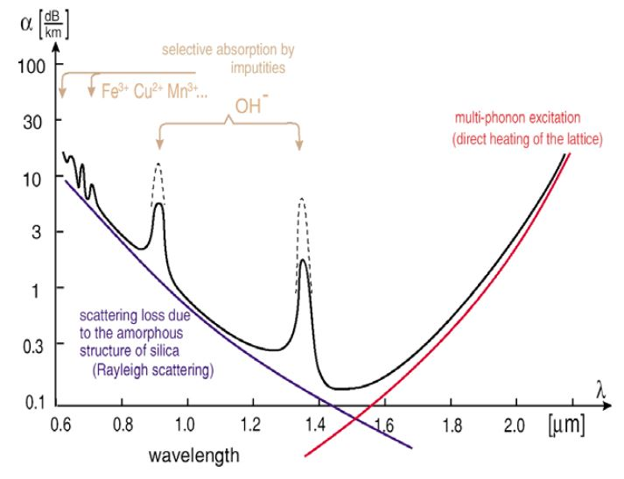
Figure 1: Typical Silica optical-fibre attenuation characteristic [6]
The fibres exhibit minimum dispersion at ~1.3µm and minimum optical loss at 1.55 µm. These two properties define the detection wavelength at which the photodetectors must operate.
Dispersion is relatively low at both wavelengths, but at distances of hundreds of kilometres, minimising optical loss becomes more important, which is why the focus in this report will be on 1.55µm wavelength photodetection.

Requirements

Material Considerations
A wavelength of 1.55µm corresponds to an energy of ~0.79eV. For a photodiode to therefore be able to absorb photons of such a wavelength, the bandgap (the energy difference between the semiconductor valence- and conduction bands) in its absorption layer must be equal to that energy or less. Having a larger gap will cause no photons of this wavelength to be absorbed and a smaller one will increase the dark current significantly and also absorb photons that are not part of the signal, such as background radiation, which increases the noise. Wavelength and bandgap are related through equation 1.2.1,
$λ_{c}=\frac{hc}{E_{g}}$ (1.2.1)
Where $λ_{c}$ is the cut-off wavelength, $h$ and $c$ are Planck’s constant and the speed of light and $E_{g}$ is the bandgap energy. The cut-off wavelength determines the longest wavelength detectable.
The only elemental semiconductor that would come close to meeting the bandgap requirement is Germanium with a bandgap of ~0.6eV. This small bandgap and its indirect nature, which reduces internal quantum efficiency, makes pure Germanium not suitable for photodiodes.
To overcome this problem, semiconductor alloys are used in the absorption, with alloy combinations from groups III and V of the periodic table being the most common.
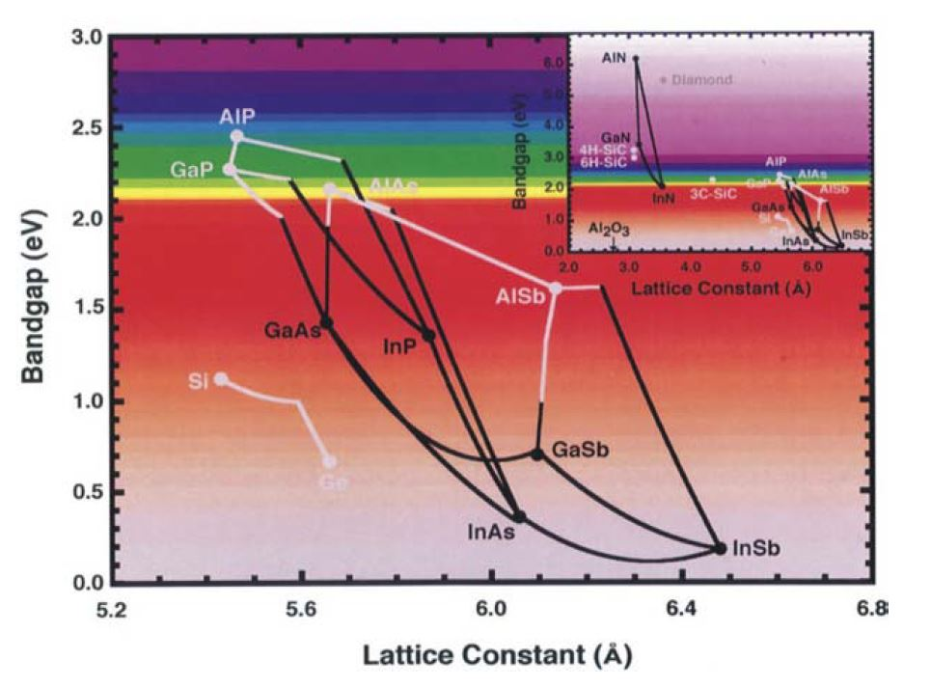
Figure 2: Lattice Constants and Bandgaps of selected semiconductor materials
Figure 2 shows the bandgaps for various alloys and the corresponding lattice constants. Lines in-between the dots represent alloy compositions, where a point halfway between Gallium Arsenide (GaAs) and Indium Arsenide (InAs) would be Indium Gallium Arsenide (InGaAs) with an even ratio of Indium and Gallium, for example. To achieve a suitable bandgap, In_{0.53}Ga_{0.47}As is commonly used, as it has a bandgap of 0.75eV and is lattice-matched to Indium-phosphide substrates. Lattice-matching is needed to minimise defects and irregularities in the crystal structure during growth.

Sensitivity
Sensitivity describes the minimum optical power a signal must have to be detected by a photodetector with a low bit error rate, usually <10⁻⁹. It is particularly relevant in long-range systems, where the signal is attenuated through the fibres. Sensitivity can be improved through a high gain, which amplifies the optoelectronic signal. Gain is created through the avalanche process and impact ionisation in APDs. This process requires a finite amount of time and the higher the gain, the longer the time needed to achieve it, causing it to be inversely proportional to bandwidth. This leads to the gain-bandwidth product (GBP), which gives the maximum frequency at which a signal can be converted and amplified by a given factor.

Bandwidth
The bandwidth is synonymous with speed and the larger this value is, the more data it can pass through. The 3 dB-bandwidth is defined as the range of frequencies over which the signal loss is less than 3 dB compared to its peak. If a signal has a frequency exceeding a device’s bandwidth, the photodiode will attenuate analogue signals or give a higher bit error rate if the signal is digital.
In an APD the bandwidth is determined by three factors and limited by the lowest one: the transit time, the resistance-capacitance (RC) time constant and the diffusion time. The capacitance of the RC-time constant is proportional to the area of the device, therefore keeping the devices small will improve the bandwidth of RC-limited devices.

Coupling Efficiency and Absorption
To maintain an optical signal power above the sensitivity threshold it is essential to minimise any losses during transmission, which includes coupling from the fibre to the device. Coupling from a fibre to a device becomes more difficult with decreasing device size. Fibre tips, made up of a thin core and relatively thick cladding, can be orders of magnitude larger than the optical window of a device. To improve the coupling efficiency, waveguides can be employed as an intermediary between fibre and device.

Wavelength Division Multiplexing
Another way of increasing the transmitted data rate is to send multiple signals of different frequencies through the same optical fibre with the use of optical bandpass filters, a technique called wavelength division multiplexing. The wavelength differences would be large enough to be separated by different filters and guided to individual photodetectors but small enough to not be affected by the transmission and absorption characteristics of the fibre and photodetector.

Available Photodetector Technologies

Photodiode
A photodiode is a semiconductor device which absorbs light and generates current. A PIN photodiode is made up of p-type, intrinsic and n-type semiconductor material layers and create an electric field across the intrinsic region, as shown in Figure 3. It is a special case of the PN photodiode and is commonly used for optical-fibre telecommunications.
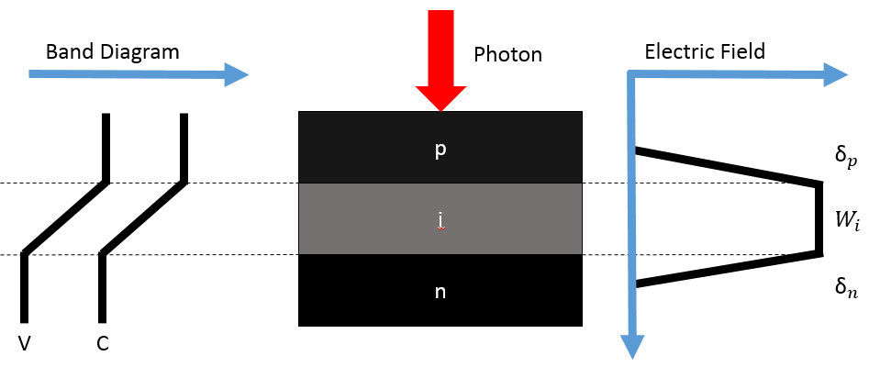
Figure 3: PIN photodiode: band diagram, device structure and electric field profile
The depletion region width (W_{D}) in a PIN photodiode is determined by the thickness of the intrinsic layer (W_{i}), which is also where absorption occurs, and the amount of diffusion at the junctions (δ_{p}, δ_{n}). A thicker intrinsic layer results in a higher absorption efficiency of photons. There is however a trade-off between absorption efficiency and bandwidth because carriers have to travel longer distances with increasing intrinsic layer thickness. To counter this, light can be side-injected through a waveguide. PIN photodiodes have unity gain but can be modified to make separate absorption, charge, gradient and multiplication region (SACGM) avalanche photodiodes (APDs), which have an internal gain mechanism through impact ionisation.

Phototransistor
A phototransistor, as shown in Figure 4, is similar to a standard bipolar transistor except that the base is exposed to light to produce a current. It can be operated in active mode where the output is proportional to light intensity or, more importantly in a communications context, as a switch to be either conducting or non-conducting.
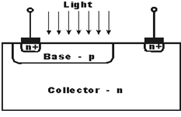
Figure 4: Phototransistor diagram
It is an older technology with high gain and low noise but slower frequency responses, commonly in microseconds (as opposed to nanoseconds for photodiodes). The slow frequency response is due to the large capacitance between the base and collector junction areas. Performance also varies more with temperature compared to photodiodes.

Schottky Photodiode
Schottky photodiodes are made of metal-semiconductor junctions. They have a simple structure, require only one photolithography step and have a thin active region and low capacitance to give a very high response speed. Carriers are generated when light enters the semiconductor and are collected by the electric field to produce a photocurrent. Schottky Photodiodes can be arranged with interdigited electrodes as shown in Figure 5 to form metal-semiconductor-metal (MSM) photodetectors.
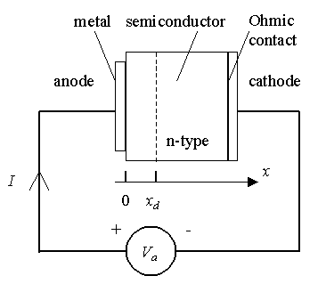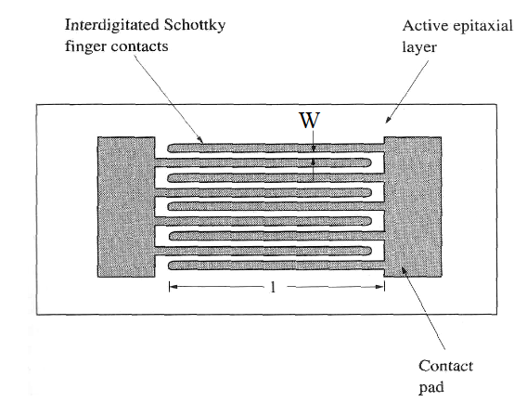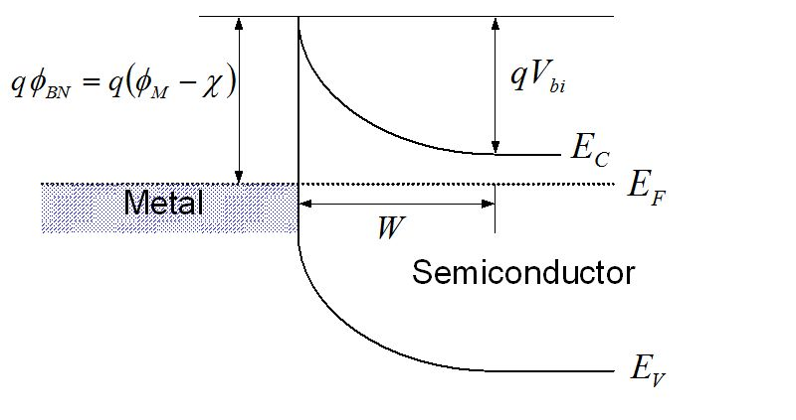
Figure 5: Schematic (left), top-view (right) diagrams and band diagram (bottom) of Schottky photodiode
These have pure drift photocurrent and no diffusion component but suffer from high dark currents from the back-to-back Schottky barrier junctions. Their low responsivity is caused by reflection from the metal contacts (although back-illumination is possible) and the finite carrier lifetime, since they have to cross the metal gaps before being collected.

Photomultiplier Tubes
Photomultiplier tubes (PMTs) are vacuum glass tubes with a photosensitive surface, which emits electrons when hit by photons. The electron is attracted to the focusing electrode and then multiplied by a process called secondary emission. It passes through a series of additional electrodes where each one is held at approximately 100 V higher than the previous electrode, as shown in Figure 6.
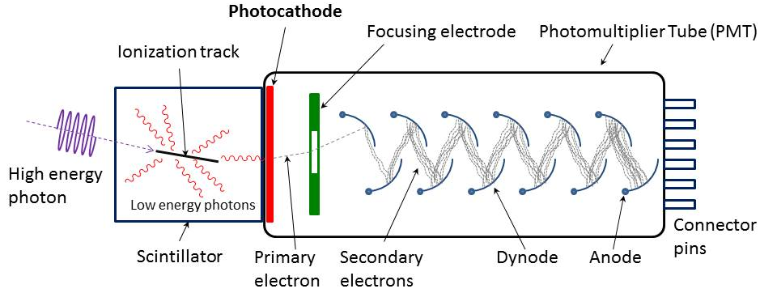
Figure 6: Photomultiplier tube diagram
The electrode stack allows for extremely high gains of up to 100 million at a reference bandwidth of 1 Hz. The bandwidth however is generally quite low. The device must be operated in total darkness to avoid over excitation and is operated at over one thousand Volts. Quantum efficiency (percentage of photons absorbed) is in the single percent range but can reach 20-40% for research-grade devices. PMTs are commonly used in physics laboratories, observatories and medical equipment.

Available Optical Waveguide & Demultiplexer Technologies

Dielectric Slab Waveguide
A dielectric slab waveguide uses a core of high-permittivity material surrounded by cladding of low-permittivity material or air to contain and guide light along its path, as shown in Figure 7. Ray angles must remain below the critical angle for total internal reflection or else light will escape the waveguide. Bending or high curvatures will cause significant signal losses.
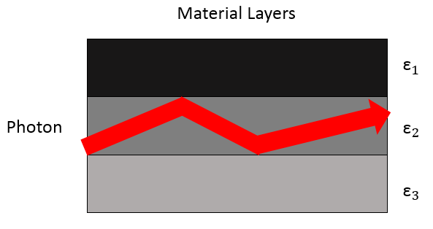
Figure 7: Dielectric slab waveguide
Dielectric waveguide bandpass filters can be made by stacking materials of different permittivity and layer thicknesses [7]. Adjusting these two parameters makes it possible to allow for only one frequency range, see Figure 8.
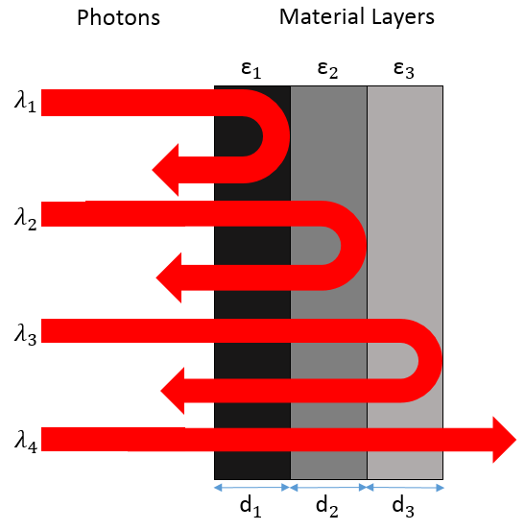
Figure 8: Dielectric Slab bandpass filter

Photonic Crystal Waveguide
Photonic crystals are created through periodic variations in refractive indices. Unlike slab waveguides, where there is a block of a single dielectric material sandwiched between two layers of another material, photonic crystals obtain their photonic properties through etched features, as shown in Figure 37. They are unique in the sense that they can be virtually lossless, perfect waveguides.
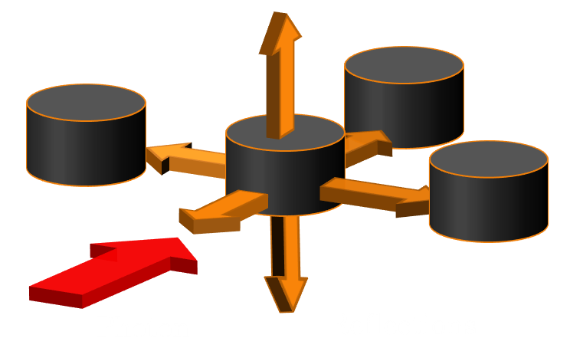
Figure 9: Photonic crystal waveguide
Figure 9 shows a typical photonic crystal waveguide with offset rows of cylinders etched into it to create a periodic variation in of refractive index. When a photon (red arrow) enters the photonic crystal, it is reflected at the interface of two different refractive indices at the atom (black cylinder) in different directions (orange arrows). Depending on the distance between the atoms and their arrangement, these reflected waves interfere con- or destructively. Feature sizes can be as small as less than 100 nm, allowing for highly frequency selectivity and narrow pass-bands or bandgaps.
Highly selective filters with widths as small as tenths of a nanometre can easily be made adjusting the structure of the photonic crystal, without using additional materials, since its properties arise primarily from its spatial arrangement.

Overview of Report
This thesis will introduce the physical principles behind APDs, explain the figures of merit and choice of technology and summarise the current state-of-the-art and methods of improving the technology. It will also explore an alternative way of increasing information rates through wavelength division multiplexing using photonic crystal demultiplexers.
The first chapter has explained the research area and the aim of the technology. Chapter two includes the proposal and will review the physics and development of photodiodes and waveguides. Experimental techniques and modelling software are explained in chapter three. Chapter four contains the results, discussion and recommendations for further work. Chapter five contains the appendix.

Proposal, Theory and Literature Review

Proposal

Photodetector
For high-speed applications, PMTs and phototransistors are unsuitable due to their low bandwidth. Schottky photodiodes are fast but have a high dark current. Photodiodes are superior overall by combining the advantages of high bandwidth, low dark currents and an internal gain mechanism (for APDs). They are also very compact and easily integrated with waveguide technology. This thesis will characterise an InGaAs PIN photodiode and an AlGaAsSb SACGM APD and measure the gain-bandwidth product of the latter.

Waveguide
Photonic crystals make superior waveguides relative to dielectric slabs due to being almost completely lossless. Filters can be easily integrated in the same fabrication step by adjusting the shape or size of the photonic crystal features and do not require growth of another material with a different permittivity on the wafer. To increase the information rate of optical telecommunication systems and reduce signal losses at the interface between fibre and photodiode, photonic crystal waveguides and filters will be explored and modelled. The focus will be on maximising the number and narrowness of frequency channels and their transmission efficiencies.

Photodiode Principles and Figures of Merit
The remainder of this chapter will introduce basic photodiodes and the more complex separate absorption, charge, gradient and multiplication region avalanche photodiodes (SACGM or SAM APDs), explain important parameters and investigate state-of-the art devices.
Early optical-communications photodiodes, developed in the 1960’s, employed a PIN structure [2]. It was found that operation at a bias voltage close to breakdown creates a signal gain and improves the signal-to-noise ratio and noise equivalent power [8], making the device perform much better for communication purposes due to the higher sensitivity. Succeeding work focused on reducing the noise and dark currents, leading to the development of separate absorption and multiplication regions around 1980 [9] [10] and then shifted towards improvements in gain and bandwidth, which will also be of particular interest in this chapter. The internal gain of APDs reduces the need for high gain in the pre-amplifier, significantly reducing its noise contribution.

PIN Photodiode
PIN photodiodes are currently the most commonly used photodetectors in optical telecommunications. The generated photocurrent in a photodiode, $I_{ph}$ , is described in equation (2.2.1), where $P_{opt}$ is the optical power, $e$ the charge of an electron, $hf$ the energy of a photon and $r$ is the reflection coefficient at the semiconductor-air surface junction, and shows how the quantum efficiency $η$ is proportional to the absorption coefficient $α_{0}$ and depletion region width $d$ [11].
$I_{ph}=\frac{P_{opt}e(1-r)}{hf}\left[1-\exp\left(-α_{0}d\right)\right]=\frac{P_{opt}eη}{hf}, ∴η∝ \left[1-\exp\left(-α_{0}d\right)\right]$ (2.2.1)
The absorption coefficient is the fraction of photons that are absorbed per unit length in the material. The reflection coefficient describes the fraction of light that is reflected from the surface and does not enter the device. Many PIN photodiodes are vertically illuminated, where the quantum efficiency and transit time are dependent on the thickness of the intrinsic layer. Thinner intrinsic layers have better transit-times but lower quantum efficiencies in designs with wide-bandgap (non-absorbing) p-type and n-type regions. SACGM APDs can compensate for thinner intrinsic regions with a built-in gain mechanism and improve their responsivity, while achieving higher bandwidths at the same time.
Majority carriers from the p- and n-type regions diffuse towards each other, creating a depletion region added to the intrinsic layer, labelled δ_{p} and δ_{n} in Figure 3. Because electrons and holes are collected in the n- and p-type regions respectively, all photons would ideally be absorbed in the depletion region, where carrier pairs are separated through the high electric-field and move at their respective saturation velocities and generate drift current. If photons are absorbed outside of the high electric-field region, the carriers instead diffuse or recombine. This diffusion current is slower than drift current, limiting the response speed of the photodiode, and is therefore less desirable.

SACGM APD
Avalanche photodiodes benefit from an internal current gain mechanism, providing pre-amplification in the receiver circuit, and detection below the noise floor of the amplifier, increasing the sensitivity, i.e. the lowest detectable optical power and signal-to-noise ratio (SNR).
As mentioned in the introduction (Chapter 1), InGaAs is the most common material used for the absorption region. Its narrow bandgap, however, leads to high dark currents and tunnelling at the high electric-fields of 200kV/cm needed for impact ionisation [12] [13]. This lead to the development of separate absorption and multiplication region avalanche photodiodes (SACGM APDs), as shown in Figure 10.
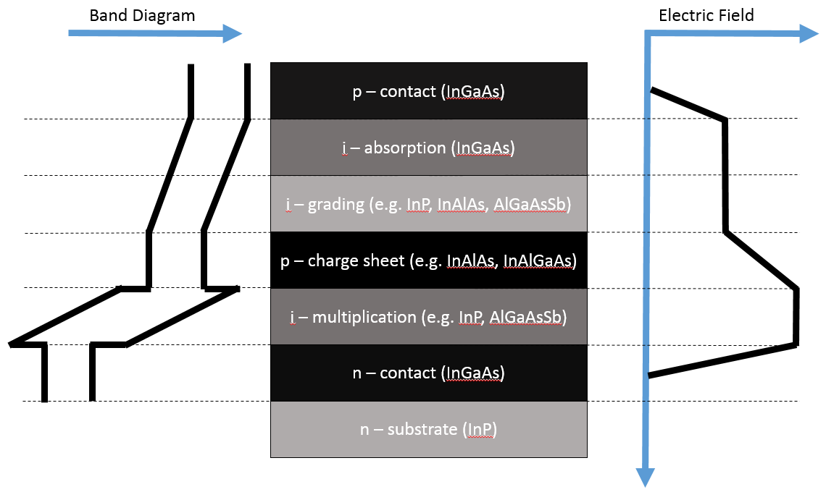
Figure 10: SACGM APD: band diagram, device structure and electric field profile
The multiplication region consists of a wider bandgap material, such as lattice-matched Indium Phosphide (InP) or Indium Aluminium Arsenide (InAlAs), where tunnelling is inconsequential. InP is widely used in commercial photodiodes with typical gain-bandwidth products of up to 160 GHz, whereas InAlAs can typically achieve up to 180 Ghz [14]. To achieve higher gain-bandwidth products, new materials are needed (see section 2.2.6).
The electric field is determined by a high-low doping profile [14], comparable to reach-through Silicon APDs [15]. A detailed example of a SACGM APD is given in Table 3 in section 4.2.
The grading layers inhibit charge accumulation at heterojunction interfaces by providing a lattice-matched intermediate bandgap and charge sheet layers separate the different electric fields in the absorption and multiplication regions. Commonly used materials for the transition or grading layer are Indium Gallium Arsenic Phosphide (InGaAsP) [16] [17] or Indium Aluminium Gallium Arsenide (InAlGaAs) [18], and Indium Aluminium Arsenide [18] [19] for the charge sheet.
Indium Phosphide is used as substrate due to its semi-insulating properties, which reduces parasitic capacitances.

Impact Ionisation, Sensitivity and Gain
Unlike PIN photodiodes, APDs have an additional high electric-field gain region, in which carriers are accelerated by the high-electric field and create more electron-hole pairs through a process called impact ionisation.
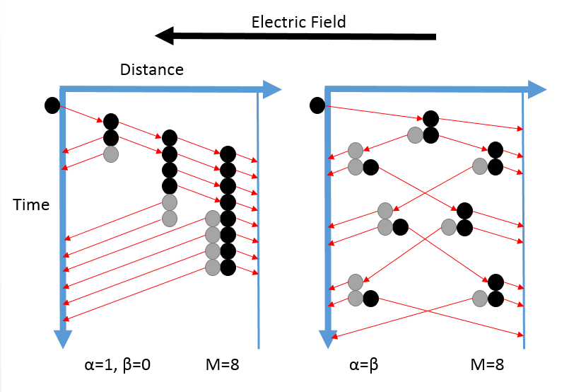
Figure 11: Avalanche Multiplication through Impact Ionisation with unequal and equal ionisation coefficients
Figure 11 illustrates the impact ionisation process, where a free carrier causes the generation of another electron-hole pair and begins a chain reaction. Although there is a probability distribution, it should be noted that the process is very random; the impact ionisation distances, number of ionisation events, the gain and the time taken to achieve it may all vary.
As a carrier travels across, there is a strongly electric field-dependant probability to impact ionise, quantified by the impact ionisation coefficient which describes the average number of impact ionisation events per unit distance caused by a carrier.
On the left-hand diagram, with the x-axis representing distance across the multiplication region and the y-axis time, avalanche multiplication is shown for when the hole impact ionisation coefficient β is zero. This means holes will traverse the avalanche region without triggering an impact ionisation event and all gain is provided by electrons. On the right-hand side is what happens when the impact ionisation coefficients for holes and electrons are equal. Both carriers will impact ionise equally, on average, as they move across the avalanche region.
The local model is a collective name for the set of mathematical expressions first described by R. J. McIntyre in 1966 [20]. It describes the avalanche multiplication process for APDs under the assumption that the carrier distribution is in equilibrium with the electric field within the device, although the dead-space effect or non-local model should be considered when dealing with APDs with thin multiplication regions.
When a carrier is injected at a position $x$ within the multiplication region of an APD with width $w$, the multiplication factor $M$ can be expressed as a function of the impact ionisation coefficients $α$ and $β$, for electrons and holes respectively, as shown in equation (2.2.2).
$M\left(x\right)=\frac{exp\left[-\int_{x}^{w}{⁡(β-α)dx'}\right]}{1-\int_{0}^{w}{α⁡exp\left[-\int_{x}^{w}{⁡(β-α)dx''}\right]dx'}}$ (2.2.2)
For most semiconductors, $α≈β$, especially at large electric fields. Equal ionisation coefficients reduce the multiplication equation (2.2.3) to
$M=\frac{1}{1-αW_{d}}$ (2.2.3)
where $α$ is the ionisation coefficient and$W_{d}$ the depletion width. The breakdown condition occurs when $αW_{d}=1$ and the gain becomes infinite.
Avalanche gain is defined in equation (2.2.4), with $I_{out}$ being the total output current and $I_{ph}$ the primary photocurrent (current generated without gain).
$M=\frac{I_{out}}{I_{ph}}$ (2.2.4)

Noise and Excess Noise Factor
There are some drawbacks to APDs however. The avalanche process is stochastic in nature and the resulting current gain may fluctuate due to every electron and hole acting independently. Some carriers may ionise more than others on their path across the multiplication region or not at all.
For pure electron injection, the excess noise factor is given in equations (2.2.5) and (2.2.6) for electrons and holes respectively, where $k =\frac{β}{α}$ , $k'=\frac{α}{β}$ and $<G>$ is the average gain in a single multiplication process. The average gain is used due to randomly occurring fluctuations in impact ionisation.
$F=kM+(2-\frac{1}{M})(1-k)$ (2.2.5)
$F=k^{'}<G>+(2-\frac{1}{<G>})(1-k')$ (2.2.6)
The excess noise factor can be minimised by having disparate ionisation coefficients, giving a smaller $k$-value and reducing the volatility of the random nature of multiplication noise (the effects of which are shown in Figure 12). It is possible to choose an inherently less noise-generating material, for example Indium Aluminium Arsenide (InAlAs) tends to be less noisy than Indium Phosphide (InP) in the multiplication region.
Figure 12: Predictions for excess noise factor based on McIntyre's local model for k=0, 0.2, 0.4, 0.6, 0.8, 1.0, 5.0 and 10 for electron injection and 1/k for hole injection
Scaling the multiplication region to sub-micron levels strongly reduces the excess noise factor by taking advantage of the dead-space effect – the distance a carrier travels before having gained enough energy to impact ionize. Li et al developed an InGaAs/InP APD with a 300 nm thick multiplication giving a dark current of 0.1 nA [21]. The dead-space distance becomes significant when its length makes up a large proportion of the multiplication region. It limits the stochastic nature of impact ionisation and makes the process more deterministic, leading to a reduction in excess noise factor.

Bandwidth Definition, Limits and Gain-Bandwidth Product
The bandwidth is defined as the range of frequencies at which the signal can pass through the APD compared to 3 dB of its flat response, i.e. a gain of one. The signal power decreases with increasing frequency. Gain is needed to amplify weak signals. An ideal APD therefore would have a large bandwidth and gain. These two properties however are inversely proportional to each other, which is why the term gain-bandwidth product (GBP) is often used.
The multiplication process requires a finite amount of time to allow for impact ionisation and the higher the multiplication factor, the larger the amount of time needed to achieve it [26]. The inversely proportional relationship between gain and bandwidth can be seen in Figure 13, where the curves become almost straight lines, indicating a constant GBP. The larger α is relative to β, the less a higher multiplication factor reduces the bandwidth.
When both electrons and holes can impact ionise, it takes longer for carriers to exit the multiplication region and thus contribute to current, reducing the bandwidth. When a hole is generated by an electron, the hole will travel across the multiplication region in the opposite direction to the electron. If the hole then generates another electron-hole pair, the resulting electron would have a larger distance to travel than the original electron, resulting in a delayed response (see Figure 13 with equal ionisation coefficients). The longer response is therefore due to the larger impact ionisation chains when both carriers can impact ionise.
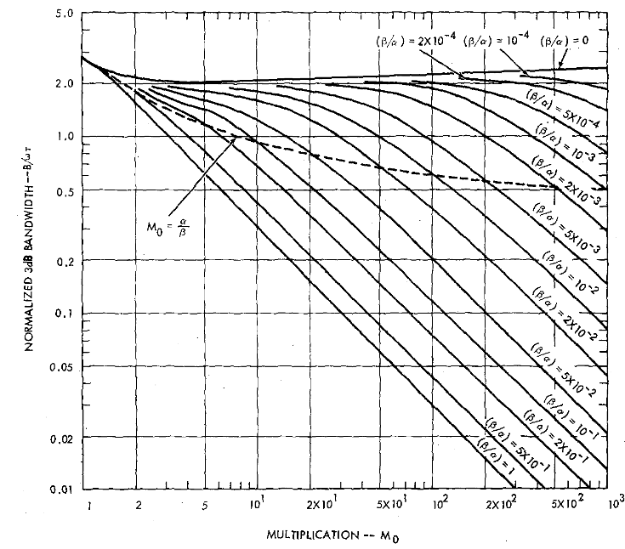
Figure 13: Bandwidth changing with gain for different impact ionisation coefficients (After [26])
There are three factors that limit the response speed, i.e. bandwidth, of a photodiode: the transit time across the device, the RC-limited bandwidth and the diffusion time. The lowest of these will determine the bandwidth of the device, hence it is important to know what the value of each of them is.
The transit-time is the time needed for the carriers to move across the depletion region. The transit time-limited 3dB-bandwidth in a PIN diode is defined by
$f_{transit}≈0.5×\frac{v_{sat}}{d}$ (2.2.8)
where $v_{sat}$ is the carrier saturation velocity and $d$ the depletion region width, although this equation becomes invalid in avalanche photodiodes because the carriers may have to cross the depletion region multiple times. A solution to increasing the transit time-limited 3dB-bandwidth could be to decrease the width of the absorption layer. This however comes at the cost of reduced external quantum efficiency, as given by equation (2.2.9), since the longer a photon travels within the absorption region, the greater its chance to generate a electron-hole pair.
$η_{ext}∝(1-exp⁡(-αd)$ ) (2.2.9)
The RC-limited bandwidth is due to the capacitance and resistance of the device. The capacitance is given by
$C= \frac{εA}{d}$ , (2.2.10)
where $A$ is the area of the device and $ε$ and $d$ are the dielectric constant and the thickness of the depletion region. To minimise the capacitance, it is important that the device area is kept very small.
The resistance $R$ includes the semiconductor and metal series resistance, $R_{s}$, and the load resistance, $R_{L}$, which is typically 50Ω, and is described in equation (2.2.11).
$R=R_{s}+R_{L}$ (2.2.11)
The RC-limited bandwidth is defined by
$f_{RC}=\frac{1}{2πRC}$ . (2.2.12)
Diffusion occurs under low electric fields when electrons and holes attempt to evenly concentrate in the material and is a slow process. The diffusion time is given by equation (2.2.13) where $x$ is the distance travelled in the low-field region and $D$ is the minority carrier diffusion coefficient.
$τ_{diff}=\frac{{4x}^{2}}{π^{2}D}$ (2.2.13)
Due to the moderate to high electric field present in SAM APDs, however, it is significantly less of an issue than the RC-limited bandwidth and the transit time.

AlGaAsSb Multiplication Region
AlGaAsSb is an extension of Aluminium Arsenic Antimonide (AlAsSb) multiplication regions. AlAsSb was found to give lower excess-noise factors than Indium Phosphide and Indium Aluminium Arsenide multiplication regions [22]. AlAsSb (with an AlAs_{0.56}Sb_{0.44} composition) also has a larger bandgap (1.65 eV) than InP (1.34 eV) and InAlAs (1.45 eV), allowing thinner multiplication regions with reduced transit-time and higher electric fields. However, AlAsSb suffers from significant lateral oxidation [23], which increases the dark currents due to surface leakage.
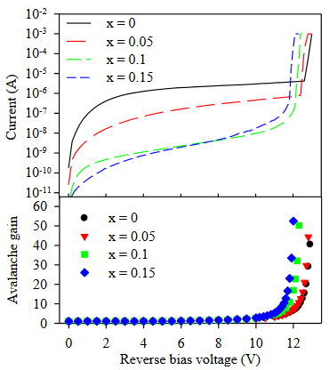
Figure 14: Comparison of reverse IV data and gain for AlAsSb (black, x=0) and AlGaAsSb APDs [24]
The addition of Gallium to make AlGaAsSb prevents lateral oxidation and reduces surface leakage and dark current levels, while retaining the benefits of AlAsSb. Figure 14 shows how dark currents can be reduced by factors of 10³-10² by adding 10-15% Gallium to the Aluminium, corresponding to x=0.10, 0.15 in Al_{1-x}Ga_{x}As_{0.56}Sb_{0.44}. It also reduces the breakdown voltage, enabling avalanche operation at a lower reverse bias voltage.
Zhou et al [23] demonstrated an InGaAs/AlGaAsSb APD with a gain-bandwidth product as high as 407.4 GHz. The bandwidth was 14 GHz with a gain of 29.1. AlGaAsSb results appear promising and require further investigation (see section 4.2).

Development of Waveguide Integration
Optical fibre cores are only approximately 8 µm in diameter, but several times that if the cladding is included. Aiming the fibre core surrounded by thick cladding at a device which may only be tens of micron across is very difficult. Optimal coupling, guiding as much light into the device as possible and increasing the responsivity of the device, therefore becomes a challenge. There are a variety of solutions and approaches, which will be discussed.
Traditionally, APDs have been vertically illuminated, where light would enter through the top of the device. In that case, the light can only be absorbed over the width of the absorption region and there is a trade-off between responsivity, quantum efficiency and the transit-time component of the bandwidth [27].
To achieve quantum efficiencies >90 %, the absorption region must be approximately 2.5µm thick for vertical illumination at an absorption coefficient in the order of 10⁴ cm⁻¹ [28] [29]. This structure is acceptable for <10 Gb/s operation, but for higher speeds, waveguide integration becomes necessary.
It is possible to integrate layers that act as mirrors above and below the absorption region (see Figure 15 b), a structure known as resonant cavity, enabling the light to traverse the absorption region multiple times and thus increase the effective absorption region width. Lenox et al achieved a GBP of 280 GHz in 1999 with a resonant-cavity InGaAs/InAlAs APD, which had an external quantum efficiency of 70%, low noise (with a k-value corresponding to approx. 0.18) and an absorption region thickness of 60 nm [30]. A resonant-cavity however significantly increases the complexity of the APD structure and fibre-coupling remains an issue, a problem waveguide designs do not have.
To avoid the responsivity and transit-time trade-off and maintain a high absorption rate at a thin absorption region width, photons can enter the device from the side, in-plane to the absorption region. This improves the quantum efficiency, since devices are typically much wider than the absorption region is thick, without affecting the device speed.
Since the absorption region is very narrow, it would be virtually impossible to attach a fibre to it and keep it aligned. Instead, the fibre is coupled to a waveguide which then guides the light into the side of the absorption region (see Figure 15 c),. This is called side-illumination and has advantages such as less wavelength selectivity and no optical window being required at the top of the device, allowing for a larger metal contact to lower the resistance and RC-time constant [31]. Kinsey et al demonstrated a side-illuminated InGaAs/InAlAs SAM APD in 2000 that had a GBP of 120 GHz and a unity-gain bandwidth of 27 GHz [32]. The quantum efficiency however was very low, only 23%, due to undesirable etching characteristics (sidewall undercut). The bandwidth was lower than the estimated value of 40 GHz and was independent of area for devices below 100 µm², suggesting a transit-time limitation. Just a year later Kinsey, Campbell and Dentai eliminated the etching problem and developed another side-illuminated InGaAs/InAlAs SAM APD with a similar low-gain bandwidth of 27 GHz but an even higher GBP of 320 GHz [33]. The multiplication region was 150 nm thick, 25% thinner than the resonant-cavity APD from 1999 [30], the external quantum efficiency however was much lower at 16%.
An alternative to side-illumination is evanescent coupling, where the waveguide is below the device and extends across the whole length of the device. This allows light to be absorbed relatively uniformly across the device and improves its power tolerance. The different approaches are illustrated in Figure 15.
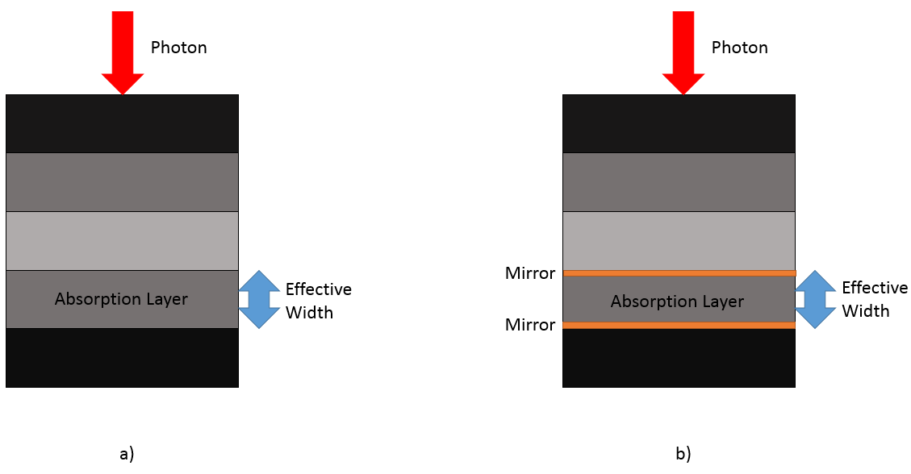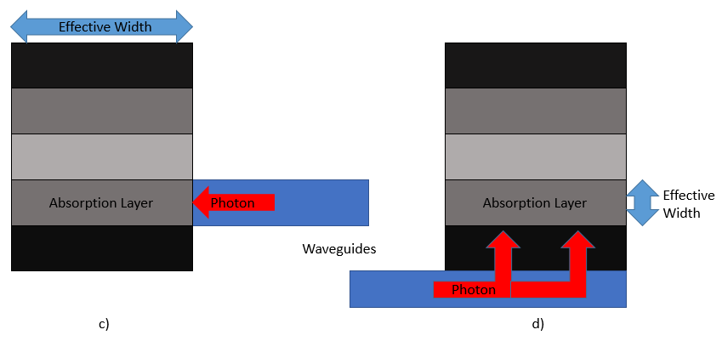
Figure 15: a) vertical illumination b) resonant-cavity c) side-illumination d) evanescent coupling
Evanescent coupling has been used in conjunction with photodiodes since at least 1977, where T. R. Ranganath and Shyh Wang developed a silicon photodiode operating at 632 nm [34] that used this technique. In 2001, Demiguel et al demonstrated a simple-to-fabricate, evanescently-coupled APD with a quantum efficiency of 50%, a bandwidth of 34.8 GHz (limited by the transit-time) and a 160 GHz GBP [35].
In conclusion, waveguide designs are superior to top-illumination structures, as they have improved coupling and allow for thinner absorption regions. Evanescent coupling allows the light to be absorbed evenly across the whole absorption region, giving a larger power tolerance. This preferable to side-illumination in close- and medium-range communications systems, as there is a greater variation amongst the incoming signal powers due to attenuation, although side illumination gives a larger effective width of the absorption region and improves the quantum efficiency.

Current high-speed Photodiodes
The recent resurgence of interest in avalanche photodiodes was caused by fast growth of optical telecommunications systems. Multiple devices are used in conjunction with wavelength division multiplexing to produce 100 Gb/s Ethernet systems, with 400 Gb/s Ethernet systems being the next target.
Nada et al [37] developed a double-mesa, vertically illuminated APD for 50 Gb/s applications with an InAlAs multiplication region in 2014. The GBP was found to be 270 GHz, with a maximum bandwidth of 35 GHz at a gain of 3. The device has a responsivity of 0.69 A/W and uses a maximum-induced current (MIC) design [38], which contains a 600 nm thick, undoped and p-type hybrid InGaAs absorption layer that improves the carrier transit-time.
In 2015 Xie, Zhang and Tan [38] introduced a InGaAs/InAlAs APD with low dark currents for 25 Gb/s operation. The absorption layer was 1.2 µm thick and gave a responsivity of 0.91 A/W, when used with a waveguide. This device had a bandwidth of up to 40 GHz at low gain and produced a GBP of 115 GHz. The low noise of less than 50 nA at 90% of the breakdown voltage and low excess noise gave low predicted sensitivities.
Zhou et al [23] presented an InGaAs/AlGaAsSb APD (mentioned in section 2.2.6) in 2016, which had a GBP of 200 GHz and a maximum GBP of 407.4 GHz, 3dB-bandwidth of 14 GHz and gain of 29 for a device size of 20 µm, making it suitable for 10 Gb/s systems. The responsivity for 1550 nm wavelengths was 1.04 A/W, with a maximum 5.33 A/W, and a 300 nm thick absorption layer. The GBP was achieved with a 100 nm thick multiplication region and the choice of AlGaAsSb material.
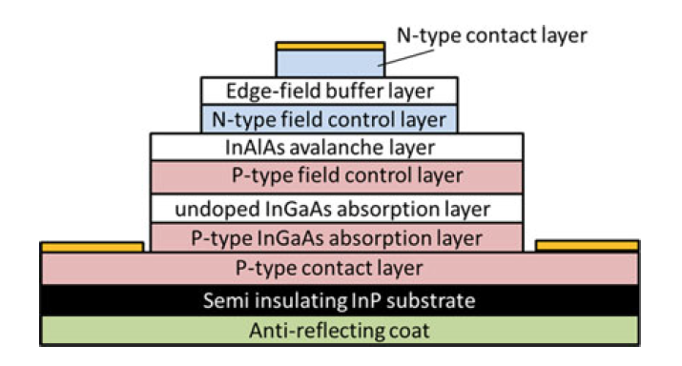
Figure 16: APD cross-section diagram after [36]
In 2015, Nada et al [36] have designed a vertical-illumination, triple-mesa APD with InAlAs avalanche layer for use in 100 and 400 Gb/s Ethernet systems, shown in Figure 16. The device can be scaled in size for 25 and 50 Gb/s applications with diameters of 20 and 14 µm and absorption layer thicknesses of 1.0 and 0.6 µm, respectively. Other layer thicknesses are adjusted to prevent edge breakdown. The triple-mesa structure reduces dark current and confines the electric field to the centre of the device. The maximum GBPs were found to be 235 and 270 GHz with error-free transmission ranges of 50 and 20 km for the 25 and 50 Gb/s designs, respectively.

Photonic Crystal Demultiplexers
A photonic crystal demultiplexer generally contains a coupling input for the optical fibre, waveguides, filters and output waveguides connecting to a photodiode, as shown in Figure 17.
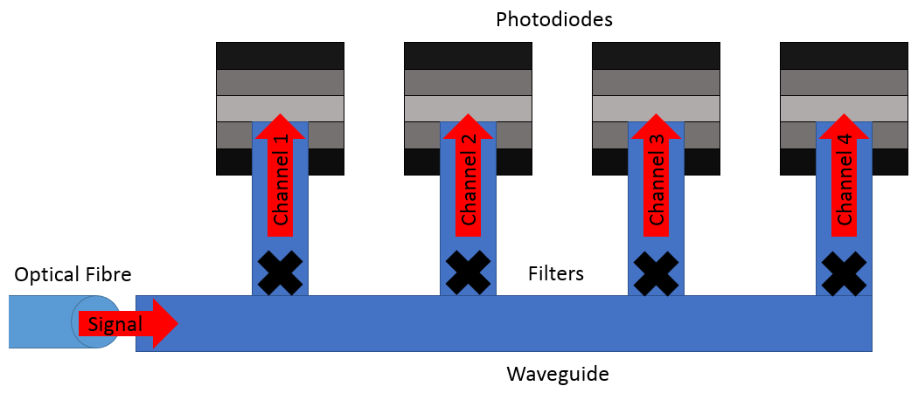
Figure 17: General photonic crystal demultiplexer diagram
Important design considerations for photonic crystal demultiplexers are the material and total area of the design or the area per channel, the wavelength range and peak width, the number of channels and the transmission efficiency.
Minimising the area of the design allows for a greater number of elements within an integrated circuit. The waveguide should have a large bandgap to contain a wide range of wavelengths without loss. Transmission efficiency is defined as the ratio of signal output power (after passing through the filter) to signal input power (when the signal enters the waveguide). The filter design should have a narrow passband. Optimising these parameters allows for an increased number of channels with the highest signal power and minimal crosstalk, resulting in a high total transmission rate with a low error rate.
Photonic crystal waveguides simply consist of rods, commonly in square or triangular lattices (see Figure 18). For filters, there are many different designs, including line defects, resonant cavities and ring resonators. Filters are defects in the waveguide, where a defect is defined as any irregularity in the waveguide structure. Line defects will have the same structure as the rest of the waveguide, but different rod sizes and therefore a different bandgap. Cavities generally have a structural irregularity, such as a larger rod and a shifted lattice for example, with a narrow passband for only a few frequencies. Ring resonators are looped waveguides exactly the length of a single wavelength or multiples thereof to create constructive interference.
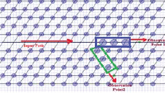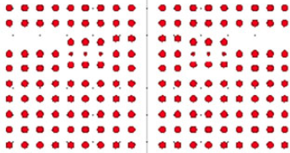
Figure 18: 2-channel line defect [36] (left) and a resonant cavity [37] demultiplexers (right)
Kumar and Sabnani designed a 2-channel demultiplexer using a line defect to separate signals with wavelengths of 1350 and 1530 nm [36], which is also known as a channel drop filter, where one channel is removed from the rest of the signal. It is shown in Figure 18. Gallium Arsenide (GaAs) rods are in a triangular lattice surrounded by air. GaAs is chosen for its high refractive index at room temperature, which results in a larger bandgap. A straight waveguide splits into two in a Y-configuration with three defect rods acting as filters in each of the separate channels. Transmission is above 90% and crosstalk is around 10%.
In 2016, Mehdizadeh and Soroosh designed an eight-channel demultiplexer based on resonant cavities [37], as shown in Figure 18. Elliptical cavities consisting of three horizontally aligned, smaller rods, surrounded by eight rods that are slightly shifted from the waveguide lattice, produce a channel spacing of 2.1 nm and a minimum transmission efficiency of at least 94%. Channels have center frequencies of 1536.9 to 1551.4 nm and peak widths are between 0.4 and 1.0 nm. The total area is 495 µm² or 62 µm² per channel.
Talebzadeh et al [38] developed Silicon and Carbon-based six- and eight- channel ring resonator demultiplexers in 2017. The design is relatively complex with three different rod radii making up the ring resonator and containing two different materials. Transmission efficiency was originally 80% on average but the addition of carbon rods within the ring resonator improved transmission efficiency, giving an average of 94% for all channels. Minimum and maximum crosstalk values lie between -11 and -47 dB, respectively, with a channel spacing of 1.0-1.15 nm. The total footprint was 1597 µm² or 200 µm² per channel for the eight-channel demultiplexer.
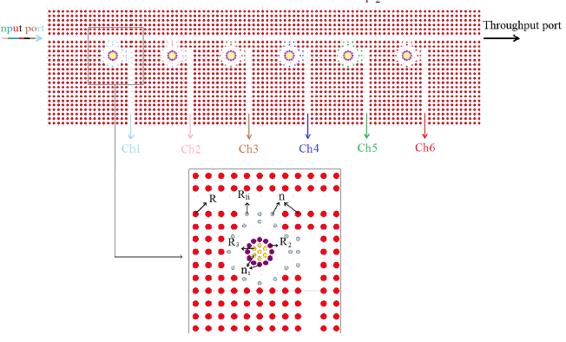
Figure 19: Ring resonator demultiplexer based on [38]
Talebzadeh et al then went on to improve this design by combining resonant cavities with semi-feedback structures [39]. The design is based on silicon rods with a radius of 133 nm and a lattice constant of 555 nm. Channel spacing averaged 1.75 nm and a mean crosstalk value of -18 dB. The overall size of the design was 790 µm². Transmission efficiency was extremely high at an average of 99%.
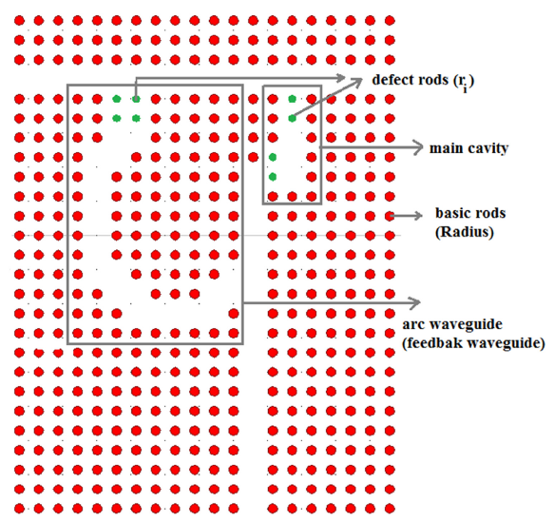
Figure 20: Resonant cavity filter with semi-feedback structure [39]

Experimental Details

Device Fabrication

Device Fabrication
Semiconductor wafers were grown using molecular beam epitaxy. Developed by A. Y. Cho, [36] [37] this technique allows accurate control over material composition and layer thickness through a deposition rate of under 1um per minute and shuttered sources. The wafers were then fabricated with a mesa-structure. The fabrication process for these high-speed devices generally consists of six stages – Top contacts, mesa etch, bottom contacts, substrate etch and surface passivation. A detailed step-by-step description has been included in the appendix section 5.1.
Contacts were made through thermal evaporation of titanium and gold, with thicknesses of 20 and 200 nanometres respectively, though other materials may be used for future devices. Titanium is used to strengthen the bond between the semiconductor surface and the gold. Gold is a common choice for contacts due to its excellent conductivity, giving the devices a lower series resistance. The series resistance affects the RC-time constant, which is a significant factor affecting the speed of the device. After thermal evaporation, the sample underwent rapid thermal annealing at 420°C for 30s to allow the formation of semiconductor-metal alloys to give a lower resistance. Good contacts are very important due to devices commonly being limited by the RC-time constant, where most factors are fixed by the photodiode design, such as the diode’s area, material permittivity and depletion region width.
The device pattern was defined using photolithography. An ultraviolet light-sensitive liquid, called photoresist, is applied to the sample surface. The sample is placed below a mask with the desired device pattern and exposed to ultraviolet light to either remove or harden the photoresist in the exposed areas. This is followed by a photoresist-developer bath, which removes excess (either exposed or unexposed, depending on the type used) photoresist from the sample surface. These two steps are repeated for each stage in the fabrication process, i.e. each time a metal deposition, etching or surface passivation is carried out. Correct exposure and developer times are needed to obtain clearly defined, high-resolution device features.
Mesa-structures were produced through wet-etching, as opposed to dry-etching techniques. Dry-etching is a very destructive process and may introduce defects into the crystal structure.
To protect the device from degrading over time through reactions with moisture and gases in the air, a surface passivation layer of 4-5µm thick SU-8 [38] is added. This helps the sample maintain good electrical characteristics, such as low dark current.
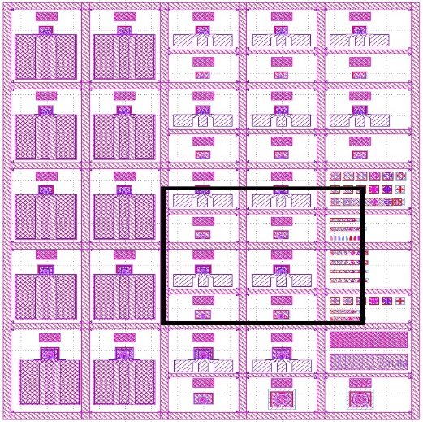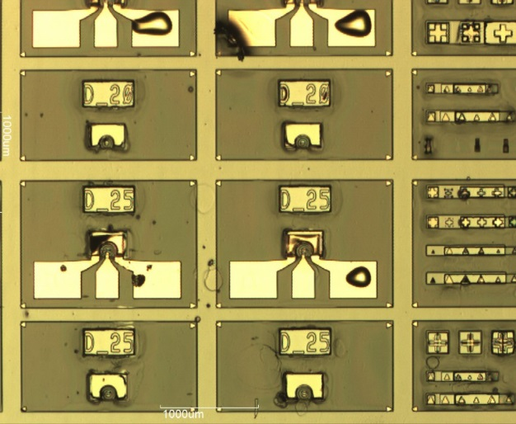
Figure 21: High-speed mask unit cell layout and photo of fabricated devices
Device diameter sizes for the PIN photodiodes were 50, 100, 200 and 400 µm. The sizes for the high-speed APD devices were 10, 15, 20, 25 and 50 µm, some of which may be seen in Figure 21. Actual sizes may deviate from this by up to ±5-10 % due to under- or overexposure of the photoresist and the etch profile. The high-speed mask uses smaller devices than most other masks to reduce the RC-time constant, since the capacitance scales with device area. The devices fabricated with this mask are too small to be probed directly and have large contact pads with thinning connections leading to the device.

Mask Design
Masks used in the photolithography stage of the fabrication process are designed using KLayout. Mask design is an important part of device design because the shape and size of devices, as well as the contacts, will impact important characteristics such as the capacitance and resistance.
The mask is designed layer by layer, which will then be printed in chrome onto a quartz plate. A good mask will maximise the number of devices per unit cell and contain some alignment features to ensure that each layer can be properly aligned with the next. There are also practical considerations such as size labels above the devices, distances between sizes and the size of contact pads.
Alignment marks, which can be seen on the right in the photo of Figure 21, aid in the exact alignment of each layer and consist of features such as crosses and triangles and are only a few micron large. TLM pads enable measurement of the contact resistance.

Current-Voltage Measurement

General Setup
Current-Voltage (IV) measurements are an important part of any device analysis. Reverse IV measurements taken in the dark can give insights into the dominant current mechanism, which can be either bulk or surface leakage currents. Bulk leakage current mechanisms scale with device diameter and include diffusion, band-to-band tunnelling and generation-recombination. As the name suggests, surface leakage currents occurs on the surface, where the crystal structure ends, and causes irregularities in the conduction- and valence-bands. This allows current to flow easily, increasing the level of dark current, making it harder to detect the photocurrent signal, and scales with perimeter.
Dividing the absolute reverse IV data for devices with different diameters by their respective device area or perimeter may give an indication of which one of the above mentioned current mechanisms dominates.
Forward bias current data can be used to extract the series resistance and ideality factor by fitting the ideal forward diode current equation to it. The ideality factor usually lies between one and two. A value close to n=1 suggests diffusion current is dominant, whereas a value close to n=2 indicates a generation-recombination dominated current.
The ideal forward current equation (3.2.1) [39] is given below and has been modified to include the series resistance caused by the cladding layers and metal contacts.
$I_{F}=I_{0}exp\left[\frac{q\left(V_{t}-IR_{s}\right)}{nk_{B}T}-1\right]$ (3.2.1)
$I_{F}$ is the forward current, $I_{0}$ the saturation current (limit of forward current), $q$ the electron charge, $V_{t}$ the voltage dropped across the diode, $I$ the applied current, $R_{s}$ the series resistance, $n$ the ideality factor, $k_{B}$ the Boltzmann constant and $T$ the temperature.
IV measurements can also be used as an indicator of fabrication quality, where a well-made sample will have uniform characteristics, such as dark current levels and the breakdown voltage, across all devices of the same size on the wafer.

TLM Details
The Transmission Line Model is used to determine the resistance of the metal contacts. A lower contact resistance may increase bandwidth, if the device is limited by its RC time-constant. To measure the contact resistance of a metallisation scheme, the photolithography mask used in the device fabrication process includes a line of several rectangular pads with linearly increasing distances between them. The total measured resistance between two pads is given in equation (3.2.2) and is illustrated in Figure 22.
$R_{measured}=2R_{pad}+R_{semiconductor}+R_{system}$ (3.2.2)
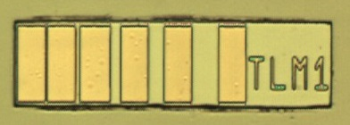
Figure 22: TLM Pad diagram [11] (left) and photo (right)
The system resistance $R_{system}$ includes the probes and cables and can be measured by simply short-circuiting the two probes. An IV-measurement across two neighbouring pads will produce a straight line, the gradient of which gives the resistance for that pad distance. The resistances for each distance are then plotted against distance. Interpolating between these resistance data points will give another straight line, the y-intersect of which will be equivalent to the resistance across a distance of zero. This removes the term $R_{semiconductor}$ in equation 3.1.2. Subtracting $R_{system}$ from this theoretical resistance value at a distance of zero and halving it will give $R_{pad}$. By multiplying $R_{pad}$ by the pad area $A$, one obtains the contact-resistance area product.

Capacitance-Voltage Measurement
Capacitance-Voltage (CV) measurements can be used to gain information about the depletion width, doping levels and the built-in potential, as well as the actual diameter sizes of the devices. In a high-speed device context, CV measurements are needed to evaluate the RC-time constant, a potentially limiting factor for the bandwidth. The capacitance of a device is given by Gauss’ Law in equation (3.3.1)
$C=\frac{ε_{0}ε_{r}A}{W}$, (3.3.1)
Where $ε_{0}$ is the permittivity of free space, $ε_{r}$ is the relative material permittivity, $A$ is the device area and $W$ is the depletion region width. CV measurements were carried out with a HP 4275A LCR-meter. The setup superimposes a sinusoidal test signal with a small voltage (tens of millivolts) to the applied reverse bias. The signal frequency of 1 MHz is chosen to ensure the measured impedance originates from the diode capacitance, where the displayed phase angle on the LCR-meter is close to 90°.
In the absence of parasitic capacitances, device capacitance scales with area. Parasitic capacitances may stem from the contact pads or surface passivation. Parasitic capacitance can be estimated by extrapolating capacitance data points to a theoretical device area of zero, similar to how the contact resistance is estimated in section 3.2.2 using TLM pads.

Responsivity and Gain Measurement
Responsivity measures the photocurrent produced by a device when subjected to light through the optical window, using modulated laser light and a lock-in amplifier. The setup is shown in Figure 23. It is an indicator of how well the diode converts an optical signal into an electrical one and is a measure of the external quantum efficiency.
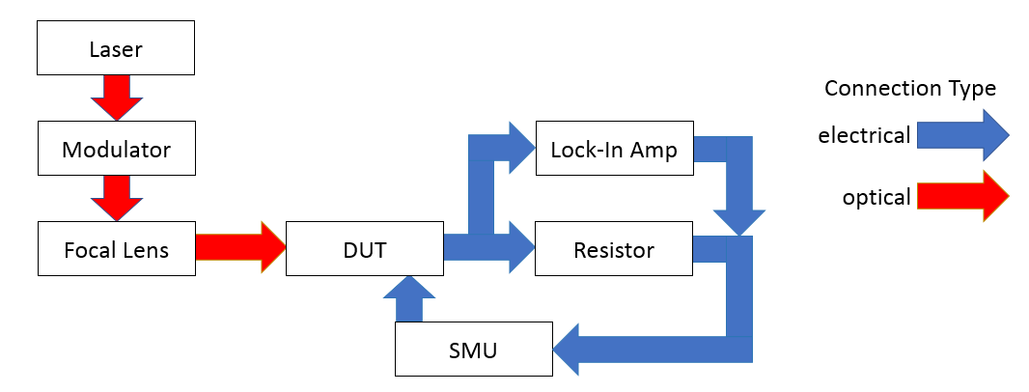
Figure 23: Responsivity measurement setup
To accurately process the raw data which includes the applied bias voltage and lock-in amplifier current, it is essential to know the exact optical power reaching the device, since this will determine the responsivity.
Responsivity measurements can indicate a punch-through in the device, where otherwise it would be masked by high dark currents and is needed to determine the gain of the device. If every photon hitting the device is converted into one electron-hole pair, the device has unity external quantum efficiency.
$R=\frac{I_{ph}}{P_{opt}}=\frac{ηq}{hv}=\frac{ηλ(µm)}{1.24}$ (3.4.1)
Responsivity is defined in equation 3.4.1, where $I_{ph}$ is the generated photocurrent, $P_{opt}$ the optical power, $η$ the external quantum efficiency, $v$ the frequency,$h$ Planck’s constant and λ and 1.24 is the wavelength and Planck’s constant multiplied by the speed of light in micrometres.
To filter out dark currents when taking the measurement, the laser light is modulated to a specific frequency and the lock-in amplifier will only pick up on AC currents with this same frequency, i.e. the photocurrents. A frequency of 180 Hz was chosen because it is relatively low (and therefore close to DC behaviour) and not a multiple of the mains power frequency. It would be possible to measure the responsivity without modulation, provided that the photocurrent is orders of magnitude larger than the dark current. Modulation is still useful even when dark current levels are low though, because it allows the use of lower laser powers. Lower laser powers generate less heat, which may have an impact on device performance, and do not significantly carrier injection conditions.
Responsivity generally improves with increased reverse bias voltage, as does the gain. It also depends on the wavelength of the light being used, as each material and material composition is only suited for a certain range of wavelengths. Responsivity data can be used to extract the gain of the device and information about how the electric field develops. Hypothetically, without gain, the responsivity as a function of bias voltage would be a straight line with a small positive gradient, which can be considered the baseline responsivity against which the gain is measured. The gradient is due to the electric field expanding into the cladding layers, increasing the depletion width and therefore absorption region. This slightly larger absorption region then naturally improves the responsivity by absorbing more photons. The gain is calculated by dividing the photocurrent at each voltage by the baseline primary current.

Bandwidth Measurement

General Setup
The main instrument used to measure the bandwidth is an Agilent E8364B network analyser and the setup is described in Figure 24. The network analyser has two ports, one to generate a signal of varying frequencies (10MHz-50GHz in this setup) and another to receive the signal and measure the signal loss.
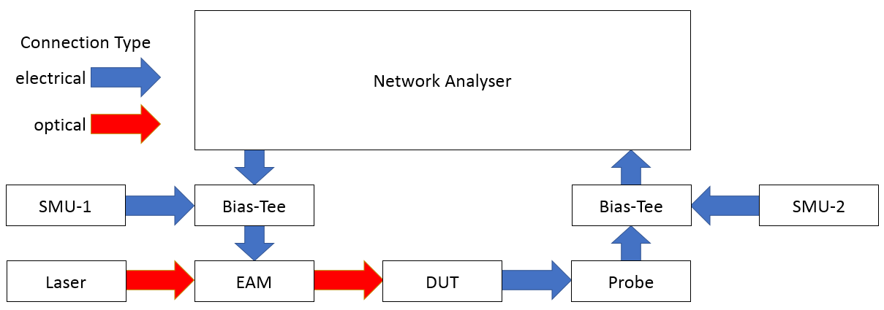
Figure 24: Bandwidth Measurement Setup
The generating port on the left is connected to an electro-absorption modulator (EAM). The EAM uses the electrical signal to modulate the light from a laser. From the EAM, this modulated optical signal is then directed at the device-under-test. The SMU and bias-tee connected to the EAM protect the EAM from high voltages. The device is probed, with an optical fibre from the EAM pointing at the optical window, and connected to the second port. The signal is processed and the network analyser calculates the strength of the incoming signal relative to the one that has been generated (both electrical), though only the relative values of the incoming signals have significance since the signal is converted to light in the EAM, therefore making the absolute values meaningless. This is why relative normalised dB-units are used instead of dBm.
The measurement described above is called forward transmission loss and can show the frequency range at which the device can operate without the signal diminishing too much in power. Generally, the loss increases with frequency due to the diode’s RC-time constant, diffusion and transit time. An important data point is the 3 dB-frequency. It is the point at which the signal power has decreased by 3 dB relative to its peak and defines the devices bandwidth.

System Loss Calibration
To take an accurate measurement, one must know the system loss. All components have an insertion loss of 1-3dB for fibre-optic cables and up to 8 dB for the EAM, at 40 GHz. The system loss needs to be subtracted from the measured data, since it does not originate from the device and would distort the results. The network analyser is calibrated in a two-step process. To calibrate the second port which has the probe and is a purely electrical signal, a commercial substrate is used with a known performance. This removes the system loss caused by components connected to the second port. Loss in the first port is measured with a commercial photodiode. Bandwidth data from its specification sheet is added to the calibration measurement and gives the system loss, which is then added to the actual device measurements.
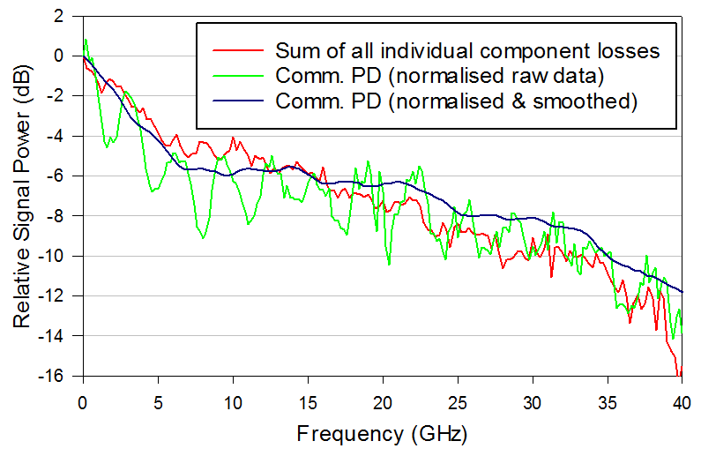
Figure 25: Component total and commercial photodiode loss
Figure 25 compares the system loss found by summing the measured loss from each component with the loss found by using the commercial photodiode. The results generally concur within 1-2dB, apart from some reflection spikes distorting the average.

Photonic Crystal Modelling
Two different pieces of software were used to model the photonic crystal properties. The first is “MIT Photonic Bands” (MPB). It produces the band structure diagram for a given unit cell and tells the user which frequencies may pass through and which ones may not. The other is “MIT Electromagnetic Equation Propagation” (MEEP). MEEP is used to simulate the flow of light through a photonic crystal structure. In essence, MPB finds the most suitable “building blocks” with the desired properties in terms of passbands and bandgaps and MEEP puts these blocks together to model the overall behaviour of the structure.

MIT Photonic Bands
MPB [12] computes definite-frequency eigenstates or harmonic modes of Maxwell’s equations [13] in periodic dielectric structures. The equations are shown below.
$∇∙H\left(r,t\right)=0$ (3.6.1)
$∇∙\left(ε\left(r\right)E\left(r,t\right)\right)=0$ (3.6.2)
$∇×E\left(r,t\right)+ μ_{0}\frac{δH\left(r,t\right)}{δt}=0$ (3.6.3)
$∇×H\left(r,t\right)- ε_{0}ε_{(r)}\frac{δE\left(r,t\right)}{δt}=0$ (3.6.4)
$E\left(r,t\right)$ is the electric field strength, $H\left(r,t\right)$ is the magnetic field strength, $ε_{0}$ and $ε_{(r)}$ is the permittivity of free space and relative permittivity, respectively. These equations can be used to calculate the band structure of a photonic crystal.
A unit cell is the smallest, periodic element and has a length $a$. All calculations are scale-invariant and therefore relative to the unit cell. The unit cell is assumed to be repeated infinitely in two dimensions, i.e. in horizontal and vertical directions with infinite height, to form a lattice as shown in Figure 26.
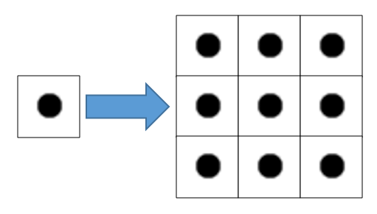
Figure 26: Unit Cell of a cylinder with r=0.193a (left) and its regular, periodic lattice (right)
Applying the equations from [12] to the unit cell produces a list of “allowed” and “forbidden” frequencies for a given k-vector. K-vectors are analogous to degrees and describe the incident angle of the photon hitting the photonic crystal. A significant k-vector is the gamma-point (Γ), which corresponds to light entering the unit cell at a 90° angle. The band structure diagram was used here to find suitable cylinder sizes to either act as a waveguide for a range of frequencies or as a filter for a specific frequency.
Once suitable cylinder sizes are identified in MPB, they can then be used and combined in MEEP to perform certain functions, such as filters or waveguides.

MIT Electromagnetic Equation Propagation
MEEP is a finite-difference time-domain simulation software to model electromagnetic systems [24]. In MEEP, the user can define objects in terms of size, position and dielectric constant and a light source with a given frequency or range of frequencies and observe the propagation of electromagnetic waves over time (see Figure 27), as well as measure the transmitted and reflected flux to produce transmission-reflection spectra, which are useful in quantifying the efficiency of a waveguide or filter. Figure 27 shows a dielectric waveguide consisting of a material ‘A’ (black) surrounded by air (white).
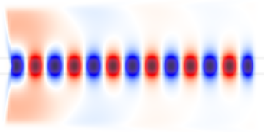
Figure 27: Simple dielectric waveguide (left) and the electromagnetic field propagation for a single frequency

Results

InGaAs PIN diode
In_{0.53}Ga_{0.47}As (InGaAs) is a direct bandgap semiconductor compound with a bandgap energy of 0.75 eV and can be used to detect wavelengths of up to 1.6 µm. Its wavelength range is ideal for use with optical fibres. An InGaAs PIN, the structure of which is shown in Table 1, was characterised to assess which component is limiting the bandwidth.
Thickness (nm) | Material | Doping Type | Doping Level
100 | In_{0.53}Ga_{0.47}As | P | 1.0x10¹⁹
300 | In_{0.52}Al_{0.48}As | P | 5.0x10¹⁸
1000 | In_{0.53}Ga_{0.47}As | I | 1.0x10¹⁵
200 | In_{0.52}Al_{0.48}As | N | 5.0x10¹⁸
1000 | In_{0.53}Ga_{0.47}As | N | 1.0x10¹⁹
Table 1: InGaAs PIN Diode Structure

IV-Measurements
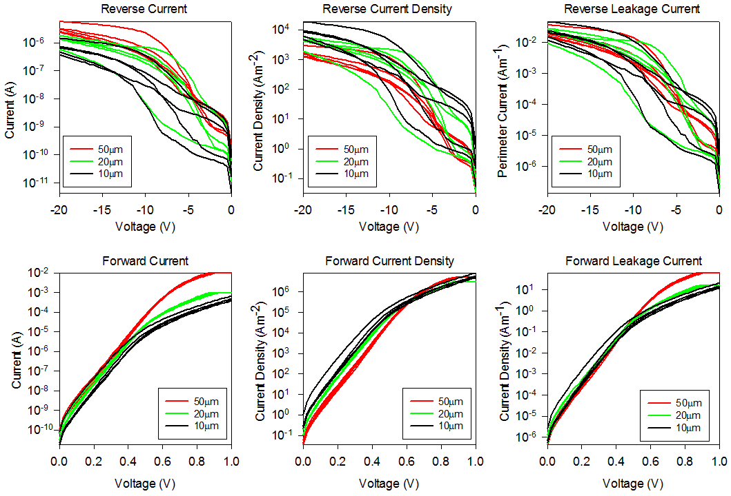
Figure 28: InGaAs PIN diode IV-Data for 50, 20 and 10µm diameter device sizes
The IV-data is shown in Figure 28. Though the reverse bias measurements are less consistent than the forward bias measurements, there is a visible trend of reduced dark current for smaller devices. The large spread in dark currents is due to surface leakage currents caused by unoptimised wet etching.
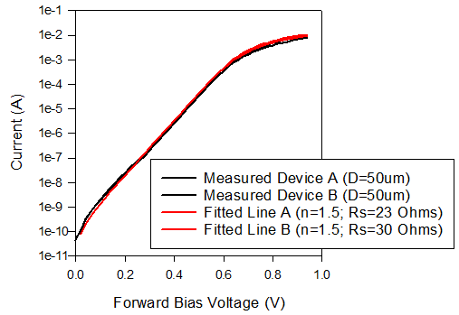
Figure 29: Ideal Diode Equation Fitting for InGaAs PIN diode
Assuming an ideality factor of 1.5, the ideal diode equation fit for the IV-data suggests a series resistance of between 23-30 Ω, as shown in Figure 29.

CV-Measurements

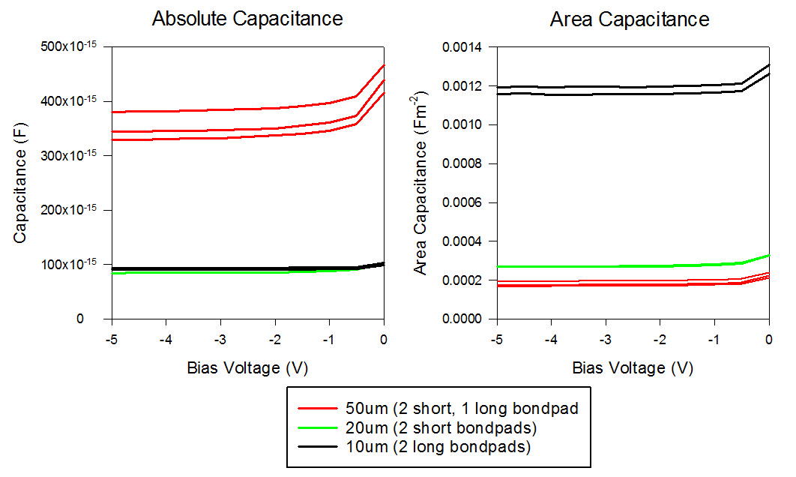
Figure 30: InGaAs PIN diode CV-Data
Figure 30 shows the CV-data for the InGaAs PIN diode. Capacitance should be proportional to the area in a perfect device, though parasitic capacitances from, for example, the bond pads may affect this. The high capacitance for the long-bond pad 10 µm devices relative to the short-bond pad 20 µm devices suggests that the capacitance of the devices themselves is relatively small compared to the capacitance of the bond pads. The capacitance is higher near zero volts due to incomplete depletion in the intrinsic region.

Bandwidth
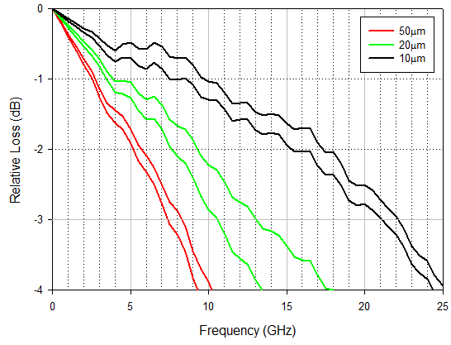
Figure 31: InGaAs PIN diode Bandwidth-Data
The bandwidths for different device sizes are shown in Figure 31. 50, 20 and 10 µm diameter devices had average bandwidths of around 8, 12 and 22 GHz, respectively. Measurements were taken using a wavelength of 1300 nm and an optical power of 180 µW at the surface of the device (the laser diode was driven with a current of 80mA). A reverse bias of 20 V was applied.

Discussion & Conclusion
The theoretical transit-time limited bandwidth was found to be 62.5 GHz, based on an InGaAs saturation velocity according to [52] and using eqn. (2.2.8). Diffusion-time limited bandwidth is not applicable here, since no photons are absorbed outside of the absorption region that would contribute to the total current, since the P- and N-regions are made of, for 1550 nm light, non-absorbing InAlAs. The devices were therefore limited by the diameter-dependant RC-time constant. Theoretical resistance values based on eqn. (2.2.12) and exact capacitance and bandwidth results are shown in Table 2. The data suggests that short bond pads reduce the bandwidth by increasing the resistance. Smaller devices also have smaller contacts with a higher resistance. Higher than expected capacitance values could be due to relatively large parasitic capacitances and resistances in the bond pads and depend on bond pad area. The bond pads have an estimated parasitic capacitance of 50 fF and a resistance of about 50 Ω on average [53] (though the short bond pads are quarter the length of the long bond pads) and therefore make up a significant proportion of the devices capacitance and resistance values, particularly for the smaller devices.
Device (µm) | Bandwidth (GHz) | Capacitance (fF) | Theoretical Resistance (Ω) | Bond pad
50 - A | 7.5 | 324 | 65 | Short
50 - B | 8.5 | 376 | 50 | Long
20 - A | 10.5 | 85 | 178 | Short
20 - B | 13.1 | 84 | 144 | Short
10 - A | 21.1 | 95 | 80 | Long
10 - B | 22.1 | 94 | 76 | Long
Table 2: Exact InGaAs PIN diode values
The capacitance values seem very reliable, being only 1 fF apart for the two pairs of smaller devices. The difference in the 50 µm device capacitance is due to the bond pad size difference and as expected. The bandwidth results are within 1 GHz of each other, except for the 20 µm devices, though some variation may be due to reflections in the cables and a 2.6 GHz difference at a bandwidth of 13.1 GHz is still reasonable. The 10 µm devices with a bandwidth of over 20 GHz are capable of 25 Gbit/s operation. The 20 µm devices may cope with 20 Gbit/s operation, though nominally a bandwidth of 14 GHz would be required for reliable operation.

AlGaAsSb SACGM APD
The second type of device was a SACGM APD with an AlGaAsSb multiplication layer. It has a thin InGaAs absorption layer with a width of only 300 nm and AlGaInAs/InAlAs grading layers.
Thickness (nm) | Material | Doping Type | Doping Level
50 | In_{0.53}Ga_{0.47}As | N | 5.0x10¹⁹
150 | Al_{0.85}Ga₀₁₅As_{0.56}Sb_{0.44} | N | 3.4x10¹⁸
100 | Al_{0.85}Ga₀₁₅As_{0.56}Sb_{0.44} | I | 1.0x10¹⁵
47 | Al_{0.85}Ga₀₁₅As_{0.56}Sb_{0.44} | P | 1.2x10¹⁸
25 | Al_{0.85}Ga₀₁₅As_{0.56}Sb_{0.44} | I | 1.0x10¹⁵
25 | In_{0.52}Al_{0.48}As | I | 1.0x10¹⁵
25 | Al_{0.27}Ga_{0.2}In_{0.53}As | I | 1.0x10¹⁵
25 | Al_{0.13}Ga_{0.34}In_{0.53}As | I | 1.0x10¹⁵
300 | In_{0.53}Ga_{0.47}As | I | 1.0x10¹⁵
25 | Al_{0.13}Ga_{0.34}In_{0.53}As | I | 1.0x10¹⁵
25 | Al_{0.27}Ga_{0.2}In_{0.53}As | I | 1.0x10¹⁵
25 | In_{0.52}Al_{0.48}As | I | 1.0x10¹⁵
300 | In_{0.52}Al_{0.48}As | P | 5.0x10¹⁸
500 | In_{0.53}Ga_{0.47}As | P | 5.0x10¹⁹
Table 3: AlGaAsSb SACGM APD Structure

IV-Measurements
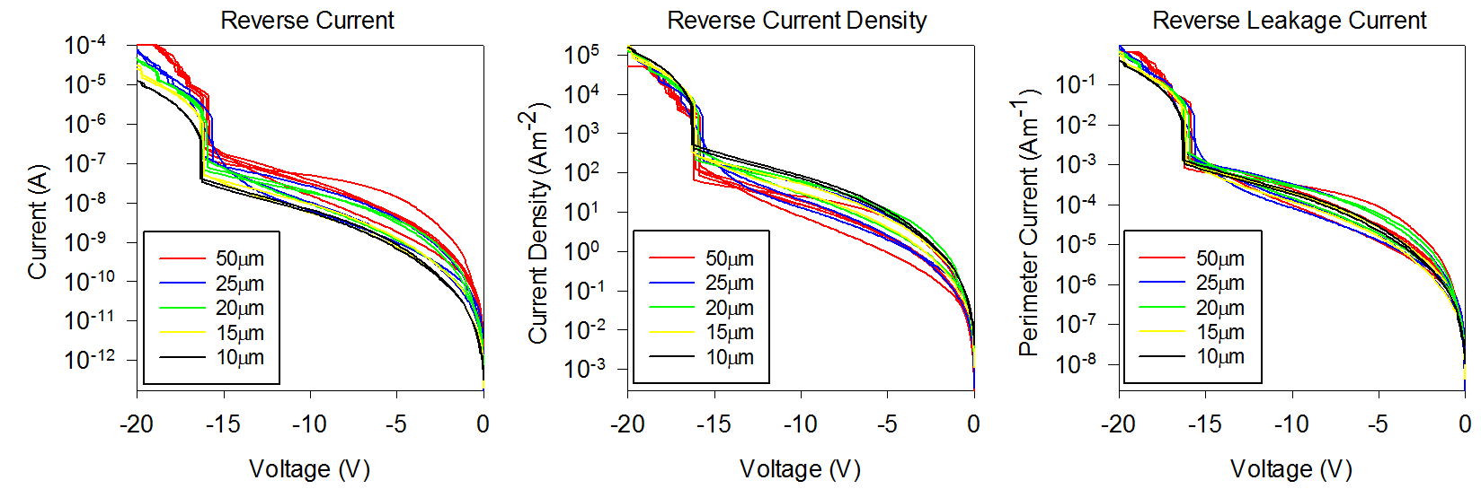
Figure 32: AlGaAsSb SACGM APD IV-Data for different device sizes
Figure 32 shows the IV-characteristic of the AlGaAsSb APD without any illumination. Dark current scales more with the perimeter (right diagram), suggesting leakage current mechanisms are more dominant. A clear punch-through appears at around 16 V, though the avalanche mechanism may occur simultaneously due to high charge sheet doping. A 25 µm and a 50 µm device have a smooth curve, otherwise results are consistent for each size and the expected trend of reduced dark current for smaller devices is clearly visible.

Responsivity & Gain
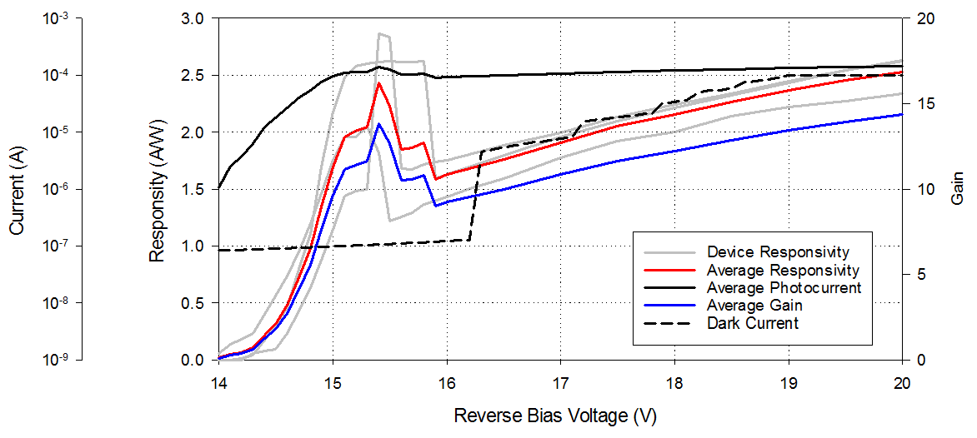
Figure 33: AlGaAsSb APD Responsivity and Gain Results
Responsivity was measured using 1550 nm infrared light modulated at 180 Hz and an optical power of 180 µW with a lock-in amplifier at room temperature. Measurements were performed on three 50 µm devices (grey lines) to ensure all the light is coupled into the device and results were averaged (solid red, black and blue lines), as shown in Figure 33. Gain was calculated relative and normalised to the theoretical peak responsivity at punch-through, i.e. before the avalanche multiplication process takes effect, multiplied by a reflectivity factor of 0.3. The absorption coefficient was assumed to be 8000 cm⁻¹ [54] for the 300 nm InGaAs absorption layer, giving a responsivity of 0.16 A/W at M =1. The explanation for the peaks at 15.5 V is unknown, but could be due to charge accumulation at heterojunctions within the device.

Bandwidth
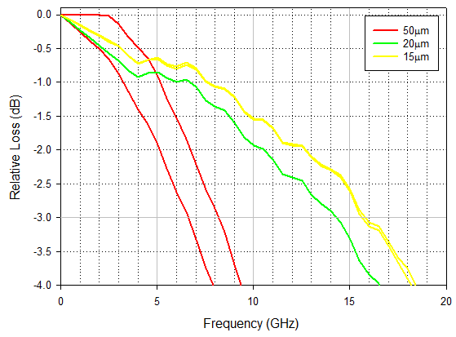
Figure 34: AlGaAsSb SACGM APD Bandwidth-Data for different device sizes
The bandwidth results were measured using 1550 nm infrared light at an optical power of 180 µW and are shown in Figure 34. 50, 20 and 15 µm devices reverse biased at 20 V had average bandwidths of around 7, 14 and 16 GHz, respectively.

Gain Bandwidth Product
Theoretically, responsivity and gain values are independent of device size, assuming all the optical power can be perfectly coupled with any device size, since device area is not affecting the results of the equations used. Therefore, the gain-bandwidth product of this AlGaAsSb APD can be estimated to be around 224 GHz, based on a gain of 14 (Figure 33) and bandwidth of 16 GHz (Figure 34) for 15 µm devices. The reason larger devices were measured for responsivity measurements was to ensure that all the light from the laser fibre would be coupled into the device, since the fibre including the cladding is as large as some of the smaller devices. Performing the measurements on smaller devices would have been very difficult experimentally and made the results less reliable and accurate due to the aforementioned coupling issues.

Discussion & Conclusion
During the measurements, the AlGaAsSb devices were very sensitive to being probed and would become defective, resulting in fewer devices being available for measurements as the characterisation progressed. The IV-measurements are the most reliable, with at least three devices measured for each of the five sizes. The bandwidth measurement only had two devices for each of the three sizes measured. The responsivity measurement required larger devices to ensure full coupling of light into devices and only three devices of the largest size were measured.
The GBP estimate could have been higher if the devices had been biased to a higher voltage, such as 25 V, which may increase the gain to around 22, if the measured gradient persisted. The 224 GHz value has a large tolerance, since if one accepts a 10% tolerance on gain and bandwidth results, respectively, these will then add and produce an approximately margin of error of 20%, producing a potential range of GBP estimates between 180 and 260 GHz.

Resonant-Cavity Defect Demultiplexer
There is a potentially infinite number of ways to design photonic crystal waveguides and filters. Waveguides can consist of cylindrical rods or other shapes, such as chevrons, that are arranged in regular lattices of squares, triangles or hexagons, to name a few. Filters can use resonant-cavities, gratings or different types of waveguides to select light of certain frequencies. The design examined in this thesis is based on a proposal by Alipour-Banaei, Mehdizadeh and Hassangholizadeh-Kashtiban [49]. It was chosen due to its simplicity, using a regular square lattice made of a single material with only two different cylinder sizes, and a high number of potential channels (64). The resonant-cavity defect design is easily tuned to different frequencies by adjusting one simple variable, producing linearly shifting, narrow peaks.

Waveguide
The first step in designing a photonic crystal demultiplexer is to design a suitable waveguide. The waveguide should be lossless for the largest possible range of frequencies and therefore should have a large bandgap. MPB uses an iterative process to find the largest bandgap and varies the radius of the cylinder within the unit cell to maximise the gap between the first and second bands. Lower bands tend to be less dense and therefore have a greater likelihood of large, complete bandgaps.
For a square unit cell of size $a$, the largest bandgap occurs for cylinders with a radius of $r=0.1933a$ (all sizes and lengths in the simulations are relative to the unit cell size). The band structure diagram is shown in Figure 35.
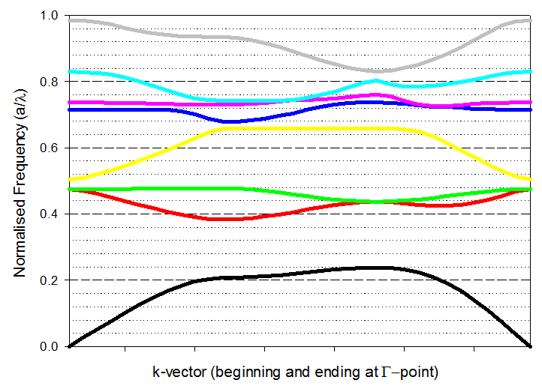
Figure 35: Band structure diagram of a cylinder with r=0.1933a
It can be seen that there is a complete (across all k-vectors) bandgap for normalised frequencies of 0.23 to 0.38, in which all frequencies between $\frac{0.23a}{λ}$ and $\frac{0.38a}{λ}$ are unable to pass through the photonic crystal from any angle and will therefore be contained within the waveguide without any loss.
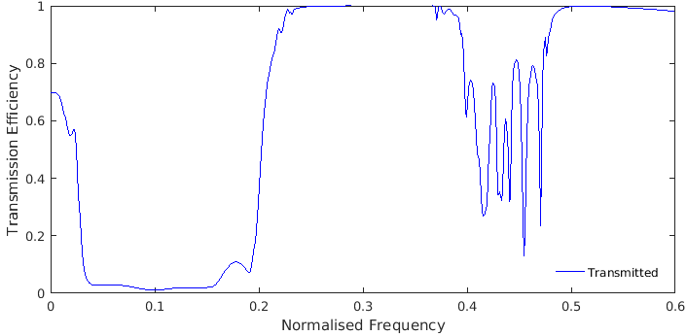
Figure 36: Transmission spectrum of a photonic crystal waveguide with cylinders of radius r=0.1933a
Running a simulation of this waveguide with the abovementioned cylinder dimensions produces the transmission spectrum shown in Figure 36. As expected, there is full transmission of normalised frequencies between 0.23 and 0.38, with higher losses for other frequencies. The transmission spectrum is illustrated in Figure 37, where a light signal with a frequency of 0.30 is contained within the waveguide (centre) and a frequency of 0.15 is not (right).
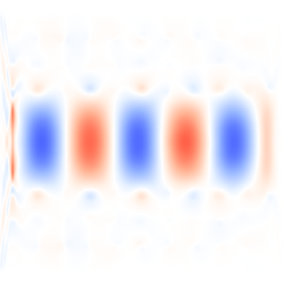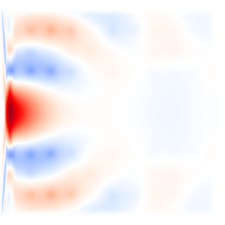
Figure 37: Waveguide structure (left), field propagation for frequency within (centre) and outside of that structure’s bandgap (right). Blue and red areas represent field strength minima and maxima, respectively.
The absolute unit cell size and therefore the overall system size depends on the frequencies of interest, since frequency is proportional to unit cell size. Assuming a frequency range centred on 1550 nm and choosing a reference normalised frequency in the middle of the bandgap, such as 0.30, the unit cell length would need to be a = 465 nm, giving a lattice cylinder radius of 90 nm and central defect radius of 232.5 nm for Silicon, though other materials can be used by adjusting the sizes. The bandgap range of 0.38 to 0.23 corresponds to a wavelength range of 1224-2021 nm. Since InGaAs photodiodes have an operation range of approximately 1200-1600 nm, outside of which the quantum efficiency is drastically reduced [55], only a normalised frequency range of 0.29-0.38 can be used. A range of relevant normalised frequency-to-wavelength conversions is given below in Table 4.
f_{norm} | 0.23 | 0.24 | 0.25 | 0.26 | 0.27 | 0.28 | 0.29 | 0.3 | 0.31 | 0.32 | 0.33 | 0.34 | 0.35 | 0.36 | 0.37 | 0.38
λ(nm) | 2022 | 1938 | 1860 | 1788 | 1722 | 1661 | 1603 | 1550 | 1500 | 1453 | 1409 | 1368 | 1329 | 1292 | 1257 | 1224
Table 4: Normalised frequency to wavelength conversion table

Resonant-Cavity Defect Filters
Now the guidable frequency range has been identified, the filter design can be adjusted to accommodate frequencies within that range. The resonant-cavity defect filter consists of a central defect cylinder with a radius of 0.5a and nine, smaller cylinders with a radius of 0.1933a, the same as the regular waveguide lattice cylinders. The frequency tuning was done by changing the distance between the central defect and its horizontally and vertically adjacent cylinders, which is illustrated in Figure 38.
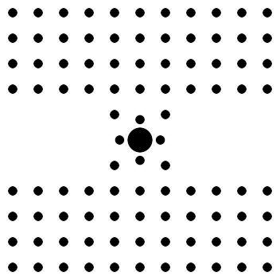
Figure 38: Waveguide with defect filter. Indent lengths shown are L=0.0, 0.2, 0.4 and 0.5.
Transmission spectra were generated for waveguides by inserting a source on the left and measuring the transmitted flux on the right side of the structure, including a resonant-cavity defect filter with indent lengths from L = 0.00 to L = 1.00 in intervals of 0.05. Figure 39 shows that in the waveguide’s bandgap frequency range from 0.23 to 0.38, there are generally two to four major peaks.
The transmission peaks for indents of L = 0.00 to 0.80 are summarised in Figure 40, which shows how the indent lengths affects the transmission efficiency and peak frequency position. For values of L > 0.75, there was no change in the transmission spectrum due to the cylinders fully overlapping with the central defect, making no difference to the overall shape. The pink line of peaks merges with the black line at the edge of the bandgap frequency range.
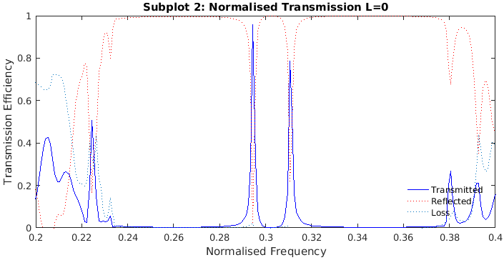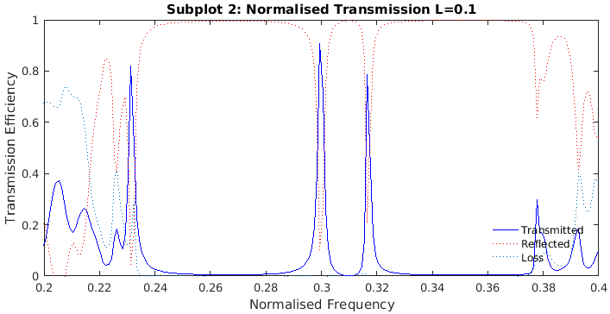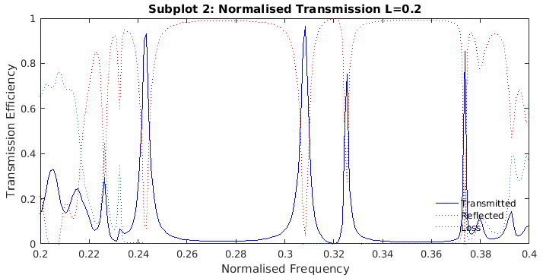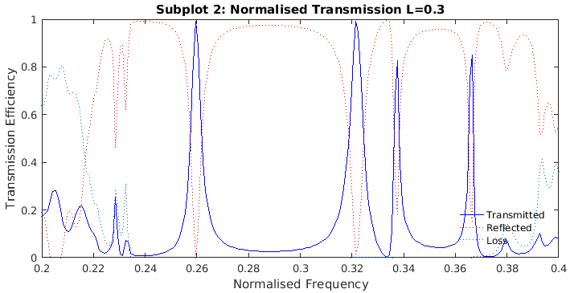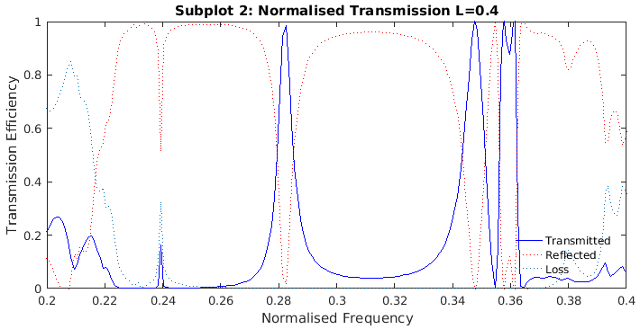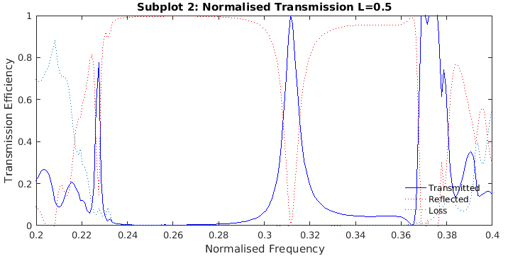
Figure 39: Transmission spectra for indent lengths L=0.00 to 0.50
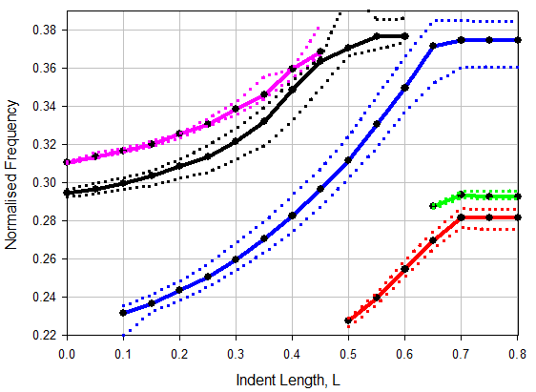
Figure 40: Transmission peaks (circles) with width (dotted)
The two most important factors when selecting indent lengths are (1) a high peak transmission efficiency and (2) a narrow peak, so there is as little overlap as possible with any other chosen indent length, which may cause a signal to leak into another filter channel and produce crosstalk, but also allows for more channels over a smaller frequency range.

Demultiplexer
The waveguide and filters are combined to construct a demultiplexer. The demultiplexer consists of a main signal waveguide with branches for the different channels. Channels are separated from the main signal waveguide by a defect filter. The defect filter will only allow a selected frequency to pass through it, depending on its indent length.
Figure 41: Demultiplexer with two filters (left) and a simple straight waveguide (right).
The transmission efficiency of the overall demultiplexer is measured relative to a straight, lossless waveguide. The structures for the demultiplexer and the waveguide are shown in Figure 41, where the solid rectangular blocks represent where the flux is being measured. On the left side is an opening for the optical input. On the right is an output for a further extension of the main signal waveguide, where more channel branches may be added. Any frequency within the bandgap, that does not pass through any of the defect filters, generally passes towards the output.
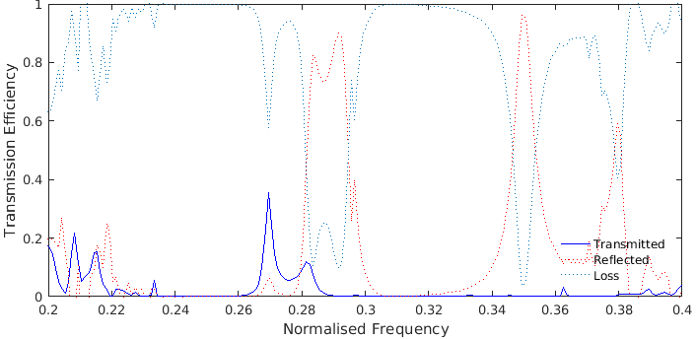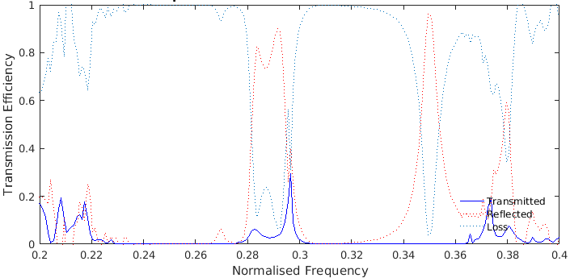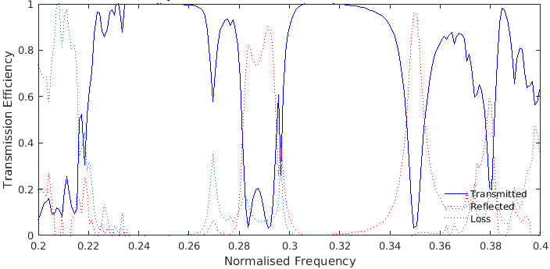
Figure 42: Transmission spectra through the filters with L=0.35 (left), L=0.45 (right) and at the output (center)
To demonstrate the demultiplexer, indent lengths of L = 0.35 and 0.45 have been chosen for channels 1 and 2, respectively, producing the transmission spectra shown in Figure 42. These indent lengths are suitable because the transmission efficiency is high and their peaks do not overlap. Channels 1 and 2 have respective transmission efficiencies of 30% and 35% at normalised frequencies of 0.269 and 0.296. The output transmission spectra shows that frequencies within the bandgap that do not pass through the filters, remain contained inside of the waveguide and remain available to be filtered out in additional channels past the output. Some frequencies experience losses in the resonant-cavities.

Discussion & Conclusion
The smallest feature size of 180 nm diameter is above the minimum feature size currently limiting photonic crystals. Based on Figure 40, the maximum number of channels without any significant crosstalk can be estimated to be eleven within the full wavelength range suitable for InGaAs photodiodes, giving an average channel width of 30 nm. The highest channel density is found across a smaller wavelength range of 1430 - 1500 nm (0.325 - 0.31), where the number of channels is five with an average width of 14 nm. A compromise between maximum number of channels and channel width is found between 1330 – 1500 nm, where the average channel width is 18 nm and gives 7 channels. This is considerably more than the average channel width of 1.5 nm of the original (eight channels across 12 nm) but produces less crosstalk due to a stricter threshold when selecting channels. Assuming the transmission efficiency for other channels is comparable to Figure 42, the average transmission efficiency for each channel would be between 30-40%, just over half of the average transmission efficiency of 60.3% achieved in the original paper, although the total footprint of this design with eight possible channels is only 62% of the size of the original, with areas of 349 µm² and 560 µm², respectively, based on the dimensions given at the end of section 4.3.1 and adding five unit cells at the end of either channel output to connect to the devices.

General Conclusions and Future Recommendations
The AlGaAsSb APD results showed a performance similar to current state-of-the-art APDs discussed in 2.2.8 and reproduced results from a similar very device by Zhou et al. [27]. Although there is some variation from device to device, the measurements are reliable and accurate. Considering the results from Zhou et al. [27], it can be assumed that these values are a lower ceiling and an optimised device with better contacts and a bigger sample may have obtained higher values.
The next benchmark target for optical telecommunication APDs is to achieve a gain-bandwidth product of 500 GHz. To achieve this GBP, the gain would need to be 20 and 12.5 for bandwidths of 25 and 40 GHz, respectively. Designs would require a low punch-through voltage and reduced dark currents. Waveguides can be integrated to improve the quantum efficiency and allow for thinner absorption layers.
As found in section 4.1.4, the bond pads add a significant amount of series resistance and capacitance to the device which affect the bandwidth and could be improved by, for example, finding new metallisation schemes to reduce the resistivity or other ways to reduce capacitance.
For future work with photonic crystal demultiplexers, different filter designs could be experimented with to further reduce the channel widths while maintaining a high transmission efficiency and be integrated with APD devices.

Appendix

Fabrication Process
A: Cleaving
# | Step Description | Notes
1 | Make orientation marks on back of wafer | Arrows to major edge
2 | Use Scribe to cleave on backside | Small scratch near edge
3 | Press on cleave with cotton bud from backside
4 | Change filter paper
5 | Blow wafer with nitrogen
6 | Place sample, wafer in respective boxes, replace wafer

B: Cleaning
# | Step Description | Notes
1 | Fill three beakers with n-butyl, acetone and IPA
2 | Place all on hotplate to boil | Avoid superheating
3 | Place sample in each beaker for 30s
4 | Inspect surface | If still dirty, repeat B1-4

C: Photoresist and Mask Alignment
# | Step Description | Notes
1 | Pre-bake for >1-2min
2 | Use photoresist BPRS200
3 | Spin for 30 seconds at 4000rpm (default setting)
4 | Post-bake for 1.5min
5 | Remove excess photoresist near edges | Using scrap pieces, expose and develop edges
6 | Use Photomask XXXX | Fabrication dependant
7 | Align and expose for (xx) seconds | Check in clean room for time – varies with UV-bulb
8 | Using Developer XXXX, develop for ## (60 in thesis) seconds and rinse in DIW | Fabrication dependant

D: Deposition of Top Contacts Ti/Au (20/200 nm)
# | Step Description | Notes
1 | Get 6cm Ti-wire, 2 Au-Wires
2 | Place all of each metal in its own evap-coil and boil in n-butyl
3 | Clean in acetone
4 | Place Ti, coils at top, Au bottom tier
5 | Place sample on Aluminium plate to conduct heat away from sample
6 | Set up thickness monitor
7 | Evaporate as described in manual and lift off in Acetone

E: Second (Isolation) Mesa Etch
# | Step Description | Notes
1 | Three-step Clean (See B: Cleaning)
2 | Mask Layer 2 (See C: Photoresist and Mask Align)
3 | Using H2SO4: H2O2: DIW (with the ratio of 1:8:80) etch 100nm deep to top edge of 300nm InAlAs layer
4 | Three-step Clean (See B: Cleaning)
5 | Mask Layer 3 (See C: Photoresist and Mask Align)
6 | H2SO4: H2O2: DIW (with ratio of 1:8:80) finish etching the bottom n+ InGaAs layer  and H3P04: HCL: DIW (with ratio of 3:1:2) which etched the InP semi-insulating  substrate for 10 s with the thickness of 0.5 μm.
7 | Inspection under microscope and clean the photoresist in the acetone

F: Deposition of Ground Contacts Ti/Au (20/200nm)
# | Step Description | Notes
1 | Get 6cm Ti-wire, and 1 lengths of gold wire (6cm)
2 | Place all of each metal in its own evap-coil and boil in n-butyl
3 | Clean in acetone
4 | Place Ti coil at top, Au bottom tier
5 | Place sample on Aluminium plate to conduct heat away from sample
6 | Set up thickness monitor
7 | Evaporate as described in manual and lift off in Acetone

G: Passivation (Optional – done before ground contacts usually)
# | Step Description | Notes
1 | Apply passivation mask (See C: Photoresist and Mask Align) | -Check specific exposure-, pre bake-times, spinner speeds etc for passivation used

Mask Details
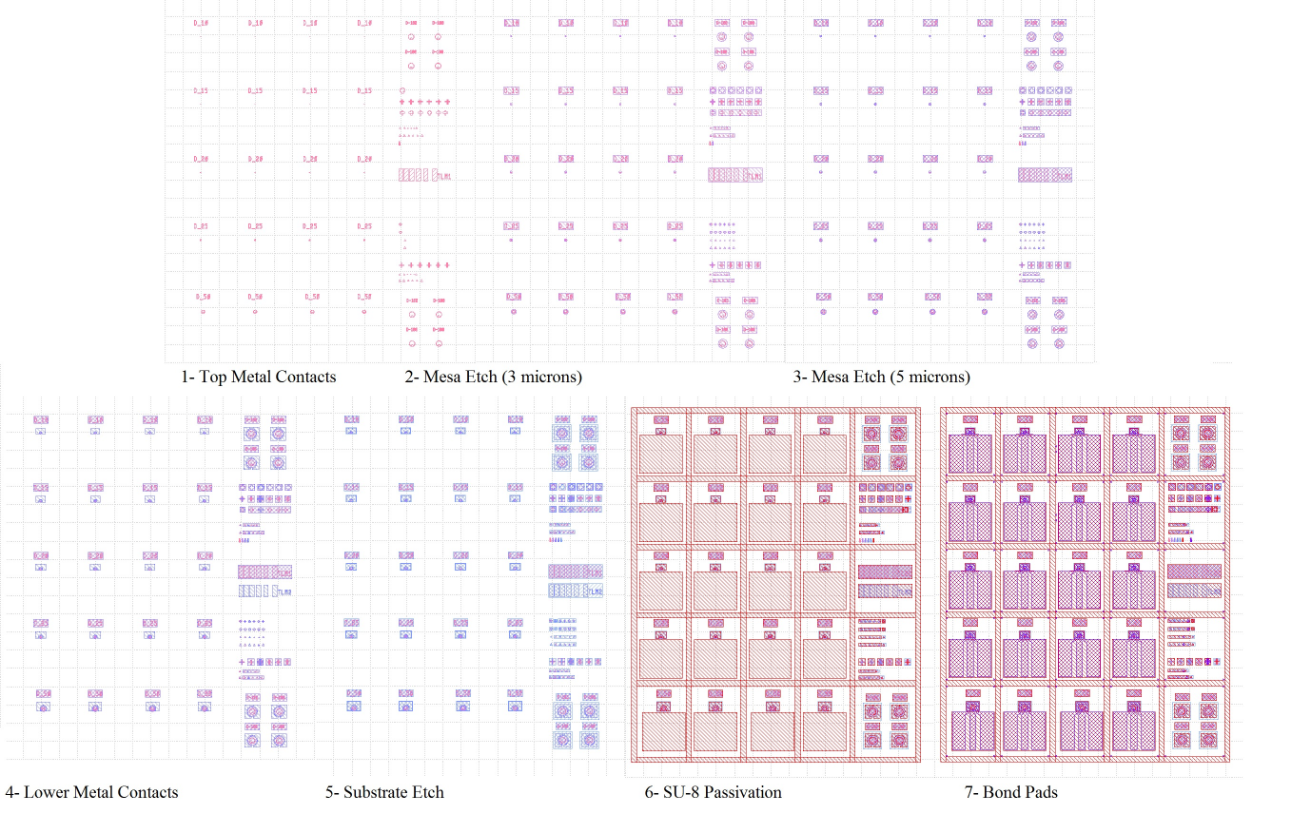
Figure 43: Mask Layers Details
Each layer is shown with the preceding layers, i.e. layer 7 is shown with layers 1-6 below it for reference. Either layer 2 or layer 3 are used, depending on the required etch depth for the sample. Layer 3 has a larger tolerance to protect the devices from suboptimal etching profiles, which are more significant over larger etch depths.

Table of Figures
Figure 1: Typical Silica optical-fibre attenuation characteristic [6] 6
Figure 2: Lattice Constants and Bandgaps of common semiconductor materials 7
Figure 3: PIN photodiode structure and electric field profile 9
Figure 4: Phototransistor diagram 10
Figure 5: Schematic (left) and top-view (right) diagrams of Schottky photodiode 10
Figure 6: Photomultiplier tube diagram 11
Figure 7: Dielectric slab waveguide 12
Figure 8: Dielectric Slab bandpass filter 12
Figure 9: Photonic crystal waveguide 13
Figure 10: SACGM APD structure and eletric field profile 16
Figure 12: Avalanche Multiplication through Impact Ionisation with unequal and equal ionisation coefficients 17
Figure 13: Predictions for excess noise factor based on McIntyre's local model for k=0, 0.2, 0.4, 0.6, 0.8, 1.0, 5.0 and 10 for electron injection and 1/k for hole injection 19
Figure 14: Bandwidth changing with gain for different impact ionisation coefficients (After [26]) 21
Figure 11: Comparison of reverse IV data and gain for AlAsSb (black, x=0) and AlGaAsSb APDs [24] 23
Figure 15: a) vertical illumination b) resonant-cavity c) side-illumination d) evanescent coupling 25
Figure 16: APD cross-section diagram after [36] 27
Figure 17: General photonic crystal demultiplexer diagram 27
Figure 18: 2-channel line defect [36] (left) and a resonant cavity [37] demultiplexers (right) 28
Figure 19: Ring resonator demultiplexer based on [38] 29
Figure 20: Resonant cavity filter with semi-feedback structure [39] 30
Figure 21: High-speed mask unit cell layout and photo of fabricated devices 32
Figure 22: TLM Pad diagram [11] (left) and photo (right) 34
Figure 23: Responsivity measurement setup 36
Figure 24: Bandwidth Measurement Setup 37
Figure 25: Component total and commercial photodiode loss 38
Figure 27: Unit Cell of a cylinder with r=0.193a (left) and its regular, periodic lattice (right) 39
Figure 28: Example model of a simple dielectric waveguide (left) and the electromagnetic field propagation for a single frequency 40
Figure 29: InGaAs PIN diode IV-Data for 50, 20 and 10µm diameter device sizes 41
Figure 30: Ideal Diode Equation Fitting for InGaAs PIN diode 42
Figure 31: InGaAs PIN diode CV-Data 42
Figure 32: InGaAs PIN diode Bandwidth-Data 43
Figure 33: AlGaAsSb SACGM APD IV-Data for different device sizes 45
Figure 34: AlGaAsSb APD Responsivity and Gain Results 46
Figure 35: AlGaAsSb SACGM APD Bandwidth-Data for different device sizes 46
Figure 36: Band structure diagram of a cylinder with r=0.1933a 48
Figure 37: Transmission spectrum of a photonic crystal waveguide with cylinders of radius r=0.1933a 49
Figure 38: Waveguide structure (left), field propagation for frequency within (centre) and outside of bandgap (right) 49
Figure 39: Waveguide with defect filter. Indent lengths shown are L=0.0, 0.2, 0.4 and 0.5. 50
Figure 40: Transmission spectra for indent lengths L=0.00 to 0.50 51
Figure 41: Transmission peaks (circles) with width (dotted) 51
Figure 42: Demultiplexer with two filters (left) and a simple straight waveguide (right) 52
Figure 43: Transmission spectra through the filters with L=0.35 (left), L=0.45 (right) and at the output (center) 53
Figure 44: Mask Layers Details 57

References

[1] | T. H. Maiman, “Stimulated Optical Radiation in Ruby,” Nature, vol. 187, pp. 493-494, 1960.
[2] | R. P. Riesz, “High-Speed Semiconductor Photodiodes,” Review of Scientific Instruments, vol. 33, no. 9, pp. 994-998, 1962.
[3] | F. P. Kapron, D. B. Keck and R. D. Maurer, “Radiation Losses in glass optical waveguides,” Applied Physics Letters, vol. 17, no. 10, pp. 423-425, 1970.
[4] | J. Manyika and C. Roxburgh, “The Great Transfomer: The Impact of the Internet on economic Growth and Prosperity,” McKinsey Global Institute, San Francisco, CA, 2011.
[5] | L. Fisher, D. Mansfield, D. Kingman, R. Lodge and K. Koutsavakis, “Builtvisible.com,” [Online]. Available: https://builtvisible.com/messages-in-the-deep. [Accessed 30 April 2017].
[6] | X. Zheng, High-Speed Avalanche Photodiodes and APD Arrays, Austin, TX: University of Texas at Austin, 2004.
[7] | A. Aydogan, F. Akleman and S. Yildiz, “Dielectric Loaded Waveguide Filter Design,” in International Symposium on Fundamentals of Electrical Engineering, Bucharest, Romania, 2016.
[8] | K. M. Johnson, “High-speed Photodiode SIgnal Enhancement at Avalanche Breakdown Voltage,” IEEE Transactions on Electron Devices, vol. 12, no. 2, pp. 55-63, 1965.
[9] | K. Nishida, K. Taguchi and Y. Matsumoto, “InGaAsP heterostructure Avalanche Photodiodes with high avalanche gain,” Applied Physics Letters, vol. 35, no. 3, pp. 251-253, 1979.
[10] | H. Kanbe, N. Susa, H. Nakagome and A. Hiroaki, “InGaAs Avalanche Photodiode with InP p-n junction,” Electronics Letters, vol. 16, no. 5, pp. 163-165, 1980.
[11] | T. P. Lee and T. Li, Optical Fibre Telecommunications, New York, NY: Academic Press, 1979, pp. 593-626.
[12] | S. R. Forrest, M. DiDomenico Jr., R. G. Smith and H. J. Stocker, “Evidence for tunneling in reverse-biased III-V photodetector diodes,” Applied Physics Letters, vol. 36, no. 7, pp. 580-582, 1980.
[13] | H. Ando, H. Kanbe, M. Ito and T. Kaneda, “Tunneling Current in InGaAs and Optimum Design for InGaAs/InP Avalanche Photodiode,” Japanese Journal of Applied Physics, vol. 19, no. 6, pp. 1277-1280, 1980.
[14] | C. H. Tan, S. Xie and J. Xie, “Low Noise Avalanche Photodiodes incorporating a 40 nm AlAsSb Avalanche Region,” IEEE Journal of Quantum Electronics, vol. 48, no. 1, pp. 36-42, 2012.
[15] | F. Capasso, A. Y. Cho and P. W. Foy, “Low-dark current, low-voltage 1.3-1.6um Avalanche Photodiode with high-low electric field profile and separate absorption and multiplication regions by molecular beam epitaxy,” ELectronics Letters, vol. 20, no. 15, pp. 635-637, 1984.
[16] | H. W. Ruegg, “An Optimized Avalanche Photodiode,” IEEE Transactions on Electron Devices, vol. 15, no. 5, pp. 239-251, 1967.
[17] | J. C. Campbell, A. G. Dentai, W. S. Holden and B. L. Kasper, “High-Performance Avalanche Photodiode with separate absorption, grading and multiplication regions,” Electronics Letters, vol. 19, no. 20, pp. 818-820, 1983.
[18] | “High-speed response InGaAs/InP heterostructure Avalanche Photodiode with InGaAsP buffer layers,” Electronics Letters, vol. 18, no. 22, pp. 945-946, 1982.
[19] | N. Li, R. Sidhu, X. Li, F. Ma, X. Zheng, S. Wang, G. Karve, S. Demiguel, A. L. Holmes Jr. and J. C. Campbell, “InGaAs/InAlAs avalanche photodiode with undepleted absorber,” Applied Physics Letters, vol. 82, no. 13, pp. 2175-2177, 2003.
[20] | B. F. Levine, R. N. Sacks, J. Ko, M. Jazwiecki, J. A. Valdmanis, D. Gunther and J. H. Meier, “A new planar InGaAs-InAlAs Avalanche Photodiode,” IEEE Photonics Technology Letters, vol. 18, no. 18, pp. 1898-1900, 2006.
[21] | R. J. McIntyre, “Multiplication Noise in Uniform Avalanche Diodes,” IEEE Transactions on Electron Devices, vol. 13, no. 1, pp. 164-168, 1966.
[22] | B. Li, H.-W. Yang, Q. Gui, X.-H. Yang, J. Wang, X.-P. Wang, S.-Q. Liu and Q. Han, “Ultra-low dark current, high-responsivity and thin multiplication region in InGaAs/InP Avalanche Photodiodes,” Chinese Physics Letters, vol. 29, no. 11, pp. 118503-1-3, 2012.
[23] | R. B. Emmons, “Avalanche-Photodiode Frequency Response,” Journal of Applied Physics, vol. 38, no. 9, pp. 3705-3714, 1967.
[24] | X. Jingjing, S. Xie, R. C. Tozer and C. H. Tan, “Excess Noise Characteristics of Thin AlAsSb APDs,” IEEE Transactions on Electron Devices, vol. 59, no. 5, pp. 1475-1479, 2012.
[25] | O. Blum, K. M. Geib, M. J. Hafich, J. F. Klem and C. I. H. Ashby, “Wet Thermal Oxidation of AlAsSb lattice matched to InP for Optoelectronic Applications,” Applied Physics Letters, vol. 68, no. 22, pp. 3129-3131, 1996.
[26] | X. Zhou, S. Zhang, J. P. R. David and C. H. Tan, “Avalanche Breakdown Characteristics of AlGaAsSb quaternary alloys,” IEEE Photonics Letters, 2016.
[27] | X. Zhou, S. Xie, S. Zhang, J. S. Ng and C. H. Tan, “InGaAs/AlGaAsSb APD with over 200 GHz gain-bandwidth product,” in Compound Semiconductor Week, Toyama, Japan, 2016.
[28] | J. C. Campbell and A. Beling, “High-speed, waveguide photodiodes,” in International Topical Meeting on Microwave Photonics, jointly held with the 2008 Asia-Pacific Microwave Photonics Conference, Gold Coast, Australia , 2008.
[29] | D. A. Humphreys, R. J. King, D. Jenkins and A. J. Moseley, “Measurement of absorption coefficients of Ga(0.47)In(0.53)As over the wavelength range 1.0-1.7um,” Electronics Letters, vol. 21, no. 26, pp. 1187-1189, 1985.
[30] | F. R. Bacher, J. S. Blakemore, J. T. Ebner and J. R. Arthur, “Optical-absorption coefficient of In(1-x)Ga(x)As/InP,” Physical Review B, vol. 37, no. 5, pp. 2551-2557, 1988.
[31] | C. Lenox, H. Nie, P. Yuan, G. Kinsey, A. L. Holmes, B. G. Streetman and J. C. Campbell, “Resonant-Cavity InGaAs-InAlAs Avalanche Photodiodes with Gain-Bandwidth Product of 290 GHz,” IEEE Photonics Technology Letters, vol. 11, no. 9, pp. 1162-1164, 1999.
[32] | J. C. Campbell, “Low-noise high-speed avalanche photodiodes,” in OFC, Anaheim, CA, 2002.
[33] | G. S. Kinsey, C. C. Hansing, A. L. Holmes, B. G. Streetman, J. C. Campbell and A. G. Dentai, “Waveguide InGaAs-InAlAs Avalanche Photodiode,” IEEE Photonics Technology Letters, vol. 12, no. 4, pp. 416-418, 2000.
[34] | G. S. Kinsey, J. C. Campbell and A. G. Dentai, “Waveguide Avalanche Photodiode operating at 1.55um with a Gain-Bandwidth Product of 320 GHz,” IEEE Photonics Technology Letters, vol. 13, no. 8, pp. 842-844, 2001.
[35] | T. R. Ranganath and W. Shyh, “Light detection in dielectric waveguides by a photodiode through direct evanescent field coupling,” Applied Physics Letters, vol. 31, no. 12, pp. 803-806, 1977.
[36] | S. Demiguel, Z. Xiaoguang, L. Ning, L. Xiaowei, J. C. Campbell, J. Decobert, N. Tscherptner and A. Anselm, “Evanescently-coupled avalanche photodiodes integrating a short multimode waveguide for high-responsivity and high-speed applications,” in Conference on Optical Fiber Communication, Los Angeles, California, 2004.
[37] | M. Nada, H. Yokoyama, T. Ishibashi and H. Matsuzaki, “Vertical illumination InAlAs Avalanche Photodiode for 50-Gbit/s applications,” in Int. Conf. on Indium Phosphide and Related Materials, Montpellier, France, 2014.
[38] | Y. Muramoto and T. Ishibashi, “InP/InGaAs pin photodiode structure maximising bandwidth and efficiency,” Electronics Letters, vol. 39, no. 24, pp. 1749-1750, 2003.
[39] | S. Xie, S. Zhang and C. H. Tan, “InGaAs/InAlAs Avalanche Photodiode with low dark current for high-speed operation,” IEEE Photonics Technology Letters, vol. 27, no. 16, pp. 1745-1749, 2015.
[40] | M. Nada, T. Yoshimatsu, Y. Muramoto, H. Yokoyama and H. Matsuzaki, “Design and Performance of High-Speed Avalanche Photodiodes for 100-Gb/s Systems and Beyond,” Journal of Lightwave Technology, vol. 33, no. 5, pp. 984-991, 2015.
[41] | G. Kumar and P. Sabnani, “Design and Simulation of 1×2 Optical Wavelength Division De-multiplexer by using Line Defect Photonic Crystal Resonator,” in 5th Confluence Conference, Noida, India, 2014.
[42] | F. Mehdizadeh and M. Soroosh, “A new proposal for eight-channel optical demultiplexer based on photonic crystal resonant cavities,” Photonic Network Communications, no. 31, pp. 65-70, 2016.
[43] | R. Talebzadeh, M. Soroosh, Y. S. Kavian and F. Mehdizadeh, “All-optical 6- and 8-channel demultiplexers based on photonic crystal multilayer ring resonators in Si/C rods,” Photonic Network Communications, vol. 33, no. 1, pp. 1-10, 2017.
[44] | R. Talebzadeh, M. Soroosh, Y. Kavian and F. Mehdizadeh, “Eight-channel all-optical demultiplexer based on photonic crystal resonant cavities,” Optik - Internatiounal Journal for Light and Electron Optics, vol. 140, p. 331–337, 2017.
[45] | A. Y. Cho, “Epitaxy by periodic Annealing,” Surf. Sci, vol. 17, no. 2, pp. 494-504, 1969.
[46] | A. Y. Cho, “Morphology of Epitaxial growth by a Molecular Beam Method: The observation of surface structures,” Journal of Applied Physics, vol. 41, no. 7, pp. 2780-2786, 1970.
[47] | MicroChem, “microchem.com,” [Online]. Available: http://www.microchem.com/pdf/SU8_2-25.pdf. [Accessed 1 May 2017].
[48] | S. M. Sze and K. K. Ng, Physics of Semiconductor Devices, New York, NY: Wiley, 2006.
[49] | P. J. Ker, Development of high-speed low noise InAs electron avalanche photodiodes, Sheffield: University of Sheffield, 2012.
[50] | S. G. Johnson and J. D. Joannopoulos, “Block-iterative frequency-domain methods for Maxwell's Equations in a planewave basis,” Optics Express, vol. 8, no. 3, pp. 173-190, 2001.
[51] | J. C. Maxwell, “On Physical Lines of Force,” Philosophical Magazine and Journal of Science, vol. IV, 1861.
[52] | A. F. Oskooi, D. Roundy, M. Ibanescu, P. Bermel, J. D. Joannopoulos and S. G. Johnson, “MEEP: A flexible, free software package for electromagnetic simulations by the FDTD method,” Computer Physics Communications, no. 181, pp. 687-702, 2010.
[53] | V. Balynas, A. Krotkus, A. Stalnionis, A. T. AGorelionok, N. M. SHmidt and J. A. Tellefsen, “Time-resolved, hot-electron conductivity measurement using an electro-optic sampling technique,” Applied Physics, vol. 51, pp. 357-360, 1190.
[54] | S. Xie, Design and Characterisation of InGaAs high-speed photodiodes, InGaAs/InAlAs APDs and novel AlAsSb-based APDs, Sheffield: University of Sheffield, 2012.
[55] | H. Alipour-Banaei, F. Mehdizadeh and M. Hassangholizadeh-Kashtiban, “A novel proposal for all optical PHC-based demultiplexers suitable for DWDM applications,” Optical Quantum Electronics, no. 45, pp. 1063-1075, 2013.
[56] | T. P. Pearsall, “InGaAs Photodetectors,” in Properties of Lattice-Matched and Strained Indium Gallium Arsenide, London, IEE Press, 1993, pp. 267-277.
[57] | C. H. Tan, Measurements of excess avalanche noise in sub-micron Si and AlGaAs avalanche photodiodes, University of Sheffield, 2002.
[58] | F. Nakajima, M. Nada and T. Yoshimatsu, “High-speed Avalanche Photodiode and High-sensitivity Receiver Optical Subassembly for 100 Gb/s Ethernet,” Journal of Lightwave Technology, vol. 34, no. 2, pp. 243-249, 2016.

