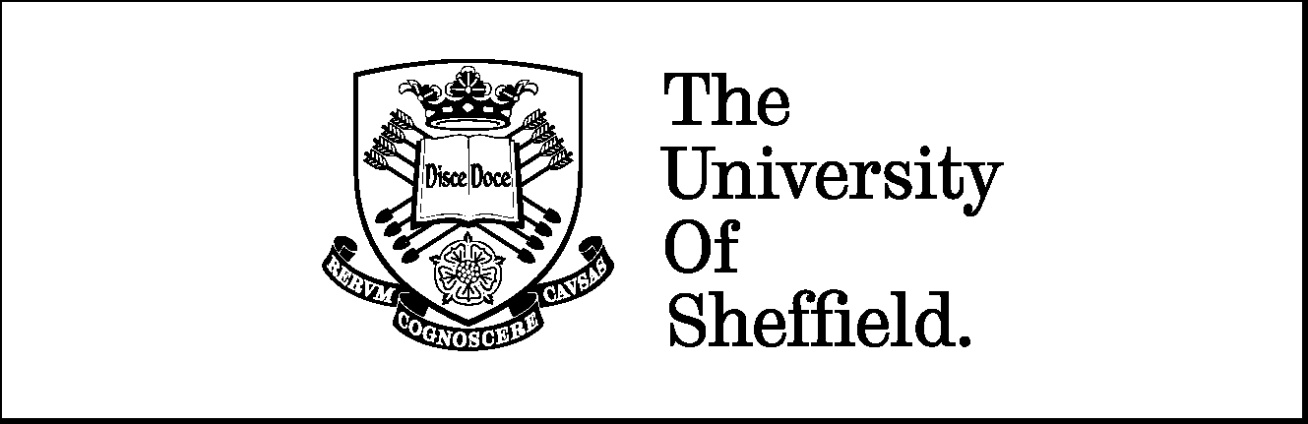
Department of
Mechanical Engineering

MPhil Mechanical Engineering
Final Thesis

The influence of catheter design on Urodynamics and their potential role on biofilm formation

Mauro Pistis

Dr. Alberto Marzo Dr. Cecile Perrault

Summary
The most commonly used indwelling urinary catheter design is the one proposed by Foley in 1930s. This is a closed system, consisting of a tube inserted through the urethra held in place by an inflatable balloon. The catheter is connected to a drainage system which allows drainage of urine from the bladder. These devices were originally designed for short-term use, but they are currently used for long-term treatments. The design has been changed little so far and it is considered obsolete by the scientific community. These catheters are vulnerable to encrustation and consequent blockage due to biofilm crystal deposition. The aim of this study is to characterise the effect of catheter design on urinary flow and to explore the potential role of urodynamics on biofilm development and encrustation. This study focused firstly on the correlations between catheter design, urodynamics and the phenomenon of encrustation using an idealized geometry to validate the CFD model with experimental data; subsequently it was used on a real geometry to study the role of the catheter design on the flow properties. The research hypothesis is that catheter design may affect internal urodynamics, and, as a consequence, the process of biofilm formation. A computer model, mimicking the physics of flow through a catheter, was used to predict and investigate flow near its tip. Model geometries were created based on measurements obtained from $μCT$ scans of a Foley catheter. The fluid solver used was ANSYS-CFX, and the physical problem was simplified by using water as a fluid which has similar properties of urine during the first stage. During the second part of the study the fluid solver used was a fluid modelling the rheological behaviour of human urine. Predicted values of volumetric flow rate were validated with data previously obtained experimentally. The results showed flow discontinuities in the proximity of the areas were encrustation is believed to start occluding the catheter. Low velocity values were found in proximity of the tip and near the lower edge of the eyelets. Wall shear stress value were also lower where encrustation commonly develops. These results are in good agreement with experimental data in the literature, indicating a possible correlation between urodynamics and encrustation. A parametrized study was also performed to understand the correlations between catheter design and flow behaviour. All the results obtained were then exhaustively analysed and discussed. To conclude this study provides a methodology which could be used to analyse the influence of catheter design and their potential role on the biofilm formation.

Nomenclature & Acronyms
In this section the nomenclature and acronyms used in the report are listed with the correspondent International System (IS) units.
Nomenclature
$$Re$$ | Reynolds number
$$V$$ | Velocity (m/s)
$$ν$$ | Kinematic Viscosity (m²/s)
ρ | Density of fluid (kg/m³)
$$μ$$ | Dynamic Viscosity (Pa·s)
$$y^{+}$$ | Dimensionless vector first node distance from the wall
1D | Mono-dimensional
2D | Two-dimensional
3D | Three-dimensional

Acronyms
CAUTIs | Catheters Urinary Tract Infections
CFD | Computational fluid dynamics
LTC | Long Term Catheterisation
SI | International system units
STC | Short Term Catheterisation
UI | Urinary Incontinence
WSS | Wall Shear Stress
IGES | Initial Graphics Exchange Specification
CAD | Computer-aided Design

Contents
Summary ii
Nomenclature & Acronyms iv
Contents v
Acknowledgements vii
1 INTRODUCTION 1
1.1 MPhil aim and objectives 3
2 LITERATURE REVIEW 5
2.1 The Foley indwelling urinary catheter 5
2.2 The biofilm formation process 6
2.2.1 Biofilm in urinary catheters 6
2.3 Current catheter designs 8
2.4 An overview of Biofilm modelling 10
3 CFD MODELLING OF A URINARY CATHETER TO ANALYSE FLOW-FIELD PROPERTIES 14
3.1 Methods and materials 14
3.1.1 CFD approach 14
3.1.2 Geometry 17
3.1.3 Fluid properties 21
3.1.4 Mesh 23
3.2 Results 30
3.2.1 Experimental data 30
3.2.2 CFD Phase 1: Tubes 31
3.2.3 CFD Phase 2: Catheters 33
3.3 Discussion 36
4 influence Of CATHETER DESIGN on URODYNAMICS USING CFD 38
4.1 Methods and materials 38
4.1.1 Fluid properties 44
4.2 Urinary catheter simulations 44
4.2.1 Fixed design 46
4.2.2 Parameterized designs 50
4.3 Results 56
4.3.1 Fixed design 56
4.3.2 Parameterized design 61
4.4 Discussion 70
5 CONCLUSIONS 71
5.1 Main contributions 71
5.2 Limitations 72
5.3 Future work 72
5.3.1 A biofilm modelling approach for future studies 73
6 REFERENCES 74
7 scientific outputs & pubblications 80
7.1 Work presented to the 2015 Biomedical Engineering Association Conference 80
7.2 Abstract submitted to 2016 European Society of Biomechanics (ESB) conference in Lyon (France) 80
7.3 Paper submitted to the “Journal of Engineering in Medicine” on May 2017 (Under Revision) 80

Acknowledgements
I would like to thank my supervisors, Alberto Marzo and Cecile Perrault, for all the help and the valuable advices they gave me during my MPhil pathway.
A huge thank you to Ale and Ivan for this amazing experience, their friendship and all the time spent together. Of course I wish to thank all the INSIGNEO group and all the amazing people who belong to it.
Thanks of course to Noemi and my Family to have supported me when needed and when tough time came up.
Finally, thank to Luke Boldock for helping me in order to perform the $μCT$scans of the catheter to take measurements of all the key parameters used to create re relevant geometry.

INTRODUCTION
For many years, the definition of Urinary Incontinence (UI) has been incomplete and ambiguous. A study performed in 1997 by Hampel et al. [1] analysed 48 surveys and several other articles published between 1954 and 1995, and showed how UI was explained in different ways. The Hampel study highlighted the need for an unambiguous definition to which researches could refer during their studies. A standardised terminology was introduced in 2002 by Abrams et al. [2] who defined UI as “a complaint of any involuntary leakage of urine”.
Urinary incontinence affects a huge number of people worldwide and it burdens healthcare systems with significant costs. Particularly, UI costs in the UK are on the order of £500m per annum [3]. A yearlong study performed by McGrother et al. in 2004, showed that more than 9 million people in the UK (a third of people over 40 years old) were affected by urinary storage symptoms and more than 5 million required healthcare [4]. Unfortunately, often there are no effective treatments available and the use of incontinence pads, commode toilets or bladder drainage tubes connected to wearable bags to collect the urine is required. The latter is the most common way to deal with UI, however, it is associated to catheter associated urinary tract infections (CAUTIs). Catheters are in some cases wore for long periods and defined as long-term catheterisation (LTC) if in place for more than 28 days [5]. Many patients undergoing LTC suffer from infection-related problems due to encrustation and blockage of their catheters by bacteria aggregation and growth on their surface. Moreover, these patients are prone to other related consequences, as demonstrated by D.J Stickler et al. [6] who showed that catheterised patients are three times more likely to be hospitalised, often require antibiotics, and have a greater fatality risk than non-catheterised patients, despite age or clinical status. CAUTIs sufferers are constantly vulnerable to complications such as:
- Pyelonephritis: This condition occurs when bacteria invade from the bladder one or both kidneys. This happens when persistent bacteriuria (such as in the case of LTC) deforms the bladder wall. This deformation, combined with the inflammatory status of the lower urethral wall, modifies the intravesical pressure and could damage the ureterovesical valve. Under these circumstances, a backward flow of infected urine toward the ureters increases the risk of renal damage [7];
- Bacteraemia: presence of bacteria in blood [8] which is a sterile environment. The detection of bacteria in the blood is an abnormal situation that could cause severe complications;
- Carcinoma of the bladder [6]: this condition occurs when a growth of abnormal tissue, known as a tumour, develops in the bladder lining. This scenario can have serious consequences for the patient, until a possible death.
These examples show how patients undergoing LTC and related CAUTIs are exposed to several complications due to the fact that external microorganisms (i.e. bacteria) can attack the immune system [9,10]. The phenomenon of CAUTIs, in the case of indwelling urinary catheter in fact, is due to the presence of an external device inside the bladder, which could be seen as a bridge between a non-sterile environment and the internal part of the body. In these conditions, bacteria grow on the catheter surface increasing the risk of consequent infection and catheter blockage. Catheter obstruction by encrustation is considered one of the major issues in the long-term management of urinary devices [11,12].
In this study, we studied how the Urodynamics inside the catheter could affect biofilm formation and growth. The analysis of flow properties inside the urinary tract through urodynamic studies is standardly defined as “urodynamic observation” [2]. We used this approach to try to understand the correlation between flow field and the incrustation phenomena. Subsequently, a parametrized study using a fluid with some physical properties as urine determine the role that the catheter design plays on the flow behaviour and properties. A relatively small literature using a purely CFD approach to the problem has been found so far. A study performed by Frawley et al. in 2009 [13] analysed a male urinary Foley catheter with a CFD approach using FLUENT 3.6. The aim of this study was to maximise the flow rate by changing the dimension and position of the eyelets. It demonstrated that the flow rate was affected by the eyelet size. However, the study was related to the use of the external geometry of the catheter instead of the actual flow domain. In this study the CFD methodology has been used to characterise the Urodynamics inside the catheter in a biofilm free environment.

MPhil aim and objectives
Aim
Analyse the role of design on Urodynamics and crystalline biofilm.
Objectives
To achieve this goal the project has been divided into objectives listed below:
- Creation of an idealized geometry through a typical catheter;
- To perform the convergence criteria independence study;
- To perform the mesh independence study;
- Validation of the model with experimental data already available:
  - Phase 1: Tubes;
  - Phase 2: Catheters;
- Utilize the validated model using a fluid with some physical properties as urine and a real geometry by means of a $μCT$ scan;
- To make some changes on the real geometry aimed to study their effect on the flow properties
- To perform a parametrized study using the validated model aimed to show how the flow behaviour is affected by a design modification near the eyelets;
- To analyse the results obtained;
- To discuss any future possible works to address the biofilm catheter encrustation issue using a modelling approach.

These objectives are investigated throughout the chapters addressing the following aspects:
- In chapter 1 an Introduction of the problem, and the MPhil aim and Objectives are presented;
- In Chapter 2 the Literature Review used during this study is described;
- In Chapter 3 the CFD model of a Foley Urinary Catheter is developed and validated. The methodology used is described and the main results are showed at the end;
- In Chapter 4 a case study of this model is presented and described. It is divided in two main phases. Firstly, five different fixed geometry scenario are analysed where no parameterization was applied. Secondly, three more scenarios are studied where one variable is parametrized for each of them;
- In Chapter 5, the conclusion, key findings, and limitations are revised and some possible future works are proposed;
- In Chapter 6 the references used during this study are listed;
- In Chapter 7 an abstract accepted and presented during the 2016 European Society of Biomechanics (ESB) conference in Lyon (France) is presented. A work presented to a Conference in London and a Paper submitted to the “Journal of Engineering in Medicine” on May 2017 are shown.

LITERATURE REVIEW
In this chapter the clinical context is presented, and the biofilm formation process and relative catheter blockage concepts are introduced. An overview of some literature studies and some of the main biofilm models used to reproduce this phenomenon will be given.

The Foley indwelling urinary catheter
Every year almost 100 million catheters are sold worldwide and more than 130000 ”urinary” catheters are used per annum in the UK [14]. This, in turn, has a costly economic impact with approximately 3 million people affected by UI [15]. The Foley indwelling urinary catheter is the most commonly used device of its kind. It is a system comprising a tube (typically 220-420 mm in length and 3.92-5.94 mm in external diameter) inserted through the urethra, held in place by an inflatable balloon, and connected to a drainage system. The catheter itself is composed of a tube which includes an inlet channel for the saline solution that fills the balloon and an outlet channel for the urine. Near the tip there are two eyelets (rounded rectangular in shape) from which the urine drains. (Figure 2.1-1)
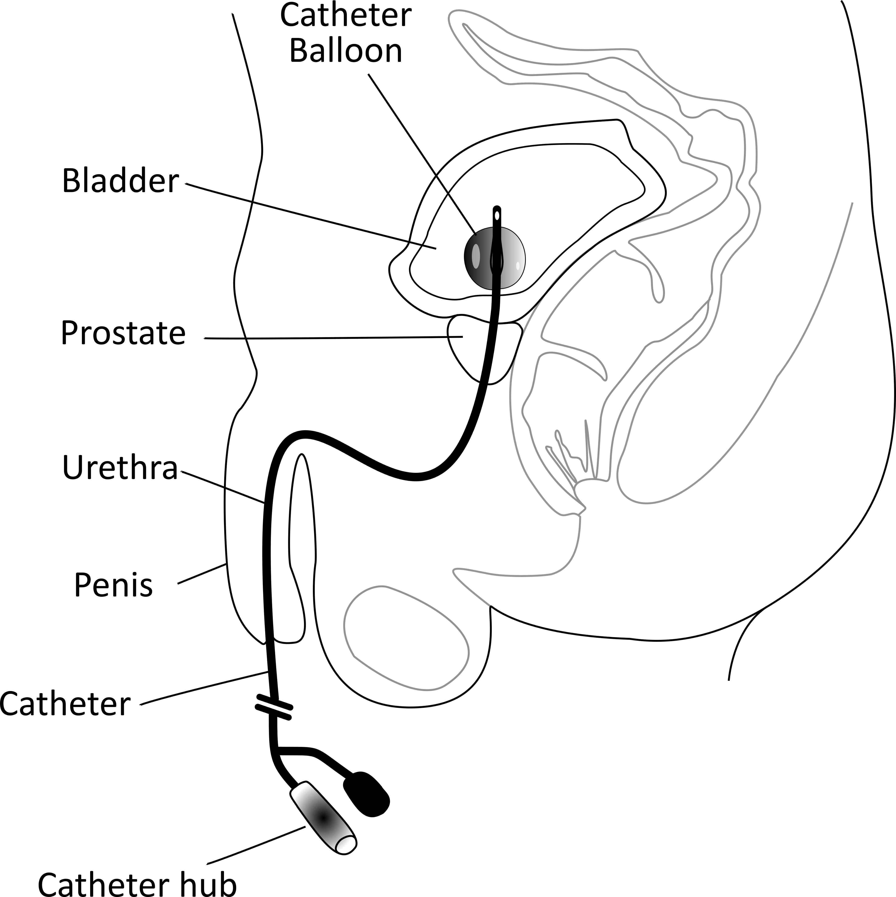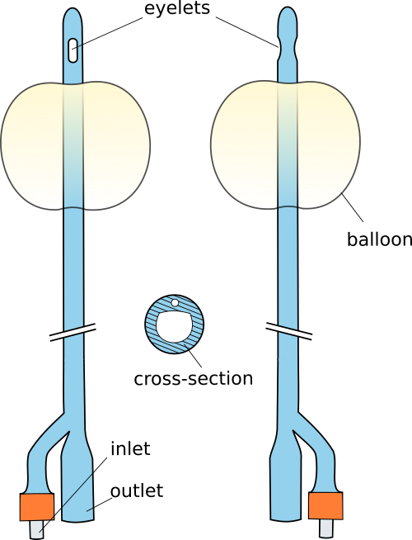
Figure 2.1-1 A male (females are similarly affected to males) urinary tract with catheter in place on the left side and the catheter design on the right. The water from the inlet through the little tube fills the balloon which is just below the two eyelets. The picture shows also a cross section which includes a small circular tube and a bigger semi-spherical one which correspond respectively to the inlet and the outlet.
The Foley catheter, initially designed for short-term catheterization (STC, 1-7 days [5]) and now commonly used also for LTC, was introduced by Dr. Frederick Foley in 1930s [3,16]. Its design has changed little since then and is considered obsolete by many in the scientific community [17,18].

The biofilm formation process
The biofilm formation process is characterised by a microorganism community, which grows on the catheter surface [19]. The colonisation phenomenon is well known since it can occur in infectious diseases but also in many different natural environments [20,21]. A paper from 1933 by Henrici [22] represents the first recorded observation of the biofilm phenomenon. Biofilm was defined as a “protected mode of growth that allows cells to survive in hostile environments and also disperse to colonise new niches” [20], and described as a dynamically complex and structured biological system, rather than simply a passive aggregation of cells attached to the surface

Biofilm in urinary catheters
The biofilm formation related to urinary tract infections is a biological process that can be subdivided in eight steps. This process is closely related to the length of time in which a catheter is kept in place, and it is dependent on chemical and physical factors combined with environmental changes, flow properties and catheter design. Biofilm growth is also dependent on flow rate, nutrient content and temperature [23]. The first step is (a) the protein adsorption (i.e. adhesion of atoms, ions or larger particles to a surface) on the biomaterial and it is followed by (b) the development of an organic conditioning film on the catheter surface. Once the film is formed, (c) the urease-producing bacteria adhere to the biofilm and (d) a community of bacteria starts to develop biofilm within a bacterial exopolysaccharide matrix. At this point, (e) the pH rise become a crucial factor [24] and (f) calcium and magnesium ions start to bind with the matrix gel. The crystals (g) are then stabilized and can grow and aggregate (h). The process is facilitated by the alkaline urine (pH 8.3-8.6) combined with bacteria attached to the surface [25].
Figure 2.2-1 - Biofilm process inside the Urinary Indwelling Catheter. The key point is the rise of pH which determines calcium and magnesium ions deposition.
CAUTIs is considered an issue which must be controlled and corrected as soon as possible [7,8]. R.C.L Feneley and D.J. Stickler have been studying this phenomena for the last 35 years [27] publishing more than 50 papers. However, CAUTI question is still unresolved. Feneley and Stickler have been analysing the issue mainly from a medical, biological and experimental point of view, trying to understand what exactly happens inside the catheter and how it becomes blocked. The type of bacteria involved in the process of CAUTIs is an important aspect. Feneley and Stickler showed that the rise in pH to alkaline conditions (pH 8.3-8.6) is almost exclusively due to bacteria P. Mirabilis, Proteus Vulgaris and Providencia Rettgeri. High values of pH facilitates the development of biofilm which rapidly encrusts and blocks the catheter [28]. It has also been demonstrated by P. Tenke et al. [29] that the rise of pH due to P. Mirabilis is 6-10 times faster than the rate caused by other species. In fact, preventing a raise in pH levels is essential to reduce catheter encrustation as shown by experimental studies performed in 2008 [30]. Several studies proposed different solutions such as drinking cranberry juice, a bladder washout with saline, an acid or antiseptic solution, using an antimicrobial coating or using an antibiotic treatment. However one of the most common ways to deal with biofilm encrustation is to replace the catheter, which is a painful process for the patient and also a cost for the healthcare system [3,25,31,32]. One of the main results, which helped the scientific community to characterize the encrustation, was to show how crystalline material starts to develop near the tip and below the eye-holes of commonly commercialised catheters [30,33]. The surface roughness facilitates the first phases of bacteria development in which they are trapped in surface irregularities and crevices. Figure 2.2-2 shows a silicone catheter cross-section, at (a) 1, (b) 4, (c) 6, (d) 12, (e) 22 and (f) 32 cm from the tip, which was removed after blockage.
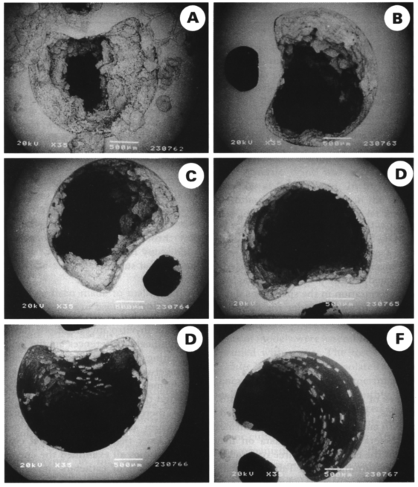
Figure 2.2-2 - Silicone catheter cross section after blockage [33]
In a recent paper [26], Feneley states “is time for the research founders, the healthcare providers and the regulators to stimulate the scientific, engineering, commercial and clinical communities to meet the challenge” in order to solve this issue.

Current catheter designs
The design of a medical device is a complex process, which requires the contribution of a specialised multidisciplinary team. During the design process, efficacy (i.e. the capacity to drain urine in case of necessity) and safety are the most important aspects [34,35].
The SuPort project [36], founded by the UK government, was a study which involved several professionals in an attempt to deal with CAUTIs issue. The SuPort project, identified how a multi-disciplinary team composed of urologists, material scientists, hydrodynamic experts, ergonomic experts, surgeons, and nurses could find feasible alternative design solutions. Firstly, the project showed how this team used a range of formal design methods in order to develop three medical devices. They then tried to develop feasible design alternatives. Unfortunately this project ended before producing a final device [37].
Currently, a group of researchers which works for a company called Sharklet Technologies, Inc. are trying to produce a new design for a urinary catheter, inspired by the structure of shark scales. Their studies have been focused on the internal catheter surface. The new device would be made with a nontoxic coating surface to reduce the possibility of cells/organisms adhesion without the need for chemical modification or leeching of any substances from the base material. This technology has been tested in marine applications where the bio-adhesion processes of complex organisms such as motile Ulva zoospores of common algae were studied [38,39]. These results (e.g. to reduce Ulva linza zoospore attachment to a smooth substrate) could be seen as scientific proof that reproducing the anatomy of shark skin on a surface usually attacked by bacteria could reduce their adherence on it. This has been an important result that could open new research scenarios, not only in marine applications but also in biomedical devices such as urinary indwelling catheters. The group then performed a study to show how the Sharklet micro-pattern may be a novel concept in addressing the CAUTI issue [40]. Analysing three variations of micro-patterned silicone surfaces versus a smooth silicone control in a static vitro environment, they found that all these three surfaces inhibited E. Coli colonisation, reducing their colony size of the 76%. This study is an evidence that a Sharklet-patterned surface can inhibit bacterial migration inside a Foley catheter. Currently, Sharklet has partnered with Cook Medical to produce the Sharklet Foley Catheter. However, this is a new technology and it would be necessary to evaluate the health economic impact compared with the actual available devices.

An overview of Biofilm modelling
Mathematical models can be and have been used to explore biofilm properties and its ability to attach to a surface under particular environmental conditions. These models permit us to investigate how the environment can influence biofilm formation and growth step by step. Mechanistically based modelling of biofilms began in the 1970s [41] and from that time experimental techniques which give a detailed evaluation of the structure and activity of biofilm have advanced significantly. The visualisation of heterogeneous and complex structures in biofilms (e.g., using images from confocal laser scanning microscopy) has triggered the development of a new generation of mathematical models in which the three-dimensional structure of biofilm is simulated [41]. These models have been primarily used for research purposes in order to understand, control, and engineer biofilms in a variety of scenarios, e.g. pollution control, prevention of corrosion and biofouling, minimisation of bacteria regrowth in water distribution systems, biomedical applications and medical devices [42]. The biofilm growth has been modelled in 1D, 2D and 3D and compared with experiments in order to predict the biofilm’s behaviour in various conditions. A review paper of biofilm mathematical models [43] classified, according to their dimensionality, the way in which diffusion is treated and the complexity of the physical, chemical, and biological effects.
A 2009 study by L.R. Band et al. [44] based on a 2D model considered the bladder as a reservoir of fluid (Figure 2.4-1) flowing through a catheter, which is considered as a rigid channel of length L* and width 2Y*.

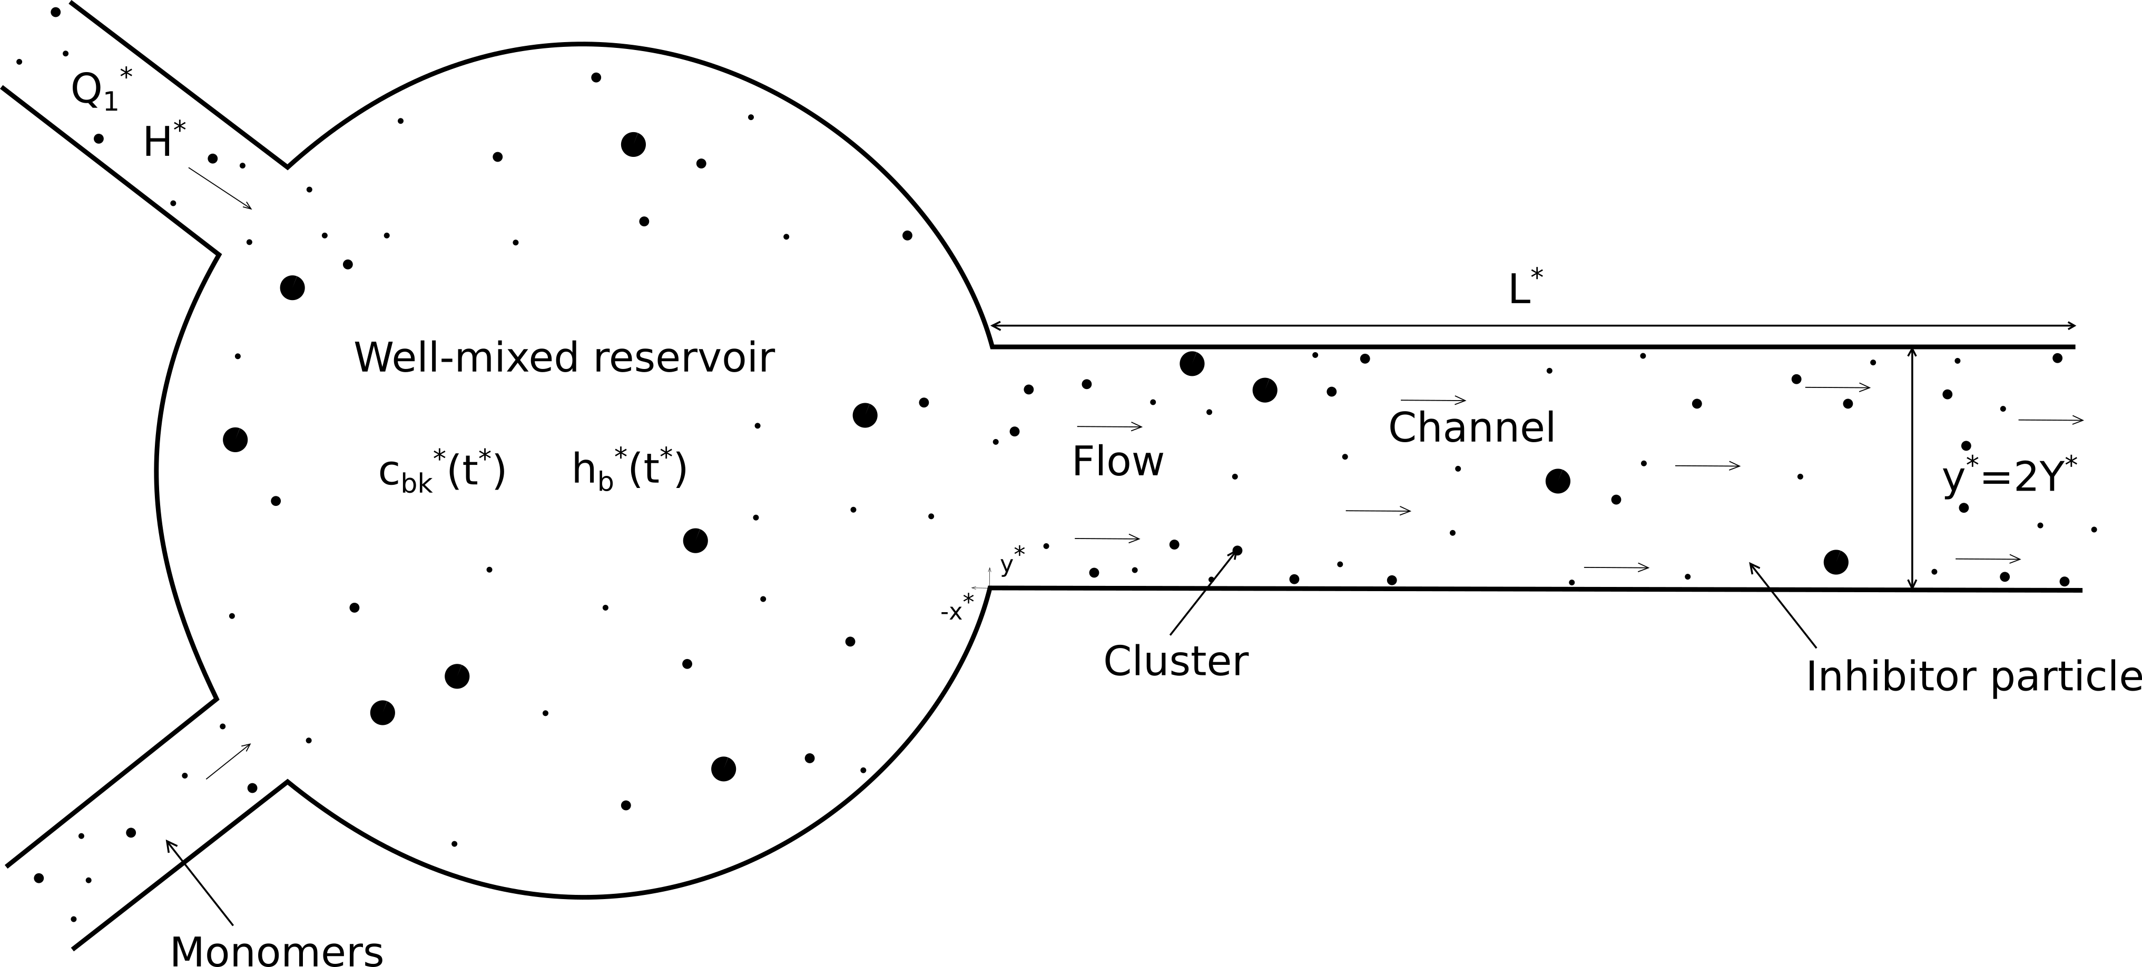
Figure 2.4-1 - System used for the mathematical model where Q₁* is the monomers rate and H* the inhibitor particle rate both per unit area. C_{b1}*(t*) and C_{bk}*(t*) and h_{b}*(t*) are the spatially homogeneous bulk concentrations of monomers inhibitor and k-clusters (k>=2) particles respectively. Asterisks are used to indicate dimensional quantities
This mathematical model, which is useful in investigating crystal deposition on the catheter surface, is based on the Becker-Döring coagulation theory (i.e. considering the interactions between monomers and clusters as the dominant growth mechanism)[45]. This model analysed biofilm crystal deposition ignoring spatial variation in the bulk concentration inside the bladder.
D’Acunto et al. [46] developed a 1D modelling method which is currently used and under study at the Department of Mathematics and Applications at the University of Naples. All the analysis considered the generic biofilm growth, with particular attention on new bacterial species in multispecies biofilms. This model could be used as a basis of researches aimed at modelling the biofilm performance in engineering applications. Starting with this work, D’Acunto et al. [47] have continued to develop this model proposing a mathematical modelling approach to study the initial phase of biofilm growth, particularly the population dynamic competition during attachment. A part of this study also provided a numerical simulation to illustrate the model, in the case where a thin layer of biofilm has already formed. Subsequently, using the properties of the model to manage the number of microbial species, biological processes such as the colonisation of new species as they diffuse from bulk liquid to biofilm [48] and the development of latent microbial species within the biofilm [49] were added. D’Acunto et al. studies do not consider a 3D biofilm modelling approach.
The actual catheter geometry is not symmetric and it is strongly three-dimensional. Therefore, it is necessary to integrate a 3D biofilm model as a multiscale framework within the CFD technique. Hence, the Biofilm Research Group at the Delft University of Technology (TUDelft) focused the attention on this feature. This group developed a multidimensional methodology to model the biofilm structure [50,51] which is considered a good starting point for this study. They considered both “positive” processes (i.e. cell attachment, cell division, etc.) and “negative” processes (i.e. cell detachment, cell death, etc.), which are key features during biofilm growth. An accurate balance of these processes allows to simulate biofilms with different structural properties such as surface roughness, porosity or density. The biofilm growth time scale is characteristic of these dynamic processes and it is also different from the simulations used to define the flow field and its properties. This is why a multiscale approach is necessary to develop a catheter model in which the urodynamics and the biofilm growth have different time scales. To solve this issue, they assumed that some processes were in a dynamic or frozen regime, while others were in equilibrium. The model, used for several applications [52–56], was divided in five main steps:
- The fluid velocity field v was computed at each simulation step by means of the lattice Boltzmann method [57], which solves both the continuity equation (1) and the Navier-Stokes equations (2) over the biofilm.

 | $$∇∙v=0,$$ | (1)

 | $$\frac{∂v}{∂t}+v∙∇v=-\frac{1}{ρ}∇p+\frac{μ}{ρ}∇^{2}v,$$ | (2)

where $p$ was the pressure and $ρ$ was the fluid density. The body forces in equation (2) were neglected since they were considered negligible;
- The convective-diffusive mass conservation equations (3) were solved as in the first step with the lattice Boltzmann algorithm [57] or with a finite difference algorithm [58].

 | $$\frac{∂C_{S}}{∂t}+v∙∇C_{S}=-R_{S}\left(C_{S},C_{X}\right)+D∇^{2}C_{S},$$ | (3)
where:
$$C_{S}=concentration of substrate,$$
$$C_{X}=concentration of biomass,$$
$$R_{S}=rates of substrate consumption,$$
$$D=substrate diffusion coefficient;$$

- The concentration of biomass $C_{X}$ was calculated using the Herbert-Pirt equation (4) which simulated the biofilm growth:

 | $$\frac{dC_{X}}{dt}=R_{X}\left(C_{S},C_{X}\right),$$ | (4)

where $R_{X}$ is the rate of biofilm formation;
- The 3rd step controlled biofilm growth and a redistribution of the new biomass was necessary. They used a cellular automata approach based on discrete rules developed by Picioreanu et al. [59,60];
- They also simulated the detachment step before the redistribution balancing positive and negative processes. When the biofilm external structure was defined it became the input of the new hydrodynamic step, which was necessary to close the loop.

CFD MODELLING OF A URINARY CATHETER TO ANALYSE FLOW-FIELD PROPERTIES
The aim of this study is to characterise urinary flow in an attempt to establish correlations between catheter design, urodynamics and the phenomenon of encrustation. A computer model mimicking the physics of flow through a catheter was used to predict and investigate flows near its tip. Model geometries were created from micro CT scans of a Foley catheter to create the computational model. The fluid solver used was ANSYS-CFX, and the physical problem has been simplified using the fluid properties of water, a fluid with similar physical properties to urine

Methods and materials
In this section the work done and the methods used to perform it are described. Catheter geometries were obtained from $μCT$ scans of a Foley catheter. The fluid solver used was ANSYS-CFX, and the physical problem has been simplified using the fluid properties of water, a fluid with physical properties similar to urine. Predicted values of volumetric flow rate were validated with data previously obtained experimentally. As the experimental data have been reproduced, contour plots have been compared with some results available in literature, in terms of biofilm formation and its localisation during the first phase of the process [28,30,33,61].

CFD approach
Computational modelling enables researchers to predict results of in vivo and in vitro experiments by means of computer-based simulations. Numerical analyses of systems involving fluid flows are commonly known as Computational Fluid Dynamics (CFD). This design methodology has been used since 1960’s in many industrial processes involving fluid analysis. Even though theoretical and experimental approaches are still considered fundamental, CFD integrates several advantages such as time and cost reduction, the ability to perform studies which are difficult to do experimentally and the level of result details.
A CFD analysis consists of five main steps:
- Computational domain (geometry) definition;
- Meshing: the division of the domain in a number of points where the solution is calculated;
- Fluid properties and boundary conditions definition;
- Solution of the discretised representation of the model;
- Post processing and validation of results.
In this study a finite volume method solver called ANSYS-CFX [62,63] was used. Fluid characteristics, such as velocity, pressure and flow rate, are defined at nodes and both accuracy of solution and its calculation time are strictly related to the grid (mesh) quality and its fineness. ANSYS-CFX can be used to solve the equation of continuity (5) and the Navier-Stokes equation (6) for incompressible steady flow:

 | $$∇∙v=0,$$ | (5)

 | $$v∇∙v=-\frac{1}{ρ}∇p+\frac{μ}{ρ}∇^{2}v+F,$$ | (6)

where $ν$, $ρ$, $μ$, and F represent the velocity, the pressure, the fluid density, the fluid viscosity and body forces, respectively. In the view of reproducing experimental unpublished results (experiments done by Melis. A et al at The University of Sheffield), the fluid was modelled as water and the geometry was drawn to resemble the experimental setup. The system consisted of a reservoir mimicking the bladder connected to a straight rigid tube (which could be either a tube or a proper catheter). The known data were the height of water inside the reservoir (h = 0.05 m), the tube/catheter internal diameter (d) and its length (l), (Figure 3.1-1).
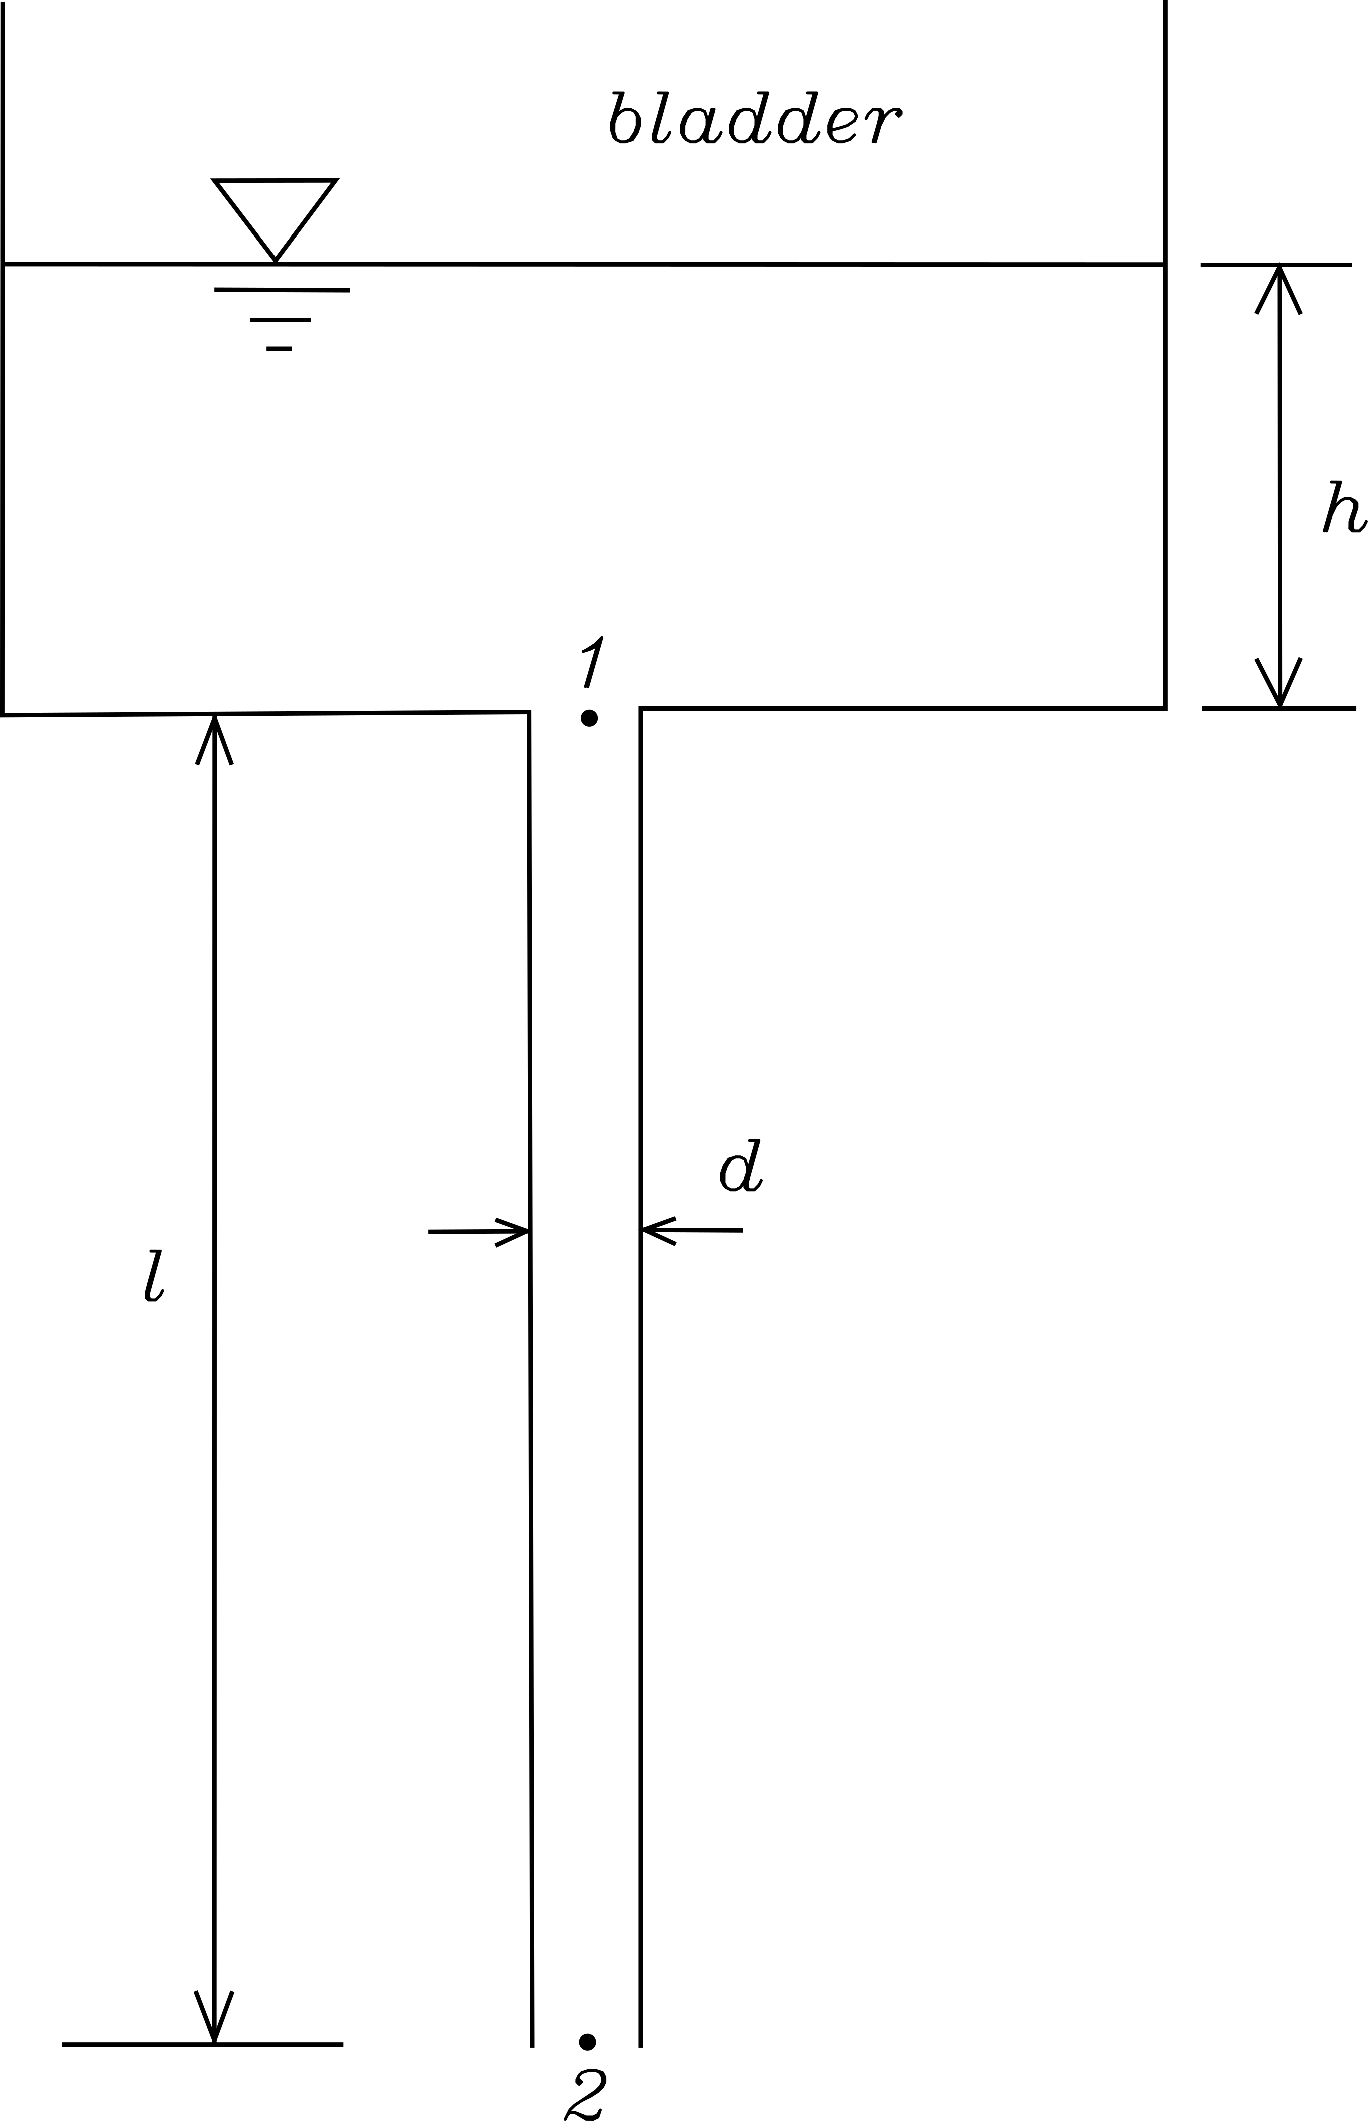
Figure 3.1-1 - Model which mimics the experimental setup
A pressure was applied at the inlet, which coincides with point 1 in the scheme shown in Figure 2.2-1.

 | $$P_{1}=P_{a}+ρgh+ρgl$$ | (7)

where $ρgh$ was the head pressure due to the water inside the reservoir and $P_{a}$ the atmospheric pressure. The last term $ρgl$ considered the body forces in the model below the point 1. Atmospheric pressure was applied at the outlet which coincides with the point 2:

 | $$P_{2}=P_{a}$$ | (8)

The non-slip condition (i.e. zero normal velocity at the wall) was imposed on the tube and catheter surfaces.
Simulations were carried out using ICEBERG the University of Sheffield's central High Performance Computing (HPC). ICEBERG specification are shown in Table 3-1.
Total CPUs | 3440 cores
Total GPUs | 16 units
Total Memory | 31.8 TBytes
Permanent Filestore | 45 TBytes
Temporary Filestore | 260 TBytes
Physical size | 8 Racks
Operating System | 64-bit Scientific Linux
Table 3-1 - ICEBERG specifications
Serial calculations in batch mode were used to perform the analysis at one of the INSIGNEO nodes.

Geometry
During the experiments six tubular geometries and three different catheters sizes were used. The study was then divided into two different phases in which the geometry was changed. In the first phase, a simple straight tube was used for validation, the turbulence model and the use of the CFD tool. The second phase was performed using a catheter realistic geometry, for which a $μ$CT-scan was acquired. However, it was decided not to use the $μ$CT geometry directly because a parameterization was required. Therefore, an idealized realistic geometry was designed. In the following paragraphs the two steps are analysed separately.

TUBES
From the experimental data, internal diameters and length of the tubes were available as shown in Table 3-2:
Tube | Internal diameter [mm] | Length [cm]
1 | 1.6 | 32.0
2 | 2.0 | 32.0
3 | 3.2 | 32.0
4 | 4.0 | 31
5 | 4.8 | 32
6 | 5.92 | 25.6
Table 3-2 - Tubes used during the experiments and their proprieties
The geometry of these tubes was generated on SolidWorks 2015/2016 (©Dassault Systemes, SolidWorks Corporation).
CATHETERS
In this case, the experimental data provided the catheter and consequently both external diameter and length. Diameter units are usually given on French scale or French gauge, which are used to measure the size of a catheter. French size (Ch) is three times the external diameter in mm, i.e. a Ch18 catheter has an external diameter of 6 mm. The three different devices used and their properties are shown in Table 3-3:

Catheter | Brand | Ext diameter [Ch] | Length [cm]
1 | Covidien | 14 | 42.0
2 | Covidien | 16 | 42.0
3 | Covidien | 18 | 42.0
Table 3-3 - Catheters used during the experiments and their proprieties
The catheter internal flow is related to the catheter internal diameter and shape. However, the internal cross-section does not have a standard shape but presents an asymmetric semi-circle geometry (Figure 3.1-2A). In this study, it was decided to use a circular shape (see Figure 3.1-2B) with an equivalent cross section equal to the actual catheter. By using the catheter length and its volume (experimentally measured), the equivalent internal diameter was computed. To account for uncertainty in the experimental measurements (repeatability), the same measurement procedure was repeated 10 times. The obtained values were subsequently averaged. Internal diameters calculated experimentally for the three different catheters are illustrated in Table 3-4.
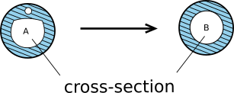
Figure 3.1-2 - Cross section of the catheter: (A) cross-section observed experimentally, (B) cross-section simplified for computational simulations as calculated from the external diameter

Catheter | Ext diameter [Ch] | Ext diameter [mm] | Length [cm] | Int. diameter [mm]
1 | 14 | 4.667 | 42.0 | 2.312
2 | 16 | 5.333 | 42.0 | 2.776
3 | 18 | 6 | 42.0 | 3.263
Table 3-4 - Internal diameter values for the catheters used
The next step was to create a geometry for the eyelets. Their real shape is not standard since they are handmade. Catheters with the same diameter, unfortunately, have slightly different shapes in terms of eyelets and this is a critical aspect when a standardised geometry is required. The same geometry for both the eyelets was considered, therefore a standard shape for all the three catheters was created. An elliptical shape was chosen as it was necessary to have a geometry which would change automatically once a different internal diameter was considered. The two ellipses created to simulate the eyelets have the following properties:

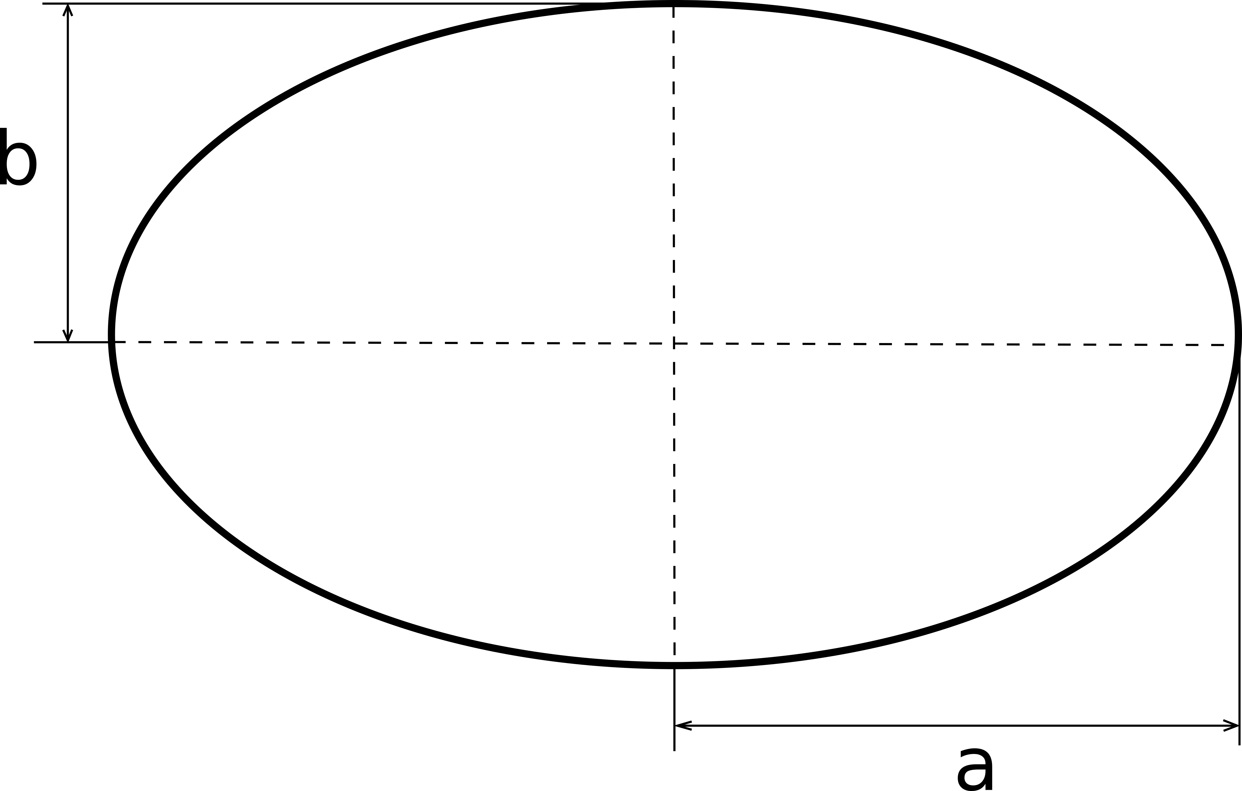
$\left\{\begin{aligned}A=π∙a∙b \\ \\ b=\frac{a}{2}\end{aligned}\right.$

Where:
$A=π∙{\left(\frac{d}{2}\right)}^{2}$, $d=Internal diameter$

The catheter wall thickness was measured ten times with a calliper and the mean value was taken. All the other internal dimensions were defined as a function of the internal diameter. Hence, the entire geometry was parameterised with respect to the internal diameter (Figure 3.1-3):
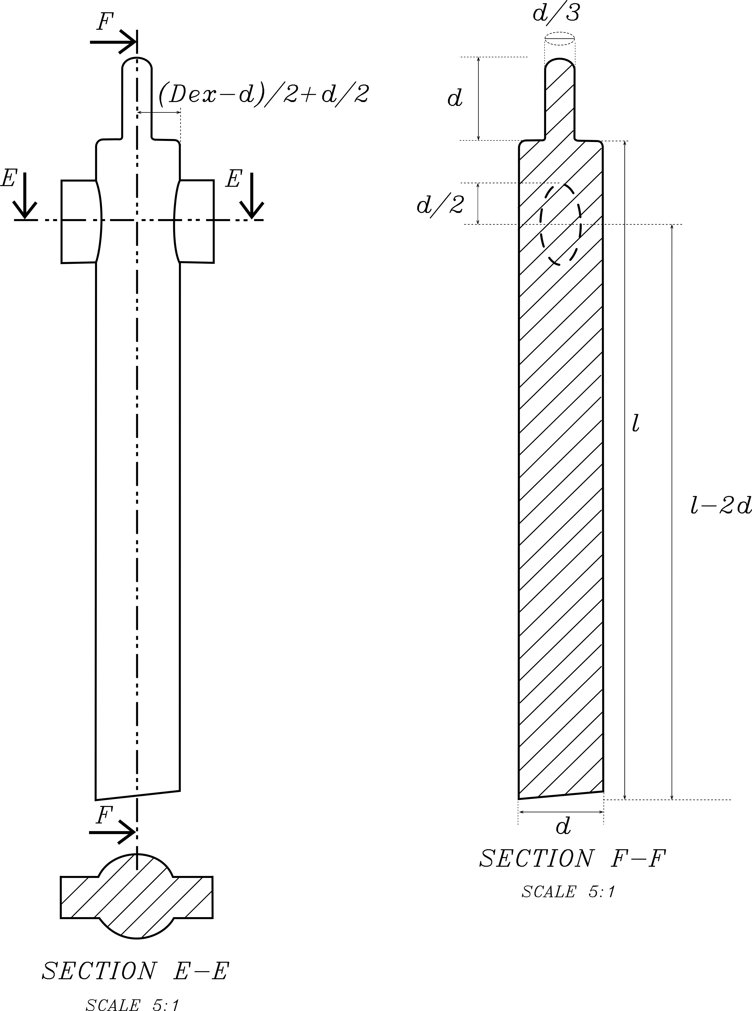
Figure 3.1-3 - Longitudinal and transversal-section of the urinary catheter geometry used during the ANSYS-CFX simulations
A $μ$CT scan was performed in order to exactly capture the fluid domain. This geometry was not used directly for the simulations because one of the objectives is to perform a study in which the geometry would be changed. This geometry was used to validate the dimensions defined beforehand. A comparison between the $μ$CT scan and the catheter created on Solidworks is shown in Figure 3.1-4. . The image is focused on the tip, where the shape changes.
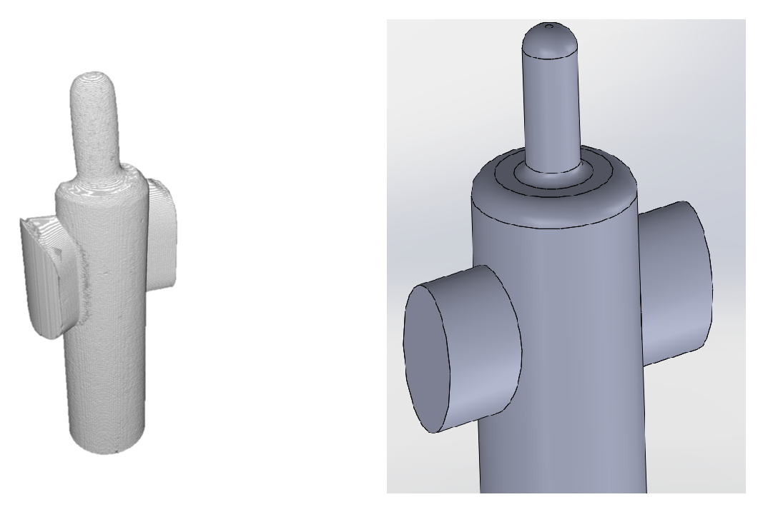
Figure 3.1-4 – The $μ$CT scan (A) and Solidworks (B) geometry of the Foley catheter

Fluid properties
The SolidWorks geometries were imported into ANSYS-ICEM for meshing. Before creating the mesh, it is always necessary to define the flow properties in terms of turbulence. A Newtonian laminar flow does not require a very refined mesh, but it is able most of the time to accurately reproduce the physics. In the case of turbulent flow, the grid must be generated in accordance with the turbulence model used to perform the simulation. Using a laminar model for a turbulent flow, indeed, does not guarantee the convergence of the solution.
The flow turbulence is defined according to the value of the Reynolds number ($Re$). An internal flow can be defined as laminar when the value of $Re$ is lower than 2300. If $Re$ is between 2300 and 4000 the flow is considered transitional. Eventually, if $Re$ is greater than 4000 the flow is turbulent [64]. The $Re$ number is calculated using the characteristic length of the geometry used. This is a value usually known a priori, and in this study it is the internal diameter. This number includes also fluid properties such as the velocity ($u$), the kinematic viscosity ($μ$) and the density of the fluid used ($ρ$):
$$Re=\frac{ρ∙u∙D}{μ} → \left\{\begin{aligned}Re<2300 Laminar \\ \\ 2300≤Re≤4000 Transition \\ \\ Re>4000 Turbulent\end{aligned}\right.$$
The $Re$ number was calculated for all the tubes and all the catheter used during the simulations. Since its value depends on the internal diameter and the flow velocity, the results obtained are different for each case and are reported in Table 2-4. The velocity was calculated based on the flow rate obtained experimentally.

Tube diameter [mm] | $$Re$$ | Catheter internal diameter [mm] | $$Re$$
1.6 | 1091 | Ch14 | 2718
2 | 2254 | Ch16 | 3012
3.2 | 4591 | Ch18 | 4493
4 | 5347
4.8 | 6296
5.92 | 8564
Table 3-5 - Reynolds numbers related to the tubes and catheter used during the CFD simulations
The results show that the $Re$ number is greater than 2300 in all cases, except for the tubes with 1.6 and 2 mm as internal diameter. This would imply the necessity to solve the CFD problem using a turbulence model. However, a laminar model was used, in order to understand the behaviour in terms of flow rate (this was the physical quantity measured previously experimentally) compared to the turbulence models. Depending on the fluid model employed, a different mesh with different properties was required.

Mesh
The characteristics of a turbulent flow are drastically different from the ones of a laminar flow. The main differences are near the wall where strong gradients related to the dependent variable increase the computational cost of the analysis. The velocity in these areas, for example, changes rapidly as shown in Figure 3.1-5.
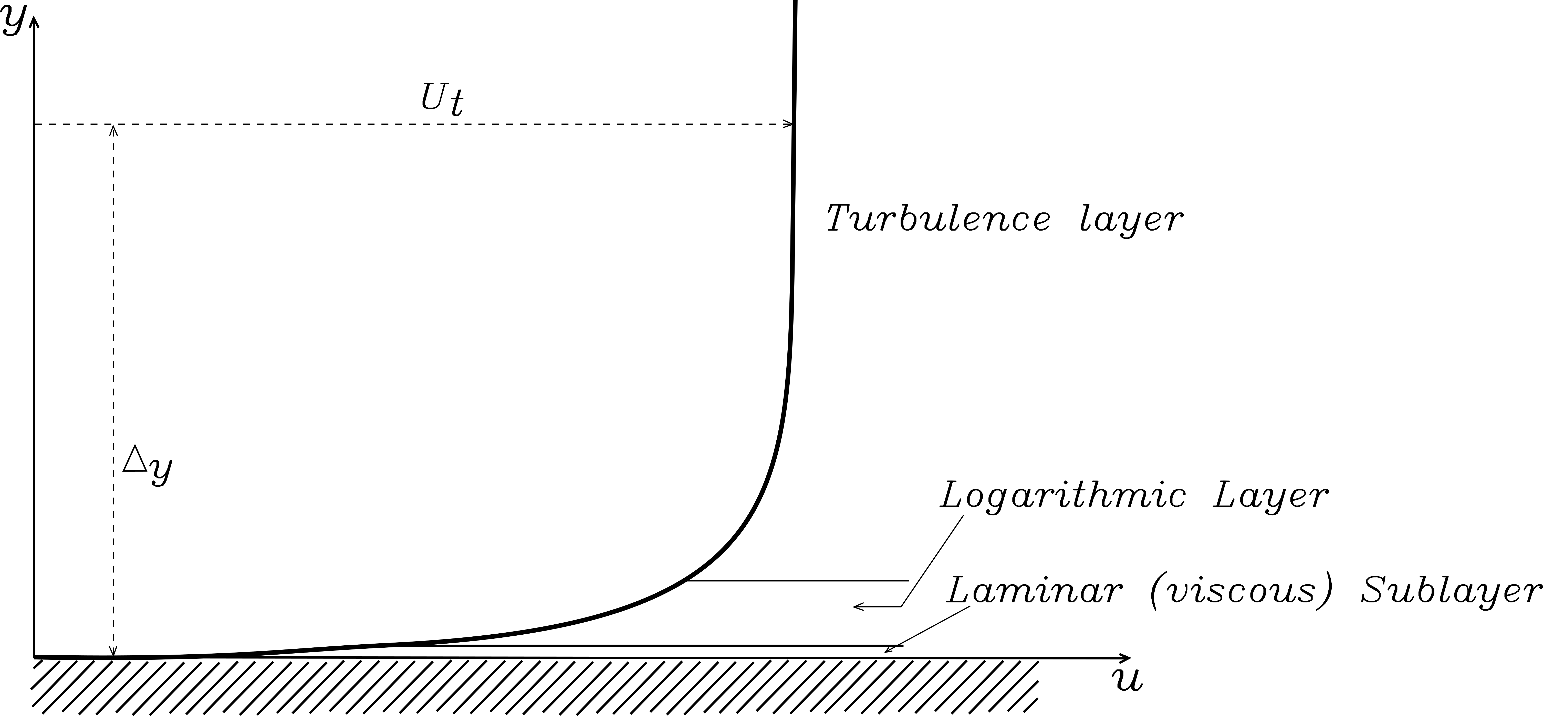
Figure 3.1-5 - Velocity profile near the wall in case of turbulent flow
Representing a numerical solution in processes with turbulent flows raises several problems, such as how to consider the viscous effects at the wall or how to find the solution of flow variables within the turbulent boundary layer. Figure 3.1-6 shows boundary layer properties used to consider the flow behaviour near the wall by software such as ANSYS-CFX (usually the shape is the same for all flows). Moreover, the following formula is used to define a priori the first layer distance from the wall $y$ when the $y^{+}$ suggested for the turbulent model used is known:

 | $$y^{+}=\frac{yU_{τ}}{υ}$$ | (9)

where $v$ is the kinematic viscosity and $y^{+}$ is the known dimensionless distance vector dependent on the turbulent model used. $U_{τ}$ is the velocity on the wall calculated using the empirical value of predicted wall shear stress $τ_{w}$ (11).
Equation (9) permits to predict near wall cell size and to capture, therefore, all the needed boundary layer information according to the turbulence model used during the analysis. The $y^{+}$ is a key parameter during the simulations.
Figure 3.1-6 considers the following boundary layer properties:
- Logarithmic scales;
- Dimensionless velocity such as $U/U_{t}$ where $U_{t}=\sqrt{τ_{wall}/ρ}$;
- Dimensionless wall distance vector called $y^{+}$

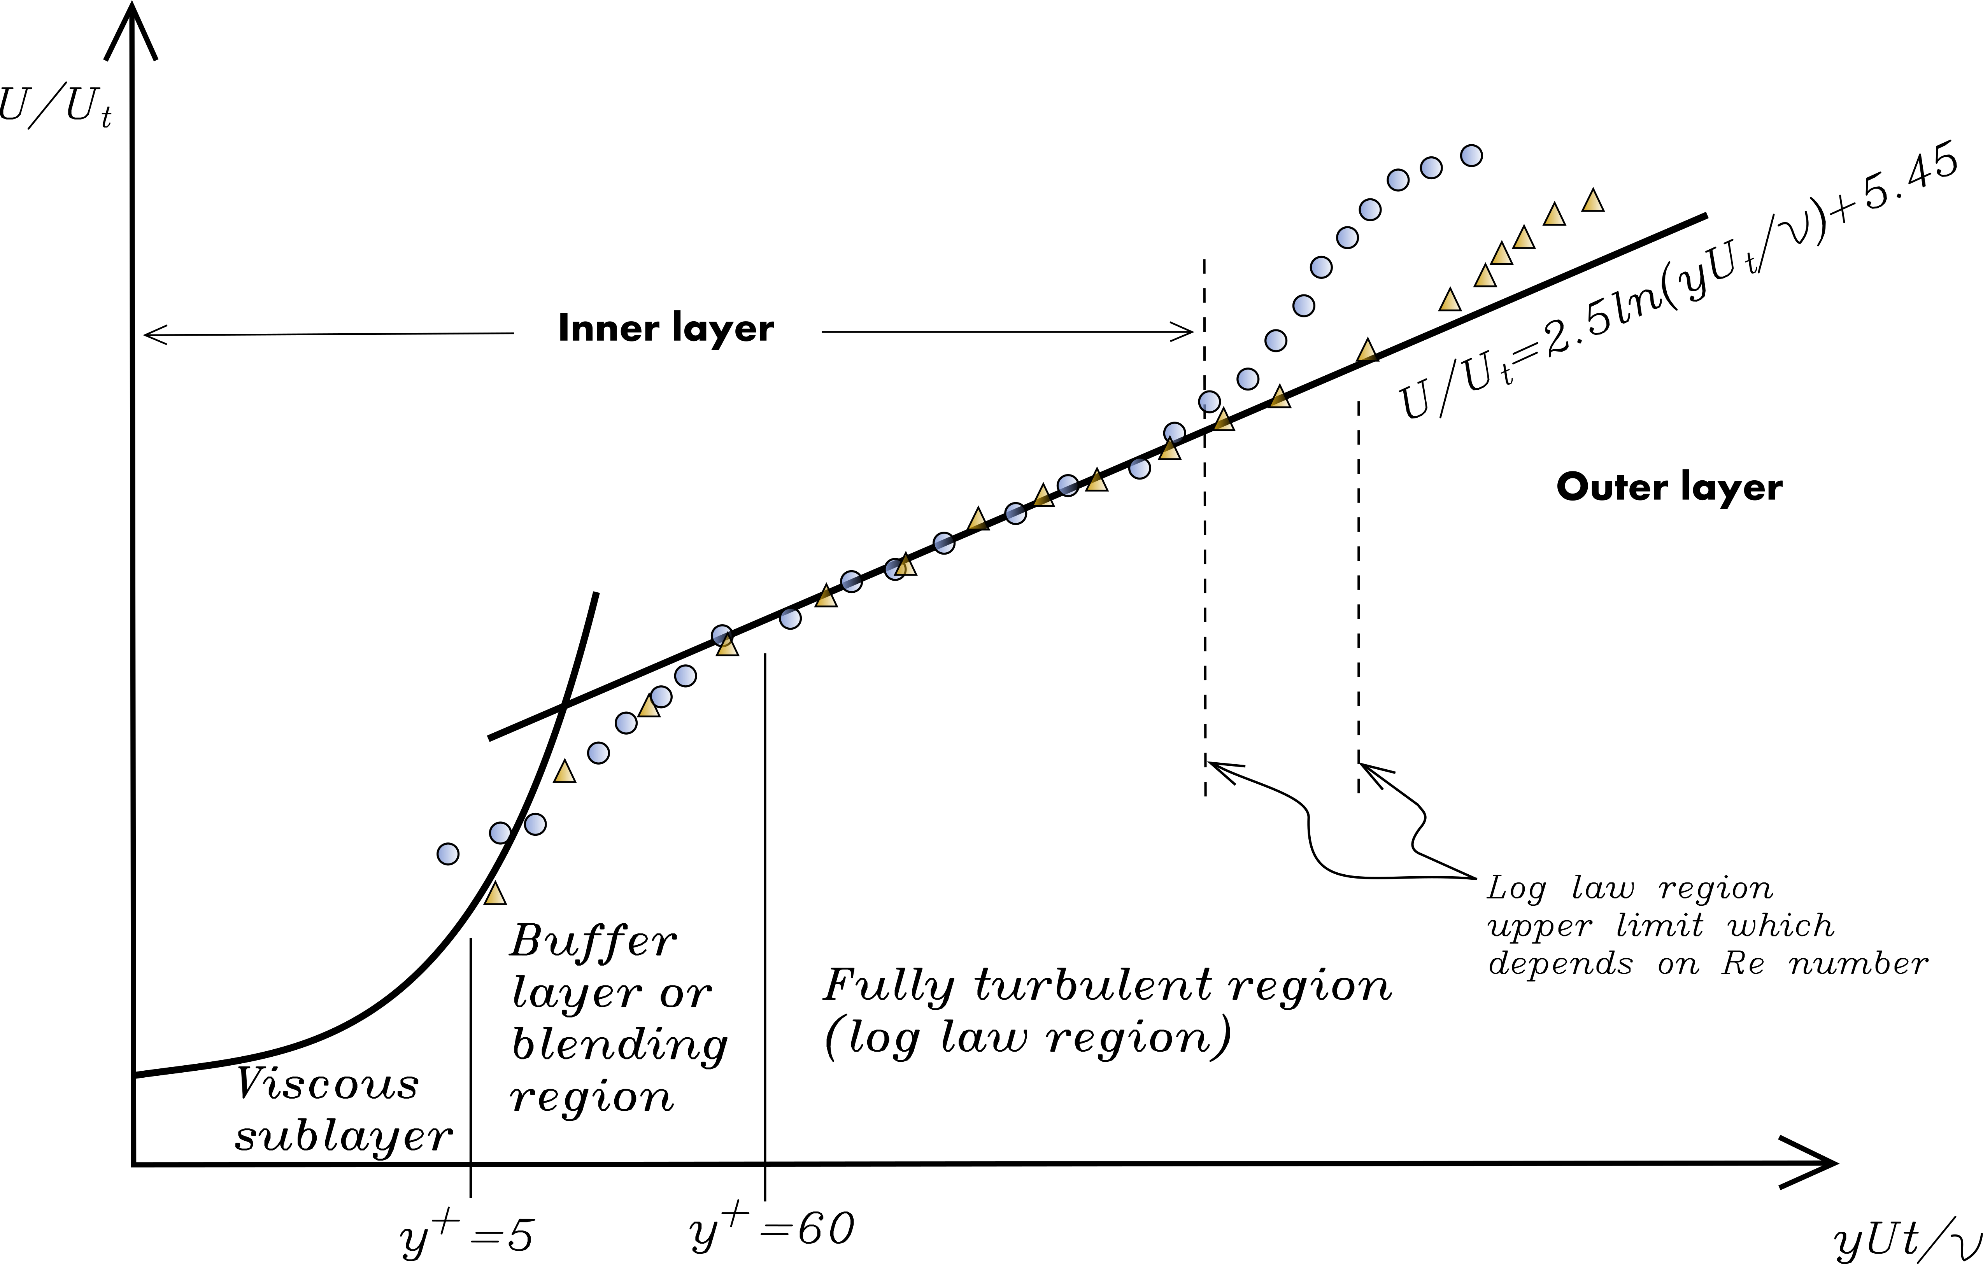
Figure 3.1-6 - Boundary layer properties described with dimensionless quantities [65]
Once a simulation for a turbulent flow is required, the way to proceed is different depending on whether the information near the wall is important or not. The viscous sublayer is the area with greater gradients, which could be solved in two different ways using the ANSYS-CFX software:
- The wall-function method: It is the easiest one and based on empirical formulas. It does not resolve the boundary layer, however it imposes appropriate conditions near to the wall. This feature allows the user to create a coarser mesh in this region, which is still able to model high gradients and, as a consequence, to save computational resources;
- The Low-Reynolds method: This is the most accurate and it is able to define all the properties in detail within the boundary layer profile. To do that it is necessary to generate a mesh with a number of nodes which increases in a direction perpendicular to the wall. It is necessary also to guarantee that at least one point of the mesh is inside the viscous sublayer.
The dimensionless distance vector between the first node and the wall called $y^{+}$ is defined for each turbulent model. With this value it is possible to re-arrange equation (9) and calculate that distance in SI units. Furthermore, knowing the first layer of the grid cell (Figure 3.1-7) means a reduction in the need to re-mesh the domain every time that the flow field solution is computed.

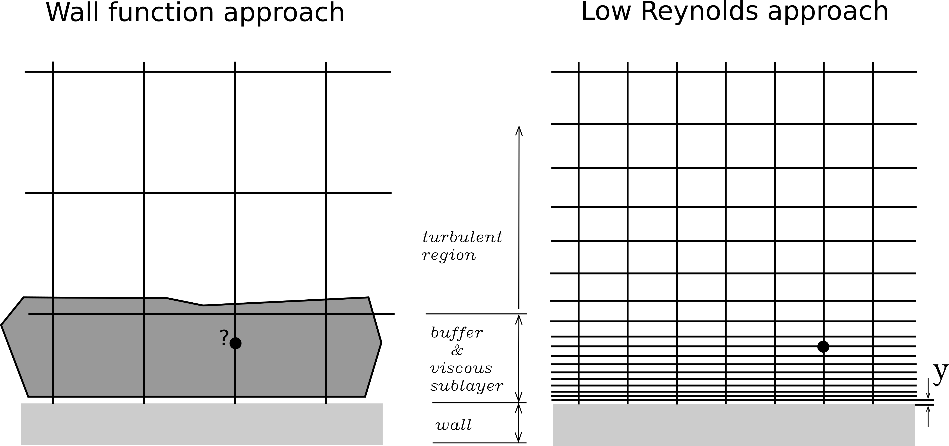
Figure 3.1-7 - Meshing differences between a wall-function and low Reynolds approach
In order to calculate $y^{+}$ the skin friction based on a pipe diameter $Re$ number has been calculated using the following formula (10). The theorem which considers the change of the momentum carried by the fluid due to the friction between fluid and a solid is the base from which the skin friction is considered [64]. Taking into account the boundary layer modelling, it is necessary to consider this parameter. In literature it has been defined empirically by several authors and the following one is suggested by the ANSYS documentation in case of a pipe [65].

 | $C_{f}=0.079{Re}^{-0.25}$ | (10)

Once the skin friction was known the wall shear stress $τ_{w}$ can be predicted

 | $$τ_{w}=\frac{1}{2}C_{f}ρU_{∞}^{2}$$ | (11)

where $U_{∞}$ is the undisturbed velocity inside the pipe (i.e the velocity $u$ calculated inside the tubes and the catheters). The velocity $U_{τ}$ is

 | $U_{τ}=\sqrt{\frac{τ_{w}}{ρ}}$. | (12)

Eventually, the first cell height can be calculated from equation (13) considering the $U_{τ}$ value

 | $$y=\frac{y^{+}μ}{U_{τ}ρ}$$ | (13)

Equation (10) gives the value of the first cell height in meter which guarantee the correct $y^{+}$ depending on the turbulent model used. A brief introduction to the models utilised in this study is given in the following paragraphs. Each of them requires a different value of $y^{+}$ in order to be used properly.
$k-ε$ Model
The $k-ε$ is a model that guarantees strong stability and is considered the standard model for industrial applications. Accuracy and robustness are peculiarities of this model, which is based on the wall-function approach and is able to predict many different flows in engineering contexts. However there are some cases in which other models could give more accurate solutions and are able to better simulate the fluid dynamics. For instance, the $k-ε$ model is not able to solve low turbulent $Re$ number computations properly. Moreover, to model the area closest to the wall using $k-ε$ it is necessary to use damping functions, which are incorporated in ANSYS-CFX, refining the grid resolution appropriately. As a result a value of $y^{+}<0.2$ is required. Other cases in which this model may not give the best solution could be when a layer separation occurs within the boundary or there are sudden changes in the mean stream rate. Moreover, also in the case of flow which is rotating or which has strong curvatures, it could be necessary to use more appropriate models [63]. During the transition between laminar and turbulent behaviour other model could give a more accurate solution, and in some cases depending to the catheter diameter other models could be better. During the study the flow rate solution has been the driving choice since the experimental data available were based on this parameter. In future studies a full simulation with another model and a consequent comparison could give a more accurate solution.
$k-ω$ Model
To bypass the problems related to the $k-ε$ approach another model has been developed and can be used with ANSYS-CFX which is called $k-ω$ model. It is able to appropriately predict low turbulent $Re$ number flows with good numerical stability. However, to guarantee a good solution a value of $y^{+}<2$ is required when a near-wall treatment is required [63]. This model has been chosen, since it is the optimal in cases of large curvatures such as in the tip of the catheter, around the eyelets.
In this study, simulations with all three models mentioned in the previous paragraphs were performed. To do that the mesh was created in accordance with the guidelines. For the laminar model the mesh used was the one used for the $k-ε$ since this was the most refined near the wall. This guarantees an accurate solution.

Convergence criteria study and mesh independence study
Once the mesh was created, a convergence criteria independence study and mesh independence study were performed for each catheter and each tube, in order to choose the best possible mesh. The physical values monitored for each geometry where:
- Flow rate at the outlet $\left({ml}/s\right)$;
- Maximum velocity along the catheter $\left({ml}/s\right)$
- Wall shear stress $\left(Pa\right)$.
The study for one geometry started with the creation of 5 different meshes with different properties in terms of maximum elements and number of layers, but maintaining the same value of ${0y}^{+}$. For the convergence study the residuals have been changed starting from ${10}^{-1}$ to ${10}^{-6}$. When a relative difference less than $5\%$ between the last two values was achieved the “convergence study” was considered complete. The mesh independence study was then performed using those values calculated for each mesh. To do that the same procedure used for the convergence criteria independence study was used. Once the relative difference between the last two meshes was less than $0.5\%$, the mesh independence study was considered complete. An example of result is shown in Figure 3.1-8.

Figure 3.1-8 - Physical values of maximum outlet pressure against the number of mesh elements for one case of study during the simulations
Mesh properties for each catheter obtained after the convergence and the convergence criteria independence studies for laminar, $k-ε$ and $k-ω$ are reported in Table 3-6.
 | Catheter | Tot ele. | Tot nod. | Max ele. [mm] | y [mm] | Ratio | Boundary Layers
Laminar  &  $$k-ε$$ | Ch14 | 536450 | 196450 | 0.0005 | $$1.8∙{10}^{-6}$$ | 1.5 | 8
 | Ch16 | 2443517 | 820374 | 0.0003 | $$1.6∙{10}^{-6}$$ | 1.5 | 10
 | Ch18 | 2625266 | 894973 | 0.0003 | $$1.4∙{10}^{-6}$$ | 1.7 | 10
$$k-ω$$ | Ch14 | 1742731 | 622225 | 0.0003 | $$1∙{10}^{-5}$$ | 1.2 | 10
 | Ch16 | 2283487 | 793242 | 0.0003 | $$7∙{10}^{-6}$$ | 1.3 | 10
 | Ch18 | 2607909 | 892181 | 0.0003 | $$7∙{10}^{-6}$$ | 1.3 | 10
Table 3-6 - Catheter proprieties in all the cases analysed

In Figure 3.1-9 an example of the mesh obtained for one of the catheters used is shown:
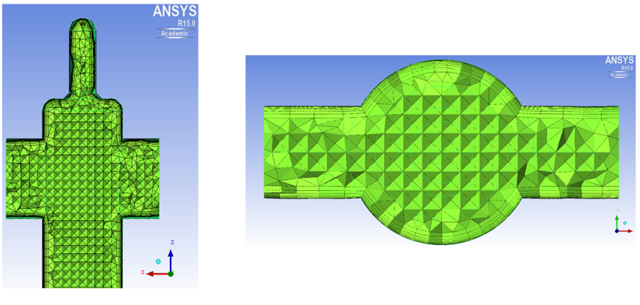
Figure 3.1-9 - An example of one mesh created in ICEM which has been used during during the simulations with ANSYS-CFX
To achieve the correct mesh for each geometry as shown, it was necessary to perform 60 simulations for each tube and 90 for each catheter which means in total 630 simulations carried out on ICEBERG (see Table 3-1 for details).

Results
In this section the results obtained so far are presented. In the following paragraphs they are divided in two different phases:
- Phase 1: Tubes;
- Phase 2: Catheters.
Furthermore, contour plots of the catheter flow rate and shear stress are compared with the results of the experiments found in literature. These outcomes show how the models used (including both boundary conditions and mesh) are able to reproduce the physics and the urodynamics inside the catheter. The chapter starts with an overview of the experimental results obtained in a previous project, which were used to validate the models. These experiments considered both tubes and catheters.

Experimental data
The experimental data, used in this part of the project to validate the numerical results, was collected at The University of Sheffield in 2015. The aim was to minimise the visual impact of the drainage tubes by reducing their internal diameter, validate current standards and build knowledge to inform the development of new standards. This was not strictly related to biofilm formation and the aim of the present research. The analysis was subdivided in four phases and two of them were on reproducing the flow rate both inside straight tubes and catheters. This was done accordingly to the standards BS 1616 and BS 8669-2 which require and specify a minimum value of flow rate [66,67]. Following these guidelines, the corresponding results reproduced the real system accurately. In this analysis these results were used to validate the computational model in terms of flow rate.
Phase 1: Tubes
The aim of this phase was to measure flow rates in drainage tubes of different diameters under the standardised pressure head of 5 cm. These outcomes were then compared with a theoretical/analytical study, performed before the experiments. The results from the study were used to validate the CFD procedure in terms of physics, meshing and flow rate. The results of the experiments are reported in Figure 3.2-1.
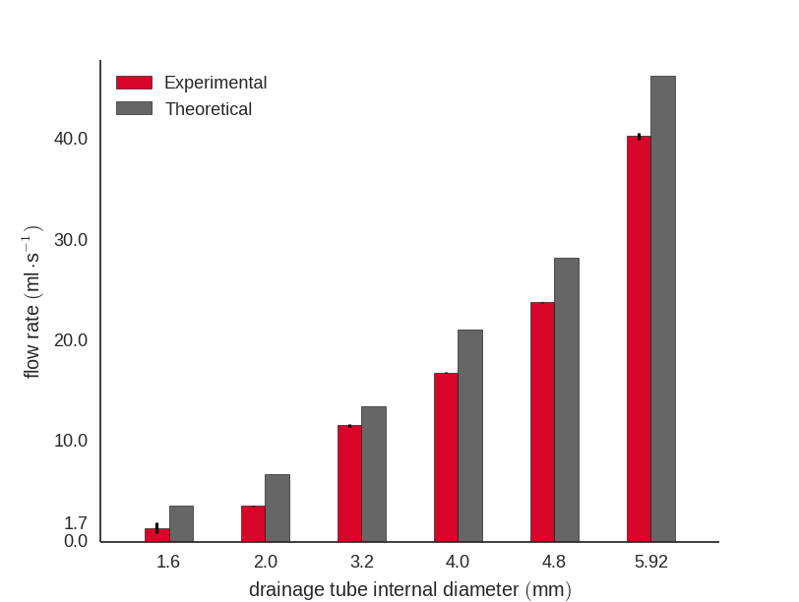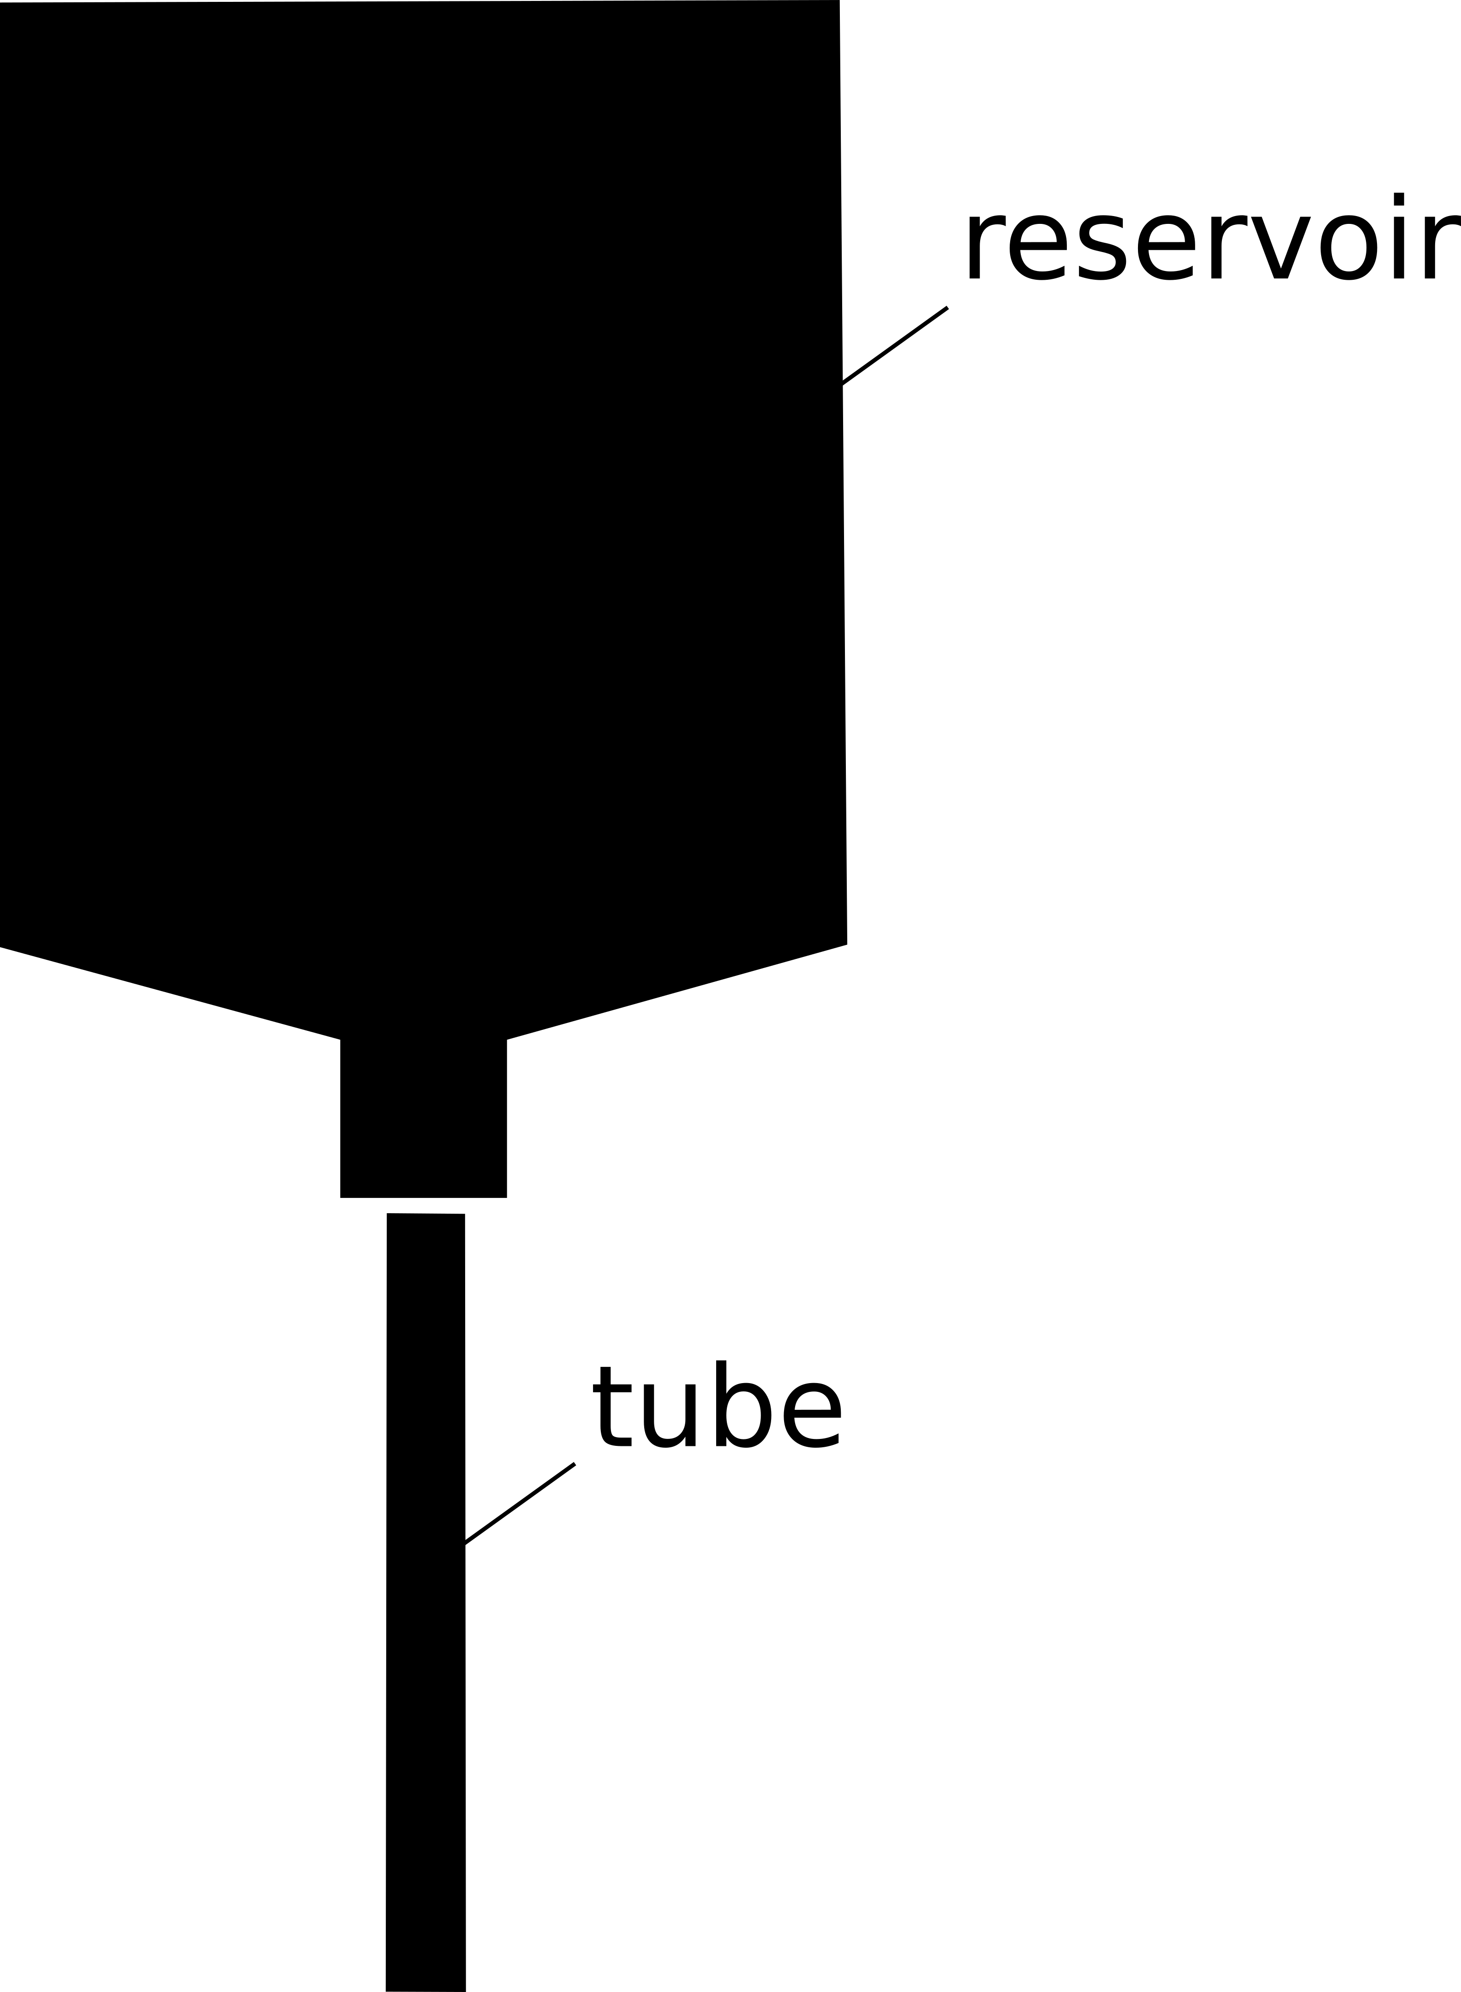
Figure 3.2-1 - Experimental and theoretical results for 6 different tubes.
Phase 2: Catheters
In this case the flow rate was measured using a catheter currently on the market and in use in real cases of UI. The pressure head used was the same as in phase 1 (5 cm) and the results are reported in Figure 3.2-2.
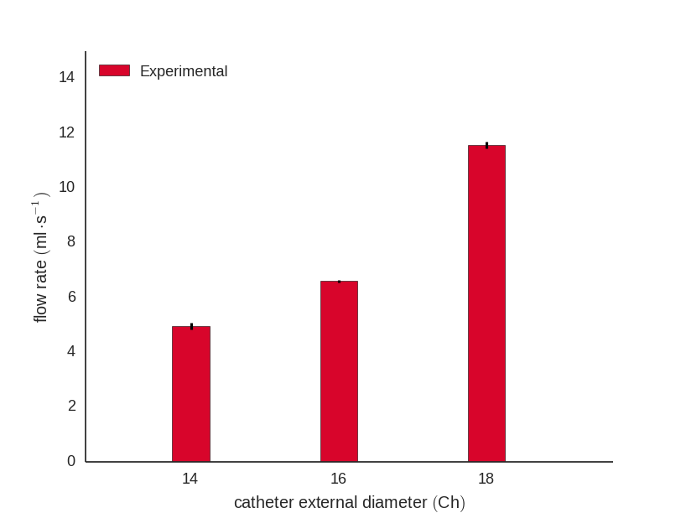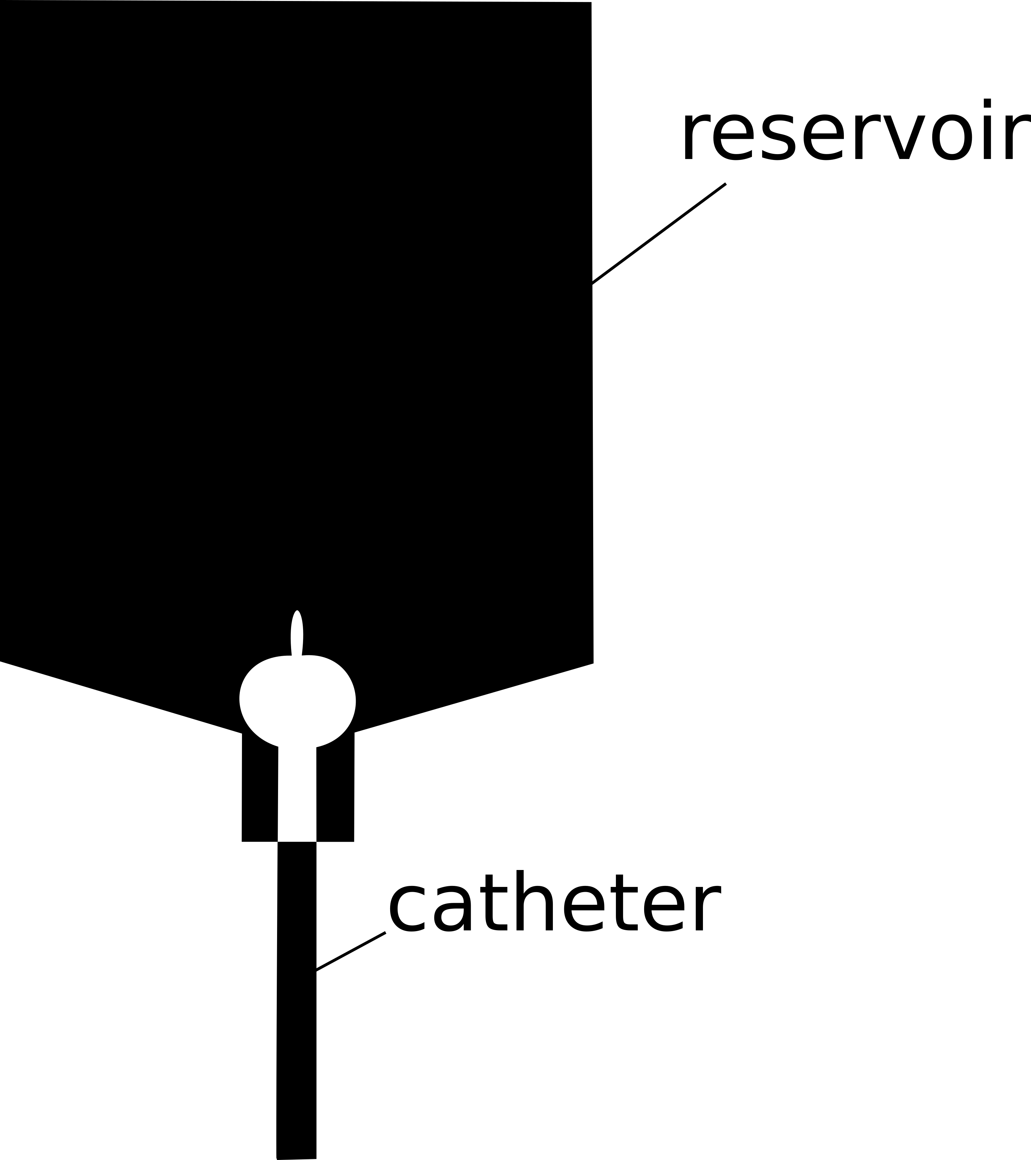
Figure 3.2-2 - Experimental results for three different catheters

CFD Phase 1: Tubes
The tubes were used only to validate the methodology from which the results were obtained. This validation in terms of flow rate guaranteed a good basis for phase 2 where the catheter was used and in which the geometry was not a standard one such as in case of simple tubes. In the case of the tubes only the laminar and the $k-ε$ models were used. The graph in Figure 2.2-3 shows the flow rate in the outlet section for the two different models utilised during the simulations:

Figure 3.2-3 - Results in terms of flow rate for the six tubes used during the simulation with ANSYS-CFX
The $k-ε$ model is the one that guarantees the best solution. All the values obtained with that model are closer to the data in the experiments in comparison with the laminar one. This was something expected since the flow was turbulent For the tubes 1.6 and 2 the Re number was respectively 1091 and 2253, and the laminar model is enough to reproduce the correct behaviour. However for the next step, where the Re number for all the three catheter considered (based on either experimental measurements or analytical calculation) is shown in Table 3-7, the $k-ε$ model was used.

CFD Phase 2: Catheters
As in phase 1, the flow rate calculated at the outlet section of the catheter in comparison with the one obtained experimentally is shown in Figure 3.2-4. In this stage, the simulations were performed for all the three models (Laminar, $k-ε$ and $k-ω$) since the large curvature near the tip could affect the quality of the solution. However, looking at the results obtained, the $k-ε$ model is still the one which best simulates the experimental data in terms of flow rate. The overall trend is followed in all three cases, which means that the physical problem abides to the models.

Figure 3.2-4 - Results in terms of flow rate for the three used during the simulation with ANSYS-CFX
The Re number for these three cases is shown in Table 3-7
Catheter | Re (experimental D) | Re (analytical D)
Ch14 | 2718 | 2138
Ch16 | 3012 | 2636
Ch18 | 4494 | 3960
Table 3-7 Reynolds number for the three catheters
The 3D contour plots of velocity along the mid-plane of the catheter and the contour plot of wall shear stress in the whole domain were generated and compared with the experimental study of Morris et al. [33].
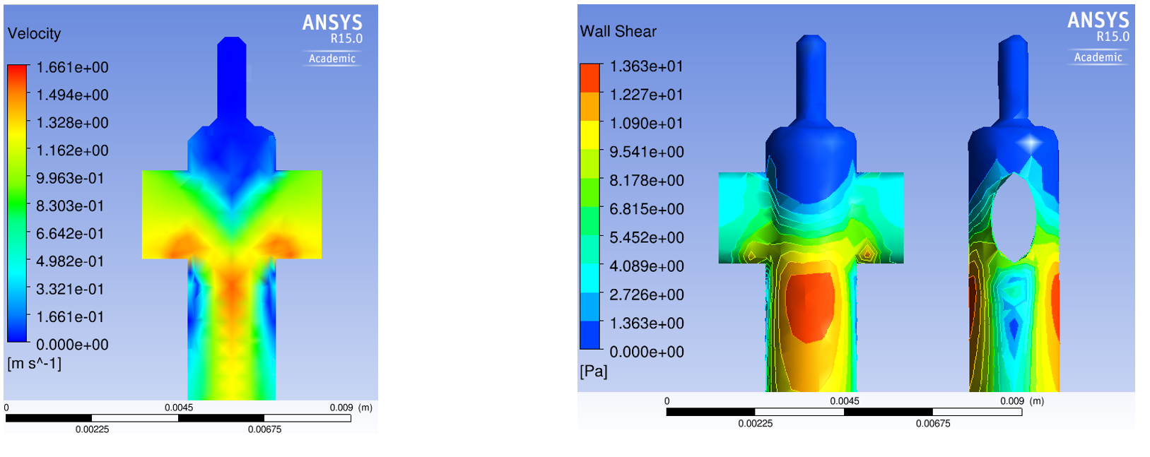
Figure 3.2-5 - Contour plots of velocity and wall shear stress along the mid-plain of the computational domain and along the whole domain respectively
A 3D plot of velocity (Figure 3.2-6) shows that in section (a) at 1 cm (b) at 12 cm and (c) at 32 cm from the tip velocity contours display a correlation between lower values of velocities and encrustation sites detected experimentally.
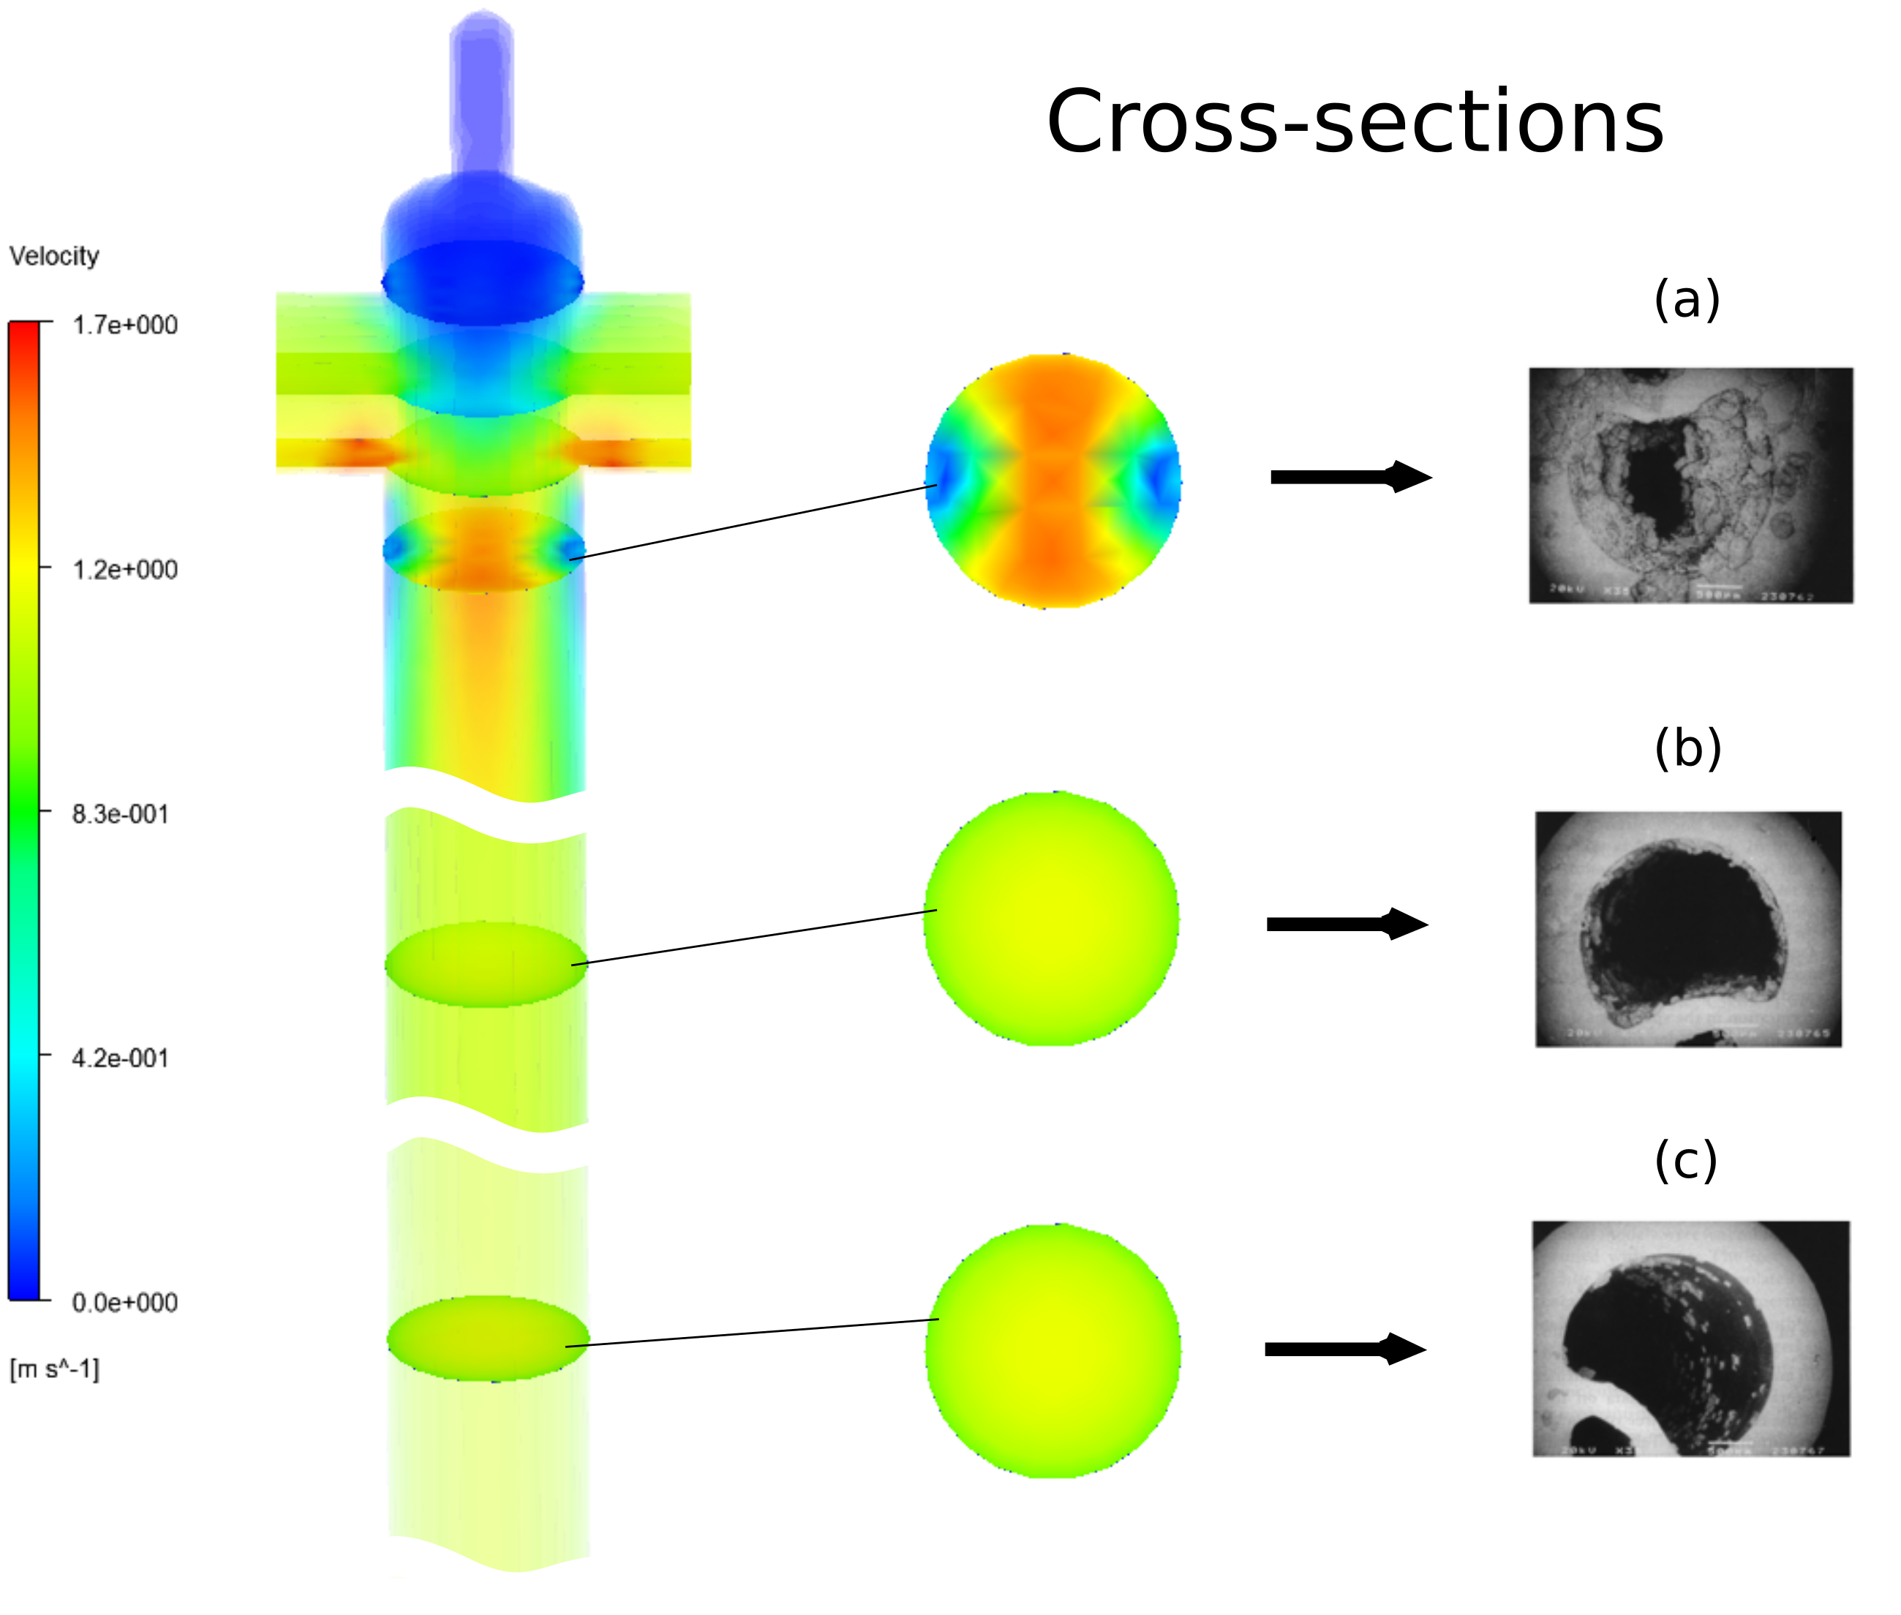
Figure 3.2-6 - Comparison between CFD results and experimental data in the three sections described in Figure 3.3-2
Finally, Figure 3.2-7 shows the velocity streamlines inside the catheter:

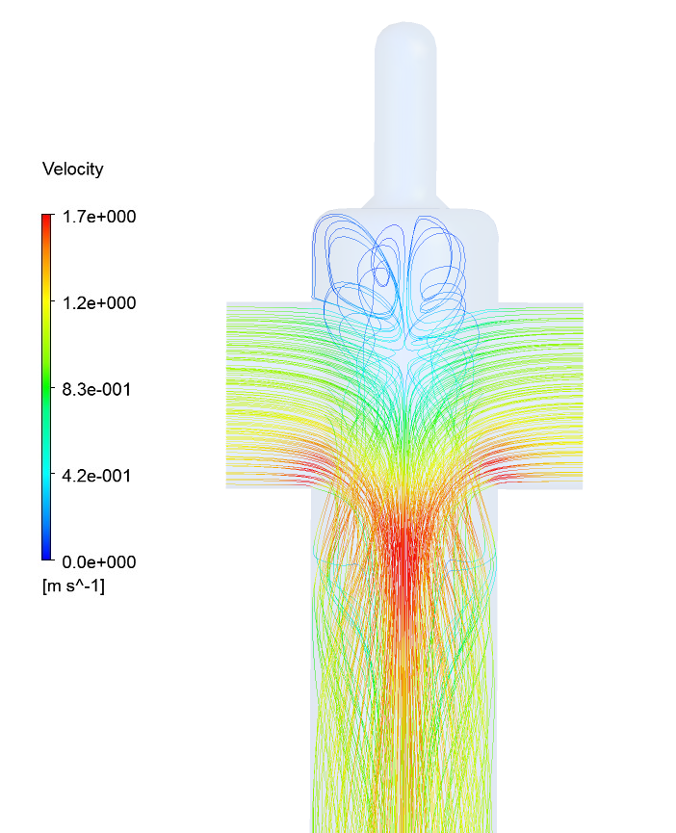
Figure 3.2-7 - Velocity streamlines near the tip of the catheter

Discussion
The work done so far provides the methodological framework to develop a more complex modelling approach including a model of biofilm formation inside a urinary catheter. These preliminary results showed possible correlations between urodynamics and the phenomenon of encrustation, and have identified regions of the design that could be improved.

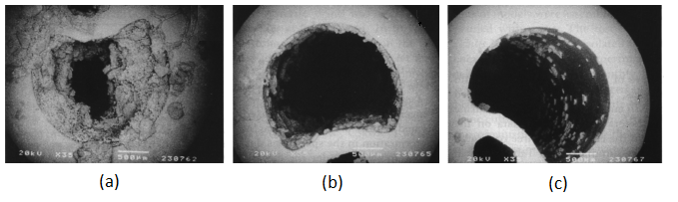
Figure 3.3-1- Silicone catheter cross-sections at (a) 1, (b) 12 and (c) 32 cm from the tip. The images were taken after blockage (52 h) in a bladder model [33].
The picture above shows that 1 cm far from the tip of the catheter, immediately below the two eyelets, the biofilm occludes the lumen. Bacteria and crystals attack the surface, and the contour plots (see Figure 2.2-5) showed that the velocity in that area of the catheter is almost zero. Moreover, looking at the wall shear stress the lowest value is just below the eyelet, where the biofilm starts to grow. The attachment phase of the biofilm formation process is the most critical one. A different flow field, with higher values of velocity and wall shear stress in that region, could help to prevent the adherence of the bacteria to the surface and reduce the possibility of biofilm formation. As a consequence, this could reduce the risk of medical treatments and resulting complications for the patient.
The next step will be to perform a study in which the geometry near the tip is changed. After that, its influence on the urodynamics will be studied and discussed. The velocity profile and the consequent shear stress shown in Figure 2.2-5 are strictly correlated to the flow domain. The streamlines (Figure 2.2-7) follow the internal shape of the catheter. Therefore, different spacing between the eyelets would probably influence the flow field and the stagnation zones.

influence Of CATHETER DESIGN on URODYNAMICS USING CFD
Urinary catheters currently used in clinical practice are vulnerable to encrustation and consequent blockage by biofilm crystal deposition, often starting at their tip. The biofilm may be sensitive to the surrounding flow field and its properties, e.g. the wall shear stress. The previous Chapter has shown a possible correlation between the flow field inside the catheter and the phenomenon of encrustation (see Figure 2.2-6). Areas with lower flow velocity and wall shear stress correspond to biofilm encrustation zones, and they are the focus of the study presented in this chapter. The computational model described and validated in chapter 3, to analyse key flow properties inside the Foley catheter, is considered as reference for this analysis. However, in this study the Urine properties rather than water were considered to better simulate the real environment. Several geometries were created aimed at capturing important flow-field variations in areas where the biofilm develops. The methodology used to perform this study is presented in the following paragraphs.

Methods and materials
In this part of the study the CFD model described in Chapter 3 was tested to see how changes in the design could affect the flow behaviour inside the catheter.
A total of 29 catheter geometry configurations were acquired. First, the Foley catheter was imaged by means of $μCT$ scan. Using an image processing package IMAGEJ [68], all the most relevant geometrical characteristics were measured. The catheter geometry was drawn in 2D dimension and then reproduced in a 3D shape using Solidworks (©Dassault Systemes, SolidWorks Corporation). The scan machine used was a Skyscan (Bruker microCT technologies) with the following technical specifications:

Camera type | 10 Mp Hamamatsu-100/250 10 Mp
Camera Pixel size | 11.65 $μm$
Image Pixel size | 9.05 $μm$
Number of lines to be reconstructed | 859
Table 4-1 - Scan machine properties
All the images were analysed and reconstructed in order to obtain all the relevant information. A quick overview is shown in the Figure 4.1-1.
Figure 4.1-1 - An overview of the section images taken using the $μ$CT scan. The one at the top-left corner represents the bottom of the catheter where the atmospheric pressure was applied. Following the sections from the left to the right and from the top to the bottom it is possible to see how the catheter shape changes up to the tip. The location were chosen according to the area where the internal shape of the catheter changes. Strategic sections such as the one where the eyelet started were used to measure the relevant parameters.
All key parameters were measured and converted to mm using the scan machine conversion factors shown in Table 3-1. The reference fluid domain is shown in Figure 4.1-2.
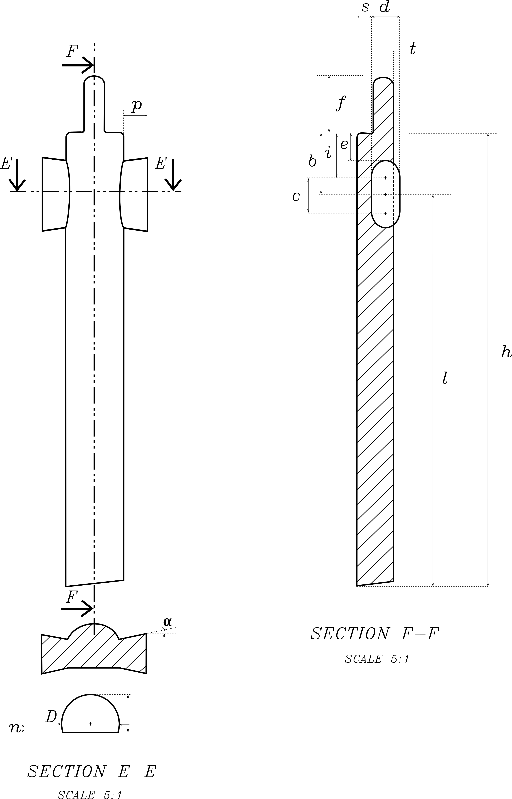
Figure 4.1-2 - Catheter geometry used for the simulations performed, all the main geometrical characteristics are listed
The inlet pressure, as in the Chapter 3, is defined through the l distance and the outlet is located at the bottom of the catheter where the atmospheric pressure acted on it. Parameters c and d were used to create the two eyelets. They are the key variables used to guarantee the equivalent area at the catheter outlet section. Moreover, e, i, and b were used to position the eyelets accurately. The following table shows the list of parameter values used to create the Foley catheter geometry in Solidworks (©Dassault Systems, SolidWorks Corporation). The same parameter were measured also with the goniometer to minimize any possible error.
Parameter | Values
b | 2.586 [mm]
c | 2.163 [mm]
d | 1.629 [mm]
e | 1.385 [mm]
f | 3.158 [mm]
h | 411.146 [mm]
i | 2.199 [mm]
l | 414.027 [mm]
n | 0.612 [mm]
p | 1.167 [mm]
s | 0.629 [mm]
t | 0.201 [mm]
α | 9º
D | 3.014 [mm]
Table 4-2 - List of Parameter Values measured from the $μCT$ scan
Finally the $y^{+}$and the consequent first layer height were calculated following the procedure described in Section 3.1.4. The Reynolds number was based on the circular shape where its equivalent diameter was calculated starting from the semi spherical one measured using IMAGEJ The velocity used was calculated using the flow rate obtained experimentally and the equivalent radius $1.306 mm$. The flow was turbulent as expected (see $Re$ number in Table 4-3) and the $k-ε$ model was taken into account. In the Table 4-3, the results in terms of equivalent area/radius ($A and r_{eq}$), experimental flowrate ($Q$), consequent Reynolds number ($Re$) and $y$ value are shown:
$$A$$ | 5.36 $mm^{2}$
$$r_{eq}$$ | 1.306 $mm$
$$Q$$ | 6.593${ml}/s$
$$Re$$ | 3303
$$y$$ | $2∙{10}^{-6}$ $mm$
Table 4-3 – Flow properties such as the Re number are shown in the table. The mesh was created according with these values in order to capture all the flow field properties.
The final geometry is shown in Figure 4.1-3:
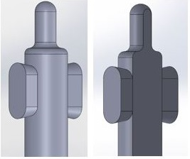
Figure 4.1-3 - Foley catheter created using SolidWorks
The CAD geometries created in SolidWorks were imported into ICEM-ANSYS using the IGES format to create the elements which reproduce the fluid volume. All the convergence criteria study and mesh independence study performed previously were used as a reference for the current mesh elements dimension and shape. The catheter geometry is considered with similar key properties (e.g. equivalent inlet/outlet areas) to the one used in Chapter 3, therefore, the same mesh were considered adequate to provide an accurate solution for all the cases analysed. The global mesh settings used for all the 37 geometries are shown in Table 4-4.

Max Element | 0.0002 [mm]
Smooth Mesh | Yes
Max Size | 0.0002 [mm]
Height | $2∙{10}^{-6}$ [mm]
Height Ratio | 1.5
Layers | 10
Table 4-4 - Mesh elements properties for all the catheter geometries utilized during the study

The simulation convergence was achieved for all the cases analysed and all the criteria studies done previously guarantee the best mesh configuration for the catheter shape and length. In Figure 4.1-4 the final mesh and its boundary layers is shown.
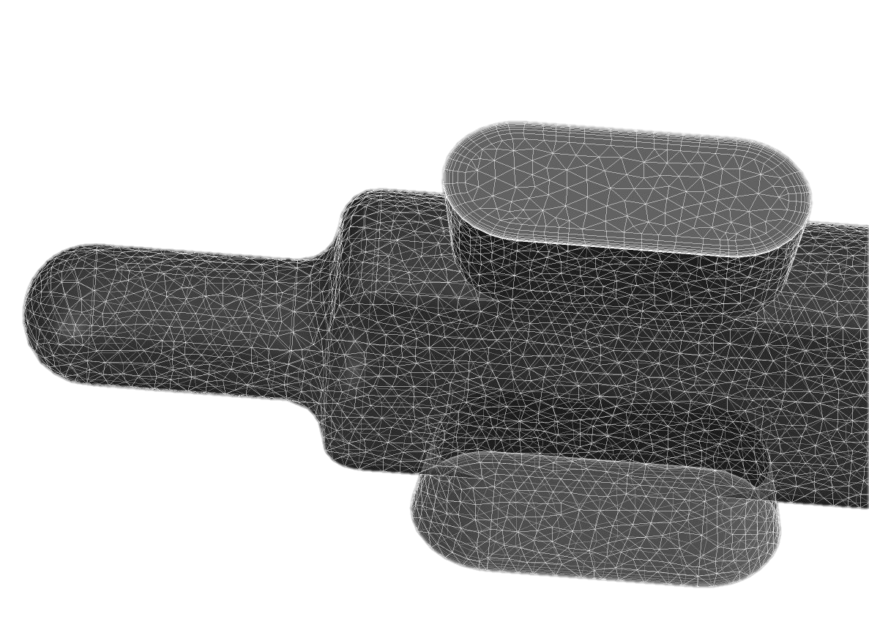
Figure 4.1-4 - Final mesh used for all the catheter simulations. The ten layers guarantee an accurate solution over the boundary layer and over $7∙{10}^{6}$ elements were able to capture all the main flow properties while it flows into the device.

Fluid properties
In this Chapter the realistic properties of urine were taken into account. The first parameter which had to be calculated was its density. The urine is composed by 95% water and 5% by the following chemical components [69,70]:
 | $$H_{2}{SO}_{4}+{CrO}_{3}+{CuSO}_{4}$$ | (14)
The average Molar Mass were calculated obtaining the following value:
 | $$\sum_{i=1}^{n}{x_{i}M_{i}}=26.301 \left[\frac{Kg}{Kmol}\right]$$ | (15)
where $x_{i}$ is the component mole fraction, $M_{i}$ is the molar mass, and $n$ is the number of components. At this point a new material called urine was created within ANSYS-CFX and the requested relevant properties were defined in Table 4-5 [69,71,72]:
Parameter | Values
$$ρ$$ | 1030 ${Kg}/{m^{3}}$
$$μ$$ | 0.001 $Pa∙s$
Reference state | 37 ºC
Pressure | 1 atm
Table 4-5 - List of Urine Parameter Values

Urinary catheter simulations
The study was divided into two parts. First, only fixed geometries were considered. A total of five cases were taken into account (Figure 4.2-1). At this stage the shape of the catheter was chosen a priori, making one strategical change at time, but without parameterization applied. Subsequently, three geometric scenarios (Figure 4.2-1) were studied parametrizing one key variable for each of them. A total of 29 different configurations were simulated by means ANSYS-ICEM-CFX. Moreover, other catheter geometries suggested also by clinicians were considered in order to understand how those geometrical changes could really improve the catheter performance.
For each model the geometry coincided with the flow domain inside, so that the catheter itself did not need to be included in the simulation, with the walls modelled with a no-slip condition. The fluid was driven by the total pressure at the inlet (the two eyelets) and the atmospheric pressure at the outlet. In the following paragraphs both the fixed geometries and the parametrized ones are described and presented in details. Eventually, the results achieved during this study will be presented, and possible further works to improve the catheter, will be discussed.
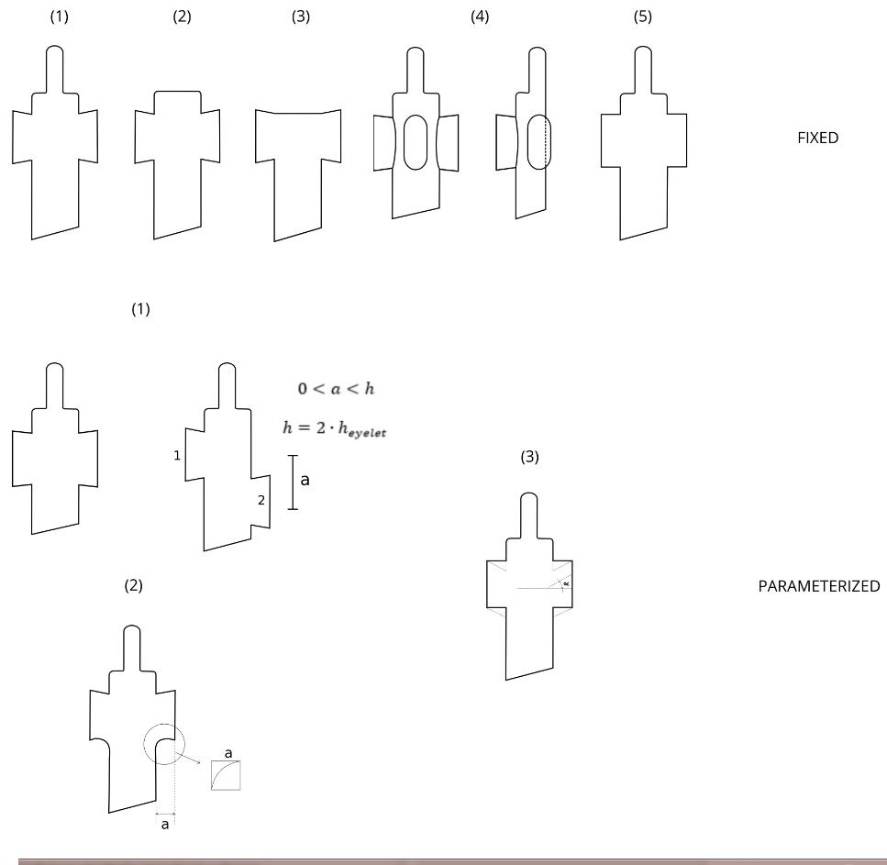
Figure 4.2-1 - Comparison between FIXED and PARAMETERIZED design.

Fixed design
A fixed design differs from the original one due to a change on its shape in a strategic point but no parameterization is applied. Five cases were studied during this stage.
FIXED DESIGN F1
The starting point of this study were the simulations using the catheter geometry obtained from the $μCT$ images. This analysis gave a good understanding of how the urine flows inside the device and which are the areas where a better shape could improve its performances. The study should show a behaviour similar to the one done in Chapter 3. The main difference was the fluid used and the geometry details. However, since the urine should have similar properties to the water and only minor geometrical changes were made, a similar results were expected. The Figure 4.2-2 shows a graphical comparison between the geometry used for the studies in chapter 3 (A) and the one used during this analysis (B).
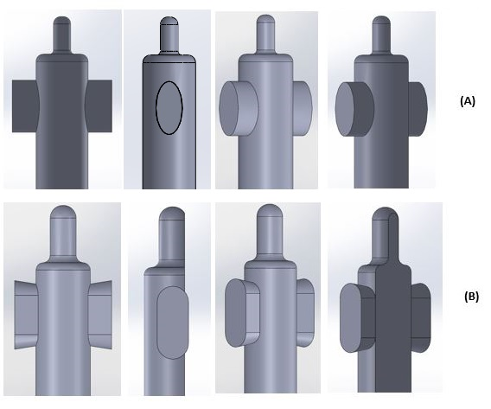
Figure 4.2-2 - Comparison between the idealized geometry used during the independence/convergence study (A) and the geometry created using the real shape of the catheter (B). The back side was cut and the eyelets did not have an elliptical shape. The extrusion was performed with an angle of 9 degrees which generated two inclined lines on the eyelet sides, according with the details shown by the $μCT$ scan.

FIXED DESIGN F2
In this case the upper part of the catheter tip (probably existing due to manufacturing reasons) was removed. The reason of this change was that, looking at the results related to the real catheter, the flow velocity in this area was almost zero (see Figure 3.2-5 ). This is the zone were the biofilm start to develop and consequently block the catheter. Flow field parameters changes in this particular location could influence the biofilm growth. However, form Figure 3.2-7 related to streamlines applied to the experimental fluid domain, it is possible to see a recirculation zone just above the inlet point level so this area was considered during this stage.

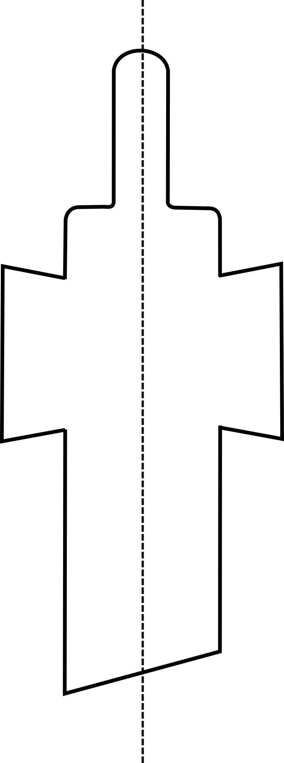
Figure 4.2-3 – Catheter fixed DESIGN F2 used for the simulations

FIXED DESIGN F3
The third geometry proposed was aimed at analysing the effect of the areas above the points where the urine enters the catheter and the velocity magnitude are very small. The tip of the catheter was removed and there was no more space available for the flow above the inlets. This zone was considered with a no-slip wall condition. The hypothesis behind this choice was that the cut would not make a big difference on the flow behaviour, but it could substantially reduce the available space for biofilm encrustation and development. The recirculation zone was considered small enough and negligible for this first case of study. The other tip details, such as either the eyelet shape or their position, were not modified. In Figure 4.2-4 the FIXED DESIGN F3 is shown.
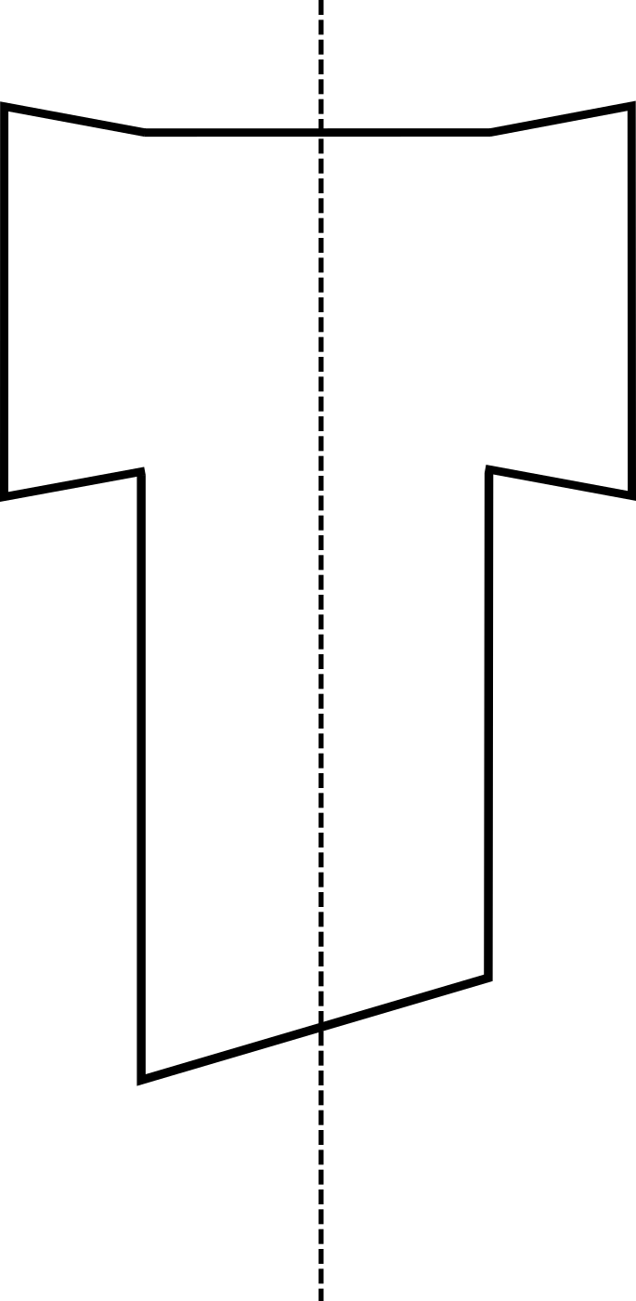
Figure 4.2-4 - Catheter FIXED DESIGN F3 utilised for the simulations. The catheter tip was cut up to the inlet level to see how this change would affect the flow behaviour

FIXED DESIGN F4
In the fourth design, the area above the inlet sections, which was the main focus of FIXED DESIGN F2 and F3 was left as the original geometry. As shown in Chapter 2 the sections located in this area showed a really small flow-field velocity values. This area is also important for the biofilm development and catheter blockage. This new design considered an extra eyelet positioned between the two existing ones. Since the balloon tube goes through one side of the catheter, it was not possible to add a fourth eyelet. The hypothesis of this change was that another inlet point could direct the flow to the areas just below the eyelets. In this way, the biofilm which grows and attaches on the wall, could be removed by flow forces and vorticity. The new Design is shown in Figure 4.2-5.
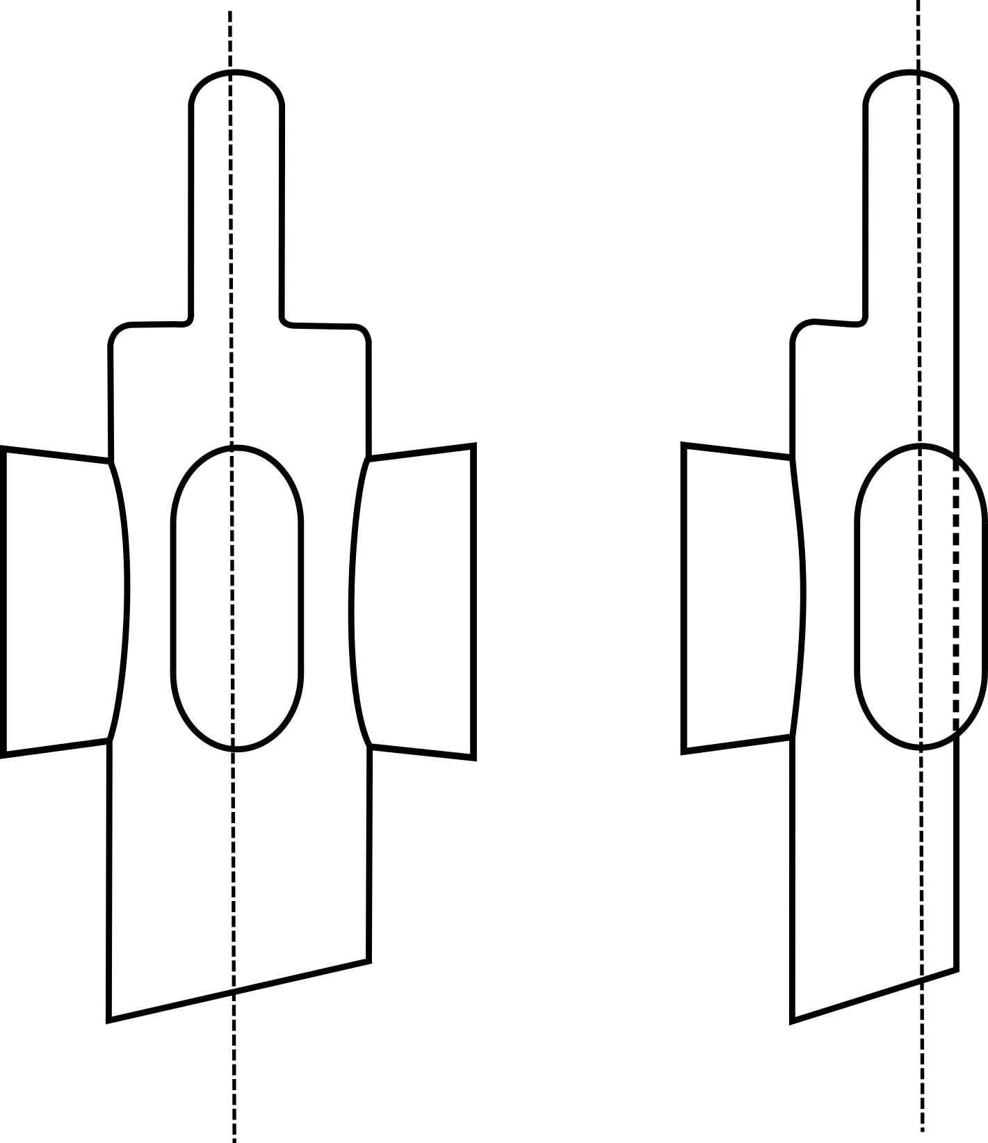
Figure 4.2-5 - Catheter FIXED DESIGN F4 used for the simulation. A third eyelet was added in order to analyse its effect on the flow field properties.
FIXED DESIGN F5
In the fifth design the eyelets were inclined following a 9 degree angle (see angle $α$ in Table 4-2). The hypothesis was that this angle does not affect the results enough to justify the inclination. Parametrizing two parallel sides within Solidworks makes more sense rather than two inclined ones, therefore this step is necessary to understand if the inclination could be neglected or not. In the next paragraph the PARAMETERIZED DESIGN P3 considered parallel eyelet. It was made possible due to this analysis. The Figure 4.2-6 shows the DESIGN F5 used for this simulations.
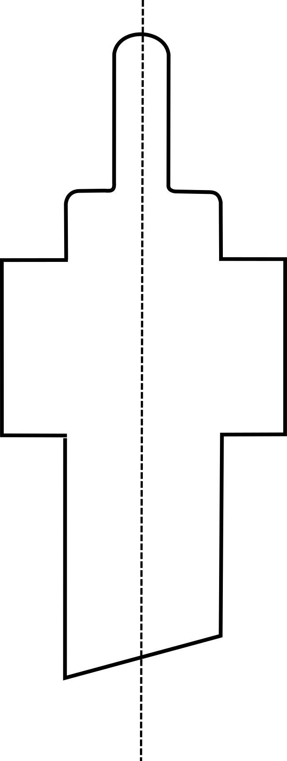
Figure 4.2-6 FIXED DESIGN F5 - which is characterized by parallel eyelets and does not consider the 9 degree angles used during the previous geometries.

Parameterized designs
The chapter describes the study performed using parameterized designs. Also in this stage, for each change considered, the analysis started from the real catheter shape. Successively, the parameter was modified eight times up to a predetermined point established a priori. It was defined under certain criteria explained, for each case, in the following paragraphs. The interval of interest was evenly sampled. This allowed a qualitative assessment of the influence of each parameter on the flow inside the catheter. In this way it was possible to show a qualitative behaviour on how that parameterization would influence the flow properties.

 | $$h_{eyelet }\left[mm\right]$$ | L $\left[m\right]$ | $$P_{inlet1} \left[Pa\right]$$ | $$P_{inlet2} \left[Pa\right]$$
$$0$$ | $$0$$ | $$0.4111$$ | $$4523.85$$ | $$4523.85$$
$$0.25h$$ | $$0.744$$ | $$0.4104$$ | $$4523.85$$ | 4516.54
$$0.5h$$ | $$1.489$$ | $$0.4097$$ | $$4523.85$$ | 4509.24
$$0.75h$$ | $$2.233$$ | $$0.4089$$ | $$4523.85$$ | 4501.94
$$h$$ | $$2.977$$ | $$0.4082$$ | $$4523.85$$ | $$4444.64$$
$$1.25h$$ | $$3.722$$ | $$0.4074$$ | $$4523.85$$ | 4487.33
$$1.5h$$ | $$4.466$$ | $$0.4067$$ | $$4523.85$$ | 4480.03
$$1.75h$$ | $$5.211$$ | $$0.4059$$ | $$4523.85$$ | $$4472.73$$
$$2h$$ | $$5.955$$ | $$0.4052$$ | $$4523.85$$ | 4465.43
Table 4-6 - Parameters utilized during the simulation. The table considers both geometrical parameters and inlet boundary conditions

PARAMETERIZED DESIGN P1
In PARAMETERIZED DESIGN P1 the eyelet position were kept constant while an angle along the catheter was applied. The aim was to see its influence on the flow behaviour and on the associated recirculation zones. Catheter with this kind of geometry are being tested already (e.g. at The Teaching Hospital in Sheffield), however no parameterized studies were found in the literature.
The angle, according to some existing design, was inclined up to 45 degree along a plane parallel to the eyelet one. In this way, both were under the same boundary pressure (see Figure 4.2-7). The other parameter which was considered was the distance between the tip of the catheter and the angle attachment point. The choice of this length was measured considering the results achieved for the real shape of the catheter, which corresponds also to the distance measured for the existing samples. Hence, the point where the flow field does not change anymore due to the vorticity at the inlet, is the one on which the angle was applied. The Figure 4.2-9 shows the parameters utilized for the simulations.
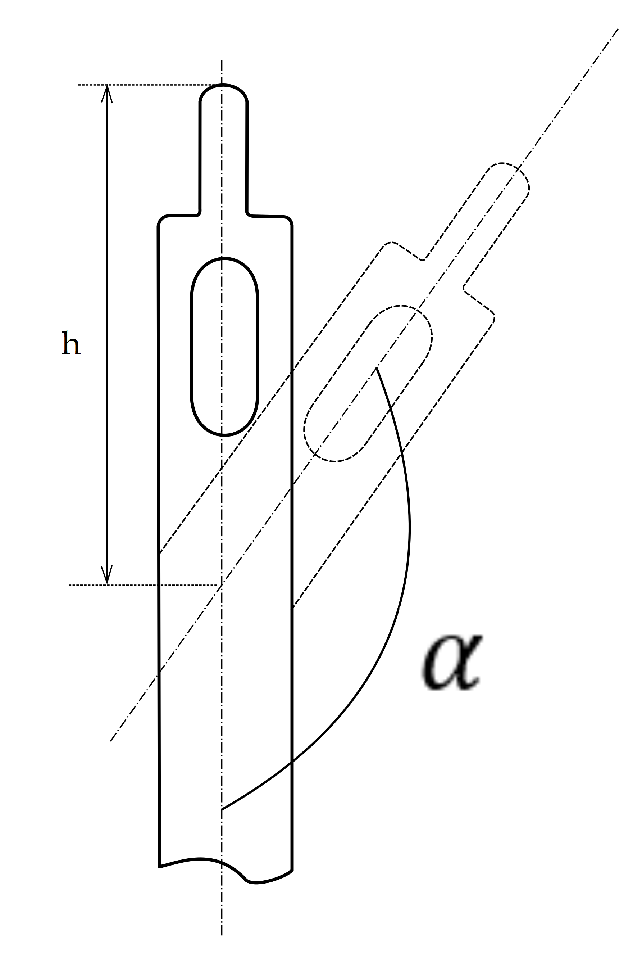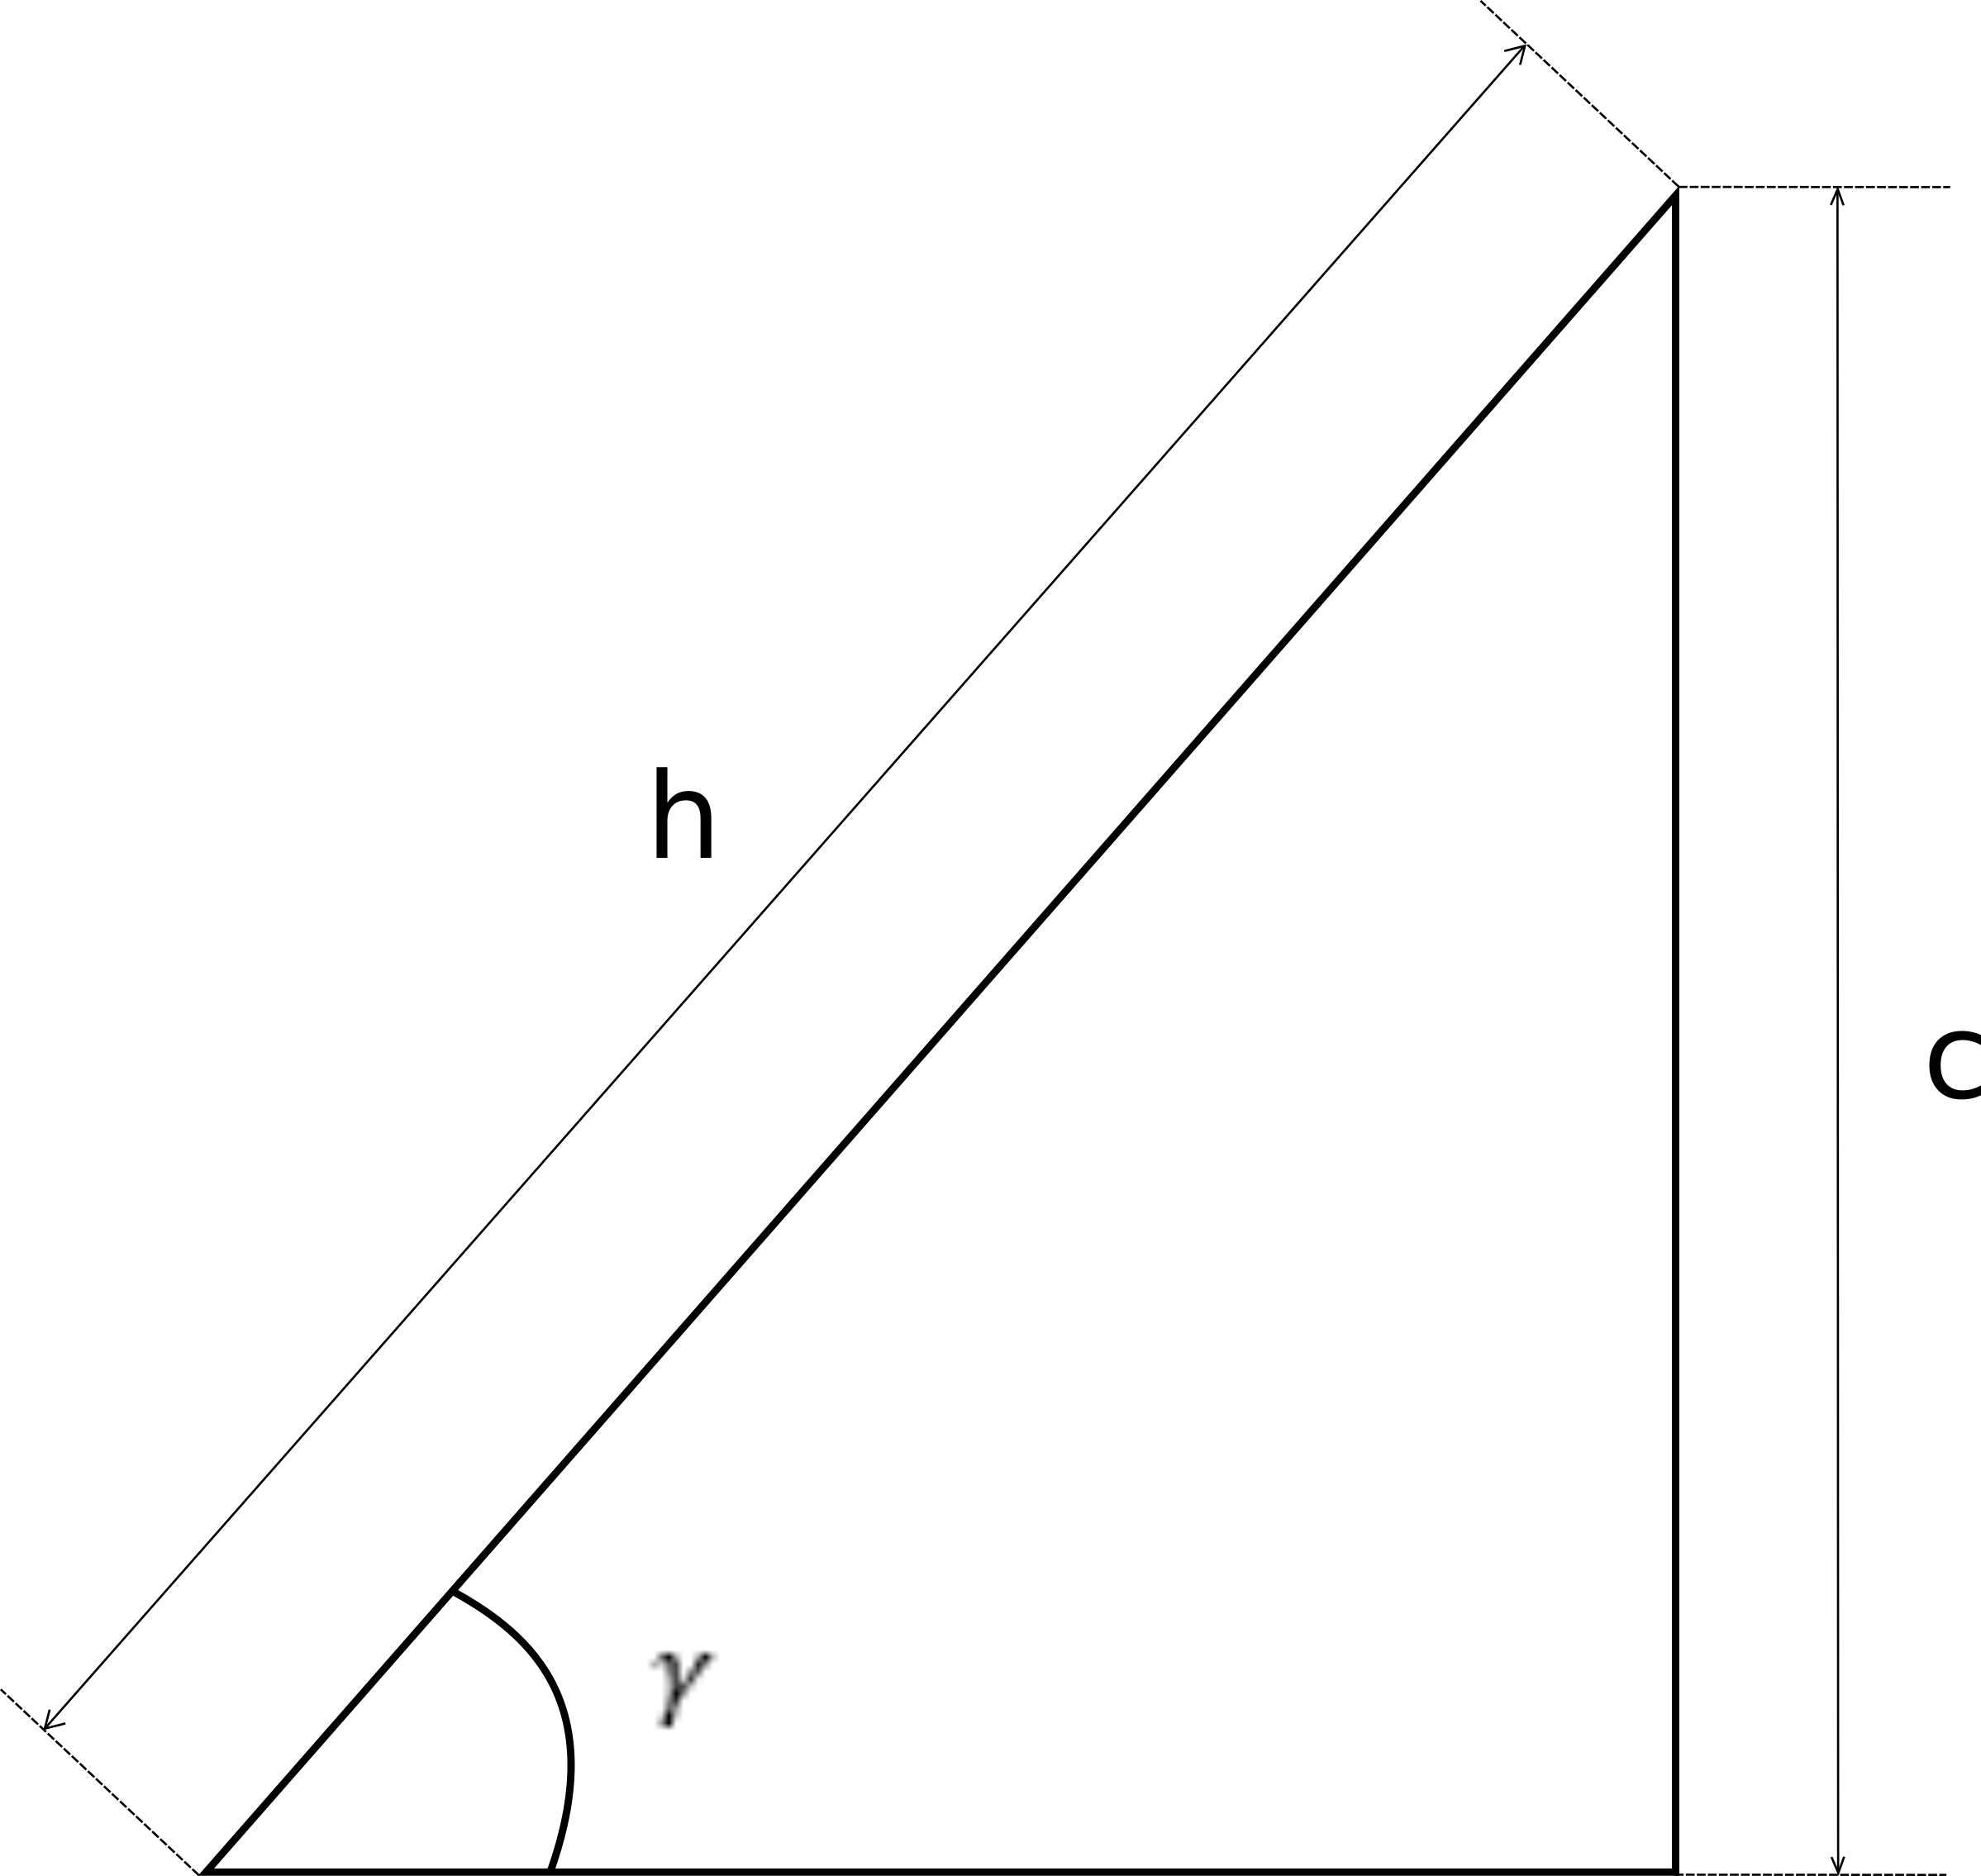
Figure 4.2-7 – PARAMETERIZED DESIGN P1 and its key parameters
The $h$ value utilized was:
 | $$h=8.68655 mm$$ | (17)
While the angle $γ$ was:
 | $$γ=45+β$$ | (18)
Where $β$ is the angle to be added step by step for the number of interval points as shown in the Table 4-7.
The same boundary conditions of FIXED DESIGN F1 were employed. The eyelet pressure was calculated for each angle, considering the eyelet centre as a reference point to calculate the vertical length “c”. A summary of all the parameters involved is shown in Table 4-7. Scenarios such as implanting time, standing up sitting and lay down position were not taken into account during these analysis and they could be considered in future studies.

$$β \left[°\right]$$ | $$γ \left[°\right]$$ | $$c \left[mm\right]$$ | L $\left[m\right]$ | $$P_{inlet1} \left[Pa\right]$$ | $$P_{inlet2} \left[Pa\right]$$
$$0$$ | $$45$$ | $$2.211$$ | $$0.4102$$ | $$4514.86$$ | $$4514.86$$
$$5.625$$ | $$50.625$$ | $$2.417$$ | $$0.4104$$ | $$4516.88$$ | $$4516.88$$
$$11.25$$ | $$56.25$$ | $$2.560$$ | $$0.4106$$ | $$4518.68$$ | $$4518.68$$
$$16.875$$ | $$61.875$$ | $$2.757$$ | $$0.4108$$ | $$4520.22$$ | $$4520.22$$
$$22.5$$ | $$67.5$$ | $$2.888$$ | $$0.4109$$ | $$4521.51$$ | $$4521.51$$
$$28.125$$ | $$73.125$$ | $$2.992$$ | $$0.4110$$ | $$4522.53$$ | $$4522.53$$
$$33.75$$ | $$78.75$$ | $$3.066$$ | $$0.4111$$ | $$4523.26$$ | $$4523.26$$
$$39.375$$ | $$84.375$$ | $$3.114$$ | $$0.4113$$ | $$4523.95$$ | $$4523.95$$
$$45$$ | $$90$$ | $$3.126$$ | $$0.4111$$ | $$4523.85$$ | $$4523.85$$
Table 4-7 Parameters utilized during the simulation. The table considers also in this case both geometrical parameters and inlet boundary conditions

PARAMETERIZED DESIGN P2
One of the main problems related to the Foley catheter and its eyelet shape is that the eyelets are handmade, as discussed in Chapter 1. The manufacturing companies are still producing these device following biological and medical instruction, and no inputs from an engineering point of view has been found in the literature so far. The aim is to provide a better understanding of the geometrical impact on the flow inside the catheters. The eyelet angle was the focus of this stage aimed to understand how the eyelet could be changed strategically adding an angle at its attachment point. It did not involve the section where the boundary condition was applied. Therefore, the inlet pressure was kept constant (see Figure 4.2-8) for all the simulations. The range of the angle used was the same such as in the previous design ($0°<α<45°$), however it was applied on a different location.

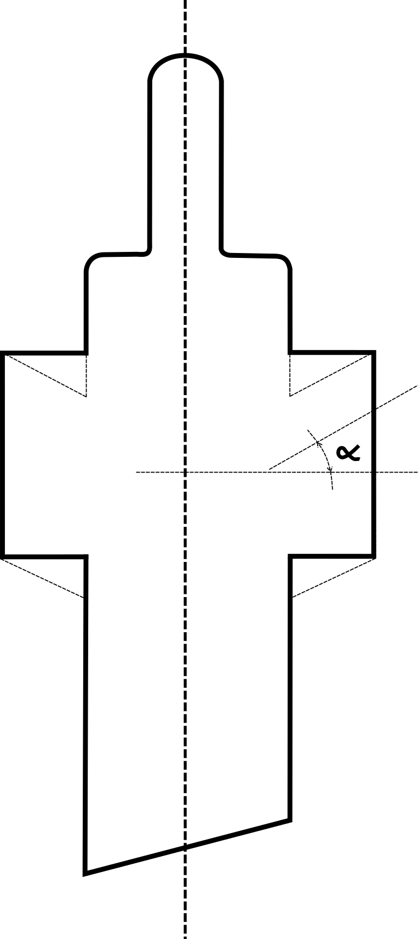
Figure 4.2-8 - The image shows the key parameter utilized to perform all the simulation for the PARAMETERIZED DESIGN P2.

First, parallel eyelets were considered. The Table 4-8 shows the main parameters involved during the simulations.
$α$ $\left[°\right]$ | L $\left[m\right]$ | $$P_{inlet1/2} \left[Pa\right]$$
$$0$$ | $$0.4111$$ | $$4523.85$$
$$5.625$$ | $$0.4111$$ | $$4523.85$$
$$11.25$$ | $$0.4111$$ | $$4523.85$$
$$16.875$$ | $$0.4111$$ | $$4523.85$$
$$22.5$$ | $$0.4111$$ | $$4523.85$$
$$28.125$$ | $$0.4111$$ | $$4523.85$$
$$33.75$$ | $$0.4111$$ | $$4523.85$$
$$39.375$$ | $$0.4111$$ | $$4523.85$$
$$45$$ | $$0.4111$$ | $$4523.85$$
Table 4-8 - Parameters utilized during the simulations, geometrical parameters and inlet boundary conditions
PARAMETERIZED DESIGN P3
The final case is still focused on the eyelet. However, a fillet was applied rather than an angle. The analysis was aimed to see the effect of a smoothed eyelet corner on the flow behaviour. All the considerations made previously are the basis of these simulations. The radius was defined between zero and a value which created almost a straight line between the eyelet corner and the eyelet attachment point. It corresponded to the catheter thickness “a” (see Figure 4.2-9)
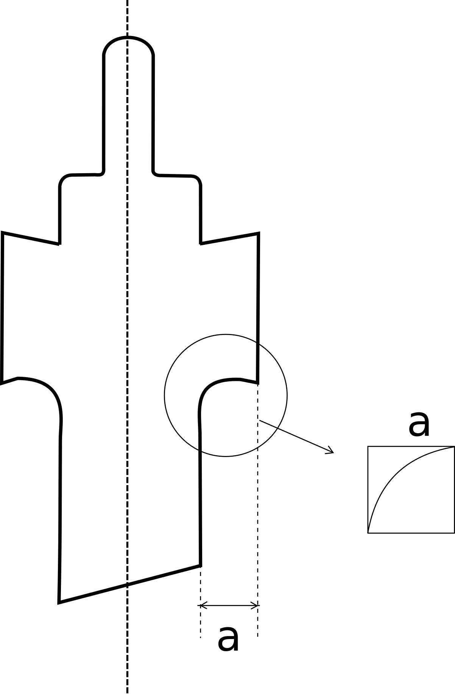
Figure 4.2-9 - PARAMETERIZED DESIGN P3 and its key parameter
The Table 4-9 shows the parameters used during the simulations:
$r$ $\left[mm\right]$ | L $\left[m\right]$ | $$P_{inlet1/2} \left[Pa\right]$$
$$0$$ | $0.411$1 | $$4523.85$$
$$0.135$$ | $$0.4111$$ | $$4523.85$$
$$0.269$$ | $$0.4111$$ | $$4523.85$$
$$0.404$$ | $0.411$1 | $$4523.85$$
$$0.538$$ | $$0.4111$$ | $$4523.85$$
$$0.673$$ | $$0.4111$$ | $$4523.85$$
$$0.808$$ | $$0.4111$$ | $$4523.85$$
$$0.942$$ | $$0.4111$$ | $$4523.85$$
$$1.077$$ | $$0.4111$$ | $$4523.85$$
Table 4-9 - Parameters utilized during the simulations, geometrical parameters and inlet boundary conditions

Results
In this section the results obtained are discussed. The aim was to understand how the flow field behaved inside the catheter and its possible impact on the biofilm growth and consequent catheter blockage. The results analysis in divided in two main parts:
- FIXED DESIGNS;
- PARAMETERIZED DESIGNS.
Results are presented in form of contour plots of flow velocity and shear stress. These parameters were chosen to be consistent with what has been analysed and discussed so far.
The five FIXED DESIGN scenarios are analysed together in order to understand which one of them could guarantee the best performances in term of Wall Shear Stress (WSS). However, considering the parameterized study, the analysis will be focused on each scenario at a time. This is due to show the influence of a single parameter on the device performances.

Fixed design
The results related to the five fixed designs (i.e. F1, F2, F3, F4, and F5) are discussed in this section. In these geometries, one change was applied and their comparison shows the influence of the geometry on the flow behaviour. Figure 4.3-1 shows a detailed overview of the WSS from three different view directions.
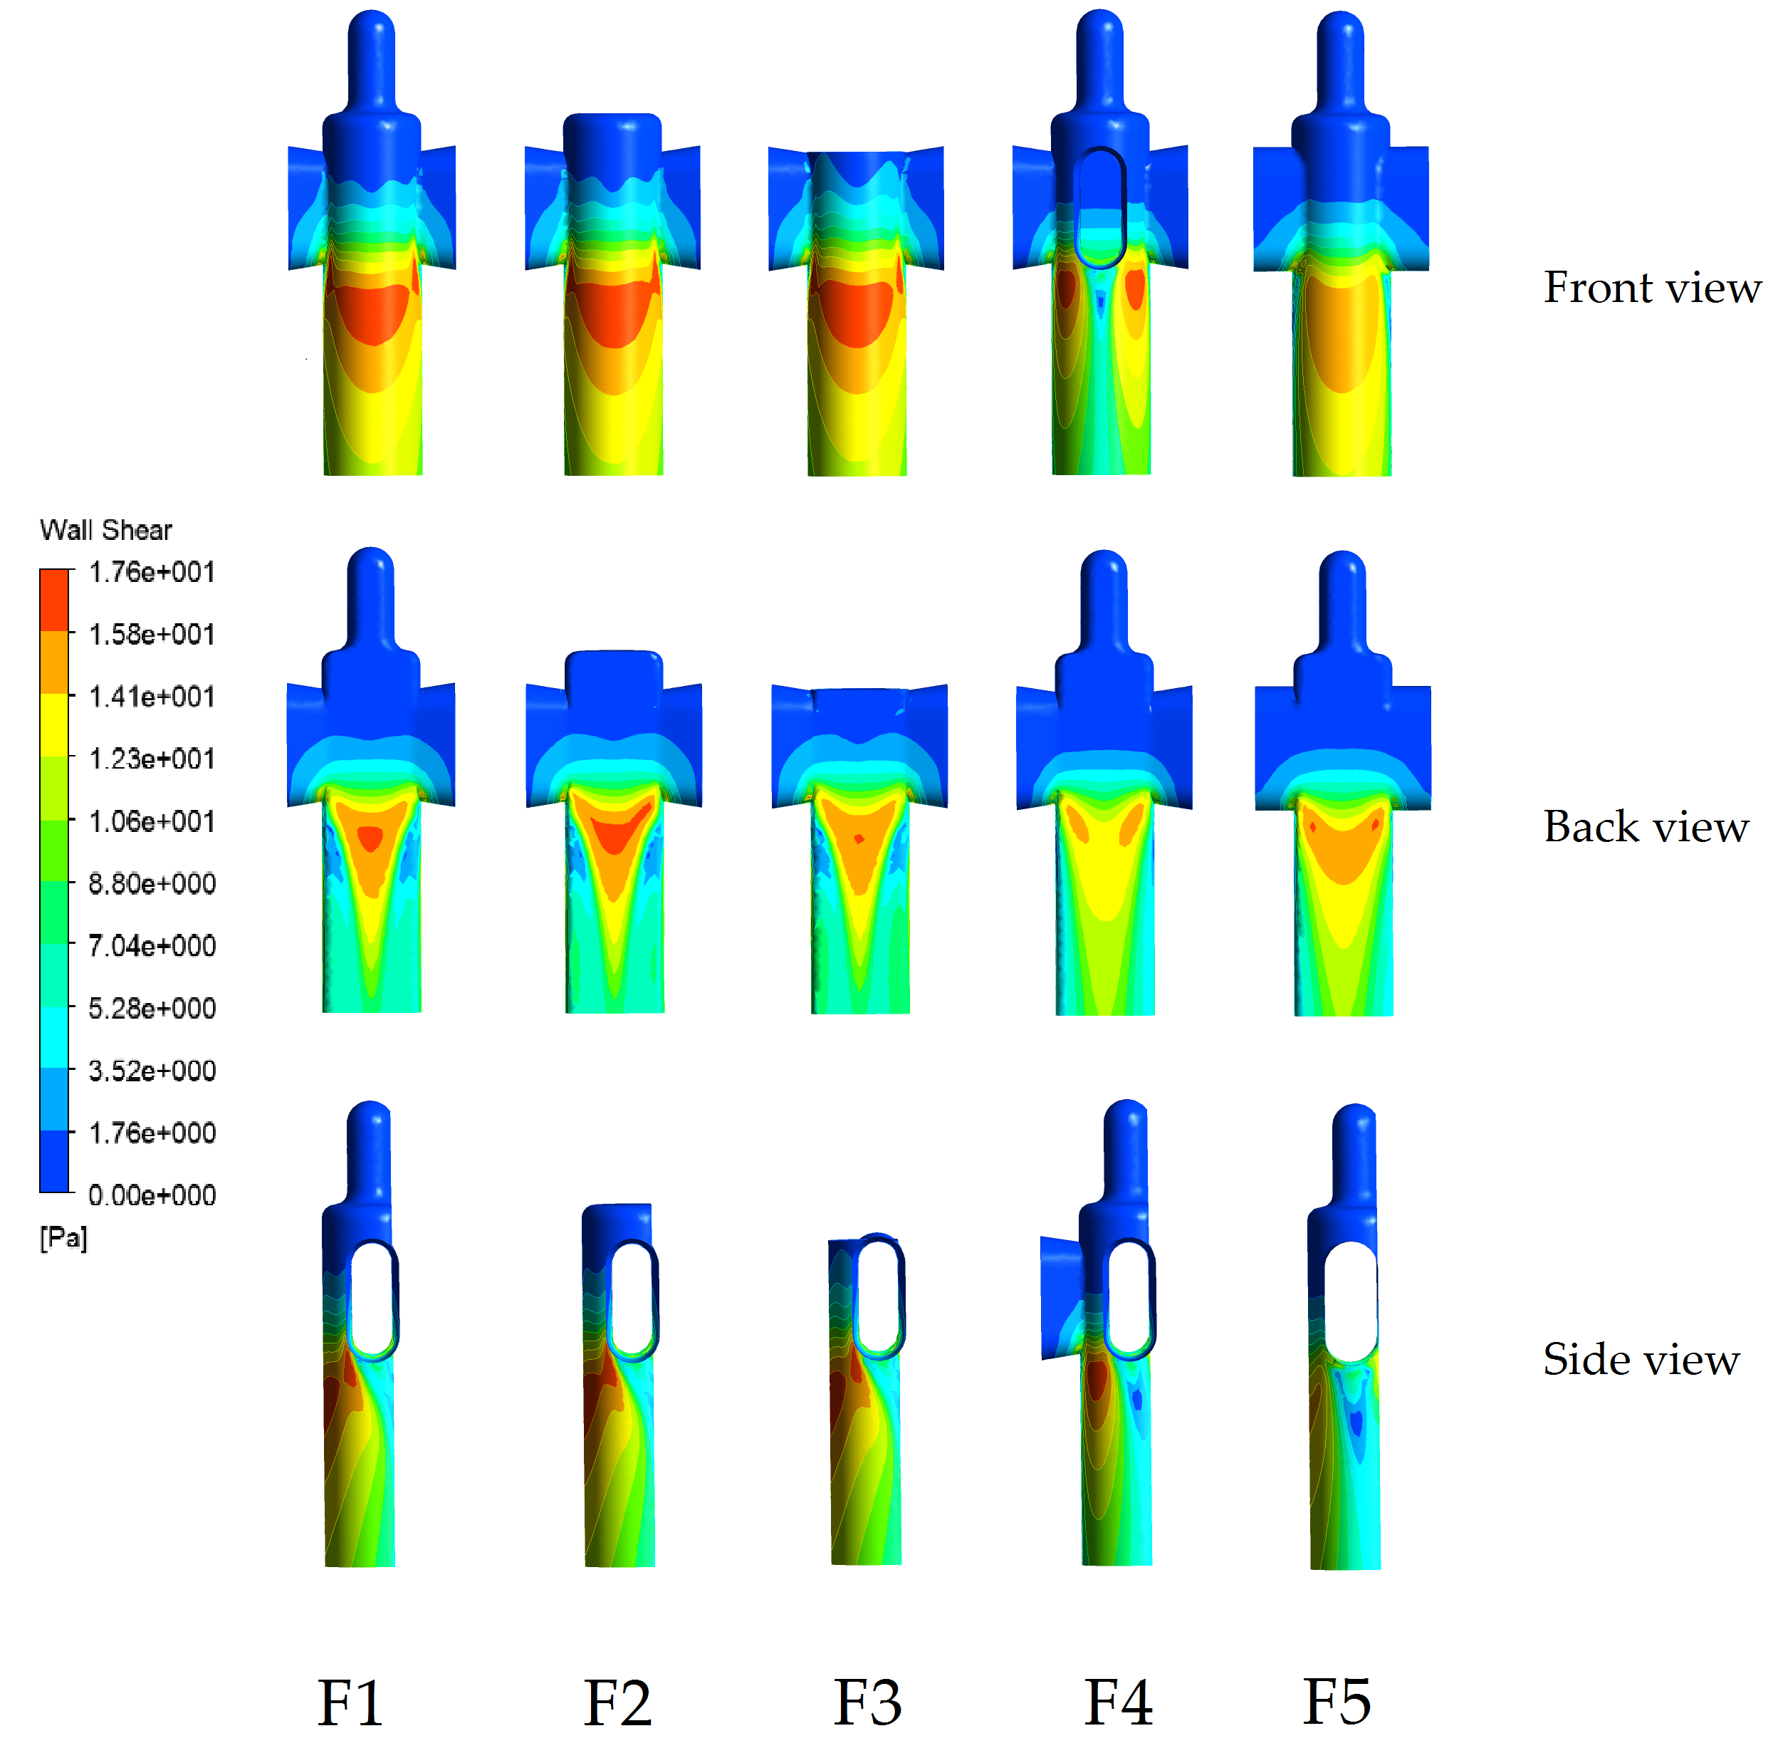
Figure 4.3-1 - Wall shear stress for all the five cases analysed. The picture shows the back, front, and left side view of the device.
Considering the above results it is possible to see the WSS trend inside the catheter. Values vary between $0 Pa$ and $17.59 Pa$. The FIXED DESIGN F2 appears to be the best possible solution among these 5 scenarios because it shows a bigger area with high values in the sections just below the eyelet, which is the main zone of interest, for both front and back views. Furthermore, considering the area just below the eyelet corner from the left side perspective, it shows a constant WSS value which appears to be higher than in the other four cases. Conversely, for the FIXED DESIGN F4 and F5, the WSS values in those areas reaches almost the minimum ($0 Pa$). All these key areas are the ones where the biofilm starts to develop and occlude the device (as shown in Chapter 2). The worst scenario considering all the three views is the FIXED DESIGN F4. This is because the third eyelet introduces a new area with low values such as the one below the eyelets corner described above which could worsen the catheter performances and, as a consequence, increases the risk of bacteria attachment. Considering the FIXED DESIGN F3, it shows a behaviour similar to the FIXED DESIGN F2 but with lower values in some areas. This could be due to the fact that, looking at Figure 2-16, there is a recirculation area just above the eyelets which is probably required by the flow to follow its pathway correctly. An overcut in that zone could influence the overall flow-field behaviour.
The next analysis refers to the flow-field velocity behaviour inside the catheter. It agrees with the study done in Chapter 2 provides insight on how this property could be affected by catheter geometry changes. The Figure 4.3-2 shows the velocity-field inside the catheter, considering only the mid-plane, for the five scenarios analysed before in terms of WSS.
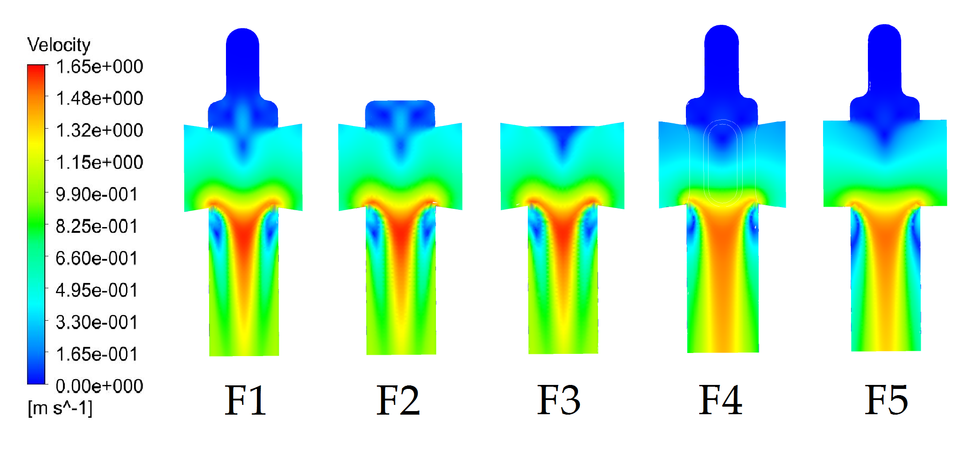
Figure 4.3-2 - Velocity profile along a mid-plane created inside the catheter. The picture shows the behaviour for all the five FIXED DESIGNS
The results in Figure 4.3-2 refer to how the flow velocity develops inside the catheter. Also in this case, the FIXED DESIGN F2 is the one which guarantees the best velocity trend. FIXED DESIGN F1, F2, and F3 show similar results with respect to velocity profiles. This was expected considering the small changes applied on these geometries and the results showed in Figure 3.3-1 in terms of wall shear stress. The FIXED DESIGN F4 and F5 display worse results comparing with the other three scenarios. The flow in these cases develops with lower velocity in the middle, and bigger areas with values close to zero (e.g. near the inlet sections). An advantage regarding these two geometries is that, although the velocity in the middle reaches lower peak values, its maximum covers a bigger area. It could be a good result in terms of the amount of biofilm removed by the urine flowing inside the device. To show the velocity field inside the catheter, six sections are reported Figure 4.3-4. The sections are described in Figure 4.3-3 which shows a front view of the catheter and the related axes located on the YZ planes. The space between the centre and the wall was divided equally in six different segments and their six values are shown in Table 4-10.
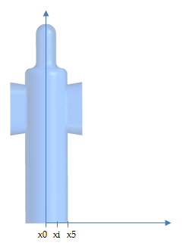  Figure 4.3-3 The figure shows the x-coordinates location and their values. On each of them an YZ plane where created to analyse the flow velocity inside the catheter | $$\left[mm\right]$$  $$x0$$ $$0$$  $$x1$$ $$0.3$$  $$x2$$ $$0.6$$  $$x3$$ $$0.9$$  $$x4$$ $$1.2$$  $$x5$$ $$1.4$$  Table 4-10 Values of the x-coordinates used for the catheter cross sections

Velocity contour plots for each YZ section plane are shown in Figure 4.3-4.
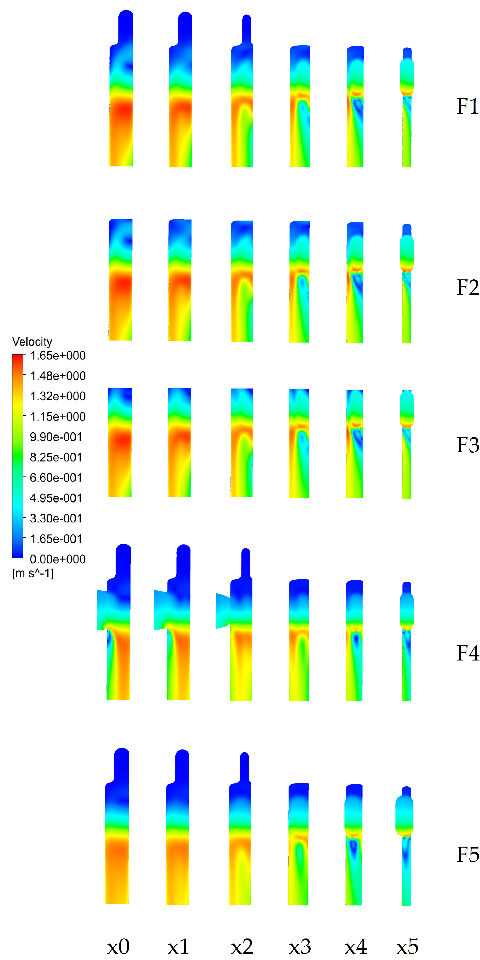
Figure 4.3-4 - Contour plots on five different YZ cross section planes along each of the FIXED DESIGN analysed.
FIXED DESIGN F1, F2, and F3 show the optimal results. FIXED DESIGN F4 and F5 present the worst situation in terms of velocity contour plots from side views. The way in which the flow develops inside the catheter creates several areas with low velocity values.
In conclusion, considering the results in terms both of WSS and velocity contour plots, the FIXED DESIGN F2 is the one which optimises the performance. Maximal values of these parameters are attained using this configuration and also a minimal number of areas with velocity close to zero around the critical zones. The worst case scenario is represented by the FIXED DESIGN F4 which has more recirculation areas with both low velocity and WSS values. The design F5 is the one with the bigger area of velocity and WSS values almost equal to zero, just below the two eyelets where the biofilm start to growth and block the catheter. As a result of this study, this study should be.

Parameterized design
This Chapter is focused on the three parameterized design described within the Methods and Materials section. The results obtained from these simulations will be presented aimed to show all the most relevant features and properties. In this analysis velocity and WSS values are the key factors that will be taken into account in order to be consistent with the study so far. All the single sections are similarly structured. In each of them the result discussion is divided into two main parts:
- This is focused on the WSS contours plot, again from three different views as shown for the FIXED DESIGN;
- The second part concerns the velocity plots visualised from both the middle XZ plane of the catheter and the 6 YZ plane sections used in the Chapter 4.2.1 and described in Figure 4.3-3.

PARAMETERIZED DESIGN P1
The Figure 4.3-5 shows an overview of the WSS contour plots for both the front and longitudinal view.
Figure 4.3-5 - WSS Contour plots of PARAMETERIZED DESIGN P1. The image shows both front and side view of the catheter for each value of the angle alpha.
For this analysis both Velocity and WSS parameters are analysed together. This is because the results suggest an important conclusion applicable only on this scenario. Therefore velocity contour plots are shown below in Figure 4.3-6 and discussed subsequently.

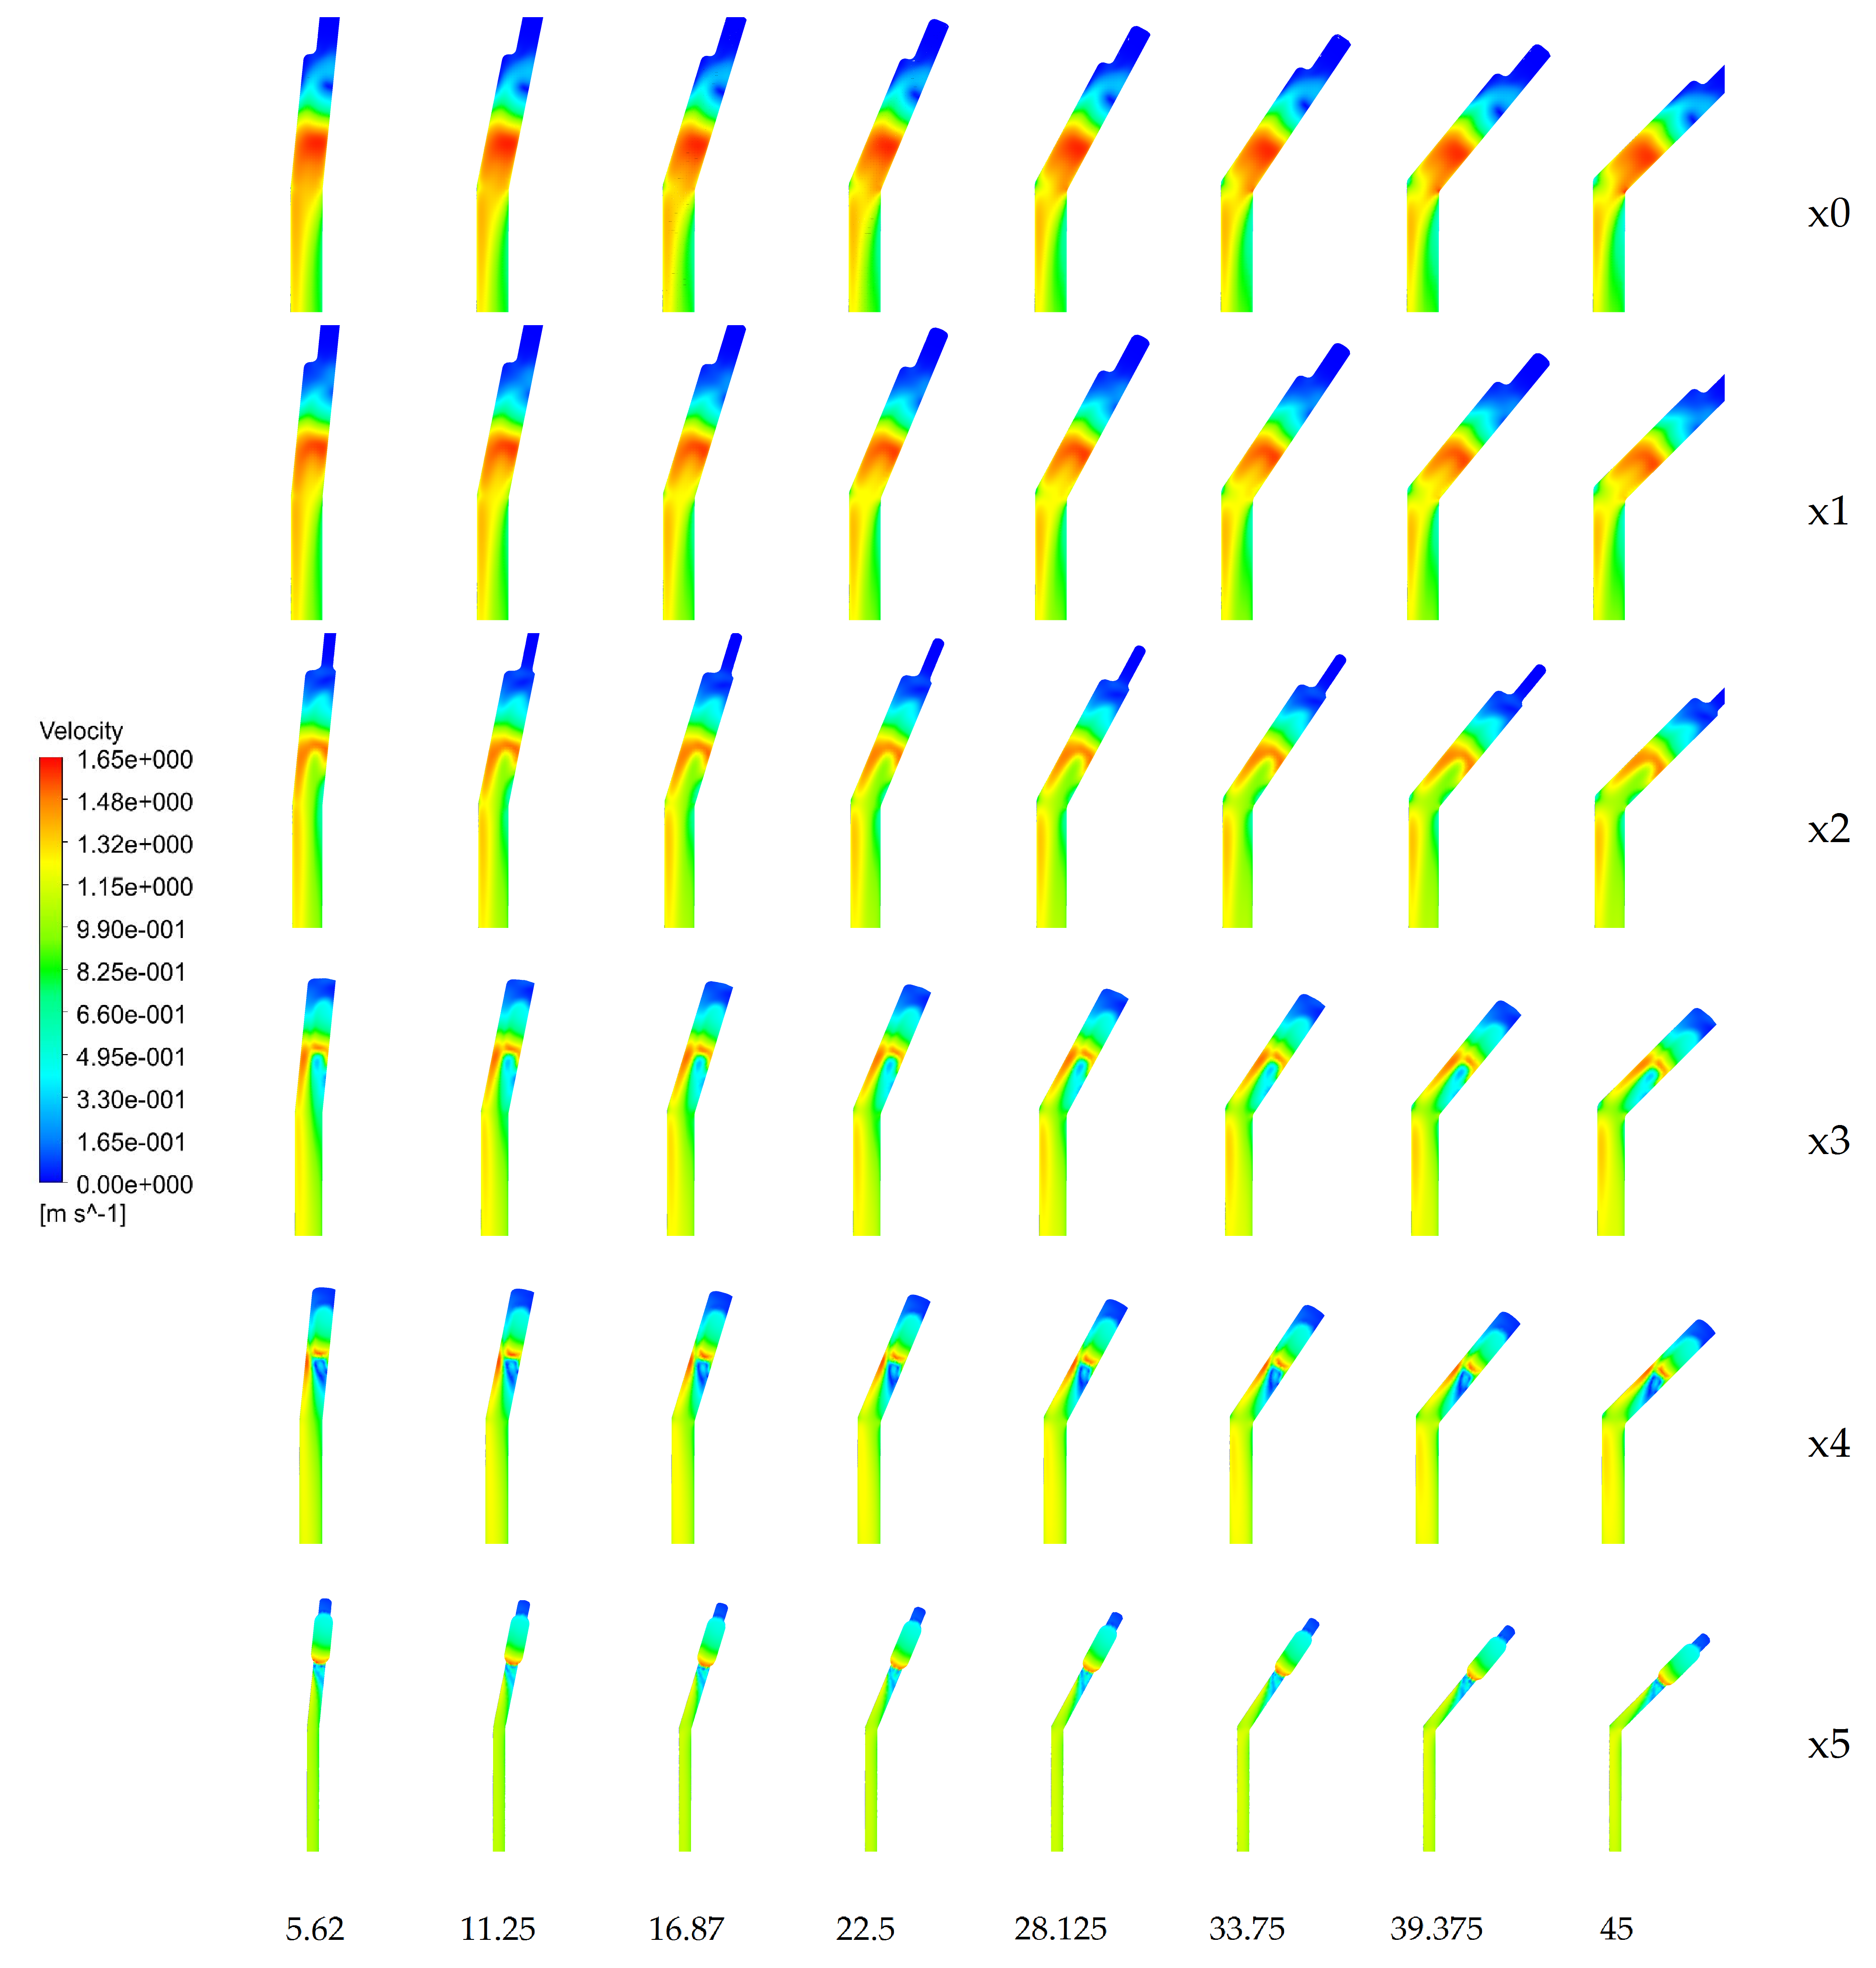
Figure 4.3-6 - Velocity contour plots along 6 different planes (see Figure 3.3-3). They are shown for all the "alpha" parameter values
The velocity contour plots on the middle plane were not considered necessary for this case. This is because, neither the velocity nor WSS profiles near the eyelets are influenced by the angle alpha applied to the catheter body. Only the area where the parameters analysed behave differently is where the device shape changes angle. This suggests that the CFD model used does not reproduce the real environment. It has been developed using the pressure as a boundary condition applied directly on the two inlet surfaces. Therefore, this system is not sensitive to an angle applied on a section located distal from the eyelets. To reproduce such a scenario, it would be necessary a tank simulating the bladder on top of the catheter using the free liquid surface as boundary condition. A further analysis would be required.
PARAMETERIZED DESIGN P2
PARAMETERIZED DESIGN P2 and P3 are focused on the catheter eyelets and their shape. This part of the device, as shown in the literature review, is considered the most critical one in terms of biofilm attachment and growth. Moreover, this is an area where geometry is mainly hand-made and there could be room of improvement. In this section the change made applies to the inclination of the eyelets. An angle on the horizontal direction was added to see how the flow-field inside behaves. Figure 4.3-7 shows the WSS contour plots from the front, back and longitudinal view for all eight configurations.
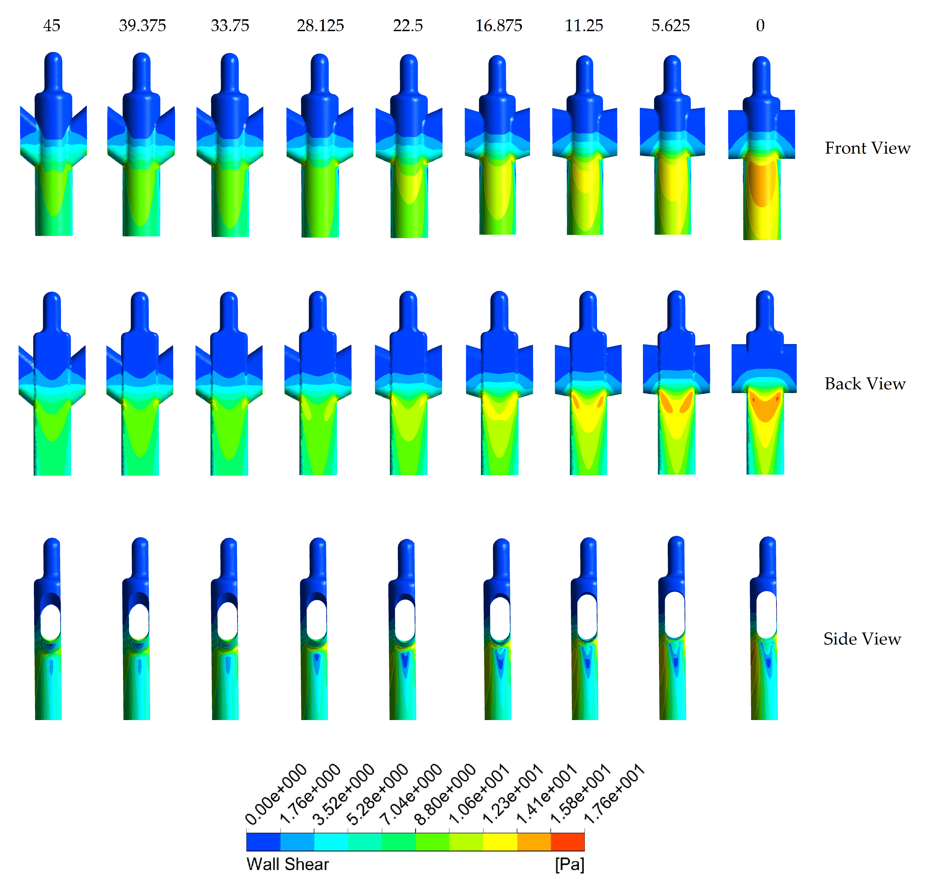
Figure 4.3-7 - WSS Contour plots of PARAMETERIZED DESIGN P2. The image shows front, back, and side view of the catheter for each value of the angle considered.
These results suggest that the bigger the angle, the lower the WSS peak value is. Simultaneously, a bigger angle implies a more distributed trend. Therefore, the peak is smaller but the areas just below the eyelets with WSS almost equal to zero disappear. The same conclusion is reached if the analysis focuses on the flow-field velocity as shown in Figure 4.3-8.
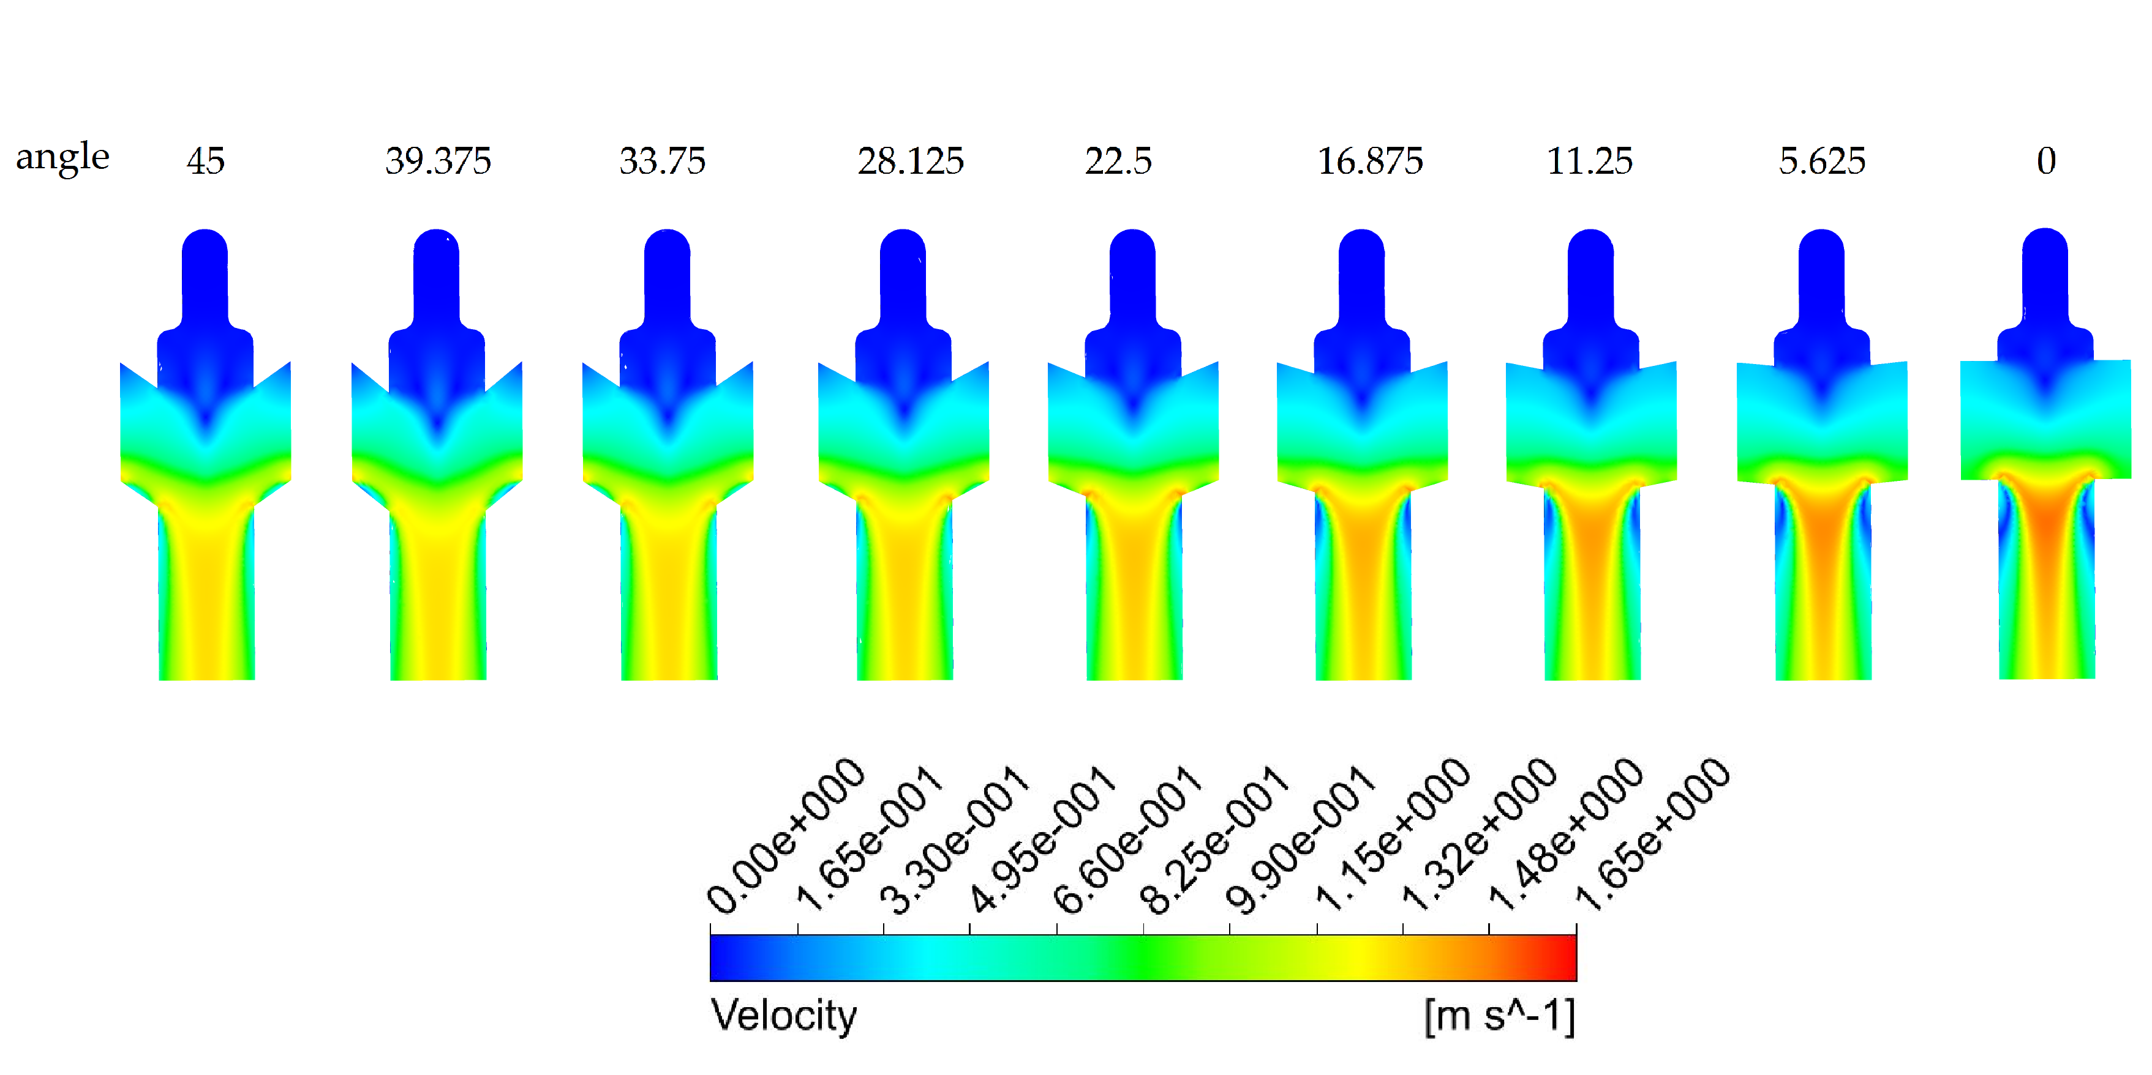
Figure 4.3-8 - Velocity contour plots on the PARAMETERIZED DESIGN P2. Moving from right to left the first geometry is the one parallel eyelets used as a starting point, and the others are all the ones with different values of the "angle” parameter applied.
Looking at the Figure 4.3-8, moving from right to left the velocity peak value decreases, but, at the same time, the maximum value for each geometry is spread all over the catheter. The recirculation areas almost disappear suggesting that there is less space available for the biofilm to grow and develop. However, increasing the angle means also having a bigger area with velocity almost equal to zero just above the eyelets. Also in this case the third image shows velocity contour plots of six different YZ section planes for all the geometries analysed. The same considerations can be applied also to Figure 4.3-9.
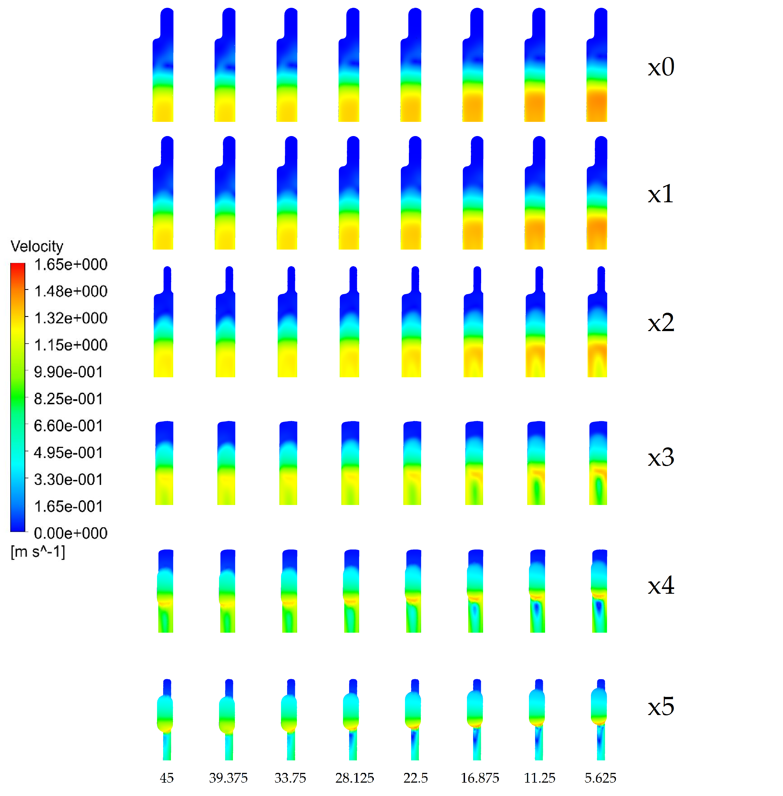
Figure 4.3-9 Velocity contour plots along 6 different planes (see Figure 3.3-3). They are shown for all the angle values applied

PARAMETERIZED DESIGN P3
The last change applied was a fillet on the eyelets attachment corner. The fillet concept is used in many other applications to smooth the liquid which flows around a corner and to increase performances. The same concept was applied on the catheter and the results in terms of WSS are shown in Figure 4.3-10.
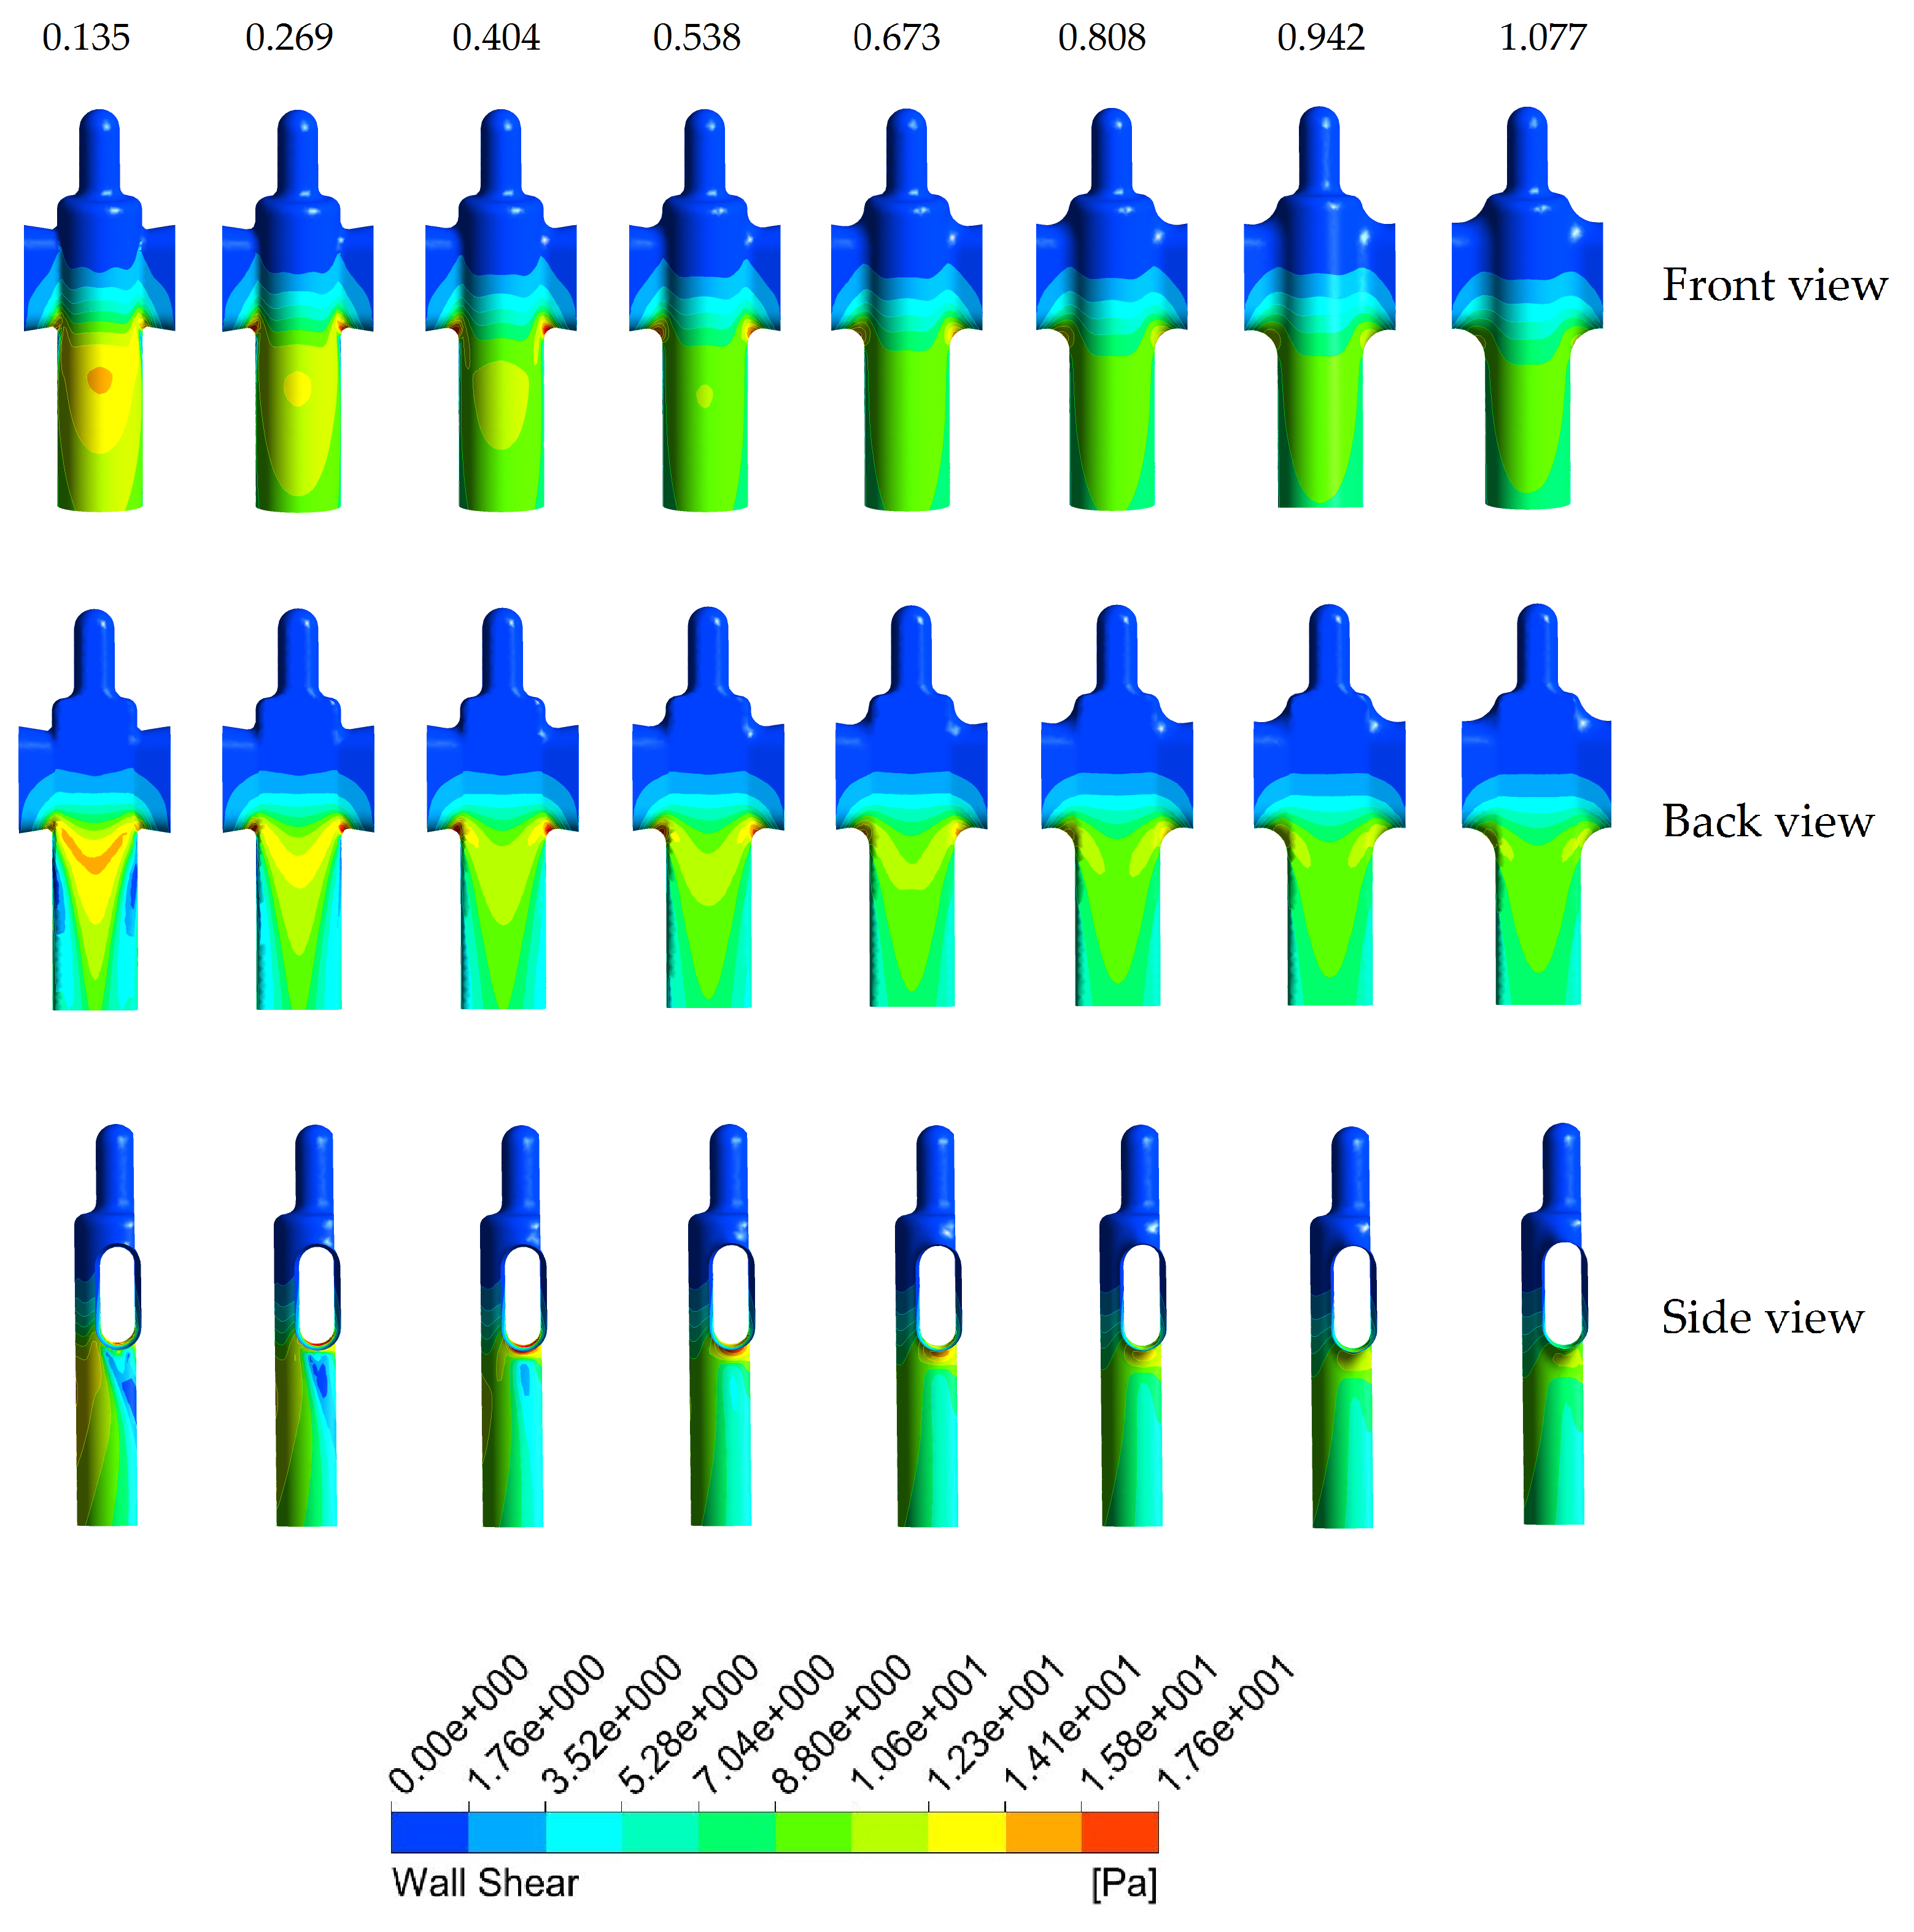
Figure 4.3-10 WSS Contour plots of PARAMETERIZED DESIGN P3. The image shows front, back, and side view of the catheter for each value of the considered fillet radius “r”.

Applying a fillet guarantees the same type of improvements obtained in the PARAMETERIZED DESIGN P3 case of study. The peak value of both WSS and flow velocity decreases (see Figure 4.3-11) as the fillet radius increases.
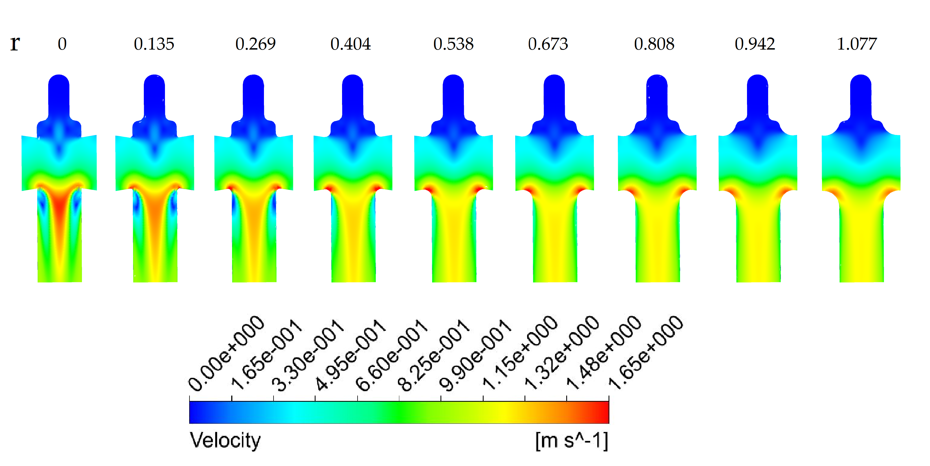
Figure 4.3-11 Velocity contour plots on the PARAMETERIZED DESIGN P3. Moving from the left to the right side the first geometry is the one currently used in the clinical market, and the others are all the ones with different values of the "r” parameter applied.
As shown in the Figure 4.3-11, another result for this case is that where the fillet was applied the flow velocity was higher. Combining this with the fact that the recirculation areas almost disappear just below the eyelets (see Figure 4.3-12 from the radius value equal to 0.404 mm and above) this solution could be seen as one that could definitely improve the catheter performances. The best scenario is the one with radius equal to 0.538 mm. The only negative aspect which has to be taken into account is that the maximum value (located at the centre of the catheter) of velocity is smaller than in the current Foley catheter design. However, it is also true that the biofilm starts to develop near to the wall and not in the middle of the device. It implies that this is the most critical area which has to be improved rather than the central region.
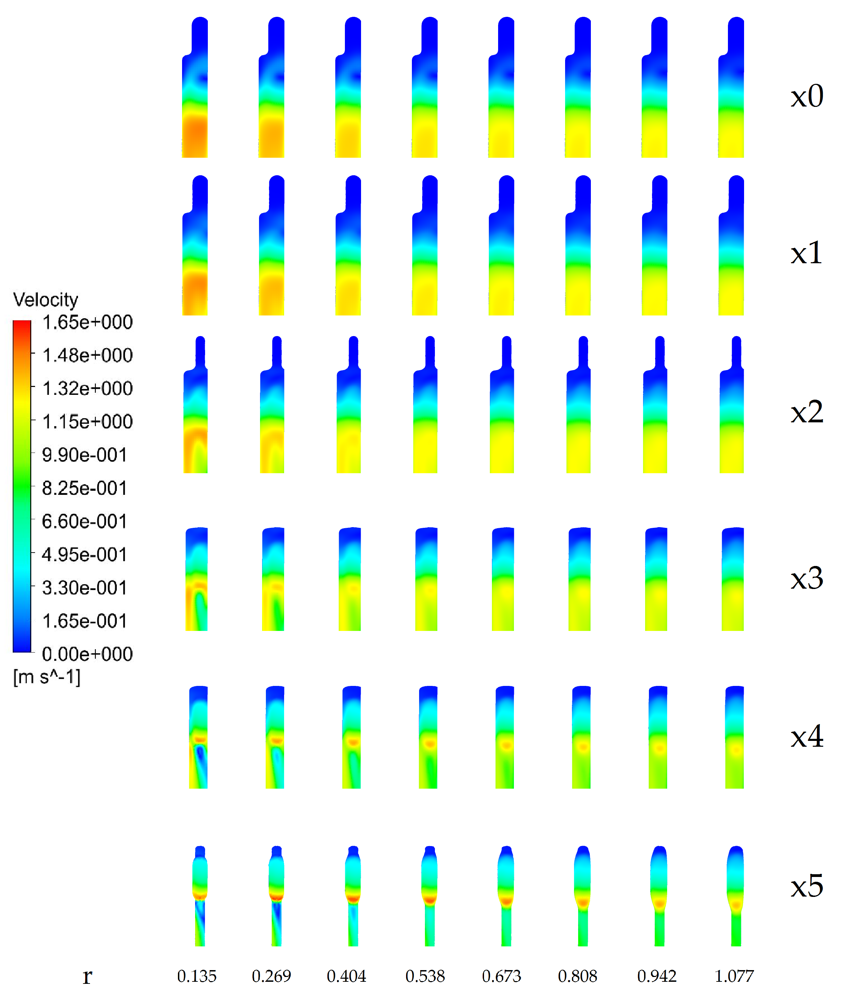
Figure 4.3-12 Velocity contour plots along 6 different planes (see Figure 4.3-3). They are shown for all the fillet radius values applied.

Discussion
Catheter encrustation is a problem that must be quickly addressed. The case of study presented in Chapter 4 is a good example on how to use the CFD model created and validated in Chapter 3. This work showed a new methodology to study and discuss, using such model, the role of catheter design on the flow-field inside. All the results obtained and the consequent contour plots showed that it is possible to improve the Foley Catheter performances applying little geometrical changes on its tip. The first section related to fixed designs demonstrated how even little changes on the geometry could change substantially the way in which the urine flows. FIXED DESIGN F2 (see Figure 4.3-1) is the one which guarantees the best values in terms of WSS and flow velocity. Moreover, considering the parameterized study, the analysis showed which could be the role of simple geometry parameters (e.g. fillet, angles, eyelet position, etc.) on the way in which the urine flows, stresses the surface, and as a consequence on the biofilm encrustation process.
The PARAMETERIZED DESIGN P2 and its related study, demonstrated how a different environment around the catheter which mimics also the bladder, could definitely improve the model. By doing this, it would be possible to capture information which are otherwise dependent to the inlet boundary condition and the locations where they are applied. Another model which considers different boundary conditions could be created and compared with the one used in this study to see which are the differences and to improve it. However, this study defined a good pathway aimed to determine a methodology that could be used in the healthcare and in the biomedical industry to improve the catheter performance even considering only little geometrical changes. Creating a device based on engineering considerations rather than only biological ones is a necessary step to be made. A CFD approach such as this one can guarantee the right flexibility and accuracy to be considered and perhaps introduced within the industrial process.

CONCLUSIONS
This chapter summarizes the main contributions of this work. It discusses how the study could be utilised by the scientific community and the methodology main limitations. Finally, an overview of future work is presented.

Main contributions
- The creation of a methodological framework to develop a more complex modelling approach including a model of biofilm formation inside a urinary catheter (Chapter 3);
- The results obtained showed quantify correlations between Urodynamics and the phenomenon of encrustation, and identified regions of the design that could be improved;
- The CFD model created can be used for further studies and analysis related to the Foley catheter and in general to similar invasive devices. This could be used to find innovative designs using the fluid dynamics results as a guide to identify critical areas.
Figure 5.1-1 shows the best results obtained in this work.
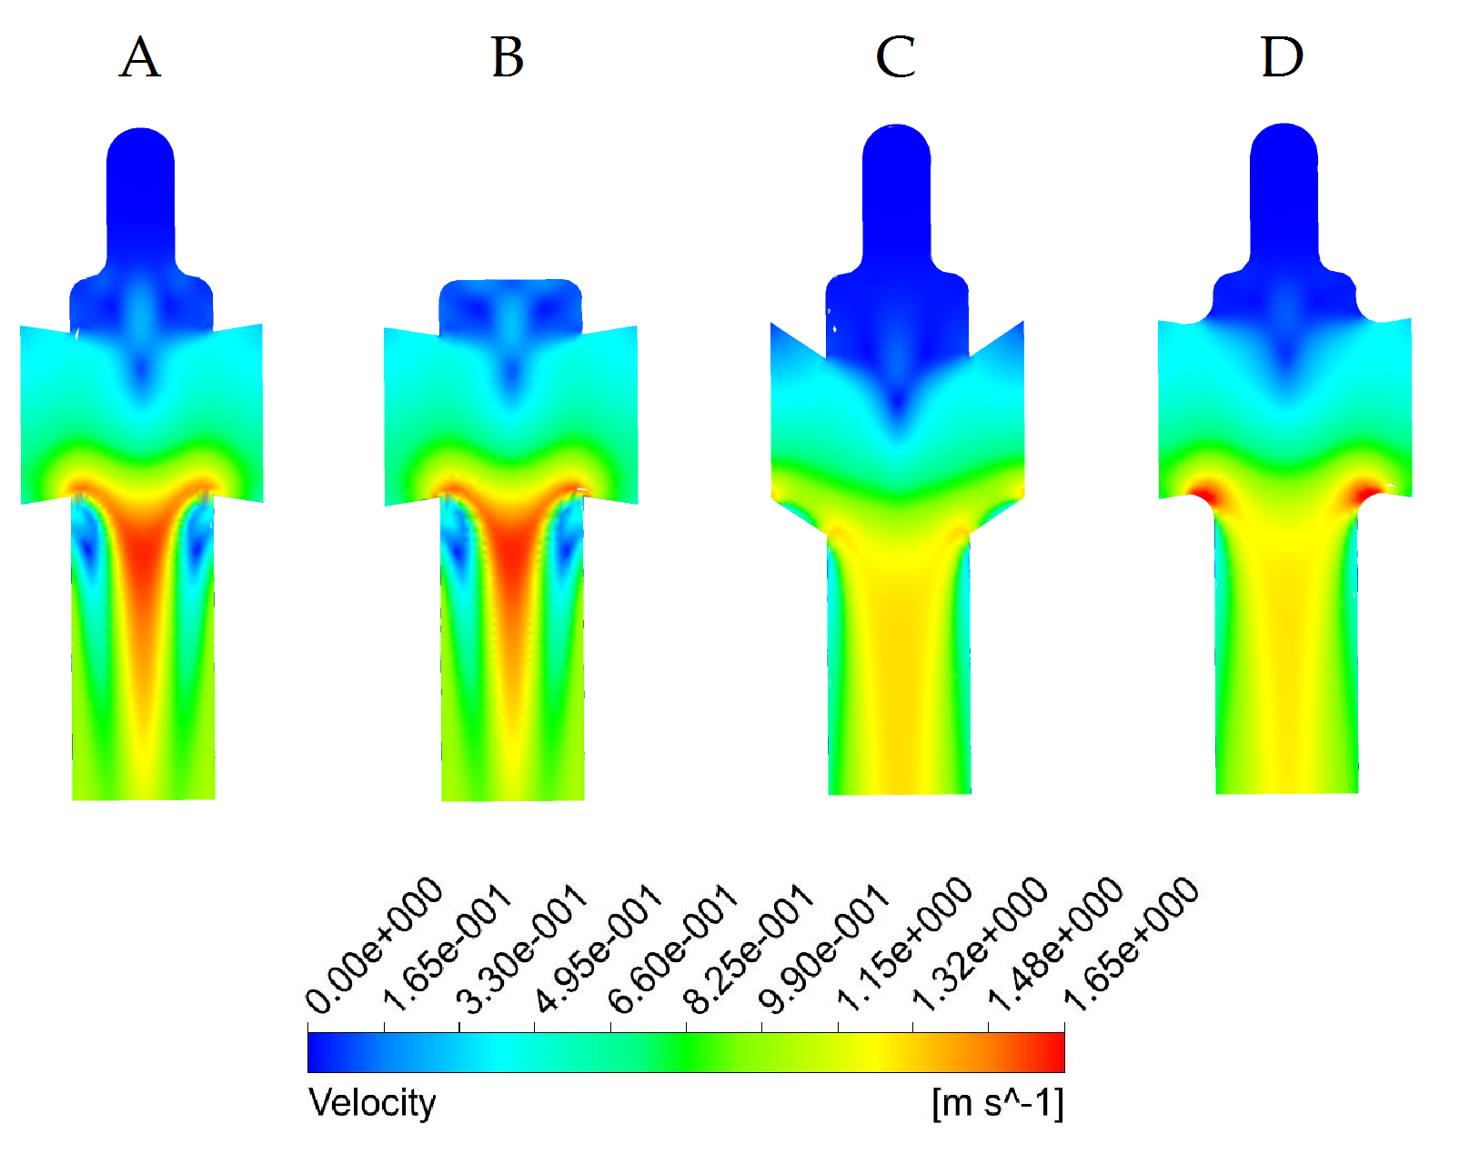
Figure 5.1-1 Velocity contour plot comparison between the current Foley catheter (A) and the two best cases analysed. The figure shows the FIXED DESIGN F1 (B), the PARAMETERIZED DESIGN P2 and P3, with angle equal to 33.75º and radius equal to 0.538 mm, respectively

Limitations
The validated CFD model does not reproduce the real environment in a case where the key parameter used should be independent from the section on which the boundary condition are applied (for example changing the location of the Inlet Boundary Conditions). A more appropriate model, in such case, should be developed and the convergence criteria study and mesh independence study would have to be performed again. This could be done following the same procedure used in Chapter 3.
The analysis described and discussed during this work is based on experimental data (i.e. catheter flow rate), obtained during a study done at The University of Sheffield considering standard protocols. It would be of interest to validate the methodology using also the real bladder flow rate. This will help to understand even better how the urine flows inside the catheter and the changes which should be applied on its geometry.
As discussed in Chapter 3 a transitional flow exists in some catheters and in some areas of them and another more appropriate turbulent model could better simulate the real behaviour within the boundary layer. Further studies based on this concept could be compared with the solution obtained during this study in which the flow-rate was the key experimental properties given. The model used is however acceptable in terms of stability and turbulence analysis.

Future work
There are many aspects that could be further explored in order to improve this methodology. Few more steps could be undertaken to analyse more scenarios correlated to the Foley catheter and the biofilm encrustation issue. Some analysis and possibilities are listed below:
- More strategical parameters could be analysed to investigate their correlation to the catheter performance;
- A sensitivity analysis could be done in order to use all the chosen parameters and to determine which is the combination that guarantees the best solution;
- Validate all the results using a $μPIV$ to observe the internal velocity field.
This CFD methodological framework gives all the fluid property information such as velocity, pressure, WSS, etc. Subsequently, a biofilm model could be developed following the method proposed in Chapter 5.3.1. To do so, it would be necessary to couple the biofilm growth with the new geometry, either changing the geometry at each time step or increasing the flow viscosity in strategic areas [73]. The latter would allow the generation of a zone in which the fluid behaves as a solid, mimicking the biofilm structure. It would be also necessary to analyse advantages and limitations of both methods in order to opt for the best one.

A biofilm modelling approach for future studies
A possible solution considering the combination between a CFD approach and the TUDelf Group methodology, instead of the lattice Boltzmann algorithm, to solve the flow field inside the catheter is proposed below. Hence, the MPhil project was focused on the 1st step considering Figure 5.3-1. As the catheter CFD model has been defined during this study, the next steps would be to follow the TUDelft Group methodology, where biofilm parameters such as liquid viscosity, liquid density substrate diffusion coefficient $D$, etc., could be chosen according to the literature. Figure 5.3-1 shows the general algorithm that could be used in the future to solve the dynamic biofilm model inside the urinary catheter. This is not a part of this study, but could be considered for future ones.
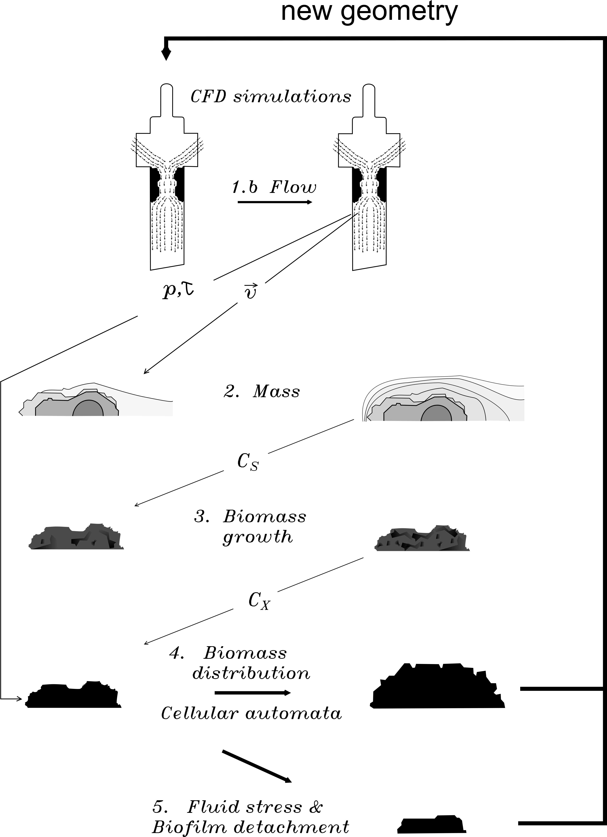
Figure 5.3-1 - Methodology proposed to developed the dynamic biofilm model inside the urinary tract. Picture adapted from [51]

REFERENCES
[1] C. Hampel, D. Wienhold, N. Benken, C. Eggersmann, W. Thuroff, Definition of overactive bladder and epidemiology of urinary incontinence, Elsevier Sci. Inc. 4295 (1997).
[2] P. Abrams, L. Cardozo, M. Fall, D. Gri, P. Rosier, U. Ulmsten, et al., The Standardisation of Terminology of Lower Urinary Tract Function : Report from the Standardisation Sub-committee of the International Continence Society, Neurourol. Urodyn. 21 (2002). doi:10.1002/nau.10052.
[3] E.L. Lawrence, I.G. Turner, Materials for urinary catheters: A review of their history and development in the UK, Med. Eng. Phys. 27 (2005) 443–453. doi:10.1016/j.medengphy.2004.12.013.
[4] C.W. Mcgrother, M.M.K. Donaldson, C. Shaw, R.J. Matthews, T.A. Hayward, H.M. Dallosso, et al., Storage symptoms of the bladder: Prevalence, incidence and need for services in the UK, BJU Int. 93 (2004) 763–769. doi:10.1111/j.1464-410X.2003.04721.x.
[5] L. Winson, Catheterization: a need for improved patient management., Br. J. Nurs. 6 (1997) 1229–52. doi:10.12968/bjon.1997.6.21.1229.
[6] D.J. Stickler, J. Zimakoff, Complications of urinary tract infections associated with devices used for long-term bladder management, J. Hosp. Infect. 28 (1994) 177–194.
[7] Warren JW, M.H. Jr, B. EJ, H. JM., Sequelae and management of urinary infection in the patient requiring chronic catheterization, J. Urol. 125 (1981) 1–8.
[8] L.A. Jewes, W.A. Gillespie, B. Myers, R.A. Simpson, M.J. Stower, A.C. Want, Bacteriuria and bacteraemia in patients with long-term indwelling catheters-a domiciliary study, J. Med. Microbiol. 26 (1988) 61–65.
[9] C.M. Kunin, Urinary Tract Infections in Females, Clin. Infect. Deseases. 18 (1994) 1–12.
[10] W.E. Stamm, Thomas M. Hooton, Management of Urinary tract infection in adults, New Engl. Med. 329 (1993) 1328–1334. doi:10.1056/NEJM199310283291808.
[11] K.A. Getliffe, A.B. Mulhall, The Encrustation of Indwelling Catheters, Br. J. Urol. 67 (1991) 337–341.
[12] A.W. Bruce, S.S. Sira, A.F. Clark, The problem of catheter encrustation, C. J. 111 (1974) 238–240.
[13] P. Frawley, M. Geron, Combination of CFD and DOE to analyze and improve the mass flow rate in urinary catheters, J. Biomech. Eng. 131 (2009) 84501. doi:10.1115/1.3128692.
[14] S.M. Jacobsen, D.J. Stickler, H.L.T. Mobley, M.E. Shirtliff, Complicated catheter-associated urinary tract infections due to Escherichia coli and Proteus mirabilis, Clin. Microbiol. Rev. 21 (2008) 26–59. doi:10.1128/CMR.00019-07.
[15] A. Evans, D. Pheby, D. Painter, R. Feneley, The costs of long-term catheterization in the community., Br. J. Community Nurs. 5 (2000) 477–8, 480, 482, 484–8. doi:10.12968/bjcn.2000.5.10.12985.
[16] F.E.B. Foley, Self-Inflating bag catheter, United States Pat. Off. (n.d.) 3,152,592.
[17] D.J. Stickler, Clinical complications of urinary catheters caused by crystalline biofilms: Something needs to be done, J. Intern. Med. 276 (2014) 120–129. doi:10.1111/joim.12220.
[18] R.C.L. Feneley, C.M. Kunin, D.J. Stickler, An indwelling urinary catheter for the 21st century, BJU Int. 109 (2012) 1746–1749. doi:10.1111/j.1464-410X.2011.10753.x.
[19] D.J. Stickler, Bacterial biofilms in patients with indwelling urinary catheters., Nat. Clin. Pract. Urol. 5 (2008) 598–608. doi:10.1038/ncpuro1231.
[20] L. Hall-Stoodley, J.W. Costerton, P. Stoodley, Bacterial biofilms: from the natural environment to infectious diseases., Nat. Rev. Microbiol. 2 (2004) 95–108. doi:10.1038/nrmicro821.
[21] T.J.M. J.W. Costerton, K.-J. Cheng, Gill G. Greesy, Timothy I. Ladd, J. Curtis Nickel, Mrinal Dasgupta, Bacterial biofilms in nature and disease, Ann. Rev. Microbiol. 41 (1987) 435–464. doi:10.1146/annurev.mi.41.100187.002251.
[22] A.T. Henrici, Studies of freshwater bacteria, (1932) 277–287.
[23] R.J. Palmer, D.C. White, Developmental biology of biofilms: implications for treatment and control., Trends Microbiol. 5 (1997) 435–440. doi:10.1016/S0966-842X(97)01142-6.
[24] D.J. Stickler, R.C.L. Feneley, The encrustation and blockage of long-term indwelling bladder catheters: a way forward in prevention and control., Spinal Cord Off. J. Int. Med. Soc. Paraplegia. 48 (2010) 784–790. doi:10.1038/sc.2010.32.
[25] S. Choong, S. Wood, C. Fry, H. Whitfield, Catheter associated urinary tract infection and encrustation, Int.J.Antimicrob.Agents. 17 (2001) 305–310.
[26] R.C.L. Feneley, I.B. Hopley, P.N.T. Wells, Urinary catheters: history, current status, adverse events and research agenda, J. Med. Eng. Technol. 39 (2015) 459–470. doi:10.3109/03091902.2015.1085600.
[27] R.C.L. Feneley, A.M. Shepherd, P.H. Powell, J. Blannin, Urinary Incontinence: Prevalence and Needs, Br. J. Urol. 51 (1979) 493–496. doi:10.1111/j.1464-410X.1979.tb03585.x.
[28] D. Stickler, N. Morris, M.C. Moreno, N. Sabbuba, Studies on the formation of crystalline bacterial biofilms on urethral catheters, Eur. J. Clin. Microbiol. Infect. Dis. 17 (1998) 649–652. doi:10.1007/s100960050150.
[29] P. Tenke, B. Kovacs, M. Jäckel, E. Nagy, The role of biofilm infection in urology, World J. Urol. 24 (2006) 13–20. doi:10.1007/s00345-005-0050-2.
[30] D.J. Stickler, S.D. Morgan, Observations on the development of the crystalline bacterial biofilms that encrust and block Foley catheters, J. Hosp. Infect. 69 (2008) 350–360. doi:10.1016/j.jhin.2008.04.031.
[31] M.E. Rupp, T. Fitzgerald, N. Marion, V. Helget, S. Puumala, J.R. Anderson, et al., Effect of silver-coated urinary catheters: Efficacy, cost-effectiveness, and antimicrobial resistance, Am. J. Infect. Control. 32 (2004) 445–450. doi:10.1016/j.ajic.2004.05.002.
[32] I. Banerjee, R.C. Pangule, R.S. Kane, Antifouling coatings: Recent developments in the design of surfaces that prevent fouling by proteins, bacteria, and marine organisms, Adv. Mater. 23 (2011) 690–718. doi:10.1002/adma.201001215.
[33] N.S. Morris, D.J. Stickler, Encrustation of indwelling urethral catheters by Proteus mirabilis biofilms growing in human urine, J. Hosp. Infect. 39 (1998) 227–234. doi:10.1016/S0195-6701(98)90262-6.
[34] M. Tamsin, C. Bach, The Design of Medical Devices, 1 (2014) 127–134.
[35] B.L. Gilman, J.E. Brewer, M.W. Kroll, Medical device design process., Conf. Proc. IEEE Eng. Med. Biol. Soc. 2009 (2009) 5609–5612. doi:10.1109/IEMBS.2009.5333644.
[36] M. Woolley, J. Scanlan, W. Eveson, Optimising the Development of a Medical Device Using Formal Engineering Design Techniques and the 2 DESIGN THROUGH SELECTION : Project Planning - Identifying an Appropriate Design Process to Achieve Current Good Design Practice ( cGDP ) The 2-Phase Design, (n.d.).
[37] R.C.L. Feneley, J. Parkin, J. Scanlan, M. Woolley, Developing alternative devices to the long-term urinary catheter for draining urine from the bladder., Proc. Inst. Mech. Eng. H. 217 (2003) 297–303. doi:10.1243/095441103322060758.
[38] J.F. Schumacher, T.G. Estes, M.E. Callow, D.E. Wendt, M.L. Carman, L.H. Wilson, et al., Shark inspired non-toxic coatings for non-fouling marine applications, Abstr. Pap. Am. Chem. Soc. 230 (2005) U4280–U4281.
[39] J.F. Schumacher, C.J. Long, M.E. Callow, J. a. Finlay, J. a. Callow, A.B. Brennan, Engineered nanoforce gradients for inhibition of settlement (attachment) of swimming algal spores, Langmuir. 24 (2008) 4931–4937. doi:10.1021/la703421v.
[40] S.T. Reddy, K.K. Chung, C.J. McDaniel, R.O. Darouiche, J. Landman, A.B. Brennan, Micropatterned Surfaces for Reducing the Risk of Catheter-Associated Urinary Tract Infection: An In Vitro Study on the Effect of Sharklet Micropatterned Surfaces to Inhibit Bacterial Colonization and Migration of Uropathogenic Escherichia coli., J. Endourol. 25 (2011) 1547–1552. doi:10.1089/end.2010.0611.
[41] O. Wanner, Mathematical modeling of biofilms, Book. (2006).
[42] D.R. Noguera, Biofilm modeling: present status and future directions, (1999) 273–278.
[43] Q. Wang, T. Zhang, Review of mathematical models for biofilms, Solid State Commun. 150 (2010) 1009–1022. doi:10.1016/j.ssc.2010.01.021.
[44] L.R. Band, L.J. Cummings, S.L. Waters, J.A.D. Wattis, Modelling crystal aggregation and deposition in the catheterised lower tract, Math. Biol. 59 (2009) 809–840. doi:10.1007/s00285-009-0253-z.
[45] V.R.B. und W. Doring, Einetische Behandlung der Eeimbildurzg in ubersattdgtem Dampfern, Ann. Phys. (1935) 719–752.
[46] B. D’Acunto, L. Frunzo, Qualitative analysis and simulations of a free boundary problem for multispecies biofilm models, Math. Comput. Model. 53 (2011) 1596–1606. doi:10.1016/j.mcm.2010.12.024.
[47] B. D’Acunto, G. Esposito, L. Frunzo, M.R. Mattei, F. Pirozzi, Analysis and simulations of the initial phase in multispecies biofilm formation, Commun. Appl. Ind. Math. Artic. Press. (2013). doi:10.1685/journal.caim.448.
[48] B. D’Acunto, L. Frunzo, I. Klapper, M.R. Mattei, Modeling multispecies biofilms including new bacterial species invasion, Math. Biosci. 259 (2015) 20–26. doi:10.1016/j.mbs.2014.10.009.
[49] M.R. Mattei, L. Frunzo, B. D’Acunto, G. Esposito, F. Pirozzi, Modelling microbial population dynamics in multispecies biofilms including Anammox bacteria, Ecol. Modell. 304 (2015) 44–58. doi:10.1016/j.ecolmodel.2015.02.007.
[50] C. Picioreanu, M.C.M. Van Loosdrecht, J.J. Heijnen, Multidimensional modelling of biofilm structure, in: 1999.
[51] M.C.M. Van Loosdrecht, J.J. Heijnen, H. Eberl, J. Kreft, C. Picioreanu, Mathematical modelling of biofilm structures, Antonie Van Leeuwenhoek. 81 (2002) 245–256.
[52] C. Picioreanu, J.S. Vrouwenvelder, M.C.M. van Loosdrecht, Three-dimensional modeling of biofouling and fluid dynamics in feed spacer channels of membrane devices, J. Memb. Sci. 345 (2009) 340–354. doi:10.1016/j.memsci.2009.09.024.
[53] C. Picioreanu, J. Kreft, M.C.M. Van Loosdrecht, Particle-Based Multidimensional Multispecies Biofilm Model, Appl. Environ. Microbiol. 70 (2004) 3024–3040. doi:10.1128/AEM.70.5.3024.
[54] A.I. Radu, L. Bergwerff, M.C.M. Van Loosdrecht, C. Picioreanu, Combined biofouling and scaling in membrane feed channels : a new modeling approach, Taylor Fr. (2015) 37–41. doi:10.1080/08927014.2014.996750.
[55] H.J. Eberl, C. Picioreanu, J.J. Heijnen, M.C.M. Van Loosdrecht, A three-dimensional numerical study on the correlation of spatial structure , hydrodynamic conditions , and mass transfer and conversion in biofilms, Chem. Eng. Sci. 55 (2000) 6209–6222.
[56] D.A.G. Von Der Schulenburg, Pintelon, T R R, Picioreanu, C., van Loosdrecht, M. C M, Johns M.L., Three-Dimensional Simulations of Biofilm Growth in Porous Media, AIChE J. 55 (2009) 494–504. doi:10.1002/aic.
[57] S.P. Dawson, S. Chen, G.D. Doolen, Lattice Boltzmann computations for reaction-diffusion equations, J. Chem. Phys. 98 (1993) 1514–1523.
[58] C. Picioreanu, M.C.M. Van Loosdrecht, J.J. Heijnen, A new combined differential-discrete cellular automaton approach for biofilm modeling : Application for growth in gel beads, Biotechnol. Bioeng. 57 (1998) 718–731. doi:10.1002/(SICI)1097-0290(19980320)57.
[59] C. Picioreanu, Modelling biofilms with cellular automata, 1996.
[60] C. Picioreanu, M.C.M. Van Loosdrecht, J.J. Heijnen, Mathematical Modeling of Biofilm Structure with a Hybrid Differential-Discrete Cellular Automaton Approach, Biotechnol. Bioeng. 58 (1998) 101–116.
[61] D.J. Stickler, G.L. Jones, a. D. Russell, Control of encrustation and blockage of Foley catheters, Lancet. 361 (2003) 1435–1437. doi:10.1016/S0140-6736(03)13104-2.
[62] I. ANSYS, ANSYS CFX-Solver Theory Guide, (2006).
[63] I. ANSYS, ANSYS CFX-Solver Modeling Guide, (2009).
[64] T. von Karman, Turbulence and Skin Friction, J. Aeronaut. Sci. 1 (1934).
[65] I. ANSYS, Introduction to ANSYS FLUENT, L6-1 (2010).
[66] British Standard EN 1616: 1997, Sterile urethral catheters for single use, (1997).
[67] B.S.E.I. 8669-2:1996, Urine collection bags - Requirements and test methods, (1996).
[68] C.A. Schneider, W.S. Rasband, K.W. Eliceiri, NIH Image to ImageJ : 25 years of image analysis, Nat. Methods. 9 (2012) 671–675. doi:10.1038/nmeth.2089.
[69] D.F. Putnam, Composition and Concentrative properties of human urine, Natl. Aeronaut. Sp. Adm. - Washington, D.C. - NASA Contract. Rep. (1971).
[70] C. Rose, A. Parker, B. Jefferson, E. Cartmell, A. Parker, B. Jefferson, et al., The Characterization of Feces and Urine : A Review of the Literature to Inform Advanced Treatment Technology, Crit. Rev. Environ. Sci. Technol. 3389 (2015) 1827–1879. doi:10.1080/10643389.2014.1000761.
[71] T. Bevan, R. Carriveau, L. Goneau, P. Cadieux, H. Razvi, Numerical Simulation of Peristaltic Urine Flow in a Stented Ureter, Am. J. Biomed. Sci. 4 (2012) 233–248.
[72] B.A. Inman, W. Etienne, R. Rubin, R.A. Owusu, T.R. Oliveira, D.B. Rodriques, et al., The impact of temperature and urinary constituents on urine viscosity and its relevance to bladder hyperthermia treatment, Int. J. Hyperth. 6736 (2013) 1–5. doi:10.3109/02656736.2013.775355.
[73] P. Orlowski, P. Summers, J.A. Noble, J. Byrne, Y. Ventikos, Computational modelling for the embolization of brain arteriovenous malformations, Med. Eng. Phys. 34 (2012) 873–881. doi:10.1016/j.medengphy.2011.09.028.

scientific outputs & pubblications

Work presented to the 2015 Biomedical Engineering Association Conference
This study has been presented by Dr. Alberto Marzo at the last Biomedical Engineering Association Conference occurred in London. The conference was organised by the Institution of Mechanical Engineers and was about the incontinence and the related engineering challenge

Abstract submitted to 2016 European Society of Biomechanics (ESB) conference in Lyon (France)
The abstract attached in the following page has been submitted to the 22nd ESB congress, which will take place in Lyon on July 2016 between the 10th and the 13th. The abstract has been accepted for a poster and a flash presentation.
The title is:
An engineering approach for a better indwelling urethral catheter, Mauro Pistis, Cecile Perrault, Alberto Marzo.

Paper submitted to the “Journal of Engineering in Medicine” on May 2017 (Under Revision)
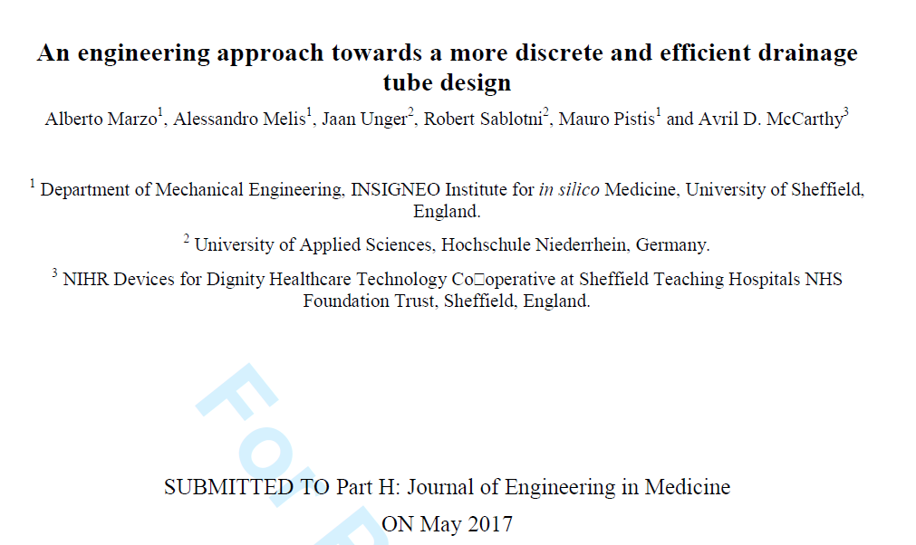
Figure 7.3-1 - Title, authors, and journal where the Paper has been submitted.

AN ENGINEERING APPROACH FOR A BETTER INDWELLING URETHRAL CATHETER
Mauro Pistis (1,2), Cecile Perrault (1,2), Alberto Marzo (1,2)

1. INSIGNEO Institute for in silico medicine, The University of Sheffield, UK; 2. Department of Mechanical Engineering, The University of Sheffield, UK

Introduction
The Foley indwelling urethral catheter is the most commonly used device of its type. It is a system comprised of a tube inserted through the urethra and held in place by an inflatable balloon, and connected to a drainage system. This forms a closed system that allows drainage of urine from the bladder. These devices, originally designed for short-term use are now also used in the long-term setting too. Modern catheters are vulnerable to encrustation and consequent blockage by biofilm crystal deposition, often starting at the tip (Figure 1). The design, considered obsolete by the scientific community [1], must be reconsidered to produce a device suitable for long-term use.

Figure 1: Silicone catheter cross-sections at (a) 1, (b) 12 and (c) 32 cm from the tip. The images were taken after blockage (52 h) in a bladder model [2].

The research hypothesis is that catheter design may affect internal urodynamics, and as a consequence the process of biofilm formation. The aim of this study is to characterise urinary flow in an attempt to establish correlations between catheter design, urodynamics and the phenomenon of encrustation.

Methods
A computer model mimicking the physics of flow through a catheter was used to predict and investigate flows near its tip. Model geometries were created from micro CT scans of a Foley catheter to create the computational model. The fluid solver used was ANSYS-CFX, and the physical problem has been simplified using the fluid properties of water, a fluid with similar physical properties to urine. Predicted values of volumetric flow rate were validated with data previously obtained experimentally.

Results
The results show discontinuities in proximity to the areas where encrustation is believed to start occluding the catheter. An analysis of the velocity field along the mid-plane of the catheter shows that lower values are found in proximity to the tip and near the lower edges of the eyelets (Figure 2). Furthermore, wall shear stress values are also lower where encrustation starts to develop (Figure 3).

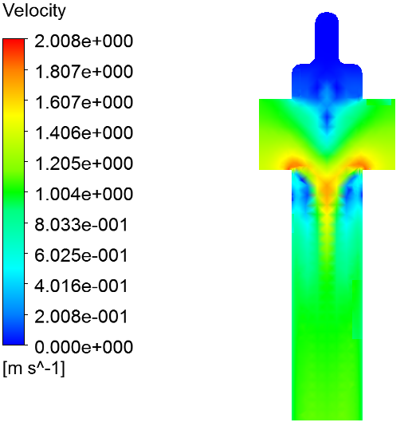
Figure 2: Contour plots of velocity along the mid-plane of the computational domain.

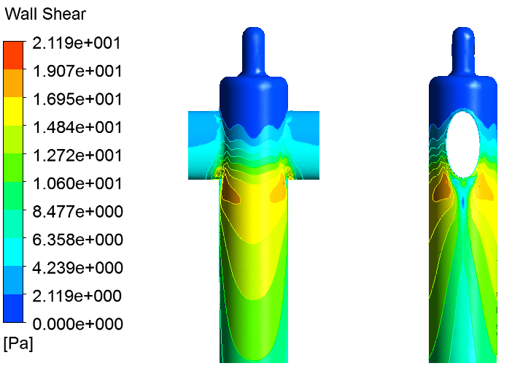
Figure 3: Contour plots of wall shear stress.

Discussion
These preliminary results have shown possible correlations between urodynamics and the phenomenon of encrustation, and have identified regions of the design that could be improved. This work will provide the methodological framework to develop more complex modelling approaches including the modelling of biofilm formation and crystal deposition. The latter will allow to study and identify the correlations between novel design concepts, urodynamics and occlusion, when patient-specific aspects are also considered, for example urine composition.

References
Roger C.L. Feneley et al, British Journal of Urology International 109:1746-1749, 2011.
N.S. Morris et al, Journal of Hospital Infection 39:227-234, 1998.

