Automatic Interpersonal Emotion Regulation
By:
Daría Naieli Hernández Ibar
A thesis submitted in partial fulfilment of the requirements for the degree of doctor of Philosophy
The University of Sheffield
Faculty of Science
Department of Psychology
23rd of September 2016

Abstract
Automatic interpersonal emotion regulation (the things people do to modify the emotions of those they interact with without awareness of what they do to cause such changes) was explored in the present thesis in 6 empirical studies. Study 1 found that people report using more strategies to improve someone else’s emotions in an automatic way with people they feel close to. Studies 2a and 2b indicated that participants primed to worsen the emotions of someone else behaved in a way that suggested they tried to worsen someone else’s emotions in comparison to participants who were not primed. Furthermore, studies 2a, 2b and 2c suggest that having an explicit goal to worsen the emotions of another person mediates the effect of the prime. In study 3, a measure of self-control depletion during the working day was developed in the hope to have an instrument that would help researchers to identify people who were depleted of self-control (as the literature suggest that people who are depleted of self-control are more likely to act automatically). Nevertheless, it was not possible to identify self-control depletion from this new measure (as observed in the scores of participants on a Stroop task). Thus, the further exploration between self-control depletion and automatic interpersonal emotion regulation could not be carried out. Instead, Study 4 was conducted, to explore the association between cognitive load and automatic interpersonal emotion regulation. The results suggest that participants under high cognitive load exerted less effort to regulate someone else’s emotions, that self-control depletion and high cognitive load made participants less aware of using IER strategies and also influenced their levels of intention to use IER (by decreasing them). Overall, these studies suggest that AIER exists and that it is possible to study it empirically.
Summary
Interpersonal emotion regulation (hereafter, “IER”) refers to the things that people do to modify the emotions of others. Several aspects of IER have been studied such as the different strategies used to modify someone else’s emotions and the aims that people pursue when engaging in IER. However, the extent to which people regulate someone else’s emotions automatically (with little or no awareness, intention and/or effort) has not been explored much. Therefore, this thesis concerns automatic IER (hereafter, “AIER”). AIER refers to the things that people do aimed at modifying or influencing the emotions of those they interact with, without awareness of what they are doing to cause such an influence or the intentionality of such behaviour. Six empirical studies were conducted to explore how AIER can be measured and the circumstances under which AIER occurs.
Study 1 explored whether people are more likely to use improving (making someone feel better) or worsening (making someone feel worse) forms of AIER when interacting with people that they feel close to and with people that they do not feel close to. A self-report questionnaire found that participants reported using improving forms of AIER with close others. Participants also reported using both improving and worsening forms of IER, in a less automatic way with people with whom they are not close to.
Studies 2a, 2b and 2c used a priming paradigm in a series of experiments in an attempt to elicit AIER. After, subjects were given the option to choose between improving or worsening the emotions of someone else. These three studies found that it was possible to prime participants to worsen the emotions of others, but that the success of the prime depended upon the subject choosing the goal of worsening the emotions of someone else and the context of where the regulation occurred (i.e. a fictional context or a familiar context).
Study 3 investigated an alternative means of studying AIER by investigating whether IER occurs even when peoples’ self-control resources are depleted. Previous research has established that the exertion of self-control leads to a state of ego-depletion (a temporary impairment of self-control) that reduces peoples’ willingness or ability to regulate emotion in a controlled way. Following this idea, study 3 examined whether exerting self-control during the day leads to a state of ego-depletion, as measured by performance on a Stroop task. If ego-depletion could be detected then it would be possible to study whether depleted people are more or less likely to use AIER, as automaticity of behaviour has been linked to poor self-control. Unfortunately, Study 3 found no effect of reported use of self-control on the Stroop task, suggesting that the measure did not accurately reflect use of self-control and, thus, it was not possible to examine whether the use of self-control was associated with the use of AIER.
Study 4 focused on a different way to examine AIER by manipulating cognitive load to see whether doing so influenced the likelihood that people would use more automatic forms of IER when interacting with a potential romantic partner (during a speed dating event). Results showed that participants exerted less effort to use IER when under high cognitive load (as compared to participants under low cognitive load), and, that regulatory depletion (caused by a consecutive use of IER) may have made participants under cognitive load less aware of using IER and less likely to intentionally try to make their dates feel better. These findings suggest that cognitive load has an effect on the use of IER. Specifically that it increases the likelihood of people being less aware of using IER, reduces the effort required to use IER and reduces the frequency of engaging in less intentional forms of IER. This could indicate that people rely more on automatic forms of IER when under high cognitive load, especially if they are depleted of their regulatory resources.
From the findings of these six studies it is concluded that AIER happens and that it can be observed empirically using different methods. Also, that there are circumstances that render people more likely to engage in AIER, such as being under high cognitive load. The methods presented in this thesis could potentially help researchers further investigate different aspects of AIER, such as in which kind of relationships it occurs, how to instigate IER unobtrusively, and the circumstances under which it occurs. Nevertheless, more work is needed to fully understand AIER, such as the motives behind it, and whether it is beneficial or detrimental to people’s lives and relationships.

Acknowledgements
First I would like to thank my two great supervisors, Thomas Webb and Peter Totterdell. I would not have been able to complete this thesis without their excellent academic guidance and their moral support during the difficult times.
I would also like to thank all the people that took part in this research. Special thanks to my office mate, Tom, who always listened to my doubts and offered good advice to solve them. I would also like to acknowledge my colleagues and friends, Raúl, Giulia, Tom (again), Betty, Javier and Sofía who kindly helped as research assistants and that contributed to the full experience of the PhD with interesting talks and necessary distractions.
Special acknowledgements to my family, and to my mum in particular. It would have not been possible for me to do this PhD without her help, always encouraging me to keep studying and forcing me to keep attending my English classes when I was a stubborn teenager. I would also like to thank my grandmother: abue, ya terminó el martirio, gracias por echarme porras todo el tiempo, esta tesis en parte va para ti.
Finally I would like to thank Andrew Gardner, who kindly did my proofreading (and a bit more) without much complaints and who was incredibly supportive and helpful in all imaginable ways during this process.

Publication and conferences
Webb, T. L., Totterdell, P., Hernandez-Ibar, D. N. (2015). Foundations and extensions for the extended model: more on implicit and explicit forms of emotion regulation. Psychological Inquiry, 26 (1), 123-129.
Hernandez Ibar, D. N. (2014). Can automatic interpersonal emotion regulation be instigated via the use of the scrambled sentence task? Paper presented at the Consortium of European Research on Emotion Conference, Berlin, 2014.
Hernandez Ibar, D. N. (2013). Making someone feel bad without awareness of how we did it. Paper presented at the XI Symposium of Mexican Students and Studies, University of Sheffield 2013.

Contents
CHAPTER 1. CONCEPTUAL FOUNDATIONS OF AUTOMATIC INTERPERSONAL EMOTION REGULATION p16
1.1 Introduction p17
1.2 Emotion regulation p19
1.2.1 How is emotion regulated? P21
1.2.2 Classification of emotion regulation strategies p23
1.3 Automatic emotion regulation (or implicit emotion regulation) p25
1.4 Interpersonal emotion regulation (or extrinsic emotion regulation) p32
1.5 Automatic interpersonal emotion regulation p34
1.6 Methodological approaches for studying AER p37
1.7 Concluding comment p41
1.8 Broad research questions in the present thesis. P42
1.9 Plan of the thesis p43
CHAPTER 2. HOW DO PEOPLE REGULATE OTHERS’ EMOTIONS? MEASURES OF FREQUENCY AND HABIT. p47
2.1 Automatic emotion regulation with close others and with acquaintances p48
2.1.2 Improving and worsening IER p51
2.2 Habits and automaticity p54
2.3 Study 1 p56
2.3.1 Method p57
2.3.1.1 Participants p57
2.3.1.2 Procedure p57
2.3.1.3 Materials p59
2.3.2 Results p61
2.3.2.1 Manipulation check p61
2.3.2.2 Self-reported AIER p63
2.4 Discussion p65
2.5 Limitations and Future Directions p70
2.6 Conclusion p76

CHAPTER 3. IS IT POSSIBLE TO PRIME INTERPERSONAL EMOTION REGULATION? USING THE SCRAMBLED SENTENCE TASK TO INSTIGATE AUTOMATIC INTERPERSONAL EMOTION REGULATION p78
3.1 Introduction p80
3.2 Priming p82
3.2.1 Scrambled Sentence Task p87
3.3 Studies 2a and 2b p88
3.3.1 Study 2a p88
3.3.1.1 Method p89
3.3.1.1.1 Participants p89
3.3.1.1.2 Procedure p90
3.3.1.1.3 Materials p91
3.3.1.1.4 Coding strategy p94
3.3.1.2 Results p96
3.3.1.3 Discussion p101
3.3.2 Study 2b p102
3.3.2.1 Method p103
3.3.2.1.1 Participants p103
3.3.2.1.2 Procedure p103
3.3.2.1.3 Coding strategy p104
3.3.2.2 Results p105
3.3.2.3 Discussion p109
3.3.3 Study 2c p111
3.3.3.1 Method p112
3.3.3.1.1 Participants p112
3.3.3.1.2 Procedure p113
3.3.3.1.3 Materials p114
3.3.3.1.4 Coding strategy p116
3.3.3.2 Results p117
3.3.3.3 Discussion p122
3.3.4 General discussion p124

CHAPTER 4. DOES HAVING PREVIOUSLY EXERTED SELF-CONTROL AFFECT THE USE OF INTERPERSONAL EMOTION REGULATION? p129
4.1 Strength model of self-control p131
4.2 Study 3 p140
4.2.1 Predictions p140
4.2.2 Method p142
4.2.2.1 Participants p142
4.2.2.2 Procedure p142
4.2.2.3 Materials p143
4.2.3 Results p147
4.2.4 Discussion p153
4.2.5 Concluding comment p167

CHAPTER 5. ARE PEOPLE MORE LIKELY TO USE AUTOMATIC INTERPERSONAL EMOTION REGULATION WHEN EXPERIENCING MENTAL LOAD IN A SOCIAL CONTEXT? P169
5.1 Automaticity and cognitive load p172
5.2 Interpersonal emotion regulation in romantic interactions p174
5.3 Factors that affect AIER p176
5.4 Study 4 p178
5.4.1 Method p179
5.4.1.1 Participants p179
5.4.1.2 Procedure p180
5.4.1.3 Materials p184
5.4.1.4 Data analysis strategy p189
5.4.2 Results p191
5.4.3 Discussion p214

CHAPTER 6. General discussion p220
6.1 Summary of Chapter 1 to 5 p222
6.2 Does AIER happen, and if so, can it be empirically studied? P229
6.2.1 AIER with close others p236
6.2.2 Improving vs worsening forms of AIER p237
6.3 What factors are associated with the use of AIER? P238
6.4 Limitations and future directions p240
6.6 Final comment p243
References p244

List of tables
Table II.1 p63
Table II.2 p63
Table III.1 p93
Table III.2 p96
Table III.3 p98
Table III.4 p101
Table III.5 p105
Table III.6 p106
Table III.7 p117
Table III.8 p118
Table III.9 p120
Table IV.1 p148
Table IV.2 p151
Table IV.3 p153
Table V.1 p194
Table V.2 p195
Table V.3 p196
Table V.4 p199
Table V.5 p209
Table V.6 p209

List of figures
Figure 2 p64
Figure 3.1 p100
Figura 3.2 p109
Figure 3.3 p121
Figure 5.1 p202
Figure 5.2 p204
Figure 5.3 p206
Figure 5.4 p207

APPENDICES
Chapter 2 p281
Chapter 3 p290
Chapter 4 p300
Chapter 5 p305

CHAPTER 1
Conceptual foundations of automatic interpersonal emotion regulation

1.1 Introduction
In everyday life people are exposed to situations that may potentially elicit emotions. People might have a stressful work meeting, attend their child’s first school performance, or simply watch a very sad film, to name some examples. During situations like this people may need to control or change the way they feel or express their emotions, referred to as emotion regulation (ER). For example, a driver might control her anger by refraining from shouting at someone overtaking her when she is at a corner. People engage in ER for many reasons, they could use ER to react appropriately in a given context (e.g. avoid crying in public or smiling when receiving a gift that one does not like), or to promote pleasure and avoid pain (e.g. looking away during the disturbing scenes of a horror film) (Gross, 1998; Tice & Bratslavsky, 2000).
Individuals can regulate their emotions in a variety of ways. From shifting their attention to avoid exposure to an undesired situation (e.g. Aspinwall & Taylor, 1997) to thinking of a situation in a different way to make it less threatening, unpleasant or distressing (Gross & John, 2003b), or even by modulating body responses like the way one breathes to reduce worrying about a particular event (Arch & Craske, 2006). ER can occur under the person’s awareness – termed controlled emotion regulation (CER) (e.g. breathing deeply to soothe angry feelings); and ER that happens without the person’s awareness - termed automatic or implicit emotion regulation (AER) (e.g., walking away from a market stall with rotting fish to avoid feeling disgust, without awareness of what is being done to avoid such disgust). Furthermore, ER can occur within the person – termed intrapersonal emotion regulation (e.g. listening to a song one likes to enhance one’s emotions) (see Koole, 2009, for a review); or between individuals – termed interpersonal emotion regulation (IER) (e.g., soothing a child who has burst into tears to try to make him feel better).
Although research into ER has been increasing rapidly (Gross, 2013; Koole, 2009), most of it focuses on controlled and intrapersonal forms of ER. The little research that has investigated IER (interpersonal emotion regulation) has focused mostly on controlled IER (see Niven, Totterdell, & Holman, 2009; Parkinson & Totterdell, 1999, for an overview). The present thesis distinguishes itself by attempting to investigate automatic forms of interpersonal emotion regulation (AIER). AIER strategies are the things that people do to modify the emotions of others without awareness, intention and/or effort to do something to elicit those changes. The AIER strategies that this thesis explores have the purpose of changing another person’s emotions. Thus, this thesis would talk about, for example, chewing with an open mouth to annoy someone else but would not include chewing with an open mouth when it is a habitual behaviour that does not have the purpose of regulating someone else’s emotions.
Several empirical studies have suggested the presence of automaticity in IER (e.g., Coan, Schaefer, & Davidson, 2006; Fitzsimons & Bargh, 2003; Hafner & IJzerman, 2011) but there is currently no consensus on the best way to elicit and measure AIER. This thesis aims to develop a systematic way to elicit and measure AIER and to investigate the factors that predict or are associated with the use of AIER. Studying AIER should provide a better understanding of interpersonal relationships by explaining: why people engage in AIER, which IER strategies tend to be more automatic (i.e. improving someone else's emotions, worsening someone else's emotions), the conditions in which IER is more likely to be performed automatically (i.e. after having previously exerted self-control, under cognitive load, with close others, with strangers) and how to identify AIER. This holds the promise of improving relationships and well-being in general.
The present chapter describes the basic concepts necessary to understand AIER. The chapter then outlines how the automaticity of ER has been studied and describes the methodology that this thesis uses to explore AIER. The basic questions investigated in this thesis are then introduced and finally the content of the thesis is briefly described.
1.2 Emotion regulation
To first understand what ER is, it is necessary to explain what is being regulated, thus to understand what emotions are. Emotions are multifaceted, whole-body responses that involve coordinated changes in the domains of subjective experience, neurological activation, attention processes, cognitive appraisals (i.e. interpretations of an emotionally arousing event), behaviour and peripheral physiology (Mauss, Bunge, & Gross, 2007; Thompson, 1994). Emotions can be differentiated from moods by their duration (emotions are shorter than moods), their intensity (emotions are more intense than moods), but mainly due to the of the presence of a goal (emotions are goal directed whereas moods tend not to) (Moors, 2010). Emotions have a goal component as they originate when a person sees a situation that is relevant to his or her goals. For example, a student might get a good grade and feel happy because she had the goal of raising her grades to enter a good university (Gross & Thompson, 2007). The present thesis will focus on emotions only, given the fact that they have an intentional component (a goal), and the topic of study in the present thesis, AIER, implies engaging in intentional behaviour to modify or regulate the emotions of someone else in an automatic way.
This thesis considers emotions as dimensional (including two or more dimensions, like valence and arousal (Lang, Greenwald, Bradley, & Hamm, 1993; Posner, Russell, & Peterson, 2005; Russell, 1980; Talarico & Rubin, 2009). On the valence dimension, emotions cause changes in many aspects of people's bodies and minds and these changes can be generally interpreted as positive or negative; giving rise respectively to positive and negative experiences of emotion (Fredrickson, 2004; Ortony & Turner, 1990). Negative emotions refer to emotions which are believed as non-desired, to be avoided, considered as undesirable behaviour and, experienced as unpleasant, for example, sadness, anger and fear (Green, 1992). On the other hand, positive emotions refer to emotions believed as desired, to be approached, considered desirable behaviour and experienced as pleasant states, for example, joy (Green, 1992). On the arousal dimension emotional experiences range from calming or soothing to agitating or exciting. Although many researchers have seen emotions as portraying pleasant or unpleasant states that are approached or avoided, in many cases unpleasant emotions serve as vehicles to attain goals (Tamir, 2009). For example, Tamir and Ford (2012), showed that participants preferred experiencing unpleasant emotions when having the goal to confront someone. To sum up, even though emotions have been generally categorised as positive and negative, it is important to keep in mind that disregarding the valence, emotions can help people reach a goal, becoming useful or positive for people's aims. Emotions are important as they may inform people about the progress that they have made towards their goals and signal where attention is needed (Carver & Scheier, 1990). For example, if someone experiences unpleasant emotions (feels unhappy) about his eating habits, this could be telling him that more work needs to be done to reach the goal of eating healthily.
Having explained what is being regulated it is now possible to have an operational definition of ER. Many researchers have provided different definitions of ER but for the purpose of this thesis emotion regulation is defined as the changes in any aspect of people’s emotional states (e.g. occurrence, valence, arousal, duration, approach/avoidance) that can happen at any point from the person’s total awareness to the person’s total lack of awareness (Gross & Thompson, 2007; Koole, 2009). When regulating emotions, people can regulate the intake of emotionally arousing information, they can alter the interpretation of emotionally eliciting events (e.g. by thinking that sweating before teaching a class is normal), or can enhance accessibility to coping resources (e.g. calling a friend to provide company) (Thompson, 1994). For example, if people perceive a situation as dangerous they might behave in a cautious or evasive manner and probably experience body signs of alert (e.g. sweating, palpitations, etc.).
1.2.1 How is emotion regulated?
The regulation of emotions is done in numerous ways. People can smoke a cigarette to decrease anxiety, pet their dog after a tiring day, or put on headphones to avoid listening to an unpleasant conversation. ER therefore involves attempting to evoke some kind of increment, decrement or maintenance of the experience of emotions (Gross, 2013; Gross & Thompson, 2007; Koole, 2009). In this thesis the decrement of negative and positive emotions will be referred to as down-regulation of negative and positive emotions respectively (e.g. watching a comedy program to feel better or breathing deeply and slowly to avoid laughing out loud in an inappropriate situation). The increment of negative and positive emotions will be referred to as up-regulation of negative and positive emotions respectively (e.g. over criticising oneself for a committed mistake or buying a desired item as a reward for an accomplished goal). When ER is aimed at worsening (making feel bad) the emotions of a person it will be referred as worsening ER, while enhancing ER (making the person feel good) will be referred as improving ER.
When people experience an emotion as negative, it is likely they will try to down-regulate it (Gross, Richards, & John, 2006), but sometimes people maintain negative states, especially during psychopathological processes such as depression. For example, (Nolen-Hoeksema, 2000) reported rumination (which refers to the persistent thinking and attention to the symptoms of one's distress) to be a predictor of depressive disorders. Increments in emotional responses have also been explored. For example, Schmeichel, Demaree, Robinson, and Pu (2006) manipulated the disgust reactions of people watching a disgust-inducing film clip. They asked participants to exaggerate their disgust and noticed that such exaggeration caused participants to reduce their cognitive fluency (as measured by their verbal fluency).
Increments, maintenance and decrements of the emotion experience can be achieved using a wide number of strategies. Some example strategies that are aimed at up-regulating and/or down-regulating positive emotions include savoring which refers to focusing on positive aspects of the past, future or present to maintain and/or up-regulate positive emotions; capitalising which refers to strategies used to up-regulate positive emotion such a celebrating and sharing; or dampening, which refers to focusing on negative thoughts to down-regulate positive affect (Carl, Soskin, Kerns, & Barlow, 2013). On the other hand, rumination is an example of an ER strategy aimed at up-regulating or maintaining negative emotions (Nolen-Hoeksema, Wisco, & Lyubomirsky, 2008). Most ER strategies however do not exclusively serve the increment or decrement of positive or negative emotions. For example, reappraisal or changing the way one thinks about a potentially emotional-eliciting event (e.g. thinking of talking in public as a rehearsal instead of the real event in order to decrease anxiety) can be used either to improve one's affect or to worsen one's affect (Gruber, Hay, & Gross, 2014). More detail of different ER strategies and the way they have been classified is provided next.
1.2.2 Classification of emotion regulation strategies
Many strategies to regulate one’s emotions have been identified. People can use reappraisal which is a form of cognitive change that involves construing a potentially emotion-eliciting situation in a way that decreases its emotional impact (e.g., Goldin, McRae, Ramel, & Gross, 2008; Gross, 1998; Gross & John, 2003b; Ochsner, Bunge, Gross, & Gabrieli, 2002; Richards, Butler, & Gross, 2003; Richards & Gross, 2000), self-distraction (e.g. Kalisch, Wiech, Herrmann, & Dolan, 2006; Parkinson & Totterdell, 1999b; Rusting & Nolen-Hoeksema, 1998; Sheppes, Catran, & Meiran, 2009), attentional deployment to shift attention away or towards the emotional response (e.g. Ferri, Schmidt, Hajcak, & Canli, 2013; Johnson, 2009; Urry, 2010), and suppression (e.g. Butler et al., 2003; Gross & Levenson, 1993; Hofmann, Heering, Sawyer, & Asnaani, 2009; Levesque, Copeland, & Sutcliffe, 2006; Richards et al., 2003), to name some.
Literature on ER has classified ER strategies according to different criteria, for example, Koole (2009) uses a classification according to the psychological function of ER. He talks about three functions: the need-directed function (aimed at decreasing the negative and increasing the positive level of the emotion), the goal-directed function (aimed at pursuing a desirable emotional state) and the person-directed function (which focuses on the needs, goals, motives and other self-aspects of the person). Within each of these functions an individual can engage in ER behaviours at an attentional level (turning attention away or towards the emotional stimulus), at a knowledge level (where the person thinks in an evaluative manner of an emotional situation) or body level (which refers to the changes that can be made in the bodily manifestations of emotion) (Koole, 2009). For example, in the need-directed function, an attentional level ER strategy would be attentional avoidance (directing one’s attention away from the emotional situation); in the knowledge level, relevant strategies would include cognitive dissonance reduction (reduction in the feeling of discomfort caused by conflictive attitudes, beliefs or behaviours) or motivated reasoning (the influence motives have on perceptions, attitudes and attributions); and in the body level, stress-induced eating would be relevant.
Another widely-used classification of ER strategies bases its classification on the stage at which the emotion is regulated in its development. Gross's, process model of emotion regulation (2002) broadly classifies ER regulation into antecedent focused ER, which includes the 1) selection of the situation, 2) the modification of the situation, 3) attentional deployment and, 4) cognitive change; or response focused emotion regulation which includes 5) the modulation of the emotional response. Antecedent focused ER strategies occur before the emotion has been completely activated. One antecedent focused ER strategy would be reappraisal, which is used before something provokes an emotional reaction in the person. For example, people who are afraid of dentists might think in advance that they are going for a simple procedure, in order to prevent feelings of fear from happening. In contrast, response focused ER strategies occur when the emotion has already been activated. Using the same going to the dentist situation, people might try to hide their feelings of fear to avoid the dentist noticing they are terrified. This model is particularly useful as it allows researchers to investigate which strategies are more effective (for a review see Webb, Miles, & Sheeran, 2012), with a tendency of antecedent-focused strategies as being more effective than response-focused strategies (Gross, 1998; Gross & John, 2003b), particularly, cognitive change strategies (e.g. reappraisal) (Webb et al., 2012).
Another broad way of classifying ER is into strategies designed to improve versus those designed to worsen emotions. (Niven et al., 2009) proposed and validated a classification of IER strategies (strategies people use to modify the emotions of someone else) in which, at the broadest level of abstraction, classified strategies into improving and worsening IER depending on whether the motive behind the use of the IER strategy was to improve or to worsen the other person's feelings (e.g. making time for someone or being unfriendly toward someone, respectively). This classification will be discussed in more detail in the section on IER.
1.3 Automatic emotion regulation (or implicit emotion regulation)
One broad classification that can include pretty much every kind of ER is to place ER strategies on a continuum that goes from automatic to controlled processes (Gyurak, Gross, & Etkin, 2011). In Bargh's (1994) work The four horsemen of automaticity, he describes automatic processes as processes that occur without the person’s awareness, control, intention, and which require little or no effort to be carried out. Bargh proposes that a person can be unaware of the process itself, of the way it is interpreted, and/or of the influence it has on the person’s thought, perception, and/or behaviour. The control feature refers to the person’s incapacity to stop the mental process, either its onset, development and/or completion (Bargh, 1994). An automatic process occurs without the person’s intention, nevertheless, intentions can be triggered outside of conscious awareness (Bargh, Gollwitzer, Lee-chai, Barndollar, & Trotschel, 2001). The final feature of an automatic process for Bargh refers to its efficiency, meaning that the automatic process does not depend upon limited attentional resources. By contrast, in explicit or controlled emotion regulation (CER), people are aware of the environmental cues that initiate an emotional response, the emotions they are experiencing, and the effect of the regulation on these emotions and on their behaviour (Gyurak et al., 2011). Although these four features define an automatic process, there is no consensus among researchers as to whether all these features need to be present or not. Even Bargh and Williams (2007) acknowledge that these features may or may not co-occur in an all-or-none fashion and recommend that researchers focus on the features of most interest to them. These aspects being the defining features of automatic processes, Bargh and Williams (2007) also propose that they would likely be present in AER; although they mention that AER might not necessarily function in the same way as other automatic cognitive phenomenon (e.g. stereotypes, attitudes), and would most likely have its own particular automatic ways of working. Thus, considering these four aspects the features of AER; in the present thesis, AER is described as any process that operates without the need of conscious supervision or explicit intentions, which is relatively effortless, and which is aimed at modifying the exposure to, processing of, duration, and/or response to an emotionally evocative event (Williams, Bargh, Nocera, & Gray, 2009).
Some researchers argue that AER presents more advantages to the individual than CER because it is adaptive and can help self-regulation by relying on automatic processes that free the individual from his/her conscious concerns about the surrounding environment (Bargh & Williams, 2006). One example showing that AER can be adaptive and help control negative emotions is the work conducted by Mauss, Cook, and Gross (2007). In two experiments Mauss and colleagues found that participants primed to control their emotions via the Scrambled sentence task (Srull & Wyer, 1979) (by unscrambling sentences including words like restrains, stable, and covered), reported less anger when provoked (asked to count backwards by 7 or 13s from 18652 while being interrupted multiple times and given negative feedback) than participants primed with emotion expression (by unscrambling sentences including words like impulsive, volatile, and boiled). Mauss and colleagues observed that participants in the emotion control group reported less anger than participants in the emotion expression condition. Furthermore, participants in the emotion control group did not present maladaptive cardiovascular responding (e.g. increased sympathetic activation, threat pattern of physiological responding), which suggests that AER helped participants to control their anger without negative consequences. Repressive coping (an AER strategy that consists in directing attention away from negative affective experiences) has shown to be adaptive as well. Coifman, Bonanno, Ray, and Gross (2007) found that repressive coping helped people deal with strong aversive events (e.g. death of a spouse) and was also associated to less symptoms of psychopathology, less somatic complaints and better social adjustment than in people who did not use repressive coping.
On the other hand, some researchers have found that AER can be maladaptive. Shedler, Mayman, and Manis (1993) found that people judged as mentally distressed by professional clinicians but who used defensive denial to present themselves as mentally healthy when answering standard mental health scales (the Eysenck Neuroticism Scale and the Beck Depression Inventory) presented more implicit signs of anxiety (e.g. stammering) and more cardiovascular responding when exposed to psychological stressors (solving arithmetic calculations, telling stories in response to the Thematic Apperception Test, and responding to a phrase association test). Some researchers have also identified that people with avoidant attachment styles (people that avoid engaging in close emotional relationships) have developed the capacity to automatically inhibit negative emotional impulses, but this capacity comes with a cost for the person: affecting his/her personal relationships, his/her recognition of her/his own emotions, his/her problem solving skills (Shaver & Mikulincer, 2007). For example, in a study conducted by Dozier and Kobak (1992), participants with an avoidant attachment style who were asked to recall distressing child events (i.e. separation, loss), expressed few negative feelings but showed high physiological responding (as measured by their skin conductance). In short, understanding which emotion regulation strategies can improve the individual’s life when used automatically could have important implications for mental and physical health, as well as for our understanding of social relationships.
The extent to which people engage in AER and/or get healthy outcomes from using AER may depend on individual differences or on the mental health of the person. Schmeichel and Demaree (2010) found that participants high in working memory capacity (WMC) engaged more easily in AER. They asked participants to solve an alleged emotional intelligence test and were provided with negative feedback. Schmeichel and Demaree found that the affect of participants who scored high in a WMC measure did not decrease when they received negative feedback, while the affect of participants low in WMC did, suggesting that participants high in WMC spontaneously engaged in emotion regulation strategies to improve their affect. In another study by Jostmann, Koole, Van Der Wulp, and Fockenberg (2005), participants with action orientation approaches (i.e., those that intuitively promote affect regulation and action) showed less negative affect in response to a priming task that consisted of subliminally showing angry faces to participants on screen, in comparison with participants with state-oriented approaches (i.e., those that inhibit affect regulation and action). DeWall et al. (2011) found in a series of studies that people low in depression as well as people high in self-esteem automatically improved their negative affect when experiencing acute exclusion. Thus, the adaptive or maladaptive consequences of engaging in AER might not only depend on the type of AER strategy the person uses, but also on the personal characteristics of each individual, such as WMC, action orientation styles and mental health.
Although it is useful to distinguish between controlled and automatic ER strategies, these two poles should not be treated in an exclusive way since there are some cases in which ER may contain elements of both, if not simultaneously, and in which the same ER strategy can be used both automatically and in a controlled manner. For example, reappraisal has been used as both a CER and AER strategy. Ochsner et al. (2002) used reappraisal as a form of controlled emotion regulation. They asked participants to decrease, maintain or increase their emotional reactions using this strategy while watching emotion-eliciting pictures. Ochsner and colleagues (2002) observed that reappraisal decreased the participant’s subjective experience of negative emotion. Through the use of fMRI, they also observed that specific areas of the brain became active while reappraising (the lateral and medial prefrontal regions). In another study, Williams et al. (2009) also studied reappraisal, only that they used it as both a CER and an AER strategy. They used the Scrambled Sentence Task to prime one third of their participants with the goal to reappraise. Another third of participants was explicitly told to reappraise and the rest were given no instructions. They then exposed all participants to a stressful task (preparing a 3-minute oral speech) and measured their heart rate variability (HRV). They found that both the explicit and the priming group had significantly less HRV than the non-instructed participants, indicating primed participants experienced less distress than the control participants. The studies by Ochsner et al. (2002) and Williams et al. (2009) exemplify that some ER strategies can work in both automatic and controlled ways.
How people make use of AER in their lives seems to be linked to different factors. For example, habits might promote the use of automatic forms of emotion regulation. Bargh, Chen, and Burrows (1996) suggested that if a person consistently behaves in the same form in response to a situation, that response should become automatically associated with that situation. This principle may be applied to emotion regulation behaviour too. Children, for example, start using ER strategies from a very early age (Calkins, 2004), thus, the frequent use of a specific forms of ER could end up in an automation of that behaviour (Bargh & Williams, 2007). For example, if someone encounters a person that behaves in a rude manner all the time, that person may think that it is not worth feeling bad about this rudeness, then this ER strategy (changing the way one thinks about a situation) may become more automatic the more the person uses it. Similarly, being in a state of ego depletion (“a temporary reduction in the self’s capacity or willingness to engage in volitional action caused by prior exercise of volition”, Baumeister, Bratslavsky, Muraven, and Tice (1998, p. 1253) might also influence the use of AER. People who have expended this resource or that are low in self-control are more likely to act according to impulses, to rely on heuristics, on effortless processes and associative mental representations (Hofmann, Friese, & Strack, 2009; Strack & Deutsch, 2004). To sum up, people may engage in ER in an automatic way, varying the amounts of effort, awareness, intention and/or efficiency they exert when modifying their emotions, and this AER could be adaptive or maladaptive depending on the personal characteristics of each individual, as well as on the person’s mental health. Furthermore, habitually using certain ER strategies throughout life or being in a state of ego depletion could also make people more likely to engage in AER.
1.4 Interpersonal emotion regulation (or extrinsic emotion regulation)
While it is true that emotions are experienced at a personal level, it is undeniable that a social component plays a paramount part in the way people interpret, feel, and communicate emotions. For example, observing someone’s emotional expression provides information about the situation (e.g. someone expressing fear could indicate there is a dangerous situation to be avoided). Experiencing pleasure from the misfortune of someone else or schadenfreude is another example of how emotions have an interpersonal ingredient. Emotions also provide information on how to respond to people, seeing someone cry might elicit a comforting response (for a review of the social psychology of emotions see Parkinson, 2011). This social component of emotions may also affect ER, as mentioned in the introduction of this chapter, ER may occur within the person – that is, people control their own emotions (termed intrapersonal or intrinsic emotion regulation) – or between people – that is, people influence someone else’s emotions (termed interpersonal emotion regulation or IER). Kappas (2011) argues that ER has an interpersonal component because it is influenced by social processes. He observed that people (especially children) might not be able to regulate their emotions all the time and that the help of adults is useful in these cases. In the present thesis, IER is defined as the process of purposely influencing the internal affective states of another person (Niven et al., 2009).
In the same way as there are multiple forms of regulating one’s emotions, the strategies used to regulate someone else’s emotions can also vary greatly. For example, Vangelisti, Daly, and Rudnick (1991) studied the use of guilt as an IER strategy. They found that behaviours that make the other person feel guilty increase in number as the relationship becomes more intimate. Neuman and Baron (1998) studied aggression in the work place (efforts to harm others with whom one works or has worked), and they identified that most of them were not physical assaults but involved some kind of verbal or symbolic aggression (e.g. ostracism). Kahn (1993) studied caregiving in institutions (e.g. churches, hospital, schools) and identified eight behavioural dimensions of caregiving that encompass many different actions (e.g. welcome other, maintain respectful tones, speak warmly, nod encouragingly). It was also identified that these behaviours influenced the emotions of the care seeker by making him/her feel cared for and about. Francis, Monahan, and Berger (1999) explored the use of humour as a means of managing interpersonal emotions in medical institutions, finding that humour was used to enhance the emotions of people involved in medical interactions. These research examples illustrate in a very brief way the diversity of forms and contexts in which a person may regulate the emotions of others.
The number of potential IER strategies that individuals can use is large so it is useful to be able to classify them. Niven et al. (2009) classified controlled IER strategies according to three factors: i) the motive behind IER (to improve or to worsen the target's affect), ii) the primary means to achieve IER (to change the way the target feels by behaving in a certain way with him/her or by changing the way he/she feels about his/her situation), and iii) the secondary means to achieve IER (to engage in the target's feelings or to divert the target's feelings). Most research that has explored IER to date has focused on the first factor; namely, whether IER is used to improve or to worsen someone else's emotions. Niven and colleagues also considered this distinction as fundamental. In their classification of controlled IER strategies they asked participants to sort out cards that contained different IER strategies into any kind of categories the participants could think of. They found that participants tended to distinguish between strategies aimed at making someone feel better and strategies aimed at making someone feel worse. For this reason, and for parsimony, this thesis will focus on distinguishing between improving and worsening IER.
A crucial aspect of IER is that it likely occurs in every kind of relationship. Researchers have found people using IER in: intimate relationships (Buss, 1992; Indvik & Fitzpatrick, 1982; Vangelisti et al., 1991), work relationships (Cross, Baker, & Parker, 2003; Francis et al., 1999; Neuman & Baron, 1998), non-familiar encounters (Cahill & Eggleston, 1994) and during therapy (Thoits, 1996), to name some examples. But one question that still needs an answer is whether people use IER in an automatic way.
1.5 Automatic interpersonal emotion regulation
So far, it has been explained that ER shapes people’s behaviours. It can be intended to improve or worsen emotions, either at an intrapersonal level (the individual’s own emotions) or at an interpersonal level (someone else’s emotions), that the number of ER strategies is as numerous as the situations in which emotions can be regulated, that ER can be beneficial of harmful for the individual and that ER can be performed automatically or under the individual’s control. One last feature that still remains to be explained, and the one that forms the focus of this thesis, is the potential for ER to occur both interpersonally and at an automatic level, which will be named as automatic interpersonal emotion regulation (AIER).
Some of the first evidence of emotions occurring automatically in a social context can be seen in research about motor mimicry and emotional contagion. Chartrand and Bargh (1999) coined the term “the chameleon effect” to refer to the nonconscious mimicry of the postures, mannerisms, facial expressions, and other behaviours of interaction partners. Chartrand and Bargh suggested that this nonconscious mimicry facilitated social interactions without intention or awareness. They also observed that people whose mannerisms are mimicked by others report liking these others more (even if they are strangers) and give a more positive evaluation of the interaction than when not mimicked. The phenomenon of mood contagion is similar but focuses on mimicking the mood (e.g., the behaviours expressed by that mood, like smiling and frowning) of the person that one is interacting with. This mimicking occurs without conscious awareness and later causes a congruent mood state in the person that is mimicking the behaviour (Neumann & Strack, 2000). For example, researchers have argued that people can regulate the emotions of someone else by influencing the other person directly (e.g. by complimenting the other person), but also by regulating or modifying their own emotions which, in turn, are thought to influence other people’s emotions, perhaps via mood contagion (Lopes et al., 2011).
Although the previous paragraph provides evidence of emotions occurring interpersonally and to some extent automatically, it does not clearly refers to AIER, as the changes in the emotions of one person seem to occur at an intrapersonal level to then be transferred passively to another individual by simple mimicry or contagion, which does not reflect an intention to change the emotions of someone else. There is evidence of research where AIER seems to occur in a more active fashion. For example, Häfner and IJzerman (2011) explored the spontaneous occurrence of ‘accommodation’ (the tendency to deliberately inhibit a destructive reaction in response to a partner’s destructive behaviour) in romantic couples. The researchers showed participants an angry picture of their romantic partner and observed that those in communal relationships (interacting on the basis of a special obligation to the other’s needs) smiled at it, as measured by an EMG (electromyogram). The smiling reaction occurred within the first second after the angry face was presented, which suggests that the accommodation strategy occurred outside the participant’s awareness. Häfner and IJzerman study is important evidence of ER occurring in an interpersonal relationship and in an automatic way, nevertheless Häfner and IJzerman do not make clear whether the participant’s smile was aimed at modifying their partner’s emotions. Another example constitutes the work of Coan et al. (2006) on social contact as a way to promote health in the face of life stressors. In their research, they exposed different groups of women to a stressor (the threat of an electric shock), while holding the hand of their husbands, the hand of a male experimenter or no hand at all, and they observed that the hand of their husbands and the hand of a male experimenter attenuated the women’s neural activation to threat (as measured in an fMRI), more in the case of the husband’s hand than in the case of the experimenter’s hand. This study shows that holding the hand of someone can diminish stress responses, nevertheless, this research was conducted from the point of view of women who regulated their own threat response by holding the hand of someone else. To be able to say that this was AIER, it would have been necessary to explore this regulation from the point of view of the people who held the hand of the women participants. A final piece of evidence that suggests the existence of AIER lays in the work of (Fitzsimons & Bargh, 2003). In a set of studies where the researchers activated interpersonal goals (goals ‘to attain, maintain, or avoid a specific end state for the partner or the relationship’ (p. 150)) without the participant’s awareness (by asking half of participants to think of a friend and the other half, to think of a co-worker), they observed that, when participants had an activated interpersonal goal they tended to be more helpful and understanding towards others. However, Fitzsimons and Bargh do not consider this IER but rather interpersonal goals. Thus, the question of whether AIER occurs still remains as there has not been yet conclusive evidence confirming its existence. One of the possible reasons might be the difficulty of studying automatic processes. The next section summarises some of the most representative methods to study automatic processes, and presents the methods that were used to empirically study AIER in the following chapters.
1.6 Methodological approaches for studying AER
AER in psychology can be studied in many different ways. For example, some researchers have used neuroimaging procedures, such as the fMRI, that aim to identify which parts of the brain become active while people allegedly engage in AER. Research by Gillath, Bunge, Shaver, Wendelken, and Mikulincer (2005), for example, explored the neural correlates of women with different attachment styles using the fMRI. They asked their participants to imagine negative scenarios (i.e. break-up, death of a partner, conflict) and then to try to stop thinking of them while the researchers measured which areas on the brain became active. They found that women low in attachment avoidance exhibited suppression of the subcallosal cingulate cortex (a brain area involved in autonomic functions, i.e. heart rate, breathing), which suggests that low attachment avoidance participants may use AER. Electrophysiological techniques, like the electroencephalogram (EEG) and electrocardiogram, have also been used to study AER. Jackson et al. (2003) found that participants who were presented with unpleasant photographs showed an activation in the prefrontal cortex, (an area that has been previously associated to CER, Ochsner et al., 2002). They suggested participants may have engaged in AER because they were not explicitly instructed to regulate their emotions but that area became active. Williams et al. (2009) exposed their participants to a stressful situation (prepare a speech they were allegedly going to present publicly) and compared the heart rate of participants explicitly asked to reappraise the situation (asked to think of this situation in a not threatening way) to the heart rate of participants primed to reappraise (using the Scrambled Sentence Task and including words such as reassessed perspective, carefully analysed) and participants who were given no instructions to reappraise nor were primed. Williams and colleagues observed that participants explicitly asked to reappraise and participants primed to reappraise, had less heart reactivity than participants who were given no further instructions.
Although the abovementioned physiological techniques have provided useful information about automaticity in ER most of them have weak points when approaching it. When using neuroimaging measures, certain brain areas might become active for both automatic and controlled processes, so one cannot associate a specific brain area with an AER process or a CER process. For example the prefrontral cortex seems to be implicated in both automatic and controlled ER (Etkin, Prater, Hoeft, Menon, & Schatzberg, 2010; Ochsner et al., 2002).
Self-report measures, where participants are simply asked to reflect and report on their behaviour, have also been used to study AER (e.g. Gross & John, 2003; Mauss, Evers, Wilhelm, & Gross, 2006; Williams et al., 2009). They provide a fast, economic and easy way to gather information about AER but they have some important limitations. One of them, is that they present the disadvantage that one can only infer AER to be happening or to have happened, as asking participants requires their awareness on the concept being explored. Also, the metacognitive nature of self-report measures implies that the person has good insight into their own thought processes, which may not always be true. Furthermore, self-report measures are subject to social desirability, it is then possible that, when touching delicate topics, participants present themselves in a socially desirable manner (Nosek, 2007). Nevertheless, self-report measures are still one of the most widely used methods used in psychological research and an easy introductory way to start exploring a particular concept.
Another methodological approach to study automaticity especially in social psychology is priming. Priming consists of using environmental cues (e.g., words, images, sounds) to activate social knowledge structures (e.g., attitudes, beliefs, behaviours) incidentally or unobtrusively in an effort to influence a subsequent response without the person’s awareness of this influence (Bargh, 2006). Priming can be explained through the ‘situated inference model’ (Loersch & Payne, 2011), which basically has three steps. In the first step a priming stimulus makes some kind of information ready to be used. On a second step this is information is mistakenly attributed to one’s internal thoughts processes. Finally, on a third step something in the environment provides this misattributed information with an opportunity to become salient. For example, Mauss, et al. (2007, Study 1) used priming to explore the benefits of regulating one’s anger automatically. As a first step they used the Scrambled Sentence Task (Srull & Wyer, 1979) to activate the goal of expressing or controlling one’s emotions. One half of participants had to build coherent sentences from a set of 42 jumbled sentences, in which 19 contained the ‘emotion control’ prime, by including words like restrains, stable, covered. The other half of participants unscrambled sentences related to ‘emotion expression’ which included words such as impulsive, volatile and boiled. Once the ‘emotion control’ and ‘emotion expression’ primes were activated, as a second step, this information should have been interpreted by the participant as something ingrained in them, and not attributed to the task (the SST) they had just solved (this interpretation occurs without the person’s awareness). As a third step, Mauss and colleagues provided the appropriate environment to see the effect of the prime on the participants behaviour: they asked participants to quickly count letters on a blurry copy while at the same time the experimenter interrupted them with negative feedback about their performance. Later, participants answered an anger experience questionnaire. The researchers found that participants primed with ‘emotion control’ reported less anger than participants primed with ‘emotion expression’. Thus, the effect of the prime became salient on the third stage of this study. Mauss et al. research illustrates the suitability of priming techniques to study AIER, as they work in harmony with Bargh's (1994) features of automatic processes (little or no awareness, intention, effort, and/or control).
Another form of studying automatic processes is to create a situation in which automaticity is likely to happen. Research has shown that when people are under cognitive load (Hagger, Wood, Stiff, & Chatzisarantis, 2010) and when they are depleted of their self-control resources (Hofmann et al., 2009) they are more likely to act automatically. For example, some researchers have manipulated the cognitive capacity of their participants to facilitate the participant reliance on automatic processes when engaging in some mental or physical task (e.g. Ward & Mann, 2000). Other researchers have used the ‘dual task paradigm’ to achieve the same. In the dual task parading participants are asked to solve two different behavioural tasks at the same time in a very quick succession, as the cognitive resources of the participants are in heavy demand one of the tasks gets affected and may fail to be performed or may be performed automatically (for a review see Evans, 2008). When people have used lots of self-control (for example, they have avoided to smoke all day despite the heavy wish to do it), this self-control may run out, leaving people to respond automatically to subsequent acts that require self-control (for a review see Hagger et al., 2010). In the present thesis some of these methods, namely, self-report measures, priming, self-control depletion and cognitive load will be used to investigate AIER.
1.7 Concluding comment
Although research in ER has been increasing rapidly, most of it focuses on controlled and intrapersonal emotion regulation and a smaller part has looked into AER. The purpose of this thesis is to fill this gap in research by investigating automatic interpersonal emotion regulation (AIER) or the things people do to modify the emotions of others without awareness of what they do to generate those changes, for example, smiling at one’s partner to make him/her feel better without planning nor being aware of one’s smile. In particular, this thesis aims to develop a systematic way to identify AIER to then look into the things that predict or are associated to the use of AIER. Studying AIER could provide us with a better understanding of interpersonal relationships which hold the promise of improving relationships and well-being in general.
1.8 Broad research questions in the present thesis.
The present thesis aims to answer two fundamental questions. The first concerns whether it is possible to empirically observe AIER. To achieve this, a self-report questionnaire (Study 1) and a priming methodology (Studies 2a, 2b, and 2c) will be employed. In Study 1, participants are asked to what extent they use AIER with close others and with acquaintances. Besides identifying participants’ use of AIER, Study 1 will also provide preliminary information about the kind of relationship in which AIER is more likely to occur. In Studies 2a, 2b, and 2c, a non-obtrusive technique to explore AIER is used. Specifically, participants are primed with IER and then presented with a social situation where they had the opportunity to regulate someone else’s emotions. Studies 2a, 2b, and 2c will also explore the role that goals have in the expression of AIER.
The second question involves investigating the factors that facilitate or promote the use of AIER. To attain this, an ego-depletion task (Study 3) and a cognitive load (Study 4) task will be used. In Study 3 it was expected that, ego-depleted participants would use more automatic forms of IER when interacting with their romantic partners. In the last study (Study 4) participants were subjected to a cognitive load task while having short dates (at a heterosexual speed dating event). The use of IER was explored via questionnaires at the end of each date. It was expected that participants under cognitive load would report more use of AIER strategies as reported by the levels of intention, effort and awareness they perceived they used while engaging in IER strategies.

1.9 Plan of the thesis
The remainder of the thesis takes the form of five chapters – four describing empirical studies designed to investigate the two questions posed above, followed by a chapter that discusses the findings. An overview of these chapters is provided below.
Chapter 2. How do people regulate others’ emotions? Measures of frequency and habit.
Study 1 investigated the strategies that people use to regulate someone else's emotions and the level of awareness they report having over these strategies. For these purposes, a questionnaire asking people to report on the level of awareness they have over the IER strategies that they use to improve (e.g. listening to this person’s problems is something I do without thinking) and to worsen (e.g. acting very annoyed towards this person is something I do automatically) someone else’s emotions was designed. It was expected that participants would regulate the emotions of those close to them in a more automatic fashion than those of with whom they are less close. Thus, the questionnaire asked participants about the IER strategies that they use with someone close to them (e.g., a best friend, a close relative, a partner) as well as with an acquaintance (e.g., a neighbour, a work colleague).
Chapter 3. Is it possible to prime IER? Using the Scrambled Sentence Task to instigate automatic interpersonal emotion regulation
Asking people about the way in which they regulate someone else's emotions and their level of awareness over the IER they use provides a starting point but it can be argued that self-report measures may not necessarily reflect reality because people arguably have to be aware of what IER strategies they use in order to report them. To address this limitation, Studies 2a, 2b, and 2c used a different approach to study AIER – they tested whether it is possible to prime people (outside their awareness) to use IER. Study 2a used the Scrambled Sentence Task to prime participants to up-regulate negative emotions. Participants were later given the opportunity to regulate the emotions of someone else (they were asked to write a script between two characters and to play the part of one of these characters). The script also asked them to choose between two IER goals: either to improve or to worsen the emotions of someone else. Study 2b explored whether the removal of the IER goal option would change the effect of the prime. Study 2c was a replication of study 2a and 2b, which in addition explored the use of IER with someone the participant knew very well.
Chapter 4: Does having previously exerted self-control affect the use of interpersonal emotion regulation?
Evidence suggests that when people exert self-control over something then it is more difficult to exert self-control in a subsequent task (an effect termed “ego-depletion”). The consequence is that depleted people tend to rely on automatic responses, acting impulsively and in accordance with habits. One prediction, therefore, is that people are more likely to use automatic forms of IER when depleted than when not depleted. Following this logic, Study 3 developed a measure of the use of self-control to then be used to investigate the effect of self-control on IER. The measure consisted of a self-report questionnaire investigating the extent to which people have used self-control during their working day. It was planned to validate this questionnaire by measuring participant’s self-control capacity using the Stroop task. It was predicted that participants who reported having used more self-control during the day would perform worse on the Stroop task than participants who reported having exerted less self-control. In addition, factors that may influence self-control performance including emotional exhaustion, fatigue, quality of sleep and affect were measured.
Chapter 5: Are people more likely to use automatic interpersonal emotion regulation when experiencing mental load in a social context?
ER requires cognitive resources; therefore, having limited or no cognitive resources can lead people to rely more on automatic processes. Study 4 aimed to explore whether cognitive load influenced the way people used IER strategies in a romantic context, at a speed dating event. Variations in three features of IER that have been associated with automaticity were measured: i) the extent to which people were aware of their use of IER strategies, ii) the effort exerted when using IER strategies and iii) the intention to use IER strategies. Participants attended a speed dating event where they had between 5 and 6 dates of 4 minutes duration. Half of the participants were allocated to a cognitive load condition where they were asked to remember an 11-digit number throughout their dates and then were asked to report it at the end of each date. The other half of the participants were asked to remember a one digit number. At the end of each date participants answered a questionnaire that asked them whether they tried to make their date feel good / bad, whether they intended to do so, and the amount of effort that they put into it. It was predicted that participants in the cognitive load condition in comparison with participants in the no load condition, would report lower levels of intentionality, effort and awareness of use of behaviours aimed at improving or worsening the emotions of their dates. These are strong candidates for indicators of AIER.
Chapter 6: General discussion.

CHAPTER 2
How do people regulate others’ emotions? Measures of frequency and habit.

The previous chapter introduced basic concepts to understand automatic interpersonal emotion regulation (AIER) or the things that people do to modify the emotions of others in an automatic way. It also presented a plan for the present thesis along with two fundamental questions this thesis aims to answer: i) whether it is possible to empirically observe AIER and ii) which are the factors that facilitate or promote the use of AIER. The current chapter introduces the first empirical study which aims to answer the first fundamental question. The goal of Study 1 is to identify if people report using AIER and, specifically to investigate whether people’s report on their use of AIER varies depending on the purpose of the interpersonal emotion regulation (IER) behaviour (to make others feel better or worse) and on whether the IER takes place with close others or acquaintances.

2.1 Automatic emotion regulation with close others and with acquaintances

As people move from one social context to another, they also interact with different sorts of people. The way in which people behave towards others depends on the kind of relationship they have with them. The people encountered in a family reunion are not the same as the people encountered in a work meeting. For example, people usually hug and kiss their children when they fall down to make them feel better but they probably would not hug and kiss a stranger's child. Generally speaking, any relationship can be found along a continuum from close relationships on one end to non-close relationships on the opposite end. According to Kelley et al. (1983), close relationships have a considerable duration (measured in months or years rather than days) and the interconnections between people’s thoughts, feelings and/or behaviours are strong, frequent and diverse (e.g. sexual, intellectual, recreational, professional). Examples of close relationships include friendships, marriages and parent-child relationships. On the other hand, non-close relationships occur between people that rarely see or speak to each other and that are perceived as non-close (Kelley et al., 1983). IER may occur in every kind of relationship, it can be found in intimate relationships (i.e., mates, friends, and parents; Buss, 1992) and in romantic partners (Indvik & Fitzpatrick, 1982; Vangelisti et al., 1991). IER also occurs in work relationships (Francis et al., 1999; Neuman & Baron, 1998); in non-familiar encounters (i.e. IER between wheelchair users and strangers, Cahill & Eggleston, 1994); and in therapeutic relationships (Thoits, 1996) to name some examples. Nevertheless, close relationships present more intense experiences and expressions of emotion (Berscheid & Ammazzalorso, 2008; Schoebi & Randall, 2015) making them an ideal scenario to investigate IER.
One aspect in the use of IER strategies that may be affected by how close are people in a relationship is the level of automaticity of the IER. AIER may be present in close relationships because people interact with each other with more frequency than in non-close relationships (Kelley et al., 1983), thus, the IER strategies used in close interpersonal relationships may occur more frequently as well. Behaviours that occur frequently tend to become stronger, thus becoming habitual (Butler, 2011). The idea that automaticity may occur in close relationships is not something new, some researchers have discussed the possible presence of automaticity in interpersonal behaviours in close relationships (e.g. Fincham, 2001; Reis, Collins, & Berscheid, 2000). There is even empirical evidence that certain interpersonal behaviours may occur in an automatic fashion in close relationships. For example, in a series of four studies Karremans and Aarts, (2007) found evidence that people tend to automatically forgive moderate offensive behaviours (e.g. lying, cheating, deceiving, insulting) when the behaviour was committed by a close other but not when it was committed by a non-close other. In studies 1 and 2, participants primed with the name of a close other (presented for 23ms on a screen) before the presentation of a word indicating a moderately forgivable behaviour, were more likely to indicate they would forgive this behaviour than participants primed with the name of an acquaintance. In study 3, participants were more likely to forgive a hypothetical transgression (i.e. their close/non-close other forgetting to post an important document for them, causing that the participant not getting a job) by a close other than by an acquaintance. Finally, in study 4 participants reported a bigger inclination to forgive a close other both under high and low time pressure, while the inclination to forgive a non-close other under high time pressure was very low (as measured by a word completion task where participants had to complete the word "forgive" and "forgiveness"). This set of four studies show an automatic tendency to forgive as participants were not aware they were primed with the name of their close other, nor of the effect of the prime on their behaviour. Also, in study 4, the fact that under time pressure participants had a bigger inclination to forgive a close other rather than a non-close other, also suggests this tendency to forgive was automatic, as time pressure taxes the participant’s cognitive resources. This suggests that the participant’s tendency to forgive occurred without much effort which is one of the features of automatic processes (Bargh, 1994). Study 1 conducted by Fitzsimons and Bargh (2003) also seems to indicate some sort of automaticity in behaviours occurring in interpersonal interactions (i.e. the automatic activation of the goal to help someone). Fitzsimons and Bargh found that participants who were primed with the representation of a close friend (i.e., they were asked questions about this friend) were more likely to later help an experimenter than participants who were primed with the representation of a co-worker (whose description implied that he/she was not that close to the participant). The findings of both, Karremans and Aarts, and Fitzsimons and Bargh studies, suggest that when people are provided with the representation of a close other they are more likely to automatically engage in interpersonal behaviours (forgiving and helping, respectively) than when they have the representation of someone who is less close and that these behaviours occur to a certain extent in an automatic fashion. In line with the evidence provided by Karremans and Aarts, and by Fitzsimons and Bargh studies, in the study presented in this chapter, it is suggested that AIER will follow the same logic, meaning that people will be more likely to engage in AIER with close others than with non-close others.

2.1.2 Improving and worsening IER

The amount of worsening and improving IER strategies people use, also seem to vary in different kinds of relationships. Some research indicates that close relationships present more IER (both to improve and to worsen the emotions of someone else) than non-close relationships (Schoebi & Randall, 2015). Research seems to indicate that people from various groups (social work agencies, paramedic services, university staff and students, prisoners) tend to use more interpersonal strategies designed to improve affect than interpersonal strategies designed to worsen affect, and that IER strategies designed to improve affect seem to be more likely to occur with close others (Niven, Totterdell, Holman, & Headley, 2012; Niven, Totterdell, Stride, & Holman, 2011). Niven, Macdonald, and Holman (2012) found that people use more IER strategies to improve and worsen the emotions of someone else with people they feel closer to (romantic partners, friends and relatives) than with people they do not feel that close to (work relationships), and that in romantic relationships people use more IER strategies (both to improve and worsen the emotions of someone else) than with friends or relatives. Niven and colleagues also found that non-close relationships (i.e. work relationships) were the kind of relationships where people used less IER regulation strategies and that the strategies aimed to improve the emotions of someone else abounded more than the strategies aimed to worsen the emotions of someone else, both in close and non-close relationships.
“Load sharing” relationships (a kind of close relationship where a partner can be counted on) are another example of close relationships where interpersonal regulation to improve someone’s affect is frequent. In these kind of relationships, partners engage in positive emotional exchanges (e.g. providing care and emotional comfort, helping to nurture and to protect the offspring) which do not happen between pairs of strangers (Butler & Randall, 2013). Contact with close others seems to have the benefits of improving someone else's emotions or even preventing negative emotions from occurring. Coan et al. (2006) exposed a group of married women to the threat of receiving an electric shock when holding their husband's hand or a male stranger's hand. Women exhibited less neural threat response when holding their husband's hand in comparison to holding a stranger's hand.
The abovementioned research seems to reflect that people generally use more IER to improve someone else’s affect with people they feel close to than with people they do not feel so close to. People may use more improving IER because of its consequences. For example people get involved in positive interpersonal sexual and intimate behaviours (e.g., cuddling, nuzzling) because these behaviours activate oxytocin and opioid systems that provide pleasure and reduce distress (Sbarra & Hazan, 2008). Also, the need to form and maintain strong, stable interpersonal relationships is one of the central tasks and goals of human relationships and constitutes a very powerful, fundamental and extreme pervasive motivation (Baumeister & Leary, 1995a). Forming and maintaining close relationships requires things, like the promotion of contact (e.g. meeting with friends); the engagement in the other's person activities, preferences, hobbies (e.g. a person might start reading history books because his/her close other is an historian); the sharing of values and attitudes (Leone & Hawkins, 2006). Thus, close relationships present the possibility of providing a fruitful context in which to observe improving IER (e.g. being affectionate towards someone, complimenting someone, compromising), and to a lesser extent (but still more than with acquaintances) to observe worsening IER. On the other hand, non-close relationships are less likely to present as many improving IER behaviours as close relationships do.
Although strategies to improve someone else's emotions seem to abound more in close relationships than in non-close relationships it is also important to note that behaviours aimed to worsen the emotions of others also occur. For example, Niven, Sprigg, and Armitage (2013) observed that social work employees and emergency service personnel (ambulance workers) experience negative IER in the workplace, termed by the authors as workplace aggression (negative acts such as mistreatment, bullying, and humiliation). Niven and colleagues specifically focused on workplace aggression carried out by people outside the organisation (clients and patients) and by people inside the organisation (co-workers, subordinates, or superiors). In close relationships, IER aimed at worsening the emotions of someone else also occurs. For example, Gottman’s studies with couples have found that there are behaviours that can successfully predict divorce (Gottman, 1994). Gottman mentions 4 of these behaviours: criticism, contempt, defensiveness, and stonewalling (listener withdrawal).

Thus, the kind of relationship and/or level of closeness between people are important aspects to consider when studying IER as they might influence the way in which people regulate the emotions of others. Study 1 will use close and non-close relationships to investigate AIER, as they are likely to provide adequate scenarios where a variation of frequency of use of automatic improving and worsening IER might be present.

2.2 Habits and automaticity

In Chapter 1 (section 1.3) it was mentioned that habits might promote the use of automatic forms of ER. Bargh et al. (1996) suggest that, if a person consistently behaves in the same way in response to a situation, then that response becomes strongly associated with that situation or context and thus, the context comes to automatically trigger the associated response. People form habits by repeatedly performing a particular behaviour in the same context; at the beginning people behave in a certain way to attain a goal and after repeating this behaviour several times in the same context, the goal is not necessary anymore, the contextual cues come to automatically activate the associated behaviour (Neal, Wood, Labrecque, & Lally, 2012). As in close relationships people require frequent interaction (Kelley et al., 1983), it is plausible that IER strategies that are frequently used may become habitual. Thus, the present research will investigate whether participants would be more likely to report habitual or automatic use IER strategies with people they consider close than with acquaintances.

One way to study habits empirically is through self-reported questionnaires. Verplanken and Orbell (2003) developed a scale to measure habits focusing on three characteristics: automaticity, frequency of occurrence and relevance to self-identity. They named this scale the Self-Reported Habit Index (SRHI). The SRHI has been successfully used to measure a wide variety of habits including healthy eating behaviours (Brug, de Vet, de Nooijer, & Verplanken, 2006; Verplanken, 2006), choice of transportation mode (Verplanken, Myrbakk, & Rudi, 2005), and negative self-thinking (Verplanken, Friborg, Wang, Trafimow, & Woolf, 2007). The SRHI has shown to be reliable and to have good content, discriminant and predictive validity. However, it has not yet been used to measure the extent to which people habitually use different emotion regulation strategies. Gardner, Abraham, Lally, and de Bruijn (2012) created a short scale of the SRHI and named it the Self-Report Behavioural Automaticity Index or SRBAI as they only focused on the automaticity feature, which they consider the defining feature of habits (Gardner et al., 2012; Verplanken & Melkevik, 2008). Gardner and colleagues (2012) found the SRBAI to be reliable and to adequately capture habitual behaviours. Research that has used the SRBAI to study habits in the use of active (bicycle) and inactive (car) travelling, in unhealthy snacking, and in alcohol consumption (Gardner et al., 2012) has also found it reliable. It has also been successfully used to measure habit as a mediator between past and future physical activity (van Bree et al., 2015). As the focus of the present research is the automaticity of IER, the SRBAI will be used to ask participants to report on how automatic their use of several IER behaviours is (the methods section will provide more information about this).

2.3 Study 1

The present research will look at the automatic use of interpersonal emotion regulation strategies aimed at improving and at worsening emotion via a self-report questionnaire. Two contexts in which IER is used will be explored, the context of close relationships and non-close relationships. As aforementioned, close-relationships provide a good opportunity to explore the use of AIER strategies for two main reasons: i) firstly, people are more likely to engage in IER behaviours (Zaki & Williams, 2013) as the feelings and thoughts shared between people are strong (Kelley et al., 1983); ii) secondly, it is plausible that the frequency of contact between people close to each other could promote a more habitual or automatic use of IER behaviours (Neal et al., 2012). Comparing the use of IER strategies between people close to each other and people non-close to each other, may help to identify the kind of relationship where AIER is more likely to happen. Furthermore, using the SRBAI to explore AIER may provide researchers on AER with an initial point to explore AIER, as it would be the first time this scale would be used to study AIER. Based on the evidence provided in the introduction of this chapter Study 1 predicts that: i) the strategies aimed at improving someone else's emotions will be reported by participants as being used more automatically when interacting with a close other but not when interacting with an acquaintance, ii) the strategies aimed at worsening someone else’s emotions will be reported as more automatic when the participant reports on a person close to them than when the participant reports on an acquaintance and, iii) participants will report using more automatic forms of IER aimed at improving the emotions of someone else, both with close others and with acquaintances.

2.3.1 Method
2.3.1.1 Participants

185 participants took part in this study (98 women). Ages ranged from 15 to 99 years (M = 32.16 yr, SD = 12.30). 67.6% participants described themselves as white (25.9% UK heritage and 41.6% white other), 17.3% as Latin American, 3.8% as Indian, 1.6 % as Chinese, 1.1% as Pakistani, and 8.6% as other (Turkish, Inuit, Korean, White-Nordic, Asian, East Indian-Caribbean, Bi-racial, Japanese, Arab, Russian, Jewish, American Indian, Scottish, Mixed race, American, Bulgarian). A priori power analysis for a medium effect for a two-way repeated measures ANOVA indicated that 18 participants were sufficient for a power at .80 where p < .05.

2.3.1.2 Procedure

Participants were recruited through personal contacts, through snowball sampling and by posting a link to the online questionnaire on the r/SampleSize forum in reddit. To be eligible to take part, people had to be fluent in English. Once participants agreed to take part in the study, they were invited to complete a questionnaire exploring the way in which people manage the emotions of close others and acquaintances (an email with the link to the questionnaire was sent to personal contacts and snowball sampling participants). The questionnaire was designed using an online survey software tool called Qualtrics. The questionnaire took around 15 minutes to complete. Participants were given two different sets of instructions – to nominate someone that they considered close to them and to nominate an acquaintance. The instructions for nominating the close person were as follows: The next set of questions asks you about your relationship with a person that you feel close to (e.g. that you spend a considerable amount of time with and that you know very well). This person could be a romantic partner, a close friend, a relative, etc. Please write the (first) name of the person that you are thinking about below (e.g., James). The instructions for nominating the acquaintance were as follows: The next set of questions asks you about your relationship with an acquaintance that you see and talk to rarely (e.g. a work-colleague, the friend of a friend, a neighbour, a distant relative). Please write the (first) name of the person that you are thinking about if you know his/her name (e.g., Emma) or write a word or phrase to refer to this person (e.g. blue house neighbour).
Having nominated someone close and an acquaintance, participants were asked about how close they feel to each of the nominated people as a check on the manipulation. After, participants completed two different measures for each one of their nominees, thus completing 4 measures in total. Each of these measures asked participants how they regulate the emotions of each of these people (i.e. how participants make their nominated close-others and acquaintances feel good or bad). The order of the four measures was counterbalanced. Participants were informed their answers would be anonymous and that the study had received ethical approval from the Research Ethics Committee in the Department of Psychology at the University of Sheffield. Informed consent was obtained from each of the participants at the start of the survey. The survey was online for a month; the completion rate was 44%.

2.3.1.3 Materials

The Unidimensional Relationship Closeness Scale (URCS; Dibble, Levine, & Park, 2012) was used to explore how close participants felt to their nominated "close other" and to their nominated "acquaintance". Relationship closeness is defined here as the degree of interdependence occurring between relationship partners that can be experienced cognitively, emotionally, and behaviourally, and that can vary temporally within and across relationships (Dibble et al., 2012). The URCS consists of 12 items that participants were asked to respond to on a 7-point Likert scale where 1 reflects a total lack of meaningful relationship closeness and 7 reflects the highest relationship closeness. Examples of these items included: #nominee# and I have a strong connection, #nominee# and I disclose important personal things to each other. The 12 items of the URCS proved internally reliable (α = .90).

The Self-report behavioural automaticity index (SRBAI; Gardner et al., 2012) was used to explore the automaticity of IER. The SRBAI is composed of 4 items with answers ranging from 1 (completely disagree) to 7 (completely agree). The questionnaire for the present research used three of these items to explore AIER (i.e. “Behaviour x” is something I do automatically, “Behaviour x” is something I do without thinking, and, “Behaviour x” is something I start doing before I realise I am doing it). Participants responded to each of these items with respect to 13 IER strategies taken from the Classification of Controlled Interpersonal Affect Regulation Strategies (Niven et al., 2009) for both, their nominated close other and their nominated acquaintance. The SRBAI for a close other and for an acquaintance proved to be highly reliable α = .90, α = .95 respectively.

In the Classification of Controlled Affect Regulation Strategies (Niven et al., 2009) the strategies were clustered according to three levels of abstraction, the first one concerning whether the motive behind the use of the IER strategy was to improve or to worsen the target's feelings (e.g. making time for the target, being unfriendly toward the target, respectively). The second level referred to the means used to achieve IER (e.g. positive engagement, acceptance, negative engagement and rejection). Finally, the third level of abstraction concerned more specific means to achieve IER (e.g. valuing the target, putting one's own feelings first). The first level of abstraction (improving and worsening) was used in the present research. Strategies described as the most prototypical by Niven and colleagues (strategies that were closest to the meaning of this level of abstraction) were chosen, resulting in 6 improving IER strategies (i.e. Listening to #name# problems..., Discussing all the positive characteristics of #name#..., Giving #name# advice..., Arranging a social activity including #name#..., Valuing #name#..., Acting silly to make #name# laugh...) and in 7 worsening IER strategies (i.e. Explaining to #name# why he/she has made me feel bad..., Letting #name# I think he/she is not pulling his/her weight..., Acting very annoyed towards #name#, Bragging to #name# about how good I am..., Refusing to talk to #name#..., Pointing out #name#’s flaws..., Being rude to #name#...). Each of these 13 strategies was followed by the three items chosen from the SRBAI (i.e. Giving #name# advice is something I do automatically, Giving #name# advice is something I do without thinking, and, Giving #name# advice is something I start doing before I realise I am doing it).

2.3.2 Results
2.3.2.1 Manipulation check

To test whether the automaticity of IER was affected by the nature of the relationship (close other and acquaintance) and the nature of the IER (positive or negative) a doubly repeated measures ANOVA was conducted. Before running the actual analysis and in accordance with repeated measures ANOVA assumptions, all 4 dependent variables (scores for worsening IER strategies used with a close other, improving IER strategies used with a close other, worsening IER strategies used with an acquaintance and, improving IER strategies used with an acquaintance) were checked for outliers and normal distribution. Histograms and the Kolmogorov-Smirnov (K-S) test for the four DVs indicated that the data were non-normally distributed for the four DVs. To improve the distribution, the outliers were removed using the z score method, z-scores greater than 3.29 were removed from the analysis. After removing the outliers only the worsening and improving IER strategies used with a close other became normal. Nevertheless, the selection of a repeated measures ANOVA was kept as it is a robust test that can still yield reliable results with non-normal distributions.

To check that participants truly selected a person close to them and an acquaintance, a paired t-test was conducted to compare the mean score for the Relationship Closeness Scale between the close other and the acquaintance. There was a significant difference between the relationship closeness score for the close other (M = 6.08, SD = 0.80) and for the acquaintance (M = 2.27, SD = 0.85), t(184) = 40.89, p < 0.05. This result indicates that participants indeed felt closer to their nominated close other than to their nominated acquaintance.

With respect to the gender of the nominated close other and acquaintance that the participants chose, two separate Chi-square tests reported that there was a significant association between the gender of the participants and whether they chose a male or a female as their close other χ²(1) = 25.45, p < .001 and as their acquaintance χ²(1) = 18.85, p < .001. Table II.1 shows that female participants tended to choose a man more often as their close other than male participants, while male participants tended to choose a woman more often as their close other than female participants. The pattern was reversed when it came to choose an acquaintance.

Table II.1. What is the gender of your CLOSE other and of your ACQUAINTANCE?
 |  | Gender of the close OTHER |  |  | Gender of the ACQUAINTANCE
 |  | Male | Female | Total | Male | Female | Total
Participant's gender | Male | 22 | 65 | 87 | 58 | 29 | 87
 | Female | 61 | 37 | 98 | 34 | 64 | 98
Total |  | 83 | 102 | 185 | 92 | 93 | 185

2.3.2.2 Self-reported AIER

A two-way repeated measures ANOVA was conducted to look at the effect the nature of the relationship (close other and acquaintance) and the nature of the IER (positive or negative) had on the relative automaticity of IER (see Table II.2).
Table II.2. Mean of AIER by nature of relationship and nature of IER
 | Improving IER | Worsening IER
Close other | 5.56 (0.82) | 2.86 (0.99)
Acquaintance | 3.12 (1.23) | 1.98 (0.84)
Note. Standard deviations are in parenthesis. Self-reports of AIER ranged from 1 to 7, with 7 indicating the highest level of automaticity.

The extent to which IER was automatic was significantly affected by the nature of the relationship, F(1,184) = 497.10, p < .001, d = 3.29, and by the nature of the IER, F(1,184) = 901.25, p < .001, d = 4.42. Participants reported that their use of IER was more automatic in close relationships (M = 4.21, SD = 0.05), relative to less close relationships (M = 2.55, SD = 0.07), and that their use of improving IER was more automatic (M = 4.34, SD = 0.06), than their use of worsening IER (M = 2.42, SD = 0.05).

These main effects were, however, qualified by a significant interaction between the nature of the relationship and the nature of the IER, F(1,184) = 191.95, p < .001, d = 2.04 which supports the study’s hypotheses. As predicted in hypothesis one, simple main effects showed that participants used positive forms of IER more automatically with a close other (M = 5.56, SD = 0.82) than with an acquaintance (M = 3.12, SD = 1.23), F(1,184) = 560.07, p < .001, d = 3.46. In accordance with hypothesis two, participants also used more automatic forms of IER strategies aimed at worsening someone else’s affect when reporting about a close other (M = 2.86, SD = 0.99) than when reporting about an acquaintance (M = 1.98, SD = 0.84), F(1,184) = 113.44, p < .001, d = 1.57 (see Table II.2). Finally, the third hypothesis of Study 1 was also met, showing that participants used forms of IER aimed at improving the emotions of someone else more automatically than forms of IER aimed at worsening the emotions of someone else (for close others: F(1,184) = 961.00, p < .001, d = 4.58, and for acquaintances: F(1, 184) = 188.90, p < .001, d =2.04) (See Figure 2). These results suggest that the nature of the relationship (close other or acquaintance) and the nature of the IER (to improve or to worsen someone else’s emotions) influence the participant’s use of AIER.

2.4 Discussion

The goal of this study was to see whether there existed automatic forms of IER (improving and worsening) when interacting with close others and/or with acquaintances, as reported by participants in the SRBAI. Interactions with close others occur with more frequency than interactions with acquaintances (Kelley et al., 1983). The literature suggests that close relationships present more intense experiences and expressions of emotions (both positive and negative) than relationships with acquaintances (e.g. Berscheid & Ammazzalorso, 2008; Buss, 1992; Schoebi & Randall, 2015) thus increasing the likelihood of these emotional expressions and experiences of becoming habitual or automatic (Butler, 2011). In the present chapter it was reasoned that IER strategies would also occur with more frequency and strength in relationships with close others than in relationships with acquaintances, and that this would increase the probability of IER becoming automatic. The first two hypotheses suggested that both, IER strategies aimed at improving (hypothesis 1) and at worsening (hypothesis 2) someone else’s emotions would be reported by participants as more automatic when the participant reported interactions with close others than with acquaintances. The results confirmed these hypotheses; it was found that participants reported using more automatic forms (both improving and worsening) of IER with close others than with acquaintances. In line with research that has found that improving forms of IER seem to be more pervasive than worsening forms of IER (Niven, Totterdell, & Holman, 2007), the third hypothesis of this study proposed that improving forms of IER would be more automatic than worsening forms of IER, which was also confirmed by the results of the present study. The results of Study 1 highlight two important issues: i) it is necessary to consider the kind of relationship (close relationships and relationships with acquaintances) and the kind of IER (aimed at improving or at worsening someone else’s affect) when studying automatic forms of IER and ii) the SRBAI proved to be a reliable measure of self-reported AIER.

With respect to the second point abovementioned, the present study demonstrated that it is possible to use the SRBAI to measure usage of AIER strategies, which is an interesting contribution as this scale had not been used to explore AIER before. Moreover, even though there are other scales that have explored AER, like the Emotion Regulation-Implicit Association Test (Mauss et al., 2006), the Emotion Regulation Questionnaire (Gross & John, 2003a), and the Beliefs about Mood Regulation Scale (Hutchison & Gunthert, 2013), the SRBAI is the first scale that explores AIER. The results of the SRBAI suggest that participants used IER strategies with a certain degree of automaticity, although only the IER strategies to improve the close other emotions seemed to strongly reflect AIER, as the scores fell above the midpoint on the SRBAI scale. The results of Study 1 are supported by other studies that also used the midpoint of the SRBAI scale to show automatic behaviours. For example, Gardner and colleagues (2012) looked at the convergent and predictive validity of the SRBAI which, as mentioned in section 2.2, focuses specifically on the automatic feature of habits, and which considers automaticity of behaviour as the main component of habitual behaviour. They used this scale to re-analyse four datasets that had previously used the SRHI to measure habituation related to car commuting and bicycle commuting (Gardner, 2009); to unhealthy snacking (Rothman, Sheeran, & Wood, 2009); and to alcohol consumption. Gardner and colleagues found that the SRBAI was reliable to measure habitual behaviours as indicated by the high correlations between the SRBAI and the SRHI, and by the correlation between the SRBAI and the actual behaviours. Importantly, based on the mean scores in the SRBAI, Gardner and colleagues suggested that their results reflected moderate snacking habits (M = 3.39), weak drinking habits (M = 1.90), and strong car commuting and bicycle habits (M = 4.49and M = 5.34 respectively). Thus, from the results found in the present study, it could be said that improving the emotions of a close other was the case that reflected more AIER.

One of the reasons why the findings of the present study suggest that regulating the emotions of close others happens in a more automatic way than regulating the emotions of acquaintances might be because close others activate nonconscious goals that are associated to themselves (e.g. a mother’s nonconscious goal to protect gets activated by the presence of her children). Bargh and Williams (2006) suggest that due to the kind of goals people typically pursue with close others (e.g. intimacy, belonging, achievement) and the high frequency of interaction in close relationships, close others are likely to externally prompt the pursuit of nonconscious goals. The present study believes this to be true for IER, in that there are improving IER goals that people typically pursue with those they feel close to, and the frequency of interaction in their close relationships makes the close others become triggers of nonconscious IER aimed at improving the emotions of someone else. This association may indeed be true as when people are presented with the representation of a close other their behaviour is affected by the goals that the close other represent (Shah, 2005). People aim to form and maintain close and healthy relationships in order to keep and promote their psychological and physiological health (Baumeister & Leary, 1995a), and they promote them by engaging in positive emotion interactions (e.g., empathic, loving, forgiving) (Kelley et al., 1983). Improving IER might happen relatively automatically because people have the goal of maintaining good relationships with close others and the processes associated to the maintenance of a good relationship with a significant other could be translated into improving IER strategies (e.g. making someone laugh, valuing someone), which could have become automatised due to the high frequency of interaction people have in close relationships.

Worsening the emotions of close others was also reported by participants to occur more automatically between close others than between acquaintances. Nevertheless, this finding was not statistically significant. When observing the mean scores for each, the acquaintances and close other group, it can be seen that they fall quite low on the SRBAI scale (i.e., below the midpoint), thus, it cannot be claimed that worsening IER also occurs more automatically with close others than with acquaintances. However, the IER strategies aimed at worsening the emotions of someone else follow the same trend as the IER strategies aimed at improving the emotions of someone else. If participants indeed use worsening IER more automatically with close others that with acquaintances, it could be because in close relationships there is a higher frequency of negative emotional behaviours occurring as well. For example, dissatisfied married couples tend to share negative affect reciprocity (the mutual feeling by both members of the couple of experiencing negative affect about the same event) (Levenson, Carstensen, & Gottman, 1994), dissatisfied couples, also, tend to engage in continuation of negative affect, meaning that the expression of negative affect by one spouse is continued by the expression of negative affect by the other spouse (Carstensen, Gottman, & Levenson, 1995). A research example that more clearly illustrates that worsening IER is more likely to happen among close others that among acquaintances was conducted by Vangelisti and colleagues (Studies 1 and 2, 1991). They studied the use of guilt as an IER strategy. They asked participants to write down a situation where someone made them feel guilty and when they made someone feel guilty, and to specify how close they felt to this person in each case. Vangelisti and colleagues results showed that the attempts to generate guilt occurred mainly in close relationships (80% of the relationships were described as very close ones, and 20% as somehow close). Furthermore they found that guilt was typically used in close relationships as reported by participants (Study 2). More evidence why worsening AIER could be higher with a close other is because some kinds of negative emotions serve prosocial purposes in close relationships. Schoebi and Randall (2015) conducted a study exploring the “susceptibility to partner’s affect” (degree to which the expressed emotions of one partner affect the subsequent emotions of the other partner) of couples, and the relationship of these susceptibility with symptoms of psychological distress (as measured by the Beck Depression Inventory for Primary Care; Steer, Cavalieri, Leonard, & Beck, 1999). They found that susceptibility to the partners soft negative affect (as in hurt or fear, which is considered to be relationship oriented because it shows a concern for the relationship) was associated with less psychological distress over the course of 12 months. This study suggests that it is possible that certain types of negative affect (soft negative affect in this case) also occur in close relationships as they may have beneficial effects for the individual and for the relationship. Thus, following the same logic as in the case of improving IER strategies, it is probable that in the participants’ daily lives, the high frequency of interaction they have with their nominated close others, plus the high amount of negative emotional episodes, are likely to cause close others to activate the use of worsening IER strategies.

The results of this first study prove important as they serve to answer the first question of the present thesis: whether it is possible to empirically observe AIER, confirming that through the use of the SRBAI it is possible to measure the participants use of AIER strategies. Moreover, Study 1 indicates that the sort of relationship (close relationships or relationships with acquaintances) and the valence of the IER strategy (to improve or to worsen the emotions of someone else) seem to be fundamental if one is to study AIER. Close relationships are fertile ground to observe AIER as people in these kinds of relationships interact on more frequent basis, which promotes the development of habitual and thus more automatic forms of IER. Furthermore, the automaticity of IER seems to occur more often when people aim to improve the emotions of someone else which concurs with interpersonal goals that search for the development and maintenance of healthy and pleasant close relationships.

2.5 Limitations and Future Directions

There are some important limitations to the current investigation. First, the extent to which IER is automatic is based on self-report data; therefore, responses could be influenced by what participants perceived as being a "socially adequate" response. Research has shown that when people are asked things that could give a negative impression of themselves (e.g. show them as racist), they tend to modify their responses or to act in a social desirable manner (Nosek, 2007). In the present research, participants could have reported using more improving IER more automatically with a close other than worsening IER because reporting the contrary might have made them look mean, aggressive or unfriendly. Although this could be the case, research that has used other-reported data (where people report on whether they believe another person has used IER strategies towards them), demonstrated that people indeed use more improving IER than negative IER (Niven, Totterdell, et al., 2012; Niven et al., 2011). The fact that the automatic improving IER seemed to only have occurred with close others was also expected, as close others provide a stable context where improving IER repeatedly occurs and thus, likely becomes automatic. Thus, social desirability might not have influenced the findings of this study. A second limitation of self-reported data is that it relies on the participant’s memory of events, in this case of the occurrence of AIER strategies. To deal with this issue, further research should explore the use of AIER strategies in real time and correlate them with the scores on the SRBAI.

Most importantly, one could argue that self-reported data is, by definition, based on awareness. Given the fact that self-report measures involve respondents knowing about what they are being assessed (in the present research, their use of IER), one would think that the results of a self-report instrument measuring automatic use of IER strategies could not be considered as automatic, as one of the key features of an automatic process is a lack of awareness in its use (Bargh, 1994). Nevertheless, research on implicit attitudes shows that people are able to accurately predict their implicit attitudes (Hahn, Judd, Hirsh, & Blair, 2014). Thus, it is possible that participants were relatively accurate in reporting the extent to which they engaged in IER automatically with their nominated close other and acquaintance. Also, as mentioned in section 2.3, the scale used to measure habituation of IER, the SRBAI, has proved to measured other habitual patterns of behaviour that have actually correlated with the behaviours themselves (Gardner et al., 2012).

In the present study participants were not asked further questions concerning the nature of the relationship they had with their close other nor with their acquaintance, which does not allow us to see whether there is a difference in the use of IER in different kinds of close relationships (e.g. romantic relationships, friendships or family relationships). Previous studies have shown that the amount of IER used in different close relationships varies according to the kind of relationship (Niven, Macdonald, et al., 2012). Given that male participants tended to nominate women as their close other (and vice versa), it is possible that most of the relationships reported in the present study might have been romantic relationships. This would not be a surprise as in other studies where participants have been asked to nominate a person they feel close to, they have, in most cases, chosen a romantic partner (e.g., Karremans & Aarts, 2007). If most people in the present research indeed chose a romantic partner as their close other, this could help explain why the IER strategies were reported as used more automatically with close others than with acquaintances as research suggests that romantic relationships present more emotions occurring in an interpersonal context than other kinds of relationships (Kelley et al., 1983). For example, Buss (1992) investigated tactics of manipulation (i.e. charm, reason, coercion, silent treatment, debasement, regression, responsibility invocation, reciprocity, monetary reward, pleasure induction, social comparison, and hardball) in close relationships (i.e. spouses, close friends, and parents), and individual differences in the use of these tactics according to different personality dimensions. He found that spousal relationships presented the highest frequency across all manipulations tactics. Further research should explore the use of AIER strategies in different kinds of close relationships.

Another option why participants reported more automatic IER with close others could be due to the effect of cross-gender interactions, rather than relationship closeness. Research has found that opposite-sex relationships display more affectionate behaviours than same-sex relationships, although this was only true when compared with men in same-sex relationships (Shuntich & Shapiro, 1991) as women in same-sex relationships displayed as much affectionate behaviours as heterosexual couples. Future research should look at homosexual relationships to rule out this possibility. It is also possible that both worsening and improving IER strategies were reported as used more automatically with close others because close others provide a context of more confidence, where the expression of emotion is less restrictive than with acquaintances or strangers, as well as more socially accepted (Floyd & Morman, 1997). Future research should explore the level of confidence between close others to see if this affects their use of AIER strategies.

The quality of the relationship was another aspect that was not explored in this study. Participants might have chosen a close other with whom they feel happy and this might have also influenced the increased level of improving AIER reported by participants when interacting with a close other. According to Baumeister, Bratslavsky, and Vohs (p. 328, 2001) "people satisfied with their relationships communicate with more positive verbal behaviours (e.g. agreement, confirmation, constructive problem solving, politeness, expressive forgiveness) and nonverbal behaviours (e.g. smiling, head nodding, caring, or concerned voice)”. It is likely that participants chose a close other with whom they have a good quality relationship, hence the increased level of improving AIER. Further research should evaluate the quality of the relationship with the acquaintance and the close other to see if the variations in the levels of use of AIER are affected by this.

Even though the participants’ scores on worsening AIER fell below the midpoint of the SRBAI scale, which suggests that people generally do not use worsening forms of IER automatically, it might be the case that the nominated people participants chose (a close other and/or an acquaintance) were people they had positive feelings toward and therefore didn’t elicit worsening AIER behaviours. After all, negative emotions have a bigger impact on people than positive emotions (Baumeister et al., 2001). For example, research has found that negative behaviours in married couples (e.g. reciprocating the negative emotions of the partner) have a bigger impact on the relationship satisfaction, irrespective of whether positive behaviours occur with the same frequency as negative behaviours (Levenson & Gottman, 1983, 1985). Thus, future research should explore relationship satisfaction to see if it affects the participants report of use of worsening AIER. If the frequency with which participants interact with close others and the relationship goals of having a good relationship influence the participants use of improving AIER strategies, it is probable that with low levels of satisfaction people might engage in more worsening AIER in their daily lives, as the frequency of interaction would still be high and, in a dissatisfied relationship the relationship goals might be different. Along with relationship satisfaction, how much participants liked the close other and the acquaintance was not measured either. Research suggests that liking someone promotes the use of improving interpersonal behaviours (e.g., being nice to that person, DeScioli, Kurzban, Koch, & Liben-Nowell, 2011). Participants might have liked their close other more than they liked their acquaintance, hence, they reported more automatic use of improving IER strategies. Even if participants liked their nominated close other more than their nominated acquaintance, it is questionable that this was the reason there was more improving AIER with close others, as research suggests that the amount of liking does not affect the automatic use of prosocial behaviours such as forgiveness. For example, research by Karremans and Aarts (2007) revealed that automatically forgiving the offenses of a close other was not influenced by the how much they liked that person.

Finally, future research should also explore the mood of the person who engages in IER as research has found that improving the emotions of someone else has positive effects on the person doing the regulation, while worsening the emotions of someone else has negative consequences for the person who regulates the emotions of others. Research has shown that improving the emotions of someone else, also improves de emotions of the person engaging in IER (Niven et al., 2007; Zaki & Williams, 2013). In a study exploring the use of improving and worsening IER strategies by staff and inmates in an UK prison, Niven and colleagues (2007) found that using strategies to make someone feel better reduced the person’s levels of anger and fear and increased the person’s levels of pride, hope and calmness; on the other hand, using worsening IER strategies worsened the feelings of participants. Furthermore, in another study by Niven and colleagues exploring individual differences in intrapersonal emotion regulation and interpersonal emotion regulation, they found that worsening the emotions of someone else was associated to health related problems (as shown in participants scores of the SF-12 Health Survey) (Niven et al., 2011). A history of repetition of use of improving IER strategies may condition people and lead them to associate that making someone feel better is going to make the person feel better. It is likely that people would have learned this from diverse interpersonal interactions throughout their lives and now they engage in prosocial behaviour in an habitual, thus automatic, way. Exploring the affect of participants after engaging in AIER could provide information with respect to whether people engage in AIER to self-enhance their own emotions.

2.6 Conclusion

The present study helped answer the first research question of this thesis, providing evidence that it is possible to empirically observe AIER via the use of the SRBAI. Moreover, it suggested that participants use more improving AIER but only with people they feel close to, as indicated by the SRBAI scores above the midpoint of the scale. The results also showed that people report using more worsening AIER with close others rather than with acquaintances, although it cannot be said that worsening IER happened automatically, as the scores on the SRBAI fell below the midpoint of the scale. Two important limitations of the SRBAI are that: i) as the SRBAI is a self-report measure, the use of AIER strategies can only be inferred by what participants report, ii) social desirability might have affected the participants report on their use of worsening AIER strategies. Thereby, in the next Chapter of this thesis, AIER would be investigated in real time in a series of laboratory studies, specifically, the next series of studies will explore worsening AIER. To control for the effects social desirability may have on the participants’ use of AIER, AIER will be elicited in an unobtrusive way, via priming.

CHAPTER 3
Is it possible to prime interpersonal emotion regulation? Using the Scrambled Sentence Task to instigate Automatic Interpersonal Emotion Regulation

Chapter 2 provided initial empirical evidence of automatic interpersonal emotion regulation (AIER) as reported by participants. Specifically, through a self-report scale measuring automatic use of IER strategies (i.e., the Self-Report Behavioural Automaticity Index or SRBAI), it was found that participants used more AIER with a close other but only to improve the other's emotions. Although these results suggest participants engaged in AIER, the self-report nature of the instrument used to measure AIER posits two main limitations (see section 2.5 of Chapter 2 for a full discussion of the limitations). First, despite the fact that there exist evidence that indicates that people are able to report on automatic behaviours via self-report questionnaires (e.g., Hahn et al., 2014), and even on AER (e.g., Hutchison & Gunthert, 2013) self-report instruments, by definition, require the participant's awareness on what is being measured. Thus, reporting on an automatic process (characterised by the person’s unawareness of its occurrence) could be argued to be not really automatic, as the person would have to reflect on its use. Second, self-report instruments, in this case the SRBAI, could not measure AIER occurring in real time, but rather measure the extent to which IER strategies were generally used in an automatic way in participant’s daily lives. Chapter 3 will tackle these two main limitations by approaching the study of AIER in an unobtrusive way so participants are not aware of what is being measured, thus preventing any observation of AIER having occurred under the participant’s awareness. Furthermore, the present research aims at observing AIER in real time by presenting participants with a situation where they will have the opportunity to regulate the emotions of someone else. Finally, in the present chapter the use of AIER aimed at worsening the emotions of someone else, will be investigated. In Study 1 participants reports on their daily use of AIER strategies aimed at worsening the emotions of someone else may have been affected by social desirability (the tendency people have to give desirable answers in order to present a more acceptable self-image of themselves, (Haghighat, 2007), as people probably would not like to show themselves behaving badly towards someone else. In the present chapter, it is proposed that, by unobtrusively instigating IER aimed at worsening the emotions of someone else, any alleged effects of social desirability would disappear and it would be possible to observe a stronger use of IER aimed at worsening the emotions of someone else than that reported by participants on Study 1.
3.1 Introduction
As mentioned in Chapter 1, people often regulate the emotions of others (use IER strategies), for example, a boss may tell her employees they are doing a really good job to enhance the employees feelings. But there are times when something in the environment activates people’s use of IER. For example, a person driving back home might hear on the radio information about Valentine’s day. Without noticing, that might activate the goal to be nice to his or her romantic partner, and then, when getting home and encountering his or her partner, this person might start complimenting his or her partner to make him or her feel better. These environmental cues could be priming the person to behave or think in a certain way. In the present chapter, it is suggested that environmental cues, or primes, could make participants use IER strategies without their awareness. Thus, the present research will aim at instigating IER via behavioural priming. Being able to activate IER unobtrusively (by the use of priming) could provide evidence of one of the possible factors (i.e. environmental cues) that lead people to regulate someone else’s emotions automatically, which could help to better understand IER and, more generally, social interactions.
The current chapter introduces three empirical studies. The first one, Study 2a investigated whether it is possible to prime people to worsen the emotions of someone else and to observe the priming effects in written conversations that people had with a fictional person (i.e. scripts written by participants where they imagine interacting with a fictional character). Study 2a also looked into whether priming people to worsen the emotions of someone else made them more likely to choose a worsening IER goal before writing their scripts. Study 2b looked at whether it was possible to prime IER aimed at worsening the emotions of someone else without the participant choosing an explicit goal to interpersonally regulate someone else's emotions. Finally, Study 2c partly replicated Studies 2a and 2b in that participants were primed to worsen the emotions of someone else and either given an explicit IER goal to worsen or to improve the emotions of someone else. Moreover, following the findings of Study 1 where IER was reported as used more automatically with a close other, in Study 2c it was investigated whether it was possible to observe a priming effect when people imagined an interaction with someone familiar to them (i.e., a romantic ex-partner).
The chapter will begin by introducing behavioural priming as a method to instigate IER. Examples of empirical studies that have used behavioural priming will be introduced. Next, the three empirical studies will be presented. Later, a general discussion of the use of priming to instigate IER, the role IER goals have in AIER, and the implications priming and goals may have in people’s daily use of AIER will be presented. Finally, an introduction of the next chapter is given.
3.2 Priming
Studying automatic emotion regulation (AER) has proved to be difficult as the features that define an automatic process (e.g. lack of awareness, intention and effort) are not directly observable and consequently difficult to be empirically measured. Despite this difficulty, there are techniques that can help researchers to explore automatic processes, one of them is the use of priming. Priming is ‘the activation of various mental constructs unbeknownst to individuals via perception of external stimuli’ (Weingarten et al., 2016 p. 472). In experiments that use priming, the basic procedure is to prime participants with some concept or idea to then, in a subsequent task (the target task), observe the effect of the primed concept on the behaviour, thought, capacity to react, or judgement of the participants, to name some examples.
There are different kinds of priming. For example, semantic priming is an increase in speed response in the target task or stimulus (the task where the effect of priming shows) when the target is preceded by a semantically related prime (Storbeck & Clore, 2008). Thus, if a researcher was to prime participants with the concept of animal it would be expected that participants would recognise words such as monkey and parrot faster as opposed to, for example, words like trousers and skirt. Another kind of priming is affective priming. In affective priming people respond faster to targets that have the same valence as the prime, for example, people would recognise faster the word danger if it was preceded by the word accident than if it was preceded by the word nice (Musch & Klauer, 2003). In construal priming participants would recognise faster a person that matches the prime (Loersch & Payne, 2011), for example, people would perceive the name Chaplin as funnier if it was preceded by the word comedy than if was preceded by the word documentary. In behavioural priming, the priming task influences the subsequent behaviour (for example, presenting participants with the word gun would presumably make them behave more aggressively in a subsequent task. In the studies presented in this chapter behavioural priming will be used as the aim of this chapter is to investigate whether making someone feel bad can be primed.
In experiments where behavioural priming is used, participants are exposed to the concept under study via the use of images, words or sounds. Then, participants are presented with an opportunity to engage in the primed behaviour, typically in a subsequent (ostensibly unrelated) task. If the priming is successful, it should activate the concept under study and generate changes in the person’s behaviour without his or her awareness (Smeesters, Wheeler, & Kay, 2010). For example, Bargh et al. (1996, Experiment 1) primed participants with the concept of rudeness through the use of words. The researchers exposed their participants to words like bother and disturb and then gave participants the opportunity to behave in a rude manner by interrupting a conversation between the experimenter and a confederate. Bargh and colleagues observed an effect of the prime on the subsequent behaviour of the participants. Primed participants interrupted the researcher sooner than the control group. Bargh and colleagues study exemplifies how exposing people to words related to concepts the researcher aims to study, can influence the behaviour of the person.
For something to be an instance for priming it is necessary to have an evaluative feature. People possess decision mechanisms that allow them to evaluate diverse situations (e.g. to decide whether something is good or bad) (Hermans, De Houwer, & Eelen, 2001). When primed, people automatically evaluate the prime (e.g., as positive or negative) and the effect of that evaluation is shown when people display a behaviour that is congruent with the valence of the prime (e.g., priming a person with a positive valence word such as puppy will lead the person to evaluate the word sunshine faster, as both words share a positive valence). Some researchers explain that affective and semantic priming occur through the process of spreading activation, which is an activation from prime to target in semantic memory that occurs when the two share an associative link (in this case the positive valence) (Storbeck & Clore, 2008). Loersch and Payne (2011) propose that behavioral, construal and goal priming (where the prime influences people to become motivated to pursue a certain state) can be explained through what they coined as the ‘Situated Inference Model’. In this model Loersch and Payne explain that priming makes a concept ‘accessible’ and that this concept is later used to answer different questions. For example, in the case of construal priming, where the participant is to judge another person or object in the environment, the question to be answered is ‘Who is that?’, ‘What is that?’. In behavioral priming where participants are expected to behave in a certain way the question is ‘What will I do?’. In the present chapter it is proposed that after presenting participants with a prime intended to make accessible the idea of worsening the emotions of someone else, they would answer the question of ‘What will I do’ by using IER aimed at worsening someone else’s emotions.
Priming has been widely used in social psychology, for example to prime: goals to perform well or to cooperate (Bargh et al., 2001); the concept trait of hostility (Bargh & Pietromonaco, 1982); aggressive behaviour and perception of aggression (Carver, Ganellen, Froming, & Chambers, 1983); the goal to achieve (Moore, Ferguson, & Chartrand, 2011); happy and sad emotion concepts (Silvia, Phillips, Baumgaertner, & Maschauer, 2006); and the concepts of hostility and kindness (Srull & Wyer, 1979).
Priming has also been successfully used to prime emotion regulation. Williams et al. (2009, Experiment 1) explored the use of reappraisal as an emotion regulation strategy. The experimenters primed one third of their participants with the goal to reappraise by asking them to unscramble (i.e. create a sentence from randomly ordered words) five neutral sentences and five sentences containing words or phrases related to reappraisal (reassessed, perspective, appraised again, carefully analysed, strategy). Another third was explicitly told to reappraise by giving them a set of instructions where they were asked to reassess the situation, adopt a neutral attitude, think objectively and emotionally detach themselves from the situation. The remaining participants (control group) were neither primed nor explicitly told to reappraise. Then, all participants were exposed to a stressful task in which they had 3 minutes to mentally prepare a timed 2-minute oral speech which they were told was going to be graded on the quality of various aspects. The heart rate of all participants was measured during this task. The researchers found that the heart rate of participants primed to reappraise and of participants explicitly instructed to reappraise increased less than the heart rate of control participants, which indicated primed participants engaged in automatic use of reappraisal which help them manage their emotions better thus experiencing less stress. Williams and colleagues thereby demonstrated that it is possible to regulate emotional responses in an automatic way. However, they focused on intrapersonal ER (how people regulate their own emotions), rather than on interpersonal ER (how people regulate other peoples’ emotions).
Beside priming being one of the most successful approaches for studying automaticity it is also important as people are likely constantly primed by things in their environment. For example, a study by Selterman, Apetroaia, Riela, and Aron (2013) exploring the effects of dreams on subsequent social behaviour (i.e., with romantic partners) suggested that dreams influence people’s behaviour in a similar way as priming does. Selterman and colleagues asked their participants to keep a diary for 14 days where they reported their dreams along with their daily social activity. After analysing the content of the participant’s dreams and of their daily social activity, the researchers found that dreams with jealousy and infidelity content led participants to experience less intimate feelings and to have more conflict with their partners. This study suggests that dreams can prime people’s behaviour, in that as participants recalled their dreams, the social content of the dream was made available in a way similar to priming, thus affecting the subsequent behaviour participants had with their partners. Another phenomenon that illustrates that diverse factors in the environment can influence people’s behaviour is what Wegner called the ironic process model (Wegner, 1994). In the ironic process model, the mere thought of not wanting to do or to say something causes people to actually do it more often (especially when people do not have attentional resources). Importantly, this increment in the occurrence of the thing one wants to avoid thinking of or doing occurs automatically. To sum up, the previous paragraphs have introduced what is priming, the types of priming, how it works and how things naturally occurring in the environment could prime people’s behaviours. It has also introduced some techniques used to prime participants, one of them being the Scrambled Sentence Task (SST). In the next section the SST will be explained in more detail and it will be introduced as the priming task used in the empirical studies conducted in the present chapter.
3.2.1 Scrambled Sentence Task
One popular priming technique is the Scrambled Sentence Task (SST). It was originally developed by Srull and Wyer in 1979 and since then it has been demonstrated to work as an effective priming technique on a wide range of behaviours. As mentioned in the previous section, Bargh et al. (1996) used it to prime rudeness. In another study, Chartrand and Bargh (1996, Experiment 1) used the SST to prime participants with the goal of memorization or impression formation. Participants were assigned to either the impression formation condition (unscrambling sentences that included words such as opinion, personality, evaluate and impression) or to the memorize condition (unscrambling sentences that included words such as absorb, remember, retain, and memory). Then participants were asked to read 24 sentences which belonged to 4 different categories (six sentences per category): social/interpersonal, athletic, intelligent and religious. The sentence categories were mixed. As a filler task, participants were asked to discuss three controversial topics. Finally, participants were asked to recall as much information about the sentences as possible within a time limit of 4 minutes. The researchers found that the participants primed with the goal of impression formation were able to recall more behavioural information and clustered more of the sentences into their categories than those primed to memorise. These experiments show that the SST is an effective tool to prime goals and behavioural traits.
The present chapter investigates in 3 studies whether it is possible to prime worsening IER via the SST. The choice of priming worsening IER was due to the fact that in Study 1 (Chapter 2) automatic worsening IER could not be observed, despite the fact that there is evidence that suggests that people also use worsening interpersonal behaviours automatically (Bargh et al., 1996). If automatic worsening IER is a valid phenomenon, then priming participants with worsening IER should be an effective method to reveal an effect on the participant’s behaviour.
Study 1 used close others and acquaintances as the targets of IER. In the present chapter these targets were slightly modified. Instead of using acquaintances, fictional characters were used in Studies 2a and 2b (characters from an imaginary play script that participants were to write); and instead of using close others, romantic ex-partners were used as targets of IER (Study 2c). It was reasoned that fictional characters, in contrast to acquaintances and close others, as in Study 1, would facilitate the activation of a worsening IER prime, as participants would likely not refrain from behaving badly to someone that they don’t know, nor exists. In the case of the romantic ex-partner it was reasoned that, as in study 1 participants reported more worsening AIER with close others than with acquaintances, but still did not reach a SRBAI score that could indicate automaticity, it might have been because the nominated close other did not elicit any negative valenced ER, but the case of a romantic ex-partner might be a situation where worsening AIER is more expected.
3.3 Studies 2a and 2b
3.3.1 Study 2a
Study 2a investigated whether it was possible to prime worsening IER using the SST. Half of the participants were primed to use worsening IER and the other half received no prime. Both groups of participants were later asked to write an imaginary script where they would play the part of one of two characters and to choose whether to make a fictional character feel better or worse. It was expected that: i) participants in the priming condition would show more worsening IER strategies than participants in the control condition, as reflected in their scripts, and that ii) primed participants would be more likely to choose to make the other character feel worse than participants in the control condition.
3.3.1.1 Method
3.3.1.1.1 Participants
45 participants volunteered to take part in this study (38 women) in exchange for university credits. All of them were first year psychology undergraduate students from the University of Sheffield. Participants were required to be native English speakers. Ages ranged from 18 to 29 (M = 19.02 yr, SD = 2.02). Participants were randomly assigned to one of two conditions: i) experimental condition (primed to worsen the emotions of someone else) and, ii) control condition. A priori power analysis for a medium effect for a between subjects mixed-design ANOVA indicated that 28 participants were sufficient for a power at .80 where p < .05.

3.3.1.1.2 Procedure
The experiment took place in the Department of Psychology of the University of Sheffield. Upon arrival participants were taken to an individual cubicle. Once there participants were given an information sheet which explained to them that the purpose of the experiment was to investigate the use of written English language on native English speakers and that they would complete three short tasks: i) a scrambled sentence task (SST), ii) the writing of a short script and, iii) questions concerning their personal attitudes and traits. They were also informed that their answers would be anonymous and that the study had received ethical approval from the Research Ethics Committee in the Department of Psychology at the University of Sheffield. After, participants signed a consent form.
After having consented to take part, participants were given the first task - the SST - and left alone in the cubicle to solve it without distractions. After completing the SST, participants called the experimenter to receive the script task and were again left alone to work through it. Then, participants answered the Social-Desirability Short Scale (Ray, 1984) to assess whether or not their responses were influenced by social desirability. Before leaving the experimental room, participants completed a funnel debrief procedure (Chartrand & Bargh, 1996) to probe for awareness of the real purposes of the investigation. Participants were asked 1) what they thought the purpose of the experiment was, 2) whether they saw any relationship between the first and the second task and if so to state which, 3) whether they thought that what they did on the first task could have affected what they did on the second task and if so to explain how, 4) whether they had ever seen or completed the SST for another experiment before, 5) whether they remembered any of the words on the SST and if so, which, and 6) whether they thought any of the words on the SST seemed unusual or distinctive and if so, which. Three participants noticed a relationship between the first and the second task. They told the experimenter the negative content of the SST might have influenced their choice to pick the worsening IER goal on the script task. All three reported they did not notice this relationship while solving the tasks but while being asked during the debriefing. For this reason, it can be reported that no participant showed any awareness or suspicion of the real purposes of the research while solving any of the three tasks. One participant reported that she thought that the purpose of the experiment was to be mean towards someone but that she did not realise the purpose of the experiment while solving any of the tasks but realised only when asked during the debriefing. The rest of the participants reported the cover story given at the beginning of the experiment. After answering all the debriefing questions, participants were informed of the true purpose of the experiment and thanked.
3.3.1.1.3 Materials
Scrambled Sentence Task (SST)
The participants first task was to work on a series of scrambled sentences (SST: Srull & Wyer, 1979) designed to non-consciously activate IER strategies. Each SST had eighteen scrambled sentences, ten of which included a prime in the experimental condition. Primes were intimidate, patronise, annoy, bother, reject, bully, mock, hurt, belittle, and insult. Each sentence consisted of 5 words from which participants had to build meaningful sentences using all of the words. Two versions of the SST were devised i) to prime worsening IER behaviours and; ii) to serve as a control. Both versions of the SST included the same sentences and the only thing that varied was the prime. Primes were replaced by neutral words that were selected, with the help of the MRC Psycholinguistic Database, for having approximately the same length, being of the same type (verbs) and having (approximately) the same frequency of occurrence in written speech as the critical prime words. Examples of the sentences included in each condition can be seen in Table III.1.

Table III.1 Examples of the sentences included in each condition
Worsening IER | Neutral (control group)
popular / the / intimidates / girl / everyone | popular / the / imitates / girl / everyone
patients / hurts / a / nurse / her | patients / washes / a / nurse / her
insults / teacher / our / students / her | informs / teacher / our / students / her

Script
As people use IER in social interactions, Study 2a chose an imaginary social interaction to see whether AIER occurred. This imaginary interaction took the form of a script with two characters in it. Participants had to imagine an interaction between these two characters and create the script playing the part of one of these characters. Participants also had to choose one of two IER goals: whether to make the other character feel better or worse. The format of the script had three sections: i) the instructions of the script, ii) the section where participants had to choose the character, an object, an IER goal, and a situation, and iii) blank space for participants to actually write the script. Next, each of these sections will be described in more detail. The instructions of the script were as follows: This task involves writing a script. There are just two characters in the play, a 32-year-old woman and a 25-year-old man. You will play one of the characters and your goal is to make the other character feel better or worse. Your play must also involve an object, and a situation. Please choose which character you would like to play, along with an object and a situation below. Then please write a short script (one A4 page) in the form of a dialogue between the two characters. Don’t forget to include your chosen object, goal and situation. Below these instructions, there were three items with two options of response each, where participants had to tick a box next to the option of character they wanted to play (Person A: A 32-year-old woman, Person B: A 25-year-old man); the object they wanted to include in the script (a stick or a carpet); the IER goal they wanted to use with the other character on script (make the other character feel better or make the other character feel worse); the situation or context where the script was going to take place (a supermarket or a street in a city). After, space for participants to write the script was presented. The first four lines of the script were provided to help the participant start the story. (Line one, PERSON A: How long have you had that jumper you're wearing?; line 2, PERSON B: I've had it since school; line 3 PERSON A: I think it...; line 4 PERSON B: Well, in fact it...). Participants started the script by completing the third and fourth line. For present purposes, the character the participants chose to play will be referred to as the “agent”. The other character in the script who the participants were instructed to modify the emotions of will be referred to as the “target”.
Social-Desirability Short Scale
At the end of the study participants completed a short version (8 items) of the Marlowe-Crowne Social Desirability Scale (Ray, 1984) (e.g. Are you quick to admitting a mistake?). The answers to these questions had a true/false format.

3.3.1.1.4 Coding strategy
Participants’ scripts were first coded by the experimenter and then second coded by an independent experimenter who was blind to the purpose of this study. Both coders looked for behaviours describing IER such as insulting one of the characters, telling one of the characters that she/he looked great or telling one of the characters that he/she shouldn't put herself/himself down so much. For the second coder to know what an IER behaviour was, she was provided with the complete list of interpersonal affect regulation strategies from (Niven et al., 2009). Both coders used Qualitative Content Analysis (a technique used to interpret meaning from the content of data) to classify IER behaviours on the participants’ scripts (Schreier, 2012). Both coders used segmentation (dividing the material into units such that each segment can be fitted into one category of the coding frame) and highlighted every word, phrase or expression that they considered to indicate IER and then assigned the highlighted parts of the scripts into one of 6 IER categories: i) upregulate negative emotion behaviours performed by the target or URNEt, ii) upregulate negative emotion behaviours performed by the agent or URNEa (examples of URNE strategies: making fun of, ignoring, or criticising someone), iii) upregulate positive emotion behaviours performed by the target or URPEt, iv) upregulate positive emotion behaviours performed by the agent or URPEa (examples of URPE strategies: acting silly around someone to make the person laugh, agreeing with someone, hugging someone), v) downregulate negative emotion behaviours performed by the target or DRNEt, and, vi) downregulate negative emotion behaviours performed by the agent or DRNEa (examples of DRNE strategies: being there for someone, apologising to someone, offering a shoulder to cry) . The experimenter explained to the second coder what each category referred to and provided some examples of each category as well. Frequencies of IER behaviours for each one of the 6 classifications were obtained. The intraclass correlation coefficient (ICC) values ranged from strong to almost perfect which indicated that both coders classified the IER on the scripts in a very similar way. The ICC values can be seen in Table III.2.
Table III.2 ICC values
 | URPEt | URPEa | URNEt | URNEa | DRNEt | DRNEa
Absolute agreement | 0.82 | 0.70 | 0.83 | 0.95 | 0.85 | 0.85
Consistency (alpha) | 0.88 | 0.74 | 0.84 | 0.95 | 0.85 | 0.87

3.3.1.2 Results
To test whether the IER behaviours differed between conditions a between groups mixed-design ANOVA was conducted. Before running the actual analysis and in accordance with mixed-design ANOVA assumptions, all 6 dependent variables (URPEt, URPEa, URNEt, URNEa, DRNEt and DRNEa) were checked for outliers and normal distribution. Histograms and the Shapiro-Wilks test for the six DVs by condition (experimental, control), indicated that the data were statistically normal for URPEt W(22) = .96, p > .05, URPEa W(22) = .96, p > .05 but only in the control condition, the Shapiro-Wilks test was significant for the rest of the DVs indicating they were non-normally distributed for both the experimental and the control condition. To improve the distribution of the data all DVs were transformed into their square roots and outliers were dealt with by replacing them by the next higher score plus one (Field, 2009), this was done because the extreme scores of participants are believed not to be due to error caused by the measurement instrument but rather by personal differences in the way participants responded.
To check that the frequencies of IER strategies were not affected by how much participants wrote in each condition (number of words participants wrote in their scripts) an independent-samples t-test was conducted. There was no significant difference in the scores for length of the script of participants in the priming condition (M = 234.70, SD = 83.25) and of participants in the control condition (M = 258.18, SD = 77.80); t(43) = 0.98, p = .66. These results suggest that the frequencies of IER strategies were not affected by the length of the participant script.
It was expected that participants in the priming condition would exhibit a greater number of worsening IER behaviours in comparison with the control group. It was also expected that the number of participants choosing the worsening IER goal would be greater in the priming condition than in the control. To test these hypotheses IER responses were subjected to a between-subjects (condition: experimental, control) mixed-design ANOVA with URPEt, URPEa, URNEt, URNEa, DRNEt and DRNEa frequencies as the dependent variables and social desirability as a covariate.

Table III.3. Means and standard deviations of IER strategies as a function of condition
IER strategies | Condition | Mean | Std. Deviation | N
URPEa | Control | 2.30 | 0.62 | 22
 | experimental | 1.78 | 0.80 | 23
 | Total | 2.04 | 0.76 | 45
URPEt | Control | 2.19 | 0.54 | 22
 | experimental | 1.74 | 0.72 | 23
 | Total | 1.96 | 0.67 | 45
URNEa | Control | 1.22 | 0.42 | 22
 | experimental | 1.82 | 1.04 | 23
 | Total | 1.53 | 0.85 | 45
URNEt | Control | 1.17 | 0.32 | 22
 | experimental | 1.59 | 0.86 | 23
 | Total | 1.39 | 0.68 | 45
DRNEa | Control | 2.03 | 0.92 | 22
 | experimental | 1.65 | 0.91 | 23
 | Total | 1.83 | 0.92 | 45
DRNEt | Control | 1.23 | 0.40 | 22
 | experimental | 1.23 | 0.47 | 23
 | Total | 1.23 | 0.43 | 45

Mauchly’s test indicated that the assumption of sphericity had been violated for the main effects of regulation, χ2(2) = 13.59, p < .01, and for the interaction effects between role and regulation, χ2(2) = 11.19, p < .01. Therefore, degrees of freedom were corrected using Greenhouse–Geisser estimates of sphericity (ε = .78 for the main effect of regulation and .81 for the interaction effect between role and regulation).

There was a significant interaction effect between the type of regulation (URPEt, URPEa, URNEt, URNEa, DRNEt and DRNEa) and the condition (experimental and control) to which participants belonged F (1.56,65.52) = 6.36, p ˂ .01, d = 0.77. This indicates that the condition to which participants belonged had different effects on the type of IER behaviours participants used. The score participants got for social desirability did not affect their results F (1.56, 65.52) = 0.05, p = .91. Table III.3 presents the means and standard deviations for each of the dependant variables.
The mixed-design ANOVA showed an interaction effect between the condition participants belonged to and the type of regulation. These general results do not explain though which types of regulation differed between the two conditions. To look for these differences three separate one-way between groups ANOVAs were used for each of the IER behaviours (URPEt, URPEa, URNEt, URNEa, DRNEt and DRNEa).
The first one-way between subjects ANOVA was conducted to compare the effect of condition (experimental, control) on URPEt and URPEa. There was a significant effect of condition on URPEt F(1,43) = 5.73, p = .05, d = 0.71. There was also a significant effect of condition on URPEa F (1,43) = 5.74, p ˂ .05 d = 0.71.
The second one-way between subjects ANOVA examined the effect of condition (experimental, control) on URNEa and URNEt. There was a significant effect of condition on URNEt F (1,43) = 4.48, p ˂ .05, d = -0.63. There was also a significant effect of condition on URNEa F (1,43) = 6.47, p ˂ .05, d = -0.76.
The third one-way between subjects ANOVA examined the effect of condition on DRNEa and DRNEt. No significant effect of condition on DRNEa F (1,43) = 1.95, p = .17, d = 0.42 nor on DRNEt F (1,43) = .001, p = .98, d = 0 was found.
Figure 3.1 illustrates these effects. It can be observed that participants in the priming condition exhibited more worsening IER behaviours (URNEa and URNEt) than participants in the control condition. It can also be observed that participants in the priming condition used less strategies to make someone else feel good (URPEa and URPEt) than participants in the control condition.

To test whether the type of goal selected (improving or worsening the target’s emotion) was affected by the condition participants were assigned to, a Chi Square test was conducted. There was a statistically significant difference in the frequency with which the two goal types were selected, X²(1) = 6.8, p ˂ .05, depending on whether the participants belonged to the primed or the control group. This seems to represent the fact that, based on the odds ratio, the odds of participants choosing to make the target character feel bad were 0.77 times higher when they were in the experimental group than when they were in the control group. Table 3.4 illustrates this effect, more participants in the experimental group chose the goal to make the target character feel bad (10 participants) than participants in the control group (2 participants). These results support the second hypothesis of this study, suggesting that participants in the priming condition were more likely to choose to make the other character in the script feel bad than in the control condition.
Table III.4 Participant's goal choice to make the person feel better or make the person feel worse according to condition
Crosstabulation of Condition and Goal
 |  | Goal |  | Total
 |  | Better | Worse
Condition | Control | 20 | 2 | 22
 | Experimental | 13 | 10 | 23
Total |  | 33 | 12 | 45

3.3.1.3 Discussion
The results of Study 2a suggest that it is possible to prime worsening IER behaviours via the SST. The results confirmed both hypotheses of this study: i) participants primed to worsen the emotions of someone else exhibited more worsening IER behaviours as reflected in a script they wrote with two fictional characters from which they played the part of one of these characters, ii) more participants in the priming condition selected a goal to make the other character in the script feel bad, in comparison to participants in the control condition. The results of these studies match the results of other research that has demonstrated that it is possible to prime behaviours using the SST (Bargh et al., 1996; Williams et al., 2009). Furthermore, Study 2a indicates that the SST can be used to prime IER behaviour, specifically, making another person feel worse. To investigate whether the effect of the prime would remain significant in the absence of an IER goal (to improve or worsen the emotions of someone else), Study 2b was designed. Study 2b followed the same procedure as Study 2a with the only exception that the IER goal choice was removed from the task (the script).
3.3.2 Study 2b
Study 2a showed that it is possible to prime people to worsen the emotions of someone else and that this priming made participants more prone to choose a worsening IER goal. The goal choice to worsen the emotion of someone else could have affected the effect of the prime over the IER behaviours of the participants. Thus, receiving worsening IER priming may have made participants more likely to choose the worsening IER goal, that then could have activated the IER worsening behaviours (as expressed in participant's scripts). Some researchers argue that automatic behaviours cannot happen without the presence of a goal that then causes the behaviour (Aarts & Dijksterhuis, 2000), even if this goal is implicit (Aarts & Dijksterhuis, 2000; Tamir, Ford, & Ryan, 2013). Study 2b was conducted to explore whether the effect of the prime on the behaviour of the participants would remain when participants are not asked to adopt an IER goal and make it explicit. Study 2b investigated whether priming worsening IER would activate worsening IER behaviours by simply presenting participants with an interpersonal context (the script) in which there was an opportunity for the behaviour to occur, without the need of adopting an explicit IER goal.
3.3.2.1 Method
3.3.2.1.1 Participants
18 volunteers took part in Study 2b (10 men). Ages ranged from 19 to 64 (M = 33.72 yr; SD = 13.28). Participants were randomly assigned to one of two conditions: a) experimental condition (primed to worsen the emotions of someone else) and, b) control condition.
3.3.2.1.2 Procedure
Participants were recruited through personal contacts and through the volunteers list from the University of Sheffield. To take part in the study, participants were required to be native English speakers. The materials and procedure were the same as in Study 2a. Participants were invited via email to take part in a study allegedly aimed at investigating the use of English language on native English speakers. Once they agreed to take part they came to the department of Psychology at the University of Sheffield. Participants read the information sheet and signed the consent form. As in Study 2a, participants were informed their answers would be anonymous and that the study had received ethical approval from the Research Ethics Committee in the Department of Psychology at the University of Sheffield. After signing the consent form, participants solved the SST and then the script task. The script task was the same as the one used in Study 2a with the only difference that the IER goal option was removed. The instructions were as follows: This task involves writing a script. There are just two characters in the play, a 32-year-old woman and a 25-year-old man. You will play one of the characters. Your play must also involve an object, and a situation. Please choose which character you would like to play, along with an object and a situation below. Then please write a short script (one A4 page) in the form of a dialogue between the two characters. Try to write as much as possible. Don’t forget to include your chosen object and situation. The sections on the script task were the same as the sections in Study 2a: i) the instructions of the script, ii) the section where participants had to choose the character, an object, and a situation, and iii) blank space for participants to write the script. After, participants completed the Social-Desirability Short Scale and were funnel debriefed. Using the same debrief procedure as in study 2a, it was found that no participant showed any awareness with respect to the purpose of the experiment. Finally, the purpose of the experiment was explained to participants.
3.3.2.1.3 Coding strategy
The strategy for coding the scripts of Study 2b was the same as the strategy used in Study 2a. The scripts were first coded by the experimenter and then second coded by a person who was blind to the purpose of this study. Importantly, the second coder was different from the coder in Study 2a. Both coders looked for instances of IER in the script using Quantitative Content Analysis as the method. The coders assigned each instance of IER into one of the 6 IER categories (URPEa, URPEt, URNEa, URNEt, DRNEa, DRNEt. The Intraclass Correlation Coefficient (ICC) values ranged from strong to almost perfect, reflecting both coders classified the IER on the scripts in a very similar way. The ICC values can be seen in Table III.5.
Table III.5 ICC values
 | URPEt | URPEa | URNEt | URNEa | DRNEt | DRNEa
Absolute agreement | 0.87 | 0.85 | 0.99 | 0.97 | 0.96 | 0.79
Consistency (alpha) | 0.87 | 0.85 | 0.99 | 0.97 | 0.95 | 0.79

3.3.2.2 Results
The 6 dependent variables (URPEt, URPEa, URNEt, URNEa, DRNEt and DRNEa) were checked for outliers and normal distribution. Histograms and the Shapiro-Wilks test for the six DVs by condition (experimental, control), indicated that the data were statistically normal in the control condition for URPEa W(8) = .9, in the experimental condition for URPEa W(10) = .9 p > .05 and, in the control condition for URPEt W(8) = .87, p > .05. As in Study 2a, to improve the distribution of the data and comply with the requirements to run a mixed-design ANOVA all DVs were transformed into their square roots and the outliers were transformed using the same method as in Study 2a (replacing them to the next higher score plus one).
As in Study 2a, to check that the frequencies of IER strategies were not affected by how much participants wrote in each condition (number of words participants wrote in their scripts) an independent-samples t-test was conducted. There was no significant difference in the scores for length of the script of participants in the priming condition (M = 262.60, SD = 92.09) and of participants in the control condition (M = 316, SD = 141.40); t(16) = 0.97 , p = .35. These results suggest that the frequencies of IER strategies were not affected by the length of the participant script.
It was expected that participants in the priming condition would exhibit more worsening IER behaviours in comparison with the control group. To test this hypothesis, IER responses were subjected to a between-subjects (condition: experimental, control) mixed-design ANOVA with URPEa, URPEt, URNEa, URNEt, DRNEa and DRNEt frequencies as the dependent variables and social desirability as a covariate.
Table III.6. Means and standard deviations of IER strategies as a function of condition
IER strategies | Condition | Mean | Std. Deviation | N
URPEa | Control | 2.10 | 0.44 | 8
 | Experimental | 1.56 | 0.43 | 10
 | Total | 1.80 | 0.50 | 18
URPEt | Control | 1.50 | 0.39 | 8
 | Experimental | 1.85 | 0.52 | 10
 | Total | 1.70 | 0.49 | 18
URNEa | Control | 1.21 | 0.42 | 8
 | Experimental | 1.24 | 0.41 | 10
 | Total | 1.23 | 0.40 | 18
URNEt | Control | 1.74 | 0.90 | 8
 | Experimental | 1.36 | 0.42 | 10
 | Total | 1.53 | 0.68 | 18
DRNEa | Control | 1.23 | 0.36 | 8
 | Experimental | 1.29 | 0.50 | 10
 | Total | 1.26 | 0.43 | 18
DRNEt | Control | 1.13 | 0.35 | 8
 | Experimental | 1.20 | 0.42 | 10
 | Total | 1.17 | 0.38 | 18

Mauchly’s test indicated that the assumption of sphericity was met for the main effects of regulation, χ2(2) =.11, p > .05 and for the interaction effects between role and regulation, χ2(2) = 2.63, p > .05.
There was a significant interaction effect between the type of regulation (URPEt, URPEa, URNEt, URNEa, DRNEt and DRNEa), the role (target and agent), and the condition (experimental and control) to which participants belonged F (2,30) = 5.11, p ˂ .05, d = 1.15. This indicates that the condition to which participants belonged and the role they chose to play on the script had different effects on the type of IER behaviours participants used. The score participants got for social desirability did not affect their results F (2,30) = .14, p > .05. However, there was a non-significant interaction between the condition and the type of regulation F (2,30) = .31, p > .05.
The mixed-design ANOVA showed an interaction effect between the condition participants belonged to, the character they chose to play in the script and the type of regulation. To explore which types of regulation differed between the two conditions and the difference between the number of IER behaviours performed by the agent and by the target character, three separate one-way between groups ANOVAs were used for each of the IER behaviours (URPEt, URPEa, URNEt, URNEa, DRNEt and DRNEa).
The first one-way between subjects ANOVA was conducted to compare the effect of condition (experimental, control) on URPEt and URPEa. There was a significant effect of condition on URPEa, F(1,16) = 6.9, p < .05, d = 1.24. There was no significant effect of condition on URPEt, F(1,16) = 2.60, p > .05. These results indicate that participants used less strategies (as reflected in the IER identified in the dialogues of the agent character) to make the target character feel good in the experimental condition (M = 1.56, SD = .43) than in the control condition (M = 2.10, SD = .44) (see Table III.6 and Figure 3.2).
The second one-way between subjects ANOVA exploring the effect of condition on URNEa and URNEt found non-significant effects neither on URNEa F(1,16) =.31, p > .05, nor on URNEt F(1,16) = 1.45, p > .05.
The last one-way between subjects ANOVA found no significant effects of condition over, DRNEa F(1,16) = .08, p > .05, nor over DRNEt, F(1,16) = .16, p > .05. This suggests that the condition to which participants were assigned did not affect the number IER strategies they used in neither the target nor agent character for the IER strategies of URNE and DRNE.
In contrast with Study 2a. In Study 2b an effect of the experimental condition on the number of URNA strategies participants used on their script was not observed. Which suggests that being primed to make someone else feel bad did not affect the number of IER to worsen the emotions of someone else participants used in their scripts. Nevertheless, as in Study 2a, Study 2b also found that participants in the experimental condition used less URPA strategies in the dialogues of the character they chose to play in the script (the agent). In sum, these results may indicate that, while it is necessary to have an explicit goal to make someone else feel bad in order to observe an effect of the prime on the IER strategies aimed at worsening the emotions of someone else, it is not necessary to have an explicit goal to make someone else feel bad in order to observe an effect of the prime on IER aimed at making someone else feel less good.

3.3.2.3 Discussion
Study 2b investigated whether it was possible to prime worsening IER without giving participants the choice to pick either a worsening or an improving IER goal. Study 2b showed that when the goal choice was removed, participants primed to worsen the emotions of an imaginary character in a written script did not make more use of worsening IER than did non-primed participants. Nevertheless, participants primed to worsen the emotions of someone else used less IER strategies to improve the emotions of the target character than non-primed participants, which was also found in Study 2a. These results suggest that having an explicit goal to make someone feel bad might be necessary to activate the effect of the prime on the worsening IER behaviours participants used.
Another explanation might have to do with the kind of priming effect that the SST had on the participant. A priming task could have semantic, construal, behavioural, or goal effects (Loersch & Payne, 2011). Thus, priming participants with words related to worsen the emotions of someone else might have worked as ‘goal priming’ in Study 2a, making participants more likely to pursue the goal to worsen someone else’s emotions and then acted accordingly (using more worsening IER strategies), while in Study 2b it may have worked as ‘behavioural priming’, promoting the participants use of behaviours that made another person feel bad (using less upregulation of positive affect).
Another reason the SST may have not increased the frequency of use of worsening IER strategies can be explained by the neutrality of the target task. Research has demonstrated that for a prime to work, the target task has to elicit in some way the concept being primed (Bargh et al., 2001). Bargh and colleagues (2001) primed half of their participants with words related to achieve (e.g. win) while the other half was not primed, they then asked their participants to work on a word search puzzle where they had to find as many words on a given category as they could within a limit of time. The word search puzzle task in Bargh’s experiment is related to the primed concept, to achieve, thus it matches the concept that was primed. The target task (script) was quite neutral, it did not provide participants with a germane opportunity to use worsening IER. It might be the case that without an IER goal, the target task (script) might not be strong enough to activate worsening IER on its own.
Another reason why the results in Study 2b may have been different to the results in Study 2a is that the nature of the sample differed. In study 2a participants were significantly younger (M = 19.02 yr, SD = 2.02) than participants in experiment 2b (M = 33.72 yr, SD = 13.3), t(61) = 7.3, p < .001. Baumeister et al. (2001) argues that younger people allocate more importance to negative stimuli than older people. The negative prime might therefore have had a greater impact on participants in experiment 2a than 2b.
Given the discrepancy between the results of the two studies, it became necessary to conduct a third study to try to resolve the difference. To do this Study 2c was designed. Study 2c kept the same structure as Study 2a in that the SST was used to prime participants to make someone feel bad and that the target task asked participants to choose between two IER goals (making someone feel bad or making someone feel better), but it changed the target task in two aspects: the IER goal option was present in half of the target tasks and absent in the other half, and the nature of the target task changed. Instead of exposing participants to an interpersonal context by asking them to write an imaginary script between two people and to play the part of one of the characters in the script, Study 2c's interpersonal context took the form of a letter to a romantic ex-partner of the participants. Providing participants with a situation where they had to interact with someone they were likely to have some negative feelings towards, gave a stronger context to elicit worsening IER. A romantic ex-partner is the kind of relationship where worsening IER is likely to occur (Sbarra & Ferrer, 2006). Study 2c aimed to investigate whether worsening IER behaviours would still be present in the target task if, instead of regulating the emotions of a fictional character, participants had to regulate the emotions of someone they knew well from a terminated relationship.
3.3.3 Study 2c
Study 2c aimed to replicate the findings of study 2a and 2b, namely, to see if it was possible to prime participants to worsen the emotions of someone else. Participants were randomly allocated to one of four conditions. In condition A, participants were primed to worsen the emotion of someone else and were then asked to write a letter to an ex-partner of theirs, with the option of making the ex-partner feel better or worse. In condition B, participants were also primed and asked to write a letter to an ex-partner of theirs, but they were not asked to choose between making their ex-partners feel better or worse. In condition C, participants were not primed, but the letter to their ex-partner contained the explicit instruction to adopt an IER improving or worsening goal. Finally, in condition D, participants were not primed (neutral SST), nor given the IER goal option. i) It was expected that participants in the primed and IER-goal condition (A) would use more URNE strategies than participants in the prime an no IER-goal condition (B), not-primed and IER-goal condition (C), and not-primed and no IER-goal condition (D), and less URPE strategies than in B and than participants in the not-primed and IER-goal condition (C) and than participants in the no prime and no IER-goal condition (D). ii) I was also expected that participants in the prime an no IER-goal condition (B) would also use less URPE strategies than participants in the not-primed and IER-goal condition (C) and in the not-primed and no IER goal condition (D). iii) Finally, it was expected that participants in the prime and IER goal condition (A) would be more likely to choose the worsening IER goal than the not-primed and IER goal condition participants (C ).
3.3.3.1 Method
3.3.3.1.1 Participants
63 participants took part in this study (50 women). All participants were students from the University of Sheffield. Ages ranged from 18 to 38 years (M = 19.32 yr, SD = 3.03). Participants were randomly assigned to one of four conditions: a) primed to worsen the emotions of someone else with the IER goal option, b) primed to worsen the emotions of someone else with no IER goal option, c) not primed but given the IER goal option, and d) no-prime no-goal control group. An apriori power analysis indicated that 40 participants were enough for a power at .80.
3.3.3.1.2 Procedure
The experiment took part in the department of Psychology at the University of Sheffield. First, participants read an information sheet where they were given information about the experiment that included the allegedly purpose of the experiment (to investigate the use of English language on native English speakers). They were informed their answers would be anonymous and that the study had received ethical approval from the Research Ethics Committee in the Department of Psychology at the University of Sheffield. If the participants agreed to take part they signed a consent form. After signing the consent form, participants were given the SST and left alone in a cubicle to solve it without distractions. Once they finished the SST, they called the experimenter, who was waiting outside, and received the target task which consisted of writing a letter to an ex-partner of theirs. If the participant had not had any romantic relationship before, they were asked to imagine one. Once participants had finished writing the letter to their ex-partner, they put it in an envelope and sealed it. The letter was then placed by participants in a mail box the experimenter used for this Study. Participants were informed the mail box would not be opened until the Study had reached the desired sample size, thus their letter would be mixed with lots of other letters making it even more difficult for the experimenter to know which letter belonged to which participant. After placing the letter in the mail box, participants called the experimenter again who gave them the Social Desirability Short Scale. Finally, after completion of the Social Desirability Short Scale, participants called the experimenter who then debriefed them by asking them the same 6 questions used in the debrief in Study 2a, plus three extra ones: 7) On a scale from 1 to 5 where 1 means not at all and 5 very, how easy was it for you to write the letter?; 8) Were you surprised by the tone of what you wrote in the letter? and 9) To what extent do you think that your letter was trying to make your ex-partner feel better or worse? Questions 7 and 8 of the debriefing procedure were included to explore the effortless feature of automatic processes, and question 9 was included to explore the unintentional feature of automatic processes (Bargh et al., 1996). A couple of weeks later, participants were contacted via email and invited to complete a follow-up questionnaire which consisted of answering questions exploring their explicit attitudes towards their ex-partners. Although participants were not informed they would be answering this questionnaire when they first agreed to take part in this Study, in the email inviting them to answer the questionnaire about their explicit attitudes towards their ex-partners, they were explained that their answers would help the researcher understand the significance of the letters. 45 participants completed the questionnaire.
3.3.3.1.3 Materials
Scrambled Sentence Task
This study used the same priming task as the one used in Study 2a for the primed and IER goal condition (A and C), and the same priming task used in Study 2b for the primed and no IER goal condition (B and D).
Letter to an ex-partner
The instructions for the letter to the ex-partner in the goal condition were as follow: This task involves writing a letter to an ex-partner of yours (i.e., an old girlfriend or boyfriend). You can change any information you include in the letter that you think might provide clues for the experimenter to trace your identity or the identity of your partner (i.e. names, locations, dates, etc.). Letters will be read only by the experimenter after the collection of the whole sample. It is recommended you cover all the space provided below to write your letter. If you need more space, use the reverse side of the page. You can choose whether to try to make your ex-partner feel better or worse when they read your letter. Please tick on one of these options below.
_____ I will try to make my ex-partner feel better
_____ I will try to make my ex-partner feel worse
In the no goal condition, the instructions were the same with the exception of the removal of the IER-goal option (whether to make the ex-partner feel better or worse). Participants were informed their letter would be read only by the experimenter and by a research assistant and that everything they wrote would be treated with strict confidentiality.
Social-Desirability Short Scale
The present study used the same Social-Desirability Short Scale (Ray, 1984) as the one used in Studies 2a and 2b.
Explicit attitudes towards ex-partner
An explicit attitudes towards an ex-partner scale (Imhoff & Banse, 2011) was used to explore the participants’ explicit attitudes towards their ex-partners and to see whether these attitudes influenced the use of IER strategies participants used in the letter they wrote to their ex-partner. The scale consisted of 18 items answered on a 5-point Likert scale from 0 (strongly disagree) to 4 (strongly agree). Examples of the items included: My ex-partner is not made for a serious relationship, My ex-partner has many qualities. Two more items were added to the scale in order to have a better understanding of how much participants liked their ex-partner: I dislike my ex-partner, My ex-partner means a lot to me. The total 20 items proved to have adequate internal reliability (α = .75).
3.3.3.1.4 Coding strategy
Participants script letters were first coded by the experimenter and secondly coded by an independent coder who was blind to the purpose of the experiment. The second coder was different from the second coder in Study 2a and from the second coder in Study 2b. As in the previous studies, Qualitative Content Analysis was used as the coding strategy. The intraclass correlation coefficient (ICC) values ranged from strong to almost perfect, indicating that both coders classified the IER on the letters in a very similar way. The ICC values can be seen in Table III.7.

Table III.7 ICC values
 | URPE | URNE | DRNE
Absolute agreement | 0.91 | 0.95 | 0.95
Consistency (alpha) | 0.93 | 0.96 | 0.95

3.3.3.2 Results
In accordance with mixed-design ANOVA assumptions, the three DVs (URPE, URNE, and DRNE) were checked for outliers and normal distribution prior to analyses. As in studies 2a and 2b, to correct for non-normality, squared root transformations were obtained for all DVs and outliers were treated in the same way as in studies 2a and 2b.
As in Studies 2a and 2b, to check that the frequencies of IER strategies were not affected by how much participants wrote in each condition an independent-samples t-test was conducted. There was no significant difference in the scores for length of the script of participants in the priming condition (M = 144.39, SD = 34.93) and of participants in the control condition (M = 150, SD = 36.18); t(61) = 0.62 , p = .53. These results suggest that the frequencies of IER strategies were not affected by the length of the participant script.
To test the first prediction, IER responses (URNE, URPE, and DRNE) were subjected to a 2-between subjects, SST (control, experimental) and goal (with IER-goal, without IER-goal) mix-design ANOVA with URNE, URPE and DRNE frequencies as the dependent variables and social desirability as a covariate in a first analysis, and liking or disliking of the ex-partner as a covariate in a second analysis.
Mauchly’s test indicated that the assumption of sphericity was violated for the main effects of regulation, χ2(2) =10.00, p > .05. Thus the Greenhouse-Geisser correction was used.
Table III.8. Means and standard deviations of IER strategies as a function of condition and goal
IER strategies | SST | Goal | Mean | Std. Deviation | N
URPE | Neutral | No goal | 4.31 | 3.93 | 13
 |  | Goal | 3.88 | 2.70 | 17
 |  | Total | 4.07 | 3.23 | 30
 | Prime | No goal | 5.00 | 3.31 | 17
 |  | Goal | 2.91 | 1.93 | 16
 |  | Total | 3.98 | 2.89 | 33
 | Total | No goal | 4.70 | 3.54 | 30
 |  | Goal | 3.41 | 2.38 | 33
 |  | Total | 4.02 | 3.04 | 63
URNE | Neutral | No goal | 5.04 | 3.88 | 13
 |  | Goal | 3.56 | 3.07 | 17
 |  | Total | 4.20 | 3.46 | 30
 | Prime | No goal | 3.12 | 2.56 | 17
 |  | Goal | 4.38 | 4.28 | 16
 |  | Total | 3.73 | 3.50 | 33
 | Total | No goal | 3.95 | 3.28 | 30
 |  | Goal | 3.95 | 3.67 | 33
 |  | Total | 3.95 | 3.46 | 63
DRNE | Neutral | No goal | 2.27 | 1.42 | 13
 |  | Goal | 4.35 | 2.85 | 17
 |  | Total | 3.45 | 2.54 | 30
 | Prime | No goal | 3.74 | 2.95 | 17
 |  | Goal | 5.34 | 3.63 | 16
 |  | Total | 4.52 | 3.35 | 33
 | Total | No goal | 3.10 | 2.49 | 30
 |  | Goal | 4.83 | 3.24 | 33
 |  | Total | 4.01 | 3.01 | 63

The analysis revealed there was a non-significant interaction effect between the SST (experimental or control) and the goal option (goal, no goal) over the number of IER strategies participants used in the letters F(1.72,116) = 1.48, p > .05. There was, however, a marginally significant effect of the goal option over the number of IER strategies participants used F(1.72,116) = 2.77, p = .075, d = .44. Finally, there was a non-significant main effect of the SST (experimental or control) over the number of IER behaviours participants used in the letters they wrote to their ex-partners F(1.72,116) = 1.00, p > .05. The score participants got for social desirability did not affect their results. The results were not affected either by the liking or disliking of the ex-partner (as a covariate on a second mix-design ANOVA). Means and standard deviations for each of the dependant variables can be seen in III.8. These results do not support the first and second hypotheses of Study 2c, in that priming participants to worsen the emotions of someone else did not affect the number of URNE nor URPE strategies participants used in the letter they wrote to their ex-partners in comparison to participants who were not primed. However, the number of IER strategies participants used in the letter they wrote to their ex-partner was affected by whether they belonged or not to the IER-goal condition.
To explore how the different goals participants chose (to improve the emotions of their ex-partners, to worsen the emotions of their ex-partners, no goal) affected the frequency of IER strategies (URPE, URNE, DRNE) participants used in their letters, independent one-way between subjects ANOVAs were conducted.

Table III.9. Means and standard deviations of IER strategies as a function of goal choice
IER strategies | Goal choice | Mean | Std. Deviation | N
URPE | feel better | 4.39 | 2.20 | 23
 | feel worse | 1.15 | 0.34 | 10
 | No goal | 4.70 | 3.54 | 30
 | Total | 4.02 | 3.04 | 63
URNE | feel better | 1.93 | 1.75 | 23
 | feel worse | 8.60 | 2.44 | 10
 | No goal | 3.95 | 3.28 | 30
 | Total | 3.95 | 3.46 | 63
DRNE | feel better | 6.20 | 2.95 | 23
 | feel worse | 1.70 | 0.63 | 10
 | No goal | 3.10 | 2.49 | 30
 | Total | 4.01 | 3.01 | 63

A first one-way between subjects ANOVA conducted to compare the effect of choice of goal (improve, worsen, no goal) on URPE, revealed a significant effect the choice of goal over the number of URPE strategies participants used in their letters F(2,60) = 6.32, p < .01, d = -.46. Participants who were in the no choice goal and participants who chose to improve the emotions of their ex-partner M = 4.70, SD = 3.54, M = 4.39, SD = 2.20 respectively, use more URPE strategies on their letter than participants who chose to worsen the emotions of their ex-partner M = 1.15, SD = .34.
A second one-way between subjects ANOVA with choice of goal (improve, worsen, no goal), and URNE as the DV found a significant effect of the choice of goal on URNE F(2,60) = 21.42, p < .001, d = -.27. From Table 3.9 it can be seen that participants who chose the worsening IER goal used more worsening IER strategies on their letters to their ex-partners M = 8.60, SD = 2.44, than participants who chose to make their ex-partner feel better M = 1.93, SD = 1.75 and participants who were not offered an IER-goal choice M = 3.95, SD = 3.28.
Finally, a third one-way ANOVA was used to explore the choice of goal (improve, worsen, no goal) on the participants’ frequency of use of the DRNE strategy. There was a significant effect of the choice of goal over the use of DRNE F(2,60) = 15.06, p < .001, d = .69. From Table 3.9 it can be seen that participants who chose to make their ex-partner feel good used more DRNE strategies M = 6.20, SD = 2.95 than participants who chose the worsening IER-goal M = 1.70, SD = .63, and than participants who were not given an IER-goal option M = 3.10, SD = 2.49.

Although no prediction was made with respect to the amount of URPE, URNE and DRNE participants would use depending on the IER-goal they chose and were assigned to, it can be observed from the three previous one-way ANOVAs that the frequency with which participants used URPE, URNE and DRNE strategies on their letters depended on the goal the chose.

To answer the second hypothesis, whether the choice of goal (make feel better or make feel worse) was affected by the IER priming group participants were assigned to (priming SST or neutral SST) a Chi-square test was conducted. There was a non-significant difference in the frequency with which the two goal types were selected, X²(1) =.76, p > .05, depending on whether the participants belonged to the primed (SST with negative primes) or the control group (SST with neutral primes). This indicated that, unlike Study 2a, being primed to worsen the emotions of someone else did not affect the participant choice of IER-goal. These results do not support the third hypothesis of the present study, in that participants primed to worsen the emotions of someone else (condition A) did not select the worsening IER-goal more than participants who were not primed (condition C).
A Chi square test to see if the choice of goal was influenced by the liking or disliking of the ex-partner showed there was a non-significant effect, X²(1) =.50, p > .05. This results indicate that the extent to which participants liked or disliked their ex-partner did not affect the IER-goal choice they made.
3.3.3.3 Discussion
The present results replicated those of experiment 2b in that it was not possible to observe an effect of the prime on the URNE strategies participants used in their letters without providing them with the option of the goal to improve or worsen someone else's emotions. What was surprising was that, unlike Study 2a, the priming task did not affect the participant’s choice of IER-goal (as in Study 2a the priming task made participants more prone to chose a worsening IER-goal). Furthermore, and also an unexpected finding, unlike Studies 2a and 2b, priming participants to worsen the emotions of someone else did not affect their use of improving IER strategies (URPA), influencing them to use less URPE than participants who were not primed.
As improving and worsening the emotions of a romantic ex-partner might have been affected by how much the participants still liked or disliked their ex-partner, the analysis conducted included this variable. Nevertheless, no effects of liking or disliking the ex-partner were found neither in the frequency of use of IER strategies (URNE, URPE, DRNE) nor on their choice of IER-goal (to improve or worsen the emotions of their ex-partner).
It is likely that the impersonal nature of the target task in Studies 2a and 2b (interacting with a fictional character) allowed the prime to be activated but in Study 2c, the personal nature of the target task did not facilitate the activation of the prime. Romantic relationships are very complex and it is probable that many different factors could have affected the amount of IER strategies participants used, such as the quality of the relationship participants had with their ex’s, whether they are still in contact or not, whether the participant was the one who ended the relationship, or whether it was an easy or difficult break-up. One limitation of Study 2c is that participants were asked to imagine a romantic ex-partner in the case they had never had one before. The IER strategies used by participants who imagined a romantic ex-partner might have been different from the IER strategies of participants who indeed wrote a letter to a romantic ex-partner and Study 2c did not include a measure that would allow to differentiate participants who had had a romantic relationship from participants who imagined having had a romantic relationship. Nevertheless, research on adolescent and young adult romantic relationships has found that nearly 80% of people over the age of 20 have been in at least one romantic relationship (as reported by the participants themselves, by peers, and parents) (Carver, Joyner & Udry, 2003; Grieger, Kusunoki & Harding, 2014; Moore, Leung, Karnilowicz & Lung, 2012). Thus, it is highly probable that the vast majority of participants in Study 2c, actually wrote a letter thinking of a real romantic ex-partner.
3.3.4 General discussion
The present studies introduced the SST to prime participants to worsen the emotions of someone else. In Studies 2a and 2b, the opportunity for participants to show an effect of the priming task on their behaviour was a play script participants were to write. In this play script participants were instructed to play the role of one of the characters. In Studies 2a and 2b it was found that when participants were primed to worsen the emotions of someone else, they did it in two different ways: by using more upregulation of negative emotion or URNE strategies in the scripts (e.g. insult hurt), as in the case of Study 2a, and by using less upregulation of positive emotion or less URPE strategies in their scripts (e.g. less compliment, praise), as in the case of Studies 2a and 2b. Also, in Study 2a, after being primed, participants were presented with two IER-goal options (to improve or to worsen the emotions of the other character on script). Participants in Study 2b did not have this IER-goal option. It was found that for the primed participants to exhibit a larger number of URNE strategies, they needed to encounter the IER-goal and to choose the worsening IER-goal. In the last study of this Chapter, Study 2c, the target task (the script) was changed, and instead, after being primed, participants were instructed to write a letter to a romantic ex-partner of theirs. It was not possible to replicate the results of studies 2a and 2b. Participants who were primed to worsen the emotions of someone else did not use more URNE or less URPE strategies in the letters they wrote to their ex-partners than participants who were not primed. Furthermore, in Study 2c, primed participants did not choose with more frequency the worsening IER-goal than participants who were not primed. The three previous experiments suggested that AIER happens in that it can be primed using the SST, but that the success of priming the use of negative IER strategies seemed to have depended on whether there was an IER-goal that probably mediated the effect of the prime, nevertheless, choosing a worsening IER goal was not necessary for the prime to activate less use of positive IER strategies. Also, the success of the prime seemed to have been affected by the kind of target task participants encountered after being primed.
The effect of a prime can vary greatly because a primed construct can be influenced by the participant or by the circumstances in which the prime is taking place. For example, (Smeesters et al., 2010) proposed that priming behaviour could act through two different ways, through direct accounts and through indirect accounts. Direct accounts work through the perception-behaviour link (Bargh & Dijksterhuis, 2001), people perceive something in the environment that directly activates a certain behaviour. Indirect accounts, on the other hand, require priming to work through perceptual processes of the self, the situations, or others. In the case of Studies 2a and 2b, the indirect account situation could explain why having an ambiguous target task (make up a conversation between two strangers) activated the prime more than having an explicit situation (write a letter to an ex-partner of yours). This is supported by the fact that ambiguous situations require the person interpretation of this situation and this is why the primed constructs work to attain this process (Higgins, 1996). The situated inference model (Loersch & Payne, 2011) can also help understand the different effects a prime might have on the behaviour of a person. After the first step, where the prime is activated, and the second step, where the prime is misattributed to one’s own internal process thoughts, comes the opportunity provided by the environment for the effects of the prime to become noticeable (in step three). It is this last step where the effect of the prime can vary from individual to individual, as the environment has many options for interpretation, judgement and behaviour. Thus, in the present series of studies it may have been possible that the environment provided to participants for the primed construct of worsening someone else’s emotions might have been interpreted differently and consequently acted differently. As it could be observed in Study 2a and Study 2b, a small variation in the environment (asking participants to choose between a worsening and a improving IER goal in Study 2a, and not giving them this option in Study 2b) might have been enough for the environment to be interpreted differently and thus, for the prime to manifest in a slightly different way (by increasing the number of worsening IER used in Study 2a, and by decreasing the number of improving IER strategies in studies 2a and 2b) but still under the main purpose: making someone feel bad. As making someone feel bad does not necessarily has to be done by using worsening IER strategies, but a person can also be less nice to someone else. Future research could include an impression formation task before the target task (similar to the one used by Chartrand and Bargh, 1996). This impression formation task could illustrate a situation where someone is, for example, being mean towards someone who has not done anything to deserve it. Thus, in the script, the names of both people that were presented in the evaluative task could be used and it would be expected that the evaluation of participants of the target task would be negative, probably making the primed participant to evaluate the script task as negative making him/her more likely to use worsening IER strategies.
Sometimes the prime has a different effect than the one expected. When priming something negative as it was done (worsening IER), it might be possible to activate this IER behaviour, or to activate a negative mood in the participant. In Study 2c, for example, one possible explanation it did not work as expected might be that priming participants with worsening IER might have induced a negative mood on the participants which then made participants compensate for this negative mood by writing nice or neutral letters to their ex-partners.
Some researchers claim that, in order for priming to be effective, the construct being primed has to run in accordance to the person’s believes, goals, etc., meaning that it is difficult, if not impossible to prime people against their will. Grecco, Robbins, Bartoli, and Wolff (2013) primed participants with the concept of disclosure (using words such as opens and talks) and nondisclosure (using words such as closes and restricted). They also asked participants to rate some self-affirmation statements (in a scale from -3 to 3) in order for participants to identify or not with the words previously primed. For the disclosure group an item example was sometimes I like talking to people, for the nondisclosure group an example was sometimes I like being quiet. They found that group disclosure wrote significantly longer essays with significantly more statements about feelings. In this study the researchers showed that in order for the prime to express on the behaviour participants needed to internalize this prime first. This seems to justify what Ferguson (2008) claimed, that having a goal makes people evaluatively ready to pursue it, even if the goal is primed and participants are not aware of it.
As a conclusion the present chapter suggests that it is possible to prime worsening IER using the SST but that the effect of priming may not necessarily and exclusively show in the form of IER strategies aimed at increasing the negative emotions of someone else, like insulting or bothering someone, but that the effect of the prime can manifest in the form of being less friendly or nice to some else. Also, this chapter illustrated that primed worsening IER strategies do not manifest unless the participants see a clear chance to manifest them, in this case, the chance of choosing a goal to make someone else feel bad. Finally, the present chapter showed that the task where the effect of the prime is to be observed has to be chosen carefully, so it can activate the concept the researcher wants to prime.

CHAPTER 4
Does having previously exerted self-control affect the use of interpersonal emotion regulation?

Chapters 2 and 3 presented evidence of automatic interpersonal emotion regulation (AIER) happening. In Chapter 2, participants reported using AIER strategies to improve the emotions of close others to a greater extent than with acquaintances. In Chapter 3, participants that were primed to worsen the emotions of someone else exhibited more worsening forms of IER in a fictional conversation they imagined they had with a fictional character. Despite having found some evidence of AIER, this evidence has been based on self-report questionnaires (Chapter 2) and on responses to imaginary interpersonal interactions (Chapter 3), which does not necessarily reflect how AIER happens in real time and in interactions outside of the context of the laboratory respectively. Furthermore, neither chapter provides an explanation of why AIER happens, other than it occurs more in close relationships and that environmental cues (i.e., priming) can activate AIER.
The present chapter investigates one of the factors that has been associated with automaticity, namely, being depleted of self-regulatory resources. The aim of this chapter is to develop a (self-report) measure of self-control depletion that could then be used to investigate the relationship between self-control depletion and use of AIER. The next section will describe the Strength Model of Self-Control and explain the relationship between self-control and automaticity. Next, Study 3, which involved giving participants a questionnaire to measure the extent to which they exerted self-control during their working day and whether this affected their performance on a measure of self-control will be introduced. Investigating factors associated with the use of automatic behaviours (in this case, self-control depletion) provides the opportunity of creating scenarios where automaticity happens, making easier to empirically study AIER.
4.1 Strength model of self-control
In everyday life people frequently try to control their responses and override impulses (Hofmann, Baumeister, Förster, & Vohs, 2012). For example, people might avoid having a second drink at a work event to remain professional, refrain from opening Facebook while at work or continue jogging a bit further when working out despite the feeling of muscles burning. These acts that alter people’s responses are acts of self-control. For the purposes of the present chapter self-control is defined as a finite resource that determines the capacity for effortful control over dominant responses and, once expended, leads to impaired self-control task performance, known as ego-depletion (Hagger et al., 2010). Self-control is very useful in people’s lives; it helps people avoid unwanted outcomes, like gaining weight from overeating (Vohs & Heatherton, 2000), spending money on unnecessary stuff (Vohs & Faber, 2007) or engaging in inappropriate sexual behaviour (Gailliot & Baumeister, 2007). However, as the definition states, self-control is a finite resource and when depleted it can affect behaviours that require it. Self-control declines after the person has used it repeatedly (Baumeister, Vohs, & Tice, 2007) – this temporary depletion of the willingness or ability to exert self-control following an initial exertion is termed ‘ego-depletion’ (Baumeister et al., 1998). For example, people whose self-control resources have been depleted might say inappropriate things, have that second drink they did not want to, or binge on chocolates. People who have expended this resource or that are low in self-control are more likely to act according to impulses, to rely on heuristics, on effortless processes and associative mental representations (Hofmann et al., 2009; Strack & Deutsch, 2004). For example, a person trying to lose weight might have been controlling him/herself all morning by trying not to snack and when lunch times arrives, instead of waiting for the food he/she ordered, he/she might just start eating the bread that the waiter put on the table due to being depleted of self-control. For example, research conducted by Hofmann, Rauch, and Gawronski (2007) showed that participants that were depleted of self-control resources (by asking them to suppress any feelings that might come up while watching an emotion eliciting video) acted more according to their implicit attitudes (as measured by the Implicit Association Test, the IAT) towards candy consumption (ate more candy) than to their dietary restraint standards, than participants in which self-control capacity was not depleted (asked to watch the video as they would normally do). In another study by Ostafin, Marlatt, and Greenwald (2008) it was also shown that implicit attitudes are a good predictor of behaviour that occurs when people are depleted of self-control. In their research, Ostafin and colleagues showed that implicit attitudes toward alcohol consumption were a good predictor of later consumption of alcohol in participants whose self-control resources were depleted (by suppressing their emotions while seeing emotion eliciting slides) but not in participants whose self-control resources where not depleted. Friese, Hofmann, and Wänke (2008), also found that implicit attitudes towards beer predicted its consumption in participants that exerted previous self-control (participants with positive attitudes towards beer consumed more beer afterwards) but not in participants that did not exert previous self-control. These studies demonstrate than when participants are low in self-control resources they are more likely to act according to their implicit attitudes.
Self-control depletion has been studied by many researchers. For example, in a series of studies by Muraven, Tice, and Baumeister (1998), the exertion of self-control (suppressing or expressing emotions – Study 1, suppressing thoughts – Study 2 and 3) affected a subsequent act of self-control (a hand-grip task – Study 1, unsolvable anagrams – Study 2, and mathematical calculations – Study 3), making participants to persevere less on the second task.
Self-control depletion seems to affect subsequent acts that require self-control regardless of its nature, in other words, the nature of the task where people got their self-control depleted, does not have to be the same as the nature of the subsequent task where the effects of self-control depletion are expected to be observable. In Muraven’s and colleagues (1998) experiments, exerting self-control by controlling one’s emotions was of a different nature than exerting self-control by holding a hand-grip, the former being emotional control and the latter physical control, but the researchers still found an effect of the first self-regulatory task on the second self-regulatory task (i.e. people that controlled their emotions persisted less on the hand-grip task). Thus, it seems that the exertion of self-control in any kind of activity can potentially affect a later act of self-control.
Depleting self-control resources does not necessarily mean that the subsequent tasks after the initial act of self-control will be loaded with failure at controlling people’s behaviours. Research suggests that there are things that can replenish self-control resources, one of them being the consumption of glucose. When people engage in acts of self-control they spend glucose (the brain’s main source of energy), resulting in less glucose in the bloodstream (Gailliot et al., 2007) which has been linked to impulsive, uninhibited behaviour (Gailliot & Baumeister, 2007). Research by Niven, Totterdell, Miles, Webb, and Sheeran (2013) showed that, unlike people that are good at regulating their emotions (as measured by their perceptions on self-regulatory success in emotion regulation), people that are bad at regulating their emotions spend more glucose when they engage in a self-control activity (to improve their affect). Given the fact that acts of self-control spend body-levels of glucose, receiving glucose can counteract the effects of depletion (Alquist, Baumeister, & Tice, 2012; Gailliot et al., 2007; McMahon & Scheel, 2010; Wang & Dvorak, 2010). In the present study (Study 3) glucose was monitored before participants engaged in a self-control task (i.e. Stroop task) to see how much glucose participants were likely to have before starting the self-control task, as this could affect their performance.
This chapter has mentioned what is self-control and how its depletion affects subsequent acts that also require self-control. It is worth noticing that most of the research mentioned up to now experimentally manipulates self-control (it exposes participants to self-control tasks in the laboratory context to then identify the possible effects its depletion on a subsequent self-control task). Although these experiments allow the researcher to have good control of the manipulation task, they pose the disadvantage of not reflecting self-control depletion that would occur, otherwise, naturally (i.e. in daily life activities). Some research exceptions have investigated the use of self-control outside the laboratory. For example, Muraven et al. (Study 4, 1998) asked participants to write down a story where they were successful at self-control (controlling their emotions) and where they were unsuccessful (failed at regulating their emotions) and they found that the stories of self-regulatory failure had more instances of events where participants had other self-regulatory demands (e.g. were under stress, were experiencing simultaneous emotions). Also, in the self-regulatory failure stories, the researchers found that participants mentioned that they had to respond to another self-regulatory demand (trying to remain motivated while working, having to deal with people in some problematic situation, or trying to make a good impression) shortly before the event they were describing. In an attempt to have more external validity the present study, Study 3, introduces a self-report measure of self-control that people exerted during their working day, which presumably could reflect several areas where self-control might be used, instead of restraining participants to experimentally engage in a specific self-control activity. Study 3 will be validated by observing participants’ self-control success on a colour recognition task. Both tasks will be explained in more detail in the materials section.
Self-control has been related to several things, such as being fatigued, being in a bad mood, or being emotionally exhausted. People that exert self-control report being more fatigued than people that do not. In Muraven and colleagues research (Study 1, 1998), it was found that participants depleted of self-control (that were asked to suppress and noticeably express their emotions) reported being more fatigued than participants whose self-control resources were not manipulated (participants asked to act normally). In a meta-analysis by Hagger et al. (2010) it was found that there were two things that correlated with ego-depletion: fatigue and negative affect. Nevertheless, some researchers believe it is not necessarily negative emotions but emotions in general (both positive and negative) but experienced more strongly that is related to ego-depletion (Vohs et al., 2014). Emotional exhaustion has also been linked to ego-depletion. Research by Martinez, Poerio, and Totterdell (2013) observed that people who were asked to regulate the emotions of someone else or to use IER (which is also considered an activity that requires self-control) later persisted less time trying to solve an unsolvable anagram. Importantly, self-reports of the use of IER (as measured by the Emotion Regulation of Other and Self; Niven et al., 2011) were linked to emotional exhaustion when people engaged in worsening IER but not when they engaged in improving IER, as indicated by people’s scores on the Maslach Burnout Inventory (MBI; Maslach, Jackson, & Leiter, 1996). Study 3 will include measures of fatigue, mood and emotional exhaustion (burnout) to see if they relate to self-control and to its contribution in self-control depletion.
There is evidence that supports that the availability of self-control resources can affect interpersonal relationships. For example, self-regulatory depletion decreases the likelihood of a person responding constructively to his/her romantic partner destructive behaviour (Finkel & Campbell, 2001). People with high self-control report having a positive family environment, are more empathetic, and are less likely to react aggressively (Tangney, Baumeister, & Boone, 2004). But being depleted of self-regulatory resources does not necessarily mean interpersonal relationships will be negatively affected. Righetti, Finkenauer, and Finkel (2013) were interested in the way people in close relationships (friends and romantic partners) behaved when their self-regulatory resources were depleted. They conducted a series of experiments where in the self-control depletion task some participants were exposed to a self-control situation (watching a video of a woman talking and, at the same time, avoiding looking at words that appeared on screen during the video), and some to a control condition (where asked to watch the video normally). Righetti and colleagues later observed that when encountered with a situation where participants had to sacrifice themselves for their close other (e.g. doing something undesirable or giving up something desirable for the interest of the other person or of the relationship), participants in the self-control condition were more willing to sacrifice themselves than participants whose self-regulatory resources had not been depleted. If people in a state of ego-depletion are more likely to rely on heuristics and automatic processes when asked to regulate someone else’s emotions, it is possible that sacrificing oneself is an automatic interpersonal behaviour. Empirical evidence of the effect of self-control resources on interpersonal relationships is important and a reason why, in the present study, self-control resources are investigated. Hopefully being able to identify people more vulnerable to depletion from people less vulnerable to depletion would present the opportunity to see how AIER manifests.
One instrument widely used to explore self-control capacity is the Self-Control Scale, developed by Tangney et al. (2004). The 36 items of this scale measure people’s ability to override or change their inner responses and to interrupt undesired behavioural tendencies (e.g. impulses) and refrain from acting on them. Most of the items in this scale refer to exerting self-control by inhibiting some kind of behaviour or thought (example items include: I do certain things that are bad for me, if they are fun; and, I wish I had more self-discipline). Inhibition seems to be one of the main forms of self-control as exemplified in the definition Tangney and colleagues (2004) give of self-control.
Furthermore, according to Baumeister, Heatherton, and Tice (1994), 80 to 90% of the regulation in daily life consists of inhibiting some kind of response. Since its publication in 2004, the scale has been used among different populations: young adolescents (Finkenauer, Engels, & Baumeister, 2005), and adult romantic partners (Finkel & Campbell, 2001), to name some examples. De Ridder et al. (2012) conducted a meta-analysis to see how effective different instruments to investigate self-control were. They found that the Tangney’s Self-Control Scale had stronger relationships to behaviour than the other Self-Control measures included in their meta-analysis: The Barratt Impulsiveness Scale, (Patton, Stanford, & Barratt, 1995) and the Low Self-Control Scale, (Grasmick, Tittle, Bursik, & Arneklev, 1993). Ridder and colleagues found that the Self-Control Scale had an effect size of ρ = .26 (p < .001) in other words, a small to medium effect on behaviour (regardless of the type of behaviour involved). Several studies have successfully used it to measure a wide variety of behaviours (e.g. pain tolerance, Schmeichel & Zell, 2007; and unhealthy eating, Gerrits & Koekman, 2010). In addition to the 36-item full scale, Tangney and her colleagues developed a 13-item brief scale which has also been used successfully to study self-control. For example, Friese and Hofmann (Study 1, 2009) found that participants who scored low in self-control and whose automatic affective reactions towards chips (as measured by the SC-IAT) were more positive, consumed more chips than participants who scored high in self-control and who also had positive automatic affective reactions towards chips. Some studies have even used a modified version of the Self-Control Scale and they have found it reliable. For example, in a longitudinal study, De Kemp et al. (2009) used a shortened version of 5 items of the Self-Control Scale to investigate self-control and antisocial behaviour, and found the scale to have an internal consistency of α = .68 at time one and α = .74 at time two (in De Ridder et al., 2012). Given the fact that the brief Self-Control Scale (Tangney et al., 2004) has been successfully used to study self-control in a variety of behaviours and that both, the full and brief Self-Control Scales, and even modified versions, have been successful at linking self-control to behaviour, a modified version of the brief Self-Control Scale was chosen to measure self-control in the present study. The details of how this scale was modified will be explained in more detail in the materials section.
One popular task in which the effect of self-control depletion can be observed is the Stroop Colour task (Stroop, 1935) which consists in reacting to the colour in which a word is written, instead of on what the word says (e.g. in the word “blue” (printed in red) the participant should say or type in “red”). The Stroop Task requires self-control as people have to inhibit an automatic response, namely, recognising words. Furthermore, they have to name colours, which is not automatic and requires more effort and self-control than reading. Considering self-control depletion has been related to acting impulsively or automatically, the Stroop task seems like an ideal tool to study self-control depletion as depleted people would be unable to inhibit their impulses (reading the words). In study 3, the Stroop Task will be used to identify participants who are depleted of their self-regulatory resources from those who are not.
The present chapter develops a new self-report measure of the use of self-control during people’s working day. This self-report measure is then validated by comparing responses to the measure to performance in a colour recognition task that requires self-control (namely, the Stroop Colour Task, Stroop, 1935). A poor performance in this task could be indicative of self-control depletion (Webb & Sheeran, 2003). Being able to identify people that have their self-control resources depleted could serve as a tool to detect people that might be more vulnerable to rely on automatic or impulsive processes. Once it is possible to identify people that are depleted of self-control it would be possible (in subsequent studies) to look at the relationship between self-regulatory depletion and the use of IER. If IER can take place automatically, then its use should not differ between people whose self-control resources have been depleted by use and those that have plenty of self-control resources.
4.2 Study 3
The aim of the Study 3 was to develop a self-report measure of the extent to which people have used self-control during their working day. This measure will be validated by measuring participant’s self-control capacity using the Stroop task. In line with research on ego-depletion effects (for a review, see Hagger et al., 2010) it is predicted that participants who report using lots of self-control during their working day will perform worse on the Stroop than participants who have exerted less self-control. In addition, other factors that have been related to self-control will be explored, including emotional exhaustion (burnout), fatigue (physical and mental fatigue, and quality of sleep) and affect.

4.2.1 Predictions
First, the structure of the online questionnaire will be examined. Tangney et al. (2004) found 5 factors in their complete Self-Control Scale. Factor 1 represented “general capacity for self-discipline”, factor 2 “inclination towards deliberate/nonimpulsive action, factor 3 “healthy habits”, factor 4 “self-regulation in service of a work ethic”, and factor 5 “reliability”. To build their Brief Self-Control Scale they took 5 items from factor 1, 3 from factor 2, 2 from factor 3, 2 from factor 4, and 1 from factor 5, but they did not state whether the Brief Self-Control Scale also had 5 factors. Other researchers that have used Tangney’s et al. Brief Self-Control Scale have also found a multidimensional structure. For example, Maloney, Grawitch, & Barber, (2012), investigated the structure of Tangney’s et al. Brief Self-Control Scale in three different samples, finding two factors every time: restraint and impulsivity. As the items that conform the Brief Self-Control Scale belong to each of the factors of the complete Scale and as other researchers have also found a multidimensional structure. In the present Study i) it is expected that the new measure of use of self-control would also have a multidimensional structure.
Next, the relationship between scores on the new measure of self-control during the working day and related constructs such as affect, fatigue and emotional exhaustion will be examined. Given the fact that previous research has found mixed results regarding the relationship between affect and self-control depletion, in Study 3 it was only expected that ii) participants who reported using more self-control during their working day would also report stronger emotions, both positive and negative (Vohs, Sengupta, & Dahl, 2014). Previous research has indicated fatigue correlates with ego-depletion (Hagger et al., 2010). For this reason it was expected that iii) participants who reported using more self-control during their working days would also report being more fatigued, as reflected on their scores of mental energy and physical energy. Finally, based on empirical evidence that has linked emotional exhaustion and ego-depletion (Martinez et al., 2013), iv) emotional exhaustion was also expected to be positively correlated to use of self-control.
Finally, the main purpose of present study will be examined. Self-control will be investigated by looking at the relationship between the participant’s scores on the use of self-control during the working day scale, and scores of self-control as measured on a Stroop Colour Task. It is expected that v) participants who report having used more self-control during their working days will have less self-control, as reflected on a worse performance on the Stroop Task, than participants who reported using less self-control.

4.2.2 Method
4.2.2.1 Participants
154 participants volunteered to take part in this study (97 women). Ages ranged from 21 to 87 (M = 40.47 yr, SD = 11.84). 136 participants were native English speakers. From the total of 154 participants, 85 (55%) completed the Stroop Task (56 women). Ages ranged from 23 to 64 years old (M = 40.18, SD = 11.01).
4.2.2.2 Procedure
An email inviting people to take part in an experiment aimed at exploring the extent to which people use self-control while at work was sent to a list of volunteers at the University of Sheffield. Participants were informed that a weblink (https://www.surveymonkey.com/r/MPHJNX6) would take them to a questionnaire where they would first answer some questions related to their use of self-control and then they would solve a word reading task. Participants were reminded their responses would be confidential and that they could withdraw the experiment at any time.
Once participants clicked on the link to the questionnaire they were asked to generate a unique identification code. After, they answered some questions about the extent to which they had exerted self-control during their working day. Then they answered some questions about their mood, their physical and mental energy, and the extent to which they experienced emotional exhaustion at their jobs on that day. Later, they answered some questions about their consumption of sugar during the day and the quality of their sleep during the previous night. Finally, some demographics were collected (gender, age, whether they were native English speakers, and the time that they arrived and left from work). After answering the questions, participants were redirected to Inquisit where they were asked to complete a Stroop colour task. At the end of the Stroop task participants were fully debriefed and thanked for their participation.
4.2.2.3 Materials
1. To explore the extent to which the participants had used self-control, experienced physical and mental fatigue, emotional exhaustion, and changes in their mood, they answered a questionnaire comprising four different measures exploring each of these aspects.

a) New measure of the use of self-control during the working day
A modified version of the 13 item Brief Self-Control Scale (BSCS; Tangney et al., 2004) was used to measure the extent to which people tried to exert self-control during their working day. The items conserved the same format and content as the items in the BSCS with the addition of specifically referring to self-control exerted on the current day (e.g., I had to resist temptation today, I often acted without thinking through all the alternatives today) and were answered on a 5-point Likert scale from 1 (not at all) to 5 (very much). This scale proved to have adequate internal reliability α = .71.
b) Mood
Mood was measured using a 16-item scale previously used by Bindl, Parker, Totterdell, and Hagger-Johnson (2012). The instructions of the scale were as follow: Please think about your day up to this point and indicate how have you felt today. Participants were asked to indicate on a 7-point Likert scale ranging from 1 = never to 7 = always, how they felt on each one of the 16 items. The items explored mood in four different dimensions: i) high activated positive mood (HAPM) with the items "enthusiastic", "excited", "inspired" and "joyful", α = .82; ii) low-activated positive mood (LAPM) with the items "at ease", "calm", "laid-back" and, "relaxed", α = .86; iii) high-activated negative mood (HANM) with the items "anxious", "nervous", "tense" and, "worried", α = .91 and; iv) low-activated negative mood (LANM) with the items "dejected", "depressed", "despondent" and, "hopeless", α = .86.

c) Emotional exhaustion
Emotional exhaustion was measured using the 9-item Maslach Burnout Inventory (Maslach et al., 1996) emotional exhaustion subscale. Emotional exhaustion measures the feelings of being exhausted by one’s work. This subscale includes items like “I feel emotionally drained from my work” and participants are asked to respond on a 7-point Likert scale ranging from 0 (never) to 7 (every day). The scale was adapted to fit the emotional exhaustion experienced by participants during their working day (e.g. I feel emotionally drained from my work today). The scale proved to have good internal consistency α = .88.
d) Fatigue
Physical and mental fatigue was measured using the two items developed by Wood, Magnello, and Jewell (1990). Participants were instructed to indicate on a scale ranging from 0 (I have no energy at all) to 100 (I am full of energy) how physically fatigued they were on one item and how mentally fatigue they were on a second item, α = .82.
2. To check if participants’ reports on the questionnaire reflected use of self-control the Stroop Colour Task (Stroop, 1935) was used – our hypothesis was that the self-control resources of participants who reported exerting a lot of self-control during the working day, would likely be depleted and thus they would perform worse on the Stroop task than participants who reported exerting less self-control during the day. Previous research has used the Stroop Task to measure self-control. For example, Wright, Stewart, and Barnett (2008) observed impaired performance on the Stroop task after a previous depleting task. Hagger and colleagues’ meta-analysis (2010) reported a large-sized effect of prior exertion of self-control on the Stroop task (d⁺ = .76). The logic by which the Stroop task works is by exposing people to stimulus they automatically process (reading words). The automatic response (reading) then competes against a controlled response (naming the colour in which a word is written) creating an interference effect (Glaser & Düngelhoff, 1984). People require self-regulation to inhibit this interference effect (Hui et al., 2009).
Participants were presented with 171 trials of a computer-based Stroop Task. In each trial, participants were presented with the words: "red", "black", "green" and "blue" shown in colours that mismatched the meaning of these words (e.g., red was shown in green font). Participants were asked to respond to the colour that the word was shown in as accurately and as fast as they could by typing in the "d" key on their computers for words printed in red, "f" for words printed in green, "j" for words printed in blue and, "k" for words printed in black. For example, when the word "red" appeared on screen printed in black participants had to hit the key "k" on their keyboards. Participants were instructed to place their index and middle fingers on the d, f, j, and k keys of the keyboard so that they were ready to respond. These keys were selected because their position on the keyboard would make it the easiest for participants to respond. There were also informed that they would have a visual reminder of the keys all the time throughout the experiment on top of the screen. Participants were also informed that the task would not take more than 3 minutes to complete and instructed to keep going until the phrase 'This is the end of the task' appeared on screen.

4.2.3 Results
To check the factor structure of the new questionnaire designed to measure use of self-control a principal component analysis (PCA) was conducted on the 13 items with oblimin rotation for the 154 participants that answered the online questionnaire. The Kaiser-Meyer-Olkin Measure verified the sample adequacy for the analysis, KMO = .820 (‘great’ according to Field, 2009), and all KMO values for individual items were > .55, which is above the acceptable limit of .5 (Field, 2009), so it was decided to keep all variables. Barlett’s test of sphericity X² (78) = 520.55, p < .001, indicated that correlations between items were sufficiently large for PCA.
An initial analysis was run to obtain eigenvalues for each component in the data. Three components had eigenvalues over Kaiser’s criterion of 1 and in combination explained 53.92% of the variance (component 1 accounted for 30.63% of the variance, component 2 accounted for 13.20% of the variance, and component 3 accounted for 10.1% of the variance). The scree plot showed an inflexion that justified retaining 3 components. Table IV.1 shows the factor loadings after rotation. Based on the content of each of the components, it is suggested that component 1 represents ‘loss of control’, component 2 ‘exertion of self-control effort’, and component 3 ‘success at self-control’. These three components correspond to the aspects Tangney and colleagues measure on their scale, namely, people’s capacity to change their inner responses and to interrupt undesired behavioural tendencies (e.g. impulses), and refrain from acting on them. When looking at each component separately, it can be seen that ‘Loss of control’ would correspond to Maloney and colleagues (2012) impulsivity factor, ‘and exertion of self-control effort’ to Maloney’s restraint factor. Nevertheless, the two items that conform component 3 or ‘success at self-control’ do not quite fit into any of Maloney’s factors. Thus, they were kept separately under the name ‘success at self-control’. The present factor analysis confirmed the first hypothesis of this chapter, in that the new ‘use of self-control scale’ would have a multidimensional structure which suggests the use of self-control during the working day may be composed of different aspects, in the present case of instances where people lose control, where they exert self-control effort, and where they succeed at self-control.
Table IV.1. Factor loadings after rotation
Item | Loss of control | Exertion of self-control effort | Success at self-control
I said inappropriate things today (R) | .777
Pleasure and fun sometimes kept me from getting work done today (R) | .661
I had trouble concentrating today (R) | .629
There were times today when I couldn't stop myself from doing something, even if I knew it was wrong (R) | .578
I was lazy today (R) | .558
I often acted without thinking all the alternatives today (R) | .547
I did certain things that were bad for me today, if they were fun (R) | .506
I had to resist temptation today |  | .806
I tried to break bad habits today |  | .774
I wish that I had had more self-discipline today (R) |  | .640
I refused things that are bad for me today |  | .570 | .419
People would say that I had an iron self-discipline today |  |  | .776
Today, I was able to work effectively toward long-term goals |  |  | .621
Extraction Method: Principal Component Analysis.
Rotation Method: Oblimin with Kaiser Normalization.
- Rotation converged in 10 iterations.
(R) reversed items.

Bivariate correlation analyses were conducted to investigate the relationship between each of the factors of the new use of self-control scale (loss of control, exertion of self-control effort, and success at self-control) and the scores of mental fatigue, physical fatigue, emotional exhaustion, and each of the four dimensions of mood (HAMP, LAPM, HANM, and LANM). All correlations can be seen in Table IV.2. When looking at the correlations between mood and use of self-control, it was observed that ‘loss of control’ was significantly negatively correlated with high activated (e.g., r = -.20, p < .05) and low activated (r = -.21, p < .01) positive moods, and positively correlated with high activated (r = .34) and low activated (r = .48) negative moods (p < .01 in both cases). ‘Exertion of self-control effort’ also significantly negatively correlated with low activated positive mood (r = -.16, p < .05), and positively correlated with high and low activated negative mood (r = .31, p < .01, r = .17, p < .05, respectively). Finally, there was a significant positive relationship between ‘success at self-control’ and low activated positive mood (r = .20, p < .05), and a significant negative relationship with low activated negative mood (r = -.27, p < .01). These findings suggest that, as predicted in the second hypothesis of the present study, it is not only negative affect that is correlated with use of self-control as some literature has suggested (Hagger et al., 2010), but affect in general. In particular it could be observed that when participants reported more lost of control and exertion of self-control effort, they experienced less positive mood and more negative mood while succeeding at self-control was related to positive mood.
Next, the correlations between use of self-control and mental and physical energy were looked at. As predicted in hypothesis three of the present study, use of self-control during the working day was significantly negatively related to levels of energy. Specifically, a significant negative correlation between ‘loss of control’ and mental and physical energy was found (r = -.25, r = -.26, respectively, both ps < .01. No significant correlation was found between ‘exertion of self-control’ and mental and physical energy. Finally, ‘success at self-control’ was positively significantly correlated to mental (r = .26) and physical (r = .21) energy (ps < .01). These results indicate that participants who reported using more self-control and failed at it also reported having less mental and physical energy. On the other hand, succeeding at self-control was related to higher levels of mental and physical energy. Another factor that is associated to fatigue is quality of sleep. Thus, it was explored whether quality of sleep would also affect participant’s use of self-control. To explore this, a MANOVA with quality of sleep as the IV, and the three factors of the use of self control scale as DVs (loss of control, exertion of self-control effort, and success at self-control) was conducted. There was no significant association between the scores on the scale of use of self-control and the quality of sleep F(3,15) = 1.4, p > .05
Finally, the last factor that has also been associated to self-control, namely, emotional exhaustion, was examined. It was found that only ‘loss of control’ significantly positively correlated with emotional exhaustion (r = .38, < .01). This partly confirms the hypothesis that emotional exhaustion is related to the use of self-control, although, as these results suggests, it seems that there’s a relationship only when participants lose self-control, not that much when they exert self-control.

Table IV.2 Bivariate correlations among the factors of the use of self-control and mental energy, physical energy, emotional exhaustion, and the four dimensions of mood
 | 1 | 2 | 3 | 4 | 5 | 6 | 7 | 8 | 9 | 10
1 | 1
2 | .24** | 1
3 | -.23** | -0.11 | 1
4 | -.25** | -0.14 | .26** | 1
5 | -.26** | -0.09 | .21** | .84** | 1
6 | .38** | 0.14 | -0.08 | -.35** | -.34** | 1
7 | -.20* | 0.11 | .48** | .34** | .35** | -.24** | 1
8 | -.21** | -.16* | .20* | .29** | .25** | -.37** | .33** | 1
9 | .34** | .31** | -0.10 | -.30** | -.29** | .50** | -0.09 | -.62** | 1
10 | .48** | .17* | -.27** | -.41** | -.36** | .63** | -.40** | -.48** | .58** | 1
**p < 0.01; *p < 0.05 (significant at two-tailed)
N = 154
Note: Two extreme cases for mental energy and one extreme case for physical energy were removed from the analyses as the scores indicate a random response from the participant. Thus the sample size varies in some analysis (N = 152 for mental energy and N = 153 for physical energy).
1. Loss of control, 2. Exertion of self-control effort, 3. Success at self-control, 4. Mental energy, 5. Physical energy, 6. Emotional exhaustion, 7. High activated positive mood, 8. Low activated positive mood, 9. High activated negative mood, 10. Low activated negative mood

The next analyses explored the main hypothesis of Study 3: whether participants who reported having used more self-control during their working days would have less capacity or willingness to exert self-control than participants who reported using less self-control, as reflected on a worse performance on the Stroop Task. A correlation analysis between each of the five variables (three corresponding to the factors or the ‘use of self-control scale’: loss of control, exertion of self-control effort, success at self-control; and the other two corresponding to the factors associated to the use of self-control: emotional exhaustion, mental energy and physical energy) and i) the percentage of correct responses on the Stroop task and ii) the mean of reaction time, was conducted. Outliers over 3 SDs for the percentage of correct responses and the mean of reaction time in the Stroop task were removed. There was no significant relationship between ‘loss of control’ (r = -.13), ‘exertion of self-control effort’ (r = -.11) and, ‘success at self-control’ (r = .13) (all ps > .05) and the percentage of correct responses on the Stroop Task. There was not either a significant relationship between ‘loss of control’ (r = -.06), ‘exertion of self-control effort’ (r = .01) and, ‘success at self-control’ (r = .11) and the mean of reaction time on the Stroop task (all ps > .05) (see Table IV.3). No significant associations between any of the four dimension of mood and the mean of reaction time on the Stroop task were found: HAPM (r = -.10), HANM (r = .10), LAPM (r = -.09), and LANM (r = .09) (all ps > .05). The four dimensions of mood were not significantly correlated either with the percentage of correct response on the Stroop task: HAPM (r = .16), HANM (r = -.09), LAPM (r = .06), and LANM (r = -.09) (all ps > .05). There was no significant relationship between physical energy (r = .07), and mental energy (r = .05), and the mean of reaction time on the Stroop task (ps > .05). There was no significant relationship either between physical energy (r = -.04), and mental energy (r = -.01), and the percentage of correct responses on the Stroop task (ps > .05). Emotional exhaustion did not significantly correlate with neither the mean of reaction time on the Stroop task (r = -.02), nor with the percentage of correct response on the Stroop task (r = -.14, ps > .05). Finally, as some research has suggested that glucose intake could help replenish people’s self-regulatory resources (Alquist, Baumeister, & Tice, 2014; Gaillot et al., 2007; McMahon & Scheel, 2010; Wang & Dvorak, 2010), a last analysis explored whether participants who reported consuming sweet products during the last hour would have a different performance on the Stroop task than participant who did not consume any sweet products. To explore this, a MANOVA with consumption of sweet products during the last hour as the IV and mean reaction time and percentage of correct response on the Stroop task as DVs was conducted. No significant effect of consuming sweet products during the last hour on the participants reaction time nor percentage of correct response on the Stroop task was found, F(2,82) = .77, p > .05.
Table IV.3 Correlations between use of self-control, mood, energy and emotional exhaustion and, the mean reaction time and percentage of correct response on the Stroop task
 | 1 | 2 | 3 | 4 | 5 | 6 | 7 | 8 | 9 | 10
Mean reaction time on the Stroop | -0.06 | 0.01 | 0.11 | -0.1 | 0.1 | -0.09 | 0.09 | 0.07 | 0.05 | -0.02
Percentage of correct responses on the Stroop | -0.13 | -0.11 | 0.13 | 0.16 | -0.09 | 0.06 | -0.09 | -0.04 | -0.01 | -0.14
**p < 0.01; *p < 0.05 (significant at two-tailed)
N = 85
1. Loss of control, 2. Exertion of self-control effort, 3. Success at self-control, 4. High activated positive mood, 5. High activated negative mood, 6. Low activated positive mood, 7. Low activated negative mood, 8. Physical energy, 9. Mental energy, 10. Emotional exhaustion

These results could not confirm the main hypothesis of Study 3 in that no significant relationship between the use of self-control during participant’s working day and their performance on the Stroop task was found.
4.2.4 Discussion
Based on Tangney’s et al. (2004) Brief Self-Control Scale, Study 3 developed a self-report measure of the extent to which people exerted self-control during their working day. To identify levels of self-control, a Stroop Task was administered straight after the online questionnaire. It was expected that high self-reports of use of self-control during the working day would be related to a bad performance in the Stroop Task. A principal component analysis on the new ‘Use of self-control during the working day’ scale yielded three different factors: i) loss of control, ii) exertion of self-control effort and, iii) success at self-control. These results do not match the 5 factor structure of Tangney’s et al. (2004) original Self-Control Scale, which suggests ‘use of self-control during the working day’ reflects a rather different construct to the one measured in Tangney’s Self-Control Scale. The factor structure found in Study 3, partially matches the factor structure Maloney and colleagues (2012) reported for the Tangney’s Brief Self-Control Scale. Maloney and colleagues (2012) found two factors which they called ‘impulsivity’, that corresponded to acting spontaneous thoughts and feelings and, ‘restraint’, that corresponded to self-discipline and resisting temptation. Taking a closer look at the items than formed Maloney’s factors, it can be seen that the ’loss of control’ factor found in Study 3 matches Maloney’s impulsivity factor, and that ‘exertion of self-control’ matches Maloney’s restraint factor. Nevertheless, the factor ‘success at self-control’ did not fit into any of Maloney’s factors, which provides more evidence that reporting on the use of self-control during the working day measures something slightly different from what Tangney’s et al. (2004) original Self-Control Scale (and Brief Self-Control Scale) measures. This is something researchers looking into self-control should take into consideration, especially if the focus of study is the use of self-control during the day rather than individual differences in self-control. Furthermore, the three factor structure found in Study 3 suggests that, when looking at how the use of self-control during the working day relates to other constructs, it may be important to look at the scores of each factor rather than looking at a global score on the scale, as it seems ‘use of self-control during the working day’ is not a one-dimensional construct.
As self-control has been linked to other factors such as emotional exhaustion, fatigue and affect, in Study 3, it was proposed that the of ‘Use of self-control during the working day’ scale would also be correlated to these factors. Correlation analyses between these factors and the ‘Use of self-control during the working day’ confirmed them to be related. When looking at affect, a relationship with the use of self-control during the working day was found. These results contradict research that has found no effect between the use of self-control and affect (e.g., Baumeister et al., 1998; Bruyneel, Dewitte, Hans-frances, & Dekimpe, 2009; Muraven et al., 1998). The measure of affect used in Study 3 had the advantage of measuring both activation and valence components of affect (Russell, 2003), resulting in 4 different measures of affect which provided the opportunity to see which kinds of affect are related to the use of self-control. Both high (i.e. anxious, nervous, worried, tense) and low (i.e. despondent, dejected, depressed, hopeless) activated negative affect were positively related to participant’s ‘loss of control’ and to ‘exertion of self-control effort’ factors, whereas low activated positive affect (at ease, laid-back, relaxed calm) was negatively related to ‘loss of control’ and to ‘exertion of self-control effort’, as well as high activated positive affect was negatively related to ‘loss of control’. These findings go in line with research that says that negative affect increases with depletion (Ciarocco, Sommer, & Baumeister, 2001; Hui et al., 2009). This could indicate that exerting self-control might be aversive for people (Hagger et al., 2010) although the positive correlations between low activated positive affect and ‘success at self-control’, and the negative correlation between low activated negative affect, and ‘success at self-control’ contradict this. In short, there seems to be a relationship between affect and use of self-control during the working day, specifically, the present findings suggests that when participants reported exerting self-control during the day but were not very successful (they lost control) they experienced more negative feelings and less positive feelings, while when they succeeded at self-control factor, they reported more positive feelings and less negative feelings. Another interpretation of these findings could be that it is the consequences of exerting self-control that are related to different affective states, in that when people succeed at self-control they experience positive affect while when they fail at self-control they experience negative affect.
Emotional exhaustion was also related to the use of self-control, specifically to the ‘loss of control’ factor. The findings of the present study suggest that participants who used more self-control during the working day tended to report more emotional exhaustion, which could reflect low self-regulatory capacity. Research from Maloney et al. (2012) supports this idea. They used the emotional exhaustion Scale from the Maslach Burnout Inventory (Maslach, et al., 1996), as an affective outcome on the basis that people with high self-regulatory capacity should be less susceptible to cognitive and emotional depletion. Some researchers have even used emotional exhaustion as a subjective measure of ego-depletion (Martinez, et al., 2013). Although in study 3 it cannot be said that emotional exhaustion and use of self-control are the same, they are indeed related, showing that when one occurs the other occurs as well.
The last factor found to be related to the use of self-control during the working day was fatigue, as measured by the participants levels of physical and mental energy. The findings suggests that when participants failed at using self-control (as reflected on their scores on the ‘loss of control’ factor), they experienced more mental and physical fatigue, whereas when they ‘succeeded at self-control’ the opposite effect was found. These findings confirm what literature suggest in that people that exert self-control report higher levels of fatigue than people who do not exert self-control (Hagger, et al., 2010; Muraven et al., 1998).
The main objective of Study 3 was to develop a new self-report measure of the use of self-control during the working day and validate it by examining the relationship between scores on this measure and the performance of the participants on the Stroop Task. Finding this relationship would work as a way of identifying people that are likely depleted of self-control resources from people that are not, to then use this classification in subsequent studies of IER. The prediction for such studies would be that people depleted in self-control would be more likely to rely on heuristics and/or automatic processes, and so identifying these people could provide evidence of how AIER manifests. To see if there was a relationship between the use of self-control during the working day and levels of self-control, participants’ scores on the questionnaire were correlated with their performances on the Stroop Task. No relationship between any of the three factors of the ‘Use of self-control during the working day’ scale and the performance in the Stroop task was found. Even though the factors associated to the use of self-control, such as emotional exhaustion, fatigue and mood suggests that the ‘Use of self-control during the working day’ scale may be measuring use of self-control, the scale itself did not allow to see whether the use of self-control affected the participant’s willingness or ability to exert self-control in the Stroop task. This could have happened because: i) the exertion of self-control during the day might not be associated to a willingness or ability to exert self-control but rather to a vulnerability to depletion; ii) participants were not depleted by the self-control that they used during their working day; iii) the Stroop Task could not detect self-control depletion or because; iv) self-control depletion is not simply a reduction or lack of self-control capacity after having engaged in a previous activity that required self-control but rather, a switch between “have to” and “want to” goals. In the next paragraphs, each of these explanations will be further explained.
With respect to the first point, classic research on vulnerability to depletion typically asks participants to complete two tasks requiring self-control in quick succession. For example, in the research conducted by Webb and Sheeran (Experiment 2, 2003) looking at whether implementation intentions (if then plans) could prevent ego-depletion, participants in the ego-depletion condition were asked to count down in sevens from 1000 while standing on their weaker leg (which required self-control), and immediately after the completion of this task they were asked to complete the Stroop task, where it would be possible to observe any effects of vulnerability to depletion if the performance on the Stroop was impaired. In Study 3, participants did not move from a self-control exertion task straight into the Stroop task, instead, they answered the ‘Use of self-control during the working day’, and even if they had exerted self-control just before responding to the scale, the time wait between this exertion and the Stroop task (due to responding to the ‘Use of self-control during the working day’ scale) might have been enough for participants to overcome any effects of self-control depletion. As literature suggests periods of rest provide the opportunity for participants to recover from ego depletion (Oaten, Williams, Jones, & Zadro, 2008). In the present study, any activities participants might have engaged in before completing the Stroop task, including answering the ‘Use of self-control during the working day’ scale, may have helped them to recover self-control capacity. Also, participants were not asked what time did they last exerted self-control during their working day so it was impossible to know whether participants use of self-control happened at the beginning of the day, in the middle of the day, or during the whole day. If, for example, participants only exerted self-control at the beginning of their working days, this could have given them time to recover from the effects of ego-depletion. Therefore, in order to investigate whether the ‘Use of self-control during the working day’ scale is associated to people’s vulnerability to self-control depletion, a self-control task would have to be included before participants engaged in the Stroop task. If the scale of ‘Use of self-control during the working day’ is related to vulnerability to depletion, it would be expected that this scale would be related to the performance of participants on a Stroop task after having engaged in a previous self-control task. An independent study using the ‘Use of self-control during the working day’ scale tested this idea (Cole, Jin Ha, Samuel, & Webb, 2016). In this study participants engaged in a letter search task that, as a first stage, required them to highlight all the ‘e’s in a passage of text, and as a second stage, it required them to highlight all the ‘e’s in the same passage of text but with some restrictions. Participants were instructed to only highlight the ‘e’s that were two letters away from another vowel (e.g. highlighting the ‘e’ in the word ‘arise’, but not in the word ‘killed’. This task has previously been used to deplete self-control resources, as people first form the habit of highlighting all ‘e’s they find in the text and then have to inhibit it, and breaking habits requires self-control (Baumeister et al., 1998; Dewall, Baumeister, Gailliot, & Maner, 2008). After participants finished the letter search task they moved straight forward to the Stroop. Finally participants answered the ‘Use of self-control during the working day’ scale along with other questions aimed at exploring replenishing activities that might also influence vulnerability to depletion (helping participants overcome the effects of depletion). These questions included quality of sleep, glucose consumption, positive affect, pleasurable activities and/or events (i.e. someone told me that they loved me today, today is my birthday or anniversary of a positive event), and motivation to perform well on the Stroop task (i.e. I want to succeed in the following task, It is important to me to do well in this task), and religious beliefs. The results of Cole’s et al. study could not find an effect of the use of self-control during the working day and vulnerability to depletion, meaning that the scores participants got on the ‘Use of self-control during the working day’ scale were not related to the performance of participants on the Stroop task after being depleted of self-regulatory resources. The replenishing activities (quality of sleep, glucose consumption, positive affect, pleasurable activities and/or positive events, and motivation) were not related to the participants’ performance on the Stroop either, which may indicate that they have not influenced vulnerability to depletion. The findings of Study 3 along with the findings of Cole’s et al. study (2016) could not validate the ‘Use of self-control during the working day’ scale as a measure of vulnerability to depletion. This may suggest that possible periods of recovery between the self-control exerted during the working day and the responses to the Stroop task were not responsible for not having found a self-control depletion effect of the use of self-control during the working day.
Thus, the explanation may be related to the second point: participants were not depleted by the self-control they used during their working day. It could be that when people anticipate using self-control they conserve resources before reaching a depleted state (Muraven, Shmueli, & Burkley, 2006). In Study 3, when people were invited to take part, they were told that after completing the questionnaire they would be directed to another webpage where they would complete a word task. Participants might have conserved self-control resources during their working day anticipating they would be needing them during the questionnaire or word task. Nevertheless, participants were not told they would have to exert any kind of self-control during the work task. In any case, one way in which this could be controlled in future experiments would be to conceal from participants the fact that they would be asked to engage in another task.
As it is unlikely that participants saved self-control resources to perform well on the Stroop task an alternative explanation, still related to the second point, would be that participants who exerted self-control did not reached depletion because of being good at so doing and so were able to perform the Stroop task without having to draw on their self-control resources. De Ridder and colleagues (2012) found that people high in self-control are good at automatising their behaviour. In a meta-analysis they conducted on how self-control relates to behaviour they found that the biggest effect size corresponded to controlled versus automatic behaviours. They found that the effect size of trait self-control on controlled behaviours (both desired and undesired) was small, but that the effect of trait self-control on automatic behaviours was medium to large, suggesting that people high in self-control are good at automatising their behaviour (regardless of whether it is desired or undesired). It is possible, therefore, that people that reported having used more self-control during their working day might have also been good at self-control, which would make them good candidates to automatise their responses on the Stroop Task. Related to this idea, people may also habitually encounter the same tasks that require self-control in their jobs, this constant ‘training’ on self-control could help people to develop well-learned skills in particular activities in their jobs requiring self-control. For example, health care personal might constantly have to control their emotions to talk about delicate topics with their patients and this constant use of self-control might work as a kind of training, making them less vulnerable to ego-depletion effects. Research suggests that training in self-control improves self-control capacity which reduces self-control depletion (Hagger, et al., 2010). In Study 3, it is likely that participants might have been good at self-control during their working day as the activities they face are likely to repeat constantly. Thus, they may still have exerted self-control during their day but this exertion might not have led them to be depleted of self-control resources. The Self-control during the working day questionnaire should then include measures of self-control ability as well as it should include further questions that explore unexpected situations that people face during their working days and that require self-control. Unexpected situations would be expected to be situations for which people have had not been able to train for before (are not part of their daily work activities) and thus for which they may not be good at or may not have been in contact frequently enough to become good at self-control in those particular situations. These kind of situations may offer a more adequate context in which to explore self-control depletion during the working day.
In relation to the third point (the Stroop task could not detect self-control depletion) it is possible that people depleted of self-regulatory resources can still exert self-control, especially if they are offered some sort of incentive (e.g. money), are particularly motivated to do well, believe that their willpower is unlimited, or are exposed to a novel task (Baumeister & Vohs, 2007; Job, Dweck, & Walton, 2010; Muraven & Slessareva, 2003). In Study 3, participants might have experienced the Stroop Task as a novel situation or might have been motivated to perform well. As Baumeister and Vohs say (p. 115, 2007) “A reduction in ego resources can be temporarily overcome by strong motivation”. Study 3 did not ask participants how motivated they were to perform well in the Stroop task but the research conducted by Cole and colleagues (2016) did, finding no relationship between motivation to perform well on the Stroop and participants’ scores on the Stroop task. Also, neither Study 3 nor Cole’s et al. (2016) study offered participant’s any kind of incentive (e.g. money, food, a little price). There might have been other things that might have prevented participants from experiencing depletion that Study 3 did not control for and that have been associated to people overcoming self-depletion, like watching people’s favourite TV series, smoking or praying (Inzlicht, Schmeichel, & Macrae, 2013). Nevertheless, Cole’s et al. (2016) study controlled for pleasurable activities or events and for religious faith, finding no effect between these and participants performance on the Stroop task. Thus, it is unlikely that replenishing activities such as pleasurable activities, motivation to perform well and religious beliefs have helped participants overcome any depletion effects from having used self-control during their working days.
The last point suggests that the reason why it was not possible to see an effect of the exertion of self-control depletion caused by exerting self-control during the working day and the participants performance on the Stroop task, is because self-control depletion may not simply be a lack of self-control resources due to a previous exertion of self-control, but rather a change in balance between “have to” and “want to” goals. This idea was proposed by Inzlicht, et al. (2013). Given the big debate in social psychology surrounding ego-depletion (e.g. Is self-control really limited, Does the effect of ego-depletion really exists?), Inzlicht and colleagues reformulated the concept of self-control from a resource dependant to a non-resource dependant mental process and explained how this reformulation can account for the apparent limits of self-control. According to Inzlicht and colleagues, the effect ego-depletion is not caused by exhausting self-regulatory resources but by a motivated switching between goals people have to do (meaning, they feel obliged to do out of a sense of duty, for example, finishing writing a research paper) and goals people want to do (things people search for in order to obtain some sort of gratification, for example, going to the pub). They explain that it is likely that the effects of ego-depletion found in research are due to people changing from the ‘have to’ to ‘the want’ to goal. Thus, when a person cannot control himself/herself on a task (e.g. inhibiting reading the words of the Stroop task) it is not because they cannot actually control themselves but because they have decided they do not want to, meaning that they have switched from “I have to name the colours because the experimenter is asking me to do it” to “I do not want to name the colours because this is more gratifying for me right now”. In the typical research about ego depletion, where there is a first self-control task aimed at depleting self-regulatory resources, immediately followed by a second self-regulatory task where this lack of self-control resources should show, according to Inzlicht and colleagues model, the effect of ego-depletion would be due to people having less motivation to engage in have to tasks and more motivation to engage in want to tasks. Thus, it would be important to explore how motivated people are at engaging in both, the first self-control task and the subsequent self-control task. If any effects of depletion were to be observed on the latter task, this could then mean that people were not motivated to engage in the second task (probably because in the first self-control task they acted in accordance to “have to” goals and in the second task the switched to “want to” goals). Finding such a switch in motivation could also explain research that has not found an ego-depletion effect, in these cases one plausible explanation according to Inzlicht and colleagues model would be that the nature of the goal to perform the first self-control task was probably experienced as a “want to” goal, instead of as a “have to” by the participants.
In the present study, motivation to perform well on the Stroop task was not measured, but Cole et al. (2016) study did measure it and still did not find an effect of use of self-control during the working day and self-control depletion. Nevertheless, neither study (Study 3 nor Cole’s) explored “wanting to” versus “having to” goals of participants during their working day. If participants, for example, liked their jobs or had lots of incentives to do their jobs (for example, monetary incentives, a good work environment), it is likely that this was what may have prevented observing a depletion effect on the Stroop, as participants would not have needed to switch to a “want to” goal during the Stroop as they were carrying out their work activities under the perspective of “want to” goal as well.
It is also worth mentioning that the limited strength model has been controversial, as the effect that researchers claim to exist, might (or is likely to) be inflated, overestimated because it includes studies with small effects. For example, Carter and McCullough (2014) applied methods for correcting for small study effects (such as publication bias) finding very strong signals of publication bias and that the depletion effect was actually no different from zero.
Following the previous four explanations of why the new measure of self-control during the working day questionnaire could not predict an effect of self-control depletion (as observed on the scores of participants on the Stroop task) and the controversy surrounding research on ego-depletion, in the present Study it is suggested that an ego depletion effect was not observed because: i) participants may have not been depleted of self-control as a consequence of their exertion of self-control during the working day and/or ii) because there was not a motivational switch between “want to” or “have to” goals at time one (during the working day) and “want to” or “have to” goals at time two (during the Stroop task). In the former case, participants may have not reached depletion because the tasks they perform on their daily jobs are performed everyday and they do not ‘exhaust’ them anymore, also it might be possible that they are good as self-control as a consequence of habitually using self-control in their jobs. In the latter case, it may be possible that participants have been motivated to do their correspondent daily working tasks and were also motivated to perform good on the Stroop task or were not motivated to do their jobs neither to perform well on the Stroop task, but in any case there was no motivational switch between what he participants felt they had to do and what they wanted to do. Future research should explore whether unexpected situations at work that require self-control are more likely to deplete people of their self-control resources. Research should also explore the motivations of people while at work and see whether they are extrinsically or intrinsically driven, and whether people that report extrinsically driven motivations on their working day would show a depletion effect on the Stroop task (or on any other self-control task). Finding that unexpected tasks at work deplete people of their self-control resources would support the idea of self-control as a resource based phenomenon whether reports of extrinsically driven motivations during the working day would support the idea of self-control as a non-resource based phenomenon. In any case, self-control depletion may not be neither purely resourced based nor purely motivationally based and exploring both aspects would help researchers better understand this phenomenon.
To sum up, the ‘Use of self-control during the working day’ scale presented in Study 3 is probably reflecting the participant’s use of self-control during their working day as it correlates with other factors that have been associated to self-control, namely, to emotional exhaustion, fatigue and negative affect. Nevertheless, the present new scale might not predict self-control depletion nor vulnerability to self-control, as it was not possible to find a relationship between the participants’ scores on the Stroop task and the scores on the use of self-control scale which confirmed that high use of self-control during the day affected the participants use of self-control during the Stroop. This was not possible to confirm even when a self-control task was administered immediately before the Stroop task. This discussion suggests that participants might have not been depleted by their use of self-control during the working day because of being good at self-control, (either because the quotidian engagement in self-control tasks they encounter on daily basis may make them better at self-control or simply because it may be a personal characteristic of them) or because there might have not been a motivational switch between the participants work tasks and the Stroop task.
4.2.5 Concluding comment
The present chapter started exploring the second question of this thesis: what are the factors that facilitate or promote the use of AIER. As the literature suggests that self-control depletion makes people more vulnerable to act on automatic basis, it was hypothesised that people depleted of their self-control resources would be more likely to engage in AIER. Thus, the main purpose of the present study was to use the ‘Use of self-control during the working day’ scale to identify people that are likely ego-depleted and to then examine the relationship between self-depleted people and their use of AIER (expecting that depleted people would be more likely to engage in AIER) in a subsequent study. However, the new developed scale in the present chapter did not manage to reflect self-control depletion. Thus, the next study will look at other factor that has also been associated to promote the use of automatic behaviours, namely, cognitive load. Through manipulating the cognitive capacity of participants, the next study tests whether being under high cognitive load makes participants more vulnerable to use AIER strategies in comparison to being under no cognitive load. This would be done in real interactions between pairs of people and in a more natural environment (in the context of a dating event).

CHAPTER 5
Are people more likely to use automatic interpersonal emotion regulation when experiencing mental load in a social context?

Chapter 4 presented an online self-report measure of the extent to which people exerted self-control during their working day. This measure was designed with the purpose to later be used to investigate the relationship between self-control depletion and the use of automatic interpersonal emotion regulation (AIER) in interpersonal interactions (e.g. between romantic couples). To identify the levels of self-control of the participants, a Stroop Task was administered straight after the online questionnaire. As not having enough self-control resources affects the capacity for effortful control over dominant responses (Hagger et al., 2010), rendering people more vulnerable to rely on heuristics or automatic resources (Hofmann et al., 2009), a poor performance on the Stroop Task could indicate low levels of self control. Unfortunately, evidence of self-control depletion could not be observed. This might have happened for two main reasons. First, it might have been the case that participants were not depleted by the self-control they used during their working day because of being high in trait self-control (Baumeister, Gailliot, DeWall, & Oaten, 2006) or because constantly encountering the same activities requiring the use of self-control at work might have served as training for participants, attenuating the effects of depletion (Muraven, Baumeister, & Tice, 1999). Second, because the participants motivations to perform both their daily work tasks and the Stroop task may have been the same (i.e. in both cases they either wanted to or had to do both tasks or they did not want or did not have to do either task) (Inzlicht, et al., 2013). Therefore, in the present chapter, a controlled manipulation of cognitive load, which has also been associated with the use of automatic behaviour (Hofmann et al., 2009), was used to create a situation where participants would be more likely to use AIER during interpersonal interactions. The effects of this manipulation on the use of AIER in interpersonal interactions were studied.
When people have to deal with several mental tasks at the same time sometimes their performance in one or more of these tasks is affected. Imagine a parent at the supermarket trying to remember the shopping list (that was mistakenly left at home) while at the same time he/she is trying to keep a conversation with his/her 9-year old who is excitedly telling him/her how the school day went. Most likely, some things from the shopping list will be forgotten; it might be also possible that this parent manages to both remember the list and to sustain the conversation with his/her child, by responding to the child in a mechanical or automatic way. This example illustrates that in some cases people under cognitive load (trying to remember the shopping list) rely more on their impulsive or automatic behaviours when engaging in self-control tasks (Friese et al., 2008). On this basis, in the present chapter’s research, a cognitive load task was employed in order to observe whether people would be more likely to use AIER under high cognitive load. To manipulate cognitive load, half of participants in a speed dating event (an event where people seeking romantic relationships have a series of short conversations or dates with potential partners in order to determine whether there is mutual interest) were assigned to a high cognitive load condition (remembering an 11-digit number) while the other half was assigned to a low cognitive load condition (remembering a 1-digit number) while having 5 or 6 short dates. After each date, participants answered a questionnaire about the emotion regulation (ER) strategies that they used and experienced during their date. The distinction between use of automatic and controlled interpersonal emotion regulation (IER) was achieved by measuring variations in three features of IER that have been associated with automaticity: i) awareness of using IER strategies, ii) effort exerted when using IER strategies and, iii) intention in using IER strategies (Moors & De Houwer, 2006). The main prediction of the present research was that participants in the high cognitive load condition, in comparison to participants in the low cognitive load condition, would use more AIER strategies as reported by themselves and by their dates. The chapter will first explain the relationship between cognitive load and automatic behaviours. Then, romantic interactions will be presented as a good scenario to observe AIER, in particular, speed dates. Later, different factors that might affect people’s use of AIER will be explained. Finally, Study 4 will then be presented.
5.1 Automaticity and cognitive load
When people’s cognitive functions (e.g. attention and memory) are demanded by a particular situation (just as the parent in the aforementioned example, trying to remember the shopping list), other tasks that require cognitive resources may be affected (the parent may be incapable of sustaining a conversation with his/her kid), but in some cases it may be possible that this other task could run to completion by relying on automatic processes (the parent may manage to keep a conversation with his/her child by responding automatically or he/she might respond irritably without even being aware of doing so). Some research has suggested that behaviour relies more on impulsive precursors (automatic affective reactions, automatic approach-avoidance reactions) and less on reflective precursors (restrains and deliberate evaluations) under conditions of cognitive load (Hofmann et al., 2009). For example, research involving people who are trying to diet has found that when their cognitive resources are required by some other tasks, they are more likely to behave automatically, losing control on their diet restrictions and eating more (Boon, Stroebe, Schut, & Ijntema, 2002; Ward & Mann, 2000). In a study by Boon and colleagues (2002), a radio conversation was used to distract participants while they were consuming ice-cream. The researchers found that participants who were distracted and had eating restrictions (e.g. were on a diet) consumed more ice-cream than participants who also had eating restrictions but were not distracted. Boon et al. concluded that not having full cognitive resources affects people’s attempts at controlling their behaviour. Having one’s cognitive resources demanded by a particular task may affect not only the behaviour of the person when performing another task happening concurrently, making the behaviour more automatic, but it can also affect the person’s thoughts and beliefs. For example, Gilbert and Hixon (1991) found that race stereotypes were more likely to be activated under high cognitive load. In their experiment, they asked their participants to rehearse an 8-digit number while watching a video of an Asian woman showing cards with words participants had to complete. The researchers found that participants who were cognitively busy completed the words with more Asian stereotypical words than participants who were not cognitively busy, thus having the Asian stereotype activated. Later, in a subsequent task, participants were asked to listen to the same Asian woman in a video describing a typical day in her life and to form an impression of her. Again, some participants were subjected to a cognitive load condition (counting letters on screen) while others were only instructed to normally watch the video of the Asian woman. Gilbert and Hixon found that participants who were under cognitive load applied stereotypical responses in the impression they formed of the Asian woman. The researchers suggest that being cognitively busy affects people’s awareness of their behaviour, making them, in this case, more prone to behave according to their stereotypical beliefs, as the automatic feature of stereotypes helps to ease the burden of information processing. These research examples illustrate that cognitive load tasks have a toll on people’s awareness, attention, and control over different kinds of behaviours and/or thoughts. It seems that when something is already requiring people’s self-control (e.g. controlling one’s eating behaviour during dieting, as in the case of Boon et al., 2002), and therefore the person’s cognitive resources, a simultaneous demand of cognitive resources, affects the former behaviour (controlling food consumption), making it happen in a more automatic fashion.
In order to elicit automaticity, in the present chapter it is reasoned that the IER strategies participants engage in while having short duration dates, would likely be affected by a cognitive load task provided by the experimenter, by making the IER strategies occur in a more automatic and less controlled way. Based on Gilbert and Hixon’s (1991) research, in the present chapter, the 8-digit retention task will be used to place cognitive load on participants while having their dates (more detail on this task will be provided in the method section).
5.2 Interpersonal emotion regulation in romantic interactions
The previous chapters have explored different interpersonal contexts where AIER may happen. For example, close relationships and relationships with acquaintances (Chapter 2) and, hypothetical encounters with strangers and romantic ex-partners (Chapter 3). One context that offers a good opportunity to observe IER is romantic interactions. Research studies of romantic interactions have found evidence of different IER strategies occurring, such as flattery and silent treatment (Buss, 1992), guilt (Vangelisti et al., 1991), criticism (Gottman, 1994), to name some examples. Therefore, in romantic interactions, both improving and worsening IER strategies may occur. Couples engage in behaviours aimed at improving the emotions of someone else to create and maintain a bond and strengthen a relationship (Gordon, Impett, Kogan, Oveis, & Keltner, 2012). But couples can also engage in behaviours that worsen the emotions of others and deteriorate the relationship and/or bond, especially when the levels of satisfaction in the relationship are low (Carrère, Buehlman, Gottman, Coan, & Ruckstuhl, 2000).
A novel method that has increasingly been used to study interpersonal phenomena is the use of speed dating events. Speed dating designs have been successfully used to study romantic interaction (Finkel, Eastwick, & Matthews, 2007), affective presence (Berrios, Totterdell, & Niven, 2013), sex differences in romantic preferences (Eastwick & Finkel, 2008), to name some examples. Speed dating procedures consist of a series of short-duration dates (e.g. four minutes) where participants talk to a series of potential romantic partners. At the end of each date participants privately report whether or not they would like to see that person again. If two participants report they would like to see each other again, then there is a ‘match’ and the organiser of the event provides the couple with each other’s contact details so that they can meet in the future. Speed dating procedures pose several advantages – they allow researchers to study both members of a dyad, the observations provided come in real time, and they have good ecological validity (Eastwick & Finkel, 2008). In the present chapter a speed dating event was chosen to investigate AIER in romantic interactions. This procedure enabled the researcher to exert some control over the experimental variables while at the same time capturing responses to interpersonal interactions outside the context of the laboratory.
5.3 Factors that affect AIER
5.3.1. Regulatory depletion, emotional exhaustion and negative affect. Several factors have been associated with the use of automatic behaviours. As mentioned in Chapter 4, being depleted of self-control resources could lead people to a state of ego-depletion (a temporary depletion of the willingness or ability to exert self-control following an initial exertion, Baumeister et al., 1998) which would make them more vulnerable to act automatically. In the present research trying to regulate the emotions of people date after date might deplete participants of regulatory resources as the regulation of emotions has been shown to deplete self-regulatory resources (Baumeister et al., 1998). Thus, it may be possible that the participants’ use of IER becomes more automatic as the event progress. As research suggests that emotional exhaustion is also associated to ego-depletion (Martinez et al., 2013), it may be possible that consecutive dates and allegedly, consecutive attempts at regulating the emotions of someone else might cause emotional exhaustion in the participants making them more vulnerable to ego-depletion and consequently to engage in AIER. Another factor that is also significantly related to ego-depletion is negative affect. Research has found that exerting self-control may induce negative affect because self-control tasks may have an aversive nature (Hagger, et al., 2010; Tice, Bratslavsky, & Baumeister, 2001) which could reduce people’s subsequent attempts at self-control. Thus, in the present research, the emotional exhaustion and affect of the participants will be also taken into account as their dates progress and any effects of the same over the participants use of IER will be explored.
5.3.2 Habitual use of IER. Habituation in the use of IER strategies may be related to automaticity in the use of IER strategies. People who have extensively practiced a behaviour tend to learn it, and this knowledge may be accompanied by changes in attention, awareness, control, speed, and accuracy, so that performing the behaviour requires less cognitive resources (less attention and/or effort) and less awareness (Moors & De Houwer, 2006). Habitual behaviours are difficult to suppress under cognitive load. For example, Aarts and Dijksterhuis (2000) found that people under cognitive load cannot inhibit their typical or habitual travel mode choice when a travel goal is activated. In the present research, investigating participants’ habitual use of improving and worsening IER strategies could provide some insight into the automaticity of the use of IER when people are under cognitive load.
5.3.3 Difficulties in regulating emotions. An individual difference that might affect the way people control their emotions is how good they are at emotion regulation. Gratz and Roemer (2004) Difficulties in Emotion Regulation Scale (DERS) assesses different aspects that comprise the difficulties people have when regulating emotions. In the present study two of these aspects will be explored, namely, difficulties at controlling impulses and lacking emotional awareness. As impulses are responses that happen without people’s control, it would be expected that people who have difficulties controlling their impulses would also be more likely to use AIER. Not being able to reflect on one’s use of emotion regulation or lacking emotional awareness may also be related to people being more vulnerable to use AIER.
The aforementioned factors that could affect the person’s use of AIER were explored by measuring them in an online questionnaire that participants answered a couple of weeks before the speed dating event.
5.4 Study 4
The aims of this research study were twofold. First, the present research aimed to identify people’s use of AIER during interpersonal interactions by looking at variations in the amount of awareness, effort, and intention involved in their use of IER strategies when placed under high cognitive load. A first hypothesis predicts that: 1) awareness, effort, and intention in the use of IER strategies will differ between people under high cognitive load and people under low cognitive load, such that awareness, effort and intention respectively, will each be negatively related to high cognitive load. As regulatory depletion (which was expected to occur the more dates participants had), emotional exhaustion and affect could also influence the participant’s use of AIER strategies, it was expected that the load condition to which participants were allocated, would interact with these factors. Specifically, the second hypothesis predicts that 2) levels of awareness, intention and effort in the use of IER strategies will decrease as participants’ dates progress when participants are under high cognitive load, in contrast to participants under low cognitive load. With respect to emotional exhaustion and affect it is predicted that the 3) levels of awareness, intention and effort in the use of IER strategies will be lower in participants under high cognitive load whose levels of emotional exhaustion and negative affect respectively, are high, in comparison to participants under low cognitive load, whose levels of emotional exhaustion and negative affect are not high.
The second aim of this research was to explore individual differences that could be associated with the use of AIER, namely whether the habitual use of IER strategies and the participant’s difficulties in emotion regulation (specifically the difficulties at controlling impulses and lacking emotional awareness) would affect their levels of awareness, intention and effort to use IER strategies. It was expected that 4) an habitual use of IER strategies would be associated to less awareness, intention and effort of use of IER. It was also expected that 5) more difficulties at controlling impulses would be related to less awareness, intention and effort to use IER, and that 6) less emotional awareness would be associated to less awareness, intention and effort to use IER.
5.4.1 Method
5.4.1.1 Participants
A total of 43 heterosexual participants (23 women and 20 men, Mean age = 25.26 yr, SD = 2.86) answered a pre-questionnaire previous to coming to the speed dating event. Of those 43 participants, 34 participants (17 men and 17 women, Mean age = 25.33 yr, SD = 2.85) took part in the speed dating event in exchange for a discount on a drink and the opportunity of winning £5 (there were eight prizes so £40 in total). The event was conducted as a genuine speed-dating event, therefore participants had the opportunity of obtaining a second date if they found a match. Participants were recruited via the student’s volunteer system of the University. One participant dropped out in the middle of the speed dating event. To keep the fluency of the event and not leaving one person without a date on each round a back-up (confederate) took this place.
5.4.1.2 Procedure
Participants were invited to take part in an experiment ostensibly to explore the effects of memory in interpersonal interactions. Only participants who were single, heterosexual, and fluent in English were eligible to take part. They were informed their personal contact details would be passed to their dates only in the case there was a match, which occurred if both the participant and his/her date answered yes to a question asking them whether they would like to see their date again. Once participants agreed to take part in the study, they were sent a link to the online pre-event questionnaire. The study had received ethical approval from the Research Ethics Committee in the Department of Psychology at the University of Sheffield.
The day previous to the event, the researcher contacted each participant to confirm their attendance. 34 participants confirmed their attendance. The researcher then created individual identification (ID) numbers that helped her distinguish women from men. Using these codes, participants were quasi-randomly allocated to one of three tables they were going to sit at during the event, and to one of two conditions (high cognitive load and low cognitive load), in a fashion that produced an equal number of participants in the control and experimental condition.
The speed dating event took place on the premises of the University’s bar. Participants were asked not to consume any alcohol during the first part of the event (the first 3 dates); during the second part of the event a few participants purchased a beer. On arrival, participants were given a tag with their ID number that they wore in a visible place. This was done to allow participants to identify themselves and their dates throughout the event. Participants were directed to their respective pre-assigned table (two tables of 12 people and one of 10 people) having a row of women sitting opposite a row of men. Thus, there were two tables with 6 participants in the control condition (3 men and 3 women) and six participants in the experimental condition (3 men and 3 women), and one table with 6 participants in the control condition (3 men and 3 woman) and 4 participants in the experimental condition (2 men and 2 women). They were asked not to talk to members of the opposite sex on their assigned table until instructed to do so by one of 5 research assistants or by the experimenter.
Once all participants were at their respective table, they were provided with a ‘welcome’ document which explained what was going to happen in the event. This document first welcomed participants to the event, explained to them that they should write down their ID number and the ID number of their date in a questionnaire they were going to be asked to complete after each date. They were also informed that before each date they were going to be provided with a number they would have to remember throughout their date, and that they were going to be asked to write down this number at the end of each date. Special emphasis was made at telling them that, as they were told the purpose of this study was to explore the effect of memory on interpersonal interactions, it was very important for them to remember this number and that in the case they did not remember the whole number at the end of their date, they should write as much as they remembered of it. After reading the welcome document and before starting their first date, all participants answered an initial questionnaire (the pre-date questionnaire) containing a measure of mental energy, emotional exhaustion and intrinsic affect (what the participant was feeling). This questionnaire also included the manipulation of cognitive load which was based on the cognitive capacity manipulation by Friese et al. (2008). Participants were allocated to either a low cognitive load or a high cognitive load condition. In the low cognitive load condition participants were asked to remember a 1-digit number during each of their dates (one different number every time). In the high cognitive load condition participants were given an 11-digit number that had the structure of an UK mobile telephone number (one different number every time). Participants in both conditions were asked to write down as much as they remembered of this number at the end of their dates and they were not aware there were two different conditions (control and experimental). Each date lasted 4 minutes. Research assistants at each table signalled the start and end of each date.
After each date, participants received a questionnaire (the after-date questionnaire) which first asked them to recall the number that they were given on the previous questionnaire. They then answered six questions concerning their use of IER. The first three questions concerned their use of improving IER strategies: i) the first question asked them whether they had done or said anything nice to try to make their date feel good; ii) the second question asked them whether they intended or not to do or say something nice to try to make their date feel good; iii) the third question asked them whether it was easy or not for them to say or do something nice to try to make their date feel good. The other three questions explored the participant’s use of worsening IER strategies and followed the same format as the improving IER strategies questions (these questions corresponded to the factors used in the present study to identify use of AIER strategies, namely awareness of use of IER, intention to use IER and effort exerted in using IER). Participants were also asked whether they thought their date had used worsening and improving IER strategies. The questionnaire also contained measures of intrinsic affect; extrinsic affect (how the participant’s date made them feel); mental fatigue; emotional exhaustion; and partner’s physical attractiveness and likeability (attractiveness and likeability were explored to see whether they influenced the participant willingness to go on a second date). A question then asked participants whether they would like to go on a second date with that person or not; and finally participants were given a number to remember throughout their next date.
To move to the next date, the male members of each table moved clockwise while the women remained at their seats. After the third date, participants were given a short 10-minutes break, where they could drink either a non-alcoholic or an alcoholic drink. Very few participants had an alcoholic drink. Individuals had between 5 and 6 different dates, depending on whether they belonged to a table with 10 or a 12 people. This provided a total of 97 different dates and 194 observations. At the end of the event, the participants completed a short final questionnaire (the end-of-event questionnaire), and the experimenter fully debriefed them and thanked them for their participation.
5.4.1.3 Materials
Data was collected in two stages, first a couple of weeks before the speed dating event in the form of the pre-event questionnaire, then, on the day of the event in the form of the pre-date questionnaire, the series of after-date questionnaires, and the end-of-event questionnaire.
Stage 1: Pre-event questionnaire
The Self-Report Habit Index (SRHI, Verplanken & Orbell, 2003) was used to measure the extent to which participants habitually use IER strategies. 12 items assessed the extent to which people habitually make others feel better (e.g. Making people feel better is something I do frequently; α=.89) and 12 items assessed the extent to which people habitually make others feel worse (e.g. Making people feel bad is something I do automatically; α=.90). All statements were responded to on a scale ranging from 1 (strongly agree) to 11 (strongly disagree).
The Difficulties in Emotion Regulation Scale (Gratz & Roemer, 2004) was used to explore difficulties in ER. It consisted of 36 items on a 5-point Likert scale ranging from 1 (almost never) to 5 (almost always). It comprised 6 factors which assess: i) non-acceptance of emotional responses (e.g. When I am upset, I become angry with myself for feeling that way, α = .88); ii) difficulties in engaging in goal-directed behaviour (e.g. When I’m upset, I have difficulty getting work done, α=.62); iii) impulse control difficulties (e.g. I experience my emotions as overwhelming and out of control, α=.72); iv) lack of emotional awareness (e.g. I pay attention to how I feel, α=.78); v) limited access to ER strategies (e.g. When I’m upset, I believe that I will remain that way for a long time, α=.80); and vi) lack of emotional clarity (e.g. I have no idea how I am feeling, α=.50).
The Berkeley Expressivity Questionnaire (BEQ: Gross & John, 1997) was also administered, which consisted of 16 items exploring emotional expressivity in the form of behavioural (e.g. facial, postural) changes associated with emotion, on a scale ranging from 1 (strongly disagree) to 7 (strongly agree). The BEQ is divided into three subscales: the negative expressivity subscale (e.g. People often do not know what I am feeling, α=.10); the positive expressivity subscale (e.g. Whenever I feel positive emotions, people can easily see exactly what I am feeling, α=.81) and; the impulse strength subscale (e.g. I sometimes cry during sad movies, α=.69).
The Emotion Regulation Questionnaire (ERQ: Gross & John, 2003a) was used to assess individual differences in the use of two ER strategies: cognitive reappraisal and expressive suppression. It consisted of 10 items answered on a scale ranging from 1 (strongly agree) to 7 (strongly disagree) and comprised two subscales: the cognitive reappraisal subscale and the expressive suppression subscale. The internal consistency was good for both the cognitive reappraisal subscale (e.g. When I want to feel more positive emotion (such as joy or amusement), I change what I’m thinking about; α=.84) and the emotional suppression subscale (e.g. I keep my emotions to myself; α=.72).
The Action Control Scale (ACS: Kuhl & Beckmann, 1994) was used to measure individual differences in action-state. It was composed of 36 items, each with two possible responses (one indicating action-oriented tendencies and the other state-oriented tendencies). The ASC contained three subscales of twelve items each: (i) the failure related action orientation vs. preoccupation subscale (e.g. When I have lost something valuable and I can’t find it anywhere: a) I have a hard time concentrating on anything else, or b) I don’t dwell on it, α=.74); (ii) the decision-related action orientation vs. hesitation subscale (e.g. When I know I must finish something soon: a) I have to push myself to get started, or b) I find it easy to get it done and over with, α=.78) and; (iii) the performance-related action orientation vs. volatility subscale (e.g. When I have learned a new and interesting game: a) I quickly get tired of it and do something else, or b) I can really get into it for a long time, α=.61.
A Romantic motivation measure asked participants to rate how important it was for them to find a date at the speed dating event on a scale from 1 (not important at all) to 5 (very important). This was done because research has shown that when people are motivated to do or get something they can overcome the effects of self-regulatory depletion and of cognitive load (Baumeister & Vohs, 2007; Job et al., 2010; Muraven & Slessareva, 2003).

Stage 2: Pre-date questionnaire, after-date questionnaire and end-of-event questionnaire.
- Pre-date questionnaire. This questionnaire was intended to provide a baseline measure of mental energy, emotional exhaustion and affect as well as to give participants the manipulation task. It included a measure of mental fatigue that was reported by participants on a scale from 1 (I have no mental energy at all) to 5 (I am full of mental energy) (Wood et al., 1990). It also included a measure of emotional exhaustion that explored the extent to which participants felt emotionally drained using an item taken from the Maslach Burnout Inventory (Iwanicki & Schwab, 1981) (I feel emotionally drained) that participants were asked to respond to on a scale ranging from 1 (not at all) to 5 (extremely). This item has been demonstrated to reflect emotional exhaustion (Totterdell, Hershcovis, Niven, Reich, & Stride, 2012). Finally, the pre-date questionnaire included a measure of affect that in 4 items asked participants to indicate on a scale from 1 to 5 the extent to which they felt gloomy(1) or happy (5), anxious (1) or calm (5), tired (1) or energetic (5), and bored (1) or excited (5) (Totterdell et al., 2012).
- After-date questionnaire. After each date participants were invited to answer a questionnaire including the same items as the initial questionnaire plus measures of: AIER, intrinsic and extrinsic affect, how physically attractive and how likeable they found the person they just dated, and whether they would like to go on a second date with that person or not. To explore the participant’s use of IER strategies and the extent to which this use was automatic, a 6-item adapted version of the Emotion Regulation of Others and Self Scale or EROS (Niven et al., 2011) was completed by the participants. The EROS measures individual differences in the use of ER strategies at an intrinsic level (within the individual) and at an extrinsic level (regulating other individuals). Three items assessed the participant’s or ‘actors’ use of IER strategies to make their dates or ‘partners’ feel good in three aspects: i) their awareness in the use of IER (i.e. I did or said something nice to try to make my date feel good), ii) the effort they exerted in using IER (i.e. It was easy for me to do or say something nice to try to make my date feel good) and, iii) whether they had the intention of using IER or not (i.e. I intended to do or say something nice to try to make my date feel good). The other 3 items explored the extent to which the ‘actors’ used IER in order to make their dates or ‘partners’ feel bad. The response options ranged from 1 (not at all) to 4 (quite a lot) with a fifth option being “not applicable” that was coded as a missing value. Participants also answered two more items referring to whether they felt that their date or ‘partner’ did something to try to make them feel better or worse (i.e. My date did or said something nice to try to make me feel good; My date did or said something bad to try to make me feel bad). The option responses for these two items were either Yes or No.
To explore whether participants found their partners physically attractive and likeable they were asked to indicate on a scale from 1 (very physically unattractive) to 5 (extremely physically attractive) how attractive they found their date. They were also asked to indicate how likeable they found their date on a scale from 1 (very unlikeable) to 5 (extremely likeable). The after-date questionnaire also explored romantic interest. This was done by asking participants whether they would like or not to go on a second date with the person they had just dated (YES/NO). Participants were informed that their contact details would be shared with the dates with whom they had a mutual liking.
c) End-of-event questionnaire. At the end of the event participants completed a short (8 items) version of the Marlowe-Crowne Social Desirability Scale (Ray, 1984) to try to identify whether participants were responding in a socially desirable manner (e.g. Have there been occasions when you took advantage of someone?). The answers to these questions used a true/false format.
5.4.1.4 Data analysis strategy
Given the fact that the present research used dyadic a methodology, namely, a speed dating event, to explore AIER, a model able to work with dyadic data was used for the analyses. The Social Relations Model (SRM, Kenny & La Voie, 1984) was used for this purposes. The SRM allows researchers to investigate interpersonal relations by modelling dyadic data. According to the SRM, data on interpersonal interactions can be decomposed into three sources of variability (plus error): the variance due to the actor (the way a person consistently behaves, feels and/or perceives), the variance due to the partner (the way that person is acted towards, felt for and/or perceived by others) and, the variance due to the relationship between actor and partner. These three sources of variability constitute the three main components of the SRM: the actor effect, the partner effect and the relationship effect. In the social relations model there are two main designs: the block design and the round robin design. In the latter, each person interacts with every other person in the group. In the block design a group of participants are divided into two different subgroups and one subgroup interacts with the other (Back & Kenny, 2010). Block designs are useful if one wants to study asymmetric dyads (e.g. women and men), thus, they are particularly useful to deal with heterosexual speed dating data, as there is a subgroup of men and a subgroup of women interacting with each other. In the present research an asymmetric block design was used to analyse the speed dating data. Lashley and Kenny (1998) recommend having 11 groups of twelve people each to have around .80 of statistical power for an actor effect estimate of .01. The present study is interested in what the actor reports about his/her use of IER, thus the present design would need 11 tables of 12 participants each to achieve the same power. However, it was not possible to reach this sample size for the event (to remind the reader, there were three groups, two of 12 people and one of 10 people) thus the power of the present research is less than .80.
Due to the dyadic nature of the data, which means that each observation (date) comprised two individuals (the actor and the partner) and therefore were not independent, multilevel modelling was used. Three levels were distinguished: the group level (comprising the three tables in the event), the dyad level (the 97 different dates generated) and, the individual level (the 194 individual observations). There were therefore three units of analysis: i) the participant (either as an actor or a partner), ii) the dyad, and iii) the group, which gives rise to a cross-classified data structure.

5.4.2 Results
The first part of the results includes general information about: i) the number of romantic matches during the event, ii) the effectiveness of the manipulation involving the cognitive load task, iii) differences in perceived physical attractiveness, likeability and social desirability between conditions, iv) descriptive statistics for each of the 3 aspects (awareness, effort, intention) that define AIER, and v) sex differences with respect to the participants’ willingness to see their partners on a second occasion and to the participants’ use of IER.
The second part of the results focuses on the main purpose of the present study: vi) whether cognitive load affected the amount of awareness, effort, and intention in the use of IER strategies of participants, and vii) whether depletion of regulatory resources (using date number as the proxy measure), emotional exhaustion and affect interacted with cognitive load, making participants more likely to report levels of IER consistent with automaticity (less awareness, effort and intention).
The third part of the results explore individual differences in the use of AIER. Specifically, it was examined whether viii) the habitual use of IER strategies would make participants more likely to use AIER (as reflected on less reported awareness, intention and effort to use IER). Also, whether having difficulties at controlling impulses and lacking emotional awareness would make participants more likely to engage in AIER.
I. Number of romantic matches. As abovementioned, participants were assigned to either a table with 12 or 10 people, with an equal number of men and women on each table, which resulted in a total of 97 different dates. 15.46% of this total (15 dates) produced romantic matches (mutual willingness to go on a second date from an actor and a partner). The percentage of matches of the present study was larger than it has been in other speed dating procedures (other events with a proxy of 22 men and 22 women have found an average of 4% matches, Belot & Francesconi, 2006). This might have happened because the tables were smaller (6 women and 6 men in the largest tables), which might have made participants say “yes” to go on a second date with their partners because they were not going to have a large number of dates to choose from. Thus, having little options to choose from might have contributed to the larger percentage of matches compared to other speed dating events. Research in marketing supports this idea in that when people are offered more choices, they consume less than then they are offered less choices (Iyengar, Sheena, Lepper, & Mark, 2000). Another reason might have been that cognitive load could have made participants more likely to say “yes” to go on a second date with their partners, this option will be further explored in the results sections number III and V.
II. Manipulation check. To explore whether cognitive load affected the participants’ memory of the number they had to remember, a Chi square test was conducted. A significant association was found between the condition participants were assigned to (high cognitive load, low cognitive load) and whether they remembered the number that was given to them χ²(1) = 93.93, p < .001. This seems to represent, based on the odds ratio, that the odds of participants remembering the number correctly were 62.35 times higher when they were in the low cognitive load condition than when they were in the high cognitive load condition. This suggests that the manipulation of cognitive load worked.
III. Did being under high cognitive load affect how attractive and likeable participants perceive their dates to be, and how socially desirable participants show themselves to be? To see whether the condition participants belonged to (high cognitive load, low cognitive load) affected how likeable and how physically attractive they perceived their dates to be, two separate mixed model analyses were conducted. No significant relationship between cognitive load and how likeable participants found their partners was found, t(25.35) = -1.35, p = 0.19, with an effect estimated between -.46 and .09. The mixed model analysis exploring whether cognitive load affected how physically attractive participants perceived their dates to be was non-significant either, t(23.41) = -0.02, p = 0.98, with an effect estimated between -.26 and .25.
With respect to differences in participants’ scores on social desirability, an independent t-test found that there was no significant difference between participants in the control (M = 2.37, SD = .45) and experimental condition (M = 2.32, SD = .30), t(189) = .87, p > .05, which suggests that participants in the two conditions did not differ in the way they portrayed themselves, as in trying to act according to social norms or expectancies.
IV. How much awareness, intention and effort in use of IER did participants report in each condition? Table V.1 presents the means and standard deviations of levels of awareness, intention and effort in the use of IER that participants reported exerting on their dates. The mean for awareness, intention and effort for each participant throughout their dates was calculated first (to eliminate variation due to differences in the number of observations that individuals provide), prior to calculating a global mean for awareness, intention and effort for all participants. As observed, it seems participants used more improving IER than they use worsening IER.
Table V.1 Mean levels of awareness, intention and effort in the use if IER strategies in participants with high and low cognitive load
 | Participants making their partners feel good |  |  | Participants making their partners feel bad
Cognitive load | Awareness | Intention | Effort | Awareness | Intention | Effort
Low | 2.82 (.59) | 2.83 (.65) | 2.84 (.63) | 1.02 (.08) | 1 (0) | 1.12 (.41)
High | 2.59 (.48) | 2.74 (.72) | 2.64 (.45) | 1.03 (.09) | 1.03 (.09) | 1.04 (.14)
N = 96 in the low cognitive load condition, N = 50 in the high cognitive load condition.
Standard deviations are in parentheses
Participants answers ranged from 1 to 4, with 4 being the highest level of awareness, intention and effort respectively

V. Did men or women express greater willingness for a second date, or think they used more improving IER when dating and, did this depend on the condition they belonged to? To explore if there were differences in the willingness of participants to go on a second date depending on whether the participant was a woman or a man, a Chi square test was conducted with gender as the independent variable and willingness to go on a second date as the dependent variable. There was a significant association between the gender of the participant and whether or not they would say “yes” when asked if they would like to go on a second date with their partner χ² (1) = 12.66, p < .001. As can be observed in Table V.2, this seems to represent, based on the odds ratio, that men were 2.98 times more likely to report they would like to go on a second date than women. To rule out that the condition participants belonged to made them more likely to say “yes” to go on a second date, another Chi square test with condition as the IV and willingness to go on a second date as the DV was conducted. There was no significant association between condition and second date χ² (1) = .024, p > .05.
Table V.2 Gender of the participant and willingness to go on a second date
Crosstabulation of gender and second date
 | Willingness to go on a second date |  | Total
 | No | Yes
Women | 68 | 26 | 94
Men | 43 | 49 | 92
Total | 111 | 75 | 186

To investigate whether the selection of an asymmetric block design was the correct choice, sex differences in the use of IER were also explored. A one-way (gender: male, female) MANOVA, with awareness, intention and effort in the use of improving and worsening IER strategies respectively, was conducted. There was a significant interaction effect between the use of IER (awareness, intention and effort in improving and worsening the emotions of the partner, respectively) and the gender of the participant (male and female), F(6,179) = 9.54, p ˂ .001, d = 1.13. This indicated that the gender of the participant affected their awareness, intention and effort when trying to make their partners feel good or bad.

Table V.3 Means and standard deviations of use of IER as a function of gender
Indicator of AIER |  | Gender | Mean | Std. Deviation | N
Make the partner feel good | Awareness | Female | 2.59 | 0.47 | 97
 |  | Male | 2.91 | 0.61 | 89
 |  | Total | 2.74 | 0.56 | 186
 | Intention | Female | 2.75 | 0.72 | 97
 |  | Male | 2.91 | 0.63 | 89
 |  | Total | 2.82 | 0.68 | 186
 | Effort | Female | 2.62 | 0.63 | 97
 |  | Male | 3.01 | 0.47 | 89
 |  | Total | 2.80 | 0.59 | 186
Make the partner feel bad | Awareness | Female | 1.00 | 0.00 | 97
 |  | Male | 1.04 | 0.11 | 89
 |  | Total | 1.02 | 0.08 | 186
 | Intention | Female | 1.00 | 0.00 | 97
 |  | Male | 1.02 | 0.08 | 89
 |  | Total | 1.01 | 0.06 | 186
 | Effort | Female | 1.01 | 0.04 | 97
 |  | Male | 1.15 | 0.43 | 89
 |  | Total | 1.08 | 0.31 | 186

The previous analysis indicates that there were differences in the amounts of awareness, intention and effort men and women exerted when trying to make their dates feel good or bad. Nevertheless, the results do not explain whether significant differences were found for each of the 6 DVs. Therefore, to look for these differences six separate one-way between groups ANOVAs were used for each of the DVs (awareness in making the partner feel good, intention in making the partner feel good, effort in making the partner feel good, awareness in making the partner feel bad, intention in making the partner feel bad and, effort in making the partner feel bad).
The first three one-way between-subjects ANOVAs were conducted to compare the effect of gender (female, male) on awareness in making the partner feel good, intention in making the partner feel good, and effort in making the partner feel good respectively. There was a significant effect of gender on awareness, F(1,189) = 19.82, p < .001, d = 0.65; on intention F(1,189) = 4.93, p < .05, d = 0.30 and; on effort, F(1,189) = 26.23, p < .001, d = 0.74.
The second three one-way between-subjects ANOVAs were conducted to compare the effect of gender (female, male) on awareness in making the partner feel bad, intention in making the partner feel bad, and effort in making the partner feel bad respectively. There was a significant effect of gender on awareness, F(1,189) = 14.05, p < .001, d = 0.52; a significant effect of gender on intention F(1,189) = 6.54, p < .05, d = 0.36 and; a significant effect of gender on effort, F(1,184) = 9.55, p < .05, d = 0.47.
The results indicate, as illustrated in Table V.3, that men generally reported using more improving IER than women in their dates in that they were more aware, intended more, and exerted more effort to make their partners feel better than women participants. These results confirm that the selection of an asymmetric block design was the correct choice.
VI) Cognitive load as predictor of AIER - amount of awareness, intention and effort. The main analyses focused on how cognitive load (high cognitive load and low cognitive load), affected the participants self-reported levels of awareness, intention and effort in using IER. The analyses only focused on positive IER (i.e., trying to make the partner feel good) as there were too few instances of regulation of negative emotion reported by the participants for the model to be fitted. The analyses included only the cases where the actor was engaged in the cognitive load task. The analyses will be presented by dependent variable (awareness, intentionality and effort), starting with awareness in the use of IER to make the partner feel good.
VI.1 Awareness of use of IER to make the partner feel good.
A mixed model analysis was used to look at the effects of cognitive load (high cognitive load vs. low cognitive load) on the actor’s awareness of using IER to make the partner feel good (as indicated by the actor reporting he/she did or said something nice to try to make his/her date feel good). No relationship between cognitive load and awareness of using IER to make the partner feel good t(23.63) = 1.02, p = 0.32 was found. These results suggest that being under cognitive load did not affect the actors’ awareness of using IER strategies to make their dates feel good. However, the present findings are based on the perspective of the actors’ use of IER only and one of the advantages of the present design is that it is possible to look into the perspective of the partner. Observing a discrepancy between what the actor reports he/she did and what the partner reports he/she perceived the actor did, could potentially indicate that the actor was not fully aware of his/her use of IER strategies (i.e. the actor could report he/she used IER to make the partner feel good, but the partner could report she/he did not). To investigate this, a correlation analysis between the actor’s awareness of use of IER to make his/her partner feel good and the partner’s report of whether or not he/she perceived the actor used IER to make him/her feel good was carried out. The cases where the actor reported remembering more than four digits were kept selected to make sure participants were engaged in the cognitive load task. No significant relationship between the actor’s report of his/her awareness of use of IER to make the partner feel good and the partner’s report of the actors use of IER to make him/her feel good was found (r = .06, p > .05). To make sense of these findings the frequencies between the actor’s reports while under high cognitive load and under low cognitive load and the partner’s perception of the actor using IER were calculated. Table V.4 suggests that the non-significant correlation between the actor’s report on their use of IER and the partner’s report on the actor’s use of IER might be due to the actor generally reporting less use of IER than what the partner perceives he/she uses irrespective of the cognitive load condition they belonged to. It seems that partners overestimate how much IER actors report they use.
Table V.4 Actor's and partner's reports on actors use of IER
 |  | IER use | Frequency | Valid Percent | Cumulative Percent
Actors' self-report of use of IER | when under high cognitive load | Weak use of IER | 29 | 19.3 | 19.3
 |  | Strong use of IER | 25 | 16.7 | 36.0
 |  | Total | 54 | 36.0
 | when under low cognitive load | Weak use of IER | 49 | 32.7 | 68.66
 |  | Strong use of IER | 47 | 31.3 | 100
 |  | Total | 96 | 64.0
Partner's report on actor's use of IER | when actor is under high cognitive load | Did not use IER | 11 | 7.3 | 7.3
 |  | Used IER | 42 | 28.0 | 35.3
 |  | Total | 53 | 35.3
 | when actor is under low cognitive load | Did not use IER | 26 | 17.3 | 52.66
 |  | Used IER | 69 | 46.0 | 100
 |  | Total | 95 | 63.3

VI.2 Intention of use of IER to make the partner feel good.
To explore the effects of cognitive load (high cognitive load vs. low cognitive load) on the participant’s intention of using IER to make their partner’s feel good (as indicated by the actor reporting he/she intended to do or say something nice to try to make his/her date feel good), a second mixed model analysis was used. No relationship between cognitive load and intention of using IER to make the partner feel good t(27.47) = .03, p = 0.97 was found.
VI.3 Effort exerted in using IER to make the partner feel good.
The third mixed analysis explored the effects of cognitive load (high cognitive load vs. low cognitive load) on the actor’s exerted effort in using IER to make their partner feel good (as indicated by the actor reporting to what extent it was easy for him/her to do or say something nice to try to make his/her date feel good). A marginally significant relationship between cognitive load and exerted effort in using IER to make the partner feel good t(19.64) = 1.97, p = 0.06 was found with an effect estimated between -.02 and .63. The estimated marginal means suggest that actors in the high cognitive load condition (M = 2.64, SD = .19), reported exerting less effort to make their partners feel good in comparison with actors in the low cognitive load condition (M = 2.93, SD = .18). These results suggest that the condition participants belonged to may have affected the amount of effort they exerted in trying to make their dates feel good, making participants under cognitive load less likely to exert effort than participants under no cognitive load. It is unlikely that a reduction of effort to make the partner feel good had been caused by the actor using less IER strategies when he/she was in the high cognitive load condition, as the results in section VII.1 showed that the actor’s reports of use of IER (or awareness) in the control and experimental conditions did not significantly differ. Nevertheless, effort might have been affected by the actor’s levels of mental energy. Exerting effort requires attentional resources, which is why effortless processes require little or no attention, and attentional resources require energy to be carried out (Moors & DeHouwer, 2006). Thus, it is possible that the actor’s report on the effort their exerted in the high cognitive load condition may have been increased by low levels of mental energy or no energy at all. To investigate this, a mixed model analysis for the interaction between cognitive load and mental energy over the actors’ reported effort to make their partners feel good was conducted. It was found that the interaction between cognitive load and mental energy over the actor’s reported effort to make the partner feel good was significant for high cognitive load t(135.03) = 3.53, p < 0.01, with an effect estimated between .18 and .62, and for low cognitive load t(131.86) = 4.63, p < 0.01, with an effect estimated between .25 and .62. Inspecting the mental energy means between participants in the experimental and control condition indicates that participants’ levels of mental energy were lower in the high cognitive load condition (M = 3.11, SD = .45), than in the in the low cognitive load condition (M = 3.53, SD = .67), which supports the idea that having little or no mental energy affects the actor’s report on their use of effort to make their partners feel good, increasing the actors report of use of little effort.
The results in the previous sections VII.1, VII.2 and VII.3 indicate that cognitive load somehow affected the participants’ effort exerted when trying to say or do something to make their dates feel good, as illustrated in Figure 5.1. It is worth noticing that these levels seem to have been exacerbated by the participant’s low levels of mental energy. Also, the actors’ report of using less effort in the high cognitive load condition (in comparison to the low cognitive load condition) is probably not caused by the participant using or intending to use less IER, as the reports on awareness to use and intention to use IER did not significantly differ between cognitive load conditions. These results partially confirm the first hypothesis of the present chapter in that being under high cognitive load affected the effort participants exerted to make their dates feel good.

VII) Did depletion of IER resources, emotional exhaustion and negative affect make participants under high cognitive load more likely to use AIER? As mentioned previously in the chapter, there are factors that may affect people’s use of AIER, such as being depleted of self-regulatory resources, being emotionally exhausted or being in a negative affective state (e.g. being sad or angry). In the present section it was investigated whether these factors could have interacted with the cognitive load condition participants were assigned to, making participants under high cognitive load more vulnerable to use AIER in comparison with participants under low cognitive load. The present section will start by at looking at the interaction between regulatory depletion (depletion of IER resources) and cognitive load over automaticity. Self-regulatory depletion will be explored by looking at the participants’ reports of awareness, intention and effort when using IER as their dates progressed. It is possible that consecutive attempts at regulating someone else’s emotions (i.e. participants trying to make their dates feel good date after date) could have had depleted participants of their IER resources making them even more vulnerable to use AIER when under high cognitive load (as reflected by the participant lower levels of awareness, intention and effort to use IER), compared to participants under low cognitive load. After, it will be explored whether participants who report being highly emotionally exhausted and also under high cognitive load are more likely to engage in AIER. Lastly, this section will explore the interaction between being in a negative affective state and being under high cognitive load over the participants’ use of AIER to make their dates feel good. As in the previous analyses, the cases where the actors were engaged in the cognitive load task were selected.
VII.1 Regulatory depletion (number of date and cognitive load).
A first mixed model analysis explored the interaction between the number of date (1, 2, 3, 4, 5 and 6) and the condition (high cognitive load, low cognitive load) the participant belonged to, over the participants’ reports on their awareness of using IER to make their dates feel good. The interaction effect between cognitive load and number of date over the actor’s awareness of using IER to make the partner feel good was significant for date 1 t(167.1) = -2.98, p < 0.01, with an effect estimated between -1.50 and -.30; non-significant for date 2 t(156.50) = -1.67, p = 0.1, with an effect estimated between -1.16 and .1; marginally significant for date 3 t(160.33) = -1.91, p = 0.06, with an effect estimated between -1.27 and .02; non-significant for date 4 t(173.95) = -1.40, p = 0.16, with an effect estimated between -1.05 and .18 and; significant for date 5 t(161.97) = -2.20, p < 0.05 with an effect estimated between -1.34 and -0.7. As illustrated in Figure 5.2, it seems that the participants’ awareness of using IER was irregular throughout their dates and declined on their last date in the high cognitive load condition while it was more stable throughout their dates and showed an increment in the low cognitive load condition.
The previous results suggest that participants in the high cognitive load condition reported less awareness in using IER to make their partners feel good on their last date. To rule out that this did not happen merely because the actors used less IER the more dates they had, the perception of the partner over the actor’s use of IER to make him/her feel good was examined (i.e. my date did or said something nice to try to make me feel good) as the dates progressed as well. To do this a General Linear Mixed Model (GLMM) was conducted to look at the interaction effect between cognitive load (high and low) and number of date (1, 2, 3, 4, 5, 6) over the partner’s perception of the actor using IER to make the partner feel good. A GLMM was used in this case instead of a mixed model because the perception of the partner is a dichotomous variable (partner perceived actor used IER, or partner did not perceived actor used IER). For this analysis the cases where the partner was engaged in the cognitive task (i.e. remembered more than 4 digits of the number he/she was given to memorise) were selected. No significant interaction effect between condition and number of date over the partner’s perception of the actor using IER was found, F(11, 137) = 0.88, p > 0.05. Thus, it seems that the interaction between being under high cognitive load and the progression of dates affected the actors’ awareness of using IER rather than their actual use of IER, as the GLMM shows that the partners did not vary in their perception of the actors trying to make them feel good when actors were under high cognitive load or had taken part in more dates.
The second mixed model analysis explored the interaction between the number of date (1, 2, 3, 4, 5 and 6) and the condition (high cognitive load, low cognitive load) the participant belonged to, on the participants’ reports of their intention to use IER to make their dates feel good. The interaction effect between cognitive load and number of date over the participant’s intention to use IER to make the partner feel good was significant for date 1 t(93.24) = -2.59, p < 0.05, with an effect estimated between -1.67 and -.22; significant for date 2 t(90.79) = -2.27, p < 0.05, with an effect estimated between -1.61 and -.11; significant for date 3 t(91.87) = -2.70, p < 0.01, with an effect estimated between -1.78 and -.27; non-significant for date 4 t(95.99) = -1.37, p = 0.18, with an effect estimated between -1.25 and .23 and; non-significant for date 5 t(88.57) = -1.14, p = 0.26 with an effect estimated between -1.20 and 0.33. Figure 5.3 shows a trend of participants having less intent to make their partners feel good as their dates progress, in comparison with participants in the low cognitive load condition.

The third mixed model analysis explored the interaction between the number of date (1, 2, 3, 4, 5 and 6) and the condition (high cognitive load, low cognitive load) the participant belonged to, on the participants’ report of the effort they exerted to use IER to make their dates feel good. The interaction effect between cognitive load and number of date over the participant’s exerted effort to use IER to make the partner feel good was non-significant for all of the dates: date 1 t(111.90) = -1.07, p = 0.29, with an effect estimated between -1.32 and .40; date 2 t(114.62) = -1.09, p = 0.28, with an effect estimated between -1.38 and .40; date 3 t(115.86) = -.92, p = 0.36, with an effect estimated between -1.31 and .48; date 4 t(114.90) = -.68, p = 0.50, with an effect estimated between -1.17 and .57 and; date 5 t(108.54) = -.70, p = 0.49 with an effect estimated between -1.24 and 0.59. As can be seen in Figure 5.4 there was no difference in how the date progression affected participants’ effort to make their dates feel good between cognitive load conditions. As mentioned in the results section VII.3, what seems to have affected the effort participants exerted was the cognitive load condition they belonged to, with participants in the high cognitive load condition reporting less effort than participants in the low cognitive load condition.

This section’s results partially support the second hypothesis of the present chapter, in that it seems that the participants’ levels of self-reported awareness and intention to use IER to make their partner feel good were affected by the participants being under high cognitive load when they had taken part in more dates.
VII.2 Emotional exhaustion and negative affect, and cognitive load.
Previously in the chapter, it was mentioned that when people are self-depleted they are more likely to experience negative affect and emotional exhaustion and that, consequently, they may be more likely to use AIER under high cognitive load. The first step in investigating this idea involved examining whether emotional exhaustion increased and affect decreased the more dates participants had and whether these changes could be associated with being under high cognitive load. To do this, two separate regression analysis were conducted for the relationship between cognitive load (high cognitive load and low cognitive load) and number of date (1, 2, 3, 4, 5, and 6) over the participant’s reported emotional exhaustion and negative affect respectively. As illustrated in Tables V.5 and V.6, the number of date did not affect the participants’ emotional exhaustion nor affect. Nevertheless, cognitive load affected the participants’ affect. Thus, in a second step, separate mixed analysis explored whether emotional exhaustion and affect interacted with cognitive load, influencing the participant’s levels of awareness, intention and effort when using IER to make their dates feel good. As the progression of dates did not affect the participants scores on emotional exhaustion and affect, it was not included in the mixed models. First three separate mixed model analyses explored the effects of emotional exhaustion and the interaction between emotional exhaustion and cognitive load on the actors’ levels of awareness, intention and effort when using IER to make their partners feel good. Secondly another three separate mixed model analyses explored the effects of negative affect and the interaction between negative affect and cognitive load on the actors’ levels of awareness, intention and effort when using IER to make their dates feel good.

Table V.5 Summary of regression analysis for variables predicting emotional exhaustion
 |  | B | Std. Error | Beta
Model 1 | (Constant) | 1.96 | 0.13
 | Number of date | 0.02 | 0.04 | .04
Model 2 | (Constant) | 1.94 | 0.14
 | Number of date | 0.02 | 0.04 | .04
 | Cognitive load | 0.05 | 0.13 | .03
All ps > .05

Table V.6 Summary of regression analysis for variables predicting negative mood
 |  | B | Std. Error | Beta
Model 1 | (Constant) | 3.55 | 0.12
 | Number of date | -0.02 | 0.03 | -.05
Model 2 | (Constant) | 3.68 | 0.12
 | Number of date | -0.02 | 0.03 | -.06
 | Cognitive load | -0.36 | 0.11 | -.27*
*p < .05

- Emotional exhaustion. A first mixed model analysis for the main effect of emotional exhaustion and for the interaction effect of cognitive load and emotional exhaustion, over the actors’ reported awareness of use of IER to make their partners feel good, showed no significant relationship between emotional exhaustion and awareness of use of IER to make the partner feel good, t(25.41) = 1.57, p > .05, with an effect estimated between -.15 and 1.08. The relationship between the interaction of emotional exhaustion and condition over awareness of use of IER was not significant either, t(23.15) = -.32, p > .05, with an effect estimated between -.94 and .69.
A second mixed model analysis was conducted to explore the main effect of emotional exhaustion, and the interaction of cognitive load and emotional exhaustion, over the actors’ reported intention to use of IER to make their partners feel good. No significant relationship between emotional exhaustion and reported intention to use IER was found, t(25.98) = 1.26, p > .05, with an effect estimated between -.32 and 1.33. The relationship between the interaction effect of emotional exhaustion and condition over the intention to use IER was not significant either, t(25.27) = -.29, p > .05, with an effect estimated between -1.25 and .94.
A third mixed model analysis for the main effect of emotional exhaustion and for the interaction effect of cognitive load and emotional exhaustion, over the actors’ reported effort exerted to use IER to make their partner feel good, showed no significant relationship between emotional exhaustion and effort to use IER to make the partner feel good, t(24.02) = .77, p > .05, with an effect estimated between -.34 and .75. The relationship between the interaction effect of emotional exhaustion and condition over exerted effort to use IER was not significant either, t(19.37) = .13, p > .05, with an effect estimated between -.67 and .75.
- Affect and cognitive load. The first mixed model analysis exploring the effects of affect on the actors’ awareness of use of IER to make their partners feel good, found no relationship between affect and the actors’ awareness, t(36.6) = .20, p > .05, with an effect estimated between -.60 and .73. There was no significant interaction effect either between cognitive load and affect on the actors’ awareness of using IER to make their partners feel good t(26.07) = -.31, p > .05, with an effect estimated between -1 and .74.
The second mixed model analysis explored the effect of affect on the actors reported intention to make their dates feel good. No significant relationship between affect and the actors’ intention of using IER strategies to make their partners feel good was found, t(26.75) = -1.13, p > .05, with an effect estimated between -1.31 and .38. There was no significant interaction effect either between cognitive load and affect on the actors’ intention to make his/her dates feel good t(24.67) = .43, p > .05, with an effect estimated between -.91 and 1.38.
The third mixed model analysis explored whether affect would influence the actor’s effort exerted to make his/her dates feel good. No significant relationship between affect and the actors’ reported effort to make their partners feel good was found, t(23.84) = -.26, p > .05, with an effect estimated between -.61 and .47. No significant interaction effect between cognitive load and affect on the actors effort exerted to make their dates feel good was found either t(21.16) = -.02, p > .05, with an effect estimated between -.75 and .73.
Altogether, these results indicate that neither emotional exhaustion nor affect influenced the participants’ levels of awareness, intention and effort when using IER to make their dates feel better. Also, the interaction between emotional exhaustion or affect and cognitive load did not affect the participants’ levels of awareness, intention and effort when using IER to make their dates feel good. Thus, the third hypothesis of the present study was not supported.
VIII) Individual differences in AIER
The last section of the results explored whether individual differences in the habitual use of IER (as measured by the SRHI), difficulties in controlling impulses (as measured by the ‘impulse control difficulties’ factor of the DERS), and lack of emotional awareness (as measured by the DERS factor of the same name) could have affected the participants’ awareness, intention and effort exerted when using IER to make their partners feel good. As the previous results sections have focused only on IER to make the partner feel good, only the habitual use of IER to improve a person’s emotions was used (namely the SRHI items exploring the extent to which participants habitually make people feel better). Separate mixed model analyses for each one of the predictors (habitual use of IER, difficulties in controlling impulses, lack of emotional awareness) were conducted to predict the actor’s awareness of use of IER, intention to use IER, and effort exerted to use IER. Next, each of the predictors will be presented separately.
VIII.1 Habitual use of IER.
The first three mixed model analyses explored whether the participants’ scores on the SRHI affected their reports on their awareness, intention and effort to use of IER. No significant relationship between habitual use of IER strategies and the actors’ reported awareness of use to make their partners feel good was found, t(28.90) = -.42, p = .68, with an effect estimated between -.18 and .12. A marginally significant relationship between habitual use of IER strategies and the actors intention to make their dates feel good was found t(28.98) = -1.96, p = .059, with an effect estimated between -.37 and .01. There was a non-significant effect between the habitual use of IER reported by participants and the effort they reporting exerting to make their dates feel good t(21.95) = -.37, p = .72, with an effect estimated between -.16 and .11. These first results partially support the fourth hypothesis of the present study in that a more habitual use of IER to make people feel better was related to participants intending less to make their dates feel good.

VIII.2 Difficulties in controlling impulses and lack of emotional awareness
To explore whether the participants scores on the DER’s factors “difficulties in controlling impulses” and “lack of emotional awareness” affected the participants’ awareness, intention and effort to use IER to make their dates feel good, separate mixed model analyses were conducted. The first three mixed model analyses looked at the relationship between difficulties to control impulses and awareness, intention and effort. There was a non-significant association between difficulties to control emotions and the participants’ report on their awareness to use IER to make their dates feel good t(24.95) = -1.04, p = .31, with an effect estimated between -.48 and .16. There was also a non-significant relationship between the participants’ difficulties to control impulses and the intention they reported to make their dates feel good t(27.43) = -.45, p = .66, with an effect estimated between -.51 and .32. The relationship between the participants’ difficulties to control impulses and the effort they reported exerting to make their dates feel good was not significant either t(23.38) = 1.43, p = .17, with an effect estimated between -.08 and .46. These results do not support the fifth hypothesis of the present study as they indicate that the participants’ difficulties to control their impulses did not affect the participants’ awareness, intention nor effort to use IER to make their dates feel good.
The second three mixed model analyses looked at the relationship between lack of emotional awareness and the participants’ reported awareness, intention and effort to make their dates feel good. There was a non-significant association between lack of emotional awareness and the participants’ report on their awareness to use IER to make their dates feel good t(25.10) = 1.32, p = .20, with an effect estimated between -.11 and .48. However, there was a significant association between lack of emotional awareness and the participants’ intention to use IER to make their dates feel good t(24.90) = 3.05, p < .01, with an effect estimated between .16 and .80. Finally, there was also a significant association between lack of emotional awareness and the participants’ report on their effort exerted to make their dates feel good t(24.07) = 2.41, p < .05, with an effect estimated between .04 and .51. These results partially support the sixth and last hypothesis of the present study in that the more aware participants are of their emotions the more they reported intending and exerting effort to use IER to make their dates feel good.
5.4.3 Discussion
The present research explored whether being under high cognitive load could have affected the participants’ use of IER strategies to make potential romantic partners feel good or bad. To test this idea, a speed-dating event was designed, where participants had the opportunity to have a series of short duration dates in the hope of finding a romantic partner to go on a second date with and to use IER strategies. When looking at the reports of participants about their use of improving and worsening IER strategies during their dates, it was observed that worsening IER strategies were barely used, which is why the present research focused on the effect of being under high cognitive load (or not) on the use of improving IER strategies. It was expected that being under high cognitive load (in contrast to being under low cognitive load) would make participants more likely to use AIER, as reflected on the participants reporting less awareness, intention and effort to use IER during their dates. The results suggest that when participants were under high cognitive load they used less effort to regulate the emotions of their dates. Furthermore, when participants reported not having much mental energy, their reports on their exerted effort to make their partners feel good were even lower. Importantly, this decrease in effort seemed not to be caused by the participants simply using less IER strategies to make their dates feel good, as neither the actors reported being aware of using less IER strategies, nor his/her partners perceived the actors use of IER varied between cognitive load conditions (high and low cognitive load). Exerting less effort to regulate someone else’s emotions could indicate a certain extent of automaticity of IER.
As there is evidence that shows that exerting self-control in one task depletes people of their self-regulatory resources in a subsequent task that requires it, in the present study is was also expected that a consecutive use of IER would deplete participants of their regulatory resources, making participants under high cognitive load (as compared with participants under low cognitive load) more vulnerable to use AIER when interacting with their dates. The results of the present study supported this idea, participants’ awareness of using IER and the intention to use IER declined when participants were under high cognitive load but only as their dates progressed, which suggests that consecutively regulating the emotions of their dates may have depleted participants’ regulatory resources, making them more prone to rely on AIER when they were under high cognitive load, in comparison to not being under cognitive load.
Other factors that may have also affected the participants use of AIER were also explored, namely, whether being emotionally exhausted and having a negative affect could have made participants under high cognitive load (in comparison to participants under low cognitive load) more prone to use AIER. No effect of being emotionally exhausted nor of having a negative affect when being under high cognitive load was found over the participants’ awareness, intention and effort to use IER was found.
Finally, individual differences, such as habitually using IER, having difficulties to control impulses and lacking emotional awareness may cause participants to use IER. The results showed that a habitual use of IER to make people feel good predicted the participants’ intention to make their dates feel good. Nevertheless, having difficulties controlling impulses did not predict the participant’s automatic use of IER, but being emotionally aware (i.e. attending and acknowledging emotions) did predict the participants’ intention and effort to use IER, in that participants who reported having less emotional awareness reported intending and using less effort to make their dates feel good, in comparison to participants with high emotional awareness.
Altogether, these results provide some evidence that suggest AIER occurs, at least in the context of a speed dating event and when participants engage in IER to make potential romantic partners feel good. Next, each one of the findings will be explored in more detail and an explanation of why in this thesis it is suggested that these results indicate that AIER happens, will be presented.
The fact that people in the cognitive load condition experienced less intention to use IER after more dates may be explained by what Bargh (1989, 1999., in Moors & DeHouwer 2006 pp 302) considered to be a post-condition of automatic processes. This refers to a process requiring a conscious input (so participants reported and knew that they were using IER), but no intention (participants didn't intent to do this).
If a participant was motivated to have a match then this could be seen as an intention to have match (an intentional act) and the use of IER might be the engagement on this goal (Moors & DeHouwer, 2006, pp. 303). Motivation to go on a second date could indicate a goal but according to Moors and DeHouwer there is a distinction between goal directed behaviour and goal dependent behaviour. Goal directed behaviour in this case would refer to a person aiming to go on a second date and performing a series of behaviours instrumental to attain that goal, engaging in these behaviours can be unintentional as the individual might not have the goal to, for example, be charming, compliment the date, pay attention to the date, be attentive (so the goal is to have a second date but that goal probably doesn't include each one of these small steps, which in the present study could correspond to IER strategies, people don't tell themselves "I want to go on a date and for that I am going to introduce myself with a smile, look at my date at his/her eyes, pay attention to everything he/she says, to name some examples").
Emotional exhaustion was not linked to a likely regulatory depletion (caused by a consecutive use of IER date after date) which is consistent with Niven, Totterdell, Stride, and Holman (2011) research on the use of IER measured by the EROS. Niven and colleagues found that emotional exhaustion occurred in worsening IER but not in improving IER, as indicated by people’s scores on the Maslach Burnout Inventory (MBI; Maslach, Jackson, & Leiter, 1996).
The intention of participants to make their dates feel good may have been lower in participants that habitually use IER to make people feel good, this may be explained by interpersonal implicit goals. People have the implicit or automatic goal to be nice to someone else, as it is something they have been doing since they were children, thus, it has become a habit, and they do not have to explicitly form the intention to make their dates feel good. Especially in this context, as in dating people try to be nicer than usual, the intention is implicit, they want to be nice to reach the goal of getting a romantic partner.
In Gratz and Roemer (2004) Difficulties in Emotion Regulation Scale, the lack of emotional awareness factor refers to the tendency of people to attend and to acknowledge emotions. The impulse control difficulties reflect difficulties in remaining in control of one’s behaviour when experiencing negative emotions. As in the present study, participants did not use or barely used (as they reported) IER to make their partners feel bad, this scale could not explain their automatic use of improving IER, this is probably why a relationship between having difficulties to control impulses and the participants’ use of AIER was not found. If the scale had focused on controlling impulses when experiencing positive emotions an effect may have been found.
One of the things that this research (Study 4) offered was that it used the approach of several researchers who have studied automaticity focusing on its different features separately (in this case the unawareness, non-intentionality and effortless features) without trying to include all the features at once to define an automatic process (Bargh & Williams, 2007). Another thing that this study contributed with was that it showed that, contrary to what other research has found in that improving the emotions of someone else also improves the emotions of the person engaging in IER (Niven, Totterdell, & Holman, 2007; Zaki & Williams, 2013), in here, the affect of the participants did not seem to be affected by using improving IER. Thus, people might engage in improving IER just to make others feel good. Thus, AIER might be a truly interpersonal phenomenon, serving interpersonal purposes, rather than an interpersonal phenomenon serving intrapersonal purposes (e.g. improving one’s emotions).
Another important contribution of the present study is that it provided some ideas that might explain why it has been so difficult for researchers to observe all the factors that define automatic processes at once. Mainly, study 4 results suggest that when studying AIER it is important to monitor some other factors that may contribute to the automaticity of IER. For example, in study 4 it was shown that cognitive load affected effort, thus, cognitive load might need to be monitored for researchers studying effortless processes but it might not be necessary to monitor it when studying unintentional or non-aware processes. In the same vein, self-control depletion and cognitive load may be need to be monitored when studying unintentional and non-aware IER but not when studying effortless IER.

CHAPTER 6
General discussion

The present thesis investigated automatic interpersonal emotion regulation or AIER (the things people do or say without awareness, effort nor the explicit intention to modify the emotions of those they interact with). The main purpose of the present thesis was two answer two fundamental questions: i) whether or not AIER can be empirically observed and thus whether it actually occurs or not, and, ii) what factors are associated with the use of AIER. Answering the first question would be a big contribution to research on AIER as to date there have not been any conclusive studies demonstrating that forms of AIER occur, to the author’s knowledge. Thus, studying it empirically would be a first step to show that AIER exists. Answering the second question would help researchers understand some of the circumstances that make people more likely to use AIER as well as it would provide researchers with ideas of scenarios where AIER can be further investigated. To answer these questions in the present thesis the theoretical basis for AIER was introduced (Chapter 1) then six empirical studies divided into 4 chapters were carried out. The first 4 studies (Study 1, and Studies 2a, 2b and 2c) were designed to answer the first question and see whether AIER occurred as reported by participants and as unobtrusively instigated in the context of the laboratory. Chapters 4 and 5 (Studies 3 and 4 respectively) aimed to answer the second research question; namely, to explore the circumstances under which AIER is more likely to occur.
The present chapter aims to bring together the findings in order to bring a better understanding of AIER by answering the two fundamental questions of this thesis. To do this, first a summary of the findings of each chapter is presented. Then, each of the research questions is answered using the evidence found in the studies presented in this thesis and evidence from other research. Finally, the limitations of the present thesis are discussed and future directions are presented.
6.1 Summary of Chapters 1 to 5
Chapter 1 provided the theoretical basis for AIER. Emotions were framed as serving social functions , for example, people interpret what they are feeling by paying attention to others (Parkinson, 1996), people can also feel happy or sad by being around others that are feeling that way (Hatfield, Cacioppo, & Rapson, 1994) or people engage in sequences of reciprocating emotions in romantic interactions (Gottman, 1994). The concept of emotion regulation (ER) was introduced as the change in any aspect of people’s emotional states that can happen at any point of the emotional response (Gross & Thomson, 2007; Koole, 2009). After, it was explained that ER can occur within the person (a person regulating his/her own emotions), termed intrapersonal emotion regulation, or between people (a person can regulate the emotions of someone else), termed interpersonal emotion regulation (IER). Later, it was explained that emotions can be regulated with the person’s awareness, termed controlled emotion regulation (CER) or outside the person’s awareness, termed automatic emotion regulation (AER). Finally, AIER was framed as referring to the things that people do or say with the purpose of modifying someone else’s emotions, and thus, would not include things that may modify the emotions of someone else but that do not occur with the purpose of modifying such emotions (e.g., smiling at someone to make that person feel better would be considered AIER but smiling at someone because one was remembering something funny would not be considered AIER). Chapter 1 also explained that AIER strategies could be roughly divided into strategies designed to improve or worsen someone else’s emotions, given the fact that most research that categorises ER have found these two categories as the most basic forms of dividing ER. The defining features of AIER were also presented - based on the automaticity of some other mental processes, it was reasoned that AIER would likely have the same automatic features, namely, that it would occur without the person’s awareness, without the person’s explicit intention, without the person’s control and without the person’s effort. It was also mentioned that not all of these features needed to be present for AIER to be considered automatic. Finally, some ways of studying AIER were presented, such as the ones used in the present thesis, which included self-report measures, priming, and manipulations of self-control and cognitive load.
Chapter 2 presented Study 1, which used an adapted version of the Self-Report Behavioural Automaticity Index, the SRBAI (Gardner et al., 2012), that was named Automatic Emotion Regulation of Others (AERO). The AERO explored the extent to which participants reported using worsening and improving AIER strategies with close others and with acquaintances. It was found that participants reported using more improving IER in an automatic way with people with whom they felt close to than with acquaintances. Even though participants reported using both improving and worsening IER with close-others and with acquaintances, the scores on the AERO indicated that only the improving IER seemed to be used in a more automatic way but only when people reported using improving IER with a close-other. The results of Study 1 then suggest that AIER happens (as reported by participants) but that it occurs with people participants considered close to them and when the purpose of the IER is to make the other person feel good, thus, the valence of the IER (to improve or to worsen the emotions of others) and the nature of the relationship (close relationships or relationships with acquaintances) in which AIER occurs are important aspects to consider when investigating AIER. Chapter 2 proposed that this might happen because close others activate interpersonal goals. One of the main limitations of Study 1, was that self-reports require the person’s awareness on what is being reported, thus, reporting on the use of AIER requires the participant to have awareness of using AIER, so it could be argued that having knowledge of using AIER cannot reflect true AIER. Furthermore, research has found that worsening IER also happens; nevertheless, it was not possible to observe worsening AIER in the reports of participants, perhaps because portraying themselves as being bad towards someone else is not socially accepted. To address these limitations, in Chapter 3, worsening IER was instigated unobtrusively and social desirability was controlled for.
Chapter 3 presented Studies 2a, 2b and 2c that used a priming task in an effort to instigate worsening IER (i.e., to make someone else feel bad). In Study 2a, half of the participants were primed via the Scrambled Sentence Task (SST, Srull & Wyer, 1979) to worsen the emotions of someone else by unscrambling sentences that included words related to worsening IER (e.g., insult, hurt), the other half of the participants unscrambled sentences that included neutral words. All participants were then asked to write an imaginary script between two characters, where they would play the part of one of the characters in the script. Before writing the script and after the priming task, participants were asked to choose one of two IER goals: to make the fictional character they were going to have the conversation with feel better or to make her/him feel worse. It was found that participants in the priming condition more frequently chose the worsening IER goal in comparison to participants who were not primed. It was also observed that participants primed to worsen the emotions of someone else used more worsening IER in their scripts (e.g. used phrases that criticised, insulted, mocked the other fictional character) than did control participants. Furthermore, primed participants used less IER aimed at improving the emotions of the other character than participants who were not primed.
In study 2a it was suggested that the explicit IER goal may have mediated the effect of the priming task, but only in making participants who chose the worsening IER goal more prone to use worsening IER strategies in their scripts (as using less strategies aimed at improving someone else’s emotions, which could also be considered as a way of making someone feel bad, seemed not to be affected by whether participants were able or not to choose a worsening IER goal, but seemed to only be affect by being assigned to the experimental condition). To investigate whether or not the effect of the prime would remain in the absence of an explicit IER goal, Study 2b replicated the procedure of Study 2a with the only exception of removing the IER goal. Thus, participants were not asked before completing the script whether they would like or not to make the other fictional character on script feel either good or bad. It was observed that primed participants did not use more worsening IER strategies in the imaginary scripts they wrote, nevertheless, participants who were primed still used less improving IER strategies.
Having observed that the priming task (the SST) had an effect on the participants’ use of IER strategies as reflected on their scripts, it was expected that the effect of the priming task would also be reflected on task different to the script. Therefore, in Study 2c, participants were asked to write a letter to a romantic ex-partner of theirs. It was reasoned that, as break-ups are generally not a happy scenario, writing a letter to a romantic ex-partner would be a good situation to investigate the use of worsening IER. Participants were divided into 4 groups: one group of participants were primed and given the option to choose to make their ex-partner feel better or worse on the letter they would write to him/her, another group of participants were primed but they were not given the option to choose between the two IER goals, a third group of participants were not primed but given the IER goal option and the last group of participants were neither primed nor given an IER goal option. The findings suggested that the priming condition did not influence the frequency with which participants used worsening IER in the letters that they wrote to their ex-partners. Rather, what seemed to have affected the amount of worsening or improving IER participants used was the IER goal that they choose, with participants choosing the improving IER goal using more improving IER strategies in their letters, and participants choosing the worsening IER goal choosing more worsening IER in their letter. Importantly, the priming condition did not affect the participant’s choice of IER goal, as it did in Study 2a. Thus, the results of studies 2a and 2b were not replicated.
Chapter 4 presented Study 3. While the previous studies (1, 2a and 2b) showed some evidence of AIER, this evidence was based on self-reports (Study 1) and on imaginary interactions (Studies 2a and 2b). Furthermore, none of these studies identified the factors that make people more likely to use IER. Study 3 drew on evidence that suggests that when people are depleted of their self-control resources they are more likely to rely on automatic processes, to develop a (self-report) measure of self-control depletion that could then be used to investigate the relationship between self-control depletion and use of AIER. A modified version of the Brief Self-Control Scale (BSCS; Tangney et al., 2004) was used to measure participants’ use of self-control during their working day. In an attempt to validate this new measure of the use of self-control, participant’s self-control capacity was measured using the Stroop task. It was predicted that participants who reported using lots of self-control would perform worse on the Stroop than participants who have exerted less self-control. Unfortunately, the scores of participants in the new measure of use of self-control during the day were not associated with participant’s performance on the Stroop task, meaning that it was not possible to identify participants depleted of their self-control resources by their scores on the new scale. Therefore, in the next empirical study, the impact of another factor associated with automaticity on the use of AIER was explored; namely, being under high cognitive load.
Chapter 5 described Study 4 that explored whether being under high cognitive load would make participants taking part in a heterosexual speed dating event, more prone to use AIER when interacting with their dates. AIER was identified by asking participants to report the extent to which they were aware, intended, and exerted effort to use IER. To do this a modified version of the Emotion Regulation of Others and Self (EROS) was used. Dyads of participants had a series of short dates while they were trying to remember an 11-digit number (in the high cognitive load condition) or a 1-digit number (in the low cognitive load condition). Participants were both actors (people that used IER) and partners (people that perceived the actors used IER) in the speed dating event. At the end of each date, using the modified version of the EROS, participants reported their levels of awareness, intention and the amount of effort that they had exerted to make their partners feel good and bad. Participants also reported whether they thought that their partners tried to make them feel good or bad.
Participants’ responses suggested that they rarely used worsening IER; therefore, the focus was on the extent to which improving IER strategies were used automatically. It was found that participants reported exerting less effort when under high cognitive load. Importantly, reduced effort seemed to be not simply a function of actors using less IER in the high cognitive load condition, as there was no difference between the reports of the actors in the high and low cognitive load condition with respect to their use of improving IER. The results also suggest the presence of some sort of self-regulatory depletion (thought to have occurred by the consecutive use of IER date after date). The results of study 4 showed that a likely self-regulatory depletion may have made participants more prone to use AIER, but only while under high cognitive load. Specifically, the results showed that participants under high cognitive load reported being less aware of using improving IER with their dates, and intending less to make their dates feel good the more dates that they had.
Finally, some individual differences in the use of AIER were found. Before attending the event, participants were sent a questionnaire exploring several aspects that could be associated with a stronger reliance on AIER, namely, how habitually they use both improving and worsening forms of IER and the extent to which they experience difficulties in ER (i.e., problems controlling impulses and lack of awareness of emotional responses). It was found that the participants who reported using improving forms of IER in a habitual way, were less likely to intend to make their partners feel good. It was also found that the participants’ who reported having low levels of emotional awareness had weaker intentions and exerted less effort to improve their partner’s emotions.
6.2 Does AIER happen, and if so, can it be empirically studied?
The answer to these questions would be yes, according to the evidence provided in this thesis. In four of the six studies the results suggest that AIER happens. In Study 1, people reported engaging in AIER to make someone close feel good. In Studies 2a and 2b, it was found that participants could be primed to make a fictional person feel bad and that they were not aware of what caused them to engage in worsening IER. In Study 4, variations in the levels of three features of automaticity (little or no awareness, intention and/or effort) as a function of being under high cognitive load, of being likely depleted of self-control resources, habitually using IER strategies, and on individual differences, seemed to have indicated that the participants were using relatively automatic forms of IER.
But how do we know that AIER actually occurred in the studies presented in this thesis? It is difficult to know for sure whether automatic processes occur or not as the features that define an automatic process are not directly observable. Being unaware of using IER to improve someone else affect, for example, is not something researchers can directly observe but only infer from their participant’s reports or from research that manipulates people’s behaviour, attitudes or believes in an unobtrusive was (such as in priming). Nevertheless, the present thesis presents initial evidence to believe that AIER happens, which is supported by existing research on automaticity. Starting with the first piece of evidence that this thesis provides, Study 1 showed that participants used improving forms of AIER with close-others. It is believed that their reports truly reflected AIER because the AERO questionnaire (based on the SRBAI) that they answered to provide this information explored the habitual use of IER; and automaticity is the main feature of habitual behaviours (Gardner et al., 2012). Also, the SRBAI and the long version of this scale, the SRHI, have been used to study other automatic (Gardner, et al., 2012) and habitual (Gardner, 2009; Rothman et al., 2009) behaviours (i.e. habitual transportation mode and unhealthy snacking, respectively), and have found it to be a valid way of assessing them. Improving IER with close others may occur so frequently that it may become, like other skills that become less effortful with repetition, less effortful, and consequently more automatic the more that people use it (Bargh & Williams, 2007; Fitzsimons & Bargh, 2004).
Other research supports this. For example, Christou-Champi, Farrow, and Webb (2014) found that practice increased the efficiency of emotion regulation (in the sense that it required less effort). Thus constantly using improving IER with close others would likely increase the efficiency of the strategies used, making improving IER more automatic. Furthermore, Study 4 showed that one of the factors that predicted participants’ use of AIER (as reported by their low levels of awareness, intention and effort to use IER) was habitually using IER to improve other peoples’ emotions. It is possible that the constant repetition of IER strategies in close relationships has strengthened these strategies making them habitual (Butler, 2011).
The second piece of evidence that it is possible to regulate others emotions relatively automatically comes from Studies 2a and 2b, where it is proposed that AIER occurred because the participants used AIER to worsen the emotions of a fictional character (either by using more worsening IER strategies or by using less improving IER) without knowing what caused them to behave like this towards the fictional character. In these particular studies then, the lack of awareness by participants of what caused them to use IER before the IER behaviour unfolded is what suggests that their actions were relatively automatic. Nevertheless the results of these studies should be interpreted with care because of two reasons: i) it was not possible to observe an effect of the prime (more use of worsening IER strategies) on the participants target task (the script and the romantic letter to an ex-partner participants wrote) across the three studies, even though the priming task was the same for the three studies and; ii) the nature and size of the samples varied across studies, with study 2b being underpowered. Priming effects are very sensitive to variations in experimental features and subject populations (Cesario, 2014), this might have explained why it was not possible to observe an effect of the prime on the participants’ target tasks every time. Cesario suggests that researchers should predict such variations apriori as well as they should replicate their studies to confidently talk about their results. In the present studies no exact replications were carried out, thus it would be necessary to conduct exact replications of each study and see whether or not the findings remain the same, only then it would be safe (and maybe not even then) to claim AIER occurred because people were successfully primed to worsen the emotions of someone else. Nevertheless, a meta-analysis of 133 behavioural priming studies by Weingarten, Chen, McAdams, Yi, Hepler, and Albarracín (2016) still found an effect (although small d = .35). They also found that more valued behaviours or goal concepts (associated with important values or outcomes, for example, a student valuing as high getting a high score in a IQ test) had stronger priming effects. The authors of this meta-analysis mentioned that goals are important to see the effect of priming, either because the goal task the participant is engaged in is inherently important for him/her or because the goals in the priming experiments are manipulated. Thus, goal activation contributes to explain priming effects in addition to the perception-behaviour. Thus, it is likely that the inclusion of a goal in the priming studies presented in this thesis was what contributed to find an effect of the prime over the behaviour of the participants when they used worsening IER strategies, but maybe the perception-behaviour link would better explain participants using less strategies to make another person feel good.
Lastly, in Study 4 the fact that the IER strategies that participants reported using occurred when they were under cognitive load (suggesting that they were efficient) and without the participants’ awareness and intention to use them, suggests that the IER that was occurring was to a certain extent, automatic, as some of the fundamental features of automatic processes are that they occur without the person’s awareness, with little or no explicit intention, and efficiently (without much effort) (Moors & DeHouwer, 2006), Nevertheless, the results of study 4 should also be interpreted with caution as the sample size was considerably smaller than it should have been in order to achieved the desired statistical power.
The present thesis is unique in studying the extent to which IER (and by extension AIER) is intentional when considered in the broader context of its general use (i.e. the IER behaviours are often actively used to intentionally modify someone else’s emotions, unlike, for example, emotional contagion which is passively used). Other research that has found evidence of AIER happening has not clearly shown that the AIER occurring was intentional. For example, people have been found to unconsciously mimic the physical manifestations of emotion (e.g., postures, facial expressions, mannerisms) of another person (Chartrand & Bargh, 1999), but the person who is mimicked does not intend to modify the emotions of the person that mimics. In the case of emotional contagion, the person unconsciously mimics the mood of another person and then experiences the mood of that person, but again, it seems that the person they mimic and catch the emotion from does not transfer his/her emotions with the purpose of modifying the emotions of the other. Even some of the most recent research on AIER fails to show that AIER is intentional. For example, in Häfner and IJzerman (2011) research, the automatic tendency of participants to smile in response to their romantic partners angry expression, was not clearly shown by the authors to be actively intentional. Therefore, the studies presented in this thesis present AIER that happens in an actively intentional way to modify the emotions of someone else.
With respect to the question of whether AIER can be studied empirically, the present thesis provided two different methods to study AIER. Studies 1 and 4 demonstrate that AIER can be explored via self-report questionnaires, although the nature of these self-reports was slightly different. Study 1 developed the ‘AERO’ questionnaire, which explored different forms of AIER (improving and worsening) focusing on the habitual use of IER. Study 4 adapted the EROS questionnaire to explore three qualities of IER; namely lack of awareness, intention and control. The adapted version of the EROS questionnaire also explored whether the participant perceived that his/her emotions were being regulated by his/her date. Unlike the AERO, the adapted version of the EROS, would not be enough to measure AIER; rather, the adapted EROS questionnaire requires that participants report on their responses in situations where AIER is likely to occur. In the case of Study 4, this situation was when taking part in a speed date, under cognitive load and / or when depleted of regulatory resources.
Studies 2a and 2b used priming to instigate worsening IER. However, the effectiveness of the prime seem to have depended on various factors. In Study 2a, when the priming task, the SST, was used followed by an IER goal (either to make someone else feel better or worse), it was possible to observe an effect of the prime. The effect of the prime was observed first in the goal option participants selected (with primed participants selecting the worsening IER with more frequency than non-primed participants), and then on the frequency with which participants used worsening IER in their scripts. Nevertheless, in Study 2b, when the SST was used in isolation (without a following IER goal) it was not possible to observe more negative IER strategies on the scripts of the participants. What was observed was that primed participants used less improving IER strategies in their scripts (in comparison with control participants). Using less improving IER strategies also occurred in Study 2a when participants chose a worsening IER goal. These results suggest that the methodology used to instigate IER, the SST, was effective, but that its effectiveness depended in some part on having a goal that matched the prime. Nevertheless, as mentioned above, it would be necessary to replicate each of these studies to more strongly support the effectiveness of this methodology.
The meta-analysis by Weingarten et al. (2016) supports this. They found that the effects of priming were small when the experiments did not have a goal component (e.g., achieve a final state), however, when priming involved some sort of goal the effect was bigger. An explanation of why participants used less improving IER in the priming condition in comparison to participants in the control condition could be that, decreasing behaviours to improve someone else’s affect may be in the behavioural repertoire of participants while worsening IER may be not, which is why the IER goal was necessary. Research indicates that priming works when the person has the prime concept within his/her mental repertoire (Smeesters et al., 2010). Thus, for example, priming the concept of elderly only worsens the memory of participants that have been in contact with elderly people and have a mental association between elderly and memory loss (Dijksterhuis, Aarts, Bargh, & van Knippenberg, 2000).
Unexpectedly, Study 2c did not observe an effect of the priming task on the behaviour of the participants, in that participants did not use more worsening IER nor chose a worsening IER goal when primed. One explanation is that the task used in Studies 2a and 2b provided participants with the opportunity of regulating the emotions of a fictional character, while in Study 2c the task provided participants with the opportunity of regulating the emotions of a romantic ex-partner. Thus the effect of the prime may have been affected by the target of the IER. Specifically, it is possible that the kind of relationship participants may have had with their romantic ex-partner overshadowed the effect that the priming task may have had, and participants instead pursued the regulatory goals represented by their ex-partner.
In summary, the methods used in the present thesis provide an initial promising scenario to study AIER but it is important to consider the factors that contributed to their effectiveness (goals, cognitive load, and depletion). The self-report scale used to measure AIER in Study 1 (the SRBAI), and the modified EROS questionnaire have not been used before (to the researchers knowledge) to study AIER, which make them potential useful tools for researchers who want to study AIER in the future. Apart from providing evidence of AIER occurring, these studies showed two features of AIER, the first one being that it occurs more frequently in close, relative to distant, relationships, and the second being that forms of improving AIER seem to be more abundant than worsening forms of AIER. In the next two sections these two findings will be discussed in more detail.
6.2.1 AIER with close others
The studies reported in this thesis suggest that improving AIER happens most frequently in the context of close relationships. Close others have been associated with several different automatic processes. For example, Karremans and Aarts (2007) found that nonconsciously priming the representation of close others led participants to automatically forgive, and that they expended less cognitive resources when forgiving a close other than when forgiving an acquaintance. The notion that close others activate automatic IER may help researchers, clinicians, to name some examples, to better understand close interpersonal relationships and hopefully find ways to improve the quality of relationships and consequently, the mental and physical health of people.
Ouellette et al. (1998) meta-analysis showed that the influence of past behaviour on future behaviour was most pronounced for behaviours that are executed frequently (that is, on a daily basis) and consistently in a stable context. Behaviours that are carried out less often were more accurately predicted by consciously formed intentions towards the behaviour (see Aarts, Verplanken, & Knippenberg, 1998, for a similar observation in the domain of travel behaviour). This could help to explain the findings observed in the present thesis. In Study 1 the frequency with which the participants likely interacted with close others probably meant that a conscious intention to use IER is not required. In the case of Study 2C, however, an ex-partner might not be someone with who participants (currently) interact with on regular basis, thus the habits associated with the interaction between the participant and this ex-partner could have disappeared or could be weakened. Future research should explore frequency of interaction to be able to determine if it affects the use of automatic behaviours. This may explain why a conscious intention (a IER goal in this case) to regulate the emotions of the ex-partner predicted the behaviour of participants in Study 2c better than the prime.
6.2.2 Improving vs worsening forms of AIER
One of the findings that was consistent throughout the studies presented in this thesis was that improving forms of AIER seemed to occur more frequently than worsening forms of AIER. Even though in Study 1, participants were asked to report on both the improving and worsening forms of AIER that they used with close others and with acquaintances, neither the worsening AIER reported with close others nor the worsening AIER reported with acquaintances, reached a score on the SRBAI that could be considered to indicate that the process occurred automatically, unlike improving AIER with close others, which did seem to meet the criteria for an automatic process (e.g., that it occurred without the person thinking about it). In Study 4 this was again observed, as participants were asked to report on their use of improving and worsening IER but they barely reported using worsening IER. The very few to null reports on the participants’ use of worsening IER strategies made it impossible to investigate whether their use of worsening IER could have been automatic which is why Study 4 focused only on IER strategies designed to improve affect. Importantly, social desirability seemed not to have affected the participants’ reports about using IER, thus, it cannot be said that it was not possible to observe worsening AIER because of this.
Taken together, the research presented in this thesis suggests that participants tried to automatically improve the emotions of others more often than they tried to automatically worsen them. This is supported by research and literature on IER which suggest that people use more improving forms of IER than they use worsening forms of IER (e.g., Niven et al., 2007; Niven, Totterdell, et al., 2012). This may be because improving IER, in contrast to worsening IER, may facilitate interactions between people and help people to fulfil their need for social interactions (Baumeister & Leary, 1995). Another explanation for why participants in the present studies reported using more improving forms of AIER than worsening forms could be because people may expect others to reciprocate. Thus, people may use improving IER over worsening IER if they are expecting to get a similar response in return from the people they interact with. This expectation for reciprocity is something that may be habitual, as children start learning from a very young age that if, for example, they share, the person they shared with is likely to share back in the future (Staub & Sherk, 1970). However, the notion of reciprocity also implies a degree of intentionality, which may warrant further investigation.
6.3 What factors are associated with the use of AIER?
The present thesis also offered some evidence of the circumstances that can promote and inhibit AIER. Specifically, Study 4 showed that being under high cognitive load can make people more prone to use AIER, and it also observed that the interaction between being under high cognitive load and being depleted of regulatory resources (for the consecutive use of regulatory resources date after date) can also make participants more likely to use AIER.
Even though the present thesis only explored self-control depletion and being engaged in a high cognitive load task as possible factors that could promote the use of AIER, these are by no means the only factors that could promote AIER usage. An important aspect of IER that the present thesis did not explore was the emotional cues that the people one interacts with provide and that could elicit IER in those they interact with. People also engage in IER because the person they interact with displays an emotion that requires some sort of modulation. For example, the expression of fear in a child learning to ride a bicycle may communicate to the parent that reassurance is needed so the child can feel confident and safe. Several expressed emotions by one person prompt the use of IER strategies by another person they are interacting with. For example, the expression of anxiety may elicit comfort, reassurance or practical support (Fridlund, 1994 in Parkinson & Simons, 2012). Worry is another emotion that elicits different kinds of IER. In two dyadic studies in romantic heterosexual couples by Parkinson, Simons and Niven (2016), it was found that when one member of the couple (mainly the male partner) showed worry the other member engaged in calming behaviours. Interestingly, the researchers found that the participants whose dispositional experience of worry was greater, received more interpersonal calming from their partners. This was again mostly true for the female partner’s whose male partner’s experience of worry was greater. The latter finding could be a potential area of research for AIER. If it was the case that individual differences in the experience (and probably expression) of certain emotions of the people one interact with (e.g. a romantic partner) could predict one’s use of AIER, then it would be interesting to explore whether living with someone who continuously experiences certain emotion could predict the use of certain IER strategies by the people this person lives with. As a repeated use of certain IER could lead to the use of these IER habitually, it might be possible that frequently interacting with someone who, let’s say, experiences worry, may lead the IER regulator to automatically use calming strategies on the worried partner.

6.4 Limitations and future directions
One of the things that most of the studies in the present thesis have in common is that they investigated AIER in opposite sex dyads. For example, in Study 1 more than half the participants (62% of women and 74% of men) chose a close other of the opposite sex, In Studies 2a, 2b and 2c, the people that participants were asked to imagine interacting with were also opposite to the sex of the participant, and in Study 4 participants had short duration heterosexual dates during the speed-dating event. Thus the findings of the present thesis present evidence of AIER occurring mostly in opposite sex interactions. It would be important to explore whether, for example, the predominance of improving AIER would prevail if the interactions were between people of the same sex.
A second limitation was that, with the methods used in the present thesis, it was not possible to know at what point in the emotion generation process AIER occurred. Apart from the priming studies, in which AIER occurred before the behaviour unfolded, in the rest of the studies it was not possible to know whether the AIER occurred as antecedent focused regulation or as response focused regulation. Being able to identify at which point AIER happens would allow researchers to develop methods to more accurately investigate AIER.
It is also important to acknowledge that the IER identified in the studies carried out in this thesis probably had an automatic and a controlled component. As in the priming studies, it seems that the automatic part of the IER strategy occurred before the behaviour unfolded but the behaviour itself occurred under the participant’s awareness. It is plausible that every form of behaviour comes from a mix of conscious and unconscious processing (Baumeister, Masicampo, & Vohs, 2011) and future research on AIER should try to identify which parts of the process of regulating the emotions of someone else occur in an automatic fashion and which parts occur in a more controlled way.
Further research could use the methods employed in the present thesis to explore aspects of AIER that were not investigated here. For example, whether certain forms of AER may be adaptive or not. Study 4 hinted that AIER was adaptive, as people under high cognitive load managed to shield their behaviour from their lack of cognitive resources and still use IER to try to go on a second date with a potential romantic partner.
One practical implication of the priming studies is the if priming works to instigate worsening IER, it could be used to help people that engage in non-constructive IER behaviours, or in people that need to be more assertive and maybe need more aggressiveness to achieve something, for example, a job interview. In a recent study, Minas, Poor, Dennis and Bartelt (2016) used the SST to prime men and women (semantic priming) with healthy body image and found a significant effect of the interaction between gender (woman) and priming over the number of calories consumed (less calories). Something similar could be done to promote healthy IER interactions or more assertive IER interactions. Another way in which people could be trained to use constructive AIER would be to use implementation intentions. Gallo, Keil, McCulloch, Rockstroh, and Gollwitzer (2009) trained people that were scared of spiders to form implementation intentions (and if I see a spider, then I will remain calm and relax) and found these people were better at down-regulating their fear than participants with a goal intention (I will not het frightened). People could also receive training in emotion regulation to automatise their emotion regulation behaviours. For example, Christou-Champi, Farrow, Webb (2015) trained half of their participants to reappraise negatively valence images (3 training sessions) and asked the other half of their participants to simply “attend” (control) the images. They found that participants who received the training decreased their time to regulate emotions and increased their HRV, which, according to the authors are indicators of AER. They also found that participants regulated negative emotions two weeks after in a spontaneous manner.
The present thesis did not explore whether people engaged in AIER to improve their own emotions as well as the emotions of someone else. Zaki and Williams (2013) make a distinction between intrinsic and extrinsic interpersonal regulation. Intrinsic interpersonal regulation refers to attempts to look for social contact in order to regulate one’s own emotions, while extrinsic interpersonal regulation refer to attempts to regulate the emotions of someone else, without doing so in an effort to modify one’s own emotions. It is likely that both intrinsic and extrinsic emotion regulation can occur at the same time (e.g. while making someone else feel happy, one feels happy oneself) (e.g., Niven et al., 2007). In the future it would be interesting to explore whether peoples’ initial goal for engaging in AIER was to modify their own emotions or the emotions of someone else. This is useful as it would help researchers identify when IER is a product of intrinsic emotion regulation, or when it is purely done to change someone else’s affect.

6.6 Final comment
The present work suggests that AIER occurs, that improving forms of AIER occur more often than worsening forms of AIER, that the recipient of the IER also determines whether the IER will tend to be automatic or controlled, and that not having enough self-regulatory resources or cognitive resources may make people more reliant on AIER. The present thesis is far from explaining exactly how, when, and why AIER happens but it provides a useful first approach to the study of AIER. By proposing different methods and circumstances in which AIER is likely to occur, this thesis hopes to provide the basis for future research on AIER.

REFERENCES
Aarts, H., & Dijksterhuis, A. (2000). Habits as Knowledge Structures: Automaticity in Goal-Directed Behavior. Journal of Personality and Social Psychology, 78(1), 53–63. http://doi.org/10.1037//0022-3514.78.1.53
Aarts, H., Verplanken, B., & Knippenberg, A. (1998). Predicting Behavior From Actions in the Past: Repeated Decision Making or a Matter of Habit? Journal of Applied Social Psychology, 28(15), 1355–1374. http://doi.org/10.1111/j.1559-1816.1998.tb01681.x
Ahmed, a. M., & Salas, O. (2008). Trust in India and Sweden: An Experimental Examination of the Fukuyama Conjecture. Cross-Cultural Research, 42(4), 420–429. http://doi.org/10.1177/1069397108322455
Alquist, J., Baumeister, R. F., & Tice, D. M. (2012). What you dont know can hurt you: uncertainty depletes self-regulatory reserves. Advances in Consumer Research, 40, 9–12.
Andrew, W., & Reis, H. T. (2000). The Relationship Context of Human Behavior and Development, 126(6), 844–872. Retrieved from http://ovidsp.tx.ovid.com/sp­3.17.0a/ovidweb.cgi?QS2=434f4e1a73d37e8c1b4a447f0f0a848df209ff13f94da1a465d96f9d9ec7d7ff5c0f537b2bb3ada2819b1cb0…
Arch, J. J., & Craske, M. G. (2006). Mechanisms of mindfulness: Emotion regulation following a focused breathing induction. Behaviour Research and Therapy, 44(12), 1849–1858. http://doi.org/10.1016/j.brat.2005.12.007
Aspinwall, L. G., & Taylor, S. E. (1997). A stitch in time: Self-regulation and proactive coping. Psychological Bulletin, 121(3), 417–436. http://doi.org/10.1037/0033-2909.121.3.417
Back, M. D., & Kenny, D. A. (2010). The social relations model: How to understand dyadic processes. Social and Personality Psychology Compass, 4(10), 855–870. http://doi.org/10.1111/j.1751-9004.2010.00303.x
Bargh, J. A. (1994). The four horsemen of automaticity: Awareness, intention, efficiency, and control in social cognition. In J. Wyer, Robert S. & T. K. Srull (Eds.), Handbook of Social Cognition: (pp. 1–40). Hillsdale,NJ, US: Lawrence Erlbaum Associates.
Bargh, J. A. (2006). What have we been priming all these years? on the development, mechanisms, and ecology of nonconscious social behavior. European Journal of Social Psychology, 36(2), 147–168. http://doi.org/10.1002/ejsp.336
Bargh, J. A., Chen, M., & Burrows, L. (1996). Automaticity of social behavior: Direct effects of trait construct and stereotype-activation on action. Journal of Personality and Social Psychology, 71(2), 230–244. http://doi.org/10.1037/0022-3514.71.2.230
Bargh, J. A., & Dijksterhuis, A. (2001). The perception-behavior expressway: Automatic effects of social perception on social behavior. Advances in Experimental Social Psychology, 33, 1–40. http://doi.org/10.1016/S0065-2601(01)80003-4
Bargh, J. A., Gollwitzer, P. M., Lee-chai, A., Barndollar, K., & Trotschel, R. (2001). The Automated Will: Nonconscious Activation and Pursuit of Behavioral Goals. Journal of Personality and Social Psychology, 81(6), 1014–1027. http://doi.org/10.1016/j.biotechadv.2011.08.021.Secreted
Bargh, J. A., & Pietromonaco, P. (1982). Automatic information processing and social perception: The influence of trait information presented outside of conscious awareness on impression formation. Journal of Personality and Social Psychology, 43(3), 437–449. http://doi.org/10.1037/0022-3514.43.3.437
Bargh, J. A., & Williams, L. E. (2007). Handbook of Emotion Regulation. In James J. Gross (Ed.), Handbook of Emotion Regulation (pp. 429–445). New York, NY: Guilford Press.
Bargh, J., & Williams, E. (2006). The Automaticity of Social Life. Current Directions in Psychological Science, 2(1), 1–4. http://doi.org/10.1038/nature13314.A
Baumeister, R. F., Bratslavsky, E., Muraven, M., & Tice, D. M. (1998). Ego depletion: is the active self a limited resource? Journal of Personality and Social Psychology, 74(5), 1252–1265. http://doi.org/10.1037/0022-3514.74.5.1252
Baumeister, R. F., Bratslavsky, E., & Vohs, K. D. (2001). Bad Is Stronger Than Good. Review of General Psychology, 5(4), 323–370. http://doi.org/10.1037//1089-2680.5.4.323
Baumeister, R. F., Gailliot, M., DeWall, C. N., & Oaten, M. (2006). Self-regulation and personality: How interventions increase regulatory success, and how depletion moderates the effects of traits on behavior. Journal of Personality, 74(6), 1773–1801. http://doi.org/10.1111/j.1467-6494.2006.00428.x
Baumeister, R. F., Heatherton, T. F., & Tice, D. M. (1994). Losing control: How and why people fail at self-regulation. The Journal of Psychiatry & Law, 15(4), 367–368. http://doi.org/10.1016/0272-7358(95)90149-3
Baumeister, R. F., & Leary, mark r. (1995a). the need to belong: desire for interpersonal atachments as a fundamental human motivation. Psychological Bulletin, 117(3), 497–529.
Baumeister, R. F., & Leary, M. R. (1995b). Baumeister & Leary (1995). The Need to Belong--Desire for Interpersonal Attachments as a fundamental human emotion.pdf. Psychological Bulletin, 117(3), 497–529. http://doi.org/10.1037/0033-2909.117.3.497
Baumeister, R. F., Masicampo, E. J., & Vohs, K. D. (2011). Do conscious thoughts cause behavior? Annual Review of Psychology, 62, 331–61. http://doi.org/10.1146/annurev.psych.093008.131126
Baumeister, R. F., & Vohs, K. D. (2007). Self-Regulation, Ego Depletion, and Motivation. Social and Personality Psychology Compass, 1(1), 115–128. http://doi.org/10.1111/j.1751-9004.2007.00001.x
Baumeister, R. F., Vohs, K. D., & Tice, D. M. (2007). The Strength Model of Self Control. Current Directions in Psychological Science, 16(6), 351–355. Retrieved from http://www.jstor.org/stable/20183234
Belot, M., & Francesconi, M. (2006). Can anyone be’the’one? Evidence on mate selection from speed dating. IZA Discussion Paper, (2377). Retrieved from http://papers.ssrn.com/soL3/papers.cfm?abstract_id=941111
Berrios, R., Totterdell, P., & Niven, K. (2013). Why Do You Make Us Feel Good? Correlates and Interpersonal Consequences of Affective Presence in Speed-dating. European Journal of Personality, 29(1), 72–82. http://doi.org/10.1002/per.1944
Berscheid, E., & Ammazzalorso, H. (2008). Emotional experience in close relationships. In G. J. O. Fletcher & C. Margaret S. (Eds.), Blackwell Handbook of Social Psychology: Interpersonal Processes. John Wiley & Sons.
Bindl, U. K., Parker, S. K., Totterdell, P., & Hagger-Johnson, G. (2012). Fuel of the self-starter: how mood relates to proactive goal regulation. The Journal of Applied Psychology, 97(1), 134–50. http://doi.org/10.1037/a0024368
Boon, B., Stroebe, W., Schut, H., & Ijntema, R. (2002). Ironic processes in the eating behaviour of restrained eaters. British Journal of Health Psychology, 7(1), 1–10. http://doi.org/10.1348/135910702169303
Brug, J., de Vet, E., de Nooijer, J., & Verplanken, B. (2006). Predicting Fruit Consumption: Cognitions, Intention, and Habits. Journal of Nutrition Education and Behavior, 38(2), 73–81. http://doi.org/10.1016/j.jneb.2005.11.027
Bruyneel, Dewitte, Hans-frances, P., & Dekimpe, marnik g. (2009). I felt low and my purse feels light: Depleting mood regulation attempts affect risk decision making. Journal of Behavioural Decision Making, 22, 153–170. http://doi.org/10.1002/bdm.619
Buss, D. M. (1992). Manipulation in close relationships: five personality factors in interactional context. Journal of Personality, 60(2), 477–499. http://doi.org/10.1111/j.1467-6494.1992.tb00981.x
Butler, E. A. (2011). Temporal Interpersonal Emotion Systems: The “ TIES ” That Form Relationships. Personality and Social Psychology Review, 15(4), 367–393. http://doi.org/10.1177/1088868311411164
Butler, E. A., Egloff, B., Wilhelm, F. H., Smith, N. C., Erickson, E. A., & Gross, J. J. (2003). The social consequences of expressive suppression. Emotion, 3(1), 48–67. http://doi.org/10.1037/1528-3542.3.1.48
Butler, E. A., & Randall, a. K. (2013). Emotional coregulation in close relationships. Emotion Review, 5, 202–210. http://doi.org/10.1177/1754073912451630
Cahill, S. E., & Eggleston. (1994). Managing Emotions in Public : The Case of Wheelchair Users. Social Psychology Quarterly.
Calkins, S. D. (2004). Early Attachment Processes and the Development of Emotional Self-Regulation. In R. F. Baumeister & K. D. Vohs (Eds.), Handbook of Self-regulation (pp. 324–339). New York, NY: The Guildford Press.
Carl, J. R., Soskin, D. P., Kerns, C., & Barlow, D. H. (2013). Positive emotion regulation in emotional disorders: A theoretical review. Clinical Psychology Review. http://doi.org/10.1016/j.cpr.2013.01.003
Carrère, S., Buehlman, K. T., Gottman, J. M., Coan, J. a, & Ruckstuhl, L. (2000). Predicting marital stability and divorce in newlywed couples. Journal of Family Psychology, 14(1), 42–58. http://doi.org/10.1037/0893-3200.14.1.42
Carstensen, L. L., Gottman, J. M., & Levenson, R. W. (1995). Emotional Behavior in Long-Term Marriage Emotion and Aging Gender Differences in Marital Interactions. Psychology and Aging, 10(1), 140–149. Retrieved from http://www.ncbi.nlm.nih.gov/pubmed/7779311
Carter, E. C., & McCullough, M. E. (2014). Publication bias and the limited strength model of self-control: has the evidence for ego-depletion been overestimated? Frontiers in Psychology, 5, 1-11.
Carver, C. S., Ganellen, R. J., Froming, W. J., & Chambers, W. (1983). Modeling: An analysis in terms of category accessibility. Journal of Experimental Social Psychology, 19(5), 403–421. http://doi.org/10.1016/0022-1031(83)90019-7
Carver, C. S., & Scheier, M. F. (1990). Origins and functions of positive and negative affect: A control-process view. Psychological Review, 97(1), 19–35. http://doi.org/10.1037/0033-295X.97.1.19
Carver, K., Joyner, K. & Udry, J.R. (2003). National estimates of adolescent romantic relationships. In P. Florsheim (Ed.) Adolescent romantic relations and sexual behavior: Theory, research and practical implications (pp.23–56). Mahwah, NJ: Lawrence Erlbaum Associates.
Cesario, J. (2014). Priming, replication and the hardest science. Perspectives on Psychological Science, 9(1), 40-48.
Chartrand, L. T., & Bargh, A. J. (1996). Automatic Activation of Impression Formation and Memorization Goals: Nonconscious Goal Priming Reproduces Effects of Explicit Task Instructions. Journal of Personality and Social Psychology, 71(3), 464–478.
Chartrand, T. L., & Bargh, J. a. (1999). The chameleon effect: the perception-behavior link and social interaction. Journal of Personality and Social Psychology, 76(6), 893–910. http://doi.org/10.1037/0022-3514.76.6.893
Christou-Champi, S., Farrow, T. F. D., & Webb, T. L. (2015). Automatic control of negative emotions: Evidence that structured practice increases the efficiency of emotion regulation. Cognition & Emotion, 1–13. http://doi.org/10.1080/02699931.2014.901213
Ciarocco, N. J., Sommer, K. L., & Baumeister, R. F. (2001). Ostracism and Ego Depletion: The Strains of Silence. Personality and Social Psychology Bulletin, 27(9), 1156–1163. http://doi.org/10.1177/0146167201279008
Coan, J. A., Schaefer, H. S., & Davidson, R. J. (2006). Lending a Hand of the Neural Response to Threat. Psychological Science, 17(12), 1032–1039. http://doi.org/10.1111/j.1467-9280.2006.01832.x
Coifman, K. G., Bonanno, G. A., Ray, R. D., & Gross, J. J. (2007). Does repressive coping promote resilience? Affective-autonomic response discrepancy during bereavement. Journal of Personality and Social Psychology, 92(4), 745–758. http://doi.org/10.1037/0022-3514.92.4.745
Cole, E. C., Jin Ha, Y., Samuel, C. J., & Webb, T. L. (2016). The effect of self-control use throughout the day on the vulnerability to depletion. Unpublished Undergraduate Dissertation. University of Sheffield.
Cross, R., Baker, W., & Parker, A. (2003). What creates energy in organizations? MIT Sloan Management Review, 44, 51–57.
De Kemp, R. A. T., Vermults, A. A., Finkenauer, C., Scholte, R. H. J., Overbeek, G. R., Rommes, E. W. M., & Engels, R. M. C. E. (2009). Self-control and early adolescent antosocial behaviour. Journal of Early Adolescence, 29, 497–517.
De Ridder, D. T. D., Lensvelt-mulders, G., Finkenauer, C., Stok, F. M., F., R. B., de Ridder D., D. T., … Baumeister, R. F. (2012). Taking Stock of Self- Control. Personality and Social Psychology Review, 16(1), 76–99.
DeScioli, P., Kurzban, R., Koch, E. N., & Liben-Nowell, D. (2011). Best Friends: Alliances, Friend Ranking, and the MySpace Social Network. Perspectives on Psychological Science, 6(1), 6–8. http://doi.org/10.1177/1745691610393979
Dewall, C. N., Baumeister, R. F., Gailliot, M. T., & Maner, J. K. (2008). Depletion makes the heart grow less helpful: helping as a function of self-regulatory energy and genetic relatedness. Personality and Social Psychology Bulletin, 34(12), 1653–1662. http://doi.org/10.1177/0146167208323981
DeWall, C. N., Twenge, J. M., Koole, S. L., Baumeister, R. F., Marquez, A., & Reid, M. W. (2011). Automatic emotion regulation after social exclusion: tuning to positivity. Emotion (Washington, D.C.), 11(3), 623–36. http://doi.org/10.1037/a0023534
Dibble, J. L., Levine, T. R., & Park, H. S. (2012). The Unidimensional Relationship Closeness Scale (URCS): Reliability and validity evidence for a new measure of relationship closeness. Psychological Assessment, 24(3), 565–572. http://doi.org/10.1037/a0026265
Dijksterhuis, A., Aarts, H., Bargh, J. A., & van Knippenberg, A. (2000). On the relation between associative strength and automatic behavior. Journal of Experimental Social Psychology, 36, 531–544. http://doi.org/10.1006/jesp.2000.1427
Dozier, M., & Kobak, R. R. (1992). Psychophysiology in attachment interviews: converging evidence for deactivating strategies. Child Development, 63(6), 1473–1480. http://doi.org/10.1111/1467-8624.ep9308195014
Eastwick, P. W., & Finkel, E. J. (2008). Speed-Dating. Current Directions in Psychological Science, 17(3), 193–197. Retrieved from http://www.jstor.org/stable/20183280
Epley, N., & Gilovich, T. (1999). Just Going Along: Nonconscious Priming and Conformity to Social Pressure. Journal of Experimental Social Psychology, 35(6), 578–589. http://doi.org/10.1006/jesp.1999.1390
Etkin, A., Prater, K. E., Hoeft, F., Menon, V., & Schatzberg, A. F. (2010). Failure of anterior cingulate activation and connectivity with the amygdala during implicit regulation of emotional processing in generalized anxiety disorder. American Journal of Psychiatry, 167(5), 545–554. http://doi.org/10.1176/appi.ajp.2009.09070931
Evans, J. S. B. T. (2008). Dual-Processing Accounts of Reasoning, Judgment, and Social Cognition. Annual Review of Psychology, 59, 255–78. http://doi.org/10.1146/annurev.psych.59.103006.093629
Ferguson, M. J. (2008). On Becoming Ready to Pursue a Goal You Don’t Know You Have: Effects of Nonconscious Goals on Evaluative Readiness. Journal of Personality and Social Psychology, 95(6), 1268–1294. http://doi.org/10.1037/a0013263
Ferri, J., Schmidt, J., Hajcak, G., & Canli, T. (2013). Neural correlates of attentional deployment within unpleasant pictures. NeuroImage, 70, 268–277. http://doi.org/10.1016/j.neuroimage.2012.12.030
Fincham, F. D. (2001). Attributions in close relationships: from balkanization to integration. In G. G. O. Fletcher & M. S. Clarck (Eds.), Blackwell Handbook of Social Psychology: Interpersonal Processes (pp. 3–31). Blackwell Publishing.
Finkel, E. J., & Campbell, W. K. (2001). Self-control and accommodation in close relationships: an interdependence analysis. Journal of Personality and Social Psychology. http://doi.org/10.1037/0022-3514.81.2.263
Finkel, E. J., Eastwick, P. W., & Matthews, J. (2007). Speed dating as an invaluable tool for studying romantic attraction: A methological primer. Personal Relationships, 14, 149–166. http://doi.org/10.1111/j.1475-6811.2006.00146.x
Finkenauer, C., Engels, R. C. M. E., & Baumeister, R. F. (2005). Parenting behaviour and adolescent behavioural and emotional problems: The role of self-control. International Journal of Behavioral Development, 29(1), 58–69. http://doi.org/10.1080/01650250444000333
Fitzsimons, G. M., & Bargh, J. A. (2003). Thinking of you: nonconscious pursuit of interpersonal goals associated with relationship partners. Journal of Personality and Social Psychology, 84(1), 148–164. http://doi.org/10.1037/0022-3514.84.1.148
Fitzsimons, G. M., & Bargh, J. A. (2004). Automatic self-regulation. In R. F. Baumeister & K. D. Vohs (Eds.), Handbook of Self-regulation: research, theory and applications (pp. 151–170). New York: Guilford Press.
Floyd, K., & Morman, M. T. (1997). Affectionate communication in nonromantic relationships: Influences of communicator, relational, and contextual factors. Western Journal of Communication, 61(February 2015), 279–298. http://doi.org/10.1080/10570319709374578
Francis, L., Monahan, K., & Berger, C. (1999). A laughing matter? The uses of humor in medical interactions. Motivation and Emotion, 23(2), 156–174. http://doi.org/10.1023/A:1021381129517
Fredrickson, B. L. (2004). The broaden-and-build theory of positive emotions. Philosophical Transactions of the Royal Society of London. Series B, Biological Sciences, 359(1449), 1367–78. http://doi.org/10.1098/rstb.2004.1512
Friese, M., & Hofmann, W. (2009). Control me or I will control you: Impulses, trait self-control, and the guidance of behavior. Journal of Research in Personality, 43(5), 795–805. http://doi.org/10.1016/j.jrp.2009.07.004
Friese, M., Hofmann, W., & Wänke, M. (2008). When impulses take over: moderated predictive validity of explicit and implicit attitude measures in predicting food choice and consumption behaviour. The British Journal of Social Psychology / the British Psychological Society, 47(Pt 3), 397–419. http://doi.org/10.1348/014466607X241540
Gailliot, M. T., & Baumeister, R. F. (2007). Self-regulation and sexual restraint: dispositionally and temporarily poor self-regulatory abilities contribute to failures at restraining sexual behavior. Personality and Social Psychology Bulletin, 33(2), 173–186. http://doi.org/10.1177/0146167206293472
Gailliot, M. T., Baumeister, R. F., Dewall, C. N., Maner, J. K., Plant, E. A., Tice, D. M., … Schmeichel, B. J. (2007). Self-Control Relies on Glucose as a Limited Energy Source: Willpower Is More Than a Metaphor. Journal of Personality and Social Psychology, 92(2), 325–336. http://doi.org/10.1037/0022-3514.92.2.325
Gallo, I. S., Keil, A., McCullough, K. C., Rockstroh, B., & Gollwitzer, P.M. (2009). Strategic automation of emotion regulation. Journal of Personality and Social Psychology, 96(1), 11-31.
Gardner, B. (2009). Modelling motivation and habit in stable travel mode contexts. Transportation Research Part F: Traffic Psychology and Behaviour, 12(1), 68–76. http://doi.org/10.1016/j.trf.2008.08.001
Gardner, B., Abraham, C., Lally, P., & de Bruijn, G.-J. (2012). Towards parsimony in habit measurement: testing the convergent and predictive validity of an automaticity subscale of the Self-Report Habit Index. The International Journal of Behavioral Nutrition and Physical Activity, 9, 102. http://doi.org/10.1186/1479-5868-9-102
Gerrits, A., & Koekman, C. (2010). Platelet tissue factor synthesis in type 2 diabetic patients is resistant to inhibition by insulin. Diabetes, 59(June), 1487–1495. http://doi.org/10.2337/db09-1008.
Gilbert, D. T., & Hixon, J. G. (1991). The trouble of thinking: Activation and application of stereotypic beliefs. Journal of Personality and Social Psychology, 60(4), 509–517. http://doi.org/10.1037/0022-3514.60.4.509
Gillath, O., Bunge, S. A., Shaver, P. R., Wendelken, C., & Mikulincer, M. (2005). Attachment-style differences in the ability to suppress negative thoughts: Exploring the neural correlates. NeuroImage, 28(4), 835–847. http://doi.org/10.1016/j.neuroimage.2005.06.048
Glaser, W. R., & Düngelhoff, F. J. (1984). The time course of picture-word interference. Journal of Experimental Psychology . Human Perception and Performance, 10(5), 640–654.
Goldin, P. R., McRae, K., Ramel, W., & Gross, J. J. (2008). The Neural Bases of Emotion Regulation: Reappraisal and Suppression of Negative Emotion. Biol Psychology, 63(6), 577–586.
Gordon, A. M., Impett, E. A., Kogan, A., Oveis, C., & Keltner, D. (2012). To have and to hold: gratitude promotes relationship maintenance in intimate bonds. Journal of Personality and Social Psychology, 103(2), 257–74. http://doi.org/10.1037/a0028723
Gottman, J. (1994). What predicts divorce? The relationship between marital processes and marital outcomes. Lawrence Erlbaum Associates.
Grasmick, H. G., Tittle, C. R., Bursik, R. J., & Arneklev, B. J. (1993). Testing the core empirical implications of Gottfredson and Hirschi’s general theory of crime. Journal of Research on Crime and Delinquency, 30, 5–29.
Gratz, K. L. ., & Roemer, L. (2004). Multidimensional assessment fo emotion regulation and dysregulation: Development, factor structure, and inittial validation of the Difficulties in Emotion Regulation Scale. Journal of Psychopathology and Behavioral Assessment, 26(1), 41–54.
Grecco, E., Robbins, S. J., Bartoli, E., & Wolff, E. F. (2013). Use of Nonconscious Priming to Promote Self-Disclosure. Clinical Psychological Science, 1(3), 311–315. http://doi.org/10.1177/2167702612472176
Green, O. H. (1992). The emotions: a philosophical theory. Springer.
Grieger, L.D., Kusunoki, Y. & Harding, D.J. (2014). The social contexts of adolescent romantic relationships. Focus, 31(1), 15–17.
Gross, J. J. (1998). The Emerging Field of Emotion Regulation : An Integrative Review Ih Ih. Review of General Psychology, 2(5), 271–299. http://doi.org/10.1037/1089-2680.2.3.271
Gross, J. J. (2002). Emotion regulation: Affective, cognitive, and social consequences. Psychophysiology, 39(3), 281–291. http://doi.org/10.1017/S0048577201393198
Gross, J. J. (2013). Emotion regulation: Taking stock and moving forward. Emotion, 13(3), 359–365. http://doi.org/10.1037/a0032135
Gross, J. J., & John, O. E. (1997). Revealing Feelings: Facets of Emotional Expressivity in Self-Reports, Peer Ratings, and Behavior. Journal of Personality and Social Psychology, 72(2), 435–448.
Gross, J. J., & John, O. P. (2003a). Emotion Regulation Questionnaire. NeuroImage (Vol. 48). http://doi.org/10.1037/0022-3514.85.2.348
Gross, J. J., & John, O. P. (2003b). Individual differences in two emotion regulation processes: implications for affect, relationships, and well-being. Journal of Personality and Social Psychology, 85(2), 348–362. http://doi.org/10.1037/0022-3514.85.2.348
Gross, J. J., & Levenson, robert w. (1993). Emotional suppression: physiology, self-report, and expressive behavior. Journal of Personality and Social Psychology, 64(6), 970–986. http://doi.org/10.1037/0022-3514.64.6.970
Gross, J. J., Richards, J. M., & John, O. P. (2006). Emotion Regulation in Couples and Families: Pathways to Dysfunction and Health. In D. K. Snyder, J. A. Simpson, & J. N. Hughes (Eds.) (pp. 13–35). Washington DC: American Psychological Association.
Gross, J. J., & Thompson, R. A. (2007). Emotion regulation: Conceptual foundations. Handbook of Emotion Regulation, (January 2007), 3–24.
Gruber, J., Hay, A. C., & Gross, J. J. (2014). Rethinking emotion: Cognitive reappraisal is an effective positive and negative emotion regulation strategy in bipolar disorder. Emotion, 14(2), 388–96. http://doi.org/10.1037/a0035249
Gyurak, A., Gross, J. J., & Etkin, A. (2011). Explicit and implicit emotion regulation: a dual-process framework. Cognition & Emotion, 25(3), 400–12. http://doi.org/10.1080/02699931.2010.544160
Hafner, M., & IJzerman, H. (2011). The Face of Love: Spontaneous Accommodation as Social Emotion Regulation. Personality and Social Psychology Bulletin, 37(12), 1551–1563. http://doi.org/10.1177/0146167211415629
Hagger, M. S., Wood, C., Stiff, C., & Chatzisarantis, N. L. D. (2010). Ego depletion and the strength model of self-control: a meta-analysis. Psychological Bulletin, 136(4), 495–525. http://doi.org/10.1037/a0019486
Haghighat, R. (2007). The Development of the Brief Social Desirability Scale (BSDS). Europe’s Journal of Psychology, 3(4). http://doi.org/10.5964/ejop.v3i4.417
Hahn, A., Judd, C. M., Hirsh, H. K., & Blair, I. V. (2014). Awareness of implicit attitudes. Journal of Experimental Psychology. General, 143(3), 1369–92. http://doi.org/10.1037/a0035028
Hatfield, E., Cacioppo, J. T., & Rapson, R. L. (1994). Emotional contagion. Emotional Contagion.
Hermans, D., De Houwer, J., & Eelen, P. (2001). A time course analysis of the affective priming effect. Cognition and Emotion, 15(2), 143–165. http://doi.org/10.1080/0269993004200033
Higgins, E. T. (1996). Knowledge activation: accessibility, applicability, and salience. In E. T. Higgins & A. W. Kruglanski (Eds.), Social Psychology: Handbook of Basic Principles (pp. 133–168). New York, NY: Guilford Press.
Hofmann, S. G., Heering, S., Sawyer, A. T., & Asnaani, A. (2009). How to handle anxiety: The effects of reappraisal, acceptance, and suppression strategies on anxious arousal. Behaviour Research and Therapy, 47(5), 389–394. http://doi.org/10.1016/j.brat.2009.02.010
Hofmann, W., Baumeister, R. F., Förster, G., & Vohs, K. D. (2012). Everyday temptations: an experience sampling study of desire, conflict, and self-control. Journal of Personality and Social Psychology, 102(6), 1318–35. http://doi.org/10.1037/a0026545
Hofmann, W., Friese, M., & Strack, F. (2009). Impulse and Self-Control From a Dual-Systems Perspective. Perspectives on Psychological Science : A Journal of the Association for Psychological Science, 4(2), 162–176. http://doi.org/10.1111/j.1745-6924.2009.01116.x
Hofmann, W., Rauch, W., & Gawronski, B. (2007). And deplete us not into temptation: Automatic attitudes, dietary restraint, and self-regulatory resources as determinants of eating behavior. Journal of Experimental Social Psychology, 43(3), 497–504. http://doi.org/10.1016/j.jesp.2006.05.004
Hui, S. K. A., Wright, R. A., Stewart, C. C., Simmons, A., Eaton, B., & Nolte, R. N. (2009). Performance, cardiovascular, and health behavior effects of an inhibitory strength training intervention. Motivation and Emotion, 33(4), 419–434. http://doi.org/10.1007/s11031-009-9146-0
Hutchison, J. A., & Gunthert, K. C. (2013). Measuring beliefs about automatic mood regulation: Development of a self-report scale. Cognitive Therapy and Research. http://doi.org/10.1007/s10608-013-9559-7
Imhoff, R., & Banse, R. (2011). Implicit and explicit attitudes toward ex-partners differentially predict breakup adjustment. Personal Relationships. http://doi.org/10.1111/j.1475-6811.2010.01308.x
Indvik, J., & Fitzpatrick, M. A. (1982). “If You Could Read My Mind, Love...,” Understanding and Misunderstanding in the Marital. Source: Family Relations, 31(1), 43–51. Retrieved from http://www.jstor.org/stable/584200
Inzlicht, M., Schmeichel, B. J., & Macrae, C. N. (2013). Why self-control seems (but may not be) limited. Trends in Cognitive Sciences. http://doi.org/10.1016/j.tics.2013.12.009
Iyengar, S. S., & Lepper, M. R. (2000). When choice is demotivating: can one desire too much of a good thing? Journal of Personality and Social Psychology, 79(6), 995-1006.
Iwanicki, E. F., & Schwab, R. L. (1981). Maslach burnout inventory. Educational and Psychological Measurement, 41, 1167–1174. http://doi.org/10.1017/S0033291798257163
Jackson, D. C., Mueller, C. J., Dolski, I., Dalton, K. M., Nitschke, J. B., Urry, H. L., … Davidson, R. J. (2003). Now you feel it, now you don’t: Front brain electrical assymetry and individual differences in emotion regulation. Psychological Science, 14(6), 612–617. http://doi.org/10.1046/j.0956-7976.2003.psci_1473.x
James J. Gross, & Ross A. Thompson. (2007). Emotion regulation: Conceptual foundations. In James J Gross (Ed.), Handbook of Emotion Regulation (pp. 3–24). New York: Guilford Press.
Job, V., Dweck, C. S., & Walton, G. M. (2010). Ego Depletion--Is It All in Your Head?: Implicit Theories About Willpower Affect Self-Regulation. Psychological Science, 21(11), 1686–1693. http://doi.org/10.1177/0956797610384745
Johnson, D. R. (2009). Goal-directed attentional deployment to emotional faces and individual differences in emotional regulation. Journal of Research in Personality, 43(1), 8–13. http://doi.org/10.1016/j.jrp.2008.09.006
Jostmann, N. B., Koole, S. L., Van Der Wulp, N. Y., & Fockenberg, D. A. (2005). Subliminal affect regulation : The moderating role of action vs. State orientation. European Psychologist, 10(3), 209–217. http://doi.org/10.1027/1016-9040.10.3.209
Kahn, W. A. (1993). Caring for the Caregivers : Patterns of Organizational Caregiving. Administrative Science Quarterly, 38(4), 539–563.
Kalisch, R., Wiech, K., Herrmann, K., & Dolan, R. J. (2006). Neural Correlates of Self-distraction from Anxiety and a Process Model of Cognitive Emotion Regulation. Journal of Cognitive Neuroscience, 18(8), 1266–1276. http://doi.org/10.1162/jocn.2006.18.8.1266.Neural
Kappas, A. (2011). Emotion is not just an alarm bell--it’s the whole tootin’ fire truck. Cognition & Emotion, 25(5), 785-8-93. http://doi.org/10.1080/02699931.2011.587641
Karpinski, A., & Steinman, R. B. (2006). The single category implicit association test as a measure of implicit social cognition. Journal of Personality and Social Psychology, 91, 16–32.
Karremans, J. C., & Aarts, H. (2007). The role of automaticity in determining the inclination to forgive close others. Journal of Experimental Social Psychology, 43(6), 902–917. http://doi.org/10.1016/j.jesp.2006.10.012
Kelley, H. H., Berscheid, E., Christensen, A., Harvey, J. H., Huston, T. L., Levinger, G., … Peterson, D. R. (1983). Analyzing close relationships. In H. H. Kelley (Ed.), Close Relationships (pp. 20–67). New York, NY: W.H.Freeman & Co Ltd. Retrieved from http://www.peplaulab.ucla.edu/Peplau_Lab/Publications_files/Kelly_etal_83s.pdf
Kenny, D. A., & La Voie, L. (1984). The social relations model. Advances in Experimental Social Psychology, 18, 142–182.
Koole, S. L. (2009). The psychology of emotion regulation: An integrative review. Cognition & Emotion, 23(1), 4–41. http://doi.org/10.1080/02699930802619031
Kuhl, J., & Beckmann, J. (1994). Volition and personality : action versus state orientation. Hogrefe & Huber Publishers.
Lang, P. J., Greenwald, M. K., Bradley, M. M., & Hamm, a O. (1993). Looking at pictures: affective, facial, visceral, and behavioral reactions. Psychophysiology, 30(3), 261–273. http://doi.org/10.1111/j.1469-8986.1993.tb03352.x
Lashley, B. R., & Kenny, D. A. (1998). Power estimation in social relations analyses. Psychological Methods, 3(3), 328–338. http://doi.org/10.1037//1082-989X.3.3.328
Leone, C., & Hawkins, L. B. (2006). Self-monitoring and close relationships. Journal of Personality, 74(3), 739–778. http://doi.org/10.1111/j.1467-6494.2006.00391.x
Levenson, R. W., Carstensen, L. L., & Gottman, J. M. (1994). The influence of age and gender on affect, physiology, and their interrelations: a study of long-term marriages. Journal of Personality and Social Psychology, 67(1), 56–68. http://doi.org/10.1037/0022-3514.67.1.56
Levenson, R. W., & Gottman, J. M. (1983). Marital interaction: Physiological linkage and affective exchange. Journal of Personality and Social Psychology, 45(3), 587–597. http://doi.org/10.1037/0022-3514.45.3.587
Levenson, R. W., & Gottman, J. M. (1985). Physiological and affective predictors of change in relationship satisfaction. Journal of Personality and Social Psychology, 49(1), 85–94. http://doi.org/10.1037/0022-3514.49.1.85
Levesque, C., Copeland, K. J., & Sutcliffe, R. A. (2006). Conscious and Nonconscious Processes: Implications for Self- Determination Theory. Bargh. http://doi.org/10.1037/a0012756
Loersch, C., & Payne, B. K. (2011). The Situated Inference Model: An Integrative Account of the Effects of Primes on Perception, Behavior, and Motivation. Perspectives on Psychological Science, 6(3), 234–252. http://doi.org/10.1177/1745691611406921
Lopes, P. N., Nezlek, J. B., Extremera, N., Hertel, J., Fern??ndez-Berrocal, P., Sch??tz, A., & Salovey, P. (2011). Emotion Regulation and the Quality of Social Interaction: Does the Ability to Evaluate Emotional Situations and Identify Effective Responses Matter? Journal of Personality, 79(2), 429–467. http://doi.org/10.1111/j.1467-6494.2010.00689.x
Maloney, P. W., Grawitch, M. J., & Barber, L. K. (2012). The multi-factor structure of the Brief Self-Control Scale: Discriminant validity of restraint and impulsivity. Journal of Research in Personality, 46(1), 111–115. http://doi.org/10.1016/j.jrp.2011.10.001
Martinez, Poerio, & Totterdell. (2013). The association between controlled interpersonal affect regulation and resource depletion. Applied Psychology: Health and Well-Being, 5(2), 248–269. http://doi.org/10.1111/aphw.12009
Maslach, C., Jackson, S. E., & Leiter, M. P. (1996). Evaluating Stress: A Book of Resources.
Mauss, I. B., Bunge, S. A., & Gross, J. J. (2007). Automatic Emotion Regulation. Social and Personality Psychology Compass, 1(10), 146–167. http://doi.org/10.1111/j.1751-9004.2007.00005.x
Mauss, I. B., Cook, C. L., & Gross, J. J. (2007). Automatic emotion regulation during anger provocation. Journal of Experimental Social Psychology, 43(5), 698–711. http://doi.org/10.1016/j.jesp.2006.07.003
Mauss, I. B., Evers, C., Wilhelm, frank h., & Gross, J. J. (2006). How to bite your tongue without blowing your top: implicit evaluation of emotion regulation predicts affective responding to anger provocation. Personality & Social Psychology Bulletin, 32(5), 589–602. http://doi.org/10.1177/0146167205283841
McMahon, A. J., & Scheel, M. H. (2010). Glucose promotes controlled processing: Matching, maximizing, and root beer. Judgment and Decision Making, 5(6), 450–457.
Minas, R. K., Poor, M., Dennis, A. R., & Bartlet, V. L. (2016). A prime a day keeps calories away. The effects of supraliminal priming on food consumption and the moderating role of gender and eating restraint. Apetite, 105, 494-499.
Moore, S. G., Ferguson, M. J., & Chartrand, T. L. (2011). Affect in the aftermath: how goal pursuit influences implicit evaluations. Cognition & Emotion, 25(3), 453–465. http://doi.org/10.1080/02699931.2010.538598
Moore, S., Leung, C., Karnilowicz, W. & Lung, C.L. (2012). Characteristics and predictors of romantic relationships in late adolescence and young adulthood in Hong Kong and Australia. Australian Psychologist, 47(2), 108–117. dating violence: A closer look at adolescent romantic relationships. National Institute of Justice Journal, No. 261, pp.34–40. Available via www.nij.gov/journals/261
Moors, A. (2010). Automatic Constructive Appraisal as a Candidate Cause of Emotion. Emotion Review, 2(2), 139–156. http://doi.org/10.1177/1754073909351755
Moors, A., & De Houwer, J. (2006). Automaticity: A Theoretical and Conceptual Analysis. Psychological Bulletin, 132(2), 297–326. http://doi.org/10.1037/0033-2909.132.2.297
Muraven, M., Baumeister, R. F., & Tice, D. M. (1999). Longitudinal Improvement of Self-Regulation Through Practice: Building Self-Control Strength Through Repeated Exercise. The Journal of Social Psychology, 139(4), 446–457. http://doi.org/10.1086/250095
Muraven, M., Shmueli, D., & Burkley, E. (2006). Conserving self-control strength. Journal of Personality and Social Psychology, 91(3), 524–537. http://doi.org/10.1037/0022-3514.91.3.524
Muraven, M., & Slessareva, E. (2003). Mechanisms of Self-Control Failure: Motivation and Limited Resources. Personality and Social Psychology Bulletin, 29(7), 894–906. http://doi.org/10.1177/0146167203253209
Muraven, M., Tice, D. M., & Baumeister, R. F. (1998). Self-Control as Limited Resource: Regulatory Depletion Patterns. JOURNAL OF PERSONALITY AND SOCIAL PSYCHOLOGY, 74(3), 774–789.
Musch, J., & Klauer, K. C. (2003). The Psychology of Evaluation: Affective Processes in Cognition and Emotion. Booksgooglecom. Lawrence Erlbaum Associates. http://doi.org/10.1016/j.beproc.2006.12.001
Neal, D. T., Wood, W., Labrecque, J. S., & Lally, P. (2012). How do habits guide behavior? Perceived and actual triggers of habits in daily life. Journal of Experimental Social Psychology, 48(2), 492–498. http://doi.org/10.1016/j.jesp.2011.10.011
Neuman, J. H., & Baron, R. A. (1998). Workplace Violence and Workplace Aggression: Evidence Concerning Specific Forms, Potential Causes, and Preferred Targets. Journal of Management, 24(3), 391–419. http://doi.org/10.1177/014920639802400305
Neumann, R., & Strack, F. (2000). “ Mood Contagion ”: The Automatic Transfer of Mood Between Persons. Journal of Personality and Social Psychology, 79(2), 211–223. http://doi.org/10.1037//0022-3514.79.2.211
Niven, K., Macdonald, I., & Holman, D. (2012). You spin me right round: Cross-relationship variability in interpersonal emotion regulation. Frontiers in Psychology, 3(OCT). http://doi.org/10.3389/fpsyg.2012.00394
Niven, K., Sprigg, C. A., & Armitage, C. J. (2013). Does emotion regulation protect employees from the negative effects of workplace aggression? European Journal of Work and Organizational Psychology, 22(1), 88–106. http://doi.org/10.1080/1359432X.2011.626200
Niven, K., Totterdell, P., & Holman, D. (2007). Changing moods and influencing people: The use and effects of emotional influence behaviours at HMP Grendon. Prison Service Journal, 173, 39–45.
Niven, K., Totterdell, P., & Holman, D. (2009). A classification of controlled interpersonal affect regulation strategies. Emotion, 9(4), 498–509. http://doi.org/10.1037/a0015962
Niven, K., Totterdell, P., Holman, D., & Headley, T. (2012). Does Regulating Others’ Feelings Influence People’s Own Affective Well-Being? The Journal of Social Psychology, 152(2), 246–260. http://doi.org/10.1080/00224545.2011.599823
Niven, K., Totterdell, P., Miles, E., Webb, T. L., & Sheeran, P. (2013). Achieving the same for less: improving mood depletes blood glucose for people with poor (but not good) emotion control. Cognition & Emotion, 27(1), 133–40. http://doi.org/10.1080/02699931.2012.679916
Niven, K., Totterdell, P., Stride, C. B., & Holman, D. (2011). Emotion Regulation of Others and Self (EROS): The Development and Validation of a New Individual Difference Measure. Current Psychology, 30(1), 53–73. http://doi.org/10.1007/s12144-011-9099-9
Nolen-Hoeksema, S. (2000). The role of rumination in depressive disorders and mixed anxiety/depressive symptoms. Journal of Abnormal Psychology, 109(3), 504–11. http://doi.org/10.1037/0021-843X.109.3.504
Nolen-Hoeksema, S., Wisco, B. E., & Lyubomirsky, S. (2008). Rethinking Rumination. Perspectives on Psychological Science, 3(5), 400–424. http://doi.org/10.1111/j.1745-6924.2008.00088.x
Nosek, B. a. (2007). Implicit – Explicit Relations. Current Directions in Psychological Science, 16(2), 65–69. http://doi.org/10.1111/j.1467-8721.2007.00477.x
Oaten, M., Williams, K. D., Jones, A., & Zadro, L. (2008). The Effects of Ostracism on Self–Regulation in the Socially Anxious. Journal of Social and Clinical Psychology, 27(5), 471–504. http://doi.org/10.1521/jscp.2008.27.5.471
Ochsner, K. N., Bunge, S. A., Gross, J. J., & Gabrieli, J. D. E. (2002). Rethinking feelings: an FMRI study of the cognitive regulation of emotion. Journal of Cognitive Neuroscience, 14(8), 1215–1229. http://doi.org/10.1162/089892902760807212
Ortony, A., & Turner, T. J. (1990). What ’ s Basic About Basic Emotions ? Psychological Review, 97(3), 315–331. http://doi.org/10.1037/0033-295X.97.3.315
Ostafin, B. D., Marlatt, G. A., & Greenwald, A. G. (2008). Drinking without thinking: An implicit measure of alcohol motivation predicts failure to control alcohol use. Behaviour Research and Therapy, 46(11), 1210–1219. http://doi.org/10.1016/j.brat.2008.08.003
Ouellette, J. A., Wood, W., Bushman, B., Johnson, B., Pool, G., Prislin, R., & Ouellette, A. (1998). Habit and Intention in Everyday Life: The Multiple Processes by Which Past Behavior Predicts Future Behavior. Psychological Bulletin, 124(1), 124–54. http://doi.org/10.1037/0033-2909.124.1.54
Parkinson, B. (1996). Emotions are social. British Journal of Psychology, 87(DECEMBER 1996), 663–683. http://doi.org/10.1631/jzus.2005.AS0128
Parkinson, B. (2011). How social is the social psychology of emotion? British Journal of Social Psychology, 50(3), 405–413. http://doi.org/10.1111/j.2044-8309.2011.02034.x
Parkinson, B., & Simons, G. (2012). Worry spreads: interpersonal transfer of problem-related anxiety. Cognition and Emotion, 26(3), 462-479.
Parkinson, B., Simons, G., & Niven, K. (2016). Sharing concerns: interpersonal worry regulation in romantic couples. Emotion, 16(4), 449-458.
Parkinson, B., & Totterdell, P. (1999a). Classifying Affect-regulation Strategies. Cognition & Emotion, 13(3), 277–303. http://doi.org/10.1080/026999399379285
Parkinson, B., & Totterdell, P. (1999b). Classifying Affect-regulation Strategies. Cognition & Emotion. http://doi.org/10.1080/026999399379285
Patton, J. H., Stanford, M. S., & Barratt, E. S. (1995). The factor structure of the Barratt Impulsiveness Scale. Journal of Clinical Psychology, 51(6), 768–774.
Posner, J., Russell, J. A., & Peterson, B. S. (2005). The circumplex model of affect: An integrative approach to affective neuroscience, cognitive development, and psychopathology. Development and Psychopathology, 17(3), 715–734. http://doi.org/10.1017/S0954579405050340
Ray, J. J. (1984). The Reliability of Short Social Desirability Scales. The Journal of Social Psychology. http://doi.org/10.1080/00224545.1984.9924522
Reis, H. T., Collins, W. A., & Berscheid, E. (2000). The relationship context of human behavior and development. Psychological Bulletin, 126(6), 844–872. http://doi.org/10.1037//0033-2909.126.6.844
Richards, J. M., Butler, E. A., & Gross, J. J. (2003). Emotion Regulation in Romantic Relationships: The Cognitive Consequences of Concealing Feelings. Journal of Social and Personal Relationships, 20(5), 599–620. http://doi.org/10.1177/02654075030205002
Richards, J. M., & Gross, J. J. (2000). Emotion regulation and memory: the cognitive costs of keeping one’s cool. Journal of Personality and Social Psychology, 79(3), 410–424. http://doi.org/10.1037/0022-3514.79.3.410
Righetti, F., Finkenauer, C., & Finkel, E. J. (2013). Low self-control promotes the willingness to sacrifice in close relationships. Psychological Science, 24(8), 1533–40. http://doi.org/10.1177/0956797613475457
Rothman, A. J., Sheeran, P., & Wood, W. (2009, December 29). Reflective and automatic processes in the initiation and maintenance of dietary change. Annals of Behavioral Medicine. http://doi.org/10.1007/s12160-009-9118-3
Russell, J. A. (1980). A circumplex model of affect. Journal of Personality and Social Psychology, 39(6), 1161–1178. http://doi.org/10.1037/h0077714
Russell, J. A. (2003). Core affect and the psychological construction of emotion. Psychological Review, 110(1), 145–72. http://doi.org/10.1037/0033-295X.110.1.145
Rusting, C. L., & Nolen-Hoeksema, S. (1998). Regulating responses to anger: effects of rumination and distraction on angry mood. Journal of Personality and Social Psychology, 74(3), 790–803. http://doi.org/10.1037/0022-3514.74.3.790
Sbarra, D. A., & Ferrer, E. (2006). The structure and process of emotional experience following nonmarital relationship dissolution: dynamic factor analyses of love, anger, and sadness. Emotion, 6(2), 224–38. http://doi.org/10.1037/1528-3542.6.2.224
Sbarra, D. A., & Hazan, C. (2008). Coregulation, dysregulation, self-regulation: an integrative analysis and empirical agenda for understanding adult attachment, separation, loss, and recovery. Personality and Social Psychology Review : An Official Journal of the Society for Personality and Social Psychology, Inc, 12(2), 141–167. http://doi.org/10.1177/1088868308315702
Schmeichel, B. J., & Demaree, H. A. (2010). Working memory capacity and spontaneous emotion regulation: high capacity predicts self-enhancement in response to negative feedback. Emotion (Washington, D.C.), 10(5), 739–44. http://doi.org/10.1037/a0019355
Schmeichel, B. J., Demaree, H. A., Robinson, J. L., & Pu, J. (2006). Ego depletion by response exaggeration. Journal of Experimental Social Psychology, 42(1), 95–102. http://doi.org/10.1016/j.jesp.2005.02.005
Schmeichel, B. J., & Zell, A. (2007). Trait self-control predicts performance on behavioral tests of self-control. Journal of Personality, 75(4), 743–756. http://doi.org/10.1111/j.1467-6494.2007.00455.x
Schoebi, D., & Randall, A. K. (2015). Emotional Dynamics in Intimate Relationships. Emotion Review, 7(4), 1–7. http://doi.org/10.1177/1754073915590620
Schreier, M. (2012). Qualitative Content Analysis in Practice. Sage Publications.
Selterman, D. F., Apetroaia, A. I., Riela, S., & Aron, A. (2013). Dreaming of You. Social Psychological & Personality Science. http://doi.org/http://dx.doi.org/10.1177/1948550613486678
Shah, J. Y. (2005). The automatic pursuit and management of goals. Current Directions in Psychological Science. http://doi.org/10.1111/j.0963-7214.2005.00325.x
Shariff, A. F., & Norenzayan, A. (2007). God is watching you: Priming God concepts increases prosocial behavior in an anonymous economic game. Psychological Science. http://doi.org/10.1111/j.1467-9280.2007.01983.x
Shaver, P. R., & Mikulincer, M. (2007). Adult Attachment Strategies and the Regulation of Emotion. In J. J. Gross (Ed.), Handbook of Emotion Regulation (pp. 446–465). New York, NY: The Guilford Press.
Shedler, J., Mayman, M., & Manis, M. (1993). The illusion of mental health. The American Psychologist, 48(11), 1117–1131. http://doi.org/10.1037/0003-066X.48.11.1117
Sheppes, G., Catran, E., & Meiran, N. (2009). Reappraisal (but not distraction) is going to make you sweat: Physiological evidence for self-control effort. International Journal of Psychophysiology, 71(2), 91–96. http://doi.org/10.1016/j.ijpsycho.2008.06.006
Shuntich, R. J., & Shapiro, R. M. (1991). Explorations of verbal affection and aggression. Journal of Social Behavior and Personality, 6(2), 283–300.
Silvia, P. J., Phillips, A. G., Baumgaertner, M. K., & Maschauer, E. L. (2006). Emotion concepts and self-focused attention: Exploring parallel effects of emotional states and emotional knowledge. Motivation and Emotion, 30(3), 225–231. http://doi.org/10.1007/s11031-006-9033-x
Smeesters, D., Wheeler, S. C., & Kay, A. C. (2010). Chapter Five: Indirect prime-to-behavior effects: The role of perceptions of the self, others, and situations in connecting primed constructs to social behavior. Advances in Experimental Social Psychology. http://doi.org/10.1016/S0065-2601(10)42005-5
Srull, T. K., & Wyer, R. S. (1979). The role of category accessibility in the interpretation of information about persons: Some determinants and implications. Journal of Personality and Social Psychology, 37(10), 1660–1672. http://doi.org/10.1037/0022-3514.37.10.1660
Staub, E., & Sherk, L. (1970). Need for Approval, Children’s Sharing Behavior, and Reciprocity in Sharing. Source: Child Development, 41(1), 243–252. http://doi.org/10.2307/1127403
Steer, R. A., Cavalieri, T. A., Leonard, D. M., & Beck, A. T. (1999). Use of the beck depression inventory for primary care to screen for major depression disorders. General Hospital Psychiatry, 21(2), 106–111. http://doi.org/10.1016/S0163-8343(98)00070-X
Storbeck, J., & Clore, G. L. (2008). The Affective Regulation of Cognitive Priming. Emotion, 8(2), 208–215.
Strack, F., & Deutsch, R. (2004). Reflective and impulsive determinants of social behavior. Personality and Social Psychology Review : An Official Journal of the Society for Personality and Social Psychology, Inc, 8(3), 220–247. http://doi.org/10.1207/s15327957pspr0803_1
Stroop, J. R. (1935). Studies of interference in serial verbal reactions. Journal of Experimental P1sychology, 18(6), 643–662.
Talarico, J. M., & Rubin, D. C. (2009). Flashbulb memories result from ordinary memory processes and extraordinary event characteristics. Flashbulb Memories: New Issues and New Perspectives. http://doi.org/10.4324/9780203889930
Tamir, M. (2009). What do people want to feel and why?: Pleasure and utility in emotion regulation. Current Directions in Psychological Science. http://doi.org/10.1111/j.1467-8721.2009.01617.x
Tamir, M., & Ford, B. Q. (2012). Should people pursue feelings that feel good or feelings that do good? Emotional preferences and well-being. Emotion, 12(5), 1061–1070. http://doi.org/10.1037/a0027223
Tamir, M., Ford, B. Q., & Ryan, E. (2013). Nonconscious goals can shape what people want to feel. Journal of Experimental Social Psychology, 49(2), 292–297. http://doi.org/10.1016/j.jesp.2012.11.009
Tangney, J. P., Baumeister, R. F., & Boone, A. L. (2004). High self-control predicts good adjustment, less pathology, better grades, and interpersonal success. Journal of Personality, 72(2), 271–324. http://doi.org/10.1111/j.0022-3506.2004.00263.x
Thoits, P. A. (1996). Managing the Emotions of Others. Symbolic Interaction, 19(2), 85–109. http://doi.org/10.1525/si.1996.19.2.85
Thompson, R. A. (1994). Emotion Regulation: A Theme in Search of Definition. Monographs of the Society for Research in Child Development, 59(2–3), 25–52. http://doi.org/10.1111/j.1540-5834.1994.tb01276.x
Tice, D. M., & Bratslavsky, E. (2000). Giving in to Feel Good: The Place of Emotion Regulation in the Context of General Self-Control. Psychological Inquiry, 11(3), 149–159. http://doi.org/10.1207/S15327965PLI1103_03
Tice, D. M., Bratslavsky, E., & Baumeister, R. F. (2001). Emotional distress regulation takes precedence over impulse control: if you feel bad, do it! Journal of Personality and Social Psychology, 80(1), 53–67.
Totterdell, P., Hershcovis, M. S., Niven, K., Reich, T. C., & Stride, C. (2012). Can employees be emotionally drained by witnessing unpleasant interactions between coworkers? A diary study of induced emotion regulation. Work & Stress, 26(2), 112–129. http://doi.org/10.1080/02678373.2012.681153
Urry, H. L. (2010). Seeing, thinking, and feeling: emotion-regulating effects of gaze-directed cognitive reappraisal. Emotion, 10(1), 125–35. http://doi.org/10.1037/a0017434
van Bree, R. J. H., van Stralen, M. M., Mudde, A. N., Bolman, C., de Vries, H., & Lechner, L. (2015). Habit as mediator of the relationship between prior and later physical activity: A longitudinal study in older adults. Psychology of Sport and Exercise, 19, 95–102. http://doi.org/10.1016/j.psychsport.2015.03.006
Vangelisti, A. L., Daly, J. A., & Rudnick, J. (1991). Making people feel guilty in conversations. Human Communication Research, 18(1), 3–39. http://doi.org/10.1111/j.1468-2958.1991.tb00527.x
Verplanken, B. (2006). Beyond frequency: Habit as mental construct. British Journal of Social Psychology, 45(3), 639–656. http://doi.org/10.1348/014466605X49122
Verplanken, B., Friborg, O., Wang, C. E., Trafimow, D., & Woolf, K. (2007). Mental habits: metacognitive reflection on negative self-thinking. Journal of Personality and Social Psychology, 92(APRIL 2007), 526–541. http://doi.org/10.1037/0022-3514.92.3.526
Verplanken, B., & Melkevik, O. (2008). Predicting habit: The case of physical exercise. Psychology of Sport and Exercise, 9(1), 15–26. http://doi.org/10.1016/j.psychsport.2007.01.002
Verplanken, B., Myrbakk, V., & Rudi, E. (2005). The Measurement of Habit. In The routines of decision making (pp. 231–247). http://doi.org/10.4324/9781410611826
Verplanken, B., & Orbell, S. (2003). Reflections on past behavior: A self-report index of habit strength. Journal of Applied Social Psychology, 33(1313), 1313–1330. http://doi.org/10.1111/j.1559-1816.2003.tb01951.x
Vohs, K. D., Baumeister, R. F., Ramanthan, S., Mead, N. L., Schmeichel, B. J., & Hofmann, W. (2014). Depletion enhances urges and feelings. Unpublished Manuscript.
Vohs, K. D., & Faber, R. J. (2007). Spent resources: Self‐regulatory resource availability affects impulse buying. Journal of Consumer Research, 33(4), 537–547. http://doi.org/10.1086/510228
Vohs, K. D., & Heatherton, T. F. (2000). Self-Regulatory Failure: A Resource-Depletion Approach. Psychological Science, 11(3), 249–254. http://doi.org/10.1111/1467-9280.00250
Vohs, K. D., Sengupta, J., & Dahl, D. W. (2014). The Price Had Better Be Right: Women’s Reactions to Sexual Stimuli Vary With Market Factors. Psychological Science, 25(1), 278–83. http://doi.org/10.1177/0956797613502732
Wang, X. T., & Dvorak, R. D. (2010). Sweet future: Fluctuating blood glucose levels affect future discounting. Psychological Science, 21(2), 183–188. http://doi.org/10.1177/0956797609358096
Ward, A., & Mann, T. (2000). Don’t mind if I do: disinhibited eating under cognitive load. Journal of Personality and Social Psychology, 78(4), 753–63. http://doi.org/10.1037/0022-3514.78.4.753
Ware, J., Kosinski, M., & Keller, S. (2016). A 12-Item Short-Form Health Survey : Construction of Scales and Preliminary Tests of Reliability and Validity. Medical Care, 34(3), 220–233.
Webb, T. L., Miles, E., & Sheeran, P. (2012). Dealing with feeling: a meta-analysis of the effectiveness of strategies derived from the process model of emotion regulation. Psychological Bulletin, 138(4), 775–808. http://doi.org/10.1037/a0027600
Webb, T. L., & Sheeran, P. (2003). Can implementation intentions help to overcome ego-depletion? Journal of Experimental Social Psychology. http://doi.org/10.1016/S0022-1031(02)00527-9
Wegner, D. M. (1994). Ironic processes of mental control. Psychological Review, 101(1), 34–52. http://doi.org/10.1037/0033-295X.101.1.34
Weingarten, E., Chen, Q., McAdams, M., Yi, J., Hepler, J., & Albarracín, D. (2016). From primed concepts to action: A meta-analysis of the behavioral effects of incidentally presented words. Psychological Bulletin, 142(5), 472–497. http://doi.org/10.1037/bul0000030
Williams, L. E., Bargh, J. A., Nocera, C. C., & Gray, J. R. (2009). The unconscious regulation of emotion: Nonconscious reappraisal goals modulate emotional reactivity. Emotion, 9(6), 847–854. http://doi.org/10.1037/a0017745
Wood, C., Magnello, M. E., & Jewell, T. (1990). Measuring vitality. Journal of the Royal Society of Medicine, 83(8), 486–489.
Wright, R. A., Stewart, C. C., & Barnett, B. R. (2008). Mental fatigue influence on effort-related cardiovascular response: Extension across the regulatory (inhibitory)/non-regulatory performance dimension. International Journal of Psychophysiology, 69(2), 127–133. http://doi.org/10.1016/j.ijpsycho.2008.04.002
Zaki, J., & Williams, W. C. (2013). Interpersonal emotion regulation. Emotion (Washington, D.C.), 13(5), 803–10. http://doi.org/10.1037/a0033839

The MRC Psycholinguistic Database http://websites.psychology.uwa.edu.au/school/MRCDatabase/mrc2.html#K-F
Social desirability Short scale http://jonjayray.comuv.com/shortsd.html

APPENDICES
CHAPTER 2
AERO questionnaire
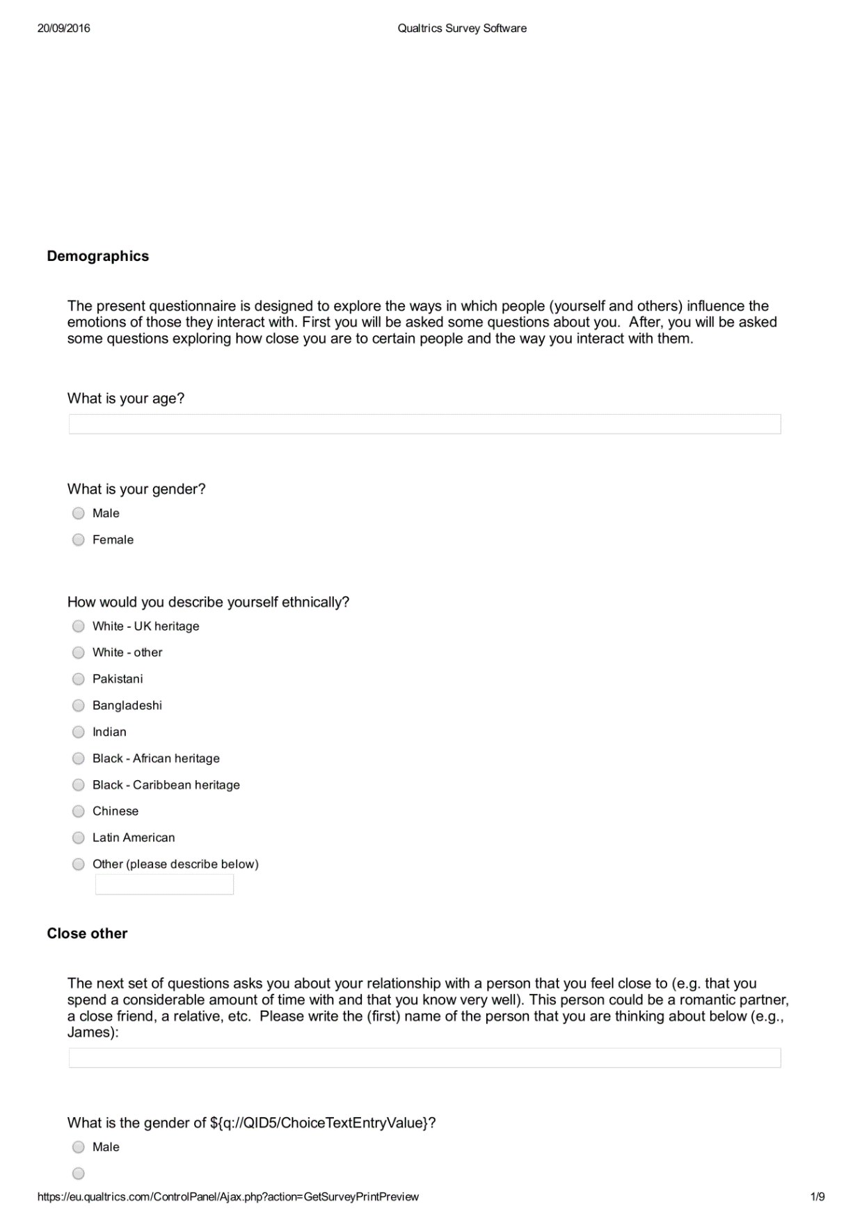

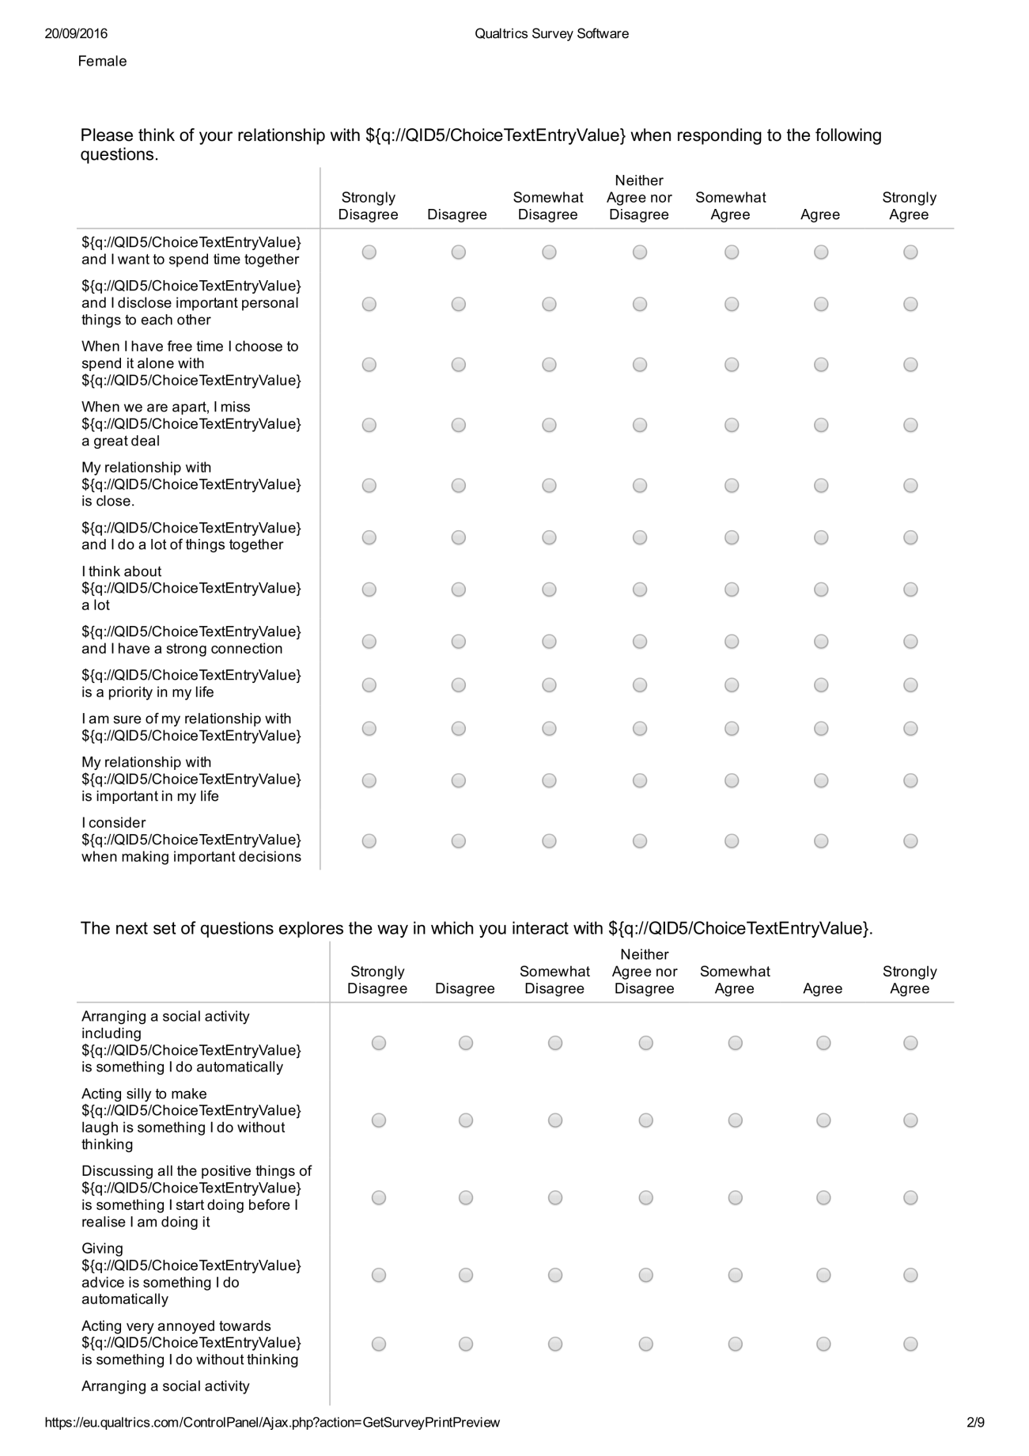

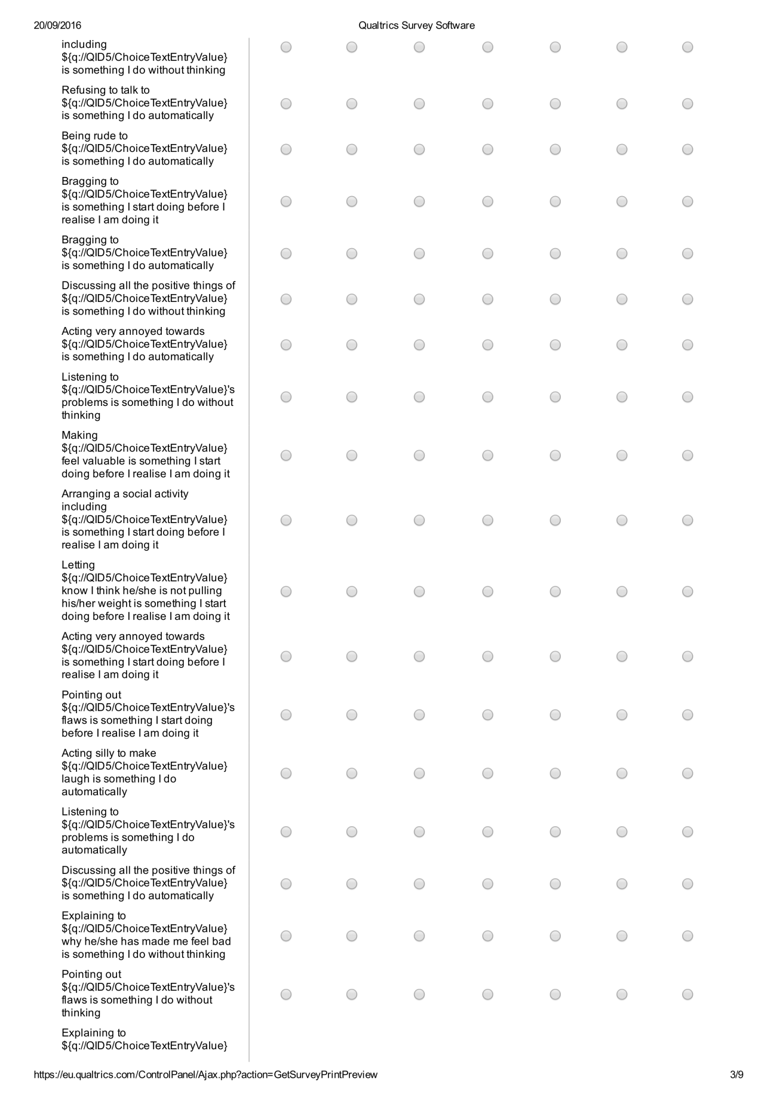
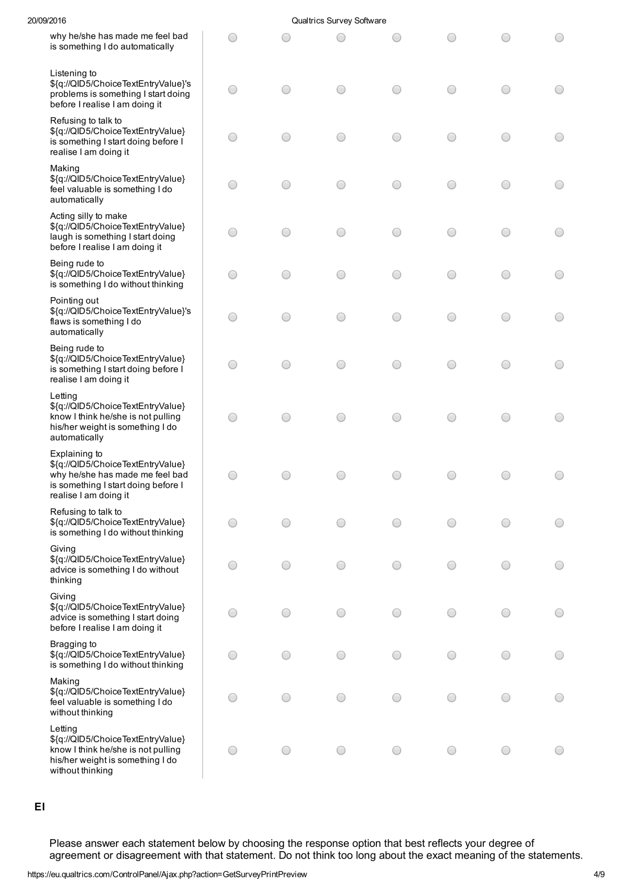
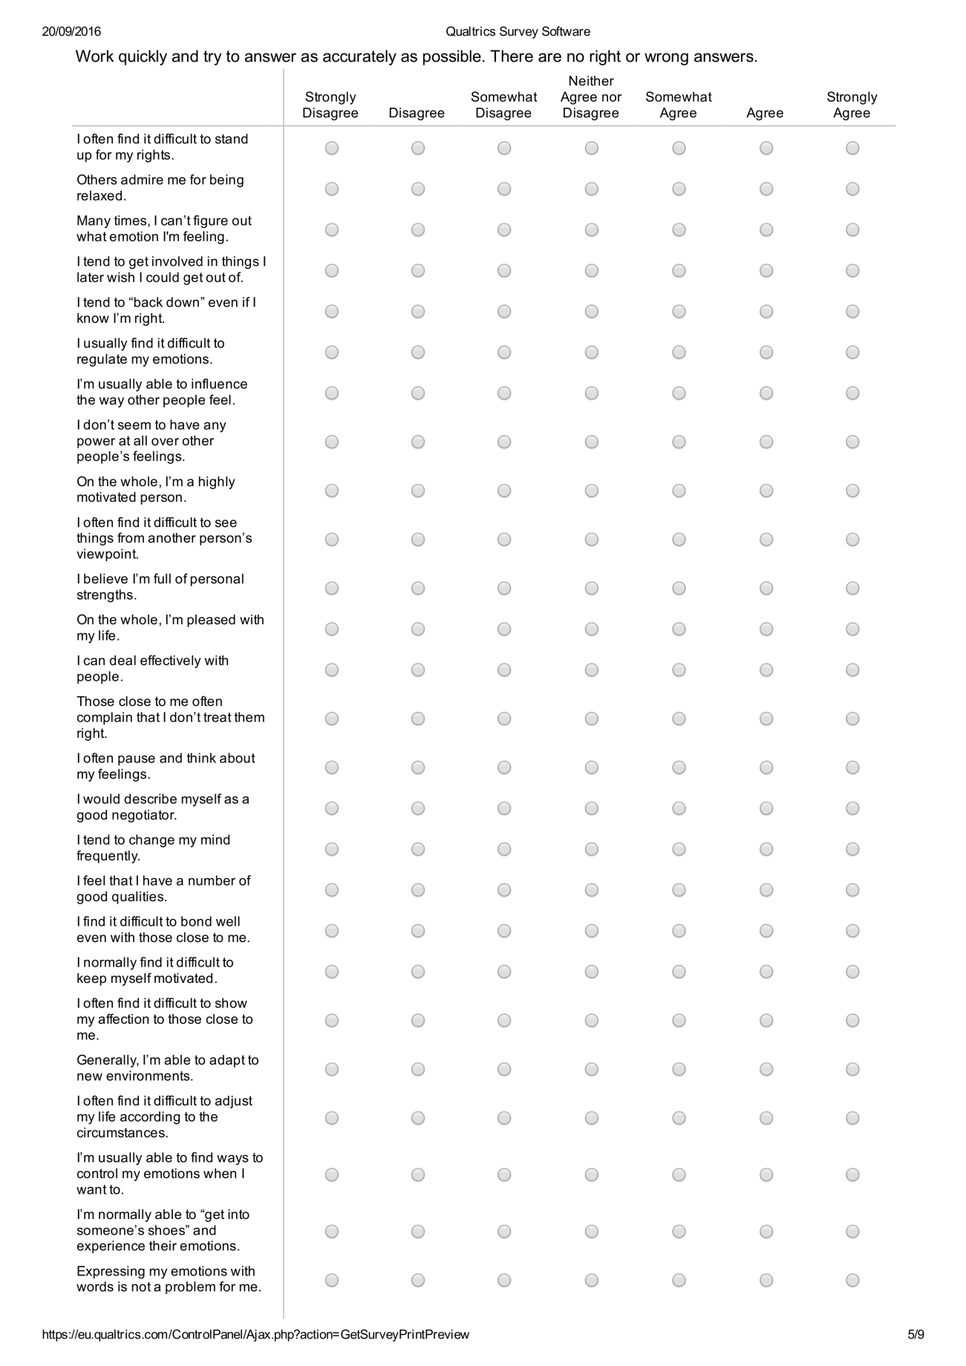
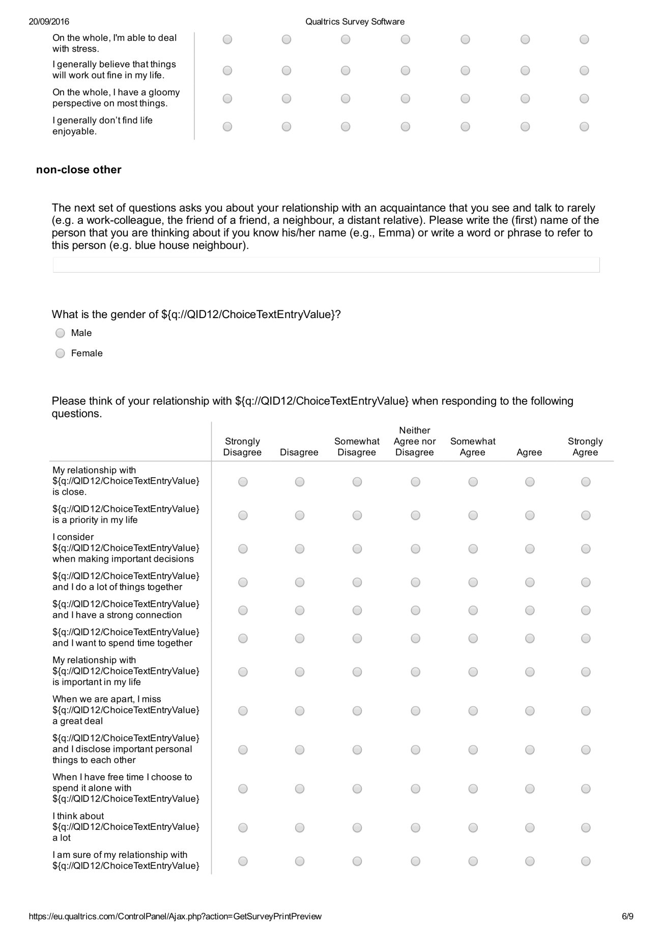
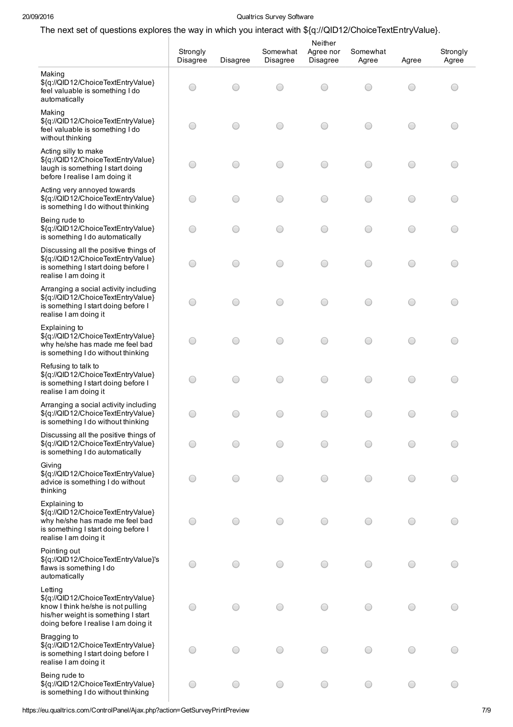
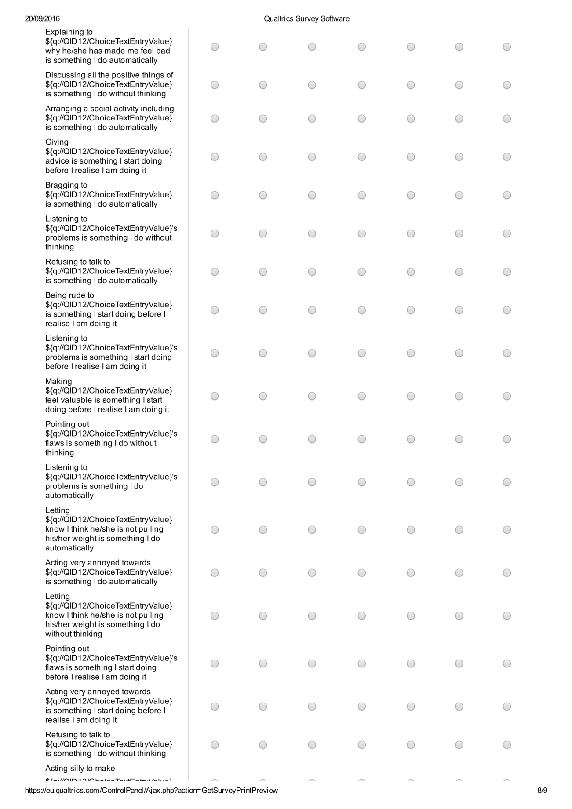
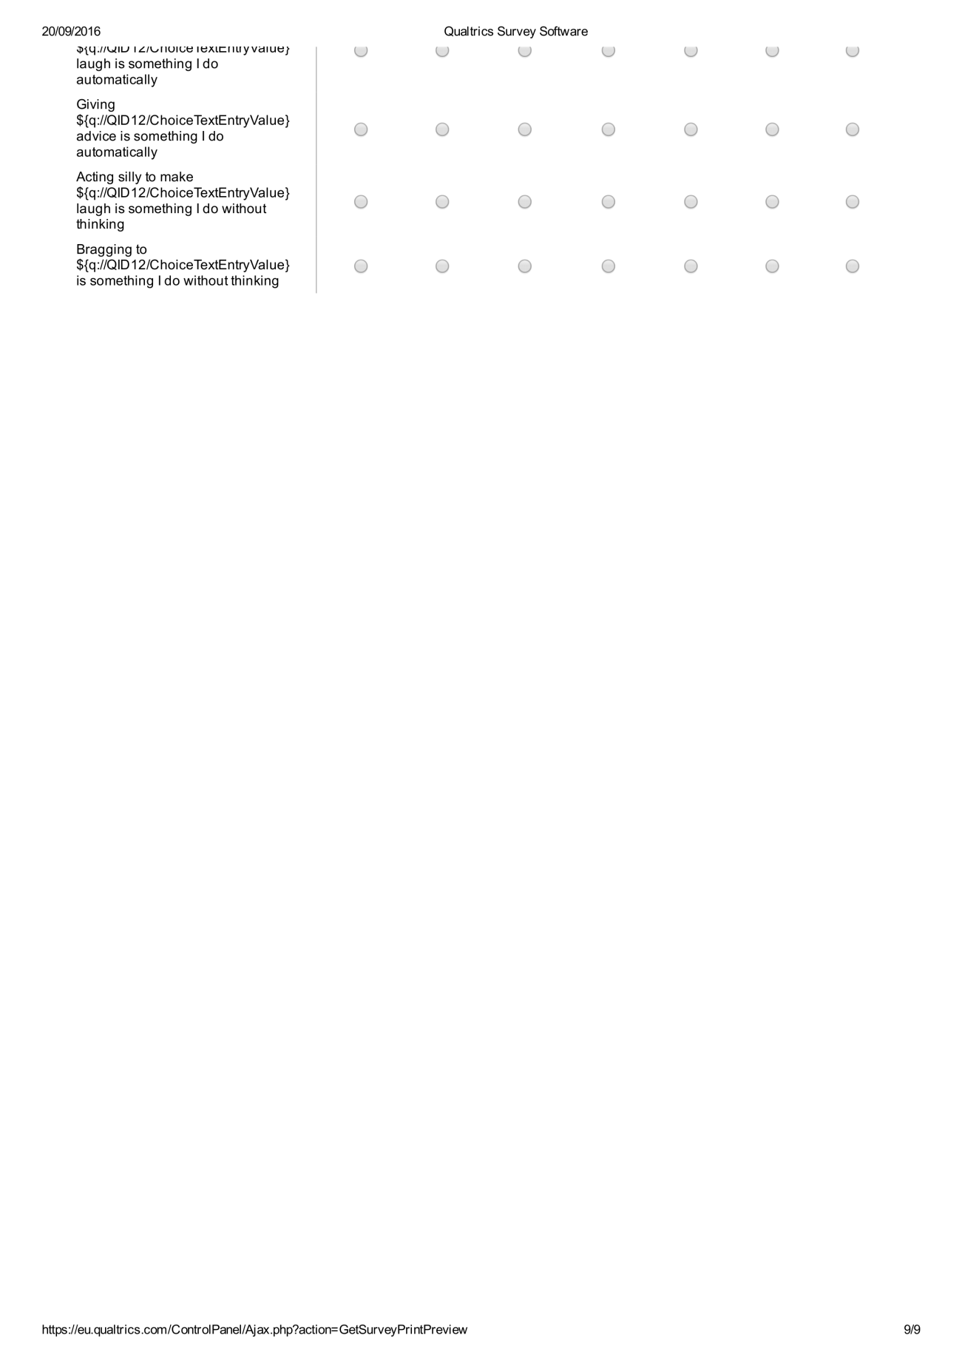

CHAPTER 3
Information sheet for study 2a and 2b
Use of written English language on native English speakers
The aim of the present research is to explore the use of written English language by native English speakers. For this purpose, you will be asked to engage in two short tasks and also to answer a few questions about your personality at the end of the study. The first task consists of building grammatically correct sentences. The second task consists of writing an imaginary script between two characters from which you have to play the part of one.
All the information you provide will be anonymous and confidential.
At the end of the study the experimenter will provide you with information about the purpose of the experiment as well as try to answer any questions that you may have.
This experiment is being conducted under the supervision of Dr Thomas Webb and Prof Peter Totterdell and has received ethics approval by the Department of Psychology Ethics Committee.
Your participation is entirely voluntary. You are allowed to leave the experiment at any point without providing any reasons.
Contact for further information
Experimenter: Daria Hernandez Ibar dnhernandezibar1@sheffield.ac.uk
Supervisors: Dr Thomas Webb t.webb@sheffield.ac.uk
Prof Peter Totterdell p.totterdell@sheffield.ac.uk

Participant consent form for study 2a, study 2b and study 2c
Title of research project: Use of written English language on native English speakers
Name of researcher: Daria Naieli Hernandez Ibar
Participation identification number for this project:
Please initial on the line provided
- I confirm that I have read and understand the information sheet explaining the above research project and I have had the opportunity to ask questions about the project. _______
- I understand that my participation is voluntary and that I am free to withdraw at any time without giving any reason and without there being any negative consequences. In addition, should I not wish to answer any particular question or questions, I am free to decline. _______
- I understand that my responses will be kept strictly confidential. I give permission for members of the research team to have access to my anonymised responses. I understand that my name will not be linked with the research materials, and I will not be identified or identifiable in the report or reports that result from the research. _______
- I agree for the data collected from me to be used in future research. _______
- I agree to take part in the above research project. _______

________________________ ________________ ____________________
Name of Participant Date Signature
(or legal representative)

Scrambled Sentence Task for studies 2a, 2b and 2c

WORSENING IER SCRAMBLED SENTENCES
1. here / smells / food / like / it | it smells like food here
2. old / sold / they / wardrobe / an | they sold an old wardrobe
3. popular / the / intimidates / girl / everyone | everyone intimidates the popular girl
4. ones / younger / older / siblings / patronise | older siblings patronise younger ones
5. seven / closes / at / library / the | the library closes at seven
6. boyfriend / she / her / annoys / always | she always annoys her boyfriend
7.other / bother / friends / each / some | some friends bother each other
8. weather / is / the / available / forecast | the weather forecast is available
9. grandchildren / rejects / a / her / grandma | a grandma rejects her grandchildren
10. speak / English / many / people / million | many million people speak English
11. must / teeth / they / their / brush | they must brush their teeth
12. bullies / he / classmates / his / female | he bullies his female classmates
13. peers / young / people / their / mock | young people mock their peers
14. double / the / has / building / glazing | the building has double glazing
15. patients / hurts / a / nurse / her | a nurse hurts her patients
16. summer / than / autumn / warmer /is | summer is warmer than autumn
17. their / mothers / belittle / own / children | mothers belittle their own children
18. insults / teacher / our / students / her | our teacher insults her students

NEUTRAL SCRAMBLED SENTENCES
1. here / smells / food / like / it | it smells like food here
2. old / sold / they / wardrobe / an | they sold an old wardrobe
3. popular / the / imitates / girl / everyone | everyone imitates the popular girl
4. ones / younger / older / siblings / surround | older siblings surround younger ones
5. seven / closes / at / library / the | the library closes at seven
6. boyfriend / she / her / nominates / always | she always nominates her boyfriend
7. other / select / friends / each / some | some friends select each other
8. weather / is / the / available / forecast | the weather forecast is available
9. grandchildren / awaits / a / her / grandma | a grandma awaits her grandchildren
10. speak / English / many / people / million | many million people speak English
11. must / teeth / they / their / brush | they must brush their teeth
12. appraises / he / classmates / his / female | he appraises his female classmates
13. peers / young / people / their / cite | young people cite their peers
14. double / the / has / building / glazing | the building has double glazing
15. patients / washes / a / nurse / her | a nurse washes her patients
16. summer / than / autumn / warmer /is | summer is warmer than autumn
17. their / mothers / resemble / own / children | mothers resemble their own children
18. informs / teacher / our / students / her | our teacher informs her students

Script studies 2a and 2b (Study 2b varied in that it did not include a ‘goal choice’).
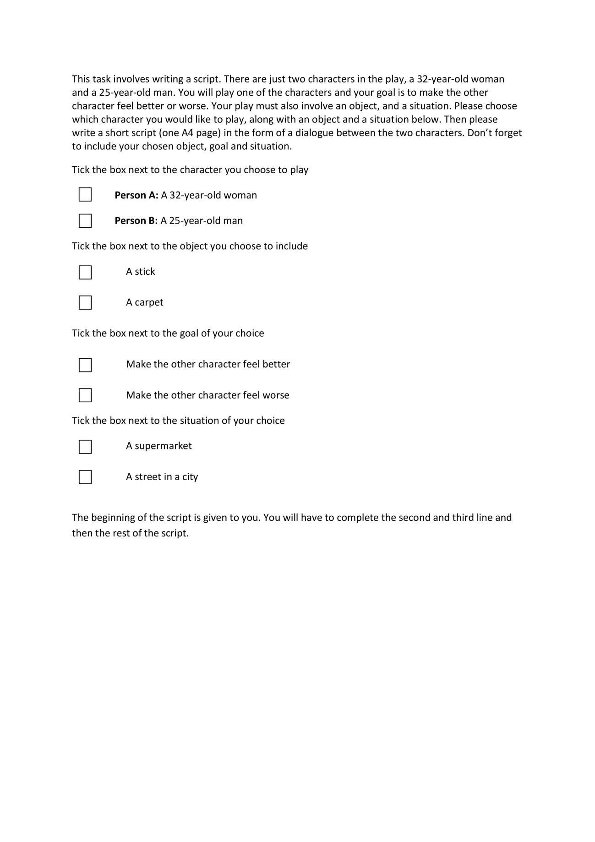
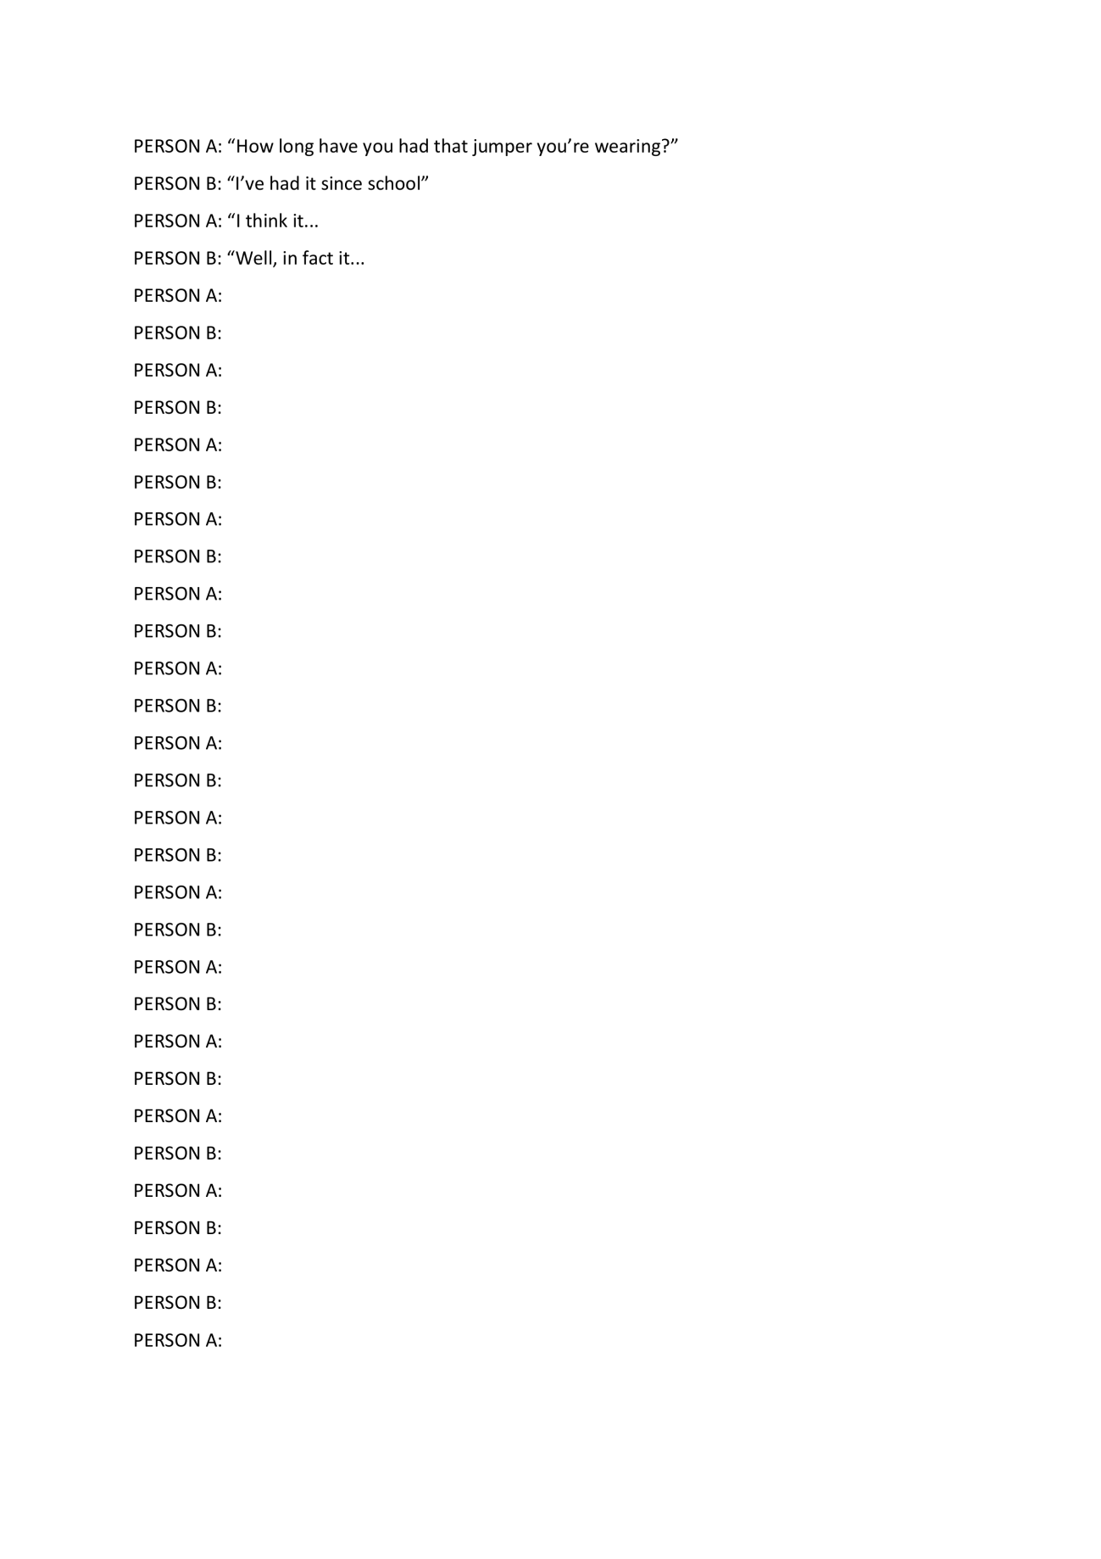

Social-Desirability Short Scale studies 2a, 2b and 2c
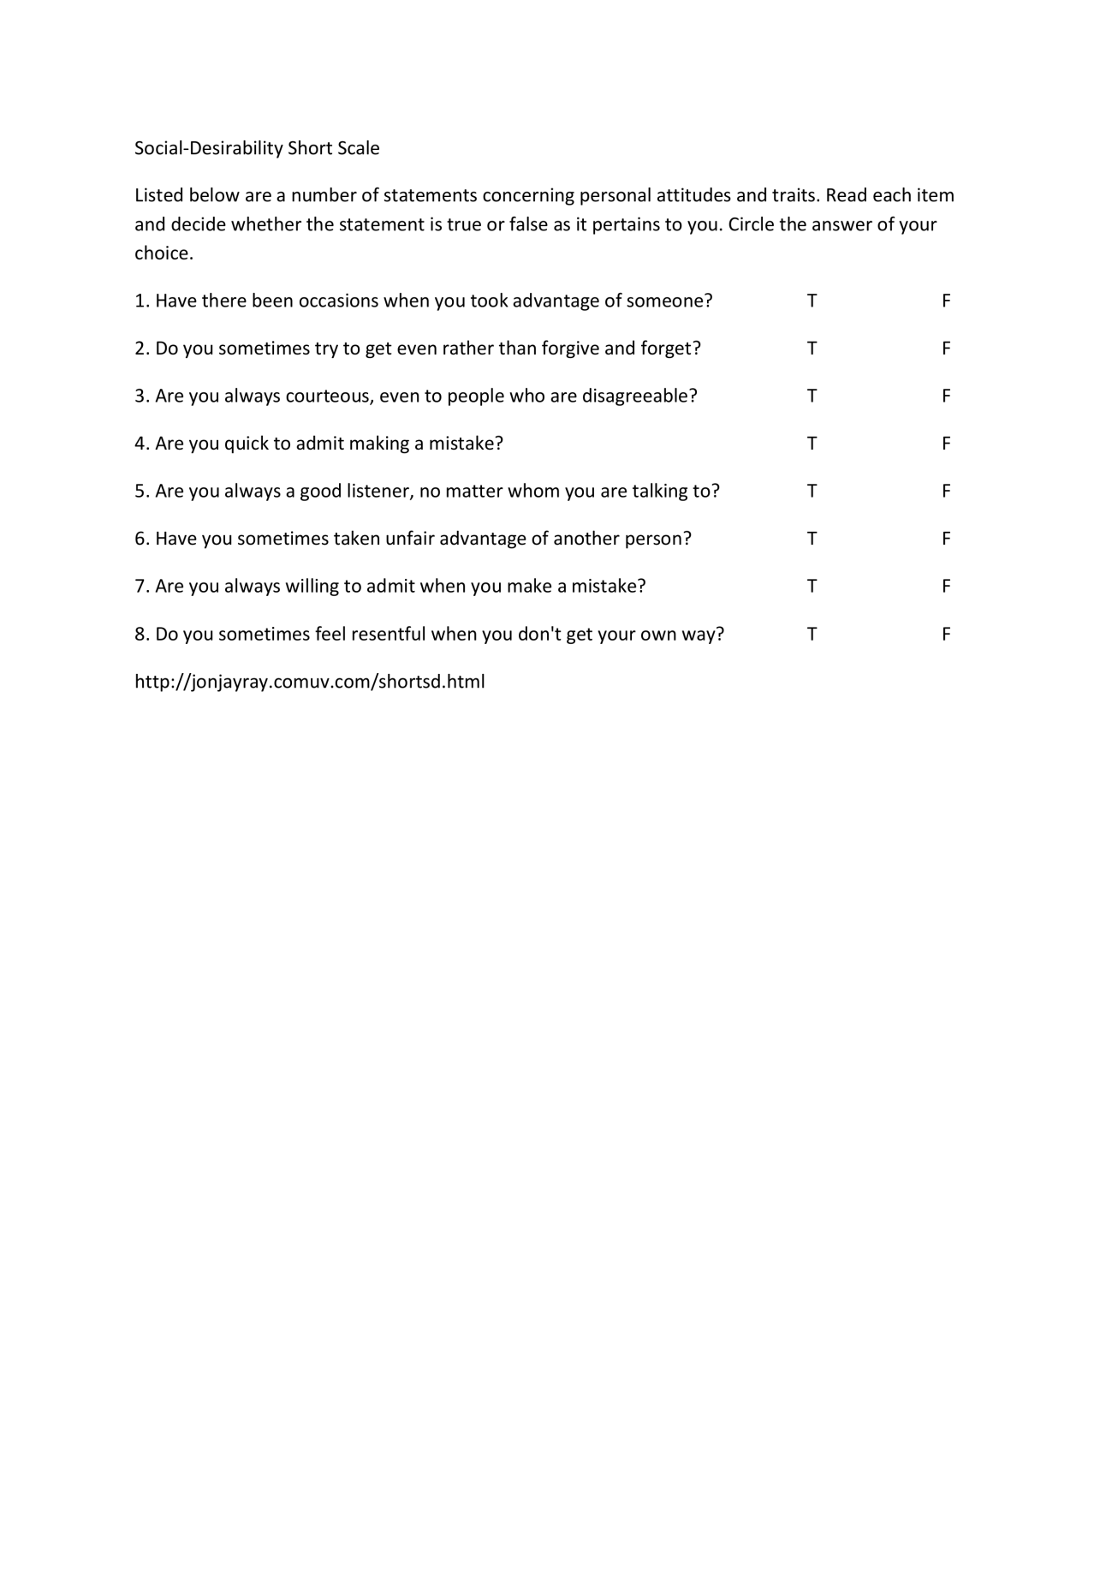

Information sheet for study 2c
Information Sheet

Use of written English language on native English speakers
The aim of the present research is to explore the use of written English language by native English speakers. For this purpose, you will be asked to engage in two short tasks and also to answer a few questions about your personality at the end of the study. The first task consists of building grammatically correct sentences. The second task consists of writing a letter to an ex-partner of yours (i.e., an old boyfriend or girlfriend). These letters will not be posted – the task is just used for us to assess your use of English.
In order to protect your anonymity, after finishing the letter you should place it inside an envelope that the experimenter will provide you with. Then you should place the letter in the mailbox outside the cubicle where the experiment takes place. The experimenter will not read the letters until she has collected the full sample. In this way, your letter cannot be traced back to you and so it is anonymous.
At the end of the study the experimenter will provide you with information about the purpose of the experiment as well as try to answer any questions that you may have.
This experiment is being conducted under the supervision of Dr Thomas Webb and Prof Peter Totterdell and has received ethics approval by the Department of Psychology Ethics Committee.
Your participation is entirely voluntary. You are allowed to leave the experiment at any point without providing any reasons.
Contact for further information
Experimenter: Daria Hernandez Ibar dnhernandezibar1@sheffield.ac.uk
Supervisors: Dr Thomas Webb t.webb@sheffield.ac.uk
Prof Peter Totterdell p.totterdell@sheffield.ac.uk

Email sent to participants to explore the liking or disliking of the ex-partner for study 2c
Dear (name of participant),
Some time ago you took part in a piece of research titled “Use of written English language on native English speakers”. In this research you were asked to unscramble some sentences and to write a letter to an ex-partner of yours.
As part of the same research, we would greatly appreciate if you could complete a short (5 minute) questionnaire about your feelings toward your ex-partner. To complete the questionnaire please follow this link:
http://www.surveymonkey.com/s/MVGNQN2
You will be asked for an identification code in order to complete the survey, so that your responses can be anonymised. Your identification code is (here I will write the participant identification number).
This research has been approved by the Research Ethics Committee in the Department of Psychology.
Many thanks,

Liking or disliking of the romantic ex-partner questionnaire for study 2c
1. My ex-partner is not made for a serious relationship.
a. Strongly disagree b. Disagree c. Neutral / unsure d. Agree e. Strongly agree
2. My ex-partner has many qualities.
3. My ex-partner has charisma.
4. Sometimes I have the wish to yell at my ex-partner.
5. When I think about my ex-partner I get angry.
6. I feel good when I am close to my ex-partner.
7. I often think about my ex-partner.
8. I avoid touching my ex-partner.
9. When I am with my ex-partner I often have the wish to be alone.
10. My ex-partner should change a few things about himself/herself.
11. I get sad when I think about my ex-partner
12. I usually feel better when my ex-partner is not around.
13. My ex-partner is egoistic.
14. When I think about my ex-partner I rejoice.
15. Sometimes I want to give my ex-partner a telephone call.
16. Other men/women find my ex-partner attractive.
17. When I am with my ex-partner I often have the desire to hug him/her.
18. I feel drawn to my ex-partner.
19. I dislike my ex-partner
20. My ex-partner means a lot to me

CHAPTER 4
Complete questionnaire for the ego-depletion study
The link to this questionnaire in survey monkey is https://www.surveymonkey.com/r/MPHJNX6
Email sent to volunteers
Dear volunteer,
We are investigating the extent to which people use self-control while at work. As such, we would be very grateful if you could complete a short questionnaire and a word task on the computer AT THE END OF YOUR WORKING DAY. The study will take no more than 10 minutes to complete and your responses will remain anonymous.
If you are interested in taking part, then please click on the link below BEFORE YOU LEAVE WORK TODAY (you can complete the questionnaire if you have worked at home): https://www.surveymonkey.com/s/MPHJNX6
This experiment is being conducted under the supervision of Dr Thomas Webb and Prof Peter Totterdell and has received ethics approval by the Department of Psychology Ethics Committee.
Your participation is entirely voluntary and you can leave the study at any point without providing reasons.
Best wishes,
Daria Hernandez Ibar
Information related to this message is available at https://www.surveymonkey.com/s/MPHJNX6.
For information about this email list, including how to remove your name, please visit http://www.shef.ac.uk/cics/email/distributionlists.htmland click the list name.

New measure of the use of self-control during the working day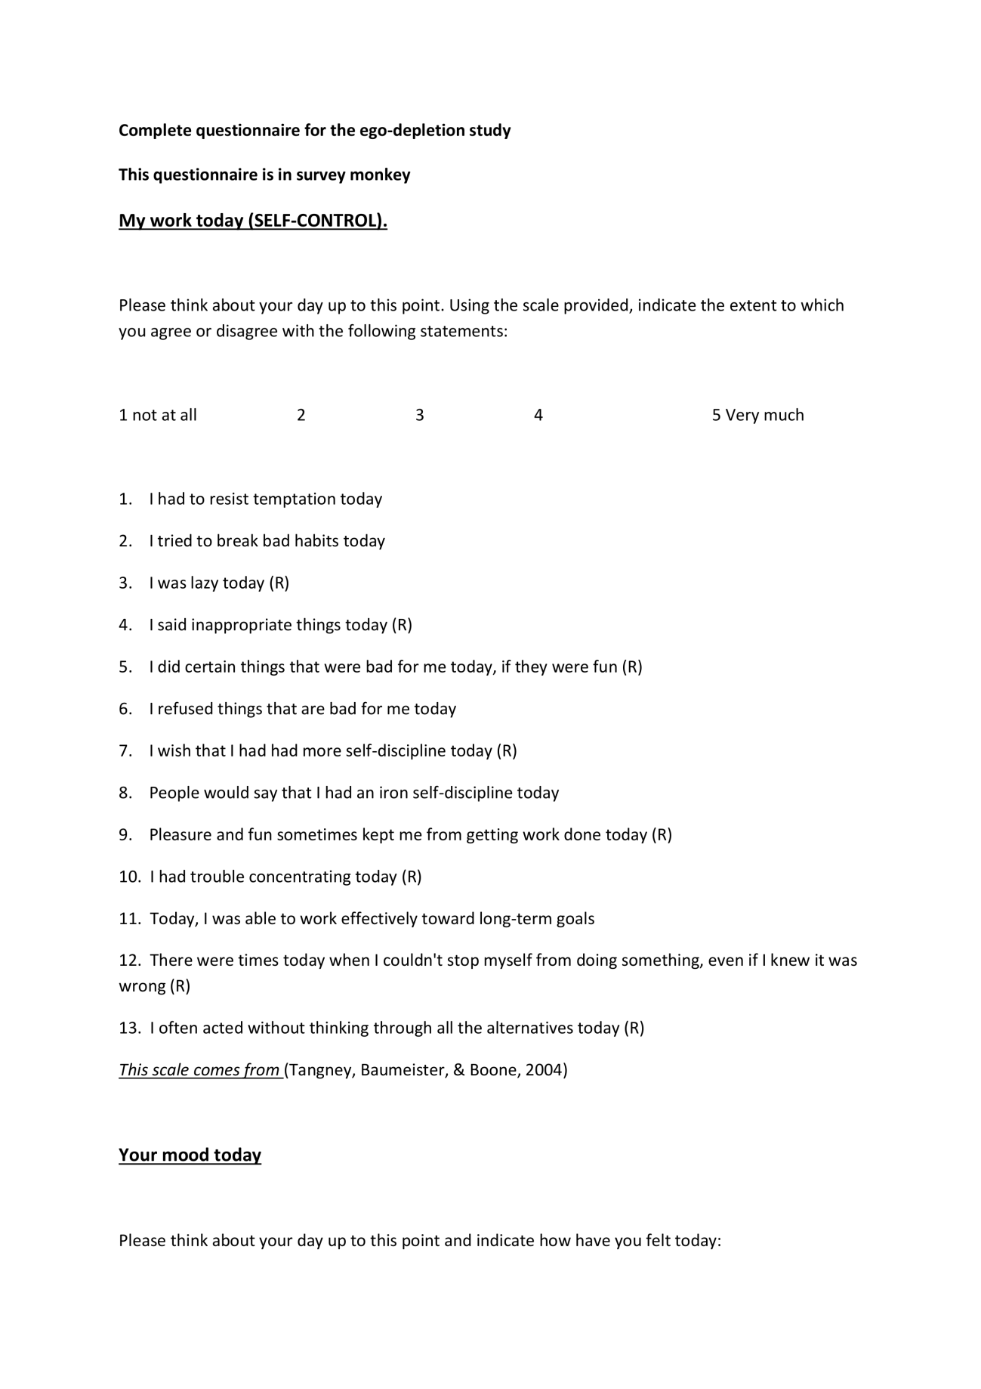
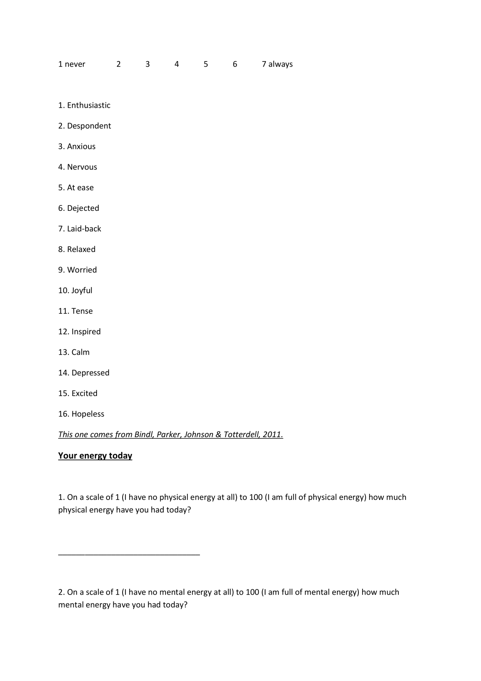
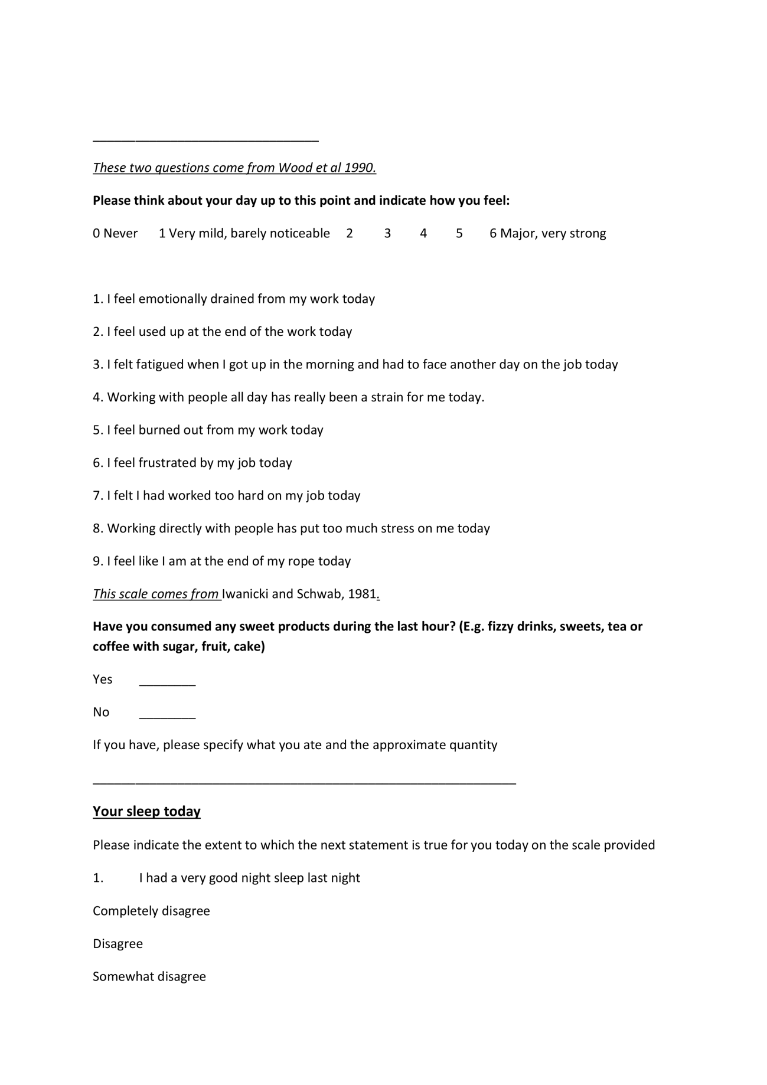
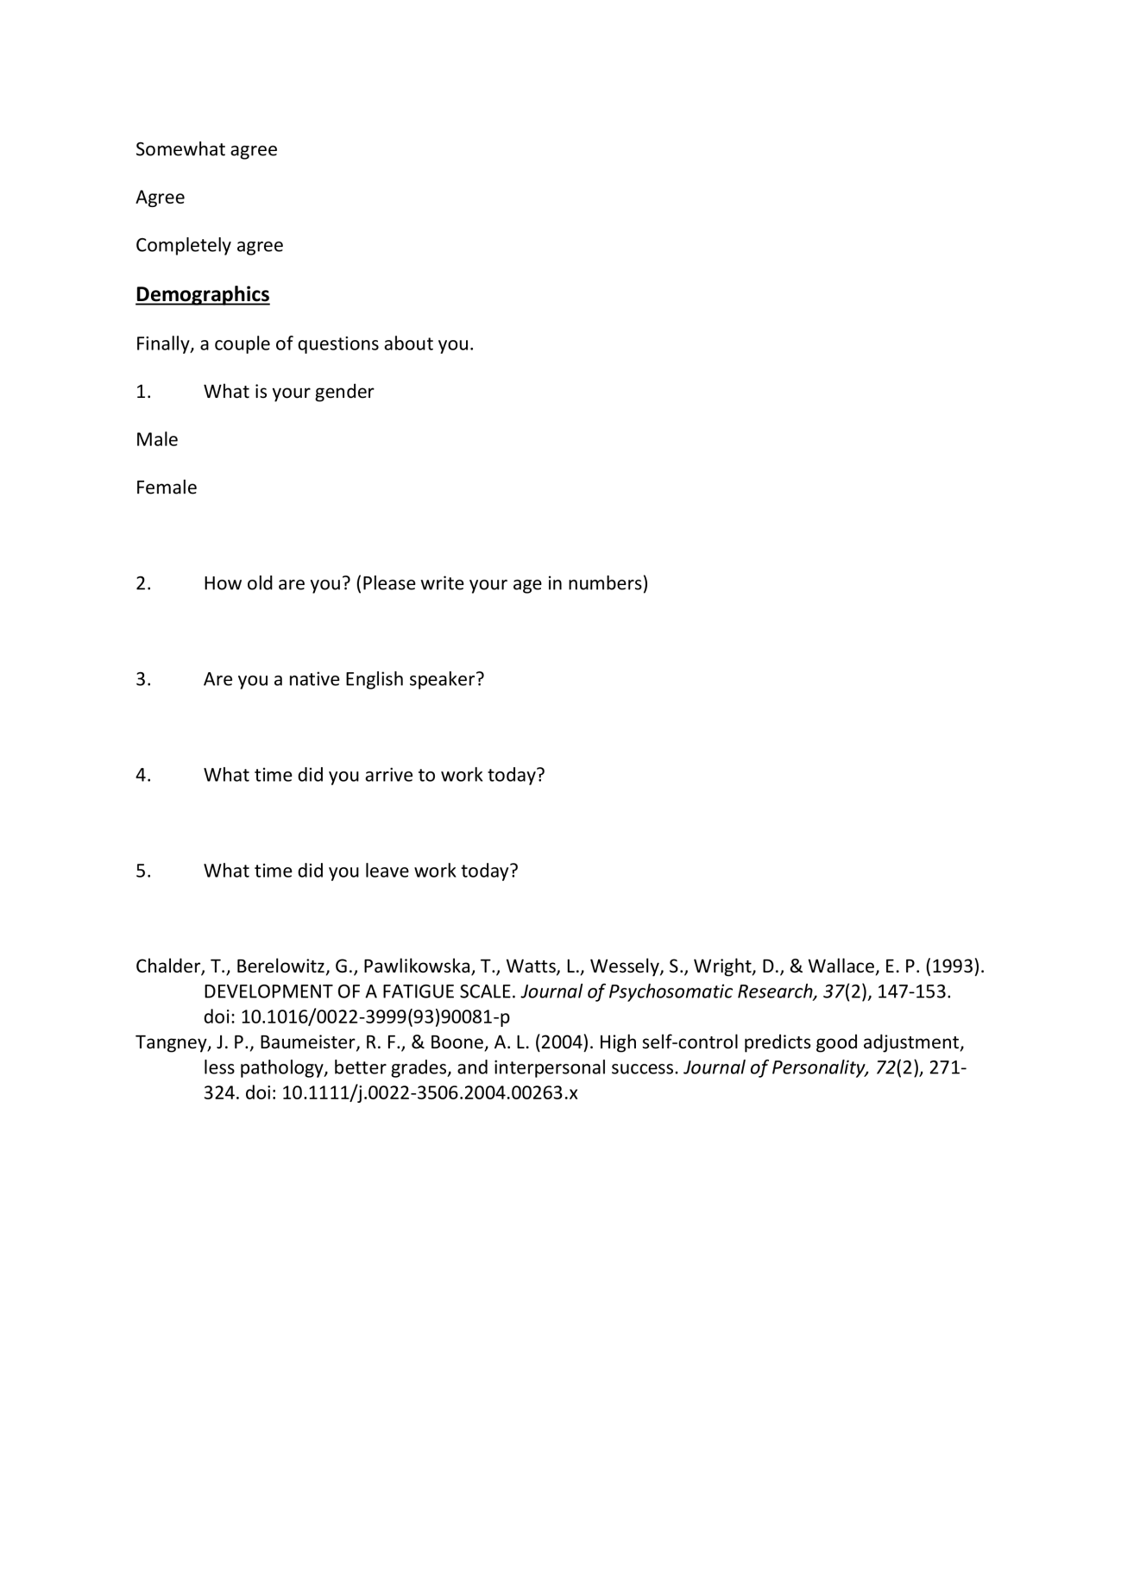

CHAPTER 5
Pre-event questionnaire
Thank you for taking part in the study "How memory works in interpersonal interactions"
------------------------
The event is divided in two stages:
1. This questionnaire, where you will answer some questions about your personality to help us find you a better match.
2. The speed dating event, where you will have around 8 different dates of 4 minutes duration each. After each date you will be invited to answer a few questions about your date. Each date will be audio recorded but neither your name nor any personal details will be required, so you won't be identifiable.
In case you have a match the experimenter will contact you on the next day to provide you with the contact details of your match so you both (your match and you), can arrange a date if you would like to.
At the end of the event there will be a prize draw of eight £5 notes. Also, each participant will receive a 50p discount voucher so you can buy a drink if you would like to.
------------------------------
Over the next pages you will see a series of questions about your personality that will help us to find you a match during the event.
At the end of this questionnaire you will see the details about the speed dating event (venueand time).
Please click the 'arrow' button to begin the questionnaire.
----------------------------------
Over the next questions you are invited to provide us with some demographics and your contact details so the experimenter can contact you later in the case you have a match during the speed dating event.
All the information you provide is strictly confidential and the experimenter will be the only one with access to it.
-------------------------------------
In order to identify you without having to use your name and thus, respecting your anonymity, please write down the CODE the experimenter emailed to you (this code comes in the email with the link to this questionnaire).
-----------------------------------
Please write the email address where the experimenter has been contacting you about the speed dating event
---------------------------------

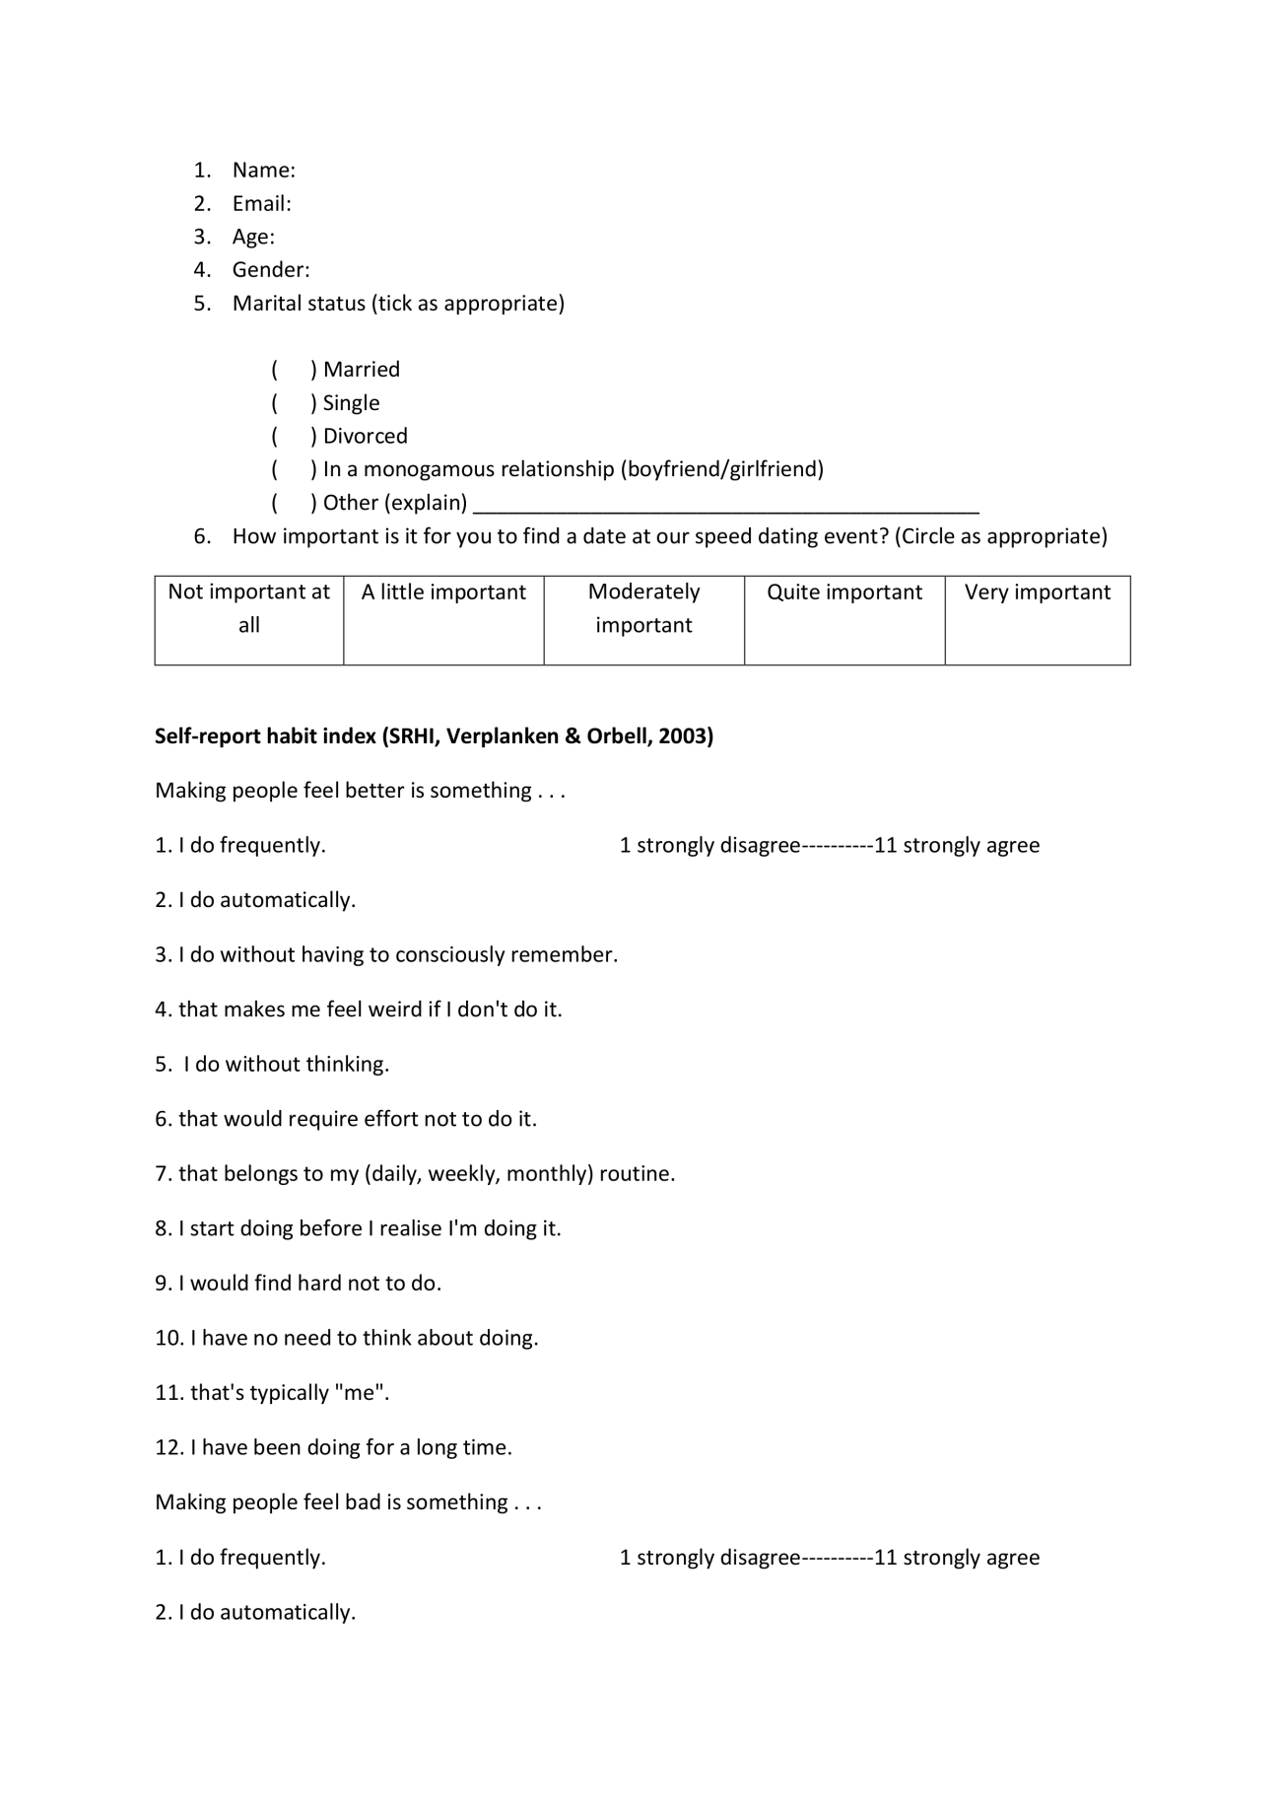
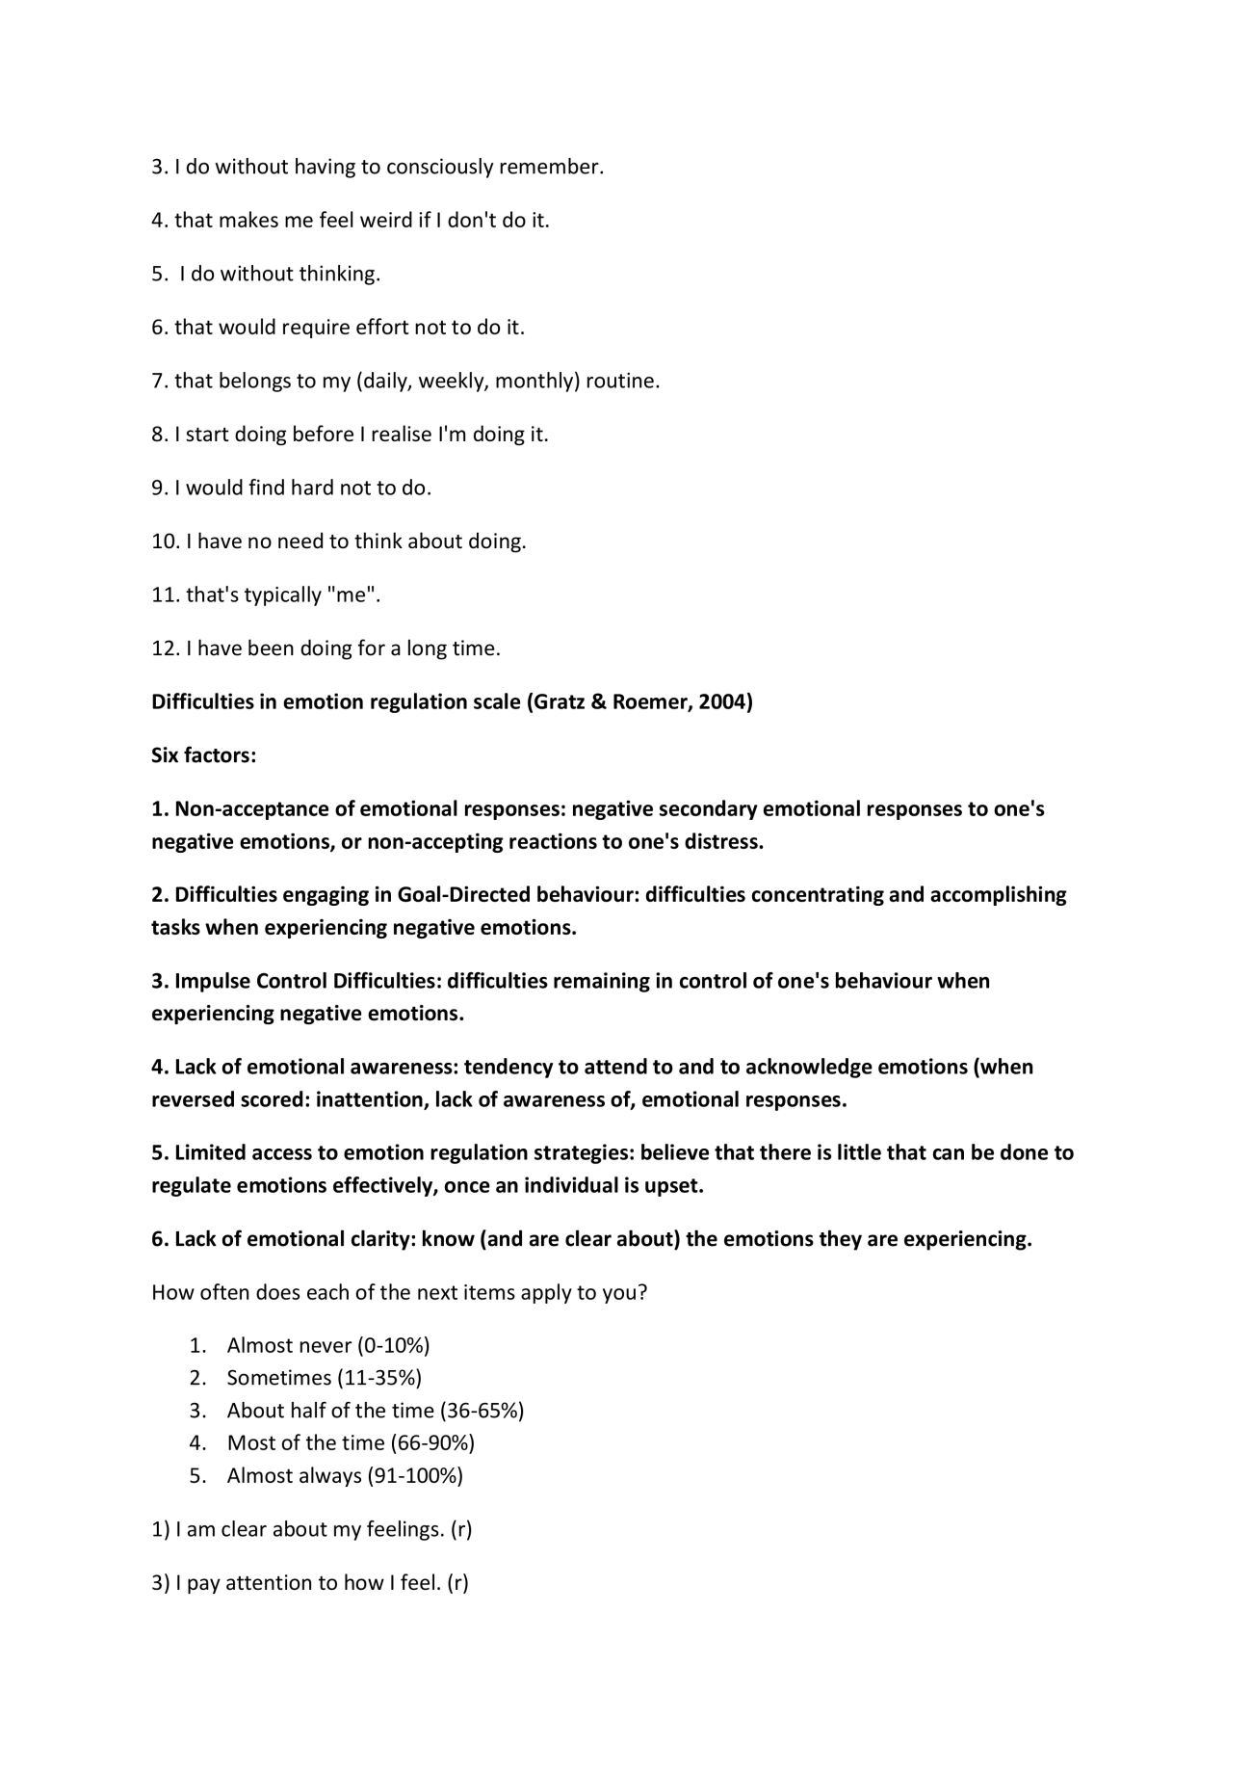
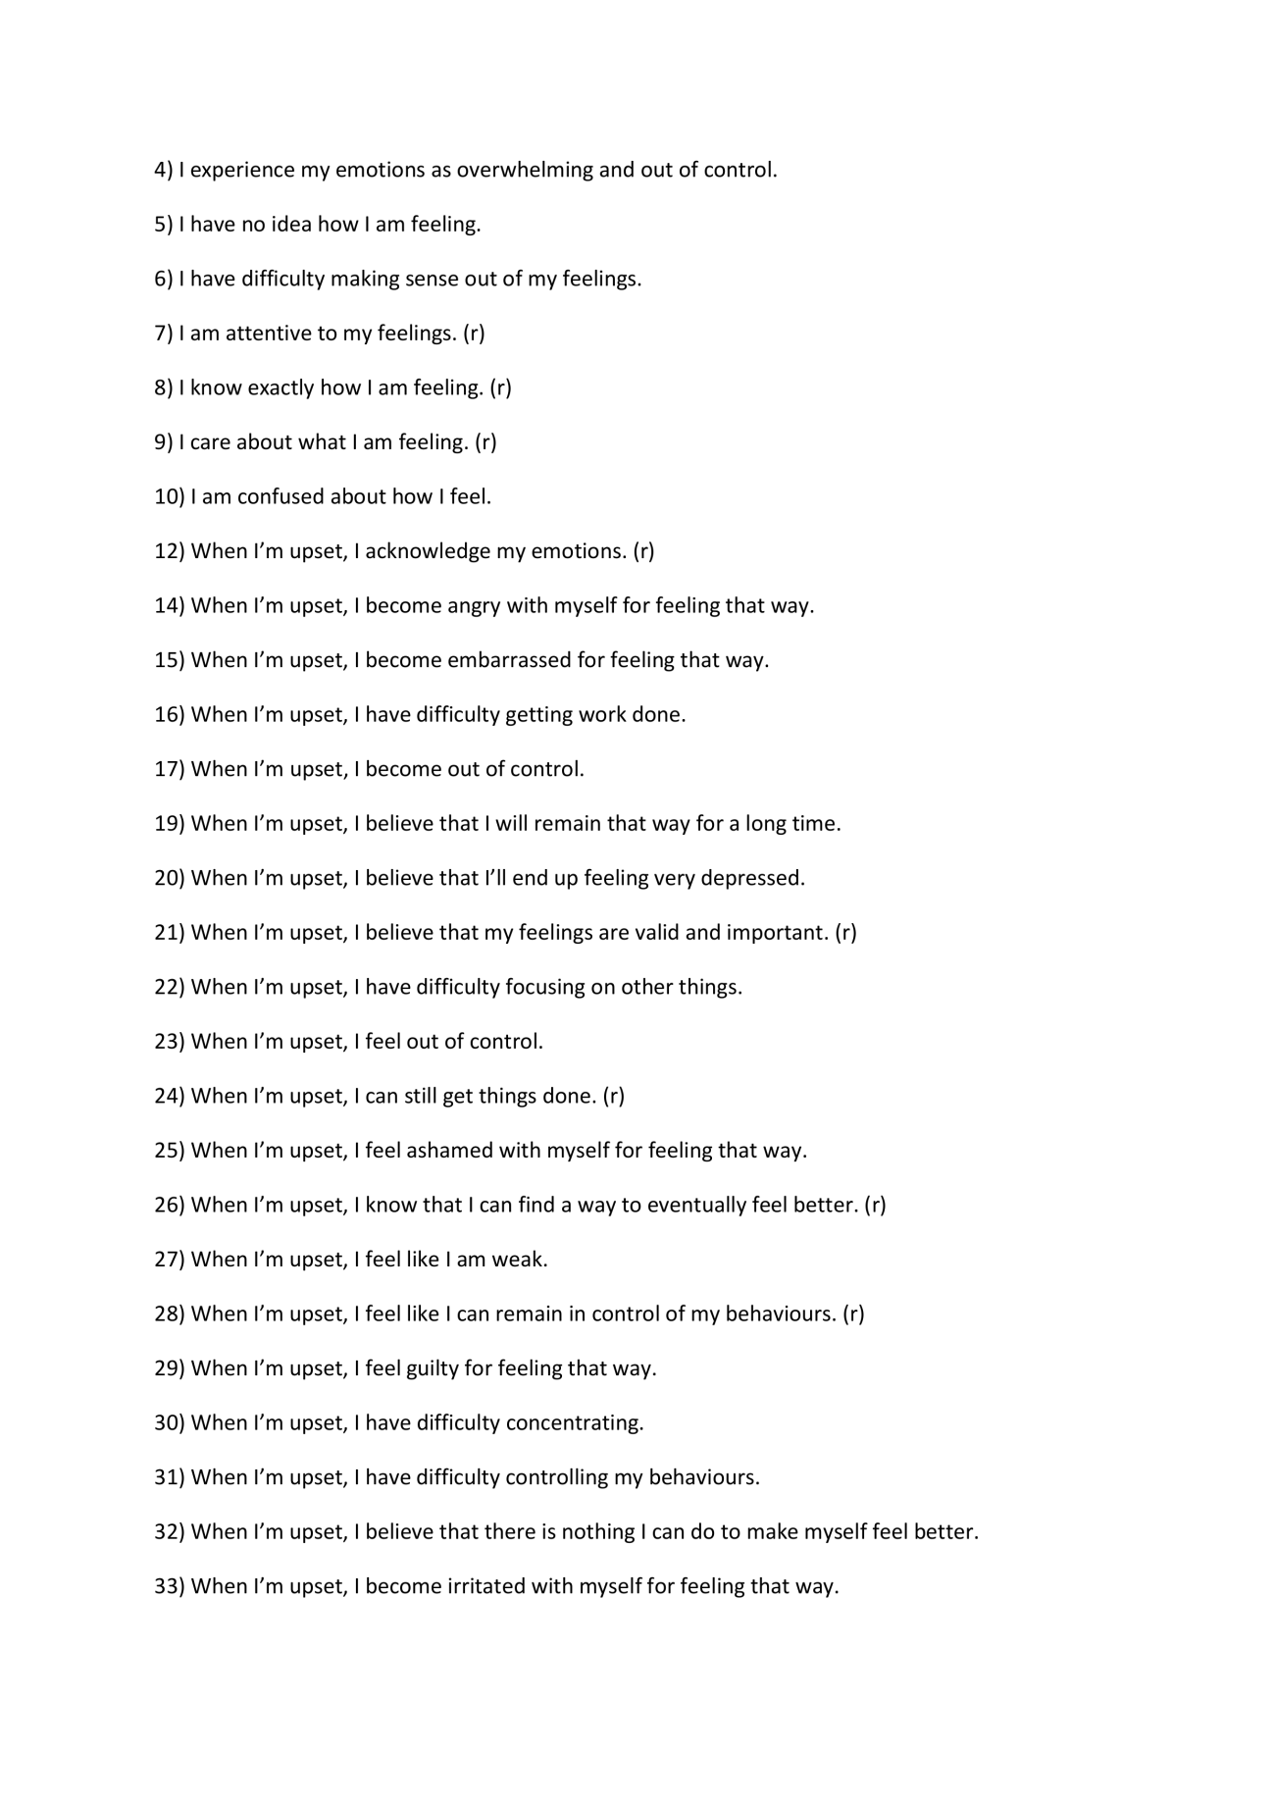
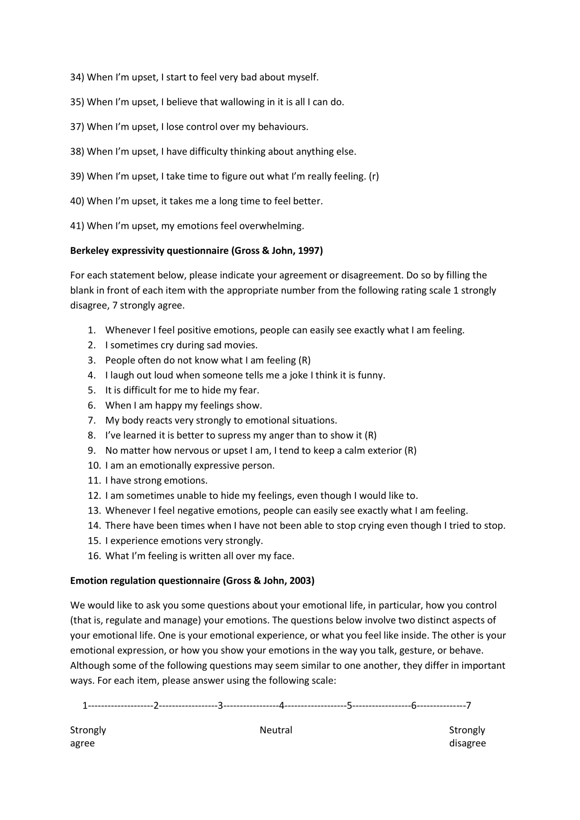
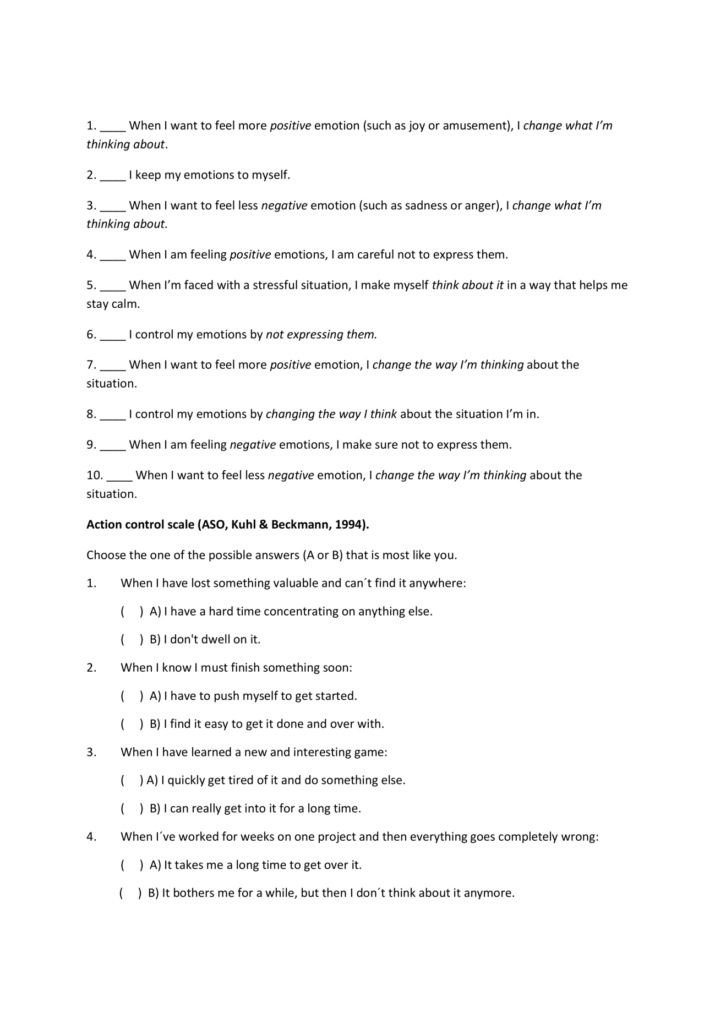
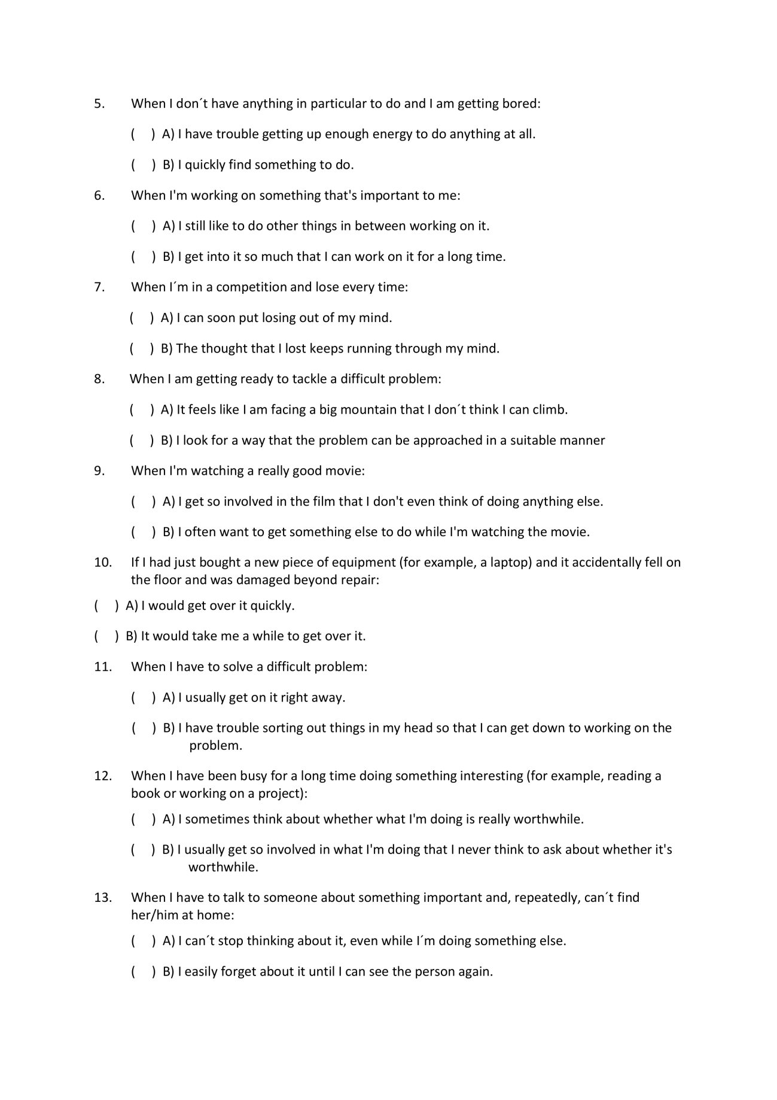
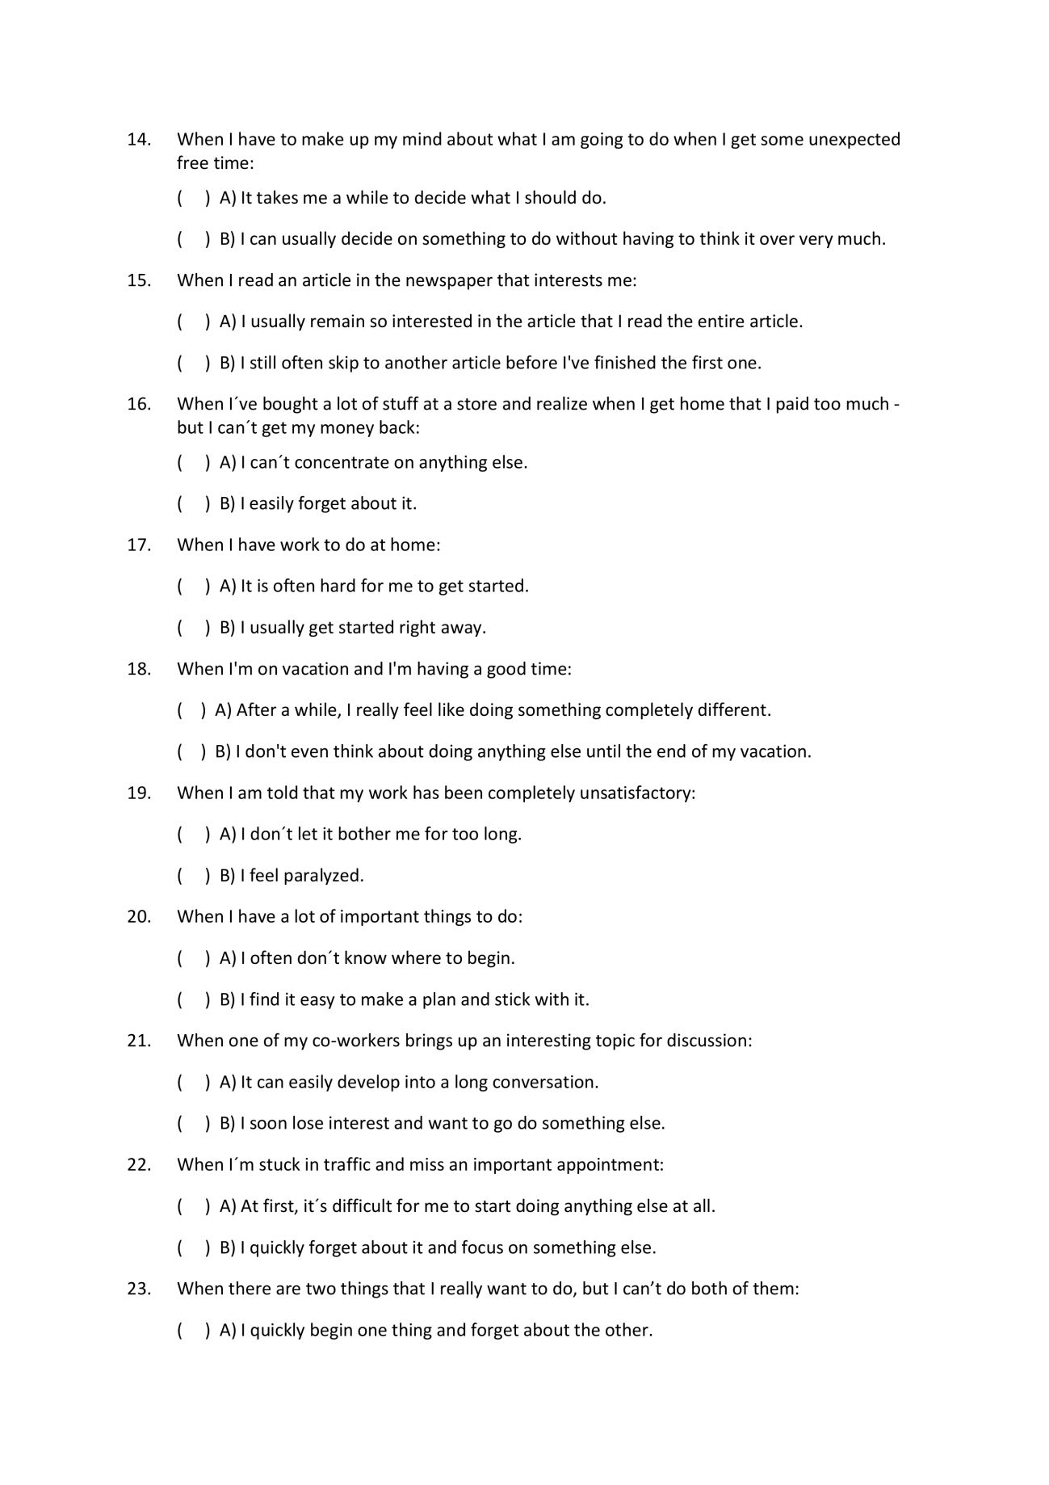
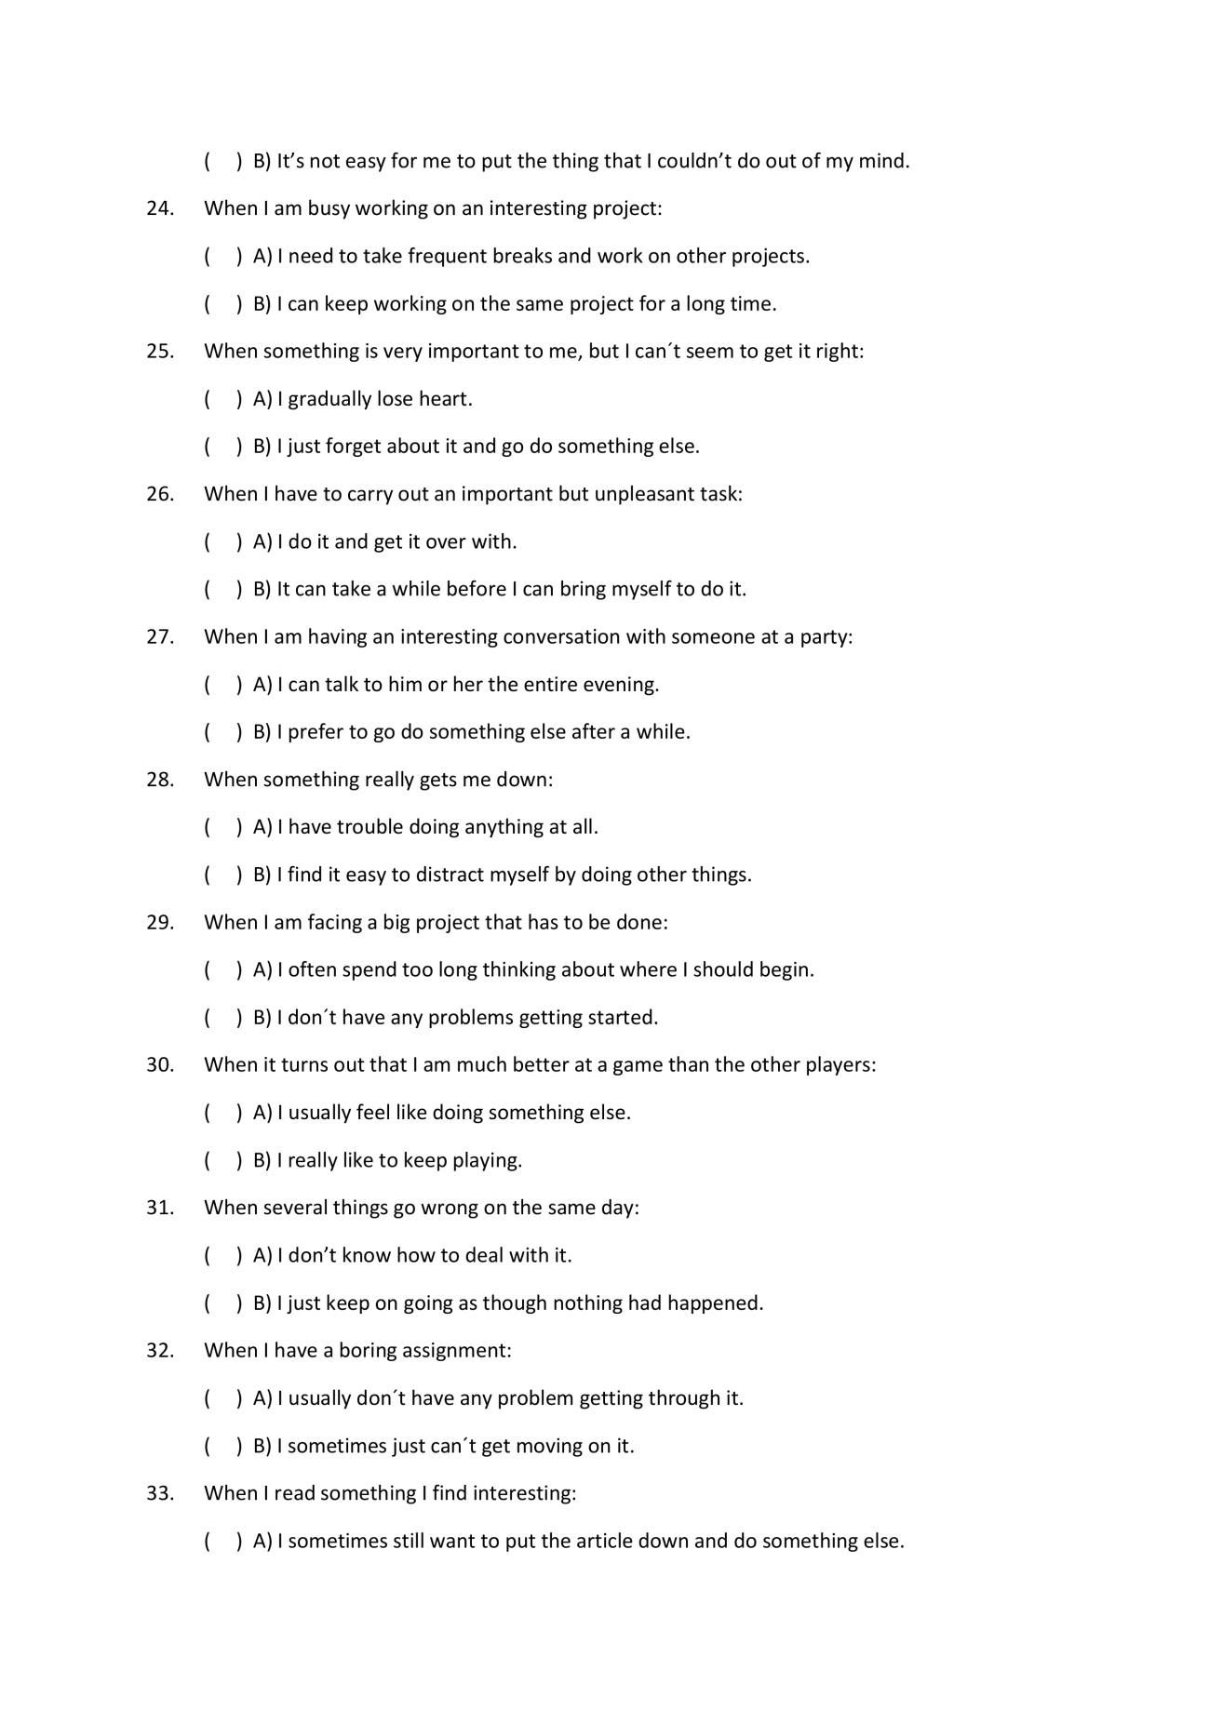
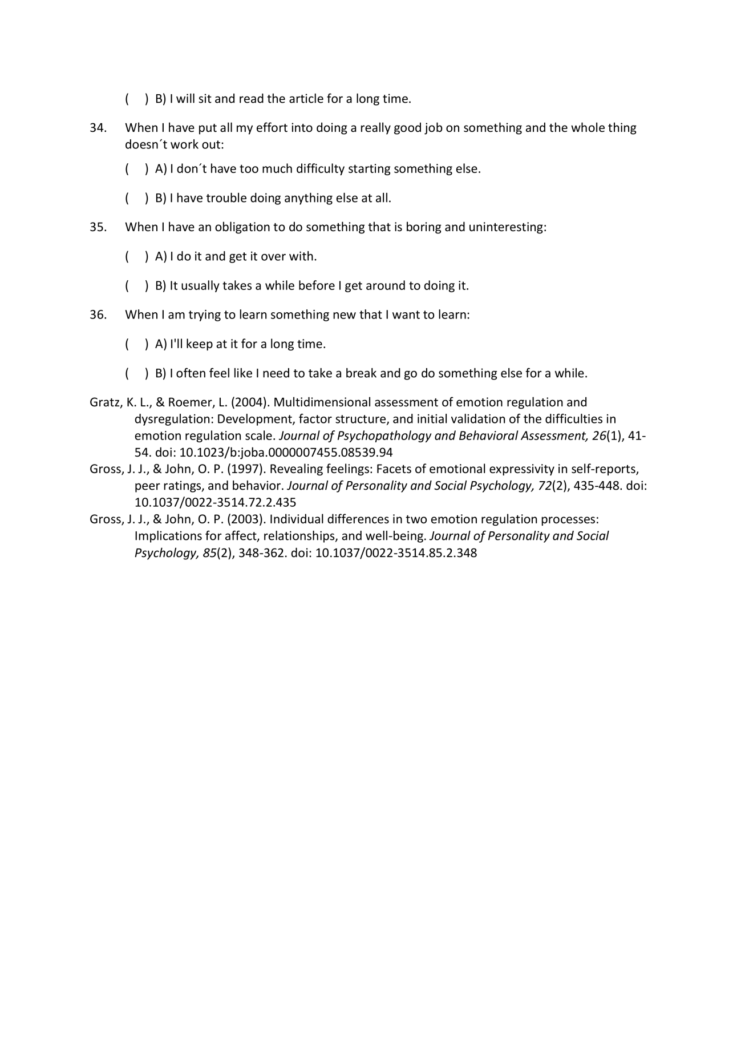

Action control scale (ASO, Kuhl & Beckmann, 1994).
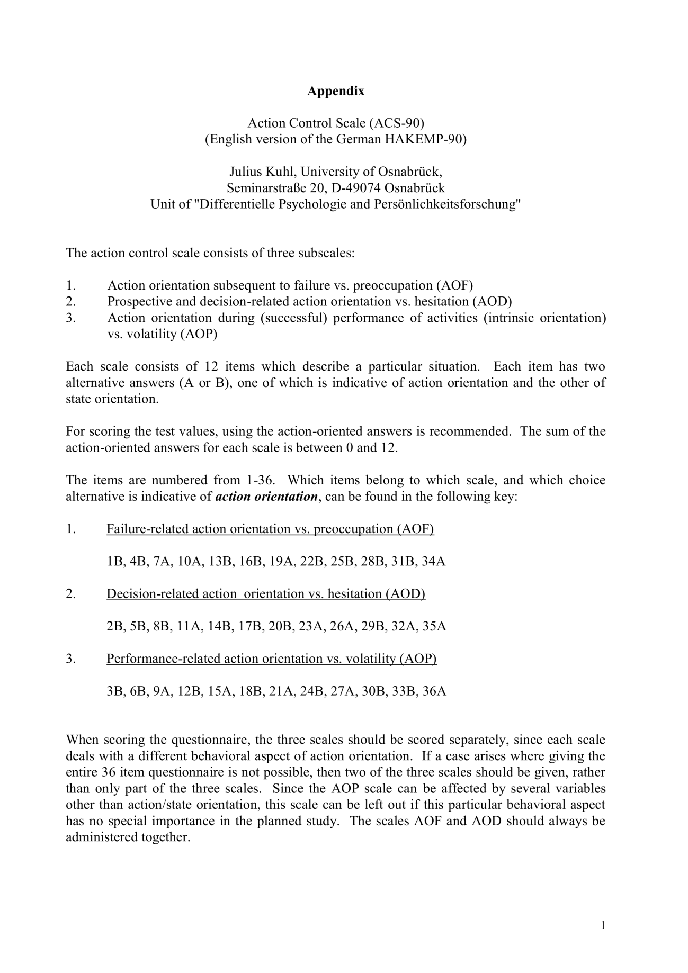
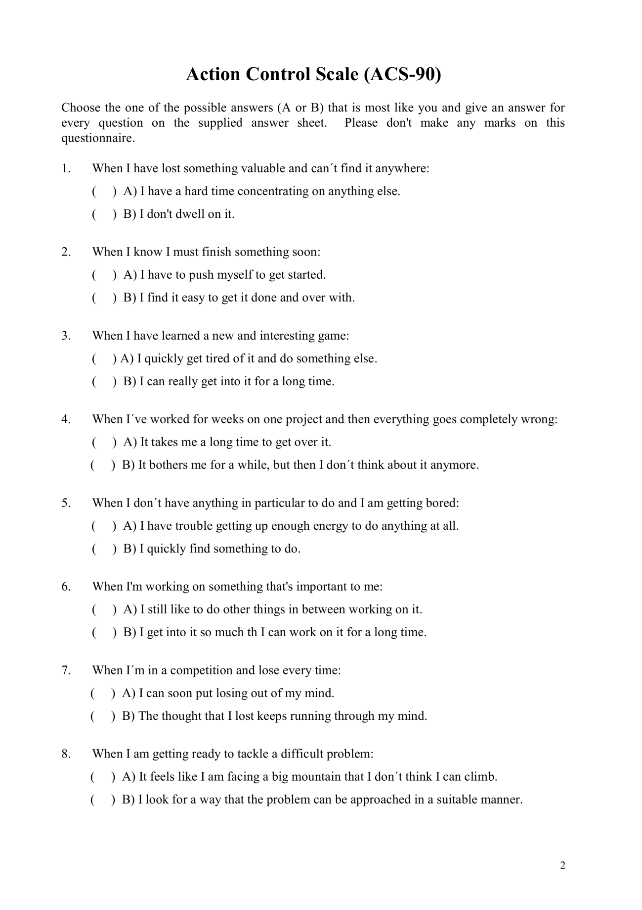
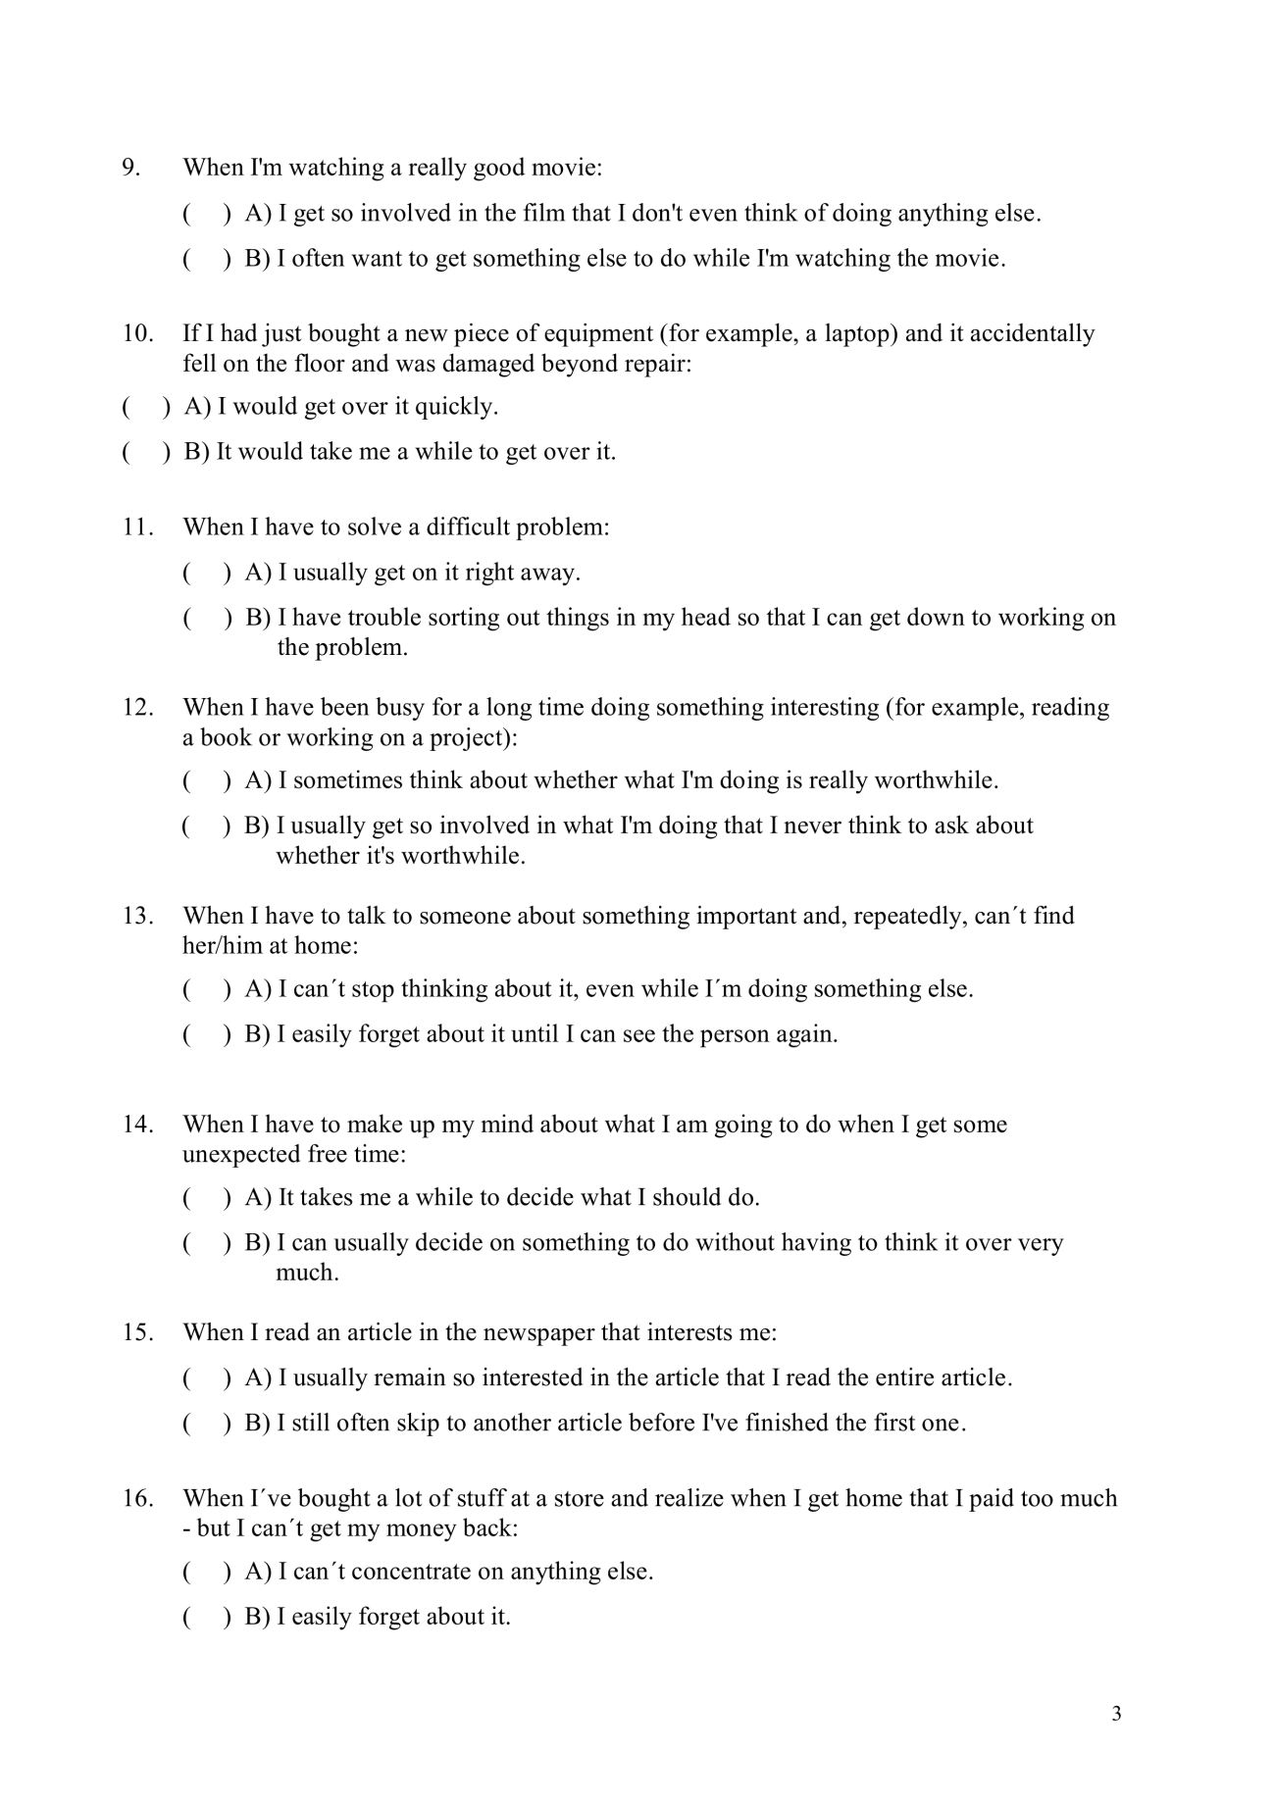
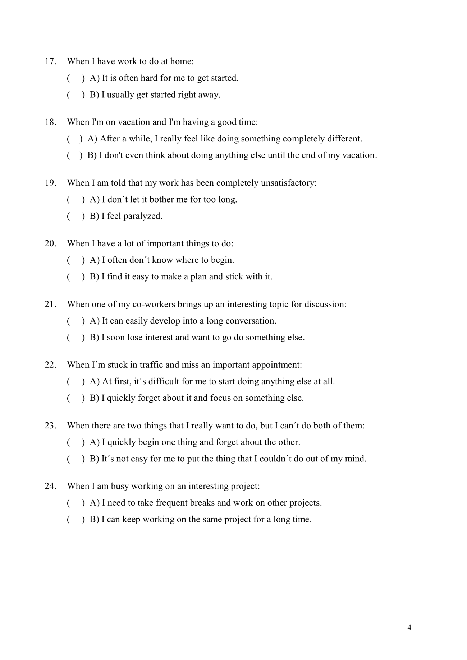
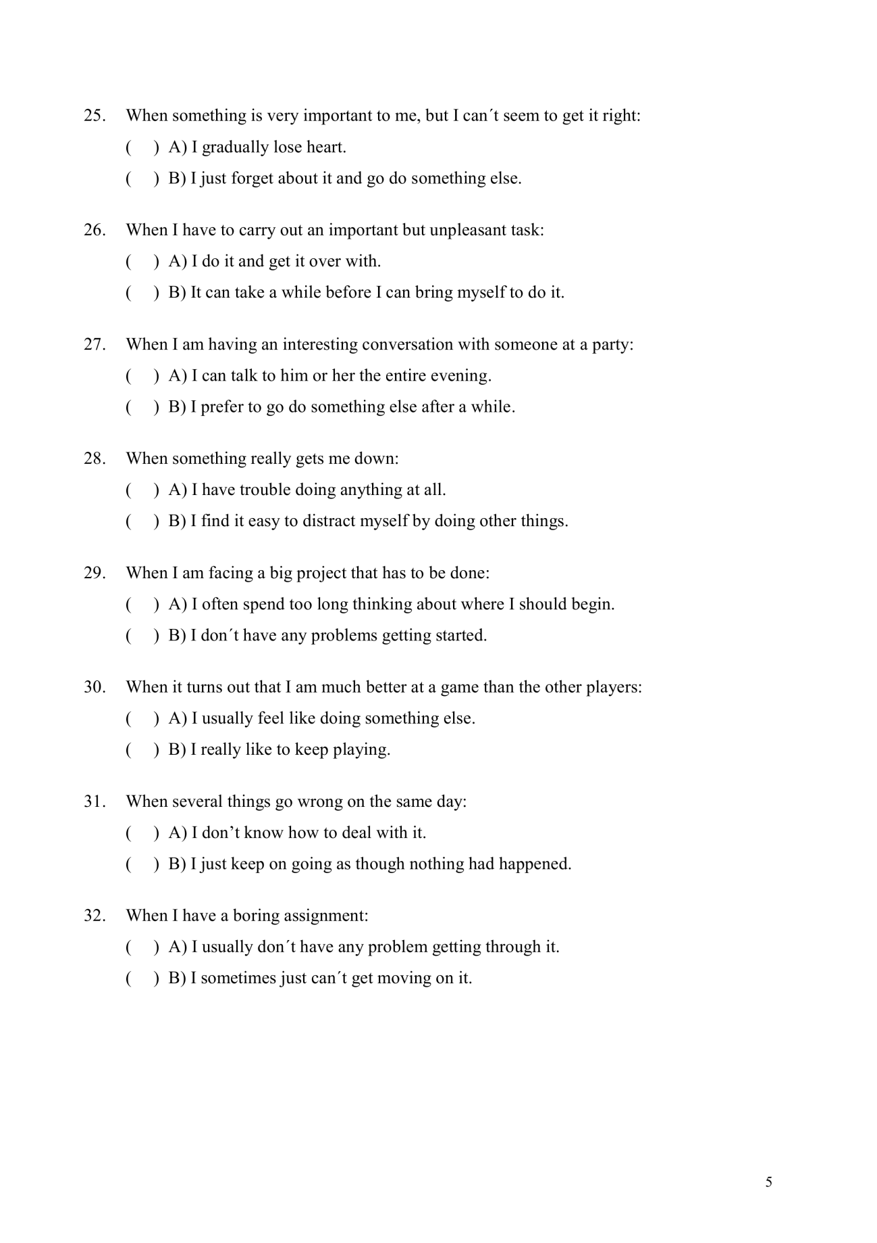
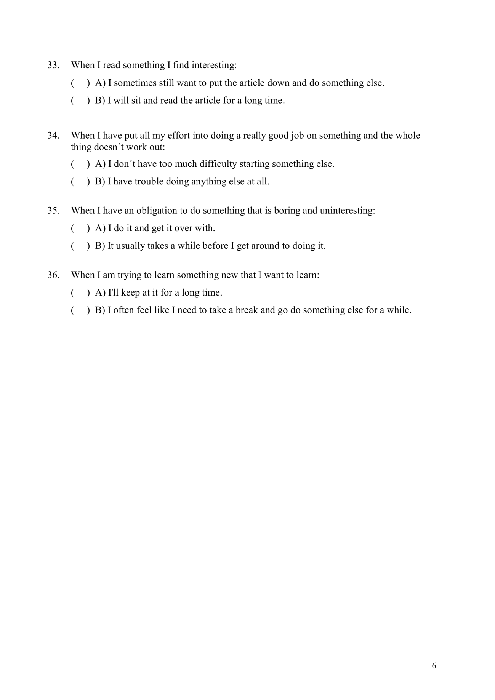

Welcome Sheet
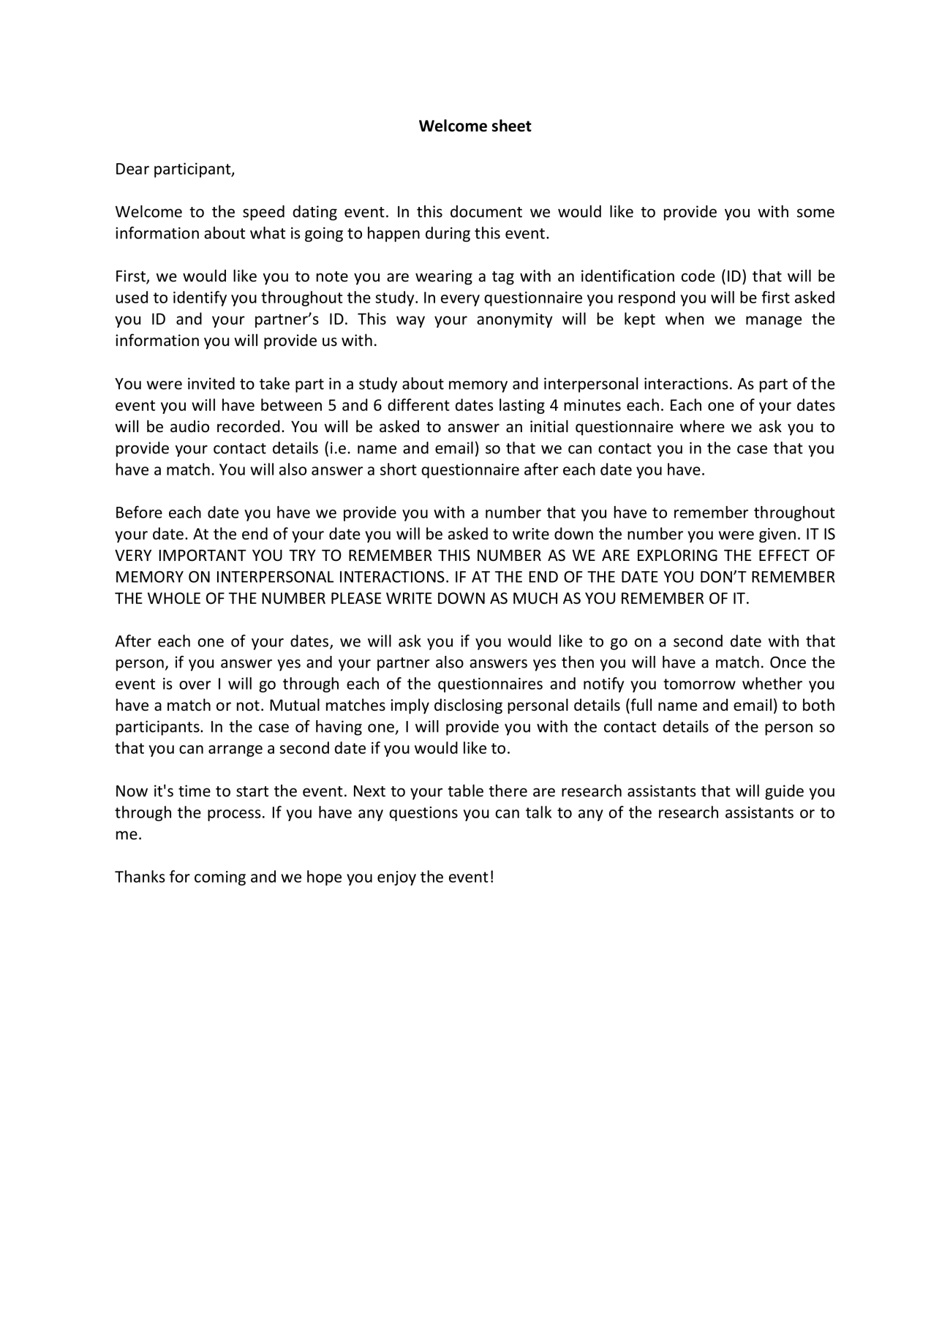

Initial questionnaire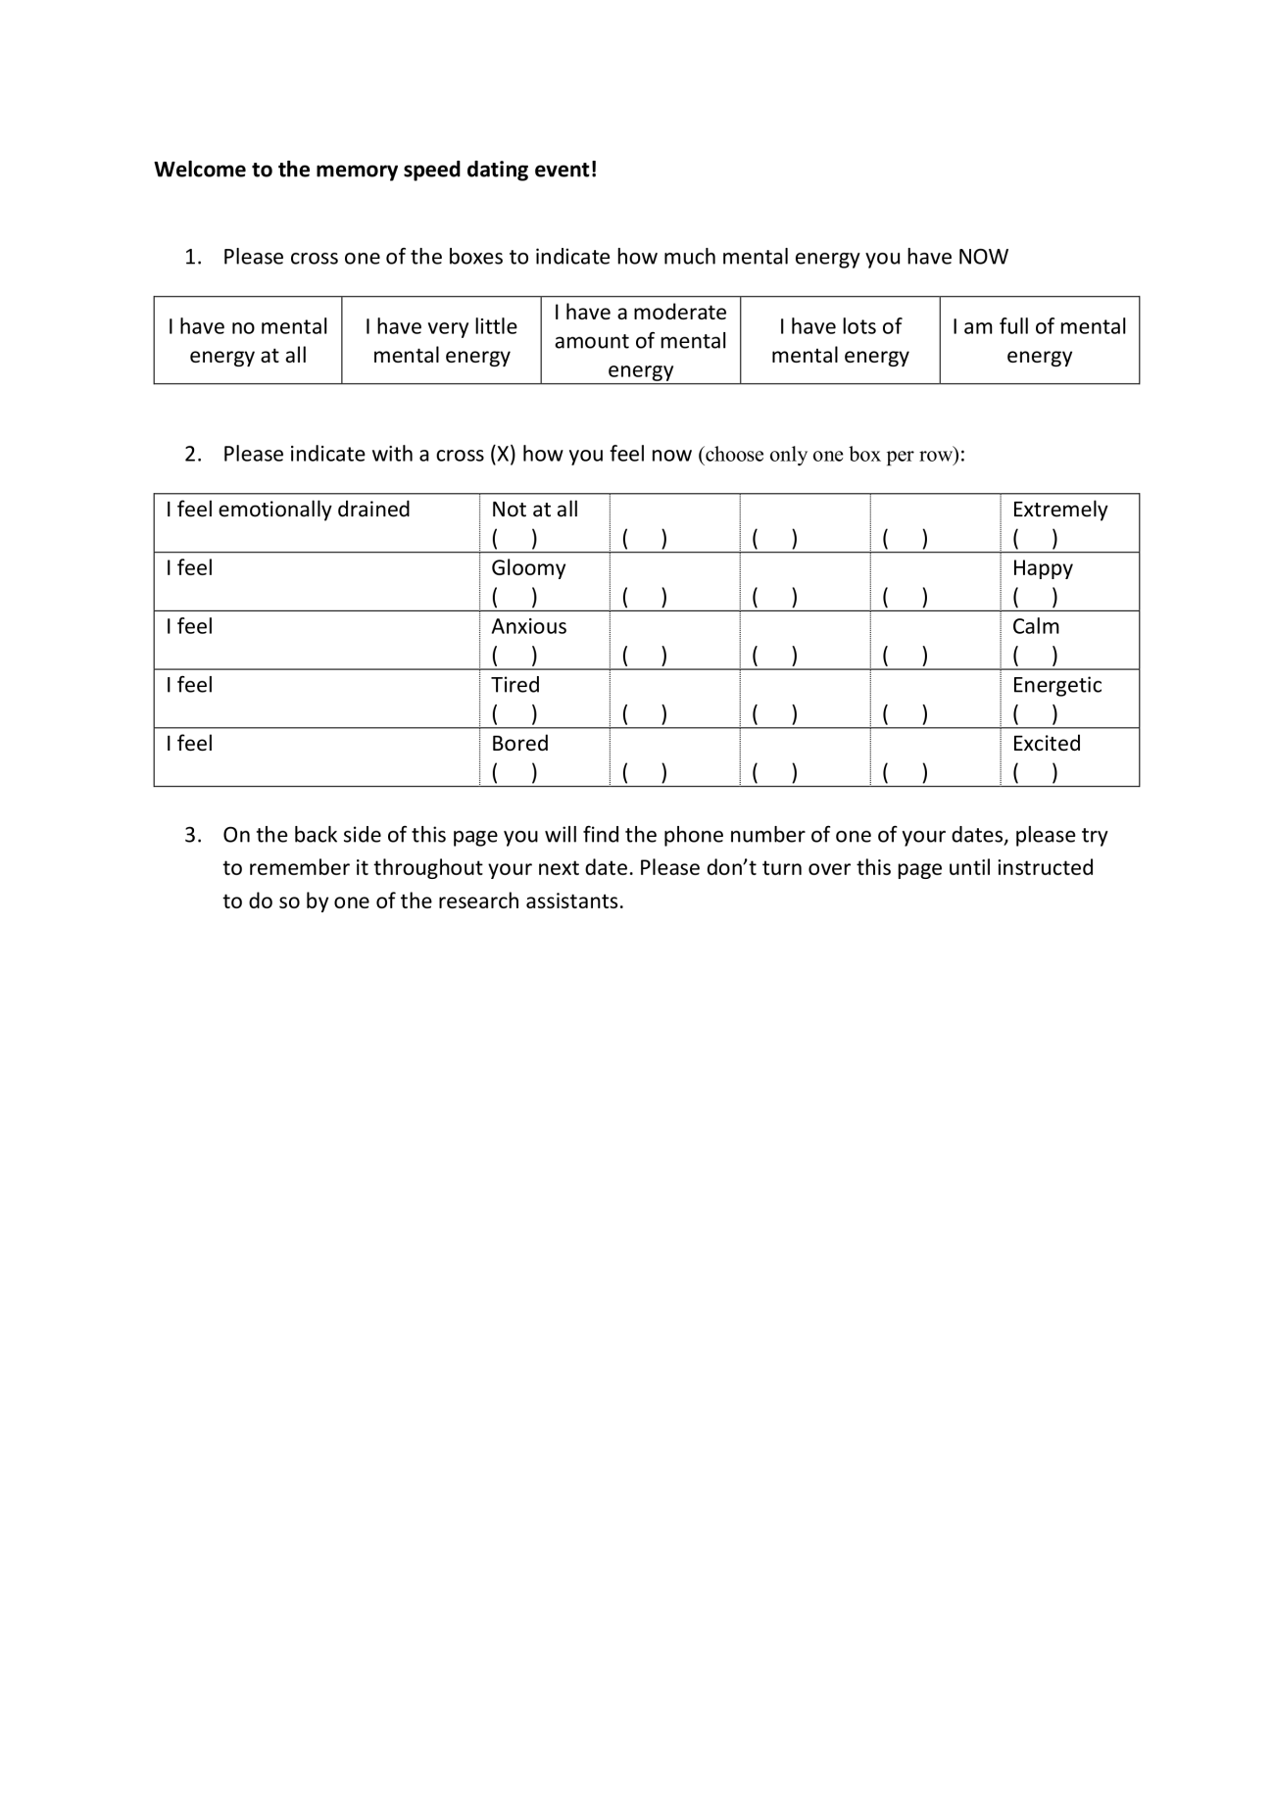
After date questionnaire
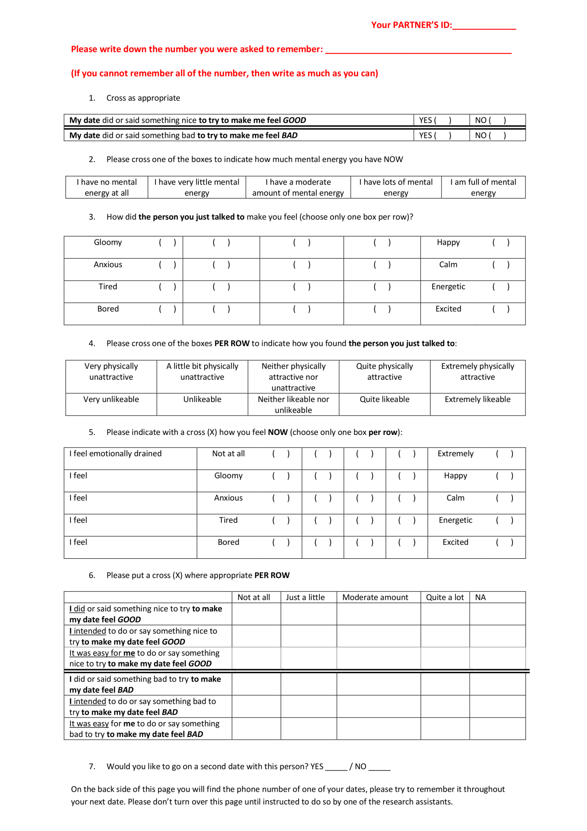

Short desirability scale
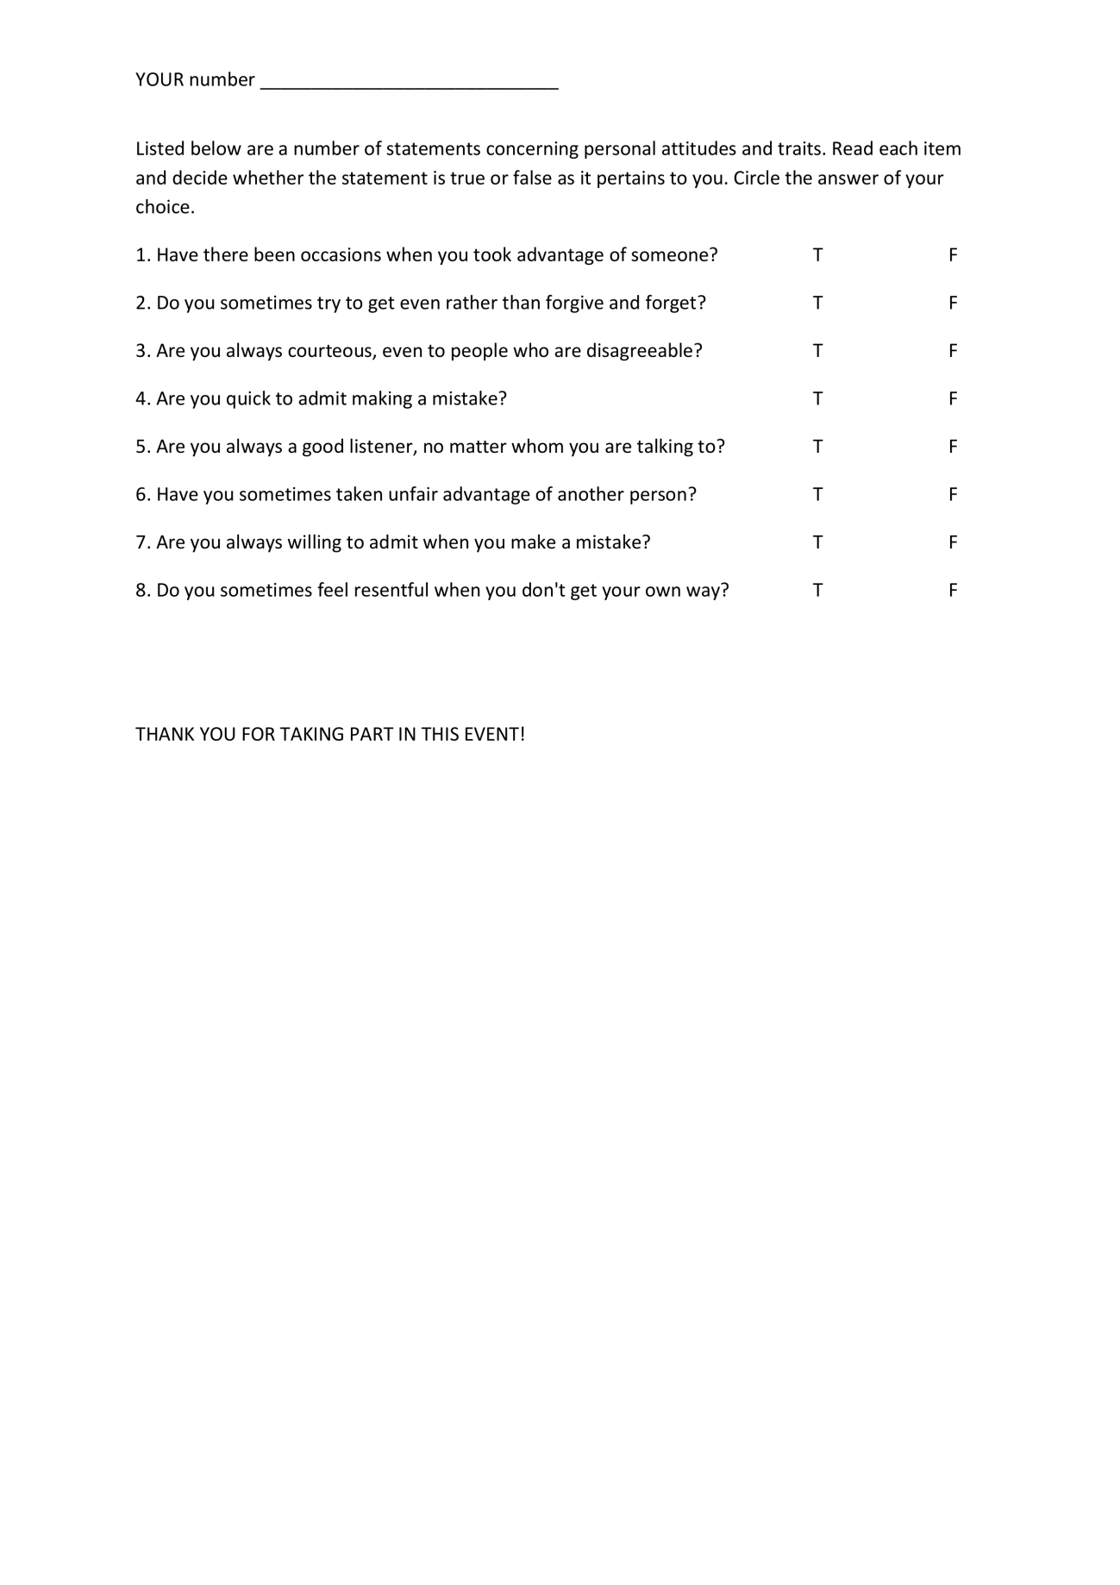

Throughout this thesis the acronym IER will refer to interpersonal emotion regulation as intrapersonal emotion regulation was not investigated.
Affect and emotion will be used interchangeably throughout this thesis.
The Scrambled Sentence Task (SST), developed by Srull and Wyer (1979) is a priming instrument that consists on unscrambling sentences that include words a researcher wants to elicit in his/her participants (e.g. if a researcher wanted to elicit shame, words like embarrassment, guilt, remorse, could be included in the scrambled sentences). The words included in the SST would later affect the behavior of the participant in an unobtrusive or automatic way (without the person’s conscious intention and/or control).
Shedler and colleagues suggest that people high in defensiveness have little awareness of their feelings, suppressing negative emotions to present themselves as psychologically healthy.
HRV is a measure of physiological reactivity that has an effect on emotion regulation, thus helping researchers monitor emotion regulation processes (Mauss, Cook, et al., 2007).
This research will be explained in more detail in Chapter 2.
In chapter 3 priming will be used as the main methodology, thus more detail such as the theory behind it, fundamental features, research examples and its use in ER will be explained there.
Karremans and Aarts (2007) research was conducted in Dutch so the in the word completion task the words "forgive" and "forgiveness" were in Dutch.
Reddit is an entertainment, social networking, and news website where registered community members can submit content. The present questionnaire was posted in a forum called r/SampleSize, the message to this survey and the link to the same can be found in https://en.reddit.com/r/SampleSize/comments/3haxlg/academic_emotional_regulation_have_you_ever/
All materials used in the present studies can be found in the Appendices at the end of this thesis.
Three of the original 4 items in the SRBAI were used to reduce the number of items to the minimum functional possible thus, reducing the possible effects of fatigue the questionnaire might cause on the participants. The item “Behaviour x” is something I do without having to consciously remember was deleted as it was considered as the item that could produce most confusion at the time of being answered.
The worsening and improving IER cluster was chosen as other research has also focused on this broad classification of IER. See the introduction of this chapter and chapter 1.
In the case of unhealthy snacking, for example, the snacking behaviour was measured by asking participants with which frequency they ate high calorie snacks (crisps, chocolates, cakes, sweets, and biscuits) over the previous week, (as Gardner et al. (2012) consider frequency to be related to automaticity arguing that as a behaviour occurs with more frequency in a stable context it increases the possibility of becoming habitual or automatic). To explore behaviours related to type of transportation, Gardner and colleagues asked participants to report as fast as possible (within a time limit) which means of transportation they would use in different circumstances (e.g. going to work). The researchers argue that habitual behaviours occur without effort and thus, under time pressure participants would report the mode of transportation they habitually use.
A health survey that measures physical and mental health (Ware, Kosinski, & Keller, 2016).
First year psychology undergraduate students at the University of Sheffield are required to collaborate as participants in research projects conducted by academic staff, postgraduate students, and level 3 undergraduate students. Each 15 minutes of participation is worth one credit. Once students have gathered 10 hours of participation they are given the opportunity to use this system of recruitment when they conduct they research project during their third year as undergraduate students. This system of recruitment allows everyone to conduct their experiments with more ease.
Ethics approval was obtained from the Ethics committee at Sheffield University for the three studies in the present Chapter (Study 2a, Study 2b, and Study 2c). The ethics form request stated that the experimenter was going to conduct a series of studies involving priming participants with emotion content words and then asking them to engage in imaginary or hypothetical interpersonal written interactions.
Analyses were conducted with and without these 4 participants. Results are reported with and without these people on the results section 3.3.1.2.
There is no consensus as to which is the best number of primes to include in the SST. Some researchers have used SST including 10 sentences, in which half of the sentences included the concept to be primed (Ahmed & Salas, 2008; Shariff & Norenzayan, 2007; Williams et al., 2009), others have used 30 sentences from which 20 included the prime (Epley & Gilovich, 1999), others 30 sentences in which half included the prime (Bargh et al., 1996), others have used 45 sentences with 30 of them including the concept to be primed (Silvia et al., 2006). Thus, in the present study 18 sentences were chosen as this number was considered to be adequate to not tire participants. 10 of the sentences included the prime as 10 sentences are more than 50% of the total sentences in the SST, and most researchers that have also used the SST have included primes in at least 50% of their sentences.
The words chosen as primes for the SST were taken from a pilot study conducted by the author of the present thesis as part of her Master’s degree dissertation, where 32 native English speakers (23 women and 9 men, ages ranging from 18 to 77, M = 29.82 yr, SD = 13.88) described whether they used certain emotion content words (i.e. praise, care, cheer-up, amuse, annoy, mock, share, blame, give hope, intimidate, joke, soothe, reassure, reject, flaunt, brag, complain, shout, empathise, swear, encourage, insult, bother, comfort, help, hurt, patronise, be unfriendly, bully, be rude, belittle, charm, criticise, love, captivate, promote, sympathise, smile, reinforce, sulk) in interpersonal contexts. The words with the highest frequencies of interpersonal use were chosen to build the present SST. These emotion content words were derived from interpersonal affect-worsening strategies (Niven et al., 2009).
The MRC Psycholinguistic Database: Machine Usable Dictionary, version 2.00 is an online dictionary resource designed to be used to select stimulus for research. It provides information about the linguistic properties of English words. Informatics Division Science and Engineering Research Council Rutherford Appleton Laboratory Chilton, Didcot, Oxon, OX11 0QX Michael Wilson 1 April 1987.
Coders also looked for instances of down-regulation of positive emotions (DRPE) (e.g. making someone happy feel less happy), but there were too few instances to include in subsequent analyses.
A second mixed-design ANOVA was conducted excluding the 4 participants that showed some sort of awareness to the purpose of the study. These results still show a significant interaction effect between the type of regulation (URNEt, UTPEa, URNEt, URNEa, DRNEt and DRNEa) and the condition (experimental and control) to which the participants belonged F (2,76) = 3.89, p < .05, d = .63.
One way ANOVAS excluding the 4 participants that showed some sort of awareness with respect to the purposes of the study were also conducted. The results showed that there was a marginally significant effect of condition on URPEa F (1, 39) = 3.73, p = .06, d = .61, and on URPEt F (1,39) = 3.44, p = .07, d = .73; a significant effect of condition on URNEa F (1.39) = 4.44, p < .05, d = -.65; a non-significant effect of condition on URNEt F (1,39) = 2.69, p = .11, d = -.52, on DRNEa F (1,39) = .702 p = .41, d = .27, nor on DRNEt F (1,39) = .03, p = .86, d =.07. These results indicate the same as the results including all participants in that: i) participants primed to worsen the emotions of someone else used more strategies to make someone feel bad than participants in the control condition (although in this case the effect was only found on the agent character or the character the participants chose to play), and, ii) participants in the priming condition used les strategies to make someone feel good in comparison to participants in the control condition.
Due to academic period where data was collected (summer holidays), it was very difficult to reach the required sample size (N = 28) to achieve a .80 power at an α = .05. This is also why the nature of the sample was different, as most students were not in Sheffield, personal contacts and volunteers from a list of registered volunteers from the University of Sheffield were used instead.
Analysis that include this measure (attitudes towards the ex-partner) will therefore have a smaller sample size.
As in Study 2a and 2b there were very few instances of DRPE found by both coders on the participants’ letters, which is why this variable was not included in the analysis.
Chartrand and Bargh (1996) primed people with impression formation by subliminally showing them words related to impression formation (e.g. impression, judgement, personality and evaluate) then, they presented participants with sentences that portrayed as honest, dishonest and neutral person. In a subsequent task they found that participants made impressions of that person according to what they were shown in the sentences.
Self-control and self-regulation will be used interchangeably in the present chapter to refer to the same function of self-control as the capacity to alter or inhibit a person’s response. Some researchers that make a distinction between self-control and self-regulation refer to self-control as a deliberate act of control whether self-regulation could also include processes such as maintaining a constant body temperature (Baumeister et al., 2007).
Tangney defines self-control as capacity to override or inhibit “undesirable behavioural tendencies” (such as impulses) and to refrain from acting on them
The Single Category Implicit Association Test (Karpinski & Steinman, 2006)
The small percentage completion for the main dependent measure (the Stroop task) might have been due to the fact that when participants were directed to Inquisit, where the Stroop task took place, it was required for them to run a temporary file on their computers in order for Inquisit to work. This might have caused distrust in participants which could have made them quit the experiment even though they were reassured this temporary file would not cause any harm to their equipment and they could delete it as soon as they finish.
Inquisit is an online software that allows participants to answer psychological instruments from any computer that has access to the internet.
The correlation coefficients between each variable and factor can be observed on Table IV.2
Given the fact that from the 154 participants, only 85 completed both the new measure of self-control during the working day and the Stroop task, using independent samples T-tests it was investigated if the participants that did not complete the Stroop task were different from participants that did complete it with respect to: i) each of the use of self control factors, ii) mental energy, ii) physical energy, iv) emotional exhaustion, v) and to each of the four dimensions of mood. No significant differences were found between any of these variables and whether the participant completed the use of self-control scale only, or both, the use of self-control scale and the Stroop task.
Cole’s et al. (2016) study used the ‘Use of self-control during the working day’ scale presented in the current chapter to give continuity to the findings of Study 3.
For practical purposes, the present research investigates three features of automaticity but to remind the reader, automatic processes have been associated with more concepts than the ones presented here. The review on automaticity by Moors and De Houwer (2006) for example, talks about eight of these features: (un)intentional, goal (in)dependent, (un)controlled/(un)controllable, autonomous, purely stimulus driven, (un)conscious, efficient and fast. While Bargh and Williams (2007) focus mainly on four features: efficiency, lack of awareness, lack of control, and little or no intention.
The data of the back-up was not included in the analyses.
The researcher had a model of the tables and seats for the event, where, for each table there were half the places for women and half the places for men. The places where numbered from 1 until 17 for both men and women. From the places for the women and for the men respectively, half of them were signalled as belonging to the high cognitive load condition and the other half to the low cognitive load condition. The researcher had two boxes with the IDs of the participants (one for men and one for women) from which she drew one person at a time and assigned it to one of the seats on the model, starting from number 1 and finishing at 17.
The welcome document also informed participants their dates would be audio-recorded. Therefore recording devices were placed in the middle of the table between some pair of participants (man and woman). Unfortunately, the event and place were so noisy that it was not possible to use the recordings.
Mental energy was also monitored as research has found that people that exert self-control report being more fatigued than people that do not (Muraven et al., 1998).
Friese et al. (2008) used an 8-digit number to manipulate the control resource cognitive capacity. Even though, in the present research, participants were given a larger number (11-digits), this number was larger in only one digit than the numbers used by Friese and colleagues. The first 2 digits were always 07, which are the numbers that correspond to mobile phones in the UK which is something people living in the UK know.
Although participants were not informed that there was a high and a low cognitive load condition (hence, long and short numbers) it is possible that throughout the event they realised this.
The categories of improving and worsening IER were again used in the present study as they are the two kinds of IER most research on IER focuses on (see Chapter 1 section 1.2.3 and 1.4 and Chapter 2 section 2.1.2).
Participants in the experimental condition received a different 11-number digit every time they answered a questionnaire; and participants in the control condition received a different one-digit number every time.
All the scales included in the pre-event questionnaire were answered by all participants that participated in the speed-dating event. Nevertheless, only the SRHI and the ‘impulse control difficulties’ and the ‘lack of emotional awareness’ factors from the DERS were included in the analyses.
Both the DERS and the BEQ include a measure of impulsivity, in the analyses, only the impulse-control subscale was used as it had better internal consistency.
The ERQ was not used in the analysis because the responses of participants mainly indicated they used positive IER strategies and the ERQ focuses on the regulation of negative emotions.
The terms ‘actor’ and ‘partner’ will be used throughout the results and discussion sections.
Most speed dating events run a series of different events with an average of 22 people per event (Belot & Francesconi, 2006; Finkel et al., 2007). In the present study, as the space where the speed dating was conducted belonged to the university, special permission was needed to conduct the event and it would have been difficult to conduct a series of events. Thus, the biggest sample that could be collected for this event was gathered together on the same day.
Participants who had a match were contacted via email and passed the contact detail of their match or matches. It was up to them whether or not to arrange a second date.
As the success in observing an effect of the condition participants were assigned to on the use of IER strategies depended on the participants being actually engaged in the cognitive load task (i.e. actively trying to remember the number that was given to them), only the cases where the participants reported remembering more than four digits were selected. Gilbert and Hixon (1991) established this criterion as a cut-off point to suggest that participants were actually trying to remember the number that was given to them.
There was N = 186 in the repeated measures ANOVA because the last dependent variable (effort to make the partner feel bad) had missing cases. Nevertheless, in the subsequent one-way ANOVAs N = 191.
The actor scores reporting on his/her use of IER to make their partners feel good were divided between “strong use of IER” and “weak use of IER” to make the partner feel good using the median = 2.83 as the cut-off point.
Selecting the cases where the partner was engaged on the cognitive load task might have affected the partner’s perception on the actors use of IER, making it more inaccurate, thus, as a check test, the GLMM was run without filtering the partners that were engaged in the cognitive load task, finding the same results, namely, a non-significant interaction between condition and number of date over the partner’s perception of the actor using IER (F (11,174) = .80, p > .05).
The four items exploring affect provided an overall score of affect with lower scores indicating negative affect and higher scores indicating positive affect.

