Investigation of Magnetron Sputtered Nitrogen-Containing Chromium Coatings with Additions of Copper and Silver

by:
Xingguang Liu
A dissertation submitted in fulfilment of the requirements for the degree of
Doctor of Philosophy
Department of Materials Science and Engineering
August 2016

ABSTRACT
In the past two decades, research in the field of plasma-assisted Physical Vapour Deposition (PVD) has been intensively concentrated on hard and superhard coatings, particularly ceramic-ceramic and ceramic-metal nanocomposite film, in order to achieve improved tribological properties, such as wear resistance and low friction. However, sufficient (rather than extreme) high hardness, combined with low elastic modulus (high H/E ratio), often proves to be more effective again wear than (extreme) high hardness by itself, especially so for coatings on soft or compliant substrates.
In addition, self-lubricating PVD tribological thin films have been intensively investigated in recent years. Among these, PVD nanocomposite coatings containing soft metals (e.g. Ag or Cu), as a solid lubrication phase, embedded in a hard wear-resistant matrix, such as a transition metal nitride, carbide, oxide or supersaturated solid solution, and mixtures of them (in ternary/quaternary/nanocomposite coating systems), have all been extensively studied, with the promise of improved tribological performance during transient and/or cyclic temperature changes. Therefore, a PVD coating with similar elastic modulus as soft or compliant metallic substrates (e.g. around 200 GPa or less), and promising solid-lubricating properties over a (relatively) large range of temperatures, would be of great application interest.
This work concentrates on nanocomposite metallic (or partially metallic) PVD CrCuAgN coatings. The main aims of the study are to preserve the metallic state of Cr and, instead of creating stoichiometric ceramic nitride phases (CrN or Cr₂N), to supersaturate it with interstitial nitrogen atoms, in order to obtain coatings with high H/E ratios. Moreover, the transport behaviour of solid lubricants (i.e. Cu and Ag) to coating surfaces under medium high temperature would also be important for the tribological and antimicrobial properties of these coatings. Guidelines of coating design for specific applications can be obtained by comprehensive study of the abovementioned studies.
Coatings were produced by asymmetric pulsed-DC unbalanced magnetron sputtering, on AISI 316 stainless steel coupons. Then they were divided into three groups for post-coat annealing at different temperatures, which were as-deposited (no annealing), 300 °C and 500 °C, respectively, with a fixed annealing duration of 2 hours. The as-deposited and annealed coatings were then analysed and/or evaluated using X-ray diffraction (XRD) analysis, scanning electron microscopy with energy dispersive X-ray analysis (SEM/EDX), transmission electron microscopy (TEM), high-resolution TEM and scanning TEM (STEM) with EDX, nanoindentation, scratch test, high-temperature reciprocating sliding wear test, in order to investigate the phase composition, chemical composition, surface and fracture morphologies, phase- and elemental distribution, mechanical properties and tribological properties, etc.
The result show that, in coatings with a nitrogen concentrations of up to 16 at.% (i.e. N/(Cr+N) atomic ratio up to 0.18), a metallic Cr solid solution with supersaturated interstitial nitrogen was preserved, even after post-coat annealing at 300 °C and 500 °C. At relative higher N/(Cr+N) atomic ratios, the coexistent state of α-Cr solid solution with embedded Cr₂N nitride phase is relatively stable over a large range of nitrogen concentrations (i.e. N/(Cr+N) ratios from 0.18 to 0.55 in this investigation), which can also survive at relatively high temperature (e.g. 500 °C). Nitrogen-free CrCuAg coatings exhibited relatively low hardness, ranging from 5 GPa to less than 10 GPa. With the introduction of nitrogen, the hardness of CrCuAgN coatings increased significantly, to ~15 GPa with a preserved metallic Cr solid solution matrix. And the tribological test results showed that, a significant decrease in the coefficients of friction, over 50% compared to that of the substrate (from 0.31 to 0.14 with diamond indenter, and from 0.83 to 0.40 with alumina ball, respectively) was obtained for the CrCuAgN coatings, showing effective solid lubricating behaviour.
The co-existence of Cu in a PVD coating containing Ag was found to be beneficial to Ag transport onto the coating surface, resulting not from the preconceived ‘intergranular network channels’ of Cu, but from the much higher detachment (from small precipitates to larger ones) rate of Cu than Ag, which would ‘leave a path’ for Ag to transport after Cu. Therefore by proper design and processing, CrCuAgN coatings with appropriate elemental compositions and solid-solution matrix can be obtained, in which the precipitation rate of Ag can be (partially) controlled by a moderate concentration of Cu (4.5 at. % appears to be sufficient), resulting in a controlled supply of solid lubricants, hence being highly promising in the application fields of solid lubricating coatings.

ACKNOWLEDGEMENTS
I would firstly express my great appreciation to Dr. Adrian Leyland, Prof. Allan Matthews, and the Department of Materials Science and Engineering, for the joint financial support to cover my tuition fees; and to China Scholarship Council (CSC) for the funds of living costs. Without these financial supports, it would be impossible for me to start my PhD study here in the UK, in this world-class and prestigious university.
I would like to thank both my supervisors, Dr. Adrian Leyland and Prof. Allan Matthews, for providing me this opportunity to undertake this research project, and for offering their guidance, support, encouragement, patience, immense knowledge and experience, without which I could not finish this thesis.
I would also like to send great thanks to Dr. Aleksey Yerokhin and Dr. Gwen Reilly, as my annual progress examiners, they offered me helpful and insightful suggestions and advice.
My grateful thanks to Dr. Le Ma and Dr. Itzel Castillo-Müller for their enthusiastic and timely help with the high-temperature reciprocating sliding wear tests. And many thanks to Chanon Iamvasant and Xiao Tao for their help with the annealing processes.
My sincere thanks also goes to the experimental officers of electron microscopes, including Dr. Peter Korgul, Dr. Le Ma, Dr, Peng Zeng, and Dr. Cheryl Shaw from Sorby Centre, and Dr. Ian Ross from Department of Electronic and Electrical Engineering (EEE), for the generous help and useful discussions with their expertise in various electron microscopes.
Great thanks to my friends and members (and former members) of the RSCE group, Dr. Alison Beck, Dr. John Kavanagh, Dr. Chen-Jui Liang, Dr. Heqing Li, Dr. Yonghao Gao, Dr. Omoniyi Fasuba, Mrs. Josephine Lawal, Mrs. Fahima Indeir, Mr. Chang Liu, Mr. Lian Liu, Mr. Jack Cooper, Mr. Ming Sun, Mr. Xiao Tao, Mr. Chanon Iamvasant, Mr. Wei-Yu Chen, Mr. Gorkem Yumusak, Mr. Laurynas Lukosevicius, Mr. Andrius Subacius, Ms. Lynne Hopkins, Mr. Husein D Meshreghi, Mrs. Nora Yaakop, for their help and the joyful time we had together. And thanks to my friends from other groups, Dr. Zhen Xu, Dr. Feng Qian, Dr. Junheng Gao, Dr. Dikai Guan, Dr. Zhilun Lu, Dr. Peng Gong, Mr. Zhe Cui, Mr. Haitao Zhao, Miss Wen Zhao, Miss Haiyun Wang, Mr. Yuhe Huang and Mr. Pu Liu, for their help and more importantly the memorable time we spent together.
Special and deep appreciation to my parents, who although living in China have always sent me their care and support. And to my beloved wife, Shasha Wu, who has always been by my side, accompanying me through every hard or good day.

Contents
ABSTRACT I
ACKNOWLEDGEMENTS IV
Contents V
Figure Captions IX
Table Captions XV
Chapter 1. Research topic 1
1.1. Background 1
1.2. Research feasibility and title 4
1.2.1. Research feasibility 4
1.2.2. Research title 5
Chapter 2. Physical Vapour Deposition 6
2.1. Introduction PVD processing methods 6
2.1.1. Background of PVD 6
2.1.2. Characteristics of PVD techniques 6
2.1.3. Categories of PVD process 7
2.1.4. Applications of PVD 8
2.2. Introduction to magnetron sputtering 9
2.2.1. Background 9
2.2.2. Applications: competent, versatile and promising 11
2.2.3. Thornton’s structural zone model (SZM) 12
2.2.4. Bombardment and asymmetric pulsed power 14
2.2.5. Process parameters 17
2.2.6. Adhesion and its improvement 19
2.2.7. Deficiencies of magnetron sputtering (of hard thin films) 20
2.2.8. Types and new improvements of magnetron sputtering 20
Chapter 3. Recent development in solid-lubricating PVD coatings 22
3.1. Introduction to solid lubricants and solid-lubricating coatings 22
3.1.1. Definition 22
3.1.2. The need for solid lubrication 22
3.2. Primary research areas of solid-lubricating coatings 27
3.2.1. Classification of solid lubricants 27
3.2.2. Adaptive solid-lubricating coatings: a combination of two or more solid lubricants 29
3.3. Recent development in TM-nitride (or nitrogen-containing-TM) films, with added soft metals for solid-lubrication 32
3.3.1. Addition of Cu into TM-nitride or nitrogen-containing TM coatings 36
3.3.2. Addition of Ag into TM nitride or nitrogen-containing TM coatings 37
Chapter 4. Experimental Procedures 40
4.1. Substrate preparation 40
4.2. Coating deposition 40
4.2.1. Deposition rig and power supplies 40
4.2.2. Deposition configurations 42
4.2.3. Deposition procedures 46
4.3. Coating analysis 49
4.3.1. XRD analysis 49
4.3.2. EDX analysis 49
4.3.3. Coating surface and fracture section morphologies 50
4.3.4. S/TEM analysis 52
4.3.5. Nanoindentation (H and E) 54
4.3.6. Scratch test and high-temperature reciprocating sliding wear test 54
4.3.7. Sample labelling methodology 55
Chapter 5. Morphology, Nanostrucure of As-deposited Coatings 56
5.1. Introduction 56
5.2. Coating thickness 57
5.2.1. Coating thickness: The overall trend 58
5.2.2. Coating thickness: Comparison among three groups 59
5.3. Fracture Cross-sections 61
5.3.1. Fracture cross-sections: The nitrogen-free control group 61
5.3.2. Fracture cross-sections: The 5 sccm group 61
5.3.3. Fracture cross-sections: The 10 sccm group 61
5.3.4. Fracture cross-sections: Comparison among three groups 62
5.4. Surface morphology 65
5.4.1. Surface morphology: The nitrogen-free control group 65
5.4.2. Surface morphology: The 5 sccm group 66
5.4.2. Surface morphology: The 10 sccm group 66
5.4.4. Surface morphology: Topography classification 66
5.5. Elemental composition 67
5.5.1. Elemental concentrations 67
5.5.2. Improved elemental composition distribution by the new deposition configuration 69
5.5.3. Atomic concentration ratios 69
5.5.4. Summary of elemental composition analysis 70
5.6. Phase composition 72
5.6.1. Phase composition: The nitrogen-free control group 73
5.6.2. Phase composition: The 5 sccm group 77
5.6.3. Phase composition: The 10 sccm group 79
5.6.4. Phase composition: Comparison of the two nitrogen-containing groups 79
5.7. Summary 81
Chapter 6. Effects of Post-deposition Annealing: Part 1 83
6.1. Introduction 83
6.2. Fracture cross-sections 85
6.2.1. The 0 sccm (nitrogen-free) control group 85
6.2.2. The 5 sccm and 10 sccm (nitrogen-containing) groups 85
6.3. Surface morphology 87
6.3.1. The 0 sccm (nitrogen-free) control group 88
6.3.2. The 5 sccm and 10 sccm (nitrogen-containing) groups 88
6.3.3. Comparison among the three coating groups 91
6.3.4. Summary of surface morphology analysis 91
6.4. XRD analysis 92
6.4.1. The 0 sccm (nitrogen-free) control group 93
6.4.2. The 5 sccm group 94
6.4.3. The 10 sccm group 95
6.4.4. Comparison among the three coating groups 95
6.4.5. Summary of XRD analysis 98
6.5. TEM analysis 99
6.5.1. Coating selection for TEM analysis 99
6.5.2. 5 sccm-P2-AD 100
6.5.3. 5 sccm-P2-300 104
6.5.4. 5 sccm-P2-500 106
6.5.5. 10 sccm-P4-500 108
6.5.6. Summary of TEM analyses 112
6.6. Summary 114
Chapter 7. Effects of Post-deposition Annealing: Part 2 116
7.1. Introduction 116
7.2. Coating thickness 119
7.3. Elemental composition and atomic ratios 120
7.3.1. Elemental composition 120
7.3.2. Selected atomic ratios 122
7.4. Surface morphology 123
7.4.1. As-deposited CrCuAgN coatings 123
7.4.2. Annealed coatings 125
7.5. Phase composition and transformation, part 1: XRD analyses 130
7.5.1. Introduction 130
7.5.2. As-deposited coatings 133
7.5.3. Coatings annealed at 300 °C 137
7.5.4. Coatings annealed at 500 °C 137
7.6. Phase composition and transformation, part 2: TEM analyses 139
7.6.1. Coating selection for TEM analysis 139
7.6.2. Coating TR 140
7.6.3. Coating MC 148
7.6.4. Coating MR 151
7.7. Summary 156
Chapter 8. Mechanical, tribological properties of selected coatings 158
8.1. Mechanical properties 158
8.1.1. Mechanical properties: The nitrogen-free control group 160
8.1.2. Mechanical properties: The 5 sccm group 160
8.1.3. Mechanical properties: The 10 sccm group 160
8.1.4. Mechanical properties: Comparison among three groups 161
8.2. Coefficient of friction 163
8.2.1. Scratch test 163
8.2.2. Reciprocating sliding wear tests at room and elevated temperature 165
8.3. In-situ three-point bending of PVD films using focused ion beam 167
8.3.1. The need to determine ‘critical strain’ values for mechanically-loaded thin films 167
8.3.2. A solution using focused-ion beam 170
8.4. Summary 176
Chapter 9. discussion with current related research results 178
9.1. Nanostructure of as-deposited coatings 178
9.2. Effects of annealing and transportation mechanisms 179
9.3. Mechanical and tribological properties 181
Conclusions and future works 183
Conclusions 183
The first stage study 183
The second stage study 185
Mechanical and tribological properties 187
Future works 189
References 191
Appendix Research Activities during PhD study 202

Figure Captions
Fig. 2.1. Schematic diagram showing the different plasma confinements in balanced and unbalanced magnetrons (reconstructed based on reference [65]). 10
Fig. 2.2. (a) Thornton’s structural zone model [86] (reconstructed); (b) revised structural zone model by Messier, et al[88], which takes the effects of bombardment (substrate bias) into account as well (reconstructed). 14
Fig. 3.1. The hexagonal WS₂ structure, showing the covalent bonding inside the S-W-S “sandwich”, and the weak interplanar force between these sandwiches. 28
Fig. 3.2. Calculated Cr-Cu binary phase diagram [161]. 33
Fig. 3.3. Calculated Ag-Cr binary phase diagram [161]. 33
Fig. 3.4. A schematic diagram showing the possible nanostructure of Cr-Ag-N system. 34
Fig. 3.5. A schematic diagram showing the possible nanostructure of Cr-Cu-N system. 34
Fig. 4.1. The Nordico unbalanced magnetron sputtering deposition rig, with the ENI DCG-100 DC-pulsed and RPG-100 DC generators. 41
Fig. 4.2. Schematic drawing of (a) target-substrate arrangement in deposition chamber and (b) plan-view of the Cu-Ag target. 43
Fig. 4.3. Schematic drawing of (a) plan-view of target-substrate geometry in deposition chamber (and sample matrix designation) and (b) vertical arrangement of Cr-Cr-Cu and Cr-Cr-Ag segmented targets. 45
Fig. 4.4 Schematic procedures of the fraction section preparation for SEM observation. 51
Fig. 4.5. Schematic diagrams of these two types of FIB samples: (a) Plan-view TEM sample extracted directly from the fractured coating; (b) cross-section coating extracted from coating surface. 53
Fig. 4.6. A schematic diagram showing a TEM sample copper grid, with the relative position of the TEM foil indicated. 53
Fig. 5.1. SEM micrographs showing the fracture sections and coating thickness for (a) the nitrogen-free control group, (b) 5 sccm group, (c) 10 sccm group; (d) a focused ion beam (FIB) coating cross section image showing the numerous pores and voids existing in sample CrCuAgN5-P4-AD (clean cross section cut by FIB, final milling using Gallium ion beam at 100 pA, 30 kV). 58
Fig. 5.2. Oblique-view coating surface SEM micrographs of (a) nitrogen-free control group, (b) 5 sccm group and (c) 10 sccm group. 65
Fig. 5.3. Concentrations of different elements at 0 sccm, 5 sccm and 10 sccm nitrogen flow rate, versus deposition position: (a) Cu and Ag, with an inset of Ag concentration at a larger scale, (b) Cu+Ag, (c) N, (d) Cr, (e) N/(Cr+N), (f) Ag/Cu and (g) (Cu+Ag)/Cr. 68
Fig. 5.4. X-ray diffraction patterns of the as-deposited coatings: (a) nitrogen-free control group, (b) 5 sccm group and (c) 10 sccm group. 72
Fig. 5.5 (a) (same to Fig. 3.1) Calculated Cr-Cu binary phase diagram [161]; (b) reconstructed schematic PVD phase fields for the Cu-Cr system [37]. 74
Fig. 5.6. (a) XRD pattern of standard silicon powder; (b) Enlarged deflection, the one marked using an orange square in (a). 76
Fig. 6.1. Fracture section SEM micrographs of (a) nitrogen-free control group, (b) 5 sccm group and (c) 10 sccm group, in which ‘AD’ means ‘as deposited’, ‘300’ means annealed at 300 °C for 2 hours, and ‘500’ means annealed at 500 °C for 2 hours. 86
Fig. 6.2. Oblique-view coating surface SEM micrographs of (a) nitrogen-free control group, (b) 5 sccm group and (c) 10 sccm group, with Cu and/or Ag aggregates indicated by the red circles. 88
Fig. 6.3. EDX line scan results of an aggregate on the surface of sample 10 sccm-P5-500. 89
Fig. 6.4. X-ray diffraction patterns of the as-deposited and annealed coatings, (a) nitrogen-free control group. (b) 5 sccm group and (c) 10 sccm group. 92
Fig. 6.5. Plane-view TEM images and SAED pattern of 5 sccm-P2-AD, (a) SAED pattern; (b) BF image at low magnification; (c) DF image at low magnification, same area as (b), with its corresponding diffraction point (part of the (110) ring) shown in the black circle in (a); (d) BF image of the selected area shown in (b) at high magnification; (e) DF image of the selected area shown in (c) at high magnification, which is also the same feature as the one shown in (d). Continued on next page. 102
Fig. 6.5. Continued. 103
Fig. 6.6. Plane-section TEM images and SAED pattern of 5 sccm-P2-300, (a) SAED pattern; (b) BF image at low magnification; (c) DF image at low magnification, same area as (b), with its corresponding diffraction point (part of the dashed (110) ring) shown in the black circle in (a); (d) BF image of the selected area shown in (b) at high magnification; (e) DF image of the selected area shown in (c) at high magnification, which is also the same feature as the one shown in (d). 105
Fig. 6.7. Plane-section TEM images and SAED pattern of 5 sccm-P2-500, (a) SAED pattern; (b) BF image at low magnification; (c) DF image at low magnification, same area as (b), with its corresponding diffraction point (part of the dashed (110) ring) shown in the black circle in (a); (d) BF image at high magnification; (e) BF image of another area at high magnification, with clear moiré fringes as indicated in red circles. 107
Fig. 6.8. Plane-section TEM images and SAED pattern of 10 sccm-P4-500, (a) SAED pattern and (b) BF image at low magnification. 109
Fig. 6.9. DF images of 10 sccm-P4-500, with their corresponding diffraction pattern shown in Fig. 6.8, (a) the large black circle, which contains (b), (c); (b) the small red circle, in which are parts of the diffraction rings belonging to Cr(110), Cu(111), Cr2N(111), Cr2N(200) and Cr2N(201), with Cr(110) being the brightest; (c) the small green circle, in which are two diffraction points along the Cr2N(112) diffraction ring. 111
Fig. 7.1. Elemental concentrations of each coating in atomic percentage, displayed in 3D columns in 3×3 matrix: (a) Cr; (b) Cu; (c) Ag and (d) N. 121
Fig. 7.2. Selected atomic-percentage ratios of each coating, displayed in 3D columns in 3×3 matrix: (a) N/(Cr+N); (b) Cu/(Cr+Cu); (c) Ag/(Cr+Ag) and (d) (Cu+Ag)/(Cr+Cu+Ag). 122
Fig. 7.3. Secondary-electron images, exhibiting the surface morphologies of as-deposited coatings, in 3×3 matrix, corresponding to positions shown in Fig. 4.3a. 124
Fig. 7.4. Secondary-electron images exhibiting the surface morphologies of 500 °C annealed coatings, in 3×3 matrix, corresponding to positions shown in Fig. 4.3a. Several selected backscattered electron images are also inset at the top-right corner of their corresponding secondary-electron images. 127
Fig. 7.5. (a) Secondary-electron images of two aggregates, from sample MR-500; (b) corresponding backscattered-electron image of (a); (c) and (d) Secondary-electron images of 2 large aggregated grains of sample ML-500, the ‘on-going’ fusion processes can be clearly seen, e.g. areas marked using blue circles. The grain in (c) is the same grain as the one shown at position ML in Fig. 7.4. 128
Fig. 7.6. Secondary-electron imaging showing the surface morphology of MR-500, with the corresponding EDX elemental mapping RGB (red: Cr, green: Cu and blue: Ag) image shown in the top-right-corner inset. 128
Fig. 7.7. Calculated Ag-Cu binary phase diagram [161]. 129
Fig. 7.8. X-ray diffraction patterns of the as-deposited CrCuAgN coatings. 131
Fig. 7.9. X-ray diffraction patterns of the annealed CrCuAgN coatings: (a) after annealing at 300 °C for 2 hours; (b) after annealing at 500 °C for 2 hours and (c) coatings from chapter 6, CrCuAgN5-P1 to P5, annealed at 500 °C for 2 hours, replotted based on Fig. 6.4b in Section 6.4.2. Note: the intensity scales in Fig. 7.8 (same with Fig. 9c), Fig. 7.9 and Fig. 9b were in ratios of 1:10:20, respectively. 132
Fig. 7.10 (same as Fig. 5.5). Reconstructed schematic PVD phase fields for the Cr-Cu system [37]. 136
Fig. 7.11. Schematic PVD phase fields for the Cr-Ag system, based on principles of ref. [37]. 136
Fig. 7.12. TR-AD-Cross section: (a) BF image at low magnification; (b) BF image at high magnification; (c) DF image at low magnification; (d) DF image at high magnification and (e) SAED pattern, with the small red circle corresponding to selected part of SAED pattern for the dark field imaging of (c) and (d). 141
Fig. 7.13. TR-AD-plan view: (a) BF image at low magnification; (b) BF image at high magnification; (c) dark field image at low magnification; (d) DF at high magnification and (e) SAED pattern, with the small red circle corresponding to selected part of SAED pattern for the dark field imaging of (c) and (d). 142
Fig. 7.14. Sample TR-AD-cross section: (a) high resolution TEM image taken from Cr[100] zone axis, with growth direction shown by green arrow; (b) IFFT of image (a), with several stacking faults indicated using yellow dashed arrows, and distorted lattice marked by yellow lines. 142
Fig. 7.15. TR-500 cross-section: (a) BF image in STEM mode; (b) HAADF image from the same area as (a). 144
Fig. 7.16. TR-500 cross-section: (a) HAADF image at medium magnification; (b) RGB EDX mapping image, with corresponding area shown in (a); (c) HAADF image at high magnification, (d) RGB EDX mapping image, with corresponding area shown in (c). Red, green and blue refer to Cr, Cu and Ag, respectively. 145
Fig. 7.17. TR-500 plan-view: (a) SAED pattern, with the colour circles corresponding to selected (using objective aperture) spots for DF imaging, and relevant crystal planes are also indicated; (b) the BF image of the corresponding SAED pattern shown in (a); (c) corresponding DF image of (b), processed by overlaying and colourizing of 5 DF images, with same colours as their corresponding marks in (a). 146
Fig. 7.18. A large Ag nanocrystallite merging with a small Ag nanocrystallite, from sample TR-500 plan-view. 147
Fig. 7.19. MC-500 cross-section: (a) HAADF image at low magnification; (b) RGB EDX elemental mapping, same area as (a); (c) HAADF image at high magnification; (d) RGB EDX mapping image, same area as (c). Red, green and blue refer to Cr, Cu and Ag, respectively. 149
Fig. 7.20. MC-500 cross-section: stitched elemental mapping image, using the EFTEM 3-window elemental mapping method. The area corresponds to the square area shown in Fig. 7.19d. Red, green and blue refer to Cr, Cu and Ag, respectively. 149
Fig. 7.21. MC-500 cross-section: (a) SAED pattern, with the coloured circles corresponding to spots selected (using objective aperture) for DF imaging, and relevant crystal planes are also indicated; (b) the BF image of the corresponding SAED pattern shown in (a); (c) corresponding DF image of (b), processed by overlaying and colourizing of 10 DF images, with same colours as their corresponding marks in (a). 150
Fig. 7.22. MR-AD cross-section: (a) BF image at low magnification; (b) BF image at high magnification; (c) DF image at low magnification; (d) DF image at high magnification and (e) SAED pattern, with the small red circle corresponding to selected part of SAED pattern for the DF imaging of (c) and (d). 152
Fig. 7.23. MR-AD plan-view, elemental mapping image, using the EFTEM 3-window elemental mapping method. Red, green and blue refer to Cr, Cu and Ag, respectively. 152
Fig. 7.24. MR-500 cross-section: (a) HAADF image at low magnification; (b) RGB EDX mapping image, same area as (a); (c) HAADF image at medium magnification; (d) RGB EDX mapping image, same area as (c); (e) HAADF image at high magnification; (f) RGB EDX mapping image, same area as (e). Red, green and blue refers to Cr, Cu and Ag, respectively. 155
Fig. 8.1. Mechanical properties of as-deposited coatings, (a) Hardness, (b) Elastic modulus, (c) H/E Ratio (solid line), combined with the Cu+Ag concentration figure (dashed line), and (d) a typical “Indentation depth vs Load” curve. 159
Figure 8.2. Evaluation at room temperature of coefficients of friction for the AISI 316 substrate and 5 sccm-P4-(as-deposited, 300 °C annealed and 500 °C annealed). Tests performed using a Rockwell C diamond stylus and 20N constant load. 164
Figure 8.3. Evaluation of coefficients of friction at room temperature (RT), 300 °C and 500 °C, for the AISI 316 substrate and 5 sccm-P4-AD. Tests performed with an alumina ball (6.35 mm in diameter) counterface; normal load, sliding distance and frequency being 1 N, 1 mm and 1 Hz, respectively. 166
Fig. 8.4. Schematic diagram showing the microindentation geometry for coating fracture toughness measurement (reconstructed based on ref. [213]). 169
Fig. 8.5. XRD pattern of the CrN film, obtained from a symmetric θ-2θ scan, indicating the CrN film possessing preferred crystalline plane orientation (111). 171
Fig. 8.6. Schematic diagram showing the in-situ three-point bending test using FIB, (a) cross-section view and (b) plan view. 173
Fig. 8.7. Ion beam images of the as-deposited CrN film at increasing strains: (a) 0%, before test; (b) 0.4%; (c) 1.2%; (d) 1.6%; (e) 1.8%, broken. 175

Table Captions
Table 3.1. Types of lubricating films (reconstructed based on ref. [128]). 23
Table 3.2. Major shortcomings of solid-lubricating coatings and corresponding requirements to overcome these limitations [138]. 26
Table 3.3. Classification of tribological coatings, depending on the nature of the constituting material [138]. 27
Table 5.1. Coating thickness, deposition rate and elemental composition for the as-deposited CrCuAgN coatings 64
Table 5.2. The FWHM, FWHM with the instrumental line broadening subtracted, corresponding Bragg angle, and calculated average grain sizes of as-deposited coatings in the nitrogen-free group. 77
Table 6.1. Thickness, coating deposition rate, elemental compositions and atomic concentration ratios of the as-deposited coatings. 84
Table 7.1. Coating thicknesses and deposition rates of the CrCuAgN coatings (in 3x3 array). 119

Chapter 1. Research topic

1.1. Background
Physical vapour deposition (PVD) is an advanced vacuum coating technique which is used widely for surface strengthening and/or modification. Among the various subdivisions of PVD processes, closed field unbalanced magnetron sputtering (CFUMS) is one of the most important and widely used techniques in recent decades and probably remains so in the foreseeable future.
Various kinds of materials, such as nitrides, oxides, composites, Diamond-like Carbon (DLC), etc, with various compositions and properties can be made via PVD and the deposited films usually possess a number of excellent properties, such as high or super-high hardness, low friction, wear resistance and chemical stability, etc. (see following literature review).
In the past two decades, research was intensively concentrated on hard and superhard coatings, such as ceramic-ceramic and ceramic-metal nanocomposite thin films, in order to achieve improved tribological properties [1-4]. However, sufficient (rather than extreme) high hardness-combined with low elastic modulus (high H/E ratio), often proves to be more effective than (extreme) high hardness by itself, especially so for coatings on soft or compliant substrates [5, 6]. Moreover, tribological coatings which are effective over a wide temperature range are increasingly required [7-14]. Among these, PVD nanocomposite coatings containing soft metals (e.g. Ag or Cu), as a solid lubrication phase, embedded in a hard wear-resistant matrix, such as a transition metal (TM) nitride [15-21], carbide [22, 23] or oxide [8, 10, 24], and mixtures of these ceramics (in ternary/quaternary/nanocomposite coating systems), have all been extensively studied, with the promise of improved tribological performance during transient and/or cyclic temperature changes [20, 22, 25-33]. Because of the need for improved tribological performance during transient and/or cyclic temperature changes, it would be necessary for solid lubricating coatings to self-replenish the worn or oxidised lubricious ingredients during service at elevated/cyclic temperatures. Therefore, the reliable transport of solid lubricants to coating surfaces from their interior would be exceptionally important and fundamentally influence both tribological performance and service life. In particular, Cr-Ag-N [19, 20, 25-27, 29, 30] and Cr-Cu-N [18, 34, 35] are two typical coating systems that have been intensively studied in the past decade, due to their proven capability of solid-lubricant self-replenishment under medium high (e.g. ~500 °C) or cyclic temperature. For coatings in the Cr-Ag-N system, it is revealed that Ag precipitates often tend to exhibit a lamellar shape (height/width: ~ 1/2 to 1/3), with a uniform, but isolated distribution in the ceramic nitride matrix of the deposited coating [31, 36]. However, for coatings in the Cr-Cu-N system, it is typically found that a metastable solid solution phase of Cu in bcc Cr (with Cu content of up to 60 at.%) will form at low deposition temperatures [37] (e.g. ≤ 200 °C), or that nanocrystalline Cr (or CrN if nitrogen is introduced) embedded in a semi-continuous Cu-rich intergranular ‘tissue’, will form – as was experimentally verified by a number of studies (e.g. Baker et al. [38], Lee et al. [39]). Furthermore, it has been proved that Ag is more effective in both solid-lubricating and antimicrobial applications than Cu, with the only drawback of its ‘dot-like’ or ‘chain-like’ distribution in PVD transition-metal nitride coatings (which will make it more difficult to percolate to the coating surface, for continuous functionality during service, compared to those ‘net-like’ intergranular distributed functional phases – e.g. Cu). It would therefore be interesting to combine both Cu and Ag into nitrogen-containing PVD-Cr coatings, in order to obtain ‘blending’ together of the distributional structure of Cu and more effective functionality of Ag.
The feasibility of adding these soft noble metals into PVD thin films to obtain improved tribological properties, lie in some intrinsic properties of these noble metals: low shear strength and stable thermochemistry, hence possible applications in both ambient air and vacuum environments in a wide temperature range [25]. Examples are dry machining [15, 40], turbine components [41], aerospace [29, 42, 43], etc. However, in ambient air applications, oxidative degradation under high temperature would become a limitation for these soft metal-containing solid-lubricating coatings. For example, the coefficient of friction (CoF, with the counterpart being an alumina ball) of CrN-Ag nanocomposite coatings starts to increase when sliding test temperature is above 500 °C [27]. And above 600 °C, Ag oxidation and mechanical collapse of the coating would result in failure very quickly [25]. However, from room temperature (RT) to ~500 °C in ambient air, the CrN-Ag nanocomposite coating could provide promising solid-lubricating properties [26, 27, 29].
The hardness to elastic modulus (H/E) ratio is now widely recognised as being a more important and effective property optimisation parameter than hardness (H) alone in defining the mechanical behaviour of tribological coatings on relatively soft and/or compliant substrates (such as low-alloy steels, light metals and other non-ferrous alloys), especially in applications other than cutting and forming operations [5, 6, 32, 38, 44]. However, it is important - particularly for metallic nanostructured and amorphous tribological coatings - that this parameter is considered together with other factors such as system tribochemistry and oxidation kinetics (depending on the operating environment and choice of counterface material).

1.2. Research feasibility and title

1.2.1. Research feasibility
From the background introduction, it can be seen that, adding both copper and silver simultaneously into a nitrogen-containing chromium PVD might enable us to obtain solid-lubricating coatings with interesting nanostructure and behaviour, hence possibly promising tribological properties. Therefore, investigation of the transport behaviour of Cu and Ag to the surfaces of CrCuAgN coatings during post-deposition annealing, as well as their interactions and resulting properties, would be both useful and feasible in order to obtain guidelines of coating design for specific applications.
Moreover, metallic nanocomposite PVD coatings with possessing high H/E ratio [5, 6] might be more suitable for soft and/or compliant substrates. Therefore, preserving the metallic state of Cr and, instead of creating stoichiometric ceramic nitride phases (CrN or Cr₂N), supersaturating it with interstitial nitrogen atoms would probably be a feasible design.
Furthermore, unbalanced magnetron sputtering (will be introduced in Section 2.2) exhibit excellent and unparalleled advantages in depositing nanocomposite films. Therefore, choosing this technique as the coating preparation method to produce the nanocomposite coatings in this research project would be a feasible strategy.
The phase composition, chemical composition, surface and fracture morphologies, phase- and elemental distribution, mechanical properties and tribological properties of the as-deposited and annealed CrCuAgN coatings can be observed and/or measured by X-ray diffraction (XRD) analysis, scanning electron microscopy with energy dispersive X-ray analysis (SEM/EDX), transmission electron microscopy (TEM), high-resolution TEM and scanning TEM (STEM) with EDX, nanoindentation, scratch test, high-temperature reciprocating sliding wear test, etc. Therefore, evolutionary design would also be feasible based on the comprehensive characterisation and evaluation carried out by abovementioned techniques. It means that, preliminary and following evolved designs can be made, in order to obtain not only CrCuAgN coatings which possess promising properties for applications in automotive or antimicrobial fields, but also design guidelines and continuously evolving designing methods for different applications.
Therefore, the study was split into two stages, stage 1 and stage 2, which corresponded to the preliminary stage and the evolved stage, respectively. The main design variables were: i) concentration of nitrogen, copper and silver alloying elements in chromium, and ii) post-coat annealing temperatures. Variations in nitrogen concentration were controlled by adjusting nitrogen reactive gas flow rate in a range from zero to that which formed stoichiometric CrN. Variations in copper or silver concentration were controlled in a range from zero to over 50 atomic percent (i.e. with non-nitride forming elements being in the majority). Post-coat annealing temperatures were chosen to be ‘no annealing’ (control group), 300 °C annealing and 500 °C annealing, covering a large range of potential service temperatures (from room temperature to 500 °C).

1.2.2. Research title
Based on the feasibility discussed above, I aimed in my PhD project to: a) attain metallic (or at least partially metallic) state of Cr with supersaturated N, to obtain high H/E ratio, by avoiding Cr existing in nitride phases entirely; b) investigate the combined behaviour of Cu and Ag at both as-deposited and annealed states, in CrCuAgN coatings. By integrating the processing technique, my PhD research project was defined as ‘Investigation of magnetron sputtering nitrogen-containing chromium coatings with additions of copper and silver’.

Chapter 2. Physical Vapour Deposition

2.1. Introduction PVD processing methods

2.1.1. Background of PVD
Physical vapour deposition (PVD) is a flexible and environmentally friendly surface engineering technique which was first investigated systematically in the early 1900s and, with the development of appropriate hardware and process control, was exploited commercially from the 1970s onwards. Now it has become a widespread technique in the field of materials science and engineering [45] .
It utilizes physical processes, such as thermal evaporation, sputtering, arc vaporisation, pulsed laser ablation, etc., to transfer solid materials into vapour in the form of atoms, molecules or ions from one or more (molten) evaporant or (solid) target source through a vacuum or low-pressure gaseous ambient, onto a substrate, on which a condensed film is formed [45].

2.1.2. Characteristics of PVD techniques
According to Mattox [45], PVD techniques:
- need a high vacuum environment
- have a relative low processing temperature: The processing temperature of PVD is much lower than that of chemical vapour deposition (CVD), usually between 250°C and 450°C (compared to 600°C and 1000°C for CVD), depending on specific film or application. One main initial advantage of a low processing temperature (below 500°C), is the possibility to coat tool steels with hard, wear resistant coatings such as TiN which, by CVD, remains limited to expensive carbide substrate materials. Afterwards, PVD has exhibited advantages in many other applications where maintaining a low substrate temperature is extremely important, such as low-alloy and stainless steels, light alloys, other non-ferrous metals, polymers, composite materials, etc.
- are capable of depositing a large variety of materials, including almost any kind of inorganic material and a large number of organic materials.
- are environment-friendly, with little or no polluting by-products.
- can produce films in a wide thickness range of less than a nanometre (a few angstroms) to a few (and even several tens of) micrometres.
- are capable of depositing not only single layer film using a single kind of material, but also alloyed, graded and multilayer coatings by using two or more kinds of source material.
- have relatively simple working procedures.
viii) can deposit coatings with high density and good adhesion to the substrate material.

2.1.3. Categories of PVD process
There are a variety of PVD techniques which are mainly characterized by their different physical vaporization and deposition processes in each specific technique. The main categories are:
- Evaporative deposition (e.g. Electron beam (EB) evaporation) [45, 46];
- Sputter deposition (e.g. magnetron sputtering) [45, 47, 48];
- Arc vapour deposition (e.g. cathodic arc evaporation (CAE)) [45, 49, 50];
- Ion plating, which is characterised by the application of a negative electrical bias to the substrate to be coated - and thus the introduction of energetic particles via a plasma environment to bombard the growing film [51, 52];
- Pulsed laser deposition (PLD) [53, 54]
- Combined techniques, such as Magnetron sputter ion plating (MSIP) [55], Multi-arc ion plating (MAIP) [56], cathodic arc plasma deposition (CAPD) [57], etc.

2.1.4. Applications of PVD
To categorize from the perspective of industrial applications, PVD techniques are widely used in a large number of industries such as magnetic data storage, solar energy harvesting, metallurgical thin films industry, microelectronic thin films and devices, optical coatings, etc.
To categorize from the kinds of products which can be produced by PVD technique, the range is too wide to list one by one in this report. Several typical products are given below. PVD is capable to make insulating coatings for microcircuits, electronic devices e.g. capacitors, complex glass coatings, oxygen barrier films used for food packaging, high efficiency lamp coatings or induction heat furnace shields for heat reflection, transparent conductive oxides (TCOs) such as Indium Tin Oxide (ITO), coated onto glass for LCD displays, tribological (i.e. friction or wear) applications, etc.
A list of typical PVD coatings are listed below in different categories:
- Nitride coatings such as TiN, TiAlN, CrN, ZrN, MoN, TaN, Si₃N₄, etc;
- Oxides such as Al₂O₃, TiO₂, SiO₂, Ta₂O₅, etc;
- Nanocomposites, include three categories, which are ceramic-ceramic, i.e. (Ti,Al)N/BN [58], TiN/Si₃N₄ [2], etc., ceramic-metal, i.e. CrN/Cu [18, 34], Zr-Cu-N [21, 59] and Ti-Cu-N [60], and metal-metal, e.g. CrCu(N) [38], Mo(N)/a-Cu [44];
- Diamond-Like Carbon (DLC) [61];
- Functional coatings, such as Barium Strontium Titanate (BST) [62], Indium Tin Oxide (ITO) [63], etc.

2.2. Introduction to magnetron sputtering

2.2.1. Background
Amongst all kinds of processes for depositing thin films in vacuum environments, sputter PVD is a most important one. In the field of sputtering technology, although the older processes such as planar d.c. and r.f. diode sputtering are still used nowadays, most of the improvement has been in magnetron sputtering in the past 10 years, attributing to its wide success in industry [64].
“Sputtering” means the process of using energetic ions (in a glow discharge plasma) to bombard a solid-material target and hence remove atoms from it [65]. These “sputtered” atoms may then transport to the substrate and condense on it to form a thin film [66]. In order to maintain the glow discharge plasma, electrons in it are of great importance. Although basic sputtering has been known for many year and successfully applied to many materials [67, 68] for coating deposition, widespread applications of it had been obstructed due to its limitations. Without confinement, electrons in the glow discharge plasma of basic sputtering process are free to move in the entire deposition chamber, which could cause several problems: a) low plasma density; b) low ionisation efficiency; c) high substrate heating effects and d) very low deposition rate [65]. Thankfully, these problems have been solved by the introduction of magnetrons, which can confine the electrons to the vicinity of the target [65, 69]. More recently, the introduction of unbalanced magnetrons to sputtering, brought this technique to widespread use. “Unbalanced magnetron” means the outer-ring magnets possess different strength with the central pole, hence 2 possible types of configurations, as can be seen from Fig. 2.1.
Fig. 2.1 is a schematic diagram showing the different plasma confinements in balanced and unbalanced magnetrons, reconstructed according to reference [65]. It can be easily seen from Fig. 2.1 that, in order to obtain higher deposition rate and coating density (affected significantly by the ion bombardment), type-2 configuration is the one being normally employed. High flux (> 2 mA/cm²) and relatively low energy (< 100 eV) ions are usually preferred for deposition of dense, low stress coatings [70]. These requirements can be easily fulfilled by the employment of type-2 unbalanced magnetron sputtering (see Fig. 2.1) [65]. Further discussion on unbalanced magnetron sputtering will be made in section 2.2.8.1.
Fig. 2.1. Schematic diagram showing the different plasma confinements in balanced and unbalanced magnetrons (reconstructed based on reference [65]).
Currently, unbalanced magnetron sputtering has become a widely used technique both in laboratory and in industry to produce thin coatings and films, which is due to many reasons as follows [69].
- It has low complexity and high reliability.
- It attains the cost and property requirements in industry application due to its sufficient deposition rate.
- It allows more than one target to operate under different physical conditions, so it can produce films with various chemical compositions and hence different properties.
- It imparts relatively low radiative heating to the substrate holder (compared to other deposition methods, e.g. evaporative PVD), which results in it being more suitable for coating of heat sensitive materials.
Sputter PVD is continuously and rapidly being improved. In recent years, the asymmetric bipolar-pulsed (target) bias and ‘High Power Impulse Magnetron Sputtering (HIPIMS)’ techniques were developed and are being intensively studied [71-80].

2.2.2. Applications: competent, versatile and promising
Magnetron sputtering can be used to produce coatings for various applications, such as:
- Protective hard coatings on tools and other mechanical components;
- Decorative coatings on everyday goods such as glasses and jewellery;
- Thermal control, photocatalytic and TCO films for window glass and other large area substrates;
- Deposition on very thin items such as fabric sheet and plastic foils, semiconductor and thin-film PV manufacture, etc.
For example, nanocomposite coatings can be easily produced by magnetron sputtering. Nanocomposite coatings mean a new type of films which are, most simply, comprising of two different phases in domain dimensions no more than 100 nm, typically 10 nm or even smaller. These coatings possess a typical characteristic, which is the number of grain atoms number N1 is comparable or even smaller than the grain boundary atoms number N2. In that case, the properties of the coatings are determined not only by the properties of atoms A1 in grains as they are in polycrystalline coatings but also by the properties of atoms A2 in boundaries and their mutual interaction. This fact imparts to nanocomposite coatings a number of exclusive properties compared to polycrystalline coatings consisting of large ‘micro’ grains greater than 100 nm, which is a main reason why nanocomposite films are intensively studied nowadays. A promising method to produce nanocomposite films is magnetron sputtering because this method (i) is capable of sputtering alloys and nanocomposite films containing two or more metal elements, e.g. Au–Ga [81], Ti–Ni, Ni–Cr [82], Zr–Y, Zr–Cu [83], Cu–Y [84], Al–Sm [85] etc.; (ii) can produce coatings with non-equilibrium metastable phases/composites[37], which are far from their equilibrium states and can hardly be produced using other coatings techniques, such as thermal spraying, electroplating, laser cladding, etc.; and (iii) can be easily transferred to industrial applications.

2.2.3. Thornton’s structural zone model (SZM)
Thornton [86] proposed a structural zone model (SZM) in 1974 which since then has been used to predict the structural forms and zones of sputtered metal coatings. The SZM is a 2-dimentional schematic diagram predicting the coating’s structural forms with respects to T/T_{m} (T is the substrate temperature during deposition, T_{m} is the melting temperature of the coating material) and sputtering gas pressure, respectively. A reconstructed Thornton’s SZM is shown in Fig. 2.2a. Four structural zones were classified: zone 1, zone T, zone 2 and zone 3, respectively [86, 87].
Zone 1 consists of tapered grains with domed tops, poorly defined crystals and high dislocation density, separated by voided boundaries. Along with increasing T/T_{m}, the grain diameter rises. The formation of zone 1 structure (Fig. 2.2) is caused primarily by “shadowing effects”, which overcomes the insufficient surface adatom diffusion [86, 87]. Shadowing effect occurs where formation of a conformal coating (i.e. coating thickness remains uniform during deposition, regardless of the geometry of underlying features.) on a surface is inhibited due to the surface features (either pre-existing or formed during deposition process) during physical vapour deposition. For example, vertical walls, sharp corners or trenches on a substrate surface will not be evenly coated by evaporated atoms approaching at certain angles [15, 16].
Zone T is called “transition zone” (between zone 1 and zone 2), which consists of dense, poorly defined fibrous grains with void-free boundaries. According to Thornton [87], zone T can be seen a subzone of zone 1. It possesses a dense, fine fibrous structure, which can provide favourable mechanical properties [86, 87].
Zone 2 consists of columns which are separated by defined and dense boundaries. Highly faceted surfaces are often a feature of zone 2 structure as well. Surface diffusion dominates in zone 2 [86, 87].
Zone 3 consists of equiaxed, large grown grains. Bulk diffusion determines in zone 3 [86, 87].
Substrate bias is now widely used in various PVD processes [65, 88-91]. However, the ion bombardment due to substrate bias was not taken into account in Thornton’s SZM model. To solve this problem, Messier, et al [88] proposed a revised SZM, which is shown in Fig. 2.2b (reconstructed). It can be clearly seen from Fig. 2.2b that, with higher bias voltage, zone T increase significantly, which indicates that the increasing ion bombardment is beneficial for the formation of dense, fibrous zone T structure with respectable mechanical properties.

Fig. 2.2. (a) Thornton’s structural zone model [86] (reconstructed); (b) revised structural zone model by Messier, et al[88], which takes the effects of bombardment (substrate bias) into account as well (reconstructed).

2.2.4. Bombardment and asymmetric pulsed power

2.2.4.1. Control of film growth characteristics by energetic bombardment
Bombardment by ions and high-energy neutral species during growth of thin films can:
- improve reactivity;
- densify the structure of the deposited coating;
- increase preferred orientation;
- produce compressive stresses;
- bury gas in the growing film.
In the past two decades, the study and improvement of bombardment characteristic has never ceased, including:
- controlling ion bombardment by designing unbalanced magnetic field [92];
- minimizing the bombardment of neutral energetic particles by adopting heavy inert gases [93, 94];
- using PC version TRIM programs for source and substrate bombardment phenomena calculation [95, 96];
- investigating the influence of dc or rf excitation on the ion flux and self-bias voltage [97], (5) and other new ideas such as rotatable magnetrons [98] (which is probably the future of sputter deposition), collimated sputtering [99] and in the control of reactive deposition processes [100].
Hurkmans et al [101] studied the effect of ion bombardment on microstructure and properties of CrN_{x} films using the unbalanced magnetron sputtering technique. They found that by changing the ion bombardment via adjusting the bias voltage or current density of the substrate, both the microstructure and the properties of CrN_{x} films are altered. Results showed that at floating voltage, which was about -25V (U_{f}), the film lattice parameter had the same value with that of bulk CrN_{x}, whilst the compressive stress was negligible. With the increase of substrate bias voltage, both the lattice parameter and the internal stress rose sharply, with the stress going up to 1 GPa μm⁻¹ (normalized stress to 1 μm film thickness) at a substrate bias voltage (U_{b}) of -200V. Meanwhile, a change in the film texture was found. The dominating orientation (111) at bias voltage under U_{b}=-50 V gradually changed to (220) orientation with the increase of bias voltage. The results also showed that the influence of adding bias current density was similar as that caused by changing bias voltage of the substrate. The lattice parameter increased and the internal stress of CrN_{x} coatings rose from zero to 1.1 GPa μm⁻¹ as the substrate current density changed from 0.9 mA cm⁻² to 4.4 mA cm⁻². Increasing ion bombardment by using the two methods above, the CrN_{x} coatings were densified. Results showed that the hardness of CrN_{x} coatings increased from H_{v}=2012 to H_{v}=2440 along with the bias current density rising from to 0.9 mA cm⁻² to 4.4 mA cm⁻² at a fixed bias voltage of U_{b}=-100 V, and from H_{v}=1300 to H_{v}=2200 with the bias voltage rising from U_{b}=0 V to U_{b}=-200 V. The reason that changing the substrate bias voltage had a more significant effect on the hardness of CrN_{x} coatings than changing the substrate bias current density, was attributed to the higher efficiency of increasing ion energy than increasing ion flux.

2.2.4.2 Asymmetric bipolar pulsed DC power
According to Sellers [102], target poisoning and the subsequent arcing and other process instabilities are intrinsic problems of reactive DC sputtering during the deposition of insulative materials from conductive sources. Therefore, asymmetric bipolar pulsed DC has been introduced to solve these problems due to its typical advantages in reactive physical vapour deposition.
Este and Westwood [103] were first to describe a dual target sinusoidally-reciprocating DC-biasing system, which solved the ‘disappearing anode’ problem of single-target reactive magnetron sputtering. Later, Scholl [104] improved this system by changing the sinusoidal power into asymmetric-pulsed d.c. power, which solved intrinsic problems of arc control difficulty of sinusoidal system.
Barshilia and Rajam [105] applied asymmetric-pulsed d.c. power in unbalanced magnetron sputtering (introduced below in 2.8.1), to produce several kinds of hard nitride film with obviously different values of electrical resistivity (2.5×10⁻⁹, 6.4×10⁻⁸, 2×10⁻¹ and 1×10¹⁶ Ωm for TiN, CrN, TiAlN and Si₃N₄, respectively). They also produced TiN, CrN and TiAlN coatings in the same sputtering system by using a (non-pulsed) DC generator (no Si₃N₄ coating was made using DC power because its extremely high electrical resistivity made it unachievable using DC power supplied reactive sputtering technique), in order to compare with those made using asymmetric-bipolar pulsed D.C power supply. Results showed that:
- TiN, CrN and TiAlN coatings had a polycrystalline structure with a single phase, no matter using non-pulsed DC or asymmetric-bipolar pulsed generators;
- Lower cathode potential was needed in order to maintain a fixed cathode current in pulsed deposition, in contrast with the conventional DC deposition;
- At a fixed power, a higher ion current was also caused by the pulsed DC deposition;
- The XRD data results exhibited shifts in the 2θ values of peak positions, which indicated differences in the microstructure and stress state of the coatings;
- The deposition rate of TiN using asymmetric-bipolar pulsed generator was less than that using DC deposition. CrN and TiAlN coatings showed inverse results, with deposition rates using pulsed power being higher than those using DC deposition. As to Si₃N₄ coating (using pulsed power only, see above), it showed a comparable deposition rate to that of CrN and TiAlN. All the TiN CrN, TiAlN coatings produced by pulsed mode deposition exhibited higher hardness and smoother surface morphology by comparison with those produced by the DC mode, respectively. These improvements were attributed to a rise in ion current flux.

2.2.5. Process parameters

2.2.5.1. Gas pressure
Typically around 0.1- 0.2 Pa, so that sputtered target atoms suffer little or no collisions hence reserve their kinetic energies in traveling from the target to the substrate. This is important because the deposition of a dense, defect-free coating requires sputtered target atoms with high enough kinetic energies.

2.2.5.2. Cathode (or target) negative potential V_{c} and substrate bias potential V_{s}
Typically V_{c} is around 350V-500V negative, and V_{s} is floating or within 100V negative with respect to the anode surface.

2.2.5.3. Plasma potential V_{p}
Typically +5 to +20V with respect to the anode, (positive d.c. potential)
Therefore, ions from the plasma bombard the cathode with an energy given by the potential difference between the cathode and the plasma (V_{c}-V_{p}).

2.2.5.4. Ionization by secondary electrons
Plasma (with (V_{c}-V_{p}) energy) sputters away target material, and produces secondary electrons during this sputtering. These electrons accelerate into the plasma with the same high energy, and are trapped by the magnetic field, giving up energy through impact ionization of atoms/molecules in the plasma before reaching the anode surfaces.
Different kinds of energetic particles are generated in the plasma and the sputtering process, and can affect the film growth characteristics.
- Photons
Compared with other energy inputs (of energetic particles), the energy of photon flux (from the glow discharge reaching the substrate during magnetron sputtering deposition) is low [106]. And it is much lower than the radiative heating of evaporative deposition. Therefore, it is more suitable for deposition onto heat sensitive materials.
Photons affect the deposition process by desorbing vapors from the surfaces in the chamber.
- Plasma ions and electrons
The bombarding energy of ions and electrons can be altered by changing the negative bias voltage V_{b} (different from the cathode (or target) negative potential ‘Vc’). The ions will obtain their energies from the potential difference of V_{b} and V_{p} (potential of plasma).
- Sputtered atoms
Usually, the energies of atoms being sputtered from metallic targets are in a range of 5-50eV, related to the energy of inert gas and the target-inert gas combination.
- Neutral sputter gas atoms
Where the mass of sputtering gas atom is significantly less than that of the target atom, neutrals with high energy are produced. A large amount of these atoms cross the chamber and bombard the growing film, resulting in sputtering [107], heating [108], stress [109], and burial of inert gas in the film.

2.2.6. Adhesion and its improvement
According to Musil and Vlcek [69], the properties of a coating depend not only on its chemical composition, microstructure and phases, but also on the adhesion between the coating and substrate.
Many factors can affect the formation of the interface region, such as the chemical and phase composition, and the microstructures of both the substrate and the coating, the roughness of the substrate surface and its cleanliness prior to the deposition process, and the reproducibility. The roughness and cleanliness are mainly responsible for the non-reproducibility of interfaces.
Processes used to improve the adhesion:
- (Substrate surface) cleaning under precise plasma bombardment control (e.g. sputter cleaning);
- Addition of a thin (often metallic) interlayer, usually 100 to 200nm thick;
- Implanting coating metal ions M+ into the surface of the substrate at low energy (e.g. Computer Aided Engineering (CAE) metal-ion etching).

2.2.7. Deficiencies of magnetron sputtering (of hard thin films)
According to Window [110], the requisite developments of magnetron sputtering as a technique are not necessarily to produce harder films, but to improve the quality of the entire coating (of which higher hardness may be one of many resulting property improvements). The current difficulties are mainly on: (a) attaining excellent adhesion; (b) controlling the substrate temperature; (c) reducing or eliminating contaminants such as inert gas ions or oxygen; (d) lowering cost.

2.2.8. Types and new improvements of magnetron sputtering

2.2.8.1 Unbalanced magnetrons
A significant improvement is the use of magnetic fields to control bombardment of electrons and ions [54, 108], which significantly increases the efficiencies of gas ionisation by electrons and target sputtering by ions from the plasma. According to Window and Savvides [93], if the centre magnet is stronger than the outer one which is around the sputtering zone, the magnetic fields produced by them will drive plasma away from the substrate, hence causing lower bombardment than that caused by balanced magnetic fields. Analogously, if the outer magnet is stronger than the inner one, their magnetic fields will push the electrons and ions towards the substrate, which leads to higher bombardment than that produced by the normal balanced magnetic fields, hence the term ‘unbalanced’ arises, to describe this ‘asymmetrical’ magnet layout and the magnetic fields so formed (see Fig. 2.1).
By changing the relative strengths of the inner and outer magnets, the ion flux of inert gas (for small circular magnetrons) can be altered by a factor of up to 300, with the depositing rate remaining approximately constant.
Hence, unbalanced magnetron sputtering is chosen as the main preparation method for nanostructured coatings during this PhD research.

2.2.8.2 Rotatable magnetrons
It is not until the last two decades that rotatable magnetrons have started to be widely used [111], although the concept was originally introduced much earlier [98]. In a rotatable magnetron system, the magnet is usually stationary, while the cylinder-shaped target is driven around it. In reactive-gas sputter deposition, this kind of system shows great advantages. This system is less likely to form an arc (which is undesired and harmful to the depositing coatings) than conventional systems, because the cylinder-shaped target can be continuously cleaned while it is moved through the sputtering zone, leaving no dielectric layer behind - which is the precondition of forming an arc. One drawback of this system is that it can only be used effectively for large targets [64]. The integration of closed-field heavily-unbalanced magnetron targets to such rotatable designs is probably the most recent and promising development in this area.

Chapter 3. Recent development in solid-lubricating PVD coatings

3.1. Introduction to solid lubricants and solid-lubricating coatings

3.1.1. Definition
Some materials (in solid state) possess low shear strength and hence when applied on or between the counterfaces of tribological components, they can lower the coefficient of friction (CF). These materials are referred to as ‘solid lubricants’. When solid lubricants are added into tribological coatings, solid-lubricating coatings can be obtained. Because normally the solid lubricants are embedded into the coatings during the production of these coatings, hence lubrication can be obtained without the addition of external lubricants. Therefore, solid-lubricating coatings can also be called ‘self-lubricating’ coatings (or films).

3.1.2. The need for solid lubrication
For the purpose of lowering the coefficient of friction (CoF) and improving the performance and/or service life of two components which experience relative motion between their contacting surfaces under load, a large number of lubrication methods are available (in which different types of lubricating films are formed) [25, 27, 112-127]. Miyoshi [128] classified these lubricating films into three main groups, namely solid films, liquid films and thin films. Based on these classifications, some typical examples which have been investigated (and published in the open literature), are shown in Table 3.1 (reconstructed based on the classifications proposed by Miyoshi [128]).

Table 3.1. Types of lubricating films (reconstructed based on ref. [128]).
Classification | Typical examples of lubricating films
Solid films | - Coatings which contain nanotubes, nano-onions, and other nanoparticles (C, BN, MoS₂, and WS₂)  - Nanocomposite coatings (CrN/Cu, ZrN/Cu, CrN/Ag, WC/C, MoS₂/C, WS₂/C, TiC/C)  - Diamond and diamondlike carbon coatings (diamond, hydrogenated carbon (a-C:H), amorphous carbon (a-C),  - Carbon nitride (C₃N₄), and boron nitride (BN) films  - Lamellar films (graphite, MoS₂ and other dichalcogenide-based systems), and lamellar carbon compound film (fluorinated graphite and graphite fluoride)  - Non-metallic films (calcium fluoride, glasses, lead oxide, tin oxide, titanium dioxide and zinc oxide)  - Soft metallic films (lead, gold, silver, indium, copper, and zinc)  - Self-lubricating composites (nanotubes, polymer, metal-lamellar solid, carbon, graphite)  - Polymers (Polytetrafluoroethylene - PTFE, nylon, and polyethylene)  - Fats, soap, wax (stearic acid)
Liquid films | - Hydrodynamic film:  Thick hydrodynamic film  Elastohydrodynamic film  - Hydrostatic film  - Squeeze film
Thin films | - Mixed lubricating film  - Boundary lubricating film

A large number of excellent reviews on solid lubricants and solid lubricating coatings can be found in the literature [13, 113, 118, 125, 126, 128-140]. As service conditions become more rigorous, conventional lubricants such as oils or grease would either not be competent, in performance or durability [138, 139], or not be desired due to environmental considerations [128]. Therefore, in demanding service conditions, e.g. high-speeds, high loads, high vacuum [134], high temperature [11, 13], aerospace applications [14, 42, 141], etc., competent solid lubricants are increasingly required [139].
Common solid lubricants such as molybdenum disulphide (MoS₂) and graphite oxidise quickly when the temperature rises above 350°C [30]. Although as solid lubricant, soft metals (e.g. Cu, Ag, Au, etc.) can survive at higher temperatures, when used as coatings by themselves their low wear resistance and high plastic deformation during tribological service are unacceptable shortcomings [30]. Therefore, studies begin to focus on combining good solid lubricating materials such as soft metals (e.g. Ag, Cu), with a hard, wear-resistant matrix (e.g. TiN, CrN), which can support the soft phases against severe plastic deformation at high contact load. Hence composite and multilayered coatings are intensively investigated in recent years.
Holmberg and Matthews [142] performed a general design appraisal of the requirements on tribological coatings, which can be summarised as follows:
- The initial coefficient of friction (CF, or μ), the steady-state CF and the friction stability must not exceed certain design values;
- The wear of the contacting surfaces, including the coated surface, must not exceed certain design values;
- The lifetime of the system must, with a specified probability, be longer than the required lifetime. The lifetime limit of the system may be defined as the time when one of the earlier requirements is not maintained.
A lot of sophisticated coating techniques have been developed for the production and processing of solid-lubricating coatings, such as plasma spraying, physical vapor deposition (PVD), chemical vapour deposition (CVD), ion beam assisted deposition (IBAD) and their combinations [113], etc.
It is well known that tribological properties are not intrinsic or inherent to specific materials, but are strongly system and process dependent. The tribological properties of all materials and coatings are thus strongly influenced not only by the operating test parameters (contact pressure, sliding speed, and counterpart materials) but also by environmental factors, including temperature, humidity, atmosphere, degree of vacuum etc. In the case of temperature, it has been seen that self-lubricating coatings provide effective lubrication in a specific (limited) temperature range, beyond which their performance deteriorates rapidly. The main challenge is thus to develop self-lubricating coatings which can be used over a wide operating temperature range [143].
Besides comprehensive reviews [13, 132, 137-139] on solid lubricants and solid lubricating coatings, a large number of successful improvements in the domain of solid lubricant coatings have been made in the recent years [11, 14, 20, 29, 40, 115, 119, 122, 134, 135, 140]. However, every one of these novel solid lubricant coatings is very unique and usually specifically designed for certain service conditions. No coating could be competent in all of the demanding severe applications. Different coatings show highly variable performance and durability under different conditions of wear and temperature, for example. In addition, despite the considerable progresses made in the past decades, there are still some shortcomings [138] for solid lubricant coatings, as shown in Table 3.2.
Erdemir [144] proposed a crystal chemical model which he claimed could be used to assist in the design of low-friction and solid-lubricating coatings, in order to satisfy the increasing demand for such coatings – because conventional machining fluids or lubricants are increasingly discouraged, especially in the fields of dry machining and high temperature bearings. Sometimes low shear strength oxides (such as V₂O₅, B₂O₃), can be formed during high temperature service, which do not perform as abrasives (that might be expected to encourage wear) but become solid lubricants - due to their low shear strength and hence low friction (i.e. 0.1-0.3) - and usually exhibit better performance at higher temperature. According to the crystal chemical model proposed by Erdemir, the higher ionic potential (φ, see equation 1 for definition) an oxide has, the lower coefficient of friction at increasing temperature it will provide [144]. This model shows a good match with several published studies on low friction and solid lubricating coatings [12, 145-147].
φ=Z/r (3-1)
where Z is the cationic charge and r is the radius of the cation.

Table 3.2. Major shortcomings of solid-lubricating coatings and corresponding requirements to overcome these limitations [138].
Shortcomings | Requirements
Adherence | Interface optimisation
Fluctuation in friction coefficient | Run-in control and wear debris removal
Finite wear life | Difficulty of replenishment
Tribo reactivity | Effect of temperature and environments
Poor thermal conductivity | How to carry away heat ?
Complex deposition procedures | Lowering costs

3.2. Primary research areas of solid-lubricating coatings

3.2.1. Classification of solid lubricants
According to the classification of Donnet and Erdemir [138], solid lubricants can be divided into two broad categories: soft (with hardness less than 10 GPa) and hard (with hardness more than 10 GPa). The typical examples of each category are listed in Table 3.3.

Table 3.3. Classification of tribological coatings, depending on the nature of the constituting material [138].
Hard coatings (H ≥ 10 GPa) | Soft coatings (H < 10 GPa)
Nitrides  Hex-BN [148], VN [12], TiN [149]  Carbides  TiC, WC/C [40, 150], CrC  Oxides [144] | Soft metals  Ag, Pb, Au, In, Sn, Ni, Cu  Lamellar solids  MoS₂, WS₂, Graphite, H₂BO₃, h-BN, GaS, GaSe
Al₂O₃, Cr₂O₃, TiO₂, ZnO, CdO, Cs₂O, PbO, Re₂O₇ | Halides sulfates, sulfur  GaF₂, BaF₂, PbS, CaSO₄, BaSO₄
Borides  TiB₂ [151] | Polymers  PTFE, PE, Polyimide, Polymerlike DLC
DLC & Diamond
a-C, ta-C, a-C:H, ta-C:H, CN_{x},
a-C:X(:H), (nc-)diamond
of which,
DLC = diamond-like carbon nc = nanocrystalline
a = amorphous PTFE = polytetrafluorethylene
ta = tetrahedral amorphous PE = polyethylene
X = a transition metal (e.g. Ti, Cr, W) or
metalloid (e.g. Si)

The lubrication mechanisms of these materials are different. For example, the lubrication of the soft metals arises primarily from their low shear strength in many crystalline directions. However, the lubrication of the lamellar solid lubricants is from the anisotropic shear properties with preferred planes resulting in easy shear parallel to the basal planes of the crystallites [13]. Take WS₂ for example, its low friction comes from the weak Van der Waals’ forces between sandwiches of S-W-S hexagonal basal planes in its crystal lattice [118], which results in easy intra- and inter-crystalline slip in the friction contact [116]. A schematic diagram showing the hexagonal WS₂ structure is shown in Fig. 3.1 (reconstructed according to reference [116]).
Fig. 3.1. The hexagonal WS₂ structure, showing the covalent bonding inside the S-W-S “sandwich”, and the weak interplanar force between these sandwiches.
In order to make these slip mechanisms effective, crystals with their basal planes oriented parallel to the substrate surface will be required. This mechanism also applies to other ‘layered lattice’ materials such as dichalcogenides (e.g. MoS₂), graphite, graphite fluoride (CF_{x})_{n}, etc.
Therefore, new types of coating structures, such as nano-structures and/or composites, muti-layers, gradient coatings, adaptive (chameleon) coatings, etc, have been proposed and explored by researchers, e.g. [7-10] (see also the four generations of solid lubricant coatings classified by Donnet and Erdemir [138]), in order to make them survive under a range of varying service conditions. Results show that some nanocomposite coatings exhibit the capability of offering better performance and durability in different service conditions [138].

3.2.2. Adaptive solid-lubricating coatings: a combination of two or more solid lubricants
Besides the coating designs with only one solid lubricant, coatings with a combination of two or more of the above solid lubricants, which are also usually called ‘adaptive’ coatings or ‘chameleon’ coatings, are becoming a research hotspot in recent years [7-10, 42, 112, 141, 152-154]. These coatings normally contain several (at least two) solid lubricants so that during change or cycling of environmental conditions (e.g. humidity, temperature, vacuum, etc), different lubricants can become effective in turns to offer appropriate lubrication under any condition.
Voevodin and Zabinski’s group carried out a number of investigations on adaptive coatings, or what they called ‘chameleon coatings’ [43, 112, 141, 152-154]. Adaptive coatings consisting of diamond-like carbon (DLC), crystalline carbides, and transition metal dichalcogenides, etc. were produced. The self-adaptive properties of the coatings were attributed to different mechanisms activated under different service conditions, such as:
- friction induced sp3-sp2 phase transition of the DLC phase;
- change of structure and surface chemistry from amorphous carbon in humid air to structure of hexagonal dichalcogenide in vacuum and dry nitrogen;
- re-crystallization and reorientation of dichalcogenide phases;
- change of mechanical response from rigid and hard to quasi-plastic due to grain boundary sliding at loads above the elastic limit;
- sealing of dichalcogenide phases to avoid oxidation, which were demonstrated by examples of TiC/DLC, WC/DLC and WC/DLC/WS₂ coatings.
For example, WC/DLC/WS₂ nanocomposite tribological coatings which contain two solid lubricants, DLC and WS₂, were produced by Voevodin et al [42], using a duplex treatment combining magnetron sputtering and pulsed laser deposition. Coatings they made showed a nanostructure composed of nanocrystalline WC and WS₂ grains, embedded in an amorphous DLC matrix. These WC/DLC/WS₂ coatings exhibited low friction (e.g. as low as 0.02 in dry nitrogen and 0.05 in vacuum) and high wear resistance (e.g. 2 million cycles in space stimulation tests) in high vacuum, dry nitrogen or humid air. After tribological tests in different (environmental) conditions, they also studied the adaption-induced nanostructure or phase changes, which in detail are:
- crystallization and preferred reorientation of WS₂ grains which were initially nanocrystalline and randomly oriented;
- graphitization of initially amorphous DLC matrix;
- reversible regulation of the composition of the transfer film between WS₂ and graphite with environmental cycling from dry to humid;
- possible DLC /WS₂ synergistic effects, resulting in decrease of friction in oxidizing environments.
Environment (mainly humidity) and temperature-adaptive coatings composed of Al₂O₃/DLC/Au/MoS₂ were also an good example [112]. The coatings exhibited a nanostructure of alumina (Al₂O₃) embedded in an Au matrix, with inclusions of DLC and MoS₂ nanoparticles. This nanostructure was delicately designed in order to acquire wear resistance from the hard Al₂O₃ phases, to enhance toughness using the soft-metal (Au) matrix, and to obtain environment-adaptive solid lubrication by the inclusion of amorphous and/or nanocrystalline solid lubricants (DLC and MoS₂ respectively). The tribological test results showed that in variable humidity environments under low temperature, the DLC and MoS₂ combination offered low friction (as low as 0.02-0.03 in dry nitrogen, and 0.1-0.15 in humid air); and at elevated temperature (500℃) in air, the soft metal Au matrix could be beneficial to maintain the low friction.

3.3. Recent development in TM-nitride (or nitrogen-containing-TM) films, with added soft metals for solid-lubrication
TM-nitride films have attracted considerable research interest in recent years because of their excellent mechanical properties such as high hardness and strength, and good stability at high temperature, etc. [30].
CrN coatings have been intensively investigated because they possess high thermal stability [155, 156] and good antioxidation ability [157, 158], as well as excellent tribological properties [159, 160], which are desirable features in severe service conditions.
Self-lubricating PVD nanocomposite coatings containing soft metals (e.g. Cu, Ag and Au), as a solid lubricant phase (with low shear strength and stable thermochemistry), and a hard wear-resistant phase, such as a transition metal nitride [15-21], carbide [22, 23] or oxide [8, 10, 24], have been extensively studied in recent years, due to their promise for improved tribological performance during transient and/or cyclic temperature changes [25-27]. In particular, CrAgN [19, 20, 25-27, 29, 30] and CrCuN [18, 34, 35] coatings are two typical combinations which have been intensively studied.
Both copper and silver are immiscible with metallic chromium under equilibrium conditions, as can be seen from the calculated Cr-Cu and Ag-Cr binary phase diagrams [161-164] shown in Figs. 3.2 and 3.3 [161], respectively. Moreover, both copper and silver impart beneficial effects to chromium nitride or nitrogen-containing chromium coatings, such as solid lubricating and antibacterial properties, when they are added separately. However, they exhibit completely different distribution morphologies when added separately into chromium nitride or nitrogen-containing chromium coatings (e.g. CrCuN or CrAgN PVD coatings).
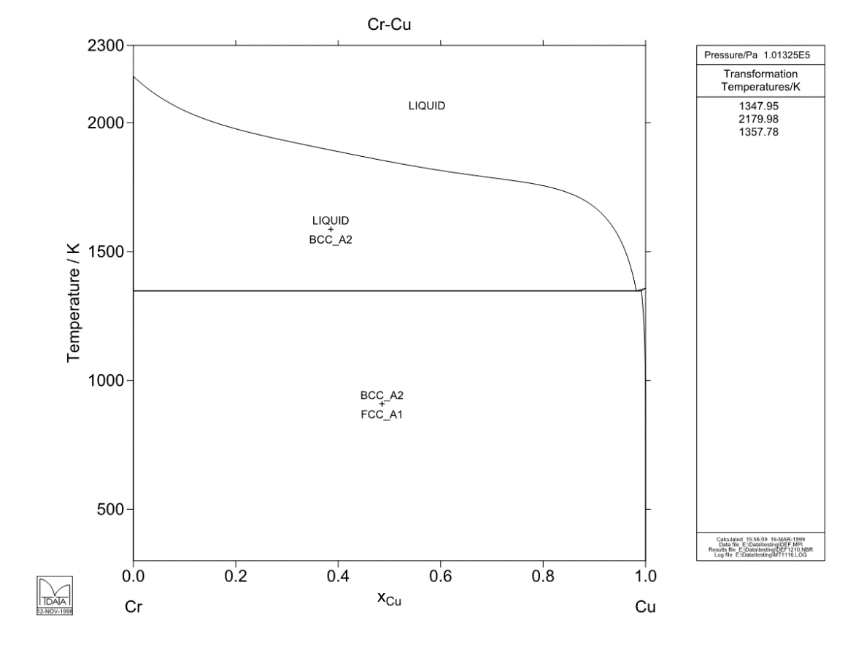
Fig. 3.2. Calculated Cr-Cu binary phase diagram [161].
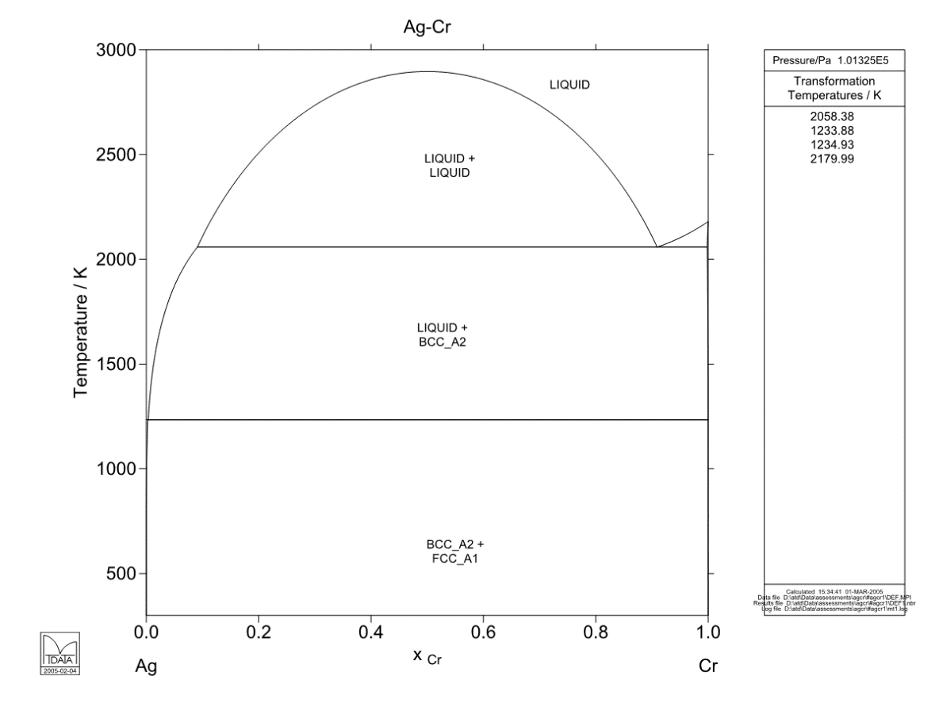
Fig. 3.3. Calculated Ag-Cr binary phase diagram [161].

It is revealed that for CrN-Ag coatings, Ag aggregates tend to exhibit a lamellar shape (Height/Width: ~ 1/2 to 1/3) and are distributed uniformly in the coating [31, 36]. A schematic diagram showing the possible nanostructure of Cr-Ag-N system is shown in Fig. 3.4.
Fig. 3.4. A schematic diagram showing the possible nanostructure of Cr-Ag-N system.
However, for CrCuN coatings, it is predicted that a metastable solid solution phase of Cu in Cr b.c.c. (with Cu up to 60%) will form at low deposition temperature [37] (e.g. up to 200 °C), or that nanocrystalline Cr (or CrN if nitrogen is introduced) embedded in a Cu-rich intergranular amorphous “tissue” will form [38, 39]). A schematic diagram showing the possible nanostructure of Cr-Cu-N system is shown in Fig. 3.5.
Fig. 3.5. A schematic diagram showing the possible nanostructure of Cr-Cu-N system.

Due to the different distribution preferences of Cu and Ag in Cr-N coatings, by adding both of them and tuning their concentrations and/or concentration ratios, coatings with novel nanostructures (e.g. Ag precipitated in the intergranular tissue of Cu-rich material, which surrounds N-containing Cr nano-grains) may be obtained, which will be helpful in controlling the transportation of Cu and/or Ag in Cr-N coatings during transient or cyclic temperature changes. Therefore, a novel design methodology can be formulated, whereby tuning the Cu and Ag concentrations and their ratio in CrN (or in other transition metal nitrides, carbides, borides), combined with appropriate deposition parameters, permits coating architectures to be designed for specific service conditions, to provide effective solid lubrication and a controlled, continuous replenishment of active solid lubricant species from the coating interior - hence prolonging service life.
According to Musil and Vlček [165], incorporating soft metals into TM-nitride PVD nanocomposites can further improve the friction and wear performances of them. Therefore, in recent studies, soft metals such as Cu, Ag, which are, in principle, immiscible with Cr, are added into CrN and other TM-nitride PVD coatings, with a large amount of published successful improvements being attained up to now [15, 18-20, 25-27, 29-32, 34, 36, 38, 39, 166-169]. However, as mentioned in the background introduction in Chapter1, limitations exist for soft metal-containing tribological coatings while they are applied to high-temperature ambient air or oxidation environments. For example, the coefficient of friction (CoF, with the counterpart being an alumina ball) of CrN-Ag nanocomposite coatings starts to increase when sliding test temperature is above 500 °C [27]. And above 600 °C, Ag oxidation and mechanical collapse of the coating would result in failure very quickly [25].
Several typical successful research results will be discussed in detail below.

3.3.1. Addition of Cu into TM-nitride or nitrogen-containing TM coatings
Incorporating Cu into hard films significantly improves the tribological properties of nc-MeN/a-Cu type hard coatings [60]. In the Cr-Cu-N system, it is typically found that a metastable solid solution phase of Cu in bcc Cr (with Cu content of up to 60 at.%) will form at low deposition temperatures [37] (e.g. ≤ 200 °C), or that nanocrystalline Cr (or CrN if nitrogen is introduced) embedded in a semi-continuous Cu-rich intergranular ‘tissue’, will form – as was experimentally verified by a number of studies (e.g. Baker et al. [38], Lee et al. [39]). Following are several examples with concise study results.
Baker et al. [38] produced predominantly metallic nanocomposite coatings consisting mostly of fine Cr(N) grains distributed in a Cu (a small portion) matrix. Results showed that at a composition of CrCu_{0.07}N_{0.48}, the coating exhibited optimum mechanical properties, with hardness of up to 20 GPa.
Baker et al. [32] also prepared CrCuN coatings consisting of fine Cr(N) metallic grains and/or β-Cr₂N ceramic grains distributed in a Cu matrix (of minority proportions). Results showed that coatings with a structure of 1-3 nm α-Cr(N) and β-Cr₂N separated by intergranular Cu exhibited excellent wear resistance.
Lee et al. [39] studied the effect of Cu content on the microstructure and mechanical properties of CrN coatings produced by pulsed DC magnetron sputtering (2kHz, 80% duty cycle to the targets, and -250V, 50kHz, 80% duty cycle to the substrates). Results showed that the columnar structure of the CrN/Cu coating disappeared when the Cu content was above ~11 at.%. At a Cu content of 2.6 at.% or more, only one kind of nitride, CrN phase, was revealed and no β-Cr₂N could be detected, although it was verified to exist in coatings with lower Cu content.
Ezirmik et al. [16] investigated the temperature-dependent reciprocating-sliding wear performance of Cu-containing CrN coatings. The wear debris were analysed using micro-Raman spectroscopy and the results showed that CrN-Cu coatings with wear performance independent of temperature (in a range from room temperature to 150°C) could be attained by incorporating oxygen into the coatings.
Kuo et al. [166] produced CrN/Cu nanocomposite films with Cu content up to 24.3 at.%, using reactive magnetron sputter PVD with a bipolar asymmetric pulsed DC power (same as [39]). Coatings with low friction, high hardness and good antimicrobial performance were attained at a Cu content of ~16 at.%, showing promise for applications in fields such as medical device manufacture and food processing. The results were also in good accordance with those of other literature data [18, 34], which also showed that nanocomposite coatings of the Cr-Cu-N type tend to reach peak hardness at a Cu content of ~16 at.%, being 15 GPa [34] and 17 GPa [18], respectively. All the results indicated a decrease in hardness with higher Cu content.
Polychronopoulou et al. [33] produced coatings within the Cr-Cu-N system over an extreme wide range of Cu/Cr ratio (from 0.04 to 4.5), using electron-beam PVD (EBPVD) at 450°C, and investigated their tribological properties at high temperature (840°C). Results showed that coatings within the Cr-Cu-N ternary phase system with low Cu content (i.e. 3 at.%) exhibited competent anti-wear capabilities for demanding applications at high temperature.
There are also a number of reports of improvements in other transition metal (TM) nitride coating systems with addition of Cu, e.g. Zr-Cu-N [21, 35, 59, 83] and Ti-Cu-N [60].

3.3.2. Addition of Ag into TM nitride or nitrogen-containing TM coatings
As mentioned previously, coatings in the Cr-Ag-N system tend to exhibit Ag precipitates of a lamellar shape, with a uniform, but isolated distribution in the ceramic nitride matrix [31, 36]. Mulligan and Gall [26, 27, 29-31, 36] produced Ag-containing CrN coatings using reactive magnetron sputter deposition, on Si wafer and stainless steel substrates. Results showed that the nanocomposite coatings produced possessed a dense columnar microstructure. Ag solid lubricant phases were separated from the CrN matrix (and homogeneously distributed in it). They also annealed the coatings after deposition to investigate the diffusion and redistribution of Ag phases in the CrN matrix [31]. Results showed that when the Ag content was above 12 at.%, Ag was mobile during the annealing process. Ag atoms diffused to the coating surface and shaped into homogeneously distributed agglomerates, with their sizes increasing with the processing time and temperature of annealing, and also depending on initial Ag coating content. When the initial Ag content is below 12 at.% (for example 3 at.% in this study [30]), few diffused surface agglomerates were found. The authors attributed this phenomenon to the discontinuous distribution of Ag phases between CrN columnar grains, which cut the paths through which they diffuse to the surface during annealing. Incerti et al. [19] produced CrN/Ag nanocomposite coatings using two different PVD techniques, reactive magnetron sputtering and reactive arc discharge evaporation - investigating their morphology, composition, structure, and tribological performance. Results showed that both coatings exhibited the lowest friction coefficient at 600°C, and that the low friction resulted from Ag segregation to the surface from the CrN matrix.
According to after recently published research results, Ag-containing ZrN [170, 171] or TiN [172] nanocomposite coatings also exhibited excellent performance in reducing friction and improving wear resistance. Kelly et al [171] studied the tribological and antimicrobial performances of siver containing ZrN nanocomposite coatings. Results showed that, although the hardness of the ZrN coatings decreased after adding silver, the unlubricated sliding friction coefficient against a steel counterpart went down and the adhesion between the coating and the substrate increased with rising silver content. Antimicrobial tests (using zones of inhibition (ZoI) and a nitro-blue tetrazolium (NBT) redox dye) of ZrN/Ag coatings showed satisfying antimicrobial results due to the intrinsic bactericidal effect of silver ions released from the coatings. In another study of Kelly et al. [172], silver containing titanium nitride nanocomposite coatings exhibited significantly improved lubricating performance and a marginal decrease in friction coefficient for TiN coatings in thrust washer wear testing against a steel counterface. Silver-containing TiN coatings also showed good antimicrobial properties as well, similar to the ZrN/Ag coatings [171] described above.
Furthermore, it has been proved that Ag is more effective in both solid-lubricating and antimicrobial applications than Cu, with the only drawback of its ‘dot-like’ or ‘chain-like’ distribution (which will make it more difficult to percolate to the coating surface for continuous functionality during service, compared to those ‘net-like’ intergranular distributed functional phases – e.g. Cu) in PVD coatings such as nitrogen-containing chromium. Therefore it would be worthy to investigate PVD CrCuAgN coatings, in order to combine various advantages of different constituents together.

Chapter 4. Experimental Procedures

4.1. Substrate preparation
AISI316 stainless steel coupons, with dimensions of 50mm × 25mm × 2mm, were chosen as the substrates of this PhD project.
The coupons were sequentially grinded from 200 mesh until 2500 mesh, and then polished using 6μm diamond suspension, final mirror finish polishing was carried out using 1μm diamond suspension.
Before the deposition process, all substrates were ultrasonically cleaned using (sequentially) acetone and isopropanol, then immediately dried under a pressurised flow of warm air.

4.2. Coating deposition

4.2.1. Deposition rig and power supplies
All coatings were produced using a Nordiko unbalanced magnetron sputtering rig. One ENI DCG-100 DC plasma generator and two ENI RPG-100 DC plasma generators were used as the power supplies. The Nordiko rig and plasma generators (power supplies) are shown in Fig. 4.1.

Fig. 4.1. The Nordico unbalanced magnetron sputtering deposition rig, with the ENI DCG-100 DC-pulsed and RPG-100 DC generators.

4.2.2. Deposition configurations
In order to investigate the effects of variable concentrations of nitrogen, copper and silver on the morphology, nanostructure and mechanical properties of CrCuAgN coatings, the deposition configurations were designed and separated into two types (two successive stages of these investigations).
4.2.2.1 Configuration type 1 (first-stage study).
Configuration type 1 is shown schematically in Fig. 4.2. Two targets, Cr (380mm×100mm×6mm) and Cu-Ag (Cu: 380mm×100mm×6mm, with embedded Ag buttons: 20mm in diameter), were used. Due to the obvious difference between the magnetron powers applied to Cr and Cu-Ag targets respectively (see paragraph below), the interfacial angles between the surface plane of the substrate holder (i.e. parallel to the coated substrate surface) and those of Cr and Cu-Ag targets were 20° and 70°, respectively – in order to obtain coatings of varying elemental compositions but similar deposition rates and hence thicknesses. 5 mirror-finish AISI316 stainless steel coupons were mounted on the substrate holder in a row, with fixed positions P1 to P5 for different deposition runs, as shown in Fig. 4.2.

Fig. 4.2. Schematic drawing of (a) target-substrate arrangement in deposition chamber and (b) plan-view of the Cu-Ag target.

4.2.2.1 Configuration type 2 (second-stage study).
Configuration type 2 is shown schematically in Fig. 4.3. Six small target segments were used, all in dimensions of 127mm×100mm×6mm. They were separated into two combinations of 3 segments: Cr-Cr-Cu and Cr-Cr-Ag, respectively, and mounted to the two target holders (same holders as used in configuration 1). The angles between the surface of the substrate holder (i.e. parallel to the coated substrate surface) and the Cr-Cr-Cu segmented target and Cr-Cr-Ag segmented target in this case orthogonal (both 45°). In order to obtain coatings of varying composition but similar deposition rate and thickness, 12 mirror-finish AISI316 stainless steel coupons were arranged into a 3 × 4 matrix, as shown in Fig. 4.3; and the same applied power to the target-combinations were used, as will be discussed in Section 4.2.3.

Fig. 4.3. Schematic drawing of (a) plan-view of target-substrate geometry in deposition chamber (and sample matrix designation) and (b) vertical arrangement of Cr-Cr-Cu and Cr-Cr-Ag segmented targets.

4.2.3. Deposition procedures
For both configurations, the coating chamber was evacuated to approximately 2×10⁻⁵ mbar (2×10⁻³ Pa) base pressure. Before deposition, the substrates were sputter cleaned at an argon pressure of 3.3×10⁻² mbar (3.3 Pa) and substrate bias voltage of -700V, for 15 mins. Then the argon pressure was adjusted to 2.7×10⁻³ mbar (0.27Pa), for the following target sputter cleaning and deposition processes.

4.2.3.1 Deposition procedures specific to configuration type 1
Due to the higher sputter power applied to the Cr target during the deposition process, compared to that of the Cu-Ag target (1000W and 400W, respectively), the edges and centre area of the rectangular Cu-Ag target become ‘contaminated’ with a cross-sputtered Cr layer after each deposition run, due to the relatively low resputtering rate caused by a low (or zero) horizontal magnetic field component in these areas. This results in little or no Lorentz force perpendicular to the target surface – hence reduced resputtering (and a vulnerability to contamination through net deposition of Cr on the Cu-Ag target surfaces adjacent to the ‘racetrack’). Therefore, in order to remove the Cr contaminant on the Cu-Ag target surface before the coating deposition process, a relatively lower power to Cr target and higher power to Cu-Ag target (compared to their deposition powers), 800W and 500W respectively, were initially applied. In this case, the substrates were covered by a protective shutter during substrate cleaning and target cleaning, in order to avoid contamination of samples to be coated. Deposition was carried out for 5 min with the Cu-Ag target covered by the shutter (with no nitrogen introduced) in order to produce a ~200nm thick pure Cr interlayer (to improve interfacial adhesion between the substrate surface and the subsequent CrCuAgN coating). Then the Cu-Ag target shutter was moved and nitrogen was introduced, with the deposition process set to run for a further 90 min, with the Cr and Cu-Ag targets powered at constant 1000W and 400W, respectively. The substrates were biased at a DC pulsed voltage of -100V, with a frequency of 180 kHz (It was found that selection of the correct substrate pulsed bias significantly improves the microstructure of PVD CrCuN or CrCuAgN coatings) with ~0.4 mA/cm² substrate current density. Three different nitrogen flow rates – 0 sccm (control group), 5 sccm, 10 sccm – were used, in order to obtain coatings containing different nitrogen contents and hence Cr(N) solid solutions with different nitrogen saturations (and/or chromium nitride phases). Nitrogen was introduced using a step by step procedure of 1 sccm increment per min until the designated value was reached (e.g. set initially to 1 sccm for 1 min, and then increased to 2 sccm for 1 min, and so on), which led to the formation of a compositionally graded layer, to further improve the adhesion between the Cr interlayer and the alloy coating. For both the 5 sccm and 10 sccm nitrogen flow rate groups, the nitrogen flow rate ramp time was included in the 90 min deposition time (95 min in total, including the initial 5 min pure-Cr thin adhesion interlayer deposition), so that coatings deposited at different nitrogen flow rates had the same total deposition duration.

4.2.3.2 Deposition procedures specific to configuration type 2
Only 5 sccm nitrogen flow rate was used in the second-stage of this study (configuration type 2) because, based on the investigation results in the first-stage study, it was concluded that chromium remains metallic (both in as-deposited state and in annealed state, e.g. 2 hours annealing under 500℃) at 5 sccm nitrogen flow rate (with the power of Cr and Cu-Ag targets being 1000 W and 400 W, respectively). However, a higher nitrogen flow rate (e.g. 10 sccm and above) would result in the formation of chromium nitrides (e.g. Cr₂N). As one of the key aims of the investigation was to remain the metallic state of chromium with the introduction of nitrogen, the second-stage study was focused mainly on CrCuAgN coatings where Cr remained as a metallic solid solution with interstitial nitrogen, which was achieved by control of both the nitrogen flow rate (fixed at 5 sccm) and the total power applied to separated targets - 700W to each, and 1400W in total - i.e. identical total deposition power to that used in the first-stage study (which was 1000 W + 400 W = 1400 W).
Both Cr-Cr-Cu and Cr-Cr-Ag segmented targets were sputter cleaned before every deposition process, in order to remove the contaminants condensed on the target surfaces from the ambient during the venting process, and any cross-contamination formed during the previous deposition run. A 1000W fixed power (higher than that used in the deposition process) was applied to both target sets to execute sputter cleaning for 10 mins, with the substrates covered by the shutter to avoid contamination of the samples to be coated. The reason for using a higher power in the target-cleaning process than those used in the deposition process itself was to clean a larger ‘racetrack footprint’ than that formed in the deposition process, in order to minimise sputtered vapour from uncleaned areas and thus improve coating purity. A ~200nm thick nitrogen-free CrCuAg interlayer (to improve interfacial adhesion between the substrate surface and the subsequent CrCuAgN coating) was deposited on the substrates. Then Nitrogen was introduced using a step by step procedure of 1 sccm increment per min (i.e. the same procedure as the one used in the first-stage study) until 5 sccm was reached. Substrates were biased at a DC pulsed voltage of -100V, with ~0.4 mA/cm² substrate current density. The total deposition duration was set to be 95 mins, including the nitrogen flow rate ramp time and the initial ~200nm thick nitrogen-free CrCuAg thin adhesion interlayer deposition time (~3.5 mins), so that coatings produced in the first-stage study and the second-stage study had the same total deposition duration.

4.3. Coating analysis

4.3.1. XRD analysis
X-ray diffraction (XRD) measurements were carried out using Siemens D5000 and Bruker D2 PHASER X-ray diffractometers, both equipped with a Cu-Kα source (λ=0.15418 nm). Bragg-Brentano θ-2θ scanning mode was used for phase composition analysis of both the as-deposited coatings and the post-deposition annealed coatings.
In order to distinguish coating diffraction peaks from those of the substrate, a diffraction pattern for the uncoated AISI 316 stainless steel coupon was also obtained.

4.3.2. EDX analysis
Quantitative Energy Dispersive X-ray (EDX) analysis was performed using a JEOL JSM-6400 scanning electron microscope (SEM) equipped with an Oxford Instruments EDX detector. EDX is a chemical analysis technique which employs a focused electron beam to bombard a solid sample, then detects, processes and analyses the characteristic X-rays emitted by the corresponding atoms existing in the solid sample. Technically, all elements from Be to U (i.e. atomic number 4 to 92) can be detected and analysis. However, in order to obtain reliable EDX quantitative analysis results, both appropriate alignments during detection and proper corrections during quantitative calculation (i.e. Z<10) would be necessary. Firstly, from the instrumental point of view, proper alignments are required before the analysing process, such as peak-position alignment and peak-shape deconvolution (eliminating effects such as the point spread function (PSF) of discrete detection channels). This was done by the “Quant Optimization” function integrated in the INCA (Oxford Instruments) software, using a Cobalt standard. Secondly, from the post-detection calculation (based on the spectrum obtained) point of view, two main aspects corrections need to be considered and properly carried out. First aspect is background correction (or background subtraction). Two proven successful methods are background filtering and background modelling. The second aspect is matrix corrections, which includes four factors: a) sample absorption correction, b) backscattering correction, c) fluorescence correction and d) stopping power correction. INCA makes use of the XPP matrix correction scheme which was developed by Pouchou and Pichoir, to implement appropriate corrections and hence obtain reliable quantitative EDX analysis results. Furthermore, in order to obtain reliable EDX quantitative results of nitrogen, a phase-pure CrN coating with known concentrations of Cr and N was used (atomic ratio of Cr:N was 52:48) to set up the EDX analysis parameters. By setting the acceleration voltage at 20kV and working distance at 18mm (with the instrument and detector being aligned using a cobalt standard), a measured Cr:N ratio of 53.5:46.5 was obtained for the CrN control sample, which meant the measured nitrogen concentrations in the CrCuAgN coatings should be within ±1.5 at.% of the actual values. Therefore, by EDX analysis using the parameters proper corrections stated above, acceptable results for the elemental compositions (Cr, Cu, Ag and N) of the CrCuAgN coatings in this study could be obtained.

4.3.3. Coating surface and fracture section morphologies
Fracture sections of the as-deposited and annealed samples were prepared. First, a small piece (25mm × 5mm) of the coated sample was removed from the test coupon and then cut into shapes with three-side notches; then, the notched samples were immersed in liquid nitrogen to cool down; after it was fully cooled down in liquid nitrogen, the notched sample could be fractured by bending in tension; finally the smaller part of the two broken sections was adhered onto an aluminium pin stub using double-sided carbon tape, with the fracture section upward for observation using SEM. The whole procedure of making a fracture sample is illustrated schematically in Fig. 4.4.
High-resolution secondary electron imaging was used to observe the morphologies of coating surfaces and fracture sections, using a Philips XL 30 field emission gun scanning electron microscope (FEG-SEM). High-resolution secondary electron (SE) and backscattered electron (BSE) images were obtained using a FEI Nova NanoSEM 450, equipped with an Oxford Instruments Silicon Drift Detector (SDD) X-Max^{N} 80 (detector size: 80mm²) and proprietary AZtec software package, in order to carry out high resolution surface-morphology and Z-contrast imaging, together with high-speed, high-resolution EDX mapping of the as-deposited and annealed CrCuAgN coatings.

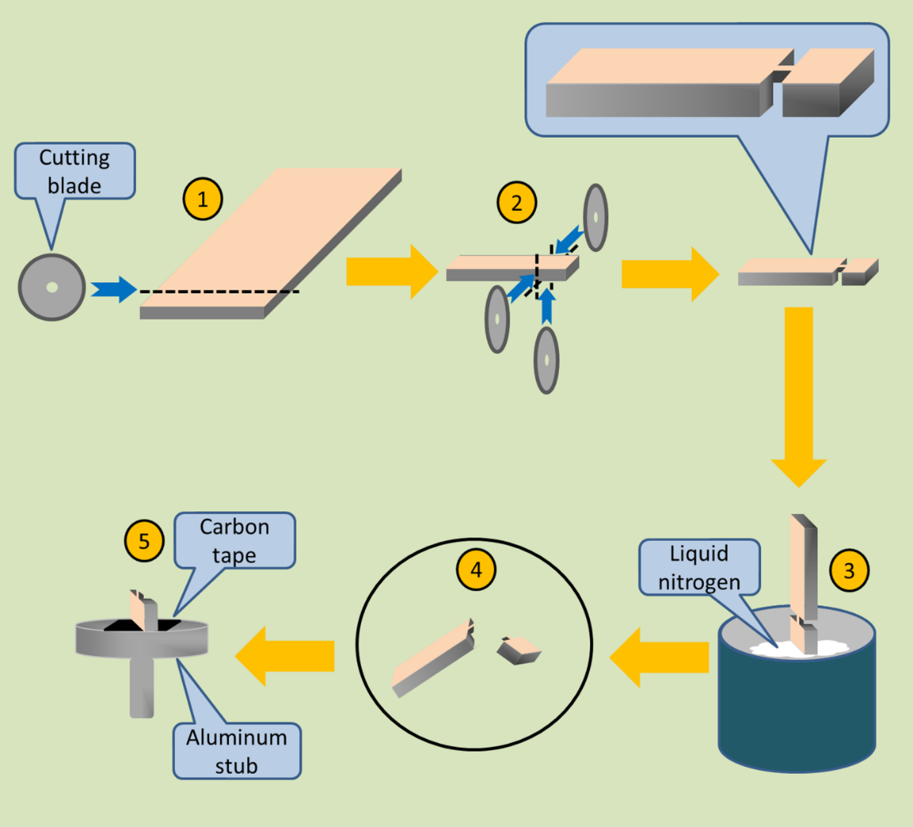
Fig. 4.4 Schematic procedures of the fraction section preparation for SEM observation.

4.3.4. S/TEM analysis
A selection of CrCuAgN coatings were chosen for conventional transmission electron microscopy (TEM), high resolution (HR)TEM and/or scanning (S)TEM analyses. For each selected sample, either plan-view or cross-section (or both) TEM thin-foil samples was made. The selection and type (plan-view or cross-section) of TEM thin-foil samples to be prepared was based on the evaluation results from the investigation methods listed above (i.e. SE/BSE imaging, EDX point analyses and mapping, together with XRD analysis). Conventional TEM was carried using a Philips EM420 (fitted with a tungsten filament) and a FEI Tecnai T20 (fitted with a LaB₆ filament), with the accelerating voltage (high tension, or HT in short) of 120 keV and 200 keV, respectively. They were used to obtain bright field (BF) images, and dark field (DF) images with corresponding SAED patterns. HRTEM imaging, STEM bright field and high angle annular dark field (HAADF) imaging for Z-contrast (atom mass), and energy-filtered (EF)TEM elemental mapping (3-window method) were carried out using a JEOL 2010F HRTEM; it is equipped with a Schottky field emission gun (operated at 200 keV), a Gatan Imaging Filter (GIF) 794 spectrometer, and Gatan Digiscan STEM BF and HAADF detectors.
All TEM samples were prepared using an FEI Quanta 200 3D scanning electron microscope equipped with gallium Focused Ion Beam (FIB). Plan-view TEM thin foils were extracted directly from fracture section sample, and cross-section TEM foils were extracted from the surface of coated AISI316 coupon. Schematic diagrams of these two types of FIB samples are shown in Fig. 4.5a and b, respectively. Firstly, a 10μm × 4μm × 1μm (this size is for cross-section samples, plan-view samples extracted directly from fractured coatings could be larger depending on the size of the separated coating area) rectangular foil was machined out and extracted from the coating surface or fracture section (cross-section or plan view, respectively). The foil was then adhered to a 3-pin copper grid (as shown in Fig. 4.6) and ion milled, using the gallium FIB at a fixed accelerating voltage of 30kV, and varying beam current (the thinner the foil, the smaller the current used). After ion milling, a final thickness of less than 50nm was achieved.
Fig. 4.5. Schematic diagrams of these two types of FIB samples: (a) Plan-view TEM sample extracted directly from the fractured coating; (b) cross-section coating extracted from coating surface.
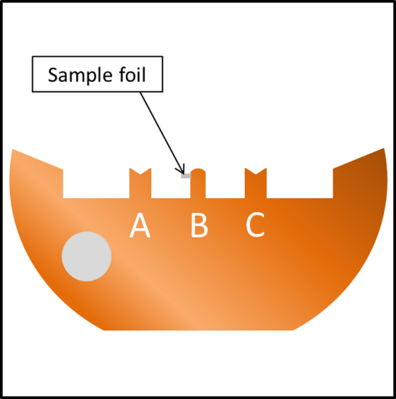
Fig. 4.6. A schematic diagram showing a TEM sample copper grid, with the relative position of the TEM foil indicated.

4.3.5. Nanoindentation (H and E)
The hardness (H) and elastic modulus (E) of all as-deposited and annealed coatings were measured using a Hysitron Triboscope® Nano-indenter. In order to obtain reliable and repeatable results, 16 indentations were measured to extract average values of H and E for each coating. A load-limited indentation regime was chosen for each sample, to ensure that the maximum indentation depth was less than 1/10 of the specific coating thickness of each sample. Based on the coatings’ thicknesses (which are in the range of 2.5 μm to 4.5 μm for the coatings chosen for nanoindentation measurement), ~1/10 indentation depth was ensured by a trial of varying load (typically from 2,000 μN to 10,000 μN), in order to obtain a data set of “load - indentation depth” relationship. Then, a sufficient high depth, (i.e., >150nm, however lower than 1/10 depth of the measured coating) was chosen, hence the corresponding fixed load used to implement the 16 indents (4 x 4). It needs to be mentioned that too low a depth, i.e., less than 100 nm, might give unreliable measurement results due to the effects from the coating surface morphology and indenter tip area function (TAF).

4.3.6. Scratch test and high-temperature reciprocating sliding wear test
In order to evaluate the solid lubricating performance of the as-deposited and annealed CrCuAgN coatings, coefficients of friction (CoF) at room temperature (RT) was obtained using a laboratory scratch adhesion test instrument, equipped with a 0.2mm radius Rockwell C hemispherical diamond indenter. The critical load (L_{c}) of each selected sample was obtained first. Then, a fixed normal load of 20N (significantly lower than the L_{c} of all tested coatings) was used to obtain the CoF. A scratch speed of 0.2mm/s and distance of 5mm were used in all tests. Moreover, a Bruker CETR-UMT instrument equipped with a high temperature reciprocating sliding wear test module was used to evaluate the tribological properties at RT, 300 °C and 500 °C. An alumina ball of ¼ inch (6.35 mm) diameter was used as the counterface. Normal load, sliding distance and frequency were 1 N, 1 mm and 1Hz, respectively.

4.3.7. Sample labelling methodology
In order to simplify the description and analysis in the following sections, each sample (or the deposited coating on it) from the positions P_{X} (x=1, 2, 3, 4, 5, see Fig. 4.2a) will be simply described using ‘P_{X}’ (unless otherwise stated), and each group of samples deposited at 0 sccm, 5 sccm and 10 sccm N₂ flow rates will be briefly described as ‘control group’, ‘5 sccm group’ and ‘10 sccm group’, respectively. Other specific, detailed acronyms and abbreviations are explained at the beginning of each corresponding chapter.

Chapter 5. Morphology, Nanostrucure of As-deposited Coatings

5.1. Introduction
CrCuAgN coatings with different Cu and Ag concentrations were produced using closed-field unbalanced magnetron sputtering, at three different nitrogen reactive gas flow rates, in order to investigate the combined effects of Cu and Ag on the nanostructure and mechanical properties of nitrogen-containing chromium-based PVD hard coatings. See Fig. 4.2 for the schematic configuration of the deposition chamber.
Three groups of coatings were produced, deposited at nitrogen flow rates of 0 sccm (control group), 5 sccm and 10 sccm, respectively. Each group contained 5 samples, which were located at 5 different positions between the Cu-Ag composite target and pure Cr target during deposition, as shown schematically in Fig. 4.2. The chamber was evacuated to a base pressure of 2×10⁻⁵ mbar (2×10⁻³ Pa) before the deposition process commenced. During deposition, the substrates were biased at a DC pulsed voltage of -100 V, with a frequency of 180 kHz and substrate current density of ~0.4 mA/cm². Cr and Cu-Ag targets were powered at 1000 W and 400 W, respectively. The detailed deposition process - including pre-deposition preparation, sputter target configuration and deposition pressure/voltage parameters - was described in detail in chapter 4.
As explained in Section 4.3.6, in order to simplify the description (and the analysis in the following sections), each of the three sample groups are described as ‘control group’, ‘5 sccm group’ and ‘10 sccm group’, respectively and each of the 5 coating samples from each group is described using ‘P_{X}’ (x=1 to 5 / see Fig. 4.2a).

5.2. Coating thickness
The thicknesses of as-deposited coatings from the three groups are indicated in the SEM fracture cross-section micrographs shown in Fig. 5.1.
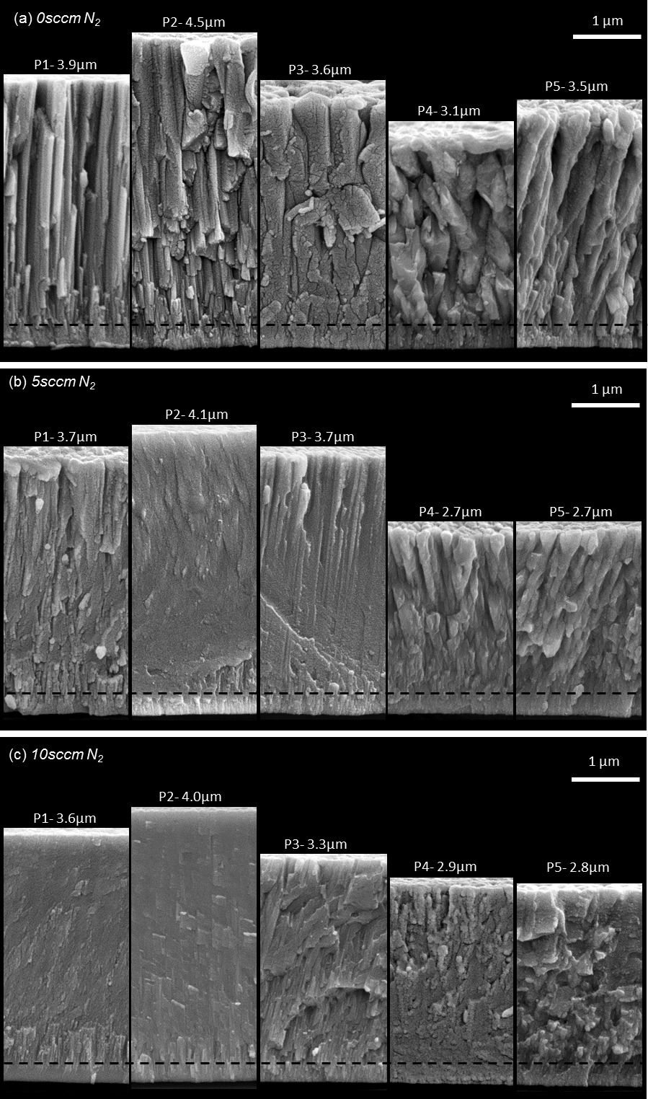

Fig. 5.1. SEM micrographs showing the fracture sections and coating thickness for (a) the nitrogen-free control group, (b) 5 sccm group, (c) 10 sccm group; (d) a focused ion beam (FIB) coating cross section image showing the numerous pores and voids existing in sample CrCuAgN5-P4-AD (clean cross section cut by FIB, final milling using Gallium ion beam at 100 pA, 30 kV).

5.2.1. Coating thickness: The overall trend
It can be seen from Fig. 5.1 that, in each group, the ratio of highest to lowest thickness is only about 1.5. For the orthogonal configuration originally trialled, where angles between target surface (Cr or Cu-Ag target) and sample holder surface were both 45°, and the applied powers of Cr and Cu-Ag targets were (similarly to previously reported work [21, 32, 38, 44]) 1500 W and 150 W, respectively, the ratio between thickest and thinnest coating was over 3.5. It can also be seen that P2 has the largest thickness in each group, 4.5μm, 4.1μm and 4.0μm, respectively. Coating thickness tends to decrease gradually from P2 to P4, which is mainly caused by the differences in sample-target distances and the supplied powers to Cr (1000 W), Cu-Ag (400 W) targets during deposition. P1 has a thickness smaller than that of P2 (and similar to that of P3 in most cases), which might be due to the larger sample distance of P1 from the (high-powered) Cr target (see red lines in Fig. 4.2a) compared that of P2 (see blue lines in Fig. 4.2a). However, the changes in coating thickness from P4 to P5 for each of the three groups is complicated, and might be due to several factors. The first cause could be that, due to the non-orthogonal sample/target configuration (see Fig. 4.2a), the rate of decrease of substrate to Cu-Ag target distance (with increasing sample position) is much larger than the rate of increase of substrate to Cr target distance (see the yellow, red and blue lines in Fig. 4.2a). The second cause might be the relatively small difference in deposition powers applied to Cr and Cu-Ag targets, in which the former (1000 W) is just 2.5 times the latter (400 W), compared to other published work using similar configurations, where the difference is typically a factor of 10 [32, 38, 39]. The third cause might be related to the different nitrogen flow rates applied – with coating nitrogen uptake (at a given reactive gas flow rate) strongly dependent on changes in (Cu+Ag)/Cr ratio with sample position.

5.2.2. Coating thickness: Comparison among three groups
In comparison to coatings deposited in the 0 sccm N₂ control group, those deposited in equivalent positions at 5 sccm and 10 sccm N₂ flow rate are somewhat thinner (by up to 22%); this is likely to be due to partial target poisoning (particularly for the Cr target) by introduced nitrogen. However, the influence was rather indistinct compared to the study results of Jimenez et al. [21] (where the thicknesses of sputtered ZrCuN coatings deposited at 5 sccm N₂ flow rate were barely 50% of those produced with no nitrogen), which utilised quite similar deposition processes, but not the modified target-substrate configuration and target powers employed in this study. According to the records of power supply parameters, the applied discharge voltages of both targets during deposition processes for the nitrogen-free group and the two nitrogen-containing groups were nearly the same (-331 V to -327 V for Cr target, -376 V to -373 V for Cu-Ag target, barely a 1% change for both targets), which would not be expected to cause significant changes in coating thickness. Moreover, the thickness changes between the 5 sccm and 10 sccm groups are difficult to explain simply by target poisoning effects alone – especially the increase in thicknesses at positions P4 and P5 from 5 sccm to 10 sccm N₂ flow.

5.3. Fracture Cross-sections
Fracture cross-section SEM micrographs of as-deposited coatings from the three groups are shown in Fig. 5.1.

5.3.1. Fracture cross-sections: The nitrogen-free control group
In the nitrogen-free control group (Fig. 5.1a), it can be seen that, from P1 to P3, the coating morphology gradually changes from fine columnar structure with sharp and smooth boundaries, to a more coarse columnar structure with blunter and rougher boundaries; this appears to relate to the increase of the combined Cu+Ag atomic percentage in the films from 5.0 at.% to 10.2 at.% (see Table 5.1). In particular, P4 shows a strange prismatic fracture appearance. P5 showed a rough, non-compact structure compared to those from P1 to P3.

5.3.2. Fracture cross-sections: The 5 sccm group
In the 5 sccm group (Fig. 5.1b), coatings exhibited in general a much more dense and smooth structure compared to their counterparts deposited in the equivalent positions in the control group (particularly P2 and P3), indicating that the introduction of nitrogen changed and densified the microstructure of as-deposited coatings. Unlike P4 in the 0 sccm control group, coating P4 at 5 sccm exhibited a similar fracture appearance to P5, (this being very similar also to that of P5 in the control group).

5.3.3. Fracture cross-sections: The 10 sccm group
In the 10 sccm group (Fig. 5.1c), P2 exhibited the most smooth and dense fracture cross-section appearance. P1 also showed a more smooth and dense structure than its counterparts in the control and 5 sccm group. P3 showed a rough fracture section, with torn edges and tilted fine columns. P4 in this group showed a noticeably different fracture structure to those of the other four coatings, and in this respect it is similar to P4 in the control group. P5 exhibited rough structure with torn edges, similar to P3.

5.3.4. Fracture cross-sections: Comparison among three groups
For all groups, a Cr interlayer with a thickness of ~200 nm can be seen, as indicated by the dashed black line in Figs. 5.1a to 5.1c.
A columnar morphology can be seen for coatings 0 sccm P1 to P5, 5 sccm P1 and P3 to P5, 10 sccm P4, with some slightly tilting, which can be explained by ‘shadowing’ effects [15, 16]. Intercolumnar voids can also be seen from the 0 sccm P2 to P5, which could be attributed to competitive (columnar) growth caused by preferential sputtering [173]. The resultant preferred orientation in the coating structure was confirmed in the XRD analysis in Section 5.6.1. For the remaining coatings, no clear columnar structure could be found.
For all three groups, the changes in fracture morphology should be noted. With the combined Cu+Ag atomic concentrations ranging between ~7% and ~30% from P1 to P5 (see Table 5.1.), the columnar morphology did not disappear – even becoming coarser for some of them (e.g. from P3 to P5 in the 10 sccm group). This is contrary to results predicted by the model of Barna and Adamik [174], or other experimental results for CrCuN coatings [39, 166] which showed that, with increasing Cu content, the coating morphology became more dense and featureless above some critical value (e.g. ~11 at.% Cu in [39]), with the columnar structure vanishing and the coating becoming fully dense. In particular, for the three coatings deposited at the equivalent position P3, it can be seen that the cross-section morphologies of 0 sccm P3 and 10 sccm P3 are coarser than that of 5 sccm P3, which it seems likely is due in part to the significantly higher Ag concentrations in 0 sccm P3 and 10 sccm P3, compared to that of 5 sccm P3 (these being 2.9, 2.8 and 2.0 at.%, respectively). We suspect that this is because Ag has much lower solubility in Cr(N) or Cr₂N compared to Cu, and also because Ag tends to precipitate as discrete grain boundary particles (at a ‘global’ Ag concentration less than, but approaching, 3 at.%) , rather than (as in the case of copper) emerging as a semi-continuous tissue of Cu-rich intergranular phase (typically occurring at a Cu concentration >10 at.%).

Table 5.1. Coating thickness, deposition rate and elemental composition for the as-deposited CrCuAgN coatings
at.% (±0.5)
(Nitrogen: ± 1.5 at.%)
N₂ Flow  rate ( sccm) | Position | Thickness (μm) | Deposition rate (nm/min) | N | Cr | Cu | Ag | N/Cr  ratio | Hardness ( GPa) | Elastic Modulus ( GPa) | H/E ratio
0 | 1 | 3.9 | 43 | -- | 92.7 | 5.4 | 1.9 | -- | 10.1 | 188.0 | 0.053
 | 2 | 4.5 | 50 | -- | 90.7 | 7.1 | 2.2 | -- | 6.6 | 168.4 | 0.039
 | 3 | 3.6 | 40 | -- | 87.3 | 9.8 | 2.9 | -- | 3.3 | 133.3 | 0.024
 | 4 | 3.1 | 34 | -- | 81.8 | 16.4 | 1.8 | -- | 4.0 | 145.7 | 0.027
 | 5 | 3.5 | 39 | -- | 67.3 | 30.2 | 2.5 | -- | 3.1 | 111.8 | 0.027
5 | 1 | 3.7 | 41 | 15.8 | 76.6 | 5.0 | 2.2 | 0.21 | 14.1 | 202.0 | 0.070
 | 2 | 4.1 | 46 | 16.3 | 74.9 | 6.5 | 2.3 | 0.22 | 15.3 | 201.1 | 0.076
 | 3 | 3.7 | 41 | 16.4 | 73.1 | 8.5 | 2.0 | 0.22 | 13.9 | 194.4 | 0.071
 | 4 | 2.7 | 30 | 17.7 | 65.1 | 15.3 | 2.0 | 0.27 | 9.6 | 174.5 | 0.055
 | 5 | 2.7 | 30 | 22.3 | 47.9 | 26.3 | 3.6 | 0.47 | 6.9 | 151.9 | 0.046
10 | 1 | 3.6 | 40 | 27.4 | 65.0 | 5.1 | 2.5 | 0.49 | 14.7 | 192.6 | 0.076
 | 2 | 4.0 | 44 | 27.8 | 64.2 | 5.6 | 2.4 | 0.41 | 14.1 | 196.0 | 0.072
 | 3 | 3.3 | 37 | 29.3 | 60.5 | 7.5 | 2.8 | 0.48 | 9.4 | 176.4 | 0.052
 | 4 | 2.9 | 32 | 25.7 | 59.8 | 12.9 | 1.6 | 0.47 | 14.1 | 195.8 | 0.072
 | 5 | 2.8 | 31 | 28.0 | 45.5 | 23.5 | 3.0 | 0.58 | 11.5 | 164.8 | 0.070

5.4. Surface morphology
Oblique-view SEM micrographs of all coating surfaces are shown in Fig. 5.2.
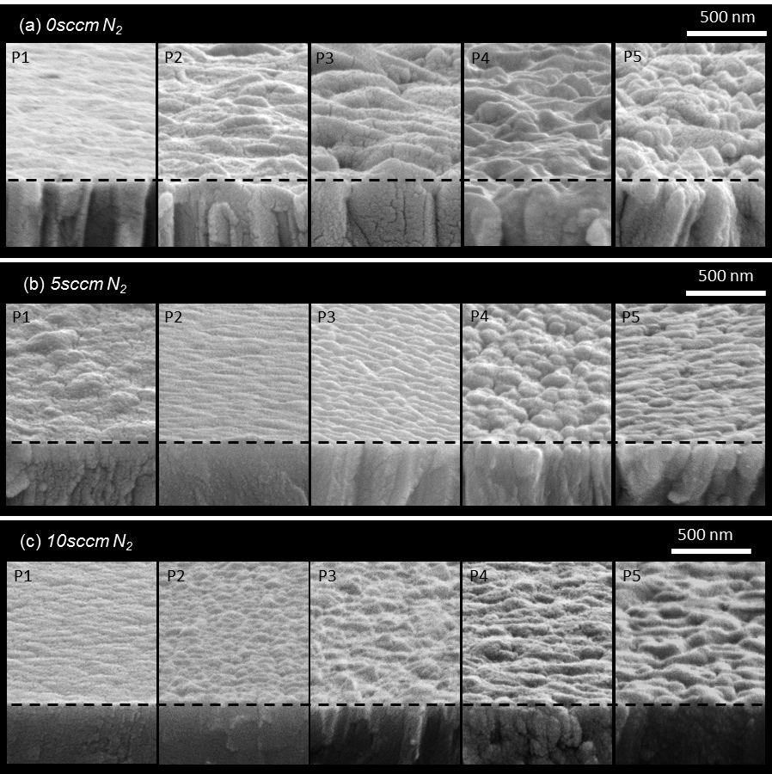
Fig. 5.2. Oblique-view coating surface SEM micrographs of (a) nitrogen-free control group, (b) 5 sccm group and (c) 10 sccm group.

5.4.1. Surface morphology: The nitrogen-free control group
In the control group (Fig. 5.2a), it can be seen that from P1 to P5 (with the exception of the anomalous morphology previously mentioned for P4), the surfaces gradually become rougher. In particular, P4 shows the roughest surface topography and is the only sample exhibiting a polygonal grain structure. It should be mentioned also that, although P1 showed a sharp, angular columnar structure in the fracture section micrograph, its surface is one of the smoothest in all three groups of as-deposited coatings (similar to those of 5 sccm P2 and 10 sccm P1).

5.4.2. Surface morphology: The 5 sccm group
In the 5 sccm group, the topographical progression of coating surfaces from position to position is more complex. P2 exhibited the smoothest and most compact surface, whilst P4 again showed the roughest topography. A sequence of roughness from low to high can be drawn: P2<P3<P1<P5<P4, in accordance with the columnar size sequence observed in fracture cross-section (see Fig. 5.1b). Except P1, all other samples in the 5 sccm N₂ group showed a smoother surface compared to their counterparts in the nitrogen-free group.

5.4.2. Surface morphology: The 10 sccm group
In the 10 sccm group, coatings became progressively rougher from P1 to P5 (except P4), similar to the control group – but with each coating showing a smoother surface compared to its control group counterpart. Compared to their counterparts in the 5 sccm group, 10 sccm P1 and P4 showed smoother surfaces, with P2, P3 and P5 exhibiting a slightly rougher topography.

5.4.4. Surface morphology: Topography classification
The surface topographies can be divided into four generic categories: (A) smooth, (B) wave shape, (C) bump shape and (D) wave-bump combined shape. Samples 0 sccm P1, 5 sccm P2 and 10 sccm P1 belong to category A, sample 5 sccm P3 to category B and samples 0 sccm (P4, P5), 5 sccm P4, 10 sccm (P2, P3) to category C – although they show obvious changes in the sizes of the bumps. Samples 0 sccm (P2, P3), 5 sccm P5 and 10 sccm (P4, P5) belong to category D.

5.5. Elemental composition
Concentrations of different elements versus deposition position in coatings deposited at 0 sccm, 5 sccm and 10 sccm nitrogen flow rate are shown in Fig. 5.3.

5.5.1. Elemental concentrations
Figs. 5.3a to 5.3d show the variation of Cu, Ag, Cu+Ag, N, and Cr concentrations with sample location in the chamber respectively, and an inset of Ag concentration trend at a larger scale in Fig. 5.3a as well. It can be seen from Fig. 5.3a that Cu concentration increased gradually from P1 to P5. However, Ag concentration remained relatively steady across all positions from P1 to P5 (and obviously different from the trend of Cu concentration). This might be caused by the difference in mass between Ag and other species in the deposition plasma (Ag 108; Cu 64; Cr 52; N₂ 28). It seems likely that Ag atoms suffered less gas scattering during their journey from target to substrate, hence similar numbers of Ag atoms reaching each position, compared to Cu and Cr. Another trend that can be seen from the Cu concentration distributions is that, with increasing nitrogen gas flow, Cu concentration in coatings deposited at an equivalent position decreases gradually. Similar behaviour was also found in the trend of Cr concentration, as shown in Fig. 5.3d. This was caused by the introduction of nitrogen, which occupied a higher percentage in at.% as the nitrogen flow rate was increased, as shown in Fig. 5.3c, hence the concentration drop of the other two main elemental constituents, Cu and Cr, with other deposition conditions unchanged. As for Ag, no similar behaviour was found (see the inset in Fig. 5.3a); probably due in part to the relatively low atomic concentration compared to other elements, as well as its relative high atomic mass (see above). However, Ag concentrations showed an anomalous trend between positions P3 and P4 in all three groups. All coatings deposited at P4 exhibited the lowest Ag concentration in their group, which might be one cause of their distinctly different morphologies in fracture cross-section, as illustrated in Fig. 5.1.
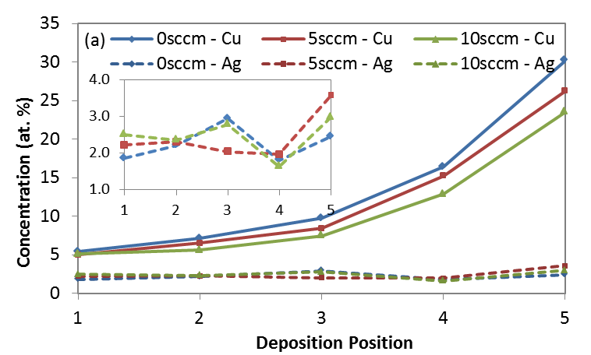
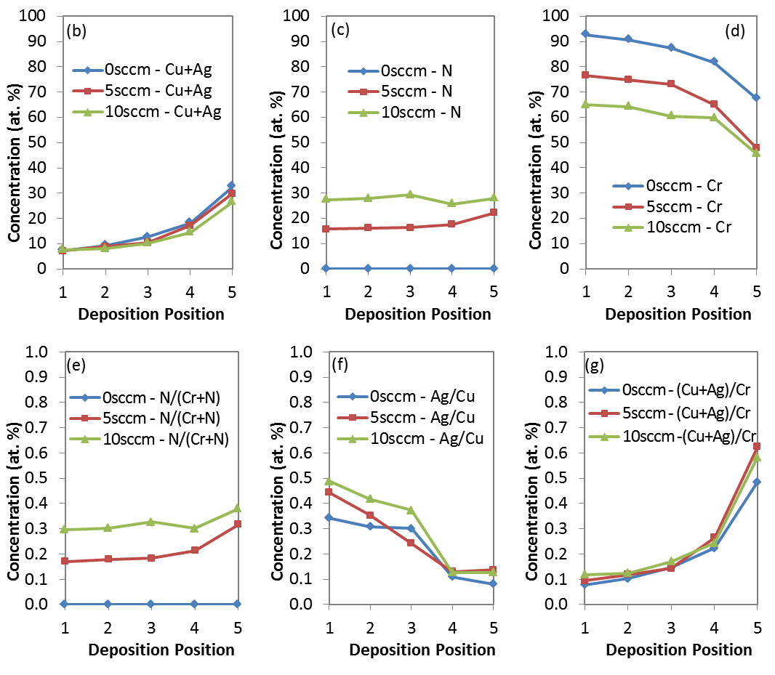
Fig. 5.3. Concentrations of different elements at 0 sccm, 5 sccm and 10 sccm nitrogen flow rate, versus deposition position: (a) Cu and Ag, with an inset of Ag concentration at a larger scale, (b) Cu+Ag, (c) N, (d) Cr, (e) N/(Cr+N), (f) Ag/Cu and (g) (Cu+Ag)/Cr.

For 5 sccm P3, the Ag concentration exhibited an apparently different trend from its counterparts, 0 sccm P3 and 10 sccm P3, (which were relatively high in Ag content, as described in Section 5.3.2), that might contribute to the particularly dense fracture cross-section morphology observed – with discrete fine, sharp columns in the top half of the coating (see P3 in Fig. 5.1b), and a distinctly wave-shaped surface topography (the only one in category (B), see Section 5.3.3).

5.5.2. Improved elemental composition distribution by the new deposition configuration
It can be seen that the optimised sample-target configuration was not only effective in obtaining coatings with similar thicknesses, but also resulted in a reasonable elemental composition distribution of Cu+Ag (from ~7 at.% to 25-30 at.%, see Fig. 5.3b), with no excessively low Cu+Ag concentrations (which might be insufficient for a solid lubrication benefit), or excessively high Cu+Ag concentrations (which would significantly decrease the coating hardness - and probably sliding wear resistance as well).

5.5.3. Atomic concentration ratios
Figs. 5.3e to 5.3g show the atomic concentration ratios of N/(Cr+N), Ag/Cu and (Cu+Ag)/Cr, respectively. The curve shapes and trends of N/(Cr+N) ratio vs. deposition sample position are quite similar to those of the N concentration alone. Specifically, 10 sccm P4 showed a relatively low N concentration (and N/(Cr+N) ratio), compared to that of the 5 sccm group. (This will be discussed later in Section 8.1, in combination with the mechanical properties of the coatings.) The curve shapes and trends of Ag/Cu ratio vs. deposition position are also similar to those of Ag concentration alone; however, the trends is in this case descending, due to the relatively steady Ag concentration across all sample positions – in contrast to the trend of significantly increasing Cu concentration. By comparing Figs. 5.3a, 5.3b, 5.3d and 5.3g, it can be seen that the varying trends of (Cu+Ag)/Cr concentration ratio are more complicated – although, with increasing nitrogen flow rate, both Cu+Ag and Cr concentrations drop progressively (see analysis made in the previous paragraph above). At positions P1, P2 or P3, from 0 sccm to 10 sccm, it can be seen from Fig. 5.3g that the (Cu+Ag)/Cr concentration ratios of coatings from equivalent positions vary inversely with the trends of Cu+Ag or Cr concentration – which means that, although both Cu+Ag and Cr concentration decrease gradually with increasing nitrogen flow, the reduction in Cr concentration is more abrupt than that seen for Cu+Ag. This effect is probably due to partial poisoning of the Cr target (by introduced nitrogen), which influenced the deposition rate of Cr much more than that of Cu+Ag. Coatings from positions P4 and P5 show a distinct trend, in which the 5 sccm group exhibits the highest (Cu+Ag)/Cr concentration ratio compared to equivalent counterparts in the other two groups – and the control group the lowest, with the 10 sccm group in the middle. This behaviour is in good agreement with the coating thickness variations shown in Fig. 5.1, where P4 or P5 in the 5 sccm group had the lowest thickness and P4 or P5 in the control group the highest.
Therefore, a conclusion can be drawn that (Cu+Ag)/Cr concentration ratio of the coating is strongly correlated to the arrival rate of the coating vapour flux of each of the metallic species involved (and hence to coating thickness). This can also be further verified by comparing 0 sccm P3 with 5 sccm P3 (or 5 sccm P2 with 10 sccm P2) in Fig. 5.3g, where the (Cu+Ag)/Cr concentration ratios overlap – and the coating thicknesses are almost identical (see Fig. 5.1).

5.5.4. Summary of elemental composition analysis
Overall, for coatings in each group, Cr content decreased and Cu content increased gradually from P1 to P5, mainly because the successive sample positions are further from the Cr target and nearer to the Cu-Ag target; however, Ag and N content remain relatively stable across all positions. For silver, this appears to be due to its much higher atomic mass, causing the Ag vapour flux to be scattered less than for the other metallic species present. For nitrogen, a similar result is yielded because it is introduced to the deposition chamber as a gaseous phase (having a relatively low mass - even in molecular form), leading to a significantly more uniform distribution of the arriving ion flux across all sample positions.

5.6. Phase composition
The 2-theta diffraction patterns for all 15 as-deposited coatings are shown in Fig. 5.4. By using PDF-4 2015 Sieve+ software, the simulated XRD patterns of α-Cr with different grain sizes are shown in Fig. 5.5.

Fig. 5.4. X-ray diffraction patterns of the as-deposited coatings: (a) nitrogen-free control group, (b) 5 sccm group and (c) 10 sccm group.

5.6.1. Phase composition: The nitrogen-free control group
It can be seen from Fig. 5.4a that the lattice structures of the control group coatings show a strong preferred growth orientation. In detail, positions P1, P2 and P3 were mainly composed of a Cr(211) and a separate Ag(311) phase. No Cu or Cr-nitride peaks could be found. Although Cr and Cu are immiscible under 1000 K in equilibrium state under standard pressure (see Fig. 5.5a [161]), Holleck [37] proposed that metastable bcc-Cr-based or fcc-Cu-based metastable solid solutions could form in PVD coatings deposited at relative low substrate temperature (e.g. below 200 °C). The corresponding phase-fields diagram (reconstructed) is shown in Fig. 5.5b. And this kind of metastable solid solutions were confirmed by Dicks, et al [175] via their studies on electron beam evaporation deposited Cr-Cu, Mo-Cu and W-Cu thin films. Results showed that bcc Cr, Mo and W could accommodate at least 40 at.% of Cu in these binary-system PVD films (deposited on unheated substrates). For all as-deposited coatings in this project, no external heating was applied during deposition process, and bombardment heating caused by applying the substrate bias (fixed at -100V in this study) might be expected to heat the substrates up to a temperature range of 100 °C - 120 °C [176]. Therefore, it can be deduced that a bcc Cr solid solution with substitutional Cu atoms (and possibly Ag atoms as well) might form. Another possibility is that Cu exists as intergranular amorphous phase [32, 38], with its typical low-intensity “hump”-like XRD pattern immerged in the background and could not be distinguished.

Fig. 5.5 (a) (same to Fig. 3.1) Calculated Cr-Cu binary phase diagram [161]; (b) reconstructed schematic PVD phase fields for the Cu-Cr system [37].

The XRD patterns of P1 to P3 exhibit a similar and distinct Ag(311) peak, which changed to Ag (220) for those of P4 and P5. Considering the low concentration of Ag compared to Cu (around 2-3 at.% in all coatings, according to the EDX analysis in Section 5.5), it can be concluded that, Ag exhibits very limited solid solubility in Cr – with the limit most probably lying within the approximately 2-3 at.% concentration range in this work. The low solubility is in agreement with Ag-Cr binary equilibrium phase diagram (Fig. 1.2) and [162, 163]. Moreover, it can also be noticed the distinct difference of Cu and Ag in their distribution behaviour in a Cr PVD coating (as discussed in section 3.3). Cu probably exists in the bcc-Cr solid solution as substitutional atoms, with other possibilities such as intergranular amorphous phase; Ag, however, tends to exist as a separate crystalline phase, even with as low concentration as ~3 at.%.
A calculation of grain sizes were carried out, which was based on the Scherrer formula [177, 178] (see equation 5-1). It indicates that the full width at half maximum (FWHM) of the diffraction peak is inversely proportional to the size of crystallites:
$B=Kλ/(L cosθ )$ 5-1
where B is the FWHM of the diffraction peak, K is a dimensionless shape factor (also called “Scherrer constant”), λ is the wavelength of the incident x-ray, L is the mean crystalline size and θ is the Bragg angle.
Patterson [178] carried out an exact derivation of the Scherrer equation based on spherical particles, and compared the exact calculated data with those obtained from several approximation methods. Results showed that the tangent plane approximation would provide acceptable data, based on spherical particles.
Besides, the instrumental broadening effect was determined by a measurement using standard silicon powder (Line Position and Line shape Standard, NIST, 640d), with the whole XRD pattern and an enlarged defection shown in Figs. 5.6a and b, respectively.
Fig. 5.6. (a) XRD pattern of standard silicon powder; (b) Enlarged deflection, the one marked using an orange square in (a).
The instrumental line broadening imposed onto the FWHM was then measured to be 0.0024 rad. Therefore, the revised Scherrer formula, after subtracting the instrumental line broadening effect, can be written as:
$B-0.0024=Kλ/(L cosθ)$ 5-2
Combining the known incident beam wavelength, λ=0.15418nm (Cu-Kα source), and the Scherrer constant calculated by Patterson [178], which was 1.107, the average grain sizes of the as-deposited nitrogen-free coatings could therefore be calculated via equation 5.2. The results were listed in Table 5.2.
Table 5.2. The FWHM, FWHM with the instrumental line broadening subtracted, corresponding Bragg angle, and calculated average grain sizes of as-deposited coatings in the nitrogen-free group.
 | P1 | P2 | P3 | P4 | P5
FWHM (B, rad) | 0.0143 | 0.0161 | 0.0148 | 0.0154 | 0.0113
B-0.0024 | 0.0119 | 0.0137 | 0.0124 | 0.0130 | 0.0089
Bragg angle (θ) | 40.86 | 40.86 | 40.86 | 22.20 | 22.20
Average grain size (nm) | 19.0 | 16.5 | 18.2 | 14.2 | 20.7

It can be seen that the calculated grain sizes of all as-deposited coatings are in the range of 10-20 nm. Note that the effects of micro-strain to the peak broadening has been neglected in the calculation.
Besides, the origins of the strong preferred orientation of Cr, and what causes the change from Cr(211) to Cr(110) texture (see Fig. 5.4a, where the preferred orientation changed from Cr(211) in P1, P2, P3 to Cr(110) in P4 and P5) remain unclear.

5.6.2. Phase composition: The 5 sccm group
For the 5 sccm group, the extremely large full width at half maximum (FWHM) of the main reflection – which is extends 10 degrees of 2θ for P1 to P3, and around 5-8 degrees for P4 and P5 – and the relatively ‘sharp’ peak (compared to typical amorphous phase patterns) indicates that the nanostructure of these coatings contains long-range disorder, but also that they are not totally amorphous. It seems therefore that the majority of the coating phase constituents are likely to be Cr-rich nanocrystallites with an extremely high degree of Cu (and/or N) in solid solution.
For P1-P3, all diffraction patterns show an overlap of two broad peaks, whose positions are centred at around 56° and 64.6°, indicating the existence of ‘Cr₂N(112)’ and Cr(200), respectively. However, it will be shown later (Section 6.4.2) that, after annealing at 300 °C, the ‘Cr₂N’ peaks disappeared, which is highly unlikely to happen for the Cr₂N ceramic phase (possessing high thermal stability). No other nitride reflections was found. Moreover, a similar XRD pattern could not be obtained by simulation (e.g. Figs. 5.5 and 5.6), either individually or by a summation of possibly-existing phases (Cr, Cu and/or Ag, with N being in interstitial solid solution). Therefore, the following discussion will, for the moment, use single quoted ‘Cr₂N’ to describe the ‘unassignable’ peak at 56°.
From P1 to P3, both the shift of ‘Cr₂N(112)’ peak towards lower angles of 2θ, and the decline of the Cr(200) peak, indicate a progressively higher degree of lattice distortion, which is probably caused primarily by the increasing levels of Cu dissolved in Cr. However, for 5 sccm positions P4 and P5, stronger ‘Cr₂N(111)’ and Cr(110) peaks were found, which (as mentioned above) exhibit around 5-8 degrees FWHM. The measured ‘global’ Cu concentrations in P4 and P5 are 15.3 and 26.3 at.%, respectively, i.e. much higher than those of P1 to P3 (5.0, 6.5, 8.5 at.%, respectively). Therefore, if Cu atoms are all situated in Cr in substitutional solid solutions, the peaks of P4 and P5 would be expected to be broader and/or lower than those of P1 to P3. However, as can be seen from Fig. 5b, the diffraction peaks of P4 and P5 are actually higher and narrower than those of P1 to P3, indicating that a significant percentage of the available Cu atoms probably exist as a separate phase. According to this explanation (based on the higher and narrower diffraction peaks of P4 and P5), the degree of Cu substitution in Cr in P4 and P5 is likely therefore lower than in P1 to P3, which suggests logically that at least 6.8 at.% Cu in P4 and 17.8 at.% Cu in P5 exists in a separate phase (based on the ‘global’ Cu concentrations measured for P4 and P5, minus that found in P3 – which, at 8.5 at.%, is the highest of the Cu contents measured for the three other positions) and, at these percentages, its diffraction peaks should appear. However, no peak corresponding to a separate, crystalline Cu-based phase can be found. Therefore, besides existing in bcc Cr solid solution as substitutional atoms, Cu probably as well exists in a Cu-rich intergranular amorphous phase, with its “hump”-like broad reflection submerged in the background, similar to its distribution in the nitrogen-free CrCuAg coatings discussed in section 5.6.1 (which is not unlikely – see following paragraph).

5.6.3. Phase composition: The 10 sccm group
For the 10 sccm group, the diffraction patterns of P1 to P3 show a more Gaussian peak shape (again lying in the approximate range of 40 to 50° of 2θ), which is the characteristic feature of an amorphous (or more specifically, an X-ray amorphous) phase. Moreover, no other peaks could be found (except those from the substrate), which suggests that there might only be a single phase formed in these three coatings, ie. the one that the Gaussian peaks reveal. Therefore, it can be concluded that an amorphous phase, containing all four elements – Cr, Cu, Ag and N – was most likely formed for P1 to P3 in the 10 sccm group. For positions P4 and P5, besides the amorphous peak, another broad, shallow peak at 2θ=40.2° can be found in Fig. 5c, which corresponds to the location of Cr₂N(002).

5.6.4. Phase composition: Comparison of the two nitrogen-containing groups
It can be seen from Figs. 5.4b and 5.4c that, for coatings in both 5 sccm and 10 sccm groups, the XRD reflections are fairly broad, with no sharp peaks except those from the AISI 316 substrate. This indicates the existence of either ultra-fine grain sizes (in a range within a few to a few tens of nanometres), or of amorphous phase constituents, or (most probably) both.
For both 5 sccm and 10 sccm groups, no Ag diffraction peaks were found, which is most probably attributable to Ag atoms being dissolved in the Cr phases because the high-degree of Cu solubility (and of N) in Cr caused long-range disorder and extreme lattice distortion (low and broad diffractions peaks for all coatings in the 5 sccm and 10 sccm groups), hence increasing the solid solubility for Ag as well. Other possibilities also exist, i.e., Ag diffraction peaks were submerged under those of Cr, due to its lower concentration, hence peaks with lower diffraction intensities – or Ag existing as nano-precipitates (i.e. a grain size of only a few nanometres), hence undetectable using X-ray diffraction. Furthermore, in positions P4 and P5 of each the nitrogen-containing groups (with Cu content >10 at.%), the likely existence of a Cu-rich intergranular amorphous phase gives another possibility for incorporation of significant quantities of silver in locations undetectable by XRD. TEM studies (Chapter 6) are clearly needed to confirm/deny the various possible scenarios mentioned above.

5.7. Summary
CrCuAgN coatings were prepared using a semi-orthogonal, closed-field unbalanced magnetron sputtering technique. Coating thicknesses were maintained to similar values over a wide composition range by optimisation of the substrate-target configuration and selected deposition parameters (primarily sputter target power ratio).
- Overall, for coatings in each group, Cr content decreased (and Cu content increased) systematically with sample position; however, Ag and N content remained relatively stable from position 1 (nearest to the Cr target) to position 5 (nearest to the Cu-Ag composite target). For silver, this appears to be due to its much higher atomic mass, causing the Ag vapour flux to be scattered less. For nitrogen, a similar result is observed because it was introduced ‘reactively’, as a gaseous phase (and has a relatively low mass - even in molecular form), which yields a uniform distribution in the coating chamber.
- In the nitrogen-free control group, coatings showed a strong preferred orientation, for both metallic Cr and Ag, changing sharply from Cr(211) to Cr(110) and from Ag(311) to Ag(220), when the deposition positions changed from P1, P2, P3 to P4, P5. Cu exists either in the bcc-Cr solid solution as substitutional atoms, or as an intergranular amorphous phase, with its “hump”-like peak submerged within the XRD background, or both.
- The introduction of nitrogen at 5 sccm flow rate resulted in a high degree of solubility of Cu in metallic Cr and, with increasing Cu content, the preferred growth orientation changed from Cr(200) to Cr(110). However, Cu probably exists as a separate amorphous phase in coatings with higher Cu concentrations (e.g. 15.3 and 26.3 at.% in positions P4 and P5).
- When the nitrogen flow rate was increased to 10 sccm, only a single, X-ray amorphous phase was found in coatings with low Cu concentration (5.1, 5.6 and 7.5 at.% for positions P1 to P3, respectively). In coatings with higher Cu concentration (12.9 and 23.5 at.% in positions P4 and P5), nanocrystalline Cr₂N(002) phase was formed. Ag atoms are most probably dissolved in the Cr phases because of the high degree of solubility of Cu and N in Cr (and possibly of Cu in Cr₂N) causing long-range disorder and extreme lattice distortion (low and broad diffractions peaks for all nitrogen-containing coatings) – hence increasing the substitutional solubility of Ag as well.

Chapter 6. Effects of Post-deposition Annealing: Part 1

6.1. Introduction
In the previous chapter, as-deposited CrCuAgN coatings were produced reactively by unbalanced magnetron sputtering of a composite target (silver ‘buttons’ embedded in a copper plate) and a pure chromium target at three different nitrogen flow rates (0 sccm, 5 sccm and 10 sccm). The nanostructure, morphology and mechanical properties were systematically studied.
In this chapter, those as-deposited CrCuAgN coatings discussed in chapter 5 will be used to study the effects of post-deposition annealing. Such CrCuAgN coatings were annealed at 300 °C and 500 °C, for 2 hours. The chamber was heated under high vacuum from ambient at a heating rate of ~15 °C/min, then held at the prescribed annealing temperature for two hours. After annealing, the chamber was cooled back to room temperature under vacuum. The effects of post-deposition annealing on the surfaced topography, fracture morphology, elemental distribution, nanostructure and resulting phase composition of these coatings were investigated.
The coating thickness, deposition rate, elemental composition and selected atomic concentration ratios of the coatings investigated in this chapter are listed in Table 6.1. Discussions will be made in Sections 6.4 to 6.6, together with other results.

Table 6.1. Thickness, coating deposition rate, elemental compositions and atomic concentration ratios of the as-deposited coatings.
 |  |  |  | at.% (±0.5)  (Nitrogen: ± 1.5 at.%) |  |  |  | Selected ratios
N₂ flow rate  ( sccm) | Position | Thickness  (μm) | Deposition  rate (nm/min) | N | Cr | Cu | Ag | N/  (Cr+N) | (Cu+Ag)/  (Cr+Cu+Ag) | (Cu+Ag+N)/  (Cr+Cu+Ag+N)
0  (Nitrogen free) | 1 | 3.9 | 43 | -- | 92.7 | 5.4 | 1.9 | -- | 0.07 | --
 | 2 | 4.5 | 50 | -- | 90.7 | 7.1 | 2.2 | -- | 0.09 | --
 | 3 | 3.6 | 40 | -- | 87.3 | 9.8 | 2.9 | -- | 0.13 | --
 | 4 | 3.1 | 34 | -- | 81.8 | 16.4 | 1.8 | -- | 0.18 | --
 | 5 | 3.5 | 39 | -- | 67.3 | 30.2 | 2.5 | -- | 0.33 | --
5 | 1 | 3.7 | 41 | 16 | 76.6 | 5.0 | 2.2 | 0.17 | 0.08 | 0.23
 | 2 | 4.1 | 46 | 16 | 74.9 | 6.5 | 2.3 | 0.17 | 0.11 | 0.25
 | 3 | 3.7 | 41 | 16 | 73.1 | 8.5 | 2.0 | 0.18 | 0.12 | 0.26
 | 4 | 2.7 | 30 | 18 | 65.1 | 15.3 | 2.0 | 0.22 | 0.21 | 0.35
 | 5 | 2.7 | 30 | 22 | 47.9 | 26.3 | 3.6 | 0.32 | 0.38 | 0.52
10 | 1 | 3.6 | 40 | 27 | 65.0 | 5.1 | 2.5 | 0.30 | 0.11 | 0.35
 | 2 | 4.0 | 44 | 28 | 64.2 | 5.6 | 2.4 | 0.31 | 0.11 | 0.36
 | 3 | 3.3 | 37 | 29 | 60.5 | 7.5 | 2.8 | 0.32 | 0.15 | 0.39
 | 4 | 2.9 | 32 | 26 | 59.8 | 12.9 | 1.6 | 0.31 | 0.19 | 0.40
 | 5 | 2.8 | 31 | 28 | 45.5 | 23.5 | 3.0 | 0.38 | 0.37 | 0.55

6.2. Fracture cross-sections
The fracture-section secondary-electron images of the as-deposited and annealed coatings (annealed under vacuum at 300 °C and 500 °C, respectively, with a fixed duration of 2 hours for both) are shown in Fig. 6.1.

6.2.1. The 0 sccm (nitrogen-free) control group
In the 0 sccm (nitrogen-free) control group, the columnar structures of the as-deposited (AD) coatings in P1 and P2 became less obvious after 300 °C annealing and even more so after 500 °C annealing. For P3, little difference (except the emergence of fine ‘lumps’ on the columnar surfaces) was found from ‘AD’ to ‘300’ then to ‘500’, probably due to its ‘native’ coarse columnar structure in as-deposited condition compared to the relatively fine columnar structures of P1-AD and P2-AD. For P4 and P5, the fracture sections became gradually more ‘lumpy’ and rough from ‘AD’, to ‘300’ and then to ‘500’. The blurred columnar boundaries and emergence of ‘lumps’ on the columnar surfaces after annealing probably indicate the occurrence of phase transformation and will be discussed further in Sections 6.3 to 6.5.

6.2.2. The 5 sccm and 10 sccm (nitrogen-containing) groups
In the two nitrogen-containing groups (5 sccm group and 10 sccm group), all coatings showed more lumpy and rough fracture-section structures after annealing - and progressively more so with increasing annealing temperature. According to discussions in Chapter 5, all as-deposited coatings in 5 sccm and 10 sccm groups were substitutionally super-saturated nitrogen-containing chromium (i.e. Cu and Ag in Cr(N)) and hence likely to be highly metastable. Therefore, it may be expected that precipitates would form during annealing, which could explain the formation of the ‘lumps’ in the fracture sections of the annealed coatings (and this will be confirmed in the phase transformation analysis in sections 6.5 and 6.6).
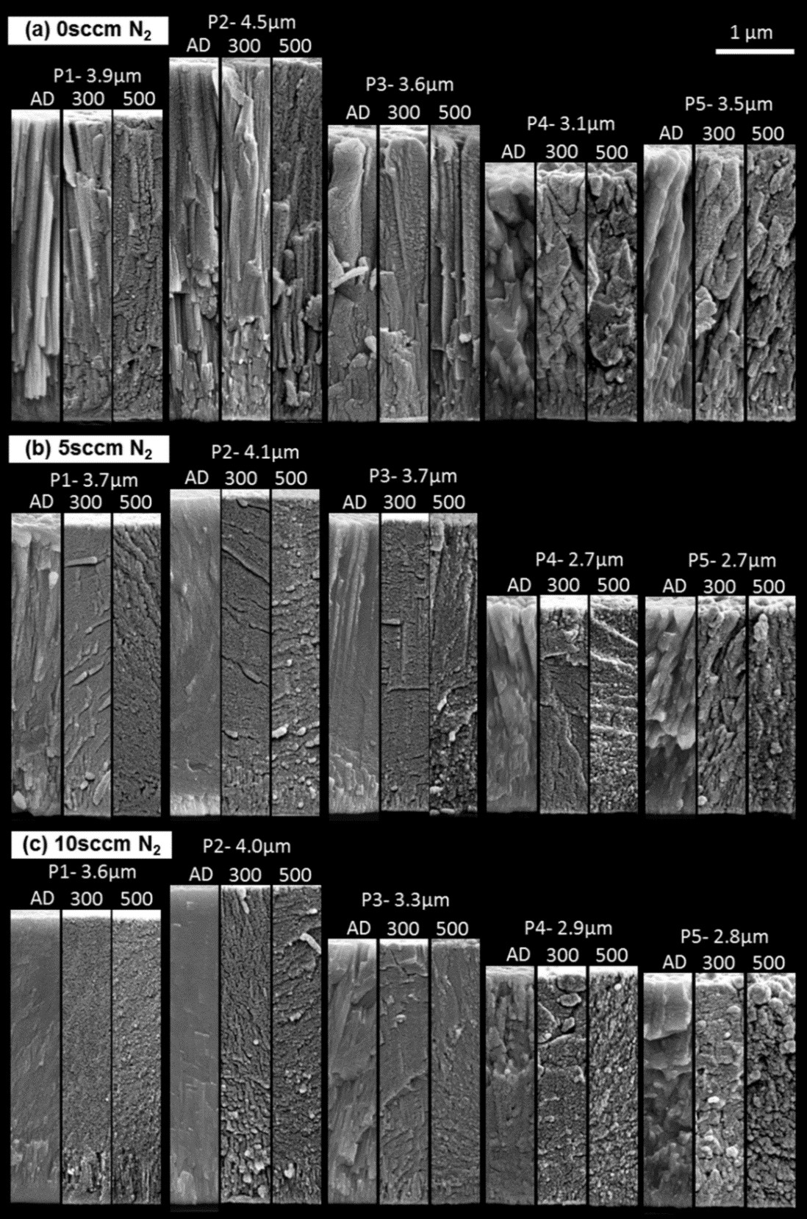
Fig. 6.1. Fracture section SEM micrographs of (a) nitrogen-free control group, (b) 5 sccm group and (c) 10 sccm group, in which ‘AD’ means ‘as deposited’, ‘300’ means annealed at 300 °C for 2 hours, and ‘500’ means annealed at 500 °C for 2 hours.

6.3. Surface morphology
Oblique-view secondary-electron images of the coating surface morphologies are shown in Fig. 6.2.

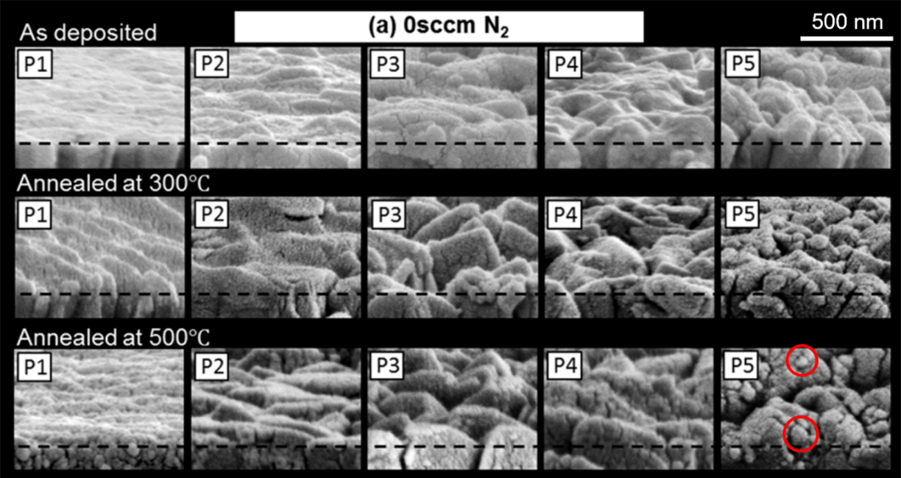
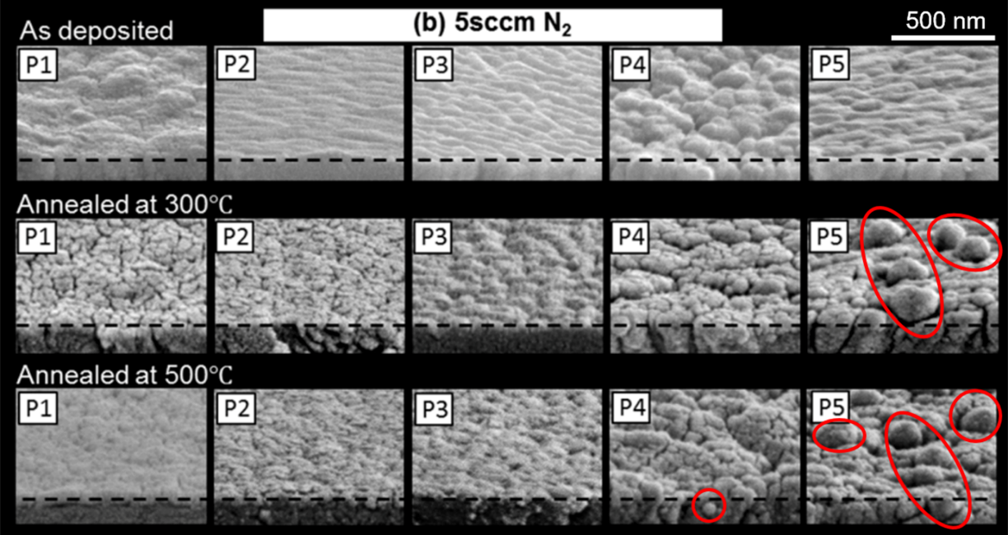
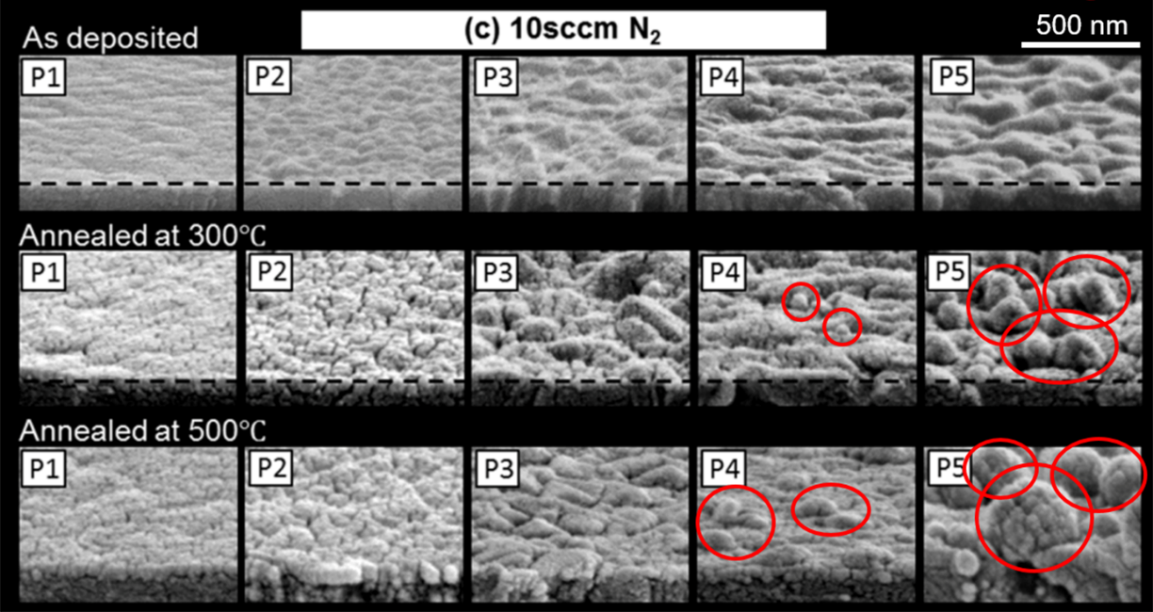
Fig. 6.2. Oblique-view coating surface SEM micrographs of (a) nitrogen-free control group, (b) 5 sccm group and (c) 10 sccm group, with Cu and/or Ag aggregates indicated by the red circles.

6.3.1. The 0 sccm (nitrogen-free) control group
For the 0 sccm control group, it can be seen that from ‘AD’ to ‘300’ to ‘500’, coating surfaces become rougher. Some precipitated particles can be seen from 0 sccm-P5-500, as shown by areas circled in Fig. 6.2a.

6.3.2. The 5 sccm and 10 sccm (nitrogen-containing) groups
In the two nitrogen-containing groups, for P1 and P2, no obvious change in surface roughness can be seen from their as-deposited states to their annealed states, as shown in Figs. 6.2b and c. Some tiny cracks can be seen in 5 sccm-P1-300, 5 sccm-P2-300 and 10 sccm-P2-300. However, no obvious cracks can be seen from P1-500 and P2-500 in both 5 sccm and 10 sccm groups. The surface roughness of P3 in both nitrogen-containing groups changed slightly after annealing; however, no development of surface aggregates could be observed.
For P4 and P5 in the two nitrogen-containing groups, sphere-like aggregates emerged, and became larger in size from P4 to P5 (and from 300 °C to 500 °C annealing temperature), as shown by the areas circled in Figs. 6.2b and c. An EDX line scan across one selected aggregate from coating 10 sccm-P5-500 was carried out, with the results shown in Fig. 6.3.
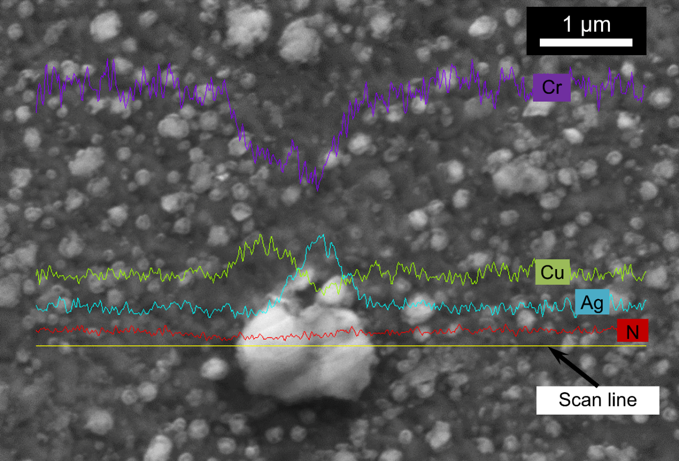
Fig. 6.3. EDX line scan results of an aggregate on the surface of sample 10 sccm-P5-500.
It can clearly be seen that the aggregate is (Cu, Ag)-rich. According to a further EDX point analysis of a similar aggregate, it was found that the concentrations of Cr, Cu, Ag and N in it were 33.2, 31.1, 10.5 and 25.2 at.%, respectively, with the Cu and Ag concentrations much higher than the ‘global’ (average) values measured for 10 sccm-P5-AD (as listed in table 1). Compared to the electron beam penetration depth in EDX analysis (normally in the order of a few microns, depending on the accelerating voltage and the material to be analysed), the sizes of the aggregates are relatively small (below 1 μm in diameter, as can be seen from Fig. 6.3). Thus there would also be some X-ray signal generated from areas surrounding (and beneath) the aggregate, being incorporated into the EDX point analysis results, making them nearer to the ‘global’ concentration values of the entire coating. Therefore, the real concentrations of Cu and Ag in the aggregates are likely to be even higher than the above EDX point analysis results indicate.
It is also interesting to notice the significantly enhanced Ag mobility (compared to the relatively small differences in homologous temperature of the two elements during annealing at 500 °C; 773K). It is clear that the existence of copper enhanced the transportation of silver to the coating surface in significant quantities even though the ‘global’ Ag content of the coating is low (~3 at.% or less). According to the existing literature, in (for example) CrAgN PVD coatings with no added Cu, the Ag concentration needs to be at least 12 at.% (more than 4× higher than in our study) to permit ‘transportation’ to the coating surface – even during annealing at quite high temperatures (e.g. 600 - 700 °C) [30] - and needs to be in excess of 20 at.% to transport sufficiently well to provide adequate solid lubricating benefits [20, 26, 29-31]. Enhanced transportation of Ag from the interior to the coating surface (and subsequent surface aggregation) is also a desirable characteristic for antimicrobial coating applications [28, 172], particularly when the Ag aggregates are presented in nanocrystalline topography [179].
Furthermore, from the EDX line scan shown in Fig. 6.3, it can be seen that the Cu and Ag concentration maxima are displaced from each other. The analysed aggregate appears Cu-rich on the left and Ag-rich on the right. In other words, after annealing, although both Cu and Ag precipitate from substitutional solid solution in Cr (and are transported synergistically to the coating surface), they are inclined to exist separately - which is in good agreement to the solubility limits shown in the Ag-Cu binary phase diagram [162] and to first-principles calculations [180, 181] (at equilibrium silver and copper are expected to be nearly immiscible below 550K). The mechanisms of how Cu enhances the transportation rate of Ag have also been investigated and will be discussed Chapter 7.

6.3.3. Comparison among the three coating groups
It was noticed that, after annealing, the number of aggregates found in the nitrogen-containing coatings was much higher than in the nitrogen-free control group, which is probably because the introduction of nitrogen reduced the solubility of Cu (and Ag) in Cr, therefore more (Cu, Ag)-rich aggregates would form for the nitrogen-containing coatings after annealing. This is further supported by the fact that more (and larger) aggregates were found in the 10 sccm group than in the 5 sccm group.
For both the nitrogen-free control group and the nitrogen-containing groups, voids and spaces between columns can be clearly seen in the coatings with high Cu+Ag concentrations (e.g. P4 or P5 in each group) after annealing, which is probably caused by the diffusion of Cu and Ag from within the coating to the coating surfaces (and hence formation of the aggregates discussed above).

6.3.4. Summary of surface morphology analysis
For the surface morphologies of all three groups, annealing resulted in more obvious changes to coatings containing higher Cu+Ag concentrations.
The introduction of nitrogen reduced the solubility of Cu (and Ag) in Cr; therefore, after annealing, progressively increasing numbers of aggregates formed, in direct correlation with the nitrogen flow rate increasing during coating deposition from 0 sccm to 5 sccm and then to 10 sccm.
Annealing activated the ‘transportation’ of Cu and Ag to the coating surfaces under moderately high temperature (e.g. slightly at 300 °C and more noticeably at 500 °C), which is a desirable in-service adaptive property in solid lubricating applications, because it can facilitate replenishment of the solid lubricating phases which might be consumed (e.g. worn, oxidized and/or dissolved) during service.

6.4. XRD analysis
The X-ray diffraction patterns are shown in Fig. 6.4.
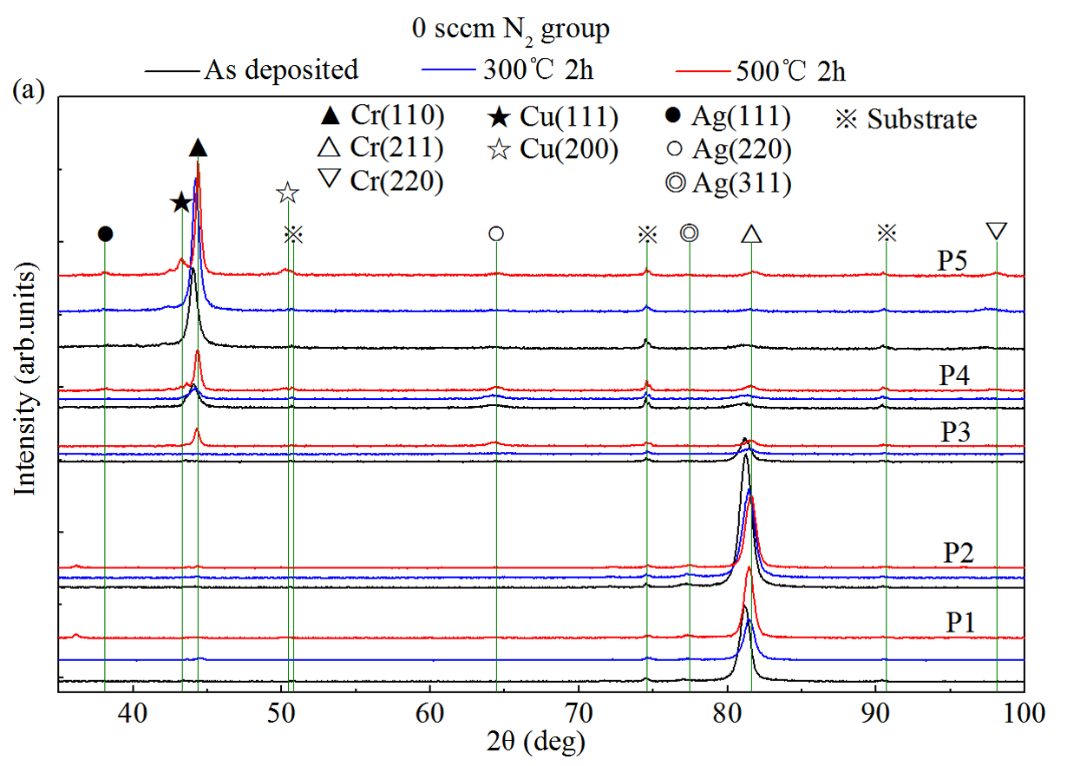
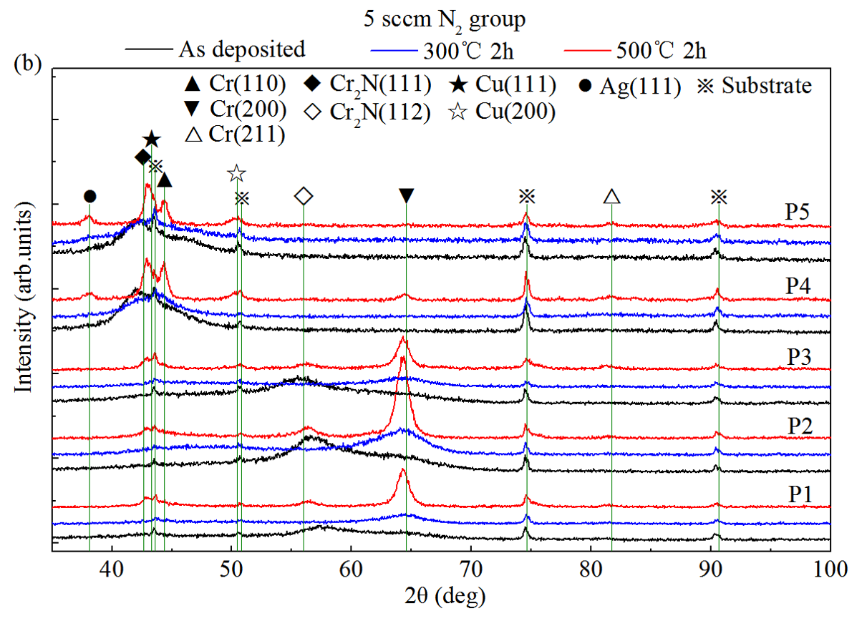
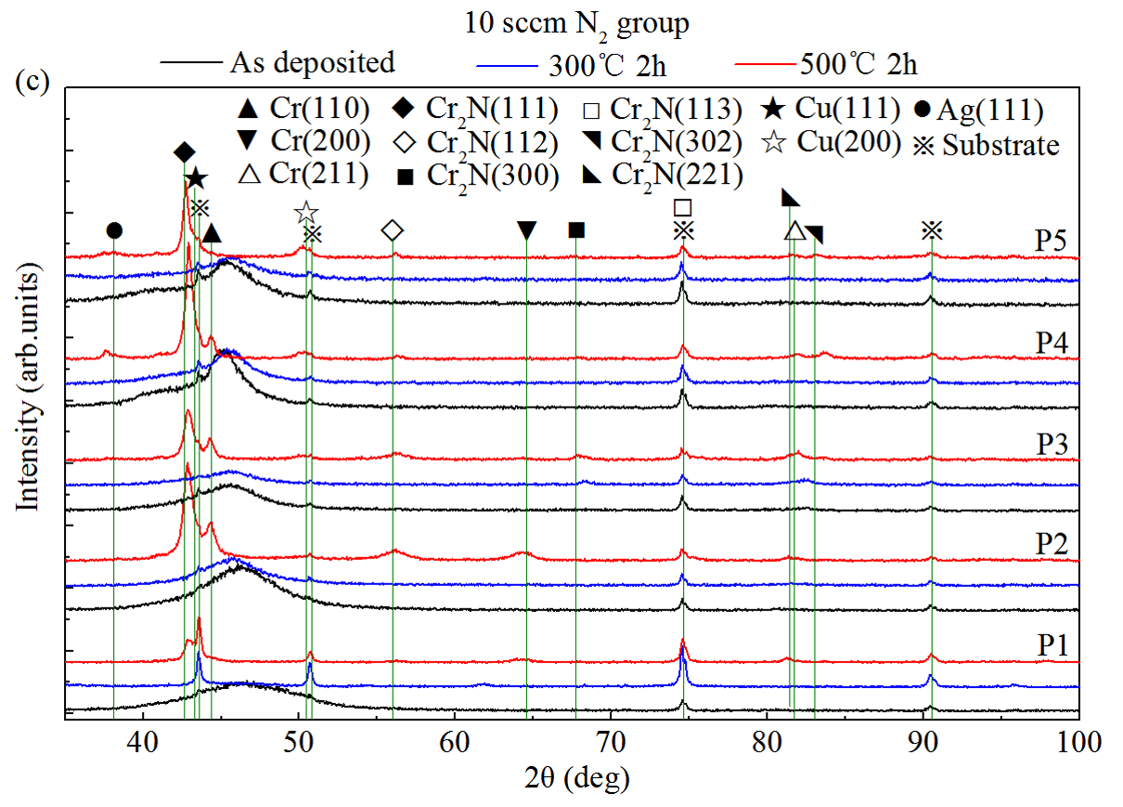
Fig. 6.4. X-ray diffraction patterns of the as-deposited and annealed coatings, (a) nitrogen-free control group. (b) 5 sccm group and (c) 10 sccm group.

6.4.1. The 0 sccm (nitrogen-free) control group
From the diffraction patterns of the 0 sccm control group shown in Fig. 6.4a, it is clear that all of the annealed coatings (except 0 sccm-P3-500) retained the same preferred orientations as their as-deposited counterparts. Regarding 0 sccm-P3-500, it showed preferred orientation of Cr(110) rather than the Cr(211) texture of its counterparts 0 sccm-P3-AD and 0 sccm-P3-300. It can also be seen that the as deposited coatings in 0 sccm group exhibited a transition of preferred orientation from Cr(211) to Cr(110), and these transitions remained after annealing at 300 °C or 500 °C. Moreover, distinguishable movement of shifted peaks back to their theoretical (unstrained) positions after annealing can also be seen, by comparing the diffraction patterns of as-deposited and annealed coatings. This movement means the interplanar spacings of the as-deposited coatings regressed during annealing, indicating a relaxation of compressive growth stresses and probably expulsion of interstitial (N)/substitutional (Cu, Ag) supersaturated elements. Therefore, it can be deduced that annealing probably resulted in recovery of the crystalline lattice from significant distortion (due to the supersaturated solid solution developed during sputter deposition at low temperature). Likewise, it can be deduced that the 500 °C annealing caused more lattice recovery than the 300 °C annealing, because the diffraction peaks of coatings annealed at 500 °C are more closely aligned to their theoretical values than those annealed at 300 °C, as indicated by the green lines in Fig. 6.4a. Cu(111) and Cu(200) peaks were also found in the diffraction patterns of 0 sccm-P4-500 and 0 sccm-P5-500, probably because Cu precipitated from solid solution in the Cr-rich matrix and formed a separate crystalline phase after annealing at 500 °C, which is in agreement with the EDX line-scan results (Section 6.4) and is further supported by the SAED patterns shown later in Fig. 6.8

6.4.2. The 5 sccm group
The diffraction patterns of the 5 sccm group are shown in Fig. 6.4b.
The first three coatings, 5 sccm-(P1 to P3), with the same post-coat treatment (and irrespective of annealing condition: ‘AD’ or ‘300’ or ‘500’), exhibited quite similar diffraction patterns, probably due to their relatively similar chemical compositions (in contrast to P4 and P5), see Table 1. However, for each coating the phase structure changed obviously after post-coat annealing. The low and wide diffraction peaks of 5 sccm-(P1 to P3), in either ‘AD’ or ‘300’ condition, indicate an extremely distorted and supersaturated lattice structure, being amorphous or nanocrystalline (or a mixture of both). In contrast, after the 500 °C annealing, the XRD patterns of all three coatings exhibit narrower and higher-intensity peaks, indicating a phase transformation from amorphous/nanocrystalline to distinctly crystalline, with little (or no) residual lattice distortion. An apparent low and wide ‘Cr₂N(112)’ nitride peak was also found for the 500 °C annealed 5 sccm-(P1 to P3), which required further investigation (and will be discussed in the TEM analysis in Section 6.6). Moreover, even after annealing at 500 °C, Cr(200) is still the observed primary lattice peak (much higher than others) indicating that, with a nitrogen concentration up to 16 at.% (or N/(Cr+N) atomic ratio up to 0.18, see Table 6.1), Cr exists mainly (if not entirely) as a metallic crystalline phase, with nitrogen in supersaturated interstitial solid solution (further investigations made using TEM analysis are discussed in Section 6.6). From ‘AD’ to ‘300’, the primary diffraction peaks of 5 sccm-(P1 to P3) apparently shifted from ‘nitride’ Cr₂N(112) to ‘metallic’ Cr(200). Because of the well-known high thermal stability of chromium nitride, it is unlikely that Cr₂N would somehow dissolve or decompose after 300 °C or 500 °C annealing. Therefore further investigation on the phase composition and transformation of 5 sccm-(P1 to P3), from ‘AD’ to ‘300’ and ‘500’ was required, this will also be discussed further in the TEM analysis in Section 6.5.
For 5 sccm-(P4 and P5), the phase compositions of the as-deposited and 300 °C annealed coatings are quite similar, being either amorphous or nanocrystalline (or a mixture of both). However, after annealing at 500 °C, their phase structure became distinctly crystalline, with the diffraction patterns (hence phase compositions) quite similar to those of the 500 °C annealed coatings in the 10 sccm coating group. Therefore, 500 °C annealed 5 sccm-(P4 and P5) and 10 sccm-(P1 to P5) are discussed together in the TEM analysis in Section 6.5.

6.4.3. The 10 sccm group
For the diffraction patterns of the 10 sccm group shown in Fig. 6.4c, it can be seen that the X-ray diffraction patterns of the as-deposited and 300 °C annealed coatings exhibit the typical featureless ‘hump’ of an amorphous phase. However, coatings annealed at 500 °C exhibit clear peaks of Cu(111), Cu(220), Cr(110), Cr₂N(112), which also indicate phase transformation from amorphous to crystalline due to 500 °C annealing. Further discussion on this will also be made in the following TEM analyses. It should be mentioned that, in coatings which possess high N/Cr atomic ratios (e.g. 0.42 to 0.48, see Table 1), these ratios are in fact quite near to the stoichiometric ratio of Cr₂N (0.5) - such as in 5 sccm-P5 and 10 sccm-(P1 to P4). After annealing at 500 °C, a clear Cr(110) diffraction peak was found, with its intensity around 1/3 to 1/2 of the strongest peak - Cr₂N(111), indicating that Cr remains inclined to exist as a nitrogen-supersaturated metallic phase in CrCuAgN coatings, rather than as a stoichiometric nitride, even after annealing at moderately high temperature (e.g. 500 °C).

6.4.4. Comparison among the three coating groups
From Figs. 6.4b and 6.4c, which show the diffraction patterns of the two nitrogen-containing groups, it can clearly be seen that the diffraction patterns of coatings annealed at 300 °C exhibit wide and low-intensity peaks, similar in shape to those of their as-deposited counterparts, indicating an extremely high degree of lattice distortion. However, after 500 °C annealing, the XRD patterns of all nitrogen-containing coatings exhibit new peaks, narrower and higher in intensity - indicating a phase transformation from amorphous or nanocrystalline (or a mixture of both) to more strongly crystalline with little (or no) lattice distortion - confirming the apparent phase transformations noted in the previous surface morphology discussions of Section 6.3. Moreover, these new peak positions are closely aligned to the theoretical values, indicating less lattice expansion (shift to lower angles of 2θ) or indeed contraction (shift to higher angles of 2θ), hence reduced solid solution of Cu, Ag and N in the Cr (or newly formed Cr₂N) matrix [167], which is supported by the clearly identified formation of Cu- and Ag-rich aggregates on coating surfaces (Section 6.3) and the EDX line-scan data (Section 6.4).
In the nitrogen-free control group, no Cu or Ag diffraction peaks were found in as-deposited (or annealed) P1 to P3; however, Cu(200) and Ag(111) peaks were found in 0 sccm-(P4 and P5)-500, corresponding to a threshold (Cu+Ag)/(Cr+Cu+Ag) atomic ratio of ~0.2 (e.g. 0.18, that of 0 sccm-P4; see Table 6.1).
In the two nitrogen-containing groups, no obvious Cu peak was found in as-deposited or annealed 5 sccm-(P1 to P3); however, after annealing at 500 °C, a clear Cu(111) peak was found in 5 sccm-(P4 and P5) and in 10 sccm-(P1 to P5). By combining the chemical compositions and atomic ratios (Table 6.1), it can be concluded that in nitrogen-containing coatings the (Cu+Ag+N)/(Cr+Cu+Ag+N) atomic ratio is more relevant to the separation of Cu from solid solution in Cr than the (Cu+Ag)/(Cr+Cu+Ag) atomic ratio. When the (Cu+Ag+N)/(Cr+Cu+Ag+N) atomic ratio is higher than ~0.35 (as is the case of P4 and P5 in the 5 sccm group and P1 to P5 in the 10 sccm group - see Table 6.1), after annealing at 500 °C, Cu tends to separate from solid solution in Cr. In other words, the introduction of nitrogen reduces the substitutional solubility of Cu and Ag in Cr. Interestingly, Ag diffraction peaks (e.g. 111) can only be found in 500 °C annealed P4 and P5 in all three groups, indicating that the separation of Ag from solid solution in Cr is highly connected to the Cu concentration and relatively less influenced by the introduction of nitrogen (further discussions will be made in Chapter 7, primarily in Sections 7.5 and 7.6). The (Cu+Ag)/(Cr+Cu+Ag) atomic ratio is therefore more important for the separation of Ag during annealing, whereas the (Cu+Ag+N)/(Cr+Cu+Ag+N) atomic ratio is more important in the case of Cu. By extracting the data of P4 in all three groups from Table 6.1, the threshold of the (Cu+Ag)/(Cr+Cu+Ag) ratio to activate separation of Ag during annealing is around 0.2. By combining the fact the Cu and Ag aggregates were found on the surfaces of 500 °C annealed P4 and P5 in both nitrogen-containing groups, it can be concluded that - with (Cu+Ag)/(Cr+Cu+Ag) atomic ratio higher than 0.2 and (Cu+Ag+N)/(Cr+Cu+Ag+N) atomic ratio higher than 0.35 (and under a moderately high annealing temperature; 500 °C) - Cu can assist Ag transportation from inside the coating onto the coating surface. This indicates that the concept of adding both Cu and Ag into nitrogen-containing chromium coatings is a feasible approach for precise tuning of nanostructure (and promotion of ‘adaptive’ behaviour) in solid lubricating and antibacterial applications.
After annealing at 500 °C, all coatings in the nitrogen-containing groups exhibited reflections of bcc α-Cr. Take 10 sccm-P5-500 for example, with a N/(Cr+N) atomic ratio as high as 0.55 (i.e. even higher than the Cr₂N stoichiometry), although Cr₂N formation was promoted, no CrN phase is detected and a significant proportion of nitrogen-supersaturated Cr(N) metallic phase remains. This behaviour indicates that the coexistent state of α-Cr solid solution with Cr₂N nitride phase is relatively stable in a large range of nitrogen concentrations (or N/(Cr+N) ratios, from 0.18 to 0.55 in this study), and can survive intact at moderately high temperature (e.g. 500 °C).

6.4.5. Summary of XRD analysis
Overall, 300 °C annealing did not obviously change the phase structure of both nitrogen-free and nitrogen-containing coatings. However, annealing at 500 °C resulted in significant phase transformation in (particularly) the nitrogen-containing coatings. The newly formed Cu and Ag phases in coatings with sufficiently high Cu+Ag concentrations were confirmed, in agreement with the surface morphology evaluation and EDX line-scan data. The formation of Ag aggregates relates to the (Cu+Ag)/(Cr+Cu+Ag) atomic ratio (threshold ~0.2), whereas the formation of Cu aggregates relates to the (Cu+Ag+N)/(Cr+Cu+Ag+N) atomic ratio (threshold ~0.35). Cu can assist Ag transportation from inside the coating onto the coating surface.
With a nitrogen concentration up to 16 at.% (or N/(Cr+N) atomic ratio up to 0.18, see Table 6.1), Cr exists mainly - if not entirely - as a metallic crystalline phase, with nitrogen in supersaturated interstitial solid solution (further investigations of which are made using TEM analysis in Section 6.6). The coexistent state of α-Cr(N) solid solution with the Cr₂N nitride phase is relatively stable over a large range of nitrogen concentrations (or N/(Cr+N) ratios, from 0.18 to 0.55 in this study), and can survive intact at temperatures up to at least 500 °C.

6.5. TEM analysis

6.5.1. Coating selection for TEM analysis
Several representative nitrogen-containing coatings were chosen for TEM analysis to further investigate the phase compositions and annealing-induced phase transformations of CrCuAgN coatings. The selection of representative samples was based on the XRD analysis (as mentioned in Sections 3.4.2 and 3.4.3), which revealed similar diffraction patterns for
- as-deposited 5 sccm-(P1 to P3);
- 5 sccm-(P1 to P3) annealed at 300 °C;
- 5 sccm-(P1 to P3) annealed at 500 °C;
- 5 sccm-(P4 and P5) and 10 sccm-P1 to P5, annealed at 500 °C.
Therefore, one sample was chosen from each of the above groups - namely:
- 5 sccm-P2-AD;
- 5 sccm-P2-300;
- 5 sccm-P2-500;
- 10 sccm-P4-500.
SAED patterns, together with bright field (BF) and dark field (DF) images, were collected and are shown in Figs. 6.5 to 6.8, with the fitted indices of corresponding crystallographic planes marked on the SAED patterns. The sampled diffraction point (or a diffraction ring segment) for dark field imaging is indicated using a small black circle - as can be seen from the SAED patterns in each of the abovementioned figures.

6.5.2. 5 sccm-P2-AD
The SAED pattern, BF and DF images for 5 sccm-P2-AD, are shown in Fig. 6.5, with the position of the selected area aperture shown using a green circle in Fig. 6.5b. From the SAED pattern in Fig. 6.5a, discontinuous diffraction rings with a small number of spots (as indicated by the yellow arrows) can be seen. The diffraction rings exhibit relatively narrow width and sharp boundaries (compared to the typical wide and blurred diffraction rings of an amorphous phase), indicating that the phase was not completely amorphous. However, it was also not a typical nanocrystalline diffraction pattern, an excellent example of which is shown later in Fig. 6.7b. Therefore, the phase is probably ultra-fine nanocrystalline (probably smaller than a few nanometers), which is also the reason why it is undetectable by XRD. Moreover, these diffraction rings match well with bcc α-Cr, rather than Cr₂N ceramic nitride (as the XRD data in Fig. 5.4b seemed to suggest), indicating the existence of ultra-fine Cr nanocrystallites. These nanocrystallites can be seen form the BF and DF images shown in Figs. 6.5b, c and d, f, at relatively low and high magnifications, respectively. From the BF and DF images, especially the high magnification DF image shown in Fig. 6.5e, it can be seen that the white ‘dots’ are of sizes ranging from less than 1nm up to ~10nm. Moreover, the rings are discontinuous (e.g. the (110) plane diffraction ring in Fig. 6.5a), indicating that these ultra-fine nanocrystallites are not randomly oriented. In other words, they possess a certain preferred orientation. Atomic planes tend to align in one direction, with twists and distortions, hence the “Gaussian distribution”-like ED pattern segments (Fig. 6.5a) rather than a round spot. No Cu or Ag patterns were found, indicating that they either (highly likely, see discussions in sections 5.6.1 and 5.6.2) exist in the ultra-fine bcc α-Cr nanocrystallites (further explains the cause of rather broad ‘shoulder’ between 2θ = 60° and 70° for 5 sccm-P2-AD), or exist in an intergranular amorphous Cu-rich “tissue” (see further discussion in the next paragraph), or both (in agreement with the discussion in section 5.6.2). As alluded to in Section 6.4.2, despite the existence of 16 at.% nitrogen in the as-deposited 5 sccm-P2 coating, the main constituent is an ultra-fine grained Cr-rich metallic phase (with supersaturated nitrogen in interstitial solid solution), rather than a ceramic nitride. Although for 5 sccm-P2-AD the wide, low-intensity peak in the XRD pattern roughly matched with the expected position of the Cr₂N(112) reflection, it probably merely indicated the existence of a ultra-fine nanocrystalline phase (as confirmed by SAED pattern), since no existence of nitrides could be confirmed by TEM for this coating.
In order to obtain a more comprehensive understanding of the phase composition of sample 5 sccm-P2-AD, a large degree of tilting (60° in total) in TEM was carried out and the corresponding BF and DF images (7 equidistant positions recorded) are shown in Fig. 6.5f and g, respectively. BF and DF images were taken from a start position of clockwise tilt at 30°, with an anticlockwise stage tilt at a step size of 10°, to a final tilt position of anticlockwise 30°. It can be seen by combining the bright nanocrystalline grains in DF images that, the nanocrystallites are homogeneously distributed in the entire coating, with an overwhelming majority of coverage. However, there are also some dark areas in the DF images existing around the boundaries of these nanocrystallites, as indicated in Fig. 6.5e, where nanocrystallites are marked by yellow circles and dark areas indicated by yellow arrows. These areas might be related to a Cu-rich amorphous “tissue” along the nanocrystalline bcc-Cr boundaries, in agreement with discussions in both the previous paragraph, and the section 5.6.2. Furthermore, both two possible distribution behaviour, in bcc-Cr solid solution [37] or in an intergranular amorphous “tissue” [38, 39]), have been reported in the literature, as reviewed in section 3.3 and shown schematically in Fig. 3.5.

Fig. 6.5. Plane-view TEM images and SAED pattern of 5 sccm-P2-AD, (a) SAED pattern; (b) BF image at low magnification; (c) DF image at low magnification, same area as (b), with its corresponding diffraction point (part of the (110) ring) shown in the black circle in (a); (d) BF image of the selected area shown in (b) at high magnification; (e) DF image of the selected area shown in (c) at high magnification, which is also the same feature as the one shown in (d). Continued on next page.

Fig. 6.5. Continued.

6.5.3. 5 sccm-P2-300
The SAED pattern, BF and DF images for 5 sccm-P2-300 are shown in Fig. 6.6. Clearer diffraction spots around the rings (Fig. 6.6a) can be distinguished, with the discontinuous diffraction rings found in 5 sccm-P2-AD having faded, but not totally disappeared - indicating a mixed structure of ultra-fine nanocrystalline phases. The BF and DF images (from the same area), as shown at relatively low and at higher magnification in Figs. 6.6b, 6.6c and Figs. 6.6d, 6.6e respectively, suggest that the nanostructure of 5 sccm-P2-300 remains quite similar to that of 5 sccm-P2-AD. A slight difference after 300 annealing is seen in the higher number of relatively large nanocrystallites visible, compared to 5 sccm-P2-AD (e.g. those of the order of several nanometres in diameter, comparing Fig. 6.5e with Fig. 6.6e), which is indicative of a small amount of annealing-induced grain growth. The pattern again correlates well to the calculated diffraction ring positions for bcc α-Cr metal. As for 5 sccm-P2-300, no Cu or Ag pattern was found; therefore, by combining the EDX and XRD analyses, it can be deduced that 5 sccm-P2-300 was mainly composed of ultra-fine to nanocrystalline metallic Cr, with Cu and Ag in substitutional solid solution and nitrogen in supersaturated interstitial solid solution (similar to 5 sccm-P2-AD, excepting grain size distribution). The three alloying elements, Cu, Ag and N, either co-exist in one metallic Cr-rich phase, or may exist separately, e.g. nanocrystalline Cr(Cu, Ag) and Cr(N); however neither scenario can be unambiguously determined from the present data. No existence of nitride phases was found by TEM in 5 sccm-P2-300.

Fig. 6.6. Plane-section TEM images and SAED pattern of 5 sccm-P2-300, (a) SAED pattern; (b) BF image at low magnification; (c) DF image at low magnification, same area as (b), with its corresponding diffraction point (part of the dashed (110) ring) shown in the black circle in (a); (d) BF image of the selected area shown in (b) at high magnification; (e) DF image of the selected area shown in (c) at high magnification, which is also the same feature as the one shown in (d).

6.5.4. 5 sccm-P2-500
The SAED pattern, BF and DF images for 5 sccm-P2-500 are shown in Fig. 6.7. The SAED pattern (Fig. 6.7a) showed a typical nanocrystalline electron diffraction pattern, and it was perfectly-fitted to the calculated diffraction rings of bcc α-Cr. A diffuse ring was also found as marked by the black arrows in Fig. 6.7a, which indicated the co-existence of an amorphous phase. Because Cr was confirmed to exist as nanocrystallites, the amorphous phase was most probably composed of Cu, Ag and N (and possibly Cr as well, since it is known that up to 40 at.% Cr can co-exist in an amorphous Cu phase for sputtered PVD Cr-Cu coatings deposited at low temperature [37]). Similar to the 5 sccm-P2-300 sample, no existence of nitrides could be confirmed by TEM for the P2-500 coating. The sizes of the nanocrystallites are relatively evenly distributed (compared to those of 5 sccm-P2-300) in a range of 10nm to 20nm, as can be seen from Figs. 6.7d and 6.7e. In particular, clear moiré fringes were observed in Fig. 6.7e, which further confirmed that the particles found were crystalline rather than amorphous (under this magnification, the only possible cause of such fringes would be the interference of crossed lattice planes).

Fig. 6.7. Plane-section TEM images and SAED pattern of 5 sccm-P2-500, (a) SAED pattern; (b) BF image at low magnification; (c) DF image at low magnification, same area as (b), with its corresponding diffraction point (part of the dashed (110) ring) shown in the black circle in (a); (d) BF image at high magnification; (e) BF image of another area at high magnification, with clear moiré fringes as indicated in red circles.

6.5.5. 10 sccm-P4-500

6.5.5.1. 10 sccm-P4-500: a SAED pattern and BF image
The SAED pattern and BF image of 10 sccm-P4-500 are shown in Fig. 6.8. From the SAED pattern (Fig. 6.8a), it can be seen from the calculated diffraction rings (solid lines in different colours) of Cr, Cu and Cr₂N that a large number of them are closely overlapped, and hence difficult to distinguish without ambiguity. However, the existence of nanocrystalline Cr₂N can be easily confirmed according to the clear dotted diffraction rings (similar to the features of Fig. 6.7a, indicating a nanocrystalline structure based on the discussion above) of low-index planes, e.g. Cr₂N(101), (110) and (112). The existence of nanocrystalline Cr and Cu can also be confirmed by Cr(110), Cr(200) and Cu(200), respectively, because of the relatively large and distinguishable distances of these diffraction rings from others in Fig. 6.8a. However, no Ag diffraction rings or spots can be confirmed by our TEM analysis. One (likely) reason is that every Ag diffraction ring is so close to one or more diffraction rings of Cr, Cu and/or Cr₂N that they could not be separately resolved. Other possible reasons are the relatively low concentration of Ag in all coatings, and its preferred transportation to the coating surface during 500 °C annealing (as confirmed in Fig. 6.3), resulting in very little Ag remaining in the area from which this particular TEM sample was extracted.

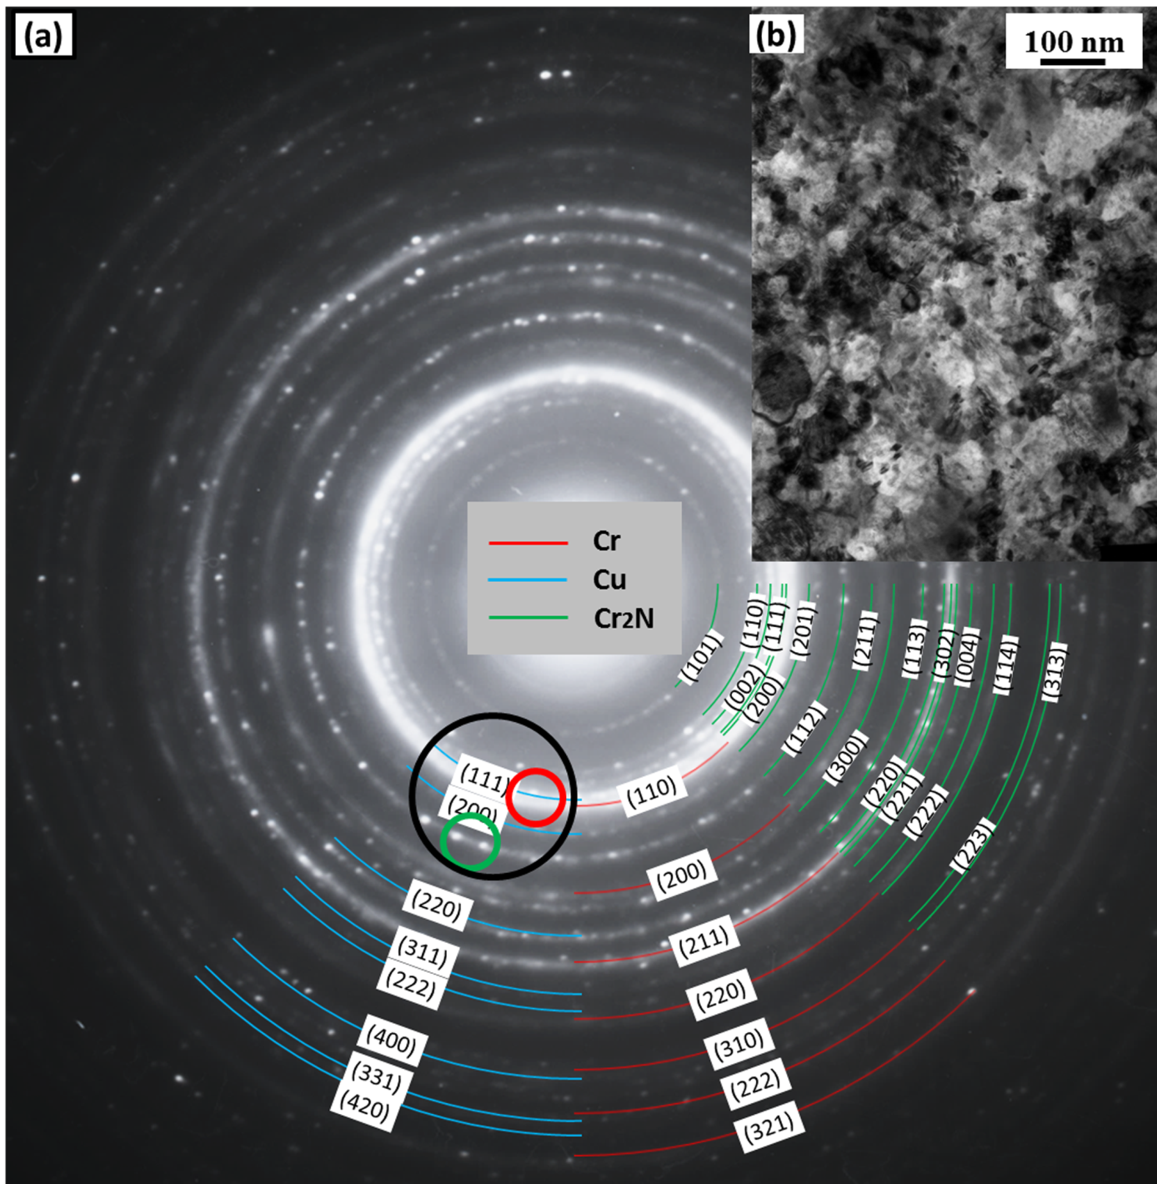
Fig. 6.8. Plane-section TEM images and SAED pattern of 10 sccm-P4-500, (a) SAED pattern and (b) BF image at low magnification.

6.5.5.2. 10 sccm-P4-500: three DF images of a same selected area
Three DF images of 10 sccm-P4-500 are shown in Fig. 6.9; these were obtained by choosing different sizes and parts of the SAED pattern shown in Fig. 6.8a, with the corresponding sectors of the diffraction pattern indicated using black, red and green circles in Fig. 6.8a, respectively.
Fig. 6.9a, with the corresponding diffraction pattern indicated by a black circle in Fig. 6.8a, shows a number of nanocrystallites with sizes ranging from several nanometres to several tens of nanometres. Four relatively large grains are labelled 1-4, respectively, as shown in Fig. 6.9.
After choosing a smaller objective aperture, shown using a red circle in Fig. 6.8a, the DF image changed to that shown in Fig. 6.9b, imaged from the same area as in Fig. 6.9a. It can be seen that grain 1 and 2 are still visible in Fig. 6.9b, however grains 3 and 4 ‘disappeared’. Because Cr(110) exhibited the brightest diffraction ring (see Fig. 6.8a) and the centre of the red circle is on the Cr(110) diffraction ring, it may be deduced that grain 1, which is the largest and brightest grain in Fig. 6.9b, is probably a nanocrystalline Cr grain, with the (110) plane (or equivalent planes from the $\left\{110\right\}$ family) perpendicular to the TEM sample foil (no stage tilt was applied when obtaining the SAED patterns and DF images). Grain 2, however, could be a nanocrystallite corresponding to Cu(111), Cr₂N(111), Cr₂N(200) or Cr₂N(201) orientations, and could not be fully confirmed, due to the nearly overlapped diffraction rings and relatively large objective aperture (although the smallest objective aperture in the TEM instrument had been used for Figs. 6.9b and 6.9c).
By moving the objective aperture to another area (shown using the green circle in Fig. 6.8a) a third DF image, Fig. 6.9c, was obtained. This time only one diffraction ring (with two diffraction spots along it) was included inside the objective aperture, being that of Cr₂N(112) - see Fig. 6.8a. From Fig. 6.9c, it can be seen that the ‘disappeared’ grains 3 and 4 became visible once more, which confirms these to be Cr₂N nanocrystallites - with plane indices belonging to the $\left\{112\right\}$ family.

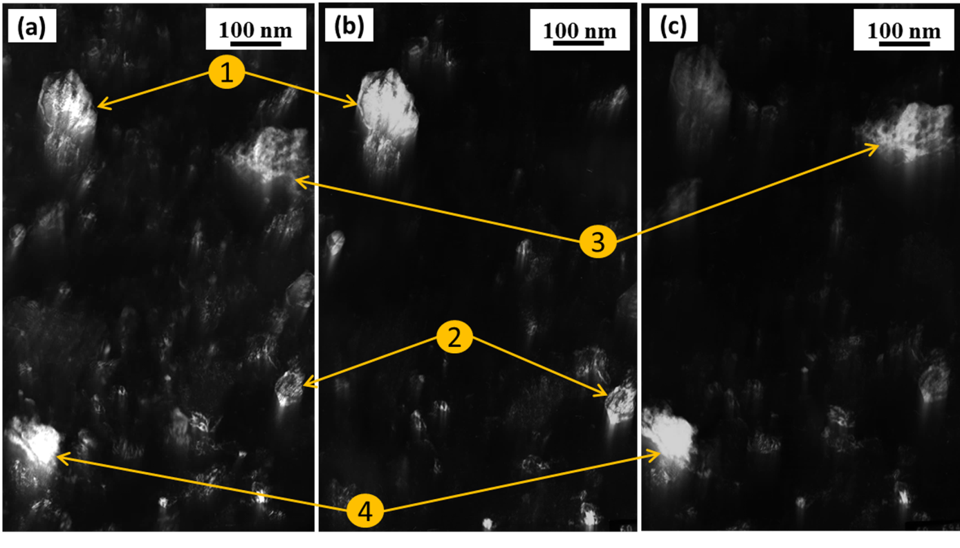
Fig. 6.9. DF images of 10 sccm-P4-500, with their corresponding diffraction pattern shown in Fig. 6.8, (a) the large black circle, which contains (b), (c); (b) the small red circle, in which are parts of the diffraction rings belonging to Cr(110), Cu(111), Cr2N(111), Cr2N(200) and Cr2N(201), with Cr(110) being the brightest; (c) the small green circle, in which are two diffraction points along the Cr2N(112) diffraction ring.

6.5.6. Summary of TEM analyses
Overall, TEM analyses of 5 sccm-P2-(AD, 300 and 500) reveal phase transformations from the original ultra-fine nanocrystalline Cr-based solid solution (5 sccm-P2-AD; Cu and Ag in substitutional solid solution and N in supersaturated interstitial solid solution), to a mixture of nanocrystalline Cr and ultra-fine nanocrystalline Cr-based solid solution after 300 °C annealing (5 sccm-P2-300; similar solid solutions as the as-deposited coating), then to a mixture of nanocrystalline Cr and twining-nanocrystalline Cu, together with an amorphous phase consisting of Cu, Ag, N (and possibly also Cr) after 500 °C annealing (5 sccm-P2-500). The formation of an amorphous phase (Cu, Ag, N and/or with Cr) originating from the nanocrystalline Cr-based solid solution, possibly results from the low miscibility of Cu with Ag [162, 180, 181] (and also of Cu with Cr –and/or Ag with Cr [162]), together with the non-nitride forming characteristics of Cu and Ag. Because Fig. 5b shows that 5 sccm-(P1 to P3) exhibited quite similar XRD patterns to each other - whether in the as-deposited state, or in either of the two annealed states - it can be deduced that similar phase transformations occurred for each of 5 sccm-(P1 to P3).
From the XRD and TEM analysis of 5 sccm-P2-(AD, 300 and 500), It can also be seen that, for nitrogen-containing coatings with nitrogen content up to 16 at.% (or a N/(Cr+N) atomic ratio up to 0.18, see Table 6.1), chromium exists as a metallic supersaturated interstitial solid solution with nitrogen, even after 300 °C and 500 °C annealing.
After annealing, Cu exists not only on the coating surface, but also inside the coating (e.g. in solid solution for 5 sccm-P2-300, in nanocrystalline twinning and an amorphous state for 5 sccm-P2-500, or as nanocrystallites in 10 sccm-P4-500), rather than being fully transported to the coating surfaces - indicating the dependence of this ‘transportation’ on annealing duration. Moreover, annealing at 500 °C caused more and larger Cu-Ag aggregates to be formed on the coating surface than did annealing at 300 °C, indicating the (not unexpected) dependence of the Cu (and Ag) transportation speed on temperature. Furthermore, increasing nitrogen concentration caused larger Cu (and Ag) aggregates to form on the coating surface, indicating the dependence also of the Cu (and Ag) transportation (different from the influencing factors of the separation of Cu and/or Ag from solid solution in Cr, which are (Cu+Ag+N)/Cr and (Cu+Ag)/Cr atomic ratios, respectively) on nitrogen concentration. Considering the apparent dependence of Cu and Ag transportation on the ‘global’ Cu+Ag concentration, a conclusion can be drawn that the transportation of Cu and Ag to the surface depends on annealing temperature, annealing duration, nitrogen concentration and overall Cu+Ag concentration. In other words - by appropriate design - the transportation of Cu (and particularly Ag) can be tuned for specific applications in order to obtain both the required functionality (such as solid lubrication) and an optimised service life in, for example, high temperature (or cyclic temperature) tribological or antimicrobial service conditions.

6.6. Summary
The effects of annealing on the fracture sections, surface morphologies, phase compositions and nanostructure of CrCuAgN PVD coatings were comprehensively investigated. The following conclusions can be drawn:
- Annealing altered the coating fracture section appearance and surface morphology; as might typically be expected, the higher the annealing temperature, the more obvious are the changes occurring to the coating nanostructure, phase composition and (somewhat more importantly) surface morphology/chemical composition. Copper- and silver-rich aggregates formed on the surfaces of nitrogen-containing coatings after annealing, the number and size of which increased with increasing Cu+Ag concentration and/or annealing temperature. The number and size of the surface aggregates were also influenced by the nitrogen flow rate, probably due to nitrogen incorporation reducing the solubility of Cu and Ag in Cr, or Cr₂N (where formed).
- In coatings with a nitrogen concentration of up to 16 at.% (N/(Cr+N) atomic ratio up to 0.18), a metallic Cr solid solution with supersaturated interstitial nitrogen remained present, even after post-coat annealing at 300 °C and 500 °C. At higher N/(Cr+N) atomic ratios, the coexistent state of α-Cr solid solution with Cr₂N nitride phase is relatively stable in a large range of nitrogen concentrations (e.g. N/(Cr+N) ratios, from 0.18 to 0.55 in my PhD investigation), and can survive at relatively high temperature (e.g. 500 °C).
- The formation of Ag aggregates relates primarily to the (Cu+Ag)/(Cr+Cu+Ag) atomic ratio in the coating, whereas the formation of Cu aggregates relates primarily to the (Cu+Ag+N)/(Cr+Cu+Ag+N) atomic ratio. In CrCuAgN coatings with (Cu+Ag)/(Cr+Cu+Ag) and (Cu+Ag+N)/(Cr+Cu+Ag+N) atomic ratios higher than 0.2 and 0.35, respectively, under relatively high temperature (e.g. 500 °C), Cu can assist Ag to be transported from within the coating to the coating surface - and with surprisingly enhanced Ag mobility. Cu and Ag either exist in the ultra-fine bcc α-Cr nanocrystallites, or exist in an intergranular amorphous Cu-rich “tissue”, or both. Moreover, after annealing, although both Cu and Ag transported to coating surface, they are inclined to exist separately.
- The transportation of Cu (and Ag) to the surface depends clearly on the chosen annealing temperature, annealing duration, nitrogen concentration and ‘global’ Cu+Ag concentration. This provides a possibility to tailor coatings with a range of desired functionalities and properties for specific applications.
- Furthermore, almost all of the available literature on MeN:Ag PVD coatings reveals the silver to precipitate as separate, isolated particles, with little or no migration path available. However, the incorporation of Cu appears to be a powerful strategy to enhance the transportation rate of Ag. Much lower concentration of Ag (from ~20 at.% in the literature for no added Cu to ~3 at.% in this study) in such coatings is required to obtain effective transportation rate to coating surfaces under moderately high service temperature (and/or by coating pre-conditioning through careful post-coat annealing). Therefore, the results of the present study indicate that the concurrent addition of both Cu and Ag (in appropriate concentrations) to PVD nitrogen-containing chromium coatings is a viable method to promote adaptive behaviour - and to permit the development of ‘self-replenishing’ thin film architectures for antimicrobial and solid lubricating coating applications.

Chapter 7. Effects of Post-deposition Annealing: Part 2

7.1. Introduction
In the previous chapter, the effects of post-coat annealing (300 °C and 500 °C, respectively) on the surface morphology, phase composition and nanostructure of CrCuAgN coatings (which were produced at N₂ flow rates of 0 sccm, 5 sccm and 10 sccm, respectively) were investigated systematically. It was found that in coatings with N contents up to 16 at.%, Cr exists as metallic Cr with N in supersaturated solid solution, even after 300 °C and 500 °C post-coat annealing. It was also found that, with sufficient Cu content (> 12 at.%), annealing at a moderately high temperature (e.g. 500 °C) leads to the co-transportation of both Cu and Ag (even at relatively low Ag concentration, ≤ 3 at.%) from inside the coating to the coating surface. These results indicate that the addition of both Cu and Ag (in appropriate concentrations) to nitrogen-containing chromium is a viable strategy for the development of ‘self-replenishing’ silver-containing thin film architectures for temperature-dependent solid lubrication requirements. However, the CrCuAgN coatings in this previous study all contained relatively low Ag concentrations, ≤ 3 at.%. Therefore, further study of CrCuAgN coatings with higher Ag concentrations was considered necessary, which is the main topic of this paper.
In this section of work, CrCuAgN coatings were produced using asymmetric unbalanced magnetron sputtering from two segmented targets. The nitrogen flow rate during the deposition process was fixed at 5 sccm, based on the investigation outcomes from Chapter 6. It was concluded that Cr remains metallic (both in as-deposited state and in annealed state, e.g. 2 hours annealing under 500 °C) at 5 sccm nitrogen flow rate (with the power of Cr and Cu-Ag targets being 1000W and 400W, respectively). However, higher nitrogen flow rates (e.g. 10 sccm, or above) tends to result in the formation of Cr nitrides (e.g. Cr₂N). As one of the key aims of my PhD investigation was to retain the metallic state of Cr when introducing nitrogen, the second-stage study was therefore mainly focused CrCuAgN coatings with Cr remaining metallic solid solution, which was achieved by control of both the nitrogen flow rate (fixed at 5 sccm) and the total power applied to both segmented-targets (700W to each, and 1400W in total), i.e. identical to the total deposition power used in stage one (which was 1000W + 400W = 1400W). The purpose of this revised experimental design was to obtain a larger range of Cu and Ag concentrations (e.g. Cu: ~5 to ~50 at.%; Ag: ~2 to 40 at.%), in order to further investigate their distribution in nitrogen-containing chromium coatings, under both as-deposited and annealed states - and also their transportation behaviour during the post-coat annealing. By doing so, it was expected that clearer guidelines could be drawn for the design of CrCuAgN coatings to satisfy different solid-lubricating or antimicrobial application requirements.
For the post-deposition annealing, the CrCuAgN coatings discussed above were divided into 3 groups. Three different annealing conditions were investigated, with the annealing parameters being identical to those described already in Section 6.1. The surfaced morphology, elemental composition and distribution, phase composition and distribution of these coatings, and the effects of post-deposition annealing on these features, were investigated.
In order to simplify the description and analysis in the following sections, each sample (or the deposited coating thereon) from the 3×3 matrix (see Fig. 4.3a, Section 4.2) will be simply described using the names shown in Fig. 4.3a (the designations: ‘T, M, B’ and ‘L, C, R’ stands for ‘Top, Middle, Bottom’ and ‘Left, Centre, Right’, respectively; e.g. TL indicates the top-left sample). As-deposited coatings without annealing will be described as XY-AD (where X=T, M or B; Y=L, C or R; AD means as-deposited). Coatings annealed at 300 °C and 500 °C, will be described as XY-300 and XY-500, respectively. ‘Column’ would be used to describe a set of 3 samples distributed in the vertical direction; similarly, ‘row’ would be used to describe a set of 3 samples distributed in horizontally. By analogy, several descriptive examples are listed below: XL indicates the 3-sample set of TL, ML and BL (in all three post-deposition annealing conditions); TY-500 indicates the 3-sample set of TL-500, TC-500 and TR-500; TL-Cr indicates chromium (concentration) in the top-left sample, etc.

7.2. Coating thickness
Coating thicknesses and deposition rates corresponding to each sample are listed in Table 7.1. As can be seen from Table 7.1, Coating thicknesses (e.g. deposition rates) vary with deposition positions. In columns, coating thickness increases from top to bottom, which is probably related to the higher Ar ion sputtering yields of Cu and Ag, compared to that of Cr. For example, based on the improved (from an original empirical formulation given by Matsunami, et al. [182]) semi-empirical formula provided by Seah et al.[183, 184], at normal incidence, a 500 eV Ar ion could yield 1.751 Cu atoms and 2.604 Ag atoms, however for Cr it is only 1.131. In rows, it can be seen from Table 7.1 that, for each of the three horizontal rows (‘Top’, ‘Middle’ and ‘Bottom’, to be specific), the three coatings from position ‘Centre’ exhibited lowest thicknesses, compared to their analogues from positions ‘Left’ and ‘Right’ (which are rather similar in comparison). This might be related their difference in substrate-target distances and vapour flux incident angles, which are schematically shown in green and red arrow-lines, and α, β in Fig. 4.3a. To simplify for comparison, lines were drawn from the centre of the combo-targets. Actually the sputtering source (mainly from the ‘race track’) of a magnetron enhanced rectangular planar target is much more complicated than a simplified point source.

Table 7.1. Coating thicknesses and deposition rates of the CrCuAgN coatings (in 3x3 array).
Vertical position | Th for Thickness (μm) & DT for Deposition rate (nm·min⁻¹) | Horizontal position
 |  | Left | Centre | Right
Top | Th (DT) | 3.5 (37) | 1.8 (19) | 2.9 (31)
Middle | Th (DT) | 4.4 (46) | 2.4 (25) | 4.3 (45)
Bottom | Th (DT) | 4.9 (52) | 2.7 (28) | 5.5 (58)

7.3. Elemental composition and atomic ratios

7.3.1. Elemental composition
Fig. 7.1 shows the elemental concentrations of the 4 constituents – Cr, Cu, Ag and N – in each as-deposited coating, in atomic percentage.
From Fig. 7.1, it can be seen that in each column, from top to bottom, Cr concentration decreases while Cu and Ag concentrations increase. Moreover, in each row, from ‘Left’ to ‘Right’, Cu concentration decreases while Ag concentration increases. These results are mainly related to the specific substrate-target distance of each sample, as can be seen from Fig. 4.3a and Fig. 4.3b. Furthermore, being introduced as gaseous state, nitrogen could distribute into the processing chamber much more homogeneously than the other constituents (e.g. Cr, Cu and Ag, from solid targets); however, it does not deposit onto each substrate at similar rates as originally expected. By comparing Fig. 7.1c and d it can be seen that the concentration of N in each coating varies in quite similar trend as that of Ag does. In other words, where Ag concentration increases, N concentration increase as well, although it seems there is threshold (compare the trends from MR to BR for Ag and N, clearly N concentration stopped increasing, probably due to the limitation of its low, fixed flow rate – 5 sccm).

Fig. 7.1. Elemental concentrations of each coating in atomic percentage, displayed in 3D columns in 3×3 matrix: (a) Cr; (b) Cu; (c) Ag and (d) N.

7.3.2. Selected atomic ratios
Four selected atomic percent ratios, which are N/(Cr+N), Cu/(Cr+Cu), Ag/(Cr+Ag) and (Cu+Ag)/(Cr+Cu+Ag), respectively, are calculated and shown in Fig. 7.2. Except the N/(Cr+N) ratio, the overall trends of all three other ratios are highly related to the corresponding position and substrate-target distance of each substrate during deposition process. All these 4 ratios will be useful in the phase composition analysis in following sections.
Fig. 7.2. Selected atomic-percentage ratios of each coating, displayed in 3D columns in 3×3 matrix: (a) N/(Cr+N); (b) Cu/(Cr+Cu); (c) Ag/(Cr+Ag) and (d) (Cu+Ag)/(Cr+Cu+Ag).

7.4. Surface morphology

7.4.1. As-deposited CrCuAgN coatings
Fig. 7.3 shows the secondary-electron (SE) images (acquired in scanning electron microscope, i.e. SEM) of the surface morphologies of each as-deposited coating. It can be seen that the coating morphology changed obviously as the substrate position changes. It can be roughly divided into three groups:
- Group 1, ‘bumpy’ surface with homogenously distributed particle-like or spherical grains, e.g. TL, BL and BR;
- Group 2, ‘flake-like’ surface, e.g. MR and BC;
- Group 3, dense surface, with shallow gullies, e.g. TC, TR, ML and MC. Hillock-like flaws can also be found in TC and TR, the cause of which is unknown.
The causes of unclean substrate surfaces before deposition or arcs during deposition process could be eliminated, because:
- The substrates were polished and cleaned using the same procedures successively;
- These hillock-like flaws are evenly distributed on the surface of TC and TR and relatively small in sizes (less than 1 μm, mainly in sizes around 500 nm);
- No similar flaws were found on any other coatings, despite all of the 9 as-deposited coatings in this study were produced simultaneously, in the same processing run.
Besides, some bright spots can be seen from Figs. ML, MC, MR and BR, the elemental composition and source of which remain unknown. They could be contamination, from an unidentified source.

Fig. 7.3. Secondary-electron images, exhibiting the surface morphologies of as-deposited coatings, in 3×3 matrix, corresponding to positions shown in Fig. 4.3a.

7.4.2. Annealed coatings
Fig. 7.4 shows the SE images of the surface morphologies of each coating after annealing at 500 °C for 2 hours. Several selected BSE images revealing the Z-contrast are shown in the top-right-corner insets. By comparing Fig. 7.3 and Fig. 7.4, it can be seen that annealing caused obvious changes in surface morphology. To simplify, coating surface topography after annealing at 500 °C can be divided into 2 groups, as shown using the red and green outlines in Fig. 7.4. Coatings in the red outline group do not exhibit obvious precipitates on their surfaces (although tiny precipitates can be seed on TL-500, their sizes are not in the same order of those in the green outline group). However, coatings in the green outline group exhibit obvious polygonal precipitates, which are all in similar sizes (in the range of 200-500 nm) for all the 6 coatings in this group. Fig. 7.5 shows a SE image (and corresponding BSE image) of two aggregates from sample MR-500, at much higher magnification. These basic precipitates could aggregate and fuse into larger ones, as shown by the SE images (and BSE image insets). The exception is TR-500 in the red outline group, in which nodular flaws are seen rather than precipitates formed due to annealing. Several ‘on-going’ fusion processes are marked using blue circles in Fig. 7.4, in ML-500 and BC-500 , respectively; an early-stage fusion process was marked in Fig. 7.5a (Fig. 7.5c and d give 2 more SE images showing the ‘on-going’ fusion process at higher magnifications, with the same grain of ML in Fig. 7.4 being shown in Fig. 7.5c).
For the relatively large fused aggregates, they are not elementally homogenous, as can be seen from the BSE image insets in Fig. 7.4 (and confirmed by EDX elemental mapping, as shown in Fig. 7.6); further evidence is given in the TEM analysis later. In detail, these large aggregates are composed of Cu and Ag, with relative sharp interfaces between them, as can be seen from BSE of ML in Fig. 7.4, and further proved by the HAADF imaging and STEM EDS mapping of MR-500 in later discussion. This behaviour can be related to the intrinsic immiscible features of Cu and Ag in equilibrium state, as can be seen from Ag-Cu binary phase diagram [162] and the first-principles calculation [180, 181] (at equilibrium silver and copper are nearly immiscible below 550K). The calculated Ag-Cu binary phase diagram [161], is shown in Fig. 7.7.
From the absence of obvious Cu-Ag aggregates for the 3 coatings in the red outline group in Fig. 7.4, to the relative similarity in the sizes of ‘basic’ Cu-Ag aggregates (before they fuse together) for the 6 coatings in the green outline group, two conclusions can be drawn:
- In order to effectively form Cu and/or Ag aggregates on CrCuAgN coating surfaces under moderately high temperature (e.g. 500 °C, in annealing or during service), the Cu+Ag concentration needs to be above some threshold, which is ~17.5 at.% (this is the highest Cu+Ag concentration of TL, TC and TR) in this study. However, it needs to state that this threshold value is drawn from the very limited number of coatings in this study, hence could be arbitrary; moreover, for coatings deposited under other parameters (e.g. substrate temperature), the value might vary as well.
- When the Cu+Ag concentration is above this threshold, the sizes of the basic aggregates formed (before they fuse together and grow larger) are relatively similar and seems to be largely independent of the elemental composition.

Fig. 7.4. Secondary-electron images exhibiting the surface morphologies of 500 °C annealed coatings, in 3×3 matrix, corresponding to positions shown in Fig. 4.3a. Several selected backscattered electron images are also inset at the top-right corner of their corresponding secondary-electron images.

Fig. 7.5. (a) Secondary-electron images of two aggregates, from sample MR-500; (b) corresponding backscattered-electron image of (a); (c) and (d) Secondary-electron images of 2 large aggregated grains of sample ML-500, the ‘on-going’ fusion processes can be clearly seen, e.g. areas marked using blue circles. The grain in (c) is the same grain as the one shown at position ML in Fig. 7.4.
Fig. 7.6. Secondary-electron imaging showing the surface morphology of MR-500, with the corresponding EDX elemental mapping RGB (red: Cr, green: Cu and blue: Ag) image shown in the top-right-corner inset.

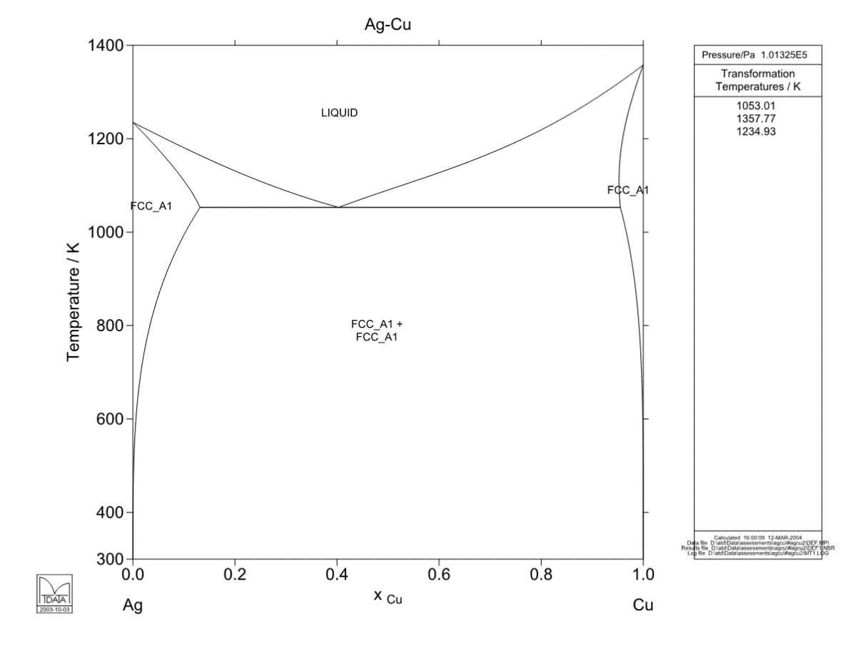
Fig. 7.7. Calculated Ag-Cu binary phase diagram [161].

7.5. Phase composition and transformation, part 1: XRD analyses

7.5.1. Introduction
The XRD patterns of as-deposited and annealed coatings are plotted in Fig. 7.8. In order to deal with the ‘overlapping’ problem of Cr, Cr₂N, Cu, Ag and substrate austenite peaks (AISI316 stainless steel) at 2θ ranges of 37º to 39º and 42º to 45º, a break (46º to 46.5º) at the 2-Theta axis was introduced and the range 35º to 45º (will be called ‘overlapping zone’ or OLZ in the following discussion) was scaled to 75% of the whole 2-Theta axis range (35º - 90º), as can be seen from Figs. 7.8 and 7.9. Therefore, the OLZ can be revealed with much more details (where overlapping peaks otherwise hardly be distinguished). Moreover, there are significant peak intensity differences among coatings after different post-deposition treatments; therefore, in order to distinguish most peaks in the XRD patterns, different intensity scales were used: the intensity ratios among Figs. 7.8, Fig. 7.9a and 7.9b are 1:10:20, respectively. It should also be mentioned again that the atom radii of the 4 constituents, Cr, Cu, Ag and N are 1.66Å, 1.45 Å, 1.65 Å and 0.56 Å, respectively [185].

Fig. 7.8. X-ray diffraction patterns of the as-deposited CrCuAgN coatings.

Fig. 7.9. X-ray diffraction patterns of the annealed CrCuAgN coatings: (a) after annealing at 300 °C for 2 hours; (b) after annealing at 500 °C for 2 hours and (c) coatings from chapter 6, CrCuAgN5-P1 to P5, annealed at 500 °C for 2 hours, replotted based on Fig. 6.4b in Section 6.4.2. Note: the intensity scales in Fig. 7.8 (same with Fig. 9c), Fig. 7.9 and Fig. 9b were in ratios of 1:10:20, respectively.

7.5.2. As-deposited coatings
Fig. 7.8 shows the XRD patterns of the as-deposited coatings. All as-deposited coatings only show one primary reflection (except the TR-AD pattern, which shows two reflections with similar intensities, Cr(110) and Cr(200), respectively). Considering their much lower-intensity and broader peaks (comparing with Figs. 7.9a and 7.9b - and remembering the scale ratios stated above), and also the intrinsic immiscibility between each pair of the three transition-metal constituents (Cr-Cu, Cr-Ag and Cu-Ag) [162-164, 181], several preliminary conclusions can be drawn: firstly, each as-deposited coating is composed of one primary solid solution (including TR-AD, which has a bcc α-Cr matrix); secondly, the solid solutions are all supersaturated, which inevitably causes extreme lattice distortion; thirdly, these solid solutions might exist as nanocrystallites, which although not easy to confirm using XRD analysis above, is usually the case for PVD coatings on low-temperature substrates - and is subsequently proved by TEM analysis later (Section 7.6). Coatings with low Cu+Ag concentrations, e.g. TL, TC and TR, exhibited a broad reflection of Cr(110), shifted to lower angles of 2θ, indicating an expanded lattice parameter. No other reflections were found (except a Cr(200) reflection for TR), indicating that TL-AD, TC-AD and TR-AD are each composed of a bcc α-Cr-matrix solid solution, with strong preferred orientation (also discussed further in the TEM analysis section). As the combined Cu+Ag concentration increases, the ‘matrix’ of the solid solution changes. When the PVD process is performed at relatively low temperature (as in the case of this study), non-equilibrium and metastable phases can form in the coatings. Take the Cu-Cr binary system for example: Holleck [37] presented a schematic figure to exhibit the actual, approximate PVD phase fields observed, as a function of both chemical composition and deposition temperature, see Fig. 7.10 (reconstructed, based on the original figure in ref. [37]), as confirmed by Dirks, et al. in ref. [175] via analyses on PVD Cu-Cr, Cu-Mo and Cu-W coatings - and also by Baker et al [38], via studies on PVD CrCu(N) coatings (with substrates heated to ~200 °C before deposition). In the study of Dirks, et al [175], no external heating was applied, as in this study - although under the substrate bias (-100V) and other deposition parameters (e.g. working pressure, target power, etc.) used in my study, the ion bombardment might be expected to heat the substrates up to a temperature range of 100 °C - 120 °C [176]. Therefore, as Cu and/or Ag concentration rises, the solid solution gradually changes. Starting from the sample with the highest Cu concentration - BL, which has a Cu concentration as high as 50.7 at.% (see Fig. 7.1b); a sharp and high reflection at 2θ=42.25 was found for BL-AD. The closest ‘match’ for this reflection would be Cr₂N(111) (as indicated in red font in Fig. 7.8), with its 2θ position of 42.61°. However, the pattern of BL-300 in Fig. 7.9a showed that the original ‘Cr₂N(111)’ reflection from BL-AD had disappeared - which was unlikely to happen for Cr₂N when annealing at as low as 300 °C for 2 hours. This indicated strongly that the reflection at 2θ=42.25° for BL-AD was not Cr₂N(111), but an as yet unidentified expanded metastable phase. Considering the high Cu/(Cr+Cu) ratio (0.59, Fig. 7.2b), and the phase fields shown in Fig. 7.10, it could be deduced that this reflection came from Cu(111), whose theoretical 2θ location was 43.30°. The shift of this reflection to a significantly lower angle of 2θ indicates a substantial increase in lattice parameter, due to the substitution of Cu atoms by larger Cr (35.6 at.%) and Ag (3.1 at.%) atoms, and the solution of interstitial N (10.6 at.%) atoms (see Fig. 7.1 for elemental composition). Similarly, strong Ag(111) reflection appears for MR-AD and BR-AD, with the Ag/(Cr+Ag) ratios being 0.44 and 0.64, respectively. Moreover, it seems the range of fcc (Ag,Cr) (fcc Ag being the matrix with Ag/(Cr+Ag) ratio as low as 0.44) in the Cr-Ag system is much broader than the range of fcc (Cu, Cr) in Cr-Cu system. Based on the data in this study, a schematic Cr-Ag phase field diagram is shown in Fig. 7.11. Similar fcc-Ag based metastable solid solution was also found for Ag-Mo system, with relatively high Ag concentration (over than 79 at. %) [186]. Furthermore, unlike the Cu(111) reflection shifting to lower angles of 2θ, the Ag(111) reflections of MR and BR shifted to higher 2θ angles, indicating a decrease in lattice parameter. This decrease is caused by the following combined effects: (1) substitution of Ag atoms by Cr atoms (see their radii in last paragraph): almost no change; (2) substitution of Ag atoms by Cu atoms: lattice shrinking significantly; (3) solution of interstitial N atoms: lattice expanding. In other words, the effects from Cr, Cu and N on changing the lattice parameter of fcc-Ag-matrix counteract each other partially (depending on over chemical composition), however, the effects of Cr, Ag and N on changing the lattice parameter of fcc Cu-matrix are superimposed. That is also the reason of smaller shift amplitude of Ag(111) for MR-AD than that of Cu(111) for BL-AD. ML-AD also exhibited an unidentified reflection at ~57º (as indicated using a red question mark), which disappeared after annealing.

Fig. 7.10 (same as Fig. 5.5). Reconstructed schematic PVD phase fields for the Cr-Cu system [37].

Fig. 7.11. Schematic PVD phase fields for the Cr-Ag system, based on principles of ref. [37].

7.5.3. Coatings annealed at 300 °C
After annealing at 300 °C for 2 hours, as shown in Fig 7.9a, the reflections became sharper and much higher in intensity, compared to those of the as-deposited coatings (note that the intensity scale of Fig. 7.9a is 10 times that of Fig. 7.8). Overall, as Cu and/or Ag concentration increases in the coating, higher reflections of their crystalline phases emerge. Moreover, these Cu and Ag reflections are nearly at their theoretical 2θ value, indicating the relaxation of lattice distortion compared to their as-deposited analogues. Furthermore, for those coatings that showed clear Cu and/or Ag reflections, clear reflections from Cr arise as well, indicating the precipitation of Cr from the fcc- Cu or Ag matrix. By combining the fact that no Cr nitride reflection (from Cr₂N or CrN) was found, the following conclusions can be drawn: (1) the fcc-matrix solid solution formed by PVD on substrates without external heating (up to 120 °C due to ion bombardment, as mentioned in Section 7.5.2) are extremely unstable, and under annealing at relatively low temperature (e.g. 300 °C), they would transform into more stable phases by the precipitation of substitutional elements (e.g. MR-AD primarily composed of fcc (Ag, Cr), while MR-300 composed of fcc Ag and precipitated bcc Cr); (2) the bcc α-Cr-matrix solid solution is relatively stable, and retains its structure under low temperature annealing, which is partially due to the relatively low Cu+Ag concentration (e.g. TL-300, TC-300 and TR-300); (3) N probably exists in the Cr-matrix as an interstitial solid solution.

7.5.4. Coatings annealed at 500 °C
After annealing at 500 °C for 2 hours, as shown in Fig. 7.9b, all 9 coatings exhibit clear Cr₂N(111) and Cr(110) reflections, covering a surprisingly large range of N/(Cr+N) ratios from 0.11 to 0.55. However, according to the analyses in Chapter 6, for coatings with a N/(Cr+N) ratio of 0.18, although ‘suspicious’ Cr₂N reflections appeared in the corresponding XRD pattern, no existence of Cr₂N could be confirmed by the TEM analysis. No CrN reflections can be found, even for BR-500, which has a N/(Cr+N) ratio as high as 0.55. This was also the case of 10 sccm-P5-500 discussed in Section 6.4.3 back in Chapter 6, which exhibited a same N/(Cr+N) ratio of 0.55, no CrN reflections could be found there, either. These behaviours indicate once again (see Sections 6.4.4 and 6.4.5) that the coexistent state of α-Cr solid solution with Cr₂N nitride phase is relatively stable in a large range of nitrogen concentrations (e.g. N/(Cr+N) ratios, from 0.18 to 0.55 in these PhD investigations), and can survive at relatively high temperature (e.g. 500 °C).
Moreover, it would also be interesting to compare the phase transformation of TR and MC between the two annealed states. It can be seen that TR-500 exhibits a sharper and slightly higher Ag(111) reflection than TR-300; however, MC-500 exhibits a sharper and much higher reflection of Ag(111) than MC-300, much higher even than TR-500. This behaviour is not in accord with the actual Ag atomic concentrations of TR (12.4 at.%) and MC(4.1 at.%), whereas it is to some extent in accord with the (Cu+Ag)/(Cr+Cu+Ag) ratios (see Fig. 7.2d), indicating the positive role of Cu in helping Ag to precipitate from as-deposited coatings.

7.6. Phase composition and transformation, part 2: TEM analyses

7.6.1. Coating selection for TEM analysis
TR, MC and MR were chosen for TEM analysis to further investigate the phase compositions and annealing-induced phase transformations of CrCuAgN coatings. The selection of these representative samples was based on above discussions, with the principles of (a) varying as-deposited matrix (bcc α-Cr matrix or fcc-Ag matrix); (b) reasonably high Cu+Ag concentration (e.g. at or above the precipitation threshold: 17.5 at.%, see the first conclusion in Section 7.4.2; however no need to be higher than 40 at.%); (c) varying Ag/Cu ratios. In details:
- TR – TR-AD exhibits a bcc α-Cr matrix, a Cu+Ag concentration of 17.5 at.%, and relatively high in Ag concentration. Four TEM samples were prepared, which were TR-AD-cross section, TR-AD-plan view, TR-500 -cross section and TR-500 -plan view, respectively.
- MC – MC-AD exhibits a bcc α-Cr matrix, a Cu+Ag concentration of 23.4 at.%, and a low Ag/Cu ratio. One TEM sample was prepared, which was MC-500 -cross section;
- MR – MR-AD exhibits an fcc-Ag matrix, a Cu+Ag concentration of 34 at.%, and a high Ag/Cu ratio. Four TEM samples were prepared, which were MR-AD-cross section, MR-AD-plan view, MR-500 -cross section and MR-500 -plan view, respectively.

7.6.2. Coating TR

7.6.2.1. TR-AD
The bright field (BF) and dark field (DF) images of TR-AD-cross section and TR-AD plan-view are shown in Figs. 7.12 and 7.13, respectively. BF and DF images were taken from the same area, at both low and high magnifications, with corresponding selected area electron diffraction (SAED) patterns shown in the centre of each figure as well, with the diameter of the selected area aperture being 1μm, and its centre corresponds to that of the yellow square in Fig. 7.12a.
For the TR-AD cross-section, a clear columnar structure can be seen from Figs. 7.12a and 7.12c. From Fig. 7.12d, it can also be seen that the grains of TR-AD are nanocrystalline, with their sizes being less than 5 nm, even sub-nanometre. The SAED pattern in the centre (Fig.13e) further proves the existence of an ultrafine nanocrystallites and confirms that the nanocrystallites are bcc-Cr, as suggested by the XRD pattern in Fig. 7.8. Fig. 7.12e also indicates that the nanocrystallites exhibit a strong preferred orientation.
For the TR-AD plan view, cross-sections of the columns shown in Fig. 7.12 can be seen from Fig. 7.13a and c, with column diameters between 100 and 300 nm. A column was chosen for higher magnification, as seen in Figs. 7.13b and 7.13d. Nanocrystallites of sizes less than 5 nm can be seen within the column, as Fig. 7.12d. The SAED pattern (Fig. 7.13e, with the diameter of the selected area aperture being 1μm, and its centre corresponds to that of the yellow square in Fig. 7.13a) indicates existence of ultrafine nanocrystalline bcc α-Cr. It also indicates no existence of lateral preferred orientation.
Only bcc Cr diffraction rings were found from both the cross-section and plan-view SAED patterns, further proving that the other constituents, Cu, Ag and N, exist in solid solution in the bcc α-Cr-matrix. Therefore, inevitable serious lattice distortion would be caused to the Cr matrix, as can be seen from Fig. 7.14a, which shows a high resolution TEM image taken from the Cr[100] zone axis, with its IFFT (Inverse Fast Fourier Transform) image shown in Fig. 7.14b. A large number of stacking faults (e.g. ‘disappearing’ atomic planes, indicated by yellow dashed arrows) together with a significantly distorted lattice (e.g. distorted atomic planes indicated by the yellow lines), can be clearly seen from Fig. 7.14b. These results are in good agreement with the XRD analyses in Section 3.3.1.

Fig. 7.12. TR-AD-Cross section: (a) BF image at low magnification; (b) BF image at high magnification; (c) DF image at low magnification; (d) DF image at high magnification and (e) SAED pattern, with the small red circle corresponding to selected part of SAED pattern for the dark field imaging of (c) and (d).

Fig. 7.13. TR-AD-plan view: (a) BF image at low magnification; (b) BF image at high magnification; (c) dark field image at low magnification; (d) DF at high magnification and (e) SAED pattern, with the small red circle corresponding to selected part of SAED pattern for the dark field imaging of (c) and (d).

Fig. 7.14. Sample TR-AD-cross section: (a) high resolution TEM image taken from Cr[100] zone axis, with growth direction shown by green arrow; (b) IFFT of image (a), with several stacking faults indicated using yellow dashed arrows, and distorted lattice marked by yellow lines.

7.6.2.2. TR-500
For the sample TR-500 cross-section, low magnification BF and high-angle annular dark field (HAADF) images are shown in Fig. 7.15. It can be seen that the surface of TR is quite rough, and the columnar structure in the as-deposited state remained partially after annealing at 500 °C. Moreover, the nanocrystallites in the coating are quite different in size, and distributed unevenly. The above results are in accord with the surface morphology discussion in Section 7.4, where it was shown that TR-AD had large nodular flaws on its surface, which persisted after annealing at 500 °C.
HAADF images, with corresponding EDX elemental mapping acquired at medium and high magnification are shown in Fig. 7.16. It can be seen that a large number of Cu and Ag nanocrystallites, in sizes of 20 nm to 200 nm, precipitated from the bcc α-Cr matrix during annealing at 500 °C. A colourised image, constructed by combining of 5 different DF images taken from TR-500 plan-view is shown in Fig. 7.17, with the corresponding SAED pattern and BF image for better illustration. Fig. 7.17 clearly exhibits the plan-view morphologies and sizes of Cr, Cr₂N and Ag nanocrystallites. Note that only a portion of the nanocrystallites in the view of Fig. 7.17b are ‘inserted’ into Fig. 7.17c (note the numbers of spots inside and outside the colour circles in Fig. 7.17a).
Mulligan et al. [31] proposed that the Ag transport in CrN-Ag coatings is detachment-limited rather than diffusion-limited. Their analysis was based on the Gibbs-Thomson effect [187] and related to particle coarsening (Ostwald ripening) [188], and explained the behaviour of Ag transport during annealing in PVD CrN-Ag coatings. The chemical potential change Δμ with the size of a spherical particle can be calculated by [26, 187]:
$$Δμ=ΔP∙V_{m}=\frac{2γV_{m}}{r} (7-1)$$
where ΔP is the additional external pressure imposed on the particle due to its surface energy, V_{m}, γ and r are the molar volume, surface energy and radius of the spherical particle, respectively. Therefore, a smaller particle (larger curvature) possesses higher chemical potential, hence a higher detachment rate. For CrCuAgN coatings in this study, similar behaviours have been found for both Ag and Cu transportation. As can be seen from Fig. 7.16b, larger Cu and Ag particles are found in the near-surface area, and relatively smaller Cu and Ag nanocrystallites are distributed in the whole coating cross section (no diffusion gradient). However, the transportation of Ag in the CrCuAgN coatings are more complicated than that the abovementioned CrN-Ag coatings. This will be discussed further in section 9.2. Fig. 7.18 shows a large Ag nanocrystallite (red) and a smaller Ag nanocrystallite (green), from TR-500 plan-view. Note that their boundary is extremely flat, indicating that the interface energy (chemical potential) between these two grains tends to remain as low as possible.

Fig. 7.15. TR-500 cross-section: (a) BF image in STEM mode; (b) HAADF image from the same area as (a).

Fig. 7.16. TR-500 cross-section: (a) HAADF image at medium magnification; (b) RGB EDX mapping image, with corresponding area shown in (a); (c) HAADF image at high magnification, (d) RGB EDX mapping image, with corresponding area shown in (c). Red, green and blue refer to Cr, Cu and Ag, respectively.

Fig. 7.17. TR-500 plan-view: (a) SAED pattern, with the colour circles corresponding to selected (using objective aperture) spots for DF imaging, and relevant crystal planes are also indicated; (b) the BF image of the corresponding SAED pattern shown in (a); (c) corresponding DF image of (b), processed by overlaying and colourizing of 5 DF images, with same colours as their corresponding marks in (a).

Fig. 7.18. A large Ag nanocrystallite merging with a small Ag nanocrystallite, from sample TR-500 plan-view.

7.6.3. Coating MC
For sample MC-500 cross-section, the HAADF images and corresponding colourised RGB EDX mapping images at relatively low and high magnification are shown in Fig. 7.19. As can be seen from Figs. 7.19a and 7.19c, the nanograins are equiaxed. Moreover, Figs. 7.19b and 7.19d demonstrate that Cu and Ag precipitates are of similar size and are distributed homogeneously through the coating, which is a more desired nanostructure than that shown in Fig. 7.15. After the original Cu and Ag precipitation across the coating, smaller precipitates (with higher chemical potentials), which have higher detachment rates, would merge with larger ones, which will be constrained inside the coating. Finally, due to the reduced constraint of the precipitates in the surface region, they aggregate and grow larger in size, as discussed in Section 7.4 and shown in Figs. 7.5, 7.6 and 7.7. Larger Cu aggregates near the coating surface can be seen from Figs. 7.19b and 71.9d. The square area selected in Fig. 7.19d was chosen to obtain a clearer colourised and stitched elemental map using the 3-window method in energy-filtered (EF)TEM, which is shown in Fig. 7.20. It can be clearly seen from Fig. 7.20 that Cu grains (in green) near the surface are larger than those further from surface. Large Ag nanocrystallites (in blue) were found next to Cu grains, taking into account their atomic concentrations in MC (Cu: 19.3 at.%; Ag: 4.1 at.%), it may be deduced that Cu exhibited positive effects on Ag transport to the coating surfaces.
A colourised image constructed by the combining of 10 different DF images taken from MC-500 cross-section is shown in Fig. 7.21 (similar to Fig. 7.17). It clearly exhibits the cross-sectional morphologies, sizes and crystalline directions of Cr, Cr₂N, Cu and Ag nanocrystallites. Similarly, note that only a portion of the nanocrystallites in the view of Fig. 7.21b are ‘inserted’ into Fig. 7.21c (note the number of spots inside and outside the colour circles in Fig. 7.21a).

Fig. 7.19. MC-500 cross-section: (a) HAADF image at low magnification; (b) RGB EDX elemental mapping, same area as (a); (c) HAADF image at high magnification; (d) RGB EDX mapping image, same area as (c). Red, green and blue refer to Cr, Cu and Ag, respectively.
Fig. 7.20. MC-500 cross-section: stitched elemental mapping image, using the EFTEM 3-window elemental mapping method. The area corresponds to the square area shown in Fig. 7.19d. Red, green and blue refer to Cr, Cu and Ag, respectively.
Fig. 7.21. MC-500 cross-section: (a) SAED pattern, with the coloured circles corresponding to spots selected (using objective aperture) for DF imaging, and relevant crystal planes are also indicated; (b) the BF image of the corresponding SAED pattern shown in (a); (c) corresponding DF image of (b), processed by overlaying and colourizing of 10 DF images, with same colours as their corresponding marks in (a).

7.6.4. Coating MR

7.6.4.1. MR-AD
For sample MR-AD cross-section, its BF and DF images from conventional TEM analysis are shown in Fig. 7.22. BF and DF images were taken from the same area, at both low and high magnification, with the corresponding selected area electron diffraction (SAED) pattern also shown in the centre, with the diameter of the selected area aperture being 1μm, and its centre corresponds to that of the yellow square in Fig. 7.22a. The SAED pattern (Fig. 7.22e) confirmed that MR-AD has a fcc-Ag based matrix, and strong preferred orientation, all in agreement with the XRD analyses. This fcc-Ag-matrix coating also exhibited a clear columnar growth structure, with the columns containing nanocrystallites less than 5 nm in width (see Fig. 7.22d).
For sample MR-AD plan-view, an elemental map acquired in EFTEM using the 3-window method is shown in Fig. 7.23. Fluctuations in Cr, Ag and Cu distributions in less than 5 nm scale can be seen, indicating the Ag-matrix solid solution was not homogeneous in elemental distribution. This characteristic could be beneficial in the precipitation of Cu and/or Ag as solid lubricants under medium-high temperature (e.g. 500 °C) service.

Fig. 7.22. MR-AD cross-section: (a) BF image at low magnification; (b) BF image at high magnification; (c) DF image at low magnification; (d) DF image at high magnification and (e) SAED pattern, with the small red circle corresponding to selected part of SAED pattern for the DF imaging of (c) and (d).

Fig. 7.23. MR-AD plan-view, elemental mapping image, using the EFTEM 3-window elemental mapping method. Red, green and blue refer to Cr, Cu and Ag, respectively.

7.6.4.2. MR-500
For sample MR-500 cross-section, HAADF images and corresponding RGB EDX elemental mapping at low, medium and high magnification are shown in Fig. 7.24. The cross-section sample was taken by cutting through 2 grown-up precipitates (similar to those shown in Fig. 7.7).
Fig. 7.22a shows that after annealing at 500 °C, the columnar structure in MR-AD (Fig. 7.22) disappeared and the entire coating is filled with nanocrystallites. Most nanocrystallites are equiaxed, however, a portion of them are elongated along the original columnar direction, as indicated using black ellipses. Fig. 7.24b exhibits that Cr and Ag distribute homogeneously inside the coating; however, Cu precipitates aggregate obviously, both inside the coating and on the coating surface, indicating higher detachment rate of Cu than Ag. Moreover, despite the relatively low concentration of Cu in MR (Ag: 29.5 at.%; Cu: 4.5 at.%), Cu aggregates are larger than Ag aggregates (see the green large Cu aggregates in Fig. 7.24b), and most of the large aggregates on the coating surface are found to be fused Cu and Ag, with clear boundaries (see Fig. 7.24b, ML-BSE image in Fig. 7.4, and Fig. 7.7). Therefore, when annealed at a moderately high temperature (500 °C), Cu in solid solution would quickly precipitate and aggregate into larger ones, leaving voids in the original solid solution which would be beneficial for Ag to precipitate, both inside the coating and onto coating surface. In other words, by proper design and processing, CrCuAgN coatings with appropriate elemental compositions and solid-solution matrix can be obtained, in which the precipitation rate of Ag can be partially controlled by the concentration of Cu (not necessarily very high, as in MR, 4.5 at.% Cu would be sufficient), resulting in a controlled supplement rate of solid lubricants.
Figs. 7.24c to 7.24f exhibit the yellow and pink squared areas indicated in Fig. 7.24a at medium and high magnifications. It can be clearly seen (especially from Fig. 7.24f) that spherical Cr-containing (Cr or Cr₂N) nanocrystallites precipitate from the Ag matrix. No particular shape was found for Cu nanocrystallites inside the coating, probably because they aggregate quite quickly by taking any available voids formed by other precipitates. The large Cu aggregates on the coating surface are polygonal (Fig. 7.24b) or spherical (Fig. 7.7)

Fig. 7.24. MR-500 cross-section: (a) HAADF image at low magnification; (b) RGB EDX mapping image, same area as (a); (c) HAADF image at medium magnification; (d) RGB EDX mapping image, same area as (c); (e) HAADF image at high magnification; (f) RGB EDX mapping image, same area as (e). Red, green and blue refers to Cr, Cu and Ag, respectively.

7.7. Summary
CrCuAgN coatings were produced on AISI 316 stainless steel substrates, in a 3×3 matrix configuration. Then the effects of post-deposition annealing on the nanostructure of as-deposited coatings were investigated. The following conclusions can be drawn:
- In order to effectively form Cu and/or Ag aggregates on CrCuAgN coating surfaces under moderately high temperature (e.g. 500 °C, in annealing or during service), the Cu+Ag concentration needs to be higher than a threshold, which is 17.5 at.% in this study; when the Cu+Ag concentration is above the threshold, the sizes of the basic aggregates formed (before they aggregate together and grow larger) are relatively similar and independent of the elemental composition. However, this threshold is drawn from a very limited number of coatings and hence is arbitrary; moreover, it is highly related to the deposition conditions in this study and could vary when conditions change (e.g. higher substrate temperature).
- Each as-deposited coating is composed of one primary solid solution. Moreover, the solid solutions are all supersaturated, exist as ultra-fine nanocrystallites and possess extremely distorted lattices. Furthermore, different elemental compositions of CrCuAgN coatings could result in different solid-solution matrices. In this study, bcc α-Cr-matrix, fcc-Cu-matrix and fcc-Ag-matrix solid solutions were found, depending on the major elemental component.
- It was further confirmed that in coatings with a nitrogen concentration of up to 16 at.% (i.e. N/(Cr+N) atomic ratio up to 0.18), a metallic Cr solid solution with supersaturated interstitial nitrogen remained present, even after post-coat annealing at 300 °C and 500 °C. No CrN was found, even for coatings possessing a N/(Cr+N) ratio as high as 0.55 (i.e. N/Cr ratio over 1.2). At higher N/(Cr+N) atomic ratios, the coexistent state of α-Cr solid solution with Cr₂N nitride phase is relatively stable in a large range of nitrogen concentrations (e.g. N/(Cr+N) ratios, from 0.18 to 0.55 in these PhD investigations), and can survive at relatively high temperature (e.g. 500 °C).
- With an atomic ratio of Ag/(Cr+Ag) as low as 0.44 (other elements being the minority), an fcc-Ag matrix (with other elements in solid solution) would form. Moreover, fluctuations in Cr, Ag and Cu distribution in a scale of less than 5 nm was found, which could be beneficial in the precipitation of Cu and/or Ag as solid lubricants under moderately high temperature (e.g. 500 °C) service.
- The co-existence of Cu with Ag in a PVD metallic coating was found to be beneficial to Ag transport onto the coating surfaces, resulting not from the anticipated ‘intergranular network channels’ of Cu, but from the much higher detachment rate of Cu than Ag, which can ‘leave a path’ for Ag to transport after Cu. Therefore by proper design and processing, CrCuAgN coatings with appropriate elemental compositions and solid-solution matrix can be obtained, in which the precipitation rate of Ag can be partially controlled by the concentration of Cu (which does not need to be very high; 4.5 at.% Cu appears to be sufficient), resulting in the controlled supplement of solid lubricants to the coatings surface.

Chapter 8. Mechanical, tribological properties of selected coatings

8.1. Mechanical properties
After annealing, the measured coating hardness (H) and elastic modulus (E) could be influenced by the Cu and/or Ag rich surface aggregates formed. The sizes of the aggregates formed during post-coat annealing were found to be in the range of 0.2 to 1 μm, see Fig. 6.2. Moreover, the indent depth in nano-indentation measurement was controlled to remain in the range of 100 nm to 200 nm, which was less than a tenth of the coating thickness (e.g. 2.5 μm to 4.5 μm, see Fig. 5.1) in order to eliminate (or reduce as far as possible) the influence from the relatively soft substrate (AISI316 stainless steel). Therefore, the influence of the surface aggregates on the nano-indentation measurements could be significant and may result in unreliable data. Because of this, only the nano-indentation measurements taken on the as-deposited coatings (discussed in Chapter 5) are reported.
Coefficients of friction (CoF) at room temperature (RT) was obtained using a laboratory scratch adhesion test instrument, equipped with a 0.2mm radius Rockwell C hemispherical diamond indenter. A fixed normal load of 20N (significantly lower than the L_{c} of all tested coatings) was used to obtain the CoF. A scratch speed of 0.2mm/s and distance of 5mm were used in all tests. A Bruker CETR-UMT instrument equipped with a high temperature reciprocating sliding wear test module was used to evaluate the tribological properties at RT, 300 °C and 500 °C. An alumina ball of ¼ inch (6.35 mm) diameter was used as the counterface. Normal load, sliding distance and frequency were 1 N, 1 mm and 1Hz, respectively.
H, E and H/E ratios of three groups of coatings presented in Chapter 5 are shown in Fig.8.1.
Fig. 8.1. Mechanical properties of as-deposited coatings, (a) Hardness, (b) Elastic modulus, (c) H/E Ratio (solid line), combined with the Cu+Ag concentration figure (dashed line), and (d) a typical “Indentation depth vs Load” curve.

8.1.1. Mechanical properties: The nitrogen-free control group
As expected, the 0 sccm N₂ control group showed the lowest H, E and H/E ratio, because a lack of nitrogen caused the coating to be a metallic composite of Cr and the soft metals Cu, Ag; however, compared to the H and E values of P3, those of P4 increased (rather than decreased), despite a significantly higher combined Cu+Ag concentration. Although not clear, this effect seems to be related to the fact that P4 (and P5) exhibit a dramatic change in preferred orientation, from Cr(211) to Cr(110) (see Fig. 5.4a, and the corresponding XRD analysis in Section 5.6.1). Moreover, the existence of preferred orientation was further confirmed in the TEM analysis in Section 6.5.2 (see the electron diffraction pattern of 5 sccm-P2-AD in Fig. 6.5a). Since the Cr(110) plane (e.g. P4 and P5 in nitrogen-free control group in Chapter 5) is more closely packed than the Cr(211) plane (P1 to P3 in the same group), it could be argued that higher hardness and elastic modulus values are not an unexpected outcome for P4 and P5.

8.1.2. Mechanical properties: The 5 sccm group
In the 5 sccm group, it can be seen that positions P1 to P3 show similar H (and nearly the same E) values, which is probably due to their similar phase compositions (see Section 5.6.2). However, positions P4 and P5 show much lower H and E values than the other three coatings, which appears to relate primarily to the formation of a separate, soft Cu(111) phase - although textural changes Cr from (200) to (110) (also discussed in Section 5.6.2) might also contribute to the lower values (in a way that we do not at present understand).

8.1.3. Mechanical properties: The 10 sccm group
In the 10 sccm group, the H and E values of P1 to P3 decline gradually; however, H and E increase significantly for P4, compared to P3. Combining the previous phase composition discussions (in Section 5.6.3), this is probably due to the structural change from a predominantly amorphous structure to nanocrystalline Cr₂N(002) and (Cu, N)-containing Cr(110) phases. It seems very likely that the amorphous phase would exhibit lower H and E values than either Cr₂N(002) or (probably also) metallic Cr(110). It should be mentioned that the measured hardness of Cr₂N coatings varies significantly in the available literature [189-196], with the reported values ranging from ~21 GPa [189] to as high as ~42 GPa [190]. Yan, et al [197] attributed the varying H and E in Cr₂N thin films to possible N-disordering, which is highly likely to happen, due to the non-equilibrium characteristics of PVD thin film deposition; these authors also made first-principle calculations of the theoretical elastic properties of Cr₂N, with the results exhibiting that the elastic properties of C₂N was closely related to the site occupation of N in the Cr₂N unit cell. Lin, et al [192] found that the hardness of Cr₂N coatings (produced by high power pulsed magnetron sputtering, i.e. HPPMS [79, 80, 198]) decreased from 27.3 GPa to 24.5 GPa, as the coating thickness increased from 2.5 μm to 55 μm. This was attributed to several factors, such as: (1) larger coating grain size with increasing coating thickness (i.e. due to softening Hall-Petch effects [199-202]); (2) relaxation of compressive residual stress, due to defects being absorbed or annihilated with increasing deposition time (and substrate temperature); (3) pinning of dislocations at the coating-substrate interface. Moreover, this thickness-related hardness behaviour of Cr₂N thin films could also give an explanation of the reported hardness of bulk Cr₂N – being as low as 14.5 GPa [203].

8.1.4. Mechanical properties: Comparison among three groups
It can be seen from Fig. 8.1 that hardness (H), Elastic Modulus (E) and H/E ratio of all three groups of coatings showed fairly similar trends, and that behaviour is strongly connected to their elemental and phase compositions (See Sections 5.5 and 5.6).
In all three groups, for coatings of similar phase constitution, the H and E values are mainly influenced by the combined Cu+Ag concentration. The general tendency of this influence is that, the higher the Cu+Ag concentration, the lower the H and E values measured (i.e. from P1 to P3 in the 0 sccm and 10 sccm groups, or from P4 to P5 in all three groups, respectively). However, an exception to this trend is that H of 5 sccm P2 increased noticeably compared to 5 sccm P1, with no clear indication as to the likely cause.
Also, with the similarly high Cu+Ag concentrations of positions P4 and P5 in the 5 sccm and 10 sccm groups (see the combined plot shown in Fig. 8.1(c)), Phase composition of super-saturated Cr₂N(002) and Cr(110) exhibits higher H and E than that of super-saturated Cr₂N(111) and Cr(110), which might be related to a change H and E of the Cr2N phases in these coatings (see the discussion in Section 8.1.3 on Cr₂N coatings). Furthermore, 5 sccm positions P1 to P3 show higher H and E than their counterparts in the 10 sccm group (with the exception of H for 5 sccm P1), implying that coatings with a constitution of super-saturated combinations of Cr₂N(112) and Cr(200) (i.e. 5 sccm P1 to P3) are both harder and tougher than coatings composed of a CrCuAgN-based amorphous phase (i.e. 10 sccm positions P1 to P3). In particular, P4 in the 10 sccm group shows a hardness of 14.1 GPa (approaching that of bulk Cr₂N, which is 14.5 GPa [203]) and a H/E ratio of 0.72, which are approaching the highest values obtained amongst all coatings discussed in Chapter 5 (see table 5.1 for details). However, it contains high concentrations of (potentially solid-lubricating) soft metals (Cu+Ag = 14.5 at.%) which, should provide a replenishable supply of solid lubricant– and would therefore be a promising candidate for prolonging the lifetime of wear resistant coatings under conditions of conventional lubricant starvation, high vacuum or adverse temperature.
It needs to mention that the standard deviations of the measured H and E values, which can be seen from the standard deviation bars in Figs. 8.1a and b. The errors were caused by several factors, such as the nanoscale grains (hence possible heterogeneous properties between nanograins and grain boundaries, see Fig. 6.5), microscale columnar structures existed in the tested coatings (Fig. 5.1), surface roughness (Fig. 5.2), nodular flaws (TC and TR in Fig. 7.3), etc.

8.2. Coefficient of friction

8.2.1. Scratch test
Scratch test results showing the CoF of the AISI 316 substrate, and 5 sccm-P4-(as-deposited, 300 °C annealed and 500 °C annealed) are shown in Fig. 8.2. It can be clearly seen that CrCuAgN coatings exhibited significantly lower CoF than the AISI 316 substrate. Moreover, for the same coating, annealing at higher temperature resulted in lower CoF in the scratch test. Particularly, the average CoF of 5 sccm-P4-500 was only 0.14, reduced by more than 50% compared to that of the AISI 316 substrate (~0.31). The corresponding CoFs of as-deposited and annealed coatings are in good agreement with the morphology and nanostructure discussions made in Chapter 6.

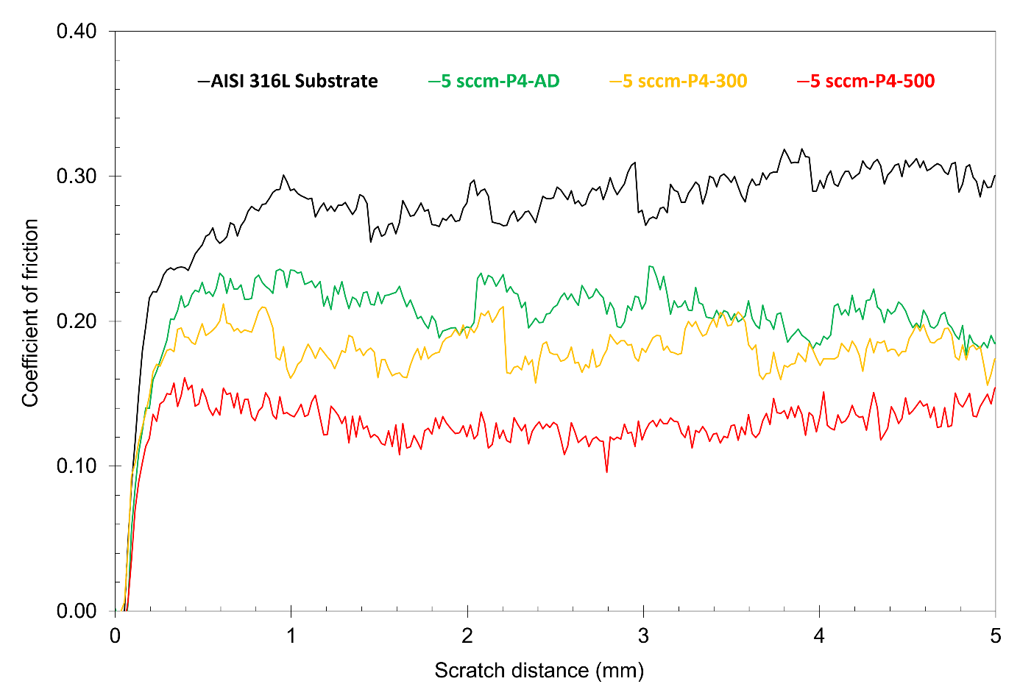
Figure 8.2. Evaluation at room temperature of coefficients of friction for the AISI 316 substrate and 5 sccm-P4-(as-deposited, 300 °C annealed and 500 °C annealed). Tests performed using a Rockwell C diamond stylus and 20N constant load.

8.2.2. Reciprocating sliding wear tests at room and elevated temperature
The results of reciprocating sliding wear tests (at room temperature (~20 °C), 300 °C and 500 °C, respectively - of polished AISI 316 substrate and 5 sccm-P4-AD, with an alumina ball counterface, are shown in Fig. 8.3. It can be seen that the CoF of 5 sccm-P4-AD decreases significantly as the ambient temperature increases, from an average of ~0.77 (tested at RT) to as low as ~0.40 (tested at 500 °C). Compared to the average CoF of the polished AISI 316 substrate (~0.83), the CoF of 5 sccm-P4-AD at medium high temperature (500 °C) is reduced by more than 50%. It can also be seen that the CoF at 500 °C is much more stable – and reduces slowly as the test carries on, indicating the stability of the solid lubricating performance under moderately high temperature for the CrCuAgN coatings. The tribological properties of CrCuAgN coatings in this study are in good agreement with those of the CrN-Ag coatings (with more than 20 at.% of Ag) studied by Mulligan, et al [26, 27, 29].

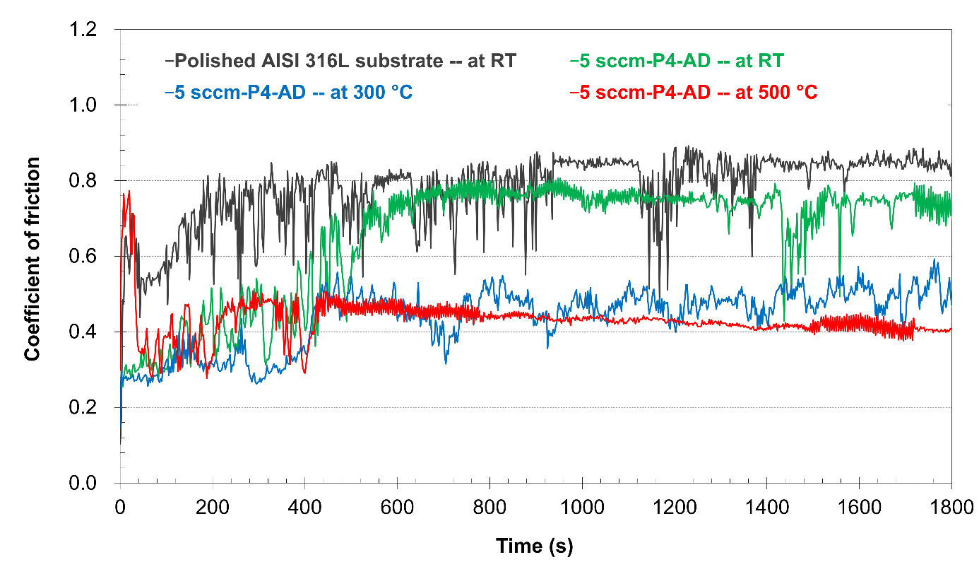
Figure 8.3. Evaluation of coefficients of friction at room temperature (RT), 300 °C and 500 °C, for the AISI 316 substrate and 5 sccm-P4-AD. Tests performed with an alumina ball (6.35 mm in diameter) counterface; normal load, sliding distance and frequency being 1 N, 1 mm and 1 Hz, respectively.

8.3. In-situ three-point bending of PVD films using focused ion beam

8.3.1. The need to determine ‘critical strain’ values for mechanically-loaded thin films
Thin films coated on relatively soft substrate materials are required to deform with the substrate without delamination or cracking during service. Therefore, one design consideration that could not be overlooked for tribological thin films on relatively soft materials, such as mild steels, light alloys, plastics, etc, is the coordination of the film deformation with the substrate, such as in bending (where there is no direct mechanical loading of the film), or tribological contact (where there are direct contact loads on the film). There are several kinds of failures that could occur for a tribological film, of which ‘delamination’ and ‘cracking’ are of high importance. Delamination is mainly related to the cohesion (and adhesion) strength [204] of the film and the adhesion strength of the interlayer, while cracking is normally dependent on the fracture toughness property of the coated film itself. There are several test methods which can roughly evaluate the fracture toughness of a tribological film, such as impact test [204-208], and scratch test [208-211]. In impact test evaluation, three failure zones can be defined in the impact scar [206, 207]: (1) a central zone with cohesive failure, (2) an intermediate zone with cohesive and adhesive failure, and (3) a peripheral zone with circular cracking failure; therefore both ‘cohesion’ (coating itself) and ‘adhesion’ (coating-substrate) can be evaluated. The scratch test is mainly used to evaluate the coating-substrate adhesion; whereas, a subjective indication of film stress state and fracture toughness of the film can be obtained from observations of spallation/chipping [208] (similar to the peripheral circular-cracking zone proposed by Batista et al [206]) or number (and shape) of cracks within the track [212]. Xia et al. [213] proposed an improved method to evaluate the fracture toughness (K_{IC}) of thin films using microindentation on half-coated brittle substrates, with the schematic geometry shown in Fig. 8.4 and equation for calculation in formula 8-1:
$K_{c}={\left\{K_{s}^{2}{\left[1+λ\frac{(Φb-a)}{t}\sqrt{\frac{E_{c}}{E_{s}}\frac{(1-υ_{s}^{2})}{(1-υ_{c}^{2})}}\right]}^{2}±{\left[2ψ_{c}σ_{r}\sqrt{t\frac{E_{c}}{E_{s}}\frac{(1-υ_{s}^{2})}{(1-υ_{c}^{2})}}\right]}^{2}\right\}}^{1/2}$ (8-1)
where, K_{c}, E_{c}, υ_{c} and K_{s}, E_{s}, υ_{s} are the fracture toughness, elastic modulus, and Poisson’s ratio of the coating and substrate, respectively; $λ$ and $ψ_{c}$ are dimensionless factors; a and b are indicated in Fig. 8.4; t is the coating thickness; $Φ$ is a factor varies with residual stresses in coating; $σ_{r}$ is the residual stress and the signs ‘+’ or ‘-’ corresponds to tensile or compressive residual stress in coating, respectively.
According to the calculated results from Xia et al [213], this method performs well in measuring the K_{IC} of CVD diamond films, SiO₂ and PZT coatings (all on Si substrates). More recently, Wang et al [214] applied this method to evaluate the fracture toughness of Fe/VC nano-multilayered coatings on Si substrates (deposited by dc magnetron sputtering).
However, there are several limitations to this method. Firstly, coatings could be substrate-dependent on various aspects, such as: microstructure [215, 216], internal stress [217-219]), coating-substrate adhesion [220] (which was hypothesised by Xia et al [213] to be sufficiently strong and no delamination would occur during the test), chemical composition and mechanical properties [215], etc. However, this microindentation method could only perform well on brittle substrates (e.g. Si, [213, 214]), which might be valid only to the specific substrate and could not represent coatings (with identical deposition parameters) on different (e.g. metallic) substrates. Secondly, for composite, gradient-structured or multilayer coatings, the Poisson’s ratio (see equation 8-1) is unknown and/or difficult to measure by other means – making the test results difficult to validate with any certainty. Thirdly, due to the typical low thickness of a PVD thin film (i.e. no more than a few microns in most cases) compared to the substrate dimensions (typically millimetres, or larger), it is the substrate which will provide the main load support [221]; therefore, the load-supporting capability (related to the fracture stress) of a tribological film is rather less important, whereas the critical strain (beyond which the coating cracks) of a coating would be much more useful.
Fig. 8.4. Schematic diagram showing the microindentation geometry for coating fracture toughness measurement (reconstructed based on ref. [213]).
However, no present test method can give a quantitative value directly related to the ‘critical strain’ of a tribological film. This value should only depend on the film itself, which in other words should not be influenced by the mechanical properties of the underlying substrate. With the quantitative values reaching the above requirements, different tribological films can be compared to each other more easily and accurately, which will give more reliable guidance on choosing an appropriate tribological film for a specific substrate (with known mechanical properties), or for a specific application.

8.3.2. A solution using focused-ion beam
In this section, the ‘anti-cracking’ property of a CrN thin film is investigated on the microscale. A novel bending test with in-situ and real-time observation using a scanning electron microscope (SEM) equipped with focused ion beam (FIB) is proposed, and carried out on a magnetron sputtered CrN film. This test could be used to evaluate the critical strains of thin films tested and hence provide guidance on the choice and design of tribological films based on specific applications (and/or substrates).
A ~2μm thick stoichiometric CrN film was deposited on AISI 316 stainless steel substrate using unbalanced magnetron sputtering, with a 99.95% purity Cr-target, deposition power of 1000W, deposition duration of 1 hour and the nitrogen flow rate of 20 sccm; the substrate holder surface (parallel to the substrate surface) was mounted parallel to the Cr-target surface, at a surface-to-target distance of 21cm. All other parameters and deposition procedures are identical to those described in Chapter 4.
The XRD analysis (Siemens D5000 X-ray diffractometer, with a Cu-Kα source, λ=0.15418nm) results are shown in Fig. 8.5, and the ‘standard aligned’ EDX analysis (see Section 4.3.3) shows that the Cr:N atomic ratio is 51:49 (average of 4 selected areas, all of which were in 20μm × 20μm squares).

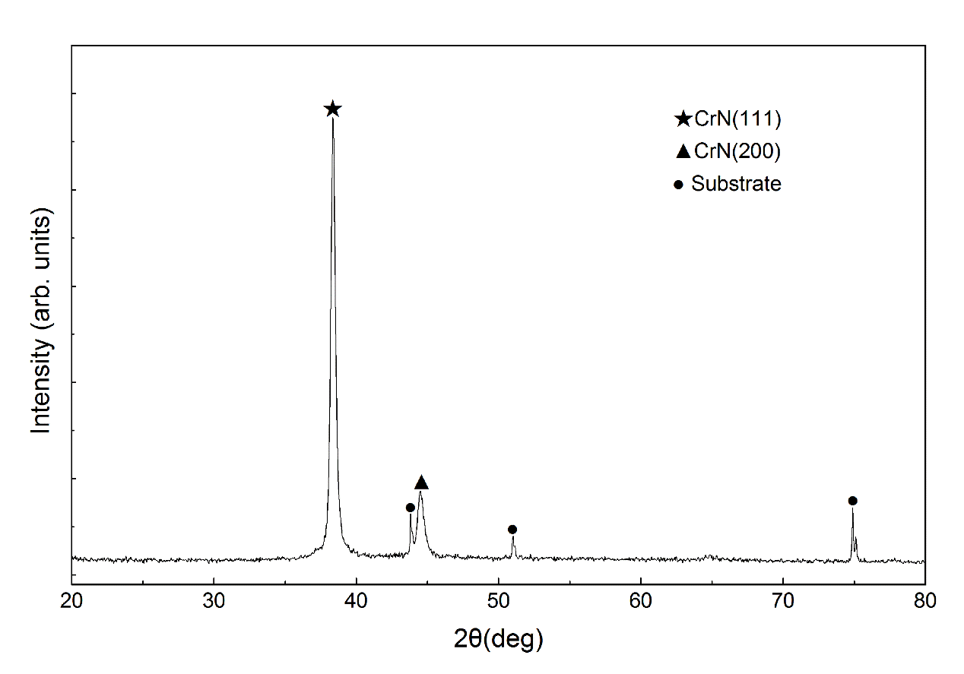
Fig. 8.5. XRD pattern of the CrN film, obtained from a symmetric θ-2θ scan, indicating the CrN film possessing preferred crystalline plane orientation (111).

A FEI Quanta 200 3D scanning electron microscope (SEM) equipped with focused Gallium ion beam (FIB) and Oxford Instruments OmniProbe 100 was used for the in-situ and real-time three-point bending test of the CrN film.
The flexural test sample of the CrN film was prepared based on the ‘Specimen size configuration A’ (with dimensions of 25 × 2.0mm × 1.5mm, and cross-sectional dimensional tolerances within ± 0.05mm) in the ASTM standard C1161−13 (Standard Test Method for Flexural Strength of Advanced Ceramics at Ambient Temperature). Accordingly, a miniature test foil (and supporting notch) of identical geometry was cut using FIB, making the span with dimensions of 25μm × 2.0μm × 1.5μm, with cross-sectional dimensional tolerances of ± 0.05μm or less. A schematic diagram of the process is shown in Fig. 8.6. The test was repeated 3 times to obtain reliable, averaged results. According to ASTM C1161-13, the strain rate should be in the order of 1.0 × 10⁻⁴s⁻¹ and the strain rate can be defined as follows:
ε_{r} = 6ds/L² (8-2)
where ε_{r} is the strain rate, d is the specimen thickness, s is the crosshead (the probe in this study) speed, and L is the support span (the length of the concave notch).
Due to the limitation of the OmniProbe 100 movement speed (100nm minimum step size), a compromise was made: the loading rate was set with steps of 100nm every 10 seconds, resulting in an average strain rate of 1.4 × 10⁻⁴s⁻¹. Ion beam images (Fig. 8.7) were taken in these 10-second intervals without suspending the bending test. Based on the formula 8-2, the strain after loading time t can be deduced as follows:
ε = 6dst/L² = 6dS/L² (8-3)
where ε is the strain after loading time t, S is the corresponding distance moved by the probe head.
Note that the latest Oxford Instruments OmniProbe 400 can reach 10nm step resolution, which will solve this compromise problem.

Fig. 8.6. Schematic diagram showing the in-situ three-point bending test using FIB, (a) cross-section view and (b) plan view.

During the in-situ bending test, a series of ion beam images were taken at increasing bending degrees (hence increasing strain), as shown in Fig. 8.7. It can be seen that the CrN foil specimen endured the deformation until the strain reached 1.8%. Based on the real-time observation, the cracking occurred and ran through the thickness direction of specimen foil suddenly, with no visible pre-cracking and the cracking speed was so high that it could not be measured. In a parallel bending test, the load was retracted at strain = 1.7%, to investigate the deformation type – plastic, elastic or mixed. It was found that the foil fully rebounded back to its original shape after unloading, indicating the deformation to 1.7% strain was elastic rather than plastic (or mixed). Moreover, based on repeated testing, the critical strain for the PVD CrN film in this study was found to be (1.8±0.1)%.
Overall, this three-point bending method can be used to obtain quantitative critical strain values of a specific coating and hence beneficial in the design of appropriate tribological coatings (e.g. material choice, matrix/nanoparticle property matching, film nano-structural design, substrate selection, etc.) for specific applications. It needs to mention that the residual stress could influence the abovementioned critical strain of PVD coatings. A comprehensive review by Winiarski, et al. [222] lists a number of methods which employ FIB-SEM combined with digital image correlation (DIC) analysis to measure the residual stresses at the micron scale. By combing these residual stress measurements, the three-point bending test method proposed here would be more accurate and exhibit wider prospect of application.
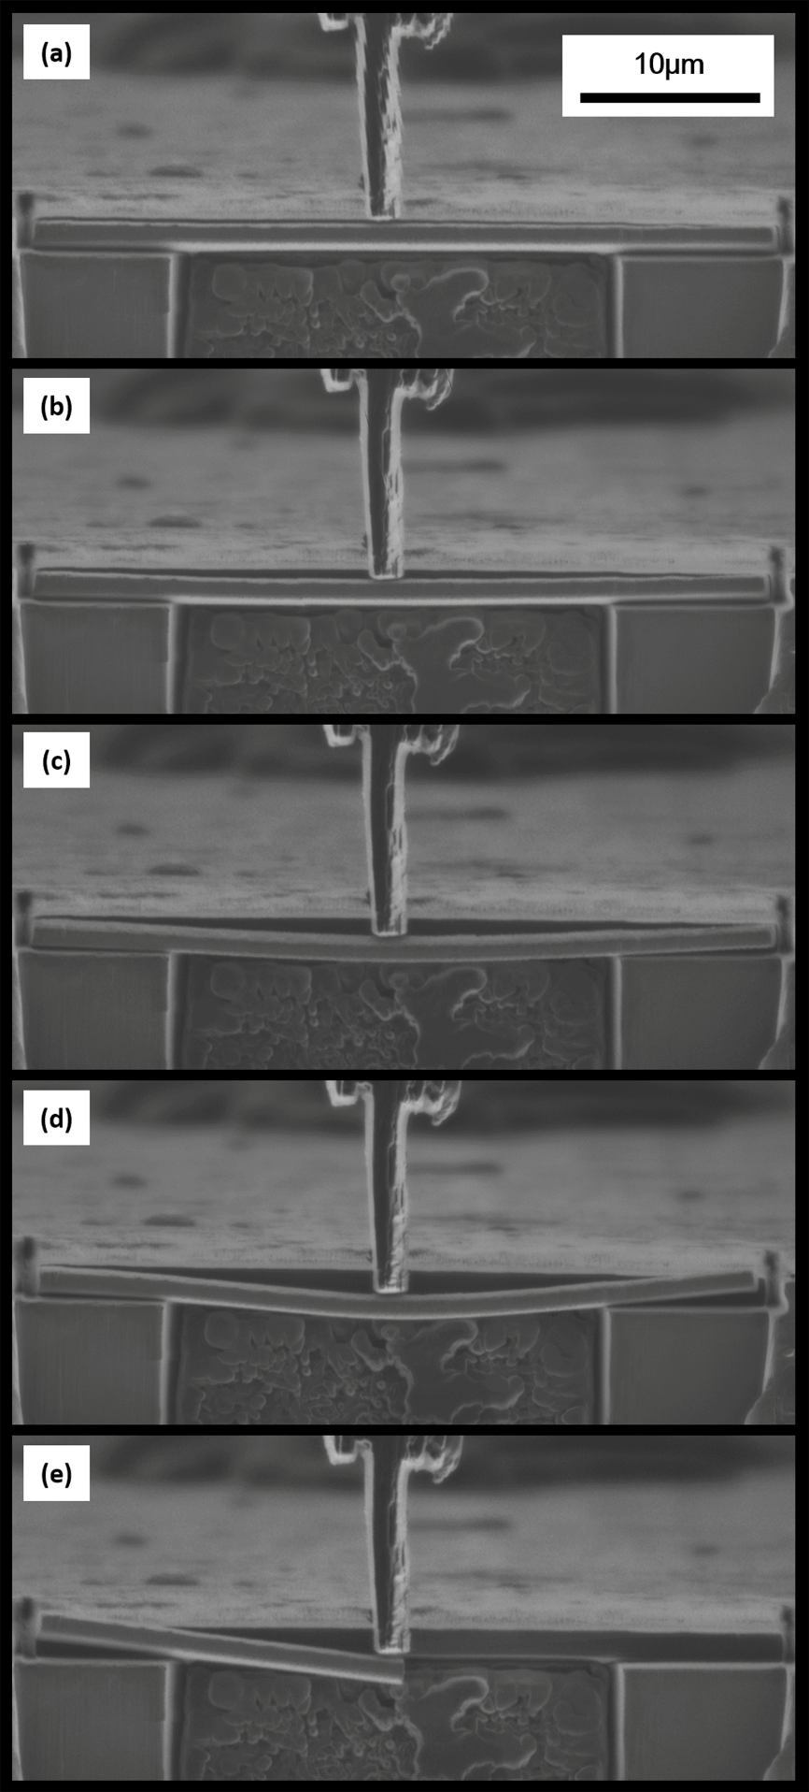
Fig. 8.7. Ion beam images of the as-deposited CrN film at increasing strains: (a) 0%, before test; (b) 0.4%; (c) 1.2%; (d) 1.6%; (e) 1.8%, broken.

8.4. Summary
The hardness and elastic modulus of CrCuAgN coatings are strongly related to their elemental phase composition.
- From the perspective of elemental composition, the trends are: coatings of similar phase composition, their H and E values are mainly influenced by the combined Cu+Ag concentration - the higher the Cu+Ag concentration, the lower are H and E.
- From the perspective of phase composition, in the nitrogen-free control group, coating with a Cr(110) texture shows higher H and E than that with a Cr(211) texture – possibly due to the more closely-packed atoms in Cr(110) planes being parallel to the coating surface. In the two nitrogen-containing groups, combinations of super-saturated Cr-nitride and metallic Cr (i.e. Cr₂N(112) and Cr(200), or Cr₂N(002) and Cr(110) - depending on Cu content)), show higher H and E than the CrCuAgN-based amorphous phase. At similar (high) Cu+Ag concentrations (i.e. positions P4 and P5), a texture combination of Cr₂N(002) and Cr(110) exhibits higher H and E than that of Cr₂N(111) and Cr(110), probably because the Cr₂N constituents in these coatings are different in H and E (due to the N disordering in the Cr₂N unit cells).
- For tribological properties, a significant decrease in the coefficients of friction, over 50% compared to that of the substrate (from 0.31 to 0.14 with diamond indenter, and from 0.83 to 0.40 with alumina ball, respectively) was obtained for the CrCuAgN coatings, showing effective solid lubricating behaviour.
- A novel in-situ three-point bending test preparation route using scanning electron microscope (SEM) equipped with focused ion beam (FIB) and OmniProbe 100 is presented, with tests carried out on a magnetron sputtered CrN film. The critical strain of the thin CrN films, was (1.8±0.1)%, with its deformation type before failure being elastic rather than plastic or mixed. This test method could be used to evaluate the deformation capability of various thin films and to provide a guidance on the design (e.g. material choosing, composite matching, nanostructure design, substrate selection, etc.) of tribological films for specific applications.

Chapter 9. discussion with current related research results

9.1. Nanostructure of as-deposited coatings
As reviewed in the literature review, in the Cr-Cu-N system PVD coatings, Cu either exists in a metastable solid solution phase of Cu in bcc Cr solid solution (with Cu content of up to 60 at.% [37], see Fig. 7.10), with substrates unheated or low in temperature [37] (e.g. ≤ 200 °C); or exists as a semi-continuous Cu-rich intergranular ‘tissue’, surrounding the Cr(N) or Cr-nitride nanocrystallites [38, 39]). For the CrCuAgN coatings in this study, a highly likely bcc-Cr solid solution with Cu being substitutional atoms (and N as interstitial atoms when nitrogen was introduced during the deposition process) was found, for coatings with Cu concentration ranging from ~5 at.% to ~30 at.% and the Ag concentration being relatively stable: ~ 3 at.% (Coatings in study stage 1, Chapters 5 and 6). However, the possibility of Cu existing as a semi-continuous Cu-rich intergranular ‘tissue’ could not be eliminated.
As Ag concentrations in the CrCuAgN coatings went up, which was the regime of study stage 2 and discussed in detail in Chapter 7, several types of solid solution matrices, e.g. bcc-Cr, fcc-Cu and fcc-Ag, were found, mainly depending on their elemental compositions. Even for coatings containing Ag as high as ~30 at.% (see section 7.6.4, on coating N5-MR), fcc-Ag solid solution supersaturated with Cr and Cu, rather than separated Ag grains distributed in a Cr(N) or Cr-nitride matrix, was found. However, from the published research results of on CrN-Ag coatings [20, 25-27, 29-31, 36], Ag tends to present as a separate phase in a lamellar shape in CrN matrix, with the width (~10 to 170 nm) parallel to the coating surface and the height (~10 to 60 nm) along the growth direction. The significant differences in the Ag distributing behaviour might be caused by the huge difference in the substrate temperatures (T_{s}) employed during deposition process. In the abovementioned studies, the employed T_{s} ranged from 500 °C to 700 °C [27, 29, 30, 36] (T_{s}/T_{m}: 0.63 to 0.79), much higher than the T_{s} employed in this PhD study, which was only 100-120 °C (T_{s}/T_{m}: ~0.3) caused by bombardment (no external heating source).

9.2. Effects of annealing and transportation mechanisms
By incorporation of both Cu and Ag into a same nitrogen-containing PVD coatings, significantly enhanced Ag mobility under medium-high temperature annealing (e.g. 500°C) was observed in this study. It is clear that the existence of copper enhanced the transportation of silver to the coating surface in significant quantities, even with relatively low Ag concentration in the coating (e.g. ~3 at.% or less). As alluded in section 6.3.2, according to the existing literature, in (for example) CrAgN PVD coatings with no added Cu, the Ag concentration needs to be at least 12 at.% (more than 4× higher than in our study) to permit ‘transportation’ to the coating surface – even during annealing at quite high temperatures (e.g. 600 - 700 °C) [30] - and needs to be in excess of 20 at.% to transport sufficiently well to provide adequate solid lubricating benefits [20, 26, 29-31].
Enhanced transportation of Ag from the interior to the coating surface (and subsequent surface aggregation) is also a desirable characteristic for antimicrobial coating applications [28, 172], particularly when the Ag aggregates are presented in nanocrystalline topography [179].
However, as mentioned in the previous section, the distributing behaviour of Ag in the CrN-Ag coatings in the literature [20, 29-31, 36] is obviously different from that in the CrCuAgN coatings in this study. For the former, separated Ag grains already existed in the CrN-Ag coatings at the as-deposited state, before post-coat annealing. Therefore, during annealing, smaller Ag grains particle (i.e. larger curvature) possess higher chemical potential, hence a higher detachment rate [31]. The small Ag grains could even disappear after sufficient annealing process (e.g. sufficient long duration combined with sufficient high temperature), leaving voids behind them [20, 29, 31]. In other words, the detachment process would start from the beginning of annealing process. However, for the later (i.e. the as-deposited CrCuAgN coatings in this study), Ag and Cu existed in a solid solution (the solid solution matrix could be bcc-Cr, fcc-Cu or fcc-Ag, depending on the elemental composition) rather than a separate phase. Therefore during the post-annealing process, desolvation of the substitutional atoms from the solid solution matrix would occur before the detachment process. Once the desolvation started, nucleation of a new phase would proceed, which resulted in ultra-fine grains possessing very high chemical potential. Therefore, detachment process might get involved immediately after the nucleation process. Due to the highly metastable state [37, 175] of the supersaturated solid solution matrix, provided the medium high temperature (annealing), the beginning of the nucleation could probably proceed quicker than the detachment process. This can be verified by the homogenously distributed, nanostructural feature of MR-500 in Fig. 7.24 (section 7.6.4.2), which indicates that numerous nucleation occurred (nearly) simultaneously at a scale of the entire coating. Although the above discussion is made based on the transportation behaviour of Ag, due to the similar distributing behaviour of Cu in the CrCuAgN coatings (i.e. besides Cr, solid solution matrix forms for both Cu-dominating and Ag-dominating coatings, see Figs. 7.10 and7.11). And it was verified by the evidence shown in Fig. 7.24: large aggregates of both Cu and Ag formed on coating surface (see detailed discussion in section 7.6.4).
Therefore, it can be concluded one possible transportation mechanism of both Cu and Ag is a “combined desolvation-detachment process”. And as discussed in section 7.6.4.2, the higher detachment rate of Cu could help the transportation of Ag, hence enhanced (as well as controllable, by adjusting Cu concentration) Ag mobility onto the coating surface. For the other existing possibility of Cu in the CrCuAgN coatings, a semi-continuous intergranular “tissue”, which from the structure itself would obviously be beneficial for its transportation to the coating surface. Moreover, the enhancement on Ag transportation (even with Ag concentration as low as 3 at.%) by incorporating Cu into a same coating has been proved and discussed in section 6.3.2.
It can also be noticed that no voids can be seen in the annealed coating cross section (see Fig. 7.24). This can be attributed to the numerous, simultaneous nucleation process occurred before the detachment process, which spread the detachment at a much finer scale (nanoscale, or even sub-nanoscale). Because of the voids caused by detachment of Ag grains inside the CrN-Ag coating, a porous CrN skeleton was left [25], which would easily form debris, hence accelerating coating degradation after Ag reservoir was used out. The absence of voids inside the coating might be beneficial for solving this problem.

9.3. Mechanical and tribological properties
According to a study by Baker et al. [38] on the CrCuN coatings, predominantly metallic nanocomposite coatings consisting mostly of fine Cr(N) grains distributed in a Cu (a small portion) matrix was observed, which is in agreement to one of the two Cu-distributing structures in this study (see sections 5.6.2, 6.5.2 and 9.2). Their study results showed that at a composition of CrCu_{0.07}N_{0.48}, the coating exhibited optimum mechanical properties, with hardness of up to 20 GPa, which was slightly higher than the hardness of the CrCuAgN coatings in this study, primarily due to the pursue of a metallic coating with high H/E ratio (rather than extreme hardness) was one of the main aims of this project.
The studies of Mulligan and his co-workers on CrN-Ag coatings revealed that promising tribological properties at both room temperature and elevated temperature [25-27, 29] can be obtained by appropriate design of these CrN-Ag coatings, corresponding to the scratch test and high temperature reciprocating sliding wear test results in section 8.2. During a reciprocating sliding wear test at 600 °C with alumina, a CoF of ~0.42 was obtained for a CrN-Ag coating (Ag concentration: 12 at.%) [25]. This CoF is also in good agreement with that of 5 sccm-P4-AD obtained under similar test conditions (i.e. reciprocating sliding test with alumina at 500 °C).
For the critical strain value of PVD CrN coating obtained using the three-point bending methd in section 8.3, the corresponding critical strain value of bulk CrN is not available from the literature, therefore no comparison can be made. Although CrN possesses a number of competitive properties, such as high hardness, high thermal stability, satisfactory oxidation and wear resistance at elevated temperatures, which make CrN a widespread candidate in the design of tribological coatings [16, 52, 122, 158, 160, 169, 189-192, 223-225]; however, a critical strain of ~1.8% seems to be fairly low and would not be competent in increasingly demanding service conditions (e.g. high load, impact, etc.). Therefore, in order to improve the properties of CrN-based or CrN-containing tribological coatings, various structural designs (e.g. nanocomposite, multilayer, etc.) have been investigated by researchers [18, 19, 31, 34, 36, 155-157, 218, 225-228]. Take alternate CrN/Cr (ceramic-metallic) multilayer coating for example [226, 227], it was found that with the bilayer thickness less than 60nm, CrN/Cr multilayer coatings exhibited better properties than single-layer CrN coating, together with reduced residual stress and increased critical load [226].

Conclusions and future works

Conclusions
CrCuAgN coatings were prepared using a semi-orthogonal, closed-field unbalanced magnetron sputtering technique. Study were investigated in two stages. In the first stage, the effects of varying concentrations of nitrogen and copper (silver concentration being relatively steady), and post-coat annealing on the fracture sections, surface morphologies, phase compositions and nanostructure of CrCuAgN PVD coatings were comprehensively investigated. And in the second stage, the nitrogen low rate in coating deposition processes was fixed (based on the results acquired in the first stage study) and it was primarily focused on further investigation of varying copper and silver concentrations, together with post-coat annealing, on the surface morphologies, phase compositions and nanostructure of CrCuAgN coatings.

The first stage study
- Coatings without introducing nitrogen showed strong preferred orientations, for both metallic Cr and Ag, changing sharply from Cr(211) to Cr(110) and from Ag(311) to Ag(220), when the deposition positions approaching the Cu-Ag target. The introduction of nitrogen at 5 sccm flow rate resulted in a high degree of solubility of Cu in metallic Cr; and a separate, nanocrystalline Cu(111) phase is believed to have formed in coatings at higher Cu concentration (e.g. 15.3 and 26.3 at.%). When the nitrogen flow rate was increased to 10 sccm, only a single, X-ray amorphous phase was found in coatings with low Cu concentration (e.g. below 7.5 at.%). In coatings with higher Cu concentration (e.g. 12.9 or 23.5 at.%), nanocrystalline Cr₂N(002) and Cu(111) phases were formed. Ag atoms are most probably dissolved in the Cr phases because of the high degree of solubility of Cu and N in Cr (and possibly of Cu in Cr₂N) causing long-range disorder and extreme lattice distortion (low and broad diffractions peaks for all nitrogen-containing coatings) – hence increasing the substitutional solubility of Ag as well.
- Annealing altered the coating fracture section appearance and surface morphology. Copper- and silver-rich aggregates formed on the surfaces of nitrogen-containing coatings after annealing. The number and size of the surface aggregates were also influenced by the nitrogen flow rate, probably due to nitrogen incorporation reducing the solubility of Cu and Ag in Cr, or Cr₂N (where formed).
- In coatings with a nitrogen concentration of up to 16 at.% (N/(Cr+N) atomic ratio up to 0.18), a metallic Cr solid solution with supersaturated interstitial nitrogen remained present, even after post-coat annealing at 300 °C and 500 °C. At higher N/(Cr+N) atomic ratios, the coexistent state of α-Cr solid solution with Cr₂N nitride phase is relatively stable in a large range of nitrogen concentrations, and can survive at relatively high temperature (e.g. 500 °C).
- Although both Cu and Ag precipitate from substitutional solid solution in Cr (and are then transported to coating surface) after annealing, they are inclined to exist separately. The transportation of Cu (and Ag) to the surface depends clearly on the chosen annealing temperature, annealing duration, nitrogen concentration and ‘global’ Cu+Ag concentration. This provides a possibility to tailor coatings with a range of desired functionalities and properties for specific applications.
- Almost all of the available literature on MeN:Ag PVD coatings reveals the silver to precipitate as separate, isolated particles, with little or no migration path available - whereas the incorporation of copper (which, it is known, tends to precipitate as an intergranular/intercolumnar ‘tissue’ phase) appears to be a powerful strategy to enhance Ag mobility at low concentration (from ~20 at.% in the literature for no added Cu to ~3 at.% in this study) in such coatings under moderately high service temperature (and/or by coating pre-conditioning through careful post-coat annealing). Therefore, the results of the present study indicate that the concurrent addition of both Cu and Ag (in appropriate concentrations) to PVD nitrogen-containing chromium coatings is a viable method to promote adaptive behaviour - and to permit the development of ‘self-replenishing’ thin film architectures for antimicrobial and solid lubricating coating applications.

The second stage study
- Conclusion (iii) in the first stage study was further confirmed. No CrN was found, even for coatings possessing a N/(Cr+N) ratio as high as 0.55 (i.e. N/Cr ratio over 1.2). Based on the experimental results in this PhD investigation, the range of N/(Cr+N) ratios in which α-Cr solid solution with Cr₂N nitride phase could co-existed stably (at least to 500 °C) was 0.18 to 0.55.
- In order to effectively form Cu and/or Ag aggregates on CrCuAgN coating surfaces under moderately high temperature (e.g. 500 °C), the Cu+Ag concentration needs to be higher than a threshold, which is 17.5 at.% in this study; when the Cu+Ag concentration is above the threshold, the sizes of the basic aggregates formed (before they aggregate together and grow larger) are relatively similar and independent of the elemental composition.
- Each as-deposited coating is composed of one primary solid solution. Moreover, the solid solutions are all supersaturated, exist as ultra-fine nanocrystallites and possess extremely distorted lattices. Furthermore, different elemental compositions of CrCuAgN coatings could result in different solid-solution matrices. In this study, bcc α-Cr-matrix, fcc-Cu-matrix and fcc-Ag-matrix solid solutions were found, depending on the major elemental component. With an atomic ratio of Ag/(Cr+Ag) as low as 0.44 (other elements being the minority), an fcc-Ag matrix (with other elements in solid solution) would form. Moreover, fluctuations in Cr, Ag and Cu distribution in a scale of less than 5 nm was found, which could be beneficial in the precipitation of Cu and/or Ag as solid lubricants under moderately high temperature (e.g. 500 °C) service.
- One (highly) possible transportation mechanism of both Cu and Ag in the CrCuAgN coatings is called a “combined desolvation-detachment process”. The higher detachment rate of Cu could help the transportation of Ag, hence enhanced (as well as controllable, by adjusting Cu concentration) Ag mobility onto the coating surface. Another possible transportation mechanism is related to the second possible distributing structure of Cu in the CrCuAgN coatings: a semi-continuous intergranular “tissue”. This structure would obviously be beneficial for the transportation of Cu itself onto the coating surface. Moreover, the observed transportation enhancement of Ag (even with Ag concentration as low as 3 at.%) onto the coating surface can also be attributed to this distributing structure of Cu.
- The co-existence of Cu with Ag in a PVD metallic coating was found to be beneficial to Ag transport onto the coating surfaces, resulting not from the anticipated ‘intergranular network channels’ of Cu, but from the much higher detachment rate of Cu than Ag, which can ‘leave a path’ for Ag to transport after Cu. Therefore by proper design and processing, CrCuAgN coatings with appropriate elemental compositions and solid-solution matrix can be obtained, in which the precipitation rate of Ag can be partially controlled by the concentration of Cu (which does not need to be very high; 4.5 at.% Cu appears to be sufficient), resulting in the controlled supplement of solid lubricants to the coatings surface.

Mechanical and tribological properties
The hardness and elastic modulus of CrCuAgN coatings are strongly related to their elemental phase composition.
- From the perspective of elemental composition, the trends are: coatings of similar phase composition, their H and E values are mainly influenced by the combined Cu+Ag concentration - the higher the Cu+Ag concentration, the lower are H and E.
- From the perspective of phase composition, in the nitrogen-free control group, coating with a Cr(110) texture shows higher H and E than that with a Cr(211) texture – possibly due to the more closely-packed atoms in Cr(110) planes being parallel to the coating surface. In nitrogen-containing coatings, combinations of textured super-saturated Cr-nitride and metallic Cr (i.e. Cr₂N(112) and Cr(200), or Cr₂N(002) and Cr(110) - depending on Cu content), show higher H and E than the CrCuAgN-based amorphous phase. At similar (high) Cu+Ag concentrations, a texture combination of Cr₂N(002) and Cr(110) exhibits higher H and E than that of Cr₂N(111) and Cr(110), probably because the Cr₂N constituents in these coatings are different in H and E (due to the N disordering in the Cr₂N unit cells).
- For tribological properties, a significant decrease in the coefficients of friction, over 50% compared to that of the substrate (from 0.31 to 0.14 with diamond indenter, and from 0.83 to 0.40 with alumina ball, respectively) was obtained for the CrCuAgN coatings, showing effective solid lubricating behaviour.
- A novel in-situ three-point bending test preparation route using scanning electron microscope (SEM) equipped with focused ion beam (FIB) and OmniProbe 100 is presented, with tests carried out on a magnetron sputtered CrN film. The critical strain of the thin CrN films, was (1.8±0.1)%, with its deformation type before failure being elastic rather than plastic or mixed. This test method could be used to evaluate the deformation capability of various thin films and to provide a guidance on the design (e.g. material choosing, composite matching, nanostructure design, substrate selection, etc.) of tribological films for specific applications.

Future works
The origins of the strong preferred orientation of Cr - and what causes the change from Cr(211) to Cr(110) texture in the as-deposited nitrogen-free PVD CrCuAg coatings - still remain unclear. A number of factors have been proposed in the literature to explain the development of preferred texture in PVD thin films, e.g.:
- Ion channelling [223, 229-231], which means that grains with different orientations demonstrate different capability in channelling ions into them during deposition (the grains with the most open lattice direction ‘aligned’ to the incident ion beam would survive and grow, leaving those ‘misaligned’ ones to recrystallise [229]); the difference in sputtering yields for ‘aligned’ and ‘misaligned’ grains could be as high as a factor of 5 [232].
- Preferential sputtering and shadowing [173], which suggests that the crystallographic plane possessing the lowest sputtering rate would grow larger; these larger grains would then obstruct the growth of smaller grains due to the shadowing effect, hence a domination of growth for those grains with the ‘lowest-sputtering-rate’ advantage.
- Surface energy minimisation [233, 234], which suggests that the crystallographic plane with the lowest surface energy would dominate in the film growth.
- Adatom mobility restriction [235-237], which suggests the anisotropy of surface diffusivity and surface bonding energy would influence the texture formation of a thin film.
Besides, the texture in a PVD thin film could exist in different preferred orientations and also change in directions with varying circumstances, e.g. Cr(211) to Cr(110) in this study as mentioned above, and many others [223, 233, 235, 236, 238, 239]. Huang, et al. [239] attributed the evolution in texture of magnetron sputtered copper thin film to the surface-strain energy competition; however, in a study on the controlled texture evolution of TiN films (by reactive magnetron sputtering), Greene et al. [236] argue that the presence of strain and/or its change are not necessary in transitions of preferred orientation. Therefore, further study on the causes of the texture formation, the factors related to texture transitions, together with corresponding mechanisms would be necessary.
The tribological tests in this PhD study for the as-deposited and annealed CrCuAgN coatings are just preliminary. Only selected coatings were evaluated using reciprocating sliding wear and scratch test, which were focused primarily on obtaining coefficient of friction (CoF) values. In order to fully understand the tribological behaviour of these solid-lubricating coatings, more systematic tests, such as CoF and wear resistance with a variety of counterparts (e.g. steel, ceramics, cemented carbides, etc.), are needed. In addition, the tribological behaviour of these coatings under vacuum conditions (e.g. for spacecraft applications) would also be interesting to study further.
As mentioned several times in the discussion, the CrCuAgN coatings developed in this Thesis could also be used in antimicrobial applications, because of the inherent antibacterial properties of both copper and silver ions. Although the antimicrobial properties of copper- or silver-containing thin films have been investigated in a number of studies [34, 166, 171, 172, 240], the combined (and possibly synergistic) antimicrobial effects of both copper and silver in a PVD film have not yet been reported in the scientific literature - and would hence be interesting to investigate systematically.
Combining the residual stress measurements at the micron scale [222], the in-situ three-point bending test method proposed in this Thesis could be used to obtain the critical strain of a specific coating, with reliable accuracy. However, it would be much more effective in the regard of coating selection and design if a critical-strain database of typical thin films and substrates could be built using this method.

References
[1] J. Musil, Hard and superhard nanocomposite coatings, Surface and Coatings Technology, 125 (2000) 322-330.
[2] S. Veprek, The origin of superhardness in TiN/Si3N4 nanocomposites: the role of the interfacial monolayer, High Pressure Research, 26 (2006) 119-125.
[3] S. Veprek, Superhard nanocomposites: design concept, properties, present and future industrial applications, The European Physical Journal Applied Physics, 28 (2004) 313-317.
[4] S. Veprek, The search for novel, superhard materials, Journal of Vacuum Science & Technology A: Vacuum, Surfaces, and Films, 17 (1999) 2401-2420.
[5] A. Leyland, A. Matthews, On the significance of the H/E ratio in wear control: a nanocomposite coating approach to optimised tribological behaviour, Wear, 246 (2000) 1-11.
[6] A. Leyland, A. Matthews, Design criteria for wear-resistant nanostructured and glassy-metal coatings, Surface and Coatings Technology, 177-178 (2004) 317-324.
[7] S. Aouadi, B. Luster, P. Kohli, C. Muratore, A. Voevodin, Progress in the development of adaptive nitride-based coatings for high temperature tribological applications, Surface and Coatings Technology, 204 (2009) 962-968.
[8] C. Muratore, J. Hu, A. Voevodin, Adaptive nanocomposite coatings with a titanium nitride diffusion barrier mask for high-temperature tribological applications, Thin solid films, 515 (2007) 3638-3643.
[9] C. Muratore, A. Voevodin, Chameleon coatings: adaptive surfaces to reduce friction and wear in extreme environments, Annual Review of Materials Research, 39 (2009) 297-324.
[10] C. Muratore, A. Voevodin, J. Hu, J. Zabinski, Tribology of adaptive nanocomposite yttria-stabilized zirconia coatings containing silver and molybdenum from 25 to 700 C, Wear, 261 (2006) 797-805.
[11] C. DellaCorte, The effect of counterface on the tribological performance of a high temperature solid lubricant composite from 25 to 650 C, Surface and Coatings Technology, 86 (1996) 486-492.
[12] G. Gassner, P. Mayrhofer, K. Kutschej, C. Mitterer, M. Kathrein, A new low friction concept for high temperatures: lubricious oxide formation on sputtered VN coatings, Tribology Letters, 17 (2004) 751-756.
[13] H.E. Sliney, Solid lubricant materials for high temperatures—a review, Tribology International, 15 (1982) 303-315.
[14] M.R. Hilton, P.D. Fleischauer, Applications of solid lubricant films in spacecraft, Surface and Coatings Technology, 54 (1992) 435-441.
[15] P. Basnyat, B. Luster, Z. Kertzman, S. Stadler, P. Kohli, S. Aouadi, J. Xu, S. Mishra, O. Eryilmaz, A. Erdemir, Mechanical and tribological properties of CrAlN-Ag self-lubricating films, Surface and Coatings Technology, 202 (2007) 1011-1016.
[16] V. Ezirmik, E. Senel, K. Kazmanli, A. Erdemir, M. Ürgen, Effect of copper addition on the temperature dependent reciprocating wear behaviour of CrN coatings, Surface and Coatings Technology, 202 (2007) 866-870.
[17] H.C. Barshilia, N. Selvakumar, B. Deepthi, K. Rajam, A comparative study of reactive direct current magnetron sputtered CrAlN and CrN coatings, Surface and Coatings Technology, 201 (2006) 2193-2201.
[18] T. Elangovan, P. Kuppusami, R. Thirumurugesan, C. Sudha, E. Mohandas, D. Mangalaraj, A Study on the Influence of Copper Content in CrN/Cu Nanocomposite Thin Films Prepared by Pulsed DC Magnetron Sputtering, Journal of Nanoscience and Nanotechnology, 9 (2009) 5436-5440.
[19] L. Incerti, A. Rota, S. Valeri, A. Miguel, J. García, R. Rodríguez, J. Osés, Nanostructured self-lubricating CrN-Ag films deposited by PVD arc discharge and magnetron sputtering, Vacuum, 85 (2011) 1108-1113.
[20] P. Papi, C. Mulligan, D. Gall, CrN-Ag Nanocomposite Coatings: Control of Lubricant Transport by Diffusion Barriers, Thin solid films, DOI (2012) 211-217.
[21] O. Jimenez, M. Audronis, M. Baker, A. Matthews, A. Leyland, Structure and mechanical properties of nitrogen-containing Zr–Cu based thin films deposited by pulsed magnetron sputtering, Journal of Physics D: Applied Physics, 41 (2008) 155301.
[22] J.L. Endrino, J.J. Nainaparampil, J.E. Krzanowski, Microstructure and vacuum tribology of TiC–Ag composite coatings deposited by magnetron sputtering-pulsed laser deposition, Surface and Coatings Technology, 157 (2002) 95-101.
[23] Y. Wang, J. Wang, G. Zhang, L. Wang, P. Yan, Microstructure and tribology of TiC (Ag)/aC: H nanocomposite coatings deposited by unbalanced magnetron sputtering, Surface and Coatings Technology, 206 (2012) 3299-3308.
[24] A. Voevodin, J. Hu, J. Jones, T. Fitz, J. Zabinski, Growth and structural characterization of yttria-stabilized zirconia–gold nanocomposite films with improved toughness, Thin solid films, 401 (2001) 187-195.
[25] K. Kutschej, C. Mitterer, C.P. Mulligan, D. Gall, High‐Temperature Tribological Behavior of CrN‐Ag Self‐lubricating Coatings, Advanced Engineering Materials, 8 (2006) 1125-1129.
[26] C. Mulligan, T. Blanchet, D. Gall, CrN–Ag nanocomposite coatings: High-temperature tribological response, Wear, 269 (2010) 125-131.
[27] C. Mulligan, T. Blanchet, D. Gall, CrN–Ag nanocomposite coatings: Tribology at room temperature and during a temperature ramp, Surface and Coatings Technology, 204 (2010) 1388-1394.
[28] J. Zhao, H. Feng, H. Tang, J. Zheng, Bactericidal and corrosive properties of silver implanted TiN thin films coated on AISI317 stainless steel, Surface and Coatings Technology, 201 (2007) 5676-5679.
[29] C. Mulligan, T. Blanchet, D. Gall, Control of lubricant transport by a CrN diffusion barrier layer during high-temperature sliding of a CrN–Ag composite coating, Surface and Coatings Technology, 205 (2010) 1350-1355.
[30] C. Mulligan, D. Gall, CrN–Ag self-lubricating hard coatings, Surface and Coatings Technology, 200 (2005) 1495-1500.
[31] C. Mulligan, P. Papi, D. Gall, Ag transport in CrN-Ag nanocomposite coatings, Thin solid films, DOI (2012) 6774-6779.
[32] M. Baker, P. Kench, C. Tsotsos, P. Gibson, A. Leyland, A. Matthews, Investigation of the nanostructure and wear properties of physical vapor deposited CrCuN nanocomposite coatings, Journal of Vacuum Science & Technology A: Vacuum, Surfaces, and Films, 23 (2005) 423-433.
[33] K. Polychronopoulou, C. Rebholz, N.G. Demas, A.A. Polycarpou, P. Gibson, Effect of Cu Content on the Tribological Performance of Cr-N Coatings at High Temperatures (840° C), ASME, 2009.
[34] P. Kuppusami, T. Elangovan, S. Murugesan, R. Thirumurugesan, S. Khan, R. George, R. Ramaseshan, R. Divakar, E. Mohandas, D. Mangalaraj, Microstructural, nanomechanical and antibacterial properties of magnetron sputtered nanocomposite thin films of CrN/Cu, Surface Engineering, 28 (2011) 134-140.
[35] A. Öztürk, K. Ezirmik, K. Kazmanlı, M. Ürgen, O. Eryılmaz, A. Erdemir, Comparative tribological behaviors of TiN, CrN and MoNCu nanocomposite coatings, Tribology International, 41 (2008) 49-59.
[36] C. Mulligan, T. Blanchet, D. Gall, CrN–Ag nanocomposite coatings: Effect of growth temperature on the microstructure, Surface and Coatings Technology, 203 (2008) 584-587.
[37] H. Holleck, Metastable coatings—prediction of composition and structure, Surface and Coatings Technology, 36 (1988) 151-159.
[38] M. Baker, P. Kench, M. Joseph, C. Tsotsos, A. Leyland, A. Matthews, The nanostructure and mechanical properties of PVD CrCu (N) coatings, Surface and Coatings Technology, 162 (2003) 222-227.
[39] J.W. Lee, Y.C. Kuo, Y.C. Chang, Microstructure and mechanical properties of pulsed DC magnetron sputtered nanocomposite Cr–Cu–N thin films, Surface and Coatings Technology, 201 (2006) 4078-4082.
[40] V. Derflinger, H. Brändle, H. Zimmermann, New hard/lubricant coating for dry machining, Surface and Coatings Technology, 113 (1999) 286-292.
[41] W. Wang, Application of a high temperature self-lubricating composite coating on steam turbine components, Surface and Coatings Technology, 177–178 (2004) 12-17.
[42] A. Voevodin, J. O'neill, J. Zabinski, Nanocomposite tribological coatings for aerospace applications, Surface and Coatings Technology, 116 (1999) 36-45.
[43] A. Voevodin, J. Zabinski, Nanocomposite and nanostructured tribological materials for space applications, Composites Science and Technology, 65 (2005) 741-748.
[44] M. Joseph, C. Tsotsos, M. Baker, P. Kench, C. Rebholz, A. Matthews, A. Leyland, Characterisation and tribological evaluation of nitrogen-containing molybdenum–copper PVD metallic nanocomposite films, Surface and Coatings Technology, 190 (2005) 345-356.
[45] D.M. Mattox, Handbook of physical vapor deposition (PVD) processing: film formation, adhesion, surface preparation and contamination control, William Andrew1998.
[46] K. Saron, M. Hashim, M. Farrukh, NH3-Free Growth of GaN Nanostructure on n-Si (111) Substrate using a Conventional Thermal Evaporation Technique, Journal of Crystal Growth, 349 (2012) 19-23.
[47] C. Nimisha, G.M. Rao, G. Venkatesh, K.Y. Rao, N. Munichandraiah, Morphology dependent electrochemical performance of sputter deposited Sn thin films, Materials Research Bulletin, 47 (2012) 1950-1953.
[48] H.J. Quah, K.Y. Cheong, Effects of post-deposition annealing ambient on Y2O3 gate deposited on silicon by RF magnetron sputtering, Journal of Alloys and Compounds, 529 (2012) 73-83.
[49] S. Mukherjee, P. Barhai, Reliability of anodic vacuum arc in depositing thermoelectric alloy thin films, Journal of Alloys and Compounds, 511 (2012) 14-21.
[50] Y. Zhu, R.J. Mendelsberg, S.H.N. Lim, J. Zhu, J. Han, A. Anders, Improved structural and electrical properties of thin ZnO: Al films by dc filtered cathodic arc deposition, Journal of Materials Research, 27 (2012) 857-862.
[51] N. Lin, X. Huang, X. Zhang, A. Fan, L. Qin, B. Tang, In vitro assessments on bacterial adhesion and corrosion performance of TiN coating on Ti6Al4V titanium alloy synthesized by multi-arc ion plating, Applied Surface Science, 258 (2012) 7047-7051.
[52] M. Zhang, K.H. Kim, F. Xu, X. Yang, Structure and oxidation behavior of compositionally gradient CrN x coatings prepared using arc ion plating, Surface and Coatings Technology, 228 (2013) S529-S533.
[53] A. Anzai, M. Fuchigami, S. Yamanaka, K. Inumaru, Preparation of calcium-doped boron nitride by pulsed laser deposition, Materials Research Bulletin, 47 (2012) 2062-2066.
[54] A.L. Thomann, C. Vahlas, L. Aloui, D. Samelor, A. Caillard, N. Shaharil, R. Blanc, E. Millon, Conformity of Aluminum Thin Films Deposited onto Micro‐Patterned Silicon Wafers by Pulsed Laser Deposition, Magnetron Sputtering, and CVD, Chemical Vapor Deposition, 17 (2011) 366-374.
[55] M. Lubwama, K. McDonnell, J. Kirabira, A. Sebbit, K. Sayers, D. Dowling, B. Corcoran, Characteristics and tribological performance of DLC and Si-DLC films deposited on nitrile rubber, Surface and Coatings Technology, 206 (2012) 4585-4593.
[56] J.S. Yoon, H.S. Myung, J.G. Han, J. Musil, A study on the synthesis and microstructure of WC–TiN superlattice coating, Surface and Coatings Technology, 131 (2000) 372-377.
[57] S.K. Kim, V. Van Le, Cathodic arc plasma deposition of nano-multilayered ZrN/AlSiN thin films, Surface and Coatings Technology, 206 (2011) 1507-1510.
[58] M. Baker, M. Monclus, C. Rebholz, P. Gibson, A. Leyland, A. Matthews, A study of the nanostructure and hardness of electron beam evaporated TiAlBN Coatings, Thin solid films, 518 (2010) 4273-4280.
[59] M. Audronis, O. Jimenez, A. Leyland, A. Matthews, The morphology and structure of PVD ZrN–Cu thin films, Journal of Physics D: Applied Physics, 42 (2009) 085308.
[60] J. Musil, J. Vlček, Magnetron sputtering of hard nanocomposite coatings and their properties, Surface and Coatings Technology, 142 (2001) 557-566.
[61] A. Ghiotti, S. Bruschi, Tribological behaviour of DLC coatings for sheet metal forming tools, Wear, 271 (2011) 2454-2458.
[62] J. Xin, K. Hui, K. Wang, H.L.W. Chan, D.H.C. Ong, C. Leung, Thermal tuning of surface plasmon resonance: Ag gratings on barium strontium titanate thin films, Applied Physics A: Materials Science & Processing, 107 (2011) 101-107.
[63] H. Pandya, S. Chandra, A. Vyas, Fabrication and Characterization of Ethanol Sensor Based on RF Sputtered ITO Films, Sensors & Transducers, 10 (2011) 141-150.
[64] B. Window, Recent advances in sputter deposition, Surface and Coatings Technology, 71 (1995) 93-97.
[65] P. Kelly, R. Arnell, Magnetron sputtering: a review of recent developments and applications, Vacuum, 56 (2000) 159-172.
[66] S. Rossnagel, S.W. Sproul, K. Legg, Opportunities for Innovation Advanced Surface Engineering, Technomic Publishing Co, Switzerland, 1995.
[67] P.D. Townsend, J.C. Kelly, N.E.W. Hartley, Ion implantation, sputtering and their applications, Academic Press1976.
[68] R. Behrisch, Sputtering by particle bombardment I, Sputtering by Particle Bombardment I: Physical Sputtering of Single-Element Solids, 1 (1981).
[69] J. Musil, J. Vlček, A perspective of magnetron sputtering in surface engineering, Surface and Coatings Technology, 112 (1999) 162-169.
[70] F. Adibi, I. Petrov, J.E. Greene, L. Hultman, J.E. Sundgren, Effects of high‐flux low‐energy (20–100 eV) ion irradiation during deposition on the microstructure and preferred orientation of Ti0.5Al0.5N alloys grown by ultra‐high‐vacuum reactive magnetron sputtering, Journal of Applied Physics, 73 (1993) 8580-8589.
[71] C. Vitelaru, D. Lundin, G. Stancu, N. Brenning, J. Bretagne, T. Minea, Argon metastables in HiPIMS: time-resolved tunable diode-laser diagnostics, Plasma Sources Science and Technology, 21 (2012) 025010.
[72] T. Kubart, M. Aiempanakit, J. Andersson, T. Nyberg, S. Berg, U. Helmersson, Studies of hysteresis effect in reactive HiPIMS deposition of oxides, Surface and Coatings Technology, 205 (2011) S303-S306.
[73] G. West, P. Kelly, P. Barker, A. Mishra, J. Bradley, Measurements of deposition rate and substrate heating in a HiPIMS discharge, Plasma Processes and Polymers, 6 (2009) S543-S547.
[74] J. Gudmundsson, Ionization mechanism in the high power impulse magnetron sputtering (HiPIMS) discharge, Journal of Physics: Conference Series, IOP Publishing, 2008, pp. 082013.
[75] N. Brenning, I. Axnäs, M.A. Raadu, D. Lundin, U. Helmerson, A bulk plasma model for dc and HiPIMS magnetrons, Plasma Sources Science and Technology, 17 (2008) 045009.
[76] A. Mishra, P. Kelly, J. Bradley, The evolution of the plasma potential in a HiPIMS discharge and its relationship to deposition rate, Plasma Sources Science and Technology, 19 (2010) 045014.
[77] A. Vetushka, A.P. Ehiasarian, Plasma dynamic in chromium and titanium HIPIMS discharges, Journal of Physics D: Applied Physics, 41 (2007) 015204.
[78] A. Hecimovic, A. Ehiasarian, Time evolution of ion energies in HIPIMS of chromium plasma discharge, Journal of Physics D: Applied Physics, 42 (2009) 135209.
[79] P. Poolcharuansin, J. Bradley, Short-and long-term plasma phenomena in a HiPIMS discharge, Plasma Sources Science and Technology, 19 (2010) 025010.
[80] A. Hecimovic, K. Burcalova, A. Ehiasarian, Origins of ion energy distribution function (IEDF) in high power impulse magnetron sputtering (HIPIMS) plasma discharge, Journal of Physics D: Applied Physics, 41 (2008) 095203.
[81] L. Maya, W. Allen, A. Glover, J. Mabon, Gold nanocomposites, Journal of Vacuum Science & Technology B: Microelectronics and Nanometer Structures, 13 (1995) 361-365.
[82] J. Musil, F. Regent, Formation of nanocrystalline NiCr–N films by reactive dc magnetron sputtering, Journal of Vacuum Science & Technology A: Vacuum, Surfaces, and Films, 16 (1998) 3301.
[83] J. Musil, P. Zeman, Structure and microhardness of magnetron sputtered ZrCu and ZrCu-N films, Vacuum, 52 (1999) 269-275.
[84] R. Moss, M. Merz, Modification of the grain size of sputtered copper with additions of oxygen, krypton, silver, or yttrium, Journal of Vacuum Science & Technology A: Vacuum, Surfaces, and Films, 3 (1985) 2694-2699.
[85] S. Takayama, N. Tsutsui, Al---Sm and Al---Dy alloy thin films with low resistivity and high thermal stability for microelectronic conductor lines, Thin solid films, 289 (1996) 289-294.
[86] J.A. Thornton, Influence of apparatus geometry and deposition conditions on the structure and topography of thick sputtered coatings, Journal of Vacuum Science & Technology, 11 (1974) 666-670.
[87] J.A. Thornton, High rate thick film growth, Annual Review of Materials Science, 7 (1977) 239-260.
[88] R. Messier, A. Giri, R. Roy, Revised structure zone model for thin film physical structure, Journal of Vacuum Science & Technology A, 2 (1984) 500-503.
[89] X. Liu, C. Iamvasant, C. Liu, A. Matthews, A. Leyland, CrCuAgN PVD nanocomposite coatings: Effects of annealing on coating morphology and nanostructure, Applied Surface Science, 392 (2017) 732-746.
[90] B. Window, K.-H. Müller, Strain, ion bombardment and energetic neutrals in magnetron sputtering, Thin Solid Films, 171 (1989) 183-196.
[91] J.A. Thornton, The influence of bias sputter parameters on thick copper coatings deposited using a hollow cathode, Thin solid films, 40 (1977) 335-344.
[92] B. Window, N. Savvides, Charged particle fluxes from planar magnetron sputtering sources, Journal of Vacuum Science & Technology A: Vacuum, Surfaces, and Films, 4 (1986) 196-202.
[93] B. Window, Removing the energetic neutral problem in sputtering, Journal of Vacuum Science & Technology A: Vacuum, Surfaces, and Films, 11 (1993) 1522-1527.
[94] D. Hoffman, J.A. Thornton, Compressive stress and inert gas in Mo films sputtered from a cylindrical‐post magnetron with Ne, Ar, Kr, and Xe, Journal of Vacuum Science and Technology, 17 (1980) 380-383.
[95] J. Biersack, L. Haggmark, A Monte Carlo computer program for the transport of energetic ions in amorphous targets, Nuclear Instruments and Methods, 174 (1980) 257-269.
[96] J. Ziegler, J. Biersack, Computer Code TRIM-91, IBM-Research, Yorktown, New York, DOI (1991).
[97] B. Window, G. Harding, Characterization of radio frequency unbalanced magnetrons, Journal of Vacuum Science & Technology A: Vacuum, Surfaces, and Films, 10 (1992) 3300-3304.
[98] J.J. Hofmann, 32nd Annual Technology Conference Society of Vacuum Coaters, Albuquerque, NM, 1989, pp. 297.
[99] G. Turner, S. Rossnagel, J. Cuomo, Directionality of sputtered Cu atoms in a hollow cathode enhanced planar magnetron, Journal of Vacuum Science & Technology A: Vacuum, Surfaces, and Films, 11 (1993) 2796-2801.
[100] P. Carlsson, C. Nender, H. Barankova, S. Berg, Reactive sputtering using two reactive gases, experiments and computer modeling, Journal of Vacuum Science & Technology A: Vacuum, Surfaces, and Films, 11 (1993) 1534-1539.
[101] T. Hurkmans, D. Lewis, H. Paritong, J. Brooks, W. Münz, Influence of ion bombardment on structure and properties of unbalanced magnetron grown CrN< sub> x</sub> coatings, Surface and Coatings Technology, 114 (1999) 52-59.
[102] J. Sellers, Asymmetric bipolar pulsed DC: the enabling technology for reactive PVD, Surface and Coatings Technology, 98 (1998) 1245-1250.
[103] G. Este, W. Westwood, A quasi‐direct‐current sputtering technique for the deposition of dielectrics at enhanced rates, Journal of Vacuum Science & Technology A: Vacuum, Surfaces, and Films, 6 (1988) 1845-1848.
[104] R.A. Scholl, Asymmetric bipolar pulsed power: a new power technology, Surface and Coatings Technology, 98 (1998) 823-827.
[105] H.C. Barshilia, K. Rajam, Reactive sputtering of hard nitride coatings using asymmetric-bipolar pulsed DC generator, Surface and Coatings Technology, 201 (2006) 1827-1835.
[106] J.A. Thornton, Substrate heating in cylindrical magnetron sputtering sources, Thin solid films, 54 (1978) 23-31.
[107] D. Hoffman, Intrinsic resputtering—theory and experiment, Journal of Vacuum Science & Technology A: Vacuum, Surfaces, and Films, 8 (1990) 3707-3712.
[108] J.A. Thornton, J.L. Lamb, Substrate heating rates for planar and cylindrical-post magnetron sputtering sources, Thin solid films, 119 (1984) 87-95.
[109] J.A. Thornton, D. Hoffman, The influence of discharge current on the intrinsic stress in Mo films deposited using cylindrical and planar magnetron sputtering sources, Journal of Vacuum Science & Technology A: Vacuum, Surfaces, and Films, 3 (1985) 576-579.
[110] B. Window, Issues in magnetron sputtering of hard coatings, Surface and Coatings Technology, 81 (1996) 92-98.
[111] A. Belkind, Cosputtering and serial cosputtering using cylindrical rotatable magnetrons, Journal of Vacuum Science & Technology A: Vacuum, Surfaces, and Films, 11 (1993) 1501-1509.
[112] C. Baker, J. Hu, A. Voevodin, Preparation of Al2O3/DLC/Au/MoS2 chameleon coatings for space and ambient environments, Surface and Coatings Technology, 201 (2006) 4224-4229.
[113] P. Martin Jr, A Survey of Solid Lubricant Technology, DTIC Document, 1972.
[114] A.A. Voevodin, J. Zabinski, Nanocomposite and nanostructured tribological materials for space applications, Composites Science and Technology, 65 (2005) 741-748.
[115] M.R. Hilton, R. Bauer, S.V. Didziulis, M.T. Dugger, J.M. Keem, J. Scholhamer, Structural and tribological studies of MoS2 solid lubricant films having tailored metal-multilayer nanostructures, Surface and Coatings Technology, 53 (1992) 13-23.
[116] S. Prasad, J. Zabinski, Lubricants: super slippery solids, Nature, 387 (1997) 761-763.
[117] N. Renevier, J. Hamphire, V. Fox, J. Witts, T. Allen, D. Teer, Advantages of using self-lubricating, hard, wear-resistant MoS 2-based coatings, Surface and Coatings Technology, 142 (2001) 67-77.
[118] R. Deacon, J. Goodman, Lubrication by lamellar solids, Proceedings of the Royal Society of London A: Mathematical, Physical and Engineering Sciences, The Royal Society, 1958, pp. 464-482.
[119] J. Haider, M. Rahman, B. Corcoran, M. Hashmi, Deposition and characterization of hard-solid lubricant coating by closed-field magnetron sputtering, Surface and Coatings Technology, 200 (2005) 1080-1083.
[120] K. Wahl, L. Seitzman, R. Bolster, I. Singer, M. Peterson, Ion-beam deposited Cu-Mo coatings as high temperature solid lubricants, Surface and Coatings Technology, 89 (1997) 245-251.
[121] L. Rosado, N.H. Forster, H.K. Trivedi, J.P. King, Solid Lubrication of Silicon Nitride with Cesium-Based Compounds: Part I—Rolling Contact Endurance, Friction and Wear, Tribology transactions, 43 (2000) 489-497.
[122] Z. Yang, P. Zhang, Y.L. Di, Z.H. Cai, Q. Li, Investigation on Microstructure of CrN-Based Solid Self-Lubricant Composite Coating, Advanced Materials Research, 538 (2012) 406-409.
[123] E.R. Booser, Tribology Data Handbook: An Excellent Friction, Lubrication, and Wear Resource, CRC Press1997.
[124] J. Lince, P. Fleischauer, Solid Lubrication for Spacecraft Mechanisms, DTIC Document, 1997.
[125] J. Lancaster, Solid lubricants, CRC Handbook of Lubrication: Theory and Practice of tribology, 2 (1984) 269-290.
[126] M. Campbell, Solid Lubricants--A Survey, DOI (1972).
[127] K. Miyoshi, Solid lubrication fundamentals and applications, CRC Press2001.
[128] K. Miyoshi, Solid lubricants and coatings for extreme environments: state-of-the-art survey, DOI (2007).
[129] I.M. Allam, Solid lubricants for applications at elevated temperatures, Journal of Materials Science, 26 (1991) 3977-3984.
[130] T.W. Scharf, S.V. Prasad, Solid lubricants: a review, Journal of Materials Science, 48 (2013) 511-531.
[131] S.Z.a.W.L. Qinling Bi, High temperature self-lubricating materials, Tribology in Engineering, DOI (2013) 109-133.
[132] D. Teer, New solid lubricant coatings, Wear, 251 (2001) 1068-1074.
[133] V. Fox, A. Jones, N. Renevier, D. Teer, Hard lubricating coatings for cutting and forming tools and mechanical components, Surface and Coatings Technology, 125 (2000) 347-353.
[134] C. Donnet, Advanced solid lubricant coatings for high vacuum environments, Surface and Coatings Technology, 80 (1996) 151-156.
[135] E. Roberts, Thin solid lubricant films in space, Tribology International, 23 (1990) 95-104.
[136] K. Miyoshi, Durability evaluation of selected solid lubricating films, Wear, 251 (2001) 1061-1067.
[137] A. Erdemir, Solid lubricants and self-lubricating films, Modern tribology handbook, 2 (2001) 787.
[138] C. Donnet, A. Erdemir, Solid lubricant coatings: recent developments and future trends, Tribology Letters, 17 (2004) 389-397.
[139] C. Donnet, A. Erdemir, Historical developments and new trends in tribological and solid lubricant coatings, Surface and Coatings Technology, 180 (2004) 76-84.
[140] Y. Ding, P.Y. Song, The Research Progress of Embedded Solid Lubricant Materials, Advanced Materials Research, 535 (2012) 1369-1373.
[141] C. Baker, R. Chromik, K. Wahl, J. Hu, A. Voevodin, Preparation of chameleon coatings for space and ambient environments, Thin solid films, 515 (2007) 6737-6743.
[142] A.M. K. Holmberg, Coatings Tribology, Elservier, Downson(Ed.), 1994.
[143] J.-F. Yang, Y. Jiang, J. Hardell, B. Prakash, Q.-F. Fang, Influence of service temperature on tribological characteristics of self-lubricant coatings: A review, Frontiers of Materials Science, DOI (2013) 1-12.
[144] A. Erdemir, A crystal chemical approach to the formulation of self-lubricating nanocomposite coatings, Surface and Coatings Technology, 200 (2005) 1792-1796.
[145] E. Lugscheider, O. Knotek, K. Bobzin, S. Bärwulf, Tribological properties, phase generation and high temperature phase stability of tungsten-and vanadium-oxides deposited by reactive MSIP-PVD process for innovative lubrication applications, Surface and Coatings Technology, 133 (2000) 362-368.
[146] W. Gulbiński, T. Suszko, W. Sienicki, B. Warcholiński, Tribological properties of silver-and copper-doped transition metal oxide coatings, Wear, 254 (2003) 129-135.
[147] P. Mayrhofer, P.E. Hovsepian, C. Mitterer, W.-D. Münz, Calorimetric evidence for frictional self-adaptation of TiAlN/VN superlattice coatings, Surface and Coatings Technology, 177 (2004) 341-347.
[148] W. Chen, Y. Gao, C. Chen, J. Xing, Tribological characteristics of Si3N4–hBN ceramic materials sliding against stainless steel without lubrication, Wear, 269 (2010) 241-248.
[149] M. Stoiber, E. Badisch, C. Lugmair, C. Mitterer, Low-friction TiN coatings deposited by PACVD, Surface and Coatings Technology, 163–164 (2003) 451-456.
[150] B. Navinšek, P. Panjan, M. Čekada, D.T. Quinto, Interface characterization of combination hard/solid lubricant coatings by specific methods, Surface and Coatings Technology, 154 (2002) 194-203.
[151] D. Jianxin, C. Tongkun, L. Lili, Self-lubricating behaviors of Al2O3/TiB2 ceramic tools in dry high-speed machining of hardened steel, Journal of the European Ceramic Society, 25 (2005) 1073-1079.
[152] A. Voevodin, T. Fitz, J. Hu, J. Zabinski, Nanocomposite tribological coatings with “chameleon” surface adaptation, Journal of Vacuum Science & Technology A: Vacuum, Surfaces, and Films, 20 (2002) 1434-1444.
[153] A. Voevodin, J. Zabinski, Smart nanocomposite coatings with chameleon surface adaptation in tribological applications, Nanostructured thin films and nanodispersion strengthened coatings, DOI (2004) 1-8.
[154] A. Voevodin, J. Zabinski, Supertough wear-resistant coatings with ‘chameleon’surface adaptation, Thin solid films, 370 (2000) 223-231.
[155] H.C. Barshilia, A. Jain, K. Rajam, Structure, hardness and thermal stability of nanolayered TiN/CrN multilayer coatings, Vacuum, 72 (2003) 241-248.
[156] H.C. Barshilia, M.S. Prakash, A. Jain, K. Rajam, Structure, hardness and thermal stability of TiAlN and nanolayered TiAlN/CrN multilayer films, Vacuum, 77 (2005) 169-179.
[157] P. Panjan, B. Navinšek, A. Cvelbar, A. Zalar, J. Vlcek, High-temperature oxidation of TiN/CrN multilayers reactively sputtered at low temperatures, Surface and Coatings Technology, 98 (1998) 1497-1502.
[158] I. Milošev, H.H. Strehblow, B. Navinšek, XPS in the study of high-temperature oxidation of CrN and TiN hard coatings, Surface and Coatings Technology, 74 (1995) 897-902.
[159] A. Tricoteaux, P. Jouan, J. Guerin, J. Martinez, A. Djouadi, Fretting wear properties of CrN and Cr< sub> 2</sub> N coatings, Surface and Coatings Technology, 174 (2003) 440-443.
[160] Y. Fu, X. Zhu, B. Tang, X. Hu, J. He, K. Xu, A. Batchelor, Development and characterization of CrN films by ion beam enhanced deposition for improved wear resistance, Wear, 217 (1998) 159-166.
[161] MTDATA, Calculated Cr-N phase diagram, the National Physical Laboratory, Phase Diagram Software from the National Physical Laboratory.
[162] T.B. Massalski, H. Okamoto, P. Subramanian, L. Kacprzak, W.W. Scott, Binary alloy phase diagrams, American Society for Metals Metals Park, OH1986.
[163] W.G. Moffatt, The handbook of binary phase diagrams, Genium Pub. Corp.1976.
[164] P.R. Subramanian, Phase diagrams of binary copper alloys, Asm Intl1994.
[165] J. Musil, J. Vlcek, Magnetron sputtering of films with controlled texture and grain size, Materials chemistry and physics, 54 (1998) 116-122.
[166] Y.C. Kuo, J.W. Lee, C.J. Wang, Y.J. Chang, The effect of Cu content on the microstructures, mechanical and antibacterial properties of Cr-Cu-N nanocomposite coatings deposited by pulsed DC reactive magnetron sputtering, Surface and Coatings Technology, 202 (2007) 854-860.
[167] X. Liu, J. Kavanagh, A. Matthews, A. Leyland, The combined effects of Cu and Ag on the nanostructure and mechanical properties of CrCuAgN PVD coatings, Surface and Coatings Technology, 284 (2015) 101-111.
[168] J. Musil, I. Leipner, M. Kolega, Nanocrystalline and nanocomposite CrCu and CrCu–N films prepared by magnetron sputtering, Surface and Coatings Technology, 115 (1999) 32-37.
[169] P. Jurci, I. Dlouhı, Coating of Cr-V ledeburitic steel with CrN containing a small addition of Ag, Applied Surface Science, DOI (2011).
[170] S. Aouadi, A. Bohnhoff, M. Sodergren, D. Mihut, S. Rohde, J. Xu, S. Mishra, Tribological investigation of zirconium nitride/silver nanocomposite structures, Surface and Coatings Technology, 201 (2006) 418-422.
[171] P. Kelly, K. Whitehead, H. Li, J. Verran, R. Arnell, The Influence of Silver Content on the Tribological and Antimicrobial Properties of ZrN/Ag Nanocomposite Coatings, Journal of Nanoscience and Nanotechnology, 11 (2011) 5383-5387.
[172] P. Kelly, H. Li, K.A. Whitehead, J. Verran, R. Arnell, I. Iordanova, A study of the antimicrobial and tribological properties of TiN/Ag nanocomposite coatings, Surface and Coatings Technology, 204 (2009) 1137-1140.
[173] F. Ying, R.W. Smith, D.J. Srolovitz, The mechanism of texture formation during film growth: The roles of preferential sputtering and shadowing, Applied physics letters, 69 (1996) 3007-3009.
[174] P. Barna, M. Adamik, Formation and characterization of the structure of surface coatings, Protective Coatings and Thin Solid Films, Kluwer Academic Publisher, DOI (1997).
[175] A. Dirks, J. Van den Broek, Metastable solid solutions in vapor deposited Cu–Cr, Cu–Mo, and Cu–W thin films, Journal of Vacuum Science & Technology A, 3 (1985) 2618-2622.
[176] M. Audronis, A. Leyland, A. Matthews, F.V. Kiryukhantsev-Korneev, D.V. Shtansky, E.A. Levashov, The Structure and Mechanical Properties of Ti-Si-B Coatings Deposited by DC and Pulsed-DC Unbalanced Magnetron Sputtering, Plasma Processes and Polymers, 4 (2007) S687-S692.
[177] P. Scherrer, Estimation of the size and internal structure of colloidal particles by means of röntgen, Nachr. Ges. Wiss. Göttingen, 2 (1918) 96-100.
[178] A. Patterson, The Scherrer formula for X-ray particle size determination, Physical review, 56 (1939) 978.
[179] K. Dunn, V. Edwards-Jones, The role of Acticoat™ with nanocrystalline silver in the management of burns, Burns, 30 (2004) S1-S9.
[180] V. Ozoliņš, C. Wolverton, A. Zunger, Cu-Au, Ag-Au, Cu-Ag, and Ni-Au intermetallics: First-principles study of temperature-composition phase diagrams and structures, Physical Review B, 57 (1998) 6427-6443.
[181] J. Sanchez, J. Stark, V. Moruzzi, First-principles calculation of the Ag-Cu phase diagram, Physical Review B, 44 (1991) 5411-5418.
[182] N. Matsunami, Y. Yamamura, Y. Itikawa, N. Itoh, Y. Kazumata, S. Miyagawa, K. Morita, R. Shimizu, H. Tawara, Energy dependence of the yields of ion-induced sputtering of monatomic solids, Institute of Plasma Physics, Nagoya University, Nagoya, Japan, 1983.
[183] M. Seah, An accurate semi-empirical equation for sputtering yields, II: for neon, argon and xenon ions, Nuclear Instruments and Methods in Physics Research Section B: Beam Interactions with Materials and Atoms, 229 (2005) 348-358.
[184] M. Seah, C. Clifford, F. Green, I. Gilmore, An accurate semi‐empirical equation for sputtering yields I: for argon ions, Surface and interface analysis, 37 (2005) 444-458.
[185] E. Clementi, D. Raimondi, W. Reinhardt, Atomic screening constants from SCF functions. II. Atoms with 37 to 86 electrons, The Journal of chemical physics, 47 (1967) 1300-1307.
[186] K. Sarakinos, G. Greczynski, V. Elofsson, D. Magnfält, H. Högberg, B. Alling, Theoretical and experimental study of metastable solid solutions and phase stability within the immiscible Ag-Mo binary system, Journal of Applied Physics, 119 (2016) 095303.
[187] D.A. Porter, K.E. Easterling, Phase transformation in materials, Chapman & Hall, Boundary Row, London, DOI (1992) p. 132.
[188] P.W. Voorhees, Ostwald ripening of two-phase mixtures, Annual Review of Materials Science, 22 (1992) 197-215.
[189] T. Hurkmans, D.B. Lewis, J.S. Brooks, W.D. Münz, Chromium nitride coatings grown by unbalanced magnetron (UBM) and combined arc/unbalanced magnetron (ABS™) deposition techniques, Surface and Coatings Technology, 86 (1996) 192-199.
[190] A. Barata, L. Cunha, C. Moura, Characterisation of chromium nitride films produced by PVD techniques, Thin Solid Films, 398–399 (2001) 501-506.
[191] H.-Y. Chen, S. Han, H.C. Shih, Microstructures and properties changes induced by a metal vapor vacuum arc chromium interlayer in chromium nitride films, Materials Letters, 58 (2004) 2924-2926.
[192] J. Lin, W.D. Sproul, J.J. Moore, S. Lee, S. Myers, High rate deposition of thick CrN and Cr2N coatings using modulated pulse power (MPP) magnetron sputtering, Surface and Coatings Technology, 205 (2011) 3226-3234.
[193] P. Kringhøj, J. Bøttiger, J. Chevallier, E.J. Bienk, K. Rätzke, The influence of temperature on the microstructure and mechanical properties of sputtered Cr2Nx coatings, Surface and Coatings Technology, 149 (2002) 82-88.
[194] C. Rebholz, H. Ziegele, A. Leyland, A. Matthews, Structure, mechanical and tribological properties of nitrogen-containing chromium coatings prepared by reactive magnetron sputtering, Surface and Coatings Technology, 115 (1999) 222-229.
[195] P. Hones, R. Sanjines, F. Levy, 24th International Conference on Metallurgical Coatings and Thin FilmsCharacterization of sputter-deposited chromium nitride thin films for hard coatings, Surface and Coatings Technology, 94 (1997) 398-402.
[196] R. Sanjinés, P. Hones, F. Lévy, Hexagonal nitride coatings: electronic and mechanical properties of V2N, Cr2N and δ-MoN, Thin Solid Films, 332 (1998) 225-229.
[197] M.F. Yan, H.T. Chen, Structural, elastic and electronic properties of Cr2N: A first-principles study, Computational Materials Science, 88 (2014) 81-85.
[198] J. Alami, S. Bolz, K. Sarakinos, High power pulsed magnetron sputtering: Fundamentals and applications, Journal of Alloys and Compounds, 483 (2009) 530-534.
[199] W. Sylwestrowicz, E.O. Hall, The Deformation and Ageing of Mild Steel, Proceedings of the Physical Society. Section B, 64 (1951) 495.
[200] E. Hall, The deformation and ageing of mild steel: II characteristics of the lüders deformation, Proceedings of the Physical Society. Section B, 64 (1951) 742.
[201] E.O. Hall, The Deformation and Ageing of Mild Steel: III Discussion of Results, Proceedings of the Physical Society. Section B, 64 (1951) 747.
[202] N. Petch, The cleavage strength of polycrystals, J. Iron Steel Inst., 174 (1953) 25-28.
[203] Y. Shoji, M. Yoshinaka, K. Hirota, O. Yamaguchi, Fabrication of Bulk Chromium Nitrides Using Self-Propagating High-Temperature Synthesis and Hot Isostatic Pressing, Journal of the Japan Society of Powder and Powder Metallurgy, 49 (2002) 323-326.
[204] O. Knotek, B. Bosserhoff, A. Schrey, T. Leyendecker, O. Lemmer, S. Esser, A new technique for testing the impact load of thin films: the coating impact test, Surface and Coatings Technology, 54 (1992) 102-107.
[205] X. Nie, A. Leyland, H. Song, A. Yerokhin, S. Dowey, A. Matthews, Thickness effects on the mechanical properties of micro-arc discharge oxide coatings on aluminium alloys, Surface and Coatings Technology, 116 (1999) 1055-1060.
[206] J. Batista, C. Godoy, A. Matthews, Impact testing of duplex and non-duplex (Ti, Al) N and Cr–N PVD coatings, Surface and Coatings Technology, 163 (2003) 353-361.
[207] R. Bantle, A. Matthews, Investigation into the impact wear behaviour of ceramic coatings, Surface and Coatings technology, 74 (1995) 857-868.
[208] W. Heinke, A. Leyland, A. Matthews, G. Berg, C. Friedrich, E. Broszeit, Evaluation of PVD nitride coatings, using impact, scratch and Rockwell-C adhesion tests, Thin Solid Films, 270 (1995) 431-438.
[209] P. Hedenqvist, M. Olsson, S. Jacobson, S. Söderberg, Failure mode analysis of TiN-coated high speed steel: in situ scratch adhesion testing in the scanning electron microscope, Surface and Coatings Technology, 41 (1990) 31-49.
[210] P. Nledengvist, S. Hogmark, Experiences from scratch testing of tribological PVD coatings, Tribology International, 30 (1997) 507-516.
[211] J. Pujante, M. Vilaseca, D. Casellas, M.D. Riera, High temperature scratch testing of hard PVD coatings deposited on surface treated tool steel, Surface and Coatings Technology, 254 (2014) 352-357.
[212] S.J. Bull, Failure modes in scratch adhesion testing, Surface and Coatings Technology, 50 (1991) 25-32.
[213] Z. Xia, W.A. Curtin, B.W. Sheldon, A new method to evaluate the fracture toughness of thin films, Acta Materialia, 52 (2004) 3507-3517.
[214] C. Wang, J.M. Pureza, Y. Yang, Y.-W. Chung, Investigation of hardness and fracture toughness properties of Fe/VC multilayer coatings with coherent interfaces, Surface and Coatings Technology, 288 (2016) 179-184.
[215] M.S.R.N. Kiran, M. Ghanashyam Krishna, K.A. Padmanabhan, Substrate-dependent structure, microstructure, composition and properties of nanostructured TiN films, Solid State Communications, 151 (2011) 561-563.
[216] Ku C. Kyung, Yohtaro Yamazaki, Substrate-Dependent Microstructure and Magnetoresistance of La–Sr–Mn–O Thin Films Grown by RF Sputtering, Japanese Journal of Applied Physics, 38 (1999) 56.
[217] J.H. Jou, M.Y. Han, D.J. Cheng, Substrate dependent internal stress in sputtered zinc oxide thin films, Journal of Applied Physics, 71 (1992) 4333-4336.
[218] F.R. Lamastra, F. Leonardi, R. Montanari, F. Casadei, T. Valente, G. Gusmano, X-ray residual stress analysis on CrN/Cr/CrN multilayer PVD coatings deposited on different steel substrates, Surface and Coatings Technology, 200 (2006) 6172-6175.
[219] R. Ghosh, D. Basak, S. Fujihara, Effect of substrate-induced strain on the structural, electrical, and optical properties of polycrystalline ZnO thin films, Journal of Applied Physics, 96 (2004) 2689-2692.
[220] U. Schulz, M. Menzebach, C. Leyens, Y.Q. Yang, Influence of substrate material on oxidation behavior and cyclic lifetime of EB-PVD TBC systems, Surface and Coatings Technology, 146–147 (2001) 117-123.
[221] A. Matthews, R. Jones, S. Dowey, Modelling the deformation behaviour of multilayer coatings, Tribology Letters, 11 (2001) 103-106.
[222] B. Winiarski, P.J. Withers, Novel implementations of relaxation methods for measuring residual stresses at the micron scale, The Journal of Strain Analysis for Engineering Design, 50 (2015) 412-425.
[223] C.-H. Ma, J.-H. Huang, H. Chen, Texture evolution of transition-metal nitride thin films by ion beam assisted deposition, Thin solid films, 446 (2004) 184-193.
[224] L. Chekour, C. Nouveau, A. Chala, C. Labidi, N. Rouag, M. Djouadi, Growth mechanism for chromium nitride films deposited by magnetron and triode sputtering methods, Surface and Coatings Technology, 200 (2005) 241-244.
[225] S. Yao, Y. Su, The tribological potential of CrN and Cr (C, N) deposited by multi-arc PVD process, Wear, 212 (1997) 85-94.
[226] A. Lousa, J. Romero, E. Martınez, J. Esteve, F. Montala, L. Carreras, Multilayered chromium/chromium nitride coatings for use in pressure die-casting, Surface and Coatings technology, 146 (2001) 268-273.
[227] E. Martinez, J. Romero, A. Lousa, J. Esteve, Nanoindentation stress–strain curves as a method for thin-film complete mechanical characterization: application to nanometric CrN/Cr multilayer coatings, Applied Physics A, 77 (2003) 419-427.
[228] S. Carrera, O. Salas, J. Moore, A. Woolverton, E. Sutter, Performance of CrN/MoS< sub> 2</sub>(Ti) coatings for high wear low friction applications, Surface and Coatings Technology, 167 (2003) 25-32.
[229] D. Dobrev, Ion-beam-induced texture formation in vacuum-condensed thin metal films, Thin Solid Films, 92 (1982) 41-53.
[230] L.S. Yu, J.M.E. Harper, J.J. Cuomo, D.A. Smith, Control of thin film orientation by glancing angle ion bombardment during growth, Journal of Vacuum Science & Technology A, 4 (1986) 443-447.
[231] L.S. Yu, J.M. Harper, J.J. Cuomo, D.A. Smith, Alignment of thin films by glancing angle ion bombardment during deposition, Applied physics letters, 47 (1985) 932-933.
[232] H.E. Roosendaal, Sputtering yields of single crystalline targets, in: R. Behrisch (Ed.) Sputtering by Particle Bombardment I: Physical Sputtering of Single-Element Solids, Springer Berlin Heidelberg, Berlin, Heidelberg, 1981, pp. 219-256.
[233] G. Knuyt, C. Quaeyhaegens, J. D'Haen, L. Stals, A quantitative model for the evolution from random orientation to a unique texture in PVD thin film growth, Thin solid films, 258 (1995) 159-169.
[234] L. Hultman, W.D. Münz, J. Musil, S. Kadlec, I. Petrov, J.E. Greene, Low‐energy (∼100 eV) ion irradiation during growth of TiN deposited by reactive magnetron sputtering: Effects of ion flux on film microstructure, Journal of Vacuum Science & Technology A, 9 (1991) 434-438.
[235] L. Hultman, J.E. Sundgren, J. Greene, D. Bergstrom, I. Petrov, High‐flux low‐energy (≂ 20 eV) N+ 2 ion irradiation during TiN deposition by reactive magnetron sputtering: Effects on microstructure and preferred orientation, Journal of Applied Physics, 78 (1995) 5395-5403.
[236] J. Greene, J.E. Sundgren, L. Hultman, I. Petrov, D. Bergstrom, Development of preferred orientation in polycrystalline TiN layers grown by ultrahigh vacuum reactive magnetron sputtering, Applied Physics Letters, 67 (1995) 2928-2930.
[237] D. Gall, S. Kodambaka, M. Wall, I. Petrov, J. Greene, Pathways of atomistic processes on TiN (001) and (111) surfaces during film growth: an ab initio study, Journal of Applied Physics, 93 (2003) 9086-9094.
[238] H. Wei, H. Huang, C. Woo, R. Zheng, G. Wen, X. Zhang, Development of< 110> texture in copper thin films, Applied Physics Letters, 80 (2002) 2290-2292.
[239] H. Huang, H. Wei, C. Woo, X. Zhang, Copper thin film of alternating textures, Applied Physics Letters, 82 (2003) 4265-4267.
[240] B. Finke, M. Polak, F. Hempel, H. Rebl, C. Zietz, V. Stranak, G. Lukowski, R. Hippler, R. Bader, J.B. Nebe, Antimicrobial Potential of Copper‐Containing Titanium Surfaces Generated by Ion Implantation and Dual High Power Impulse Magnetron Sputtering, Advanced Engineering Materials, DOI.

Appendix Research Activities during PhD study
Conference Attendance
- “Study on Mechanical Properties of PVD Metallic Nanocomposite Cr(N) Coatings with Additions of both Silver and Copper”
International Conference on Metallurgical Coatings & Thin Films (ICMCTF), San Diego, US, April 29 to May 3, 2013.
- “Study of Nitrogen-containing Cr(N) Metallic Nanocomposite Coatings with Addition of both Ag and Cu”
10th TriboUK, University of Leeds, March 24 - 25, 2013.
- “Investigation of Nanocomposite CrCuAgN Films Prepared by Magnetron Sputtering”
International Conference on Metallurgical Coatings & Thin Films, San Diego, US, April 20 - 24, 2015.
- “Study of PVD Metallic Nanocomposite Cr(N)-based Coatings with Combined Additions of Silver and Copper”
International Conference on Metallurgical Coatings & Thin Films, San Diego, US, April 24 – 29, 2016.

Conference Organisation
Organised (with 5 colleagues) the 11th TriboUK conference (an annual PhD level student tribology conference, based in the United Kingdom, also open to research students all over the world), on 7-8 April 2014.

Publications
Xingguang Liu, John Kavanagh, Allan Matthews, Adrian Leyland, The combined effects of Cu and Ag on the nanostructure and mechanical properties of CrCuAgN PVD coatings, Surface and Coatings Technology, 284 (2015) 101-111.
Xingguang Liu, Chanon Iamvasant, Allan Matthews, Adrian Leyland, CrCuAgN PVD Nanocomposite Coatings: Effects of Annealing on Coating Morphology and Nanostructure, Applied Surface Science, 392 (2017) 732–746.
Xingguang Liu, Xiao Tao, Allan Matthews, Chang Liu, Chanon Iamvasant, Allan Matthews, Adrian Leyland, CrCuAgN PVD Nanocomposite Coatings: Effects of Post-coat Annealing on the Transport of Cu and Ag, (2017) (Prepared Manuscript).
Xingguang Liu, Xiao Tao, Allan Matthews, Chang Liu, Chanon Iamvasant, Allan Matthews, Adrian Leyland, CrCuAgN PVD Nanocomposite Coatings: Control of Cu and Ag Transportation via Multilayer Design (2017) (Prepared Manuscript).

