

**The impact of adopting shareholder primacy corporate governance on the growth of the financial market in developing countries.**

**By:**

Navajyoti Samanta

A thesis submitted in partial fulfilment of the requirements for the degree of

Doctor of Philosophy

The University of Sheffield

Faculty of Social Sciences

School of Law

November 2015

*Dedicated to the giants*

*on whose shoulders I stand*

**Abstract**

*Since the late 1990s, developing countries have been encouraged by international financial organisations to adopt a shareholder primacy corporate governance model. It was anticipated that in an increasingly globalised financial market, countries which introduced corporate governance practices that favour investors would gain a comparative advantage and attract more capital leading to financial market growth.*

*The present research investigates whether adopting shareholder primacy norms has had any impact on the growth of the financial market, focusing on developing countries. First, a time series (1995-2014) corporate governance index is prepared for twenty-one countries using data compiled by local expert respondents on fifty-two corporate governance parameters; second, a financial market development index comprised of five variables, and three control indices comprised of ten variables are prepared for a similar time frame; third and finally, a lagged multilevel regression between these indices coupled with change-point analysis shows the strength and direction of causality between the adoption of pro-shareholder corporate governance and the growth of the financial market.*

*The research finds that the adoption of shareholder primacy corporate governance has been steadily rising in developing countries in the past twenty years, however, the rate has considerably slowed in recent years. The research also finds that shifting towards a shareholder primacy model in corporate governance has a very small effect on growth of financial market in developing countries. It also finds that some countries react more positively than others to the adoption of shareholder primacy corporate governance models, but overall the financial, economic, and technological controls have more impact on the growth of financial markets.*

*This research allows developing countries to choose wisely between competing corporate governance norms and encourages them to develop a sui generis model keeping in mind local realities, with the aim of having a financial market which grows at a sustainable rate.*

**Acknowledgments**

I am thankful for the unwavering support, continued guidance and boundless patience of my supervisor Professor Andrew Johnston. I am extremely grateful for his constant encouragement and keen interest in my personal and professional development. I would also like to thank Professor Lindsay Stirton, who supervised me for over two years and helped me lay down the methodological foundation of this research.

I would like to thank all the expert respondents who completed the questionnaire and provided feedback for their respective country, this research would not have been possible without their help. However if any errors and mistakes have crept in during the coding and editing process they are mine and mine alone.

Many thanks are owed to Mike Croucher, who showed me how to effectively use High Performance Computer resources at the University, the PGR support staff at the School of Law, whose efficient handling of administrative tasks allowed me to solely focus on my research, all the members of Sheffield Institute of Corporate and Commercial Law, for their critical appraisals of my research, Dr Miguel Juarez from the School of Mathematics and Statistics, for reviewing the equations and codes used in the research, Rachel Robson, for proofreading this thesis, and my friends, for their wholehearted support in the best and worst of times.

Furthermore, I am grateful to the participants and panellists at the seminars and conferences I have presented at, for providing insightful suggestions on improving my research. I would like to specifically mention Edinburgh Postgraduate Law Conference 2014 and KCL Transnational Law Summer Institute 2015.

I would like to thank my parents whose unconditional love and endless encouragement provided the bedrock on which I could build my professional and academic career.

Finally, I am very grateful to the University of Sheffield for awarding me the University Prize Scholarship, without the financial support of the University this research would not have been possible.

**Contents**

1. **Introduction…………………………………………..….……………… 6**
2. **Literature Review and variable coding ………….…....……………… 14**

2.1 *Introduction* …….………….……………………………………..14

2.2 *Gaps in the literature*……………………………………………...25

2.3 *Predictor variable*…………………………………….…………...31

2.4 *Outcome variable*…………….…….…….…………….…………45

2.5 *Control variables*……………..……….….……………………….52

2.6 *Enforcement quality*……………………………………………….64

2.7 *Industrial value addition through R&D*…………………………..66

1. **Methodology………………………………....……………….…..…….. 70**
   1. *Data collection…*……….….…….……...….…...…….…...….…..70
   2. *Dynamic graded response-based corporate governance index*…. 77
   3. *Bayesian factor analysis-based control indices*………....…….… 93
   4. *Structural models*………………………………….……………. 99
   5. *Country wise models*………………………………….…………113
2. **Analysis...……………………………………………………..……….. 114**
   1. *Corporate governance convergence*………………….………... 115
   2. *Breakpoint analysis: endogeneity of corporate governance* …...127
   3. *Structural model*.……………………………………….………..167
   4. *Individual country-based model*.…..…….……….…….....…..…172
3. **Conclusion……………………….…….…….…………...……..….…. 219**
4. **Bibliography…………….….….…………………….….….…….…… 226**
5. **Appendix I:** *Sample questionnaire and formatted data*..……..…..…....**271a**
6. **Appendix II:** *Convergence graphs and codes for Bayesian factor*

*analysis for financial market development index*…….…**316**

1. **Appendix III:** *Convergence graphs and codes for final model*.…..……**486**
2. **Appendix IV:** *Published papers* *and abstracts*………..….…….………**766**
3. **Introduction**

Corporate governance has become a lightning rod for a wide variety of issues ranging from business standards to accounting standards, from corporate social responsibility to supply chain management, from a band aid to financial crisis, via a tool for ensuring macro/microeconomic stability to a way of improving political economy. Almost all strands of interdisciplinary studies in law, economics and finance have been invaded by the omnipresent spectre of corporate governance. For a long time this battle was ideological and mostly theoretical, whilst on the ground, the impact of scholarly work on corporate governance was at best ignored and at worst ridiculed. However, over the years, with repeated accounting frauds and related crises, there has been a growing clamour for a magic bullet to solve these problems, and so theoreticians and practitioners dusted off these old ideas and ‘reinvented’ corporate governance in the early 1990s.

Suddenly, the world seemed to be in the grip of a new mania. This coincided with the period following the grand success of the neo-liberal economic principles of 1980s, and the fall of the Soviet Union seemed to provide final proof of the superiority of free market principles. Thereafter followed a period of intense transplantation of legal ideas, and future legal historians will look back at this period and observe that, during the twenty year period from 1995 to 2014, corporate law around the world converged more rapidly than during any other period in history. The only period which even comes close is the period of imperialism and colonialism, and even then the transplantation of law was a relatively slow process. The drivers of this new wave of convergence were not colonial powers but international financial organisations. While some scholars on the left would view these organisations as neo-imperialist, this thesis is not a denouncement of any political theory or cause.

The international financial organisations promised that ‘[T]he improvement of corporate governance practices is widely seen as one important element in strengthening the foundation for individual countries’ long-term economic performance and in contributing to a strengthened international financial system.’[1] This economic rationale was also picked up by the United Nations Conference on Trade and Development which stated that improvements to corporate governance would ‘facilitate investment flows and mobilize financial resources for economic development.’[2] This thesis is limited to exploring whether the promise that countries adopting shareholder primacy corporate governance norms would benefit from higher financial market growth, which justified convergence and transplantation, specifically in the area of company law and corporate governance in developing countries, has been fulfilled.

The major corporate governance code available around this time period was the OECD Principles of Corporate Governance, which was based primarily on the shareholder value corporate governance model, although it also provided limited space for stakeholder models. So in effect what was being recommended to developing countries was a shareholder value model based on the Anglo-Saxon model. The claim was that if a country adopted a shareholder primacy corporate governance model, then foreign investors would invest in that country, stimulating the financial market, and local investors would also pitch in, leading to further growth of the financial market. Surplus capital can be used for economically useful – but less well-funded – activities, leading to economic growth and a sustainable future. The present research empirically investigates these claims and tries to find out whether changing the corporate governance of a country for the ‘better’, that is, by implementing a pro-shareholder approach, has any link with financial market growth in that country.

This thesis will first analyse whether the corporate governance regulations around the world are indeed converging towards a shareholder primacy model, based on the OECD Principles of Corporate Governance, and if so, will calculate the rate of such change over time. Second, it will investigate if major step changes in corporate governance happen before or after a step change occurs in the financial market – this will prove whether changes in corporate governance affect financial markets, or whether it is the other way round. In other words, do changes in financial markets, in the form of a crisis or the growing lobbying power of shareholders force policy makers to adopt shareholder value corporate governance norms and practices? Therefore, this thesis will also verify whether anecdotal qualitative evidence of surges in corporate governance development following corporate scandals and financial market downturns holds true in a quantitative multi-country survey. Third, this thesis will investigate whether adopting shareholder primacy corporate governance has any overall impact on the growth of the financial market – this will allow the research to investigate whether varying the corporate governance model towards a pro-shareholder approach has any effect in terms of increasing financial market development. This will allow the research to scrutinise the claims from international financial organisations that strong pro-shareholder corporate governance is fundamentally linked to improved long-term financial and economic performance. Finally, this thesis explores how each of the countries in the study fare in terms of the impact of corporate governance changes on financial market growth compared to the global average. This will permit us to look closely at each country and find out if it has fared better or worse than the global average, and we will hypothesize which sui generis factors may have led to such differences. Hence, this thesis lays down directions for future qualitative research.

The research was undertaken in a number of steps. First, a database on the evolution of corporate governance in twenty-one countries for twenty years (1995-2014) was created. Local experts in corporate governance in those jurisdictions were asked to fill out a detailed questionnaire based on archival and allied qualitative research. The aim of this phase was to collect data on fifty-two separate company and corporate governance variables based on the OECD Principles of Corporate Governance and previous indices for twenty years (1995-2014). The variables were scaled polynomially, i.e., the value could be zero, or one, or two which meant the survey went beyond a simple yes/no response in order to take into account systems which use optional rules or ‘soft law’.

Second, a graded response model was used with a Kalman filter to create a dynamic corporate governance index for twenty-one countries over a twenty year period. A dynamic index allowed the researcher to distribute the changes identified over a period of time rather than confining them to just one year. It is widely acknowledged that laws and regulations take some time to show their impact, hence considering development of corporate governance over a number of years yielded more realistic results. A Bayesian factor analysis was used to build up a separate multi-country multiyear index of financial market growth consisting of five variables - foreign direct investment (FDI), market capitalisation of listed companies, S&P global equity index, volume of stocks traded and the number of listed domestic companies to represent the financial growth of countries, and three control indices of similar timescales comprised of a total of ten variables – annual percentage growth rate of GDP, purchasing power parity conversion factor, current account balance, real interest rate, external debt stocks, commercial bank branches per head of population, mobile cellular telephone subscriptions per head of population, electric power consumption per capita, high-technology (products with high R&D intensity) exports in current USD and the number of patent and trademark applications filed at USPTO. Bayesian change point analysis was then used to identify the breakpoints, i.e. the time period or particular year when there was a regime shift (a substantial movement away from the previous distribution or, qualitatively speaking, a ‘complete’ change from the previous system). In the corporate governance development index, a breakpoint signifies a complete change from the previous system, usually in the form of a completely new corporate governance code that changes the previous system. In the financial market development index, a breakpoint signifies either a market high or low, compared with recent statistics, and so usually coincides with the peak of a boom or the trough of a bust. By using a qualitative analysis of the breakpoints, i.e. an analysis of the legal, financial and economic literature discussing the growth or decline in the financial market and the corporate governance changes during that time period, it is possible to double check the robustness of the methods. If the breakpoint model is correct the quantitative change-points in the financial market growth index and corporate governance index should coincide within one year of the qualitative estimations of such a change. By graphically representing the change-points on a heatmap it is possible to analyse whether changes in corporate governance drive financial market growth or vice versa. To check for convergence, the dynamic corporate governance index was analysed, first by using various quasi-experimental methods like calculating the average corporate governance score amongst all countries and then tracking its growth, and assessing the difference between the highest and lowest corporate governance index to provide an estimate of the extent of differences in the adoption of shareholder value corporate governance norms among the countries studied. Once the preliminary results from the quasi experimental methods were obtained, the findings were confirmed by using experimental methods like the square of Pearson correlation coefficient, which makes it possible to track the relative deviation within the corporate governance of the countries studied in this research. The combination of these three methods was intended to give a robust answer as to whether corporate governance norms around the developing world are converging on the pro-shareholder ideology espoused by the OECD Principles of Corporate Governance.

Finally, a Bayesian multilevel lagged regression model was constructed, using the five indices. The financial market index was used as a dependent variable, the dynamic corporate governance index as predictor variable, and the three control indices as control variables. Four country level control variables were used for each country – human development index, GINI index, peace index and rule of law. This made it possible to check whether changes in corporate governance models and, especially, whether any shift towards a shareholder value model, has had any effect on financial market growth in developing countries. To investigate the structural model further, individual country level regression analysis were also performed.

Significant convergence in corporate governance regulation was found among the countries studied. However this convergence appears to have reached a peak around 2007/08. Since the financial crisis, this process of convergence has stopped, with the majority of the countries choosing not to amend their company and corporate governance regulations further. It was also discovered that it is hard to determine the direction of causality between a change in corporate governance and financial market growth, i.e. whether changes towards pro-shareholder corporate governance regulations leads to financial market growth or whether it is growth and downturns in financial markets which lead to further shifts in corporate governance in a pro-shareholder direction. Some countries changed their corporate governance before major financial market events, whilst in other countries the corporate governance change followed a significant upheaval in the financial market. Overall on average corporate governance seems to have changed before financial market change in the period studied in the research.

On the key question of the impact of changes in corporate governance on the growth of financial markets, the results are a bit clearer. A shift towards a pro-shareholder value model in developing countries has little impact on the growth of financial markets, especially in comparison to the impact of economic and other control factors like increased investment in R&D and growth in high technology-led export-based industries. It is evident that the rule of law is twice as important as the quality of corporate governance in promoting market growth. This indicates that developing countries should perhaps put more emphasis on promoting the public perception that market regulators are independent from government, create efficient enforcement of rights in the courts or otherwise, and dispose quickly of commercial litigation rather than simply changing the corporate governance regulations to make it more shareholder friendly. It is far more effective to boost financial market growth by improving the economic growth factors and investing in R&D-led high technology-based export industries, as opposed to simply adopting more pro-shareholder regulations and norms. On a per country basis it was identified that in some countries, like Chile, Poland and Hong Kong, financial markets grew at a rapid pace when corporate governance regulations shifted towards a more shareholder primacy approach. It is recommended that further qualitative study is done to investigate what sui generis cultural, economic, historical and political factors may have led to such results. Bayesian inference estimates of the impact of corporate governance are generally higher than frequentist methods. However it was also found that Bayesian analysis provides results which are more realistic and feasible, especially by contextualising any relationship which may emerge between corporate governance and financial market growth. Such contextualisation is not available directly in frequentist methods where results are deemed to be statistically immutable, rigid and generally accepted at face value which may lead to erroneous conclusions. Although this research does not look into the common law vs civil law debates on the development of corporate governance, Bayesian analysis shows that civil law countries would have scored less on the corporate governance index if frequentist methods had been followed. This might be because of the common law tilt in the OECD Principles of Corporate Governance which forms one of the foundational bases of the questionnaire survey data used in this research. However, by using the Bayesian methods it is possible to overcome this unconscious common law bias. To the best of our knowledge this is the first research in comparative corporate governance to solely base its analysis on Bayesian inference. In doing so this research provides a solution to weighting problems in the measurement of legal rules, addressses issues of the direction of causation between legal and financial changes, and avoids over-reliance on p values to determine impact significance.[3]

1. **Literature review and variable coding**

Abstract: *This literature review will focus on research engaged with the quantitative analysis of corporate governance and its impact on financial market development; as such it will not delve into the substantive literature regarding the evolution of corporate governance or descriptions of divergence in corporate governance models – namely the shareholder and the stakeholder models etc. This review will also focus on the functional aspects of Bayesian literature and the practical basics of computer coding. Again, it will not be an in depth review of Bayesian literature. Given the quantitative nature of this research project it might not be ideal to clump several different literature strands into one chapter – so a basic literature review is presented in this chapter and brief reviews are given at the beginning of subchapters as the need arises. This chapter will end by describing the variables that will be used in this research.*

While the origins of corporate governance can be traced back to Adam Smith in the 18th century,[4] empirical research on corporate governance began in 1932 with the publication of *The Modern Corporation and Private Property*. In this book, through quantitative analysis, the authors Adolf Berle and Gardiner Means showed that due to the wide dispersal of ownership it was possible for a small class of managers, with very little share ownership, to effectively control the entire company. Though they did not code for the systems of governance, more importantly they showed that the impact of corporate governance can be coded from primary effects like board structure and ownership patterns.[5]

However, in spite of such pioneering work in the early days of law and finance, until recently little effort was expended on quantitative research in comparative corporate governance. One major reason that could be suggested for this trend is that the comparative study of corporate governance, before 1990, was limited to four major countries – the United States of America, the United Kingdom, Germany and Japan.[6] And given the low number of jurisdictions studied, these research projects focused on a qualitative comparison rather than a quantitative one. The other reason that can be ascribed to low academic output in quantitative corporate governance research was the unavailability of an acceptable uniform standard to judge the law and policy adopted by different countries. This was remedied to an extent in 1992 by the publication of the Cadbury Report,[7] which acted as a catalyst for a spate of academic papers on how countries fared in shareholder and investor rights.[8]

Before mid-1990s ‘no systematic data [were] available on what the legal rules pertaining to corporate governance are around the world, how well these rules are enforced in different countries, and what effect these rules have.’[9] This logjam was broken by a series of seminal papers from La Porta et al.,[10] where with the aid of quantitative coding of corporate governance for comparative cross country studies, they examined ‘how laws protecting investors differ across countries, how the quality of enforcement of these laws varies, and whether these variations matter for investment patterns around the world.’

In their 1996 NBER working paper, La Porta et al., focussed on the rights of investors vis-à-vis the power of management by coding for the following broad heads - voting powers, ease of participation in corporate voting, legal protection against expropriation by management, respect for the security of the loan, the ability to grab assets in case of a loan default, and the inability of management to seek protection from creditors unilaterally.[11] La Porta et al. coded for 24 individual factors out of which 14 factors are directly related to corporate governance, 2 are incidental and the rest are not related to the core issues of corporate governance. The 16 factors coded by La Porta et al.[12] were one share-one vote,[13] proxy by mail,[14] shares not blocked before meeting,[15] cumulative voting or proportional representation,[16] the oppressed minorities mechanism,[17] percentage of share capital necessary to call an extraordinary general meeting (EGM),[18] anti-directors rights,[19] mandatory dividend,[20] restrictions on filing a reorganisation petition,[21] automatic stay on secured assets,[22] secured Creditors first,[23] management stays,[24] legal Reserve,[25] risk of expropriation,[26] accounting standards,[27] and repudiation of contracts by the government.[28]

In their published papers of 1997 and 1998 La Porta et al.,[29] improved upon their coding and added few more variables. The anti-director rights index was improved and crystallised to six factors - (1) the ability to mail in a proxy vote (2) the lack of a requirement for shares to be deposited prior to proxy voting (3) the availability of cumulative voting (4) the presence of “legal mechanisms against perceived oppression by directors” against minority shareholders (5) the “pre-emptive right to buy new issues of stock” which can only be waived by a shareholder vote (6) whether “the percentage of share capital needed to call an extraordinary shareholders meeting” is at or below 10%.

Two new variables were added, a pre-emptive right which was coded as 1 when the pre-emptive right to buy new issues of stock could only be waived by a shareholder vote or 0 otherwise and a creditor rights index ‘by adding 1 when (1) the country imposes restriction such as creditors’ consent or minimum dividends to file for reorganisation; (2) secured creditors are able to gain possession of their security once their reorganisation petition has been approved (no automatic stay); (3) secured creditors are ranked first in the distribution of proceeds that result from the disposition of the bankrupt firm; (4) the debtor does not retain the administration of its property pending the resolution of the reorganisation. The index ranges from 0 to 4.’

By 2000, La Porta et al. had distilled the quantitative coding of corporate governance down to three measures: Shareholder protection, creditor protection and enforcement.[30]

As expected, the La Porta et al.’s articles were extensively critiqued on a variety of planes, but a quick review of these criticisms shows that it is the desire of La Porta et al. to link the bulk of their findings to judicial, political, and historical origins, differences which have garnered maximum disapproval.[31] Slowly the criticisms gravitated to the empirical aspect of the research and there were two influential papers which recoded investor protection and corporate governance digressing from La Porta et al.’s views.[32]

The first was written in 2005 by Simeon Djankov with the three authors of the original papers Rafael La Porta, Florencio Lopez-de-Silanes and Andrei Shleifer. Djankov et al. focussed narrowly on self-dealing aspects of expropriation by corporate insiders (who may be majority shareholders, usually the promoters, or in the case of a widely dispersed company; the incumbent management). Djankov et al. formulated coding for public and private enforcement against self-dealing, based on a hypothetical case where a majority shareholder-director owns 90% of a private seller company and 60% of a public buyer company. The buyer company buys excess unwanted goods from the seller company. The coding looks for rights available to shareholders of the buyer company to hold the self-dealing majority shareholder and its board liable. Djankov et al. code for the presence of features in security and company law such as ex-ante private control, for example seeking approval from disinterested shareholders, full disclosure before transaction, independent review by a financial expert; ex-post private control like disclosures in annual reports, the ability of minority shareholders to bring an action against the self-dealing majority shareholder; the code also looks for variables which may reflect the extent of liability like if the self-dealing majority shareholder can be held liable for civil damage for issues such as acting on bad faith, negligence, unfair transactions, oppressive or prejudicial actions, and whether the approving body can be held liable. The code concludes with an index for public enforcement dealing with the availability and quantum of punishment for the self-dealing majority shareholder and the approving body such as fines, jail sentences etc.

The second paper was by Holger Spamann a SJD student at Harvard Law School in 2006, who followed up the La Porta et al. and Djankov et al. studies, coding with his own version of the updated anti-director shareholder rights index (ADRI) with an emphasis on consistent coding and rigorous data collection. Unlike previous research, Spamann relied on experts qualified in the local jurisdiction to offset any common law bias which may have crept in due to difficulties in translation, interpretation etc. He also extensively recoded the variables to take care of variations in local laws and regulations. To do this he explained the variables in a comparably more detailed and objective way. He comprehensively explored and clarified each of La Porta et al.’s ADRI variables, trying to ensure that each variable is clearly defined and is consistent across all jurisdiction. For example, La Porta et al. coded proxy vote by mail as 1 if the company law or commercial code allowed shareholders to mail their proxy vote, and 0 otherwise. Spamann gave further explanation for this variable to make it consistent across all jurisdictions and at the same time to make it possible to highlight minute differences. Spamann codes the same variable as 1 ‘if shareholders can either vote by mail (‘ballot by mail’), or if the firm is under obligation to accept proxies with directions about how to vote for them (the assumption is that no such obligation exists unless it is explicitly stated in the statutes, the literature, or in an opinion by a local lawyer). […] The firm must also provide a voting form on which the shareholder can mark his choices for each resolution to be voted. […] If the firm (or its management) solicits proxies, the legal proxy rules require that they provide the shareholder with a ballot card that gives them the opportunity to approve or disapprove.’ Unlike La Porta et al., Spamann took stock exchange rules into account. He similarly explained and recoded for variables on blocking of shares, pre-emptive rights and shareholder equality. On the basis of the new coding Spamann recalculated all the La Porta et al. (1998-2004) indices and found that the numerous empirical studies of La Porta et al. ‘that have used the non-recoded ADRI as a measure of investor protection may have obtained erroneous results, and may have to be revisited.’[33]

In response to these academic critiques, La Porta et al. in 2006 further updated their investor protection index to include more facets of securities law. The coding was widened to include disclosure requirements, liability standards, power and characteristics of the supervisor of the securities markets etc. It was hoped that along with the creditor’s rights index and the anti-director rights index, the new public enforcement and securities index would provide a well-rounded quantitative analysis of the comparative corporate governance structure. The disclosure index consisted of a mean of six variables regarding the requirement of issuing a prospectus before selling securities, the requirement for the executive compensation to be disclosed in the prospectus, whether the equity ownership structure is disclosed, whether equity ownership by each director is disclosed, if the terms of ‘material contracts made by the issuer outside the ordinary course of its business are disclosed and if all transactions in which related parties have, or will have, an interest is disclosed.’ The liability standard index is comprised of the mean liabilities of issuer, director, distributor and accountant depending on what the aggrieved shareholder has to prove. The characteristics and powers of the supervisors of securities markets focused on the nature of the appointment, type of tenure, the rulemaking powers of the supervisor along with their ability to issue criminal sanctions against directors, distributors etc. [34]

Alongside the development of quantitative coding by academics, various international organisations also developed a series of scales and codes for the comparative analysis of the adoption and implementation of corporate governance. In their original 1996 paper, La Porta et al. used data from secondary sources such as Price Waterhouse’s *Doing Business* reports for various countries.[35] Soon after the initial La Porta et al. papers, in May 1999, OECD published its non-binding Principles for Corporate Governance. In the same year the World Bank launched the *Reports on the Observance of Standards and Codes (ROSC)* initiative to ‘benchmark the member country’s corporate governance framework and company practices against the OECD Principles for Corporate Governance, assist the country in developing and implementing a country action plan for improving institutional capacity with a view to strengthening the country’s corporate governance framework and to raise awareness of good corporate governance practices among the country’s public and private sector stakeholders.’[36] ROSC provides one of the most comprehensive quantitative codings for comparative corporate governance compliance. Scholars like Ruth V. Aguilera and Cynthia A. Williams believe that developments like ROSC can be traced to the La Porta et al. 1996 paper which ‘provided intellectual support for a complex of policy prescriptions that are considered important in allowing financial markets to flourish.’[37] Another interesting broad-based quantitative coding method, which evolved from La Porta et al., is the authoritative *Doing Business Survey* formulated by the World Bank which deals with comparative ranking on issues like starting a business, getting permits, electricity, registering property, taxes, enforcing contracts etc. The index also contains the shareholder protection index formulated by Djankov et al.[38] which, as discussed earlier, draws inspiration from the methodology of the 1996 paper by La Porta et al.

The ROSC corporate governance coding template focuses on (1) Ownership and Control (2) Legal and regulatory frameworks (3) Historical influences on the current corporate governance system (4) checks on legal and regulatory requirements that affect corporate governance practices in a jurisdiction regarding consistency with the rules of law, transparency and enforceability (5) division of responsibilities among different authorities in a jurisdiction (6) rights of shareholders and key ownership functions – ownership registration, transfer of shares, basic shareholder rights, equitable treatment of shareholders (7) efficiency and transparency of market for corporate control (8) rights of stakeholders in corporate governance (9) prevalence of performance related pay (10) financial disclosure and transparency in globally accredited accountancy format (11) responsibilities of board of directors.

It is also interesting to note that around 2003 another fork appeared in computing corporate governance indices. This time instead of the macro index popularised by La Porta et al., the index focussed solely on firm level corporate governance performance. This micro level index was popularised by Paul A. Gomperset al.[39] In their seminal paper they studied 24 firm level corporate governance factors for 1500 large corporations for the period 1990-1999. The corporate governance provisions were divided into five thematic groups: tactics for delaying hostile bidders, director/officer protection, voting rights, other takeover defences, and State/laws.[40] Paul A. Gomperset al. focussed on anti-shareholder provisions in the company’s prospectus and other documents creating a ‘G index’ where higher scores meant lower shareholder rights. They then concentrated on two extreme ends of the index creating a ‘Dictatorship Portfolio’ of the firms with the weakest shareholder rights (G≥14), and a ‘Democracy Portfolio’ of the firms with the strongest shareholder rights (G ≤ 5).’[41]

This paper led to a series of similar works using different index components across different jurisdictions to compute the effects of corporate governance at a firm-specific level.[42] However, in this research the researcher will focus mainly on the macro-corporate governance index as it is better related to the macro-economic observed variables which this research seeks to explain.

Thus, the literature review of the quantitative coding on macro-corporate governance provides us with a readily available menu of wide and exhaustive choices of variables.

|  |  |
| --- | --- |
| Author | No. of variables related to corporate governance |
| La Porta et al. (1996) | 14+ |
| Djankov et al. (2005)/ Doing Business Survey (corporate governance index) | 20+ |
| Spamann (2006) | 15+ |
| La Porta et al. (2006) | 20+ |
| ROSC template for country assessment of corporate governance | 465+ |

**2.2 Gaps in the literature**

One of the major drawbacks of the existing corporate governance index in scholarly literature is the wide generalisation it employs. For example, La Porta et al. in their 2006 paper had to dilute their sole focus on macroeconomic corporate governance as they sought to explain not only financial market developments, but also control premium, ownership structure, firm valuation etc. Djankov et al., on the other hand focussed too narrowly on sanctions and remedies against expropriation by corporate insiders and never really moved beyond that sphere. The ROSC template, on the other hand, is quantitatively so vast that any meaningful time series or cross section survey for a host of countries is almost impossible at an individual level. Thus none of the indices focus solely on the tension between a shareholder primacy regulation vis-à-vis a stakeholder approach.

Another major problem faced in quantitative legal research is the tension between hard law and soft law or between law and practice. It generally manifests itself in a multijurisdictional study where the mode and method of implementation varies. For example, in some jurisdictions there may not be a black letter law on the right of first refusal but it may be an established practice to do so, in some other jurisdictions there may be a non-binding code of best practice for directors for the issuance of new capital with a comply or explain provision, and in still other jurisdictions there may be a binding code which may not be strictly enforced due to judicial dilution. Similarly, provisions relating to performance related pay are generally put forward in a non-binding corporate governance code which is essentially a soft law and difficult to code in a dichotomous output survey. This problem is exacerbated by the choice of law – La Porta et al.[43] chose to only focus on company law, excluding stock market regulations, Djankov et al.,[44] on the other hand, focuses strongly on listing regulations while Spamann tries to oscillate between the two, depending on the variable.[45] None of the indices have any mechanism for comparing the intra-item variance towards hard law or soft law.

Even after consulting experts from their domestic jurisdictions it might still be difficult to properly interpret the law in order to complete the legal survey. A legal question can be answered in a different manner by lawyers from the same jurisdiction, it would depend on facts, regulations, judicial interpretations and even general practice. Therefore the reproducibility of the research even on the same fact situation is uncertain. Thus, there would always remain a question of the reliability of a quantitative legal survey which solely depends on primary sources, rather than a qualitative survey which takes into account secondary interpretations. Also some countries may have sub-national legislation which may vary across states. However, as most legal surveys are designed to enter only one response per country, it would not be possible to accurately draw a complete legal picture of the entire country.

The problem of not adequately highlighting the shareholder primacy can be remedied by focussing on variables from the available indices and adding some which solely deal with the practicalities of shareholder-oriented corporate governance. As the present research focuses on finding out the answer to the question of whether adopting shareholder primacy corporate governance enhances factors of financial market growth, variables for the quantification of the corporate governance rules and policies of the sample countries should be chosen to reflect shareholder security and not go beyond the agency problem. The researcher will thematically follow the shareholder primacy corporate governance principle as outlined by Henry Hansmann and Reiner Kraakman: [46]

1. ultimate control over the corporation should rest with the shareholder class;
2. the managers of the corporation should be charged with the obligation to manage the corporation in the interests of its shareholders;
3. other corporate constituencies, such as creditors, employees, suppliers, and customers, should have their interests protected by contractual and regulatory means rather than through participation in corporate governance;
4. non-controlling shareholders should receive strong protection from exploitation at the hands of controlling shareholders; and
5. the market value of the publicly traded corporation’s shares is the principal measure of its shareholders’ interests

Based on this classification, the researcher will broadly look into increased shareholder rights, increased market for corporate control,[47] reduced managerial and stakeholder rights as outlined in the OECD principles of corporate governance. As most of the listed companies in developing countries have a dominant owner-manager[48] the researcher will also look at minority rights with emphasis on reduction of self-dealing.

The dilemma in choosing between hard law and soft law, between statute books, private contractual regulations (like listing rules) and non-binding governance codes impacts on the aim of the research. It can be methodologically dealt with to a large extent by following an ordered response model offering choice from multiple options instead of a binary option. Financial development depends to a large extent on the availability of funds to primary and secondary markets. These markets are governed by listing rules and companies who want to raise money from these markets would have to adhere to these rules. Listing rules have become quite expansive over the years and in many ways set a higher disclosure and shareholder rights benchmark for companies. However, the soft laws; the corporate governance codes, the general practice etc. though usually non-binding and do not have the force of a statutory law or judicial precedent are an equally important indicator of the overall trend of a country towards achieving greater corporate governance. Thus, for each variable the researcher will first direct the legal survey towards the listing agreements of the share market with the highest market capitalisation in a country. If the variable is not addressed by the listing agreement then the survey will take into account the company and securities law focussing on statutes enacted at a federal level. For every variable which is addressed by hard law and enforceable, generally by the market regulator, and justiciable, usually by courts will be coded as 2. If the variable is not adequately dealt with by hard law the survey will move to soft law such as non-binding corporate governance codes, codes of ethics for company executives and self-governing codes like City codes etc. These variables would be coded as 1. If the variable is not dealt with by either hard law or soft law it will be coded as 0. Therefore, unlike the early research by La Porta et al., this research will not compile the compulsory minimum standard of corporate governance, neither will this research arbitrarily source some variables from hard law and others from soft law. For each variable which can be dealt with by regulation there will be a three stage ordered response – no law 0, soft law 1 and hard law 2. This will not only capture a wider picture of the implementation of corporate governance policies in different jurisdictions, but will also be useful in intra-code comparison and finding out which portions of corporate governance tend to be implemented differently via soft law etc.

To address the issue of interpretation, inter-rater reliability and the replicability of the data set and the index, the researcher will set variables which can more or less be objectively defined and are consistent across jurisdictions. The researcher will rely on feedback loops where the experts being surveyed can raise queries about the variables and the researcher will provide them with additional information based on the feedback and if required amend the variables to reflect the change for all the countries surveyed. The researcher will provide the expert correspondents with a questionnaire, a detailed definition of the variables and a model answer for India and Chile for illustration. Increasing the number of expert surveys per country will increase the reliability of data but given the practical considerations regarding limitations in funding, the researcher will approach one expert per jurisdiction.

This research empirically investigates whether adopting a more shareholder primacy corporate governance, over a period of time, leads to an increase in the growth of financial markets in developing countries. This is done primarily by performing a regression analysis. A multiple linear regression model can be mathematically represented as:

Y = α + β1X1 + β2X2 + ε

In the equation above, Y is the dependent variable which is influenced by two independent variables X1 and X2. For the purposes of this research Y is the financial market indicator, X1 is the corporate governance indicator and X2 is the control variable. We already have the observed values of Y, X1 and X2; X1 is a matrix of various corporate governance indices such as the shareholders rights index, anti-managerial rights index, minority rights index, stakeholder rights index etc. Y is a bundle of stock market performance indicators such as the total volume traded, number of IPOs, market capitalisation etc. However, in this research the primary interest is in isolating the effect that corporate governance has on the financial market (the effect is represented in the model as β1) – this is the predictor variable, but it is evident from experience that the growth of financial markets is affected by many other factors (apart from corporate governance) such as interest rates, financial inclusion, rule of law etc.; so all these other factors are bundled as control variables (the effect of control variables are represented in the model as β2). Control variables thus help to accurately measure the impact of the main observed variable being studied (in this case the impact of an inclination towards shareholder corporate governance on the financial market), above and beyond the effects of other variables. The autocorrelation among variables are usually taken care of by the error term represented in the model as ε.

Therefore, keeping in mind the availability, authenticity and authoritativeness of the survey it would be useful to draw the variables from the OECD Principles of Corporate Governance, ROSC and *Doing Business* templates. Based on this understanding the researcher will conduct a survey constructed on the following variables:

**2.3 Independent/ Predictor variable (X1)**

**2.3.1 Shareholder rights index**

* *Secure methods of ownership registration* - 2 if a central depository is available and shares are mandatorily held in an electronic dematerialised format in the central depositories, 1 if there is a central depository but it is optional to have shares in dematerialised format, 0 if there is no central depository.

The first step for a shareholder to claim these rights would be to prove himself a shareholder, with increasing cross-border holdings, registration often becomes the first hurdle. Thus a pro-shareholder corporate governance regime would insist on an easy process with dematerialised shares which allow for electronic transfer especially through a central clearing house to reduce frauds, transaction time etc.

* *Transfer of shares* – 2 if shares of listed/public companies which can be traded in the open market are fully transferable, 1 if there are restrictions at the discretion of companies and if a non-binding regulations call for full transferability of shares, 0 otherwise; 2 if foreign nationals are allowed to own and transfer shares and are treated on a par with the citizens of the host country, 1 if foreign nationals are allowed to own and transfer shares but with certain restrictions not placed on the citizens of the host country 0 if foreign nationals are not allowed to own or transfer shares.

The founding pillar of pro-shareholder corporate governance allows the shareholders a free choice to exit a company. Hence there is a need for an equity market, the shares need to be fully transferable and there should not be an onerous burden on the shareholder to transfer the shares. Some jurisdictions may have some restrictions on transfer such as a lock in period for promoters, restriction on preference shares, partially paid up equity shares etc. In the majority of such cases these non-transferable shares are not allowed to be traded on the open market (though sometimes trade is allowed in private markets). Therefore, to allow uniformity, only those shares which can be traded on the open market (like common equity shares) need to be fully transferable. Some jurisdictions place extra burden on foreign nationals and thus increase the cost of access to capital, a pro-shareholder policy would allow foreign funds entry to the financial market as it would give shareholders more choice and would lead to a more vibrant equity market.

* *Regular and timely information* – 2 if half yearly and annual reports are mandatorily sent to shareholders and a central registry, 1 if annual reports are sent to the central registry only and not to shareholders, 0 if no reports are sent or otherwise; 2 if it is statutorily mandated that an annual report includes at least five of the following: a. balance sheet, b. profit and loss statement, c. cash flow statement, d. statement of changes in ownership equity, e. notes on the financial statements and f. an audit report, 1 if it is recommended under a non-binding code 0 if otherwise; 2 if financial reporting mandatorily is based on International Financial Reporting Standards (IFRS) and International Standards on Auditing (ISA) 1 if it is recommended under a non-binding code 0 if otherwise.

Timely and regular information is key in order to make an informed choice. Shareholders always suffer from an information gap, thus pro-shareholder corporate governance policies would always insist on higher burdens on companies to share the maximum possible financial reports on more than an annual basis. IFRS and ISA or comparable standards ensure that companies’ financial records comply with the globally accepted standards. This would allow easy comparisons across companies and help in shareholder choice.

* *Participate in shareholders meetings –* 2 if the law explicitly mandates that any class of shareholders are allowed to attend the meeting and take part in discussion, 1 if it is a common practice backed by a non-binding code 0 otherwise; 2 if a law mandates that a proxy form to vote on the items on the agenda accompanies notice of the meeting or if shareholders may vote by mail on the items on the agenda, 1 if it is recommended by a non-binding code or is a general practice, 0 if under law/non-binding regulation/practice absent shareholders vote (or shareholders who have not returned the proxy form/postal ballot) is given to mangers by default; 2 if cross-border proxy voting is allowed without any restriction, 1 if it is allowed with some restriction or a non-binding governance code recommends cross-border proxy voting without restriction, 0 otherwise.

Although some classes of shareholders like those holding preference shares are barred from voting, a policy which allows them to participate in the meeting (without voting) is more shareholder-friendly than regulations which completely bar the participation of nonvoting shareholders from general meetings. Further, in many highly dispersed companies it is not possible for the shareholder to attend the meetings and personally cast votes and proxies are generally used. A system which recognises shareholders as owners of the company would try to make it easier for more shareholder participation rather than using regulatory loopholes. A further mark of a liberalised regime would be to allow foreign nationals to use proxies to cast their votes as it otherwise might be financially onerous on the foreign shareholder.

* *Dividend –* 2 if shareholders can approve the amount of dividend to be paid with a simple majority, 1 if it is recommended under a non-binding regulation or code, 0 otherwise; Shareholder primacy corporate governance ensures shareholder wealth maximisation, timely and appropriate dividends is one way. In many common law jurisdictions the board of directors decides the amount of dividend to be paid. Thus, shareholder approval by simple majority on the amount of dividend paid would ensure that shareholders have an indirect say on the amount of dividend rather than a situation where the board can itself decide and approve the dividend amount.
* *Supermajority for extraordinary transaction –* 2 each if it is mandated by rule or statute that 75% or more shareholders need to agree for the following authorizing a) capital increases; b) waiving pre-emptive rights; c) buying back shares; d) amending articles of association; e) delisting; f) acquisitions, disposals, mergers and takeovers; g) changes to company business or objectives; h) making loans and investments beyond limits prescribed under prospectus; i) authorizing the board to: (i) sell or lease major assets; (ii) borrow money in excess of paid-up capital and free reserves, and (iii) appoint sole selling agents and apply to the court for the winding up of the company, 1 each if it is under a non-binding regulation with a comply or explain architecture or if it is a common practice, 0 otherwise.

Shareholders should retain control over the board in the case of an extraordinary transaction which may affect the long term and short term viability and profitability of the company. Buy back of shares, issuance of new shares and corporate restructuring generally lead to changes in the total paid up share capital and directly impacts on share prices. Capital restructuring can also lead to the consolidation of incumbent management in a widely held company. This provision can be misused by majority shareholders who can issue new shares to themselves, waiving the pre-emptive rights of first refusal of the minority, this leads to further dilution of minority held shares. Moreover, with an increased number of shares the price of shares would generally fall thereby expropriating the share value of the minority. Similarly, significant changes to the asset base of the company would also impact on the prices of shares. Rights issues can also be used as a takeover defence. Some jurisdictions allow for some of these powers to be exercised directly by the board, some require a simple majority while others demand a supermajority. If a supermajority is required for these transactions, shareholders are able to get full ex-ante information about aspects limiting their rights that would normally be factored into the price of the security. This limitation on absolute board power would also enable minority shareholders to protect themselves from self-dealing corporate insider expropriation by dilution, to an extent.

**2.3.2 Anti-Managerial rights index**

* *Performance related pay* - 2 if under law a minimum fixed portion of executive remuneration is performance linked, 1 if it is a common practice or recommended under a non-binding corporate governance code, 0 otherwise; 2 if executive remuneration requires shareholder approval, 1 if shareholder approval is only advisory, 0 otherwise; 2 if there are statutory rules relating to stock option plans and stock linked pension funds exist, 1 if there is a non-binding code or regulation, 0 otherwise.

One of the cornerstones of agency-based shareholder value maximisation of corporate governance is to align the interests of the managers and the employees to the interest of the shareholders i.e. to increase the price of shares on equity markets. This can be achieved if emphasis is placed on encouraging executives to take a major portion of their remuneration in stock options. Like the OECD principles of corporate governance which states that performance related pay should be allowed to develop, most jurisdictions do not put in a fixed line as to how much executive compensation should be linked to the performance of share prices. However, a jurisdiction which wants to implement a performance-linked pay for executives will fix a minimum amount of compensation which must be linked to share performance. Similarly for employees there can be stock-linked pension funds or employees stock ownership plans (ESOPs). In many jurisdictions these exist as general practice, however as it becomes more prevalent legislators tend to regulate it by bringing rules. Thus the presence of guiding rules relating to ESOPs etc. acts as a proxy for the fact that performance related pay for employees has been generally accepted. Executive compensation is usually fixed by the remuneration committee, however, if shareholders need to approve the quantum of compensation, it adds another layer of shareholder control over the directors.

* *Proportionality of ownership of share and control –* 2 if ordinary equity shares that do not carry a preference of any kind, neither for dividends nor for liquidation carry one vote per share,[49] 1 when a non-binding code discourages the existence of methods of disproportional control like multiple-voting and nonvoting ordinary shares, pyramid schemes or does not allow firms to set a maximum number of votes per shareholder irrespective of the number of shares owned, 0 otherwise

Each shareholder should be given proportional equity control to the amount invested. However over the years, due to financial requirements, various forms of shares have evolved – preference shares which have higher or fixed cash flow rights but sacrifice voting rights, golden shares which may contribute little to equity but have disproportionate voting rights etc.[50] which are separate from ordinary equity shares. The survey will limit itself to one vote per one ordinary share to ensure proportionality of control across the ordinary equity class. Thus, for example, a jurisdiction which does not have any regulation on disproportionate voting rights like golden shares, pyramid schemes etc. would be scored 0.

* *Markets for corporate control* - 2 if pre-offer takeover defences are statutorily banned, 1 if there is a non-binding code which specifically discourages directors from using pre-offer defences, 0 if there is no regulation; 2 if post-offer takeover defences are statutorily banned, 1 if there is a non-binding code which discourages directors from using post-offer defences, 0 if there is no regulation; 2 if at least 25% or more shares are to be with the public for listed companies, 1 if there is a non-binding code for the same, 0 otherwise; 2 if a declaration to the market by a shareholder holding 5% of share capital is necessary whenever their shareholding changes by more than 1-5% of the total subscribed share capital within a given period of time, 1 if the disclosure is recommended by a non-binding code, 0 otherwise;

To ensure that the market for corporate control can function effectively, any pro-shareholder corporate governance would try to restrict the powers of the incumbent managers to scupper takeover attempts. Takeover defences can be divided into two categories based on the time when they can be effected. Defences like the poison pill, automatic rights issue, golden parachute for executives, staggered board etc. are arranged before a bid is made for the control of the company. On the other hand, defences like targeted repurchase bids (coupled with white knight etc.), asset restructuring (crown jewel defence, scorched earth policy etc.), capital restructuring (issue of new shares to existing shareholders), greenmailing are usually set in motion once the takeover bid has already been made. ‘Poison pills provide their holders with special rights in the case of a triggering event such as a hostile takeover bid. If a deal is approved by the board of directors, the poison pill can be revoked, but if the deal is not approved and the bidder proceeds, the pill is triggered. Similarly, golden parachutes are severance agreements that provide cash and non-cash compensation to senior executives upon an event such as termination, demotion, or resignation following a change in control.’[51] Rights issue (either contingent on takeover bid or post bid effected by incumbent management) allows for the issue of new shares to existing shareholders, this would lead to an increase in the number of shares and make it expensive for the raider to get majority control. As detailed in several pieces of research, takeover defences affect share prices and earnings.[52] Thus, an ideal shareholder primacy corporate governance system would discourage takeover defences. It is also necessary to differentiate between pre-bid and post-bid defences as many jurisdictions allow some form of defence such as counter offers etc. which usually raises the share prices and thus offers a better exit to shareholders. Therefore, if a jurisdiction bans the incumbent management from executing pre-offer defences such as staggered board, poison pill, golden parachute, supermajority (over 80%) to approve merger, dual class recapitalisation then the jurisdiction would be coded 2, if some of them are banned and others are specifically discouraged by a non-binding code then the country is coded 1, if there is no code or rule then it is coded 0. Similarly, for post-bid defences the survey will look for laws and rules banning or discouraging asset restructuring, liability restructuring, capital restructuring and targeted repurchase (not open competitive bidding).

In developing countries the share markets are generally illiquid and there is a high prevalence of block-holder directors. This situation can be remedied by having a minimum amount of shares with the public which may lead to more dispersed holding.[53] In India, which as per S&P is a leading emerging market, only recently was it made mandatory that for listing at least 25% of the shares should be with public. Therefore, to ensure that markets in developing countries move towards a more open market it is imperative that shares become more dispersed, the first step towards this would be a minimum of 25% free float.

The disclosure rule for shareholders with 5% shareholding would nullify any attempts to effect a creeping acquisition and allow for proper share valuation due to an expected increase in demand.

* *Impediments to cross border voting* – 2 if American Depositary Receipt (ADR) and Global depository receipt (GDR) with voting rights at par equity is allowed, 1 if ADR and GDR have voting rights with some restriction, 0 otherwise.

An investment bank can buy shares of companies listed at a share market in a developing country and later issue a negotiable security linked to these issues at a stock exchange in a developed country. These negotiable securities are referred to as depository receipts and their value varies according to the price of the underlying share in the original host country. If depository receipts for foreign companies are issued in the US market they are referred as ADR and if these depository receipts are issued in the non US market[54] it is commonly referred to as GDR. ADR and GDR allows foreign capital to flow into the host country and at the same time ensures that the companies adhere to the deposit agreements. Deposit agreements follow a strict set of disclosures, thus jurisdictions which allow ADR and GDR automatically ensures that companies which choose to issue ADR or GDR has to comply with strict standards. Whether the ADR/GDR purchaser would be able to vote depends on the depository agreements, however from a pro-shareholder view any equity investment should be able to exert proportionate control. Thus, shareholder primacy corporate governance would allow default voting rights for depository receipts to be on a par with domestic equity shares.

* 2 if by law external auditors need to be changed after 1-5 years and some cooling off period, 1 if it is recommended under a non-binding code, 0 otherwise.

A regular change in the external auditor would ensure that management always remains at arms-length from the auditors. A quick glance at major corporate fraud like the Enron scandal, Satyam scandal[55] would suggest that in many cases it was the willing oversight of the auditors which led to the delayed discovery of fraud. Thus a pro-shareholder corporate governance policy would favour a change of auditors at regular intervals so that the integrity of the financial information/disclosure is maintained.

* 2 each if it is mandatory for presence of audit committee, remuneration committee, nomination committee with a majority of independent directors, 1 if it is recommended by a code, 0 otherwise.

NEDs are supposed to act as an internal control mechanism looking at a long term view. Through these committees they are supposed to keep watch on executive directors and managers, appoint auditors, fix remuneration of the executives and maintain continuity with nominating executives for the top positions. The majority rule has to be enforced by statutory binding regulation. Independent directors are those directors who do not have any financial interest in the company and whose remuneration is not linked with performance.

* 2 if the country has legal protection for whistle-blowers, 1 if it is recommended in a non-binding corporate governance code etc., 0 otherwise. Many accounting frauds are found after someone in the middle or lower management brings it to the attention, so a policy which favours more information disclosure would try to encourage it by all means possible. An insider with the correct knowledge is in the perfect position to balance this information asymmetry by becoming a whistle blower. However by this very act the whistle blower becomes a pariah and can also be legally prosecuted for disclosure of confidential information. Therefore it is imperative that corporate governance codes accord legal protection to whistle blowers.

**2.3.3 Minority shareholders rights index**

* *Ability to influence an electing member of board –* 2 if cumulative voting is allowed, 1 if it is recommended but discretionary, 0 otherwise.

Shareholders should be allowed to have effective control over the board by electing its members. Most jurisdictions offer shareholders the opportunity to elect members but in a shareholder primacy system cumulative voting would be allowed as minority shareholders would then be able to pool their votes for certain board candidates.

* *Prohibit abusive self-dealing -* A score of 0 if the board of directors, the supervisory board or shareholders must vote and the self-dealing majority shareholder is permitted to vote, 1 if it is recommended under a non-binding code that the board of directors or the supervisory board must vote and the self-dealing majority shareholder is not permitted to vote, 2 if it is mandatory that the self-dealing majority shareholder is not permitted to vote; 2 if shareholders must vote and the self-dealing majority shareholder is not permitted to vote, 1 if it is recommended, 0 otherwise. A score of 0 is assigned if no disclosure is required 1 if disclosure on the terms of the transaction is recommended, 2 if it is required; 2 if an external auditor is required to review the transaction before it takes place, 1 if it is recommended, 0 otherwise.

A majority shareholder who is also a member of the board is at a distinct advantage over minority shareholders in terms of insider information and control. This may also lead to the diversion of company’s assets for personal gain and eventual expropriation. Therefore a shareholder wealth maximisation of corporate governance would call for strict regulations to limit any self-dealing, putting in place checks and balances like NEDs, external auditors and even approval in shareholder meetings.

* *Ability to take judicial recourse -* 2 if direct or derivative suits are available for 100 shareholders or shareholders holding a minimum of 5-10% of the share capital, 1 if between 10%-25% or between 100-250 shareholders are required for a suit, 0 in other cases.

Business judgment rule prevents courts from interfering in the internal decision making process of a company, unless a sizeable number of shareholders approach the court. A pro-shareholder corporate governance policy would try to keep this threshold low so that even minority shareholders can approach the court to seek redressal in cases of oppression and mismanagement. Yet at the same time it should not be so low that the company has to always defend frivolous law suits.

**2.3.4 Anti-Stakeholder rights index**

* 0 if under a regulation stakeholder representation is found/encouraged in board, 1 if it is discouraged by a non-binding code or if there is no mention, 2 if it is prohibited by a binding regulation; 0 if under a regulation stakeholders or their representatives can be present/are encouraged to be present in shareholders meeting, 1 if it is discouraged by a non-binding code 2 if it is prohibited by a binding regulation and only shareholders can be present; 2 in the case of a unitary managing board where a majority of its members are directly elected by shareholders or are selected with the concurrence of the elected members of the board, 1 where under a non-binding code it is encouraged, 0 otherwise; 0 if stakeholders find remedy inside company law, 1 where there is a non-binding code under which stakeholders other than shareholders are offered remedy outside of company law, 2 if the company code or the listing agreements do not have any provision for stakeholder remedies except for shareholders; 0 if the country has a code of ethics for directors which explicitly states that stakeholder rights come before any other shareholder rights, 1 if it is recommended that directors give due consideration to the rights of different stakeholders but does not state if one group has a higher claim than another, 2 if there is a mandatory code which mentions that shareholders have precedence over other stakeholders.

Shareholder primacy corporate governance demands that stakeholders like creditors, employees, suppliers and customers are not represented at any stage of the decision making process. They should find remedies outside the corporate law and corporate governance mechanism. Therefore a jurisdiction which mandates dual board structure with stakeholder representation would score lower in the overall assessment.

**2.4 Dependent/outcome variable (Y)**

The dependent variables are those which are affected by the independent variables, under this definition the dependent variable in this case would be those economic and market parameters which are directly affected by changes in corporate governance regulations. Before those variables are discussed it is necessary to briefly review the dependent variables used by other researchers; La Porta et al. (1997)[56] divided dependent variables into measures of three categories – equity finance, debt finance and microeconomic data (based on the WorldScope database). As a measure of equity finance they used the ratio of stock market capitalisation to GNP, number of listed firms in relation to its population, number of initial public offerings (IPOs) in relation to its population; as a measure of debt finance the total bank debt of the private sector and the total face value of corporate bonds were used; and four parameters were used as a measure of microeconomic performance (limited to public companies): the median ratio of market capitalisation to sales of companies, the median ratio of market capitalisation to cash flow, the median ratio of total debt to sales of all firms and the median ratio of total debt to cash flow. La Porta, Lopez and Shleifer (2006)[57] refreshed their stock market development parameters to adjust with the changes from public enforcement to private enforcement. They use seven proxies to quantify the development of the financial market – the first variable was ‘ratio of stock market capitalization to gross domestic product (GDP) scaled by the fraction of the stock market held by outside investors’; the second variable was a log of the ‘number of domestic publicly traded firms in each country relative to its population’; the third variable was ‘the value of initial public offerings in each country relative to its GDP’; the fourth variable sought to reflect the access to equity for new and medium-sized firms from securities market, it was an index (scaled from 1-7) compiled by the Global Competitiveness Report 1999[58] from interviews and surveys with business executives in various countries; the fifth variable was block premium and acted as a proxy for private benefits for control, the researchers computed it by ‘taking the difference between the price per share paid for the control block and the exchange price 2 days after the announcement of the control transaction, dividing by the exchange price and multiplying by the ratio of the proportion of cash flow rights represented in the controlling block’; the sixth variable looked at the ‘average percentage of common shares owned by the top three shareholders in the 10 largest nonfinancial, privately owned domestic firms in a given country’, it acted as a proxy for ownership concentration; the seventh variable measured ‘the ratio of traded volume to GDP’ and acted as a proxy for liquidity. Djankov et al.[59] used six of the dependent variables used by La Porta, Lopez and Shleifer (2006)[60] and dropped the access to equity index. Armour, Deakin et al. (2008)[61] similarly look at four time series financial development indicators – stock market capitalisation as a percentage of GDP, the value of stock trading as a percentage of GDP, the stock market turnover ratio and also the number of domestic firms listed in the stock market.

On the basis of the available literature the researcher has selected six indicators which act as a measure for financial market development. The aim of this section would be to show that there is a direct theoretical (or established) connection between corporate governance and these dependent variables.

**Foreign Direct Investment (FDI)** – International Monetary Fund defines net FDI as ‘the net inflows of investment to acquire a lasting management interest (10 percent or more of voting stock) in an enterprise operating in an economy other than that of the investor. It is the sum of equity capital, reinvestment of earnings, other long-term capital, and short-term capital as shown in the balance of payments.’[62] There is a wide array of literature which empirically connects improvement in corporate governance with an increase in FDI.[63] The rationale is that a country which adopts a stronger corporate governance regime (which provides higher investor protections) gives a competitive advantage to that country as ‘Investors “cherry pick” the countries to which they allocate capital, based on the strength of investor protections. After countries undertake corporate governance reforms, they are more likely to draw in foreign investments.’[64] Fazio and Talamo investigated this transmission channel using a ‘two-stage version of the gravity model and investigate[d] the determinants of FDI flows with special reference to the institutional factors, after controlling for a number of traditional variables and potential incentives, such as wages and taxes.’[65] They found that robust corporate governance is an important factor in attracting FDI.[66]

**Market capitalisation of listed companies –** Standard & Poor defines market capitalisation or market value as ‘the share price times the number of shares outstanding. Listed domestic companies are the domestically incorporated companies listed on the country's stock exchanges at the end of the year.’[67] The rationale behind linking shareholder primacy corporate governance with market capitalisation is the empirical evidence that ‘firms with stronger shareholder rights had higher firm value, higher profits, higher sales growth, lower capital expenditures, and made fewer corporate acquisitions’[68] this ‘enhances the investors’ optimism in the firm’s future cash-flow and growth prospects’[69] leading to higher share prices and therefore higher market capitalisation.[70]

**Number of IPOs –** Initial public offering generally allows the shares of a company to be listed at a stock exchange and be bought and sold by the public.[71] Given the long history of stock exchange scams where unsuspecting investors were lured into buying worthless shares,[72] it is quite natural that strict corporate governance guidelines have been innovated to ensure continuing confidence amongst investors.[73] Microeconomic firm-level evidence shows that ‘firms with stronger [corporate] governance structures have higher IPO valuations and better long term operating performance than their peers.’[74] Thus, as Prof. Coffee posits, Anglo-American style shareholder primacy corporate governance may be instrumental in assuring greater protections for minority shareholders and increased financial transparency and thereby lead to an upsurge in the number of IPOs.[75]

**Number of listed domestic companies -** Listed domestic companies are the domestically incorporated companies listed on the country’s stock exchanges at the end of the year.[76] It is widely used as a proxy for financial market development[77] as a vibrant financial market governed by adequate corporate governance regulation would induce private companies to seek equity funds and relinquish control.[78]

As there is high correlation between the number of firms and the number of IPOs, this survey uses the total number of listed domestic companies as part of the dependent index.

**S&P global equity index -** S&P Global Equity Indices measure the U.S. dollar price change in the stock markets covered by the S&P/IFCI and S&P/Frontier BMI country indices.[79] The theoretical basis for linking the equity index with corporate governance lies in the doctrine of market for corporate control,[80] where it is hypothesised that if managers of a company are unable to produce the desired results in the form of higher share prices then the shareholders would divest those shares, resulting in the fall of share prices and thereby opening the entrenched management to the perils of takeover and consequent loss of position. Thus, a shareholder oriented corporate governance is theorised to positively impact stock market performance.[81]

**Traded volume of stocks traded –** Stocks traded refers to the total value of shares traded during the period.[82] It is controlled for foreign exchange price fluctuation. This variable provides a measure of financial market depth, liquidity (consequently the fall in the cost of access to capital)[83] and acts as an indicator of market development and growing financialisation.[84] All these factors are affected by changes in corporate governance.[85]

**2.5 Control variables (X2)**

Ideally predictor and control variables should not be correlated (both within and between themselves) but both of them are expected to have some correlation with the dependent variables. Researchers should preferably be able to show from previous literature that control variables are correlated to dependent variables. It thus depends on the skill of the researcher to choose the proper underlying constituent variables which make up the dependent, predictor and control variables. Before the control variables used in this study are explained the control variables used in similar studies in the past will briefly be discussed.

In their 1997 paper[86], La Porta et al. while looking to isolate the impact of investor rights on external finances, first controlled for GDP growth as ‘such a growth is likely to affect both valuations and market breadth’;[87] the second control was a log of real GNP as the growth of ‘capital markets might be an increasing returns to scale activity, and therefore larger economies might have larger capital markets’;[88] they then control for the rule of law in the sense that it would allow to act as a proxy for likelihoods of implementation of law on books to law in action, and therefore a country with stronger rule of law is expected to have a better capital market as investors are supposed to feel more secure in investing in such jurisdictions. La Porta et al. did not control for GDP per capita as the correlation between GDP per capita and rule of law was around 0.87 and thus controlling for GDP per capita would not significantly add to the explanatory power of the predictor variable (which in the case of La Porta et al. was investor rights, a precursor of corporate governance).

In their 2006 paper[89] on examining the effect of securities laws on stock market development, La Porta et al. controlled for log GDP per capita on the basis that ‘economic development is often associated with capital deepening.’;[90] they then controlled for the efficiency of the judiciary on the basis that ‘richer countries might have higher quality institutions in general, including better property rights and rule of law, which could be associated with better financial development regardless of the content of the laws.’[91] They also refer to their earlier studies in 1997 and 1998 as a rationale to control for anti-director rights and legal origin on the basis that investor protection derived from corporate law and legal origin are associated with stock market development. La Porta et al. also tried to evaluate the relative importance of components of investor protection in securities law and they then variedly controlled for (1) supervisor attributes; (2) rule-making powers; (3) investigative powers; (4) orders; and (5) criminal sanctions.

Djankov et al. in their 2005 working paper[92] investigated the impact of the ‘legal protection of minority shareholders against expropriation by corporate insiders’ (which they called the anti-self-dealing index) on stock market development (which was comprised of five variables – ratio of Stock market capitalization to GDP, control premium, log of firm to population ratio, average ratio of IPO to GDP and ownership concentration). To isolate this impact Djankov et al. controlled for log of per capita Gross Domestic Product on the basis that an increase in economic wellbeing would allow for surplus cash which could be invested in the financial market; to control for enforcement they looked at a log of the time taken to collect on a bounced check; following the La Porta et al. hypothesis of the financial market being influenced by legal origin they controlled for the type of legal origin (whether or not the country was under a common law system); disclosure and liability in publishing a prospectus is controlled ‘to deal with the problem of the validity of the instrument’[93] and to take into account as financial market indicators ‘heavily focus on disclosure’; tax evasion is controlled for as it is significant ‘for stock market capitalization and log domestic firms per capita and it is a subjective variable highly correlated with perceptions of the quality of corporate governance as proxied by the perceived incidence of insider trading or the perceived quality of financial disclosure’,[94] therefore to rule out the effect of the informal economy on financial market indicators, Djankov et al. use tax evasion as a control; they next control for newspaper circulation as it can be a proxy for ‘public opinion pressure, [which] through the media could also curb private benefits’, thus a control for newspaper circulation can effectively allay concerns that the benefits of disclosure come not from anti self-dealing measures but ‘from the effects of the open media working as a watchdog’; finally Djankov et al. look at whether investor protection is a by-product of political determinants rather than legislative competence in drafting robust anti self-dealing regulations, so they control for legislative competitiveness and proportional representation in legislature on the basis of the model (Volpin and Pagano 2005) that one sided legislative assemblies with ‘higher proportional electoral systems are conducive to weaker investor protection’. Djankov et al. also use the control variables to construct alternate theories and test their original hypothesis.

Armour, Deakin et al. in 2008[95] while analysing the possibility of a link between shareholder protection and stock market development controlled for legal origin, state of economic development proxied by level of per capita GDP and countries’ positions on the World Bank ‘rule of law’ index.

The final 2008 paper[96] from La Porta et al. summarised the research development in correlating financial growth with legal origin hypothesis. Thus La Porta et al. once again sought to prove ‘that the historical origin of a country’s laws is highly correlated with a broad range of its legal rules and regulations, as well as with economic outcomes.’ In this paper they control for per capita income as a very crude proxy for quality of judiciary and hence enforcement; they also control for measure of human capital, proxied by average years of schooling in 1960, as growth in education leads to growth of the economy in general. In a telling conclusion highlighting the importance of correct control variables, La Porta et al. state that ‘If politics were appropriately controlled for in the regressions legal origin would not matter.’[97]

In this study the dependent variables representing financial market development or growth comprise of market capitalisation, annual foreign direct investment, number of IPOs, S&P global equity index and stock turnover ratio (these variables have been justified in section 2.4).

Thus control variables should adhere to the following qualities:

* they must affect any one of the preceding financial market variables or directly related economic growth variables with supporting literature
* they should not directly affect the corporate governance framework variables

The control index is subdivided into four broad categories: macroeconomic indicators, human development and financial inclusion indicators, proxies for enforcement and indicators for industrial value addition through an increase in R&D.

**2.5.1 Macroeconomic Indicators**

**Log GDP** – this variable adjusts for the generally observed exponential growth of GDP and gives a clearer picture about the actual growth rate of GDP. This also, to an extent, nullifies the autocorrelation in real GDP values.[98] Log GDP acts as a proxy for economic growth. It is an accepted theory that there is a two way linkage between GDP and FDI, scholars like Hansen,[99] Basu et al.,[100] Hsiao[101] etc. have clearly enumerated the long term relationship between FDI and GDP. There is also an accepted relationship between GDP and the stock index,[102] as higher log GDP usually translates into an increase in industrial output, which *pari passu* in turn should increase share prices. The data will be sourced from WB WDI dataset.

**Log GNP** – log GNP adjusts for the actual growth of GNP, it thus provides for the growth in market value of all the goods and services produced in one year by labour and property supplied by the citizens of a country. Therefore it can account for an increase in the industrial productions, based on the investment made in a different country and consequently can supplement GDP values which focus solely on the geographical location of production. Scholars like Cutler et al.,[103] Dhakal et al.,[104] Mahdavi[105] etc. have shown that there is a causality between market variations and GNP. The data will be sourced from WB WDI dataset. However owing to the high correlation between log GDP and log GNP, we will not use log GNP.

**Log PPP** – Purchasing power parity determines the relative value of different currencies, thus an increase in PPP would allow researchers to estimate the economic growth especially when the real GDP (which is pegged to a historic USD value) can fluctuate based on varying exchange rates. Thus log PPP complements both log GDP and log GNP in proxying for macroeconomic growth by stabilising inflationary forces.[106] This connection between PPP, capital flow, exchange rates and market growth has been explored by other researchers like Hung,[107] Ammer,[108] Sarno,[109] etc. The data will be sourced from the WB WDI dataset.

**Balance of payment** or **Current a/c balance** – this records all the financial transactions between the economy of the country and rest of the world, it can be crudely defined as the difference between the cost of import and export of all goods and services. Balance of payment has a direct effect on exchange rates,[110] exchange rate has direct impact on FDI.[111] Also if a country had suffered a balance of payment crisis its financial market would have reacted adversely during that period,[112] controlling for balance of payment would allow for the negation of such variations. The data will be sourced from the WB WDI dataset.

**Deposit and lending interest rates** – The World Bank defines interest rate spread as the interest rate charged by banks on loans to private sector customers minus the interest rate paid by commercial or similar banks for demand, time, or savings deposits. The Central banks of countries vary the interest rates and so stimulate or slow down economies by increasing or restricting the flow of money and easy credit. Therefore the interest rates have a direct impact on the financial market.[113] Thus, interest rates can be used to control for monetary policy and structural shocks, inflationary pressure etc. and its effect on financial market.[114] The data will be sourced from the WB WDI dataset.

**External debt** – this is the public debt that is owed to foreign financial institutions.[115] International lenders keep an eye on the ratio of GDP to external rate to secure themselves against the risk of default.[116] Thus when the foreign investment dries up smaller economies can fall into a growth trap where because of lower investment there is slower economic growth.[117] Research has now clearly shown that higher external debts lead to ever increasing debt servicing burden, which has a negative effect on the productivity of labour and capital, leading to adverse effects on long term economic growth.[118] Hence, it is important to control for the negative impact of debt pressure and systemic shocks on financial growth especially in smaller emerging economies.[119]

**2.5.2 Financial and technological inclusion and human development indicators**

**Banks per capita** – the number of banks per capita can be considered as a rough approximation of financial inclusion and the development of the banking sector. Financial inclusion plays a vital role in allowing marginal populations to directly or indirectly access capital and influence economic growth.[120] A robust banking sector is also an indicator of a vibrant stock market and long-term economic growth.[121] This phenomenon is however largely confined to economies with lower financial inclusion (such as the majority of developing countries) where a large part of the population does not have access to formal capital structures and have to depend on usurious loans and thus have rippled negative economic effects.[122] Hence, to isolate the effects of corporate governance on the overall financial market it is important from the context of developing countries that we control for varying financial inclusion.

**Access to ICT** - information and communication technology has led to the structural reorganisation of the financial market through extending trade, reorganising capital and enhancing the availability of information.[123] Easier access to ICT encourages SMEs and populations from weaker economic areas to interact with the economic mainstream and can lead to economic growth, there have been studies with panel data which have shown links between ICT use and the growth rate of GDP per capita.[124] Therefore, information on inclusion measured by the number of internet users and the number of mobile subscriptions per 1000 inhabitants provides a general control metric for its effect on financial and economic growth.[125]

**Access to electricity** and **power consumption per capita** – access to electricity and electricity consumption per capita is a proxy for the level of industrialisation and therefore has a direct effect on foreign direct investment and other financial market indicators.[126] It is thus believed that access to electricity would become a part of access to resources and augment the classical growth theory.[127] Several researchers have shown bi-directional causality between economic growth and power consumption,[128] therefore, it is imperative that access to electricity and power consumption per capita be used as a control variable to insulate the effects of corporate governance policies on the growth of the financial market.

**Human development index** – this ‘is a summary measure of average achievement in key dimensions of human development: a long and healthy life, being knowledgeable and have a decent standard of living. The HDI is the geometric mean of normalized indices for each of the three dimensions.’[129] HDI can therefore act as a proxy for level of education, health and general standard of living.[130] It is theorised that the improvement of HDI is concurrent and co-dependent on economic growth as a more educated long living population should foster more economic growth which in turn would increase spending on health and education leading to a virtuous cycle.[131] Due to the relative stability of the variable over time, this variable is used as a country level control indicator.

**Gini coefficient** –is an ad hoc measure for income inequality.[132] It is theorised that a higher Gini coefficient denoting a higher income inequality would result in more conflicts, skewed political decisions favouring further accumulation of capital and lower spending on developing human capital[133] leading to less sustainable economic growth.[134] However this view has been challenged by numerous scholars who argue that in the short and medium term income inequality actually fosters higher economic growth.[135] However a different strand of scholarship finds a direct correlative link between ‘increases in wealth inequality and stock market participation, smaller increases in consumption inequality and the fraction of indebted households, and a decline in interest rates’[136] especially in booming economies. Therefore, in spite of several shortcomings, Gini coefficient gives a proxy for poverty and inequality which is not adequately measured by HDI. Due to the relative stability of the variable over time, this variable is used as a country level control indicator.

**2.6 Enforcement quality**

**Global Peace Index** – this index attempts to calculate the relative peace in a country. It compiles around 22 individual qualitative and quantitative indicators under ‘three broad themes: the level of safety and security in society; the extent of domestic or international conflict; and the degree of militarisation.’[137] Civil strife and conflicts have significant negative economic effects as they raise expenditure on violence containment thereby increasing the cost of business etc. Most developing countries score lower on the peace index and are theorised to lose between 5%-10% of their GDP on violence containment.[138] The link between conflicts and economic growth seems quite clear, conflicts lead to diversion of resources from economically useful ventures to more security oriented sectors with less economic return.[139] The peace index can also stand as a proxy for political stability.[140] In recent years terrorism has led to short lived but major distortions in financial markets.[141] The peace index is available only from 2007 onwards. The unavailability of data for the major part of the time period studied in this research, along with the probable relative stability of the variable over time, this variable is best used as a country level indicator.

**Rule of law** – the index is sourced from the World Justice Project, it comprises of ‘47 indicators organized around 8 themes: constraints on government powers, absence of corruption, open government, fundamental rights, order and security, regulatory enforcement, civil justice, and criminal justice.’[142] Rule of law is important for economic and financial growth at several levels - it repudiates crony capitalism leading to fair allocation of resources, reduces incidences of corruption like bribery etc.; a vibrant judicial system can control excesses of executive and legislature and provide a safety net for foreign investors, a perception of higher rule of law along with confidence in judicial integrity and impartial market regulators would thus allow for a growth in inflow of capital and more robust capital market.[143] Therefore a country with better rule of law would have higher economic development and market growth.[144] Rule of law can also act as a proxy for political stability along with judicial and administrative independence.[145] The WJP rule of law index is available only from 2007 onwards. The unavailability of data for the major part of the time period studied in this research, along with the probable relative stability of the variable over time, this variable is best used as a country level indicator.

**2.7 Industrial value addition through R&D**

**High technology export** – WB defines high-technology exports as products with high R&D intensity, such as in aerospace, computers, pharmaceuticals, scientific instruments, and electrical machinery.[146] It can act as a proxy for the level of industrialisation in a society, as per the theories of comparative and competitive advantages of international trade, it is the ultimate goal of societies to move from low value addition to high technology exports through lowering the costs of manufacture.[147] Thus we would expect to find mature developing countries to have higher technological exports and be recipients of higher technology transfer.[148] These exports also influence the inflow of FDI[149] and have a bidirectional positive effect on the financial market and economic growth.[150]

**Number of patent and trademark applications** –acts as a proxy for investment in R&D, level of industrialisation and as an indicator of technological activities.[151] There is an established link between R&D and economic growth,[152] however its effect on the financial market is uncertain. Some commentators and researchers show a negative link between increased R&D expenditure and stock prices, arguing shareholder short-termism[153] while other scholars argue for positive long term impact.[154] There is yet another branch of research which links R&D and capital expenditure to corporate governance and tries to explain that the transmission channel for the effects of R&D on the financial market runs through the emergence and pre-eminence of Anglo-American corporate governance which may focus on short term turnovers.[155] Thus R&D stands in a unique position among the variables studied in that it behaves as a control variable (it affects economic growth and the financial market) and at the same time also shows characteristics of interdependent variable (it is directly affected by the type of corporate governance policies chosen by the polity).

However, on the balance of probability it would be best to use R&D as a control variable and ignore the effects of corporate governance on R&D to solely focus on the impact of corporate governance on financial market growth.

1. **Methodology**

*The aim of the thesis is to quantitatively investigate if changing the corporate governance regime of a country, to make it more shareholder primacy oriented, has any proportional long term causal impact on the growth of the financial market in those countries. This is done in three steps: first, primary data is collected from jurisdictional experts on the evolution of corporate governance regulations from various, mostly middle income, developing countries, for the last twenty years, then financial indicator panel data for these countries for the same period is curated from various open source databases. Second, based on the responses by the experts a dynamic corporate governance index is created using a graded response model, and using Bayesian factor analysis a financial development index, and a control index are created from the open source financial data. Third, a Bayesian inference for the panel data regression model with a hierarchical model for unobserved unit level heterogeneity is used on the three indices – corporate governance, financial development and control along with country level indicators, to check if the change in corporate governance has any causal impact on the long term growth of the financial market. The entire operation is computed within a single JAGS model so as to allow for the errors to fully propagate within the model and thereby increase the overall robustness of the model.*

**3.1 Collection of corporate governance data: questionnaire survey**

Unlike most previous research which focused on countries in a cross-sectional manner (data is analysed for one year), the present study takes into account the dynamic nature of law and its effect on financial and economic indicators, wholly in a time series or panel data manner, retrospectively analysing data for twenty years. The first obstruction to such an approach was the unavailability of time series data on corporate governance evolution.[156] One way to solve this could have been standardising the scores and pooling them in a time series format from various multi-country studies conducted by La Porta et al., Djankov et al., Spamann, Armour, Deakin et al., ROSC etc. at different time period/gap over the last twenty years. This can be further supported by numerous single country studies, again in different time periods. However, this approach has certain obvious limitations such as differences in the number, type and consistency of variables, inter-rater reliability in coding, incorrect statistical assumptions of changepoints/breakpoints in indices etc. The other would be to use some of the existing panel data on corporate governance evolution, however the lack of comprehensiveness of the items both in the number and definition of such items, made them inappropriate for use in this present research. Therefore, the only reliable way to obtain robust panel data on the evolution of corporate governance was to collect it directly from primary sources like stock exchanges, corporate governance organisations, business practitioners, scholars, academics and subject experts etc.

A questionnaire was created to investigate the presence, absence and the levels of enforceability (compulsory or optional) of over fifty corporate governance parameters, as explained in the previous chapter. This questionnaire tried to look for the changes in these variables in the last twenty years from 1994 to 2014. It would have become extremely tiresome for expert respondents to check and conduct archival research for changes every year in the past twenty years, so the questionnaire was constructed along the lines of Pagano-Volpin bunch up model;[157] where the respondents are first asked to check the regulations of the nearest time point (which for this research was 2014) and are then asked to check whether the regulation was similar five years ago. If the regulation was similar then the respondent could move back another five years and check again. This process could be repeated according to need and the retrospective depth of the research. In the case of a regulation change, the respondent was required to determine which year it had taken place, state the year and explain the change briefly. Thus for the purpose of this research, instead of filling out twenty columns the respondents were first asked to check, for each variable, whether it was present in their jurisdiction in 2014 and if it was present then whether it was compulsory or optional. The respondents were then asked to state the legal source of their response, then they were asked if the regulation was the same in 2009 in comparison to 2014 and if not when it had changed between 2009 and 2014 and how was it different. This was repeated for three time periods: 2009-2004, 2004-1999 and 1999-1994. Thus, to obtain data for a twenty year period, the respondents had to fill up only four columns. The respondents were also asked to add a small comment about the level of enforceability of each regulation/parameter in their jurisdiction. Please refer to Appendix I for a copy of the questionnaire, coded data for each country and DVD1 for the original responses.

The questionnaire was trialled multiple times in 2013 on three respondents from two different countries. Initially there were over sixty individual parameters, however, during the trial it was found that the data can be more effectively collated if the variables are reduced to around fifty. The trial process also streamlined the feedback loop processes and led to more consistent coding. Some of the variables were modified to take polynomial values, and give more explanatory power to capture the legal variations across different jurisdictions. The trial respondents were sometimes asked to provide incorrect responses so as to stress test the questionnaire and gather data about respondent reliability. The trial process helped in drafting more effective explanatory notes for the variables for future respondents and draft an efficient questionnaire.

In keeping with the data collection philosophy of recruiting jurisdictional experts, to avoid inter-jurisdictional bias, the questionnaire was sent to stock exchanges, financial regulators, academics, practitioners and corporate governance organisations across over fifty developing countries. Although previous researchers like La Porta et al., Djankov et al., etc. had employed Lex Mundi law firms for their 2008 papers, given the paucity of fund it was only possible offer a small financial benefit of around £100 per country, which would not be sufficient for recruiting formal help from any reputed law firms. Therefore we requested help gratis, with £100 as only a small token of acknowledgment and not compensation. We approached close to two hundred experts, got around forty responses. The wide breadth of the data collection with deep archival research challenges and professionally inadequate monetary compensation had led to a supermajority of respondents declining the request. Among the respondents who agreed to participate in the data collection process - the Karachi Stock Exchange agreed to help with the corporate governance data for Pakistan, Tehran Stock Exchange helped to liaise with their corporate governance bureau to acquire the necessary data for Iran, the Financial Services Board of South Africa also provided the same for South Africa. Several individual academics and practitioners were approached through European Corporate Governance Institute (ECGI), the International Corporate Governance Network (ICGN) and the International Finance Corporation (IFC) of the World Bank Group. The World University Network, the university alumni network and many social and professional networks were also used to recruit respondents from around the world. We sought to recruit various LPOs, on the hope that they would be a more economical alternative to law firms, but the quote for the work was several order of magnitude higher that what the research funds could afford. Lecturers and research assistants at law and management departments in various universities were also contacted, as were board members of public and private corporate governance institutes. Cefeidas Group, an international advisory firm based out of Buenos Aires, Argentina coordinated data from six South and Central American countries, the Institute of Corporate Directors helped with countries in South East Asia. Data was finally obtained from twenty one countries – Argentina, Brazil, Chile, China, Colombia, El Salvador, Germany, Hong Kong, India, Indonesia, Iran, Kenya, Nigeria, Pakistan, Peru, Philippines, Poland, Russia, South Africa, United Kingdom and Vietnam. Below please find a brief description of the expert respondents:

|  |  |  |
| --- | --- | --- |
| Country | Name of expert | Description |
| Argentina | Santiago Chaher and Soledad Aroz | Santiago is the Managing Director at Cefeidas Group, Buenos Aires & Partner at Díaz, Elias & Chaher (DECH Law), Soledad is an analyst at Cefeidas Group. |
| Brazil | Bruno C.H. Bastit | Senior SRI & Sustainability Analyst for Emerging Markets team, Hermes EOS, London. |
| Chile | Matías Zegers Ruiz-Tagle | Matías is a board member of the UC Centre for Corporate Governance and Professor of Commercial Law at the Faculty of Law of the Catholic University of Chile. He is also partner of the law firm Bahamondez, Alvarez & Zegers Ltda. |
| China | Dr. Zhong Zhang; Xiao Xun | Lecturer, School of East Asian Studies, University of Sheffield; Xiao is a PhD candidate at Rotterdam Institute of Law and Economics. |
| Colombia | Daniel Davila | Managing Director, DHD Consultants SAS, Bogota |
| El Salvador | Douglas Hernandez | Lawyer, Supreme Court (CSJ) of El Salvador. |
| Germany | Dr. Andreas Ruhmkorf | Lecturer, School of Law, University of Sheffield |
| Hong Kong | In Wai Lee | JD final year student, School of Law, City University of Hong Kong |
| India | Rohan Mukherjee | Director, Grayscale Legal (LPO) |
| Indonesia | Yuni Arti | Lecturer at Faculty of Law, Airlangga University |
| Iran | Seyed Rouhollah Hosseini | Director of Listed Companies Affairs, Tehran Stock Exchange |
| Kenya | Loice Shuma | Analyst, Africa Corporate Governance Advisory Services Ltd. |
| Nigeria | Dr. Simisola Iyaniwura | Lecturer at Manchester Trinity College |
| Pakistan | Asif Paryani | Joint Director, Securities & Exchange Commission of Pakistan |
| Peru | Dr. Edison Ochoa | Lecturer at Universidad San Ignacio de Loyola |
| Philippines | Nelvi Myn Palomata | CG Scorecards Specialist at Institute of Corporate Directors |
| Poland | Tomasz Regucki | PhD candidate, Allerhand Institute |
| Russia | Peter Vishnevskiy | Lecturer, Faculty of Law, Department of Public and Private International Law, National Research University Higher School of Economics, Moscow |
| South Africa | Mabulenyana Marweshe | Analyst, Financial Services Board, Pretoria |
| UK | Luke Blindell | PhD candidate, School of Law, University of Sheffield |
| Vietnam | Anh Linh Nguyen | Lawyer |

Although the researcher fell short of the original goal, a good and wide sample of developing countries was still managed; obtaining data from the BRICS nations, Eastern European countries like Poland which is still transitioning into shareholder primacy systems, Germany and UK as the dual poles of the European corporate governance system, the ‘Asian Tiger’ economy of Hong Kong, Indonesia where the original structural reforms of corporate governance were carried out in the aftermath of the 1997 Asian financial crisis, Africa’s second and third best performing economies by GDP – Nigeria and Kenya. We tried several networks to get data from the MENA region but though we got several responses the quality of work was not suitable for using it in a time series study. Responses were also received from Singapore, Bangladesh, Sri Lanka, Thailand, Greece and Turkey but they were in smaller time scales and hence have not been used in this research.

There were several feedback and feedforward rounds between the expert respondents and the research group, variables were clarified, the most common being the variables on self-dealing adapted from Djankov et al.[158] The data was codified as soon as the completed questionnaires were received in order to shorten feedback time and provide follow up questions. The respondents were also provided with a participant information sheet to explain the aims of the research and a consent form; the respondents were asked to provide scanned copies of signed consent forms in accordance with the university research guidelines.

3.1.1 Collection of financial data for control and dependent variables

As explained in the preceding chapter, there are several financial variables which are used as control and dependent variables. The majority of these data were sourced from WB WDI databases. The trademark and patent data was sourced from USPTO. Unlike corporate governance data which does not have any missing data, the financial data has quite a large amount of missing data. Some of the stock exchanges provided IPO data but as the majority did not provide data and high correlation with number of listed companies (which was another dependent variable) it was necessary to drop it from the main statistical inferences.[159]

**3.2 Construction of a dynamic corporate governance index using item response theory (IRT)**

The questionnaire on quantifying the shareholder primacy traits of the corporate governance of developing countries gives us around fifty polytomous response categories. Traditional approaches followed by most quantitative scholars use the classical test theory where the responses are usually averaged or summed up. However, due to the inherent multiscalarity of the variables this may mislead researchers. For example, the questionnaire for each country checks if it follows financial reporting based on International Financial Reporting Standards (IFRS) and International Standards on Auditing (ISA) and if such reporting is compulsory or optional, then the response is marked as two or one or zero, while if external auditors are changed after 1-5 years and some cooling off period is envisaged and depending on the level of enforcement it is also marked as two or one or zero. If classical test theory was followed it would have been necessary to add the responses to both the variables and to prepare the index, but this would mean that compulsorily following the IFRS and the ISA standard and the change of external auditors are given same or equal significance in the index. From experience it is known that each variable has different discriminating powers and it would be difficult to quantify the importance of each variable by itself. Hence, any such parameter bias arising out of classical test theory would only enlarge with the increase in the number of variables and lead to an erroneous conclusion. Item Response Theory (IRT) on the other hand refers to a mathematical model to describe in probabilistic terms the relationship between the responses to the survey variables and the latent variable being measured by the scale or index. IRT thus does away with the arbitrary imposition of equal values to each variable and builds a more inclusive and robust quantitative index using a local and class dependence distribution.

IRT owes its early development to the evolving need of psychometrians for a more robust index to test children’s mental development on an age graded scale.[160] In 1905 psychologist Alfred Binet and Theodore Simon published a scale assessing the attention, memory and verbal skills of students in a French school to study and predict their latent traits of intelligence.[161] This pioneering study led to widespread research on the ability to predict a hidden or latent trait from evaluating directly observable or assessable characteristics. Several similar studies were conducted in other countries and refinements to the scale were proposed.[162] While reviewing the aggregate results of the Binet scale on British school children, in 1925 American psychologist Louis Leon Thurstone used a cumulative normal distribution as illustrated in Figure 1. He thus inferred the distribution of proficiency for a standard age.[163] This allowed for basic standardisation and provided ‘a basis for administering the items in order of increasing difficulty and determining from the responses the child’s approximate mental age as defined by the Binet.’[164]

Figure 1. As illustrated by David Thissen and Lynne Steinberg.[165] *Upper panel*: Two normal curves representing the distribution of mental age for 7- and 8-year-old children [modelled after Thurstone][166], with dots on the *x*-axis indicating the ‘location’ of seven of the items [in a style similar to that of Thurstone],[167] with the corresponding item numbers in boxes below the axis. *Lower panel*: The observed percentages correct for eleven of the Binet items in Burt’s data,[168] plotted as a function of age in a graphic modelled after Thurstone.[169] The arrows show the correspondence between the percentage of 7 and 8 year-old children to the right of the location of item 41 and the observed percentage correct.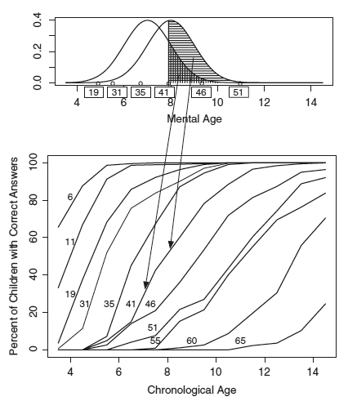

Although this is rudimentarily similar to modern IRT, yet further work by Thurstone then was hampered by the inadequacy of appropriate statistical tools.[170] However, with the introduction of a maximum likelihood estimator and a logistic item response function by Ronald Fisher,[171] a series of research papers in the field of psychometric testing gave gradual shape for IRT to move beyond normal distribution estimation.[172]

Under the IRT measurement philosophy, we can only measure the expression of the property sought to be measured. Thus we can only estimate the corporate governance of a country based on the presence or absence and levels of implementation of certain observable corporate governance parameters. Let us assume that the corporate governance of a country (t) is θt. In attempting to estimate the unknown value of θt, in this scale we assume that the higher the shareholder primacy leaning of a country, the higher the value of θt, and hence deduce that also the higher its influences are over other observable parameters to make them more pro-shareholder. For example, if there are two observable parameters; whether shareholders have a right to decide on executive compensation and if stakeholders other than shareholders find remedies within company law. If a country has more shareholder primacy corporate governance leanings then it should have regulations which would give shareholders veto power over executive remuneration and should keep stakeholders out of company law. On the other hand if a country has weak shareholder primacy corporate governance then intuitively we expect to find that this particular country would not have regulations which favour giving shareholders the power to decide how much managers should be paid and in the case of a country with very poor shareholder primacy corporate governance the company law may specify that stakeholders like employees may be represented within the board and find remedies within the company laws. So far it seems that IRT is just an inverse form of classical test theory, however IRT does add varying difficulty and discriminatory powers to each parameter.

Momentarily moving back to the early works of Thurstone, it is possible to note that he inferred that, based on the number of correct responses to the same question given by different age groups, it is possible to deduce the mental ability test scores within a single age group, he called it developmental scaling or vertical linking.[173] He found that the ability of students to answer each question correctly when plotted more or less fits with the normal ogive model.

This remained the central idea for around two and half decades, finally, in 1950 Paul Felix Lazarsfeld one of the major figures in 20th century quantitative sociology and the founder of Columbia University’s Bureau of Applied Social Research, posited that ‘all interrelationships between the items should be accounted for by the way in which each item alone is related to the latent continuum.’[174] He showed that every item or parameter which manifests the underlying latent trait has its own difficulty and discriminatory power and therefore even with the same latent trait, different parameters would have different expressions. He called it the latent structure analysis and helped to estimate the underlying latent trait based on the expression of the observable parameters using a distribution. This led to the creation of the item characteristics curve, which distinguished the difficulty and discriminatory powers of the parameters. Baker describes the difficulty of the item as the position where ‘the item functions along the ability scale. […] Discrimination, describes how well an item can differentiate between examinees having abilities below the item location and those having abilities above the item location.’[175]

To explain, we know intuitively that for example in an exam an easy question would be answered by more students than a difficult question, this is the difficulty parameter.

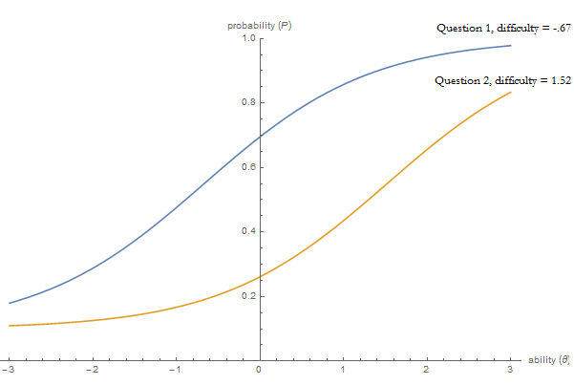

It can be represented graphically as above, thus *pari passu* the item characteristic curve of the easier question would be to the left of more difficult questions.

The second character is the discrimination of parameters, so, questions which make it easier to distinguish between abilities, it can refer to trick questions which are expected to be answered correctly by higher ability students. It is represented in the item characteristic curved as a slope.

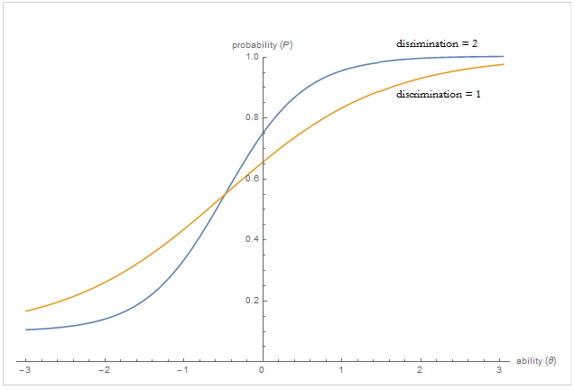[176]

To import these elements to corporate governance, we can describe the difficulty parameter as how difficult it is for a country in comparison to other regulations/parameters to have a particular regulation, say shareholder control on executive pay; while a discrimination parameter can be explained as how important it is for a country to have that particular regulation.

So, assuming that for a country i there is an unknown corporate governance trait measure of θi and fifty observable parameters, one of which is shareholder control over executive remuneration (denoted by a variable S/hexecp). A two parameter IRT model for this single observed variable can be mathematically represented as:[177]

(1)

Where αS/hexecp is the discrimination parameter and βS/hexecp is the difficulty parameter. So, in other words, in a corporate governance context the probability for item S/hexecp (which is the observed variable regarding whether the country has rules relating to shareholder control over executive remuneration) to have either the value of 1 or 0 would depend on the unknown discrimination parameter αS/hexecp and the unknown difficulty parameter βS/hexecp of the observed variable. It can also be tentatively explained as [Probability of whether this country i would have a regulation that shareholders can control executive remuneration = 1/(1 + exp^( – how *important* is it to have a regulation that shareholders can control executive remuneration for a good corporate governance * (corporate governance index of country i – *difficulty* in legislating a regulation that shareholders can control executive remuneration))]

However, merely the presence of a law or policy does not mean that it is going to be implemented, in other words a binomial system may not work adequately in the real world. So it is necessary to increase the ability for the variable to take more than two responses, so instead of S/hexecp Є {0, 1} we have S/hexecp Є {0, 1, 2} where 0 would mean that a regulation is absent, 1 can mean that the regulation is present but not generally implemented or is optional and 2 would mean that the regulation is compulsory and strictly implemented. This required certain changes to equation (1). This was done by Fumiko Samejima who provided a way to estimate the latent trait based on more than two ordered categorical responses, this resulting polytomous item response model was called the Graded Response Model.[178]

The item response curve for dichotomous and polytomous 2PL IRT model can be graphically compared as below.

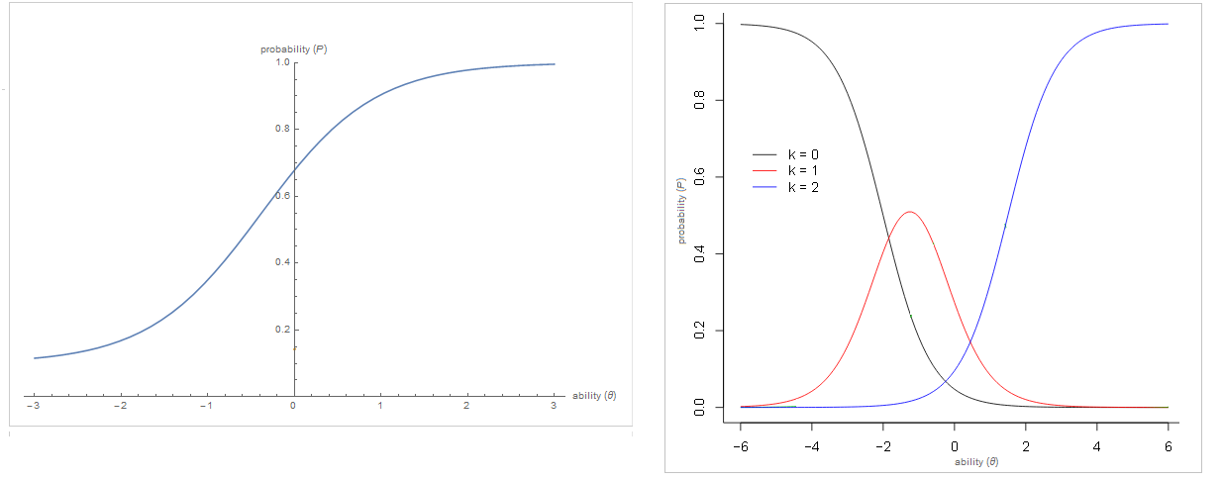

The graph on the left shows that the probability of the response to S/hexecp varies on the item curve, thus it can be 0 or 1 depending on the latent ability of the country. However on the left three options are possible, so depending on the latent ability of the corporate governance of the country i the value of S/hexecp denoted in the graph as k can be 0 or 1 or 2, and each value would have its own separate item characteristics curve. This is also called a difference model as it breaks the single item curve into hierarchical category boundaries and probabilities are set as differences between cumulative probabilities.

Therefore the probability of item j (which as per our example is S/hexecp) to take each of the three values {0, 1, 2} for country i (therefore sharing a common trait of θi) can be mathematically represented as:[179]

P (S/hexecp = 0| θi)= 1 - P* (S/hexecp = 1| θi)

P (S/hexecp = 1| θi)= P* (S/hexecp = 1| θi) - P* (S/hexecp = 2| θi)

P (S/hexecp = 2| θi)= P* (S/hexecp = 2| θi) (2)

This basically represents that the probability of a positive response in a category is calculated as the probability of responding positively at a category boundary less the probability of responding positively to the next category boundary. Therefore to sum up, in general the Graded Response Model Category Boundary Response Function would be:

${ P}_{jk}^{*}= \frac{e^{α_{j}(θ- β_{jk})}}{1+ e^{α_{j}(θ- β_{jk})}}$ (3)

Here θ is constant for country i, αj is the item discrimination parameter and βjk is the boundary location parameter.[180] We repeat this process for each item for all the countries. So finally for i number of countries, for each country there are the observed response patterns of corporate governance indicators Yi, the overall pattern is denoted by Y, j denotes the individual corporate governance items, αj denotes the discrimination for item j, βj denotes the difficulty for item j, then the ability or trait θi can be estimated as:[181]

(4)

This can be represented as a fully Bayesian process or through marginal maximum likelihood given a marginal prior distribution P(θi) for each value of the latent variable, the posterior distribution of θi as:[182]

(5)

This falls squarely within the Bayesian function of prior times, the likelihood is proportional to the posterior. However as a time series analysis is also considered, it is necessary to include a time component as well, the Martin and Quinn dynamic ideal point estimation[183] can be used to estimate the dynamic corporate governance of each country over each year. So a joint derivation of proportionality function (5) of item and trait parameters gives:

$P\left(θ_{it} | α_{ij},β_{ij},Y_{i}\right)∝P(θ_{it})\prod_{t=1}^{T}{\prod_{i=1}^{I}{\prod_{j=1}^{J}{{f\left(θ_{it} | α_{j},β_{j}\right)}^{Y_{itj}}{(1- f\left(θ_{it} | α_{j},β_{j}\right))}^{1-Y_{itj}}}} }$ (6)

Until the turn of the last century, a major breakthrough in Bayesian-based social science research was hampered by the absence of the computing power necessary to accurately test the estimation theories of IRT. Hence, scholars used maximum likelihood estimators to infer latent traits based on a distribution model. By the mid-1990s there were several technological leaps which allowed for solving a fully Bayesian function. The only way to adequately test the Bayesian process was through simulation, to generate thousands of probable solutions and check which fits best. The most commonly available computer simulation technique is the Monte Carlo method which was invented in the 1940s and was initially used to help develop the nuclear bomb in the Manhattan Project.[184] However, low computing power could not fully exploit the large probability distribution for large numbers of unknown parameters as is often the case with IRT.[185] This required constraints or boundaries to make the Monte Carlo method more efficient, this was provided by Markov Chain processes. Put very simply, in a Markov Chain the conditional probability distribution of a future draw depends only on the current state of the system.[186] The Markov Chain Monte Carlo gave powerful computational tools to solve multidimensional integration problems like in equation (5). MCMC has several advantages over the maximum likelihood or maximum a posteriori methods, first MCMC allowed for a ‘fully Bayesian estimation involving computing the mean of the posterior distribution of the parameters, as opposed to the mode of the likelihood, which is located using an ML algorithm.’[187]

Second, the Bayesian MCMC, after an initial steep learning curve, is comparatively easier to use to handle parameters of more complex models over frequentist ML estimation.[188] Finally, MCMC provides a representation of the complete posterior distribution of the parameters, which gives researchers invaluable tools to qualitatively inspect the model.[189] The only limitation left for wide adoption was the availability of easy computational language. In the mid-1980s Stuart and Donald Geman created a functional computer algorithm based on a sampling method first inferred by Josiah Willard Gibbs at the turn of the 20th century, the model was called Gibbs sampling.[190] This was a special case of single component Metropolis-Hastings algorithm, it was extensively used in statistical physics and was called a heat bath algorithm.[191] Gibbs sampling makes it possible to obtain samples from probability distributions without having to explicitly calculate the values for their marginalizing integrals.[192] This sampling method was later introduced to R programming language through another language called Just Another Gibbs Sampler (JAGS) in 2007. When MCMC was combined with JAGS it created an immensely powerful tool for social scientists to check Bayesian theories which had been impossible only a decade ago.

In this research MCMC in JAGS is used to estimate the dynamic corporate governance index for the twenty-one countries. So there is a I X J X T matrix where I stands for number of countries, K stands for number of corporate governance variables and T stands for the time period. So we have a data matrix of 21 X 52 X 20 totalling approximately 21,840 elements.

BUGS code by S. McKay Curtis[193] is adapted into JAGS. First, as JAGS is unable to deal with zero we add +1 to all the elements of our I X J X T matrix. So where the input was 0 in the original response sheet, now it becomes 1 and so on. As the increase is across the board this is only for computational ease and does not have any effect on the final result and analysis. Next, the algorithm is implemented as described in equation (2), specifying the categorical distribution.

So there are n =(1 to i) countries (in this case n=21), p = (1 to j) items (in this case p=51), each item has three possible responses; k = {1 or 2 or 3}. ‘The probability that the i-th subject will select the k-th category on the j-th item is constructed by first considering the cumulative probabilities:[194]

(6.1)

Where FL(.) is the cumulative density function of the logistic distribution and $K_{jk}$ is the threshold. Therefore depending on the value, each item will have a maximum of 2 thresholds. The probability pijk that the i-th subject will select the k-th category on item j is expressed in equation (2). They can also be written as:

$$p_{ij1}=P_{ij1}$$

${ p}_{ijk}=P_{ijk}-P_{ijk-1}$ for k = 2, ….., Kj – 1

${ p}_{ijk_{j}}=1- P_{ijk_{j}-1}$ (6.2)

Where Kj is the largest category, in the data Kj = 3. A general distribution function of N(0,1) is used for estimates of trait parameters. MCMC is then used to simulate the data for discrimination and difficulty parameters along with the latent trait, to create a prior distribution which best fits the observed responses.[195] The JAGS code is as below:



Code snippet

Equation (2) and (6.2) is represented by lines 27-41, the prior distribution is set by lines 43-59, the GRM category boundary function as described in equation (3) and (6) is set by lines 5-25.

After the best fit trait values were obtained, a Kalman filter was run to account for the dynamic nature of the corporate governance evolution. A Kalman filter is an algorithm which allows for exact inference in a linear dynamical system (like in the present research where the corporate governance trait of countries might change every year but the shift only occurs over an extended period of time), which is a Bayesian model but where the state space of the latent variable is continuous and where all latent and observed variables have a Gaussian distribution (as has been assumed in this research).[196] A Kalman filter is mathematically represented as:

$x_{t}=F_{t}x_{t-1}+ B_{t}u_{t}+ w_{t}$ (7)

Where xt is the state in time t, Ft is the state transitional model in time applied to previous state xt-1, Bt is the control model applied to control vector ut and wt is the process noise which is assumed to be multivariate normal with mean 0.[197] The JAGS code for the Kalman filter is as below:



Code snippet

Equation (7) in line 10 is modified such that the corporate governance of a country for time t varies normally over the corporate governance of the same country in time t-1 with the process noise as variance. The Kalman filter ‘dampens’ yearly variations and helps to discern the overall trend in the evolution of corporate governance. A by-product of ignoring yearly variations would be a more robust analysis of the long term effects of change in corporate governance on the growth of the financial market and any other economic parameter.

**3.3 Construction of a dependent financial index and control index using Bayesian factor analysis**

The present research uses five variables to measure and construct the financial growth index and fourteen variables to create the control index for financial growth. Out of the control variables four are country level indicators, which means the variable is time independent i.e. there is little variation in these variables over time, while the remaining ten vary for each country per year. Until now most researchers have used one variable as a proxy for financial growth or have performed multiple regression analysis with different dependent variables to analyse the link between change in corporate governance and financial growth. This type of analysis fails to take into account the latent nature of financial growth which can only be expressed or measured by a factor analysis of several variables thereby adequately ‘explain[ing] the observed relationship among a set of observed variables in terms of a smaller number of unobserved variables’[198].

As discussed in the previous chapter five variables were chosen for this study - Foreign Direct Investment (FDI), Market capitalisation of listed companies, S&P global equity index, traded volume of stocks traded and number of listed domestic companies to represent the financial growth of countries. To construct this financial market index similar methodological issues of measurement are faced as were encountered while constructing the index for corporate governance development. IRT would not be the proper solution as the financial market growth variables are continuous in nature. Therefore a factor analysis model would ‘provide a flexible framework for modelling multivariate [financial] data by a […] latent factor.’[199] The traditional method of performing factor analysis is using the Maximum likelihood factor analysis which ‘relies on large sample theory, and it is consequently often recommended to use it only in large samples (e.g. N=200 or more). In smaller samples, Maximum likelihood factor analysis can run into problems like model non-convergence, negative residual variances etc. Bayesian statistics typically perform better in small samples, and may therefore be useful in studies that rely on smaller sample sizes.’[200] As data is available for 17-20 years per country, a Bayesian factor analysis will give a better fit index than using a Maximum likelihood estimator.

The classical factor model can be defined as below:

$Σ= ΛΦΛ^{'}+ Ψ$ (8)

Where Λ is a p x k matrix of factor loading i.e. the contribution of each variable to the final index, p is the number of observed indicators or variables, k is the number of latent trait factors being measured, and Ψ is the diagonal p x p matrix with uniqueness on the diagonal.[201]

This can also be represented in terms of observed variable y as:

$y_{i}=Λη_{i}+ ε_{i}, { ε}_{i}\sim N_{p}(0, Σ)$ (9)

Where Λ is a p x k matrix of factor loading, p is the number of observed indicators or variables (j = 1,…,p), k is the number of latent trait factors being measured, i is the number of observation per indicator (i = 1,…,n), ${ ε}_{i}$ is the residual with a diagonal covariance matrix Σ and $η_{i} \sim N_{k}(0, I_{k})$ which is a vector of standard normal latent factors.[202] In our research p=5 (number of variables), k=1 (number of latent trait, which in this research is the financial development index) and i=18 (number of observation which is the time period).

To convert equation (9) into a fully Bayesian approach it is necessary to ‘compute the posterior density over all unknown parameters in the model conditional on the observable indicators and any prior information.’[203] To do this the equation (9) can be rewritten as:

$y_{ij} \sim N(γ_{j0}+ γ_{j1}ξ_{i}, ω_{j}^{2})$ (10)

Where γ is the factor loading, ξ is the single latent factor and ω2 is the measurement error variances. This can expressed as a likelihood function as:

$L≡p\left(Y | θ\right)∝ \prod_{i=1}^{n}{\prod_{j=1}^{p}{ϕ(\frac{y_{ij}- γ_{j0}- γ_{j1}ξ_{i}}{ω_{j}})}}$ (11)

Where Y is the n x p matrix of observed indicators, θ = {Γ, ψ, ξ} is the matrix set of unknown parameters comprising of factor loading [Γ = ($γ_{10},…, γ_{p1}$)’], measurement error [ψ = ($ω_{1}^{2}$, …, $ω_{p}^{2}$)'] and latent factor variable [ξ = $(ξ_{1},…,ξ_{n})'$], and ϕ is the standard normal density.

Extrapolating prior distribution over the components of θ from equation (11) can be represented as:

$$p\left(θ\right)=p\left(ξ_{1},…,ξ_{n}\right)p\left(γ_{1}|ω_{1}^{2}\right)p\left(ω_{1}^{2}\right)…p\left(γ_{p}|ω_{p}^{2}\right)p\left(ω_{p}^{2}\right)$$

$=\prod_{i=1}^{n}{p(ξ_{1})}\prod_{j=1}^{p}{p\left(γ_{j}|ω_{j}^{2}\right)p\left(ω_{j}^{2}\right)}$ (12)

Equation (12) fits the Bayes rule of posterior density being proportional to the prior times likelihood. This factorial equation can be operationalised as:

${ ξ}_{i} \sim N\left(μ_{ξ}, σ^{2}\right), i=1,…,n$ (13)

${ γ}_{j}|ω_{j}^{2} \sim N\left(g_{j0}, ω_{j}^{2}G_{j0}\right), j=1,…,p$ (14)

${ ω}_{j}^{2} \sim inverse-Gamma\left(\frac{ν_{j0}}{2},\frac{ν_{j0}ω_{j0}^{2}}{2}\right), j=1,…, p$ (15)

Where $g_{j0}$ and $G_{j0}$ are user specified hyper-parameters of initial values for intercept and slope for the simulations. As stated earlier $ω_{j0}^{2}$ is the measurement error variances. The mean, standard deviation and the initial values for the common priors for the inverse Gamma densities are provided. As Simon Jackmann envisages, in the absence of prior information about factor loading large values are set for the elements of the prior sum of square matrices[204] and run the simulations for a longer period of time until the model converges. It is a resource-intensive method but is simpler to execute.

A one dimension latent variable model for financial growth is fitted, with p=5 set of underlying indicators, using a Byesian model and a Gibbs sampler. The initial value of $g_{j0}$ and $G_{j0}$ as 0.5 is taken as a halfway point between 0 and 1 and for latent variable ξi and the item parameters the lack of identification by imposing normalisation. Thus restrictions are imposed on the latent variable with fixed mean and variance and thereby inducing local identification; similarly for item parameters a restriction on sign will rule out invariance to rotation and provide global identification. Moreover, normalising latent variables to a fixed location eliminates translations and ensures that the latent variable and item parameters are jointly identified. This will also ensure the identification of measurement error variance parameters. Therefore, a Bayesian rule for the financial development index can be written as:

p(θ|Y) α p(θ).p(Y|θ) (16)

which obtains the prior value of the index from p(θ) – the probability of a set of unknown parameters comprised of factor loading, measurement error and latent factors, from equation (12) and likelihood of p(Y|θ), i.e. probability of the observed value given the probability of unknown parameters, from equation (11). As there are multiple unknown parameters it is not possible to solve them algebraically. To compute this it is necessary to rely on Gibbs sampler, ‘building up a Monte Carlo based approximation to the posterior density by sequentially sampling from low dimensional conditional densities’.[205]

From equation (16) a total of n+3p parameters are obtained, so to approximate the value of latent variable output it is necessary to simulate the values across n+3p dimensional distribution. A N(0,1) prior for latent variable output is specified, thereby imposing normalising restrictions, inverse Gamma priors of (0.01, 0.01) are also specified for the measurement error variance parameters. The JAGS code implementing these for preparing the control index is as below:



Code snippet

Please note that we follow similar codes for preparing the financial development index which is the factor analysis of five variables; however as the financial development index is on the left hand side of the final regression analysis, [please refer to equation (17)], there is a clash between setting the prior for latent variables for the financial development index [refer to lines 19-27 in the codes above] in the Bayesian factor analysis model and the regression model. Hence the prior for computing the Bayesian factor analysis to produce the financial development index is provided by a nested prior from the regression model. However this leads to convergence problems, therefore dependent index is calculated externally.

**3.4 Structural models**

3.4.1 Regression analysis

Once the panel data[206] for financial development index, control index and the corporate governance index is obtained, the next step would be to ascertain the relationship between the variables, especially whether there is a causal effect of change in corporate governance on financial development. Regression techniques have become quite common in law and economics literature and are a useful tool to estimate quantitatively the effect of causal variables on dependent variables.[207]

A simple regression model can be represented mathematically as:

Yi = β0 + β1Xi + εi  for i = 1,….,n, (17)

where Yi is the dependent or outcome variable for individual/count i, similarly Xi is the independent or explanatory variable for individual i, β0 is the constant or the intercept value, i.e. the estimated value of Yi if Xi is 0, β1 is the regression coefficient which would provide a quantitative estimation of effect of Xi on Yi and εi is the error term.

In a regression model, like in equation (17), where there is a single explanatory variable, the model is referred to as a simple regression model. In social sciences literature it is difficult to find simple regression models as we know from qualitative experience that outcomes are often determined by more than one factor. So it is necessary to introduce more variables on the right hand side of the equation (17) to isolate the effect that the explanatory variable has on the outcome variable:

Yi = β0 + β1X1i + β2X2i + εi for i = 1,….,n (18)

In this equation there are two sets of independent variables on the right hand side, X1i can be designated as the explanatory variable or the variable whose effect on Yi is being investigated and X2i is the control variable, i.e. any other independent variable which also affects Yi. Equation (18) is an example of multiple regression as there are more than one variable whose effects are being estimate on the outcome variable. Equation (18) can also be written as:

Yi ~ (β0 + βXi, σ2), for i = 1, …., n,(18.1)

where X is an n by 2 matrix (as there are two independent variables) with ith row Xi or using multivariate notation,

Yi ~ (β0 + βX, σ2I),

where Y is a vector of length n, X is a n by 2 matrix of predictors, β is a column vector of length 2 and I is the n by n identity matrix.[208]

3.4.1.1 Pooled regression

In the present research the individual countries can be denoted as j, there are 21 countries, so j = 1 to 21, Y the outcome variable is the financial development index prepared by the Bayesian factor analysis of five factors, X1 the explanatory variable is the corporate governance index prepared by utilising the graded response model on fifty two variables, X2 the control variable is the control index created from fourteen variables. However in addition to individual countries j it is necessary to also add a factor for time, as the study is longitudinal in nature, so equation (18) can be rewritten as:

Yjt = β0 + β1X1jt + β2X2jt + εjt  (19)

For this research t = 1 to 20, to account for twenty year period, and as stated earlier, j = 1 to 21 for twenty-one countries. Equation (19) can also be represented as a distribution in terms of:

Yjt ~ N(β0 + β1X1jt + β2X2jt + εi, σ2)

σ2 ~ N(0, ω2) (19.1)

The model as described in equation (19) and (19.1) can also be designated as a complete pooling model as group indicators are not included in the model,[209] in other words the coefficients β0, β1 and β2 do not vary across countries and time period. This is computed using the following JAGS code:



Code snippet

The code in line 2 and 3 executes the simple OLS equation (19.1). The prior distribution is set between line 5 to 8. The output in a 3d format is as below:

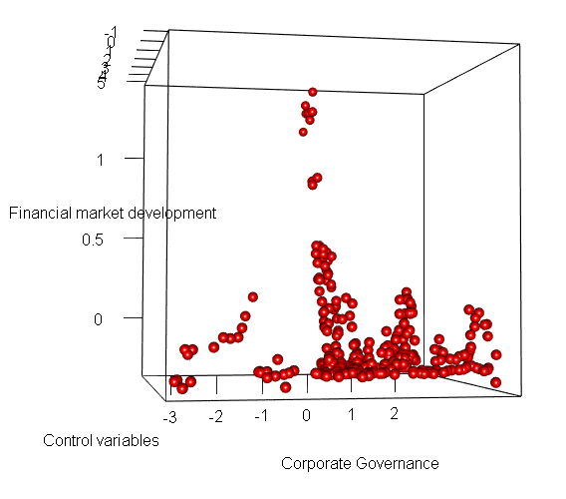

The graph shows that there is a low correlation between corporate governance and financial growth, however, there is also high dispersion, it suggests that the model can be refined further.

A visual check for convergence in a Bayesian model is to inspect the trace plot, if a model has converged then the trace plot moves along a central line and the density plot is usually uniform. Trace and density plot of a single chain of converged variable usually looks as below:

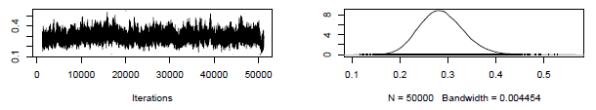

Therefore the trace plot below of the intercept suggests that the model had not stabilised even after 50,000 iterations and is likely to be biased, inefficient and/or inconsistent:

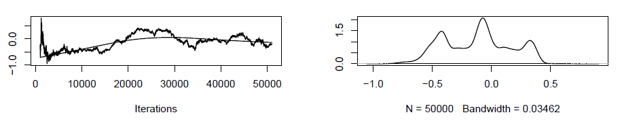

The density plot on the above right shows that there are at least three distinct intercept categories. This indicates that despite relative convergence (as shown below) in the coefficients the groups are not homogenous and the model needs to be explored further to fully explain the links between corporate governance and financial growth. Thus although OLS pooled regression ‘captures not only the variation of what emerges through time or space, but [also] the variation of these two dimensions simultaneously’[210], our analysis shows that errors may not be independent and homoscedastic over time, and hence pooled OLS regression leads to erroneous results.[211]

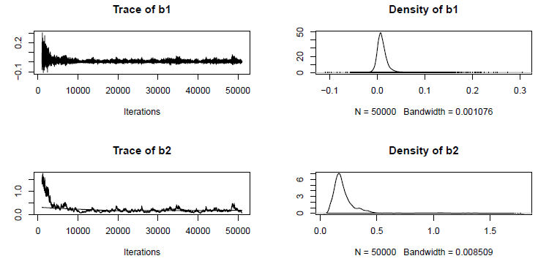

3.4.1.2 Unpooled regression

Therefore the next step of model building would be to let the intercept vary with the country.

The new derived equation will be:

Yjt = β0j + β1X1jt + β2X2jt + εjt  (20)

Yjt ~ N(β0j + β1X1jt + β2X2jt + εi, σ2) (20.1)

where j is the country and t is the time period. This model can also be referred to as no pooling as separate models are fit within it for each country.[212] In computation terms this model is referred to as a Bayesian Inference for Panel Data Regression Model with a Non-Hierarchical model for Unobserved Unit Level Heterogeneity. This is better than letting the slopes (the regression coefficients) vary as well, because then cross validation cannot be performed at country level.[213] The following JAGS code is used:



Code snippet

Line 1 to 9 sets out the main argument, Yxi is the financial development index for each country, it is in a 420 by 1 matrix, each cell represents one country and one year. Similarly there is a 420 by 1 matrix for Z.theta which is the corporate governance index and X2xi which is the control index. Line 7 provides the distribution of financial development which is normal over mean Rmu and standard deviation Rtau. Rmu is bounded by the regression equation as stated in equation (20). So Rmu is a function of an intercept β0 which is allowed to float across countries and a constant coefficient β1 across all countries for corporate governance and β2 for control index. So we get 21 intercepts, the convergence and density plots for couple of β01 ,…., β021 is as below:

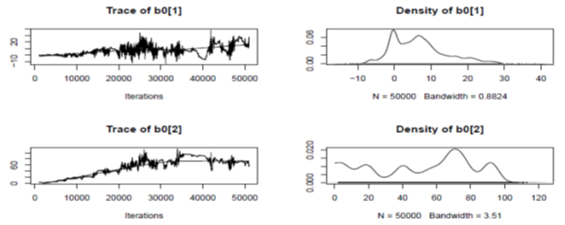

Almost all of them show instability and from the density plot and bandwidth[214] we find that coefficient for corporate governance index and control index have also become less stable.[215]



3.4.2 Random unpooled

The relative instability of β0 shows that the model is a random effects model, so the next step will be to introduce unit specific heterogeneity and reduce standard deviation of the priors. As we see from the previous JAGS code lines 10-14, there is a fixed normal prior, we would let this prior to vary.[216]



Code snippet

The new model lets the standard deviation float to account for unobserved unit level heterogeneity. We find that there is comparatively more convergence for β01 ,…., β021, as depicted below:

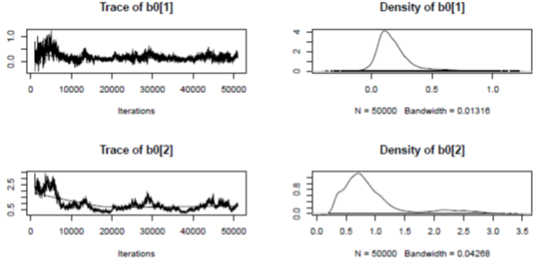

and the coefficient for corporate governance and control index becomes relatively stable with some strong variations in the tail.[217]



3.4.3 Multilevel hierarchical

This proves that the next step to further converge the model would be to pick up variables from the control data set which do not vary much over the entire dataset and is not uniformly available. Also ‘the multilevel model gives more accurate predictions than the no-pooling and complete-pooling regressions, especially when predicting group averages.’[218] We take out GINI coefficient, HDI indicator, rule of law and peace coefficient from the Bayesian factor analysis to act as a country level indicator with its own prior distribution.

So algebraically we can represent the new relationship drawing from equation (21.1) as:

Yjt ~ N(β0j + β1X1jt + β2X2jt + εi, σ2j) (21)

this gives us the first level model, then we have a second level regression fit for each country,

β0j ~ N(γ0 + γgX3j, σ2β)  (21.1)

where j represents the country and t represents the year, X3 is the country level indicators, g represents the number of country level indicator, in our research it is 4, and γ represents the country level indicator coefficient γ0,…, γ4. We assume that the errors in the second level regression is distributed normally over mean 0 and standard deviation σβ.

The JAGS code for implementing equations (21) and (21.1) is as below:



Code snippet

We can try two different priors strategy – one favoured by Gelman and Hill giving a uniform distribution[219]



Code snippet

and the other by Simon Jackmann favouring a Gamma distribution computed via the Poisson density[220]



Code snippet

Both give very similar results, however Gamma distribution is found to take a bit longer to converge.

Comparison of coefficient for corporate governance and control index is as below

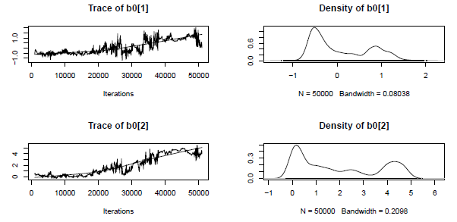

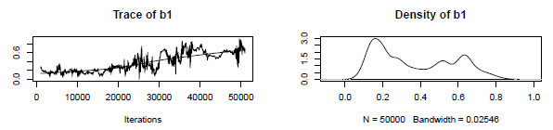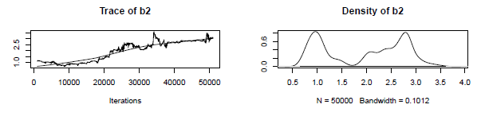

It shows that the model has not yet converged.[221]

3.4.4 Multilevel hierarchical with lag

As evidenced by experience, the effect of the change in corporate governance on financial development is gradual, this is called lag effect.[222] We compensate for this lag effect by regressing the outcome at a later time period. So varying the time component we have:

Yjt+1 ~ N(β0j + β1X1jt + β2X2jt+1 + εi, σ2j) (22)

The corporate governance index ranges from 1995-2014, however the financial index and control index data for 2013-14 is incomplete. So for corporate governance the time period 1995-2011 (17 years) is used with the corresponding financial and control index for time period 1996-2012. Thus the financial and control index lags one year behind the corporate governance index. The coefficient for corporate governance and control index is as below:[223]

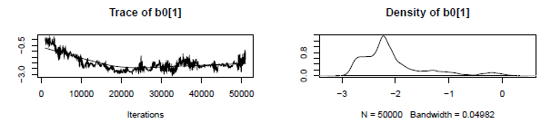

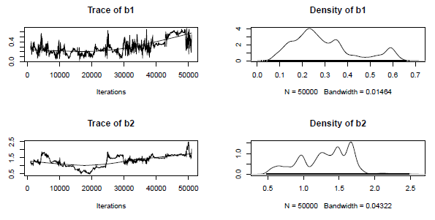

3.4.5 Convergence analytics

Even with lagging for corporate governance change, the model does not converge, so a few radical solutions were implemented.

First, it was found that Yxi (the dependent variable) was not converging properly when its prior was obtained from the regression analysis [line 5 in code snippet 7]. So, a separate Bayesian factor analysis is run for Yxi and the value is fed into the main regression model.

The traceplot and density graphs change from

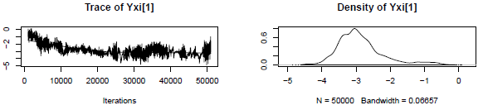

to 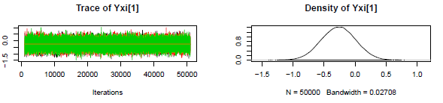

Second, the control variable index was split into three indices to reflect the underlying nature of the variables being factored in – so the new indices represented economic growth, financial inclusion and increase in investment in R&D and technology led export.

Third, priors for precision terms for country level indicators, which were fixed at dgamma(0.01,0.01) [line 1 code snippet 9] was changed to dgamma(2,0.6) for quicker convergence.

**3.5 Country wise analysis**

Once the regression model is complete, the following coefficients and indices emerge – country level indicator coefficient γ0,…, γ4; country intercepts β01 ,…., β021; a corporate governance [z.theta], financial development [Yxi] and control [X2xi] panel index, obtaining a data point for each country for each year between 1995 and 2011 (for financial and control index and 2014 for corporate governance index). The next step after a macro level multi country time series cross sectional analysis would be to check the country level variations and check how each country stands in comparison to the overall group. To do this country level analysis exploratory techniques like change point analysis are first used. This will show the time period when change(s) has/have occurred in the overall corporate governance evolution and financial development. This will help to pinpoint if corporate governance ‘improvements’ follow financial boom or if it is the other way round. We use the R package bcp to implement the change point solutions.[224] A typical line of R code for the same is as below:



Code snippet

There will be a very short qualitative introduction on each country regarding how corporate governance evolved, highlighting the key areas, time period and legislations. After the change point analysis a country wise regression is conducted to graphically compare the coefficient with the overall multi-country trend using both frequentist and Bayesian frameworks.

1. **Analysis**

*This chapter is divided into four subchapters each analysing the four main issues: first, what is the direction of corporate governance evolution – this will allow us to track if the corporate governance around the world is converging towards a more shareholder primacy model based on OECD Principles of Corporate Governance and the rate of such change over time; second, does major step change in corporate governance happen before or after such a change occurs in the financial market – this will provide general information on whether corporate governance growth is exogenous or endogenous to major changes in the financial market and also check if anecdotal qualitative evidence of surges in corporate governance development following market failure holds true in a quantitative multi country survey; third, does adopting shareholder primacy corporate governance have any overall impact on the growth of the financial market – this will make it possible to investigate if varying the corporate governance model towards a pro-shareholder approach has any effect on increasing the financial market development, thereby scrutinising the claims from international financial organisations that strong corporate governance is fundamentally linked to long term financial and economic performance; and fourth, how does each of the twenty-one countries in the study fare in corporate governance impact on financial market growth in comparison to global average – this will permit a close examination of each country to find out if it has fared better or worse than the global average, hypothesizing the sui generis factor which may have led to such differences thus laying down directions for future qualitative research.*

**4.1 Corporate governance convergence**

In comparative law convergence has been an oft debated topic,[225] more so in comparative company law and corporate governance where much of the focus is on the question of convergence.[226] This can be functionally attributed to prolonged initiatives to unify commercial laws for ease of cross border trade and commerce,[227] transplantation or transfer of ‘best practices’ through investment liberalisation resulting in investor pressure,[228] spread of neo-liberal pro shareholder value ideologies,[229] and harmonising role of global financial institutions.[230] Until the 1996 La Porta et al. paper[231] most of such discussions on the degrees of relative convergence focussed on qualitative comparisons, however post La Porta et al. there was a newfound focus on quantifying country level legal rules and empirically investigating whether there is any convergence. Most of the research work before 2000 was cross sectional in nature, i.e. they focussed on comparing the variables for many countries but were limited to a single year. At around this time dire/triumphant (depending on one’s perspective) predictions were being made suggesting that shareholder primacy corporate governance had won over the stakeholder approach and that eventual full convergence was only a matter of time.[232] To investigate convergence empirically there was a need for time series cross sectional or panel data collection.

This was first attempted in 2005 by the project on Law, Finance and Development at the Centre for Business Research (CBR) in the University of Cambridge.[233] They developed two indices on shareholder protection in listed companies. The first one coded for 60 variables for 5 countries for the years 1970 to 2005.[234] The second index coded for 10 variables for 25 countries for the years 1995 to 2005.[235] The general finding on convergence from these studies was that ‘convergence in shareholder protection has been taking place since 1993 and has increased considerably since 2001.’[236]

In 2006 IMF developed a Corporate Governance Quality (CGQ) index based on firm level accounting and market data for 41 countries for the years 1994 to 2003.[237] They concluded ‘that corporate governance quality has improved in almost all countries, and there is evidence of convergence.’[238]

A country level panel data set, similar to CBR, was developed in 2010 by Marina Martynova and Luc Renneboog, coding for 55 variables for 30 European countries and the US for the years 1990 to 2005.[239] They concluded that ‘the global convergence of legal systems towards a single system of corporate regulation is unlikely, [but] there are still signs of increasing convergence by national corporate governance regulations towards a shareholder-based regime when the protection of (minority) shareholders is considered.’[240]

A mixed variable, firm level, multiyear corporate governance data set for 5 emerging countries was developed in 2013 by Black et al.[241] Although they did not focus on convergence, their study shows gradual convergence.[242]

In 2015 Dionysia Katelouzou and Mathias Siems expanded the second CBR shareholder protection index coding for the original 10 variables for 30 countries for the years 1990 to 2013.[243] They concluded that certain market-oriented conceptions of company law such as the requirement for independent directors have spread around the world.[244] They also found that the ‘general trend shows, however, that all legal systems have strengthened both enabling and paternalistic tools of shareholder protection regardless of legal origin and stage of economic development.’[245]

As explained in the methodology chapter, this research codes for 52 variables for 21 countries for the years 1995 to 2014. A dynamic graded response model is used to compute the index. Below the evolution of corporate governance index for the 21 countries is presented in graphical format:

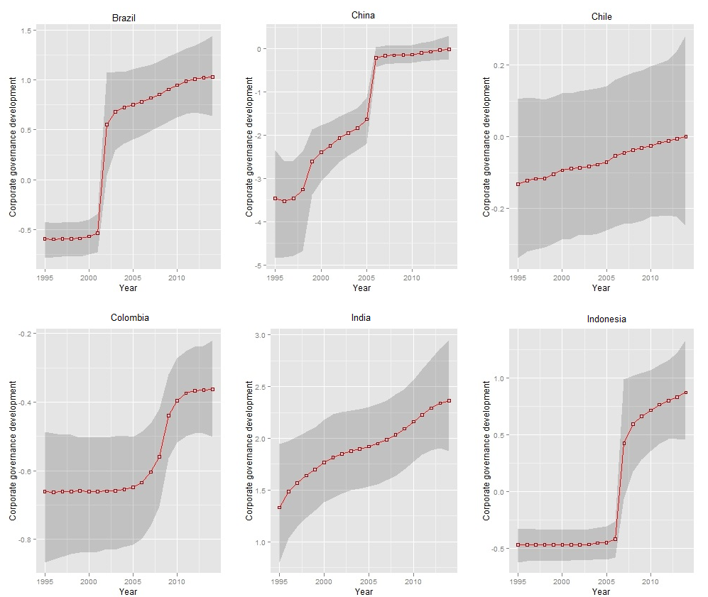

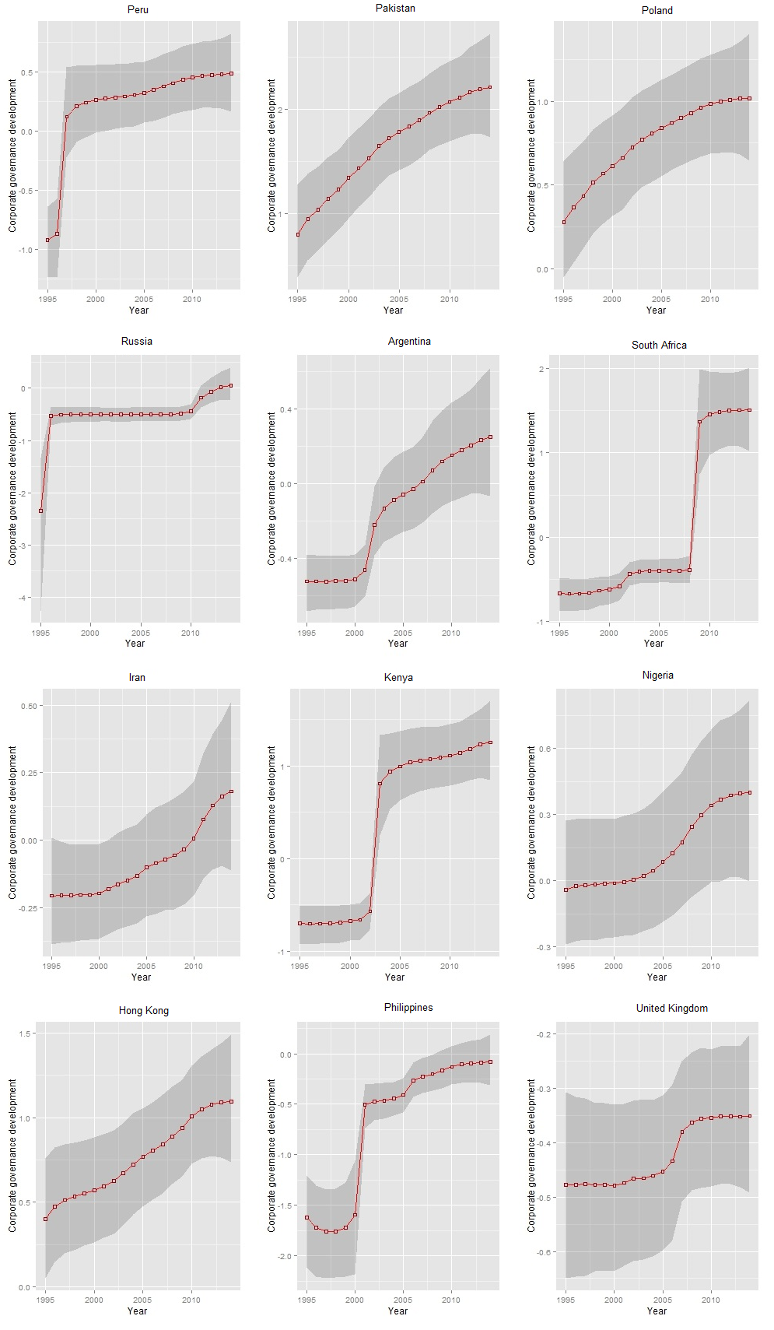

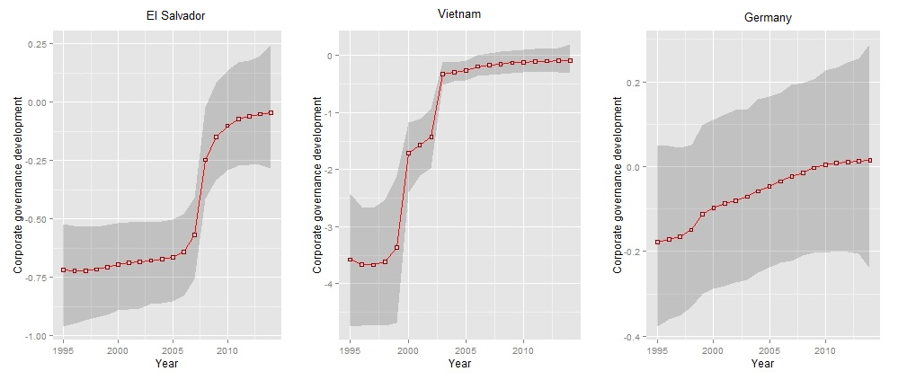

The preceding graphs show that for all the countries in this study, the corporate governance index becomes more pro-shareholder over time. However the rate of such increase is different for each country. Please note that the scale is not uniform in the graphs above, this allows for a greater focus on the individual trends for each country. However to compare the trends of corporate governance across all the countries, we need to plot the corporate governance development on a uniform scale. This is done in the graphs below:

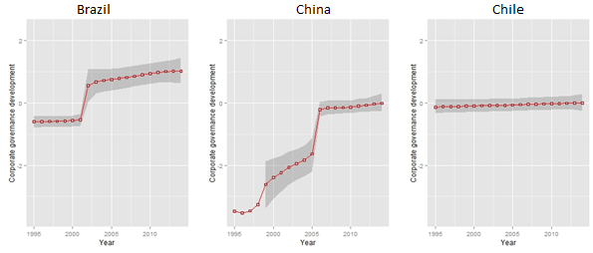

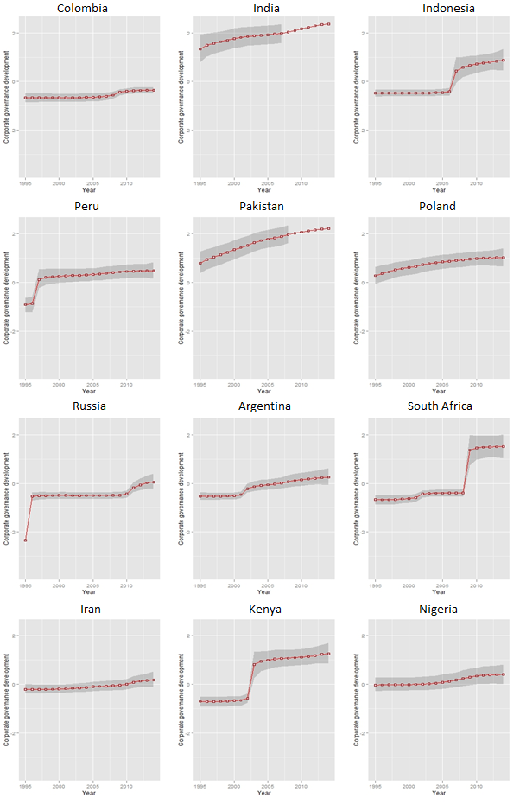

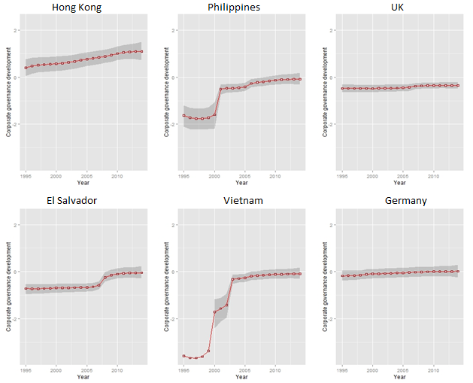

Change in shareholder primacy corporate governance (1995 – 2014) standardised scores is tabulated below (darker shade represents more change):

|  |  |  |  |
| --- | --- | --- | --- |
| Country | Change | Country | Change |
| China (CH) | 3.46 | Vietnam (VTN) | 3.49 |
| Russia (RUS) | 2.4 | South Africa (RSA) | 2.18 |
| Kenya (KEN) | 1.96 | Brazil (BR) | 1.62 |
| Pakistan (PK) | 1.42 | Philippines (PHL) | 1.54 |
| Indonesia (INS) | 1.34 | Peru (PER) | 1.4 |
| Hong Kong (HKG) | 0.7 | India (IN) | 1.03 |
| Argentina (AR) | 0.77 | El Salvador (ELS) | 0.67 |
| Poland (PL) | 0.74 | Colombia (COL) | 0.3 |
| Nigeria (NGA) | 0.44 | Iran (IRN) | 0.39 |
| Chile (CHL) | 0.13 | Germany (DEU) | 0.19 |
| United Kingdom (UK) | 0.13 |  |  |

The graphs and table show that for countries like Germany, UK, Chile, Iran, Nigeria and Colombia there have been very small shifts towards shareholder primacy corporate governance (0 – 0.5). For countries like El Salvador, Hong Kong, Poland, Argentina and India there have been larger shifts (0.5 – 1). For Brazil, Pakistan, Indonesia, Peru and Philippines there have been major shifts (1 – 1.75). While for Vietnam, China, Russia, South Africa and Kenya there have been significant shifts (1.5 and above) towards adopting shareholder primacy corporate governance principles over the last twenty years.

Convergence will be measured in two ways, first three quasi-experimental methods – average, difference between the highest and lowest corporate governance index per year and the total difference from the highest corporate governance per year. Secondly the findings are confirmed by computing the square of the Pearson product moment correlation coefficient.

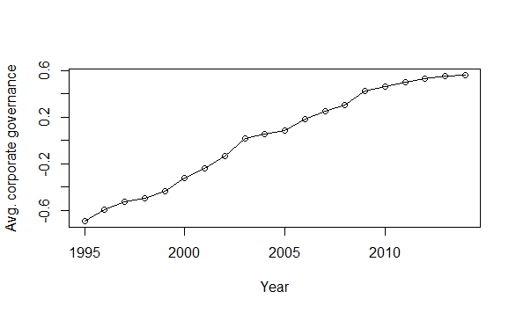

The average corporate governance index is computed by averaging the individual corporate governance indices across all countries for each year. The graph shows that the average corporate governance is becoming more pro-shareholder over the studied time period.

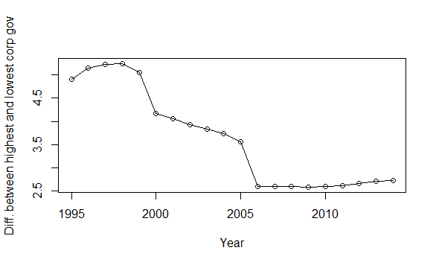

The graph showing the difference between the highest corporate governance scores and the lowest corporate governance scores per year also shows a marked fall, signalling a convergence.

Similarly when we find the difference between each country and the highest corporate governance country and add up all such differences we get the following graph.

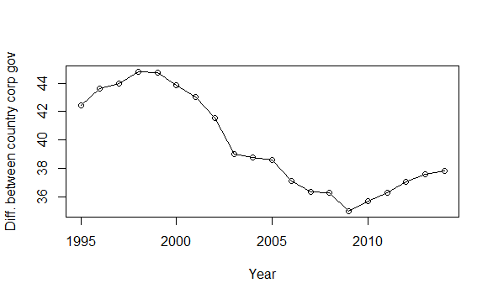

This graph shows that until around 2009 there was a steady convergence but after 2010 there is a slight divergence. This research does not look into the qualitative reasons for such a divergence, nevertheless this divergence can be attributed to a move away from a pro-shareholder approach in the aftermath of the Global Financial Crisis. Another reason might be the introduction of G20/OECD Principles of Corporate Governance in September 2015 which aims to maintain and strengthen the core values of 2004 Principles based on experience since then. The questionnaire used in this research is designed to capture the corporate governance regime based primarily on the 2004 Principles. It can be also be argued that the stall in convergence since 2008, highlighted in this research, is a combination of the perceived need for more effective regulations which are now aimed to be fulfilled by the 2015 Principles and the need to update the variables to capture this post-2015. Hence, there is a need for a further in depth study to find out accurately the reasons behind such divergence post-2009, especially in light of the 2007/08 Global Financial Crisis and the introduction of the 2015 OECD Principles.

So overall the three quasi-experimental models show that there is a convergence. This is proved experimentally by the square of the Pearson correlation coefficient (r) calculated for each year for all the countries. The graph below shows the movement of r2. As the original corporate governance data for each year across every country can also form a univariate ordinary least square regression, the coefficient of determination will also be equal to the computed square of the Pearson correlation coefficient. Hence the graph also shows how well the corporate governance of each country fits to a line of best fit. This makes it possible to identify the extent to which a uniform corporate governance regime is emerging. A local regression line is fitted in order to produce a nonlinear trend line (in blue). This shows that between 1995 and 2005 the rate of convergence was quite high, this slowed down between 2006 and 2008 and then fell from 2009 onwards.

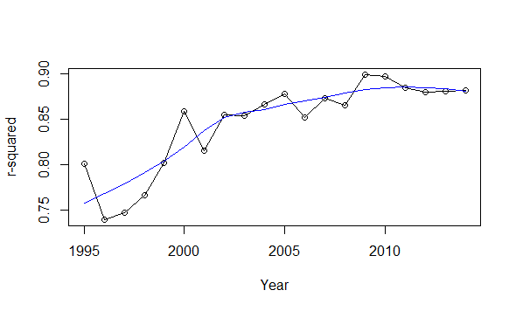

Thus there is clear evidence that corporate governance is converging towards a shareholder primacy approach, although the rate has slowed since 2009. It might be suggested that this is either because most of the countries examined have reached peak shareholder primacy regulation before 2009, or because of a global fatigue towards pro shareholder rhetoric in the aftermath of the Global Financial Crisis.

The experimental result is complemented by the heatmap of the corporate governance index below which also shows the steady growth of pro-shareholder corporate governance around the world. The spread of red indicates the increase in shareholder value corporate governance over time:

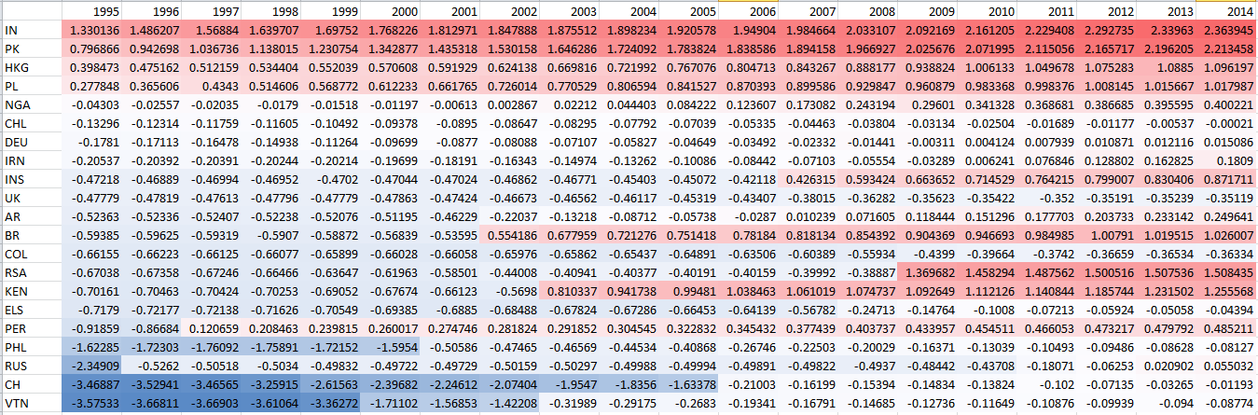

**4.2 Are corporate governance shifts endogenous or exogenous?**

Once time series data on both corporate governance and financial market development is available it is possible to explore if corporate governance development is led by financial development or if it is the other way round. Armour, Deakin et al. have used Grangers causality test to determine if change in corporate governance has causal inference.[246] They found that the ‘Granger causality tests showed that the direction of causation ran from the increase in shareholder protection to the decline in the number of listed companies, not the other way round.’[247] However due to the shorter period of time (20 years for corporate governance and 17 years for financial development) a Bayesian change point analysis is used on the corporate governance development index and financial development index to compare the time points when there was a marked generational change in the indices. A *bcp* package is used in R to perform these calculations.[248]

The change-points allow us to compare quasi-experimentally the direction and feedback effects in a panel data structure. It is possible to speculate as to if corporate governance growth drove financial market development or if it was the financial market development that led to the adoption of a more shareholder primacy approach. If financial market development regime shift regularly occurs before such changes in shareholder primacy corporate governance, then we can safely deduce that corporate governance has no role to play in financial development and posit that the direction of the financial market would determine the type of corporate governance a country will adopt. On the other hand, if financial market development happens in conjunction or after a spurt in corporate governance, it is necessary to build structural models to tease out the statistical relationship between the choice of corporate governance and its impact on the growth of financial market development. As explained in the methodology subchapter, Bayesian change point analysis would entail partitioning the time series data into segments so that the mean within the segment remains constant. For each sample in the time series, the Bayesian change point determines the posterior probability that the sample is a change point, i.e. a point of significant change in corporate governance between two segments of different mean corporate governance.[249] The Bayesian analysis was configured with 5000 Markov-chain Monte-Carlo (MCMC) iterations with a burn-in period of 500 iterations i.e. the first 500 simulations are discarded, giving time for the model to converge and then simulate 5000 times to compute the final probabilities. Following the analysis, each year is assigned a value associated with a posterior probability of being a change point. Change points were considered to occur when the posterior probabilities were higher than 0.9 or 0.5 if there are multiple weak change points between 0.5 and 0.8.

For each country, its corporate governance and financial market development indices are passed through the *bcp* package. Two plots summarizing the analysis are generated. The first figure, ‘Posterior Means of corporate governance development’, displays the index along with the posterior mean of each year for the corporate governance development data. This peaks for years when there is a high probability of generational shift or a step change between 1995 and 2014; the second graph shows the ‘Posterior Means of financial market development’ which similarly shows the posterior means and probabilities of change as calculated on the Bayesian factor analysis mean results for the financial market development index between 1996 and 2012.[250] For each country, both the graphs are followed by a brief assessment focussing on explaining what happened in or around the breakpoint identified by the quantitative assessment. This dual assessment is intended to explain the quantitative findings. A table of the posterior probability of a change in mean, along with the posterior mean and standard deviation for each position for each country is provided in the appendix for replication purposes.[251]

4.2.1 Brazil

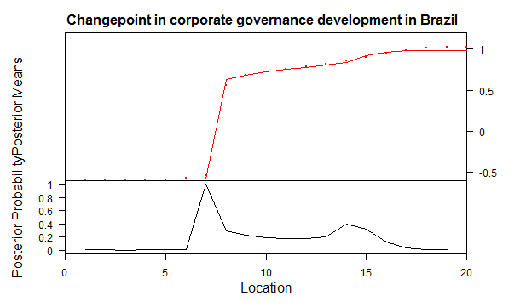

The change occurs in year 7 (probability of 1) of the dataset or in year 2001. It is consistent with qualitative studies on Brazilian corporate governance which find that in 2000 the Sao Paulo stock exchange Bovespa created a three tier listing agreement for better obsevance of corporate governance, followed by amendments in Company laws in 2001 providing new rights for minority shareholders.[252]

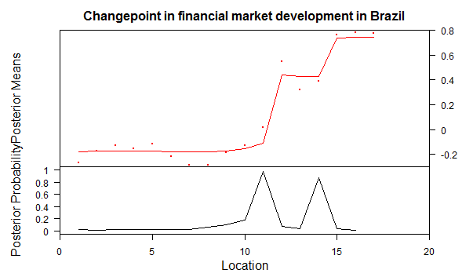

The probability of change occurring in year 11 (probability of 0.97) and year 14 (probability of 0.87) is high. This correspond to year 2006/07 and 2009/10 which was the time period of the Global Financial crisis and relative recovery.

4.2.2 China

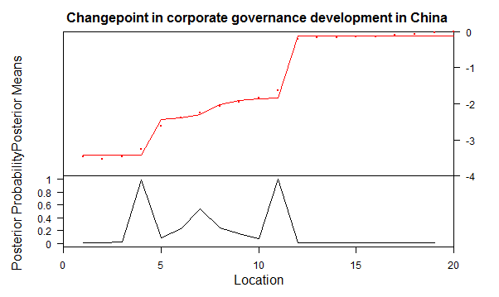

The probability of change occurring in year 4 (probability of 0.99) and year 11 (probability of 1.0) is quite high. This corresponds to the year 1998 when Securities Law was adopted[253] and the years 2005/06 which sits squarely between the amendments to company law in 2005, a new Administrative Measures on Securities Depository and Clearing in 2006 and Provisional Administrative Measures on Transferring Shares Owned by State-Owned Shareholders (promulgated by the CSRC and SASAC in 2007).

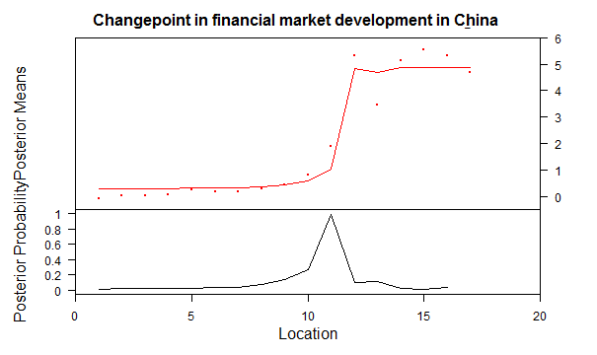

The probability of change in financial market development in China is quite high for year 11 (probability of 0.99). This corresponds to the year 2006/07 which was the start of the Global Financial Crisis.

4.2.3 Chile

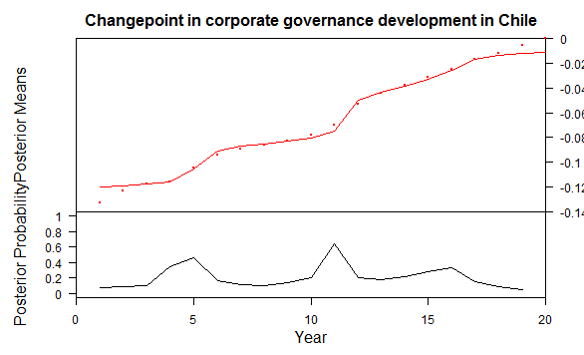

The probability of regime or shift change in corporate governance development in Chile is overall quite low, there are two low crests in year 5 (probability of 0.46) and 11 (probability of 0.65), these correspond to the years 1999 and 2005. The low probability of change is due to the gradual nature of such corporate governance development in Chile. The market regulator of Chile had promulgated new regulations on corporate governance in 1998.[254] This was followed up by several circulars by the market regulator in 2006 and the major corporate governance regulation in 2009.[255]

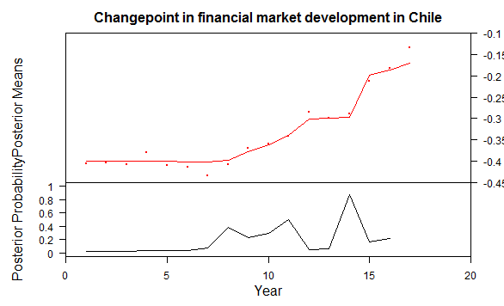

The probability of a change point in financial market development in Chile is quite high for year 14 (probability of 0.88). This corresponds to the year 2009/10. This also corresponds to the time period of the Global Financial Crisis.

4.2.4 Colombia

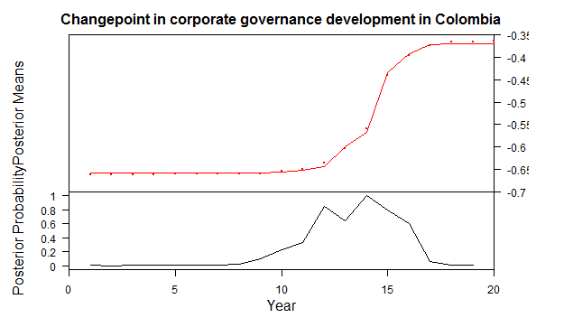

The probability of change point in corporate governance development in Colombia is quite high for year 12 (probability of 0.84) and year 14 (probability of 0.99). This corresponds to the years 2006 and 2008. These change points coincide with rapid changes in the corporate governance framework in Colombia through the introduction of Securities Market Law (Law 964 of 2005),[256] The Colombian Code of Best Corporate Practice in 2007 and The Colombian Guide of Corporate Governance for Closed Societies and Family Firms in 2009.[257]

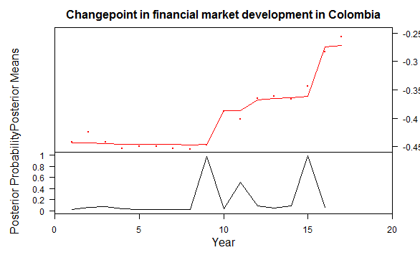

The probability of change point financial market development in Colombia is quite high for year 9 (probability of 0.97) and year 15 (probability of 0.98). This corresponds to the years 2003/04, when the Colombian economy started rapidly recovering from the Colombian Financial Crisis of 1998,[258] and the year 2010 which coincides with the upheaval from the Global Financial Crisis of 2007.

4.2.5 India

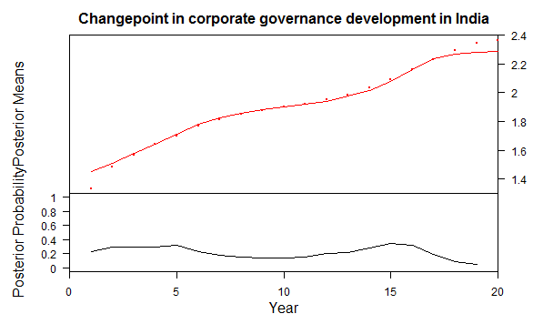

The probability of regime shift in Indian corporate governance development is very low throughout the period studied, this is due to the steady change in the updating of the corporate governance process in India. There are two very minor crests of probability 0.32, in year 5 and year 15. This corresponds to the years 1999/2000 around when the Report of the Kumar Mangalam Birla Committee on Corporate Governance (2000)[259] was accepted along with the publication of the Draft Report of the Kumar Mangalam Committee on Corporate Governance (1999)[260] and the Desirable Corporate Governance in India - A Code (1998) [261] and the years 2008/09 which came in the implementation phase of Clause 49 (adopted in 2005)[262] and the publication of the Corporate Governance Voluntary Guidelines (2009).[263]

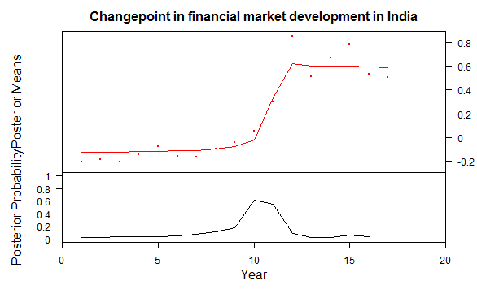

The probability of a change point in the financial market development in India is highest for year 10 (probability of 0.61). This corresponds to the year 2005. This corresponds with the time period of rapid financial growth, especially between 2005 to 2008 when the rate of growth averaged over 9%.[264]

4.2.6 Indonesia

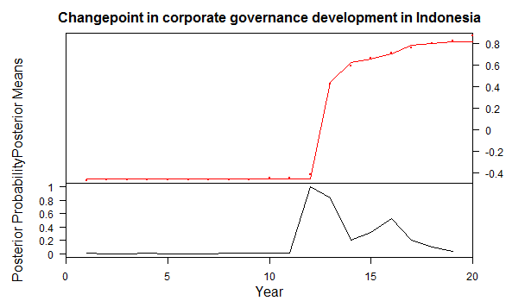

The probability of a change point in the corporate governance growth in Indonesia is high for year 12 (probability of 1) and year 13 (probability of 0.84). This corresponds to the years 2006/07. It was during this period that the new Code of Good Corporate Governance (2006) was being implemented.[265] It was around this time that corporate governance rules for banks were introduced (2006), a number of other legislative reforms were also executed the Law on Foreign Investment, adopted in 1967 was amended in 2007, and the Indonesian Company Law adopted in 1995 was amended in 2007.[266]

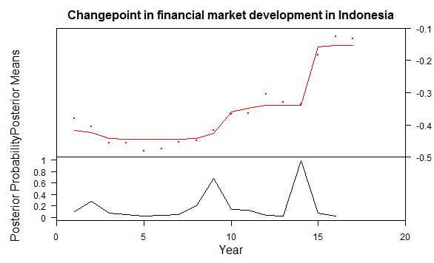

The probability of a change point in financial market development in Indonesia is high for year 14 (probability of 0.98), medium for year 9 (probability of 0.68) and low for year 2 (probability of 0.3). They correspond to year 2009, 2004 and 1997. These time periods coincide with the 1997 Asian financial crisis, recovery and the start of a growth phase in 2004, and the Global financial crisis in 2007/08.[267]

4.2.7 Peru

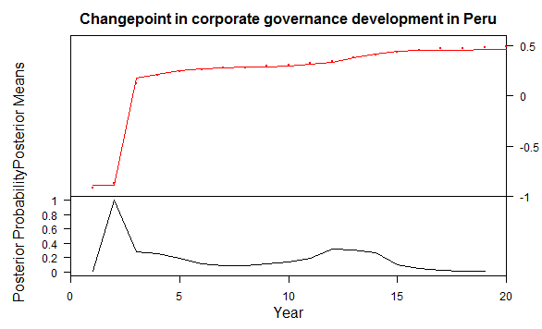

The probability of a change point in the Peruvian corporate governance development is highest in year 2 (probability of 1). This corresponds to the year 1996. Peru thoroughly amended its Securities Market Act in 1996 ‘to increase the efficiency of the capital markets and to boost trading activity.’[268]

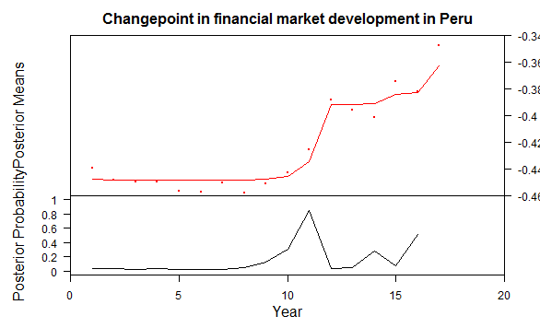

The probability of a change point in the financial market development in Peru is highest in year 11 (probability of 0.85). This corresponds to the year 2006. This was the period of the start of strong economic growth of around 7% per annum which was also reflected in the stock market.[269]

4.2.8 Pakistan

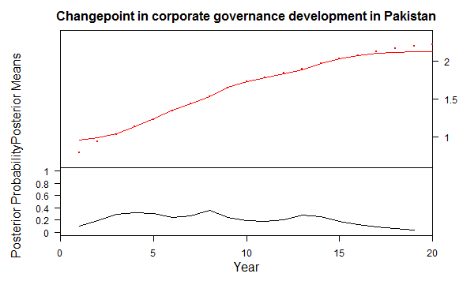

Pakistan does not have any major change points, this shows that there has been a steady growth in corporate governance development without any major upheaval in its laws.

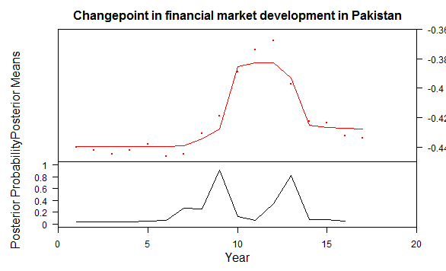

The probability of a change point in the financial market development in Pakistan is quite high for year 9 (probability of 0.91) and year 13 (probability of 0.83). This corresponds to the years 2004 and 2008. In 2004 there was an accelerated growth in all the financial market development parameters – FDI as percentage of GDP shot up, total volume of stocks traded rose sharply and almost all economic parameters were on an upswing. This is captured by the change point analysis of a positive change in 2004. The next change point in 2008 coincides with the Global Financial Crisis and reverses much of the gains made in the previous four years.

4.2.9 Poland

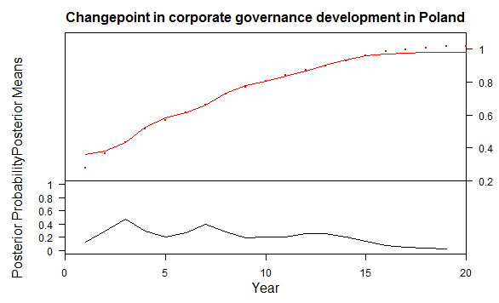

The probability of change points in Polish corporate governance development is relatively low with minor crests in year 3 (0.48) and year 7 (0.4). This correspond to the years 1997 and 2001. This means that, overall, Polish corporate governance has improved at a stable rate. However the spikes in 1997 correspond to the Act on Public Trading of Securities which was enacted in 1997 which brought several securities and company law reforms and in 2001 when the new Code of Commercial Companies was implemented which amended and repealed several regulations on corporate governance.

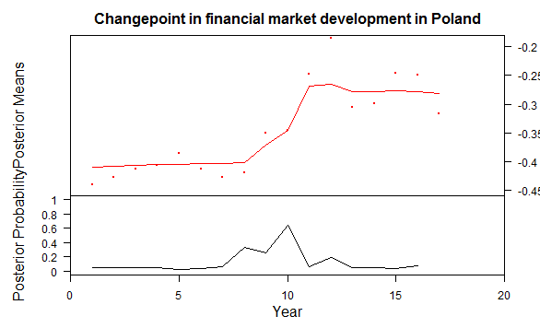

The probability of a change point in financial market development in Poland is highest in year 10 (probability of 0.67). This corresponds to the year 2005. This was the period which was marked by rapid growth in the financial market which continued until the Global Financial Crisis of 2007/08.[270]

4.2.10 Russia

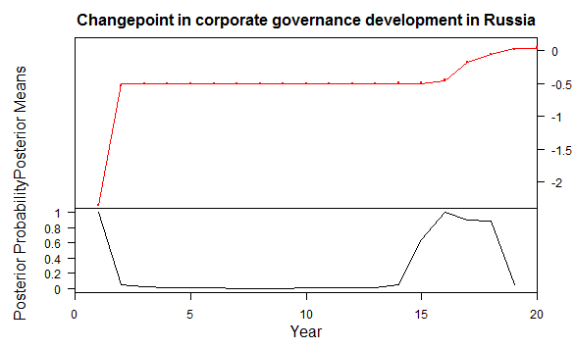

The probability of change points in Russian corporate governance development is high for year 1 (probability: 1) and year 16 (probability: 1), with moderately high probabilities of .89 for year 17 and 18. These correspond to the years 1995, 2010, 2011 and 2012. The change point analysis also suggests that Russian corporate governance leapt forward in the years 1995/96 and had rapid development between 2010 and 2012. Russia introduced a modern system of company law in 1996[271] to bootstrap into privatised economy with shareholder led companies which led to the initial spurt in shareholder primacy corporate governance. For about fifteen years there was no other development, a period marred by inefficient running of companies and a financial collapse in 1998.[272] A slew of new regulations and several amendments to company law have been brought in since 2010.[273]

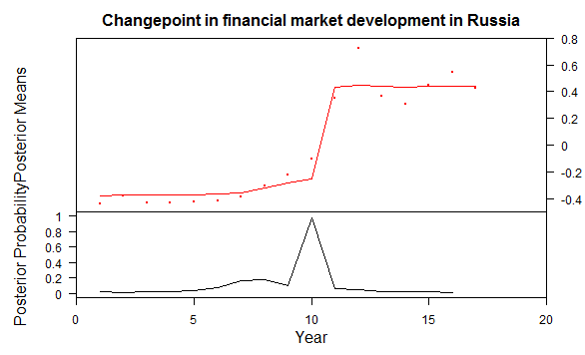

The probability of change points in financial market development for Russia is high for year 10 (probability: 0.98). This corresponds to year 2005. This was the year in which, after the 1998 crash, ‘Russian indexes are out-jumping their rivals in other emerging markets’,[274] based on a surging oil price fuelled boom.[275]

4.2.11 Argentina

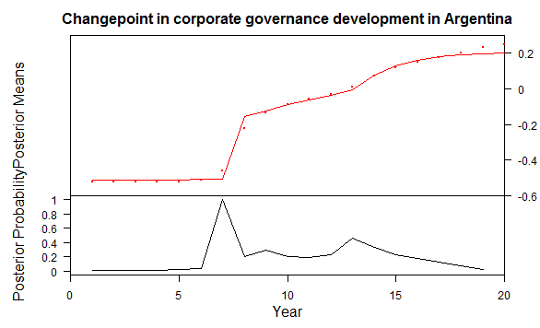

The probability of change in Argentinian corporate governance is highest in the year 7 (probability: 0.99). This corresponds to the year 2001. It was during this period that Argentina adopted Mandatory Tender Offer and in 2002 adopted regulations requiring Audit Committees in public companies.[276] Also in 2001, the National Securities Commission (NSC) Regulations strengthening corporate governance rules on securities law were introduced.

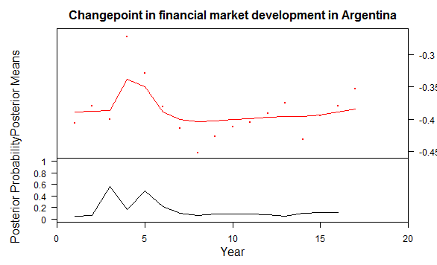

The probability of a change point in the Argentinian financial market is highest in year 3 (probability: 0.56) and year 5 (probability: 0.49). These correspond to the years 1998 and 2000. These years coincide with the 1998–2002 Argentine great depression and an unlikely boom in stock prices in 1999/2000 followed by a steep crash.[277]

4.2.12 South Africa

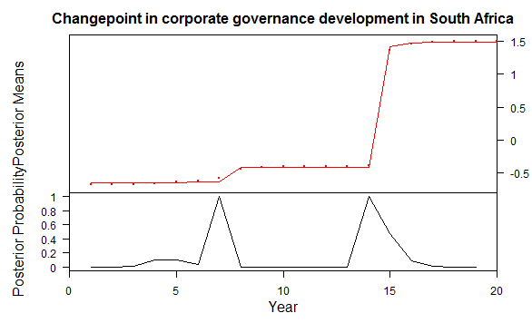

The probability of a change point in the corporate governance development in South Africa is highest for year 7 (probability: 0.99) and year 14 (probability: 1). These correspond to the years 2001 and 2008. They match closely with the introduction of the King Report on Corporate Governance for South Africa - 2002 (King II Report) and the King Code of Governance for South Africa 2009 (King III).

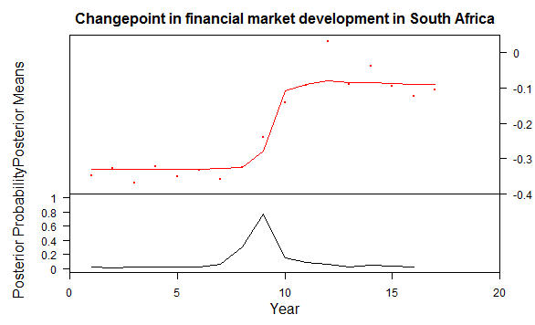

The probability of a change point in financial market development in South Africa is highest in year 9 (probability: 0.77). This corresponds to the year 2004. This was the start of the period when a credit bubble led to impressive financial market growth which ended with the Global Financial Crisis.[278]

4.2.13 Iran

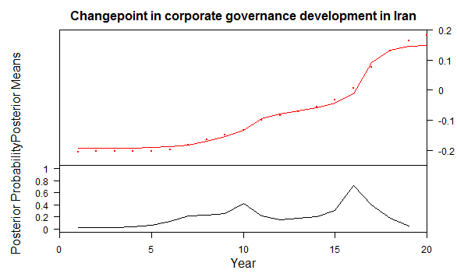

The probability of a regime shift in Iranian corporate governance development is highest for year 16 (probability: 0.72) with a minor crest in year 10 (probability: 0.42). These correspond to the years 2010 and 2004 respectively. Iran improved its security law by enacting a new Securities Market Act in 2005,[279] Iran also updated its commercial laws around 2010 with several guidelines for related party transactions, listing rules at the Tehran Stock Exchange and the promulgation of Fifth Development Economic, Social and Cultural Development Plan Law (2010).

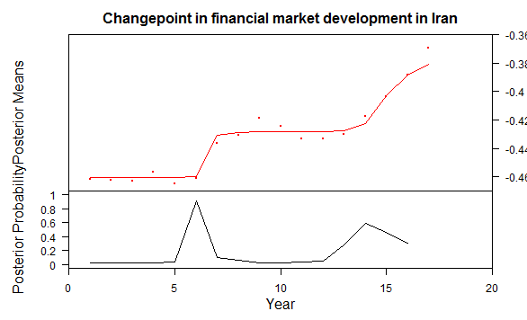

The probability of a change point in the Iranian financial market development is highest in year 6 (probability: 0.91) and a minor inflection in year 14 (probability: 0.59). These correspond to the years 2001 and 2009 respectively. The 2000/01 change was due to increased trading facilitated by automated trading introduced by the Tehran Stock Exchange (TSE) and was backed by improving economic growth and foreign investment. These however diminished over the next few years due to sanctions.[280] The TSE index grew nearly 80% between March 2001 and April 2003.[281] The reasons behind 2009 peak are controversial because some commentators believe that it was ‘a state-created bubble’ while others linked it with increased ‘flow of cash into the stock market.’[282]

4.2.14 Kenya

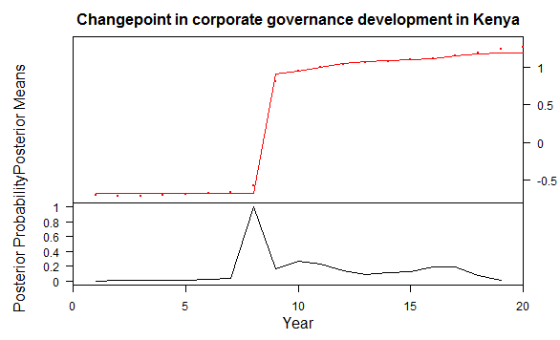

The probability of a change point in Kenyan corporate governance development is highest in year 8 (probability: 1). This corresponds to the year 2002. In this year Kenya introduced the Sample Code of Best Practice for Corporate Governance[283] and the Corporate Governance Codes and Principles.[284]

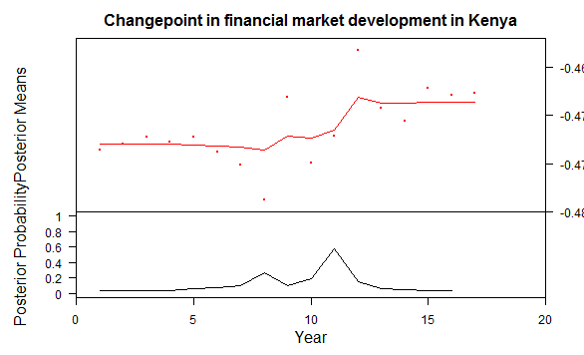

The probability of a shift change in Kenyan financial market development is highest for year 11 (probability: 0.58). This corresponds to the year 2006. This was period of boom amid lot of market and macroeconomic volatility, it is worth noting that the ‘highest figure for Nairobi Stock Exchange 20-share index was recorded in the last quarter of 2006.’[285]

4.2.15 Nigeria

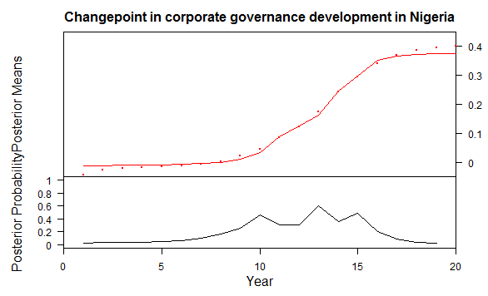

The highest probability of a change point in Nigerian corporate governance development is in year 13 (probability: 0.6), with minor crests in year 10 (probability: 0.48) and year 15 (probability: 0.48). These years correspond to 2007 (major change), and the years 2003 and 2009/10 for minor change. The first Corporate Governance Codes and Principles[286] in Nigeria was introduced in 2003 by the Securities and Exchange Commission, Nigeria, in 2006 the Code of Corporate Governance for Banks in Nigeria Post-Consolidation was introduced, in 2008 the Code of Corporate Governance for Licensed Pension Operators was introduced, these regulations together contributed to the 2007 crest. Later in 2011 the Code of Corporate Governance was updated along with giving protection to whistle-blowers in 2014, these would have contributed to the 2009/10 crest.

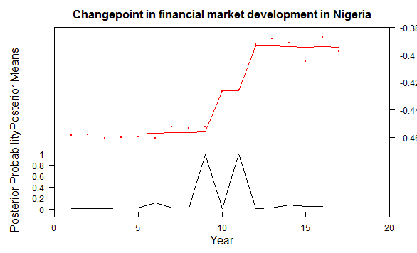

The probability of change in the Nigerian economy was highest in year 9 (probability: 0.99) and 11 (probability: 0.99). They correspond to years 2004 and 2006. 2004 to 2008 was a period of rapid financial growth in Nigeria fuelled by steadily rising oil prices:

“Government spending tracked the price of oil, monthly disbursements of oil revenues flooded the banking system, driving up deposits and lending, and accelerating credit creation. During this period, bank deposits and consumer credit quadrupled, as banking assets grew at an average rate of 76% post-consolidation. […] Nigeria’s financial boom was too rapid for the real economy to absorb the excess liquidity from oil revenues and foreign investments in productive sectors. This drove significant flows into non-priority sectors and into the capital markets – mostly in the form of margin loans and proprietary trading. […] As a result, the NSE’s market capitalization surged between 2004 and 2008, as the market capitalization of banking stocks grew by a factor of nine.”[287]

4.2.16 Hong Kong

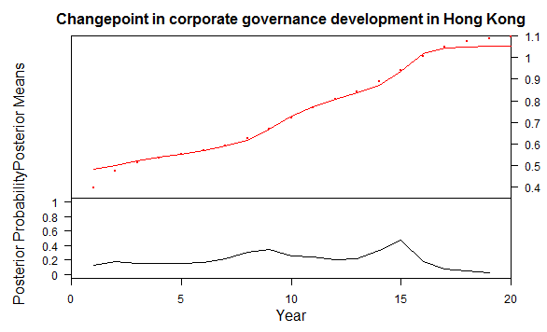

The corporate governance growth of Hong Kong has been quite steady so there are not any major change points, the only highlights are in year 15 (probability: 0.47) and year 9 (probability: 0.35). These correspond to the years 2009 and 2003. The 2003 change can be attributed to adoption of Hong Kong Code on Corporate Governance in 2004, Model Code for Securities Transactions by Directors of Listed Companies: Basic Principles in 2001 and the Corporate Governance Disclosure in Annual Reports in 2001. The 2009 change can be attributed to changes in Codes on Takeovers and Mergers and Share Buy-backs and amendments to Company law around that period. It is to be kept in mind that the absence of change points does not mean that corporate governance has not developed, it can be interpreted in several ways – 1) that the development has been steady without any sharp cut off point, 2) there has been no development and it has been steady – this could be because the country already has a good corporate governance system or because it does not legislate on the issues that are being studied in this research.

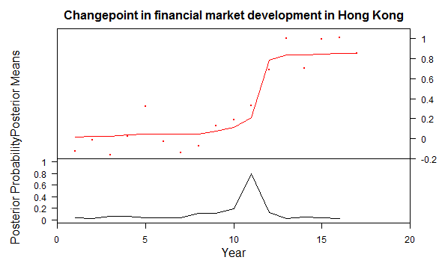

The probability of a change point in financial development in Hong Kong is highest in year 11 (probability: 0.8). This corresponds to year 2006, when Hong Kong Stock Exchange was pushed up by the Chinese Equity bubble.[288] Many companies in China are dual listed in China and Hong Kong, as there is a QFII quota for foreign investors in China. The shares in China are called A shares and the shares in Hong Kong are called H shares. Based on robust economic growth and presumptions of future demands, Chinese companies held IPOs in Hong Kong, this ‘attracted global liquidity to Hong Kong and the Hong Kong China Enterprise Index (HKCEI) jumped 94 percent and 56 percent in 2006 and 2007 respectively.’[289]

4.2.17 Philippines

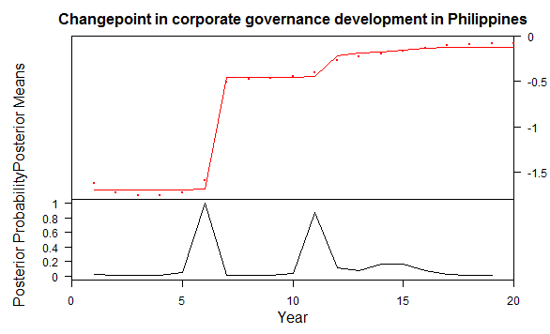

The probability of a change occurring in the corporate governance landscape in the Philippines is high for year 6 (probability: 1) and in year 11 (probability: 0.87). These correspond to the years 2000 and 2005. In 2000 the Philippines adopted ICD Code of Proper Practices for Directors, in the same year The Securities Regulation Code (SRC) was legislated. The 2005 change was due to the amendments to SRC and the Special Accounting Rules, to conform to International Accounting Standards (IAS).[290]

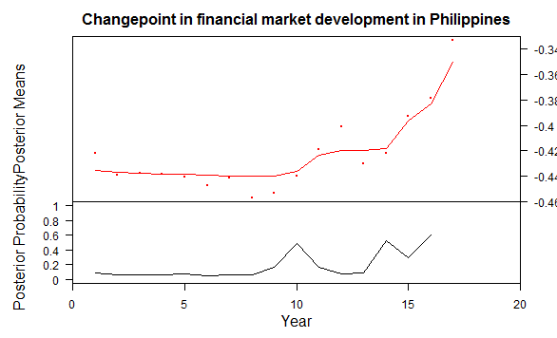

The probability of change points in the Philippines financial market development is low except in year 10 (probability: 0.48), year 14 (probability: 0.53) and year 16 (probability: 0.6). These correspond to the years 2005, 2009 and 2011 respectively. Philippines showed net inflows in its capital and financial account during the period 2000–07, with higher relative growth in 2005, in tandem with robust growth and positive prospects for the economy.[291] The Philippines financial market also remained relatively insulated from the Global Financial Crisis and was one of the few economies where the market rebounded quickly.[292] The 2009 and 2011 peaks can be attributed to this recovery from the Global Financial Crisis of 2008.

4.2.18 United Kingdom

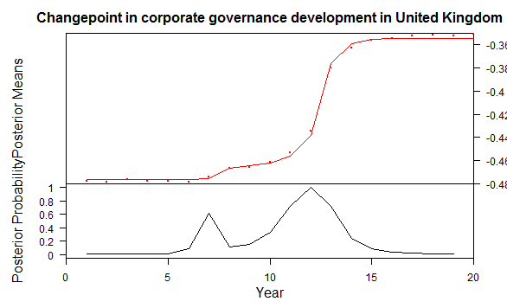

The change in corporate governance in the UK in the last twenty years is minimal, but the probability of any change point in the last twenty years is highest in the year 12 (probability: 1) with minor changes in year 7 (probability: 0.62), 11 (probability: 0.72) and 13 (probability: 0.72). The major shift corresponds to the year 2006 with minor shifts in 2001, 2005 and 2007. These shifts can be attributed to the publication of several non-binding codes like good practice suggestions from the Higgs Report[293] and the publication of the Combined Code on Corporate Governance by the Financial Reporting Council (FRC) in 2006; Myners Report[294] and the Code of Good Practice[295] by Association of Unit Trusts and Investment Funds in 2001; Internal Control: Revised Guidance for Directors on the Combined Code published by FRC in 2005 etc.

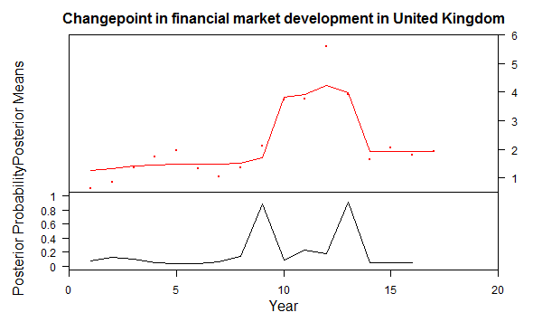

The probability of change points in UK financial development is highest for year 9 (probability: 0.88) and year 13 (probability: 0.91). These correspond to the years 2004 and 2008 respectively. There was a sustained upswing in the financial market in the UK from 2003 to 2007, Ben Bernanke ‘argued that, probably thanks to better theory of monetary policy, the world had entered the era of “great moderation”, in which the volatility of prices and outputs is minimised.’[296] The FTSE regained the height of the late -1990s dotcom boom.[297] Mervyn King, the then Governor of the Bank of England termed the years as the ‘nice’ (non-inflationary consistently expansionary) decade.[298] Gordon Brown, the then Chancellor of the Exchequer claimed to help solve the ‘boom and bust’ economics leading to ever greater economic growth.[299] It is postulated that deregulation and the ‘benign macro-economic situation encouraged investment in both capital and financial investments. […] Financial institutions became willing to take on more risky investments because they were more confident that there wouldn’t be any major economic downturn.’[300] This led to the Global Financial Crisis of 2008 and the London Stock Exchange suffered the worst fall in its history.[301] As shown in the graph above, the post-2008 the financial market fell back to its pre-2004 level.

4.2.19 El Salvador

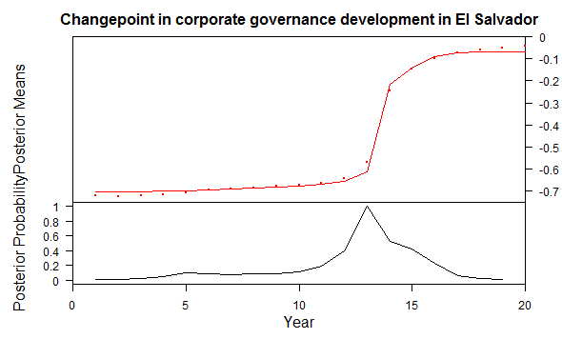

The probability of a change point in corporate governance development of El Salvador is highest for year 13 (probability: 1). This corresponds to year 2007/08, when the International Services Act, establishing a legal framework with clear rules for new opportunities for investment in the service sector with the potential to be traded internationally was adopted, along with reforms in the Commercial Code. El Salvador also introduced The Financial System Supervision and Regulation Law in 2011 to integrate its financial regulators into one super regulator.[302]

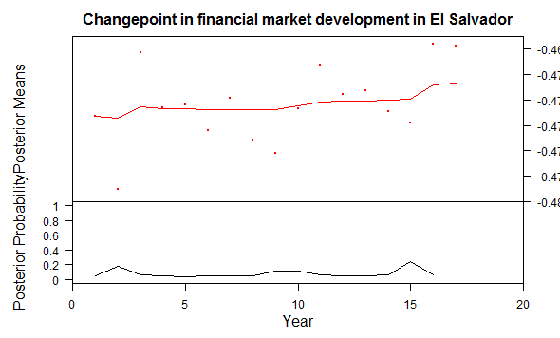

4.2.20 Vietnam

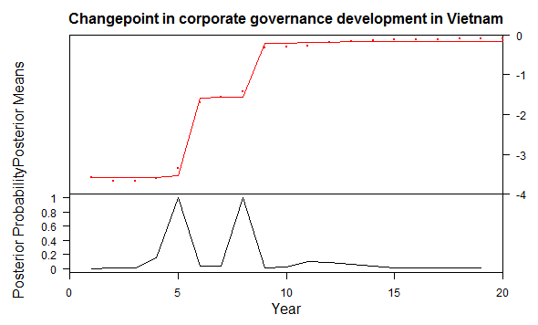

The probability of a change point in Vietnamese corporate governance development is highest in year 5 (probability: 1) and year 8 (probability: 1). They correspond to years 1999 and 2002. These steep jumps would coincide with several reforms initiated to update the corporate governance regime in Vietnam – chief among them are Law on Enterprises (LOE, 2005), the Model Charter 2002, and the Law on Securities 2006.[303]

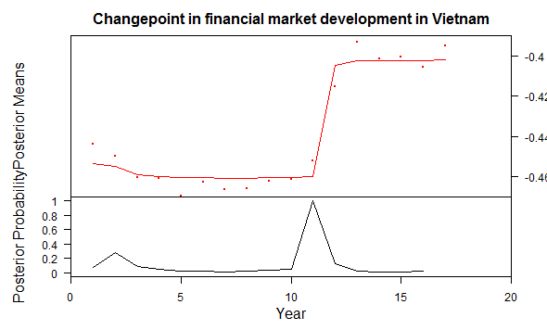

The probability for a change point in the financial market development of Vietnam is highest for year 11 (probability: 1). This corresponds to the year 2006, which saw the stock market of Vietnam booming at an unprecedented rate, becoming the ‘the second-best-performing exchange in the world’[304] that year. It joined WTO the same year and was ‘Asia’s second fastest growing economy after China’[305]

4.2.21 Germany

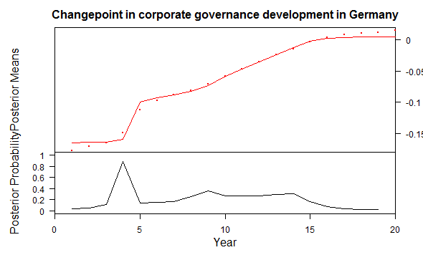

The probability of a shift change in German corporate governance can be observed in year 4 (probability: 0.88). This corresponds to year 1998, when Germany amended the Aktiengesetz (AktG) - the German Joint Stock Corporations Act and the Handelsgesetzbuch (HGB) – the German Commercial Code, to improve disclosure requirements, abolish golden shares, allow buy-back of shares etc. Germany introduced a formal but non-binding corporate governance code in 2002[306] and has since then continuously updated it.[307]

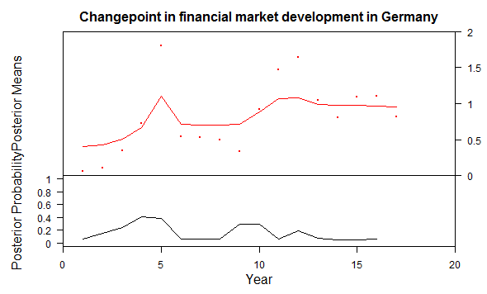

The financial market of Germany has remained remarkably stable with steady growth and very few substantial change points, the only minor change point that can be determined is in year 4 (probability: 0.41). This corresponds to the year 1999, when the dot com bubble was pushing up stock prices especially those of technology stock companies in more developed countries. The subsequent fall in 2000/01 corresponds to the bursting of the dot com bubble.[308]

When the probabilities of the change points of corporate governance development are consolidated in a heatmap time panel, the following pattern emerges. A higher shade of red indicates a higher probability of a breakpoint while a darker shade of blue indicates a lower probability of change:

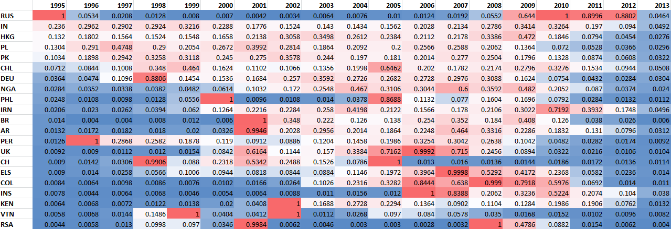

The outcome is in line with the previous findings on convergence, there is a steady shift in the adoption of pro-shareholder corporate governance policies. This happens in two main waves first between 1999 and 2002 and the second between 2005 and 2008. After that there is a sudden decline in the rate of convergence towards a shareholder value model of corporate governance. Similarly, for financial market development there is the following change point probability heatmap:

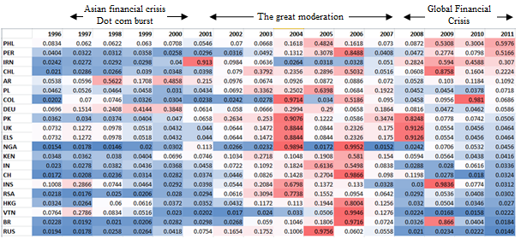

It shows that major bands of change points for financial market development cluster around the Global Financial Crisis.

Comparing the time gap between regime changes in corporate governance and financial market development, interesting recurring pattern emerges. In ten (Brazil, China, Chile, Colombia, Indonesia, Peru, Poland, Kenya, South Africa and Germany) out of twenty one countries studied in this research, the corporate governance change point occurs before the financial market development change point, with an average gap of 3.7 years. For five countries (Russia, Argentina, Iran, Nigeria and Hong Kong) the financial market development shift change happened before major shareholder value oriented developments in corporate governance caught up with it, with an average gap of 2 years. The gap is absent, negligible or indistinguishable for six countries (El Salvador, United Kingdom, Philippines, India, Pakistan and Vietnam).

This analysis would suggest that corporate governance might have a role to play in financial market development. However we also have to keep in mind that the seventeen year duration (1996-2012) of financial market development studied in this research contains three major periods of market volatility (clearly visible in the heatmap above) - the Asian Financial Crisis, the dot com bubble and the Global Financial Crisis. Most of the economies studied received a negative shock as part of at least one of these crises. Conversely many of the economies received a powerful boost between 2004-2007 when favourable monetary policies coupled with robust economic growth meant that the stock markets were performing exceedingly well.

So these findings based on change point analysis confirm that corporate governance may affect financial market development. However, to confirm whether this is really the case requires, ideally, data for a longer period of time. Unfortunately, since the drive for shareholder primacy in emerging and developing economies really began in the mid-1990s this is not really possible. However, structural models relying on Bayesian techniques can be used to isolate the impact of shifts towards shareholder primacy corporate governance on the growth of the financial market. Structural models with now be applied to the datasets.

**4.3 Structural models**

As the previous subchapter posits, corporate governance step change developments generally occur prior to shifts in financial market developments. As such, there might be some impact of changing corporate governance on financial market development. So, in this subchapter structural models are used to explore the extent to which corporate governance change impacts on financial market development.

As has already been explained in the methodology chapter a Bayesian panel data multilevel regression model will be run with the following variables. The dependent variable is a Bayesian factor analysis of five individual variables - Foreign Direct Investment (FDI), market capitalisation of listed companies, number of listed domestic companies, S&P global equity index and volume of stocks traded, which produces a financial market development index. The independent or the explanatory variable is a corporate governance index which is calculated utilising fifty two polynomial variables using a dynamic graded response model. There are three control indices – the first is a financial control index which is a Bayesian factor analysis of five variables: GDP, PPP, balance of payment, interest rates and external debt; the second control is a technological and financial inclusion index which is a Bayesian factor analysis of three variables: banks per capita, access to cellphones and access to internet; the third control is on industrial value addition through R&D which is calculated as a Bayesian factor analysis of two variables: annual value of high technology exports and the number of patent and trademark applications at USPTO. The country level controls are Human Development Index, GINI coefficient, peace index and rule of law index.

All the variables have been scaled during analysis, this has been done so that data across different scales can be brought to equal footing and be comparable. Standardised scores retain the order of values and do not alter the spread of the distribution. In order to interpret the regression coefficients adequately, it is important to get reacquainted with the dimensions of the variables being studied. The outcome variable (financial market growth) mean varies between -0.484442342 to 5.590986766; corporate governance mean ranges from -3.534233674 to 2.379850602; control 1 mean varies from -0.812063767 to 6.603306772; control 2 mean varies from -0.963732058 to 2.522277709; control 3 mean varies from -0.544303762 to 7.081288848; HDI ranged between 1.708205376 to 1.658184144; GINI values ranged between -1.93865098 and 1.38711035; peace index ranged between -1.86111526 and 1.52476794; rule of law ranges from -1.6202276 to 1.9709245.

The results of the regression analysis with the mean estimate and 95% credible interval are summarised below:

|  |  |  |  |
| --- | --- | --- | --- |
| Coefficients | Mean estimate | 2.5% quantile | 97.5% quantile |
| Corporate governance (b1) | 0.065933098 | 0.003271972 | 0.128982723 |
| Control 1 (economic) (b2) | 0.416891465 | 0.330837219 | 0.496054383 |
| Control 2 (technological inclusion) (b3) | 0.084809059 | 0.013562828 | 0.15347945 |
| Control 3 (industrial value addition) (b4) | 0.370575484 | 0.28245685 | 0.451040566 |
| Country level common intercept (R0) | -0.139287 | -0.2875252 | 0.01033384 |
| HDI (R1) | -0.07932591 | -0.3499764 | 0.1961929 |
| GINI (R2) | -0.008270965 | -0.1712987 | 0.1565898 |
| Peace index (R3) | -0.02080429 | 0.2493879 | 0.2069733 |
| Rule of law (R4) | 0.1610097 | -0.2072071 | 0.5279218 |

The country level varying intercepts (b0) are as following:

|  |  |  |  |
| --- | --- | --- | --- |
|  | Mean | 2.5% quantile | 97.5% quantile |
| Brazil | -0.12244 | -0.27047 | 0.02468 |
| China | 0.013511 | -0.23057 | 0.263796 |
| Chile | -0.16961 | -0.30289 | -0.03452 |
| Colombia | -0.15642 | -0.2914 | -0.02088 |
| India | -0.0192 | -0.21219 | 0.175485 |
| Indonesia | -0.16174 | -0.29934 | -0.02264 |
| Peru | -0.20591 | -0.33799 | -0.07059 |
| Pakistan | -0.27066 | -0.4467 | -0.09117 |
| Poland | -0.317 | -0.46093 | -0.16702 |
| Russia | -0.2549 | -0.42917 | -0.07813 |
| Argentina | -0.26076 | -0.39827 | -0.12043 |
| South Africa | -0.12753 | -0.27251 | 0.015126 |
| Iran | -0.28772 | -0.43223 | -0.14406 |
| Kenya | -0.19227 | -0.3366 | -0.05165 |
| Nigeria | -0.20744 | -0.3563 | -0.06275 |
| Hong Kong | 0.270039 | 0.094032 | 0.450204 |
| Philippines | -0.24643 | -0.38522 | -0.10797 |
| El Salvador | -0.17016 | -0.30293 | -0.03418 |
| Vietnam | -0.0575 | -0.2212 | 0.105893 |

The trace plots below on the left show that the MCMC chains have converged and the density plots on the right show the spread of the output. Uniform density plots and converging trace plots signify that the Bayesian model being run in this research has converged and is statistically valid. A couple of graphs are shown here the entirety of trace plots and density plots is available in DVD2 and Appendix IV.

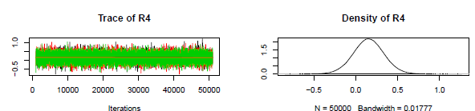

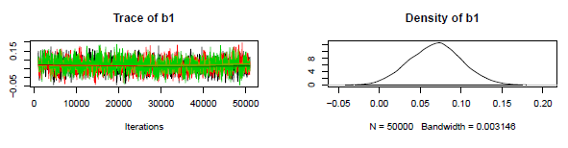

A further proof that the model is stable is provided by the Gelman and Rubin's convergence diagnostic, if the value is 1± 0.05 the variable is said to have converged.[309] Below are Gelman and Rubin's convergence diagnostic for the regression coefficients:

|  |  |
| --- | --- |
| Variable | Mean estimate of convergence diagnsotic |
| b1 | 1.010659 |
| b2 | 1.0047 |
| b3 | 1.011442 |
| b4 | 1.001846 |
| R0 | 1.000046 |
| R1 | 1.000867 |
| R2 | 1.000028 |
| R3 | 1.001067 |
| R4 | 1.001472 |

A comparison of corporate governance coefficient (b1) mean estimates of 0.0659 with the mean estimates of control variables like economic growth coefficient (b2) 0.4169 and industrial value addition coefficient (b4) 0.3706, shows that economic growth coupled with technology-led industrial growth has twelve times more impact on financial market development than a change in corporate governance model towards more shareholder value.

Another way of presenting the data would be to state that the model predicts that keeping other factors constant increasing the economy and high technology output by 1.25 times double the financial development, while to reach the same level of financial development growth only by improving corporate governance would require a fifteen fold shift in the corporate governance regime towards a shareholder value model. As seen in the previous subchapter, the corporate governance regimes in all the countries have reached peak shareholder value orientation, it is possible therefore to posit that there is no scope for the level of change required in corporate governance models to make any significant contribution to financial market growth. Armour, Deakin et al. also found that ‘increases in shareholder protection have not led to greater stock market development, as might have been expected.’[310] However they also posited that given the data was for 1995 to 2005 ‘the strengthening of shareholder rights which took place in the 1990s and 2000s has not been having its principal intended effect.’[311] This research confirms that even under a longer time period, data change in the corporate governance model does not have any noticeable impact on financial market growth.

However the estimate of impact of change in corporate governance (b1) 0.0659 has more bearing on financial market development in comparison to the country level variables like GINI coefficient (R2) -0.0082, peace index (R3) -0.0208, HDI (R1) -0.0793, except for rule of law estimated at (R4) 0.161 which has double the impact on financial market development.

The model predicts that GINI coefficient (-0.0082) has almost no impact on financial market development. What is interesting is that HDI affects the financial market development negatively, this can be correlated to the fact that lower HDI would mean lower wages which would lead to more FDI and hence greater financial development. However, this also paradoxically reduces the amount of technology-led exports and R&D expenditure which has a high impact on financial market growth.

The model also predicts that rule of law is twice as important as adopting shareholder primacy models on the growth of financial markets. This is in line with the common understanding that investors move to countries with a stable legal and judicial system.

So we can summarise that for the developing countries, studied under this research there is a weak impact of change in the corporate governance model on financial market growth, especially in comparison to the overall impact of financial, technological and economic growth.

**4.4 Individual country-based models**

From the analysis of the structural model in the previous subchapter it is evident that a pro-shareholder change in corporate governance regulation has little impact on financial market development in emerging economies. However, it will be interesting to find out the range of impact on a per country basis, i.e. instead of running a structural model incorporating all countries a basic OLS regression for each country will be used. This will help to isolate any country which may have reacted more positively than others which is the natural corollary to the varying intercept structural model in the previous subchapter. If a country which has reacted more positively to change in corporate governance is found, it will set the foundations for future qualitative research to find out, for example, what happened differently in that country in comparison to others, what sui generis factors were present, and so on.

In this subchapter regression utilising both frequentist and Bayesian approaches is applied. The results of the regression coefficients are presented first, in a tabular format. Then a brief report is presented for each country describing the impact of change in corporate governance on the financial market. This will be accompanied by sets of three 3D graphs showing the contrasting impact of corporate governance change and three controls on the financial market using both frequentist and Bayesian outputs. Each graph will show local regression planes, light red is the frequentist regression plane whilst green denotes the Bayesian regression plane.

|  |  |  |  |  |  |  |  |
| --- | --- | --- | --- | --- | --- | --- | --- |
| Bayesian analysis | | | | | | | |
|  | Corporate Governance coefficient | | | Intercept | Control 1 coefficient | Control 2 coefficient | Control 3 coefficient |
|  | Mean | 2.5% quantile | 97.5% quantile | Mean | Mean | Mean | Mean |
| Brazil | 0.062853 | 0.049519 | 0.0761 | -0.11515 | 0.418122 | 0.084039 | 0.43738 |
| China | 0.032681 | 0.018637 | 0.046816 | -0.00826 | 0.46066 | 0.24393 | 0.327721 |
| Chile | 0.139975 | -1.24498 | 2.030255 | -0.14729 | 0.399509 | 0.079426 | 0.468502 |
| Colombia | 0.075378 | -0.03726 | 0.185066 | -0.13884 | 0.425973 | 0.079505 | 0.429411 |
| India | 0.062502 | 0.003676 | 0.120785 | -0.01918 | 0.398711 | 0.057521 | 0.472082 |
| Indonesia | 0.066574 | 0.038958 | 0.094967 | -0.14892 | 0.411826 | 0.087087 | 0.465394 |
| Peru | 0.060262 | 0.011902 | 0.116667 | -0.20842 | 0.394241 | 0.079355 | 0.39691 |
| Pakistan | 0.062161 | 0.033106 | 0.091461 | -0.25478 | 0.43312 | 0.079625 | 0.414556 |
| Poland | 0.077912 | -0.00566 | 0.158403 | -0.3002 | 0.480641 | 0.070058 | 0.393737 |
| Russia | 0.064709 | 0.051765 | 0.077738 | -0.24181 | 0.413657 | 0.084067 | 0.452866 |
| Argentina | 0.066942 | -0.01842 | 0.158039 | -0.2454 | 0.413628 | 0.08443 | 0.456878 |
| South Africa | 0.064471 | 0.053535 | 0.07527 | -0.11819 | 0.417834 | 0.087343 | 0.435347 |
| Iran | 0.019438 | -0.27192 | 0.308407 | -0.27136 | 0.489304 | 0.088699 | 0.428396 |
| Kenya | 0.097482 | -2.01627 | 2.025642 | -0.04713 | 0.548885 | 0.107545 | 0.604804 |
| Nigeria | 0.055016 | -0.07813 | 0.182682 | -0.19151 | 0.416011 | 0.088196 | 0.436266 |
| Hong Kong | 0.074224 | -0.06334 | 0.212401 | 0.274053 | 0.410382 | 0.0851 | 0.453187 |
| Philippines | 0.054709 | 0.017428 | 0.089057 | -0.25566 | 0.421624 | 0.07878 | 0.351537 |
| El Salvador | 0.040808 | -0.18211 | 0.2067 | -0.24525 | 0.31797 | 0.06451 | 0.292567 |
| Vietnam | 0.060049 | 0.037825 | 0.086218 | -0.04812 | 0.450734 | 0.084713 | 0.37679 |

All the individual models have converged with 50,000 iterations except for Kenya and El Salvador which required 400,000 iterations to reach acceptable convergence. Even then, the confidence interval is very wide for most of the Kenyan and El Salvadorian coefficients reducing their efficiency. This means that it is not possible to use a coefficient for Kenya and El Salvador for accurate predictive analysis. The Gelman-Rubin diagnostic, the density and trace plots, and the complete output with upper and lower quantiles for intercepts and controls are presented in the Appendix.

|  |  |  |  |  |  |  |  |  |  |  |
| --- | --- | --- | --- | --- | --- | --- | --- | --- | --- | --- |
| Frequentist analysis | | | | | | | | | | |
|  | Intercept | CG | Control 1 | Control 2 | Control 3 | Pr.Intercept | Pr.CG | Pr.Ctrl1 | Pr.Ctrl2 | Pr.Ctrl3 |
| Brazil | -0.11254 | 0.038065 | 0.42516 | 0.092546 | 0.446796 | 8.40E-07 | 5.62E-05 | 2.66E-11 | 0.000197 | 2.17E-07 |
| China | -0.10093 | 0.005788 | 0.460602 | 0.23133 | 0.342759 | 0.003033 | 0.563697 | 1.07E-13 | 4.43E-06 | 1.88E-12 |
| Chile | -0.15745 | 0.039628 | 0.407343 | 0.08679 | 0.458427 | 4.93E-23 | 4.31E-12 | 1.21E-19 | 3.77E-21 | 8.51E-18 |
| Colombia | -0.13978 | 0.123907 | 0.407344 | 0.067939 | 0.319288 | 1.72E-08 | 4.03E-13 | 1.18E-09 | 3.61E-09 | 1.68E-05 |
| India | -0.16607 | 0.140102 | 0.342849 | 0.021449 | 0.541839 | 5.91E-08 | 4.48E-08 | 3.18E-05 | 0.200271 | 2.58E-05 |
| Indonesia | -0.15773 | 0.085853 | 0.397137 | 0.072739 | 0.47568 | 1.05E-09 | 7.17E-07 | 1.32E-11 | 6.81E-05 | 7.14E-07 |
| Peru | -0.33505 | 0.010709 | 0.269808 | 0.044918 | -0.0278 | 1.58E-09 | 0.201662 | 2.85E-05 | 0.000148 | 0.774833 |
| Pakistan | -0.3114 | 0.074054 | 0.37303 | 0.051913 | 0.406858 | 7.36E-15 | 2.67E-10 | 7.25E-08 | 2.14E-05 | 1.56E-06 |
| Poland | -0.2897 | 0.046818 | 0.470849 | 0.083779 | 0.393734 | 2.33E-21 | 4.52E-15 | 1.86E-10 | 1.97E-16 | 8.20E-09 |
| Russia | -0.24547 | 0.064273 | 0.411433 | 0.086978 | 0.451778 | 1.46E-22 | 2.63E-17 | 8.09E-26 | 2.39E-18 | 8.36E-21 |
| Argentina | -0.32011 | -0.08268 | 0.311571 | 0.149698 | 0.380249 | 4.34E-13 | 5.32E-05 | 9.83E-09 | 2.37E-07 | 8.55E-06 |
| South Africa | -0.21902 | 0.051184 | 0.460795 | 0.184856 | 0.299026 | 1.22E-10 | 2.44E-07 | 0.000234 | 1.35E-08 | 0.013631 |
| Iran | -0.2807 | -0.19914 | 0.590959 | 0.122274 | 0.443141 | 1.15E-09 | 8.23E-06 | 1.41E-06 | 3.92E-08 | 5.44E-06 |
| Kenya | -0.23664 | 0.049405 | 0.377399 | 0.064134 | 0.288727 | 8.05E-09 | 3.40E-09 | 4.78E-08 | 1.38E-08 | 5.31E-09 |
| Nigeria | -0.45282 | -0.01946 | -0.1454 | 0.088249 | -0.31805 | 0.039874 | 0.911714 | 0.456527 | 0.474992 | 0.300745 |
| Hong Kong | 0.201533 | 0.380608 | 0.372686 | -0.00216 | 0.463233 | 1.51E-06 | 9.39E-10 | 0.000122 | 0.920713 | 0.00022 |
| Philippines | -0.30529 | 0.022953 | 0.256987 | 0.076865 | 0.123642 | 1.46E-12 | 0.011679 | 3.18E-05 | 2.09E-05 | 0.001053 |
| El Salvador | -0.32644 | 0.016982 | 0.182318 | 0.049945 | 0.237212 | 9.98E-07 | 0.12988 | 0.000503 | 0.000129 | 0.005943 |
| Vietnam | -0.04222 | 0.060918 | 0.458623 | 0.085261 | 0.381997 | 0.041982 | 7.16E-11 | 4.18E-10 | 6.52E-14 | 3.47E-11 |

Almost all the factors are predicted to be highly significant under the Null hypothesis test. The factors deemed not significant under the Null hypothesis test are underlined (for pr>.05).

4.4.1 Brazil

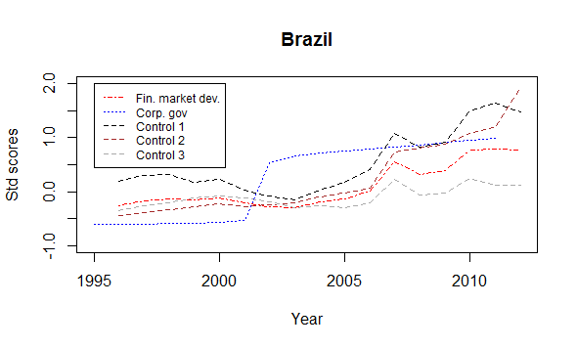

The graphs above show that there were three main corporate governance phases in Brazil, a steady even phase of no shift to shareholder value from 1995 to 2001, a sharp rise in shareholder primacy regulation and then slow growth from 2002 onwards. The graph above also shows that control variables have more impact and correlate more closely to the changes in financial market development in Brazil than any change in its corporate governance models.

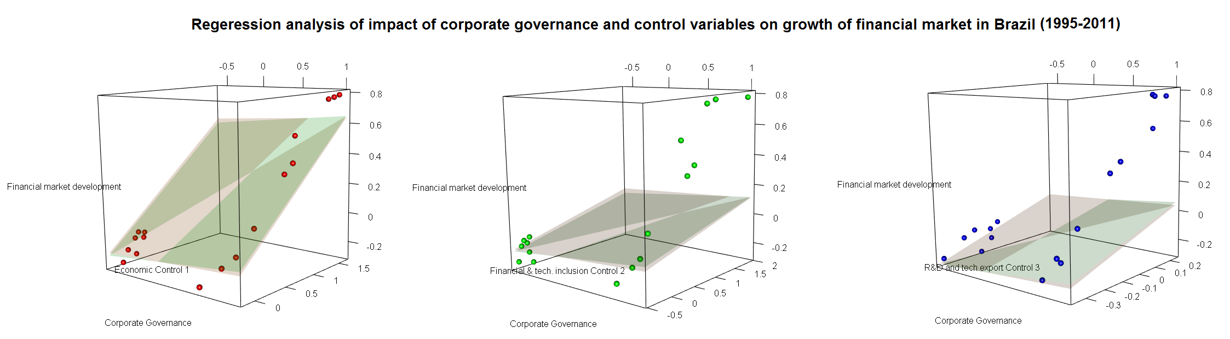

This is borne out by the three regression graphs above. The graphs show that there was higher financial market development with more shareholder primacy corporate governance. However, the control variables on the Z axis show that higher financial market development always coincided with higher economic development (control 1) and more high technology export and investment in R&D (control 3). The mean Bayesian and frequentist coefficients diverge significantly for the impact of corporate governance. Bayesian analysis shows almost double the impact of change in corporate governance in comparison to frequentist analysis.

|  |  |  |  |  |  |
| --- | --- | --- | --- | --- | --- |
|  | CG | Control 1 | Control 2 | Control 3 | Intercept |
| Mean Bayesian | 0.062853 | 0.418122 | 0.084039 | 0.43738 | -0.11515 |
| Frequentist | 0.038065 | 0.42516 | 0.092546 | 0.446796 | -0.11254 |

The Bayesian analysis puts the corporate governance coefficient high density interval to be between 0.049519 and 0.0761. The frequentist coefficient of 0.38065 falls outside this area. Please note that the frequentist coefficient is not treated as a marker for region of practical equivalence to test the significance of the Bayesian output, as there is no intuitive or scientific reason to prefer frequentist analysis as a standard. However, what is clear from both the Bayesian and frequentist coefficient is that in comparison to the controls they tend to be insignificant.

Therefore, we can conclude that change in corporate governance policies had little impact on financial market development in Brazil, at least compared to the impact of economic, financial and technological investment controls.

4.4.2 China

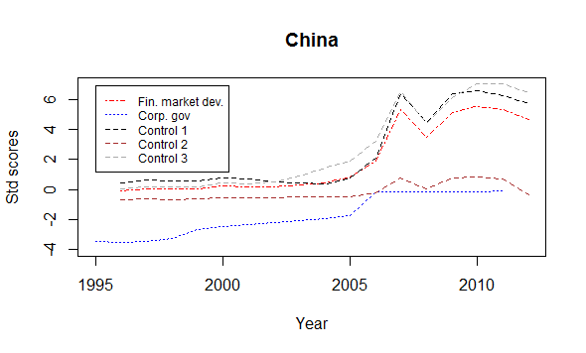

The graphs above show that in comparison to other countries, Chinese corporate governance was non-existent for a period of time (the Chinese corporate governance index starts at -3, one of the lowest among the countries studied), then it was aggressively developed over a short period of time with some rapid bursts followed by a slow tapering off (between 1995 and 2014 China had one of the highest degrees of shareholder value shift, in the corporate governance model, among the countries studied).

Increased shareholder value corporate governance tends to coincide with higher financial market development, but the control variables show much greater influence on financial markets.

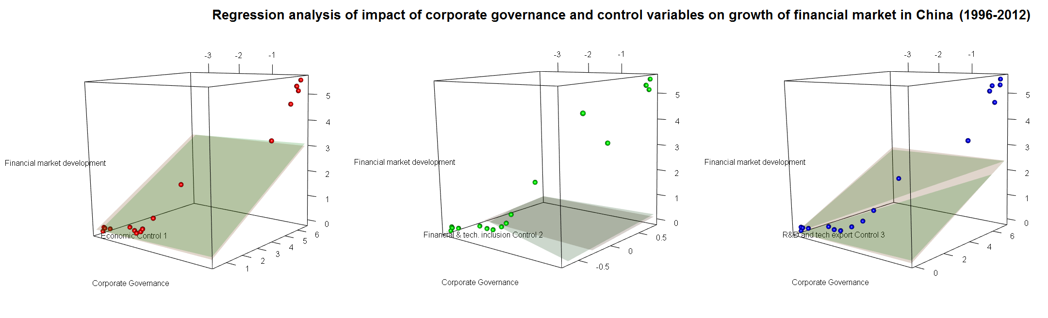

This is proved by the fact that the regression planes have a remarkably high tilt towards the Z axis which denotes the control variables. Change in corporate governance has an impact on financial market growth comparable with that of financial and technological inclusion (control 2) where the regression plane is almost flat, signifying similar importance between the variables in the X axis and the Z axis. The other control factors like the economic factors (control 1) and increase in investment in R&D and technology-led exports have far more impact than shifts in the corporate governance model.

While the regression coefficients for control variables are comparable, the corporate governance regression coefficients diverge extremely between Bayesian and frequentist analysis. Bayesian analysis puts the impact of change in corporate governance at approximately five times that given by frequentist analysis.

|  |  |  |  |  |  |
| --- | --- | --- | --- | --- | --- |
|  | CG | Control 1 | Control 2 | Control 3 | Intercept |
| Mean Bayesian | 0.032681 | 0.46066 | 0.24393 | 0.327721 | -0.00826 |
| Frequentist | 0.005788 | 0.460602 | 0.23133 | 0.342759 | -0.10093 |

Bayesian analysis puts the high density interval tightly between 0.018637 and 0.046816, the frequentist coefficient falls well out of this range. However, both coefficients are much smaller in comparison to the control coefficients.

Thus, it is quite clear that in comparison to other control factors, the change in corporate governance has little correlation to the growth in the financial market in China.

4.4.3 Chile

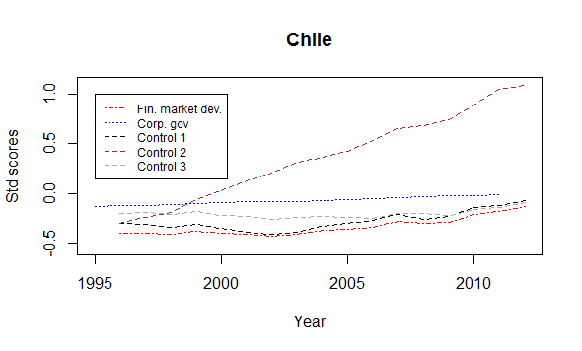

The graph above shows that the scale of shift in the corporate governance model towards a shareholder primacy model is low in Chile. The corporate governance regime has remained mostly stable with comparatively very minor, gradual shift towards pro-shareholder policies. While control 1 and control 3 are highly correlated to financial market growth, there is little correlation between the shift in corporate governance and financial market growth. This predicts a higher impact for control 1 and 3 and relatively lower impact for corporate governance.

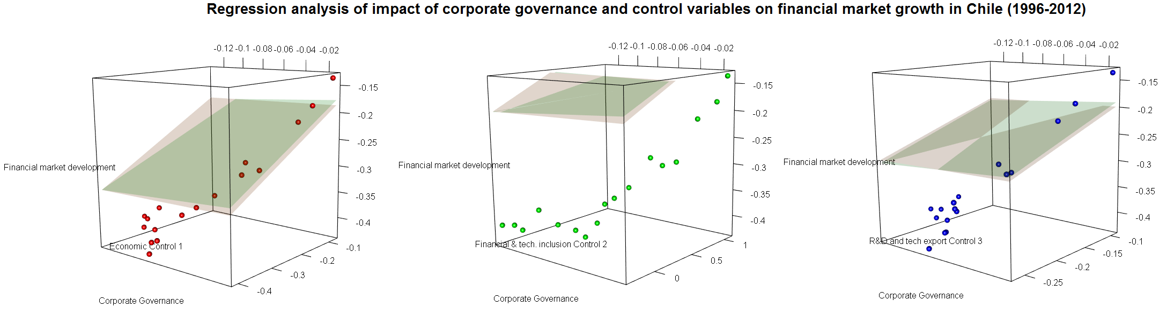

The relatively low corporate governance shift towards a pro-shareholder value model distorts some of the outcomes in the graph, a quick look at the scatter graphs above would suggest that the direction of regression lines would be from somewhere near the origin to the top end. However, this disregards the relative invariance of corporate governance in Chile (a shift between -0.12 to -0.02, one of the lowest among the countries studied in this research). The minor shift in corporate governance in Chile also gives a major boost to the impact of corporate governance on financial market development in Bayesian analysis (Chile scores the highest mean corporate governance coefficient among all the countries studied).

|  |  |  |  |  |  |
| --- | --- | --- | --- | --- | --- |
|  | CG | Control 1 | Control 2 | Control 3 | Intercept |
| Mean Bayesian | 0.139975 | 0.399509 | 0.079426 | 0.468502 | -0.14729 |
| Frequentist | 0.039628 | 0.407343 | 0.08679 | 0.458427 | -0.15745 |

However given the relative stability of corporate governance, the high density interval compensates with an extremely wide range with values between -1.24498 to 2.030255. This extreme statistical range suggests that under a Bayesian model it is difficult to confidently predict the impact of corporate governance shift on the growth of the financial market in Chile. Bayesian mean values for the impact of corporate governance shift on financial marker growth, as discussed above, is the highest among the countries studied, but this can also be due to the relatively flat corporate governance shift in Chile. This argument is bolstered by the frequentist analysis which puts the impact of corporate governance much lower than other control variables.

Quantitatively, it is difficult to isolate the impact of change in the corporate governance model on financial growth in Chile. Therefore, it can be concluded that in Chile, corporate governance may play a varying role in the growth of the financial market which is still mostly affected by financial and economic control variables. It is a case fit for further qualitative study to act as an interlocutor between the varying Bayesian and frequentist results, and to analyse the effect that corporate governance change may have on financial market growth in Chile.

4.4.4 Colombia

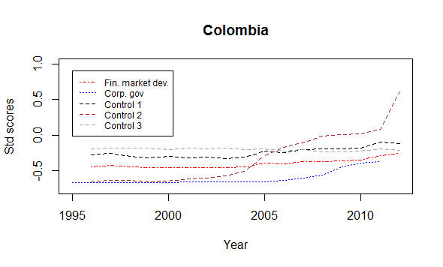

The graph above shows that the corporate governance regime in Colombia has gradually shifted towards a pro-shareholder approach. As this has occurred, the financial market has developed. The economic variables (control 1) and R&D expenditure along with technological export (control 3) closely mirror the growth in the financial market, while financial and technological inclusion (control 2) is erratic. It can be thus surmised that statistically control 1 and control 3 are more likely to be significant than change in the corporate governance model in driving the growth of the financial market in Colombia, and that control 2 is similar or less impactful than corporate governance.

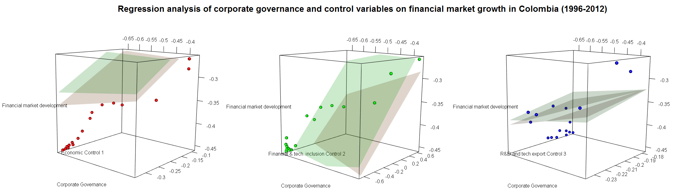

This is proved experimentally in the scatter plot and regression plane graphs, where in the middle plot in the graph above, the regression plane moves across the ZX plane in comparison to other plots, illustrating the higher or equal impact of change in corporate governance and control 2 on financial growth in Colombia.

The mean Bayesian coefficient for corporate governance of 0.075378 varies a little in comparison to the frequentist value of 0.075378. However, the high density interval of the distribution of Bayesian values range from -0.03726 to 0.185066, the frequentist value falls within the range.

|  |  |  |  |  |  |
| --- | --- | --- | --- | --- | --- |
|  | CG | Control 1 | Control 2 | Control 3 | Intercept |
| Mean Bayesian | 0.075378 | 0.425973 | 0.079505 | 0.429411 | -0.13884 |
| Frequentist | 0.123907 | 0.407344 | 0.067939 | 0.319288 | -0.13978 |

As has been mentioned above, the corporate governance regression coefficients are similar or more than that of control 2, however, the corporate governance impact is much less in comparison to that of control 1 and control 3.

Thus it can be concluded that in comparison to economic and technological innovation controls, corporate governance shift towards a shareholder value model has low impact on the growth of the financial market. However, in comparison to other countries, the financial market in Colombia shows a more positive response to change in the corporate governance model. Therefore, it merits further qualitative research to isolate the sui generis factors that might be present in Colombia which have led to a more positive response to shift towards a shareholder primacy corporate governance model.

4.4.5 India

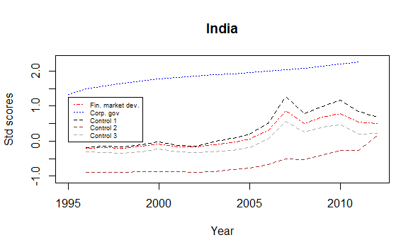

From the graph above, it can be summarised that corporate governance in India has shifted steadily towards a shareholder value model over the period of time studied under this research. The shift in corporate governance has coincided with growth in the financial market. However, the growth in the financial market also corresponds to economic (control 1) growth and an increase in R&D expenditure and high technology export (control 3). Prima facie control 1 and control 3 are more correlated to financial market development than change in corporate governance.

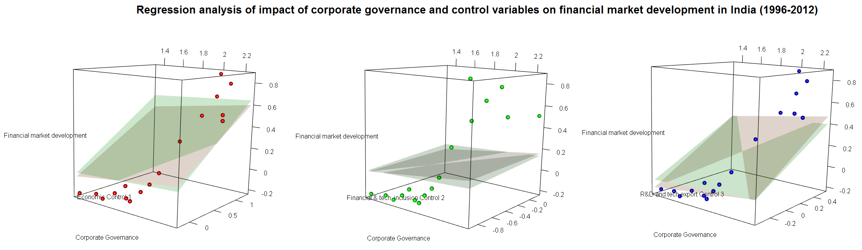

This is experimentally proven by the regression planes and scatter plot in the graphs above. However, the corporate governance regression coefficient for the Bayesian analysis differs significantly in comparison to frequentist analysis. The high density interval for the Bayesian analysis lies between 0.003676 and 0.120785, the frequentist coefficient of 0.140102 lies just beyond this area.

|  |  |  |  |  |  |
| --- | --- | --- | --- | --- | --- |
|  | CG | Control 1 | Control 2 | Control 3 | Intercept |
| Mean Bayesian | 0.062502 | 0.398711 | 0.057521 | 0.472082 | -0.01918 |
| Frequentist | 0.140102 | 0.342849 | 0.021449 | 0.541839 | -0.16607 |

However, both the regression analyses show that the corporate governance regression coefficient is low in comparison to the mean control 1 and control 3 coefficient. Its impact is similar to control 2 for Bayesian analysis and seven times larger in frequentist analysis. The frequentist analysis also predicts that the corporate governance change in India has the second highest impact on financial market growth among the countries studied under this research, while Bayesian analysis puts India at eighth among the nineteen developing countries studied in this research. Thus there is a need for further qualitative study to explore the reason behind this apparent dissociation between the results predicted by Bayesian and frequentist methods.

It can thus be concluded that although changes in the corporate governance model in India may have some impact (based on frequentist analysis) on the growth of the Indian financial market, it is still several times lower than control 1 and control 3.

4.4.6 Indonesia

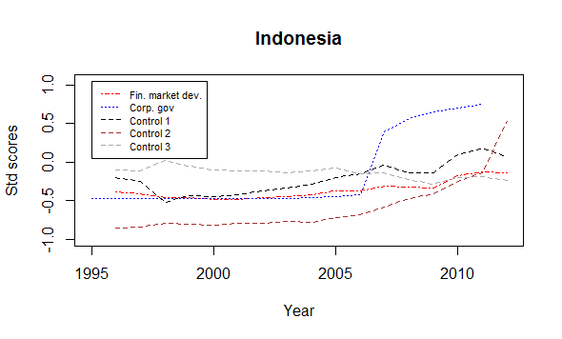

Corporate governance shift in Indonesia can be grouped into three periods: the period of slow gradual reform between 1995 and 2006, the period of intense restructuring 2006-2007 to attract foreign investors in the period of global financial upswing and finally the period of moderate reforms in the aftermath of the global financial crisis.

Financial market development was generally steady and this is consistent with other developing countries in SE Asia. Indonesia was not greatly affected by the global financial crisis and recovered quickly. Control 1 and control 3 mirror the financial market growth but control 2 echoes the corporate governance development more than it does financial market growth.

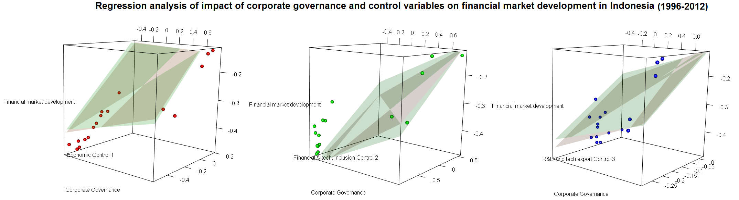

The graphs above show the overall regression analysis between the financial market development as a dependent variable, corporate governance as an explanatory or independent variable and three control variables. The results are presented below:

|  |  |  |  |  |  |
| --- | --- | --- | --- | --- | --- |
|  | CG | Control 1 | Control 2 | Control 3 | Intercept |
| Mean Bayesian | 0.066574 | 0.411826 | 0.087087 | 0.465394 | -0.14892 |
| Frequentist | 0.085853 | 0.397137 | 0.072739 | 0.47568 | -0.15773 |

It is found that Bayesian and frequentist values generally match each other. The mean coefficient for corporate governance is 0.066574 under Bayesian analysis with the high density interval ranging from 0.038958 to 0.094967, the frequentist coefficient of 0.085853 falls within this range.

The impact of corporate governance on financial market development is comparable to that of control 2, but is much lower than that of control 1 and control 3. So it can be safely concluded that in comparison to the impact of economic and technological growth, change in corporate governance has had little impact on the growth of the financial market in Indonesia.

4.4.7 Peru

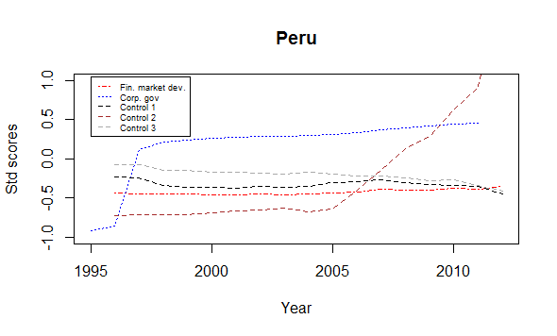

As explained in the previous subchapter and as is clear from the graph above, corporate governance in Peru has shifted over time towards a more OECD model of corporate governance with a pro-shareholder tilt. The financial market development has remained relatively flat and the control variables have remained relatively stable except for financial and technological inclusion (control 2) which has grown at an exponential rate from 2005 onwards.

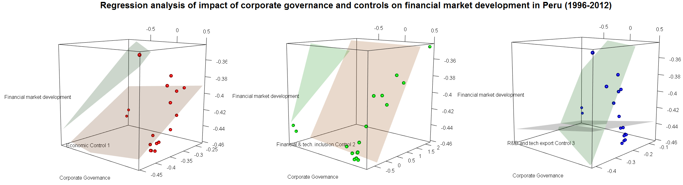

Prima facie, it would seem that change in corporate governance has little impact on financial market development, the frequentist analysis puts the regression coefficient for corporate governance at 0.01, one of the lowest in this study. However, the Bayesian mean of 0.06 diverges widely from the frequentist estimates; the frequentist estimate falls just outside of the high density interval for the Bayesian estimate ranging from 0.011902 to 0.116667.

As is clear from the graphs above, the Bayesian and frequentist estimates vary on all parameters, frequentist estimates for research and development investment and high technology export (control 3) is in negative, while for the Bayesian mean estimate its impact is predicted to be as high as that of economic control factors (control 1). However, it can also be noted that the negative estimate for control 3 under the frequentist method falls within the Bayesian credible interval which ranges from -0.070311675 to 0.921943003. This anomaly can be attributed to the relative stability of the variables which leads to such wide difference in estimation.

|  |  |  |  |  |  |
| --- | --- | --- | --- | --- | --- |
|  | CG | Control 1 | Control 2 | Control 3 | Intercept |
| Mean Bayesian | 0.060262 | 0.394241 | 0.079355 | 0.39691 | -0.20842 |
| Frequentist | 0.010709 | 0.269808 | 0.044918 | -0.0278 | -0.33505 |

Based on the Bayesian mean estimates, it can be concluded that corporate governance change towards a more shareholder value model has 0.15 times the impact on financial market development in relation to financial and economic growth (control 1), and an increase in technological exports and research spending (control 3), and is hence negligible as a factor affecting the growth of the financial market.

4.4.8 Pakistan

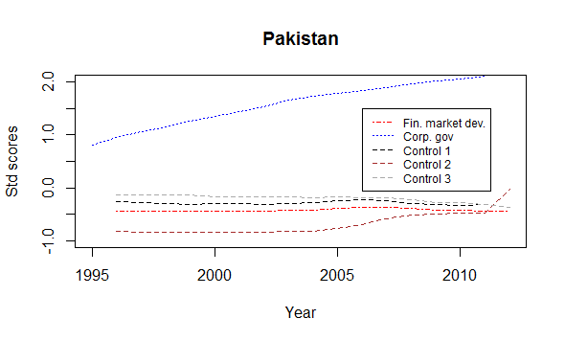

Pakistan has one of the highest shareholder primacy corporate governance regulation ratings; its laws mirror OECD regulations to a very high degree. Yet its financial market development is relatively under-developed. Despite changes in the corporate governance model to give high protection to shareholders, there does not appear to have been any effect on financial market growth, which remained low throughout the period and post global financial crisis became negative.

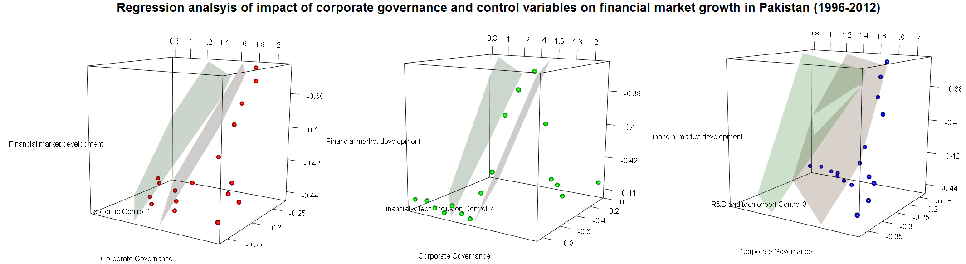

This view is well reflected in the regression graphs above, where in spite of a very high corporate governance index, the regression coefficient for corporate governance is low in comparison to control 1 and control 3.

The corporate governance coefficient for mean Bayesian and frequentist estimates are quite similar, the frequentist estimate of 0.074 falls well within the credible interval of the Bayesian estimate of 0.033106 to 0.091461.

|  |  |  |  |  |  |
| --- | --- | --- | --- | --- | --- |
|  | CG | Control 1 | Control 2 | Control 3 | Intercept |
| Mean Bayesian | 0.062161 | 0.43312 | 0.079625 | 0.414556 | -0.25478 |
| Frequentist | 0.074054 | 0.37303 | 0.051913 | 0.406858 | -0.3114 |

It can thus be concluded that a change in corporate governance does not play an important role in the growth of the financial market in Pakistan, especially in comparison to other control factors. Pakistan gives the best credible evidence of the hypothesis that a high shareholder primacy rules-based system does not per se result in higher financial market growth. It is also quite interesting to note that the largest number of research papers on explicitly linking shareholder primacy corporate governance to higher growth in the financial market come from the roundtable discussions of international financial organisations held in Pakistan.

4.4.9 Poland

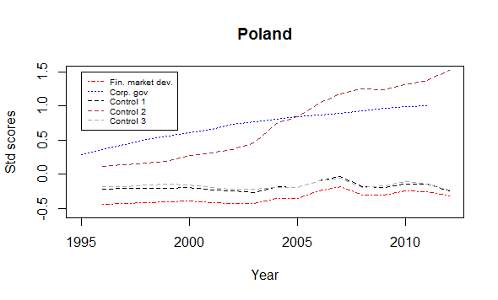

Corporate governance in Poland has gradually shifted towards a pro-shareholder approach. Progress was slow until 2003; rapid between 2004 and 2007; and since then there have been only slow incremental changes. This shift in corporate governance regulation parallels the slow growth of the Polish financial market until 2004, the rapid bursts between 2005 and 2008, and then the gradual decline. It is also interesting to note from the graph above the high correlation between control 1 and control 3, and the financial market development.

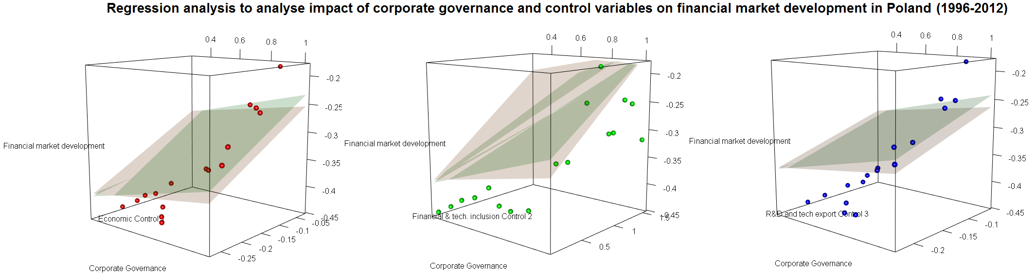

This is amply highlighted in the graphs above which show that financial market development is impacted more by change in financial indicators (control 1) and a rise in research investment and high technology exports (control 3), than by a change in corporate governance to make it more shareholder friendly. The only indicator which has the same impact as changes in the corporate governance model is that of financial and technological inclusion (control 2). However, in comparison to other countries studied in this research, Poland has the second highest impact of change in corporate governance in relation to control 3 and the fifth highest impact of change in corporate governance in relation to control 1, on the growth of the financial market. This means that changes in corporate governance in Poland had more impact on the growth of the financial market than in almost all other countries. However, under frequentist models, Poland is ranked eleventh and twelfth for the relative impact of change in corporate governance in relation to control 1 and control 3 respectively, on the growth of the financial market. Although frequentist and Bayesian mean estimates vary, the frequentist estimate of 0.046818 is within the credible interval of -0.00566 to 0.158403 predicted by Bayesian estimates. However the relative gap, highlighted by comparing with other countries, shows that further qualitative studies are required to understand what other factors may have affected the growth of the financial market in Poland, it can be surmised that entry into the Eurozone may have had some impact. However, to obtain definite proof further in depth study is required.

|  |  |  |  |  |  |
| --- | --- | --- | --- | --- | --- |
|  | CG | Control 1 | Control 2 | Control 3 | Intercept |
| Mean Bayesian | 0.077912 | 0.480641 | 0.070058 | 0.393737 | -0.3002 |
| Frequentist | 0.046818 | 0.470849 | 0.083779 | 0.393734 | -0.2897 |

To conclude, change in corporate governance to make it more shareholder friendly or OECD compliant may have played a role in the financial market development in Poland; however this impact is many times less than the impact of economic growth and the increase in technology-based exports.

4.4.10 Russia

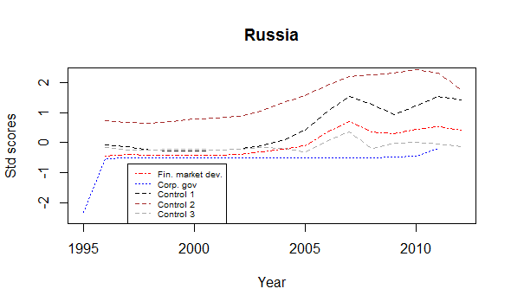

Corporate governance as understood in this research was largely absent in Russia before 1995, between 1995 and 1996 Russia adopted several company law reforms with a view to bringing the company law structure in line with the Anglo-Saxon model of company law and heralding the advent of capitalism and a break from the socialist structures of the USSR; this was followed by almost a decade of no change in company law, then from 2007 onwards Russia has slowly adopted pro-shareholder corporate governance principles with the aim of harmonising with OECD Principles of Corporate Governance. Russia is one of the very few countries which has changed its corporate governance policies to create more pro-shareholder values after the Global Financial crisis of 2008. The financial market growth does not reflect this evolution in corporate governance. The financial market growth more or less mirrors the changes in economic growth and technology-led exports.

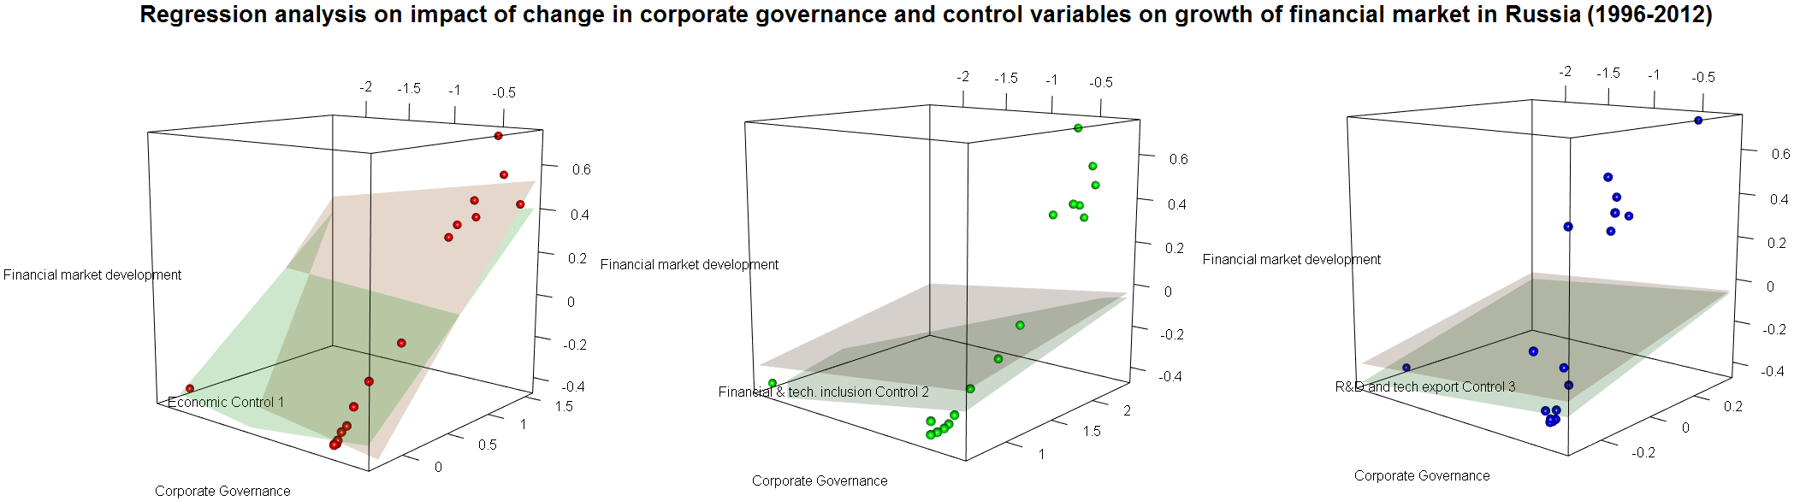

The relative stability in corporate governance for most of the period studied in this research, the high correlation between control 1 and control 3 with financial market development, coupled with the fall of the financial market coinciding with the rise in corporate governance leads to a negative estimation of corporate governance regression coefficient under frequentist methods. In effect, a frequentist estimate suggests that an increase in shareholder primacy corporate governance in Russia leads to a decline in Russian financial market development. This is not so for Bayesian analysis where the mean coefficient for corporate governance is low at 0.064709 but not negative, and the credible interval is also positive ranging between 0.051765 to 0.077738.

|  |  |  |  |  |  |
| --- | --- | --- | --- | --- | --- |
|  | CG | Control 1 | Control 2 | Control 3 | Intercept |
| Mean Bayesian | 0.064709 | 0.413657 | 0.084067 | 0.452866 | -0.24181 |
| Frequentist | -0.24547 | 0.411433 | 0.086978 | 0.451778 | -0.24547 |

It can thus be concluded that corporate governance may have a role to play in financial market development in Russia, but this might be because Russian corporate governance before 1998/99 was non-existent and is still quite far from being compliant with many of the provisions of the OECD principles of corporate governance. As under many other countries in this study, corporate governance has little impact on the growth of the financial market in comparison to other economic factors.

4.4.11 Argentina

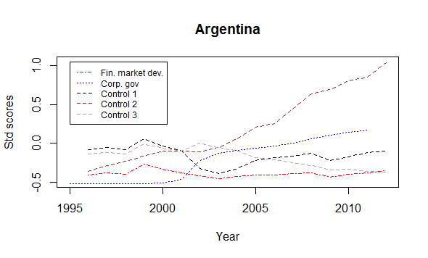

As has been discussed in the previous subchapter and as is apparent from the graph above, corporate governance in Argentina developed in three distinct phases, the period of relative stability with no shift towards shareholder primacy between 1995 and 2000, followed by a period of rapid shift between 2000 and 2003, followed by a period of gradual increase in the adoption of pro-shareholder policies after that. For most of the period studied in this research, corporate governance shifts came after a fall in the financial market, and to compensate for that the corporate governance has been lagged by one year.

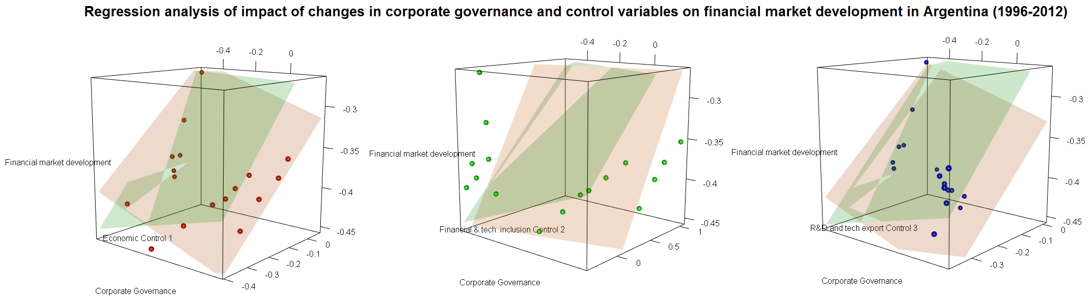

But even then, as shown in the graphs above, the apparent dissociation between corporate governance growth and financial market growth, accentuated by the high correlation between financial market growth and economic growth (control 1), pushes the frequentist estimate of the corporate governance regression coefficient to negative. However the mean Bayesian estimate predicts the coefficient to be positive, it is estimated at 0.066942. The credible interval or the high density interval for the Bayesian prediction is between -0.01842 to 0.158039. The frequentist estimation falls outside this predicted Bayesian boundary.

|  |  |  |  |  |  |
| --- | --- | --- | --- | --- | --- |
|  | CG | Control 1 | Control 2 | Control 3 | Intercept |
| Mean Bayesian | 0.066942 | 0.413628 | 0.08443 | 0.456878 | -0.2454 |
| Frequentist | -0.08268 | 0.311571 | 0.149698 | 0.380249 | -0.32011 |

The coefficient for controls also varies between the Bayesian and frequentist estimates. If the frequentist estimate of a negative coefficient for corporate governance is not disregarded, it can be conclude that, in comparison to the other controls, a change in the corporate governance model does not have much impact on the growth of the financial market in Argentina.

4.4.12 South Africa

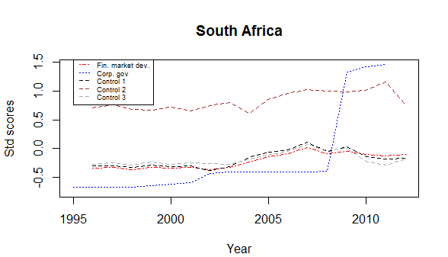

Like most other top performing developing countries, in economic terms, South Africa developed its corporate governance in three distinct phases. However, unlike other countries, South Africa had a head start with some early developments in the early to mid-1990s. Shifts in corporate governance more or less followed the movement of the financial market. In 2000, the market contracted, the government responded by increasing shareholder primacy corporate governance, between 2001 and 2008 when the market grew and corporate governance remained unchanged. Post-global financial crisis, there is a huge shift in corporate governance to shareholder primacy and attendant OECD regulation. Once the market stabilised, the pace of reform in corporate governance also slackened. On an individual country basis South Africa is one of the best examples to prove the hypothesis that corporate governance reform generally follows an economic or financial upheaval.

The control variables, especially economic growth (control 1) and technological improvement (control 3) follow the financial market development very closely, whilst financial inclusion (control 2) follows the trend of financial market development but is less closely correlated than other controls.

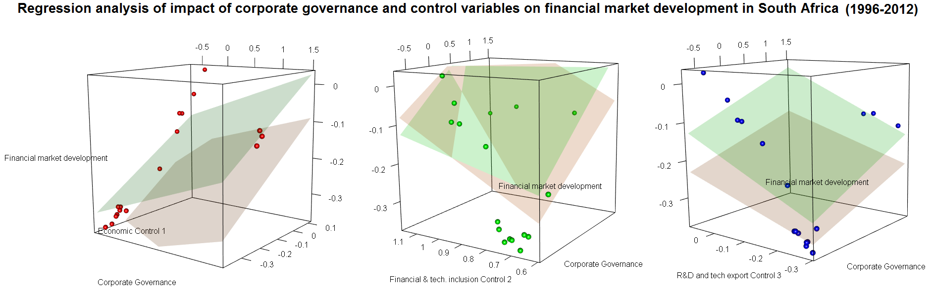

The regression analysis confirms the conclusion reached in the previous paragraph: the coefficient for corporate governance impact is low compared to financial and technological controls. The mean Bayesian estimate and the frequentist estimate are close to each other. The frequentist estimate of 0.051184 falls just outside the credible interval of the Bayesian estimate ranging from 0.053535 to 0.07527.

|  |  |  |  |  |  |
| --- | --- | --- | --- | --- | --- |
|  | CG | Control 1 | Control 2 | Control 3 | Intercept |
| Mean Bayesian | 0.064471 | 0.417834 | 0.087343 | 0.435347 | -0.11819 |
| Frequentist | 0.051184 | 0.460795 | 0.184856 | 0.299026 | -0.21902 |

It can be concluded that corporate governance development in South Africa follows the changes in financial market development. Even when a lag is created for the corporate governance shift we find comparatively little impact of change in corporate governance policy on the growth of the financial market, especially in relation to the control variables.

4.4.13 Iran

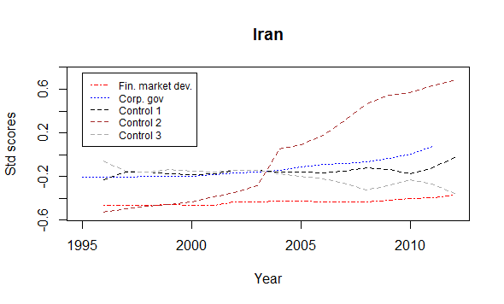

Iranian corporate governance development in a shareholder value direction has been slow and until 2005 was almost imperceptible. Since 2005 there has been an upswing, with the Tehran Stock Exchange taking a leading role in bringing the Iranian corporate governance regime to the shareholder value fold. The slow shift in corporate governance mirrors the gentle growth in the financial market in Iran, which has been stifled by a multitude of financial sanctions. This relative isolation from the external world provides an opportunity to isolate the impact of change in corporate governance on the financial market in the absence of external factors.

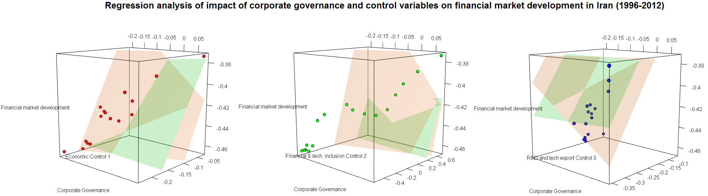

The mean Bayesian estimate is low at 0.019438, which is unsubstantial in comparison to the economic factors which have a coefficient in the range of 0.49, technological improvements and investments with a coefficient in the range of 0.43. This relative unimportance of corporate governance is more starkly represented in the frequentist analysis which predicts the value to be in the negative. This value is within the credible interval for the Bayesian estimate range of -0.27192 to 0.308407.

|  |  |  |  |  |  |
| --- | --- | --- | --- | --- | --- |
|  | CG | Control 1 | Control 2 | Control 3 | Intercept |
| Mean Bayesian | 0.019438 | 0.489304 | 0.088699 | 0.428396 | -0.27136 |
| Frequentist | -0.19914 | 0.590959 | 0.122274 | 0.443141 | -0.2807 |

What is predicted is that the shareholder corporate governance shift has absolutely no impact on financial market development in Iran, based on the model used in this research. However, these findings may be criticised on the basis that a primary reason for having shareholder primacy corporate governance is to encourage foreign investors to come and invest in a certain country. For Iran, due to financial sanctions this transmission mechanism may have failed, so the country has to depend on the internal market to provide the necessary capital and financial investments. This is arguably the reason for Iran having the lowest corporate governance regression coefficient and at the same time the highest coefficient for control variables among the countries studied under this research.

This makes Iran one of the best candidates for further research to investigate the impact of changes of corporate governance on a relatively closed economy. There is potential for the Iranian economy being opened to foreign investors in the next five years, especially with the easing of tensions with USA, it will be a fascinating time to assess the importance of external capital on financial market growth and if it affects or drives corporate governance shift.

4.4.14 Kenya

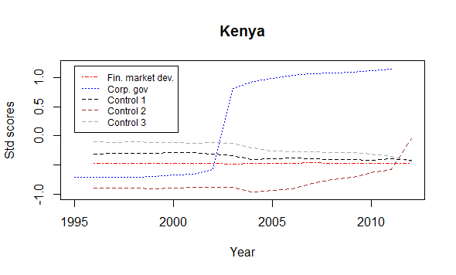

Corporate governance dramatically shifted towards a shareholder primacy model in Kenya between 2001 and 2004. While the economic (control 1) and technological (control 3) parameters show contraction, financial market development was almost static. This unusual combination of factors have led the Bayesian estimates to converge after an unusually large number of iterations. Even then, the high density interval is so large that it is almost impossible to draw any meaningful conclusions. The regression results are shown below:

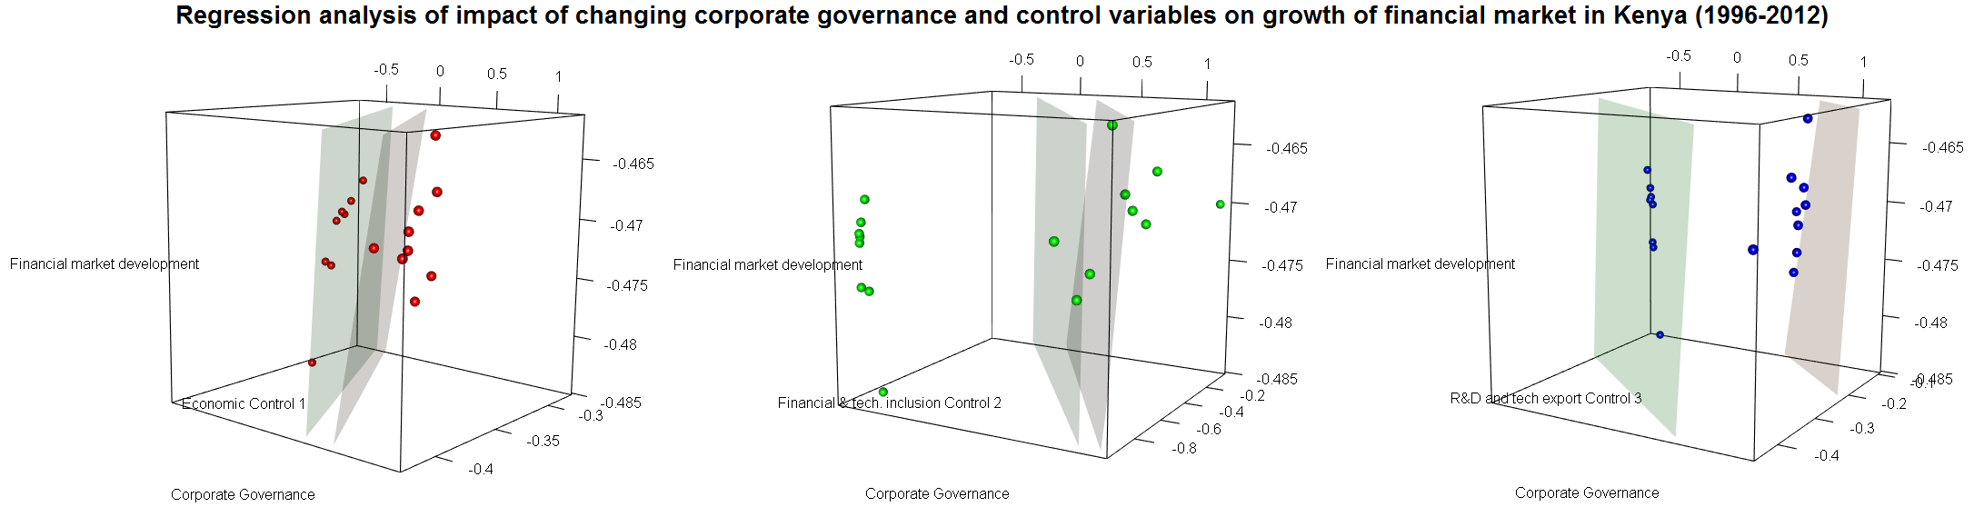

|  |  |  |  |  |  |
| --- | --- | --- | --- | --- | --- |
|  | CG | Control 1 | Control 2 | Control 3 | Intercept |
| Mean Bayesian | 0.097896 | 0.65547 | 0.142408 | 0.66122 | -0.00781 |
| Frequentist | 0.049405 | 0.377399 | 0.064134 | 0.288727 | -0.23664 |

Given the unusual data the Bayesian and frequentist estimates vary significantly, although the mean Bayesian estimate for the corporate governance coefficient is 0.0978 and the frequentist estimate is 0.0494, the high density interval for the Bayesian estimate ranges from -0.95621 to 0.881144, the width is so large that any meaningful comparison is futile. Similarly for the control variables the credible interval is so large that control 1 ranges from -5.29 to 5.7, control 2 ranges from -1.69 to 1.55, control 3 ranges from -7.94 to 7.28, so the only conclusion that can be reached is that on an individual country basis, with the variables considered at it is impossible to determine whether corporate governance has any meaningful impact on the financial market development in Kenya.

4.4.15 Nigeria

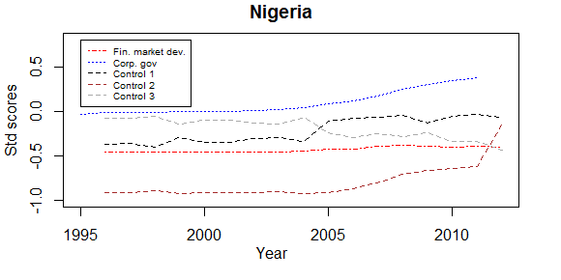

There has been a steady shift towards shareholder primacy corporate governance in Nigeria, the pace of which has accelerated since 2005. Financial market development remained steady and fell post-Global Financial Crisis. The financial and economic factors (control 1) seem to be inversely correlated to investment in technology and R&D (control 3). Only financial and technological inclusion rises steadily.

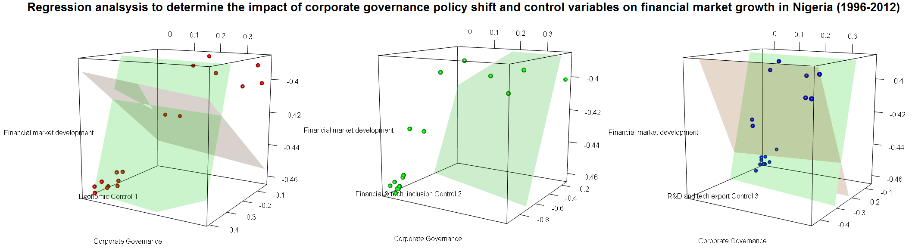

Faced with this dataset, the frequentist estimate lowers the intercept value (the analysis predicts Nigeria to have the lowest intercept among all the countries studied under this research) and lowers the impact for other explanatory variables. The Bayesian mean estimates and the frequentist estimates vary widely except for the coefficient for control 2 which is almost exactly the same. The Bayesian mean estimate for the control 1 regression coefficient is 0.416 and the credible interval ranges between 0.2486 and 0.60, the frequentist estimate of -0.1454 falls outside this range, similarly for control 3 the Bayesian credible interval ranges from 0.189 to 0.717, the frequentist estimate of -0.318 falls outside this range. The corporate governance regression coefficient under the Bayesian credible interval varies between -0.07813 and 0.182682, with a mean of 0.055, the frequentist estimate is negative at -0.019, and this estimate is within the range of Bayesian estimates.

|  |  |  |  |  |  |
| --- | --- | --- | --- | --- | --- |
|  | CG | Control 1 | Control 2 | Control 3 | Intercept |
| Mean Bayesian | 0.055016 | 0.416011 | 0.088196 | 0.436266 | -0.19151 |
| Frequentist | -0.01946 | -0.1454 | 0.088249 | -0.31805 | -0.45282 |

This high divergence between frequentist and Bayesian estimates for control 1 and control 3 is because of the high inverse correlation. Almost all the predictions from the frequentist analysis, for other countries, are judged to be highly significant under the null hypothesis test; however all the coefficients for Nigeria are judged to be insignificant under the null hypothesis testing. This is again due to the peculiar data for Nigeria. This also makes it possible to show the best example of advantages of Bayesian regression which, through simulations, can salvage meaningful results from partially correlated data.

We can conclude from the mean Bayesian estimate that control 1 and control 3 do have a far greater role to play on financial market development and that changes in corporate governance have a relatively minor effect.

4.4.16 Hong Kong

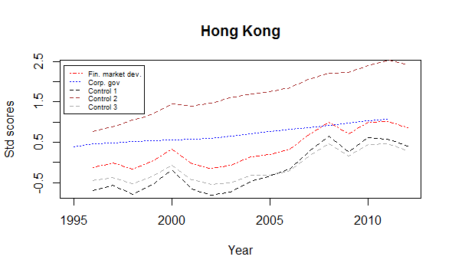

Hong Kong has been the best performing ‘developing country’ in terms of financial market development and one of the higher rated ‘countries’ in terms of corporate governance development. Shareholder value corporate governance in Hong Kong was high to start with and it has developed gradually and has steadily updated its shareholder primacy-based regulations. The financial market development is closely correlated to the control variables, especially the financial and economic variables (control 1), and the increase in technology-led export and proxies for R&D investments (control 3). The technological and financial inclusion variable (control 2) is one of the highest among the countries studied in this research. It steadily rises with some minor slow down coinciding with economic downturns.

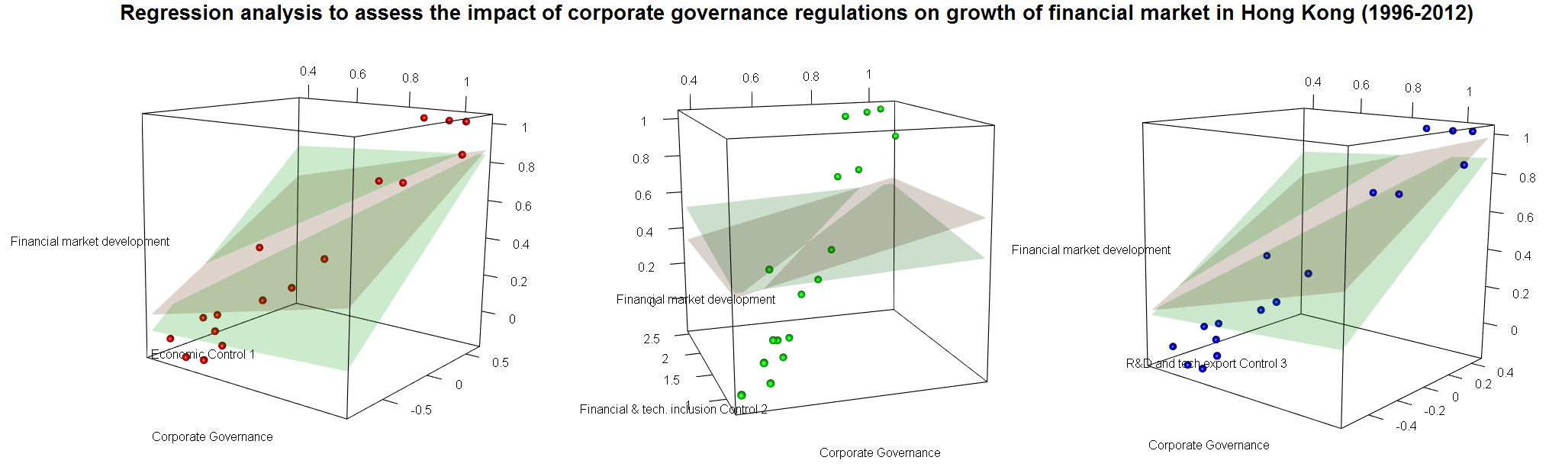

There is a high correlation between corporate governance shifts and financial market growth, this results in the highest regression coefficient for corporate governance, and also the highest impact relative to control 1 and control 3 on financial market growth for Hong Kong under frequentist analysis among the countries studied under this research. However, the mean Bayesian estimate for the corporate governance regression coefficient diverges widely and is about a fifth of the frequentist estimate. The credible interval for the Bayesian regression coefficient for corporate governance ranges between -0.063 to 0.212, this is outside the frequentist estimates.

|  |  |  |  |  |  |
| --- | --- | --- | --- | --- | --- |
|  | CG | Control 1 | Control 2 | Control 3 | Intercept |
| Mean Bayesian | 0.074224 | 0.410382 | 0.0851 | 0.453187 | 0.274053 |
| Frequentist | 0.380608 | 0.372686 | -0.00216 | 0.463233 | 0.201533 |

So although frequentist estimates show a highly significant role for corporate governance in the development of the financial market in Hong Kong, on par with economic factors (control 1), the Bayesian estimate on the other hand suggests only a minor role, about 0.18 times as impactful as control 1, and at best only about half as important as economic and technological controls. Thus, it can be concluded that given the high incumbent financial market growth in Hong Kong, a continued shift in corporate governance regulations towards ensuring greater shareholder control, may have a noticeable impact on further growth in the financial market. This could be because of several extraneous factors outside the scope of the present model - the position of Hong Kong as a gateway to the Chinese financial market on a shareholder value term, higher rule of law (which was not used in the per-country regression analysis), a history as a hub of the financial market etc.

4.4.17 Philippines

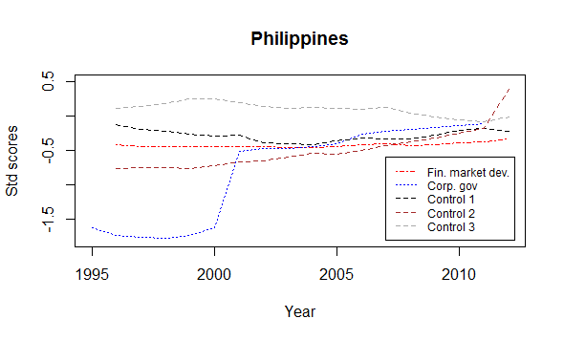

Corporate governance in the Philippines has steadily shifted towards a shareholder primacy model, the shift is one of the greater ones among the countries studied under this research. Financial market development has remained relatively stable with a spike in 2006. The economic factors (control 1) closely follows financial market growth, the financial and technological factor (control 2) seems to vary independently with a rapid upswing in 2011, the investment in R&D and technology-led export variables (control 3) show signs of gradual decline.

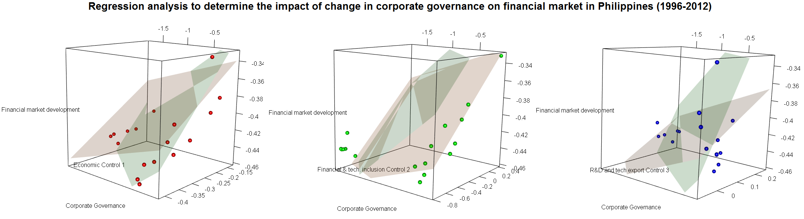

The corporate governance regression coefficient for the Philippines is similar in Bayesian and frequentist inferences, the frequentist estimate is well within the Bayesian credible interval estimate range of 0.017428 to 0.089057. The coefficients for control 2 under Bayesian and frequentist inference match closely.

|  |  |  |  |  |  |
| --- | --- | --- | --- | --- | --- |
|  | CG | Control 1 | Control 2 | Control 3 | Intercept |
| Mean Bayesian | 0.054709 | 0.421624 | 0.07878 | 0.351537 | -0.25566 |
| Frequentist | 0.022953 | 0.256987 | 0.076865 | 0.123642 | -0.30529 |

The corporate governance coefficient under both Bayesian and frequentist inferences are quite low in comparison to the control coefficient. So we can conclude that for the Philippines, changes in corporate governance have had little impact on the growth of the financial market, especially in comparison to financial and economic controls.

4.4.18 El Salvador

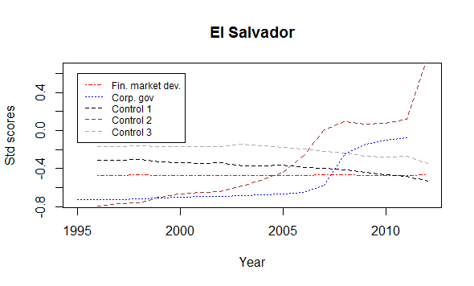

Financial market development has remained remarkably stable in El Salvador in comparison to other variables. The corporate governance development and control 2 seems to be correlated, although there is little obvious reason for their correlation. The economic and financial variables (control 1) seem also to be correlated to some extent to investment in R&D and technology-based exports (control 3). There was some missing data for El Salvador which have further compounded the problem. All these unconnected reasons have made it extremely difficult to correctly predict the impact of change in corporate governance on the growth of the financial market in El Salvador. Like Kenya before, El Salvador is the only country among those being studied in this research that needs about eight times more iterations than other countries, to reach a converging Bayesian model. Even then, the credible intervals are too large to come to any meaningful comparison. So it can be surmised that the data does not fit the model being used to explain financial market growth.

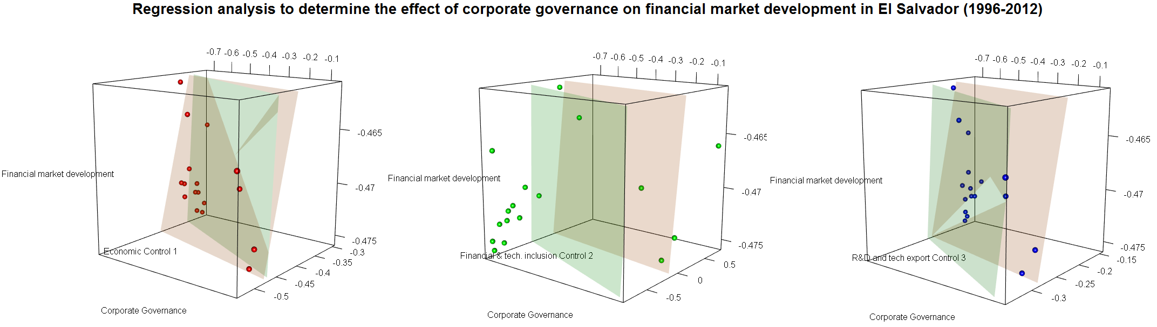

The regression analysis gives extremely wide results for credible intervals, the Bayesian estimate for intercept ranges from -7.67 to 6.69, the corporate governance regression coefficient ranges from 2.03 to -2.02, the control 1 regression coefficient is estimated to be between -8.83 to 9.27, the control 2 regression is inferred to be between -1.54 to 1.63, and finally the high density interval for the control 3 regression coefficient is between -10.4 to 11.1. Given the wide intervals in Bayesian estimates all the frequentist inferences fall within the credible intervals.

|  |  |  |  |  |  |
| --- | --- | --- | --- | --- | --- |
|  | CG | Control 1 | Control 2 | Control 3 | Intercept |
| Mean Bayesian | 0.097482 | 0.548885 | 0.107545 | 0.604804 | -0.04713 |
| Frequentist | 0.016982 | 0.182318 | 0.049945 | 0.237212 | -0.32644 |

The high density intervals are so large that it is impossible to deduce any meaningful conclusion from the results. What can be surmised is that El Salvador is an outlier and does not fit the model being predicted by us. We can thus surmise that corporate governance does not have any major role to play in the growth of the financial market in El Salvador, and it is quite possible that none of the explanatory variables used in this study adequately explain the growth of the financial market in El Salvador. These external factors can be relative political instability, low rule of law, higher corruption, lower industrial development, small size, dense population etc.

4.4.19 Vietnam

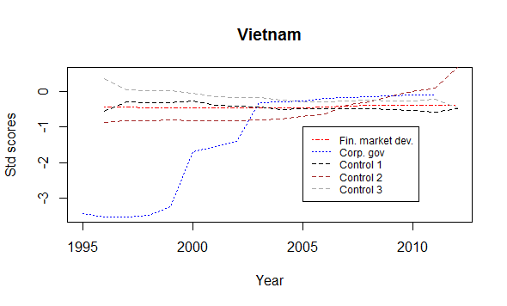

Vietnam has the highest shift towards a shareholder primacy corporate governance model. Financial market growth has remained stable in comparison to other factors, with variations around the Global Financial Crisis 2008. Economic controls and investment in R&D controls are correlated to an extent. The financial and technological inclusion has steady growth between 1996 and 2005 and an exponential growth after 2005.

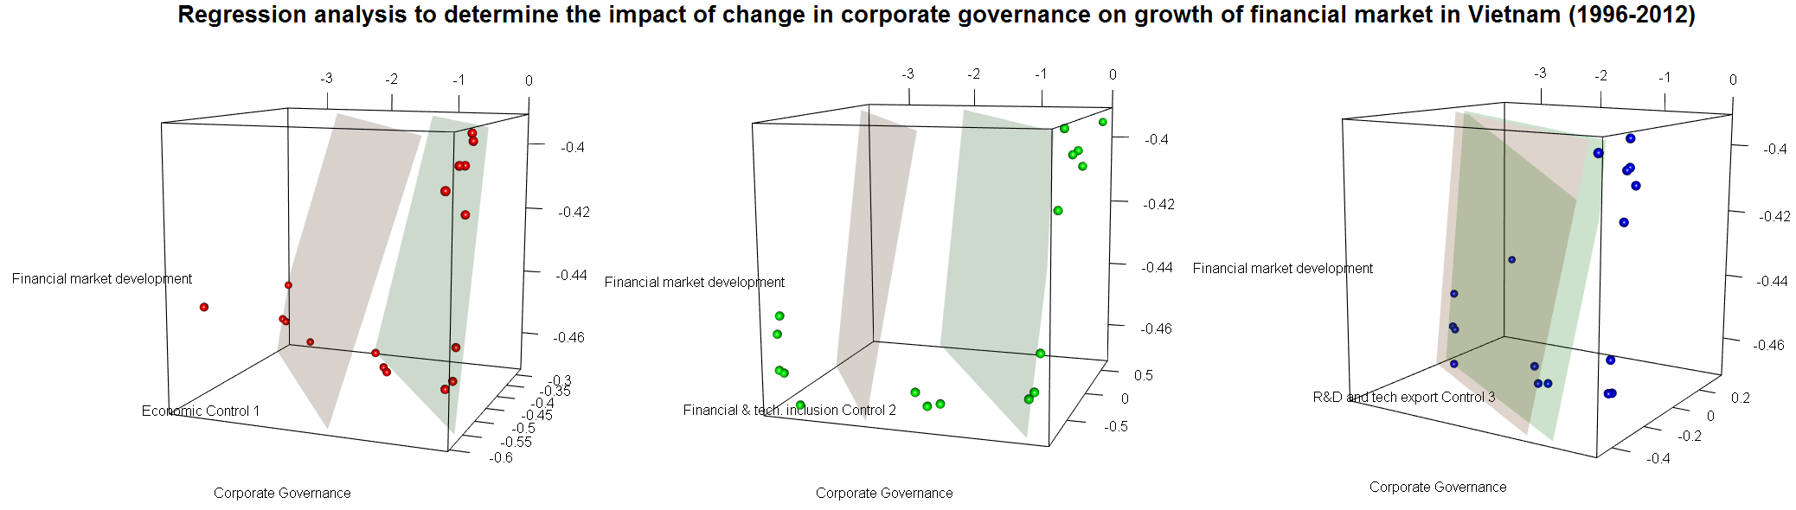

Vietnam is one of the very few countries where the mean Bayesian estimates and the frequentist results are almost same. The regression analysis as shown above clearly demonstrates that the regression planes for Bayesian and frequentist inferences are almost parallel to each other. The corporate governance regression coefficient for the Bayesian mean is estimated to be at 0.06, the frequentist coefficient is also 0.06, the credible interval for the Bayesian estimate range is quite narrow - between 0.0378 to 0.0862.

|  |  |  |  |  |  |
| --- | --- | --- | --- | --- | --- |
|  | CG | Control 1 | Control 2 | Control 3 | Intercept |
| Mean Bayesian | 0.060049 | 0.450734 | 0.084713 | 0.37679 | -0.04812 |
| Frequentist | 0.060918 | 0.458623 | 0.085261 | 0.381997 | -0.04222 |

From the regression analysis it can be concluded that in comparison to the impact of financial and economic growth (control 1) and an increase in investment for R&D and technology-led exports, the impact of change in corporate governance in Vietnam is only minor.

4.4.20 Conclusion

It can be concluded that for the majority of the countries, changes in corporate governance have no major role to play in the growth of the financial market in that country. However, the impact does vary, more so under frequentist methods than under Bayesian inferences. At this point it will be interesting to compute and contrast the relative impact of shifts in corporate governance towards a shareholder value model in relation to economic growth (control 1), and increases in investment for R&D and technology-led export (control 3) on the growth of the financial market. This is computed and presented in the table below.

In comparing the relative impact of change in corporate governance to control 1 and control 3 predicted by Bayesian and frequentist methods the following results are obtained:

|  |  |  |  |  |  |  |  |  |  |  |
| --- | --- | --- | --- | --- | --- | --- | --- | --- | --- | --- |
|  | Mean Bayesian | | Frequentist | | Bayesian : Frequentist | | Mean Bayesian | | Frequentist | |
| Countries | CG:Ctrl1 | CG:Ctrl3 | CG:Ctrl1 | CG:Ctrl3 | CG:Ctrl1 | CG:Ctrl3 | Ctrl1:CG | Ctrl3:CG | Ctrl1:CG | Ctrl3:CG |
| Brazil | 1 : 6.6524 | 1 : 6.9588 | 1 : 11.169 | 1 : 11.74 | 1 : 1.678976 | 1 : 1.686728 | 1 : 0.150322 | 1 : 0.143703 | 1 : 0.089532 | 1 : 0.085196 |
| China | 1 : 14.096 | 1 : 10.028 | 1 : 79.581 | 1 : 59.22 | 1 : 5.645692 | 1 : 5.905502 | 1 : 0.070943 | 1 : 0.099721 | 1 : 0.012566 | 1 : 0.016886 |
| Chile | 1 : 2.8541 | 1 : 3.347 | 1 : 10.279 | 1 : 11.568 | 1 : 3.601473 | 1 : 3.456244 | 1 : 0.350368 | 1 : 0.298772 | 1 : 0.097285 | 1 : 0.086444 |
| Colombia | 1 : 5.6512 | 1 : 5.6968 | 1 : 3.2875 | 1 : 2.5768 | 1 : 0.581737 | 1 : 0.452332 | 1 : 0.176954 | 1 : 0.175537 | 1 : 0.304182 | 1 : 0.388072 |
| India | 1 : 6.3792 | 1 : 7.5531 | 1 : 2.447 | 1 : 3.868 | 1 : 0.383613 | 1 : 0.512036 | 1 : 0.15676 | 1 : 0.132396 | 1 : 0.408641 | 1 : 0.258568 |
| Indonesia | 1 : 6.186 | 1 : 6.991 | 1 : 4.6258 | 1 : 5.5406 | 1 : 0.747776 | 1 : 0.792572 | 1 : 0.161655 | 1 : 0.143048 | 1 : 0.216181 | 1 : 0.180486 |
| Peru | 1 : 6.5422 | 1 : 6.5864 | 1 : 25.195 | 1 : -2.596 | 1 : 3.851141 | 1 : -0.39416 | 1 : 0.152855 | 1 : 0.151827 | 1 : 0.039691 | 1 : 0.385191 |
| Pakistan | 1 : 6.9677 | 1 : 6.6691 | 1 : 5.0373 | 1 : 5.4941 | 1 : 0.722945 | 1 : 0.823816 | 1 : 0.143519 | 1 : 0.149946 | 1 : 0.19852 | 1 : 0.182014 |
| Poland | 1 : 6.169 | 1 : 5.0536 | 1 : 10.057 | 1 : 8.4099 | 1 : 1.630256 | 1 : 1.664144 | 1 : 0.162101 | 1 : 0.197879 | 1 : 0.099433 | 1 : 0.118908 |
| Russia | 1 : 6.3925 | 1 : 6.9985 | 1 : 6.4014 | 1 : 7.0291 | 1 : 1.001381 | 1 : 1.004377 | 1 : 0.156432 | 1 : 0.142889 | 1 : 0.156217 | 1 : 0.142266 |
| Argentina | 1 : 6.1789 | 1 : 6.825 | 1 : -3.768 | 1 : -4.599 | 1 : -0.60987 | 1 : -0.67384 | 1 : 0.161842 | 1 : 0.146521 | 1 : -0.26537 | 1 : -0.21744 |
| South Africa | 1 : 6.4809 | 1 : 6.7526 | 1 : 9.0028 | 1 : 5.8422 | 1 : 1.389109 | 1 : 0.865178 | 1 : 0.154299 | 1 : 0.148092 | 1 : 0.111077 | 1 : 0.171169 |
| Iran | 1 : 25.173 | 1 : 22.039 | 1 : -2.968 | 1 : -2.225 | 1 : -0.11789 | 1 : -0.10097 | 1 : 0.039725 | 1 : 0.045373 | 1 : -0.33698 | 1 : -0.44938 |
| Kenya | 1 : 6.6955 | 1 : 6.7543 | 1 : 7.6388 | 1 : 5.844 | 1 : 1.140884 | 1 : 0.865234 | 1 : 0.149353 | 1 : 0.148055 | 1 : 0.13091 | 1 : 0.171115 |
| Nigeria | 1 : 7.5617 | 1 : 7.9299 | 1 : 7.4699 | 1 : 16.34 | 1 : 0.987859 | 1 : 2.060563 | 1 : 0.132246 | 1 : 0.126106 | 1 : 0.133871 | 1 : 0.0612 |
| Hong Kong | 1 : 5.529 | 1 : 6.1057 | 1 : 0.9792 | 1 : 1.2171 | 1 : 0.177101 | 1 : 0.199337 | 1 : 0.180866 | 1 : 0.163782 | 1 : 1.021258 | 1 : 0.821634 |
| Philippines | 1 : 7.7067 | 1 : 6.4256 | 1 : 11.197 | 1 : 5.3869 | 1 : 1.45283 | 1 : 0.838349 | 1 : 0.129758 | 1 : 0.155628 | 1 : 0.089314 | 1 : 0.185637 |
| El Salvador | 1 : 5.6307 | 1 : 6.2043 | 1 : 10.736 | 1 : 13.969 | 1 : 1.906693 | 1 : 2.251404 | 1 : 0.177599 | 1 : 0.161179 | 1 : 0.093145 | 1 : 0.07159 |
| Vietnam | 1 : 7.5061 | 1 : 6.275 | 1 : 7.5286 | 1 : 6.2707 | 1 : 1.002997 | 1 : 0.999366 | 1 : 0.133225 | 1 : 0.15937 | 1 : 0.132827 | 1 : 0.159471 |

By plotting the results of the first four columns of the table above, to compare the relative impact of change in corporate governance on the growth of the financial market to economic controls and technological and export controls, through both frequentist and Bayesian methods the following graph is obtained:

What is found from the graph above is that, under frequentist analysis, the relative impact of corporate governance on the growth of the financial market is generally underestimated. From the last two columns of the table it can be observed that, on average, frequentist analysis underestimates the relative impact of changes in corporate governance on the growth of the financial market compared to economic factors (control 1) by 1.43 times to mean Bayesian estimates. While in relation to growth in investment for R&D and technology-based exports (control 3) the impact of change in corporate governance on growth in the financial market is underestimated in frequentist analysis by a factor of 1.22.

It is also possible to compare the relative impact by reverse ratio with the impact of control 1 and control 3 fixed at 1 and analyse the impact of corporate governance. On average the difference between the mean Bayesian impact and frequentist impact was about 7.65% more for Bayesian inference for relative impact to control 1 and 2.5% more for Bayesian inference for relative impact to control 3.

By ranking the countries by their relative impact of corporate governance shift to control 1 and control on financial market development the following table is obtained:

|  |  |  |  |  |  |  |  |
| --- | --- | --- | --- | --- | --- | --- | --- |
| Rank of country by higher impact of CG relative to Control 1 | | | | Rank of country by higher impact of CG relative to Control 3 | | | |
|  | Mean Bayesian estimate (B) | Freq.  est. (F) | Change in rank  (B-F) |  | Mean Bayesian estimate (B) | Freq.  est. (F) | Change in rank  (B-F) |
|  | Chile (CHL) | HKG | +1 |  | Chile (CHL) | HKG | +3 |
|  | Hong Kong (HKG) | **IN** | **+6** |  | Poland (PL) | COL | +1 |
|  | El Salvador (ELS) | COL | +1 |  | Colombia (COL) | PER | +5 |
|  | Colombia (COL) | INS | +3 |  | Hong Kong (HKG) | **IN** | **+12** |
|  | Poland (PL) | **PK** | **+9** |  | El Salvador (ELS) | PHL | +2 |
|  | Argentina (AR) | RUS | +3 |  | Vietnam (VTN) | PK | +3 |
|  | Indonesia (INS) | **NGA** | **+9** |  | Philippines (PHL) | **INS** | **+7** |
|  | India (IN) | **VTN** | **+7** |  | Peru (PER) | RSA | +2 |
|  | Russia (RUS) | KEN | +4 |  | Pakistan (PK) | KEN | +2 |
|  | South Africa (RSA) | RSA | 0 |  | South Africa (RSA) | VTN | -4 |
|  | Peru (PER) | **PL** | **-6** |  | Kenya (KEN) | RUS | +4 |
|  | Brazil (BR) | **CHL** | **-11** |  | Argentina (AR) | **PL** | **-10** |
|  | Kenya (KEN) | **ELS** | **-10** |  | Brazil (BR) | **CHL** | **-12** |
|  | Pakistan (PK) | BR | -2 |  | Indonesia (INS) | BR | -1 |
|  | Vietnam (VTN) | PHL | +2 |  | Russia (RUS) | **ELS** | **-10** |
|  | Nigeria (NGA) | PER | -5 |  | India (IN) | NGA | +1 |
|  | Philippines (PHL) | CH | +1 |  | Nigeria (NGA) | CH | +1 |
|  | China (CH) | **AR** | **-12** |  | China (CH) | **AR** | **-6** |
|  | Iran (IRN) | IRN | 0 |  | Iran (IRN) | IRN | 0 |

The countries are colour coded for relative high to mid (yellow>0.2), low to negligible (0.1<green<0.2) and negligible (Turquoise<0.1) impact. Please note that there is no absolute scale and the grouping is done to highlight probable clusters and is arbitrary in nature. The ranks estimated by Bayesian and frequentist methods are also compared and the change in rank shows the difference between the Bayesian rank and frequentist ranks. The countries that drop ranks in frequentist estimates are coloured red, countries for whom the frequentist and Bayesian estimates vary widely (fixed at +/- 6) are in bold.

The graphs and the table clearly show that solely relying on frequentist analysis can lead us to erroneous results. On the one hand, there is an underestimation of the relative impact of change in corporate governance on financial market growth in China, Brazil and Chile, but on the other hand there is a negative estimation of the impact of corporate governance on growth of financial markets in Argentina, Peru and Iran, as well as an overestimation of the corporate governance impact for Hong Kong, Colombia, India, Pakistan etc. Chile and Poland are estimated under Bayesian mean inferences to have the largest impact of shift in corporate governance models on the growth of the financial market, yet, under frequentist methods, changes in corporate governance towards shareholder values has relatively little impact. It is thus important to explore qualitatively the reason behind the wide divergences in frequentist and mean Bayesian estimates of impact especially in Chile, Poland, Colombia, Argentina, Peru and Iran. It is also interesting to note that all of these countries are classified as ‘frontier markets’ and not much qualitative research is available on the development of corporate governance in these countries.

However, irrespective of the methods being used, and ignoring the p values given by the frequentist results, the relative comparison of the impact of change in corporate governance to changes in economic controls, technology-based export and R&D controls on financial market development shows that change in the corporate governance model, even on a per country basis, has little effect except for Hong Kong, which can be explained through other historical, economic and political factors.

1. **Conclusion**

This research finds that corporate governance norms across all the developing countries studied under this research have been converging on a shareholder primacy model of corporate governance. It is evident that convergence accelerated after 2000 and reached its peak in 2007/08. By that time most of the countries examined had attained their maximum level of shareholder primacy corporate governance regulation. It is surprising to find that most of the countries analysed in this research have surpassed the United Kingdom, one of the birthplaces of shareholder primacy corporate governance, in terms of legislating pro-shareholder regulations and developing compulsory legal codes. The international financial organisations can regard implementation of more or less uniformly pro-shareholder policies in developing countries as a great success. Never before in the history of comparative law have developing countries ‘voluntarily’ accepted such far reaching changes to their legislation without being signatories to an overarching treaty. This stands as the greatest triumph of neo-liberal political economic principles in influencing the field of law. The prediction of Hansman and Kraakman that ‘[T]he ideology of shareholder primacy is likely to press all major jurisdictions toward similar rules of corporate law and practice […] although some differences may persist as a result of institutional or historical contingencies, the bulk of legal development worldwide will be toward a standard legal model of the corporation’[312] has come true. Corporate governance regulations across the world have never looked so similar. However, the central premise on which this convergence was effected, namely that the adoption of shareholder primacy corporate governance stimulates financial market growth, has been proven false in this research. Economic growth, increases in investment in R&D and growth of high technology-led export industries have several times more impact on financial market growth than pro-shareholder changes in corporate governance regulations. It is also found that the quality of legal enforcement – measured through the rule of law index – has twice the impact on the growth of financial markets than a shift in corporate governance regulations towards a shareholder primacy model.

Since the Global Financial Crisis of 2008, convergence seems to have slowed down, if not stopped completely. While some countries have moved forward with new rafts of pro-shareholder policies, in most developing countries there seems to be either fatigue or disenchantment with shareholder primacy corporate governance rules, perhaps because of the crisis. Countries which had been eagerly adopting shareholder primacy regulations during the last decade or so may now be reflecting and asking whether the promise of higher financial market growth through the magic of pro-shareholder policies have borne any fruit.

Studies in the past were inconclusive, so this research was conducted in order to prove definitively whether changing the corporate governance regulations of a country to make it more shareholder friendly has any impact on the growth of financial markets in that country.

It was found that over the long term, changes in corporate governance regulations have little effect on the growth of financial markets in developing countries. Economic factors and investment in R&D and technology-led export industries have approximately seven and six times, respectively, more impact on the growth of the financial market than changes in corporate governance regulations.

It was also found that rule of law is almost two and a half times more important for the growth of the financial market than corporate governance regulations. It can therefore be concluded that the quality of law enforcement is far more important than the quality of law on the books in terms of fostering the sustainable growth of the financial market. This perhaps illustrates one of the major areas of improvement for developing countries – it is imperative that securities market regulators and commercial law courts are perceived to be independent, consistent, objective, efficient, transparent and that their orders are enforceable in a timely fashion. While developing countries have rapidly adopted regulations providing for ever-increasing shareholder control and influence, they have rarely invested adequately in ensuring the integrity and efficiency of regulators and enforcement mechanisms. It can thus be suggested that instead of applying window-dressing by rearranging corporate governance norms or plucking the low hanging fruits by adopting shareholder value regulations, countries should concentrate on increasing the efficiency of adjudication processes and enforcement authorities in order to put financial market growth on a more sustainable footing. Countries should invest more in upgrading judicial infrastructures and providing market regulators with sufficient financial resources and legislative powers. Regulators should be encouraged to take a proactive stance in enforcing legal rules in order to ensure that laws are not simply rules ‘on the books’ and are actually implemented in practice. It is possible to predict that improvements in the rule of law based around an efficient market regulator, and an independent judiciary, operating according to efficient and reliable processes, will contribute significantly to sustainable financial market growth, regardless of the precise content of corporate governance regulation. It is interesting to note that the G20/OECD Principles of Corporate Governance 2015 has also emphasised the regulatory and implementation aspects of corporate governance. Further studies are needed to find out if the countries which have eagerly adopted the shareholder primacy model espoused in the 2004 Principles show similar propensity towards strengthening the regulatory systems as encouraged in the 2015 Principles.

Finally, an individual country-based regression model was established, using both frequentist and Bayesian models to check whether some countries reacted more positively to shifts in pro-shareholder corporate governance. The results were interesting to say the least. Bayesian mean estimates of the relative impact of corporate governance, compared to economic control variables, were on average 7.65% more than under frequentist methods signalling that frequentist methods used in previous research may have underestimated the impact of corporate governance. Similarly, Bayesian mean estimates of the relative impact of corporate governance, compared to high technology investment and export control variables, were on average 2.49% more than under frequentist methods, signifying again that Bayesian estimates give more importance to the impact of corporate governance than frequentist methods. However, on the whole it can be concluded that, even on an individual country basis, changes in corporate governance regulations have little effect on the growth of financial markets. It was also found that Bayesian methods provided more meaningful and valid results than frequentist methods which provide skewed and absurd results, such as the negative impact of corporate governance for Argentina and Iran. However, there are some countries like Chile, Poland and Hong Kong where financial markets showed a greater response to a shift towards a shareholder value corporate governance regime. The positive correlation between the adoption of shareholder primacy corporate governance and increased financial market growth in Poland can be attributed to its entry into the European Union, where it directly benefitted from a common market, single currency, infrastructure investments and higher foreign investment inflows. Its relative labour cost efficiency, as well being part of a common regulatory and enforcement framework, gave it comparative advantage, resulting in greater capital inflows. Hong Kong has always been an outlier among developing countries. Being a city state, its economic growth is heavily dependent on continued financial innovation, and it is still the main entry point to the Chinese capital markets, especially for foreign investors who want to gain exposure to the Chinese stock market boom, but prefer the comfort of a proven common law system with higher rule of law settings. However, there is a need for further qualitative research to look into these countries and investigate what factors have worked locally to create such results.

Finally, it can be concluded that, on average, among the countries studied in this research, changes in corporate governance policies have a relatively low impact on the growth of financial markets in developing countries, particularly when compared with the impact of economic growth and increases in investment in R&D and technology-led exports. This is in line with the findings in the composite multilevel model. While it is difficult to exercise a radical influence on economic growth in a short space of time, it is much easier to have a significant impact on R&D investment and encourage technology based industries. The researcher thus proposes that in order to achieve sustainable growth in financial markets, developing countries should adopt policies encouraging R&D and focussing on high technology-led export industries. These policies could take the form of: favourable tax regulations for R&D investments; incentives for high technology industries through conducive regulatory mechanisms such as easier access to credit, simpler rules for doing business, fewer opportunities for regulatory arbitrage, single window clearance whereby businesses are allowed to submit regulatory documents to a single entity, tax credits etc.; and discouraging financial transactions which legitimise unproductive rent-seeking behaviour, for example by imposing higher tax rates on buy backs of shares, and rationalising capital gains tax rules, especially when they are being used as the primary avenue to seek returns on investment etc.[313] It is time to think beyond the existing shareholder primacy corporate governance regulations, and to rebuild a new corporate law structure based on sustainable economic growth, eschewing short term profit making.[314] It is necessary to question the rationale for society’s decision to use law to provide the twin privileges of separate legal personality and limited liability to companies. Is it for the benefit of the few or is it for a wider societal good? Companies should not be treated like disposable financial and tax efficient vehicles, but rather as repositories of long term investment, where investors look not for quick speculative profits. Investors need to view themselves as force multipliers for long term sustainable economic growth. It is vital to move beyond the paradigm that the responsibility of companies is solely to be profit generating machines for their shareholders and that greed is good to viewing companies as trustees for its stakeholders – employees, customers, creditors, shareholders etc., As Jack Welch commented ‘shareholder value is a result not a strategy.’[315]

This research thus proves that changes in corporate governance regulations to make it pro-shareholder have had little effect on the growth of financial markets in developing countries. At best the shareholder value model is a waste of time; at worst developing countries are being shoehorned into a one size fits all model which benefits foreign investors and domestic elites, but in the long term may irreparably harm the country’s innovative capacity by allowing excessive rent-seeking on the part of the investors.

1. **Bibliography**

‘A just-so German story’ (The Economist, 4 July 2012) available at <http://www.economist.com/blogs/freeexchange/2012/07/euro-crisis-0>

Abadie A and Gardeazabal J, ‘Terrorism and the world economy’ (2008) 52 (1) European Economic Review 1-27

Abbott FM, ‘Comparative Study of Selected Government Policies for Promoting Transfer of Technology and Competitiveness in the Colombian Pharmaceutical Sector’ (2007) United States Agency for International Development - Programa MIDAS, Public Law Research Paper

Aggarwal R et al., ‘Does Governance Travel around the World? Evidence from Institutional Investors.’ (2011) 100 Journal of Financial Economics 154

— — and Rivoli P, ‘Fads in the initial public offering market?’ (1990) Financial Management 45-57.

Aghion et al., ‘The relationship between health and growth: when Lucas meets Nelson-Phelps’, (2010) National Bureau of Economic Research No. w15813 available at <http://scholar.harvard.edu/files/aghion/files/relationship_between_health.pdf>

Aglietta M and Rebérioux A, *Corporate governance adrift: a critique of shareholder value* (Edward Elgar Publishing, 2005)

Aguilera RV and Williams CA, ‘Law and Finance: Inaccurate, Incomplete, and Important’ (2009) Illinois Public Law Research Paper No. 09-20 < http://papers.ssrn.com/sol3/papers.cfm?abstract_id=1523895> (2009) 6 Brigham Young University Law Review 1413

Akhmat G et al., ‘Impact of financial development on SAARC’S human development’ (2013) Quality and Quantity 1-16

Akram et al., ‘Does the law of one price hold in international financial markets? Evidence from tick data’ (2009) 33 (10) Journal of Banking & Finance 1741-1754

Alam MM and Uddin MGS, ‘Relationship between interest rate and stock price: empirical evidence from developed and developing countries.’ (2009) 4 (3) International Journal of Business and Management 43

Albert JH, ‘Bayesian estimation of normal ogive item response curves using Gibbs sampling’, (1992) 17 Journal of Educational Statistics 251–269

Alesina A et al., ‘Political instability and economic growth’ (1996) 1 (2) Journal of Economic growth 189-211

— — and Rodrik D, ‘Distributive politics and economic growth’ (1991) National Bureau of Economic Research working paper no. 3668 available at <http://www.nber.org/papers/w3668> published at published at (1994) 109 (2) The Quarterly Journal of Economics 465

Allen F et al., ‘Law, finance, and economic growth in China’ (2005) 77 (1) Journal of financial economics 57-116

Altinay G and Karagol E, ‘Electricity consumption and economic growth: evidence from Turkey.’ (2005) 27 (6) Energy Economics 849-856

Ammer J and Mei JP, ‘Measuring international economic linkages with stock market data’ (1996) 51 (5) Journal Of Finance 1743-1763

Amuzegar J, ‘The Tehran Stock Exchange: A Maverick Performer?’ (2005) 48 (21) Middle East Economic Survey as cited in Khedar Alaghi, ‘What is the Tehran Stock Exchange?’ <http://www.fineco.am/pdfs/Kheder_Alaghi_1.pdf >

Anand S and Sen A, ‘The income component of the human development index’ (2000) 1 (1) Journal of human development 83-106

Andrieu C, ‘Monte Carlo Methods for Absolute Beginners’ in Olivier Bousquet, Ulrike von Luxburg and Gunnar Rätsch (eds) *Advanced Lectures on Machine Learning* (Springer 2004) 113-145

Ansoff H, *Corporate Strategy* (McGraw-Hill 1965)

Anwar S and Nguyen LP, ‘Foreign direct investment and export spillovers: Evidence from Vietnam’ (2011) 20 (2) International Business Review 177-193

Apergis N and Payne JE, ‘Energy consumption and economic growth in Central America: evidence from a panel cointegration and error correction model.’ (2009) 31 (2) Energy Economics 211-216

Archibugi D and Pianta M, ‘Measuring technological through patents and innovation surveys’ (1996) 16 (9) Technovation 451-468

Ariff AM, Ibrahim MK and Othman R, ‘Determinants of firm level governance: Malaysian evidence’ (2007) 7 (5) Corporate Governance 562-573

Armour J, Deakin S et al., ‘Law and Financial Development: What We Are Learning from Time-Series Evidence’ (2010) ECGI Working Paper Series in Law Working Paper No.148/2010 published at (2009) Brigham Young University Law Review 1435

— — ‘How Do Legal Rules Evolve? Evidence from a Cross-Country Comparison of Shareholder, Creditor and Worker Protection’ (2009) 57 American Journal of Comparative Law 579

— — ‘Shareholder Protection and Stock Market Development: An Empirical Test of the Legal Origins Hypothesis’ (2008) ECGI Working Paper No.108/2008 available at <http://ssrn.com/abstract=1094355> published at (2009) 6 Journal of Empirical Legal Studies 343

Asafu-Adjayeb C, ‘The relationship between energy consumption, energy prices and economic growth: time series evidence from Asian developing countries’ (2000) 22 (6) Energy economics 615-625

Bai. et al., ‘Corporate governance and market valuation in China’ (2004) 32 (4) Journal of Comparative Economics 599-616

Baker F and Kim S, *Item Response Theory* (2nd edn, Marcel Dekker 2004)

Baker FB, *The Basics of Item Response Theory* (ERIC Clearinghouse on Assessment and Evaluation 2001) available at <http://echo.edres.org:8080/irt/baker/chapter1.pdf>

Bao Q et al., ‘Do High-technology Exports Cause More Technology Spillover in China?’ (2012) 20 (2) China & World Economy 1-22

Barczyk D and Kredler M, ‘Inequality and asset prices’ (2015) Working Paper available at <http://danielbarczykresearch.mcgill.ca/research_files/Asset_Dec15. pdf>

Barro RJ, ‘Inequality and Growth in a Panel of Countries’ (2000) 5 (1) Journal of economic growth 5-32

Bartholomew DJ, *Latent Variable Models and Factor Analysis* (2nd edn, Wiley 1999).

Basu et al., ‘Liberalization, FDI, and growth in developing countries: a panel cointegration approach’ (2003) 41 (3) Economic Inquiry 510-516.

Bauer R, Braun R and Clark GL, ‘The emerging market for European corporate governance: the relationship between governance and capital expenditures, 1997–2005’ (2008) 8 (4) Journal of Economic Geography 441-469

Bauer R, Guenster N and Otten R, ‘Empirical evidence on corporate governance in Europe: The effect on stock returns, firm value and performance’ (2004) 5 (2) Journal of Asset Management 91-104

Baysinger BD and Butler HN, ‘Corporate governance and the board of directors: Performance effects of changes in board composition.’ (1985) Journal of Law, Economics, & Organization 101-124

BBC, ‘Investors celebrate stock market boom’ (31 December 2003) <http://news.bbc.co.uk/1/hi/business/3359241.stm>

Bebchuk L, ‘Efficient and Inefficient Sales of Corporate Control’ (1994) Quarterly Journal of Economics 957-994

— — and Weisbach MS, ‘The State of Corporate Governance Research’ (2010) 23 (3) Review of Financial Studies 939-961

— — Cohen A and Ferrell A, ‘What Matters in Corporate Governance?’ (2004) available online at < http://www.law.harvard.edu/faculty/bebchuk/pdfs/2008_What-Matters-Review-of-Financial-Studies.pdf> accessed 20 January 2015 published at (2009) 22 (2) Review of Financial Studies 783-827

— — and Zingales L, ‘Corporate Ownership Structures: Private vs. Social Optimality’ (1996) NBER Working Paper No. w5584 available at <http://ssrn.com/abstract=225533>

Beck T and Levine R, ‘Stock markets, banks, and growth: Panel evidence.’ (2004) 28 (3) Journal of Banking & Finance 423-442

Beiner S, Drobetz W, Schmid M and Zimmermann H, ‘An Integrated Framework of Corporate Governance and Firm Valuation-Evidence from Switzerland’ (2004) European Corporate Governance Institute Working Paper No. 34/2004 later published at (2006) 12 (2) European Financial Management 149-283

Bellotti XA, Taffler R and Tian L, ‘Understanding the Chinese Stockmarket Bubble: The Role of Emotion’ (2010) <http://ssrn.com/abstract=1695932>

Berger B and Martin RF, ‘The Chinese Export Boom: An Examination of the Detailed Trade Data’ (2013) 21 (1) China & World Economy 64-90

Berle A and Means G, *The Modern Corporation and Private Property* (First published 1932, Reprint edition, Transaction Publishers 1991)

Bernal A, ‘Country Report: Voluntary Corporate Governance Code in Colombia’ (2007) <http://www.oecd.org/corporate/ca/corporategovernanceprinciples/39741294.pdf>

Bhaktavatsalam V, ‘Going With the Flow of Russia's Oil Boom’ Bloomberg News (26 February 2006) < http://www.washingtonpost.com/wp-dyn/content/article/2006/02/25/AR2006022500231.html >

Biedny C, ‘Financial Development and Economic Growth: Does Stock Market Openness Matter’ (2012) 11 (1) Journal of International Business & Law 225-238

Bilbao‐Osorio B and Rodríguez‐Pose A, ‘From R&D to innovation and economic growth in the EU’ (2004) 35 (4) Growth and Change 434-455

Binet A, ‘New methods for the diagnosis of the intellectual level of subnormals’ (1905) 12 L’Annee Psychologique191-244 as cited in Robert M. Thorndike, ‘IRT and Intelligence Testing Past, Present, and Future’ in Susan E. Embretson and Scott L. Hershberger (eds), *The New Rules of Measurement: What Every Psychologist and Educator Should Know* (Psychology Press 1999)

Black B, ‘The corporate governance behaviour and market value of Russian firms’ (2001) 2 (2) Emerging Markets Review 89-108

— — Carvalho AG, Khanna V, Kim W, Yurtogl B, ‘Methods for Multicountry Studies of Corporate Governance (and Evidence from the BRIKT Countries)’ (2013) Northwestern University School of Law Law and Economics Research Paper No. 13-05 available at < http://ssrn.com/abstract=2219525 > accessed 10 May 2015 later published at (2014) 183 (2) Journal of Econometrics 230

— — Carvalho AGD and Gorga E, ‘Corporate governance in Brazil.’ (2010) 11 (1) Emerging Markets Review 21-38 at 23,24.

— — Jang H and Kim W, ‘Does corporate governance predict firms’ market values? Evidence from Korea’ (2006) 22 (2) Journal of Law, Economics, and Organization 366-413

— —Woochan Kim W, Jang H and Park KS, ‘How Corporate Governance affects Firm Value: Evidence on Channels from Korea’ (2009) available at <http://ssrn.com/abstract=844744> a version of this paper was published as ‘How corporate governance affect firm value? Evidence on a self-dealing channel from a natural experiment in Korea’ (2015) 51 Journal of Banking and Finance 131-150

— — Jang H and Kim W, ‘Predicting Firms’ Corporate Governance Choices: Evidence from Korea’ (2006) 12 Journal of Corporate Finance 660-691

— — ‘The Corporate Governance Behavior and Market Value of Russian Firms’ (2001) 2 Emerging Markets Review 89-108

— — Kraakman R and Tarassova A, ‘Russian privatization and corporate governance: what went wrong?’ (2000) Stanford law review 1731-1808 <http://wdi.umich.edu/files/publications/workingpapers/wp269.pdf> published in (2000) 52 Stanford Law Review 1731-1808

Blois JL, Williams JW, Grimm EC, Jackson ST, Graham RW, ‘A methodological framework for assessing and reducing temporal uncertainty in paleovegetation mapping from late-Quaternary pollen records.’ (2011) 30 (15) Quaternary Science Reviews 1926-1939

Blonigen BA, ‘Firm-specific assets and the link between exchange rates and foreign direct investment’ (1997) The American Economic Review 447-465

Bock RD, ‘The mental growth curve reexamined’, in D J Weiss (ed.), *New Horizons in Testing* (New York: Academic Press 1983)

— — Bock RD, ‘A brief history of item theory response’ (1997) 16(4) Educational Measurement: Issues and Practice 21-33

— — and Aitkin M, ‘Marginal Maximum Likelihood Estimation of Item Parameters: Application of an EM Algorithm.’ (1981) 46 (4) Psychometrika 443-459

Bodea C and Elbadawi IA, ‘Political Violence and Economic Growth, (2008) World Bank, Washington available at <https://openknowledge.worldbank.org/handle/10986/6805>

Bove V and Elia L, ‘The impact of American and British involvement in Afghanistan and Iraq on health spending, military spending and economic growth’ (2014) 14 (1) The BE Journal of Macroeconomics 325–339

Bowen RM, Rajgopal S and Venkatachalam M, ‘Accounting choice, corporate governance and firm performance’ (2002) Working paper, University of Washington at Seattle later published as ‘Accounting Discretion, Corporate Governance, and Firm Performance’ (2008) 25 (2) Contemporary Accounting Research 351-405

Bradlow E, Wainer H and Wang X, ‘A Bayesian random effects model for testlets’, (1999) 64 Psychometrika 153–168

Braunerhjelm P and Thulin P, ‘Can countries create comparative advantages? R&D expenditures, high-tech exports and country size in 19 OECD countries, 1981–1999’ (2008) 22 (1) International Economic Journal 95-111

Brown LD and Caylor ML, ‘Corporate governance and firm valuation’ (2006) 25 (4) Journal of Accounting and Public Policy 409-434

Bruton et al., ‘Governance, ownership structure, and performance of IPO firms: the impact of different types of private equity investors and institutional environments’ (2010) 31 (5) Strategic Management Journal 491-509

Brynjolfsson E and Yang S, ‘Information Technology and Productivity: A Review of the Literature’ (1996) 43 Advances in Computer 179–214

Burhop C, Chambers D and Cheffins BR, ‘Regulating IPOs: Evidence from Going Public in London and Berlin, 1900-1913’ (2012) ECGI - Law Working Paper No. 180/2011 <http://ssrn.com/abstract=1884190>

Bussière M, ‘Balance of payment crises in emerging markets: how early were the ‘early’ warning signals?’ (2013) 45 (12) Applied Economics 1601-1620

Cadbury A, ‘Financial Reporting Council, Report of the Committee on the Financial Aspects of Corporate Governance (Cadbury Report)’ (1992)

Canova TA, ‘Financial Market Failure as a Crisis in the Rule of Law: From Market Fundamentalism to a New Keynesian Regulatory Model’ (2009) Chapman University Law Research Paper No. 09-39 <http://ssrn.com/abstract=1489492> published as (2009) 3 (2) Harvard Law & Policy Review 369-396

Cappiello L et al., ‘Asymmetric Dynamics in the Correlations of Global Equity and Bond Returns’ (2006) 4 (4) Journal of Financial Econometrics 537-572

Castelló A and Doménech R, ‘Human capital inequality and economic growth: some new evidence’ (2002) 112 (478) The economic journal C187-C200

CBR, Law, Finance & Development, CBR (2005-2009) <http://www.cbr.cam.ac.uk/research/research-projects/completed-projects/law-finance-development/> accessed 10 May 2015.

Chambers D et al., ‘Excess returns to R&D-intensive firms’ (2000) 7 Review of Accounting Studies 133–158

Chan L et al., ‘The stock market valuation of research and development expenditures’ (2001) 56 Journal of Finance 2431–2456

Chan SH et al., ‘Corporate research and development expenditures and share value’ (1990) 26 Journal of Financial Economics 255–276

Chang HJ, ‘This is no recovery, this is a bubble – and it will burst’ (The Guardian, 24 February 2014) <http://www.theguardian.com/commentisfree/2014/feb/24/recovery-bubble-crash-uk-us-investors>

Charkham J, The American Corporation and the Institutional Investor: Are There Lessons from Abroad: Hands Across Sea (1988) 3 Columbia Business Law Review 765-774

Cheffins B, Koustas DK and Chambers D ‘Ownership Dispersion and the London Stock Exchange’s 'Two-Thirds Rule': An Empirical Test’ (2012). University of Cambridge Faculty of Law Research Paper No. 17/2012. Available at <http://ssrn.com/abstract=2094538> published as (2013) 55 (4) Business History 670-693

Chemmanur TJ, Paeglis I, and Simonyan K, ‘Management quality and antitakeover provisions.’ (2011) 54 (3) Journal of Law and Economics 651-692

Cheung YL, Connelly JT, Limpaphayom P and Zhou L, ‘Do Investors really value Corporate Governance? Evidence from the Hong Kong Market’ (2005) HKIMR Working Paper No. 22/2005 published at (2007) 18 (2) Journal of International Financial Management & Accounting 86-122

Chinzara Z, ‘Macroeconomic uncertainty and emerging market stock market volatility: The case for South Africa’ (2010) Economic Research Southern Africa Working paper no. 187

Chirico F and Larouche P, ‘Convergence and Divergence, in Law and Economics and Comparative Law’ in P. Larouche and P. Cserne (eds.), *National Legal Systems and Globalization* (Springer 2013)

Chong A and López-de-Silanes F, ‘Corporate governance and firm value in Mexico’ (2006) < http://ssrn.com/abstract=1820043 >

Chontanawat J, Hunt LC and Pierse R, ‘Does energy consumption cause economic growth?: Evidence from a systematic study of over 100 countries’ (2008) 30 (2) Journal of Policy Modelling 209-220

Chowdhry B, Roll R and Xia Y, ‘Extracting inflation from stock returns to test purchasing power parity’ (2005) 95 (1) American Economic Review 255-276

Chung KH, Elder J and Kim JC, ‘Corporate governance and liquidity’ (2010) Journal of Financial and Quantitative Analysis 265-291

Chung KH, Wright P and Kedia B, ‘Corporate governance and market valuation of capital and R&D investments’ (2003) 12 (2) Review of Financial Economics 161

Claessens S, Djankov S and Lang LHP, ‘The separation of ownership and control in East Asian corporations’ (2000) 58 (1) Journal of financial Economics 81

Claessens S and Fan J, ‘Corporate governance in Asia: A survey’ (2002) 3 (2) International Review of Finance 71

Clark JB, ‘For a historical treatment of the issue see The Economic Costs of War’ (1916) 6 (1) The American Economic Review 85-93

Clarke T, *International corporate governance: A comparative approach* (Routledge, 2007)

Clements BJ, Bhattacharya R and Nguyen TQ, ‘External debt, public investment, and growth in low-income countries.’ (2003) International Monetary Fund Working paper no. 2249

Coe DT and Helpman E, ‘International R&D spillovers’ (1995) 39 (5) European Economic Review 859-887

Coetzee C, ‘Monetary conditions and stock returns: a South African case study’ (2002) EconWPA working paper no. 0205002

Coffee JC, ‘The Future as History: The Prospects for Global Convergence in Corporate Governance and its Implications’ Working Paper No. 144 < http://www.tcgrf.org/research/accession/991020101.pdf> published as (1998-1999) 93 Northwestern University Law Review 641

— — ‘Racing towards the Top: The Impact of Cross-Listing and Stock Market Competition on International Corporate Governance’ (2002) 102 (7) Columbia Law Review 1757

Cohen D and Sachs J, ‘Growth and external debt under risk of debt repudiation.’ (1986) 30 (3) European Economic Review 529-560

Collier P, ‘On the economic consequences of civil war’ (1999) 51 (1) Oxford Economic Papers 168-183

Colombo J, ‘A Guide To South Africa's Economic Bubble And Coming Crisis’ Forbes (19 March 2014) <http://www.forbes.com/sites/jessecolombo/2014/03/19/a-guide-to-south-africas-economic-bubble-and-coming-crisis/>

Core JE, Guay WR and Rusticus TO, ‘Does Weak Governance Cause Weak Stock Returns? An Examination of Firm Operating Performance and Investors' Expectations’ (2004) <http://ssrn.com/abstract=533582> published at (2006) 61 (2) The Journal of Finance 655-687

Core JE, Holthausen RW and Larcker DF, ‘Corporate governance, chief executive compensation, and firm performance’ 1999 51 Journal of Financial Economics 371-406

Coughlan AT and Schmidt RM, ‘Executive compensation, management turnover, and firm performance: An empirical investigation’ (1985) 7 (1) Journal of Accounting and Economics 43-66

Curtis SM, ‘BUGS Code for Item Response Theory’ (2010) 36 Journal of Statistical Software 1-34 available at <http://core.ac.uk/download/pdf/6340240.pdf> last accessed on 5 May 2015

Cutler et al., ‘What moves stock prices?’ in Peter L. Bernstein and Frank L. Fabozzi (eds.), *Streetwise: The Best of the Journal of Portfolio Management* (Princeton University Press 1998) 56-63

Dalhuisen J, *Dalhuisen on Transnational Comparative, Commercial, Financial and Trade Law Volume 1: Introduction - The New Lex Mercatoria and its Sources* (A&C Black 2014)

Dam KW, ‘China as a Test Case: Is the Rule of Law Essential for Economic Growth?’ (2006) U Chicago Law & Economics, Olin Working Paper No. 275 <http://ssrn.com/abstract=880125>

— — ‘The Judiciary and Economic Development’ (2006) U Chicago Law & Economics, Olin Working Paper No. 287 <http://dx.doi.org/10.2139/ssrn.892030>

— — *The law-growth nexus: The rule of law and economic development* (Brookings Institution Press 2007)

Davis L and Sener MF, ‘Intellectual Property Rights, Institutional Quality and Economic Growth’ (2012) working paper series available at <http://dx.doi.org/10.2139/ssrn.1815258> published at (2012) 3 (1) Journal of International Commerce, Economics and Policy <DOI: 10.1142/S1793993312400054>

Deakin S, ‘Corporate Governance, Finance and Growth: Unravelling the Relationship’ (2010) 1 Acta Juridica 191

Demetriades PO and Luintel KB, ‘Financial development, economic growth and banking sector controls: evidence from India.’ (1996) The Economic Journal 359-374

Demirgüç-Kunt A and Levine R, ‘Stock market development and financial intermediaries: stylized facts’ (1996) 10 (2) The World Bank Economic Review 291-321

Denis DK and McConnell JJ, ‘International corporate governance’ (2003) 38 (1) Journal of Financial and Quantitative analysis 1-36

Deniz O, ‘The importance of corporate governance for a well performing financial system: Reforming corporate governance in developing countries’ (2011-12) 14 (2) Duquesne Business Law Journal 219

Dewan S and Kraemer KL, ‘Information Technology and Productivity: Evidence from Country-Level Data’ (2000) 46 (4) Management Science 548-562

Dhakal et al., ‘Causality between the money supply and share prices: a VAR investigation’ (1993) Quarterly Journal of Business and Economics 52-74

Diamond PA, ‘National debt in a neoclassical growth model.’ (1965) The American Economic Review 1126-1150

Dignam A and Galanis M, *The Globalization of Corporate Governance* (Ashgate Gower 2009)

DiNardo J and Tobias JL, ‘Nonparametric Density and Regression Estimation’ (2001) 15 (4) Journal of Economic Perspectives 11, 16 <http://www.uibk.ac.at/econometrics/dl/jep01fall/02_nonparametric.pdf> accessed 10 June 2015

Djankov S, Silanes FL, Porta RL and Shleifer A, ‘The Law and Economics of Self-Dealing’ (2005) <http://papers.ssrn.com/sol3/papers.cfm?abstract_id=864645> published at (2008) 88 (3) Journal of Financial Economics 430-465

Dorfman R, ‘A formula for the Gini coefficient’ (1979) The Review of Economics and Statistics 146

Dorsett R, ‘The effect of the Troubles on GDP in Northern Ireland’ (2013) 29 European Journal of Political Economy 119-133

Drobetz W, Schillhofer A and Zimmermann H, ‘Corporate governance and expected stock returns: Evidence from Germany’ (2004) 10 (2) European Financial Management 267-293.

Drucker P, ‘A crisis of capitalism’ Wall Street Journal (30 September 1986) 31; J. Stein, ‘Takeover threats and managerial myopia’ (1988) 96 Journal of Political Economy 61–80

Duca LD, ‘Developing Global Transnational Harmonization Procedures for the Twenty-First Century: The Accelerating Pace of Common and Civil Law Convergence’ (2007) 42 Texas International Law Journal 625

Eberhart A, Maxwell WF and Siddique AR, ‘An examination of long-term abnormal stock returns and operating performance following R&D increases’ (2004) 59 Journal of Finance 623–650

Ebke WF, ‘In Search of Alternatives: Comparative Reflections on Corporate Governance and the Independent Auditor's Responsibilities’ (1984-85) 79 (4) Northwestern University Law Review 663-720

Erdman C and Emerson JW, ‘bcp: an R package for performing a Bayesian analysis of change point problems’ (2007) 23 (3) Journal of Statistical Software 1-13 available at <http://www.jstatsoft.org/v23/i03/paper>

Ertugrual E and Hedge S, ‘Corporate Governance Ratings and Firm Performance’ (2009) Financial Management 139-160;

Falvey R, Greenaway D and McGregor NF, ‘Intellectual Property Rights and Economic Growth’ (2005) Internationalisation of Economic Policy Research Paper No. 2004/12 published at (2006) 10 (4) Review of Development Economics 700-719

Faragher R, ‘Understanding the Basis of the Kalman Filter Via a Simple and Intuitive Derivation’ (2012) IEEE Signal Processing Magazine 128-133 available at <http://www.cl.cam.ac.uk/~rmf25/papers/Understanding%20the%20Basis%20of%20the%20Kalman%20Filter.pdf> last accessed on 5 May 2015.

Farhadi et al., ‘Information and Communication Technology Use and Economic Growth’ (2012) 7 (11) PLoS ONE available at <http://www.plosone.org/article/info%3Adoi%2F10.1371%2Fjournal.pone.0048903>

Favilukis J, ‘Inequality, stock market participation, and the equity premium’ (2013) 107 (3) Journal of Financial Economics 740-759

Fazio G and Talamo GMC, ‘How attractive is good governance for FDI’ (2008) 9 International Finance Review 33-54, 50

Feld LP and Voigt S, ‘Economic Growth and Judicial Independence: Cross Country Evidence Using a New Set of Indicators’ (2003) CESifo Working Paper Series No. 906 <http://ssrn.com/abstract=395403> published at (2003) 19 (3) European Journal of Political Economy 497-527

Ferguson GA, ‘Item selection by the constant process’ (1943) 7 Psychometrika 19–29

Financial Reporting Council (FRC), ‘Good practice suggestions from the Higgs Report’ (2006)

Fischer R, ‘Theory of statistical estimation’ (1925) 22 Proceedings of the Cambridge Philosophical Society 699-725

Fleckner AM and Hopt KJ (eds.), *Comparative Corporate Governance - A Functional and International Analysis* (Cambridge University Press 2013)

Forbes KJ, ‘A Reassessment of the Relationship between Inequality and Growth’ (2000) American Economic Review 869-887

Fosu AK, ‘The external debt burden and economic growth in the 1980s: evidence from sub-Saharan Africa.’ (1999) 20 (2) Canadian Journal of Development Studies 307-318

Fox JP, ‘Multilevel IRT using dichotomous and polytomous response data’ (2005) 58 British Journal of Mathematical and Statistical Psychology 145–172

— — and Glas C, ‘Bayesian estimation of a multilevel IRT model using Gibbs sampling’ (2001) 66 Psychometrika 269–286

Fraser NG, ‘Share Prices and Macroeconomic Factors’ (1997) 24 (9-10) Journal of Business Finance & Accounting 1367-1383

Friedman M, ‘The Social Responsibility of Business is to increase its Profits’ The New York Times Magazine (New York, 13 September 1970)

Frolov IE and Lebedev KK, ‘Assessing the impact of high-technology exports on the growth rate and structure of the Russian economy’ (2007) 18 (5) Studies on Russian Economic Development 490-500

Froot KA and Stein JC, ‘Exchange rates and foreign direct investment: an imperfect capital markets approach’ (1992) NBER Working Paper No. 2914

Frost CA, Gordon EA, and Hayes AF, ‘Stock exchange disclosure and market development: an analysis of 50 international exchanges.’ (2006) 44 (3) Journal of Accounting Research 437-483

Renders A, Gaeremynck A and Sercu P, ‘Corporate-Governance Ratings and Company Performance: A Cross-European Study’ (2010) 18 (2) Corporate Governance: An International Review 87-106

Gallagher KP and Porzecanski R, ‘Climbing Up the Technology Ladder? High-Technology Exports in China and Latin America’ (2008) Center for Latin American Studies Working paper series no. 20

Gelman A, ‘Multilevel (hierarchical) modeling: what it can and can't do’ (2005) <http://www.stat.columbia. edu/~gelman/research/unpublished/multi.pdf > accessed 10 June 2015

— — and Hill J, *Data analysis using regression and multilevel/hierarchical modelling* (Cambridge University Press 2007)

Geman S and Geman D, ‘Stochastic relaxation, Gibbs distribution and the Bayesian restoration of images’ (1984) 6 IEEE Transactions on pattern analysis 721-741

Ghosh J and Dunson D, ‘Default priors and efficient posterior computation in Bayesian Factor analysis’ available at < http://people.ee.duke.edu/~lcarin/DunsonBayesianFA.pdf> accessed 12 June 2015

Ghosh S, ‘Electricity consumption and economic growth in India.’ (2002) 30 (2) Energy policy 125-129

Gilks WR, Richardson S and Spiegelhalter DJ, ‘Introducing Markov Chain Monte Carlo’ in W R Gilks, S Richardson and DJ Spiegelhalter (eds.) *Markov Chain Monte Carlo in Practice* (Chapman and Hill 1996)

Glas CAW and Meijer RR, ‘A Bayesian Approach to Person Fit Analysis in Item Response Theory Models’ (2003) 27 (3) Applied Psychological Measurement 217

— — ‘Bayesian Estimation Methods for Multidimensional Models for Discrete and Continuous Responses’ (2006) available at <http://www.lsac.org/docs/default-source/research-%28lsac-resources%29/rr-06-05.pdf> last accessed on 1 May 2015.

Goetzmann WN et al., ‘Long-term global market correlations’ (2005) 78 (1) The Journal of Business 1-38

Goldberg LS and Kolstad CD, ‘Foreign direct investment, exchange rate variability and demand uncertainty.’ (1994) NBER Research Working paper No. 4815 published at (1995) 36 (4) International Economic Review 855-873

Gomez-Gonzalez JE and Kiefer NM, ‘Bank failure: Evidence from the Colombian financial crisis’ (2007) OCC Economics Working Paper 2007-2 < http://www.occ.gov/publications/publications-by-type/occ-working-papers/2008-2000/wp2007-2.pdf>

Paul Gompers, Joy Ishii and Andrew Metrick, ‘Corporate governance and equity price’ (2003) 118 (1) Quarterly Journal of Economics 107 working paper available at < http://www.boardoptions.com/governancearticle.pdf>

Gonzalez CM, ‘Capital flows and financial assets in the Philippines: determinants, consequences and challenges for the central bank’ (2008) BIS Papers No 44 < http://www.bis.org/publ/bppdf/bispap44t.pdf >

Government Commission on the German Corporate Governance Code, ‘The German Corporate Governance Code’ (2002), popularly referred as The Cromme Code after its author Dr. Gerhard Cromme, available at <http://www.ecgi.org/codes/documents/corgov_endfassung_e.pdf>

Green RT and Allaway AW, ‘Identification of export opportunities: a shift-share approach’ (1985) The Journal of Marketing 83-88

Grewal M and Andrews AP, *Kalman Filtering - Theory and Practice Using MATLAB* (Wiley 2001).

Griffith R et al., ‘Mapping the two faces of R&D: productivity growth in a panel of OECD industries’ (200) 86 (4) Review of Economics and Statistics 883-895

Gromb D, ‘Is One-share-One-vote Optimal?’ (1993) Working Paper Series, LSE

Grossfeld B and Ebke W, ‘Controlling the Modern Corporation: A Comparative View of Corporate Power in the United States and Europe’ (1978) 26 (3) American Journal of Comparative Law 397-433

Guerrera F, ‘Welch condemns share price focus’ *Financial Times* (New York, 12 March 2009)

Gurgul H and Lach L, ‘Financial Development and Economic Growth in Poland in Transition: Causality Analysis’ (2012) 62 (4) Czech Journal of Economics and Finance 347-367 <http://journal.fsv.cuni.cz/storage/1253_347-367---gurgul.pdf >

Haggard S and Tiede L, ‘The Rule of Law and Economic Growth: Where are We?’ (2011) 39 (5) World Development 673-685

Haid A and Weigand J, ‘R&D, liquidity constraints, and corporate governance’ (2001) Journal of Economics and Statistics 145-167

Hall B, ‘The stock market's valuation of R&D investment during the 1980’s’ (1993) 83 American Economic Review 259–264

Hambleton R, Swaminathan H and Rogers H, *Fundamentals of Item Response Theory: Measurement Methods for the Social Science* (SAGE 1991)

Hameed et al., ‘External debt and its impact on economic and business growth in Pakistan.’ (2008) 20 International Research Journal of Finance and Economics 132-140

Hansen H and Rand J, ‘On the causal links between FDI and growth in developing countries’ (2006) 29 (1) The World Economy 21-41

Hansmann H and Kraakman R, ‘The End of History for Corporate Law’ (2000) 89 Geo. L. J. 439

Haque F, Arun T and Kirkpatrick C, ‘Corporate governance and financial market a conceptual framework’ < http://virtusinterpress.org/additional_files/journ_coc/full-text-papers-open-access/Paper012.pdf> accessed 20 January 2015

Harford J, Mansi SA and Maxwell WF, ‘Corporate governance and firm cash holdings in the US.’ (2008) 87 Journal of Financial Economics 535-555

Harris M and Raviv A, ‘Corporate governance: Voting rights and majority rules’ (1988) 20 Journal of Financial Economics 203-235

Hartzell JC, Kallberg JG, and Liu CH, ‘The role of corporate governance in initial public offerings: evidence from real estate investment trusts.’ (2008) 51 (3) Journal of Law and Economics 539-562

Lehuedé H, ‘Colombian SOEs: A Review Against the OECD Guidelines on Corporate Governance of State-owned Enterprises’ (2013) OECD Corporate Governance Working Papers No. 12, OECD Publishing. <http://dx.doi.org/10.1787/5k3v1ts5s4f6-en>

Heerwegh D, ‘Small Sample Bayesian Factor Analysis’ Working Paper SP03 (2014) available at <http://www.phusewiki.org/docs/Conference%202014%20SP%20Papers/SP03.pdf> accessed on 12 June 2015;

Henisz WJ, ‘The institutional environment for economic growth’ (2000) 12 (1) Economics & Politics 1-31

Hess GD, ‘The economic welfare cost of conflict: an empirical assessment’ (2003) CESifo Working Paper No. 852

Hewson M and Bonga LB, ‘The effects of monetary policy shocks on stock returns in South Africa: a structural vector error correction model’ (2005) Economic Society of South Africa Conference, Durban

Hopt KJ, ‘Comparative Company Law’ in Mathias Reimann & Reinhard Zimmermann (eds.) *The Oxford Handbook of comparative law* (OUP 2006)

Hou J, ‘The dynamics of Human Development Index’ (2014) The Social Science Journal doi:10.1016/j.soscij.2014.07.003

Hsiao FST and Hsiao MCW, ‘FDI, exports, and GDP in East and Southeast Asia—Panel data versus time-series causality analyses’ (2006) 17 (6) Journal of Asian Economics 1082

Hui W, ‘Debt Financing, Corporate Governance and Market Valuation of Listed Companies’ (2003) 8 Economic Research Journal 3

Humber Y, ‘7 Years Ago the Markets Were Booming: 2005 Is Year of Russian Markets’ The Moscow Times (Moscow, 29 December 2005) < http://www.themoscowtimes.com/20th/welcome/7-years-ago-the-markets-were-booming_-2005-is-year-of-russian-markets.html >

Hung MW and Jan YC, ‘Use of deviations of purchasing power parity and interest rate parity to clarify the 1997 Asian financial crisis’ (2002) 5 (2) Review of Pacific Basin financial markets and policies 195

Ibrahim AA, ‘Developing governance and regulation for emerging capital and securities markets’ (2007-08) 39 Rutgers Law Journal 111

International Finance Corporation (World Bank Group), The Indonesia Corporate governance manual (IFC 2014) 35 <http://www.ifc.org/wps/wcm/connect/64185f0042cc3ab0b145fd384c61d9f7/Indonesia_CG_Manual_Feb2014.pdf?MOD=AJPERES>

International Finance Corporation (World Bank Group), ‘Global Corporate Governance Forum - Better Companies, Better Societies’ (2010) < http://www-wds.worldbank.org/external/default/WDSContentServer /WDSP/IB/2011/07/08/000333037_20110708022840/Rendered/PDF/628780NEWS0Glo00Box0361495B0PUBLIC0.pdf> accessed 20 January 2015

International Finance Corporation (World Bank Group), ‘The Latin American corporate governance roundtable’ (2010) < http://www.ifc.org/wps/wcm/connect/1a3d778048a7e4b29e7fdf6060ad5911/101020_Building%2Bon%2Ba%2BDecade%2Bof%2BProgress_Web.pdf?MOD=AJPERES >

Institute of Economics & Peace, Global Peace Index: Measuring peace and assessing country risk (2014) available online at <http://www.visionofhumanity.org/sites/default/files/2014%20Global%20Peace%20Index%20 REPORT.pdf>

Institute of Economics & Peace, The economic cost of violence containment: a comprehensive assessment of the global cost of violence (2014) available at <http://www.visionofhumanity.org/sites/default/files/The%20 Economic%20Cost%20of%20Violence%20Containment.pdf>

International Monetary Fund, *Staff Country Reports: Peru* (2007 IMF)

Ireland P, ‘Financialization and corporate governance’ (2009) 60 North Ireland Legal Quarterly 1

Jackman S, ‘Estimation and Inference Are Missing Data Problems: Unifying Social Science Statistics via Bayesian Simulation.’ (2000) 8 Political Analysis 307-332

Jackman S, ‘Estimation and Inference via Bayesian Simulation: An Introduction to Markov Chain Monte Carlo.’ (2000) 44 American Journal of Political Science 375-404

Jackmann S, *Bayesian Analysis for the Social Sciences* (Wiley 2009)

Jalava J and Pohjola M, ‘Economic growth in the new economy: Evidence from advanced economies.’ (2002) 14 (2) Information Economics and Policy 189–210

Jensen MC and Meckling WH, ‘Theory of the Firm: Managerial behaviour, Agency costs and ownership structures’ (1976) 3 Journal of Financial Economics 305

Jiraporn P, ‘An empirical analysis of corporate takeover defences and earnings management: evidence from the US’ (2005) 15 (5) Applied Financial Economics 293-303

John P et al., *Policy Agendas in British Politics* (Palgrave Macmillan 2013) 127

Kandil M, ‘Exchange Rate Fluctuations and the Balance of Payments: Channels of Interaction in Developing and Developed Countries’ (2009) 24 (1) Journal of Economic Integration 191-174

Karmel RS, ‘The Vietnamese Stock Market’ <http://www.fwa.org/pdf/Vietnam_posttrip_article.pdf>

Katelouzou D and Siems M, ‘Disappearing Paradigms in Shareholder Protection: Leximetric Evidence for 30 Countries, 1990-2013’ (2015) King's College London Law School Research Paper No. 2015-21 < http://ssrn.com/abstract=2579832 > accessed 10 May 2015 published at (2015) 15 Journal of Corporate Law Studies 127-160

Kay J, *Obliquity: Why our goals are best achieved indirectly* (Profile Books 2010)

Kendall J, ‘Local financial development and growth’ (2012) 36 (5) Journal of Banking and Finance 1548-1562

Kin BB, ‘Stock Returns, Corporate Governance, and Long-Term Economic Growth’ (2009) 35 (2) Ohio Northern University Law Review 685

Klapper LF and Love I, ‘Corporate governance, investor protection, and performance in emerging markets’ (2004) 10 (5) Journal of corporate Finance 703-728

Klein MW and Rosengren E, ‘The real exchange rate and foreign direct investment in the United States: relative wealth vs. relative wage effects’ (1994) 36 (3) Journal of international Economics 373-389

Kollias C et al., ‘European Markets’ Reactions to Exogenous Shocks: A High Frequency Data Analysis of the 2005 London Bombings’ (2013) 1 (4) International Journal of Financial Studies 154

Krafft et al., ‘Corporate Governance, Industry Dynamics and Firms Performance: An Empirical Analysis of a Best Practice Model’ (2008) 74 (4) Louvain Economic Review 455

Krever T, ‘The Legal Turn in Late Development Theory: The Rule of Law and the World Bank's Development Model’ (2011) 52 (1) Harvard International Law Journal 287-319

Kuznets S, ‘Economic growth and income inequality’ (1955) The American Economic Review 1-28

La Porta R, Lopez-de-Silanes F, Shleifer A and Vishny RW, ‘Law and Finance’ (1996) NBER Working Paper 5661

— — ‘Legal Determinants of External Finance’ (1997) 52 (3) Journal of Finance 1131-1150

— — ‘Law and Finance’ (1998) Journal of Political Economy 1113-1155

— — ‘Investor Protection and Corporate Governance’ (2000) 58 Journal of Financial Economics 3, working paper available at <http://ssrn.com/abstract=183908>

— — ‘Do institutions cause growth’ (2005) Journal of Economic Growth 271

— — ‘What Works in Securities Laws’ (2006) Journal of Finance 1-32

— — ‘The Economic Consequences of Legal Origins’ (2008) 46 (2) Journal of Economic Literature 285-332

Lall S, ‘Export performance, technological upgrading and foreign direct investment strategies in the Asian newly industrializing economies: with special reference to Singapore in ECLAC, Division of Production, Productivity and Management, Unit of Investment and Corporate Strategies’, (2000) available at <http://repositorio.cepal.org/bitstream/handle/11362/4461/S00080739_en.pdf?sequence=1>

— — ‘Technological change and industrialization in the Asian newly industrializing economies: achievements and challenges’ in Linsu Kim and Richard R. Nelson (eds.) *Technology, learning, & innovation: Experiences of newly industrializing economies* (Cambridge University Press 2000) 13-68

Lane JE, ‘Law and economics in the ASEAN +3 region: The rule of law deficit’ (2011) 38 (10) International Journal of Social Economics 847-857

Lawley DN, ‘On problems connected with item selection and test construction’ (1943) 62A (1) Proceedings of the Royal Society of Edinburgh 74–82

Lazarsfeld P, ‘The logical and mathematical foundation of latent structure analysis’, in S A Stouffer et al. (eds.), *Measurement and Prediction* (Wiley 1950) 362–412

Lazonick W, ‘Stock Buybacks: From retain and reinvest to downsize and distribute’ (2015) Working paper Centre for Effective public management at Brookings

— — and O’sullivan M, ‘Maximizing shareholder value: a new ideology for corporate governance’ (2000) 29 (1) Economy and society 13-35

Lee SYT, Gholami R and Tong TY, ‘Time series analysis in the assessment of ICT impact at the aggregate level – lessons and implications for the new economy’ (2005) 42 (7) Information & Management 1009

Lele P and Siems M, ‘Shareholder protection: a leximetric approach’ (2007) 7 Journal of Corporate Law Studies 17-50, data is available at < http://www.cbr.cam.ac.uk/fileadmin/user_upload/centre-for-business-research/downloads/research-projects-output/Shareholder%20protection%20index%20data%205%20countries .xls> accessed 10 May 2015

Levine R, ‘The legal environment, banks, and long-run economic growth.’ (1998) Journal of Money, Credit and Banking 596-613

— — and Zervos S, ‘Stock Markets, Banks, and Economic Growth’ (1998) 88 (3) The American Economic Review 537-558

Li H and Zou H, ‘Income Inequality is not Harmful for Growth: Theory and Evidence’ (1998) 2 (3) Review of Development Economics 318-334

Linden W and Hambleton RK, ‘Item Response Theory: Brief History, Common Models, and Extensions.’ in Wim van der Linden and Ronald K. Hambleton, *Handbook of Modern Item Response Theory* (Springer 1997) 1-28

Litan RE, Benkler Y, Butler HN, Clippinger HJ, Deegan BC, Cooter RD, Edlin AS, Garnett NS, Gilson RJ, Goodenough OR, Hadfield GK, Lemley AM, Partnoy F, Priest GL, Ribstein LE, Sabel CF, Schuck PH, Scott HS, Scott RE, Stein A, Stodden V, Tyler III JE, Viard AD and Wittes B, ‘Rules for Growth: Promoting Innovation and Growth Through Legal Reform’ (2011) Yale Law & Economics Research Paper No. 426 available at < http://papers.ssrn.com/sol3/papers.cfm?abstract_id=1757982>

Longin F and Solnik B, ‘Is the correlation in international equity returns constant: 1960–1990?’ (1995) Journal of International Money and Finance 3-26

Lopes HF and West M, ‘Bayesian model assessment in factor analysis’ (2004) 14 Statistica Sinica 41 available at <http://citeseerx.ist.psu.edu/viewdoc/download?doi=10.1.1.10.8242&rep=rep1 &type=pdf> accessed 12 June 2015;

Loughran T, Ritter JR and Rydqvist K, ‘Initial public offerings: International insights.’ (1994) 2 (2) Pacific-Basin Finance Journal 165-199;

Lu Y, ‘Corporate Governance Reforms and Firm-Level Allocation of International Capital Flows’ (2010) < http://ssrn.com/abstract=1544967>

Mahdavi S and Sohrabian A, ‘The link between the rate of growth of stock prices and the rate of growth of GNP in the United States: a Granger causality test’ (1991) The American Economist 41-48

Malecki EJ, ‘Technology and Economic Development: The Dynamics of Local, Regional, and National Change’ (1997) University of Illinois working paper series

Mallick KS and Sousa MR, ‘Inflationary pressures and monetary policy: evidence from BRICS economies.’ (2011) Quantitative and Qualitative Analysis in Social Sciences Conference available at <www. qass. org. uk/2011-May_Brunel-conference/Mallick.pdf>

Malmendier U, ‘Roman Law and the Law-and-Finance Debate’ (2010) <http://emlab.berkeley.edu/~ulrike/Papers/JELDraft70.pdf>

Mangani R, ‘Monetary policy, structural breaks and JSE returns.’ (2011) 73 Investment Analysts Journal 27-35

Manne HG, ‘The Higher Criticism of the Modern Corporation’, (1962) LXII Columbia Law Review 399

— — ‘Mergers and the Market for Corporate Control’ (1965) 73 (2) The Journal of Political Economy 110

Mansfield E, ‘Contribution of R&D to economic growth in the United States’ (1972) Science 477-486

Mardia KV, Kent JT and Bibby JM, *Multivariate Analysis* (San Diego Academic Press 1980)

Martin AD and Quinn KM, ‘Dynamic Ideal Point Estimation via Markov Chain Monte Carlo for the U.S. Supreme Court,1953–1999’ (2002) 10 (2) Political Analysis 134-153

Martynova M and Renneboog L, ‘A Corporate Governance Index: Convergence and Diversity of National Corporate Governance Regulations’ (2010) CentER Discussion Paper Series No. 2010-17 <http://ssrn.com/abstract=1557627> a version of this paper was published as ‘Evidence on the international evolution and convergence of corporate governance regulations’ (2011) 17 (5) Journal of Corporate Finance 1531-1557.

Maskus KE, ‘Intellectual Property Rights And Foreign Direct Investment’ (2000) Centre for International Economic Studies Working Paper No. 22;

Mattei U, ‘Efficiency in legal transplants: An essay in Comparative Law and Economics’ (1994) 14 (1) International Review of Law and Economics 3-19

Mauro P, ‘Stock Returns and Output Growth in Emerging and Advanced Economies’ (2000) IMF Working Paper No. 00/89 < http://ssrn.com/abstract=879628 > published at (2003) 71 (1) Journal of Development Economics 129-153

McCahery J et al. (eds), *Corporate Governance Regimes: Convergence and Diversity* (OUP 2002)

McGillivray M, ‘The human development index: yet another redundant composite development indicator?’ (1991) 19 (10) World Development 1461-1468

Mercurio BC, ‘Reconceptualising the Debate on Intellectual Property Rights and Economic Development’ (2010) 3 (1) The Law and Development Review 65

Meric I and Meric G, ‘Co-movements of European equity markets before and after the 1987 crash’ (1997) Multinational Finance Journal 137-152

Micheals R, ‘Comparative Law by Numbers? Legal Origins Thesis, Doing Business Reports, and the Silence of Traditional Comparative Law’ (2009) 57 (4) The American Journal of Comparative Law 765;

Miguel E et al., ‘Economic shocks and civil conflict: An instrumental variables approach’ (2004) 112 (4) Journal of political Economy 725-753

Ministry of Corporate Affairs, Government of India, ‘Corporate Governance Voluntary Guidelines’ (2009) <http://www.ecgi.org/codes/documents/cg_voluntary_guidelines_2009_india_24dec2009_en.pdf>

Mohanty P, ‘Institutional Investors and Corporate Governance in India’ (2004) available at <http://ssrn.com/abstract=353820>;

Mohtadi H and Agarwal S, ‘Stock market development and economic growth: Evidence from developing countries’ (2001) <http//www. uwm. edu/mohadi/PA-4-01. Pdf>

Motohashi K, ‘ICT diffusion And Its Economic Impact In OECD Countries.’ (1997) 20 STI Reviews 13-45

Murphy KJ, ‘Corporate performance and managerial remuneration: An empirical analysis’ (1985) 7 (1) Journal of Accounting and Economics 11-42

Myners P, ‘Institutional Investment in the UK: A Review’ (2001) available at < http://uksif.org/wp-content/uploads/2012/12/MYNERS-P.-2001.-Institutional-Investment-in-the-United-Kingdom-A-Review.pdf >

Nestor S, ‘International Efforts to Improve Corporate Governance: Why and How’ (2001) OECD <http://www.oecd.org/corporate/ca/corporategovernanceprinciples/1932028.pdf > accesed 10 May 2015;

Neusser K and Kugler M, ‘Manufacturing growth and financial development: Evidence from OECD countries.’ (1998) 80 (4) Review of Economics and Statistics 638-646

Nicolò GD, Laeven L, and Ueda K, ‘Corporate Governance Quality: Trends and Real Effects’ (2006) IMF Working Paper WP/06/293 < https://www.imf.org/external/pubs/ft/wp/2006/wp06293.pdf> published at (2008) 17 (2) Journal of Financial Intermediation 198-228

Ogus A, ‘Competition Between National Legal Systems: A Contribution of Economic Analysis To Comparative Law’ (1999) 48 (2) International and Comparative Law Quarterly 405-418

Olaechea E, ‘Lex Mundi Guide to Doing Business: Peru’ (2012) 18 <www.lexmundi.com/Document.asp?DocID=6295>

Olweny TO and Kimani D, ‘Stock market performance and economic growth: empirical evidence from Kenya using causality test approach’ (2011) 1 (3) Advances in Management and Applied Economics 153-196 <http://oro.open.ac.uk/34798/1/Stock%20market%20performance%20and%20economic %20growth.pdf >

Omri A and Kahouli B, ‘Causal relationships between energy consumption, foreign direct investment and economic growth: Fresh evidence from dynamic simultaneous-equations models’ (2014) 67 Energy Policy 913-922

Onyema O, ‘Genesis of Nigerian stock market collapse’ (World Stage, 14 May 2012) <http://worldstagegroup.com/worldstagenew/index.php?active=news&newscid=4789&catid=7>

Open University, Markov Chains (Open University 1988)

Ostini R and Nering M, *Polytomous Item Response Theory Models* (SAGE 2006) 65

Owen BM, Sun S and Zheng W, ‘Antitrust in China: The Problem of Incentive Compatibility’ (2006) Stanford Law and Economics Olin Working Paper No. 295 <http://dx.doi.org/10.2139/ssrn.595801> published at (2005) 1 (1) Journal of Competition Law and Economics 123-148.

Pagano M and Volpin P, ‘The Political Economy of Corporate Governance’ (2005) The American Economic Review 1005

Park D, Ramayandi A and Shin K, ‘Why Did Asian Countries Fare Better during the Global Financial Crisis than during the Asian Financial Crisis?’ in Changyong Rhee and Adam S. Posen (eds.) *Responding to Financial Crisis: Lessons from Asia Then, the United States and Europe Now* (PIIE 2013) <http://www.piie.com/publications/chapters_preview/6741/04iie6741.pdf >

Park WG, ‘International R&D spillovers and OECD economic growth’ (1995) 33 (4) Economic Inquiry 571-591

Pattillo C, Poirson H and Ricci L, ‘External debt and growth’ (2002) International Monetary Fund working paper No. 02/69 available at <https://www.researchgate.net/profile/Luca_Ricci2/publication/227471647_External_Debt_and_Growth/links/0c96051cb75a30c13b000000.pdf> an updated version was published at (2011) 2 (3) Review of Economics and Institutions 1 available at <http://www.rei.unipg.it/rei/article/view/45/61>

Patz R and Junker B, ‘A straightforward approach to Markov chain Monte Carlo methods for item response models’, (1999) 24 Journal of Educational and Behavioral Statistics 146–178

— — ‘Applications and extensions of MCMC in IRT: Multiple item types, missing data, and rated responses’ (1999) 24 Journal of Educational and Behavioral Statistics 342–366

Patz RJ and Yao L, ‘Vertical scaling: statistical models for measuring growth and achievement’, in C R Rao and S Sinharay (eds.), *Handbook of Statistics: Psychometrics* (Amsterdam: North-Holland 2007)

Paul S and Bhattacharya RN, ‘Causality between energy consumption and economic growth in India: a note on conflicting results’ (2004) 26 (6) Energy Economics 977-983

Pechota V, ‘Developments in Foreign and Comparative Law’ (1985) 24 (1) Columbia Journal of Transnational Law 191-230

Peerenboom R et al. (eds.) *Asian Discourses of Rule of Law* (Routledge 2003)

Pericoli M and Sbracia M, ‘A primer on financial contagion’ (2003) 17 Journal of Economic Surveys 571-608

Persson T and Tabellini G, ‘Is Inequality Harmful for Growth? Theory and Evidence’ (1991) University of California at Berkley working paper no. 91-155 an updated version was published as ‘Is Inequality Harmful for Growth?’ (1994) 84 (3) The American Economic Review 600-621

Pettinger T, ‘The Great Moderation’ (Economics Help, 21 February 2013) <http://www.economicshelp.org/blog/6901/economics/the-great-moderation/> accessed 15 May 2015

Pinto A, ‘Globalization and the Study of Comparative Corporate Governance’ (2005) 23 Wisconsin International Law Journal 477 <http://ssrn.com/abstract=764844>

Pistor K, ‘Rethinking the “Law and Finance” Paradigm’ (2009) Brigham University Law Review 1647;

Podestà F, ‘Recent developments in quantitative comparative methodology: The case of pooled time series analysis’ DSS PAPERS SOC 3-02 <http://localgov.fsu.edu/readings_papers/Research%20Methods/Podesta_Pooled_Time_Series_Cross_Section.pdf> accessed 10 June 2015

Porter M, ‘Capital disadvantage: America's failing capital investment system’ (1992) 70 Harvard Business Review 65–82

Prasso S, ‘Vietnam's stock market is booming’ (Fortune, 12 April 2006) <http://archive.fortune.com/magazines/fortune/fortune_archive/2006/04/17/8374384/index.htm>

Qian Y, ‘How Reform Worked in China’ (2002) William Davidson Institute Working Paper Number 473 <http://dx.doi.org/10.2139/ssrn.317460> also published in D. Rodrik (ed.), *Search of prosperity: Analytic narratives on economic growth* (Princeton University Press. 2003)

Ramirez A, Ranis G and Stewart F, ‘Economic Growth and Human Development’ (1997) Yale University working paper no. 18 available at <http://www3.qeh.ox.ac.uk/pdf/qehwp/qehwps18.pdf> a version was later published as Ranis G, Stewart F and Ramirez A, ‘Economic Growth and Human Development’ (2000) 28 (2) World Development 197-219 available at <http://www.econ.yale.edu/~granis/papers/cp0546.pdf >

Ranis G and Stewart F, ‘Dynamic Links between the Economy and Human Development’ (2005) Department of Economics and Social Affairs (UN) Working Paper available at <http://economics.ouls.ox.ac.uk/12091/1/Ranis%2520%26%2520Stewart.pdf>

Rashid K and Islam SMN, *Corporate Governance and Firm Value Econometric Modellling and Analysis of Emerging and Developed Financial Markets* (Pergamon Press 2008)

Ravallion M, ‘Troubling tradeoffs in the Human Development Index’ (2012) 99 (2) Journal of Development Economics 201-209

Reeve BB and Fayers P, ‘Applying item response theory modelling for evaluating questionnaire item and scale properties’ in P Fayers and R Hays (eds.), *Assessing Quality of Life in Clinical Trials: Methods of Practice* (2nd edn, OUP 2005)

Reitz J, ‘Legal Origins, Comparative Law, and Political Economy’ (2009) 57 (4) The American Journal of Comparative Law 847-862

Resnik P and Hardisty E, ‘Gibbs Sampling for the Uninitiated’ (2010) <http://www.umiacs.umd.edu/~resnik/pubs/LAMP-TR-153.pdf> last accessed on 1 May 2015

Richardson MW, ‘The relationship between difficulty and the differential validity of a test’ (1936) 1 Psychometrika 33–49

ROSC, ‘Country Assessment: Vietnam’ (2006) <http://www.worldbank.org/ifa/rosc_cg_vm.pdf>

Rossiter WS, ‘The Statistical Side of the Economic Costs of War’ (1916) 6 (1) The American Economic Review 94-117

Rowe DB, *Multivariate Bayesian Statistics: Models for Source Separation and Signal Unmixing* (CRC Press 2003)

Roxas B et al., ‘Effects of rule of law on firm performance in South Africa’ (2012) 24 (5) European Business Review 478-492

Ruback RS, ‘An Overview of Takeover Defenses’ in Alan J. Auerbach, (ed.) *Mergers and Acquisitions* (University of Chicago Press 1987)

Rubin PH, ‘Legal Systems as Frameworks for Market Exchanges’ (2003) <http://dx.doi.org/10.2139/ssrn.413626> published in Menard C and Shirley MM (eds) *Handbook of New Institutional Economics* (Springer 2005) 205-228

Saad M and Zantout Z, ‘Stock price and systematic risk effects of discontinuation of corporate R&D programs’ (2009) 16 (4) Journal of Empirical Finance 568-581

Sagar AD and Najam A, ‘The human development index: a critical review’ (1998) 25 (3) Ecological economics 249-264

Saha M, ‘Indian Economy and Growth of Financial Market in the Contemporary Phase of Globalization Era’ (2012) 1 International Journal of Developing Societies 1-10.

Samanta N, ‘Utilising item response theory in computing corporate governance indices’ (2015) 2 (4) Edinburgh Student Law Review (ESLR) 103-116

Samejima F, ‘Estimation of latent ability using a response pattern of graded scores.’ (1969) 34 (4) Psychometrika Monograph Supplement 100

Samuel MM, ‘International Financial Markets and Regulation of Trading of International Equities’ (1989) 19 (2) California Western International Law Journal 327-382

Sandte H, ‘Stock Markets vs GDP Growth: A Complicated Mixture’ (2012) WestLB Mellon Asset Management Viewpoint 1 – 8 available at <http://us.bnymellonam.com/core/library/documents/knowledge/AlphaTrends/Stock_Markets_vs_GDP.pdf>

Sarma M and Pais J, ‘Financial inclusion and development.’ (2011) 23 (5) Journal of International Development 613-628

Sarno L and Valente G, ‘Deviations from purchasing power parity under different exchange rate regimes: Do they revert and, if so, how?’ (2006) 30 (11) Journal of Banking & Finance 3147–3169

Schumpeter J, *The Theory of Economic Development* (Harvard University Press 1934)

SEBI, Clause 49, SEBI Listing Regulation <http://www.sebi.gov.in/commreport/clause49.html>

SEBI, Draft Report of the Kumar Mangalam Committee on Corporate Governance (1999) <http://www.ecgi.org/codes/documents/draft_report.pdf>

SEBI, Report of the Kumar Mangalam Birla Committee on Corporate Governance (2000) <http://www.ecgi.org/codes/documents/corpgov.pdf>

Segrestin B and Hatchuel A, ‘Beyond Agency Theory, a Post-crisis View of Corporate Law’ (2011) 22 British Journal of Management 484–499

Seo HJ and Lee YS, ‘Contribution of information and communication technology to total factor productivity and externalities effects’ (2006) 12 (2) Information Technology for Development 159-173

Seyoum B, ‘The role of factor conditions in high-technology exports: An empirical examination’ (2004) 15 (1) The Journal of High Technology Management Research 145-162

— — ‘Determinants of levels of high technology exports an empirical investigation’ (2005) 13 (1) Advances in Competitiveness Research 64

Shafi M and Medabesh AH, ‘Financial Inclusion in Developing Countries: Evidences from an Indian State’ (2012) 5 (8) International Business Research 116

Shari I, ‘Economic growth and income inequality in Malaysia, 1971–95’ (2000) 5 (1) Journal of the Asia Pacific Economy 112-124

Sharma A and Dietrich M, ‘The Structure and Composition of India’s Exports and Industrial Transformation (1980–2000)’ (2007) 21 (2) International Economic Journal 207-231

Shiblee LS, ‘The Impact of Inflation, GDP, Unemployment, and Money Supply On Stock Prices’ (2009) available at <http://dx.doi.org/10.2139/ssrn.1529254>

Shiu A and Lam PL, ‘Electricity consumption and economic growth in China.’ (2004) 32 (1) Energy policy 47-54

Shleifer A and Vishny RW, ‘A survey of corporate governance.’ (1997) 52 (2) The Journal of Finance 737-783

Silveira ADM, ‘Historical Perspective and main CG landmarks in Brazil’ (2014) available at <http://ssrn.com/abstract=1998306>

Smiech S and Papiez M, ‘Energy consumption and economic growth in the light of meeting the targets of energy policy in the EU: The bootstrap panel Granger causality approach’ (2014) 71 Energy Policy118-129

Smith A, *An Inquiry into the Nature and Causes of the Wealth of Nations* (1776)

Smith RP, ‘The economic costs of military conflict’ (2014) 51 (2) Journal of Peace Research 245-256

So A, ‘Shenzhen Special Economic Zone: China's Struggle for Independent Development’ (1988) 9 (2) Canadian Journal of Development Studies 313-323

Soederberg S, ‘The promotion of Anglo-American corporate governance in the south’, (2003) 24 (1) Third World Quarterly 7–27

Soytas U and Sari R, ‘Energy consumption and GDP: causality relationship in G-7 countries and emerging markets’ (2003) 25 (1) Energy economics 33-37

Spamann H, ‘On the Insignificance and/or Endogeneity of La Porta et al.’s ‘Antidirector Rights Index’ under Consistent Coding’ Harvard Law School Discussion Paper No. 7 (2006) < http://papers.ssrn.com/sol3/papers.cfm?abstract_id=894301>

— — ‘The “Antidirector Rights Index” Revisited’ (2010) 23 (2) The Review of Financial Studies 467

— — ‘Empirical Comparative Law’ (2015) 11 Annual Review of Law and Social Science 131

Spindle S and Keeler D, ‘Nuclear Deal Could Drive Foreign Investors to Iran Stocks’ The Wall Street Journal (30 March 2015) < http://www.wsj.com/articles/nuclear-deal-could-drive-foreign-investors-to-iran-stocks-1427750282 >

Stewart F and Fitzgerald V, *The Economic and Social Consequences of Conflict* (Oxford University Press 2000)

Stokey NL, ‘R&D and economic growth’ (1995) 62 (3) The Review of Economic Studies 469-489

Summers D, ‘No return to boom and bust: what Brown said when he was chancellor’ (The Guardian, 11 September 2008) < http://www.theguardian.com/politics/2008/sep/11/gordonbrown.economy > accessed 15 May 2015

Sun H and Tipton F, ‘A Comparative Analysis of the Characteristics of Direct Foreign Investment in China, 1979-1995’ (1998) 32 (2) The Journal of Developing Areas 159

Swamy V, ‘Financial Inclusion, Gender Dimension, and Economic Impact on Poor Households’ (2014) 56 World Development 1-15

Sykes AO, ‘An Introduction to Regression Analysis’ Chicago Working Paper in Law & Economics <http://www.law.uchicago.edu/files/files/20.Sykes_.Regression.pdf> acceded 10 June 2015

Szewczyk S et al., ‘The valuation of corporate R&D expenditures: evidence from investment opportunities and free cash flow’ (1996) 25 Financial Management 105–110

Tait R, ‘Iran Risks Crash With Record Stock Market Boom, Say Economists’ (Radio Liberty, 2 September 2010) <http://www.rferl.org/content/Iran_Risks_Crash_With_Record_Stock_Market_Boom_Say_ Economists/2146481.html >

Talamo GMC, ‘FDI, mode of entry and corporate governance’ in Neri Salvadori and Pasquale Commendatore (eds), Geography, structural change and economic development (Edward Elgar Publishing 2009)

— — ‘Corporate Governance and Capital Flows’ (2012) PRA Paper No. 35853 < http://mpra.ub.uni-muenchen.de/35853/> accessed 20 January 2015 also published in (2011) 11 (3) Corporate Governance: The International Journal of Business in Society 228-243

Tambunan TTH, ‘The Indonesian Experience with Two Big Economic Crises’ (2010) Modern Economy 156-167 <www.scirp.org/journal/PaperDownload.aspx?paperID=3095>

Thissen D and Steinberg L, ‘Item Response Theory’ in Roger E. Millsap and Alberto Maydeu-Olivares (eds), *The SAGE Handbook of Quantitative Methods in Psychology* (SAGE 2009)

Thurstone LL, ‘A Method of Scaling Psychological and Educational Tests’ (1925) 16 Journal of Educational Psychology 433- 451 < http://www.brocku.ca/MeadProject/Thurstone/Thurstone_1925b.html>

— — ‘A Law of Comparative Judgement’ (1927) 34(2) Psychological Review 273-286

Tucker LR, ‘Maximum validity of a test with equivalent items’ (1946) 11 Psychometrika 1–13

UNCTAD, ‘Guidance on good practices in corporate governance disclosure’ (2006) UNCTAD/ITE/TEB/2006/3

Underhill G and Zhang X, ‘Setting the rules: private power, political underpinnings, and legitimacy in global monetary and financial governance’ (2008) 84 (3) International Affairs 535-554

UNDP, Technical notes in United Nations Development Programme, Human Development Report 2014 available at http://hdr.undp.org/sites/default/files/hdr14_technical_notes.pdf

Varshney P, Kaul VK and Vasal VK, ‘Corporate Governance Index and Firm Performance: Empirical Evidence from India’ (2012) available at < http://ssrn.com/abstract=2103462>

Villa P, ‘Financial constraint and growth in the developing countries’ (1998) 49 (1) Revue Economique 103-117

Wainer H, Bradlow ET and Du Z, ‘Testlet response theory: an analog for the 3-PL useful in testlet-based adaptive testing’, in Wim van der Linden and Cees Glas (eds.), *Computerized Adaptive Testing: Theory and Practice* (Kluwer Academic Publishers 2000) 245–270

Wainer H, Bradlow ET and Wang X, *Testlet Response Theory and its Applications* (Cambridge University Press 2007)

Wang JY, ‘Rule of Law and Rule of Officials: Shareholder Litigation and Anti-Dumping Practice in China’ (2008) Rule of Law in China Series Policy Brief No. 4 <http://dx.doi.org/10.2139/ssrn.1126202>

Wang M, Lai KK and Yen J, *China's Financial Markets: Issues and Opportunities* (Routledge 2014)

[

Wang X, Bradlow ET, Wainer H and Muller ES, ‘A Bayesian method for studying DIF: a cautionary tale filled with surprises and delights’ (2008) 33 Journal of Behavioral and Educational Statistics 363–384

Wang X, Bradlow ET and Wainer H, ‘A general Bayesian model for testlets: theory and applications’ (2002) 26 Applied Psychological Measurement 109–128

Wells LT, *Third world multinationals: The rise of foreign investments from developing countries* (MIT Press Books 1983)

Westphal CC and Rother P, ‘The impact of high government debt on economic growth and its channels: An empirical investigation for the euro area.’ (2012) 56 (7) European Economic Review 1392-1405

Williams VSL, Pommerich M and Thissen D, ‘A comparison of developmental scales based on Thurstone methods and item response theory’ (1998) 35 Journal of Educational Measurement 93–107

Williamson OE, ‘Corporate finance and corporate governance’ (1988) 43 (3) The Journal of Finance 567-591

Winnett R, ‘Financial crisis: London stock exchange suffers worst fall in history’ (The Telegraph 6 October 2008) <http://www.telegraph.co.uk/finance/financialcrisis/3147764/Financial-crisis-London-stock-exchange-suffers-worst-fall-in-history.html>

Wolde-Rufael Y, ‘Electricity consumption and economic growth: a time series experience for 17 African countries’ (2006) 34 (10) Energy Policy 1106-1114

Wong DC, ‘An assessment of corporate governance reforms in the Philippines: 2002-2009’ (2009) 16 Philippine Management Review 24-57 <http://journals.upd.edu.ph/index.php/pmr/article/viewFile/1796/1713>

World Bank, ‘Corporate Governance and Financial Reporting Global Solutions Groups’ (The World Bank, 18 June 2015) < http://www.worldbank.org/en/topic/governance/brief/corporate-governance-and-financial-reporting-global-solutions-groups > accessed 20 June 2015

World Bank, ‘Report on the Observance of Standards and Codes (ROSC) – Corporate Governance Country Assessment: El Salvador’ (2012) <http://www-wds.worldbank.org/external/default/WDSContentServer/WDSP/IB/2014/09/22/000470435_20140922134610/Rendered/PDF/908170ROSC0Box0lvador0201100PUBLIC0.pdf>

World Bank, Reports on the Observance of Standards and Codes (ROSC), World Bank <http://www.worldbank.org/ifa/rosc_cg.html#country> accessed 1 June 2013

World Justice Project, WJP Rule of Law Index 2014 at <http://worldjusticeproject.org/rule-of-law-index>

Yang L and Maskus KE, ‘Intellectual Property Rights, Technology Transfer and Exports in Developing Countries’ (2008) CESifo Working Paper Series No. 2464 also published at (2009) 90 (2) Journal of Development Economics 231-236

Yen WM and Burket GR, ‘Comparison of item response theory and Thurstone methods of vertical scaling’ (1997) 34 Journal of Educational Measurement 293–313

Yeyati EL, Schmukler SL and Horen NV, ‘The price of inconvertible deposits: the stock market boom during the Argentine crisis’ (2004) 83 Economic Letters 7-13 <http://siteresources.worldbank.org/DEC/Resources/LevyYeyati-Schmukler-VanHoren-ADRsandCrises.pdf >

Yu M, ‘Moving up the value chain in manufacturing for China’ in Yiping Huang and Juzhong Zhuang (eds.) *Can PRC escape the middle-income trap* (2011)

Yuan J et al., ‘Electricity consumption and economic growth in China: cointegration and co-feature analysis.’ (2007) 29 (6) Energy Economics 1179-1191

Yun H, ‘The choice of corporate liquidity and corporate governance’ (2009) 22 (4) Review of Financial Studies 1447-1475

Zhang Y, ‘Income Inequality and Asset Prices: A Cross-Country Study’ (2013) working paper available at <http://dx.doi.org/10.2139/ssrn.2021287>

Zingales L, ‘The Value of the Voting Right: a Study of the Milan Stock Exchange Experience’ (1994) The Review of Financial Studies 125-148

— — ‘What Determines the Value of Corporate Votes?’ (1995) 110 Quarterly Journal of Economics 1075-1110

1. The 1999 Memorandum of Understanding between the World Bank and OECD, establishing the framework for the Latin American Roundtable among a series of Regional Corporate Governance Roundtables
2. UNCTAD, ‘Guidance on good practices in corporate governance disclosure’ UNCTAD/ITE/TEB/2006/3
3. See generally Holger Spamann, ‘Empirical Comparative Law’ (2015) 11 Annual Review of Law and Social Science 131; working paper available at <<http://papers.ssrn.com/sol3/papers.cfm>? abstract_id=2577350>
4. See generally Adam Smith, *An Inquiry into the Nature and Causes of the Wealth of Nations* (1776) Book V, Ch.1, Para 18
5. See generally Adolf Berle and Gardiner Means, *The Modern Corporation and Private Property* (First published 1932, Reprint edition, Transaction Publishers 1991)
6. A literature review of research articles from 1970-1990 would show that influential papers like Bernhard Grossfeld and Werner Ebke, ‘Controlling the Modern Corporation: A Comparative View of Corporate Power in the United States and Europe’ (1978) 26 (3) American Journal of Comparative Law 397-433; Jonathan Charkham, The American Corporation and the Institutional Investor: Are There Lessons from Abroad: Hands Across Sea (1988) 3 Columbia Business Law Review 765-774; Margaret Maureen Samuel, ‘International Financial Markets and Regulation of Trading of International Equities’ (1989) 19 (2) California Western International Law Journal 327-382; Vratislav Pechota, ‘Developments in Foreign and Comparative Law’ (1985) 24 (1) Columbia Journal of Transnational Law 191-230; Werner F. Ebke, ‘In Search of Alternatives: Comparative Reflections on Corporate Governance and the Independent Auditor's Responsibilities’ (1984-85) 79 (4) Northwestern University Law Review 663-720
7. Financial Reporting Council, *Report of the Committee on the Financial Aspects of Corporate Governance* (Cadbury Report) (1992)
8. See generally Lucian Bebchuk, ‘Efficient and Inefficient Sales of Corporate Control’ (1994) Quarterly Journal of Economics 957-994; Lucian Bebchuk and Luigi Zingales, ‘Corporate Ownership Structures: Private vs. Social Optimality’ (1995) Working Paper Series, University of Chicago; Denis Gromb, ‘Is One-share-One-vote Optimal?’ (1993) Working Paper Series, LSE; Luigi Zingales, ‘The Value of the Voting Right: a Study of the Milan Stock Exchange Experience’ (1994) The Review of Financial Studies 125-148; Luigi Zingales, ‘What Determines the Value of Corporate Votes?’ (1995) 110 Quarterly Journal of Economics 1075-1110.
9. La Porta et al., ‘Law and Finance’ (1996) NBER Working Paper 5661, 3
10. La Porta et al., ‘Legal Determinants of External Finance’ (1997) 52 (3) Journal of Finance 1131-1150; La Porta et al., ‘Law and Finance’ (1998) Journal of Political Economy 1113-1155; La Porta et al., ‘Investor Protection and Corporate Governance’ (2000) 58 J. Fin. Econ. 3 <http://ssrn.com/abstract=183908>; La Porta et al., ‘Do institutions cause growth’ (2005) Journal of Economic Growth 271; La Porta et al., ‘What Works in Securities Laws’ (2006) Journal of Finance 1-32; La Porta et al., ‘The Economic Consequences of Legal Origins’ (2008) 46 (2) Journal of Economic Literature 285-332
11. La Porta et al. (n 9) 5
12. ibid Table 1
13. Equals 1 if the Company Law or Commercial Code of the country requires that ordinary shares carry one vote per share, and 0 otherwise, Equivalently, this variable equals 1 when the law prohibits the existence of both multiple-voting and non-voting ordinary shares and does not allow firms to set a maximum number of votes per shareholder irrespective of the number of shares owned, and 0 otherwise.
14. Equals 1 if the company law or commercial code allows shareholders to mail their proxy vote, and 0 otherwise
15. Equals 1 if the company law or commercial code allows firms to require that shareholders deposit their shares prior to a General Shareholders Meeting thus preventing them from selling those shares for a number of days and 0 otherwise.
16. Equals 1 if the company law or commercial code allows shareholders to cast all of their votes for one candidate standing for election to the board of directors, and 0 otherwise
17. Equals 1 if the company law or commercial code grants minority shareholders either a judicial venue to challenge the management decisions or the right to step out of the company by requiring the company to purchase their shares when they object to certain fundamental changes, such as mergers, asset dispositions and changes in the articles of incorporation. The variable equals 0 otherwise.
18. It is the minimum percentage of ownership of share capital that entitles a shareholder to call for an Extraordinary Shareholders’ Meeting. It ranges from 1 to 33%
19. An index aggregating the shareholder rights which La Porta et al. labelled as “anti-director rights.”

    The index is formed by adding 1 when: (1) the country allows shareholders to mail their proxy votes (2) shareholders are not required to deposit their shares prior to the General Shareholders’ Meeting; (3) cumulative voting is allowed; (4) an oppressed minorities mechanism is in place; or (5) when the minimum % of share capital that entitles a shareholder to call for an Extraordinary Shareholders’ Meeting is less than or equal to 10% (the sample median). The index ranges from 0 to 5.
20. Equals the percentage of net income that the company law or commercial code requires firms to distribute as dividends among ordinary stockholders. It takes a value of 0 for countries without such restriction.
21. Equals 1 if the reorganization procedure imposes restrictions, such as creditors’ consent to file for reorganization. It equals 0 if there are no such restrictions.
22. Equals 1 if the reorganisation procedures imposes an automatic stay on the assets of the firm upon filing the organization petition, This restriction prevents secured creditors to gain possession of their security, It equal 0 if such restriction does not exist in the

    law
23. Equals 1 if secured creditors are ranked first in the distribution of the proceeds that result from the disposition of the assets of a bankrupt firm. Equals 0 if non-secured creditors, such as the Government and workers, are given absolute priority
24. Equals 1 if the debtor keeps the administration of its property pending the resolution of the reorganization process, and 0 otherwise. Equivalently, this variable equals 0 when an official appointed by the court or by the creditors, is responsible for the operation of the business during reorganization
25. It is the percentage of total share capital mandated by corporate law to avoid the dissolution of an existing firm. It takes a value of 0 for countries without such restriction.
26. International Country Risk’s assessment of the risk of “outright confiscation” or “forced nationalization”. International Country Risk Average of the months of April and October of the monthly index between 1982 and 1995. Scale from 0 to 10, with lower scores for higher risks
27. Index created by examining and rating companies’ 1990 annual reports on their inclusion or omission of 90 items. These items fall into 7 categories (general and Auditing Trends, information, income statements, balance sheets, funds flow statement, accounting standards, stock data and special items). A minimum of 3 companies in each country were studied. The companies represent a cross-section of various industry groups where industrial companies numbered 70% while financial companies represented the remaining 30%.
28. International Country Risk’s assessment of the “risk of a modification in a contract taking the form of a repudiation, postponement or scaling down” due to “budget cutbacks, indigenization pressure, a change in government or a change in government economic and social priorities.” Average of the months of April and October of tie monthly index between 1982 and 1995. Scale from 0 to 10, with lower scores for higher risks.
29. See La Porta et al. (n 10)
30. La Porta et al. (2000) (n 10) 10,11. Anti-director rights index - Proxy by mail, Shares not blocked before meeting, Cumulative voting/proportional representation, Oppressed minority, Pre-emptive right to new issues, % Share of capital to call and ESM ≤ 10%; Creditor rights index - No automatic stay on secured assets, Secured creditors first, Paid restrictions for going into reorganization, Management does not stay in reorganization; Enforcement - Efficiency of the judicial system, Corruption, Accounting standards
31. See generally Ulrike Malmendier, ‘Roman Law and the Law-and-Finance Debate’ <http://emlab.berkeley.edu/~ulrike/Papers/JELDraft70.pdf>; Katharina Pistor, ‘Rethinking the “Law and Finance” Paradigm’ (2009) Brigham University Law Review 1647; John Armour, Simon Deakin et al., ‘How Do Legal Rules Evolve? Evidence from a Cross-Coun try Comparison of Shareholder, Creditor and Worker Protection’ (2009) 57 American Journal of Comparative Law 579; Ralf Micheals, ‘Comparative Law by Numbers? Legal Origins Thesis, Doing Business Reports, and the Silence of Traditional Comparative Law’ (2009) 57 (4) The American Journal of Comparative Law 765; John Reitz, ‘Legal Origins, Comparative Law, and Political Economy’ (2009) 57 (4) The American Journal of Comparative Law 847-862
32. Simeon Djankov et al., ‘The Law and Economics of Self-Dealing’ (2005) <http://papers.ssrn.com/sol3/papers.cfm?abstract_id=864645> published at (2008) 88 (3) Journal of Financial Economics 430; Holger Spamann, ‘On the Insignificance and/or Endogeneity of La Porta et al.’s ‘Antidirector Rights Index’ under Consistent Coding’ Harvard Law School Discussion Paper No. 7 (2006) < http://papers.ssrn.com/sol3/papers.cfm?abstract_id=894301>
33. Spamann (n 32) 69
34. See generally La Porta et al. (2006) (n 10)
35. Holger Spamann, ‘The “Antidirector Rights Index” Revisited’ (2010) 23 (2) The Review of Financial Studies 467, 471
36. Reports on the Observance of Standards and Codes (ROSC), World Bank <http://www.worldbank.org/ifa/rosc_cg.html#country> accessed 1 June 2013
37. Ruth V. Aguilera and Cynthia A. Williams, ‘Law and Finance: Inaccurate, Incomplete, and Important’ (2009) Illinois Public Law Research Paper No. 09-20 < http://papers.ssrn.com/sol3/papers.cfm?abstract_id=1523895> published at (2009) 6 Brigham Young University Law Review 1413
38. Djankov et al. (n 32)
39. Paul Gompers, Joy Ishii and Andrew Metrick, ‘Corporate governance and equity price’ (2003) 118 (1) Quarterly Journal of Economics 107 working paper available at < http://www.boardoptions.com/governancearticle.pdf>
40. ibid Table 1 and Appendix A
41. ibid working paper 10
42. See generally L Bebchuk et al., ‘What matters in Corporate Governance?’ (2004) Harvard Law School John M. Olin Center Discussion Paper No. 491 later published at (2009) 22 (2) Review of Financial Studies 783; Wolfgang Drobetz, Andreas Schillhofer and Heinz Zimmermann, ‘Corporate Governance and Expected Stock Returns: Evidence from Germany’ (2004) 10 (2) European Financial Management 267-293; P Mohanty, ‘Institutional Investors and Corporate Governance in India’ (2004) available at <http://ssrn.com/abstract=353820>; S Beiner et al., ‘An Integrated Framework of Corporate Governance and Firm Valuation-Evidence from Switzerland’ (2004) European Corporate Governance Institute Working Paper No. 34/2004 later published at (2006) 12 (2) European Financial Management 149-283; Y Cheung et al., ‘Do Investors really value Corporate Governance? Evidence from the Hong Kong Market’ (2005) HKIMR Working Paper No. 22/2005 published at (2007) 18 (2) Journal of International Financial Management & Accounting 86; B Black et al., ‘Predicting Firms’ Corporate Governance Choices: Evidence from Korea’ (2006) 12 Journal of Corporate Finance 660-691; B Black et al., ‘How Corporate Governance affects Firm Value: Evidence on Channels from Korea’ (2009) available at <http://ssrn.com/abstract=844744>; M Ertugrual and S Hedge, ‘Corporate Governance Ratings and Firm Performance’ (2009) Financial Management 139-160; Annelies Renders, Ann Gaeremynck and Piet Sercu, ‘Corporate-Governance Ratings and Company Performance: A Cross-European Study’ (2010) 18 (2) Corporate Governance: An International Review 87-106; Pankaj Varshney et al., ‘Corporate Governance Index and Firm Performance: Empirical Evidence from India’ (2012) available at < http://ssrn.com/abstract=2103462>
43. La Porta et al. (1998) (n 10) 1120
44. Djankov et al. (n 32) 6
45. Spamann (n 32) 14
46. Henry Hansmann and Reiner Kraakman, ‘The End of History for Corporate Law’ (2000) 89 Geo. L. J. 439 at 440-441
47. See generally Henry G. Manne, ‘Mergers and the Market for Corporate Control’ (1965) 73 (2) The Journal of Political Economy 110; see also Henry G. Manne, ‘The Higher Criticism of the Modern Corporation’, (1962) LXII Columbia Law Review 399; M. C. Jensen and W. H. Meckling, ‘Theory of the Firm: Managerial behaviour, Agency costs and ownership structures’ (1976) 3 Journal of Financial Economics 305; Milton Friedman, ‘The Social Responsibility of Business is to increase its Profits’ *The New York Times Magazine* (New York, 13 September 1970)
48. See generally Stijn Claessens and Joseph Fan, ‘Corporate governance in Asia: A survey’ (2002) 3 (2) International Review of Finance 71; Stijn Claessens et al., ‘The separation of ownership and control in East Asian corporations’ (2000) 58 (1) Journal of financial Economics 81
49. Even with a strict imposition of one share one vote rule, which should in theory nullify golden shares, there would be other ways like stock pyramids, cross-ownership structures and dual class equity structures which gives disproportional control delinked from cash flow rights by careful manipulation of common equity shares.
50. See generally Milton Harris and Artur Raviv, ‘Corporate governance: Voting rights and majority rules’ (1988) 20 Journal of Financial Economics 203-235
51. See Gompers et al. (n 39) Appendix A
52. See Richard S. Ruback, ‘An Overview of Takeover Defenses’ in Alan J. Auerbach, (ed.) *Mergers and Acquisitions* (University of Chicago Press 1987) table 3.1 and 3.2; Pornsit Jiraporn, ‘An empirical analysis of corporate takeover defences and earnings management: evidence from the US’ (2005) 15 (5) Applied Financial Economics 293-303.
53. Though Cheffins et al. ‘Ownership Dispersion and the London Stock Exchange’s ‘Two-Thirds Rule’: An Empirical Test’ (2012). University of Cambridge Faculty of Law Research Paper No. 17/2012. Available at <http://ssrn.com/abstract=2094538> concludes that two-thirds rule of London stock exchange was not the catalyst for dispersion of ownership and control that might have been expected. This article was published at (2013) 55 (4) Business History 670.
54. For example in European stock exchanges like Frankfurt Stock Exchange, London Stock Exchange etc.
55. Criminal prosecution of auditors is still on-going
56. La Porta et al. (1997) (n 10)
57. La Porta et al. (2006) (n 10)
58. Klaus Schwab et al. (eds), *The Global Competitiveness Report 1999* (Oxford University Press, New York).
59. Djankov et al. (n 32)
60. La Porta et al. (2006) (n 10)
61. John Armour, Simon Deakin et al., ‘Shareholder Protection and Stock Market Development: An Empirical Test of the Legal Origins Hypothesis’ (2008) ECGI Working Paper No.108/2008 available at <http://ssrn.com/abstract=1094355> published at (2009) 6 Journal of Empirical Legal Studies 343.
62. World Development Index < http://data.worldbank.org/indicator/BX.KLT.DINV.CD.WD> accessed 20 January 2015
63. See Yao Lu, ‘Corporate Governance Reforms and Firm-Level Allocation of International Capital Flows’ (2010) < http://ssrn.com/abstract=1544967>; Lucian A. Bebchuk and Michael S. Weisbach, ‘The State of Corporate Governance Research’ (2010) 23 (3) Review of Financial Studies 939-961
64. International Finance Corporation (World Bank Group), ‘Global Corporate Governance Forum - Better Companies, Better Societies’ (2010) < http://www-wds.worldbank.org/external/default/WDSContentServer /WDSP/IB/2011/07/08/000333037_20110708022840/Rendered/PDF/628780NEWS0Glo00Box0361495B0PUBLIC0.pdf> accessed 20 January 2015
65. Giorgio Fazio and G.M. Chiara Talamo, ‘How attractive is good governance for FDI’ (2008) 9 International Finance Review 33-54, 50
66. ibid. See also Giuseppina Maria Chiara Talamo, ‘FDI, mode of entry and corporate governance’ in Neri Salvadori and Pasquale Commendatore (eds), *Geography, structural change and economic development* (Edward Elgar Publishing 2009); Giuseppina Talamo, ‘Corporate Governance and Capital Flows’ (2012) PRA Paper No. 35853 < http://mpra.ub.uni-muenchen.de/35853/> accessed 20 January 2015; Ali Adnan Ibrahim, ‘Developing governance and regulation for emerging capital and securities markets’ (2007-08) 39 Rutgers Law Journal 111; Ozden Deniz, ‘The importance of corporate governance for a well performing financial system: Reforming corporate governance in developing countries’ (2011-12) 14 (2) Duquesne Business Law Journal 219
67. World Development Index < http://data.worldbank.org/indicator/CM.MKT.LCAP.CD?cid=GPD_31> accessed 20 January 2015
68. Gompers et al. (n 39)
69. Faizul Haque, Thankom Arun and Colin Kirkpatrick, ‘Corporate governance and financial market a conceptual framework’ < http://virtusinterpress.org/additional_files/journ_coc/full-text-papers-open-access/Paper012.pdf> accessed 20 January 2015
70. For an alternate method but similar results see Bebchuk et al. (n 42); Lawrence D. Brown and Marcus L. Caylor, ‘Corporate governance and firm valuation’ (2006) 25 (4) Journal of Accounting and Public Policy 409-434; for country specific examples see Akmalia Mohamad Ariff, Muhd Kamil Ibrahim and Radiah Othman, ‘Determinants of firm level governance: Malaysian evidence’ (2007) 7 (5) Corporate Governance 562-573; Bernard S. Black, ‘The Corporate Governance Behavior and Market Value of Russian Firms’ (2001) 2 Emerging Markets Review 89-108; see generally Kashif Rashid and Sardar M. N. Islam, *Corporate Governance and Firm Value Econometric Modellling and Analysis of Emerging and Developed Financial Markets* (Pergamon Press 2008)
71. See generally Reena Aggarwal and Pietra Rivoli, ‘Fads in the initial public offering market?’ (1990) Financial Management 45-57.
72. Historically we can refer to various bubbles especially the South Sea bubble, in modern times there were Ponzi scammers like Bernard Madoff, corporate accounting fraudsters like Bernard Ebbers (WorldCom), Andrew Fastow (Enron), Byrraju Ramalinga Raju (Satyam), inside traders like Tang Wanxin, Harshad Mehta, Raj Rajaratnam etc.
73. See generally Tim Loughran, Jay R. Ritter and Kristian Rydqvist, ‘Initial public offerings: International insights.’ (1994) 2 (2) Pacific-Basin Finance Journal 165-199; Carsten Burhop, David Chambers and Brian R. Cheffins, ‘Regulating IPOs: Evidence from Going Public in London and Berlin, 1900-1913’ (2012) ECGI - Law Working Paper No. 180/2011 <http://ssrn.com/abstract=1884190>
74. Jay C. Hartzell, Jarl G. Kallberg, and Crocker H. Liu, ‘The role of corporate governance in initial public offerings: evidence from real estate investment trusts.’ (2008) 51 (3) Journal of Law and Economics 539-562; for a different viewpoint which shows that firms with higher management quality but greater number of anti-takeover regulations (which goes against a shareholder primacy corporate governance principle as it negates market for corporate control) outperforms other firms in post IPO stock return performance and obtain higher IPO valuation see Thomas J. Chemmanur, Imants Paeglis, and Karen Simonyan, ‘Management quality and antitakeover provisions.’ (2011) 54 (3) Journal of Law and Economics 651-692; see Garry D. Bruton et al., ‘Governance, ownership structure, and performance of IPO firms: the impact of different types of private equity investors and institutional environments’ (2010) 31 (5) Strategic Management Journal 491-509 for empirical evidence that concentrated ownership improves IPOs' performance thereby supporting agency theory argument.
75. John C. Coffee Jr., ‘The Future as History: The Prospects for Global Convergence in Corporate Governance and Its Implications’ (1999) Columbia Law School Center for Law and Economic Studies Working Paper No. 144 <http://ssrn.com/abstract=142833> published as (1998-1999) 93 Northwestern University Law Review 641.
76. World Development Index < http://data.worldbank.org/indicator/CM.MKT.LDOM.NO> accessed 20 January 2015
77. See Paolo Mauro, ‘Stock Returns and Output Growth in Emerging and Advanced Economies’ (2000) IMF Working Paper No. 00/89 < http://ssrn.com/abstract=879628 > published at (2003) 71 (1) Journal of Development Economics 129; Carol Ann Frost, Elizabeth A. Gordon, and Andrew F. Hayes, ‘Stock exchange disclosure and market development: an analysis of 50 international exchanges.’ (2006) 44 (3) Journal of Accounting Research 437-483; Alberto Chong and Florencio López-de-Silanes, ‘Corporate governance and firm value in Mexico’ (2006) < http://ssrn.com/abstract=1820043 >
78. See generally Diane K. Denis and John J. McConnell, ‘International corporate governance’ (2003) 38 (1) Journal of financial and quantitative analysis 1-36; Andrei Shleifer and Robert W. Vishny, ‘A survey of corporate governance.’ (1997) 52 (2) The journal of finance 737-783.
79. World Development Index < http://data.worldbank.org/indicator/CM.MKT.INDX.ZG?cid=GPD_31>
80. See generally (n 47).
81. See Leora F. Klapper and Inessa Love, ‘Corporate governance, investor protection, and performance in emerging markets’ (2004) 10 (5) Journal of corporate Finance 703-728; Jackie Krafft et al., ‘Corporate Governance, Industry Dynamics and Firms Performance: An Empirical Analysis of a Best Practice Model’ (2008) 74 (4) Louvain Economic Review 455; Brian B. Kin, ‘Stock Returns, Corporate Governance, and Long-Term Economic Growth’ (2009) 35 (2) Ohio Northern University Law Review 685; Simon Deakin, ‘Corporate Governance, Finance and Growth: Unravelling the Relationship’ (2010) 1 Acta Juridica 191; Robert M. Bowen, Shivaram Rajgopal and Mohan Venkatachalam, ‘Accounting choice, corporate governance and firm performance’ (2002) Working paper, University of Washington at Seattle; William Lazonick and Mary O’sullivan, ‘Maximizing shareholder value: a new ideology for corporate governance’ (2000) 29 (1) Economy and society 13-35; Bernard Black, ‘The corporate governance behaviour and market value of Russian firms’ (2001) 2 (2) Emerging Markets Review 89-108; Wang Hui, ‘Debt Financing, Corporate Governance and Market Valuation of Listed Companies’ (2003) 8 Economic Research Journal 3; for link between share performance and performance linked executive pay see John E. Core, Robert W. Holthausen and David F. Larcker, ‘Corporate governance, chief executive compensation, and firm performance’ 1999 51 Journal of Financial Economics 371-406; Kevin J. Murphy, ‘Corporate performance and managerial remuneration: An empirical analysis’ (1985) 7 (1) Journal of Accounting and Economics 11-42; Anne T. Coughlan and Ronald M. Schmidt, ‘Executive compensation, management turnover, and firm performance: An empirical investigation’ (1985) 7 (1) Journal of Accounting and Economics 43-66; for local markets see Bernard S. Black, Hasung Jang, and Woochan Kim, ‘Does corporate governance predict firms’ market values? Evidence from Korea’ (2006) 22 (2) Journal of Law, Economics, and Organization 366-413; Chong-En Bai. et al., ‘Corporate governance and market valuation in China’ (2004) 32 (4) Journal of Comparative Economics 599-616; Rob Bauer, Nadja Guenster and Roger Otten, ‘Empirical evidence on corporate governance in Europe: The effect on stock returns, firm value and performance’ (2004) 5 (2) Journal of Asset Management 91-104; for an alternate perspective to argue that corporate governance does not impact share price see John E. Core, Wayne R. Guay and Tjomme O. Rusticus, ‘Does Weak Governance Cause Weak Stock Returns? An Examination of Firm Operating Performance and Investors' Expectations’ (2004) <http://ssrn.com/abstract=533582> published at (2006) 61 (2) The Journal of Finance 655.
82. World Development Index < http://data.worldbank.org/indicator/CM.MKT.TRAD.CD?cid=GPD_31>
83. Ross Levine and Sara Zervos, ‘Stock Markets, Banks, and Economic Growth’ (1998) 88 (3) The American Economic Review 537-558; Christina Biedny, ‘Financial Development and Economic Growth: Does Stock Market Openness Matter’ (2012) 11 (1) Journal of International Business & Law 225-238; see generally John C. Jr. Coffee, ‘Racing towards the Top: The Impact of Cross-Listing and Stock Market Competition on International Corporate Governance’ (2002) 102 (7) Columbia Law Review 1757; see generally Hamid Mohtadi and Sumit Agarwal, ‘Stock market development and economic growth: Evidence from developing countries’ (2001) <http//www. uwm. edu/mohadi/PA-4-01. Pdf>
84. Asli Demirgüç-Kunt and Ross Levine, ‘Stock market development and financial intermediaries: stylized facts’ (1996) 10 (2) The World Bank Economic Review 291-321
85. See generally Thomas Clarke, *International corporate governance: A comparative approach* (Routledge, 2007); Michel Aglietta and Antoine Rebérioux, *Corporate governance adrift: a critique of shareholder value* (Edward Elgar Publishing, 2005); Paddy Ireland, ‘Financialization and corporate governance’ (2009) 60 North Ireland Legal Quarterly 1; Kee H. Chung, John Elder and Jang-Chul Kim, ‘Corporate governance and liquidity’ (2010) Journal of Financial and Quantitative Analysis 265-291; Hayong Yun, ‘The choice of corporate liquidity and corporate governance’ (2009) 22 (4) Review of Financial Studies 1447-1475; Oliver E. Williamson, ‘Corporate finance and corporate governance’ (1988) 43 (3) The Journal of Finance 567-591.
86. La Porta et al. (1997) (n 10)
87. ibid
88. ibid
89. La Porta et al. (2006) (n 10)
90. ibid
91. ibid
92. Djankov et al. (n 32)
93. ibid
94. ibid
95. Armour, Deakin et al. (n 61)
96. La Porta et al. (2008) (n 10)
97. ibid 312
98. For advantages of using log GDP and its impact on health please refer to Aghion et al., ‘The relationship between health and growth: when Lucas meets Nelson-Phelps’, (2010) National Bureau of Economic Research No. w15813 available at <http://scholar.harvard.edu/files/aghion/files/relationship_between_health.pdf>
99. Henrik Hansen and John Rand, ‘On the causal links between FDI and growth in developing countries’ (2006) 29 (1) The World Economy 21-41
100. Basu et al., ‘Liberalization, FDI, and growth in developing countries: a panel cointegration approach’ (2003) 41 (3) Economic Inquiry 510-516.
101. Frank S.T. Hsiao and Mei-Chu W. Hsiao, ‘FDI, exports, and GDP in East and Southeast Asia—Panel data versus time-series causality analyses’ (2006) 17 (6) Journal of Asian Economics 1082
102. See generally Holger Sandte, ‘Stock Markets vs GDP Growth: A Complicated Mixture’ (2012) WestLB Mellon Asset Management Viewpoint 1 – 8 available at http://us.bnymellonam.com/core/library/documents /knowledge/AlphaTrends/Stock_Markets_vs_GDP.pdf; Lena Saeed Shiblee IV, ‘The Impact of Inflation, GDP, Unemployment, and Money Supply On Stock Prices’ (2009) available at http://dx.doi.org/10.2139/ssrn.1529254; N Groenewold Fraser, ‘Share Prices and Macroeconomic Factors’ (1997) 24 (9-10) Journal of Business Finance & Accounting 1367-1383
103. Cutler et al., ‘What moves stock prices?’ in Peter L. Bernstein and Frank L. Fabozzi (eds.), *Streetwise: The Best of the Journal of Portfolio Management* (Princeton University Press 1998) 56-63.
104. Dharmendra Dhakal et al., ‘Causality between the money supply and share prices: a VAR investigation’ (1993) Quarterly Journal of Business and Economics 52-74.
105. Saeid Mahdavi and Ahmad Sohrabian, ‘The link between the rate of growth of stock prices and the rate of growth of GNP in the United States: a Granger causality test’ (1991) The American Economist 41-48.
106. B Chowdhry et al., ‘Extracting inflation from stock returns to test purchasing power parity’ (2005) 95 (1) American Economic Review 255-276
107. Mao-Wei Hung and Yin-Ching Jan, ‘Use of deviations of purchasing power parity and interest rate parity to clarify the 1997 Asian financial crisis’ (2002) 5 (2) Review of Pacific Basin financial markets and policies 195
108. J Ammer and JP Mei, ‘Measuring international economic linkages with stock market data’ (1996) 51 (5) Journal Of Finance 1743-1763
109. Lucio Sarno and Giorgio Valente, ‘Deviations from purchasing power parity under different exchange rate regimes: Do they revert and, if so, how?’ (2006) 30 (11) Journal of Banking & Finance 3147–3169; See also Akram et al., ‘Does the law of one price hold in international financial markets? Evidence from tick data’(2009) 33 (10) Journal of Banking & Finance 1741-1754.
110. Magda Kandil, ‘Exchange Rate Fluctuations and the Balance of Payments: Channels of Interaction in Developing and Developed Countries’ (2009) 24 (1) Journal of Economic Integration 191-174
111. See generally Michael W. Klein and Eric Rosengren, ‘The real exchange rate and foreign direct investment in the United States: relative wealth vs. relative wage effects’ (1994) 36 (3) Journal of international Economics 373-389; Kenneth A. Froot and Jeremy C. Stein, ‘Exchange rates and foreign direct investment: an imperfect capital markets approach’ (1992) NBER Working Paper No. 2914; Bruce A. Blonigen, ‘Firm-specific assets and the link between exchange rates and foreign direct investment’ (1997) The American Economic Review 447-465; Linda S. Goldberg and Charles D. Kolstad, ‘Foreign direct investment, exchange rate variability and demand uncertainty.’ (1994) NBER Research Working paper No. 4815 published at (1995) 36 (4) International Economic Review 855.
112. See generally Matthieu Bussière, ‘Balance of payment crises in emerging markets: how early were the ‘early’ warning signals?’ (2013) 45 (12) Applied Economics 1601-1620
113. Md Mahmudul Alam and Md Gazi Salah Uddin, ‘Relationship between interest rate and stock price: empirical evidence from developed and developing countries.’ (2009) 4 (3) International Journal of Business and Management 43; Clive Coetzee, ‘Monetary conditions and stock returns: a South African case study’ (2002) EconWPA working paper no. 0205002; Zivanemoyo Chinzara, ‘Macroeconomic uncertainty and emerging market stock market volatility: The case for South Africa’ (2010) Economic Research Southern Africa Working paper 187.
114. See generally Ronald Mangani, ‘Monetary policy, structural breaks and JSE returns.’ (2011) 73 Investment Analysts Journal 27-35; K. S Mallick and M. R. Sousa, ‘Inflationary pressures and monetary policy: evidence from BRICS economies.’ (2011) Quantitative and Qualitative Analysis in Social Sciences Conference available at www. qass. org. uk/2011-May_Brunel-conference/Mallick.pdf; Michael Hewson and Lumengo Bonga-Bonga, ‘The effects of monetary policy shocks on stock returns in South Africa: a structural vector error correction model’ (2005) Economic Society of South Africa Conference, Durban.
115. World Development Index defines external debt stock as ‘Total external debt is debt owed to nonresidents repayable in currency, goods, or services. Total external debt is the sum of public, publicly guaranteed, and private nonguaranteed long-term debt, use of IMF credit, and short-term debt. Short-term debt includes all debt having an original maturity of one year or less and interest in arrears on long-term debt.’ <http://data.worldbank.org/indicator/DT.DOD.DECT.CD?cid=GPD_31>
116. See generally Daniel Cohen and Jeffrey Sachs, ‘Growth and external debt under risk of debt repudiation.’ (1986) 30 (3) European Economic Review 529-560.
117. Pierre Villa, ‘Financial constraint and growth in the developing countries’ (1998) 49 (1) Revue Economique 103-117
118. Hameed et al., ‘External debt and its impact on economic and business growth in Pakistan.’ (2008) 20 International Research Journal of Finance and Economics 132-140; See also Cristina Checherita-Westphal and Philipp Rother, ‘The impact of high government debt on economic growth and its channels: An empirical investigation for the euro area.’ (2012) 56 (7) European Economic Review 1392-1405; For a neoclassical economic perspective see Peter A. Diamond, ‘National debt in a neoclassical growth model.’ (1965) The American Economic Review 1126-1150.
119. See generally Catherine A. Pattillo et al., ‘External debt and growth’ (2002) International Monetary Fund working paper No. 02/69; see also Benedict J. Clements et al., ‘External debt, public investment, and growth in low-income countries.’ (2003) International Monetary Fund Working paper no. 2249; Augustin Kwasi Fosu, ‘The external debt burden and economic growth in the 1980s: evidence from sub-Saharan Africa.’ (1999) 20 (2) Canadian Journal of Development Studies 307-318.
120. See Levine and Zervos (n 83); See also Thorsten Beck and Ross Levine, ‘Stock markets, banks, and growth: Panel evidence.’ (2004) 28 (3) Journal of Banking & Finance 423-442.
121. Ross Levine, ‘The legal environment, banks, and long-run economic growth.’ (1998) Journal of Money, Credit and Banking 596-613.
122. See Vighneswara Swamy, ‘Financial Inclusion, Gender Dimension, and Economic Impact on Poor Households’ (2014) 56 World Development 1-15; Jake Kendall, ‘Local financial development and growth’ (2012) 36 (5) Journal of Banking and Finance 1548-1562; Mohammad Shafi and Ali Hawi Medabesh, ‘Financial Inclusion in Developing Countries: Evidences from an Indian State’ (2012) 5 (8) International Business Research 116; Panicos O. Demetriades and Kul B. Luintel, ‘Financial development, economic growth and banking sector controls: evidence from India.’ (1996) The Economic Journal 359-374; Mandira Sarma and Jesim Pais, ‘Financial inclusion and development.’ (2011) 23 (5) Journal of International Development 613-628. For a developed country perspective see Klaus Neusser and Maurice Kugler, ‘Manufacturing growth and financial development: Evidence from OECD countries.’ (1998) 80 (4) Review of Economics and Statistics 638-646.
123. Maryam Farhadi et al., ‘Information and Communication Technology Use and Economic Growth’ (2012) 7 (11) PLoS ONE available at http://www.plosone.org/article/info%3Adoi%2F10.1371%2Fjournal.pone.0048903
124. ibid
125. See generally Sanjeev Dewan and Kenneth L. Kraemer, ‘Information Technology and Productivity: Evidence from Country-Level Data’ (2000) 46 (4) Management Science 548-562; Sang-Yong Tom Lee et al., ‘Time series analysis in the assessment of ICT impact at the aggregate level – lessons and implications for the new economy’ (2005) 42 (7) Information & Management 1009; Hwan-Joo Seo and Young Soo Lee, ‘Contribution of information and communication technology to total factor productivity and externalities effects’ (2006) 12 (2) Information Technology for Development 159-173; for a review of the literature see Erik Brynjolfsson and Shinkyu Yang, ‘Information Technology and Productivity: A Review of the Literature’ (1996) 43 Advances in computer 179–214; for a developed country perspective see K Motohashi, ‘ICT diffusion And Its Economic Impact In OECD Countries.’ (1997) 20 STI Reviews 13-45; J Jalava and M Pohjola, ‘Economic growth in the new economy: Evidence from advanced economies.’ (2002) 14 (2) Information Economics and Policy 189–210.
126. Alice Shiu and Pun-Lee Lam, ‘Electricity consumption and economic growth in China.’ (2004) 32 (1) Energy policy 47-54; Jiahai Yuan et al., ‘Electricity consumption and economic growth in China: cointegration and co-feature analysis.’ (2007) 29 (6) Energy Economics 1179-1191; Sajal Ghosh, ‘Electricity consumption and economic growth in India.’ (2002) 30 (2) Energy policy 125-129; Nicholas Apergis and James E. Payne, ‘Energy consumption and economic growth in Central America: evidence from a panel cointegration and error correction model.’ (2009) 31 (2) Energy Economics 211-216; Yemane Wolde-Rufael, ‘Electricity consumption and economic growth: a time series experience for 17 African countries’ (2006) 34 (10) Energy Policy 1106-1114; Galip Altinay and Erdal Karagol, ‘Electricity consumption and economic growth: evidence from Turkey.’ (2005) 27 (6) Energy Economics 849-856; for a developed country perspective see S Smiech and M Papiez, ‘Energy consumption and economic growth in the light of meeting the targets of energy policy in the EU: The bootstrap panel Granger causality approach’ (2014) 71 Energy Policy118-129; Jaruwan Chontanawat et al., ‘Does energy consumption cause economic growth?: Evidence from a systematic study of over 100 countries’ (2008) 30 (2) Journal of Policy Modeling 209-220.
127. Anis Omri and Bassem Kahouli, ‘Causal relationships between energy consumption, foreign direct investment and economic growth: Fresh evidence from dynamic simultaneous-equations models’ (2014) 67 Energy Policy 913-922
128. John Asafu-Adjaye, ‘The relationship between energy consumption, energy prices and economic growth: time series evidence from Asian developing countries’ (2000) 22 (6) Energy economics 615-625; Ugur Soytas and Ramazan Sari, ‘Energy consumption and GDP: causality relationship in G-7 countries and emerging markets’ (2003) 25 (1) Energy economics 33-37; for a counter opinion see Shyamal Paul and Rabindra N. Bhattacharya, ‘Causality between energy consumption and economic growth in India: a note on conflicting results’ (2004) 26 (6) Energy Economics 977-983.
129. United Nations Development Programme, *Human Development Report 2014*; for a more critical view see Mark McGillivray, ‘The human development index: yet another redundant composite development indicator?’ (1991) 19 (10) World Development 1461-1468; Ambuj D.Sagar and Adil Najam, ‘The human development index: a critical review’ (1998) 25 (3) Ecological economics 249-264; Jack Hou, ‘The dynamics of Human Development Index’ (2014) The Social Science Journal doi:10.1016/j.soscij.2014.07.003; Martin Ravallion, ‘Troubling tradeoffs in the Human Development Index’ (2012) 99 (2) Journal of Development Economics 201-209
130. See Technical notes in United Nations Development Programme, *Human Development Report 2014* available at http://hdr.undp.org/sites/default/files/hdr14_technical_notes.pdf
131. Alejandro Ramirez et al., ‘Economic Growth and Human Development’ (1997) Yale University working paper no. 18; Gustav Ranis et al., ‘Economic growth and human development’ (2000) 28 (2) World development 197-219; Gustav Ranis and Frances Stewart, ‘Dynamic Links between the Economy and Human Development’ (2005) Department of Economics and Social Affairs (UN) Working Paper available at http://economics.ouls.ox.ac.uk/12091/1/Ranis%2520%26%2520Stewart.pdf; Sudhir Anand and Amartya Sen, ‘The income component of the human development index’ (2000) 1 (1) Journal of human development 83-106; Ghulam Akhmat et al., ‘Impact of financial development on SAARC'S human development’ (2013) Quality and Quantity 1-16.
132. Robert Dorfman, ‘A formula for the Gini coefficient’ (1979) The Review of Economics and Statistics 146.
133. See generally Amparo Castelló and Rafael Doménech, ‘Human capital inequality and economic growth: some new evidence’ (2002) 112 (478) The economic journal C187-C200.
134. Torsten Persson and Guido Tabellini, ‘Is Inequality Harmful for Growth? Theory and Evidence’ (1991) University of California at Berkley working paper no. 91-155; Alberto Alesina and Dani Rodrik, ‘Distributive politics and economic growth’ (1991) National Bureau of Economic Research working paper no. 3668 available at <http://www.nber.org/papers/w3668> published at (1994) 109 (2) The Quarterly Journal of Economics 465.
135. See Kristin J. Forbes, ‘A Reassessment of the Relationship between Inequality and Growth’ (2000) American economic review 869-887; Hongyi Li and Heng-fu Zou, ‘Income Inequality is not Harmful for Growth: Theory and Evidence’ (1998) 2 (3) Review of Development Economics 318-334; Robert J. Barro, ‘Inequality and Growth in a Panel of Countries’ (2000) 5 (1) Journal of economic growth 5-32; see also Simon Kuznets, ‘Economic growth and income inequality’ (1955) The American Economic Review 1-28.
136. Jack Favilukis, ‘Inequality, stock market participation, and the equity premium’ (2013) 107 (3) Journal of Financial Economics 740-759; for the knock on effect of income inequality especially on asset pricing see Daniel Barczyk and Matthias Kredler, ‘Inequality and asset prices’ (2015) Working Paper available at < http://danielbarczyk-research.mcgill.ca/research_files/Asset_Dec15.pdf >; Yilin Zhang, ‘Income Inequality and Asset Prices: A Cross-Country Study’ (2013) working paper available at http://dx.doi.org/10.2139/ssrn.2021287
137. Institute of Economics & Peace, *Global Peace Index: Measuring peace and assessing country risk* (2014) available online at http://www.visionofhumanity.org/sites/default/files/2014%20Global%20Peace%20Index%20 REPORT.pdf
138. Institute of Economics & Peace, *The economic cost of violence containment: a comprehensive assessment of the global cost of violence* (2014) available at http://www.visionofhumanity.org/sites/default/files/The%20

     Economic%20Cost%20of%20Violence%20Containment.pdf
139. John Bates Clark, ‘For a historical treatment of the issue see The Economic Costs of War’ (1916) 6 (1) The American Economic Review 85-93; William S. Rossiter, ‘The Statistical Side of the Economic Costs of War’ (1916) 6 (1) The American Economic Review 94-117; for a more recent treatment of the issue see Ron P. Smith, ‘The economic costs of military conflict’ (2014) 51 (2) Journal of Peace Research 245-256; Frances Stewart and Valpy Fitzgerald, *The Economic and Social Consequences of Conflict* (Oxford University Press 2000); Vincenzo Bove and Leandro Elia, ‘The impact of American and British involvement in Afghanistan and Iraq on health spending, military spending and economic growth’ (2014) 14 (1) The BE Journal of Macroeconomics 325–339; Gregory D. Hess, ‘The economic welfare cost of conflict: an empirical assessment’ (2003) CESifo Working Paper No. 852; Edward Miguel et al., ‘Economic shocks and civil conflict: An instrumental variables approach’ (2004) 112 (4) Journal of political Economy 725-753; Paul Collier, ‘On the economic consequences of civil war’ (1999) 51 (1) Oxford economic papers 168-183; Richard Dorsett, ‘The effect of the Troubles on GDP in Northern Ireland’ (2013) 29 European Journal of Political Economy 119-133; Alberto Abadie and Javier Gardeazabal, ‘Terrorism and the world economy’ (2008) 52 (1) European Economic Review 1-27
140. See generally Cristina Bodea and Ibrahim A. Elbadawi, ‘Political Violence and Economic Growth, (2008) World Bank, Washington available at https://openknowledge.worldbank.org/handle/10986/6805; Alberto Alesina et al., ‘Political instability and economic growth’ (1996) 1 (2) Journal of Economic growth 189-211.
141. Christos Kollias et al., ‘European Markets’ Reactions to Exogenous Shocks: A High Frequency Data Analysis of the 2005 London Bombings’ (2013) 1 (4) International Journal of Financial Studies 154; for ripple effects of interconnected stock exchanges in a globalised world see also M Pericoli and M Sbracia, ‘A primer on financial contagion’ (2003) 17 Journal of Economic Surveys 571-608; I. Meric and G Meric, ‘Co-movements of European equity markets before and after the 1987 crash’ (1997) Multinational Finance Journal 137-152; W N Goetzmann et al., ‘Long-term global market correlations’ (2005) 78 (1) The Journal of Business 1-38; Lorenzo Cappiello et al., ‘Asymmetric Dynamics in the Correlations of Global Equity and Bond Returns’ (2006) 4 (4) Journal of Financial Econometrics 537-572; F Longin and B Solnik, ‘Is the correlation in international equity returns constant: 1960–1990?’ (1995) Journal of International Money and Finance 3-26.
142. World Justice Project, WJP Rule of Law Index 2014 at http://worldjusticeproject.org/rule-of-law-index
143. Randall Peerenboom (eds.) *Asian Discourses of Rule of Law* (Routledge 2003); see also Timothy A. Canova, ‘Financial Market Failure as a Crisis in the Rule of Law: From Market Fundamentalism to a New Keynesian Regulatory Model’ (2009) Chapman University Law Research Paper No. 09-39 <http://ssrn.com/abstract=1489492> published as (2009) 3 Harvard Law & Policy Review 369; Kenneth W. Dam, *The law-growth nexus: The rule of law and economic development* (Brookings Institution Press 2007); Jan-Erik Lane, ‘Law and economics in the ASEAN +3 region: The rule of law deficit’ (2011) 38 (10) International Journal of Social Economics 847-857; Banjo Roxas et al., ‘Effects of rule of law on firm performance in South Africa’ (2012) 24 (5) European Business Review 478-492; Stephan Haggard and Lydia Tiede, ‘The Rule of Law and Economic Growth: Where are We?’ (2011) 39 (5) World Development 673-685; Witold J. Henisz, ‘The institutional environment for economic growth’ (2000) 12 (1) Economics & Politics 1-31; T Krever, ‘The Legal Turn in Late Development Theory: The Rule of Law and the World Bank's Development Model’ (2011) 52 (1) Harvard International Law Journal 287-319
144. The only exception seems to be China, see JiangYu Wang, ‘Rule of Law and Rule of Officials: Shareholder Litigation and Anti-Dumping Practice in China’ (2008) Rule of Law in China Series Policy Brief No. 4 http://dx.doi.org/10.2139/ssrn.1126202; Kenneth W. Dam, ‘China as a Test Case: Is the Rule of Law Essential for Economic Growth?’ (2006) U Chicago Law & Economics, Olin Working Paper No. 275 http://ssrn.com/abstract=880125; Yingyi Qian, ‘How Reform Worked in China’ (2002) William Davidson Institute Working Paper Number 473 http://dx.doi.org/10.2139/ssrn.317460; for a similar perspective but from competition law see Bruce M. Owen et al., ‘Antitrust in China: The Problem of Incentive Compatibility’ (2006) Stanford Law and Economics Olin Working Paper No. 295 <http://dx.doi.org/10.2139/ssrn.595801> also published at (2005) 1 (1) Journal of Competition Law and Economics 123; Franklin Allen et al., ‘Law, finance, and economic growth in China’ (2005) 77 (1) Journal of financial economics 57-116.
145. See Lars P. Feld and Stefan Voigt, ‘Economic Growth and Judicial Independence: Cross Country Evidence Using a New Set of Indicators’ (2003) CESifo Working Paper Series No. 906 <http://ssrn.com/abstract=395403> published at (2003) 19 (3) European Journal of Political Economy 497; Kenneth W. Dam, ‘The Judiciary and Economic Development’ (2006) U Chicago Law & Economics, Olin Working Paper No. 287 <http://dx.doi.org/10.2139/ssrn.892030>; Paul H. Rubin, ‘Legal Systems as Frameworks for Market Exchanges’ (2003) <http://dx.doi.org/10.2139/ssrn.413626> published in Claude Menard and Mary M. Shirley (eds) *Handbook of New Institutional Economics* (Springer 2005) 205-228.
146. WB WDI 2014 available online at <http://data.worldbank.org/indicator/TX.VAL.TECH.CD>
147. See generally Belay Seyoum, ‘The role of factor conditions in high-technology exports: An empirical examination’ (2004) 15 (1) The Journal of High Technology Management Research 145-162; Belay Seyoum, ‘Determinants of levels of high technology exports an empirical investigation’ (2005) 13 (1) Advances in Competitiveness Research 64; for a more specific case study see Miaojie Yu, ‘Moving up the value chain in manufacturing for China’ in Yiping Huang and Juzhong Zhuang (eds.) *Can PRC escape the middle-income trap* (2011); Kevin P. Gallagher and Roberto Porzecanski, ‘Climbing Up the Technology Ladder? High-Technology Exports in China and Latin America’ (2008) Center for Latin American Studies Working paper series; Abhijit Sharma and Michael Dietrich, ‘The Structure and Composition of India’s Exports and Industrial Transformation (1980–2000)’ (2007) 21 (2) International Economic Journal 207-231; for a developed country perspective see Pontus Braunerhjelm and Per Thulin, ‘Can countries create comparative advantages? R&D expenditures, high-tech exports and country size in 19 OECD countries, 1981–1999’ (2008) 22 (1) International economic journal 95-111.
148. See generally Lei Yang and Keith E. Maskus, ‘Intellectual Property Rights, Technology Transfer and Exports in Developing Countries’ (2008) CESifo Working Paper Series No. 2464 also published at (2009) 90 (2) Journal of Development Economics 231-236; Frederick M. Abbott, ‘Comparative Study of Selected Government Policies for Promoting Transfer of Technology and Competitiveness in the Colombian Pharmaceutical Sector’ (2007) United States Agency for International Development - Programa MIDAS, Public Law Research Paper; Brett Berger and Robert F. Martin, ‘The Chinese Export Boom: An Examination of the Detailed Trade Data’ (2013) 21 (1) China & World Economy 64-90.
149. See Louis T. Wells, *Third world multinationals: The rise of foreign investments from developing countries* (MIT Press Books 1983); Haishun Sun and Frank Tipton, ‘A Comparative Analysis of the Characteristics of Direct Foreign Investment in China, 1979-1995’ (1998) 32 (2) The Journal of Developing Areas 159; Alviny So, ‘Shenzhen Special Economic Zone: China's Struggle for Independent Development’ (1988) 9 (2) Canadian Journal of Development Studies 313-323; Sanjaya Lall, ‘Technological change and industrialization in the Asian newly industrializing economies: achievements and challenges’ in Linsu Kim and Richard R. Nelson (eds.) *Technology, learning, & innovation: Experiences of newly industrializing economies* (Cambridge University Press 2000) 13-68; Sanjaya Lall, ‘Export performance, technological upgrading and foreign direct investment strategies in the Asian newly industrializing economies: with special reference to Singapore in ECLAC, Division of Production, Productivity and Management, Unit of Investment and Corporate Strategies, 2000 available at http://repositorio.cepal.org/bitstream/handle/11362/4461/S00080739_en.pdf?sequence=1
150. Sajid Anwar and Lan Phi Nguyen, ‘Foreign direct investment and export spillovers: Evidence from Vietnam’ (2011) 20 (2) International Business Review 177-193; Qun Bao et al., ‘Do High-technology Exports Cause More Technology Spillover in China?’ (2012) 20 (2) China & World Economy 1-22; I. E. Frolov and K. K. Lebedev, ‘Assessing the impact of high-technology exports on the growth rate and structure of the Russian economy’ (2007) 18 (5) Studies on Russian Economic Development 490-500; for a developed country perspective see Robert T. Green and Arthur W. Allaway, ‘Identification of export opportunities: a shift-share approach’ (1985) The Journal of Marketing 83-88; for a critical view of high technology export oriented economy see Ishak Shari, ‘Economic growth and income inequality in Malaysia, 1971–95’ (2000) 5 (1) Journal of the Asia Pacific Economy 112-124.
151. Daniele Archibugi and Mario Pianta, ‘Measuring technological through patents and innovation surveys’ (1996) 16 (9) Technovation 451-468.
152. See J. Schumpeter, *The Theory of Economic Development* (Harvard University Press 1934); H. Ansoff, *Corporate Strategy* (McGraw-Hill 1965); Edward J. Malecki, ‘Technology and Economic Development: The Dynamics of Local, Regional, and National Change’ (1997) University of Illinois working paper series; David T. Coe and Elhanan Helpman, ‘International R&D spillovers’ (1995) 39 (5) European Economic Review 859-887; Nancy L. Stokey, ‘R&D and economic growth’ (1995) 62 (3) The Review of Economic Studies 469-489; for a developed country perspective see Walter G. Park, ‘International R&D spillovers and OECD economic growth’ (1995) 33 (4) Economic Inquiry 571-591; Edwin Mansfield, ‘Contribution of R&D to economic growth in the United States’ (1972) Science 477-486; Rachel Griffith et al., ‘Mapping the two faces of R&D: productivity growth in a panel of OECD industries’ (200) 86 (4) Review of Economics and Statistics 883-895; Beñat Bilbao‐Osorio and Andrés Rodríguez‐Pose, ‘From R&D to innovation and economic growth in the EU’ (2004) 35 (4) Growth and Change 434-455.. for a view that intellectual property regime, which may affect R&D, affects economic growth see Keith E. Maskus, ‘Intellectual Property Rights And Foreign Direct Investment’ (2000) Centre for International Economic Studies Working Paper No. 22; Robert E. Litan et al., ‘Rules for Growth: Promoting Innovation and Growth Through Legal Reform’ Yale Law & Economics Research Paper No. 426, Stanford Law and Economics Olin Working Paper No. 410, UC Berkeley Public Law Research Paper No. 1757982; Rod Falvey et al., ‘Intellectual Property Rights and Economic Growth’ (2005) Internationalisation of Economic Policy Research Paper No. 2004/12 published at (2006) 10 (4) Review of Development Economics 700; Bryan Christopher Mercurio, ‘Reconceptualising the Debate on Intellectual Property Rights and Economic Development’ (2010) 3 (1) The Law and Development Review 65; Lewis Davis and M. Fuat Sener, ‘Intellectual Property Rights, Institutional Quality and Economic Growth’ (2012) working paper series available at <http://dx.doi.org/10.2139/ssrn.1815258>.
153. See P. Drucker, ‘A crisis of capitalism’ *Wall Street Journal* (30 September 1986) 31; J. Stein, ‘Takeover threats and managerial myopia’ (1988) 96 Journal of Political Economy 61–80; M. Porter, ‘Capital disadvantage: America's failing capital investment system’ (1992) 70 Harvard Business Review 65–82; B. Hall, ‘The stock market's valuation of R&D investment during the 1980’s’ (1993) 83 American Economic Review 259–264
154. See S.H. Chan et al., ‘Corporate research and development expenditures and share value’ (1990) 26 Journal of Financial Economics 255–276; S. Szewczyk et al., ‘The valuation of corporate R&D expenditures: evidence from investment opportunities and free cash flow’ (1996) 25 Financial Management 105–110; L. Chan et al., ‘The stock market valuation of research and development expenditures’ (2001) 56 Journal of Finance 2431–2456; Mohsen Saad and Zaher Zantout, ‘Stock price and systematic risk effects of discontinuation of corporate R&D programs’ (2009) 16 (4) Journal of Empirical Finance 568-581; for studies which show mixed results see D. Chambers et al., ‘Excess returns to R&D-intensive firms’ (2000) 7 Review of Accounting Studies 133–158; A. Eberhart et al., ‘An examination of long-term abnormal stock returns and operating performance following R&D increases’ (2004) 59 Journal of Finance 623–650.
155. See Alfred Haid and Jürgen Weigand, ‘R&D, liquidity constraints, and corporate governance’ (2001) Journal of Economics and Statistics 145-167; Kee H. Chung, Peter Wright and Ben Kedia, ‘Corporate governance and market valuation of capital and R&D investments’ (2003) 12 (2) Review of Financial Economics 161; Rob Bauer, Robin Braun and Gordon L. Clark, ‘The emerging market for European corporate governance: the relationship between governance and capital expenditures, 1997–2005’ (2008) 8 (4) Journal of Economic Geography 441-469
156. Till date only Centre for Business Research, University of Cambridge produced an extended shareholder protection index in a panel data format for ten variables for ten years from 1995-2005 for twenty-five countries available at <http://www.cbr.cam.ac.uk/fileadmin/user_upload/centre-for-business-research/downloads/research-projects-output/Shareholder%20protection%20index%20references%2025%20countries.pdf> accessed on 12 June 2015
157. See Marco Pagano and Paolo Volpin, ‘The Political Economy of Corporate Governance’ (2005) The American Economic Review 1005
158. Djankov et al. (n 32)
159. Though it is quite invaluable for country level analysis. It is possible to extrapolate the IPO numbers from log results of listed domestic companies per year, however this data will be a poor proxy for the amount of money collected by these IPOs, also the number of listed domestic companies is already part of the financial development index so absence of number of IPOs will not erode much from the model.
160. See generally R Darrell Bock, ‘A brief history of item theory response’ (1997) 16(4) Educational Measurement: Issues and Practice 21-33; R Hambleton, H Swaminathan and H Rogers, *Fundamentals of Item Response Theory: Measurement Methods for the Social Science* (SAGE 1991)
161. Alfred Binet, ‘New methods for the diagnosis of the intellectual level of subnormals’ (1905) 12 L’Annee Psychologique191-244 as cited in Robert M. Thorndike, ‘IRT and Intelligence Testing Past, Present, and Future’ in Susan E. Embretson and Scott L. Hershberger (eds), *The New Rules of Measurement: What Every Psychologist and Educator Should Know* (Psychology Press 1999)
162. Cycril Burt used the Binet scale on British school children and published the results in C Burt,  *Mental and scholastic test* (PS King & Son. 1921); Refinement to the Simon-Binet test was first proposed in 1916 by Stanford University psychologist Lewis Terman. For further revision of the scale see Lewis Madison Terman and Maude A. Merrill, *Measuring intelligence: A guide to the administration of the new revised Stanford–Binet tests of intelligence* (Houghton Mifflin 1937)
163. Louis L. Thurstone, ‘A Method of Scaling Psychological and Educational Tests’ (1925) 16 Journal of Educational Psychology 433- 451 < http://www.brocku.ca/MeadProject/Thurstone/Thurstone_1925b.html>
164. Bock (n 160) 21; See also L Thurstone, ‘A Law of Comparative Judgement’ (1927) 34(2) Psychological Review 273-286
165. David Thissen and Lynne Steinberg, ‘Item Response Theory’ in Roger E. Millsap and Alberto Maydeu-Olivares (eds), *The SAGE Handbook of Quantitative Methods in Psychology* (SAGE 2009)
166. Thurstone (n 163) Figure 2
167. ibid Figure 1
168. Burt (n 162) 132–133
169. Thurstone (n 163) Figure 5
170. Bock (n 160) 22
171. Ronald Fischer, ‘Theory of statistical estimation’ (1925) 22 Proceedings of the Cambridge Philosophical Society 699-725; R Fisher and F Yates, *Statistical tables for biological, agricultural and medical research* (Hafner 1938)
172. See M.W. Richardson, ‘The relationship between difficulty and the differential validity of a test’ (1936) 1 Psychometrika 33–49; G.A. Ferguson, ‘Item selection by the constant process’ (1943) 7 Psychometrika 19–29; D.N. Lawley, ‘On problems connected with item selection and test construction’ (1943) 62A (1) Proceedings of the Royal Society of Edinburgh 74–82; L.R. Tucker ‘Maximum validity of a test with equivalent items’ (1946) 11 Psychometrika 1–13 as cited in Thissen and Steinberg (n 165)
173. See generally R D Bock, ‘The mental growth curve reexamined’, in D J Weiss (ed.), *New Horizons in Testing* (New York: Academic Press 1983); R J Patz and L Yao, ‘Vertical scaling: statistical models for measuring growth and achievement’, in C R Rao and S Sinharay (eds.), *Handbook of Statistics: Psychometrics* (Amsterdam: North-Holland 2007); V S L Williams et al., ‘A comparison of developmental scales based on Thurstone methods and item response theory’ (1998) 35 Journal of Educational Measurement 93–107; W M Yen and G R Burket, ‘Comparison of item response theory and Thurstone methods of vertical scaling’ (1997) 34 Journal of Educational Measurement 293–313.
174. P Lazarsfeld, ‘The logical and mathematical foundation of latent structure analysis’, in S A Stouffer et al. (eds.),

     *Measurement and Prediction* (Wiley 1950) 362–412.
175. Frank B. Baker, *The Basics of Item Response Theory* (2001) 7 <http://echo.edres.org:8080/irt/baker/chapter1.pdf>
176. Created using ‘Item Characteristic Curves" from the Wolfram Demonstrations Project’ coded by Vincent Kieftenbeld < http://demonstrations.wolfram.com/ItemCharacteristicCurves/>
177. Bryce B Reeve and Peter Fayers, ‘Applying item response theory modelling for evaluating questionnaire item and scale properties’ in P Fayers and R Hays (eds.), *Assessing Quality of Life in Clinical Trials: Methods of Practice* (2nd edn, OUP 2005)
178. Fumiko Samejima, ‘Estimation of latent ability using a response pattern of graded scores.’ (1969) 34 (4) Psychometrika Monograph Supplement 100.
179. Adapted from ‘Whats’ beyond Concerto: An introduction to the R package catR’ - Overview of polytomous IRT models available at < http://www.psychometrics.cam.ac.uk/uploads/documents/catr/catr-workshop-session-4>; See also Cees A. W. Glas, ‘Bayesian Estimation Methods for Multidimensional Models for Discrete and Continuous Responses’ (2006) available at <http://www.lsac.org/docs/default-source/research-%28lsac-resources%29/rr-06-05.pdf> last accessed on 1 May 2015.
180. See Remo Ostini and Michael Nering, *Polytomous Item Response Theory Models* (SAGE 2006) 65
181. F Baker and S Kim, *Item Response Theory* (2nd edn, Marcel Dekker 2004)
182. Wim van der Linden and Ronald K. Hambleton, ‘Item Response Theory: Brief History, Common Models, and Extensions.’ in Wim van der Linden and Ronald K. Hambleton, *Handbook of Modern Item Response Theory* (Springer 1997) 1-28; This can also be done using Maximum Likelihood Estimator as discussed in R. Darrell Bock and Murray Aitkin, ‘Marginal Maximum Likelihood Estimation of Item Parameters: Application of an EM Algorithm.’ (1981) 46 (4)Psychometrika 443-459.
183. Andrew D. Martin and Kevin M. Quinn, ‘Dynamic Ideal Point Estimation via Markov Chain Monte Carlo for the U.S. Supreme Court, 1953–1999’ (2002) 10 (2) Political Analysis 134-153.
184. See generally Christophe Andrieu, ‘Monte Carlo Methods for Absolute Beginners’ in Olivier Bousquet, Ulrike von Luxburg and Gunnar Rätsch (eds) *Advanced Lectures on Machine Learning* (Springer 2004) 113-145.
185. James H Albert, ‘Bayesian estimation of normal ogive item response curves using Gibbs sampling’, (1992) 17 Journal of Educational Statistics 251–269. In this paper he provided the first MCMC algorithm for estimation of the parameters of the normal ogive model, complete with a small block of code for the computer software MATLAB that has been the basis for a good deal of the subsequent work. Albert used data augmentation, which is one common approach to MCMC estimation for latent-variable problems. In few years’ time the method was refined by Mark Patz and Brian Junker in their papers R Patz and B Junker, ‘A straightforward approach to Markov chain Monte Carlo methods for item response models’, (1999) 24 Journal of Educational and Behavioral Statistics 146–178 and R Patz and B Junker, ‘Applications and extensions of MCMC in IRT: Multiple item types, missing data, and rated responses’ (1999) 24 Journal of Educational and Behavioral Statistics 342–366 where they provided an alternative MCMC algorithm based on Metropolis-Hastings within Gibbs sampling, the other common approach to complex MCMC estimation, for the 2PL and 3PL models.
186. See generally *Markov Chains* (Open University 1988)
187. Thissen and Steinberg (n 165) 148-178
188. See generally Howard Wainer et al., *Testlet Response Theory and its Applications* (Cambridge University Press 2007); Eric Bradlow et al., ‘A Bayesian random effects model for testlets’, (1999) 64 Psychometrika 153–168; Howard Wainer et al., ‘Testlet response theory: an analog for the 3-PL useful in testlet-based adaptive testing’, in Wim van der Linden and Cees Glas (eds.), *Computerized Adaptive Testing: Theory and Practice* (Kluwer Academic Publishers 2000) 245–270; Xiaohui Wang et al., ‘A general Bayesian model for testlets: theory and applications’ (2002) 26 Applied Psychological Measurement 109–128; For a review of Bayesian techniques especially multilevel modelling see Jean Paul Fox, ‘Multilevel IRT using dichotomous and polytomous response data’ (2005) 58 British Journal of Mathematical and Statistical Psychology 145–172 and Jean Paul Fox and Cees Glas, ‘Bayesian estimation of a multilevel IRT model using Gibbs sampling’ (2001) 66 Psychometrika 269–286.
189. See generally Xiaohue Wang et al., ‘A Bayesian method for studying DIF: a cautionary tale filled with surprises and delights’ (2008) 33 Journal of Behavioral and Educational Statistics 363–384.
190. See S Geman and D Geman, ‘Stochastic relaxation, Gibbs distribution and the Bayesian restoration of images’ (1984) 6 IEEE Transactions on pattern analysis 721-741
191. See W R Gilks et al., ‘Introducing Markov Chain Monte Carlo’ in W R Gilks et al. (eds.) *Markov Chain Monte Carlo in Practice* (Chapman and Hill 1996)
192. Philip Resnik and Eric Hardisty, ‘Gibbs Sampling for the Uninitiated’ (2010) <http://www.umiacs.umd.edu/~resnik/pubs/LAMP-TR-153.pdf> last accessed on 1 May 2015
193. S. McKay Curtis, ‘BUGS Code for Item Response Theory’ (2010) 36 Journal of Statistical Software 1-34 available at <http://core.ac.uk/download/pdf/6340240.pdf> last accessed on 5 May 2015
194. ibid 7
195. Cees A. W. Glas and Rob R. Meijer, ‘A Bayesian Approach to Person Fit Analysis in Item Response Theory Models’ (2003) 27 (3) Applied Psychological Measurement 217
196. Ramsey Faragher, ‘Understanding the Basis of the Kalman Filter Via a Simple and Intuitive Derivation’ (2012) IEEE Signal Processing Magazine 128-133 available at <http://www.cl.cam.ac.uk/~rmf25/papers/Understanding%20the%20Basis%20of%20the%20Kalman%20Filter.pdf> last accessed on 5 May 2015. Kalman Filter has a long an illustrious history in the state space literature, it is a very popular tool to filter out the noise and give the overall trend, but sometimes it oversimplifies the model leading to loss of useful local time variations. It would thus depend on the skills of the researcher and the need of the research to properly implement Kalman filter.
197. See generally Mohinder Grewal and Angus P. Andrews, *Kalman Filtering - Theory and Practice Using MATLAB* (Wiley 2001).
198. Daniel B. Rowe, *Multivariate Bayesian Statistics: Models for Source Separation and Signal Unmixing* (CRC Press 2003)
199. Joyee Ghosh and David Dunson, ‘Default priors and efficient posterior computation in Bayesian Factor analysis’ available at < http://people.ee.duke.edu/~lcarin/DunsonBayesianFA.pdf> accessed 12 June 2015
200. Dirk Heerwegh, ‘Small Sample Bayesian Factor Analysis’ Working Paper SP03 (2014) available at <http://www.phusewiki.org/docs/Conference%202014%20SP%20Papers/SP03.pdf> accessed on 12 June 2015; see also Navajyoti Samanta, ‘Utilising item response theory in computing corporate governance indices’ (2015) 2 (4) Edinburgh Student Law Review (ESLR) 103-116
201. Kanti V. Mardia, John T. Kent and John M. Bibby, *Multivariate Analysis* (San Diego Academic Press 1980)
202. See generally Hedibert Freitas Lopes and Mike West, ‘Bayesian model assessment in factor analysis’ (2004) 14 Statistica Sinica 41 available at <http://citeseerx.ist.psu.edu/viewdoc/download?doi=10.1.1.10.8242&rep=rep1 &type=pdf> accessed 12 June 2015; David John Bartholomew, *Latent Variable Models and Factor Analysis* (2nd edn, Wiley 1999).
203. Simon Jackmann, *Bayesian Analysis for the Social Sciences* (Wiley 2009) 438
204. ibid 439
205. ibid 438, 442
206. Sometime also referred to as time series cross sectional data. In the present study the panel data matrix for regression analysis will be approximately 21(countries)x20(time period)x3(indices). Please note that the control index will be divided into group/country level indicators and individual/time level indicators as the model progresses.
207. See generally Alan O. Sykes, ‘An Introduction to Regression Analysis’ Chicago Working Paper in Law & Economics <http://www.law.uchicago.edu/files/files/20.Sykes_.Regression.pdf> acceded 10 June 2015
208. Andrew Gelman and Jennifer Hill, *Data analysis using regression and multilevel/hierarchical modelling* (Cambridge University Press 2007) 38
209. ibid 251
210. Federico Podestà, ‘Recent developments in quantitative comparative methodology: The case of pooled time series analysis’ DSS PAPERS SOC 3-02 <http://localgov.fsu.edu/readings_papers/Research%20Methods/Podesta_Pooled_Time_Series_Cross_Section.pdf> accessed 10 June 2015
211. Podestà lists five major complications for using OLS procedure on pooled data: 1) errors tend to be dependent from a period to the next, 2) the errors tend to be correlated across countries (or groups), 3) errors tend to be heteroskedastic, such that they may have differing variances across ranges or sub sets of nations. In other words, countries with higher values on variables tend to have less restricted and, hence, higher variances on them, 4) errors may contain both temporal and cross-sectional components reflecting cross-sectional effects and temporal effects. Errors tend to conceal unit and period effects. In other words, even if we start with data that were homoscedastic and not auto-correlated, we risk producing a regression with observed heteroskedastic and auto-correlated errors. This is because heteroscedasticity and auto-correlation we observe is a function also of model misspecification. The misspecification, that is peculiar of pooled data, is the assumption of homogeneity of level of dependent variable across units and time periods. In particular, if we assume that units and time periods are homogeneous in the level (as OLS estimation requires) and they are not, then least squares estimators will be a compromise, unlikely to be a good predictor of the time periods and the cross-sectional units, and the apparent level of heteroscedasticity and auto-correlation will be substantially inflated, 5) errors might be non-random across spatial and/or temporal units because parameters are heterogeneous across subsets of units. In other words, since processes linking dependent and independent variables tend to vary across subsets of nations or/and periods, errors tend to reflect some causal heterogeneity across space, time, or both.
212. Gelman and Hill (n 208) 251
213. Andrew Gelman, ‘Multilevel (hierarchical) modelling: what it can and can't do’ (2005) <http://www.stat.columbia. edu/~gelman/research/unpublished/multi.pdf > accessed 10 June 2015
214. John DiNardo and Justin L. Tobias, ‘Nonparametric Density and Regression Estimation’ (2001) 15 (4) Journal of Economic Perspectives 11, 16 <http://www.uibk.ac.at/econometrics/dl/jep01fall/02_nonparametric.pdf> accessed 10 June 2015
215. Please note that the entire convergence plots along with the replication images for the intermediate models are available in DVD3
216. For background in this technique refer to Jackman (n 203); Simon Jackman, ‘Estimation and Inference Are Missing Data Problems: Unifying Social Science Statistics via Bayesian Simulation.’ (2000) 8 Political Analysis 307—332; Simon Jackman, ‘Estimation and Inference via Bayesian Simulation: An Introduction to Markov Chain Monte Carlo.’ (2000) 44 American Journal of Political Science 375-404.
217. Please note that the entire convergence plots along with the replication images for the intermediate models are available in DVD3
218. Gelman and Hill (n 208) 5
219. The Uniform Distribution < https://stat.ethz.ch/R-manual/R-devel/library/stats/html/Uniform.html>
220. The Gamma Distribution < https://stat.ethz.ch/R-manual/R-devel/library/stats/html/GammaDist.html>
221. Please note that the entire convergence plots along with the replication images for the intermediate models are available in DVD3
222. For instances of usage of lag effect in calculating impact of corporate governance see generally Barry D Baysinger and Henry N. Butler, ‘Corporate governance and the board of directors: Performance effects of changes in board composition.’ (1985) Journal of Law, Economics, & Organization 101-124; Jarrad Harford, Sattar A. Mansi and William F. Maxwell, ‘Corporate governance and firm cash holdings in the US.’ (2008) 87 Journal of Financial Economics 535-555.
223. Please note that the entire convergence plots along with the replication images for the intermediate models are available in DVD3
224. bcp: Bayesian Analysis of Change Point Problems <https://cran.r-project.org/web/packages/bcp/index.html>
225. See generally Anthony Ogus, ‘Competition Between National Legal Systems: A Contribution of Economic Analysis To Comparative Law’ (1999) 48 (2) International and Comparative Law Quarterly 405-418; Ugo Mattei, ‘Efficiency in legal transplants: An essay in Comparative Law and Economics’ (1994) 14 (1) International Review of Law and Economics 3-19; Filomena Chirico and Pierre Larouche, ‘Convergence and Divergence, in Law and Economics and Comparative Law’ in P. Larouche and P. Cserne (eds.), *National Legal Systems and Globalization* (Springer 2013)
226. See generally Coffee (n 75) ; Klaus J. Hopt, ‘Comparative Company Law’ in Mathias Reimann & Reinhard Zimmermann (eds.) *The Oxford Handbook of comparative law* (OUP 2006); Alan Dignam and Michael Galanis, *The Globalization of Corporate Governance* (Ashgate Gower 2009); Andreas M. Fleckner and Klaus J. Hopt (eds.), *Comparative Corporate Governance - A Functional and International Analysis* (Cambridge University Press 2013); Joseph McCahery et al. (eds), *Corporate Governance Regimes: Convergence and Diversity* (OUP 2002); Arthur Pinto, ‘Globalization and the Study of Comparative Corporate Governance’ (2005) 23 Wisconsin International Law Journal 477 <http://ssrn.com/abstract=764844>.
227. See The International Institute for the Unification of Private Law (UNIDROIT) <http://www.unidroit.org/about-unidroit/overview> and United Nations Commission on International Trade Law (UNCITRAL) <http://www.uncitral.org/uncitral/en/index.html>; see also Jan Dalhuisen, *Dalhuisen on Transnational Comparative, Commercial, Financial and Trade Law Volume 1: Introduction - The New Lex Mercatoria and its Sources* (A&C Black 2014) on the influence of international bodies on the harmonisation and convergence in commercial and financial laws; Louis Del Duca, ‘Developing Global Transnational Harmonization Procedures for the Twenty-First Century: The Accelerating Pace of Common and Civil Law Convergence’ (2007) 42 Texas International Law Journal 625.
228. See Reena Aggarwal et al., ‘Does Governance Travel around the World? Evidence from Institutional Investors.’ (2011) 100 Journal of Financial Economics 154. See also CalPERS effect.
229. See Susanne Soederberg, ‘The promotion of Anglo-American corporate governance in the south’, (2003) 24 (1) Third World Quarterly 7–27; Geoffrey Underhill and Xiaoke Zhang, ‘Setting the rules: private power, political underpinnings, and legitimacy in global monetary and financial governance’ (2008) 84 (3) International Affairs 535-554.
230. See Stilpon Nestor, ‘International Efforts to Improve Corporate Governance: Why and How’ (2001) OECD <http://www.oecd.org/corporate/ca/corporategovernanceprinciples/1932028.pdf > accesed 10 May 2015; See also ‘Corporate Governance and Financial Reporting Global Solutions Groups’ (*The World Bank,* 18 June 2015) < http://www.worldbank.org/en/topic/governance/brief/corporate-governance-and-financial-reporting-global-solutions-groups > accessed 20 June 2015
231. La Porta et al. (n 9)
232. See Hansmann and Kraakman (n 46).
233. Law, Finance & Development, CBR (2005-2009) <http://www.cbr.cam.ac.uk/research/research-projects/completed-projects/law-finance-development/> accessed 10 May 2015.
234. Priya Lele and Mathias Siems, ‘Shareholder protection: a leximetric approach’ (2007) 7 Journal of Corporate Law Studies 17-50, data is available at < http://www.cbr.cam.ac.uk/fileadmin/user_upload/centre-for-business-research/downloads/research-projects-output/Shareholder%20protection%20index%20data%205%20countries .xls> accessed 10 May 2015
235. < http://www.cbr.cam.ac.uk/fileadmin/user_upload/centre-for-business-research/downloads/research-projects-output/Shareholder%20protection%20index%20data%2025%20countries.xls > accessed 10 May 2015
236. Priya and Siems (n 230) 33
237. Gianni De Nicolò, Luc Laeven, and Kenichi Ueda, ‘Corporate Governance Quality: Trends and Real Effects’ (2006) IMF Working Paper WP/06/293 < https://www.imf.org/external/pubs/ft/wp/2006/wp06293.pdf> published at (2008) 17 (2) Journal of Financial Intermediation 198
238. ibid 20
239. Marina Martynova and Luc Renneboog, ‘A Corporate Governance Index: Convergence and Diversity of National Corporate Governance Regulations’ (2010) CentER Discussion Paper Series No. 2010-17 <http://ssrn.com/abstract=1557627 >
240. ibid 24
241. Bernard Black et al., ‘Methods for Multicountry Studies of Corporate Governance (and Evidence from the BRIKT Countries)’ (2013) Northwestern University School of Law Law and Economics Research Paper No. 13-05 available at < http://ssrn.com/abstract=2219525 > accessed 10 May 2015 later published at (2014) 183 (2) Journal of Econometrics 230.
242. ibid Table 3
243. Dionysia Katelouzou and Mathias Siems, ‘Disappearing Paradigms in Shareholder Protection: Leximetric Evidence for 30 Countries, 1990-2013’ (2015) King's College London Law School Research Paper No. 2015-21 < http://ssrn.com/abstract=2579832 > accessed 10 May 2015 published at (2015) 15 Journal of Corporate Law Studies 127
244. ibid 33
245. ibid
246. John Armour, Simon Deakin et al., ‘Law and Financial Development: What We Are Learning from Time-Series Evidence’ (2010) ECGI Working Paper No.148/2010 available at <http://ssrn.com/abstract=1580120> published at (2009) Brigham Young University Law Review 1435
247. ibid 34
248. Chandra Erdman and John W. Emerson, ‘bcp: an R package for performing a Bayesian analysis of change point problems’ (2007) 23 (3) Journal of Statistical Software 1-13 available at <http://www.jstatsoft.org/v23/i03/paper>
249. Adapted from Jessica L. Blois et al., ‘A methodological framework for assessing and reducing temporal uncertainty in paleovegetation mapping from late-Quaternary pollen records.’ (2011) 30 (15) Quaternary Science Reviews 1926-1939. See also Peter John et al., *Policy Agendas in British Politics* (Palgrave Macmillan 2013) 127
250. Erdman and Emerson (n 244) 5
251. Please note that the entire convergence plots along with the replication images for country based models are available in DVD1
252. Bovespa’s Corporate Governance Special Listing Segments: three listing segments for firms voluntarily committing themselves to higher standards : Level 1, Level 2, and Novo Mercado (equivalent to a Level 3). See Prof. Alexandre Di Miceli da Silveira, ‘Historical Perspective and main CG landmarks in Brazil’ <http://ssrn.com/abstract=1998306>; see also Bernard S. Black, Antonio Gledson De Carvalho and Erica Gorga, ‘Corporate governance in Brazil.’ (2010) 11 (1) Emerging Markets Review 21-38 at 23,24.
253. Securities Law of the People's Republic of China < http://www.npc.gov.cn/englishnpc/Law/2007-12/11/content_1383569.htm>
254. Law 18,876
255. Law Number 20,382
256. Héctor Lehuedé, ‘Colombian SOEs: A Review Against the OECD Guidelines on Corporate Governance of State-owned Enterprises’ (2013) OECD Corporate Governance Working Papers No. 12, OECD Publishing. <http://dx.doi.org/10.1787/5k3v1ts5s4f6-en>
257. See generally Andrés Bernal, ‘Country Report: Voluntary Corporate Governance Code in Colombia’ (2007) <http://www.oecd.org/corporate/ca/corporategovernanceprinciples/39741294.pdf>
258. Jose E. Gomez-Gonzalez and Nicholas M. Kiefer, ‘Bank failure: Evidence from the Colombian financial crisis’ (2007) OCC Economics Working Paper 2007-2 < http://www.occ.gov/publications/publications-by-type/occ-working-papers/2008-2000/wp2007-2.pdf>
259. SEBI, Report of the Kumar Mangalam Birla Committee on Corporate Governance (2000) <http://www.ecgi.org/codes/documents/corpgov.pdf>
260. SEBI, Draft Report of the Kumar Mangalam Committee on Corporate Governance (1999) <http://www.ecgi.org/codes/documents/draft_report.pdf>
261. Desirable Corporate Governance in India - A Code (1998) <http://www.ecgi.org/codes/documents/desirable_corporate_governance240902.pdf>
262. Clause 49, SEBI Listing Regulation <http://www.sebi.gov.in/commreport/clause49.html> <http://indianboards.com/files/clause_49.pdf>
263. Ministry of Corporate Affairs, Government of India, ‘Corporate Governance Voluntary Guidelines’ (2009) <http://www.ecgi.org/codes/documents/cg_voluntary_guidelines_2009_india_24dec2009_en.pdf>
264. Malayendu Saha, ‘Indian Economy and Growth of Financial Market in the Contemporary Phase of Globalization Era’ (2012) 1 International Journal of Developing Societies 1-10.
265. National Committee on Governance, ‘Code of Good Corporate Governance’ (2006) <http://www.ecgi.org/codes/documents/indonesia_cg_2006_en.pdf>
266. See IFC, *The Indonesia Corporate governance manual* (IFC 2014) 35 <http://www.ifc.org/wps/wcm/connect/64185f0042cc3ab0b145fd384c61d9f7/Indonesia_CG_Manual_Feb2014.pdf?MOD=AJPERES>
267. See generally Tulus T. H. Tambunan, ‘The Indonesian Experience with Two Big Economic Crises’ (2010) Modern Economy 156-167 <www.scirp.org/journal/PaperDownload.aspx?paperID=3095>
268. Estudio Olaechea, ‘Lex Mundi Guide to Doing Business: Peru’ (2012) 18 <www.lexmundi.com/Document.asp?DocID=6295>
269. International Monetary Fund, *Staff Country Reports: Peru* (2007 IMF) 4
270. See generally Henryk Gurgul and Lukasz Lach, ‘Financial Development and Economic Growth in Poland in Transition: Causality Analysis’ (2012) 62 (4) Czech Journal of Economics and Finance 347-367 <http://journal.fsv.cuni.cz/storage/1253_347-367---gurgul.pdf >
271. Federal Law NO. 208-FZ 1996 On Joint Stock Companies Adopted by the State Duma on November 24, 1995
272. Bernard Black, Reinier Kraakman and Anna Tarassova, ‘Russian privatization and corporate governance: what went wrong?’ (2000) Stanford law review 1731-1808 <http://wdi.umich.edu/files/publications/workingpapers/wp269.pdf > published in (2000) 52 Stanford Law Review 1731-1808
273. Federal Law of the Russian Federation of 6 December 2011 No. 402-FZ On Bookkeeping; Federal Law dated 7 December 2011 No. 414 On Central Depository; Order of the Federal Service on Securities Market No. 11-46/pz-n dated 4 October 2011 On Approval of Regulations on Information Disclosure by the Issuers of Issuance Securities; and amendments dated October 4, November 3, December 28, 2010, July 18, November 21, 30, December 7, 2011, June 14, July 28, December 29, 2012, April 5, July 23, November 6, December 21, 28, 2013 to the Russian Joint Stock Companies Act.
274. Yuriy Humber, ‘7 Years Ago the Markets Were Booming: 2005 Is Year of Russian Markets’ *The Moscow Times* (Moscow, 29 December 2005) < http://www.themoscowtimes.com/20th/welcome/7-years-ago-the-markets-were-booming_-2005-is-year-of-russian-markets.html >
275. Sree Vidya Bhaktavatsalam, ‘Going With the Flow of Russia's Oil Boom’ *Bloomberg News* (26 February 2006) < http://www.washingtonpost.com/wp-dyn/content/article/2006/02/25/AR2006022500231.html >
276. IFC, ‘The Latin American corporate governance roundtable’ (2010) < http://www.ifc.org/wps/wcm/connect/1a3d778048a7e4b29e7fdf6060ad5911/101020_Building%2Bon%2Ba%2BDecade%2Bof%2BProgress_Web.pdf?MOD=AJPERES >
277. Eduardo Levy Yeyati, Sergio L. Schmukler and Neeltje Van Horen, ‘The price of inconvertible deposits: the stock market boom during the Argentine crisis’ (2004) 83 Economic Letters 7-13 <http://siteresources.worldbank.org/DEC/Resources/LevyYeyati-Schmukler-VanHoren-ADRsandCrises.pdf >
278. Jesse Colombo, ‘A Guide To South Africa's Economic Bubble And Coming Crisis’ *Forbes* (19 March 2014) <http://www.forbes.com/sites/jessecolombo/2014/03/19/a-guide-to-south-africas-economic-bubble-and-coming-crisis/>
279. Securities Market Act of The Islamic Republic of Iran 2005 <http://www.tse.ir/cms/Portals/0/int/_Securities_Market_Act4.pdf >
280. Bill Spindle and Dan Keeler, ‘Nuclear Deal Could Drive Foreign Investors to Iran Stocks’ *The Wall Street Journal* (30 March 2015) < http://www.wsj.com/articles/nuclear-deal-could-drive-foreign-investors-to-iran-stocks-1427750282 >
281. Jahangir Amuzegar, ‘The Tehran Stock Exchange: A Maverick Performer?’ (2005) 48 (21) Middle East Economic Survey as cited in Khedar Alaghi, ‘What is the Tehran Stock Exchange?’ <http://www.fineco.am/pdfs/Kheder_Alaghi_1.pdf >
282. Robert Tait, ‘Iran Risks Crash With Record Stock Market Boom, Say Economists’ (*Radio Liberty*, 2 September 2010) <http://www.rferl.org/content/Iran_Risks_Crash_With_Record_Stock_Market_Boom_Say_ Economists/2146481.html >
283. Sample Code of Best Practice for Corporate Governance <http://www.ecgi.org/codes/documents/sample_code.pdf >
284. Corporate Governance Codes and Principles < http://www.ecgi.org/codes/documents/principles_2.pdf >
285. Tobias O. Olweny and Danson Kimani, ‘Stock market performance and economic growth: empirical evidence from Kenya using causality test approach’ (2011) 1 (3) Advances in Management and Applied Economics 153-196 <http://oro.open.ac.uk/34798/1/Stock%20market%20performance%20and%20economic %20growth.pdf >
286. Securities and Exchange Commission, Nigeria, ‘Corporate Governance Codes and Principles’ (2003) <http://www.ecgi.org/codes/documents/cg_code_nigeria_oct2003_en.pdf >
287. Oscar Onyema, ‘Genesis of Nigerian stock market collapse’ (*World Stage*, 14 May 2012) <http://worldstagegroup.com/worldstagenew/index.php?active=news&newscid=4789&catid=7>
288. See generally Xijuan Angel Bellotti, Richard Taffler and Lin Tian, ‘Understanding the Chinese Stockmarket Bubble: The Role of Emotion’ (2010) <http://ssrn.com/abstract=1695932>; see also ‘How we explain the Chin

     ese stock market bubble?’ < http://www.cass.city.ac.uk/__data/assets/pdf_file/0010/56377/2B_Taffler.pdf >
289. Ming Wang, Kin Keung Lai and Jerome Yen, *China's Financial Markets: Issues and Opportunities* (Routledge 2014) 58
290. Debbie C. Wong, ‘An assessment of corporate governance reforms in the Philippines: 2002-2009’ (2009) 16 Philippine Management Review 24-57 <http://journals.upd.edu.ph/index.php/pmr/article/viewFile/1796/1713>
291. Celia M Gonzalez, ‘Capital flows and financial assets in the Philippines: determinants, consequences and challenges for the central bank’ (2008) BIS Papers No 44 < http://www.bis.org/publ/bppdf/bispap44t.pdf >
292. See generally Donghyun Park, Arief Ramayandi and Kwanho Shin, ‘Why Did Asian Countries Fare Better during the Global Financial Crisis than during the Asian Financial Crisis?’ in Changyong Rhee and Adam S. Posen (eds.) *Responding to Financial Crisis: Lessons from Asia Then, the United States and Europe Now* (PIIE 2013) <http://www.piie.com/publications/chapters_preview/6741/04iie6741.pdf >
293. Financial Reporting Council (FRC), ‘Good practice suggestions from the Higgs Report’ (2006)
294. Paul Myners, ‘Institutional Investment in the UK: A Review’ (2001)
295. Association of Unit Trusts and Investment Funds, ‘Code of good practice’ (2001) <http://www.ecgi.org/codes/documents/autif.pdf>
296. Ha-Joon Chang, ‘This is no recovery, this is a bubble – and it will burst’ (*The Guardian*,24 February 2014) <http://www.theguardian.com/commentisfree/2014/feb/24/recovery-bubble-crash-uk-us-investors>
297. BBC, ‘Investors celebrate stock market boom’ (31 December 2003) <http://news.bbc.co.uk/1/hi/business/3359241.stm>
298. Speech given by Mervyn King, Leicester 14 October 2003 as cited in Treasury Committee, House of Commons, *Banking Crisis: Dealing with the Failure of the UK Banks : Report, Together with Formal Minutes* (Seventh report of session 2008-09) 12
299. Deborah Summers, ‘No return to boom and bust: what Brown said when he was chancellor’ (*The Guardian*, 11 September 2008) < http://www.theguardian.com/politics/2008/sep/11/gordonbrown.economy > accessed 15 May 2015
300. Tejvan Pettinger, ‘The Great Moderation’ (*Economics Help*, 21 February 2013) <http://www.economicshelp.org/blog/6901/economics/the-great-moderation/> accessed 15 May 2015
301. Robert Winnett, ‘Financial crisis: London stock exchange suffers worst fall in history’ (*The Telegraph* 6 October 2008) <http://www.telegraph.co.uk/finance/financialcrisis/3147764/Financial-crisis-London-stock-exchange-suffers-worst-fall-in-history.html>
302. The World Bank, ‘Report on the Observance of Standards and Codes (ROSC) – Corporate Governance Country Assessment: El Salvador’ (2012) <http://www-wds.worldbank.org/external/default/WDSContentServer/WDSP/IB/2014/09/22/000470435_20140922134610/Rendered/PDF/908170ROSC0Box0lvador0201100PUBLIC0.pdf>
303. ROSC, ‘Country Assessment: Vietnam’ (2006) <http://www.worldbank.org/ifa/rosc_cg_vm.pdf>
304. Sheridan Prasso, ‘Vietnam's stock market is booming’ (*Fortune*, 12 April 2006) <http://archive.fortune.com/magazines/fortune/fortune_archive/2006/04/17/8374384/index.htm>
305. Roberta S. Karmel, ‘The Vietnamese Stock Market’ <http://www.fwa.org/pdf/Vietnam_posttrip_article.pdf>
306. Government Commission on the German Corporate Governance Code, ‘The German Corporate Governance Code’ (2002), popularly referred as The Cromme Code after its author Dr. Gerhard Cromme, available at <http://www.ecgi.org/codes/documents/corgov_endfassung_e.pdf>
307. The Cromme code has been amended on 21 May 2003, 2 June 2005, 12 June 2006, 14 June 2007, 6 June 2008, 18 June 2009, 26 May 2010, 15 May 2012, 13 May 2013 and 24 June 2014. <http://www.ecgi.org/codes/all_codes.php>
308. ‘A just-so German story’ (*The Economist*, 4 July 2012) <http://www.economist.com/blogs/freeexchange/2012/07/euro-crisis-0>
309. Zhe Chen, *Advanced State Space Methods for Neural and Clinical Data* (2015 Cambridge University Press) 236; See also Manual for rjags <https://cran.r-project.org/web/packages/runjags /runjags.pdf>
310. Armour, Deakin et al. (n 246) 42
311. ibid 35
312. Hansman and Kraakman (n 46) abstract
313. See generally William Lazonick, ‘Stock Buybacks: From retain and reinvest to downsize and distribute’ (2015) Working paper Centre for Effective public management at Brookings
314. See generally Blanche Segrestin and Armand Hatchuel, ‘Beyond Agency Theory, a Post-crisis View of Corporate Law’ (2011) 22 British Journal of Management 484–499.
315. See Francesco Guerrera, ‘Welch condemns share price focus’ *Financial* Times (New York, 12 March 2009); see also John Kay, *Obliquity: Why our goals are best achieved indirectly* (Profile Books 2010)