

**Genetic and neural changes in zebrafish and how they contribute to different behaviours**

**By:**

Charlotte Emma Lupton

A thesis submitted in partial fulfilment of the requirements for the degree of

Doctor of Philosophy

The University of Sheffield

Faculty of Science

School (or Department) of Animal and Plant Sciences

30th September 2015

# Abstract

How particular neural circuits within the brain control cognition and behaviour is one of the major and yet frequently, unanswerable questions within neuroscience. Over recent years, zebrafish have become an increasingly popular model in which to study behavioural neuroscience due to their vast behavioural repertoire, combined with their ease of recording and manipulation. Recently, two independent genetic systems, the exostosin family of glycosyltransferases, encoded by the *EXT* genes, and the neuropeptide kisspeptin, encoded by the *KISS1* gene, have been implicated in a variety of behaviours within mammals, and more recently, zebrafish (*ext* and *Kiss1* respectively). Abnormalities in exostosin1 in humans (*EXT1*) has been linked to mental retardation (MR) and austistic-like tendencies in mice (*Ext1*), whereas, preliminary studies in the zebrafish have suggested defects within aggression. The kisspeptin system is a known regulator of reproduction in a wide variety of mammalian species, and dysfunction leads to variety of manifestations, including infertility. Surprisingly, a recent study has detailed the insignificant role of the kisspeptin system in controlling reproduction in zebafish and instead, another study has linked kisspeptin to aberrations in innate fear after exposure to alarm substance (AS).

Inspite of notable findings regarding the behavioural function of the *ext2* and *Kiss1* genes in zebrafish, an in depth and broader characterization of their function is needed. Using an existing mutant zebrafish line which carries a mutation within the *ext2* gene, and robust behavioural assays, I show how heterozygous zebrafish harbouring this mutation, show possible defects in their aggression tendencies, as seen previously, but also within anxiety-like behaviour in the zebrafish.

Furthermore, I employed the Clustered Regularly Interspaced Short Palindromic Repeat (CRISPR)/Cas9 technology to generate novel mutations within the *Kiss1* gene, and its receptor, *Kiss1rb*. Fish harbouring mutations within kisspeptin 1, were found to have differences compared to control fish in their regulation of fear after exposure to AS. Additionally, mutants also displayed anomalies during the active avoidance paradigm, suggesting that kisspeptin may have a novel role in learning in the zebrafish.

In conclusion, this study details the possible differences seen in behaviour following the manipulation of two discrete genetic systems in the zebrafish.

# Acknowledgments

There are a vast number of people I would like to acknowledge whom without; my Ph.D would not have been possible.

Primarily, I would like to thank my supervisors Dr Penelope Watt, Dr Suresh Jesuthasan and Dr Henry Roehl for your unlimited mentorship, patience and encouragement. Your vast fields have enlightened my view on science.

Roger Butlin, my project supporter for your help and guidance in the early stages of my Ph.D.

The zebrafish facilities at both the University of Sheffield and the Institute of Molecular and Cellular Biology (IMCB) for an exceptional job in looking after my many fish lines in accordance with all standard animal regulations.

The sequencing facility at IMCB for handling the substantial number of sequencing jobs I would submit on a daily basis.

All past and present members of the neural circuitry and behaviour laboratory in IMCB, Singapore. Dr Ajay Sriram Mathuru for the countless discussions and for keeping me on track when I strayed; Caroline Kibat for teaching me everything I know about molecular biology and for excellent lab managing skills; Ruey-Kuang Cheng for all your time and effort helping me with behavioural assays and imaging experiments; Seetha Krishnan for your incredible coding skills; and Joei, Mahathi, Lin Qian and Michelle for making me laugh on a daily basis.

All of the friends I made in Singapore who made my stay so wonderful.

My family, who have played a key role during the last four years with constant encouragement and understanding.

Finally, my greatest thanks are to my parents and to my husband. You encouraged me in every one of my dreams and never waivered in your support, for that, I am eternally grateful.

# Table of contents

Abstract 2

Acknowledgments 4

Table of contents 6

List of figures 12

List of tables 15

List of abbreviations 16

Chapter 1: Introduction 18

1.1Variation in behaviour 18

1.2Genetic influences on behaviour 18

1.3Exostosin genes in mammalian systems 20

1.4Exostosin genes in zebrafish 24

1.5Neuroendocrine control of behaviour 25

1.6Kisspeptin system in mammals 26

1.6.1 Discovery of kisspeptin in mammals 26

1.6.2 Structure of kisspeptin in mammals 27

1.6.3 Signalling of kisspeptin in mammals 29

1.6.4 Anatomy of the kisspeptin system in mammals 30

1.6.5 Function of the kisspeptin system in mammals 31

1.7Kisspeptin signalling in zebrafish 36

1.7.1 Discovery and structure of kisspeptin in zebrafish 36

1.7.2 Signalling of the kisspeptin system in zebrafish 37

1.7.3 Anatomy of the kisspeptin system in zebrafish 38

1.7.4 Function of the kisspeptin system in zebrafish 39

1.8Zebrafish as a model for behavioural genetics 40

1.9Objectives of the project 42

Chapter 2: Variations in behaviour between *ext2* loss of function zebrafish mutants and their wild type siblings. 44

2.1 Abstract 44

2.2 Introduction 44

2.2.1 Behavioural assays in zebrafish 45

2.2.1.1 Boldness 45

2.2.1.2 Aggression 47

2.2.1.3 Anxiety 49

2.2.1.4 Sociability 51

2.3 Materials and methods 52

2.3.1 Animals and housing 52

2.3.2 Adult zebrafish movement analysis 53

2.3.2.1 Boldness testing apparatus and procedure 53

2.3.2.2 Aggression testing apparatus and procedure 55

2.3.3.3 Anxiety testing apparatus and procedure 56

2.3.3.4 Social cohesion apparatus and procedure 57

2.3.3.5 Data analysis 58

2.4 Results 59

2.4.1 General activity and length of *dakto273+/-*fishand their wild type siblings 59

2.4.2 Boldness in zebrafish *dakto273+/-*mutants and wild type siblings 60

2.4.3 Aggression in zebrafish *dakto273+/-*mutants and wild type siblings. 64

2.4.4 Anxiety in zebrafish *dakto273+/-*mutants and wild type siblings using the scototaxis test 69

2.4.5 Anxiety in zebrafish *dakto273+/-*mutants and wild type siblings using the novel tank diving test 70

2.4.6 Sociability in zebrafish *dakto273+/-*mutants and wild type siblings 73

2.5 Discussion 74

Chapter 3: Generation of zebrafish *Kiss1* and associated receptor mutants using Clustered Regularly Interspaced Short Palindromic Repeats (CRISPR) technology 80

3.1 Abstract 82

3.2 Introduction 82

3.3 Materials and methods 84

3.3.1 Animals 84

3.3.2 Cas9 mRNA production 84

3.3.3 sgRNA design 85

3.3.4 sgRNA production 86

3.3.5 Embryo microinjection 87

3.3.6 Genomic DNA extraction 87

3.3.7 Primer design for High Resolution Melt Analysis (HRMA) 88

3.3.8 Genome editing detection using HRM analysis 88

3.3.9 Quantitative PCR analysis of gene expression 89

3.3.10 Sequencing of PCR and HRM amplicons 91

3.3.11 Immunohistochemistry (IHC) of zebrafish *Kiss 1* gene 91

3.3.12 Statistical analysis 92

3.4 Results 92

3.4.1 eGFP locus disruption by CRISPR/Cas9 in NBT:GCaMP5 zebrafish. 92

3.4.2 *Kiss1* gene disruption by CRISPR/Cas9 technology in zebrafish 94

3.4.3 CRISPR/Cas9 induced *Kiss1* mutations are heritable 95

3.4.4 Real-time PCR analysis of *Kiss1sq1sj-/- Kiss1sq2sj-/-*mutants 97

3.4.5 Immunohistochemistry of *Kiss1sq1sj-/-* and*Kiss1sq2sj-/-*mutants 99

3.4.6 *Kiss1ra* gene disruption by CRISPR/Cas9 technology in zebrafish 100

3.4.7 CRISPR/Cas9 induced *Kiss1ra* mutations are heritable 101

3.4.8 Real-time PCR analysis of *Kiss1rasq3sj-/-* mutants 102

3.4.9 *Kiss1rb* gene disruption by CRISPR/Cas9 technology in zebrafish 105

3.4.10 CRISPR/Cas9 induced *Kiss1rb* mutations are heritable 105

3.4.11 Real-time PCR analysis of *Kiss1rbsq5sj-/-* mutants 105

3.5 Discussion 108

List of Tables 111

Chapter 4: The role of kisspeptin in anxiety and fear responses in zebrafish. 114

4.1 Abstract 114

4.2 Introduction 114

4.2.1 Models of anxiety in rodents and humans 115

4.2.2 Models of fear in rodents and humans 119

4.2.3 Using the zebrafish as a model of anxiety and fear 120

4.2.4 Kisspeptin and behaviour 122

4.3 Methods 124

4.3.1 Zebrafish maintenance 124

4.3.2 Alarm substance (AS) preparation 125

4.3.3 Behaviour analysis

. 125

4.3.4 Novel Tank Diving (NTD) test 126

4.3.5 Alarm substance and innate fear 127

4.3.6 Data analysis 127

4.4 Results 128

4.4.1 Assessing anxiety-like responses in *Kiss1sq1sj-/-*zebrafish 128

4.4.2 Assessing innate fear responses in *Kiss1sq1sj-/-*zebrafish after exposure to AS 131

4.4.3 *Kiss1sq2sj-/-* zebrafish show similar levels of anxiety and fear responses to control fish 134

4.4.4 Assessing anxiety-like responses in*Kiss1rbsq5sj-/-* zebrafish 140

4.4.5 Assessing innate fear responses in *Kiss1rbsq5sj-/-* zebrafish after exposure to AS 143

4.5 Discussion 146

Chapter 5: The role of kisseptin in learning in zebrafish 150

5.1 Abstract 150

5.2 Introduction 150

5.2.1 Reward and learning 151

5.2.2. Fear and learning 154

5.3 Methods 155

5.3.1 Animals and housing 155

5.3.2 Active avoidance apparatus 156

5.3.3 Active avoidance paradigm 157

5.3.4 Data analysis 160

5.4 Results 160

5.4.1 *Kiss1sq1sj-/-* zebrafish show an impairment in learning in the active avoidance paradigm 160

5.4.2 *Kiss1sq2sj-/-* zebrafish show similar responses to control fish in learning in the active avoidance paradigm 165

5.4.3 *Kiss1rbsq5sj-/-*zebrafish in the active avoidance paradigm 170

5.5 Discussion 174

Chapter 6: General discussion…………………………………………………………179

Bibliography 183

List of publications 211

# List of figures

Figure 1.1 Heparan sulfate chain biosynthesis………………………………………………21

Figure 1.2 Clinical presentation of Hereditary Multiple Exostoses (HME)………23

Figure 1.3 Kisspeptin cleavage products.. 28

Figure 1.4 Kisspeptin action inside GnRH neurons.. 30

Figure 1.5 The role of kisspeptin in the reproductive axis.. 35

Figure 1.6 Schematic diagram showing the location of Kiss1 and Kiss2 in the zebrafish brain.. 39

Figure 2.1 General activity and length of zebrafish prior to behavioural testing. 60

Figure 2.2 Behavioural parameters measured during the open field test 62

Figure 2.3 Behavioural parameters of thigmotaxis... 64

Figure 2.4 Behavioural parametes measured during the aggression assay 67

Figure 2.5 Behavioural parameters measured during the aggression test for display section. 68

Figure 2.6 Behavioural parameters measured during the scototaxis test 70

Figure 2.7 Behavioural parameters emasured during the novel tank diving test. 72

Figure 2.8 Behavioural parameters measured during the sociability paradigm. 74

Figure 3.1 Targetting of double strand breaks using the CRISPR/Cas9 technology……………………………………………………………………… …………………………82

Figure 3.2 Disruption of GCaMP5 loci by the CRISPR/Cas9 system 93

Figure 3.3 Summary of the *Kiss1* mutations from CRISPR/Cas9 injections. 96

Figure 3.4 Characterization of the *Kiss1sq1sj-/-* zebrafish using qRT-PCR 98

Figure 3.5 Characterization of the *Kiss1sq2sj-/-* zebrafish using qRT-PCR 99

Figure 3.6 Knockdown of kisspeptin reveals no expression in the habenula 100

Figure 3.7 Summary of the *Kiss1ra* mutation from the CRISPR/Cas9 injections *.* 103

Figure 3.8 Characterization of the *Kiss1rasq3sj-/-*zebrafish using qRT-PCR. 104

Figure 3.9 Summary of the Kiss1rb mutations from CRISPR/Cas9 injections. 107

Figure 3.10 Characterization of the *Kiss1rbsq5sj-/-* zebrafish using qRT-PCR. 108

Figure 3.11 F1 generation sequences for the CRISPR/Cas9 induced mutations in *Kiss1*, *Kiss1ra* and *Kiss1rb*. 113

Figure 4.1 Schematic of NTD test. 129

Figure 4.2 Effect of the novel tank diving test on anxiety like behaviours 130

Figure 4.3 Effect of exposure to AS on fear responses. 133

Figure 4.4 Effect of novel tank diving on anxiety like behaviour 137

Figure 4.5 Effect of exposure to AS on fear responses. Behavioural parameters measured during exposure to AS. 139

Figure 4.6 Effect of the novel tank diving test on anxiety-like behaviour 142

Figure 4.7 Effect of exposure to AS on fear responses.. 145

Figure 5.1 Schematic of the active avoidance paradigm. 157

Figure 5.2 Performance during the active avoidance conditioning……………….161

Figure 5.3 The mean probe score…………………………………………………….………….162

Figure 5.4 Additional parameters measured during the active avoidance conditioning………………………………………………………………………………………………165

Figure 5.5 Performance during the active avoidance conditioning paradigm..166

Figure 5.6 The mean probe cross score…..........................................................................167

Figure 5.7 Additional parameters measured during active avoidance conditioning……………………………………………………………………………………………...169

Figure 5.8 Performance during active avoidance conditioning……………………..170

Figure 5.9 The mean probe cross score………………………………………………………171

Figure 5.10 Additional parameters measured during the active avoidance conditioning………………………………………………………………………………………………173

# List of tables

Table 1 qRT-PCR and HRMA primers 111

Table 2 CRISPR target sites for kisspeptin and receptor genes 112

# List of abbreviations

AS – Alarm substance

ARC – Arcuate nucleus

ATP – Adenosine Triphosphate

AVPV – Anteroventral periventricular nucleus

BSA – Bovine serum albumin

Cas9 – CRISPR associated protein 9

cDNA – Complementary DNA

CSF – Cerebrospinal Fluid

CRISPR – Clustered Regularly Interspaced Short Palindromic Repeat

CI – Confidence interval

dNTP – Deoxynucleotide triphosphate

DMSO – Dimethyl sulfoxide

DNA – Deoxyribonucleic acid

DPF – Days post fertilization

eGFP – Enhanced Green Fluorescent Protein

EPAP – E. coli Poly(A) Polymerase

FSH – Follicle stimulating hormone

GnRH – Gonadotropin releasing hormone

GTH - Gonadotropin

HPF – Hours post fertilization

HRM – High resolution melt

HRMA – High resolution melt analysis

IHC – Immunohistochemistry

IHH – Idiopathic hypogonadotropic hypogonadism

ISH – In situ hybridization

Kir – Inwardly rectifying potassium channels

LH – Luteinizing hormone

LMA – Low melting agarose

MeOH – Methanol

mRNA – Messenger RNA

NBT – Neural-specific beta tubulin promoter

NKB – Neurokinin B

NT – Nucleotides

NTC – No template control

PAM – Proto-spacer adjacent motif

PBS – Phosphate buffered saline

PCR – Polymerase chain reaction

PFA – Paraformaldehyde

qRT-PCR – Real-time reverse transcription-PCR

RT- Room temperature

RNA – Ribonucleic acid

SEM – Standard error of the mean

sgRNA – synthetic guide RNA

TAE – Tris-acetate-EDTA

TE – Tris-EDTA

TALEN – Transcription activator-like effector nucleases

WT – Wild type

ZF – Zinc fingers

# Chapter 1: Introduction

## Variation in behaviour

The field of neuroscience is a large, diverse and extremely complicated one that arouses research interest into the functions of the nervous system. One of the fundamental questions in neuroscience is how neural circuits in the brain control cognition and behaviour. When studying vertebrates, whether it is humans, rodents or fish, distinct behavioural variations among individuals have been found to occur. However, exactly how the majority of these differences between individuals arise and persist over time, are still unknown. Whilst the environment is known to play a key role in the formation of behaviour in animals, through examples such as sensory cues, it cannot explain the persistent differences seen within a species regardless of time and situation. Likewise, a gene is not the sole factor for generating a specific behaviour. Instead, genes act to modulate the development and functionality of a neural pathway. Behaviour is therefore considered an extremely complicated phenotype, which arises from a combination of intrinsic motivation and extrinsic stimuli.

## Genetic influences on behaviour

Mutations within genes are thought to affect neural circuitry in two ways, by either disrupting the formation of a neural circuit or its functionality (Guo 2015). The use of molecular genetics paired with analysis of behaviour allows genes that reside within a neuronal circuit to be isolated and how they work together to orchestrate a given response to be determined. Disruptions in several genes have resulted in distinguished behavioural phenotypes in a variety of species. For example, mutations within the *period* gene using the chemical mutagen ethyl methanesulfonate (EMS), disrupts the normal 24 hour cycle of *Drosophila melanogaster* (Konopka & Benzer,1971), a phenomenon that was also shown in humans with mutations causing diurnal preference and disorders of sleep timing (Carpen et al. 2006). Another example comes in the form of the leptin receptor in mice. Here, the long alternatively spliced transcripts of the receptor vital for intracellular transduction helps prevent the development of obesity (Chen et al. 1996). Furthermore, in humans, mutations in leptin results in early-onset obesity (Clément et al. 1998). These examples not only show the contribution a gene possesses in regards to a behavioural phenotype, but also that such genes have a conserved function between humans and animal models.

Within this thesis I will be focussing predominantly on two genes in the zebrafish, *ext2* and *Kiss1*. *EXT2* in humans is a member of the exostosin family of tumour suppressor genes that along with *EXT1* is responsible for the synthesis of heparan sulfate. *EXT1* has been implicated in autism in humans (Li et al. 2002) and mice (Irie et al. 2012); I will, however, be assessing the behavioural role of its counterpart, *ext2,* in zebrafish.

Kisspeptin is a neuropeptide transcribed from the *KISS1* gene and is largely involved in regulating reproductive functions in mammals; conversely, it has recently been shown in the zebrafish that kisspeptin signalling is dispensable for this role. Alternative functions, however, have arisen regarding kisspeptin in the modulation of fear in the zebrafish (Ogawa et al, 2014) and I will further investigate these and other behavioural roles for kisspeptin in the zebrafish.

## Exostosin genes in mammalian systems

In 1993, a study found a 70-kDA protein responsible for the biosynthesis of heparan sulfate (HS) glycosaminoglycan (GAG) chains by both D-glucuronosyl- (GlcA) and N-acetyl-D-glucosaminyl- (GlcNAc) transferase reactions (Lind & Lidholt 1993) (Fig.1.1). Cloning of the resulting cDNA after isolation from bovine serum showed a 94% homology with the human *EXT2* gene (Lind et al. 1998). The *EXT2* gene, found on chromosome 8q23-q24 (Ahn et al., 1995; Cook et al. 1993) has 16 exons with an open reading frame of 2154 base pairs that encodes a protein of 718 amino acids (Stickens et al., 1996).

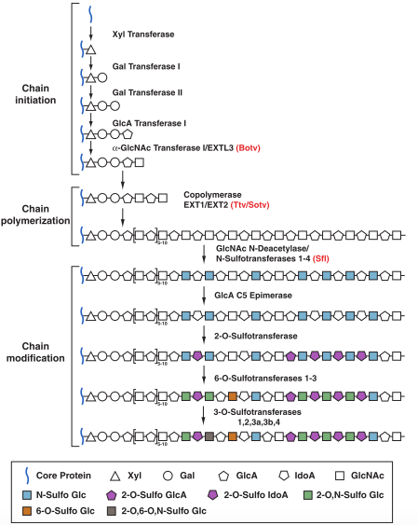

Figure 1.1 Heparan sulfate chain biosynthesis. Heparan sulfate (HS) glycosaminoglycan (GAG) chains are synthesized by a three-step process of chain initiation, polymerisation and modification on a core protein. HS chain synthesis starts with an addition of a linkage tetrasaccharide on a serine residue in the core protein. During the polymerisation process, alternating GlcA and GlcNAc residues are added to the HS chain by the EXT family of proteins. Modification of the HS chain includes deacetylation, epimerization and sulfation (Image taken from Lin 2004).

The carboxy terminal of *EXT2* shows a high homology at the amino acid level to *EXT1* (chromosome 11p11-p12, (Wuyts et al. 1995; Wuyts et al. 1998); however, a comparison between functional domains yielded no resemblance between the two (Wuyts et al., 1996). In spite of this, mutations in the *EXT1* and *EXT2* genes causing truncated forms of their respective proteins, called exostosins, are responsible for the majority of cases of hereditary multiple exostoses (HME) (Cook et al. 1993). HME is a disorder of endochondral bone growth and is identified by the existence of multiple cartilage-capped bony outgrowths, called exostoses (Cook et al. 1993) (Fig.1.2). An additional exostosin gene, *EXT3* located on chromosome 19 (Merrer et al. 1994) has been linked to a small number of clinical cases, whereas no cases have been shown to be linked to the exostosin-like genes (EXTL1, EXTL2, EXTL3). HME presents as several cartilage-capped outgrowths (exostoses) occurring at numerous locations in the skeleton, particularly at the juxtaepiphyseal region of the long bones (Solomon et al., 1963).

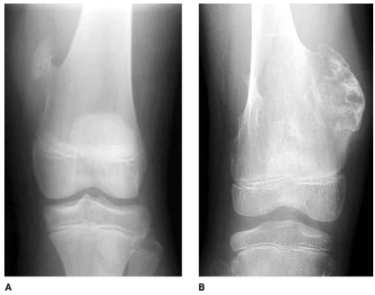

**Figure 1.2 Clinical presentation of Hereditary Multiple Exostoses (HME).** Patients with HME have numerous cartilage-capped bony outgrowths that may be sessile or pedunculated. (A) Anteroposterior radiograph of a pedunculated osteochondroma. (B) Anteroposterior radiograph of a sessile osteochondroma. (Image taken from Stieber and Dormans 2005).

Heparan sulfate (HS), a highly sulfated linear polysaccharide is covalently linked to a range of diverse core proteins to produce HS proteoglycans (HSPGs). These HSPGs are densely present on cell surfaces and can bind to a broad spectrum of molecules including growth factors, cell-surface receptors and morphogens (Irie et al. 2012). Therefore, HS or the genes that regulate its synthesis were suggested to possess a role in the physiological functioning of mammals. An indication of this role was suggested by Li et al (2002) after examining two separate cases of EXT sufferers who displayed autism associated with mental retardation (MR). Despite HME lacking manifestation of MR tendencies, another disorder termed tricho-rhinophalangeal syndrome (TRPS) type II is associated with the presence of both exostoses and MR. Type I and III of the TRPS disorder, however, lack any MR phenotypes, suggesting that the autistic tendencies may be due to the deletion of another gene near the TRPS loci. Interestingly, one case of TRPS type II harboured a deletion in both *TRPS 1* and the *EXT1* gene, implying involvement of *EXT1* and subsequently HS, in the development of mental disorders (Li et al., 2002). Irie and colleagues (2012) further defined the role of the *Ext1* gene and ultimately HS in mental disorders by generating transgenic mice lacking *Ext1* in the glutamatergic neurons of the forebrain. These mice consequently lacked HS expression in excitatory neurons in the forebrain as HS synthesis has been shown to be dependent on both exostosin genes being fully functional (Mccormick et al. 1998). Remarkably, *Ext1* mutant mice showed a wide range of autistic-like tendencies, including presentation of stereotypical, repetitive behaviours, deficiencies in social interaction and reduced ultrasonic vocalization. This study showed how mutations in the pathway responsible for synthesis of HS produced a wide array of autistic symptoms in the mouse, which closely resembles those characteristics seen in humans.

## Exostosin genes in zebrafish

A large-scale screen locating genes responsible for the organisation of the nerves which connect to retina to the tectum in the midbrain, also known as retinotectal projections, in the zebrafish discovered a gene, *dackel*, that disrupted the sorting of axons in the optic tract (Trowe et al. 1996). Further analysis by molecular cloning revealed that *dackel* (*dak*) encoded the zebrafish exostosin gene, *ext2* (Lee et al., 2004). Disaccharide profiling of mutant *ext2* zebrafish showed an 89% reduction in the total level of HS in 5 days post fertilisation (dpf) larvae, strongly implicating the role of *dak/ext2* in HS synthesis (Lee et al., 2004). Furthermore, *dak* mutant fish display defects in cartilage which strongly parallel those seen in HME patients (Clement et al., 2008). These include hypertrophic differentiation of chondrocytes, loss of bone cartilage formation and a reduction in intramembranous bone formation due to a reduction in osteoblast differentitation (Clement et al., 2008).

## Neuroendocrine control of behaviour

Neuromodulators have long been implicated in the regulation of the nervous system and ultimately, behaviour. For example, injection into the third ventricle of Siberian hamsters with neuropeptide Y (NPY), significantly increases their foraging and hoarding of food (Day et al. 2005). Furthermore, the neuropeptides oxytocin (OXT) and arginine vasopressin (AVP) are known regulators of complex social behaviours (Heinrichs & Domes 2008). Neuromodulators can act in a variety of fashions, from auto-regulation, circulation to distant targets and also through co-release with other transmitters (Marder 2012). To this end, they are capable of modulating the entire nervous system. However, exactly how the majority of identified neuromodulators act to regulate neural circuits and ultimately, behaviour is still largely unknown. Kisspeptin, a neuropeptide present in all mammals tested is recognized for its major role in reproduction. However, its exact role in lower vertebrates and additional functions outside reproduction in mammals are still not fully determined. Due to the pace of change and breadth of research within this field, an all-inclusive review may be unachievable; instead, I will present a brief review of the kisspeptin system first in mammals and following this, the kisspeptin system in zebrafish. For further information there are several excellent general reviews on kisspeptin signalling in the mammalian system (Clarke et al. 2015; Oakley et al. 2009; Pinilla et al. 2012).

## Kisspeptin system in mammals

### Discovery of kisspeptin in mammals

In 1977, a cardioexcitatory peptide was purified from the ganglia of the venus clam, *Macrocaliista nimbosa*, that was found to have the tetrameric conformation Phe-Met-Arg-Phe-NH2 leading to of a new class of peptides deemed the RFamides (Price and Greenberg, 1977). Following this discovery, numerous other peptides with the common C-terminal sequence Arg-Phe-NH2 have been found in a variety of vertebrate species (Osugi et al. 2015). One such peptide, KISS-1, discovered in 1996 and originally identified as a metastasis-suppressor gene, now belongs to one of the five classes of the mammalian RFamide peptide family (Lee et al. 1996). The four remaining classes in vertebrates include neuropeptide FF (NPFF), which was the first to be discovered (Yang et al. 1985), followed by the gonadotropin-inhibitory hormone (GnIH) (Tsutsui et al. 2000), 26Rfa/pyroglutamylated RF-amide peptide (QRFP) (Chartrel et al. 2003) and prolactin-releasing peptide (PrRP) (Hinuma et al. 1998). Although the RF-amides all present a shared C-terminal, they differ substantially in their N-termini illustrating their diverse patterns of biological activity (Findeisen et al. 2011; Tsutsui et al. 2010).

### Structure of kisspeptin in mammals

The human *KISS-1* gene, mapped to chromosome1q32-q41 (West et al. 1998) is composed of 438 nucleotides that produce a translated protein of 145 amino acids in length (West et al. 1998). A peptide of 54 amino acids results from the proteolytic cleavage of the protein. Further fragments of 14, 13 and 10 amino acids in size were also found to be biologically active, however, no additional cleavage sites were found within the peptide. It is therefore suggested that the longer form, designated kisspeptin-54, may be unstable and ultimately degraded to create the smaller fragments (Fig.1.3) (Kotani et al. 2001)**.**

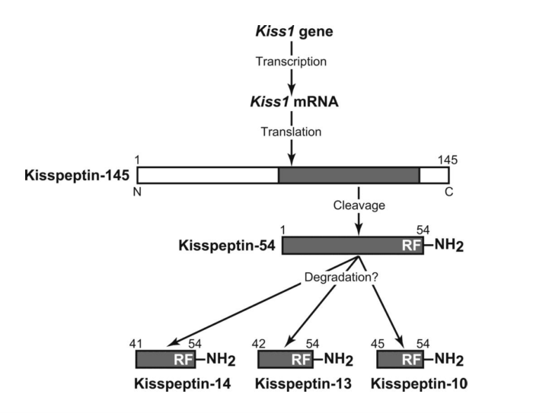

Figure 1.3 Kisspeptin cleavage products. A 145 amino acid peptide is translated from Kiss1 mRNA, which is subsequently transcribed from the *KISS-1* gene. The grey bar indicates the two cleavage sites used to produce kisspeptin-54, which presumably by degradation leads to the formation of shorter peptides. These shorter peptides maintain the C-terminus of kisspeptin-54 but extend to different lengths towards the N-terminus. The precursor mRNA contains a signal peptide at the N-terminus which acts to target the pre-propeptide to the rough endoplasmic reticulum, and on to the Golgi apparatus. Once there it undergoes post translational modifications before being packaged into vesicles for release (Image taken from Biran et al. 2008).

### Signalling of kisspeptin in mammals

The receptor for kisspeptin is a G protein coupled receptor (GPCR) with seven transmembrane domains belonging to the rhodopsin family of receptors (Clements et al. 2001). Currently known as GPR54, it is also known as KISSR, AXOR12 and hOT7T175. It has a high homology to the galanin receptor (~45%) though surprisingly it does not bind galanin nor the galanin-like peptide (Lee et al. 1999). Kisspeptin-10 is the minimum sequence needed for receptor activation in mammals (Ohtaki et al. 2001; Kotani et al. 2001). After binding of a ligand, a signal cascade is initiated beginning with phospholipase C, signifying the involvement of the a Gαq/11 pathway (Muir et al. 2001). This leads to PIP2 hydrolysis, subsequent accumulation of IP3, followed by release of Ca2+ and protein kinase C activation (Fig.1.4) (Kotani et al. 2001; Stafford et al. 2002).

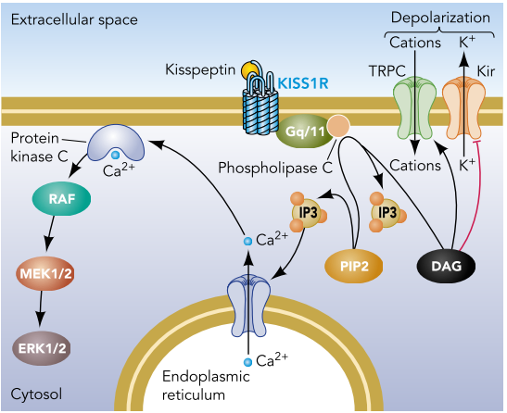

Figure 1.4 Kisspeptin action inside GnRH neurons. Ligand binding causes activation of the G-protein coupled receptor via the Gq/11 pathway to stimulate phospholipase C to form inositol triphosphate (IP3) through the cleavage of 4,5-biphosphate (PIP2). This causes Ca2+ release from the endoplasmic reticulum that activates further downstream pathways (Image taken from d’Anglemont de Tassigny and Colledge 2010).

### Anatomy of the kisspeptin system in mammals

In humans, kisspeptin expression has been found at high levels in the placenta, basal ganglia, intestine and testis (Muir et al. 2001; Tena-Sempere 2006) and shows weakly in almost all mouse tissues (Stafford et al. 2002). A common region of expression for kisspeptin is the hypothalamus, however, the exact localisation within this region varies across species. The most consistent expression seen in mammals is in the arcuate nucleus (ARC), known as the infundibular nucleus in humans and primates (Fig.1.5). Humans, monkeys and sheep show kisspeptin expressing cells in the preoptic area (POA), however, in rodents and pigs this expression is more localised to the anteroventral periventricular nucleus (AVPV) and the periventricular nucleus (Gottsch et al., 2004, Lehman et al, 2010). The expression of kisspeptin is also found to exhibit a sexual differentiation in some species. For example, in rats the number of Kiss-1 expressing cells in the AVPV region was significantly higher in females compared to male rats, a difference which was not seen in the ARC (Kauffman et al. 2007). This phenomenon is also seen in mice (Knoll et al. 2013), medaka (Kanda et al. 2008), sheep (Cheng et al. 2010) and humans (Semaan & Kauffman 2010).

Characterisation of the kisspeptin receptor, GPR54 shows a wide expression pattern in humans being present in the placenta, brain, pituitary, adipose tissue and pancreas. Within the brain it is localised mainly to the amygdala, nucleus accumbens, hippocampus and cingulate gyrus (Muir et al. 2001).

### Function of the kisspeptin system in mammals

The molecular mechanisms of KISS1 were initially ambiguous (Lee et al. 1996). However, further analysis showed that KISS1 was in the possession of a potential signal peptide sequence and several putative cleavage sites (Ohtaki et al. 2001; Nielsen et al. 1997; Rouillé et al. 1995) which suggested that it was more than likely to be a secreted neuropeptide. Furthermore, experiments by Ohtaki and colleagues (2001) showed how a peptide, identical to KISS1, isolated from human placental extract robustly activated a rat orphan receptor (rOT7T175), very similar to the human G-protein coupled receptor, GPR54 (Ohtaki et al. 2001). Different length fragments of the KISS1 peptide were shown to have varying levels of activation of the GPR54 receptor and that the residues Tyr112 and Asn113 may play vital roles in receptor activation (Ohtaki et al. 2001; Muir et al. 2001).

The first indication of a role for kisspeptin in reproductive functions came in 2003. Hypogonadotropic hypogonadism is a condition that is characterised by a series of disruptions in reproductive function, including delayed or absent puberty, insufficient sex steroids, immature reproductive organs and infertility (Wacker et al. 2008). A study surrounding a family with five members suffering from idiopathic hypogonadotropic hypogonadism (IHH), showed that all affected members possessed a mutation within the GPR54 receptor (de Roux et al. 2003). Astonishingly, mice carrying null mutations in the GPR54 gene showed phenotypes that almost completely replicated those seen in humans (Seminara et al. 2003). Moreover, it was found that administration of the KISS-1 peptide in a chronic and central manner in female rats resulted in signs of precocious puberty, such as advanced vaginal opening (Navarro et al. 2004). Following these discoveries, both kisspeptin and its receptor were understandably assumed to be key regulators of reproduction in mammals and hence began the extensive investigation in to their exact functions. Despite the lack of a defined pattern of brain expression of the ligand and receptor in mice, it was proposed that the reproduction signalling was centred on the hypothalamus. Injection of an exogenous source of varying concentrations of mouse kisspeptin-54 into the lateral cerebral ventricle in mice showed an increase in the blood serum levels of luteinizing hormone (LH) and follicle stimulating hormone (FSH). The same effects were seen with administration of human kisspeptin-10. Homology between the complete mouse and human kisspeptin peptides is low, however, the C-terminal 10-amino acid sequence differs by only one amino acid (Stafford et al. 2002). Additionally, the effect of kisspeptin-54 was shown to be mediated by gonadotropin releasing hormone (GnRH) as a GnRH antagonist, acyline, given prior to the injection of kisspeptin-54 abolished this effect (Gottsch et al. 2004), further suggesting a role of kisspeptin in reproduction. However, whether this centrally administered source of kisspeptin-54 acted directly on the hypothalamus or on surrounding brain regions, and how it affected GnRH neurons, was not known.

Several studies subsequently focussed on the role kisspeptin plays with regards to GnRH neurons. The first insight was provided by double-situ hybridization (ISH) studies, a method of detecting mRNA, using both GnRH and kisspeptin anti serum which showed a large proportion of GnRH neurons express the kisspeptin receptor, GPR54 (Irwig et al. 2004). Electrophysiology experiments showed how kisspeptin has an ability to activate GnRH neurons, even with small concentrations, capable of inducing a depolarization of neurons that can last up to 20 minutes (Liu et al. 2008). Sampling of cerebrospinal fluid (CSF) and plasma levels after intracerebroventricular kisspeptin administration showed an increase in GnRH peptide levels, a result that was absent in GPR54 knock-out mice (Messager et al. 2005). It has since been shown that the kisspeptin receptor, GPR54, activates GnRH neurons through activating transient receptor potential canonical (TRPC) – like channels and inhibiting inwardly rectifying potassium (Kir) channels (Zhang et al. 2008). The release of GnRH from the hypothalamus acts on the pituitary to regulate the release of gonadotropins (GTHs) such as LH and FSH. These gonadotropins progress to both incite gonadal development and sex steroid release, which then feedback on the brain to ultimately form the hypothalamus-pituitary-gonadal (HPG) axis (Pinilla et al. 2012; Shahjahan et al. 2013).

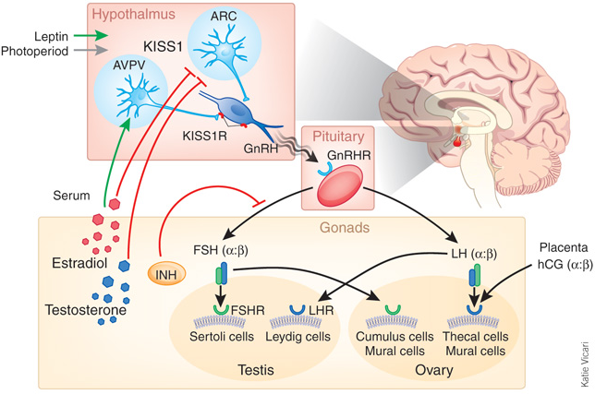

Figure 1.5 The role of kisspeptin in the reproductive axis. KISS1 stimulates the secretion of GnRH from the hypothalamus. This causes the release of the gonadotropins, LH and FSH from the pituitary, which then act on the gonads to induce development and subsequent sex steroid feedback regulation (Figure taken from Matzuk & Lamb 2008).

Seasonal changes can have an impact on reproduction because the time of year an offspring is born is vital for survival (Pellicer-rubio & Malpaux 2008). Melatonin, a hormone that helps to dictate day length is responsible for regulating the pulsatile release of GnRH from the hypothalamus (Ronnekleiv and Kelly, 2013). Hamsters placed under conditions that mimic a short day (SD) cycle, and therefore, reproductively unfavourable, show a reduced number of KISS1 expressing neurons. Remarkably, this effect was abolished by removal of the pineal gland that regulates of synthesis and release of melatonin (Revel et al. 2007).

Leptin is a hormone that acts to inhibit hunger and mutations within this peptide cause hypogonadotrophic hypogonadism (Clément et al. 1998). This hints at a relationship between leptin and GnRH function, however, GnRH neurons do not possess receptors for leptin. It is therefore likely that kisspeptin acts in an intermediary manner between leptin and the GnRH system (Smith et al, 2006).

Kisspeptin is also known to regulate numerous other neurotransmitters. For example, in the Japanese rice fish, *Oryzias latipes*, vasotocin and isotocin (Vasopressin and Oxytocin orthologues in mammals) neurons have been shown to express the kisspeptin receptor, GPR54 (Kanda et al. 2013). Furthermore, administration of kisspeptin increases serum levels of oxytocin and vasopressin in mammals (Kotani et al. 2001). Kisspeptin is co-expressed with dynorphin and neurokinin B (NKB) in the ARC in many species (Burke et al., 2006; (Rance 2009; Cheng et al. 2010). Despite the implications of kisspeptin in a variety of processes, some of which are listed above, a vast amount of work still needs to be conducted to ascertain its precise molecular functions.

## Kisspeptin signalling in zebrafish

### Discovery and structure of kisspeptin in zebrafish

Due to the eruption of interest surrounding kisspeptin function in mammals, it was not surprising that studies delved in to the possibility of kisspeptin signalling in other species. In 2007, van Aerle and colleagues used the sequence of human Kisspeptin-10 to identify putative sequences in five teleost species, including the zebrafish. A possible sequence for *Kiss-1* was found on chromosome 11 consisting of two exons and one intron. Within this region, predicted sequences for kisspeptin-10, a signal peptide sequence as well as possible cleavage sites were found, cementing this as homologous to the mammalian kisspeptin (van Aerle et al. 2008; Biran et al. 2008). Closer examination of the prospective kisspeptin-10 sequence in zebrafish showed that it differed from the mammalian peptide by only one amino acid (Yeo et al. 2009). Furthermore, a second isoform of kisspeptin was found in numerous species, including zebrafish. This sequence, named Kiss-2, is 125 amino acids in length and has a slightly different core kisspeptin-10 (FNLNPFGLRF) sequence compared to Kiss1 (YNLNSFGLRY). (Yeo et al. 2009; Kitahashi et al. 2009). Comparison of the full-length sequence of zebrafish kisspeptin genes to the mammalian form yields low homology, however, the kisspeptin-10 core sequence shows up to 80% homology (Biran et al. 2008).

### Signalling of the kisspeptin system in zebrafish

Due to the presence of two kisspeptin isoforms in the zebrafish, it was speculated that there would also be multiple forms of its receptor. In 2009, Yeo and colleagues discovered this second receptor and they denoted it GPR54-2. Both of the zebrafish kisspeptin receptors (Kiss1ra (GPR54-1) and Kiss1rb (GPR54-2)) show the same level of homology to the human kisspeptin receptor (45-49%), however, Kiss1rb showed an 18 amino acid difference compared to Kiss1ra which suggests a separate lineage of this receptor. The relative ligand specificity of the two receptors was tested and revealed that Kiss1ra showed a high affinity for Kiss1, whereas Kiss1rb had a similar affinity for both the kisspeptin ligands (Yeo et al. 2009). Furthermore, Kiss1ra has been shown to activate its downstream signalling pathways through Protein Kinase C (PKC), whereas Kiss1rb utilizes both the PKC and Protein Kinase A (PKA) pathway (Biran et al. 2008).

### Anatomy of the kisspeptin system in zebrafish

*Kiss1* expression in the zebrafish is seen in the brain and the testis (Servili et al, 2011). *Kiss2* is more widespread and is detected in the brain, ovary, testis, kidney and intestine (Kitahashi et al. 2009; Biran et al. 2008). Looking more closely at the expression in the brain, *Kiss1* expressing cells were found uniquely in the habenula, in the ventromedial and dorsomedial regions. Fibres positive for *Kiss1* were seen in the fasciculus retroflexus, ventral IPN and in the raphe nucleus. Conversely, *Kiss2* cells were located mostly in the mediobasal hypothalamus with a limited number in the preoptic area and in the periventricular nucleus (Fig.1.6). When regarding the receptors for kisspeptin, *Kiss1ra* containing cells were found in a pattern that replicated that seen for the peptide and double staining confirmed that cells expressing *Kiss1* also expressed *Kiss1ra.* On the other hand, *Kiss1rb* expression was mainly seen in the parvocellular preoptic nuclei, entopeduncular nucleus and thalamus (Fig.1.6) (Servili et al, 2011; Song et al. 2014). The pattern of expression of the kiss system in zebrafish is similar to that seen in mammals signifying a possible conservation across vertebrates (van Aerle et al. 2008). Changes in the expression of *Kiss1* mRNA are seen during development, for example, in female zebrafish there is a peak at 12 weeks post fertilisation and in males the peak is seen at 6 weeks. *Kiss1ra* mRNA levels increased throughout development and then dropped after 12 weeks, whereas *Kiss1rb* reached an elevated level at 6 weeks (Biran et al. 2008).

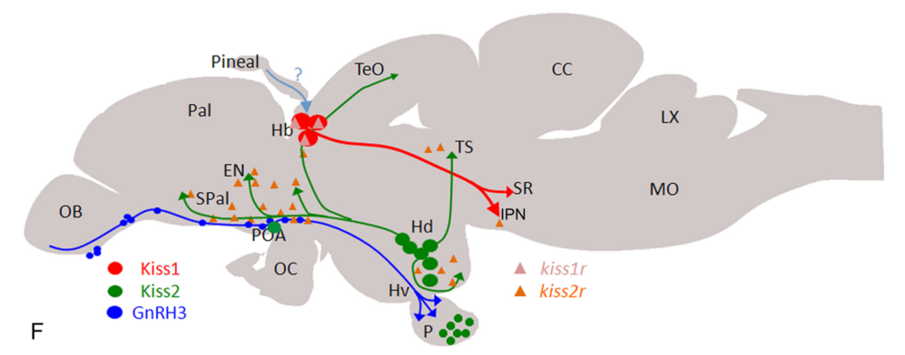

Figure 1.6 Schematic diagram showing the location of Kiss1 and Kiss2 in the zebrafish brain. Labelled are the: Habenula (Hb), optic tectum (TeO), torus semicircularis (TS), superior raphe (SR), Interpeduncular nucleus (IPN), medulla oblongata (MO), vagal lobe (LX), crista cerebelli (CC), dorsal (Hd) and ventral (Hv) hypothalamus, pituitary (P), Pineal, pallium (Pal), entopeduncular nucleus (EN), olfactory bulb (OB), subpallium (Spal), preoptic region (POA) and optic chiasma (OC) (Servili et al. 2011).

### Function of the kisspeptin system in zebrafish

It has clearly been shown that zebrafish possess two independent signalling systems concerning the kisspeptin gene. Kiss2 and its receptor, which are expressed mainly in the hypothalamus, were strong candidates for replicating the Kiss1 organization in humans and other mammals. However, a recent study has shown how mutations within all four members of the zebrafish kisspeptin system (*Kiss1, Kiss2, Kiss1ra* and *Kiss1rb*) using the TALEN method of genome editing had no obvious effect on the control of reproduction in zebrafish through analysis of spermatogenesis, folliculogenesis and reproductive capability (Hai et al. 2014). These results suggest that the kisspeptin system is dispensable for zebrafish reproduction , a drastic difference to the majority of vertebrates, where kisspeptin signalling is a criticial regulator of reproduction. However, a recent study showed the activation of a robust compensatory mechanism following deleterious mutations in the endothelial extracellular matrix gene, *egfl7*, a phenomenon not seen in transcriptional knockdowns (Rossi et al. 2015). These results suggest that there can be extreme differences in the phenotypes caused by gene knockdowns versus a genetic mutation. Therefore, the observation that kisspeptin signalling is not essential for a functioning reproductive system in the zebrafish may have arose from the genetic modification techniques used. The function of the Kiss1/Kiss1ra system is still largely unknown, however, recent evidence has also suggested a possible role in mediating the fear response through serotonin signalling in zebrafish (Ogawa et al. 2014; Nathan et al. 2015). Further investigation however, is needed to ascertain the exact functions of the kisspeptin signalling system in zebrafish.

## Zebrafish as a model for behavioural genetics

Behavioural genetics faces the need to overcome numerous obstacles in order dissect the components which act together to produce a behaviour. For example, one needs to be able to quantify distinct behaviours; recognize the vast variation that can occur within and between individuals; identify the role of particular genes, and acknowledge that genes can interact in a spatial and temporal manner (Sokolowski 2001). The zebrafish, a small tropical fish native to Southeast Asia, has fast become an excellent model species for behavioural genetics research. Having a fully sequenced genome with freely accessible databases providing gene information, a fast and external development, transparent larvae and expression of a large range of innate behaviours, the zebrafish provides a system for countless experimental advantages. Zebrafish have been primarily used in forward genetic screens where mutagenic agents are used to cause random mutations and the genes responsible are later mapped after phenotypic analysis. However, they are now used robustly in reverse genetics, which involves engineering a gene sequence and subsequently analysing the phenotypic changes later. An explosion in genome editing techniques such as Zinc Finger Nucleases (ZFNs) (Maeder et al. 2009), Transcription Activator-Like Effector Nucleases (TALENs) (Moore et al., 2012) and the Clustered Regularly Interspaced Short Palindromic Repeats (CRISPRs)/Cas9 system (Hwang et al., 2013), has allowed efficient and rapid knockdown of selected genes that is extremely beneficial when focussing on a specific neural circuit. The development of transgenic systems permits the expression of a wide spectrum of fluorescent proteins in the zebrafish that can be localised to a particular cell type or anatomical location (Scott et al. 2007). Furthermore, this system can be manipulated to allow for the activation and deactivation of specific genes across time or in a specific tissue (Lenz & Lobo 2013). The latest optical technology including two-photon microscopy (Ahrens et al. 2012) or light-sheet microscopy (Ahrens et al., 2013; Keller et al., 2008) allow for whole-brain imaging of the zebrafish at a single cell level. Additionally, the ease of drug administration for therapeutic evaluation and novel behaviour analysis brings the zebrafish to the forefront of translational research.

Utilizing animal models, such as the zebrafish that possess simple nervous systems but are still capable of producing complex motor and emotional behaviours, is fundamental for neural circuitry research. A high percentage of genes that are known to cause disease states in humans (~70%) present a functional homologue in zebrafish (Santoriello & Zon 2012; Howe et al. 2013). Whilst the zebrafish provides an excellent system in which to model mammalian disease, it is also a valuable model to study both simple and complex behaviours., At less than a week old, larval zebrafish will show a range of innate behaviours including prey-capture and escape responses, amongst many others (Burgess and Granato 2007; Budick & O’Malley 2000).­ Throughout development, behaviours become more advanced and complex in adult zebrafish including aggression, anxiety, shoaling, reward and learning and memory, which are all capable of being tested and quantified (Norton & Bally-Cuif 2010; Egan et al. 2009; Aoki et al. 2014; Ariyomo & Watt 2012). The evidence of a highly similar genome alongside validated methods to assess an extensive scope of behaviour that correlates with that seen in the mammalian system, makes the zebrafish an ideal model for the molecular and cellular basis of behaviour.

## Objectives of the project

The objectives of this project were to assess the genetic basis of behaviour in zebrafish focussing largely on two genes, *ext2* and *Kiss1*. The first part of my thesis investigates the behavioural function of the *ext2* gene in adult zebrafish. Studies in humans and rodents have suggested that defects in the exostosin genes contribute to MR and autistic-like tendencies. Therefore, I used validated behavioural assays to phenotypically characterize a stable zebrafish line with a point mutation in the *dak*/*ext2* (*dakto273b*allele) gene. The results of these studies are found in Chapter 2.

Following behavioural assessment of *dakto273b*heterozygous zebrafish, I then wanted to assess the role of kisspeptin1 on zebrafish behaviour. Due to the absence of a kisspeptin 1 mutant line in the zebrafish, I utilized the CRISPR/Cas9 system to create stable mutant lines within the kiss/kiss receptor system in the zebrafish, details of which are given in Chapter 3 of this thesis. The use of numerous behavioural paradigms characterized the behavioural phenotypes of these mutants (Chapter 4 and 5). Literature has shown that an addition of exogenous kisspeptin is able to reduce fear in the zebrafish but lacks any effect on anxiety. Chapter 4 describes several behavioural assays used to measure both fear and anxiety (Ogawa et al. 2014) and the results seen between the kisspeptin systems induced mutants compared to control fish. In chapter 5, I implicate a novel role for kisspeptin in regards to learning.

# Chapter 2: Variations in behaviour between *ext2* loss of function zebrafish mutants and their wild type siblings.

## 2.1 Abstract

The exostosin genes in mammals are responsible for the synthesis of heparan sulfate (HS) and mutations within the exostosin genes cause a condition known as hereditary multiple exostoses (HME) in humans. Interestingly, mutations in the *EXT1* gene have been linked to secondary causes of mental retardation in human patients. Furthermore, a recent study has shown how inactivation of the gene encoding one of the exostosin glycosyltransferases, *Ext1,* in postnatal neurons of mice, causes aberrant anxiety responses as well as autistic tendencies in mice. In this study, I show how zebrafish carrying mutations within another exostosin gene, *ext2* gene show subtle aberrations in two areas of behaviour, aggression and anxiety-like responses. These results highlight the possibility of the conservation of gene function across species and help create a functional network of genes and behaviour.

## 2.2 Introduction

Exostosin (*EXT*) genes encode glyscosyltransferases that are required in all cells to catalyse the polymerization of sugars to form heparan sulfate (HS) (See Chapter 1, Fig.1.1). Mutations in human *EXT* genes (*EXT1* or *EXT2*) underlie a dominant disease called hereditary multiple exostoses (HME) whereby sufferers develop cartilage capped bony outgrowths on their long bones (See Chapter 1, Fig.1.2) (Bovee, 2008). Furthermore, these genes are also involved in developmental pathways, particularly within intracellular signalling and neuronal path finding (Lee et al., 2004). A study by Li et al (2002) showed how human patients with Tricho-rhinophalangeal Syndrome Type II who present with mental retardation caused by deletion mutations in the *trps1* gene might also involve mutations in the *EXT1* gene.Following this, a more recent study has shown that mice are capable of exhibiting a broad range of autistic tendencies after elimination of HS in postnatal glutamatergic neurons through inactivation of the *Ext1* gene (Irie et al., 2012). Mutant mice showed impairments in social interaction, expression of stereotyped, repetitive behaviour and impairments in ultrasonic vocalization.

Preliminary work on zebrafish has suggested that fish possessing mutations within an allele of the *ext2* gene present with anomalies in their aggression and social tendencies (S. E. B. Wheat, Unpublished). Together these findings open the door to investigate the effects of mutations in a gene as well as other components of a specific developmental pathway on the behaviour of an animal.

## 2.2.1 Behavioural assays in zebrafish

### 2.2.1.1 Boldness

Boldness can be measured using the ‘open field test’ (Fig.2.2.C.ii) (Walsh and Cummins, 1976, Sousa et al., 2006) which measures behaviours elicited when an animal is confined to a novel open space without an opportunity to escape. Here an animal is confronted with its desire to explore a new environment paralleled with its fear of open spaces (Champagne et al., 2010, Sousa et al., 2006, Hascoet et al., 2001). This test has been validated using many animals including fish, where it is thought that it is not uncommon for them to encounter novel environments due to flooding or predator escape in the wild (Burns, 2008, Walsh and Cummins, 1976). Numerous parameters can be used to assay behaviours seen in the open field test, ambulation being a prime example due to the ease of its measurement and high level of validity (Burns et al. 1983). Quantification of ambulation can be done spatially by dividing the floor of the testing arena into a number of equal subdivisions and calculating the number of entries into each section. A higher number of entries implies a higher level of exploration and therefore increased boldness of the animal (Fig.2.2.C.ii) (Walsh & Cummins 1976; Ariyomo & Watt 2012). Boldness can also be measured by the total distance swam by an individual in response to a novel environment (Tran et al. 2013). Rather than being an independent variable to the number of lines crossed for measuring the boldness of an individual, they are two methods of measuring locomotor activity.

Conversely, ambulation of an animal can also be monitored by its lack of activity which is commonly divided in to two constraints, latency and freezing. Latency can be described as the passing of time until an animal elicits a particular behaviour such as initial movement or entry into a particular section of the testing arena. Freezing on the other hand is defined as a total absence of movement. Increased presence of both latency and freezing suggests a shyer individual as apposed to the high levels of movement seen in a bold individual (Burns, 2008, Walsh and Cummins, 1976).

An additional measure of boldness that can be calculated from the open field test is the propensity of an animal to remain close to the walls of the testing environment. This characteristic, known as thigmotaxis is considered to be utilized in the wild to help search for escape routes, shelter or protection (Champagne et al., 2010) and is one of the most commonly used behavioural end points used with rodents (Schnorr et al., 2012). In a testing environment, the proportion of time spent within the inner section of the test arena compared with the outer section can convey a measure of boldness (Fig.2.3.C). Shyer individuals tend to remain close to the periphery of the tank, whereas bold individuals are more likely to actively explore the same environment and therefore spend more time in the middle of the enclosure (Walsh and Cummins, 1976, Wilson et al., 1993). Thigmotaxis is considered to have high validity for the assessment of anxiety due to the knowledge that a variety of drugs have the ability to alleviate or exacerbate its presence (Schnorr et al., 2012).

### 2.2.1.2 Aggression

Aggression is an extensively studied trait in zebrafish due to its ability to create dominance hierarchies that can contribute to an animals access to food, mates and territory (Ariyomo & Watt 2012; Norton & Bally-Cuif 2010). The development of a validated test to assess aggression levels is therefore unsurprising. The mirror test, also known as mirror image stimulation (MIS) (Archard and Braithwaite, 2011) involves placing a zebrafish in an isolated environment with a mirror placed at an inclination to one side of the tank (Fig.2.4.C) (Gerlai et al. 2001; Moretz & Morris 2003; Ariyomo & Watt 2012). This test helps to stimulate the intrinsic level of aggression in an individual as the fish will attack its mirror image as though it is a real ‘opponent’ despite this being a subject of debate among scientists (Desjardins and Fernald, 2010, Hojesjo et al., 2011). It has also been insinuated that the mirror induces a greater reaction from the test fish when compared to either a real fish or an artificial opponent because the mirror image which directly mimics the testing fish, provides a constant source of aggressive reinforcement (Earley et al., 2000), however, this has not been found to be the case in zebrafish (Ariyomo & Watt 2013).

The acts of aggression displayed by a fish upon introduction of the mirror stimulus can include biting, erection of fins, fast bouts of swimming, colour changes and swimming back and forth in front of its image (Gallup, 1968, Moretz and Morris, 2003). The summary of the overall number of antagonistic acts displayed by an animal during the mirror test can produce an aggression ‘scale’ whereby animals exhibiting a high level of antagonistic acts are deemed more aggressive than their milder conspecifics, which display a fewer number of antagonistic acts (Ariyomo & Watt 2012). Additionally, due to the position of the mirror an animal’s reflection will appear closer on the side of the tank where the mirror makes contact with the outside wall of the testing tank. The distance of the perceived ‘opponent’ will then increase along the length of the tank away from the point of contact. Division of the testing arena in to four equal sections allows visualization of the location of the animal throughout the test. A greater length of time spent within the section of closest proximity to the ‘opponent’ insinuates a more aggressive individual

When compared to a baseline level of aggression obtained from wild type animals, *ext2*+/- mutants have been shown to display decreased levels of antagonistic acts towards their ‘opponent’. It was also found that although mutant fish preferred to be in the section closest to the mirror, they spent less time in a closer position compared to wild type fish (S. E. B. Wheat, unpublished).

### 2.2.1.3 Anxiety

Anxiety, which involves a foreboding distress from either a perceived or real event, is one of the most broadly researched behaviours in zebrafish. Common methods to judge the level of anxiety-like responses in animals include measuring the occurrence of avoidance behaviours (Champagne et al., 2010) and an animals response to threatening stimuli (Blaser et al., 2010). In rodents, threatening stimuli include novel, bright and open arenas as well as the presence of a predator or its cues. These techniques can be directly applied to the zebrafish (Blaser et al., 2010) and examples include the light/dark (scototaxis) test to measure anxiety in the zebrafish. Here an experimental tank is divided in to two equal sections, with one half covered with black material and the other in white (Fig.2.6.B) (Li, 2001, Serra et al., 1999). This experimental set up provides a preferable environment for zebrafish within the dark section, contrasting with a tendency of fish to avoid the white compartment (Blaser and Penalosa, 2011, Serra et al., 1999). These findings contradict the results of several studies however, which show fish with a strong avoidance of the dark compartment (Gerlai, 2003, Steenbergen et al., 2011, Li, 2001). Although it is not known for certain why these discrepancies arise, it is more than likely due to subtle differences in methodologies (Champagne et al., 2010).

The tendency to remain close to the wall of the testing arena (thigmotaxis), time spent in either the light or dark section of the tank, as well as the number of entries into each section can be used to assess the level of anxiety in zebrafish in the scototaxis test. Freezing, leaping and erratic movements, however, have been found to be inaccurate measurements (Blaser et al., 2010). Fish will tend to spend more time in the ‘safe’ environment (dark compartment) making short trips into the potentially ‘risky’ (white) environment. It is debatable, however, as to whether the behaviour seen is due to a positive approach for the dark compartment or a negative behaviour to avoid the white compartment (Maximino et al., 2010a). Using this knowledge, we can say a fish shows decreased levels of anxiety when increased time duration or increased entries in the white section of the tank occurs. Highly anxious individuals, however, will spend a high amount of time confined to the black compartment with fewer entries into the illuminated section.

The novel tank diving (NTD) test is a widely used test in the field of anxiety-like behaviour (Fig.2.7.C.ii) (Maximino et al., 2010b). Although a similar set up in respect to the open field test, the results from this test are obtained via vertical patterns of movement (Champagne et al., 2010). When a fish is first placed in a tank containing deep water, it will spend approximately 70-85% of its first minute in the lower half of the tank (Maximino et al., 2010b). This is due to the exposure of an unfamiliar environment which excels the zebrafish to seek safety at the bottom of the tank (geotaxis) until it becomes familiar with its surroundings (Stewart et al., 2011). Several parameters can be measured in this test, with the choice of position within the tank being a key indicator of anxiety (Bencan et al., 2009). Longer latency to reach the upper portion of the tank, as well as increased time spent in this half portrays anxiolytic behaviour. On the other hand, a high number of erratic movements, increased freezing and the majority of time spent in the lower half of the tank insinuates an anxious individual (Stewart et al., 2011).

### 2.2.1.4 Sociability

Amongst the numerous behavioural phenotypes displayed by sufferers of autism, impaired social interaction is one (Jamain et al. 2008). Zebrafish display an innate preference to connect with a shoal making them an ideal model for sociability (Barba-Escobedo & Gould, 2012). Social preference tests for zebrafish have been adapted from studies implemented in rodents (Kas et al. 2014) and normally comprise of a putting an individual in a tank which contains conspecifics at one end and is empty at the other (Fig.2.8.C) (Stewart et al. 2013). In a shoaling paradigm, zebrafish will normally choose to spend the majority of their time near the shoal, as opposed to the empty side (Stewart et al. 2013).

The *EXT* genes are strongly linked to the development of HME and more recently mental retardation (MR) (Bovée 2008; Li et al. 2002). Mice completely lacking *Ext1* in post natal neurons showed a vast display of autistic like tendencies (Irie et al. 2012). To further establish the role of the *EXT* genes in behaviour, I used a variety of behavioural assays to test zebrafish carrying heterozygous mutations in the dakto273b allele of the dackel gene (*ext2*), the zebrafish equivalent of *EXT2* in humans*.* The behaviours tested included aggression, boldness, social cohesion and also anxiety, and these results show that the zebrafish dackel, *ext2*, mutants show small anomalies in their aggression and also anxiety-like responses.

## 2.3 Materials and methods

### 2.3.1 Animals and housing

The mutant *dakto273b* alllele encodes base changes of ATT GAG to ATA TAG (aa 50-51) in exon1, resulting in a premature stop codon, causing nonsense mediated decay of the destabilized mutant mRNA (Lee et al, 2004).

All *dakto273b+/-* heterozygous mutant fish (denoted as dackel +/- in figures) and wild type sibling controls (denoted as dackel +/+ in figures) used for the behavioural assays in this study came from stocks maintained in the laboratories of the Department of Biomedical Science, University of Sheffield. Fish were kept on a 12/12 Light-Dark cycle and were fed twice daily with brine shrimp and dry fish food. Fish were housed in a centrally filtered re-circulatory system with no more than 40 fish per 10 L tank, heated to 26 ± 1**°**C. On the day the fish were tested they were fed after the trials to standardize hunger levels. Body length was measured from the tip of the mouth to the caudal peduncle using callipers (Mitutoyo Digimatic CD6’ CSX). All behavioural work was conducted under UK HO licence 40/3704.

### 2.3.2 Adult zebrafish movement analysis

Locomotion of adult zebrafish was monitored using an automatic

Video-tracking system (Videotrack, ViewPoint Life Sciences). Fish were tested individually in experimental tanks with the sides covered with opaque paper to prevent environmental influences. The Zebralab system contained a digital camera (25 fps) connected to a computer and movement of individual fish was analysed using Zebralab 3.10 software (Viewpoint Life Sciences). An infrared lighting system base (500 x 500 mm, Viewpoint behaviour technology) provided a contrast between the fish and a dark background to allow for efficient tracking. Lighting was kept uniform and constant between trials by three 14 W Daylight™ energy saving tubes (250 W equivalent) encased in a lamp head of size 610 x 110 x 60 mm (Daylight™, product code: D32500) situated approximately 60 cm above the testing tank. Tests were conducted on both male and female heterozygote *dakto273b+/-* and wild type zebrafish from two generations between the hours of 0900 and 1700 h. Fish were used once in each assay and they were left for a minimum of at least 24 hours between various behavioural tests. Before each test, females were separated from males and both groups were left for 30 minutes to acclimatize in their holding tanks to reduce stress levels before behavioural assays were performed.

### 2.3.2.1 Boldness testing apparatus and procedure

Boldness was measured using the ‘open field test’ (Walsh and Cummins, 1976, Sousa et al., 2006) (Fig.2.2.C.ii). Fish were initially placed in a small holding tank before transferred to a plastic 11 L capacity tank (Geo, Ferplast). The tank dimension was 35.6cm (length) x 23.4 cm (height) x 22.8 cm (width) and it was filled to a depth of 3 L with aquarium water. The floor of the testing arena was divided in to 24 rectangles, each measuring approximately 5.9 x 5.7 cm, using the Viewpoint system, which prevented the fish from becoming distracted by any physical marks on the tank. Individual fish were placed in the experimental tank for a 60-second acclimatization period and then their behaviour was recorded for 180 seconds, following a published protocol (Ariyomo and Watt. 2012). The number of lines crossed as well as the time spent in a frozen state was recorded throughout the experiment. Fish with fewer lines crossed or a higher level of freezing were designated shy, in contrast with bolder individuals who crossed a higher number of lines and spent less time in a frozen state.

An additional measure of boldness is the propensity of an animal to remain close to the walls of the testing environment, a characteristic known as thigmotaxis (Champagne et al., 2010). Using the Viewpoint system, the results obtained from the ‘open field test’ were re-analysed to judge for this behaviour. The floor of the testing arena was divided in to two sections of equal area, an inner rectangle (approximately 27 cm (length) x 15 cm (width)) surrounded by an outer portion (Fig.2.3.C). The proportion of time spent within the inner section of the testing arena was compared with the time spent in the outer section. An animal that spent a longer time in the periphery of the tank was deemed shy compared to an animal that spends a greater length of time in the middle section of the tank (Walsh and Cummins, 1976, Wilson et al., 1993). The number of entries into the inner section was also recorded, with a higher number of entries indicating a bolder individual.

### 2.3.2.2 Aggression testing apparatus and procedure

The mirror test involves placing a zebrafish in an isolated environment with a mirror placed at an inclination to one side of the tank (Gerlai et al., 2000, Moretz et al., 2007) (Fig.2.4.C). Fish were individually placed in an experimental tank of size 35.6cm (length) x 23.4 cm (height) x 22.8 cm (width) with the floor of the testing arena divided in to four equal sections (8.9 cm (length) x 23.4 (height) x 22.8 cm (width)) using the Viewpoint software. A mirror covered by opaque paper was placed at the side of the tank at an angle of 22.5°. After an acclimatization period of 60 seconds, the mirror was uncovered and the fish location and the number of aggressive displays were recorded for 300 seconds, following a published protocol (Ariyomo and Watt. 2012). The number of bites, displays and fast bouts of swimming were recorded as an indication of aggression, summarised as antagonistic displays. The time spent in each of the four divisions of the tank was also used to judge whether a fish preferred to be near its mirror image or avoid it, which could also be an indication of its aggressiveness. An increased amount of time spent by a fish in the section where its mirror image was closest (section A) was judged as a more aggressive individual than one that did not (Gerlai et al., 2000, Norton and Bally-Cuif, 2010). Using the Viewpoint system, an additional preference zone was created on the side of the tank where the mirror was placed (Fig.2.5.C). This area, deemed the display section (a rectangle box the length of the tank and 1.5cm deep), was the closest position a fish could get to its mirror image and therefore, the amount of time it spent both in and entering this this section was recorded and this gave a theoretical score of the number of antagonistic displays conducted by the animal.

### 2.3.3.3 Anxiety testing apparatus and procedure

The light/dark preference tank, or scototaxis test was used to measure anxiety in the zebrafish (Fig 2.6.B). Here, a tank (30 cm (length) x 20 cm (height) x 20.3 cm (width), Geo, Ferplast) was divided in to two equal sections (each 15 cm (length) x 20 cm (height) x 20.3 cm (width)). The dark section was additionally covered on the top and base in order to produce a stronger contrast between the two sections. In this test, fish were able to move freely between the two sections. Fish were placed individually in the testing environment for an acclimatization period of 60 seconds and then behaviour was recorded for 300 seconds, following a published protocol (Holcombe et al., 2013). During this test, an animal that spent longer in the dark side of the tank would be deemed more anxious than one that spent more time in the white/light section of the tank (Blaser and Penalosa, 2011, Serra et al., 1999).

The novel tank test, although similar in set up to the open field test, obtains results via the vertical patterns of movement (Champagne et al., 2010). When first confronted with deep water, fish swim to the bottom of the tank and spend the majority of their time there. Therefore, a fish that spends longer in the upper section of the tank will be judged as less anxious than a fish that seeks safety for longer at the bottom the tank. In these experiments, a tank was divided in to two portions (Fig. 2.7.C.ii). A fish was placed into the tank and was recorded for 360 seconds, following a published protocol (Breazeale. 2013). The location of the fish within the tank throughout the length of the test was measured using the Viewpoint system (Stewart et al., 2011).

### 2.3.3.4 Sociability apparatus and procedure

Social cohesion was measured using a custom-built glass tank (40 x 21 x 25 cm) consisting of a large central chamber flanked by two identical side chambers (7 x 21 x 25 cm) that contained either five conspecifics or remained empty (Fig.2.8.C). Individual fish were placed in the central compartment, which was divided in to four equal sections using the Viewpoint system (6.5 x 21 x 25 cm). Due to the nature of the experimental set up, olfactory cues, which may have influenced fish behaviour, were eliminated; instead only a visual representation of the shoal was used. To prevent any side bias, the shoal location was alternated between the two side chambers in the pattern L-R-R-L-R-L-L-R. After 60-second acclimatization period, fish location within the central compartment was recorded for 300 seconds, following a published protocol (Ward, Axford and Krause. 2003).

The division of the central compartment into ‘preference zones’ allowed characterization of fish social behaviour (Pritchard et al., 2001)(Fig.2.8.C). A greater amount of time spent within the section closest to the shoal would indicate group preference as opposed to a decreased social preference if a fish spent an increased amount of time next to the empty compartment (Miller and Gerlai, 2007).

## 2.3.3.5 Data analysis

Statistical analyses and graphs were made using R statistical package, v3.2.1 (R Development Core Team 2011). Visualising the quantile-quantile plot for residuals, as well as the Shapiro-Wilk Normality Test was used to assess normality, and if deviations occurred, data transformation was performed using log or power transformation. Normal data was then analysed using either an independent t-test or two-way Analysis of Variance (ANOVA), corrected for multiple comparisons using the Bonferroni method (0.05/number of statistical tests = adjusted P value) and post-hoc examination was conducted through the Tukey’s honestly significant difference test. If normality could not be achieved, non-parametric analysis was conducted using the Mann-Whitney-Wilcoxon test, Kruskal-Wallis test and the Dunn’s post hoc test. I used logistic regression to investigate the factors that affected the tendency of fish to freeze in a behavioural assay. I recorded whether a fish exhibited freezing and used these one-zero scores as the dependent variable. Genotype and sex were analyzed for their effects as independent variables. P<0.05 was set as the threshold for significance before correction and the size of the effect was measured using Cohen’s d and reported as d=n (Sullivan and Feinn, 2012). No fish were removed from analysis in this study.

## 2.4 Results

### 2.4.1 General activity and length of *dakto273b+/-*fishand their wild type siblings

To test whether there was a difference in baseline locomotion between *dakto273b+/-*fishand wild type siblings, a segmented screen was placed over the home tank and the number of lines crossed per fish was recorded and subsequently analyzed. Genotype had no significant effect on the number of lines crossed during locomotion within the home tank, suggesting no difference in the baseline activity between the two genotypes (Fig.2.1.A.i: two-way ANOVA: F(1,59)=0.824, p=0.3676; d=0.22, n=63). There was also no effect of sex on the number of lines crossed whilst in the home tank (Fig.2.1.A.ii: two-way ANOVA: F(1,59)=1.541, p=0.2193, n=63). However, there was an interaction between genotype and sex on the number of lines crossed whilst in the home tank (two-way ANOVA: F(1,59)=7.254, p=0.0092) with wild type females crossing significantly fewer lines than wild type males (Tukey HSD post-hoc test: p=0.0332).

Analysis of the standard lengths of the two genotypes showed a significant difference with wild type fish being significantly shorter in length than heterozygotes (Fig.2.1.B: Mann-Whitney rank sum test W=295, p=0.0002; d=-0.99, n=70).

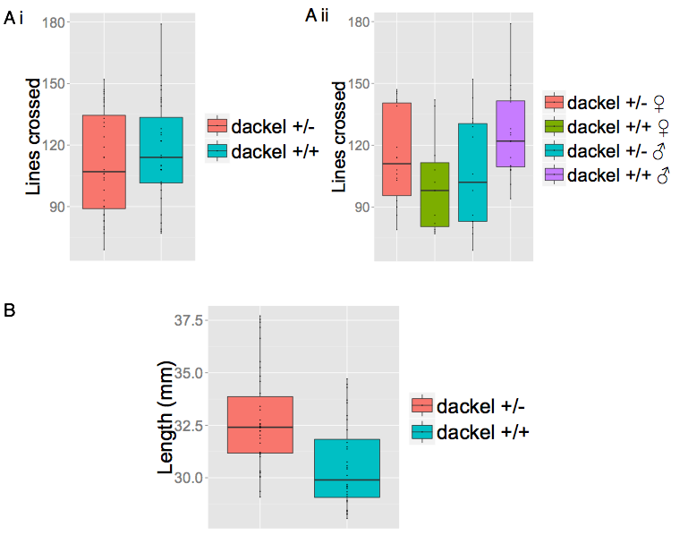

Figure 2.1 General activity and length of zebrafish prior to behavioural testing (A) Boxplot of the number of lines crossed whilst in home tanks for (i) genotypes as a whole and (ii) divided into sexes. (B) Boxplots for body length (mm). Data represented as median (solid line), upper and lower quartiles and 95% confidence intervals. *p<0.05. Dots represent individual data points.

### 2.4.2 Boldness in zebrafish *dakto273b+/-*mutants and wild type siblings

Analysis showed that there was no significant effect of genotype on the log transformed data of the number of lines crossed during the open field test (Fig.2.2.A.i: two-way ANOVA: F(1,66)=0.4631, p=0.4985; d=0.16, n=113). No effect of sex was seen on the log of the number of lines crossed in the open field test (Fig.2.2.A.ii: two-way ANOVA: F(1,66)=0.8802, p=0.3516; d=0.25, n=113) and no interaction of the transformed data between genotype and sex was seen (two-way ANOVA: F(1,66)=1.7559, p=0.1897).

No significant effect of genotype was seen on the log transformed data of the distance swam in the open field test (Fig.2.2.B.i: two-way ANOVA: F(1,66)=0.8368, p=0.3636; d=0.25, n=113) and neither by sex (Fig.2.2.B.ii: two-way ANOVA: F(1,66)=0.3115; d=-0.17, n=113). There was no interaction between genotype and sex on the log transformed data of the distance swam in the open field test (two-way ANOVA: F(1,66)=1.4086, p=0.2395).

A binomial logistic regression was run to understand the effect of genotype and sex on the tendency to freeze in the OFT. Neither genotype (z=1.764, p=0.078), nor sex (z=-1.009, p=0.3131), had an effect on the probability of freezing (Fig.2.2.C.i).

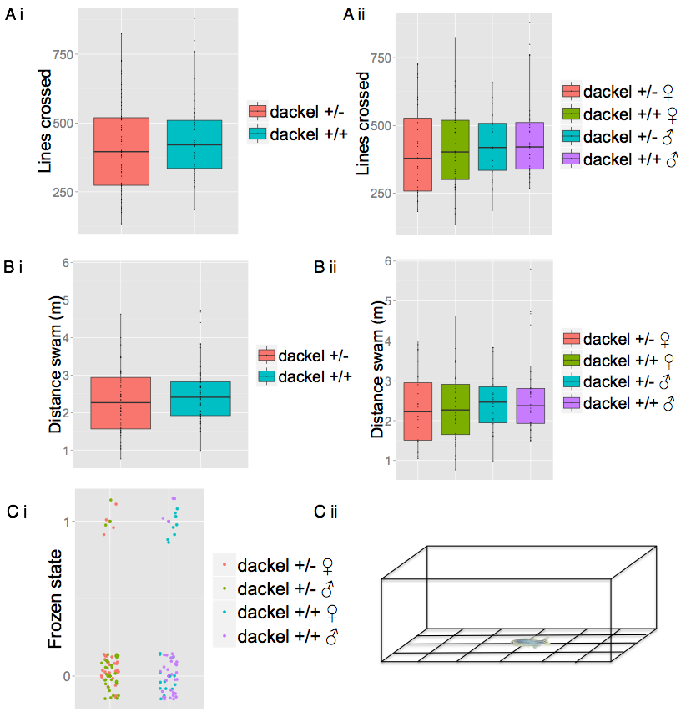

Figure 2. Behavioural parameters measured during the open field test

(A) Boxplots of the number of lines crossed between (i) *dakto273b+/-*and control siblings and (ii) sexes. (B) Boxplots of the total distance swam (m) between (i) *dakto273b+/-*and wild type siblings and (ii) sexes. Data represented as median (solid line), upper and lower quartiles and 95% confidence intervals. *p<0.01 with Bonferroni correction. Data in all boxplots are not transformed to show raw data. (C) (i) Scatterplot showing the frozen state of individual fish (1= presence of freezing activity, 0=absence of freezing activity) during the open field test and (ii) schematic of the OFT.

There was no significant effect of genotype on the time spent in the outer section of the tank as a thigmotactic measure during the OFT (Fig2.3.B.i: two-way ANOVA: F(1,109)=1.7403, p=0.1899; d=0.18, n=113).There was also no effect of sex on the time spent in the periphery of the tank (Fig.2.3.B.ii: two-way ANOVA: F(1,109)=2.1891, p=0.1419; d=0.14, n=113) and there was no interaction between sex and genotype on the time spent in the outer section of the tank as a measure of thigmotaxis (two-way ANOVA: F(1,109)=0.1319, p=0.7172).

Furthermore, the genotype of a fish had no effect on the log transformed data of the number of entries into the centre of the tank during the OFT (Fig.2.3.C.i: two-way ANOVA: F(1,109)=2.0262, p=0.1575; d=0.2, n=113). There was also no main effect of sex on the number of entries into the centre of the tank in open field test (Fig.2.3.C.ii: two-way ANOVA: F(1,109)=0.5108, p=0.4763; d=0.12, n=113) nor was there an interaction between genotype and sex on the number of entries into the centre of the tank during the OFT (two-way ANOVA: F(1,109)=0.2267, p=0.6349).

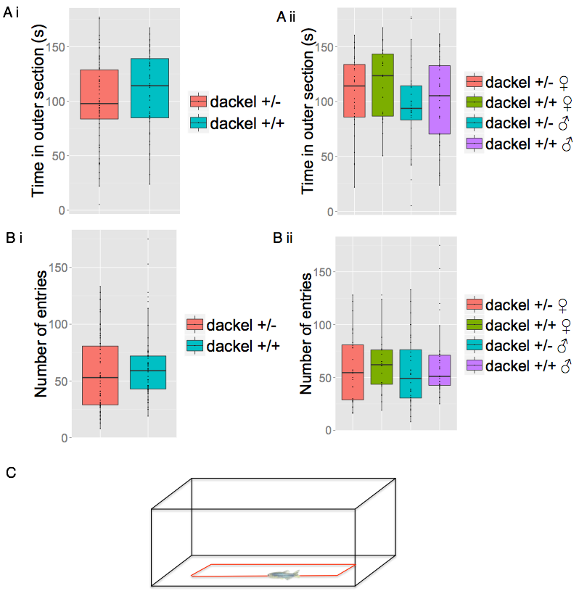

Figure 2. Behavioural parameters of thigmotaxis.. (A) Boxplot of time spent (s) in the outer portion of the tank for (i) genotypes and (ii) sexes. (B) Boxplot of non-transformed data to show the raw data of the number of entries into the inner section for (i) genotypes and (ii) sexes. Data represented as median (solid line), upper and lower quartiles and 95% confidence intervals. *P<0.01. (C) Schematic of the thigmotaxis test.

### 2.4.3 Aggression in zebrafish *dakto273b+/-*mutants and wild type siblings.

There was no signficant effect of genotype on the time spent in the section closest to the mirror, section A, during the aggression test (Fig.2.4.A.I: two-way ANOVA: F(1,101)=0.6823, p=0.4107; d=-0.12, n=105). However, there was an effect of sex on the time spent in section A during the mirror test, which was borderline significant following Bonferroni correction (p<0.01) (Fig.2.4.A.ii: two-way ANOVA: F(1,101)=6.6014, p=0.0116; d=-0.24, n=105). However, a post-hoc comparison using a Tukey HSD test yielded no significant differences. No interaction between genotype and sex was found on the time spent in the section closest to the mirror in the aggression test (two-way ANOVA: F(1,101)=0.0789, p=0.7794).

The effect of genotype on the number of aggressive displays seen during the mirror test was not significant on the transformed data (Fig.2.4.B.i: two-way ANOVA: F(1,58)=3.5221, p=0.06559; d=-0.33, n=62). However, there was a significant effect of sex on the transformed number of aggressive displays following Bonferroni correction (p<0.01) (Fig.2.4.B.ii: two-way ANOVA: F(1,58)=0.6579, p=0.0031; d=0.45, n=62). Post-hoc analysis revealed that wild type females showed a significantly lower number of aggressive displays compared to heterozygous males following Bonferroni correction (p=0.00279). There was no interaction between genotype and sex on the number of aggressive displays (two-way ANOVA: F(1,58)=0.658, p=0.4206).

There was no effect of genotype on the transformed number of entries into the display section during the mirror test (Fig.2.5.B.i: two-way ANOVA: F(1,100)=0.3475, p=0.5568; d=0.05, n=105), nor was there an effect of sex (Fig,2.5.B.ii: two-way ANOVA: F(1,100)=1.7117, p=0.1938; d=-0.4, n=105). There was also no interaction between sex and genotype on the number of transformed entries during the mirror test (two-way ANOVA: F(1,100)=0.8087, p=0.3707).

A Kruskal Wallis rank sum test revealed a non-significant effect of genotype on the time spent in the display section after Bonferroni correction (p<0.01) (Fig.2.5.A.i: X2(1)=4.2087, p=0.0402; d=-0.4) and no effect of sex on the time spent in the display section (Fig.2.5.A.ii: X2(1)=0.9647, p=0.326).

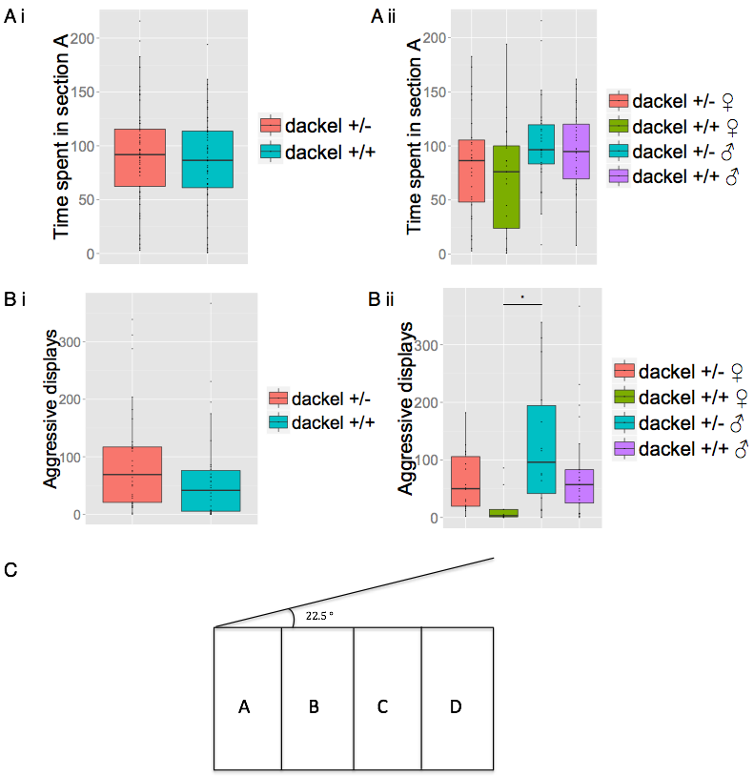

Figure 2. Behavioural parameters measured during the aggression assay

(A) Boxplot of the time spent (s) in section A between (i) genotypes and (ii) sexes. (B) Boxplot of the non-transformed raw data for the number of antagonistic displays between (i) genotypes and (ii) sexes**.** Data represented as median (solid line), upper and lower quartiles and 95% confidence intervals**.** *P<0.01. (C) Schematic of the mirror test.

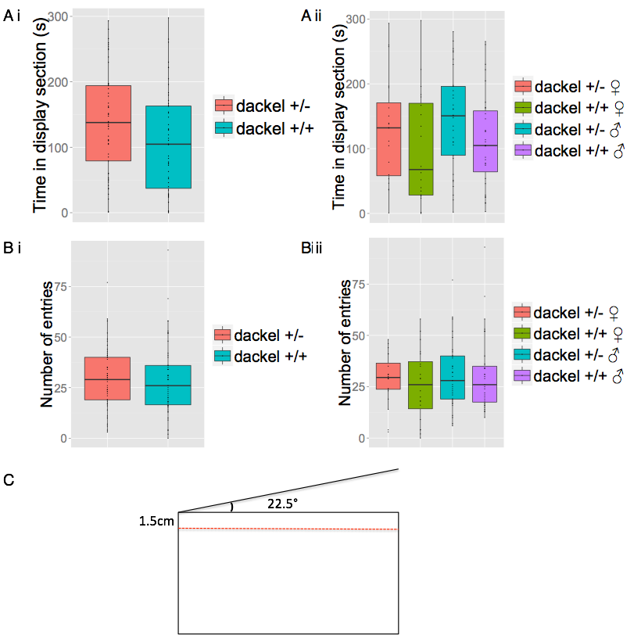

Figure 2. Behavioural parameters measured during the aggression test for display section (A) Boxplot of the time spent (s) in the display section for (i) genotypes and (ii) sexes. (B) Boxplot of the non-transformed raw data for the number of entries into the display section of the different (i) genotypes and (ii) sexes. Data represented as median (solid line), upper and lower quartiles and 95% confidence intervals. *P<0.01. (C) Schematic of the display section during the mirror test. The red dotted line indicates the boundary for the display section.

### 2.4.4 Anxiety in zebrafish *dakto273b+/-*mutants and wild type siblings using the scototaxis test

There was no effect of genotype on the time spent in the dark section of the tank during the scototaxis test (Fig.2.6.A.i: two-way ANOVA: F(1,103)=0.121, p=0.7282; d=0.06, n=107). Whilst there was no significant effect of sex on the time spent in the dark section (Fig.2.6.A.ii: two-way ANOVA: F(1,103)=3.613, p=0.0601), there was an interaction between genotype and sex on the time spent in the dark section of the tank (two-way ANOVA: F(1,103)=8.464, p=0.0044). Post-hoc analysis revealed a significant difference between wild type male and wild type female fish, with wild type females spending longer in the dark section of the tank (p=0.005).

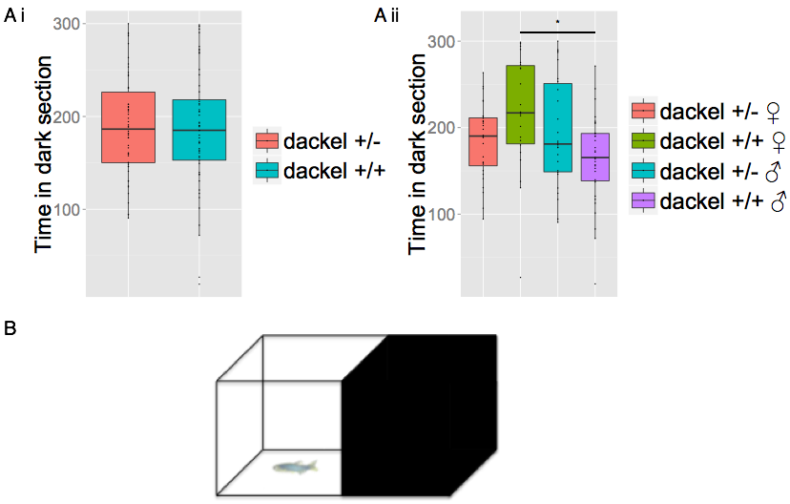

Figure 2. Behavioural parameters measured during the scototaxis test

(A) Boxplot of the time spent (s) in the dark section throughout the test for (i) genotypes and (ii) sexes. Data represented as median (solid line), upper and lower quartiles and 95% confidence intervals. *P<0.05. (B) Schematic of the scototaxis test.

### 2.4.5 Anxiety in zebrafish *dakto273b+/-*mutants and wild type siblings using the novel tank diving test

There was a significant effect of genotype on the time spent in the lower half of the tank in the NTD, with *dakto273b+/-*heterozygous fish spending significantly less time in the lower half on the tank compared to wild type fish (Fig.2.7.A.i: Kruskal-Wallis: X2(1)=5.1646, p=0.0231; d=0.56, n=92), which was insignificant after Bonferroni correction (p<0.01). There was also a signficant effect of sex on the time spent in the lower half of the tank during the NTD (Fig.2.7.A.ii: Kruskal Wallis rank sum test: X2(1)=5.0402, p=0.0247), with heterozygous females spending significantly less time in the lower section of the NTD test compared to wild type males (Fig.2.7.A.ii: Dunn’s post-hoc test: p=0.0061), which was significant after Bonferroni correction (p<0.01).

There was no effect of genotype on the number of entries into the upper half of the tank during the NTD test (Fig.2.7.B.i: Kruskal-Wallis rank sum test: X2(1)=2.5199, p=0.1124; d=-0.35), however, there was a significant effect of sex on the number of entries (Fig.2.7.B.i: Kruskal-Wallis rank sum test: X2(1)=7.9544, p=0.004797: d=-0.42), with heterozygous females exhibiting an increased number of entries in to the upper half of the tank compared to wild type males (Fig.2.7.B.i: Dunn’s post-hoc test: p=0.0078).

A binomial logistic regression was run to understand the effect of genotype and sex on the tendency to freeze during the NTD. Neither genotype (z=-0.617, p=0.537), nor sex (Fig.2.7.C.i: z=0.875, p=0.381) had a significant effect on the probability of freezing.

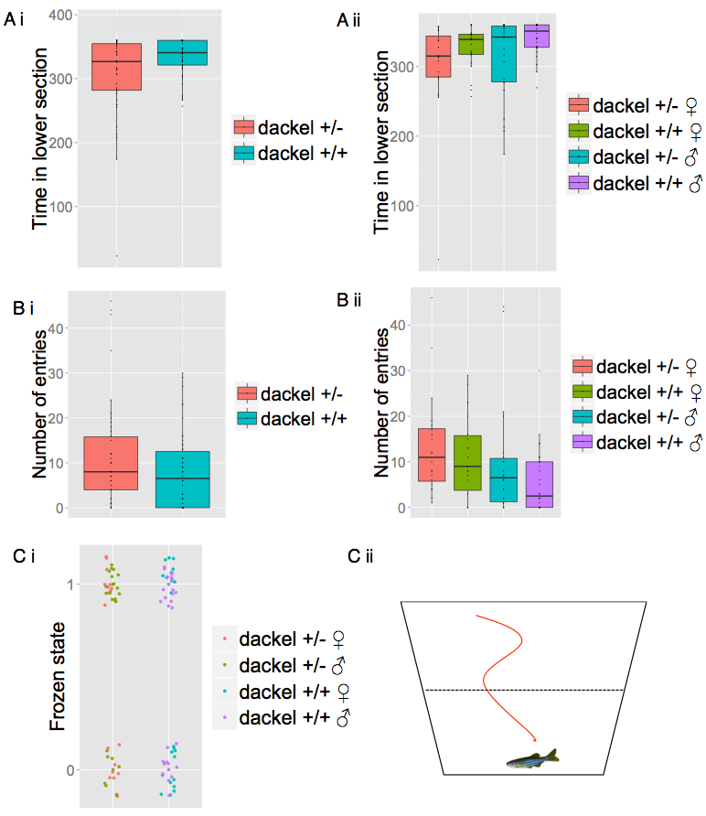

Figure 2. Behavioural parameters measured during the novel tank diving test (A) Boxplot of the time spent (s) in the bottom half of the test of the different (i) genotypes and (ii) sexes. (B) Boxplot of the number of transitions into the upper half of the tank of the different (i) genotypes and (ii) sexes. Data represented as median (solid line), upper and lower quartiles and 95% confidence intervals. *p<0.01. (C) (i) Scatterplot showing the frozen state of individual fish (1= presence of freezing activity, 0=absence of freezing activity) during the novel tank diving test, (ii) Schematic of the NTD test.

### 2.4.6 Social preference in zebrafish *dakto273b+/-*mutants and wild type siblings

There was no significant difference in the time spent in each section during the sociability paradigm between *dakto27b3+/-*mutantfish and wild type siblings (two-way ANOVA F(1,240)=0.03, p=0.826; n=61).Analysis showed there was no effect of genotype on the time spent in the section closest to the shoal, section A, during the social preference test (Fig. 2.8.A.i: two-way ANOVA: F(1,57)=0.663, p=0.4190; d=0.24). Furthermore, there was also no main effect of sex on the time spent closest to the shoal (Fig.2.8.a.ii: two-way ANOVA: F(1,57)=0.708, p=0.4038), nor was there an interaction between genotype and sex on the time spent in the section closest to the shoal in the social cohesion paradigm (two-way ANOVA: F(1,57)=0.7889, p=0.0701).

Additional analysis showed no effect of genotype on the number of entries into the section closest to the shoal, section A (Fig.2.8.B.i: two-way ANOVA: F(1,57)=0.496, p=0.484; d=0.18). Sex also had no effect on the number of entries into the section closest to the shoal (Fig.2.8.B.ii: two-way ANOVA: F(1,57)=0.112, p=0.740: d=0.02) and there was no interaction between genotype and sex on the number of entrie into the section closest to the shoal in the social preference assay (two-way ANOVA: F(1,57)=0.361, p=0.550).

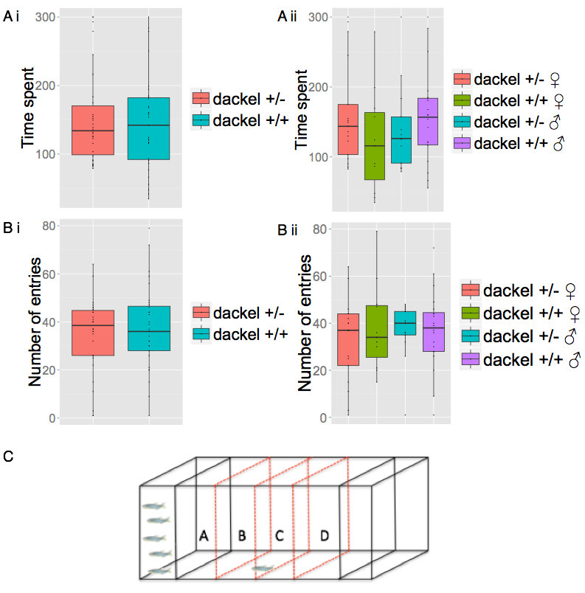

Figure 2. Behavioural parameters measured during the social cohesion paradigm (A) Boxplot of the time spent (s) in the section closest to the shoal, section A, between genotypes (i) and (ii) sexes. (B) Boxplot of the number of entries into the section closest to the shoal, section A between genotypes (i) and (ii) sexes. Data represented as median (solid line), upper and lower quartiles and 95% confidence intervals. *P<0.016. (C) Schematic diagram of the social preference paradigm.

## 2.5 Discussion

The exostosin genes (*EXT1* and *EXT2*) are vital for the synthesis of heparan sulfate (HS) in many mammals. Due to its role in regulating of a wide-range of cell-signalling events, genetic manipulation of the genes responsible for its synthesis may provide evidence for its role in the adult brain. To investigate the role of the *ext2* gene in zebrafish, I utilized a variety of different behavioural paradigms to ascertain whether a behavioural phenotype exists in *ext2* heterozygous mutant zebrafish, denoted *dakto273b+/-.* I initially implemented the open field test (OFT) to assay for the level of boldness through exploratory behaviour. Results indicated no differences in the parameters measured during the OFT between *dakto273+/-*mutantfish and their wild type siblings. This included exploratory behaviour analyzed through the number of lines crossed, distance swam and also time spent frozen. Furthermore, no differences were seen in thigmotaxic behaviour, with comparable times spent in the inner section of the tank, as well as the number of entries into the centre of the tank between *dakto273b+/-* mutant fish and control fish. These results were seen when looking at the sample population as a whole and also when comparing between the sexes of the two genotypes. Similar findings in *ext2* mutants in fish have been reported previously (Wheat, Unpublished). Together, these results suggest that the *ext2* gene does not contribute to bold-shy spectrum of behaviours in the zebrafish.

The mirror test was utilized to assay for the intrinsic level of aggression a fish possesses. Here, if a fish spends a larger amount of time in the section where the mirror appears closest (section A), it suggests a more aggressive individual than one that spends a larger amount of time in the section furthest away (section D). Furthermore, the number of antagonistic displays, time spent in the display section, and entries into the display section, are also indicative of a higher basal level of aggression. No difference was seen in the time spent in section A during the mirror test between *dakto273b+/-* mutant fish and control fish, and despite an effect of sex on the time spent in the section closest to the mirror, post-hoc anaylsis did not yield further details of a difference. No significant differences were seen in the number of entries into the display section between *dakto273b+/-* mutant fish and control fish. However, an effect of sex was seen on the number of antagonistic displays during the mirror test, with female wild type fish presenting significantly fewer antagonistic displays compared to heterozygous males. This suggests that there may be a subtle difference in aggression between the two genotypes, with an effect of sex. Furthermore, mutant fish appeared to spend a greater amount of time in the display section, that is the section closest to the mirror, across the entire length of the tank, compared to control fish. This result however was not significant following multiple correction application. These results suggest that *dakto273b+/-* mutant fish may have a small increase in the level of aggression compared to their wild type siblings, therefore suggesting that *ext2* may have a subtle role in regulating aggression in zebrafish. The results here however, contradict earlier findings seen in zebrafish that reported a decrease in antagonistic displays, and therefore decreased aggression in the *ext2* mutant zebrafish (Wheat, unpublished). The cause for the difference seen between these two experiments is unknown, however it could be explained by differences in experimental design, data collection and experimenter differences.

Mice that have *EXT1* conditionally inactivated in their post-natal neurons, show deficits in anxiety-related behaviours (Irie et al. 2012). To test for anxiety, two behavioural assays were used in this study, the light/dark (scototaxis) test and the novel tank diving test. In zebrafish, when presented with a tank composing of a light and dark section, adult fish show a robust preference for the dark section of the tank. Although no difference was observed between the two genotypes as a whole in the time spent in the two sections, a significant difference was seen between wild type fish. Here, wild type female fish spent significantly more time in the dark section compared to wild type male fish, suggesting that they are more anixous than males of the same genotype.

To further test whether there was any behavioural differences between *dakto273b+/-* heterozygous and wild type fish in regards to anxiety, I also used the novel tank diving test. During this paradigm, *dakto273b+/-* mutant fish spent a significantly decreased amount of time in the lower half of the tank compared to their wild type siblings, but this difference was non-significant after Bonferroni correction. However, further analysis showed that heterozygous females spent significantly less time than wild type males in the lower section of tank. Furthermore, heterozygous female fish also performed significantly more transitions into the upper half of the tank during the novel tank diving test. No difference in the level of freezing was seen between the two genotypes. These results parallel those seen in mice that have had *Ext1* conditionally knocked-out in their post-natal neurons. *Ext1CKO* mice spent an increased amount of time in the open arms during the elevated plus maze (EPM) test, in contrast to wild type mice, that remained mostly in the closed arms (Irie et al. 2012). Furthermore, *Ext1CKO* mice also spent an increased amount of time in the brightly illumination side of the light/dark box test compared to WT mice. These results, with effects seen both in fish and mice suggest that animals in with defects in their exostosingenes may show behavioural deficits in regards to anxiety-like behaviours.

Despite a deficit in social interaction seen in mice, fish carrying heterozygous mutations in the *ext2* gene showed no such impairments and spent a similar amount of time as wild type fish next to a shoal of fish, as well as no difference in the number of entries into the section closest to the shoal.

In the present study, a multiple comparison correction method was used to compensate for the number of statistical tests performed when analysing the different behaviours between the two zebrafish genotypes. Therefore, despite several of the parameters being significantly different between *dakto273b+/-* heterozygous and control fish, these differences were rejected when using the adjusted threshold for significance under the Bonferroni method. Therefore, the behavioural conclusions reported here must be taken with caution. Additional behavioural analysis on an increased sample size and supplementary mutant alleles of the dackel gene would help elucidate whether the differences seen in this study are conclusive. In spite of this, these results show how zebrafish with mutations in the *ext2* gene show several possible impairments in behaviour within their aggression and anxiety-like responses compared to wild type siblings. Mice with mutations in the *Ext1* show a wider, and more prominent range of behavioural phenotypes. The reason I may see an alleviated phenotype in this study is from the use of heterozygotes fish, due to the homozygous lethal nature of this allele (Clement et al, 2008). Therefore, some HS may still be able to be synthesized from the functional allele and retain normal behaviour in the zebrafish. However, several of the behaviours seen in zebrafish through this study and previously (Wheat, unpublished), recapitulate the behaviours seen in both rodents and humans who also carry mutations within the exostosin genes. These results imply that the exostosin genes may potentially govern similar roles between species and that therefore their functions have been maintained throughout evolution. However, more work needs to be conducted on the *ext2* gene in regards to zebrafish before one can say this with conviction.

# Chapter 3: Generation of zebrafish *Kiss1* and associated receptor mutants using Clustered Regularly Interspaced Short Palindromic Repeats (CRISPR) technology

## 3.1 Abstract

Recently the CRISPR/Cas9 system, which was originally discovered as a means of adaptive immunity in prokaryotes, has been modified to allow genome editing in a variety of eukaryotic systems. The production of targeted double strand breaks in almost any gene allows for the rapid and robust production of mutants for a variety of neuroscience applications. Here, I use the CRISPR/Cas9 system to successfully mutate *Kiss1,* the gene encoding the neuropeptide kisspeptin 1 in the zebrafish. Kisspeptin has previously been implicated in a variety of biological roles, namely reproduction in a large number of vertebrates. However, recently it has been suggested that it may participate in the modulation of fear behaviour in the zebrafish. To further elucidate the function of kisspeptin system in the zebrafish, I used the CRISPR/Cas9 system to genetically modify both *Kiss1*, and its associated receptor, *Kiss1rb.* Efficient knock down was later verified by immunohistochemistry and quantitative real-time PCR. This is the first study to show CRISPR/Cas9 generated mutants of the kisspeptin system in the zebrafish.

## 3.2 Introduction

The use of N-ethyl N-nitrosourea (ENU) in chemical mutagenesis to induce single nucleotide polymorphisms (SNPs) or small deletions in the zebrafish genome is the traditional method of mutagenesis. However, this allows no control of the gene being modified (Driever et al. 1996). Precise inactivation of choice genes by various methods, including homologous recombination, is vital for those who wish to study the function and interaction of genes. As with any technique there is a constant challenge to improve upon both the efficiency and speed in which to obtain optimal results. Most targeted genome inactivation methods exhibit caveats that inhibit productivity. For example, recombineering methods are extremely time consuming and have a low germline transmission rate (Suster et al. 2011). Morpholinos which produce a quick knockdown of a gene, often produce a transient response and their actions may terminate before phenotypes are discernable (Corey & Abrams 2001; Gebruers et al. 2013). The bacterial type II clustered regularly interspaced short palindromic repeats (CRISPR) – associated system (Cas) is the latest player in genome editing and provides a robust method for targeted mutagenesis (Hwang et al. 2013). In contrast to Transcription Activator-Like Effector Nucleases (TALENs) or Zinc Fingers (ZF), the modified CRISPR/Cas9 system can direct a common nuclease to a specific DNA sequence by a short, readily generated RNA. Therefore, the only need is to create a specific gRNA oligo of <100 nucleotides (nt) for each new target sequence, as the Cas9 protein is universal for all different target sites. Efficient target recognition by the CRISPR/Cas9 system requires 20 nt of homology between the sgRNA and its genomic target. Cleavage also requires that the 3’ end of the genomic target sequence contains a 3 base pair (bp) proto-spacer adjacent motif (PAM) sequence, NGG, which differentiates self from invading DNA in the endogenous system (Jinek et al., 2012).

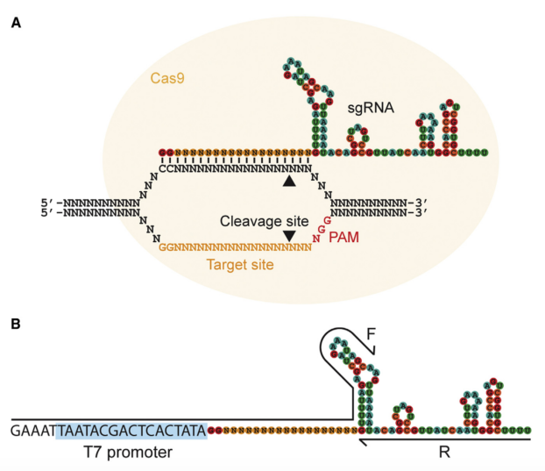

**Figure 3.1 Targetting of double strand breaks using the CRISPR/Cas9 technology**. (A) Two elements are required for the creation of double strand breaks. The synthetic guide RNA (sgRNA) possesses a region, which is complementary to the target site in the DNA and a region for binding to the Cas9 protein. The yellow circle denotes the Cas9 protein; the cleavage sites by the arrowheads and the protospacer adjacent motif (PAM, NGG) in the red. (B) Generation of the sgRNA by the PCR transcription-based method requires two oligonucleotides. The forward primer contains the T7 promoter (blue) and the GGn18 target-sequence and the reverse contains the remainder of the sgRNA after the target site. (Image taken from Bassett et al. 2013).

Ultimately, sgRNA target sites are designed by seeking sequences consistent with GG-N18-NGG on either the sense or anti-sense strand of DNA. Several well-designed web based sources allow for identification of targets from a chosen DNA source, such as ZiFiT Targeter (Sander, Zaback, Joung, Voytas, & Dobbs, 2007) or CHOPCHOP (Montague, Cruz, Gagnon, Church, & Valen, 2014).

There are several techniques which can be used to assess for successful genome modifications when using the CRISPR/Cas9 technology, for example, T7 endonuclease assays (Zhu et al. 2014) or restriction enzymes digests (Ran et al. 2013) which are both used extensively. An alternative option is High Resolution Melt Analysis (HRMA). HRMA is a post PCR analysis method that is highly efficient at detecting differences in nucleic acid sequences (Dahlem et al. 2012). Implementation of a quantitative real-time PCR (qRT-PCR) based technique allows single base pair change resolution within an amplified region of interest. With HRMA, the melt curve of the qRT-PCR reaction is produced using a low ramp rate of 1% during amplicon melting such that slight differences in melting temperature, as well as melt curve shape due to base pair changes, can be detected. The HRMA software can then normalize raw melt curve data and assign variant calls to the samples (Bratčikov & Mauricas 2009).

In the present work, I use the CRISPR/Cas9 system to induce mutations within *Kiss1* and the receptor genes, *Kiss1ra* and *Kiss1rb*,to help illuminate the function of the kisspeptin system in the zebrafish*.* Previous work using saporin, a ribosome inactivating protein, which inhibits protein synthesis and ultimately induces cell death, has shown how kisspeptin 1 regulates the fear response in the zebrafish (Ogawa et al. 2014). However, additional analysis showed no impairment within anxiety-like responses from a reduction in kisspeptin 1 neurons in the zebrafish (Ogawa et al. 2014). Furthermore, the ventral raphe, which receives afferent fibres from the kisspeptin 1 expressing ventral habenula neurons, has recently been implicated in learning in the zebrafish (Amo et al. 2014). Therefore, the resulting mutants developed in this study will be used in variety of behavioural assays to further investigate the function of kisspeptin1 signaling in zebrafish.

## 3.3 Materials and methods

### 3.3.1 Animals

All procedures were carried out in accordance with the Institutional Animal Care and Use Committee (IACUC) standards of the Biological Resource Centre at Biopolis, Singapore (IACUC Protocol number: 120730). Adult Tg(elavl3:GCaMP6f) fish were in crossed according to Westerfield., M (2000) and fertilized embryos were used for microinjections.

### 3.3.2 Cas9 mRNA production

The Cas9 expression vectors MLM3613 (Addgene #42251, Hwang et al., 2013) or pT3Ts-nls-zCas9-nls (plasmid #46757, Jao et al, 2013), were linearized using PmeI or XBaI respectively (New England Biolabs). Digests comprised of the following components; 1ug plasmid template, 1ul restriction enzyme, 5ul Cutsmart buffer (New England Biolabs) and ddH2O up to 50ul and incubated at 37°C for 60 min. The restriction enzyme digest was terminated using a method of PCR purification (Qiaquick PCR purification Kit, Qiagen). Cas9 mRNA was produced by in vitro transcription of 1ug template using the mMessage mMachine T3/T7 kit (1ug linearized Cas9, 10ul 2x NTP/CAP, 2ul 10x reaction buffer, 2ul enzyme mix, nuclease free water up to 20ul, Ambion) for two hours at 37°C. Capped, polyadenylated Cas9 mRNA was made using the Poly(A) kit (Ambion). Briefly, reactions consisted of 36ul nuclease free H2O, 20ul 5x EPAP buffer, 10ul 35nM MnCl2 and 10ul ATP solution, incubated at 37°C for 60 min, followed by addition of 4ul E-PAP (Ambion), and incubated for a further 60 min. The reaction was precipitated using 30ul lithium chloride solution (Ambion) and placed at -20°C overnight to aid precipitation. The following day, samples were microcentrifuged at 13,000 rpm for 30 min, washed with 70% ethanol and microcentrifuged for an additional 30 min. RNA was eluted in 30ul nuclease free H2O, aliquoted in to 1ul samples and stored at -80°C until use. A 1ul sample was run on a 1% agarose gel alongside the RiboRuler High Range ladder (Thermo Scientific) to check for correct size of product (~3kb).

### 3.3.3 sgRNA design

The sequences for zebrafish *Kiss1*, *Kiss1ra* and *Kiss1rb* were downloaded from Ensembl at www.ensembl.org/ (Flicek et al., 2014) or the UCSC Genome Bioinformatics Site at http://genome.ucsc.edu/ (DiBiase, Harte, Zhou, Zon, & Kent, 2006). (ENSDARG00000075829.2,ENSDARG00000002728, ENSDARG00000067563 respectively). sgRNA target sites that conformed to the sequence GGN18NGG on either the sense or antisense strand were identified using ZiFiT Targeter at http://zifit.partners.org/ZiFiT/ (Sander et al., 2007). The Basic Local Alignment Search Tool (BLAST) was used to test for off-targets and only those target sites that yielded no identical off-targets were used.

### 3.3.4 sgRNA production

The chosen target sites were integrated into a forward primer (GAAATTAATACGACTCACTATAGGN18GTTTTAGAGCTAGAAATAGC, Bassett et al., 2013). PCR was performed with Phusion High-Fidelity polymerase (ThermoScientific) with no template and a universal reverse primer that defined the remainder of the sgRNA sequence (AAAAGCACCGACTCGGTGCCACTTTTTCAAGTTGATAACGGACTAGCCTT ATTTTAACTTGCTATTTCTAGCTCTAAC) in a 50µl reaction volume (36.5ul H2O, 10 ul 5x HF Buffer, 1ul custom forward primer, 1ul universal reverse primer, 1ul dNTPs). The PCR reaction was cycled as follows: 98°C 30s, 29 cycles of [98°C 10s, 60°C 30s, 72°C 15 s], 72°C 10 min. PCR products were purified (QIAquick PCR purification kit, Qiagen) and 0.1ug was transcribed using the MEGAshortscriptTM T7 Transcription Kit (Life Technologies). The following mixture was performed at room temperature; 1ul of each dNTP solution (ATP, CTP, GTP, UTP), 1ul 10x reaction buffer, 0.1ug purified PCR product and 1ul of T7 enzyme). After 37°C incubation for 2 hours, and DNase (Qiagen) treatment for 30 min, sgRNAs were purified using ammonium acetate precipitation (2.5ul 0.1M EDTA (Promega), 5ul 5M ammonium acetate solution (Qiagen), 115ul 100% ethanol) and stored in 1ul aliquots at -80°C until needed.

### 3.3.5 Embryo microinjection

A mixture containing approximately 1ug Cas9 mRNA and 400ng/ul of sgRNA(s) was injected into the animal pole of Tg(elavl3:GCaMP6f) embryos at the one-cell stage using an electronically regulated air-pressure micro-injector (Harvard Apparatus). Needles were produced by pulling Borosilicate Glass 0.75mm with filament by a P-1000 Next Generation Micropipette Puller, Sutter instruments. Approximately 200-300 embryos were injected for each set of sgRNA preparations. The injected embryos were washed with E3 medium and kept in 10cm diameter petri dishes at 28.5°C until 5dpf.

### 3.3.6 Genomic DNA extraction

Genomic DNA from single 24 hpf embryos or from adult fin clips were extracted using a 100ul TE buffer (Promega) solution containing 20ug/ul proteinase K. Adult fish were anaesthetized with 0.4mg/ml tricaine solution (Sigma-Aldrich) and placed into individual tanks immediately following tail biopsies. Samples were incubated at 55**°**C for 60 minutes (individual embryos) or 90 minutes (adult fin clips) and then at 100°C for 10 minutes. Following brief centrifugation, 2.5ul (individual embryos) or 0.5ul (adult fin clips) of the DNA extraction were used in a 25ul genotyping PCR. Standard PCR conditions comprised of the following protocol: 95°C for 3 min; 35 cycles of [95°C for 30 s, primer annealing temperature for 30 s (*Kiss1*: 54°C, *Kiss1ra*: 54°C, *Kiss1rb*: 54.4°), 72°C 30 s], 72°C for 10 min and held at 16°C until ready for use. PCR products were run on a 1-2% agarose gel depending on the size of the final product.

### 3.3.7 Primer design for High Resolution Melt Analysis (HRMA)

Genome editing techniques may produce deletions or insertions of a small number of bases within a DNA sequence that would prove difficult to assess by a polymerase chain reaction (PCR) whose resolution is approximately 20bp. Therefore, the technique of HRMA was utilized in this study which is capable of identifying single bp changes within a DNA sequence. Oligonucleotides were made which would encompass the presumptive CRISPR cleavage site and give a product size of between 100-220 nucleotides in length. The melting temperature of the primers were set at 60°C and made using Primer 3 (Untergasser et al, 2012). These primers were then BLAST-searched against primer BLAST and also NCBI database to ensure specificity for the selected gene and were also analyzed using uMeltSM (Melting Curve Prediction Software for Single, Batch, and Multiplex PCR Products, Dwight et al, 2011) Software, which predicts the fluorescent high resolution DNA melting curve of PCR products. Selected primers were then synthesized and delivered in TE buffer at a concentration of 100uM by Integrated DNA Technologies and are listed in table 1.

### 3.3.8 Genome editing detection using HRM analysis

HRMA was performed using the MeltDoctorTM HRM Mastermix (Life Technologies, 5ul MeltDoctorTM HRM Mastermix, 1ul Diluted DNA (20ng/ul), 0.3ul Forward and Reverse primer (10uM) and 3.4ul nuclease free H2O) under the following conditions: 95°C 10 min, 40 cycles of [95°C 15s, 60°C 1 min], 95°C 10s, 60°C 1 min, 95°C 15s, 60°C 15s on the 7500 Fast Real – Time PCR system (Applied Biosystems). Nucleic acid concentration was measured using a Nanodrop® ND-1000 (Thermoscientific). Concentrations of nucleic acids were measured by the absorbance at 260 nm and the purity of the sample was quantified by the ratio of sample absorbance at 260/280 nm. A lower limit of 1.10 was set as the boundary for an acceptable reading for the 260/280 values due to impurities interfering with the HRMA analysis. During each HRMA reaction, 3 wild type samples were used as controls and each test sample was run as a replicate.

### 3.3.9 Quantitative PCR analysis of gene expression

Relative abundance of *Kiss1* and kisspeptin receptor mRNAs were tested by normalizing against a reference gene whilst undergoing the comparative threshold cycle method in adult (F3) mutant zebrafish and wild type control siblings. Adult fish were anesthetized in 0.4% Tricaine and submersed in ice for 15 minutes for euthanization (Gupta and Mullins, 2010). After decapitation with surgical scissors, brain dissection was performed in Ringer’s solution by cutting along the dorsal side of the head and pulling the two halves of the skull apart. RNA extraction was performed using the RNeasy Mini Kit (Qiagen). Individual brains were immediately placed into a 1.5 ml Eppendorf tube containing 350ul RLT buffer on ice and homogenized using a rotor-startor homogenizer (pellet pestle® motor, Kontes). Reverse transcription was performed using 0.1ug of total RNA using the SuperScript®III First-Strand Synthesis SuperMix (Invitrogen). The following was added to the reverse transcription reaction: 0.1ug RNA, 1ul Oligo(dT) 20 (50uM), 1ul dNTPs (10mM) and nuclease free water up to 13ul. The mixture was incubated at 65**°**C for 5 min and placed on ice for 1 min. Next, 4ul 5x first strand buffer, 1ul 0.1M DTT, 1ul RNase out inhibitor and 1ul Superscript III RT were added. This was incubated at 50**°**C for 60 minutes and inactivated at 70**°**C for 15 minutes. Nucleic acid quantification was gaged using 1 ul of the cDNA sample on a Nanodrop® ND-1000 (Thermoscientific) and RNA integrity (260/280) was between 1.8-2.0 for all samples.

Quantitative Real-Time PCR was performed using the SYBR GreenER™ qPCR SuperMix Universal (Invitrogen), following manufacturer’s instructions in a 7500-fast real time PCR machine (Applied Biosystems). The reaction comprised of the following: 5ul EXPRESS SYBR GreenER™ MasterMix, 200nM final concentration of both forward and revere primers, 0.2ul ROX reference Dye (25uM).

The threshold cycle for each sample was obtained and normalized against a reference gene, *β-actin* (Kitahashi et al. 2009) using the 2-∆∆Ct method that represents relative mRNA levels. The resulting PCR product was ran on a 2% TAE gel to ensure specificity by a single band at the anticipated size. PCR efficiency was guaranteed through the amplification of serial dilutions (1000; 200; 40; 8; 1.6 ng/ul) of brain cDNA samples and the resulting Cq values were plotted against the log concentration of the template. Furthermore, where possible RT-qPCR sample sets contained a no template control (NTC) to detect for contamination as well as a no enzyme control (NEC) to ensure any amplification seen was from the synthesized cDNA and not genomic DNA or other contamination.

### 3.3.10 Sequencing of PCR and HRM amplicons

Forward and reverse ends of the products from either PCR amplification using genotyping primers or the amplicon from HRM analysis were sequenced using BigDye® Terminator v3.1 Cycle Sequencing Kit (Applied biosystems) with either the forward or reverse primer. The following PCR conditions were used; 95°C 3 min, 24 cycles of [95°C for 10 s, 55°C for 20 s, 60°C 4 min] and then held at 16°C until use.

### 3.3.11 Immunohistochemistry (IHC) of zebrafish *Kiss 1* gene

To study the kisspeptin system in the zebrafish, I used a polyclonal antiserum for prepro-zebrafish Kiss1 (Servili, et al. 2011). Fish were fixed in 4% PFA after genotyping to identify homozygous mutant and wild type sibling fish at 7 dpf. Following overnight incubation in 100% MeOH and washing with PBS containing 0.1% Triton X, samples were permeabilized in blocking solution (PBS, 3% bovine serum albumin (BSA) (Sigma Aldritch), 1% DMSO and 0.1% Triton X-100) for one hour at room temperature and then incubated in the prepro-zebrafish Kiss1 antiserum in a 1:500 dilution overnight. After washing in PBS, the samples were then incubated in (1:1000) Goat Anti-Rabbit IgG (Alexa Fluor**®** 647) for one hour. Specimens were mounted in 2% LMA in PBS and imaged using a Zeiss LSM 510 Meta Confocal (Zeiss). The fluorophores were excited by an Argon laser at 488nm and 633nm using a C-Apochromat 40x/1.2 W Corr objective lens. The emission spectra collected for Alexa Fluor**®** 488 at band pass 505nm to 530nm and for Alexa Fluor**®** 647 at long pass 650nm. Stacks of images were Z-projected to make a maximum image with ImageJ 1.49v.

### 3.3.12 Statistical analysis

Data were expressed as mean values ± standard error of the mean (SEM). Differences in expression were analyzed using one-way analysis of variance (ANOVA) to assess statistically significant results. Analyses were performed using R Statistical Computing and Graphics software, version 3.2.1.

## 3.4 Results

### 3.4.1 eGFP locus disruption by CRISPR/Cas9 in NBT:GCaMP5 zebrafish

To test the capabilities of the CRISPR/Cas9 system in the zebrafish, I used an sgRNA designed to target the eGFP reporter locus (Table 1) (Bassett et al. 2013) in the transgenic line Tg(NBT:GCaMP5) (Fig.3.2). The neural-specific beta tubulin promoter (NBT) drives expression of GCaMP5, a green fluorescent protein in the nervous system of the zebrafish. Successful mutagenesis within this locus would give a readily distinguishable phenotype, by a lack of fluorescence and thus a competent readout of CRISPR efficiency. The resulting injections produced a startling phenotype with an almost complete lack of fluorescence in the majority of fish injected (Fig.3.2.B). At 6 days post fertilization (dpf) there was a lack of fluorescence in 82% (82/100) of eGFP sgRNA + Cas9 injected larvae, compared with a 5% (2/39) rate in the un-injected larvae (Fig.3.2.C). Furthermore, after sequencing of four Tg(NBT;GcaMP5) injected embryos with the Cas9 and eGFP sgRNA mixture that showed a lack of fluorescence, all revealed a series of deletions which occurred very near to the PAM of the eGFP target site (Fig.3.2.D). However, sequencing of an uninjected fish that retained fluorescence showed an undisturbed sequence. This indicated that the lack of fluorescence was in fact due to the actions of the CRISPR/Cas injections and not the result of an aberrant factor. A slightly higher death rate was seen in the injected embryos compared to uninjected embryos across the 6 days (37.8% vs 20.5%). However, these results suggested that not only was the CRISPR/Cas system working efficiently but also that it was tolerable at a cell survival level.

### 

Figure 3.2 Disruption of GCaMP5 loci by the CRISPR/Cas9 system

### Dorsal views of (A) 6dpf Tg(NBT:GCaMP5) un-injected and (B) Tg(NBT:GCaMP5) + eGFP sgRNA + Cas9 injected (B) fish. (C) Percentages of fluorescent and non-fluorescent fish. (D) Sequencing results from an un-injected and non-fluorescing injected fish shows a deletion upstream of the PAM sequence, highlighted in red. The CRISPR target site is underlined in black.

### 3.4.2 *Kiss1* gene disruption by CRISPR/Cas9 technology in zebrafish

Following the success of eGFP sgRNA CRISPR/Cas injections, two sgRNAs were designed to target the signal peptide sequence in exon 1 of the zebrafish *Kiss1* gene. (Fig.3.3.A, Table 2). Zebrafish embryos obtained from a Tg(elavl3:GCaMP6f) incross were injected with 1nl of a mixture containing Cas9 mRNA (880ng/ul) and the two sgRNAs (T1.1 and T1.2, 400ng/ul) into the animal pole of one-cell stage embryos. Effective RNA guided mutagenesis of the *Kiss1* gene resulted in a variety of mutant alleles in the F0 injected embryos that could be readily detected by high resolution melt analysis (HRMA) (Fig.3.3.B). The HRMA method involves the conduction of a qPCR reaction using specifically designed primers to produce short amplicons, which cover a predicted mutation site (Table 1). Genetic variation due to insertions or deletions are distinguished from wild type sequences due to there melting temperatures and therefore varying shape of melt curves. Successful genome editing was implied after HRM analysis from the initial sample of F0 generation of *Kiss1* sgRNA injected zebrafish with the melt curves showing distinct differences from the wild type samples (Fig.3.3.B, Table 3). Sanger sequencing confirmed this high mutation rate showing that 88.8% (8/9) of the injected fish assayed by HRMA possessed a mosaic sequence surrounding the PAM site of target T1.1 (Fig.3.3.Ci). Validation of the high mutation rate seen at the *Kiss1* loci was achieved with additional screening of injected embryos (Fig.3.3.C,ii). Here, 100% (8/8) of the embryos screened showed mutations, with embryo 4 displaying a mutation occurring at a location more upstream to those seen earlier.

### 3.4.3 CRISPR/Cas9 induced *Kiss1* mutations are heritable

To test the germline transmission of the CRISPR/Cas9 induced *Kiss1* mutants, positive founder fish (F0) were outcrossed to a Tg(elavl3:GCaMP6f) line. F1 offspring were subjected to HRM analysis at 24hpf and showed a 100% mutation rate (10/10) in embryos screened from two separate crosses, indicating mutation occurred within both alleles of the gene targetted, also known as bialleic mutations, in the F0 generation (Fig.3.11.A). F1 generation fish harbouring mutations were outcrossed twice more to produce a stable F3 generation. Two mutations were used from the F3 generation, a 19 base pair deletion (Δ19) spanning the signal peptide site (Fig.3.3.D,ii) designated Kiss1sq1sj-/-, and a second, 7 base pair insertion (+7) immediately following the signal peptide site at the exon-intron boundary (Fig.3.3.D.iii) called *Kiss1sq2sj-/-.*

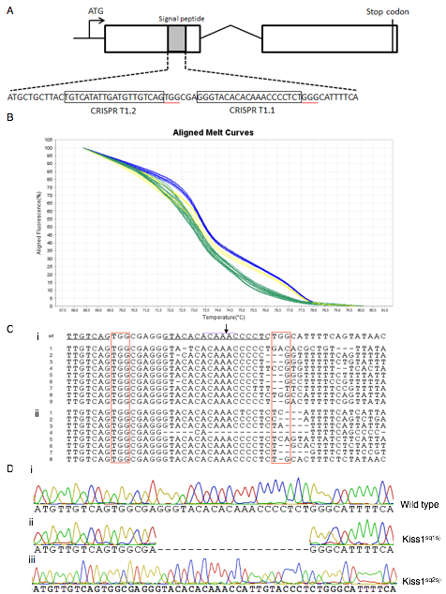

Figure 3.3 Summary of the Kiss1 mutations from CRISPR/Cas9 injections.

(A)Schematic of the *Kiss1* gene and the sgRNA target sites designed to target exon 1. Black boxes denote the target sequences and the red lines indicate the PAM sequences. (B) HRM results from 24 hpf DNA taken from 9 injected (Cas9 (880ng/ul) + *Kiss1* T1.1 and 1.2 sgRNA (400ng/ul) and 3 control fish. The blue lines indicate wild type sequences; green and yellow lines designate sequences that deviated from wild type. (C) Sequences of (i) the 9 embryos from the HRM plot and (ii) an additional 8 embryos screened showing the mutations surrounding the T1.1 and T1.2 target sites. (D) Sequences from (i) a wild type control and selected F3 generation fish show a (ii) Δ19, *Kiss1sq1sj-/-*, and a (iii) +7 *Kiss1sq2sj-/-*mutation. Arrowhead indicates exon-intron boundary.

### 3.4.4 Real-time PCR analysis of *Kiss1sq1sj-/- andKiss1sq2sj-/-*mutants

To investigate the effects of these mutants, I first examined the *Kiss1sq1sj-/-* and *Kiss1sq2sj-/-* average mRNA transcript levels by quantitative reverse transcription PCR (RT-qPCR). *Kiss1sq1sj-/-* mutant fish displayed a significant difference in mRNA transcript levels compared to wild type controls (ANOVA F(1,16)=176498, p<0.0001) by showing an almost complete (~99.7%, N=5) absence of transcript levels compared to wild type (WT) fish (Fig.3.4.A), as well as no detectable product after gel electrophoresis (Fig.3.4.B), implying a high messenger RNA (mRNA) degradation rate. No difference was seen in the gross morphology between wild type and *Kiss1sq1sj-/-* fish.

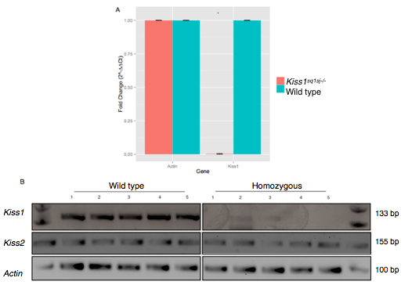

Figure 3.4 Characterization of the *Kiss1sq1sj-/-*zebrafish using qRT-PCR

(A) The fold change results (2-∆∆Ct) for *Kiss1sq1sj-/-*and control fish for both *Kiss-1* and *Actin* transcripts. (B) qRT-PCR products visualised on a 2% TAE agarose gel for *Kiss1sq1sj-/-*and control fish for the three genes, *Actin*, *Kiss1* and *Kiss2*.

Analysis of the mRNA transcript levels in homozygous *Kiss1sq2sj-/-*fish were also tested for several genes, including *Actin*, *Kiss1* and *Kiss2*. Transcript levels in *Kiss1sq2sj-/-* fish differed significantly from control fish (ANOVA F(1,12)=127.6, p<0.0001) and showed a decrease of approximately ~77% (77.4%, N=4) in mRNA transcript levels compared to control fish (Fig.3.5.A), despite a detectable band of the right size upon gel electrophoresis for the *Kiss1sq2sj-/-*fish qRT-PCR product Fig.3.5.B).

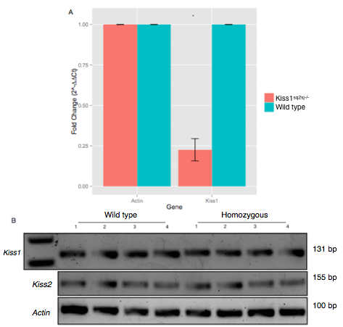

Figure 3.5 Characterization of the *Kiss1sq2sj-/-*zebrafish using qRT-PCR

(A) The fold change results (2-∆∆Ct ) for *Kiss1sq2sj-/-* and control fish for both *Kiss1* and *Actin* transcripts. (B) qRT-PCR products visualised on a 2% TAE agarose gel for *Kiss1sq2sj-/-* and control fish for the three genes, *Actin*, *Kiss1* and *Kiss2*.

### 3.4.5 Immunohistochemistry of *Kiss1sq1sj-/-* and*Kiss1sq2sj-/-*mutants

To further characterize the *Kiss1sq1sj-/-* and*Kiss1sq2sj-/-*mutantfish, I performed immunohistochemistry on both mutant and wild type siblings. Immunoreactivity was seen in the ventral habenula (VHb) of the wild type fish (Fig.3.6.A); however, no *Kiss1* labelling was seen in the VHb of *Kiss1sq1sj-/-* mutantfish (Fig.3.6.C). Surprisingly, despite a reduction of approximately 77% in mRNA transcript levels in *Kiss1sq2sj-/-*, mutantfish still exhibited Kiss1 immunoreactivity in the vHb (Fig.3.6.D).

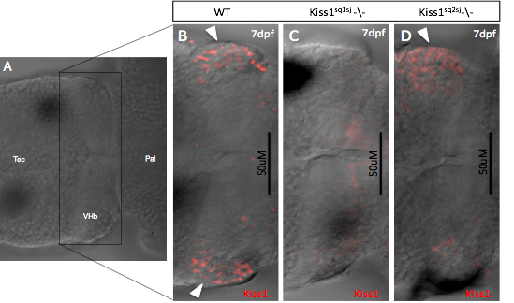

Figure 3.6 Knockdown of kisspeptin reveals no expression in the habenula

(A) A single optical section of a 7dpf wild type fish showing the location of the habenula in relation to the pallium (Pal) and tectum (Tec). (B-D) Confocal section of 7dpf larval zebrafish immunnostained with Kiss-1 antibody in (A) wild type sibling (B) *Kiss1sq1sj-/-* mutant and (C) *Kiss1sq2sj-/-* mutant.Arrowheads indicate kisspeptin expression.

### 3.4.6 *Kiss1ra* gene disruption by CRISPR/Cas9 technology in zebrafish

After successful mutation of the zebrafish *Kiss1* gene, I turned to its receptor, *Kiss1ra*. Reports from mammalian studies suggest that the leucine residue at position 148 (L148) in the GPR54 is important for the receptor to activate its downstream signalling system through the second intracellular loop of the G-protein coupled receptor (Seminara et al, 2003). By comparing the amino acid sequences for the mammalian kisspeptin receptor (GPR54) with the zebrafish *Kiss1ra* sequence, I was able to confer homology between the receptors and show that the presumptive leucine residue important for receptor activation in mammals appears to be conserved in the zebrafish kisspeptin receptor. A search for suitable CRISPR target sites within the *Kiss1ra* gene revealed a target near the start of exon three, the exon containing L148 in the *Kiss1ra* gene (Fig.3.7.A). The sgRNA *Kiss1ra* T3.1 (Table 2) was subsequently injected into Tg(elavl3:GCaMP6f) embryos at similar concentrations to those mentioned previously (Cas9 mRNA, 950ng/ul, sgRNA(s) 400ng/ul). HRM analysis of the FO generation of injected fish revealed highly efficient genome editing, paralleling that seen in the Kiss1 CRISPR/Cas injections. Analysis of 10 selected embryos showed indels in 60% (6/10) of those chosen at 24 hpf (Fig.3.7.B,C).

### 3.4.7 CRISPR/Cas9 induced *Kiss1ra* mutations are heritable

As shown in figure 3.10, the F0 injected generation injected with sgRNAs targeted to the *Kiss1ra* exon 3 loci produced a stable mutation, which was transmitted through the germline to F1 offspring. The rate of heritability was 100% (8/8) (Fig.3.11.B) suggesting bi-alleic mutations. Further outcrossing showed that mutant fish (F3 generation) denoted Kiss1rasq3sj-/- harboured a 6 base pair deletion at the beginning of exon 3 (Fig.3.7.D).

### 3.4.8 Real-time PCR analysis of *Kiss1rasq3sj-/-* mutants

To further characterize this mutant fish line, RT-qPCR was conducted on *Kiss1rasq3sj-/-* homozygous mutants to compare the level of mRNA transcripts with that in wild type siblings. There was no significant difference in the transcript levels between control and mutant fish (ANOVA F(1,8)=0.02, p=0.9970) with a less than 2% difference between mRNA transcript levels (Fig.3.8.A: 1.6%, N=3) as well as a detectable band after gel electrophoresis (Fig.3.8.B). These results suggest that the stable, 6 bp deletion in exon 3 of the *Kiss1ra* locus did not cause a frame shift mutation and did not inhibit mRNA production.

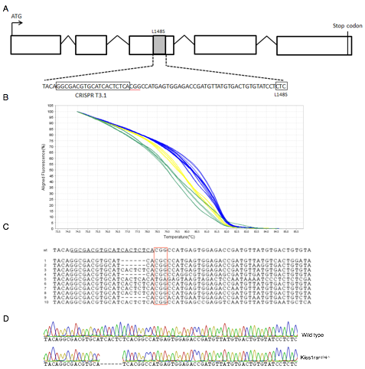

Figure 3.7 Summary of the *Kiss1ra* mutation from the CRISPR/Cas9 injections (A) Schematic of the *Kiss1ra* gene and the sgRNA target sites designed to target exon 1. Black boxes denote the target sequences and the red lines indicate the PAM sequences. (B) HRMA results from 24 hpf DNA taken from 10 injected (Cas9 (880ng/ul) + kiss1 T3.1 sgRNA (400ng/ul)) and 3 control fish. The blue lines indicate wild type sequences; green and yellow lines designate sequences that deviated from wild type. (C) Sequences from the 10 embryos subjected to HRM analyses show 6/10 of the sequences possessing mutations surrounding the PAM site in red. (D) Sequences from a wild type fish and selected F3 generation fish show a Δ6 mutation denoted *Kiss1rasq3sj-/-.*

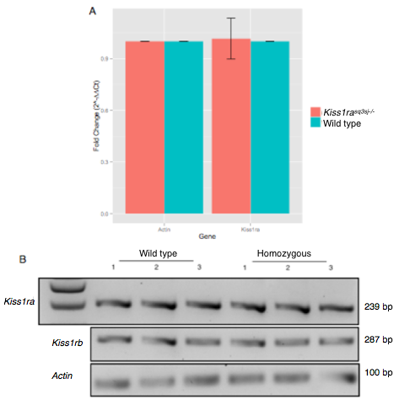

Figure 3.8 Characterization of the *Kiss1rasq3sj-/-*zebrafish using qRT-PCR (A) Graph depicting the fold change results (2-∆∆Ct) for *Kiss1rasq3sj-/-*and control fish for both kiss1ra and Actin transcripts. (B) qRT-PCR products visualised on a 2% TAE agarose gel for *Kiss1rasq3sj-/-*and control fish for the three genes, *Actin*, *Kiss1ra* and *Kiss1rb*.

### 3.4.9 *Kiss1rb* gene disruption by CRISPR/Cas9 technology in zebrafish

I also utilized the CRISPR/Cas9 technology to target the *Kiss1rb* gene. Similarly to the *Kiss1ra* gene, a residue homologous to the L148S residue in mammals was located in the zebrafish receptor b gene (Fig.3.9.A). Two sgRNAs were designed to target this region (Fig.3.9.A, Table 2) and were injected at similar concentrations as those mentioned previously. *Kiss1rb* showed successful mutagenesis with 100% (10/10) of injected embryos showing a mutation surrounding the injected CRISPR targets through successive HRM analysis in 24hpf embryos (Fig.3.9.B,C).

### 3.4.10 CRISPR/Cas9 induced *Kiss1rb* mutations are heritable

Adult fish were screened for mutations surrounding the CRISPR/Cas9 target sites in those injected with *Kiss1rb* sgRNAs and positive founder fish were outcrossed. Screening and subsequent sequencing showed again the high mutagenesis of the CRISPR/Cas9 system as 100% (10/10) of the F1 progeny screened showed heterozygosity of the site of targeting (Fig.3.11,C). Additional outcrossing and subsequent sequencing revealed a stable 28 base pair (∆28) deletion (Fig.3.9.D) in the F3 generation denoted *Kiss1rbsq5sj-/-.*

### 3.4.11 Real-time PCR analysis of *Kiss1rbsq5sj-/-* mutants

To further characterize the mutants, adult F3 control and *Kiss1rbsq5sj-/-* fish were subjected to RT-qPCR analysis using specific primers (Table 1). A significant difference between the fold change and therefore mRNA transcript levels was seen between *Kiss1rbsq5sj-/-*and control fish (ANOVA F(1,12)=1087639, p<0.0001) (Fig.3.10.A) as well as no detectable product after gel electrophoresis (Fig.3.10.B). Mutant fish presented with an almost complete (~99.8%) knock down of mRNA transcript levels compared to control fish..

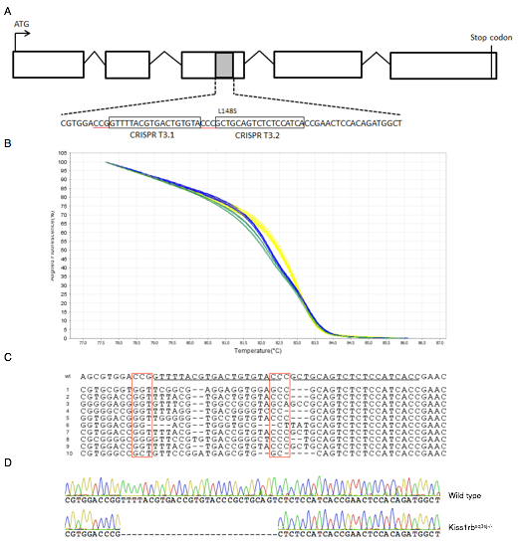

Figure 3.9 Summary of the *Kiss1rb* mutations from CRISPR/Cas9 injections (A) Schematic of the *Kiss1rb* gene and the sgRNA target sites designed to target exon 1. Black boxes denote the target sequences and the red lines indicate the PAM sequences. (B) HRM results from 24 hpf DNA taken from 10 injected (Cas9 (880ng/ul) + *Kiss1rb* T3.1 and 3.2 sgRNA (400ng/ul)) and 3 control fish. The blue lines indicate wild type sequences; green and yellow lines designate sequences that deviated from wild type. (C) Sequences from a wild type fish and selected F3 generation fish show a Δ28 base pair deletion.

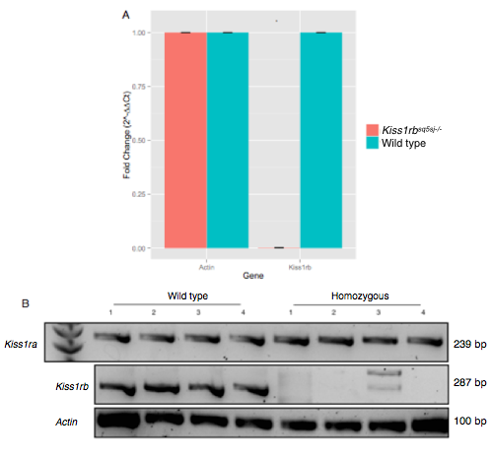

Figure 3.10 Characterization of the Kiss1rbsq5sj-/- zebrafish using qRT-PCR (A) The fold change results (2-∆∆Ct) for *Kiss1rbsq5sj-/-*and control fish for *Kiss1rb*, *Kiss1ra* and *Actin* transcripts. (B) qRT-PCR products visualised on a 2% TAE agarose gel for *Kiss1rbsq5sj-/-*and control fish for the three genes, *Actin, Kiss1ra* and *Kiss1rb*.

## 3.5 Discussion

In the present study, I have effectively used the CRISPR/Cas9 genome editing system to create mutations within the *Kiss1* gene and the associated receptors, *Kiss1ra* and *Kiss1rb*, in the zebrafish. Using this technology I was able to competently induce site-specific disruptions within 3 genes in the kisspeptin system with efficiency between 60-100%. Using the CRISPR/Cas9 system, I targeted the signal peptide sequence in exon 1 on the *Kiss1* gene. Analysis showed two distinct mutations, a ∆19 deletion, which completely removed the signal peptide sequence, and a +7 base pair insertion immediately following the signal peptide sequence. These produced stable and heritable mutations that resulted in an extensive knockdown of mRNA transcript of *Kiss1* mRNA. Furthermore, immunohistochemistry revealed a distinct expression of Kiss1 in the VHb in control fish, which was completely lacking in the *Kiss1sq1sj-/-* mutant line. Surprisingly, despite a 7bp insertion, *Kiss1sq2sj-/-* and displaying a~77% reduction in mRNA transcript levels, these fish still exhibited abundant protein levels through immunohistochemistry. However, several studies have assessed the relationship between mRNA and protein and it is thought that mRNA expression can at most capture only 40% of protein expression (Tian et al. 2004). Therefore, these differences observed between mRNA and protein levels in the *Kiss1sq2sj-/-* may bedue to several factors including post transcriptional, translational or post-translational modifications.

Regardless of producing a heritable, 6 base pair deletion in exon 3 of the *Kiss1ra* gene, I did not see an effect on the mRNA levels in homozygous mutants compared to control fish. On the other hand, mutagenesis of the *Kiss1rb* gene produced an almost complete knockdown of mRNA levels in *Kiss1rbsq5sj-/-*fish*.* However, neither of the kisspeptin receptors could be corroborated with immunohistochemistry due to the lack of readily available antibodies and an insufficient amount of time to generate them myself

The mutants created, *Kiss1sq1sj-/, andKiss1rbsq5sj-/-* providea stable and enduring method to determine the functional role of the kisspeptin system in the zebrafish through gene inactivation. The use of these mutant fish as a basis for a variety of behaviour tests will be explained in the following chapters.

## List of Tables

|  |  |  |  |  |  |
| --- | --- | --- | --- | --- | --- |
| **Target gene** | **Primer** | **Sequence** | **Product size** | **Slope** | **R2** |
| Actin | β-actin qRT F | AGAGCTATGAGCTGCCTGACG | 106 bp | -3.276 | 0.995 |
| β-actin qRT R | CCGCAAGATTCCATACCCA |
| Kiss1 | Kiss1 qRT F | ACAAGCTCCATACCTGCAAGTG | 131 bp | -3.132 | 0.996 |
| Kiss1 qRT R | AATACTGAAATGCCCAGAGGG |
| Kiss1 HRM F | TTGTTCTTTTCTTTCAGAACTCTTCTC | 184 bp |  | |
| Kiss1 HRM R | CAACTGAAATTAACAAATGGAACC |
| Kiss2 | Kiss2 qRT F | TTTACTGCGTGCTAGTCGATGTTT | 155 bp | -3.108 | 0.996 |
| Kiss2 qRT R | GCCTATGCCAGACCCCAAA |
| Kiss1ra | Kiss1ra qRT F | CCTAACTTCAAGGCCAAC | 239 bp | -2.776 | 0.978 |
| Kiss1ra qRT R | CCTCTCAGTGTTGCTTTC |
| Kiss1ra HRM F | TTTACCCTGGTGCCCTGAAG | 180 bp |  |  |
| Kiss1ra HRM R | CGATGGTGCAGGGATTTGAG |
| Kiss1rb | Kiss1rb qRT F | AGACGTCATCGGAGCGTG | 287 bp | -3.237 | 0.985 |
| Kiss1rb qRT R | CCTCCTTTTGAAGATCAGAGGAC |
|  | Kiss1rb HRM F | AACAGCTCCCTTTTAGATGC | 182 bp |  |  |
| Kiss1rb HRM R | CTAGTGTACAGTAAACATTGGCTTT |  |

Table . qRT-PCR and HRMA primers

The target gene, primer name, sequence and product are detailed in the first four columns**.** The final two columns indicate the slope and R2 values obtained from validation assays.β-actin primer sequences were used from (Kitahashi et al. 2009) and Kiss1, Kiss2, Kiss1ra and Kiss1rb were used from (Biran et al. 2008).

|  |  |  |  |
| --- | --- | --- | --- |
| Target gene | Target # | Target sequence (5' to 3') | Strand |
| Kiss1 [exon 1] | T1.1 | GTACACACAAACCCCTCTGGG | Sense |
| Kiss1 [exon 1] | T1.2 | TGTCATATTGATGTTGTCAGTGG | Sense |
| Kiss1ra [exon 3] | T3.1 | GGCGACGTGCATCACTCTCACGG | Sense |
| Kiss1rb [exon 3] | T3.1 | TGATGGAGAGACTGCAGCGGG | Antisense |
| Kiss1rb [exon 3] | T3.2 | TACACAGTCACGTAAAACCGG | Antisense |
| eGFP | eGFP | GGCGAGGGCGATGCCACCTACGG | Sense |

Table . CRISPR target sites for kisspeptin and receptor genes

Listed is the target gene, the name of the sgRNA and sequence and also the strand it is located on. eGFP sequence was obtained from (Auer et al. 2013).

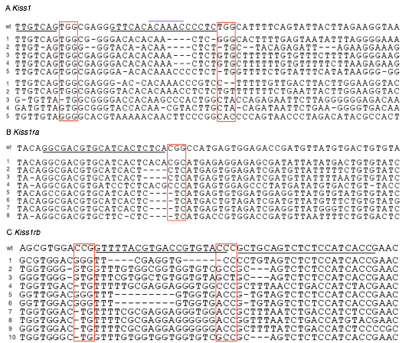

Figure 3.1 F1 generation sequences for the CRISPR/Cas9 induced mutations in Kiss1, Kiss1ra and Kiss1rb (A) A total of 10 F1 generation fish from two separate crosses showing 100% (10/10) mutations at the *Kiss1* loci. (B) *Kiss1ra* F1 generation with 100% (8/8) showing mutations surrounding the CRISPR/Cas9 target site (C) 10 fin clips from F1 generation *Kiss1rb* fish showing 100% (10/10) mutagenesis. PAM sequences are in red; target sequences are underlined in black.

# Chapter 4: The role of kisspeptin in anxiety and fear responses in zebrafish.

## 4.1 Abstract

Kisspeptin, a neuropeptide known largely for its role in reproduction in mammals has recently been suggested to reduce fear in adult zebrafish via the habenula-raphe circuit, based on the finding that injecting the peptide into the central nervous system (CNS) inhibited fear induced by the alarm substance (Ogawa et al, 2014). To validate these findings, I examined fear responses in CRISPR/Cas derived mutants of *Kiss1* and its receptor *Kiss1rb*. I found that *Kiss1sq1sj-/-*zebrafish show an exacerbated fear response after exposure to an alarm substance. Mutants in the Kiss1rb receptor, *Kiss1rbsq5sj-/-*, which is expressed outside the habenula and raphe, show a decrease in some aspects of innate fear responses after exposure to alarm substance. These data reiterate the idea that kisspeptin reduces fear response in zebrafish, but suggest that the actions of kisspeptin may not be restricted solely within the habenula, and instead may affect other brain regions.

## 4.2 Introduction

Whether a clear distinction can be made between anxiety and fear is a common question in ethology (Steimer 2002; Jesuthasan 2010). Although both exist to act as a warning method for an individual, one can distinguish anxiety as a response to an unknown threat, whilst fear is based around performance when presented with an external danger (Steimer 2002). Furthermore, fear is generally a rapid response which can be adapted to quickly, whereas anxiety is thought to be a more long-term state of apprehension (Davis et al. 2010). Fear and anxiety can be separated on the neural substrates they use, partially determined on account of their sensitivity to different drugs (Blanchard et al. 1993). However, disorders within both of these behaviours can cause severe problems to an individual’s well being. In humans, abnormalities in anxiety can cause a variety of disorders including generalized anxiety disorder (GAD) and post-traumatic stress disorder (PTSD), whereas dysfunctional fear pathways result in phobias (a persistent fear of a specific object or situation) (Martin 2003; Shin & Liberzon 2010). Furthermore, levels of anxiety and fear are key to an animal’s survival, particularly regarding predation. For example, a study using *Gasterosteus aculeatus* showed how juvenile fish exhibiting increased levels of anxiety were attacked at a faster rate than conspecifics that did not show anxiety (Mcghee & Bell 2014).

### 4.2.1 Models of anxiety in rodents and humans

Anxiety, deemed a long-term trait causing an exaggerated response to a potential threat, contributes to a variety of disorders and embodies the most prevalent of psychiatric diseases. Adaptation during evolution ensures animals maintain a level of anxiety that is beneficial to survival due to the fine balance that exists between the positive and negative elements of anxiety-like behaviours. Whilst anxiety permits a heightened sense of environmental danger, it can also be detrimental to fitness, highlighting a need for optimization (Steimer 2002). For example, if the detection threshold for anxious stimuli were too low one would respond continuously to non-dangerous situations. On the contrary, if the threshold is too high, threatening situations may be missed (Stein & Bouwer 1997). Two main underlying factors are believed to be responsible for increased anxiety and other behaviours. The first is genetic susceptibility, which involves a subset of genes associated with neural and molecular circuits to compose the innate aspect of anxiety. Genetic linkage analysis studies have implicated several susceptibility genes for anxiety, for example, mutations in the gene coding for the adenosine 2A receptor (ADORA2) have provided strong evidence for linkage between the ADORA2A locus and panic disorders (Hamilton et al. 2004; Arnold et al. 2004). Secondly, the influence of environmental factors such as parenting and adverse life events are responsible for the acquired trait (Brook & Schmidt 2008). These two processes are in no way discrete from each other and instead, exogenous factors may influence the expression of anxiety related genes through, for example, epigenetic regulation. Epigenetic mechanisms are processes through which molecular events governed by the environment are capable of modulating the genome of an organism (Powledge 2011). It is therefore the combination of these two elements that determines an individual’s anxiety level and the strategies that one implements to cope when such a situation is presented (Steimer 2002).

Rodents are frequently used as models for anxiety with several well-established assays available to test the actions associated with this behaviour. For example, the elevated plus maze (EPM) comprises of a network of four arms, two of these are open and two are enclosed. Exposure to the novelty of the open arms in this paradigm induces both fear and a drive for exploration (Pellow et al. 1985). Significantly fewer entries into the open arms are made by rats under normal conditions due to their tendency to avoid open spaces, a characteristic which can be reversed with the addition of clinical anxiolytics (Pellow et al. 1985). The light/dark box, also known as a scototaxis test, exploits the innate aversion rodents display when exposed to a brightly lit space. The rodent has to consequently battle between the novelty of the situation presented to them and their desire to explore, opposed with the apprehension of the unknown (Hascoët & Bourin 2009). The time spent in either section, as well as the number of transitions into the illuminated partition can be used to score anxious behaviour (Crawley & Goodwin 1980). Another paradigm is the open field test (OFT) where an animal is placed in a novel environment with walls that prevent it from escaping (Walsh & Cummins 1976). Anxiolytic behaviour presents as a tendency to remain close to the wall of the testing environment (thigmotaxis) and to avoid entering the centre of the open space (Prut & Belzung 2003). These behaviours have also been alleviated by the treatment of a variety of anxiolytic drugs (Britton & Britton 1981; Rex et al. 1998).

The need to obtain or optimize existing treatments for anxiety-disorders has spurred extensive investigations in to the neural circuits that govern anxiety. Copious studies have indicated the amygdala as a major player in anxiety-related behaviours in a variety of animals. In humans for example, patients who presented with 3 forms of anxiety disorders showed increased amygdala and insular activity (Etkin & Wager 2007) and more recently a study in children showed an increased size in volume of the amygdala correlated with increased anxiety (Qin et al. 2014). Similar pathways are suggested in mice with the use of optogenetics showing how stimulation of the basolateral amygdala (BLA) causes a reduction in anxiogenic responses, whereas inhibition exerts an anxiogenic response (Tye et al. 2011).

The habenula, an epithalamic structure connecting the forebrain to the ventral midbrain, has vast anatomical connections that, unsurprisingly, have been linked to a wide range of behaviours. In mammals, it is composed of two subunits, the medial (MHb) and lateral (LHb) habenulae. They predominantly receive input from the septum and entopeduncular nucleus (EP) respectively (Sutherland 1982). The main projection of the MHb is to the interpeduncular nucleus (IPN) and activation of this pathway and subsequent downstream pathways are responsible for addiction, withdrawal and reward (Fowler et al. 2011; Glick et al. 2011; R Baldwin et al. 2012). The lateral habenula on the other hand, mainly innervates the median and dorsal raphe (Herkenham and Nauta 1975) and stimulation of the former, has been shown to activate or inhibit serotonergic cells in the latter (Reisine 1982). Rats who possessed lesions in the LHb showed impairments in the EPM, showing a decrease in latency to withdraw from the enclosed arm, which is suggestive of anxiolytic behaviour (Pobbe & Zangrossi 2008).

Several neurotransmitters have also been connected with anxiety, for example, mouse pups which lacked serotonin (5-HT) in the brain through knockout of tryptophan hydroxylase 2 (*Tph2*) the enzyme responsible for 5-HT synthesis, have been found to show a decreased level of anxiety-related behaviours (Mosienko et al. 2015). Furthermore, serotonin re-uptake inhibitors (SRIs) are recognized treatments for anxiety disorders and buspirone, a serotonergic (5HT1A receptor agonist) causes a reduction in anxiety-like behaviour in the zebrafish (Bencan et al. 2010).

### 4.2.2 Models of fear in rodents and humans

Fear is initiated by exclusive stimuli determined by a previous aversive event (Davis et al. 1997). Whilst a key aspect in guaranteeing survival, perpetual fear can be debilitating and severely disrupt the daily functioning of an individual (Ganella & Kim 2014).

In 1951, Brown and colleagues developed an assay to assess fear-potentiated startle in rats that is indicative of phasic fear. Here the delivery of a conditioned stimulus (CS), for example a tone or light is paired to an aversive unconditioned (US) stimulus such as an electric shock (Brown et al, 1951). The fear potentiated startle is the measure of the increase in the startle response presented after the stimulus that was formerly paired with the aversive event (Jovanovic et al. 2006). A similar test was later developed in humans (Grillon and Davies, 1997). Sustained or unlearned fear can be measured in rodents by the light-enhanced startle (Walker & Davis 1997) and in humans by the dark-enhanced startle (Grillon et al. 1997). These tests employ the fact that rodents find white light aversive, whereas humans display the opposite behaviour and are fearful of dark environments (Grillon et al. 1997).

The amygdala, as well as being implicated in anxiety, has long been associated with the fear response. An early study demonstrated how lesioning of the amygdaloid nuclei in rats resulted in reduction of fear when presented with a cat stimulus (Blanchard & Blanchard 1972). Later it was shown how regions of the extended amygdala possessed differing roles in the regulation of fear. For example, temporary inactivation of the basolateral nucleus of the amygdala (BLA) and central nucleus of the amygdala (CeA) showed disruption in fear-related behaviours. The bed nucleus of the stria terminalis (BNST) is involved in learning of fear-stimuli (Radke 2010). Moreover, the synaptic plasticity of the inputs to the amygdala from the cortex and thalamus appear to be important for fear conditioning (Blair et al. 2001) as does glutamate and also serotonin signalling (Gewirtz & Davis 1997; Hindi Attar et al. 2012).

### 4.2.3 Using the zebrafish as a model of anxiety and fear

The vast majority of behavioural neuroscience research uses rodent models, however, the zebrafish has fast become a powerful animal model to help secure and corroborate results seen in higher order animals. One caveat with working with zebrafish is the need to confer exact homology in the anatomy of fish and mammalian brains. Although anatomical location may not be the defining property to homology of brain structures between species, the connectivity, gene expression and function that suggest shared development are vital (Jesuthasan 2012). In spite of this bottleneck, zebrafish show a range of phenotypes similar to those seen in mammals following the disruption of specific neural networks, corroborating the potential for a model of mammalian circuitry and function. One such example is a condition known as DiGeorge syndrome (DGS). The majority of patients with DiGeorge syndrome (DGS) who present with numerous defects including craniofacial abnormalities and hearing loss are found to carry mutations within chromosome 22, including the *Tbx1* gene. Interestingly, a zebrafish mutant termed *van gogh* (*vgo*) that possesses a mutation in the *tbx1* gene shows a very similar phenotype to human cases of DGS (Piotrowski et al. 2003; Lindsay 2001).

Silencing of the medial habenula through chemical or genetic methods in zebrafish leads to an increase in freezing when fish are exposed to aversive conditioning paradigms (Agetsuma et al., 2010; Lee et a*l*, 2011). This phenomenon is found in both larval and adult fish, indicating a role for the medial habenula in fear conditioning (Agetsuma et al., 2010; Lee et a*l*, 2011). Interestingly, septal input into the MHb can be divided into two separate pathways, which show different and distinct roles regarding behaviour. The triangular septum (TS) projects to the ventral MHb and to the core IPN and ablation of these neurons using immunotoxin-mediated cell targeting in mice show impairment in anxiety. On the other hand, the bed nucleus of the anterior commissure (BAC) which projects to the peripheral IPN through the dorsal Mhb is accountable for an enhanced fear response after selective inactivation of these neurons in mice (Yamaguchi et al. 2013).

Zebrafish show a variety of complex behaviours with studies across a broad spectrum including reward, aggression and learning (Norton & Bally-Cuif 2010). These studies have thus established and validated a variety of behavioural assays that are vital for use within reverse genetics. One such assay, which is used in the following study, is the novel tank diving test. This test (Fig.4.1) can be used with fish to assess for the presence of anxiety-like behaviours through exposure to deep water, along with a novel shaped tank. When a fish is first placed in deep water, the natural predisposition of a fish is to seek the safety by diving to the bottom of tank (Egan et al. 2009). Further validation of the novel tank diving test is provided by the ability of anxiolytic drugs commonly used in humans, such as buspirone and diazepam, to reduce the amount of time zebrafish spend at the tank bottom (Bencan et al. 2010).

Fear responses in the zebrafish can be measured through the exposure to an aversive stimulus. Gerlai and colleagues have found that visual stimuli, be it the Indian leaf fish (Bass & Gerlai 2008), a predator of the zebrafish, or an animated, moving stimuli (Bass & Gerlai 2008), can successfully elicit a fear response in the zebrafish. Additionally, Gerlai and other groups (Speedie & Gerlai 2008; Waldman 1982) have authenticated the use of alarm substance (AS) in inducing the fear response in zebrafish. Alarm substance, made by club cells in the skin of several species of fish is released after injury and initiates robust fear-like behaviours such as darting (rapid swimming), freezing and bottom dwelling (Waldman 1982).

### 4.2.4 Kisspeptin and behaviour

Kisspeptin 1, which was originally identified as a metastasis suppressor (Gene et al. 1996), is a key regulator of reproductive functions in mammals. However, recent studies have looked in to its role in a variety of other functions, including metabolism regulation (Tolson et al. 2014), neuroendocrine function (Kanda et al. 2013), depression (Tanaka et al. 2013) and more recently fear (Ogawa et al. 2014). Two kisspeptin genes are present in the zebrafish, *Kiss1* and *Kiss2* (Kitahashi et al. 2009). *Kiss1* is expressed in the ventromedial habenula (vHb) in the zebrafish (equivalent to the lateral habenula (lHb) in mammals) and Kiss1expressing neurons project to the median raphe (MR). Exogenous administration of kisspeptin-10 by Ogawa and colleagues (2012) led to an up-regulation of the *pet1* and *slc6a4a* genes which are involved in regulating concentration and extracellular clearance of serotonin (5-HT) (Ogawa et al. 2012). This evidence suggests a role for kisspeptin in 5-HT related behaviours. However, no direct connections between Kiss1 expressing neurons and serotonergic neurons have been found, indicating an indirect connection.

The distribution of kisspeptin expression has largely focussed on areas known for regulating reproduction, such as the arcuate nucleus (ARC) and the anteroventral periventricular nucleus (AVPV) in the hypothalamus. However, a recent study has shown the expression of kisspeptin in the medial nucleus of the amygdala in mice and rats (Kim et al. 2011). Furthermore, the median raphe (MR), whose serotonergic neurons are possibly regulated by kisspeptin, project back to the hippocampus and amygdala (Silva et al, 2002). This highlights a role for kisspeptin in amygdala-mediated behaviour, which include fear and anxiety.

The lateral habenula in rodents has been shown to regulate anxiety and fear (Pobbe & Zangrossi 2008; Okamoto et al. 2012) and recent literature has shown the implication of kisspeptin in modulating the response in zebrafish. Prior administration of exogenous kisspeptin-10 eliminated the innate fear response that is usually seen after presentation of alarm substance in zebrafish (Ogawa et al. 2014). However, there are several caveats regarding the techniques used in this study and their conclusion that this behaviour is modulated solely by habenula kisspeptin. Firstly, the injection of kisspeptin-10 into the cranial cavity of zebrafish would allow binding of kisspeptin-10 to any brain region containing either Kiss1ra or Kiss1rb receptors and not specifically to the ventral habenula. The second caution lies with the use of saporin, a ribsome inactivating protein which when conjugated to kisspeptin 1, Kiss-SAP, inhibits the protein synthesis and induces cell death. In the study from Ogawa and colleagues, although the binding selectivity of Kiss1-SAP was shown to be higher for Kiss1ra than for Kiss1rb, a clear luciferase reporter activity with Kiss1rb was seen. However, no behavioural assays were conducted on fish with inactivation of Kiss1rb neurons.

Therefore, to further characterize the role of kisspeptin 1 in zebrafish, I utilized the CRISPR/Cas technology to induce mutations within *Kiss1* and its receptor, *Kiss1rb*. This allowed us to assess the role of the kisspeptin in anxiety and innate fear using the novel tank diving assay and response to alarm substance, respectively, using knock out models. Here, the behavioural effect seen from a lack of kisspeptin signalling, rather than an overexpression of kisspeptin was analyzed. Exogenous administration of kisspeptin 1, and therefore a higher than baseline level of kisspeptin caused a decrease in fear responses in the zebrafish; I therefore predicted that the opposite would occur with a lack of kisspeptin and that instead we may see in an increase in fear responses.

## 4.3 Methods

### 4.3.1 Zebrafish maintenance

Zebrafish were housed in the Institute of Molecular and Cellular Biology (IMCB) facility in Singapore with water a temperature of 28°C and adults were kept in a fixed 14 hour light, 10 hour dark cycle. Embryos were obtained through natural crosses according to Westerfield, M (2000). All procedures were carried out in accordance with the Institutional Animal Care and Use Committee (IACUC) standards (IACUC Protocol Number: 120730).

### 4.3.2 Alarm substance (AS) preparation

Alarm Substance (AS) or Schreckstoff was prepared following Mathuru et al. (2012). After euthanization in ice water for 15 minutes, five small incisions were made along each side of the trunk of five fish and they were placed into a 14 ml falcon tube containing 3ml E3 medium and placed on a shaker for 5 minutes. The liquid was then placed in 1.5ml Eppendorf tubes and heated at 99°C overnight. After 10 mins centrifugation, the supernatant was removed and stored at 4°C degrees until use. The raw preparation of AS was taken as 1x AS and a dilution of 1:5 (0.2%) with E3 medium was used for the behavioural assays described. Although the exact concentration of the AS could not be determined, the same method and concentration was maintained throughout all tests. Fresh alarm substance was prepared each evening for use the following day.

## 4.3.3 Behaviour analysis

## Individual F0 offspring with identified mutations in their respective targetted genes were outcrossed to wild-type zebrafish to generate F1 offspring. This process was repeated so that individual F1 carriers were outcrossed to wild-type zebrafish to obtain an F2 generation, of which half will carry the original mutation. This process was further repeated to produce an F3 generation. F2 or F3 generation carriers were mated to one another to produce a mixed cross, containing wild type, homozygous and heterozygous fish in a Mendelian ratio. All behavioural tests were conducted using adult (>3months), mixed sex zebrafish from either F3 or F4 generation. Fish genotypes were identified after behavioural tests were conducted by a genotyping PCR and wild type siblings were used as controls.

### 4.3.4 Novel Tank Diving (NTD) test

Adult zebrafish were initially placed in a small beaker before being transferred to a 1.25 L custom made tank filled with 1 L of facility water (Fig.4.1). The tank dimensions were 20cm (length) x 12cm (height) x 5cm (width). The tank was located 25cm from an AGENT V5 Full HD Webcam (1920 x 1080 video capture resolution, Liquid Digital). A light source was provided from Koncept 35 LED Z bar light, situated 40cm above the testing tank. Individual video files were recorded using the QuickTime Player 7 Software (7.7 frames/sec). Whilst recording, curtains were used to obscure the tank from view and eliminate any possible environmental factors. Post-recording analysis was performed using ImageJ v1.49 (National Institutes of Health, USA) and MetaMorph® Microscopy Automation & Image Analysis Software to give X-Y coordinates of each fish per frame. Swimming behaviour was then analysed using Python Software, v2.7.10. Several behavioural parameters were calculated throughout the duration of each 10-minute experiment. These included: time spent in both the bottom half and the bottom quarter of the tank (s), latency to enter the upper half of the tank (s) and the number of transitions into the upper half of the tank, which are indicative measures of the basal level of anxiety that a fish possesses.

### 4.3.5 Alarm substance and innate fear

To test the effect of the addition of AS on innate fear, a similar protocol as described for the NTD test was used with several adjustments. After a two-minute acclimatization to the testing tank, 200ul of 0.2% AS was manually delivered to the upper corner of the tank (0.1ml/5s) via Tygon® tubing (3/16” OD) connected to a 2.5ml syringe. As well as the time spent in the bottom half of the tank, latency to enter the upper half (s) and the number of transitions into the upper half of the tank, several additional parameters were also calculated. These included freezing (continuous pausing for >5 frames, pausing is defined as speed less than 3.5mm/s, calculated to be a standard speed from the mean of three control fish) and darting (speed > 6 standard deviations of the average speed. The location of the fish throughout the length of the test, as well as the presence of erratic movement (freezing and darting) can be used to analyse innate fear (Waldman 1982).

### 4.3.6 Data analysis

Analysis of data and production of graphs were made with R statistical software package v3.2.1. Normality was tested using a combination of techniques including the Shapiro-Wilk Normality test and assessing the quantile-quantile plot of residuals. If deviations from normality occurred, data was transformed using log transformation or box-cox power transformation. Data was then analysed with either the independent t-test or analysis of variance (ANOVA) followed by post-hoc comparisons. Non-normal data was analyzed using the Kruskal Wallis or the Mann-Whitney-Wilcoxon test, followed by Dunn’s post-hoc test. Binomial data, such as the rate of freezing was analyzed using binomial logistic regression. If a fish froze it was given a score of one, whereas one that didn’t was given a score of zero. Multiple comparisons within the same data set were corrected for by using the Bonferroni method (p/number of statistical test used = adjusted *p value). The size of an effect was measured using Cohen’s d, displayed as d=n (Sullivan and Feinn, 2012). No fish were removed from analysis in this study.

## 4.4 Results

### 4.4.1 Assessing anxiety-like responses in *Kiss1sq1sj-/-*zebrafish

As seen in Figure 4.2, there was no significant difference in the amount of time spent in the lower half of the tank between control and *Kiss1sq1sj-/-*zebrafish in the novel tank assay for the duration of the test (Fig. 4.2A; Independent t-test: t(25.38)=0.656, p=0.5177; d=-0.23, n=29). Division of the test in to halves saw no effect of genotype on the time spent in the bottom half of the test (Kruskal-Wallis rank sum test: X2(1)=0.1358, p=0.7125) and no effect of the time interval (Fig.4.2: Kruskal Wallis rank sum test: X2(1)=0.3876, p=0.5336). *Kiss1sq1sj-/-*zebrafish exhibited a marginal increase in the log transformed latency (s) to enter the upper half of the tank compared to their WT siblings (Fig.4.2,C,ii; Independent t-test: t(25.56)=-2.04, p=0.051; d=0.8, n=29). The number of transitions into the upper half of the tank during the novel tank diving test, did not differ between genotypes (Fig.4.2.C.i; Independent t-test: t(20.92)=1.32, p=0.2013; d=0.57, n=29). Further behavioural parameters were examined, including the number of erratic movements (Fig.4.2C. i-ii). The number of darting episodes, defined as speed that exceeded 6 standard deviations of the average speed, did not differ between control and *Kiss1sq1sj-/-*fish (Fig.4.2.D.i; Independent t-test: t(26.73)=1.28, p=0.212; d=0.47, n=29). Furthermore, the level of freezing did not differ between the two genotypes following binomial logistic regression (Fig.4.2.D. ii. X2(1)=0.0031, p=0.8612).

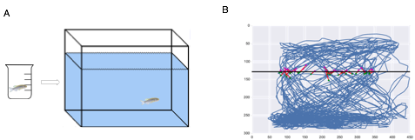

Figure 4. Schematic of Novel Tank Diving (NTD) test (A) Initially, individual fish are placed in a pre-test beaker before being transferred to the novel tank for behavioural observation. (B). A side-view track of the swimming behaviour of a fish exposed to the NTD test. Blue lines show the swimming path of the fish, red lines indicate a transition to the upper portion of the tank and the black line shows the midway point of the tank.

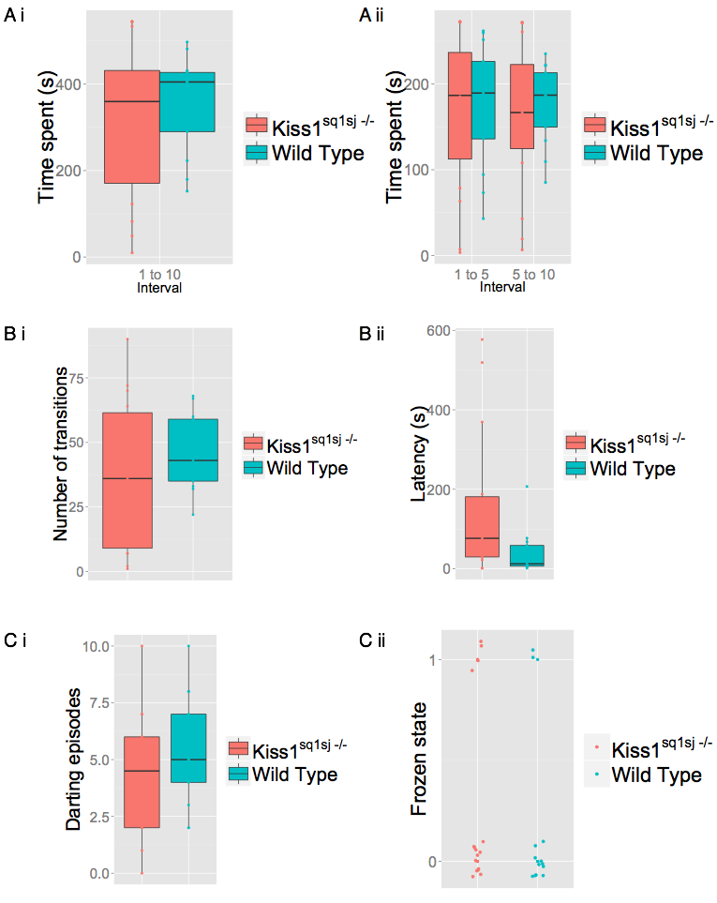

Figure 4. Effect of the novel tank diving test on anxiety like behaviours

Behavioural parameters measured during the novel tank diving test. (A) Boxplots of the time spent (s) in the bottom half of the tank during (i) the whole test and (ii) 5-minute segments. (B) (i) Boxplots of the number of transitions into the upper half of the tank and (ii) the untransformed, raw data of the latency of time (s) to enter the upper half of the tank. (D) (i) Boxplot of number of darting episodes (n=29). Data represented as median (solid line), upper and lower quartiles and 95% confidence intervals. *p<0.007(ii)Scatterplot showing the frozen state of individual fish (1= presence of freezing activity, 0=absence of freezing activity) during the novel tank diving test

### 4.4.2 Assessing innate fear responses in *Kiss1sq1sj-/-* zebrafish after exposure to AS

*Kiss1sq1sj-/-*fish showed a trend to spend a greater amount of time in the lower section of a tank compared to control siblings after exposure to AS, as seen by the large effect size (Fig.4.3,A.i; Mann-Whitney rank sum test: W=35, p=0.059; d=0.77, n=24). Furthermore, this trend was found to occur in the second half of the test (Fig.4.3.A.ii: Mann-Whitney rank sum test: W=34.5, p=0.0465). However, after Bonferroni correction, this difference was deemed as non-significant (p<0.007). *Kiss1sq1sj-/-*fish showed a decreased number of transitions (Fig.4.3.C,i; Mann-Whitney rank sum test: W=107, p=0.04365; d=0.74, n=24), which was not significant after Bonferroni correction (p<0.007), as well as a trend for increase in latency (Fig.4.3.C.ii; Mann-Whitney rank sum test: W=42.5, p=0.05423; d=0.67, n=24) to enter the upper half of the experimental tank when exposed to AS. When looking at the erratic movements, the number of darting episodes between control and *Kiss1sq1sj-/-*fish did not significantly differ (Fig.4.3.D.i; Independent t-test: t(21)=0.909, p=0.3734; d=0.38, n=23), and nor did the level of freezing after binomial logistic regression analysis (Fig.4.3.D.ii; X2(1)=2.3817, p=0.1228, d=0.28, n=23). The results seen in the behavioural parameters tested between control and *Kiss1sq1sj-/-*included a trend to spend an increased amount of time spent in the lower half of the testing tank, with a difference in the latter half of the test, a trend for increased latency to enter the upper half of the tank and a decreased number of transitions into the upper half of the tank.

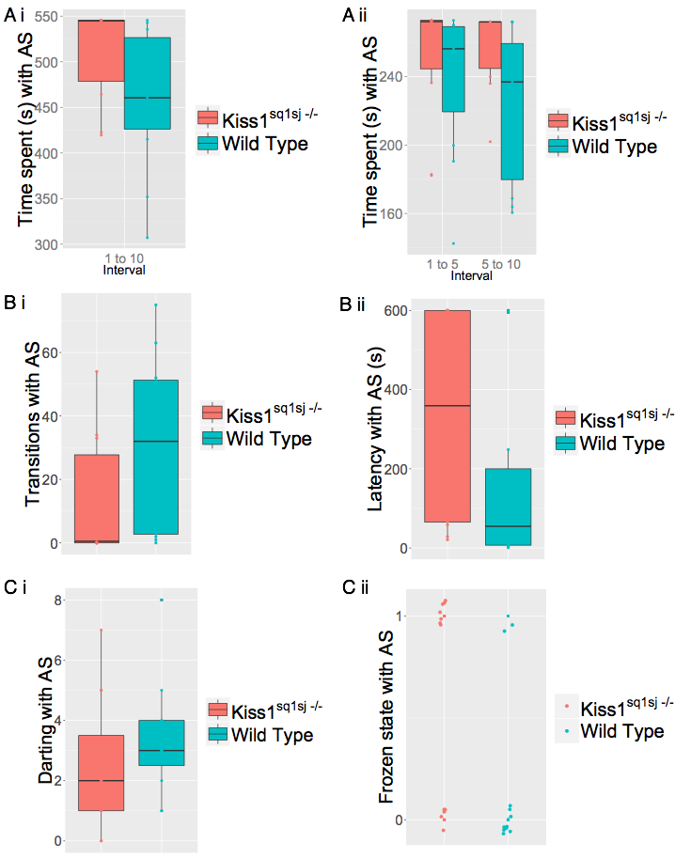

**Figure 4.3 Effect of exposure to AS on fear responses.** Behavioural parameters measured when mutant and WT fish were exposed to AS. (A) Boxplots for the amount of time spent (s) in the bottom half of the tank during (i) during the whole test (ii) when divided in to two halves. (B)(i) Boxplots for the number of transitions into the upper half of the tank and (ii) the latency (s) of time (s) to enter the upper half of the tank.. *p<0.05. (C) (i) Boxplot for the number of darting episodes across the 10-minute test between control and *Kiss1sq1sj-/-*fish.Data represented as median (solid line), upper and lower quartiles and 95% confidence intervals, *p=<0.007. (ii)Scatterplot showing the frozen state of individual fish (1= presence of freezing activity, 0=absence of freezing activity) during the novel tank diving test after exposure to AS.

### 4.4.3 *Kiss1sq2sj-/-*zebrafish show similar levels of anxiety and fear responses to control fish

Analysis showed no effect of genotype on the number of transitions into the upper portion of the tank during the NTD after data transformation (Fig.4.4.B.i: Independent t-test: t(13.63)=-0.899, p=0.384; d=0.29, n=18), nor within the latency to enter the upper half of the tank after data transformation (Fig.4.4.B.ii: Independent t-test: t(15.59)=0.499, p=0.6241; d=0.21).

When examining the time spent in the bottom half of the tank during the novel tank diving test, no significant effect of genotype was seen across the duration of the test (Fig.4.4.A.i; Independent t-test: t(14.95)=1.19, p=0.2512, d=0.56). Furthermore, no effect of genotype on the time spent in the bottom half of the tank was seen when looking at the first half (Fig.4.4.A.ii: Mann Whitney rank sum test: W=51, p=0.3483), or the latter half (Fig.4.4.A.ii: Mann Whitney rank sum test: W=57, p=0.1424).

There was an effect of genotype on the number of darting episodes between Kiss1sq2sj-/- mutant and control zebrafish with mutants displaying fewer darting episodes (Fig.4.4.C.i: Independent t-test: t(13.85)=2.22, p=0.0435), however, this was not significant following Bonferroni correction (p<0.007). A binomial logistic regression was run to understand the effect of genotype on the tendency to freeze during the NTD and results showed there was no effect of genotype on this behaviour (Fig.4.4.C.ii: z=0.266, p=0.79).

When *Kiss1sq2sj-/-* fish were exposed to AS to test for innate fear responses there were no discernible effect of genotype on the time spent in the lower half of the tank during the whole test (Fig.4.5.A; Mann-Whitney rank sum test: W=101, p=0.3932; d=0.19, n=26). Furthermore, there was no effect of genotype on the time spent in the lower half of the tank after division of the test in to halves (Fig.4.5.A.ii: first half: Mann Whitney rank sum test: W=89.5, p=0.7941; second half: Mann Whitney rank sum test: W=84, p=1).

During exposure to AS, no significant difference in the number of transitions to the upper half (Fig. 4.5.B.i; Mann-Whitney rank sum test: W=86.5, p=0.6966; d=0.14, n=29) or in the latency to enter the upper half (Fig. 4.5.B.ii; Mann Whitney rank sum test: W=106.5, p=0.5921; d=0.35, n=29) was seen between the two genotypes. Additionally, no effect of genotype on the number of darting episodes was seen during the NTD after exposure to AS (Fig.4.5.C.i; Mann-Whitney rank sum test: W=105.5, p=0.4615; d=0.29, n=28). Furthermore, binomial logistic regression showed no effect of genotype on the probability of freezing episodes (Fig4.5.C.ii: z=0.741, p=0.459).

These results suggest that there does not appear to be any differences in behavioural parameters evaluated from the innate fear response to AS between *Kiss1sq2sj-/-*fish and control fish, further implying similar levels of both anxiety and fear between these two genotypes.

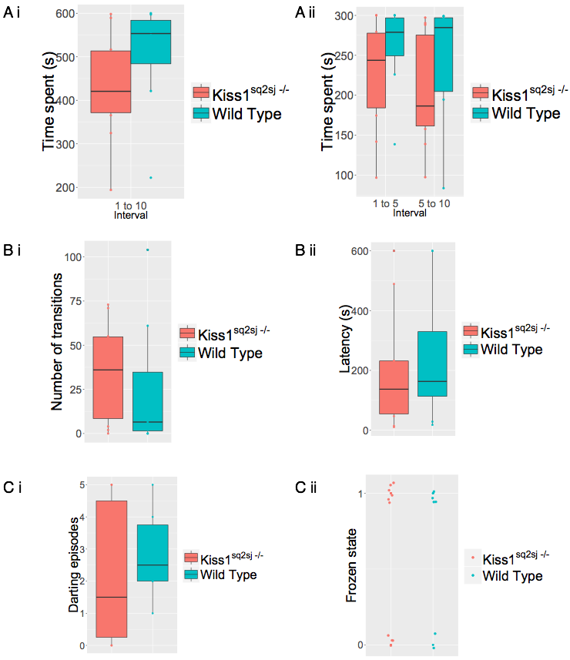

Figure 4. Effect of novel tank diving on anxiety like behaviour

Behavioural parameters measured during the novel tank diving test (A) Boxplots of the time (s) in the lower half of the tank for (i) the whole test and (ii) during five minute segments (B) Boxplots for (i) the number of transitions into the upper half of the tank and (ii) the latency (s) to enter the upper half of the tank (s). (C) (i) Boxplot for the number of darting episodes. Data represented as median (solid line), upper and lower quartiles and 95% confidence intervals, *p=<0.007. Data is raw, un-transofrmed data. (C) (ii) Scatterplot showing the frozen state of individual fish (1= presence of freezing activity, 0=absence of freezing activity) during the novel tank diving test.

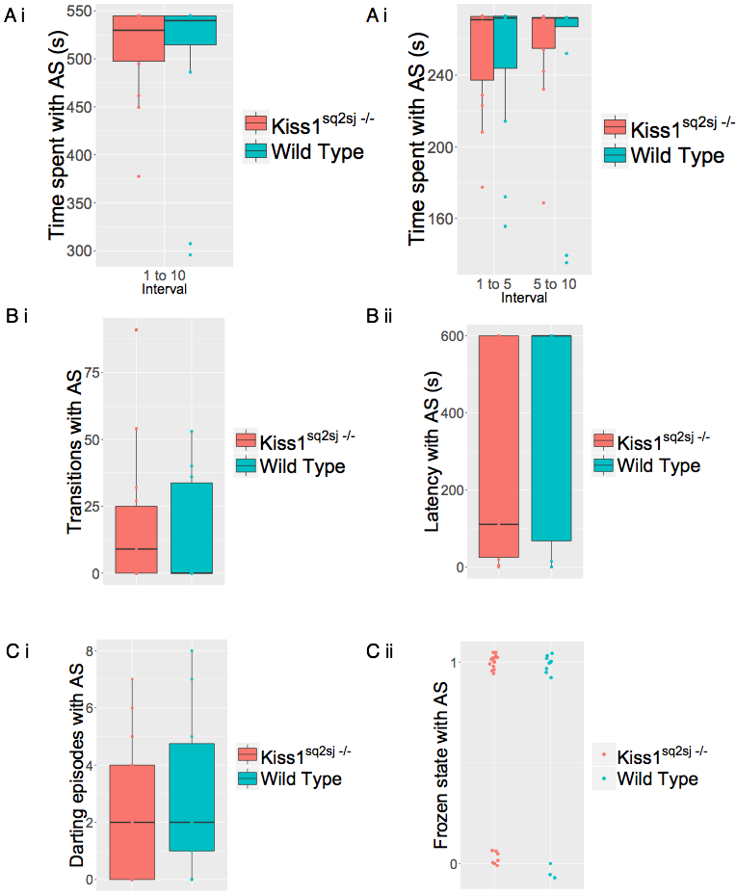

Figure 4. Effect of exposure to AS on fear responses. Behavioural parameters measured during exposure to AS. (A) Boxplots of the time spent (s) in the bottom half of the tank throughout (i) the whole test and (ii) the two halves of the test. (B) Boxplots for (i) the number of transitions into the upper half of the tank and (ii) the latency of time (s) to enter the upper half of the tank. (C) (i) Boxplot of the number of darting episodes. Data represented as median (solid line), upper and lower quartiles and 95% confidence intervals, *p=<0.007. (C) (ii) Scatterplot showing the frozen state of individual fish (1= presence of freezing activity, 0=absence of freezing activity) during the novel tank diving test

### 4.4.4 Assessing anxiety-like responses inKiss1rbsq5sj-/- zebrafish

Application of the novel tank diving test yielded no significant effect of genotype on the time spent in the lower half of the tank between Kiss1rbsq5sj-/- mutant and control zebrafish (Fig. 4.6.A.i; Independent t-test: t(18.18)=-0.05, p=0.9536; d=0.03, n=21), nor when dividing the test into 5-minute segments (Fig.4.6.A.ii: two-way ANOVA: F(1,38)=0.015, p=0.9034,; d=0.01, n=21). Interestingly, there was effect of time interval on the time spent in the bottom section of the NTD test (Fig.4.6.A.ii: two-way ANOVA: F(1,38)=4.919, p=0.0326), however, this was not significant following Bonferroni correction (p<0.008). No interaction between genotype and time interval was seen (two-way ANOVA: F(1,38)=0.004, p=0.9501). Neither the number of transitions, nor the latency to enter the upper half of the tank differed significantly between *Kiss1rbsq5sj-/-* and control fish during the novel tank diving test (Fig.4.6.B.i; transitions: Independent t-test: t(19.65)=0.2268, p=0.8229; d=0.09, n=22; Fig.4.6.B.ii, latency: Mann-Whitney rank sum test: W=53.5, p=0.6685; d=0.4, n=22).

The genotype of a fish had no effect on the number of darting episodes (Fig.4.6.C.i; Independent t-test: t(18.24)=0.809, p=0.429; d=0.35). Furthermore, binomial logistic regression showed no effect of genotype on the probability of freezing in the NTD (Fig.4.6.D.ii: z=-0.724, p=0.469).

These results suggest that the basal level of anxiety did not differ between control and *Kiss1rbsq5sj-/-* fish when using the novel tank diving test as a behavioural assay.

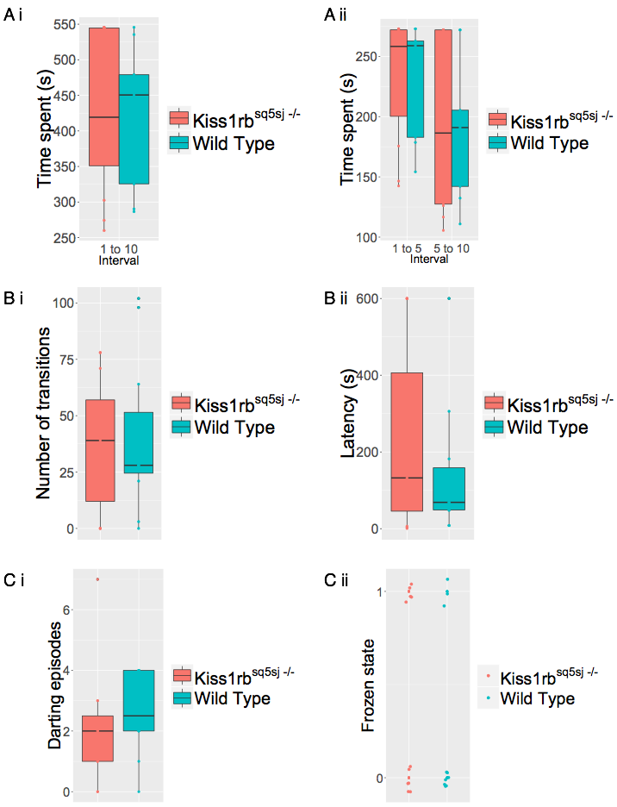

Figure 4. Effect of the novel tank diving test on anxiety-like behaviour

Behavioural parameters measured during the novel tank diving test. (A) Boxplots for the time spent (s) in the bottom half of the tank for control and *Kiss1rbsq5sj-/-*fish for (i) the whole test or (ii) 5-minute segments. (B) Boxplots for the number of transitions into the upper half of the tank and (ii) the latency of time (s) to enter the upper half of the tank. (C) Boxplot for the number of darting episodes. Data represented as median (solid line), upper and lower quartiles and 95% confidence intervals, *p=<0.0007..(ii) Scatterplot showing the frozen state of individual fish (1= presence of freezing activity, 0=absence of freezing activity) during the novel tank diving test.

### 4.4.5 Assessing innate fear responses in *Kiss1rbsq5sj-/-*zebrafish after exposure to AS

Analysis showed that genotype had a significant effect, with a large trend, on the time spent in the lower half of the tank after exposure to AS, with

*Kiss1rbsq5sj-/-*mutant zebrafish spending less time in the bottom of the tank after addition of AS compared to control fish (Fig.2.7.A.i: two-way ANOVA: F(1,76)=3.968, p=0.050; d=0.73, n=40). This result however, was not significant following Bonferroni correction (p<0.008). The time interval did not appear to have an effect on the amount of time spent in the lower half of the tank (Fig.4.7.A.ii: two-way ANOVA: F(1,76)=1.107, p=0.296). Furthermore, there was no interaction between genotype and the time interval on the time spent in the bottom half of a tank after exposure to AS (two-way ANOVA: F(1,76)=0.049, p=0.826).

No effect of genotype was seen on the number of transitions into the upper half of the tank after addition of AS (Fig.4.7.B.i: Mann-Whitney rank sum test: W=134, p=0.08943; d=0.56, n=40), nor in the latency (s) ( Fig.4.7.B.ii; Mann-Whitney rank sum test: W=229, p=0.3583; d=0.32, n=40). The number of darting episodes was not affected by genotype (Fig.4.7.C.i; Mann-Whitney rank sum test: W=213.5, p=0.6205; d=0.21),

Binomial logistic regression showed that genotype had no effect on the probability of a freezing response after exposure to AS (z=0.904, p-0.366).

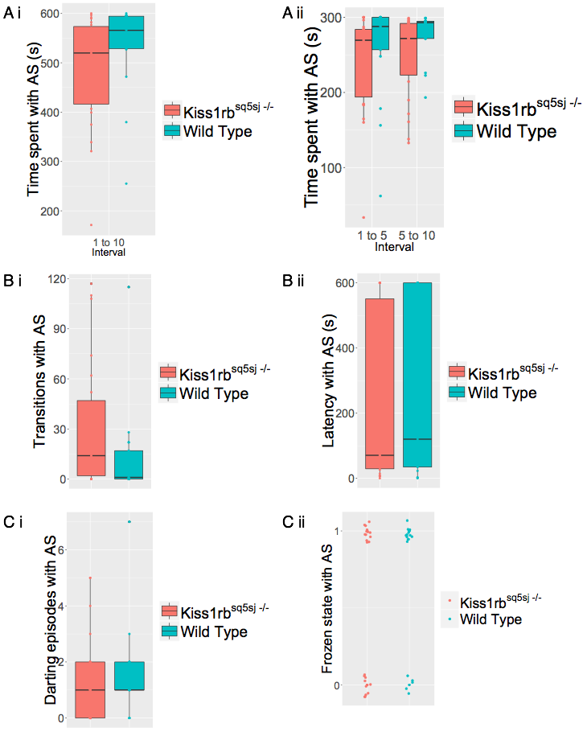

Figure 4.7 Effect of exposure to AS on fear responses. Behavioural parameters measured when Kiss1rbsq5sj-/- and control fish were exposed to AS during the novel tank diving test. (A) Boxplots showing the time spent (s) in the lower half of the tank in (i) the whole test and (ii) the first and second portions. (B) (i) Boxplots to show the number of transitions into the upper half of the tank or (ii) the latency of time (s) to enter the upper half of the tank. (C) Boxplot to show the darting episodes. Data represented as median (solid line), upper and lower quartiles and 95% confidence intervals, *p=<0.05 (ii) Scatterplot showing the frozen state of individual fish (1= presence of freezing activity, 0=absence of freezing activity) during the novel tank diving test.

## 4.5 Discussion

Zebrafish lacking kisspeptin showed no differences to wild type fish when they were assessed for anxiety-like behaviour during the novel tank diving test under a variety of behavioural parameters. This included bottom dwelling, transitions into the upper half of the tank, and erratic movements such as darting and freezing. However, *Kiss1sq1sj-/-*fish did show a marginal increase in latency to enter the upper half of the tank, suggesting that kisspeptin mutants may show a decrease in exploration activity (Egan et al. 2009). This result however, was deemed insignificant after multiple comparison correction. If we take the difference in latency between kisspeptin mutant and control fish as a real effect due to the large effect size, however, this result mirrors those seen in other experiments regarding the role of kisspeptin in behavioural responses. For example, Ogawa et al (2014), found that zebrafish subjected to the novel tank diving test four hours after the administration of exogenous Kiss1, showed an increase in the number of transitions into the upper half of the novel test tank. An increased number of transitions, similar to the latency to enter the top half of the tank, are indicative of an increased exploratory behavioural tendency.

Fear can be induced in a very strong and repeatable manner in a variety of animals from the injury of conspecifics, including snails and damselfly larvae (Aizaki and Yusa 2009; Chivers et al. 1996). Originally identified and described in the European minnow by Karl von Frisch (1938), alarm substance, or schreckstoff, is made by club cells in the epidermis, and is released from the skin of fish after injury (State 1998). After exposure to AS, the majority of fish, regardless of the genotype, would make a slight approach to the site of origin of the substrate followed by a sudden retreat to the bottom of the tank (data not shown), similar to what was seen in other studies (Waldman 1982). These results firstly indicate that the kisspeptin mutant fish I generated are capable of detecting and responding to AS in the first instance, and that the sensory mechanisms underlying AS recognition were not impaired. I found that both control and *Kiss1sq1sj-/-*fish showed an increase in the amount of time spent bottom dwelling after exposure to AS compared to the control test. However, fish that lacked kisspeptin1 showed a non-significant, albeit large trend to spend more time in the lower section of the tank compared to WT fish. Furthermore, this difference appeared to occur in the latter half of the test. However, this result was classed as insignificant after correction for multiple comparison correction. Interestingly, several behavioural parameters associated with anxiety assessed here, showed a difference between *Kiss1sq1sj-/-*and control fish. The number of transitions into the upper half of the tank was significantly reduced in *Kiss1sq1sj-/-*fish, and the latency to enter the upper half was marginally significant, but with a large effect size. However, following up behaviour analysis with the multiple comparison correction technique of Bonferroni, deemed each of these findings non-significant. These results may help form an initial hypothesis that *Kiss1sq1sj-/-*fish possess a more amplified level of innate fear compared to control fish.

*Kiss1sq2sj-/-*fish displayed normal immunohistochemistry staining for kisspeptin1 during mutant characterization, but a reduction in mRNA transcript levels (see chapter 3) and showed normal anxiety levels when exposed to the novel tank diving test. They also showed no differences in fear-responses after introduction of AS.

Fish that carried mutations within *Kiss1rb,* showed a marginal decrease in time spent in the bottom half of the novel tank diving test after exposure to AS, insignificant after multiple comparison correction. In contrast to mammals, zebrafish possess two copies of both the kisspeptin gene (*Kiss1* and *Kiss2*) and subsequent receptors (*Kiss1ra* and *Kiss1rb*). The two kisspeptin receptors have distinct expression patterns in the zebrafish; Kiss1ra is exclusively in the habenula whilst Kiss1rb is expressed in the hypothalamus. Interestingly, however, it has been shown that while *Kiss1rb* encodes a receptor activated by both Kiss1 and Kiss2 at comparable affinities, Kiss1ra is only activated by the Kiss1 peptide (Onuma & Duan 2012), suggesting that the modulation of fear by kisspeptin may not be limited to the habenulo-raphe circuit. Instead, partial modulation may occur through Kiss1rb receptors located in other brain regions, including the hypothalamus. This theory is enhanced by the fact that exogenous kisspeptin peptide injected into the ventricle in zebrafish in earlier studies was not specifically localized to the habenula nuclei, but still caused an effect (Ogawa et al. 2014). In addition, transgenic fish with Kiss2 conjugated to mCherry show Kiss2 expressing cells located in the periventricular hypothalamus and Kiss2 fibres projecting to the hypothalamus (Song et al. 2014), a region implicated in a variety of behaviours.

This study supplements work on the role of kisspeptin in modulating the innate fear in zebrafish. Despite multiple comparison correction judging several parameters measured as non-significant, this work questions the proposal that the kisspeptin1 fear response acts solely through the habenula-raphe circuit. I decided against the use of both the peptide, and the antagonist, kisspeptin-234, used in mammalian studies in my experiments due to its inability to cross the blood brain barrier and the non-specificity of binding from intracranial injections. However, future work should elucidate a method to allow the specific introduction of the kisspeptin1 peptide to specific brain areas to allow for assessment of activity. A battery of tests to further assess mutant behavioural phenotypes should be considered, as well as an increased sample size, and additional genetic or chemical inactivation of the kisspeptin pathway. For example, using morpholinos to knock down transcriptional activity of members the kisspeptin system. The last point is important especially considering the recent findings from Rossi and colleagues that there are compensatory mechanisms initiated from deleterious mutations, but not with knockdown studies (Rossi et al. 2015). Although this phenomenon may be gene specific, genetic compensation is indeed possible and this cannot rule out the lack of reproduction deficits seen from the kisspeptin system knockouts using TALENs (Tang et al. 2015).

# Chapter 5: The role of kisspeptin in learning in zebrafish

## 5.1 Abstract

The ability to respond to predictable danger by directed escape, rather than repeated panic behaviour, is vital for an animal’s survival. Recent work has demonstrated that the activity of the ventral habenula (vHb) in zebrafish increases as a cue is recognized as predicting danger and decreases as the animal learns to avoid the threat. Inhibition of synaptic transmission from the ventral habenula to its downstream target, the median raphe (MR), causes impairments in learning. The vHb-MR pathway has thus been identified as a crucial circuit for representing the level of anticipated danger and behaviour needed to adaptively avoid a possible threat (Amo et al. 2014). I have previously shown how zebrafish lacking the kisspeptin 1 neuropeptide display a possibe change in some areas of innate fear (see chapter 4). Here, I investigate the role of kisspeptin 1 during instrumental learning in the zebrafish and show that *Kiss1* mutants show some deficiencies in two-way active avoidance conditioning. These results suggest that kisspeptin 1 signalling may be a player in the processing of danger signals and the learning of behavioural responses needed to avoid a future threat, possibly through regulation of the vHb.

## 5.2 Introduction

During evolution, animals have developed mechanisms that allow them to rapidly respond to situations of predictable danger. Expectation of a potential threat will initially induce panic, such as a freezing or flight response, which is beneficial during the initial presentation to an aversive situation. However, an adaptive strategy whereby an individual learns how to actively avoid a possible dangerous environment is vital for an animal’s well being and ultimately its survival (Stein & Bouwer 1997).

### 5.2.1 Reward and learning

A crucial factor for generating adaptive behaviour in a dynamic environment is the formation of the expectation value of rewards, that is the size or nature of a reward from a particular behaviour (Davies et al. 2015). A reward may have a positive or negative value and these can be separated by the behaviours they induce. For example, positive rewards will prompt approach behaviour whereas a negative reward will induce avoidance behaviour in rats (Skinner, 1938). One of the main neuronal systems associated with reward information is midbrain dopamine signalling in the ventral tegmental area (VTA) and substantia nigra compacta (SNc) in monkeys (Schultz 1998; Satoh et al. 2003). Research in mammals has shown how the majority of dopamine (DA) neurons show a phasic increase in activation after presentation to a rewarding stimulus (Schultz, W., 1986). Conversely, withdrawal of, or a less than expected reward caused a decrease in activity in DA neurons in monkeys (Schultz 1998; Satoh et al. 2003; Nakahara et al. 2004). Interestingly, over time the presentation of a stimulus predicting a reward, rather than the reward itself prompted the initiation in activity of DA neurons. This infers a role for these neurons in reinforcement learning (Nakahara et al. 2004). Numerous brain regions are known to project to the midbrain dopaminergic regions, one of which is the lateral habenula (lHb), an epithalamic structure located in the dorsal diencephalon (Christoph et al., 1986). The lHb in mammals also projects to numerous other targets including the ventral tegmental area (VTA), the thalamus and the dorsal raphe (DR) (Akagi and Powell.1968). A landmark study using rhesus monkeys showed how the projection from the lHb to the SNc may be responsible for the negative reward related signals in DA neurons (Matsumoto & Hikosaka 2007). In this study, a presentation of a target that signified an absence of an upcoming reward caused robust activation of lHb neurons, whereas a reward suggestive target resulted in an inhibition. These are contrary to the responses seen in DA neurons in response to reward. Notably, the increase in activity seen in the lHb after exposure to non-rewarding stimuli preceded the decrease in activity in DA neurons. Furthermore, electrical stimulation of the lHb resulted in the inhibition of DA neurons (Morgane & Foundation 1979). This suppression of DA signalling is thought to act via an indirect striatal pathway to consequently prevent the repetition of an incorrect response (Frank et al. 2004). These findings imply that lHb neurons influence the reward-related behaviour of dopamine neurons and that they are conveying aversive or anti-reward information (Amo et al. 2014; Matsumoto & Hikosaka 2009). However, a reduction in DA signalling cannot be the exclusive reason for learning to cope with an aversive stimulus. The action to move from a potentially dangerous environment, to a safe one, or to omit a behaviour leading to a negative outcome, would eventually become a positive prediction error, that is, it would have the valence and effect of a reward. Therefore, the ability to avoid or prevent a hazardous situation should be characterised as a reward and in turn, an increase in dopamine signalling. As a consequence, during learning, the expectation of a negative reward needs to be constantly re-evaluated in respect to the real outcome of an event, also known as the reward expectation value. The vHb –MR circuit in the zebrafish was found to encode the aversive expectation value (Amo et al. 2014; Boureau & Dayan 2010). Serotonin, an additional monoamine neurotransmitter is also implicated in reward processing (Dayan & Huys 2009). In monkeys, the activity of serotonergic cells in the dorsal raphe nucleus (DRN) are tonically affected by an expected reward size, thus suggesting that serotonergic neurons in the raphe help translate reward expectation values (Nakamura et al. 2008).

In contrast to the mammalian lHb which projects to numerous brains regions, the zebrafish homolog of the lHb, the vHb, projects solely to the median raphe (MR) (Aizawa et al. 2011). Amo and colleagues (2014) utilized this select projection to investigate the role of the habenulo-raphe circuit in avoidance learning. This method of reinforcement learning is achieved in two stages, association followed by avoidance learning. Here, a conditioned stimulus (CS) is paired to an unconditioned stimulus (US) of aversive nature and an animal will ultimately learn to associate the CS with the impending threat. Following this, an avoidance phase will incite goal-directed behaviour to move from the dangerous environment to one that represents safety (Amo et al. 2014). Electrophysiological recordings in the lHb of adult zebrafish showed that a subset of neurons projecting to the serotonergic MR, tonically increased their firing during repeated exposure to the aversive stimulus, implying these neurons represent the negative reward expectation value (Amo et al. 2014). Inactivation of this neural circuit using tetanus toxin showed a significant reduction in the ratio of fish that successfully learnt during the active avoidance paradigm. Furthermore, artificial activation of this pathway using an optogenetic technique induced place avoidance behaviour. These results suggest that a functioning vHb – MR circuit is required for active avoidance learning in the zebrafish (Amo et al. 2014).

### 5.2.2. Fear and learning

Mowrer and Lamoreaux (1945) discussed the intervening factors that may alter performance in instrumental learning. They emphasized that rather than primary drives such as hunger and pain, conditioning is highly dependent on secondary emotional drives, specifically fear. The exposure to a previously impartial stimulus after association to an aversive stimulus will therefore become a ‘danger signal’ and induce fear in a individual (Mowrer & Lamoreaux 1945). This fear is thought to induce two possible responses that conflict with one another. The first is a passive avoidance strategy, in which an individual remains in the compartment where the shock was administered due to classical fear conditioning. The second is an active avoidance approach that results from an adaptive response to move away from the dangerous compartment into a safe zone (Vicens-costa et al. 2011).

A recent study has shown how rats that show an increased level of conditioned freezing (i.e. conditioned fear) in the initial stages of an instrumental learning paradigm show a deficit in acquisition of active avoidance (Vicens-costa et al. 2011). This contributes to the theory that avoidance behaviour is initially reinforced by fear, and then further enhanced by the reduction of this fear (Bravo-rivera et al. 2015).

To assess the role of kisspeptin 1 in reinforcement learning, I tested CRISPR/Cas9 generated zebrafishcarrying mutations within the *Kiss1* locus using the two-way active avoidance paradigm. I predicted that fish in possession of a dysfunctional kisspeptin signalling system would show deficits in a learning paradigm, similar to the phenotype seen in fish with an inactivated vHb – MR pathway.

## 5.3 Methods

### 5.3.1 Animals and housing

Fish were kept in a 14-hour light and 10 hour dark cycle at the Institute of Molecular and Cellular Biology (IMCB) zebrafish facility. All procedures were carried out in accordance with the Institutional Animal Care and Use Committee (IACUC) standards (IACUC Protocol Number: 120730). *Kiss1* and *Kiss1rb* mutants (described in chapter 3) and wild type sibling controls of mixed sex and approximately 5-6 weeks of age were used from either an F3 or F4 generation heterozygous incross (more details described in Chapter 4, under behaviour analysis). All behavioural tests were run blind in regards to the genotypic identity of the individual fish, that is, genotypes of tested fish were ascertained using a genotyping PCRafter any behavioural assay to omit any bias.

### 5.3.2 Active avoidance apparatus

Shuttle boxes that compel a fish to swim to and from one end of a testing arena to another to avoid a shock was first described in 1961 (Horner et al., 1961, Morin et al, 2013). Several studies have implemented the active avoidance conditioning paradigm in zebrafish since its introduction (Morin et al, 2013., (Pradel et al. 2000; Xu et al. 2007).In this study, fish were first placed on to a light box (Art graph Lightpad**®** 940, 305mm x 432 mm) in a communal tank to acclimatize for approximately 60 mins. Individual fish were then transferred to a transparent plastic rectangular shuttle-box 60 mm (length) x 30 mm (height) x 43 mm (width) (Fig.5.1.A), with four of such tanks connected as a functional unit (Fig.5.1.B). The shuttle-box consisted of a tank containing 50 ml E3, separated in to two equal partitions by an opaque wall (5 cm x 4 cm), with a section removed to allow free passage between sides. Each tank was enclosed by a black cardboard box that possessed a red light-emitting diode (LED) on either side of the partition, midway up the tank. Electrical wires were secured in the four corners of the tank using crocodile clips and administered a mild electrical shock as the unconditioned stimulus (US) (0.70 V/mm, a single pulse of 25 V, 200ms). Both the LEDs and electrical wires were connected to a project board, and then to a computer operating Microsoft Visual Basic (VB6) via a USB port. The Visual Basic (VB6) software received information from a HD webcam (Logitech, 640 x 480p, C615) at a rate of 12 frames per second (fps). Fish location was computated through subtraction of each frame from a background frame (updated every 10 s). This created a threshold for the images containing the fish, and point locations were achieved through the group of pixels that showed a difference between the two images. The centre point of this collection of pixels defined the location of the fish. Tracking was conducted between consecutive frames. Real-time tracking allowed a flexible, closed-loop system of the recording system that responded to individual fish behaviour. Fish location determined the time of delivery of the conditioned stimulus (CS), administration of the US, and ultimately the total length of test. Positional information (X and Y values) and time stamps were collected in individual text files and were analyzed usingMicrosoft Excel Macrofiles.

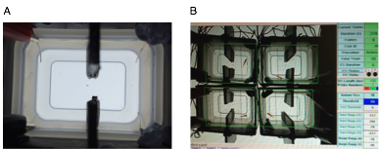

Figure 5. Schematic of the active avoidance paradigm. (A) The experimental tank for the two-way active avoidance paradigm. (B) A set-up of four functional units.

### 5.3.3 Active avoidance paradigm

Before conduction of the active avoidance assay, fish were habituated for 20 mins in the individual testing tanks (Fig.5.1) and no stimuli; neither CS nor US were administered. This time acted to diminish any aspects of fear or anxiety from exposure to a novel environment, or from stress due to being transferred between tanks. After completion of the habituation period, the beginning of the test was initiated when a fish swam at a minimum speed of 5 pixels across two frames. Commencement of a trial stimulated the illumination of the red LED in the same section of the tank the fish was positioned in. Fish then had 5 seconds to cross to the other side of the tank where the CS was not activated. If the fish crossed the midline and stayed in the non-CS side for the full 5 seconds, no US was delivered. On the contrary, if the fish remained in the side exposed to the CS or returned to this side before the end of the CS, a US was administered to the side presenting the CS. Following the decision to either administer or refrain a US, an inter-trial interval (ITI) of a minimum of 300 s was introduced between trials, and only with a fish moving at a speed of 5 pixels across successive frames, did the next trial begin. To further assess whether a fish learnt to avoid the US from presentation of a CS by swimming to the opposite side of the tank, a probe trial was added to the end of the 10 test trials. In the probe trial, a fish was presented with the CS and regardless of whether the fish crossed the midline or not, a US was not fulfilled. Therefore, a fish that had successfully learnt to escape the impending danger through active avoidance conditioning would swim away from the red LED, or CS, to the safe compartment of the tank.

Several behavioural parameters were calculated from the active avoidance paradigm to ascertain whether a fish had leant to avoid the aversive stimulus during the training. For example, the number of successful crosses over the midline during the course of 10 trials was calculated. A higher ratio of crosses to non-crosses would indicate that an individual had learnt the task. Similarly, whether a fish crossed the midline during the probe trial after appearance of the CS was also suggestive of learning capability. The reaction of a fish after commencement of the CS was an additional parameter measured during the active avoidance paradigm. If a fish learnt that a CS predicts a US, then it may present a startle response after onset of the red LED due ­to the looming threat. To assess this, the average speed in the two seconds directly following the onset of the CS was divided by the mean four seconds immediately before the CS. A startle ratio of 1 would indicate that there was no difference in the speed taken before and after the CS, indicative of no association of the CS with the US. However, if the startle ratio is above baseline towards the end of the test (>1), this implies a fish had an increased swim speed after the CS, signifying that a link between the CS and US was made. Furthermore, the average speed during the inter-trial intervals (ITIs) and the average length of the ITIs were also assessed. A fish needed to swim at a rate of 5 pixels to activate the next trial, therefore, the speed of a fish during the ITI, may dictate the overall ITI time as a slower swimming fish would delay the start of the next trial and ultimately increase the the ITI time, therefore, these behavioural parameters are not entirely independent from each other. A decrease in swim speed (mm/s), and an increased ITI Time (s), may be indicative of fear responses by a fish due to the possibility of an increased rate of freezing. Successive frame data to assess freezing responses was not obtained in this study; however, the average speed during individual trials could be calculated. A previously used measure to ascertain pausing of an individual was employed (Chapter 4). Briefly, a swim speed of less than 3.5 mm/s, calculated by taking the mean speed of 3 control fish was used to define a pausing event.

### 5.3.4 Data analysis

All data and graphs presented were made and analysed using the R statistical package v3.2.1. Observing the quantile-quantile plot of the residuals or analysis using the Shapiro Wilks test was used to test data for normality. Where possible, data was transformed to normaility using either a log or boxcox power transformation and analyzed using the parametric Independent t-test or two-way Analysis of Variance (ANOVA). Non-normal data was analyzed using the Mann-Whitney-Wilcoxon test, Kruskal Wallis test or the Chi-Squared test for binary data. A significance threshold of P<0.05 was used and corrected for using the Bonferroni method (p/number of statistical test used = adjusted *p value) (Bonferroni. 1935) and effect size was measured using Cohen’s d (presented as d=n) (Sullivan, & Feinn,. 2012). No fish were removed from analysis in this study.

## 5.4 Results

### 5.4.1 *Kiss1sq1sj-/-*zebrafish show an impairment in learning in the active avoidance paradigm

Analysis of the power transformed number of correct crosses over the midline during the active avoidance conditioning tests was not different between the two genotypes across ten trials (Fig.5.2.A: Independent t-test: t(34.78)=1.44, p=0.1598; d=0.42, n=39). Further analysis showed a difference between the score and the trial number (Fig.5.2.B: Kruskal-Wallis rank sum test: X2(3)=20.65, p<0.0001), and post-hoc analysis showed *Kiss1sq1sj-/-*mutant fish achieving a significantly lower number of crosses over the midline in the second half of the test compared to wild type fish (Fig.5.2.B: Dunn’s post-hoc test: p=0.0121). However, this was non-significant following Bonferroni correction (p<0.007). No difference in the first five trials between the two genotypes was seen (Fig.5.2.B: Dunn’s post-hoc test: p=0.2499).

The number of crosses during the probe trial showed no difference between the genotypes, but there was a trend towards a lower level of successful crosses within the *Kiss1sq1sj-/-*fish (Fig.5.3: Pearson’s Chi-squared test: X2(1)=2.309, p=0.1286: d=0.61).

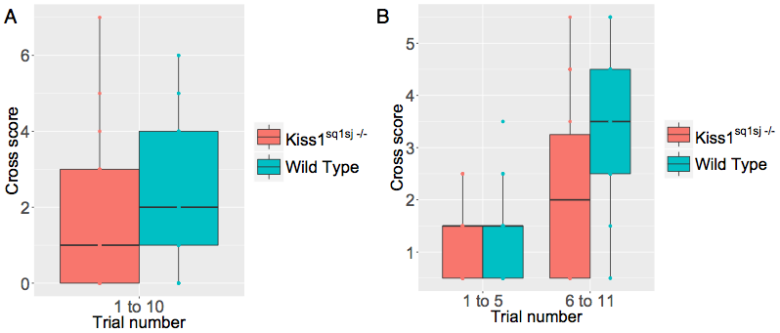

Figure 5.2 Performance during the active avoidance conditioning. Boxplots of the untransformed, raw data of the cross scores after presentation to the conditioned stimulus (CS) at different time points in the test including (A) the whole test and (B) the first half and second half between *Kiss1sq1sj-/-* and control fish. Data are presented as median (solid line), first and third quartile and 95% CI of median. *p<0.006. Coloured dots represent individual data points.



Figure 5.3 The mean probe score during the active avoidance paradigm. Data presented as mean ± 95% CI for both *Kiss1sq1sj-/-*mutant and control zebrafish.

Additional analysis showed that the inter-trial interval (ITI) time was not significantly different between control and *Kiss1sq1sj-/-*fish (Fig.5.4.A.i.: Mann-Whitney rank sum test: W=74, p=0.2706; d=0.22), No difference was seen in the power transformed ITI speed between *Kiss1sq1sj-/-*and control fish (Fig.5.4.A.ii: Independent t-test: t(18.50)=1.901, p=0.0730; d=0.18). The power transformed startle ratio during the active avoidance paradigm after presentation of the CS did not differ between *Kiss1sq1sj-/-*and control fish (Fig.5.4.A.iii: Independent t-test: t(15.34)=0.616, p=0.5469; d=0.04). Furthermore, quantification of the level of pausing showed it was not significantly different between *Kiss1sq1sj-/-*and control fish (Mann-Whitney rank sum test: W=3805, p=0.2336).

To investigate further whether there were any differences between *Kiss1sq1sj-/-*and control fish in the ITI time, ITI speed and startle ratio, each parameter was visualised for individual trials from trial 2 to 10 (Fig.5.4.B.i-iii) (No ITI time, ITI speed or startle ration is available for trial 1 because the habituation periods preceeds this). This data showed how *Kiss1sq1sj-/-*fish showed a larger ITI time between trials from trial 4 onwards, as indicated by a lack of overlap between the 95% confidence intervals (Fig.5.4.B.i). Furthermore, this difference in ITI time was not seen between the first and second trial indicating that this result is due to exposure to the test and not a mobility defect (Fig5.4.B.i). When looking at the ITI speed in the individual trials, there was no difference between Kiss1sq1sj-/- and control fish at trial 2 (Fig.5.4.B.ii: Mann-Whitney rank sum test: W=197.5, p=0.9775; d= 0.043), however, the speed for mutant fish declined rapidly at trial 3, and was consistently lower for the remainder of the test. The startle ratio between control and *Kiss1sq1sj-/-* mutant fish did not differ after presentation of the CS at trial 2 (Fig.5.4.B.iii: Mann-Whitney rank sum test: W=194, p=0.8991; d=-0.035) nor during trial 10 (Fig.5.4.B.iii: Mann-Whitney rank sum test: W=216.5, p=0.06044; d= 0.35). Despite the 95% confidence intervals not overlapping during several of the trials, the nature of the crossovers were volatile and were not consistent between genotypes. These data, as well as no discernable differences across all trials, led to the deduction that no differences in the startle ratio, and therefore linkage of the US to the CS after its presentation, was seen between *Kiss1sq1sj-/-*mutant and control fish.

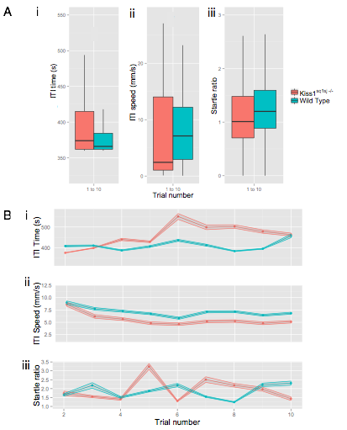

Figure 5.4 Additional parameters measured during the active avoidance conditioning (A) Boxplots for the (i) ITI time (s), (ii) ITI speed (mm/s) and (iii) startle ratio, after presentation to the CS of *kiss1sq1sj-/-*and control fish across the entire active avoidance test. Data are presented as median (solid line), first and third quartile and 95% CI of median and data is the un-transformed, raw data. *p<0.006. (B) (i) ITI time, (ii) ITI speed and (iii) startle ratio in 10 trials for *Kiss1sq1sj-/-*(pink) and control fish (blue). Data are presented as mean ± 95% CI.

### 5.4.2 *Kiss1sq2sj-/-*zebrafish show similar responses to control fish in learning in the active avoidance paradigm

The results from the two-way active avoidance test showed that there was no significant difference between *kiss1sq2sj-/-*and control fish in the number of crosses made after the presentation of the CS during the entire test (Fig.5.5.A: Mann-Whitney rank sum test: W=78.5, p=0.3622; d=0.39). Power transformation of the data for the halves of the test showed a significant effect of trial number on the number of cross scores (Fig.5.5.B: two-way ANOVA: F(1,54)=4.582, p=0.0368), which was not significant after Bonferroni correction (p<0.006), and no further differences were seen with a post-hoc test. Furthermore, there was no difference in the number of successful crosses during the probe trial (Fig.5.6: Pearson’s Chi squared test: X2(1)<0.001, p=1).

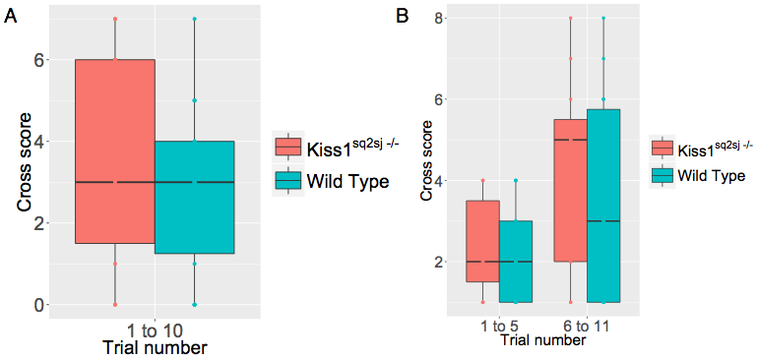

Figure 5.5 Performance during the active avoidance conditioning paradigm. Boxplots for the cross scores of *Kiss1sq2sj-/-*and control fish after presentation to the conditioned stimulus after (A) the whole test and (B) the first half and second half of the test (non transformed data shown). Data are presented as median (solid line), first and third quartile and 95% CI of median. *p<0.006. Coloured dots represent individual data points.

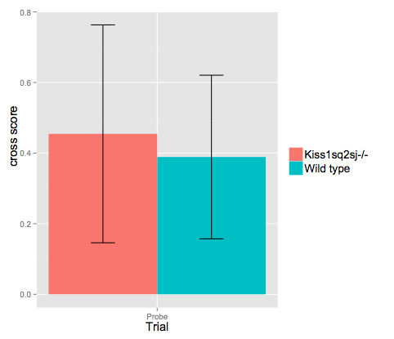

Figure 5.6 The mean probe cross score (A). Data presented as mean ± 95% CI for both *Kiss1sq2sj-/-*mutant and control zebrafish.

Further analysis showed that there was no significant difference between Kiss1sq2sj-/- and control fish in the ITI time across the entire duration of the test (Fig.5.7.A.i: Mann-Whitney rank sum test: W=11408, p=0.7191; d=0.11). Nor was there a significant difference between *Kiss1sq2sj-/-*and control fish in the ITI speed (Fig.5.7.A.ii: Mann-Whitney rank sum test: W=9927, p=0.11-7; d=0.21), or in the startle ratio after presentation to the CS (Fig.5.7.A.iii: Mann-Whitney rank sum test: W=11822, p=0.3657; d=0.26). Furthermore, observation of these parameters for individual trials suggests that no significant differences occurred between *Kiss1sq2sj-/-*and control fish, due to the numerous cross overs of the 95% CI throughout the duration of the test (Fig.5.7.B). The two genotypes looked very smilar at the beginning of test in the ITI time (Fig.5.7.B.i); ITI speed (Fig.5.7.B.i) or the startle response (Fig.5.7.B.iii). Furthermore, no difference in trial 10 was seen for ITI time (Fig.5.7.B.i: Mann-Whitney rank sum test: W=84, p=0.522; d=-0.35), or for the ITI speed (Fig.5.7.B.ii: Mann Whitney rank sum test: W=0.2852, p=0.2852; d=-0.50). Similar to Kiss1sq1sj-/- fish, the response of the startle ratio (Fig.5.7.B.iii), for individual trials between Kiss1sq2sj-/- mutant and control zebrafish overlapped on numerous occassions. I deduced from this data that no differences occurred in the startle ratio between the genotypes across the duration of the test, nor within the ITI time or ITI speed. These results suggest that mutant Kiss1sq2sj-/- fish have normal locomotion and are also able to respond to the CS, making them indistinguishable from wild type sibling controls.

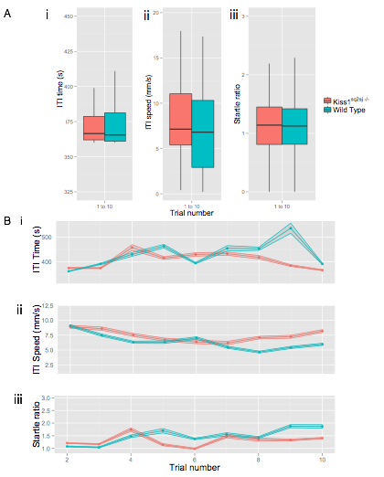

Figure 5.7 Additional parameters measured during active avoidance conditioning (A) Boxplots of the (j) ITI time (s) , (ii) ITI speed (mm/s) and (iii) startle ratio to presentation of the CS of *Kiss1sq1sj-/-*and control fish. Data are presented as median (solid line), first and third quartile and 95% CI of median. (B) (i) ITI time, (ii) ITI speed and (iii) startle ratio in 10 trials for *Kiss1sq2sj-/-*and control fish. Data are presented as mean ± 95% CI. *p<0.007.

### 5.4.3 *Kiss1rbsq5sj-/-*zebrafish in the active avoidance paradigm

The number of crosses over the midline across the entire duration of the active avoidance test did not differ significantly between *Kiss1rbsq5sj-/-*mutants and control zebrafish when analysing the whole test (Fig.5.8.A: Mann-Whitney rank sum test: W=62, p=0.2905; d=0.36). Likewise, there was no difference between the genotypes in the number of lines crossed when dividing the test into first and second halves (Fig.5.8.B: Dunn post hoc test: first half: p=0.1828; second half: p=0.1471). Additionally, the average number of successful crosses during the probe trial did not differ between control and *Kiss1rbsq5sj-/-* fish (Fig.5.9: Mann-Whitney rank sum test: W=80, p=0.8998; d=0.06).

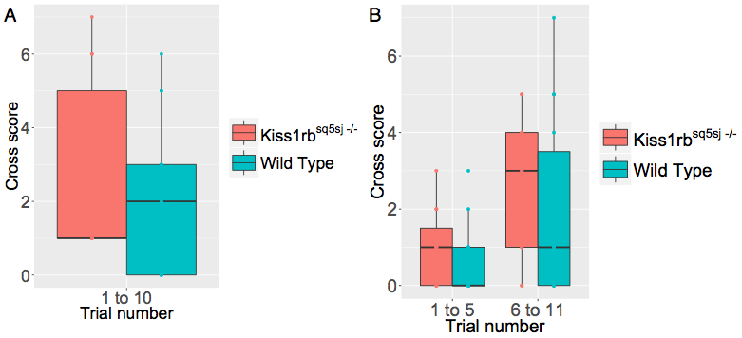

Figure 5.8 Performance during active avoidance conditioning. Boxplot of the cross scores after presentation to the conditioned stimulus during (A) the whole test and (B) the first half and second half of *Kiss1rbsq5sj-/-*and control fish. Data are presented as median (solid line), first and third quartile and 95% CI of median. *p<0.007. Coloured dots represent individual data points.

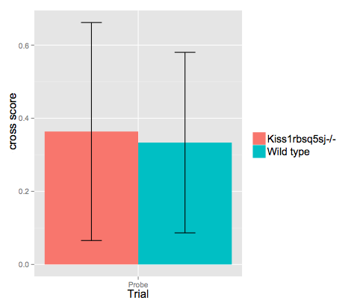

Figure 5.9 The mean probe cross score (A). Data presented as mean ± 95% CI between *Kiss1rbsq5sj*-/- and controlfish.

Observation of the additional parameters during the active avoidance paradigm showed that *Kiss1rbsq5sj-/-*fish differed significantly from control fish in the ITI time (Fig.5.10.A.i: Mann-Whitney rank sum test: W=11593, p=0.00766; d=0.12), with control fish spending a greater amount of time between trials compared to mutants. Additionally, the ITI speed differed significantly, with control fish having a lower speed compared to mutant fish across the duration of the test (Fig.5.10.A.ii: Mann-Whitney rank sum test: W=6824, p=0.0001; d=0.54). However, the startle ratio did not differ between *Kiss1rbsq5sj-/-*and control fish (Fig.5.10.A.iii: Mann-Whitney rank sum test: W=9863, p=0.9029; d=0.58). Whilst neither the ITI duration, or the startle ratio to the CS differed at the beginning of the test (Fig.5.10.B.i,iii), the ITI speed differed significantly, with mutant *Kiss1rbsq5sj-/-*fish displaying an increased basal swim speed compared to control fish (Fig.5.10.B.ii: Mann-Whitney rank sum test W=39, p=0.02369, d= -0.97). Across the duration of the conditioning trials, the plots for ITI Time (Fig.5.10.i) and the startle ratio (Fig.5.10.iii) seemed to show no drastic differences, with numerous cross overs, suggesting no difference in these measures between Kiss1rbsq5sj-/-and control zebrafish. The ITI speed (Fig.5.10.ii) on the other hand, appears consistently higher in the mutant population, suggesting they have a higher, basal swim speed compared to wild type siblings.

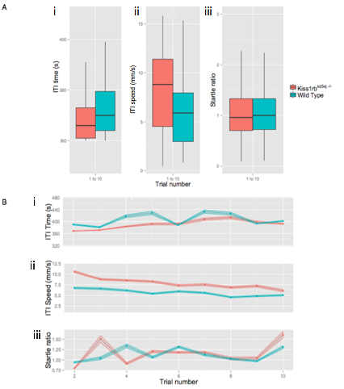

Figure 5.0 Additional parameters measured during the active avoidance conditioning (A) Boxplots for the (i) ITI time (s), (ii) ITI speed (mm/s) and (iii) startle ratio of *Kiss1rbsq5sj-/-*and control fish. Data are presented as median (solid line), first and third quartile and 95% CI of median. (B) (i) ITI time, (ii) ITI speed and (iii) startle ratio over the10 trials for *Kiss1rbsq5sj-/-*and control fish. Data are presented as mean ± 95% CI. *p<0.007.

## 5.5 Discussion

Learning to associate the connection between environmental stimuli and an aversive event is key to survival. To test this in an experimental setting one can use a method of conditioning called active avoidance. This approach of behavioural analysis involves a change of interpreting an originally neutral stimulus to one that signifies a looming danger. Unlike passive avoidance, this test includes the option for a testing animal to actively avoid a negative outcome through elicitation of a specific behaviour.

I show here that fish which lacked the neuropeptide kisspeptin 1 denoted *Kiss1sq1sj-/-*, showed a significantly reduced number of successful crosses over the midline to escape the aversive shock stimulus when compared to their wild type siblings. This difference was not observed in the earlier half of the trials and instead occurred in the latter half. However, this difference was determined insignifcant following multiple comparison correction. There was a medium trend towards mutant fish presenting with a decreased average of probe cross scores compared to their control siblings, however, a larger sample size is needed to see whether this result would be significant. Conversely, examination of the startle response produced from presentation of the CS appeared normal in *Kiss1sq1sj-/-*fish and did not differ significantly from wild type siblings. This suggests that the ability to associate the red light of the CS to the aversive event of the US, fundamental for Pavlovian learning by classical fear conditioning was maintained in *Kiss1sq1sj-/-*fish. It also suggests that the motor and sensory functions of these mutant fish remained intact. A recent study has shown how the tonic activity in vHb neurons in the zebrafish is responsible for sending aversive expectation value to serotonergic neurons in the raphe (Amo et al. 2014). The inactivation of the vHb – MR pathway causes a reduction in the ratio of fish that become successful learners during reinforcement learning. Kisspeptin 1 is expressed exclusively in the vHb of zebrafish and kisspeptin 1 containing neurons have been shown to project to a specific ventral region of the MR (Song et al. 2014). The results from vHb – MR inactivation and kisspeptin KO fish show a resemblance before multiple comparison correction, suggesting that kisspeptin signalling may help mediate the negative (aversive) expectation value inferred through the vHb – MR pathway.

Despite the initial similarities between wild type siblings and mutant fish in their ITI speed and duration, mutant fish quickly showed a decline in their swim speed (mm/sec) and consequently, an increase in the duration of ITI time (s). It has been shown earlier (Chapter 4) that zebrafish harbouring mutations within *Kiss1* show a possible decrease in exploratory behaviour when exposed to the novel tank diving test, but lacked any phenotypes regarding a change in anxiety. Therefore, the reduction in swim speed and increase in ITI time duration in mutant fish are unlikely to stem from variations in anxiety. Instead, this reduction in swim speed may result from a greater level of freezing in these fish due to fear conditioning. Previously it was shown (Chapter 4) that fish carrying mutations in *Kiss1* possiblypresent with an increase in some areas of innate fear. A study in rats has showed how an increased display of context-conditioned fear was negatively correlated with acquisition during the two-way active avoidance paradigm (Vicens-costa et al. 2011). These suggest that an increase in fear may inhibit the normal flight response seen during the active avoidance paradigm. However, analysis of the number of pausing episodes seen in kisspeptin 1 mutant versus control fish did not differ, implying that despite the increased level of fear seen in *Kiss1sq1sj-/-* fish seen in other paradigms, this increase in fear does not seem to be responsible for the inefficiency in learning in this paradigm. However, one cannot completely rule out the presence of fear and other parameters may need further analysis to rule this factor out entirely.

The association phase of reinforcement learning remained intact in the *Kiss1* mutant population, meaning that fish were capable of pairing the CS with the aversive US. These findings conflict with results from dHb inactivation in zebrafish that show a reduction in flight responses (Agetsuma et al. 2010), further confounding the differing roles the habenula subunits possess in fear modulation.

*Kiss1sq2sj-/-* fish showed no impairments during the two-way active avoidance paradigm through the number of traverses across the midline after presentation of the CS, nor in the number of successful probe trial crosses. Furthermore, there were no differences in the speed during the ITI intervals, or in the overall ITI duration. The startle ratio between mutant and control siblings also did not differ. This mutant line showed decreased levels of mRNA transcripts after qRT-PCR analyses, however, immunohistochemistry for the Kiss1 peptide in homozygous mutants revealed intact protein expression in the vHb. The lack of a phenotypic difference between sibling controls and

Kiss1sq2sj-/- mutant fish, parallel with intact protein expression, confound the results that it is indeed the lack of kisspeptin 1 causing the phenotypes seen in the *Kiss1sq1sj-/-* fish.

To ascertain whether the function of kisspeptin 1 acted solely within the vHb-MR circuit, I tested the function of the Kiss1rb receptor in active avoidance learning by using the Kiss1rbsq5sj-/- mutant line. Results suggested that there was no impairment in reinforcement learning through analyses of the average cross scores away from the CS after pairing with the aversive US. Furthermore, no differences were seen in the number of successful probe trial traverses between *Kiss1rbsq5sj-/-*fish and control siblings. However, evaluation of the speed and duration of the ITI between wild type siblings and controls showed a difference with mutant *Kiss1rb* fish displaying a decrease in ITI duration presumably as a consequence of an increased ITI speed. Whilst the ITI duration was indistinguishable between genotypes at the start of the conditioning trials, there was a significant difference with a large effect between Kiss1rbsq5sj-/- fish and their control siblings in their ITI swim speed. These results propose that the difference in speed is inherent in this mutant line and is not a result of the behavioural paradigm under which they were tested. The increase in speed may reflect an elevated exploratory drive. Therefore, although the *Kiss1rb* may play a role in innate fear, it seems dispensable for reinforcement learning.

Fear conditioning paradigms are vital to dissect the neural circuits that underlie the processing of emotional behaviours in animals. Despite the vast amount of work that still needs to be conducted in order to fully elucidate such pathways; this work has helped to identify key players within this circuit. In this study I have demonstrated that zebrafish lacking the neuropeptide kisspeptin 1 show impairment during two-way active avoidance behavioural assay. There were initially two possible reasons for this deficit. The first is an existing presentation of elevated innate fear in these fish that may inhibit the ability of a fish to learn how to respond to a safety signal. However, this hypothesis lacks conviction due to similar levels of pausing seen between the two genotypes. Furthermore, an enhanced fear response should induce a larger startle response to the conditioned CS, which was not seen in these mutant fish. On the other hand, kisspeptin 1 could be the facilitator of negative (aversive) expectation value from the vHb to the serotonergic MR. In this case, a lack of kisspeptin signalling should replicate the phenotype seen in vHb – MR pathway inactivated fish, which we have successfully shown is the case.

**Chapter 6: General discussion**

Each chapter of this thesis contains individual discussion of the results, however, here I will summarise the findings as well as suggesting specific directions for future research.

The present work shows the behavioural results from zebrafish carrying mutations in two independent genetic pathways within the zebrafish, the first being the *ext2* gene, involved in heparan sulfate formation and the second being the neuropeptide, *Kiss1,* widelyknown for its role in reproduction in a variety of species.

I performed a selection of behavioural assays on two generations of dackel mutant zebrafish, which were heterozygous for the *ext2to273b* allele. The main findings from this research were that heterozygous zebrafish showed subtle differences in respect to their aggression and anxiety-like behaviours when internally compared to wild type siblings. Wild type female zebrafish showed a decrease in the number of aggressive displays compared to heterozygous males during the mirror test. Furthermore, heterozygous *ext2to273b* zebrafish spent more time than their wild type counterparts in the display section, before multiple comparison correction, suggesting that heterozygous fish display an increased aggression level over wild type fish. When tested for anxiety-like responses, heterozygous zebrafish spent less time in the lower section of a novel tank before multiple comparison correction. Additional analysis showed how heterozygous females spent significantly less time in the lower section of the novel tank, as well as an increased number of transitions into this section, suggesting that heterozygous *ext2to273b* zebrafish display decreased anxiety responses compared to wild type fish. Although differences are seen in behaviour between heterozygous *dackel* mutants and wild type siblings, the effects are subtle. Studies detailing the phenotypic profile from a lack of heparan sulfate by inactivation of the *Ext1* gene in mice on the other hand, showed startling results. Mice that had Ext1 conditionally inactivated in postnatal neurons at approximately three weeks of age in the forebrain (Ext1CKO), showed a recapitulation of almost the entire range of autistic symptoms. The methodology in the mouse study has several differences with my own, which may help explain the small behavioural differences seen here. For example, Ext1CKO mice grow normally, with no obvious developmental defects, allowing for the previously impossible observation of behaviour in *Ext1* knockout mice due to embryonic lethality. Behavioural analysis of homozygous *dackel* mutant zebrafish, however, is still a problem, due a lack of a similar transgenic line of that seen in mice. However, this genetic manipulation could be more easily achieved through a method previously discussed in this study; the CRISPR/Cas9 system. For example, the Cas9 protein can be driven by a heat-shock-inducible or tissue-specific promoter to achieve either temporal or spatially restricted gene inactivation (Yin et al. 2015). Generation of mutant lines for the exostosin genes in zebrafish using this technique would greatly enhance the understanding of the behavioural repercussions of knockout mutations of the exostosin genes. Furthermore, once this technique is of accessibility, one can use it to target other genes with a given molecular pathway to firther understand the molecular mechanisms behind a specific behaviour.

Quantification of HS reduction in Ext1CKO mice was performed using the enzyme-linked immunosorbent assay (ELISA), and showed a significant reduction in the levels of HS in mutant mice compared to wild type animals (Irie et al. 2012). Similar results are seen in fish, with 5dpf *dakto273b* homozygous mutants showing an 89% reduction in the level of HS by disaccharide profiling assays (Lee et al. 2004). However, the level of HS in heterozygous *dakto273b* zebrafish has not been tested, it is therefore unknown if there is a reduction in HS in heterozygous *dackel* fish and if there is, the magnitude of the change. A small change in the level of HS in heterozygous zebrafish may explain the subtle behaviour differences seen from this study; therefore, this is an experiment that needs to be completed in the near future to fully understand the mechanism of HS action in heterozygote carrier fish.

Potential studies to further assess the exostosin family of genes influence on behaviour in the zebrafish should include behavioural analysis of other mutant alleles within the *dackel* gene. Additional alleles available within the *dackel* gene include *daktw25e* (TAT to TAA – aa227/exon5) and *dakt079e* (TAC to TAA – aa 26/exon1) (Lee et al. 2004). Behavioural analysis of numerous mutant alleles, with sufficient sample sizes would help confound the results seen in this study.

The second gene analysed in this thesis was the neuropeptide kisspeptin, *Kiss1*. Kisspeptin, a key player in the HPG axis, has been shown to be a vital regulator of reproduction in most vertebrates. This study is the first to detail both *Kiss1-/-* and *Kiss1rb-/-* mutant zebrafish lines using the latest genome editing technique, CRISPR/Cas9 technology. Generation of the mutants and verification through qRT-PCR and immunohistochemistry experiments produced two *Kiss1*, and one *Kiss1rb* zebrafish mutant to phenotypically analyse. Literature shows how the addition of the kisspeptin peptide prior to alarm substance (AS) exposure results in a reduction in the fear response in adult zebrafish. The results from this study show that when zebrafish lack kisspeptin1, we see a trend for an increase in bottom dwelling after exposure to AS. Moreover, mutant fish display an increased latency to enter the upper half of the tank as well as a decreased number of transitions. Despite several non-significant scores due to multiple comparison correction using the Bonferroni method, this data fits in nicely with the known literature on this subject. That is, an overexpression of kisspeptin in the adult zebrafish causes an inhibition of the fear response (Ogawa et al 2014), whereas as a reduction in kisspeptin signalling causes an enhanced fear response as seen in this study.

Another recent study looked at the role of the Habenulo-Raphe serotonergic circuit in active avoidance conditioning (Amo et al 2014). It was shown here how, the ventral habenula, the primary site of kisspeptin 1 expression in the zebrafish, increases its firing to a cue which represented danger. When the synaptic transmission of this pathway, from the ventral habenula to the median raphe was inhibited, impairment in adaptive active avoidance conditioning was seen. Due to the dense expression of kisspeptin1 in the ventral habenula, and the kisspeptin receptor in the fasciculus retroflexus, the bundle of fibres carrying afferents from the habenula to the IPN, I utilized the kisspeptin system CRISPR/Cas9 mutants for a potential role in active avoidance learning. Results from this study showed how zebrafish carrying homozygous mutations within the *Kiss1* locus, made significantly fewer crosses over the midline compared to control fish in the later half of the test, though non-significant following Bonferroni correction. Furthermore, there was trend towards a lower number of crosses during the probe trial, increased ITI time and decreased ITI speed in the homozygous Kiss1sq1sj-/- mutants compared to wild type fish, suggesting further evidence for a dysfunction in active avoidance in mutant zebrafish. The failure of fish with defective kisspeptin signalling to perform in the active avoidance paradigm suggests some involvement of kisspeptin1 in adaptive learning in the zebrafish.

As mentioned previously, changes in genetic code that result in a null gene, through genome editing techniques such as the CRISPR/Cas9 technique, are capable of initiating compensatory mechanisms, which may obscure a behavioural phenotype (Rossi et al. 2015). Therefore, one needs to complement the results of a deletrious mutation in a gene with supplementary methods, including gene knockdowns by techniques. Therefore, the use of morpholinos, a comon antisence knockdown technique, or CRISPR interference (CRISPRi) (Larson, Gilbret and Wang. 2013), a genetic pertubation method allowing for site-specific repression or activation of a gene would be extremely beneficial in the phenotypic analysis of a genes function in adult zebrafish behaviour.

To conclude, I have provided evidence for the potential involvement of the exostosin gene, *ext2*, in aggression and anxiety-like responses in the zebrafish. Furthermore, I have also further implicated the kisspeptin system in fear responses as well as in a novel behaviour, in active avoidance learning.

Bibliography

Agetsuma, M. et al., 2010. The habenula is crucial for experience-dependent modification of fear responses in zebrafish. *Nature neuroscience*, 13(11), pp.1354–6.

Ahrens, K.F. et al., 2012. Two-photon scanning microscopy of in vivo sensory responses of cortical neurons genetically encoded with a fluorescent voltage sensor in rat. *Frontiers in Neural Circuits*, 6(March), pp.1–9.

Ahrens, M.B. et al., 2013. Whole-brain functional imaging at cellular resolution using light-sheet microscopy. *Nature methods*, 10(5), pp.413–20.

Aizaki, K. & Yusa, Y. 2009. Field observations of the alarm response to crushed conspecifics in the freshwater snail Pomacea canaliculata: effects of habitat, vegetation, and body size. *Journal of Ethology*, 27: 175–180.

Aizawa, H., Amo, R. & Okamoto, H., 2011. Phylogeny and ontogeny of the habenular structure. *Frontiers in neuroscience*, 5(December), p.138.

Akagi,K & E.W.Powell (1968).Differential projections of habenular nuclei. *Expimenttal Neurology.* 182: 263-274

Amo, R. et al., 2014. The Habenulo-Raphe Serotonergic Circuit Encodes an Aversive Expectation Value Essential for Adaptive Active Avoidance of Danger. *Neuron*, pp.1–15.

Aoki, R., Tsuboi, T. & Okamoto, H., 2014. Y-maze avoidance: An automated and rapid associative learning paradigm in zebrafish. *Neuroscience Research*, pp.10–13.

Archard, G. A. & Braithwaite, V. A. 2011. Variation in aggressive behaviour in the poeciliid fish Brachyrhaphis episcopi: Population and sex differences. *Behavioural Processes,* 86**,** 52-57.

Ariyomo, T.O. & Watt, P.J., 2013. Aggression and sex differences in lateralization in the zebra fish. *Animal Behaviour*, 86, pp.617–622.

Ariyomo, T.O. & Watt, P.J., 2012. The effect of variation in boldness and aggressiveness on the reproductive success of zebra fi sh. *Animal Behaviour*, 83(1), pp.41–46.

Arnold, P.D., Zai, G. & Richter, M.A., 2004. Genetics of Anxiety Disorders. *Current Psychology Reports*. 6:243-254.

Auer, T.O. et al., 2013. Highly efficient CRISPR/Cas9-mediated knock-in in zebrafish by homology-independent DNA repair. *Genome research*. Baldwin, P., Alanis, R. & Salas, R., 2012. The Role of the Habenula in Nicotine Addiction. *Journal of Addiction Research & Therapy*, 01(S1).

Bass, S.L.S. & Gerlai, R., 2008. Zebrafish (Danio rerio) responds differentially to stimulus fish: The effects of sympatric and allopatric predators and harmless fish. *Behavioural Brain Research*, 186(1), pp.107–117.

Bassett, A.R. et al., 2013. Highly efficient targeted mutagenesis of Drosophila with the CRISPR/Cas9 system. *Cell reports*, 4(1), pp.220–8.

Bencan, Z., Sledge, D. & Levin, E. D. 2009. Buspirone, chlordiazepoxide and diazepam effects in a zebrafish model of anxiety. *Pharmacology Biochemistry and Behavior,* 94**,** 75-80.

Bencan, Z., Sledge, D. & Levin, E.D., 2010. Model of Anxiety.94(1), *Physiology Behaviour*. pp.75–80.

Biran, J., Ben-Dor, S. & Levavi-Sivan, B., 2008. Molecular identification and functional characterization of the kisspeptin/kisspeptin receptor system in lower vertebrates. *Biology of reproduction*, 79(4), pp.776–86.

Blair, H.T. et al., 2001. Synaptic plasticity in the lateral amygdala: a cellular hypothesis of fear conditioning. *Learning & memory (Cold Spring Harbor, N.Y.)*, 8(5), pp.229–242.

Blanchard, D.C. & Blanchard, R.J., 1972. Innate and conditioned reactions to threat in rats with amygdaloid lesions. *Journal of comparative and physiological psychology*, 81(2), pp.281–290.

Blanchard, R.J. et al., 1993. Defense system psychopharmacology: an ethological approach to the pharmacology of fear and anxiety. *Behavioural brain research*, 58(1-2), pp.155–165.

Blaser, R. E., Chadwick, L. & Mcginnis, G. C. 2010. Behavioral measures of anxiety in zebrafish (Danio rerio). *Behavioural Brain Research,* 208**,** 56-62.

Blaser, R. E. & Penalosa, Y. M. 2011. Stimuli affecting zebrafish (Danio rerio) behavior in the light/dark preference test. *Physiology & Behavior,* 104**,** 831-837.

Bonferroni, C. E. "Il calcolo delle assicurazioni su gruppi di teste." In *Studi in Onore del Professore Salvatore Ortu Carboni.* Rome: Italy, pp. 13-60, 1935

Boureau, Y. & Dayan, P., 2010. Opponency Revisited : Competition and Cooperation Between Dopamine and Serotonin. *Neuropsychopharmacology*, 36(1), pp.74–97.

Bovée, J.V.M.G., 2008. Multiple osteochondromas. *Orphanet journal of rare diseases*, 3, p.3.

Bratčikov, M. & Mauricas, M., 2009. The use of high-resolution melting analysis for *Salmonella* spp. CRISPR sequence genotyping. *Acta medica Lituanica*, 16(3), pp.98–102.

Bravo-rivera, C. et al., 2015. Persistent active avoidance correlates with activity in prelimbic cortex and ventral striatum. 9(July), *Front Behaviour Neuroscience,* pp.1–8.

Breazeale, Christine E., "Assessing behaviour change related to acute stress exposure in the zebrafish". (2013) *Honours thesis*. Paper 165.

Britton, D.R. & Britton, K.T., 1981. A sensitive open field measure of anxiolytic drug activity. *Pharmacology, biochemistry, and behavior*, 15(4), pp.577–582.

Brook, C.A. & Schmidt, L.A., 2008. Social anxiety disorder : A review of environmental risk factors. , 4(1), pp.123–143.

Budick, S. a & O’Malley, D.M., 2000. Locomotor repertoire of the larval zebrafish: swimming, turning and prey capture. *The Journal of experimental biology*, 203(Pt 17), pp.2565–2579.

Burgess, H. a & Granato, M., 2007. Modulation of locomotor activity in larval zebrafish during light adaptation. *The Journal of experimental biology*, 210(Pt 14), pp.2526–39.

Burns, R.S. et al., 1983. A primate model of parkinsonism : Selective destruction of dopaminergic neurons in the pars compacta of the substantia nigra by N-methyl-4-phenyl- Neurobiology : *Proceedings of the National Academy of Sciences of the United States of America*, 80(July), pp.4546–4550.

Burns, J. G. 2008. The Validity of Three Tests of Temperament in Guppies (Poecilia reticulata). *Journal of Comparative Psychology,* 122**,** 344-356

Cachat J, Stewart A, Utterback E, Hart P, Gaikwad S, et al. (2011) Three-Dimensional Neurophenotyping of Adult Zebrafish Behavior. PLoS ONE 6(3): e17597. doi:10.1371/journal.pone.0017597Carpen, J.D. et al., A silent polymorphism in the. *PER1* gene associates with extreme diurnal preference in humans. *J Hum Gene*t (2006) 51:1122–1125

Champagne, D. L., Hoefnagels, C. C. M., DE Kloet, R. E. & Richardson, M. K. 2010. Translating rodent behavioral repertoire to zebrafish (Danio rerio): Relevance for stress research. *Behavioural Brain Research,* 214**,** 332-342.

Chartrel, N. et al., 2003. Identification of 26RFa, a hypothalamic neuropeptide of the RFamide peptide family with orexigenic activity. *Proceedings of the National Academy of Sciences of the United States of America*, 100(25), pp.15247–15252.

Chen, H. et al., 1996. Evidence That the Diabetes Gene Encodes the Leptin Receptor : Identification of a Mutation in the Leptin Receptor Gene in db / db Mice. *Cell*, 84, pp.491–495.

Cheng, G. et al., 2010. The kisspeptin/neurokinin B/dynorphin (KNDy) cell population of the arcuate nucleus: Sex differences and effects of prenatal testosterone in sheep. *Endocrinology*, 151(1), pp.301–311.

Chivers, D.P., Wisenden, B.D. & Smith, R.J.A.N.F., 1996. Damselfly larvae learn to recognize predators from chemical cues in the predator’s diet. *Animal Behaviou*r, pp.315–320.

Clarke, H., Dhillo, W.S. & Jayasena, C.N., 2015. Review Article Comprehensive Review on Kisspeptin and Its Role in Reproductive Disorders. *Endocinology and Medicin*e, pp.124–141.

Clément, K. et al., 1998. A mutation in the human leptin receptor gene causes obesity and pituitary dysfunction. *Nature*, 392(6674), pp.398–401.

Clements, M.K. et al., 2001. FMRFamide-related neuropeptides are agonists of the orphan G-protein-coupled receptor GPR54. *Biochemical and biophysical research communications*, 284(5), pp.1189–1193.

Cook, A. et al., 1993. Genetic Heterogeneity in Families with Hereditary Multiple Exostoses. *American Journal for Human Genetics*, pp.71–79.

Corey, D.R. & Abrams, J.M., 2001. Minireview Morpholino antisense oligonucleotides : tools for investigating vertebrate development. *Genome Biology*., pp.3–5.

Crawley, J. & Goodwin, F.K., 1980. Preliminary report of a simple animal behavior model for the anxiolytic effects of benzodiazepines. *Pharmacology, biochemistry, and behavior*, 13(2), pp.167–170.

d’Anglemont de Tassigny, X. & Colledge, W.H., 2010. The role of kisspeptin signaling in reproduction. *Physiology (Bethesda, Md.)*, 25(4), pp.207–17.

Dahlem, T.J. et al., 2012. Simple Methods for Generating and Detecting Locus- Specific Mutations Induced with TALENs in the Zebrafish Genome. *PLoS* ome. 8(8).

Davies, A.C., Nicol, C.J. & Radford, A.N., 2015. Effect of reward downshift on the behaviour and physiology of chickens. *Animal Behaviour*, 105, pp.21–28.

Davis, M. et al., 2010. Phasic vs sustained fear in rats and humans: role of the extended amygdala in fear vs anxiety. *Neuropsychopharmacology : official publication of the American College of Neuropsychopharmacology*, 35(1), pp.105–135.

Davis, M., Walker, D.L. & Lee, Y., 1997. Amygdala and bed nucleus of the stria terminalis: differential roles in fear and anxiety measured with the acoustic startle reflex. *Philosophical transactions of the Royal Society of London. Series B, Biological sciences*, 352(1362), pp.1675–1687.

Day, D.E., Keen-Rhinehart, E. & Bartness, T.J., 2005. Role of NPY and its receptor subtypes in foraging, food hoarding, and food intake by Siberian hamsters. *American journal of physiology. Regulatory, integrative and comparative physiology*, 289(1), pp.R29–R36.

Dayan, P. & Huys, Q.J.M., Serotonin in Affective Control. A*nnu. Rev. Neurosci.* 2009. 32:95–126.

Driever, W. et al., 1996. A genetic screen for mutations affecting embryogenesis in zebrafish. *Development*, pp.37–46.

Egan, R.J. et al., 2009. Understanding behavioral and physiological phenotypes of stress and anxiety in zebrafish. *Behavioural Brain Research*, 205(1), pp.38–44.

Etkin, A. & Wager, T.D., 2007. Functional neuroimaging of anxiety: a meta-analysis of emotional processing in PTSD, social anxiety disorder, and specific phobia. *The American journal of psychiatry*, 164(10), pp.1476–1488.

Findeisen, M., Rathmann, D. & Beck-Sickinger, A.G., 2011. RFamide Peptides: Structure, Function, Mechanisms and Pharmaceutical Potential. *Pharmaceuticals*, 4(9), pp.1248–1280.

Fowler, C.D. et al., 2011. Habenular α5 nicotinic receptor subunit signalling controls nicotine intake. *Nature*, 471(7340), pp.597–601.

Frank, M.J., Seeberger, L.C. & Reilly, R.C.O., 2004. By Carrot or by Stick : Cognitive Reinforcement Learning in Parkinsonism. Science, (October), pp.1940–1944.

Ganella, D.E. & Kim, J.H., 2014. Developmental rodent models of fear and anxiety: From neurobiology to pharmacology. *British journal of pharmacology*, pp.1–42.

Gebruers, E. et al., 2013. A Phenotypic Screen in Zebrafish Identifies a Novel Small-Molecule Inducer of Ectopic Tail Formation Suggestive of Alterations in Non-Canonical Wnt / PCP Signaling. , 8(12), pp.1–14.

Gene, M. et al., 1996. KiSS-1 , a Novel Human Malignant Melanoma. Journal of the National Cancer Institute, Vol. 88, No. 23, December 4, 1996

Gerlai, R., Lahav, M., Guo, S. & Rosenthak, A. 2000. Drinks like a fish: zebra fish (Danio rerio) as a behavior genetic model to study alcohol effects. *Pharmacology Biochemistry and Behavior,* 67**,** 773-782.

Gerlai, R. et al., 2001. Drinks like a fish : zebra fish ( Danio rerio ) as a behavior genetic model to study alcohol effects. , 67(2000), pp.773–782.

Gewirtz, J.C. & Davis, M., 1997. Second-order fear conditioning prevented by blocking NMDA receptors in amygdala. *Nature*, 388(6641), pp.471–474.

Glick, S.D. et al., 2011. Brain regions mediating α3β4 nicotinic antagonist effects of 18-MC on nicotine self-administration. *European Journal of Pharmacology*, 669(1-3), pp.71–75.

Gottsch, M.L. et al., 2004. A role for kisspeptins in the regulation of gonadotropin secretion in the mouse. *Endocrinology*, 145(9), pp.4073–4077.

Grillon, C. et al., 1997. Darkness facilitates the acoustic startle reflex in humans. *Biological Psychiatry*, 42(6), pp.453–460.

Guo, S., 2015. Linking genes to brain , behavior and neurological diseases : what can we learn from zebrafish? *Genes Brain Behaviour,* 3 : 63-74

Hai, T. et al., 2014. One-step generation of knockout pigs by zygote injection of CRISPR/Cas system. *Cell research*, 24(3), pp.372–5.

Hamilton, S.P. et al., 2004. Evidence for Genetic Linkage Between a Polymorphism in the Adenosine 2A Receptor and Panic Disorder. Neuropsychopharmacology, pp.558–565.

Hascoet, M., Bourin, M. & Dhonnchadha, B. A. N. 2001. The mouse light-dark paradigm: A review. *Progress in Neuro-Psychopharmacology & Biological Psychiatry,* 25**,** 141-166.

Hascoët, M. & Bourin, M., 2009. The mouse light-dark box test. *Neuromethods*, 42, pp.197–223.

Heinrichs, M. & Domes, G., 2008. Neuropeptides and social behaviour: effects of oxytocin and vasopressin in humans. *Progress in brain research*, 170(08), pp.337–50.

Hindi Attar, C., Finckh, B. & Büchel, C., 2012. The influence of serotonin on fear learning. *PloS one*, 7(8), p.e42397.

Hinuma, S. et al., 1998. A prolactin-releasing peptide in the brain. *Nature*, 393(6682), pp.272–276.

Holcombe A, Howorko A, Powell RA, Schalomon M, Hamilton TJ (2013) Reversed Scototaxis during Withdrawal after Daily-Moderate, but Not Weekly- Binge, Administration of Ethanol in Zebrafish. PLoS ONE 8(5): e63319. doi:10.1371/journal.pone.0063319

Howe, K. et al., 2013. The zebrafish reference genome sequence and its relationship to the human genome. *Nature*, 496(7446), pp.498–503.

Hwang, W.Y. et al., 2013. Efficient genome editing in zebrafish using a CRISPR-Cas system. *Nature biotechnology*, 31(3), pp.227–9.

Irie, F., Badie-mahdavi, H. & Yamaguchi, Y., 2012. stereotypies in mice lacking heparan sulfate. *Proceedings of the National Academy for Sciences of the United states of America*, 109(13), pp.5052–5056.

Irwig, M.S. et al., 2004. Kisspeptin activation of gonadotropin releasing hormone neurons and regulation of KiSS-1 mRNA in the male rat. *Neuroendocrinology*, 80(4), pp.264–272.

Jamain, S. et al., 2008. Reduced social interaction and ultrasonic communication in a mouse model of monogenic heritable autism. *Proceedings of the National Academy for Sciences of the United states of America*, 105(5).

Jesuthasan, S., 2012. Fear, anxiety, and control in the zebrafish S. W. Wilson & F. Engert, eds. *Developmental Neurobiology*, 72(3), pp.395–403.

Jovanovic, T. et al., 2006. Contingency awareness and fear inhibition in a human fear-potentiated startle paradigm. *Behavioral neuroscience*, 120(5), pp.995–1004.

Kanda, S. et al., 2008. Identification of KiSS-1 product kisspeptin and steroid-sensitive sexually dimorphic kisspeptin neurons in Medaka (Oryzias latipes). *Endocrinology*, 149(5), pp.2467–2476.

Kanda, S. et al., 2013. Neuroanatomical evidence that kisspeptin directly regulates isotocin and vasotocin neurons. *PloS one*, 8(4), p.e62776.

Kas, M.J. et al., 2014. Assessing behavioural and cognitive domains of autism spectrum disorders in rodents : current status and future perspectives. *Psychopharmacology* , pp.1125–1146.

Kauffman, A.S. et al., 2007. Sexual differentiation of Kiss1 gene expression in the brain of the rat. *Endocrinology*, 148(4), pp.1774–1783.

Keller, P.J. et al., 2008. Reconstruction of zebrafish early embryonic development by scanned light sheet microscopy. *Science (New York, N.Y.)*, 322(5904), pp.1065–1069.

Kim, J. et al., 2011. Regulation of Kiss1 expression by sex steroids in the amygdala of the rat and mouse. *Endocrinology*, 152(5), pp.2020–2030.

Kitahashi, T., Ogawa, S. & Parhar, I.S., 2009. Cloning and expression of kiss2 in the zebrafish and medaka. *Endocrinology*, 150(2), pp.821–31.

Knoll, J.G. et al., 2013. Developmental profile and sexually dimorphic expression of kiss1 and kiss1r in the fetal mouse brain. *Frontiers in endocrinology*, 4(October), p.140.

Konopka, R.J. & Benzer, S., 1971. Clock Mutants of Drosophila melanogaster. *Proceedings of the National Academy for Sciences of the United states of America*, 68(9), pp.2112–2116.

Kotani, M. et al., 2001. The Metastasis Suppressor Gene KiSS-1 Encodes Kisspeptins, the Natural Ligands of the Orphan G Protein-coupled Receptor GPR54. *Journal of Biological Chemistry*, 276(37), pp.34631–34636.

Larson, M. Gilbert, X. and Wang., 2013. CRISPR interference (CRISPRi) for sequence-specific control of gene expression. *Nature Publishing Group*. 8(11),2180-2196.

Lee, D.K. et al., 1999. Discovery of a receptor related to the galanin receptors. *FEBS Letters*, 446(1), pp.103–107.

Lee, J.H. et al., 1996. KiSS-1, a novel human malignant melanoma metastasis-suppressor gene. *Journal of the National Cancer Institute*, 88(23), pp.1731–1737.

Lenz, J.D. & Lobo, M.K., 2013. Optogenetic insights into striatal function and behavior. *Behavioural brain research*, pp.1–11.

Li, H. et al., 2002. Association of autism in two patients with hereditary multiple exostoses caused by novel deletion mutations of EXT1. *Journal of Human Genetics,* pp.262–265.

Lind, T. et al., 1998. The Putative Tumor Suppressors Glycosyltransferases Required for the Biosynthesis of Heparan Sulfate. *Journal of Biological Chemistry.* 12(31330), pp.26265–26269.

Lind, T. & Lidholt, K., 1993. Biosynthesis of heparin / heparan sulfate . Identification of a 70-kDa protein catalyzing both the D-glucuronosyl- and the N-acetyl-D- glucosaminyltransferase reactions . J *Biol Chem*. 272, (9), 26265-26268.

Lindsay, E.A., 2001. chromosomal microdeletions : dissecting del22q11 syndrome. *Nature Genetics*, 2(November), pp.858–868.

Liu, X., Lee, K. & Herbison, A.E., 2008. Kisspeptin excites gonadotropin-releasing hormone neurons through a phospholipase C/calcium-dependent pathway regulating multiple ion channels. *Endocrinology*, 149(9), pp.4605–4614.

Maeder, M.L. et al., 2009. Oligomerized pool engineering (OPEN): an “open-source” protocol for making customized zinc-finger arrays. *Nature protocols*, 4(10), pp.1471–501.

Marder, E., 2012. Neuromodulation of neuronal circuits: back to the future. *Neuron*, 76(1), pp.1–11.

Martin, P., 2003. The epidemiology of anxiety disorders: A review. *Dialogues in Clinical Neuroscience*, 5(3), pp.281–298.

Mathuru, A.S. et al., 2012. Report Chondroitin Fragments Are Odorants that Trigger Fear Behavior in Fish. *Current Biology*, 22(6), pp.538–544.

Matsumoto, M. & Hikosaka, O., 2007. Lateral habenula as a source of negative reward signals in dopamine neurons. *Nature*, 447(7148), pp.1111–1115.

Matsumoto, M. & Hikosaka, O., 2009. Two types of dopamine neuron distinctly convey positive and negative motivational signals. *Nature*, 459(7248), pp.837–41.

Matzuk, M.M. & Lamb, D.J., 2008. The biology of infertility : research advances and clinical challenges.*Nature Medecine*, 14(11), pp.1197–1213.

Mccormick, C. et al., 1998. The putative tumour suppressor EXT1 alters the expression of cell-surface heparan sulfate. *Proceedings of the National Academy for Sciences of the United states of America.* 19(june), pp.158–161.

McGhee KE, Bell AM. 2014 Paternal care in a fish: epigenetics and fitness enhancing effects on offspring anxiety. *Proc. R. Soc*. B 281: 20141146.

Merrer, M. Le et al., 1994. A gene for hereditary multiple exostoses maps to chromosome 19p. *Human Molecular Genetics*, 3(5), pp.717–722.

Messager, S. et al., 2005. Kisspeptin directly stimulates gonadotropin-releasing hormone release via G protein-coupled receptor 54. *Proceedings of the National Academy for Sciences of the United states of America*, 102(5), pp.1761–1766.

Miller, N. & Gerlai, R. 2007. Quantification of shoaling behaviour in zebrafish (Danio rerio). *Behavioural Brain Research,* 184**,** 157-166.

Moretz, J.A. & Morris, M.R., 2003. Evolutionarily labile responses to a signal of aggressive intent. *Proceedings of the Royal Society B: Biological Sciences*, 270(1530), pp.2271–2277.

Moretz, J. A., Martins, E. P. & Robison, B. D. 2007. Behavioral syndromes and the evolution of correlated behavior in zebrafish. *Behavioral Ecology,* 18**,** 556-562.

Morgane, P.J. & Foundation, W., 1979. Effects of Electrical Stimulation of the Lateral Habenula Activity of Raphe Neurons. *Experimental Neurobiology*, 342, pp.326–342.

Mosienko, V. et al., 2015. Reduced isolation-induced pup ultrasonic communication in mouse pups lacking brain serotonin. *Molecular autism,* pp.1–13.

Mowrer, O.H. & Lamoreaux, R.R., 1945. fear as an intervening variable in avoidance. *Journal of Comparative Psychology,* Vol 39(1), Feb 1946, 29-50

Muir, A.I. et al., 2001. AXOR12, a Novel Human G Protein-coupled Receptor, Activated by the Peptide KiSS-1. *Journal of Biological Chemistry*, 276(31), pp.28969–28975.

Nakahara, H. et al., 2004. Dopamine Neurons Can Represent Context-Dependent Prediction Error. *Neuron*, 41, pp.269–280.

Nakamura, K., Matsumoto, M. & Hikosaka, O., 2008. Reward-Dependent Modulation of Neuronal Activity in the Primate Dorsal Raphe Nucleus. , 28(20), pp.5331–5343.

Nathan, F.M., Ogawa, S. & Parhar, I.S., 2015. Kisspeptin1 modulates odorant-evoked fear response via two serotonin receptor subtypes (5-HT1A and 5-HT2 ) in zebrafish. *Journal of neurochemistry*.

Navarro, V.M. et al., 2004. Advanced vaginal opening and precocious activation of the reproductive axis by KiSS-1 peptide, the endogenous ligand of GPR54. *The Journal of physiology*, 561(Pt 2), pp.379–386.

Nielsen, H. et al., 1997. Identification of prokaryotic and eukaryotic signal peptides and prediction of their cleavage sites. *Protein engineering*, 10(1), pp.1–6.

Norton, W. & Bally-Cuif, L., 2010. Adult zebrafish as a model organism for behavioural genetics. *BMC neuroscience*, 11, p.90.

Oakley, A.E., Clifton, D.K. & Steiner, R. a., 2009. Kisspeptin signaling in the brain. *Endocrine Reviews*, 30(6), pp.713–743.

Ogawa, S. et al., 2012. Habenular Kiss1 neurons modulate the serotonergic system in the brain of zebrafish. *Endocrinology*, 153(5), pp.2398–407.

Ogawa, S., Nathan, F.M. & Parhar, I.S., 2014. Habenular kisspeptin modulates fear in the zebrafish. *Proceedings of the National Academy of Sciences of the United States of America*, 111(10), pp.3841–6.

Ohtaki, T., Shintani, Y. & Honda, S., 2001. Metastasis suppressor gene KiSS-1 encodes peptide ligand of a G-protein-coupled receptor. *Nature Publishing Group*, pp.613–617.

Okamoto, H., Agetsuma, M. & Aizawa, H., 2012. Genetic dissection of the zebrafish habenula, a possible switching board for selection of behavioral strategy to cope with fear and anxiety S. W. Wilson & F. Engert, eds. *Developmental Neurobiology*, 72(3), pp.386–394.

Onuma, T. a & Duan, C., 2012. Duplicated Kiss1 receptor genes in zebrafish: distinct gene expression patterns, different ligand selectivity, and a novel nuclear isoform with transactivating activity. *FASEB journal : official publication of the Federation of American Societies for Experimental Biology*, 26(7), pp.2941–50.

Osugi, T. et al., 2015. RFamide peptides in agnathans and basal chordates. *General and Comparative Endocrinology*.

Chemineauet. P. 2008. Seasonality of Reproduction in Mammals : Intimate Regulatory Mechanisms and Practical Implications. *Reproductive Domestic animal*, 43, pp.40–47.

Pellow, S. et al., 1985. Validation of open:closed arm entries in an elevated plus-maze as a measure of anxiety in the rat. *Journal of neuroscience methods*, 14(3), pp.149–167.

Pinilla, L. et al., 2012. Kisspeptins and reproduction: physiological roles and regulatory mechanisms. *Physiological reviews*, 92(3), pp.1235–316.

Piotrowski, T. et al., 2003. The zebrafish van gogh mutation disrupts tbx1 , which is involved in the DiGeorge deletion syndrome in humans. *Development and disease*. 530, 5043-5052.

Pobbe, R.L.H. & Zangrossi, H., 2008. Involvement of the lateral habenula in the regulation of generalized anxiety- and panic-related defensive responses in rats. *Life Sciences*, 82(25-26), pp.1256–1261.

Powledge, T.M., 2011. Behavioral Epigenetics : How Nurture Shapes Nature. *BioScience* , 61(8), pp.588–592.

Pradel, G., Schmidt, R. & Schachner, M., 2000. Involvement of L1 . 1 in Memory Consolidation after Active Avoidance Conditioning in Zebrafish. *Developmental Neurobiology*. 4, 389,403.

Pritchard, V. L., Lawrence, J., Butlin, R. K. & Krause, J. 2001. Shoal choice in zebrafish, Danio rerio: the influence of shoal size and activity. *Animal Behaviour,* 62**,** 1085-1088.

Prut, L. & Belzung, C., 2003. The open field as a paradigm to measure the effects of drugs on anxiety-like behaviors: A review. *European Journal of Pharmacology*, 463(1-3), pp.3–33.

Qin, S. et al., 2014. Amygdala subregional structure and intrinsic functional connectivity predicts individual differences in anxiety during early childhood. *Biological Psychiatry*, 75(11), pp.892–900.

R Development Core Team 2011. R: A Language and Environment for Statistical Computing. Vienna: R Foundation for Statistical Computing. http://www.r- project.org.

Radke AK. (2009). The role of the bed nucleus of the stria terminalis in learning to fear. *The Journal of Neuroscience*, 29: 15351-15352.

Ran, F.A. et al., 2013. Genome engineering using the CRISPR-Cas9 system. *Nature protocols*, 8(11), pp.2281–308.

Rance, N.E., 2009. Menopause and the human hypothalamus: Evidence for the role of kisspeptin/neurokinin B neurons in the regulation of estrogen negative feedback. *Peptides*, 30(1), pp.111–122.

Reisine, D., 1982. Involvement habenula-dorsal raphe neurons in the differential regulation of striatal nigral serotonergic transmission in cats. , The Journal of Neuroscience. pp.1062–1071.

Revel, F.G. et al., 2007. Kisspeptin: A key link to seasonal breeding. *Reviews in Endocrine and Metabolic Disorders*, 8(1), pp.57–65.

Schultz, W., 1998. Predictive Reward Signal of Dopamine Neurons. *Journal of Neurophysiolog*y. 1998 **Vol.** 80 **no.** 1, 1-27.

Rex, a. et al., 1998. Pharmacological evaluation of a modified open-field test sensitive to anxiolytic drugs. *Pharmacology Biochemistry and Behavior*, 59(3), pp.677–683.

Rossi, A. et al., 2015. Genetic compensation induced by deleterious mutations but not gene knockdowns. *Nature*. 0,3.

Rouillé, Y. et al., 1995. Proteolytic processing mechanisms in the biosynthesis of neuroendocrine peptides: the subtilisin-like proprotein convertases. *Frontiers in neuroendocrinology*, 16(4), pp.322–361.

De Roux, N. et al., 2003. Hypogonadotropic hypogonadism due to loss of function of the KiSS1-derived peptide receptor GPR54. *Proceedings of the National Academy of Sciences of the United States of America*, 100(19), pp.10972–10976.

Santoriello, C. & Zon, L.I., 2012. Science in medicine Hooked ! Modeling human disease in zebrafish. *The Journal of Clinical Investigation*, 122(7), pp.2337–2343.

Satoh, T. et al., 2003. Correlated Coding of Motivation and Outcome of Decision by Dopamine Neurons. *The Journal of Neuroscience*, 23(30), pp.9913–9923.

Scott, E.K. et al., 2007. Targeting neural circuitry in zebrafish using GAL4 enhancer trapping. *Nature Publishing Group; Brief Communications*, 4(4), pp.323–326.

Semaan, S.J. & Kauffman, A.S., 2010. Sexual differentiation and development of forebrain reproductive circuts. *Curr Opin Neurobiol*, 20(4), pp.424–431.

Seminara, S.B. et al., 2003. The GPR54 gene as a regulator of puberty. *The New England journal of medicine*, 349(17), pp.1614–1627.

Serrz, E. L., Medalha, C. C. & Mattioli, R. 1999. Natural preference of zebrafish (Danio rerio) for a dark environment. *Brazilian Journal of Medical and Biological Research,* 32**,** 1551-1553.

Servili, A., Le Page, Y., Leprince, J., Caraty, A., Escobar, S., Parhar, I.S., et al., 2011. Organization of two independent kisspeptin systems derived from evolutionary-ancient kiss genes in the brain of zebrafish. *Endocrinology*, 152(4), pp.1527–1540.

Shahjahan, M. et al., 2013. Temperature differentially regulates the two kisspeptin systems in the brain of zebrafish. *General and Comparative Endocrinology*, 193(July 2015), pp.79–85.

Shin, L.M. & Liberzon, I., 2010. The neurocircuitry of fear, stress, and anxiety disorders. *Neuropsychopharmacology : official publication of the American College of Neuropsychopharmacology*, 35(1), pp.169–191.

Sokolowski, M.B., 2001. DROSOPHILA : GENETICS MEETS BEHAVIOUR. *Nature reviews: Genetic*s. 2, 879-890.

Song, Y. et al., 2014. The distribution of Kiss1- and Kiss2-positive neurones and their connections with GnRH3 neurones in the zebrafish brain. *Journal of neuroendocrinology*.

Sousa, N., Almeida, O. F. X. & Wotjak, C. T. 2006. A hitchhiker's guide to behavioral analysis in laboratory rodents. *Genes Brain and Behavior,* 5**,** 5-24.

Speedie, N. & Gerlai, R., 2008. Alarm substance induced behavioral responses in zebrafish (Danio rerio). *Behavioural Brain Research*, 188(1), pp.168–177.

Stafford, L.J. et al., 2002. Identification and Characterization of Mouse Metastasis-suppressor KiSS1 and Its G-Protein Coupled Receptor. *Cancer Research*, 62(August), pp.5399 –5404.

State, M., 1998. A re-evaluation of the e ff ect of shoalmate familiarity on the proliferation of alarm substance cells in ostariophysan fishes. *Journal of fuh biolog*y, pp.841–846.

Steimer, T., 2002. The biology of fear- and anxiety-related behaviors. *Dialogues in Clinical Neuroscience*, 4(3), pp.231–249.

Stein, D.J. & Bouwer, C., 1997. A neuro-evolutionary approach to the anxiety disorders. *Journal of Anxiety Disorders*, 11(4), pp.409–429.

Stewart, A., WU, N., Cachat, J., Hart, P., Gaikwad, S., Wong, K., Utterback, E., Gilder, T., Kyzar, E., Newman, A., Carlos, D., Chang, K., Hook, M., Rhymes, C., Caffery, M., Greenberg, M., Zadina, J. & Kalueff, A. V. 2011. Pharmacological modulation of anxiety-like phenotypes in adult zebrafish behavioral models. *Progress in Neuro-Psychopharmacology & Biological Psychiatry,* 35**,** 1421-1431.

Stewart, A.M. et al., 2014. Developing zebrafish models of autism spectrum disorder (ASD). *Progress in Neuro-Psychopharmacology and Biological Psychiatry.* 50::27-36.

Suster, M.L. et al., 2011. Transposon-mediated BAC transgenesis in zebrafish. *Nature protocols*, 6(12), pp.1998–2021.

Sutherland, R.J., 1982. The dorsal diencephalic conduction system: A review of the anatomy and functions of the habenular complex. *Neuroscience and Biobehavioral Reviews*, 6(1), pp.1–13.

Tanaka, M., Csabafi, K. & Telegdy, G., 2013. Neurotransmissions of antidepressant-like effects of kisspeptin-13. *Regulatory Peptides*, 180(1), pp.1–4.

Tang, H. et al., 2015. The kiss/kissr Systems Are Dispensable for Zebrafish Reproduction: Evidence From Gene Knockout Studies. *Endocrinology*, 156(2), pp.589–99.

Tena-Sempere, M., 2006. GPR54 and kisspeptin in reproduction. *Human reproduction update*, 12(5), pp.631–9.

Tian, Q. et al., 2004. Integrated Genomic and Proteomic Analyses of Gene Expression in Mammalian Cells. *Molecular and cellular proteomics,* pp.960–969.

Tolson, K.P. et al., 2014. Impaired kisspeptin signaling decreases metabolism and promotes glucose intolerance and obesity. *Journal of Clinical Investigation*, 124(7), pp.3075–3079.

Tran, S., & Gerlai, R. (2013). Individual differences in activity levels in zebrafish *(Danio rerio)*. *Behavioural Brain Research*, *257*, 224–229. http://doi.org/10.1016/j.bbr.2013.09.040

Trowe, T. et al., 1996. Mutations disrupting the ordering and topographic mapping of axons in the retinotectal projection of the zebrafish , Danio rerio. , pp.439–450.

Tsutsui, K. et al., 2000. A novel avian hypothalamic peptide inhibiting gonadotropin release. *Biochemical and biophysical research communications*, 275(2), pp.661–667.

Tsutsui, K. et al., 2010. Discovery and evolutionary history of gonadotrophin-inhibitory hormone and kisspeptin: New key neuropeptides controlling reproduction. *Journal of Neuroendocrinology*, 22(7), pp.716–727.

Tye, K.M. et al., 2011. Amygdala circuitry mediating reversible and bidirectional control of anxiety. *Nature*, 471(7338), pp.358–362.

Van Aerle, R. et al., 2008. Evidence for the existence of a functional Kiss1/Kiss1 receptor pathway in fish. *Peptides*, 29(1), pp.57–64.

Vicens-costa, E. et al., 2011. Physiology & Behavior Two-way avoidance acquisition is negatively related to conditioned freezing and positively associated with startle reactions : A dissection of anxiety and fear in genetically heterogeneous rats. *Physiology & Behavior*, 103(2), pp.148–156.

Wacker, J.L. et al., 2008. Disease-causing mutation in GPR54 reveals the importance of the second intracellular loop for class A G-protein-coupled receptor function. *The Journal of biological chemistry*, 283(45), pp.31068–78.

Waldman, B., 1982. Copeia 23. , 1982(1), pp.1–9.

Walker, D.L. & Davis, M., 1997. Anxiogenic effects of high illumination levels assessed with the acoustic startle response in rats. *Biological Psychiatry*, 42(6), pp.461–471.

Walsh, R.N. & Cummins, R. a, 1976. The Open-Field Test: a critical review. *Psychological bulletin*, 83(3), pp.482–504.

Ward, A. J. W., Axford, S., and Krause, J. 2003. Cross-Species familiarity in shoaling fishes. *The Royal Society*, 270, 1156-1161.

Wilson, D. S., Coleman, K., Clark, A. B. and Biederman, l. 1993. Shy bold continuum in pumpkinseed sunfish (lepomis-gibbosus) - an ecological study of a psychological trait. *Journal of Comparative Psychology,* 107**,** 250-260.

West, a et al., 1998. Chromosome localization and genomic structure of the KiSS-1 metastasis suppressor gene (KISS1). *Genomics*, 54(1), pp.145–148.

Wuyts, W. et al., 1998. Mutations in the EXT1 and EXT2 Genes in Hereditary Multiple Exostoses. *The American society of Human Genetics*. 62. 346–354.

Wuyts, W. et al., 1995. Refinement of the Multiple Exostoses Locus ( EXT2 ) to a 3-cM Interval on Chromosome I I. *The American society of Human Genetics*. 57:382-387.

Xu, X. et al., 2007. Active avoidance conditioning in zebrafish ( Danio rerio ). *Neurobiology of Learning and Memory*, 87, (2007). 72–77.

Yamaguchi, T. et al., 2013. Distinct roles of segregated transmission of the septo-habenular pathway in anxiety and fear. *Neuron*, 78(3), pp.537–44.

Yang, H.Y. et al., 1985. Isolation, sequencing, synthesis, and pharmacological characterization of two brain neuropeptides that modulate the action of morphine. *Proceedings of the National Academy of Sciences of the United States of America*, 82(22), pp.7757–7761.

Yeo, R.L. et al., 2009. Molecular evolution of multiple forms of kisspeptins and GPR54 receptors in vertebrates. *Endocrinology*, 150(6), pp.2837–2846.

Yin L, Maddison LA, Li M, Kara N, LaFave MC, Varshney GK, et al. Multiplex conditional mutagenesis using transgenic expres- sion of Cas9 and sgRNAs. Genetics 2015;200:431–41.

Zhang, C. et al., 2008. Kisspeptin depolarizes gonadotropin-releasing hormone neurons through activation of TRPC-like cationic channels. *The Journal of neuroscience : the official journal of the Society for Neuroscience*, 28(17), pp.4423–4434.

Zhu, X. et al., 2014. An Efficient Genotyping Method for Genome-modified Animals and Human Cells Generated with CRISPR/Cas9 System. *Scientific Reports*, 4, p.6420.

**List of publications**

Krishnan, S., Mathuru, A.S., Kibat, C., Rahman, M., Lupton, C.E., Steward, J., Claridge-Chang, A., Yen, S., and Jesuthasan, S. (2014). The right dorsal habenula limits attraction to specific odors in zebrafish., Current Biology.