CHAPTER ONE

LOCUS AMOENUS

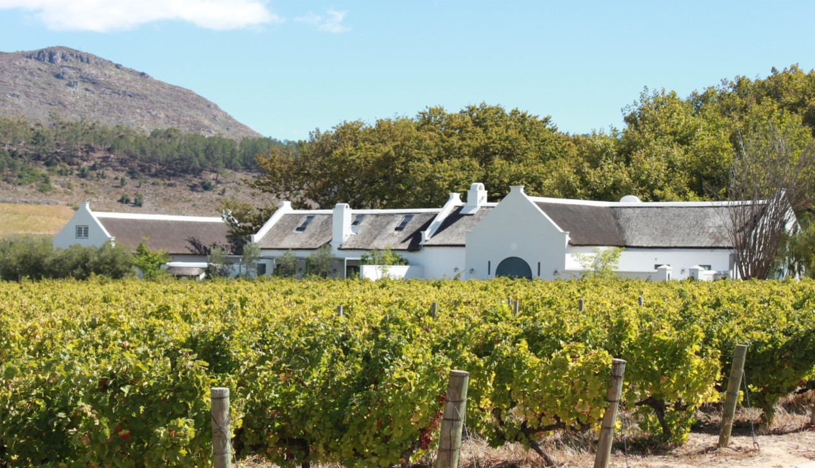

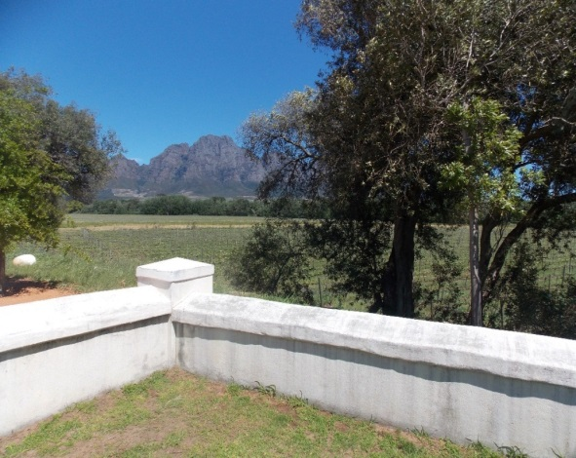
Fig. 1.1: Views of Solms Delta, Franschhoek wine farm October 2014
Photo: Corrie de Blocq

“dearest South Africa. see us. see us clear, see us proper --- just see us, how in this here corner we crouch beneath black flags and count our dead --- again. flags black, yes, the colour of smoke, of charred bodies, of mauled bodies, of dead bodies, bodies black, the colour of their killers, that right there—mother-God—it’s the heaviest, bottomless, saddest kind of tragedy it has no names, it deserves no name-- see us. see us, pressing palms to heaving chests so our hearts may quiet because we’ve been waking up to them roaring for days now and every sunrise is a new sad song. see us, teeth clenched so tight just so the rivers inside us don’t break and drown us, crouching and counting the dead coz we can’t ever raise them, see, they ain’t Jesus, ain’t nothing gonn’ bring them back – see us. see us, we do not sing funeral songs coz there ain’t no words for this, no sounds for this, coz we’re too ashamed coz how d’you even tell the murdered to rest in peace, how? see us, see us not know what to say. to the dead.”

NoViolet Bulawayo, Zimbabwean writer, mourning the deaths of foreign African nationals during an outbreak of xenophobic violence in South Africa, April 2015.

1.1 INTRODUCTION

A Cape wine is an oenological raconteur. It tells stories of South Africa’s viticultural geographies, replete with images of lovely rural estates. Here, white-washed farmyard walls embrace the undulating curves and hollows of their well-appointed gabled homesteads. The plump convexity of the grapes burgeoning in adjacent vineyards is an apparent fact no less than the rain and the rivers that feed them. Enfolded within fertile valleys, framed by rugged peaks and exuding vernacular charm, these photo-ready wine farms self-assertively belong where they are. Over the past 40 years each of these farms has been systematically mapped into defined wine-of-origin regions. Most maps of the winelands will verify and support the appearance of order and stability (Appendix A). What is left off the maps and out of the stories of origin however, is the fraught dialectic of violence that exists between the spatial expanses of the Cape winelands and their historical confinements. Pairing wine with violence disrupts popular contiguities and unsettles local geographies and histories but that is what this thesis sets out to do.

The metaphor of a locus amoenus is employed here because it evokes the specificities of farm space and simultaneously suggests an underlying violence. A locus amoenus is a classical setting for occurrences of a violent nature that draw attention to the genesis of the biophysical world as well as to the reification of particular qualities within a landscape and in the living bodies that inhabit it (McIntyre 2008:22). Locus amoenus means a ‘sweet place’ or ‘pleasance.’ However the disjunctions between the enticing environment and the acts of violence that occur there create tensions which in turn remove the ‘sweet place’ from the ambit of desirable human experience. The locus amoenus in this thesis is a wine farm. Set in the Franschhoek region of the Western Cape, the estate, currently known as Solms Delta, also referred to as Delta, carries all the comfortable, picturesque contiguities associated with the winelands. Using this single farm as the articulation of its interlocking concerns, this thesis examines both characteristically contradictory phenomena of a locus amoenus at once. On one level the thesis explores the beginnings of winemaking in South Africa and the subsequent expansions into the Franschhoek valley. On a different level, it develops an atypical way of looking at the violence that is fused with the histories and geographies of Cape viticulture.

From 1994 when a newly democratized South Africa re-entered the international wine markets, Cape wine routes became more accessible. An increasingly seamless stream of attractions is now offered to visitors. Yet this same ready accessibility and enticing seamlessness has contributed to an apparent ‘legibility’ of the scene, deflecting other characterizations. One of the reasons for which alternative characterizations are rarely recognizable is because they retain much the same framework as the locus amoenus. For many who have worked on these wine farms, a life of labour has been marked by powerlessness, deprivation and pain. However, these darker aspects are not visible because they are built into the very stuff of the places and spaces in which they have manifested. In this sense I have come to understand that a wine farm is not comprised only of its products, physical features and built constructs. Neither, as this thesis will show, does it solely involve the rights and powers conferred by law or local custom. Instead, a wine farm comprises a landed property with a set of shifting human relations all entangled with multiple modalities and categories of violence.

1.2 WHY WINE?

Wine is by far the biggest and most valuable agricultural export from the Western Cape and its production has been vital to the local economy and employment market from soon after its inception in 1659. A 2015 SAWIS-commissioned study found that the wine industry employs 300 000 people, including those in farm work, packaging, retail and tourism. Moreover, of the ZAR 36.1 billion grossed by the industry, about ZAR 19.3 billion stays in the Western Cape. Since democratization the wine industry has played effective catch-up in improved wine quality, technological developments, market share, industry regulation and tourism. However, such industry improvements still contribute to the processes that have obscured and naturalized a history of violence. What is also problematic is that existing research does not adequately reflect the ways in which this industry with its particular confluence of geographies, contains, within those very quantifiable dimensions mentioned above, far more radical seeds of transformation in terms of how wine is produced, sold and consumed. Speaking into both gaps this thesis asserts farm space as constituting and structuring relationships and situates its social life within a complex repertoire of violence.

The crises brought about by ongoing violence in the present era of liberatory democracy, coupled with struggles to resolve land and labour inequities, all brought to a bursting point in a fiery protest by wine farm workers in 2012/13, have made me ask questions about how violence is connected with Cape viticulture. In my attempts to make sense of the complexity and diversity of the connections, I have come to identify a spatialized source of tension - and potential source of transformation - where people and things can belong in the same space but belong there very differently. This tension has emerged as I have traced the stories of Solms Delta. The wine farm dates from 1690 and it still stands on the site of one of the first parcels of agricultural land claimed by Europeans in the Franschhoek valley. Unpacking its stories means asking questions about what has contributed to its becoming. Most importantly in this thesis, it means asking questions about violence in those spatial tensions of multiple existences within a given place. The net result is a targeted, but intricate exposure of viticultural space in South Africa that has not been made before. Although in no way inevitable, geographically definitive, nor the only way to access meaning, these means of examination combine to offer a view of some fissures and fault-lines through which violence has a propensity to re-emerge. I suggest this view is necessary and central because it is only through continuous vigilance in social relations and the ability to respond to changing materialities that wine producers succeed in keeping this space of tension from disintegration.

1.2.1 Disquieting wine

This section draws attention to the disquieting interplay of wine with property and violence. By merging insights from the recent sale of a wine farm with different ways that that property ownership is imagined, the potential for conflict and violence becomes more visible. My understanding that violence exists in the heart of property has been informed by authors such as Tilly (1990), Blomley (2000; 2003), Springer (2011; 2012) and Correia (2013) among others. Collectively these authors show that property is only quieted through acts of sustained violence. Similar concerns occupy those engaged in land reform and restitution in general and South Africa in particular. Entering into its third decade as a democracy, this country is a lively, shifting setting for this study, where particular material is drawn from the rich geographies of Cape viticulture with its long history of unquiet title. As a means of introducing the contingent and ever-present nature of violence in viticulture I do not begin with the start of winemaking in the Cape in the mid-17th century, but with a recent purchase of property - a wine farm in Franschhoek. What may have seemed at the time of acquisition to be a straightforward purchase of a Franschhoek farm also represents a flashpoint for the themes of my thesis. On 29th May 2014, South Africa’s Mail and Guardian newspaper published an open letter from the land commissar of the Economic Freedom Fighters (EFF). The EFF was formed in 2013 by Julius Malema after losing his leadership of ANCYL (the youth organization integrated into the African National Congress party) for fostering opposition to some of its leading political figures. The letter was directly addressed to Sir Richard Branson. As these extracts indicate, when talking about a wine farm as property in Franschhoek it is not a conversation about technical questions of land use in terms of winemaking. There are questions about social order and human subjectivities in which the potential for violence is embedded (Ryan 1984).

“Dear Mr. Branson,

My name is Andile Mngxitama and I am the Economic Freedom Fighters’ commissar for land and agrarian revolution. Our media reports that you have just bought yourself a 40 hectare wine farm in Franschhoek. Sir, you have just bought stolen property.

The consequence of your participation in this illegal transaction is that the EFF policy of land expropriation without compensation may in the near future affect your investment adversely….It behooves me to warn you that…. an act of evil doesn’t erode with the passing to time. So from our perspective, it doesn’t matter how many times the stolen land changes hands, it remains stolen property…… To make this settler idiom clearer, let me give you an analogy. Basically, it’s as though I came to your house with a marauding armed gang and forced you and your family out of your house into the coldness of the streets. Then, I wrote a piece of paper, called it a title deed and put my name on it; this paper I sent to the gang headquarters as evidence of my ownership of your house. The title deed you have is a piece of paper written by the original land thieves to give them illegal dominion over property that doesn’t belong to them. The title deed here, sir, is a pathetic attempt by the land usurper to legalize an act of illegality.

The land thieves undertook genocide against the legitimate landowners. This genocide has not been accounted for nor have reparations been paid…. As you can see, we are a nation with deep problems. The descendants of the original landowners have been reduced to slaves….farm workers who work those vineyards earn as little as R1 400 a month. This is a legislated form of slavery by our democratic government. The EFF has called for a R5 000 minimum wage for farm workers…. I believe I have brought the most important information to your attention. What you do with it is really between you and your God. Those buying land in our country can no longer plead ignorance…”

(From: The Mail and Guardian, May 29, 2014: 33).

In referencing this letter, I am not emphasizing another example of a not-yet-completed liberation from colonial status in Africa. I am interested only in the underlying tensions between violence and wine. What Mngxitama’s letter highlights is that the spatial production of this tension emanates not only from within a particular property, but occurs in a fraught context of land and labour reform amidst some intransigent contemporary political formations.

This thesis deliberately moves away from a linear postcolonial line of inquiry in an explicit effort to access “worlds and knowledges otherwise” (Karkov & Robbins 2014:3). Eschewing the limitations of any so-called ‘post’ moment on a given time scale, this thesis uses wine as an unsettling register of violence. As something more-than-postcolonial and also more-than-human, wine is used as the central modality of connections including those between human bodies, land and geo-political worlds. Deployed in this way, wine is a disturbing analytic, for while it is obviously a consumable commodity, the integrated and attendant violence is not easily confined within the individual bodies at which it is targeted. Looking at the same concept another way, the circulatory motion of wine as an object of inquiry is akin to the ‘dance of agency’ described by Pickering (2011). This motion is “a performative, transformative and productive back and forth between human and non-human agency” that evokes the notion of intertwined histories (Pickering 2011:3). Taking the idea of connected changing agency as a cue, I have organized the material in this thesis so as to enable a narrative mode which may contain the messy life of a farm and the ways in which it exists in a context of repercussive violence in South Africa. This particular mode of ordering facilitates movement through the complexities of heterogeneous action and also provides analytical insights into the tensions that play themselves out in the spaces of Delta. Thus the text is not aimed to simply illuminate the development of Cape wine-making. The thesis remains foremost an investigative, violence-centred geography of wine.

1.3 PROPERTIES OF VIOLENCE

As one outcome, this thesis is intended to create another space for dialogue around the spatiality of violence. Towards this end, essentializing typologies are avoided, as is any tendency to broadly assign violence to any group. However, to bring into focus the interactions that are explored, it is helpful to be aware of three types of violence that are identifiable as (1) embodied, (2) existing in particular structures and (3) in symbolic forms.

Embodied violence occurs when a direct act is committed by an identifiable actor. Most explanations of embodied violence attempt to count, or to account for, the occurrence of violent events that tend to take place in isolated or self-contained instances. In this form of violence, as Wilcox (2014) suggests, bodies both direct violent acts and are constituted by practices that manage violence. Being attentive to embodied violence helps to understand which bodies are more vulnerable or invulnerable in the workings of power in any given space. However, attention focused on embodied violence alone fails to capture a concept of the range of socially produced harms. Whereas in instances of embodied violence, consequences can be traced to particular sources or instances of direct harm, such tracing is not helpful in seeking structural violence. Instead, structural violence is found integrated into a social structure or built into an institution. Indeed, “societies are violent to the extent that these structures or institutionalizations impinge upon or reduce human potential” (Galtung 1969:170). It is arguable that while structural forms of violence may involve systems of rule, they can also pre-date and post-date these systems. Structural violence can be understood as unequal power ratios instituted in human relations that produce unequal life chances (Galtung 1969:170).

The third form, symbolic violence, lacks, as Morgan et al. (2006) put it, “the intentional and instrumental quality of brute violence” as well as not having the functional nature of structural violence. It is a more subdued but pernicious expression of violence that operates through everyday modes of power. Symbolic violence can be considered generative inasmuch as it procreates aspects of social life “in specific ways that depend on violent meanings, expression and action” (Colaguori 2010:392). An end result is that people become unable to visualize or mobilize themselves differently. My understanding of symbolic violence combines the insights of Bourdieu (1989) and Comaroff (1985) respectively, insofar as it comprehends the stultifying effect of an individual’s absorption of social norms while also remaining sensitive to the fact that socialization is not always unconsciously absorbed. There are, moreover, almost always moments of paradox or contradiction which humans can respond to or subvert. However, relative success in the outcomes of such moments is arguably more often a question of a macro-environment than it is of individual agency. Concerning Delta, I will suggest that even if choices are possible, as indeed they almost always are, the nature of the politics of the day can thwart attempts to secure change outside of mainstream discourse. In personal terms too, security and well-being also arguably depend less on establishing an ‘independent’ self-identity than upon a certain level of individual compliance with prevailing socio-political trends.

In sum, violence is understood as a multivalent phenomenon derived from wider geographical phenomena. This thesis seeks violence in its contingency – in the work of the land and climate, the plants and people and the spaces of their interactions. Direct embodied violence is largely recognized through intention. In identifying structural violence, attention is directed more towards consequentiality. Symbolic violence is made evident insofar as it helps to direct embodied violence and structural violence towards feeling right or legitimate in a society. It is discerned less as a physical or existential matter and more as a problem of meaning. Recognition of the properties of these linked forms of violence emphasizes that it is a relational assemblage and not limited to localized or individually embodied manifestations. Understanding violence as a multivalent phenomenon derived from wider geographies, I seek it in its contingency. Indeed if the contingent constitution of this wine farm is examined with the work of land and climate, plants and people and the spaces of their interactions, then apparently singular expressions of violence can be viewed as incorporated within broader socio-spatial patterns. In this way, the darker matter in the constitution of this locus amoenus becomes more visible. Simon Springer (2011:90) expresses the emancipatory nature of this line of thinking by saying that “what this re-theorization does is open up the supposed fixity, separation and immutability of place to instead recognize it as always co-constituted by, mediated through, and integrated within the wider experiences of space. Such a radical rethinking of place fundamentally transforms the way we understand violence.”

1.4 FRANSCHHOEK: AN AFRICAN LOCUS AMOENUS

The locus amoenus distills the central geographical paradox in this thesis: that a beautiful place, a safe refuge for many, has an exploitative, violent dimension and that a situation of violent exploitation has a locus amoenus. As an apt setting, Franschhoek is an apparently idyllic landscape. It comprises a village, a farmed valley and a ward in the South African wine-of-origin scheme. Here is a description of the valley by a 19th century English traveller Andrew Steedman (1835:2-3):
“The Franch Hoek Mountain bounded one end… and before us lay a delightful prospect of mountain hill and dale. On this hand … the lofty promontory of Table Mountain, that ancient landmark of ‘sea-tossed men’ and …. immediately below, the fertile valley and orange groves...with serpentine windings the Berg River. The eye roamed with delight over these varied beauties, which sweetly blended, each relieving the other in the landscape, produced a scene of deep and peculiar interest…”

Centuries later, the eye still ‘roams with delight’ over the Franschhoek wine farms lying in a loose string along the extended U-shaped floor of the Drakenstein valley. These farms take their entrances from a single rural road, once a dirt track where labouring oxen dragged heavy wagons over the Helshoogte - the heights of hell. Today, visitors descend swiftly into the valley motor vehicles and disgorge to partake in a vinous harvest. Guests typically follow oak avenues towards the well-appointed farm homesteads. These buildings of elegant Cape-Dutch architectural proportions still exert a most remarkable presence. For in a very particular kind of understanding, land as power and viticulture as order are yet projected throughout the valley (Walker 2007). Many farms and homes still bear unmistakably French names and even Franschhoek itself means ‘French Corner’ in Dutch. This name marks the original presence and lasting influence of the Huguenot refugees who entrenched wine farming in the valley from the late 17th century. Together with the mountainous natural surroundings and iconic built properties, it is a legacy that has come to be deeply expressive of the local viticultural heritage. Almost any current description renders Franschhoek wine farms readily identifiable by the vectored influences described here and in many ways it is unfeasible to argue otherwise.

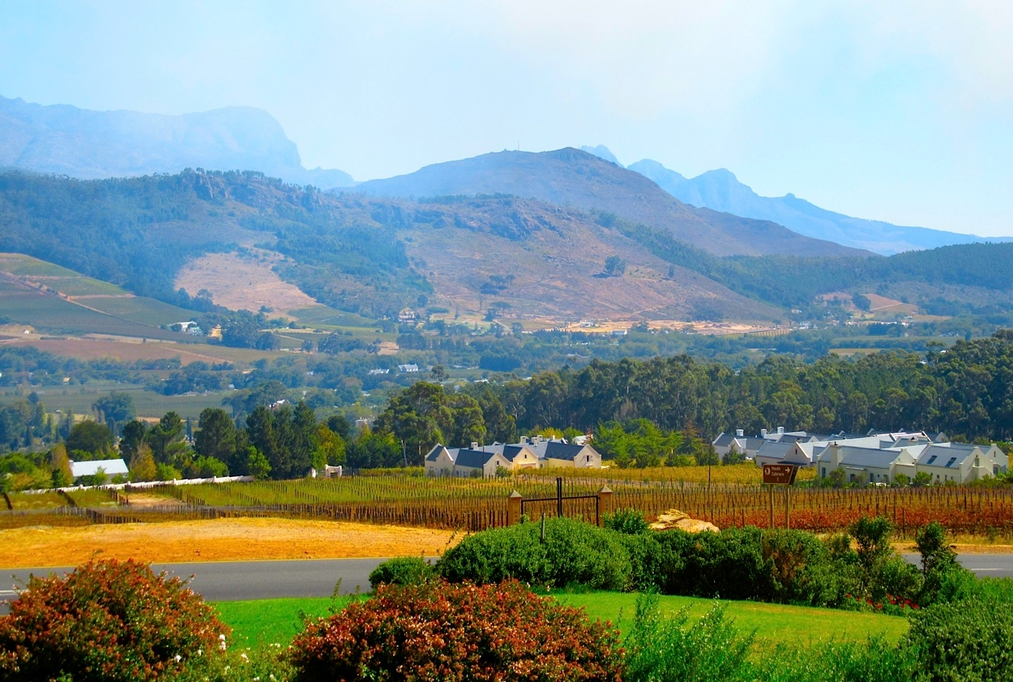
Fig. 1.2: Franschhoek valley April 2015
Photo: Corrie de Blocq

The red indicators on the illustrations in Fig. 1.3 locate Franschhoek and Solms Delta, respectively, situated inland from the Cape peninsula and set in the heart of a valley.

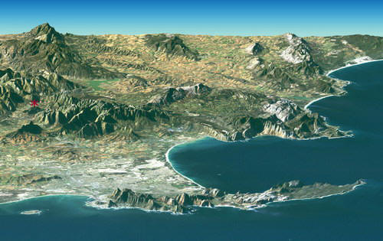

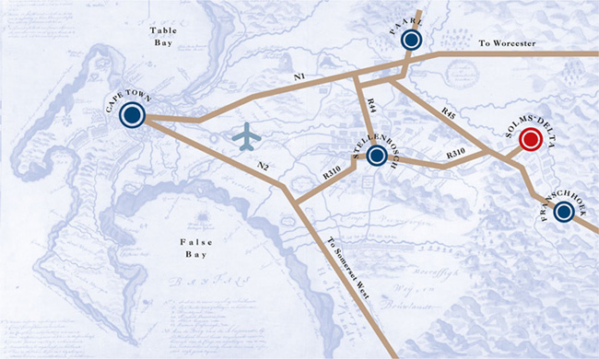
Fig. 1.3: Illustrated views of Franschhoek’s location
Source: (1) NASA and (2) Solms Delta

The markers of property dispensations enacted by Dutch and Huguenot settlers are hauntingly present in the valley, albeit now arranged as gracious estates and attractive vineyards. Similarly, in the streets of the village of Franschhoek, imprints of old hierarchies linger amongst the high-end boutiques and cutting-edge restaurants with chic French names and outrageous prices (Walker 2007). In Provence-meets-Africa, slave lodges are luxuriously reincarnated as up-market guesthouses and foodies, musos, sports enthusiasts and local literati rush to participate in events and festivals hosted in the valley. Today, comprising a lifestyle playground for wealthy international investors, the village and the surrounding farms are collectively reinvented as the French themed ‘Food and Wine Capital of the Cape.’ Indeed, as the following image in Fig. 1.4 shows, Franschhoek and the wine farms in the valley even celebrate Bastille Day with an annual festival celebrating wine and French culture.

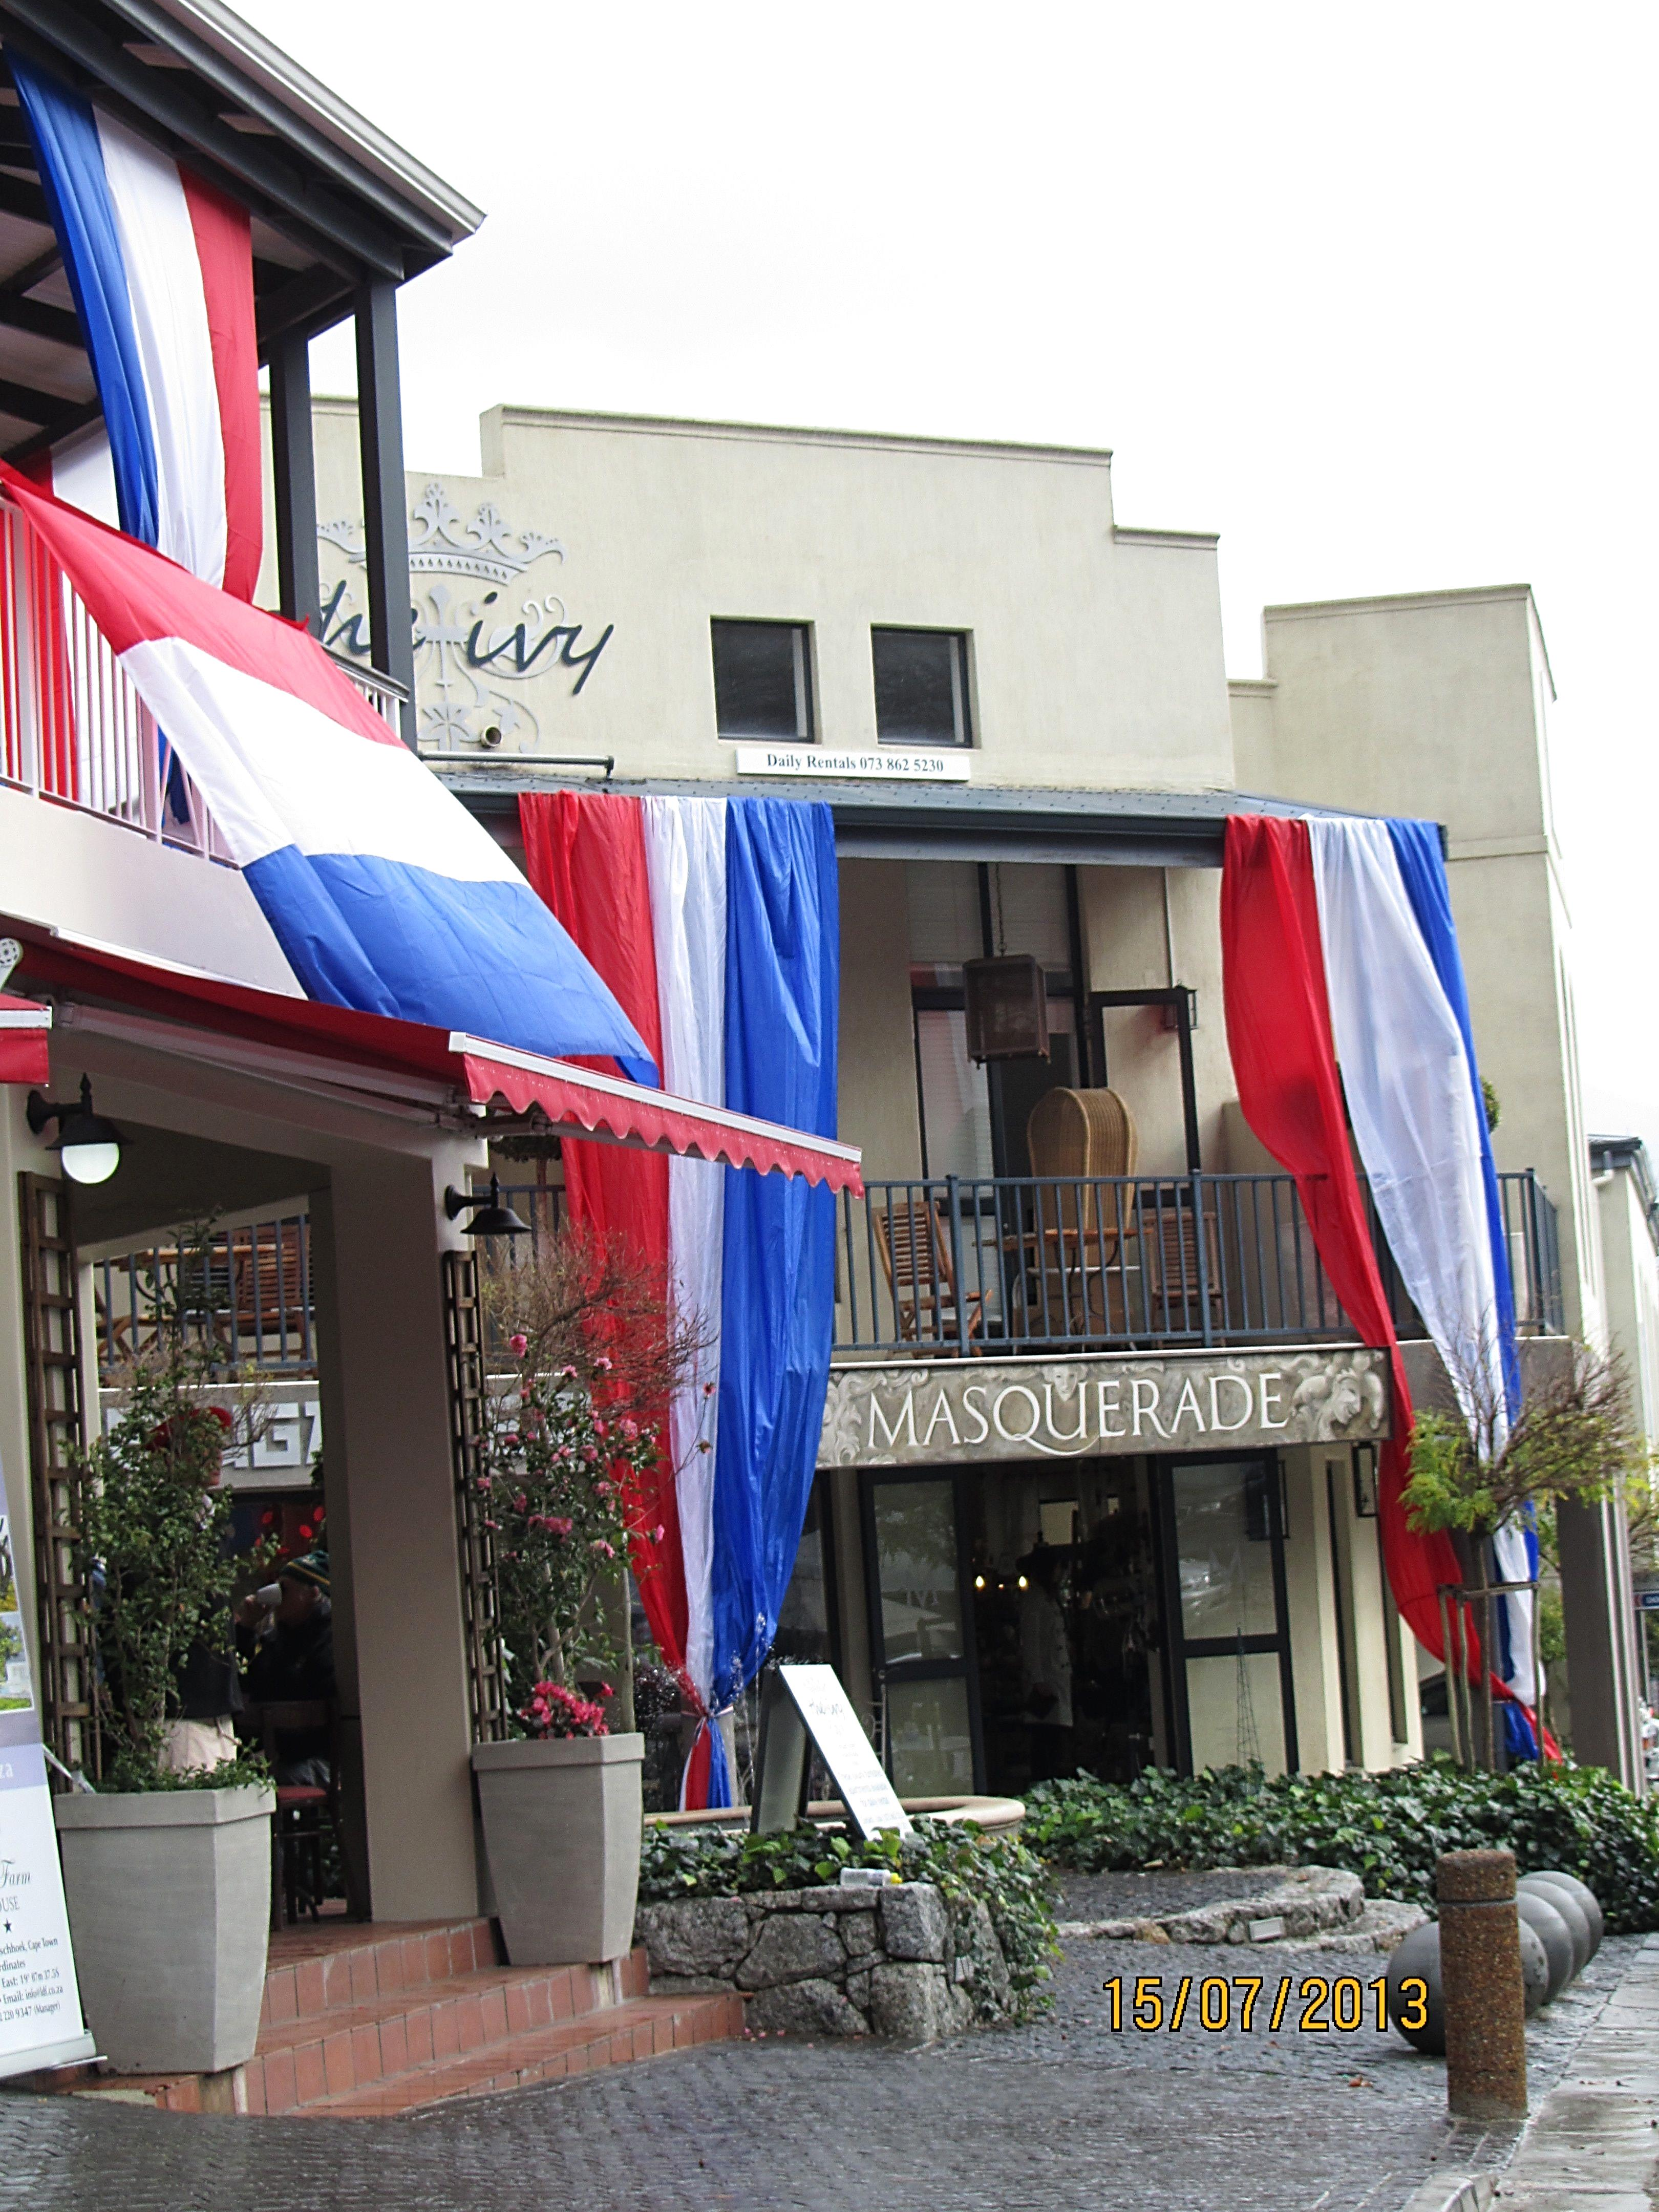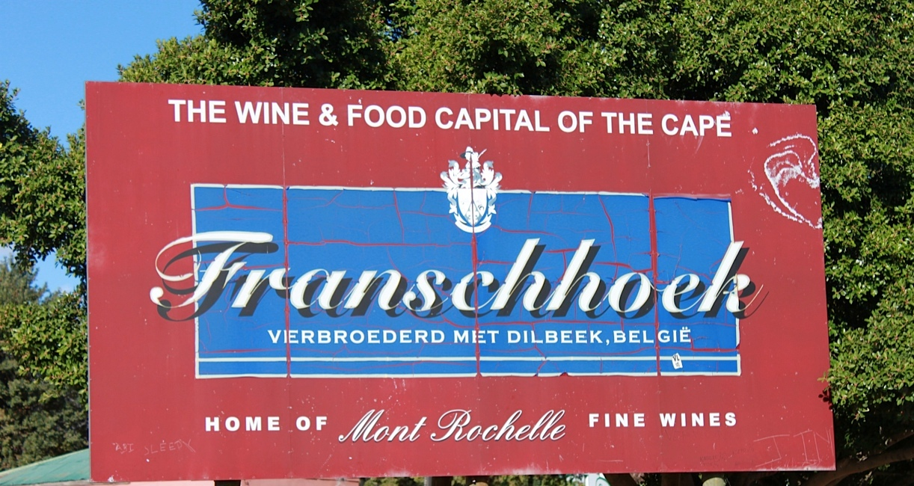
Fig. 1.4: Bastille Day Franschhoek village Fig. 1.5: Foodie Franschhoek
Photo: Corrie de Blocq Photo: Corrie de Blocq

Sheltered within the elbow of towering mountains, this village, once a tiny community without a name-tag, emerged from the constellation of original settler farms that date from 1658. For much of the 19th century, the little settlement existed as an isolated Afrikaans kerksdorp. By the early 20th century however, Franschhoek had been subsumed into the production pathways of a vast British agricultural empire. During the mid-1940s, it was reclaimed as a site of Afrikaner heritage. A strong Afrikaner cultural pride is still materially evidenced where the road into the village meanders to an end in a park. Here, an arresting monument crafted from nacreous marble stands solo. The central statue incorporates a stylized figure of a woman clutching a bible in her right hand and a broken chain in her left – she symbolizes the spirit of religious freedom. Seen in Fig. 1.6, she is in the process of throwing off an outer garment, the cloak of oppression.

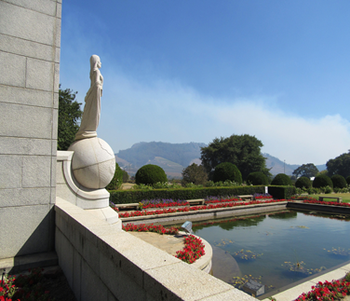
Fig. 1.6: The Huguenot monument
Photo: Corrie de Blocq

Haloing the three arches behind her, which implicate the Holy Trinity, is a symbolic sun of righteousness. In the background, a colonnade is constructed in a smooth semi-circle embodying the inscription: “Peace of mind, found after so many years of persecution and so long a struggle.” This local icon is known simply as ‘The Huguenot Monument.’ Ironically among the descendants of these refugees who sought in South Africa a freedom from their oppression in France was the first apartheid Prime Minister, Dr. DF Malan, as were many other National Party leaders. Dated April 17, 1948, the local ‘Lady Liberty’ was inaugurated just weeks before the National Party first swept to power ahead of forty tumultuous years in an apartheid system.

In numerous ways the seductive natural surroundings together with the advantageously appointed estates and sophisticated amenities continue to absorb and naturalize difficult heterogeneous relationalities. This unresolved heterogeneity is endogenous in the sense of crisis that attends the meaning of land in South Africa. From the past I need only mention Cecil John Rhodes the “incorrigible imperial dreamer” who gazed north from Table Mountain, desiring a railway line and a British Pax Africana from the Cape to Cairo (Twidle 2010:114). From a rich scholarship on the historically fierce and oppositional sense of land ownership held by the Afrikaners, ‘the white tribe of Africa’ Patterson (2013:177) puts it well: “To the Boers, the Old Testament was like a mirror of their own lives. In it, they found the deserts and the fountains, the droughts and the plagues, the captivity and the exodus…“

In this vision, the British administration stood symbolically in the shoes of Pharaoh and oppressed a people in their own land, thus justifying the search for, and the determined struggle to retain, a mythologized promised land for their nation. Similarly, George McCall Theal (1897:340) an English-speaking historiographer wrote:
“[t]he aged grazier of the interior understood the imagery of the Hebrew writers more perfectly than anyone in Europe…for it spoke to him of his daily life. He had heard the continuous roll of thunder which was the voice of the Lord upon many waters, and had seen the affrighted antelopes drop their young as they fled before the storm, when the great trees came down with a crash and lightning divided like flames of fire….”

Today this sort of imaging is contested as a naturalizing fragment of a “nationalist epic” (Twidle 2010:8). It is however, enough to show that the concept of landed property is slippery and recalcitrant (de Kock 2001). A contemporaneous form of naturalization involving a taken-for-granted view of a post-apartheid landscape may well have contributed to Branson’s purchase of property in Franschhoek, previously alluded to. On the other side of the debate, a post-liberation master narrative including new myths of origin and land symbolisms dominates in the EFF land commissar’s letter to Richard Branson. More deeply than this though, I suggest that this response to Branson’s purchase appropriates and naturalizes a right to the use of force. Phrases like “legitimate landowners” and “land thieves” imply a legitimization of future instances of violence towards obtaining or retaining landed property acquired in the past (Blomley 2003). Although framed here by a reference to a specific property, what is theoretically notable is the propensity for allowing for certain types of violence to be deemed rational while condemning others as irrational. These revolutionary - implying cyclical and not necessarily liberatory - propensities show up jointly as a primary instrument of power insofar as “perceived rationality becomes misconstrued with legitimacy” (Springer 2011:93).

In South Africa, innumerable acts throughout the colonial periods, during apartheid, in the current liberation regime and now, arguably, into a dawning counter-revolution, have reassigned notions of property and of belonging from one signifying system to another. In this history, various groups of people have been perceived as uninvited bodies, whose claims relating to property in the region/ colony/ union/ republic/democracy have been contested or denied (de Kock 2001). Drawing attention to the oppositional nationalistic identities and divergent ethnic affiliations that have fomented violence, Mngxitama’s missive acts as an introductory tool with which to dig into the significances of land in South Africa. In this regard, speaking as someone who is South African-born, my relations to this field of reference are not uncomplicated and I do not seek to describe the country, the region or even the Franschhoek area in a comprehensive sense. Instead, I hone in on this single wine farm which has exhibited its own particular floresence of violence and change. A focus on Delta offers latitude to creatively exploit the possibilities and tensions of scale-jumping where spatial claims and power established at one geographical scale of property are expanded to another. Appendix J provides maps to locate Delta in the south-western Cape and to identify it as an established farm.

I encountered with Delta with a colleague who was researching indigenous culinary vegetation, but I also recognized an intriguing contrast between Delta’s typical history and projects that counteract historical violences. Delta comprises an identifiable piece of land, a foundational example of settled viticulture and represents a pillar of the local economy. It reflects common difficulties affecting farm workers that extend from the establishment of viticulture through apartheid social engineering and into a politically-defined democracy that lacks the capacity to empower such communities. Indeed, the timeline attached as Appendix H traces how the property has changed hands and signals the continuity of structures of power beyond the era of colonial rule. Yet Delta is different in that it is owned in equal thirds between a scientist, a businessman and the workers as a group. This model rearranges the traditional hierarchies of power in wine farming. The owners also spearhead unprecedented socio-spatial transformations on this farm. Delta’s distinctive differences and its contemporary nature offer an exceptional opportunity to explore the trajectories and changing relationalities of violence with wine. Through an analysis of how “forms of violence co-exist, nurture and sustain each other” in this bounded context, the intransigence and perpetuation of violence in South Africa can be considered in a different way (Morgan & Bjorket 2006:450).

1.5 A THEORETICAL PERSPECTIVE

There are far-reaching implications in the properties of violence in a given space that are uncontainable within any given segment of time, but can be captured in moments (Mellino 2008). These moments, as Springer (2011) suggests, are temporal, memory-rich amalgamations where ideas and things coalesce through embodied experiences and physical environments and in turn also contour these experiences and environments. I propose that his inseparability of space and time can entail an imaginative recognition of Delta as a collection of moments. This proposal is based in two distinct but complementary theories that frame the thesis.

1.5.1 A simultaneity of stories-so-far

While the objective is to study a single farm, there is also a consciousness of how the (re)configurations, spaces and subjectivities of Delta are linked to a wider world. This awareness dovetails with Massey's (2005) account of place and space, where places manifest particular qualities which cannot be understood by considering a local context alone. Massey constitutes space as the sphere of the possibility of the existence of multiplicity in the sense of contemporaneous plurality. The theoretical crux is “the contemporaneous existence of a plurality of trajectories, a simultaneity of stories-so-far” (Massey 2005:12). My interpretation is that trajectories are made up of scalar and storied moments that link different events and movements by coalescing and colliding. In their intersection with various socio-political orders, trajectories give rise to historical connotations that serve to endow this farm with meaning and through which the inhabitants have developed various concepts of belonging. Taking Delta’s farm space as a kind of “spatially contingent relationship of belonging” enables an analytical view of how belonging differently comes to be a fundamental factor in the reappearances of forms of violence (Keenan 2014:6). The broad theoretical utility of the plural trajectory is that it enables a re-imagining of this single wine farm as an articulation of social production practices and bodily deployment (Low 2008; Springer 2011:93). There is also a methodological alignment, in that understanding space as ‘a simultaneity of stories-so-far’ is not to reduce space to narrative but instead “to capture… its vitality and its interconnectedness” Keenan (2014:6). The idea of ‘a simultaneity’ accepts the multiplicity of the trajectories that connect and cross in the spaces of this farm. In the ‘so-far ‘there is a sense of openness to change. Thus in representing Delta as ‘a simultaneity of stories-so-far’ its spaces can be thought of as “open, multiple and relational, unfinished and also becoming” (Massey 2005:59). Accordingly this thesis is not a historical trajectory in any progressive sense: rather it is a bundle of stories-so-far.

1.5.2 We were never decolonial

Massey’s concept of trajectories discursively opens up to other global-local influences and relations. Indeed, from a decolonial perspective Grosfoguel argues similarly that there are “neither autonomous logics nor a single logic, but multiple, heterogeneous, entangled, and complex processes within an historical trajectory” (2008:15). As I am resistant to referencing any specific political moment of decolonization processes or date-stamped form of emancipation from territorial occupation, the decolonial imagination allows for a deconstruction of reductive recognitions of violence that move beyond restrictive tendencies to dualisms like ‘pre’ and ‘post.’ In particular I draw on broad decolonial principles that for Maldonado-Torres (2008:7) involve:
“…making visible the invisible and as analyzing the mechanisms that produce such invisibility or distorted visibility, in light of a large stock of ideas that must necessarily include the critical reflections of the invisible….” [This turn] “…seeks to open up the sources for thinking and to break up the apartheid of theoretical domains through renewed forms of….epistemic creolization.”

In terms of espousing decolonial concepts in research in South Africa, my approach stands upon Achille Mbembe’s (2001) critique of the postcolony where he does not reject the history of a colonial past. He simply refuses to integrate it linearly to the present. In this way Mbembe (2001) calls for liberation from the past without erasing it. The theory of decoloniality provides a cogent way of thinking through the conditions pertaining to changes on Delta. Resonating with Massey’s (2005) spatialized concept of simultaneity, Mbembe’s postcolony is an entanglement of temporalities. It is a particular movement that brings both the ‘being formed’ and the ‘being dissolved’ into collision (Mbembe in Holler 2011). By using this theory to trouble anew the dimensions of a surface and what lies beneath it, this thesis also usefully invigorates the tradition of South African historical geography. It does so by engaging with ideas of decoloniality to illuminate the specificity of place through the bundle of its constitutive connections to violence. More acutely it is in the spaces of a single Cape farm, as I will show, that such complexities of the decolonial take particular shape.

David Attwell (2005) also rejects conventional postcolonial theory as a foreign and homogenizing importation and proposes that South African scholars need to reinvent it on their own chosen terms. Attwell argues for a form of local exceptionalism, pointing to the textured histories of settler-colonial and migrant communities interwoven with indigenous societies. Implicit here is the suggestion that South Africa has never been decolonialized in any conventional sense. For Attwell there is no sense of a new unity. Indeed, as a country with 11 national languages and even more ethnic groupings, South Africa has a population composed almost entirely of what Neocosmos (2010) terms ‘native foreigners’ and ‘foreign natives.’ Scattered across the land in a population of more than 51 million, is a group of 4.5 million white South Africans most of whom, who although divided along lines of language and heritage, are African-born. Many understand their family lines to have been native of South Africa for centuries. As mentioned earlier, numerous white South African farmers in this group have deep, mythologized attachments to the earth beneath their feet (Foster 2008; Beningfield 2007; Giliomee 2003).

In this historic demographic gaskommeling the Western Cape is a special case in showing the impossibility of ever negating a colonial influence and simultaneously asserting the importance of confronting what exists in the present. The Cape differs in multiple ways from the other eight provinces and not least in its demographic make-up. The vast majority in every other province in the country is comprised of black South Africans of varying ethnic origins. By contrast, although coloured communities have the same percentage of the national population as whites, at approximately 8.9%, they constitute 53% of the inhabitants in the Cape. With forebears in the Khoikhoi and the San, the only indigenous peoples of South Africa and with familial connections to almost every other South African ethnic group and colonizer nation, coloured communities are both undeniably of Africa and uniquely of South Africa. The socio-political situation of coloured communities is extremely complicated in that successive nationalistic, race-oriented elites - both Afrikaner and now arguably Africanist - have re-entrenched and preserved privilege at the moment of their independence from a prior regime. There is in other words, a substantiated belief that coloured South Africans have been repeatedly caught in awkward social and racial interstices (Horner & Wilson 2008; Adhikari 2005, 2009). Thus the Cape, I suggest, represents the idea of decolonial in a very specific sense that is more so than any other region of South Africa.

1.6 THESIS STRUCTURE

I have incorporated stories from Delta’s past and present by using a range of sources, with participant observation, semi-structured interviews, documentary and archival searches utilized as main research modalities. Yet as Hammersley & Atkinson (1983) point out, a mere aggregation of data does not unproblematically add up to a ‘truth’ and similarly the process has been one of collection, coalescence and curation - mining resource fields for material of a minute and partial nature. This thesis facilitates attention to the spatial and historical constitution of Delta and to the context of violence and change. The ways in which people engage in Delta’s specific spaces, together with the outcomes that such relations produce, is a contingent matter, so analysis has been inductive and constant-comparative (Yin 2003). However, my structuring of this thesis only makes links that relate to this farm. For in the light and limits of its aims, this thesis does not extend to a chronology or inclusive account of South Africa’s wine history, nor are specific claims made for any added explanatory power to be gained in any other analysis through the adoption of methods used here. That would necessarily assume frameworks, or variables, have constant and additive effects identifiable regardless of particular context, which would need a generalizable account that lies outside my objectives.

1.6.1 Modes of ordering

Proceeding through distinct, thematically linked chapters, this thesis examines the connections between violence and viticulture in the Cape. It explores various materializations, administrations and images of wine as it merges, and also emerges from, these connections. The structure is, as Mbembe (2001:16) writes in his Notes Provisoires on the postcolony, not a simple sequence “…in which each moment effaces, annuls, and replaces those that preceded it.‟ Instead it is “an interlocking of presents, pasts, and futures that retain their depths of other presents, pasts, and futures, each age bearing, altering, and maintaining the previous ones.‟ Chapters 4 to 7 each take a different aspect of viticulture as a primary interest, building a narrative record of wine as one steeped in chronic violence. These storied chapters demonstrate what a narrative approach can tell us about violence as embodied and structural as well as violence in its symbolic forms. I will return to these in more detail in Chapter 2, but for now the emphasis is that the storied nature of this thesis develops a nuanced understanding of contingency and recurrences.

This first chapter has offered an overview of the contexts of the study. The metaphor of a locus amoenus used here is not an illustration without materiality. For in the classical way, a topography of imagination is mapped on to the ‘real’ landscape of a given site, thereby evoking the specificities of place and yet re-thinking space. Chapter 1 has given an orientation to Franschhoek and an introduction to Solms Delta as the study subject as well as explanations of the relevance of a focus on violence in relation to viticulture. The theories that ground the study, as well as its aims, method and rationale are all found here. A storied and heterarchical approach is proposed as a means to capture something of the relational and consequential nature of violence.

Chapter 2 sets out a theoretical context. I describe the influence of authors whose works have helped me to consider, combine and construct the material that makes up this thesis. The relevant topics addressed include violence, property, power and empowerment, as considered in relation to South African wine farming and to Delta in particular. Highlighting the tensions under examination, relevant research concerning wine and violence respectively is foregrounded. Then historiographic reconnections are made with a pivotal period of political dissent in South Africa. Following this, the co-constituents of property and power are re-imagined in relation to the legalities and spaces of wine farming respectively. A motivation for the narrative structure is included in this chapter, as well as an exploration of the haunting properties that provoke reappearances of violence in the wine industry.

Methodological considerations are discussed in Chapter 3. In this chapter I explain why particular qualitative approaches and methods were chosen for the study. Descriptions are given of all aspects of the research from its planning, design, ethical considerations and information collection, to the analytic process and the structure of the thesis. This is a reflexive chapter that draws upon the numerous associated memos, records and field notes from extended visits, meetings, events, interviews, walks and talks. These were undertaken and written in a planned series during an intensive year of fieldwork as well as intermittently over a period of almost four years while I was immersed in the farm life and happenings related to Delta.

Chapter 4 engages with the viticulture-based practices that bring humans into relationships with the land and with each other. Delta is embedded within a material and conglomerate mix of geomorphologic and climactic properties. In the first part of this chapter the land takes centre stage, but living there are human beings in their corporeality and sensuousness, their limitations and imaginations, their thoughts and ideologies. So Delta’s land is also viewed as a contingent space in an emerging frontier where the combination of some people and certain resources increasingly separates them from others. The creation of Delta as legalized severable property gives substance to notions of ownership and bears witness to the perverse intimacies that were shaped in the Cape by the social positionings and spatial expressions of farmer-slave relationships. Overall, Chapter 4 moves the emphasis away from “the propertied subject and his/her right to exclude” to situate Delta in more spatial and inter-relational concepts of power and property (Keenan 2010:243). This arrangement claims a place for considerations of spatiality in an analysis of uneven inclusion with repercussive violence.

Chapter 5 threads together the stories of some of the people who have owned and/or worked on Delta. Specifically, it interweaves the stories of two families who owned Delta together with the changing conditions of farm workers in the valley. The families each exhibited a dominant presence in the valley, acquiring land as well as exerting extensive influence in the lives of their workers. Although the owners included here are only a handful of those who have used this land over time, I approach their stories and the situations of the workers as a means of offering insights into how property ownership and allied imaginaries are generative of social and spatial meanings. The exchange and use of landed property is central in the first part of the chapter. However a discussion of what I refer to as ‘moral communities’ in the second part, counters a tendency to regard property merely as that over which ownership is claimed. In this sense, it supports the argument that “property is what we have in things, not the things that we think we have.” 'Property' in this sense is more an identifying word applied to a legal, because socially-endorsed, coalescence of power in relation to resources, things and attributions. Chapter 5, in sum, demonstrates shifting power-property relationships in respect of assets and attributions that have social value as well as value in land.

Chapter 6 contends that wine - in its biochemical nature simply a consumable alcoholic product - comprises a complex and violence-ridden set of relations in South Africa. In this chapter, wine as the central thematic thread becomes evident also as a circulatory object that itself mediates the content of other chapters. In Chapter 6, wine is treated as a condensed space-time and analyzed as such to render a fuller account of spaces and times in which it is an element (Munn 1986:10). This chapter suggests that to experience wine is to experience the presence of what and who is not physically there - the power of ghosts (Stiles et al. 2011). Ghosts are not devoid of power relations by virtue of their ghostliness. Quite the reverse - it is the unseen quality of power that distinguishes it from mere force in perpetuating violence. Particularly for the coloured communities who provide the majority of labour for Cape farms, wine is historically and repeatedly beset by recurrent embodied health crises and social distress. Labyrinthine hierarchies of alcohol consumption in South Africa are exposed in this chapter, while interjecting the fraught nature and particular repercussive violences of wine production.

Chapter 7 demonstrates overlaps between some of the difficult politics-in-motion observed in Chapter 6 with wine production and developments on this particular farm today. The chapter title is ‘Hiervandaan’ meaning ‘of this place’ and whilst the word possesses innately historical nuances of attachment, the narrative engages with recent changes effected on Delta’s land, its spaces and in and through its people. In doing so, this chapter explores aspects of property and belonging not in the past but in the lively, sensorial present. Composed with material from fieldwork and incorporating perspectives from the people who live and work there, this chapter illuminates what it means to be of this place now. There is a wider speculation upon an increasing divide between wine farm workers who live within a net of farmer-generated benefits and those who are externalized. This chapter addresses changes in land ownership and land uses and enters into the rapidly changing spaces on the farm, their repurposed uses and different meanings.

Chapter 8 offers a reflection on the thesis in a palimpsestuous reading. The central concerns are with interpreting space as “a simultaneity of stories-so-far” via a critical decolonial geography of property and power interactions (Massey 2005). Such a necessarily geographical approach has given rise to a discussion including a hypothesis that being in the same space but differently, comprises a strong part of the continuance of South Africa’s violent geographies. In accounting for the strength of this thematic thread, I consider that in the transfer of landed property there exist apparitions that comprise “juridical and psychological phenomena wherein the law of things remains bound up with the law of persons" (Mauss 1988:2). Through these same avenues though, I consider that there also exist opportunities for social reinvestment. I suggest that in the case of Delta these opportunities comprise a repurposing of a particular past, into newer and still-opening spaces. Throughout this rerouted geographic vision, this thesis examines a working farm and Cape viticulture in ways not primarily attendant upon a particular worldview or a cluster of diachronic histories. Instead, a consciousness of disjuncture, synchronicity and transformation is facilitated where aspects of violence remain hauntingly present in relation to property and related power. The thesis pivots here, querying whether an ethical decolonial project can somehow be sustained whilst asking where the opposing or supportive powers might lie. There are no absolute conclusions delineated in Chapter 8 - to do so would deny the existence of too many loose ends and ghosts and possibilities.

CHAPTER TWO

NGESIKHATHI S’UDLAME – THEORIZING IN A TIME OF VIOLENCE

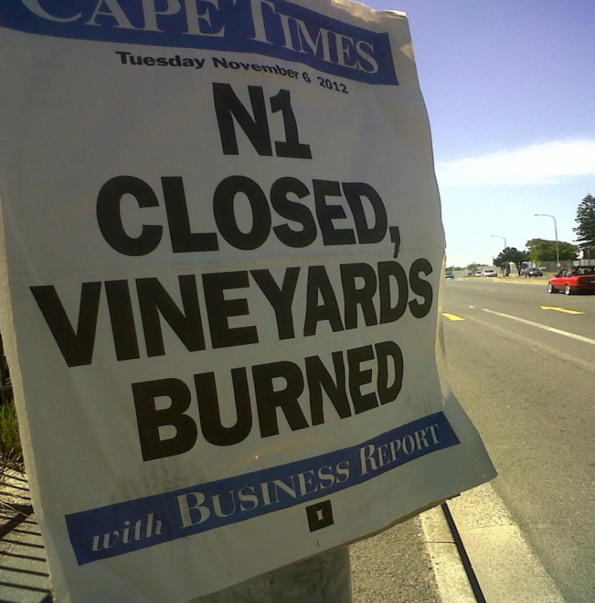

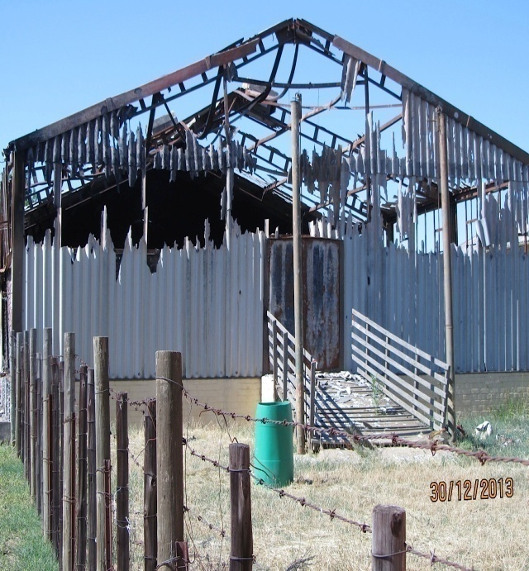
Fig. 2.1: Farm worker protests 2012/13
Photos: Corrie de Blocq

2.1 INTRODUCTION

Ngesikhathi S’Udlame means “in a time of violence” in isiZulu. This unmoored phrase points to the fluidity of violence and is used here to suggest that at no time has wine making in the Cape not been underlain by flows of violence. This suggestion contrasts with commonly existing approaches to violence in South African literature that are restrained by rigid concepts of a repressive state and extreme forms of political terror. As a result, the potential for recognizing violence elsewhere has been limited - not least in the apparently innocent and peaceful pursuit of making wine where the relationships with violence remain largely unexplored. This is a gap that this thesis seeks to address by focusing on and exploring violence as an active ongoing presence in the production, practices and spatial discourses of viticulture and winemaking.

Chapter 2 situates this thesis within a diverse and growing body of work in relation to wine production as well as in the creation of new spaces for understanding violence. First there is brief review of wine research and then an engagement with literature on violence. This is followed by acknowledgments of an older revisionist South African historiography that examined similar socio-spatial inequities in the 1970s and 80s. The theme of property, especially landed property, is strongly relevant together with its underlying properties of power. Circulations of such power are identified here in three ways: through property law, in the relations that occur in farm space, and in projects of empowerment. The latter acknowledges that “power is not necessarily repressive, prohibitive, negative or exclusionary (although it can be all of these things). It is also positive” (Gaventa 2003:2a). This allows me to direct attention away from the propertied subject with rights to exclude, towards a relational notion of property as space where belonging is perceived and experienced differently and by different subjectivities. In considering what it is to belong differently in a context of Cape viticulture, the twinned concepts of haunting and reinvesting are explained. Haunting implies spectral repetitions in which a form of violence or inequity that is seemingly not there becomes apparent. Reinvestment, material as much as metaphoric, is addressed here as a creative response to such spectral reminders. Ideas borrowed from trauma theory indicate that it is possible to acknowledge the ghosts of violence so as to encourage reinvestment in a given situation of loss. By such means, particular apparitions might be redirected in the present or prevented from resurfacing to haunt the wine industry in the future.

2.2 “WINE IS NOT A POTATO”

Described as “liquid geography” in de Blij’s Wine: An Appreciation (1983), wine is an ideal subject for geographic inquiry. De Blij’s comprehensive work ranges through an historical geography to discuss wine’s economics and politics and explore the landscapes and physical geographies of wine. De Blij maintains that viticulture and viniculture can be examined from numerous viewpoints “but none provides the particular spatial perspective, so essential to both endeavours, as effectively as does geography” (de Blij 1983:1). This thesis integrates the essential importance of spatiality by taking the spatial nature of emerging and mutating violence in sensitive encounters with viticulture as its concern. So in a small way it reconfigures de Blij’s (1983) spatial perspective of viticulture by including the phenomenon of violence together with elements of its relational nature. First published in 1991, Tim Unwin’s Wine and the Vine is a foundational resource for situating wine geographies. Both renowned scholars make the point that linkages between fields such as geopolitics, agriculture, and economics are not discrete. To my knowledge, no works in the fields and linkages so definitively advanced by de Blij and Unwin, have yet explored viticulture in direct relation to the phenomenon of violence.

In 1982, immediately prior to de Blij’s ground-breaking work, Dickenson & Salt produced a review enumerating then-current approaches and applied research in the geographical study of wine. Studies of the bio-physical environment of winegrowing were cited, as were explorations of the historical diffusion of viniculture and viticulture, various economic geographies of wine and marketing, considerations of political influences on wine trade and production, and studies of cultural landscapes, traditional products and popular customs. These works are based in identifiable ‘plants or people’ categories and much subsequent work followed this binary path. Although wine is extensively researched in South Africa, the trends here also continue to be roughly divided between topics that fall either into the natural sciences or social sciences.

In the natural sciences category there is a world-leading body of research in oenology as well as institutes dedicated to improving the physical and chemical processes involved in wine making. The Wine Industry Network for Expertise and Technology (Winetech) combines public and private stakeholders towards co-ordinating research and practical extension work with wine farmers. There is a Stellenbosch-based research facility ARC Infruitec-Nietvoorbij dedicated to advancing knowledge in all aspects of the physical environment of wine production, from soil composition through vine physiology and health, to weather and climate patterns. This thesis has benefitted from aspects of such oenological research within which the contributions of Victoria Carey (2005; 2008; 2009; 2011) whose iterations between quantitative metrics and the more polyglot concepts of terroir have been helpful. The importance to viticulture of localized climates and geomorphologies was gleaned from Vink, Deloire, Bonnardot and Ewert (2012). Particular knowledge of the underlying soil structure owes partly to work by Bargmann (2003). Problems and co-operations between the Cape’s fragile biodiversity and the practices of viticulture are intensively researched and Cowling’s body of work on viticulture within the Cape’s Fynbos ecoregion is gratefully cited.

The fields of viticulture and oenology cover a range of wine production and related biological sciences, including practical research in support of adaptations that support vine-growing and winemaking. There is a tendency in these sciences to regard vines only as objects without agency existing within efficient authorized practices (Brice 2014). A way of registering where this thesis might contribute to purely empirical work can be found in Ingold's (2000: 415) argument that accomplished action needs the ability of “[t]he skilled practitioner” in such a way as to “… continually to attune his movements to perturbations in the perceived environment.” In this reading, Ingold is describing a synchronous dexterity between research and practice that is generative of agency. In attuning perceptions to the environment, considerations of social fractures might be fruitfully included into ways and means of adapting to the “perturbations” of soil and water and atmospheric changes. In this way possibilities might open for an alternative politics of the crop vines that are produced by the cutting-edge research in viticultural and oenological sciences in South Africa, which is grounded in a less aestheticized, more decolonialized system.

Existing applied social research on wine reflects South Africa’s unstable positioning between ‘the West’ and ‘the global South.’ Research is directed respectively towards amelioration of social disruption, statistics of economic inequities, physical manifestations of alcohol abuses, or sophisticated consumer studies. Introducing an understanding of the nature and extent of the embodied violence of wine, London’s (1999; 2000) foundational work on Foetal Alcohol Spectrum Disorder (FASD) as well as later medical studies such as those by May et al. (2007) have been vital. For specific on-farm conditions for coloured wine farm labourers, I am indebted to social work studies on capacity building and farm worker dependency on Delta as undertaken by Ruddock (2012) and Falletisch (2008) respectively. This thesis contributes to this urgently-needed body of research by sign-posting new spaces within mainstream viticultural enterprise that correlate with aspects of socio-economic participation as well as informing work on conditions of empowerment in small rural communities. New forms of constructive discussion and partnership might also be opened.

In the related fields of global fair trade and ethical consumerism, the South African wine industry has received limited recognition in studies where the material cultures of other commodities, like chocolate, tea, coffee palm-oil bananas have attracted attention (Renard 1999; Barratt-Brown 2000; Jaffee et al. 2004; Bek et al. 2007; Richardson 2015). In this regard, information about commodities has arguably not been globalized at the same rate as the commodities themselves. In terms of wine, a variety of factors like personal taste, preferred varieties, price point and marketing strategy contribute to the continuing opacity of information about production conditions. This thesis contributes towards reducing this blind-spot insofar as it considers both the representational and material influence of wine when “bodies meet” in a given space (Greenhough & Roe 2010:44). In the given spaces of Delta, material, human and more-than-human natures are linked up in perpetuating violence but importantly also in fostering transformation. South African wine is thus tangentially situated in critical webs of ethical meaning through the current innovative means of production and consumption on Delta.

Finally, a more expansive body of wine-related research might benefit from a serious discursive engagement between the material resources and socio-spatial interactions of wine production and its peculiarly haunting properties of violence. Indeed, the co-existing and co-constituting spheres of wine and violence have largely been conceived of as worlds apart, in spite of the centrality of the troubled socio-political history in the development trajectories of the Cape wine industry. Critical insights into the effectivity of legislative and institutional changes are provided by Ponte, Roberts & van Sittert (2007), Mbeki (2009) and Nattrass (2014) among others. There may be space to contribute to this body of research informing official legislations and initiatives in the sphere of viticulture. When it comes to converging wine and viticultural research into central policy, du Toit (2009:6) has flagged the ongoing problem clearly by saying that “no coherent and organized social group exists that can convincingly challenge or restructure the nature of productive relations on the post‐apartheid countryside. The scope for change is constrained and land reform policy… can only have limited impact.” This thesis responds to the needs described, by seeking to provide a means of adding to current understandings of the tensions that haunt ‘official’ renderings of viticultural developments. It makes no claim to be the only study to straddle discrete areas of research and interest, yet no work in the field of viticulture similarly blends with a critical consideration of violence. Thus it offers an injection of some heterogeneity into the wider body of wine research.

This short review touches on only some resources in the rich body of relevant literature. It has however been enough to conclude that there is an underlying ontological position that still separates the natural from the cultural as if these were discrete domains. It indicates that at least some of the barriers to understanding the contingent nature of violence might exist in stringent vocabularies and disciplinary boundaries. It also shows up a perceptible need for a study such as this - one that offers the utility of a heterogeneous methodological approach and a discursive-analytical perspective on the links between violence and viticulture. In particular this thesis might contribute to the prospects for change in a farmed landscape still profoundly and disquietingly marked by its own underlying violences. It concerns itself both with the apparently limitless nature of recurring violence and also with the constituents of small transformations that might, somewhat audaciously, slip past the apparent limits to change.

2.3 DELTA: a different door

This thesis takes a position that unbundling violence from the stasis of national and nationalistic paradigms makes innovative conceptual spaces possible. It is a critical step in developing an argument for viticulture as an unusual analytic approach to the question of why violence emerges and re-merges. This position echoes what Walter Benjamin (1940) terms blasting out of the continuum of history. Gordon (1997:66) elaborates insofar as “blasting might be conceived as entering through a different door….through this door a certain kind of search is established, one that often leads along an associative path of correspondences.”

The use of Delta as such a different door extends into a spatial and narrative engagement with violence. The path of correspondences draws analytic attention simultaneously and heterogeneously to the spaces of the farm and to those of the people who have lived there. It is people who facilitate and (re) produce the shifts in meaning and in reformulated geographical imaginings. The lived experience, threat, or fear of violence is inﬂuential in bringing emotional charges to interpretations of a place (Corsin-Jiménez 2003; Pain 2009; Springer 2011). Whether Delta is recognized as farm, home, or prison, or if the land is comprehended as working vineyard, rural idyll, or killing field, is dependent upon the stories that fill those spaces (Massey 2005). To this degree, any imagination of what is safe, or innocuous, or bristling with violence, also folds back recursively on to the humans who have inhabited this farm.

2.3.1 Open to worlds of violence

Violence is a concept blurred by its own dramatic optics and overburdened by theoretical non-specificity. Nevertheless, as Tyner & Inwood (2014) contend, once violence is recognized, people usually do move to respond. However as responses commonly focus on legal recriminations, criminalization or memorialization, a pre-given reality is already assumed –namely that violence simply exists. In the absence of critical evaluations of specific links between the generative processes of violence and their spaces, this lacuna of understanding repeatedly appears where manifestations of violence seem to be natural and aspatial. This thesis works towards filling something of this gap in a productive disaggregation of violence.

Insofar as being naturalized, violence is so well-grafted into a locus amoenus, as to be all but hidden. Here is part of Barrow’s (1806:16-17) description of Franschhoek:
“The mountains are eminently grand….part of a great chain ‘The Backbone of the Earth ‘… nothing could be more beautiful, rich and clothed with vegetation than the vale they enclose, which is well watered by the Berg river…. the principal produce is wine.”

By contrast, unseen and even meaningless until other dimensions are made visible, the sticky bonds of violence that still encompass such beauty in Franschhoek are obscured. In exposing these bonds, I am primarily interested in discerning the presence of the permeable trifecta of embodied, structural and symbolic violence in the minutiae of a single farm. It is however unavoidable that through the ‘everydayness’ of Delta’s farm existence, something of South Africa itself is also glimpsed - a vast complex of stories-so-far of oppression and struggle, hope and disappointment and beguiling beauty twisted by recurring violence (Barolsky 2005; Seekings & Nattrass 2006; Altbeker 2007; Falletisch 2008; Kaufman 2012; Hook 2013). Nancy Scheper-Hughes, an ethnographer who has worked on violence in South Africa, and coauthor Philippe Bourgois catch something of this complexity in their suggestion that:
“Violence… can be everything and nothing: legitimate or illegitimate; visible or invisible; necessary or useless; senseless and gratuitous or utterly rational and strategic. Revolutionary violence, community-based massacres, xenophobic attacks and instances of state repression are often painfully graphic and transparent. The everyday violence of infant mortality, slow starvation, disease, despair, and humiliation, that destroys socially marginalized humans with even greater frequency, is usually invisible or misrecognized” (Scheper-Hughes & Bourgois 2004:2).

These authors highlight a lethal reciprocity of reinforcement that is similarly noted by Iadicola & Shupe (2003) who contend that not only does inequality cause violence but that violence also causes inequality. Another confounding effect of violence as illuminated here, is that it frequently comprises a miserable canon of normative phenomena shot through with perceptual blindness. In other words, because of this opacity it is difficult to recognize violence in the everyday, except when expressed spectacularly. These authors echo Walter Benjamin’s argument in his monumental Critique of Violence (1986) that exposes the unremitting human tendency to blur violence by virtue of its aestheticized institutionalized forms. I clarify this as an inability to rethink violence critically (Keane [1996] in Blomley 2003:121). In this light, it is arguable that throughout all the politics of imperialism, racial difference, nationalism and economic maximization, what South African histories and geographies reveal is a frozen political imagination towards violence. The direct implication is that violence inevitably re-occurs where there is an inability to open freedom onto the uncharted territories of the future. Violence, if always institutionalized, cannot be looked at anew.

To this body of research, this thesis can offer a yet-unexplored way of investigating the existence of violence. However, amongst the difficulties in formulating responses to the violence, are two particular challenges. First, much of the literature assumes violence to be anomalous, that it stands apart from the supposedly ‘co-operative’ everyday. The second is that violence tends to be largely researched in its most immediate and often most attention-grabbing form. Complicating the first challenge is that violence in its conventional sense belonged to apartheid, but violence in the now is described in terms that are anything but structural. Unexpected eruptions of violence do not sit well with the development logic of national becoming. Inversely, when present violence is described in the South African context, it is frequently relegated to the status of anachronous symptom (Hook 2013). As Hook suggests, brutal actions are frequently seen as the inability to shake off specific histories or, even more disturbingly, along anticipatory lines of future inevitability (Hook 2013). However, in distinction to violence as merely past, or to violence as future unfolding, this thesis offers a view of violence as an erratic, rupturing process that arises from broader phenomena and that in itself disturbs the assumption of geographical and historical progression. Put another way, one of the particular problems of a historicist diagnosis of violence is that not all forms of violence can be attributed to the calculated uniformity of time-bound regimes. Rather, as this thesis will show, they can also be seen as cultural performances or as everyday expressions deriving from the slippery histories together with the relational geographies of the local and the locale (Agnew 2014).

Concerning the second challenge, the most immediate form of violence is the manifestation of a physical force intending to inflict direct harm (Blomley 2002). A particular type of assault takes place at a particular moment and there are identifiable protagonists or victims. Because direct violence is immediate and usually visible, it demands attention. However, as indicated in Chapter 1, violence must also be seen as the diffuse implications of coercion, comprising the product of structural systems of politics and economics as well as the less overtly noticeable forms of symbolic violence (Galtung 1969; Bourdieu 1989). Implicit in these overlapping formations of violence is that a material act of violation, albeit shocking, is in itself a merely an instance “marked with absolutist accounts of space and time,” whereas violence is instead integrated into broad arrays of troubled geographies (Springer 2011:138). In this regard, I suggest that South Africans, even if not immune, are worryingly accustomed to frequent instances of brutal violence. As a result, ennui or ‘compassion fatigue’ is experienced by many without the societal resources or institutional structures to support investigations and foster recuperation. The challenge of dealing with violence becomes a case of what it is that is immediately visible becomes what it is that is important (Nene 2006). By contrast, this thesis confronts the everyday experience of violence with the awareness that a focus on its material expressions, such as a single law or a swish of a sjambok, is reductionist. Further it contends that such reductionism neglects the possibilities in the tomorrow of violence. Indeed it is here, in envisioning the future of violence that ideas of haunting emerge and practices of transformation become possible (Nordstrom 2004).

The everyday violence of poverty in the inequities in South Africa has been continually cast as illusory by sequential master narratives promulgated by national leaders. Part of the ambition of this thesis is to show analogously through Delta’s imagined geographies that a certain frozen political imagination, as conceived of in this chapter, is returning to haunt South Africa. In regard of the first post-1994 ‘Born Free’ generation, Mbembe’s (2012) contention is that the EFF represents the cyclic emergence of the youth as a force in South Africa’s socio-political landscapes. In the early 1950’s, the ANC became an armed resistance movement under radical pressure from its youth wing. A dramatic instance occurred as the bloody Soweto student uprising of 1976. Later, there was the 1980s manifestation of young ‘comrades’ creating popular civic structures that made urban areas ungovernable by the ruling party. The ascendancy of the youth to wrest power from an older generation, to take charge of the adults, has historically coincided with critical periods of stagnation in the liberation movement. In this respect, following Mbembe (2012), what much of the world hailed as ‘the South African miracle’ in 1994 is now precisely the stalemate that current political figures like the EFF’s Julius Malema, prophet of the disillusioned youth of a post-apartheid regime, intend to puncture. In Springer’s (2012:138) words, “when we bear witness to violence, what we are seeing is not a ‘thing’ but a moment with a past, present and future, that is determined by its elaborate relations with other moments of social process.”

2.4 PATHWAYS AND PALIMPSESTS: a South African historiography

“We were the killed and the killing. It couldn’t last…. Or could it?” (Boraine 2013)

Peeling back layers of South African historiography I revisit and also depart from the prescient equation of geographic space and living by the early 20th century historian W.M. MacMillan who said that “the South African history that is significant tells us about the everyday life of people; how they lived. What they thought what they worked at; what they produced…and the whole of their social organization.” MacMillan’s work, The South African Agrarian Problem and its Historical Development was published in 1919. MacMillan provided a foundation for interpreting violence by emphasizing the crucial spheres of land and labour. Expressed long before architects of apartheid identified exactly the same key nexus for political purposes, MacMillan’s words also articulate the unresolved tensions that brought the EFF to become contemporary South Africa’s third largest political party within a year of its formation. The rapid rise of the EFF on the political landscape indicates that the current government has failed to build on the promise of the extraordinary rupture that brought it to power in 1994. Thus, a century after MacMillan, this study connects not in time-bound empirics but in a discursive attempt to escape the restrictions of a nation-state frame.

Another temporal quality of this study is that it links with South African historiography of the late 1970s and the 1980s. Representing a political nadir, those decades were characterized by extreme uses of force enacted by the state and by many in opposition. Political violence was exemplified in capricious arrests, systematic torture, legal detention of prisoners without trial and widespread civic disobedience with instances of sabotage (Hamber 1999). This violence was however, also coupled with the rise of new social histories and human geographies (Visser 2004). For at the same time, adventurous academics began seeking to expose everyday experiences and consciousness of the ordinary by recovering the experiences of those who had fallen into the gaps in historical narratives. As one example, in her work Maids and Madams Jacklyn Cock (1980) extended boundaries in a study of power relations. Here Cock developed a paradigm for understanding the domestic employment relationship between maids and employers in the Eastern Cape, which was liberating for the employer and exploitative of the employee, even as both categories of women experienced the general oppression of females. In this same vein of revisionist ‘microhistories’, Charles van Onselen (I982) exposed the work situations of subordinate groups as varied as Afrikaner brick and road workers and Zulu washermen.

The socio-political situation became increasingly intransigent and by the 1980s, South African lives had become engulfed in contention with erupting waves of violent protests and draconian means of suppression. The late academic and anti-apartheid activist, Neville Alexander (1990:102) is recorded as saying:
“Whether one believes in a revolutionary process, in the sense of a process that also involves violent transformations … one has to start off by accepting that our society is caught in a process that involves violence…. ”

During the middle years of the apartheid period, the economy moved into a deepening crisis as the country became increasingly isolated in the world. Politicking and concerns with economic self-sufficiency continually seized centre stage. Yet despite societal stress, heavy censorship, and even personal danger, scholarly contributions opened up previously strategically sidelined issues featuring exposes of land appropriation and working conditions in rural areas. In The Rise and Fall of the South African Peasantry (1979) Bundy protested untenable allocations of land and property rights, insisting that these both construct and maintain an unjust, inequitable social order. Shula Marks, an influential revisionist, historicized the material base of South African society to establish the nature of its various political economies, including that of merchant/settler. Other concerns with re-thinking local histories, ecological debates and work with spatial under-development galvanized purposeful writing. Spanning temporal situations, there was groundbreaking work on neglected topics like the legacies of slavery and exclusionary structures of colonialism, that revived a strong consciousness of the lack of justice and inadequate social structures for labour. Among these, Robert Ross (1983) is influential and of especial interest for this study is his Cape of Torments: Slavery and Resistance in South Africa. Ross’s contribution, The Origins of Capitalist Agriculture in the Cape Colony: A Survey to Beinart et al. (1986), Putting a Plough to the Ground, addresses movements towards commercial farming, the dispossession of traditional rural land users, and the change to an economy tied to dimensions of race and class. Offering an historical study of farming conditions is Marincowitz’ (1985) Rural Production and Labour at the Western Cape, 1838 to 1888, with Special Reference to the Wheat Growing Districts. From the large left-leaning literature on land expropriation some of those that have been important for my purpose are Clifford Crais’ 1992 study White Supremacy and Black Resistance in Pre-industrial South Africa: The Making of the Colonial Order in the Eastern Cape, 1770-1865 and Farm Labour in South Africa ( Wilson et al. 1977).

The theoretical resonance from the 1970s and 1980s is strong. As a body of work, these writings tackled ways to expose unsustainable social problems largely based on inequitable and undemocratic resource and land sharing. This corpus also foreshadowed much writing on agriculture from the time of South Africa’s democratic liberation where later authors again identified similar difficulties to those that were explored in the 1970s and 1980s. Such recurring concerns are the focus of much of Andries du Toit’s body of work early into South Africa’s new democracy. His studies at the time included examinations of labour relations on fruit and wine farms and exposes of chronic and structural rural poverty, for example The Fruits of Modernity: Law, Power and Paternalism in Western Cape Fruit and Wine Farms in Norval & Howarth’s (1998) South Africa in Transition: New Theoretical Perspectives. Du Toit’s retrospective concerns with institutional attempts to change the situation for workers resonate in research such as Mayson’s (1990) thesis The Rural Foundation – Management and Change on Fruit Farms: A Case Study of Selected Farms in the Elgin Area. What is troubling is that problems very similar to those that concerned such eminent South African researchers are still currently affecting the milieu of wine farming. So while this thesis aligns in theoretical empathy with academic literature written at different periods of South Africa’s past, it does not relegate this writing to a lifeless historiography archive. Rather it draws upon the strengths of this literature in motivating ideas of resistance to perceived preordained national emplotments, whilst also recognizing that thinking about history is always a matter of thinking through the image of the palimpsest. Indeed I suggest that the ghostly trope of the palimpsest emblematizes that violence is not singular, discrete, or temporally delineated events, but an encompassing pattern of writings and erasures on land, bodies, and minds, where the texts interrupt and inhabit each other. This thesis itself employs a form of palimpsestuous reading insofar as it does not simply consider the underlying text but appreciates the palimpsest precisely as the involution of texts (Dillon 2007). Similarly, I demonstrate throughout the layerings in this review a spectral consciousness of the past which continually bursts into the present. This occurs even though only traces or the buried silences of an 'official' historiography might exist (Ashcroft et al. 2013). In terms of my thesis all of this consciousness emerges of course, in a place so very beautiful as to belie its recurring violence.

2.5 ‘THROWNTOGETHER’ theories of property with power

Massey’s (2005:151) “throwntogetherness” aptly describes the manifold processes of property and power that impinge upon Delta. Section 2.5 theorizes that violence promulgated by property law cannot be excluded from analyses of the socio-spatial workings in and of (farm) property. A parallel view is that implications for violence are revealed less by identifying who is permitted to wield power, than by how power operates with property to cause or heal violence. Extending this point, Section 2.6 theorizes the phenomenon of empowerment that represents a particular set of socio-economic transformations on Cape wine farms.

2.5.1 Property

What does it mean to examine Delta as property? Blomley (2003:132) contends that landed property is often imagined as a “static relation between an owner and an inert property” and then eviscerates that image as false. Hann (1998:4) stresses that property relations can only exist between people with regard to objects, or subjects. This is ownership with no essential relations between object and owner. Following these authors this section addresses no specific landowners, but focuses on links between property and law and property and space to theorize Delta’s history as neither inevitable nor non-relational and certainly not apolitical. Indeed, despite how static or solid it may appear it is rather, as Hoebel (1966:424) argues, “…a network of social relations that governs the conduct of people with respect to the use and disposition of things.” Even in the most elementary of terms, arable land as the basis for a property system, the earliest moments of viticulture in the Cape entailed actions that included dispossession and blockages of prior uses. The result of these actions, as the present landowner of Delta, Professor Mark Solms, points out, is that indigenous people without title-deeds were assumed not to be landowners when Delta was established and these land users were excluded from entrance to, or use of, that land. Following Rose (1994:295), this was arguably because the San and Khoikhoi “had not been able to signal or enforce proprietary claims in a way that was persuasive enough to the colonial settlers.” I suggest that Rose’s claim that property is a discursive problem is valid insofar as the absence of shared ciphers or recognized means of persuasion undoubtedly do render concepts of property disparate and difficult to understand. In so doing, I do not deny the violence threatened and applied by imperial territorializing forces, for neither traditional claim nor indeed even the possession of a title deed, have the persuasive qualities of the barrel of a rifle. Nevertheless such culture-conflict stories, albeit distressing, reinforce the point that ideas of property always reflect cultural limitations in imagination (Boulding 1991; Singer & Beerman 1993; Singer 2000b; Blomley 2003). Drawing on property theory, including the extent to which it requires persuasive communication to others, this thesis argues that property is not simply that which is owned by an individual but is something that is compellingly and coercively social.

That said, if looking only to the narratives that people tell when struggling over the meanings of property in particular contexts, then there is a real risk of missing the critical importance of property to legal relations. If there is latitude for the recovery of property – land restitution being a pressing national concern – then the uses of power must be considered in relation to laws as well as to spaces for engagement (Walker 2000). Thus this section works to extend Delaney’s (2004: 851) argument that “spatio-legal representations are imbricated with elements of the material world.”

2.5.1.1 Property and law: who goes here?

Ineluctably, “property rules entail choices about the quality and character of human relationships and myriad choices about the kind of society we will collectively create.” (Singer 2000:13a). To expand understandings of its power dimensions without entering into specific canons of property law, per se, I briefly approach the overlapping means in which the power of property works through its legalities. Waldron (1990:276) makes the legal basis of property clear when he says that “the rules of property give us a way of determining in the case of each place, who is allowed to be in that place and who is not.” Nicholas Blomley (2003:121) also theorizes the intersections between law, space, property and power by contending that property rights are “necessarily relational, being held against others.” Likewise, Singer (2000:3a) maintains that “property rights regulate relations among people by distributing powers to control valued resources” and that such rights are enforceable. Essentially, to legally own landed property is to have exclusive rights to the benefits in the eyes of the law and Delta is the same as other landed property in this way. These rights include powers of exclusion, use and transfer. I suggest that Mngxitama (2014) reveals similar beliefs through his letter to Richard Branson quoted in Chapter 1:
“…..The consequence of your witting or unwitting participation in this illegal transaction is that the EFF policy of land expropriation without compensation may, in the near future, affect your investment adversely.”

This arguably is a view of property which is based upon powers of expulsion as legal accruals of the state. The following points are taken from the official land policy statement of the EFF:
1. The state should, through its legislative capacity transfer all land to the state, which will administer and use land …... This transfer should happen without compensation…
2. Once the state is in control and custodianship of all land, [all] will apply for land-use licences which should be granted only when there is a purpose for the land being applied for. Those applying… will be granted licences for a maximum of 25 years…..
It is not difficult to see an underlying belief in which, as Blomley (1998) points out, legalities of property are upheld in an attempt to make a world that exists as a binary order – where people and human practices are contrasted with what seem to be inert matter and enforced structures. In approaching Delta, I have assumed that such concepts are necessarily historical as well as geographical. The divisions of space into public and private realms are most clearly explicable with reference to our knowledge of what happened (Waldron 1990), thus I turn briefly to a local historiography that places Delta within the tension between property and law in the Cape.

Here, Dye and la Croix (2014) offer a useful dissection of the casual and ambiguous way that early claims at the Cape were delineated. As Chapter 6 will show, Dutch colonial laws first officially demarcated farmland in South Africa thus fatefully marking space and dividing it into places where people were put. Exclusive property ownership concepts were introduced to the Franschhoek area when the Dutch East India Company claimed swathes of land in the region with no recompense to the indigenous land users at the time (Dye & la Croix 2014). The Company then conferred land grants upon employees it released for the specific purposes of turning them into wheat and wine farmers. It was in accordance with this system that Delta’s land was carved out along the banks of the Berg River in 1690. During the later British rule at the Cape, from 1795-1910 the region saw a concretion of ideas of property into a recognizably modern conception of land. This solidification became a basis for secure farming entitlements for some settlers that could be rented, used, sold and willed. Although at first, under Dutch law from the 1650s, issues of race, gender and nationality were no particular obstacles to property ownership in the Cape, the colonial rules gradually became more restrictive (Mitchell 2008).

The pivotal Glen Grey Act of 1894 passed by Westminster created large-scale farms and white-owned estates that were developed and sustained by cheap black labour and/or tenant farmers Thompson & Wilson 1969; Nomvete et al. 1997; Davenport & Saunders 2000). Later, when the Union of South Africa came into being in May 1910, it occurred by making South Africa an exclusive 'White Dominion’ in the British empire. Magubane (1995) describes this dispensation as “[an] unconscionable political betrayal of a people by a colonial power that prided itself as a paragon of virtue and the mother of parliamentary democracy.” Indeed, the Glen Grey Act was followed by a series of restrictive legislation for black and coloured farmers. By contrast white farmers were assisted through such instruments as the Land and Agricultural Bank. Possibly the most definitive act was the 1913 Natives Land Act, which restricted land that could be owned by blacks in South Africa to 10%, later 13%, of the land mass of the Union. This land was held in traditional communal rights, meaning that it could not be bought, sold or mortgaged. Altogether, between 1910 and 1935 there were 87 acts passed to protect and support white farmers in the Union of South Africa. These earlier spatial bounds helped to produce a set of social and legal hierarchies that rested on conceptions of land as property from which the architects of apartheid drew strongly.
As Giliomee (2003) explains, when Britain finally relinquished dominion status of South Africa in 1960, it was to a multi-ethnic republic, where Afrikaners, who had long considered themselves especially African, had dominated local government since 1948. The Nationalist Party was strident in its fears about maintaining Afrikaner culture against the minority commercially powerful, English-speaking South Africans and the vast black majority. The Afrikaans-speaking coloured communities concentrated in the Cape were perceived as somewhat less of a threat to Afrikaner culture than black groups, but also had their freedom of movement, speech and legal status severely restricted. Couched in benign terms of ‘separate development,’ while tactically and topologically trenchant, the central characteristics of apartheid policies, and hence laws, were a fierce concern with ethnic purity and a ruthless facilitation of exploitation and domination of the land. An entire country was accordingly transformed through violent means and legal fabrications, where land-based narratives of ownership and power informed both farmers and workers of its meanings and of anxieties (Beningfield 2006; Foster 2008). Taking into account the disproportionate land ownership statistics recognized by the new democratic dispensation in 1994, a land reform process was vital. Politically, the ‘new’ South Africa needed land distribution to redress injustices committed and in more economic terms, to reassign resources and to lessen poverty (Zimmerman 2000). The 1994/5 national Reconstruction and Development Programme (RDP), refined by the 1997 “White Paper on South African Land Policy” aimed to “…provide the disadvantaged and the poor with access to land …. to improve their income and quality of life.” The guiding tenets were redistribution, restitution and reform specifically to ensure the transfer of “30% of agricultural land to black South Africans within 5 years” [of 1994], (DLA 1997:9, 38). However, more than two decades after apartheid ended, the original aims of land policy are far from having been achieved, including in the wine sector (Zimmerman 2000; Mather 2002; Moseley 2008).

The centenary anniversary of the Natives Land Act was marked in 2013 when President Zuma signed an amendment to the 1994 Land Claims act. The amended act extended the time frame by five years for people who had not lodged claims by the initial 1998 cut-off date. According to the Land Claims Commission, as reported in South Africa’s Mail and Guardian, 12,500 new claims were lodged within a month. The tardiness of land change in South Africa is undeniable but South Africans still waiting for restitution fear that current extensions may impede the claims that are already outstanding and could further retard the slow progress in re-organizing land use and ownership (Cousins & Hall 2011). Before the amendment was signed, numerous civic organizations made statements to Parliament; amongst these was PLAAS (Cousins et al. 2013). Professor Ruth Hall described the extension as “a populist move that’s likely to come back to haunt us… because it’s raising expectations without the possibility of being able to deliver” (Africa Monitor 29th August 2014 npg). Land claimants and civil activists are further concerned that traditional leaders are asking for tracts of land encompassing smaller pre-existing claims. For example, Zulu King Goodwill Zwelithini is considering claims that incorporate the entire province of KwaZulu-Natal and sections of three adjoining provinces. As yet, it is unclear how this new law will affect Cape wine farmers. However, it is arguable that for Delta there could be legal claims from individuals or communities with Khoikhoi and San ancestry for land that British commercial agricultural enterprises took from a farming family of French origins. This family had acquired the land from the German owner who was first given the land by the Dutch company whose land grant had blocked the transhumance patterns of indigenous inhabitants. Thus multiple conflicting claims could be submitted for land and/or traditional authority over Delta, a property that today comprises a farm currently jointly owned by its community of coloured workers together with an international scientist and a British billionaire.

It also cannot be known how Delta would fare, should a recent proposal be made into law. In June 2014, Minister Gugile Nkwinti of the Department of Rural Development and Land Reform tabled a proposal “Strengthening the Relative Rights of People Working the Land” for enhancing land reform. If enacted, this law would force commercial farmers to split their farms with 50% of the land to be given to workers, divided pro rata depending on length of service. Such proposals continue to elicit anxiety among commercial farmers. Responses have already been to abandon farming, sell the land and invest in new careers or leave South Africa, sometimes to farm elsewhere in Africa. Zambia, for example, is waiving import duties and VAT on agricultural equipment and is investing in road building and electrical power grids for large ‘farm blocks’, to entice farmers from South Africa (Reuters 2010). Farming units in South Africa have decreased from about 60,000 in 1996 to around 35,000 now, with ownership of multiple farms suggesting an under-representation of the scale of exit (Afriforum in SABC; Wolford, Borras et al. 2013). For some years now, right-wing networks have warned of a looming exodus where “white farmers are about to depart for greener pastures” (Phillips 2010). There are also warnings of reduced food security if this demographically small but skilled community emulates its ancestors of the Great Trek, an iconic collective movement of Afrikaner Boers who defied British colonial rule during 1830s (Hall 2012). The implication is that these resilient farmers no longer belong in their place of birth and are once again without a secure homeland.

In sum, in the telling of legal property claims, it could be expected, even predicted, that different versions of the same event will be told by various opposing voices depending on whichever pre-existing repertoire is accessed by each claimant. Indeed, in this section I have gestured towards the complexity of legal histories and engaged with the struggles over the meaning and rights attached to property. Further to showing how property exists within law’s parameters, the following section is oriented towards thinking of property through spatial representations (Davis 1991). This, as Keenan (2010:424) puts it, “invites a rethinking of what property can do.”

2.5.1.2 Property and space: a relational contingency

My critical concern with representing space turns on a dynamic of contingency where space is persistently made and remade through a complex of forces, influences and practices. This is not to reify space as universal, nor is it to assume that Delta, like all other places, is just a subdivision of a more omnipresent space. For space is, as Escobar (2001:143) argues, not “dissociated from the bodies that occupy it and from the particularities that these bodies lend to the places they inhabit.” Concerning the location of violence in particular, this thesis aligns with Springer (2011) who contends that violence, even though experienced through the priorities of a particular place, is also not extractable from space or spatial relationships. In Delaney’s (1998:6) explanatory logic, “the effects are complex, entailing the assignment of a particular meaning to lines and spaces in order to control, at first glance, determinable segments of the physical world. Upon further reflection, it is clear that the objects of control are social relationships and the actions and experiences of people.”

Delaney’s explanation also arguably comprises a representational knot, where a sense of belonging can be regarded an object of control that is central in social relations of space. In considering this ‘knot’ I have incorporated Trudeau’s (2006) theory on belonging. Trudeau maintains that belonging implies membership of a polity, necessarily entailing bounded classifications of characteristics associated with the polity. When a polity is associated with a territory, whether material, metaphorical, or imagined, belonging is always inherently spatial and members of the polity feel that they belong in the associated places. Trudeau (2006) however also makes the case that the opposite of belonging is exclusion. This thesis takes another view, that in which various kinds of belonging occur simultaneously. It thus moves away from the absolutes of exclusion towards constructing a spatial representation of property where belonging is relative and relational. In an extension of this understanding, the level of belonging is associated with the potential to experience violence. So in sum Delta can be represented as a legally recognized place with a clear extent of land, while, at the same time, other spatialized relationships such as belonging and relative vulnerability to violence, co-exist in ways that exceed and trouble the ‘laws’ of measurable boundaries.

2.5.1.3 Farm space: reservoir of mixed imaginaries

Farm space was not initially the object of my attention but over the years of research, it revealed itself to be a peculiarly effective medium for analysis. This is especially so, given the need to understand that violence is never ‘anywhere and nowhere’ but is constituted in specifically spatial terms (Allen 2003). I discovered however that literature addressing farm space is scarce. Nevertheless as Ingold (2000:230) puts it: “we know as we go, not before we go.” So what I offer here are some of the eclectic texts from which I derived theoretical import as the study went forward. I took as a departure point Ingold's well-known analysis of Brueghel's painting, The Harvesters. Foregrounding the scene is a fruit tree, presumably on a farm, around which workers are busy harvesting grain. Ingold (2000:204) gives meaning to the vegetal matter that grows in the form of this tree. He posits that:
“The place was not there before the tree, but came into being with it. … And the history consists in the unfolding relations with manifold components of its environment….The people in other words, are as much bound up in the life of the tree as is the tree in the life of the people.”

Following Ingold here, it is evident that notions and actions of dwelling comprise a complexity, a mixing of heterogeneous elements where the more-than-human is never passive. In this harvest image, Ingold encodes meaning into the relational processes of producing fruit. On Delta, vines too have their spatial and temporal meaning. They move along their own trajectories through space and seasons, letting the earth make them first. Then the work of humans and the climate scars the stalk and produces sugar in the berry. It is however the farm’s spaces themselves that are most influential in bringing together other relations. Delta’s spaces are not stationary as their humans migrate and their vines grow, but move materially and temporally in a dynamic relationship to one another (Cloke & Jones 2001: Gaventa 2003b). Seen thus, farm space comprises an ongoing enactment, demarcating boundaries, staging seasonal activities and wine making rituals. Labour routines, rules and discipline are all simultaneously enacted in particular spaces on the farm (Gregson & Rose 2000). Moreover, through all these acts, space is not only produced, but itself spatializes any given performance that may be possible within it (Fleischmann 2012). This consideration extends the dwelling concept towards Keenan’s (2010) concept of space as something ajar to change. Delta’s farm space, in other words, does not comprise inert matter where events happen, nor is it an already-complete story on to which some meanings can be glued by one PhD thesis. Rather, space continually unfolds and what this can do is to direct attention not only to individual people or particular built constructs but also to the nature of farm space and its particular relationship to the logics and illogics of violence (Massey 2005).

Delta’s boundaries, although merely cartographic, have often proved to be as inescapable to labourers variously bound by slavery, poverty or alcohol addictions, as prison walls might have been (Dooling 2007). The cross-grain between Delta as a farm enterprise and its relational, spatialized geographies invites a dual perspective. While viewed as an exceptional and bounded space that throws into relief different life forms that exist within its enclosures, Delta is also a microcosm that concentrates and makes visible the connections between bodies, technologies and environments that exist outside its boundaries – from political regimes to international wine markets. Indeed throughout this account I suggest that Delta has not only operated historically as an organizing site of both exploitation and production, but is undoubtedly a part of shaping geographic and cultural imaginaries. If Delta, as I argue, gives rise to (and acts as) a reservoir for mixed narratives and imaginaries, it also always contains seeds of transformation (Agnew 2011). Pregnant with a drowsy sort of cataclysm, the histories that it holds are such that, having been opened, reveal a past that was in some way untenable. It is a space arouses ghosts from their dormancy to reveal, through associations that may have been forgotten, a present that is not yet right. Or at the very least it is a space that forces its current inhabitants to reconsider their own positions in the world today (Soja 2009). Massey’s apposite claim is that “most of us are consigned to positions that we would wish to resist, shift, and reconfigure” (Massey in Kaplan 1996:154). This claim poses the question of how wine farm workers and owners live now. Here, the thesis joins an expanding range of South African literature that discusses this problem of ‘present-futures’ in terms of access to the material resources and social institutions that influence the potential for advancement or of stagnation in the viticultural system. Of crucial importance here is that discourse of ‘empowerment’ which in recent years has formed part of the ideological and administrative rhetoric of the new South Africa. Essentially holding a Foucauldian sense that power is not possessed so much as exercised, the following discussion of empowerment is intended to make implicit empowerment perspectives more explicit.

  - EMPOWERING PROPERTIES

This thesis maintains that property entails significant power but that property is not an extension of a subject. Rather, it is “a relationship between subjects” (Keenan 2010:425). This understanding is removed from the time-worn theories of Locke who famously conceptualized property as the relationship of a person with a thing. Instead, my alternative understanding includes contentions from modern property theorists who argue that ‘dominium,’ or private power over things is at the same time also ‘imperium,’ or socio-political power, over people (Cohen in McPherson 1978; Keenan 2010). To negotiate the vast topic of power relations with space, I have relied upon the work of Lefebvre, together with that of Foucault. My theoretical concept is broadly based upon Lefebvre’s (1991: 24) contention that “space is a social product … not simply … a neutral container waiting to be filled, but a dynamic, humanly constructed means of control, and hence of domination, of power.” This contention dovetails with Foucault’s fundamental exhortation to think of power as heterogeneous: “[I]f we want to do an analysis of power … we must speak of powers and try to localize them in their historical and geographical specificity” (in Crampton & Elden 2012:6). I draw particular impetus from Soja (1989:1) in an effort to “spatialize the historical narrative, to attach to the duree a critical human geography.” I have taken as a premise the argument that socially and materially produced space are inevitably saturated with power relations. Of equal interest in terms of South Africa’s recent history, is the dialectic of freedom with power in which as Hayward (1998:2) argues, power comprises “the network of social boundaries that delimit fields of possible action.” Following Hayward (1998:2) further, I concur that freedom, as part of the empowerment debate, is as he phrases it, “the capacity to participate effectively in shaping the social limits that define what is possible.”

In considering how property intersects with power relations in the geographies of Delta, it is useful to recognize two related points. One is that power in the form of empowerment is of pivotal importance for the farm workers, operating by structuring the field of choices, decisions and practices. The other point is that property neither exists nor functions as a pre-given entity and therefore all employment of property towards empowerment is predicated on active doing (Rose 1994). While encompassing these wider significances, the concept of empowerment also exists almost independently in the South African wine industry with its own set of policies and legislations (McEwan & Bek 2009).

    - Empowerment wine
Despite being ill-defined, the idea of empowerment is significant in the wine industry in South Africa. This term has a particular meaning in wine production where practical values are assigned to particular projects of social transformation that are not always well-captured in official policy (Gray 2006; Rogerson 2013). My interest in how ideas of empowerment work in wine projects springs from experiences with wineries such as Thandi in the Grabouw/Elgin area and Fair Valley in the Agter-Paarl area. These ground-breaking projects produced what were then known as ‘empowerment wines.’ In the world of Cape viticulture, such empowerment projects were initially classified as ‘worker equity schemes’ and are still vehicles for workers to acquire rights to the benefits of producing wine (Karaan 2004; Ewert, Eva & Hamman 2006). Business models vary from case-to-case, where a given group of farm workers becomes engaged in producing wines under a label of their own that is different to that of the estate. The aim is to raise revenue to grow the project or, depending on the structure of the scheme, to disburse. Often these schemes are associated with Fair Trade implications. The first scheme under the hopeful New Beginnings label was not however a success. This lack of traction was due to a transition without sufficient technical support, financial mechanisms, or educational resources in place and with little real power over the reorientation of farm space.

A deeper consideration of the balance of power with freedom is needed, especially in terms of the relations of what motivates and sustains power in empowerment wine projects. A helpful line of logic promoted by Gaventa (2007:8) is that “participation as freedom comprises the right to participate effectively in a given space and, equally, the right to define and to shape that space.” Such a right is based on an understanding of power as non-finite; as a resource with the potential to be employed, shared or produced in multiple ways (Foucault 1980). There is little here to debate. The precarious nature of local empowerment wine projects is however caught up in questions related to Gaventa’s (2006) categorizations of relative power. Gaventa (2006) echoes Foucault’s (1980) contention that that power is not necessarily a zero-sum notion in which any gain implies a relational loss. Here, the “power over” describes the brute capacities of certain subjects to influence the actions and thoughts of others. In more fluid, qualified terms I refer to other types of power. The ‘’power ‘to” pinpoints what is central to the capacity for action i.e. the exercise of agency and realizations of the potential of rights and voice. It is however the “power within” that refers to the acquisition of a sense of self-identity and the confidence and awareness as precursors for action. Finally the idea of “power with” envisages a synergy with potential to materialize through partnerships and collaborations (Gaventa 2006; McEwan & Bek 2006).

Theoretically then, semantically different prepositions can change a perception of power. Nevertheless I also theorize that it is socio-political vectors that change the actual operation of power at every stage of empowerment in the Cape wine sector. These vectors are what underlie the precarious nature of each project. They include questions of access to the particular form of power, the terrain upon which it operates and the subject matter with which it interacts to “produce, change or maintain the status quo” (Cooper 1994:450). In all these respects, empowerment should be a key strategy across government policies in South Africa. Yet arguably, nowhere is state strategy still more contestable than in the plight of the Cape wine farm workers. This is a social constituency whose existence continues to be moulded, manipulated and marginalized by those with more economic and political resources.

2.6.2 Overwhelmed and under-resourced: wine farm workers

The largely invisible profile of most wine farm workers in the Cape matches their relative powerlessness in their jobs. Numerous studies including Simbi & Aliber (2000); Atkinson (2007) and du Toit (2013), indicate that the situation of most farm workers has worsened over the past 20 years. Falletisch, a social worker who conducted research on Delta describes the sense of powerlessness with which farm workers contend. Falletisch (2008:4) closely links the question of volition in the exercise of power to social inequalities.
“Hopelessness is…the most difficult aspect of understanding and working with an overwhelming sense of disempowerment and dependency that is manifested in the daily lives of [wine farm] labourers. It [is] impossible to help people overcome addiction, or engage in development, or self-help projects, while labourers have almost no sense of their own ability to create change or at least be part of the processes.”

Other texts, both academic and policy oriented, highlight the lack of appropriate governmental response to the specifics of the Cape wine farming communities
1993: “National agendas of reconstruction that are not rooted in local histories and geographies of complexity will be roundly rejected by millions of rural poor…and those on white owned farms” (Jeeves & Crush 1993:354).
2006: “There is need to mainstream alternative and more transformational strategies and approaches to engaging the rural poor in local agricultural and economic development, such as equity schemes in respect of the South African wine industry …..” (DFID briefing paper, Martin et al. 2006).
2013: “Fresh into the new year and South Africa’s labour relations are once again degenerating. The country will not easily extricate itself from what is becoming a no-win situation. Established systems and structures no longer work; jobs, industry and the economy face multiple threats; radical rhetoric, wild demands and a blame game are the order of the day; and government finds itself between a rock and a hard place, unable to decisively intervene” (Terblanche in Leadership, Jan 29, 2013).

Nattrass (2014:75) says that “racial inequality has declined sharply” since the advent of democracy in 1994, but argues that it is evident that unemployment coupled with lack of state support for the unemployed has induced a persistent poverty and inequality. In this respect Aliber (2003) and Ponte et al. (2007) argue that since 1994, the participation of previously disadvantaged communities in the local economy has been significantly curtailed by employment trends. These authors maintain that job creation has not kept pace with an expanding labour force, thus exacerbating unemployment problems. Industry restructuring has seen employment patterns shifting towards skilled jobs, so that those without formal work, like seasonal farm workers, are unskilled or semi-skilled (Bhorat & Hinks 2005). Moreover, as du Toit (2013) points out, activists for farm worker rights in the Cape are ill-supported by a legal framework that permits involvement only after a violation occurs. Not only does this framework rely on unrealistic expectations of the monitoring abilities of capacity-deficient government departments but it focuses on the apparent exceptionalism of particular violations. In this whole scenario, ongoing “exploitative social relations and impoverishing employment practices constitute normal operations” and thus remain unproblematized (du Toit 2011:6).

The ESTA, Extension of Security of Tenure Act, of 1997is a regulatory framework applied to address the problem of vulnerability in farm worker communities. This act includes rules for evictions and for residential tenure on farms for extended families and upon workers’ retirement. Cousins & Hall (2011) argue that such emphasis on land rights is appropriate in provinces where the wellbeing of farm workers remains bound in long-term economic connections to contested land. But ironically, in the labour-intensive sphere of Cape viticulture, where farm workers’ livelihoods are dependent on seasonal mobility, the policy arguably worsens power relations (Waldman 1993). In the Cape, wine farmers increasingly turn to third party labour brokers and migrant workers from neighbouring African countries like Lesotho and Zimbabwe (Ewert, Eva & Hamman 2006). The violent fiery protests that engulfed the wine sector in 2012/13 during the time that fieldwork for this thesis was undertaken, collectively expressed deep local labour insecurity and frustration at the lack of action and foresight towards solving these problems.

In the extensive literature on the difficulties besetting all agricultural reform in South Africa, two problems continually loom large: overlooking local complexity and the failure to engage community participation. Responding to the first, at the dawn of the new democracy in 1994, du Toit (1994) argued that restructuring processes uninformed by the ambiguous, antagonistic nature of rural discourse were shaping up struggles on the ground. Addressing the second problem at a similar time, the environmental historian Beinart (1994:389) maintained that analyses of land reform potential should stay sensitive to the strategies of all participant communities meaning farmers, farm workers and the previously dispossessed. A decade on, Ewert & du Toit (2005) continued to contend that ‘heroic narratives’ of modernizing viticulture had failed to capture the complex diversity and the non-static nature of change. Du Toit & Ewert (2002) had already concluded that unequal benefits from modernization and international exposure still existed, noting that since the transitional mid-1990s, numerous wine farmers had left the land or the industry, making workers’ employment less secure. Obviously a range of causes from labour law to agrifood deregulation and supermarket demands to farm attacks also have their roles. However it is difficult to refute that ESTA worsened downward trends by almost instantly reversing housing from an investment into a liability for farmers (Ewert & du Toit 2005). Housing is now regarded as the means of establishing unsustainable tenure rights. Du Toit (2013) points out that ESTA also destroyed the faint opportunity of agreement between progressive commercial viticulture, government and unions - with the loss being consensus on how wine farm workers might be shielded under current conditions of globalization.

2.6.3 Reformatting social empowerment in the wine industry

Given the persistence of socio-economic inequity after South Africa’s transition, a neo-Zimbabwean type of fast-track land redistribution has emotional appeal. However such patterns can be destructive in practice. According to du Toit (2013:19): “tendencies to link land and identity so tightly and so ahistorically create problems..... in the context of the high degrees of migrancy, mobility and ongoing displacement in Southern Africa.” Walker (2005) points out that in discourses around identity, such notions add muscle to essentialist, apartheid-style conceits. She contends that such discursively unreconstructed notions are often predicated upon idealizations of a pre-colonial existence. Moreover, insofar as such essentialisms focus on earlier land theft, there are widespread claims that this provides ideological cover for rampant enrichment by a new African elite and is removed from strategies for truly equitable change (Walker 2005). In short, the need to experiment with responsible power relations, as well as the imperative of not to resorting to violence have possibly never been as acute (Mbembe 2012). However the ability to do so on a national scale is waning. Addressing the EFF in this regard, Mbembe (2012 in Forde 2012) paints a damning picture:
“His [Malema’s] stock is rising in a landscape of ruins – the ideological bankruptcy of the official left, the racial and class narcissism of the official opposition, and an ANC consumed by corruption and greed, brutal internecine battles for power and a deadly combination of predatory instincts and intellectual vacuity.”

To counteract the limited capacity of the state to effect change, it is important for those in the wine industry to balance and reconcile different agendae and expectations. The spine of post-apartheid modernization in viticulture is the Black Economic Empowerment Charter, part of the Black Economic Empowerment policies (BEE) which came into being in the early 1990s, focusing on share ownership by black actors in major corporations (CliffeDekker 2007; Ponte et al. 2007). The second phase beginning in 2000 generated industry empowerment charters, like that in the wine industry, through the Broad-Based BEE act and its associated implementation codes. In this body of legislation, ownership is one criterion of the seven by which South African businesses are assessed. These include preferential procurement and management representation, enterprise development, employment equity, corporate social investment and skills development. In this way employment relations have been constructed in law as a private domain, defined by the instruments of ordering, in contracts and tenders, and in the various rights attendant to ownership of productive property. An obvious case can be made for the tactical use of such legalities in progressive struggles. However, these should not be taken as given and many authors are wary of their effectiveness in naturalizing relations of oppression and exploitation in the wine industry. Indeed, as a system, BEE has drawn fire from across a political spectrum with critics arguing that BEE has not only failed to address transformation but has deepened inequality (Bond 2000; Freund 2007; Mbeki, 2009; van Wyk 2009). Malikane & Ndletyana 2006 (in Ponte et al. 2007:3), speak of a “black capitalist class [that] is thought to be providing legitimacy to the installment of a ‘rainbow’ neoliberal economic and political system.” After a decade of its existence, Murray (2000:203) described BEE thus: “black empowerment…is a token corporate blackwash for there is nothing patriotic about capital – it knows no community, state or national loyalty – only the incoherent march towards globalization.” Left-of-centre economist Nicoli Nattrass (2014) contended more recently that BEE policies in South Africa have “undermined an already racially-fraught business sector and opened the door for growing patrimonialism and corruption.”

Critics from the South African left wing view BEE as justifying cronyism and betraying the transition (Slovo 1990; Turok 2008). Joe Slovo questioned the increasing divide between socialism and democracy, which he framed as the difference between a single party dictatorship and a multiparty state with free elections. Slovo, leader of the ANC’s liberation army in exile and later Minister of Housing, has since passed away. Ben Turok (2012) continues to speak of a current “narrow black chauvinism” being a “distraction from meaningful socio-economic transformation for a country like ours.” In terms of agriculture, Sefoko et al. (2008) argue that the institutional weakness of the BEE Charter and its processes, together with the failures of regulatory and governing agencies, leaves too much to the agricultural industries and individual farmers to implement and assess. McEwan & Bek (2006) ask if equating empowerment to BEE acts to depoliticize empowerment or if it does not in reality fail to deliver the institutional transparency and fundamental structural changes necessary to facilitate empowerment that benefits all disadvantaged groups (du Toit 2004; du Toit, Kruger & Ponte 2008). McEwan & Bek (2006:1024) claim specifically that fostering a racialized corporate elite in the wine industry has significant “opportunity costs for other stakeholders, especially for coloured workers, the unemployed and the rural poor.” Bundy (2007:83) too is insistent that coloured communities have been adversely affected contending that:
“…savage inequalities persisted; programmes of affirmative action and black economic empowerment ignited new anxieties. This was fertile ground for popular and manipulated ethnic resentment. Indians and coloureds, particularly the unskilled and poor among them, experienced the government’s affirmative action measures as deeply unsettling.”

Indeed, any understandings of how discourses of power and empowerment projects work in the Cape wine industry, which is reliant on predominantly coloured labour, are earthed in very particular local conditions and problems. McEwan and Bek (2006) insist that empowerment in viticulture is inseparable from the complex socio-politics of the Cape where strongly specific meanings adhere to what it is to be ‘coloured’, ‘white’ ‘black’ and also ‘foreign’ African (McEwan & Bek 2006:1025). Equally, for most farm workers being ‘on’ or ‘off’ a wine farm is important in terms of the benefits accruing from being permanent workers. Indeed, as Cresswell (1996) reminds us, being ‘out of place’ is often a dangerous thing. These are critical points because the mainstream discourse that surrounds black empowerment in South Africa is commonly expressed in essentialist terms that marginalize coloured farm workers and their unique constellation of problems (du Toit 2004; McEwan & Bek 2006). Circling back to Gaventa (2006) I suggest that empowerment for coloured farm worker communities needs the enabling ‘power from within’ for farm workers that can generate a belief in their roles in enacting change (Rowlands 1997:111).

  - HAUNTING AND REINVESTMENT

I have already indicated that a goal of this thesis is to construct and present a narrative that unpacks the stories of Delta and brings what is hidden to the fore. The trope of haunting offers a way in which to do this. Gordon (1997:17) suggests that “….to write ghost stories implies that ghosts are real, that is, they produce material effects. To impute this kind of objectivity to ghosts implies that from certain standpoints, the dialectics of visibility and invisibility involve a constant negotiation between what can be seen and what is in shadows.” By contrast, a traditional narrative holds a single, linear version of history composed of an exclusive set of facts and dates with identifiable categories of the victorious and defeated. In this kind of narrative, a static and finite past remains immutable. Acknowledging a ghostly presence is a rupture in the dominant narrative of any historiography and Bowe (2012) contends that such ruptures offers the potential for the living to recognize and recover the untold, partly erased, or repressed.

McEwan (2008:31) goes another step further towards the positive claiming that while ghost stories do not necessarily fit with “more optimistic politics of enchantment” in the South African context they can represent “active political engagement and produce positive political effect, rather than simply disenchanting those modernities that produce them.” The combined views of these authors indicate that hauntings contain transformative power within. Ghosts point to something important that has been overlooked, to where the problem is that needs attention, to where something needs to be done. The stories-so-far of this wine farm comprise one way to go about knowing and representing haunting violence as well as the twinned concept of reinvestment in the situation.

    - Haunting: knowing what happened

Haunting is seen here as active, as incorporating movement and change, as the opposite of traumatic paralysis. Following Gordon (2007 no page given), haunting is not the same as being exploited, traumatized, or oppressed, although it involves these experiences or is produced by them. “What’s distinctive about haunting … is that it is an animated state in which a repressed or unresolved social violence is making itself known, sometimes very directly, sometimes more obliquely.” In decolonial and African terms, Ndlovu-Gatsheni (2013:63) expresses what is haunting the current situation. He states that “unless Africans take a serious leap forward from ‘learned ignorance’ emanating from the realities of coloniality” and understand that we are participating in “the operations of the modern racialized, hegemonic, patriarchal world, [we] may continue to celebrate illusions of decolonization and myths of freedom.” Taken together, these authors suggest that haunting is a constitutive feature of dispossession and disempowerment as well as the aftermaths of these processes. Living farmers and workers in the Cape are arguably haunted by the twists of history in their very location as well as by rights of property ownership that are held in a broader geography of a land also possessed by the dead and the displaced. Indeed, as Buse & Scott (1999) argue “where there are disputes over property we find ghosts, or where we find ghosts there are bound to be anxieties about property.” It should be evident that I am not opposing the material world of viticulture by the use of this trope. Instead what is intended is to challenge the taken-for-grantedness of what is considered to be material in any given space as well as to emphasize what can be done to change things.

This thesis interacts with other works in which haunting has been used to express the importance of addressing unfinished business in South Africa. For instance, the well-known anti-apartheid activist Mamphele Ramphele’s (2008) Laying Ghosts to Rest: Dilemmas of the Transformation in South Africa. Ramphele’s review of democratic South Africa emphasizes that ordinary people need to learn the ways of democracy and can share in its ownership by asserting their rights and also by exercising reciprocal responsibilities. Similarly, Comaroff & Comaroff’s (1999) Occult economies and the violence of abstraction: notes from the South African postcolony, studies the dialectical inter-play between the deployment of magic and the achievement of material ends, as it composed and described many of the social struggles in post-apartheid South Africa. Although the specific subject matter of this thesis is different, there an affinity in the view that ghosts afford recognition not only of what has happened but also imbue meaning into what is happening now. In this case, a combination of property with power has exposed people living on Delta not only to instances and structures of violence and to symbolic acts of historical erasure, as well as to their recurrence in a contemporary society at once animated by lawmaking and ideas of equality and by the failure of such promises (Altbeker 2008).

In another application, haunting disrupts neat master narratives. As reflected upon earlier in this chapter, the idea of haunting allows one to recognized the unexpected or unprepared-for reappearance of historical violence. In this, “the ghostly represents a fundamental untimeliness, a return of the past not in the form of memory or history, but in a contradictory experience of presence” (del Pilar Blanco & Peeren 2013:232; Gunning 2007). Ghosts as spectral reminders also insist that the past and the present are not successive moments cast in temporal lines. Ghosts that reappear out of time, in unexpected ways and places and jump scales enable a simultaneous storying of violence with wine across and through space. I refer in particular to Avery Gordon’s argument that “the way of the ghost is haunting, and haunting is a very particular way of knowing what has happened” (Gordon 1997:8). Attending to Gordon’s contention, this thesis follows the line that ghosts are not only symbolic of the haunting violence of the past, they also engage by interlocking with changing spaces and current circumstances. Jameson (1995:86) puts the case differently but insightfully:
“There needs to be no supernatural conviction to accept that ghosts exist or that the past, perhaps even the future prophesied, is very much alive and at work within the living present. All that spectrality expresses in this regard is that the living present is rarely as self-sufficient as it might claim to be… [and] that we would do well not to count on its density and solidity which might......betray us“

The nature of Cape wine, examined through the specifics of one farm, amplifies the alert for ghosts that move between spaces and emerge out of palimpsestuous layers in wider South African geographies and histories. Wine is, in its biochemical nature, simply an alcoholic liquid; however that particular set of molecular bonds is simply one of many meanings of Cape wine that manifest in innumerably different bodies and spaces and times. In this respect, my historical-geographical approach fills important gaps in theorizing about violence in that this resilient discipline has the latitude to allow various scales of analysis to be linked up to build a new understanding of the phenomenon of violence (Moser & McIlwaine 2006; Springer 2012).

    - Reinvestment: understanding what needs to be done

Ghosts point to what needs fixing or changing. “If you’ve got ghost trouble you have to do something about it otherwise it takes over …that’s why haunting is not really as much about the past as it is about the future” (Gordon 1999 npg). Reinvestment is the way we go about changing a situation in such a way that the haunting ends. Understanding what needs to be done is, I suggest, arguably a matter of understanding where and how to make alterations in power relations. In Ghostly Matters Gordon (1997) defines hauntings as a part of everyday modernity and, analytically speaking, as a means whereby we understand social life by unpacking power relations that are “never as transparently clear as the names we give them imply.”

In this thesis, the ‘unpacking’ or understanding of the haunting power of violence is informed by LaCapra’s (2001) work that includes strong ethical and recuperative dimensions of a more individual nature, to which I will soon return. My analysis is also connected to Norbert Elias’ principles of social development and transformation where the processes of forming a society involve the interactions of diverse agents, constantly engaging in the means to achieve their various objectives. The outcomes can be seen in a range of social formations, paternalism for example, constructs of national identity, or cultural traditions in a community (1994:213-214). Elias maintains that such outcomes are never intentionally planned and that human relations always involve unstable balances and changing ratios of power. The task of understanding where to make changes thus rests on understanding the mechanics of the transformations of intentional human action into unintended patterns of social life (Distiller 2008).

In considering reinvestment I draw on LaCapra’s (2001) Freudian-based concepts of “acting out” and “working through.” LaCapra (2001:716) utilizes the first concept as a regeneration of the past as if it is present and claims that with no distinction between the two realms it is hard to assume responsibility “to the extent someone is possessed by the past and acting out a repetition compulsion, she may be incapable of ethically responsible behaviour.” By contrast ‘working through’ refers to the ability to distinguish between different temporalities and ascribes psychic avowal and agency to the survivor. It does not immediately entail “definitive closure, social integration, redemption, and radically positive transcendence” (ibid: 717). Instead, it is a transitional process offering gradual recovery. As a crucial expression of working through, LaCapra’s writing on trauma history dovetails with a heterogeneous decolonial approach. Indeed, we may say that it also blends with Mbembe’s (2001) visualization of re-energizing the postcolony by capturing the double task of remembering and moving on: the simultaneous act apprehending the traumatic event and of successfully mourning it, thus allowing for a reinvestment in future life. This thesis argues that these are precisely the tasks that the protagonists of reinvestment in Delta are attempting to undertake. Put another way, Delta’s history which includes involuntary imported and indigenous labour, illuminates a present reality based less upon settled rural entitlements than on truncated options enforced by everyday threats and enactments of pain and displacement. In the development of viticulture, bodies, technologies and property have been enrolled and mobilized into farming practices. These practices have extended into owning humans as well as land and thus limiting or ending countless lives. In addressing possibilities for transformation, this thesis aligns with Elias’ exhortation of a model that places the recognition of violation and fear at its epicentre, precisely as a way to move through it. LaCapra and Elias converge on this particular point. LaCapra (2000:187) says that “specific phantoms or ghosts can be laid to rest…..only when they are specified and named as historically lost others.” Elias (in Wacquant 2004:112) posits resonantly that the expurgation of violence and fear from social experience occurs via its relocation by an existing authority and leads to the “psychologization of human …emotion and to courteous human commerce.” In many ways then reinvestment constitutes an embodied attempt to enable the world to be understood from other angles.

At this point, one extraordinary illumination needs to be noted. The present owner of the farm, and the reason it is now referred to as Solms Delta, is Professor Mark Solms. Initially trained as a medical doctor and now a world-renowned neuropsychoanalyst, Solms has his own personal take on notions of trauma and recovery. Unlike its more traditional Freudian forebear, neuropsychoanalysis has recently emerged to fully exploit cutting-edge theories in brain science. To explain, neuropsychoanalysis has a unified theory that correlates neurological insights into the structure and function of the human brain with psychoanalysis's observation of subjectivity. In this way it believes that the mechanistic reduction of mental life associated with traditional neuroscience is avoided, together with a preference for theory over science, supposedly characteristic of psychoanalysis. Solms is a professional who practices both the art and the science of recovery. As the current owner of Delta, Solms’ agency could arguably be described in Elias’ terms in seizing the opportunity of purchasing this ‘haunted’ space in order to make significant changes. Indeed, Elias (1991:49), we remember, is less concerned with agency as acting from a position of relative power than as the willingness to exercise choice. This thesis engages with the notion that Solms’ choice, or agency, is concerned with dispelling the postcolonial uncanny on Delta. It is about the politics of dispossession and the question of land, where, until Solms’ purchase of Delta, the existing farm workers were living on the derelict property almost in the role of apparitions, pointing to both an unjust past and to a future that had to change. I suggest that what makes the farm space more canny, a more secure place today, is empowerment. Such empowerment of the community on Delta through Solms’ neuropsychoanalytical interventions may counter the haunting repercussions of violence in a country that seems increasingly indifferent to extreme forms of physical and material violation. Such a turn to the canny, I suggest, might constitute the ‘ethical decolonial.’ Indeed, the question that has guided my analysis could be phrased like this: is the ethical decolonial project sustainable, or even possible, in a present distorted by the ongoing coloniality of power and deeply entrenched violence?

CHAPTER THREE

METHODOLOGICAL CONSIDERATIONS

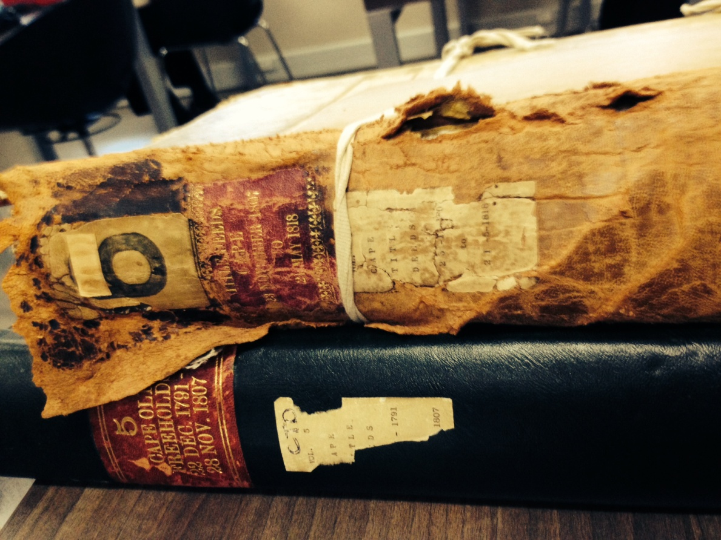

Fig. 3.1: Title deeds - Cape district and Stellenbosch and Drakenstein

Photo: Corrie de Blocq

3.1 INTRODUCTION

Chapter 3 offers a discussion of the methodological links between the research questions and the construction of the narrative of this thesis. This chapter is divided into three main sections from 3.2, which describes the research approach, an outline of the main aim and the questions that guided the research. Then section 3.3 provides a substantive overview of the study’s structure, detailing the research methods, sources of material and ethical considerations. An in-depth explanation of the analytic process is provided. The chapter ends with section 3.4 which is comprised of reflections on the research process.

  - RESEARCH APPROACH

This study sets out to examine violence by approaching a Cape wine farm as “a simultaneity of stories-so-far” Massey (2005:12). The importance of South African wine as an agricultural sector characterized by high levels of social tension represents an acute field of investigation. Of special interest are the underlying forms of violence and also the transformative initiatives on the wine farm Solms Delta. The research occurs through the specificities of this one farm.

3.2.1 Aim and methodological choices

The overall aim of the study is to better understand the relationship between violence and wine in the Cape. The particular objective is twofold – to investigate the past so as to re-imagine present challenges to Cape viticulture in addressing its integrated and overlooked violences. A dual set of questions fulfill the research objective, firstly by asking in what ways viticulture frames and focuses colonial and apartheid ideologies and then querying how Solms Delta relates to contemporary inequities. My methodological choices have been influenced by a recognition of their nature as situated and partial. As noted, the crux lies in “the contemporaneous existence of a plurality of trajectories” that co-creates Delta’s storied spaces (Massey 2005:12). As already expressed, the concept of ‘a simultaneity of stories-so-far’ structures the gathering and organizing and understanding of the study material. This qualitative approach in short, does not aim for a single strand of reproducible data. Instead it considers different modalities and meanings of violence as well as how understandings of Cape viticulture are underlain and informed by these particularities (Holloway & Jefferson 2008). A broadly interpretive position provides both the theoretical latitude and the rigorous corroborative requirements to achieve a more profound understanding of a multiplicity of realities by studying these within the spaces of Delta, i.e. within the context in which they occur. A key word in establishing this position is ‘engagement’ where the researcher role necessarily includes on-site observation and interaction with people and the environment concurrently with the kind of detailed document and text searches that are described further into this chapter.

An interpretive approach also assumes human understanding to be a cyclic process through which analysis uncovers and recreates meaning (Packer & Addison, 1989). From this iterative stance, I have been concerned with responding not only to a particular past but also as openly as possible to its existence in the present moment. Working beyond summaries, an iterative approach incorporates Massey’s (2005) view of the relational dynamism of space. This view considers spatial complexities in terms of tensions and contradictions, processes and functions (Terre-Blanche & Kelly 1999). Here, space is associated with the totality of multiple stories, which calls directly for a recognition of other stories with their own trajectories and also implies an open-ended capacity for stories to transform spaces into new configurations. Massey's (2005:12) word 'trajectories' has a bearing on this thesis in two fundamental ways. In a practical and material sense it means that the stories-so-far are imprinted with layers of investments and practices. Trajectories also give rise to interpreted histories and socio-spatial connotations, some of which come with more weight and influence than others.

Given the role of the researcher as instrument of interpretation, as an element in these trajectories, a broadly applied case study approach comprises a fluent methodology. This method is especially apt, as that many of the events with which this study engages occurred in the past and are not controlled (Yin 2003). Indeed, whilst Delta is legitimately describable as a relatively stable and solid study subject, many of its apparent permanences are nevertheless historically contingent (Harvey 1996; Mitchell 2003). From the legalities of property rights, to institutional apparatus, to the slave bell or the vines and wines themselves, all have been introduced with a view to their lived and material valencies (Mitchell 2002). Just as land becomes ‘landscape’ once inscribed with the actions, narratives and perspectives of its human actors, so does Delta and its multiple contingencies become inseparable from the storied spaces of its inhabitants and the land (Cronon 1992). Answering the dual research questions as outlined at the beginning of this section, means to seek understandings of what in these slippery spaces has died, or been forgotten and what has been established and sustained over time. Vitally, it also means to enter into what it is that is being given form in the present.

3.2.2 Design

Influenced by Ingold’s ideas, the case study was initially envisaged as a form of “dwelling” insofar as this means “engaging … with an environment that is itself pregnant with the past” (Ingold 2000:189). From this perspective, people are not separated from the world and this framework also dovetails interactively with Ricoeur’s (2004) description of a practical research operation. The conjoining of Ricoeur’s model with the notion of dwelling allows for the recognition of narratives and social structures as geographics that overlap each other and integrate with spatial structures. Underpinning the study in this way, Ricoeur’s model has been applied in three broad phases that are not “distinct or chronological, but methodological moments interwoven with one another other” (Ricouer 2004:136-137). The first phase of this study took as its programme the establishment of documentary proof. Research material ran from contemporary eyewitness accounts, to archival texts. At this stage, things, experiences, words, documents and questions were all very interdependent. The challenge was to decide how to interrogate and problematize the material so as to find the traces and threads to pull out and follow. Ricoeur’s second phase is termed “explanation” where a researcher puts the question ‘why’ to the accumulated material. This is followed by attempts to discover the ‘because’ to better construct a full and historically sensitive account. At this stage, I tended to focus on applying methods towards attempting to prise open evidentiary fragments, rather than to interpreting external meanings (Fleishman 2012). Take for an example, inventories of the estates of deceased of people connected with Solms Delta in its long distant past. I tried to consider these documents not only in terms of the legal and regulatory systems in and by which they were composed, but also questioned the implications of the testator’s property and belongings both landed and live, and asked what pieces of information these inventories could offer about the deceased individuals, their families, their positions in the community. Then the challenge was to decide what information could be useful in casting light upon the nature of violence, as the real referent to viticulture and the spaces of the farm itself.

The third phase concerns the creation of a written form which is offered to the reader. Here, following Bruner (1991:8), the task became one of “hermeneutic composability" for as he explains it, even insightful narratives are not unsponsored texts to be taken as existing unintentionally. Put another way, the challenge of this stage of research was to develop a meaning inherent in the emplotment of the thesis that is different from the meaning of the individual parts. In the process of getting there, I relied on certain historiographic methodologies relevant to geographic enquiry that include archives, interviews and narratives. Alongside the interpretation of textual documents as a mainstay of methodological discourse, the iterative and more-than-textual approach has expanded what I identify as an archive and what objects are held in it. Among items of interest were wines made of ‘heritage grapes’, musical instruments, ‘planty’ curations of gardens and food that recalls the usage of vegetal matter by nomadic communities who once used the land where Delta stands today (Brice 2014). Throughout the study fieldwork was integrated following Shurmer-Smith (2002:4), who argues for the use of all faculties in gathering information insofar as “doing includes looking, feeling, thinking, playing, talking, writing, photographing, drawing, assembling, collecting.” My fieldwork has been on a working farm that actively embraces live music, festivals and community events. The fecund vineyards, the textured earth, the food and wine produced by humans who cultivate and create. It is not difficult to understand how tastes and scents, images and sounds and expressions became my quarry. Even beyond the conclusion of formal investigations it remains a fascination to be an observer, still considering how and why Delta’s creations and events are produced and consumed.

3.2.3 Research at the rainbow’s end

Although it expands from the genesis of formal viticulture in 17th century South Africa, this thesis is not a chronological reconstruction of the historical geography of wine. Instead, what it does is to place viticulture within the contexts from which it has arisen. In so doing, it exposes inherent and concealed violence and considers the potential for haunting violence and transformation in the configurations of contemporary South African viticulture. Context has a crucial place in social constructions of knowledge and the contemporaneous context in which the concerns of my study are framed is South Africa into its third decade of its liberation era. It is at a time when ‘the rainbow nation’, the symbolic evangelic image of the new South Africa of 1994, has faded along with its chimerical implications of equity and harmony. Its dissolution has been characterized by ongoing struggles with poverty, inequality and by increasing levels of violence. The phrase, “a rainbow nation of God’s children,” was first used by Archbishop Desmond Tutu (1994) during the fragile transition to a non-racial democracy and subsequently highlighted in Nelson Mandela’s inaugural address as the president of South Africa:
“We enter into a covenant that we shall build the society in which all South Africans… will be able to walk tall, without any fear… assured of their inalienable right to human dignity - a rainbow nation at peace with itself and the world.”

The image represented a noteworthy early attempt to overcome centuries of injustice in the interests of a new, conjoined nation. Nevertheless, as Meskell (2011) bluntly puts it “the Rainbow Nation represents a failed decolonization project.” As national therapy to heal the social wounds and spatialized divides, it has both failed to take seriously this country’s repressive, indeed genocidal, histories as well as glossing a xenophobic and culturally-riven present. In 2015, South Africans are living at a moment when ‘the tackie hits the tar’ a local phrase referring to the instant when any lack of capacity for forward momentum is painfully evident.

Broadly, the contribution of this thesis is to a democratic system where processes of transformation involve a past reframed through this particular present. It is a present where increasing societal stress strongly characterized by inflammatory outbreaks of violence leaves less and less margin for error if it is to open, in turn, onto certain hopeful future imaginings (Beningfield 2006; Amnesty International 2011). In most democracies, especially one so strenuously fought for as South Africa’s has been, there are expectations of civic peace. Yet in South Africa, there is a situation where, as MacGinty (2006:84) points out:

“The re-emergence of violence causes disillusionment and cynicism towards the achievements of the peace itself, which can stimulate and perpetuate further violence thus making the prospect of building peace more elusive.”

MacGinty (2006) also notes that when intensified violence combines with other obstacles to equitable development, such as corruption and administrative incapacities, a society as fragile as South Africa becomes snagged in an intractable situation of ‘no war, no peace.’ Similarly, in South Africa, Pushed to the Limit, Marais (2011) argues that inequities that still negatively impact millions continue to be reproduced and meet with few effective new responses. He contends that many of the changes that lit and powered the struggle for liberation simply do not seem possible within the current political economy. The rampant society-wide violence in the post-conflict transition has had its impacts, not least in the agricultural sectors (Crush 2008; Mail and Guardian 11/19/2009). Thus both scholarly and urgent social debates might benefit from this different way of looking at the nature and constitution of the violence that underlies and reignites social distress.

3.2.4 Researching farmland or treurgrond?

“Awakening on Friday morning, June 20th 1913, the South African Native found himself, not actually a slave, but a pariah in the land of his birth,” wrote Sol Plaatje an early 20th century black South African author. Plaatje refers here to the 1913 Natives Land Act. Under this act promulgated by Westminster, South Africa’s black population then comprising nearly 70% of the population, could own just 7% of agricultural land. This law imploded traditional ways of farming by effectively coercing blacks into becoming migrant labourers on the mines and for white farmers. Over a century later there is no hesitation in saying that the inequitable distribution of land in this country remains a fraught state of affairs. Although there is no longer an active war, I suggest that the quality of peace in this democracy remains significantly under-theorized. In Galtung’s terms there is neither a negative peace defined by minimal or controlled violence, nor a positive peace defined by non-violence and social equity. Farmers in South Africa are particularly aware that they live in a situation of violent peace. Since 2007, the South African police stopped keeping records of attacks that take place on farms, so those particular homicides statistically disappeared and things appeared to be more peaceful. Tracking the violence of this peace in the agricultural sectors, civic bodies and farmers’ organizations and have kept figures through self and community reporting. AgriSA, a farmers’ and civil rights organization, compiled the numbers for a report to the South African Human Rights Commission (SAHRC) at a national hearing in September 2014 which was dedicated to farm security concerns. This report held calculations for 2013, indicating that murders had occurred at the rate of 130 per 100 000 per annum, among the approximately 35 000 commercial farmers in South Africa. On January 12th 2015, Afriforum stated in the South African media that seven farm murders had occurred in that month. What singles out farm murders out as unusual, even in a South African lexicon, is the extremely violent nature of the attacks. Hornschuh (2008) and Bezuidenhout (2012) report that instances can last for hours, where torture by burning with hot irons, boiling the farmer’s limbs in water or oil and the rape, stabbing, dismembering or the sequential murder of family members in front of each other, is not uncommon. As James (2007) points out, farm attacks can arguably be seen, in the light of the sheer weight of intersecting and accumulating factors, as all but inevitable. Indeed as will be seen in the unfolding chapters of this thesis, the historical context indeed threatens to be almost over-determining. Neither an empirical assessment of its extent nor a description of its multiple characteristics is within the scope of this thesis (Hartwell 2006). Nevertheless this thesis does contribute to contemporary analytics of South African violence by extending in a bounded and specific way, the body of research that continues to ask why the already high levels of violence in South Africa did not decrease and have instead proliferated since 1994 (Steinberg 2002; Kynoch 2005; Posel 2005; Barolsky & Pillay 2009; Gass et al. 2010; Barbarin & Richter 2013). There is also an argument for this thesis to make contribution where, as Dewhurst (2008:18) implies, an examination of haunting violence can also cast light on to some of the problems that need attention if a ‘better quality peace’ is to be achieved in this democratic country.

3.3 SOURCING WINE

Despite the unusual benefit of knowing exactly when and why it began, South African viticulture constitutes some messy geographies. Ever since ground was broken to receive vines in 1656, it has been a battle to survive in viticulture, albeit lucrative for a few (Dooling 2007; Viall et al. 2011). Proceeding, as noted, from a position using qualitative methods, my interest is in understanding the connections of violence with wine in a particular context (Denzin & Lincoln 2005). With traditional case-study wisdom that knows that the researcher does not begin with a priori theoretical notions and that information needs to converge in a triangulating fashion, I have worked with multiple sources and points of evidence.

3.3.1 Written words

The search for information on both early viticulture and the related practices and processes behind the records of the dead, began with looking especially for documents that offer personal perspectives. To this small extent I suggest, documentary evidence can counter the work of death through records. Journals, diaries and travel writings particularly, yielded then-contemporary views and opinions. For instance, Jan van Riebeeck’s journal records life in the tiny Cape settlement in its minutiae: illnesses, weather, the condition of the fruit and vegetable gardens, arrivals and departures of ships, relations with indigene communities and the like. As the first European ‘commander’ at the Cape, van Riebeeck was an employee of the Dutch East India Company, De Verenigde Oosterlijke Compagnie or VOC, a global trading and traded chartered company that established a strategic way station at the Cape. The decade of the mandatory Dagreghister or diary kept by van Riebeeck and officials of the VOC is the main source of information concerning the establishment of viticulture and wine-making at the Cape. My debt is to the Thom edition (1954) published in English in three volumes, from approximately 2 400 pages contained in the Cape archives. Van Riebeeck has conventionally been cast as the founding figure of European domination at the Cape. However a reading of the journal itself does much to overturn easy assumptions of colonial power and territorial ‘know-how’. The archival details reveal a different materiality. It is plain that van Riebeeck experienced disappointment that the soil was not ideal for European crops or farming practices and that the weather patterns were so harsh. Then a realization dawned that his grapes might thrive at the Cape. Hopes were dashed when the first rootstock did not take. Van Riebeeck earnestly requested more vines. Finally, there was his elation when the first wine was made. Throughout, it is evident that van Riebeeck did not see himself wholly as a master and commander at the Cape as he is commonly portrayed. His efforts to build a settlement are thwarted by destructive storms, a lack of manpower, draft animals and equipment. He is frustrated by the demands of his employers, the unsupportable needs of visiting ship’s crews and his inability to control deserters and smugglers (Pooley 2009). Moreover he constantly reminds his superiors that he dislikes being the chief farmer at an unremarkable refreshment post on a remote promontory. Van Riebeeck did not foresee that his modest viticultural experiments would become a massive economic sector in a nation-state of the future.

In a similar genre, are the letters of Lady Anne Barnard written 1797 to 1801. Lady Anne, wife of the most senior government official accompanied by a spouse, became the official hostess of the British administration, a task for which her observational talents and life experience well befitted her. Traveling with her husband, Lady Anne produced detailed accounts, for example of the wagon trip to Franschhoek and of the valley and its inhabitants. In addition to lively descriptions of the Cape, the missives contain humorous insights, sensitive sketches and shrewd suggestions as to the government of the colony with regard to the ‘treatment of the natives’ and ‘conciliation of the Dutch.’ Amongst other revealing first-person texts is a chapter written by Sir Herbert Baker, dubbed the architect of empire, in the Union of South Africa. Baker travelled to the Cape Colony in 1892 and a meeting with Cecil Rhodes led to the commission for the Prime Minister's Cape Town residence, Groote Schuur. Baker developed his Cape Dutch style from studying early Dutch and Huguenot homesteads, favouring simple whitewashed walls, broad tiled roofs, high gables and chimneys, and wood-beam ceilings. Baker remodeled parts of Delta’s manor house and also made alterations to the homestead of the neighbouring farm Lekkerwijn, both of which are relevant to this study and were acquired by Rhodes Fruit Farms (Pty.) Ltd. in the early 20th century.

Searches of the South African archives located in central Cape Town yielded information on the properties in the Drakenstein valley through title deeds and maps, probate wills and opgaafrolle. Terrifyingly, as Fig 3.2 shows, many documents that arrive on one’s desk in the reading room are the originals.

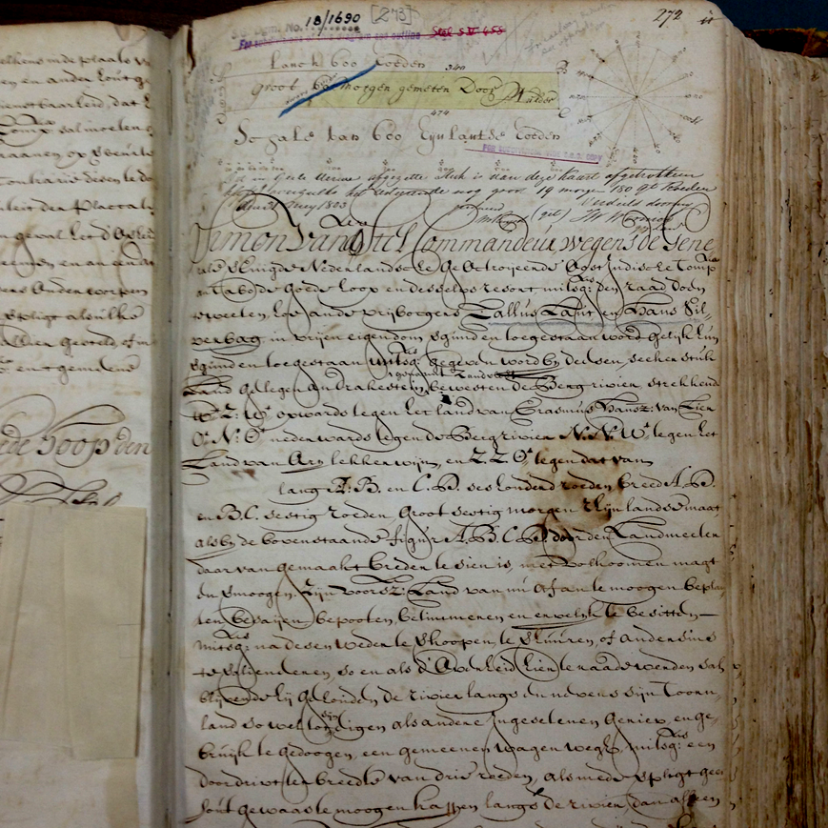

Fig. 3.2: Original grant for Zandvliet (Solms Delta) 15 October 1690

Source: Old Stellenbosch Freeholds Vol. 2(2) item 272

Inventory No. 1/84, that of Cape Title Deeds of Stellenbosch and Drakenstein, and Drakenstein and Swellendam contained the original 1690 title deed for Delta, the property then known as Zandvliet. The document shows information such as the date of the first freehold grant and the location and also indicates that one of the joint owners could not write. Callus Laut could scrawl his name, but Hans Silverbach signed with a shaky cross. Census records provided data indicative of the relative wealth of various owners of Zandvliet and other farmers in the valley. For instance, in the census results of 1692 Silverbach is recorded as owning 14 cattle and 240 sheep, domestic quantities of wheat rye and barley, plus a flintlock rifle. His farming/hunting partner Callus (Laut) Louw, on the other hand, is recorded as possessing only a flintlock rifle. These records are mostly in poor physical condition but legible, even though the old Dutch language can be nigh impossible to decipher. Gaining access to these archives is not a problem as they are open to the public and the staff is helpful. There is also a remarkable library of photographs freely available for browsing. Many are donated limited collections, almost all lack dates and attributions but were very helpful in visualizing Franschhoek valley in the past. Some are included as Appendix F. I am indebted to earlier research by Wayne Dooling (2007) and Kathryn Smuts (2012) for indications towards necessary records thus facilitating retrieval. Information provided by Cape historian Tracy Randle was also vital, especially in regard of her work in sifting through the vast and intermarried de Villiers family.

An outstanding resource organization is ‘Towards A New Age of Partnership’ or TANAP. This is a joint Dutch, South African and Asian partnership, collating, restoring, transcribing and centralizing access to original VOC documents in the Cape in two particular archives, The “Resolutions of the Council of Policy of the Cape of Good Hope” and “The Master of the Orphan Chamber.” The institutions that produced these documents operated throughout the VOC period (1652-1795), the first British occupation of the Cape (1795-1803), the brief Batavian government (1803-1806) and were still functional into the initial period of the long second British occupation beginning in 1806. One of the elements of this project involves translating early inventory lists of deceased burghers. Transcribed from older Dutch into modern Dutch, these inventories offer portals into social relations in the spaces of Cape Dutch household and environs, including the lives of slaves. As the aim of the project is to disseminate, most of these items are accessible via the TANAP website. Of particular interest for this study, documents pertaining to the extended de Villiers family, feature in transcriptions of Cape Town VOC archives. An example comprises the inventory of an Anna van Staaden, who had inherited Zandvliet (Solms Delta) from her first husband. “The Resolutions” comprise of millions of words written by council scribes for over 150 years. They cover fiscal and juridical administration, law and order, education and religion, slaves and other inhabitants, visitors and expeditions, ships, cargo, military matters and health issues, food and labour supplies, trade and diplomatic relations, weather conditions, farming activities, land developments and financial matters.

In bringing archives to life, Ingold (2011:28) explains that “…it is a matter not of adding to them a sprinkle of agency but of restoring them to the generative fluxes of the world of materials in which they came into being and continue to subsist.” In this respect, among the places of interest that I visited, were the Iziko Slave Museum in central Cape Town, the Vergelegen farm museum, in Somerset West and the Franschhoek Museum that retains an unrivalled collection of Huguenot artifacts and genealogical records. These places are all situated in old buildings on site, physically located in exactly the place that they also represent. The Slave Museum is now located in the building that was once a slave lodge built to house slaves that were corporately owned by the Dutch East India Company. For this study my consideration of the materialities of viticulture included the constitution and composition of Cape wine. In this respect, I attended, and passed, two courses offered by the Cape Wine Academy on the history of viticulture at the Cape and the mechanics of wine production as well as a tasting examination. To better understand the construction of a vineyard and the elements involved in discerning the differences between terroirs, I took guided walks around the Solms Delta vineyards and those of Klein Constantia and Cluver in the Constantia and Helderberg areas of the Cape respectively.

From mid-2010 to mid-2014, I frequently reviewed local South African newspapers. “Die Burger,” The Cape Argus, The Cape Times, The Mail and Guardian and The Sunday Times comprised the scope of review. I sought articles in which issues related to the ‘dop’ system, Foetal Alcohol Spectrum Disorder (FASD), wine farm workers’ rights and labour relations were reported. The dopstelsel or ‘tot system’ in English, names that insidiously violent centuries-old practice of paying wine farm workers partly in measures of alcohol given at intervals throughout the work day, rather than in full monetary compensation. A report in the Cape Argus (3/10/2011), confirmed that five decades after the ‘dop’ was outlawed, the Cape remains beset by a distressingly high rate of FASD, standing at 12% of all live births in some rural areas. This article led to contact with the NGO ‘Women on Farms’ to understand more about the meaning and extent of ongoing trauma from this type of birth defect. Also monitoring British newspapers during the violence of the 2012/13 protests on wine farms it was interesting to note that The Guardian (24/1/2013) ran a piece, suggesting that the British public once again boycott South African wine. The two newspaper pictures that comprise Fig. 3.3 highlight one of the outbursts in the ongoing tension in worker-farmer relations on wine farms.

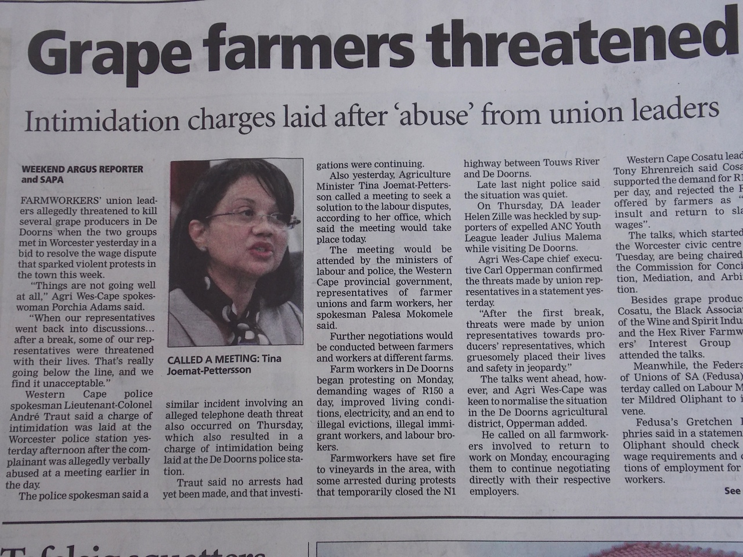

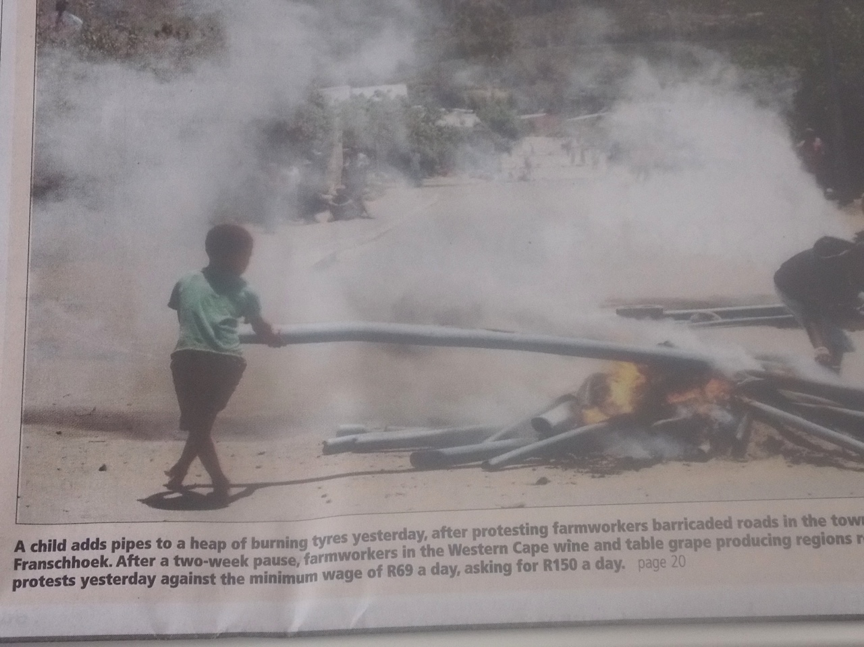

Fig. 3.3: Local newspapers: worker unrest in the winelands

Source: Cape Argus and Cape Times respectively, January 2013

Thus the background work undertaken does not emphasize document searches per se, but instead pulls them into a history narrated through geographical storytelling. The narration is intended not only to describe, but also to offer an account of what flows through the geographies of Cape wine in much the same sense that Ingold (2008:278) evokes the kinesthesia of life insofar as it “will not be contained, but rather threads its way through the world along the myriad lines of its relations.” This narrative concept comprises an appealing approach to considering how to apply the collected information so as to reveal the connections of wine with violence. It permits me at one moment to macro-focus on one trace of violence – for example the violence of property. I can zoom out to offer a view of how property is a thread is entangled with others. There is also the capacity to veer into a story such as the particularly subversive nature of drinking alcohol in South Africa and rejoin the specific stories of Delta.

3.3.2 Fieldwork

Supported by Harris' (2002) consideration of the complementary relationship between archive and field, and by the essence of viticulture that requires consideration of the physical landscape, the nature of this investigation demanded fieldwork. Over a period of 36 months, from 2011-2014, an estimated 22 visits for interviews and observation were made to Delta. My notes on what I had seen and done and heard - with additions sometimes of recorded music, a publication, a bottle of new wine, a handful of herbs, or a series of photographs - together with detailed ‘field dispatches’ emailed to my supervisors and my personal scribbles on recent conversations, emerging thoughts, or theoretical connections, comprise the material for this part of the research.

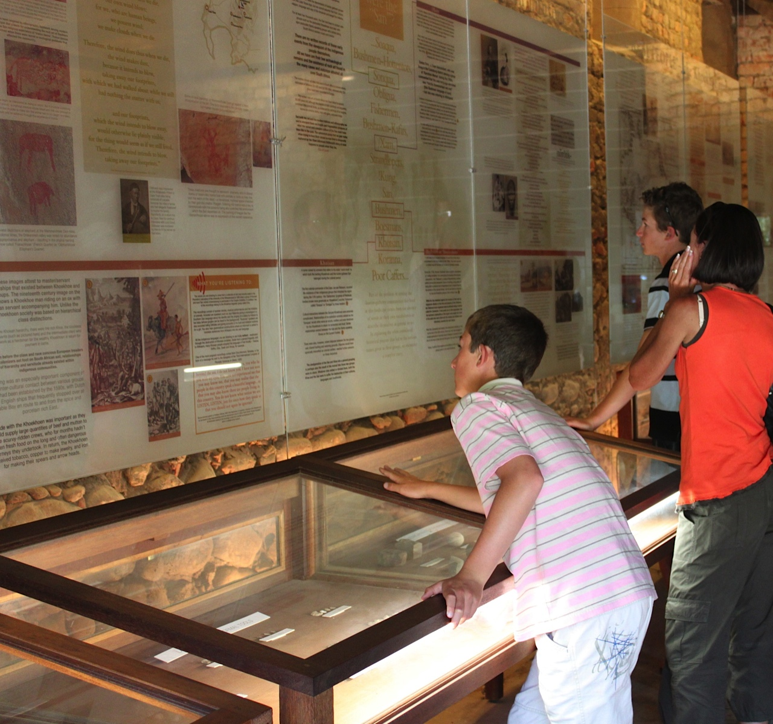

Fig. 3.4: Visiting Museum van der Caab

Photo: Corrie de Blocq

During the course of 2012/13, I partook in a number of activities. I joined farm tour groups, and shared meals in the restaurant. I visited the playschool and watched music practice. As Fig. 3.4 shows, I began to take friends to the museum myself and observed what others did and said by ‘hanging around’ with an interviewee who coordinated sales at the door. When walking, I usually went to the Dik Delta garden, observing the plant collections grow and expand. I watched the vines change with the seasons, talking with the workers when feasible. I attended formal functions that included a book launch, a wine-pairing dinner with the Delta winemaker, two music evenings and two musical harvest festivals.

Although I never satisfactorily resolved this methodological problem, my field notes puzzled about the problem of negotiating spaces which are created in ‘the now’ that could never be repeated or retrieved. Instances of listening or dancing to music, drinking and eating only happened as they were being played out or experienced. Unlike glass wine containers or paper documents, I could not hold such spaces in my hands, nor could I capture or represent them in their entirety. Eventually, and as there was no place for analysis of the music performances or tasting rituals that are so important on Delta, I integrated the ‘liveness’ of real time in indirect ways. I used music as a kind of sonic ethnography, towards understanding more about the rich cultural background of the coloured farm workers communities and how it is activated on Delta today. I included the experiential in my essentially non-representational approach insofar as it is possible to witness how space is shaped in ways such as taste and is thus given biophysical, albeit transitory, presence.

Interviews were undertaken throughout the course of the study. The intention was not to produce a survey, but to collect detailed, textured, person-centred information from a range of perspectives, “to become saturated with information” (Padgett 1998:52). Some interviews took the form of conversations with people whom I already know involved in the wine industry, in activism for equity on farms, and in the preservation of Cape heritage. However most interview information was obtained through purposive sampling and planned, informal means. A targeted interview series was conducted on Delta in mid-late 2012. Other interviews were scheduled in advance, but others were simply serendipitous upon meeting someone of interest or as Schutte (1995:8) refers to it: ‘the ethnography of everyday talking.’ Particularly interesting were those snatched conversations I had with workers after the unrest in the winelands in late 2012 early 2013. Information from inhabitants of farms other than Delta yielded valuable personal perspectives on the protests that turned violent. For example, during the Christmas holiday period in 2013, there was the testimony of a coloured farm worker hobbling along the verge of a dirt road in the Ceres district. He was balanced painfully on wooden crutches. Both this man’s knees had recently been fractured during a beating with a hefty link-chain because he had refused to attack his employer’s fruit packing shed, which is seen in the photograph is on the title page of Chapter 2.

Throughout the four years of researching and writing, I tried to remain aware of the interactive narratives at work in Delta’s spaces. I attempted to imagine intersections with archival research and to anticipate possible narrative threads emerging from the stories and information provided by participants who were interviewed. Transcripts with my expanded notes are available. Where permission was granted, names are cited. Some participants are alluded to without specific names being attached. This was for interviewees who communicated a request for anonymity, owing variously to security fears, the informal nature of the interview and personal privacy. Naming was of ethical concern, as the farm workers who did not participate in protest action were visibly vulnerable in the volatile atmosphere of labour unrest in the wine industry in 2012/13.I decided to apply anonymity to the farm workers interviewed except one who requested recognition and another who said, “ek is tevrede, ek gee niks nie, ek is te oud.” I am fine with it and too old to care [what others might think].

For every interview, my motives, intentions and reasons were made clear from the beginning. To gain access to Delta’s ‘insiders’ I contacted Ms. Charlotte van Zyl, who organizes the foundational trust funds that support the farm. Charlotte organized for me to meet directly with Delta’s current owner Professor Mark Solms and later with Ms. Charne Abrahamse the resident social worker. I supplied each of these gatekeepers with a copy of my proposal. Charlotte formulated a list of possible participants and Charne undertook to explain my study, and especially their part in it, to the workers who agreed to be interviewed. Partly as a means of ascertaining his sanction for the study, the first interview was with Professor Solms. We met in the spacious dining room of his Cape Dutch homestead for two hours when he conversed in depth about how things have changed developmentally and spatially on Delta since he purchased the farm. Professor Solms also took some time to explain how he has applied his professional experience as a neuropsychoanalyst to changing the lives of the workers.

I interviewed six farm workers, three men and three women, ranging in age from 86 to 21 years old. Four participants represented families living on the farm and two lived off the farm, one by choice and other was hoping for a house on the farm. Before each initial interview with a farm worker I took the participant verbally through the standard and obligatory ethics of research. I proffered each one an informed consent form to sign, translated into Afrikaans. Charne decided to sit in on the first interviews and she discreetly stopped me. She explained that such formalities might make the workers feel anxious or intimidated and also that one older participant could not read well. “Signing things doesn’t help his nerves” and “anyway if Mark says it’s ok then it’s ok.” I assured each farm worker that the interview would terminate instantly if he or she said that it needed to stop. The office-based staff, Charlotte and Cathy the farm manager, said that they were happy to talk with me over coffee or while accompanying them on their duties whenever was convenient but had no interest in formal ‘set-up’ interviews. I assumed this meant that these women were comfortable with my presence. It may well have been because these participants are white females in my age bracket and in the small local circle of women interested in viticulture we had acquaintances in common.

As regards Charne, after the first interview in her office, I met with her informally at every visit and we had an ongoing conversation about what had happened on the farm. Each one-hour interview with a farm worker took place in Charne’s office, conducted in colloquial Afrikaans familiar to the participants. Even so, one female participant literally sat on the edge of her chair, giving only the briefest of answers. Eventually we went over time on that interview as she relaxed and became chatty. These were semi-structured interviews resulting for the most part, in fairly free-flowing conversations. During each interview, I recorded and/or made notes depending on the comfort-level of the participant and later transcribed these records. I was interested in the life-stories of the workers. I also asked them for their perceptions of the changes that they had witnessed on the farm, as well as for their experiences of the current projects on Delta. Chain-smoking throughout the interview, ‘Oom’ Willy Venneal, in his 80’s, was insightful and humorous about the four different owners of Delta for whom he had worked since he was barely in his teens. He described his working life tied to the farm by accommodation and income needs for more than six decades. Because of the length of his service and willingness to comment on his working conditions and the quirks of his employers, Uncle Willy’s story was especially helpful in relating the farm world to his individual story. He described how he had started out as a small boy driving mules from the shed to the fields to plough. He graduated to ploughing with the mules and then eventually became a tractor driver on Delta and other farms belonging to the owner at the time.

3.3.3 Testimony and traces

For Bloch (1964), all such evidence comprises testimonies and, whether written or unwritten, all are equally unreliable. Testimony is not only thought of as eyewitness accounts or historical records but more fundamentally as an attempt to make accessible the processes and events that have co-shaped Delta. Ingold (2000) offers a key analytic concept for constructing a reliable narrative from testimony, by differentiating between a cipher and a clue – the critical distinction being between what has been tacked on to the outer surface and what exists within. Following on, the historian Ginzburg (1989) suggests that testimonies testify through words, clues through their muteness. Thus he sets up a dialectic of testimony and clue that comprises the notion of a trace. As traces obviously require critical comprehension on, this second phase of the research process involved constant comparisons. As a small instance, from the signature on this probate inventory seen in Fig. 3.5, it can be extrapolated that the signatory “Elisabet van kap” was a female household slave, born at the Cape, with some education, trusted enough to list items honestly and also responsible enough to sign in the eyes of the law.

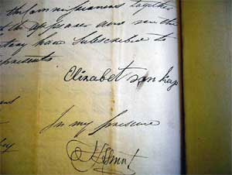

Fig. 3.5: Inventory 1830

Source: TANAP MOOC 8/44.5

Information was organized into sections in thematic files compiled physically and digitally with the same name, as both were used simultaneously. By aggregating information increasingly categorically, items became reorganized according to features that broke across files without edition (Creswell 1998). My attention expanded to connecting pieces of information, seeking traces or strands, and those silent clues. A colour coding process connected these second tier files, which became rather unwieldy as interesting relationships emerged. Fire, for example, made strong connections across time and space. Archival evidence showed that forms of arson and immolation were among the most common and feared ‘weapons of the weak’ employed by slaves at the Cape between the 17th to early 19th centuries (Scott 1995). Indeed, Chapter 4 relates an instance when a slave set fire to buildings on Delta. Searches through local literature on violence brought back the horror of a time when it was possible for policemen to enjoy beers and a barbeque whilst attempting to roast the beaten corpse of political detainee on a nearby fire (Feldman 2004).There were again the pictures of township dwellers necklaced in their communities - imprisoned in a tyre-pyre, doused with petrol and set al.ight. Fig. 3.7 shows a specific type of violence repeating hauntingly during one of the 2015 outbreaks of xenophobic attacks on citizens of neighbouring African countries. For someone who lived through the apartheid era, the images were worryingly reminiscent of scenes captured by Greg Marinovich and the ‘Bang-Bang Club’ of photographers. Fig. 3.6 is Marinovich’s Pulitzer-winning photography from 1990.

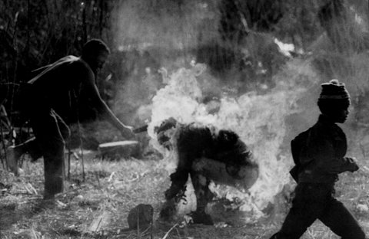

Fig. 3.6: Lindsaye Tshabalala

Source: Greg Marinovich: Pulitzer winner for Spot News Photography in 1991

Figure 3.7 below is a photograph that dominated local social and print media a quarter of a century later, on 13th April 2015, when an Ethiopian migrant was burned to death.

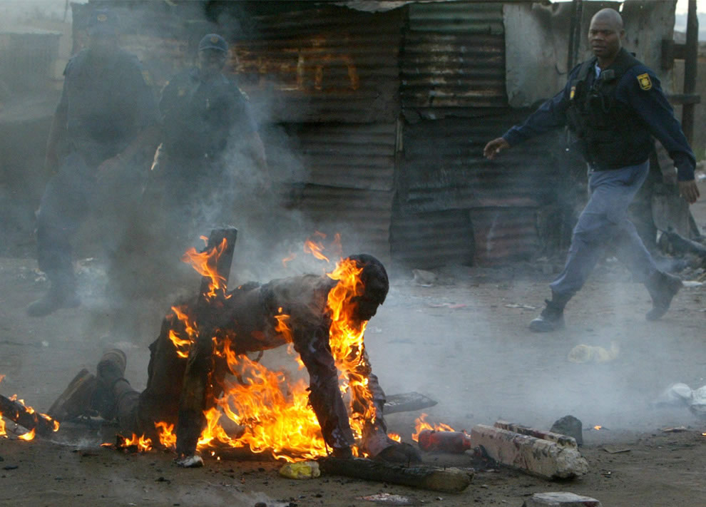

Fig. 3.7: Front page violence, an Ethiopian migrant April 2015

Source: PRAAG, Centre for Human Rights at the University of Pretoria

Ironically, on returning from a field visit in 2013, I was caught up in worker protests from local wine farms. The road along which I was driving was blocked with large rocks, behind which groups of protesting workers danced. Policemen were attempting to redirect the chaotic traffic and all the while there were plumes of smoke rising from the left, drawing the eye towards the hectares of vines that were being burned only weeks before the harvest.

For a while, I looked for other themes. My Amazon orders grew exponentially with my frustration. I could not find the strong thread for which I was searching. It was a conversation with an acquaintance who at the time, headed TransNet, South Africa’s public-sector transport provider, which showed me I already had the material I sought. Wearily he was recounting the extent of ongoing corruption and the material instances of violence and daily intimidation with which the organization has to cope. As he commented that South Africans are worryingly accustomed to living with “terror as usual” I realized that I had been blind to the traces of violence that surfaced everywhere in my files. It is violence that links the South African fire-pathology to the outermost metaphorical and epistemic power hierarchies. It connects imperial conquest to specific and physical assault. It links farming to numerous exclusions, cruelties and silencings effected by the law (Taussig 1989). Suddenly my coded files made an unexpected kind of sense. I could readdress them, newly problematized as a “series of points of passages in a network of violence” in the story of Cape viticulture (Mitchell 2001; Mitchell 2003:243 in Anderson et al. 2003; Feldman 2003). With fresh clarity, theoretical relationships connected with each other and core categories took shape.

3.4 WRITE SIDE UP

The problem of how to approach the writing became the next crippling obsession. I had been writing copious notes throughout, but as Bhabha (1997:433) expresses it, “how can we face the task of designating identities, specifying events, locating histories?” While seeking for somewhere to make a first precise analytic incision, a transcript review reminded me of something that Professor Solms said during our first meeting in July 2012. He suggested that I visit a bamboo copse on the river bank, which had once been a trysting place, circa 1824-1832, for a female slave on Delta and the oldest son of her owner. Solms’ specific words were, “that place really haunts me.” So in January 2013, I took a short hike to the patch of bamboo. I began to think about how this bit of vegetation had provided an escape for the young people. From what were they escaping? Or what was it that they were escaping into? Both lived on Delta, interacted within the same walls and traversed the same soil. Yet he, a son and heir, belonged, and she was just another belonging. Their spatial location was almost identical but their worlds were distant and apart. The creaking bamboo represented a very tiny space where they could escape the same world of their differences into their different world of togetherness. That was my clue. A concept of being in place differently imputes farm space to give rise to and act as a “reservoir” for mixed imaginaries. “These imaginaries gave meaning to the enactment of differential rights, to differing categories of people for different purposes within the same space” (Mbembe & Meintjies 2003: 25-26). In the interstices of these imaginaries is where the potential for violence lies. Farm space immediately became the prism through which this narrative account is refracted.

Even so, the construction of a narrative of farm space almost immediately became problematic insofar as a conventional thinking of space. Clearly what was not available as an option was a coherent, linear narrative. Massey (2005) argues that space is conventionally arranged in temporal sequence with the effect that nothing is differentiated except by being, behind, or indeed, ahead. So following her approach, a solution has been to portray the story of Delta as a continuation of simultaneous rejection and embracing of the past, together with a deeper examination of nodes of property and differential inclusion. My concept of farm space is thus sympathetic to rethinking Delta as “an open articulation of connections” that also “holds open the possibility of change in the future” (Massey 1999:288). As much as to emphasize the entanglements of a complicated history as to disentangle particular aspects, substantive chapters use information from numerous sources to consider the same story from different angles in the narrative structure (Denzin & Lincoln 2000). I worked in an iterative way typical of qualitative research, moving back and forth between phases, sites and discrete fields. The result was that through the sheer unlocateability of much of the apparent violence, I came to understand Delta’s spaces to be haunted (Caruth 1995). So in another sense, the narrative is a substantiated ghost story, insofar as ghost stories draw attention to the “dialectics of visibility and invisibility which necessitates negotiating what can be seen and what is in the shadows” (Gordon 1997:17).

Nevertheless, “[h]aunting legacies are things hard to….even recount” (Schwab 2010:1). Chrono-logic simply does not apply here (Jenkins 2003:30). Confusingly, in South Africa, these legacies merge into diverse processes evolving differently in victims and perpetrators. I acknowledge the numerous limitations of narrative writing, especially the problematics of writing silences and the deep difficulties of representing other people and ethnicities. As a native of this land, I understand that we are all implicated in each other’s trauma and thus that objectivity is unlikely to be achieved (Caruth 1995). Indeed, an attempt at writing a geography whose archives are always impossible to fully retrieve is arguably destined to be a failure. It cannot make present that which has gone before, nor that which has vanished. However LaCapra (2001:42) suggests that “a responsible, cognitive effort, to articulate, or rearticulate affect and representation may never transcend, but it may, to a viable extent, counter a re-enactment or traumatic haunting.” Likewise, what this study can offer is possibilities and provocations so that the remains or fragments can come together differently. Without utopian aspirations, that is what I have hoped to achieve. Indeed, I acknowledge that, even in a comprehensive understanding of Delta’s spaces as a simultaneity of stories-so-far, “there is no telling it like it is, for in the telling is the making.” My methodological undertaking in this regard is to develop the means “…to do justice to the situation and yet to recognize that all stories, including those in the natural sciences, are fabrications – things made” (Eisner 1991:191).

CHAPTER FOUR

“A FAT SOIL”

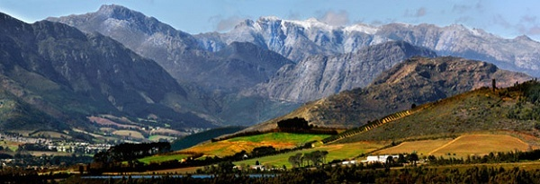
Fig. 4.1: Valley view: south east towards the Helshoogte.
Source: Franschhoek Tourism

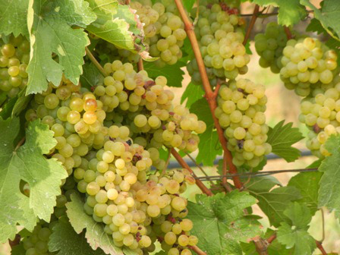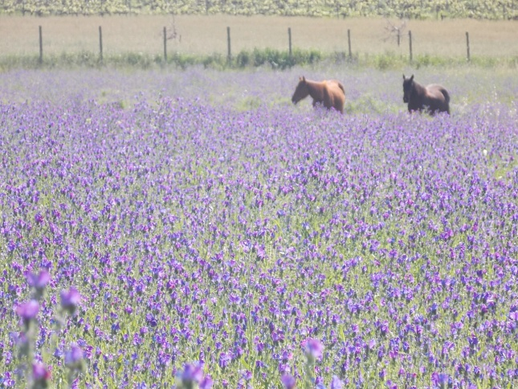
Fig. 4.2: Steen grapes: 2014 harvest, Solms Delta Fig. 4.3: Lavender fields, Franschhoek
Photo: Corrie de Blocq Photo: Corrie de Blocq

“We found the road through the Valley of Drakenstein …..the finest mountain that fancy can form. Had poor Burke seen it, he would have said that when found the Almighty had riven it in two to divide between his countries, but had stopped in the middle when half-executed… This valley is without doubt the richest land and the best in the Colony. Some bulbs that I had pulled up came up with a fat soil around them….”

From: South Africa A Century Ago – Letters written from the Cape of Good Hope 1797-1801, by Lady Anne Barnard. Wilkens, W. (ed.) 1910.

4.1 INTRODUCTION

Cape wine is self-evidently not a freely appearing occurrence. It has a very specific biophysical genesis. Yet while more-than-human, wine also has its own human history where unresolved conflicts over land have been key drivers of displacement and of violence. Chapter 4 gathers stories from the ‘fat soil’ of the valley to tell of this specific piece of earth, its spaces and its people. The multivalence of wine demands this kind of nested inquiry. As Serres (2008:158) contends:
“We would have to superimpose several maps: geological, pedological, viticultural, a mosaic of yellow pink, royal blue, bottle green, an unexpected element, as though the substratum - what a surprise - were reproducing itself on the surface, as though the old growers themselves, unwitting geologists, were revealing the dark secrets of the earth, through and in the arrangement of these maps.”

Our particular area of interest, to which Lady Anne Barnard refers, is sandwiched between the Simonsberg and the peaks of the Groot Drakenstein. The valley has the Helshoogte at its head separating it from Stellenbosch. These crags and lowlands, this soil and the rivers that once formed the resource landscapes and transhumance patterns of indigenous hunters and herders became the orbit of settler farmers. Today the same geomorphological attributes provide a dramatic backdrop to the dream-homes of 21st century billionaires. In essence, Delta is where it is and has the properties that it does, because of a cascading set of natural conditions that start with the climate and geomorphology. So this chapter begins with the land, the physical base without which viticulture would have been impossible. The location of Delta in the winelands is described together with climatic impacts and geomorphological formations – the nature and distribution of landforms and their assemblages - that give rise to the natural environment supporting Cape viticulture. These varying conditions significantly shape the proximate determinants of other considerations such as the establishment of a wine farming frontier, while also influencing the lives and choices of the humans who have co-created the spaces of this particular farm. The second part of the chapter takes cognizance of how networks of humans engage with more-than-human entities in and through farm spaces. Ideas of landed property and ownership are associated with ideological perspectives that perpetuate various forms of violence. Here, a rich but fragile geography treads over uncanny violence, awkward historical narratives and variously re-placed bodies.

4.2 WINES WITH LATITUDE

The world’s wine regions mostly fall between 30°- 50° because latitude relates to the atmospheric temperature that so profoundly influences the quantum and the quality of aroma and flavour compounds in grapes. As varieties ripen with up to two months difference this obviously affects which grapes should be grown where. In the Cape, viticulture originated and still mainly takes place at latitudes of 27°- 34° south (Linder 2003). Fig. 4.4 shows the global picture.

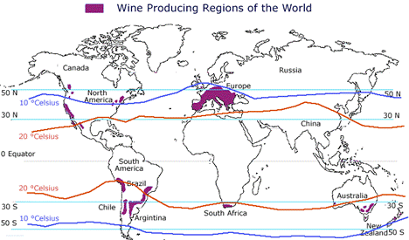
Fig. 4.4: Latitude of wine producing regions of the world
Source: Available from http://globalgeography.aag.org.

The Cape is cooler than its position suggests because of conditions caused between the Mozambique current in the Indian Ocean and the chillier Benguela current in the Atlantic Ocean to its west. Most of South Africa is semi-arid and has difficult terrain for viticulture. However hugging the far southwestern coastline of Africa, extending from the peninsula along the lowlands and into the first mountain ranges, there is a 78,500 km² Mediterranean-type bioregion called the Cape Floristic Region. It is comprised of the Fynbos and Succulent Karroo ecoregions. Most of South Africa’s vineyards are planted in the Fynbos ecoregion. The Franschhoek valley is situated here, inland from Cape Town and centrally located in a valley that is roughly 1.6km wide and 1.5km long with the average height of the surrounding mountains exceeding 900 m above sea level.

The Fynbos ecoregion is represented in Fig. 4.5 and Fig. 4.6.

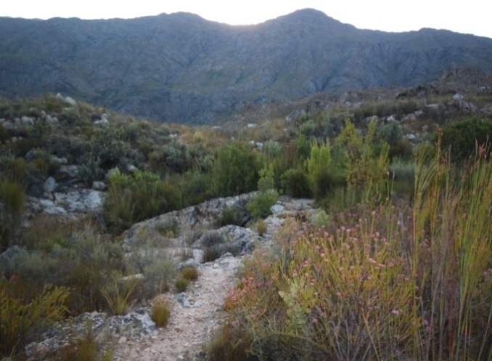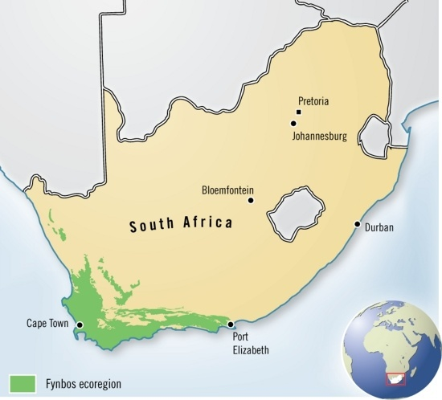
Fig. 4.5: Fynbos ecoregion Fig. 4.6: Fynbos, low scrubby, flammable
Source: Hugo Ahlenius, UNEP/GRID Photo: Corrie de Blocq

Because it does not benefit from the cooling coastal conditions, Franschhoek falls within a matrix of warmer conditions considered good for fortified wine and less so for table wine. Yet, the range of local wines includes superb examples produced from varieties associated with cooler climates. Local wine farmers have not necessarily co-operated with statistical categorization. Rather, it seems that the development of viticulture into the valley has simply followed rivers and rainfall instead of temperature levels in a region that I suggest, comprises a particular bio-contact zone.

4.2.1 Bio-contact zone
This term derives from the phrase ‘contact-zone’ applied by Pratt (2007) to describe the cultural interaction of colonial encounters. Scheibinger (2004) extended this notion to human/plant contact as a ‘bio-contact zone” and I build on this as a way of understanding how viticulture co-shapes the natural environment of the Cape (Haraway 2008). In a (botanical) sense similar to the dislodging of indigene human inhabitants, the introduction of grape vines to the Cape has caused indigenous vegetation to be displaced. This has however been a remarkably successful transplantation inasmuch as viticulture has become entrenched in the Cape and wine making is now a vital local industry. The creation and maintenance of this viticultural assemblage has however not been without difficulty and continual manipulation as the following sections will show.

4.2.2 Invasive, indigenous, inflammable: vines and Fynbos
The global positioning of Cape wine production has occurred the way it has because the conditions that support the fragile, indigenous vegetation are good for cultivating grapes (Simmons & Cowling 1996; Rouget, Richardson, Cowling et al. 2003; Cowling & Pressey 2003). The close proximity of indigenous flora with grape vines means that plants whose partnerships, as Haraway (2008:17) points out, “[do] not precede their relating” nevertheless grow in a contingent relationship of difference. The first grape vines, not unlike many early human travellers, did not survive the sea voyage to the Cape. However a subsequent batch of vines thrived and vineyards were established on slopes around the Cape settlement to experiment with wine making. Again analogous to the settlement of Europeans, the ordering of vineyards at the Cape has also meant classifying ordering systems in perceptions of what has a right to life and to living space and what is instead killable or removable. The indigenous vegetation however has had little regard for the orderly aspirations of wine farmers. In terms of fire in particular, the natural environment has never been quieted by formal plantings. As the following photograph shows, establishing vineyards adjacent to fire-prone Fynbos is always a risk.
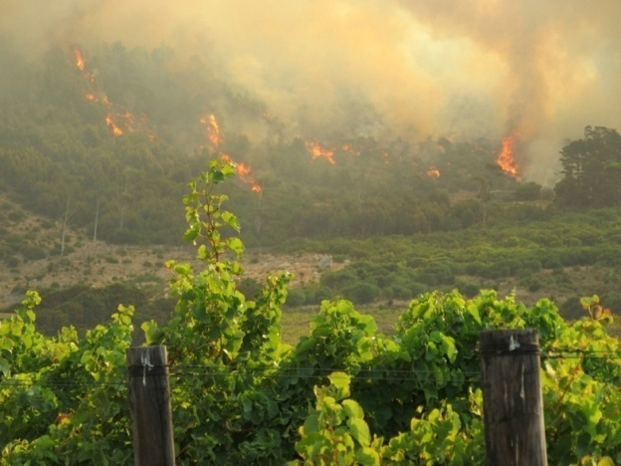
Fig. 4.7: Steenberg vineyards: fire March 2015
Photo: Corrie de Blocq

Fire is essential for maintaining the health of the Fynbos and approximately every decade Fynbos needs to burn. Without the smoke that emanates from fire, the seeds of Fynbos flora do not germinate. The essential nature of Fynbos and its dependent ecosystems thus constantly threaten grape vines, which obviously do not regenerate after burning. Even less than in other wine regions, vineyard activity in the Fynbos ecoregions is never down to autonomous choices of humans. The life-cycles of Fynbos over-ride harvests and vine-ripening patterns and force humans to respond adaptively.
4.2.3 Weathering storms: Cape climate

Climate variability and change are seldom more evident than where very narrow climate zones for optimum grape quality place them particularly at risk. The climactic conditions at the Cape are notoriously mercurial. With a centrally situated mountain to add complexity to weather patterns, the peninsula is battered by northwest winter storms and by harsh summer southeasters. Both coasts are littered with the shipwrecks of centuries and it was for good reason that in 1488 Portuguese explorer Bartolomeu Diaz named this peninsula Cabo das Tormentosa or Cape of Storms.

The winter rainfall patterns in the Cape are nevertheless ideal for the seasonal cycle of grape vines. Received rainfall varies significantly on finer measurements and Delta is fortunately appointed in the area of the winelands that receives the most abundant rainfall. In concert with temperature, conferred water status directly influences vineyards. For example, dry soils warm up more swiftly than damper soils and thus these soils induce earlier ripening which is good for some varieties but not others (van Leeuwen et al. 2003). Rainfall also influences which wines can be made insofar as low vine water status also results in reduced berry size. This water deficit causes an increase in berry tannin and anthocyanin which is good for red wine making, whilst under the same stress the aroma potential for white wine grapes decreases (Peyrot, des Gachonset et al. 2005). Plant stress during water deficits can also retard sugar accumulations, especially in vines that bear heavier crop loads. A marginal amount of water stress frequently results in better quality wine, while no water stress results in high yields, good for bulk production. Thus climatic trends constantly have significant implications for grape quality at every harvest, for changes in wine making styles, and for the character of each new vintage. The immediate influences of climactic conditions on changes in berry ripening processes also always had a strong bearing on vineyard management practices at the Cape (Vink et al. 2009). Even in 1896, Wallace noted that “the low gooseberry bush shape, adopted in France....is that seen in the Colony, the prevailing high winds making trellises and other high methods of training vines, dangerous” (1896:142).

The sensitivity of vines to prevailing climactic conditions proliferates a capacity to behave differently, that in turn provokes new and different reactions from humans. Cape wine farmers continue to alter their responses each year in accordance with vine behaviour and weather.

4.2.4 On rocky ground: winelands geomorphology

Franschhoek is located within the visually impressive Cape Fold belt of mountains that run roughly parallel to the extreme south and western coastlines. Pressure exertion combined with different resistance capacities and susceptibilities of the underlying materials is what has made up the distinctive folds. However the Cape Folds are a topographical anomaly. While plate tectonics can explain the formation of ranges like the Himalayas, it is more probable that a massive plume of hot mantle rock from the African super-swell caused the steep slopes of these mountains. The super-swell is the prevailing theory explaining why the general elevation of the Western Cape is considerably higher than other regions similar in geomorphology and geological history, such as Western Australia (McCarthy & Rubidge 2005).

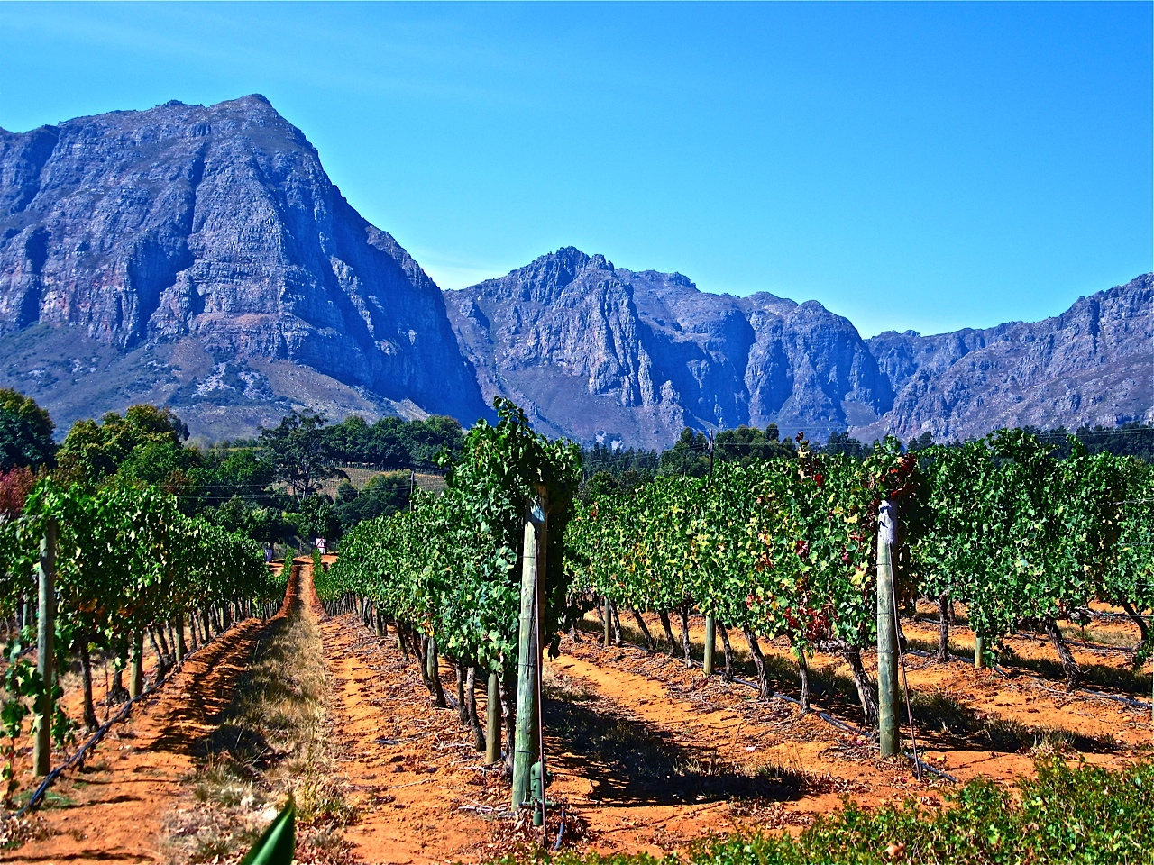
Fig. 4.8: Cape Folds: from the Helshoogte
Photo: Corrie de Blocq

Of more than spectacular interest, this topology exerts a vital influence on vine growth and grape ripening through factors such as relative rainfall, temperature, exposure to sunlight and airflow. The base elevation and the distinctive folds of these mountains diversify viticultural possibilities because they amplify solar and temperature effects. Governed by the bedrock geology, it is the differences in orientation, slope and altitude that identify this farm. Even a cursory stroll on Delta’s grounds offers a vista of a varied topology that manifests inter alia, in angled mountain slopes, valley access and riverine ecologies (Compton 2004). However while the elevations, slopes and aspects found here are responsible for supporting a wide range of identity-bearing wines, the earthy materials of the Cape soils are also vital. The South African Wines of Origin scheme acknowledges how much the soil, as well as the topography, influences the quality and character of wine. Ice-free erosion since the break-up of Gondwanaland about 200 million years ago has ensured that the bedrock soils of the winelands are diverse and susceptible to degradation. Delta lies in the Franschhoek ward, in the Paarl wine district but the complex geology in this southerly part of the valley could arguably define a discrete ward. In Fig. 4.9 a glance at a vineyard reveals a partially rocky surface underlain by the soils of a complex mantle.

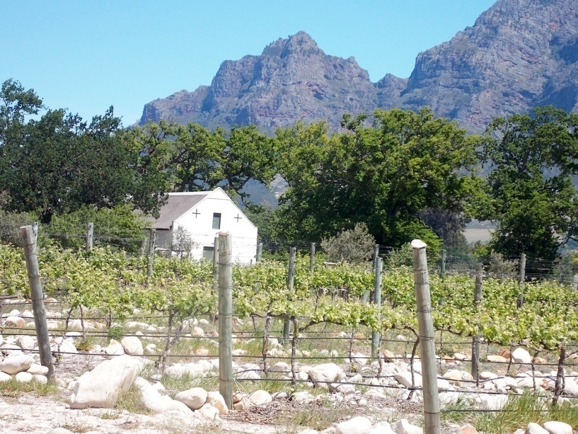
Fig. 4.9: New vineyard Solms Delta 2012
Photo: Corrie de Blocq

This specific Simondium/Groot Drakenstein sub-area is based in granites emanating from intrusions of the Stellenbosch pluton. The granites are bounded to the northeast towards Wellington by conglomerate, grits and quartzite, with intermittent shale (Bargmann 2003). Appendix B is a visual representation. Solms Delta is centrally located on a small plateau with loam and clay. Along the two rivers running across its extent there could also be overlays of sandy and alluvial soils. For making wine on Delta, the significance of this mix of soils lies in the effect that a soil type and its respective chemical balances have upon vines grown in a given place. In the makeup of its soil, as in other ways, a vineyard can resist or facilitate human objectives. Granite-derived soils, for example, hold less water than shale or clay and are less desirable in hotter areas. However these soils also promote the fine vine root systems that correlate strongly with vigorous cane growth and with increased berry size. Too much clay in cooler areas can make for waterlogged roots. As another example, the presence of potassium features strongly in granite and shale rich soils which exhibit little capacity to buffer potassium uptake by vines. Potassium-rich grapes have increased pH values and lack the acidity necessary for a structured wine so featureless wines can result instead. Thus we can see that site-specific bedrock and associated colluvial and residual soils directly affect not only the location and variety of rootstock planted but contribute directly to the berry yield and to the characteristics of the wine produced. The way in which a particular variety responds to the environment determines the optimal time for harvest in a particular place. In these among many other ways, the essential practices of tending to grapes in a given set of natural conditions render the agency of vines perceptible in patterning social time and influencing human activity (Brice 2014).

Even though I have identified here a cohesive biophysical constitution for this piece of land, I make no argument for the land underlying Cape viticulture as stable or dependable. In its formations and constitution, this land represents massive and violent upheavals in the deepest layers of the earth. The land is also clearly an active, relational presence in the co-production of wine. The non-static nature of the land in every vineyard is asserted in their intrinsic capacity to make wine with humans and also to divert or thwart human efforts. In this dance of agency with vines and land, humans occupy a space between their pre-existing goals and the eventual outcomes, always moving seasonally around the vines, unable to control or to predict every relevant variable. These vineyards foreground the following representation of a viticultural frontier for their innate plasticity identifies Delta as a material site of historical and geographic contingency.

  - VINES ON THE LINE: a viticultural frontier

By 1652, when the Dutch arrived at the Cape, King, Juan II of Portugal had already spun a myth around this stormy peninsula by renaming it Cabo das Boa Esperança or The Cape of Good Hope. The original logic of Cape viticulture owes to Dutch influence and is however rather prosaic. Indeed the Dutch acquired a foothold at the tip of Africa not in the name of monarch or country, nor for divine glory, but in the direct pursuit of mercantile profit. Determined to wrest control of the East Indies spice trade away from the Portuguese, the Dutch focused on the Cape for its privileged geostrategic location and possibilities for agriculture (Dooling 2007).
4.3.1 Refresh and rule: Dutch East India Company
As noted earlier, the first intentional European settlement at the Cape was a limited commercial enterprise by De Verenigde Oostindische Compagnie the Dutch East India Company or VOC. This trading company abjured formal colonization in favour of establishing the barest infrastructure to supply the passing East Indiamen with fresh food, water and materials to repair damaged ships. Sailors stopped to recover from illness and were subsequently redeployed to replace others who took ill on the perilous sea passages that linked the Cape with the main ports in Holland and Batavia. To this end, in 1652, Jan van Riebeeck, together with 80 VOC officers and men, was commissioned with the task of building a jetty and a fort with adjacent farming capacity (Thompson & Wilson 1969; Horner & Wilson 2008). Although his official VOC title was “Merchant and Commander” van Riebeeck was a trained ship’s surgeon (Poole 2009). It was in this medical capacity that van Riebeeck observed that Portuguese and Spanish sailors suffered fewer instances of scurvy. Upon investigating further he found generous amounts of port and sherry on these vessels and assumed that these provisions counteracted illness. Towards supplying Dutch ships with this advantage, van Riebeeck aimed to cultivate vines at ‘earth’s extremest end.’ Although the benefits of wine on board ship were indeed eventually recognized by the VOC, it took eloquence on van Riebeeck’s part to convince the Heren XVII, the Directorate of the Company, to supply vines for him to plant at the Cape. It also took time because his first rootstock parcel rotted en route and a second shipment of a different variety had to be sent. Finally, a journal entry on 2ndFebruary 1659 expressed van Riebeeck’s delight. “Today, praise be to God, wine was made for the first time from Cape grapes.” Driven neither by biology nor ideology, but emerging autonomously as a health-product, Cape wine was not a planned industry but more an accident of contingency. Yet van Riebeeck’s barrels of thin wine foreshadowed a new regime that fostered draconian laws and violent practices in creeping viticultural expansions.
The world’s largest mercantile company at the time, the VOC employed over 50,000 men and an estimated 6 000 ships at its apex during the mid-18th century (Israel 1989). In addition, the Company relied on tens of thousands of additional workers who contributed to the Company’s subsistence or were involved in the production and procurement of tradable commodities. These were mainly low-ranking European men contracted as artisans, sailors, and soldiers. The VOC’s labour practices relied on the service of un-free labour, which was in turn based upon a system of coercion backed by physical violence and predicated on an apparent lack of concern for wastefulness in terms of human life. Ships were at sea for months at a time and whilst temporary and translocal they functioned as hierarchical micro-societies. Sailors and soldiers could be beaten at will by their officers for minor offences whilst those suspected of serious offences such as assault, would be arrested and charged, then tried by a ship’s council. Punishments included the deduction of wages and fines as well as embodied violence that caused severe wounding. This form of violence featured strongly in food withdrawal, imprisonment, severe lashing, and keel-hauling akin to being skinned.

As their refreshment station developed into a settlement, the VOC’s maritime regime began to transfer its controlling laws and practices to land-based criminal courts. These Cape courts entrenched a broad repertoire of retributive violence which was perpetrated upon employees and civilians as well as indigene people and, later, slaves. Painful legal retribution was a grim reality of which Hans Silverbach, one of the original owners of Delta (then Zandvliet) was apparently acutely aware. German burgher Silverbach and his farming partner Callus Laut became the first owners of the 60 morgen farm in 1690 (OFS 1:272). A search of the Cape archives reveals that dramatically, Silverbach killed Henri L’Ecrevant of Lekkerwijn farm, by crushing his skull with a club (CA 2293, 16th July 1697). Lekkerwijn abuts Delta, separated only by a stream and the reasons for which Silverbach attacked his close neighbour L’Ecrevant are unknown. Nevertheless, to avoid punishment through the court system, Silverbach fled towards the hinterland and as far as can be ascertained he was never heard of again (Randle pers. comm. 2011). This flight was undoubtedly an expedient action, for amongst the legal consequences meted out for such crimes were numerous ways in which to die publically and in extremis. Here Semple (1805:99) describes outcomes of justice as delivered in Cape Town:
“As we approached the [Salt] River we beheld a horrid spectacle. Upon the sand were erected a number of stakes and gibbets upon which were the remains of upwards of a dozen malefactors….Some were suspended by the feet decapitated; other were laid across the narrow wheel on which they had been racked, bodies bent double and hanging down on each side, while many seemed to preserve, in the attitudes in which they were placed, the last writhings of pain and approaching death.”

Diversifications of VOC trade in the late 17th century, deployed more ships in long-distance routes between the Netherlands and Batavia. Boshoff & Fourie (2010) estimate that an annual average of 32 ships probably arrived in Table Bay from 1652 to 1700. Between 1715 and 1740, this number reached an average of 69 ships per year (Israel 1986). When the local agricultural base needed to be expanded to keep up with maritime victualing demand, the Company’s response to mounting pressure to produce supplies, including more wine, was to release men from service to farm land away from the fort and fledgling town. A dispatch from the VOC Chamber, dated 30th October, 1655 lays out the new parameters for these Freeburghers - the term ‘free’ being something of a misnomer. These new burghers were bound to remain in the country for ten years, with similar rules applied to wives who might join them. A further restriction was imposed upon the children of all Freeburghers to remain in the Cape as farmers for twenty years (Dooling 2007). All farmers were also bound to sell a percentage of their produce to the company at a non-competitive fixed price. These Freeburghers, 51 men in all, formed the nucleus of a white frontier settlement from 1658. Each man arguably took with him ingrained concepts of extreme, hierarchically imposed legalized violence. It is not difficult to surmise that such violence, cemented as it was into a regimented system of coercive control, migrated into labour systems and wine farming modus operandi which infiltrated rural social systems.

4.3.2 Putting Delta on the map

Rapid settler expansion meant that as early as 1687, the first land grants were given in the valley in the newly-named Drakenstein area. All had access to the waters of the Berg River. In his commentary on VOC Commander Simon van der Stel’s diary entry for 22nd October 1687, Sutherland (1845:468) describes the process of land acquisition thus:
“Whether the fertile and pleasant district van der Stell now named Drakenstein...had been purchased from the natives for trifles, I cannot exactly tell. However… in this case, the present transaction was ... a mere usurpation of native lands, like several former and thousands of later transactions during the Dutch administration in South Africa.”

Clearly, when Delta, then Zandvliet, was established there in 1690, it was at a raw and ragged edge of a quasi-empire. Sutherland’s (1845:471) reading of a dispatch from van der Stel in October 1687 carries the intonation of the delivery of a promised land:
“The commander went from Stellenbosch to the Berg River attended by the free burgers who had applied for land…he marked a large fertile valley and pointed out to 23 of the freemen their land along the river being in the same line and side by side 60 roods broad and 600 in length so that living close to each other, they might be more secure against attacks of the Hottentoos, and might have an open rear for their cattle towards Simons Berg. His honour named this district Drakenstein, fixed its boundaries and the free men went away well satisfied and elated; the landdrost and surveyor were ordered instantly to measure and divide the land.”

The instruments utilized in making Zandvliet were not limited to ploughs or hoes. Surveys and mapping processes positioned this frontier farm within the distinction of colonial law and thinking as apparently rational and regulated, indeed as “separated from and imagined as counter to the anomic or sectarian savagery beyond law’s boundaries” (Sarat & Kearns 1992:5). This conflation ensured that the wine farms became a kind of collective medium for controlling the movement of people and cultures. Legally bound to the land in the valley, the settlers unsurprisingly developed a sense of entitlement to possess the soil. Culture was literally sown into the ground. Adhering to the “fat soil” in which these inhabitants planted their vines was an entire figurative index that included private property, enclosures and confinements. Indigenous groups were increasingly denied use of the land as the new land users became ensconced. As Fig. 4.10 indicates, European settlement introduced new parameters by instituting concepts of severable landed property and a proprietary agricultural system. Zandvliet is situated in the mid-centre of the crescent of properties identified along the river on the far right.

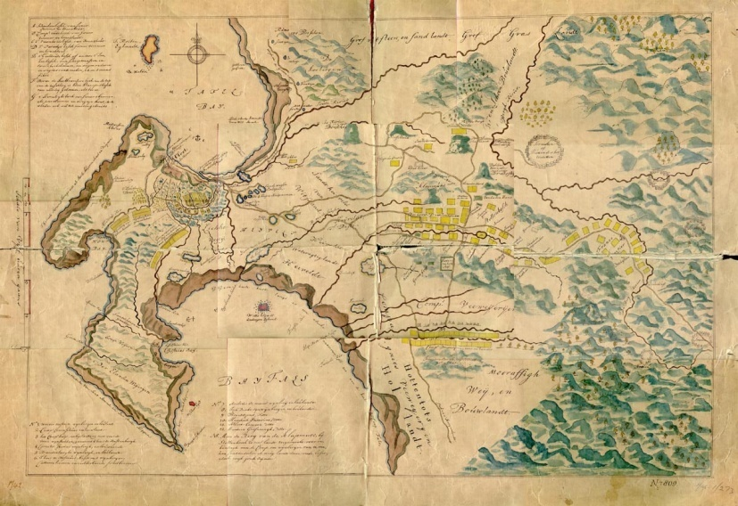
Fig. 4.10: Dutch map c 1688-1695: Cape Town and Stellenbosch districts.
Source: Cape archives CA M1/273

These frontier farms required the institutionalization and fear of violence, all conditioned by the legalized enforcements of a bundle of property rights. In this it reflects Hobbes’ ([1651]1988:186) argument that the absence of government and property underpins “a life of continual fear, and danger of violent death.” Locke ([1690] 1980:124), writing in the same year that Zandvliet was established, insisted that before a concept of property, there was “an a priori world of fears and dangers.’’ Through such processes of transference, specific places like Zandvliet became synonymous with a sense of rootedness for farmers. For these farmers, there would arguably have been a growing belief in the power of grape vines to create order in the apparently wild landscape and in wine as a provider of income and relative stability. So conceived and located within the unilaterally legitimized colonial frontier, Zandvliet’s land was seemingly securely tenured and fee-simple with regulated delivery of produce to the VOC and sharply differentiated from the apparently undeveloped land outside its boundaries.

4.3.3 Writing over indigenous communities

A density of artifacts found in the soil overlying the paleo-river terrace on which Delta is situated attests to an extended period of habitation of this site by hunter-gatherer San groups. Also using the land were the more hierarchical pastoralist KhoiKhoi communities. Initially, the Khoikhoi had been generally willing to accept European presence and to trade with the newcomers whose malnourished and disease-ridden ships’ crews needed fresh food. This changed comprehensively with the expansion of wine farms, which collectively established a new frontier in the Drakenstein area, beyond the first mountain range. At the time that land for Zandvliet was identified, nomadic groups carried their abodes around and beyond the valley, operating in an extended system of kinship affiliations and shared responsibilities. Both indigenous populations of the Cape, the Khoikhoi and San communities, were possessed of a sense of spatial inhabitance and transient mobility. These indigenous communities gathered and dispersed in response to stimuli such as climactic conditions and sustenance needs. Their movements prompted both co-operation and conflict, for struggles over specific territory seem to have occurred before the advent of Europeans in the valley in the late 17th century (Horner & Wilson 2008). Yet even so, the San who had been able to accommodate the pressure of encroaching Khoikhoi for two millennia were all but eliminated from the Cape in two centuries of interaction with Europeans. The Khoikhoi were unable to retain independent modes of subsistence on the land in the face of challenges from another agriculture-based society, particularly one that applied unheard-of land rights and was prepared to use physical and technological force to claim land for permanent settlement.

Approximately 70 years after Zandvliet was founded, hostilities over possession of the land culminated in a series of direct confrontations. The conclusion in 1739 effectively crushed possibilities for independent existence for indigenous hunters and herders who inhabited areas near colonial settlements (Horner & Wilson 2008). As the Khoikhoi communities lost watering holes and grazing grounds, so their wealth and comparative power diminished. Some continued to move northwards, but most Khoikhoi were incrementally forced to work for the Cape farmers. As the first slaves in Franschhoek only arrived in 1692, it seems likely that Khoikhoi communities were the first labourers to experience the perverse osmosis between violence and viticulture (Dooling 2007). These indigenous people were coerced into the vineyards with no recognition of either the land or their work as belonging to them (Keenan 2010). European perceptions of their mobile and apparently unsettled geographies made it possible for settlers to view the original land-users as dissonant with agriculture and to appropriate the apparently unused land for their vineyards. The indigenous peoples were displaced in “silent violence” (Lucas 2006) with the loss of land leading to their transformation from independent livestock trading partners to subordinate, dependent labourers. The following map shows that the Dutch were evidently aware of Khoikhoi kraals, depicted as small groups of triangular structures, even though they did not assign ownership to those who ranged over the soil instead of tilling it.

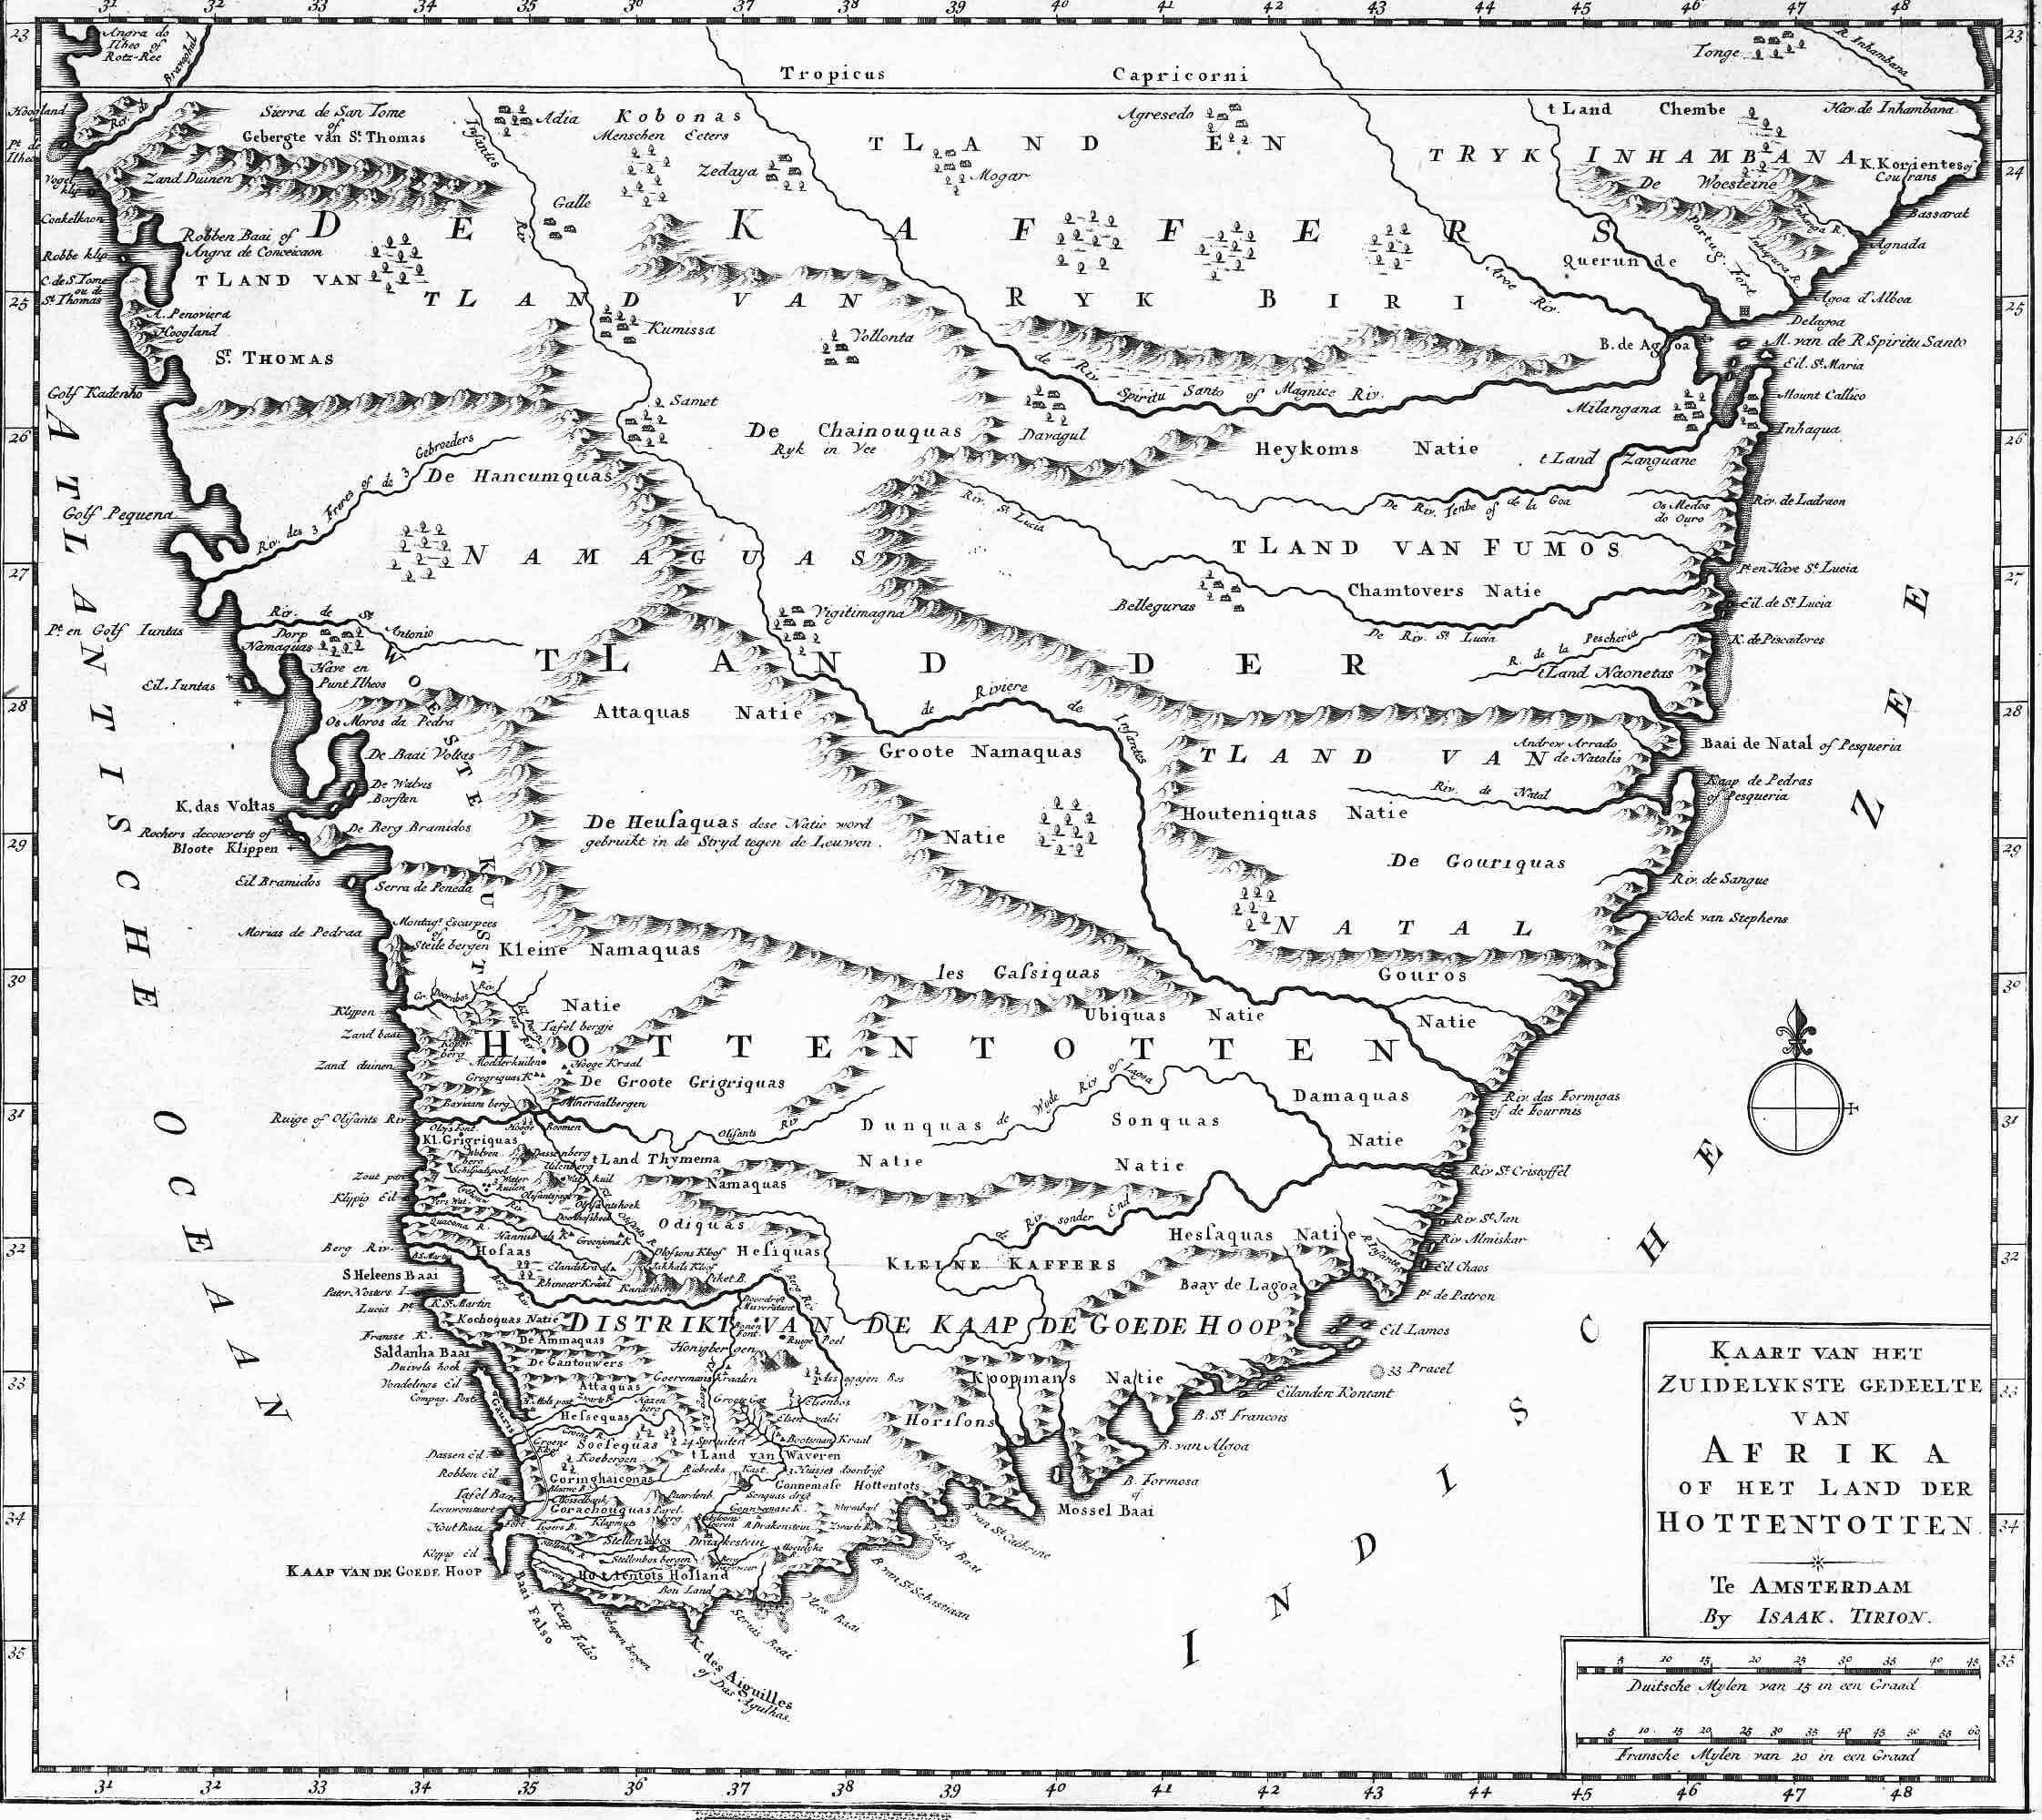
Fig. 4.11: Dutch map, Tirion 1730: Cape of Good Hope showing Khoikhoi kraals
Source: TANAP (NationaalArchief, The Hague, 4.BMF . no.471)
The degradation of indigene communities was described by John Barrow, a member of staff to the first British Governor of the Cape Lord Macartney, who travelled widely in the hinterland in 1799. Barrow speaks here of the San:
“[The Cape Dutch government] decreed that such of the Bosjemans as should be taken alive in the expeditions made against them, were to be distributed by lot among the commandant and his party, with whom they were to remain in a state of servitude during their lives “(Barrow 1806:189- 190).

The indigene people taken to work on wine farms were not only labouring bodies, but also symbols of opportunity for farmers to master in some notably violent ways. Again in the words of Barrow the contemporary eye-witness, these labourers were of less value to the farmers than slaves and thus more ill-treated:
“…..in their present condition the most wretched of the human race, duped out of their possessions, their country, and their liberty, have entailed upon their miserable offspring a state of existence to which that of slavery might bear the comparison of happiness… A farmer may beat them, cut them, fire small shot into their legs, and care little for their deaths, for though they are to all extents and purposes his slaves, yet they are not transferable property” (Barrow 1806:93-94).

Those San and Khoikhoi who sought some level of independence by working per diem or per annum on Dutch farms, commonly found themselves trapped. The most ubiquitous form of coercion was when farmers simply prevented parents from taking their own children when they tried to leave (Barrow 1806). Ironically, the prohibition of the oceanic slave trade in 1808 by parliament in Westminster played into this practice of restraint. Simple relations of supply and demand caused a spike in the price of slaves at the Cape and exacerbated the wine farmers’ persistent labour shortage. Responding to this labour crisis, the same parliament sanctioned the apprenticeship of ‘free children.’ Building upon the Dutch practice of surreptitious kidnapping, the amended Hottentot Proclamation of 1812 allowed for Khoikhoi children to be indentured from the age of eight, for a period of 10 years (Clift 1995). As a result of this proclamation, the first official register of Khoikhoi people indentured and working within the colonial boundaries was made. The Register was composed of farm-by-farm headcounts and it reflects small groups of adult labourers with children. A little family consisting of a woman named Griet with children Hanna 11, Lena 3 and new-born Joseph was registered at that time to Jan Stephanus de Villiers. The children were recorded as having been born in the Drakenstein possibly on Delta (Solms-Delta publication). Such registration was not merely a matter of demographic instrumentalization, for it drew on a societal ordering, based upon quotidian relations of domination in the way in which viticulture was practiced. Whatever their ambiguous intentions to trade rather than colonize and however determined their efforts may have been, through palisades, thorny hedges and watchtowers, to cut their outpost off from Africa, the VOC’s first grape-growing enterprise had set in motion an unstoppable process of expansion.

4.4 THE CAPE OF GOOD HOPE?

“Of Good Hope” and “of Storms,” as a wilderness and a garden, as possession and dispossession, as European and African, in these ways the Cape has been dichotomously portrayed. As described by Twidle (2010: xiv) among others, the Cape was “hardly an assured European beachhead but rather a violent slave port and backwater where the garden metaphor of succour and pastoral sufficiency would never properly take root.” The beginning of viticulture in Franschhoek does not represent an entry into an idyllic, harmonious and profitable sphere. Rather it places these settlers into strange lands and an environment that frequently eluded their understanding. These first accidental colonists were not even agriculturalists; they were soldiers and sailors who had left Europe without intending to remain at the Cape (Dooling 2007). Creating an arable settlement was no easy task for the unskilled. Also hard for inexperienced farmers was the stricture that farm loans from the VOC had to be repaid even as the VOC monopolized the market in wine and thus severely limited profits. Although there is some evidence of bartering between the Khoikhoi and the settlers in the Drakenstein valley, all informal or private trading practice was forbidden by the VOC until 1700 (de Wet 1981). Non-VOC manufacturing was forbidden and monopolistic contracts applied in most of the economic activities of the small settlement and its rural surrounds (Groenewald 2009). Moreover, as the parcels of land claimed by setters expanded this process was strenuously contested by the indigene land users. Settlements were frequently attacked by groups of Khoikhoi who repeatedly resisted their displacement, the appropriation of their livestock and hunting grounds, and their involuntary subordination and servitude in colonial farming society.

Despite it all, Cape viticultural enterprise was also fully vested in the insertion of European plants into the African earth and guarding their penetration and growth. In a similar timbre, I suggest that in organizing agricultural spaces, settlers in the valley attempted to implant their social and physical worlds. Conjoined in a similarly dichotomous way, vineyards such as those on Delta constituted a kind of suturing as they engaged with a number of trans-cultural aspects of naming and place-making on the frontier. The ecological invasion of grape vines prompted an immediate and ongoing flow of things biological and material from one to the other side of the world and into this valley, from barrels and bottles to money and slaves. This flow included linguistic dominance together with some associated aesthetics of naming and blending landforms with chosen biographies. Zandvliet means ‘sandy stream’ and the neighbouring farm of Lekkerwijn, which fortuitously translates as ‘delicious wine’ is a Dutch derivation of the surname of the first owner, Henri L’Ecrevant. Zandvliet later received the English generic geographic name ‘Delta’ so given for its surveyed physical position on a small plateau between rivers.

The viticultural frontier at the Cape of Good Hope was, borrowing Guelke’s (1985) words, "not a simple geographical phenomenon but a complex region which offered opportunities to many different kinds of people.” Amongst such diverse people were those first owners of Zandvliet, Hans Silverbach and Callus Laut (Louw) who were entered in the original title deed as “vruijluiden en makers of consorten” free men and partners or associates. Like all early settlers here, Silverbach and Laut were given a parcel of freehold land that covered an extent of 60 morgen, or 50 hectares. Not farmers, they initially lived by hunting game. Silverbach and Laut also planted approximately 3 000 vines during two years of farming at Zandvliet (CA A2250). As discussed, local economic barriers would have existed but as members of an impoverished, landless European underclass, the prospect of land and social advancement was probably still attractive. According to Fourie (2013) “…it was far better to be a poor settler at the Cape, than to be poor in Amsterdam.” So although the census of 1692 shows both Silverbach and Laut as owning only a few possessions, an improvement in their station in life was all but automatically guaranteed in the early Cape, where land ownership was considered to be the most important factor when trying to accumulate wealth and social status (Dooling 2007). So for this pair, as for most owners of Zandvliet (Delta) the battle to coax vines and a living from the land apparently seemed worth the effort. Thus situated on an agricultural frontier, Zandvliet was established at a moment that can be fixed in time and yet is also open-ended, its boundaries both determined and porous, its lands simultaneously claimed and disputed. In this way I suggest that vineyards are significant spaces of production where plants and people are tied together through deeply exploitative histories and conflictual but inter-related meanings. These differential dynamics characterize the highly-charged nature of the vineyards themselves. Rage at historic violence; guilt about unjust discriminations; acts and fears of reprisal; hopes of redemption – all these dynamics still haunt wine farming at the Cape of Good Hope (du Toit 2013).

  - WERF

“Here organisms figure not as externally bounded entities but as bundles of interwoven lines of growth and movement, together constituting a meshwork in fluid space” (Ingold 2008:1796).

A discourse of modern industrial progress has promoted Cape vineyards as positive local interventions with significant economic value. From a different angle, the geography of wine is the story of the violent production of what is a non-essential item, but to which many meanings have become attached. Thus I suggest that the spaces of a wine farm mesh many integral meanings and relational spaces (Blomley 2002). Of special interest are the intricacies between social differentialization and the perpetuation of violence within the bounds of Delta’s werf. Analogous to a walled farmyard, the werf of each old Cape Dutch wine farm had its own particular linear shape. Yet beyond its material dimensions, a werf is closely associated with a sphere of absolute authority on the part of the farmer in his space. The idea of a werf is amplified in Gaventa’s (2007:214) contention that “…power relations shape the boundaries of participatory spaces and influence what is possible within these spaces as well as bearing upon decisions regarding who may enter, with which identities, discourses and interests.” In a symbiosis of its historical meaning with its physical extent, a werf comprises a topography imbued with signs of socio-economic subjugation and structures of physical restriction.

In terms of the early freeburgher contracts, the VOC retained ‘ownership’ of the land but what each freeburgher or farmer built on the land was theirs. Thus each individual werf was, in effect, the space for personal inscription by these inhabitants. The construction of buildings meant to a farmer that he no longer stood only in a relationship of service to the Company - with the land came authority. Arguably then, each werf was, for its farmer, a means of speaking back to the monologizing master narrative of the VOC. The werf was material evidence to the farmer that he was not a peasant or a servant; instead he was a separate self, a master of his own property. Control over land arguably mirrored a sense of control not only over what was constructed and produced there, but also over those who lived and worked there, even if the farmer was not actually a landowner. A farm symbolized freedom enough to pursue an independent life. Swedish explorer and naturalist Anders Spaarman (1786:55) makes a comment in his journal:
“I went on until I arrived at the company’s farm. The steward or as they call him, the baas presented me with a glass of strong-bodied wine which was by no means adapted to quench my thirst, but the water is brackish and there is no milk…. So I took my leave of the baas – an appellation given to most Christians here, especially bailiffs and farmers…”

The notion of “baaskap” comprised an ideologically patriarchal approach to the farmer-worker relationship. It was the language communicated by the werf and these strong paternalistic communications continued to operate for centuries. Structured as a controlling mechanism, small reward was mixed with the fear and reality of physical violence that was supported by wider commercial and legal systems.

In the story of its early spaces, Delta’s original werf yields an interesting 17th century twist insofar as its first two owners were embedded in a network of freed slaves. The original owner, the absconding Silverbach, was married to a woman named Ansela van der Caab who was a freed slave. Excavations show that their original dwelling was later incorporated into a three room house that is probably that of Christoffel and Marguerite Snijman to whom Zandvliet was transferred in 1692. Fig. 4.12 shows the outline of the Snijman dwelling which was recently excavated.

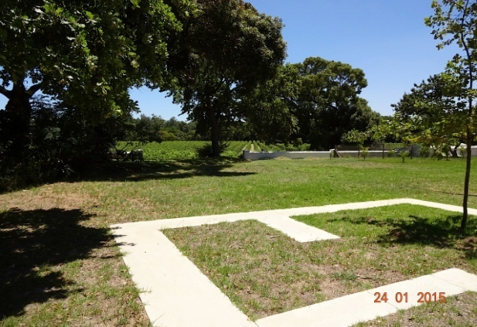
Fig. 4.12: Dwelling outline: centralized in the werf
Photo: Corrie de Blocq

The discovery of Christoffel Snijman’s home on Delta exposes a situation where race and national or ethnic origin played lesser roles in who could own what property. Indeed, building developments in Snijman’s time show that he and Marguerite expanded their living space enough to include a growing family and an increasing number of slaves. In this respect, Snijman’s story indicates that he utilized the accepted farming practices of the day that included slavery, even as he was himself the son of a freed slave (Lucas 2006). The connection between Silverbach and Snijman is not entirely clear, but it is highly likely that Ansela van der Caab, Silverbach’s wife, had befriended Snijman’s mother in the network of freed slaves in the Franschhoek area. Snijman’s mother, one Catrijn van Pallicatte had been a slave and washerwoman in van Riebeeck’s time, at the coastal fort that predates the existing stone castle. Snijman’s biological father was a soldier at the fort who was convicted in 1667 for leaving his post “te slaapen zijn ten wooenplaats an sekere bekended swarte meidjie,” to sleep at the residence of a certain well-known black girl. After her pardon, when Christoffel was about 2 years old, Catrijn married Anthonij Janze van Bengale, the first known free black to have land registered to his name (Upham 2014).

The story of Christoffel Snijman’s godmother, an Angela (Ansla) van Bengalen who started life as a chattel slave, is also enlightening. Like Catrijn, Angela had worked at the fort in van Riebeeck’s time and was also manumitted. It is probable that these two women were also friends, for there is evidence in the genealogical records that Angela witnessed the baptism of young Christoffel and that she and her Dutch husband Willem Arnoldusz Basson (MOOC 8/1.33) cared for Christoffel after his parents died (Upham 2014). One of Angela’s daughters was known as Anna de Koning, and a marriage record seen in Fig. 4.13 shows that she went on to marry Swedish soldier/entrepreneur Olof Bergh.

Fig. 4.13: Marriage register: Anna de Koning to Olof Bergh
Source: South African Dutch Reformed Church Registers, 1660-1970

The inventory produced upon her death in 1720 shows that by that time, Angela van Bengalen owned numerous landed properties including a wine farm in the Drakenstein. Her human property incorporated seven slaves – three men plus two women with a child each (MOOC 8/4.15). Both young women and their children were sold (MOOC 10/2.12). As for Angela’s own daughter, Anna de Koning was one of the wealthiest landowners in the Cape by the time she passed away (MOOC 8/5.18). The success of the ‘doing’ of property on the grape frontier was evidently contingent upon heterogeneous intersecting elements that went beyond race, ethnicity or class alone. As the stories of Christoffel Snijman, Angela van Bengalen and Anna de Koning show, the ways in which such elements link together and with a wider environment are frequently conditional upon the influences of a simultaneity of stories-so-far at any given moment.

As another instance, as soon as a slave was freed at the Cape, he or she was reclassified but not according to race, origin, occupation or physical appearance as before. After manumission it was only citizen status or gender that counted. Slaves who gained freedom were vrijswarten, free blacks, who then became visible by name in the opgaafrolle, the census/muster records kept by the VOC, together with other burghers. Freed female slaves like Angela van Bengalen who married burghers then simply blended indistinguishably into the census lists together with their children of that union, of whom Anna de Koning is an example. Like his godmother and her daughter Anna de Koning, Snijman, Zandvliet (Delta’s) second owner had a clear place within a grid that mapped out rights and denials in terms of his ownership of landed property regardless of a slave background. Indeed, the Cape archives have records of a court case against one of Marguerite Snijman’s slaves, one Adolf van Maedegascar, for attempting to commit arson (CA 324/6 1790). Together with adult children, Marguerite had to flee the homestead. The sentence passed down to her slave indicates that she did not flinch from exacting retribution concomitant with the violent justice system of the day. He was first bound to a post, then after having had his face disfigured by branding he was disemboweled, his dead body was broken on a wheel, thereafter abandoned for the birds and time to consume. The inventory drawn up upon the death of Marguerite (MOOC 8/6.95) shows that she owned slaves whom she wished to bequeath to family members. The will of Christoffel Snijman’s daughter Johanna, the granddaughter of a woman who was once a slave, also tells of wealth in this regard. As can be seen in Appendix C, upon her death Johanna owned two large farms, a house near Cape Town, a number of other smaller properties and no fewer than 34 slaves (MOOC 8/88/21). This document shows the minute detail included by assessors. Johanna’s slaves are listed last, immediately after a listing of sheep from one of her farms.
In this Cape milieu, Snijman arguably had as vested an interest in the sovereign power that secured Zandvliet’s discrete existence as any later property owners would have had. The status of the whole Snijman family would have depended upon maintaining this boundary-work. As a legal property owner, Snijman was part of the social group where a member was afforded the freedom to buy, sell, trade, and profit from anything as he chose. Through what belonged to him, he also may well have gained further social property in his status as landowner (Ahmed 2007). So in these terms, acquiring a particular characteristic of social status would not only have affected Snijman’s interactions with others but, coming full circle, it would have reaffirmed the centrality of property in his interactions with the material spaces around him (Keenan 2010). Circulating through the embeddedness of property concepts, there were mobile interstices between belonging and owning a belonging. Described by Guelke (1988) as ‘orthodoxy’ the ownership of slaves represents a move towards identifying with an ascendant culture at the Cape. The example of Christoffel Snijman and his extended family shows that heterodox/orthodox formulations contribute to a space in which where various people are included but to which they belong very differently. Wine farms have thus been deeply implicated in a discourse that reaches back into times of slavery at the Cape. Borrowing the words of Giliomee & Mbenga (2007:47), each werf came together as “the model of master and slave [that] became the model for all other relationships.”

4.6 SLAVE SPACES

According to Giliomee & Mbenga (2007:47) the early Cape was not a society “...where slave labour was one among other options; slavery was wholly integrated in the labour market, economy, the judiciary system, family life and the church.”Wine farming was deeply complicit in this structuring. Indeed the practice of owning human beings that expanded into the Cape and nowhere else in South Africa was largely due to the high labour requirements of wine production. Dependence on slave-labour even reached a point in the early 1800s where many farmers lost the practical winemaking knowledge that been passed on through generations of slaves.

4.6.1 Reclassified: replacing and renaming slaves
A defining marker of the forces of bondage at the Cape was the act of renaming. Slave naming patterns both incorporated forms of differentiated spatiality and were frequently toponymic, shifting beyond the extreme of direct violence in the slave experience to the more symbolic expressions. Put differently, renaming is where the legal ownership of slaves as property cathects power with everyday violence in a continuum of prevalence (Radford et al. 2000). A continuum does not imply that a linear straight line can be drawn between different experiences and forms of violence. Instead, “it validates the shifting boundaries between several forms of violence” (Kelly 1988:75). In showing how the symbolic violence of property can be embedded in, and even characterizes, a pattern of life, this section of the chapter briefly addresses the renaming of slaves as well as the ways in which they were reclassified.

At the Cape, the point of origin was commonly evident in slave names. For example, Christoffel Snijman’s stepfather Anthonij van Bengale would have come from India and Adolf van Maedegascar, the slave who attempted to burn the home of his widow Marguerite, was from Madagascar. In a further refinement, farmers would note such given suffixes to avoid purchasing slaves of the same culture for fear of communal plotting, or any communication in languages not understood locally. Like the genealogical isolation they suffered, name-loss was intended to wrest slaves from a former identity to another place, tradition of nomenclature and state of being. Alert to such peculiarities, Semple (1805:34) noted:
“It may here be observed that the whole heathen mythology is ransacked to find the names generally bestowed in a manner not the most honourable to those deities.... Thus Jupiter cleans the shoes, Hercules rubs down the horses, and Juno lights the fire. Yet [this] is it not done through any disrespect....as those in Scripture are applied with as little ceremony and in as inappropriate a manner, Samson being daily sent for water and Solomon up Table Mountain for firewood.”
Such a collectively codified means of reading the slave body in her/his bounded spaces must surely have internalized levels of depersonalization and differential ways of belonging. Farmers often gave such illustrious names as a joke – the slave’s status being lowly by comparison to their appellation. Someone would have had to think it amusing before inventing Domingo Aapkind (Sabbath Ape Child), a facetious name given to young dark-skinned Mozambican. By contrast, a name like Januarie simply marked the month in which a slave was registered in the Cape – this sort of generic name usually indicates a male slave. A female who worked and lived in the farmhouse had every chance of having a slave-name indistinguishable from her owners’ family names. Later I refer to female slaves who worked in the Delta homestead whose names were Philida and Candaza, such as a daughter of the house might carry.
The Cape had farmed vineyards, but no large plantations such as the sugar estates of the Caribbean islands. Worden (1985) has also pointed out that no distinctive slave culture such as those associated with larger plantation economies in the Americas existed at the Cape. With the expansion of viticulture the use of slaves became widespread, but rural slaves typically lived as individuals or in small groups on separate farms. Nevertheless, the early Cape society produced its own human cultures with hybridized identities and practices and with more vectors constituting social belonging than those obvious binaries of colonizer and colonized (Lucas 2006; Rogers 2005). Classification according to space is a common human response. However this perception of space and its representation, accomplished with signs and symbols, is conditioned by the culture of the community that produced them (Harvey 2002). Classifications at the Cape were frequently formed in terms of the relative usefulness of slave in a particular space. William Wilberforce Bird’s (1822) summary taxonomy seems to intimate how formations of identity developed as the relationship of the part to the whole in a hierarchy of specific practices, rather than by assignments of value according to race:
“The Negro… brought from Madagascar and Mosambique is the least valuable… hewers of wood and carriers of water employed by the boers and others for the hardiest field work. The Cape Malay slaves….are usually engaged in everything where what is called cleverness is required….. The last and most valuable class of slave is the produce of a European, or of a Cape Dutchman, and a slave girl….and many have progressed nearly to white….they are smart and fond of dress in which they excel. These slaves are engaged in the domestic and most confidential services of the house and ….frequently where goods are sold. The women are favourites of the mistress, entrusted with all that is valuable – more like companions; but the mistress rarely and the slave never forgets their relative situations” (Bird 1822:73).
Bird adds that the three classes of slave held themselves separate and distinct:
“The Africander slave girl would consider herself disgraced by a connection with the Negro, or the production of a black infant; and the Malays are a sect holding both the others in contempt and horror”( ibid 74).
In a similar genealogical vein, Anders Spaarman, a Swedish scientist and traveller who visited the Cape noted in his journal of April 1772 that:
“A slave born in the country, especially a Bastert, that can drive a wagon safe and well or is looked upon as a clever and faithful servant bears the price of 500 rix dollars. One newly brought from Madagascar or is not so skillful or not so much to be depended upon costs 100-150 rix dollars” (Spaarman [1772] 1975:74).
Other factors were also involved in slave categorization including differences between urban and rural slaves. Percival (1804:292) noted that material differences existed in the treatment meted out. Here he speaks of slaves in Cape Town:
“The treatment of the different classes of slaves is by no means the same. The domestic slaves at Cape Town live equally happy as our own servants, and only retain the name of slaves. The Dutch ladies take a pride in having them [female slaves] nice and well-dressed to follow them when they go to church or pay visits; they are employed to carry their mistress’s prayer book or work bag and to hold an umbrella over their heads to shade them from the sun….Few or none of them would even wish a release from this bondage, except a pretty Mulatto young woman, who may have offers of marriage from one of the inferior order of Dutchmen, or an opportunity to go to Europe to wait on a lady and her children....”

For rural slaves there were fewer spaces for social activity than for those in town. Indeed, the law of the day provided individual farmers with wide latitude as to how to treat slaves. HerePercival (1804:293) reflects on the embodied brutality that was the everyday experience of many farm slaves:
“I must say of the people of Cape Town, that they universally treat them well in comparison to the farmers. The poor creatures in the service of the latter are obliged to ....go through a great deal of fatigue and bodily labour... They are very indifferently fed and clothed. With respect to the punishing and chastising of slaves, those unfortunate creatures belonging to the country Dutch … are often beaten most unmercifully for the slightest fault. With the greatest sang-froid imaginable, one of those haughty boors sits smoking his pipe, and beholding his unfortunate slave undergoing the lash. If it is a very heinous offence, it requires more pipes than one to see it out; for it is really the case with the farmers that the punishment they inflict on their slaves is measured by the time they take to smoke so many pipes.”

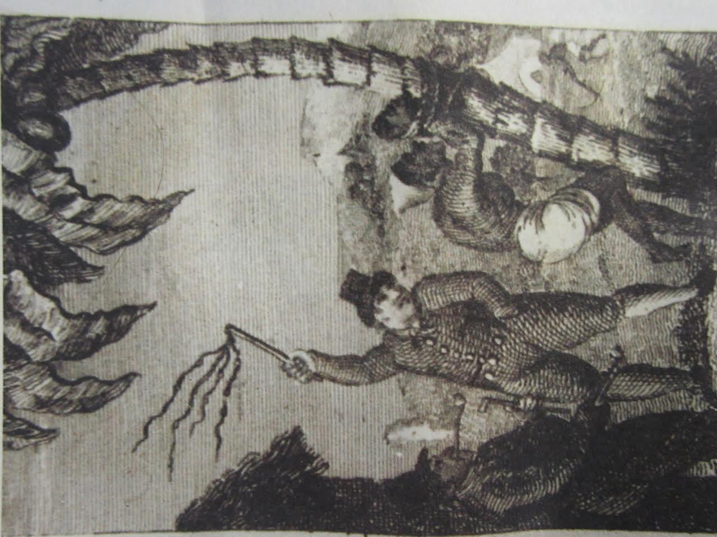
Fig. 4.14: Farmer and slave, J. Lee, 1802.
Source: National Library of South Africa.

With the major differences of their affective daily experiences also owing so much to their physical location and to the vagaries of their owners and the legal administration of the day, one can but surmise how such radically different treatments altered the individual slave’s concept of herself in the world. Indeed, much simply has to be imputed, for by contrast to the availability of evidence with which to make inferences about the stories and orientations of European and white African farmers, slave stories and perspectives are more difficult to trace. Slaves appear in censuses, registers and inventories only as property and whilst court records hold information on transgressions and punishments and Europeans even made drawings and paintings of slaves, very little of the voices of the slaves themselves is heard (Worden & Groenewald 2005; Murray 2010).

4.6.2 Landscapes of labour

Seen in Fig. 4.15, the openness of the werf on Delta, cleared of wild vegetation and situated upon slightly sloped ground, provides a heightened base to enjoy vistas of these serried vineyards today. In the 17th and 18th centuries, this area would likely have been as suitable for farmers in the surveillance of slaves as they worked in the vineyards.

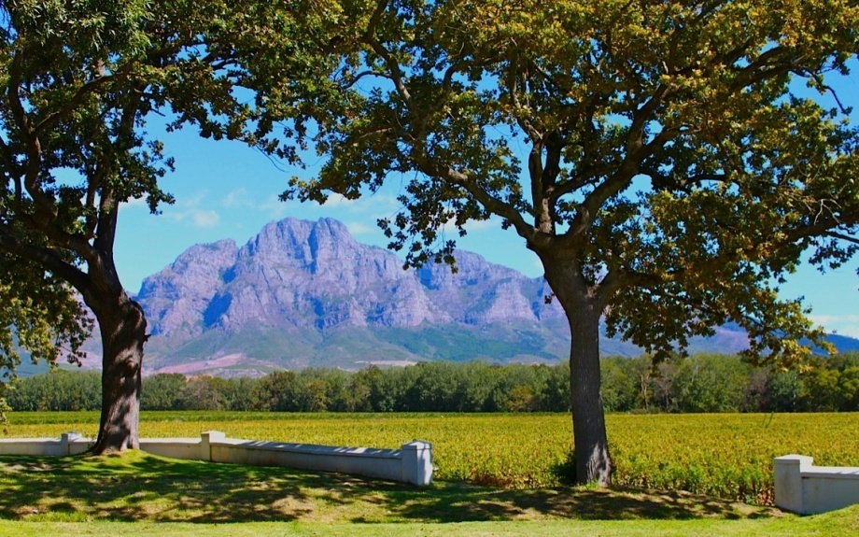
Fig. 4.15: Horizontal view from Solms Delta’s werf 2015
Photo: Corrie de Blocq

For a farmer, the werf and vineyards would have been part of comprehensive view of the valley and beyond. It is likely that he would have minutely understood the role that Delta played in trade, markets and transport systems and as well as in a network of local affiliations and kinship. To a slave, the werf might have circumscribed the entire world and it would have represented the removal of personal freedom. A slave was always in a relationship of part–whole belonging to a conjoined farming and domestic system. Her wellbeing, even her life, depended upon how she, as a part, interacted with the whole. Slaves were belongings. They were mortgageable and inheritable property. In this subject–object sense of belonging, land and assets, including slaves, belonged directly to a farmer and this kind of belonging was comprehensive.
The type of work undertaken by slaves on a wine farm was strongly differentialized. As Lucas’ (2006) typology indicates, female slaves would have mostly worked in the kitchen areas, with Asian female slaves being the most likely to have performed the more intimate, domestic duties inside the house. In Cape Dutch homesteads, the kitchen was generally situated to the rear of the house (Malan 2007). Delta is no exception, where females and slaves dominated the space such that even the farmer rarely entered (Shell 1994). If the mistress of the house physically punished a slave, the beatings not uncommonly occurred in the kitchen area, often utilizing the main table to restrain the slave and readily available salt and vinegar to rub into open wounds, referred to by slaves as ‘pickling’ (Murray 2010). The main spaces for male slaves were outbuildings and the cultivated lands on which they laboured. Male East African slaves would have probably performed most of the hard manual labour in the vineyards. In this respect, the life of a rural slave on Delta would have been cyclical, determined by the seasonality of the grape vines. Then, as now, labour requirements peak in intensity during the chaotic urgency of the harvest. Even outside the urgency of the annual harvest, life still revolves around vine cultivation and wine making with work calibrated to the maturation times of the different varieties planted. The work of the dormant months of June-August involves pruning vines and preparing the soil. Any new planting takes place in the early spring, usually September and October. As the grapes ripened, slaves’ tasks would have become those of weeding, protecting and irrigating the vineyards until they were ready to be harvested. Harvest is always at the hottest time of year in February and March, requiring long, hard days. Because of the scarcity of labour, all available hands, including family members and house-servants, picked grapes.

With an exception of the Cloete family at Groot Constantia - then, like now the most prominent wine farm in the Cape - semi-literate wine farmers did not keep notes on farming activities. Most details have been gleaned from European visitors, one of whom was Otto Mentzel, a young German man who, inter alia, worked as a tutor in the family of a wealthy Stellenbosch wine farmer in the mid 1730’s. Mentzel (1785:183) thus had opportunities to observe wine making techniques. He records that during harvest days:
“Every grapecutter had a small basket made of thin, split Spanish reed standing next to him, which when full is carried by a slave to the pressing room, or as it is wrongly called…the cellar; for it is merely a building on level ground with no windows, with its entrance facing south to prevent the sun from shining into it”.
After gathering the grapes together, the wine-making processes began. Because wooden screw presses were not available at the Cape, slaves trampled the grapes by foot to produce the juice. Mentzel (1785:183) describes a typical scene:
“A trapbalie, or barrel cut in two, which is pierced at the bottom and along the sides with many holes made with an half inch drill stands on a trestle in a second larger barrel, without holes except a bunghole, through which the must that is trodden out passes into a pail or barrel placed beneath it. A slave, or more than one, stands in the perforated barrel, holds on to a short piece of rope stretched above him and treads the grapes with which it is filled, with bare feet. The must is transferred to large vats to ferment.”
Slave labour was important in the activities of the wine cellar. Vinicultural cellar duties would have included controlling fermentation by sulphuring the barrels and transferring wine into other containers during the fermentation processes. Over time such knowledge was passed from generation to generation of slaves, with many becoming very able wine-makers. Other specific work demands were fulfilled by slaves too, such as transporting the barrels of wine to Cape Town for sale, as well as building and maintenance and hauling wood or water for household use (Lucas 2006). Into such tasks and by such demands the world of a slave on Delta would have been segmented. In this landscape of labour each slave’s space and life was defined by the werf or vineyard. The following illustration is useful as a means to infer the differentialization of a slave on Delta by the limits to his or her freedom in farm spaces (Davis 1991; Fleishman 2011).

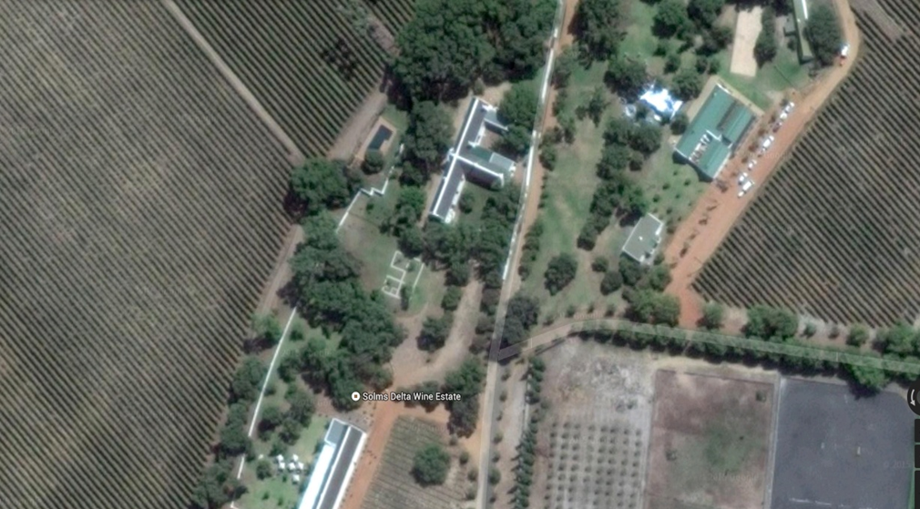
Fig. 4.16: Aerial view of Solms Delta and remaining werf
Source: Google maps (2015)

The current homestead is the large T shaped building and the early Snijman home is the U-shaped outline near the circular path. It existed in the centre of the original werf, which is partly outlined by the white wall to the left of the buildings. The vineyards are to the left and upper right of the above picture. To the lower left of the illustration is a long straight building which was the cellar and which today houses the museum and tasting room. Uncovered in this elevated portion of the werf, in same space as the earliest European-built dwelling on Delta, are the remains of a slave bell. Every wine farm had a slave bell. For, whilst the werf wall may have materially demarcated the spaces of their lives, it was the bell in the centre that controlled the movements of slaves. This was usually a ship’s bell, whose quotidian dominance was directly inherited from the VOC maritime regime. Traditionally suspended from tall, robust arch constructed for the purpose, the resonant tone of the slave bell carried far into the vineyards, audibly marking the routine of slaves, dividing each day by tasks to be performed at specific times in particular spaces around the farm.

As the early homestead at Delta typically seems to have had no separate accommodation for slaves, it can be assumed that slaves would have slept in the kitchen area, the attic if there was one, latterly in the wine cellar, or simply on the floor beside the beds of their owners. The nature of living within a household was intimate. The ever-observant Semple (1805:30) notes:
“Boer women seldom suckle their children. The prevailing practice is to hand them… to a faithful female slave who suckles them, overlooks them, and brings them up.…is a second mother.”
Yet, despite being given these responsibilities, the slave herself was always infantilized, always treated as a child. Accordingly, one might have assumed that Semple would have cast his sympathy with the slave, but instead he ends with: “Happy is he who has not sucked the milk of slavery.” His momentary comparative comment hints at what might be the internalized nervous condition of a slave-owner who was once a nursing baby and through that very process of nurturing, became an inadvertent monster. Some perverse social dynamics emerged from the integrated nature of living quarters of owners and slaves on Cape farms. Semple (1805:36) again uncomfortably ruminates:
“The children of the family mingle with the young slaves. They play with them one moment, and the next they see them beaten and in tears; but through habit the child thinks nothing of it, and waits with great coolness till his companion has done weeping to renew his play. Hence too often arises in early youth hardness of heart, a feeling for self alone, and a checking of all the best emotions of human nature. Alas! What must it be, when the child is reared in insensibility, and is permitted to make his fellows at once the companions of his sports and the objects of his tyranny and caprice?”
Slaves at Delta would have inhabited exactly such schizoid place - at once part of the family and a different type of human. In Semple’s rendering, the children are both already embedded within a meshwork of violent psychological formatting. I suggest that the children were playing out a condition of ‘ordinary suffering’ where each one was becoming oriented from a position relative to other, where she recognized herself either as belonging or as being a belonging.

It is frustrating, this need to hear a voice where there are only echoes. Some resonance exists in traces found in legal records, journals, letters and diaries. Many significant observations were made by visitors like Spaarman, who were unfamiliar with the normative social systems. As one instance, Spaarman (1786:70) describes being unexpectedly woken on a Franschhoek farm:
“I was waked here by the horrid shrieks and cries of Januarie and Februarie, who were undergoing the discipline of their master’s lash because the horses had not been found the previous evening. Soon after the family got ready for going to church……”

Knowing nothing more, the nature of such suffering remains blank to my thought. What can be inferred however is that slaves were obviously both valuable assets and abuse-able bodies. Being part of a household or of use in a production system evidently did not preclude the frequent use of everyday violence or the threat of extreme forms. Psychically fused with the dominance of paternalism many forms of violence were arguably used as mechanisms to cope with the inherent dilemma of owning other human beings who were not reducible to sum of their labours, their deprived status or their book value. Making this point, Spaarman (1786:71) continues to describe the Drakenstein farmer as someone:
“...who, in spite of a naturally good disposition was said, for trifling faults, to have beat several of his slaves to death. I could give you, Sir, many instances that the exercise of any crime ….such as the slave trade or the trafficking with the liberties of man-kind never fails to plunge men into disorders and misdemeanours of various kinds.”

Ironically, despite their structurally disempowered positions on a farm, slaves were also frequently feared and mistrusted by their owners. Indeed, as Ross (1983) contends, fear of an ‘owned other’ must be a part of any repressive social system. Certainly Spaarman (1786:73) describes the situation often. Once he mentions that:
“As the door would not lock, I set chairs against it, so that if any attempt be made on my life I might be awakened by the noise. After this I laid myself down to sleep with a drawn knife under my pillow. The many murders that to my knowledge were committed in this country rendered this caution extremely necessary.”

On another occasion Spaarman writes of a night in the Drakenstein valley, sharing a bedroom with the farmer. Five loaded firearms were placed behind the secured door to snatch up if necessary. Spaarman (1786:73) comments of this disconcerting experience:
“Even the most supportable kind of tyranny brings with it its own punishment in troubled sleep and an uneasy conscience. Slaves under even the mildest tyrant are bereaved of the rights of nature. What wonder then if those who commit outrages on their liberties should sometimes be forced to sign and seal in their blood the violated rights of mankind? Ought not my host…to fear the effects of despair upon twelve stout fellows taken from their homeland…?”

4.6.3 Small assertions of self: a dwelling perspective.

Some slaves did resist with force. Others did so without direct conflict by applying commonly used ‘weapons of the weak’ that included arson, suicide, infanticide, theft and running away. There were fearful punishments for transgressors who were apprehended, with punishments that could involve long-term restraint and extreme physical wounding and debilitation. As evidenced in the gruesome sentence passed upon Marguerite Snijman’s slave Adolf van Maedagascar, those who attacked an owner were faced with a vengefully slow and agonizing death if they were caught (Worden & Groenewald 2005). Trapped in a double-bind, slaves who resisted their enslavement simply fulfilled the European concept of savage, fuelling fear and distrust and prompting legalized violence as means of control. The self-protective quiescence of the majority of slaves would have continued to fuel their owners’ assumptions of subservient and thus abuse-able human possessions. So, either way, violence towards a slave from individual farmers or through the courts would have been justified by those in authority at the time prompted by toxic mix of domination and fear. It would have been extremely difficult for any slave to constitute a sense of self when always inside a social and legal system and never outside of a bounded physical environment or a delegated status. This relative deprivation was further spatialized in terms of gender with this sense of self being arguably even more difficult for female slaves to find or to assert (Murray 2010). I also suggest that when considered from this angle, farm space is suffused with embodied power relations and resultantly differentialized exposures to violence. For instance, male slaves were more vulnerable to extreme physical punishment while female slaves suffered more sexual abuse and bodily invasions. Insofar as private spaces for any slaves were scarce there were even fewer for female slaves. This was true even in the spaces of their own bodies. On a farm it was neither unusual nor considered reprehensible for a young white man to initiate his sexual activity with a slave woman who had no choice but to comply (Murray 2010). Spaarman (1786:70) mentions of a farmer-host in the Drakenstein area that:
“The chief of my master’s income from this farm arises from the breeding of horses. Could he keep female slaves here he would get still more by the propagation of the human species; and indeed a female slave who is prolific is always sold for three times as much as one that is barren.”

Spaarman made this comment more than six decades before emancipation of the slaves at the Cape. A tragic irony in this respect is that an intensification of the active sexual exploitation of slave girls and women at the Cape occurred only after the slave trade was abolished in the British Empire. Abolition of the trade in slaves did not occur simultaneously with local emancipation. So in a frenzied new pattern of social reproduction at that time, the bodies of existing female slaves were the only instruments for replenishing slave stock.

It is not difficult to see that the dynamics of slave existence make it problematic to access slave experiences of violence. Hutson (2002:52) refers to slaves being treated as “property with a voice.” However, the inaudibility of those voices is innate to the interpersonal structures within which the suffering of slaves occurred. Indeed, even when words seem to be adequate, as in the recording of court proceedings, full communication still fails. These recorded proceedings frequently concluded with confessions, commonly extracted through torture, or with assumptions of misdoing. What exist today are accounts which were arranged by officials of the courts in the ways that they deemed logical. The widespread instances of interpersonal violence and the fears of legalized violence at the Cape would have resulted in traumatized individuals coming to court. In this sense, the interpretive challenge of testimonies to violent events in the court records becomes even more complex because these would have been recounted by and to people who were traumatized, fearful or angry (Worden & Groenewald 2005). The stories of slave women are rendered all the more elusive by the layers of vulnerability that attend their female bodies, which were even further violated than those of male slaves. However, court records that reference Delta have yielded cases of two young female slaves and I re-tell these partial stories conscious that giving ‘speech’ to any silence is an impossible project. Yet in a small way even the attempt to do so can expose how suffering can be simplified if its power to elude is ignored.

The first story is that of a female slave named Candaza. Having worked in the household of Cornelis Isaac de Villiers and his wife Neeltjie for four years, the 18 year old Candaza took a decision to go to court and lay a charge of abuse against her owners. Her charge was that she had suffered severe physical and psychological trauma during those years. The records show that it was on 20th May 1820 that Candaza explained to the Stellenbosch magistrate (landdrost) and council:
“ ...that she was assaulted almost daily by her mistress who hit her everywhere with a broomstick or a pair of pliers; that she was constantly being called a devil, damned waistrel and beast; that she could in no way please her mistress and often had to clean the house at night. Further, Candaza contended that her mistress had …once so severely assaulted her with a knife that blood flowed from her entire body....and knocked her head so hard against a wall that the plaster came off...”

Included in her deposition was a report from a Dr. Wedemayer, dated 16th August 1819:
“At the request of the Right Honourable Lord van Rijneveld, local landdrost, I visited Candaza, female slave of Isaac de Villiers David Zoon in the local gaol and on examination she showed me a slight bruise and swelling on side of her forehead. In addition her arms, shoulders and buttocks were profusely covered in old and partly healed lesions and scars of previously administered blows.”Translated by Dr. Helena Liebenberg.

De Villiers and his wife denied Candaza’s claims of unusually cruel ill-treatment protesting that she had been beaten but two or three times and only with a length of rope. The eventual verdict was that for discomfiting not only her owners but also the landdrost, Candaza should “be condemned to close confinement for several hours then to be permanently gaoled or punished as severely as possible by employees of Justice.” After having been sentenced to yet further punishment, the young woman pleaded with the landdrost to request her owners to sell her to someone else, “… because I am being hit so badly that I look as if the crows had been feeding off me.” On 10th July 1821, Candaza was indeed finally sold to a Tulbagh farmer and as does not seem to reappear in court records, I could find no further evidence of what happened to her.

The other case of a female slave from Zandvliet (Delta) is recorded in the “Day Book and Reports of the Assistant Protector of Slaves, Case No. 405, 22nd November 1832.”
“Philida, twenty-five years, female, residing at Groot Drakenstein district of Stellenbosch, housemaid. Slave of Cornelis Brink, Janzoon, of the above place. Agriculturalist. Complaint registered by the slave herself on the above date. That her Master’s son, Frans Brink, had cohabited with her for the last eight years and made with her, four children. That the said Brink first seduced her on the promise that he would make her happy by purchasing her freedom, that she is now however sent from her Master’s place to look for another Master in Cape town, but as she was not able find one, she is now to be brought to the interior in order to be sold there, which is done to break the connection between her and said Franz Brink.”

From childhood, the slave Philida had worked as a ‘knitting girl’ for the Brink family, of whom the patriarch was a wine-merchant. She had moved with the household from Cape Town to Zandvliet when she was about 14 years old, which was her home from that time. It seems that Philida and Frans, a son of the Brink family, might have formed a genuinely affectionate relationship and her youngest child even bore his father’s first name. The court records indicate that Frans Brink had told Philida that he would purchase her freedom one day. However, in 1832, Frans Brink was to marry a wealthy white woman from Cape Town and apparently Philida was being asked to hide the fact that he was the father of her children. That denial, it seems, was more than she could bear to make and as a consequence, she was to be sold. Franz was apparently unable to help her, recorded as saying ambiguously in court that her claim referring to his promises of freedom for this mother of his children was: “… as true as it is false, that yet he could do nothing for her as she is his father’s slave….it was impossible for him to interfere for Philida had disgraced him so much with his parents…”

Frans Brink denied his involvement, claiming that the children were the issue of relationships between Philida and neighbouring slaves. For her part, Philida’s protests were conceivably an attempt to stay with the only family she knew, or to hold on to a dream of being manumitted thus making her children free people. Moreover, being sold into the interior was a fate dreaded by slaves – the further from the magisterial reaches of Cape Town or local landdrost, the more severe the physical abuse a farmer could action upon his slaves. However, the outcome of the case was that Philida was rebuked in court for wanton behaviour. She was threatened with further legally-sanctioned physical consequences if she persisted in claiming that Frans Brink had fathered her children. The following year, 1833, Philida was sold together with her two younger children to a farmer in the inland area of Worcester. Her complete inability to protect herself or to realize her own future extended also to her children.

It is impossible to know the lives of these women, the best I can do is to extrapolate something from their decisions to assert themselves in the legal system of the time. The reason for which we know anything of either of these women today is that they and these cases were recorded and then archived. Simply because of the time difference between the lodging of the claims, Philida was, I surmise, somewhat more likely than Candaza to have received measured treatment under the law of the day. Both women lived during an uninterrupted period of British administration of the Cape, but the laws regarding slave representation changed several times between the points that Candaza and Philida made their respective complaints. Court petitions are found in the inventory 1/21 in the Cape archives. This is the Inventory of the archives of The Registrar and Guardian of Slaves, 1717 – 1848. In its own underlying biography, the inventory reveals that in 1826 the officer for the inspectorate of slave registration had become the newly appointed ‘Slave Registrar and Guardian’. Then in 1830, a position for a ‘Protector of Slaves’ was made. This was followed by the institution of two assistant protectors, one for the eastern regions of the colony and one for the western regions which included Franschhoek. The ordinances passed to achieve these changes brought a newer and more enlightened rhetoric and promised amelioration in the treatment of slaves (Moodie 1960). Given the timing it seems that Philida accessed the opportunity offered by the offices of the assistant protectors of slaves. Candaza however would have had to make her case through the mainstream justice system that was profoundly prejudiced against slaves who showed any form of resistance and thus Candaza experienced a harsher outcome from her plea for better treatment.

In one sense, by accessing existing civic structures to put their cases, each woman was also ostensibly making a public announcement of her identity as a British imperial subject. For even in the very actions of querying her hypostatized difference she claimed for herself a locally universalized subjectivity before the law of the day (de Kock 2001). Nevertheless, in so doing, each woman also undeniably confirmed her own variable identity. Paradoxically, the carefully scripted and detailed court records of each case conceal something important - a mobility of self. Although in neither case did the conclusion of the legal process offer Candaza or Philida a release from her pain, each woman shows initiative and a sense of self that is separate from her bound position in life. Paternalism, infantilism and normative violence may have been internalized by the slave owner, or farmer. Yet despite being dependent for shelter, food, clothing, indeed life itself, there were arguably at least some fissures insofar as slaves on wine farms did not all live or think in a way consistent with their status as mere possessions. Making an official assertion of wrongdoing on the part of her owners would have taken courage and persistence on the part of a woman who had little education and no legal independence or physical freedom. The faint trails that we have now of the lives of Candaza, Philida and others, are traces of how different people placed, grounded, constructed and contested their experiences on Delta. Even enslaved, humans can and do purposely adapt or contest the roles that have been assigned to them (Blomley 2003).

Vitally, the lives of these two women, like those of dozens of other slaves, were lived on Delta’s land. They dwelt in Delta’s spaces. So here, at the conclusion of this chapter, Ingold’s idea of dwelling that initially guided my methodology helps to account for the existence of different, constantly overlapping spaces. As Ingold (2005npg) insists, “fundamental to the dwelling perspective ….is that the production of life involves the unfolding of a field of relations that crosscuts the boundary between human and non-human.” In effect, dwelling is: “the manner by which [we] are on the earth” (Vycinas in Cloke & Jones 2001:652). I align with Cloke and Jones (2001) as they conceive of Ingold’s concept in two ways. Firstly insofar as an exploration of ‘dwelling’ helps to account for the rich and intense making of the world, I suggest that Delta is an outcome of a meeting up of such divergences - geological and climactic events, cultures, political designs, economic strategies, environmental, technology and information. However Ingold himself says dwelling should not be understood to be “too cosy” (Ingold 2005 npg). So secondly, I suggest that this chapter has shown that such richness of dwelling does not necessarily mean it is desirable in nature, but indeed that it can take bitter and tragic forms. In this sense of dwelling, this chapter has provided a context for a number of stories-so-far within amalgamations and intersections of violence are seen to exist, coalesce and fracture. Overall this chapter shows how in the making of wine, various groups of people came to live on the land and within the werf of Delta, inhabiting the same spaces but very differently. The inquiry has been directed towards a range of social and material infrastructures on the farm and in understanding how these infrastructures can generate the peculiar power relations constitutive of Delta’s history as a slave economy. The next chapter raises further questions about such relational processes through the stories of two families who owned Delta. These stories show a paradoxical polar blend of hybridizations and displacements in which violence is integrated.

CHAPTER FIVE

A GLORIOUS BASTARDISATION?

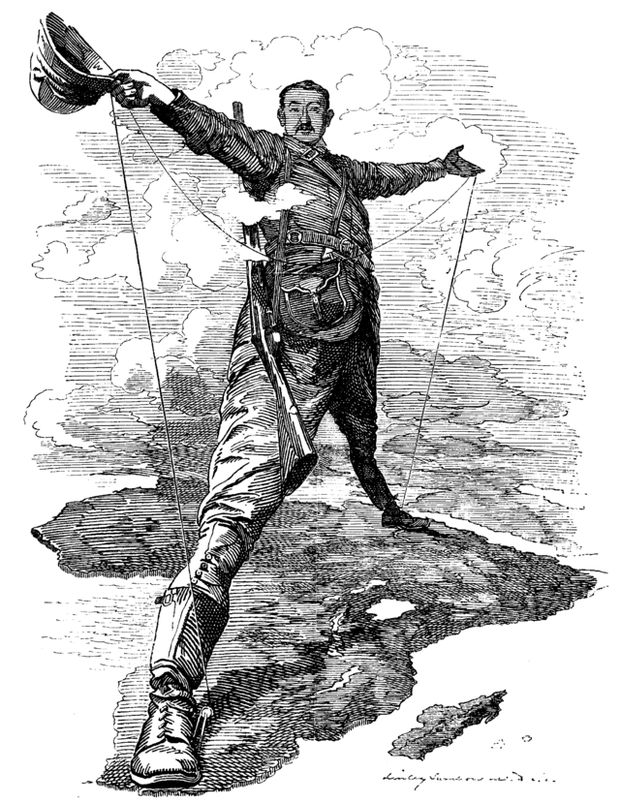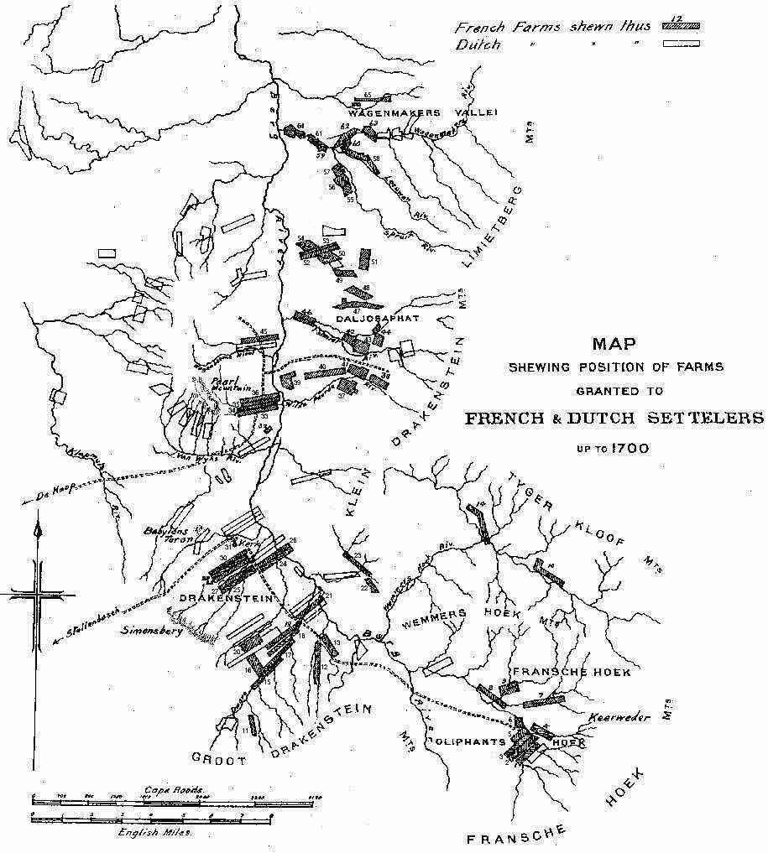
Fig. 5.1: Rhodes colossus Fig. 5.2: French and Dutch farms 1700
Source: Punch (Dec 1892) Source: Botha (1921)

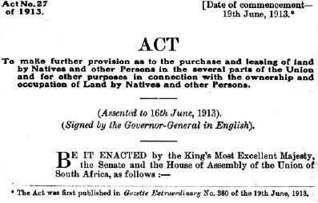
Fig. 5.3: Natives Land Act 1913
Source: “The Centre for African Studies” UCT

“What I want to write about is the….penetration, coupling, mixing, separation, regrouping of peoples and cultures…the glorious bastardisation of men and women mutually shaped by sun, wind and soil…and everywhere is exile; we tend to forget that now. The old ground disappears, expropriated by blood as new conflicting patterns emerge.” Breyten Breytenbach (1999:35) DogHeart: a memoir.

5.1 INTRODUCTION

This chapter focuses a high resolution lens on the stories of two families: the de Villiers and the Pickstone families who owned Delta at different times. Each family in its own way became integrated and even legendary in Franschhoek valley. Their stories entwine with those of the communities of coloured farm labourers upon whom their viticultural enterprise in the valley depended. As the title indicates, this chapter takes the South African writer Breyten Breytenbach’s notion of bastardization as its inter-referential metaphor. I use the nuanced Afrikaans sense of “baster” which implies a depth of dissemination and a richness of mixing, rather than the straitlaced, prejudicial connotations of “bastard” in English. The processes of bastardization at the Cape comprise far more than a common location of peoples of different origins within a global positioning system. This chapter seeks other convergences, while understanding that even explicit co-mingling does not necessarily improve an inequitable situation and can also open new spaces for social asymmetry and visitations of violence (Tsing 2005). For, as Lijnders (2012:5) contends, “frontiers of violence do not necessarily cease to be violent once they are crossed. [Instead] they continue to exhibit power structures and create insecurity.”

Piecing together the material for this chapter took longer than for any other. The effort of learning one of an historian’s skills was offset only by the discoveries of tiny slices of life in the archives, maps and photographs. There was also the frustration of not finding or knowing any more. I found that this rewarding but unsettled process has reflected what de Kock (2001:272) refers to as “the dialectics of ‘here’ and ‘there’ that have haunted South Africans for so long now that we can justifiably point to thoroughly interstitial identities.” This chapter demonstrates then the paradoxical ease and difficulties of bastardization processes in these interstices. In one old-fashioned sense, bastardization can be as swift an act as Franz Brink transmitting semen into the body of the slave woman Philida. Vine bastardization too can be equally obvious and imposed. To recall, the VOC’s initial batch of vines rotted en route to the Cape, but the second consignment of either French or Spanish stock was quickly and successfully implanted in African soil. The foreign rootstock grew into vines and produced fruit. From that time, the lively materialities, sensitivities and vagaries of grape vines, including the diseases that affect them, have interacted with the lives and livelihoods of humans in the valley. Indeed, swift and simple acts do not predominate in creating a viticultural “baster.” Instead what comes to the fore are the complexities of growing grapes and making wine, all interconnected with the social integration of people outside of any normative matrix.

In South Africa, differently to most other former British colonies in Africa, the majority of settlers, of mixed European origin, stayed in situ after independence. Many were deeply emotionally attached to the land. Unlike settlers in former colonies like Canada or Australia though, the descendants of European settlers in South Africa have remained in the minority. They have been demographically divided amongst themselves as well. Of the two families discussed in this chapter, the de Villiers family is of farming French/Dutch origins whilst the Pickstone/Rhodes heritage is colonial English. It is along these same language and cultural lines that generations of white South Africans have felt separated. In the 20th century, active divisions became particularly entrenched after 1925 when Afrikaans replaced Dutch as the alternate official language in South Africa. For the first time Afrikaans-speaking whites achieved an organized modality of communication that was articulated around a bitter anti-British republicanism (Foster 2008). To this day, English-speaking whites are regarded as less connected to the African soil by whites of an Afrikaans background and thus more likely to betray the motherland by taking flight when times are hard. South Africans are conscious that they co-exist without a common language, ethnicity or religion, with no joint notion of property and little mutual loyalty to a nation. Even the concept of a community, often regarded as a positive notion, fragments under closer inspection in this chapter. As du Toit (2005:12) puts it, a community is at best “an imprecise term referring in part to social relations between individuals and within and between groups.”

In the absence of any cohesive matrix as an analytic scale, evidence of some other type convergence is necessary. So in the second part of this chapter, the stories of these two families are reconsidered in the light of the mutations and transformations that each family has wrought in Delta farm spaces. This approach aligns with that of Das, Kleinman et al. (2000) who suggest that it is the inter-subjectivity that develops from being rooted in the same historical and structural situation that constitutes a shared sphere of cognizance and practice. Following their cue, I suggest that processes leading to “bastardisation” as well as to the “new conflicting patterns” described by Breytenbach, cause new communities to be formed where relations of inter-subjectivity develop. I suggest that even where direct and embodied violence is not immediately visible, the structural and symbolic violences of oppression and differentialization are nevertheless discernable in these communities.

5.2 THE DE VILLIERS: a Huguenot family

In a flurry of letters dating from late 1687, the Heren XVII, the VOC directorate, informed Commander Simon van der Stel that French religious fugitives were to be re-homed at the Cape. This group of Protestant dissidents known as Huguenots had fled to Holland to avoid persecution after the revocation of the Edict of Nantes. Amongst the new inhabitants being passed on to him, so van der Stel was told, he would find wine farmers to fill the gap so much complained of by him in terms of expanding viticulture at the Cape. Commander van der Stel was instructed to supply the new immigrants with what they needed to subsist until they were settled enough to earn a living. These fugitives, the directorate said, were “destitute, but industrious and grateful for aid” (Letter, 16/ 11/ 1687 from the Chamber of Amsterdam. CA 512 in Botha 1921).

The ‘Oosterlandt’ one of the first Dutch ships carrying refugees reached Table Bay on 26th April, 1688. Of the 24 Huguenots on board was the merchant Jacques de Savoy of Aeth with his family. His older daughter Marguerite later married Christoffel Snijman and this couple became the second owners of Delta. Aboard the ‘Zion’ arriving at the Cape on 6th May 1689, were three French brothers Pierre, Abraham and Jacob (Jacques) de Villiers, bringing a message from the Heren XVII:
“With this ship (the Zion) we have permitted the following French refugees to sail to the Cape and earn their living as freemen, Pierre de Villiers, Abraham de Villiers and Jacob de Villiers, all three brothers born near La Rochelle. We are informed that these persons have a good knowledge of laying out vineyards and managing the same, and thus we hope that the Company' will acquire their good service. You are recommended to give them a helping hand.”(Letter, 16/12/1688 from the Chamber of Delft. Botha 1921).

Unlike many of the early Dutch settlers, the French immigrants were educated enough to read and write. For refugees attacked for their faith and stripped of their assets in France, the thought of religious freedom and the opportunities to become landowners at the Cape might well have beckoned enticingly. However, like the release of the Freeburghers before them, the freedom given to the Huguenots comprised only one of many tactical economic decisions taken by the Company. That the collective VOC eye was firmly on the financial bottom-line is evidenced in an extract from a letter taken from Botha (1921) dated 16th Nov. 1687 from the Heren XVII to the Cape, discussing the advantage to the Company of the Huguenot arrivals:
“As soon as the Freemen referred to have increased numerically, the result will be that the garrison at the Cape may be diminished, as it has always been a heavy tax on the Company's resources. If it were to be calculated how much the Cape has cost, although until now it has served solely, or principally, as a refreshment station for passing vessels to or from India, it would amount to an immense sum, and therefore such measures as are likely to reduce the expenditure for the future must be considered.”

Despite such official hopes, van der Stel became rapidly disillusioned about the profitability of his new citizens. He wrote to the VOC to complain of the extreme poverty of the French refugees and that he had to support them by means of the local poor fund (Letter, 22/4/1689 to Batavia. CA 755 in Botha 1921). Van der Stel was also apparently annoyed that the Huguenots were recalcitrant about learning the Dutch language and customs. He complains that their wispeltuurige, fickle, nature still clings to them and that they are like the children of Israel, who, fed by the hand of God in the wilderness, longed for the onion pots of Egypt. Nevertheless, in a note dated 12th June, 1690, van der Stel confirmed to the Heren XVII that, after the inevitable deaths from conditions on board ship, 150 women men and children in total had arrived. He added that the refugees were living chiefly in the Drakenstein region deliberately dispersed amongst the Dutch farmers (Letter, 12/6/1690 to the Chamber of Amsterdam. CA 755 in Botha 1921).

5.2.1 Growing a dynasty

Although destitute upon arrival, the de Villiers family was apparently much determined to succeed in their new homeland.The trio of brothers took up adjacent plots of land which they nostalgically named Bourgogne, Champagne, and La Bri. However Abraham de Villiers soon sold his farm Champagne and relocated towards the Drakenstein side of the valley by buying up cheaper farms there. Among these farms was Meerust acquired in 1702, which is part of Delta today and also Lekkerwijn, bought in 1716, which was also once a part of Delta.

Together with the very large farm Boschendal, purchased earlier in 1701, these farms comprised almost a quarter of freehold land in the valley – a total of about 500 acres. It seems that Abraham de Villiers was important enough to have his farm marked by specific name on a map dated 1710, of which Fig. 5.4 below is a copied section.

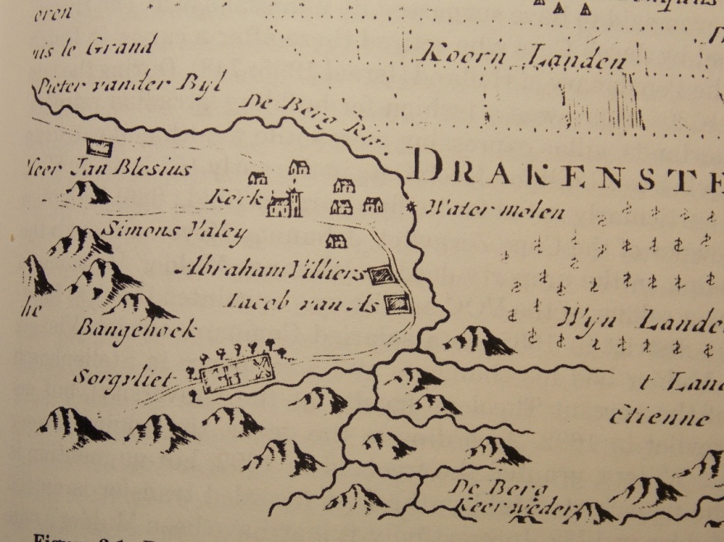
Fig.5.4: Section of a map: ‘Drakenstein en Het Land ‘t Waveren’
Source: Cape archives.

Ultimately moving far from being a small impoverished group of refugees, the extended de Villiers family built upon their predecessors’ early scramble for landed property and compounded its value over years to become the strongest dynasty in the Drakenstein valley. A census report from 1850 shows that, without counting any of the families into which they had married, 32 of the 97 Huguenot families living on farms west of the Berg River, had the last name de Villiers. By intermarrying frequently, the Huguenot families Taillefert, Gardiol, and de Villiers created a big clan. Pierre de Villiers for instance fathered 25 children, even living long enough to witness his 100th grandchild being baptized. Church registers in the Drakenstein indicate that the brothers de Villiers baptized offspring frequently. Appendix E is one example. It is a copy of page 2 of the baptismal register from the Huguenot’s Drakenstein French congregation: Le livre de Registre des Enfáns. Qu'on á Baptize dans Nôtre Eglise françoise de drakestein. Du depuis le 29'. a'oust l’annee 1694.

Before he died, Abraham sold Boschendal to his brother Jacob, who then also moved to the Drakenstein. It is likely that the two brothers, who were also brothers-in-law having married a pair of Huguenot sisters Suzanna and Marguerite Gardiol, were on good fraternal terms. It is equally probable that Abraham came to a mutual agreement with his brother Jacob, to ensure that his properties remained in the de Villiers family, for his only surviving son seems to have been unable to farm (Krzesinski-De Windt 2002:412). In Abraham’s inventory, his son Jacob is described as gebrekkelijk, meaning infirm. So Abraham’s wife Suzanna inherited his two remaining farm properties Meerust and Lekkerwijn (MOOC8/5.50). Later, upon her own death in 1729, Suzanna left the properties to Jacob, Abraham’s brother, who promptly gave these to farms to one of Abraham’s daughters, a Marie de Villiers. Although the trail is unclear because the owner at the time was listed as Marie’s husband, Johan (Jan) Schabort, Meerust and Lekkerwijn were eventually both passed back to one of Jacob de Villiers’ sons, Jan. Jacob the father died in 1735 and later, upon her death in 1749, his widow Marguerite left Boschendal to her son Jan. Thus Jan was charged with keeping in the family all three farms once owned by his uncle Abraham de Villiers.

Although their French language disappeared under pressure from the Dutch administration, the Huguenot families in the valley adopted a strongly non-integrationist stance when it came to owning property and to marriage. Such family strategies took advantage of Roman-Dutch law applied in the Cape as in the Netherlands where a widow inherited half her husband’s estate with the remaining half divided between their children. Unlike the English law of male primogeniture, this allowed females to inherit and to keep property in their own right. As J.M. Coetzee writes in “Dusklands” (1974):
“Dutch girls carry an aura of property with them. They are first of all property themselves, for they bring not only so many pounds of white flesh, but also so many morgen of land, and so many head of cattle, and so many servants.”
Giliomee (2010) points out that a widow who had been left half the estate of a wealthy farmer could consider the options for a subsequent marriage just astutely as a modern investment manager might do today. Indeed, a number of widowed Cape women remarried several times, accumulating small fortunes in the process. In the case of the de Villiers family, this aspect of the law was more than once used a means of uniting farms into a large swathe of agricultural land. The British administration disliked the precedent but the Cape Dutch had integrated partible inheritance with their culture and refused to consider alterations.

The multi-generational bonds of Huguenot marriages made for strong alliances when it came to property ownership in the valley. Evidence from the Cape archives indicates that Jacob’s son Jan was as ambitious to expand his family’s land holdings as his uncle Abraham had been. Jan purchased the big estate of Nieuwendorp in 1724 and in so doing he doubled the family’s collective holdings to about 1125 acres, thereby coming to control almost half the farmed land in the Drakenstein valley (Lucas 2006). Approximately a decade later, in 1735, one of Jan’s brothers, named Abraham like his uncle, acquired another expansive estate, adjoining Nieuwendorp, which was called De Goede Hoop (Lucas 2006). Like their father and uncle before them, these two brothers of the second generation of de Villiers married sisters of another Huguenot family. Jan and Abraham wedded Elizabeth and Suzanna Joubert respectively. Despite the different surname, the women were apparently already blood cousins before becoming connected by marriage. Their mother was Suzanna de Villiers, a daughter of Abraham de Villiers (MOOC 8/5, 51). In another, not untypical, intergenerational strand to these particular connections, the Joubert sisters’ paternal aunt, Louisa Joubert, married Jacob, the brother of Jan and Abraham, thus also becoming their sister-in-law.

A notable exception to the Cape Huguenot resistance to marrying outsiders was the union between Marguerite de Savoy and Christoffel Snijman. As noted, Marguerite was a daughter of the well-known merchant Jacques de Savoy but Christoffel was the son of a freed slave and an itinerant Dutch foot-soldier. Yet nothing found in the archives or in associated commentary indicates that there were social barriers to this union. The couple had nine children before Christoffel died in either 1706 or 1707 and Marguerite seems to have remarried before 1708. Because of the imbalance of genders, women who became widowed remarried very quickly at the Cape. Marguerite, then about 36, married Henning Villon son of a French-Dutch father and Dutch mother, making her also an early ancestor of the widespread Dutch/Afrikaans family Viljoen.The following year, Marguerite’s oldest surviving child Catharina, married Johannes Viljoen, who was the brother of her mother’s new husband. Henning Villon died in 1713 and the inventory drawn up at his death shows that the farm was definitely producing wine by this point. On 23rd Oct 1735, after 42 years at Delta, Marguerite sold the farm to Bernardus van Nieuwkerken (TD2268) who later sold it on to his brother, Johannes van Niekerk on 22nd Jan 1743 (TD2538). Johannes’ widow, Anna van Staaden married a Jurgen Heinrich Engela in 1746. Engela, like the first two owners of Zandvliet was German. Originally a hired soldier, Engela seemed to take well to his new station in life and he continued to farm successfully at Zandvliet after his wife’s death in 1753.

5.2.2 de Villiers at Delta

Jurgen Engela sold the farm on 25th April 1771 to Jan de Villiers, son of Jacob who was one of the original immigrant brothers (Smuts 2012). Tangentially curious as to why Engela sold Delta to someone outside of his own extended family-circle, I went back to the TANAP archives. I followed the marriages of Anna van Staaden through the inventories drawn up upon the deaths of her husbands and of herself. Engela was apparently her third husband. Van Staaden’s deceased first husband had left her with three young sons and two daughters from his own first marriage. During the time that she was van Niekerk’s second wife, Anna van Staaden had two sons with van Niekerk. These little boys were aged only 3 and 2 at the time of his death. Then the union of Anna van Staaden and Jurgen Engela produced a girl and a boy who were barely toddlers when their mother died. Given the potential for multiple claims and responsibilities, I surmise that Engela deemed it best to sell the farm (MOOC8/6.78; MOOC8/7.30). Delta then became part of the de Villiers family holdings. Please see Appendix D for a sketch of the de Villiers owners of Delta then still Zandvliet.

Jan de Villiers’ second wife, Gertruida, outlived him and on August 1st 1799, during her lifetime, she passed the farm on to Jan Pieter de Villiers, who was the husband of her daughter Anna Susanna de Villiers (TD7716). Within four years of taking possession of it, Jan Pieter sold the farm to his wife’s nephew Jan Stephanus de Villiers in 1803, (TD56). At the time of this transfer, the shape of the farm took on new material dimensions as it also incorporated Lekkerwijn (Smuts 2012). Jan Stephanus de Villiers was a grandson of Jan de Villiers the first de Villiers owner of Zandvliet. In a little family twist found in the TANAP archives, Jan Stephanus’ wife Catharina was the daughter of Willem Petrus van Niekerk. This Willem Petrus van Niekerk was the older son of erstwhile owners of Delta, Johannes van Niekerk and Anna van Staaden, one of the little boys who lost his father early in his life. Willem Petrus at that point farmed next door at Lekkerwijn. Jan Stephanus de Villiers was presumably a successful wine farmer with some financial resources, because according to investigating archeologist Katie Smuts (2012), recent deconstructions show that he embarked upon a definitive change of shape of Zandvliet’s werf during his ownership. It is possible that he was responsible for a second cellar expansion, likely to have housed a farm manager. From this we can assume that the farm operation was successful and profitable. This expansion increased the cellar to its current footprint on Delta (Smuts 2012). This same building now houses the Museum van der Caab and the wine tasting room. It was probably Jan Stephanus de Villiers who built what is the northern portion of the current homestead too. This part of the house is the same distance north of the ruin of what was Christoffel and Marguerite Snijman’s original house, as the cellar is to the south. The particularity is in keeping with the Dutch concept of a linear and proportional werf (Smuts 2012). It follows that the Snijmans’ homestead still stood as the main residence, centrally located between these two outbuildings. Jan Stephanus kept Zandvliet for 11 years before finally selling the property to his cousin Isaac Cornelis de Villiers (TD 91) on April 22nd 1814.

Isaac Cornelis also oversaw several changes to the werf, including the rebuilding of the cellar following a fire that gutted it in the early 1800’s (Smuts 2012). Isaac Cornelis de Villiers may have also demolished the original dwelling in the centre of the werf which likely no longer fitted with his own designs (Smuts, 2012). Apparently wealthy enough to make his own mark on the farm, Isaac Cornelis possibly extended the southern part of the homestead. Given that, as will be discussed later, the British government had granted preferential tariff dispensations for South African wine in 1813, I suggest that Isaac Cornelis may have benefitted from a brief uptick in business, before rapid vineyard expansions and local wine gluts crashed value in the industry. Nevertheless, however visionary they may have been about developing Zandvliet as a farm, Isaac Cornelis, and his wife Neeltjie (Johanna) in particular, were evidently exceptionally harsh slave owners. It was this pair who had so severely abused the slave Candaza in this renovated farmhouse that she became desperate enough to ask the court if she could be sold away from Zandvliet.

On Dec 5th 1823, Isaac de Villiers sold Zandvliet to a Cornelis Brink. However on closer inspection, this sale did not constitute Zandvliet’s exit from the collective property portfolio of the de Villiers clan (Brook Simons & Proust 2000). At the time of the transfer, the farm was large. It is described as comprising parts of the adjacent farms known as Lubeck and Lekkerwijn together with Zandvliet and a piece of perpetual quitrent land (Smuts 2012). Although Brink acquired the farm through his wife’s connections, his own family was also in an excellent position to ensure the success of this venture as three of his cousins were wine merchants in Cape Town and Brink himself sat on the Cape Wine Trade Committee (van Zyl 1987:81; Smuts 2012). The same Frans Brink who had children with the slave Philida was a son of this Cornelis Brink. Indeed it was Cornelis himself who insisted that his son marry a wealthy military auditor’s daughter from Cape Town. For her perceived insolence in protesting that Frans had fathered her children, Cornelis sold Philida together with two of his young grandchildren. Philida could not have known that barely a year after she was sold upcountry in 1833, she would finally gain the freedom that she was promised and denied by Frans Brink. The British government finally abolished slavery in the Cape in 1834, thereby releasing Philida and thousands of other slaves.

The Slave Abolition Act of 1834 was designed to limit financial losses to farmers, but compensation was paid by bill of credit in London, and few farmers were in a position to make that journey. Philida was one of 35 745 slaves recorded as living in Cape Town and the winelands in 1833, with a collective value estimated by Compensation Commissioners to be approximately £3 million at the time of emancipation (Dooling 2007). Many farmers also had their slaves heavily mortgaged as well as their land and creditors were swiftly calling in their loans on the slave mortgages. Thus the wine industry at the Cape entered the era of emancipation in a state of recession. Indeed, for Cornelis Brink, who had owned as many as 40 slaves at emancipation, the cost of paying for labour after slave emancipation proved to be too expensive to absorb. Without doubt, emancipation caused a drop in wine output and concurrently in the value of land. Moreover it is clear that by the time of emancipation, the wine farmers had not completely recouped after the crash of the wine industry that followed the British government’s decision to remove existing preferential tariffs on Cape wine in 1825. Dooling (2007:139) cites an article in the South African Commercial Advertiser (1842) expressing local popular sentiment:
“Instead of a benefactor, the man who introduced the vine here has been in fact the greatest enemy the Colony ever knew. And next to him was the British minister who poured the poison of protection into the Cape vineyards.”

So it was that Brink was declared insolvent in 1834, the same year that slaves were emancipated in the Cape. Zandvliet by then had taken on the material dimensions of what would probably have been considered a substantial wine farm. The inventory prepared at the time of Brink’s insolvency describes the house as having a hall, passage, four rooms, a pantry and a kitchen with two out-rooms, annex and two slave apartments. A relief on the farmhouse gable reads 1831. This dating method was common practice, marking a significant overhaul of a house. The date means that the renovations took place under the auspices of Cornelis Brink. According to Smuts (2012) there was a large wine store and a new stable in Brink’s widened werf. The farm had around 100 000 grape vines. Having to sell it all might have been a huge blow for Brink, but in the end, his insolvency was to create less upheaval than might be imagined. Brink was forced to relinquish the insolvent farm at auction on 12th June 1835, but the purchaser was none other than his sister-in-law, Elizabeth Sophia de Wet. For Brink was married at the time to Johanna Maria de Wet whose sister Elizabeth Sophia was married to Jacob Stephanus de Villiers, Isaac de Villiers’ brother. There are scribbles on the transfer deed indicating that Elizabeth Sophia de Wet had borrowed money from various neighbouring farmers to buy Zandvliet. The wider community was evidently involved in retaining Zandvliet for the de Villiers. Elizabeth Sophia remained next door at Lekkerwijn, while her sister and husband Cornelis retained occupation, if not actual ownership, of Zandvliet (TD199). The transfer of ownership of Zandvliet was evidently intended as a measure to keep the farm in the family. Indeed, in 1837, presumably back on his financial feet, Cornelis retrieved ownership of Zandvliet from his sister-in-law (TD 436). In his work on slavery and emancipation in the Cape, Dooling (1999:215) describes such a meshwork of entrenched connections as a “moral community” where those who belonged were buffered against the volatile effects of participation in a wine economy. In this way Dooling argues that Cape landowners were heirs to a small, well-integrated economy where the circulation of landed property and other accumulations of wealth was governed by community traditions that were understood in extended familial terms.

The Slave Abolition Act had made allowance for a period of adjustment to a wage labour system which in reality amounted to little more than enforced apprenticeship for former slaves on wine farms. Most ex-slaves lived in poverty, unable to build up assets and never having known a home than a particular farm. Losing a home on a farm also meant losing existing social capital in the farm community which many were loath to do (Dooling 2007). On his second attempt at farming Zandvliet, Brink seemed to have managed the changeover in viticultural labour somewhat better, because he kept the farm until 1849 when he transferred part of it to a son. It is probable that he, like other wine farmers continued to benefit from the situation of those freed slave men and women who had no options other than to labour on wine farms, only partially paid in wages. Commonly these labourers worked in return for use of the land, housing, clothing, food, and were still given the daily supplies of free wine. For some in the Drakenstein, however there was an option to move to a mission station which provided them with land and their own homes (Dooling 2007). Historian Tracey Randle (pers. comm. October 2011) says that of the 44 freed slaves living at Pniel, the mission station closest to Delta, only one is recorded as still working there at the time of transfer by Brink to his son. How many workers still lived on the farm itself is unclear.
From the wine farmers’ perspective, emancipation added a scarcity of labour to the earlier negative turns of events for them. Dooling (2007) describes a ‘vortex of misery’ for wine farmers. The depreciation of landed property by the 1840’s had become stark, especially “… in the value of all farms whereupon the vine is the principal object of culture.” Wine farmers were so deeply embattled that it is conceivable that for his son to viably retain a part of the farm, Cornelis Brink had to sell off a portion of his land. Title deeds show that when Cornelis Brink transferred Zandvliet on 9th August 1849, the farm was split into two portions. The smaller part went to son Daniel Brink (TD1255) and the larger part to a Johannes Jeremias du Plessis (TD1256) who renamed his new property ‘Delta’ for the confluence of rivers bordering his new parcel of land. At this point in its story, the farm finally passes out of the ambit of the de Villiers clan.

It seems that du Plessis was a man of some means for he not only took the portion of land with the wine cellar but he also undertook numerous alterations (Smuts, 2012). This occurred at a time when, as noted, most wine farmers at the Cape were still financially reeling. Du Plessis sold the farm in 1879, to Willem Adolph Joubert (TD637) who lived at Delta for 13 years. Joubert sold the farm after a destructive outbreak of oidium, a powdery mildew, receiving barely half of what he had paid. The purchasers were local businessmen, Frans Kuffner and Louis Malzer (TD6268). Sadly for these entrepreneurs, the year 1886 was noteworthy in the biological history of the Cape wine industry for the massive phylloxera epidemic that devastated many vineyards. Repeated subterranean attacks by this root aphid decimated the wine industry for years and despite considerable efforts Kuffner and Malzer could not make Delta profitable. They were not alone in the valley where the wine industry had been all but destroyed by vine disease. Indeed, of the estimated 214 652 vines infected, 80% of these were in the Drakenstein (van Zyl 1984). So Delta was eventually sold as an insolvent business on 28th Sept. 1899 (TD7839). The new property owners were Englishmen Harry Ernst Victor Pickstone and Cecil John Rhodes, who were buying bankrupt farms in the valley for industrial purposes.

5.3 THE PICKSTONES: a British family

Today Lekkerwijn is a guesthouse secluded within tall trees, from which the cries of an ostentation of wild peacocks echo towards neighbouring Delta. Behind the time-worn Cape-Dutch façade with Victorian alterations, the house is a traditional U shape. Lining the inner courtyard is a capacious red-tiled stoep where afternoon tea is still taken daily.
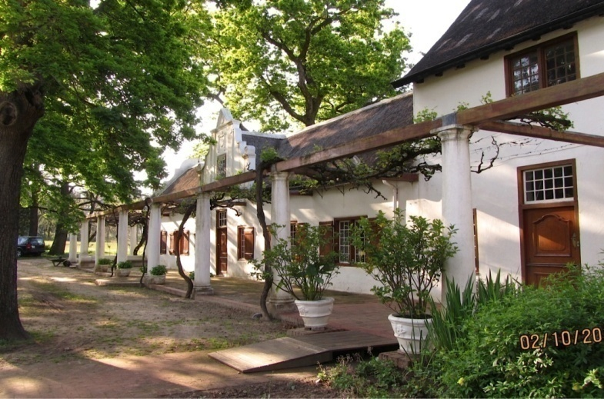
Fig. 5:5: Lekkerwijn 2014
Photo Corrie de Blocq

The interior is furnished in a colonial Edwardian style and beneath an imposing staircase in the entrance hall a small bronze statue of Cecil Rhodes is quietly displayed upon a cabinet. It is unique - the model for the monumental memorial to Rhodes in the Matopos Hills of Zimbabwe, previously Rhodesia. This figure, a gift from Rhodes to Harry Pickstone, is emblematic of the close working relationship between the two men in their agricultural enterprises which were centred upon Lekkerwijn and Delta.

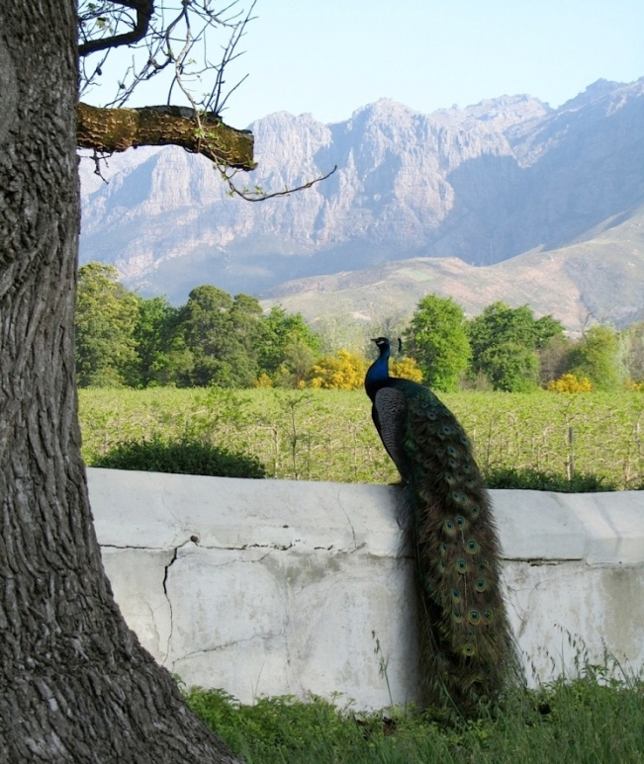
Fig. 5.6: View from Lekkerwijn’s werf 2013 Fig. 5.7: Rhodes bronze
Photo: Corrie de Blocq Photo: Corrie de Blocq
The Villiers family had arrived in the Cape as guests, albeit van der Stel was dubious about his new citizens, to break farm ground from scratch. The Pickstone presence, like others of the British colonial-mercantile ilk, was uninvited but proved to be immensely competent in discerning economic opportunities. The 27 year old Harry Pickstone arrived in Table Bay in 1892, on board the Grantully Castle, with, according to great-grandson Simon Pickstone-Taylor, nothing beyond a battered trunk and 30 shillings in his pocket (Pickstone -Taylor pers. comm. October 2013). This son of a Lancashire mill owner was however apparently in possession of a strong sense of adventure. Harry had served in a military expedition in Bechuanaland in 1884-5, but soldiering not being for him, he had then gone gold-prospecting in the United States in 1888. Changing course once more, Harry worked in the fruit orchards of California. He also took contracts from the tree nursery business. Harry quickly realized that the Mediterranean–type conditions in the Cape were similarly good for fruit production and also closer to European markets than California. So Pickstone shipped himself back to Africa seeking agricultural opportunities. In his own words:
“I left California for South Africa in 1892, not knowing whether there was any fruit grown there at all. But in the full belief that something in this direction might be possible” (Pickstone 1917:291).

Pickstone could hardly have arrived at the Cape at a more opportune moment for his ambitions. For in 1892 Sir Percy Molteno had installed refrigerated cargo facilities on some Union Castle mail ships that plied the Atlantic routes.According to Wallace (1896) by the time Pickstone arrived in the Cape, its fruit was already overdue for export. He describes the opportunity thus:
“Exploited by its former masters, the Dutch East India Company, not on its own merits, and not with a view to its individual prosperity, but solely as a tool in the management of tropical colonies farther east … for a couple of centuries. It exported little or nothing …while the roaring stream of traffic rushed on to other lands. Besides, even long after its transfer to England, its acquired habit of self-containedness and easy laissecz-aller(sic) were very little interfered with, and the Colonial Office, while not preventing enterprise, did next to nothing to call it forth locally or introduce it from abroad. It is a land for the adventurous class of tourists, the sportsman, and the missionary.”

5.3.1 Connecting with Rhodes

In the small English-speaking society at the Cape, Pickstone, the entrepreneurial wanderer, was soon introduced to Cecil John Rhodes the man who would become his benefactor. Rhodes remains a highly controversial, but unsurpassed political, cultural and financial colossus in the region. Even from a world away, Mark Twain (1899 LXVIII) once said of Rhodes:
“I know quite well that whether Mr. Rhodes is the lofty and worshipful patriot and statesman that multitudes believe him to be, or Satan come again, as the rest of the world account him, he is still the most imposing figure in the British empire outside of England. When he stands on the Cape of Good Hope, his shadow falls to the Zambesi .... he is the only unroyal outsider whose arrival in London can compete for attention with an eclipse.”

Arriving as a consumptive to rehabilitate in South Africa, Rhodes not only recovered but swiftly amassed a vast fortune on the South African diamond and gold mines. It was arguably in politics though that Rhodes left the deepest footprints. In South Africa, Rhodes garnered significant local political influence, eventually becoming Prime Minister of the Cape. For Rhodes, the Franschhoek purchases and Rhodes Fruit Farms fitted another piece into his grander designs. His ambition was well-known. Rhodes frequently spoke of his African dream, of connecting the Cape to Cairo by railway (Rotberg 1990). However, while Rhodes indeed never subdued his more rapacious imperial instincts nevertheless both he and Pickstone could be described as Cape patriots. In his formulation of a more capacious understanding of being British, Dubow (2009) explains that in the anglophone sphere of the late 19th century, there was an identifiably Cape colonial nationalism that evinced a different type of patriotism. The concurrent sense of being British and sense of belonging in South Africa is described as “an elective hyphenated form of belonging” (Dubow 2009:1). The distinguishing difference lay between the overt projection of a comprehensive format of imperial power issuing from abroad and an adapted assertion of British influence by local actors whose loyalties overlapped with their increasingly deep affinities for the country where they had settled. Such patriots were in many ways set against authoritarian British imperialism. Similarly I suggest that by the late 1800s it was less the abstractions of empire that caused commercial and community changes the Drakenstein valley than it was a matter of a deeply localized and affective connection with place. Lucas (1897 Part 1:338) said at the time that “ it is not so much... the English Government that has made South Africa, as the men on the spot... who have lived and worked in and for the land, who have seen the things whereof we read in Blue Books or newspapers, not in a glass darkly, but face to face...” Nonetheless, it was the imperial drivers of commodification and capital accumulation that motivated both Pickstone and the Rhodes Fruit Farms company (Ewert & Hamman 1999).
Indeed Pickstone himself said:
“I had always held and still hold the basic conviction that it is the duty of an Englishman to earn his own living and make a success or failure of it under his own flag. Three years of hard work in fruit in all phases in California was my qualification balanced by open mind and supported by an innate spirit of optimism. So equipped it took but a few months to make one a keen South African…” (Pickstone1917:292).

From reading these words, had he known Breyten Breytenbach, Pickstone might have agreed with Breytenbach’s (1996:31) memorable comment that “South Africaness is an itinerary (and a topography) of becoming in the making.”

The grape vines of the valley, in their sickly and diseased state, gave Pickstone that opportunity to make his claims in Franschhoek. At the time of the phylloxera outbreak, Harry Pickstone was working with John X Merriman, then Minister of Agriculture in the Rhodes Cape cabinet. It was Merriman who apparently requested the study by Wallace, a professor from Edinburgh University, cited earlier in this chapter and who sketched a bleak picture:
“The Colony does not seem to have thoroughly grasped the overwhelmingly serious nature of the consequences of the spread of phylloxera; yet most assuredly it is only a matter of time, and that not very long either, when the whole wine- growing industry of South Africa must become involved” (Wallace 1896:152).

As farmer after farmer in the Franschhoek valley became bankrupt, Pickstone and Rhodes snatched up the distressed properties. Together they purchased devastated wine farms for fruit farms and nurseries. Commenting later on this opportunistic spree of property purchases which so provoked anti-British sentiments of an Afrikaner wine-farming establishment Rhodes’ private secretary writes:
“Stellenbosch, Wellington, and Paarl were all strong Bond strongholds. In 1897 and 1898, Rhodes, through his agents, commenced buying fruit-farms in these districts from their Bond owners, with a view to settling men on them about whose politics there could be no question. The former owners were furious when they discovered who the actual purchaser of the farms was. They were repeatedly warned from the pulpits of the Dutch Reformed Church that de Beers were buying the land, and they were begged not to sell….”(Le Sueur 1913).

Local Afrikaner opposition was to no avail and the majority of farms in the valley were swiftly incorporated into Rhodes and Pickstone’s plans for industrial-scale agriculture.
With the sale to Pickstone in 1898 the long era of wine farming at Delta came to an end. The wine cellar was transformed into a fruit packing shed (Smuts, 2012). Pickstone negotiated the purchase of Lekkerwijn from Rhodes in 1901 and later bought back Daniel Brink’s portion of Delta to consolidate the whole property in 1905.

Rhodes had initially backed Pickstone’s ‘Pioneer Fruit Growing Company’ his initial modest venture in establishing tree nurseries. Then by 1897 Rhodes was also ready to back Pickstone in launching a large company that became Rhodes Fruit Farms (Pty.) Ltd.
Pickstone (1915:292) wrote that “the meeting with Mr. Rhodes at once gave direction to prompt action. He advanced the money to start the nurseries and I introduced from all over the world, every variety of tree which appeared necessary for South Africa in order to establish the industry on a world's commercial basis.” To his dying day, however enamoured he might have been of export opportunities, Rhodes apparently remained doubtful of Pickstone’s financial skills and of the profitability of deciduous fruit instead of vines. “We should make an insurance fund in vines,” Rhodes ordered from Wadi Halfa on the Nile, in 1901, while instructing a Cape Town lawyer to ensure that Pickstone planted vines (Rotberg 1990:640). Hours before Rhodes died in February 1902 Pickstone was appointed as the company’s technical director and became resident director at Groot Drakenstein. Pickstone held this position for two years before returning to his nursery business supplying Cape fruit farmers with a stock of trees. As for Rhodes, more than 110 years after his passing, the nature of his contributions of continue to be debated across South Africa. Such is his legacy that in March 2015 a group of students from the University of Cape Town tossed human waste at Rhodes’ statue on the campus.

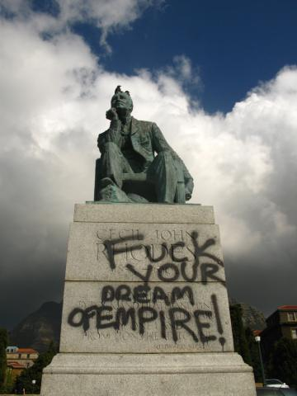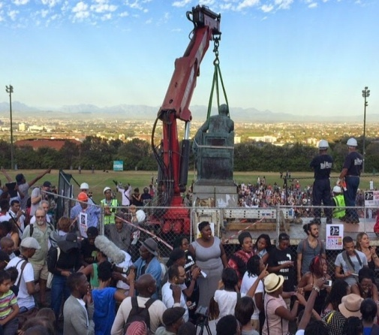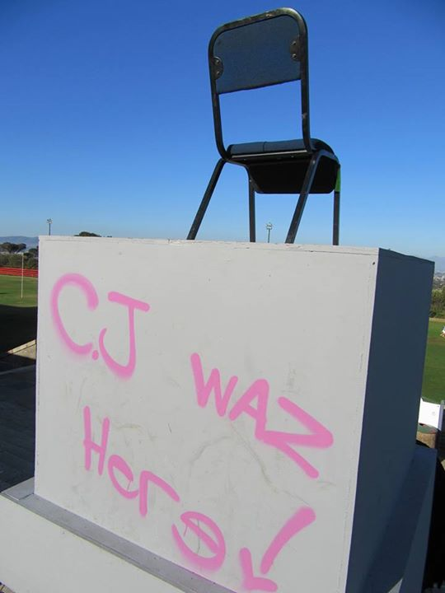
Fig. 5.8: Demise: “#Rhodesmustfall”
Photo (1) Rebecca Davis (2) and (3) Corrie de Blocq

As Rhodes had conserved and given to the university the land upon which it still stands, the anti-Rhodes protest created a bind. The authorities did not want to be accused of historical denialism or of being insensitive to the educational deprivation meted out for decades on South Africa’s black majority. After students occupied the administration building, the university had the statue removed. For Pickstone there were no statues. The valley, his farms and eventually his company, H.E.V. Pickstone and Bro. Pty. Ltd., were probably the limits of what Harry Pickstone wished to claim.

5.3.2 H. E. V. Pickstone & Bro. (Pty) Ltd: fruit and family fortunes

During the time that Harry Pickstone managed Rhodes Fruit Farms, he also acquired farms in the valley for his own business. Pickstone negotiated the purchase of Lekkerwijn from Rhodes in 1901 and later bought back Daniel Brink’s portion of Delta to consolidate the whole property in 1905. On 29 January 1907 he married Louisa ‘Mollie’ Hooff May and they set up home on Lekkerwijn. The Pickstones had one child, a son, Michael Xavier. As the business expanded, Harry recruited brother Horace, who, barely 21, followed his brother to the Cape. Nurseries were established on Delta and neighbouring Meerlust and in 1913 Harry and Horace established the company known as H. E. V. Pickstone and Brother (Pty.) Ltd. The youngest Pickstone brother, Septimus Percy eventually also emigrated and moved to Johannesburg to manage a branch of the business there. In 1915 Pickstone wrote the first extensive and definitive book on growing fruit trees in South Africa, Hints on Fruit Growing. In 1916, the main tree nurseries were moved to the farms Welgevonden and Watervliet in nearby Simondium, still in the same valley. Pickstone’s valley empire thrived not least because of the technical progress in deciduous fruit exports that took place with his encouragement. Indeed, the millionth case of deciduous fruit exported via Table Bay in April 1923, was a case of pears shipped by Pickstone. The ongoing improvements quadrupled the dock capacity and when the programme was complete in 1927, the pre-cooling installation was regarded as state-of-the-art for its day.

In 1919, Horace Pickstone also started buying properties for himself, amongst which was ‘The New House’ in Simondium, part of Rust en Vrede farm. After his wife Esther died, Horace bought the whole farm Vrede en Lust. This is the wine farm originally owned by the feisty Huguenot Jacques de Savoy, father-in-law of Christoffel Snijman. Upham (2014) indicates that Marguerite de Savoy and Snijman probably began married life on this farm before purchasing Zandvliet/Delta. Predictably, the Vrede en Lust farm also belonged for a time to the extended de Villiers family after it was purchased in 1728 by David de Villiers, a younger son of original immigrant Jacob de Villiers and his wife Marguerite Gardiol. During the 1930s numerous Cape fruit growers became insolvent because the Great Depression crashed fruit prices. Then with World War II looming, the Deciduous Fruit Board was founded in 1939 to support all Cape fruit producers and exporters. However even with state-subsidized canning and drying, opportunities to export had become almost non-existent and before the cessation of war, many fruit and wine farmers were destitute. Although barely touched by the financial downturns that ruined others, for the Pickstone family 1939 was a grievous year for personal reasons. On 22nd January 1939, Michael Pickstone died in what has been described to me only as “a horrible tragedy” on the grounds of Lekkerwijn with his father present at the time. Michael had been living on Meerust, a farm adjoining both Delta and Lekkerwijn with his American wife, Joan Marie McGeoghegan and their children Margaret and Wendy. After Michael’s death his young daughters were taken to America by their mother. Harry Pickstone, ‘the father of the South African fruit industry’ passed away on 11th Nov. 1939, “utterly heart-broken” as his great grandson expressed it to me in an interview. Pickstone willed all his debentures in H. E. V. Pickstone & Brother Pty. Ltd. to his wife in their entirety (Simon Pickstone-Taylor quoting Deceased Estate No. 66452 held by Syfrets). Mollie Pickstone inherited all her husband’s other vast collection of assets too, including the two estates Lekkerwijn and Meerust. Property transactions tell that Horace Pickstone too was largely unscathed by financial problems in the war years. When Horace sold Vrede en Lust after owning the property for 14 years the decision was instigated by concerns about old age rather than financial need. He made £2500 on the sale, a fair profit at the time. Having outlived Harry, Horace passed away in March 1949 at the age of 76 years. Like his older brother, the Lancastrian youngster had become a wealthy man from the profits made in the South African fruit business.

After her husband’s death Mollie Pickstone consolidated her property into a holding company named Pickstone & Son (Pty.) Ltd.which entity continued to thrive. She and Horace Pickstone both benefitted when the fruit export business emerged from the war years into a boom cycle. The Union Castle liners the Roslin Castle and the Rothesay Castle were decommissioned and returned to service with refrigerated container space on board (Symington 2008). Left to run the businesses alone, Harry Pickstone’s widow was apparently a woman with whom to be reckoned. Interviewee W, a long-term labourer on Pickstone agricultural properties in the valley described Mollie thus: “Die oumies was n kwaai vrou gewees.”The best translation I can make is “that old lady was fierce.” This interviewee had a long history with Mrs. Pickstone. His father had been employed in the Pickstones’ nurseries when he died unexpectedly. Without the working family member, everyone would have had to move. So the son, then only 11 years old, started to work to keep his mother and siblings housed. This interviewee had thus been employed in the Pickstone agricultural enterprises for his whole working life. In conversation, he painted a verbal picture of himself as younger man leading a group of farm workers in an attempt to bargain for improved wages:
“Ek sien dit nou.....daar was ons oppie gras voor die groot huis. Daar bo staan die witmense. Toe kyk hulle na ons van die stoep af. Mies Pickstone, sy staan nie, sy sit op a stoel, die mooi soort wat in ’n sitkamer behoort. Toe vra een van die wit mansmense Wat wil julle he?’’ Ek het voentoe gestap and het met my praatjies begin. Op’n punt maak ek so (turns his head to look over his shoulder) en wat sien ek? Ek sien net die gras. Volgende keer het ek agteraan gestaan.“
I can still see the scene...there we were on the grass in front of big house. Above us were the white people. They looked at us from the veranda. Mrs Pickstone did not stand; she sat on a chair, the nice kind that belongs in a sitting room. Then one of the white men asked us ‘What do you want?’ I stepped forward and began to give my little speech. At one point I turned around and what did I see? I saw only the grass. The next time, I stood behind [the group of workers].

Interviewee D is a woman now in her fifties, whose father was once the Pickstone’s company accountant. She lived on Delta as a young child and recalls that to such a small girl Mrs. Pickstone seemed “rather royal.”
“At Christmas-time we always went over to Lekkerwijn. My father would talk to Mrs. Pickstone and my sister and I were taken off to eat biscuits in the kitchen. But first we had to greet the old lady. As a little girl, I was almost convinced that she was the queen. It was a bit scary. She sat in the dining hall in a big chair, or at least it seemed big to us. And she had a bulldog next to her. Its name was Victoria. There was beautiful furniture and lots of silver in the cabinets that was always very shiny. She wore a massive ring – it was an emerald ring. I was absolutely fascinated by that ring when she reached out to me and my sister. She always gave us gifts, so I don’t really know why we were so intimidated.”
Mollie Pickstone remained involved in the daily business of the farming and other enterprises until her death in 1966 when all her assets passed directly to her son’s younger daughter Wendy Pickstone. Until 1977 the official owner of the assets remained Pickstone & Son (Pty) Ltd. which company incorporated Delta, together with the farms Meerlust, Watervliet and Wolvekloof, a part of Vrede en Lust. A block of high-trellis grapes, planted in the soggy lower part of Wolvekloof, was spoken of for years as ‘Pickstone’s Folly.’ Simon Pickstone-Taylor thinks that was appropriate, for Harry had never been afraid to take a chance, whatever anyone said to the contrary. Having returned to South Africa, by the time of her grandmother’s death, Wendy Pickstone already lived at Lekkerwijn. She had married local cricketer John Taylor and had two sons one of whom, Michael, inherited Delta. His brother Simon Pickstone-Taylor moved to Britain to study and work. However Simon returned to the Cape relatively recently and he is the engaged and engaging custodian of Lekkerwijn today.

5.4 FARM WORKERS: moving parts of a community

I return now to the emancipation of slaves in 1838, the time in the Cape when freed slaves and Khoikhoi and the few remaining San were officially grouped together under the demographic label “coloured.” In this period of flux, as Worden (1989) notes, mission stations were almost the only places where these individuals could ‘own’ land. Even then, only few could establish independent control over production and gain freedom from a dependence on casual wage labour. For although more mobile, most needed to work for the local farmers in order to survive (Worden 1992). The wine farmers, aware that mobility was possible, needed to retain workers in the new labour dispensation. To encourage the ex-slave community to remain in the valley, a group of Franschhoek farmers created the nondenominational Apostolic Trust in 1843 to fund housing and a church. Pniel, meaning ‘face of God’ was the name chosen for this community village.

Farmers purchased land for Pniel and subdivided it into 99 plots. Each plot was to be used productively to cultivate fruit trees and vegetables. Thus the tradition of allotment-style farming by coloured communities in the valley was developed. The mission management and education that would set the residents of Pniel apart from other farm labourers was also influential in their middle-class identity-formation (Lucas 2006). The mission influence in Pniel nurtured a deep sense of religiosity in residents and fostered locally constructed ideas of ordentlikheid which translates as respectability. Ross (2005) and Lucas (2006) find that this sense of respectability in a coloured community is very closely associated with what are considered to be a decent house and living standards and with a neat and tidy appearance and not only with connotations of a Christian morality. Family is the social ideal in Pniel and has “remained a key mode that articulated residents’ identity” (Lucas 2006:164). Houses and land have been passed through the generations and many Pnielers own land that has become, at the time of writing, prime Franschhoek real estate.

In 1898, just over 50 years after Pniel was established, Rhodes in his turn became acutely aware of the need to retain agricultural labour. It must have been something of a cleavage of consciousness for Rhodes, as the looming labour shortage was largely due to demand from the gold and diamond mines in which industries he was heavily invested. However Rhodes Fruit Farms was by far the biggest employer in the valley and Rhodes commissioned Sir Herbert Baker, an eminent architect of the Victorian era, to design a village where farm workers could live (van der Heijden 2009). “The cottages are necessary,” said Rhodes “…to keep good the farm culture” (Rotberg 1990:641). Rhodes may have also enjoyed some political glee at the thought of new constituents because at that time coloured men were enfranchised to vote in Cape. The outcome was a village named Languedoc, which still exists today, approached by the avenue of oaks planted over a century ago. This is indeed a “baster” of a place. It is a village named for a French wine region of which the coloured farm workers had likely never heard; designed by British immigrants in a Dutch-inspired architectural style to keep labour on African soil.

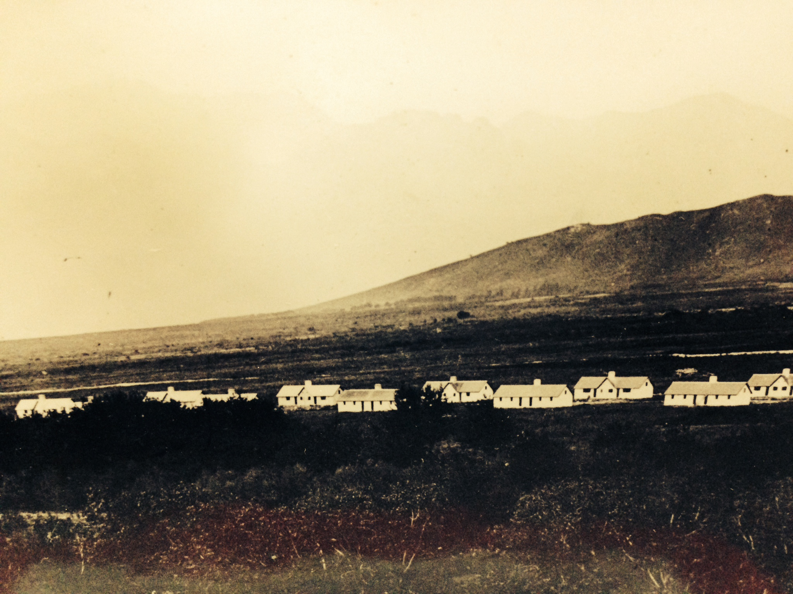
Fig. 5.9: Cottages: Languedoc
Source: Cape archives, AG photograph collection

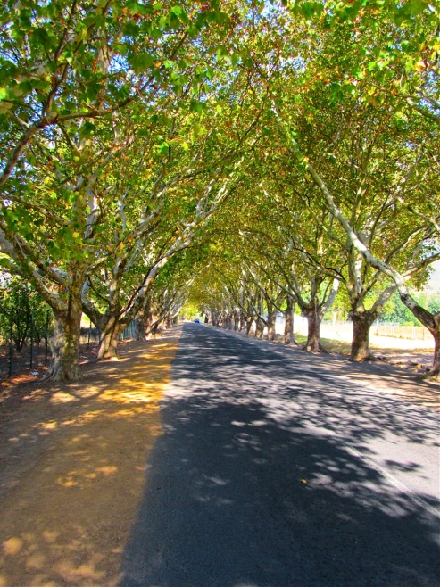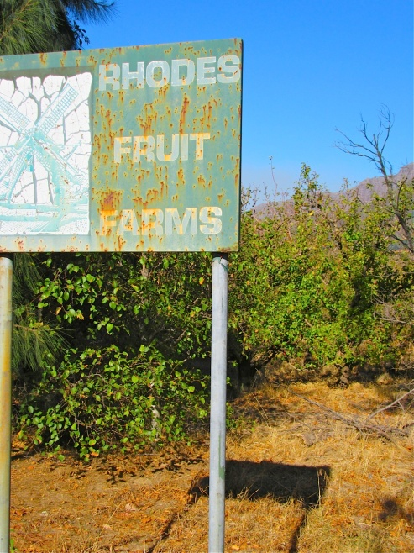
Fig. 5.10: Languedoc oaks April 2015 Fig. 5.11: Sign, Languedoc entrance
Photo Corrie de Blocq Photo Corrie de Blocq

A school and 100 small houses were built, together with the St Guiles Church and vicarage. Each house had a garden to grow flowers and vegetables. The keeping of two horses, two cows and pigs was permitted and enough commonage was provided for livestock to graze. Drunkenness was forbidden on pain of dismissal with one week’s notice. Rhodes insisted that the village be governed in an orderly manner to encourage sobriety and respectable living. Some twenty-six regulations applied to Languedoc residents and Rhodes provided financial incentives including a pound paid for each child born in the village in wedlock. Prizes of £5, £3 & £1.10s were disbursed for the best-kept gardens and houses. In short, like Pniel, the managerial style was that of ‘parenting’ those less equal. Indeed, Languedoc was no simplistic system; officially the village represented the ‘reformism’ of a mutually beneficial labour relationship. However through mechanisms of patronage it also unilaterally mediated workers’ recourse to housing and access to land. The nature of the reward did not necessarily depend on labour performed but on the status quo of a given client-patron relationship. At this time, Pickstones’ farming operations at the Cape would have benefitted from export technologies but also from an incrementally stratified labour market, put in place and overseen by the British government and further refined by the apartheid government.

As far as workers were concerned, whether they lived on Delta or in a nearby location, the mechanism worked like this: the Native Regulation Act of 1911 ensured that all farm workers had to be registered with the Labour Bureau and once having registered as such, they were not free to change to industrial or commercial employment. Thereafter, The Natives Land Act of 1913 began the march towards exclusive white land ownership in viticulture while farm workers were forced to become increasingly static. In 1923, ‘influx control’ was instituted through The Urban Areas Act whereby the labour bureaux decided where farm workers could only move according to the labour needs of the area at the time. The lone voice of Helen Suzman, a liberal MP, continued to protest strongly that:
“State machinery is being used to keep a cheap supply of labour at the disposal of farmers whose conditions of employment do not attract labour voluntarily - their choice is to accept or go to gaol” (Hansard 1959, cited in Mager 2004).

Unless an individual contract existed between a farmer and his workers, the workers were not entitled to sick leave, overtime or public holidays. The Education and Training Act of 1979 drawn up by the Nationalist government that prohibited anyone from withdrawing a child from school, was not applied to children living on farms. This pattern of labour control persisted. Indeed, up until 1994, all farm workers in South Africa were omitted from legislations that provided for the regulation of urban and industrial labour.

Eventually, through the Coloured Labour Preference Policy Act of 1963 the agricultural regions of the Western Cape became areas reserved for coloured labour only. Black South Africans were not permitted to work there, unless there were no coloured workers available for employment in that area or industry. Thus coloured identities as nurtured under apartheid, gave rise to ambiguous and simultaneous connotations of ‘second class citizens’ and ‘preferential workers’ (van der Heijden 2009:57). State interventions fundamentally influenced the racial make-up of the work force in the wine industry and overall “...categorized blacks as intruders to justify measures of labour control in the Western Cape and sought to prevent the moral decline and economic impoverishment amongst coloureds” (Humphries 1989:171). Du Toit (2005:13) contends that on wine farms, even in the ‘new’ South Africa, “[t]he deeply embedded local discourses and practices of racial paternalism structure between white and coloured people tends to construct African workers as outsiders:…..”. Indeed problems arose after the democratic South Africa came into being in 1994, when Languedoc village became part of a relocation scheme. It now houses farm workers and also some migrants from as far away as the Transkei in the Eastern Cape. A number of current Languedoc residents, consider that these housing ‘skiems’ (schemes) comprise a plague on the village where housing and service delivery issues and social degradation are related to racial discomfort. In her study of female livelihood practices in the valley, van der Heijden (2009) found that women who live in Pniel have a negative perception of those who live in these schemes, in the gif (in poison) in Languedoc for not keeping proper houses and thus being less than respectable. Interviewee T who contributed to this study works on Delta, but lives in Languedoc. She said vociferously that she wants to relocate and that she keeps her children away from those in other parts of the village. She would like to live on Delta. Yet until Professor Solms purchased Delta in 2001, workers had felt very differently. A female farm worker described what it was like to live on Delta at the time that Michael Pickstone-Taylor owned the farm:
“We sat outside except when it rained, because we couldn’t build fires in the house. Sometimes we would go to W’s house, because he had a job off the farm and we could cook there. It was hard, to cook, hard for the children to come home, no food, hard to wash clothes….ag man, die lewe was net moelikheid, altyd, altyd moelikheid.” It was a hard life, always difficulties.”

This situation, without running water or electricity continued until 2001 when Solms bought Delta from a Trust of Michael Pickstone-Taylor, who as mentioned earlier is the great grandson of Harry Pickstone. The following photographs show what the living arrangements for farm workers had been like on Delta. The building shown as Fig. 5.12 was once the wine cellar, but in the 1950s it was re-arranged to accommodate farm workers (Smuts 2012).

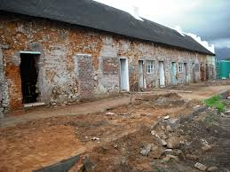
Fig. 5.12: Workers housing: Pickstone-Taylor ownership
Source: Solms Delta

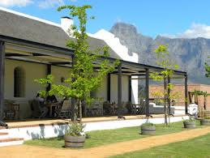
Fig. 5.13: Same building: Solms/Astor trusteeship
Photo: Corrie de Blocq

A report from Die Burger newspaper (10/07/1997) offers an insight into an incident involving a conflict of interests between Michael Pickstone-Taylor and a farm worker interviewed for this study. The worker had lived on Delta since the time of Pickstone-Taylor’s great-grandparents. According to the report, the Pickstone tree nursery business had been divided into four parts in 1991. The worker concerned had, since that change of ownership worked for the new owners of the nursery business although he continued to reside in the house he had occupied on Delta for 20 years. The worker maintained that Pickstone-Taylor had summarily bulldozed both his garage and the wall separating his house from his neighbours, as well as sending a plough over his kitchen garden and rose garden. Pickstone-Taylor claimed that he needed that piece of land for a new nursery he was developing on Delta. Under a legally binding agreement, Pickstone-Taylor agreed to restore the damaged buildings and gardens. A decade later, Delta’s land and buildings which included the unmaintained homes for coloured farm workers, were sold to Mark Solms after Michael Pickstone-Taylor was declared insolvent in 2001.

5.5 MORAL COMMUNITIES

This chapter has shown that despite attempts to hold land, control power and limit inter-marriage, farmer families and workers and their families alike lived within increasingly bastardised social formations in the Cape winelands. I suggest that these formations have become structured as various ‘moral communities’ as described by Regan (1991:20):
“Suppose we imagine the moral community circumscribed by a circle. Individuals inside the circle are members of the moral community; individuals outside the circle are not. Those inside the circle, by virtue of their membership in the moral community, are entitled to a kind of consideration denied those outside.”

‘Moral’ in this sense, is not something religious or allied with judgmentalism, nor is it extraordinary and removed from normal life (Dooling 1999). This concept also does not necessarily depend upon owning land. Instead, there is more resonance with Keenan’s (2010:1) concept of property as “a spatially contingent relation of belonging.” My use of this term thus refers to communities that may differ immensely in their values, their beliefs and even levels of cohesiveness but they all share the common characteristic of dependence on relative inclusion.

In considering the extensive de Villiers family as such a community, I suggest that what initially came into being was a collective refugee response to the dilemmas of being in an unfamiliar environment. These new settlers who had shared the dangers of an ocean journey and the traumatic divide from their native country would have been dependent upon one another for comfort, everyday co-operation and emergencies as they confronted new physical, economic and social landscapes. As religious refugees, there may have been an initial desire to build a new society without the vices of the old. Indeed, Trapido (1992) proffers a notion of a New Jerusalem at the Cape and the Huguenots may well have had a sense of having transitioned through trauma into a promised land. When it comes to the de Villiers clan, it is conceivable that with this kind of ‘cognitive map’ they could feel more confident about challenging Dutch authority, establishing new hierarchies and pursuing profit for themselves. As they began to establish new communities under the wary eye of the VOC, the Huguenot families intermarried intensively, all the while acquiring and passing farming properties amongst themselves. In the process, land became both the means and the medium through which these settlers constructed a distinct identity. Retaining their own church, minister, language and customs, there was an initial desire on the part of the French Huguenots to assert their own gentility in a strange land. However, I suggest that over the years, the pattern of robust changes on Delta both represented and reinforced a more bastardized identity for the de Villiers’. In the buildings and extent of its werf, there was an adoption of a local idiom for the layout of their farms that mirrored the loss of French traditions in Franschhoek. Joining up with Dutch families through the generations, the continued acquisition of land and building contributed to a different familial consciousness in a transformation from immigrant to native.

As centuries passed and the wealth and influence of the extended de Villiers family compounded, they emerged as a local elite. This is not a contention that a ‘de Villiers identity’ was created self-consciously. Albeit infused with material ambition leading to a remarkable familial influence in the Cape in many spheres, I suggest that for the most part the process was that of transformation. In their case, I suggest, the notion of a moral community becomes applicable over time as a system dominated by men and women of landed property. It was a system which circulated property between recognized members and it established practices of hegemony over less wealthy settlers as well as labourers, servants and indigene people in the valley. The de Villiers merged into rural Cape society, responding first to one set of stimuli, then to others. No one stimulus in the ‘evolution’ in their collective identity necessarily constituted a pre-ordained point. I suggest nevertheless that incrementally, the responses can be seen on a trajectory of perverse exchanges that eventually almost defined the paternalistic politics of 20th century apartheid South Africa.

The kind of community that existed around the Pickstone family may, I suggest, have developed as a more conscious creation. For this particular partnership, the vine diseases combined with a financial depression in the wine industry to produce an identifiable kind of “spatio-temporal fix.” As Adyalot (1976, in Jessop (2014), notes:
“There are processes at work … that define regional spaces within which production and consumption, supply and demand (for commodities and labour power), production and realization, class struggle and accumulation, culture and lifestyle, hang together as some kind of structured coherence within a totality of productive forces and social relation.”

Phylloxera definitively relocated productive investment in the valley. For it was in the immediate aftermath of this viticultural apocalypse that Pickstone and Rhodes bought up distressed farm properties binding these into legalized companies and sharing the commercial profits between themselves and their investors. Then, in what proved to be a highly successful move, Rhodes Fruit Farms and Pickstone made possible the supply and transport of previously unheard of commodities like Cape refrigerated fruit. These reoriented patterns of trade were influential to the point that Mabin (1984:69) makes a claim that the“...the historical geography of the colony would become explicable through the actions of the commercial or mercantile classes...” As these two men developed the fruit industry in the valley, it became increasingly concentrated and commercialized.

Although, like the de Villiers family, the combined Pickstone/Rhodes holdings eventually encompassed most of the farmed land in the valley it was a different kind of landed property ownership that inculcated the type of moral community that I describe. It is possible that this consciousness was part of the sense of white English-speaking 'South Africanism' noted earlier, at once strongly patriotic and colonial and with no cognitive dissonance between the loyalties. Rhodes and Pickstone were each a scion of the British imperial milieu in which he was raised and exercised a choice to come to the Cape. Yet both men were also powerfully focused upon the fruits of the earth upon which they had made their homes Indeed both Harry Pickstone and Cecil Rhodes died in South Africa – neither man ever went ‘home’ to England. Innovative and determined they both were, but for each of these freelance imperialists, company ownership took a different form. Pickstone retained sole or family ownership of his companies, allowing subsequent generations to inherit, while Rhodes Fruit Farms invited outside investors to purchase stock. Nevertheless, despite indications of being modern entrepreneurs in their own rights, the joint employers were both reluctant to abandon the accepted model of responsible authority in relation to labour. Neither, it seems, wished to change the paternalistic position that he imagined he should assume in the farm community. In constructing Languedoc, Rhodes made overt efforts towards improving the living conditions of workers and presenting himself as a humane individual. In such efforts, of course, there was no simple line of division between self-interest in retaining labour for the farms and concern for workers’ well-being. Rhodes, presumably, would have calculated on the basis of both. The inclusion of farm workers based on free individual contracts was still an alien ideal of social relations in such a community. Rhodes, the political giant and commercial behemoth was little different from Pickstone the entrepreneurial agriculturalist, because both presented themselves in this paternal role within their own enterprises, in the social spaces and to the individuals over which they had the greatest control. The expanse of the werf, the farmyard area where workers would once have been controlled by de Villiers owners of Delta, was extended to include a valley largely under the control of Rhodes and Pickstone. The exchange of actual land endowed with increasing value, that took place within the de Villiers family in a particular geographical area, had been replaced by the Pickstone family, who lived in Franschhoek and employed local labour but ran a financial empire with international assets.

I suggest that Rhodes and Pickstone, albeit each in his own way, contributed to a particular type of moral community based in a mix of industry and paternalism which had “… adapted and mutated into new forms in the course of a century-and-a-half of modernization under the extensive period of British domination of South Africa”(du Toit 2007:12). The kind of worker-communities that were fostered by industrialist-farmers like Rhodes, were, in effect, worker-reserves. Here they had to live under rules conforming to missionary ideals but there was a home and a social community. Others by contrast, were forced to become itinerant seasonal workers. In many ways Rhodes’s workers’ village of Languedoc offered a similar Faustian choice: a home and limited opportunities for changing from a subordinated status versus a life on the road as penniless work-seekers. Later in the 20th century, what had been initiated in Pniel and Languedoc became overlaid by apartheid-era racial discrimination tied to the housing, the place and type of work done, levels of recompense and forms of governance. On a smaller scale, on-farm housing such as that provided by Pickstone, pulled workers into a community where, in a similar way, employment and social support systems were conflated. However, the structuring of these communities, village or farm, was not, I suggest, foremost about exclusion. Instead these communities define unequal terms of inclusion concerning where and how labourers live and the conditions under which they work. As the examples of Pniel and Languedoc show, these physically constructed communities are also social communities each with its own internal support systems and identity. In this vein, du Toit (2005) finds that the nature of social networks that support life within small communities on wine farms is stressed and conflictual. He maintains that while networks can cushion people against particular misfortunes, the constitution of these communities is still power-burdened and structurally inequitable. The difficulty is not only that those social networks are strained and subject to conflict but also that communities without sustainable resources are inevitably more vulnerable to instances of exploitation and manipulation by others in positions to exercise more forms of power. Then, indeed as now, it is unsurprising that at this essential level the workers saw no contradiction between clinging to the benefits of living inside a particular rural type of moral community and also feeling bitter against the society and individuals responsible for their humiliation. Even in a situation of partial inclusion in wider society, a home and employment on a wine farm is considered safer than casual seasonal employment. In this way, as du Toit (2007) argues, many coloured workers over the years have joined their employers in what some may have considered to be a system of benevolent authority and maybe even have believed in the possibility of a shared community of values.

Paternalism of any form though, is but a fragile consensus. Even where the farmer is a benign figure, most workers are almost inevitably denied space within which they can exercise independent judgment. At its very best an unstable and tenuous balance, if a paternalistic farmer-worker relationship goes sour, the opportunity for intimidation and coercion by a farmer is unparalleled. Similarly I suggest that whereas paternalistic employers likely viewed the benevolence of authority as the expression of a particular type of social obligation, workers have been more likely to desire recognition of equality or material fairness. Although cautiously worded, interviews with two Delta inhabitants who had worked for Michael Pickstone-Taylor, described their feelings of frustration, hopelessness and bitterness at the time. From having been somewhat more accepting under the aegis of Pickstone-Taylor’s grandmother, farmer and worker had begun to confront each other with growing suspicion and resentment. By the time Michael Pickstone-Taylor left Delta, even in the Franschhoek region where paternalistic practices and rhetoric were deep and persistent, the structure and psychology of social relations on the farm was transformed into hostility.

Overall, this chapter has reflected two patterns of settlement. One comprises a French/Dutch fixation on farming land and the other a British mercantile approach to land as agricultural industry. Each pattern comprises a different, arguably clashing, social system, but the problems go deeper. Even though Delta was changed and exchanged between different people over time, the control over its resources remained legitimized by the working of a ‘moral community’ at the time (Gray & Gray 1998; Alexander 2008). These stories have shown that change repeatedly brings power relations into being that are characterized by asymmetrical states of domination and subordination. In what I have described here as a ‘moral communities’ there are similar and persistent structures restricting access to material resources and imparting self-deprecating views to the subordinated and vulnerable. This chapter has shown that in the process of acquiring and farming land on Delta, communities have been made, blended, extended and broken but have always produced sets of inequality. Foreign bodies have moved to Franschhoek to work with and around the vines, becoming connected with each other and to the land. The conjoining of these particular stories indicates that the rich and itinerant process of such bastardization is a strong weft, or perhaps a warp, running through the historical and geographical tapestries of the Cape. French refugees created a South African dynasty and British imperialists became Cape patriots. Yet such convergences are not commensurate with a trenchantly unresolved heterogeneity where dominating persons and groups continue to exercise differentialized power. Coalescence into a community can indeed be rich and beneficial, but in another sense, this blending process has not excluded either the presence or exercise of various forms of violence.

CHAPTER 6

“DRINKING IS A POLITICAL ACT”

(Thomas Wilson 2004:26)

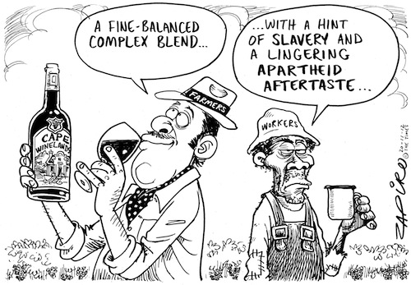

Fig. 6.1: Zapiro cartoon, Cape Times 20/11/2012

Source: ©zapiro.org. With permission fromwww.zapiro.com

6.1 INTRODUCTION

This chapter is divided into sections according to certain historical parameters. The purpose is not to canvass the full range of ways that wine is involved in the politico-social and economic agendae associated with these eras. Instead it is to emphasize that the evolving geo-political situation of the Cape is not exogenous to the development of its wine sector (Sheppard 2011). I am compacting this continuity in a kind of constellation to show how wine as a substance is one of those aspects of the constellation that occurs and reoccurs with its own form of continuity. This chapter underscores how violence is both one of those continuities and a peculiar freight of this apparently most material of the earth’s objects. It provides an understanding of the fraught nature of alcohol consumption and also reveals persistent presence of “ghosts [that] connect us over time and space to the web of social life” (Bell 1997: 832).

First I address the strategies of the Dutch settlers who introduced wine-making at the Cape and established a precedent of controlling the distribution of alcohol, thus tying alcohol sales and consumption to the organization of class and social hierarchy. Second, the period of British administration is considered as a time when imperial economic ambition blended with cultural and bio-physical changes and wine consumption in South Africa became strongly spatialized according to race and location. The third discussion comprises an examination of wine as an indicator of national convergence in the current democratic dispensation. In this chapter, wine comes to function as an allegory that bears the weight of history like no other substance. Both contingent and recursive, wine has this particular currency, it is a material object and a thematic integrally spun through the long history of the Cape with its global flows and local logics. In this way, I suggest that linear time is represented here by something else – the evolution of wine consumption.

6.2 THE GEO AND THE POLITICS OF CAPE WINE

Adam Smith (1776) states in The Wealth of Nations that:

“The two greatest and most important events recorded in the history of mankind are the discovery of America and the passage to the East Indies by the Cape of Good Hope” (Smith 1776, IV.7.166).

“The Cape of Good Hope . . . is the half-way house, if one may say so, between Europe and the East Indies, at which almost every European ship makes some stay, both in going and returning…. The supplying of those ships with every sort of fresh provision, with fruit, and sometimes with wine, affords, alone, a very extensive market for the surplus produce of the colonists” (1776, IV.7.186).

In terms of Cape viticulture, what Smith’s great pronouncement meant at the time was something different. As noted earlier, the refreshment/repair station for the Dutch East India Company did not start out quite as lucratively as might be suspected. Indeed, after the first few dismal harvests, the experimental half-way station seemed to be a failure. Although passing ships were sometimes supplied with fruit and vegetables, the small settlement had to be saved from starvation by having supplies shipped from Batavia, at some considerable cost to the VOC. Groenewald (2012:13) maintains that the settlement was “in a precarious position” finding that the total of male Freeburghers who were supposedly expanding formal agriculture, declined between 1662 and 1679. Yet, despite its slow start, the settlement saw increasing numbers of sailors and other visitors to Cape, all needing sustenance and, it seems, copious supplies of alcohol. The tiny harbour-side settlement at Cape Town was eventually dubbed ‘The Tavern of the Seas.’

6.2.1 A Dutch precedent

Groenewald (2009) notes that by the time that the Dutch arrived at the Cape, the VOC already worked within a system of excise taxes that included an allied notion of selling the right to collect certain taxes. The Dutch also understood that commercial privileges might be rented out or verpachten. Thus all original rights could remain with the dispensers, in this case the VOC, but the use or management thereof could be sold for a period of time. This system had developed in another Dutch colony, Batavia, where it was instituted as a means to combat smuggling and protect local commerce. It also had the significant advantage of generating extra revenue for the VOC. The concept of renting out rights transposed easily on to the distribution of wine and other liquor which comprised an increasingly pivotal business at the Cape from the late 17th century.

Here, in 1656, one Annetje Joris, the wife of Jan van Riebeeck’s head gardener, was awarded a pacht that allowed her the first and sole right to open an official inn. This contractual right was granted on the understanding that the inn’s stock of liquor was entirely provisioned from VOC stores at pre-determined prices and that the provenance was in turn sold at prices set by the by the VOC (Groenewald 2012). In this sense, Mevrouw Joris was managing the redistribution of alcohol at the Cape. She began a trend, for after VOC servants started to become free burghers from 1657, some who did not farm were permitted to operate tapjens (bars) also on the basis that liquor was sourced from their ex-employers. However, by February 1670, Commissioner van den Brouck took note of the existence of 18-20 taps, concentrated in the areas adjacent to the Castle. These numbers were regarded as too high and most were unlicenced (Groenewald 2012). Some researchers have claimed that the majority of houses in Cape Town had a side-business as a public house or an inn (Schutte 1989; Boshoff & Fourie 2010). So as a means of restriction, an auction to the highest bidder awarded an annual right to retail one type of alcohol only (Groenewald 2009). By 1680 the individually awarded pachts had developed into a lucrative system. Fourie (2008) provides numbers indicating that on average, 10 000 men, excluding those travelling on non-Dutch ships, landed at the Cape each year between 1720 and 1780. He points out further that the European male population for the entire Cape equalled only 2 913 by 1780, which makes the number of visitors proportionally very large. The business of supplying their wants in alcoholic drinks expanded accordingly. Indeed, Groenewald (2012) argues that the foundational components of what he terms a ‘Cape gentry’ stretch beyond the accumulation of land, to include wealth derived from entrepreneurial activities like alcohol retail. Only the wealthy could afford to buy the lucrative pachts. In this way the pacht system that developed at the Cape laid the foundation for a micro-geography of inequity. By distributing monopoly rights to undertake commercial activities between itself and private agents, the VOC established a precedent of controlling private activity in the distribution and consumption of alcohol in South Africa.

Extending this statement retrospectively into another portent of the VOC’s monopolistic logic, I suggest that that meanings of alcohol consumption became tied to spaces of racial difference that were almost indivisible from “value-laden assumptions and material interests” (Mager 2010:79). Public drunkenness seemed to be a widespread phenomenon as visitors often commented on the drunken state of seamen on the streets of Cape Town. A number of the Irish labourers brought to the Cape in 1832 were even said to have "died of Cape brandy" by 1839 (Phillips 1980:11). Alcohol was easily accessible because pubs were open from 6 am to 9 pm and bootleggers ran a good trade after hours. Indeed, the general scene in Cape Town at that time has been described this way, "[we] see grogshops in every street, and staggering drunkards daily meet our eyes" (Champion [1835] 1967:7). However, from the early days of European presence at the Cape it was regarded as far more of an offence for a subordinate or slave to drink to excess than for a Company official or settler. An entry on August 14th 1706, in the daily journal of Governor Simon van der Stel notes that:

“….great sauciness and unbridled licence are being observed among the slaves…who are beginning to despise and neglect their duties so much that many absent themselves from their masters during the night and congregate in the back slums of certain freemen’s houses to gamble, get drunk and commit other irregularities. That their impudence and daring have become so great that on Sundays when they do not work they cause great commotion in Stellenbosch and neighbourhood by fighting, beating and throwing one another, making the highways unsafe and not even hesitating to molest and frighten the minister there……After careful deliberation it was decided, that, as it is of the utmost importance that this colony which is now already very much extended, should, if possible, be kept in good order and peace, and that all evil-doers should be checked in their wantonness.”

Supposedly excessive drinking among slaves, the Khoikhoi and black consumers in general remained a social concern for a long time. The Dutch precedents set the stage for aberrant notions infused the ideologies and cultural policies of an elite insofar as later institutions linked drinking patterns to race in addition to binding race to social hierarchies (Mager 2004). An example is The Cape of Good Hope Liquor Laws Commission, which sat in 1890 to review legislations concerning alcohol production and consumption. The commission concluded that a thriving liquor industry was economically beneficial for the Cape, which seems to be a bland enough conclusion to draw. However Mager (2010:2) points out that confusingly twinned to such reports on the trade in alcohol, were claims that “a drunken state bore a stigma of disgrace for white people, while ‘no feeling of shame’ resulted from excessive alcohol intake among blacks.” Indeed, this report stated that “this condition of the native mind” was “the necessary result of a low state of civilization.” This identification of the “native character” combined with selective prohibition almost instantly comprised an instrument for achieving categorized social control (Mager 2010). Arguably both symbolizing and institutionalizing a patron-client relationship, the coloured farm workers in the Cape were addressed in a different category. The provision of alcohol on a daily basis to wine farm workers in the Cape was officially considered good practice. The farmers’ viewpoint had long been that the additional supply of cheap wine was at least as effective as monetary recompense to motivate and control these labourers. So deeply associated did the coloured demographic group eventually become with alcohol consumption that a later commission stated in 1945:

“Cape Coloured people have certain psychological characteristics which have an adverse influence on their power of resisting the temptation to over-indulge in liquor. They are intensely emotional and act on the spur of the moment…”

It is through official commentaries such as this that we have considerably more information about how elites thought about how others in terms of alcohol consumption than about what the subordinated consumers themselves did, or why. Nugent (2011) claims in this regard that one can legitimately refer to a process of imagining the nation through what is consumed where, why and how. In particular terms, the institutionalization and legalization of alcohol consumption reveal wine to be integrated into an industry that was shaped around some confusing forms of classification and hierarchy that began with the Dutch approach to producing, selling and consuming alcohol.

6.2.2 Cape wine/ British Wars

On 10th September 1926, the Union Castle mail liner, the Grantully Castle, steamed away from Table Bay heading for Southampton. Years earlier the same ship had brought a young Harry Pickstone on an inbound journey. Among the passengers in 1926 were 16 British citizens being deported to Britain. This group had been convicted of “Supplying Liquor to Natives or Coloureds” (Hyslop 2014). Albeit insignificant in itself, the incident was one of innumerable stories making up an extended trajectory of local inequities all influenced by British geopolitics (Young 1995; Mager 2010). In this respect, British colonial era tariffs on Cape wine offer a strong trace. In the midst of the geographical excess that was European colonialism, the British had invaded the Cape in 1806. The action was ostensibly to protect it from the French, who had annexed the Netherlands and installed Louis Napoleon as king. Embroiled in this combative political climate, Britain refused to import French wine, so in 1813, a special tax legislation was enacted to ensure a stream of non-French wine from the Cape. This form of retail control was unlike the Dutch pacht system, indeed, as O’Brien (1988:23-24) notes:

“Britain’s tariffs were never mere devices for raising revenue. In their range and legal complexity they reflected a penumbra of objectives related to the nation’s stance towards foreign, friendly and imperial countries within an evolving international economy. . .”

The VOC monopoly system was revoked although existing contracts were honoured, presumably because it was advantageous to have wine sold at prices set in 1793. Import duty on Cape wine was halved compared to all other foreign wines (Keegan 1996:51). Instantly transforming wine into a lubricant for establishing colonial-era exchange relationships, this preferential tariff boosted growth and exports (Bird 1822:40; Diduk 1993; Crush & Ambler 2003). The governor at the time, Sir John Cradock was, like others of the British landed classes, knowledgeable about agriculture and he was also a wine enthusiast. Cradock even set up an office of wine tasting, so that Cape wine exports achieved a more uniform standard. Cape wine had reached a peak. In evidence, there existed an estimated 15 million vines that existed in the Cape in 1810 had increased to over 32 million vines by 1823 (Keegan 1996:52). The significance of this increase is that by the 1820s, wine accounted for a massive 72% of the total value of the colony’s exports (Keegan 1996). Such selective incorporation of wine for imperial purposes operated according to a specific temporal logic, but it had a continual transformative effect in viticulture and in the wider reproduction of a culture through actions located differentially within the same complex relational fields of power and interest.

The fortuitous wine agreement between local wine producers and the British is significant indicator in this respect. It did not last. The advantages for Cape wine production were repealed in 1825 (Keegan 1996:59). Exports to Britain plummeted by 75% and the wine industry free fell into a depression (Keegan 1996:116). Wine prices dropped and so did value in land and slaves. Although the domestic market absorbed enough wine to prevent complete economic collapse, Cape wine farmers and Afrikaner politicians did not forget what they perceived of as treachery. Still battling to recover financially after the repeal of the preferential tariffs, Cape wine farmers reeled yet further from the Slave Abolition Act in 1834 (Worden & Crais 1994). In local social structures, largely untouched by the European ‘Enlightenment,’ slave emancipation was simply another reason to resent the British. Beginning in 1835, groups of farming families involving some 12 000 people moved away from the Cape to farm beyond British control. These Trekboers eventually established two independent republics, Die Oranje Vrystaat and Die Transvaal. In the Cape, the wine industry stagnated economically for the latter part of the 19th century. One of the proximate external causes was a new shipping route via the Suez Canal, opened in 1869, causing the Cape to lose its privileged geopolitical position almost overnight. European ships no longer had a need to ply the dangerous waters around the Cape. As noted earlier, yet another industry-wide setback occurred in the 1890s as a result of a massive phylloxera outbreak (Giliomee 1987).

Before the Cape vineyards had been resuscitated from years of problems, South Africa was plunged into the Anglo-Boer Wars. The first short encounter between Afrikaner farmers and British forces lasted from December 1880 to March 1881. It concluded with British recognition of the two small republics. However, in 1886, the first discovery of South African gold was made. The gold was found in the Witwatersrand area controlled by the Boers, which meant that the British returned with renewed efforts to take this land from the agriculturalists who had settled there. The British military force met with local resistance from farmers using guerilla tactics, but not for very long. The fighting farmers were dependent on supplies from each other’s farms and eventually the supply lines were cut. The British captured most of the families who had been left to run the farms. It was to intern the Boers’ families during this second war, that the concentration camps of the 20th century were invented in November 1900. More than a third of the women and children in the population of Afrikaners died in these camps. Fig. 6.2 shows a teenage girl just before her death, mentioned in writings by Emily Hobhouse, the English anti-war protestor. A British scorched earth campaign finally ensured the almost complete destruction of homesteads and livestock in the north. Eventually the farmers were defeated and the short-lived republics were subsumed into the ambit of the British Empire in 1902.

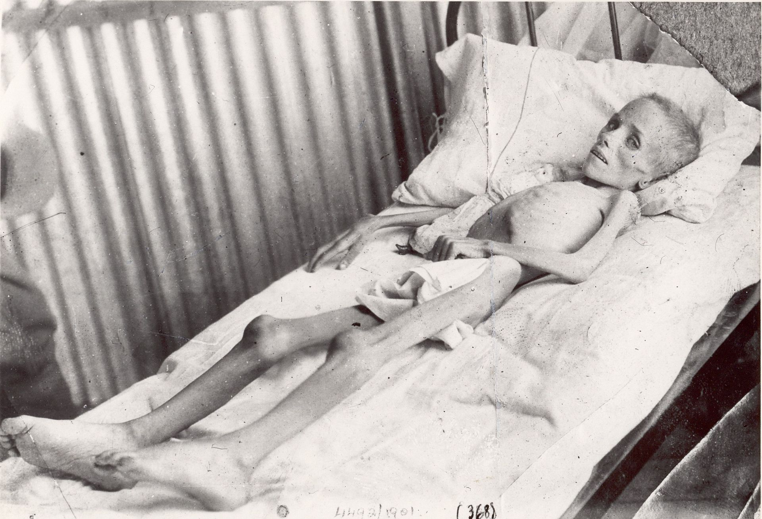

Fig. 6.2: Lizzie van Zyl: farmer’s daughter

Source: Anglo-Boer War Museum, Bloemfontein

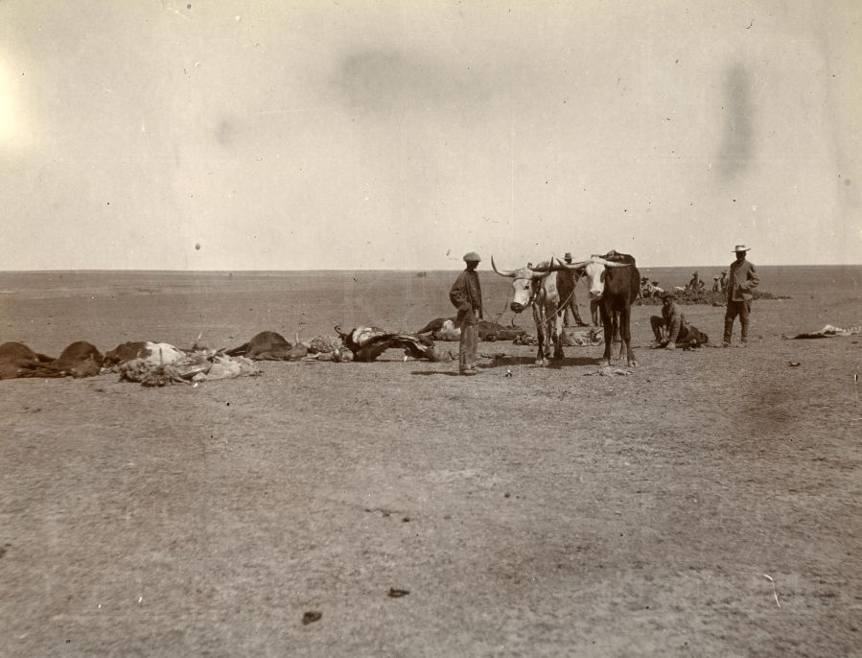

Fig. 6.3: Scorched earth: burying livestock

Source: www.kingscollections.org (CraigVol1 01 to CraigVol1 12)

After the seizures of their farms in the ex-republics and the swift British domination of South Africa’s mineral resources, the surviving Afrikaners were pushed into desperate and increasingly concerted attempts to build their stake in agriculture in the Cape. The intent to recoup viticulture in particular led to the formation of a new company in 1918: The Co-operative Wine Growers Association of South Africa, Die Ko-operatiewe Wijnbouwers Vereniging van Zuid Afrika or KWV. The rationale was that machinery could be efficiently shared and technical knowledge could be centralized while unit costs of production could be reduced, and competition could be challenged by more powerful collective bargaining and marketing capacities (Hughes et al. 1988). The co-operative was started with seed funding from the parliament of the then Union of South Africa and was initially floated on the market as a limited company. The integrated development of the KWV was interrupted in the early 1920s when a struggle to survive played out against a background of scrappy socio-political debates about racial segregationism connected with wine in particular.

In 1912, farmer and parliamentarian Tielman Roos had attempted to pass a bill permitting freer access for black communities to purchase beer and light wines, allowing coffee shops and boarding houses to apply for wine and liquor licences and extending the hours of sale. The bill failed. Then in 1915 the influential Synod of the Cape Dutch Reformed Church had taken a position questioning the dop system, although arguing for regulating instead of ending the system. The champion of this stand in parliament was Dr. D. F. Malan, later a prime minister, and also a theologian whose parents were wine farmers (Korf 2010). The general parliamentary swing toward further prohibitions on alcohol sales was repeatedly met by wine farmers arguing instead for supporting moderate consumption. Louis Leipoldt, a respected Afrikaner intellectual with a medical background, brought a physiological perspective to the wine farmers’ contentions. He maintained that alcohol was an inherent part of human physiology and hence he reasoned it was the intuitive opposite of a poison. Highlighting the difficult nature of the debates, a contemporaneous American commentator, Winshaw, described “an awful spectre of South Africa being turned into a nursery of fanatics ... with perhaps two and a half hypocrites to a family – one awful vast Kansas” (in Nugent 2014:352). However, in 1920 a bill proposing prohibition was only narrowly defeated (Nugent 2014). Following the tension of the debate surrounding the 1920 bill, the declared wine surplus in the Cape then increased to as much as two thirds of the entire production. While the merchants at the time were paying £9 a leaguer to the KWV, the farmers only received £3 and they also had to surrender their surpluses for destruction, which understandably resulted in widespread resentment. Merchants and farmer alike threatened to withdraw from the co-operative system. The KWV was fighting for its survival (Nugent 2014). Directors of the KWV approached the Prime Minster Jan Smuts, with a request for complete regulatory powers over the wine industry. It was that, they said, or face dissolution. Smuts was dubious, but with persuasion and support from members of parliament representing wine farming constituencies, a bill granting these rights was carried. The Wine and Spirit Control Act that was passed in 1924 finally transformed the KWV “from a voluntary organization into a state-sponsored body, with the power to exercise control over production through a quota system” (Scully 1990:107). This act began a “process of legal protection and control of the wine industry” in the 20thcentury which was continually tightened and refined (Hughes et al. 1988:34).

In 1928 Tielman Roos tried again. He proposed an extension of the dop system in operation at the Cape, to the Transvaal province. The proposal was made on the basis that outright prohibition for blacks had proved to be a singular failure and being a farmer, he thought that extending the dop system on farms might stem the drift of labour to the mines. In addition, his proposed new bill envisaged government canteens through which liquor could be made available to coloureds in the Cape. Part of the intention was to expand the market for light wines, which Roos considered a desirable outcome (Nugent 2014). In his proposal, whites were to be permitted to purchase wine and beer from cafés and restaurants without licensing restrictions although coloureds would be banned from making off-licence purchases. In the end, a differently phrased bill passed, and it did allow coloureds the right to purchase alcohol at off-licence outlets. As Martens (2001) noted, a number of members of parliament had defended coloured rights to consume alcohol insisting that there should be less racialism and holding the belief that most coloured people were as sober and respectable as white people. This theme resonated in the Cape Coloured Liquor Commission of 1945. Two specific claims were made in this report. The first was that Coloureds had become so ‘enfeebled’ through consuming wine that strenuous manual work was becoming less possible and thereby unwanted gaps were being made for black farm labour. The second was that because blacks could not legally acquire access to beer in the Cape, they illegally acquired wine and spirits from poor whites and coloureds anyway. Having drawn attention to the illicit trade, the commission did not advocate an immediate change to the law but recommended that government consider the ‘native’ liquor question in the Cape.

Before the commission sat in 1945, an act promulgated in 1940 had added ‘good wine’ to the jurisdiction of the KWV. It also restricted wine production only to those who held permits issued by KWV and it set the minimum levels for prices paid to farmers (Marcus 1989). This move to limit farmers’ commercial freedom carried some strong overtones of the monopoly pachts issued by the VOC during its incumbency in the 17th and 18th centuries. Thereafter, the KWV quickly came to exert a rigid grip on all grape-based alcohol produced in South Africa (Scully 1990:107). Indeed, the KWV was a very different company from that which once represented an ethnic underdog snatching at left-over agricultural scraps after a devastating war with the British. By the 1980s, the KWV had come incorporate the social and economic capital of an elite. This institution was fully integrated into the apartheid system as a top-dog organization. In this powerful mode, the KWV eventually became so influential that national legislations were made in favour of the wine farmers as a group. Indeed after the reports of the Malan Commission, which sat in 1955, recommended a gradual removal of race-based restrictions on alcohol sales, the Nationalist parliament simply approved an amendment in 1961 which made all alcohol products legally available to all races. In the wake of this victory the KWV embarked on advertising campaigns to bring wine to the consciousness of a new market of black consumers. A later amendment eased distribution control by allowing wine, but only wine, to be made available in grocery stores and supermarkets. Presiding government minister, John Vorster, insisted that there had been no pressure from the wine farmers although he added that he would be pleased if the farmers benefitted. The singularly privileged place of wine on supermarket shelves to this day reflects the strength of the KWV of 60 years ago. No South African supermarkets yet sell any form of consumable alcohol other than wine.

6.2.3 Apartheid spaces

The Nationalist Party that instituted a formalized system of apartheid had begun its political ascendancy by the mid 1940s. As should be clear by now the South African wine domestic market was already intricately segmented by interest groups, race and region. Indeed, refined by later apartheid laws, the already perverse forms of alcohol consumption continued to represent the dysfunctionality of an accumulation of geo-political systems for innumerable disenfranchised South Africans.

Before it became a Republic independent of Britain in 1961, South Africa was divided into four provinces. The provinces were demarcated as they had been at the so-called union after the Anglo-Boer Wars, with the Cape and Natal provinces being ex-British colonies, and the Transvaal and the Orange Free State being former Boer republics. As far as the liquor laws that were inherited by the largely Afrikaner government, the situation was complicated. Blacks were entirely banned from drinking “European alcohol” in all four of these provinces, as indeed happened in a number of other British settler colonies (Ambler 1992:340). The list of substances banned from consumption by black South Africans included wine as well as spirits, and bottled beers. Rural black communities however, had legal latitude to brew their own beer. Urban dwellers were allowed to drink the sorghum beer that was specially brewed for consumption in municipal beer halls, thereby providing important revenue for town councils (la Hausse 1992). Not entirely tangentially, the racialized form of prohibition generated a market for marginal entrepreneurs including the mostly female shebeen owners. Ironically, in some ways it also created a zone of inter-racial exchange where poor whites, for whom purchase was legal, often took to buying a few units of liquor for quick resale to black people. The illegal black drinking clubs that proliferated were known by an Irish name shebeen (la Hausse 1988). As a response to laws of preferential prohibition shebeens became a preferred alternative to the legalized beer halls. Shebeens were also constantly raided by police and it was not uncommon for patrons to develop patterns of very swift, thus often excessive, alcohol consumption as a way to counteract unannounced interruptions. As far as the coloured farm worker communities were concerned, the entrenched dop system combined with the expanding power of the KWV meant that a different dispensation applied. Coloured farm workers could not be banned from consuming wine without causing labour disruptions in the winelands or institutional protest. The dop was given up to four times on work days with more on Fridays.

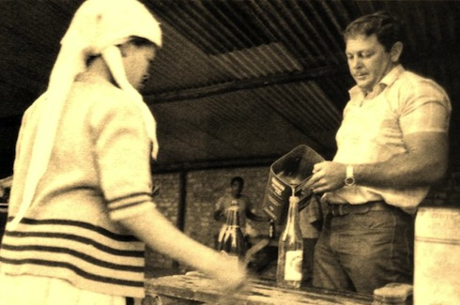

Fig. 6.4: Farmer pours a dop

Source: ©2oceansvibe all rights reserved, with permission

In a complicated set of legislations, all coloureds were permitted to drink wine in the Cape, while wine consumption by any coloured people in the other provinces was illegal. In this way, the coloured communities of the Cape from whom almost all farm workers were drawn became the only demographic group that was not purely white-skinned who were legally permitted to drink wine. As such, these Cape-based communities were at once both the producers of wine and relatively privileged consumers (Nugent 2014). Wine was particularly contentious, because it tended to blur the colour lines.

Under the legacy of British liquor legislations, white people could drink alcohol in all four provinces albeit subject to strict retail licensing laws. However Nugent (2010) finds that outside of the Cape most Afrikaners consumed very little wine. Further, when these groups did indulge in grape-based liquor, it tended to be brandy or fortified wine. A considerable number of Afrikaners, including many of the Calvinist-oriented wine farmers, were teetotallers. By contrast, English-speaking whites who were mostly concentrated in urban areas consumed natural wines, bottled beers and spirits. Yet, parliamentary debates on liquor abuse also expose in a nuanced way, how whites were separated by politics of class in terms of their positions vis a vis alcohol consumption and culture. Anne Mager (2004) cites an instance where a Nationalist politician supportive of wine producers opined that “the responsible use of liquor is part of a larger pattern of life, of a way of life, of civilization, of a culture.” This view was opposed by a politician of his own party, race and language, who represented a less privileged constituency. “Restraint is not a matter of culture but a matter of concern to all people” said the second man while pleading for government intervention in “the dangers of liquor.” Buried in this plea is an inkling of how class situated people in relation to the consumption of alcohol. Imputing from the political exchange highlighted above if ignorance might have excluded the poor whites from restraint in the consumption of alcohol, then it might also have distanced this group from a more ‘sophisticated’ wine culture. It follows then that the structurally deeper poverty of blacks and coloureds would have had even more destructive impacts. Implicit in this discursive maze of alcohol were the both privilege of white society as well as its differing internal positions on alcohol consumption. For the small white South African communities at the time, alcohol consumption was segmented not just by race but also by internal ethnicities and class.

This confusing and inequitable state of affairs was criticized by the Malan Commission, mentioned in the previous section that was set up in 1955 to enquire into all aspects of liquor distribution. Most radically, it recommended that all racial groups should enjoy the same access to liquor, albeit subject to rigorous licensing laws. It admitted the failure of past legislation and urged the government to recognize the changing landscape of African consumption. Similarly, the wine industry believed that the removal of the restrictive legislation would lead to an increased interest in of natural wine by the black communities if the enabling environment were created. Yet despite this pressure, legal changes were slow to take place during the 1960s . By the 1970s, the western world was already on the verge of rejecting South African wine because its production was so deeply entangled with the politics of apartheid. Wine, like other highly identifiable products of origin, was marked by South Africa’s increasing isolation in the world because of its government’s racist policies (Pearce 1996). Yet, as well as building a national fortress with high levels of border protection, the Nationalist Party government became focused on creating national self-sufficiency during the 1970s. Similarly forced to look inward for growth, the wine industry imported Old World wine norms on its own terms. The Stellenbosch Wine Route was the first in South Africa to be opened in 1971 and the Wine of Origin legislation was introduced in 1973. In 1975 the world-famous Nederburg Auction of Cape fine wines was inaugurated (Hughes et al. 1988). Together with such responses to political sanctions, other narratives, notably those of liquor abuse, came to reflect various political standpoints in South Africa.

By building upon an already complicated regime of liquor legislation to further its racialized purposes, the state fueled rampant illegal trading and fomented social situations wherein “alcoholic excess…. took on extraordinary proportions and dangerous meanings” (Mager 2004:735). In defiance of restrictive laws and policing methods, alcohol consumption became a means of political resistance. By the late 1960s, an estimated 22% of black men and 10% of black women in urban areas were consuming a minimum of 25 alcoholic drinks per week (Coetzee, 1966:8). In the early 1970s, during the increased social unrest, the sales figures of branded bottled beers rocketed by 17% while those of ‘legal’ sorghum beer increased by only 5% (Frahm 1982:83). It was estimated that in Soweto, the township outside Johannesburg the residents on average spent more money on alcohol purchases than on rent. Mager (2010) notes that in 1974, the Kwazulu homeland leader Chief Mangosothu ‘Gatsha’ Buthelezi protested that increased wages for Durban workers mostly benefitted the dealers in liquor. His argument was that numbers of Zulu adults spent more of their pay-cheques on liquor than on food for their families. As a large, collective example, the apartheid ‘homeland policy’, whereby groups of people were forcibly moved to supposedly autonomous regions according to their ethnic origins, encouraged new drinking patterns. The investment of anew black elite in the so-called homelands in what are locally known as ‘bottle stores’ coincided with increases in the uncommitted income of many civil servants in the new bureaucracies. Ironically, the enforced social stratification in the homelands led to drinking cultures emerging as a demonstration of financial advancements and distinguishing style (Mager 2004). Distilled ‘European’ liquor signified both a newly elevated financial status and a new means of social distancing. The up and coming elite, the business people and power brokers within the homeland administrations, began to eschew the traditions of communal drinking where bonds of kin, village life or ethnic similarities were the adhesive.

Much of the drinking outside the homelands during the almost two decades of their existence from 1976, inevitably continued in the shebeens which proliferated in defiance of the law and not through compliance with it (Ballantine 1987; Coplan 1985). Mager (2004) quotes black South African writer Jon Qwelane as saying that “the real excitement of drinking in shebeens was the thrill of breaking the white man’s law and getting away with it - there is nothing quite as pleasing as beating the system.” Interestingly, in the 1970s some up-market shebeens materialized in almost plain view and were tolerated by the authorities. That even mainstream whites were reconsidering the shebeen phenomenon is evident in article in Wynboer in 1978. Here, instead of the imagined place of excess and drunken black bodies, shebeens were portrayed as sites of conviviality where friends mutually consumed food and alcoholic drinks:

“The Blacks were never partial to the colonialistic habit of sundowner drinking…... the Black knows no set hours in which it is sociable to consume alcohol. By nature he is a sociable person….. He is inclined to want to drink in large groups sharing his liquor with easy-going gregarious company.”

In a subtle inversion of racial stereotypes here it is suggested that whites, more likely to drink alone behind closed doors, were more prone to addictions. Similar ironic twists and turns abounded. As one example, investigatory commission after commission instituted during the apartheid era, recommended a proscription of the dop. However not only did wine farmers resist the loss of this leverage, but they were supported in these efforts by the majority of coloured workers who also insisted on their right to consume wine, even to excess if they so chose (Nugent 2014). In another instance, a few months into the wider 1976 Soweto uprising, thousands of students took to the streets specifically to destroy shebeens and beer halls. They set roadblocks to search cars and torched buildings. The reasons they gave were multiple. Some were angry because their fathers spent family money drinking all weekend; others maintained that freedom for South Africa would never be achieved if those who should be seeking it were not sober. In the labyrinthine lunacy of the world of South African alcohol, these very different communities were arguably only asserting their relatively autonomous positions, in spaces that inflected the discourse of wine.

Like the existence of the shebeens themselves, drinking to excess was subversive but in a social context of deep alienations the dangers of alcohol abuse were blurred (Mager 2010). Rampant domestic violence, financial desperation, emotional shame and loneliness, many such indicators often associated with alcohol addiction lay hidden in the abyss of civic unrest and could be all the more easily ignored. This extract from an article in Drum magazine depicts wracked township lives in an image too distressing to be wholly collusive with energizing discourses of subversion. It describes a scene at a bus-stop on a Monday morning.

“Her baby was hanging dangerously on her back as she staggered up Victoria Road. Someone in the queue remarked dryly ‘ S’funny how a drunk woman’s baby never falls.’

‘Shet-up’ said Marta in the one vulgar [English] word she knew. She stood, swaying a moment on her heels and watched the people in the queue bitterly. A bus swung round the Gibson Street corner and narrowly missed hitting her.

Three or four women in the queue screamed ‘Oooo!’ But Marta just turned and staggered off into Gibson Street, the child carelessly hanging on her back.”

The spaces of such alienation were also exemplified by drinking on the mines. Separated from family, migrant workers in the notorious bachelor hostels found few leisure options other than at the bar. For many, the excessive consumption of the beer available on the compounds became integrated into the meaning of migrant mining work. Indeed, Mager (2010:56) quotes a migrant hostel dweller saying that “this [sitting at the bar] is part of my job.” Mine managers were similar to wine farmers in that they restricted access to distilled liquor out of concern about frequent absenteeism and outbreaks of fighting. Nevertheless, much like wine farmers provided a dop of wine to retain labour on the farm, mine managers liberally dispensed sorghum beer to keep miners on the compound (Terblanche 1977). For a temporary escape, drinking cultures became prevalent both among miners and workers on the Cape wine farms. Scully (1992:59) comments that “gulping a rationed tot of wine enveloped the farm workers in a social moment in which farmers could not share.” Yet, even so, although offering moments away from their restricted lives, the crude wine ingested daily by farm workers exacerbated social difficulties, caused health problems and created widespread addiction (Rendall-Mkosi et al. 2008). The import of wine consumption unmistakably extends well beyond issues of simple ingestion. Borrowing Mies’ words, “it is difficult to argue Cape wine was not, in almost any sphere, “violent and based on accumulation of wealth through conquest…” (1986:145).

6.3 NEW DIVIDES/HAUNTED SPACES
“Turn your face violently towards things as they exist now. Not as you'd like them to be, not as you think they were ten years ago, not as they're written about...but as they really are: the contradictory, stony ground of the present conjuncture”(Hall [1989] in Clifford 2000:94).

As the era of global isolation for South Africa dissolved in the mid-1990s, wine buyers from across the world descended on the Cape winelands. These representatives were bristling with requests that the industry, at that point, could not fulfill. Even so, a local oenophile, John Platter, made a prescient observation in the introduction to his 1995 guide to South African wines. He said optimistically and indeed accurately, that the finest Cape wines had yet to be made. If the future was so pregnant with hope at that time, what has emerged over the past 20 plus years?

In terms of grape vines, the hope has been if anything exceeded. In 1993, Cape wine exports approximated 25-million litres. At the time, the national vineyard planting was also somewhat brute - composed of 85% white grape varieties and mostly Chenin Blanc (Steen). Other wine grapes were predictable and limited with Cabernet, Merlot, Shiraz, Pinot Noir, Chardonnay and Sauvignon Blanc comprising less than 15% of the total. Today, there are about 600 wineries, exports reached 500-million litres in 2014, and the vineyard profile is sophisticated - roughly equal amounts of red and white grapes, and premium varieties make up close to half of all plantings (James 2013; WOSA 2015). The vines have flourished. The wines are now plentiful, varied and creatively made.

However, as Cape wine industry celebrated its re-entry to the global markets, after 1994, the society was still reeling and soul-searching after an extended period of violence that was a civil war in all but name. It was a time for national reflection. Mamdani (2001) argues that the transition into post 1994 political justice created space to focus on the recurrent cycles of violence that threatened the roots of the new society. Such reflexivity was however, complicated by the instances of violence that skyrocketed immediately after the first democratic elections. To isolate and draw out the meanings of individual threads of violence in a society swamped by general violence, both criminal and political, was not and still is not easy. Indeed, the focus on statistically spectacular violence at the time proved to be so all-encompassing that Hamber (1999:116) argued that other social problems in South Africa became “totally over-shadowed by the high levels of violent crime the country is experiencing.” This thesis argues that violence does need to be acknowledged and that its indicators should not get subsumed into a larger social morass. Indeed I suggest that such ghosts of violence, those that are ignored or overlooked, are just as significant as the ghosts which are seen.

6.3.1 Same-same but different?

‘Same-same but different’ is a phrase used in South Africa meaning that something is functionally or substantively the same as another thing, experience or time-period, but that it differs in implementation. This section addresses two particular spaces where drinking is both different and not so different to the past. The objective is to expose various returning spectres through instances of violence that link wine with human bodies. The first concerns the wider spaces of drinking in the Cape. The second focuses on the spaces of maternal and foetal bodies.

One of the more obscured aspects of the ‘rainbow nation’ is that South Africans today continue to be exceptionally heavy episodic drinkers. It is not a situation that can be overlooked in the Cape or any other province. Specifically, Lawhon & Herrick (2013) find that in the Cape, alcohol is framed by most citizens as a criminogenic, responsible for family breakdown, neighborhood decline and unsafe environments. The last national survey regarded as reliable was the 1998 South African Demographic and Health Survey (SADHS) which at that time estimated conservatively that 10 per cent of Cape Town’s population met the DSM-IV criteria for alcohol dependence that requires some form of intervention (Parry et al. 2005). The significance in local terms is this status refers less to the non-communicable diseases that concern western research, than to homicide as the major public health concern with alcohol cited as an instigating factor (Norman, Matzopoulos et al. 2007; Lawhon & Herrick 2013). With this background, a sense of urgency has emerged in the government of the Western Cape, in addressing the widespread and deleterious effects of substance abuse. As an example, an April 2013 results were released from a local survey Alcohol and Tobacco Use, Mental Health Problems, and Exposure to Violence among learners in Grades 8-10. This survey found that irrespective of gender or educational district, 66% of the participants aged 12-16 self-reported frequent and excessive drinking in addition to pre-teen initiation into alcohol use. Correlated instances of exposure to community violence were strong in the majority of districts. Within in the year prior to the survey 62% of youngsters said they had been present during an assault; 40% had seen a stabbing; 21% watched a shooting and 12% had witnessed forced sex. This survey also discovered the existence of multiple determinants of risk to mental health and the likelihood of a range of problematic behaviours developing in the youngsters.

Whilst the legacies of multiple legislations including the dop system, have undoubtedly had dynamic roles in the patterns of alcohol consumption in the Cape they cannot, as Herrick (2014) points out, be the only reasons now for widespread excessive use of alcohol and its correlated violence. Indeed, the further permeation of such causal narratives might exacerbate their effect by causing other possibilities to be overlooked. In many ways things are very different now. The parameters of current alcohol laws no longer enforce official spaces where people have to be and what it is, or where it is or with whom it is, that they may or may not drink. Drinking laws are now the same for everyone. Yet, the links between alcohol, people and their spaces still have social implications beyond the physical instance of drinking. These implications are, I suggest, the ghostly apparitions of the real politics of alcohol in the democratic South Africa which have not necessarily broken up spatial demarcations. Rather, boundaries are being re-erected, but in geographical and social spaces that no longer marked entirely by race.

Looking at urban examples, what is considered to be a ‘fair-enough’ activity in one part of Cape Town may not be tolerated somewhere else in the city. Herrick (2014) cites one example where representatives from a Shebeen Association explained that different enforcements of social safety rules in the city are related to the effectiveness with which residents push back. In the townships and poorer suburbs reports are rare, due to distrust of the police, the disarray of community policing and anxieties about retributions from shebeeners and individuals who are the targets of complaints. In a similar spatial vein, Long Street, Cape Town’s not-always-salubrious nightlife hub, still offers some degree of safety through private security and CCTV surveillance (Pirie 2007; Visser & Kotze 2008; Didier, Morange et al. 2012). The CBD area is characterized by a plethora of bars and clubs with late liquor licences. These attractions pull a youngish crowd of revellers of all races (Tredoux & Dixon 2009). Herrick’s (2014) study asked participants in the area why, given a high concentration of people consuming alcohol, there was less alcohol-related violence than that in townships. One respondent cited fundamental differences in how people react to situations, “in a black township if I’ve had enough to drink and my friend looks at my girlfriend I will haul out a panga. But in Long Street, it might be a punch in the face … then the bouncer steps in and bollocks both of you and tells you get out” (Herrick 2014:89).

In rural areas, there are other divisions occurring around drinking and surveillance. A study by Gossage et al. (2014) shows current widespread concern among wine farmers about excessive use of alcohol among workers. They find that a majority of wine farmers are engaged in strategies to combat excessive use. On-farm, they tend to move the spaces and rules of engagement and surveillance. Some add money to their workers’ pay packets if they do not show up for work intoxicated. Others use breathalyzers, especially on Mondays. Some refer labourers to social workers and NGO’s for treatment while others have started farm-based education programmes promoting healthy living and teaching life skills. Farmer intervention non-withstanding, in the farm worker communities of the rural Western Cape, alcohol consumption can still reach epidemic proportions (London 2003; Falletisch 2008; Jansen van Vuuren 2013).The generally high level of alcohol dependence in the farm worker communities in the Cape winelands becomes very visible in the Cape’s high instances of Foetal Alcohol Spectrum Disorder (FASD) which affects 9% - 12% of children in some areas (May et al. 2007). Denis Viljoen (2008) from the Foundation for Alcohol Related Research writes in a paper that “foetal alcohol spectrum disorder is the most common birth defect in South Africa, by far more common than Down’s syndrome and neural-tube defects combined.” May et al. (2007) examine children affected by FASD exhibit a range of disabilities. Depending on the severity, problems include any combination of learning difficulties, physical abnormalities, and behavioural problems. There is also impaired growth, visual impairments, restricted verbal, cognitive and motor skills and attention and memory difficulties. These long-term conditions have been well categorized in South African research. As the children grow, the effects or their impairments become more or less stable depending on their care. Either way they are still experienced in the children’s bodies as ongoing and unremitting. Local research also shows that the original disabling with FASD can be exacerbated because the disabilities themselves can trigger pre-existing social interpretations, linked to relative privilege. Indeed, while alcoholic intoxication for the mother is a transient state, lasting for a matter of hours, the foetal damage is always more wholly embodied. A mother’s historically injured body may be temporarily wounded by the effects of alcohol, but there are very different meanings in the permanently wounded foetuses that are unable to recover. Deep in the spaces of their mothers’ bodies, these tiny bodies are, as Rose (1996:185) expresses it, “… a matter of brains, hormones and chemical molecules that connect and transform the capacities of various parts – of exciting them, co-ordinating them, fusing them or disengaging them. These assemblages are not delimitated by the envelope of the skin, but link up ‘outside’ and ‘inside’.”

Insofar as considering these spaces of the ‘outside,’ the social construction of FASD exposes a deep saturation of power relations in the winelands. Foucault’s (1978:139) idea of the “anatomo-politics” of human bodies is a way to conceive of the violence wrought by alcohol. For at the same time as the body is the raw unit onto which power is inscribed, it is also the medium through which it is experienced. Because of the social history of the Cape, it is wine in particular that is the medium abusively inscribing human bodies. By design, the dop system rendered the body docile for efficient use within a viticultural system. The body politic arguably thus moulds the individual bodies not only of women who drink through their pregnancies, but also the developing bodies of babies not yet born. Foetal Alcohol Spectrum Disorder is inevitably gendered because it is the mother’s drinking habits that affect the development of the foetus and this is strongly linked with the precariousness of being a female in some communities in the winelands.

The prevalence of this spectrum disorder reflects each individual mother’s experience of life. An estimated 40% of pregnant women in some farm worker communities continue to drink heavily throughout their pregnancies. Women who are vulnerable to alcohol abuse during their pregnancies often live in rural and underserved communities and not uncommonly have been abused at some point of their lives. Typically the women come from multi-generational families of heavy drinkers and often cannot stop drinking alcohol, or do not stop in time, to prevent FASD manifesting through their bodies (May et al. 2004). Because of lack of restricted opportunities for education and a lack of understanding about the role of health facilities, women and their families have limited knowledge of the physical harm associated with alcohol use during pregnancy. With regards to the lack of guidance I refer to Falletisch’s (2008) study because it is based at Delta. Her findings indicate that drinking is most commonly a bonding group activity that serves to promote friendship. Ruddock (2012), whose study also references Delta, shows that severe episodic drinking related to stress and unhappiness is commonly perpetuated by social norms in farm worker communities. Both studies indicate that on the whole, there is little support for women to stop drinking among many peer groups on Cape wine farms, with extreme binge-drinking occurring at the end of the work week. Charne Abrahamse, the social worker on Delta told me directly that she is aware of a number of women in Franschhoek communities who self-report struggles with low self-esteem, depression and reduced personal motivation.

Prenatal risk conditions are therefore but only some of the factors and challenges in an entire constellation of stress conditions currently facing the women in these communities. The restricted means with which to make informed decisions quite obviously affects a woman’s own life opportunities and those of her children affected by FASD. However it sometimes extends even to those of their children who were not born with FASD (Meekosha & Soldatic 2011). Viljoen (2010) is reported as saying that “…the ubiquity of alcohol in South Africa means that some women regard it as harmless….I have sat in shebeens and watched women put wine in their baby’s bottles. They give them wine to keep them quiet.” (VOA, Oct. 2010). In other words, even children born without the markers of Foetal Alcohol Spectrum Disorder might still be children whose lives are defined by history's oppressive legacies. Infants fed wine by their mothers continue to be marked by the persistent experience of oppressed existences. All these conditions can be intensified through cultural isolation, marginalization and discrimination. Indeed, very much the same conditions that might have brought a mother of an unborn child to consume alcohol in the first place. Physical abuse, poverty and illness are rife and I suggest that through living in the world, many of the mothers have internalized that their lives are not fully theirs to lead and their bodies not theirs to control.

I have specifically emphasized some spaces of an urban/rural divide and of the internal/external spaces of FASD in the Cape. There are many examples, but these particular inter-linkages serve to demonstrate that alcohol consumption can be a material construction of the self, and that it is also part of constructing the self in a far more metaphorical sense. There are indeed new spaces of alcohol consumption that seem to be different today, but I also suggest that while these spaces may indeed have shifted, their essential nature has not done so in the same ways.

6.3.2 Diverse drinking: new consumers, new wines, what meaning?

On the other side of the coin from impoverished and disadvantaged coloured wine farm workers are the drinking trends of the growing black elite. In respect of this particular consumer market, Nugent (2010) comments that “…..the wine industry believes that finally its time may have come.” Nugent (2010) maintains that the wine industry is conscious of the fact that per capita consumption and the total volume of domestic wine been falling in the past decade, but that the black middle class is apprehending that wine can provide a marker of status. Nugent (2010) is not alone in this view. “I get a lot of South African guests who are new to wine” says Luvo Ntezo, “most black South Africans started drinking wine only in the past 10 years or so.” Ntezo is a one-time dishwasher and now head sommelier at the One & Only, a luxury hotel in Cape Town’s Waterfront precinct (pers. comm. June 2014). Many of Ntezo’s customers are among the so-called black diamonds, part of that affluent black professional class, whom Nugent (2010:103) references when he says that: “…..the black nouveaux riches are spending more money on top-end wines….”

Nugent and Ntezo speak of the consumer, but on the production end there are numerous black-owned wine farms with labels like M’Hudi, Thandi, Tukulu, and Ses’Fikele. Indeed, Makaziwe Mandela, daughter of Nelson Mandela together with her daughter have produced a limited range of wine. The Thembu Collection, named for the Xhosa clan to which the Mandela’s belong represents the family's first commercial enterprise in the world of wine (AFP 2013). The wines are not yet much known in South Africa, although they are made from local grapes, under the watchful eye of a seasoned Afrikaans winemaker. More generally, the Soweto Wine Festival that specifically targets black consumers beyond the Cape, has enjoyed some increasing success in recent years. Nugent (2010) notes that optimists in the industry observe that much as Afrikaners ‘progressed’ from cheap, sweet wines, black South Africans are likely to come to appreciate the pleasures of wine at higher price-points. In this respect, he comments that there is movement at both the top and bottom ends of the wine market and such trends give cause to suppose that wine is being regarded less as the preserve of white and coloured consumers. Arguably, this line of sight re-connects race and class by locating the connections in what Appadurai (2004:59) calls “the capacity to aspire.” Without trivializing the wider debate, I suggest that this capacity, also described by Appadurai (2004) as a ‘collective asset’ can be visualized as social capital attached to increasingly sophisticated drinking cultures. Indeed, prior to the South African national elections of 2009, Julius Malema, then president of the ANCYL, the ANC’s youth organization, was specific about aspirational politics, drinking preferences, and social mobility:

“The ANC changes lives. It can change you from a hobo into someone very important. This ANC has taught those who are insulting it today to use fork and knife, to taste red wine, to wear expensive suits” (Posel 2010:159).

Malema’s words also imply that the relationship between wine as aspiration and wine as a commodity could have alienating as well as self-expressive elements. Remaining cognizant of the racially-charged symbolics of acquisition in South Africa today, producers of both wine and beer now stage creative engagements with evocative signifiers. The employment of symbols and stories of history, nature and social identity among others are all aimed to open up new meanings and possibilities for their products. As Mager (2008:160) says, commercial uses of heritage by South African Breweries, the vast beer corporation, “… draw heavily on the notion that what gives heritage its force is not its antiquity but its immediacy and givenness.” Beer has colonized South Africans’ abiding love of sport as its chosen avenue of heritage. Wine is not very different in principle insofar as the labels on wine bottles also draw attention to a shared heritage. With wine it is often more the natural environment, particular fauna and flora, quirky aspects of history and even characteristics of the winemaker. Of course this kind of labelling also reminds the consumer that the wine is a distinctively South African product with local terroir and culture. In this ways the wine industry currently seeks to link the notion of wine-drinking with the concept of unity in diversity. With wines seemingly more user-friendly, black consumers from provinces other than the Western Cape are being encouraged not just to drink more sophisticated wines, but also to visit the Cape and explore wine routes.

One of the ways in which Delta is attempting to link wine-making with other elements, is through referencing local music and dance. An example is a white blend made on Delta named Vastrap which means to ‘trample.' The reason for a Vastrap party was always communal - to trample dung into a smooth floor in a new home. The sound of the music involved unites KhoiSan trance-dance with Dutch folk music and it is played on any of a range of local instruments popular with musicians in coloured communities, like accordions, fiddles or blik-kitaars - guitars made out of petrol/oil cans. In one wine, Vastrap has neatly connected cultivars that have grown at the Cape and on the farm for centuries, with traditional Afrikaans and particularly coloured folk music. Vastrap’s component grapes are classic Cape varieties. The keynote Chenin Blanc was known by the Dutch wine farmers as Steen meaning grape pips and Semillon as the ubiquitous Groen Druif or green grape. This grape has been continuously grown in Franschhoek for over three centuries. According to Professor Solms, no other white varieties were grown on the Delta estate for almost two centuries.

Vastrap is marketed to a range of consumers while reflecting the context of music of the Cape and traditionally of local coloured communities. The accessibility of Vastrap and other Delta wines offers, I suggest, an un-erasure of the labour of the Delta farm workers, in such a way that appears to be incidental. Couched in an easy-drinking wine, there is arguably a subtle kind of identity-based resistance to current trends of Africanist nationalism in the country at large. Indeed, unlike either the Wines of South Africa (WOSA) usage of generic images to market South African wine, or the Mandela family’s use of a socio-political legacy, a wine like Vastrap does not work on behalf of a collective, nor does it reference large-scale assets and abstract principles. Vastrap informs consumers informally of coloured culture in the winelands by cheerfully and breezily tapping into the language and musical culture of the majority of its farm workers (Adhikari 2004; Hendricks 2005). The happy, positive acknowledgement chips away at a commonly-held image of coloured farm workers caught up helplessly in legacies of alcoholism.

By contrast to the bottled, branded South African wines as discussed above, the current trend for Cape wine has been towards bulk export. Indeed, as noted at the beginning of this chapter, total exports rose to a record 500 million litres in 2013/14. Bulk exports contributed strongly to the 100 million litres more than the previous record in 2012. However what might seem like a positive trend has other less positive ramifications. It seems that wine farmers have taken advantage of cash flow from this bonanza to invest in equipment, particularly in mechanization. In a corresponding trend there is new investment in vineyard replacement reducing hectares under vines and planting higher-yielding varieties (Hira 2013). It is a strange trend indeed that increased wine exports should result in a significant downturn for labour opportunities. Yet as Rico Basson, of VinPro explains it, in addition to fears over legal changes in land reform, the proximate motivations were the 2012/13 strikes and protests on Cape wine farms.

“Wine farmers want to reduce risk and increase productivity and the newly enforced wage increases by the government made this more feasible. Pre-strike mechanization accounted for 50% of the harvest. It will be at 60% in two years estimating that one mechanical harvester replaces 100 workers” (Financial Mail 01/08/13).

In efforts to adjust to the government mandate to pay an immediately effective increase from the previous maximum of ZAR 94-00 per diem to ZAR 105-00 per diem, employers made swift unilateral alterations to the conditions of employment. For example, workers on full-time weekly rates changed to piece labour rates and these were moreover tied to the output that a worker delivers per hour. Older farm workers were suddenly at a disadvantage as they could not compete with speedier and more productive young workers. At the same time, household expenditures for farm workers were raised on items that were previously received gratis, such as paying rent for housing and for extended family members living but not working on farms, plus also paying for utilities and transport costs.

The recent moves towards the casualization and externalization of labour provides one way of demonstrating that South African social tensions continue to play out in patterns of wine production and consumption. Although ostensibly, farmers are reducing labour and costs in the wake of the strikes, I suggest that this is possibly due not only to the amount of destruction wrought, but also connected with the farmers’ general sense of a lack of gratitude on the part of the workers who took part. In the absence of traditional loyalty as reciprocity, farmers feel justified in finally withdrawing from adherence to the vestigial responsibilities of the paternalistic system that once compelled them to provide as much work as possible for farm workers and their families. It is ironic that actions changing to conform to new social structures through the de-activation of old symbols of power still do not comprise neutral exchanges. Instead, they maintain relations of domination. In Bourdieu’s words (1998: 85) “…part of a mode of domination of a new kind, based on the creation of a generalized and permanent state of insecurity aimed at forcing workers into submission, into the acceptance of exploitation.”

This chapter has been composed from juxtapositions that provide an awareness of how deeply the narrative of wine is integrated in South Africa’s past and present. Collectively the material gestures towards how wine has been involved in statements about race and class status and to express structures of relative inclusion (Dietler 2006). At the same time there has been a re-examination of wine as determinately embedded in broad relations such as consumption trends and small events like the making of a particular wine on Delta. In all this, the chapter has followed wine-related changes through time and politics, only to find that a number of wine farm workers are still living destitute and damaged lives. In this rerouted way, I suggest that it is through spatial permutations of practice rather than vast hegemonic constructs that symbolic, structural and embodied diacritica of violence converge most perceptibly. Undoubtedly, legalities and interventions in hegemonic discourse alone do not necessarily lead to social improvements. To have pretensions otherwise is to ignore very real social contradictions in South Africa today. There is a situation with a democratically elected government, new drinking laws, policy changes afoot in the wine industry and also many wine farm workers for whom none of this amounts to an ethical world.

So what is left? A call for a new spirit? Any new spirit needs to take cognizance of the past, not to deny it but to communicate the shared responsibility to reduce the severe alcohol-related harms in the wider society and to rationalize the labour situation. It is clear that a new spirit for the wine industry cannot be conjured at immediate will any more than a future can be performed as an instant break from the past. Wine in particular cannot avoid the focus on deepening inequality and poverty among farm workers. The challenge is that the production of wine is both alienating and self-expressive. Paradoxically, re-imagining space and meanings of belonging through Cape wine still demands that attention is focused on perceived differences and on grasping that which will not heal. For all of these reasons, there are no fewer meanings attached to the simple act of opening a bottle of Cape wine in this, South Africa’s liberation era, than there were before.

CHAPTER SEVEN

HIERVANDAAN

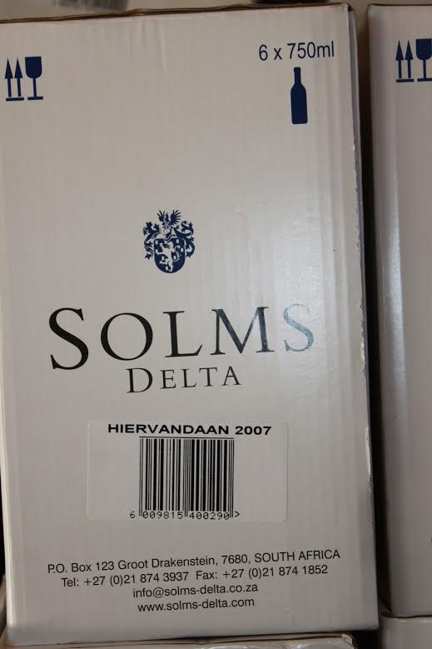
Fig. 7.1: A box of Hiervandaan wine
Photo: Corrie de Blocq

7.1 INTRODUCTION

My first meeting with Professor Mark Solms in July 2012 was in the dining room of the Delta homestead. Solms, who had arrived home from a trip to Brazil only minutes before our early meeting, handed me a mug of coffee while he related a story. The tale concerned one Marquard de Villiers, a latter-day scion of the Huguenot family who had been owners of Delta for many years. Solms recounts a conversation that de Villiers had with a labourer of Khoikhoi origin at a neighbouring wine farm also once owned by this family. In response to de Villiers’ statement that his family had farmed there 300 years ago the worker replied that he too was hiervandaan which means ‘of this place’. The man said that his own people been hiervandaan ‘sommer van altyd’ meaning ‘just since forever.’ This sense of being hiervandaan is, I suggest, neither unified nor singular and it contains elements of both the past and the present. It is however coded with an identifiable sense of belonging. Throughout this thesis there has been a contention that recurrent violence owes much to experiences of being in the same space but belonging there differently. Here I open the contention further by reconsidering the meaning attached to the word ‘differently.’ Instead of referring only to the implications of positionality, ‘differently’ is also understood to have significance as ‘change’. I ask what it is to be hiervandaan on Delta now.

7.2 TAKING IT ON TRUST

“You can’t take on the ownership of such a property and not also take on its history…”
Professor Mark Solms (notes at Delta, July 2012).

Without doubt, the catalyst of the current changes on Delta is Professor Solms. Throughout my years of work on Delta I cogitated on what Solms had expressed about his field at our first meeting. “Neuropsychoanalysis is all how the actual stuff of being a person relates to the tissue and physiology and anatomy and chemistry of the brain? How is it that dreams, fantasies, memories and feelings emerge from a chunk of flesh and tissue?” Qualified as both a medical doctor and as a psychoanalyst, Solms lived and worked in Britain as an adult. Nevertheless, upon purchasing Delta and returning to South Africa in 2001, Solms says that he felt a familiar uncomfortable feeling come rushing back - an awkward amalgamation of historical guilt and immediate responsibility. The proximate reason, Professor Solms told me, was that South African-style, he had inherited seven families of workers who lived on the neglected farm.
The existing inhabitants were resentful and unhappy. Initially Solms was faced with sullen, disempowered workers, who were unwilling to communicate or to co-operate with him. Solms said openly, “You would have to be an absolute bloody fool to not recognize that you’re in danger if you hold on.... Somebody’s going to come and take it back eventually. Think about the spate of farm murders—not just simple murders and robberies. If you look at the details of the attacks, you can see there is rage behind them.” The ubiquity and intensity of farm attacks in South Africa only underscores that Solms has good reason to prioritize personal safety for his family when living on a farm. The targets of the attacks are usually farmers, their families and domestic workers. Solms continued,“…all kinds of rationalizations flood into your mind, like... it’s not me who took the land. It’s not these same farm workers right here and now who were dispossessed of it. That was all going on centuries ago.”

Solms’ solution to the problem was to fall back on his professional psychoanalytic training. So he consciously set about uncovering the ‘case-histories’ or farm workers’ stories. In the telling of stories, Solms believes there is healing. In the process, the idea for the Museum van der Caab was also born. Its purpose was to tell the stories of those who had worked on this farm for over three centuries. The museum, however, was just an entree. The more acute question, said Solms, was what to do about the land? Solms’ answer came in the form of a loan that was co-sponsored by his friend Richard Astor, who purchased a farm adjoining Delta. By using their newly-acquired lands as collateral they made it possible for the 180 workers connected to the farm to buy an adjoining 30 hectares. The two families and the group of workers each formed a separate trust to operate as equal partners in the Solms-Delta wine enterprise. The management of the farm and associated trusts are of interest in this study that links wine and violence in a way that takes account of social dynamics.

According to Solms-Delta co-owner Mark Solms, the decision-making processes of the ‘equal partnership’ work over multiple layers as summarized here:
1. The board of Solms-Delta is the ultimate decision-making body and it consists in three directors, representing the Solms family, the Astor family and the Solms-Delta Trust.
2. The board of the Trust has two beneficiary members representing their interest directly, in addition to the chair, who sits on the Solms-Delta board. The other members are: the Franschhoek mayor and local ward councillor, the citizens’ bureau officer, a local government employee, a lawyer and an accountant.
3. The chair of the Trust represents the plaaskommitee (tenants’ committee) elected annually by all resident beneficiaries. S/he also represents non-resident beneficiaries via six representatives elected per department: cellar, vineyards, restaurant, museum, security, administration. These representatives have regular weekly meetings.
5. The beneficiaries, resident and non-resident, meet monthly with the Solms-Delta board members. Professor Solms says that these meetings ensure that understandings are not “lost in translation” and are attended by the six representatives of non-residents mentioned above, plus one representative of each resident household (Professor Mark Solms, pers. comm. 19/11/2015).

As noted in Chapter 6, the trend is for most South African wine farmers to move workers off the land. Cape wine farms offered for sale without workers in situ realize considerably higher prices than those with farm-dwellers. However Delta’s owners have done the opposite. Solms and Astor are utilizing trusts to invest in their workers’ personal and social development in place.
7.2.1 Wijn de Caab Trust
Established in 2005, the Wijn de Caab Trust owns a third of Solms-Delta’s conjoined farms and one third of any joint profits also devolves to the trust. As farm-workers and farm-owners are equal shareholding partners, the trust itself carries implications of linked responsibilities and in theory the social power ratio should become less unequal. Charlotte van Zyl, the administrator for the farm trusts told me that the purpose of the Wijn de Caab Trust is to make interventions in the poverty cycles still affecting the both the residents and workers on the farm. The trust especially aims to widen the horizons of opportunities for children living on Delta. In the past, the children of agricultural labourers in the rural areas have become farm workers themselves out of financial necessity. Through this trust, educational opportunities and reductions of the parental burden of care have been put in place and workers on Delta enjoy free education for their children. This trust covers the costs for the children to attend a local ‘ex-Model C’ school. Homework supervision, remedial help and other educational assistances are offered on-site. A care-centre for babies and small children, Klein Handjies (Little Hands) and after-school facilities for older children have also been established on Delta. Financial support for the first years of college education is available. Improved medical care is integrated into the funding structure of the trust as well. It covers most individual medical and dental costs. Towards promoting physical and occupation well-being, sporting and recreational facilities are provided together with appropriate training. On a day-to-day basis, all these programmes are coordinated by a social worker Charne Abrahamse.
I met with Charne on numerous occasions and saw the wide-reaching scope of her responsibilities. They extend from individual counselling, to acting in support of insecure parents at school meetings, to developing occupational activities for retired farm workers on Delta. Indeed, on a field visit to Delta just before Christmas 2012, I noticed a pile of hand-knitted and crocheted blankets folded in a corner of Charne’s office. Upon my inquiry about the blankets, Charne explained that the handwork had been done by a group of retired workers living with their extended families on the farm. All the old people whose handiwork those blankets represented are coloured, and the blankets were to be delivered to as gifts to a nearby old-age home where most of the patients are poor white people. I thought about this story for a long time. This relatively insignificant instance represented a convergence of the subjective experiences of people with their interdependencies, not just in specific relationships, but in the shifting relations between social groups. In a South African context, the simple actions of making, donating and receiving blankets comprise a game-changer.
The Wijn de Caab Trust has also engaged in improving the quality of accommodation for farm workers and residents by building new houses and renovating older houses. Although farm workers clearly derive direct material benefits from advantages of modern building construction, free utilities, even free television, in their rent-free houses, the construction of subjectivity through such processes is more indirect and not entirely uniform. Five of the six farm worker interviewees expressed positive feelings resulting from all these material changes. The sixth interviewee stated that he did not choose to avail himself of the free amenities on the farm and instead lives in nearby Paarl. He offered an analogy as a reason. As ‘n mens iemand ander se kar altyd dryf, dan vergeet hy vinnig hoe om vir sy eie kar te sorg. ‘If you always have someone else’s car to drive, then you soon forget how to maintain your own’.

7.2.2 Delta Trust

The privately-funded Delta Trust was established in 2007 by the Astor and Solms families. Charlotte van Zyl says that the co-founders “… believe that what happens on a Franschhoek farm could have influence throughout the valley and beyond.” The aim of this trust is to support social cohesion through the mediums of creative local cultural work. At the transformative end of this spectrum, as van Zyl told me, the combined input of Delta’s trusts encourages projects that develop this dynamic on Delta. This trust supports a broad range of projects that span the fields of cultural heritage, social upliftment, sport and recreation. One of the outcomes of such funding is the Franschhoek Oesfees an annual harvest celebration held on Delta. The farm’s cultural projects are also funded by the Trust. Two of these substantial projects are the Museum van de Caab and the newer centre for Music van de Caab, which frames and facilitates ongoing research into what the Delta website calls “the colourful musical heritage of the Cape.” Having discovered how Delta’s funding was structured, I then began to think about the particular restructuring projects on the farm and the narratives through which they are producing new spaces of opportunity to participate in a social experience and each has particular recuperative meanings at its centre.

7.3 BUILDINGS

Today, both the Museum van der Caab and the wine tasting room on Delta exist within the footprint of the same long, low building. It is the building where at the time of Solms’ purchase, most of the families of farm workers had lived in cramped and unsanitary apartments carved from the spaces of the old wine cellar on Delta. A young adult member of the farm community, who, at the time that I spoke with him in 2012, was studying tourism and hospitality at a local college, posed smilingly for a photograph at the door of the museum. He told me that he was born in this very building and as a child he had lived there with his own family and some others, in crowded unsanitary privations. He said cheerfully and professionally that it now gives him satisfaction to greet visitors “...with a product to offer that people like and a story that is not just about the miserable past”.

7.3.1 Making space for history
Social change as Bolender (2010) points out is neither neat and tidy nor monolithic. A visit to the museum on the Delta heightens this awareness of a changing present existence that is caught up in multiple stories-so-far. For a visitor today, a casual moment of standing on the lawn overlooking the vines will locate one physically within Delta’s traditional werf. This werf, as indicated through the history of ownership recounted in Chapter 5, has been repeatedly re-envisioned and reconstructed. The view along the valley floor from upon its heightened geo-paleological shelf locates this place within the seasonal ambit of Khoikhoi and San groups. The rivers for which Delta is named were integral to the growing settlement of Huguenots in this now well-vined valley. The Delta werf as it exists today is surrounded by the erstwhile properties of the Pickstones that were described by Interviewee W, as stretching van berg tot berg, translatable as encompassing all the space across the valley from mountain-top to mountain-top. Standing in the werf today also situates one within numerous layers defined by other people situated in other moments, working from different subjectivities for other purposes. Reminders of Delta’s palimpsestuous existence are evident in the Museum van de Caab which is housed in the gabled end of the old cellar building. The logic of curation and the material display takes the visitor from ancient and pre-contact usage of the land, into European settlement and the introduction of alienable property, towards the social legacies of slavery and apartheid. Discovered artifacts and snippets gleaned from local archives are used to represent the story of Delta. However what attracted my immediate attention the first time I entered the museum was a sheet of closely-fitted black granite tiles covering the back wall. Each tile bears the name and life-dates of a slave who worked at Delta.
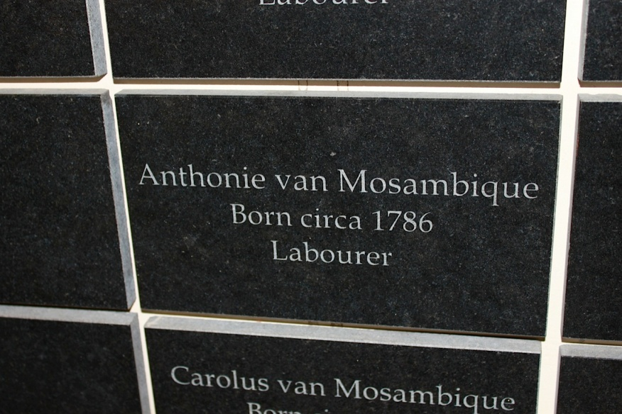
Fig. 7.2: Slave name inscribed
Photo: Corrie de Blocq

The wall is a memorial, a simple, striking acknowledgement that these human beings existed and ensuring that their stories are included in this space. In some cases there is no name, only the gender and approximate date, for that is all there has been discovered of the slave. Tracy Randle, the curating historian says that “communities sometimes look to museums as places in which their identity is articulated…..particularly in a society like ours, museums need to ensure that exhibitions depict history and culture in a dynamic way.”

A part of the display includes a video that has recorded some of Mark Solms’ reflections as well as the personal stories of farm workers currently living on the property. In a way of linking inside and outside spaces, museum also organizes a number of walking tours as well as the expected cellar tour. These include a culinary tour of the Dik Delta Fynbos garden, a heritage walk with a focus on the natural environment, a Cape musical experience and also a social transformation tour of the changes at Solms-Delta. Such tours are billed on the official website as:
“Our unique guided wine farm tours expose visitors to more than just award-winning wines. Led primarily by farm residents, the tours offer rare personal insight into the vineyards, farm workers’ lives, and the cultural and musical heritage of Solms-Delta and the surrounding Cape Winelands.”

Perceived as a product in high demand - even the South African government urges providers to offer similarly “authentic and memorable experiences through meaningful interaction with local people and cultures” - there is much for the tourists at Delta (DEAT 2011). The product is not without some of the ambiguities that tend to accompany of this type of tourism. In this respect Witz, Rassool & Minkley (2001:277) argue that “such tourism in South Africa is not merely a business, it is also about the packaging of images that represent the society and its past.” Conradie (2012:3) says that “the country’s cultural heritage is ... conceived of as asset and product which competes with the cultural assets offered by other nations who position themselves upon the shelves of the global, heritage-supermarket.”

This section is not a debate on local cultural tourism. Rather, it indicates something of the changing subjectivities of Delta workers in response to the changing spatialities of increased tourism on the farm. All the Delta farm worker participants were enthusiastic on the topic of tourism. Of those with whom I spoke who live on the farm, there was not one who expressed any negativity towards the apparent commodification of their personal or family stories, even though tours take strangers past their homes and gardens. On one occasion, as I watched, a pair of tourists left their group and tried to take photographs inside the room where older children were engaged with their homework. Somewhat indignant, I asked the tourists to leave, but the children were unconcerned, as was the farm worker guide upon retrieving her missing visitors. The major motivation seems to be that the attention and interest makes the participants feel good, with improved self-esteem often acknowledged. Interviewee J said that that guiding visitors and answering their questions had been for him a way of being able to be “...proud about what I do on the farm.” Interviewee T commented that she liked the new experience of talking with non-South Africans and hearing their comments, “except for Americans … they cry too much…..if you think of their own slave history.” Two other interviewees also mentioned enjoyment of the “opportunity to mix with people from other countries” and its lekker, nice, just to answer questions, because nou weet ek wat gaan hieraan. I feel like I know things [about where I live].

These responses resonate with Conradie (2012:3) who notes, with reference to much-contested ‘cultural villages’ in South Africa, that residents who “reproduce their own ethnicities for public consumption are no longer employees exchanging their labour for salaries, individuals and groups are motivated to become entrepreneurs…marketing their own vernacular life-ways.” Nevertheless, the more I considered this phenomenon, the less I liked it. I eventually realized that my own education that had left me overly attuned to the negative side of cultural (re)productions. I innately fear that amnesiac tendencies about the continuing inequities of South African society will re-emerge if spatial configurations become too comfortably fixed. However, the important point is how the exponents themselves feel about their performances of identity production. As Comaroff & Comaroff (2009:50) contend, “…identity has come to rest, at once, on ascription and choice…ineffability and self-management, embedded in human subjects increasingly seen, and experienced from within, as entrepreneurial.” Similarly, Hughes (2003:2) argues for the collaboration of touristic ventures and cultural heritages to fulfill contingent needs, saying that “tourism has become deeply embedded in this effort: it can provide jobs and therefore hope for the future, based on the one resource that poor communities are thought to possess in abundance: their past and present.” Albeit unwilling to relinquish my objections, I acknowledge that this simple exchange dynamic has worked extremely well on Delta thus far.

7.3.2 Tasting spaces
Henri Lefebvre (1991:31) contends that that “every society…produces a space, its own space.” This contention raises an important question about how the configuration of this space of consumption might contribute to the survival of past into the future through its present figurations. In considering tasting spaces on Delta it was particularly helpful to consider Lefebvre’s (1991:31) tripartite concept of space comprising “spatial practices”, “representations of space” and the “spaces of representation.” Spatial practices refer to the everyday, almost unconscious sense of space that comprises perceived space. In this directly sensible kind of space the contemporary incarnation of the restaurant Fyndraai, presents a slick and user-friendly take on a Cape Dutch architectural design. The design interest is in how the deployment of materials engenders active and sensual tasting experiences, textural, visual, tactile and aural. Fyndraai is adjacent to and in the same building as the Music van der Caab museum and all the background music is of the traditional Cape. The building sits squarely as a Janus-faced material construct – the side that opens on to the werf looks like a barn, whitewashed and plain with a rustic interior. Once inside, a visitor moves through a rustic informal area to the main restaurant, whereupon the vista changes. A narrow linear pool divides the vernacular from the super-modern part of the building. Despite its sleek image, the look and sound are instant reminders of the traditional irrigation sloots familiar to many South Africans. These were long channels dug into the ground through which the Dutch settlers brought water to their vines. Moving past the pool, one enters a clean open space full of artfully simple white-clothed tables. The colours are a sophisticated rendition of shades of brown and charcoal commonly associated with African-themed interiors. In the summer this space is mercifully cool and air-conditioned, the temperature change offering a line of retreat that encourages diners to linger and enjoy the food and view of vineyards and mountains.
This is a space that is materially manipulated and combined to address a variety of concerns – ranging from user comfort and experience, to how the use of specific materials contribute towards heritage awareness, as well as how the use of space supports skill-development, especially in the young farm residents who wait on the tables. Fyndraai has served as a training ground for teaching hospitality and service skills to a number of young adults from the farm and community in the valley. Solms admitted that for a while “I would just close my eyes” to the errors made by youngsters, most of whom had previously never even entered an upmarket restaurant. By the time this study began, however, Fyndraai was rated in the top ten for service by Eat Out, South Africa’s premier restaurant magazine, with reviewers complimenting some "truly unique South African flavours.” I have invited a number of guests to Fyndraai over these years and also attended special events in the restaurant. Interestingly, like the vineyards, it is a space of seasonal practice, full and busy in the summers and almost deserted in the middle of the Cape winters.
The tasting room is situated diagonally across the werf. It is a long low whitewashed building with a stoep running along its length. The building is comforting to behold - rustic Cape Dutch. In the summer, families spread blankets on the lawn and children play on the grass while adults sip their wine. Nothing external is unusual as a place to have a wine-tasting experience in the winelands. The rupture comes up through the internal floor that is entirely composed of large square reinforced glass panels, held in place by metal girders. Breaking through into another era, the layers of this building date back to its earliest construction. Having discovered the remains of slave shackles on site, archaeologists currently think that the cellar was used not only for storing wine, but at some point, also for restraining and punishing slaves (Randle pers. comm. 2012). So what becomes visible directly beneath visitors’ feet is the bitter taste of other uses and times. For visitors, in my observation mostly of a middle-class identity, the transparent floor is a show-stopper. Wine tasters rarely stay seated, curiosity prompting them instead to wander between tables, gazing into the ruins underneath. Thus consciously integrated into a tasting experience on this site are the episodic and sequential performances of history and a spatial gathering of its particular stories. This was summed up by Interviewee L, a young restoration architect, when she spoke of the wine tasting space as “a repository of memory, a reminder of injustice.”

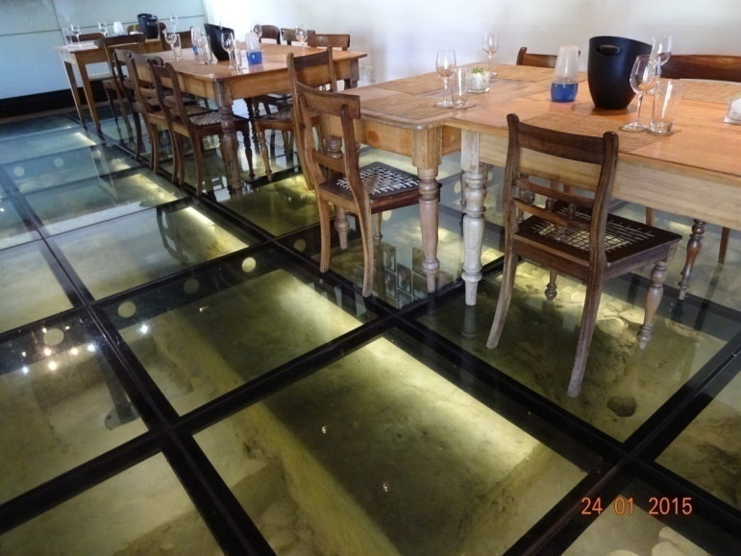
Fig. 7.3: Tasting room Solms Delta
Photo: Corrie de Blocq

As such a conceived space, this tasting room is also bound to particular relations of production, in this case of wine (Soja 1989). I have yet to tire of watching how this floor swiftly becomes a kind of liminal grid, making the act of tasting into an experience of “a space that stretches across the images and symbols that accompany it” (Soja 1996:67). Both Fyndraai and the wine tasting room offer paradoxical spaces, at once tending to erase the past and at yet at the same time leaving visible the marks of that erasure.

Lefebvre’s representations of space I took to mean a conceptualized space, related to what Minkley & Bank (1998/1999 npg) describe as “the space of planners…. who identify what is lived and what is perceived with what is conceived.” Fyndraai is a deliberately conceived space with a purpose and a message. It is self-consciously tied to the natural produce of the land and to an empowerment paradigm through music. The restaurant abounds in depictions that form an architectural orchestration of local food and music. There is also another kind of acknowledgment. The wall in the section that serves lighter meals houses an extensive photograph gallery of the workers on the farm. The arrangement of faces on the wall creates an awareness of living human labour, similar, in a way, to the consciousness of “dead labour” that comes up through the transparent floor in the tasting room (Mitchell 2003). An adjoining wall, seen in Fig. 7.4, is emblazoned with descriptions of different kinds of Cape music and the hopeful slogan: “You can never utterly destroy the hopes of people who can sing.” The formal side of the restaurant has subtle cut-outs on the only wall that is not mostly made of glass. The shapes visible in Fig. 7.5 represent musical instruments, highlighting, through design, the social mediation of music.

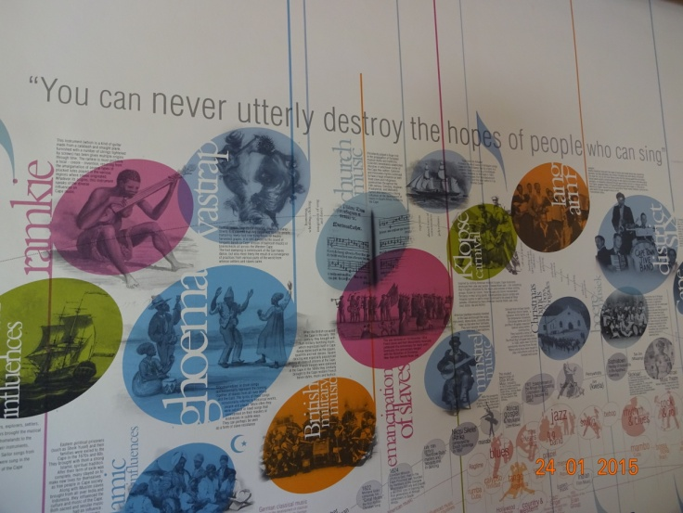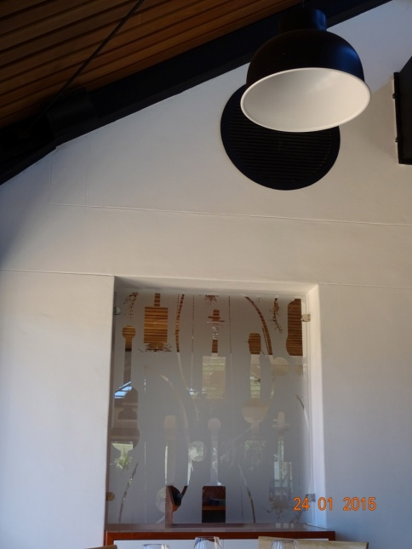
Fig. 7.4: Music history wall Fig. 7.5: Instrument wall
Photo: Corrie de Blocq Photo: Corrie de Blocq

In its conception and construction then, Fyndraai spatially multi-tasks in what it makes visible, in that with which it surrounds visitor and, centrally, in what is consumed here. Heritage here is how people in their activities of bodily consumption are, remembering, communicating, negotiating and expressing local identity through the spaces around wine and food (Smith & Stenning 2006).
Lefebvre’s third category comprises spaces of representation. These can be seen as distinct, but in some senses the other two conceptions of space are also incorporated. Seen as lived space, this includes not only a sense of how space is occupied by humans and non-humans, but also of various meanings associated with space. I explored this kind of space through the associated ways in which Fyndraai operates in the lived spaces of food production and consumption on the farm. When Fyndraai first opened its doors the aim was for the food to reflect the Cape’s very particular traditions. The recipes used in the kitchen owe much Renata Coetzee’s work on Afrikaans and indigenous culinary heritages (pers. comm. Feb. 2011). The menu is completed with a glossary of the Afrikaans terms from which the restaurant staff derives pleasure in translating. Fig. 7.6 is a recent example of menu.
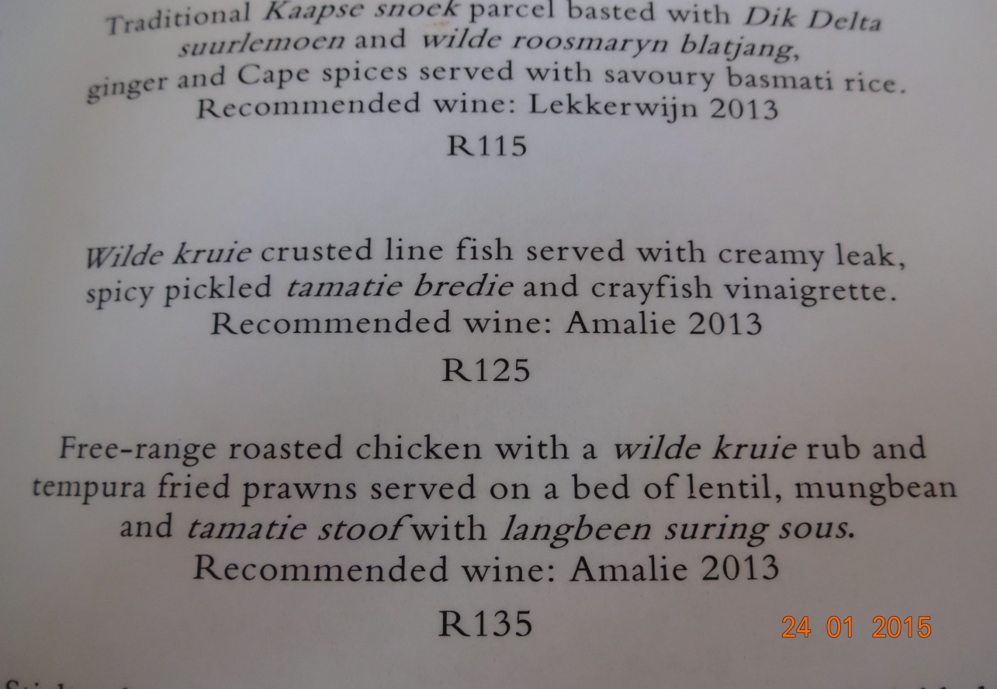
Fig. 7.6: Fyndraai lunch menu 2015
Photo: Corrie de Blocq

In this kitchen there are strong references to Afrikaner boerekos, a style of Cape food that was influenced by mixed European and slave practices. As prepared at Fyndraai this culinary tradition is now mixed with flavours from ingredients used by the Khoikhoi and San communities whom moved around in the valley millennia ago. The vision to recreate this veldkos heritage of the Khoikhoi and San communities, says Solms, was the genesis for the food garden called Dik Delta. This kitchen and its garden comprise a spatio-temporal rooting, with specific links to a Cape heritage that comes with multiple appropriations of this resource. Heritage in Dik Delta can literally be induced from the ground up, not only deduced from the top down (Solli et al. 2011).

Approaching the Delta farm complex along the main avenue, it is easy to miss the garden. The hardy plants lend themselves to the stoniness of the earth and without the demarcated paths as markers, the indigenous plantation would blend easily into the environment. A two-hectare section of the garden is an area given over to the cultivation of plants for culinary purposes. The main path draws attention upwards to the dramatic mountains. However the eye is also directed to the centre of the path which is a circle, representing communal meeting areas of traditional Khoikhoi and San cultures. Paths edged with stones radiate outwards. The beds between the paths are filled with edible plants like spekboom. The beds are bordered by trees like the Kei-apple which are reminiscent of old Khoikhoi and San landscapes. In a broadly inclusive way, the bio-heritage of this part of the Cape and that of its indigenous people is represented through some 400 plant species. The garden has been carefully constructed, with plant specimens obtained from various local nurseries and identified through botanical hunts in the indigenous bush in the Franschhoek area. There is an adjoining 15-hectare section of land that is about to become the first Fynbos/Renosterveld park. It showcases indigenous trees and other plants that were utilized in different ways by the Khoikhoi.

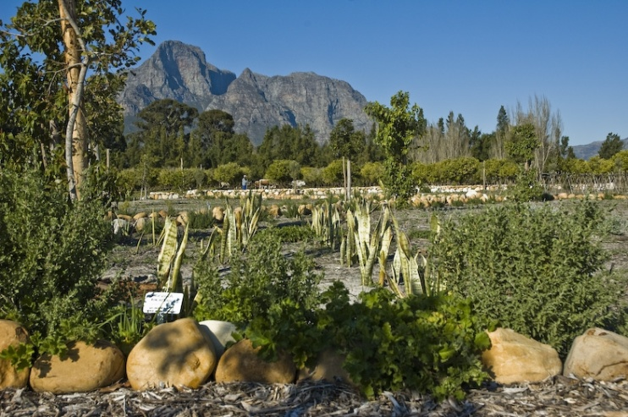
Fig. 7.7: Dik Delta: culinary heritage garden
Photo: Corrie de Blocq

The re-planting edible indigenous vegetation is arguably rehabilitating the zone of bio-contact that was established as a one-way vegetal incursion of vines hundreds of years ago. The garden re-introduces the vegetal material that was displaced and simultaneously acknowledges the consumers of the past who were denied access to the resources of this piece of land. The way in which the restaurant staff recognize and interpret this biological heritage as part of their own, affirms its foundational elements and the connotations seem to be accepted. I suggest that this relationship with the food and wine made on the farm also constitutes a referential point according to which the young people can become mobilized. In other words, engagement with Fyndraai’s successful manipulation of the dining performance not only translates into means higher economic returns for the young staff members, but adds opportunities for more intrinsic rewards and subjective self-recognition. The buildings that house the dining and wine tasting experiences are new re-designs of older spaces, each space building upon the history and the very structure that it occupies. Each space of consumption is for transient use in the present. Yet the sonic and culinary experiences happening in these buildings are a combination of historical and traditional cultural context. In thinking of Fyndraai in this way, its spaces of representation do indeed contain many real and imagined spaces simultaneously (Soja 1996).
7.4 MUSIC MAKING

Music resounds throughout Delta’s spaces and makes its way into the farm’s vinous libations. There is the wine called Vastrap, already mentioned and others named Langarm and Cape Jazz Shiraz. The first two are Afrikaans words, referring to a vernacular style of dancing and to a set of dance steps respectively; the third and best-selling of the wines, self-evidently relates to a popular genre of free-flowing music. The local ‘flavour’ indicated on respective bottles is savvy marketing. Yet music on Delta offers more than an amusing riff on a wine label. As the names of their wines strongly indicate, the owners and winemakers promote interest in the cultural heritage of the coloured people in the Cape. Professor Solms says cheerfully that “we don’t just farm wine here, we also farm music.” Please listen to any, or all, of the songs from the CD included as Appendix G. Most of the songs are original, in the Cape genre and performed by musicians connected with Solms Delta.

7.4.1 Musical therapy

The syncretic process on Delta that relates music to wine is, I suggest, a pioneering form of heritage-based development. For the farm workers here, music comprises a massive community performance. Delta boasts four bands, which includes a marching band drawing at any given time upon approximately 80 musicians. Adriaan Brand is the current music project co-ordinator. Self-deprecatingly introducing himself as “a failed Baptist” the talented Brand has assumed his role on Delta with an obvious sense of mission. He is also trumpeter for one of South Africa’s leading music groups, but this musician has a special interest in children with Foetal Alcohol Spectrum Disorder.

Constructed during the time I was visiting Delta, the Music van de Caab museum opened in October 2014. This museum is part of the ongoing Cape music project that the Delta Trust initiated in 2007. Research has focused on researching, protecting and re-interpreting Cape music. The vernacular music has been influenced by indigenous traditions of the Khoikhoi and San communities, the cultural traditions brought by slaves from Indian Ocean rim countries and also by European folk music. The small exhibition area has touch-screens with interactive displays and audio. The display cases contain instruments such as bow lutes and a blik-kitaar which is a guitar made of an old oil can. Among other instruments there are the seaweed horns of the Cape fishermen; reed flutes; musical bows and ramkies made from a calabash or a tin can. Visitors can try these out or watch a demonstration by the exhibition guide who is someone who lives on the farm. The photographs comprising Fig. 7.8 are of handmade traditional musical instruments.

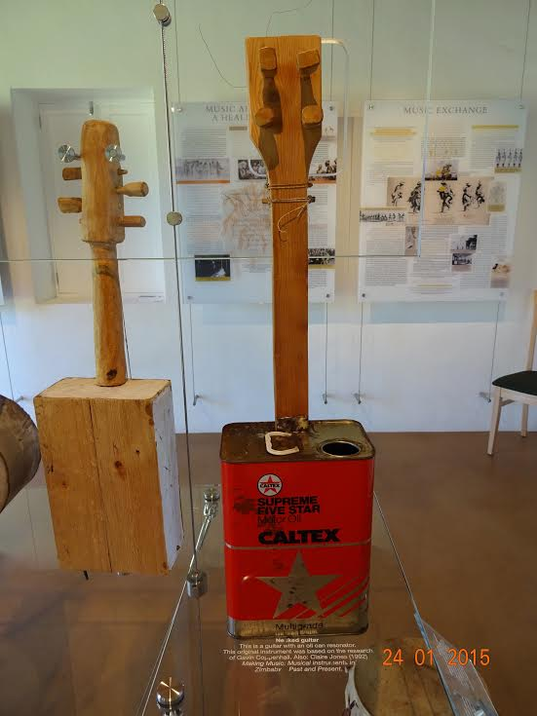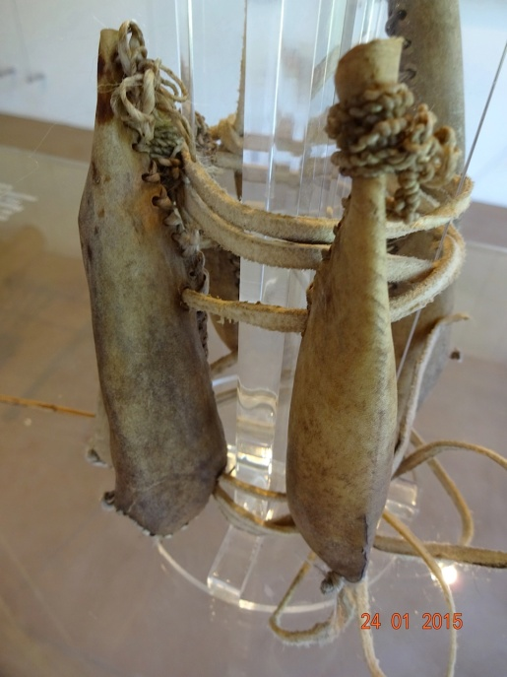
Fig. 7.8: (1) Blik-kitaar (2) Dried springbok ears rattles.
Photos: Corrie de Blocq

During one visit to the music museum I watched a group of 5-7 year old children handling a selection of instruments. They particularly liked dancing with the ankle rattles made of springbok ears stuffed with dried moth cocoons and also running around outside with the bull-roarers which are stopped flutes made from animal horns. A skills and knowledge transfer programme has also been developed to teach participants from local farming communities how to make these instruments. Training, which runs over two years, covers everything from the basics of indigenous instrument making and playing, to learning about the history of Southern African indigenous music. Attuned thus to both to the viticultural environment and to Afrikaans country music regeneration, the past traditions are alive in the present in the music made on Delta. The instruments on display have been hand-made by farm community members, guided by Adriaan Brand, in the traditional way and with materials that are as authentic as possible.

7.4.2 Sanna’s story

Sanna was literally sitting on the edge of her chair when I walked into the room that Charne had set up for interviews. My heart sank. However Sanna had been identified as someone from the farm community with whom I should definitely speak. The first time I saw Sanna, Professor Solms had extracted her from domestic duties in his farmhouse kitchen to meet me. She had smiled shyly and silently. Now faced with the interview, she still smiled and said nothing. I asked if she would prefer to leave, but she said Nee, Mevrou, ek is net ‘n bietjie skaam’ (I’m just a bit shy). So I packed up my recording devices and moved my chair around the table to sit nearby. I told Sanna that my children often tease me because I am still at school, but the reason I was on the farm that day was because I like what I do, regardless. She laughed and then I asked Sanna about her family and what she likes to do. Opening up, Sanna told me about her children and that she likes singing. My heart lifted. “Can you sing something for me?” I asked. Sanna began to sing ‘The Freedom Song’“….its freedom, come on, try to sing…” After she had finished the song, I asked Sanna what was nice about life on Delta. She told me that the music is the best thing that ever happened to the farm. Sanna does not read music, nor was she given formal singing lessons but she has a truly lovely voice. When I asked her about her music, Sanna explained that she is one of the musical leaders on the farm and a member of women’s singing group Die Soetstemme which translates as ‘sweet voices’.

Sanna grew up working on Delta. She recalls first working in the Pickstone tree nursery, cultivating the stokkies or grafted rootstock, and packing the young plants for transport to other parts of the country. Apart from music and cooking, she told me that one of her skills is instantly knowing the difference between varieties of deciduous trees when they are ...net so vet soos my duim ‘only as wide as my thumb.’ When I first met Sanna in 2012, she told me that she was very excited …ek is baie opgewonder... about the prospect of becoming a guide at the museum and research centre for local music that at the time was yet to be constructed. Sanna also became enthusiastic in explaining to me how music converges with dance on Delta, most especially in the riveting rieldans (circle-dancing) performances by the farm’s groups. These groups, as Sanna told me, have won the ATKV’s national rieldans competition at the Taalmonument in Paarl., the world’s only monument to a language (Afrikaans). This dance form, nearly extinct only 10 years ago, is an ancient ritual that was performed by San women upon the return of the huntsmen with meat to cook for the group. Moving constantly around an imagined circular campfire, the dancers communicate joy and gratitude for the sustenance about to be received. Rieldans has been revived with support of the ATKV, Die Afrikaanse Taal en Kultuur Vereniging. The immense irony of the involvement of the ATKV in indigenous KhoiSan culture should not be lost. Previously in what was an all-white grouping of ultra-nationalistic Afrikaners with linked branches throughout South Africa, the inclusion of people of another race would have been completely unimaginable. By 2011 Sanna had become chairperson of the local branch of the ATKV.

When I spoke with Sanna after a performance of Die Soetstemme during a book launch at Delta later in 2012, she reiterated that she is skaam ‘shy’ but happy that she has opportunities to communicate and experience other worlds through singing and music. With Adriaan’s help she was expanding her voice range. In 2013 Sanna had told me that she was excited to be working with Adriaan to manually re-create ancient KhoiSan musical instruments. In January 2015 I met with Sanna again. Of her own volition, Sanna chatted relaxedly in English with my non-South African colleague while I took photographs. Sanna talked about coming to grips with her role as docent at the recently opened Museum Music van Caab. She also told me that she was simultaneously rehearsing for a more overt performance. Three years after Philida’s story had prompted me to visit the bamboo copse and begin exploring what it is to be in the same spaces but differently, the same slave woman was to be portrayed in a music-based dramatization of slave life. Sanna was proud to be the main narrator, on stage at a theatre in Cape Town. Sanna also confirmed that she had indeed been minutely involved in helping to make instruments in the traditional way for the museum.

The process at Delta as I see it has been a ‘digging up’ of the past, from discovering the confluence of styles that have formed Cape music, to the human origins of those who first used the land where Delta stands. Possibly this is as much a Freudian activity as it is an archeological one - I do not have the background to surmise. However, layer by layer the archaeological frame of the farm has been brought to light and Delta has numerous stories of historical violence to expose. At the same time, also layer by layer, those who live and work on Delta are gaining new perspectives on the positions that they occupy in the scheme of things. Professor Solms told me that music engages every part of the human brain. Delta’s music director, Adriaan Brand, also pointed out in particular terms that children who suffer from Foetal Alcohol Spectrum Disorder or social problems, often find singing, dancing or playing a musical instrument to be a form of release from physical or social limitations and a source of fulfillment. In linking music and body with dance, Brand believes that the process of identity formation provides a bridge between the musical performance and the experience of the body, improving the child’s ability to manage her micro-social field (Born 2000). It seems to work just as well for adults. For Sanna, finding her own beautiful voice and the opportunities to dance and to perform the music that she loves so much, have been undeniably transformative. In Sanna’s story, the quality of those spaces within which this change has happened is largely sonic. Sanna is openly happy to impart to visitors what she views as an important element of farm life, the music of the Cape and how it got here. Sanna asked me to include photographs of her in this thesis and my promise to her is fulfilled here.

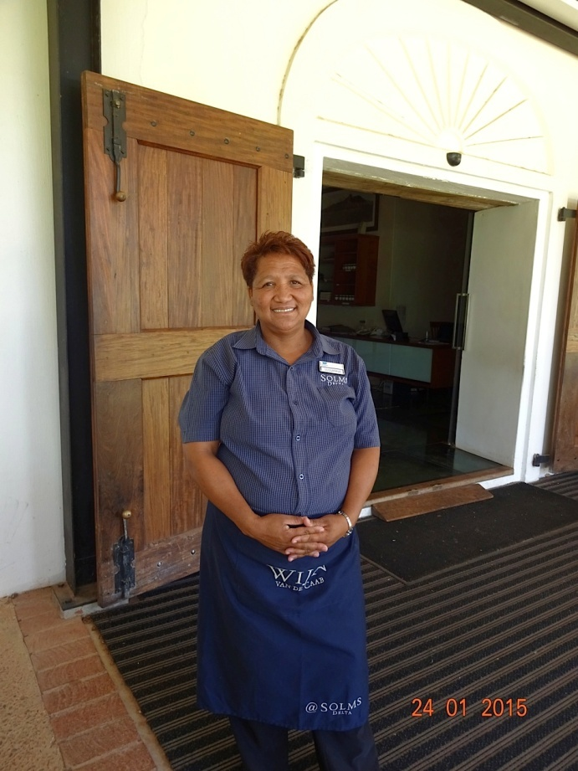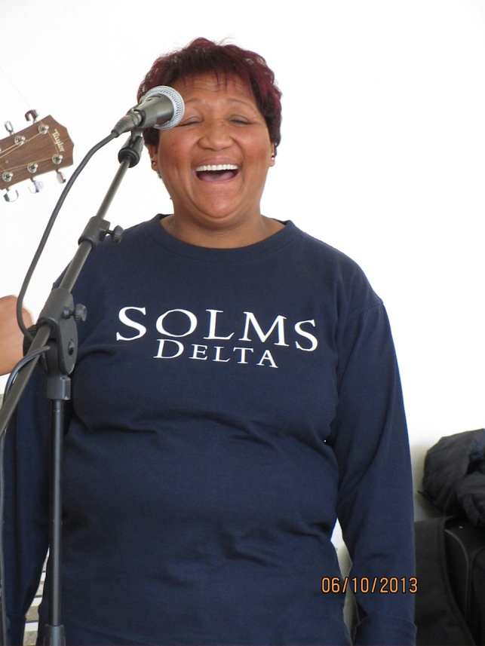
Fig. 7.9: Sanna
Photo’s: Corrie de Blocq

7.4.3 Oesfees: a sonic harvest

Delta annually opens its gates on a Saturday in March and a flood of music-lovers pours in. The tide has turned for the now wildly popular Oesfees, harvest festival. With just a few dozen local workers sent by their employers in the first year, the Oesfees is now a notable fixture on the local music calendar. The festival is composed of musical performances from the farm’s bands, dancing and marching groups, also drawing big-name performers and attracting Afrikaans and English speaking festival-goers from round the region. People of all ages and walks of life spend a day in the sun listening to music and dancing energetically on the expansive hay strewn lawn that comprises the dance-floor. It is difficult not to be charmed and delighted by the happy atmosphere.

Professor Solms says he was puzzled that Franschhoek did not have a community celebration tradition like other wine-producing regions of the world, particularly given that harvest is an ‘all-hands-on-deck’ time on most farms. Almost everyone connected to Delta now joins in to help co-ordinate the event which designed as a family festival to celebrate the completed harvest. As there are now more festival-goers than can be accommodated, tickets are sold. At the 2013 Oesfees, Charlotte van Zyl told me that Solms reserves a quarter of the tickets to be given free to local farm workers. The festival is now also co-sponsored by the ATKV, Die Afrikaanse Taal en Kultuur Vereniging in support of performances of local music and mostly Afrikaans songwriting. For me, as a South African who grew up with the social polarizations of the apartheid era, hearing Oom Japie Gouws, long-time ATKV president, speaking at an Oesfees in jocular fraternal terms of die bonde tussen bruin en wit Afrikaners ‘the bonds that exist between white and brown Afrikaans-speakers’ was something once impossible to imagine. What Oom Japie intimated was that music constructs a sense of joint identity. The Oesfees offers direct experiences in terms of the kind of music that enables people to place themselves together in a cultural narrative.

This is, perhaps, what makes this music special on Delta – it reiterates a common identity and defines that space without the previously enforced racial boundaries (Frith 1996:124-125). I suggest that there is possibly also a reach and resonance beyond fragmentary Afrikaans-speaking groups brought together once a year. There is an inventive political potential in synchronous participation in dance and music. (Born 2013). Such a big public performance can productively, even if only temporarily, defamiliarize the ANC’s culturally specific liberatory subjectivity and the overtly centrist motions that define contemporary politics in South Africa. It has the potential to buttress the constitution of the coloured communities against increased marginalization.

7.5 CONTINGENCY OR PROCESS?

It is evident that the prioritization of space in tandem with considerations of subjectivities is not simply a fortuitous convergence upon which to hang this chapter. Massey’s (2005) sense of space as being a simultaneity-of-stories-so-far has provided for different, but equally tenable, explanations for the emerging subjectivities of those people who live and work on Delta today. Over the years that I have been visiting Delta I met a security guard who became a sommelier and I have observed the increasing confidence of the young restaurant staff. I have talked to a female farm-worker prostituted over weekends by her husband and who found the strength to remove him from her life. I noted a labouring community losing unskilled functions to other levels of social organization. I heard repeatedly how the previously high rates of alcoholism and domestic violence on Delta have receded.

It was interesting to me that there were frequent comments about how such outcomes also apparently occurred randomly asof die dinge het net sommer gebeur (as if things just happened). In this the owner seemed to concur. Reflecting on the years of owning Delta, Mark Solms by his own admission, claims that he “could not possibly have foreseen” how Delta has changed and continues to develop. The Delta general manager at the time of active fieldwork responded similarly. She remembered when:
“Mark first saw an advertisement of this farm for sale in 2000. He just said, I’m going to buy this place. So don’t ask me what the plan is for the future...there has never been one. We’ve simply responded to what a perceived need might be...first the housing, then the schooling and now festivals and heritage....Mark didn’t have plans and I do whatever comes up. Things transpire….”
Although characterized by this apparently spontaneous equilibrium between conservation and endless adaptation, it is clear that different spaces on Delta are being deliberately constructed to make channels for different purposes and social experiences under the Solms/Astor direction. Yet time as well as space is obviously crucial for the figuration of a farm of which they are each a part. There is an increasingly structured narrative coherency to the farm, noticeably different to the inspired often fragmented dispersion of energies that I first encountered there. Especially interesting are the catalysts that have accumulated to spark a heritage ‘realization’ amongst the farm workers For example, Professor Solms told me the story of a farm worker who responded tearfully that he was being unkind when he pointed out that her last name was a definite indicator that an ancestor had been a slave. At that time, just over a decade ago, slave ancestry was still something considered to be shameful in her family. To rethink an aspect of one’s own family of which one was once ashamed, in the different terms of a rich local heritage and further as part of what has become a successfully storied tourist venture is a big, and empowered, psychic leap. This type of confrontation allows for a critical realization. Heritage becomes realized as the construction of social value as property. The further appropriation of that value enhances a sense of belonging. This process of adherence by claiming ownership, lends these wine, food and music projects a legitimized local and internal character, thus securing attachment by the community.

Professor Solms is skilled at promoting this attachment. In his hands, heritage promotion is a case of building what Gobodo-Madikizela (2010) describes as a moral imagination. This vision is eagerly consumed by burgeoning numbers of visitors. I suggest that part of the attraction of the moral imagination is that it is also very material. Indeed, as I have described, even the buildings themselves break down historical and other barriers. It seems to be an aspect which Professor Solms himself emphasizes. Solms strode into Fyndraai with a visitor in tow as I was sharing a meal there with friends in December 2014. Smilingly he said “I’m bragging about the new restaurant” which from its slight elevation on the werf has an expansive view across the working vineyards and to the towering mountains beyond. “Our old restaurant has glass floors” Solms announced, “and this one has glass walls.”I felt that there was some portent to this, possibly about visual or temporal barriers, but sadly no more was said on the glass walls. Personally I hope to return to Delta many times and I do not, indeed cannot, quarrel with the apparent success of Delta as a tourist venture. Nor can I deny the revolutionary beneficial changes brought about for its workers and indeed the surrounding communities. The new social values are not simply legitimized by the number of the interested visitors; they seem to be a part of the ethos of farm work. It seems to be a comprehensively positive story. However, as a kind of post-script after the bulk of my fieldwork was completed, I took to informal conversations with local visitors from the immediate Cape Town, Stellenbosch, Paarl and Franschhoek areas, asking only what they thought of Delta. There were no outright negative comments, but unlike the farm interviews, there was occasionally a raised eyebrow, or a quizzical lets-wait-and-see expression. There was even a reference to “Solms thinks he’s a pretty big man around here.”

‘Around here’ Mark Solms certainly looms large. He is engaged in some ground-breaking practices of property and in the creation of new concepts of what it means to belong here. In some senses, Solms and Astor are not very different from the owners of wine farm in the past. Like the first pair who owned Delta, these partners are not obviously ‘hiervandaan.’ Neither man inherited the land and nor were they born there. They are not wine farmers by trade and their families have not worked on this land in the past. Like most prior owners, they are also undeniably plugged into wider social and economic networks than most others. The Solms and Astor names on the products mean that these wines can and do reach a far wider consumer market than many local wine farmers can access. For example, when the pair launched their wines in the United Kingdom in March 2011, they did so together with a sale of valuable South African artwork at Bonham’s in London. The director of South African art at Bonham’s commented at the time that “we are delighted to be part of the Solms-Delta UK launch. It is entirely appropriate that ….we are able to toast this event with the best of the Cape vineyards.”Even amongst their peers in the valley, their international mobility means that Solms and Astor have more contacts, influence, information and other ways of financing their transformational projects than local farmers have at their disposal.

Although owning the farm in equal thirds through three separate trusts, Solms and Astor are otherwise still vastly more privileged than any farm workers, indeed more so than the majority of all South Africans. The farm is not all they have and the difference lies in their relative wealth and opportunities. Both men belong in other worlds too. It is arguable that Delta is still a space where various levels of belonging affect what is possible and for whom. In this light, and as Ahmed (2007:152) contends, “doing things depends not so much on intrinsic capacity, or even upon dispositions or habits, but on the ways in which the world is available as a space for action, a space where things ‘have a certain place’ or ‘are in place’.” When thinking this through, I turned to Massey (1991) who makes it clear that the economic transactions and international interactions usually thought of as “globalization” always must take place somewhere, and that the global is therefore always also local. Massey (2004) also calls for a relational politics of responsibility in which places are required to take responsibility for their economic and political connections to other places while including connections within the same country. In this case, I suggest that Solms and Astor are performing this task of interlinking global and local with a politics of responsibility on Delta. I suggest that reasons for which Solms and Astor are thought of as hiervandaan owes less to what they have materially, noticeably more than most, than to what it is they do with it. For members of the Delta community, the roles of these two men open a future, albeit often by ‘happenstance,’ out of what was previously unimagined.

7.6 DOING DEMOCRACY DIFFERENTLY AT DELTA

For violence-weary South Africans always desperately seeking a local success story, might Delta count as one such victory? I cannot deny that it might be, but I do not do not mean to suggest a simplistic redemptive narrative. As I have indicated, farm workers, visitors and media alike express positive feelings about the social enterprises and changes here. As for the one or two slightly suspicious, possibly envious, queries that asked “how can this all work out so perfectly?” and “…when do you think he (Solms) will make a mistake?” and “stuff in South Africa doesn’t happen like that,” these are not answerable questions. I cannot foresee what might happen in South African agriculture generally, or in the wine industry. On a national scale, it is as yet difficult to predict how the government’s policy on splitting farms between workers and farmers will work in practice. It also remains to be seen how the intention to take possession of agricultural land in the extended claims system will work. Where would Delta fit into a scenario like that? It cannot yet be known.

Delta’s is however undoubtedly part of “stuff in South Africa” as it exists in and interacts with the current climate of social change and land reform. Delta’s simultaneity of stories-so-far is context specific, but not context-bound. Its stories reflect that the legal, political and spatial wrangles over land and property redistribution, restitution and recompense have been difficult in the past and are still fiery. It is clear that after more than two decades of living in the same democratic country, under a progressive constitution that currently acknowledges property rights, South Africans are still asking of each other not without considerable anger, who has the right to the land? To whom does it belong? Who can call the land home? Who belongs here? These continue to be incendiary questions to ask in a land to which so many different people feel emotionally, economically, temporally, legally and justifiably attached. Varied senses of belonging are at the heart of all the anxious questions about who owns the land. Indeed, belonging does not happen automatically simply by the legal owning of property. Nor, as shown in this thesis, is sharing space, even over time, at all analogous with belonging there.

The example of Delta has shown that belonging is always relative. It has also suggested that the paradoxical state of being in the same space but differently opens up fissures for violence. However Delta’s stories-so-far also show that belonging differently does not always mean there is an unbridgeable abyss. I suggest that under the Solms/Astor aegis, a sense of belonging, even differently, has been constructed in ways that that override positionality in favour of change. Here it is perhaps helpful to briefly disentangle the symbiotically connected notions of identity and of belonging. Anthias (2008:8) usefully explains that:

“Identity involves individual and collective narratives of self and other, presentation and labelling, myths of origin and myths of destiny with associated strategies and identifications. Belonging, on the other hand, is more about experiences of being part of the social fabric and the ways in which social bonds and ties are manifested…”

A collective construction of belonging, like that described here by Anthias, is occurring in the community on Delta despite Solms and Astor’s noticeably different backgrounds and privileged lifestyles. One reason for this, I suggest, is because the farm workers attribute most of the positive changes in their lives on Delta to the presence and generosity of these two men. I was told variously by farm workers that it is because of Solms and Astor that Delta currently attracts numerous visitors, sells wine in a number of countries and produces tangible benefits and improvements in their living standards.

Solms and Astor quite obviously do not, indeed cannot, have identities as farm workers. These owners have however been successful in building a sense of belonging in the Delta community that often supersedes categories of identity such as race, class or occupation. They are positioned differently in life in all these ways, but they still belong in the farm community. The workers seem to understand Solms’ and Astor’s actions on Delta as constructing new socially-produced relations and they convert the value of these relations into fixed structures. The existence of trusts, educational opportunities and houses are material and also symbolic structures that reflect increasingly cohesive imaginings of belonging. Paradoxically, these same structures could also function as more than strongholds from which to build a better life. They might even represent borders around the togetherness of new ‘moral community’ on Delta. For example, during the protests among farm workers in 2012/13 the Delta workers en masse rejected the Unions’ call to take action. Delta was one of the few farms in the winelands that was unaffected by the violence that occurred over those months. In conversation with some of Delta’s permanent employees afterwards, they told me that they saw no reason to jeopardize their increasingly varied avenues of work, or risk the opportunities to share in the value of the land that they own and the products that they create. This sense of belonging is a different kind of democracy.

All of these benefits most certainly improve the lives of the core of on-farm workers. Yet, at the time of writing, these improvements stand in sharp relief against the loss of permanent employment and housing for many other farm workers in the winelands and in the fruit industry in general. The discussion earlier in this thesis concerning institutional and governmental failures to reorient the wine industry has highlighted the plight of labourers who cannot find steady work and security. The exploration of Foetal Alcohol Spectrum Disorder indicates that farm worker communities which need social support often experience poor or non-existent service delivery. Those many casualized and externalized wine farm workers who need employment and opportunities to make more of their lives but who are not as fortunate as Delta community members, are in Mbembe’s (2012) words, “stuck in a field of blighted possibilities.” Thus the workers on Delta are, I suggest, more likely to subscribe to a more complete sense of belonging in their farm community than they are to identify completely with the world of other workers in the winelands, or even in the same Franschhoek valley.

In considering what makes people count as hiervandaan on Delta, the question that emerges asks if the kind of techno-managerial reason that has been produced by Solms’ brand of experimental recuperative neuropsychoanalysis on his wine farm can be replicated in the rehabilitation of politics? For if as Nicholas Blomley (2003:126) contends “violence provides the occasion and method for founding a property regime” then doing property differently might short-circuit the recycling violence. That is, the issue at hand is whether landed property, and different collectives can be defamiliarized enough for there to be materially different answers to the questions of balancing ownership with a fair share of the South Africa’s wealth and resources? The projects unfolding on Delta demonstrate some constructive responses to such questions but not all the answers are to be found here. Neither is it possible to separate this farm from the wine industry as a whole or the current political climate with its uncertain land legislations and policies. Nevertheless there is an understanding that wine making, approached as it is here with the intent to seek out the crevices where its historical violence hides, can be employed to recycle and to transform that violence. Based upon what is happening at Delta, this chapter closes on an argument for finding recuperation that is based not upon fictions of an imagined unity, but instead exists within a shared problematic: a mutual implication of violence in a history of differences (Thornton 2007). It is the conscious engagement with such fundamental choices that will determine the nature of this significant South African democratic experiment.

CHAPTER EIGHT

OPENLY ENDING

8.1 INTRODUCTION

Taking one farm as its remit, this thesis has explored the existence and perpetuation of violence by tapping into geographies and histories of Cape wine. The aim has been to re-imagine the current challenges to Cape viticulture through an investigation of the past. The objective was not simply to re-enact the specific subject, but to follow the threads of violence that weave through diverse pathways that include everything from Dutch mercantile ambitions, Afrikaner political enterprise and post-apartheid reinvestments to the cells of a human foetus.

Following Massey’s (2005) re-thinking of space as a simultaneity made up of scalar and storied trajectories, this very specific narrative has been constructed out of a more extensive spatial logic. The stories-so-far that comprise Chapters 4-7 opened a view on to the land together with its overlapping communities and their diverse interests. These interests include viticultural practices as well as wine legislations with some of their spatial and cultural outcomes. The chapters have worked together as a field of engagements with wine as their given circulatory object. Insights from scholars of spatial and decolonial theory have been applied and extended in a complementary way that did not “take fright at diverse vocabularies” but instead promulgated “those strands in a possible conversation…which presupposes no disciplinary matrix that unites the speakers, but where the hope of agreement is never lost so long as the conversation lasts" (Rorty 1979:318). Yet even so, after carefully unravelling and re-threading some strands into a new simultaneity, both the nature and content of the study still resisted any synthetic finale. This final chapter thus comprises an open ending.

8.2 RECONSIDERING THE LOCUS AMOENUS

The value of a locus amoenus is that it has offered a metaphor for lateral thinking and a geographical approach to violence as cross-cutting binaries. The essence of a locus amoenus is that it is simultaneously both a ‘pleasance’ and steeped in violence. Introducing Delta as a locus amoenus opened the opportunity for a study of less visible violences that have produced powerful and haunting effects in Cape viticulture. I also suggested that particular forms of violence had become hidden by becoming indivisible from Delta itself and the associated viticultural developments by which it came into being. So these naturalized geographies of violence were sought in their more subtle, integrated states and not viewed as isolated, spectacular or anomalous instances. The following section outlines some of the protean and relational contours of such geographies as they have become more visible.

Firstly, and this is perhaps overly obvious, there are no discernibly pre-determined plots to the violence in these stories-so-far. It is not that legal and other normative canons and actions that create and perpetuate forms of violence have not been planned and executed. To the contrary, throughout this thesis there is evidence of innumerable laws, policies and conventions enforcing properties which concerned land and slaves, alcohol production and consumption, racial and ethnic separation. In seeking to understand how violence plays out in Delta’s spaces this thesis has also addressed the influence and activities of particular individuals and groups of people. Indeed as Blomley (2002:557) contends, “property doesn't just happen.” It also needs doing. Carving out Zandvliet, later Delta, and making the landed property into a wine farm has involved surveying and planning, arranging and reinforcing the rights of apparently determinate legal owners. It is not difficult to see that violence, either built into the structure of a slave system refined over centuries or embodied in the daily pouring of a ‘dop,’ became enculturated in viticulture. All of these stories-so-far have evidence that this enculturation has happened. Nevertheless despite all the doings, legal and otherwise, the changing spaces of Delta were not plotted along an inescapable trajectory. It was not the quiescence of an unavoidable history that brought about the forms of violence that shaped and were shaped by these farm spaces. Likewise in its current incarnation, the transformations at Delta were never predictable. The odds of a derelict African wine farm coming into the joint sphere of an academic neuropsychoanalyst and the wealthy son of the editor of a British newspaper, with outcomes that now include enhanced food-ways and groundbreaking applications of music therapy, were arguably not high. Thus I suggest that while various embodied, structured and symbolic forms of violence may be the direct spawn of particular intentions and their ‘healing’ through therapeutic interventions may now be in process, none could have come into being without a prevailing logic that itself is the sum of numerous influences. I have come to believe that violence is indeed integrated into the proximate nature of Cape viticulture, but also that its very endemicity forecloses simple conclusions about any single logic.

Second, this thesis offers an enhanced understanding of the contiguous, but non-linear ways in which “violence compresses the sometimes forbiddingly abstract spaces of geopolitics…into everyday life and the innermost recesses of the human body” (Gregory & Pred 2007:6). In a way both nuanced and grounded, this thesis demonstrates how violence accompanies viticulture. Unlike many representations of geopolitics that abrogate local geographies, this study of Cape viticulture grows the innate acknowledgment of geographical particularity. The reason for European settlers’ arrival, which led to the establishment of viticulture, must be seen to lie on the specific location of the Cape on trade routes between the east and the west where two oceans blend. Likewise, the lives of the indigenous land users and those of most later inhabitants of Delta were profoundly affected by relations to places they could never have visited together with laws promulgated in other dispensations and by regimes in which they had no say. Inevitably then, the particular stories–so-far of Delta were also collected from wider spatial formations. This thesis has identified how diverse geopolitical influences through British imperial desire, Dutch global mercantilism, apartheid grand strategy and liberation rhetoric have all come to crisscross in Delta’s farm space.

Following on, another value of using Delta as a single site of investigation is that the pathways that violence takes are more recognizable when they emerge or converge within the bounds of a particular space. That said, the argument here has insisted that violence is both a contingent phenomenon and also expressive of forces wider than the immediate intent to do bodily harm. This of course does not mean that it is merely amorphous in either its form or generation. Indeed, the systematic attention to identifiable forms of violence threading through this simultaneity of stories-so-far, has uncovered some very specific fault-lines and particular entanglements. Addressing the fault-lines through which violence emerges has meant identifying those spatio-relational conditions that hold the potential for haunting recurrences of violence into the future. The most noticeable of these fissures has been the mercurial and persistent tension between property and power. Uncovering Delta as a locus amoenus has exposed how the propensity to naturalize property’s violence is connected to the modes and means by which its particular violences have become spatialized, be it through a map, a plough, a building, a community customs or other every-day applications and entities (Blomley 2003). As such, the balances of power are rendered largely invisible and the integrated violences too, simply disappear into the order of things. The thesis has exposed some of the violence associated with a bio-physical realignment of vegetation on the land as well as the symbolic, structural and corporeal forms of human violence so integrated with viticulture (Blomley 2003:123). However it has also done more than examine what has crossed paths or blended into forms of violence in Delta farm spaces. Moving deeper into the spaces of the farm there has been an attempt to see where haunting happens and, by the same spectral token, where reinvestment is possible. In regard to reinvestment, this thesis has shown that in these spaces the tension between property and power has become productively expressed less in terms of power understood as the right to own property than in the relative nature of empowerment. In this way, the pursuit of the violence that is hidden in and by the spaces of one farm can offer a way of understanding that whatever de-naturalizes space can provide a way of re-socializing property (Blomley 2003).

Fourth, this exploration of the interactivity of viticulture and violence also underscored the entanglements of the human and the more-than-human. Although the nature of the land was my immediate focus, the attention to the specific capacities of the grape vines nevertheless proved to be a way to understand what Head et al. (2014:284) term “the specifics of relationality and distributed agency in human–plant encounters.” In the human entanglements with the more-than-human world, the configurations of violence that accompany the vines did not appear as pre-existing givens, but came into being through a process of relation. What Head et al. (2014:1) describe as “collaborative and conflictual relations between people and plants” comprise a fascinating type of “vegetal politics” that also interacts with the land (Brice 2014). The iconic Cape vineyards are more deeply saturated with power relations than might be immediately apparent. In a way reflective of the settlement pattern of Europeans at the Cape, the establishment of vines swiftly asserted these plants as locally indigenized, assumptively part of the biophysical environment and human landscapes. As well as changing aspects of the natural environment, grape vines have co-generated human practices and cultural values and also the production and organization of material artifacts through their multiple ‘planty’ volitions (Brice 2014). In the umwelt of viticulture and viniculture at the Cape the management of these processes demands that human time and activity revolves around those of the vines. To various degrees, depending on the intentions of a winemaker, the amelioration or increase of vine distress produces a particular kind of grape with which to make a better wine. The examination of the spaces of slaves on Delta showed how the activities of tending to vines and their fruit and winemaking processes all incorporated mechanisms of spatial and social control and physical coercion. Today the vines and their produce are used in new ways to reflect new ethics of responsibility on Delta. In an almost circular manner these newer ethics now acknowledge the centrality of the violence brought about by the cultivation of vines and production of wine and in the arrangements of its consumption.

The overall thread of this geography of wine is that while violence may be pernicious and repercussive and haunting, it is not inevitable. As Springer (2009:164) says, it is always possible to imagine new horizons and different geographies for “geography is not destiny any more than culture is.” Things can change. Violence is ever-contingent and space is always becoming. The projects at Delta work directly to expose the underbelly of Cape viticulture and in the light of their outcomes it can be argued that placing violence at the epicentre of a decolonial project can be productive. In other words, conciliation does not sit at the opposite end of a spectrum but is held in tight dynamic relation with the pain-filled acknowledgments of violence. It is exactly in those spaces where the ghosts of violence emerge that those living in the present should look to do some work if the future is not to be haunted by the same problems.

8.3 STORIED-SO-FAR

Chapter 4 began with a particular biophysical topography and as Delta’s different spaces and features were examined so another topographical logic was counteracted - a logic premised directly on landed property as the production and marking of coherent spaces. The land although obviously central and fertile can also be difficult and contested. My simultaneous invocations of the geomorphology of the land and the agent-like qualities of vineyards, together with considerations of the farm on an ambivalent frontier have resisted any single-strain narrative. The frontier although expanding and apparently settling, remained unstable. In its natural surroundings and as well as a part of a multivalent frontier, Delta exhibits that there exist different, constantly overlapping spaces in interactions of property with power.

Groups of people constructed accounts about themselves that were strongly dependent upon land as a resource and conflicting ascriptions of belonging. The capacity of slavery to capture valences of violence in the term ‘property’ is notable. Slaves were subordinated and owned little, being property themselves. For members of indigenous communities, albeit not legally enslaved, the situation was often worse. There were some vastly different perceptions of property ownership rights to land and to the labour of other humans. Frequently a factor in their various owner/worker relationships was mutual fear and distrust. Ownership of landed property obviously expands to comprise more than the physical earth. For some of the early owners of Delta, Hans Silverbach, Callas Laut and Christoffel and Marguerite Snijman and Steinbeck’s words ring true: “We were poor people with a hell of a lot of land which made us think we were rich people” (Steinbeck & Wallsten 1975 npg). Christoffel Snijman is one example in whose life some diverse, less tangible possessions came to light in the aura of belonging to a certain social group. For the Snijmans and other families to whom landed and other property may have legally belonged, such property represented relative independence stamped with authority and power. Chapter 4 describes some of the early attempts to define new spaces - on the land, in the realm of relative freedom and in the assertion of identity. Farm space then, is exposed as a mass of relationships intricate, intimate and often perverse where concepts of belonging are confusing and harsh. This chapter subverts the conventional notion of property by deconstructing its associations with land ownership. In all this, land remains fundamental. Land continues to support or to thwart human endeavour, as well as to connect all South Africans albeit through different uses and investments.
The second story, represented in Chapter 5 delves into the lives of two families of farm owners and their relations with farm workers. This story explores how different constellations of people lived here and constructed narratives about their own identity and sense of belonging, or not belonging, in their place of residence. These narratives draw attention to the quotidian tasks, performances, improvisations and scripts through which inhabitants have used and made Delta’s spaces “relevant for their own lives, strategies, and projects" (Rose 2002:457). Owners and workers are seen to interact, sometimes with co-operation, but also with misunderstanding, mistreatment and ignorance. I found that contradicting points of view can stem from impulses to self-preservation, arguing here that the Huguenot de Villiers’ family were initially immigrants simply attempting to survive. Whether the outcome of that impetus developed into forms of social injustice, has little to do with the fact that owner-groups and worker-groups alike formed their moral communities. In these communities people engaged in circulating what resources they acquired for a number of reasons including as a means of survival or in support of notions like non-integrationism or in pursuit of industrialization. This story has most certainly shown that neither the shaping of space, nor the subject’s relative positioning within it is fixed or permanent. For looking closely at these families and concurrently the conditions of the farm workers it becomes clear that even in these groups’ own internally persuasive discourses, Delta’s spaces remain fluid, continuing to change, always opening and closing in interaction with different people and new contexts.
Zooming out from the more personal and particular of human stories, the third story comprising Chapter 6 refocuses on the life of wine itself within a racialized and spatialized history of alcohol production and consumption. This story indicates that Cape wine is far from being only a product of the causal influences of geographic determinants such as physical form or climate. The biophysical consumption and bodily integration of wine, as well as why, how and where this occurs, brings the more-than-human fruit of the land and vine directly into social worlds and human bodies. Three aspects emerge in particular. One is that the complicated and prejudicial legalities underlying the production, distribution and uses of wine mean that the law does not exist separately from the narratives that locate it and give it meaning as well as power. Secondly, although in a simple sense a merely consumable commodity, the character of South African wine is that of a racialized property that references several overlapping histories of spatial segregation and dispossession. Third is the independent agency of wine itself. Agency, I suggest, involves more than the means through which the alcoholic beverage is actually made. Rather, agency highlights the current extent of the freight of national reconciliatory convergence as it is borne by the patterns of wine consumption in particular. Taken together, these points work together to counteract the assumption that any imperialist or a nationalistic law merely imprints itself on a passive space (Blomley 1994). Put another way, this chapter challenges the idea that when the bottle is empty nothing remains. For in this rerouted vision, wine consumption is not a distinct and completed event, nor simply an ephemeral one. It offers some indication of how the wider story of wine continues to haunt the sector and its society.

“We’re the people, we go on.... A different time’s comin’…’” so says a character in Steinbeck’s The Grapes of Wrath (1939:139:291). For the people of Delta, how did a different time ever come? Is violent experience still a part of their story? How can we tell? Chapter 7 uses the local idiom of hiervandaan to engage with these questions and with the changes that are currently evident on the farm, its land, vines and wines, legal constructs and its people and their spaces. Without doubt, the structural and somatic effects of violence stretch performance across time and space. As these effects follow current social changes on Delta, it also tracks the contours of that extended reach (Thompson 2009:158). I suggest that what is occurring on Delta is an invention of place through the discursive constitution of history as a particular kind of a heritage narrative. This seems to be a strategy that is as popular among the farm workers as it simultaneously changes their life prospects as co-owners; possessors not only of the farm and its land, but of the overlooked stories and culture of coloured communities. There is also a deeper sense of Delta challenging and superseding its own history in ways that jibe with sociological and psychological theories of transformation. Incorporating violence centrally in performances and representations of its story has been used as a means to face and thereby overcome its legacy. It is in this kind of incorporation, I suggest, that the liminal spaces of Cape viticulture can be repurposed into new social formations of belonging.

  - PALIMPSESTUOUS READING

The stories-so-far were analyzed as they were constructed, in a palimpsestuous reading of the subtle workings of violence, in this case with viticulture as its medium. This particular kind of reading is non-dichotomous - it considers multiple causations and attempts to be parsimonious in defining the consequences. Dillon’s (2007) contention is that palimpsestuous reading is a disruptive process that makes diverse connections possible across chronological layers, to reveal or forge couplings not necessarily immediately visible. Identified in Chapter 1 as embodied, structural and symbolic, the forms of violence that have been exposed are multiple in matter and measure and also in their manifestations. Blending into a particular farm-based geography of wine these have been read together with the establishment of wine-making and the expansions of viticulture at the Cape.

A continued reliance on micro stories rather than on macro generalizations opened up a range of approaches. Some avenues were archival and historiographic, while others comprised participant-observer ethnology and independent fieldwork which also drew on previous knowledge of biodiversity in the winelands and methods of wine production. The stories have encompassed everyday history and the events of life on a wine farm. There are also stories of official practices of law and some extraordinary events. Included too are some of the investment decisions, wars, natural disasters and technical innovations that have shaped the land and shaped social possibilities.

8.4.1 Reading simultaneity

The simultaneity of these stories-so-far has been critical and transformative in showing the indivisibility and ‘ongoingness’ of their different trajectories. Taken together each of these storied chapters has contributed towards the argument that violence does not make its independent destructive way across the surface of a ready-made world. Instead it occurs through fractures in a world always actively in formation. (Ingold 2008:8). In compact form, I reiterate some of the instances of simultaneity across the storied chapters.

There are for example the shebeens and the dop system as discussed in Chapter 6, where many other manifestations of violence are difficult to disassemble from the properties of alcohol. The material existence of both shebeens and the ‘dop’ manifests myths about race. Physical attacks through police raids cannot be separated from the legally enforced spatialities of the apartheid era. It is indeed not possible to untangle from the social existence of shebeens the symbolically subversive drinking patterns and the embodied harm that has resulted. It is also not possible to insert exact boundaries between story of the community that produces wine and that of an unborn baby already impaired by the chemical effects of the alcohol in her mother’s body.

The simultaneities provided by the rich, varied earth of the winelands are also considerable. Indeed, it is only because the land and the Cape climate are conducive for viticulture that slaves were forced to labour in the vineyards. The unimaginable misery on the wine farms is barely hinted at from what we little know of the lives of slaves who worked there in the dramatically beguiling natural landscape. Today, would visitors come to Delta in droves were it less beautiful? It is unlikely that tourists and other visitors would consume the experience of food and wine, stories and activities as avidly as they do were it not such a very lovely environment in which to do so. Without the visitors’ interest and input the projects designed to overcome historical injustice might not maintain their momentum.

Thinking of spatial simultaneity, there is no complete division between spaces of pain for a slave on a wine farm and spaces of torture in the streets of Cape Town. As I described in Chapter 3, my archival/document searches frequently trawled through old diaries and colonial-era travelogues. I found numerous visitors to the Cape felt compelled to relate harrowing recollections of violence publically perpetrated on both rural and town slaves. In Chapter 2 Barrow’s descriptions of the Khoikhoi and San people indicate their ill treatment as being even worse that of the slaves, because there was no monetary value attached to these coercively indentured workers. The brutal justice system that legitimated such actions was part of the VOC project that transported and established of vines at the Cape. Such pivotal instances of simultaneity put the story of the Cape vines at the heart of violence in all its forms, embodied, structural and symbolic.

There are simultaneities across time spans too. Consider the 18th century farmer sleeping within reach of his firearms, cited in Chapter 4 from Spaarman’s notes and the fear of violent attacks that haunts farmers in South Africa today. Spaarman’s farmer-host locked himself into his bedroom with his firearms at night. In a contemporary parallel, Carla van der Spuy (2014) recalls that while walking through a farmhouse to interview the remaining family members after a recent fatal attack, she was struck by the row of five mattresses on the lounge floor where the whole remaining family huddle at night in an attempt to ward off their fears. Extending from the early days of Spaarman’s travels, farming men and women of property in South Africa continue to be terrified for and, sometimes of, their property. Many farmers in South Africa like the settlers before them are stuck within their fearful visions, living and working on what are considered by others to be stolen grounds. There is no immediately apparent reason to believe that those who might take the land in the future by applying or threatening violence will find themselves anywhere other than in yet another anxious environment where legal entitlements are once more challenged or ignored. It is precisely in this context that the point of considering this simultaneity of violence becomes important as that which emerges and re-emerges along with various positioning practices in space.

8.4.2 Reading decoloniality

Decoloniality has been employed in this thesis as a framework that supports alternative ways of knowing (Dastile & Ndlovu-Gatsheni 2013). In this respect, Aizur, Cotten et al. (2014:310) point out that decolonial thinking “consider[s] different models for knowing, forms of connecting, or being with” and likewise I resist framing any knowledge gained in this one sphere of viticulture as generalizable truth. The world already knows much about violence. At best, this thesis can help to illuminate that knowledge.

First this thesis has challenged a common narrative of colonial legacies that follows an automatic dispossession-liberation-nation-state trajectory and then ends abruptly. That violence has both continued in South Africa and in some areas like farming, it has further intensified, is a thread that strongly outlives a trajectory fulfilled by social liberation and/or the installation of a democratic form of government. The emotionally-charged tensions over land use and ownership in the winelands as in the rest of South Africa are far from having been resolved. Moreover, the more ubiquitous type of narrative is one which also readily obliterates nature as an active, relational presence in social co-productions (Goodman 2001). I have instead repeatedly shown that, recalcitrant as well as forthcoming, vineyards in South Africa stand up as living evidence that the legacies of transplantation are non-binary – they are at once violent and productive, diseased as well as fruitful. In this account, “plants’…couplings with their environments render them difference generators.” Much like the humans that brought them to the Cape and who continue to cultivate them here, the vines continually “…improvise new ways to articulate themselves, to register new kinds of differences in the world, and to invent new ways to make a difference in the world” (Hustak & Myers 2012: 105).

Second, the storied approach has offered an appropriate mode of representing a decolonial perspective insofar as this incorporates an intersectional and critical lens. The material in these stories-so-far shows that 21st century Cape vineyards are “place[s]… crisscrossing in the wider power-geometries that constitute both themselves and the global” (Massey 2005:101) as much as when European vines were brought by Dutch ships. Together these interconnected trajectories represent Delta, its vineyards and wines as fluid `tissues' with instances of violence influenced by and influencing people, places and processes and the flow of objects and information. Each storied chapter has been interpreted as representing particular wounds or forms of healing that result from different empires of thought and practice. Decolonial thinking also allows for space to understand and to apply theory differently and the storied mode provides a way of co-constituting theory with material and analysis. Particular insights are drawn from established spatial theories as well as those of property and power which have led to a conceptualization of violence as systemic, articulated with reference to a specific place. Delta, as one subject, shows both that viticulture was a main reason for the Cape to have adopted this form of labour in the times of European expansion and that the patterns of relating that developed on wine farms through slavery defined a wider social history. The revolution of these separate but connected stories provides both commentary and interrogation of the power structures that have made some lives more valuable and prone to gaining recognition in terms of social capital and property rights than others.

Third, decolonialization is not a project that sits easily with any category as a stable or self-evident identity. Here, the cross-cutting nature of violence destabilizes categorical thinking insofar as an application of violence theory to the fields of viticulture and viniculture acts as a critique and not as a study of a pure phenomenon. Violent phenomena are recast into a more bio-political blend “that regulates and organizes bodies in a particular recognition framework or particular vectors of risk, value, and potentiality” (Aizura, Cotten et al. 2014:314). One way in which this recasting is achieved is by exploring the spaces of land and slaves in the first substantive chapter. The structural, physical, and juridical violence of both sets of spaces were emphasized early, thereafter acting as a thick frame for the meanings and possibilities of all bodies within the viticultural system that grew in and through these spaces. The outcome fits with the ethos of decolonial thinking as it disrupts the operative logics of easy categorization.

Decolonial research also engages in tracing subjectivities and practices as a means of interrogating the logic of smooth circulation in progress narratives of globalization. Similarly, this work investigates wine as a circulatory object addressing wine as more than a simple commodity with an uncomplicated straight line to be traced from acts of consumption back to the hidden truth of exploitative labour. Instead the stories have emphasized the strategic interests and partial knowledges with which particular actors have encountered and constructed wine at different moments. This thesis uses wine to follow a vinous commodity chain in the co-ecology of land, plants and people that has created forms of violence. It also considers the role of wine in reimagining potential for conciliation between historical social divisions that concern race, class, gender, language and ethnicity.

Decolonial studies often extend to encompass violence however I believe that in geographies of wine decoloniality remains an unusual means of understanding. In this thesis, the decolonial interpretive method has not sought to recover violence as the preserve of any historical time, rather it acknowledges the ways in which the history of wine haunts the discourses that South Africans use to understand notions of belonging and difference. What is crucial here is not to attempt to find a better position inside existing colonizing practices, but rather to find some ways of making a different world (Mignolo & Tlostanova 2009).

8.5 SHAPING A USEABLE PAST

Despite the emphasis on fluidity in the stories-so-far that have been developed through this thesis, in some ways Delta’s spaces cannot ever be different precisely because of the simultaneity in its own stories-so-far. Social relations today are undeniably based upon traces of the past and these are spatial as well as temporal and haunted. The relations that make up Delta are always connected to other times and places. Grape vines were not only bio-vegetal matter transplanted to South Africa. They came with people, legalities, customs, concepts about property and power-sharing. Although the vines were initially installed through physical force by breaking the soil, the social dislocation that was part of wine and alcohol consumption patterns as described in Chapter Six, occurred through “the enactment of states and… submission of the canons of grammatical imperatives” (Delaney 2004:849). Even in its physical extent, the current legal and cartographic boundaries of Delta are based on those of colonial and apartheid past. In this sense, everything is still in the same space together.

After having said that, simply being on the farm seems to be very easy now. Indeed a current visit to Delta obliterates so much of what the indigenous users and the settlers on that land would have faced. Now there seems no call to assume that the farmer is forcing a hard living out of the resistant earth. Here a loving and giving Nature visibly surrounds the visitor, just beyond those gleaming glass windows of the air-conditioned restaurant. The herbs and plant foods of Khoikhoi and San ancestors grow abundantly near the fruitful grape vines and one does not need to live in this place to liberally receive the benefits of both. Wine and food come to the table, or picnic basket, in copious supply complete with an extra sprinkling of interest because of references to the vegetation used for culinary purposes by others millennia and centuries ago. To belong, in the sense of being a worker in and around the homestead, is now eons away from scarred, starving slaves in the kitchens and vineyards. Smiling young women and men learn and earn by serving tables either in Fyndraai or al fresco on the lawns overlooked by mountains. What this entire current scenario, and indeed the business of Delta, depends upon to a great extent is the re-invention of its past as more useable within the spaces of the farm today. A useable past creates a readily accessible history for visitors (Schutte 2003). In Chapter 7, I discussed the meaning of hiervandaan which supposedly connects the spirit of the place with the people's character. I suggest here that much of what it means to be in the same space but differently today, is that this community has constructed a notion of hiervandaan as a useable past, that like Delta’s wines, is produced for and to be consumed by others. Importantly and differently to the past, it is now, again like Delta’s wines, owned by the whole community. What I describe as a new propinquity of property is what fosters cohesion and what emphasizes what and who belongs in Delta’s community.

8.5.1 The propinquities of being hiervandaan

This study has repeatedly shown that the fact of everyday encounters does not necessarily make the accommodation of difference easier. So being in the same space but doing it differently today requires that negotiation remains vital. It needs propinquity as much as ever (Valentine 2008). This contention derives from Foucault’s notion of propinquity and his interest in how a culture establishes a tabula of relationships and the means by which these are considered (In: Bergendorff 2009:37). In this reading, culture is a space of knowledge that differentiates between things. Propinquity is how these things exist together. Echoing the idea, Massey (2005:150) suggests that spatial politics involve the ways in which juxtapositions may be regulated, how space might be coded and how the terms of connectivity are negotiated. The understanding of propinquity discussed in Chapter 2 involves “issues thrown up by living with diversity and sharing a common territorial space” (Amin 2004:39). So at the end of this thesis, I am taking Foucault’s idea of propinquity into Delta’s spaces once more. For one aspect that is fundamental to considering propinquity as it is thrown up in the subject matter of this thesis, is ‘the taking place.’ This concept of a specific ‘somewhere’ makes the farm itself both an everyday field of action and also a basis for action. Here is latitude to describe reinvestment in much the same terms of interwoven closeness with viticulture that this thesis has discussed with reference to the nuances of violence. This particular claim relates to the negotiation of problems that, although not necessarily always arising from the local or contemporaneous, still need to be resolved locally by people sharing the same space at the same time.

Benedict Anderson (1991:15) maintains that in the construction of any “imagined community” a shared history is an essential element. In this regard, there is a paucity of consensus about collective memory in South Africa and few South Africans misconstrue ‘the nation’ as an appropriate holder of a collective experience for an imagined community (Baines 2003). Given this lacuna, I suggest that Delta’s useable past is, to borrow the words of Appleby (1998:11) “the identity politics of our day [that] have emerged precisely in reaction to the claims of the [South African] nation to represent an homogenized people.” Indeed, creativity and reinterpretations of legacy currently combine on Delta together with impulses towards restitution. All these are premised upon the stimulation of modes of empowerment as a common birth channel for the newly useable past for Delta. With some unconventional methods of mobilization centred round a viticultural heritage, this farm is today representative of a different logic of modification and social composition. It is one where Delta as a specific location has determined the conceptual foundation of this heritage resource.

It is unmistakably noted in the thesis, in Chapter 7 in particular, that Delta’s spaces are being materially changed. I suggest now that the entire farm now arguably comprises a social experiment in action and that this venture accommodates a large tourist business too. This change is however, not only occurring in the high-visibility spaces such as museum buildings and restaurants, vineyards and festival spaces. There is evidence that all these spaces are also integrally connected to the negotiation of everyday life. This renegotiation is occurring in new forms of ownership, new work sharing and new responsibilities. The everyday on Delta is no longer wrapped up in only tending and harvesting grapes and making wine. No longer merely employees, people are moved to be more entrepreneurial in the processes of becoming producers of themselves (Conradie 2012). Further, it is not only the group of people who work in the vineyards who are incorporated here. A new social constellation is finding new ways of living and working together and ways of deciding. Each is, by “virtue of membership in this moral community, entitled to a [particular] kind of consideration” (Regan 1991:20). Elias (1994) maintains that the diachrony of long-term social processes eventually increases interdependency between individuals and groups and engenders a greater degree and intensity of mutual identification (van Krieken 2014). Sociologist de Swaan (1995:21), drawing on Elias’ theories, has coined the phrase ‘widening circles of identification’ and I use this notion of widening to capture the processes through which the boundaries of eligibility for moral consideration have expanded on Delta today. The expansion has created new blended categories like worker-owner, farmer-psychoanalyst, diner-activist. In a vital way, new spaces for negotiating with the voices of the past are being opened up by the voices, songs and sounds and skills of the people of the present. Such propinquities of reinvestment invite a consideration of whom and what belongs on Delta today.

‘Belongingness’ on Delta now depends upon gathering up the existing parcels of land, their biodiversity, the wine, slave stories and music into a narrative of hiervandaan. All these individual elements have, I think, given rise to what might be described as specific mythologies of foundation which facilitate the ability to live and work as a co-operative and empowered community of people in the same space today. Hiervandaan also implies the idea of a longstanding temporal relationship to Delta, an ideal which is frequently drawn upon in terms of ancestral connections between local coloured communities and the Khoikhoi and San. Even though Solms and Astor themselves cannot respectively draw on any long-term family or personal residence, they have successfully constructed an attachment to property through activating their other discursive resources including psychology, cultural, musical and environmental heritages and empowerment projects. Arguably then, the sharing of familiar representations, the identification of common heritage objects, in essence the process of choice and adaptation, is what comprises the construction of a social property. As we have already seen, the possession of social property can set those who belong, even new-comers, apart from others. In a sense not dissimilar from the world of Christoffel Snijman centuries ago, there is still value to be found not only in owning actual land, but also in leveraging ownership status and a sense of belonging to a group which is seen as having power.

Belonging has significant and indeed unusual benefits for the farm workers on Delta today. Yet there must also be questions about perpetuating the functions of paternalism in a new way of engendering dependency. In the current climate of casualization and externalization there is every reason for farm workers to cling tightly their current privileges that although removed from apartheid-style baaskap are still remarkably similar in form and bring exactly the same benefits albeit on a contemporary scale. Increasingly the labour landscape is characterized by the casual workers who however exist on the fringes of farm space, constantly on the move, scouring the winelands for seasonal work. The overall impact is, as Ewert and Du Toit (2005) put it, “likely to be the deepening of the division between the ‘insiders’ and the ‘outsiders’.” Thus, a caution in promoting this farm’s heritage, as indeed with any overtly useable past, is that whenever a past is made too readily legible it can be manipulated in terms of who belongs and who benefits from belonging and who does not. It is in this vein that Baines (2003) imputes that in South Africa the production of a useable past has almost always targeted victims in any given present. Baines (2003) maintains that reasons, or excuses, for degrees of marginalization lead to partial inclusion, then to discrimination and eventually to authoritarianism. In terms of landed property, my question is what happens when a reconstructed geography produces a belief among leaders of a polity that a successful present or future requires the dispossession and/or displacement of some people and not others? The stories of empire, and of apartheid, of BEE and land manifestoes of the present and in the future, possibly the EFF, are all in the same mix and of immediate relevance. Indeed, returning to the letter from Andile Mngxitama cited in Chapter 1, the Economic Freedom Fighters might arguably recast Solms and Astor in the same mould as he has Branson, as part of another unwanted ripple of European colonizers of South African land and resources. In this casting as purchasers of allegedly stolen property, the wine farms cannot belong to them and therefore they obviously cannot belong there.

  - OPENING

Foucault has established the idea that culture is not univocal, but supplies innumerable points of confrontation and foci of instability, each with its own risk and capacity to disturb a given set of power relations (Foucault in Rabinow 1984:174). Considered in this way, viticulture provides one focus and an identifiable point of confrontation. This thesis has challenged simplistic interpretations of Cape wine by adding texture to the spatial constructions of a wine farm and illuminating the centrality of violence as it is grafted into the development of viticulture. In Delta’s current existence it is clear that some unusual and progressive meanings have been assigned to particular farm activities and wine making practices. The way in which Delta is ‘doing wine’ in an ethical register is fostering an innovative and alternative production of farm space which involves a kind of collectivization of the forces of ethical consumption singularities, endowing them specifically with the politics of the possible. As far as being in the same space but differently now, Delta seems to be transforming its space into an interpretive model that captures LaCapra's conceptualization, insofar as it is angled towards the therapeutic as it works through its own violent past. The outcomes appear to be positive at least for those who live and visit there (LaCapra 2001). Even so, these stories-so-far of Delta have ensured that this thesis ends in something of a theoretical crux where wine itself renders its own dialectic. For in the propinquity of things, wine, indivisibly incorporating this land and its extraordinary biology is also, in its implantations and expropriations, all about divided and contested ground. Claims of land ownership repeatedly include highly oppositional negotiations about how to define a given property and its bundles of rights and powers. There are still heated and bitter contests around the questions of to whom the land, its fruit and its attendant social properties might belong. Therein the fissures that enable new flows of violence reappear once more. Humans, with their agendae, their evasions and frozen eyes continually add immense symbolic bulk to the sandstone, shales and granites of this mountain chain sunk into the sea at the foot of Africa.

References
Primary Sources
Cape archives
Inventory no. 1/89 Title deeds Stellenbosch and Drakenstein and Swellendam
Collection: CTD
Vol 3 Title Deeds, Deeds of Transfer and Notarial Deeds: 1666 Jan 9-1669 Dec 23.
Vol 4 Title Deeds, Deeds of Transfer and Notarial Deeds: 1670 Jan 7-1671 May 26.
Vol 5 Title Deeds, Deeds of Transfer and Notarial Deeds: 1670 Dec 22- 1672 Dec 20.
Vol 9 Title Deeds, Deeds of Transfer and Notarial Deeds: 1736 Jan 2- 1736 Dec 22.
Vol 14 Title Deeds Cape District: 1791 Dec 22 - 1807 May 28.
Vol 15 Title Deeds Cape District: 1807 Nov 28 -1818 May 21.
Vol 16 Title Deeds Stellenbosch and Drakenstein: 1689 Nov 10 - 1722 Nov 17.
Vol 18 Title Deeds Stellenbosch and Drakenstein: 1743 Dec 31 - 1787 Oct 10.
Vol 19 Title Deeds Stellenbosch and Drakenstein: 1787 Sept 25 – 1806 Jan 8.
Inventory no. 1/5 Census/muster reports
Collection A Opgaafrolle 1682-1782
A 2250
Collection J
J 183 – J 233 Opgaafrolle Stellenbosch and Drakenstein 1692 -1806
Inventory no. 1/21 Archives of the Register and Guardian of slaves 1717-1848
3/26 Reports
Day Book and Reports of the Assistant protector slaves: Case no. 405, 22 Nov 1832.
Inventory 1/STB
2/2 Archives of the Magistrate of Stellenbosch 1683 onwards
Case of: Secretary of Stellenbosch contra Isaac Cornelis de Villiers and his housewife Neeltjie Brasler, 20 May 1830
16/13 Hottentot Register 1812

Government House manuscripts
GH No.2817 Enclosure 2 of despatch 85, 26th Aug. 1884. Report Requested by the Secretary for the Colonial Department.
National Archives' cartographic and library material, microfilms and copies
Photographs: AG collection
AG7495 View of Rhodes fruit farms, Groot Drakenstein.
AG7526 Homestead on Rhodes fruit farm Delta
AG7518 Veranda showing reed ceiling of a homestead on Rhodes fruit farm Delta
AG7532 View of a crowd of labourers waiting to be paid on Rhodes fruit farm, Lanquedoc showing three gentlemen seated at table on right, Simondium.

TANAP – Towards a New Age of Partnership
Inventories of the Orphan Chamber of the Cape of Good Hope

MOOC 8/1.33 Testator(s): Arnout Willemsz Bason, 4 Februarij 1698

MOOC 8/44.5 Testator(s): Johan Casper 16 February 1830
Signed: Elisabet van de Kap

MOOC 8/8.8 1/2 Testator(s): Johanna Snijman, 26 Meij 1755

MOOC 8/6.95 Testator(s): Margaretha Theresia de Savoije, 20 Maart 1742

MOOC 8/4.15 Testator(s): Ansla van Bengalen, 18 Julij 1720

MOOC 10/2.12 Testator(s): Ansla van Bengalen, 14 September 1720
Auction prices of her slaves
MOOC 8/5.50 Testator(s):Susanna Gardiol Glaude Marais,
12 September 1729
MOOC 8/6.78; Testator(s):Johannes van Nieuwkerken, 25 Februarij 1745
MOOC8/7.30. Testator(s): Anna van Staaden, 19 Maij 1753

South African National Library
Cape Town Special collections
Item AZ 968.7031: Sketch, J. Lee 1802.

Published Primary Sources
Barnard, Lady Anne, In: Wilkens, W. (ed.) 1910. South Africa A Century Ago - Letters written from the Cape of Good Hope 1797-1801, by Lady Anne Barnard. London: Smith, Elder & Co.
Barrow, Sir John. 1806. Travels into the Interior of Southern Africa in which are described the character and condition of the Dutch colonists of the Cape of Good Hope and of the several tribes of Natives beyond its Limits: the Natural History of such subjects as occurred in the Animal Mineral and Vegetable Kingdoms; and the Geography of the Southern Extremity of Africa. London: T Cadel and W Davis. Available at: https://archive.org/stream/travelsintointer11806barr/travelsintointer11806barr_djvu.txt. [Accessed 08/11/2012].
Bird, W. 1823.The State of the Cape in 1822. London: John Murray.
Böeseken, A. 1957.Resolusies van die Politieke Raad: Deel I, 1651- 1669.Government Printers: Cape Town.
Bulawayo, N. 2014. Writing shared on my Facebook wall. NoViolet Bulawayo (Elizabeth Tshele). Posted on Facebook at: https://www.facebook.com/pages/NoViolet-Bulaway
[Accessed 29/04/2015].

Cape of Good Hope, 1883. Liquor Licensing Act (Act No. 28, 1883). Cape Town: W.A. Richards and Sons.

Cape of Good Hope, 1898. Liquor Law Amendment Act (Act No. 28, 1898). Cape Town: W.A. Richards and Sons.
Cape of Good Hope Liquor Laws Commission, 1890.Report of the Liquor Laws Commission (Series G.1-90). Cape Town: Government Printer.
Cape of Good Hope Liquor Laws Commission, 1890.Minority Report. (Series G.1-90). Cape Town: Government Printer.
DEAT, 2011. Final draft national heritage and cultural tourism strategy. The South African Department of Environmental Affairs and Tourism, Pretoria: Government Printers.

DLA, 1997. White Paper on South African Land Policy. The South African Department of Land Affairs, Pretoria: Government Printers.

Krzesinski-De Windt, A-M. 2002. Die Boedelinventarisse van Erflaters in die Distrik Stellenbosch 1679-1806. Stellenbosch: Stellenbosch Museum.

Leibrandt, H. 1896. Precis of the Archives of the Cape of Good Hope. Van der Stel; Journal 1699-1732. Cape Town: W.A Richards & Son, Government Printers. Available at: http://archive.org/stream/precisofarchives01capeiala/precisofarchives01capeiala_djvu.txt [Accessed 26/11/2013].

Le Sueur, G. 1913. Cecil Rhodes the man and his work by one of his private and confidential secretaries, Gordon Le Sueur, FRGS, with illustrations. London: John Murray. Available at: http://archive.org/stream/cecilrhodesmanhi00lesurich/cecilrhodesmanhi00lesurich_djvu.txt [Accessed 19/10/2012].
Mentzel, O. [1787]. A complete and authentic geographical and topographical description of the famous and (all things considered) remarkable African Cape of Good Hope. Mandelbrote, H. (ed.) 1944. Transl. Marais, G. and Hoge, J. Cape Town: Van Riebeeck Society.
Pama, C. 1981. C.C. de Villiers’ Genealogies of Old South African Families. Cape Town: Balkema.
Percival, R. 1804. An Account of the Cape of Good Hope. London: Baldwin. Available at: https://archive.org/details/anaccountcapego00percgoog [Accessed 20/01/2012].
Pickstone, H. 1917. The Cape Fruit Industry, Journal of the Royal African Society 16 (64) July, 1917.
RDP: ANC 1994. The Reconstruction and Development Programme: A Policy Framework. Available from: http://www.anc.org.za/rdp/rdp.html [Accessed 29/08/2011]
RDP: ANC. White Paper: Discussion Document. Available from:
http://www.anc.org.za/ancdocs/policy/rdpwhite.html [Accessed 29/08/2011]

Report of the South Africa Cape Coloured Liquor Commission of Inquiry appointed by His Excellency the Officer Administering the Government of the Union of South Africa, 1945. Government Printers: Pretoria.
Semple, R. 1804. Walks and sketches at the Cape to which is subjoined a journey to Blettenbergs Bay. London: C & R Baldwin. Available at: https://archive.org/details/walksandsketche00sempgoog[Accessed 16/02/2012].
South Africa, Dutch Reformed Church Registers 1660-1970.Index and images. Available at: https://familysearch.org/pal:/MM9.3.1/TH-267-11116-194446 23?cc=1478678&wc=MMLQ. [Accessed 01/04/2014].

South Africa, 1928.Liquor Act (Act No. 30 of 1928). Government Printer: Cape Town
Spaarman, A. 1786.A voyage to the Cape of Good Hope, towards the Antarctic polar circle, and round the world: But chiefly into the country of the Hottentots and Caffres, from the year 1772 to 1776. Available at: https://archive.org/details/voyagetocapeofgo00spar [Accessed 12/03 2012 and 15/01/2015].
Steedman, A. 1835.Wanderings and Adventures in the Interior of Southern Africa, Vol. 11. London: Longman & Co. Available at: https://archive.org/details/wanderingsadvent02stee [Accessed 17/10/2013].
Sutherland, J. 1845. Original Matter Contained in Lieut. Colonel Sutherland’s Memoir on the Kaffres, Hottentots, and Bosjemans of South Africa. Cape Town: Pike and Phillip. Available at: https://archive.org/details/originalmatterc00suthgoog [Accessed 21/09/2012].
Twain, M. (Clemens, S.) 1899. Following the Equator. A Journey Around the World. Digitized from the library of University of Michigan. Available at: https://archive.org/details/followingequato03twaigoog [Accessed 06/09/2014].
Van Riebeeck, J. Daghregister gehouden bij den Oppercoopman Jan Antonisz van Riebeeck, 1651-1662. Deel 1-3. Thom, H. and Bosman, D. (eds.). 1952-1957. Cape Town: Van Riebeeck-Vereniging.
Wallace, R. 1896. Farming of Cape Colony (1986:142).P.S. King & Sons: Westminster, London.
Maps consulted
CA M1/11/59 Map: Drakenstein en Het Land ‘t Waveren’
CA M1/273 Map: Cape Town and Stellenbosch districts.
TANAP Map: Tirion 1730: Map: Cape of Good Hope

Secondary Sources
Adhikari, M. 2005. Not White Enough, Not Black Enough - Racial Identity in the South African Coloured Community. Columbus OH: Ohio University Press.
Agnew, J. 2011. Space and place. In: Agnew, J. and Livingstone, D. (eds.) The Sage handbook of geographical knowledge, 316-331. London: Sage.
Agnew, J. 2014. Place and Politics. Routledge Library Editions: Political Geography: The Geographical Mediation of State and Society. London: Routledge.
Ahmed, S. 2007. A Phenomenology of Whiteness. Feminist Theory 8(2):149-168.
Aizura, A., Cotten, T., Balzer, C., Ochoa, M. and Vidal-Ortiz, S. 2014. Introduction, Transgender Studies Quarterly 1(3):308-319.
Altbeker, A. 2007. A country at war with itself: South Africa’s crisis of crime. Johannesburg: Jonathan Ball.
Altbeker, A. 2008. Adding Insult to Injury: How Exclusion and Inequality Drive South Africa’s Problem of Violence. Report 4 of CSVR study of violent crime. Johannesburg: Centre for the Study of Violence and Reconciliation.
Alexander, N. 1990. Education and the struggle for national liberation in South Africa. Braamfontein: Skotaville.
Alexander, G. 2008. Commodity & Propriety: Competing Visions of Property in American Legal Thought, 1776-1970. Chicago IL University of Chicago Press.
Aliber, M. 2003. Chronic Poverty in South Africa: Incidence, Causes and Policies. World Development 31(3):473-490.
Amnesty International. 2011. Key Human Rights Concerns in South Africa. Amnesty International, 2011. Submission to the UN Periodic Review, May-June 2012.
Anderson, B. 1991.Imagined Communities, Reflections on the origin and spread of nationalism. New York: Verso.
Anthias, F. 2008. Thinking through the lens of translocational positionality: an intersectionality frame for understanding identity and belonging. Translocations: Migration and Social Change 4(1):5-20.
Appadurai, A. 2004. The capacity to aspire: Culture and the terms of recognition. In: Rao, V. and Walton, M (eds.) Culture and public action, 59-84. Palo Alto CA: Stanford University Press.
Appleby, J. 1998. The Power of History. American Historical Review 103(1):1-14.
Ashcroft, B., Griffiths, G. and Tiffin, H. 2013. Post-colonial studies: the key concepts. London: Routledge.
Atkinson, D. 2007. Going for broke: The fate of farm workers in arid South Africa. Cape Town: HSRC Press.
Attwell, D. 2005. Rewriting modernity: studies in black South African literary history. Columbus OH: Ohio University Press.
Baines, G. 2003. The Politics of Public History in Post-Apartheid South Africa. Grahamstown: Rhodes University.
Ballantine, C. 1987. From marabi to exile: A brief history of black jazz in South Africa. Paper Presented at the Sixth Symposium on Ethnomusicology, Rhodes University, 1-3 October 1987.
Barbarin, O. and Richter, L. 2013. Mandela's children: Growing up in post-apartheid South Africa. London: Routledge.
Bargmann, C. 2003. Geology and wine production in the coastal region, Western Cape Province, South Africa. Geoscience Canada 30(4):161-182.
Barolsky, V. 2005. Transitioning out of violence: snapshots from Kathorus. Johannesburg: Centre for the Study of Violence and Reconciliation.
Barolsky, V. and Pillay, S. 2009. A call for comparative thinking. SA Crime Quarterly 27:15-21. Sabinet Online.
Barolsky, V. 2012. ‘A better life for all’, social cohesion and the governance of life in post-apartheid South Africa. Social Dynamics 38(1):134-151.
Barratt-Brown, M. 2000. ‘Fair trade’ with Africa. Review of African Political Economy 34(112):267-277.
Beinart, W., Delius, P. and Trapido, S. 1986. Putting a Plough to the Ground. Johannesburg: Ravan Press.
Beinart, W. 1994. Farmers' strategies and land reform in the Orange Free State. Review of African Political Economy 21(61):389-402.
Bek, D., McEwan, C. and Bek, K. 2007. Ethical trading and socioeconomic transformation: critical reflections on the South African wine industry. Environment and planning A 39(2):301-319.
Bell, M. 1997. The ghosts of place. Theory and society, 26(6):813-836.
Beningfield, J. 2006. The frightened land: Land, landscape and politics in South Africa in the twentieth century. Oxford: Routledge.
Benjamin, W. [1978] 1986. ‘Critique of Violence.’ In: Demetz, P. (ed.) Walter Benjamin: Reflections: Essays, Aphorisms, Autobiographical Writings, 279-95. New York: Schocken.
Benjamin, W. 1940. On the Concept of History. Available at: http://www.marxists.org/reference/archive/benjamin/1940/history.htm [Accessed 14/08/2011].

Bergendorff, S. 2009. Simple lives, cultural complexity: Rethinking culture in terms of complexity theory. Lanham MD: Rowman & Littlefield.
Bezuidenhout, C. 2012. An overview of farm attacks in South Africa and the potential impact thereof on society. Pretoria: Solidarity Research Institute.
Bhabha, H. 1997. Editor's introduction: Minority maneuvers and unsettled negotiations. Critical Inquiry 23(3):431-459.
Bhorat, H. and Hinks, T. 2005. Changing Patterns of Employment and Employer-Employee Relations in post-Apartheid South Africa. Paper presented at Stellenbosch University conference on South African Policy Under Democracy: A 10 Year Review, Stellenbosch, 2005.
Bloch, M. [1949] 1964.The historian's craft. Transl. Putnam, P. New York: Vintage Books.
Blomley, N. 1994. Law, space and the geographies of power. New York: Guilford.
Blomley, N. 1998. Landscapes of property. Law and Society Review 32(3):567–612.
Blomley, N. 2000. “Acts,”“deeds,” and the violences of property. Historical Geography, Annual Review 28 (2000):86–107.
Blomley, N. 2002. Mud for the land. Public Culture 14(3):557–82.
Blomley, N. 2003. Law, Property, and the Geography of Violence: The Frontier, the Survey, and the Grid. Annals of the Association of American Geographers 93(1):121–141.
Bolender, D. (ed.) 2010. Eventful archaeologies: new approaches to social transformation in the archaeological record. New York: SUNY Press.
Bond, P. 2000. Elite Transition. London: Zed Books.
Born, G. 2000. Music and the representation/articulation of sociocultural identities. In: Born, G. and Hesmondhalgh, D. (eds.) Western Music and Its Others: Difference, Representation, and Appropriation in Music, 31–37. Berkeley CA: University of California Press.
Boshoff, W. and Fourie, J. 2010. The significance of the Cape trade route to economic activity in the Cape Colony: a medium-term business cycle analysis. European Review of Economic History 14(3):469-503.
Botha, C. 1921. The French Refugees at the Cape. Cape Town: Cape Times Limited.
Boulding, K. 1991. Reflections on property liberty and polity. Journal of Social Behavior and Personality 6(6):1-16.
Bourdieu, P. 1989. Social Space and Symbolic Power. Sociological Theory 7(1):14-25.
Bourdieu, P. 1998. Acts of Resistance: Against the Tyranny of the Market. New York: The
New York Press.
Breytenbach, B. 1996. Fragments from a Growing Awareness of Unfinished Truths. In: The Memory of Birds in Times of Revolution, 24-37. New York: Harcourt Brace.
Breytenbach, B. 1999. Dog Heart: a memoir. New York: Harcourt Brace.
Brice, J. 2014. Attending to grape vines: perceptual practices, planty agencies and multiple temporalities in Australian viticulture. Social & Cultural Geography15(8):942-965.
Brooke Simons, P. and Proust, A. 2000. Cape Dutch Houses and Other Old Favourites. Cape Town: Struik/Fernwood Press.
Bruner, J. 1991. The narrative construction of reality.Critical Inquiry 18(1):1-21.
Bryceson, D. 2002. Alcohol in Africa: Substance, stimulus and society. Alcohol in Africa: Mixing Business, Pleasure and Politics. Portsmouth: Heinemann.
Bundy, C. 1979. The rise and fall of the South African peasantry. Berkley CA: University of California Press.
Bundy, C. 2007. In: Stolten, H. (ed.) History making and present day politics: the meaning of collective memory in South Africa, 73-94. Uppsala: NordiskaAfrikainstitutet.
Buse, P. and Scott, A. 1999. Ghosts: Deconstruction, psychoanalysis, history. Basingstoke: Palgrave Macmillan.
Can Themba, D. 1989. Marta. In: Chapman M (ed.) Drum Decade: Stories from the 1950s. Pietermaritzburg: University of Natal Press.
Carey, V., Archer, E., Barbeau, G. and Saayman, D. 2008. Viticultural terroirs in Stellenbosch, South Africa. II. The interaction of Cabernet-Sauvignon and Sauvignon blanc with environment. Journal international des sciences de la vigne et du vin/ International journal of vine and wine sciences 42(4):185-201.
Carey, V., Archer, E., Barbeau, G. and Saayman, D. 2009.Viticultural terroirs in Stellenbosch, South Africa. III. Spatialisation of viticultural and oenological potential for Cabernet-Sauvignon and Sauvignon blanc by means of a preliminary model. Journal International des Sciences de la Vigne et du Vin 43(1):1-12.
Carey, V., Bonnardot, V. and Rowswell, D. 2011. Observed climatic trends in Stellenbosch: update and brief overview. Wynboer 263:95-99.
Caruth, C. (ed.) 1995. Trauma: Explorations in memory. Baltimore MD: Johns Hopkins University Press.
Chakrabarty, D. 1992. Postcoloniality and the artifice of history: Who speaks for Indian pasts? Representations 37(Winter):1-24.
Champion, G. 1835. Journal of the Rev. George Champion: American Missionary in Zululand 1835-1839. Booth, A. (ed.) (1967) Cape Town: Struik.
CliffeDekker, 2007. The Way to BEE 2007: A guide to black economic empowerment. Johannesburg: CliffeDekker.

Clifford, J. 2000. 'Taking identity politics seriously.' In: Gilroy, P., Grossberg, L. and McRobbie, A. (eds.) Without guarantees: In honour of Stuart Hall, 94-112. London: Verso.
Cloke, P. and Jones, O. 2001. Dwelling, place, and landscape: an orchard in Somerset. Environment and Planning A 33(4):649-666.
Cock, J. 1980.Maids & Madams: a study in the politics of exploitation. Johannesburg: Ravan Press.
Coetzee, J. M. 1974. Dusklands. Johannesburg: Ravan Press.
Coetzee, H. 1966. Die drinkpatroon van die Bantoe in Suid-Afrika. Johannesburg: SANCA Archives.
Cohen, M. 1978. Property and sovereignty. In: Macpherson, C. (ed.) Property: Mainstream and Critical Perspectives, 155–75. Toronto: University of Toronto Press.
Colaguori, C. 2010. Symbolic Violence and the Violation of Human Rights: Continuing the Sociological Critique of Domination. International Journal of Criminology and Sociological Theory 3(2):388-400.
Comaroff, J. 1985. Bodily reform as historical practice: the semantics of resistance in modern South Africa. International Journal of Psychology 20(3-4): 541-567.
Comaroff, J. and Comaroff, J. 1999. Occult economies and the violence of abstraction: notes from the South African postcolony. American ethnologist 26(2):279-303.
Comaroff, J. and Comaroff, J. 2009. Ethnicity Inc. Chicago IL: University of Chicago Press.
Compton, J. 2004. The rocks and mountains of Cape Town. Cape Town: Juta.
Conradie, A. 2012. Remaking Culture for Sale: The Strategic Commodification, Construction and Performance of ‘Traditional’ Cultural Identity in South African Cultural Villages. In: Boswell, D., O’Shea, R. and Tzadik, E. (eds.) Interculturalism, Meaning and Identity, 65-76.
Cooper, D. 1994. Productive, relational and everywhere? Conceptualising power and resistance within Foucauldian feminism. Sociology 28(2):435-454.
Coplan, D. 1985. In Township Tonight! South Africa’s Black City Music and Theatre. London: Longman.
Correia, D. 2013. Properties of Violence: Law and Land Grant Struggle in Northern New Mexico. Athens GA: University of Georgia Press.
Corsin-Jiménez, A. 2003. On Space as Capacity. Journal of the Royal Anthropological Institute 9:137-153.
Cousins, B. and Hall, R. 2011.Rights without Illusions: The potential and limits of rights-based approaches to securing land tenure in rural South Africa. Cape Town: Institute for Poverty, Land and Agrarian Studies (PLAAS).
Cousins, B., Hall, R., Paradza, G. and Isaacs, M. 2013. Submission to parliament, 1st November 2013. Available at: http://www.plaas.org.za/plaas-publication/submission-restitution-bill [Accessed 05/11/2014].
Cowling, R. and Pressey, R. 2003. Introduction to systematic conservation planning in the Cape Floristic Region. Biological Conservation 112(1):1-13.
Crais, C. 1992. The making of the colonial order: White supremacy and black resistance in the Eastern Cape, 1770-1865. Johannesburg: Witwatersrand University Press.
Crampton, J. and Elden, S. (eds.) 2012. Space, knowledge and power: Foucault and geography. Aldershot: Ashgate.
Creswell, J. 1998. Qualitative inquiry and research design: Choosing among five traditions. Thousand Oaks: Sage.
Cresswell, T. 1996. In place-out of place: geography, ideology, and transgression. Minneapolis MN: University of Minnesota Press.
Cronje, F. 2014. The looming dangers of land reform promises. Farmers’ Weekly opinion page, April 27.
Cronon, W. 1992. A place for stories: Nature, history and narrative. The Journal of American History 1347-1376.
Crush, J. (ed.) 2008. The Perfect Storm: The Realities of Xenophobia in Contemporary South Africa. Southern African Migration Project: Migration Policy Series 50, 1-61.
Crush, J. and Ambler, C. (eds.) 1992. Liquor and labour in Southern Africa. Pietermaritzburg: University of Natal Press.
Das, V., Kleinman, A., Lock, M., Ramphele, M. and Reynolds, P. (eds.) 2001. Remaking a world: Violence, social suffering, and recovery. Berkley and Los Angeles CA: University of California Press.
Dastile, N. and Ndlovu-Gatsheni, S. 2013. Power, Knowledge and Being: Decolonial Combative Discourse as a Survival Kit for Pan-Africanists in the 21st Century. Alternation 20(1):105-13.
Davenport, T. and Saunders, C. 2002. South Africa: A Modern History. London: Macmillan.
Davis, J. 1991. Contested ground: Collective action and the urban neighborhood. Ithaca NY: Cornell University Press.
De Blij, H. 1983. Wine - a geographic appreciation. Lanham MD: Rowman & Littlefield.
De Kock, L. 2001. South Africa in the global imaginary: An introduction. Poetics Today 22(2):263-298.
Delaney, D. 1998. Race, place, and the law, 1836-1948. Austin TX: University of Texas Press.
Delaney, D. 2004. Tracing displacements: or evictions in the nomosphere. Environment and Planning D: Society and Space 22(6):847-860.
Del Pilar Blanco, M. and Peeren, E. (eds.) 2013. The Spectralities Reader: Ghosts and Haunting in Contemporary Cultural Theory. Aldershot: Ashgate.
Denzin, N. and Lincoln, Y. 2005. Introduction: The discipline and practice of qualitative research. In: Denzin, N. and Lincoln, Y. (eds.) The Sage handbook of qualitative research, 1-32. Thousand Oaks CA: Sage.
De Swaan, A. 1995. Widening circles of identification: emotional concerns in sociogenetic perspective. Theory, Culture & Society 12(2):25-39.
De Wet, G. 1981. Die Vryliede en Vryswartes in die Kaapse Nedersetting, 1657-1707. Kaapstad: Historiese Publikasie-Vereniging.
Dickenson, J. and Salt, J. 1982. In vino veritas: an introduction to the geography of wine. Progress in Human Geography 6(2):159-189.
Didier, S., Morange, M. and Peyroux , E. 2012. The adaptative nature of neoliberalism at the local scale: Fifteen years of City Improvement Districts in Cape Town and Johannesburg. Antipode 45(1):121-139.
Diduk, S. 1993. ‘European Alcohol, History, and the State in Cameroon.’ African Studies Review 36(10):1-42.
Dietler, M. 1990. Driven by drink: The role of drinking in the political economy and the case of early Iron Age France. Journal of Anthropological Archaeology 9(407):352–406.
Dietler, M. 2006. Alcohol: anthropological/archaeological perspectives. Annual Review of Anthropology 35(1):229-249.
Dillon, S. 2007. The Palimpsest. Literature, Criticism, Theory. New York: Continuum.
Distiller, N. 2008. ‘Surviving the Future’: Towards a South African cultural studies. Cultural Studies 22(2):273-283.
Dooling, W. 2005. The Origins and the Aftermath of the Cape Colony's 'Hottentot Code' of 1809. Kronos 31:50–61.
Dooling, W. 2007. Slavery, emancipation, and colonial rule in South Africa. Scottsville: University of KwaZulu-Natal Press.
Dubow, S. 2009. How British was the British World? The Case of South Africa. Journal of Imperial and Commonwealth History 37(1):1-27.
Du Toit, Andre. 1960. Algemene gesindheid teenoor wyn is nie reg nie. In: Die Wynboer Maart 1960:3.
Du Toit, A. 1994. Farm Workers and the 'Agrarian Question' Review of African Political Economy 21(61):375-388.
Du Toit, A. 1998. The Fruits of Modernity: Law Power and Paternalism in Western Cape Fruit and Wine Farms. In: Norval, A. and Howarth, D. (eds.) South Africa in Transition: New Theoretical Perspectives, 149-164.London: Macmillan.
Du Toit, A. 2001. The externalisation and casualisation of farm labour in Western Cape
horticulture. Cape Town: Programme for Land and Agrarian Studies, University of the Western Cape.
Du Toit, A. 2004. Forgotten by the highway: globalisation, adverse incorporation and
chronic poverty in commercial farming district. PLAAS: Chronic Poverty and Development Policy Series No. 4; CCSR Working paper No.101.
Du Toit, A. 2005. Chronic and structural poverty in South Africa: challenges for action and research. PLAAS: Chronic Poverty and Development Policy Series No. 6; CCSR Working Paper No.121.

Du Toit, A. 2007. Poverty Measurement Blues: some reflections on the space for understanding ‘chronic’ and ‘structural’ poverty in South Africa. Paper presented at the Workshop on Concepts and Methods for Analysing Poverty Dynamics and Chronic Poverty, Manchester, 23-25 October 2006.

Du Toit, A. 2009. Adverse Incorporation and Agrarian Policy in South Africa. PLAAS: UWC.

Du Toit, A. 2011. Real Acts, Imagined landscapes. Reflections on South Africa’s Land Reform Discourse (Or how to do things with land reform). Paper presented at the PLAAS/ STIAS Colloquium, Land Reform, Agrarian Change and Rural Poverty at the University of Stellenbosch, 8-9 March 2011.

Du Toit, A. 2013. Imagined Landscapes – Reflections on the discourse of land reform in South Africa after 1994. Journal of Agrarian Change 13(1):16-22.
Du Toit, A. and Ewert, J. 2002. Myths of globalisation: Private regulation and farm worker livelihoods on Western Cape farms. Transformation: Critical Perspectives on Southern Africa 50(1):77-104.
Du Toit, A., Kruger, S. and Ponte, S. 2008. Deracializing exploitation? ‘Black economic empowerment’ in the South African wine industry. Journal of Agrarian Change 8(1):6-32
Dye, A. and de la Croix, S. 2014. Property Rights in Land and the Extent of Settlement in Dutch South Africa, 1652-1750. Available at: http://www.lse.ac.uk/economicHistory/seminars/ModernAndComparative/Papers13-14/DyeLaCroixCape.pdf [Accessed 06/01/2015].
Eisner, E. 1991.The enlightened eye. New York: Macmillan.
Elias, N. 1991. The Society of Individuals. Oxford: Blackwell.
Elias, N. 1994. The Civilizing Process,Vol. 1 and Vol.2. Oxford: Blackwell.
Escobar, A. 2001. Culture sits in places: reflections on globalism and subaltern strategies of localization. Political geography 20(2):139-174.
Ewert, J. and du Toit, A. 2005. A deepening divide in the countryside: Restructuring and rural livelihoods in the South African wine industry. Journal of Southern African Studies 31(2):315-332.
Ewert,J. and Hamman, J. 1999. Why paternalism survives: Globalization, democratization and labour on South African wine farms. Sociologia Ruralis 39(2):202-221.
Ewert, J. Eva, G. and Hamman, J. 2006. The Inclusion and Empowerment of Farm Workers Through Partnerships: The Case of Thandi Fruit and Wine. Report for the Re-governing
Markets Programme. London: Institute for environment and development, (IIED).
Feldman, A. 2003. Strange Fruit: The South African Truth Commission and the Demonic Economies of Violence. Social Analysis 46(3):234-265.
Feldman, A. 2004. Memory Theaters, Virtual Witnessing and the Trauma Aesthetic. Biography an Interdisciplinary Quarterly 27(1):163-202.
Forde, F. 2012. An Inconvenient Youth: Julius Malema and the 'new' ANC. Johannesburg: Picador Africa.
Foster, J. 2008. Washed with Sun. Pittsburgh PA: University of Pittsburgh Press.
Foucault, M. 1978. The history of sexuality: An introduction. Vol. 1. New York: Vintage.
Foucault, M. 1980. Power/knowledge: Selected interviews and other writings, 1972-1977. New York: Pantheon.
Fourie, J. 2008. The Development and Importance of Travel Services Exports in South Africa. In: Trade and Industrial Policy Strategies Annual Forum. Available at: http://www.tips.org.za/publication/development-and-importance-travel-service-exports-south-africa [Accessed 05/07/2013].
Fourie, J. 2013. The remarkable wealth of the Dutch Cape Colony: measurements from eighteenth‐century probate inventories 1. The Economic History Review 66(2):419-448.
Freud, S. [1919] 1971. The Uncanny. Transl. Strachey, J. London: Hogarth.
Freund, B. 2007. South Africa: The end of apartheid & the emergence of the ‘BEE Elite’. Review of African Political Economy 34(114):661-678.
Frith, S. 1996. Music and identity. In: Hall, S. and du Gay, P. (eds.) Questions of cultural identity, 108-27. London: Sage.
Galtung, J. 1969. Violence, peace, and peace research, Journal of peace research6(3):167-191.
Gass, J., Stein, D., Williams, D. and Seedat, S. 2010. Intimate partner violence, health behaviours, and chronic physical illness among South African women. South African Medical Journal 100(9):582-585.
Gaventa, J. 2003a. Power after Lukes: A Review of the Literature. Brighton: Institute of Development Studies.
Gaventa, J. 2003b. Towards Participatory Governance: Assessing the Transformative Possibilities. Paper presented at conference Participation: From Tyranny to Transformation, Manchester. 27-28 February 2003.
Gaventa, J. 2006. Finding the spaces for change: a power analysis. IDS bulletin 37(6):23-33.
Gaventa, J. 2007. Levels, spaces and forms of power: Analysing opportunities for change. In: Berenskoetter, F. and Williams, M. (eds.) Power in world politics, 204-223. New York: Routledge.
Giliomee, H. 1987. Western Cape farmers and the beginnings of Afrikaner nationalism, 1870–1915.Journal of Southern African Studies 14(1):38-63.
Giliomee, H. 2003. The Afrikaners: biography of a people. Cape Town: Tafelberg.
Giliomee, H.2010. “Allowed such a state of freedom”: women and gender relations in the Afrikaner community before enfranchisement in 1930. New Contree: A Journal of Historical and Human Sciences for Southern Africa 59.
Giliomee, H. and Mbenga, B. 2007. New History of South Africa. Cape Town: Tafelberg.
Ginzburg, C. 1989. Clues: Roots of an Evidential Paradigm. In: Clues, Myths and the Historical Method, 96-125. Transl. Tedeschi, J. and Tedeschi, A. Baltimore MD: Johns Hopkins University Press.
Gobodo-Madikizela, P. 2010. The 'Face of the Other: Human dialogue at Solms Delta and the meaning of moral imagination. Inaugural lecture, University of Cape Town, 11th November 2010.
Goodman, D. 2001. Ontology Matters: The Relational Materiality of Nature and Agro‐Food Studies, Sociologia Ruralis 41(2):182-200.
Gordon, A. 1997. Ghostly Matters: Haunting and the Sociological Imagination. Minneapolis MN: University of Minnesota Press.
Gordon, A. 2007. “who’s there? an interrogation in the dark.” Presentation delivered at the United Nations Plaza, Berlin, 22–26 October 2007.
Gossage, J., Snell, C., Parry, C, Marais, A., Barnard, R., de Vries, M., Blankenship, J., Seedat, S., Julie M. Hasken, J. and May, P. 2014. Alcohol Use, Working Conditions, Job Benefits, and the Legacy of the “Dop” System among Farm Workers in the Western Cape Province, South Africa: Hope Despite High Levels of Risky Drinking. International Journal of Environmental Research and Public Health 11(7):7406-7424.
Gough, A. 1937.The Empire Dried Fruits industry. Journal of the Royal Society of Arts 86(435):27.
Gray, K. 1991. Property in Thin Air.The Cambridge Law Journal 50(2):252-307.
Gray, K. and Gray, S. 1998. The idea of property in land. In: Bright, S. and Dewar, J. (eds.) Land Law: Themes and Perspectives, 15-51. Oxford: Oxford University Press.
Gray, M. 2006. The progress of social development in South Africa. International Journal of Social Welfare 15(1):53-64.
Greenhough, B. and Roe, E. 2010. ‘From ethical principles to response-able practice.’ Environment and Planning D28 (1):43-4.
La Hausse, P. 1992. Drink and Cultural Innovation in Durban: The Origins of the Beerhall in South Africa, 1902-1916. In Crush, J. and Ambler, C. (eds.) Liquor and Labour in Southern Africa 28(1):43.
Gregory, D. and Pred, A. (eds.) 2007. Violent geographies: fear, terror and political violence. London: Routledge.
Gregson, N. and Rose, G. 2000. Taking Butler elsewhere: Performativities, spatialities and subjectivities. Environment and Planning D 18:433–52.
Groenewald, G. 2009. An early modern entrepreneur: Hendrik Oostwald Eksteen and the creation of wealth in Dutch Colonial Cape Town, 1702-1741. Kronos 35(1):7-31.
Groenewald, G. 2012. More comfort, better prosperity, and greater advantage: Free burghers, alcohol retail and the VOC authorities at the Cape of Good Hope 1652-1680. Historia 57(1):1-21.
Grosfoguel, R. 2008. Transmodernity, Border Thinking, and Global Coloniality:
Decolonizing Political Economy and Postcolonial Studies. Available at: http://www.eurozine.com/articles/2008-07-04-grosfoguel-en.html [Accessed 07/02/2013].
Grosfoguel, R. 2011. Decolonizing Post-Colonial Studies and Paradigms of Political Economy: Transmodernity, Decolonial Thinking, and Global Coloniality. Transmodernity, 1(1):1-36.

Guelke, L. 1985. The Making of Two Frontier Communities: Cape Colony in the Eighteenth Century. Historical Reflections/Reflexions Historiques12(3):419-481
Gunning, T. 2007. To Scan a Ghost: The ontology of mediated vision. Grey Room (26):94-127. MIT Press Journals.
Hall, R. 2012. The next Great Trek? South African commercial farmers move north. Journal of Peasant Studies 39(3-4):823-843.
Hall, R. 2014. In: Africa Monitor IV(23)npg. 29 August 2014. Observer Research Foundation. Available at: orfonline.org [ Accessed 22/01/2015].
Hamber, B. 1999. “Have No Doubt it is Fear in the Land": An Exploration of the Continuing Cycles of Violence in South Africa. Johannesburg: Centre for the Study of Violence and Reconciliation.
Hann, C. (ed.) 1998. Property Relations: Renewing the Anthropological Tradition. Cambridge: Cambridge University Press.
Haraway, D. 2008. When species meet. Minneapolis MN: University of Minnesota Press.
Harris, V. (2002) The archival sliver: a perspective on the construction of social memory in archives and the transition from Apartheid to democracy. In: Hamilton, C. and Harris, V. (eds.) Refiguring the archive, 135-60. Cape Town: David Philip.
Hartwell, M. 2006. Violence in Peace: Understanding Increased Violence in Early PostConflict Transitions and its Implications for Development. Research Paper No. 2006/18 UNU-WIDER, The United Nations University.
Harvey, D. 1996. Justice, nature and the geography of difference. Oxford: Blackwell.
Harvey, D. 2002. Agency and community: a critical realist paradigm. Journal for the Theory of Social Behaviour 32(2):163-194.
Hayward, C. 1998. De-facing power. Polity 31(1):9-21.
Head, L., Atchison, J., Phillips, C. and Buckingham, K. 2014. Vegetal politics: belonging, practices and places. Social & Cultural Geography 15(8):861-870.
Hermann, D., Van Zyl, C. and Nieuwoudt, I. 2012. Treurgrond: die realiteit van plaasaanvalle, 1990-2012.Pretoria: Kraal Uitgewers.
Herrick, C. 2014. Stakeholder narratives on alcohol governance in the Western Cape: the socio-spatial ‘nuisance’ of drink. South African Geographical Journal 96(1):81-96.
Hira, A. 2013. The South African wine industry: bifurcation undermines success. Prometheus 31(4):335-344.
Hobbes, T. [1651] 1988. Leviathan. London: Penguin.
Holloway, W. and Jefferson, T. 2008. The free association narrative interview method. Sevenoaks CA: Sage.
Hook, D. 2013. (Post) apartheid Conditions: Psychoanalysis and Social Formation. London: Palgrave Macmillan.
Horner, D. and Wilson, F. 2008.A tapestry of people: The growth of population in the province of the Western Cape. Cape Town: SALDRU.
Hughes, D., Hands, P. and Kench, J. 1988. The Complete Book of South African Wine. Pretoria: Struik.
Hughes, H. 2003. What is remembered and what forgotten: A decade of redefining culture and heritage for tourism in South Africa. Proceedings of the 2nd De Haan tourism management conference: Developing cultural tourism. Nottingham, 16th December 2003.
Humphries, R. 1989. ‘Administrative politics and the coloured labour preference policy during the 1960s.’ In: James, W. and Simons, G. (eds.) The Angry Divide: Social and Economic History of the Western Cape, 169-179. Cape Town: New Africa Books.
Hustak, C. and Myers, N. 2012. Involutionary momentum: affective ecologies and the sciences of plant/insect encounters. differences 23(3):74-118.
Hutson, A. 2002. Enslavement and Manumission in Saudi Arabia, 1926-38.Critique: Critical Middle Eastern Studies 11(1):49-70.
Hyslop, J. 2014. 'Undesirable Inhabitant of the Union .... Supplying Liquor to Natives': D.F. Malan and the Deportation of South Africa's British and Irish Lumpen Proletarians 1924 -1933, Kronos 40: 178-197.
Iadicola, P. and Shupe, A. 2003. Inequality and human freedom. Boulder CO: Rowman and Littlefield.
Ingold, T. 2000.The Perception of the Environment: Essays in Livelihood, Dwelling and Skill. London: Routledge.
Ingold, T. 2003. Key Debates in Anthropology. London: Routledge.
Ingold, T. 2005. Epilogue: Towards a Politics of Dwelling. Conservation and Society 3(2):501-508.
Ingold, T. 2008. Bindings against boundaries: entanglements of life in an open world. Environment and planning A 40(8):1796.
Ingold, T. 2011. Being alive: Essays on movement, knowledge and description. Taylor & Francis.
Israel, J. 1989. Dutch primacy in world trade, 1585-1740. Oxford: Oxford University Press.
Jaffee, D., Kloppenburg, J. and Monroy, M. 2004. Bringing the “Moral Charge” Home: Fair Trade within the North and within the South. Rural Sociology 69(2):169-196.
James, T. 2013.Wines of the New South Africa: Tradition and Revolution. Berkley CA: University of California Press.
James, D. 2007. Gaining Ground? Rights and Property in South African Land Reform. London: Routledge.
Jameson, F. 1995. Marx's Purloined Letter. New Left Review.
Available at: http://newleftreview.org/static/assets/archive/pdf/NLR20505.pdf. [Accessed 17/09/2014].

Jansen van Vuuren, A. and Learmonth, D. 2013. Spirit(ed) away: preventing foetal alcohol syndrome with motivational interviewing and cognitive behavioural therapy. South African Family Practice 55 (1): 59-64.
Jayne, M., Valentine, G. and Holloway, S. 2010. Emotional, embodied and affective geographies of alcohol, drinking and drunkenness. Transactions of the Institute of British Geographers 35(4):540-554.
Jeeves, A. and Crush, J. 1993. Transitions in the South African countryside.Canadian Journal of African Studies/La Revue canadienne des études africaines 27(3):351-360.
Jenkins, K. 2003: Re-thinking History. London: Routledge.
Jessop, B. 2006. Spatial fixes, temporal fixes and spatio-temporal fixes. In: Castree, N. and Gregory, D. (eds.) David Harvey: A Critical Reader, 142-166 Oxford: Blackwell.
Kaplan, C. 1996. Questions of Travel: Postmodern Discourses of Displacement. Durham NC: Duke University Press.
Karaan, M. 2004. Overview of BEE initiatives in the wine industry. Unpublished report, Department of Agricultural Economics, University of Stellenbosch.
Karkov, N. and Robbins, J. 2014. Decoloniality and Crisis. Journal for Culture and Religious Theory13(1):1-10.
Keegan, T. 1996. Colonial South Africa and the Origins of the Racial Order. Cape
Town: David Philip.
Keenan, S. 2010. Subversive property: Reshaping malleable spaces of belonging. Social & Legal Studies 19(4):423-439.
Keenan, S. 2014. Subversive property: law and the production of spaces of belonging. London: Routledge.
Kelly, L. 1988. Surviving sexual violence. Cambridge: Polity Press.
Kynoch, G. 2005. Crime, conflict and politics in transition-era South Africa. African Affairs 104(416):493-514.
LaCapra, D. 2001. Writing Trauma, Writing History. Baltimore MD: Johns Hopkins University Press.
La Hausse, P. 1988. Brewers Beerhalls and Boycotts: A History of Liquor in South Africa. Johannesburg: Ravan Press.
La Hausse, P. 1992. Drink and Cultural Innovation in Durban: The Origins of the Beerhall in South Africa, 1902-1916. In Crush, J. and Ambler, C. (eds.) Liquor and Labour in Southern Africa 78-105. Pietermaritzburg: University of Natal Press.
Law, J. 1994. Organizing Modernity. Oxford: Blackwell.
Lawhon, M. and Herrick, C. 2013. Alcohol control in the news: the politics of media representations of alcohol policy in South Africa. Journal of Health Politics, Policy and Law 38(5):987-1021.
Lefebvre, H. 1991. The Production of Space. Transl. Nicholson-Smith, D. Oxford: Blackwell.
Linder, H. 2003. The radiation of the Cape flora, southern Africa. Biological Reviews 78(4):597-638.
Locke, J. [1690] 1980. Second treatise of government. Indianapolis IN: Hackett Publishing.
London, L. 1999. The “dop‟ system, alcohol abuse and social control amongst farm workers in South Africa: a public health challenge. Social Science & Medicine 48:1407-1414.
London, L. 2000. Alcohol consumption amongst South African farm workers: a challenge for post-apartheid health sector transformation. Drug and Alcohol Dependence 59 (2): 199-206.
London, L. 2003. Human rights, environmental justice, and the health of farm workers in South Africa. International journal of occupational and environmental health 9 (1): 59-68.
Löw, M. 2008. The Constitution of Space - The Structuration of Spaces Through the Simultaneity of Effect and Perception. European Journal of Social Theory 11(1):25-49.
Lucas, C. 1897. South and East Africa- Part 1. Oxford: Clarendon Press. Available at: https://archive.org/details/southeastafrica00lucarich [Accessed 29/03/2014].
Lucas, G. 2006. An archaeology of colonial identity: power and material culture in the Dwars Valley, South Africa. New York: Springer.
MacGinty, R. 2006. No war, no peace. New York: Palgrave Macmillan.
MacMillan, W. [1919] 1974. Reprint of ‘The South African agrarian problem and its historical development.’ Witwatersrand: Central News Agency for the Council of Education.
Mager, A. 2004. ‘White liquor hits black livers’: meanings of excessive liquor consumption in South Africa in the second half of the twentieth century. Social Science & Medicine 59(4):735-751.
Mager, A. 2008. Apartheid and business: Competition, monopoly and the growth of the malted beer industry in South Africa. Business History 50 (3): 272-290.
Mager, A. 2010. Beer, sociability, and masculinity in South Africa. Bloomington IN: Indiana University Press.
Magubane, B. 1995.Reflections on the Challenges Confronting Post-Apartheid South Africa. Management of Social Transformations, Discussion Paper Series No. 7. Paris: UNESCO.
Malan, A. 2007. Building Lives at the Cape in the early VOC Period. Kronos33:45-71.
Maldonado-Torres, N. 2008. Against war: Views from the underside of modernity. Durham NC: Duke University Press.
Malikane, C. and Ndletyana, M. 2006. In: Ponte, S., Roberts, S. and van Sittert, L. 2007. Black Economic Empowerment’ (BEE), Business and the State in South Africa. Development and Change 38(5):933-955.
Mamdani, M. 2001. Making Sense of Non-Revolutionary Violence: Some Lessons from the Rwandan Genocide. Text from Frantz Fanon Lecture. University of Durban, Westville, August 8th 2001.
Mandela, M. 2013. Interview with Agence France Presse May 8th. Available at: http://www.capitalfm.co.ke/lifestyle/2013/05/08/new-south-african-wines-use-mandelas-name/ [Accessed 30/05/2013].
Mandela, N.R. 1994. Presidential inaugural speech. South African Broadcasting Corporation: “Nelson Mandela’s inauguration” Available at: https://www.youtube.com/watch?v=pJiXu4q__VU [Accessed 16/02/2015].
Mandela, N.R. 1998. Freedom Day speech. Available at: http://www.sahistory.org.za/article/address-president-nelson-mandela-south-african-freedom-day-celebrations-0 [Accessed 02/03/2015].
Marcus, T. 1989. Modernising Super-Exploitation: Restructuring South African Agriculture. London: Zed Books.
Marinovich, G. 1990. Story and photographs available at:www.thebangbangclub.com/greg-marinovich.html[Accessed 28/09/2012].
Marks, S. and Atmore, A. (eds.) 1980: Economy and society in pre-industrial South Africa. London: Longman.
Marks, S. and Rathbone, R. (eds.) 1982.Industrialization and Social Change in South Africa: African Class Formation, Culture and Consciousness, 1870-1930. London: Longman.
Marks, S. and Trapido, S. 1987.The Politics of Race, Class and Nationalism in Twentieth Century South Africa. London: Longman.
Martens J. 2001. Conflicting views of “Coloured” people in the South African Liquor Bill debate of 1928. Canadian Journal of African Studies 35(2):313-338.
Martin, A., Nelson, V., Ewert, J., Omosa, M. and Morris, M. 2006. Comparative Livelihoods Impact of Codes of Practice in the Kenyan Cut Flower and South African Wine Industries. Journal of Corporate Citizenship 12(28):61-72.
Massey D. 1991. A global sense of place. In: Barnes, T. and Gregory, D. (eds.) Reading Human Geography: The Poetics and Politics of Inquiry, 313–323. London: Arnold.
Massey, D. 1999. Power-geometries and the Politics of Space and Time. Hettner Lecture Department of Geography at the University of Heidelberg, 1998.
Massey, D. 2004. Geographies of responsibility.Geografiska Annaler 86B (1):5-18.
Massey, D. 2005. For Space. London: Sage.

Mather, C. 2000. South African agriculture and rural livelihoods in the era of liberalisation. In: Cousins, B. (ed.) 2000. At the crossroads: Land and agrarian reform in South Africa into the 21st century. Papers from a conference held at Alpha Training Centre, Broederstroom, Pretoria, 26-28 July 1999. Cape Town: PLAAS.
Mattes, R. 2011."Born Frees”: The prospects for generational change in post-Apartheid South Africa. Working Paper No. 131. Afrobarometer at: www.agrobarometer.org.
Mauss, M. 1988. The Gift: forms and functions of exchange in archaic societies. London: Routledge.
May, P., Gossage, J., White‐Country, M., Goodhart, K., Decoteau, S., Trujillo, P., Kalberg, W., Viljoen, D. and Hoyme, E. 2004. Alcohol consumption and other maternal risk factors for fetal alcohol syndrome among three distinct samples of women before, during, and after pregnancy: the risk is relative. American Journal of Medical Genetics Part C: Seminars in Medical Genetics 127(1):10-20.
May, P., Gossage, J., Marais, A., Adnams, C., Hoyme, H., Jones, K., Robinson, L., Khaole, N., Snell, C., Kalberg, W., Hendricks, L., Brooke, L., Stellavato, C. and Viljoen, D. 2007. The epidemiology of fetal alcohol syndrome and partial FAS in a South African community. Drug and alcohol dependence 88(2):259-271.
Mbeki, M. 2009. Architects of Poverty.Johannesburg: Pan Macmillan.
Mbembe, A. 2001. On the Postcolony [Notes Provisoires Sur La Postcolonie]. Berkeley CA: University of California.
Mbembe, A. 2012. Foreword. In: Forde, F. 2012. An Inconvenient Youth. Johannesburg: Picador Africa.
Mbembe, A. and Meintjes, L. 2003. Necropolitics. Public Culture 15(1):11-40.
McCarthy, T. and Rubidge, B. 2005. The story of earth & life: a southern African perspective on a 4.6 billion-year journey. Cape Town: Struik.
McEwan, C. 2008. A very modern ghost: postcolonialism and the politics of enchantment. Environment and Planning D 26:29-46.
McEwan, C. and Bek, D. 2006. (Re)politicizing empowerment: lessons from the South African wine industry. Geoforum 37(6):1021-1034.
McEwan, C. and Bek, D. 2009. The political economy of alternative trade: Social and environmental certification in the South African wine industry. Journal of Rural Studies 25(3):255-266.
Meekosha, H. and Soldatic, K. 2011. Human rights and the global South: The case of disability. Third World Quarterly 32 (8):1383-1397.
Mellino, M. 2008. In: Lucero, M. 2011. Beyond the Favela, the Rua and the Museum: Reading Hélio Oiticica and Artur Barrio from Decoloniality. Fluctuations and Paradoxes of a Latin-American Modernity. Paper for the Southern Perspectives series at the Institute of Postcolonial Studies, August 11th 2011. Melbourne.
Meskell, L. 2011. The nature of heritage: the new South Africa. Malden MA: John Wiley & Sons.
Mies, M. 1986. Patriarchy and accumulation on a world scale: Women in the international division of labour. London: Zed Books.
Mignolo, W. and Tlostanova, M. 2006. Theorizing from the Borders. Shifting to Geo-and Body-Politics of Knowledge. European Journal of Social Theory 9(2):205–221.
Minkley, G. and Bank, A. 1998/1999. Genealogies of Space and Identity in Cape Town. Editorial in the ‘pre-millennium issue.’ Kronos 25.
Mitchell, D. 2001.The Devil’s Arm: Points of Passage, Networks of Violence and the
Political Economy of Landscape. New Formations: Journal of Culture/Theory/Politics 43(Spring):44‐60.
Mitchell, D. 2002. Cultural landscapes: the dialectical landscape-recent landscape research in human geography. Progress in Human Geography 26(3):381-390.
Mitchell, D. 2003. Dead labor and the political economy of landscape-California living, California dying. In: Anderson, K., Domosh, M. and Pile, S. (eds.) The Handbook of Cultural Geography, 233-248. Thousand Oaks CA: Sage.
Mitchell, D. 2008. New axioms for reading the landscape: Paying attention to political economy and social justice. In: Wescoat, J. and Johnson, D. (eds.) Political Economies of Landscape Change: Places of Integrative Power, 29–50. Dordrecht: Springer.
Mngxitama, A. 2014. Letter, in The Mail and Guardian, 22nd May. Available at: http://mg.co.za/article/2014-05-22-youre-buying-stolen-land-mr-branson [Accessed 04/06/2014].
Moodie, D. (ed.) 1960. The Record or the Series of Official Papers Relative to the Condition and Treatment of the Native Tribes of South Africa. Cape Town: Balkema.

Morgan, K. and Björkert, S. 2006. ‘I'd rather you'd lay me on the floor and start kicking me': Understanding symbolic violence in everyday life. Women's Studies International Forum 29(5):441-452.
Moseley, W. 2008. Fair trade wine: South Africa's post-apartheid vineyards and the global economy. Globalizations 5(2):291-304.
Moser, C. and McIlwaine, C. 2006. Latin American urban violence as a development concern: towards a framework for violence reduction. World Development 34(1):89-112.
Mostert, N. 1992. Frontiers. London: Jonathan Cape.
Müller, A. 1981. Slavery and the development of South Africa. South African Journal of Economics 49(2):95-103.
Munn, N. 1986. The Fame of Gawa. Cambridge: Cambridge University Press.
Murray, G. 2000. Black empowerment in South Africa: ‘Patriotic capitalism’ or corporate black wash? Critical Sociology 26(3):183-204.
Murray, J. 2010. Gender and violence in Cape slave narratives and post-narratives. South African Historical Journal 62(3):444-462.
Nattrass, N. 2014.A South African variety of capitalism? New Political Economy 19(1):56-78.
Ndlovu-Gatsheni, S. 2013. Coloniality of Power in Postcolonial Africa: Myths of Decolonization. Dakar: Codesria.
Neocosmos, M. 2006. From Foreign Natives to Native Foreigners: explaining xenophobia in contemporary South Africa. Dakar: Codesria.
Nomvete, B., Maasdorp, G. and Thomas, D. (eds.) 1997. Growth with equity. Cape Town: Francolin Publishers.
Nordstrom, C. 2004. The tomorrow of violence. In: Whitehead, N. (ed.) Violence, 223-243. London: James Currey.
Norman, R., Matzopoulos, R., Groenewald, P. and Bradshaw, D. 2007. The high burden of injuries in South Africa. Bulletin of the World Health Organization 85(9):695-702.
Nugent, P. 2010. Do nations have stomachs? Food, drink and imagined community in Africa. Africa Spectrum: Continuities, Dislocations and Transformations: 50 Years of Independence in Africa 45(3):87-113.
Nugent, P. 2011. The Temperance Movement and wine farmers at the Cape: Collective action racial discourse and legislative reform, c 1890-1965. The Journal of African History 52(3):341-363.
Nugent, P. 2014. Modernity, Tradition, and Intoxication: Comparative Lessons from South Africa and West Africa. Past & Present 222(suppl. 9):126-145.
O’Brien, P. 1988. The political economy of British taxation, 1660‐1815.The Economic History Review 41(1):1-32.
Padgett, D. 1998. Qualitative Methods in Social Work Research: Challenges and Rewards. Thousand Oaks CA: Sage.
Pain, R. 2009. Globalized fear? Towards an emotional geopolitics. Progress in Human Geography 33(4):466-486.
Parry, C., Plüddemann, A., Steyn, K., Bradshaw, D., Norman, R. and Laubscher, R. 2005. Alcohol use in South Africa: findings from the first Demographic and Health survey in 1998. Journal of Studies on Alcohol 66(1):91–97.
Patterson, S. 2013. The last trek: a study of the Boer people and the Afrikaner nation. Routledge.
Pearce, R. 1996. Economic Policies and the Environment in South Africa: The Commercial Farming Sector. Johannesburg: Land and Agriculture Policy Centre and the Overseas Development Institute, Policy Paper 30.
Phillips, H. 1980. Cape Town in 1829. In: Saunders, C. and Phillips, H. (eds.) Studies of the history of Cape Town, Vol. 3, 5-11. Cape Town: Centre for African Studies, University of Cape Town.
Phillips, H. 2010. Republic of Georgia to the Rescue of South African Farmers. Available at: http://afrikanerjournal.wordpress.com/2010/11/02/republic-of-georgia-to-the-rescue-of-south-african-farmers/ [Accessed 20/06/2011].
Pickering, A. 2011. Ontological Politics: Realism and Agency in Science, Technology and Art. Insights 4(9):2-11.
Pirie, G. 2007. ‘Reanimating a comatose goddess’: Reconfiguring central Cape Town. Urban Forum 18(3):125-151.
Plaatje, S. [1916] 1982. Native Life in South Africa: Before and Since the European War and the Boer Rebellion. Reprint of 1916 edition published in London by P S King and Son Ltd. Johannesburg: Ravan Press.
Ponte, S., Roberts, S. and van Sittert, L. 2007. ‘Black Economic Empowerment,’ Business and the State in South Africa. Development and Change 38(5):933-955.
Pooley, S. 2009. Jan van Riebeeck as pioneering explorer and conservator of natural resources at the Cape of Good Hope (1652-62). Environment and History 15(1):3-33.
Posel, D. 2005. The scandal of manhood: ‘Baby rape’ and the politicization of sexual violence in post‐apartheid South Africa. Culture, Health & Sexuality 7(3):239-252.
Posel, D. 2010. Races to consume: revisiting South Africa's history of race, consumption and the struggle for freedom. Ethnic and Racial Studies 33(2):157-175.
Pratt, M. 2007. Imperial eyes: Travel writing and transculturation. London: Routledge.
Rabinow, P. 1984. The Foucault Reader: An introduction to Foucault’s thought, with major new unpublished material. London: Penguin.
Radford, J., Friedberg, M. and Harne, L. (eds.) 2000. Women, violence and strategies for action. Feminist research, policy and practice. Buckingham: Open University Press.
Ramphele, M. 2008. Laying ghosts to rest: Dilemmas of the transformation in South Africa. Cape Town: Tafelberg.
Regan, T. 1991. The Thee Generation: Reflections on the Coming Revolution. Philadelphia PA: Temple University Press.
Renard, M-C. 1999. The interstices of globalization: The example of fair coffee. Sociologia Ruralis 39(4):484-500.

Rendall-Mkosi, K., London, L., Adnams, C., Morojele, N., McLoughlin, J. and Goldstone, C. 2008. Fetal alcohol spectrum disorder in South Africa: Situational and gap analysis. Pretoria: UNICEF.

Richardson, B. 2015. Making a Market for Sustainability: The Commodification of Certified Palm Oil. New Political Economy 20(4):545-568.
Ricoeur, P. 1984. Time and narrative: Vol.1. Transl. McLaughlin, K. and Pellauer, D. Chicago IL: University of Chicago Press.
Ricoeur, P. 2004. Memory, History, Forgetting. Transl. Blamey, K. and Pellauer, D. Chicago IL: University of Chicago Press.
Rogers, J. 2005. Archaeology and the Interpretation of Colonial Encounters. In:
Stein, G. (ed.) The Archaeology of Colonial Encounters: Comparative Perspective, 331–54. Santa Fe NM: School for American Research.
Rogerson, C. 2013. Tourism, small firm development and empowerment in post-apartheid South Africa. In: Thomas, R. (ed.) 2013. Small Firms in Tourism, 13-34. London: Routledge.
Rorty, R. 1979. Philosophy and the mirror of nature. Princeton NJ: Princeton University Press.
Rose, C. 1994. Property as persuasion: Essays, on the history, theory, and rhetoric of ownership. Boulder, CO: Westview Press.
Rose, N. 1996. Inventing Our Selves: Psychology, Power, and Personhood. Cambridge: Cambridge University Press.
Rose, M. 2002. Landscape and labyrinths. Geoforum 33(4):455-467.
Ross, R. 1983. Cape of Torments. London: Routledge.
Ross, R. 1999. Status and respectability in the Cape Colony, 1750–1870: A tragedy of manners. Cambridge: Cambridge University Press.
Ross, F. 2005. Model Communities and Respectable Residents? Home and housing in a low income residential estate in the Western Cape South Africa. Journal of Southern African Studies 31(3):631-648.
Rotberg, R. 1990. The founder: Cecil Rhodes and the pursuit of power. Oxford: Oxford University Press.
Rouget, M., Richardson, D., Cowling, R., Lloyd, J. and Lombard, A. 2003. Current patterns of habitat transformation and future threats to biodiversity in terrestrial ecosystems of the Cape Floristic Region, South Africa. Biological Conservation 112(1):63-85.
Rowlands, J. 1997. Questioning Empowerment: Working with Women in Honduras, Oxford: Oxfam.
Ryan, A. 1984. Property and political theory. Oxford: Blackwell.
Sarat, A. and Kearns, T. 1992. Introduction to: Sarat, A and Kearns, T. (eds.) Law's violence 1–23. Ann Arbor MI: University of Michigan Press.
Saunders, C. and Southey, N. 1998. A Dictionary of South African History. Cape Town: David Philip.
Scheper-Hughes, N. and Bourgois, P. 2004. ‘Making sense of violence.’ In: Scheper-Hughes, N. and Bourgois, P. (eds.) Violence in War and Peace, 1-27. Malden: Blackwell.
Schutte, G. 1989. Company and colonists at the Cape. In: Elphick, R. and Giliomee, H. (eds.) The Shaping of South African Society, 1652–1820, 283-323. Cape Town: Maskew Miller Longman
Schutte, G. 1995. What racists believe: Race relations in South Africa and the United
States. Thousand Oaks CA: Sage.
Schutte, G. 2003. Tourists and tribes in the ‘new’ South Africa. Ethnohistory 50(3):473-487.
Scheibinger, L. 2004. Plants and empire: colonial bioprospecting in the Atlantic world Cambridge MA: Harvard University Press.
Schwab, G. 2010. Haunting legacies: Violent histories and transgenerational trauma. New York: Columbia University Press.
Scully, P. 1990. The Bouquet of Freedom: Social and economic relations in the
Stellenbosch district, South Africa, c1870 – 1999. Communications paper No. 17. Cape Town: The Centre for African Studies, University of Cape Town.
Scully, P. 1992. Liquor and labour in the Western Cape, 1870–1900. In: Crush, J. and Ambler, C. (eds.) Liquor and labour in Southern Africa, 56–77. Pietermaritzburg: University of Natal Press.
Seekings, J. and Nattrass, N. 2006. Class, Race and Inequality in South Africa.
Pietermaritzburg: University of KwaZulu Natal Press.
Sefoko, M., Van Rooyen, J. and Ndanga, L. 2008. Strategies to promote competitiveness and equity in South African agribusiness: the case of black economic empowerment in the South African wine industry. A report prepared for the National Agricultural Marketing Council, Pretoria.

Serres, M. 2008. The Five Senses: A Philosophy of Mingled Bodies. Transl. Sankey, M. and Cowley, P. London: Continuum International.
Shell, R. 1994. Children of bondage: A social history of the slave society at the Cape of Good Hope, 1652-1838. Hanover NH: Wesleyan University Press .
Sheppard, E. 2011.Geography, nature, and the question of development. Dialogues in human geography 1(1):46-75.
Shurmer-Smith, P. 2002. Introduction. In: Shurmer-Smith, P. (ed.) Doing cultural geography. London: Sage.
Simbi, T. and Aliber, M. 2000. The Agricultural Employment Crisis in South Africa. TIPS Working Paper No.13. Johannesburg: Trade and Industry Policy Strategies.
Simmons, M. and Cowling, R. 1996. Why is the Cape Peninsula so rich in plant species? An analysis of the independent diversity components. Biodiversity & Conservation 5(5):551-573.
Singer, J. 2000a. Property and social relations: From title to entitlement. In: Geisler, C. and Daneker, G. (eds.) Property and values: alternatives to public and private ownership, 3–20. Washington, DC: Island Press.
Singer, J. 2000b. Entitlement: The paradoxes of property. New Haven CT: Yale University Press.
Singer, J. and Beerman, J. 1993. The social origins of property. Canadian Journal of Law and Jurisprudence 6(2):217-48.
Slovo, J. 1990. Has Socialism Failed? London: Inkululeko Press.
Small, A. 1975. Die Here Het Geskommel. From: Kitaar my Kruis. Kaapstad: HAUM.
Smith, A. 1776. An Inquiry into the Nature and Causes of the Wealth of Nations. Available at: http://www.gutenberg.org/files/3300/3300-h/3300-h.htm [Accessed 15/11/2013].
Smith, M. 1996. Old South time in comparative perspective. The American Historical Review 1432-1469.
Smith, A. and Stenning, A. 2006. Beyond household economies: articulations and spaces of economic practice in postsocialism. Progress in Human Geography 30(2):190-213.
Soja, E. 1989. Postmodern geographies: The reassertion of space in critical social theory. London: Verso.
Soja, E. 1996. Thirdspace: Journeys to Los Angeles and other real- and-imagined places. Oxford: Blackwell.
Soja, E. 2009. Taking space personally. In: Warf, B. and Araias, S. (eds.) The Spatial Turn: Interdisciplinary perspectives, 11-36. London: Routledge.
Solli, B., Burström, M., Domanska, E., Edgeworth, M., González-Ruibal, A., Holtorf, C., Lucas, G., Oestigaard, T., Smith, L. and Witmore, C. 2011. Some reflections on heritage and archaeology in the Anthropocene. Norwegian Archaeological Review 44(1):40-88.
Springer, S. 2011. Violence sits in places? Cultural practice, neoliberal rationalism, and virulent imaginative geographies. Political Geography 30(2):90-98.
Springer, S. 2012. Neoliberalising violence: of the exceptional and the exemplary in coalescing moments. Area 44(2):136-143.
Steinbeck, J. 1939. Grapes of Wrath. New York: Viking Press. Available at: https://archive.org/details/JohnSteinbeckTheGrapesOfWrath1940PulitzerPrizemobi [Accessed 19/07-2014].
Steinbeck, E. and Wallsten, R. 1975. John Steinbeck: A Life in Letters. New York: Penguin.
Steinberg, J. 2002. Midlands. Cape Town: Jonathan Ball.
Stiles, K., Altıok, Ö. and Bell, M. 2011. The ghosts of taste: food and the cultural politics of authenticity. Agriculture and Human Values 28(2):225-236.
Taussig, M. 1989. Terror as usual: Walter Benjamin's theory of history as a state of siege. Social Text (23):3-20, Autumn/Winter 1989.
Terblanche, S. 1977. Misuse of alcohol and alcoholism as extremely important factors in the loss accounts of employers and the economy as a whole. Social Work 13(1):40-47.
Terblanche in Leadership, 29th January 2013. Available at: http://www.leadershiponline.co.za/articles/labour-disruption-has-lasted-into-the-first-month-of-the-new-year-4288.html [Accessed 14/07/2014].
Terre Blanche, M. and Kelly, K. 1999. Interpretive methods. In: Terre Blanche, M. and Durrheim, K. (eds.) Research in Practice: Applied Methods for the Social Sciences, 123– 146. Cape Town: University of Cape Town Press.
Theal. G. 1897. History of South Africa under the Administration of the Dutch East India Company (1652-1795) Vol. II. London: Swan Sonneschein & Co.
Thompson, J. 2009. Performance affects: applied theatre and the end of effect. Basingstoke: Palgrave Macmillan.
Thompson, L. and Wilson, M. (eds.) 1969. The Oxford History of South Africa: South Africa to 1870. Oxford: Clarendon Press.
Tilly, C. 1990. Coercion, capital, and European states AD 990–1990. Oxford: Blackwell.
Trapido, S. 1992. The emergence of liberalism and the making of Hottentot nationalism 1815-1834. In: Collected Seminar Papers of the Institute of Commonwealth Studies: The Societies of Southern Africa in the Nineteenth and Twentieth Centuries (42):34-60. London: Institute of Commonwealth Studies, University of London.

Tredoux, C. and Dixon, J. 2009. Mapping the multiple contexts of racial isolation: The case of Long Street, Cape Town. Urban Studies 46(4):761-777.
Trudeau, D. 2006. Politics of belonging in the construction of landscapes: place-making, boundary-drawing and exclusion. Cultural geographies 13(3):421-443.
Tsing, A. 2005. Friction: An ethnography of global connection. Princeton NJ: Princeton University Press.
Turok, B. (ed.) 2008. Wealth doesn't trickle down: the case for a developmental state in South Africa. Cape Town: New Agenda: South African Journal of Social and Economic Policy.
Tutu, D. 1994. The Rainbow People of God: A Spiritual Journey from Apartheid to
Freedom. Cape Town: Double Storey Books.
Tyner, J. and Inwood, J. 2014.Violence as fetish Geography, Marxism, and dialectics. Progress in Human Geography 38(6):771-784.
Unwin, T. [1991] 2005. Wine and the Vine. London: Routledge.
Upham, M. 1997. "In Hevigen Woede . . . Earliest recorded female bandiet at the Cape of Good Hope - A Study in Upward Mobility." Western Cape Branch, Genealogical Society of South Africa: Capensis 3/97, 4/97.
Upham, M. 2014. Cape Mothers: Groote Catrijn van Paliacatta (c. 1631-1683), her slave Maria van Bengale and her daughter-in-law Marguerite-Thérèse de Savoye (1673-1742). In: Upham, M. 2014. Uprooted Lives. Available at: http://www.e-family.co.za/ffy/. [Accessed 15/01/2015].
Valentine, G. 2008. Living with difference: Reflections on the geographies of encounter. Progress in Human Geography 32(3):323–337.
Van der Spuy, C. 2014. Plaasmoorde: slagoffers vertel self. Pretoria: Heroloda.
Van Krieken, R. 2014. Norbert Elias and Emotions in History. In: Lemmings, D. and Brooks, A. (eds.) Emotions and Social Change: Historical and Sociological Perspectives, 19-42. London: Routledge.
Van Onselen, C. 1982. Studies in the Social and Economic History of the Witwatersrand, 1886-1914, New Babylon and New Nineveh including ‘The World the Mine-owners Made’ and ‘AmaWasha: The Zulu washermen’s guild of the Witwatersrand, 1890-1914.’ Johannesburg: Ravan Press.
Van Onselen, C. 1996. “The Seed is Mine.” The Life of Kas Main, a South African Sharecropper 1894-1985. David Philip: Cape Town.
Van Wyk, J-A. 2009. Cadres, capitalists and coalitions: the ANC, business and development in South Africa. Leaders, Elites and Coalitions. Discussion Paper No. 46. Uppsala: Nordiska Afrikainstitutet
Van Zyl, D. 1984. Phylloxera vastatrix in die kaapkolonie, 1886-1900: voorkoms, verspreiding en ekonomiese. South African Historical Journal 16:26–48.
Van Zyl, D. 1987. Economics. In: Oberholster, A. (ed.)1987. Paarl Valley 1687-1987, 73-108. Pretoria: Human Sciences Research Council Press.
Viall, J., James, W. and Gerwel, J. 2011.Grape - Stories of the Vineyards in South Africa. Cape Town: Tafelberg.
Viljoen, D. 2008. Proceedings: The symposium on the prevention of FASD, Tygerberg, 9-10 September 2008.
Viljoen, D. 2010. In: Taylor, D. In South Africa, Unborn Children Harmed by Alcoholic Mothers. VOA News. Available at: http://www.voanews.com/content/a-13-2009-05-29-voa52-68825792/414022.html. [Accessed online 04/04/2014].
Vink, N., Deloire, A., Bonnardot, V. and Ewert, J. 2012. Climate change and the future of South Africa's wine industry. International Journal of Climate Change Strategies and Management 4(4):420-441.
Visser, W. 2004.Trends in South African historiography and the present state of historical research. Paper presented at the Nordic Africa Institute, Uppsala, 23rd September 2004.
Visser, G. and Kotze, N. 2008. The state and new-build gentrification in central Cape Town, South Africa. Urban Studies 45(12):2565-2593.
Wacquant, L. 2004. Decivilising and demonising: the social and symbolic remaking of the black ghetto and Elias in the dark ghetto. In: Loyal, S. and Quilley, S. (eds.) The Sociology of Norbert Elias, 15-121. Cambridge: Cambridge University Press.
Waldron, J. 1990. Homelessness and the issue of freedom. UCLA Law Review 39: 95–324. Los Angeles: University of California. Available at: http://faculty.washington.edu/pembina/all_articles/Waldron%201991.pdf [Accessed 29/02/2015]

Walker, C. 2000. Relocating Restitution. Transformation 44: 7-8. Available at: http://kznhass-history.net/ojs/index.php/transformation/article/view/810/625 [Accessed 26/02/2015]
Walker, C. 2005. The limits to land reform: Rethinking ‘the land question’. Journal of Southern African Studies 31(4):805-824.
Walker, C. 2007. Unsettled. Re-imagining Positionality and Place. Inaugural lecture, University of Stellenbosch, 8 May 2007.
Whatmore, S. 1999: Human geographies: rethinking the ‘human’ in human geography. In: Massey, D., Allen, J. and Sarre, P. (eds.) Human geography today, 22–39. Cambridge: Polity Press.
Wilcox, L. 2014. Bodies of Violence: Theorizing Embodied Subjects in International Relations. Oxford: Oxford University Press.
Wilson, T. 2004. Globalization, differentiation and drinking cultures, an anthropological perspective. Anthropology of food 3:4-11. Available at: https [Accessed 28/02/2015].
Wilson, F. Kooy, A. and Hendrie, D. (eds.) 1977. Farm Labour in South Africa. Cape Town: David Philip.
Witz, L., Rassool, C. and Minkley, G. 2001. Repackaging the past for SA tourism. Daedalus 130(1):277–296
Wolford, W., Borras, S., Hall, R., Scoones, I. and White, B. 2013. Governing global land deals: the role of the state in the rush for land. Development and Change 44(2):189-210.
Worden, N. 1985. Slavery in Dutch South Africa. African Studies Series, No. 44. Cambridge: Cambridge University Press.
Worden, N. 1989. Adjusting to emancipation: Freed slaves and farmers in mid-nineteenth-century South-Western Cape. In: James, W. and Simons, M. (eds.) The angry divide: Social and economic history of the Western Cape, 31-39. Cape Town: David Philip.
Worden, N. 1992. Diverging Histories: Slavery and its Aftermath in the Cape Colony and Mauritius. South African Historical Journal 27(1):3-25.
Worden, N. and Crais, C. 1994. Breaking the chains: slavery and its legacy in the nineteenth-century Cape Colony. Johannesburg: Witwatersrand University Press.
Worden, N. and Groenewald, G. (eds.) 2005. Trials of Slavery: Selected Documents Concerning Slaves from the Criminal Records of the Council of Justice at the Cape of Good Hope, 1705–1794. The Van Riebeeck Society Second Series, No. 36. Cape Town: Van Riebeeck Society.
Wynboer, 1978. Wine and Shebeens in Soweto. October 1978, 12-16.
Yeoh, B. 2001. Postcolonial cities. Progress in Human Geography 25(3):456-468.
Yin, R. 2003.Case Study Research Designs and Methods. Thousand Oaks CA: Sage.
Young, R. 1995. Colonial desire: Hybridity, theory, culture and race. London: Routledge.
Zapiro cartoon. Jonathan Shapiro. From: www. Zapiro.com [Accessed 02/05/2015]
Zimmerman, F. 2000. Barriers to participation of the poor in South Africa’s land redistribution. World Development 28 (8):1439-1460.

Theses
Bowe, J. 2012. Linger: Searching for Ghostly Justice in American History. Honors Thesis, Program in American Studies, Tufts University.
Carey, V. 2005. The use of viticultural terroir units for demarcation of geographical indications for wine production in Stellenbosch and surrounds. PhD dissertation, University of Stellenbosch.
Clift, H. 1995. The assimilation of the Khoikhoi into the rural labour force of Paarl, Drakenstein District. Honours dissertation. Cape Town: University of Cape Town
Dewhurst, S. 2008. “Violence is just a part of our culture”: Explaining Enduring Violence in Post-Independence Timor-Leste. MA thesis, Post-War Reconstruction and Development Unit. York: University of York.
Falletisch, L. 2008. Understanding the legacy of dependency and powerlessness by farm workers on wine farms in the Western Cape. MA Social Work thesis, Stellenbosch University.
Fleishman, M. 2012. Remembering in the postcolony: refiguring the past with theatre. PhD thesis, University of Cape Town.
Frahm, B. 1982. Aspects in the marketing of sorghum beer in South Africa. MA thesis, University of Pretoria.
Hornschuh, V. 2008. A victimological investigation of farm attacks with specific reference to farmers’ perceptions of their susceptibility, the consequences of attacks for farmers and the coping strategies applied by them after victimisation. MA dissertation, University of Pretoria.
Korf, L. 2010. DF Malan: a political biography. PhD dissertation, University of Stellenbosch.
Lijnders, L. 2012. Caught in the Borderlands: Discursive, Bodily, and Collective Frontiers of Violence Experienced by Eritrean Refugees in Israel. MSc. Thesis, University of Utrecht.
Mabin, A. 1984. The making of colonial capitalism: intensification and expansion in the economic geography of the Cape Colony, South Africa, 1854-1899. PhD dissertation, Simon Fraser University.
Mayson, D. 1990. The Rural Foundation, Management, and Change on Fruit Farms: A Case of Selected Farms in the Elgin Area. MA dissertation, University of Cape Town.
McIntyre, J. 2008. Written into the landscape: Latin epic and the landmarks of literary reception. PhD dissertation, The University of St Andrews.
Nene, N. 2006. Compassion fatigue and the sense of coherence in caregivers working with sexually abused children in Soweto. PhD dissertation, University of the Witwatersrand.
Ruddock, F. 2012. Capacity building for farm workers on Solms-Delta Wine Estate: A social development perspective PhD Social Work dissertation, University of Stellenbosch.
Smuts, K. 2012. Report on Research Excavation of the Stables Building at Solms Delta Farm, Groot Drakenstein, Western Cape. MSc thesis, University of Cape Town.
Springer, S. 2009. Neoliberalizing Violence: (Post)Marxian Political Economy, Poststructuralism, and the Production of Space in ‘Postconflict’ Cambodia. PhD dissertation, University of British Columbia, Vancouver
Symington, S. 2008. Staying ahead of the global pack: Creating sustainable competitive advantage in the marketing of South African table grapes to the United Kingdom in the deregulated era. Dissertation, University of Cape Town Business School.
Twidle, H. 2010. Prison and garden: Cape Town, natural history and the literary imagination. PhD dissertation, University of York.
Van der Heijden, I. 2009. Women of Steel’: Articulations of empowerment and livelihood practices in the Dwars River Valley, Western Cape. MA thesis, University of Stellenbosch.
Waldman, P. 1993. Here you will remain: adolescent experience on farms in the Western Cape. MA thesis, University of Cape Town.
Websites consulted
http://www.averygordon.net/writing-haunting/ghostly-matters/
http://www.boschendalwines.com/about-us/history/.
http://www.burgundybourgogne.co.za/
http://blog.babylonstoren.com/
http://www.sawis.co.za
http://www.solms-delta.co.za/
https://www.vnl.co.za/wp-content/.../The-History-of-Vrede-En-Lust.pdf
http://www.wineland.co.za
http://www.wosa.co.za

APPENDICES

Appendix A: Popular tourist maps of the Cape winelands
Appendix B: Soil types in the traditional winelands
Appendix C: Baptisms: Snijman and de Villiers
Appendix D: Inventory: Johanna Lombaart (Snijman)
Appendix E: Sketch: de Villiers owners of Delta
Appendix F: Pickstone photographs
Appendix G: Music CD
Appendix H: Timeline
Appendix I: Interview schedule
Appendix J: Maps: Delta in perspective

Similar to the French Appellation Contrôlée: the initial demarcation is a provincial unit. A region is defined by surroundings - rivers, valleys. Regions subdivide into districts - areas with distinctive macro-ecological characteristics. Within districts, wards are named by place with micro-particular soil, climate and ecologies. The net effect conflates wines with the land as indivisible from a very specific natural environment.
Several stories in Ovid‘s epic Metamorphoses take place in a locus amoenus – a vividly described landscape where the apparent serenity hides something darker. The classical methodical contribution of a locus amoenus is that it manifests itself as the means of reflexive interrogation and of articulating material, while demonstrating the ambiguity and potential for transformation and subversion that lies at the heart of the given text (McIntyre 2008).
SAWIS, “The South African Wine Industry Information and Systems” is the statistics and communication body for the wine industry and it coordinates the wines of origin scheme. http://www.sawis.co.za/info/download/Press_release_2015.pdf
The EFF platform is to move beyond the political freedoms won by a black majority in 1994, to secure economic freedom via three core agendae: forced land redistribution, asset nationalization and anti-capitalism.
The concept of more-than-human recognizes the active participation of nonhuman forces and calls for acknowledgments of the nonhuman in the fabric of social life (Whatmore 1999).
Longstanding debates concern the prefix ‘post’ in that it elides continued neocolonial processes, enduring discourses and socio-economic inequalities which persist in various forms of nationalism after formal political colonization. See: Chakrabarty (1992); Ashcroft et al. (1998); Yeoh (2001).
In the 1820s it was a dorp or village with a single street. There were prior references to Olifantshoek, Le Quartier Francais or Le Coin Francais. In 1881 a municipality was formed and the village became Fransche Hoek, an official town.
In 1832 a chapel was established. A main argument for this, and for a later church, was that coloured farm workers without transport to services in Paarl needed a place of worship.
I am uncertain of the exact origin, but this term was applied during the 1970s in David Dimbleby’s BBC series and book that claimed a universalizing story of: “Man’s search for power and security, for a sense of identity and a measure of freedom, even at the expense of his neighbour’s….”
Key proponent of decolonial thinking, Ramon Grosfoguel writes from a Latin American perspective. His works “expand notions of world-systems theory into a critical response to both hegemonic and marginal fundamentalisms” in the so-called global South (Grosfoguel 2011: 2).
There is a census every 10 years. Figures are from the South African National Census 2011/2012.
The English meaning is ‘mixing.’ The extract is from Adam Small’s (1975) poem that described the situation of coloured communities by visualizing God shaking dice - with the dice falling badly for them. “Die Here het gaskommel en die dice het verkeerd geval vi' ons…” Famously quoted by President Nelson Mandela April 1998, in a speech in Cape Town, for that year’s Freedom Day celebrations.
Bentham claimed that by an ellipsis, which, “violent as it is, has become ubiquitous, they have made that part of it which consists of the words ‘a man's property’ perform the office of the whole.” This connection is identified in modern arguments for equitable property in Gray (1991:252) who points out that in the phrase "the object of a man's property," the sub-phrase, i.e. ‘the object of’ is dropped.
“Wyn is nie ‘n aartappel nie!” A comment from an Afrikaans-speaking viticulturalist based at Distell’s research institute, Stellenbosch.
Leather whip, made of a single piece of hide, often used in cases of physical assault.
Mattes (2011:14), director, Democracy in Africa Research Unit at UCT finds: “Rather than re-drawing the country’s main cleavages along lines of age and generation (as post-war Germany), many of the key fault lines of apartheid have been replicated within the new generation” [author’s italics].
Dr. Alex Boraine, Methodist minister, well-respected anti-apartheid veteran, deputy chair of the post-apartheid ‘Truth and Reconciliation Commission’ recently chaired a similar commission in Mauritius. His latest book is titled “What’s Gone Wrong?’ South Africa on the brink of failed statehood“(2014). I met with Dr. Boraine in December 2013, just prior to its launch.
Colin Bundy’s career was divided between South Africa and the United Kingdom. Of the generation of academic activists referenced here because their work substantially reinterpreted South African socio-political history, Bundy is recognized for work on the peasantry and rural resistance.
A classic example is van Onselen’s (1996) representation of the outworking of property laws and effects on family life in “The Seed is Mine: The Life of Kas Maine, a South African Sharecropper 1894-1985.”
See: Marks, S. & Atmore, A. (eds.) 1980. Economy and Society in Pre-Industrial South Africa. Also: Marks, S. & Rathbone, S. (eds.) 1982. Industrialization and Social Change in South Africa. African Class Formation, Culture and Consciousness 1870-1930 and Marks, S. & Trapido, S. (eds.) 1987. The Politics of Race, Class and Nationalization in Twentieth Century South Africa.
Now director of PLAAS, The Programme for Land and Agrarian Studies, University of the Western Cape.
Hoebel argues that the nature of property does not exist in the attributes of objects but in social relations.
Walker, professor of sociology at Stellenbosch University, sat on the land claims commission for Kwazulu Natal in the 1990s, is the founder of NGO supporting displaced people and the author of various books addressing land reform.
http://effighters.org.za/policy/on-land/ [Accessed 20/11/ 2014].
‘Natives Land Act 1913 legacy reversal: Parliamentary oversight and campaigns’ Report of the parliamentary monitoring group. Online at: https://pmg.org.za/committee-meeting/15638/ [Accessed 22 01/2015]
http://mg.co.za/article/2014-02-27-land-reform-laws-are-biased-says-zuma [Accessed 20/11 2014].
http://www.sabc.co.za/news/a/f3301200451e3f16a57eb5a5ad025b24/Plans-to-launch-land-claim-at-advanced-stage:-Zwelithini-20141608 [Accessed 02/08/2014].
Afriforum an NGO connected with Solidarity trade union, is a platform for information communications and rights of minorities See: http://www.sabc.co.za/news/a/34cdfa00443adb10948e9659b2015eed/Exodus-of-SA-farmers-seen-as-a-threat-to-food-security-20140306
From notes taken at Turok’s speech on 19 June 2012 at the Spin St Restaurant in Cape Town during the launch of two books on anti-apartheid struggle stalwarts Ruth First and Albert Luthuli.
Extract from a paper titled “who’s there? – an interrogation in the dark” delivered at the UN Plaza, Berlin 22-26 October 2007.
After her partner Steve Biko, was killed by police in 1977 Ramphele did not go into political exile, but participated in the struggle from inside South Africa. Ramphele has been a medical doctor, university vice chancellor, World Bank director and leader of an ill-fated political party. Outspoken in her opinion on the moral bankruptcy of the current ruling party, Ramphele writes and lectures on international circuits.
From Gordon’s blog: http://www.averygordon.net/writing-art-things/making-pictures-of-ghosts/ [Accessed 20/08/2014].
I use Elias’ notion that societal processes can be assessed by examining the regulation and management of violence in daily life while retaining a critical awareness of his other sociological work and teleology of emotional control.
Solms coined the term ‘neuropsychoanalysis.’ Renowned for discovering a vital mechanism for dream activity in the human brain, Solms co-directs the International Centre for Neuropsychoanalysis, teaches surgery at St Bartholomew’s hospital in London and holds the chair of neuropsychoanalysis in the psychology department, University of Cape Town.
Uncanny is a Freudian-based, English version of “unheimlich” Both terms mean a sense of fear, not of something unknown but of something unsettling emanating from the strangely familiar (Freud, S. [1919] 1971:2).
See Ricoeur, “Time and Narrative, Vol.1” trans. McLaughlin &Pellauer (1984:41-42 and 53-54) for more on emplotment as a grasping together of disparate elements into a narrative whole.
http://www.southafrica.to/people/Quotes/NelsonMandela/Nelson-Mandela-inauguration.htm [Accessed 14/03/2015]
The book title is “Making heritage pay in the Rainbow Nation.” It was read on a tablet and the extract is found in the section headed “Developing heritage” in Chapter 2 written by Meskell but the exact page is not definable.
Notes from public speech attended 22nd October 2013 in Cape Town. Cape ANC leader, Marius Fransman talked of property ownership: “We are now crossing the threshold of more than three centuries of history….. that has shaped the physical and spatial realities within which we find ourselves. “
“Treurgrond” translates as ‘mourning place’ or ‘land of sorrow.’ It is the title of a book detailing 3 319 attacks that took place on South African farms from 1990 to 2012. A film based upon this book was made during the writing of this thesis.
http://www.transcend.org/ - Galtung's network for peace and development
From Van der Spuy’s “Farm Killings: Victims Tell Their Own Stories” (2014). During the attacks investigated, 1 610 people were murdered. Apart from such texts, newspaper reports are the best sources on victims who do not survive, but comprehensive studies are lacking.
Accessed online 09/03/2015, at http://www.citypress.co.za/news/7-farm-murders-2015-afriforum
Data-rich documents in the form of minutely itemized old ledgers, derived from the Dutch garrison inventories from the early 1650s. By the late 1600s the information gathered was a mix of military muster, census demographics and items for agricultural taxation.
Part of triumphant recitations for laying the cornerstone of the new stone castle overseen by Zacarias Wagenaar, Dutch commander at the Cape
From the Thom Edition Dagreghister Vol 3: 10
Israel explores 17thC Dutch trade and financial innovation through the massively profitable VOC, the world’s first joint-stock company that also operated as an independent juridical entity, a sea-borne empire.
Saunders and Southey (1998:75) say the term “free burghers” first referred to ex-officials of the VOC, but later described all whites who were not Company officials. Freeburghers, Giliomee (2003:6) explains, “were released from their contract with the Company but continued to be subject to regulations for the Cape settlement and the decisions of the Cape authorities.”
A retrospective projection of something resembling national self-consciousness and patriotic unity is noted in scholarly accounts. Giliomee (2003: xiv) for example contends that “they were among the first colonial peoples to cut most family and community ties with Europe and develop a distinct sense of self-consciousness; they made the new land genuinely their own.”
This was written after the Peace of Amiens when Britain returned the Cape to the Dutch. Even accounting for a desire to discredit the Dutch, Barrow offers a picture of wholesale serfdom for the San and semi-slavery the Khoikhoi who served on contracts which removed freedom of movement, with small reward for services and brutal punishment for transgressions.
Dooling (2005) The Origins and the Aftermath of the Cape Colony's 'Hottentot Code' of 1809, Kronos 31: 50–61, is helpful in understanding coerced agricultural labour.
Noel Mostert’s work includes aspects of all these and in his extraordinary historical book “Frontiers” he argues for “a hemispheric seam to the world between Occident and Orient…. along the eastern seaboard of Africa” (1992: xv).
Different to Bourdieu’s concept of orthodoxy that concerns structures embedded in stable social relations. Guelke refers more to linkages that shape settler identities.
Muller (1981) estimates that in 1795, a rix dollar had an English equivalent of 3s 6d.
Tsing posits the idea of frontiers of violence through the example of Indonesian rainforests.
C. Graham Botha became chief archivist in 1912. He believed that the French and Dutch/German farmers swiftly joined forces against the tyranny of the Dutch governor and that the bond continued to grow. Working with records at his disposal Botha made a detailed reconstruction of the early settlement of the Huguenots in “The French refugees at the Cape” ([1919] 1921).
Information on the Cape Huguenot émigrés, comprehensive genealogies of the de Villiers family, including farm grants, names and owners, is available in the holdings of the Huguenot Museum, Franschhoek, under the auspices of “The Huguenot Society of South Africa.” “The Genealogical Society of South Africa” has an extensive family tree for the de Villiers’. The online platform offers interactive updated information on all aspects of genealogy in South Africa. It includes ongoing transcripts of old documents and an image library:http://www.eggsa.org/index.htm The Heritage Association of South Africa has publically available historical research on the population and land developments of Franschhoek and the Drakenstein valley: http://www.heritagesa.org/ http://www.geni.com/projects/SA-French-Huguenot-Settlers/8652
The Genealogical Society of South Africa has an extensive family tree for the de Villiers’. The online platform offers interactive updated information on all aspects of genealogy in South Africa. It includes ongoing transcripts of old documents and an image library:http://www.eggsa.org/index.htm
The First Fifty Years is a collaborative project between professional researchers and others, aiming to transcribe and make available information on families and individuals who lived at the Cape in the fifty years after 1652. This project yielded significant amounts of information on members of the de Villiers family and also the Snijman family. Material includes marriage and baptismal transcripts from Stellenbosch and Drakenstein congregations: http://www.e-family.co.za/ffy/
This information is on a CD made by the Drakenstein Heemkring which offers an index to the original register in the form of photographed copies of entries Also VC644 VC654 in the Cape Archives.
Dubow makes the case that in South Africa the term ‘British’ became descriptive thus denoting affinity rather than possession.
Die Afrikander Bond, the South African Nationalist Association, opposed the political influence and mercantilist imperialism of the British.
This lady advanced two reasons for her application: she was a freewoman thus eligible for a pacht: genouchsaem een vrije vrouwe. She needed income because she was ‘lumbered’ with eight children: met acht kinderen beladen (Boekesen 1957: 73).
“Cape of Good Hope, Liquor Laws Commission” (1890:30) majority opinion.
ibid: 31.
“Cape of Good Hope, Liquor Laws Commission” (1890), Appendix 1 to minority report.
“Union of South Africa, Report of the Cape Coloured Liquor Commission of Inquiry “(1945:3).
Minister of Justice, John Vorster, introducing the second reading of the Liquor Laws Amendment Act, in “Unie Van Suid-Afrika, Debatte van die Volksraad"10 June 1963, column 7912. Pretoria. For deeper commentary on the social movements underlying this parliamentary debate see Nugent (2011).
The instance involved Dawie de Villiers, a well-known apartheid apologist and National Party government minister. See Mager (2004) for her groundbreaking interpretation of how race and culture differences affected relative access to rehabilitation facilities.
One of the ways in which the homelands asserted their ‘independence’ was by passing liquor and gambling laws that were antithetical to the restrictive legislations in the rest of South Africa.
This publication has a traditionally conservative readership. Writing tends to be cutting edge in terms of viticultural technology and research
Originally African Drum, and often used in support of apartheid ethnic separations, the publication became Drum in 1951 with a new (white) editor and image and urban black culture was featured. Drum provided a media platform for emergent black interests and facilities for training black journalists and photographers.
Available from www.mrc.ac.za [Accessed 06/07/2013].
Ubiquitous 12” broad-blade machete originally used to slice sugarcane.
Cited in Jayne, Valentine & Holloway 2010, who offer a discussion engaging geographical research on alcohol with emotion, embodiment and affect.
As I interpret Foucault’s concept, bodily inscription serves to define the subjective positionality of the individual woman, speaking of her present location as well as to the socio-historical trajectories along, or through which she is moving.
Service organization representing interests of wine producers and farmers and cellar members at all levels, including government.
Astor is the hugely wealthy and well-connected son of David Astor, long-term editor of The Observer, whose South African sympathies led him to shelter ANC activists in exile in the apartheid era.
During the last years of apartheid, all white government schools converted to Model C allowing substantial autonomy for parents to control fundraising and extra facilities offered. After the end of racially-segregated education parents of all races clamour to get children into an “Ex Model C” because other government schools continue to deliver significantly poorer educational standards.
Interview with a deciduous fruit farmer from nearby Paarl.

