APPENDIX J Maps: Delta in perspective
Solms-Delta is located on the Delta Road off the R45 in the Groot Drakenstein, 15km west of Franschhoek. The farm lies at 33˚51’47.41”S 18˚59’24.60”E.
Source: Google Earth 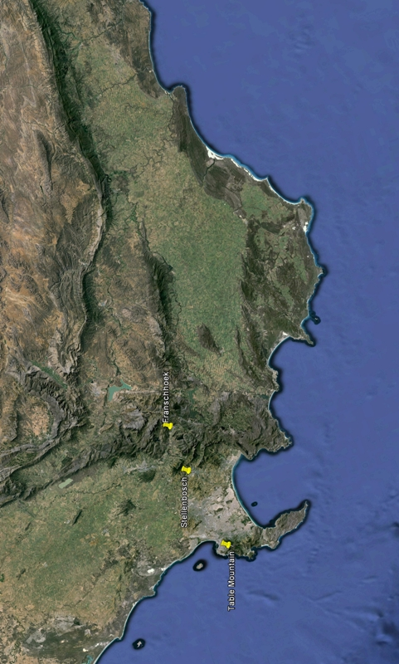
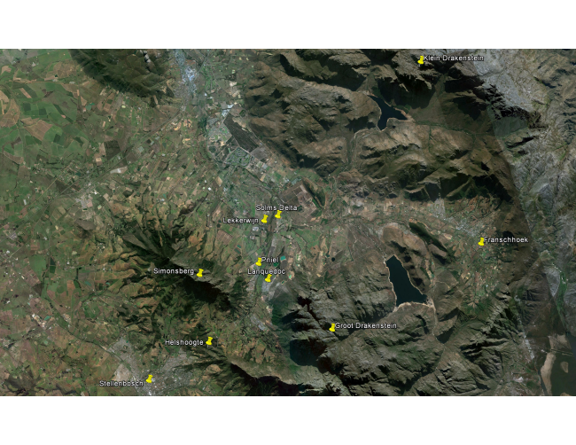
Source: Trevor Thorald Architects
