APPENDIX F Pickstone photographs
SOURCE: The Rhodes Fruit Farm section of the AG collection Cape Archives, photographer not noted. All photographs taken during Pickstone’s ownership of Delta
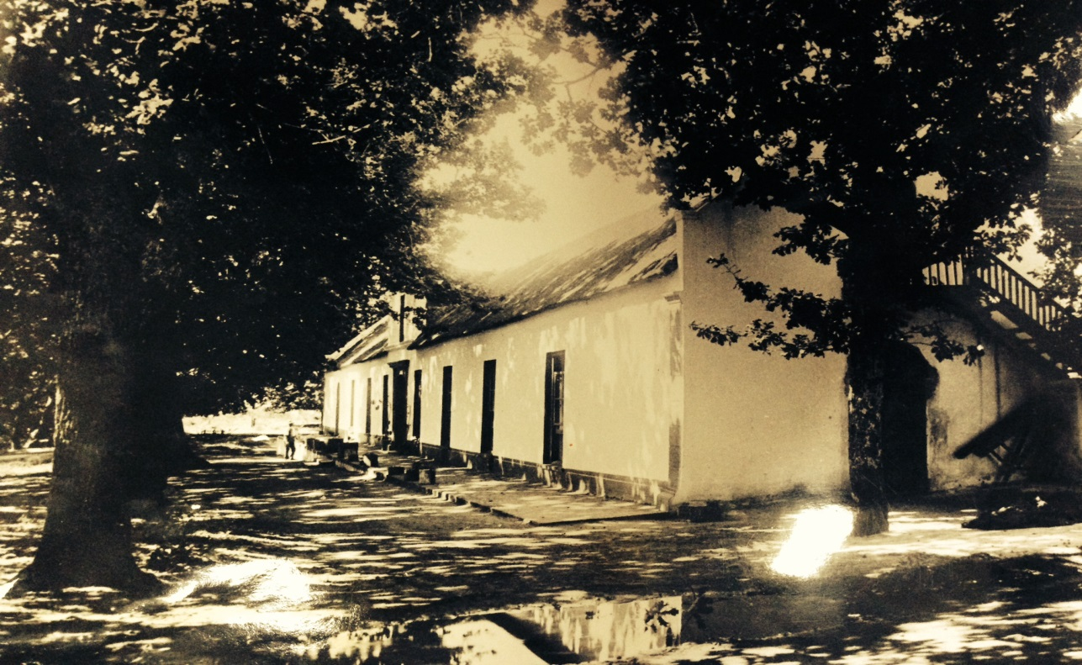
Above: Delta homestead façade, undated, Source: CA AG 7526
Below Delta’s stoep, undated. Source: CA AG7518

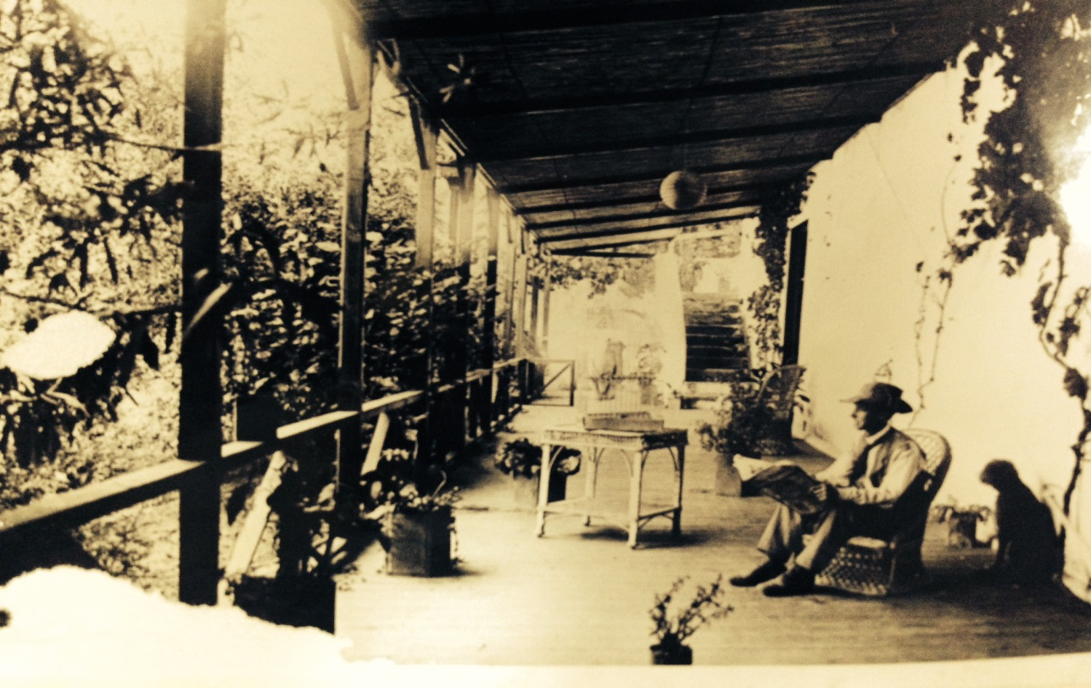
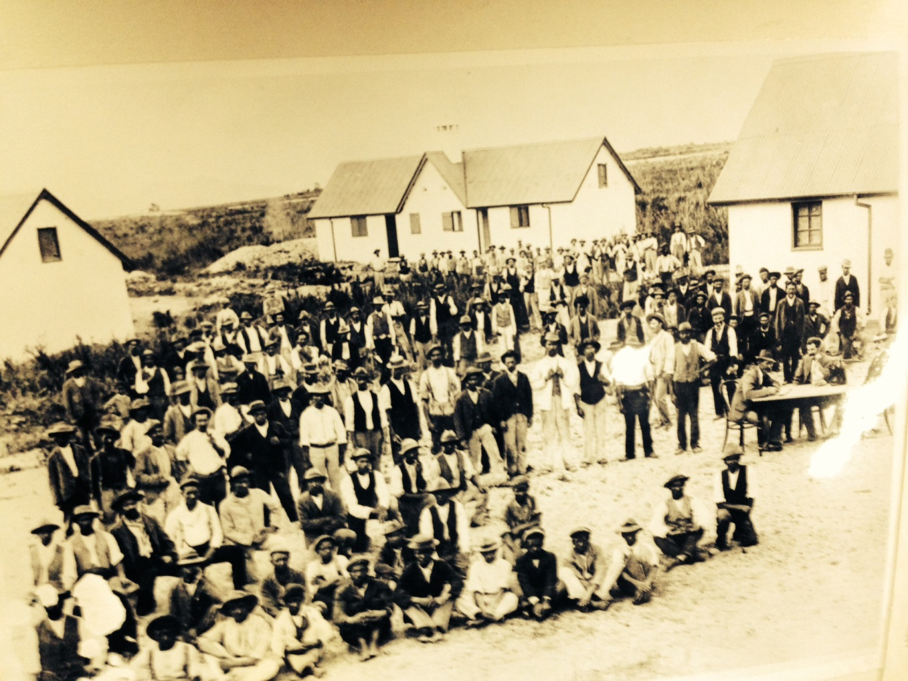
Above: Payday at Languedoc workers village, undated. Source CA AG 7532
Below: Rhodes Fruit Farms, view across the valley undated. Source: CA AG7495

